January 2017

Australian Public Assessment Report for Human Papillomavirus 9 valent vaccine
  - Proprietary Product Name: Gardasil 9
  - Sponsor: Merck Sharp & Dohme Australia Pty Ltd

About the Therapeutic Goods Administration (TGA)
- The Therapeutic Goods Administration (TGA) is part of the Australian Government Department of Health and is responsible for regulating medicines and medical devices.
- The TGA administers the Therapeutic Goods Act 1989 (the Act), applying a risk management approach designed to ensure therapeutic goods supplied in Australia meet acceptable standards of quality, safety and efficacy (performance) when necessary.
- The work of the TGA is based on applying scientific and clinical expertise to decision-making, to ensure that the benefits to consumers outweigh any risks associated with the use of medicines and medical devices.
- The TGA relies on the public, healthcare professionals and industry to report problems with medicines or medical devices. TGA investigates reports received by it to determine any necessary regulatory action.
- To report a problem with a medicine or medical device, please see the information on the TGA website <https://www.tga.gov.au>.
About AusPARs
- An Australian Public Assessment Report (AusPAR) provides information about the evaluation of a prescription medicine and the considerations that led the TGA to approve or not approve a prescription medicine submission.
- AusPARs are prepared and published by the TGA.
- An AusPAR is prepared for submissions that relate to new chemical entities, generic medicines, major variations and extensions of indications.
- An AusPAR is a static document; it provides information that relates to a submission at a particular point in time.
- A new AusPAR will be developed to reflect changes to indications and/or major variations to a prescription medicine subject to evaluation by the TGA.
Copyright
© Commonwealth of Australia 2017
This work is copyright. You may reproduce the whole or part of this work in unaltered form for your own personal use or, if you are part of an organisation, for internal use within your organisation, but only if you or your organisation do not use the reproduction for any commercial purpose and retain this copyright notice and all disclaimer notices as part of that reproduction. Apart from rights to use as permitted by the Copyright Act 1968 or allowed by this copyright notice, all other rights are reserved and you are not allowed to reproduce the whole or any part of this work in any way (electronic or otherwise) without first being given specific written permission from the Commonwealth to do so. Requests and inquiries concerning reproduction and rights are to be sent to the TGA Copyright Officer, Therapeutic Goods Administration, PO Box 100, Woden ACT 2606 or emailed to <tga.copyright@tga.gov.au>.

Contents
Common abbreviations 5
I. Introduction to product submission 8
Submission details 8
Product background 9
Regulatory status 9
Product Information 10
II. Quality findings 10
Drug substance (active ingredient) 10
Drug product 11
Biopharmaceutics 12
Quality summary and conclusions 12
III. Nonclinical findings 13
Introduction 13
Pharmacology 13
Pharmacokinetics 14
Toxicology 14
Nonclinical summary and conclusions 17
IV. Clinical findings 19
Introduction 19
Pharmacokinetics 24
Pharmacodynamics 24
Dosage selection for the pivotal studies 24
Efficacy 24
Safety 26
First round benefit-risk assessment 28
First round recommendation regarding authorisation 30
Clinical questions 30
V. Pharmacovigilance findings 30
Risk management plan 30
VI. Overall conclusion and risk/benefit assessment 46
Quality 46
Nonclinical 46
Clinical 46
Risk management plan 58
Risk-benefit analysis 58
Outcome 84
Attachment 1. Product Information 85
Attachment 2. Extract from the Clinical Evaluation Report 85

Common abbreviations
Abbreviation | Meaning
9vHPV | Nine valent Human Papillomavirus vaccine
AAHS | amorphous aluminium hydroxyphosphate sulfate
ACPM | Advisory Committee for Prescription Medicines (TGA)
ACSOV | Advisory Committee on the Safety of Vaccines (TGA)
ADEM | acute disseminated encephalomyelitis
AEs | Adverse events
AIH | Australian Immunisation Handbook
AIS | Adenocarcinoma in situ
ASA | Australian Specific Annex to the RMP
ARTG | Australian Register of Therapeutic Goods
ATAGI | Australian Technical Advisory Group on Immunisation
BGTD | Health Canada’s Biologics and Genetic Therapies Directorate
CCDS | Company Core Data Sheet
CHMP | Committee for Medicinal Products for Human Use
CI | Confidence interval
CIN | Cervical intraepithelial neoplasia
cLIA | Competitive Luminex Immunoassay
CMI | Consumer Medicine Information
Crl:CD(SD) | Crl:CD (Sprague Dawley) rats
CSR | clinical study report
DNA | deoxyribonucleic acid
EMA | European Medicines Agency
EU | European Union
F0 | F0 is the parent generation (Filial)
F1 | F1 generation, offspring of the F0 generation
FAS | Full Analysis Set
FDA | Food and Drug Administration
GBS | Guillain-Barre syndrome
GD | gestational day
GLP | Good Laboratory Practice
GMTs | Geometric Mean Titres
HCPs | Health Care Providers
HM | heterosexual males
HN-TS | HPV-Naïve type-Specific
HPV | Human Papillomavirus
HR | High risk
IARC | International Agency for Research on Cancer
IM | Intramuscular
IVRP | In vitro relative potency
L1 | recombinant major capsid (L1) protein from HPV
LR | Low risk
MedDRA | Medical Dictionary for Regulatory Activities
mMU/mL | milli-Merck Units per millilitre
MSD | Merck Sharp & Dohme Corp., a subsidiary of Merck & Co., Inc.
MSM | Men-having-sex-with-men
NIP | National Immunisation Program
OHP | Office of Health Protection
Pap | Papanicolaou
PASS | Post Authorization Safety Study
PCR | Polymerase Chain Reaction
PI | Product Information
PP | Per Protocol
PPE | Per Protocol Efficacy
PPI | Per Protocol Immunogenicity
PSC | Pharmaceutical Subcommittee
PSUR | Periodic Safety Update Report
qHPV | Quadrivalent Human Papillomavirus vaccine
RMP | Risk Management Plan
RRP | Recurrent Respiratory Papillomatosis
SPC | Summary of Product Characteristics
TGA | Therapeutic Goods Administration (Australia)
ULN | Upper limit of normal
ULOQ | Upper limit of quantification / Upper limit of quantitation
USA | United States of America
VaIN | Vaginal Intraepithelial Neoplasia
VE | Vaccine efficacy
VIN | Vulvar Intraepithelial Neoplasia
VLP | Virus-Like Particle

I. Introduction to product submission

Submission details
Type of submission: | New chemical entity
Decision: | Approved
Date of decision: | 22 June 2015
Date of entry onto ARTG: | 29 June 2015
Active ingredient(s): | HPV Type 11 L1 Protein, HPV Type 16 L1 Protein, HPV Type 18 L1 Protein, HPV Type 31 L1 Protein, HPV Type 33 L1 Protein, HPV Type 45 L1 Protein, HPV Type 52 L1 Protein, HPV Type 58 L1 Protein, HPV Type 6 L1 Protein
Product name: | Gardasil 9
Sponsor’s name and address: | Merck Sharp & Dohme Australia Pty Ltd  North Ryde Post Business Centre  Locked Bag 2234  North Ryde BC NSW 1670
Dose form: | Suspension for injection
Strength: | HPV Type 11 L1 Protein 40 µg, HPV Type 16 L1 Protein 60 µg, HPV Type 18 L1 Protein 40 µg, HPV Type 31 L1 Protein 20 µg, HPV Type 33 L1 Protein 20 µg, HPV Type 45 L1 Protein 20 µg, HPV Type 52 L1 Protein 20 µg, HPV Type 58 L1 Protein 20 µg, HPV Type 6 L1 Protein 30 µg
Containers: | Syringe, vial
Pack sizes: | 1, 10
Approved therapeutic use: | Gardasil 9 is indicated in females aged 9 through 45 years* for the prevention of cervical, vulvar, vaginal and anal cancer, precancerous or dysplastic lesions, genital warts, and infection caused by Human Papillomavirus (HPV) Types 6, 11, 16, 18, 31, 33, 45, 52 and 58 (which are included in the vaccine).  Gardasil 9 is indicated in males 9 through 26 years of age for the prevention of anal cancer, precancerous or dysplastic lesions, external genital lesions and infection caused by HPV Types 6,11,16,18,31,33,45,52 and 58 (which are included in the vaccine).  *Evidence of vaccine efficacy is based on core efficacy population of females 16 to 26 years of age. Immunogenicity studies have been conducted to link efficacy to younger populations (females and males 9 to 15 years of age). Currently there are no data from studies of Gardasil 9 relating to females over 26 years of age (see Clinical Trials Clinical Studies for Gardasil 9 Immune Response to Gardasil 9 at Month 7 Across All Clinical Studies).
Route of administration: | Intramuscular
Dosage: | Gardasil 9 should be administered intramuscularly as 3 separate 05 mL doses according to the following schedule:  First dose: at elected date, Second dose: 2 months after the first dose, Third dose: 6 months after the first dose. For further instructions regarding dosage please see the Product Information
ARTG numbers: | 224092, 224093

Product background
This AusPAR describes the application by Merck Sharp & Dohme Australia Pty Ltd (the sponsor) to register Gardasil 9 for the following indication:
Gardasil 9 is indicated in females aged 9 through 45 years* for the prevention of cervical, vulvar, vaginal and anal cancer, precancerous or dysplastic lesions, genital warts, and infection caused by Human Papillomavirus (HPV) Types 6, 11, 16, and 18, 31, 33, 45, 52 and 58 (which are included in the vaccine).
Gardasil 9 is indicated in males 9 through 26 years of age for the prevention of anal cancer, precancerous or dysplastic lesions, external genital lesions and infection caused by HPV Types 6, 11, 16, and 18, 31, 33, 45, 52 and 58 (which are included in the vaccine).
*Immunogenicity studies have been conducted to link efficacy in females and males aged 16 to 26 years to the younger populations.
There is a huge burden of disease, malignant and non-malignant, relating to Human Papillomavirus (HPV) infection, localised primarily in the anogenital area and aerodigestive tract, in both men and women. A variety of HPV types cause a wide range of clinical problems, ranging from being high risk carcinogens to the causative organism for anogenital and aerodigestic warts. HPV types are classified into high risk (HR) types, based on their potential to cause cancer, and low risk (LR) types (causing generally benign lesions). High risk oncogenic HPV Types 16 and 18 are responsible for approximately 70% cervical cancers and HPV 6 and 11 are responsible for nearly 90% genital warts. Five other HR HPV types are HPV types 31, 33, 45, 52 and 58.
This is a submission to register a new, recombinant vaccine, the 9 valent HPV vaccine (9vHPV vaccine), Gardasil 9. The currently approved HPV vaccine from the same sponsor is the quadrivalent Gardasil (qHPV vaccine). The quadrivalent Gardasil is a liquid suspension prepared from the highly purified virus like particles (VLPs) of the recombinant major capsid (L1) protein for HPV Types 6, 11, 16 and 18. The additional 5 HPV types in Gardasil 9 are 31, 33, 45, 52 and 58; and the vaccine contains the additional VLPs for the recombinant major capsid (L1) protein for each of these. Both products contain same amount of amorphous aluminium hydroxylphosphate sulphate (AAHS; 500µg aluminium content) as adjuvant. With the addition of five extra HR HPV types, the 9vHPV vaccine has the potential to cover nearly 90% cervical cancers.

Regulatory status
The product received initial registration on the Australian Register of Therapeutic Goods (ARTG) on 29 June 2015.
At the time the TGA considered this application, a similar application had been approved in: USA: 10 December 2015; Canada: 5 February 2015; and was under consideration in EU (projected approval date 1 June 2015 – recommended for approval by the Committee for Medicinal Products for Human Use (CHMP)); Taiwan and Korea.

Product Information
The Product Information (PI) approved with the submission which is described in this AusPAR can be found as Attachment 1. For the most recent PI, please refer to the TGA website at <https://www.tga.gov.au/product-information-pi>.

II. Quality findings

Drug substance (active ingredient)

Manufacture
The process for the manufacture of the nine HPV Type monovalent bulk adsorbed products consists of two main steps:
- Fermentation (in the yeast Saccharomyces cerevisiae) and harvest of the recombinant yeast cell slurry.
The VLPs are generated by fermentation process which consists of;
- seed fermentation to expand the working seed and to increase cell mass, and
- production fermentation to further increase cell mass and to produce VLPs for recovery and purification.
- Purification of VLPs and adsorption to aluminium containing adjuvant to form the monovalent bulk adsorbed products. The purification processes involve the following steps:
- cell thawing and breakage, homogenisation and Ribonuclease (RNase) treatment
- clarification by cross-flow microfiltration
- VLP disassembly and reassembly and buffer exchange
- sterile filtration
- adjuvant adsorption
Finally, the monovalent bulk adsorbed product for each HPV Type is dispensed into bulk storage containers and are transferred to the formulation/filling area when required.
Summary of buffers, solutions and raw materials used in the fermentation, purification and adsorption processes are provided. All viral/prion safety issues including use of animal derived excipients, in the cell expansion phase, the cell substrate have been addressed.
Establishment of source cell banks for all nine HPV Types and culture media used in development of host strains and source cell banks have been provided

Physical and chemical properties
The drug substance consists of the nine HPV Type monovalent bulk adsorbed products. The active components in each are the highly purified VLPs made up of the recombinant major capsid L1 protein for each of the nine HPV Types included in Gardasil 9 vaccine. L1 is the major structural protein of the HPV viral capsid.
Appropriate validation data have been submitted in support of the test procedures.

Drug product

Formulation
The 9vHPV vaccine, is a sterile, white cloudy liquid suspension prepared from the HPV Type 6, 11, 16, 18, 31, 33, 45, 52, and 58 monovalent bulk adsorbed products. The vaccine is filled into single dose vials or syringes to ensure a minimum recoverable volume of 0.5 mL for injection.
The complete drug product composition is provided and summarised in Table 1.
Table 1: The complete drug product composition
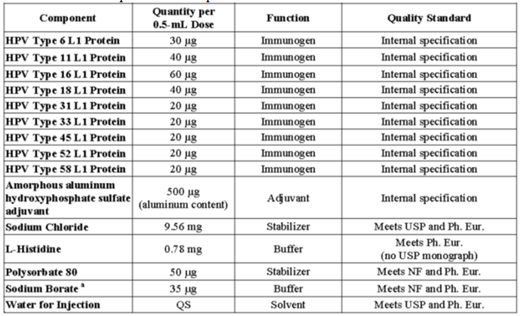

Manufacture
The finished drug product is a sterile, white, cloudy liquid suspension of adjuvant adsorbed VLPs at a target pH of 6.2. The particles settle during storage, requiring a mild shaking of the vials or syringes to regain full suspension before use.
To prepare the 9vHPV vaccine, the formulation buffer and the aluminium containing adjuvant are combined, and then the nine monovalent bulk adsorbed products are added to bring the relative content of the ingredients to the appropriate levels.
A general overview of the formulation and filling processes was provided. These same process steps were used at pilot and commercial scale.

Specifications
The specification for the 9vHPV vaccine drug product was provided. The analytical tests are performed for release and/or stability on samples of 9v final container product in vials or syringes to confirm the quality of the drug product.

Stability
The following storage period and temperature for the final formulated bulk and 9v final container product is proposed and hence evaluated:
- Final formulated bulk lots: 12 months shelf life stored at 2 to 8°C (Acceptance criteria are; no changes in physical appearance, pH, in vitro relative potency (IVRP), completeness of adsorption or sterility)
- 9vHPV vaccine lots in vials/syringes: 30 months shelf-life stored at 2 to 8oC (Acceptance criteria are; no changes in physical appearance, completeness of adsorption, pH, or sterility (and syringe ability for vaccine in syringes)).
The company commits that the stability studies will continue until completion on the 9vHPV vaccine in vials and syringes stored at 2 to 8°C, 23 to 27°C, and 35 to 39°C.
In addition, a routine annual stability program will be performed to monitor at least one vial lot and one vial syringe lot per year for a minimum of 36 months at 2 to 8°C. Routine long term stability protocol for the vial and syringes have been scheduled and provided.

Biopharmaceutics
Biopharmaceutic data are not required for this product because it is a biological vaccine product.

Quality summary and conclusions
The administrative, product usage, chemical, pharmaceutical, microbiological data submitted in support of this application have been evaluated in accordance with the Australian legislation, pharmacopoeial standards and relevant technical guidelines adopted by the TGA.
There are no outstanding issues regarding the manufacture and quality control including viral safety aspects of Gardasil 9 vaccine. However, the company must fulfil their commitments as indicated in the evaluation reports.
There are no further objections to the registration of Gardasil 9 with respect to the manufacture and quality control including viral safety aspects.

Conditions of registration
It is a condition of registration that all independent batches of Gardasil 9 vaccine imported into Australia are not released for sale until samples and/or the manufacturer’s release data have been assessed and endorsed for release by the TGA Laboratories Branch.
The company should comply with the conditions of registration regarding protocol/batch release for Gardasil 9 vaccine. For each batch of for Gardasil 9 vaccine imported into Australia the sponsor should supply the following:
  - Complete summary protocols for the manufacture and quality control of vaccine including all steps in production, from seed lot through to final packaged product, with accompanying expiry dates for vaccine (and diluents, as applicable) for the initial shipment of any Lot, and reference to the initial documentation for any subsequent shipment of that Lot, as well as evidence of a certificate release for each batch from the relevant national control authority for the country of origin.
- Number of doses in each shipment to be released in Australia.
- Evidence of product stability at release including results of the accelerated thermostability testing (where applicable).
- Evidence of maintenance of satisfactory transport conditions between the manufacturer and Australia including temperature monitors and freezer watches and printout of temperature traces.
- Ten doses of each first consignment of product lot with the Australian approved labels, PI and packaging. Three doses of any further consignment of already release product with the Australian approved labels, PI and packaging.
- Any reagents required to undertake testing as specified by the TGA Laboratories Branch.
Distribution of each batch is conditional upon fulfilment of these conditions and receipt of a letter from the TGA Laboratories Branch allowing release.

III. Nonclinical findings

Introduction
Gardasil 9 is prepared from the VLPs containing the recombinant major capsid (L1) protein of HPV Types 6, 11, 16, 18, 31, 33, 45, 52, and 58. The VLPs are adsorbed on aluminium-containing adjuvant (amorphous aluminium hydroxyphosphate sulfate), and the formulation also includes sodium chloride, L-histidine, polysorbate 80, sodium borate, and water for injection. Each 0.5 mL dose is formulated to contain 30 µg of Type 6 L1 protein, 40 µg of Type 11 L1 protein, 60 µg of Type 16 L1 protein, 40 µg of Type 18 L1 protein, and 20µg of Type 31, 33, 45, 52, and 58 L1 proteins.
In support of the proposed changes, the sponsor submitted the following non-human studies:
  - non Good Laboratory Practice (GLP) immunogenicity studies in Rhesus macaques utilizing a nona-valent VLP vaccine preparation containing HPV Types 6, 11, 16, 18, 31, 33, 45, 52 and 58 VLPs and African green monkeys (utilizing monovalent and quadrivalent VLP vaccine preparations containing HPV Types 6, 11, 16 and 18 VLPs
- a GLP 3 month duration, repeat intramuscular exposure toxicity and immunogenicity study in Crl:CD(SD) rats dosed once every 21 days with a 21 day recovery period
- a GLP repeat exposure intramuscular exposure developmental toxicity and immunogenicity study in Crl:CD(SD) rats with prenatal teratology evaluation
- a GLP repeat intramuscular exposure pre-/postnatal developmental toxicity and immunogenicity study in Crl:CD(SD) rats with post natal evaluation.

Pharmacology

Primary pharmacology
There are no appropriate animal models for the diseases produced by HPV Types 6, 11, 16, 18, 31, 33, 45, 52 and 58. Accordingly it is currently impossible to perform disease efficacy studies in animals. Gardasil 9 is undoubtedly immunogenic in rats and primates. There is also evidence of an anamnestic response following antigenic re-exposure. Detailed methodological information on the immunoassays used and their statistical analyses were not provided. While historically only the geometric mean titre has been provided with serum/antibody titre data, it is important to note that statistical analyses of these types of immune-haematological data is the currently accepted scientific norm and is good basic scientific practice.
The sensitivity, specificity, precision, negative predictive value and accuracy of these immunoassay systems could not be evaluated based on the submitted data. In particular, the antigenic cross reactivity and the lower limit of quantitation of the assays could not be assessed. Furthermore, insufficient information regarding the standard curves generated by the immunoassays and the relevant calculations performed was provided.
Because of the limitations of the data provided by the sponsor, the nonclinical immunogenicity data provided by the sponsor is qualitative to semi quantitative in nature.
Although not required by current guidelines, the immunogenicity components of all the submitted studies did not evaluate physiologically important aspects of the anamnestic response.
The immunogenicity components of all the submitted studies did not recognise that competitive immunoassays, (or any immunoassay that involves a washing step) measure the combined effect of differences in actual antibody concentrations and changes in antibody affinity/avidity. They do not simply measure antibody concentration.

Secondary pharmacodynamics
No data supplied or required. According to the guideline pharmacokinetic studies of vaccines are not normally needed.

Pharmacokinetics
No data supplied or required. According to the guidleine² pharmacokinetic studies of vaccines are not normally needed.

Toxicology

Acute toxicity
Acute toxicity was evaluated as part of the repeat dose toxicity study.

Repeat dose toxicity
When administered every 21 days to Crl:CD(SD) rats over a 3 month period, 3 developmental formulations of Gardasil 9 was well tolerated at a doses exceeding the human clinical dose by approximately 150 x on an mg/kg body weight basis. No Gardasil 9 related adverse effects occurred except at the site of injection. Evidence of systemic inflammatory and immunological responses was present in the study. However the observed changes were adaptive, immunologically necessary and were neither adverse nor disproportionate.
Histomorphological evidence of localised inflammation and muscle damage at the injection site and inflammatory/reactive changes in the draining lymph nodes were present at exposures up to approximately 150 x human clinical dose on an mg/kg basis. Injection site changes were incompletely resolved at 21 days post injection with residual sub-acute inflammation remaining. Such changes are predictable given the repeated use of Gardasil 9; especially because of the injection volume relative to the small volume of muscle at the animal injection sites. These changes are human relevant. Localised injection site pain and inflammatory changes can be expected in humans and might persist for several weeks in extreme cases. However the volume of muscle mass relative at site of injection in the study rats (quadriceps group) relative to the injection volume is much smaller than the likely site of injection in humans (deltoid). Accordingly the rodent findings constitute a worst case scenario compared with the actual human situation. Notably, pain and evidence of injection site inflammation are commonly associated (odds ratios of relevant effects > 2.5 based on meta-analysis) with quadrivalent Gardasil (HPV Types 6, 11, 16 and 18) use in humans.

Genotoxicity
No data supplied or required. According to the guidelines^{2,} and the genotoxicity studies are not generally required for vaccines.

Carcinogenicity
No data supplied or required. According to the guidelines^{2, 4} carcinogenicity studies are not generally required for vaccines.

Reproductive toxicity
Gardasil 9 was not teratogenic, embryotoxic or fetotoxic in Crl:CD(SD) rats at exposures approximately 240 x human clinical dose on a mg/kg basis. It is notable that vaccination of female rats with a developmental formulation of Gardasil 9 at exposures approximately 240 x human clinical exposure on a mg/kg basis prior to mating and on gestational day (GD) 6 resulted in generation of antibodies to all 9 HPV VLP Types in caesarean section derived, GD 21 foetuses (collected prior to parturition and first suckling), and in pre-weaning pups. There is current evidence of mother to infant vertical transmission of HPVs resulting in juvenile HPV diseases in humans. ,,Thus these results in rats support the hypothesis that Gardasil 9 might reduce the risk of human mother-to-infant vertical transmission of HPVs and juvenile onset HPV associated diseases (for example juvenile onset recurrent respiratory papillomatosis (RRP)).
Gardasil 9 is also not a reproductive or developmental toxicant in Crl:CD(SD) rats at exposures approximately 160 x human clinical dose on a mg/kg basis. Small decreases (3 to 5%) in fertility, fecundity and mating indices of rats exposed to Gardasil 9 or the Merck aluminium adjuvant article at doses approximately 160 x the human clinical dose mg/kg basis. On the balance of probabilities, and in the absence of test article related histomorphological changes in reproductive tissues, the small observed effects on rat fertility, fecundity and mating indices are likely to be non-adverse and are probably not relevant to human health.

Pregnancy classification
The sponsor has proposed Category B2 which is somewhat precautionary given the lack of evidence of reproductive or developmental effects in rats and the adequacy of these studies. Notably, current regulatory guidelines do not specify the number of test species for embryofoetal development studies or do not require testing in a second species for vaccines.²
The evaluator proposes that Gardasil 9 should be classified as Category B1 based on the lack of evidence of adverse effects in the high quality animal reproduction and development studies and limited evidence of lack of adverse effects in humans.

Local tolerance
Histomorphological evidence of localised inflammation and muscle damage at the injection site and inflammatory/reactive changes in the draining lymph nodes were present at exposures up to approximately 150 x human clinical dose on an mg/kg basis. Injection site changes were incompletely resolved at 21 days post-injection with residual sub-acute inflammation remaining. Such changes are predictable given the repeated use of Gardasil 9; especially given the injection volume relative to the small volume of muscle at the animal injection sites. These changes are human relevant. Localised injection site pain and inflammatory changes can be expected in humans and might persist for several weeks in extreme cases. However the volume of muscle mass relative at site of injection in the study rats (quadriceps group) relative to the injection volume is much smaller than the likely site of injection in humans (deltoid). Accordingly the rodent findings constitute an extreme worst case scenario compared with the actual human situation. Notably, pain and evidence of injection site inflammation are commonly associated (odds ratios of relevant effects > 2.5 based on meta-analysis) with quadrivalent Gardasil (HPV Types 6, 11, 16 and 18) use in humans.³

Impurities and residuals
No specific impurity toxicity studies have been performed, since specialised toxicological assessments were not needed for Gardasil 9. The impurity specifications for HPV VLP Types 6, 11, 16 and 18 are equivalent to those of the currently approved quadrivalent Gardasil.
The impurity specifications for residual deoxyribonucleic acid (DNA), RNA, total lipids and total carbohydrates for the monovalent bulk preparations of HPV VLP Types 31, 33, 45, 52 and 58 are as follows:
- Residual DNA < 0.08 pg/µg protein
- Residual RNA < 0.2 pg/ µg protein
- Total lipid < 20 µg/mL
- Total carbohydrate < 10 µg/mL
These impurity levels are further diluted during the final formulation of the nonavalent Gardasil 9. Toxicological evaluation of Gardasil 9 at exposure levels of up to approximately 150 x human clinical dose on an mg/kg basis did not demonstrate toxicologically adverse effects attributable to the presence of these impurities.

Paediatric use
Gardasil 9 is not proposed for paediatric use. Gardasil 9 is not a developmental toxicant in Crl:CD(SD) rats at exposures up to approximately 160 x human clinical dose on a mg/kg basis. Notably, current regulatory guidelines do not specify the number of test species for development studies or do not require testing in a second species for vaccines.²

Nonclinical summary and conclusions

Summary
- In support of registration, the sponsor submitted the following nonclinical studies: (a) non GLP immunogenicity studies in Rhesus macaques utilizing a 9 valent VLP vaccine preparation containing HPV Types 6, 11, 16, 18, 31, 33, 45, 52 and 58 VLPs and in African green monkeys utilizing monovalent and quadrivalent VLP vaccine preparations containing HPV Types 6, 11, 16 and 18 VLPs; (b) a GLP 3 month duration, intramuscular exposure toxicity and immunogenicity study in Crl:CD(SD) rats dosed once every 21 days, with a 21 day recovery period; (c) a GLP repeat exposure intramuscular exposure developmental toxicity and immunogenicity study in Crl:CD(SD) rats with prenatal teratology evaluation; and (d) a GLP repeat intramuscular exposure pre-/postnatal developmental toxicity and immunogenicity study in Crl:CD(SD) rats with post natal evaluation.
- The total HPV L1 protein exposure in Gardasil 9 is 270 µg/0.5 mL dose, versus 120 µg/0.5 mL dose in the currently approved quadrivalent Gardasil. The levels of HPV Type 6 L1 protein (20 µg/dose in Gardasil versus 30 µg/dose in Gardasil 9), HPV Type 16 L1 protein (40 µg/0.5 mL dose in Gardasil versus 60 µg/0.5 mL dose in Gardasil 9) and HPV Type 18 L1 protein (20 µg/0.5 mL dose in Gardasil versus 40 µg/0.5 mL dose in Gardasil 9) differ between the currently marketed quadrivalent Gardasil and Gardasil 9. These differences are not overtly toxicologically or immunologically detrimental.
- Gardasil 9 is undoubtedly immunogenic in laboratory animals. There is also evidence of an anamnestic response following antigenic re-exposure. Detailed methodological information on the immunoassays used and their statistical analyses were not provided. While historically only the geometric mean titre has been provided with serum/antibody titre data, it is important to note that statistical analyses of these types of immune-haematological data is the currently accepted scientific norm and is good basic scientific practice.
- The sensitivity, specificity, precision, negative predictive value and accuracy of these immunoassay systems could not be evaluated based on the submitted data. In particular, the antigenic cross reactivity and the lower limit of quantitation of the assays could not be assessed. Furthermore, insufficient information regarding the standard curves generated by the immunoassays and the relevant calculations performed was provided.
- Although not required by current guidelines, the immunogenicity components of all the submitted studies did not evaluate physiologically important aspects of the anamnestic response.
- The immunogenicity components of all the submitted studies did not recognise that competitive immunoassays, (or any immunoassay that involves a washing step) measure the combined effect of differences in actual antibody concentrations and changes in antibody affinity/avidity. They do not simply measure antibody concentration.
- When administered every 21 days to Crl:CD(SD) rats over a 3 month period, 3 developmental formulations of Gardasil 9 were well tolerated at a doses exceeding the human clinical dose by up to approximately 150 x on an mg/kg body weight basis. No Gardasil 9 related adverse effects occurred except at the site of injection. Evidence of systemic inflammatory and immunological responses was present in the study. However the observed changes were adaptive, immunologically necessary and were neither adverse nor disproportionate.
- Histomorphological evidence of localised inflammation and muscle damage at the injection site and inflammatory/reactive changes in the draining lymph nodes were present at exposures up to approximately 150 x human clinical dose on an mg/kg basis. Injection site changes were incompletely resolved at 21 days post injection with residual sub-acute inflammation remaining. Such changes are predictable given the repeated use of Gardasil 9; especially because of the injection volume relative to the small volume of muscle at the injection sites in the animals. These changes are human relevant. Localised injection site pain and inflammatory changes can be expected in humans and might persist for several weeks in extreme cases. However the volume of muscle mass relative at site of injection in the study rats (quadriceps group) relative to the injection volume is much smaller than the likely site of injection in humans (deltoid). Accordingly the rodent findings constitute a worst case scenario compared with the actual human situation. Notably, pain and evidence of injection site inflammation are commonly associated (odds ratios of relevant effects > 2.5 based on meta-analysis) with quadrivalent Gardasil (HPV Types 6, 11, 16 and 18) use in humans.³
- Gardasil 9 is not teratogenic, embryotoxic or foetotoxic in Crl:CD(SD) rats at exposures up to approximately 240 x human clinical dose on a mg/kg basis.
- Gardasil 9 is not a reproductive or developmental toxicant in Crl:CD(SD) rats at exposures up to approximately 160 x human clinical dose on a mg/kg basis.
- Small decreases (3 to 5%) in the fertility and fecundity indices of the F0 generation female animals that were exposed to Gardasil 9 or the Merck aluminium adjuvant control article at approximately 160 x the human clinical dose on a mg/kg basis prior to mating and at gestation day 6 were present in the prenatal developmental toxicity study. Decreases (5 to 10%) in the mating, fertility and fecundity indices of the F1 generation female animals that were exposed to Gardasil 9 prior to mating and at gestation day 6 were also present in the postnatal developmental toxicity study. Thus the effects of Gardasil 9 on these indices of reproduction were repeatable across studies. However it is assumed that the decreases in these indices of reproduction are still within their normal historical control ranges and thus these effects are likely to be non-adverse.
- Critically, side effects of vaccines and adjuvants such as febrile and inflammatory responses and pain (particularly given the injection volumes used relative to the volume of muscle at the injection site in the quadriceps and inflammogenic nature of the injected material) can affect mating, fertility and fecundity indices in rats. In particular quadriceps muscle pain is an impediment to mating in rodents. These issues and any putative relevance (or lack of relevance) to humans was not discussed in the relevant study reports.
- On the balance of probabilities, and in the absence of test article related histomorphological changes in reproductive tissues, the small observed effects of Gardasil 9 on rat fertility, fecundity and mating indices are likely to be non-adverse and are probably not relevant to human health.

Conclusions and recommendation
- Overall there are no nonclinical safety properties precluding Gardasil 9 registration.
- Because of the limitations of the data provided by the sponsor, the nonclinical immunogenicity data provided by the sponsor should be regarded as qualitative to semi-quantitative in nature.
- It is notable that vaccination of female rats with Gardasil 9 at exposures approximately 240 x human clinical exposure on a mg/kg basis prior to mating and on gestational day 6 resulted in generation of antibodies to all 9 HPV VLP Types in caesarean section derived, gestational day 21 foetuses (collected prior to parturition and first suckling), and in pre-weaning pups. There is current evidence of mother to infant vertical transmission of HPVs resulting in juvenile HPV diseases in humans.^{5,6,7} Thus these results in rats support the hypothesis that Gardasil 9 might reduce the risk of human mother to infant vertical transmission of HPVs and juvenile onset HPV associated diseases (for example juvenile onset RRP).
- Localised injection site pain and inflammatory changes can be expected in humans and might persist for several weeks in extreme cases.
- Gardasil 9 is not is not teratogenic, embryotoxic or foetotoxic in Crl:CD(SD) rats at exposures approximately 150 x human clinical dose on a mg/kg basis. Gardasil 9 is also not a reproductive or developmental toxicant in Crl:CD(SD) rats at exposures approximately 150 x human clinical dose on a mg/kg basis.
- Small decreases (3 to 5%) in fertility, fecundity and mating indices of rats exposed to Gardasil 9 or the Merck aluminium adjuvant article at doses approximately 150 x the human clinical dose mg/kg basis. On the balance of probabilities, and in the absence of test article related histomorphological changes in reproductive tissues, the small observed effects on rat fertility, fecundity and mating indices are likely to be non-adverse and are probably not relevant to human health.

IV. Clinical findings
A summary of the clinical findings is presented in this section. Further details of these clinical findings can be found in Attachment 2.

Introduction

Clinical rationale
There is a huge burden of disease, malignant and non-malignant, relating to HPV infection, localised primarily in the anogenital area and aerodigestive tract, in both men and women. HPV Types cause a wide range of clinical problems, ranging from being high risk carcinogens to the causative organism for anogenital and aerodigestive warts (Table 2). They are classified into high risk (HR) types, based on their potential to cause cancer, and low risk (LR) types (causing generally benign lesions). The International Agency for Research on Cancer (IARC) has identified 12 HPV Types as carcinogens. These include the 7 HR HPV Types represented in the 9vHPV vaccine (HPV 16, 18, 31, 33, 45, 52, and 58) and 5 HR HPV Types not represented in the 9vHPV vaccine (HPV 35, 39, 51, 56, and 59). LR HPV Types 6 and 11, which are responsible for approximately 90% genital warts and recurrent respiratory Papillomatosis (RRP) cases, are also included in the 9vHPV vaccine.

Table 2: Diseases attributable to HPV by anatomic site
Diseases attributable to HPV by anatomic site
Anogenital manifestations of HPV disease
Cervical Cancer | Nearly 100% of cervical cancers are caused by HPV infection 530,000 new cases diagnosed every year worldwide†; 275,000 annual deaths
Other Anogenital Cancers | Approximately 90% of anal cancers, 25% of vulvar cancers, 70% of vaginal cancers, and 30 to 40% of penile cancers are caused by HPV infection  Over 40,000 new cases diagnosed in men and women every year worldwide
Anogenital Warts (Condyloma Acuminata) | Benign lesions; treatment often lengthy and painful; high recurrence rates  Incidence rate 0.1 to 0.2% in developed countries, higher in developing countries, representing millions of cases every year
Aerodigestive manifestations of HPV disease
Oropharyngeal Cancers‡ | Approximately 27% of oropharyngeal cancers are caused by HPV infection  Approximately 22,000 new cases diagnosed every year worldwide (approximately 80% in men); infection is likely sexually acquired
Recurrent Respiratory Papillomatosis (RRP) | Rare, generally benign disease; exophytic warts in upper airway can cause severe speech and respiratory impairment, and death by blocking the airway  HPV transmitted from mother to child during passage through the birth canal. In young adults, could be sexually transmitted or a recurrence of childhood infection
† 80% of the cases in developing countries. In developed countries, cervical cancer screening programs have reduced the incidence of cervical cancer by 75% due to the detection, follow up, and treatment of premalignant lesions (generally involve invasive procedures which represent substantial healthcare utilization). ‡ HPV has also been detected in cancers of the oral cavity and the larynx, although a causal role has not been established.
The 2 currently licensed prophylactic HPV vaccines are the bivalent HPV [Types 16, 18] L1 VLP vaccine and qHPV vaccine. The bivalent vaccine address high risk Types HPV 16 and HPV 18, which are responsible for approximately 70% of cervical cancers yet does not cover genital warts. The qHPV vaccine additionally addresses LR Types HPV 6 and HPV 11 (responsible for approximately 90% of genital warts).
In clinical trials, qHPV vaccine was highly efficacious in preventing the development of HPV 16 and 18 related high grade cervical, vulvar, vaginal, and anal dysplasia (the obligate precursors of cervical cancer, and HPV related; vulvar, vaginal, and anal cancers, respectively); HPV 6 and 11 related external genital lesions (including genital warts); HPV 6, 11, 16, and 18 related cervical dysplasia (any grade); and HPV 6, 11, 16 and 18 related persistent infection. Long term effectiveness is being assessed in long term follow up of clinical study cohorts. Interim analyses showed no breakthrough of HPV related disease after up to 6 years of follow up thus far. As of July 2013, the qHPV vaccine has been approved and marketed for use in females over 9 under the name Gardasil/Silgard in over 130 countries. It has also been approved for use in males in 76 countries. Reports from several countries with HPV vaccination programs indicate a rapid, beneficial effect of qHPV vaccination at the population level, including a substantial decrease in the incidence of high grade cervical abnormalities, prevalence of vaccine HPV Types, and incidence of genital warts, as early as 3 years following the introduction of the vaccine.
Australia has been the first country to introduce a fully funded national HPV vaccination program. The program, targeted to adolescent females 12 to 13 years of age, was started in April 2007. In addition, up to 31 December 2009, a catch up vaccination program was offered to girls and women, 14 to 26 years of age. A decrease was noted in incidence of high grade cervical abnormalities in girls less than 18 years of age.¹¹ The prevalence of the vaccine HPV genotypes (6, 11, 16, and 18) also substantially decreased among women following qHPV vaccination.¹² Within approximately 3 years following implementation of this qHPV vaccination program, a decline was also observed in the diagnosis of genital warts among young Australian women. A subsequent study reported the near disappearance of genital warts in young women and young heterosexual men within approximately 4 years following implementation of this vaccination program.
Phase III studies have established that the qHPV vaccine is highly efficacious in preventing genital warts and anal cancer and pre cancers in males, and therefore can contribute to reducing the burden of HPV diseases in males. A potential benefit of HPV vaccination in males is contribution to herd protection, which could ultimately lead to a substantial reduction of HPV diseases in both males and females.
The 9vHPV vaccine contains the same HPV Types already represented in the qHPV vaccine (HPV 6, 11, 16, and 18), as well as five additional HR HPV Types (31, 33, 45, 52, and 58). HPV 16 and 18 are responsible for most (approximately70%) cases of cervical cancer. An additional approximately20% of cases are due to HPV Types 31, 33, 45, 52, and 58. Thus, the 9vHPV vaccine has the potential to prevent approximately90% cervical cancers. The 9vHPV vaccine also has the potential to expand upon the clinical benefit of the qHPV vaccine by preventing more high and low grade cervical dysplasia. The qHPV vaccine prevents approximately 50% cervical intraepithelial neoplasia (CIN) 2/32. The 9vHPV vaccine could prevent approximately 80% CIN 2/3 (a 30% incremental increase over qHPV vaccine), which could match or exceed the efficacy of most cervical cancer screening programs. The vaccine could also prevent approximately 55% CIN 1.

Contents of the clinical dossier
The submission contained the following clinical information:
- pivotal efficacy/safety studies
- Nonclinical and clinical overview, summary of clinical pharmacology, efficacy and safety, quality summary, summary of clinical safety and literature references.
There are 6 studies included in this submission that provide data for the efficacy/ immunogenicity of 9HPV. Details of these studies are listed in Tables 2, 3 and 4 of Attachment 2 (Extract of the Clinical Evaluation Report).
The qHPV vaccine has been marketed since 2006, is available in many countries, and represents the current standard of care for protection against HPV infection and disease. Therefore, using a placebo comparator to assess the clinical efficacy of the 9vHPV vaccine was not acceptable. For this reason, clinical efficacy of the 9vHPV vaccine was assessed using the qHPV vaccine as an active comparator. The clinical development program was designed to establish 9vHPV vaccine efficacy in females, 16 to 26 years of age, based on a large Phase III comparative efficacy study of 9vHPV vaccine versus qHPV vaccine, referred to as Protocol V503-001 (Study 001).
Preadolescents and adolescents could not be included in original Gardasil studies as they involved gynaecological and genital examination and sampling. Therefore, licensure of the qHPV vaccine in preadolescents and adolescents, 9 to 15 years of age, was based on demonstrating that the qHPV vaccine induced non-inferior antibody responses to all 4 vaccine types in this population compared to the responses in a core efficacy population of subjects 16 to 26 years of age (the population used to establish qHPV vaccine efficacy. Using this immunological bridging analysis, the efficacy findings in the core efficacy population were extended to the 9 to 15 year old population.
A similar adult to adolescent immunological bridging strategy was used in the clinical development program of the 9vHPV vaccine to demonstrate that the 9vHPV vaccine immunogenicity for all 9 vaccine types was non-inferior in females and males, 9 to 15 years of age, compared to that in females, 16 to 26 years of age (the population used to establish 9vHPV vaccine efficacy). This is the major objective of Protocol V503-002 (Study 002). This approach has been accepted by the US Food and Drug Administration (FDA), the EMA/CHMP, and Health Canada’s Biologics and Genetic Therapies Directorate (BGTD). Additional assessment of immunogenicity was conducted to further strengthen the immunological bridging conclusions from Study 002. Since this assessment was considered supportive, it was conducted only in females, 9 to 15 years of age. This included:
- Protocol V503-009(Study 009) provided immunological bridging from qHPV vaccine to 9vHPV vaccine in preadolescent and adolescent girls, 9 to 15 years of age, by demonstrating that both vaccines have similar immunogenicity with respect to HPV 6, 11, 16, and 18. This study was requested by the EMA/CHMP during Scientific Advice (SA) in 2008 (EMEA/H/SA/1086/1/2008/II), and by EMA Paediatric Committee (PDCO) in 2010 (EMEA-000654-PIP01-09).
- An additional, supportive cross-study analysis to compare the immunogenicity of the 9vHPV vaccine in preadolescent and adolescent girls, 9 to 15 years of age, enrolled in Study 002 with the immunogenicity of the qHPV vaccine in young women, 16 to 26 years of age, enrolled in Protocol V503-001, with respect to HPV 6, 11, 16, and 18.
The immunobridging strategy in the 9vHPV vaccine program was conducted based on a stepwise approach.
Pivotal analyses
- Demonstrate non-inferior immunogenicity in females, 16 to 26 years of age, administered 9vHPV vaccine versus females, 16 to 26 years of age, administered qHPV vaccine with respect to the 4 original types (Protocol V503- 001).
- Demonstrate non-inferior immunogenicity in females, 9 to 15 years of age, administered 9vHPV vaccine versus females, 16 to 26 years of age, administered 9vHPV vaccine with respect to the 9 vaccine types (Protocol V503-002).
- Demonstrate non-inferior immunogenicity in males, 9 to 15 years of age, administered 9vHPV vaccine versus females, 16 to 26 years of age, administered 9vHPV vaccine with respect to the 9 vaccine types (Protocol V503-002).
Supportive analyses
- Demonstrate non-inferior immunogenicity in females, 9 to 15 years of age, administered 9vHPV vaccine versus females, 9 to 15 years of age, administered qHPV vaccine with respect to HPV 16 and 18 (Protocol V503-009).
- Demonstrate non-inferior immunogenicity in females, 9 to 15 years of age, administered 9vHPV vaccine versus females, 16 to 26 years of age, administered qHPV vaccine with respect to the 4 original types (cross-study comparison: Protocol V503-002 versus Protocol V503-001).
Additional studies were conducted to demonstrate that concomitant administration of the 9vHPV vaccine and vaccines routinely administered in adolescents does not affect the antibody responses to any of the other vaccines.
- Concomitant administration of 9vHPV vaccine with Menactra (meningococcal [Groups A, C, Y and W-135] polysaccharide diphtheria toxoid conjugate vaccine, Sanofi Pasteur, Swiftwater, PA) and Adacel (tetanus toxoid, reduced diphtheria toxoid and acellular pertussis vaccine adsorbed, Sanofi Pasteur, Toronto, Ontario, Canada) was assessed in females and males, 11 to 15 years of age, in Protocol V503-005 (Study 005).
- Concomitant administration of 9vHPV vaccine with Repevax (diphtheria, tetanus, pertussis [acellular, component] and poliomyelitis [inactivated] vaccine [adsorbed, reduced antigen(s) content], Sanofi Pasteur MSD, Ltd., Lyon, France) was assessed in females and males, 11 to 15 years of age, in Protocol V503-007 (Study 007).
Use of 9vHPV vaccine in prior qHPV vaccine recipients
The qHPV vaccine has been licensed in 2006. Since then, millions of girls and women have been administered the vaccine. The 9vHPV vaccine was assessed for safety and immunogenicity in prior qHPV vaccine recipients in Protocol V503-006 (Study 006). This study was conducted in females, 12 to 26 years of age. This age range was selected as the most likely age range to receive follow up vaccination with the 9vHPV vaccine, should the vaccine be licensed.
Manufacturing lot consistency
A study was conducted to demonstrate clinical consistency of manufactured material through immunogenicity assessment of three different final manufacturing process lots of the 9vHPV vaccine. This assessment was conducted in females, 9 to 15 years of age, as part of Protocol V503-002 (Study 002).

Paediatric data
The submission includes paediatric efficacy / safety data.

Good clinical practice
There are statements of compliance with good clinical practice for all studies.

Pharmacokinetics
There was no pharmacokinetic data supplied in this submission.

Pharmacodynamics
There was no pharmacodynamic data included in this submission.

Dosage selection for the pivotal studies
The 3 dose formulations of 9vHPV vaccine tested in Protocol V503-001 are shown in Table 3. The low dose formulation contains the same amounts of HPV 6, 11, 16, and 18 VLPs as the qHPV vaccine and has a higher adjuvant to antigen ratio than the qHPV vaccine. The mid dose formulation contains increased amounts of HPV 6, 16, and 18 VLPs than the qHPV vaccine and has an adjuvant to antigen ratio that is similar to that of the qHPV vaccine. The high dose formulation contains increased antigen amounts for the 7 oncogenic types compared with the mid dose formulation. The adjuvant amount used for all 3 dose formulations was 500 µg of AAHS adjuvant. This amount of AAHS is the same as that used in Recombivax HB3 (hepatitis B vaccine [recombinant]), a recombinant protein based vaccine licensed in many countries to prevent infection with hepatitis B virus, another oncogenic DNA virus. Recombivax HB has been administered to millions of infants, adolescents, and adults, and was found to be effective and have an acceptable safety profile. The dose selected for the second part of Study 001 was the mid dose and was then used in all subsequent studies.

Table 3: Study 001; 9vHPV vaccine dose formulations used for dose selection
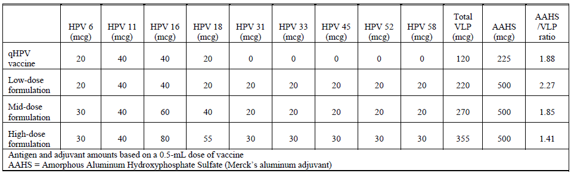

Efficacy

Studies providing efficacy data
Rather than direct comparison of the clinical efficacy of the 9vHPV vaccine versus qHPV vaccine with respect to HPV 6 , 11, 16 , and 18 related infection (not practical), the immunogenicity of the two vaccines with respect to HPV 6, 11, 16, and 18 was compared. Neutralizing antibodies are recognised as the vaccine induced immune mechanism of protection against HPV infection and disease. Therefore, immunogenicity is an appropriate surrogate for HPV vaccine efficacy. However, since no immune threshold of protection has been identified for HPV vaccines, immunogenicity of the 9vHPV vaccine was compared to that of the qHPV vaccine (known to be highly efficacious in preventing HPV infection and disease related to HPV 6, 11, 16, and 18). Specifically, the qHPV vaccine efficacy findings were bridged to 9vHPV vaccine based on the demonstration of non-inferior immunogenicity in Protocol V503-001 (as described above). This approach has been accepted by the FDA, the EMA CHMP, and Health Canada’s BGTD.
Persistent infection and disease endpoints related to HPV 6, 11, 16, and 18 were also extensively collected in Protocol V503-001 and used to conduct supportive, confirmatory analyses to demonstrate no negative trend on clinical efficacy endpoints with 9vHPV vaccine compared with qHPV vaccine. In these analyses, the respective efficacies of 9vHPV vaccine and qHPV vaccine were determined relative to endpoints in historical placebo recipients from clinical studies of the qHPV vaccine. This approach has been accepted by the FDA and European Medicines Agency (EMA) in 2008.

Assessment of 9vHPV vaccine efficacy against persistent infection and disease related to HPV Types 31, 33, 45, 52, and 58
The qHPV vaccine has limited efficacy against infection and disease caused by non-vaccine HPV types. Therefore, the qHPV vaccine represents a suitable control to assess clinical efficacy of the 9vHPV vaccine with respect to persistent infection and disease caused by HPV 31, 33, 45, 52, and 58 (essentially placebo). The qHPV vaccine clinical development program previously established disease, infection and cytology endpoints to demonstrate efficacy of the qHPV vaccine compared to placebo. Similar disease, persistent infection, and cytology endpoints were used in the 9vHPV vaccine program to assess the efficacy of 9vHPV vaccine compared to qHPV vaccine with respect to HPV 31, 33, 45, 52, and 58.
A full description of the efficacy studies and their results can be found in Attachment 2.

Evaluator’s conclusions on efficacy
- In study participants, administration of a 3 dose regimen of 9vHPV vaccine to females, 16 to 26 years of age, was shown to reduce the overall risk for development of cervical intraepithelial neoplasia (CIN), vulvar intraepithelial neoplasia (VIN) and vaginal intraepithelial neoplasia (VaIN) disease; the risk of having an abnormal Papanicolaou (Pap) test, particularly a Pap test that is predictive for CIN 2/3 and, therefore, requires colposcopic follow up; and their risk of undergoing cervical and external genital diagnostic and therapeutic procedures, especially definitive therapy procedures.
- The protective efficacy induced by the 9vHPV vaccine is durable through at least 4 years post vaccination with respect to infection and disease related to the HPV vaccine types.
- The 9vHPV vaccine induces robust anti-HPV 6, anti-HPV 11, anti-HPV 16, anti-HPV 18, anti-HPV 31, anti-HPV 33, anti-HPV 45, anti-HPV 52, and anti-HPV 58 responses through at least 1.5 years post vaccination.
- Administration of a 3 dose regimen of 9vHPV vaccine to females, 9 to 15 years of age, should have protective efficacy against cervical, vulvar, and vaginal infection and disease caused by HPV Types 31, 33, 45, 52, and 58. This conclusion is based on numerically superior and statistically non-inferior anti-HPV 31, anti-HPV 33, anti-HPV 45, anti-HPV 52, and anti-HPV 58 responses induced by 9vHPV vaccine in females, 9 to 15 years of age, compared with anti-HPV responses induced in females, 16 to 26 years of age (the population used to establish 9vHPV vaccine efficacy) (immunobridging evidence, as shown for qHPV vaccine).
- Administration of a 3 dose regimen of 9vHPV vaccine to males, 9 to 15 years of age, should have protective efficacy against external genital infection and disease caused by HPV Types 31, 33, 45, 52, and 58. This conclusion is based on numerically superior and statistically non-inferior anti- HPV 31, anti-HPV 33, anti-HPV 45, anti-HPV 52, and anti-HPV 58 responses induced by 9vHPV vaccine in males, 9 to 15 years of age, compared with anti-HPV responses induced in females, 16 to 26 years of age (the population used to establish 9vHPV vaccine efficacy) (immunobridging evidence, as shown for qHPV vaccine).
- The final manufacturing process of 9vHPV vaccine produces materials that generate consistent Month 7 anti-HPV competitive Luminex immunoassay (cLIA) responses.
- Concomitant administration of a 3 dose regimen of 9vHPV vaccine with Menactra and Adacel results in antibody responses to 9vHPV vaccine, Menactra and Adacel components that are comparable to those observed when 9vHPV vaccine is not administered concomitantly with Menactra and Adacel.
- Concomitant administration of a 3 dose regimen of 9vHPV vaccine with Repevax results in antibody responses to 9vHPV vaccine and Repevax components that are comparable to those observed when 9vHPV vaccine is not administered concomitantly with Repevax.
- Administration of a 3 dose regimen of 9vHPV vaccine in females, 12 to 26 years of age, who were previously administered a 3 dose regimen of qHPV vaccine, results in the following: (1) high seroconversion rates with respect to HPV 31, 33, 45, 52, and 58; (2) anti-HPV 6, anti-HPV 11, anti-HPV 16, and anti-HPV-18 responses that are higher than anti-HPV 6, anti-HPV 11, anti-HPV 16, and anti-HPV-18 responses following administration of a 3 dose regimen of 9vHPV vaccine in females, 12 to 26 years of age, naïve to prior HPV vaccination.

Safety

Studies providing safety data
All the studies submitted in this dossier provided evaluable safety data.
The 6 Phase III 9vHPV clinical studies (described in Section 7 of Attachment 2) were conducted in female subjects 9 to 26 years of age and male subjects 9 to 15 years of age. The population considered for evaluation of safety (‘Safety Population’) was defined as all subjects who:
- Received at least one injection and had follow up data, and
- were enrolled in Protocols V503-001, V503-002, V503-005, V503-006, V503-007, or V503- 009/GDS01C, and received the mid dose formulation of the 9vHPV vaccine or qHPV vaccine. Thus, the safety population excludes subjects enrolled in Part A of Study 001 who received the low dose formulation or the high dose formulation of 9vHPV vaccine, and subjects enrolled in Study 006 who received placebo.

Patient exposure
Overall, 13,360 subjects from these 6 studies received 9vHPV vaccine. The number of subjects enrolled by protocol and age is summarised in Table 4

Table 4: Number of subjects enrolled by protocol and age who received 9vHPV vaccine (Protocols 001, 002, 005, 006, 007, and 009) for safety analysis
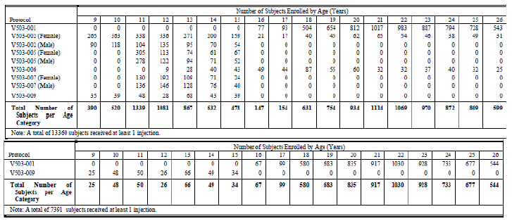

Post-marketing data
No post-marketing data is available for the 9vHPV vaccine.

Evaluator’s conclusions on safety
- The administration of 9vHPV vaccine is generally well tolerated in female subjects, 16 to 26 years of age and in female and male subjects, 9 to 15 years of age.
- The safety profile of the 9vHPV vaccine is generally comparable to that of the qHPV vaccine among subjects 9 to 26 years of age.
- Use of 9vHPV vaccine among subjects 9 to 26 years of age is associated with an increase in injection site adverse experiences compared with qHPV vaccine (probably around 88%). However, most of the injection site adverse experiences in subjects administered 9vHPV vaccine are mild or moderate in intensity.
- In general, across the 3 dose series of vaccine administration, injection site adverse experiences are reported in comparable frequencies following administration of a first, second, and third dose of 9vHPV vaccine; however, the frequencies of the adverse experiences of injection site erythema and injection site swelling were increased at each consecutive vaccine administration (similar to qHPV vaccine).
- Females, 16 to 26 years of age, and female and male subjects, 9 to 15 years of age, who begin a 3 dose regimen of 9vHPV vaccine rarely, discontinued vaccination due to an adverse experience.
- The adverse experience profile of 9vHPV vaccine is not impacted by racial background, ethnicity, or continent of origin, nor was it different in the different age groups analysed.
- Administration of 9vHPV vaccine is generally well tolerated in subjects, 9 to 26 years of age, who are seropositive or at HPV PCR-positive to at least one vaccine HPV type at the start of vaccination.
- Administration of 9vHPV vaccine is generally well tolerated among subjects who take immunosuppressive or anti-inflammatory or antipyretic medications within 15 days after any vaccination or subjects who use hormonal contraceptives at any time during the vaccination period.
- Administration of 9vHPV vaccine is generally well-tolerated in females, 12 to 26 years of age, who previously received a 3 dose regimen of qHPV vaccine but is associated with more injection site adverse experiences than in subjects’ naïve to HPV vaccination. Most of these injection site adverse experiences are mild in intensity.
- Administration of 9vHPV vaccine concomitantly with Menactra, Adacel and Repevax is generally well tolerated.
- Administration of 9vHPV vaccine does not adversely affect fertility or pregnancy outcomes in older adolescents and young women.

First round benefit-risk assessment

First round assessment of benefits
The benefits of 9vHPV vaccine in the proposed usage are:
- The 9vHPV vaccine is the prophylactic HPV vaccine that provides the broadest cancer coverage, with a potential to prevent approximately90% of all cervical cancers and the potential to prevent most (approximately80%) high grade cervical dysplasia, which could match or exceed the efficacy of most cervical cancer screening programs.
- The qHPV vaccine is known to be highly effective in preventing the development of HPV 6 , HPV 11, HPV 16 and HPV 18 related persistent infection, cervical, vulvar, vaginal, and anal disease, and genital warts. The data provided demonstrates that 9vHPV vaccine and qHPV vaccine perform similarly with respect to prevention of HPV 6, HPV 11, HPV 16 and HPV 18 related persistent infection and disease.
- Prophylactic administration of 9vHPV vaccine was highly effective compared with qHPV vaccine in preventing the development of HPV 31, HPV 31, HPV 45, HPV 52, and HPV 58 related persistent infection and cervical, vulvar, and vaginal disease. Thus, the 9vHPV vaccine can remove the risk of development of HPV 16, HPV 18, HPV 31, HPV 31, HPV 45, HPV 52, and HPV 58 related cervical, vulvar and vaginal cancers.
- Substantial reductions in the burden of HPV related vulvar, vaginal, and anal cancers are possible.
- Prophylactic administration of 9vHPV vaccine reduced the incidence of HPV 6 and HPV 11 related CIN (any grade) by 99.7%, HPV 16 and HPV 18 related CIN (any grade) by 96.9%, and HPV 31, HPV 31, HPV 45, HPV 52 and HPV 58 related CIN (any grade) by 97.7% (in the Per Protocol Efficacy (PPE) population).
- As > 90% of genital warts (and RRP) are caused by HPV 6 and HPV 11, universal vaccination with 9vHPV vaccine may nearly eradicate these lesions.
- HPV infection is common in males, causing genital warts, anal cancer, penile cancer, and oropharyngeal cancer. Men also transmit HPV to women or to other men. Gender-neutral vaccination can contribute to maximise effectiveness of HPV mass vaccination programs. The qHPV vaccine is known to be highly effective in preventing the development of HPV 6 , HPV 11, HPV 16 and HPV 18 related persistent infection, anal disease, and genital warts in males. The high prophylactic efficacy of 9vHPV vaccine with respect to Types 6, 11, 16, 18, 31, 33, 45, 52, and 58 in females 16 to 26 years of age, and the high immunogenicity of 9vHPV vaccine in males 9 to 15 years of age strongly suggest that administration of 9vHPV vaccine to males will reduce the incidence of persistent infection, anal disease, and genital warts caused by vaccine HPV Types.
- The qHPV vaccine provides continued protection against high grade cervical disease (CIN 2 or worse) caused by HPV 16 and 18 through at least 6 years following vaccination. There is a trend of continued protection up to 8 years following vaccination; however, at this time there are insufficient data in the latter 2 years of observation (Years 6 to 8). The 9vHPV vaccine induces protective efficacy through at least 4 years post Dose 3. It is anticipated that the 9vHPV vaccine will induce similar long term protection to that of the qHPV vaccine.
- The clinical efficacy of 9vHPV vaccine in males older than 15 years of age has not yet been shown, but can be reasonably assumed based on the totality of the data from the 9vHPV vaccine and qHPV vaccine clinical programs. A Phase III immunogenicity and safety study in males 16 to 26 years of age (Protocol V503-003) is ongoing.
- Use of 9vHPV vaccine did not impact overall pregnancy outcomes. Administration of 9vHPV vaccine to nursing mothers did not affect the health of the mother or the nursing child.

First round assessment of risks
The risks of 9vHPV vaccine in the proposed usage are:
- The removal of common HPV Types from their ecological niche after 9vHPV vaccination might result in an increase in disease caused by non-vaccine HPV Types. Although, in long term follow up studies of the qHPV vaccine, despite 100% prophylactic efficacy against disease related to vaccine types, administration of qHPV vaccine this has not been seen, up to at least 6 years post Dose 3.
- Administration of 9vHPV vaccine may uncover foci of undetected disease caused by less aggressive HPV Types that would have otherwise been removed during therapy for the most aggressive and/or common HPV Types (that is, the vaccine types) prior to implementation of vaccination. Administration of 9vHPV vaccine did not impact the incidence of cervical and genital disease caused by non-vaccine HPV Types
- The efficacy of 9vHPV vaccine in females older than 26 years of age has not been assessed, but can be reasonably extrapolated based on the totality of the data from the 9vHPV vaccine and qHPV vaccine clinical programs.
- The duration of efficacy beyond 4 years post Dose 3 remains to be evaluated. Study 001 will continue to accrue follow up until 2014. Scandinavian subjects in Study 001 (N = 4,400) will then be followed for 10 years through the Nordic Cancer Registry Programs (Protocol V503-021). In addition, subjects in Study 002 will be followed for ten years post Dose 3 to evaluate long-term effectiveness of the 9vHPV vaccine (Protocol V503-002-20).
- The 9vHPV vaccine had an acceptable safety profile in all groups tested. Injection site reactions are common, but usually mild. Vaccine related serious adverse experiences occurred in < 0.1% of subjects. Few subjects discontinued vaccination due to an adverse experience. There was no safety signal with respect to allergic reactions or other immune mediated diseases. The safety profiles of 9vHPV vaccine and qHPV vaccine were generally comparable.
- The frequency of injection site erythema, pain, and swelling was higher in subjects who received 9vHPV vaccine than in subjects who received qHPV vaccine. Most injection site adverse experiences were still mild or moderate in intensity, and the number of subjects reporting severe injection site adverse experiences was low in both vaccination groups. The dose of AAHS in 9vHPV vaccine is the same as that used in other licensed vaccines.
- The long-term safety of 9vHPV vaccine (> 4.5 years from first vaccination) has not been evaluated. This evaluation will be conducted in the Nordic Registry Cancer Program (Protocol V503-021).

First round assessment of benefit-risk balance
The benefit-risk balance of 9vHPV vaccine, given the proposed usage, is favourable.

First round recommendation regarding authorisation
The clinical development program for 9vHPV vaccine supports licensure of 9vHPV vaccine. There was strong evidence of efficacy in a population that was representative of the population for which 9vHPV vaccine is intended, with little observed increase in safety risk when compared with qHPV vaccine. The 9vHPV vaccine has demonstrated a favourable benefit/risk ratio for both female and male populations.

Clinical questions
There were no questions raised by the clinical evaluator.

V. Pharmacovigilance findings

Risk management plan
The sponsor submitted a Risk Management Plan (RMP) Version in EU-RMP format Version 1.0 (dated 9 January 2014, DLP 26 July 2013) and Australian Specific Annex (ASA) (dated May 2014) which was reviewed by the RMP evaluator.

Safety specification
The sponsor provided a summary of ongoing safety concerns which are shown at Table 5.

Table 5: Summary of ongoing safety concerns
Summary of ongoing safety concerns
Important identified risks | Exposure during pregnancy  Hypersensitivity (Type I)  Syncope with fall resulting in injury
Important potential risks | Viral type replacement  Guillain-Barre syndrome  Product confusion  Mixed regimen
Important missing information | Long term effectiveness and immunogenicity  Unanticipated safety signals

Pharmacovigilance plan
The sponsor proposes routine and additional pharmacovigilance activities. The additional pharmacovigilance activities are summarised in Table 6.
Table 6: Additional pharmacovigilance activities (planned or ongoing)
Additional activity | Assigned safety concern | Actions/outcome proposed | Estimated planned submission of final data
Pregnancy Registry (category 3).  Planned study.  No protocol available; concept sheet available. | Exposure to vaccine during pregnancy. | To monitor pregnancy outcomes in women exposed to 9vHPV vaccine during pregnancy. | 9 months after final data available
V503-021 Nordic Long-term Follow-Up Study (10-Year extension in subjects from V503-001) (category 3).  Planned study (extension of V503-001) – Registry study.  Protocol available. | Viral type replacement  Long-term Effectiveness/ Immunogenicity  Unanticipated safety signals | To monitor the long term safety of 9vHPVvaccine. | Q4, 2027  (first interim report: Q4, 2017)
V503-002-20 Post Dose 3 Follow-Up Study (10-Year Post Dose 3 Extension) (category 3).  Planned study (second extension of V503-002) – Clinical trial.  Protocol available. | Long-term Effectiveness/ Immunogenicity  Unanticipated safety signals | To evaluate longer-term immunogenicity and safety of V503 in subjects who were enrolled in Protocol V503-002 when they were between 9 and 15 years of age.
Post Authorization Safety Study (PASS) (category 3).  Planned study.  No protocol available; concept sheet available. | Unanticipated safety signals | To assess the general safety of V503 in the course of routine clinical practice.

Risk minimisation activities
The sponsor is only proposing routine risk minimisation activities, but not additional risk minimisation activities.

Reconciliation of issues outlined in the RMP report

Recommendation 1 in RMP evaluation report
The sponsor should provide missing study protocols or protocol synopses, as soon as they become available.
Sponsor’s response
As per the RMP evaluation report the protocols are missing for the Pregnancy Registry and the Post Authorization Safety Study (PASS).
Since the pregnancy registry is not a study, but rather, enhanced pharmacovigilance, the sponsor does not refer to a “study protocol”. The concept sheet for the pregnancy registry, which describes in detail the pregnancy registry processes, was included in the RMP in the initial submission. This document has been renamed “Surveillance Program Procedures for the Pregnancy Registry for Gardasil9 (Human Papillomavirus 9-Valent Vaccine, Recombinant)” and is considered the final version of the document.
Regarding the study protocol for the proposed PASS study, the final protocol is not yet available and will not be available until 31st December 2015. It is important to note, however, that this proposed study is being removed from the EU RMP at the request of the EMA.
RMP evaluator’s comment
From the response, it is unclear whether the sponsor proposes to supply the missing protocols, as requested. It is re-emphasised that the missing study protocols need to be supplied (including the PASS study protocol). The recommendation remains.

Recommendation 2 in RMP evaluation report
Syncope’ should be an important identified risk whether associated with a fall or otherwise), that is ‘Syncope with fall resulting in injury’ should be reclassified to ‘Syncope’.
Sponsor’s response
Regarding the inclusion of ‘syncope with fall resulting in injury’ as an identified risk, it should be considered that this is not a concern specific to Gardasil 9, but rather is related to the procedure of vaccination itself. While it is acknowledged that syncope is a possible risk for Gardasil 9, it is not considered to impact the benefit-risk for this vaccine; therefore its inclusion as an important safety concern is questionable. In accordance with the assessment of the RMP by European regulators, the sponsor has completely removed “syncope” from the European RMP as a safety risk.
RMP evaluator’s comment
It is acceptable in the context of this application for ‘Syncope with fall resulting in injury’ to remain an important identified risk.

Recommendation 3 in RMP evaluation report
‘Autoimmune disease’ should be added as an important potential risk and should particularly include demyelinating diseases.
Sponsor’s response
The sponsor does not agree that autoimmune disease should be added as an important potential risk in the RMP. Since autoimmune disease was not identified as a safety issue from the clinical program for 9vHPV vaccine, it is assumed that this request is based on the RMP for qHPV vaccine. Therefore, the rationale for not carrying over autoimmune disease to the 9vHPV vaccine RMP as a potential risk is described below.
The inclusion of autoimmune diseases (under conditions of special interest) as a potential risk in the RMP for qHPV vaccine was at the request of the EMA in 2008. These events have been monitored in the periodic safety update report (PSUR) as part of RMP commitments from 2008. However, based on ongoing post marketing surveillance of qHPV vaccine and the results of several large observational studies, conducted in the United States and Europe, no autoimmune safety signal has been identified. These studies have been published and include:
- Gardasil Protocol V501-031-02.
- Chao C, et al. (2012)
- Chao C, Jacobsen S. (2012)
- Grimaldi-Bensouda L et al (2013)
- Arnheim-Dahlstrom et al. (2013)
The above studies have been very large in nature and some have specifically monitored news on of autoimmune disorders among other events. They have consistently showed no association between vaccination with Gardasil and the occurrence of autoimmune diseases. In conclusion, due to the large scientific evidence acquired from epidemiological cohort studies in different countries in the last 6 years, autoimmune disorders is not considered an identified or potential risk for Gardasil 9 and therefore the sponsor proposes to monitor its occurrence with routine pharmacovigilance and will report in future PSURs if and when new information that changes the benefit risk profile of the vaccine becomes available.
Additional recent publications of studies on autoimmune disease and vaccination from the literature include:
- Langer-Gould et al. (2014)
- Scheller, NM et al (2015)
RMP evaluator’s comment
This is considered acceptable in the context of this application. However, this does not constitute a regulatory precedent.

Recommendation 4 in RMP evaluation report
Off-label use’ should be added as an important potential risk.
Sponsor’s response
Regarding the inclusion of ‘off label use’ as a potential risk, it should be considered that this is not a concern specific to Gardasil 9, but rather is related to the routine use of any medicinal product. This issue is addressed in the RMP in Section SVI.5 Potential for Overdose in Module SVI Additional EU requirements for the Safety Specifications. While it is acknowledged that off label use is a possible risk for Gardasil 9, it is not considered to impact the benefit-risk for this vaccine.
RMP evaluator’s comment
The section ‘potential for harm from overdose’ contains no information on off-label use. However, the other information given in the ‘Additional EU requirements’ section is adequate. However, this does not constitute a regulatory precedent.

Recommendation 5 in RMP evaluation report
Long-term safety’ should be added as missing information, as there is not sufficient long-term data available with regard to the 9 valent formulation.
Sponsor’s response
Although long-term safety is not listed as missing information in the EU RMP, there are two long term studies being conducted which will collect safety data as well. These studies are:
- V503-021 Nordic Long term Follow-up Study (10 year extension from subjects in V503-001), and
- V503-002-20 Post dose 3 Follow-up Study (10 year post dose 3 extension).
Any important safety information collected as part of these studies will be included in PSURs.
RMP evaluator’s comment
Given the sponsor has recognised that ‘Long-term safety’ is a safety concern to the extent that the sponsor is conducting 2 studies to address this issue, the sponsor will have no objection to include this item as missing information. The recommendation remains.
‘Long-term safety’ should be added as missing information in the ASA.

Recommendation 6 in RMP evaluation report
‘Females over 26 years’ should be added as missing information.
Sponsor’s response
The efficacy of 9vHPV vaccine in females older than 26 years of age can be reasonably extrapolated based on the totality of the data from the 9vHPV vaccine and qHPV vaccine clinical programs. This conclusion is supported by the observations that:
- the 9vHPV vaccine and qHPV vaccine behave similarly in several key representative populations (females aged 16 to 26 years, females aged 9 to 15 years and males aged 9 to 15 years), and
- prior demonstration that the qHPV vaccine is highly efficacious and generally well tolerated in females 24 to 45 years of age; thereby providing confidence that the 9vHPV vaccine will confer prophylactic protection for women over 26 years old and be well tolerated in that population.
RMP evaluator’s comment
This is appears reasonable in the context of this application. However, this does not constitute a regulatory precedent.

Recommendation 7 in RMP evaluation report
Males over 16 years’ should be added as missing information.
Sponsor’s response
The company proposes that the Clinical Study Report (CSR) from Protocol V503-003, completed since the marketing authorization application was submitted, provides data on males from 16 to 26 years of age. Therefore, ‘males over 16 years’ will not be added as missing information in the RMP. A summary of the Protocol V503-003 data in this population is presented below in Table 7.
Protocol 003 was a Phase III, open label, international, multicentre, clinical study to evaluate the immunogenicity and tolerability of the 9vHPV vaccine in healthy young heterosexual men (16 to 26 years of age) in comparison to healthy young women (16 to 26 years of age).
Approximately 1,100 healthy young heterosexual males (HM) (16 to 26 years of age) and approximately 1,100 healthy young women (16 to 26 years of age) were to be enrolled. In addition, approximately 300 men having sex with men (MSM) subjects (16 to 26 years of age) were to be enrolled and evaluated separately.
Approximately 10 to 20% of all subjects were expected to be 16 to 17 years old. Serum samples were obtained at Day 1 and Month 7 from all subjects for anti-HPV 6, anti-HPV 11, anti-HPV 16, anti-HPV 18, anti-HPV 31, anti-HPV 33, anti-HPV 45, anti-HPV 52, and anti-HPV 58 testing. The primary and secondary immunogenicity analyses were performed after completion of the study.
An important goal of the study was to evaluate the safety/tolerability of the 9vHPV vaccine in the study population. Subjects were monitored for safety and tolerability from Day 1 until Month 12 (approximately 6 months after the third vaccination).

Table 7: Summary of Protocol V503-003
Summary of Protocol V503-003
Endpoints and definitions | Primary endpoint | The primary immunogenicity endpoints for evaluating antibody response to 9vHPV vaccine are geometric mean titres (GMTs) to HPV 6, 11, 16, 18, 31, 33, 45, 52, and 58 at Week 4 post Dose 3.
Endpoints and definitions | Secondary endpoint | The secondary endpoints for evaluating antibody response to 9-valent HPV L1 VLP are the percentages of subjects who seroconvert for each HPV type (6, 11, 16, 18, 31, 33, 45, 52, and 58) by Week 4 Post Dose 3. (Seroconversion is defined as changing serostatus from seronegative at baseline to seropositive by Week 4 Post Dose 3. A subject with a cLIA titre at or above the serostatus cut-off for a given HPV type is considered seropositive for that type.)
Database lock | 16-October 2014 | Trial status  31-October-2012 (first subject first visit) to 04-August-2014 (last subject last visit). Collection of safety data is continuing for subjects whose vaccination schedule was delayed (e.g. due to pregnancy).
Summary of analysis: | All analyses for safety and immunogenicity were performed according to the protocol.  Administration of a 3-dose regimen of the 9vHPV vaccine to HM between the ages of 16 and 26 years who are seronegative to the relevant HPV type(s) at enrolment results in the development of:  Anti-HPV 6, anti-HPV 11, anti-HPV 16, anti-HPV 18, anti- HPV 31, anti-HPV 33, anti-HPV 45, anti-HPV 52, and anti- HPV 58 GMTs and seroconversion rates at 4 weeks post-dose 3 in HM that are non-inferior to those observed in 16- to 26-year-old women, thereby supporting the bridging of efficacy findings in 16- to 26-year-old women to 16- to 26-year-old HM.  A summary of the safety analyses and findings are presented in the response to Question 13
The synopsis for the CSR for Protocol 003 ‘A Phase III Clinical Trial to Study the Tolerability and Immunogenicity of V503, a Multivalent Human Papillomavirus (HPV) L1 Virus-Like Particle (VLP) Vaccine, in 16 to 26 Year Old Men and 16 to 26 Year Old Women’ was provided.
RMP evaluator’s comment
This is considered acceptable in the context of this application. However, this does not constitute a regulatory precedent.

Recommendation 8 in RMP evaluation report
Paediatric patients under the age of 9 years should be added as missing information.
Sponsor’s response
Data on paediatric patients under 9 years of age is not a part of missing information in the EU RMP as the indication for the 9vHPV vaccine does not include patients less than 9 years of age. If inadvertent use in this population is reported to the company, the data will be reviewed according to routine pharmacovigilance procedures.
RMP evaluator’s comment
This is considered acceptable in the context of this application. However, this does not constitute a regulatory precedent.

Recommendation 9 in RMP evaluation report
Any safety related data generated from the 4 valent formulation of Gardasil should be used to inform the risk management plan for Gardasil 9.
Sponsor’s response
The company utilised the RMP for the qHPV vaccine as the starting point in discussions focused on drafting the RMP for the 9v HPV vaccine. Each identified and potential risk as well as missing information included in the qHPV vaccine RMP was considered and discussed in light of newly available safety information from epidemiologic post marketing studies, by the Risk Management Safety Team (RMST) for HPV Vaccines, in terms of the relevance for inclusion in the 9vHPV vaccine RMP.
Additionally, the data from the 9vHPV vaccine clinical trial program were reviewed for relevance in informing the further development of the RMP for 9vHPV vaccine.
Annex 12 of the RMP included a tabular comparison of Gardasil / Silgard RMP to Gardasil 9 RMP with the rationale for inclusion or exclusion of safety issues from the RMP for the 9v HPV vaccine.
RMP evaluator’s comment
This is considered acceptable in the context of this application. However, this does not constitute a regulatory precedent.

Recommendation 10 in RMP evaluation report
The sponsor is already conducting additional pharmacovigilance activities for ‘Long term Effectiveness/Immunogenicity’. ‘Long term safety’ should be assigned to these activities.
Sponsor’s response
Although long-term safety is not listed as missing information in the EU RMP, there are two long term studies being conducted which will collect safety data as well. These studies are:
- V503-021 Nordic long term follow up Study (10 year extension from subjects in V503-001) and
- V503-002-20 Post Dose 3 Follow up Study (10 year post Dose 3 extension).
Any important safety information collected as part of these studies will be included in PSURs.
RMP evaluator’s comment
Given the sponsor has recognised the ‘Long term safety’ is a safety concern to the extent that the sponsor is conducting 2 studies to address this issue, the sponsor will have no objection to include this item as missing information. The recommendation remains.

Recommendation 11 in RMP evaluation report
The sponsor should provide a summary with regard to the post-market experience with autoimmune disease associated with Gardasil.
Sponsor’s response
From initial authorization of the qHPV vaccine, the company has closely monitored events of autoimmune disease reported as temporally associated with the administration of Gardasil as part of regulatory commitments. These events have been part of the routine aggregate safety surveillance processes conducted for each product at a minimum of every 6 months for the initial three years and then annually thereafter. For Gardasil, these aggregate reviews which specifically include events of autoimmune disease have continued on a 6 monthly basis from initial authorization through the most recent review conducted in September 2014. Additionally, the company has included reviews of autoimmune events of interest in the PSURs for Gardasil since authorization in June 2006 and through its most recent PSUR submitted in August 2014.
As a part of the routine monitoring processes described above, the adverse events of Guillain-Barre syndrome (GBS) and acute disseminated encephalomyelitis (ADEM) were spontaneously reported during post approval use of qHPV vaccine and were added to the Company Core Data Sheet (CCDS) for qHPV vaccine in 2007 and 2009 respectively. Because these experiences were reported voluntarily from a population of uncertain size, it is not possible to reliably estimate their frequency or to establish a causal relationship to vaccine exposure. The cause of GBS remains unknown, but may involve a nonspecific immune stimulus such as vaccination or infection. GBS was added to the CCDS in order to alert health care providers to these reports. The term acute disseminated encephalomyelitis was added to the post-marketing AE section of the CCDS due to the seriousness of the disease.
At the time of GBS being added to the CCDS and the summary of product characteristics (SPC), it was also added to the RMP as a potential risk at the request of the EMA. ADEM was included under the potential risk of “Conditions of Special Interest” at the time that the RMP was updated to the new template format in 2009. Note that the Medical Dictionary for Regulatory Activities (MedDRA) Lower level term of “acute disseminated encephalomyelitis” coded to the MedDRA Preferred Term of leukoencephalomyelitis at that time.
As discussed above, the results of several large observational studies, conducted in the USA and Europe, have further informed the safety profile of qHPV vaccine and no autoimmune safety signal has been identified. The final data from these studies became available in 2010 through 2014.
It is of note that by request of the EMA, as part of the post filing review process of the 9vHPV vaccine in Europe, the EU RMP has been further edited to remove the potential risk of GBS.
RMP evaluator’s comment
The information provided has been noted.

Recommendation 12 in RMP evaluation report
The sponsor should conduct an active surveillance program or another suitable additional pharmacovigilance activity, or assign an existing activity, that particularly monitors for autoimmune disease occurrences after vaccination with Gardasil 9.
Sponsor’s response
The company will monitor these events as part of the routine aggregate safety surveillance processes conducted for each product at a minimum of every 6 months for the initial three years and then annually thereafter. If a safety signal for autoimmune disease is identified by the company, it will be included in Sections 15 (overview of signals) and 16 (signal and risk evaluation) of the PSURs.
RMP evaluator’s comment
This is considered acceptable in the context of this application. However, this does not constitute a regulatory precedent.

Recommendation 13 in RMP evaluation report
It appears that there is no study safety data available on females over 26 years and males over 16 years. The sponsor should propose an appropriate additional pharmacovigilance activity or assign an existing activity to evaluate the safety in these populations further.
Sponsor’s response
The company proposes that the CSR from Protocol V503-003 provides safety data on males from 16 to 26 years of age. Please refer to the synopsis for the CSR for Protocol 003 ‘A Phase III clinical trial to study the tolerability and immunogenicity of V503, a multivalent human papillomavirus (HPV) L1 virus like particle (VLP) vaccine, in 16 to 26 year old men and 16 to 26 year old women’ was provided. A summary of the Protocol V503-003 safety data in this population is presented below.
Protocol V503-003 was described above in the response to Recommendation 8 above. A review of the safety analysis is presented below in Table 8.
Table 8: Safety data for Protocol V503-003
Safety data for Protocol V503-003
Treatments groups | 16-26 year-old males (HM) | 1,106 Subjects Randomised
 | 16-26 year-old males (MSM) | 313 Subjects Randomised
 | 16-26 year-old females | 1,101 Subjects Randomised
Analysis population and time point description | All subjects who received at least 1 study vaccination and had follow-up data were included in the safety summaries.  The following measures were collected from each study subject to assess safety: 1) temperatures (within 5 days following any vaccination); 2) all adverse events (within 14 days following any vaccination); 3) all serious adverse experiences that occurred from Day 1 through 180 days following the last vaccination; 4) all serious adverse experiences that resulted in death or were determined to be related to the study vaccine or study procedure that occurred at any time during the study. In addition to the above safety endpoints, this CSR summarises: (1) new medical conditions; (2) serious adverse experiences observed during pregnancy and lactation; (3) pregnancy outcomes; and (4) serious adverse experiences in infants (of study subjects) potentially exposed to test product.
Analysis description | All subjects who received at least 1 study vaccination and had follow-up data were included in the safety summaries. Adverse experiences were summarised descriptively as frequencies and percentages by vaccination group and type of adverse experience, by vaccination visit and across all vaccination visits. Elevated temperatures (≥100° F, ≥37.8° C, oral or oral equivalent) within 5 days following each vaccination were summarised in a similar manner. In addition, risk differences and associated 95% confidence intervals were computed comparing the groups across all vaccination visits with respect to injection site adverse experiences occurring in ≥1% of subjects in any group, specific systemic adverse events occurring in ≥1% of subjects in any group, severe injection site adverse event, serious adverse events and elevated temperatures. p-values were computed only for those adverse experiences that were prompted for on the VRC (pain/tenderness/soreness, swelling, and redness) and elevated temperatures.  The probability of observing at least 1 serious adverse experience in this study depends on the number of subjects enrolled and the incidence rate of serious adverse experiences in the general population. If no serious adverse experiences are observed among 1100 women 16 to 26 years of age, this study will provide 95% confidence that the true incidence rate for serious adverse experiences for the group is <0.3%. Likewise, if no serious adverse experiences are observed among 1400 men 16 to 26 years of age, this study will provide 95% confidence that the true incidence rate for serious adverse experiences for the group is <0.3%.
No study is currently being conducted for adult women over 26 years old. The efficacy of 9vHPV vaccine in females older than 26 years of age can be reasonably extrapolated based on the totality of the data from the 9vHPV vaccine and qHPV vaccine clinical programs. This conclusion is supported by the observations that (a) the 9vHPV vaccine and qHPV vaccine behave similarly in several key representative populations (females aged 16 to 26 years, females aged 9 to 15 years and males aged 9 to 15 years), and (b) prior demonstration that the qHPV vaccine is highly efficacious and generally well tolerated in females 24 to 45 years of age; thereby providing confidence that the 9vHPV vaccine will confer prophylactic protection for women over 26 years old and be well tolerated in that population.
RMP evaluator’s comment
This is considered acceptable in the context of this application. However, this does not constitute a regulatory precedent. Notwithstanding the above, the full study report should be provided.

Recommendation 14 in RMP evaluation report
The sponsor should conduct appropriate educational activities in Australia to educate health professionals about the indications, contraindications, potential risks (including autoimmune disease), and the lack of interchangeability between HPV vaccines. The sponsor should make these materials available to the TGA.
Sponsor’s response
Appropriate educational materials will be provided to educate Australian health professionals about the indications, contraindications and potential risks of Gardasil 9. (The interchangeability of vaccines is addressed in response to Recommendation 16, below.)
These materials will be developed following registration and prior to the anticipated launch of the vaccine in the Australian market. Once prepared, these materials can be made available to the TGA upon request.
RMP evaluator’s comment
The Round 1 RMP Evaluation Report already contained a request for the materials to be made available. Consequently, the sponsor’s statement that the materials can be made available to the TGA upon request is unclear to the RMP Evaluator. It is re-emphasised that the materials in question need to be provided to the TGA. The recommendation remains.

Recommendation 15 in RMP evaluation report
The sponsor should provide a rationale for the statement in the PI that a 12 month period is the appropriate minimum time between Gardasil vaccination courses.
Sponsor’s response
The recommendation for a 12 month period between vaccination courses cited in the PI is based on the procedures used in the V503-006 study.
The purpose of the V503-006 study was to evaluate tolerability and immunogenicity of the 9vHPV vaccine when administered to females, 12 to 26 years of age, who had previously received a 3 dose regimen of Gardasil. For enrolment into the V503-006 study, the inclusion criteria specified that subjects had to have received a 3 dose regimen of marketed Gardasil within a 1 year period (which is in alignment with the Gardasil label) and that the 3rd dose must have been administered at least 1 year prior to Day 1 in the V503-006 study. One year was required before starting the V503-006 study to allow an adequate amount of time for peak antibody titres following the last immunization with Gardasil to decrease to plateau levels (as observed in the Gardasil clinical program).
Based on data from the Gardasil clinical program, peak antibody titres are attained approximately one month following the third vaccination with Gardasil, and subsequently decrease to plateau approximately 12 months following the third vaccination; most of the decrease (approximately 75%) occurs within 6 months after the third vaccination. Therefore, a minimum interval of 12 months (1 year) was selected as sufficient time to consider immunization with 9vHPV vaccine as a new vaccination regimen separate from the Gardasil regimen.
RMP evaluator’s comment
This is considered acceptable in the context of this application for RMP purposes subject to approval by the Delegate.

Recommendation 16 in RMP evaluation report
In the ‘Dosage and Administration’ section, the PI should contain a statement that Gardasil 9 and other HPV vaccines must not be used interchangeably (or a statement to that effect).
Sponsor’s response
The sponsor believes addition of the sentence “Gardasil 9 and other HPV vaccines must not be used interchangeably” is not appropriate for the following reasons:
- Data from the Gardasil 9 clinical program do not warrant such a categorical statement. Specifically, a clinical study was conducted to assess safety and immunogenicity of Gardasil 9 administered in prior recipients of a 3 dose regimen of Gardasil. TGA’s clinical evaluator provided the following assessment of the study:
“Administration of 9vHPV vaccine is generally well tolerated in females, 12 to 26 years of age, who previously received a 3 dose regimen of qHPV vaccine but is associated with more injection site adverse experiences than in subjects’ naïve to HPV vaccination. Most of these injection site adverse experiences are mild in intensity.”
“Administration of a 3 dose regimen of 9vHPV vaccine in females, 12 to 26 years of age, who were previously administered a 3 dose regimen of qHPV vaccine, results in the following: (1) high seroconversion rates with respect to HPV 31, 33, 45, 52, and 58; (2) anti-HPV 6, anti-HPV 11, anti-HPV 16, and anti-HPV-18 responses that are higher than anti-HPV 6, anti-HPV 11, anti-HPV 16, and anti-HPV-18 responses following administration of a 3 dose regimen of 9vHPV vaccine in females, 12 to 26 years of age, naïve to prior HPV vaccination.”
Overall, it appears that no concern has been identified with using the two vaccines (Gardasil and Gardasil 9) sequentially in the same individuals. Specifically, the two vaccines can be used sequentially in the same individuals without safety concern, and the antibody response to the HPV Types addressed by Gardasil is maintained.
- Such a categorical statement may be detrimental during the transition period from Gardasil to Gardasil 9. The company’s goal is to effect promptly the transition from Gardasil to Gardasil 9 (that is, allowing sufficient time for individuals who started vaccination with Gardasil to complete the vaccination course) to minimise the risk of product confusion and operational complexities (such as having to store two vaccines). With a strong statement that the two vaccines cannot be used interchangeably, people may decide to delay vaccination which is not a preferred option. People should be offered vaccination when they need it, rather than based on product transition.
- Based on this statement, individuals who do not remember whether or not they have received one or more vaccination with Gardasil (for example, inadequate medical records) could be denied vaccination with Gardasil 9, which may leave them unprotected against HPV disease.
- This statement would be inconsistent with the interchangeability statement for HPV vaccines as seen in the Australian Immunisation Handbook (AIH). The AIH provides guidance and recommendations on the interchangeability of HPV vaccines [page 237 of 10th Edition]. It is anticipated this will be updated to reference Gardasil 9 before the vaccine becomes available in Australia. Furthermore, product packaging will be clearly differentiated between Gardasil and Gardasil 9 and educational materials will be provided to healthcare providers to minimise administration of mixed regimens. The statement in the AIH is as follows:
“There are currently no clinical data available on the interchangeability of the two HPV vaccines. However, from first principles, acceptable antibody levels and protection against HPV 16 and 18 (the Types that are shared by both these vaccines and that are the dominant causes of cervical cancer) would be expected following a combination schedule.
It is recommended that an HPV vaccination course commenced with one vaccine should, wherever possible, be completed with that vaccine and according to its recommended schedule.
Where the course includes a combination of the two HPV vaccines, either inadvertently or because of an adverse event following one vaccine, the person is considered to be fully immunised against HPV 16 and 18 disease if a total of 3 doses of HPV vaccine have been given, provided that the minimum interval requirements between the doses are satisfied.
Every effort should be made to complete a 3 dose schedule for effective protection against disease due to each of the vaccine HPV Types.”
Based on these considerations, the sponsor is proposing to not include “Gardasil 9 and other HPV vaccines must not be used interchangeably” from the Gardasil 9 PI.
RMP evaluator’s comment
This is considered acceptable in the context of this application for RMP purposes subject to approval by the Delegate.
The Advisory Committee on the Safety of Vaccines (ACSOV) provided the following advice:
The committee agreed that clear communications and educational tools should be sufficient when Gardasil 9 was introduced to minimise (but possibly not eliminate) regimens that mixed Gardasil and Gardasil 9. If Gardasil is to be replaced in the marketplace by Gardasil 9, any mixing of vaccine products would be a temporary issue only during the phase out of the original Gardasil.
However, the Delegate may wish to consider an appropriate PI documentation of the efficacy information regarding the strains of Gardasil 9 additional to the strains in the other HPV vaccine used in a particular course.

Recommendation 17 in RMP evaluation report
In the ‘Overdosage’ section, the PI should include the Poisons Information telephone number.
Sponsor’s response
This has been addressed in the enclosed PI with the addition of the sentence:
“For information on the management of overdose, contact the Poison Information Centre on 131126 (Australia) or 0800 764 766 (New Zealand).”
RMP evaluator’s comment
This is considered acceptable in the context of this application for RMP purposes subject to approval by the Delegate.

Recommendation 18 in RMP evaluation report
In regard to the proposed routine risk minimisation activities, it is recommended to the Delegate that the draft consumer medicine information document be revised to accommodate the changes made to the product information document.
Sponsor’s response
The sponsor accepts this recommendation in principle. The only amendment to the PI recommended in the RMP Evaluation Report that is relevant to the Consumer Medicine Information (CMI) is addition of the Poisons Information telephone number. However, the Medicines Australia Guidelines for Core CMI text do not recommend including an Overdosage Statement and Poisons Information telephone number (text below) for either adult injectable and paediatric injectable vaccine products.
“If you or your child takes too much (overdose) Immediately telephone your doctor or the Poisons Information Centre (telephone 13 11 26) for advice, or go to accident and emergency at the nearest hospital, if you think that you or anyone else may have taken too much Gardasil 9. Do this even if there are no signs of discomfort or poisoning. You may need urgent medical attention.”
The draft CMI was prepared in accordance with the Medicines Australia guidelines for adult injectable and paediatric injectable vaccine products. The vaccine is administered by healthcare professionals. The risk of overdosage is low, and there have been no reports of administration of higher than recommended doses of Gardasil 9, as stated in the PI. For these reasons, the sponsor contends it is inappropriate to add the Poisons Information telephone number to the CMI of Gardasil 9.
RMP evaluator’s comment
This is considered acceptable in the context of this application for RMP purposes subject to approval by the Delegate.

Summary of recommendations

Summary of outstanding issues

Recommendations in regard to safety concerns
- The sponsor should provide missing study protocols or protocol synopses, as soon as they become available (including the PASS study protocol).
- Long-term safety’ should be added as missing information in the ASA.

Recommendations in regard to additional pharmacovigilance activities
- Studies V503-021 and V503-002-20 should be added to the ASA and assigned to the safety concern of ‘long-term safety’.

Recommendations in regard to risk minimisation activities
- The sponsor should conduct appropriate educational activities in Australia to educate health professionals about the indications, contraindications, potential risks (including autoimmune disease), and the lack of interchangeability between HPV vaccines. The sponsor should make these materials available to the TGA.

Advice from the Advisory Committee on the Safety of Vaccines (ACSOV)
- Can the committee comment on the need to conduct additional pharmacovigilance activities, in particular an active surveillance program to monitor the potential risk of autoimmune disease further?
The committee noted that the sponsor proposed routine pharmacovigilance activities for this new medicine.
The committee considered whether there was a signal regarding autoimmune disease for the current qHPV vaccine, as this may be relevant to any increased reactogenicity to the 9vHPV vaccine.
The committee noted that the conclusions in the Slade et al paper based on the Proportional Reporting Ratio, and the Gee et al paper based on the relative risk, for Guillain-Barre syndrome following immunisation with the quadrivalent HPV vaccine was that the incidence of the syndrome did not meet the criteria for signal detection. Similarly, the Arnheim-Dahlström et al paper did not report raised incidences of neurological adverse events following the quadrivalent HPV vaccine. Conversely, Souayah et al had found up to a 10 times greater risk of Guillain-Barre syndrome within six weeks of Gardasil vaccination. However, the committee commented that cases with onset within three days of vaccination did not appear biologically plausible.
The committee advised that the TGA could consider how best to monitor patients with Guillain-Barre syndrome so that the tracing of vaccine related cases, if any, could be undertaken. Other autoimmune diseases, with milder symptoms, would be more difficult to trace.
Overall, the committee did not see that there was a signal regarding autoimmune disease for the current quadrivalent HPV vaccine. There was a theoretical concern, but no data, that the change from the current qHPV vaccine to the 9vHPV vaccine may be associated with an increase in autoimmune diseases.
The committee advised that ‘other autoimmune disease’ should be added to ‘potential risks’ in the pharmacovigilance activities. The committee noted that this status ensured that the PSUR would report on cases of autoimmune disease, while it was at the discretion of the TGA as to whether ‘autoimmune diseases’ would be included as a ‘Precaution’ in the PI document.
- Can the committee comment on the need for additional risk minimisation activities, namely educational materials to mitigate the potential risk of mixing HPV vaccine products?
Based on photos of the current Gardasil and proposed Gardasil 9 medicines, the committee considered that the products were adequately differentiated, although ‘Gardasil 4’ as a new name for the current medicine may be helpful to minimise any confusion.
Only 21 subjects had inadvertently been administered a combination of Gardasil and Gardasil 9 during clinical trials. No comment could be made on whether there were additional or different safety risks with this unplanned combination treatment.
The committee agreed that clear communications and educational tools should be sufficient when Gardasil 9 was introduced to minimise (but possibly not eliminate) regimens that mixed Gardasil and Gardasil 9. If Gardasil is to be replaced in the marketplace by Gardasil 9, any mixing of vaccine products would be a temporary issue only during the phase out of the original Gardasil.
As per the ‘Horvath Review’, the committee was advised that a vaccine safety plan would be established for Gardasil 9, if the vaccine was added to the National Immunisation Program (NIP). The Office of Health Protection (OHP) will lead this action, with support from the TGA and states and territories, and in consultation with key stakeholders. The OHP indicated that if any mixing of HPV vaccine products was to occur during the three dose regime, this would likely be limited to the private market. The schools based program would ensure that the same HPV vaccine was used for all doses in the regime, and Gardasil 9 would be introduced only at the beginning of a school year.

Suggested wording for conditions of registration
RMP
Any changes to which the sponsor agreed become part of the risk management system, whether they are included in the currently available version of the RMP document, or not included, inadvertently or otherwise.
The suggested wording is:
Implement Risk Management Plan Version in EU-RMP format Version 1.0 (dated 9 January 2014, DLP 26 July 2013) and Australian Specific Annex (dated May 2014), and any future updates as agreed with the TGA as a condition of registration.
Design and implement appropriate educational activities in Australia to the satisfaction of the TGA PMSB to educate health professionals about the indications, contraindications, potential risks (including autoimmune disease), and the lack of interchangeability between HPV vaccines. The sponsor should make these materials available to the TGA for consideration prior to the supply of the vaccine.

VI. Overall conclusion and risk/benefit assessment
The submission was summarised in the following Delegate’s overview and recommendations.

Quality
Each of the nine recombinant L1 proteins is produced by separate fermentation in recombinant strain of yeast Saccharomyces cerevisiae and self-assembled into VLPs. The manufacturing process for 9vHPV vaccine is similar to that of qHPV vaccine. It is a sterile product. There are no outstanding issues of manufacture or quality control including viral safety. Provision of further stability data has been negotiated between the quality evaluation area of TGA and the sponsor. The submission was not referred to the Pharmaceutical Subcommittee (PSC). The quality evaluators recommend approval. Batch release testing will be applicable as one of the conditions of registration.

Nonclinical
Overall there are no nonclinical objections to the registration. The sponsor has proposed pregnancy Category B2 based on rat studies. The toxicology evaluator considers this ‘precautionary’ and proposes Category B1. The delegate does not support this and recommends B2 category in line with the current approval of Gardasil.

Clinical
There were no pharmacokinetic or Pharmacodynamic data in this submission. A total of 7 clinical studies support the proposed use of 9vHPV vaccine as shown in Table 9.
Table 9: Clinical studies supporting the proposed use of 9vHPV vaccine
Study | Population study vaccine |  |  | Comment
001  (Part B) | Females (16 to 26 Y)  (‘Core Efficacy Population’) |  | Females (16 to 26 Y)  (‘Core Efficacy Population’) | Randomised (R)  Double blind (DB)
001  (Part B) | 9vHPV | versus | qHPV | Randomised (R)  Double blind (DB)
002 | Girls and Boys (9 to 15 Y) | versus | Females (16 to 26 Y) | -
002 | 9vHPV |  | 9vHPV | -
002/001 | Girls (9 to 15 Y) |  | Females (16 to 26 Y) | -
002/001 | 9vHPV |  | qHPV | -
009 | Girls (9 to 15 Y) |  | Girls (9 to 15 Y) | R, DB
009 | 9vHPV | versus | qHPV | R, DB
003 | Males (16 to 26 Y) | versus | Females (16 to 26 Y) | -
003 | 9vHPV |  | 9vHPV | -
006 | Females (12 to 26 Y) |  | Females (12 to 26 Y) | R, DB, previously qHPV vaccinated
006 | 9vHPV | versus | Placebo | R, DB, previously qHPV vaccinated
005 | Children (11 to 15 Y) |  | Children (11 to 15 Y) | R, Open label (OL)
005 | 9vHPV/MANECTRA/ADACEL | versus | 9vHPV → MANECTRA/ADACEL | R, Open label (OL)
007 | Children (11 to 15 Y) |  | Children (11 to 15 Y) | R, OL
007 | 9vHPV/REPEVAX | versus | 9vHPV → REPEVAX | R, OL
All studies were controlled and used a standard 3 dose vaccination schedule (Day 1, Month 2, Month 6) for HPV vaccines with assessment of immunogenicity at Month 7 that is, one month after Dose 3. All studies were carried out in baseline HPV vaccine naïve population except Study 006. The male and female preadolescent/adolescent participants 9 to 15 years of age were pre-coitarche status. The clinical evaluator supports approval. Please see the clinical evaluation report (Attachment 2) for details. A brief discussion of the studies follows:

Study 001
This is the pivotal study supporting this submission and is described as Phase II/III adaptive design with progression from Phase II dose selection to Phase III efficacy assessment within the study.

Part A

Dose selection
Three formulations of 9vHPV vaccine were tested (low, mid and high dose) against qHPV vaccine. All formulations contained 500 µg aluminium adjuvant. The antigen amount of the current HPV Types 6/11/16/18 was same in the low dose and higher in the mid dose formulation compared qHPV vaccine with resulting antigen adjuvant ratio being higher in the low dose and similar in the mid dose formulation compared to qHPV vaccine. The antigen amount of all 9 antigens was higher in the high dose formulation compared to the mid dose formulation. The dose selection was based on immunogenicity for the 4 current HPV Types as follows shown in Table 10.
Table 10: Summary of Anti-HPV cLIA geometric mean titres by vaccination group (per protocol immunogenicity population, dose ranging sub-study)
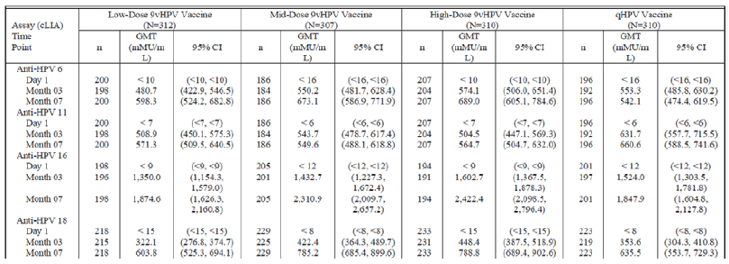
The mid dose formulation was selected based on non-inferior immune response versus qHPV vaccine at Month 7 as follows (see Table 11).
Table 11: Statistical analysis of non-inferiority comparing month 7 HPV cLIA geometric mean titres (HPV-Types 6,11,16 and 18) between subjects who received the selected dose formulation of 9vHPV vaccine and subjects who received qHPV vaccine (per protocol immunogenicity population; dose ranging sub study)
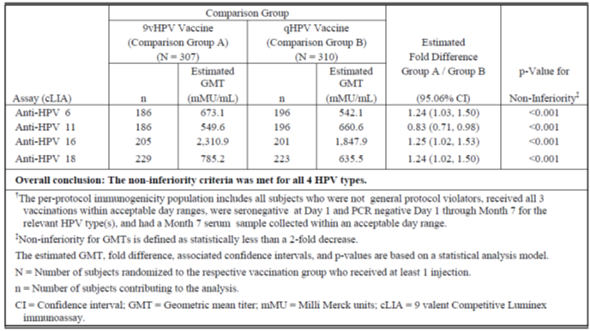
The selected mid dose formulation was subsequently used in all studies of 9vHPV vaccine including the assessment of vaccine efficacy in Part B of this study.

Part B
Vaccine efficacy was assessed in the ‘Core Efficacy Population’ that is females 16 to 26 years of age for 9vHPV vaccine versus qHPV vaccine with respect to the 5 new HPV Types 31/33/45/52/58 after standard 3 dose vaccination. For the primary variable (high grade cervical, vulvar and vaginal disease), the cumulative data up to 54 months are shown in the Figure 1 below using per protocol analysis.
Figure 1: Time to HPV 31/33/45/52/58 related CIN 2/1, adenocarcinoma in situ (AIS) cervical cancer, VIN 2/3 VaIN 2/3, vulvar cancer and vaginal cancer (per protocol efficacy analysis population)
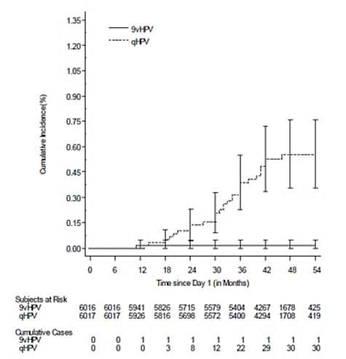
Further results were as shown in Table 12.
Table 12: Further results from Part B of Study 001
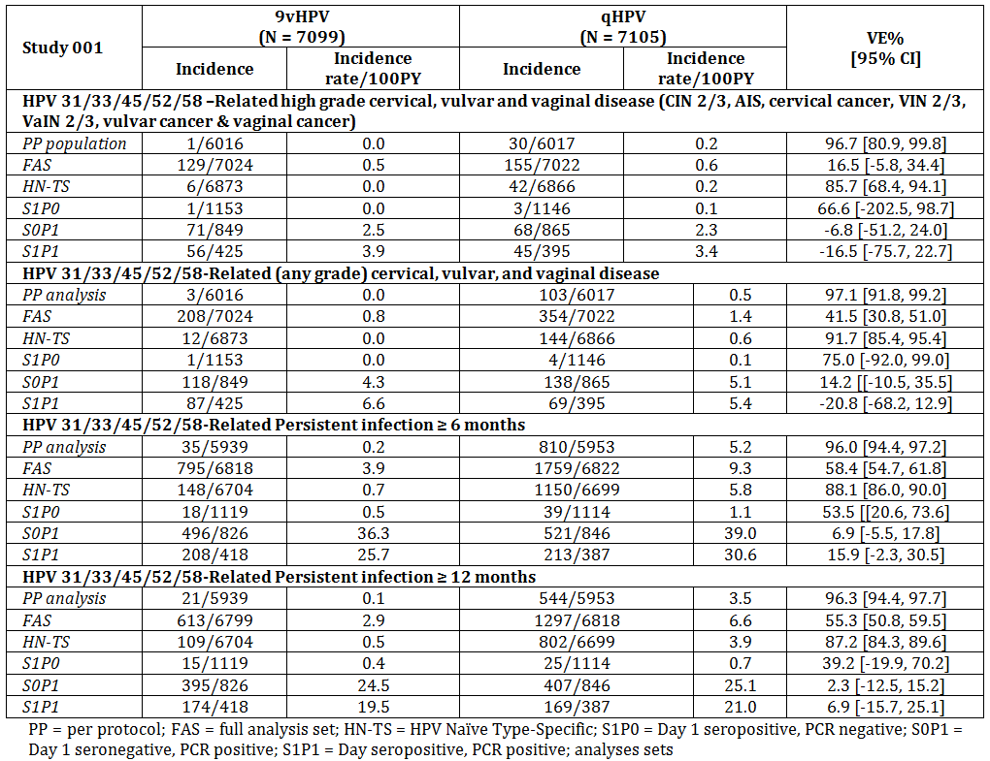
Assessment of vaccine efficacy (9vHPV vaccine versus qHPV vaccine) with respect to HPV Types 6/11/16/18 related clinical endpoints was considered not practical due to the expected very low incidence of clinical outcomes in both arms especially for the primary outcome (high grade lesions). Although a threshold of protection has not been determined for the HPV neutralizing antibodies, a demonstration of non-inferior immune response for 9vPV versus HPV was considered acceptable given the known high vaccine efficacy of qHPV vaccine. At Month 7, the results were as shown in Table 13.
Table 13: Statistical analysis of non-inferiority comparing Month 7 HPV cLIA geometric mean titres (HPV Types 6, 11, 16 and 18) between subjects who received 9vHPV vaccine and subjects who received qHPV vaccine (per protocol immunogenicity population; immunogenicity sub-study)
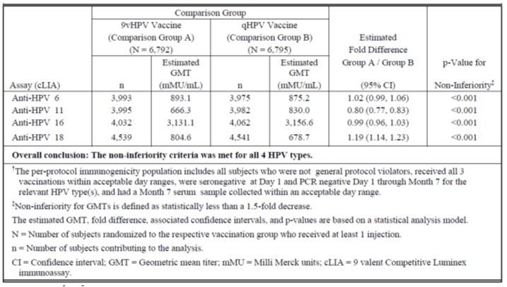
However, data for some HPV Types 6/11/16/18 related clinical endpoints was collected to demonstrate absence of any negative trend with 9vHPV vaccine compared to qHPV vaccine as shown in Table 14.
Table 14: Clinical endpoints for HPV Types 6/11/16/18
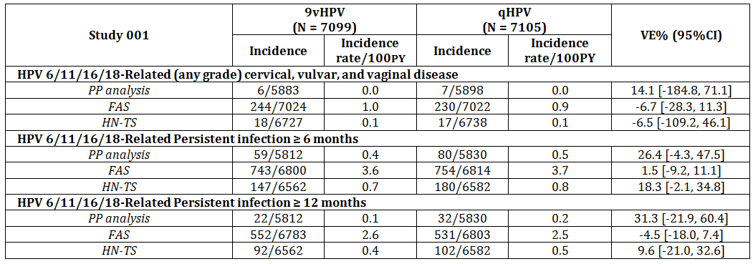
The results for HPV Types 6/11 and 16/18 related endpoints separately are provided in Table 15 below.

Table 15: The results for HPV Types 6/11 and 16/18 related endpoints separately
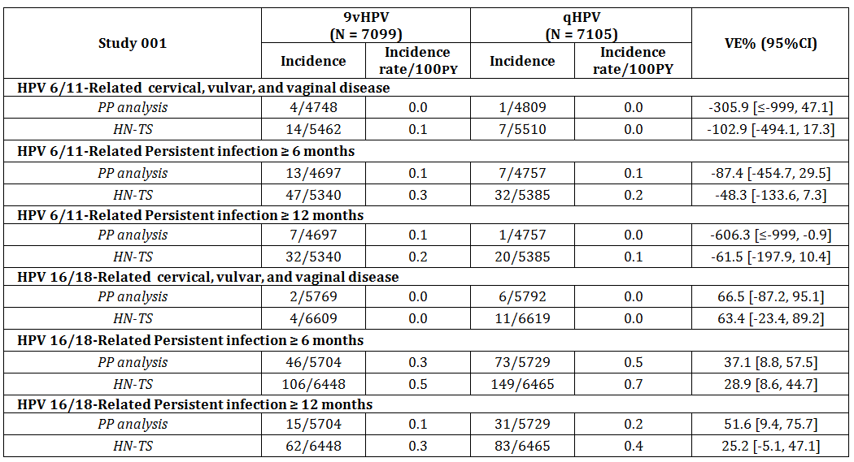
Some additional results of interest were as follows in Table 16.
Table 16: Additional results of interest
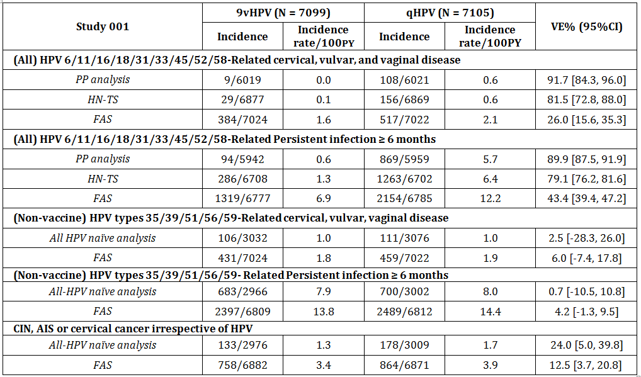
The vaccine efficacy of 9vHPV vaccine was also compared with historical placebo recipients in clinical trials of qHPV vaccine as follows shown in Table 17.
Table 17: The vaccine efficacy of 9vHPV vaccine compared with historical placebo recipients in clinical trials of qHPV vaccine
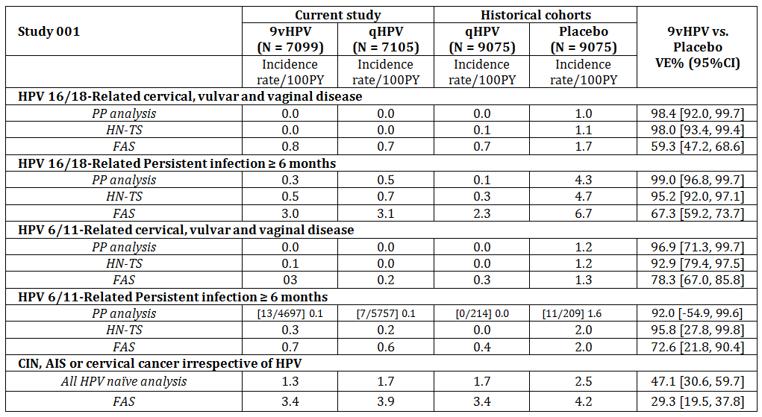

Study 002
This was an immunogenicity bridging study comparing immune response to 9vHPV vaccine in preadolescents/adolescents (9 to 15 years, boys and girls) with young women (16 to 26 years age). The results at Month 7, following completion of 3 dose course, indicated non-inferior immunogenicity according to pre-defined criterion (lower limit of 95% confidence interval (CI) for ratio not less than 0.67) but a universally significantly higher immune response to all HPV Types in 9vHPV vaccine in pre-adolescents/adolescents compared to response in young women.
Table 18: Non-inferior Month 7 HPV cLIA geometric mean titres in females 9 to 15 years of age who received 9vHPV vaccine versus females 16 to 26 years of age who received 9vHPV vaccine (per-protocol immunogenicity population) (Protocol V503-002)
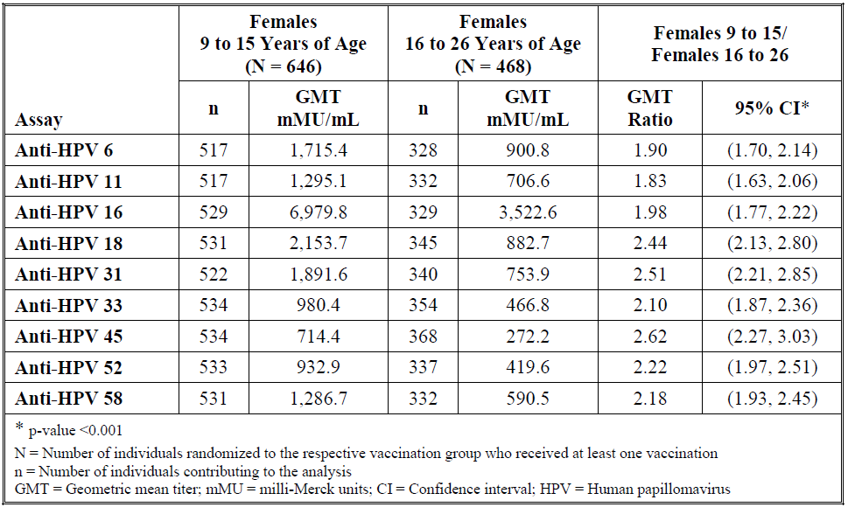

Table 19: Non-inferior Month 7 HPV cLIA geometric mean titres in males 9 to 15 years of age who received 9vHPV vaccine versus females 16 to 26 years of age who received 9vHPV vaccine (per-protocol immunogenicity population) (Protocol V503-002)
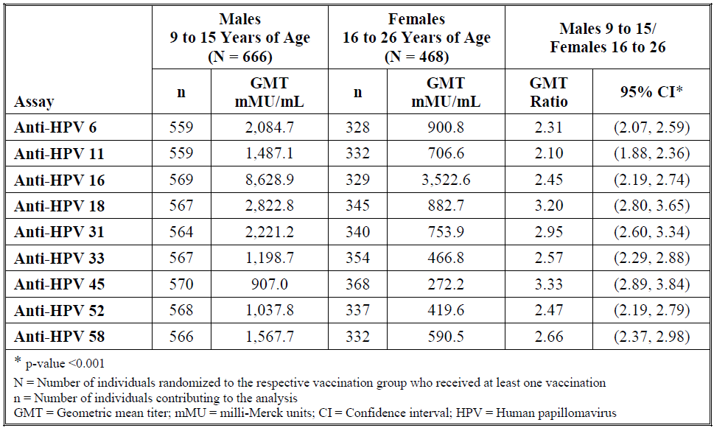

Cross study comparison
A cross study comparison of girls (9 to 15 years age; 9vHPV vaccine) in Study 002 versus young women (16 to 26 years age; qHPV vaccine) with respect to HPV Types 6/11/16/18 also showed significantly higher immune response to 9vHPV vaccine in girls (9 to 15 years) compared to qHPV vaccine in females (16 to 26 years).
Table 20 Statistical analysis of non-inferiority comparing Month 7 HPV cLIA geometric mean titres (HPV-Types 6, 11, 16 and 18) between 9 to 15 year old females in the per protocol immunogenicity (PPI) population who received 9vHPV vaccine in the immunogenicity study (Protocol 002) versus in 16 to 26 year old females in the PPI population who received qHPV vaccine in the efficacy study ((Protocol 001) per protocol immunogenicity population)
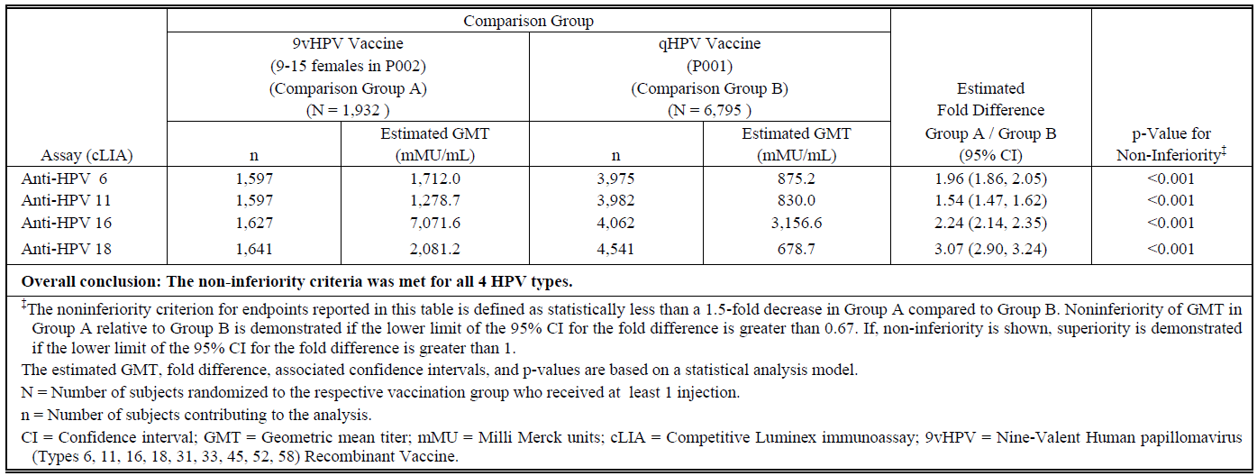
Lot to lot manufacturing consistency was separately satisfactorily demonstrated in Study 002.

Study 009
Study 009 appears to have been requested by EMA, presumably to distinguish the higher immunogenicity of 9vHPV vaccine in preadolescent/adolescents from formulation effect based on age. The results at Month 7, following completion of 3 dose course of the respective vaccines, showed that equivalent immune but high response (HPV Types 6/11/16/18) is obtained in girls (9 to 15 years age) regardless of formulation (9vHPV vaccine or qHPV vaccine ) as shown in Table 21.
Table 21: Non-inferior Month 7 HPV cLIA geometric mean titres in females 9 to 15 years of age who received 9vHPV vaccine versus females 9 to 15 years of age who received qHPV vaccine (per protocol immunogenicity population)(protocol V503-009/GDS01C)
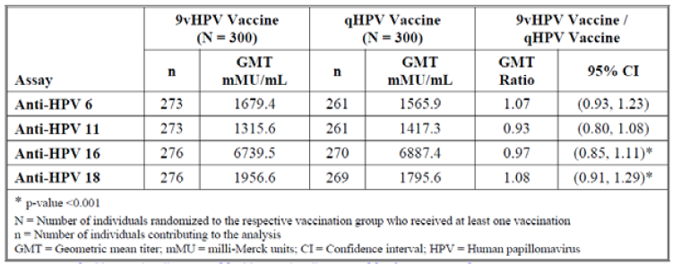

Study 003
Study 003 was an immunogenicity bridging study seeking to establish non-inferior immune response to 9vHPV vaccine in young men (16 to 26 years old) compared to young women (16 to 26 years old). Only a synopsis was included in the sponsor’s response to questions raised. The 9vHPV vaccine was shown to be similarly immunogenic in these two comparator populations as indicated by the results at Month 7 (following full 3 dose course) with respect to all 9 HPV Types (Table 22).
Table 22: Statistical analysis of non-inferiority comparing Month 7 HPV cLIA geometric mean titres between 16 to 26 year old males (HM) and 16 to 26 year old females (per-protocol immunogenicity population†)
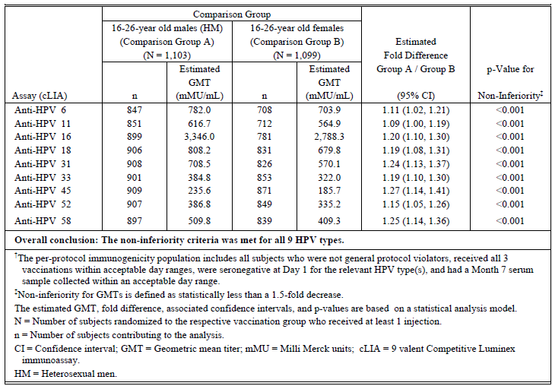

Study 006
Study 006 was conducted in females 12 to 26 years of age who had previously completed a standard 3 dose course of qHPV vaccine with the 3rd dose at least 12 months prior to the current study. The purpose of the study was to demonstrate that 9vHPV vaccine is immunogenic (predefined seropositivity rate > 90%) with respect to the new HPV Types (31/33/45/52/58) in subjects who have previously been fully primed with qHPV vaccine (Types 6/11/16/18).
The study vaccines were 9vHPV vaccine (3 dose standard schedule) versus saline placebo with immunogenicity assessment at Month 7. The seropositivity rates for Types 6/11/16/18 ranged from 88% to 100% in both groups at baseline. The seropositivity rates for the new Types 31/33/45/52/58 at various time points were as follows indicating near 100% seroconversion (Table 23).
Table 23: Summary of anti HPV cLIA seropositivity rates by vaccination group (modified per-protocol immunogenicity population†)
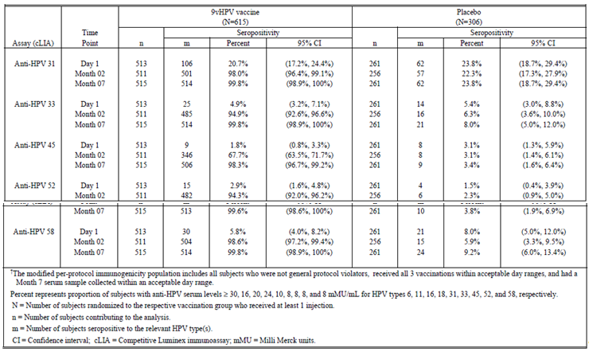

Study 005
Study 005 examined concomitant administration of 9vHPV vaccine with Menactra (meningococcal (Groups A/C/Y/W135) polysaccharide diphtheria toxoid conjugate vaccine) and Adacel (tetanus toxoid, reduced diphtheria toxoid and acellular pertussis vaccine adsorbed) in children (11 to 15 years of age). Non-interference was satisfactorily demonstrated based on pre-defined criterion of non-inferior immunogenicity for all components of the 3 vaccines. Co-administration was well tolerated.

Study 007
Study 007 examined concomitant administration of 9vHPV vaccine with Repevax (diphtheria, tetanus, pertussis (acellular) and poliomyelitis inactivated) in children (11 to 15 years of age). Non-interference was satisfactorily demonstrated based on pre-defined criterion of non-inferior immunogenicity for all components of the 2 vaccines. Co-administration was well tolerated.

Clinical safety
Overall, 13,360 subjects from the 6 Phase III studies (excluding Study 003) received 9vHPV vaccine (8,053 females 16 to 26 years of age, 3,498 females 9 to 15 years of age, and 1,809 males 9 to 15 years of age), and 7,391 subjects received qHPV vaccine (7,093 females 16 to 26 years of age, and 298 females 9 to 15 years of age). Follow-up to 4½ years was available in Study 001.
The most common local adverse events (AEs) were injection site adverse events such as erythema, pain, and swelling. In general, the frequency of local AEs relating to injection site was noted to be higher with 9vHPV vaccine compared with qHPV vaccine, increased at successive vaccine administration (similar to qHPV vaccine) and was higher in prior qHPV vaccine recipients compared to the qHPV vaccine naïve.
The most common systemic AEs included headache, pyrexia and dizziness. Overall, 6.6% 9vHPV vaccine recipients reported a temperature ≥ 37.8°C and < 38.9°C, and 1.4% subjects reported a temperature ≥ 38.9°C.
Five deaths in 9vHPV vaccine recipients were reported in Study 001. The causes were not considered related to the study vaccine including one sudden death (678 days post Dose 3). Two deaths were reported in Study 002 after Month 12 but were not considered related to the study vaccines.
A pregnancy registry data indicates that adverse pregnancy outcome in association with the study vaccine were within the background rate of occurrence.
Post market data are not yet available for 9vHPV vaccine. Advice from the ACSOV was obtained for this submission and is included in the RMP report. The committee advised that the TGA could consider how best to monitor patients with Guillain-Barre syndrome so that the tracing of vaccine related cases, if any, could be undertaken. Other autoimmune diseases, with milder symptoms, would be more difficult to trace. The committee was of the view that there was a theoretical concern, but no data, that the change from the current qHPV vaccine to the new 9vHPV vaccine may be associated with an increase in autoimmune diseases. The committee advised that it was at the discretion of the TGA to consider whether ‘autoimmune diseases’ should be included as a ‘precaution’ in the PI. It was also noted for the committee that a Vaccine Safety Plan would be required by OHP, if Gardasil 9 was added to the NIP and that any mixing of qHPV vaccine and 9vHPV vaccine is likely only in the private market.
At this stage, the overall dataset is considered very limited for determining long term safety of 9vHPV vaccine due to a limited number of subjects exposed and the short duration of follow up especially with respect to any association with chronic disease or rare serious disease including autoimmune disease. Two long term safety studies are planned (Study 021; 10 year extension from subjects in Study 001 and Study 20; 10 year post Dose 3 follow up). In its absence, it is considered appropriate that post-market safety experiences with Gardasil be also reflected in the Gardasil 9 PI.

Clinical evaluator’s recommendation
The clinical evaluator supports approval.

Risk management plan
This submission is subject to satisfactory resolution of issues and agreement between the relevant TGA area and the sponsor. The EU-RMP Version 1.0 (dated 9 January 2014, DLP 26 July 2013) and the Australian Specific Annex (dated May 2014) and any agreed updates apply to this submission.

Risk-benefit analysis

Delegate’s considerations
- The proposed 9vHPV vaccine (Gardasil 9) is a new generation HPV vaccine containing 5 additional oncogenic HPV Types compared to the current quadrivalent Gardasil (qHPV vaccine’). Each of the 5 new HPV Types 31/33/45/52/58 is present in an approximate amount of 20 µg VLPs per 0.5 mL dose.
In addition, the quantity/ratio of current 4 HPV Types 6/11/16/18 has been varied in the new vaccine. The 9vHPV vaccine contains the old HPV Types 6/11/16/18 VLPs in the amount of approximately 30/40/60/40 µg respectively per 0.5 mL of dose compared to 20/40/40/20 µg in qHPV vaccine.
The method of manufacture of recombinant VLPs is similar for both products. The total amount of VLPs in the new vaccine is 270 µg per 0.5 mL of dose compared to 120 µg in qHPV vaccine per 0.5 mL dose. Both vaccines are adjuvanted with aluminium (500 µg).
There are no outstanding matters relating to manufacturing/quality control or nonclinical data. The clinical development program for 9vHPV vaccine consisted of 7 studies. The clinical evaluator supports approval. A RMP with ASA is applicable to this submission.
- The Study 001 was the pivotal clinical study in support of the new vaccine. An adaptive Phase II/III progression within the same study was used for dose/formulation selection, evaluation of vaccine efficacy of 9vHPV vaccine in the core efficacy population of females 16 to 26 years of age with respect to the new HPV Types (31/33/45/52/58) compared to qHPV vaccine (effectively a ‘placebo’ control), and demonstration of non-inferiority of immune response with respect to the old HPV Types (6/11/16/18) for 9vHPV vaccine versus qHPV vaccine comparison in the same population.
A ‘mid dose’ formulation was selected for 9vHPV vaccine development based on the results of the dose ranging sub-study at Month 7 following completion of 3 dose vaccination schedule. The geometric mean titres (GMTs) for HPV Types 6/11/16/18 GMTs for the 3 test formulations of 9vHPV vaccine (‘low dose’ with composition of old HPV Types same as in the current qHPV vaccine; ‘mid dose’ composition as stated above; ‘high dose’ with antigen amounts greater than in ‘mid dose’ formulation) and the control qHPV vaccine indicated a flat dose response both at Month 3 and Month 7. A statistical comparison for ‘mid dose’ formulation versus qHPV vaccine was provided. The remaining two comparisons could not be located in the dossier. The selected mid dose formulation met the predefined immunogenicity non-inferiority criteria (no worse than 2 fold decrease) for all 4 (old) HPV Types. However, the GMT ratio (9vHPV vaccine/qHPV vaccine) for HPV Type 11 was 0.83 (95%CI 0.71, 0.98) indicative of a statistically significantly lower immune response compared to qHPV vaccine. This lower immune response to HPV Type 11 in 9vHPV vaccine was confirmed later on during the immunogenicity sub-study with a larger sample where the GMT ratio (9vHPV vaccine/qHPV vaccine) for HPV Type 11 was 0.80 (95%CI 0.77, 0.83). In this later analysis immune response to HPV Type 16 was also only just equivalent to that in the control qHPV vaccine (9vHPV vaccine/qHPV vaccine GMT ratio 0.99, 95%CI 0.96, 1.03).
The sponsor is requested to provide comment in its pre-ACPM response regarding the rationale for mid dose formulation selection and include statistical comparison of all 3 dose formulations with the qHPV vaccine. The sponsor is also requested to provide rationale for selecting 20 µg dose for each of the 5 new HPV Types.
Pivotal evidence, in the form of vaccine efficacy of (selected mid dose formulation) 9vHPV vaccine compared to the control qHPV vaccine with respect to the new HPV Types 31/33/45/52/58 related clinical outcomes at 4 years after completion of 3 dose vaccination schedule was demonstrated in females 16 to 26 years of age population (over 14,000 subjects equally randomised between 9vHPV vaccine and qHPV vaccine groups).
The 9vHPV vaccine was shown to have statistically significantly (predefined criterion for clinically meaningful prophylactic effect for claiming superior efficacy was > 25%) higher vaccine efficacy for all 31/33/45/52/58 related clinical endpoints compared to qHPV vaccine based on per protocol (PP) population analyses that is vaccine efficacy 96.7% [95%CI 80.9%, 99.8%] for high grade cervical, vulvar and vaginal disease; vaccine efficacy 97.1% [95%CI 91.8%, 99.2%] for any grade cervical, vulvar and vaginal disease; vaccine efficacy 96.0% [95%CI 94.4%, 97.2%] for persistent infection ≥ 6 months; and vaccine efficacy 96.3% [95%CI 94.4%, 97.7%] for persistent infection ≥ 12 months.
However, full analysis set (FAS) population is considered more ‘natural’ for examining clinical endpoints compared to PP population which is more appropriate for immunogenicity outcomes. The estimates of vaccine efficacy for HPV Types 31/33/45/52/58 related clinical endpoints were more modest based on FAS analysis but were statistically and clinically superior for all outcomes (vaccine efficacy 41.5% [95%CI 30.8%, 51.0%] for any grade cervical, vulvar and vaginal disease; vaccine efficacy 58.4% [95%CI 54.7%, 61.8%] for persistent infection ≥ 6 months; and vaccine efficacy 55.3% [95%CI 50.8%, 59.5%] for persistent infection ≥ 12 months) except vaccine efficacy of 16.5% for high grade cervical, vulvar and vaginal disease which was statistically not significant (95%CI -5.8%, 34.4%) compared to qHPV vaccine. It is, however, noted that cumulative incidence and incidence rates of all 31/33/45/52/58 related clinical endpoints were consistently lower with 9vHPV vaccine compared to the control qHPV vaccine based on both PP and FAS analysis. In its pre-ACPM response, the sponsor is requested to comment on the significance of FAS results and include sub-group analyses in the form of a forest plot for 4 clinical endpoints using the FAS population.
Next, this study sought to establish non-inferior immune response with 9vHPV vaccine for the old HPV Types 6/11/16/18 compared to HPV Types 6/11/16/18 immune response with qHPV vaccine in females (16 to 26 years of age). This was satisfactorily demonstrated based on the pre-defined criterion (no worse than 1.5 fold decrease). Lower immunogenicity for Type 11 and marginal equivalence for Type 16 compared to qHPV vaccine has been previously noted.
More importantly, some 6/11/16/18 related clinical endpoints were also collected in this study to ascertain any adverse trend in 9vHPV vaccine compared to qHPV vaccine. The ‘vaccine efficacy’ of 9vHPV vaccine relative to qHPV vaccine (‘treatment difference’) for the old HPV Types 6/11/16/18 related clinical endpoints was 14.1% [95%CI -184%, 71%] for (any grade) cervical, vulvar and vaginal disease; vaccine efficacy 26.4% [95%CI -4.3%, 47.5%] for persistent infection ≥ 6 months; and vaccine efficacy 31.3% [95%CI -21.9%, 60.4%] for persistent infection ≥ 12 months based on PP analysis, indicating that the differences in the efficacy between the two vaccines were statistically non-significant. Analysis based on FAS population accorded similar conclusions.
Further stratified analyses of 6/11 related and 16/18 related clinical endpoints separately indicated a consistently similar vaccine efficacy for the 2 vaccines in respect of 16/18 related endpoints. Furthermore, numerically lower occurrences (any grade cervical, vulvar, vaginal disease; persistent infection ≥ 6 or ≥ 12 months) were reported with 9vHPV vaccine compared to qHPV vaccine.
However, a negative trend for 6/11 related endpoints (any grade cervical, vulvar, vaginal disease; persistent infection ≥ 6 or ≥ 12 months) with higher reported incidence of these outcomes in 9vHPV vaccine vaccinated group compared to control qHPV vaccine was observed based on both PP population and HPV naïve Type specific (HN-TS) analysis. Results based on FAS population could not be located in the dossier. The sponsor is requested to include FAS based results in its pre-ACPM response.
The negative trend was confirmed for 6/11 related persistent infection ≥ 12 months (incidence 7 out of 4,697 with 9vHPV vaccine compared to 1 out of 4,757 with qHPV vaccine; a statistically significant result) based on PP analysis. This is of concern given also the issues around dose selection alluded to earlier. The negative trend is masked by additional efficacy related to the new HPV Types 31/33/45/52/58 in 9vHPV vaccine in overall results and in combined 6/11/16/18 related results. The overall vaccine efficacy for (all 9 HPV Types) was 91.7% [95%CI 84.3%, 96.0%] for any grade cervical, vulvar and vaginal disease based on PP population (vaccine efficacy 26%, 95%CI 15 to 35% based on FAS); and vaccine efficacy 89.9% [95%CI 87.5%, 91.9%] for persistent infection ≥ 6 months based on PP analysis (vaccine efficacy 43%, 95%CI 39 to 47% based on FAS). The two vaccines were also similar (treatment differences < 10%) with respect to an effect on the 5 non-vaccine HPV Type related (35/39/51/56/59) endpoints or endpoints irrespective of HPV. In its pre-ACPM response the sponsor is requested to comment on the adverse trend in 6/11 related outcomes with 9vHPV vaccine vaccination compared to the control qHPV vaccine. The sponsor should also comment and provide a summary of how any change in patterns of HVP Type related occurrence of disease or changes in epidemiology of HPV Types will be captured during post market surveillance.
Please note that the comment above regarding lower vaccine efficacy of 9vHPV vaccine for 6/11 related clinical endpoints refers to the efficacy of 9vHPV vaccine relative to qHPV vaccine. In terms of absolute vaccine efficacy against placebo, the included historical data indicated that the new 9vHPV vaccine was highly effective with vaccine efficacy 98.4% [95%CI 92.0%, 99.7%] for 16/18 related cervical, vulvar and vaginal disease based on PP analysis (vaccine efficacy 59.3%, 95%CI 47.2%, 68.6% based on FAS); vaccine efficacy 99.0% [95%CI 96.8%, 99.7%] for 16/18 related persistent infection ≥ 6 months based on PP analysis (vaccine efficacy 67.3%, 95%CI 59.2%, 73.7% based on FAS); vaccine efficacy 96.9% [95%CI 71.3%, 99.7%] for 6/11 related cervical, vulvar and vaginal disease based on PP analysis (vaccine efficacy 78.3%, 95%CI 67.0%, 85.8% based on FAS); and vaccine efficacy 92.0% [95%CI -54.9%, 99.6%] for 6/11 related infection ≥ 6 months based on PP analysis (vaccine efficacy 72.6%, 95%CI 21.8%, 90.4% based on FAS) comparable to that known for qHPV vaccine.
- The Studies 002 (9vHPV vaccine in children 9 to 15 years versus females 16 to 26 years; including a cross-study comparison with qHPV vaccine vaccinated females 16 to 26 years of age in Study 001), 003 (9vHPV vaccine in males 16 to 26 years old versus females 16 to 26 years old) and 009 (9vHPV vaccine versus qHPV vaccine in girls 9 to 15 years old) were immunogenicity studies which satisfactorily demonstrated similar immune response to 9vHPV vaccine in preadolescent/adolescent children (9 to 15 years old; both genders), males (16 to 26 years old) and females (16 to 26 years old; population with a link to vaccine efficacy). Extrapolation to these age groups as well as additional indications (anal cancer, precancerous and dysplastic lesions) is considered justifiable. No data in women > 26 years of age are currently available for 9vHPV vaccine. At this stage, extrapolation to this population group is also acceptable but a vaccine efficacy study to validate this use is required because of different baseline exposure and risk status of this population compared to the younger population, as well as due to a degree of uncertainty associated with the new 9vHPV vaccine formulation. The sponsor is requested to comment whether such study is underway or planned for examining vaccine efficacy of 9vHPV vaccine in this population.
At present, it is recommended that the proposed qualifier to therapeutic indication be modified to reflect lack of data (Evidence of vaccine efficacy is based on core efficacy population of females 16 to 26 years of age. Immunogenicity studies have been conducted to link efficacy to younger populations (females and males 9 to 15 years of age). Currently there are no data relating to females over 26 years of age). Full report of the Study 003 should also be provided to the TGA in a future submission for PI update.
- The Study 006 was placebo controlled investigation of 3 dose course of 9vHPV vaccine vaccination in 12 to 26 year old females who have previously (at least 12 month earlier) completed 3 dose course of vaccination with qHPV vaccine. The objective was to demonstrate that immune response to the new HPV Types 31/33/45/52/58 is also adequately mounted in a previously fully primed qHPV vaccine population. This objective was satisfactorily met. There is uncertainty about the utility of this study in terms of clinical recommendations for example mixing of qHPV vaccine and 9vHPV vaccine during a single course (this was not examined in the study) or a course of 9vHPV vaccine in already qHPV vaccine vaccinated population (clinical compulsion for this has not been established). The dossier did not include any information on validation of immune correlates of protection or investigation of alternative (shorter) vaccine schedule. Elsewhere, comments by the sponsor appear to imply that Gardasil 9 will be rapidly transitioned rather than a slow phasing out of Gardasil. The sponsor is requested to provide clinical justification for the proposed statement in the PI (‘If the decision is made to administer Gardasil 9 after receiving 3 doses of Gardasil, there should be an interval of at least 12 months between completion of vaccination with Gardasil and the start of vaccination with Gardasil 9 administered as a 3 dose regimen’). In the Delegate’s view this is not supported and should be removed. A description of the Study 006 will be included in the clinical trials section of the PI.
- Co-administration of 9vHPV vaccine was studied in children (11 to 15 years old) with commercially available Manectra, Adacel and Repevax vaccines routinely used in this age group. No issues of immunological interference were identified.
- Overall, the safety profile of 9vHPV vaccine was similar to that known for qHPV vaccine except somewhat higher reactogenicity. The total safety database is still very limited in terms of total number of subjects exposed to 9vHPV vaccine and firm conclusions cannot be drawn regarding occurrence of rare adverse effects. The long term concerns in relation to any association with serious chronic disease will be the subject of ongoing pharmacovigilance activities. The Scandinavian subjects in Study 001 will be followed for 10 years through the Nordic Cancer Registry Programs (Study 021) and the subjects in Study 002 will be followed for 10 years post Dose 3 (Study 020). Meanwhile, the Gardasil 9 PI will reflect the Gardasil post-market data.
- Development of HVP vaccines has been one of the most significant advances in public health during last 10 years. The vaccine efficacy of Gardasil is well established.
Overall, the 9vHPV vaccine was shown to be highly effective. However, a number of deficiencies or concerns have been raised (dose selection, modest additional benefit with the new HPV Types based on FAS analysis and an adverse trend for HPV Types 6/11 related clinical endpoints) for which the sponsor has been requested to provide further information and comments. These deficiencies need to be adequately reflected in the Gardasil 9 PI and some recommendations have been made in this overview which are expected to be supplemented after advice from Advisory Committee for Prescription Medicines (ACPM) has been obtained.
The Delegate was of the view that sufficient data have been generated for the new 9vHPV vaccine (Gardasil 9) to support its proposed use as a ‘standalone’ product, although known knowledge of Gardasil also informs the decision making.
Pending a satisfactory pre-ACPM response from the sponsor and further advice from ACPM, the overall net risk/benefit for Gardasil 9 is considered supportive of approval.

Proposed action
The Delegate had no reason to say, at that time, that the application for Gardasil 9 should not be approved for registration.

Request for ACPM advice
The committee is requested to provide advice on the following specific issues:
- Is the clinical development program for Gardasil 9 adequate to support approval of Gardasil 9 for all current indications/populations of Gardasil?
- Does the committee support the sponsor’s proposed statement in dosage and administration section (‘If the decision is made to administer Gardasil 9 after receiving 3 doses of Gardasil, there should be an interval of at least 12 months between completion of vaccination with Gardasil and the start of vaccination with Gardasil 9 administered as a 3 dose regimen’) or recommend an alternative guidance?
- Does the committee support the requirement for the sponsor to generate vaccine efficacy data in women > 26 years of age as a condition of registration?
- Would the committee like the TGA to obtain any further information or additional analyses of the data in this dossier from the sponsor prior to finalisation of this submission?
- Does the committee recommend any additional activities in the post-market phase for inclusion in the RMP/ASA?
The committee is also requested to provide advice on any other issues that it thinks may be relevant to a decision on whether or not to approve this application.

Response from sponsor

Response to matters raised by the delegate
The Delegate has requested information from the sponsor on the following issues:

Delegate question 1
The sponsor is requested to provide comment in its pre-ACPM response regarding the rationale for mid dose formulation selection and include statistical comparison of all 3 dose formulations with the qHPV vaccine. The sponsor is also requested to provide rationale for selecting 20µg dose for each of the 5 new HPV Types.
Sponsor’s response
The goal of the dose selection was to identify a vaccine candidate that:
- provided similar immunogenicity as qHPV vaccine for the original HPV Types;
- provided robust immunogenicity for the new HPV Types; and
- was generally well tolerated.
To this end, three Phase II clinical studies were conducted. The design and results of these three studies have been reported in a recently published article. Key information was also provided in Section 9.2.1.2 of the V503-001 CSR.
Protocol V502-001, an initial study to develop a 8 valent HPV (8vHPV) vaccine revealed that adding new HPV Types caused lower vaccine immunogenicity for the 4 original Types (immune interference).³¹
Protocol V503-001 was initiated subsequently. The dose selection portion of Protocol V503-001 was designed to overcome this immune interference by increasing the doses of adjuvant and antigen (HPV 6, 16, and 18 VLPs).
- The low dose formulation of 9vHPV vaccine had the same amounts of HPV 6, 11, 16, and 18 as and high adjuvant to antigen ratio than the qHPV vaccine
- The mid dose formulation of 9vHPV vaccine had higher amounts of HPV 6, 16, and 18 antigens than and the same adjuvant to antigen ratio as the qHPV vaccine
- The high dose formulation of 9vHPV vaccine had higher amounts of antigens for all 7 oncogenic types than the mid dose formulation.
The dose formulations tested in the Phase II studies are summarised in Luxembourg A et al, 2015³¹and in Table 3 (above).
The process and rationale for the selection of the mid dose formulation has been reported.³¹ Dose selection was based on an interim analysis of post Dose 2 (that is, Month 3) immunogenicity data. The results of this interim analysis are provided in a report that appears in the V503-001 CSR. The relevant table of the interim analysis report is reproduced below (Table 24). The salient elements are as follows:
- Compared with subjects who received qHPV vaccine, subjects who received the low-dose formulation had lower anti-HPV GMTs for all original types indicating that the immune interference was not overcome. Therefore, low dose formulation did not overcome the immune interference was not selected.
- Compared with subjects who received qHPV vaccine, subjects who received the mid dose or high dose formulations had similar anti-HPV 6 and 16 GMTs, lower anti HPV 11 GMT, and higher anti HPV 18 GMT. Based on these results, the mid dose formulation was selected.

Table 24: A Comparison of Month 3 HPV cLIA GMTs between subjects who received formulations of the 9-valent HPV (6, 11, 16, 18, 31, 33, 45, 52, 58) L1 VLP vaccine to subjects who received the Gardasil (among subjects who were seronegative and PCR negative to the relevant HPV Type(s) at Day1†)
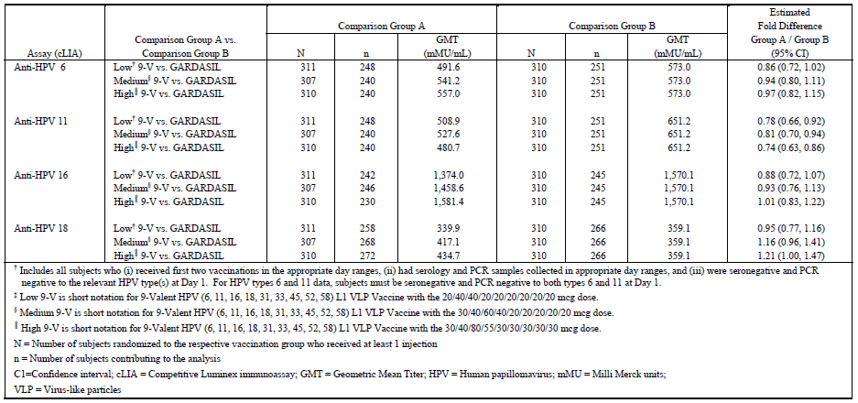
The dose selection for the new types was based on the initial study of the 8vHPV vaccine (Protocol V502-001). Three dose formulations of the 8vHPV vaccine were tested that contained different amounts of antigen for the new types (5 µg, 20 µg, or 40 µg each). All three doses were highly immunogenic (over 97% subjects seroconverted at month 7, and the GMT response was dose dependent³¹ The doses tested in V503-001 were selected based on these initial results (20 µg for each of the new Types in low dose and mid dose formulations; 30 µg for each of the new Types for the high dose formulation). As seen in Luxembourg A et al³¹ and in the V503-001 CSR, these two doses provided similar immunogenicity.
As seen in Luxembourg A et al³¹ and the V503-001 CSR, all three dose formulations of the 9vHPV vaccine were generally well tolerated.
The V503-001 study used a seamless Phase IIB/III adaptive design. As described in Chen et al and the V503-001 CSR, the study team remained blinded to vaccination group allocation during the interim immunogenicity analysis. Therefore, the study blinding was protected and the interim analysis was conducted in a way that did not introduce a risk of subsequent operational bias.

Delegate question 2
The sponsor is requested to comment on the significant of FAS results and include sub-group analyses in the form of a forest plot for 4 clinical endpoints using the FAS population.
Sponsor’s response:

Significance of FAS results
FAS analyses include subjects who at baseline were either infected or not infected with the HPV Type being analysed. These analyses represent a mixture of prophylactic and therapeutic efficacy. The 9vHPV vaccine is not a therapeutic vaccine, it is a prophylactic vaccine.
Most disease cases in FAS analyses came from subjects already infected at study enrolment. Only the first occurrence of an endpoint (most likely due to the HPV Type that infected the subject at baseline) is considered in FAS analyses, not overall protection against all vaccine HPV Types. FAS analyses support that the 9vHPV vaccine has no therapeutic activity; they cannot be used to assess overall prophylactic benefit of the 9vHPV vaccine (or lack thereof in the FAS population).
The sponsor considers that analyses in the FAS population provide confounded estimates of efficacy that largely reflect the composition of the study population (that is, rates of HPV infection at baseline) rather than vaccine efficacy. As stated in the clinical overview: “Since the FAS population included both subjects naïve to HPV at baseline, as well as subjects with past or ongoing HPV infection, efficacy estimates obtained in this population represent a confounding of prophylactic and therapeutic efficacy… Analyses of risk reductions in the FAS population are provided to support the prophylactic efficacy analyses and because they were requested by a regulatory agency.” This topic is further discussed in the V503-001 CSR.
Results in the FAS population are difficult to extrapolate to real life situations and therefore do not appear to have much value for health care providers. Thus, the sponsor has proposed not to add these results in the PI for Gardasil 9. While these analyses were considered relevant at the time of Gardasil licensure, their limitations have been recognised over time and the sponsor proposes that they are not relevant anymore to the PI for Gardasil 9. Several regulatory agencies have agreed with this change and appear to have recognised that results in the FAS population do not provide clear information on the benefit provided by vaccination with HPV vaccines. The US PI and Canadian Product Monograph for Gardasil9 do not present results in the FAS population. This is in alignment with the proposed EU label and the company core data sheet.
The requested analyses (Forest Plots) are presented below. The results of these analyses are consistent with the interpretation of the FAS results summarised in this section.

Forest plot: analysis methods
The requested subgroup analyses in the FAS population for the 4 clinical endpoints in the form of forest plots were conducted as follows.
- Four Forest plots were created, one forest plot for each of the endpoints:
- cervical, vulvar, and vaginal disease (any grade);Figure 2
- high-grade cervical, vulvar, and vaginal disease; Figure 3
- persistent infection ≥ 6 months; Figure 4
- persistent infection ≥ 12 months; Figure 5.
- For each Forest plot, estimate of vaccine efficacy (VE) and the corresponding 95% confidence interval (CI) was provided for the endpoint indicated in the title of the figure, separately for the endpoint related to each of HPV types 6, 11, 16, 18, 31, 33, 45, 52, and 58. Estimates of VE and its corresponding 95% CI were calculated for the FAS population, and for the following subgroups of the FAS population created based on HPV type specific infection at Day 1 (that is, at the time of injection of dose 1 of vaccine):
- HN-TS, corresponding to the subgroup of the FAS population who received at least one injection of vaccine and at Day 1 were uninfected or have no evidence of prior infection of the relevant HPV type being analysed (that is, HN-TS as defined in the V503-001 protocol and CSR)
- Not in HN-TS, corresponding to the subgroup of the FAS population who were not HN-TS eligible for the specific HPV type being analysed, that is, at Day 1 were infected or have evidence of prior infection of the relevant HPV type being analysed.
Examples of subgroup analysis results shown in the forest plot are as follows:
- FAS, HPV 31: corresponds to analysis of HPV 31 related endpoint in the FAS population
- HN-TS, HPV 31: corresponds to analysis of HPV 31 related endpoint in the sub-group of the FAS who were HPV 31 naïve (that is, HN-TS, type 31) at Day 1
- Not HN-TS, HPV 31: corresponds to analysis of HPV 31-related endpoint in the sub-group of the FAS who were not HPV 31 naïve (that is, not HN-TS-eligible, type 31) at Day 1
- FAS, HPV 6: corresponds to analysis of HPV 6 related endpoint in the FAS population
- HN-TS, HPV 6: corresponds to analysis of HPV 6 related endpoint in the sub-group of the FAS who were HPV 6 naïve (that is, HN-TS, type 6) at Day 1
- Not HN-TS, HPV 6: corresponds to analysis of HPV 6 related endpoint in the sub-group of the FAS who were not HPV 6 naïve (that is, not HN-TS eligible, type 6) at Day 1.
- For the purpose of readability of the “box and whiskers” in the forest plots, if a calculated estimate of the lower limit of 95% CI of VE was less than -200.0, that lower limit of 95% CI of VE was truncated at -200.0 and appears in the forest plot as “-200”, and indicated as “< -200” in the right-most data column in the forest plot. Plotting the actual lower limit of 95% CI of VE that was less than -200.0, say for example, -900.0, would result in compression, and not usefully readable, of the “box and whiskers” of VE estimates that are typically in the range (-100 to +100).
In the analyses conducted, the rationale for choosing subgroups of the FAS population that are HPV type specific, that is, the composition of the subgroups changes according to the HPV type being analysed, are as follows:
- HPV infection status at Day 1 (that is, time of administration of dose 1 of vaccine) is the singular, primary subject characteristic that impacts whether a subject, through HPV vaccination, will receive protection from disease related to the specific HPV type for which the subject is naïve or not-naïve
- The purpose of the subgroup analysis in the FAS population was to demonstrate very clearly that HPV vaccines are prophylactic; (that is, able to prevent disease in subjects who were not infected prior to vaccination for the HPV type(s) being analysed)
- Showing results in subgroups in an HPV type specific manner demonstrates that a subject who is naïve for a specific HPV type (HPV 31 for example) has potential to receive protection from disease related to that specific type, regardless of whether that subject is not naïve for other HPV types (HPV 16 for example)
- On a by HPV type basis, showing high prophylactic vaccine efficacy among the subgroup of the FAS population who are HPV naïve, and no efficacy among the subgroup of the FAS population who are not HPV naïve, demonstrates that the estimate of VE in the global FAS population (which is numerically in between the high prophylactic efficacy estimate among HPV naïve and low, no efficacy estimate among not HPV naive) is not a meaningful measure for judging the benefit of HPV vaccination in the “general population”.
Figure 2: Efficacy of 9vHPV vaccine compared to qHPV vaccine against HPV related cervical, vulvar, and vaginal disease (any grade) by subgroups of the FAS population defined based on HPV Status at Day 1
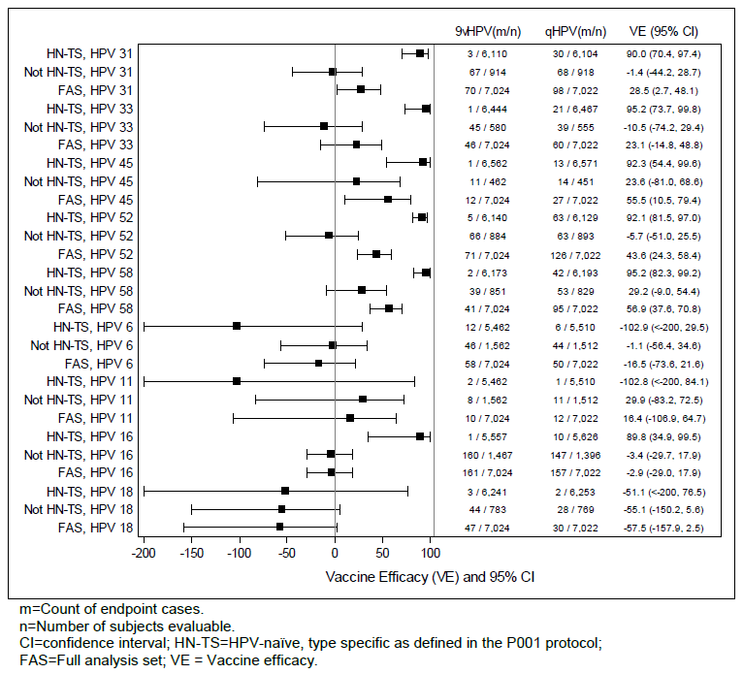
Figure 3: Efficacy of 9vHPV vaccine compared to qHPV vaccine against HPV related high grade cervical, vulvar, and vaginal disease by subgroups of the FAS population defined based on HPV Status at Day 1
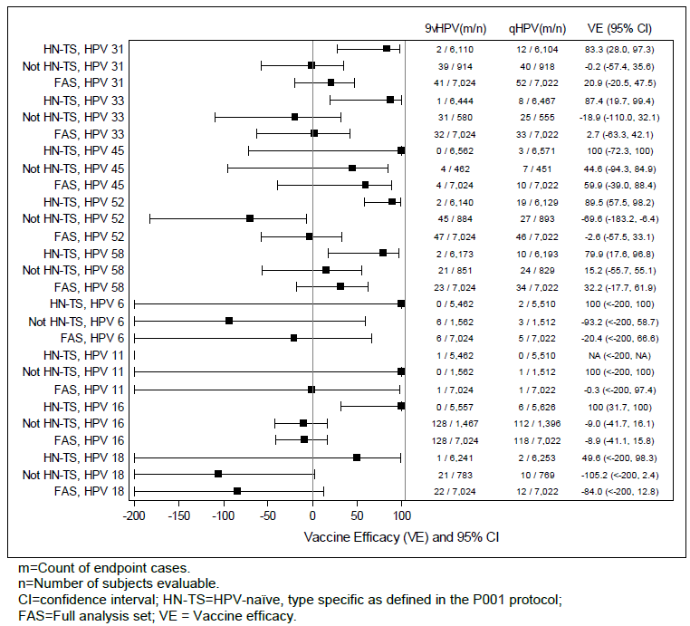
Figure 4: Efficacy of 9vHPV vaccine compared to qHPV vaccine against HPV related persistent infection ≥ 6 months by subgroups of the FAS population defined based on HPV status at Day 1
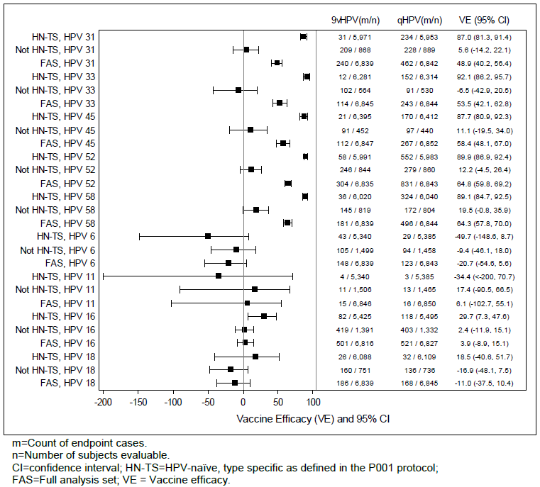
Figure 5: Efficacy of 9vHPV vaccine compared to qHPV vaccine against HPV related persistent infection ≥ 12 months by subgroups of the FAS population defined based on HPV status at Day 1
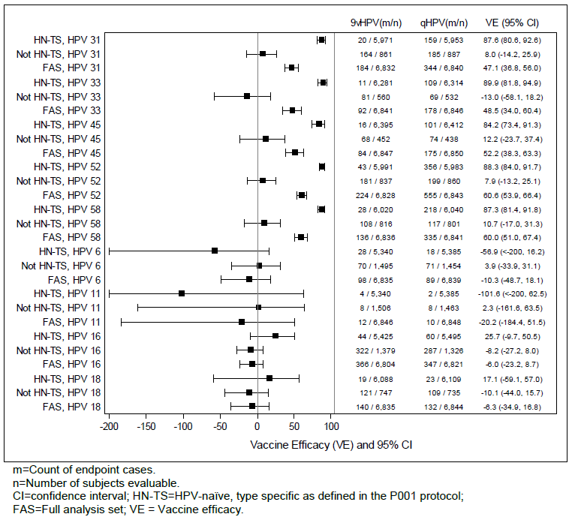

Forest plot: results and interpretations

Endpoints related to HPV 31, 33, 45, 52, and 58

Results in the HN-TS subgroup
The V503-001 study was designed to compare the 9vHPV vaccine against the qHPV vaccine. For endpoints related to HPV 31, 33, 45, 52, and 58 the estimate of VE in the HN-TS subgroup of the FAS population represents the prophylactic efficacy of the 9vHPV vaccine against a group of subjects who have not received vaccine containing HPV types 31, 33, 45, 52, and 58. For each of the 4 endpoints shown in Figure 2, Figure 3, Figure 4, and Figure 5, the estimates of prophylactic VE in the HN-TS subgroup are all very high for each of the endpoints related to HPV types 31, 33, 45, 52, and 58, thereby demonstrating the high prophylactic efficacy of the 9vHPV vaccine among the subgroup of the FAS population who are naïve to the relevant HPV type at the time of vaccination.

Results in the Not HN-TS subgroup
For endpoints related to HPV 31, 33, 45, 52, and 58, the estimate of VE in the Not HN-TS subgroup of the FAS population represents the therapeutic efficacy of the 9vHPV vaccine against a group of subjects who have not received vaccine containing HPV types 31, 33, 45, 52, and 58. HPV vaccines are prophylactic, not therapeutic vaccines. For each of the 4 endpoints shown in Figure 2, Figure 3, Figure 4, and Figure 5, the estimates of therapeutic VE in the Not HN-TS subgroup are all very low, with the 95% CI of VE containing 0%, for each of the endpoints related to HPV types 31, 33, 45, 52, and 58. These results are reflection of no therapeutic benefit for the HPV type being analysed, which was to be expected among the subgroup of the FAS population who are not naïve to the relevant HPV type at the time of vaccination. Note that this no therapeutic benefit applies on a by HVP type basis. For example, a subject who at the time of vaccination is infected with HPV 16 and naïve to HPV 31 will derive no therapeutic benefit for HPV 16 but will derive prophylactic benefit for HPV 31.

Results in the FAS population
The following mathematical artefact is noteworthy to realise and understand regarding the estimate of VE in the FAS population. In subgroup analysis of the FAS population, particularly when the subgrouping or categorization chosen is one that directly impacts the estimate of VE, such as HPV status at the time of vaccination (that is, HN-TS versus Not HN-TS):
- The estimate of VE in the FAS population is pulled towards the direction of the VE estimate in the subgroup that contributed the most number of endpoint cases;
- The estimate of VE is not pulled towards the direction of the VE estimate in the subgroup that contributed the most number of subjects;
- The estimate of VE in the FAS population does not represent an average of VE across subgroups, where the average is weighted by the size (number of subjects) of the subgroups.
For example, in the analysis of HPV 31-related high grade disease (see Figure 3):
- HN-TS: VE = 83%; 2 cases out of 6,110 in the 9vHPV vaccine group; 12 cases out of 6,104 in the qHPV vaccine group
- Not HN-TS: VE approximately 0%; 39 cases out of 914 in the 9vHPV vaccine group; 40 cases out of 918 in the qHPV vaccine group
- FAS: VE = 21%; 41 cases out of 7,024 in the 9vHPV vaccine group; 52 cases out of 7,022 in the qHPV vaccine group.
Note that a properly sample-size weighted average of VE across the HN-TS and Not HN-TS subgroups should produce an estimate of VE in the FAS population that is closer in magnitude to 83% (VE in HN-TS) than 0% (VE in Not HN-TS), because the majority of the population were HN-TS for HPV type 31.
This mathematical artefact, where the estimate of VE in the FAS population does not represent an average of VE across subgroups (of subjects who can derive benefit versus subjects who cannot derive benefit), where the average is weighted by the size of the subgroups, is a major scientific basis that gives credence to the inappropriateness of relying on the estimate of VE in the FAS population to inform decisions on the impact of HPV vaccination in the “general population”.

Endpoints related to HPV 6, 11, 16, and 18

Results in the HN-TS subgroup
The V503-001 study was designed to compare the 9vHPV vaccine against the qHPV vaccine. As such, for endpoints related to HPV 6, 11, 16, and 18, the estimate of VE in the HN-TS subgroup of the FAS population represents a measure of similarity or equivalence of incidence of disease that both vaccines have the ability to prevent in a subgroup who can derive prophylactic benefit from vaccination, because both vaccines contain HPV types 6, 11, 16, and 18. Thus, for HPV types 6, 11, 16, and 18 related endpoints in the HN-TS subgroup, the expected VE is 0%, representing similarity or equivalence of both vaccines in reducing the incidence of these endpoints.
For disease endpoints (Figure 2 and Figure 3), the absolute magnitude of counts of disease related to HPV types 6, 11, 16, and 18 were very low in each of the 9vHPV vaccine and qHPV vaccine groups, reflecting the efficacy of both vaccines in preventing such diseases. The point estimates of VE may be a large negative number (for example, –100%) with a very wide 95% CI, however, such VE estimates were produced by very low case counts (for example, 2 cases in 9vHPV vaccine versus 1 case in qHPV vaccine such as those shown for HPV-11 in Figure 2). For these HPV 6, 11, 16, and 18 related disease endpoints (and also HPV 11 related persistent infection endpoints), where the trend of negative VE arose out of very low case counts, the estimate of VE is not the clinically informative measure. The more clinically informative measure is the very low absolute magnitude counts of cases in both the 9vHPV and qHPV vaccines, because it reflects the efficacy of both vaccines in preventing disease related to HPV types 6, 11, 16, and 18.
For persistent infection endpoints (Figure 4 and Figure 5), the magnitude of case counts of HPV 6, 16 and 18 related persistent infections were higher compared to the counts of HPV 6, 11, 16 and 18 related disease endpoints. Nevertheless, the counts of cases in the 9vHPV vaccine and qHPV vaccine groups were generally similar, and the 95% CI estimates of VE contain 0%, indicating similarity of incidence of these endpoints in the 9vHPV vaccine and qHPV vaccine groups. For specific endpoints where this generalization does not seem to apply, that is, HPV 6 related persistent infection; the P001 CSR provides the likely explanation of why there were more HPV 6 related persistent infection in the 9vHPV vaccine group compared to the qHPV vaccine group:
- Persistent infection ≥ 12 months is a subset of persistent infection ≥ 6 months. What drives the higher case counts in 9vHPV vaccine group compared to qHPV vaccine group with respect to persistent infection ≥ 12 months also drives the higher case counts in 9vHPV vaccine group compared to qHPV vaccine group with respect to persistent infection ≥ 6 months. For HPV 6 related persistent infection ≥ 12 months in the HN-TS population, the trend of higher case count in the 9vHPV vaccine group compared to the qHPV vaccine group in the HN-TS subgroup was driven by the case counts in the PPE population (the PPE population being a subset of the HN-TS subgroup) comprised of 7 cases in the 9vHPV vaccine group and 1 case in the qHPV vaccine group. As noted in the P001 CSR, each of these subjects in the 9vHPV vaccine and qHPV vaccine groups who had HPV 6 related persistent infection also had co-infections of other oncogenic non-vaccine HPV types (that is, co-infections of oncogenic HPV types other than 16, 18, 31, 33, 45, and 52). Thus the higher count of HPV 6 related endpoint in the 9vHPV vaccine group compared to the qHPV vaccine group is not conclusively attributable as a negative effect of 9vHPV vaccine vaccination. The co-infections of oncogenic non-vaccine HPV types may have contributed to the susceptibility to acquire HPV 6 related persistent infection.

Results in the Not HN-TS subgroup
For endpoints related to HPV 6, 11, 16, and 18, the estimate of VE in the Not HN-TS subgroup of the FAS population represents a measure of similarity or equivalence of incidence of disease and infection that both vaccines do not have the ability to prevent or cure in a subgroup of subjects who were already infected at the time of vaccination. Thus, for HPV types 6, 11, 16, and 18 related endpoints in the Not HN-TS subgroup, the expected VE is 0%, representing similarity or equivalence of both vaccines in having no therapeutic impact to prevent or cure HPV 6, 11, 16 and 18 related disease and infection in a subgroup who were already infected at the time of vaccination. For HPV 6, 11, 16 and 18 related disease and persistent infection endpoints shown in Figure 2, Figure 3, Figure 4, and Figure 5, the counts of cases of these endpoints were similar in the 9vHPV vaccine and qHPV vaccine groups, and the estimates of 95% CI of VE contain 0%, indicating similarity of incidence of these endpoints in the 9vHPV vaccine and qHPV vaccine groups.

Results in the FAS population
Similar to the interpretation of VE in the FAS population for endpoints related to HPV types 31, 33, 45, 52, and 58
- The estimate of VE in the FAS population is pulled towards the direction of the VE estimate in the subgroup that contributed the most number of endpoint cases
- The estimate of VE is not pulled towards the direction of the VE estimate in the subgroup that contributed the most number of subjects
- The estimate of VE in the FAS population does not represent an average of VE across subgroups, where the average is weighted by the size (number of subjects) of the subgroups.
For endpoints related to HPV 6, 11, 16, and 18, the expected VE in both the HN-TS and not HN-TS subgroups of the V503-001 study, and consequently in the FAS population of the V503-001 study, is 0%. The estimate of VE in the FAS population from the V503-001 study is not useful for making informed decisions on the impact of HPV vaccination in the “general population” with respect to disease and infection related to HPV types 6, 11, 16, and 18.
Discussion
HPV vaccines are prophylactic vaccines, whereby HPV related disease and infection prevention is expected among those who received vaccination while not yet infected with HPV and therapeutic treatment of existing HPV infections is not an expected benefit from vaccination. In statistical analysis parlance, existing HPV infection at the time of vaccination is a clearly established subject characteristic that has an interaction with vaccination effect. Given that the FAS population includes those who are already infected with HPV, the results of assessment of vaccine efficacy in the FAS population is influenced by the characteristics of the population being studied, in particular, characteristics relating to HPV infection status at the time of vaccination. The impact of including in the analysis population subjects who have no potential to derive benefit from therapy is profoundly different in drug studies compared to prophylactic vaccine studies. In drug studies where the endpoint is typically related to transitioning from a diseased-state to a disease free state, inclusion of subjects who have no potential to derive benefit from therapy (for example, subjects randomised but did not receive drug) does not affect the count of subjects who transitioned from a diseased state to a disease free state and will not inflate the incidence of the endpoint being analysed. Consequently, a drug that is 100% efficacious relative to a control has a chance of being detected as such in an FAS analysis that includes subjects who did not receive a drug. In prophylactic vaccine studies where the endpoint is typically related to transitioning from a disease free state to a diseased state, inclusion of subjects who have no potential to derive benefit from therapy (for example, subjects who are HPV infected at the time of vaccination) have non-negligible impact in the count of subjects who transitions to the diseased state and will inflate the incidence of the endpoint being analysed. Consequently, a prophylactic vaccine that is truly 100% efficacious relative to a control group may not be detected as such in an FAS analysis that includes subjects who are HPV infected at the time of vaccination. For these reasons, and those already mentioned in the “Results and Interpretation” section, the estimates of VE in the FAS population do not provide clear and unambiguous measure of benefit of vaccination in the “general population”.
The prophylactic benefit of HPV vaccination is realised among subjects who are not yet infected with particular HPV types at the time of vaccination. Estimates of VE in the PPE and HN-TS populations provide unambiguous measures of prophylactic benefit of vaccination among those who are not yet infected with particular HPV types at the time of vaccination.
Importantly, a person may be infected with one, two, or three HPV types, but very rarely infected with all the nine HPV types covered by the 9vHPV vaccine. For HPV types for which the person is not infected, HPV vaccination has the potential to provide prophylactic prevention of disease and infection, with very high efficacy. In that regard, providing ambiguous VE estimate in the “general population” based on estimates in the FAS population is not informative.
Conclusion
Results in the FAS population do not provide clear information on the benefit provided by vaccination with HPV vaccines and do not appear to have much value for health care providers. Thus, the sponsor proposes to not add these results in the Australian PI for Gardasil9. This approach is in alignment with the approved US and Canadian labels, proposed European label and Company Core Data Sheet.

Delegate question 3
The sponsor is requested to include FAS based results [relating to 6/11 related endpoints] in its pre ACPM response.
Sponsor’s Response:

Executive summary
As stated in the response to Question 2, in the sponsor’s opinion results in the FAS population do not appear to have much value for health care providers. In particular, there is no adverse trend in HPV 6/11 related outcomes in the 9vHPV vaccination group compared to the qHPV vaccination group. The observed incidence of HPV 6/11 related outcomes in both the 9vHPV vaccine and qHPV vaccine groups are consistent with the high efficacy of both 9vHPV vaccine and qHPV vaccines in reducing the incidence of HPV 6/11 related disease and persistent infection.

Analysis methods
The requested FAS results relating to HPV 6/11 related endpoints are provided as follows:
- A forest plot (Figure 6) was created in order to present in a single figure all the results relating to HPV 6/11 related endpoints that were presented in Figure 2, Figure 3, Figure 4, and Figure 5.
- A table was created (Table 25) showing the incidence rate of HPV 6/11 related cervical, vulvar, and vaginal disease (any grade) in the HN-TS subgroup of the FAS population as observed in the V503-P001 study and in the V501 (Gardasil) program (protocols 007, 013 (that is, combined P011 and P012 studies) and 015). This summary was intended to provide perspective on the results observed in V503-P001 side by side with incidences observed in the qHPV vaccine and placebo vaccinated HN-TS population of the V501 program.
Figure 6: Efficacy of 9vHPV vaccine compared to qHPV vaccine against HPV 6/11 related disease and persistent infection by subgroups of the FAS population defined based on HPV status at Day 1
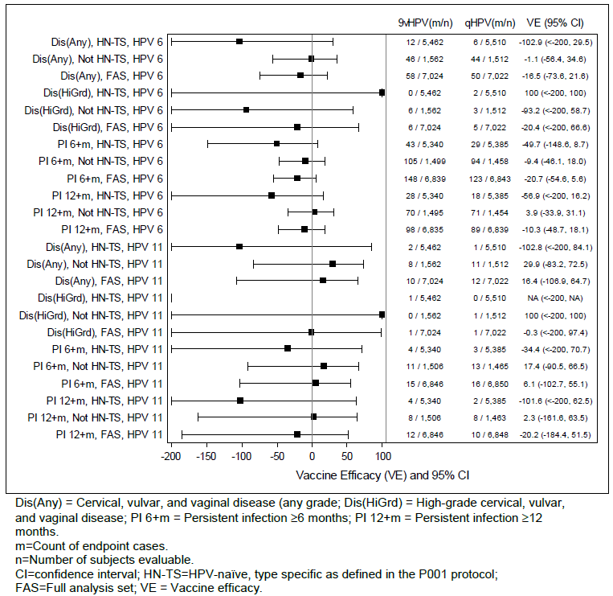
Table 25: Analysis of efficacy against HPV 6/11 related cervical, vulvar, and vaginal disease by HPV type (HPV-naïve type specific analysis population)
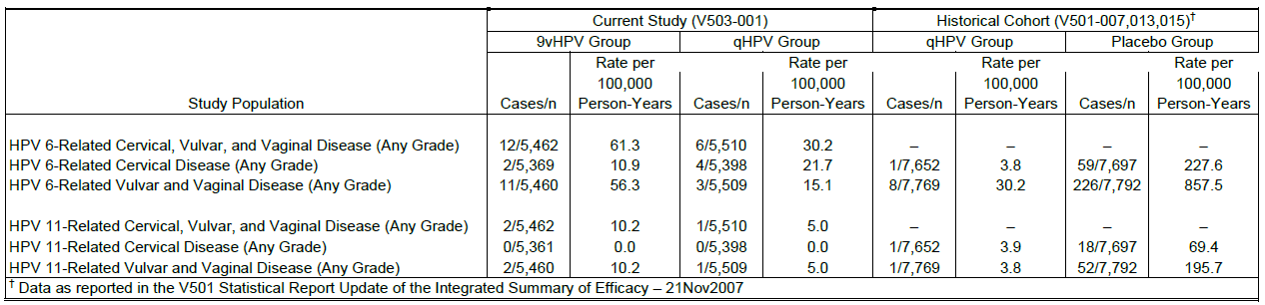

Results and interpretations

Results relating to HPV 6 related endpoints
The counts of HPV 6 related disease and persistent infection endpoints in the Not HN-TS subgroup of the FAS population were similar in the 9vHPV vaccine and qHPV vaccine groups (see Figure 6). Thus, any seemingly different incidences of HPV 6 related outcomes in the 9vHPV vaccine and qHPV vaccine groups of Protocol V503-001 are due to seemingly different incidences of HPV 6 related outcomes in the 9vHPV vaccine and qHPV vaccine groups in the HN-TS subgroup of the FAS population (see Figure 6).
- There is no adverse trend in HPV 11 related high-grade cervical, vulvar, and vaginal disease in the 9vHPV vaccine group (cases=0) compared to the qHPV vaccine group (cases=2) in the HN-TS subgroup of the V503-001 FAS population (see Figure 6).
- The seemingly adverse trend in HPV 11 related cervical, vulvar, and vaginal disease (any grade) in the 9vHPV vaccine group (cases=12) compared to the qHPV vaccine group (cases=6) in the HN-TS subgroup of the V503-001 FAS population is no adverse trend at all. As shown in Table 25, these endpoints break down into cervical diseases and vulvar and vaginal diseases as follows:
- 6 cases of HPV 6 related cervical disease (9vHPV vaccine = 2 cases; qHPV vaccine = 4 cases); the incidence rates (per 100,000 person-years) in both the 9vHPV vaccine (10.9) and qHPV vaccine (21.7) vaccine groups in V503-001 are comparable with the corresponding incidence rate in the qHPV vaccine group (3.8) of the V501 program, particularly in light of the background incidence rate in an unvaccinated population (227.6).
- 14 cases of HPV 6 related vulvar and vaginal disease (9vHPV vaccine = 11 cases; qHPV vaccine = 3 cases); the incidence rates (per 100,000 person-years) in both the 9vHPV vaccine (56.3) and qHPV vaccine (15.1) vaccine groups in V503-001 are comparable with the corresponding incidence rate in the qHPV vaccine group (30.2) of the V501 program, particularly in light of the background incidence rate in an unvaccinated population (857.5).
- As provided in the response to the previous question, the V503-001 CSR provides the likely explanation of why there were numerically greater numbers of cases of HPV 6 related persistent infection in the 9vHPV vaccine group compared to the qHPV vaccine group in the HN-TS subgroup of the FAS population. The numerically higher count of HPV 6 related persistent infection in the 9vHPV vaccine group compared to the qHPV vaccine group is not conclusively attributable as a negative effect of 9vHPV vaccine vaccination.

Results relating to HPV 11 related endpoints
The incidences of HPV 11 related disease and persistent infection were extremely low (see Figure 6). Separately within each of the HN-TS and the Not HN-TS subgroups of the FAS population, the counts of cases of HPV 11 related disease and persistent infection endpoints in the 9vHPV vaccine and qHPV vaccine groups in V503-001 differ by no more than 3 endpoint cases (see Figure 6). The incidence rate of HPV 11 related disease in the HN-TS subgroups in each of the 9vHPV vaccine and qHPV vaccine groups in the V503-001 study is similar to the corresponding incidence of qHPV vaccinated, HN-TS population in the V501 (Gardasil) program, and reflects the high prophylactic efficacy of both the 9vHPV and qHPV vaccines in preventing HPV 11 related disease compared to an unvaccinated HPV 11 naïve population (see Table 25).

Conclusion
There is no adverse trend in HPV 6 related and HPV 11 related disease and persistent infection outcomes in the 9vHPV vaccination group compared to the qHPV vaccination group in the V503-001 study.

Delegate question 4
The sponsor is requested to comment on the adverse trend in 6/11 related outcomes with 9vHPV vaccination compared to the control qHPV vaccine. The sponsor should provide a summary of how any change in patterns of HPV type-related occurrence of disease or changes in epidemiology of HPV Types will be captured during post market surveillance.
Sponsor’s response
As concluded in the response to the previous question, there is no adverse trend in HPV 6 related and HPV 11 related disease and persistent infection outcomes in the 9vHPV vaccination group compared to the qHPV vaccination group in the V503-P001 study. Importantly, as noted in the Delegate’s overview, the Vaccine Efficacy of Gardasil 9 against placebo for HPV 6/11 related cervical, vulvar and vaginal disease was 96.9%.
Any changes in patterns of HPV type related occurrence of disease or changes in epidemiology of HPV Types will be captured during post market surveillance. The sponsor will utilise routine pharmacovigilance to monitor receipt of adverse event reports for HPV types related outcomes (including 6 and 11) in recipients of the 9vHPV vaccine. These activities include ongoing individual report review and safety data review in aggregate for potential cases of vaccination failure. The final approved EU RMP (version 1.4) includes under missing information the hypothetical concern of ‘Viral type replacement’. This discusses how the impact of HPV type ecology and distribution over time will be monitored via Protocol V503-021 Nordic Long-Term Follow-Up Study (10-year extension of subjects from V503-001). The objective as stated in the RMP is to monitor the possibility of viral type replacement in the environment by monitoring for the occurrence of viral type replacement in the Nordic cohort of V503-001 study participants.
Delegate question 5
The sponsor is requested to comment on whether such study [in females aged over 26 years] is underway or planned for examining Vaccine Efficacy of 9vHPV vaccine in this population.
Sponsor’s response
A study of immunogenicity and tolerability in females aged 27 to 45 years [Protocol V503-004] has been agreed with the EMA as a post-licensure commitment in the EU.
The proposed study will be designed to provide immunobridging from 16 to 26 year old women to 27 to 45 year old women via demonstration of non-inferior antibody responses for the seven oncogenic vaccine HPV types of the 9vHPV vaccine. Approximately 600 women 16 to 26 years of age and 600 women 27 to 45 years of age will allow a rigorous assessment based on a 4 weeks post Dose 3 serum sample. Subjects will be followed in the study for a total duration of 7 months.
The proposed primary immunogenicity objective of the study will be to demonstrate that the 9vHPV vaccine induces non-inferior GMTs at Month 7 for the seven oncogenic vaccine HPV types in women 27 to 45 years of age compared with young women 16 to 26 years of age (the statistical criterion for non-inferiority will require that the lower bound of the two sided 95% confidence interval of GMT ratio [women 27 to 45 years vs. women 16 to 26 years] be greater than 0.5 for each HPV type). The proposed non-inferiority margin is based on previous results in the qHPV vaccine clinical program which showed that anti HPV antibody responses to the qHPV vaccine are lower in women 24 to 45 years of age than in women 16 to 26 years of age. Importantly, the qHPV vaccine is highly efficacious in preventing infection and disease due to vaccine HPV types in women 24 to 45 years of age. Thus, the lower immunogenicity in that population does not reflect a lower efficacy. The study is designed assuming a true GMT ratio [women 27 to 45 years versus women 16 to 26 years] of 0.7 for the seven oncogenic vaccine HPV types. With the planned sample size, the study will have approximately 90% power for the primary immunogenicity hypothesis.
Thus, the primary objective of the study is focused on the oncogenic types which represent the critical issue in women 27 to 45 years of age. Nonetheless, immunogenicity results for HPV 6 and HPV 11 will be analysed and presented descriptively; no non-inferiority testing will be conducted for these two HPV types.
In addition, the study will also include an evaluation of the safety profile of 9vHPV vaccine in all study participants.
No study of Vaccine Efficacy in females over 26 years of age is planned. The sponsor accepts the Delegate’s proposed qualifier to the proposed Indication with one minor clarification and a cross reference to the Clinical Trials section.
Delegate question 6
The sponsor is requested to provide clinical justification for the proposed statement in the PI ‘If the decision is made to administer Gardasil 9 after receiving 3 doses of Gardasil there should be an interval of at least 12 months between completion of vaccination with Gardasil and the start of vaccination with Gardasil 9 administered as a 3-dose regimen’
Sponsor’s response
Protocol V503-006, a safety and immunogenicity study of Gardasil 9 in prior recipients of a 3 dose series of Gardasil, was conducted anticipating that some individuals vaccinated with Gardasil may want to benefit from the extended protection offered by Gardasil 9. Thus, it seems valuable to mention results from that study in the PI since this may help health care providers with providing appropriate advice to their patients regarding revaccination.
An interval of 12 months between the last dose of Gardasil and the first dose of Gardasil 9 was mandated by the V503-006 study protocol. The goal was to exclude from the study subjects with high anti HPV titres (that is, close to the last vaccination with Gardasil) thereby ensuring that anti HPV 6/11/16/18 in all study participants had decreased to a plateau level and were relatively homogenous at enrolment across the study population. Based on available information, there is no reason to suspect that a shorter interval is not advisable. However, this was not studied. The applicant would propose at a minimum a statement in the PI indicating that in the study, there was an interval of at least 12 months between completion of vaccination with Gardasil and the start of vaccination with Gardasil 9 administered as a 3 dose regimen.
Taking into consideration the Delegate’s comments, the sponsor proposes to replace the above wording with the following statement:
“For information regarding administration of Gardasil 9 after receipt of Gardasil, see clinical trials Administration of Gardasil 9 to Individuals Previously Vaccinated with Gardasil”.

Sponsor’s response to issues raised by the Delegate for ACPM advice
The sponsor welcomes the Delegate’s recommendation to approve this application to register Gardasil 9 vaccine. Gardasil 9 is the ‘next generation’ of HPV vaccines, extending the prophylactic benefits of Gardasil by increasing the number of HPV Type antigens from four to nine.
This recombinant, 9 valent vaccine is prepared from the purified VLPs of the major capsid (L1) protein of nine HPV Types: the same HPV Types as contained in Gardasil (HPV Types 6, 11, 16 and 18), plus antigens from a further five oncogenic HPV Types (HPV Types 31, 33, 45, 52 and 58). By stimulating an immune response against a broader range of high risk HPV Types, Gardasil 9 has the potential to prevent a greater range of cancers and dysplasias than Gardasil, thus further reducing the health and economic burden of invasive procedures associated with treatment of these precancerous lesions.
Importantly, Australia has been at the forefront of delivery of Gardasil into the community; currently through a school based program as well as initially through a community based program. By any measure, the Government funded National HPV Vaccination program in Australia is highly successful and continues to lead the way in HPV immunisation and disease reduction. With the anticipated availability of Gardasil 9, Australia can continue to lead the way in the reduction of the burden of HPV infection and associated diseases.

Modification to indication
The proposed indications and populations for Gardasil 9 are the same as those currently approved for Gardasil. The advisory statement in the indication section has been modified from the original application at the request of the Delegate, as follows:
Gardasil 9 is indicated in females aged 9 through 45 years* for the prevention of cervical, vulvar, vaginal and anal cancer, precancerous or dysplastic lesions, genital warts, and infection caused by Human Papillomavirus (HPV) Types 6, 11, 16, 18, 31, 33, 45, 52 and 58 (which are included in the vaccine).
Gardasil 9 is indicated in males 9 through 26 years of age for the prevention of anal cancer, precancerous or dysplastic lesions, external genital lesions and infection caused by HPV Types 6, 11, 16, 18, 31, 33, 45, 52 and 58 (which are included in the vaccine).
* Evidence of vaccine efficacy is based on core efficacy population of females 16 to 26 years of age. Immunogenicity studies have been conducted to link efficacy in females aged 16 to 26 years to the younger populations (females and males 9 to 15 years of age). Currently there are no data from studies of Gardasil 9 relating to females over 26 years of age.”

Sponsor’s response to specific issues raised by the Delegate for ACPM advice
The Delegate has sought the advice of the ACPM Committee on the following issues:
- Is the clinical development program for Gardasil 9 adequate to support approval of Gardasil 9 for all current indications / populations for Gardasil?
Sponsor’s response
The sponsor considers the clinical development program adequate to support approval of Gardasil 9 for the requested indications and populations, being the same as those approved for Gardasil. The clinical program for Gardasil 9 takes as its foundation the existing body of data for Gardasil and its known utility in prevention of HPV related disease.
- The sponsor welcomes the Delegate’s position that extrapolation of indications for anal cancer, precancerous and dysplastic lesions is justifiable based on the real world experience with Gardasil and clinical trial efficacy data generated with Gardasil 9.
- Likewise, the sponsor welcomes extrapolation of indications to the populations with demonstrated similar immune responses (females and males aged 9 to 15, males aged 16 to 26). The Delegate has requested that the full report from Study V503-003 [immunogenicity and tolerability in males aged 16 to 26 years] be provided to the TGA in a future submission for a PI update. The sponsor intends to submit this study as a Category 1 application following registration.
- Finally the sponsor welcomes extrapolation to the population group of women over 26 years of age; a population that continues to be at risk of HPV acquisition and disease. Further consideration is given to this population in response to Question 3.
The four HPV Types in Gardasil (HPV 6, 11, 16 and 18) are responsible for approximately 70% of cervical cancers worldwide, and up to 85 to 90% of anal cancers. The five additional Types in Gardasil 9 (HPV 31, 33, 45, 52 and 58) are responsible for a further 20% of cervical cancers and 5 to 10% of anal cancers. Thus Gardasil 9 could help prevent infections leading to 90% of cervical cancers and 90 to 95% of anal cancers. Harmonisation of the indications for Gardasil 9 with those approved for Gardasil will deliver the full public health benefit of Gardasil 9 through prevention of transmission of oncogenic HPV Types 31, 33, 45, 52 and 58, and mitigate the risk of confusion among healthcare providers.
- Does the Committee support the sponsor’s proposed statement in the DandA section ‘If the decision is made to administer Gardasil 9 after receiving 3 doses of Gardasil, there should be an interval of at least 12 months between completion of vaccination with Gardasil and the start of vaccination with Gardasil 9 administered as a 3-dose regimen’ or recommend an alternative guidance?
Sponsor’s response
Taking into consideration the Delegate’s comments, the sponsor proposes to replace the above wording with the following statement:
“For information regarding administration of Gardasil 9 after receipt of Gardasil, see Clinical Trials; Administration of Gardasil 9 to Individuals Previously Vaccinated with Gardasil.”
When Gardasil 9 is introduced, Health Care Providers (HCPs) may seek advice on vaccination with Gardasil 9 to prior recipients of Gardasil. For this purpose, it would be useful to include a reference in the dosage and administration section of the PI to clinical study information on vaccination with Gardasil 9 in prior Gardasil recipients. The sponsor would also defer to the guidance of the relevant immunisation bodies for example Australian Technical Advisory Group on Immunisation (ATAGI).
- Does the Committee support the requirement for the sponsor to generate Vaccine Efficacy data in women > 26 years of age as a Condition of Registration?
Sponsor’s response
The sponsor agrees that the efficacy of Gardasil 9 can be extrapolated to women over 26 years of age based on the demonstrated efficacy in the younger female population. Efficacy can be validated via an immunobridging study, and therefore a vaccine efficacy study is not considered necessary and is not planned.
The sponsor accepts the Delegate’s proposed qualifier to the proposed indication, and suggests revisions for clarity with a cross reference to the Clinical Trials section as follows:
*Evidence of vaccine efficacy is based on core efficacy population of females 16 to 26 years of age. Immunogenicity studies have been conducted to link efficacy to younger populations (females and males 9 to 15 years of age). Currently there are no data from studies of Gardasil 9 relating to females over 26 years of age. (see; CLINICAL TRIALS, Clinical Trial for Gardasil 9, Immune Response to Gardasil 9 at Month 7 Across All Clinical Studies)
As a post licensure commitment in the EU, a study of immunogenicity, safety and tolerability in females aged 27 to 45 years [Protocol V503-004] has been agreed by Sanofi Pasteur-MSD with the EMA. The proposed study will be designed to provide immunobridging data from 16 to 26 year old women to 27 to 45 year-old women via demonstration of non-inferior antibody responses for the seven oncogenic vaccine HPV types of Gardasil 9 vaccine. Vaccination of approximately 600 women 16 to 26 years of age and 600 women 27 to 45 years of age will allow a rigorous assessment of response based on a 4 weeks post Dose 3 serum sample. Subjects are expected to be followed in the study for a total duration of 7 months.
The proposed primary immunogenicity objective of the study will be to demonstrate that the Gardasil 9 vaccine induces non-inferior GMTs at Month 7 for the seven oncogenic vaccine HPV Types in women 27 to 45 years of age compared with young women 16 to 26 years of age (the statistical criterion for non-inferiority required that the lower bound of the two sided 95% confidence interval of GMT ratio [women 27 to 45 years versus women 16 to 26 years] be greater than 0.5 for each HPV Type). The proposed non-inferiority margin is based on previous results in the Gardasil clinical program which showed, as expected, that anti HPV antibody responses to Gardasil are lower in women 24 to 45 years of age than in women 16 to 26 years of age (immune responses tend to be highest in younger populations). Importantly, Gardasil remains highly efficacious in preventing infection and disease due to vaccine HPV Types in women 24 to 45 years of age, demonstrating that lower immunogenicity in that population does not reflect a lower efficacy response. The proposed study design assumes a true GMT ratio [women 27 to 45 years versus women 16 to 26 years] of 0.7 for the seven oncogenic vaccine HPV Types. With the planned sample size, the study will have approximately 90% power for the primary immunogenicity hypothesis.
Thus, the primary objective of the study is focused on the oncogenic Types which represent a critical issue in women 27 to 45 years of age. Additionally, immunogenicity results for HPV 6 and HPV 11 will be analysed and presented descriptively; non-inferiority testing will not be conducted for these two HPV Types. In addition, the study will also include an evaluation of the safety profile of Gardasil 9 in all study participants.
The use of Gardasil in women over 26 years of age is well characterised and was well tolerated in clinical trials. In addition, no significant safety signals have been identified in post-marketing experience over eight years of use in Australia since its introduction on the school based NIP in April 2007 (and private market sales commencing July 2006). Based on the safety and tolerability profile of Gardasil 9 in clinical trials with females and males aged 16 to 26 years, it is anticipated that the safety profile in older subjects will be comparable.
Differences in baseline exposure to HPV between women over 26 and the younger populations are to be expected. However Gardasil 9 is likely to have more incremental benefit in this population than other HPV vaccines as Gardasil 9 contains antigens for seven high risk oncogenic HPV Types as opposed to two. It is unlikely that an individual would have been exposed to all nine HPV Types contained in the vaccine.
Women aged 27 through 45 years are at continuing risk of acquiring genital HPV infection. The sponsor acknowledges that immune responses tend to be higher in younger populations; however limiting the use of Gardasil 9 in women over 26 years denies access to a prophylactic vaccine at a time of life when it would still be valuable.
- Would the Committee like the TGA to obtain any further information or additional analyses of the data in this dossier from the sponsor prior to finalisation of this submission?
Sponsor’s response
The sponsor believes the analyses presented in the dossier are sufficient to support registration.
- The PPE dataset is considered sufficient. Estimates of vaccine efficacy in the PPE population provide unambiguous measures of prophylactic benefit of vaccination among those who are not yet infected with particular HPV Types at the time of vaccination.
- The approach of providing the per protocol dataset in the PI is in alignment with the approved US and Canadian labels, and the proposed European label (which has received a positive CHMP opinion).
This is further expanded in the sponsor responses to the issues raised by the Delegate 2, 3 and 4, outlining full analysis set (FAS) sub-analyses of the pivotal registration Study V503-P001. As discussed in the response, it is the sponsor’s belief that the results in the FAS population may not be of value and could result in confusion for the provider if included in the PI. Importantly, a person may be infected with one, two, or three HPV Types, but very rarely infected with all nine HPV Types included in the 9 valent vaccine. HPV vaccination has the potential to provide prophylactic prevention of disease and infection against those HPV Types to which a person has not been exposed, with very high efficacy.
- Does the Committee recommend any additional activities in the post-market phase for inclusion in the RMP/ASA.
Sponsor’s response
The sponsor does not recommend any additional activities in the post-market phase for inclusion in the RMP/ ASA. The sponsor considers version 1.4 of the EU RMP (the final approved EU RMP, dated 20th March 2015) and accompanying ASA v0.2 (dated 9th April 2015) to be sufficient.
The sponsor welcomes the Delegate’s positive commentary regarding the safety profile of Gardasil 9, and the Clinical Evaluator’s opinion that the risk-benefit balance of Gardasil 9 is favourable given the proposed usage. We acknowledge that the clinical trial dataset collected thus far may not identify rare adverse effects or long term safety concerns, and welcome the opportunity to include post marketing experience from Gardasil in the Gardasil 9 PI.
The risk benefit profile for Gardasil 9 is considered to be favourable. Whilst there may be higher reactogenicity with Gardasil 9 relative to Gardasil, injection site reactions observed in clinical trials were mild or moderate in intensity and the frequency of severe injection site reactions was low. The benefits relative to Gardasil are enhanced by the additional HPV Types. Therefore we do not believe this necessitates additional risk management beyond that in place for Gardasil and specified in the Gardasil 9 RMP.
The sponsor considers the current RMP to be sufficiently robust in addressing the identified and potential safety issues as well as missing information. The following activities have been included in addition to routine pharmacovigilance and risk minimization measures:
- A US-based pregnancy registry
- V503-021 Nordic Long-Term Follow-Up Study (10 year extension in subjects from V503-001)
- V503-002-20 Adolescent Long-term Follow-Up Study (10year post Dose 3 extension)
- A post-marketing immunogenicity and safety study of Gardasil 9vaccine in women 27 to 45 years of age in Europe
- A general Post Authorisation Safety Study is planned
Other matters
On 26th March 2015, the EU CHMP issued a positive opinion for approval of Gardasil 9 for the same indications and population as sought in Australia. The EMA decision on registration is due on 1st June 2015 and the outcome of this will be communicated to the TGA ahead of the ACPM meeting on 5th June 2015.
Summary
This application seeks to apply the current TGA approved Gardasil indications to Gardasil 9, based on data previously evaluated in support of Gardasil and additional clinical data presented in this dossier specific to Gardasil 9. The proposed indication, incorporating the Delegate’s and sponsors recommended revisions, is presented below
Gardasil 9 is indicated in females aged 9 through 45 years* for the prevention of cervical, vulvar, vaginal and anal cancer, precancerous or dysplastic lesions, genital warts, and infection caused by Human Papillomavirus (HPV) Types 6, 11, 16, 18, 31, 33, 45, 52 and 58 (which are included in the vaccine).
Gardasil 9 is indicated in males 9 through 26 years of age for the prevention of anal cancer, precancerous or dysplastic lesions, external genital lesions and infection caused by HPV Types 6, 11, 16, 18, 31, 33, 45, 52 and 58 (which are included in the vaccine).
* Evidence of vaccine efficacy is based on core efficacy population of females 16 to 26 years of age. Immunogenicity studies have been conducted to link efficacy to the younger populations (females and males 9 to 15 years of age). Currently there are no data from studies of Gardasil 9 relating to females over 26 years of age.
Conclusion
In conclusion, MSD agrees with the Delegate that sufficient data have been generated for the new vaccine Gardasil 9 to support its proposed use. We trust that the Committee will concur with the Delegate and recommend approval of Gardasil 9 Human Papillomavirus 9 valent vaccine for the same Indications as those currently approved for Gardasil.

Advisory Committee considerations
The Advisory Committee on Prescription Medicines (ACPM), having considered the evaluations and the Delegate’s overview, as well as the sponsor’s response to these documents, advised the following:
The ACPM, taking into account the submitted evidence of efficacy, safety and quality, agreed with the delegate and considered Gardasil 9 Solution for injection in pre-filled syringe containing 0.5 mL of Human Papillomavirus 9 valent vaccine, recombinant L1 protein Types 6/11/16/18/31/33/45/52/58 to have an overall positive benefit–risk profile for the indication;
Gardasil 9 is indicated in females aged 9 through 45 years* of age for the prevention of cervical, vulvar, vaginal and anal cancer, precancerous or dysplastic lesions, genital warts, and infection caused by Human Papillomavirus (HPV) Types 6, 11, 16, 18, 31, 33, 45, 52 and 58 (which are included in the vaccine).
Gardasil 9 is indicated in males 9 through 26 years of age for the prevention of anal cancer, precancerous or dysplastic lesions, external genital lesions and infection caused by HPV Types 6, 11, 16, 18, 31, 33, 45, 52 and 58 (which are included in the vaccine).
*Evidence of vaccine efficacy is based on core efficacy population of females 16 to 26 years of age. Immunogenicity studies have been conducted to link efficacy to younger populations (females and males 9 to 15 years of age). Currently there are no data from studies of Gardasil 9 relating to females over 26 years of age (see “CLINICAL TRIALS - Clinical Studies for Gardasil 9 Immune Response to Gardasil 9 at Month 7 Across All Clinical Studies”).

Proposed conditions of registration
The ACPM agreed with the delegate on the proposed conditions of registration.

Proposed Product Information (PI)/Consumer Medicine Information (CMI) amendments
The ACPM agreed with the delegate to the proposed amendments to the PI and CMI.

Specific advice
The ACPM advised the following in response to the delegate’s specific questions on this submission:
- Is the clinical development program for Gardasil 9 adequate to support approval of Gardasil 9 for all current indications/populations of Gardasil?
The ACPM noted that the primary clinical outcomes of the pivotal trial 001 were similar to the trials for Gardasil (4vHPV) in females 16 to 26 years of age and advised that the clinical development program was appropriate to support approval for all current indications/populations of Gardasil.
- Does the Committee support the sponsor’s proposed statement in Dose and Administration section (‘If the decision is made to administer Gardasil 9 after receiving 3 doses of Gardasil, there should be an interval of at least 12 months between completion of vaccination with Gardasil and the start of vaccination with Gardasil 9 administered as a 3 dose regimen’) or recommend an alternative guidance?
The ACPM noted the sponsor’s pre-ACPM response stating that the proposed wording regarding previous vaccination with Gardasil will be replaced with the following: “For information regarding administration of Gardasil 9 after receipt of Gardasil, see CLINICAL TRIALS Administration of Gardasil 9 to Individuals Previously Vaccinated with Gardasil.” The ACPM advised that this was appropriate.
- Does the committee support the requirement for the sponsor to generate vaccine efficacy data in women > 26 years of age as a condition of registration?
The ACPM noted that Gardasil (4vHPV) is known to have lower vaccine effectiveness in women if already sexually active and that there is no current recommendation in adult females older than 45 years of age. However, it is acknowledged that individual benefit may be possible. The sponsor’s pre-ACPM response indicated that as a post licensure commitment in the EU, a study of immunogenicity, safety and tolerability in females aged 27 to 45 years [Protocol V503-004] had been agreed by Sanofi Pasteur-MSD with the EMA, which is designed to provide immunobridging data from 16 to 26 year old women to 27 to 45 year old women. The ACPM considered this acceptable. The ACPM further noted that vaccine efficacy data in MSM and immuno-compromised populations could be useful.
- Would the Committee like the TGA to obtain any further information or additional analyses of the data in this dossier from the sponsor prior to finalisation of this submission?
The ACPM noted that long term data are proposed for collection during the post-market phase and considered this acceptable.
- Does the Committee recommend any additional activities in the post-market phase for inclusion in the RMP/ASA?
The ACPM noted that there is significant experience with Gardasil which is reassuring and advised that the RMP/ASA were satisfactory.
The ACPM advised that implementation by the sponsor of the recommendations outlined above to the satisfaction of the TGA, in addition to the evidence of efficacy and safety provided would support the safe and effective use of this product.

Outcome
Based on a review of quality, safety and efficacy, TGA approved the registration of Gardasil 9 Human Papillomavirus 9 valent Vaccine, Recombinant 30, 40, 60, 40, 20, 20, 20, 20, 20, micrograms/0.5 mL, suspension for injection syringe or vial, indicated for:
Gardasil 9 is indicated in females aged 9 through 45 years* of age for the prevention of cervical, vulvar, vaginal and anal cancer, precancerous or dysplastic lesions, genital warts, and infection caused by Human Papillomavirus (HPV) Types 6, 11, 16, 18, 31, 33, 45, 52 and 58 (which are included in the vaccine).
Gardasil 9 is indicated in males 9 through 26 years of age for the prevention of anal cancer, precancerous or dysplastic lesions, external genital lesions and infection caused by HPV Types 6, 11, 16, 18, 31, 33, 45, 52 and 58 (which are included in the vaccine).
*Evidence of vaccine efficacy is based on core efficacy population of females 16 to 26 years of age. Immunogenicity studies have been conducted to link efficacy to younger populations (females and males 9 to 15 years of age). Currently there are no data from studies of Gardasil 9 relating to females over 26 years of age (see “CLINICAL TRIALS - Clinical Studies for Gardasil 9 Immune Response to Gardasil 9 at Month 7 Across All Clinical Studies”).

Specific conditions of registration applying to these goods
- The Risk Management Plan (RMP) for Gardasi19 (Human Papillomavirus 9-Valent Vaccine, Recombinant) Solution for Injection: Risk Management Plan Version in EU-RMP format Version 1.0 (dated 9Ianuary 2014, DLP 26 Iuly 2013) and Australian Specific Annex (dated May 2014) included with submission PM-2014-01099-I-2, and any subsequent revisions, as agreed with the TGA will be implemented in Australia.
- Batch Release Testing: It is a condition of registration that all independent batches of Gardasi19 Vaccine imported into Australia are not released for sale until samples and/or the manufacturer's release data have been assessed and endorsed for release by the TGA Laboratories Branch (LB).

Attachment 1. Product Information
The PI for Gardasil 9 approved with the submission which is described in this AusPAR is at Attachment 1. For the most recent PI, please refer to the TGA website at <https://www.tga.gov.au/product-information-pi>.

Attachment 2. Extract from the Clinical Evaluation Report

Therapeutic Goods Administration
PO Box 100 Woden ACT 2606 Australia
Email: info@tga.gov.au Phone: 1800 020 653 Fax: 02 6232 8605
https://www.tga.gov.au

Reverberi, R. The statistical analysis of immunohaematological data. Blood Transfus.2008; 6: 37-45.
CPMP/SWP/465/95 Note for Guidance on Preclinical Pharmacological and Toxicological Testing of Vaccines
Gonçalves, A. K., et al. Safety, tolerability and side effects of human papillomavirus vaccines: a systematic quantitative review. Braz. J. Infect. Dis. 2014; 18: 651-659.
WHO; Guidelines on Nonclinical Evaluation of Vaccines
Lee, S.M., et al. Risk of vertical transmission of human papillomavirus throughout pregnancy: a prospective study. PLoS One 2013; 8: e66368
Syrjänen, S. Current concepts on human papillomavirus infections in children. APMIS. 2010; 118: 494-509
Syrjänen, S., Puranen, M. Human papillomavirus infections in children: the potential role of maternal transmission. Crit. Rev. Oral. Biol. Med. 2000; 11: 259-274.
Pregnancy classification B2 is defined as: Drugs which have been taken by only a limited number of pregnant women and women of childbearing age, without an increase in the frequency of malformation or other direct or indirect harmful effects on the human fetus having been observed. Studies in animals are inadequate or may be lacking, but available data show no evidence of an increased occurrence of fetal damage.
Pregnancy classification B1 is defined as Drugs which have been taken by only a limited number of pregnant women and women of childbearing age, without an increase in the frequency of malformation or other direct or indirect harmful effects on the human fetus having been observed. Studies in animals have not shown evidence of an increased occurrence of fetal damage.
Reverberi, R. The statistical analysis of immunohaematological data. Blood Transfus. 2008; 6: 37-45.
F0 is the parent generation (Filial)
F1 generation, offspring of the F0 generation
Brotherton JML, et al. Early effect of the HPV vaccination programme on cervical abnormalities in Victoria, Australia: an ecological study. Lancet 2011;377:2085-2092.
Tabrizi SN, et al. Fall in human papillomavirus prevalence following a national vaccination program. JID 2012;206:1645-1651.
Bauer HM, et al. Evidence of human papillomavirus vaccine-effectiveness in reducing genital warts: an analysis of California public family planning administrative claims data, 2007-2010. Am J Public Health 2012:e1-e3.
Garland SM, et al. Adolescent and young adult HPV vaccination in Australia: achievements and challenges. Prev Med 2011;53:S29-S35
Read TRH, et al The near disappearance of genital warts in young women 4 years after commencing a national human papillomavirus (HPV) vaccination programme. Sex Transm Infect 2011;87:544-547
Giuliano AR, et al. Efficacy of quadrivalent HPV vaccine against HPV infection and disease in males. N Engl J Med 2011;364(5):401-411
De Sanjose S, et al. Human papillomavirus genotype attribution in invasive cervical cancer: a retrospective cross-sectional worldwide study. Lancet Oncol 2010;11:1048-1056
http://www.ema.europa.eu/ema/index.jsp?curl=pages/medicines/pips/EMEA-000654-PIP01-09-M02/pip_000432.jsp&mid=WC0b01ac058001d129, accessed 12/09/2014.
PCR = Polymerase Chain Reaction
Gardasil Protocol V501-031-02. “A Post-Licensure Surveillance Program for the Safety of Gardasil in a Managed Care Organization Setting”
Chao C, et al. (2012) Surveillance of autoimmune conditions following routine use of quadrivalent human papillomavirus vaccine. J Intern Med 2012;271:193-203.
Chao C, Jacobsen S. () Evaluation of autoimmune safety signal in observational vaccine safety studies. Human Vaccines and Immunotherapeutics 2012; 8:1-3.
Grimaldi-Bensouda L et al Autoimmune disorders and quadrivalent human papillomavirus vaccination of young female subjects [Protocol GDS03E: Analysis of Gardasil and Autoimmune Disorders using the PGRx Information System, PGRx-AID Study Group]. J Intern Med. 2013;275:398-408
Arnheim-Dahlstrom et al. (2013) “Autoimmune,neurological, and venous thromboembolic adverse events after immunization of adolescent girls with quadrivalent human papillomavirus vaccine in Denmark and Sweden: cohort study” BMJ. 2013;347:f5906.
Langer-Gould et al. (2014) Vaccines and the Risk of MS and other CNS Demyelinating Diseases. JAMA Neurology. Online October 20, 2014
Scheller, NM et al (2015) Quadrivalent HPV Vaccination and Risk of Multiple Sclerosis and other Demyelinating Diseases of the CNS. JAMA Vol 313, No.1, January 6, 2015.
Slade BA, et al. Postlicensure safety surveillance for quadrivalent human papillomavirus recombinant vaccine. JAMA 2009, 302:750–757.
Gee J, et al. Monitoring the safety of quadrivalent human papillomavirus vaccine: findings from the Vaccine Safety Datalink. Vaccine 2011; 29:8279–8284.
Arnheim-Dahlström L et al. Autoimmune, neurological, and venous thromboembolic adverse events after immunisation of adolescent girls with quadrivalent human papillomavirus vaccine in Denmark and Sweden: cohort study. 2013 BMJ 347:f5906.
Souayah N1 et al. Guillain-Barré syndrome after Gardasil vaccination: data from Vaccine Adverse Event Reporting System 2006-2009.Vaccine 2011; 29:886–889.
J Horvath. Review of the management of adverse events associated with Panvax and Fluvax http://immunise.health.gov.au/internet/immunise/publishing.nsf/Content/adverse-event
Luxembourg A. et al. Phase II studies to select the formulation of a multivalent HPV L1 virus-like particle (VLP) vaccine. Hum Vaccin Immunother 2015 Apr 27 (Epub ahead of print).
Chen YH, et al. A seamless phase IIB/III adaptive outcome trial: design rationale and implementation challenges. Clin Trials 2015; 12:84-90

