June 2021

Australian Public Assessment Report for Human normal immunoglobulin
  - Proprietary Product Name: Cutaquig
  - Sponsor: Octapharma Australia Pty Ltd

About the Therapeutic Goods Administration (TGA)
- The Therapeutic Goods Administration (TGA) is part of the Australian Government Department of Health and is responsible for regulating medicines and medical devices.
- The TGA administers the Therapeutic Goods Act 1989 (the Act), applying a risk management approach designed to ensure therapeutic goods supplied in Australia meet acceptable standards of quality, safety and efficacy (performance) when necessary.
- The work of the TGA is based on applying scientific and clinical expertise to decision-making, to ensure that the benefits to consumers outweigh any risks associated with the use of medicines and medical devices.
- The TGA relies on the public, healthcare professionals and industry to report problems with medicines or medical devices. TGA investigates reports received by it to determine any necessary regulatory action.
- To report a problem with a medicine or medical device, please see the information on the TGA website <https://www.tga.gov.au>.

About AusPARs
- An Australian Public Assessment Report (AusPAR) provides information about the evaluation of a prescription medicine and the considerations that led the TGA to approve or not approve a prescription medicine submission.
- AusPARs are prepared and published by the TGA.
- An AusPAR is prepared for submissions that relate to new chemical entities, generic medicines, major variations and extensions of indications.
- An AusPAR is a static document; it provides information that relates to a submission at a particular point in time.
- A new AusPAR will be developed to reflect changes to indications and/or major variations to a prescription medicine subject to evaluation by the TGA.

Copyright
© Commonwealth of Australia 2021
This work is copyright. You may reproduce the whole or part of this work in unaltered form for your own personal use or, if you are part of an organisation, for internal use within your organisation, but only if you or your organisation do not use the reproduction for any commercial purpose and retain this copyright notice and all disclaimer notices as part of that reproduction. Apart from rights to use as permitted by the Copyright Act 1968 or allowed by this copyright notice, all other rights are reserved and you are not allowed to reproduce the whole or any part of this work in any way (electronic or otherwise) without first being given specific written permission from the Commonwealth to do so. Requests and inquiries concerning reproduction and rights are to be sent to the TGA Copyright Officer, Therapeutic Goods Administration, PO Box 100, Woden ACT 2606 or emailed to <tga.copyright@tga.gov.au>.

Contents
List of abbreviations 4
I. Introduction to product submission 6
Submission details 6
Product background 7
Regulatory status 8
Product Information 9
II. Registration timeline 9
III. Submission overview and risk/benefit assessment 10
Quality 10
Nonclinical 11
Clinical 11
Risk management plan 20
Risk-benefit analysis 21
Outcome 22
Attachment 1. Product Information 23

List of abbreviations
Abbreviation | Meaning
ACM | Advisory Committee on Medicines
AE | Adverse event
ARTG | Australian Register of Therapeutic Goods
ASA | Australia Specific annex
AUC_{IV} | Area under the concentration time curve following IVIg to the switch to Octanorm
AUC_{SC2} | Area under the concentration time curve after the 28th infusion of Octanorm
AUC_{τ} | Area under the concentration time curve (where τ is the dosing interval)
C_{avg} | Mean average plasma concentration
CHMP | Committee for Medicinal Products for Human Use (European Union)
CHQ-PF50 | Child Health Questionnaire, Parent Form 50
CI | Confidence interval
CLL | Chronic lymphocytic leukaemia
C_{max} | Maximum plasma concentration
CMI | Consumer Medicines Information
C_{min} | Minimum plasma concentration
CPD | Certified Product Details
CVID | Common variable immunodeficiency
DLP | Data lock point
EMA | European Medicines Agency (European Union)
EU | European Union
GVP | Good Pharmacovigilance Practice(s)
HBsAg | Hepatitis B surface antigen
HBV | Hepatitis B virus
HSCT | Haematopoietic stem cell transplantation
IgG | Immunoglobulin-G
IGSC | Immune globulin solution for subcutaneous infusion
IVIg | Intravenous immunoglobulin
MM | Multiple myeloma
SCIg | Subcutaneous immunoglobulin
PY | Per person per year
pH | Potential of hydrogen
PK | Pharmacokinetic(s)
PK_{IV} | PK following IVIg to the switch to Octanorm
PK_{SC1} | PK after the eleventh infusion of Octanorm
PK_{SC2} | PK after the twenty-eighth infusion of Octanorm
PI | Product Information
PID | Primary immunodeficiency disease(s)
PSUR | Periodic safety update report
RMP | Risk management plan
RSV | Respiratory syncytial virus
SAE | Serious adverse event
SBI | Serious bacterial infections
SID | Secondary immune deficiency
TEAE | Treatment-emergent adverse event
TGA | Therapeutic Goods Administration
T_{max} | Time at maximum concentration
TNBP | Tri(n-butyl)phosphate
USA | United States of America

I. Introduction to product submission

Submission details
Type of submission: | New biological entity
Product name: | Cutaquig
Active ingredient: | Human normal immunoglobulin (human immunoglobulin G)
Decision: | Approved
Date of decision: | 21 April 2021
Date of entry onto ARTG: | 3 May 2021
ARTG numbers: | 333120, 333121, 333122, 333123, 333124, 333125
Black Triangle Scheme: | Yes  This product will remain in the scheme for 5 years, starting on the date the product is first supplied in Australia
Sponsor’s name and address: | Octapharma Australia Pty Ltd  Jones Bay Wharf, 42/26-32 Pirrama Road,  Pyrmont NSW 2009
Dose form: | Solution for subcutaneous injection
Strengths: | 16.5% (165 mg/mL) solution available as 8 g/48 mL, 3.3 g/20 mL, 4 g/24 mL, 1 g/6 mL, 2 g/12 mL or 1.65 g/10 mL
Container: | Vial
Pack sizes: | 1, 10 or 20
Approved therapeutic use: | Replacement therapy in adults and children in:  • Primary immunodeficiency diseases (PID)  • Symptomatic hypogammaglobulinaemia secondary to underlying disease or treatment
Route of administration: | Subcutaneous injection
Dosage: | Replacement therapy should be initiated under the supervision of a healthcare professional experienced in the treatment of immunodeficiency.  In replacement therapy the dosage may need to be individualised for each patient dependent on the pharmacokinetic and clinical response.  For further information regarding dosage, refer to the Product Information.
Pregnancy category: | This therapeutic good is exempted from pregnancy categorisation.  The use of any medicine during pregnancy requires careful consideration of both risks and benefits by the treating health professional. This must not be used as the sole basis of decision making in the use of medicines during pregnancy. The TGA does not provide advice on the use of medicines in pregnancy for specific cases. More information is available from obstetric drug information services in your State or Territory.

Product background
This AusPAR describes the application by Octapharma Australia Pty Ltd (the sponsor) to register Cutaquig (human normal immunoglobulin) 16.5% (165 mg/mL), solution for subcutaneous injection for the following proposed indication:
Replacement therapy in adults and children in:
• Primary immunodeficiency diseases (PID)
• Symptomatic hypogammaglobulinaemia secondary to underlying disease or treatment
Primary immunodeficiency diseases (PID) are a heterogeneous group of disorders characterised by hypogammaglobulinemia usually due to a genetic defect. The clinical manifestations are related to increased susceptibility to infections starting early in life.
Replacement therapy with polyclonal, human normal immunoglobulin (immunoglobulin G (IgG)) given intravenously or subcutaneously are the mainstay of treatment in PID. The intramuscular route is not often used. There are no viable alternative treatments in PID.
For most patients, replacement therapy is a lifelong requirement. The goal of repeated therapy is to maintain IgG levels within the normal physiological range. Replacement therapy aims to reduce frequency and severity of infections and thus improve life expectancy, although patients remain susceptible to breakthrough infections.
The use of IgG therapy is variable in secondary forms of immune deficiencies.
Human normal immunoglobulin products principally contain IgG obtained from pooled human donations. The distribution of IgG subclasses in the manufactured product is similar to that in the human plasma. IgG have a broad spectrum of activity against bacterial infections.
Subcutaneous immunoglobulin (SCIg) and intravenous immunoglobulin (IVIg) preparations are therapeutically equivalent. The main difference is prolonged absorption at a slower rate with the SCIg as it requires transit from subcutaneous tissues to blood via lymphatics, with the blood IgG levels increasing gradually over 48 to 72 hours after administration. Some degradation of IgG occurs locally in subcutaneous tissues so that the absolute bioavailability of SCIg is lower than IVIg. Other than in the subcutaneous tissues, the metabolism of IgG takes place in the reticuloendothelial system.
A fixed dosing regimen is not defined and clinical practice is instead targeted towards maintaining serum IgG levels in the normal range above 5 to 6 g/L.
However, even adequate treatment may not fully prevent breakthrough infections, and progression of diseases and disease complication such as bronchiectasis remain prevalent risks in PID patients.

Regulatory status
This product is considered a new biological entity for Australian regulatory purposes.
At the time the TGA considered this application, similar applications had been approved in the European Union (EU) (approved on 25 February 2019), United States of America (USA) (approved on 12 December 2018) and Canada (approved on 15 February 2018).
Table 1, shown below, summarises these applications and provides the indications where approved.
Table 1: International regulatory status
Region | Submission date | Status | Approved indications
European Union | 5 July 2017 | Approved on 25 February 2019 | Replacement therapy in adults, children and adolescents (0-18 years) in  - Primary immunodeficiency (PID) syndromes with impaired antibody production (see Section 4.4).  - Hypogammaglobulinaemia and recurrent bacterial infections in patients with chronic lymphocytic leukaemia (CLL), in whom prophylactic antibiotics have failed or are contra-indicated.  - Hypogammaglobulinaemia and recurrent bacterial infections in multiple myeloma (MM) patients.  - Hypogammaglobulinaemia in patients pre- and postallogeneic haematopoietic stem cell transplantation (HSCT).
United States of America | 29 December 2017 | Approved on 12 December 2018 | Cutaquig (immune globulin subcutaneous (human) - hipp) is a 16.5% immune globulin solution for subcutaneous infusion (IGSC), indicated as replacement therapy for primary humoral immunodeficiency (PI)* in adults. This includes, but is not limited to, common variable immunodeficiency (CVID), X-linked agammaglobulinemia, congenital agammaglobulinemia, Wiskott-Aldrich syndrome, and severe combined immunodeficiencies.
Canada | 28 February 2017 | Approved on 15 February 2018 | Cutaquig is indicated for the treatment of patients with primary immune deficiency (PID) and secondary immune deficiency (SID) who require immune globulin replacement therapy.
*Note: The use of the abbreviation ‘PI’ in this table stands for primary humoral immunodeficiency. Except in Table 1and Table 4, the use of the abbreviation ‘PI’ in other sections of the AusPAR stands for Product Information.

Product Information
The Product Information (PI) approved with the submission which is described in this AusPAR can be found as Attachment 1. For the most recent PI, please refer to the TGA website at <https://www.tga.gov.au/product-information-pi>.

II. Registration timeline
The following table captures the key steps and dates for this application and which are detailed and discussed in this AusPAR.
Table 2: Timeline for Submission PM-2020-00473-1-2
Description | Date
Submission dossier accepted and first round evaluation commenced | 30 April 2020
First round evaluation completed | 30 September 2020
Sponsor provides responses on questions raised in first round evaluation | 30 November 2020
Second round evaluation completed | 12 January 2021
Delegate’s Overall benefit-risk assessment | 25 March 2021
Sponsor’s pre-Advisory Committee response | Not applicable
Advisory Committee meeting | Not applicable
Registration decision (Outcome) | 21 April 2021
Completion of administrative activities and registration on the ARTG | 3 May 2021
Number of working days from submission dossier acceptance to registration decision* | 199
*Statutory timeframe for standard applications is 255 working days

III. Submission overview and risk/benefit assessment
The submission was summarised in the following Delegate’s overview and recommendations.
The following guidelines or guidance documents are of relevance to the submission:
- European Medicines Agency (EMA), Committee for Medicinal Products for Human Use (CHMP), Guideline on The Clinical Investigation of Human Normal Immunoglobulin for Subcutaneous and/or Intramuscular Administration (SCIg/IMIg), EMA/CHMP/BPWP/410415/2011 rev 1, 23 July 2015.
- U.S. Department of Health and Human Services, Food and Drug Administration, Center for Biologics Evaluation and Research, Guidance for Industry: Safety, Efficacy, and Pharmacokinetic Studies to Support Marketing of Immune Globulin Intravenous (Human) as Replacement Therapy for Primary Humoral Immunodeficiency, June 2008.

Quality
Cutaquig is a SCIg product that was developed based on the manufacturing process of IVIg Octagam. The active component, IgG, is purified from human plasma. In the product, > 95% of total protein is IgG. The final product contains residues of other plasma proteins. The content of IgA is not more than 0.6 mg/mL.
The manufacturing process briefly involves plasma is thawed and pooled and may then be depleted of vitamin K-dependent coagulation factors. Heparin is removed. Precipitation followed by separation of fraction I + II + III then takes place. Fraction I + II + III is then reconstituted and fraction I + III is precipitated and separated, followed by precipitation and separation of fraction II. Fraction II paste is the starting material for the production IgG products. Fraction II is concentrated by ultrafiltration. Viruses are inactivated by the addition of octoxynol and tri(n-butyl)phosphate (TNBP). The virus inactivation reagents are then removed by the addition of castor oil and then filtration. The solution is concentrated by ultrafiltration. The final solution is prepared by the addition of a polysorbate 80/maltose solution, followed by filtration.
There are no objections to registration of Cutaquig from a quality perspective.

Nonclinical
The nonclinical dossier contained in vivo studies on primary pharmacology, safety pharmacology and local tolerance, as well as previously reviewed toxicity and pharamacokinetic studies of impurities, TNBP and octoxinol-9 (also known as Triton X-100).
One pharmacodynamic study in a mouse sepsis model showed that subcutaneous administration of Cutaquig prevented or reduced mortality against infection with Streptococcus pneumoniae, in a dose dependent manner.
A safety pharmacology study in dogs showed that subcutaneous administration of 500 mg/kg Cutaquig had no effects on blood pressure or electrocardiogram parameters with no potential for QT interval; prolongation. A study in rabbits with two batches of Cutaquig when intravenous administered via a single bolus injection showed no thrombogenic effects.
No significant treatment-related local reactions were observed at the injection site following subcutaneous administration of Cutaquig in rabbits.
The proposed levels of residual impurities, TNBP and octoxinol-9 in Cutaquig are comparable to levels in approved IgG products and are toxicologically acceptable.
There are no nonclinical objections to the registration of Cutaquig.
The PI; should be amended under Use in pregnancy by addition of a sentence: ‘animal reproductive studies have not been conducted with Cutaquig’.

Clinical
The clinical dossier is based on a single pivotal Phase III study (Study SCGAM-01), which included a pharmacokinetic (PK) substudy. The European dossier was submitted to the TGA. The TGA has adopted the EU guidance; for SCIg products which applies to Cutaquig.

Pharmacokinetics
Study SCGAM-01 was an open label, uncontrolled (single arm) prospective treatment of 60 PID patients (overall study). It was a multinational, multicentre trial conducted between 2014 and 2018 with combined PK and clinical efficacy or safety objectives.
A total of 22 PID patients (two children in the 5 to < 12 age range, one adolescent and 19 adults) had PK results reported. Two patients were excluded from the PK analysis as no blood sampling was done.
All patients had to be stable (steady state) on regular IVIg with constant three to four weekly dosing between 200 to 800 mg/kg body weight (± 20% of the mean dose in last six infusions on the same product) with IgG trough levels ≥ 5.0 g/L.
The patients entered a 12 weeks wash in/out period in which subcutaneous Cutaquig was administered at 1.5 times the previous IVIg dose (adjusted for weekly SCIg versus monthly IVIg).
Plasma PK profiles were obtained after 12 and 28 weeks of weekly dosing of subcutaneous Cutaquig.
Summary of PK parameters are presented at the designated time points in Table 2. The subcutaneous administration of Cutaquig resulted in flat PK profiles and lower fluctuations compared to IVIg dosing. For both sets of PK parameters with subcutaneous Cutaquig (PK after the eleventh infusion of Octanorm; (PK_{SC1}) and PK after the twenty-eighth infusion of Octanorm (PK_{SC2})), PK profiles were flat with a wide range of time at maximum concentration (T_{max}). The mean maximum plasma concentration (C_{max}) and minimum plasma concentration (C_{min}) were similar for PKSC1 and PKSC2, whereas mean average plasma concentration (C_{avg}) was similar for IVIg and SCIg. The systemic exposure with subcutaneous Cutaquig (area under the concentration time curve (where τ is the dosing interval)) AUC_{τ} was about one third of the AUC_{τ} with IVIg.
Table 2: Study SCGAM-01 Selected pharmacokinetic parameters for total immunoglobulin-G (all age groups) by pharmacokinetic assessment (pharmacokinetics evaluable set 1)
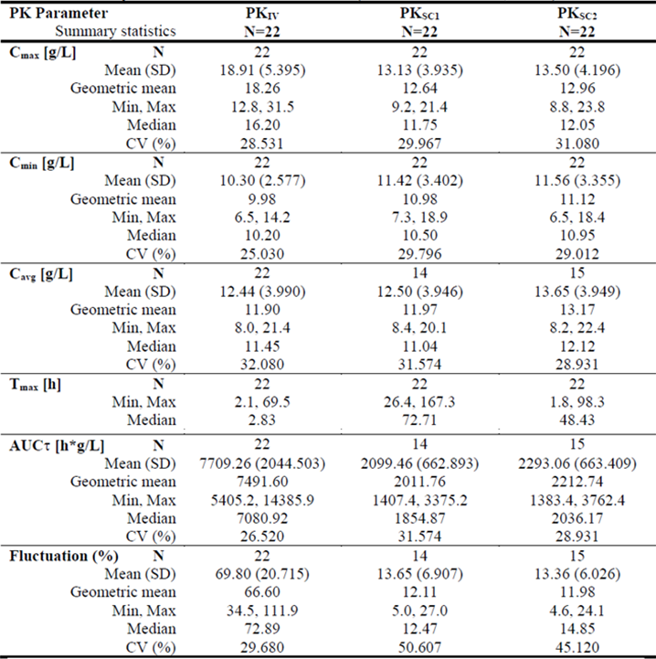
N = 22
PK = pharmacokinetics; PK_{IV} = PK following IVIg to the switch to Octanorm, PK_{SC1} = PK after the eleventh infusion of Octanorm; PK_{SC2} = PK after the twenty-eighth infusion of Octanorm; N = population size; SD = standard deviation; CV = coefficient of variation; C_{max} = maximum plasma concentration; C_{min} = minimum plasma concentration; C_{avg} = mean average plasma concentration; T_{max} = time at maximum concentration, AUC_{τ} = area under the concentration time curve (where τ is the dosing interval).
The plasma IgG and IgG subclass trough levels were nearly constant during the study, with relatively higher levels after subcutaneous treatment compared with IVIg: median value of 8.70 g/L on the last day after PK following IVIg to the switch to Octanorm (PK_{IV}), 10.30 g/L at PK_{SC1} and 11.50 g/L at PK_{SC2}. Trough levels of total IgG of above 5 to 6 g/L were able to be maintained on switching from steady state monthly IVIg (see Table 3).
Table 3: Study SCGAM-01 Selected median IgG through concentrations (pharmacokinetics evaluable set 1)
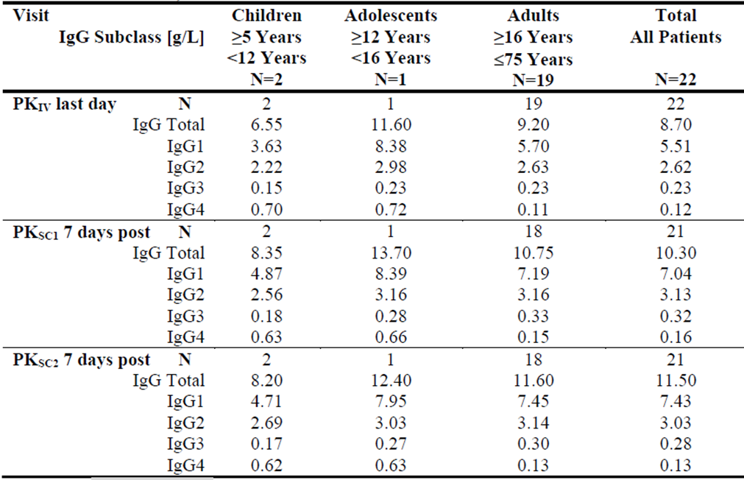
N = 22
N = number of patients, IgG = immunoglobulin-G, IgG 1 to IgG4 = immunoglobulin G subclass 1 to 4, PK_{IV} = PK following IVIg to the switch to Octanorm, PK_{SC1} = PK after the eleventh infusion of Octanorm; PK_{SC2} = PK after the twenty-eighth infusion of Octanorm.
Patient numbers were too low to make meaningful comparisons by age groups.
The geometric mean for bioequivalence, calculated as area under the concentration time curve after the twenty-eighth infusion of Octanorm (AUC_{SC2})/area under the concentration time curve following IVIg to the switch to Octanorm (AUC_{IV}), was 1.0253, (90% confidence interval (CI): 0.9778, 1.0751) based on PK evaluable set 2.
The study does not fulfil the TGA adopted guidance;⁵ with respect to the number of paediatric patients needed for PK profiling.

Efficacy
Study SCGAM-01 evaluated efficacy of subcutaneous Cutaquig in 60 PID patients for a duration of 12 months. A total of 60 PID patients (four young children, 11 older children, seven adolescents and 38 adults) were enrolled in the study, including 24 patients who were part of the PK substudy. Subsequent to 24 patients in Group A, a further 36 patients started the study whilst patients were still in the wash in/out phase of the PK substudy.
All patients were to be stable on an existing IVIg prior to starting Cutaquig in the study. Each patient was to be treated with Cutaquig for 15 months. That is, 12 weeks wash in/out phase followed by 12 months of treatment phase (primary observation period) for the assessment of efficacy.
In the 12 week wash in/out phase, weekly (± 2 days) subcutaneous Cutaquig was given at 1.5 times the previous IVIg dose adjusted for weekly dosing.
During the Efficacy phase of the study, a patient’s Cutaquig dose was to be individualised (and took precedence over dose conversion factor) by titrating upward based on the serum total IgG trough measured value and the target value.
The primary efficacy objective was to determine the efficacy of Cutaquig in preventing serious bacterial infections (SBI) with SBI rate calculated as SBI episodes per person per year.
SBI were defined as bacterial pneumonia, bacteraemia/sepsis, bacterial meningitis, osteomyelitis/septic arthritis, and visceral abscess.
The FDA Guidance for Industry on IVIg; suggests that statistical demonstration of SBI rate per person year of less than 1.0 is a satisfactory evidence of efficacy. The null hypothesis in this study was that the serious infection rate was ≥ 1.0 per person per year (PY) at 1% level of significance. The null hypothesis was to be rejected if the two sided 98% confidence interval (that is, upper limit of one sided 99% confidence interval) was a serious infection rate of < 1.0 per person PY.
Infections occurring during the 12 week wash in/out were not used for efficacy assessment.
The secondary efficacy variables were as follows:
- number of episodes of any other infections,
- number of days of use and annual rate of antibiotics, along with type and dosage of antibiotics,
- number of days of absence from work, school, kindergarten or day care,
- hospitalisations due to infections and number of days and annual rate of hospitalisation, along with reason,
- number of episodes of fever,
- quality of life assessments.
All patients (N = 60) received at least one dose of the study drug, and 54/60 (90%) completed the study.
Baseline demographics and disease characteristics by age groups are shown in Table 4. Four young children (2 to < 5 years), 11 older children (5 to < 12 years), seven adolescents (12 to < 16 years) and 38 adults (16 to 75 years) were enrolled.
Table 4: Study SCGAM-01 Baseline demographic and disease features of the study participants
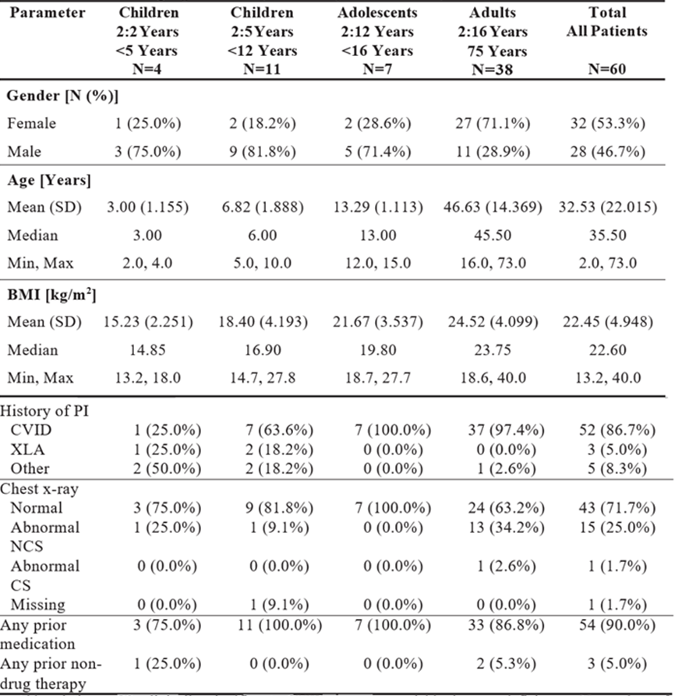
N = population size; SD = standard deviation; BMI = body mass index; PI = primary immunodeficiency; CVID = common variable immunodeficiency; XLA = X- linked agammaglobulinaemia; NCS = non-clinically significant; CS = clinically significant.
Except in Table 1 and Table 4, the abbreviation ‘PI’ in other sections of the AusPAR stands for Product Information.
No SBIs were reported in the study. Therefore, no further statistical analyses were performed. Due to low numbers of patients in the non-adult age groups and relatively low PY of exposure in these groups meaningful comparison between age groups was not possible.
One severe infection was reported in an adolescent patient (respiratory syncytial virus (RSV) bronchiolitis).
A total of 192 other infections were observed in 51 patients in the primary observation period and a total of 245 infections in 53 patients over the whole treatment period. The overall incidence rate of other infections in the primary observation period per patient per year was 3.434 (upper limit 95% CI: 4.580) based on 55.92 PY of exposure to the study medication.
A summary of other infections by age group in the primary observation period is shown in Table 5. Three quarters of the infections in the primary period were mild and one quarter were moderate intensity. One severe infection was reported in an adolescent patient (RSV bronchiolitis).
Table 5: Study SCGAM-01 Summary of other infections by age group in the primary observation period (full analysis set)
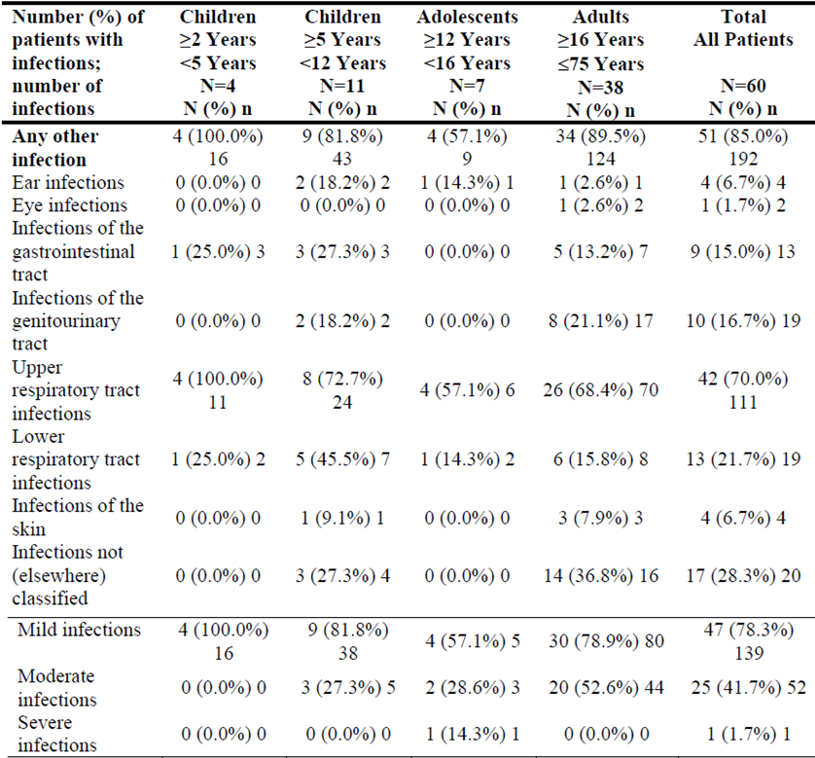
N = population size; n = sample size.
N = 60
In the primary observation period, the overall median time to resolution of other infections was 10 days (range 1 to 316 days), with longer times for moderate infections (16 days) than mild infections (8 days).
There were two episodes hospitalisation due to infection (severe asthma and RSV bronchiolitis) during the study in one adolescent who spent a total of five days in hospital in the primary period. Overall, the number of days in hospital per person year in the primary period was 0.089 days.
In the primary observation period, the number of treatment days on systemic antibiotic was 30, 58, 100 and 31 days per PY in young children, older children, adolescents and adults respectively.
During the primary observation period four patients each had one episode of fever and one patient had two episodes resulting in 0.107 episodes of fever per PY. Three of these patients were adults, one was older child and one was adolescent.
During the primary observation period 16 patients had 34 absences from work or school due to infections with a total of 164 days of absence.
Quality of life was assessed by a Child Health Questionnaire, Parent Form 50 (CHQ-PF50). Overall, there were no major changes in the mean and median CHQ-PF50 scores over time, although the number of patients (or parents) completing the questionnaire was low.

Efficacy conclusion
The efficacy of Cutaquig in preventing the occurrence of SBIs in patients with PID was confirmed as no SBI, as defined, was reported in the study. The report from the German regulatory authority; indicates that the sponsor was asked and provided calculation of upper 99% confidence limit of 0.082 for the SBI incidence rate.
There were no substantive differences between the primary observation period (excluding the 12 week wash in/out period) and whole study period.

Safety
Safety dataset was limited to the foregoing single pivotal study (Study SCGAM-01).
Overall, 60 patients in the safety analysis set received 3534 infusions of subcutaneous Cutaquig in the study.
The average dose of Cutaquig used per patient was 0.185 g/kg in adult patients, 0.134 g/kg in young children, 0.161 g/kg in older children and 0.176 g/kg in adolescents. The overall mean duration of subcutaneous infusions was 101 ± 52 minutes.
The mean maximum volume administered per patient was about 16, 31, 63 and 78 mL in young children, older children, adolescents and adults respectively. The maximum volume administered per patient was about 22, 62, 90 and 159 mL. The maximum volume per injection site was 10, 14, 16, and 24 mL in the four age groups respectively. The maximum infusion rate per patient was 25, 34, 39 and 60 mL/hour in the four age groups respectively. The maximum infusion rate per injection site was 16, 17, 15 and 23 mL/hour in the four age groups respectively.
Overall 48/60 (80%) patients experiencing a treatment-emergent adverse event (TEAE) and 4/60 (6.7%) experiencing a serious adverse event (SAE). Four SAEs were considered unrelated to study medication. One case of grand mal convulsion in an older child was considered unlikely to be related to study drug. There were no TEAEs leading to death or withdrawal.
Overall, 136 temporally associated TEAE (TEAE occurring within 72 hours of administration) were reported in 42/60 (70%) patients comprising 2/4 young children (two events), 9/11 older children (39 events), 3/7 adolescents (12 events) and 28/38 adults (83 events).
TEAEs of infection were reported in 53/60 (88%) patients. The rate of infection TEAEs per patient was 6.25, 5.27, 1.57 and 3.97in the young children, older children, adolescents and adults respectively.
Excluding infections, 27 patients experienced TEAEs of mild severity, 18 patients experienced TEAEs of moderate severity, and three patients experienced TEAEs of severe intensity. Based on the safety analysis set, 236 TEAEs were reported of which 184 were mild, 49 were moderate and three were severe. The severe adverse events (AEs) were appendicitis, nephrolithiasis and severe asthma (each one case).
The rate of TEAE, excluding infections and infusion site reaction, was 2.5 events per patient in young children, 6.18 events per patient in older children, 3.43 events per patient in adolescents and 3.53 events per patient in adults.
The rates of TEAE per infusion (excluding infection and injection site reactions) were zero, three, one and ten in young children, older children, adolescents and adults respectively.
The highest incidence of temporally associated TEAEs (excluding infections) was reported in Month 1, with 12 patients (20%) reporting 24 events. In subsequent months, the number of patients reporting temporally associated TEAEs varied between four and nine patients with between four and 12 events reported.
Overall 75% patients experienced infusion site reactions. Fourteen patients (one older child, one adolescent patient and 12 adults) experienced an infusion site reaction of moderate intensity and two adult patients experienced an infusion site reaction of severe intensity. The severe reactions were bruising at the abdominal injection site at Week 30 in one patient and a severe allergic reaction at the lower back injection sites at Week 5 in another patient.
The most common types of infusion site reactions were erythema, swelling, redness and pruritus. Other types of reaction reported in three patients each were extravasation, nodule, rash and tenderness.
When summarised by infusion, infusion site reactions occurred during 824 of the 3534 infusions (23%), with swelling in 10% of infusions, erythema in 7%, redness in 5.4% and pruritus in 4% of infusions.
Laboratory results did not indicate any specific pattern. None off the patients who had a confirmed positive Coomb’s test also had a drop of haemoglobin of > 2 g/dL.
All positive virology tests were graded as non-clinically significant except for a positive test for hepatitis B surface antigen (HBsAg) at end of study visit in one patient. The hepatitis B virus (HBV) viral load was negative at this time point. The patient was retested approximately one month later and both HBsAg and HBV viral load were negative.
No AEs of regulatory interest were reported in the limited dataset.

Safety conclusion
The adverse effects profile during the 12 to 15 months of uncontrolled, prospective treatment with weekly subcutaneous Cutaquig in 22 children/adolescents and 38 adults, was consistent with known profile of SCIg class of drugs.
No unexpected findings were reported. No rare events of regulatory interest were reported. No post market experience is currently available.

Benefit-risk assessment
PK performance was consistent with that expected for SCIg. Total IgG serum levels at steady state were maintained above 6 g/L with weekly subcutaneous Cutaquig throughout the study. PK profile is essentially limited to adults with paediatric PK data not meaningful.
Efficacy was consistent with that expected with SCIg and met the regulatory target. Efficacy with less than one SBI per patient per year was demonstrated. No SBI was reported in the study. The total dataset for efficacy is essentially limited to 22 children and 38 adults.
Safety profile was consistent with the known adverse effects profile for the SCIg class of drugs.
The dataset is limited with very low exposures in children and adolescents.

Clinical evaluator’s recommendation
The clinical evaluator considers the net risk balance is acceptable as PID are rare disorders, and the inherent deficiencies in the dataset can only be reasonably expected to be addressed through post market surveillance and accumulating post market data.

Risk management plan
The sponsor has submitted EU-risk management plan (RMP) version 01.3 (dated 12 December 2018; data lock point (DLP) 31 October 2018) and Australia Specific annex (ASA) version 01 (dated 1 April 2020) in support of this application.
The summary of safety concerns and their associated risk monitoring and mitigation strategies are summarised in Table 6.
Table 6: Summary of safety concerns
Summary of safety concerns |  | Pharmacovigilance |  | Risk Minimisation
 |  | Routine | Additional | Routine | Additional
Important identified risks | Hypersensitivity reactions, including anaphylactic reactions |  | – |  | –
Important identified risks | Thromboembolic events |  | – |  | –
Important identified risks | Aseptic meningitis |  | – |  | –
Important identified risks | Renal dysfunction/failure |  | – |  | –
Important potential risks | Interference with certain blood glucose tests |  | – |  | –
Important potential risks | Potential for transmission of infectious agents |  | – |  | –
Missing information | Safety in pregnant or breastfeeding women |  | – |  | –
- The summary of safety concerns is acceptable from an RMP perspective.
- Only routine pharmacovigilance activities have been proposed. This is acceptable.
- Only routine risk minimisation activities have been proposed. Routine risk minimisation activities are acceptable to mitigate the risks of this product. The adequacy of the PI and the Consumer Medicines Information (CMI); will be reassessed at the second round of evaluation (see recommendations below). At the second round, the CMI has been updated to the new format, and the PI and CMI have been revised to include a warning about possible interference with certain blood glucose testing systems. The risk minimisation plan is generally acceptable, however some minor changes to the CMI have been requested prior to marketing. An updated CMI was provided by the sponsor and the CMI is now acceptable.

Risk-benefit analysis

Delegate’s considerations
There are no objections to the registration of Cutaquig from a quality perspective.
There are no nonclinical objections to the registration of Cutaquig.
The clinical evaluation report has identified the TGA adopted guidance;⁵ to include at least 20 paediatric patients in the PK dataset was not met, there are no data in children under two years of age, and data in children and adolescents ≥ 2 years of age involves only 22 children. The draft PI has included statements recommended by the clinical evaluation report: ‘The PI under paediatric use should include a statement that Cutaquig has not been studied in children under 2 years of age/no data are available in children under 2 years of age’. The text on 22 patients in the PK substudy should include a description of the age distribution of participants in substudy. The Delegate accepts proposed indications for Cutaquig
‘Replacement therapy in adults and children for:
  - primary immunodeficiency disease (PID)’.
The proposed indication ‘secondary immunodeficiency (SID) due to underlying disease or treatment’ does not specify hypogammaglobulinaemia but a more general term secondary immunodeficiency. The submission has not included data in secondary hypogammaglobuliaemia but this is included in the TGA adopted guidance;⁵ and overseas product approvals for Cutaquig.
The Delegate considers the wording of this indication requires amendment to:
‘symptomatic hypogammaglobulinaemia secondary to underlying disease or treatment’.
This amended wording is consistent with:
- indications in the EU guideline EMA/CHMP/BPWP/410415/2011 rev 1;⁵
- indications for Cutaquig approved in Europe; and
- registered indications in Australia the SCIg products Cuvitru;/Hizentra, Evogam;/Gammanorm.

Proposed action
The Delegate proposes to approve the registration of the product Cutaquig for the Indications:
Replacement therapy in adults and children in:
- primary immunodeficiency diseases (PID)
- symptomatic hypogammaglobulinaemia secondary to underlying disease or treatment
The Delegate propose to impose the conditions of registration recommended in the quality and RMP evaluation reports.

Advisory Committee considerations
The Delegate did not refer this application to the Advisory Committee on Medicines (ACM) for advice.

Outcome
Based on a review of quality, safety and efficacy, the TGA approved the registration of Cutaquig (human normal immunoglobulin) 16.5% (165 mg/mL), solution for subcutaneous injection, vial, indicated for:
Replacement therapy in adults and children in:
- Primary immunodeficiency diseases (PID)
- Symptomatic hypogammaglobulinaemia secondary to underlying disease or treatment

Specific conditions of registration applying to these goods
- Cutaquig (human normal immunoglobulin) is to be included in the Black Triangle Scheme. The PI and CMI for Cutaquig must include the black triangle symbol and mandatory accompanying text for five years, which starts from the date that the sponsor notifies the TGA of supply of the product.
- The Cutaquig EU-RMP (version 01.3, dated 12 December 2018, DLP 31 October 2018), with ASA (version 01, dated 1 April 2020), included with submission PM-2020-00473-1-2, and any subsequent revisions, as agreed with the TGA will be implemented in Australia.
An obligatory component of RMP is routine pharmacovigilance. Routine pharmacovigilance includes the submission of periodic safety update reports (PSURs).
Reports are to be provided in line with the current published list of EU reference dates and frequency of submission of PSURs until the period covered by such reports is not less than three years from the date of the approval letter.
The reports are to at least meet the requirements for PSURs as described in the EMA’s Guideline on Good Pharmacovigilance Practices (GVP) Module VII-periodic safety update report (Rev 1), Part VII.B Structures and processes. Note that submission of a PSUR does not constitute an application to vary the registration.
- It is a condition of registration that all batches of Cutaquig imported into/manufactured in Australia must comply with the product details and specifications approved during evaluation and detailed in the Certified Product Details (CPD).
- It is a condition of registration that up to five initial batches of Cutaquig imported into/manufactured in Australia is not released for sale until samples and/or the manufacturer’s release data have been assessed and endorsed for release by the TGA Laboratories Branch. Outcomes of laboratory testing are published biannually in the TGA Database of Laboratory Testing Results.
- The sponsor should be prepared to provide product samples, reference materials and documentary evidence as defined by the TGA Laboratories branch. The sponsor must contact Biochemistry Testing for specific material requirements related to batch release testing/assessment of the product.
- For all injectable products the PI must be included with the product as a package insert.

Attachment 1. Product Information
The PI for Cutaquig approved with the submission which is described in this AusPAR is at Attachment 1. For the most recent PI, please refer to the TGA website at <https://www.tga.gov.au/product-information-pi>.

Therapeutic Goods Administration
PO Box 100 Woden ACT 2606 Australia
Email: info@tga.gov.au Phone: 1800 020 653 Fax: 02 6232 8605
https://www.tga.gov.au

The Black Triangle Scheme provides a simple means for practitioners and patients to identify certain types of new prescription medicines, including those being used in new ways and to encourage the reporting of adverse events associated with their use. The Black Triangle does not denote that there are known safety problems, just that the TGA is encouraging adverse event reporting to help us build up the full picture of a medicine's safety profile.
Octagam was first registered on the ARTG on 16 November 2004 (ARTG number: 113925, 113926, 113927 and 113928).
The QT interval is the time from the start of the QRS wave complex to the end of the corresponding T wave. It approximates to the time taken for ventricular depolarisation and repolarisation, that is to say, the period of ventricular systole from ventricular isovolumetric contraction to isovolumetric relaxation.
A Product Information (PI) document provides health professionals with a summary of the scientific information relevant to the safe and effective use of a prescription medicine. The information in a product information document has been written by the pharmaceutical company responsible for the medicine and has been approved by the TGA. It provides objective information about the quality, safety and effectiveness of the medicine, as demonstrated in the data provided to the TGA by the pharmaceutical company. This information is intended to assist doctors, pharmacists and other health professionals in prescribing and dispensing medicines. In addition, this information can be used by health professionals in their consultations with patients, so that the patient can be better informed about their medicines.
European Medicines Agency (EMA), Committee for Medicinal Products for Human Use (CHMP), Guideline on The Clinical Investigation of Human Normal Immunoglobulin for Subcutaneous and/or Intramuscular Administration (SCIg/IMIg), EMA/CHMP/BPWP/410415/2011 rev 1, 23 July 2015.
Octanorm is marketed as Cutaquig in Canada and the United States of America and registered under this tradename in several European countries.
U.S. Department of Health and Human Services, Food and Drug Administration, Center for Biologics Evaluation and Research, Guidance for Industry: Safety, Efficacy, and Pharmacokinetic Studies to Support Marketing of Immune Globulin Intravenous (Human) as Replacement Therapy for Primary Humoral Immunodeficiency, June 2008.
Inclusion of these information is beyond the scope of the AusPAR.
Routine risk minimisation activities may be limited to ensuring that suitable warnings are included in the product information or by careful use of labelling and packaging. Routine pharmacovigilance practices involve the following activities: - All suspected adverse reactions that are reported to the personnel of the company are collected and collated in an accessible manner; - Reporting to regulatory authorities; - Continuous monitoring of the safety profiles of approved products including signal detection and updating of labelling; - Submission of PSURs; - Meeting other local regulatory agency requirements.
The Consumer Medicines Information (CMI) is a leaflet that contains information on the safe and effective use of a prescription or specified over-the-counter medicine. Sponsors are required to provide CMIs prior to new prescription medicines and specified over-the-counter (OTC) medicines being released to the market. Products that have been registered but not yet released to the market will not have accompanying CMI documents. For medicines that do have a CMI, the sponsor is required to make it available to consumers either in the pack or in another manner that will enable the information to be given to the person to whom the medicine is administered or otherwise dispensed.
Cuvitru was first registered on the ARTG on 5 October 2017 (ARTG number: 282579).
Hizentra was first registered on the ARTG on 8 May 2014 (ARTG number: 207383, 207384, 207385 and 207386).
Evogam was first registered on the ARTG on 15 January 2013 (ARTG number: 204954, 204955 and 204956).
Gammanorm was first registered on the ARTG on 18 January 2008 (ARTG number: 128703 and 128705).
The ACM provides independent medical and scientific advice to the Minister for Health and the Therapeutic Goods Administration (TGA) on issues relating to the safety, quality and efficacy of medicines supplied in Australia including issues relating to pre-market and post-market functions for medicines. The Committee is established under Regulation 35 of the Therapeutic Goods Regulations 1990. Members are appointed by the Minister. The ACM was established in January 2017 replacing Advisory Committee on Prescription Medicines (ACPM) which was formed in January 2010. ACM encompass pre and post-market advice for medicines, following the consolidation of the previous functions of the Advisory Committee on Prescription Medicines (ACPM), the Advisory Committee on the Safety of Medicines (ACSOM) and the Advisory Committee on Non-Prescription Medicines (ACNM). Membership comprises of professionals with specific scientific, medical or clinical expertise, as well as appropriate consumer health issues relating to medicines.

