This medicinal product is subject to additional monitoring in Australia. This will allow quick identification of new safety information. Healthcare professionals are asked to report any suspected adverse events at www.tga.gov.au/reporting-problems.
▼

TREMFYA®
  - GUSELKUMAB
Australian Product information

NAME OF THE MEDICINE
Guselkumab.

Qualitative and quantitative composition
TREMFYA 100 mg solution for injection in pre-filled syringe
Each pre-filled syringe contains 100 mg of guselkumab per 1 mL solution.
TREMFYA 100 mg solution for injection in pre-filled pen
Each pre-filled pen contains 100 mg of guselkumab per 1 mL solution
Guselkumab is a fully human immunoglobulin G1 lambda (IgG1λ) monoclonal antibody (mAb) that binds selectively to the extracellular human interleukin 23 (IL-23) protein with high specificity and affinity. Guselkumab is produced in a mammalian cell line using recombinant DNA technology.
For a full list of excipients, see section 6.1 List of Excipients.

Pharmaceutical form
Solution for injection in a prefilled syringe or a pre-filled pen (One-Press® patient controlled injector).
TREMFYA is a clear, colourless to light yellow solution.

CLINICAL PARTICULARS

THERAPEUTIC INDICATIONS
Plaque psoriasis
TREMFYA is indicated for the treatment of adult patients (18 years or older) with moderate to severe plaque psoriasis who are candidates for systemic therapy or phototherapy.
Psoriatic arthritis
TREMFYA is indicated for the treatment of adult patients with active psoriatic arthritis, who have had an inadequate response to, or are intolerant to prior DMARD therapy.

Dose and METHOD OF Administration
TREMFYA is administered by subcutaneous injection.

Dosage (dose and interval)
Plaque psoriasis
The recommended dose of TREMFYA is 100 mg at week 0, week 4 and every 8 weeks thereafter.
Psoriatic arthritis
The recommended dose of TREMFYA is 100 mg at week 0, week 4, and every 8 weeks thereafter.
TREMFYA may be administered alone or in combination with a conventional synthetic disease-modifying antirheumatic drug (csDMARD) (e.g. methotrexate).

Method of Administration
TREMFYA is administered by subcutaneous injection. If possible, areas of the skin that show psoriasis should be avoided as injection sites.
TREMFYA is intended for use under the guidance and supervision of a physician. TREMFYA may be administered by a health care professional, or a patient may self-inject after proper training in subcutaneous injection technique.
After removing the pre-filled syringe or pre-filled pen from the refrigerator, keep the pre-filled syringe or pen inside the carton and allow to reach room temperature by waiting for 30 minutes before injecting TREMFYA. The pre-filled syringe or pre-filled pen should not be shaken.
Comprehensive instructions for the subcutaneous administration of TREMFYA are given in the Instructions for Use leaflet. Patients should be instructed to inject the full amount of TREMFYA according to the directions provided in this leaflet.
TREMFYA is for single use in one patient only. Following administration of TREMFYA, discard any unused portion. The syringe or pen should be disposed of using accepted medical practices for used syringes. The syringe or pen and its needle must never be re-used.
Substitution by any other biological medicinal product requires the consent of the prescribing physician.

Special Populations
Renal or hepatic impairment
Specific studies of TREMFYA have not been conducted in patients with renal or hepatic insufficiency.
Elderly (>65 years of age)
No dose adjustment is required (see sections 5.1 Pharmacodynamic Properties – Clinical Trials and 5.2 Pharmacokinetic Properties - Special Populations).
Paediatrics (< 18 years of age)
The safety and efficacy of TREMFYA in paediatric patients (< 18 years of age) have not been evaluated.

Contraindications
Serious hypersensitivity to guselkumab or any of the excipients.

SPECIAL WARNINGS AND Precautions FOR USE

Traceability
In order to improve the traceability of biological medicinal products, the trade name and the batch number of the administered product should be clearly recorded.

Infections
TREMFYA may increase the risk of infection. Treatment with TREMFYA should not be initiated in patients with any clinically important active infection until the infection resolves or is adequately treated.
Infections have been observed in clinical trials in plaque psoriasis (23% vs 21% placebo: <0.2% serious infections in both groups) and psoriatic arthritis (21% in both TREMFYA and placebo groups: <0.8% serious infections in both groups).
Instruct patients treated with TREMFYA to seek medical advice if signs or symptoms of clinically important chronic or acute infection occur. If a patient develops a clinically important or serious infection or is not responding to standard therapy, monitor the patient closely and discontinue TREMFYA until the infection resolves.

Pre-treatment evaluation for tuberculosis
In clinical studies, subjects with latent tuberculosis (TB) who were concurrently treated with TREMFYA and appropriate TB prophylaxis did not develop TB. Evaluate patients for TB infection prior to initiating treatment with TREMFYA. Initiate treatment of latent TB prior to administering TREMFYA. Patients receiving TREMFYA should be monitored for signs and symptoms of active TB during and after treatment. Do not administer TREMFYA to patients with active TB infection. Consider anti-TB therapy prior to initiating TREMFYA in patients with a past history of latent or active TB in whom an adequate course of treatment cannot be confirmed.

Immunisations
Prior to initiating therapy with TREMFYA, complete all appropriate immunisations according to current immunisation guidelines. Live vaccines should not be used concurrently in patients treated with TREMFYA. No data are available on the response to live or inactive vaccines.
Before live viral or live bacterial vaccination, treatment with TREMFYA should be withheld for at least 12 weeks after the last dose and can be resumed at least 2 weeks after vaccination. Prescribers should consult the Prescribing Information of the specific vaccine for additional information and guidance on concomitant use of immunosuppressive agents post-vaccination.

Hypersensitivity reactions
Serious hypersensitivity reactions, including anaphylaxis, have been reported in the postmarketing setting. Some serious hypersensitivity reactions occurred several days after treatment with guselkumab, including cases with urticaria and dyspnea. If a serious hypersensitivity reaction occurs, appropriate therapy should be instituted, and administration of TREMFYA should be discontinued.

Use in the elderly
Of the 3940 plaque psoriasis and psoriatic arthritis patients exposed to TREMFYA in Phase 2 and Phase 3 clinical trials, a total of 239 patients were 65 years or older, and 19 patients were 75 years or older. No overall differences in safety or effectiveness were observed between older and younger patients who received TREMFYA in clinical studies. However, the number of patients aged 65 years and older was not sufficient to determine whether they respond differently from younger patients (see section 5.2 Pharmacokinetic properties – Special Populations).

Paediatric use
The safety and efficacy of TREMFYA in paediatric patients (< 18 years of age) have not been evaluated.

Effects on laboratory tests
No data available

Interactions with other Medicines AND OTHER FORMS OF INTERACTIONS
In a Phase 1 study in subjects with moderate to severe plaque psoriasis, changes in systemic exposures (C_{max} and AUC_{inf}) of midazolam, S-warfarin, omeprazole, dextromethorphan, and caffeine after a single dose of guselkumab were not clinically relevant (see section 5.2 Pharmacokinetic Properties), indicating that drug interactions between guselkumab and substrates of various CYP enzymes (CYP3A4, CYP2C9, CYP2C19, CYP2D6, and CYP1A2) are unlikely. There is no need for dose adjustment when co-administering guselkumab and CYP450 substrates
Live vaccines should not be given while a patient is undergoing therapy with TREMFYA (see section 4.4 Special Warnings and Precautions for Use - Immunisations).

Fertility, pregnancy and lactation

Effects on Fertility
The effect of TREMFYA on human fertility has not been evaluated.
No effects on fertility parameters were identified in female and male fertility studies conducted in guinea pigs. Results from the studies indicated no effects on male or female reproductive parameters. Safety margins for C_{max} and AUC_{last} at the 100 mg/kg twice-weekly NOAEL dose were at least 60-fold and 80-fold higher, respectively than those following a single administration of a 100 mg SC dose to psoriasis subjects.

Use in Pregnancy – Category B1
The use of TREMFYA in pregnant women has not been studied and the effect of TREMFYA on human pregnancy is unknown.
No maternal, embryo or fetal toxicity was observed in cynomolgus monkeys after administration of weekly 50 mg/kg doses of guselkumab. Safety margins for C_{max} and AUC_{last} at the 50 mg/kg weekly NOAEL dose were at least 90-fold and 130-fold higher, respectively than those following administration of a 100 mg SC dose to psoriasis subjects. As with other IgG antibodies, guselkumab crosses the placenta and was detectable in newborn cynomolgus monkey serum samples indicating transplacental transfer of drug.
TREMFYA should only be used during pregnancy under the advice of a physician if the potential benefit outweighs the potential risk.
Use in Lactation
There are no data on the presence of guselkumab in human milk, the effects on a breastfed infant, or the effects on milk production. Guselkumab was not detected in the milk of lactating cynomolgus monkeys. The developmental and health benefits of breastfeeding should be considered along with the mother's clinical need for TREMFYA.

Effect on ability to drive and use machines
Tremfya has no or negligible influence on the ability to drive and use machines.

Adverse Effects (UNDESIRABLE EFFECTS)
Throughout this section, adverse reactions are presented. Adverse reactions are adverse events that were considered to be reasonably causally associated with the use of guselkumab based on the comprehensive assessment of the available adverse event information. A causal relationship with guselkumab cannot be reliably established in individual cases. Further, because clinical trials are conducted under widely varying conditions, adverse reaction rates observed in the clinical trials of a drug cannot be directly compared to rates in the clinical trials of another drug and may not reflect the rates observed in clinical practice.

Clinical Trials Experience
The safety profile of TREMFYA is based on data from the Phase 2 (PSO2001, PSA2001) and Phase 3 (VOYAGE 1, VOYAGE 2, NAVIGATE, ORION, ECLIPSE, DISCOVER 1, DISCOVER 2) studies in 3940 subjects, including 2711 with plaque psoriasis and 1229 subjects with psoriatic arthritis. The duration of exposure to TREMFYA is presented in Table 1.

Table 1: Long-Term Exposure to TREMFYA in Phase 2 and Phase 3 studies
Duration of exposure | Number of subjects
≥ 1 year | 2843ª
≥ 2 year | 1516^{b}
≥ 3 year | 692^{b}
ª plaque psoriasis and psoriatic arthritis studies
^{b} plaque psoriasis studies

Plaque Psoriasis
The adverse reaction profile of TREMFYA in 823 patients with moderate to severe plaque psoriasis is based on pooled data from two 16-week placebo-controlled phase III studies. Table 2 provides a summary of adverse reactions that occurred at a rate of at least 1% and at a higher rate in the TREMFYA group than in the placebo group during the 16-week, placebo- controlled period of the pooled clinical trials, VOYAGE 1 and VOYAGE 2.
Psoriatic Arthritis

Table 3 provides a summary of adverse reactions that occurred at a rate of at least 1% and at a higher rate in the TREMFYA group than in the placebo group during the 24-week, placebo-controlled period of the pooled clinical trials, DISCOVER 1 and DISCOVER 2.

Table 2: Adverse reactions reported by ≥1% of patients through Week 16 in VOYAGE 1 and VOYAGE 2
 | Placebo N = 422 n (%) | TREMFYAª N = 823  n (%) | Adalimumab^{b} N = 581  n (%)
Gastrointestinal disorders
Diarrhoea | 4 (0.9%) | 13 (1.6%) | 7 (1.2%)
General disorders and administration site conditions
Injection site reactions^{c} | 12 (2.8%) | 37 (4.5%) | 42 (7.2%)
Infections and Infestations
Upper respiratory infections^{d} | 54 (12.8%) | 118 (14.3%) | 80 (13.8%)
Gastroenteritis^{e} | 4 (0.9%) | 11 (1.3%) | 8 (1.4%)
Herpes simplex infections^{f} | 2 (0.5%) | 9 (1.1%) | 8 (1.4%)
Tinea infections^{g} | 0 | 9 (1.1%) | 3 (0.5%)
Musculoskeletal and connective tissue disorders
Arthralgia | 9 (2.1%) | 22 (2.7%) | 11 (1.9%)
Nervous system disorders
Headache^{h} | 14 (3.3%) | 38 (4.6%) | 18 (3.1%)
ª Subjects received 100 mg of TREMFYA at Week 0, Week 4, and every 8 weeks thereafter;
^{b} Subjects received adalimumab at 80 mg Week 0, 40 mg week 1 then 40 mg q2w thereafter
^{c} Injection site reactions include injection site erythema, bruising, haematoma, haemorrhage, swelling, oedema, pruritus, pain, discolouration, induration, inflammation, and urticaria.
^{d} Upper respiratory infections include nasopharyngitis, upper respiratory tract infection (URTI), pharyngitis, and viral URTI.
^{e} Gastroenteritis includes gastroenteritis and viral gastroenteritis
^{f} Herpes simplex infections include oral herpes, herpes simplex, genital herpes, genital herpes simplex, and nasal herpes simplex.
^{g} Tinea infections include tinea pedis, tinea cruris, tinea infection, and tinea manuum infections.
^{h} Headache includes headache and tension headache.

Table 3: Adverse reactions reported by ≥1% of patients through Week 24 in DISCOVER 1 and DISCOVER 2
 | Placebo  N = 372  n (%) | TREMFYA Q8Wª  N = 375  n (%) | TREMFYA Q4W^{b}  N = 373  n (%)
Gastrointestinal disorders
Diarrhoea | 3 (0.8%) | 6 (1.6%) | 4 (1.1%)
General disorders and administration site conditions
Injection site reactions^{c} | 1 (0.3%) | 5 (1.3%) | 3 (0.8%)
Infections and Infestations
Respiratory tract infections^{d} | 45 (12.1%) | 46 (12.3%) | 52 (13.9%)
Investigations
Transaminases increased^{e} | 17 (4.6%) | 31 (8.3%) | 32 (8.6%)
Neutrophil count decreased | 0 | 1 (0.3%) | 6 (1.6%)
Nervous system disorders
Headache^{f} | 3 (0.8%) | 8 (2.1%) | 7 (1.9%)
ª Subjects received 100 mg of TREMFYA at Week 0, Week 4, and every 8 weeks thereafter;
^{b} Subjects received 100 mg of TREMFYA at Week 0, and every every 4 weeks thereafter
^{c} Injection site reactions include injection site erythema, bruising, hematoma, hemorrhage, swelling, oedema, pruritus, pain,
discoloration, induration, inflammation, and urticaria.
^{d} Respiratory tract infections include nasopharyngitis, upper respiratory tract infection (URTI), bronchitis, pharyngitis, and viral URTI.
^{e}Transaminases increased includes: alanine aminotransferase increased, aspartate aminotransferase increased, hepatic enzyme increased, transaminases increased, liver function test abnormal, hypertransaminasaemia
^{f} Headache includes headache and tension headache.

Less Common Clinical Trial Adverse Drug Reactions (<1%)
Adverse reactions that occurred at rates < 1% in the TREMFYA group during the placebo controlled- period of the pooled plaque psoriasis and psoriatic arthritis clinical trials were :
Infections and Infestations: candida infections, gastroenteritis, herpes simplex infections, tinea infections
Nervous system disorders: migraine
Skin and subcutaneous tissue disorders: urticaria.

Postmarketing data
In addition to the adverse reactions reported during clinical studies and listed above, the following adverse reactions have been reported during postmarketing experience (Table 4). Because these reactions were reported voluntarily from a population of uncertain size, it is not always possible to reliably estimate their frequency. In the table, the frequencies are provided according to the following convention:
Very common ≥ 1/10
Common ≥ 1/100 and < 1/10
Uncommon ≥ 1/ 1000 and < 1/100
Rare ≥ 1/10000 and < 1/1000
Very rare < 1/10000, including isolated reports
Not known Cannot be estimated from the available data

Table 4: Adverse Reactions Identified During Postmarketing Experience with Guselkumab
System Organ Class  Adverse Reaction | Frequency Category Estimated from Clinical Trials with TREMFYA
Immune System Disorders
Hypersensitivity | Uncommon
Anaphylaxis | Uncommon
Skin and Subcutaneous Tissue Disorders
Rash | Uncommon
General disorders and administration site conditions
Injections Site Reactions | Common

Reporting of suspected adverse reactions
Reporting suspected adverse reactions after registration of the medicinal product is important. It allows continued monitoring of the benefit-risk balance of the medicinal product. Healthcare professionals are asked to report any suspected adverse reactions at https://www.tga.gov.au/reporting-problems.

Overdose
Single intravenous doses of TREMFYA up to 987 mg (10 mg/kg) have been administered in healthy volunteers and single subcutaneous doses of TREMFYA up to 300 mg have been administered in subjects with plaque psoriasis in clinical trials without dose-limiting toxicity. In the event of overdose, monitor the patient for any signs or symptoms of adverse reactions and administer appropriate symptomatic treatment immediately.
For information on the management of overdose, contact the Poison Information Centre on 131126 (Australia).

PharmacologICAL PROPERTIES

Pharmacodynamic PROPERTIES
Pharmacotherapeutic group: Immunosuppressants, interleukin inhibitors, ATC code: L04AC16.

Mechanism of Action
Guselkumab is a human IgG1λ monoclonal antibody (mAb) that binds selectively to the interleukin 23 (IL-23) protein with picomolar affinity. IL-23, a regulatory cytokine, affects the differentiation, expansion, and survival of T cell subsets, (e.g., Th17 cells and Tc17 cells) and innate immune cell subsets, which represent sources of effector cytokines, including IL-17A, IL-17F and IL-22 that drive inflammatory disease. In humans, selective blockade of IL-23 was shown to normalise production of these cytokines.
Levels of IL-23 are elevated in the skin of patients with plaque psoriasis. In in vitro models, guselkumab was shown to inhibit the bioactivity of IL-23 by blocking its interaction with cell surface IL-23 receptor, disrupting IL-23-mediated signalling, activation and cytokine cascades. Guselkumab is considered to exert its clinical effects in plaque psoriasis and psoriatic arthritis through blockade of the IL-23 cytokine pathway.

Pharmacodynamic effects
In a Phase 1 study, treatment with guselkumab resulted in reduced expression of IL-23/Th17 pathway genes and psoriasis-associated gene expression profiles, as shown by analyses of mRNA obtained from lesional skin biopsies of psoriatic subjects at Week 12 compared to baseline. In the same Phase 1 study, treatment with guselkumab resulted in improvement of histological measures of psoriasis at Week 12, including reductions in epidermal thickness and T-cell density. In addition, reduced serum IL-17A, IL-17F and IL-22 levels compared to placebo were observed in guselkumab treated subjects in Phase 2 and Phase 3 studies in plaque psoriasis. These results are consistent with the clinical benefit observed with guselkumab treatment in plaque psoriasis.
In Phase 3 studies in psoriatic arthritis, evaluated subjects had elevated serum levels of acute phase proteins C-reactive protein, serum amyloid A and IL-6, and Th17 effector cytokines IL-17A, IL-17F and IL-22 at baseline. Guselkumab decreased levels of these proteins within 4 weeks of initiation of treatment. By Week 24, guselkumab further reduced the levels of these proteins compared to baseline and also to placebo. In guselkumab-treated subjects, serum IL-17A and IL-17F levels were similar to those observed in a demographically matched healthy cohort at Week 24.

Immunogenicity
As with all therapeutic proteins, there is the potential for immunogenicity. The immunogenicity of TREMFYA was evaluated using a sensitive and drug-tolerant immunoassay.
Plaque psoriasis
In pooled Phase 2 (PSO2001) and Phase 3 (VOYAGE 1, VOYAGE 2 and NAVIGATE) analyses, fewer than 6% of subjects treated with TREMFYA developed antidrug antibodies in up to 52 weeks of treatment. Of the subjects who developed antidrug antibodies, approximately 7% had antibodies that were classified as neutralising which equates to 0.4% of all subjects treated with TREMFYA. Antidrug antibodies were not associated with lower efficacy or development of injection-site reactions.
Psoriatic arthritis
In pooled Phase 3 (DISCOVER 1 and DISCOVER 2) analyses up to Week 24, 2% (n=15) of subjects treated with TREMFYA developed antidrug antibodies. Of these subjects, 1 had antibodies that were classified as neutralising antibodies, and none developed injection site reactions through Week 24. Overall, the small number of subjects who were positive for antibodies to guselkumab limits definitive conclusion of the effect of immunogenicity on the pharmacokinetics and efficacy of guselkumab.
The detection of antibody formation is highly dependent on the sensitivity and specificity of the assay. Additionally, the observed incidence of antibody (including neutralising antibody) positivity in an assay may be influenced by several factors including assay methodology, sample handling, timing of sample collection, concomitant medications, and underlying disease. For these reasons, comparison of incidence of antibodies to TREMFYA with the incidences of antibodies to other products may be misleading.

Clinical Trials

Plaque Psoriasis
Four multicentre, randomised, double-blind, placebo and/or active controlled trials (VOYAGE 1, VOYAGE 2, NAVIGATE and ORION) enrolled subjects 18 years of age and older with moderate-to-severe plaque psoriasis who were eligible for systemic therapy or phototherapy. Subjects had an Investigator’s Global Assessment (IGA) score of ≥3 (“moderate”) on a 5-point scale of overall disease severity, a Psoriasis Area and Severity Index (PASI) score ≥12, and a minimum affected body surface area (BSA) of 10%. Subjects with guttate, erythrodermic, or pustular psoriasis were excluded.

VOYAGE 1 and VOYAGE 2- Placebo- and adalimumab-controlled studies
In VOYAGE 1 and VOYAGE 2, 1829 subjects were randomised to either TREMFYA (100 mg at Weeks 0 and 4 and every 8 weeks thereafter), placebo or adalimumab (80 mg at Week 0 and 40 mg at Week 1, followed by 40 mg every other week thereafter through Week 47. All subjects, including those randomised to adalimumab at Week 0, received TREMFYA 100 mg at Week 52 and every 8 weeks thereafter).
Both trials assessed the responses at Week 16 compared to placebo for the two co-primary endpoints:
- the proportion of subjects who achieved an IGA score of 0 (“cleared”) or 1 (“minimal”);
- the proportion of subjects who achieved at least a 90% reduction from baseline in the PASI composite score (PASI 90).
Comparisons between TREMFYA and adalimumab were secondary endpoints at the following time points:
- at Week 16 (VOYAGE 1 and VOYAGE 2), the proportions of subjects who achieved an IGA score of 0 or 1, a PASI 90, and a PASI 75 response;
- at Week 24 (VOYAGE 1 and VOYAGE 2), and at Week 48 (VOYAGE 1), the proportions of subjects achieving an IGA score of 0, an IGA score of 0 or 1, and a PASI 90 response.
Other evaluated outcomes included improvement in psoriasis symptoms assessed on the Psoriasis Symptoms and Signs Diary (PSSD) and improvements in psoriasis of the scalp at Week 16.
Baseline disease characteristics were consistent for the study populations in VOYAGE 1 and 2 with a median BSA of 22% and 24%, a median baseline PASI score of 19 for both studies, a median baseline DLQI score of 14 and 14.5, a baseline IGA score of severe for 25% and 23% of patients, and a history of psoriatic arthritis for 19% and 18% of patients, respectively.

Overall skin disease
TREMFYA demonstrated superiority to adalimumab on PASI 75, PASI 90 and IGA cleared or minimal (0 or 1) at Week 16 in both studies (p < 0.001 for all comparisons). TREMFYA also demonstrated superiority to adalimumab on PASI 75, PASI 90, PASI 100, IGA cleared (0), and IGA cleared or minimal (0 or 1) at Week 24 in both studies and at Week 48 in VOYAGE 1 (p < 0.001 for all comparisons)
The key efficacy results for the primary and major secondary study endpoints are shown in Table 5 below.
Table 5: Summary of Clinical Responses in VOYAGE 1 and VOYAGE 2
 | Number of patients (%)
 | VOYAGE 1 |  |  | VOYAGE 2
 | Placebo (N=174) | Guselkumab (N=329) | Adalimumab (N=334) | Placebo (N=248) | Guselkumab (N=496) | Adalimumab (N=248)
IGA response of 0/1 (cleared or minimal)
Week 16 | 12 (6.9) | 280 (85.1)^{c} | 220 (65.9)^{b} | 21 (8.5) | 417 (84.1)^{c} | 168 (67.7)^{b}
Week 24 | - | 277 (84.2) | 206 (61.7)^{b} | - | 414 (83.5) | 161 (64.9)^{b}
Week 48 | - | 265 (80.5) | 185 (55.4)^{b} | - | - | -
IGA response of 0 (cleared)
Week 16 | 2 (1.1) | 157 (47.7)ª | 88 (26.3)^{d} | 2 (0.8) | 215 (43.3)ª | 71 (28.6)^{d}
Week 24 | - | 173 (52.6) | 98 (29.3)^{b} | - | 257 (51.8) | 78 (31.5)^{b}
Week 48 | - | 166 (50.5) | 86 (25.7)^{b} | - | - | -
PASI 75 response
Week 16 | 10 (5.7) | 300 (91.2)ª | 244 (73.1)^{b} | 20 (8.1) | 428 (86.3)ª | 170 (68.5)^{b}
Week 24 | - | 300 (91.2) | 241 (72.2)^{e} |  | 442 (89.1) | 176 (71.0)^{e}
Week 48 | - | 289 (87.8) | 209 (62.6)^{e} | - | - | -
PASI 90 response
Week 16 | 5 (2.9) | 241 (73.3)^{c} | 166 (49.7)^{b} | 6 (2.4) | 347 (70.0)^{c} | 116 (46.8)^{b}
Week 24 | - | 264 (80.2) | 177 (53.0)^{b} | - | 373 (75.2) | 136 (54.8)^{b}
Week 48 | - | 251 (76.3) | 160 (47.9)^{b} | - | - | -
PASI 100 response
Week 16 | 1 (0.6) | 123 (37.4)ª | 57 (17.1)^{d} | 2 (0.8) | 169 (34.1)ª | 51 (20.6)^{d}
Week 24 | - | 146 (44.4) | 83 (24.9)^{e} | - | 219 (44.2) | 66 (26.6)^{e}
Week 48 | - | 156 (47.4) | 78 (23.4)^{e} | - | - | -
ª p < 0.001 for comparison between guselkumab and placebo.
^{b} p < 0.001 for comparison between guselkumab and adalimumab for major secondary endpoints.
^{c} p < 0.001 for the comparisons between guselkumab and placebo for the co-primary endpoints.
^{d} comparisons between guselkumab and adalimumab were not performed.
^{e} p < 0.001 for comparison between guselkumab and adalimumab.

Response over time
Guselkumab demonstrated rapid onset of efficacy, with a significantly higher percent improvement in PASI as compared with placebo as early as Week 2 (p < 0.001). The percentage of subjects achieving a PASI 90 response was numerically higher for guselkumab than adalimumab starting at Week 8 with the difference reaching a maximum around Week 20 (VOYAGE 1 and 2) and maintained through Week 48 (VOYAGE 1). In VOYAGE 1, for subjects receiving continuous guselkumab treatment, PASI 90 response was maintained from Week 52 to Week 156.

Figure 1: Percent of Subjects Who Achieved PASI 90 Response Through Week 48 by Visit (Subjects Randomised at Week 0) in VOYAGE 1
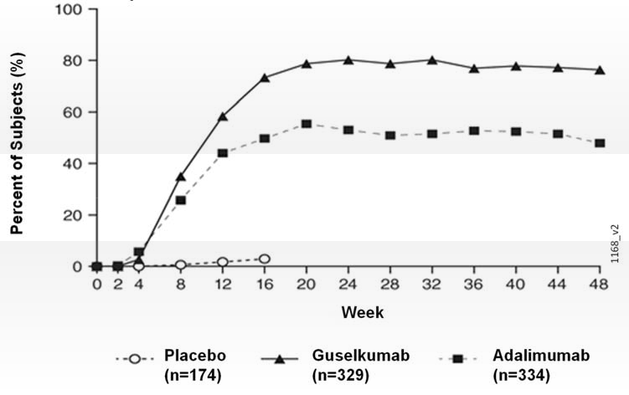
The efficacy and safety of guselkumab was demonstrated regardless of age, gender, race, body weight, plaques location, PASI baseline severity, concurrent psoriatic arthritis, and previous treatment with a biologic therapy. Guselkumab was efficacious in conventional systemic-naive, biologic-naive, and biologic-exposed patients.
In VOYAGE 2, 88.6% of patients receiving guselkumab maintenance treatment at Week 48 were PASI 90 responders compared to 36.8% of patients who were withdrawn from treatment at Week 28 (p < 0.001). Loss of PASI 90 response was noted as early as 4 weeks after withdrawal of guselkumab treatment with a median time to loss of PASI 90 response of approximately 15 weeks. Among patients who were withdrawn from treatment and subsequently re-initiated guselkumab, 80% regained a PASI 90 response when assessed 20 weeks after initiation of retreatment.
In VOYAGE 2, among 112 adalimumab subjects who failed to achieve a PASI 90 response at Week 28, 66% and 76% achieved a PASI 90 response after 20 and 44 weeks of treatment with guselkumab respectively. No new safety findings were observed in patients who switched from adalimumab to guselkumab.

Regional disease
In VOYAGE 1 and 2, significant improvements were seen in scalp, hand and foot, and nail psoriasis (as measured by the Scalp-specific Investigator Global Assessment [ss-IGA], Physician’s Global Assessment of Hands and/or Feet [hf-PGA], Fingernail Physician’s Global Assessment [f-PGA] and Nail Psoriasis Severity Index [NAPSI], respectively) in guselkumab treated patients compared to placebo treated patients at Week 16 (p < 0.001, Table 6). Guselkumab demonstrated superiority compared to adalimumab for scalp and hand and foot psoriasis at Week 24 (VOYAGE 1 and 2) and Week 48 (VOYAGE 1) (p ≤ 0.001, except for hand and foot psoriasis at Week 24 [VOYAGE 2] and Week 48 [VOYAGE 1], p < 0.05).

Table 6: Summary of Regional Disease Responses in VOYAGE 1 and VOYAGE 2
 | VOYAGE 1 |  |  | VOYAGE 2
 | Placebo | Guselkumab | Adalimumab | Placebo | Guselkumab | Adalimumab
ss-IGA (N)ª | 145 | 277 | 286 | 202 | 408 | 194
ss-IGA 0/1^{b}, n (%)
Week 16 | 21 (14.5) | 231 (83.4)^{c} | 201 (70.3)^{d} | 22 (10.9) | 329 (80.6)^{c} | 130 (67.0)^{d}
hf-PGA (N)ª | 43 | 90 | 95 | 63 | 114 | 56
hf-PGA 0/1^{b}, n (%)
Week 16 | 6 (14.0) | 66 (73.3)^{e} | 53 (55.8)^{d} | 9 (14.3) | 88 (77.2)^{e} | 40 (71.4)^{d}
f-PGA (N)ª | 88 | 174 | 173 | 123 | 246 | 124
f-PGA 0/1, n (%)
Week 16 | 14 (15.9) | 68 (39.1)^{e} | 88 (50.9)^{d} | 18 (14.6) | 128 (52.0)^{e} | 74 (59.7)^{d}
NAPSI (N)ª | 99 | 194 | 191 | 140 | 280 | 140
Percent Improvement, mean (SD)
Week 16 | -0.9 (57.9) | 34.4 (42.4)^{e} | 38.0 (53.9)^{d} | 1.8 (53.8) | 39.6 (45.6)^{e} | 46.9 (48.1)^{d}
ª Includes only subjects with ss-IGA, f-PGA, hf-PGA score ≥ 2 at baseline or baseline NAPSI score > 0.
^{b} Includes only subjects achieving ≥ 2-grade improvement from baseline in ss-IGA and/or hf-PGA.
^{c} p < 0.001 for comparison between guselkumab and placebo for the major secondary endpoint.
^{d} comparisons between guselkumab and adalimumab were not performed.
^{e} p < 0.001 for comparison between guselkumab and placebo.

Health-related quality of life / Patient reported outcomes
Greater improvements in symptoms of psoriasis (itch, pain, stinging, burning and skin tightness) at Week 16 in TREMFYA compared to placebo were observed in both trials based on the Psoriasis Symptoms and Signs Diary (PSSD). Greater proportions of subjects on TREMFYA compared to adalimumab achieved a PSSD symptom score of 0 (symptom-free) at Week 24 (VOYAGE 1 and VOYAGE 2) and Week 48 (VOYAGE 1).
In VOYAGE 1, for subjects receiving continuous guselkumab treatment, improvements in PSSD scores were maintained from Week 52 through Week 156.

NAVIGATE - Active-controlled study in ustekinumab inadequate responders
The NAVIGATE study examined the efficacy of guselkumab in patients who had an inadequate response (i.e., who had not achieved a ‘cleared’ or ‘minimal’ response defined as IGA ≥ 2) to ustekinumab at Week 16. All patients (N=871) received open-label ustekinumab (45 mg ≤100 kg and 90 mg >100 kg) at Weeks 0 and 4. At Week 16, 268 patients with an IGA ≥ 2 score were randomised to either continue ustekinumab treatment (N=133) q12w, or to initiate guselkumab treatment (N=135) at Weeks 16, 20, and q8w thereafter. Baseline characteristics for randomised subjects were similar to those observed in VOYAGE 1 and 2.
After randomisation, the primary endpoint was the number of post-randomisation visits between Weeks 12 and 24 at which patients achieved an IGA score 0/1 and had ≥ 2 grade improvement. Patients were examined at four-week intervals for a total of four visits. Among patients who inadequately responded to ustekinumab at the time of randomisation, significantly greater improvement of efficacy was observed in patients who switched to guselkumab treatment compared to patients who continued ustekinumab treatment. Between 12 and 24 weeks after randomisation, guselkumab patients achieved an IGA score 0/1 with ≥ 2 grade improvement twice as often as ustekinumab patients (mean 1.5 vs 0.7 visits, respectively, p < 0.001). Additionally, at 12 weeks after randomisation a higher proportion of guselkumab patients compared to ustekinumab patients achieved an IGA score 0/1 and ≥ 2 grade improvement (31.1% vs. 14.3%, respectively; p = 0.001) and a PASI 90 response (48% vs 23%, respectively, p < 0.001). Differences in response rates between guselkumab and ustekinumab treated patients start to become apparent at 4 weeks after randomisation (11.1% and 9.0%, respectively) and reached a maximum 24 weeks after randomisation (see Figure 2). No new safety findings were observed in patients who switched from ustekinumab to guselkumab.

Figure 2: Percent of Subjects Who Achieved an IGA Score of Cleared (0) or Minimal (1) and at least a 2-grade improvement in IGA from Week 0 Through Week 24 by Visit After Randomisation in NAVIGATE
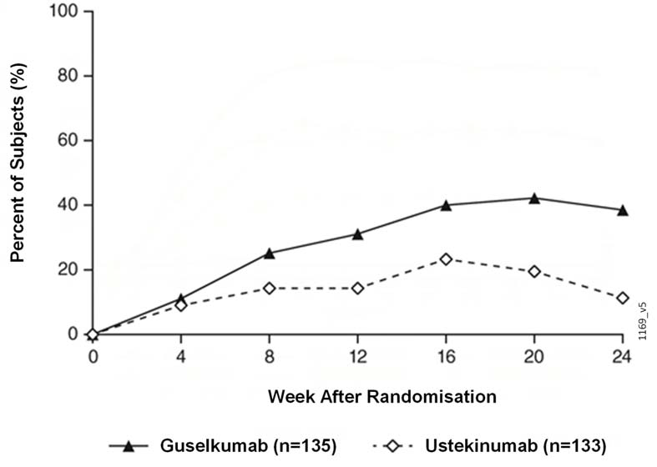
ORION - Placebo-controlled study with pre-filled pen
ORION evaluated the efficacy, safety, PK, immunogenicity, usability, and acceptability of guselkumab delivered with a pre-filled pen. In this study, 78 subjects were randomised to receive either TREMFYA (100 mg at Weeks 0 and 4 and every 8 weeks thereafter), or placebo. Baseline characteristics for randomised subjects were comparable to those observed in VOYAGE 1 and VOYAGE 2. The co-primary endpoints were the proportion of subjects who achieved an IGA score of 0 or 1 at Week 16 and the proportion of subjects who achieved a PASI 90 response at Week 16. The secondary endpoints included the proportion of subjects who achieved an IGA score 0 at Week 16 and the proportion of subjects who achieved a PASI 100 response at Week 16.
A significantly greater proportion of subjects in the guselkumab group achieved an IGA score of 0 or 1 or a PASI 90 response at Week 16 (80.6% and 75.8%, respectively, p<0.001 for both endpoints) than in the placebo group (0% for both endpoints). The proportion of subjects who achieved an IGA score of 0 at Week 16 was significantly higher in the guselkumab group compared to the placebo group (56.5% vs. 0%; p < 0.001). The proportion of subjects who achieved a PASI 100 response at Week 16 was significantly higher in the guselkumab group compared to the placebo group (50.0% vs. 0%; p < 0.001).
Patient Experience
Subject experience with the pre-filled pen was assessed on a scale of 0 (worst) to 10 (best) using a validated Self-Injection Assessment Questionnaire (SIAQ) based on subject responses across 6 domains (feelings about injections, self-image, self-confidence, pain and skin reactions during or after the injection, ease of use of the self-injection device, and satisfaction with self-injection) at weeks 0, 4 and 12. At week 12, the mean score for “Satisfaction with Self Injection” was 9.18 (with 10 indicating “Very Satisfied”) and the mean score for “Ease of Use” was 9.24 (with 10 indicating “Very Easy”). The mean scores for the other domains at week 12 ranged from 8.43 to 9.84.

Active-controlled study with secukinumab – ECLIPSE
The efficacy and safety of TREMFYA were also investigated in a double-blind study compared to secukinumab. Patients were randomised to receive TREMFYA (N=534; 100 mg at Week 0, 4 and every 8 weeks thereafter) or secukinumab (N=514; 300 mg at Week 0, 1, 2, 3, 4, and every 4 weeks thereafter). The last dose was at Week 44 for both treatment groups. Demographic and disease characteristics were similar between the two treatment groups and consistent with those of the subjects enrolled in the pivotal Phase 3 psoriasis studies for TREMFYA and secukinumab. The primary endpoint was the proportion of subjects who achieved a PASI 90 response at Week 48. Major secondary endpoints were the proportion of subjects who achieved a PASI 75 response at both Week 12 and Week 48, a PASI 90 response at Week 12, PASI 75 response at Week 12, a PASI 100 response at Week 48, an IGA score of cleared (0) at Week 48, and an IGA score of cleared (0) or minimal (1) at Week 48.
TREMFYA was superior to secukinumab as measured by the primary endpoint of PASI 90 response at Week 48 (84.5% versus 70.0%, p<0.001). Comparative clinical response rates are presented in Table 7.

Table 7: Summary of Clinical Response Rates in ECLIPSE
 | Number of patients (%)
 | TREMFYA (N=534) | Secukinumab (N=514)
Primary Endpoint
PASI 90 response at Week 48 | 451 (84.5%)ª | 360 (70.0%)
Major Secondary Endpoints
PASI 75 response at both Week 12 and Week 48 | 452 (84.6%)^{b} | 412 (80.2%)
PASI 75 response at Week 12 | 477 (89.3%)^{c} | 471 (91.6%)
PASI 90 response at Week 12 | 369 (69.1%)^{c} | 391 (76.1%)
PASI 100 response at Week 48 | 311 (58.2%)^{c} | 249 (48.4%)
IGA score of cleared (0) at Week 48 | 332 (62.2%)^{c} | 259 (50.4%)
IGA score of cleared (0) or minimal (1) at Week 48 | 454 (85.0%)^{c} | 385 (74.9%)
ª p<0.001 for both non-inferiority and superiority
^{b} p<0.001 for non-inferiority, p=0.062 for superiority
^{c} formal statistical testing was not performed

TREMFYA and secukinumab PASI 90 response rates through Week 48 are presented in Figure 3.

Figure 3 Percent of Subjects Who Achieved a PASI 90 Response from Week 0 Through Week 48 by Visit (Subjects Randomised at Week 0) in ECLIPSE
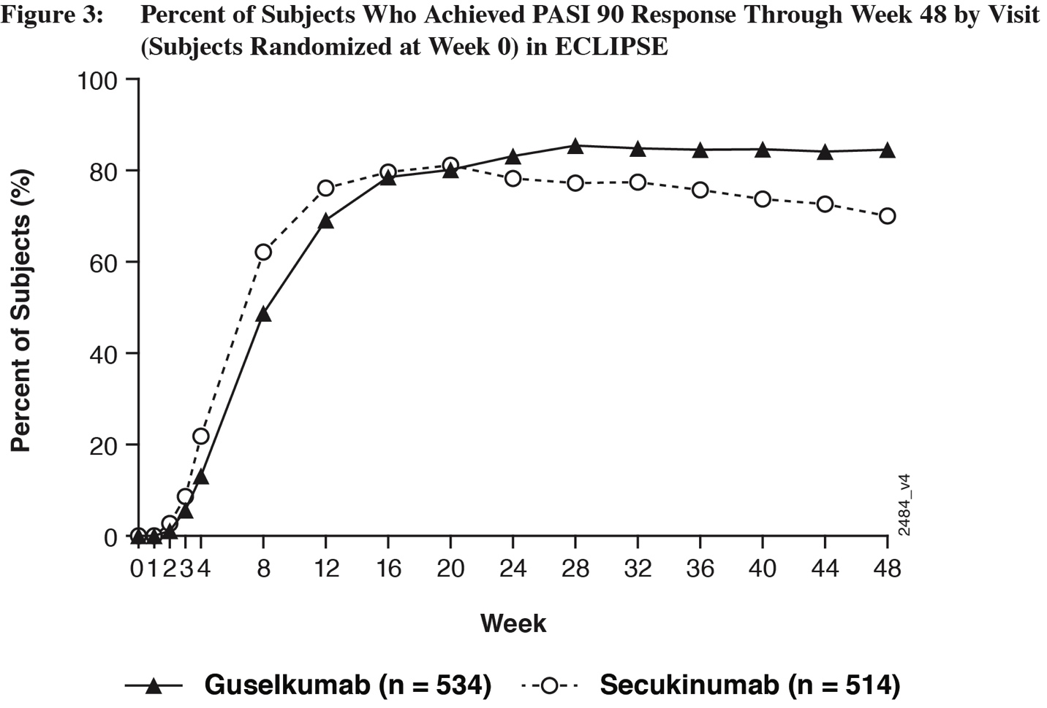

Psoriatic arthritis (PsA)

DISCOVER 1 and DISCOVER 2
The safety and efficacy of TREMFYA were assessed in 1120 patients in 2 randomised, double-blind, placebo-controlled studies (DISCOVER 1 and DISCOVER 2) in adult patients with active PsA (≥3 swollen joints, ≥3 tender joints, and a C-reactive protein (CRP) level of ≥0.3 mg/dL in DISCOVER 1 and ≥5 swollen joints, ≥5 tender joints, and a CRP level of ≥0.6 mg/dL in DISCOVER 2) who had inadequate response to standard therapies. Patients in these studies had a diagnosis of PsA for at least 6 months based on the Classification Criteria for Psoriatic Arthritis (CASPAR) and a median duration of PsA of 4 years at baseline.
In DISCOVER 1 approximately 30% of subjects had been previously treated with up to 2 anti-tumor necrosis factor alpha (anti-TNFα) agents whereas in DISCOVER 2 all subjects were biologic naïve. Approximately 58% of subjects from both studies had concomitant methotrexate (MTX) use. Patients with different subtypes of PsA were enrolled in both studies, including polyarticular arthritis with the absence of rheumatoid nodules (40%), spondylitis with peripheral arthritis (30%), asymmetric peripheral arthritis (23%), distal interphalangeal involvement (7%) and arthritis mutilans (<1%). At baseline, over 65% and 42% of the patients had enthesitis and dactylitis, respectively and over 75% had ≥3% body surface area (BSA) psoriasis skin involvement.
DISCOVER 1 evaluated 381 subjects who were treated with placebo SC, TREMFYA 100 mg SC at Weeks 0, 4 and every 8 weeks (q8w) thereafter, or TREMFYA 100 mg SC every 4 weeks (q4w). DISCOVER 2 evaluated 739 subjects who were treated with placebo SC, TREMFYA 100 mg SC at Weeks 0, 4 and q8w thereafter, or TREMFYA 100 mg SC q4w.
The primary endpoint in both studies was the percentage of patients achieving an ACR20 response at Week 24. Secondary endpoints included change from baseline in Disability Index of the Health Assessment Questionnaire (HAQ-DI), IGA, ACR 50, ACR 70, SF-36 PCS, SF-36 MCS and change from baseline in total modified van der Heijde-Sharp score (DISCOVER 2), at Week 24. Additionally, resolution of enthesitis and dactylitis based on the pooled data from DISCOVER 1 and DISCOVER 2 was assessed as a secondary endpoint in DISCOVER 2.

Signs and symptoms
In both studies, patients treated with TREMFYA 100 mg q8w or 100 mg q4w demonstrated a greater clinical response including ACR20, ACR50, and ACR70 compared to placebo at Week 24 (Table 8). Responses were seen regardless of prior anti-TNFα exposure (DISCOVER 1) and concomitant csDMARD use (DISCOVER 1 and DISCOVER 2). Additionally, in both studies, examination of age, gender, race, body weight, and previous treatment with csDMARDs did not identify differences in response to TREMFYA among these subgroups.

Table 8: Clinical Responses in DISCOVER 1 and DISCOVER 2
 | DISCOVER 1 |  |  | DISCOVER 2
 | Placebo  (N=126) | TREMFYA  100 mg q8w  (N=127) | TREMFYA  100 mg q4w  (N=128) | Placebo  (N=246) | TREMFYA  100 mg q8w  (N=248) | TREMFYA  100 mg q4w  (N=245)
ACR 20 response
Week 16 | 25.4% | 52.0%^{b} | 60.2%^{b} | 33.7% | 55.2% | 55.9%^{c}
Week 24 | 22.2% | 52.0%ª | 59.4%ª | 32.9% | 64.1%ª | 63.7%ª
ACR 50 response
Week 16 | 12.7% | 22.8% | 26.6%^{c} | 9.3% | 28.6% | 20.8% ^{c}
Week 24 | 8.7% | 29.9% ^{b} | 35.9%^{b} | 14.2% | 31.5% | 33.1% ^{c}
ACR 70 response
Week 24 | 5.6% | 11.8% | 20.3%^{b} | 4.1% | 18.5% | 13.1% ^{c}
DAS (CRP) Change from baseline (adjusted mean)
Week 24 | -0.70 | -1.43 ^{b} | -1.61 ^{b} | -0.97 | -1.59 ^{b} | -1.62 ^{b}
Minimal Disease Activity (MDA)
Week 24 | 11.1% | 22.8% ^{d} | 30.5% ^{e} | 6.1% | 25.0% ^{e} | 18.8% ^{e}
Modified PsA Responder Criteria (PsARC)
Week 24 | 31.0% | 59.8%^{e} | 72.7%^{e} | 44.7% | 72.6%^{e} | 68.6%^{e}
ª multiplicity adjusted p<0.001 for comparison between TREMFYA and placebo for primary endpoint
^{b} multiplicity adjusted p<0.001 for comparison between TREMFYA and placebo for major secondary endpoint
^{c} multiplicity adjusted p=0.006 for comparison between TREMFYA and placebo for major secondary endpoint
^{d} nominal p=0.012 for comparison between TREMFYA and placebo
^{e} nominal p<0.001 for comparison between TREMFYA and placebo

In DISCOVER 1 and 2, patients treated with TREMFYA who had spondylitis with peripheral arthritis as their primary presentation, demonstrated greater improvement from baseline in Bath Ankylosing Spondylitis Disease Activity Index (BASDAI) compared to placebo at Week 24.
In DISCOVER 2, a greater ACR 20 response was observed in both TREMFYA dose groups compared with the placebo group as early as Week 4 and the treatment difference continued to increase over time through Week 24 (Figure 4).

Figure 4: Subjects Achieving ACR 20 Response by Visit Through Week 24 in DISCOVER 2
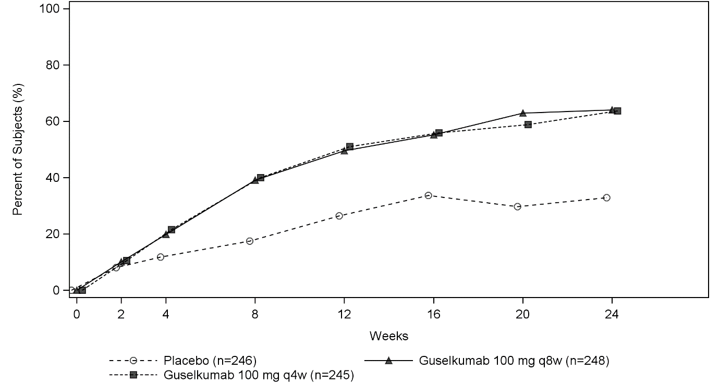
In DISCOVER 1 and DISCOVER 2, median percent improvement from baseline was observed in all components of the ACR response criteria.

Psoriasis Skin Response
In DISCOVER 1 and DISCOVER 2, among subjects with mild to severe psoriasis (BSA ≥3% and IGA ≥2) at baseline, a greater proportion of subjects in both TREMFYA dose groups achieved a psoriasis response, defined as an IGA of 0 (cleared) or 1 (minimal) and a ≥2-grade reduction from baseline, compared with the placebo group at Week 24. Results from psoriasis skin response endpoints in DISCOVER 1 and DISCOVER 2 are presented in Table 9.

Table 9: Psoriasis Skin Response in Subjects with ≥ 3% BSA and IGA ≥ 2 at Baseline
 | DISCOVER 1 |  |  | DISCOVER 2
 |  | TREMFYA |  |  | TREMFYA
 | Placebo  (n=78) | 100 mg q8w  (n=82) | 100 mg q4w  (n=89) | Placebo  (n=183) | 100 mg q8w  (n=176) | 100 mg q4w  (n=184)
IGA response IGA 0/1 and ≥2 grade improvement
Week 24 | 15.4% | 57.3%ª | 75.3%ª | 19.1% | 70.5%ª | 68.5%ª
PASI 90 response
Week 16 | 10.3% | 45.1%^{b} | 52.8%^{b} | 8.2% | 55.1%^{b} | 53.8%^{b}
Week 24 | 11.5% | 50.0%^{b} | 62.9%^{b} | 9.8% | 68.8%^{b} | 60.9%^{b}
PASI 100 response
Week 16 | 7.7% | 23.2%^{c} | 32.6%^{b} | 3.8% | 27.3%^{b} | 33.2%^{b}
Week 24 | 6.4% | 25.6%^{b} | 44.9%^{b} | 2.7% | 45.5%^{b} | 44.6%^{b}
ª p < 0.001 (major secondary endpoint)
^{b} nominal p < 0.001
^{c} nominal p=0.006

Enthesitis and Dactylitis
Enthesitis and dactylitis were assessed based on pooled data from DISCOVER 1 and DISCOVER 2. Among subjects with dactylitis at baseline, a greater proportion of subjects in both the TREMFYA 100 mg q8w and the TREMFYA 100 mg q4w groups achieved dactylitis resolution at Week 24 compared with the placebo group (Table 10). Among subjects with enthesitis at baseline, a greater proportion of subjects in both the TREMFYA 100 mg q8w group and q4w group achieved enthesitis resolution at Week 24 compared with the placebo group (Table 10).

Table 10: Dactylitis and Enthesitis Resolution at Week 24; Pooled Data from DISCOVER 1 and DISCOVER 2
 |  | TREMFYA
 | Placebo | 100 mg q8w | 100 mg q4w
Dactylitis
Subjects with dactylitis at baseline (n) | 154 | 160 | 159
Dactylitis resolution at Week 24 | 42.2% | 59.4% ^{b} | 63.5%ª
Enthesitis
Subjects with enthesitis at baseline (n) | 255 | 230 | 243
Enthesitis resolution at Week 24 | 29.4% | 49.6% ^{c} | 44.9%ª
ª p=0.006 (major secondary endpoint)
^{b} not formally tested based on hierarchical order in testing procedure, nominal p=0.001 (major secondary endpoint)
^{c} not formally tested based on hierarchical order in testing procedure, nominal p<0.001 (major secondary endpoint)

Radiographic response
In DISCOVER 2, inhibition of structural damage progression was measured radiographically and expressed as the mean change from baseline in the total modified van der Heijde-Sharp (vdH-S) score at Week 24.
TREMFYA q4w inhibited the progression of structural damage compared to placebo at Week 24. TREMFYA q8w showed numerically less, but not statistically significant, progression of structural damage compared to placebo. These results are shown in Table 11.

Table 11: Change from Baseline in vdH-S score at Week 24 in DISCOVER 2
 | N | Mean change from baseline in vdH-S score at Week 24
Placebo | 246 | 0.95
TREMFYA 100 mg q4w | 245 | 0.29ª
TREMFYA 100 mg q8w | 248 | 0.52^{b}
ª multiplicity adjusted p=0.006 for comparison between TREMFYA and placebo for major secondary endpoint
^{b} multiplicity adjusted p=0.069 for comparison between TREMFYA and placebo for major secondary endpoint

Physical function and health-related quality of life
TREMFYA-treated patients in both the 100 mg q8w and q4w dose groups in both DISCOVER 1 and DISCOVER 2 showed greater mean improvement from baseline in physical function compared to patients treated with placebo as assessed by HAQ-DI at Weeks 16 and 24. In both studies, the proportion of HAQ-DI responders (≥0.35 improvement in HAQ-DI score) was greater in both TREMFYA dose groups compared to placebo at weeks 16 and 24.

Table 12: HAQ-DI Response at Weeks 16 and 24 in DISCOVER 1 and DISCOVER 2
 | DISCOVER 1 |  |  | DISCOVER 2
 |  | TREMFYA |  |  | TREMFYA
 | Placebo  (N=126) | 100 mg q8w  (N=127) | 100 mg q4w  (N=128) | Placebo  N=246 | 100 mg q8w  (N=248) | 100 mg q4w  (N=245)
HAQ-DI Mean change from baseline^{f}
Baseline | 1.2391 | 1.2057 | 1.0938 | 1.2949 | 1.2848 | 1.2490
Mean change at Week 16 | -0.1131 | -0.2620^{d} | -0.3393^{c} | -0.1167 | -0.3177^{c} | -0.3442^{c}
Mean change at Week 24 | -0.0743 | -0.3225ª | -0.3968ª | -0.1300 | -0.3672ª | -0.4004ª
HAQ-DI Responders (≥ 0.35 improvement from baseline)
Week 16 | 30.9% | 46.4%^{e} | 57.3%^{c} | 30.9% | 50.0%^{c} | 51.8%^{c}
Week 24 | 29.1% | 50.9%^{b} | 57.3%^{c} | 31.4% | 50.0% ^{c} | 56.1% ^{c}
ª p<0.001 (major secondary endpoint)
^{b} nominal p=0.001
^{c} nominal p<0.001
^{d} nominal p=0.008
^{e} nominal p=0.019
^{f} adjusted mean change

At Week 24, subjects in both the TREMFYA 100 mg q8w and q4w dose groups in both DISCOVER 1 and DISCOVER 2 showed greater improvement from baseline in the SF-36 PCS with no worsening in the SF-36 MCS compared with placebo. At Week 24 there was consistent evidence of effect in the physical functioning, role-physical, bodily-pain, general health, social-functioning and vitality domains but not in the role-emotional and mental health domains. At Week 24, a greater mean increase from baseline in Functional Assessment of Chronic Illness Therapy-Fatigue (FACIT-F) score was observed in guselkumab treated patients compared to placebo in both DISCOVER 1 (5.609, 5.841 and 2.206 in the 100mg q8w, 100mg q4w and placebo groups, respectively; both nominal p<0.001) and DISCOVER 2 (7.550, 7.111 and 3.559 in the 100mg q8w, 100mg q4w and placebo groups, respectively; both nominal p<0.001). In DISCOVER 2, greater improvements in health-related quality of life as measured by mean change from baseline in the Dermatology Life Quality Index (DLQI) were observed in guselkumab treated patients compared to placebo at Week 24 (-8.954, -8.853, and -2.129 in the 100mg q8w, 100 mg q4w and placebo groups, respectively; both nominal p<0.001). In DISCOVER 2, greater improvements were also observed in overall work impairment and activity impairment as assessed by the Work Productivity and Activity Impairment (WPAI)-PsA questionnaire compared to placebo at Week 24.

Pharmacokinetic PROPERTIES

Absorption
Following a single 100 mg subcutaneous injection in healthy subjects, guselkumab reached a mean (± SD) maximum serum concentration (Cmax) of 8.09 ± 3.68 mcg/mL by approximately 5.5 days post dose.
Steady state serum guselkumab concentrations were achieved by Week 20 following subcutaneous administrations of 100 mg guselkumab at Weeks 0 and 4, and every 8 weeks thereafter. The mean (± SD) steady state trough serum guselkumab concentrations in two Phase 3 studies in plaque psoriasis were 1.15 ± 0.73 mcg/mL and 1.23 ± 0.84 mcg/mL. Serum guselkumab concentrations did not appear to accumulate over time when given subcutaneously every 8 weeks.
The pharmacokinetics of guselkumab in subjects with psoriatic arthritis was similar to that in subjects with plaque psoriasis. Following subcutaneous administration of 100 mg of guselkumab at Weeks 0, 4, and every 8 weeks thereafter, mean steady-state trough serum guselkumab concentration was approximately 1.2 mcg/mL. Following subcutaneous administration of 100 mg of guselkumab every 4 weeks, mean steady-state trough serum guselkumab concentration was approximately 3.8 mcg/mL.
The absolute bioavailability of guselkumab following a single 100 mg subcutaneous injection was estimated to be approximately 49% in healthy subjects.

Distribution
Mean volume of distribution during the terminal phase (V_{z}) following a single intravenous administration to healthy subjects ranged from approximately 7 to 10 L (98 to 123 mL/kg) across studies.

Metabolism
The exact pathway through which guselkumab is metabolised has not been characterised. As a human IgG monoclonal antibody, guselkumab is expected to be degraded into small peptides and amino acids via catabolic pathways in the same manner as endogenous IgG.

Excretion
Mean systemic clearance (CL) following a single intravenous administration to healthy subjects ranged from 0.288 to 0.479 L/day (3.6 to 6.0 mL/day/kg) across studies.
Mean half-life (T_{1/2}) of guselkumab was approximately 17 days in healthy subjects and approximately 15 to 18 days in subjects with plaque psoriasis across studies.

Dose Linearity
The systemic exposure of guselkumab (Cmax and AUC) increased in an approximately dose-proportional manner following a single subcutaneous injection at doses ranging from 10 mg to 300 mg in healthy subjects or subjects with plaque psoriasis.

Population Pharmacokinetic Analysis
In a population pharmacokinetic analysis, the apparent clearance (CL/F) and apparent volume of distribution (V/F) were 0.516 L/d and 13.5 L, respectively, and the T_{1/2} was approximately 18 days in subjects with psoriasis.
In the population pharmacokinetic analysis, the effects of baseline demographics (weight, age, sex, and race), immunogenicity, baseline disease characteristics, comorbidities (past and current history of diabetes, hypertension, and hyperlipidaemia), past use of therapeutic biologics, past use of methotrexate or cyclosporine, concomitant medications (NSAIDs, corticosteroids and conventional synthetic DMARDS such as methotrexate), use of alcohol, or current smoking status, on pharmacokinetics of guselkumab was evaluated. Only the effects of body weight on CL/F and V/F were found to be significant, with a trend towards higher CL/F in heavier subjects. However, subsequent exposure-response modelling analysis suggested that no dose adjustment would be warranted for body weight.

Cytochrome P450 Substrates
The effects of guselkumab on the pharmacokinetics of representative probe substrates of CYP isozymes (midazolam [CYP3A4], warfarin [CYP2C9], omeprazole [CYP2C19], dextromethorphan [CYP2D6], and caffeine [CYP1A2]) were evaluated in subjects with moderate to severe plaque psoriasis. Results from this study indicate that changes in C_{max} and AUC_{inf} of midazolam, S-warfarin, omeprazole, dextromethorphan, and caffeine after a single dose of guselkumab were not clinically relevant (see Section 4.5 Interactions with Other Medicines and Other Forms of Interactions).
There is no need for dose adjustment when co-administering guselkumab and CYP450 substrates.

SPECIAL POPULATIONS

Elderly Patients (>65 years of age and older)
Of the 1384 plaque psoriasis subjects exposed to TREMFYA in phase III clinical studies and included in the population pharmacokinetic analysis (pop PK), 70 subjects were 65 years of age or older, including 4 subjects who were 75 years of age or older. Population pharmacokinetic analyses indicated there were no apparent changes in CL/F estimate in subjects ≥ 65 years of age compared to subjects < 65 years of age, suggesting no dose adjustment is needed for elderly patients. Of the 746 psoriatic arthritis patients exposed to TREMFYA in phase III clinical studies and included in the pop PK analysis, a total of 38 patients were 65 years of age or older, and no patients were 75 years of age and older.

Patients with Renal or Hepatic Impairment
No specific studies have been conducted to determine the effect of renal or hepatic impairment on the pharmacokinetics of guselkumab.
Renal elimination of intact guselkumab, an IgG mAb, is expected to be low and of minor importance; similarly, hepatic impairment is not expected to influence clearance of guselkumab as IgG mAbs are mainly eliminated via intracellular catabolism.

PRECLINICAL SAFETY DATA

Genotoxicity
Guselkumab has not been evaluated for genotoxic potential.

Carcinogenicity
Guselkumab has not been evaluated for carcinogenic potential.

Pharmaceutical particulars

List of excipients
Histidine
Histidine hydrochloride monohydrate
Polysorbate 80
Sucrose
Water for injection.

Incompatibilities
In the absence of compatibility studies, this medicinal product must not be mixed with other medicinal products.

Shelf Life
In Australia, information on the shelf life can be found on the public summary of the Australian Register of Therapeutic Goods (ARTG). The expiry date can be found on the packaging.

Special precautions for storage
Store in a refrigerator (2°C – 8°C). Do not freeze. Do not shake.
Keep the pre-filled syringe or pre-filled pen in their original carton until time of use in order to protect from light.

Nature and contents of container
TREMFYA is supplied as a single-use sterile solution in a pre-filled 1mL glass syringe with a fixed 27G, half inch needle assembled in a passive needle guard delivery system or in a pre-filled pen with a passive needle guard enclosed in a patient-controlled injector device.
TREMFYA is available in cartons containing 1 pre-filled syringe or 1 pre-filled pen.
TREMFYA does not contain preservatives.

Special precautions for disposal
In Australia, any unused medicine or waste material should be disposed of by taking to your local pharmacy.

Physicochemical properties

Chemical structure:
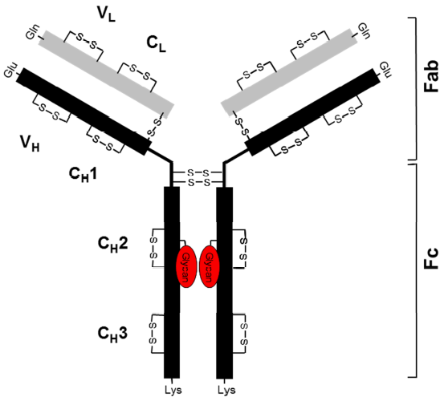
Figure 4. General structure of guselkumab
CAS No.: 1350289-85-8

Medicine Schedule (POISON STANDARD)
S4 – Prescription Only Medicine

Sponsor
JANSSEN-CILAG Pty Ltd
1-5 Khartoum Rd
Macquarie Park NSW 2113 Australia

Date of first APPROVAL
15 March 2018

Date of REVISION
29 January 2021

Summary table of changes
Section | Summary of changes
4.1 | Inclusion of Psoriatic Arthritis (PsA) as a new indication
4.2 | Inclusion of dosing instructions for PsA
4.4 | Updated exposure data from recent studies ECLIPSE & DISCOVER
4.8 | Updated exposure data and postmarketing data from recent studies ECLIPSE & DISCOVER  Included ADRs from PsA (DISCOVER) trials
5.1 | Addition of efficacy information from ECLIPSE study  Addition of efficacy (from DISCOVER 1 & DISCOVER 2 studies) information for PsA
5.2 | Updated elderly patients exposure data

