May 2014

Australian Public Assessment Report for golimumab (rmc)
  - Proprietary Product Name: Simponi
  - Sponsor: Janssen-Cilag Pty Ltd

About the Therapeutic Goods Administration (TGA)
- The Therapeutic Goods Administration (TGA) is part of the Australian Government Department of Health and is responsible for regulating medicines and medical devices.
- The TGA administers the Therapeutic Goods Act 1989 (the Act), applying a risk management approach designed to ensure therapeutic goods supplied in Australia meet acceptable standards of quality, safety and efficacy (performance), when necessary.
- The work of the TGA is based on applying scientific and clinical expertise to decision-making, to ensure that the benefits to consumers outweigh any risks associated with the use of medicines and medical devices.
- The TGA relies on the public, healthcare professionals and industry to report problems with medicines or medical devices. TGA investigates reports received by it to determine any necessary regulatory action.
- To report a problem with a medicine or medical device, please see the information on the TGA website <http://www.tga.gov.au>.
About AusPARs
- An Australian Public Assessment Record (AusPAR) provides information about the evaluation of a prescription medicine and the considerations that led the TGA to approve or not approve a prescription medicine submission.
- AusPARs are prepared and published by the TGA.
- An AusPAR is prepared for submissions that relate to new chemical entities, generic medicines, major variations, and extensions of indications.
- An AusPAR is a static document, in that it will provide information that relates to a submission at a particular point in time.
- A new AusPAR will be developed to reflect changes to indications and/or major variations to a prescription medicine subject to evaluation by the TGA.
Copyright
© Commonwealth of Australia 2014
This work is copyright. You may reproduce the whole or part of this work in unaltered form for your own personal use or, if you are part of an organisation, for internal use within your organisation, but only if you or your organisation do not use the reproduction for any commercial purpose and retain this copyright notice and all disclaimer notices as part of that reproduction. Apart from rights to use as permitted by the Copyright Act 1968 or allowed by this copyright notice, all other rights are reserved and you are not allowed to reproduce the whole or any part of this work in any way (electronic or otherwise) without first being given specific written permission from the Commonwealth to do so. Requests and inquiries concerning reproduction and rights are to be sent to the TGA Copyright Officer, Therapeutic Goods Administration, PO Box 100, Woden ACT 2606 or emailed to <tga.copyright@tga.gov.au>.

Contents
List of the most common abbreviations used in this AusPAR 5
I. Introduction to product submission 10
Submission details 10
Product background 10
Regulatory status 11
Product Information 12
II. Quality findings 12
Drug substance (active ingredient) 12
Drug product 13
Biopharmaceutics 14
Quality summary and conclusions 14
III. Nonclinical findings 14
IV. Clinical findings 14
Clinical rationale 14
Guidance 15
Contents of the clinical dossier 15
Paediatric data 16
Good clinical practice 16
Pharmacokinetics 16
Pharmacodynamics 17
Dosage selection for the pivotal studies 18
Efficacy 18
Safety 18
First round benefit-risk assessment 19
First round recommendation regarding authorisation 20
Clinical questions 20
Second round evaluation of clinical data submitted in response to questions 20
Second round benefit-risk assessment 21
V. Pharmacovigilance findings 21
Risk management plan 21
VI. Overall conclusion and risk/benefit assessment 35
Quality 36
Nonclinical 36
Clinical 36
Risk management plan 39
Risk-benefit analysis 40
Outcome 47
Attachment 1. Product Information 48
Attachment 2. Extract from the Clinical Evaluation Report 48

List of the most common abbreviations used in this AusPAR
Abbreviation | Meaning
6-MP | 6-mercaptopurine
ADR | adverse drug reaction
AE | adverse event(s)
AERS/SRS | Adverse Event Reporting System/Spontaneous Reporting System
ALT | alanine aminotransferase
ANA | antinuclear antibody
anti-dsDNA | anti-double stranded DNA
AS | ankylosing spondylitis
AST | aspartate aminotransferase
ATC | Anatomical Therapeutic Chemical
AZA | azathioprine
BCG | Bacille Calmette-Guérin
CAP | community-acquired pneumonia
CD | Crohn’s disease
CDC | Centers for Disease Control and Prevention
CHF | congestive heart failure
CHMP | Committee for Medicinal Products for Human Use
CI | confidence interval
Cmax | maximum observed concentration
CNS | central nervous system
COPD | chronic obstructive pulmonary disease
CSR | clinical study report
CV | cardiovascular
cV1q | anti-mouse TNFα monoclonal antibody
DBL | database lock
DHCP | Dear Health Care Professional (letter)
DMARD | Disease modifying antirheumatic drug
DNA | deoxyribonucleic acid
dsDNA | double-stranded DNA
EBGM | empirical Bayes geometric mean
EBV | Epstein Barr Virus
EEA | European Economic Area
EMA | European Medicines Agency
EU | European Union
FDA | Food and Drug Administration
FMEA | Failure Mode and Effects Analysis
FUM | follow-up measure
GD | gestation day
GMP | Good Manufacturing Practice
GMS | Global Medical Safety
HBV | hepatitis B virus
HCP | health care professional(s)
HD | Hodgkin’s disease
HIV | human immunodeficiency virus
HLA | human leukocyte antigen
HRCT | high-resolution computed tomography
ICH | International Conference on Harmonisation
Ig | immunoglobulin
IL | interleukin
INH | isoniazid
INN | International Non-proprietary Name
ISS | Integrated Summary of Safety
IV | intravenous
JIA | juvenile idiopathic arthritis
MAA | Marketing Authorisation Application
mAb | monoclonal antibody
MAH | Marketing Authorisation Holder
MedDRA | Medical Dictionary for Regulatory Activities
MI | myocardial infarction
MS | multiple sclerosis
MSD | Merck Sharp & Dohme, Inc.
MTB | Mycobacterium tuberculosis
MTX | methotrexate
NA | not applicable
NHL | non-Hodgkin’s lymphoma
NMSC | nonmelanoma skin cancer
NSAID | nonsteroidal anti-inflammatory drug
OIs | opportunistic infections
OR | odds ratio
PD | pharmacodynamic
PFP | prefilled pen
PFS | prefilled syringe
PFT | pulmonary function tests
PIP | paediatric investigational plan
PK | pharmacokinetic
PML | progressive multifocal leukoencephalopathy
PRR | proportional reporting ratio
PsA | psoriatic arthritis
PSO | psoriasis
PSUR | Periodic Safety Update Report
PT | preferred term
PUVA | psoralen plus ultraviolet A light
q4w | every 4 weeks
q8w | every 8 weeks
q12w | every 12 weeks
RA | rheumatoid arthritis
RMP | Risk Management Plan
RR | risk
SAE | serious adverse event(s)
SC | subcutaneous
SCEPTRE | Strategic Clinical and Epidemiological Pharmacovigilance Technology for Risk Evaluation (Johnson & Johnson Worldwide Safety Database)
SCP | Summary of Clinical Pharmacology
SCS | Summary of Clinical Safety
SD | standard deviation
SIR | standardised incidence ratio
SLE | systemic lupus erythematosus
SMR | standardised mortality ratio
SmPC | Summary of Product Characteristics (EU)
TB | tuberculosis
TH1 | T-helper cell type 1
TNF/TNFα | tumour necrosis factor alpha
UC | ulcerative colitis
UK | United Kingdom
US | United States
USA | United States of America
WHO | World Health Organization

I. Introduction to product submission

Submission details
Type of submission: | Major variation (Extension of indications)
Decision: | Approved
Date of decision: | 20 March 2014
Active ingredients: | Golimumab (rmc)
Product names: | Simponi, Simponi smartject injector
Sponsor’s name and address: | Janssen-Cilag Pty Ltd  1-5 Khartoum Road  Macquarie Park NSW 2113
Dose form: | Solution for injection
Strengths: | 50 mg, 100 mg
Containers: | Syringe, pen
Pack sizes: | Simponi 50 mg pre-filled syringe; packs of 1 or 3 syringes (0.5 mL)  Simponi 100 mg pre-filled syringe; packs of 1 or 3 syringes (1.0 mL)  Simponi Smartject Injector 50 mg pre-filled pen: packs of 1 or 3 syringes (0.5 mL)  Simponi Smartject Injector 100 mg pre-filled pen; packs of 1 or 3 syringes (1.0 mL)
Approved therapeutic use: | Ulcerative colitis (UC)  The treatment of moderately to severely active ulcerative colitis in adult patients who have had an inadequate response to conventional therapy. Patients should show a clinical response within 6 weeks of treatment to continue treatment beyond that time (see CLINICAL TRIALS).
Route of administration: | Subcutaneous injection
Dosage: | 200 mg given as a subcutaneous injection at Week 0, followed by 100 mg at Week 2 and then 100 mg every 4 weeks; thereafter.
ARTG numbers: | 208278, 208279, 153767, 153181

Product background
This AusPAR describes the application by the sponsor to register golimumab (rmc) for the following indication;
The treatment of moderately to severely active ulcerative colitis in adult patients who have had an inadequate response to conventional therapy.
Golimumab is a human IgG1κ monoclonal antibody produced by a murine hybridoma cell line with recombinant DNA technology. It forms high affinity, stable complexes with both the soluble and transmembrane bioactive forms of human tumour necrosis factor (TNF) which prevents the binding of TMF to its receptors.
Simponi (golimumab rmc) was first considered by the Advisory Committee on Prescription Medicines (ACPM, then called ADEC) at its 266th meeting on 2 October 2009. The Committee recommended approval of golimumab for the indications of rheumatoid arthritis, psoriatic arthritis and ankylosing spondylitis. The indication for psoriatic arthritis was subsequently amended to include that Simponi had been shown to inhibit the progression of structural damage.
Ulcerative colitis (UC) is a chronic, relapsing, immune-mediated, inflammatory disease of the colon that always affects the rectum, extends proximally to a variable extent, and is characterized by a relapsing and remitting course. The aims of drug therapy in UC are to induce remission in active disease, and then to maintain corticosteroid-free remission and prevent relapse. The severity of the disease and the site(s) of the affected colon determine which medicines may be used and their route of administration. In general if the disease is mild, topical (that is, rectal) therapy is often sufficient for proctitis alone, while combined topical and oral therapy is optimal for distal (left-sided) colitis. Moderate or severe, or more extensive disease requires oral or intravenous therapy.

Regulatory status
The product received initial registration on the Australian Register of Therapeutic Goods (ARTG) on 13 November 2009.
At the time the TGA considered this application, a similar application had been approved for the UC indication in the United States (US) (during the evaluation of this submission). The approved indication in the US is:
Simponi is indicated in adult patients with moderately to severely active ulcerative colitis who have demonstrated corticosteroid dependence or who have had an inadequate response to or failed to tolerate oral aminosalicylates, oral corticosteroids, azathioprine, or 6-mercaptopurine for:
- inducing and maintaining clinical response
- improving endoscopic appearance of the mucosa during induction
- inducing clinical remission
- achieving and sustaining clinical remission in induction responders (see Clinical Studies (14.4)).
Infliximab (May 2012) and adalimumab (July 2013) are other anti-TNF agents approved for treatment of UC. The indication for infliximab (Remicade) is:
Ulcerative colitis in Adults and in Children and adolescents (6 to 17 years)
Remicade is indicated for the treatment of moderately severe to severe active ulcerative colitis in patients who have had an inadequate response to conventional therapy.
The indication for adalimumab (Humira) is:
Ulcerative colitis
Humira is indicated for the treatment of moderate to severe ulcerative colitis in adult patients who have had an inadequate response to conventional therapy or who are intolerant to or have medical contraindications for such therapies. Patients should show a clinical response within 8 weeks of treatment to continue treatment beyond that time (see CLINICAL TRIALS).

Product Information
The approved Product Information (PI) current at the time this AusPAR was prepared can be found as Attachment 1. For the most recent Product Information please refer to the TGA website at <http://www.tga.gov.au/hp/information-medicines-pi.htm>.

II. Quality findings

Drug substance (active ingredient)

Structure
Golimumab (CNTO 148) is a human immunoglobulin G1 (IgG1) containing kappa light chains. The intact molecule contains 1342 amino acid residues and is composed of two identical heavy chains (approximately 50 kDa each) and two identical light chains (approximately 24 kDa each).
CNTO 148 is a glycoprotein and exhibits multiple glycoforms, containing two N-glycans (one on each heavy chain) with terminal galactose and sialic acid microheterogeneity. The glycans are bound exclusively at asparagine 306 (Asn-306) in the CH2 region of the heavy chain and glycosylation is essentially complete at each site.

Manufacture
The drug substance formulated bulk is manufactured in a 9-stage process by continuous perfusion cell culture followed by purification through affinity, cation exchange and anion exchange chromatography.
Cell banking processes are satisfactory and remain unchanged from the currently approved process.
All viral/prion safety issues have previously been addressed, including use of animal-derived excipients, supplements in the fermentation process and in cell banking.

Physical and chemical properties
CNTO 148 is a human immunoglobulin G1κ (IgG1κ) monoclonal antibody that binds with high affinity and specificity to human tumour necrosis factor alpha (TNFα), thereby neutralizing the biological activity of TNFα.
By neutralizing endogenous TNFα, CNTO 148 prevents a number of activities including the secretion of other pro-inflammatory cytokines, endothelial cell activation and subsequent expression of adhesion proteins, and proliferation of fibroblasts. CNTO 148 inhibits the biological activity of TNFα in all in vitro assays performed.

Specifications
The currently approved release and shelf life (stability) specifications for Simponi formulated bulk (FB) have had appropriate validation data submitted in support of the test procedures.

Stability
The manufacturing process for golimumab drug substance includes two stable hold points:
- direct product capture (DPC) bulk intermediate produced in Stage 3
- formulated bulk (FB) produced in Stage 9.
Stability data have been generated under real time/stressed conditions to characterise the stability/degradation profile of the substance.
The real time data submitted support a shelf life of 36 months when stored at the recommended temperature of less than or equal to −40°C for the DPC and FB.

Drug product

Formulation(s)
The drug product (DP) is supplied as a sterile solution in a single-use, pre-filled syringe (PFS). The PFS is composed of a 1-mL long syringe with a fixed needle, stoppered with a gray plunger stopper. The needle is covered with a needle shield. CNTO 148 PFS is manufactured in two dosages, a 50 mg/syringe (0.5 mL) and a 100 mg/syringe (1.0 mL). CNTO 148 PFS with 50 mg (0.5 mL) or 100 mg (1.0 mL) doses will be assembled into either an Autoinjector or an UltraSafe Passive Delivery System (UltraSafe) for subcutaneous administration by a health care professional or a patient.
The quantitative composition of CNTO 148 PFS, expressed as mg per dose. The product contains histidine, sorbitol, and polysorbate 80 (PS 80).

Manufacture
Simponi (golimumab) drug product pre-filled syringe (PFS) is manufactured from golimumab formulated bulk (FB).
Assembly of the Simponi PFS into either UltraSafe Passive Delivery System (UltraSafe) or Autoinjector device is performed.
Golimumab FB is stored at less than or equal to -40 °C in 1 L and/or 10 L polycarbonate bottles. The FB is thawed, pooled, mixed, sterile filtered and aseptically filled into a 1 mL long, Type 1 borosilicate glass syringe with fixed needle and either Needle Shield or Rigid Needle Shield, and closed with a coated stopper. Two Simponi PFS presentations are manufactured from the Simponi FB, a 50 mg/syringe dose (0.5 mL nominal fill volume) and a 100 mg/syringe dose (1.0 mL nominal fill volume). These two Simponi PFS presentations may be assembled into a pen injector device.

Stability
Stability data have been generated under stressed and real time conditions to characterise the stability profile of the product.
Photostability data showed that the product is not photostable.
The proposed shelf life is 24 months when stored at 2 to 8°C and protected from light.

Biopharmaceutics
Bioavailability evaluation is not required as there is no change to the currently approved subcutaneous route of administration and no change to formulation.

Quality summary and conclusions
Batch release condition is not required for this application as the main difference with the currently approved products is change in the fill volume of the drug product manufacturing process.
The administrative, product usage, chemical, pharmaceutical, microbiological data submitted in support of this application have been evaluated in accordance with the Australian legislation, pharmacopoeial standards and relevant technical guidelines adopted by the TGA.
There is no objection to registration on quality grounds.

III. Nonclinical findings
There was no requirement for a nonclinical evaluation in a submission of this type.

IV. Clinical findings
A summary of the clinical findings is presented in this section. Further details of these clinical findings can be found in Attachment 2.

Clinical rationale
The purpose of this submission is to support a new therapeutic indication for the treatment of moderately to severely active ulcerative colitis in adult patients who have had an inadequate response to conventional therapy including corticosteroids and 6-mercaptopurine (6-MP) or azathioprine (AZA), or who are intolerant to or have medical contraindications for such therapies.
Ulcerative colitis (UC) is a chronic inflammatory bowel disorder of unknown aetiology. The overall estimate of the prevalence of ulcerative colitis is approximately 730,000 people in North America and 1 million people in Europe.
The sponsor argues:
‘There is unmet therapeutic need for patients with ulcerative colitis, since many do not respond to or are intolerant of conventional therapies, or demonstrate corticosteroid dependence. Among patients with ulcerative colitis who respond to corticosteroids, long-term use is not recommended due to its toxicity’.
And further that, since the biologic anti-TNF agents infliximab and adalimumab are globally approved for use in patients with moderately to severely active ulcerative colitis. Golimumab:
‘provides a convenient, alternative treatment option for patients with ulcerative colitis who have not responded to conventional therapy.’

Guidance
- CHMP/EWP/18463/2006 Guideline on the Development of New Medicinal Products for the Treatment of Ulcerative Colitis Effective: 8 April 2009.
- CPMP/BPWG/283/00 Note for Guidance on the Clinical Investigation of Human Normal Immunoglobulin for Subcutaneous and Intramuscular Use Effective: 12 March 2003.

Contents of the clinical dossier
The submission contained the following clinical information:
- One Phase I PK Study CNTO148NAP1001, of single SC 200 mg and 400 mg doses in healthy volunteers.
- 2 clinical studies (C0524T16 & C0524T17) that provided PK and PD data.
- 1 population pharmacokinetic analysis.
- 3 pivotal efficacy/safety studies in subjects with moderately to severely active ulcerative colitis:
  - C0524T16 intravenous 6 week induction study double-blind, placebo controlled, parallel-group study.
  - C0524T17 subcutaneous (SC) 6 week induction study double-blind, placebo controlled, parallel-group study.
These studies, to evaluate efficacy and safety, were designed with 2 parts, a Phase II dose-finding portion (Part 1) and a Phase III dose-confirming portion (Part 2). The Part 1 analyses gave better results for the SC induction regimens than observed with the IV induction regimens, so the enrolment into the IV induction Study C0524T16 was stopped.
- Long term (54 week) maintenance study (C0524T18) of efficacy and safety. Subjects who enrolled in C0524T16 and C0524T17 and who completed the Week 6 visit were eligible to enter the maintenance study, C0524T18.
- A population PK model of golimumab in subjects with moderately to severely active ulcerative colitis was developed, using PK samples obtained from the induction and maintenance studies.
- The submission also referred to old studies for updating the clinical pharmacology information in the Product Information or for cross-study comparisons with PK data from the golimumab ulcerative colitis studies:
  - C0524T23- Phase I, single blind, partially randomized, two-dose study of Japanese and Caucasians to assess the PK profiles of golimumab following a single SC injection of 50 and 100 mg golimumab.
  - C0524T14 - Phase I randomised, open label outpatient study to assess the PKs & PDs of golimumab following multiple IV or SC administrations of golimumab in subjects with rheumatoid arthritis.
  - C0524T15 - Phase I randomised, open label parallel study to assess the absolute bioavailability of a single subcutaneous administration of golimumab in healthy subjects.
- PSUR: 7 October 2011 to 6 April 2012.
- Literature references.
- The sponsor’s Clinical Overview, Summary of Clinical Efficacy, Summary of Clinical Safety and literature references.

Paediatric data
The submission included no paediatric data.

Good clinical practice
All newly submitted studies were conducted in compliance with Good Clinical Practice.

Pharmacokinetics

Studies providing pharmacokinetic data
Table 1 shows the studies relating to each pharmacokinetic topic.
Table 1. Submitted pharmacokinetic studies
PK topic | Subtopic | Study ID | *
PK in healthy adults | General PK - Single dose 200 & 400 mg | Study CNTO148NAP1001 | *
PK in special populations | Target population§ - Multi-dose | Study C0524T16  Study C0524T17  Study C0524T18
Population PK analyses | Target population | POPPK-CNTO148-UC | *
* Indicates the primary aim of the study. § Subjects who would be eligible to receive the drug if approved for the proposed indication.
Table 2. Previously submitted & evaluated PK studies referred to in this submission
PK topic | Subtopic | Study ID | *
PK in healthy adults | General PK - Single dose 50 mg and 100 mg | Study C0524T23 | *
PK in healthy adults | Bioavailability | Study C0524T15 | *
PK in healthy adults | - Multi-dose | Study C0524T14 | *
* Indicates the primary aim of the study.
None of the PK studies had deficiencies that excluded their results from consideration.
Details of these studies may be found in the Clinical Evaluation Report (CER) Extract (Attachment 2).
Due to findings of investigator misconduct at site 6706 and site 7257, subject data from these 2 sites were excluded from all efficacy analyses but were included in the demography, PK, immunogenicity, and safety analyses.

Evaluator’s conclusions on pharmacokinetics
Overall, the PK characteristics of golimumab were not greatly different between ulcerative colitis and healthy subjects. The data suggest that the PKs of golimumab in ulcerative colitis is generally comparable to those in Rheumatoid arthritis subjects. In particular, the median t_{1/2} for Rheumatoid arthritis subjects who did not receive methotrexate was similar to that observed in the ulcerative colitis population.

Pharmacodynamics

Studies providing pharmacodynamic data
Table 3 shows the studies relating to each pharmacodynamic topic and the location of each study summary.
Table 3. Submitted pharmacodynamic studies
PD Topic | Subtopic | Study ID
Secondary Pharmacology | Effect on inflammatory markers (serum amyloid A (SAA) and plasminogen activator inhibitor-1 (PAI-1)), extracellular matrix remodelling proteins (metalloproteinase -9 (MMP-9)) and growth factors (hepatocyte growth factor (HGF)), as well as soluble signalling proteins (soluble glycoprotein 130 (sgp130); interleukin-2 receptor-alpha (IL-2Rα), interleukin-6 receptor 1 (IL-6R1), and soluble tumour necrosis factor receptor 1 (TNFR1)). | C0524T16
Secondary Pharmacology | Microarray analysis of the gene transcript levels in ulcerative colitis colonic biopsies | C0524T17
Secondary Pharmacology | Antibodies to Golimumab | C0524T16
Secondary Pharmacology | Antibodies to Golimumab | C0524T17
Secondary Pharmacology | Antibodies to Golimumab  Neutralizing Antibodies to Golimumab | C0524T18
* Indicates the primary aim of the study.
None of the pharmacodynamic studies had deficiencies that excluded their results from consideration.
Details of these studies may be found in the CER.
Due to findings of investigator misconduct at site 6706 and site 7257, subject data from these 2 sites were excluded from all efficacy analyses but were included in the demography, PK, immunogenicity, and safety analyses.

Dosage selection for the pivotal studies
The IV and SC golimumab induction doses studied in C0524T16 and C0524T17, along with the SC maintenance dosage studied in C0524T18 were selected based on clinical data of IV infliximab in Crohn’s disease and ulcerative colitis estimates of the potency of golimumab relative to infliximab using clinical data in Rheumatoid arthritis subjects, and data from the use of biologic anti-TNFα agents in Crohn’s disease.

Efficacy

Studies providing efficacy data
There was essentially a single pivotal efficacy Study C0524T18 of 54 weeks that was fed by 2 preceding 6 week induction studies (C0524T16 & C0524T17).

Evaluator’s conclusions on efficacy
Entering the maintenance study were almost all subjects (464 out of 467) in clinical response on golimumab at Week 6 of studies C0524T16 (87 (40.8%) versus 22 (30%) on placebo) and parts 1 and 2 of C0524T17 (380 (52.1%) versus 104 (31.7%) on placebo).
Of these in the maintenance study (C0524T18) on placebo 49 (31.4%) stayed in clinical response on placebo and 150 (48.9%) did so on golimumab (57.7% and 38.8% respectively met treatment failure criteria). While the difference was statistically significant, it should also be remembered that the “placebo” group had received 1 IV or 2 SC doses of golimumab initially.

Safety

Studies providing safety data
The following studies provided evaluable safety data:
- IV induction study (C0524T16),
- SC induction study (C0524T17),
- SC maintenance study (C0524T18).

Patient exposure
Table 4. Golimumab exposure in clinical studies in subjects with moderately to severely active UC
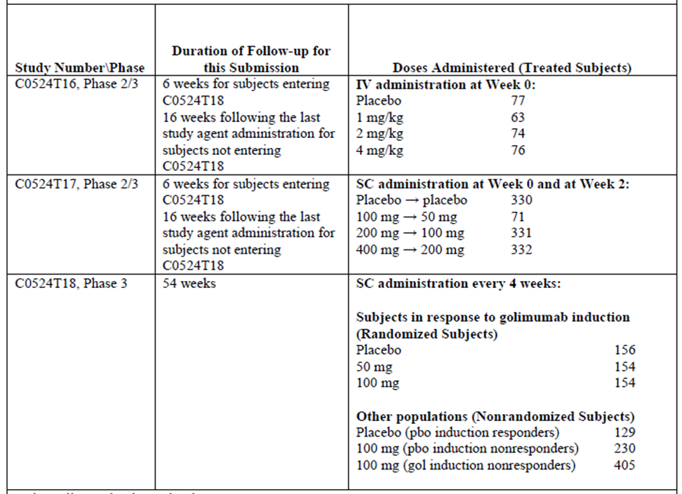

Evaluator’s conclusions on safety
There was an association of formation of antibodies to golimumab and median serum golimumab concentrations.
There appear to be no new signals compared with the risks shown to be associated with long term golimumab treatment of other disorders.

First round benefit-risk assessment

First round assessment of benefits
The benefits of golimumab in adult patients with moderately to severely active ulcerative colitis who have had an inadequate response to conventional therapy are:
- Compared to placebo inducing and maintaining lower disease severity as assessed by signs and symptoms using the Mayo score.
First round assessment of risksThe risks of golimumab in the proposed usage are:
- The proposed dosage is double that for other Indications.
- Antibody formation was 3% (9 out of 300) on golimumab and & 7.1% (11 out of 155) after an initial 1 IV or 2 SC doses. . There was an association of formation of antibodies to golimumab and median serum golimumab concentrations.
- 5 (3.2%) of the “placebo” and 11 (3.6%) of the golimumab groups discontinued study agent due to lack of therapeutic effect.
- Ulcerative colitis was the most common AE leading to discontinuation of study agent.
- The main AEs associated with the use of anti - TNFα agents is infections (including TB and opportunistic infections). Others include hepatotoxicity, congestive heart failure, hematologic toxicity, neurologic or demyelinating events, malignancies, autoimmune disorders, administration reactions, anaphylactic reactions, and delayed hypersensitivity reactions.

First round assessment of benefit-risk balance
The benefit-risk balance of golimumab, given the proposed usage, in patients who have had an inadequate response to conventional therapy is marginally favourable.

First round recommendation regarding authorisation
It is recommended that Delegate approve the proposed Indication of:
The treatment of moderately to severely active ulcerative colitis in adult patients who have had an inadequate response to conventional therapy.

Clinical questions
Please provide maintenance of response and remission rates that is response and remission at both Week 30 and Week 54 for subjects in Study C0524T18 (PURSUIT- Maintenance) who had antibodies to golimumab during the study. The total number of subjects who had antibodies to golimumab during the study should also be stated.

Second round evaluation of clinical data submitted in response to questions
The sponsor has attempted to answer, however the question cannot be accurately answered because there were 5 sub-populations treated with golimumab studied in one of the two preceding studies or in the subsequent Study C0524T18.
- those on placebo in the preceding studies and who were considered nonresponders who were treated with golimumab in Study C0524T18
- those on golimumab in the preceding studies and who were considered nonresponders who were treated with golimumab in Study C0524T18.
These groups were not randomised in the study and only continued beyond Week 16 if they became responders.
- The primary analysis population was subjects randomized at Week 0 of maintenance Study C0524T18 which included
- those responders to golimumab in the initial studies who were randomised to treatment with placebo in Study C0524T18
- those responders in the initial studies who were randomised to treatment with golimumab who were randomised to treatment with golimumab in Study C0524T18.
Thus only those responders on placebo in the initial studies did not receive golimumab initially in Study C0524T18, however if they lost response they were given golimumab. This accounts for the differences in the numbers in the reply and in this evaluation.
The sponsors response reiterates that the limited number of subjects who were positive for antibodies to golimumab in C0524T18 precludes a definitive conclusion regarding the impact of the presence of antibodies to golimumab on efficacy.

Second round benefit-risk assessment
As before: The benefit-risk balance of golimumab, given the proposed usage, in patients who have had an inadequate response to conventional therapy is marginally favourable.

V. Pharmacovigilance findings

Risk management plan
The sponsor submitted a Risk Management Plan (EU-RMP Version 8.0, dated 17 December 2012, with an Australian Specific Annex (ASA) Version: 1.0, dated 15 March 2013 which was reviewed by the TGA.
All figures and tables in this section that have been copied from the original dossier are considered by the evaluator to be an accurate representation of the reviewed data, unless qualified as such in the commentary.
Table 5. Summary of Risk Management Plan
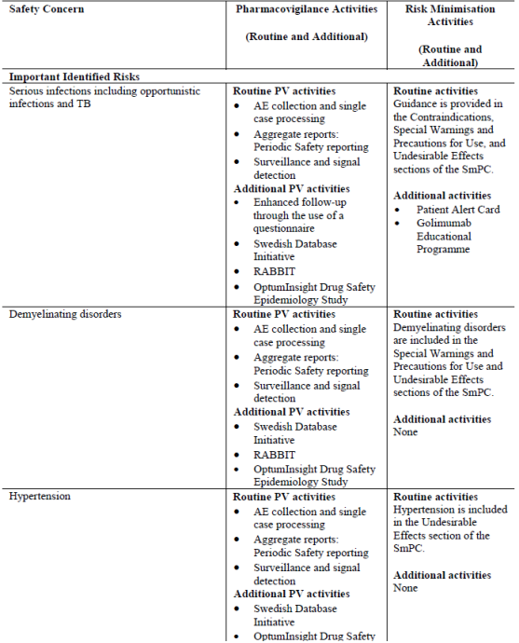
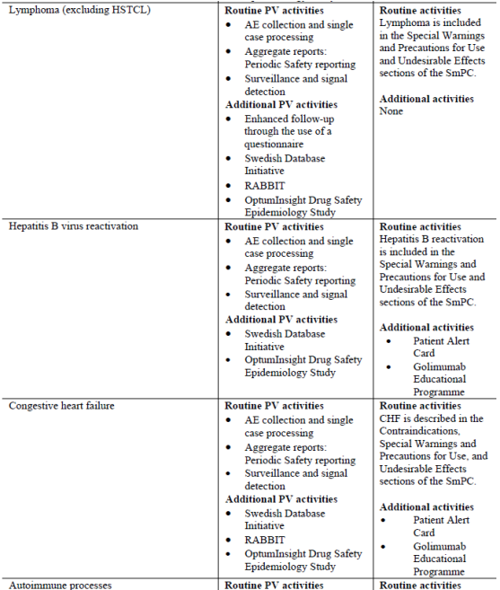
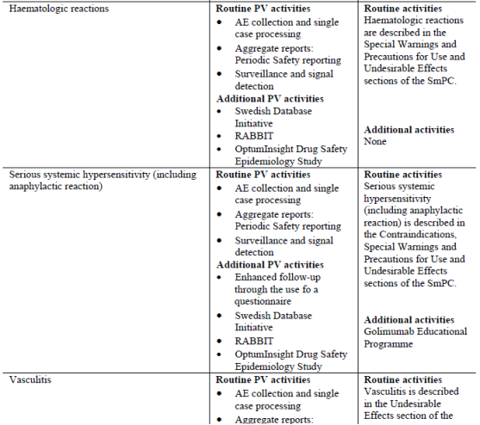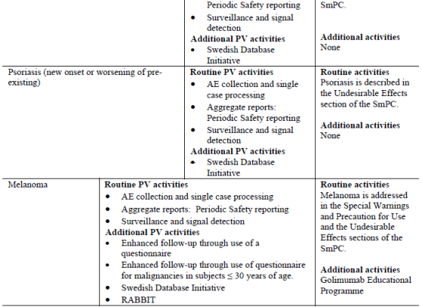
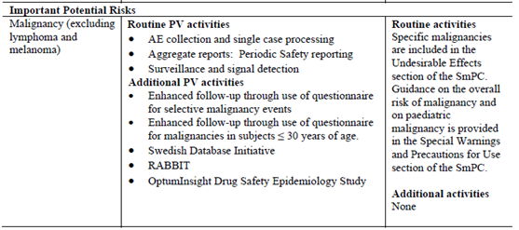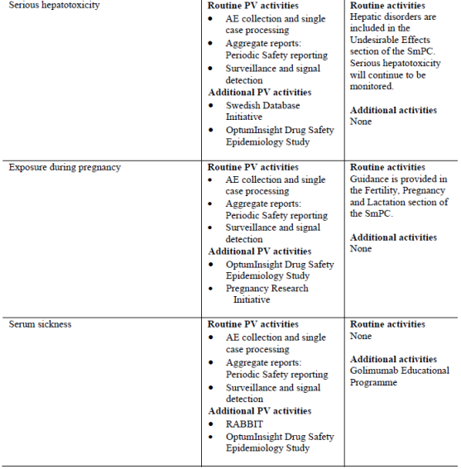
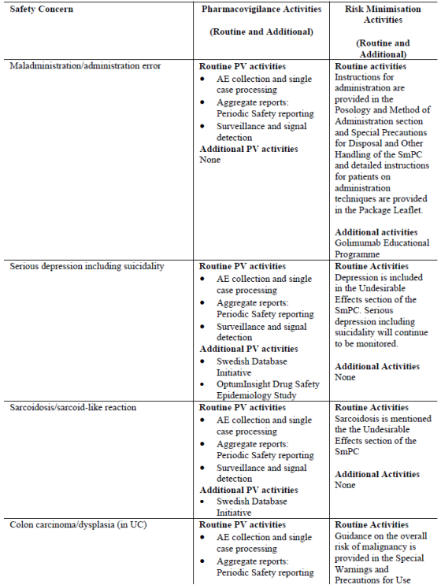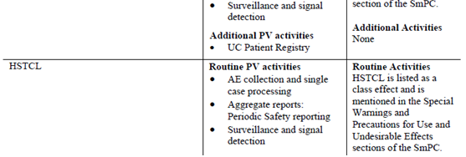
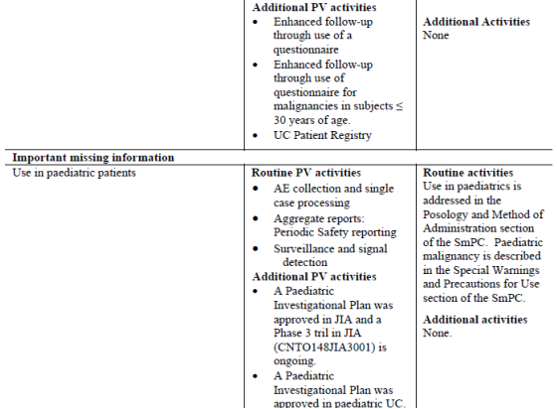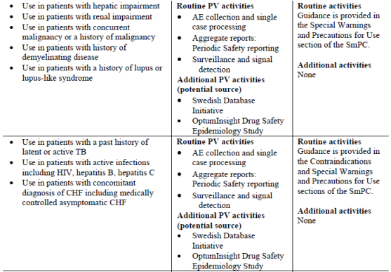
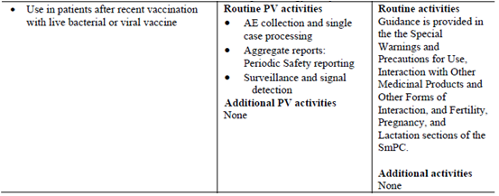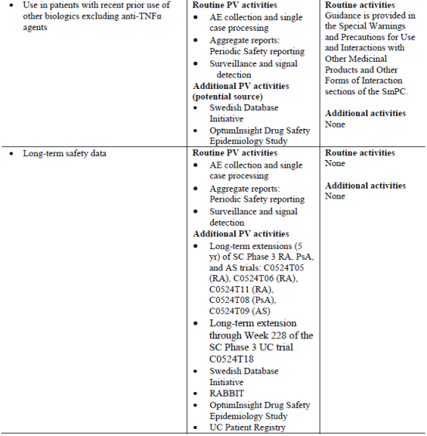

Summary – Ongoing safety concerns
Subject to the evaluation of the clinical aspects of the SS by the TGA, the summary of the Ongoing Safety Concerns as specified by the sponsor is as follows:
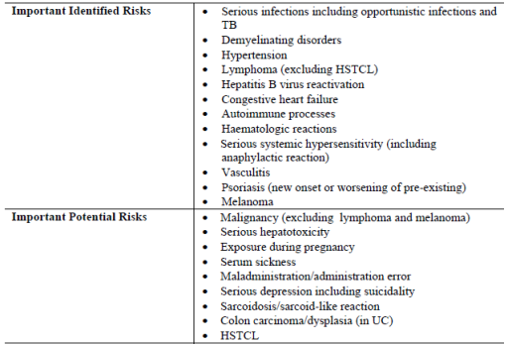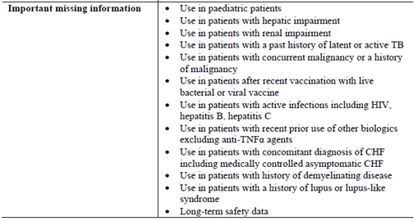
Notwithstanding the evaluation of the clinical aspects, it is recommended that the sponsor include the important missing information: ‘Use in elderly patients’ as an ongoing safety concern. This recommendation is based upon the sponsor proposing to include the following precautionary statement in the Australian PI: “In UC, there were insufficient numbers of patients aged 65 and over to determine whether they respond differently from patients aged 18 to 65.” For completeness the important potential risk: ‘Exposure during pregnancy’ should also be renamed: ‘Exposure during pregnancy and lactation’. Consequently the relevant sections of the EU-RMP and/or the ASA will need to be amended accordingly when these documents are next updated.

Reconciliation of issues outlined in the RMP report
Table 6 summarises the TGA’s first round evaluation of the RMP, the sponsor’s responses to issues raised and the TGA’s evaluation of the sponsor’s responses.
Table 6. Reconciliation of issues outlined in the RMP report
Recommendation in RMP evaluation report | Sponsor’s response | OPR evaluator’s comment
Safety considerations may be raised by the evaluators through the consolidated section 31 request and/or the Clinical Evaluation Report. It is important to ensure that the information provided in response to these include a consideration of the relevance for the Risk Management Plan, and any specific information needed to address this issue in the RMP. For any safety considerations so raised, the sponsor should provide information that is relevant and necessary to address the issue in the RMP. | The sponsor states that safety considerations that are raised by the clinical evaluator through the consolidated section 31 request and/or the Clinical Evaluation Report will be considered in light of the implications for the RMP by the Applicant when available. | This is acceptable.
Notwithstanding the evaluation of the clinical aspects of the SS, it is recommended that the sponsor include the important missing information: Use in elderly patients’ as an ongoing safety concern. This recommendation is based upon the sponsor proposing to include the following precautionary statement in the Australian PI: “In UC, there were insufficient numbers of patients aged 65 and over to determine whether they respond differently from patients aged 18 to 65.” For completeness the important potential risk: ‘Exposure during pregnancy’ should also be renamed: ‘Exposure during pregnancy and lactation’. Consequently the relevant sections of the EU-RMP and/or the ASA will need to be amended accordingly when these documents are next updated. | The sponsor notes this and states: “Any RMP updates required with respect to wording in the PI will be considered after the Delegate reviews our response to the PI revisions recommended by the clinical evaluator.” | These recommendations remain outstanding.
The sponsor should provide an assurance that all routine pharmacovigilance activities will be conducted by Janssen-Cilag Pty Ltd Australia in accordance with the regulatory guideline: Australian requirements and recommendations for pharmacovigilance responsibilities of sponsors of medicines (Version 1.1, dated December 2012). In addition the sponsor should provide copies of all the questionnaires used in Australia to follow-up case reports of the specified ongoing safety concerns to the TGA and include them as an attachment to the ASA when this document is next updated. | The sponsor does not appear to have made any response to the first recommendation.  The sponsor has now provided copies of the current target follow-up questionnaires used in Australia for ‘Serious systemic hypersensitivity reactions’, ‘Risk of tuberculosis (TB) and other infections’, ‘Risk of malignancies and lymphomas’ & ‘Risk of vasculitis’. The updated ASA refers to these as part of the Risk Minimisation Plan. This is inconsistent with the EU‐RMP v 8.0, which refers to these as additional pharmacovigilance activities. | This recommendation remains outstanding.  The TGA considers the use of follow-up questionnaires as routine pharmacovigilance. The EU-RMP and ASA should be revised accordingly when these documents are next updated, including the EU-RMP indicating the use of a follow-up questionnaire for the important identified risk: ‘Vasculitis’.
The ongoing studies are not considered to be part of the planned clinical studies in the pharmacovigilance plan. Therefore the related study protocols have not been reviewed. Nevertheless an update on the progress/results/analysis of these studies will be expected in future PSURs and updated RMPs. | The sponsor states that the relevant sections of the PSUR will be updated with an overview of ongoing clinical trials, non-interventional trials that are outlined in the EU-RMP Module SIII.1. These updates will include summaries of significant findings from clinical trials, findings from non-interventional studies and information from other clinical trials and sources as specified in PSUR template ICH E2C (R2). | This is acceptable.
The studies referenced in the PP of the EU-RMP will generate safety data that will simply support the known safety profile of the medicine, while others will generate data that will provoke applications to amend the Australian registration details. To this end it is suggested that the sponsor should provide an attachment to the ASA setting out all the forthcoming studies and the anticipated dates for their submission in Australia. | The sponsor states: “The studies listed in the Pharmacovigilance Plan of the EU-RMP include milestone dates and due dates addressing specific risks, together with other ongoing studies and their estimated due dates listed in Annexes 4 and 5, will generate safety data to further support the safety profile of the medicine. All studies currently referenced in the PP of the EU-RMP and included in the current ASA (version 2.0, as attached) are up to date. There are no ongoing studies that will provoke applications to amend the Australian registration and there are no plans at this time to submit further studies in Australia.” | Table 67: ‘Overview of Protocols for the Pharmacovigilance Plan’ of the EU-RMP provides the planned/estimated date of submission of final data in Europe. Until these studies are completed it would be premature to state that no ongoing studies will provoke applications to amend the Australian registration details. Consequently this recommendation remains outstanding.
The sponsor’s handling of the potential for medication errors using routine pharmacovigilance activities and routine and additional risk minimisation activities is considered satisfactory. | The sponsor has noted these comments. | n/a
The sponsor’s justification for not providing a Patient Alert Card in Australian packs is acceptable. Nevertheless the sponsor should provide copies of the current printed educational materials for HCPs and patients to the TGA for review and include them as attachments to the ASA when this document is next updated. The sponsor should also provide and assurance that updated printed educational materials will be attached to the ASA in the event of the UC indication is being approved. | Copies of the printed educational materials have been included as Appendix 2 and Appendix 3 to the updated ASA (version 2.0) provided. The sponsor will provide updated printed educational materials with the approval of the UC indication in the next version of the ASA. | In general the CMI is considered to be a routine risk minimisation activity for patients. Nevertheless apart from the PI (also routine risk minimisation), the other printed educational materials for HCPs do not appear to address any of the key safety messages as identified in the ASA, but rather are promotional. Consequently it is difficult to understand how the educational program will provide appropriate and accurate educational tools designed to help optimise the benefit‐to-risk profile of Simponi in the treatment of approved indications. It follows that the assessment of the effectiveness of these educational activities will also be problematic. The sponsor should address these apparent deficiencies preferably before the current application is approved.
In regard to the assessment of the effectiveness of the educational activities the sponsor has not provided any detail about how the educational materials for patients will be assessed. The sponsor should address this oversight and provide such details in a revised ASA to the TGA for review. | The sponsor states that it will conduct an Australian specific survey to evaluate the effectiveness of the educational activities, including educational materials for patients, and will provide the survey, objectives and results to the TGA upon completion. | In general this is acceptable, although the sponsor should provide details of this Australian specific survey to the TGA for review as it is developed rather than on completion. Consequently this recommendation remains outstanding.
It is suggested that the sentences: “The company proposes that a copy of the survey questionnaire be provided to the TGA within 3 months of approval of the UC indication. The assessment is proposed to be carried out 12 months after launch of the UC indication. The results will be submitted to the TGA and the company will then discuss with the TGA whether any further assessments will be required.” should be amended to: “The company proposes that a copy of the survey questionnaire be provided to the TGA within 3 months of approval of the UC indication. The assessment will then be carried out and the results will be submitted to the TGA 12 months after the launch of the UC indication.” | The ASA has been amended accordingly. | This is acceptable.
It is expected that the educational materials for HCPs and patients will be evaluated periodically to ensure that they remain current and appropriate. The sponsor should consider whether their current proposal meets these expectations and if not revise the ASA accordingly, including the criteria to trigger making changes to existing educational tools/materials. | The sponsor states: “Educational materials for HCPs and patients are reviewed and approved in accordance with the applicant’s standard operating procedures (SOP) and ensures that the materials the applicant distributes externally to the HCPs and patients comply with the applicant’s SOP, the Australian / New Zealand legislation & regulations, and the Medicines Australian Code of Conduct / Medicines New Zealand Code of Practice. The review process involves several rounds of assessments to ensure appropriateness and occur within defined timeframes to ensure the content of the materials remain current.” | This is acceptable.
In regard to the proposed routine risk minimisation activities, the draft product information document is considered satisfactory. Nevertheless it is drawn to the Delegate’s attention that:  the US FDA monograph for Simponi specifically mentions listeriosis and legionellosis as opportunistic infections reported in patients receiving TNF-blockers as a black box warning; and  the currently approved Australian PI of some of the TNF-blockers mentions listeriosis and legionellosis as opportunistic infections reported in patients receiving TNF-blocking agents in the ‘PRECAUTIONS’ section, while the proposed PI for Simponi does not. | The sponsor notes this and states: “Any RMP updates required with respect to wording in the PI will be considered after the Delegate reviews our response to the PI revisions recommended by the clinical evaluator.” | Consequently the recommendation to the Delegate that the proposed PI for Simponi should include warning statements about the specific risk of infection from listeria and legionella to be aligned with the approved PIs of other TNF-blockers remains outstanding.
In regard to the proposed routine risk minimisation activities, the draft consumer medicine information is considered satisfactory. | The sponsor has noted these comments. | n/a

VI. Overall conclusion and risk/benefit assessment
The submission was summarised in the following Delegate’s overview and recommendations:

Quality
There is no objection to the approval of this application on quality grounds.
This submission included a proposal to register new strength, 100 mg pre-filled syringe and 100 mg pre-filled pen. The drug substance and drug product manufacturing processes of the 100 mg strength remains the same as that for currently approved 50 mg strength except for the additional fill-volume in the drug product manufacturing process to create the 100 mg strength.
The pre-filled syringe (PFS) formulation is composed of 100 mg/mL Simponi with excipient concentrations of 5.6 mM L-histidine, 4.1% (w/v) sorbitol, and 0.015% (w/v) polysorbate 80 (PS 80), pH 5.5. It is manufactured in two dosages, a 50 mg/syringe (0.5 mL) and a 100 mg/syringe (1.0 mL).
The biological evaluator noted that the specifications at the time of submission were set around the time of commercialisation when there were limited data reflecting manufacturing variability. Hence, the limits were set at a range of up to 5 SD from the mean. Given that there are now more than five years of accumulated manufacturing experience and stability data, the evaluator recommended specifications of the drug substance should be revised and tightened. Release and stability acceptance criteria for some parameters were subsequently revised based on mean plus/minus 3 SD and alignment of DS and DP specifications. Justifications were provided where limits are set slightly wider than mean plus/minus 3SD. The proposed acceptance criteria for the DS were acceptable to the evaluator.

Nonclinical
There was no requirement for a nonclinical evaluation in a submission of this type.

Clinical

Pharmacology
The pharmacokinetics of golimumab in subjects with UC was compared to that of healthy subjects and with results from previously evaluated studies for other indications. The results were similar. Bioavailability is approximately 50%. Pharmacokinetics is linear for single subcutaneous doses of up to 400 mg. The half-life of golimumab is approximately 12 days. Using the proposed dose regimen, steady state was reached on Week 8 after the first maintenance dose.
At steady-state after 100 mg golimumab subcutaneously every four weeks, the median AUC in ulcerative colitis subjects of weight greater than 100 kg was approximately 33% lower than that in those weighing less than or equal to 100 kg. The effect of age, sex, race and renal function (baseline CrCL) on clearance and central Vd was not significant. The concomitant use of immunomodulators had no significant effect on the clearance of golimumab at the proposed dose. Mean clearance in the 34 subjects (2.8%) who developed immunogenicity against golimumab was 24.3% higher than the PK model-predicted mean clearance value.

Efficacy
The decision to use an induction dose regimen was based primarily on the use of these regimens with other anti-TNF agents approved for use in UC. Induction regimens are not used for the current indications of golimumab. Two induction studies were commenced. Study T16 examined the dose response of a single IV dose of golimumab (1 mg/kg, 2 mg/kg, or 4 mg/kg) or placebo. Dose response was not demonstrated and significant improvement in disease activity was not demonstrated in the initial phase of this study. Enrolment was terminated after 291 subjects were randomised.
Study T17 was the primary induction study. It is described in the CER. Study T17 was a multicentre randomised, placebo-controlled, parallel-group, double-blind study to evaluate the safety and efficacy of golimumab induction therapy, administered subcutaneously (SC), in subjects with moderately to severely active ulcerative colitis. The study was conducted in 2 parts. Part 1 of this study was dose-ranging and Part 2 was dose confirming. In Part 1 a total of 169 subjects were randomised in a 1:1:1:1 ratio at Week 0 to administration subcutaneously of golimumab Weeks 0 and 2 (100 mg → 50 mg, 200 mg → 100 mg or 400 mg → 200 mg) or placebo.
The extent and severity of disease was assessed using the Mayo scoring system. This is a well established method and was used in studies of other anti-TNF agents in patients with UC. The Mayo score is calculated as the sum of the 4 subscores of stool frequency, rectal bleeding, physician’s global assessment and the findings of endoscopy. The score can range between 0 and 12. A score of 3 to 5 points indicates mildly active disease, a score of 6 to 10 points indicates moderately active disease, and a score of 11 to 12 points indicates severe disease. The partial Mayo score is the Mayo score excluding the endoscopy subscore, and can range between 0 and 9.
The major inclusion criteria in Study T17 were intended to ensure subjects had moderate to severe UC. These were: a greater than or equal to 2 endoscopy subscore of the Mayo score at the screening sigmoidoscopy; biopsy either at screening or within 12 months of screening consistent with the diagnosis of ulcerative colitis; and a baseline (Week 0) Mayo score of 6 to 12, inclusive. Stable treatment with oral 5-aminosalicylic acid, oral corticosteroids, 6-mercaptopurine or azathioprine or a history of failure to respond to or tolerate at least of those previous treatments or steroid dependency was also required. Subjects with severe extensive colitis and those with UC limited to the rectum or to less than 20 cm of colon were excluded from the study. Subjects who had ever received biologic therapy targeted at TNFα (for example, infliximab, etanercept, certolizumab, adalimumab) were also excluded.
The primary efficacy endpoint for Part 1 was clinical response at Week 6 defined as a decrease from baseline in the Mayo score by greater than or equal to30% and greater than or equal to3 points, with either a decrease from baseline in the rectal bleeding subscore of greater than or equal to1 or a rectal bleeding subscore of 0 or 1. The method for Mayo score calculations is shown in section 7.1.1.5 of the CER. Secondary efficacy endpoints included the proportion of subjects in clinical remission at Week 6; the proportions of subjects with mucosal healing at Week 6; and the change from baseline in the Inflammatory Bowel Disease Questionnaire (IBDQ) scores at Week 6. Clinical remission was defined as a Mayo score less than or equal to 2 points, with no individual subscore greater than 1.
Due to findings of investigator misconduct at sites 6706 and 7257, subject data from these 2 sites were excluded from all efficacy analyses. The analysis of clinical response rates for the Part 1 population of Study T17 study did not demonstrate a statistically significant dose-response relationship.
The median change from baseline in Mayo score at Week 6 was –1.0, -3.0, –2.0, and -3.0 for the placebo and golimumab 100 mg → 50 mg, 200 mg → 100 mg, and 400 mg → 200 mg groups respectively. Clinical response was achieved by 13 out of 42 (31.0%) given placebo, 24 out of 42 (57.1%) given golimumab 100 mg→200 mg, 19 out of 42 (45.2%) given golimumab 200 mg →100 mg and by 22 out of 42 (52.4%) given golimumab 400 mg →200 mg. Clinical remission was achieved by 4 out of 42 (9.5%), given placebo, 7 out of 42 (16.7%) given golimumab 100 mg→200 mg, 7 out of 42 (16.72%) given golimumab 200 mg →100 mg and by 10 out of 42 (23.8%) given golimumab 400 mg →200 mg.
Part 2 of Study T17 was the Phase III, dose-confirming component. Enrolment into Phase II began prior to evaluation of the results from Phase I and initially newly enrolled subjects in Part 2 were equally randomised to the same doses of golimumab or placebo as in Part 1. After the Part 1 analysis was completed enrolment into the 100 mg → 50 mg group was not continued. Newly enrolled subjects in Part 2 were then equally randomised to 200 mg → 100 mg or 400 mg → 200 mg golimumab or placebo.
Based on a Food and Drug Administration (FDA) request, the primary analysis population was amended to include only subjects randomised to Part 2 of T17 after the dose selection. Clinical response at Week 6 was achieved 29.7% of subjects given placebo, 51.8% given golimumab 200→100 mg and by 55.0% given golimumab 400 mg→200 mg. Both doses of golimumab were superior to placebo (p < 0.0001). For the primary analysis population, clinical remission at Week 6 was reached by 6.3%, 18.7% and 17.8%, of the placebo, golimumab 200 mg→100 mg and 400 mg→200 mg groups respectively. Both golimumab dose groups had statistically significantly higher clinical remission rates than placebo (p<0.0001 for each golimumab group). The NNT for the 200 mg→100 mg group was 8 that is eight subjects would need to be treated with golimumab for 6 weeks in order for one additional subject to go into clinical remission after 6 weeks treatment. For the 400→200 mg golimumab induction regimen the NNT was 9.
Study T18 was a one year Phase III, multicentre, randomised, DB, placebo-controlled trial conducted in subjects who were in clinical response to golimumab at Week 6 in either induction Study T16 or T17, were the target population for this maintenance study.
The primary objective was to evaluate the efficacy and safety of two SC maintenance dose regimens of golimumab (50 mg or 100 mg every 4 weeks) in maintaining clinical response through Week 54 in subjects with moderately to severely active UC who achieved clinical response with golimumab in one of the induction studies. This study was planned to include a golimumab 200 mg q4w dose group however this dose regimen was stopped across the golimumab clinical development program after reports of lymphoproliferative cancers in subjects with long standing RA. Subjects in Study T18 initially randomised to 200 mg q4wk were given 100 mg q4wk.
Subjects who achieved a clinical response to any induction regimen of golimumab in Studies T16 and T17 were randomised to placebo, golimumab 50 mg q4wk or 100 mg q4wk through to Week 54. Clinical responders randomised to golimumab 50 mg q4wk who lost clinical response during study could have their dose increased to 100 mg q4wk for the remainder of the study. If, by 16 weeks following the first administration of the adjusted dose, the subject did not show improvement in their UC disease activity they were discontinued from study agent administrations. Remaining subjects in the induction studies who elected to continue were not randomised. Subjects given placebo in the induction studies who achieved a clinical response were continued on placebo. Subjects who did not achieve a clinical response at Week 6 regardless of induction regimen were given golimumab 100 mg q4wk. The nonresponders to induction dosing were to be discontinued from study agent if their disease activity did not improve at Week 16.
Concomitant treatment for UC was to remain stable while on study except for subjects taking oral corticosteroids at study entry who achieved a clinical response in the induction studies. The maximum rate of corticosteroid taper was not to exceed:
- Dose > 20 mg/day prednisone or equivalent: taper dose by 5 mg/week.
- Dose less than or equal to 20 mg/day prednisone or equivalent: taper dose by 2.5 mg/week.
The primary endpoint was clinical response through Week 54 as assessed by the Mayo score or partial score. The proportion of subjects with mucosal healing and remission were also assessed at timepoints throughout the study and included as secondary endpoints. The major secondary efficacy analyses would only be considered if the test between the high maintenance dose (100 mg) and placebo was positive for the primary endpoint of clinical response through Week 54.
A total of 464 subjects were randomised: golimumab 50 mg (n=154), golimumab 100 mg (n=154) and placebo (n=156). Overall 28.2% of these subjects discontinued study treatment prior to Week 54 with similar rates of discontinuation across the 3 study groups. 50.6% of subjects given 100 mg q4wk and 47.1% given 50 mg q4wk maintained clinical response through Week 54, compared to 31.4% given placebo (p < 0.001 and p = 0.010 and respectively). Clinical remission at both Weeks 30 and 54 was achieved by 28.6% of subjects given the 100 mg dose compared with 15.4% given placebo (p=0.003). The comparison for the 50 mg dose and placebo was not statistically significant.

Safety
The major known safety concerns identified for golimumab from its use in other indications are:
- Serious infections leading to hospitalization or death including tuberculosis (TB), bacterial sepsis, invasive fungal (such as histoplasmosis), and other opportunistic infections ; and
- Lymphoma and other malignancies
Three studies were performed to support use of golimumab in patients with UC. The proposed maintenance dose of 100 mg q4wk was given to clinical responders from the feeder studies (T16 and T17) as well as to non-responders who were not included in the subsequent efficacy analysis. A total of 1075 patients received at least one dose of golimumab in Study T18. Of these, 741 (68.9%) were exposed to golimumab for at least 6 months and 536 (49.9%) were exposed for at least 1 year. All the nonresponders (n = 635) and 154 responders from the indication studies who participated in Study T18 received the proposed maintenance dose regimen of 100 mg q4wks.
Four deaths occurred in the study program – 3 related to infection and one of cardiac failure. These are described in the CER. The causes of death were: septic shock, disseminated TB, ischiorectal abscess and cardiac failure in a subject with a history of thrombosis. Long term safety of this higher dose of 100 mg monthly compared with the current 50 mg monthly is not known however it could reasonably be anticipated that infection and malignancy rates would be dose-related.

Risk management plan
The RMP evaluator noted that the sponsor has provided justification and concluded that routine risk minimisation activities are sufficient for all the specified ongoing safety concerns, except for the important identified risks: ‘Serious infections including opportunistic infections and TB’, ‘Hepatitis B virus reactivation’, ‘Congestive heart failure’, ‘Serious systemic hypersensitivity (including anaphylactic reaction)’ & ‘Melanoma’; and for the important potential risks: ‘Serum sickness’ & ‘Maladministration / administration error’ to which additional risk minimisation activities are applied. The evaluator has accepted this response.
The routine risk minimisation activities will comprise labelling (that is, statements in the PI), including contraindications, special warning & precaution statements, drug interaction information, instructions for use and/or notification of undesirable effects for all the specified ongoing safety concerns. The RMP evaluator noted that no such activity is proposed for the important potential risk: ‘Serum sickness’ and the important missing information: ‘Long-term safety data’. Details of the proposed Australian Simponi educational program were provided. The sponsor was requested to provide copies of the current printed educational materials for healthcare professionals and patients to the TGA for review and include them as attachments to the ASA when this document is next updated.
The RMP evaluator has noted that following approval of the UC indication by the FDA the following 3 studies are to be conducted as post-marketing commitments:
- PMR #3; A prospective, multi-center, long-term, observational study of ulcerative colitis patients treated with Simponi (golimumab) in a routine clinical setting, to assess the long-term safety of Simponi (golimumab). The study’s primary outcome should be the incidence of lymphoma.
- PMC #4; Conduct a study to evaluate the pharmacokinetics of Simponi (golimumab) in pediatric patients 5 to 17 years of age with moderately to severely active ulcerative colitis. Pharmacokinetic measurements should be conducted for exposure-response analysis and compared to adult patients with ulcerative colitis treated with Simponi (golimumab). Also, collect serum samples for immunogenicity testing and conduct analyses of the impact of immunogenicity on the pharmacokinetics of Simponi (golimumab).
- PMC #5; Conduct a study to evaluate the effectiveness and safety of Simponi (golimumab) in pediatric patients 5 to 17 years of age with moderately to severely active ulcerative colitis. The study should be designed to establish that the dose regimen(s) of Simponi (golimumab) identified in PMC#4 is (are) effective and safe for induction treatment, as well as for continued treatment after induction. Pharmacokinetic measurements should be conducted for exposure-response analysis. Collect serum samples for immunogenicity testing and conduct analyses of the impact of immunogenicity on pharmacokinetics, efficacy and safety.

Risk-benefit analysis

Delegate’s considerations
The proposed dose regimen for golimumab in the treatment of moderate to severe UC has a maintenance dose that is double that of the maintenance dose approved for golimumab’s current indications. Thus the safety data derived from use of golimumab in those indications may not be fully indicative of the safety of golimumab in UC.
There was a suggestion of dose response for golimumab in the treatment of moderate to severe UC but it was not strong. The dose selection study discontinued the 50 mg q4wk maintenance regimen. Subsequent safety concerns with the higher doses may have contributed to the decision to reinstate that dose regimen in the second Phase III maintenance study. In that study small increases in clinical response and remission rates were seen between the 50 mg and 100 mg q4wk dose regimens but no statistical comparisons between these doses were made. The Delegate does not consider that the optimum dose regimen has been determined but it is clear that neither regimen examined in the Phase III studies results in a marked improvement for the majority of subjects given golimumab.
The aim of treatment of UC is clinical remission. Golimumab does not achieve that for the majority of subjects with moderate to severe UC who had golimumab added to their ongoing treatment. Given that approximately 30% of subjects given placebo had an apparent clinical response during the indication period the increase in clinical response attributable to golimumab is around 20%, that is approximately 5 patients will need to receive golimumab for 6 weeks for one to achieve a clinical response that would not otherwise have been achieved. However, it will not be apparent to the clinician whether their patient would have improved without treatment. As shown in Study T17 around half the patients given golimumab achieved a clinical response.
Maintenance was examined in a randomised clinical trial only for those patients who achieved a clinical response in the induction phase. Of this selected group there was a 20% increase in clinical response rate at 12 months compared with placebo. The effect of golimumab in patients who did not have a clinical response at Week 6 after commencing induction was not assessed in a randomised trial. It is likely to be considerably lower than the level achieved with initial responders. Continued exposure to golimumab should not be approved for patients who do not have an initial clinical response due to the low probability of therapeutic benefit and the risks of infection and malignancy associated with ongoing treatment.
The frequency of assessments and extent of response that would be sufficient to justify continuing treatment is not clear. The lowest dose should be used in patients who do respond to golimumab. It may be that only clinical remission would justify continued treatment given that surgery is also a curative option for ulcerative colitis.
The safety and efficacy of golimumab has been assessed only in anti-TNF agent naïve subjects. In studies with other anti-TNF agents in subjects with UC there was a lower response rate to the new anti-TNF agent in anti-TNF (that is, infliximab) experienced subjects. It is reasonable to expect a similar outcome with golimumab and given this concern and the absence of data on the response rates in these patients, golimumab should be restricted to anti-TNF naïve patients.
There are inadequate long term data on the safety of the dose of golimumab that is proposed to treat UC. The sponsor should be required to undertake and provide periodic reports on the post-market observational study in patients with UC that was a post-market condition of registration in the USA.

Proposed action
There is no reason to say, at this time, that the application for (the product) should not be approved for registration.

Request for ACPM advice
The committee is requested to provide advice on the following specific issues:
- Is it appropriate to include a statement in the indications that treatment only be continued in patients who show a clinical response at Week 6?
- Should continued treatment after the induction regimen be further restricted, for example, to those patients who are in clinical remission at Week 6?
- Should the indications specifically exclude patients who have received prior anti-TNF agents (this would be consistent with the clinical trial population).
- Should the indication specify use in adults (this would be consistent with the clinical trial population).
- The Delegate has recommended periodic assessment of risk and benefit. Does the Committee consider the interval between clinical reviews should be further specified?
- The committee is (also) requested to provide advice on any other issues that it thinks may be relevant to a decision on whether or not to approve this application.

Response from sponsor
Janssen thanks the Delegate for the opportunity to provide comment to the Australian Committee for Prescription Medicines (ACPM) on the particular issues raise below. Janssen agrees with the Delegate’s proposal to approve Simponi for the treatment of ulcerative colitis (UC) however Janssen would like to take this opportunity to address the following comments raised in the Delegate’s Request for the ACPMs Advice:
The Delegate has raised five issues in particular which we have grouped under the following headings:
- Indication wording
- Efficacy – Continued Treatment and Clinical Review

Indication wording

Delegate’s request:
- Is it appropriate to include a statement in the indications that treatment only be continued in patients who show a clinical response at Week 6?

Janssen’s response:
The Delegate’s proposal to restrict access to patients who demonstrate a clinical response by Week 6, would restrict access to patients who might benefit from treatment, but would be slow responders. Further the Delegate’s proposal does not take into consideration the study design for the maintenance study (C0524T18) which allowed patients who did not demonstrate a response within six weeks to continue with treatment. The 2 studies are described below:
- Induction Study C0524T17 (PURSUIT – Subcutaneous) was a Phase II/Phase III study. The primary endpoint for the Phase III part was clinical response at Week 6.
- Maintenance Study C0524T18 (PURSUIT – Maintenance) was a Phase III study to evaluate the safety and efficacy of golimumab maintenance therapy, over 54 weeks, in subjects with moderately to severely active UC. Subjects who were in clinical response to golimumab at Week 6 of the induction study were randomized to receive placebo, golimumab 50 mg or golimumab 100 mg every 4 weeks. The primary endpoint of the maintenance study was clinical response through Week 54 based on the Mayo score among subjects who were in clinical response to golimumab at Week 6 of the induction study. The maintenance study used the Mayo score to evaluate clinical response at Weeks 30 and 54 but also used the partial Mayo score to assess disease activity at all other visits.
Subjects who were not in clinical response to golimumab or placebo were not randomized, but were eligible to be enrolled in the study. Subjects who were not in clinical response to golimumab or placebo received golimumab 100 mg every 4 weeks and were evaluated using the partial Mayo score through Week 16. Subjects whose disease activity did not improve (in the opinion of the investigator) were to be discontinued from further treatment.
The data collected through Week 16 provide an opportunity to assess for delayed response. Therefore, in order to assess an appropriate timeframe in which to discontinue therapy in subjects who are not responding to golimumab induction, the proportions of subjects who achieved partial Mayo score remission and partial Mayo score response through Week 16 were analysed.
The definition of partial Mayo score remission (that is, a partial Mayo score less than or equal to 2) that is used in this analysis is based on the validation work of Lewis et al. Partial Mayo score response is defined as a change of at least 3 points from the Week 0 measurement in the induction study.
Among subjects who were not in clinical response to golimumab induction, further golimumab therapy in C0524T18 resulted in additional subjects achieving benefit as measured by partial Mayo score remission and response as follows:
- At Week 4 of maintenance therapy (that is, 10 weeks of golimumab exposure, including induction), 11.8% and 23.1% of the non-responders had achieved partial Mayo score remission and response, respectively (Table 7 and Table 8, respectively).
- At Week 8 of maintenance therapy (that is, 14 weeks of golimumab exposure, including induction), 15.6% and 28.1% of subjects achieved partial Mayo score remission and response, respectively (Table 7 and Table 8, respectively).
Although the proportions of subjects who achieved partial Mayo score remission and response continued to increase beyond the Week 8 maintenance dose, the incremental increase in benefit beyond this time point was minimal. It is worth noting that there was no comparison group as all subjects received golimumab.
Table 7. Number of subjects with partial mayo score remission through Week 16 of the maintenance study; subjects enrolled in C0524T18 who were golimumab induction nonresponders (excluding sites 6706, 7257 and 7407)
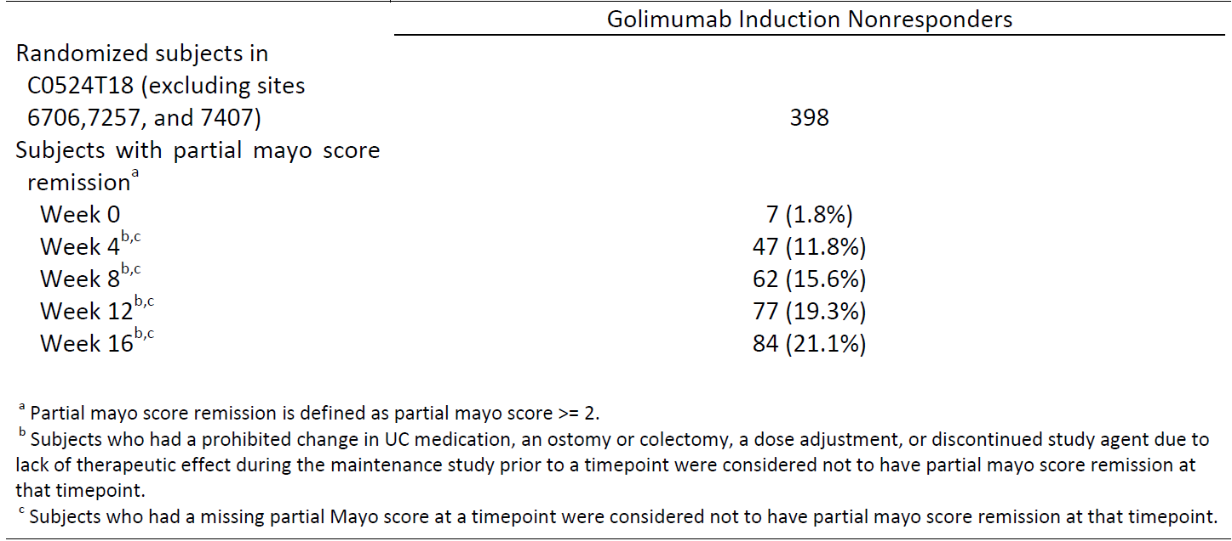
Table 8. Number of subjects with partial mayo score response through Week 16 of the maintenance study; subjects enrolled in C0524T18 who were golimumab induction nonresponders (excluding sites 6706, 7257 and 7407)
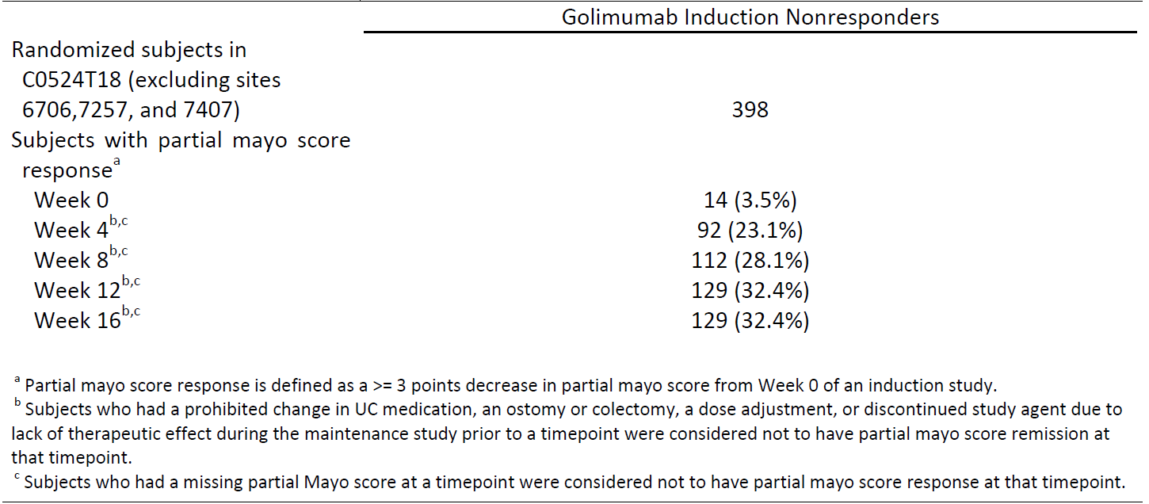
Therefore, based on the proposed posology for the UC indication, Janssen recommends that patients with UC receive induction treatment with golimumab at Week 0 and Week 2 followed by at least 2 additional doses of golimumab at Week 6 and Week 10. Patients responding to therapy would continue golimumab treatment to Week 14 and every 4 weeks thereafter. Those patients who do not respond at Week 14 should be considered for discontinuation of golimumab. In line with this, Janssen proposes the following text for the DOSAGE & ADMINISTRATION section of the label, which is also consistent with the current posology wording in the European SmPC:
‘Data from clinical studies suggest that clinical response is usually achieved within 12-14 weeks of treatment (after 4 doses). Continued therapy should be reconsidered in patients who show no evidence of therapeutic benefit within this time period.’
Therefore Janssen does not agree with the inclusion of a statement in the indications that treatment only be continued in patients who show a clinical response at Week 6.
However, should the ACPM feel that inclusion of a statement regarding a period of assessment of ongoing treatment is required in the indication, the following wording would be acceptable to Janssen:
‘Simponi is indicated in the treatment of moderately to severely active ulcerative colitis in adult patients who have had an inadequate response to conventional therapy. Patients should show a clinical response within 12-14 weeks to continue treatment beyond that time.’

Delegate’s request:
- Should the indications specifically exclude patients who have received prior anti-TNF agents (this would be consistent with the clinical trial population)?

Janssen’s response:
Janssen disagrees with the inclusion of a statement within the indication to limit access to patients who have received prior anti-TNF agents as this would unfairly prevent access to patients who may have failed prior anti-TNF treatment and may have no further treatment options.
Failure of therapy with one type of anti-TNF does not preclude the possibility that another type will provide benefit. The proposed wording in the DOSAGE and ADMINISTRATION section which advises clinicians to assess response should be sufficient to ensure if patients are not responding that they will not receive further treatment.
There is currently no evidence to suggest that patients may be adversely affected if they have been previously exposed to anti-TNF treatment.
However, in order to address the Delegate’s concerns we would be prepared to accept the following statement in the Clinical Trials section:
Efficacy and safety in patients with UC who have received prior biological therapies targeting anti-TNFs has not been assessed.

Delegate’s request:
- Should the indication specify use in adults (this would be consistent with the clinical trial population)?

Janssen’s response:
Janssen notes that the proposed Product Information already includes information restricting use in UC to adults only. Janssen is prepared to take the ACPM advice on whether the removal of this information from the indication be considered appropriate.

Efficacy – Continued treatment and clinical review

Delegate’s request:
- Should continued treatment after the induction regimen be further restricted for example, to those patients who are in clinical remission at Week 6?

Janssen’s response:
Janssen does not believe that continued treatment after induction should be restricted to those patients who are in clinical remission at Week 6.
Clinical response at Week 6 was the primary endpoint of the induction study C0524T17 (PURSUIT – Subcutaneous), and those subjects who were in clinical response following treatment with golimumab during induction were able to maintain clinical response through Week 54 of the maintenance Study C0524T18 (PURSUIT - Maintenance). Further, subjects in clinical response at the start of maintenance therapy were able to achieve sustained clinical remission as well as mucosal healing at both Weeks 30 and 54.
Janssen believes that clinical response as defined in this program is clinically meaningful to patients. Symptomatic improvement in subjects who achieved clinical response approached that of subjects in clinical remission. In contrast, subjects not in clinical response showed little change in UC symptoms. Furthermore, subjects who maintained clinical response through Week 54 showed ongoing resolution of clinical symptoms compared with those who did not maintain clinical response. Overall, these analyses support the meaningfulness of clinical response as an endpoint and further support clinical response as an appropriate measure against which to assess the continuation of golimumab therapy in a patient with UC.
Restricting continued treatment only to those subjects who achieved clinical remission at Week 6 would limit the opportunity for patients who had achieved clinical response, but not clinical remission, to continue to receive therapeutic benefit. Janssen therefore does not agree with the proposal to restrict continued treatment only to those patients who are in clinical remission (Please refer to response to Question 1).

Delegate’s request:
- The Delegate recommended periodic assessment of risk and benefit. Does the Committee consider the interval between clinical reviews should be further specified?

Janssen’s response:
Janssen has considered the Delegate’s request for advice from the ACPM in relation to wording on periodic assessment and further specification on the interval between clinical reviews.
As individual patient response to treatment varies, Janssen believes that beyond the early stages of treatment, the interval between clinical reviews should be based upon the individual patient’s response and up to the discretion of the treating physician.
Therefore, in order to address the Delegate’s concern we propose the addition of the following wording to the Dosage and Administration section of the PI:
‘Available data suggest that clinical response is usually achieved within 12-14 weeks of treatment (after 4 doses). Continued therapy should be reconsidered in patients who show no evidence of therapeutic benefit within this time period.’

CONCLUSION
In summary, Janssen believe that Simponi has a favourable benefit:risk profile and considers it is effective in the treatment of moderately to severely active UC. Janssen agrees with the Delegate’s recommendation to approve the extension of indications for Simponi to include UC.
Janssen proposes that the indication wording be approved as follows:
Simponi is indicated for the treatment of moderately to severely active ulcerative colitis in adult patients who have had an inadequate response to conventional therapy’

Advisory committee considerations
The Advisory Committee on Prescription Medicines (ACPM), having considered the evaluations and the Delegate’s overview, as well as the sponsor’s response to these documents, advised the following:
The submission seeks to register an extension of indications.
The ACPM, taking into account the submitted evidence of efficacy, safety and quality, agreed with the Delegate and considered Simponi / Simponi smartject injector Solution for injection containing 50 mg and 100 mg of golimumab (rmc) to have an overall positive benefit–risk profile for the Delegate’s amended indication;
The ACPM, taking into account the submitted evidence of efficacy, safety and quality, considered this product to have an overall positive benefit–risk profile for the indication;
The treatment of moderately to severely active ulcerative colitis in adult patients who have had an inadequate response to conventional therapy. Patients should show a clinical response within 6 weeks of treatment to continue treatment beyond that time (see CLINICAL TRIALS).
In making this recommendation the ACPM:
- expressed some reservations that satisfactory efficacy data were only available in patients who had responded by 6 weeks,
- expressed some concern that long term efficacy and safety data beyond 12 months were unavailable,
- noted that data on non-responders and patients with prior TNF inhibitor treatment were very limited or unavailable.

Proposed conditions of registration:
The ACPM agreed with the Delegate on the proposed conditions of registration.

Proposed Product Information (PI)/Consumer Medicine Information (CMI) amendments:
The ACPM agreed with the Delegate to the proposed amendments to the Product Information (PI) and Consumer Medicine Information (CMI).

Specific Advice:
- Is it appropriate to include a statement in the indications that treatment only be continued in patients who show a clinical response at Week 6?
The ACPM advised this restriction was suitable as this was the population studied. There is no evidence of long term safety or efficacy in patients who did not respond by 6 weeks.
- Should continued treatment after the induction regimen be further restricted for example, to those patients who are in clinical remission at Week 6?
The ACPM was of the view that to restrict continued treatment to only those who have clinical remission at week 6 is too restrictive.
- Should the indications specifically exclude patients who have received prior anti-TNF agents (this would be consistent with the clinical trial population)?
It seems reasonable to exclude patients who have received prior anti TNF agents, as there are no data in this population and the percentage of patients who potentially could respond is likely to be small. There is the added risk of the development of antibodies with the possibility of no clinical benefit.
- Should the indication specify use in adults (this would be consistent with the clinical trial population)?
The ACPM were concerned there were no paediatric data to support use in this population and agreed the indications should be restricted to adults.
- The Delegate proposed periodic assessment of risk and benefit. Does the Committee consider the interval between clinical reviews should be further specified?
Periodic assessment of risk and benefit is important. However, this is likely to be a part of standard clinical practice and a specific assessment regimen is not necessary.
The ACPM advised that the implementation by the sponsor of the recommendations outlined above to the satisfaction of the TGA, in addition to the evidence of efficacy and safety provided would support the safe and effective use of these products.

Outcome
Based on a review of quality, safety and efficacy, TGA approved the registration of Simponi/Simponi Smartject Injector golimumab (rmc) given as a subcutaneous injection at Week O, followed by 100 mg at Week 2 and then 100 mg every 4 weeks, thereafter, indicated for:
Ulcerative colitis (UC)
The treatment of moderately to severely active ulcerative colitis in adult patients who have had an inadequate response to conventional therapy. Patients should show a clinical response within 6 weeks of treatment to continue treatment beyond that time (see CLINICAL TRIALS).

Specific conditions of registration applying to these goods
The Simponi golimumab EU Risk Management Plan lamp), version 8.0, dated 17 December 2012 and Australian Specific Annex (ASA) Version: 2.1 dated 23 January 2014, included with your submission (2013-00215-1-1), and any subsequent revisions, as agreed with the TGA will be implemented in Australia.

Attachment 1. Product Information
The Product Information approved for Simponi at the time this AusPAR was published is at Attachment 1. For the most recent Product Information please refer to the TGA website at <http://www.tga.gov.au/hp/information-medicines-pi.htm>.

Attachment 2. Extract from the Clinical Evaluation Report

Therapeutic Goods Administration
PO Box 100 Woden ACT 2606 Australia
Email: info@tga.gov.au Phone: 1800 020 653 Fax: 02 6232 8605
http://www.tga.gov.au

Please refer to the Product Information (Attachment 1) for the full list of ingredients.
The “Placebo” maintenance group
Lewis JD, Chuai S, Nessel L, et al. Use of the noninvasive components of the mayo score to assess clinical response in ulcerative colitis. Inflamm Bowel Dis. 2008;14:1660–1666.
Sandborn WJ, Feagan BG, Marano C, et al. Clinical response is a meaningful endpoint in ulcerative colitis clinical studies. (abstract). Inflamm Bowel Dis. 2012;18:S26–S27.

