September 2020

Australian Public Assessment Report for Gilteritinib (as fumarate)
  - Proprietary Product Name: Xospata
  - Sponsor: Astellas Pharma Australia Pty Ltd

About the Therapeutic Goods Administration (TGA)
- The Therapeutic Goods Administration (TGA) is part of the Australian Government Department of Health and is responsible for regulating medicines and medical devices.
- The TGA administers the Therapeutic Goods Act 1989 (the Act), applying a risk management approach designed to ensure therapeutic goods supplied in Australia meet acceptable standards of quality, safety and efficacy (performance) when necessary.
- The work of the TGA is based on applying scientific and clinical expertise to decision-making, to ensure that the benefits to consumers outweigh any risks associated with the use of medicines and medical devices.
- The TGA relies on the public, healthcare professionals and industry to report problems with medicines or medical devices. TGA investigates reports received by it to determine any necessary regulatory action.
- To report a problem with a medicine or medical device, please see the information on the TGA website <https://www.tga.gov.au>.

About AusPARs
- An Australian Public Assessment Report (AusPAR) provides information about the evaluation of a prescription medicine and the considerations that led the TGA to approve or not approve a prescription medicine submission.
- AusPARs are prepared and published by the TGA.
- An AusPAR is prepared for submissions that relate to new chemical entities, generic medicines, major variations and extensions of indications.
- An AusPAR is a static document; it provides information that relates to a submission at a particular point in time.
- A new AusPAR will be developed to reflect changes to indications and/or major variations to a prescription medicine subject to evaluation by the TGA.

Copyright
© Commonwealth of Australia 2020
This work is copyright. You may reproduce the whole or part of this work in unaltered form for your own personal use or, if you are part of an organisation, for internal use within your organisation, but only if you or your organisation do not use the reproduction for any commercial purpose and retain this copyright notice and all disclaimer notices as part of that reproduction. Apart from rights to use as permitted by the Copyright Act 1968 or allowed by this copyright notice, all other rights are reserved and you are not allowed to reproduce the whole or any part of this work in any way (electronic or otherwise) without first being given specific written permission from the Commonwealth to do so. Requests and inquiries concerning reproduction and rights are to be sent to the TGA Copyright Officer, Therapeutic Goods Administration, PO Box 100, Woden ACT 2606 or emailed to <tga.copyright@tga.gov.au>.

Contents
Common abbreviations 4
I. Introduction to product submission 6
Submission details 6
Product background 7
Regulatory status 9
Product Information 10
II. Registration timeline 11
III. Submission overview and risk/benefit assessment 11
Quality 11
Nonclinical 12
Clinical 13
Risk management plan 21
Risk-benefit analysis 23
Outcome 24
Attachment 1. Product Information 25

Common abbreviations
Abbreviation | Meaning
ACM | Advisory Committee on Medicines
ADME | Absorption, distribution, metabolism and excretion
AIHW | Australian Institute of Health and Welfare
ALT | Alanine aminotransferase
AML | Acute myeloid leukaemia
ASA | Australian-specific Annex
AST | Aspartate aminotransferase
ARTG | Australian Register of Therapeutic Goods
AUC | Area under the plasma concentration time curve
CK | Creatinine kinase
C_{max} | Maximum plasma concentration
CMI | Consumer Medicines Information
CR | Complete remission
CRh | Complete remission with partial haematologic recovery
CYP3A4 | Cytochrome P450 enzyme 3A4
DFS | Disease-free survival
DLP | Data lock point
FLAG-Ida | Fludarabine, cytarabine, filgrastim and idarubicin (chemotherapy regimen)
FLT3 | FMS-like tyrosine kinase 3
GVP | Good Pharmacovigilance Practice(s)
HLA | Human leukocyte antigen
HSCT | Hematopoietic stem cell transplantation
ISS | Integrated summary of safety
ITD | Internal tandem
ITT | Intent to treat
IV | Intravenous
KM | Kaplan-Meier
MEC | Mitoxantrone, etoposide and cytarabine (chemotherapy regimen)
NSCLC | Non-small-cell lung carcinoma
OS | Overall survival
PI | Product Information
PK | Pharmacokinetic(s)
PRES | Posterior reversible encephalopathy syndrome
PSUR | Periodic safety update report(s)
R/R | Relapsed or refractory
RMP | Risk management plan
TKD | Tyrosine kinase domain

I. Introduction to product submission

Submission details
Type of submission: | New chemical entity
Active ingredient: | Gilteritinib (as fumarate)
Product name: | Xospata
Decision: | Approved
Date of decision: | 26 March 2020
Date of entry onto ARTG: | 2 April 2020
ARTG number: | 321060
Black Triangle Scheme: | Yes  This product will remain in the scheme for 5 years, starting on the date the product is first supplied in Australia
Sponsor’s name and address: | Astellas Pharma Australia Pty Ltd  6 Eden Park Drive  Macquarie Park NSW 2113
Dose form: | Film-coated tablet
Strength: | 40 mg
Container: | Blister pack
Pack size: | 84 film-coated tablets (4 blisters x 21 tablets)
Approved therapeutic use: | Xospata is indicated for the treatment of adult patients who have relapsed or refractory acute myeloid leukaemia (AML) with a FLT3 mutation
Route of administration: | Oral
Dosage: | The recommended starting dose of Xospata is 120 mg (three 40 mg tablets) once daily.  Blood chemistries, including creatine phosphokinase, should be assessed prior to initiation of treatment, on Day 15 and monthly for the duration of treatment.  An electrocardiogram (ECG) should be performed before initiation of Xospata treatment, on Day 8 and 15 and prior to the start of the next three subsequent months of treatment. In addition, an ECG should be performed following the same schedule in case of dose increase (see Product Information Section 4.4 Special warnings and precautions for use and section 4.8 Adverse effects (Undesirable effects)).  Treatment should continue until the patient is no longer clinically benefiting from Xospata or until unacceptable toxicity occurs. Response may be delayed; therefore, continuation of treatment at the prescribed dose for up to 6 months should be considered to allow time for a clinical response.  In the absence of a response (patient did not achieve a composite complete remission (CRc)) after 4 weeks of treatment, the dose can be increased to 200 mg (five 40 mg tablets) once daily, if tolerated or clinically warranted  For further information regarding dosage, refer to the Product Information.
Pregnancy category | D  Drugs which have caused, are suspected to have caused or may be expected to cause, an increased incidence of human fetal malformations or irreversible damage. These drugs may also have adverse pharmacological effects. Accompanying texts should be consulted for further details.  The use of any medicine during pregnancy requires careful consideration of both risks and benefits by the treating health professional. This must not be used as the sole basis of decision making in the use of medicines during pregnancy. The TGA does not provide advice on the use of medicines in pregnancy for specific cases. More information is available from obstetric drug information services in your State or Territory.

Product background
This AusPAR describes the application by Astellas Pharma Australia (the sponsor) to register Xospata (gilteritinib (as fumarate)) 40 mg film-coated tablets for the following proposed indication:
Xospata is indicated for the treatment of adult patients who have relapsed or refractory acute myeloid leukaemia (AML) with a FMS-like tyrosine kinase 3 (FLT3) mutation.
The Australian Institute of Health and Welfare (AIHW) projects 1,042 new cases of acute myeloid leukaemia (AML) diagnosed in 2019 in Australia. For the same year (2019), the AIHW projects an age-standardised incidence rate for AML of 3.9 per 100,000 persons, adjusted for the Australian standard population. The incidence of AML increases notably with age, with approximately 60% of newly diagnosed patients reported to be 65 years or older in Europe as well as in Australia. AIHW data report that in Australia the median age of AML patients at diagnosis is 68.5 years. The mortality among AML patients increases with age and, conversely, 5 year relative survival decreases with age. The 5 year relative survival for all AML patients in Australia has been reported by the AIHW to be 28%.
Treatment of AML generally consists of several phases and modalities and may vary widely based on prognosis and individual patient characteristics. Key factors used to assess risk and guide therapy include patient age, initial leukocyte count, and molecular and/or genetic risk. Intensive therapy with curative intent is generally offered to most AML patients less than 60 years of age, as well as those patients over 60 years of age who are considered fit (for example, good performance status, low-risk cytogenetics and minimal or no comorbidities). Non-intensive AML treatment is often used in patients aged ≥ 60 years with significant comorbidities, poor performance status, or organ dysfunction as these patients are significantly less likely to tolerate intensive treatment. In general, these patients should receive low-intensity therapy or best supportive care, which may include low-dose cytarabine, hypomethylating agents (for example, decitabine, azacitidine), and hydroxyurea.
Patients are considered refractory to treatment following failure of one or two cycles of induction therapy while relapsed patients are those who experience an AML recurrence following a complete remission. Both relapsed or refractory (R/R) AML patients have been reported to be at a high risk of ultimate treatment failure. There is currently no widely accepted treatment standard for R/R AML due to a lack of prospective controlled studies for these conditions. Patients with R/R AML are encouraged to enrol in clinical trials, particularly in cases where prognosis is poor such as those with a short first remission (< 1 year). Many R/R AML patients are offered palliative or best supportive care, though patients with a human leukocyte antigen (HLA)-matched donor may be given the option of allogeneic haematopoietic stem cell transplant (HSCT); and patients who relapse after a long first complete remission (for example, > 12 months) may be given intensive re-induction therapy.
If not used for first induction, high-dose cytarabine with or without an anthracycline may be used as salvage therapy prior to allogeneic HSCT in refractory patients. Autologous HSCT; is a second-line option if allogeneic HSCT is not possible (that is, should there be no suitable donor source). Alternative regimens such as mitoxantrone, etoposide and cytarabine (MEC); fludarabine, cytarabine, filgrastim, and idarubicin (FLAG-Ida); and regimens containing clofarabine, cladribine, sorafenib, enasidenib, and gemtuzumab ozogamicin have also been used as salvage therapy. For high-risk patients with a poor performance status and/or multiple comorbidities, less aggressive salvage treatment options may include low-dose cytarabine and hypomethylating agents and/or supportive care.
Certain genetic factors appear to predispose patients to poorer outcomes. Mutational status of FLT3; a member of the class III receptor tyrosine kinases, is now well recognised as delineating a subtype of leukaemia with poor prognosis. FLT3 mutations are present in about 30% of patients with AML. Midostaurin, a FLT3 inhibitor, is currently approved in the United States (US), European Union (EU) and Canada for the treatment of newly diagnosed AML that is FLT3 mutation positive in combination with standard cytarabine and daunorubicin induction and cytarabine consolidation, as well as for maintenance after conventional consolidation in the EU.
The submission described in this AusPAR is an orphan drug; and priority; submission for the registration of a new chemical entity, gilteritinib. Gilteritinib inhibits receptor signalling of the FLT3 expressed on leukaemic cells in AML, inducing cell apoptosis. The sponsor refers to literature showing that patients with R/R AML who are FLT3 mutation positive have lower remission rates with salvage chemotherapy, shorter durations of remission to second relapse and decreased overall survival relative to FLT3 mutation negative patients.,,Furthermore, due to a lack of prospective controlled studies in R/R AML FLT3 mutation positive (and negative) patients there is currently no widely accepted treatment standard for these conditions. Therefore, the sponsor concludes that there is a substantial unmet clinical need for effective treatments for patients with FLT3 mutation positive R/R AML.

Regulatory status
This product is considered a new chemical entity for Australian regulatory purposes.
At the time the TGA considered this application, similar applications had been approved in Japan (September 2018) and the USA (May 2019), and were under consideration in Canada (subsequently approved December 2019), Switzerland, and the EU (subsequently approved September 2019).
Table 1. International regulatory status of Xospata (as of March 2020)
Region | Submission date | Status | Approved indications
Japan | March 2018 | Approved September 2018 | Relapsed or refractory acute myeloid leukemia with FLT3 mutations
United States | March 2018 (interim analysis)  February 2019 (final analysis) | Approved November 2018 (interim analysis)  May 2019 (final analysis) | Xospata is a kinase inhibitor indicated for the treatment of adult patients who have relapsed or refractory acute myeloid leukemia with a FLT mutation as detected by an FDA-approved test
European Union – centralised procedure | February 2019 | Approved September 2019 | Xospata is indicated as monotherapy for the treatment of adult patients who have relapsed or refractory acute myeloid leukemia with a FLT3 mutation
Canada | May 2019 | Approved December 2019 | Xospata is indicated for the treatment of adult patients who have relapsed or refractory acute myeloid leukemia (AML) with a FMS-like tyrosine kinase 3 (FLT3) mutation.  A validated test is required to confirm the FLT3 mutation status of AML.
Switzerland | May 2019 | Under consideration | Under consideration

Product Information
The Product Information (PI) approved with the submission which is described in this AusPAR can be found as Attachment 1. For the most recent PI, please refer to the TGA website at <https://www.tga.gov.au/product-information-pi>.

II. Registration timeline
The following table captures the key steps and dates for this application and which are detailed and discussed in this AusPAR.
Table 2. Timeline for Submission PM-2019-03406-1-6
Description | Date
Positive Designation (Orphan);⁷ | 4 April 2019
Submission dossier accepted and first round evaluation commenced | 23 August 2019
Evaluation completed | 16 March 2020
Delegate’s Overall benefit-risk assessment | 19 March 2020
Sponsor’s pre-Advisory Committee response | Not applicable
Advisory Committee meeting | Not applicable
Registration decision (Outcome) | 26 March 2020
Completion of administrative activities and registration on the ARTG | 2 April 2020
Number of working days from submission dossier acceptance to registration decision* | 144
*Target timeframe for priority applications is 150 working days from acceptance for evaluation to the decision.

III. Submission overview and risk/benefit assessment
The submission was summarised in the following Delegate’s overview and recommendations.

Quality
Gilteritinib is an orally available small molecule inhibitor of FLT3 which is used as an antineoplastic agent in the treatment of acute myeloid leukaemia with FLT3 mutations. It is a pyrazinecarboxamide derivative that showed high selectivity, potency, and activity against all classes of FLT3-activating mutations. In addition to FLT3, data from the kinase selectivity assay indicated that gilteritinib has activity against receptor tyrosine kinase Axl, which may modulate the activity of FLT3 in AML. The structure of gilteritinib fumarate is shown below.
Figure 1. Structure of gilteritinib fumarate
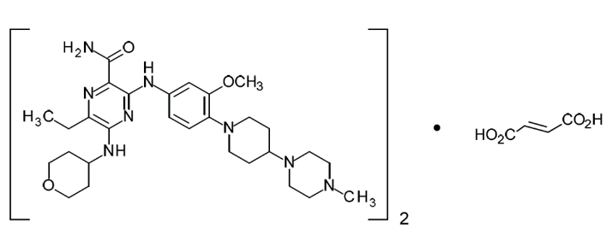
The primary packaging for gilteritinib (as fumarate) 40 mg film-coated tablets consists of OPA/aluminium/PVC/aluminium blisters (containing 21 tablets).
A food-effect study (Study 2215-CL-0113) and relative bioavailability study (Study 2215-CL-0110) were conducted in healthy adult subjects. The results of the food effect study are discussed in the ‘Pharmacology’ section, below.
The recommended starting dose is 120 mg (three 40 mg tablets) once daily. In the absence of a response after 4 weeks of treatment, the dose can be increased to 200 mg (five 40 mg tablets) once daily.
The proposed shelf life for the product is 48 months, store below 25°C.
The application and the supporting data relating to the composition, development, manufacture, quality control, stability and bioavailability of the product have been assessed and checked for compliance, as applicable, with Australian legislation and requirements for new medicines and in accordance with pharmacopoeial standards and the technical guidelines adopted by the TGA.
The justification for not providing study data to demonstrate absolute bioavailability will be referred to the clinical Delegate.
Conclusions relating to food effects will be referred to the clinical Delegate.
Various aspects require toxicological comment as noted.

Recommendation
The quality evaluator has raised no objection to the registration of Xospata gilteritinib fumarate based on the finalised product details outlined in their report.

Nonclinical
The nonclinical evaluator has raised no objections to the registration of Xospata gilteritinib fumarate but has recommended amendments to the PI as outlined in the nonclinical report.
The nonclinical evaluator has noted the following issues of potential clinical relevance:
- off–target effects on other tyrosine kinases (leukocyte tyrosine kinase (LTK); nucleophosmin-anaplastic lymphoma kinase (NPM1-ALK); AXL; anaplastic lymphoma kinase (ALK); tropomyosin receptor kinase A (TRKA); the proto-oncogene tyrosine-protein kinases ROS, RET and MER; and echinoderm microtubule-associated protein-like 4-anaplastic lymphoma kinase (EML4-ALK)) and the non-selective sigma receptor.
- inhibition of the serotonin 5HT_{2B} receptor; caution would be warranted if co-administration with medicinal products that target this receptor were necessary, and adverse pre/postnatal effects on the cardiac development of offspring may occur if taken during pregnancy
- a number of potential pharmacokinetic drug interactions; some of these have been addressed with clinical data
- effects on the gastrointestinal, haematological and hepatic systems of patients may be expected
- gilteritinib induced in vivo chromosomal aberrations and was teratogenic.
The Delegate notes that the serotonergic effects are addressed in the PI, and the potential drug interactions are mitigated by pharmacokinetic (PK) modelling in the clinical trial program.

Clinical
The clinical dossier contained:
- 2 biopharmaceutical studies in healthy volunteers (1 comparative bioavailability study and 1 food effect study); 1 drug-drug interaction study in health volunteers; 1 PK study in healthy volunteers and patients with hepatic impairment; 1 absorption, distribution, metabolism and excretion (ADME) mass balance study in patients with advanced solid tumours; and 2 concentration-safety analyses;
- 1 Phase III pivotal efficacy and safety study in patients with R/R AML;
- 1 Phase I/II dose finding study in patients with R/R AML;
- 1 Phase I supportive efficacy and safety study in Japanese patients with R/R AML; and 1 clinical study in Japanese patients with advanced non-small-cell lung carcinoma (NSCLC);
- 2 population PK studies;
- an integrated summary of safety (ISS); and
- human biomaterial studies.

Pharmacology
Following oral administration, peak plasma concentrations are observed between 4 and 6 hours in health volunteers and R/R patients. The volume of distribution is estimated to be approximately 1100 L. Plasma binding was 90.5% and is concentration independent within the range investigated, with the major binding protein being serum albumin. The half-life of gilteritinib is approximately 113 hours with an apparent clearance of 14.85 L/h.
There is no intravenous (IV) formulation of gilteritinib as it has low solubility, and so the absolute bioavailability is not known.
In vitro, gilteritinib is metabolised by cytochrome P450; enzyme 3A4 (CYP3A4) with one majority metabolite (33%) and a large number of minor metabolites. The effect of CYP3A4 inhibitors is a statistically significant co-variant in the population PK model for Gilteritinib, but the size of the effect is not considered to be clinically significant.
Age, weight and gender do not appear to be clinically significant co-variates in the population PK model for gilteritinib.
A food effect study indicated that the maximum plasma concentration (C_{max}) of gilteritinib reduced by 26% and area under the plasma concentration time curve (AUC) by 6% when the drug was administered with a high-fat meal compared with the fasted state. The clinical evaluator has noted that this effect is not considered clinically significant and so gilteritinib can be taken with or without food.
Analysis of patients with mild to moderate hepatic impairment indicated no difference in unbound gilteritinib exposure, and the sponsor has not recommended any dosage adjustment in this group. There was no data submitted in patients with severe hepatic impairment.
No specific study was conducted to investigate the PK of gilteritinib in patients with renal impairment. However, gilteritinib is not highly renally cleared and so the sponsor has not proposed a dosage adjustment is necessary for patients with renal impairment.
Gilteritinib exhibits rapid and sustained inhibition of FLT3 of > 90% by Day 8 of administration at doses > 80 mg/day.
Figure 2. Inhibition of phospho FMS-like tyrosine kinase 3 by dose level at Cycle 1, Day 8 (pre-dose)
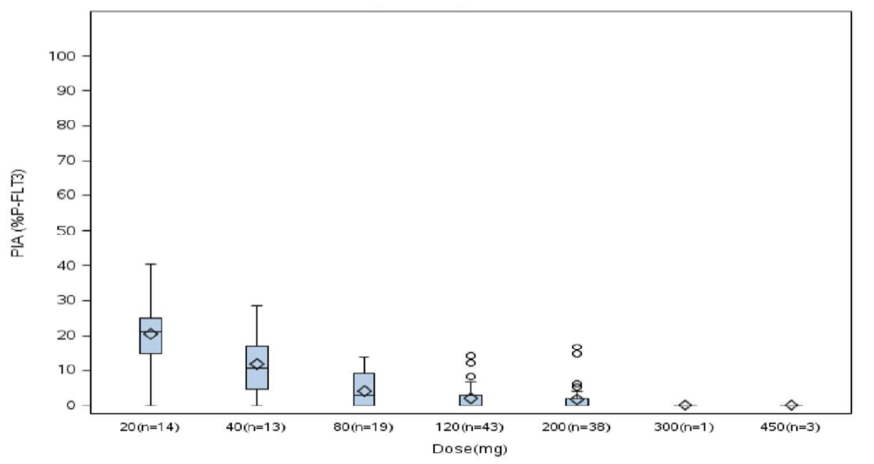
pFLT3 = phospho FMS-like tyrosine kinase 3, PIA = plasma inhibitor activity

Efficacy
Evaluable efficacy data were provided in three studies:
- Study 2215-CL-0301; was a Phase III open-label, multinational, multicentre, randomised study that compared the efficacy and safety of gilteritinib to salvage chemotherapy in FLT3-mutated AML patients who were refractory to or had relapsed after first-line AML therapy. Treatment of patients in the gilteritinib arm was initiated with a dose of 120 mg, with the option to decrease the dose to 80 mg in the event of toxicity and increase the dose to 200 mg due to lack of response (composite complete remission) after the first treatment cycle (that is, after 1 month). The intent to treat (ITT) population; included 247 patients in the gilteritinib arm and 124 patients in the salvage chemotherapy arm. This study provided the pivotal efficacy data supporting approval of gilteritinib 120 mg once daily for the proposed extension of indication. This study has been recently published in the New England Journal of Medicine.
- Study 2215-CL-0101; was Phase I/II open-label, dose-escalation, first-in-human, multinational, multicentre study in patients with R/R AML (FLT3 positive and negative), with a concomitant expansion cohort for multiple doses. Gilteritinib doses of 20, 40, 80, 120, 200, 300 or 450 mg/day were evaluated. The study included 25 patients allocated to the dose escalation phase and 240 patients allocated to the dose expansion phase. The study included 16 patients treated with 20 mg (n = 6 (escalation); n = 11 (expansion)), 18 patients treated with 40 mg (n = 3 (escalation); n = 15 (expansion)), 24 patients treated with 80 mg (n = 3 (escalation); n = 21 (expansion)), 73 patients treated with 120 mg (n = 3 (escalation); n = 70 (expansion)), 110 patients treated with 200 mg (n = 4 (escalation); n = 106(expansion)), 20 patients treated with 300 mg (n = 3 (escalation); n = 17 (expansion)), and 4 patients treated with 450 mg (n = 4 (escalation); n = 0 (expansion)).This study provided limited supportive efficacy data for approval of gilteritinib 120 mg once daily for the proposed extension of indication.
- Study 2215-CL-0102; was a Phase I open-label, dose-escalation, single-country (Japan), multicentre study of single and repeated oral once daily dosing of gilteritinib in Japanese patients with R/R AML (FLT3 positive and negative). In this study, 24 patients were treated with gilteritinib, comprising 1 patient treated with 20 mg, 4 patients treated with 40 mg, 4 patients treated with 80 mg, 4 patients treated with 120 mg, 9 patients treated with 200 mg, and 2 patients treated with 300 mg. This study provided limited supportive efficacy data for approval of gilteritinib 120 mg once daily for the proposed extension of indication.

Pivotal study; Study 2215-CL-0301
Patients enrolled in the pivotal study were adults with AML which was refractory to, or had relapsed after, first line therapy. All included patients who were positive to FLT3 mutation in bone-marrow or whole blood. The primary endpoints were OS, and the rate of complete remission (CR) and CR with partial haematological recovery (CRh) in the comparator arms.
Figure 3. Study design in pivotal study
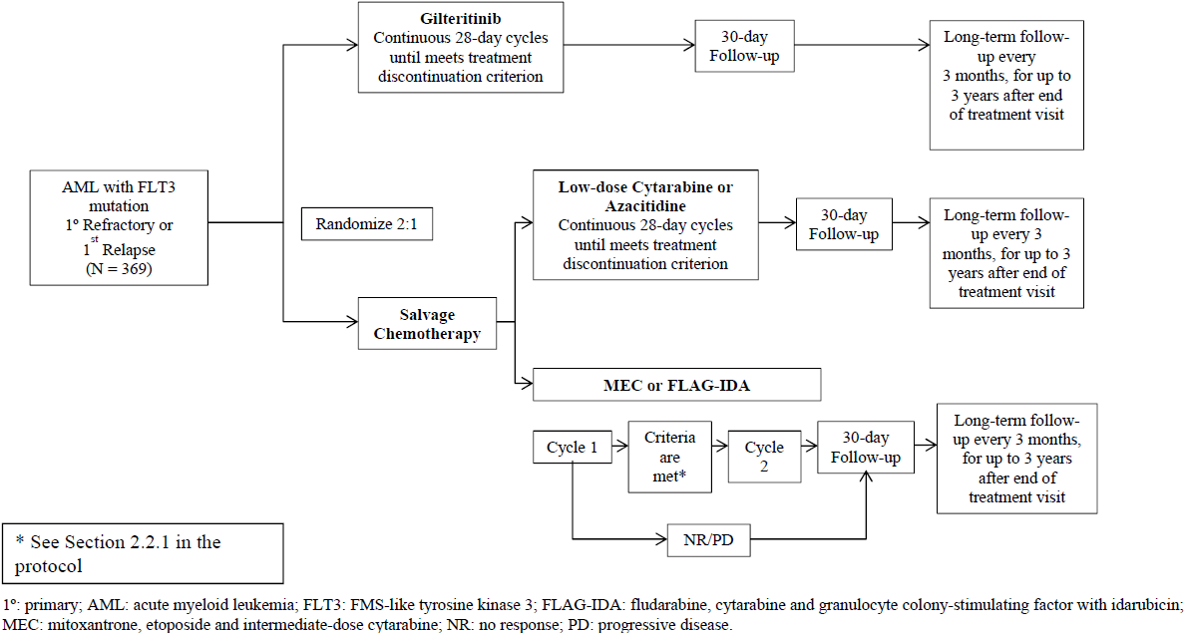
Figure 4. Study 2215-CL-0301 Participant flow
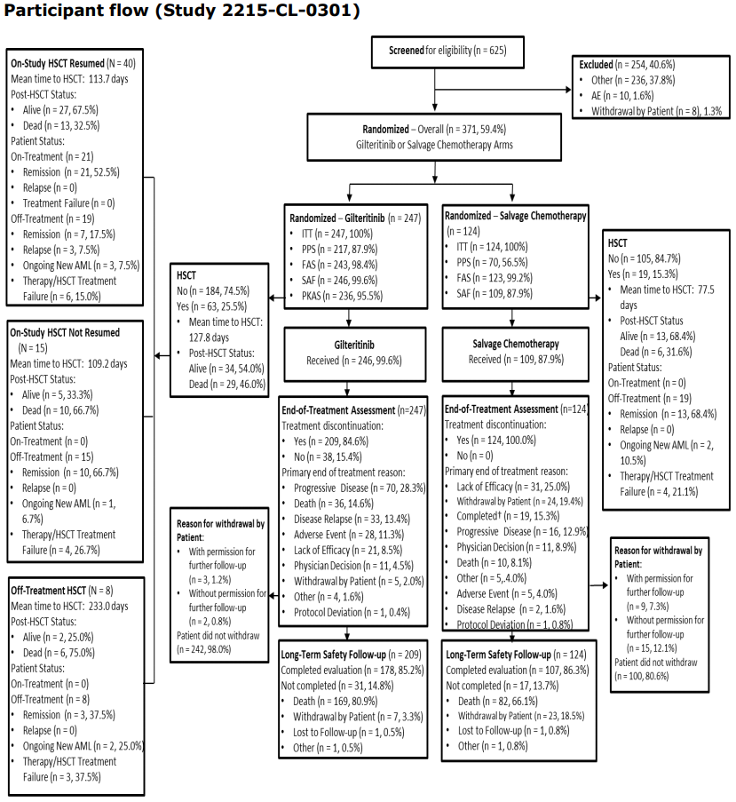
AE = adverse event, FAS = full analysis set; PPS = per protocol set, SAF = safety analysis set.

Results
Figure 5: Study 2215-CL-0301 Kaplan-Meier plot of primary endpoint overall survival (all randomised patients; intention to treatment set)
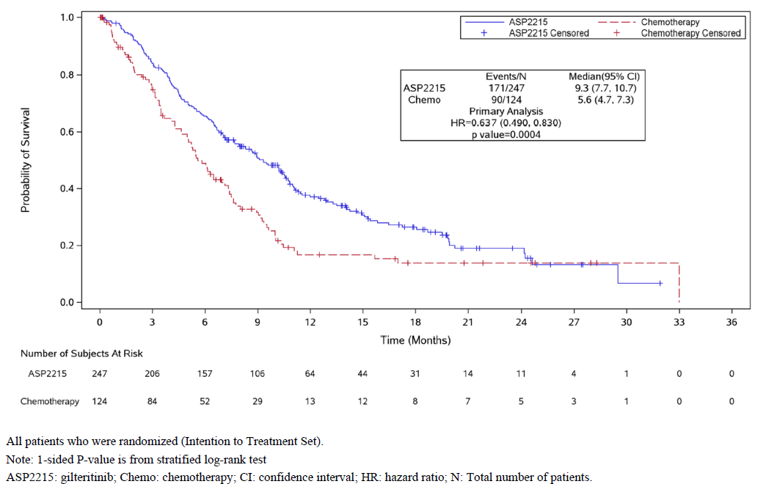
There is a statistically and clinically meaningful difference in OS between the gilteritinib and chemotherapy treatment arms, being a median of 9.3 months and 5.6 months respectively. This is a 36% improvement in OS for the gilteritinib arm.
Table 3: Study 2215-CL-0301 Complete remission (primary analysis and sensitivity analyses across populations)
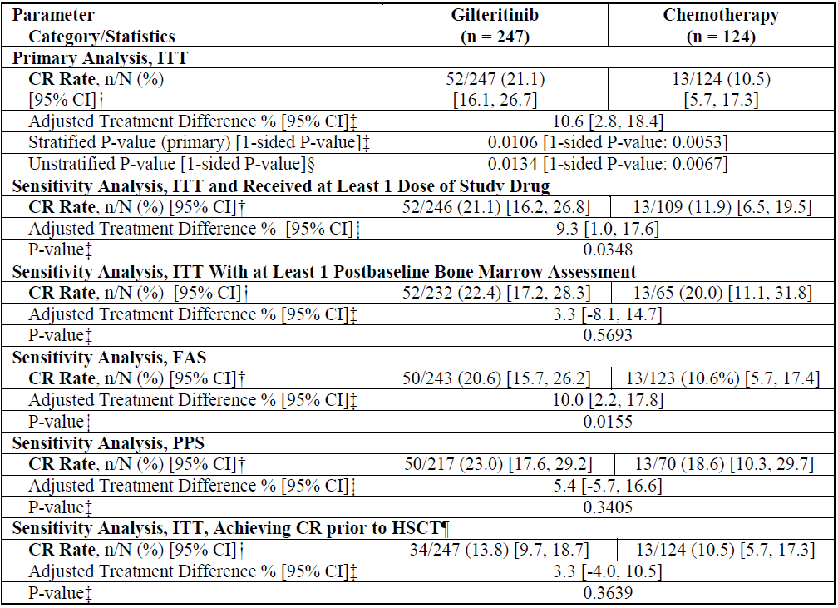
The ratio of CR/CRh was higher in the gilteritinib arm than in the chemotherapy arm, being 34% versus 15.3% respectively. This indicates a relatively higher chance of CR in patients treated with gilteritinib.

Safety
A summary of exposure to different doses of gilteritinib in the clinical development program is shown in Table 4, and the duration of exposure to gilteritinib in Study 2215-CL-0301 is shown in Table 5.
Table 4: Summary of exposure to different doses of gilteritinib in the clinical development program
ID | Population | 10 mg | 20 mg | 40 mg | 80 mg | 120 mg | 200 mg | > 200 mg | Total
R/R patients with AML
2215-CL-0101 | R/R AML [US, EU] | - | 17 | 16 | 24 | 69 | 103 | 23 | 252
2215-CL-0102 | RR/AML [Japan] | - | 1 | 4 | 4 | 4 | 9 | 2 | 24
2215-CL-0301 | R/R AML [Global] | - |  |  | - | 246 | - | - | 246
Total | R/R AML | - | 18 | 20 | 28 | 319 | 112 | 25 | 522
Healthy volunteers
2215-CL-0106 | Healthy [US] | 24 | - | - | - | - | - | - | 24
2215-CL-0108 | Healthy [US] | 61 | 20 | - | - | - | - | - | 81
2215-CL-0110 | Healthy [US] | - | - | 42 | - | - | - | - | 42
2215-CL-0113 | Healthy [US] | - | - | 32 | - | - | - | - | 32
Total | Healthy [US] | 85 | 20 | 74 | - | - | - | - | 179
Solid tumours
2215-CL-0105 | Solid tumours [US] | - | - | - | - | 6 | - | - | 6
2215-CL-5101 | NSCLC [Japan] |  |  |  | 7 | 3 |  |  | 10
Total | Solid tumours | - | - | - | 7 | 9 |  |  | 16
Total |  | 85 | 38 | 94 | 35 | 328 | 112 | 25 | 717
Table 5: Study 2215-CL-0301 Duration of exposure of patients to gilteritinib
 | Gilteritinib | Gilteritinib | Chemotherapy
 | Overall (n = 246) | No dose escalation (n = 168) | (n = 109)
Duration of exposure, median (range) days | 126.00 (4.0, 885.0) | 116.0 (4, 885) | 28.0 (5, 217)
Duration ≤ 5 days, n (%) | 1 (0.4) | 1 (0.6) | 1 (0.9)
Duration ≥ 6 to 28 days, n (%) | 10 (4.1) | 10 (6.0) | 10 (9.2)
Duration ≥ 28 to < 84 days, n (%) | 75 (30.5) | 55 (32.7) | 88 (80.7)
Duration ≥ 84 to < 168 days, n (%) | 68 (27.6) | 38 (22.6) | 6 (5.5)
Duration ≥ 168 days, n (%) | 92 (37.4) | 64 (38.1) | 4 (3.7)
Dosing days, median (range) | 114.0 (4, 885) | 107.5 (4, 885) | 6.0 (1, 70)
Dosing increases, n (%) | 78 (31.7) | 0 | 8 (7.3)
Dosing decreases, n (%) | 75 (30.5) | 58 (34.5) | 9 (8.3)
Dosing interruptions, n (%) | 122 (49.6) | 84 (50.0) | 5 (4.6)
Cumulative dose, median (range) mg | 13980.0 (480, 106200) | 11140.0 (480, 106200) | -
Average daily dose, median mg/day | 120.0 (50, 192) | 120.0 (50, 120) | -
Dose intensity, median (range), mg/day | 120.0 (46, 192) | 120.0 (46, 120) | -
Relative dose intensity, median (range), % | 100.0 (39, 160) | 100.0 (39, 100) | 99.6 (10, 322)
The clinical evaluator has summarised the findings regarding safety. They have noted that the main limitation in the submitted safety data is the lack of long-term safety information in comparison to the possible duration of therapy. The Delegate agrees that this is a concern, but notes that since submission, gilteritinib has been approved for marketing in several jurisdictions and this improves the safety monitoring population over that in the clinical trials.
Nearly all patients in both treatment arms experienced at least one treatment-emergent adverse event (TEAE). The most commonly reported TEAEs (all Grades) occurring in ≥ 30% of patients in either treatment arm, gilteritinib versus chemotherapy, were anaemia (47.2% versus 34.9%), febrile neutropenia (46.7% versus 36.7%), pyrexia (42.7%) versus 29.4%), alanine aminotransferase (ALT) increased (41.9% versus 9.2%), aspartate aminotransferase (AST) increased (40.2% versus 11.9), diarrhoea (32.9% versus 29.4%), nausea (32.1% versus 33.0%), constipation (30.9% versus 14.7%), and hypokalaemia (28.9% versus 31.2%). TEAEs reported in ≥ 10% of patients in either of the two treatment arms and more frequently in the gilteritinib 120 mg arm than in the salvage chemotherapy based on event rates adjusted by patient-years of exposure were AST increased, ALT increased, blood alkaline phosphatase increased, creatinine kinase (CK) increased, hyponatraemia, hypophosphatemia, creatinine increased, dizziness, and myalgia. All other TEAEs reported in ≥ 10% of patients in either treatment arm were reported more frequently in the salvage chemotherapy group than in the gilteritinib 120 mg group when adjusted for patient-years of exposure.
Grade ≥ 3 TEAEs reported in ≥ 10% of patients in either of the two treatment arms and more frequently in the gilteritinib 120 mg arm than in the salvage chemotherapy arm based on patient-years of exposure were AST increased, hyponatraemia, CK increased, alkaline phosphatase increased, abdominal pain, creatinine increased, headache, constipation, dizziness, and myalgia. All other Grade ≥ 3 TEAEs reported in ≥ 10% of patients in either treatment arm were reported more frequently in the salvage chemotherapy group than in the gilteritinib 120 mg group when adjusted for patient years of exposure.
In Study 2215-CL-0301, 1 patient (0.4% (1 out of 246)) in the gilteritinib 120 mg arm experienced a non-drug-related event of acute promyelocytic leukaemia differentiation syndrome (a serious TEAE). No differentiation syndrome TEAEs were experienced by patients in the salvage chemotherapy arm. In the 'integrated gilteritinib 120 mg group (n = 319), 3 (0.9%) patients experienced an event of acute promyelocytic leukaemia differentiation syndrome. In this group, 2 (0.6%) patients experienced a drug-related event of acute promyelocytic leukaemia differentiation syndrome. No patients in this group experienced a serious event of acute promyelocytic leukaemia differentiation syndrome, but 1 (0.3%) patient experienced a drug-related Grade 3 or higher event. In response to a question raised during the evaluation, the sponsor reports that, using the algorithm as defined by the Montesinos criteria, it has identified 11 (3.4%) patients in the integrated gilteritinib 120 mg group (n = 319) who have experienced differentiation syndrome. One death has been reported in the 11 patients identified as experiencing differentiation syndrome in the integrated gilteritinib 120 mg group.
The clinical evaluator has overall concluded that the risk-benefit for gilteritinib is positive.

Clinical evaluator’s recommendation
- It is recommended that gilteritinib be approved for the treatment of treatment of adult patients who have relapsed or refractory AML with a FLT3 mutation.
- It is recommended that gilteritinib be approved at the dosages proposed in the draft PI provided with the sponsor’s letter of 25 November 2019: that is, a starting dose of 120 mg once daily with option to escalate the dose to 200 mg once daily in the absence of a response (composite complete remission not achieved) after 4 weeks of treatment. Treatment should continue until the patient is no longer clinically benefiting from gilteritinib or until unacceptable toxicity occurs. Response may be delayed; therefore, continuation of treatment at the prescribed dose for up to 6 months should be considered to allow time for a clinical response. In addition, it is recommended that the dose interruption, reduction and discontinuation criteria provided in the draft PI be approved.

Risk management plan
The sponsor has submitted EU-risk management plan (RMP) version 0.2 (17 June 2019; data lock point (DLP) 17 September 2018) and Australian-specific Annex (ASA) version 0.2 (July 2019) in support of this application. In response to TGA questions sent 18 December 2019, the sponsor provided updated EU-RMP version 1.0 (4 October 2019; DLP 17 September 2018) and subsequently updated ASA version 0.4 (January 2020). In response to TGA questions sent 20 January 2020, the sponsor provided updated ASA version 0.5 (February 2020). In response to TGA questions sent 7 February 2020 the sponsor provided updated ASA version 0.6 (February 2020).
The summary of safety concerns and their associated risk monitoring and mitigation strategies are summarised in Table 6.
Table 6. Summary of safety concerns
Summary of safety concerns |  | Pharmacovigilance |  | Risk Minimisation
 |  | Routine | Additional | Routine | Additional
Important identified risks | Posterior reversible encephalopathy syndrome (PRES) |  | ¶ |  | –
Important identified risks | Differentiation syndrome | † | ¶ |  | ǁ
Important potential risks | Torsades de Pointes | – | – ¶ |  | –
Important potential risks | Serious GI disorders | – | – |  | –
Important potential risks | Eye disorders | – | – |  | –
Important potential risks | Pulmonary adverse events | – | – |  | –
Important potential risks | Pancreatitis | † | – |  | –
Important potential risks | Embryo-fetal lethality, suppressed fetal growth, and teratogenicity | * | – |  | –
Missing information | Safety in patients with renal impairment |  | ‡ |  | –
Missing information | Long term safety |  | – | – | –
* Pregnancy follow-up form and follow-up questionnaire for pregnancy outcomes, † Targeted follow-up form, ‡ Phase I study (EU only), ǁ Patient alert card in the package, ¶ Cross sectional study (EU only)
Overall, the RMP evaluator has noted routine risk-reduction measures are to be implemented for gilteritinib. They have, however, noted that the EU has required additional information to be provided to prescribers regarding the risk of differentiation syndrome and recommended that this be implemented in Australia.

Risk-benefit analysis

Delegate’s considerations
The Delegate concurs with the clinical evaluator that Study 2215-CL-0301 provides clear evidence of clinical benefit over salvage chemotherapy for the proposed indication, R/R AML.
The main outstanding issue is whether additional education should be provided to alert prescribers and patients to the potential for differentiation syndrome. This is an insidious clinical syndrome which is associated with an increased load of mature myeloid cells during treatment, and can mimic a number of other relevant conditions such as infection, thromboembolism and heart failure. Early recognition is necessary to allow management, and differentiation syndrome can be fatal.
The Delegate notes that the EU has required additional clinician information regarding this rare adverse event albeit, as the sponsor has indicated, in the context of a pharmacovigilance survey which is not being conducted in Australia. The Delegate notes that the US prescribing information; contains a Black Box warning; which states:
‘Important Safety Information
Warning: Differentiation Syndrome
Patients treated with Xospata have experienced symptoms of differentiation syndrome, which can be fatal or life-threatening if not treated. Symptoms may include fever, dyspnea, hypoxia, pulmonary infiltrates, pleural or pericardial effusions, rapid weight gain or peripheral edema, hypotension, or renal dysfunction. If differentiation syndrome is suspected, initiate corticosteroid therapy and hemodynamic monitoring until symptom resolution.’
From this, the Delegate concludes that there is a significant international regulatory consensus on the need to provide enhanced recognition of differentiation syndrome arising in gilteritinib therapy, and this is not limited to the specific implementation of an education program in the EU. While the sponsor has indicated that they do not feel such additional recognition is necessary in Australia, the Delegate is not aware of any material argument which has been proposed by the sponsor as to why the requirement for it should differ in Australia from that in other major jurisdictions.
The Delegate is minded to either require additional educational material as detailed in the RMP evaluation be made available in Australia, or to require a Black Box warning in the Australian PI as per the US Food and Drug Administration (FDA) prescribing information. The Delegate considers these equally efficacious approaches, and notes that the Black Box label might be preferred by the sponsor given that they have noted that gilteritinib is largely used under clinical supervision. The additional education program would, however, obviate the need for a Black Box warning, in the view of the Delegate.

Proposed action
The Delegate intends to register gilteritinib for the indication:
Xospata is indicated for the treatment of adult patients who have relapsed or refractory acute myeloid leukaemia (AML) with a FLT3 mutation.
Pending the sponsor’s decision whether they prefer to implement additional education program for differentiation syndrome outlined in the RMP report, the Delegate intends to approve gilteritinib with an Australian PI containing the Black Box warning discussed above.
The sponsor is requested to provide a PI document amended from the draft submitted to include changes requested in the nonclinical and clinical evaluation reports, and with amendments clearly identified (for example, comments, tracked changes). This should include the Black Box warning if this is the sponsor’s preferred means of communicating the risk of differentiation syndrome to clinicians.

Advisory Committee considerations
The Delegate did not refer this application to the Advisory Committee on Medicines (ACM) for advice.

Outcome
Based on a review of quality, safety and efficacy, the TGA approved the registration of Xospata gilteritinib (as fumarate) for 40 mg film-coated tablet administered orally, indicated for:
Xospata is indicated for the treatment of adult patients who have relapsed or refractory acute myeloid leukaemia (AML) with a FLT3 mutation.

Specific conditions of registration applying to these goods
- Xospata (gliteritinib) is to be included in the Black Triangle Scheme. The PI and Consumer Medicines Information (CMI) for Xospata must include the black triangle symbol and mandatory accompanying text for five years, which starts from the date that the sponsor notifies the TGA of supply of the product.
- The Xospata EU-RMP (version 1.0, dated 4 October 2019, DLP 17 September 2018), ASA (version 0.6, dated Feb 2020), included with submission PM-2019-03406-1-6, to be revised to the satisfaction of the TGA, will be implemented in Australia.
An obligatory component of risk management plans is routine pharmacovigilance. Routine pharmacovigilance includes the submission of periodic safety update reports (PSURs).
Reports are to be provided in line with the current published list of EU reference dates and frequency of submission of PSURs until the period covered by such reports is not less than three years from the date of the approval letter.
The reports are to at least meet the requirements for PSURs as described in the European Medicines Agency’s Guideline on Good Pharmacovigilance Practices (GVP) Module VII-periodic safety update report (Rev 1), Part VII.B Structures and processes. Note that submission of a PSUR does not constitute an application to vary the registration.
- In relation to health care professional education material for differentiation syndrome, the sponsor is instructed to: (1) update the ASA with information on how it will be implemented in Australia (including target audience, method of dissemination, timeframe for implementation and how it will be evaluated); (2) provide a copy of the materials including Black Triangle symbol and wording for review and approval prior to product supply; and (3) implement an evaluation of the effectiveness of the material through assessing healthcare professional awareness and clinical knowledge of differentiation syndrome (for example using a cross-sectional study among healthcare professionals).

Attachment 1. Product Information
The PI for Xospata approved with the submission which is described in this AusPAR is at Attachment 1. For the most recent PI, please refer to the TGA website at <https://www.tga.gov.au/product-information-pi>.

Therapeutic Goods Administration
PO Box 100 Woden ACT 2606 Australia
Email: info@tga.gov.au Phone: 1800 020 653 Fax: 02 6232 8605
https://www.tga.gov.au

The Black Triangle Scheme provides a simple means for practitioners and patients to identify certain types of new prescription medicines, including those being used in new ways and to encourage the reporting of adverse events associated with their use. The Black Triangle does not denote that there are known safety problems, just that the TGA is encouraging adverse event reporting to help us build up the full picture of a medicine's safety profile.
Australian Institute of Health and Welfare. Cancer in Australia 2019. Canberra: AIHW; 2019.
Haematopoietic stem cell transplantation (HSCT) is the transplantation of multipotent haematopoietic stem cells, usually derived from bone marrow, peripheral blood, or umbilical cord blood. Allogeneic HSCT involves the transplantation of stem cells sourced from a donor.
Autologous HSCT involves the transplantation of stem cells self-sourced from the same person being treated.
Cytarabine is also known as cytosine arabinoside (ara-C).
The Fms like tyrosine kinase 3 (FLT3), also known as cluster of differentiation antigen 135 (CD135) is a cell surface cytokine receptor (protein) encoded by the FLT3 gene, expressed in many haematopoietic progenitor cells. Signalling of FLT3 is important for the normal development of haematopoietic stem cells and progenitor cells.
'Orphan drugs' are often developed to treat small and very specific patient populations who suffer from rare diseases and conditions. In order to facilitate orphan drug access to the Australian marketplace and help offset orphan drug development costs the TGA waives application and evaluation fees for prescription medicine registration applications if a related orphan designation is in force. A medicine may be eligible for orphan drug designation if all orphan criteria set by the TGA are met. The orphan designation application precedes the registration application and the designation is specific to the sponsor, orphan indication for which designation was granted and dosage form of the medicine.
The TGA’s priority registration process has the same eight phases as the standard prescription medicines registration process but with some modifications to reduce timeframes, resulting in faster assessment of vital and life-saving prescription medicines for which a complete data dossier is available. The target timeframe of 150 working days is up to three months shorter than the standard prescription medicines registration process. A valid priority review designation must be held in order to access the priority review pathway.
Konig, H. and Levis, M. (2015). Targeting FLT3 to treat leukemia. Expert Opinion on Therapeutic Targets 19 (1): 37-54.
Chevallier, P. et al. (2011). A new Leukemia Prognostic Scoring System for refractory/relapsed adult acute myelogeneous leukemia patients: a GOELAMS study. Leukemia 25: 939-944.
Levis, M. et al. (2011). Results from a randomized trial of salvage chemotherapy followed by lestaurtinib for patients with FLT3 mutant AML in first relapse. Blood 117 (12): 3294-3301.
Cytochrome P450 (CYP) enzymes: CYPs are the major enzymes involved in drug metabolism, accounting for large part of the total metabolism. Most drugs undergo deactivation by CYPs, either directly or by facilitated excretion from the body. Also, many substances are bioactivated by CYPs to form their active compounds. Many drugs may increase or decrease the activity of various CYP isozymes either by inducing the biosynthesis of an isozyme (enzyme induction) or by directly inhibiting the activity of the CYP (enzyme inhibition). This is a major source of adverse drug interactions, since changes in CYP enzyme activity may affect the metabolism and clearance of various drugs. Such drug interactions are especially important to take into account when using drugs of vital importance to the patient, drugs with important side-effects and drugs with small therapeutic windows, but any drug may be subject to an altered plasma concentration due to altered drug metabolism.
Study 2215-CL-0301; Title: ‘A Phase 3 Open-Label, Multicenter, Randomized Study of ASP2215 versus Salvage Chemotherapy in Patients with Relapsed or Refractory Acute Myeloid Leukemia (AML) with FLT3 Mutation’. EudraCT number: 2015-000140-42; ClinicalTrials.gov Identifier: NCT02421939; also known as the ADMIRAL trial.
Randomised clinical trials analysed by the intent-to-treat (ITT) approach provide unbiased comparisons among the treatment groups. In the ITT population, none of the patients are excluded and the patients are analysed according to the randomisation scheme.
Perl, A.E. et al. (2019). Gilteritinib or Chemotherapy for Relapsed or Refractory FLT3-Mutated AML. New England Journal of Medicine 381: 1728-1740.
Study 2215-CL-0101; Title: ‘A Phase 1/2 Open-Label, Dose Escalation Study Investigating the Safety, Tolerability, Pharmacokinetics, and Pharmacodynamics of ASP2215 in Patients with Relapsed or Refractory Acute Myeloid Leukemia’. EudraCT Number: 2014-002217-31; ClinicalTrials.gov Identifier: NCT02014558
Study 2215-CL-0102; Title: ‘Dose Escalation Study to Investigate the Safety, Tolerability and Pharmacokinetics of ASP2215 in Japanese Patients With Relapsed or Refractory Acute Myeloid Leukemia’. ClinicalTrials.gov Identifier: NCT02181660.
The full analysis set (FAS) of subjects that is as close as possible to the ideal implied by the Intention-to-Treat principle. It is derived from the set of all randomised subjects by minimal and justified elimination of subjects.
The per-protocol (PP) analysis is restricted to the participants who strictly adhered to the protocol. Also known as ‘on-treatment’ analysis.
Montesinos, P. et al. (2009). Differentiation syndrome in patients with acute promyelocytic leukemia treated with all-trans retinoic acid and anthracycline chemotherapy: characteristics, outcome, and prognostic factors. Blood 113: 775-783.
Routine risk minimisation activities may be limited to ensuring that suitable warnings are included in the product information or by careful use of labelling and packaging. Routine pharmacovigilance practices involve the following activities: - All suspected adverse reactions that are reported to the personnel of the company are collected and collated in an accessible manner; - Reporting to regulatory authorities; - Continuous monitoring of the safety profiles of approved products including signal detection and updating of labelling; - Submission of PSURs; - Meeting other local regulatory agency requirements.
FDA Prescribing Information for Xospata (gilteritinib) tablets, for oral use, initial approval 2018, revised May 2019.
A boxed warning is a mechanism used to highlight special warning statements in the Product Information (PI) to the prescriber and patient that could significantly alter the risk for patients when prescribed the product. This warning typically concerns a potential for major impact on public health due to serious adverse events.
Sponsor clarification: the sponsor has agreed to implement additional educational material related to differentiation syndrome.
The ACM provides independent medical and scientific advice to the Minister for Health and the Therapeutic Goods Administration (TGA) on issues relating to the safety, quality and efficacy of medicines supplied in Australia including issues relating to pre-market and post-market functions for medicines. The Committee is established under Regulation 35 of the Therapeutic Goods Regulations 1990. Members are appointed by the Minister. The ACM was established in January 2017 replacing Advisory Committee on Prescription Medicines (ACPM) which was formed in January 2010. ACM encompass pre and post-market advice for medicines, following the consolidation of the previous functions of the Advisory Committee on Prescription Medicines (ACPM), the Advisory Committee on the Safety of Medicines (ACSOM) and the Advisory Committee on Non-Prescription Medicines (ACNM). Membership comprises of professionals with specific scientific, medical or clinical expertise, as well as appropriate consumer health issues relating to medicines.

