September 2019

Australian Public Assessment Report for Galcanezumab
  - Proprietary Product Name: Emgality
  - Sponsor: Eli Lilly Australia Pty Ltd

About the Therapeutic Goods Administration (TGA)
- The Therapeutic Goods Administration (TGA) is part of the Australian Government Department of Health and is responsible for regulating medicines and medical devices.
- The TGA administers the Therapeutic Goods Act 1989 (the Act), applying a risk management approach designed to ensure therapeutic goods supplied in Australia meet acceptable standards of quality, safety and efficacy (performance) when necessary.
- The work of the TGA is based on applying scientific and clinical expertise to decision-making, to ensure that the benefits to consumers outweigh any risks associated with the use of medicines and medical devices.
- The TGA relies on the public, healthcare professionals and industry to report problems with medicines or medical devices. TGA investigates reports received by it to determine any necessary regulatory action.
- To report a problem with a medicine or medical device, please see the information on the TGA website <https://www.tga.gov.au>.
About AusPARs
- An Australian Public Assessment Report (AusPAR) provides information about the evaluation of a prescription medicine and the considerations that led the TGA to approve or not approve a prescription medicine submission.
- AusPARs are prepared and published by the TGA.
- An AusPAR is prepared for submissions that relate to new chemical entities, generic medicines, major variations and extensions of indications.
- An AusPAR is a static document; it provides information that relates to a submission at a particular point in time.
- A new AusPAR will be developed to reflect changes to indications and/or major variations to a prescription medicine subject to evaluation by the TGA.
Copyright
© Commonwealth of Australia 2019
This work is copyright. You may reproduce the whole or part of this work in unaltered form for your own personal use or, if you are part of an organisation, for internal use within your organisation, but only if you or your organisation do not use the reproduction for any commercial purpose and retain this copyright notice and all disclaimer notices as part of that reproduction. Apart from rights to use as permitted by the Copyright Act 1968 or allowed by this copyright notice, all other rights are reserved and you are not allowed to reproduce the whole or any part of this work in any way (electronic or otherwise) without first being given specific written permission from the Commonwealth to do so. Requests and inquiries concerning reproduction and rights are to be sent to the TGA Copyright Officer, Therapeutic Goods Administration, PO Box 100, Woden ACT 2606 or emailed to <tga.copyright@tga.gov.au>.

Contents
Common abbreviations 5
I. Introduction to product submission 9
Submission details 9
Product background 9
Regulatory status 10
Product Information 11
II. Registration time line 11
III. Quality findings 12
Drug substance (active ingredient) and drug product manufacturing 12
Quality summary and conclusions 13
IV. Nonclinical findings 13
Introduction 13
Pharmacology 13
Pharmacokinetics 14
Toxicology 15
Nonclinical summary and conclusions 21
V. Clinical findings 23
Introduction 23
Pharmacokinetics 27
Pharmacodynamics 29
Dosage selection for the pivotal studies 30
Efficacy 32
Safety 32
First round benefit-risk assessment 47
First round recommendation regarding authorisation 49
Clinical questions and second round evaluation 49
Second round benefit-risk assessment 53
VI. Pharmacovigilance findings 53
Risk management plan 53
VII. Overall conclusion and risk/benefit assessment 55
Background 55
Quality 56
Nonclinical 57
Clinical 57
Risk management plan 68
Risk-benefit analysis 68
Outcome 80
Attachment 1. Product Information 81

Common abbreviations
Abbreviation | Meaning
~ | Approximately
ACM | Advisory Committee on Medicines
ADA | Anti-drug antibodies
AE | Adverse event
ALT | Alanine aminotransferase
ARTG | Australian Register of Therapeutic Goods
ASA | Australian Specific Annex
Asn | Asparagine
AST | Aspartate aminotransferase
AUC | Area under the curve
AUC_{inf} | Area under the curve (to infinity)
BMI | Body Mass Index
BUN | Blood urea nitrogen
cAMP | Cyclic adenosine monophosphate
C_{av,ss} | Average concentration within a dosing interval at steady-state
CGA… | Study identifier
CGRP | Calcitonin gene related peptide
CHMP | Committee for Medicinal Products for Human Use
CHO | Chinese hamster ovary
CI | Confidence interval
C_{max} | Peak serum concentration
CMI | Consumer Medicines Information
CNS | Central nervous system
CPD | Certified Product Details
CSF | Cerebrospinal fluid
CSR | Clinical Study Report
CV | Cardiovascular
Cys | Cysteine
EAIRs | Exposure adjusted incidence rates
ECG | Electrocardiogram /electrocardiographic
eDISH | Evaluation of drug-induced serious hepatotoxicity
EMA | European Medicines Agency
F1 | First filial generation
FDA | (United States) Food and Drug Administration
GCP | Good Clinical Practice
GGT | Gamma glutamyltransferase
GLP | Good Laboratory Practice
GMP | Good Manufacturing Practice
hERG | Human ether-à-go-go related gene
IC₅₀ | Half maximal inhibitory concentration
ICH | International Conference on Harmonisation
IgG | Immunoglobulin G
IHS | International Headache Society
IV | Intravenous
K_{b} | Equilibrium dissociation constant
K_{d} | Dissociation constant
k_{in} | Formation rate
k_{out} | Elimination rate
LC-MS-MS | Liquid chromatography–tandem mass spectrometry
LY2951742, LY | Galcanezumab (company drug development codename)
mAbs | Monoclonal antibodies
MHD | Migraine headache days
ms | Millisecond
MSQ, | Migraine Specific Quality of Life
NAb | Neutralising antibodies
NOAEL | No observed adverse effect level
PASS | Post authorisation safety study
PD | Pharmacodynamic(s)
PGI-S | Patient Global Impression-Improvement Score
PK | Pharmacokinetic(s)
pM | Picomolar
PSUR | Periodic safety update reports
QTc | QT corrected
QTcF | QT corrected by Fridericia’s method
RMP | Risk Management Plan
SAEs | Serious adverse events
SC | Subcutaneous
SmPC | Summary of Product Characteristics
SMQs | Standardised Medical Dictionary for Regulatory Activities Queries
SOC | System Organ Class
t_{½} | Biological half life
TE ADA | Treatment emergent anti-drug antibodies
TEAE | Treatment emergent adverse event
TGA | Therapeutic Goods Administration
T_{max} | The time after administration of a drug when the maximum plasma concentration is reached
ULN | Upper limit of normal
V_{ss} | Mean volume of distribution
WBC | White blood cell

I. Introduction to product submission

Submission details
Type of submission: | New biological entity
Decision: | Approved
Date of decision: | 22 May 2019
Date of entry onto ARTG: | 28 May 2019
ARTG numbers: | 302145, 302146
Black Triangle Scheme | Yes  This product will remain in the scheme for 5 years, starting on the date the product is first supplied in Australia.

Active ingredient: | Galcanezumab
Product name: | Emgality
Sponsor’s name and address: | Eli Lilly Australia Pty Limited  112 Wharf Road  West Ryde, NSW 2114
Dose form: | Injection, solution
Strength: | 120 mg/mL
Containers: | Prefilled syringe, prefilled pen
Pack sizes: | 1, 2, and 3
Approved therapeutic use: | Emgality is indicated for the prophylaxis of migraine in adults.
Route of administration: | Subcutaneous injection
Dosage: | 120 mg injected subcutaneously once a month, with an initial loading dose of 240 mg. For further details see the Product Information.

Product background
This AusPAR describes the application by Eli Lilly Australia Pty Limited (the sponsor) to register Emgality (galcanezumab) for the following indication:
Emgality is indicated for the prophylaxis of migraine in adults.
Migraine is a common neurological condition, usually manifesting as severe headache, and often accompanied by visual changes, light sensitivity, sound sensitivity, nausea, and lethargy. It is sometimes associated with focal neurological deficits such as weakness or numbness, speech disturbance, or vertigo. Many people suffer infrequent migraines, with only a few attacks per year, but some patients experience multiple attacks per month. Migraines can have major impacts on quality of life and mood, especially if they occur frequently. Migraine is also a major cause of absenteeism from work.
Severe attacks may be treated with specific anti-migraine drugs, often from the triptan family (sumatriptan, zolmitriptan, and others). These are often effective if taken early in the attack, but many patients respond only partially to triptans, and still require bed rest and analgesics. Some patients may need antiemetic (anti-nausea and vomiting) medication, as well. Resistant cases may sometimes require treatment with stronger analgesics, including narcotics. When migraines are more frequent (such as 4 or more attacks per month), or when the effects of individual migraines are very severe, prophylactic anti-migraine agents are usually indicated, such as beta blockers (especially propanolol), calcium channel blockers (verapamil), some anticonvulsants (topiramate, valproate), and pizotifen. None of these drugs are highly effective, and all of them are associated with significant tolerability issues; as such there is a clear unmet need for additional prophylactic anti-migraine agents.
Galcanezumab is a humanised monoclonal antibody (mAb) that binds to the calcitonin gene related peptide (CGRP) ligand, preventing binding to its receptor. During a migraine attack, CGRP levels increase, causing vasodilation and nociceptive signalling and it is hypothesised that inhibiting the binding of CGRP to its receptor will prevent migraine. One drug in this class (mAb) was approved last year for the preventive treatment of migraine: erenumab (Aimovig). Galcanezumab binds to the CGRP ligand, whereas erenumab binds to the CGRP receptor.

Regulatory status
The product received initial registration on the Australian Register of Therapeutic Goods (ARTG) on 28 May 2019.
At the time the TGA considered this application, a similar application had been approved in the European Union (EU), under the centralised procedure on 14 November 2018 and in the United States of America (USA) on27 September 2018 (see Table 1). An application to register Emgality was under evaluation in Switzerland.
Table 1: Foreign regulatory status of similar applications as of 18 March 2019
Region | Submitted | Status | Indication
EU (centralised) | 26 October 2017 | 14 November 2018 | Emgality is indicated for the prophylaxis of migraine in adults who have at least 4 migraine days per month.
USA | 27 September 2017 | 27 September 2018 | Emgality is indicated for the preventive treatment of migraine in adults.
Switzerland | 11 January 2018 | Under review1

Product Information
The Product Information (PI) approved with the submission which is described in this AusPAR can be found as Attachment 1. For the most recent PI, please refer to the TGA website at <https://www.tga.gov.au/product-information-pi>.

II. Registration time line
Table 2 captures the key steps and dates for this application and which are detailed and discussed in this AusPAR.
Table 2: Timeline for Submission PM-2018-00780-1-1
Description | Date
Submission dossier accepted and first round evaluation commenced | 31 May 2018
First round evaluation completed | 31 October 2018
Sponsor provides responses on questions raised in first round evaluation | 20 December 2018
Second round evaluation completed | 11 February 2019
Delegate’s Overall benefit-risk assessment and request for Advisory Committee advice | 4 March 2019
Sponsor’s pre-Advisory Committee response | 13 March 2019
Advisory Committee meeting | 5 April 2019
Registration decision (Outcome) | 22 May 2019
Completion of administrative activities and registration on ARTG | 28 May 2019
Number of working days from submission dossier acceptance to registration decision* | 208
*Statutory timeframe for standard applications is 255 working days
Evaluations included under Quality findings and Nonclinical findings incorporate both the first and second round evaluations.
TGA guidance at pre submission meetings is nonbinding and without prejudice.

III. Quality findings

Drug substance (active ingredient) and drug product manufacturing
Galcanezumab is a humanised mAb of the immunoglobulin G4 (IgG4) subclass composed of 2 identical immunoglobulin kappa light chains and two identical immunoglobulin gamma heavy chains. Each heavy chain contains a single N linked glycosylation site at asparagine (Asn) 296. The N linked glycosylation structure is predominantly a fucosylated, complex biantennary glycan with 0 galactose residues (G0F) on either arm. A schematic diagram of galcanezumab structure is shown in Figure 1.
Figure 1: Schematic diagram of galcanezumab
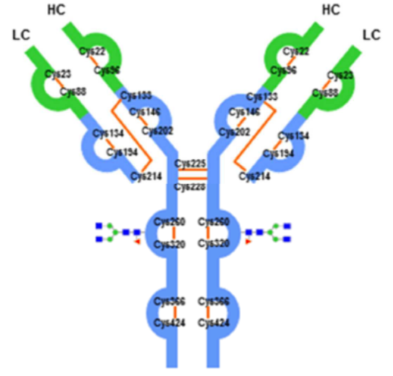
The 32 cysteine (Cys) residues that are involved in the intra chain and inter chain disulphide bonding are shown. The variable region is shown in green, the constant region is shown in blue. Orange colour lines between Cys residues indicate disulphide bonds. The location of the N linked glycosylation at asparagine (Asn) 296 in each heavy chain is also illustrated.
Analysis of galcanezumab using multiple orthogonal assays showed it had features consistent with those of an IgG4 antibody.
Overall, supplied data is satisfactory and there are no further quality related concerns pertaining to this issue.
Galcanezumab is a fully humanised IgG4 mAb generated using recombinant DNA technology in Chinese hamster ovary (CHO) cells with specificity for an epitope within the CGRP. The following steps are used in the manufacturing process of galcanezumab.
The working cell bank vial undergoes thawing and expansion in shake flasks, followed by expansion in disposable rocking back bioreactors and the commercial scale bioreactor before harvest collection to produce the bulk harvest drug product.
The bulk harvest is purified using a series of chromatography, viral inactivation and filtration steps.
The drug substance and drug product materials undergo in process control testing and in process acceptance criteria testing. All manufacturing steps and analytical procedures are validated.
All manufacturing steps are validated other than the re-filtration process in commercial manufacturing. Only laboratory scale reprocessing studies (re-filtration) were performed to characterise the impact of reprocessing across the viral filter or the drug substance final filter on galcanezumab quality attributes. The sponsor has committed to complete validation of commercial scale viral filtrate process intermediate reprocessing, and drug substance final filtration reprocessing using three runs of re-filtration in commercial manufacturing. The sponsor will report any out of specifications with this activity.
At the time of this evaluation, four manufacturer’s applications for TGA clearance are still pending to be approved. TGA Good Manufacturing Practice (GMP) clearances for two of the manufactures have expired. TGA clearance/certificate for all the manufacturers must be up to date by the time this application for registration is approved.

Quality summary and conclusions
There are no objections to the registration of this product from sterility; endotoxin, container safety and viral safety related aspects.
Overall, sufficient evidence has been provided to demonstrate that the risks related to the manufacturing quality of Emgality have been controlled to an acceptable level.

IV. Nonclinical findings

Introduction
The sponsor has applied to register a new biological entity, galcanezumab (Emgality). Emgality is proposed to be used for the prophylactic treatment of migraine in adults. The proposed dosing regimen is 120 mg injected subcutaneously once a month, with an initial loading dose of 240 mg. Treatment duration is expected to be chronic.
The nonclinical dossier was of good overall quality, and in general accordance with relevant TGA adopted guidelines, including International Conference on Harmonisation (ICH) S6(R1). All pivotal toxicity studies were conducted according to Good Laboratory Practice (GLP) standards.

Pharmacology
Galcanezumab is a humanised IgG4 mAb directed against CGRP. CGRP is widely expressed in the central and peripheral nervous systems. CGRP has been associated with the pathophysiology of migraine and numerous other (patho) physiological conditions.

Primary pharmacology
Binding studies confirmed the affinity of galcanezumab for human and rat CGRP (dissociation constant (K_{d}) 31 and 250 picomolar (pM), respectively), which share 89% amino acid sequence homology. Galcanezumab did not bind to the human CGRP receptor, amylin, adrenomedullin, calcitonin, or intermedin, all members of the calcitonin family of peptides. Galcanezumab did not bind Fc receptors I, IIa, and IIIa or the complement component C1q.
In vitro, galcanezumab inhibited both human α and β CGRP induced cyclic adenosine monophosphate (cAMP) production, half maximal inhibitory concentration (IC₅₀) 0.35 ± 0.07 and 0.176 ± 0.022 nanomolar (nM), respectively. Galcanezumab inhibited rabbit CGRP induced cAMP accumulation with an IC₅₀ of 0.06 nM and equilibrium dissociation constant (K_{b}) of 4.1 pM (human IC₅₀ 0.23 nM and K_{b} 44.2 pM) in vitro. Binding of CGRP to human amylin receptor 1 was decreased by galcanezumab (IC50 0.9 nM and K_{b} 54 pM).
In vivo, galcanezumab was shown to inhibit capsaicin induced increase in dermal blood flow in rats (4 mg/kg subcutaneous (SC)) and cynomolgus monkeys (5 mg/kg intravenous (IV)).
Overall, the primary pharmacology data support the proposed indication but do not allow in vivo efficacy assessment due to the lack of a validated animal model of migraine.

Safety pharmacology
Specialised safety pharmacology studies on galcanezumab were not conducted; however, cardiovascular, respiratory, and central nervous system (CNS) evaluations were integrated into the protocols of the GLP 6 month cynomolgus monkey repeat dose toxicology study. There were no effects on neurobehavioural parameters (including body temperature), or cardiovascular (including electrocardiogram (ECG) waveforms, heart rate, QRS duration and PR, QT, QTC intervals) or respiratory effects in the repeat dose toxicity study in monkeys, following doses up to 100 mg/kg/week SC for 6 months. Overall, no effect on functions of CNS, cardiovascular and respiratory systems is predicted with monthly dosing of galcanezumab. No human ether-à-go-go related gene (hERG) assay was performed, which is appropriate for biotechnology derived therapeutic products.

Pharmacokinetics
Pharmacokinetic (PK) and toxicokinetic characteristics of galcanezumab were assessed in rats and cynomolgus monkeys. Single dose assessment in monkeys was conducted following IV dose of 2 mg/kg. The mean volume of distribution (Vss) in monkeys was 52.2 mL/kg (approximately (~) similar to plasma volume) and mean serum clearance was 0.015 L/day following IV bolus administration. Elimination from the systemic circulation was slow after single IV administration, with half-life of ~ 8 days. Repeat dose assessments were determined in rats and monkeys from repeat dose toxicity studies. Rats and monkeys received weekly doses of galcanezumab at 1.5, 15, 20, 100 or 250 mg/kg (rats) and 1.5, 2, 15 or 100 mg/kg (monkeys) for 6 weeks, 3 or 6 months. Galcanezumab administered SC showed slow systemic distribution, reaching maximum serum concentration between 1 to7 days post dose and a long elimination (biological half-life (t_{½}) 7 to 13 days). Peak and overall exposure (peak serum concentration (C_{max}) and area under the curve (AUC)) was less than dose proportional in rats and dose proportional in monkeys. Accumulation with repeated (weekly) dosing was observed. Repeat dosing did not uncover exposure differences between male and female monkeys.
In human population pharmacokinetic studies following SC administration, peak serum concentration was reached at ~ 5 days post dose (at a 240 mg loading dose followed by 5 consecutive monthly doses of 120 mg) and the half-life was 27 days. The predicted clearance and volume of distribution were 0.19 L/day and 7.3 L (~ 122 mL/kg for a 60 kg adult), respectively.
Tissue distribution was assessed in rats following a single SC administration of radiolabelled galcanezumab at 4 mg/kg. Galcanezumab was detected in plasma and tissues for ≥ 7 days. Tissue distribution of galcanezumab across was dura mater > spleen > trigeminal ganglia > hypothalamus = spinal cord > prefrontal cortex = cerebellum > cerebrospinal fluid (CSF).
No specific studies on metabolism, excretion or pharmacokinetic interactions were conducted. This is acceptable given the protein nature of the drug, in accordance with relevant guidleines.1 It is expected that galcanezumab will be eliminated by normal protein degradation pathways for IgG molecules.

Toxicology

Acute toxicity
Acute toxicity from a single dose of galcanezumab was not examined. This is acceptable, with relevant information on acute toxicity available from repeat dose toxicity studies instead. No acute toxic effects were apparent in rats and monkeys in those studies up the highest doses tested (250 mg/kg/week SC and 100 mg/kg/week SC, respectively). A non GLP compliant single dose pharmacokinetic study was conducted in cynomolgus monkeys using the IV route.
Table 3: Relative exposure in the acute pharmacokinetic in monkeys
Study details | Dose (mg/kg/week) | AUC_{0‒∞} (μg∙hour/mL) | Exposure ratio#
Study 8214340LO  Single IV dose | 2 | 8217 | 2.1
Human: Population PK analysis  (1 compartment model) | 120 mg* | 15900
AUC_{0-∞} = Area under the curve from time zero (dosing) to infinity; * = AUC_{τ, ss} after a 240 mg loading dose followed by 5 consecutive monthly doses of 120 mg. # = animal: human serum AUC_{0-t} times by animal:human dosing frequency

Repeat dose toxicity
Repeat dose toxicity studies were conducted in rats and monkeys (6 weeks, 3 and 6 months). Administration was once weekly in all studies (that is, given more frequently than the once a month regimen in patients) and by the clinical route (SC). The pivotal studies were appropriately designed and conducted in terms of the species used (rat and cynomolgus monkey), duration (6 months), group size and range of endpoints examined.

Relative exposure
Animal:human exposure multiples achieved in the key toxicity studies are calculated below based on comparison of serum AUC for galcanezumab, adjusted for differences in dosing frequency (that is, animal values are multiplied by 4 to account for weekly compared with monthly dosing). The clinical AUC values predicted by 1 compartment population PK modelling are used for exposure comparison. The AUC data used for animals is the mean of the male and female values on the last sampling occasion. Very high multiples of the human exposure were obtained at the highest doses tested.
Table 4: Relative exposure in repeat dose toxicity studies
Species | Study duration  (Study no.) | Dose (mg/kg/week); SC | AUC_{0-168 hours}  (μg·hour/mL) | Exposure ratio#
Rat  (Sprague Dawley) | 6 weeks  (503646) | 1.5 | 4560 | 1.1
Rat  (Sprague Dawley) | 6 weeks  (503646) | 15 | 36416 | 9
Rat  (Sprague Dawley) | 6 weeks  (503646) | 100 | 35822 | 9
Rat  (Sprague Dawley) | 3 months  (504702) | 15 | 32987 | 8
Rat  (Sprague Dawley) | 3 months  (504702) | 100 | 35362 | 9
Rat  (Sprague Dawley) | 6 months  (8297946) | 20 | 29900 | 8
Rat  (Sprague Dawley) | 6 months  (8297946) | 250 | 70450 | 18
Monkey  (cynomolgus) | 6 weeks  (503647) | 1.5 | 5146 | 1.3
Monkey  (cynomolgus) | 6 weeks  (503647) | 15 | 49920 | 13
Monkey  (cynomolgus) | 6 weeks  (503647) | 100 | 436455 | 110
Monkey  (cynomolgus) | 3 months  (504703) | 15 | 55656 | 14
Monkey  (cynomolgus) | 3 months  (504703) | 100 | 334964 | 84
Monkey  (cynomolgus) | 6 months  (8297947) | 2 | 7650 | 2
Monkey  (cynomolgus) | 6 months  (8297947) | 100 | 579500 | 146
Human: Population PK analysis  (1 compartment model) |  | 120 mg* | 15900 | -
* = AUC_{τ, ss} after a 240 mg loading dose followed by 5 consecutive monthly doses of 120 mg (representative of the proposed clinical dosing regimen); # = animal:human serum AUC_{0-t} times by animal: human dosing frequency; ^ = AUC values for males only.
Limited data on anti-drug antibodies (ADA) are available. In the 3 month rat study, ADA were detected at moderate to high incidence at doses of ≥ 15 mg/kg/week (6 out of 20 animals at 15 mg/kg/week and 12 out of 20 animals at 100 mg/kg/week), and resulted in a reduction in exposure to galcanezumab in some animals. No ADA were detected in the 3 month monkey study at doses ≥ 15 mg/kg/week. The dose dependent reduction in exposure to galcanezumab in the 6 week and 3 month rat studies limits the characterisation of its toxicity at the highest dose tested (that is, 100 mg/kg/week).

Major toxicities
Galcanezumab was well tolerated in repeat dose toxicity studies following SC doses up to 100 and 250 mg/kg/week for 6 months in monkeys and rats, respectively. Two rats treated with 250 mg/kg/week galcanezumab were either found deceased (unknown causes) or euthanised during the 6 month study (on Day 169 (male) and on Day 176 (female)). The female was euthanised due to the development of a spontaneous perianal fibrosarcoma. No other galcanezumab related mortality or morbidity was observed. There were no galcanezumab related clinical signs.
Reduced body weight gain was noted in rats administered doses of 250 mg/kg/week; this was associated with in a reduction in food intake. Body weight gain was also decreased in a dose dependent manner in the 6 month monkey studies; no changes in food consumption were observed.
No remarkable effects on body temperature, safety pharmacology parameters (respiratory rate, CNS function and ECG) or clinical pathology parameters were observed following galcanezumab administration. There were also no galcanezumab related findings in ophthalmoscopic and physical examinations.
Full haematological assessment showed dose dependent changes in white blood cell (WBC) parameters in male (decreased WBC and lymphocytes counts) and female (increased WBC and lymphocytes counts) monkeys, in the 3and 6 month studies. Increased lymphocyte and eosinophil counts were also increased in both sexes in the 3 month rat study.
Serum chemistry analyses did not show clear treatment related effects, although there were some dose dependent fluctuations that were not statistically significant in the 6 month monkey study (increased cholesterol in females (33 to 52%), increased glucose in males (5 to 24%), decreased glucose in females (11 to 23%, statistically significant at high dose) and decreased gamma glutamyltransferase (GGT) in males (by up to 28%) and females (by up to 44%)). Histological correlates were not observed for any of these findings and therefore they are unlikely to be toxicologically significant. Slight changes were noted in the 6 week (decreased cholesterol, aspartate aminotransferase (AST) and increased total bilirubin) and 3 month (increased globulin, cholesterol, sodium and decreased albumin/globulin ratio) monkey studies.
Post mortem examinations revealed no galcanezumab related macroscopic observations. Histopathological changes consisted of minimal to slight perivascular mononuclear cell infiltrates (in the 6 month rat and the 3 and 6 month monkey studies), minimal to moderate inflammation (in the 6 month rat and the 6 week monkey studies) and minimal to moderate pigment (in the 6 month rat study) at the SC injection sites. The incidence and severity of these observations were generally dose dependent, but were not observed in all treated animals. Due to the lack of data (recovery periods for the 6 week and 3 month studies for only one treatment group) the reversibility of these observations could not be established. In some monkeys there was also evidence of low level muscular degeneration/fibrosis. These findings are considered to be a nonspecific response to the injection of a foreign protein and not a direct effect of galcanezumab.
A number of organ weight changes (relative to body weight) were noted following repeat dose treatment. These included increased spleen weight in male and female rats and female monkeys (6 month studies) at the high dose (rat: 7% (male) and 11% (female); monkey: 45% (female)), increased thyroid/parathyroid weight in monkeys (6 month study high dose; 19% (male) and 24% (female)), decreased epididymis and testis weight at both doses in the 6 month monkey study (18 to 26% and 39 to 51%, respectively). Uterus weight was increased in the pivotal rat study (19% at high dose). These organ weight changes were dose dependent but were not statistically significant and had no histological correlate. They were therefore not considered treatment related. A number of other dose dependent changes in organ weights including fluctuation in thymus, liver and adrenal weights were not considered to be treatment related on the basis that they had no histological correlates and were not always observed in both sexes and both species.

Genotoxicity
The genotoxic potential of galcanezumab was not examined in dedicated nonclinical studies, which is acceptable for a biotechnology derived pharmaceutical as per ICH guidelines.1

Carcinogenicity
Carcinogenicity studies were not conducted. This is acceptable under the relevant guildelines.1 The mechanism of action of galcanezumab is not expected to be carcinogenic. No pre neoplastic lesions were observed in rats and cynomolgus monkeys administered galcanezumab weekly for up to 6 months. Although this time span is relative short in the monkey lifespan, life time carcinogenicity studies in primates are not ethically feasible.

Reproductive toxicity
Reproductive toxicity studies submitted by the sponsor covered all stages (fertility, early embryonic development, embryofetal development, pre and postnatal development and juvenile development). All studies were conducted by the SC route. The pivotal studies were appropriately designed and conducted in term of dose selection, group size, the timing and duration of treatment, and the endpoints examined.

Relative exposure
Table 5: Relative exposure in reproductive toxicity studies, galcanezumab plasma steady state concentration
Species/Dose | Dose  (mg/kg) | Study AUC_{ss}  (μg∙day/mL) | AUC normalised to AUC_{0-7 days}  (µg∙day/mL) | Steady State Concentration  (µg/mL)=C_{av,ss} | Exposure ratioª
Human (120 mg)^{b,c} | 2 | AUC_{0-30 days} = 662.5 | 296 | 22.1 | -
Rat male fertility study NOAEL^{d} | 250 | AUC_{0-30 days} = 1221 | 1221 | 174 | 7.9
Rat female fertility and embryofetal development study NOAELe | 100 | AUC_{0-30 days} = 1675 | 1675 | 239 | 11
Additional rat female fertility and embryofetal development study NOAEL^{f} | 250 | AUC_{0-30 days} = 2546 | 5941 | 849 | 38
Rabbit embryofetal development study NOAEL^{g} | 100 | AUC_{0-30 days} = 4250 | 9917 | 1417 | 64
Rat prenatal and postnatal development study NOAEL^{h} | 250 | AUC_{0-30 days} = 5333 | 5333 | 761 | 34
Abbreviations: AUC = area under the serum concentration versus time curve; Cav,ss = average concentration within a dosing interval at steady-state, NOAEL =no observed adverse effect level. a Exposure multiple = (Cav,ss,animals)/(Cav,ss,humans) = (AUC_{0-7days} in animals)/(Adjusted AUC_{0-7days} in humans). b Assuming a loading dose of 240 mg followed by a monthly dose of 120 mg (120 mg per 60 kg = 2 mg/kg). c The average human steady state serum concentration at 120 mg administered every 30 days, after a 240 mg loading dose, was determined as part of a population PK analysis involving Studies CGAB, CGAE, CGAG, CGAH, CGAI, and CGAO. d Mean male rat AUC_{0-7days} was determined on Day 35 in Study 8316570. e Mean female rat AUC_{0-7days} was determined on Gestation Day 13 in Study WIL-353311. f Mean female rat AUC_{0-3days} was determined on Gestation Day 18 in Study 20096436. g Mean female rabbit AUC_{0-3days} was determined on Gestation Day 20 in Study WIL-353310. h Mean female rat AUC_{0-7days} was determined on Lactation Day 20 in Study 20092502.
Placental transfer was demonstrated in rats and was high in rabbits, with galcanezumab detected in fetal serum. Fetal to maternal ratios were 0.32 in rats and 1.89 in rabbits for 100 mg/kg/week, suggesting that rate of transfer is low in rats and high in rabbits. Moreover, given the slow elimination half-life, the likelihood of galcanezumab levels persisting in the fetal circulation is high. Excretion in milk was not examined.
No adverse effects on male or female fertility were observed with galcanezumab in rats up to the highest dose tested (250 mg/kg every 3 days or weekly; relative exposure (AUC) 8 and 38, respectively).
The embryofetal development studies tested four doses of galcanezumab (15, 30, 100 or 250 mg/kg), administered every 3 to 5 days or once per week via the SC route to rats or rabbits during the period of organogenesis. There were no maternal treatment related changes or mortalities. Fetal development was slowed at a dose of 250 mg/kg every 3 days (maternal galcanezumab treatment gestational day 3 to 18) as shown by an increased incidence of skeletal variations (incompletely ossified ribs, short ribs). These variations occurred in the absence of maternotoxicity and only at a high relative exposure (38; AUC) and are not considered clinically relevant. No embryofetal variations/malformations were observed at doses ≤ 100 mg/kg/week in the rat and rabbit embryofetal studies. Therefore, the no observed adverse effect level (NOAEL) for embryofetal development in rats and rabbits is considered to be 100 mg/kg/week or every 4 to 5days, respectively (relative exposure (AUC) 11 and 64, respectively).
In a pre/postnatal development study, pregnant rats received galcanezumab every 3 days at doses of 30 or 250 mg/kg via the SC route from the period of organogenesis through to end of the lactation period. First filial generation (F1) female offspring were observed until gestational day 13 and F1 male offspring until postpartum day 117 to 119. No adverse effects on maternal health were reported. One maternal animal in the low dose group was found deceased during the lactation period (cause not determined). The length of gestation was not affected by treatment and the total number of pups delivered was similar between groups. The rates of fetal loss and pup loss were comparable between the treated and vehicle control groups. There were no treatment related effects on clinical signs, body weight gains, sexual maturation, motor activity, learning and memory or reproductive function. F1 females showed no maternal treatment related changes. The increase in non-viable embryo numbers and post implantation loss observed was not statistically significant and did not exceed historical control range (relative exposure (AUC) of 34). Sperm motility and density in F1 males were not affected by treatment. A significant reduction in the mean number of normal sperm correlated with increase in the mean number of abnormal sperm was noted in high dose F1 males (relative exposure (AUC) of 34). This finding was attributed to one male which had small testes and small epididymides (out of 200 sperm: 13 normal, 55 with detached heads and 127 with no heads). The NOAEL for pup development is considered to be 250 mg/kg every 3 days.
Whilst no clinical juvenile indications are sought in the current submission, the sponsor submitted a juvenile repeat dose toxicity study in rats that received galcanezumab SC every 3 days at doses of 30 or 250 mg/kg from postnatal day 21 to 90. Treatment was well tolerated. A slight reduction in body weight gain and food consumption was noted in high dose groups. Full haematological assessment showed dose dependent increase in eosinophils and platelets levels in both sexes; activated partial thromboplastin time and fibrinogen levels were increased in males, decrease in prothrombin time was observed in males and urea nitrogen and creatinine levels were reduced in both sexes. Only partial recovery was observed following treatment withdrawal. There were no galcanezumab related findings in clinical pathology parameters, urinalysis, physical examination, organ weights or macroscopic evaluation.
As in adult animals, histopathological changes consisted of increased incidence of mononuclear cell infiltrates (minimal to mild). The reversibility of these findings was only partial following treatment withdrawal.
Reproductive parameters (sexual maturation, oestrous cycling, reproductive capacity (mating and fertility), sperm assessment (motility, concentration, morphology), litter values (corpora lutea, implantation numbers, pre/post implantation loss, number of live/dead fetuses)) were unaffected by treatment.
A decrease in motor activity (ambulation and fine movements) was observed at both doses in both sexes (statistically significant in females), complete reversal was observed 1 month following treatment withdrawal. There were no treatment related effects on acoustic startle habituation and learning and memory.
A potential treatment related effect on bone densitometry was observed, particularly in high dose treated animals of both sexes (relative exposure ratio to humans, 73 (male)/104 (female) based on AUC); with reduced trabecular bone area, bone mineral content (-25%) and bone mineral density (-21 to -24%). Recovery was variable in both males and females at both doses after a 46 day recovery period. Furthermore, minimal changes were observed in cortical bone, and there was no treatment related effect on femur length.
Schinke et al. (2004) showed decrease bone formation and osteopenia (including significant reduction of the trabecular bone volume) in α CGRP deficient mice, providing mechanistic evidence for a role for CGRP in bone formation. It is therefore possible that the effects observed with galcanezumab on trabecular bone of juvenile rats are pharmacologically mediated; however, consideration of the minor changes, their reversibility, and relative exposure margins (AUC) in the juvenile rat studies suggest limited clinical relevance.

Pregnancy classification
The sponsor has proposed Pregnancy Category B1 for galcanezumab. A B1 category is considered appropriate for this product in the absence of any adverse maternal or fetal effects in adequately conducted embryofetal and pre/postnatal development studies in female rats and rabbits. This is consistent with the Australian pregnancy category for erenumab, another drug in the same class.

Local tolerance
The sponsor did not conduct a dedicated local tolerance study. The assessment of local tolerance was incorporated into the repeat dose toxicology studies in rats and cynomolgus monkeys (macroscopic and microscopic evaluation of SC injection sites). Neither oedema nor erythema were observed following treatment. Examination of SC injection sites revealed an increased incidence and severity of perivascular mononuclear cell infiltrates and chronic inflammation (at concentrations up to 50 mg/mL). Isolated occurrences of slight muscular degeneration and slight fibrosis were also observed in monkeys at 50 mg/mL. These findings are considered to be reactions to the injection of foreign protein and not adverse. Injection site reactions are reported as very common adverse effects observed in clinical trial subjects in the PI document.

Immunotoxicity
Signs of immunotoxicity were not observed in general repeat dose toxicity studies and no specialised immunotoxicity studies were performed.

Phototoxicity
Phototoxicity studies were not conducted. This is acceptable in accordance with relevant guidelines.

Paediatric use
Galcanezumab is not proposed for paediatric use. In a juvenile study in rats, administration of up to 250 mg/kg every 3 days SC from postnatal day 21 to 90 did not cause any observable adverse effects apart from small, reversible reductions in trabecular bone area, bone mineral content and bone mineral density at high relative exposure ratios of 73 (males) and 104 (females), based on AUC. The NOAEL was 250 mg/kg every 3 days.

Comments on the Nonclinical Safety Specification of the Risk Management Plan
Results and conclusions drawn from the nonclinical programme for galcanezumab detailed in the sponsor’s draft Australian Specific Annex (ASA) to the EU Risk Management Plan (Version 0.1) are in general concordance with those of the nonclinical evaluator.

Nonclinical summary and conclusions

Non clinical summary
- The nonclinical dossier contained an adequate set of studies investigating pharmacology, pharmacokinetics and toxicity, conducted in general accordance with relevant TGA adopted guidelines.1 The nonclinical dossier was of good overall quality, and all pivotal safety related studies were GLP compliant.
- CGRP is widely expressed in the central and peripheral nervous systems. CGRP has been associated with the pathophysiology of migraine. It has also been suggested to be involved in numerous other (patho) physiological situations (for example, cardiovascular regulation/disease, neurogenic inflammation, pain, sepsis, arthritis, wound healing, bone formation, diabetes and obesity).
- In vitro studies established that galcanezumab binds to human and rat CGRP with high affinity (K_{D} 31 and 250 pM, respectively) and does not bind to human CGRP receptor, amylin, adrenomedullin, calcitonin, intermedin (all members of the calcitonin family of peptides), Fc receptors I, IIa, and IIIa or the complement component C1q. Galcanezumab inhibits the accumulation of cAMP induced by the human CGRP isoforms (α and β; IC₅₀ 0.35 ± 0.07 and 0.176 ± 0.022 nM, respectively) and rabbit CGRP (IC₅₀ 0.06 nM) in vitro. Binding of CGRP to human amylin receptor is decreased by galcanezumab (IC₅₀ 0.9 nM). Galcanezumab inhibits the capsaicin induced increase in dermal blood flow in rats and cynomolgus monkeys in vivo.
- α and β CGRP are highly conserved among species, including rats and human. In humans α and β CGRP differ by 3 amino acids and in rat, by one amino acid. Their biological activities are very similar. Galcanezumab shows comparable affinity for the animal forms of CGRP compared with the human form.
- Safety pharmacology parameters were incorporated into the repeat dose toxicity studies in monkeys. No adverse effects were seen on neurobehavioural parameters (including body temperature), cardiovascular (including ECG waveforms, heart rate, QRS duration and PR, QT, QTc corrected (QTc) intervals) or respiratory systems in monkeys after repeated dosing for up to 6 months.
- Pharmacokinetic studies with galcanezumab showed slow systemic distribution (time after administration of a drug when the maximum plasma concentration is reached (T_{max}) of 1 to 7 days) and a long elimination half-life (t_{½} 7 to 13 days) in rats and monkeys by the clinical SC route. Accumulation with repeated (weekly) dosing was consistent with the drug’s long half-life. Galcanezumab exhibits nonlinear PK in rats and linear PK in monkeys. The volume of distribution was low (consistent with limited extravascular 0.14 L (52.2 mL/kg) and clearance was 0.015 L/day in monkeys following single IV administration in monkeys. Tissue distribution of galcanezumab was assessed in the plasma, CSF, various structures of the CNS and limited peripheral tissues (dura mater, spleen, and trigeminal ganglia) of rats. Galcanezumab was detected in rat plasma and tissues for ≥ 7 days. Tissue distribution of galcanezumab across was dura mater > spleen > trigeminal ganglia > hypothalamus = spinal cord > prefrontal cortex = cerebellum > CSF.
- Repeat dose toxicity studies of up to 6 months duration were conducted in rats and cynomolgus monkeys. These species are appropriate models for the investigation of galcanezumab toxicity on pharmacodynamic (PD) and PK grounds and the immunogenicity of galcanezumab in these species was minimal. Weekly SC administration of galcanezumab at doses producing high to very high multiples of the clinical systemic exposure was well tolerated, with no target organs for toxicity identified. The only effect observed was decreased body weight gain in rats and monkeys at the maximum doses tested (18 and 146 times the exposure in patients, respectively). Other mild to minimal treatment related effects were injection site reactions.
- Genotoxicity or carcinogenicity studies were not conducted, which is acceptable for a biotechnology derived pharmaceutical. Based on an assessment of the published literature, the mechanism of action of galcanezumab suggests no carcinogenic potential.
- Galcanezumab had no effects on male or female fertility in treated rats (8 to 38 times the exposure in patients (based on female AUC)). No adverse embryofetal, pre/postnatal effects were evident in rats and rabbits (up to 38 and 64 times the exposure in patients, respectively). Galcanezumab crosses the placenta and is expected to be excreted into milk.
- No adverse findings were observed in the juvenile development study in rats (up to 250 mg/kg/week), corresponding to relative exposure ratios of 73 (male) and 104 (female). Galcanezumab is only indicated in adults.

Conclusions and recommendations
- The submitted nonclinical dossier was in general accordance with relevant guidelines on the nonclinical evaluation of the biotechnology derived pharmaceuticals.1 All pivotal repeat dose toxicity and reproductive toxicity studies were GLP compliant.
- Primary pharmacology studies provided sufficient evidence of galcanezumab affinity and selectivity for human, monkey and rat CGRP.
- While galcanezumab was shown to inhibit capsaicin induced increases in dermal blood flow in rats and cynomolgus monkeys, no comment can be made from a nonclinical perspective regarding efficacy for the proposed indication, as there is no validated animal model for migraine.
- Treatment related effects associated with weekly injection were minimal and limited to injection site reactions.
- Pregnancy Category B1 is considered appropriate.5
- Overall, there are no nonclinical objections to the registration of galcanezumab (Emgality).
The nonclinical evaluator also made recommendations for amendment to the PI however these are beyond the scope of the AusPAR.

V. Clinical findings
A summary of the clinical findings is presented in this section.

Introduction

Information on the condition being treated
Migraine is a common condition, usually manifesting as severe headache, and often accompanied by visual changes, photophobia, phonophobia, nausea, and lethargy. It is sometimes associated with focal neurological deficits such as weakness or numbness, speech disturbance, or vertigo. Typically, migraines cause asymmetrical or unilateral throbbing headaches, with attacks lasting from hours to days. Many patients can identify food or environmental triggers for their migraines and, in some cases, migraines are associated with menstrual cycles, but in many other cases the triggers for individual migraines are obscure. Many people suffer infrequent migraines, with only a few attacks per year, but some subjects experience multiple attacks per month. By convention, using definitions formalised by the International Headache Society (IHS); a rate of ≥ 15 headache days at least 8 of which are migraine per month is used to identify subjects with ‘chronic’ migraine, in contrast to those with ‘episodic’ migraine who suffer < 15 migraine headache days (MHD) per month.
Migraines can have major impacts on quality of life and mood, especially if they occur frequently. Migraine is also a major cause of absenteeism from work.

Current treatment options
When migraines are infrequent or mild, the usual approach is to treat individual attacks with non-pharmacological measures (lying in a darkened room) or with simple over the counter analgesics. More severe attacks may be treated with specific anti-migraine drugs, often from the triptan family (sumatriptan, zolmitriptan, and others). These are often effective if taken early in the attack, but many patients respond only partially to triptans, and still require bed rest and analgesics. Some subjects may need antiemetic medication, as well. Resistant cases may sometimes require treatment with stronger analgesics, including narcotics.
When migraines are more frequent (such as 4 or more attacks per month), or when the effects of individual migraines are very severe, prophylactic anti-migraine agents are usually indicated, such as beta blockers (especially propanolol), calcium channel blockers (verapamil), some anticonvulsants (topiramate, valproate), and pizotifen. None of these drugs is highly effective, and all of them are associated with significant tolerability issues. Propanolol may cause lethargy, hypotension, bradycardia, vivid dreams or insomnia, impotence, an exacerbation of asthma, blunting of the haemodynamic response to exercise, and other side effects. Calcium channel blockers may cause hypotension, bradycardia and constipation. Anticonvulsants commonly cause sedation and cognitive side effects, and valproate causes a large number of additional side effects including weight gain, abnormal liver function, tremor, and teratogenesis. Topiramate may cause anorexia, cognitive dysfunction, mood changes, and renal calculi. Pizotifen causes lethargy and weight gain. Higher doses of these agents tend to be more effective at reducing migraine frequency and severity, but most tolerability issues are dose dependent. Many patients are unable to tolerate the doses necessary to reduce their migraine frequency, and must settle for a compromise between ongoing migraines and side effects.
Typically, even when prophylactic agents are used, patients experience breakthrough migraines and still require acute medication to treat individual attacks.
Because existing prophylactic agents are often only partially effective, and cause significant side effects, there is a clear unmet need for additional prophylactic anti-migraine agents.

Clinical rationale
CGRP is a neurotransmitter produced in central and peripheral neurons. It is a member of the calcitonin family of peptides, which in humans exists in two forms, αCGRP and βCGRP. In humans, αCGRP is a 37 amino acid peptide and is formed from the alternative splicing of the calcitonin/CGRP gene; βCGRP differs in three amino acids, and is encoded in a separate gene in the same vicinity.
The precise physiological function of CGRP is not well defined, but it appears to play a role in cardiovascular homeostasis and nociception, and several lines of evidence suggest that it contributes to the pathogenesis of migraine. CGRP is expressed in anatomical locations that are activated during migraine attacks, including the trigeminal ganglion neurons and peripheral projections of the trigeminal nerve, and the dura mater. It is known to be a potent vasodilator; and it promotes neurogenic inflammation and nociception. It facilitates the production of pro inflammatory mediators, leading to hyperaemia, oedema, and pain in inflamed tissues. The peptide can have direct excitatory effects on nociceptive neurons, and it can facilitate the effects of other pain transmitters including glutamate and substance P. It has shown excitatory effects in animal and cultured neuron models.,
Intravenous administration of CGRP to humans has been shown to cause migraine like headaches.
Recently, several positive clinical studies have been performed in migraine sufferers, using mAbs to CGRP or to its receptor, or oral receptor antagonists to CGRP. These studies suggest that CGRP mechanisms are a valid therapeutic target for migraine.,,, Erenumab, a mAb directed against the CGRP receptor, has recently been approved in Australia for the same indication as proposed for galcanezumab, on the basis of studies broadly similar to those in the current submission.

Guidance
The sponsor’s submission makes reference to the following guidance documents:
- The European Medicines Agency (EMA) Guideline on Clinical Investigation of Medicinal Products for the Treatment of Migraine.
- EMA Guideline on The Extent of Population Exposure to Assess Clinical Safety for Drugs Intended for Long-Term Treatment of Non-Life-Threatening Conditions.
- EMA Guideline on Immunogenicity assessment of therapeutic proteins.
- Industry guidance from the Food and Drug Administration’s (FDA) on Assay Development for Immunogenicity Testing of Therapeutic Proteins; and Recommendations for the Validation of Immunoassays Used for Detection of Host Antibodies Against Biotechnology Products.
- EMA Guideline on the clinical evaluation of QT/QTc interval prolongation and pro-arrhythmic potential for non-antiarrhythmic drugs.
Of these, the most important is the EMA guideline for studies in migraine.18 The key recommendations are:
- Patient selection should be based on diagnostic criteria formulated by the IHS.
- Patients included should generally have had migraine for at least 1 year and there should be a 3 months well documented retrospective history.
- Age at onset of migraine should be less than 50 years.
- In order to justify migraine prophylaxis, attacks should occur at least 2 times per month, usually 2 to 6 times per month. There should be at least 48 hours of freedom from headache between attacks of migraine.
- A continuous registration of the patients' migraine pattern during baseline and study period should be available.
- The recommended primary endpoint is the frequency of attacks within a pre specified period.
- Secondary endpoints might be:
  - Responder rate where a ‘responder’ is defined as a patient with a 50% or greater reduction in attack frequency during treatment compared to baseline.
  - Number of days with migraine per 4 weeks.
  - Intensity of headache averaged over attacks within an evaluation period.
  - Speed of effect (active agents may be distinguished from each other or from placebo by how quickly reduction in attack frequency is achieved; thus, attack frequencies may be compared in the first 4 weeks or second 4 weeks of treatment).
  - Drug consumption for acute treatment totalled over an evaluation period.
With respect to study design, the Committee for Medicinal Products for Human Use (CHMP) guidance document recommends:
- A prospective baseline (run in period) of at least one month and a 3 month well documented retrospective history is recommended in order to determine the characteristics and the frequency of attacks per month. Randomisation should occur after the run in (baseline) period.
- Treatment periods should be at least 3 months after the titration period (if any).
- Patients should be followed for at least 4 weeks after termination of the treatment period to detect possible rebound phenomena.

Contents of the clinical dossier
As outlined in Table 6 the dossier contains:
- Three pivotal studies
  - Phase III Study I5Q-MC-CGAG (CGAG) in episodic migraine
  - Phase III Study I5Q-MC-CGAH (CGAH) in episodic migraine
  - Phase III Study I5Q-MC-CGAI (CGAI) in chronic migraine
- Two supportive efficacy studies
  - Phase II Study ART-01
  - Phase II Study CGAB
- One long term safety study
  - Phase III Study I5Q-MC-CGAJ (CGAJ)
The major efficacy studies also contributed to PK and PD analyses. The sponsor also submitted two Phase I studies (Studies CGAA and CGAE) with a major emphasis on PK and PD, and two bioequivalence studies (Studies CGAO and CGAQ).
The dossier also contains a proposed PI and Consumer Medicines Information (CMI), Risk Management Plan (RMP) and Australian-specific Annex (ASA), a clinical overview, a summary of clinical pharmacology, a summary of clinical efficacy, and a summary of clinical safety, along with relevant literature references.
Table 6: Overview of major studies in the clinical dossier
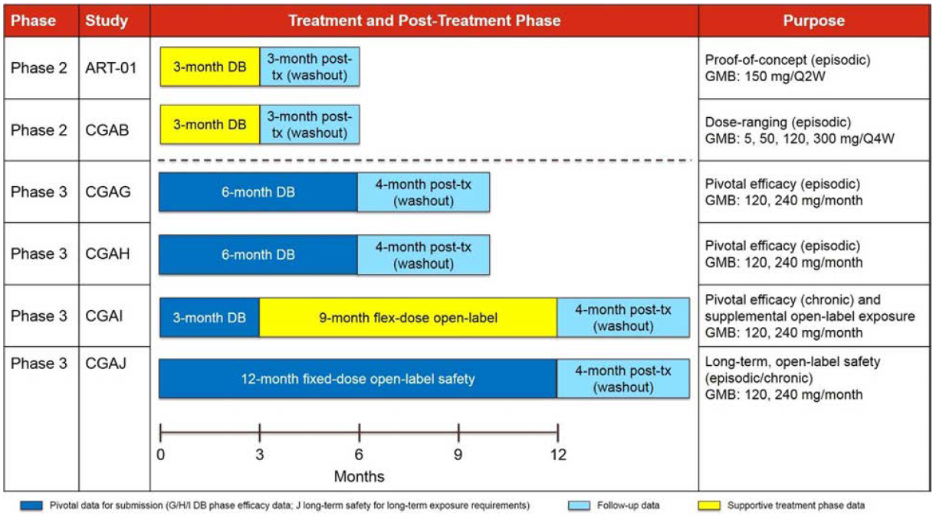

Paediatric data
The submission contains no paediatric data. The proposed indication explicitly refers to use in adults.

Good clinical practice
The submitted studies were conducted in accordance with the principles of Good Clinical Practice (GCP).

Pharmacokinetics

Studies providing pharmacokinetic data
The sponsor listed seven studies that provided PK and PD data, including three Phase III efficacy studies (Studies CGAG, CGAH and CGAI) and one long term safety study (Study CGAJ) and one Phase II efficacy study (Study CGAB), which are described in the Efficacy section of this document. Additionally, two Phase I studies (Studies CGAA and CGAE) with a major emphasis on PK and PD were submitted, which also included two relative bioavailability studies (Studies CGAO and CGAQ).
Table 7: Studies providing PK and PD data
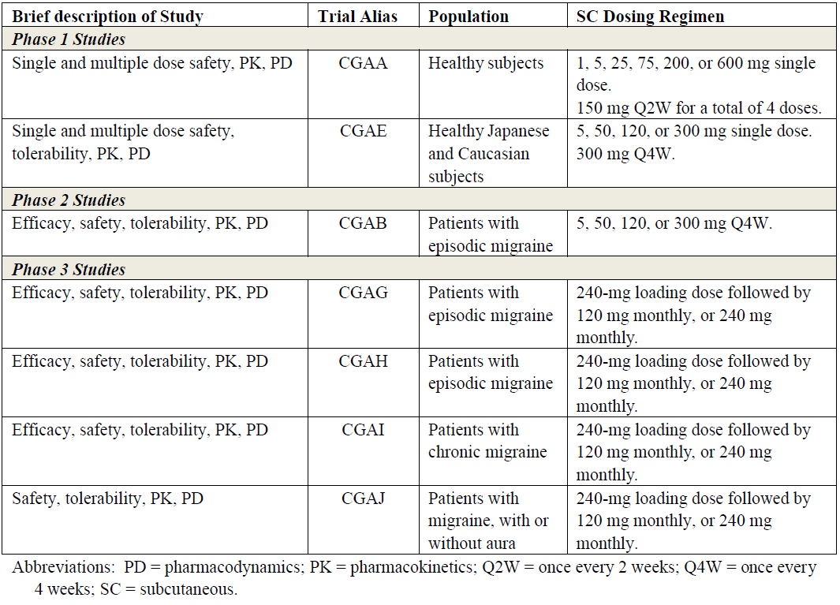
Note: Relative bioavailability Studies CGAO and CGAQ are not included in the table above.
The sponsor also performed a population-PK analysis, based on data from two Phase I studies (Studies CGAE and CGAO), a Phase II study in patients with episodic migraine (Study CGAB), and the pivotal Phase III studies. The open label Phase III Study CGAJ, in patients with episodic and chronic migraine, was used to test the model.

Anti-drug antibodies
Anti-drug antibodies (ADA) are a potential problem with all mAb therapies; they are antibodies that are formed endogenously and that bind with the exogenous, therapeutic monoclonal antibody. Usually, ADA are stimulated by treatment (treatment-emergent anti-drug antibodies (TE ADA)), and in this setting represent an immune response to the exogenous protein, but ADA may also be present prior to exposure, because the subject’s endogenous baseline repertoire of antibodies happens to include some antibodies with an antigen-binding site that matches some feature present on the mAb. By binding with the therapeutic monoclonal antibody and by potentially interfering with the binding of the mAb to its intended target, and potentially stimulating an immune response to therapy, ADA may have impacts on the PK, PD, efficacy and safety of a mAb.
In the case of galcanezumab, ADA were present at baseline in a small proportion of subjects during the pivotal studies (~ 8%), and in more than half of these subjects (~ 5% of all subjects), the antibodies were neutralising antibodies (NAb), which prevented the galcanezumab-ADA complex from binding CGRP in vitro. Table 8 shows the baseline prevalence of ADA and NAb for the two pivotal episodic migraine studies (Studies CGAG and CGAH, pooled), the pivotal chronic migraine study (Study CGAI) and the open-label Phase III study (Study CGAJ).
Table 8: Patients from Studies CGAG, CGAH, CGAI and CGAJ with anti-drug antibodies and neutralising antibodies present at Baseline
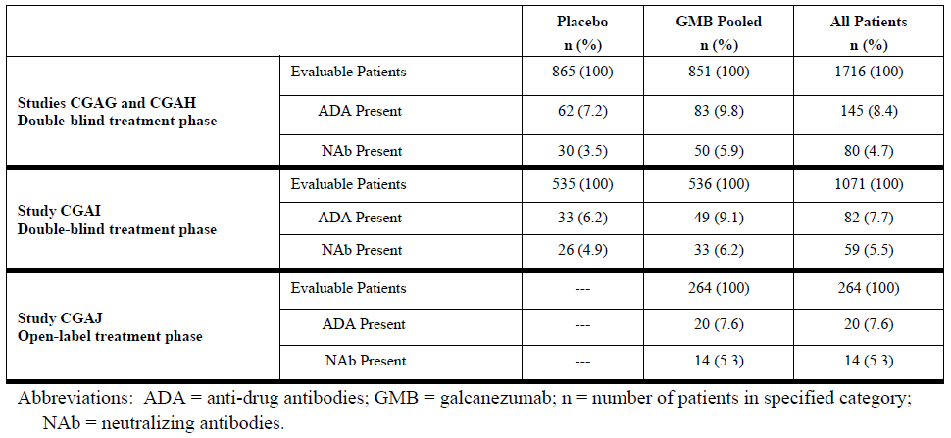
With exposure to 12 months in the open-label Phase III study, CGAJ, the overall incidence of TE ADA was ~ 9.5% (12.5% in the 120mg dose group, 6.6% in the 240 mg dose group). With briefer exposures, the incidence of TE ADA was less.
The effects of ADA are likely to depend strongly on the titre of ADA present. For most subjects in the Phase III galcanezumab study program, baseline and post-baseline ADA titres were low, and < 2% of all evaluable patients developed TE ADA with a titre ≥ 1:320.
ADA did not appear to have any substantial impact on the PK, PD or efficacy of galcanezumab. There was no definite effect on safety, either, but some weak trends were observed suggesting that TE ADA might be associated with an increased risk of hypersensitivity reactions. (Even if this association were confirmed, this would not necessarily establish a causal relationship, because the development of ADA and the development of hypersensitivity could both arise from an underlying tendency for such patients to exhibit vigorous immune responses).

Evaluator’s conclusions on pharmacokinetics
The PK of galcanezumab have been adequately characterised by the sponsor and closely resemble the PK of other IgG mAbs. Following subcutaneous administration, the PK of galcanezumab are characterised by slow absorption, limited distribution, low clearance, and a long terminal elimination half life (t_{1/2}). The description of galcanezumab PK in the proposed PI is consistent with the submitted studies.

Pharmacodynamics

Studies providing pharmacodynamic data
The studies that provided PK data, also provided some PD data, (Table 7) primarily in the form of CGRP levels. A couple of Phase I studies also studied capsaicin induced dermal blood flow, an effect mediated in part by CGRP. No studies had a primary focus on the actual cerebral mechanisms of migraine, and the basic mechanisms underlying the pharmacological action of galcanezumab in preventing migraine remain unclear.

Evaluator’s conclusions on pharmacodynamics
No direct studies of migraine pathogenesis were submitted, but some indirect measures of galcanezumab PD were assessed in dedicated PK/PD studies, as well as in pivotal efficacy studies.
The administration of galcanezumab attenuates capsaicin induced dermal blood flow, which provides an estimate of its ability to interfere with CGRP mediated processes. This effect appears within days of administration and persists for months. Galcanezumab administration also increases total CGRP levels, reflecting the fact that bound CGRP adopts the PK of the antibody to which it is bound.

Dosage selection for the pivotal studies
The doses selected for the pivotal studies were chosen on the basis of the Study CGAB (the Phase II dose ranging efficacy study that assessed galcanezumab at doses of 5, 50, 120, and 300 mg every 4 weeks) and Study ART-01 (a Phase II study that assessed galcanezumab 150 mg every 2 weeks). Positive results, relative to placebo, were obtained for 120 mg/month in Study CGAB, and for 300 mg/month in Study ART-01 (in two divided fortnightly doses), suggesting that 120 to 300 mg/month was an appropriate dose range for further investigation.
The primary hypothesis of Study CGAB was that at least one dose of galcanezumab (5, 50, 120, or 300 mg every 4 weeks) would be superior to placebo in the prevention of migraine in patients with episodic migraine. Superiority was defined as a posterior probability of ≥ 95% of galcanezumab producing a greater improvement than placebo in the mean change from Baseline in the number of MHD in the last 28 day period (Month 3) of the 12 week treatment phase. By this prospective primary endpoint, only 120 mg proved to be superior to placebo at Month 3, but 300 mg was statistically superior to placebo at Months 1 and 2, and also overall (across Months 1 to 3). The 120 mg dose group showed statistically significant separation from placebo at Month 3 and overall, but not at Month 1 or Month 2. This study therefore suggested that doses of 120 to 300 mg were worth pursuing.
In Study ART-01, galcanezumab 150 mg every 2 weeks demonstrated statistically significant separation from placebo at Months 1, 2, and 3.
The sponsor also assessed the dose response relationship using data from Study CGAB. Increases in concentrations of galcanezumab were associated with a reduction in MHD (see Figure 2, below), and the highest galcanezumab concentration quartile (116 nmol/L to 877 nmol/L) showed the highest reduction in MHD. This concentration range broadly corresponds to drug concentrations achieved following doses of 120 mg and 300 mg given every 4 weeks.
Figure 2: Relationship of median change from Baseline in MHD and galcanezumab concentration in Study CGAB
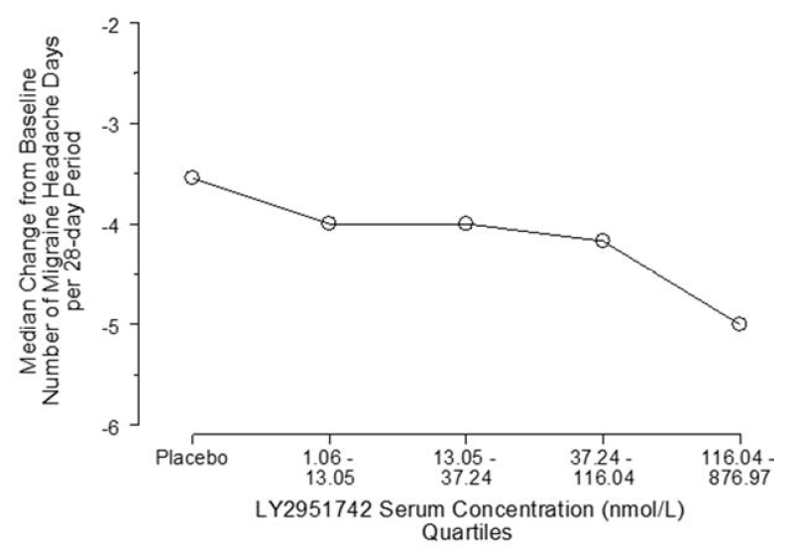
LY2951742 = galcanezumab
A pharmacodynamic model relating galcanezumab concentrations to reductions in MHD was developed, and simulations of the predicted dose effect relationship of galcanezumab across various dose regimens supported further investigation of 120 mg/month and 240 mg/month (see Figure 3, below). The sponsor’s simulations suggested that lower doses, such as 50 mg/month, would have inadequate efficacy, and higher doses, such as 300 mg/month, would not provide greater efficacy than intermediate doses (120 mg/month or 240 mg/month). The long half-life of galcanezumab, similar to the proposed dose interval, means that a loading dose of 240 mg followed by monthly doses of 120 mg essentially achieves steady state during the first dose interval, so this regimen was compared to 240 mg/month in all three of the pivotal studies.
Figure 3: Model-based prediction of the effect of galcanezumab on reduction of MHD
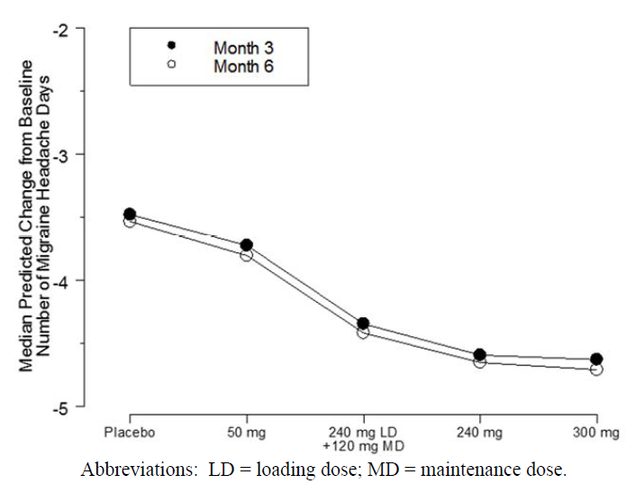
Overall, the Phase II data supported the sponsor’s choice of doses for the pivotal studies, and suggested that doses of 50 mg/month or less would be inadequate, and that doses of 300 mg/month or more offered no substantial benefits over 240 mg/month. As discussed below, the subsequent results of the Phase III study program confirmed that efficacy at 120 mg/month is very similar to 240 mg/month, so that doses higher than 120 mg/month are not likely to offer increased benefits.

Efficacy

Studies providing efficacy data
The 6 studies providing efficacy data are summarised in Table 6 above. Three of the studies were randomised, double blind, placebo controlled Phase III studies employing the proposed dose and were designated as pivotal: Studies CGAG and CGAH assessing ’episodic‘ migraine (characterised by < 15 MHD per month), and Study CGAI assessing ’chronic‘ migraine (characterised by ≥15 headaches per month at least 8 of which are migraine).⁸ Note that, in the usual sense of the word ‘chronic’, virtually all subjects with episodic migraine had a chronic problem with migraine.
The other three efficacy studies should be considered supportive: Study ART-01 and Study CGAB were Phase II studies, and Study CGAJ was a Phase III open label study.

Evaluator’s conclusions on efficacy
The sponsor has performed three pivotal studies, with two performed in episodic migraine (< 15 MHD per month at Baseline) and one performed in ‘chronic’ migraine (≥ 15 headaches per month at least 8 of which are migraine at Baseline). All three studies compared galcanezumab 120 mg/month (with a 240 mg loading dose) and 240 mg/month with placebo, and all three studies demonstrated an attributable reduction in MHD of about 2 days. The results appeared robust, with positive and consistent findings across a range of secondary endpoints, including response rates and quality of life measures.
The Phase II study program was limited, but dose ranging Study CGAB suggested that doses of 50 mg/month or less were inadequate, and a dose of 300 mg/month was no more effective than 120 mg/month. Study ART-01 showed efficacy at 300 mg month (150 mg every two weeks).

Safety

Known safety issues with galcanezumab and other agents affecting CGRP
As a new chemical entity, galcanezumab is not known to be associated with any substantial safety issues.
The recently registered anti CGRP agent, erenumab, has a safety profile that appears to be broadly acceptable, with no major safety warnings, although the safety of erenumab (like galcanezumab) has not been assessed in the setting of pregnancy, lactation, or advanced age.
Small molecule agents affecting the CGRP receptor have had some safety issues, but it is unclear whether these were due to blockade of CGRP effects.
’Among the first CGRP receptor antagonists under trial, intravenous olcegepant caused mild to moderate adverse events such as paresthesia, nausea, headache, dry mouth and unspecific vision disturbances in a minority of patients. However, more serious adverse events were reported with telcagepant and MK-3207, which caused liver toxicity with transient increase of transaminases in a small group of included subjects (n = 13 for telcagepant) upon repeated doses. This lead to discontinuation of the trial program for these molecules. Other non-peptide CGRP receptor antagonists such as BI44370TA, BMS-927711, and, most recently, MK-1602 have also been tested. For all three molecules adverse events were mild to moderate and the incidence was low and similar to the placebo group. No liver toxicity was reported for these drugs, and the gepant program is thus still ongoing.’
Expression of CGRP receptors are widespread in the body, which suggests modification of CGRP function could have effects on systems unrelated to migraine.²⁷
According to the sponsor, preclinical studies of galcanezumab raised no specific concerns.

Studies providing safety data
The sponsor’s submission is primarily based on six clinical migraine studies (four Phase III studies and two Phase II studies) and four Phase I studies in healthy volunteers.
The post treatment monitoring phases (washout) of all four Phase III studies were ongoing at the time of submission, as was the open label phase of the pivotal Phase III Study, CGAI, but the blinded phase of treatment was complete for all six migraine studies, allowing comparison of galcanezumab with placebo.
The sponsor’s safety database did not include data from a number of ongoing, blinded galcanezumab studies, including:
- Three cluster headache studies
  - Study I5Q-MC-CGAL (CGAL)
  - Study I5Q-MC-CGAM (CGAM)
  - Study I5Q-MC-CGAR (CGAR)
- Two ongoing migraine studies in Japan
  - Study I5Q-JE-CGAN (CGAN)
  - Study I5Q-JE-CGAP (CGAP)
For these studies, the sponsor provided blinded listings of deaths, serious adverse events (SAE), and discontinuations due to adverse events (AE), potentially significant cardiovascular treatment emergent adverse events (TEAE), hepatic TEAEs, and cases of alanine aminotransferase/aspartate aminotransferase (ALT/AST) levels reaching ≥ 3 times the upper limit of normal (ULN). Because of the blinded nature of this data, it is of very limited utility, but it raised no significant concerns. The sponsor’s submission also includes a study of galcanezumab in osteoarthritic knee pain (Study I5Q-MC-CGAF (CGAF)), which was stopped because of perceived futility. For Study CGAF, the sponsor provided narratives for deaths, SAEs, and discontinuations due to AEs. These narratives raised no substantial concerns.
To assess the safety of galcanezumab, the sponsor constructed five main analysis sets and three supplementary analysis sets from their database, but the main analysis set of interest is the Integrated Analysis Set A (primary placebo controlled analysis set, derived from the blinded phase of the three pivotal studies). Results in this analysis set were very similar to those in Integrated Analysis Set B (placebo controlled Phase II and Phase III analysis set, derived from all six clinical migraine studies). Only the Integrated Analysis Set A assessed galcanezumab at the proposed dose, and had an appropriate control to provide context to event rates, and so results in this analysis set represent the main focus of the safety assessment in the clinical dossier. Where relevant, the clinical dossier will also discuss data from Analysis Set E, which included data from all galcanezumab treated patients (placebo data were not included), regardless of dose, from all Phase II and Phase III migraine prevention studies (Studies ART-01, CGAB, CGAG, CGAH, CGAI, and CGAJ). Safety in the four studies in healthy volunteers is discussed in the individual study synopses, and raised no significant concerns.
Table 9: Clinical migraine studies contributing safety data
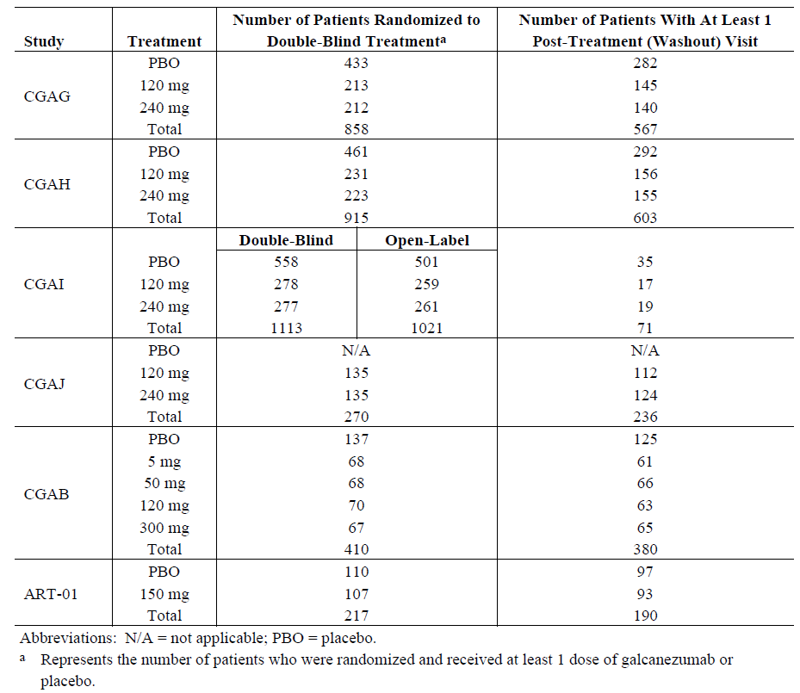

Patient exposure
Patient exposure to galcanezumab within the six clinical migraine studies is summarised in the tables below. A total of 3,156 patients were exposed to galcanezumab at any dose across the entire galcanezumab development program, and 801 subjects were exposed to placebo. Within the proposed dose range of 120 to 240 mg, a total of 1,647 patients were exposed to galcanezumab for ≥ 6 months (≥ 6 monthly doses), and 279 patients were exposed to galcanezumab for 1 year (12 monthly doses). This exposure satisfies relevant guidance.21
Table 10: Total exposure to galcanezumab
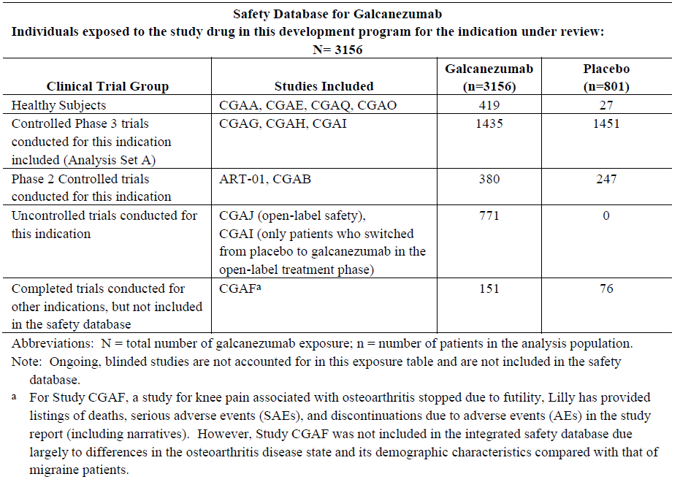
Double blind placebo controlled exposure within pivotal studies is summarised in Table 11. A total of 1,435 subjects received galcanezumab (120 mg, n = 705, 240 mg, n = 730), and 1,451 subjects received placebo, with median exposures of 169 days and > 530 patient years in both the pooled active group and the placebo group. The demographics of this core safety population in Integrated Analysis Set A are summarised in Table 12, and total exposure including uncontrolled exposure is summarised in Table 13.
Table 11: Blinded exposure in pivotal placebo controlled studies
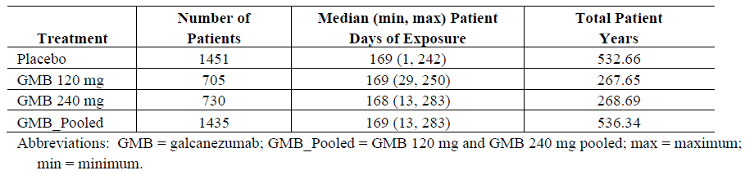
Table 12: Baseline patient demographics, Analysis Set A (Studies CGAG, CGAH and CGAI)
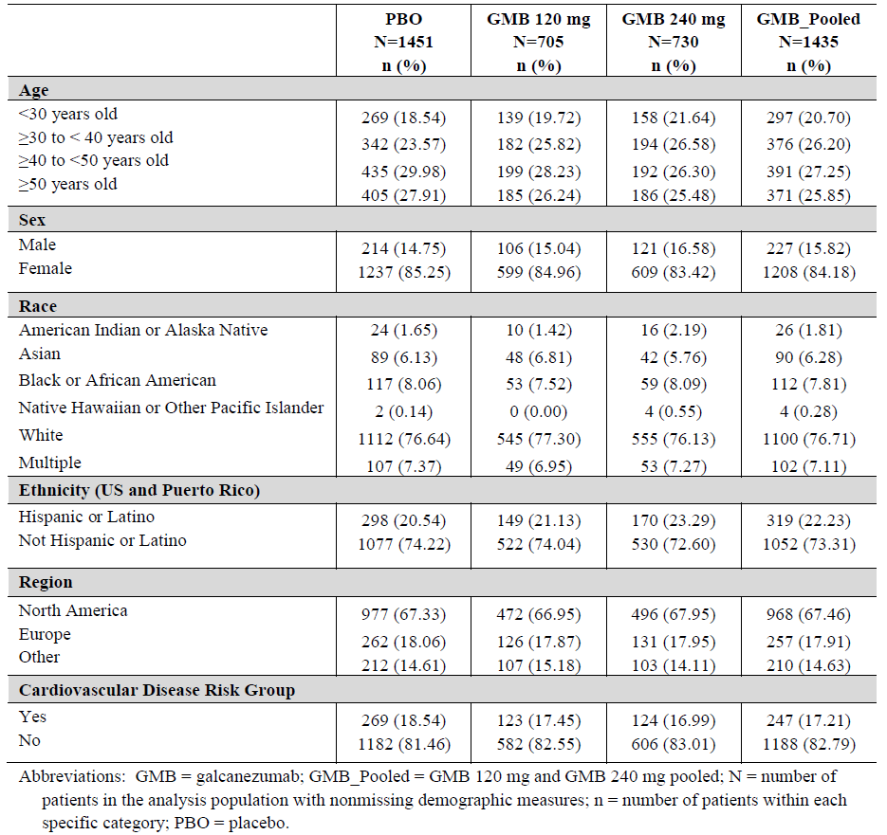
Table 13: Total exposure to galcanezumab by dose and duration of exposure
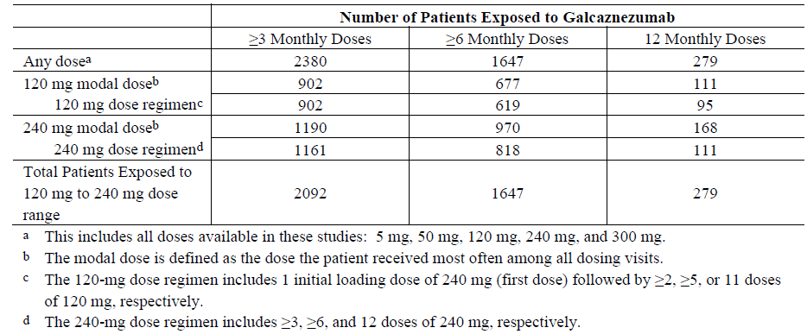

Safety issues with the potential for major regulatory impact

Liver function and liver toxicity
The sponsor used a variety of approaches to assess the safety data for potential evidence of liver toxicity. In the pooled safety analysis set from the pivotal studies (Analysis Set A), the number of patients with elevated ALT, AST or bilirubin at various threshold levels above normal was compared for each treatment group, and very few differences were found. There was, however, an excess number of galcanezumab recipients with ALT ≥ 5 times the ULN, and this was statistically significant (without correction for multiplicity of comparisons). There were four such subjects, compared to no placebo recipients. In two of these cases, abnormal liver function tests had also been present at Baseline (see Table 14). In all four cases, the abnormal LFTs either resolved, or nearly resolved: in one case, eight days after the high ALT level, ALT was still abnormal, but it was between 1 to 2 times ULN and AST was in the normal range; in the other three cases, ALT returned to normal. In one of the cases, the abnormal LFTs led to discontinuation.
For other comparisons, based on AST, bilirubin, or other threshold changes in ALT, no significant between group differences were identified.
Table 14: Patients with ALT ≥ 3 times ULN and AST ≥ 3 times ULN by treatment group, Analysis Set A (Studies CGAG, CGAH and CGAI)
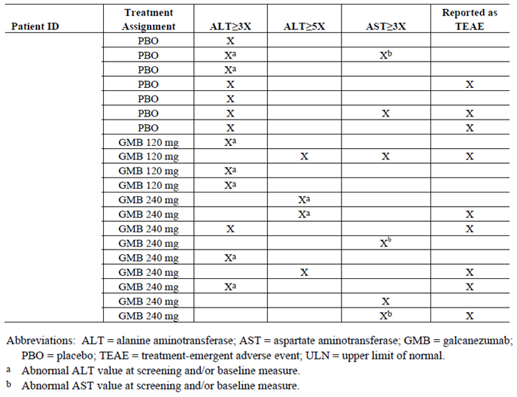

Table 15: TEAEs related to hepatic safety Analysis Set A (Studies CGAG, CGAH and CGAI)
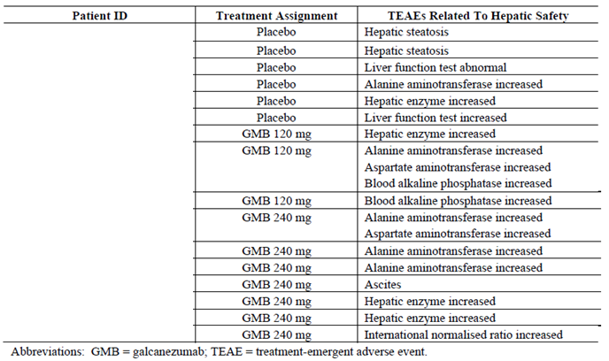
In the pooled galcanezumab group, compared to the placebo group, there was a mild excess of TEAEs related to hepatic enzymes or potentially related to liver dysfunction, as shown in Table 15 (galcanezumab 10 subjects, placebo 6 subjects). Across the entire dataset, including non-placebo-controlled exposure, there were another 16 more galcanezumab treated patients who had TEAEs related to hepatic lab values while on galcanezumab treatment, and another 3 who had hepatic TEAEs during post treatment washout. A review of the patient narratives raised no specific concerns, and in most cases alternative potential explanations for abnormal LFTs were present.
Most hepatic related AEs were mild in severity, and no hepatic SAEs were identified by systematic searches of the safety database. One patient, who received galcanezumab 240 mg, had ascites and hepatic cysts as symptoms of the SAE of acute pancreatitis, but no patient had an SAE related to hepatic laboratory values or hepatic safety during the double blind treatment phase of Studies CGAG, CGAH, and CGAI.
Two patients, both of whom received galcanezumab 240 mg, discontinued because of elevated hepatic enzymes.
At no stage did any subjects across the entire migraine study population satisfy Hy’s law. The distribution of maximum bilirubin values and maximum ALT values was similar for recipients of galcanezumab and placebo (Figure 4).
Figure 4: eDISH (Evaluation of drug-induced serious hepatotoxicity)-like plot maximum total bilirubin versus maximum ALT; safety population from Studies ART-01, CGAB, CGAG, CGAH, CGAI and CGAJ, all study phases
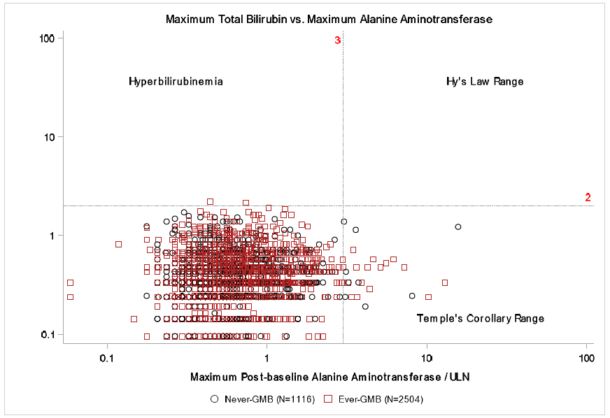
Overall, considering all of the submitted evidence, there is no clear signal of potential hepatotoxicity for galcanezumab.

Renal function and renal toxicity
Laboratory monitoring of urea and creatinine and urinalysis showed no concerning safety signals. There were significantly more patients in the galcanezumab 120 mg dose group (0.3%) who had treatment emergent low blood urea nitrogen (BUN) values compared to placebo (0.0%, p = 045), but there were no significant differences in patients with treatment emergent high BUN values.
In the pooled pivotal studies, TEAEs coded under the System Organ Class (SOC) as ’Renal and urinary disorders” occurred in a similar proportion of galcanezumab recipients and placebo recipients: placebo 20 out of 1451 (1.38%), galcanezumab 120 mg 10 out of 705 (1.42%), galcanezumab 240 mg 10 out of 735 (1.37%), pooled galcanezumab 20 out of 1435 (1.39%).
Overall, there is no evidence that galcanezumab produces renal toxicity.

Other clinical chemistry
As noted above, laboratory monitoring did not raise any other substantial concerns related to clinical chemistry.

Haematology and haematological toxicity
There was no evidence in the submitted data of clinically significant shifts in mean haematological indices, or in an excess number of shifts to abnormal in individual laboratory parameters. TEAEs related to haematological parameters were rare, and appeared to be randomly distributed among treatment groups.

Other laboratory tests
No additional concerns were raised by other laboratory tests.

Electrocardiograph findings and cardiovascular safety
In theory, agents affecting CGRP could have cardiovascular side effects. CGRP is a microvascular vasodilator and it is hypothesized to play a protective role in cardiovascular health,4 so interfering with CGRP could have haemodynamic consequences. Also, cardiovascular events including cerebrovascular and coronary events have been reported to be increased in the migraine population, though it is unclear whether CGRP plays any role in this increased risk.,,,
These points are acknowledged in the sponsor’s Risk Management Plan (RMP):
‘[…] nonclinical studies suggest that CGRP plays an important role in facilitating vasodilatation to various stimuli including acute ischaemia 4 and the target population is at higher risk of ischaemic cardiovascular outcomes.’
The pivotal studies excluded subjects with recent cardiovascular events, so it remains unclear whether such subjects would respond to galcanezumab with an increased incidence of ischaemic events. Given that cardiovascular disease may take years to become manifest and to progress, the relatively short duration of exposure in the clinical studies (up to 12 months) means that the long term cardiovascular risks of galcanezumab have not been adequately characterised.
Despite these concerns, there is no signal from the available safety data showing an increased cardiovascular risk in galcanezumab, compared to placebo.
Considering TEAEs coded to the cardiovascular organ class, the sponsor searched the database for AEs potentially related to any of the following 9 categories:
- Cardiac arrhythmias
- Cardiac failure
- Cardiomyopathy
- CNS vascular disorders
- Embolic and thrombotic events
- Hypertension
- Ischaemic heart disease
- Pulmonary hypertension
- Torsade de pointes/QT prolongation
The sponsor searched the safety database using Standardised Medical Dictionary for Regulatory Activities Queries (SMQs). Searches were conducted with both narrow and broad search terms related to the conditions of interest. No significant differences were observed between galcanezumab and placebo recipients for 8 of these 9 disease categories. For terms broadly related to pulmonary hypertension, however, 2 patients in the galcanezumab 120 mg dose group reported terms potentially indicative of pulmonary hypertension (both reported dyspnoea), compared to none in placebo, leading to a nominally significant difference for that dose group (p = 0.042). One patient in the galcanezumab 240 mg dose group also reported exertional dyspnoea, but the 240 mg dose group was not significantly different from placebo, and neither was the pooled galcanezumab group. A review of the patient narratives showed that the dyspnoea was transient, or had alternative explanations, such as pre-existing asthma. Given that dyspnoea is a non-specific symptom, only three patients reported it, no patients were actually diagnosed with pulmonary hypertension, and no dose trend was observed, this is unlikely to be of clinical significance.
For TEAEs directly coded to the cardiac category, there was no increase in event rates in galcanezumab recipients: cardiac TEAEs occurred in 11 out of 1451 placebo recipients (0.76%) 2 out of 705 subjects receiving galcanezumab 120 mg (0.28%), 9 out of 735 subjects receiving 240 mg (1.23%), and 11 out of 1435 subjects receiving either dose of galcanezumab (0.77%).
For SAEs that were cardiac in nature, the overall incidence during placebo controlled treatment was the same in recipients of placebo and galcanezumab (3 out of 1451 (0.21%) versus 3 out of 1435 (0.21%), respectively), as shown in Table 16.
Table 16: Serious adverse events likely cardiovascular in nature, by decreasing percentage in galcanezumab pooled group, safety population, Analysis Set A (Studies CGAG CGAH, and CGAI), double blind treatment phase
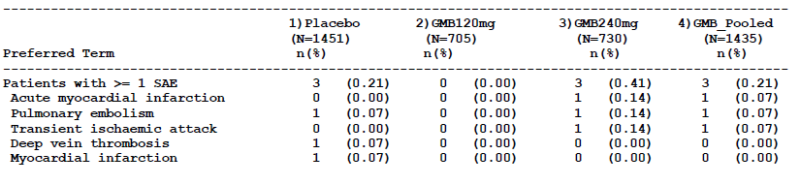
GMB = galcanezumab
When the analysis was extended to include all galcanezumab treatment, including minor studies, two additional SAEs of a cardiac nature were identified, but the overall incidence across all doses (0.19%) was similar to what had been observed in the main analysis set (0.21%). All of the SAEs occurred with the 240 mg dose group, which was the dose group with the most number of patients. Overall, there was no dose trend for cardiac SAEs, and a review of patient narratives did not raise specific concerns.
Table 17: Serious adverse events likely cardiovascular in nature by decreasing percentage in the complete galcanezumab treated population, Analysis Set E (Studies ART-01, CGAB, CGAG, CGAH, CGAI and CGAJ), galcanezumab treated time and post treatment phase
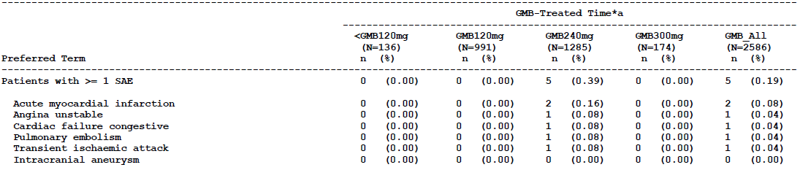
GMB = galcanezumab
The sponsor performed extensive analyses of electrocardiographic (ECG) parameters, including heart rate, PR interval, QRS intervals, and QT interval (including QT corrected by Fridericia’s method (QTcF)). The sponsor assessed several analysis sets, including the placebo controlled data from the pivotal studies, as well as the overall safety database. The ECG parameters were assessed in terms of changes from Baseline in the means for each treatment group, and the incidence of potentially clinically significant individual abnormalities. No concerning safety signals were noted.
In the pooled pivotal studies, a similar proportion of galcanezumab recipients and placebo recipients had treatment emergent changes in heart rate, PR interval, and corrected QT interval. No patients met criteria for shortened QRS interval; however, there were significantly more galcanezumab recipients (n = 8; 0.6%) who met the criteria for prolonged QRS (≥ 120 ms), compared to placebo (n = 1, 0.18%). Six of these 8 galcanezumab treated patients had a pre-existing condition of a complete or incomplete bundle branch block at study entry, and 5 of them already had a QRS ≥ 120 ms prior to dosing.
A review of QTcF values in the pooled pivotal studies showed that a higher proportion of placebo recipients had QTcF values > 450 ms, compared to galcanezumab recipients. One placebo recipient but no galcanezumab recipients had a QTcF value of > 480 ms, and no patient had QTcF > 500 ms.
In the complete database of all galcanezumab recipients, including those outside pivotal studies, a few more cases of abnormal ECG results were identified, but no consistent pattern or concerning safety signals emerged.
In conclusion, there is no evidence in the sponsor’s submission that galcanezumab is associated with significant cardiovascular toxicity, but this represents a risk that is not yet fully characterised, particularly with regard to long term use and use in the elderly.

Vital signs and clinical examination findings
The sponsor performed a comparison of galcanezumab and placebo recipients for changes in the mean values of vital signs, and the incidence of individual shifts to abnormal. No concerning safety signals were detected, and there was no evidence that galcanezumab was associated with any consistent haemodynamic effects.

Immunogenicity and immunological events
Exogenous therapeutic proteins, including mAbs, have been associated with hypersensitivity reactions, and for some mAbs the reactions have been severe and have included cases of anaphylaxis. Potentially, galcanezumab could also increase the risk of anaphylaxis, though this was not observed in the study program and hypersensitivity events appeared to be infrequent.
The sponsor’s summary of clinical safety makes the following comments about hypersensitivity:
‘Hypersensitivity events occurred more frequently in patients treated with galcanezumab than with placebo. When considering all galcanezumab treated patients during all treatment phases, the frequency of hypersensitivity events was comparable to the frequencies observed during the double blind treatment phase. Most events were non serious, mild or moderate in severity, and did not lead to discontinuation of galcanezumab. There were no confirmed cases of anaphylaxis associated with the administration of galcanezumab. Although urticaria was uncommonly reported, 2 serious cases of urticaria have been reported in galcanezumab treated patients, and an additional 2 non serious cases occurred on the same day of galcanezumab administration.’
To assess the risk of hypersensitivity reactions with galcanezumab, the sponsor searched the safety database for all TEAEs that potentially reflected hypersensitivity. The evaluation of hypersensitivity included 3 SMQs: Anaphylactic Reactions; Angioedema; and Hypersensitivity, using both narrow and broad search terms. The results are shown in Table 18, for the primary, placebo controlled studies (Analysis Set A).
Table 18: Potential hypersensitivity events: all events before medical review, Analysis Set A (Studies CGAG, CGAH, and CGAI), double blind treatment phase
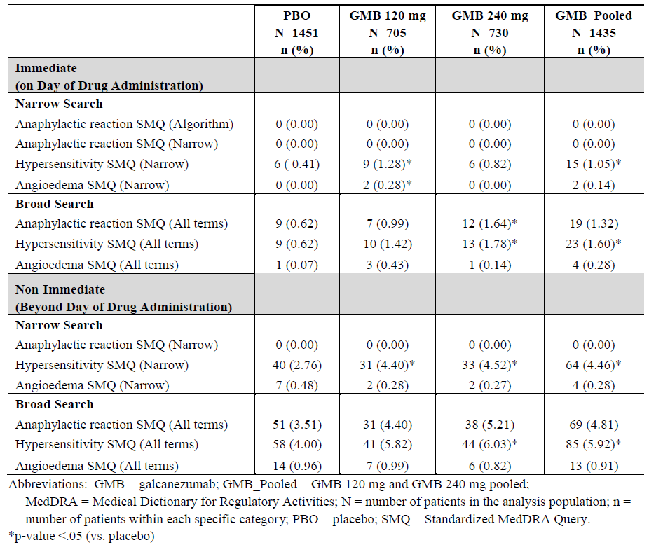
As shown in Table 18, the SMQ for Hypersensitivity on the day of administration showed a higher incidence in galcanezumab recipients (1.05%) than placebo recipients (0.41%), and the difference was statistically significant (p < 0.05). The difference in the incidence of Hypersensitivity related TEAEs was also significant when non immediate events were included and/or broad search terms were used. For the other two SMQs (Anaphylactic reaction and Angioedema), no statistically significant differences were noted between treatments, but there was an overall excess of events with galcanezumab for all three SMQs on the day of administration.
No cases of anaphylactic reaction were identified using narrow search terms. The most frequent TEAE in the narrow Hypersensitivity SMQ analysis was ‘injection site rash’, and the only individual TEAE in this SMQ showing a statistically significant difference compared to placebo was ‘urticaria’, in two patients reporting hives (the same two cases were also flagged in the narrow Angioedema SMQ, and occurred on the day of injection). Both patient narratives associated with hives showed that the patients had a recurrent tendency to develop hives at the time of injections, strongly implying a causal relationship. For one of the patients, the hives resolved even though the patient continued to receive treatment; the other patient discontinued. Both were rated as ‘non-serious’, but two cases of urticaria that occurred outside Analysis Set A, during open label treatment, were rated as ‘serious’.
Overall, this analysis suggested that galcanezumab causes occasional hypersensitivity reactions, though the frequency and severity of such reactions both appeared to be low. Among the 197 galcanezumab treated patients with migraine who reported hypersensitivity events, 96.9% of these reported mild or moderate events (191 out of 197), and the remaining 6 patients reported a severe hypersensitivity event (pruritus, rash, hypersensitivity, and urticaria). The sponsor estimated that galcanezumab treated patients experienced severe hypersensitivity reactions at an incidence of 0.2%, and the incidence of serious hypersensitivity events was 0.08% (2 cases of urticaria). The relatively limited exposure to galcanezumab so far means that infrequent but more severe reactions to galcanezumab (such as anaphylaxis) might not have been observed in the study program, despite there being an ongoing risk of such reactions in a larger population of exposed subjects. Also, the fact that patients with a history of hypersensitivity to mAbs or therapeutic proteins were excluded from the clinical development program could have led the sponsor’s safety analysis to underestimate this risk.
Subjects with previous anaphylactic reactions to mAbs should avoid galcanezumab, or they should at least have their first dose of galcanezumab under medical supervision.
To clarify the potential role of ADA in the development of hyper sensitivity reactions, the sponsor also grouped hypersensitivity related TEAEs according to whether subjects had treatment emergent ADA (TE ADA) or not, based on all subjects who received galcanezumab at any dose in a Phase III study, and excluding subjects on placebo.
According to SMQ searches conducted with narrow search terms, no subjects had an anaphylactic reaction, 13 subjects had TEAEs consistent with angioedema, and 128 subjects had TEAEs consistent with hypersensitivity. The presence of TE ADA did not appear to modify the risk substantially, with all of the potential angioedema cases occurring in ADA negative subjects, and a similar incidence of potential hypersensitivity reactions in ADA positive and ADA negative subjects.
When broad search terms were included, the number of potentially relevant TEAEs increased, and the presence of TE ADA was associated with a weak trend (p = 0.066) showing a greater risk, in TE ADA positive subjects, of events potentially suggestive of an anaphylactic reaction (see Table 19). This difference became nominally significant when post treatment events were included in the analysis (see Table 20), albeit without correction for multiplicity of comparisons. Underlying this nominally significant result, the only individual term that was increased in the search for potential anaphylactic reactions was asthma, which was reported in 2 treatment emergent TE ADA positive patients (one of whom had a documented pre-existing history of asthma) and in 4 patients without TE ADA.
Overall, these results do not strongly suggest that the presence of TE ADA increases the risk of anaphylactic reactions or angioedema, but the increased incidence of hypersensitivity events in TE ADA positive patients compared to TE ADA negative patients is sufficient to warrant further monitoring. Even if an association between TE ADA and hypersensitivity were established, it should be noted that this does not necessarily imply a causal relationship: underlying immune factors in the subject could increase their propensity for both ADA and hypersensitivity, given that these are both related to inappropriate immune activation.
No treatment emergent ADA positive patient in Studies CGAG, CGAH, CGAI, or CGAJ had an SAE related to hypersensitivity.
The sponsor’s summary of clinical safety acknowledges that hypersensitivity is a potential issue with galcanezumab, even though the frequency and severity of hypersensitivity events was generally low. The proposed PI sheet includes the following warning under ‘Special Warnings And Precautions For Use’:
Serious hypersensitivity
Serious cases of urticaria have been reported in Emgality clinical studies. If a serious hypersensitivity reaction occurs, discontinue Emgality immediately and initiate appropriate therapy. Serious hypersensitivity reactions could occur days after administration and may be prolonged.
This warning seems broadly appropriate, but additional comments should be added in relation to subjects who have previously had anaphylactic reactions to mAbs. The PI also lists urticaria and pruritus as drug reactions, which is also appropriate.
Table 19: Treatment emergent likely hypersensitivity events by TE ADA status using TE ADA status, galcanezumab treated population, Studies CGAG, CGAH, CGAI and CGAJ, galcanezumab treated time
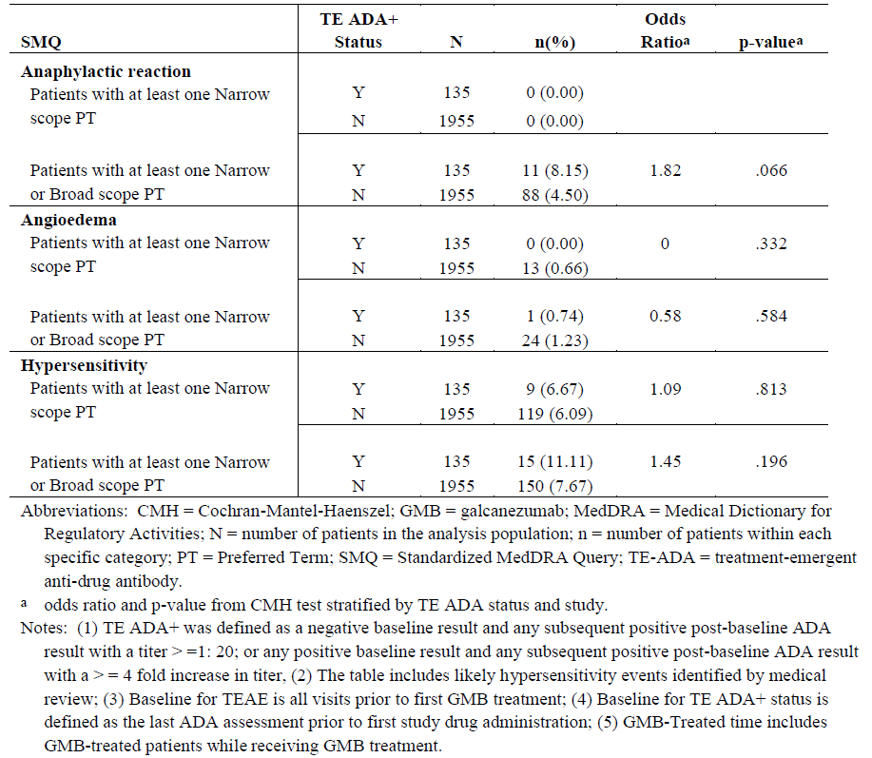
Table 20: Treatment emergent likely hypersensitivity events by TE ADA status, galcanezumab treated population, Studies CGAG, CGAH, CGAI and CGAJ, galcanezumab treated time and post treatment phase
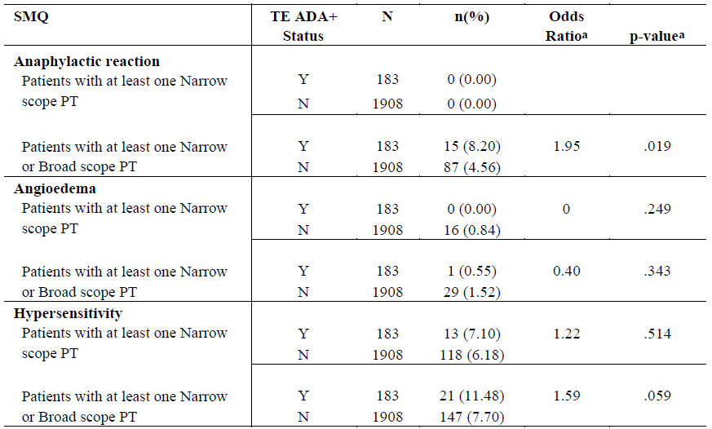

Serious skin reactions
In the pivotal studies, pruritus and urticaria were observed more frequently with galcanezumab than with placebo, as previously discussed. TEAEs related to the ‘Skin and subcutaneous tissue disorders’ SOC were reported significantly more commonly in the galcanezumab pooled group (5.6%) than in the placebo group (4.1%). The most frequent TEAEs in this SOC were rash and pruritus. Within this SOC, the TEAEs that showed a significantly higher frequency in any dose group compared to placebo were ‘pruritus’, ‘dermatitis allergic’, ‘pruritus generalized’ and ‘rash pruritic’.
Galcanezumab was also associated with a clear excess of local injection site reactions, which were not included in the ‘Skin and subcutaneous tissue disorders’ SOC.
In a couple of cases, urticaria (hives) was rated as serious, but no SAEs were reported in relation to skin reactions. The PI carries appropriate warnings about the potential for skin reactions, listing urticaria and pruritus as drug reactions.

Post marketing data
Galcanezumab is a new agent, so the submission did not include any post marketing surveillance data.

Evaluator’s conclusions on safety
The safety of galcanezumab, as characterised in the sponsor’s study program, appears acceptable. Galcanezumab has a number of tolerability issues, including injection site reactions, vertigo, and constipation, but these symptoms may be acceptable for patients who find the drug reduces the number of days of migraine. Galcanezumab is also associated with an increased risk of hypersensitivity reactions, including urticaria and pruritus, though the known cases of hypersensitivity, so far, have been without serious sequelae.
Galcanezumab is not known to pose any major safety risks, but its safety has not yet been fully characterised. As noted by the sponsor in the RMP, infrequent adverse events could have been missed in the study program: ‘The size of the galcanezumab exposed patient populations in migraine clinical trials (n = 2586) means that detection of adverse events with a 95% level of certainty is limited to those which occur at a frequency of greater than 1 in 862 patients (0.12%).’ Similarly, the long term safety (beyond 12 months) of galcanezumab has not been characterised. The safety of galcanezumab in subjects < 18 years or > 65 years, and in pregnancy and lactation has not been characterised.
Potentially, like other mAbs, galcanezumab could cause anaphylaxis in some individuals.
There are theoretical concerns suggesting that interfering with CGRP could modify processes relevant to protection against ischaemia, increasing the risk of cardiovascular events. No evidence of this emerged in the submitted studies, but subjects with a strong history of cardiovascular events were excluded.
Galcanezumab use is associated with the development of ADA. At the time of submission, there is no clear evidence that these are clinically relevant to the safety of galcanezumab, but the issue is worthy of further monitoring.
The safety of galcanezumab in combination with other agents affecting CGRP is uncharacterised.

First round benefit-risk assessment

First round assessment of benefits
Table 21 summarises the assessment of benefits of Emgality galcanezumab for the proposed indication at the first round of evaluation.
Table 21: First round assessment of benefits
Benefits | Strengths and Uncertainties
- Galcanezumab, administered at the recommended dose, is associated with an attributable reduction of ~ 2 MHD per month, relative to placebo, for at least six months. | Strengths  - A strength of the efficacy data is that a consistent effect was observed in three well designed and adequately controlled pivotal studies, with robust and highly significant results that were broadly consistent across all three studies. Also, key secondary endpoints and several additional secondary endpoints supported the primary endpoint.  - Another strength of the efficacy data is that a benefit was seen in subjects who had failed previous prophylactic therapy.  Weaknesses  - A weakness of the efficacy data is that the size of the clinical effect was modest, with the attributable reduction of ~ 2 MHD being smaller than the placebo response, and representing only a small proportion of the baseline number of MHD.  - Another weakness is that the submission contained no efficacy data in comparison to an active control therapy.

First round assessment of risks
Table 22 summarises the assessment of risks of Emgality galcanezumab for the proposed indication at the first round of evaluation.
Table 22: First round assessment of risks
Risks | Strengths and Uncertainties
- Galcanezumab is commonly associated with injection site reactions.  - Galcanezumab is associated with an increased risk of hypersensitivity reactions, including urticaria and pruritus, as well as a theoretical risk of anaphylaxis.  - Galcanezumab may cause vertigo.  - Galcanezumab is associated with an increased incidence of constipation.  - Galcanezumab use is associated with the development of ADA (though there is no clear evidence that these are clinically relevant.)  - The safety of galcanezumab in pregnancy and lactation has not been characterised.  - The long term safety (beyond 12 months) of galcanezumab has not been characterised.  - The role of CGRP in cardiovascular health is unclear, and galcanezumab could in theory increase the risk of cardiovascular events, though no evidence of this emerged in the submitted studies.  - The safety of galcanezumab in subjects < 18 years or > 65 years has not been assessed. | Strengths  - The safety data from pivotal studies, in comparison to placebo, suggests that galcanezumab is mostly well tolerated, with only a mild excess of adverse events in the galcanezumab group relative to placebo.  - The sponsor appears to have searched the safety database conscientiously to characterise the risks of hypersensitivity reactions and cardiovascular events; no concerning signals emerged from this analysis.  Weaknesses  - The biological role of CGRP is not well understood, so the long term consequences of modifying CGRP remain unclear.  - The safety database lacks information about subjects outside the 18 to 65 year age group, and subjects with recent cardiovascular events were excluded from the major studies, so safety in the most vulnerable population remains uncharacterised.  - The safety of galcanezumab in combination with other agents affecting CGRP is uncharacterised.  - The proposed PI contains only modest warnings against use in pregnancy and lactation. Given that migraine is not a life threatening condition, and that the efficacy benefits of galcanezumab were modest, stronger warnings could be appropriate.

First round assessment of benefit-risk balance
The benefit-risk balance of galcanezumab, in the proposed usage, is likely to be positive in the majority of subjects with significant and troubling migraine. Although the size of the clinical effect was modest, many patients could regard the gain of two migraine free days per month as a worthwhile benefit. Furthermore, the mean improvement of 2 MHD is not necessarily spread uniformly; some subjects might be expected to experience even greater benefit, and these are the subjects most likely to continue treatment.
The risks are potentially greater in older subjects and in those with previous hypersensitivity reactions to mAbs. The risks are poorly characterised in subjects with underlying cardiovascular disease, but there are currently no concerning safety signals suggesting an increased number of cardiovascular adverse events or increased risk in subjects with concurrent cardiovascular disease. The risks are poorly characterised for use in pregnancy, and galcanezumab should be avoided in this setting. The risks are also poorly characterised during lactation.

First round recommendation regarding authorisation
Galcanezumab should be approved for the proposed indication.
The proposed PI should be edited along the lines suggested within this report.
Ongoing pharmacovigilance activities should focus on clarifying: the risks of hypersensitivity reactions; safety during pregnancy; safety during long term use; the risk of cardiovascular effects; and the influence of ADA.

Clinical questions and second round evaluation
The second round clinical evaluation report includes the sponsor’s responses to clinical questions posed in the first round evaluation, the evaluator’s assessment of those responses, and the above erratum for the first round evaluation. It also includes a brief reassessment of the benefit-risk balance for galcanezumab, and revised evaluator comments on the product documentation.
The main conclusions and recommendations of second round clinical evaluation report do not differ substantially from those in first round evaluation report.

Question 1
At the time of submission to the TGA, applications to register galcanezumab were under evaluation in the EU, USA, Singapore and Switzerland. Please provide a summary of any significant efficacy or safety issues identified during those evaluations, and indicate whether the drug has been accepted or rejected by any of those regulatory bodies while the Australian evaluation process has been underway.

Sponsor’s response
(Please also see ‘Regulatory Status’ above in Section I)
The sponsor notes that the FDA approved galcanezumab without identifying any substantial efficacy or safety issues. According to the sponsor, the FDA considered the theoretical risk of impaired vasodilator responses in galcanezumab recipients, with subsequent increased risk of ischaemia, but the FDA approved galcanezumab without special labelling and without mandating specific post marketing studies.
The European Committee for Medicinal Products for Human Use (CHMP) raised two major objections during the registration process, but subsequently approved galcanezumab. (Information redacted)

Evaluation of response
This is an adequate response to the question. The interactions between the sponsor, the FDA and the CHMP touch on three issues:
- Efficacy of galcanezumab in subjects with < 4 migraines per month.
- Efficacy of galcanezumab in subjects > 65 years.
- The theoretical potential for aggravation of ischaemic events.
The clinical evaluator agrees with the CHMP that galcanezumab should not be used in subjects with a baseline migraine frequency of < 4 migraines per month, because efficacy has not been directly demonstrated in this population, and the potential benefit is low. As noted in the sponsor’s response, summarised above, the percent change in migraine frequency achieved with galcanezumab is similar across the range of baseline migraine frequencies, so the total number of migraine days prevented in subjects with a low baseline migraine frequency is also expected to be low. Furthermore, the mechanisms of migraine may be different in subjects with infrequent migraine, so it is unknown whether galcanezumab would have substantial efficacy in subjects with 1 to 3 migraine days per month.
The EU Summary of Product Characteristics (SmPC) covers this issue by describing the indication as follows:
‘Emgality is indicated for the prophylaxis of migraine in adults who have at least 4 migraine days per month.’
One question to consider is whether the inappropriateness of using galcanezumab in subjects with infrequent migraine (< 4 MHD per month) needs to be made explicit in the indication for galcanezumab. Three main factors suggest that it is neither necessary nor appropriate to modify the PI to mention this restriction explicitly:
- In general, migraine prophylaxis is not recommended in this population anyway, and most neurologists reserve migraine prophylaxis for subjects with at least 4 migraines per month.
- Other agents in this class have been approved without such a restriction and, for consistency the indication for galcanezumab should be the same as for agents such as erenumab.
- The description of the pivotal studies in the PI clearly indicates that efficacy was assessed in subjects with at least 4 migraines per month, strongly implying that this is the target population.
On balance, the evaluator would have preferred that all agents in this class had an indication similar to the EU SmPC, limiting use to subjects with at least 4 migraine days per month, but now that other agents have been approved without such a restriction, it is not appropriate to modify the PI for galcanezumab alone.
The evaluator accepts that efficacy in subjects over 65 years of age is likely to be acceptable, provided that the diagnosis of migraine is correct (other causes of headache are more prevalent in older subjects). Like the CHMP, the evaluator does not propose any absolute restriction in this age group.
Like the FDA and CHMP, the evaluator has ongoing concerns that agents targeting CGRP or its receptor might increase the risk of ischaemic events. This theoretical risk should be mentioned in the PI, and it should be a focus of post marketing risk management. The results of the PASS study should be submitted when these are available. The currently proposed version of the PI does not include a suitable warning about this potential risk; the PI should be modified to include a warning, using similar or identical wording to the EU SmPC.

Question 2
Apart from the indirect evidence provided by the efficacy studies themselves, is there any evidence confirming that galcanezumab reaches significant concentrations in the brain, or at sites relevant to the pathogenesis of migraine?

Sponsor’s response
The sponsor has not generated any data in humans regarding the distribution of galcanezumab in brain, or at sites relevant to the pathogenesis of migraine. However, in rats we have quantified the concentrations of galcanezumab in brain and in sites outside the blood-brain barrier with possible relevance to the pathogenesis of migraine, including the dura mater and trigeminal ganglion. Concentrations of galcanezumab in the dura mater and trigeminal ganglia were approximately 11% and 5% of plasma concentrations, respectively. Concentrations of galcanezumab in brain and CNS, including hypothalamus, prefrontal cortex, cerebellum, spinal cord, and cerebrospinal fluid were 0.1% to 0.3% of plasma concentrations. Although concentrations of galcanezumab in brain and CNS are low relative to plasma, a central site of action cannot be ruled out.

Evaluation of response
This is an adequate response. It remains unclear whether galcanezumab achieves significant concentrations at migraine effector sites, and its precise mechanism of action remains uncertain, but this is also true of other agents in this class. The efficacy studies demonstrate that, despite probable poor penetration into the CNS, galcanezumab nonetheless produces a modest anti-migraine effect.

Question 3
What is the extent of intra individual variability in the PK of galcanezumab?

Sponsor’s response
Intra individual variability was not specifically estimated in the population PK analysis. However residual variability, which includes but is not limited to intra subject variability, was estimated. The residual variability was moderately low at 22%, suggesting that intra individual variability is likely to be low to moderate.
In addition, to evaluate sufficiently intra individual variability in the PK model and to differentiate it from residual error, multiple PK blood draws per patient at each visit across multiple visits are required. This sampling design approach was not employed in Phase II and Phase III studies, because additional patient and site burden would have been incurred with a more complex PK sampling design.

Evaluation of response
This is an adequate response. The sponsor’s conclusions about the extent of intra individual variability do not differ from the evaluators. The sponsor’s comments have been incorporated into the PK section of the second round clinical evaluation report.

Question 4
Please provide a list of AEs or TEAEs thought by investigators to be potentially causally related to treatment.

Sponsor’s response
The sponsor has provided Table 23, which has also been incorporated into the Safety section of the clinical dossier. The sponsor also commented as follows.
Overall, the frequency of these 18 TEAEs that occurred at ≥ 2% in galcanezumab treated patients attributed to study treatment were balanced between patients receiving placebo and galcanezumab. For the majority of TEAEs identified, the percentage of patients with events attributed to study drug by investigators is substantially lower than the overall percentage of patients that reported the event. The 4 event terms (highlighted in grey shading in Table 23) that capture AEs related to injection sites are the primary exception, with study investigators consistently attributing AEs to treatment for these terms and in at a higher percentage in the galcanezumab pooled dose group compared to placebo. Of note, these AEs related to injection sites have already been identified as adverse drug reactions.
Table 23: Common treatment emergent adverse events reported ≥ 2% among galcanezumab treated patients, Analysis Set A
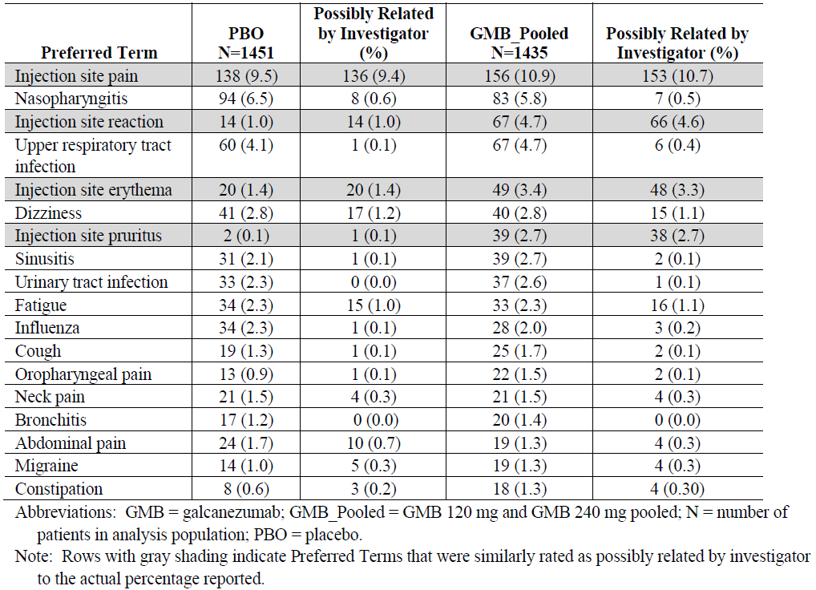

Evaluation of response
This is an adequate response. Most of the common events indicated as having a possible causal relation to treatment occurred with a similar frequency in recipients of galcanezumab and placebo. The four exceptions, highlighted in grey above, were already identified by the sponsor as adverse drug reactions, and all relate to the injection site. This extra data raises no new safety concerns.

Question 5
Please discuss the likely safety of combination therapy with galcanezumab and other agents affecting CGRP, such as erenumab.

Sponsor’s response
The sponsor begins the response with the following comments:
‘There are no clinical studies at present which combine galcanezumab and other agents targeting CGRP, such as erenumab. Therefore, any discussion regarding the safety of combining these agents in the absence of direct data is speculative. However as discussed below, it would not be expected that the safety of the combination would lead to a safety profile different from the individual mAb established profile.’
The sponsor then explains why it is unlikely that such agents would have any PK interactions; these arguments are accepted.
The sponsor also argues that it is unlikely that such agents would be subject to PD interactions, focussing on the combination of galcanezumab and erenumab. Basically, the sponsor proposes that, in the presence of galcanezumab, so little free, unbound CGRP exists that blockade of CGRP receptors by erenumab would be unlikely to produce any further effect. “Overall, given that a majority of CGRP is expected to be bound by galcanezumab and erenumab data suggests saturable CGRP receptor blockade, the degree to which CGRP can be affected by co-administration appears minimal. However, the relationship between CGRP biological activity and safety is currently unknown.” This argument appears theoretically plausible, but the safety and efficacy of such combinations are unknown, so it would be prudent to avoid such combinations. Furthermore, if the agents are not expected to produce any pharmacodynamic synergism, then combining them is also unlikely to produce additional benefit over use of a single agent.
Finally, the sponsor argues that ADA generated in response to one agent are unlikely to cross react with another agent in this class; these arguments are accepted.

Evaluation of response
The sponsor’s response is adequate. The clinical evaluator nonetheless recommends that the PI specifically advises against combining agents from this therapeutic class. There is a low but undefined risk of the combination producing unforeseen synergism compromising safety. From the sponsor’s own comments, and from first principles, there is a very high chance that the combination will fail to produce any useful therapeutic synergism.

Second round benefit-risk assessment
The benefit-risk assessment is unchanged after an evaluation of the sponsor’s response to the first round clinical evaluation report.

VI. Pharmacovigilance findings

Risk management plan

Summary of RMP evaluation
- In support of the application, the sponsor has submitted EU-RMP version 0.1 dated 23 October 2017 (data lock point (DLP) 12 May 2017) and ASA version 0.1 dated 24 April 2018. An updated EU-RMP version 1.0; dated 11 September 2018; DLP 12 May 2017 with ASA version 2.0; dated 4 December 2018, have been submitted with the response to the TGA request for information.
- The proposed summary of safety concerns and their associated risk monitoring and mitigation strategies are summarised in Table 24.
Table 24: Summary of safety concerns with associated pharmacovigilance and risk minimisation strategies
Summary of safety concerns |  | Pharmacovigilance |  | Risk Minimisation
 |  | Routine | Additional | Routine | Additional
Important identified risks | None | – | – | – | –
Important potential risks | Serious hypersensitivity | ² | ³ |  | –
Important potential risks | Serious cardiovascular outcomes in patients at high risk of cardiovascular and cerebrovascular events, including in patients ≥ 65 years¹ | ² | ³ |  | –
Important potential risks | Hypertension during pregnancy and pre-eclampsia | ² | ³
Missing information | Use in pregnancy | ² | ³ |  | –
Missing information | Long term safety including malignancies |  | ³ |  | –
1) Safety concern in Australian specific annex includes reference to patients ≥ 65 years; 2) specific adverse reaction follow-up questionnaires; 3) cohort study using electronic health record data.
- In response to the RMP evaluator’s request the sponsor has included reference to patients 65 years and over in the safety concern regarding serious cardiovascular outcomes, to reflect that the increased risk of ischemia is a safety concern with clinical significance for elderly patients, who also have an increased risk of ischaemia.
- Routine and additional pharmacovigilance activities in the form of overseas studies have been proposed for all the safety concerns. The sponsor has added the US FDA required studies in the ASA as recommended.
- Routine risk minimisation has been proposed for all the risks of serious hypersensitivity and use in pregnancy. The sponsor has agreed to include the CMI in the package insert as recommended.

New and outstanding recommendations from second round evaluation
The recommendations made in the first round evaluation, along with the RMP evaluator’s consideration of the sponsor response, are documented in the RMP evaluation report.
There are no outstanding recommendations for this submission.

Proposed wording for conditions of registration
Any changes to which the sponsor has agreed should be included in a revised RMP and ASA. However, irrespective of whether or not they are included in the currently available version of the RMP document, the agreed changes become part of the risk management system.
The suggested wording is:
The galcanezumab EU-Risk Management Plan (RMP) (version 1.0, dated 11 September 2018, data lock point 12 May 2017), with Australian Specific Annex (version 2.0, dated 4 December 2018), included with submission PM-2018-00780-1-1, and any subsequent revisions, as agreed with the TGA will be implemented in Australia.
The following wording is recommended for the periodic safety update reports (PSUR) requirement:
An obligatory component of risk management plans is routine pharmacovigilance. Routine pharmacovigilance includes the submission of periodic safety update reports (PSURs).
Reports are to be provided in line with the current published list of EU reference dates and frequency of submission of PSURs until the period covered by such reports is not less than three years from the date of this approval letter.
The reports are to at least meet the requirements for PSURs as described in the European Medicines Agency’s Guideline on good pharmacovigilance practices (GVP) Module VII-periodic safety update report (Rev 1), Part VII.B Structures and processes. Note that submission of a PSUR does not constitute an application to vary the registration.
As the sponsor has agreed to include the CMI in the pack, the following wording is recommended for a condition of registration:
The Emgality Consumer Medicine Information must be included in the package.
As Emgality is a new biological entity it should be included in the Black Triangle Scheme as a condition of registration. The following wording is recommended for the condition of registration:
Emgality (galcanezumab) is to be included in the Black Triangle Scheme. The PI and CMI for Emgality must include the black triangle symbol and mandatory accompanying text for five years, which starts from the date that the sponsor notifies the TGA of supply of the product.

VII. Overall conclusion and risk/benefit assessment
The submission was summarised in the following Delegate’s overview and recommendations.

Background

The sponsor has applied to register a new chemical entity, galcanezumab (Emgality). Emgality is proposed to be used for the prophylaxis of migraine in adults.
Galcanezumab is a humanised monoclonal antibody (mAb) that binds to the CGRP ligand, preventing binding to its receptor. During a migraine attack, CGRP levels increase, causing vasodilation and nociceptive signalling and it is hypothesised that inhibiting the binding of CGRP to its receptor will prevent migraine.
Migraine is a common neurological condition, usually manifesting as severe headache, and often accompanied by visual changes, photophobia, phonophobia, nausea, and lethargy. It is sometimes associated with focal neurological deficits such as weakness or numbness, speech disturbance, or vertigo. Typically, migraines cause asymmetrical or unilateral throbbing headaches, with attacks lasting from hours to days. Many patients can identify food or environmental triggers for their migraines and, in some cases, migraines are associated with menstrual cycles, but in many other cases the triggers for individual migraines are obscure. Many people suffer infrequent migraines, with only a few attacks per year, but some subjects experience multiple attacks per month. By convention, using definitions formalised by the International Headache Society, a rate of ≥ 15 headache days at least 8 of which are migraine per month is used to identify subjects with ‘chronic’ migraine, in contrast to those with ‘episodic’ migraine who suffer < 15 migraine headache days per month. Migraines can have major impacts on quality of life and mood, especially if they occur frequently. Migraine is also a major cause of absenteeism from work.
There are several TGA approved drugs (beta-blockers, calcium channel blockers, some anticonvulsants and pizotifen) for the prophylaxis of migraine. All of them are associated with significant tolerability issues.
One drug in this class (monoclonal antibody) was approved last year for the preventive treatment of migraine: erenumab. Galcanezumab binds to the CGRP ligand, whereas erenumab binds to the CGRP receptor.
The most important guideline used in the evaluation of this submission is the EMA document: Guideline on Clinical Investigation of Medicinal Products for the Treatment of Migraine; dated January 2007.19

Quality
There are no objections on the quality grounds to the approval of galcanezumab (Emgality).
Batch Release Testing and Compliance with Certified Product Details (CPD)
- It is a condition of registration that all batches of Emgality (Galcanezumab) imported into/manufactured in Australia must comply with the product details and specifications approved during evaluation and detailed in the Certified Product Details (CPD).
- It is a condition of registration that each batch of Emgality (Galcanezumab) imported into/manufactured in Australia is not released for sale until samples and/or the manufacturer’s release data have been assessed and endorsed for release by the TGA Laboratories Branch. Outcomes of laboratory testing are published biannually in the TGA Database of Laboratory Testing Results.
- The sponsor should be prepared to provide product samples, reference materials and documentary evidence as defined by the TGA Laboratories branch. The sponsor must contact Biochemistry.Testing@health.gov.au for specific material requirements related to the batch release testing/assessment of the product. More information at TGA testing of biological medicines.
There are minor GMP issues that must be addressed before this application can be approved. The TGA GMP clearances for the some manufacturers should be renewed/approved prior to approval of the product.2

Nonclinical
- The submitted nonclinical data was in general accordance with the ICH guideline on the nonclinical evaluation of the biotechnology-derived pharmaceuticals.2 All pivotal repeat dose toxicity and reproductive toxicity studies were GLP compliant.
- Primary pharmacology studies provided sufficient evidence of galcanezumab affinity and selectivity for human, monkey and rat CGRP.
- While galcanezumab was shown to inhibit capsaicin-induced increases in dermal blood flow in rats and cynomolgus monkeys, no comment can be made from a nonclinical perspective regarding efficacy for the proposed indication, as there is no validated animal model for migraine.
- Treatment-related effects associated with weekly injection were minimal and limited to injection site reactions.
- Pregnancy Category B16 is considered appropriate.
- Overall, there are no nonclinical objections to the registration of galcanezumab (Emgality).
- The draft PI should be amended as directed.

Clinical

Pharmacology

Pharmacokinetics (PK)
Following subcutaneous administration, galcanezumab PK properties are characterised by slow absorption, limited distribution, low clearance, and a long terminal elimination t_{1/2} similar to other mAbs. Potential sites of injection include the abdomen, arm, thigh, and buttocks. Absorption from these sites was found to be similar. In Study CGAQ, maximum concentrations of galcanezumab are reached after 1 to 2 weeks: in the Phase I study and T_{max} was between 7 and 14 days in the 1 to 600 mg dose range. The Delegate agrees with the clinical evaluator that as the efficacy studies showed similar efficacy for galcanezumab at doses of 120 mg or 240 mg per month, and that renal and hepatic insufficiency and drug interactions are not expected to play a significant role in determining the PK of galcanezumab, the uncertainty in the subcutaneous bioavailability does not appear to be clinically important.
The PK of multi dose galcanezumab inferred from population PK modelling appears to be consistent with its single dose PK. The apparent volume of distribution of galcanezumab was 7.3 L (34% inter individual variability), based on population PK analyses.
Galcanezumab, being a mAb, is expected to be eliminated by degradation into small peptides and amino acids via catabolic pathways. Based on a population PK analysis, the apparent clearance of galcanezumab was approximately 0.00785 L/hour and the half-life of galcanezumab was about 27 days.
A lyophilised formulation was developed first and was used in the Phase I and Phase II studies, including a knee pain study (Study CGAF) and two Phase III cluster headache studies (Studies CGAL and CGAM). The final commercial solution formulation was used in the Phase III migraine studies (including the 3 pivotal studies, Studies CGAG, CGAH and CHAI), a cluster headache study (Study CGAR) and the two relative bioavailability studies (Studies CGAO and CGAQ). The prefilled syringe was used in all pivotal Phase III studies, and the auto injector was used in the open label Phase III Study CGAJ. The tolerability, PK, and PD of the original lyophilised formulation were demonstrated to be very similar to those of the solution formulation.

Special populations
Based on a population PK analysis, bilirubin concentration or creatinine clearance did not significantly influence the apparent clearance of galcanezumab. Similarly, age did not emerge as a significant covariate in the population PK analysis, across a range of 18 to 65 years.
Overall, PK of galcanezumab have been adequately characterised by the sponsor and closely resemble the PK of other IgG mAbs.

Pharmacodynamics (PD)
The drug clearly targets the neuropeptide CGRP, but the precise role of this peptide remains somewhat unclear, both under normal physiological conditions and during migraine. The sponsor’s PD study of galcanezumab has largely been limited to assessing capsaicin induced dermal blood flow, and monitoring the elevation of plasma CGRP. To the extent that the chronic delayed clearance of CGRP from plasma reflects the overall binding of galcanezumab to its target, elevated plasma CGRP levels provide an indirect, surrogate marker for the proposed mopping up effect in the brain.

Dose selection
Overall, the Phase II data supported the sponsor’s choice of doses for the pivotal studies, and suggested that doses of 50 mg/month or less would be inadequate, and that doses of 300 mg/month or more offered no substantial benefits over 240 mg/month. As discussed below, the subsequent results of the Phase III study program confirmed that efficacy at 120 mg/month is very similar to 240 mg/month, so that doses higher than 120 mg/month are not likely to offer increased benefits.

Efficacy

Overview of efficacy studies
The sponsor conducted three pivotal placebo controlled efficacy trials as depicted above in Table 6.
- Two trials in episodic migraine: Study CGAG and Study CGAH.
- One trial in chronic migraine: Study CGAI.
The primary endpoint for the three pivotal efficacy trials was the mean change from Baseline in the monthly average number of MHD. The primary endpoints, as well as the key secondary endpoints were identical for all three studies, but the timing of evaluation of endpoints was different (6 month in episodic migraine trials and 3 month in chronic migraine trial).

Episodic migraine (Studies CGAG and CGAH)
Studies CGAG and CGAH were randomised, double blind, placebo controlled trials in patients with episodic migraine, and both had the same design. Subjects eligible for enrolment were adults 18 to 65 years of age with a history of migraine with or without aura for ≥ 12 months, and who experienced ≥ 4 to < 15 MHD per month. Subjects on other preventive treatments for migraine and subjects with medication overuse headache (defined as headaches occurring ≥ 15 days per month associated with regular use of acute headache medications) were excluded. Subjects were also excluded if they had ECGs showing abnormalities compatible with acute cardiovascular events, a serious cardiovascular risk, or had a history of myocardial infarction, unstable angina, percutaneous coronary intervention, coronary artery bypass grafting, stroke, deep vein thrombosis, or pulmonary embolism within 6 months of screening. Patients were also excluded if they had a planned cardiovascular surgery or percutaneous coronary angioplasty.
After a one month baseline period, eligible patients were randomized in a 2:1:1 ratio to receive placebo, galcanezumab 120 mg SC monthly with a 240 mg initial loading dose, or galcanezumab 240 mg SC monthly for 6 months. After participation in the double blind portion of the trial, patients were offered enrolment into either a 12 month open label (fixed dose) safety study, or a 4 month safety follow up period.

Study endpoints
The primary endpoint for Studies CGAG and CGAH was the mean change from Baseline in the monthly average number of MHD.
Key secondary endpoints in Studies CGAG and CGAH were:
- Change from Baseline in monthly average MHD.
- Proportion of patients with ≥ 50% reduction from Baseline in monthly MHD.
- Proportion of patients with ≥ 75% reduction from Baseline in monthly MHD.
- Mean change from Baseline in monthly MHD with acute migraine medication taken.
- Change from Baseline in the Role Function-Restrictive domain scores of the MSQ.
- Proportion of patients with 100% reduction from Baseline in monthly MHD.
- Mean change from Baseline in the Patient Global Impression-Improvement (PGI-S) score.
Table 25: Demographics and disease characteristics, intention to treat population, Studies CGAG, CGAH and CGAI
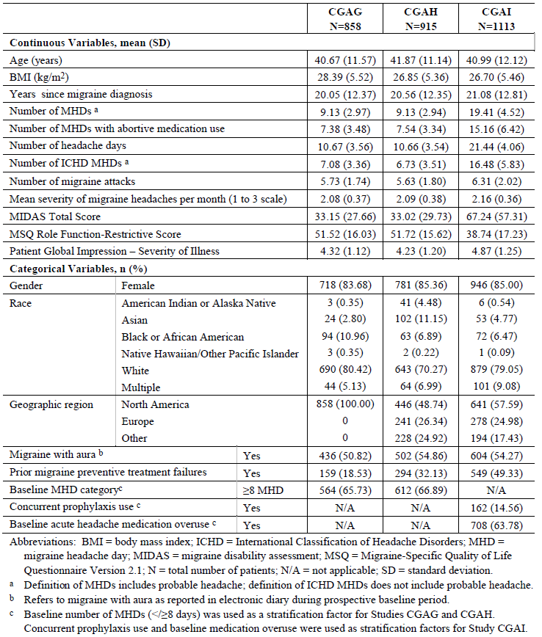
Baseline demographic and disease characteristics (see Table 25) were broadly similar across all the treatment groups. Both studies assessed a population with relatively severe migraine problems which most likely will be the user of this medication.
Completion rates for the double blind treatment phase across both episodic migraine studies ranged from 81 to 88% which seems reasonable for migraine studies. Studies were not associated with withdrawal bias as withdrawals were broadly balanced between the three treatment groups. Overall, the numbers of protocol deviations were acceptable.

Results
Both studies were positive for their primary endpoint, change in MHD. After adjustments for multiplicity, both doses of galcanezumab (120 mg/month and 240 mg/month) were significantly superior to placebo in both studies, with a greater reduction in MHD seen with either active treatment than with placebo (Figure 5).
Figure 5: Mean change from Baseline in the number of MHD by month for the double blind treatment period of Studies CGAG (left) and CGAH (right)
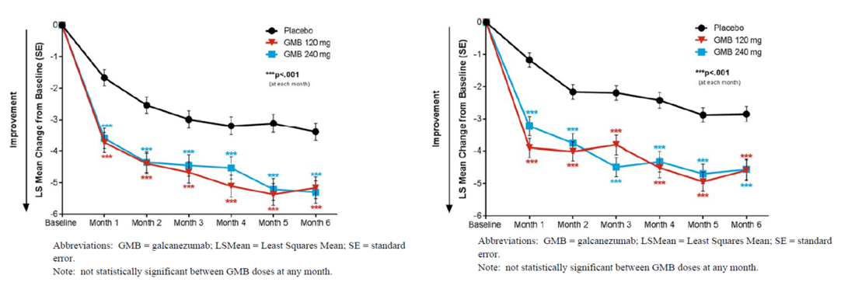
There doesn’t seem to be any major dose trend in both studies, as low dose group only showing minor numerical superiority over the high dose group for most time points.
The Delegate is uncertain about the argument on the placebo response been influenced by psychological response and natural fluctuations in migraine frequency and severity. If that is true it should impact all the arms as it is un-blinded study. However, the Delegate agrees the change of two days might make a difference in patients with 4 to 14 MHD per month (halving to one seventh reduction).
Secondary endpoints showed similar trend of superiority of galcanezumab over placebo in both pivotal episodic migraine studies, including response rates, patient global impressions, and quality of life instruments.
The first of the key secondary endpoints, 50% response rate, was achieved by 36 to 39% of placebo recipients, across the two studies, compared to 57 to 61% of galcanezumab recipients (including both dose groups of each study). Results were broadly consistent across the two studies and across doses, with no consistent dose trend. The significance of the comparison with placebo was associated with a nominal p value of < 0.001 for each of the four active groups, but these values have not been directly adjusted for multiplicity (instead, the significance threshold was lowered to 0.025). It would be expected that, of about 4 or 5 patients treated with galcanezumab, one would have a 50% reduction in MHD that was attributable to active treatment (derived through attributable response rate analysis).
Figure 6: 50% response rate (percentage of patients with ≥ 50% reduction from Baseline in MHD) by month for Studies CGAG (left) and CGAH (right)
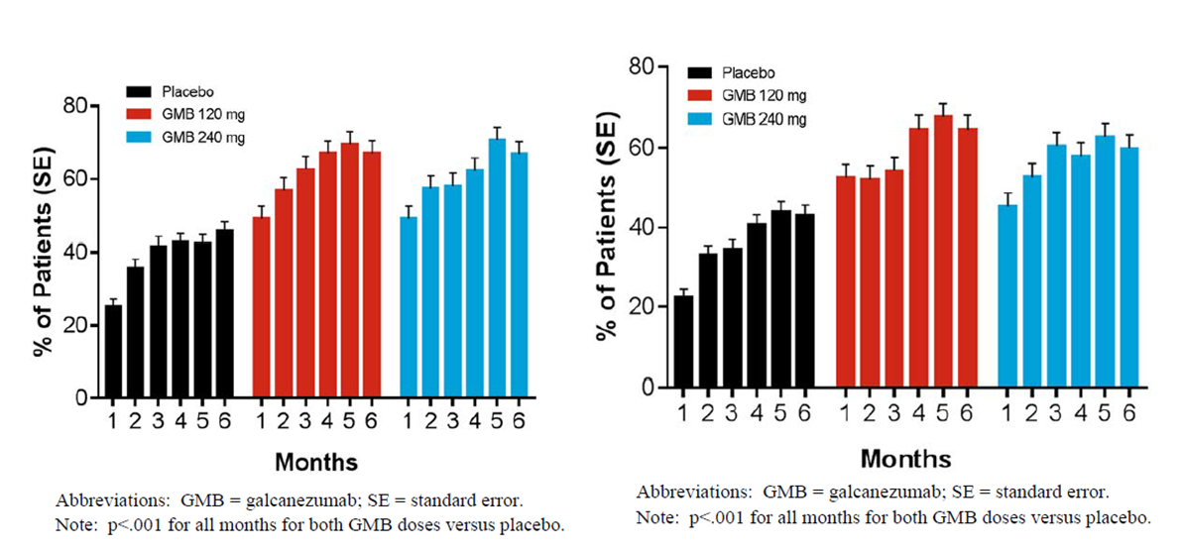
Response rates for 75% and 100% reductions in MHD were lower than the 50% response rate in all groups, as expected, but still demonstrated superiority of active treatment, with broadly similar odds ratios as observed with the 50% response rate. Across all active groups, 12 to 16% of subjects achieved a 100% reduction in MHD, whereas this was only observed in 6% of placebo recipients.
The number of MHD with acute medication use was also significantly reduced with active treatment. The difference compared to placebo was 1.61 to 1.82 days across the four active dose groups, and all comparisons with placebo were significant (p < 0.001).
Table 26: Mean change from Baseline in monthly MHD with acute medication use during double blind treatment period (Studies CGAG and CGAH)
Treatment arms | LS Mean Change from Baseline in Monthly MHD
Treatment arms | Study CGAG  Months 1 to 6 | Study CGAH  Months 1 to 6
Placebo | -2.15 | -1.85
120 mg galcanezumab | -3.96*** | -3.67***
240 mg galcanezumab | -3.76*** | -3.63***
***p < 0.001 compared to placebo
The change from Baseline in MSQ Role Function-Restrictive (assessed over the final 3 months) was positive in all treatment groups across the two studies, including placebo groups, but the improvement was greater in all active groups, with no apparent dose trend.

Pooled analysis of Studies CGAG and CGAH
Pooling of the two studies increased the statistical power of the comparisons with placebo, and provided an overall estimate of the treatment effect averaged across the two studies, but did not change conclusions drawn from considering each study individually.
Figure 7: Change from Baseline in the number of MHD by month for the double blind treatment periods of Studies CGAG and CGAH (Episodic Integrated Analysis Set)
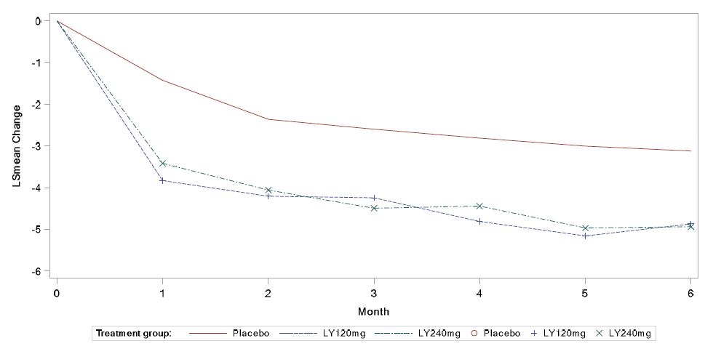
Pooled dataset was also used to compare efficacy in pre-defined subgroups but did not raise any substantial concerns about poor efficacy in any identifiable subgroup.

Chronic migraine (Study CGAI)
Study CGAI was a multicentre, randomised, double blind, placebo controlled design to compare the efficacy of galcanezumab at two different doses (120 mg/month with a 240 mg loading dose, or 240 mg/month) with placebo, in the prevention of chronic migraine. The study was conducted in 12 countries: Argentina, Canada, Czech Republic, Germany, Israel, Italy, Mexico, Netherlands, Spain, Taiwan, UK, and US.
It shared many design features with the two pivotal studies in episodic migraine, including the main efficacy variables, the primary and secondary endpoints, and the statistical approach. The primary efficacy variable was the change in the number of MHD per month similar to episodic migraine studies, over the entire double blind treatment period, compared to a prospective baseline period of 30 to 40 days.
Study CGAI differed from the episodic migraine studies in its duration, with only 3 months of double blind treatment, and in its entry criteria, in that subjects required 15 or more MHD per month at Baseline to be eligible (consistent with a diagnosis of chronic rather than episodic migraine). The double blind treatment phase was followed by a 9 month open label phase, during which former placebo recipients and all previous galcanezumab recipients received monthly galcanezumab at variable doses (240 mg for the first dose, 120 mg for the second dose, and either dose for subsequent cycles). This phase produced additional long term safety data, but it provides only weak supportive evidence for efficacy, given its open label nature and the lack of a control group.
After a one month baseline period, eligible subjects were randomized in a 1:1:1 ratio to placebo, galcanezumab 120 mg SC monthly with an initial 240 mg bolus, or galcanezumab 240 mg SC once monthly. After participation in the double blind portion of the trial, patients were offered enrolment in a 9 month open label (flexible dose) safety study (Study CGAJ) or a 4 month safety follow up period (off study medication). During the flexible dose portion of the open label safety study, investigators could select a monthly dose of 120 mg or 240 mg at their discretion, but all patients received the 240 mg bolus as the initial dose.

Study endpoints
The primary endpoint and key secondary endpoints were identical to those in the episodic migraine trials, except that evaluations for this trial were done over the 3 month double blind treatment period, rather than over the 6 month double blind treatment period of the episodic migraine trials.
Key endpoints in the chronic migraine trial were as follows:
- Change from Baseline in monthly average MHD.
- The proportion of patients with ≥ 50% reduction from Baseline in monthly MHD.
- The proportion of patients with ≥ 75% reduction from Baseline in monthly MHD.
- The mean change from Baseline in monthly MHD with acute migraine medication taken.
- The mean change from Baseline in the Role Function-Restrictive domain scores of the MSQ.
- The mean change from Baseline in the PGI-S score.
- The proportion of patients with 100% reduction from Baseline in monthly MHD.
The pre specified multiple testing procedure for controlling type 1 error was slightly different in the chronic migraine study than in the episodic migraine studies.
A total of 1,113 randomised patients received at least one dose of study drug and were included in the intention to treat population, including 558 patients who received placebo, 278 patients who received galcanezumab 120 mg, and 277 patients who received galcanezumab 240 mg. There was no excess of adverse events in the active groups; combined with the overall high completion rate, this makes it relatively unlikely that the study suffered from withdrawal bias as rightly pointed out by clinical evaluator. Overall, 18.2% of subjects had a violation the sponsor classified as ‘important’, but only in 7 cases did this lead to withdrawal from the double blind treatment phase.
Similar to episodic migraine studies, baseline demographics and disease characteristics were broadly matching between the treatment groups with a similar number of MHD, headache days and migraine attacks at Baseline, and a similar proportion of patients using concurrent migraine prophylaxis. None of differences seems to have likely biased the study in favour of active treatment.

Results
Study CGAI was a positive study, achieving a statistically significant treatment effect for its primary efficacy endpoint for both active doses, relative to placebo. The mean reductions in MHD across the 3 months of double blind treatment were -2.74 for placebo, -4.83 for galcanezumab 120 mg and -4.62 for galcanezumab 240 mg. The Delegate agrees with clinical evaluator that the clinical value of two days improvement could be debated, as it is (at best) only two MHD from a baseline of at least 15 MHD, leaving 13 MHD per month, though some patients could consider this worthwhile. For patients with very few migraine free days per month, two extra days without headache could be considered very worthwhile, as these might be days on which the subject could engage with activities. Similar to episodic migraine trials, there was no apparent dose trend between two active doses. Effect size was consistent throughout the treatment period evident by individual monthly comparisons with placebo.
Figure 8: Change from Baseline in the number of MHD by month for the double blind treatment period of Study CGAI
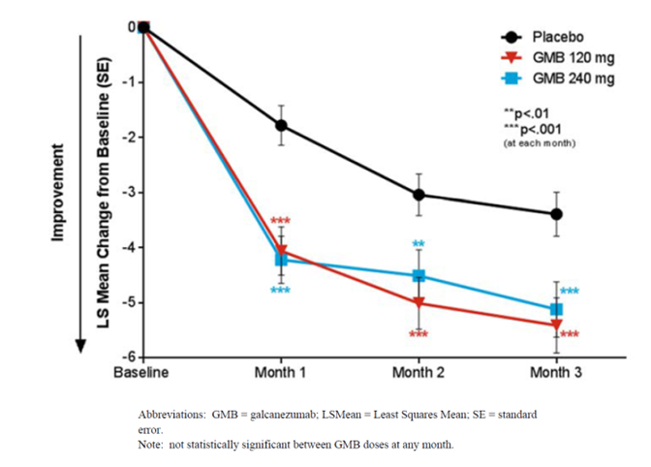
A predefined exploratory analysis suggested onset of action to be by Week 1.

Other efficacy outcomes
Figure 9: 50% (left) and 75% (right) response rate by month for Study CGAI
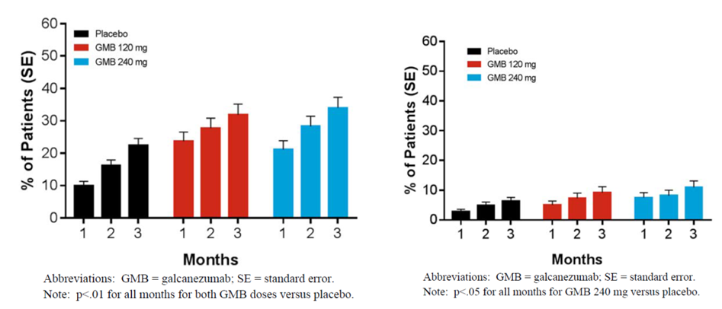
For the 240 mg dose, several key secondary endpoints remained significant after multiplicity adjustment, including: mean change in MHD requiring acute medication use, mean change in Role Function Restrictive domain scores of the MSQ from Baseline to Month 3, mean change in PGI-S from Baseline to Month 3. Because of the prespecified hierarchy of endpoints, and the negative result for the 75% response rate for the 120 mg group, the remaining key secondary endpoints could not be considered significant for the 120 mg dose, though many achieved nominally significant p values.
Overall subgroup analyses did not raise any concerns about the efficacy of galcanezumab and no strong conclusions can be drawn because the study was not specifically powered to allow subgroup comparisons.

Chronic migraine (Study CGAI); open label extension
Of the 1037 patients who completed the double blind treatment phase, 1021 patients (98.5%) entered the optional open label treatment phase, which was ongoing at the time of submission. Of these, 811 subjects (79.4%) were still in the study at the time of submission, 125 (12.2%) had discontinued, and 85 (8.3%) had completed the open label phase. Of the 447 patients with ≥ 6 months of total data (including double blind treatment), the majority had received 240 mg at the flexible dose visits (64% at Month 5, 71% at Months 6 to 11). The efficacy data from the open label extension is not yet complete, but preliminary assessments broadly suggest that efficacy is maintained over time.
Figure 10: Change from Baseline in the number of MHD including data from the ongoing open label phase (up to Month 9), Study CGAI, mixed model repeated measures analysis
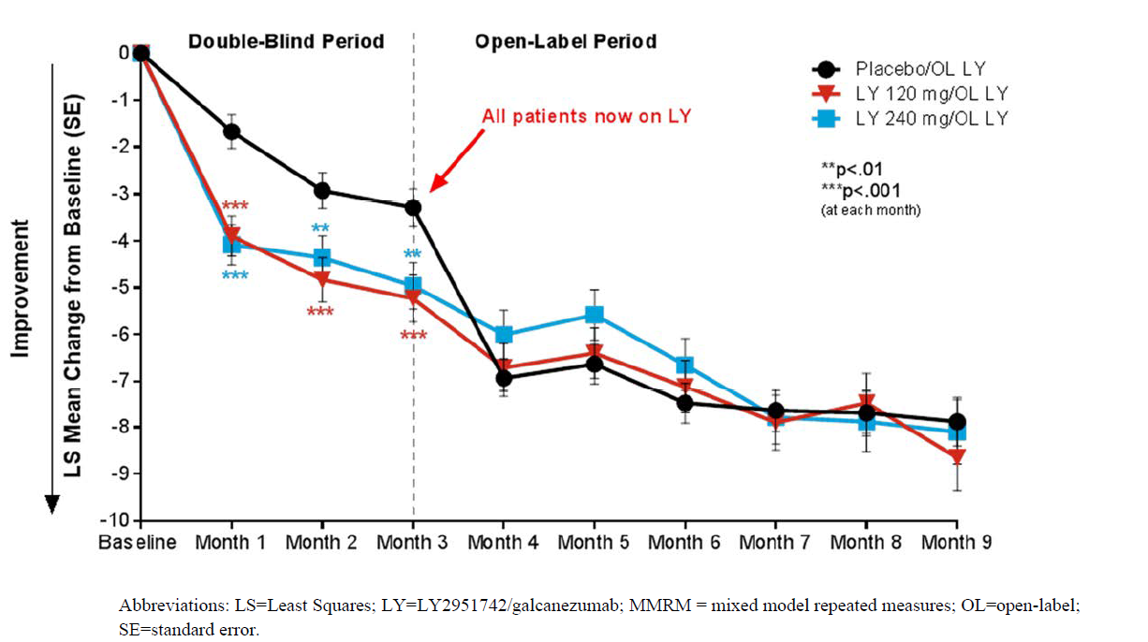
Other efficacy endpoints showed broadly similar trends, with initial placebo recipients showing an improvement on switching, and stable efficacy results in all three treatment groups over the open label phase.

Study ART-01
This Phase II proof of concept study assessed the efficacy of galcanezumab 150 mg every two weeks in adult subjects with frequent migraines. Although the study did not use the dose proposed for registration, it provides support for the pivotal studies and enhances their external validity.

Study CGAB
This 3 month dose ranging study showed that monthly subcutaneous galcanezumab 120 mg provided support for the efficacy of galcanezumab in preventing migraine, and justifies further exploration of doses of 120 mg/month and higher.

Study CGAJ
Study CGAJ (n = 270) was an open label study with a focus on safety and tolerability. It was a randomised study that compared two doses of galcanezumab: 120 mg/month (with a 240 mg loading dose, n = 135) and 240 mg/month (n = 135), continued for 12 months in adult patients with episodic or chronic migraine.
Figure 11: Mean change from Baseline in number of monthly MHD, intention to treat population, Study CGAJ
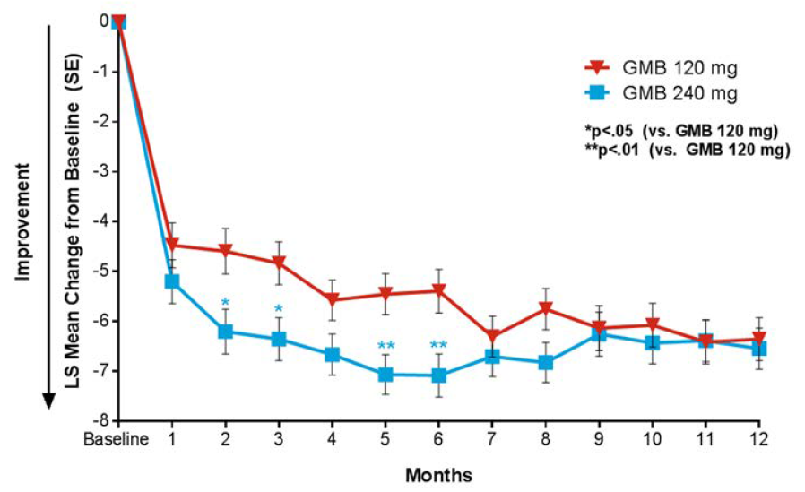
No firm efficacy conclusions can be drawn from this open label study as it lacked a non galcanezumab control group. But assuming that some of the apparent improvement in MHD relative to baseline constituted a treatment effect, there was no obvious waning of efficacy with continued use of galcanezumab over 12 months.

Safety
The overall exposure to galcanezumab exceeds the minimum numbers of patients recommended by the relevant guideline for chronically administered medications.21 However, the size and duration of exposure in the database are insufficient for evaluation of rare events such as cardiovascular, particularly in patients with pre-existing cardiovascular morbidity, which is the potential concern with CGRP inhibition. A total of 3156 patients were exposed to galcanezumab at any dose across the entire galcanezumab development program. Within the proposed dose range of 120 to 240 mg, a total of 1647 patients were exposed to galcanezumab for ≥ 6 months (≥ 6 monthly doses), and 279 patients were exposed to galcanezumab for 1 year (12 monthly doses). No patients received > 12 doses of galcanezumab in this development program.
There was a small but statistically significant excess of TEAEs in both active dose groups, compared to placebo, with an absolute excess of 6.6% in the pooled galcanezumab group (galcanezumab 63.6% versus placebo 57%).
Table 27: Overview of adverse events, safety population, Analysis Set A (Studies CGAG, CGAH, and CGAI) double blind treatment phase
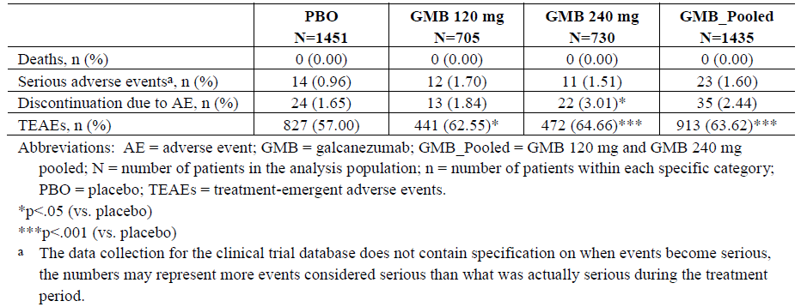
The difference between the 240 mg and 120 mg dose groups was significant for both injection site reaction and constipation, with a higher incidence in the galcanezumab 240 mg dose group (6.2% and 1.5%, respectively) compared to the galcanezumab 120 mg dose group (3.1% and 1.0%, respectively).
SAEs were uncommon, highly variable with no overall pattern of excess in any organ category. Only one SAE occurred in more than a single galcanezumab recipient: there were two patients with acute pancreatitis.
No deaths were reported in any of the six migraine studies, but two deaths were reported across the entire galcanezumab development program: one death in a cluster headache study (Study CGAM), and one in a clinical pharmacology study (Study CGAQ). The event in Study CGAQ (accidental drowning) was reported per police autopsy report in a study subject who received a single dose of galcanezumab (15 days prior to the death); the subject had reported no AEs during the study. But the Delegate also notes that FDA reviewer has questioned causality and deemed the cause of the death as undetermined and the relationship to study drug is unknown.
Discontinuations due to AEs were slightly more common in galcanezumab recipients (≤ 3.0%) than placebo recipients (< 2.0%). The most common AEs leading to discontinuation among galcanezumab patients were injection site reactions and hepatic enzyme increase. There was no clear signal of potential hepatotoxicity for galcanezumab.
No clinically meaningful differences or consistent trends between galcanezumab and placebo in changes from Baseline in chemistry, haematology, coagulation, urinalysis laboratory parameters, vital signs or ECG changes.
Similar to other mAbs, galcanezumab could potentially increase the risk of anaphylaxis, though this was not observed in the study program and hypersensitivity events appeared to be infrequent. The Delegate agrees with the clinical evaluator that this risk is appropriately documented in the PI. The PI also carries appropriate warnings about the potential for skin reactions, listing urticaria and pruritus as drug reactions.
The Delegate noted that there was discrepancy in the strength of warning with regards to pregnancy and lactation between PI and CMI. CMI was appropriately worded but PI still carried ambiguity over the risk. It has been resolved in subsequent interaction between RMP, sponsor and clinical evaluator to maintain the consistency with the similar class of drug such as recently approved Aimovig.

Risk management plan
- The proposed summary of safety concerns and their associated risk monitoring and mitigation strategies are summarised in Table 28.
Table 28: Summary of safety concerns
Summary of safety concerns |  | Pharmacovigilance |  | Risk Minimisation
 |  | Routine | Additional | Routine | Additional
Important identified risks | None | – | – | – | –
Important potential risks | Serious hypersensitivity | ² | ³ |  | –
Important potential risks | Serious cardiovascular outcomes in patients at high risk of cardiovascular and cerebrovascular events, including in patients ≥ 65 years¹ | ² | ³ |  | –
Important potential risks | Hypertension during pregnancy and pre-eclampsia | ² | ³
Missing information | Use in pregnancy | ² | ³ |  | –
Missing information | Long term safety including malignancies |  | ³ |  | –
1) Safety concern in ASA includes reference to patients ≥ 65 years; 2) specific adverse reaction follow up questionnaires 3) cohort study using electronic health record data
- In response to the RMP evaluator’s request the sponsor has included reference to patients 65 years and over in the safety concern regarding serious cardiovascular outcomes, to reflect that the increased risk of ischemia is a safety concern with clinical significance for elderly patients, who also have an increased risk of ischaemia.
- Routine and additional pharmacovigilance activities in the form of overseas studies have been proposed for all the safety concerns. The sponsor has added the US FDA required studies in the ASA as recommended.
- Routine risk minimisation has been proposed for all the risks of serious hypersensitivity and use in pregnancy. The sponsor has agreed to include the CMI in the package insert as recommended.

Risk-benefit analysis

Delegate’s considerations

Discussion
Overall, PK of galcanezumab have been adequately characterised by the sponsor and closely resemble the PK of other IgG mAbs. Following subcutaneous administration, the PK of galcanezumab are characterised by slow absorption, limited distribution, low clearance, and a long terminal elimination t_{1/2}. However, pharmacometrics working group had some suggestion over the inclusion of tolerance and delay in onset of effect by 2 to 4 weeks which needs to be addressed by the sponsor.
Similar efficacy and safety were demonstrated for both 120 mg and 240 mg once monthly regimens of galcanezumab in episodic and chronic migraine patients. Injections sites in the clinical trials included the abdomen, thigh, back of the upper arm, and buttocks. Site of injection was not found to be a significant covariate in the population PK analysis.
With treatment periods up to 12 months, the overall incidence ADA was about 12.5%; most of which were of low titre and were tested positive for neutralising ADA. The presence of ADA, irrespective of titre and neutralising activity, did not seem to affect the PK, efficacy, or safety of galcanezumab.
All the three pivotal studies were well designed, with two performed in episodic migraine (≥ 4 to < 15 MHD/month at baseline) and one performed in ‘chronic’ migraine (≥ 15 headache days at least 8 of which are migraine per month at Baseline). In the pivotal studies dosing regimen and administration instructions was the same as that in the proposed PI and CMI. All three studies compared galcanezumab 120 mg/month (with a 240 mg loading dose) and 240 mg/month with placebo, and all three studies demonstrated a reduction in MHD of about 2 days which is clinically modest. The results were consistent across a range of secondary endpoints, including response rates and quality of life measures.
The Delegate agrees with the clinical evaluator views on using galcanezumab in subjects with infrequent migraine (< 4 migraine headache days per month) as outlined in the clinical evaluation report. All the three factors discussed in the clinical evaluation report on balance supports to align the PI for galcanezumab with already approved agent (erenumab) with the similar indication.
As a new chemical entity, galcanezumab is not known to be associated with any substantial safety issues so far, but its safety has not yet been fully characterised notably in patients with cardiovascular risk factors and patients aged 65 years and older. Similarly, the long term safety (beyond 12 months), in subjects < 18 years or > 65 years, and in pregnancy and lactation has not been characterised.
Galcanezumab has a number of tolerability issues, including injection site reactions, vertigo, and constipation, but these symptoms may be acceptable for patients who benefit by reduction in their MHD. Galcanezumab is also associated with an increased risk of hypersensitivity reactions, including urticaria and pruritus, though the known cases of hypersensitivity, so far, have been without serious sequelae.
There are theoretical concerns suggesting that interfering with CGRP could modify processes relevant to protection against ischaemia, increasing the risk of cardiovascular events. No evidence of this emerged in the submitted studies; nevertheless subjects with a strong history of cardiovascular events were excluded.
The safety of galcanezumab in combination with other agents affecting CGRP is uncharacterised as pointed out by clinical evaluator. There is also no data on combination of botulinum toxin A or B with galcanezumab.
The recently registered anti CGRP agent, erenumab, has a safety profile that appears to be broadly acceptable, with no major safety warnings, although the safety of erenumab (like galcanezumab) has not been assessed in the setting of pregnancy, lactation, or advanced age.
Given the benefits from treatment are highly variable in a condition which also varies in severity over time without therapeutic intervention, it is reasonable that patients with chronic migraine should not continue with galcanezumab if they do not have a least a reduction of 2 days in their monthly migraine day frequency after a trial. Current Australian guidelines for treatment trials for migraine prophylaxis treatment recommend a trial of 8 to 12 weeks. This should also apply to galcanezumab. The delegate also notes that no patient has been re-exposed after galcanezumab treatment in any migraine or non-migraine study. This is an important potential safety issue, if a patient were to stop GMB and re-start treatment.

Deficiencies of the data
- No head to head comparison with other active comparators.
- No data on efficacy in subjects with a baseline frequency of < 4 migraines per month.
- Long-term safety (beyond 12 months).
- Safety in subjects < 18 years or > 65 years.
- Safety in pregnancy and lactation.
- No patient has been re-exposed after galcanezumab treatment (restarting galcanezumab treatment).

Conditions of registration
Any changes to which the sponsor has agreed should be included in a revised RMP and ASA. However, irrespective of whether or not they are included in the currently available version of the RMP document, the agreed changes become part of the risk management system.
The suggested wording is:
The galcanezumab EU-Risk Management Plan (RMP) (version 1.0, dated 11 September 2018, data lock point 12 May 2017), with Australian Specific Annex (version 2.0, dated 4 December 2018), included with submission PM-2018-00780-1-1, and any subsequent revisions, as agreed with the TGA will be implemented in Australia.
The following wording is recommended for the PSUR requirement:
An obligatory component of risk management plans is routine pharmacovigilance. Routine pharmacovigilance includes the submission of periodic safety update reports (PSURs).
Reports are to be provided in line with the current published list of EU reference dates and frequency of submission of PSURs until the period covered by such reports is not less than three years from the date of this approval letter.
The reports are to at least meet the requirements for PSURs as described in the European Medicines Agency’s Guideline on good pharmacovigilance practices (GVP) Module VII-periodic safety update report (Rev 1), Part VII.B Structures and processes. Note that submission of a PSUR does not constitute an application to vary the registration.
As the sponsor has agreed to include the Consumer Medicine Information in the pack, the following wording is recommended for a condition of registration:
The Emgality Consumer Medicine Information must be included in the package.
As Emgality is a new biological entity it should be included in the Black Triangle Scheme as a condition of registration. The following wording is recommended for the condition of registration:
Emgality (galcanezumab) is to be included in the Black Triangle Scheme. The PI and CMI for Emgality must include the black triangle symbol and mandatory accompanying text for five years, which starts from the date that the sponsor notifies the TGA of supply of the product.

Outstanding issues
- Cardiovascular risk.
- Re-exposure to galcanezumab.

Conclusion
Overall galcanezumab is approvable as the quality, nonclinical and clinical evaluators (subjected to product information changes) have all recommended approval. The delegate considers that sufficient data and justification have been provided to support the registration of galcanezumab on quality, safety and efficacy grounds for the prophylaxis of migraine in adults.

Summary of Issues
The delegate overall supports the clinical evaluator in recommending approval of galcanezumab for ‘for the prophylaxis of migraine in adults’.

Key issues:
- Differences from placebo in the reduction from Baseline in the mean number of migraine days per month were consistent across the studies. The absolute difference was around 2 days per month for both episodic and chronic migraine. This extent of benefit is relatively large for patients with episodic migraine but small for patients with chronic migraine.
- There are theoretical concerns suggesting that interfering with CGRP could modify processes relevant to protection against ischaemia, increasing the risk of cardiovascular events. No evidence of this emerged in the submitted studies; but it is to be noted subjects with a strong history of cardiovascular events were excluded.
- Galcanezumab has a number of tolerability issues, including injection site reactions, vertigo, and constipation, but these symptoms may be acceptable for patients who benefit by reduction in their MHD.
- The safety of galcanezumab in combination with other agents affecting CGRP is uncharacterised as pointed out by clinical evaluator. There is also no data on combination of botulinum toxin A or B with galcanezumab.
- Given the benefits from treatment are highly variable in a condition which also varies in severity over time without therapeutic intervention, it is reasonable that patients with chronic migraine should not continue with galcanezumab if they do not have a least a reduction of 2 days in their monthly migraine day frequency after a trial. Current Australian guidelines for treatment trials for migraine prophylaxis treatment recommend a trial of 8 to 12 weeks. The Delegate also notes that no patient has been re-exposed after galcanezumab treatment in any migraine or non-migraine study. This is an important potential safety issue, if a patient were to stop galcanezumab and restart treatment.

Proposed action
The Delegate had no reason to say, at the time, that the application for Galcanezumab should not be approved for registration.
Any approval is subject to taking into account all issues arising from the Advisory Committee on Medicines (ACM) deliberations and finalising matters pertaining to the PI, to the satisfaction of the TGA.

Request for ACM advice
- What are the ACM’s views on the efficacy and to what extent is there sufficient clinical trial evidence to support the proposed indication for galcanezumab?
- Does the ACM consider that the safety of galcanezumab in the proposed new indication is sufficiently well characterised and communicated in the PI
- Any specific measures to be taken to highlight possible cardiovascular risk knowing that trial population excluded elderly and patient with cardiovascular risk?
- Does the ACM anticipate frequent re-exposure to galcanezumab in clinical settings as no relevant safety data exist in any migraine or non-migraine study?
- Does the ACM foresee combination of erenumab and galcanezumab used frequently?
The Committee is also requested to provide advice on any other issues that it thinks may be relevant to a decision on whether or not to approve this application.

Response from sponsor

Pharmacokinetic/pharmacodynamic modelling
The sponsor has acknowledged the comment by the pharmacometrics working group regarding the lack of a disease modifying function in the PK/PD model, and the recommendation to add to the PI the possibility to develop tolerance and a delay in onset of effect by 2 to 4 weeks. The sponsor’s response is as follows.

Lack of disease modifying effect
To date, there is no evidence from clinical data to suggest that galcanezumab has a disease modifying effect whereby the underlying progression of migraine is altered after stopping treatment. However, clinical data does demonstrate that galcanezumab has a symptomatic effect on migraine headaches as shown by a gradual reduction in efficacy upon stopping treatment. During the 4 month post treatment (washout) phase of the Phase III Studies CGAG, CGAH, CGAI and CGAJ, the number of MHD gradually increased in the patients who received galcanezumab in the treatment phase. Figure 12 shows the time course of effect from Study CGAH as a representative illustration. This gradual decrease in effect was accompanied by a 97% decrease in galcanezumab concentrations from the last dose administered in the treatment phase (Month 5) to the end of the washout phase (Month 10) based on a galcanezumab half-life of approximately 1 month. As such, the sponsor did not see the need to develop a disease modifying PK/PD model to describe galcanezumab pharmacology.
Figure 12: Study CGAH change from Baseline in the number of MHD
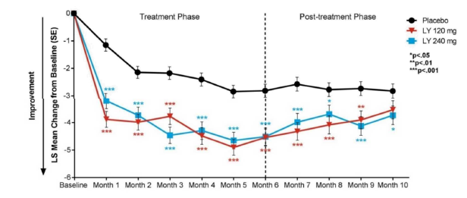
Abbreviations: LS = least squares; LY = LY2951742/galcanezumab; SE = standard error. Note: Consistent results were observed in Study CGAG (Figure 13), Study CGAI (Figure 14) and Study CGAJ (Figure 15).
Figure 13: Study CGAG change from Baseline in the number of MHD
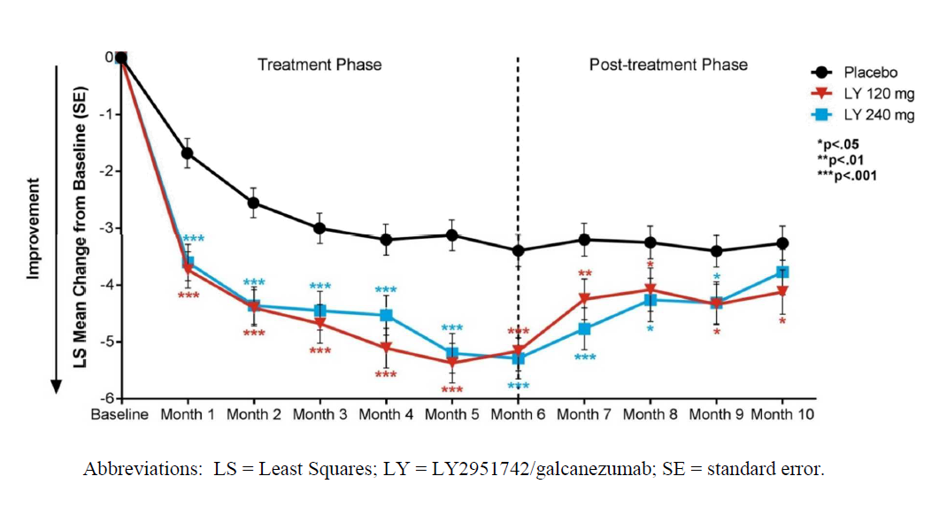
Figure 14: Study CGAI change from Baseline in the number of MHD
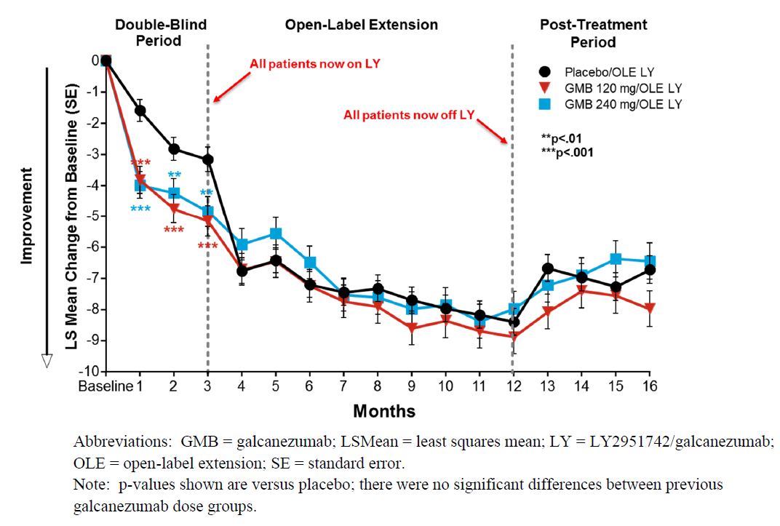
Figure 15: Study CGAJ change from Baseline in the number of MHD
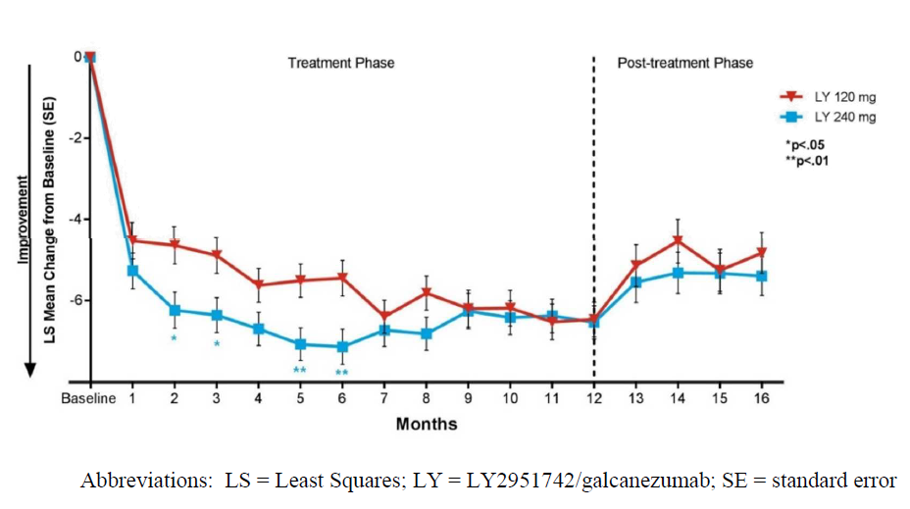

Lack of drug tolerance
To date, there is no clinical data to suggest that tolerance develops from galcanezumab treatment. A recent analysis of the persistence of effect in patients treated with galcanezumab in the 6 month placebo controlled episodic migraine Studies CGAG and CGAH demonstrated no evidence of drug tolerance. Specifically, among the galcanezumab treated patients who had a ≥ 50% reduction of MHD in Month 1, an average reduction of MHD of ≥ 40% and ≥ 50% was achieved by 89% and 83% of patients, respectively, in the remaining 5 months of treatment suggesting maintenance of response in the vast majority of Month 1 responders. As such, it is not considered warranted to include in the PI a statement on the possibility of tolerance development due to galcanezumab treatment since no such information exists from the clinical data. Furthermore, the sponsor did not develop a tolerance PK/PD model to describe galcanezumab since the clinical data did not warrant such evaluation.

Onset of treatment effect
As expected, clinical data shows a range across patients in the timing of onset of effect of galcanezumab that most likely represents inherent biological and pharmacological variability rather than a ‘delay’ in onset of effect. Galcanezumab (120 mg and 240 mg) was statistically superior to placebo in the change from Baseline in number of weekly MHD at Week 1 of the double blind treatment phase in Studies CGAG, CGAH and CGAI; and superiority versus placebo was maintained in all subsequent weeks of Month 1, indicating an early and sustained response to treatment.
Furthermore, a recently published analysis of patients with an initial non response to galcanezumab in Month 1 (defined as < 50% reduction in MHD from Baseline for episodic migraine population; < 30% reduction in MHD from Baseline for chronic migraine population) further elucidates the onset of effect. A substantial proportion of patients with episodic migraine (67%) and chronic migraine (57%) who reported an initial non response to treatment after the first dose administration reached the protocol defined response threshold of ≥ 50% reduction in MHD from Baseline for episodic migraine population and ≥ 30% reduction in MHD from Baseline for chronic migraine population after 3 monthly doses of galcanezumab. This data supports biological variability in onset of effect, and suggests that for some patients clinical response can be achieved even in the absence of early signs of efficacy.
Regarding PK/PD model development, an indirect response model was evaluated to capture the time course of reduction in MHD by galcanezumab. This model was used because galcanezumab binds to CGRP to block its biological activity, which then prevents migraine headaches; galcanezumab concentrations do not directly influence migraine headache. In this case, there is a separation of time (hysteresis) between the migraine effect and the action of galcanezumab. By using an indirect response model to describe the migraine effect, a time delay is incorporated into the formation rate (k_{in}) and elimination rate (k_{out}) of MHD per month.
In summary, the sponsor believes it is not warranted to add to the PI the possibility of tolerance or delay in onset of effect by 2 to 4 weeks given the clinical evidence for galcanezumab to be a symptomatic treatment with sustained effect, no tolerance development, and an onset of effect that will vary but occurs early in the majority of patients. In addition, the PK/PD indirect response model captures the time course of MHD sufficiently and is consistent with galcanezumab mechanism of action.

Section 4.4 of Product Information: Cardiovascular warning
In light of the theoretical attenuating effects of CGRP on cardiovascular health, the evaluation of potential and observed cardiovascular events and cardiovascular safety has been a sustained focus of attention throughout the galcanezumab development program. Of note, there have been no adverse findings related to cardiovascular events indicative of a safety signal in neither nonclinical or clinical studies with galcanezumab and other CGRP antagonist therapies. As such, any warning and precaution provided in Section 4.4 of the galcanezumab PI as requested by the ACM would be based upon a theoretical cardiovascular risk rather than any observed cardiovascular safety signal.

Global regulatory interest in the role that CGRP plays in cardiovascular function
The sponsor acknowledges that the EU SmPC does contain a special warning and precaution which identifies that patients with major cardiovascular diseases were excluded from the Phase III registration studies; this was included at the request of the EMA. The wording used is, in essence, the wording that is currently proposed for inclusion in Section 5.1 of the Australian label and does not include a specific warning or precaution to treating clinicians. The FDA evaluated similar theoretical concerns in regards to CGRP inhibition and cardiovascular risk and did not request the inclusion of a cardiovascular warning in the US PI, reaching the following conclusion:
‘We conducted an evaluation of available published literature to investigate the potential for CGRP antagonism to induce vasoconstriction or adversely affect coronary vessel size, coronary blood flow, or myocardial infarct size under experimental ischemic conditions. The results of this evaluation suggest that the regulation of vascular tone in healthy patients and those with cardiovascular disease involves multiple factors, of which CGRP is only one, and that there is limited understanding of the role of CGRP in normal hemodynamic processes or in the response to ischemia or infarction. It was concluded, therefore, that there is insufficient information to dismiss the theoretical concerns, but that additional basic science research is needed to understand further the role of CGRP in these processes. Without a better understanding, it is unlikely that nonclinical studies of galcanezumab could be designed and conducted that would provide useful information, therefore, no post marketing study will be required to assess the cardiovascular safety of galcanezumab.’
The sponsor considers that Section 5.1 of the proposed Australian galcanezumab PI appropriately notes that patients with recent acute cardiovascular events have been excluded from the Phase III clinical studies. The placement of this text as a warning and precaution in Section 4.4 carries an implied message of risk to prescribers which would be based solely on hypothetical concerns rather than evidence observed in the clinical trial data. Aimovig (erenumab) has similar wording to Emgality (galcanezumab) in Section 4.4. of its EU SmPC, but only has this patient exclusion noted in Section 5.1 of the Australian approved label, despite a similar data package that also excluded patients with recent, acute cardiovascular events.

Post-hoc analyses of cardiovascular outcomes in patient subgroups with elevated cardiovascular risk
Supporting the rationale above, the sponsor has conducted additional post-hoc analyses of cardiovascular outcomes in patient subgroups with known cardiovascular risk: patients treated with triptans, male patients, patients who report migraine with aura, and patients with chronic migraine.

Changes in categorical blood pressure
Table 29 presents categorical blood pressure values by subgroup for patients who used triptans, by sex, aura, and episodic or chronic migraine. This data in patients with a higher cardiovascular risk does not indicate an effect between galcanezumab treatment and elevated blood pressure for these subgroups. Specifically with regard to the triptan user subgroup, which includes a population that has increased risk for elevated blood pressure, a lack of a blood pressure effect with galcanezumab was confirmed. This lack of additive vasoconstrictive effect between a triptan and a CGRP inhibitor is consistent with study results reported previously for telcagepant; and erenumab.
Table 29: Exposure adjusted incidence rates for categorical blood pressure values
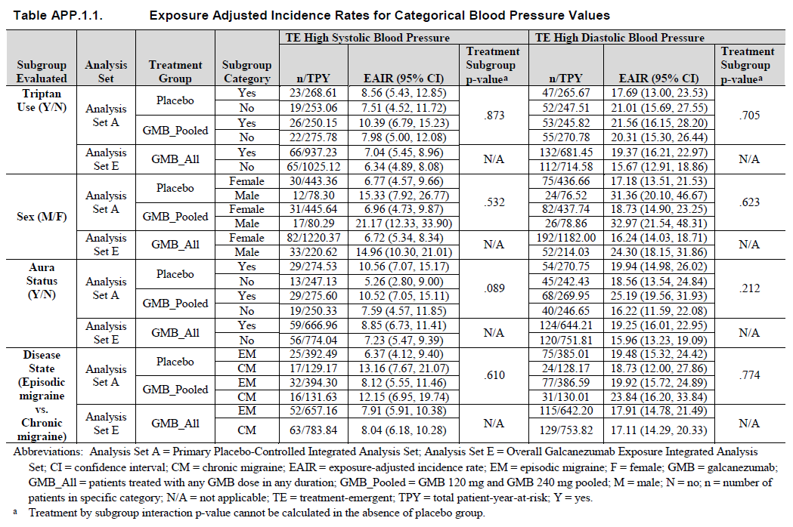
Although higher exposure adjusted incidence rates (EAIRs) are observed in some of the subgroups with higher risk (males, migraine with aura, chronic migraine), the higher EAIRs were observed for both placebo treated patients as well as galcanezumab treated patients making a treatment effect unlikely. Additionally, the analysis of the EAIRs in the overall migraine galcanezumab exposure dataset (Analysis Set E) also confirms that longer exposure does not increase the incidence rate of categorical changes in blood pressure in subgroups.

Cardiovascular events
TEAEs likely to be cardiovascular in nature were evaluated and identified using 9 SMQs. No clinically important or statistically significant increases in the incidence of TEAEs likely cardiovascular in nature, including those related to ischemia, were observed in galcanezumab treated patients overall or in galcanezumab treated patients with comorbid cardiovascular disease in Analysis Set A.
Results of post-hoc evaluation of cardiovascular events in subgroups associated with increased cardiovascular risk are provided in Table 30. These analyses showed no clinically relevant increases in cardiovascular events in galcanezumab treated patients with known cardiovascular risk factors.
Table 30: Summary of EAIRS for SMQ narrow search for TEAEs likely CV in nature by subgroup
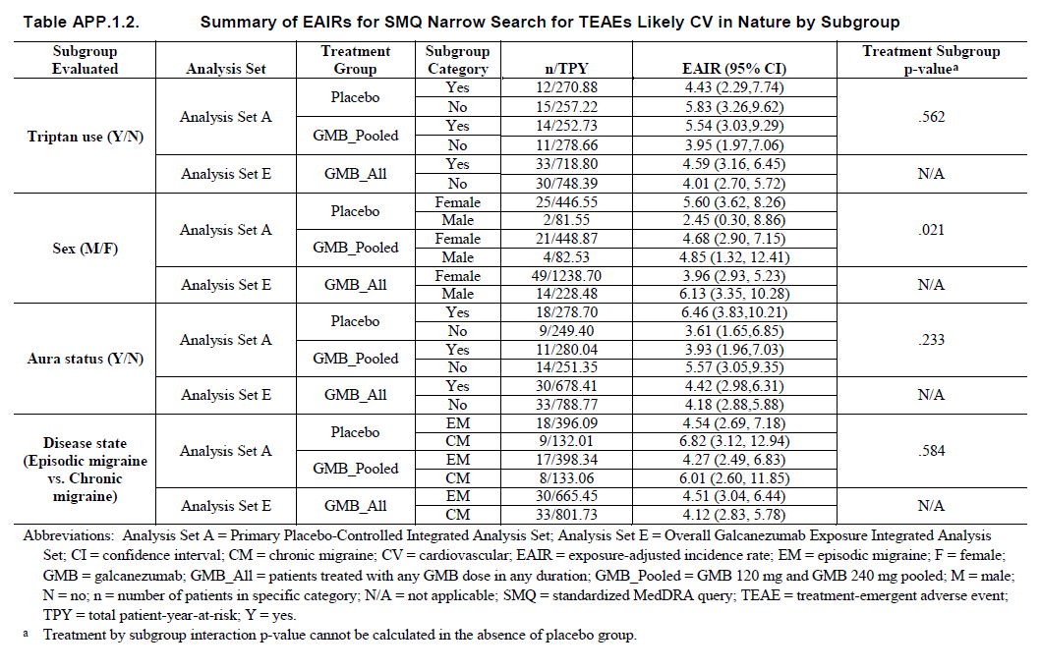

Conclusion
Similar to the Australian PI for Aimovig, the sponsor appropriately notes in Section 5.1 of the proposed galcanezumab PI that patients with recent acute cardiovascular events and/or at serious cardiovascular risk were excluded from the clinical trial population. Placement of this text in Section 4.4 as a warning and precaution to prescribers implies a risk that is not well understood by the scientific community, not universally recognized by global regulatory authorities, and not substantiated in the available galcanezumab clinical trial data. Additional post-hoc analyses evaluating cardiovascular health and function in subgroup populations of patients with known increased cardiovascular risk who were treated with galcanezumab did not identify any cardiovascular safety signal to support inclusion of a cardiovascular warning and precaution in Section 4.4 of the proposed PI. As such, it is the sponsor’s position that a description of the exclusion of patients with acute, recent cardiovascular events from the Phase III clinical studies of galcanezumab and the accompanying limitation of data in such a population in Section 5.1 of the proposed PI is adequate for alerting prescribers to a limitation of the current clinical data.

Advisory Committee considerations
The ACM, having considered the evaluations and the Delegate’s overview, as well as the sponsor’s response to these documents, advised the following.
The ACM considered the referral for advice from the Delegate in relation to the application to register Emgality, as a 120 mg/mL solution of galcanezumab for subcutaneous injection (prefilled pen and prefilled syringe). The ACM agreed that Emgality had an overall positive benefit-risk profile for the proposed indication:
‘Emgality is indicated for the prophylaxis of migraine in adults.’
In providing this advice the ACM:
- Noted that galcanezumab is similar in demographics and safety profile as erenumab, another mAb medication indicated for the prophylaxis of migraine in adults.
- Noted that galcanezumab has been approved in the EU and USA and is pending approval in Switzerland and Singapore.
- Noted that there is no long term (beyond 12 months) safety data available for galcanezumab.
- Noted the associated tolerability issues, including injection site reactions, vertigo, and constipation.
- Was of the view that the risk-benefit balance for galcanezumab is favourable for the dataset submitted based on the demonstrated efficacy and no significant safety signals.

Specific advice
The ACM advised the following in response to the Delegate’s specific request for advice:
- What are the ACM’s views on the efficacy and to what extent is there sufficient clinical trial evidence to support the proposed indication for Galcanezumab?
The ACM noted that the efficacy studies showed a consistent and sustained effect of the active drug over placebo (2 fewer migraine days per month with the active drug). Efficacy studies were conducted in patients with episodic migraines (defined as > 4 but < 15 MHD/month) and patients with chronic migraines (defined as ≥ 15 MHD/month for > 3 months).
Studies CGAG and CGAH (pivotal 6 month studies; EVOLVE-1 and 2 trials) were identical in design and compared the efficacy of 120 mg/month and 240 mg/month doses of galcanezumab with placebo for episodic migraines. Both doses were significantly superior to placebo in both studies, with a greater reduction in MHD (primary efficacy endpoint) seen with either active treatment than with placebo.
Study CGAI (pivotal study; REGAIN trial) was designed to compare the efficacy of 120 mg/month and 240 mg/month doses of galcanezumab with placebo in the prevention of chronic migraine, using the same efficacy outcomes as the episodic migraine studies. The treatment period was 3 months with a 9 month open label extension. The study results were positive with the same effect size and a similar results profile as the other pivotal studies.
The ACM was of the view that for patients with very few migraine free days per month, two extra days without headache could be considered worthwhile. Additionally, the magnitude of effect for galcanezumab was comparable to that of erenumab.
- Does the ACM consider that the safety of Galcanezumab in the proposed new indication is sufficiently well characterised and communicated in the PI
- Any specific measures to be taken to highlight possible cardiovascular risk knowing that trial population excluded elderly and patient with cardiovascular risk?
The ACM considered the cardiovascular risk to be a theoretical risk as there was no data to indicate that more specific actions would be required for these population groups.
The ACM was of the view that while it was desirable to strengthen the PI with respect to particular sections on long term use; intermittent treatment; use in pregnancy and lactation; elevated cardiovascular risk; use in patients aged ≥ 65 years; and risks of hypersensitivity (including anaphylaxis), the precedents of erenumab registration in Australia and the international registration status for galcanezumab, suggest that the PI is adequate, as there are no Australia specific factors under consideration.
The ACM noted that the proposed RMP included additional pharmacovigilance measures to address the risks associated with patients at high risk of cardiovascular and cerebrovascular events, including in patients ≥ 65 years; hypertension during pregnancy; use in pregnancy; and long term safety (including malignancy).
- Does ACM anticipate frequent re-exposure to galcanezumab in clinical settings as no relevant safety data exist in any migraine or non-migraine study?
The ACM noted that there is no data regarding the impact on efficacy or effect modification from re-treatment. Therefore, the effects of re-exposure are unknown.
The ACM advised that intermittent recurring use of galcanezumab is very likely given the preventative effect it has on migraines and the episodic nature of the condition.
- Does ACM foresee combination of erenumab and GMB used frequently?
The ACM noted that there is no data available, or history of use, regarding the potential drug interactions of galcanezumab with other calcitonin gene related peptide release (CGRP) blocking agents, such as erenumab or botulinum toxin.
The ACM suggested that, based on the understood mechanism of action, adjunctive treatment with other CGRP blocking agents would likely be unrewarding and could potentially cause adverse effects. The ACM advised that clinicians would probably trial another CGRP blocking agent if treatment with one such agent fails. The lack of data on this issue is adequately covered in the PI however.

General advice
The ACM also considered what would be an adequate treatment response period and advised that a trial of 12 weeks should be adequate, given the benefits of treatment are highly variable and the condition varies in severity over time.

Outcome
Based on a review of quality, safety and efficacy, TGA approved the registration of Emgality (galcanezumab) 120 mg/mL prefilled syringe and pen for subcutaneous injection for the following indication:
Emgality is indicated for the prophylaxis of migraine in adults.

Specific conditions of registration applying to these goods
- Emgality (galcanezumab) is to be included in the Black Triangle Scheme. The PI and CMI for Emgality must include the black triangle symbol and mandatory accompanying text for five years, which starts from the date that the sponsor notifies the TGA of supply of the product.
- The galcanezumab EU-Risk Management Plan (RMP) (version 1.0, dated 11 September 2018, DLP 12 May 2017), with ASA (version 2.0, dated 4 December 2018), included with submission PM-2018-00780-1-1, and any subsequent revisions, as agreed with the TGA will be implemented in Australia.

Batch release testing & compliance with Certified Product Details (CPD)
- It is a condition of registration that all batches of Emgality (galcanezumab) imported into/manufactured in Australia must comply with the product details and specifications approved during evaluation and detailed in the Certified Product Details (CPD).
- It is a condition of registration that each batch of Emgality (galcanezumab) imported into/manufactured in Australia is not released for sale until samples and/or the manufacturer’s release data have been assessed and endorsed for release by the TGA Laboratories Branch. Outcomes of laboratory testing are published biannually in the TGA Database of Laboratory Testing Results.
- The sponsor should be prepared to provide product samples, reference materials and documentary evidence as defined by the TGA Laboratories branch. The sponsor must contact Biochemistry.Testing@health.gov.au for specific material requirements related to the batch release testing/assessment of the product. More information at TGA testing of biological medicines.
- This batch release condition will be reviewed and may be modified on the basis of actual batch quality and consistency. This condition remains in place until the sponsor is notified in writing of any variation.
- The CPD, as described in Guidance 7: Certified Product Details of the Australian Regulatory Guidelines for Prescription Medicines (ARGPM), in PDF format, for the above products should be provided upon registration of these therapeutic goods. In addition, an updated CPD should be provided when changes to finished product specifications and test methods are approved in a Category 3 application or notified through a self-assessable change.

Attachment 1. Product Information
The PI for Emgality approved with the submission which is described in this AusPAR is at Attachment 1. For the most recent PI, please refer to the TGA website at <https://www.tga.gov.au/product-information-pi>.

Therapeutic Goods Administration
PO Box 100 Woden ACT 2606 Australia
Email: info@tga.gov.au Phone: 1800 020 653 Fax: 02 6232 8605
https://www.tga.gov.au

The submission was subsequently approved in Switzerland on 29 March 2019.
These GMP clearances have since been approved/renewed prior to registration.
European Medicines Agency (EMA), Committee for Medicinal Products for Human use (CHMP), 30 September 1997. ICH S6(R1) Guideline on preclinical safety evaluation of biotechnology-derived pharmaceuticals. EMA/CHMP/ICH/731268/1998
Russell,F.A. et al. (2014) Calcitonin gene-related peptide: physiology and pathophysiology, Physiol Rev, 2014; 94: 1099-1142.
Schinke,T. et al. (2004) Decreased bone formation and osteopenia in mice lacking alpha-calcitonin gene-related peptide, J Bone Miner Res, 2004; 19.
Pregnancy category B1: Drugs which have been taken by only a limited number of pregnant women and women of childbearing age, without an increase in the frequency of malformation or other direct or indirect harmful effects on the human fetus having been observed. Studies in animals have not shown evidence of an increased occurrence of fetal damage.
European Medicines Agency (EMA), Committee for Medicinal Products for Human use (CHMP), 31 January 2014. ICH S10 Guidelines on Photosafety evaluation of pharmaceuticals. CHMP/ICH/752211/2012
Headache Classification Committee of the International Headache Society. The International Classification of Headache Disorders. Cephalalgia. 2018; 38 (3rd edition): 1-211
Eftekhari, S. et al. (2010) Differential distribution of calcitonin gene-related Peptide and its receptor components in the human Trigeminal ganglion, Neuroscience, 2010; 169: 683-696.
Rice, F.L. et al. (2016) Anatomy and immunochemical characterization of the non-arterial peptidergic diffuse dural innervation of the rat and Rhesus monkey: Implications for functional regulation and treatment in migraine, Cephalalgia, 2010; 0; 1-23.
Brain, S.D. et al. (1985) Calcitonin gene-related peptide is a potent vasodilator, Nature, 1985; 313, 54-56.
Hirsch, S. et al. (2013) The CGRP receptor antagonist BIBN4096BS peripherally alleviates inflammatory pain in rats, PAIN, 2013; 154, 700-707.
Cady, R.J. et al. (2011) Calcitonin Gene-Related Peptide Promotes Cellular Changes in Trigeminal Neurons and Glia Implicated in Peripheral and Central Sensitization, Molecular Pain, 2011; 7
Ma, W. et al. (2010) The Calcitonin Gene-related Peptide Family: Form, Function and Future Perspectives, Chapter 10: CGRP and Adrenomedullin as Pain-Related Peptides, Springer Science and Business Media, 2010.
Natura, G. et al. (2005) Calcitonin gene-related peptide enhances TTX-resistant sodium currents in cultured dorsal root ganglion neurons from adult rats, PAIN, 2005; 116, 194-204.
Yu, Y. et al. (2002) Role of calcitonin gene-related peptide and its antagonist on the evoked discharge frequency of wide dynamic range neurons in the dorsal horn of the spinal cord in rats, Regulatory Peptides, 2002; 103, 23-27.
Olesen, J. (2004) Calcitonin Gene–Related Peptide Receptor Antagonist BIBN 4096 BS for the Acute Treatment of Migraine, N Engl J Med, 2004; 350, 1104-1110.
Ho, T. et al. (2008) Efficacy and tolerability of MK-0974 (telcagepant), a new oral antagonist of calcitonin gene-related peptide receptor, compared with zolmitriptan for acute migraine: a randomised, placebo-controlled, parallel-treatment trial, Lancet, 2008; 372, 2115-2123.
Hewitt, D.J. et al. (2011) Randomized controlled trial of the CGRP receptor antagonist MK-3207 in the acute treatment of migraine, Cephalalgia, 2011; 31: 712-722.
Marcus, R. et al. (2014) BMS-927711 for the acute treatment of migraine: A double-blind, randomized, placebo controlled, dose-ranging trial, Cephalalgia, 2014; 34: 114-125.
European Medicines Agency (EMA), Committee for Medicinal Products for Human Use (CHMP), 24 January 2007. Guideline on clinical investigation of medicinal products for treatment of migraine. CPMP/EWP/788/2001 Rev. 1.
European Medicines Agency (EMA), Committee for Proprietary Medicinal Products (CPMP), 1 June 1995. ICH E1 Guideline on population exposure: the extent of population exposure to assess clinical safety. CPMP/ICH/375/95.
European Medicines Agency (EMA), Committee for Medicinal Products for Human Use (CHMP), 18 May 2017. Guideline on Immunogenicity assessment of therapeutic proteins. EMEA/CHMP/BMWP/14327/2006 Rev 1
Food and Drug Administrations (FDA), Center for Drug Evaluation and Research and Center for Biologics Evaluation and Research, Industry Guidance on Assay Development for Immunogenicity Testing of Therapeutic Proteins, April 2016.
Shankar, G. et al. (2008), Recommendations for the validation of immunoassays used for detection of host antibodies against biotechnology products, J Pharm Biomed Anal, 2008; 48, 1267-1281.
European Medicines Agency (EMA), Committee for Medicinal Products for Human Use (CHMP), 25 January 2016. ICH guideline E14: the clinical evaluation of QT/QTc interval prolongation and proarrhythmic potential for non-antiarrhythmic drugs (R3) - questions and answers. EMA/CHMP/ICH/310133/2008.
Olesen, J. et al. (2004) Calcitonin gene-related peptide receptor antagonist BIBN 4096 BS for the acute treatment of migraine, N Engl J Med, 2004; 350: 1104-1110.
Deen, M. et al. (2017) Blocking CGRP in migraine patients - a review of pros and cons, J Headache Pain, 2017; 18.
Hy’s Law: the combination of drug related elevation of ALT ≥ 3 times ULN and bilirubin ≥ 2 times ULN, in the absence of significant cholestasis or other causes of liver injury.
Kurth, T. et al. (2006) Migraine and Risk and Cardiovascular Disease in Women, JAMA, 2006; 296: 283-291.
Becker, C. et al. (2007) Migraine and the Risk of Stroke, TIA, or Death in the UK, Headache, 2007; 47: 1374-1384.
Sacco, S. et al. (2015) Migraine and risk of ischaemic heart disease: a systematic review and meta-analysis of observational studies, Eur J Neurol, 2015; 22: 1001-1011.
Peng, K-P. et al. (2017) Migraine and incidence of ischemic stroke: A nationwide population-based study, Cephalalgia, 2017; 37: 327-335.
Routine risk minimisation activities may be limited to ensuring that suitable warnings are included in the product information or by careful use of labelling and packaging. Routine pharmacovigilance practices involve the following activities: - All suspected adverse reactions that are reported to the personnel of the company are collected and collated in an accessible manner; - Reporting to regulatory authorities; - Continuous monitoring of the safety profiles of approved products including signal detection and updating of labelling; - Submission of PSURs; - Meeting other local regulatory agency requirements.
This was subsequently addressed by the sponsor.
Förderreuther, S. et al. (2018) Preventive effects of galcanezumab in adult patients with episodic or chronic migraine are persistent: data from the phase III, randomized, double-blind, placebo-controlled EVOLVE-1, EVOLVE-2, and REGAIN studies, J Headache Pain, 2018; 19: 121.
Nichols, R. et al. (2019) Analysis of Initial Nonresponders to Galcanezumab in Patients With Episodic or Chronic Migraine: Results From the EVOLVE-1, EVOLVE-2, and REGAIN Randomized, Double-Blind, Placebo-Controlled Studies, Headache, 2019; 59: 192-204.
Depre, C. et al. (2013) A Randomized, Double-Blind, Placebo-Controlled Study to Evaluate the Effect of Erenumab on Exercise Time During a Treadmill Test in Patients With Stable Angina, Headache, 2018; 58: 715-723.
de Hoon, J. et al. (2019) Phase 1, randomized, parallel-group, double-blind, placebo-controlled trial to evaluate the effects of erenumab (AMG 334) and concomitant sumatriptan on blood pressure in healthy volunteers, Cephalalgia, 2019; 39: 100-110.
The ACM provides independent medical and scientific advice to the Minister for Health and the Therapeutic Goods Administration (TGA) on issues relating to the safety, quality and efficacy of medicines supplied in Australia including issues relating to pre-market and post-market functions for medicines. The Committee is established under Regulation 35 of the Therapeutic Goods Regulations 1990. Members are appointed by the Minister. The ACM was established in January 2017 replacing Advisory Committee on Prescription Medicines (ACPM) which was formed in January 2010. ACM encompass pre and post-market advice for medicines, following the consolidation of the previous functions of the Advisory Committee on Prescription Medicines (ACPM), the Advisory Committee on the Safety of Medicines (ACSOM) and the Advisory Committee on Non-Prescription Medicines (ACNM). Membership comprises of professionals with specific scientific, medical or clinical expertise, as well as appropriate consumer health issues relating to medicines.

