This medicinal product is subject to additional monitoring in Australia. This will allow quick identification of new safety information. Healthcare professionals are asked to report any suspected adverse events at www.tga.gov.au/reporting-problems.

EMGALITY® (galcanezumab) PREFILLED PEN AND PREFILLED SYRINGE
- NAME OF THE MEDICINE
Galcanezumab
- Qualitative and quantitative composition
Each prefilled pen (autoinjector) or prefilled syringe contains 120 mg of galcanezumab in 1 mL.
EMGALITY solution is sterile and preservative-free.
Galcanezumab is a humanised monoclonal antibody (IgG4) produced in Chinese Hamster Ovary (CHO) cells by recombinant DNA technology. It is composed of two identical immunoglobulin kappa light chains and two identical immunoglobulin gamma heavy chains (Molecular Weight = 144,084 Da non-glycosylated, disulfide linked).
EMGALITY is administered as a subcutaneous injection.

Excipient with known effect
Each 1mL of product contains approximately 3.5 mg sodium.
For the full list of excipients, see section 6.1 List of excipients.
- PHARMACEUTICAL FORM
Solution for injection in pre-filled pen (autoinjector).
Solution for injection in pre-filled syringe.
The solution is clear and colourless to slightly yellow.

- CLINICAL PARTICULARS

Therapeutic indications
EMGALITY is indicated for the prophylaxis of migraine in adults.

Dose and method of administration

Dosage
Emgality should be initiated by physicians experienced in the diagnosis and treatment of migraine.
The recommended dose is 120 mg galcanezumab injected subcutaneously once monthly, with a 240 mg loading dose as the initial dose.
Treatment response should be evaluated by the prescriber after 8-12 weeks as recommended by the current Australian treatment guideline. Any further decision to continue treatment should be taken on an individual patient basis. Evaluation of the need to continue treatment is recommended regularly thereafter.
Instruct patients to inject a missed dose as soon as possible. Thereafter, resume monthly dosing.

Method of administration
EMGALITY is for subcutaneous administration.
A patient may self-inject EMGALITY by following the instructions for use.
Sites for injection include the abdomen, thigh, back of the upper arm and buttocks.
Parenteral drug products should be inspected visually for particulate matter and discoloration prior to administration, whenever solution and container permit. Do not use EMGALITY if it is cloudy, or there are visible particles.
EMGALITY is for single use in one patient only. Discard any residue.
Comprehensive instructions for administration are given in the Instructions For Use in the package insert.

Contraindications
EMGALITY is contraindicated in patients with known serious hypersensitivity to galcanezumab or to any of the excipients.

Special warnings and precautions for use

Serious Hypersensitivity
Serious hypersensitivity reactions, including cases of anaphylaxis, angioedema and urticaria have been reported. If a serious hypersensitivity reaction occurs, discontinue galcanezumab immediately and initiate appropriate therapy. Serious hypersensitivity reactions could occur days after administration and may be prolonged.

Use in the elderly
Dose adjustments for patients aged 65 years and older are not recommended due to insufficient data to determine whether they respond differently from younger subjects.

Paediatric use
No data available.

Effects on laboratory tests
Data available but there is no evidence of clinicaly meaningful effect on any particular test.

Interactions with other medicines and other forms of interactions
No studies have assessed galcanezumab in combination with other agents targeting CGRP or the CGRP receptor, and it is not known whether such combinations are safe.

Fertility, pregnancy and lactation

Effects on fertility
No data are available of the effect of EMGALITY on human fertility. No effects on fertility parameters such as reproductive organs, oestrous cycle, sperm analysis, or mating and fertility were observed in male and female rats that were administered galcanezumab at subcutaneous doses of 250 mg/kg every 3 to 7 days that are 8 to 38 times the systemic exposure [based on AUC] in patients given an initial loading dose of 240 mg followed by the recommended dose of 120 mg monthly.

Use in pregnancy

Pregnancy Category B1
There are insufficient human data to establish the safety of EMGALITY during pregnancy.
In embryofetal development toxicity studies in pregnant rabbits and rats, galcanezumab was administered subcutaneously every 3 to 7 days throughout pregnancy at doses up to 100 to 250 mg/kg, respectively (approximately 64 and 38 times the systemic exposure [AUC] in patients, respectively). Galcanezumab did not cause any maternal toxicity or embryofetal harm. In a separate rat pre- and postnatal development study, galcanezumab given subcutaneously at doses up to 250 mg/kg once every 3 days did not cause any adverse developmental effects on neonates (approximately 34 times the exposure in patients, based on AUC).
Galcanezumab, like other IgG antibodies, was shown in rats and rabbits to cross the placental barrier. It is not known whether EMGALITY can cause fetal harm when administered to pregnant women. EMGALITY should be used in pregnancy only if the potential benefit justifies the potential risk to the mother or fetus.

Use in lactation
There are no data on the presence of galcanezumab in human milk, the effects on the breastfed infant, or the effects on milk production. Human IgG is known to be excreted in breast milk; therefore, galcanezumab may be transmitted from the mother to the breastfed infant. The developmental and health benefits of breastfeeding should be considered along with the mother’s clinical need for EMGALITY and any potential adverse effects on the breastfed infant.

Effects on ability to drive and use machines
There are no known effects on the ability to drive or use machines associated with the use of EMGALITY. Vertigo may occur following the administration of galcanezumab (see section 4.8).

Adverse effects (Undesirable effects)
Over 2500 patients were exposed to galcanezumab in clinical studies in migraine prophylaxis. Over 1400 patients were exposed to galcanezumab during the double-blind treatment phase of the placebo-controlled phase 3 studies. 279 patients were exposed for 12 months.
The reported adverse drug reactions for 120 mg and 240 mg were injection site pain (10.1 %/11.6 %), injection site reactions (9.9 %/14.5 %), vertigo (0.7 %/1.2 %), constipation (1.0 %/1.5 %), pruritus (0.7 %/1.2 %) and urticaria (0.3 %/0.1 %). Most of the reactions were mild or moderate in severity. Less than 2.5 % of patients in these studies discontinued due to adverse events.
- List of adverse reactions in clinical studies
Body system/adverse drug reaction terms | Very Common  ≥10% | Common  ≥1% and <10% | Uncommon  ≥0.1% and <1%
Ear and Labyrinth Disorders
Vertigo |  | X
Gastrointestinal Disorders
Constipation |  | X
General Disorders and Administration Site Conditions
Injection site reactions | X
Skin and Subcutaneous Disorders
Pruritus |  | X
Urticaria |  |  | X

While the data are limited for a comprehensive assessment of withdrawal and rebound effects, there is no evidence of such an effect based on review of migraine adverse events.
Review of adverse events open-label extension/active treatment period combined over a minimum period of 1 year did not reveal any signals or trends that would suggest a potential safety concern with long-term exposure to EMGALITY.

Injection Site Reactions
Injection site pain was the most frequently (≥10%) reported event. Other adverse reactions at the injection site reported ≥1% were: Injection site reaction, Injection site erythema, Injection site pruritus, Injection site bruising, Injection site swelling. The majority of events related to the injection site were mild to moderate and less than 0.5 % of patients exposed to galcanezumab during the phase 3 studies discontinued the treatment due to an injection site reaction. The majority of injection site reactions were reported within 1 day and on average resolved within 5 days. In 86 % of the patients reporting injection site pain, the event occurred within 1 hour of injection and resolved on average in 1 day. One percent of the patients exposed to galcanezumab during the phase 3 studies experienced severe pain at the injection site.

Immunogenicity
In the clinical studies, the incidence of anti-drug antibody development during the double-blind treatment phase was 4.8 % in patients receiving galcanezumab once monthly (all but one of whom had in vitro neutralising activity). With 12 months of treatment, up to 12.5% of EMGALITY-treated patients developed treatment-emergent anti-drug antibodies, most of which were of low titre and tested positive for neutralising activity in vitro. However, the presence of anti-drug antibodies did not affect the pharmacokinetics, efficacy, or safety of galcanezumab.

Postmarketing data
The following adverse effects (undesirable effects) are based on postmarketing spontaneous reports:
Immune system disorders:
Anaphylaxis: Rare (≥0.01% - <0.1%)
Angioedema: Rare (≥0.01% - <0.1%)
Skin and subcutaneous tissue disorders:
Rash: Common (≥1% - <10%)

Reporting suspected adverse effects
Reporting suspected adverse reactions after registration of the medicinal product is important. It allows continued monitoring of the benefit-risk balance of the medicinal product. Healthcare professionals are asked to report any suspected adverse reactions at http://www.tga.gov.au/reporting-problems.

Overdose
Doses up to 600 mg have been administered subcutaneously to humans without dose-limiting toxicity. In case of an overdose, it is recommended that the patient be monitored for any signs or symptoms of adverse reactions and appropriate symptomatic treatment be instituted immediately.
For information on the management of overdose, contact the Poison Information Centre on 131126 (Australia).
- PHARMACOLOGICAL PROPERTIES

Pharmacodynamic properties
Calcitonin gene-related peptide (CGRP) is a key mediator of capsaicin–induced dermal blood flow. Single doses of galcanezumab (75, 200, or 600 mg) resulted in attenuation of capsaicin-induced dermal blood flow by Day 3. Galcanezumab at 150 mg every 2 weeks for 6 weeks (4 total doses) resulted in an inhibition of capsaicin–induced dermal blood flow for at least 134 days after the last dose was given.

Mechanism of action
Galcanezumab is a humanised IgG4 monoclonal antibody that binds CGRP and prevents its biological activity without blocking the CGRP receptor. Elevated blood concentrations of CGRP have been associated with migraine. In addition, CGRP infusions can induce migraine-like attacks in some individuals with a history of migraine.
Galcanezumab targets CGRP and binds with high affinity (K_{D} = 31 pM) and high specificity (>10,000-fold versus related peptides adrenomedullin, amylin, calcitonin and intermedin).

Clinical trials

Clinical efficacy and safety
The efficacy and safety of galcanezumab has been studied in 3 phase 3, randomized, placebo-controlled, double-blind studies in adult patients (N = 2886). The 2 episodic migraine studies (EVOLVE-1 and EVOLVE-2) enrolled patients who met International Classification of Headache Disorders (ICHD) criteria for a diagnosis of migraine with or without aura with 4-14 migraine headache days per month. The chronic migraine study (REGAIN) enrolled patients who met ICHD criteria for chronic migraine with ≥ 15 headache days per month, of which at least 8 had the features of migraine. Patients with recent acute cardiovascular events (including MI, unstable angina, CABG, stroke, DVT) and/or those deemed to be at serious cardiovascular risk were excluded from the galcanezumab clinical trials. Patients > 65 years of age were also excluded.
Patients received placebo, galcanezumab 120 mg/month (with an initial loading dose of 240 mg for the first month) or galcanezumab 240 mg/month and were allowed to use medication for the acute treatment of migraine. Across the 3 studies, patients were predominantly female (> 83 %) with a mean age of 41 years, and an average migraine history of 20 to 21 years. Approximately one-third of patients across the studies had at least 1 prior failure on a migraine prophylactic treatment for efficacy reasons and approximately 16 % of patients across the studies had at least 2 prior failures on a prophylactic treatment for efficacy reasons.
In all 3 studies, the overall mean change from baseline in number of monthly Migraine Headache Days (MHDs) was the primary efficacy measure. Response rate is the mean percentage of patients meeting a defined threshold in the reduction of the number of monthly MHDs (≥ 50 %, ≥ 75 % and 100 %) across the double-blind treatment period. The impact of migraine on functioning was assessed by the Role Function-Restrictive domain of the Migraine-Specific Quality of Life Questionnaire (MSQ) version 2.1, and by the Migraine Disability Assessment (MIDAS) Questionnaire. The MSQ measures impact of migraine on work or daily activities, relationships with family and friends, leisure time, productivity, concentration, energy, and tiredness. Scoring ranges from 0 to 100, with higher scores indicating less impairment , that is, patients experience fewer restrictions on the performance of day-to-day activities. For the MIDAS, higher scores indicate more disability. The baseline scores of the MIDAS reflected severe migraine related disability of patients in EVOLVE-1 and EVOLVE-2 (mean of 33.1) and a very severely disabled population (mean of 67.2) in REGAIN.

Episodic migraine
Studies EVOLVE-1 and EVOLVE-2 had a 6 month, double-blind, placebo-controlled treatment period. Completion rate of the double-blind treatment phase for patients who received galcanezumab ranged from 82.8 % to 87.7 %.
Both galcanezumab 120 mg and 240 mg treatment groups demonstrated statistically significant and clinically meaningful improvements from baseline compared to placebo on mean change in MHD (see Table 2). Patients treated with galcanezumab had greater response rates and greater reductions in the number of monthly MHDs for which acute medication was taken compared with placebo-treated patients. Galcanezumab-treated patients had a greater improvement in functioning (as measured by the MSQ Role Function-Restrictive domain score) compared with placebo-treated patients, beginning at month 1. More patients treated with galcanezumab achieved clinically significant levels of improvement in functioning (responder rate based on MSQ Role Function Restrictive domain) compared with those treated with placebo. Galcanezumab was associated with a statistically significant reduction in disability over placebo.
Compared with placebo-treated patients, patients treated with galcanezumab 120 mg or 240 mg had significantly greater mean decreases from baseline in the number of monthly MHDs at month 1 and at all subsequent months up to month 6 (see Figure 1). Additionally, in month 1, patients treated with galcanezumab (loading dose of 240 mg) demonstrated significantly fewer weekly MHDs compared with placebo-treated patients, at week 1 and each subsequent week.
Figure 1 Reduction in monthly migraine headache days over time in studies EVOLVE-1 and EVOLVE-2

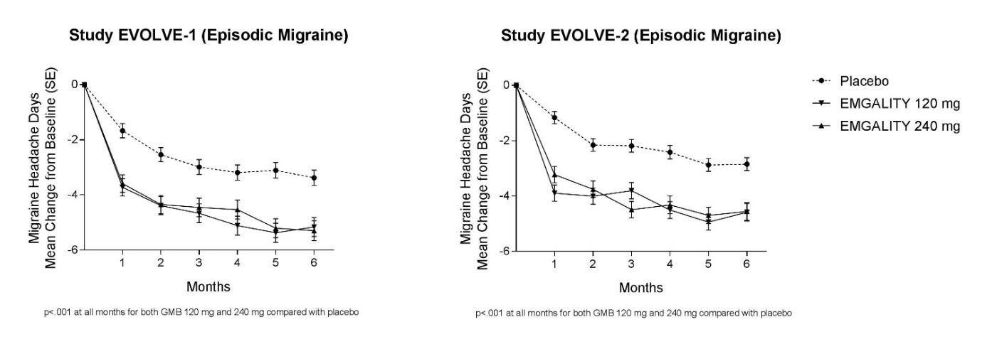

- Efficacy and patient reported outcome measures
 | EVOLVE-1 – Episodic Migraine EVOLVE-2 - Episodic Migraine
Emgality Emgality
120 mg 240 mg Placebo 120 mg 240 mg Placebo
N = 210 N = 208 N = 425 N = 226 N = 220 N = 450
Efficacy Outcomesa
MHD  Baseline Mean Change  Treatment Difference CI95 %  P-value | 9.21  -4.73  -1.92  (-2.48, -1.37)  < .001d | 9.14  -4.57  -1.76  (-2.31, -1.20)  < .001d | 9.08  -2.81 | 9.07  -4.29  -2.02  (-2.55, -1.48)  < .001d | 9.06  -4.18  -1.90  (-2.44, -1.36)  < .001d | 9.19  -2.28
≥ 50 % MHD Responders  Percentage, % P-value | 62.3  < .001d | 60.9  < .001d | 38.6 | 59.3  < .001d | 56.5  < .001d | 36.0
≥ 75 % MHD Responders  Percentage, % P-value | 38.8  < .001d | 38.5  < .001d | 19.3 | 33.5  < .001d | 34.3  < .001d | 17.8
100 % Responers Percentage, % P-value | 15.6  < .001d | 14.6  < .001d | 6.2 | 11.5  < .001d | 13.8  < .001d | 5.7
MHD with Acute Medication Use  Baseline Mean Change  Treatment Difference CI95 %  P-value | 7.42  -3.96  -1.81  (-2.28, -1.33)  < .001d | 7.34  -3.76  -1.61  (-2.09, -1.14)  < .001d | 7.38  -2.15 | 7.47  -3.67  -1.82  (-2.29, -1.36)  < .001d | 7.47  -3.63  -1.78  (-2.25, -1.31)  < .001d | 7.62  -1.85
Patient-reported Outcome Measures
MSQ Role Function- Restrictive Domainb  N  Baseline Mean Change  Treatment Difference CI95 %  P-value | 189  51.39  32.43  7.74  (5.20, 10.28)  < .001d | 184  48.76  32.09  7.40  (4.83, 9.97)  < .001d | 377  52.92  24.69 | 213  52.47  28.47  8.82  (6.33, 11.31)  < .001d | 210  51.71  27.04  7.39  (4.88, 9.90)  < .001d | 396  51.35  19.65
MSQ Role Function Restrictive Domain Respondersc  N  Percentage, % P-value | 189  63.5  < .001f | 184  69.6  < .001f | 377  47.2 | 213  58.2  < .001f | 210  60.0  < .001f | 396  43.4
MIDAS Total Scoree  N  Baseline Mean Change  Treatment Difference CI95%  P-value | 177  32.93  -21.16  -6.29  (-9.45, -3.13)  < .001f | 170  36.09  -20.06  -5.19  (-8.39, -1.98)  .002f | 345  31.84  -14.87 | 202  30.87  -21.17  -9.15  (-12.61, -5.69)  < .001f | 194  32.75  -20.24  -8.22  (-11.71, -4.72)  < .001f | 374  34.25  -12.02

N = number of patients; CI_{95 %} = 95 % confidence interval.
ªEfficacy outcomes were evaluated across Months 1-6.
^{b}Evaluated across Months 4-6.
^{c}Defined as those with an improvement of ≥ 25 points for Episodic Migraine at Months 4-6 average.
^{d}Statistically significant after adjustment for multiple comparisons.
^{e}Evaluated at Month 6.
^{f}Not adjusted for multiple comparisons.

In pooled data from studies EVOLVE-1 and EVOLVE-2, in patients who failed one or more prophylactic treatments for efficacy reasons, the treatment difference for the reduction of mean monthly MHDs observed between galcanezumab 120 mg and placebo was -2.69 days (p < 0.001) and between galcanezumab 240 mg and placebo -2.78 days (p < 0.001). In patients failing two or more prophylactic treatments, the treatment difference was -2.64 days (p < 0.001) between 120 mg and placebo and -3.04 days (p < 0.001) between 240 mg and placebo.
Chronic Migraine
Study REGAIN had a 3 month, double-blind, placebo-controlled treatment period followed by a 9 month open-label extension. Approximately 15 % of the patients continued concurrent treatment with topiramate or propranolol as allowed by the protocol for prophylaxis of migraine. Completion rate of the double-blind treatment phase for patients who received galcanezumab was 95.3 %.
Both galcanezumab 120 mg and 240 mg treatment groups demonstrated statistically significant and clinically meaningful improvements from baseline compared to placebo on mean change in MHD (see Table 3). Patients treated with galcanezumab had greater response rates and greater reductions in the number of monthly MHDs for which acute medication was taken compared with placebo-treated patients. Galcanezumab-treated patients had a greater improvement in functioning (as measured by the MSQ Role Function-Restrictive domain score) compared with placebo-treated patients, beginning at month 1. More patients treated with galcanezumab achieved clinically significant levels of improvement in functioning (responder rate based on MSQ Role Function Restrictive domain) compared with those treated with placebo. The 120 mg dose was associated with a statistically significant reduction in disability over placebo.
Compared with placebo-treated patients, patients treated with galcanezumab 120 mg or 240 mg had significantly greater mean decreases from baseline in the number of monthly MHDs at the first month and at all subsequent months up to month 3 (see Figure 2). Additionally, in month 1, patients treated with galcanezumab (loading dose of 240 mg) demonstrated significantly fewer weekly MHDs compared with placebo-treated patients, at week 1 and each subsequent week.

Figure 2 Reduction in monthly migraine headache days over time in study REGAIN

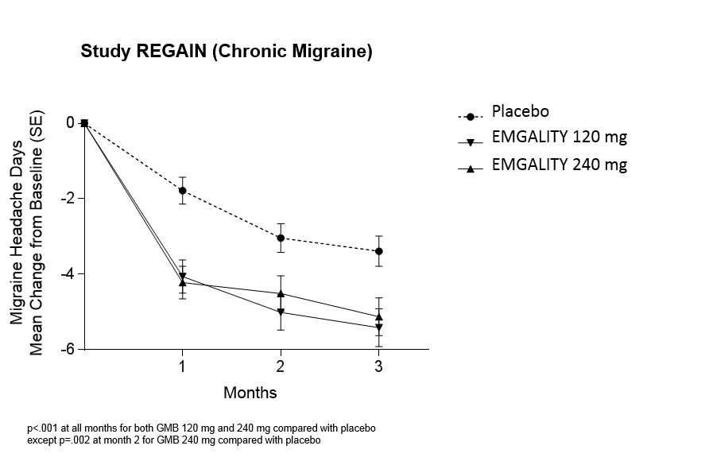

- Efficacy and patient reported outcome measures
 | REGAIN – Chronic Migraine
Emgality Placebo
120 mg 240 mg
N = 273 N = 274 N = 538
Efficacy Outcomesa
MHD  Baseline Mean Change  Treatment Difference CI95 %  P-value | 19.36  -4.83  -2.09  (-2.92, -1.26)  < .001c | 19.17  -4.62  -1.88  (-2.71, -1.05)  < .001c | 19.55  -2.74
≥ 50 % MHD Responders  Percentage, % P-value | 27.6  < .001c | 27.5  < .001c | 15.4
≥ 75 % MHD Responders  Percentage, % P-value | 7.0  .031d | 8.8  < .001c | 4.5
100 % Responders  Percentage, % P-value | 0.7  > .05d | 1.3  > .05d | 0.5
MHD with Acute Medication Use  Baseline Mean Change  Treatment Difference CI95 %  P-value | 15.12  -4.74  -2.51  (-3.27, -1.76)  < .001d | 14.49  -4.25  -2.01  (-2.77, -1.26)  < .001 c | 15.51  -2.23
Patient-reported Outcome Measuresb
MSQ Role Function-Restrictive Domain  N  Baseline Mean Change  Treatment Difference CI95 %  P-value | 252  39.29  21.81  5.06  (2.12, 7.99)  < .001d | 253  38.93  23.05  6.29  (3.03, 9.55)  < .001c | 494  38.37  16.76
MSQ Role Function Restrictive Domain Responders  N  Percentage, % P-value | 252  64.3  .003e | 253  64.8  .002e | 494  54.1
MIDAS Total Score  N  Baseline Mean Change  Treatment Difference CI95 %  P-value | 254  62.46  -20.27  -8.74  (-16.39, -1.08)  .025e | 258  69.17  -17.02  -5.49  (-13.10, 2.12)  > .05e | 504  68.66  -11.53
N = number of patients; CI_{95 %} = 95 % confidence interval.
ªEfficacy outcomes were evaluated across Months 1-3.
^{b}Patient-reported outcomes were evaluated at Month 3. MSQ role function restrictive domain responders were defined as those with an improvement of ≥ 17.14 points for Chronic Migraine at Month 3.
^{c}Statistically significant after adjustment for multiple comparisons.
^{d}Not statistically significant after adjustment for multiple comparisons.
^{e}Not adjusted for multiple comparisons.

In patients who failed one or more prophylactic treatments for efficacy reasons, the treatment difference for the reduction of mean monthly MHDs observed between galcanezumab 120 mg and placebo was -3.54 days (p < 0.001) and between galcanezumab 240 mg and placebo -1.37 days (p < 0.05). In patients failing two or more prophylactic treatments, the treatment difference was -4.48 days (p < 0.001) between 120 mg and placebo and -1.86 days (p < 0.01) between 240 mg and placebo.
Sixty-four percent of the patients had acute headache medication overuse at baseline. In these patients, the treatment difference observed between galcanezumab 120 mg and placebo and between galcanezumab 240 mg and placebo for the reduction of MHDs in these patients was respectively -2.53 days (p < 0.001) and -2.26 days (p < 0.001).
Long term efficacy
Efficacy was sustained for up to 1 year in an open-label study in which patients with either episodic or chronic migraine (with an average baseline of 10.6 monthly MHDs) received galcanezumab 120 mg/month (with an initial loading dose of 240 mg for the first month) or galcanezumab 240 mg/month. 77.8 % of patients completed the treatment period. The overall mean reduction from baseline in the number of monthly MHDs averaged over the treatment phase was 5.6 days for the 120 mg dose group and 6.5 days for the 240 mg dose group. Over 72 % of patients completing the study reported a 50 % reduction in MHDs at month 12. In pooled data from studies EVOLVE-1 and EVOLVE-2, more than 19 % of the patients treated with galcanezumab maintained a ≥ 50 % response from Month 1 to Month 6 versus 8 % of the patients on placebo (p < 0.001).

Pharmacokinetic properties

Absorption
Based on a population pharmacokinetic (PK) analysis, following a loading dose of 240 mg the maximum serum concentration (C_{max}) of galcanezumab was approximately 30 μg/mL (27% coefficient of variation [CV]) and the time to C_{max} was 5 days postdose.
Monthly doses of 120 mg or 240 mg achieved a steady-state Cmax (C_{max,ss}) of approximately 28 μg/mL (35% CV) or 54 μg/mL (31% CV), respectively. The galcanezumab C_{max, ss} at monthly doses of 120 mg is achieved after the 240 mg loading dose.
Injection site location did not significantly influence the absorption of galcanezumab.

Distribution
Based on a population PK analysis, the apparent volume of distribution (V/F) of galcanezumab was 7.3 L.

Metabolism
As a humanised IgG4 monoclonal antibody, galcanezumab is expected to be degraded into small peptides and amino acids via catabolic pathways in the same manner as endogenous IgG.

Excretion
Based on a population PK analysis, the apparent clearance (CL/F) of galcanezumab was approximately 0.008 L/h and the half-life of galcanezumab was 27 days.

Dose linearity
Galcanezumab exposure increases proportionally with dose.
Based on a population PK analysis that included doses ranging from 5 – 300 mg, the rate of absorption, CL/F and V/F was independent of dose.

Special Populations

Age, Sex, Weight, Race, Ethnicity
No dose adjustment is needed on the basis of age, sex, weight, race or ethnicity as there was no clinically meaningful effect of these factors on the CL/F or V/F of galcanezumab.

Renal or Hepatic impairment
Specific clinical pharmacology studies to evaluate the effects of renal impairment and hepatic impairment on the PK of galcanezumab were not conducted. Renal elimination of IgG monoclonal antibodies is low. Similarly, IgG monoclonal antibodies are mainly eliminated via intracellular catabolism and hepatic impairment is not expected to influence clearance of galcanezumab. Based on a population PK analysis, bilirubin concentration or creatinine clearance did not significantly influence the CL/F of galcanezumab.

Preclinical safety data

Genotoxicity
No genotoxicity studies have been conducted. As a monoclonal antibody, galcanezumab is not expected to interact with DNA or other chromosomal material.

Carcinogenicity
Nonclinical studies have not been conducted to evaluate the carcinogenic potential of galcanezumab. There is no nonclinical evidence to suggest that chronic treatment with galcanezumab would increase the risk of carcinogenesis based on data from pharmacology and chronic toxicology studies with galcanezumab as well as an assessment of the literature regarding CGRP.
- PHARMACEUTICAL PARTICULARS

List of excipients
Histidine
Histidine hydrochloride monohydrate
Polysorbate 80
Sodium Chloride
Water for Injections

Incompatibilities
Incompatibilities were either not assessed or not identified as part of the registration of this medicine.

Shelf life
The shelf life is 2 years when stored at 2°C to 8°C.
May be stored unrefrigerated for up to 7 days when stored at temperatures up to 30°C. If these conditions are exceeded, EMGALITY must be discarded. Once EMGALITY has been stored out of refrigeration, do not place it back in the refrigerator.

Special precautions for storage
Store refrigerated at 2°C to 8°C.
Protect EMGALITY from light until use.
Do not freeze.
Do not shake.

Nature and contents of container
EMGALITY is available in a single-dose prefilled pen (autoinjector). Pack sizes of 1, 2, 3.
EMGALITY is available in a single-dose prefilled syringe. Pack sizes of 1, 2, 3.
Note: not all presentations or pack sizes may be available.

Special precautions for disposal
In Australia, any unused medicine or waste material should be disposed of by taking to your local pharmacy.

Physicochemical properties

Chemical structure

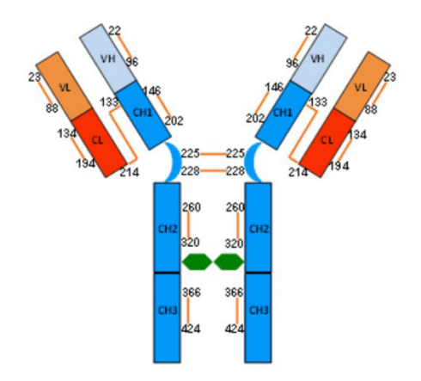

CAS number
The CAS number for galcanezumab is 1578199-75-3.
7 Medicine schedule (Poisons standard)
Schedule 4 – Prescription Only Medicine
8 Sponsor
Eli Lilly Australia Pty. Limited
112 Wharf Road
West Ryde NSW 2114
Australia
Phone: 1800 454 559
Email: au_info@lilly.com
www.lilly.com.au
9 DATE OF FIRST approval
29-May-2019

10 DATE OF REVISION

Summary table of changes
Section Changed | Summary of new information

