June 2014

Australian Public Assessment Report for Fluticasone furoate/vilanterol trifenatate
  - Proprietary Product Name: Breo Ellipta
  - Sponsor: GlaxoSmithKline Australia Pty Ltd

About the Therapeutic Goods Administration (TGA)
- The Therapeutic Goods Administration (TGA) is part of the Australian Government Department of Health and is responsible for regulating medicines and medical devices.
- The TGA administers the Therapeutic Goods Act 1989 (the Act), applying a risk management approach designed to ensure therapeutic goods supplied in Australia meet acceptable standards of quality, safety and efficacy (performance), when necessary.
- The work of the TGA is based on applying scientific and clinical expertise to decision-making, to ensure that the benefits to consumers outweigh any risks associated with the use of medicines and medical devices.
- The TGA relies on the public, healthcare professionals and industry to report problems with medicines or medical devices. TGA investigates reports received by it to determine any necessary regulatory action.
- To report a problem with a medicine or medical device, please see the information on the TGA website <http://www.tga.gov.au>.
About AusPARs
- An Australian Public Assessment Record (AusPAR) provides information about the evaluation of a prescription medicine and the considerations that led the TGA to approve or not approve a prescription medicine submission.
- AusPARs are prepared and published by the TGA.
- An AusPAR is prepared for submissions that relate to new chemical entities, generic medicines, major variations, and extensions of indications.
- An AusPAR is a static document, in that it will provide information that relates to a submission at a particular point in time.
- A new AusPAR will be developed to reflect changes to indications and/or major variations to a prescription medicine subject to evaluation by the TGA.
Copyright
© Commonwealth of Australia 2014
This work is copyright. You may reproduce the whole or part of this work in unaltered form for your own personal use or, if you are part of an organisation, for internal use within your organisation, but only if you or your organisation do not use the reproduction for any commercial purpose and retain this copyright notice and all disclaimer notices as part of that reproduction. Apart from rights to use as permitted by the Copyright Act 1968 or allowed by this copyright notice, all other rights are reserved and you are not allowed to reproduce the whole or any part of this work in any way (electronic or otherwise) without first being given specific written permission from the Commonwealth to do so. Requests and inquiries concerning reproduction and rights are to be sent to the TGA Copyright Officer, Therapeutic Goods Administration, PO Box 100, Woden ACT 2606 or emailed to <tga.copyright@tga.gov.au>.

Contents
List of abbreviations commonly used in this AusPAR 5
I. Introduction to product submission 8
Submission details 8
Product background 9
Regulatory status 11
Product information 13
II. Quality findings 13
Drug substance (active ingredient) 13
Drug product 15
Biopharmaceutics 17
Advisory committee considerations 18
Quality summary and conclusions 19
III. Nonclinical findings 19
Introduction 19
Pharmacology 20
Pharmacokinetics 21
Toxicology 23
Nonclinical summary 33
Conclusions 34
Recommendation 35
IV. Clinical findings 35
Introduction 35
Pharmacokinetics 37
Pharmacodynamics 43
Dosage selection for the pivotal studies 49
Efficacy 49
Safety 55
First round benefit-risk assessment 66
First round recommendation regarding authorisation 70
Clinical questions 70
Second round evaluation of clinical data submitted in response to questions 72
Second round benefit-risk assessment 98
Second round recommendation regarding authorisation 99
Second round recommendation regarding authorisation 103
V. Pharmacovigilance findings 104
Risk management plan 104
VI. Overall conclusion and risk/benefit assessment 115
Background 116
Quality 121
Nonclinical 121
Clinical 122
Risk-benefit analysis 131
Final outcome 158
Attachment 1. Product Information 159
Attachment 2. Extract from the Clinical Evaluation Report 160

List of abbreviations commonly used in this AusPAR
Abbreviation | Meaning
AE | adverse event
ALT | alanine aminotransferase
AMP | Adenosine 5’-monophosphate
APSD | Aerodynamic particle size distribution
AST | aspartate aminotransferase
AUC_{(0 to 24)} | Area under the concentration-time curve over the once daily dosing interval
AUC_{(0-∞)} | area under the concentration time curve extrapolated to infinity
AUC_{(0-t)} | area under the concentration time curve to the last measurable time-point
AUC_{(0-t’)} | area under the concentration time curve to the last common measurable time-point
AUC(0-t) | Area under the concentration-time curve from time zero (pre-dose) to last time of quantifiable concentration
BA | bioavailability
BD | Twice daily
BMI | Body Mass Index
CHMP | Committee for Medicinal Products for Human Use
CI | Confidence interval
CL | Systemic clearance
CL/F | Apparent clearance following inhaled dosing
Cmax | Maximum observed concentration
COPD | Chronic Obstructive Pulmonary Disease
CRQ-SAS | Chronic Respiratory Disease Questionnaire – Self-Administered Standardized
CYP3A4 | Cytochrome P450 3A4
DPI | dry powder inhaler
EAR | early asthmatic response
ECG | Electrocardiogram
eNo | exhaled nitric oxide
ETD | ex-throat dose
EU | European Union
FDA | Food and Drug Administration
Fe | fraction of total dose excreted unchanged
FEV1 | forced expiratory volume in 1 second
FF | Fluticasone Furoate
FF/V | fluticasone furoate/vilanterol
FP | fluticasone propionate
FVC | Forced vital capacity
GCP | Good Clinical Practice
GINA | Global Initiative for Asthma
GOLD | Global Initiative for Obstructive Lung Disease
GSK | GlaxoSmithKline Australia Pty Ltd
HPA | Hypothalamic-pituitary-adrenal
ICH | International Conference on Harmonisation
ICS | Inhaled corticosteroid
IMB | Irish Medicines Board
IND | Investigational New Drug
IOP | Intraocular pressure
ITT | Intent-to-Treat
IV | Intravenous
Kg | Kilogram
LABA | long-acting, beta2 adrenergic agonist
LAR | late asthmatic response
LLQ | Lower limit of quantification
LLQ | lower limits of quantification
LOCF | Last observation carried forward
LOCS III | Lens Opacities Classification System III
LogMAR | Logarithm of the angle of resolution
MA | mean absorption time
Mcg | Micrograms
MCID | Minimal clinically important difference
Mg | Milligrams
MgSt | magnesium stearate
MHRA | Medicines and Healthcare products Regulatory Agency
MRT | mean residence time
NDA | New Drug Application
NDPI | Novel Dry Powder Inhaler
OD | Once daily
PD | Pharmacodynamics
PDCO | Paediatric Committee of the European Medicines Agency
PEF | Peak expiratory flow
P-gp | P-glycoprotein
PIP | Paediatric Investigation Plan
PK | pharmacokinetic
QTcF | QT interval corrected for heart rate according to Fredericia’s formula
QTci | QT interval individually corrected for heart rate
Ro | Observed accumulation
SABA | Short-acting beta2-agonist
SAE | Serious adverse event
SE | Standard error
t_{1/2} | terminal phase elimination half-life
T90 | the time for 90% of the total to be absorbed from the lung
TED | total emitted dose
Tlast | time of last observed plasma concentration
Tmax | Time of occurrence of Cmax
ULN | upper limit of normal
URTI | Upper respiratory tract infection
VI | Vilanterol
VIM | vilanterol formulated with magnesium stearate
Vss | volume of distribution at steady-state
WHO | World Health Organisation
WM | weighted mean

I. Introduction to product submission

Submission details
Type of submission: | New chemical entity/new combination
Decision: | Approved
Date of decision: | 21 March 2014
Active ingredients: | Fluticasone furoate/vilanterol trifenatate
Product names: | Breo Ellipta
Sponsor’s name and address: | GlaxoSmithKline Australia Pty Ltd  436 Johnston Street  Abbotsford VlC 3067
Dose form: | Powder for inhalation
Strengths: | 100 µg / 25 µg, 200 µg / 25 µg
Container: | Multidose dry powder inhaler device
Pack sizes: | 14 or 30 inhalations
Approved therapeutic use: | Breo Ellipta 100/25 µg:  COPD: Breo Ellipta is indicated for symptomatic treatment of patients with COPD with a FEV1 <70% predicted normal (post-bronchodilator) in patients with an exacerbation history despite regular bronchodilator therapy.  Breo Ellipta is not indicated for the initiation of bronchodilator therapy in COPD.  Asthma: Breo Ellipta is indicated in the regular treatment of moderate to severe asthma in patients who require a medium to high dose inhaled corticosteroid combined with a long-acting beta-2-agonist. Vilanterol, an active ingredient in Breo Ellipta, is a long-acting beta-2-agonist (LABA). A class effect of all LABAs can be an increased risk of asthma death (see Precautions).  Breo Ellipta 200/25 µg:  Asthma: Breo Ellipta is indicated in the regular treatment of moderate to severe asthma in patients who require a medium to high dose inhaled corticosteroid combined with a long-acting beta-2-agonist. Vilanterol, an active ingredient in Breo Ellipta, is a long-acting beta-2-agonist (LABA). A class effect of all LABAs can be an increased risk of asthma death (see Precautions).
Route of administration: | Inhalation
Dosage: | The proposed dosage of FF/VI for COPD is 100/25 µg once daily (nominal blister content equivalent to delivered dose of 92/22 µg). The proposed dosages of FF/VI for asthma is 100/25 µg and 200/25 µg once daily (nominal blister content equivalent to delivered dose of 184/22 µg).  Treatment is administered as one inhalation once daily for both indications.
ARTG numbers: | 199747 and 199748

Product background
This AusPAR describes the application by the GlaxoSmithKline Australia Pty Ltd (GSK) to register a new combination inhalation product comprised of an inhaled corticosteroid (ICS) and long acting beta2 agonist (LABA), that is, fluticasone furoate (FF) and vilanterol (VI) Neither component is currently marketed as a single ingredient inhalation product in Australia (or in any other country).
Vilanterol trifenatate is a new chemical entity and therefore not marketed for any indication in Australia.
FF is not a new chemical entity; it is marketed as a nasal spray for allergic rhinitis. Fluticasone propionate, an ester of fluticasone and propionic acid is marketed for allergic rhinitis and asthma (single ingredient product) and as a fixed-dose combination (FDC) product (Seretide) with salmeterol (LABA) for asthma and COPD.
The proposed use of Breo Ellipta is in the treatment of asthma and Chronic Obstructive Pulmonary Disease (COPD). The proposed dosing regime is by inhalation using a pre-dispensed inhaler. For asthma patients, the proposed dose is 100/25 µg or 200/25 µg fluticasone furoate/vilanterol once daily. For COPD patients, the proposed dose is 100/25 µg fluticasone furoate/vilanterol once daily.
The development program for the fixed dose combination (FDC) of FF/VI is different from previous development programs for FDCs of ICS/LABA in asthma and COPD. Historically, ICSs and LABAs have been developed as separate mono products first; and in asthma first.
The reason for development first in asthma patients is that asthma patients are more sensitive to both ICSs and LABAs. Although there are distinct clinical differences between asthma and COPD, the similarities between these two obstructive lung conditions (for example, COPD patients have some reversible airway obstruction) have been the basis for extrapolation of dose selection of other ICS and LABA products from asthma to COPD in the past.
Concern about severe asthma exacerbation and death with LABAs has led to development of LABAs in COPD patients. For example, indacaterol was developed for marketing in COPD patients. Also, severe asthma exacerbation and death is a greater concern for LABAs used on their own as opposed to their use in combination with an ICS. Consequently, the current trend is to develop LABAs in combination with ICSs. The development program for FF/VI has taken this progression a step further: the FDC product FF/VI has been developed concurrently with development of the individual mono products and concurrently in asthma and COPD patients. Further, neither of the mono products is currently marketed for either for asthma or COPD.
For COPD, clinical practice guidelines do not recommend long-term monotherapy with ICS. Therefore the lack of a FF mono product is not a major concern for COPD. The sponsor refers to Phase III trial which show that V1 25 µg once daily is equivalent to salmeterol 50 µg twice daily; and this could provide a benchmark for step-up from a mono product LABA to the FDC FF/VI.
For asthma, once control is achieved, clinical practice guidelines recommend step down from dual-therapy with ICS/LABA to mono-therapy with ICS. Also, clinicians would need to know how to step-up from mono-therapy with ICS to dual therapy with ICS/LABA.
Fluticasone furoate is currently registered only in GlaxoSmithKline’s Avamys nasal spray. The closely related ester fluticasone propionate is currently registered by GlaxoSmithKline in various nasal products and in a range of inhalation products (shown below in Table 1).
Table 1. Fluticasone propionate in currently registered products by GlaxoSmithKline
fluticasone propionate | fluticasone propionate |  | type of product
FLIXOTIDE JUNIOR (CFC-FREE) | 50 μg |  | pressurised metered dose inhaler
FLIXOTIDE CFC-Free | 125 μg, 250 μg |  | pressurised metered dose inhaler
FLIXOTIDE DISKS | 50, 100, 250, 500 μg |  | dry powder inhaler
FLIXOTIDE JUNIOR ACCUHALER | 50, 100 μg |  | dry powder inhaler
FLIXOTIDE ACCUHALER | 250, 500 μg |  | dry powder inhaler
FLIXOTIDE NEBULES | 0.5 mg/2 mL; 2 mg/2 mL |  | nebulising suspension
combination products | fluticasone propionate | salmeterol xinafoate
SERETIDE MDI | 50 μg | 25 μg | pressurised metered dose inhaler
 | 125 μg | 25 μg | pressurised metered dose inhaler
 | 250 μg | 25 μg | pressurised metered dose inhaler
SERETIDE ACCUHALER | 100 μg | 50 μg | dry powder inhaler
 | 250 μg | 50 μg | dry powder inhaler
 | 500 μg | 50 μg | dry powder inhaler
Mundipharma Pty Ltd recently registered Flutiform fluticasone propionate/eformoterol fumarate pressurised metered dose inhalers (50 / 5 μg and 125 / 5 μg and 250/10 μg) for the treatment of asthma.
During the TGA’s evaluation of this submission the name of the product was changed from Relvar Ellipta to Breo Ellipta. Clinical concern had been expressed about possible confusion of the name ‘Relvar’ as an acute asthma attack relieving medication. (The use of a blue dustcover on the inhaler device is perhaps relevant in this context: Australian first aid information is to “Give 4 puffs of a blue Reliever inhaler (puffer)” for an asthma attack).

Regulatory status
At the time the TGA considered this application, a similar application had been approved in several countries (see Table 2 below).
Table 2. International regulatory status (as of 14 January 2014)
Country | Approval date | Approved indication
USA | 10 May 2013 COPD only | Breo Ellipta is a combination of fluticasone furoate, an inhaled corticosteroid (ICS), and vilanterol, a long-acting beta2 adrenergic agonist (LABA), indicated for long-term, once daily, maintenance treatment of airflow obstruction and for reducing exacerbations in patients with chronic obstructive pulmonary disease (COPD).
Canada | 4 Jul 2013 COPD only | Breo™ Ellipta™ 100/25 mcg is indicated for the long-term once daily maintenance treatment of airflow obstruction in patients with chronic obstructive pulmonary disease (COPD), including chronic bronchitis and/or emphysema, and to reduce exacerbations of COPD in patients with a history of exacerbations.
Japan | 20 Sep 2013 Asthma only | Bronchial asthma (in the case where concurrent use of inhaled corticosteroid and long-acting inhaled β2 agonist is required
Mexico | 11 Oct 2013 | Asthma  RELVARE is indicated for the maintenance treatment of asthma.  COPD  RELVARE is indicated for the maintenance treatment of airflow obstruction in patients with chronic obstructive pulmonary disease (COPD) including chronic bronchitis and/or emphysema and to reduce exacerbations of COPD in patients with an exacerbation history.
EU | 13 Nov 2013 | Asthma  Relvar Ellipta is indicated for the regular treatment of asthma in adults and adolescents aged 12 years and older where use of a combination medicinal product (long-acting beta2-agonist and inhaled corticosteroid) is appropriate:  - patients not adequately controlled with inhaled  corticosteroids and 'as needed' inhaled short acting beta2-agonists.  COPD  Relvar Ellipta is indicated for the symptomatic treatment of adults with COPD with a FEV1<70% predicted normal (post-bronchodilator) with an exacerbation history despite regular bronchodilator therapy.
New Zealand | 12 Dec 2013 | Asthma  Relvar Ellipta is indicated for the regular treatment of asthma in adults and adolescents aged 12 years and older where use of a combination product (long-acting beta2-agonist and inhaled corticosteroid) is appropriate.  COPD  Relvar Ellipta is indicated for symptomatic treatment of patients with COPD with a FEV1 <70% predicted normal (post-bronchodilator) in patients with an exacerbation history.
Chile | 3 Jan 2014 | Asthma  Relvar Ellipta 92/22 is indicated for the regular treatment of asthma in adults and adolescents aged 12 years and older where use of a combination medicinal product (long-acting beta2-agonist and inhaled corticosteroid) is appropriate:  - patients not adequately controlled with inhaled corticosteroids and 'as needed' inhaled short acting beta2-agonists.  Relvar Ellipta 184/22 is indicated for the regular treatment of asthma in adults and adolescents aged 12 years and older where use of a combination medicinal product (long-acting beta2-agonist and inhaled corticosteroid) is appropriate:  - patients not adequately controlled with inhaled corticosteroids and 'as needed' inhaled short acting beta2-agonists.  COPD  Relvar Ellipta 92/22 is indicated for the symptomatic treatment of adults with COPD with a FEV1<70% predicted normal (post-bronchodilator) with an exacerbation history despite regular bronchodilator therapy.
Switzerland | 9 Jan 2014 | Asthma  Relvar Ellipta is used for the regular treatment of bronchial asthma if a combination drug (long-acting beta-2 agonist and inhaled corticosteroid) is appropriate: for adults and adolescents aged 12 years old and older not adequately controlled with inhaled corticosteroids and 'as needed' inhaled short-acting beta2-agonists.  COPD  Symptomatic treatment of chronic obstructive pulmonary disease (COPD) in patients with a FEV1 < 70% and ≥ 2 exacerbations within the preceding 12 months.

Product information
The approved Product Information (PI) current at the time this AusPAR was prepared can be found as Attachment 1. For the most recent Product Information please refer to the TGA website at <http://www.tga.gov.au/hp/information-medicines-pi.htm>.

II. Quality findings

Drug substance (active ingredient)
The structures of the drug substances are illustrated in Figure 1 below together with that of fluticasone propionate.
There are British/European Pharmacopoeia and United States Pharmacopeia monographs only for the related ester fluticasone propionate. There are British Pharmacopoeia (BP) monographs for Fluticasone Powder for Inhalation and for Fluticasone Pressurised Inhalation: these are defined as products containing fluticasone propionate. There are no official monographs for fluticasone furoate as used here.
There are no monographs for vilanterol. The drug substances are micronised. Vilanterol trifenatate is a new chemical entity. Vilanterol has one chiral centre; the drug substance is the salt of the R enantiomer. There are no other trifenatate (triphenylacetate) salts on the Australian Register of Therapeutic Goods (ARTG). Vilanterol is structurally related to eformoterol, salmeterol, fenoterol and indacaterol (Figure 2).
Figure 1. Chemical structure
fluticasone furoate | vilanterol trifenatate
 |  | 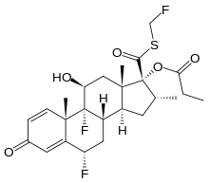
fluticasone furoate [proposed here; also in AVAMYS] |  | fluticasone propionate [FLIXOTIDE etc]
Figure 2. Chemical structure of vilanterol trifenatate and related substances
vilanterol trifenatate
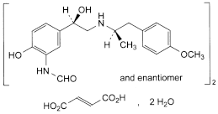 | 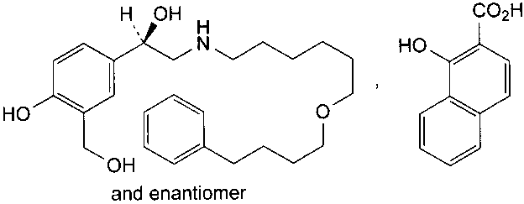
eformoterol fumarate | salmeterol xinafoate
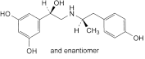 | 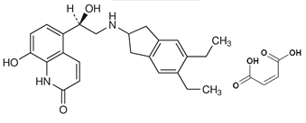
fenoterol | indacaterol maleate

Drug product

Device
Breo Ellipta is a dry powder inhalation which uses a device derived from GlaxoSmithKline’s Accuhaler Diskus products. (It appears that GlaxoSmithKline may use the Ellipta part of the name for the device in future applications with other inhaled drugs in this presentation).
Breo Ellipta is a moulded plastic inhaler with a dose counter (Figure 3). The inhaler contains two completely separate ‘cap gun’ style blister strips (either 30 or 14 blisters), each filled with an inhalation powder (Figure 3). Manual opening of the mouthpiece cover causes two blisters (one from each strip) to be peeled open adjacent to the mouthpiece. The device is not reusable or refillable.
One strip has blisters with a fluticasone furoate and lactose mixture, the other strip has blisters with a vilanterol trifenatate, magnesium stearate and lactose mixture.
Figure 3. Inhaler with dose counter
During inspiration the dry powders are aerosolised from the opened blisters, with particles colliding with each other and the device. This causes partial disaggregation of the fluticasone furoate and vilanterol particles from the lactose ‘carrier’ particles. The extent of disaggregation is somewhat dependent on the inspiratory profile.
The Ellipta airflow resistance is slightly higher than the Diskus device. The Ellipta is a relatively low resistance device (compared for example to the Turbuhaler).
Device instructions are to clean by wiping with a tissue. This could conceivably cause static problems in some areas in Australia with low humidity. Any effect is likely to be much less than problems with spacers but remains un-investigated.
The Product Information now includes a set of “Step by step instructions” for device use appended as a separate section at the end. Instructions are also in a separate leaflet to be provided inside the pack.
Drug delivery is not significantly affected by device orientation (unlike some inhalers).

Formulation
Two strengths are proposed, 100/25 and 200/25 μg. (A 50/25 μg product was developed and was used in clinical trials but is not proposed for registration.) The 25 μg vilanterol blisters are the same in all products. The fluticasone furoate blisters have different amounts of drug mixed with 12.5 mg of lactose carrier. The label claims (100 μg/25 μg and 200 μg/25 μg) are the quantities of drugs in the blisters (in the case of vilanterol trifenatate, the label claim is the equivalent amount of the base, vilanterol). The delivered (patient) doses are about 92% (fluticasone furoate) or 88% (vilanterol) of the blister contents under standard conditions.
Breo Ellipta is formulated with lactose carrier particles (12.5 mg per blister). Inhalation of excipients is broadly undesirable and the lactose is chosen to have a particle size distribution mostly larger than respirable diameter. About 5% of the lactose (approximately 600 µg) is in respirably sized particles, although in vitro testing suggests about 1% will be delivered from the product. Clinical concerns have been raised about anaphylactic reactions due to use of a different, lactose-containing dry powder inhaler in a milk allergic patient, with in vitro and in vivo testing reported to have demonstrated presence of milk protein in the dry powder device. Breo Ellipta uses lactose made with reduced protein contamination. Nevertheless, the Product Information includes a warning that the product contains milk protein and is contraindicated in patients with severe milk protein allergy.
The vilanterol powder is formulated with magnesium stearate, which is not currently used in inhalation medicines. Magnesium stearate is used to coat the lactose particles before vilanterol trifenatate is adhered to them. The coating stops a chemical reaction between lactose and vilanterol. The respirable dose of magnesium stearate is about 12 µg per inhalation. Magnesium stearate is not an excipient in inhalation products registered in Australia. The toxicological and clinical acceptability of magnesium stearate as an inhalation excipient is considered separately.
Little degradation is seen in finished product manufacture and GSK proposes not routinely controlling this at release. At least occasional, for example, annual, testing will be required (if necessary as a condition of registration).

Fine particle dose
The fine particle dose is the amount of drug estimated to reach the lung, as measured by in vitro testing using a cascade impactor. This quantifies drug aerosolised in particles smaller than 4.7 µm (aerodynamic diameter). This is tested on every batch prior to release. About 23% (fluticasone furoate) or 34% (vilanterol) of the delivered doses is in particles small enough to reach the lung (the remaining drug deposited in the mouth area).
GSK has explored the peak inspiratory flow rates (PIFR) of asthma and COPD patients. When patient inspiratory profiles are mimicked in vitro delivered doses are not markedly affected (100/25 µg fluticasone furoate delivery shown below, other strength is similar and vilanterol delivery also similar) (Figure 4).
Figure 4. Effect of PIFR on the delivered dose and fine particle mass of fluticasone furoate for breo ellipta (100/25 microgram) [GSK]
Error bars represent the range of results
Blue=total dose; Red=FPMass

Linearity in vitro
The EU Guideline on the Requirements for Clinical Documentation for Orally Inhaled Products recommends in vitro investigation of linearity. The delivered doses are reasonably linear (targets 92 and 184 μg fluticasone furoate); the fine particle dose targets are also essentially linear (21.5 and 42.5 μg).

Biopharmaceutics
Breo Ellipta acts locally in the lungs, so that bioavailability comparisons of systemic exposure are of limited use. Nevertheless, systemic steroid bioavailability studies are expected as part of the safety information.
The absolute bioavailability of Breo Ellipta has been investigated in Study HZA102934. This used a supra-therapeutic dose (800/100 μg as four 200/25 µg inhalations) in order to get measurable blood and plasma concentrations. A placebo inhaler was used for pre-dose practice, which is sensible. The three way crossover comparison also used intravenous doses of fluticasone furoate (250 μg) and vilanterol trifenatate (55 μg). Subjects were healthy volunteers (n=16).
Maximum fluticasone furoate plasma concentrations following inhaled dosing were seen between 30 and 60 minutes, compared to 5 to 10 minutes for vilanterol. This is consistent with in-vitro dissolution studies using simulated lung fluid, which showed much slower dissolution of fluticasone furoate than of vilanterol. These in vitro experiments suggested that there would be a strength dependence also due to rate limited absorption from the lung, with fluticasone furoate dissolution slower for the 200/25 µg product compared to the 50/25 µg strength (% basis). In vivo fluticasone furoate peak plasma concentration (Cmax) increase is indeed less than dose proportional (Study HZA102932), although GSK claims that this is not clinically significant.
Average fluticasone furoate absolute bioavailability was 15% [90% CI 12.6-18.4%]. Average vilanterol absolute bioavailability was 27% [90% CI 21.6-34.6%].
Note that there are losses within the inhaler during dosing (about 9% fluticasone furoate or 12% vilanterol). The anticipated absolute bioavailability also depends on the oral bioavailability of the large proportion of the powder which is not deposited in the lung.
Another study established that a 2000 µg radiolabelled, oral solution dose of fluticasone furoate gave at least 30% of the dose absorbed (radioactivity measurement), with extensive first-pass metabolism so that the oral bioavailability of fluticasone furoate was low (approximately 1.26%) [Study FFR10008].
A similar study with vilanterol trifenatate used a 200 µg oral solution dose of radiolabelled vilanterol. Based on urinary recovery of radioactivity, at least 50% of the oral dose was absorbed via the gut (actual oral absorption is likely to be greater), with extensive first-pass metabolism [Study B2C106181]. The low oral bioavailability (<2%) suggests a minimal oral contribution in the vilanterol exposure after inhalation, with systemic vilanterol largely due to lung absorption.
The fine particle dose is the amount of drug estimated to reach the lung, as measured by in vitro testing using a cascade impactor. This is 21% for fluticasone furoate and 30% for vilanterol (% of the label claim = blister contents). Comparison of the absolute bioavailability and fine particle doses suggest that most of drug that is likely to be delivered to the lung also reaches the systemic circulation.

Advisory committee considerations
The submission was considered at the 151st (2013/3) meeting of the Pharmaceutical Subcommittee (PSC). The PSC recommended:
- The PSC endorsed all the issues raised by the TGA in relation to the quality and pharmaceutic aspects of the submission by GlaxoSmithKline Australia Pty Ltd to register Breo Ellipta powder for inhalation containing 100 / 25 µg and 200 / 25 µg of fluticasone furoate / vilanterol (as trifenatate) per dose. In particular, the PSC supported the questions on the use of magnesium stearate-treated lactose carrier in the formulation.
- The PSC advised that:
- The sponsor should be asked to include microbial limit in the drug substance specifications for vilanterol trifenatate.
- If vilanterol trifenatate is manufactured at more than one manufacturing sites, batches manufactured at all nominated sites must be represented in the batch analysis and stability testing protocols.
- The sponsor should address the issues raised in relation to batch consistency to the satisfaction of the TGA.
- The PSC shared the evaluator’s concerns in relation to the absence of routine batch testing for degradation products given that the formation of impurities was shown to be dependent on both temperature and moisture.
- With regards to the population pharmacokinetic analysis, the PSC noted that the results from the analyses are included under the relevant sections (“Special Patient Populations” and “Dosage and Administration”) of the Product Information (PI). The PSC therefore advised that the pharmacometric analyses must be formally evaluated by the TGA including obtaining the key model files and datasets electronically from the sponsor and re-running them during the evaluation process to ensure the results are consistent with the sponsor’s claims. The PSC considered that this is relevant given that the analyses were used to support inclusion of material in the PI and thus require formal evaluation.
- There is no requirement for this submission to be reviewed again by the PSC before it is presented for consideration by Advisory Committee on Prescription Medicines (ACPM).
[Recommendation No. 2324]
Comments:
- Issues in relation to the carrier have been addressed.
- TGA policy is not to review microbial limit in the drug substances: controls are left as a Good Manufacturing Practice (GMP) matter.
- Only one vilanterol trifenatate manufacturing site has been used and is proposed.
- The issues in relation to the batch consistency appear to have been addressed.
- At least regular testing for degradation products in the finished products at release will be required.

Quality summary and conclusions
Registration was recommended with respect to chemistry, quality control and bioavailability aspects.

III. Nonclinical findings

Introduction
Fluticasone furoate is currently approved (Avamys®) as a nasal spray and many of the submitted studies on fluticasone furoate were previously evaluated by the TGA.
A number of new studies have been conducted on vilanterol alone and on the fluticasone furoate/vilanterol combination. Vilanterol trifenatate is referred to in this report by its common name vilanterol triphenylacetate.
The general quality of the submitted nonclinical studies was high, with pivotal studies examining repeat-dose toxicity, genotoxicity, carcinogenicity and reproductive toxicity conducted under GLP conditions.
A number of studies were included in the submission were not considered relevant to the proposed combination formulation and route of administration:
- Two intravenous irritation studies (WD2006/01772/00 and WD2007/02084/00).
- Studies examining the toxicity of vilanterol in the presence of the surfactant cellobiose octaacetate (COA) which was added to the formulation to aid physical stability but not used in the final formulation (WD2005/01578/00; WD2007/00248/00).
- Studies examining the toxicity of vilanterol in the presence of other LABA compounds (CD2007/01072/00; CD2008/00827/00; FD2009/00392/00; FD2009/00391/00; 2010n109790_00; WD2010/00677/01; FD2009/00017/00; CD2009/00970/00).
- An in vitro study on the metabolism of fluticasone furoate in dog and rat nasal tissue (WD2008/1010/00).
- Studies on dermal and eye irritation (ED207/00140/00; ED2007/00138/00; ED2007/00139/00).

Pharmacology

Primary pharmacology
Fluticasone furoate acts by binding the glucocorticoid receptor, while vilanterol is a beta2 receptor agonist. ICS are effective anti-inflammatory treatments for persistent asthma, but add-on therapy with an inhaled LABA is preferable to increasing the dose of ICS for severe asthma. For COPD patients, limited evidence shows that regular treatment with LABA and ICS may decrease the rate of lung function decline. An ICS/LABA combination is reported to reduce exacerbations and improve lung function and health status.

In vitro studies
In vitro studies with fluticasone furoate demonstrated significant human glucocorticoid receptor binding and potency as well as inhibition of the IL-1beta-induced release of GM-CSF (50% inhibitory concentration (IC₅₀) 0.009nM) and CLCX8 release (IC₅₀ 0.063nM) in lung epithelial cells (below or comparable to the clinical exposure based on Cmax). Fluticasone furoate compared favourably with other corticosteroids regarding glucocorticoid receptor (GR) selectivity (similar to fluticasone propionate and better than mometasone furoate, ciclesonide active or budesonide) and duration of action, and its metabolites had negligible GR agonist activity.
Vilanterol demonstrated potent in vitro beta2-adrenoceptor binding in chinese hamster ovary cells (CHO) cells (pKD 9.44-10.8) and human lung parenchymal cells (pKD8.8). It was also selective for beta2 receptors over beta1 (140 to 2400-fold) and beta3 receptors (80 to1000 fold). The negative logarithm of the 50% effective concentration (pEC50) at beta2 receptors was 9.3 in melanophores, 9.45 in CHO cells, and 7.87 in a guinea pig trachea preparation. Vilanterol’s primary human metabolites were 2500 times less potent than the parent compound at the beta2 receptor.
Vilanterol enhanced the inhibitory effects of fluticasone furoate on intraleukin 8 (IL-8) production in peripheral blood mononuclear cells from COPD patients.

In vivo studies
In vivo studies with vilanterol demonstrated its potency and long-acting inhibition of bronchoconstriction in guinea pigs (90% effective dose (EC₉₀) 3x10⁻⁵M). Duration of inhibition was increased significantly at higher dose levels of vilanterol compared to salmeterol. However, tachyphylaxis to the bronchoprotective effects of vilanterol occurred following 4 daily exposures at the EC₉₀. The possibility of tachyphylaxis occurring in humans following repeated vilanterol dosing needs to be analysed in the clinical trial data.
No pharmacological effects were observed following in vivo (inhalational) dosing of rats or guinea pigs with magnesium stearate at up to 3 mg/kg (>200 fold anticipated clinical exposure).

Secondary pharmacodynamics and safety pharmacology
Vilanterol showed specificity for beta2 receptors (>200 fold) over a range of other 7-TM receptors and transporters. In conscious guinea pigs, vilanterol caused lower reductions in blood pressure than salmeterol at the EC₉₀ dose level, and hence have a higher therapeutic index.
Specialised safety pharmacology studies covered the central nervous system, cardiovascular system and respiratory system. In rats, intravenous (IV) administration produced central nervous system (CNS) effects (decreased locomotor activity) at 400 µg/kg, reversible at 24 h, with a No observable adverse effect level (NOAEL) of 25 µg/kg while inhalation exposure produced a reversible decrease in motor activity and body temperature at 35 mg/kg, with a NOAEL of 612 µg/kg. Relative exposure at these NOAEL’s is equivalent to more than 300 times the clinical exposure, based on plasma C_{max}.
Vilanterol produced a concentration dependent inhibition of the potassium (K⁺) hERG channel with an IC₅₀ value of 2.3 µg/mL (4.7 µM), which is more than 50000 times the clinical C_{max} of 0.0432 ng/mL in subjects with COPD. In a Purkinje fibre assay, there were changes in action potential duration and upstroke amplitude at ≥1 µM (>10000 times the clinical exposure based on C_{max}) but these were not indicative of an increased QTc interval. Cardiovascular effects in dogs following IV administration were limited to transient increases in heart rate together with small decreases in blood pressure after either vilanterol α-phenylcinnamate or triphenylacetate salts at 0.3 µg/kg (C_{max} = 3 ng/mL (0.0062 µM; approximately 70 times the clinical exposure based on COPD C_{max} of 0.0432 ng/mL). The increased heart rate produced a small transient reduction in RR, QT and QTcl intervals, but no change in ECG rhythm or waveform morphology. The observed changes are consistent with the pharmacological response of beta2 agonists.
Respiratory parameters were examined in rats after inhalation exposure. There was a slight but reversible increase in respiratory rate at 666 µg/kg α-phenylcinnamate salt but not after the triphenylacetate salt (approximately 200 times the clinical exposure based on AUC).

Pharmacokinetics
Nonclinical pharmacokinetic studies were conducted in the mouse, rat and dog. The pharmacokinetics of fluticasone furoate have been previously evaluated. Additional studies have compared inhalation via a dry powder and a metered dose inhaler in single and repeat dose studies, as well as the effect of addition of magnesium stearate. The pharmacokinetics of the combination of fluticasone furoate and vilanterol triphenylacetate has also been examined via the inhalational route in rats and dogs.
Absorption: Absorption of vilanterol following a single dose oral exposure was rapid in both rats and dogs and T_{max} was reached usually within 1 h. In rats, oral bioavailability was low (1%) with a moderate clearance and high volume of distribution, while in dogs, oral bioavailability was moderate (approximately 30%) with a moderate volume of distribution. In humans, the oral bioavailability was low (<2%), mediated by extensive first pass metabolism. Bioavailability of the counter ion, triphenylacetate, was high (>50%) in rats.
Comparison of the pharmacokinetics of both fluticasone furoate and vilanterol following single dose inhalation in rats via a dry powder formulation or via a metered dose inhaler indicated a slightly higher exposure (area under the plasma concentration time curve (AUC) and peak plasma concentration (C_{max})) via the dry powder formulation.
The pharmacokinetics of vilanterol, triphenylacetate (counter ion), M29 and M33 (metabolites) were examined in repeat dose studies in mice, rats and dogs. Systemic exposure to vilanterol increased with increasing dose in a proportional or less than dose proportional manner in all species. There was little evidence of accumulation with time or differences between males and females. Inclusion of magnesium stearate as an excipient did not result in changes to exposure in either rats or dogs. Systemic exposure to triphenylacetic acid increased proportionally with dose in both rats and dogs in both sexes. Systemic exposure to the metabolites M29 and M33 increased in a proportional or less than proportional manner with dose in rat and dogs in both sexes. Metabolite: parent ratios (based on AUC) were 0.002 to 0.01 for M29 and 0.02 to 0.08 for M33.
Exposure to vilanterol in rats and dogs after repeat dose administration was not affected by the presence of 1% magnesium stearate. Similarly, there was no significant difference in exposure following administration of vilanterol via a dry powder formulation or via a metered dose inhaler.
Distribution: Tissue distribution of radiolabelled vilanterol in rats was widespread following IV and oral administration, with the highest concentration at 15 minutes after treatment in kidney, adrenals and liver. Radioactivity was only present at very low levels in the brain or CNS but was found in melanin containing tissues. Tissue radioactivity declined relatively rapidly with only low levels present 3 days after IV administration. In vitro plasma protein binding of vilanterol was moderately high in all species (92-99%), with specific binding to human serum albumin and α-acid glycoprotein, and low binding to γ-globulin. Plasma protein binding of the counter ion, triphenylacetate, was also high. With regard to blood-plasma partitioning, there was no evidence of differential distribution of vilanterol to red blood cells in any species, including humans. Vilanterol was a substrate for P-glycoprotein but P-gp inhibition did not generally affect absorption and total systemic exposure. However, P-gp probably attenuates CNS penetration of vilanterol, as shown by experiments in mdr1a/b knockout mice.
Metabolism: The major pathways of metabolism of vilanterol in animals were O-dealkylation, N-dealkylation, glucuronidation and C-dealkylation. In humans, the main route of metabolism was by O-dealkylation to a range of metabolites, including M29, M33 and M30. None of the animal or human metabolites had significant pharmacological activity. In vitro metabolism examined in rat, dog and human liver microsomes showed high clearance (~50% unchanged) while in human lung microsomes, clearance was negligible. The in vitro metabolism of the counter ion, triphenylacetate, was very low. In the presence of human hepatocytes, metabolism of vilanterol was rapid, with turnover >80% in 2 h, and was complete at 4 h. In vivo studies confirmed O-dealkylation as the major route of metabolism in humans. There were no human specific metabolites. Metabolites were excreted by both urinary and faecal routes. For the counter ion, triphenylacetate, glucuronidation was the only route of metabolism in rats and dogs.
Excretion: The main route of excretion of vilanterol and its metabolites in both rats and dogs was via the faeces, with the majority via the bile in rats. Mass balance ratios indicated oral absorption of 37% in rats and >56% in dogs. The major route of excretion of triphenylacetate was via the faeces in rats.
Conclusion: All the human metabolites were detected in at least one of the species (rats or dogs) used in the pivotal repeat-dose toxicity studies. The metabolic profiles were sufficiently similar in these species to allow them to serve as appropriate models for the assessment of toxicity in humans.

Pharmacokinetic drug interactions
No specific studies were undertaken to examine the potential for fluticasone furoate or vilanterol triphenylacetate administered alone or in combination to undergo pharmacokinetic drug interactions when administered with other drugs.
The toxicokinetics from the animal toxicity studies indicate that co-administration of fluticasone furoate and vilanterol triphenylacetate does not lead to increased exposure (AUC or C_{max}) of either drug compared to the exposures to each drug alone, indicating that neither drug interferes with the systemic clearance of the other.
Vilanterol triphenylacetate shows low potential for P-gp inhibition. This was only observed at very high doses (100 µM) corresponding to more than 10⁵ times the clinical exposure, based on C_{max}.
The data available on the potential for inhibition of cytochrome P450 isoforms was not of a high quality; however, it did indicate that the lowest IC₅₀ for cytochrome P450 isozyme CYP3A4 inhibition was 4 µM (equivalent to 40000 times the clinical exposure based on C_{max}).

Toxicology

Single-dose toxicity
Fluticasone furoate was previously reported to have a low order of single-dose toxicity in animal studies.There were no further single-dose toxicity studies with fluticasone furoate.
Vilanterol α-phenylcinnamate demonstrated low toxicity in dogs by the inhalation route, with the deep breathing and elevated pulse rate the only clinical signs at 0.135 mg/kg, the maximum tolerated dose (200 to 300 times the clinical exposure, based on AUC and C_{max}). Vilanterol triphenylacetate demonstrated low toxicity in rats by the oral route, with no abnormal clinical signs observed at 300 mg/kg, the maximum dose tested (>10000 times the clinical exposure, based on AUC and C_{max}). Vilanterol triphenylacetate is expected to have a low order of single-dose toxicity by the clinical (inhalation) route.

Repeat-dose toxicity
There were no further repeat-dose toxicity studies with fluticasone furoate alone; however, repeat dose studies up to 13 weeks were conducted with the fluticasone furoate/vilanterol triphenylacetate combination in rats and dogs. These studies were conducted at the clinical ratio of fluticasone furoate/vilanterol (1:1 or 2:1), as well as the maximum feasible ratio (9:1 in rats and 16:1 in dogs); and also examined the effect of the addition of magnesium stearate.
Vilanterol α-phenylcinnamate was studied alone up to 14 days in mice, 28 days in rats and 14 days in dogs. Vilanterol triphenylacetate was studied alone up to 13 weeks in mice, 26 weeks in rats and 39 weeks in dogs. The α-phenylcinnamate salt was not further developed due to its unacceptable taste. Additional bridging studies were conducted to examine the effect of the addition of magnesium stearate, as well as bridging studies to compare administration of either fluticasone furoate or vilanterol in a dry powder formulation or a metered dose inhaler. Repeat dose studies with magnesium stearate were conducted up to 26 weeks in rats and 4 weeks in dogs. All studies were conducted by the inhalation route (except for one oral mouse study) with dosing once daily for 60 min. in rats and 30 min. in dogs. The proposed clinical route is by inhalation, once daily. The studies are consistent with International Conference on Harmonisation of Technical Requirements for Registration of Pharmaceuticals for Human Use (ICH) guidelines.

Relative exposure
Exposure ratios have been calculated based on animal: human plasma AUC_{0–24 h} for the maximum recommended human doses of the two agents. The tabulated AUCs for animal studies represent the arithmetic means of data from main collection points due to the inherent variability associated with inhaled administration. Human reference values are the highest predicted (worst case) values derived from population-based PK modelling in either COPD (for vilanterol 25 µg; n=1091) or asthma (for fluticasone furoate 200 µg; n=432) patients and are given in the table below.
Toxicokinetic measurements of the counter ion, triphenylacetate, and the metabolites M29 and M33 were not used to calculate exposure ratios as the concentration of these substances in asthma and COPD patients was below the level of quantification. Therefore, there are large exposure ratios for triphenylacetate and metabolites M29 and M33 in animal studies relative to the human clinical exposure.
Table 3. Fluticasone furoate /vilanterol triphenylacetate combination in adults
Species | Study duration |  | Dose (mg/kg/day) | AUC_{0–24 h} (ng∙h/mL) | Exposure ratio#
Fluticasone furoate /Vilanterol triphenylacetate
Rat (SD) | 4 weeks | 34.9/0 |  | 0.532/- | 1/-
Rat (SD) | 4 weeks | 0/6.29 |  | -/NC | -/NC
Rat (SD) | 4 weeks | 33.5/8.31 |  | 0.235/NC | 0.5/NC
Rat (SD) | 4 weeks | 29.4/18.7 |  | 0.441/0.617 | 0.9/2
Rat (SD) | 4 weeks | 33.0/25.5 |  | 0.553/0.981 | 1/4
Rat (SD) | 13 weeks | 56.4/0 |  | 1.41/- | 3/-
Rat (SD) | 13 weeks | 0/24.9 |  | -/3.37 | -/13
Rat (SD) | 13 weeks | 7.85/5.24 |  | 0.296/0.393 | 0.6/2
Rat (SD) | 13 weeks | 19.8/11.7 |  | 0.261/0.183 | 0.5/0.7
Rat (SD) | 13 weeks | 53.8/30.7 |  | 1.18/1.51 | 2/6
Dog (Beagle) | 4 weeks | 33.8/0 |  | 1.19/ | 2.4/-
Dog (Beagle) | 4 weeks | 0/0.95 |  | -/NC | -/NC
Dog (Beagle) | 4 weeks | 35.2/1.27 |  | 1.00/0.176 | 2/0.7
Dog (Beagle) | 4 weeks | 33.3/3.71 |  | 1.19/0.542 | 2.4/2
Dog (Beagle) | 13 weeks | 56.1/0 |  | 2.54/- | 5/-
Dog (Beagle) | 13 weeks | 0/33.5 |  | -/35.6 | -/134
Dog (Beagle) | 13 weeks | 6.92/3.81 |  | 0.148/2.25 | 0.3/8
Dog (Beagle) | 13 weeks | 20.6/11.7 |  | 0.994/8.82 | 2/33
Dog (Beagle) | 13 weeks | 63.9/35.0 |  | 2.82/20.6 | 6/77
Human (with COPD) | steady state | FF: 100µg/day Vil: 25µg/day |  | 0.18 0.266* | -
Human(with asthma) | steady state | FF: 200µg/day Vil: 25µg/day |  | 0.495* 0.169 | -
# = animal: human plasma AUC_{0–24 h}; *Used to determine relative exposure; NC: not calculated, insufficient data
Table 4. Vilanterol triphenylacetate alone in adults
Species | Study duration | Achieved Dose (µg/kg/day) | AUC_{0–24 h} (ng∙h/mL) | Exposure ratio#
Mouse (CD-1) | 13 weeks | 58 | 8.52 | 32
Mouse (CD-1) | 13 weeks | 1020 | 83.1 | 312
Mouse (CD-1) | 13 weeks | 6490 | 295 | 1110
Mouse (CD-1) | 13 weeks | 38200 | 588 | 2210
Mouse (CD-1) | 2 years (carcinogenicity) | 6.4 | 7.94 | 30
Mouse (CD-1) | 2 years (carcinogenicity) | 62 | 34.9 | 131
Mouse (CD-1) | 2 years (carcinogenicity) | 615 | 135 | 508
Mouse (CD-1) | 2 years (carcinogenicity) | 6150 | 920 | 3460
Mouse (CD-1) | 2 years (carcinogenicity) | 29500 | 3590 | 13500
Rat (SD) | 13 weeks | 56.2 | NC | NC
Rat (SD) | 13 weeks | 657.9 | 39.2 | 147
Rat (SD) | 13 weeks | 1039.6 | 454 | 1710
Rat (SD) | 13 weeks | 38845.1 | 1480 | 5560
Rat (SD) | 26 weeks | 57.7 | 5.20 | 20
Rat (SD) | 26 weeks | 537 | 35.9 | 135
Rat (SD) | 26 weeks | 2674 | 313 | 1180
Rat (SD) | 26 weeks | 10253 | 665 | 2500
Rat (SD) | 2 years  (carcinogenicity) | 10.4 | 0.317 | 1
Rat (SD) | 2 years  (carcinogenicity) | 84.4 | 9.11 | 34
Rat (SD) | 2 years  (carcinogenicity) | 223 | 17.8 | 67
Rat (SD) | 2 years  (carcinogenicity) | 657 | 53.7 | 202
Dog (Beagle) | 13 weeks | 9.31 | 7.05 | 26
Dog (Beagle) | 13 weeks | 66.0 | 51.2 | 192
Dog (Beagle) | 13 weeks | 501 | 551 | 2070
Dog (Beagle) | 39 weeks | 9.55 | 5.62 | 21
Dog (Beagle) | 39 weeks | 62.5 | 32.9 | 124
Dog (Beagle) | 39 weeks | 510 | 313 | 1177
Human (with COPD) | steady state | Vil: 25µg/day | 0.266* | –
# = animal: human plasma AUC_{0–24 h}; *Used to determine relative exposure; NC: not calculated, insufficient data

Major toxicities
The nonclinical toxicity associated with vilanterol is largely associated with its pharmacological activity. There were no significant differences noted in the toxicity of the α-phenylcinnamate and triphenylacetate salts. Vilanterol was well tolerated in all species, with little evidence of clinical signs in the pivotal studies. Treatment-related effects were observed on body weight and in the liver, respiratory tract, cardiovascular system, female reproductive tract and mammary gland.
Increased body weight gain was observed in mice, rats and dogs initially following treatment but returned to control levels after several weeks. This is a class effect of beta2 adrenoceptor agonists. Similarly, the changes observed in the liver of mice and dogs, which are linked to glycogen storage (rarefaction), are related to the pharmacological activity of vilanterol. The NOAEL for this effect in dogs was 9.55 µg/kg/day (21 times the clinical exposure based on AUC).
Cardiovascular effects associated with the pharmacological activity of vilanterol were observed in dogs, including increased heart rate and vasodilation (in most animals) and myocardial fibrosis in the papillary muscle of the heart in higher dose animals in the 13 and 39 week studies, with an associated increase in troponin I. The myocardial changes are considered to be the result of a combination of localised hypoxia following vasodilation together with increased oxygen demand following tachycardia. Vasodilation of the gums and ears in dogs was observed at all dose levels. The overall NOAEL for cardiovascular effects in the 13 week study was 9.3 µg/kg/day (26 times the clinical exposure, based on AUC).
Evidence of respiratory tract irritancy at higher dose levels was noted in mice, rats and dogs and not considered to be clinically relevant as it is associated with nasal inhalation over a relatively long period compared with the short oral inhalation proposed in humans. The NOAEL for this effect in dogs was 9.55 µg/kg/day (21 times the clinical exposure, based on AUC).
Effects on the female reproductive tract and in the mammary gland were noted in mice and rats but not in dogs. The slight myometrial hypertrophy observed at ≥1020 µg/kg/day in mice only is a known beta2 agonist effect in this species. In rats, the incidence of ovarian cysts was increased together with an increase in the number of females in proestrus and estrus. A separate investigative study demonstrated increased estradiol levels correlated with cyst development, leading to reproductive senescence. The NOAEL for this effect in rats was 57.7 µg/kg/day (20 times the clinical exposure based on AUC). This conclusion is supported by the results of the mice and rat carcinogenicity studies where there was an increased incidence of ovarian cysts in mice at ≥62 µg/kg/day, and in rats at all dose levels. Estradiol levels were also increased in the rat study at Week 55. The benign neoplastic changes observed in the rat mammary gland (adenoma; acinal hyperplasia) occurred in only 2 of 18 animals dosed at 2674 µg/kg/day (>1000 times the clinical exposure based on AUC).
No novel toxicities were observed in the 4 and 13 week combination studies in rats and dogs. The observed toxicities were similar to those observed with the individual agents and were dominated by the pharmacological effects of the corticosteroid component. Likewise, the addition of magnesium stearate did not affect the observed toxicity.
Toxicity associated with use of 1% magnesium stearate in the formulation (equivalent to 30 µg/day) was examined in rats (up to 26 weeks) and in dog (up to 4 weeks). Assuming lung deposition fractions of 10% for rat, 25% for dog and a worst case of 100% for human, the deposited lung doses of magnesium stearate at the NOAELs were 210 and 1016 fold the deposited lung dose in humans during clinical exposure.

Genotoxicity
Fluticasone furoate was not considered to be genotoxic based on previous studies. A new rat micronucleus study showed no increase in micronucleated polychromatic erythrocytes (PCEs); consistent with the previous conclusion that fluticasone furoate does not have genotoxic potential in vitro or in vivo.
The genotoxic potential of vilanterol α-phenylcinnamate was examined in vitro and in vivo in assays conducted according to ICH S2A and S2B guidelines. There was no evidence of mutagenicity in the bacterial reverse mutation assay. The equivocal results in the presence of S9 in the mouse lymphoma TK assay were not concentration dependent, occurred at highly cytotoxic concentrations (< 20% relative total growth (RTG)) and were not considered biologically relevant. Similarly there was no evidence of an increased incidence of transformed cells at 32.5 µg/mL in Syrian hamster embryo cells or an increase in micronucleated PCEs in a rat micronucleus assay at 12.5 mg/kg, or an increase in unscheduled deoxyribonucleic acid (DNA) synthesis in rat hepatocytes at 12.5 mg/kg.
The vilanterol counter ion, triphenylacetate, was negative in Ames and mouse lymphoma TK assays. These studies were sufficient to account for the lack of genotoxicity studies with vilanterol triphenylacetate. Overall, the weight of evidence suggests that neither vilanterol nor its triphenylacetate counter-ion have genotoxicity potential in vitro or in vivo.

Carcinogenicity
The previous evaluation on fluticasone furoate concluded that it was not carcinogenic. No additional carcinogenicity studies have been submitted.
The carcinogenic potential of vilanterol triphenylacetate was assessed in 2 year studies in the mouse and rat. The studies were conducted according to ICH S1C guidelines. The high dose levels were reported to be based on 13 week studies in both mice and rats, however it is noted that in the 26 week study in rats there were reports of potential effects on the reproductive tract and mammary gland at the NOAEL from the 13 week study. Potential effects on the reproductive tract and on the mammary gland were not shown to be limiting factors affecting animal survival in the main mouse carcinogenicity study. Also, in the rat study, there was a higher than normal level of convulsions; however, this did not alter the background pattern and incidence of tumours compared with historical control values. On this basis, both mouse and rat studies were considered valid.
In both the mouse and rat studies, there was evidence of treatment related neoplastic and non- neoplastic changes in the reproductive tract. In mice, the increased incidence of ovarian tubulostromal hyperplasia at ≥62 µg/kg/day was accompanied by an increased incidence of ovarian tubulostromal adenomas at 29500 µg/kg/day suggesting a possible progression. These neoplastic changes were seen at ≥6150 µg/kg/day (>3000 times the clinical exposure based on AUC). There was also an increased incidence of sex cord stromal hyperplasia and adenoma but the dose relationships and possible progression from hyperplasia to adenomas was less clear in this case. In the uterus, the increased incidence of hyperplasia and B-leiomyoma and M-leiomyosarcoma are typical effects of beta2 agonists and did not show a strong dose relationship. These changes were seen at ≥62 µg/kg/day (131 times the clinical exposure based on AUC). The increased incidence (not dose related) of mesovarian leiomyoma at ≥84.4 µg/kg/day (34 times the clinical exposure based on AUC) observed in rats was a known finding with beta2 agonists in this species.
Pituitary tumours were found to be responsible for a dose related increase in mortality in male rats at ≥223 µg/kg/day and in females at ≥84.4 µg/kg/day. The literature supports the hypothesis that the increased number of ovarian cysts in treated females leads to increased levels of estradiol which contributes to the reduced latency period for pituitary tumours. In females, the incidence of adenomas (not carcinomas) was increased at ≥84.4 µg/kg/day (34 times the clinical exposure based on AUC). While pituitary tumours are common in aging Sprague Daley (SD) rats, vilanterol is likely to have hastened their onset or accelerated their progression from hyperplasia to neoplasia. The observed effects have been noted with other beta2 agonists and are considered to be pharmacologically mediated and not clinically relevant.

Reproductive toxicity
The previous evaluation on fluticasone furoate concluded that the reproductive effects observed were typical of a corticosteroid). No further reproductive toxicity studies on fluticasone furoate alone were submitted; however, a further embryotoxicity study was conducted in combination with vilanterol triphenylacetate. Studies were conducted with vilanterol triphenylacetate to examine fertility in rats, embryofetal development in both rats and rabbits, and pre- and post-natal development in rats. The studies were appropriately designed with regard to group sizes and duration of treatment.

Relative exposure
The following table summarises the relative exposure ratios in the reproductive toxicity studies.
Table 5. Relative exposure ratios
Species | Study | Achieved Dose (µg/kg/day) | AUC_{0–24 h} (ng∙h/mL) | Exposure ratio#
Fluticasone furoate / vilanterol triphenylacetate
Rat (SD) | Embryofetal development (inhalation) | 82.0/0 | 4.67/- | 9/-
Rat (SD) | Embryofetal development (inhalation) | 0/86.9 | -/9.21 | -/35
Rat (SD) | Embryofetal development (inhalation) | 7.9/8.3 | 0.174/NC | 0.4/NC
Rat (SD) | Embryofetal development (inhalation) | 29.5/31.7 | 1.36/3.36 | 2.7/12.6
Rat (SD) | Embryofetal development (inhalation) | 94.9/98.3 | 6.36/13.3 | 12.8/50
Rat (SD) | Embryofetal development (inhalation) | 94.4/3.5 | 7.93/NQ | 16.0/NQ
Vilanterol triphenylacetate
Rat (SD) | Pre-and post-natal development (oral) | 300 | NQ | -
Rat (SD) | Pre-and post-natal development (oral) | 3000 | NQ | -
Rat (SD) | Pre-and post-natal development (oral) | 10000 | NQ | -
Rabbit  (NZW) | Embryofetal development (inhalation) | 62.7 | 3.76 | 14.1
Rabbit  (NZW) | Embryofetal development (inhalation) | 591 | 42.6 | 160
Rabbit  (NZW) | Embryofetal development (inhalation) | 5740 | 276 | 1037
Rabbit  (NZW) | Embryofetal development (SC) | 3 | 1.37 | 5.1
Rabbit  (NZW) | Embryofetal development (SC) | 7 | 4.06 | 15.2
Rabbit  (NZW) | Embryofetal development (SC) | 30 | 22.4 | 84.2
Rabbit  (NZW) | Embryofetal development (SC) | 300 | 306 | 1150
Human  (with COPD) | steady state | FF: 100µg/day Vil: 25µg/day | 0.182, 0.266* | -
Human (with asthma) | steady state | FF: 200µg/day Vil: 25µg/day | 0.495*, 0.169 | -
# = animal:human plasma AUC_{0–24 h} ; *Used to determine relative exposure; NQ: not quantified, NC= not calculated due to insufficient data.
Placental transfer was not specifically studied; however, the results of embryofetal development studies indicated placental transfer of both drugs. There were no specific studies investigating milk transfer of either fluticasone furoate or vilanterol in animals. The evidence for milk transfer of either fluticasone furoate or vilanterol from dams to pups was very weak in the post natal development studies in rats; the potential for expression in the milk cannot be discounted.
Both male and female fertility were unaffected in rats treated with very high inhalational doses (31000 to 37000 µg/kg/day) of vilanterol triphenylacetate alone.
The slight delays in ossification noted at 750 µg/kg/day (equivalent to >50 times the clinical exposure based on AUC) in the rat embryofetal toxicity study with vilanterol triphenylacetate alone were likely related to maternal toxicity. In the combination study with fluticasone furoate, the observed maternal and fetal toxicity at 29.5 and 82 µg/kg/day, respectively, was likely to be due to fluticasone furoate (equivalent to 3 and 9 times, respectively, the clinical exposure based on AUC). In rabbits there was evidence of maternal toxicity and embryotoxicity following inhalation exposure to vilanterol triphenylacetate at 591 and 62.7 µg/kg/day, respectively (equivalent to 150 and 14 times the clinical exposure based on AUC). An increase in malformations which was not dose related, including the rare open eyelid, was also observed. In a separate study with subcutaneous exposure, increased incidence of open eye and an increase in skeletal variations (indicative of developmental delay) occurred at 300 µg/kg/day (equivalent to >1000 times the clinical exposure based on AUC) with a NOAEL of 30 µg/kg/day (equivalent to 84 times the clinical exposure based on AUC).
The pre/post natal development study in rats at oral vilanterol triphenylacetate doses up to 10 mg/kg/day produced a slight body weight decrease in the F1 generation at ≥3 mg/kg/day but no developmental delays.

Pregnancy classification
The sponsor has proposed Pregnancy Category B3. This category is appropriate and is consistent with the available data for animal studies which show some evidence for treatment related embryotoxicity and malformations, albeit at high relative exposure margins.

Other studies

Immunotoxicity
A sponsor review paper on potential immunotoxicity suggested no evidence of unintended immunomodulation and immunotoxicity based on existing long term studies, together with the results of existing clinical trial data. No further nonclinical studies on immunotoxicity are considered necessary.

Impurities
The product specifications detail no fluticasone furoate or vilanterol triphenylacetate related impurities at levels above the 1.0% weight/weight (w/w) threshold level for qualification for drugs with a maximum daily dose <10 mg. In an in silico assessment, the three vilanterol impurities were not considered to be mutagenic. The principal degradant, GSK441046A, was identified as a potential mutagenic substance in the in silico assessment, however, at levels <1.0% w/w it will have a maximum daily intake of <1.5 µg/day, the threshold for toxicological concern.
The vilanterol synthetic intermediate impurity GW844166X tested positive in a Salmonella reverse-mutation assay; however, this intermediate is consumed during synthesis and not identified in the final product. The starting material, 2,6-dichlorobenzyl chloride was also tested in the Salmonella reverse mutation assay and was found to be negative.
The proposed specifications for impurities/degradants in the drug product are below the ICH qualification thresholds.

Excipients – lactose-blended magnesium stearate
Lactose blended magnesium stearate is currently present in another inhalation product registered in Australia (Seebri Breezhaler®; ARTG 191517) with a maximum daily dose of 37 µg. Safety of this product was previously established by inhalation NOAELs of 1.65 mg/day in rats (6 month study) and 10 mg/kg/day in dogs (12 month study), corresponding to 840 to 3450 times the clinical dose of magnesium stearate, based on µg/m² alveolar surface area. Given these large exposure margins and the absence of effects of lactose blended magnesium stearate in rats and guinea pigs at 3 mg/kg in the current data, there are no safety concerns at the estimated maximum daily inhalation dose of 125 µg/day magnesium stearate in humans.

Juvenile toxicity
Studies to examine toxicity in juvenile animals were conducted in rats (21 day old) and dogs (8 week old) with fluticasone furoate alone up to 14 days, and with the combination of fluticasone furoate and vilanterol triphenylacetate up to 13 weeks. With fluticasone furoate alone, the changes observed at all dose levels were those expected following corticosteroid treatment and consistent with the changes observed in adult animals. With the combination of fluticasone furoate and vilanterol, similar changes were observed although in the 13 week study in dogs, additional but mild changes (not considered cliniocally relevant) were observed at ≥57.8 µg/kg/day in teeth (not examined in adult dogs), in the kidney, eye and bone at ≥18.6 µg/kg/day fluticasone furoate (>5 times the clinical exposure for adolescents based on AUC) and in the lungs at ≥ 7.07 µg/kg/day fluticasone furoate (1.5 times the clinical exposure for adolescents based on AUC).

Relative exposure
Relative exposure in juvenile animals is summarised in the following table.

Table 6. Fluticasone furoate /vilanterol triphenylacetate combination in juvenile animals
Species | Study duration | Achieved Dose (µg/kg/day) | AUC_{0–24 h} (ng∙h/mL) | Exposure ratio#
Fluticasone furoate
Rat (SD) | 14 days | 7.9 | 0.102 | 0.206
Rat (SD) | 14 days | 27 | 1.05 | 2.12
Rat (SD) | 14 days | 73 | 2.7 | 5.45
Fluticasone furoate /Vilanterol triphenylacetate
Rat (SD) | 14 days | 41.8/0 | 1.31/- | 2.65/-
Rat (SD) | 14 days | 0/20.4 | -/NC | -/NC
Rat (SD) | 14 days | 0/629.8 | -/56 | -/211
Rat (SD) | 14 days | 32.8/18.8 | 0.69/0.36 | 1.39/1.35
Rat (SD) | 14 days | 26.2/3.6 | 0.82/NQ | 9.0/NQ
Fluticasone furoate /Vilanterol triphenylacetate
Dog (Beagle) | 13 weeks | 59.9/0 | 6.63/- | 13/-
Dog (Beagle) | 13 weeks | 0/51.6 | -/29.5 | -/111
Dog (Beagle) | 13 weeks | 7.07/8.32 | 0.72/5.53 | 1.5/21
Dog (Beagle) | 13 weeks | 18.6/19.1 | 2.68/16.0 | 5/60
Dog (Beagle) | 13 weeks | 57.8/62.0 | 3.32/39.9 | 7/150
Human | steady state | FF: 200µg/day (asthma) Vil: 25µg/day (COPD) | 0.495*, 0.266* | -
# = animal:human plasma AUC_{0–τ} ; * Used to determine relative exposure; NC: not calculated, insufficient data, NQ=not quantified, below limit of quantification.

Haemolytic potential
There was no evidence of induction of haemolysis by vilanterol in rat or human blood in vitro at concentrations up to 5 µg/mL (>10⁵ times the clinical exposure based on C_{max}).

Hormone and oestrous cycle effects
Further examination of the effects of vilanterol on hormone levels and the estrous cycle in rats demonstrated that extended administration leads to early onset of normal reproductive senescence characterised by an increase in ovarian cystic follicles and subsequent elevated oestrogen levels. These effects were seen at ≥ 1 mg/kg/day (>50 times the clinical exposure based on AUC).

Paediatric use
Fluticasone furoate/vilanterol trifenatate is proposed for the treatment of asthma in adolescents (12 years and older). Some mild microscopic changes were observed in juvenile animal studies which were not observed in adults, however, these were not considered clinically relevant.

Nonclinical summary
- The nonclinical data were extensive and of high quality, with pivotal studies examining repeat-dose toxicity, genotoxicity, carcinogenicity and reproductive toxicity conducted under GLP conditions. Many of the submitted studies on fluticasone furoate were previously evaluated (Avamys).
- Primary pharmacology studies confirmed the activity of fluticasone furoate as a corticosteroid, and the activity of vilanterol as a beta2 receptor agonist, in vitro and in vivo at concentrations/doses well below clinical exposure. Vilanterol showed high specificity for beta2 receptors over a range of other receptors and transporters.
- Systemic exposure to fluticasone furoate and vilanterol following inhalation administration is via the lung, with rapid absorption. The oral bioavailability of vilanterol was low in rats (1%) and humans (<2%) and moderate in dogs (30%) due to high first-pass metabolism. Systemic exposure increased almost dose proportionally with little evidence of accumulation. Inclusion of magnesium stearate or use of a metered dose inhaler did not affect the pharmacokinetics of fluticasone furoate or vilanterol.
- Plasma protein binding of vilanterol was high in all species (92 to 99%) and its tissue distribution was rapid and widespread, decreasing to very low levels by 3 days in all tissues. The major routes of metabolism of vilanterol in animals were O-dealkylation, N-dealkylation, glucuronidation and C-alkylation, while in humans O-dealkylation was the major route of metabolism. The major human metabolites, M29, M33 and M30 were also found in animals. Vilanterol is an in vitro substrate for CYP3A4 and P-glycoprotein. Excretion was via faeces in rats and dogs, with the majority via the bile in rats. Metabolism was sufficiently similar between species to validate rats and dogs as appropriate models for the assessment of toxicity in humans.
- Pharmacokinetic drug interactions were not specifically studied but pharmacokinetic studies on the drugs alone or together indicated that neither drug interferes with the systemic clearance of the other. Potential inhibition of P-gp and CYP3A4 occurred only at very high doses which were not clinically relevant.
- Safety pharmacology studies showed that vilanterol only had effects on the cardiovascular system (transient increases in heart rate, small decreases in blood pressure, inhibition of hERG potassium channels), respiratory system (slight increase in rate) and the CNS (reduced locomotor activity and body temperature) at concentrations/doses representing large multiples of the maximum expected clinical exposure. Both fluticasone furoate and vilanterol had low single-dose toxicity in rats and dogs by the inhalation route. The only clinical signs were deep breathing and elevated pulse rate at approximately 200 times the clinical exposure.
- In the repeat dose studies with inhaled vilanterol, toxicity was largely associated with its pharmacological activity as a beta2 agonist: transient body weight gain, liver rarefaction and increased heart rate and vasodilation (resulting in myocardial fibrosis in dog papillary muscle in higher dosed animals after 13 and 39 weeks). The overall NOAEL for these toxicities and respiratory irritancy was 29 times the clinical exposure (based on AUC).
- The increased incidence of ovarian cysts observed in the rat 26 week vilanterol inhalation study correlated with endocrine effects (increased estradiol levels). This hypothesis was supported by the increase in cysts in the carcinogenicity study. The NOAEL was 15 times the clinical exposure (based on AUC). Respiratory tract irritancy was noted all species but not considered clinically relevant to the short term human exposure. Benign neoplastic changes (mammary adenomas, acinal hyperplasia) were observed in 2 of 18 animals dosed at 1000 times the clinical exposure (AUC). Combination treatment with fluticasone furoate and vilanterol triphenylacetate was dominated by typical corticosteroid toxicity and no novel toxicities were detected.
- Vilanterol was negative in a complete battery of in vitro (Ames, unscheduled DNA synthesis (UDS), Syrian hamster embryo (SHE) cell) assays and in vivo (rat bone marrow micronucleus) assays and equivocal in the mouse lymphoma assay. The weight of evidence suggests that neither vilanterol nor its counter ion, triphenylacetate, pose a genotoxic risk.
- The carcinogenicity studies on vilanterol in mice and rats produced treatment related non-neoplastic and neoplastic changes in the reproductive tract in both mice and rats. In mice, ovarian tubulostromal hyperplasia and adenomas, as well as sex cord stromal hyperplasia and adenomas, were increased at 3000 times the clinical exposure. In the uterus, B-leiomyoma and M-leiomyosarcoma incidence increased at 130 times the clinical exposure. In rats, mesovarian leiomyoma were increased at 34 times the clinical exposure. Also, pituitary tumours in rats were responsible for a dose related increased mortality, which is likely to be related to increased estradiol from the increase in ovarian cysts. In females, pituitary adenomas were increased at 44 times the clinical exposure. These effects are considered to be related to the action of beta2 agonists and not clinically relevant.
- Reproductive toxicity studies did not specifically investigate milk transfer for either fluticasone furoate or vilanterol and the pre and post natal study in rats produced only weak evidence for milk transfer. There was no evidence of a treatment related effect on fertility with vilanterol. In the rat embryofetal toxicity study with vilanterol, there was evidence of delayed ossification at >50 times the clinical exposure. In the combination study with fluticasone furoate, the maternal and fetal toxicity were typical corticosteroid class effects at 3 and 9 times the clinical exposure, respectively, based on the fluticasone furoate AUC. In rabbits, vilanterol produced some evidence of embryotoxicity and an increase in malformations that was not dose related at ≥14 times the clinical exposure (AUC). There was no evidence of developmental delays with vilanterol in the pre/post natal development study. A Pregnancy Category of B3 is considered appropriate.
- Studies on juvenile animals (rats and dogs) with fluticasone furoate produced changes typical of corticosteroid treatment and consistent with the effects observed in adults. Combination treatment with fluticasone furoate/vilanterol triphenylacetate produced similar changes together with mild changes in teeth at ≥7 times the clinical exposure (fluticasone furoate AUC), in the kidney, eye (macroscopic only) and bone at 5 times the clinical exposure and in the lung at 1.5 times the clinical exposure.

Conclusions
- Primary pharmacology data confirmed that the fluticasone furoate/vilanterol triphenylacetate combination has both corticosteroid and long acting beta2 agonist activities at clinically relevant concentrations/doses.
- Safety pharmacology studies with vilanterol did not show any potentially adverse CNS, cardiovascular or respiratory effects at expected clinical exposures.
- There was no evidence of potential pharmacokinetic drug interactions for the combination of fluticasone furoate/vilanterol at clinically relevant exposures.
- Repeat dose toxicity studies on vilanterol displayed a toxicity profile typical of a beta2 agonist. While the liver, respiratory tract, cardiovascular system, female reproductive tract and mammary gland were identified as target organs (for specific details see Assessment), the adverse effects are not expected to be observed in humans at recommended clinical doses. There were no significant toxicological interactions between vilanterol triphenylacetate and fluticasone furoate after inhalation administration of the combination.
- Neither fluticasone furoate nor vilanterol are of genotoxic concern.
- The only treatment related findings in carcinogenicity studies on vilanterol were increases in ovarian and uterine tumour incidence in mice and increases in mesovarian ligament and pituitary tumour incidence in rats.. These are known effects of beta2 agonists in rodents and are not considered to be clinically relevant.
- Reproductive toxicity studies with vilanterol produced some evidence of embryotoxicity (delayed ossification) and an increase in malformations (not dose related), but these effects only occurred at exposure margins well in excess of those anticipated clinically. Pregnancy Classification B3 is considered appropriate.
- Treatment of juvenile animals with the fluticasone furoate/vilanterol triphenylacetate combination produced effects similar to those seen in adults together with some other mild effects not considered to be clinically relevant.
- There is no safety concern associated with the inhalation of lactose-blended magnesium stearate (excipient) at the estimated maximum inhalation dose of 125 µg/day magnesium stearate in humans.

Recommendation
- There are no objections to the registration of Breo Ellipta based on the nonclinical data provided for fluticasone furoate and vilanterol triphenylacetate in this submission.
- Amendments to the draft PI were recommended by the nonclinical evaluator but these are beyond the scope of this AusPAR.

IV. Clinical findings
A summary of the clinical findings is presented in this section. Further details of these clinical findings can be found in Attachment 2.

Introduction

Clinical rationale
Inhaled corticosteroid/long acting, beta2 adrenergic agonist (ICS/LABA) is now established in international treatment guidelines for Chronic Obstructive Pulmonary Disease (COPD) patients with an exacerbation history or severe airflow limitation and in moderate to severe persistent asthma patients for whom treatment with ICS alone is not sufficient., Fixed dose combination inhalers ensure that the LABA is always accompanied by an ICS. This greater efficacy of combination treatment compared with monotherapy with ICS led to the development of fixed dose combination inhalers such as Seretide™/Advair™ (fluticasone propionate plus salmeterol) and Symbicort (budesonide plus formoterol) and beclomethasone/ formoterol. However, currently available ICS/LABA combinations are administered twice daily. It has been demonstrated that compliance with a once daily regimen is greater than with a twice daily regimen., Prescription refill data suggest that patients only refill 40-50% of their ICS/LABA prescriptions., Healthcare resource utilisation costs have also been shown to be lower in patients after initiating or switching to a once daily regimen.^{,19} Thus, a once daily ICS/LABA combination has the potential to improve subject compliance and as a result, overall disease management and the proposed novel fixed-dose combination of Fluticasone furoate/ Vilanterol Inhalation Powder (FF/VI: 100/25 µg and 200/25mg) aims to address this.

Contents of the clinical dossier
FF/VI has been evaluated in two large clinical development programs; one in subjects with asthma and one in subjects with COPD. Both programs were designed taking into consideration regulatory advice and guidance obtained during development and applicable regulatory guidelines Committee for Medicinal Products for Human Use (CHMP) requires equal emphasis to be placed on symptomatic and lung function endpoints. As neither of the components is approved for asthma or COPD, the program aimed to demonstrate the effectiveness of FF and VI individually, as well as their contribution to the combination and the effectiveness of the FF/VI combination.
A total of 79 clinical and clinical pharmacology studies have been completed with FF/VI or its components. The submission contained the following clinical information:
- 52 clinical pharmacology studies, including 11 studies that have been assessed before.
- population pharmacokinetic analyses.
- Phase III pivotal efficacy/safety studies: 3 in asthma (HZA106827, HZA106829, HZA106837) and 4 in COPD patients (HZC112206, HZC112207, HZC102871, HZC102970).
- Dose-finding studies: 4 in asthma (3 for FF dose-finding- FFA109684, FFA109685 and FFA1096987); for VI dose-finding- B2C109575) ; 1 in COPD (VI dose-finding only, B2C111045).
- Other efficacy/safety studies.
- Other, for example pooled analyses, meta-analyses, Integrated Summary of Efficacy, Integrated Summary of Safety.

Paediatric data
The submission only included two studies (HZA112776 and HZA102942) that examined the paediatric pharmacokinetic/pharmacodynamic/efficacy/safety data in children < 12 years.
GSK obtained advice from the CHMP on the paediatric clinical and nonclinical development program for FF/VI for asthma in July 2008. A Paediatric Investigation Plan (PIP), which includes a waiver in children under 5 years of age and a deferral in children aged 5 to 11 years has subsequently been agreed with the Paediatric Committee (PDCO).

Good clinical practice
All studies were undertaken in accordance with standard operating procedures of the GlaxoSmithKline Group of Companies, which comply with the principles of Good Clinical Practice (GCP). All studies were conducted with the approval of Ethics Committees or Institutional Review Boards. Informed consent was obtained for all subjects, and the studies were performed in accordance with the version of the Declaration of Helsinki that applied at the time the studies were conducted. Regulatory approval was also obtained from the relevant health authority.

Pharmacokinetics

Studies providing pharmacokinetic data
Table 7 (below) shows the studies submitted relating to each pharmacokinetic topic.
Table 7. Submitted pharmacokinetic studies.
PK topic | Subtopic | Study ID | *
PK in healthy adults | Bioavailability | HZA102934 | BA of FF/VI
PK in healthy adults |  | B2C106180 | VI PKs following ascending single doses of IV and oral VI and VIM
PK in healthy adults | ADME | B2C106181 | Metabolic profile of VIM in plasma, urine, duodenal bile and faeces
PK in healthy adults | General PK Single-dose | B2C10001 | VI PKs after single inhaled doses (12.5-800µg)
PK in healthy adults | Multi-dose | HZA102928 | Single dose and repeat dose PKs of GW685698X (400-800µg)
PK in healthy adults |  | HZA102936 | VI and FF PKs following FF/VI (200/25 and 800/100 µg) administration via NDPI.
PK in healthy adults | Dose-proportion^{y} Single-dose | HZA102932 | Dose proportionality of FF and equivalence of VI after FF/VI (50/25-200/25µg) via NDPI
PK in healthy adults | Multi-dose | B2C108784 | PKs of VIM and its metabolites following 50, 200 and 400 µg) administered for 14 days.
PK in healthy adults | Bioequivalence† Single-dose | DB1111509 | PK of GSK233705 (200µg) and VI (50µg) after single inhaled doses and in combination
PK in healthy adults |  | HZA105871 | PKs of FF and VIM following single individual doses and in combination
PK in healthy adults | Multi-dose | No Studies
PK in healthy adults | Food effect | No studies
PK in special pop^{n} | Target pop^{n}
PK in special pop^{n} | Single-dose | B2C104604 | VIM (25-400µg) PK in persistent asthmatics
PK in special pop^{n} |  | B2C106996 | PKs of VI and metabolites after VIM (25-400µg) and VIH 100µg in persistent asthmatics
PK in special pop^{n} |  | B2C101762 | VI PKs after VIH (50-200µg) and salmeterol PKs following salmeterol (50µg) in mild to moderate asthmatics
PK in special pop^{n} |  | B2C110165 | PKs of VI and its metabolites, VIM (25-100µg) in COPD patients
PK in special pop^{n} | Alt-Form^{n} | B2C111401 | VI PKs after VIM/lactose (6.25-100µg) and VIM/MgSt in persistent asthmatics
 |  | HZA108799 | FF PK after GW685698X 800µg containing magnesium stearate in mild/moderate asthmatic patients
 | Multi-dose | B2C106093 | PD of VIH and salmeterol following single and repeat doses (25-400µg once daily) and salmeterol (50µg twice daily) in persistent asthmatic subjects
 |  | B2C108562 | PK of VIH and salmeterol following VIH (100-400µg once daily) and salmeterol (50µg) in subjects with moderate COPD
 | Hepatic impairment | HZA111789 | Hepatic impairment(on the PKs of FF and VI)
 | Renal impairment | HZA113970 | Severe renal impairment on the PK of FF and VI
 | Paediatric pop^{n} | HZA112776 | VI PKs in subjects aged 5–11 years
 |  | HZA102942 | FF PKs in subjects aged 5–11 years
 | Elderly | No studies
 | Other pop^{n}
 | Japanese | DB1112017 | VI PKs in healthy Japanese males
 |  | HZA112018 | FF PKs in healthy Japanese males
 |  | DB1112146 | PKs of GSK233705 200µg and VI 50µg in healthy Japanese
 |  | DB2113208 | PKs of GSK573219 500µg and VI 50µg in healthy Japanese
 |  | HZA102940 | PKs of FF and VIM when delivered individually and in combination in healthy Japanese
 | Asian and Caucasian | HZA113477 | PKs of inhaled FF and IV in healthy Japanese, Korean, Chinese and Caucasian subjects
Genetic/ gender-related PK | Gender | No Studies
Genetic/ gender-related PK | Other genetic variable | No Studies
PK interact | Ketoconazole | HZA105548 | Interaction b/w ketoconazole and FF/VI in healthy subjects
PK interact |  | B2C112205 | PKs of VI following co-administration of repeat dose ketoconazole with single dose VIM
PK interact | Verapamil | DB2113950 | Effects of verapamil 240mg on the steady-state PKs of GSK573719 and GSK573719 in combination with inhaled VI
Pop^{n} PK analyses | Healthy subjects | 2011N130718_00 | VI and FF PPK in healthy subjects
 | Target pop^{n} | COPD 2011N122282_00 Asthma 2011N130480_00 | PPK in subjects with COPD  FF and VI PPK in subjects with asthma
 | Other
* Indicates the primary aim of the study. † Bioequivalence of different formulations. § Subjects who would be eligible to receive the drug if approved for the proposed indication. No studies - indicates that no dedicated studies specifically examined this aspect of the PKs.

Table 2A. Pharmacokinetic results excluded from consideration.
Study ID | Subtopic(s) | Reason results excluded
2011N130478_00 | Cortisol PK/PD | A significant number of studies included used formulations and delivery methods not intended for marketing
2011N124806_00 | Heart rate PK/PD | A significant number of studies included used formulations and delivery methods not intended for marketing

Evaluator’s conclusions on pharmacokinetics
The clinical development program for FF/VI was designed to comply with the relevant CHMP and FDA guidelines.

Absorption
The mean absorption time of FF was 10.53 h and for VI it was 0.66 h. Following inhalation FF was retained in the lung for longer than VI and the time for 90% of the total to be absorbed from the lung on average was 35.2 h and 3.83 h, respectively.

Distribution
In vitro plasma protein binding in human plasma of FF was very high with an average value of > 99.6% at the lowest concentrations investigated and was predominantly bound to albumin (96%) and α1-acid glycoprotein (90%). For VI, the in vitro plasma protein binding in human plasma was moderately high with an average value of 93.9% and both plasma protein binding and blood cell binding for VI were independent of concentration. The intravenous PK of FF and VI showed high plasma clearance (on average 65.4 L/h and 108 L/h, respectively). Blood cell binding for FF was independent of concentration and the blood cell association was low with a blood-to-plasma ratio of 0.6 for humans. Blood cell association was also low for VI with a blood-to-plasma ratio of 0.8 for humans.

Metabolism
Both FF and VI were primarily eliminated through hepatic metabolism via CYP3A4. The principal route of metabolism for FF was via hydrolysis of the S-fluoromethyl carbothioate group to form GW694301X (M10). Hydrolysis of the S-fluoromethyl carbothioate group was also a major metabolic pathway in vivo in mouse, rat and dog. The main route of metabolism of VI was by O-dealkylation to a range of metabolites. The metabolites of both FF and VI are thought to have negligible pharmacological activity.

Excretion
The t_{1/2} (geometric mean [CV%]) following a single inhaled dose of FF/VI (800/100 µg) in healthy subjects was 23.7 (22.6%) h and 2.47 (84.0%) h for FF and VI, respectively.
FF metabolites were excreted almost exclusively in faeces following both IV and oral administration. For VI the metabolites were principally excreted in urine (70% of the recovered dose) with smaller component excreted via faeces (30%). Following oral and intravenous administration of radiolabelled carbon [¹⁴C] FF to healthy male subjects, total radioactivity excreted was on average approximately 101% and 90% of the administered dose by 168 and 264 h post dose, respectively. Only 72% of the administered radioactive dose of VI was recovered in urine and faeces over 7 days post dose.

Bioavailability
Following administration of a single inhaled dose of FF/VI (800/100 µg), the average absolute bioavailability of FF relative to IV FF 250 µg was 15% (90% CI: 13–18%) and the average absolute bioavailability of VI was 27% (90% CI: 22–35%).

Bioequivalence
In healthy subjects, the AUC and C_{max} of FF were significantly lower, 15% and 17%, respectively, following administration, via the Novel Dry Powder Inhaler (NDPI), of the Fluticasone Furoate (FF)/ vilanterol formulated with magnesium stearate (VIM) 800 µg/100 µg combination compared to when FF was administered alone. By contrast for VIM, the AUC_{(0–t’)} and C_{max} showed no clear evidence of a difference in VIM systemic exposure when delivered via the NDPI as the FF/VIM combination compared with VIM alone. Overall, however, the difference in FF PK is unlikely to be clinically relevant and the PKs of FF and VI were not affected when administered in combination compared to when they were administered as individual components.
The sponsor states that "at the clinical dose (≤ 200/25 µg once a day) no clinically relevant effect of food would be expected and therefore a food interaction study was not conducted."
The C_{max} of FF occurred at later times as the FF dose increased and the AUC and Cmax of FF increased with increasing dose. AUC_{(0–t’)}, was dose proportional, while C_{max} increased in a less than proportional manner over the 200 µg to 800 µg dose range. It should be noted that the proposed doses in the commercial combination product contains either 100 or 200 µg FF.
In healthy subjects, the C_{max} of VI increased approximately dose proportionally across the dose range 25 µg to 100 µg. It should be noted that only the 25 µg dose of VI is included in the combination product proposed for commercialisation.
Dose proportionality was not established over a wide range of doses, in particular proportionality studies did not include 100 µg FF or doses of <25 µg VI.
Both FF and VI were extensively distributed with average Volume of distribution at steady state (Vss) of 661 L and 165 L, respectively, which is greater than the total body water for a 70 kg man (42 L).

Target population
In persistent asthmatic subjects VI was rapidly absorbed into plasma following a single inhaled administration of VIM. Exposure to VI increased with VIM dose. C_{max} increased approximately dose proportionally from VIM doses of 25 µg to 200 µg. The AUC_{(0-t)}, C_{max} and Tmax following a 25 µg dose in persistent asthmatics were 48.2 pg.h/mL, 68.8 pg/mL and 0.195 h, respectively.
In COPD patients VIM AUC_{(0–1)} and C_{max} appear to be approximately dose proportional across the dose range of 25 to 100 µg.
Following 7 days treatment with FF 200 µg/VI 25 in subjects with mild, moderate and severe hepatic impairment the AUC_{(0 to 24)} of FF was 1.34, 1.83 and 1.75 fold higher, respectively, than in healthy subjects and the C_{max} of FF was 1.18, 1.43 and 1.37 fold higher, respectively. For VI, the AUC_{(0 to 24)} was decreased by 34% and 28% in patients with mild and severe hepatic impairment compared to healthy subjects, respectively, and increased AUC_{(0 to 24)} by 33% in patients with moderate hepatic impairment compared to healthy subjects.

Special populations
Following seven days treatment with inhaled FF/VI (200/25 µg) the AUC_{(0 to 24)} of FF was lower (9%) in patients with severe renal impairment compared to healthy subjects and the C_{max} of FF was 4% lower. However, these impairment-related changes in FF PK are unlikely to be clinically relevant. For VI, the AUC_{(0 to 24)} was higher (1.56 fold) in patients with severe renal impairment compared to healthy subjects and the C_{max} was 1.08 times higher. It should be noted that the effects of haemodialysis were not investigated.
Following 7 days treatment with 25 µg VI in a paediatric population the AUC_{(0-t)} for VI was 132.8 pg.h/mL and the C_{max} was 97.4 pg/mL. For FF (100 µg), following 14 days treatment, the AUC_{(0-t)} in the paediatric population was 91.3 pg.h/mL and the C_{max} was 24.7 pg/mL.
No direct PK comparison was made between the paediatric populations and an adult population.
In healthy Japanese subjects treated with FF/VIM (800 µg/50 µg) in combination and as single doses the ratio of the adjusted geometric means for AUC_{(0–t’)} showed no clear evidence of a difference in FF AUC when delivered as FF/VIM combination compared with FF alone, whereas the FF C_{max} was approximately 19% lower when delivered as the FF/VIM combination compared with FF alone. For VI AUC_{(0-t’)} the ratio of the adjusted geometric means indicated that the AUC was 12% higher when the FF/VIM combination was given compared with VIM alone, whereas the C_{max} of VI was similar regardless of treatment given.
Following 7 days treatment with 200 µg FF the ratio for the adjusted geometric mean of C_{max} for Chinese, Japanese, Korean subjects compared to Caucasian subjects was 1.64, 1.37 and 1.78, respectively and the corresponding ratios for FF AUC_{(0 to 24)} were 1.49, 1.27 and 1.44, respectively.

Drug-drug interaction
Co-administration of FF/VI with ketoconazole resulted in clinically relevant increases in FF /VI exposure, therefore, FF/VI should not be administered with strong CYP3A4 inhibitors.
It is not clear whether the moderate CYP3A4 inhibitor verapamil affects the PKs of VI.

Population PK
PPK analyses in healthy subjects and the target population identified that the plasma FF concentration-time profile following FF/VI could be described by a two-compartment model with first order absorption and first order elimination, whereas, the plasma VI concentration-time profile following FF/VI could be well described by a three-compartment model with zero-order absorption and first order elimination.
In both the COPD and asthma populations, race was found to be a significant covariate on the CL/F of FF.
In the COPD population, meta-analysis identified decreases in VI CL/F over the observed age range (41 to 84 years) and over the bodyweight range of 160 to 35 kg. The central volume of VI was found to decrease (30%) with increasing age (41-84 years), to be lower (12%) in females and to be increased with smoking.
For VI in the asthma population, the following covariates were found to be significant: study on CL/F and the volume of the V1/F and race on V1/F. In addition, there were no notable differences in Cmax and AUC between adults (≥18 years) and adolescents (11-17 years) for either FF or VI.

Pharmacodynamics

Studies providing pharmacodynamic data
Table 8. (below) shows the studies submitted relating to each pharmacodynamic topic.
Table 8. Submitted pharmacodynamic studies. Table continued across three pages.
PD Topic | Subtopic | Study ID
Primary  Pharmacology Healthy Subjects | Bronchodilation | B2C10001 | PD of VI
Primary  Pharmacology Healthy Subjects | Bronchodilation | DB1111509 | PD effects of GSK233705 (200µg) and VI (50µg) administered as single doses and in combination.
 | Topical corticosteroid activity | ODS10004 | Effect of FF on skin blanching
 | Topical corticosteroid activity | SIG102337 | Effect of FF on skin blanching
 | Topical corticosteroid activity | BGS104270 | Effect of FF on skin blanching
Target Population | Bronchoprote-ction | HZA113090 | Bronchoprotective effect of repeat inhaled doses of FF/VI combination and FF on EAR to inhaled allergen mild asthmatics
Target Population |  | HZA113126 | Bronchoprotective effect of repeat inhaled doses of FF/VI combination and FF or VI on EAR and LAR to inhaled allergen mild asthmatics
Target Population | Time of dosing | HZA114624 | Time of dosing (AM or PM) on FEV1 following repeat dose FF/VI in patients with persistent bronchial asthma
Target Population | Bronchodilation in asthmatics | B2C104604 | Effect of VI on FEV1 and PEF
Target Population | Bronchodilation in asthmatics | B2C106996 | Effect of VI on FEV1
Target Population | Bronchodilation in subjects with COPD | B2C110165 | Effect of VI on FEV1
Target Population | Alt form | B2C101762 | Effect of single dose VIH on FEV1
Target Population | Alt form | B2C106093 | Effect of repeat dose VIH on FEV1
Target Population | Alt form | B2C111401 | Comparison of VIM/lactose and VIM/MgSt
Target Population | Alt form | HZA108799 | FF containing magnesium stearate on serum cortisol
Target Population | Alt form | B2C108562 | PD profile of VIH in subjects with moderate COPD
Secondary Pharmacology  Healthy Subjects | Serum cortisol | HZA105871 | Effects of the FF/VIM in combination compared with the individual components
Secondary Pharmacology  Healthy Subjects |  | HZA102928 | Effects of 14 days repeat dosing with FF (400-800µg once daily).
Secondary Pharmacology  Healthy Subjects | Effect on QTcF | B2C108784 | The extra-pulmonary PD effects of VIM (50-400µg)
Secondary Pharmacology  Healthy Subjects |  | HZA102936 | The extra-pulmonary PD effects of FF/VIM 200/25µg
Effect of intrinsic factors on PD Response | Effect of gender | No studies
Effect of intrinsic factors on PD Response | Effect of hepatic impairment | HZA111789 | Hepatic impairment on serum cortisol suppression
Effect of intrinsic factors on PD Response | Effect of renal impairment | HZA113970 | Severe renal impairment on cortisol suppression
Effect of intrinsic factors on PD Response | Race Japanese subjects | DB1112017 | Systemic beta-AR effect following once daily repeat doses of VIM.
Effect of intrinsic factors on PD Response |  | HZA112018 | Serum cortisol following single and repeat doses of FF (200-800µg).
Effect of intrinsic factors on PD Response |  | DB1112146 | PD effects of GSK233705 200µg and VI 50µg
Effect of intrinsic factors on PD Response |  | DB2113208 | PD effect of GSK573719 500µg and VI50 µg
Effect of intrinsic factors on PD Response |  | HZA102940 | Systemic beta-AR effects of VIM individually and in combination with GW685698X
Effect of intrinsic factors on PD Response | Caucasian, Japanese, Korean and Chinese | HZA113477 | Effects on serum cortisol following repeat dose inhaled FF (200µg)
Effect of intrinsic factors on PD Response | Effect of age -paediatric pop^{n} | HZA112776 | Repeat-dose VI (25µg) PD
Effect of intrinsic factors on PD Response |  | HZA102942 | Effect on serum cortisol following repeat-dose FF (100µg)
PD Interactions | Ketoconazole | HZA105548 | Effect of ketoconazole on PD of repeat-dose FF/VI (200/25µg)
PD Interactions | Ketoconazole | B2C112205 | Effect of repeat-dose ketoconazole on PD of single-dose VI (25µg)
PD Interactions | Verapamil | DB2113950 | Effect of verapamil on inhaled GSK573719 and VI in healthy subjects
Population PD and PK-PD analyses | Healthy subjects | 2011N130718_00
Population PD and PK-PD analyses | Target population | COPD 2011N122282_00 Asthma 2011N130480_00
* Indicates the primary aim of the study. § Subjects who would be eligible to receive the drug if approved for the proposed indication. ‡ And adolescents if applicable. ‘No studies’ indicates that no dedicated studies examined this subtopic.
None of the pharmacodynamic studies had deficiencies that excluded their results from consideration.

Evaluator’s conclusions on pharmacodynamics
Fluticasone furoate is a synthetic trifluorinated corticosteroid with potent anti-inflammatory activity. Vilanterol trifenatate is a selective long-acting, beta2 adrenergic agonist.

Healthy subjects Primary PD
In healthy subjects, VI over the dose range of 50 µg to 600 µg significantly increased bronchodilation compared with placebo 24 h post dose.

Healthy subjects Secondary PD
FF induced dose related increases in skin blanching in healthy subjects that persisted for up to 24 h compared with placebo and occurred with a slower onset of action than FP.
Two studies examined the effects of FF and VIM on QT, blood pressure and heart rate in healthy subjects. Following administration of VIM (50, 200 and 400 µg) once daily for 14 days in healthy subjects there were clinically relevant increases in weighted mean and maximum heart rate (0 to 4 h) between VIM 100 µg and placebo on Days 1 and 7 and in maximum heart rate (0 to 4 h) between VIM 25 µg and placebo on Day 1. In addition, on Days 1 and 7, VIM 50 and 100 µg increased weighted mean and maximum QTc(B) and QTc(F) compared with placebo. VIM 100 µg also increased all four parameters on Day 14 compared with placebo. By contrast, there were no apparent differences in minimum and weighted mean diastolic blood pressure or maximum and weighted mean systolic blood pressure between any dose of VIM and placebo, whereas, maximum glucose levels were higher after VIM than placebo on Days 1, 7 and 14. In comparison with placebo, the FF/VIM combination decreased 0 to 24 h serum cortisol weighted mean (90% CI) by 14.7% (7.8, 21.1), while the decrease from placebo with FF alone was 24.1% (18.1, 29.6). VIM alone had no effect on serum cortisol compared to placebo.

Target population Primary PD
In mild asthmatics, following 28 days of treatment with FF/VI (100/25 µg) once daily, the mean reduction from baseline in forced expiratory volume in 1 second (FEV1) (0 to 2 h) following allergen challenge was 145 mL smaller than following 28 days of placebo treatment. For 100 µg a 162 mL reduction in mean FEV1 was seen for FF 100 µg compared with placebo. The effect of FF/VI on the EAR was predominantly due to the FF component.
For LAR in mild asthmatics, there was a statistically significant effect (p<0.05) for combination therapy FF/VI (100/25 µg) compared with placebo as measured by both minimum and WM. Average attenuations of 70.5% and 103.8% were seen for FF/VI treatment compared with placebo for minimum and WM, respectively. Monotherapies FF and VI also showed statistically significant changes compared with placebo in both minimum and WM LAR.
In mild asthmatics, FF/VI (100/25 µg) reduced bronchial hyper reactivity induced by methacholine. In comparison with placebo, FF/VI and FF both showed evidence of reduced bronchial hyper-reactivity with significantly greater doses of methacholine required to produce a 20% fall in FEV1, whereas, VI alone did not have a significant effect on allergen-induced bronchial hyper-reactivity compared with placebo.
In persistent asthmatics and patients with COPD, VIM provided a rapid and sustained onset of bronchodilation, as measured by FEV1. From 5 minutes post dose onwards there were notable increases in FEV1 for all active treatments compared with placebo (95% CIs excluded 0). The sustained differences between active treatment and placebo were generally of this order until 24 to 26 h post dose.
In asthmatics and subjects with COPD single dose VI (25, 50 and 100 µg) demonstrated efficacy compared with placebo as measured by FEV1 from 30 minutes to 24 h post dose. The bronchodilation produced by VI persisted over the 24 h period: mean FEV1 (difference from baseline) 23 to 24 h after dosing was at least 200 mL greater than placebo for all VI doses suggesting a 24 h duration of action after a single dose.

Target population Primary PD time of dosing
In subjects with persistent bronchial asthma, statistical analysis of FEV1 (L) weighted mean (Day 14; 0 to 24 h) demonstrated clinically significantly higher values for FF/VI (100/25 µg) after both morning (AM) and evening (PM) dosing compared with placebo, while values were similar for FF/VI (100/25 µg) AM and PM dosing.
Both AM and PM pretreatment FEV1 were clinically significantly higher for FF/VI (100/25 µg) AM and FF/VI (100/25 µg) PM compared with placebo, while values were similar for FF/VI (100/25 µg) AM and PM dosing.
In addition, Peak expiratory flow (PEF) was significantly higher following both AM and PM dosing with FF/VI over 1 to 14 days compared with placebo. The increases in PEF following FF/VI were rapid in onset (that is, the full effect appeared to be evident after the first dose) and were maintained throughout the 14 day treatment period (that is, with no sign of tachyphylaxis).

Target population Secondary PD
The potential adverse systemic beta adrenergic effects of therapeutic and supra therapeutic doses of VI were assessed by measurement of blood (or plasma or serum) potassium and glucose and vital signs (heart rate and blood pressure) in healthy subjects as well as in subjects with renal impairment, hepatic impairment, COPD and asthma (including paediatric subjects).
For FF, a relationship between FF AUC_{(0 to 24)} and effect on weighted mean serum cortisol over 24 h and 24 h urinary cortisol excretion has been established.
For VIM, both maximum QTcF and maximum heart rate were linearly related to VI C_{max}.

Special populations
Serum cortisol weighted mean on Day 7 (0 to 24 h) appeared to differ for subjects with moderate hepatic impairment compared with healthy subjects, and was, on average, 34% lower (90% CI: 11% lower to 51% lower). For the mild hepatic (FF/VI 200/25) and severe hepatic impairment (FF/VI 100/12.5) groups, serum cortisol weighted mean (0 to 24 h) was on average 13% higher (90% CI: 15% lower to 50% higher) and 14% higher (90% CI: 16% lower to 55% higher) respectively, compared with healthy subjects (FF/VI 200/25).
Following repeat administration of FF/VI (200/25 µg) there was no difference between healthy subjects and patients with severe renal impairment in regard to maximum heart rate (0 to 4 h), minimum serum potassium (0 to 4 h) and serum cortisol levels (0 to 24 h).
In asthmatic subjects 5 to 11 years of age serum cortisol levels were 16% lower following dosing with FF 100 µg once daily for 14 days than following placebo Following repeat-dose VI 25 µg or FF 100 µg in asthmatic subjects, aged 5 to 11 years there were no relevant differences between VI and placebo for PD endpoints of maximum heart rate, mean heart rate, maximum QTcF, mean QTcF, maximum glucose, mean glucose, minimum potassium and mean potassium levels, whereas, there was an average 16% reduction serum cortisol weighted mean (0 to 12 h).

Pharmacodynamic interactions
There was no evidence for a difference in serum cortisol weighted mean between Caucasians and Chinese or Korean healthy subjects following 7 days of once daily inhaled FF 200 µg. By contrast, there was an average 22% (90% CI: 12 to 30%) lower serum cortisol weighted mean in Japanese subjects compared with Caucasian subjects.

Drug interactions
Co-administration of ketoconazole with FF/VI did not affect maximum heart rate (0 to 4 h) or minimum blood potassium (0 to 4 h) compared to when FF/VI was administered with placebo.
There was an average 27% reduction in weighted mean serum cortisol following repeat dosing of FF/VI (200/25 µg) with ketoconazole compared with FF/VI with placebo, with the true reduction (based on 90% confidence interval) likely between 14% and 38%. In addition maximum QTcF (0 to 4 h) was, on average, 7.55 ms higher following repeat dosing with FF/VI with ketoconazole compared with FF/VI with placebo.

Dosage selection for the pivotal studies
Refer to Attachment 2, Section 5. Dosage selection for the pivotal studies.

Efficacy

Studies providing efficacy data
There were 3 pivotal efficacy studies for asthma submitted; Studies HZA106827, HZA106829 and HZA106837. Four non pivotal studies were also submitted.
Overall, 11 studies were submitted for COPD including four Phase IIIa studies with FF/VI Inhalation Powder (HZC112206, HZC112207, HZC102871, and HZC102970) which were considered pivotal studies for the COPD indication. Five studies that provided additional efficacy and safety data were considered supportive.

Evaluator’s conclusions on clinical efficacy for asthma

Dose ranging studies
The proposed dosages of FF/VI for asthma are 100/25 µg and 200/25 µg once daily (OD). Two doses of FF (100 µg and 200 µg once daily) and a single VI dose (25 µg once daily) were selected for the combination product to take into Phase III studies based upon results of four FF and two VI Phase IIb studies in patients ≥12 years of age with persistent asthma. No further dose ranging studies of the fixed dose combination was conducted in the Phase III asthma studies. Three dose ranging studies were conducted which tested a range of FF doses (25 to 800 OD) and FP doses (100, 250 and 500 twice daily (BD)), the strength of which was determined by the severity of the population enrolled in each study (see Table 9 below).
Table 9. Baseline asthma medication and treatment arms: Studies FFA109687, FFA109685 and FFA109684 (ITT Population)
No dose-response was demonstrated for FF doses ranging from 100 to 800 µg OD in Phase II studies FFA109684 (200, 400, 600 and 800 µg) and FFA108685 (100,200,300 and 400 µg OD); however, it is important to note that these studies seemed to evaluate FF doses which were in the flat part of the dose-response curve with not much difference in the effects on trough FEV1 between these doses. Although results from Study FFA108685 did suggest that the 100 and 200 µg OD doses of FF showed the best efficacy and tolerability profile, the benefit of the 200 µg over the 100 µg was not clear. In Study FFA109687, FF 100 and 200 OD met the pre-defined value of 200 mL difference relative to Placebo and had statistically significant mean increases in trough FEV1 from baseline compared with Placebo. Both the FF 25 OD and FP 100 BD groups failed to show statistically significant differences relative to Placebo. The FF 50 group failed to meet the pre-defined 200 mL difference from Placebo (129 mL; 95% CI 11, 247) but was statistically significant compared with Placebo (p=0.033). Hence, results from this study justified use of 50 µg as the lowest FF dose to be used in the FF/VI combination in the Phase III studies. Results of the Phase II study FFA112202 demonstrated that FF 200 OD in the PM was non-inferior to FF 100 BD (LS mean treatment difference of trough FEV1= 11 mL; 95% CI: -35, 56 in the Intent-to-Treat (ITT) Population and 0 mL; 95% CI: -49, 49 in the Per protocol (PP) Population) indicating similar efficacy following once daily or twice daily dosing with total daily dose of FF 200 µg.
The selection of the VI dose for inclusion in Phase III asthma studies was based upon data available from dose interval (OD versus BD) and dose ranging studies. As LABAs are not recommended for the treatment of asthma when used without concurrent ICS therapy, the Phase IIb studies to inform dose selection and dose interval (HZA113310 and B2C109575) for Phase III evaluated the effect of VI in subjects who were also receiving treatment with an ICS. Study HZA113310 evaluated VI doses of 6.25 OD, 12.5 OD, 25 OD and 6.25 BD for 7 days and demonstrated that all VI doses produced statistically significant improvements in pulmonary function compared with placebo, both in terms of trough FEV1 (94, 102, 125 and 140 mL improvements over placebo in 6.25 OD, 12.5 OD, 25 OD and 6.25 BD groups, respectively) and weighted mean FEV1 (0 to 24 h) in subjects with persistent asthma. Weighted mean FEV1 is a better measure than trough FEV1 to compare relative effects of OD and BD dosing as there are two troughs in a 24 h interval when a drug is dosed BD. In this study, there was minimal difference in weighted mean FEV1 (0 to 24 h) between VI 12.5 OD and 6.25 BD (LS mean difference from placebo was 168 and 166 mL, respectively), demonstrating no advantage for BD dosing over OD dosing for the same total daily dose.
Study B2C109575 evaluated doses of 3 to 50 µg VI OD in subjects with asthma and showed that OD dosing in the PM with VI produced sustained, dose dependent improvements in lung function, with VI 12.5, 25 and 50 showing statistically significant, improvements in trough FEV1 compared with placebo (130, 121 and 162 mL over placebo in VI 6.25, 12.5 and 25 µg OD groups, respectively). However, weighted mean FEV1 (0 to 24 h) showed statistically significant improvements over placebo for all VI groups (151, 103, 142, 165 and 172 mL in 3, 6.25, 12.5, 25 and 50 µg groups, respectively). The dose ranging data of VI in asthma were supported by similar data from Study B2C111045 in subjects with COPD following 4 weeks treatment with VI doses of 3 to 50 VI OD. ). There was a dose dependent increase in trough FEV1 in this study (92, 98, 110, 137 and 165 mL with VI 3, 6.25, 12.5, 25 and 50 µg OD).
VI 25 was selected as the optimal dose to progress to Phase III, as greater efficacy across a range of secondary symptomatic endpoints was seen with V1 25 compared to lower doses and no greater efficacy was seen with VI 50 compared to VI 25. However, exclusion of 12.5 µg based on superior efficacy observed for 25 µg in secondary endpoints (% symptom free 24 h and rescue free 24 h periods) in a Phase II study (B2C109575) is not justified. The study was not powered to show a difference in these endpoints. It is likely that the patients have been administered a dose that is greater than that actually required. LABAs may be associated with increased severity of asthma exacerbations in some patients and hence it would be prudent to establish the minimum effective dose in patients with asthma with the option of up-titration if required in individual patients. Dose finding for VI would be required to be demonstrated in the larger Phase III trials but this was not done as only a single dose of VI (25 µg) was used in all pivotal Phase III studies. Furthermore, as the mono components (FF and VI) are not to be registered for use in asthma, it will be difficult for clinicians to make the transition to the new fixed dose combination product.

Pivotal phase III studies
The efficacy of VI 25 was further explored in the Phase III program by assessing the contribution of VI to the effect of FF/VI. Three studies analysed the incremental benefit of adding VI to doses of FF 100 or 200 (HZA106827, HZA106829 and HZA106837).
In the pivotal Phase III study HZA106827 (which recruited subjects uncontrolled on low/mid dose ICS or on low dose ICS/LABA), although both FF/VI 100/25 µg and FF 100 µg were statistically significantly better than placebo for both co primary endpoints (trough FEV1 at end of study and weighted FEV1 (0 to 24 h), there was no significant difference between the two active treatments (FF/VI and FF alone). Hence this study failed to demonstrate efficacy of the VI component in the proposed combination. Significant differences in FF/VI 100/25 compared with FF 100 were only observed for the powered secondary endpoint of percentage of rescue-free/symptom-free 24 h periods, AM and PM PEF (but not for Asthma Quality of Life Questionnaire (AQLQ)). However, statistical significance was not achieved for all treatment comparisons in the first level of Hierarchy, that is, there was no statistical significant difference between FF/VI and FF for the co-primary endpoints and hence the statistically significant treatment differences between FF/VI and FF for secondary and other efficacy endpoints should be interpreted as descriptive only.
In the Phase III pivotal Study HZA106829 (which recruited subjects uncontrolled on high dose ICS or on mid dose ICS/LABA) at the end of 24 weeks of treatment, compared with FF 200 alone, FF/VI 200/25 significantly improved trough FEV1 (adjusted treatment difference 193 mL; 95% CI 108, 277; p<0.001) and weighted mean FEV1 (0 to 24 h) (adjusted treatment difference 136 mL; 95% CI 1, 270; p=0.048). Significant differences in FF/VI 200/25 compared with FF 200 were also observed for the powered secondary endpoint of percentage of rescue-free/symptom-free 24 h periods, AM and PM PEF but not for AQLQ. After the blind was broken and following a site audit a decision was made to conduct sensitivity analyses excluding data from an investigator in the USA because of GCP issues. The sensitivity analysis of the co primary endpoint of trough FEV1 and powered secondary endpoint of rescue free 24 h period gave consistent results with those obtained from the primary (full ITT) population. However, the sensitivity analysis for the co primary endpoint of weighted mean FEV1 (0 to 24 h) was not consistent with the ITT analysis results; the treatment difference for FF/VI 200/25 versus FF 200 was 78 mL (compared with 136 mL in the ITT Population) and was no longer statistically significant (p=0.230). Non-inferiority of FF 200 to FP 500 BD (a non-inferiority margin of -125 mL had been pre-defined) was demonstrated for change from baseline trough FEV1 in the ITT Population (treatment difference from FP 500 BD = 18 mL; 95% CI -66, 102); these results were supported by the PP Population results. While this study did not include formal treatment comparisons of FF 200 with FP 500 BD on symptomatic endpoints, the similarity in the magnitude of effect on symptomatic endpoints of the two treatment arms supports the efficacy of FF 200.
Results from the well conducted Phase III study (HZA106837) showed that FF/VI 100/25 significantly reduced the risk of severe asthma exacerbations by about 20%, significantly improved lung function (trough FEV1) and led to greater asthma control (as assessed by the ACQ7) compared with FF 100 when administered for 24 to 76 weeks. The definition of severe asthma exacerbation used in this study was a robust definition that has been validated by the American Thoracic Society (ATS)/ European Respiratory Society (ERS) Taskforce. In addition, an Adjudication Committee was utilised in this study providing a blinded review to ensure all severe asthma exacerbations were identified and included in the primary measure.
Individual study results and subject level integration of data have demonstrated that FF 100 and 200 are effective in improving lung function and symptomatic endpoints, showing similar efficacy to equivalent doses of FP (250 BD and 500 BD, respectively). Efficacy was not affected by age, gender, race or geographical region.
Additionally, the comparison of FF/VI 100/25 and FP/SALM 250/50 BD showed no significant treatment differences for the primary endpoint of weighted mean FEV1 (24 h) or on asthma control or quality of life endpoints (HZA113091), Although interpretation was limited as it was not a non-inferiority study.
No Phase III studies were conducted comparing FF/VI 100/25 and 200/25; instead subjects on different baseline therapy who would be candidates for either the higher or the lower strengths were recruited into the relevant studies. However, it is not clear how subjects would be titrated to these doses as none of the individual drugs (FF or VI) are registered for treatment of asthma and titration of the FDC was not evaluated in any of the clinical studies.
Overall, the proposed doses of FF/VI 100/25 and 200/25 have provided greater benefit in terms of improvement in lung function parameters of trough FEV1, weighted mean FEV1 (0 to 24 h), AM and PM PEF than FF alone in two out of three pivotal Phase III studies (HZA106829 and HZA106837) where this was measured, thus demonstrating the contribution of VI to the combination. FF/VI 100/25 and 200/25 were also significantly better than the equivalent dose of FF monotherapy in improving symptomatic endpoints including 24 h rescue-free/symptom-free periods, time to first severe exacerbation and severe exacerbation rate. The contribution of FF to the efficacy of the combination was shown in an allergen-challenge Study HZA113126 (refer section Primary Pharmacodynamic effects) where FF/VI was significantly better than VI alone in terms of attenuating the early and late phase asthmatic response and also the increased bronchial hyper-responsiveness (BHR) associated with allergen challenge.

Evaluator’s comments on efficacy of FF/VI for indication of COPD
In order to select the appropriate combination doses of FF/VI for the COPD Phase III clinical program, FF and VI doses were selected independently on the basis of separate Phase IIb studies in asthma and COPD. No dose ranging studies with FF monotherapy were conducted in COPD as patients with COPD demonstrate minimal bronchodilation with inhaled corticosteroids. Dose ranging studies in asthma were used to inform the choice of FF doses for study in the FF/VI Phase III program in COPD. The 25 µg dose of VI was selected based on results of the Phase II study B2C111045. Three doses of FF (50, 100 and 200 µg) in the FF/VI combination were investigated in Phase III COPD studies to determine the appropriate dose for use in patients with COPD. However, only one dose of VI (25 µg) was evaluated in the FF/VI Phase III studies.
HZC112206 and HZC112207 were Phase IIIa, 6 month studies designed to evaluate the efficacy, safety, tolerability, PK and PD profile of two strengths of FF/VI Inhalation Powder administered OD, the individual components (FF and VI) administered OD, and placebo in 2254 subjects with COPD. The studies were randomised, double-blind, placebo controlled, parallel group, multi-centre studies. Both studies assessed the efficacy of VI 25 as monotherapy and the effect of VI 25 when added to FF 100. The HZC112206 study also assessed the effect of FF 50 and FF 100 when added to VI 25, whereas the HZC112207 study assessed the effect of FF 100 and FF 200 when added to VI 25. All three FF/VI combination groups and the VI 25 group demonstrated statistically significant improvements in the LS mean change from baseline trough FEV1 compared with the placebo group. The improvements were generally similar across the FF/VI 50/25, FF/VI 100/25 and FF/VI 200/25 groups, 138 mL 129 mL and 119 mL, respectively.
Although not defined as a primary treatment comparison, the FF/VI 100/25 and FF/VI 200/25 groups also showed improvements of 91 mL and 123 mL, respectively, compared with the respective FF alone group (p<0.001) Although this was not defined as a primary treatment comparison in both studies. FF 50 µg was not evaluated in these Phase III studies. There was no evidence of a dose response relationship between any of the FF/VI groups. The contribution of VI in the FF/VI combination was demonstrated by the improvements in lung function effects (measured by weighted mean FEV1 0 to 4 h post dose and trough FEV1) between subjects who received FF/VI treatment and subjects who received FF alone. The integrated results showed that the least squares (LS) mean changes from baseline in peak FEV1 were higher for the FF/VI 100/25 and FF/VI 200/25 groups compared with the respective FF groups (129 mL [95% CI: 109, 150] and 132 mL [95% CI: 103, 161], respectively; both p<0.001). Overall, 85% or more of the subjects in the FF/VI (50/25, 100 25 and 200/25) and VI 25 groups achieved their first increase of at least 100 mL or more from baseline in FEV1 within the 5 minute to 4 h post dose time-points (with more than 40% of the subjects in each of these groups demonstrating an increase of at least 100 mL within 5 minutes of dosing) compared with about 53% in the placebo and FF 100 and FF 200 groups.
Results of both 6 month lung function studies (HZC112206 and HZC112207) also demonstrated differences in LS mean change from baseline Chronic Respiratory Disease Questionnaire – Self-Administered Standardized (CRQ-SAS) dyspnoea scores between the FF/VI 100/25 and placebo groups and between the FF/VI 100/25 and FF 100 groups at the end of the 6 month treatment period. Although none of the treatment comparisons achieved the reported minimal clinically important difference (minimum clinically important difference (MCID), >0.5 point improvement). Patients treated with the proposed FF/VI 100 /25 µg also had significantly less cough and sputum, required significantly less rescue medication as measured by number of occasions of rescue salbutamol use (per 24 h period) and number of night time awakenings requiring salbutamol (per 24 h period) compared to placebo.
ICSs demonstrate small effects on lung function in subjects with COPD and the most important effects are those on symptomatic endpoints, such as reduction in COPD exacerbations. Therefore, the primary emphasis for evaluation of the contribution of different doses of FF to the FF/VI combination was done in the 1 year exacerbation studies (HZC102871 and HZC102970) involving 3255 patients with COPD with a post bronchodilator FEV1 of ≤70% predicted and an exacerbation history. Both of the 1 year exacerbation studies showed that all three strengths of FF/VI OD were more efficacious than VI 25 OD alone in reducing the annual rate of moderate and severe COPD exacerbations (the primary [symptomatic] endpoint), thereby demonstrating the benefit of the FF/VI combination and the contribution of FF in the combination. Interpretation of results from Study HZC102871 was limited due to failure to demonstrate superiority of FF/VI 200/25 over VI 25 in reducing moderate to severe exacerbations, Although all 3 FF/VI groups (200/25, 100/25 and 50/25) showed numerical improvements over VI25 for the primary and key secondary efficacy endpoints. However, the proposed dose of FF/VI 100/25 did show significant improvements in both primary and secondary endpoints. However, superiority of FF/VI 200/25 over VI 25 in reducing moderate to severe exacerbations was confirmed in the other 52 week Study HZC102970 and so results of significant reductions with proposed dose of FF/VI 100/25 µg were statistically valid.
The pooled analysis demonstrated that all three strengths of FF/VI provided significantly (p≤0.014) greater reductions in the LS mean annual rate of moderate or severe COPD exacerbations compared with VI 25 treatment alone, with the greatest reduction observed in the FF/VI 100/25 group the (27%; p<0.001). The percentage reduction in the FF/VI 50/25-treated group (16%; p=0.014) was less than that observed in the FF/VI 100/25-treated group and that there was no efficacy advantage of the FF/VI 200/25 (23 % risk reduction, p<0.001) strength over the 100/25 strength. Time to first moderate or severe exacerbation was a secondary endpoint in the two, 1 year exacerbation studies (HZC102871 and HZC102970).
The pooled analysis demonstrated that treatment with FF/VI 100/25 and FF/VI 200/25 significantly lowered the risk of the time to first moderate or severe COPD exacerbation compared with VI 25 treatment (risk reductions of 24 and 25%, respectively [both p<0.001]), while the 11% risk reduction observed in the FF/VI 50/25 group was not significant (p=0.114). All three FF/VI treatments significantly decreased the annual rate of COPD exacerbations requiring systemic/oral corticosteroids compared with treatment with VI 25, with the greatest decrease observed in the FF/VI 100/25 group compared with the VI 25 group (30%; p<0.001). The percentage reduction with FF/VI 50/25 (compared with VI) was nearly half that observed with FF/VI 100/25 and there was no efficacy advantage of FF/VI 200/25 over the 100/25 strength. The data from these studies demonstrated that FF provides a significant contribution to the FF/VI combination, primarily exhibited by the reduction in the annual rate of moderate and severe COPD exacerbations, supported by the reduction in the time to first moderate or severe exacerbation and those exacerbations requiring systemic corticosteroid use, together with small improvements seen in lung function (trough FEV1).
The 24 h bronchodilator effect of FF/VI was maintained from the first dose throughout a one year treatment period with no evidence of loss in efficacy. In the two, 6 month, lung function studies as well as in the two, 1 year exacerbation studies, there was no evidence of a dose response relationship across the FF/VI strengths (50/25, 100/25 or 200/25 µg) for lung function endpoints.
Age, gender, race or geographical regions did not have significant effect on efficacy of FF/VI in terms of effects on lung function (6 month studies) or reduction of COPD exacerbations (12 month studies). Subjects with reversible disease, past smokers, GOLD stage II showed greater treatment effects.
Results of the 5 supportive studies provide further support for the consistency of effects on lung function with FF/VI 100/25 treatment (HZC110946, HZC113107, HZC113109, and HZC112352) and VI 25 treatment (B2C111045). Three 12 week studies compared efficacy of proposed FF/VI 100/25 µg OD with twice daily dosing with FP/salmeterol (500/50 µg and 250/50 µg). The primary efficacy endpoint in these studies was weighted mean FEV1 (0 to 24 h) and proposed FF/VI 100/25 µg OD showed similar efficacy to FP/salmeterol 500/50 µg BD (Study HZC113107) and 250/50 µg BD (Study HZC112352) but was statistically significantly superior to 250/50 µg BD in Study HZC113109. However, the above results can only be considered supportive as the studies lacked placebo control and were not designed to show non-inferiority of FF/VI 100/25 to the approved ICS/LABA combination of FP/salmeterol.

Safety

Studies providing safety data
Evaluable safety data was obtained from 68 completed clinical studies including 8 Phase II, 8 Phase III studies and 52 completed clinical pharmacology studies with FF/VI and/or the individual components and involving over 10,000 subjects with asthma. The cut-off date for the safety data was 15 February 2012.
There were ten Phase IIa-IIIb studies in adult subjects (40 years of age and older) with COPD that provided data on safety of FF/VI for treatment of COPD (see Figure 5 below).
Figure 5. Key safety studies in FF/VI COPD clinical development program

Patient exposure

Asthma
A total of 10,630 subjects received at least one dose of study medication in the FF/VI clinical development program: 7034 in the Integrated Asthma Clinical Studies, 2292 in the Non-integrated Asthma Clinical Studies and 1304 in the Clinical Pharmacology Studies. Of these subjects, 2652 were treated with FF/VI, 4432 were treated with FF, and 987 were treated with VI (all administered by oral inhalation). As of the 15 February 2012 data cut-off date 686 subjects ≥12 years of age were participating in the six Ongoing Clinical Asthma Studies. A total of 599 elderly subjects (≥65 to 85 years) were enrolled in the FF/VI Asthma Clinical Development Program: 569 in the Clinical Studies (Integrated and Non-integrated Clinical Studies) and 30 in Clinical Pharmacology Studies (Table 10).
Table10. Elderly subject exposures in FF/VI asthma clinical studies and adult clinical pharmacology studies (ITT population, Key treatment groups)
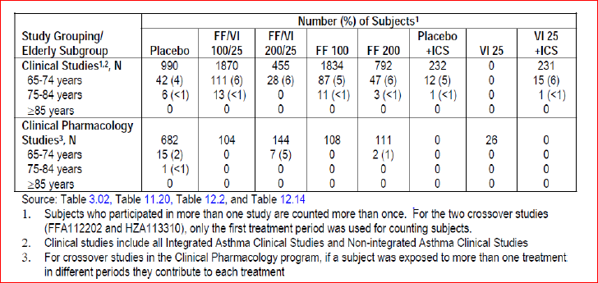
Of the 5944 subjects randomised in the 11 Integrated Asthma Clinical Studies, 5921 (>99%) received at least one dose of study medication (ITT Population). The largest numbers of subjects in the Integrated Asthma Clinical Studies were exposed to FF 100 or FF/VI 100/25 mainly because these treatments were administered in the large, long term exacerbation Study HZA106837 for up to 76 weeks.
A total of 5069 subjects were included in the seven key treatment groups of interest in the ITT Population and the majority of subjects were exposed to FF 100 (1544 subjects) or FF/VI 100/25 (1467 subjects). Of the key treatment groups, the fewest number of subjects were exposed to VI 25 + ICS or Placebo + ICS (216 and 218 subjects, respectively) since these treatments were only included in two studies. Treatment exposure varied widely across the key treatment groups from 32 to 1252 subject years. Exposure was greatest for FF/VI 100/25 (1252 subject years) and FF 100 (1128 subject years) followed by FF/VI 200/25 (271 subject years), which was administered in the 1 year safety Study HZA106839 (Table 11).
In the Non-integrated Asthma Clinical Studies, 403 subjects received FF/VI 100/25, 1119 subjects received total daily doses of FF ranging from 100 to 400 µg and 74 subjects received total daily doses of VI ranging from 6.25 to 25 µg. Median treatment exposure across the Non-integrated Asthma Clinical Studies ranged from 9 days (Study HZA113310) to 169 days (Study HZA113091).
Table 11. Treatment exposure (integrated asthma clinical studies, key treatment groups)
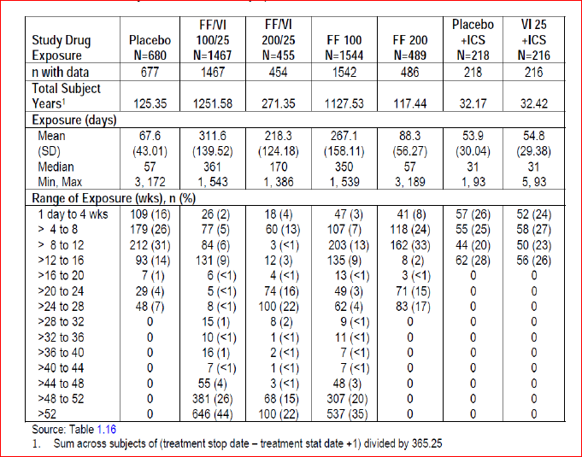
Across the key treatment groups in the Integrated Asthma Clinical Studies, premature withdrawals ranged from 10% in the VI 25 + ICS group to 28% in the Placebo group. Lack of efficacy was the most common reason for withdrawal, particularly in the Placebo (20%) and FF 200 (10%) groups. Consent withdrawn and protocol deviations were the next most frequent reasons for withdrawal. Subject withdrawals due to adverse events (AEs) were low across the key treatment groups (<1% to 2%).
In the Non-integrated Asthma Clinical Studies, majority of the subjects completed treatment (80% to 100%). The most common reasons for withdrawal were lack of efficacy/ asthma exacerbation or withdrawal of consent. Few subjects (1% to 2%) withdrew due to AEs and no subjects were withdrawn due to AEs in Studies FFA112202 or HZA113310. The majority of subjects in the key treatment groups in the Integrated Asthma Clinical Studies were White (65% to 77%), female (55% to 65%) (60%) had asthma for ≥10 years; 2% of subjects in the ITT Population had asthma for less than 1 year. The mean duration of asthma was 16 years in the ITT Population majority of subjects in the Non-integrated Asthma Clinical Studies were White (59% to 88%) and female (57% to 68%). The mean age of the study populations was 32 to 45 years (age range 12 to 85 years). Overall, the study populations evaluated for safety of FF/VI were representative of the proposed target population.

COPD
In total, 6237 subjects were randomised in the seven integrated studies of the FF/VI COPD clinical development program and majority of the subjects (5518 subjects) were enrolled in the primary COPD studies (HZC112206, HZC112207, HZC102871, and HZC102970). In the ITT Population, 3396 received treatment with the various FF/VI combination dosages (subjects who received more than one dose in HZC110946 were counted more than once and were counted under each strength received), 1727 subjects received treatment with VI alone, 613 with FF alone and 584 with placebo. Mean exposure ranged from 27.0 to 268.3 days (median 29.0 to 362.0 days) across the treatment groups. The differences in exposure across the treatment groups are a reflection of the different durations of the treatment periods for the individual studies in the integrated population (that is, 4 week Phase IIb and Phase IIa supporting studies and the six-month and one-year Phase IIIa studies).
Overall, the 6225 subjects randomised and who took at least one dose of study medication in these seven studies provided 3640 subject-years of exposure, with 2377 subject-years of exposure across the various strengths of FF/VI, 860 subject-years of exposure to the various dosages of VI alone, and 237 subject-years of exposure across the dosages of FF alone; placebo exposure was 166 subject-years. A total of 1867 subjects were treated with the various strengths of FF/VI for more than 48 weeks and 686 subjects were treated with the various strengths of FF/VI for more than 52 weeks. A total of 381 subjects were treated with VI 25 for 48 to 52 weeks and 209 subjects were treated with VI 25 for 52 weeks or more.
The 2254 subjects randomised and who took at least one dose of study medication in the two 6 month Studies HZC112206, HZC112207 provided 870 subject-years of exposure, with 318 subject-years of exposure across the various strengths of FF/VI, 161 subject-years of exposure to VI alone and 237 subject-years of exposure across the various strengths of FF alone; placebo exposure was 154 subject-years. Overall, the 3255 subjects randomised and who took at least one dose of study medication in the 1 year exacerbation studies HZC102871, and HZC102970 provided over 2700 subject-years of exposure, with 2048 subject-years of exposure across the various strengths of FF/VI and 661 subject-years of exposure to VI alone.
In addition, 1558 subjects were enrolled and comprised the ITT Population in the three Advair/Seretide comparator studies that were not included in the overall integrated population. Of these 785 subjects received FF/VI and 773 subjects received Advair/Seretide. Thus, across the seven integrated studies and the three Advair/Seretide comparator studies, overall, over 7700 subjects comprised the ITT Population in the FF/VI COPD clinical development program of which over 4150 subjects have been treated with the various strengths of FF/VI.
Of the 6225 subjects in the ITT Population of the seven integrated COPD studies, at least 73% of subjects in each treatment group completed the studies. The percentages of subjects withdrawn from the studies ranged from 3% to 27% across the active treatment groups, proportions that were similar to or lower than the percentage withdrawn from the placebo group (26%). Irrespective of study duration, the most common primary reasons for premature withdrawal were AEs (6 to 9% across treatment groups) and ‘Lack of efficacy’ (4% in active treatment groups versus 6% in placebo group and most commonly due to COPD exacerbation). The percentages of subjects withdrawn prematurely due to other reasons were low and similar across the treatment groups. Similar results were observed in the primary 6 month studies and the 12 month exacerbation studies.

Safety issues with the potential for major regulatory impact

Cardiovascular safety
Refer sections Vital signs and Electrocardiograph in Attachment 2.

Postmarketing data
There is no postmarketing data as the combination FF/VI or its individual components (FF and VI) are not approved for marketing in any country to date.

Evaluator’s overall conclusions on clinical safety in asthma
Evaluable safety data was obtained from 68 completed clinical studies including 8 Phase II, 8 Phase III studies and 52 completed clinical pharmacology studies with FF/VI and/or the individual components and involving 10,630 subjects who received at least one dose of study medication in the FF/VI clinical development program: 7034 in the Integrated Asthma Clinical Studies, 2292 in the Non-integrated Asthma Clinical Studies, and 1304 in the Clinical Pharmacology Studies (Table 12). Of these subjects, 2652 were treated with FF/VI, 4432 were treated with FF, and 987 were treated with VI (all administered by oral inhalation).
Table 12. Total subject exposure in the FF/VI asthma clinical program (completed studies)
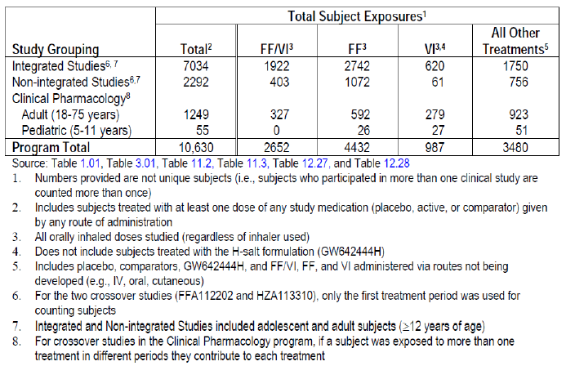
Majority of subjects in the key treatment groups in the Integrated Asthma Clinical Studies were White (65% to 77%), female (55% to 65%) (60%) had asthma for ≥10 years; 2% of subjects in the ITT Population had asthma for less than 1 year. The mean duration of asthma was 16 years in the ITT Population majority of subjects in the Non-integrated Asthma Clinical Studies were White (59% to 88%) and female (57% to 68%). The mean age of the study populations was 32 to 45 years (age range 12 to 85 years). Overall, the study populations evaluated for safety of FF/VI were representative of the proposed target population.
Overall, incidence of AEs (exposure-adjusted) was similar in all groups containing FF (FF/VI- 100/25, 200/25 and FF100, 200 groups) and lower than that in the placebo group. Since these studies were of disparate durations (6 to 76 weeks) and treatment groups had variable sample sizes (216 to 1544 subjects), the exposure adjusted data were more informative than incidence data for assessment of AEs. The most common AEs observed were headache, nasopharyngitis, upper respiratory tract infection (URTI), bronchitis and oropharyngeal pain. Except for dysphonia and oral candidiasis which consistently occurred at a higher incidence with higher doses of FF alone and in combination, no other AEs had a clear dose relationship. These AEs are common in an asthmatic population and have been documented in various ICS and ICS/LABA prescribing information.
Only 4 deaths were reported in the FF/VI asthma clinical development program (1 in the placebo group, 1 in the FF/VI 100/25 group, and 2 in the FF 100 group); based on adjudication committee assessments, none were asthma related.
Overall, the data from the Integrated and Non-integrated Asthma Clinical Studies with FF/VI and the individual components were well tolerated, with low incidence of serious adverse events (SAEs) (0% to 3%) and withdrawals due to AEs (0% to 4%). The most frequent SAE was asthma (exacerbations), reported by 12 subjects in the FF/VI 100/25 group, 9 subjects in the FF 100 group and 1 subject each in the Placebo, FF 200 and VI 25 + ICS groups. The placebo treatment arm was included only in shorter term studies where the risk of exacerbations was less, while the FF/VI 100/25 and FF 100 treatment arms were included in the exacerbation study (HZA106837) with duration of up to 76 weeks and which, unlike the other studies in the program, recruited subjects with a severe asthma exacerbation history. The incidence of withdrawals due to AEs was very low and similar across treatment groups (<1% to 2% across treatment groups) and the most frequent AE leading to withdrawal was asthma (exacerbation), reported by 3 subjects each in the FF/VI 100/25 and FF 100 groups and 1 subject each in the Placebo, FF 200 and VI 25 + ICS groups. Other common AEs leading to withdrawal (all <1% incidence) were dysphonia, pneumonia, oral candidiasis, palpitations and hypertension.
Across the key treatment groups in the Integrated Asthma Clinical studies, the most frequent types of AEs of Special Interest were local steroid effects (2% to 11%), pneumonia and lower respiratory tract infection (LRTI) (0% to 7%), and cardiovascular effects (1% to 9%). Bronchitis (0% to 5%) and oropharyngeal pain (1% to 4%) were also reported frequently. Pneumonia was reported by a total of 31 subjects (<1%) in the Integrated Asthma Clinical Studies and the incidence was not greater than 1% in any treatment group. For local steroid effects (particularly candidiasis, dysphonia and oropharyngeal pain), the incidence of events (adjusted for exposure) was higher in the FF/VI 200/25 (191.6/1000 subject years) and FF 200 (281.0) groups compared with Placebo (87.8) and the respective lower dose (FF/VI 100/25=94.3 and FF100= 103.8) groups. The incidence of pneumonia (adjusted for exposure) seen with FF/VI 100/25 and FF 100 (9.6 and 8.0/1000 subject years, respectively) was similar to that seen with placebo (8.0/1000 subject years) but a higher incidence of pneumonia was observed in the FF/VI 200/25 and FF 200 arms (18.4/ and 25.5/1000 subject years, respectively). For cardiovascular effects, the incidence of events (adjusted for exposure) was higher in the FF/VI 200/25 group (154.8/1000 subject years) than in the FF/VI 100/25 group (65.5/1000 subject years); this was mainly due to a higher incidence of extrasystoles in Study HZA106839 that included Holter monitoring.
Pneumonia was reported by a total of 31 subjects (<1%) in the Integrated Asthma Clinical Studies and the incidence was not greater than 1% in any treatment group. With exposure adjusted data, the number of subjects with an event per 1000 treatment years was similar among the FF/VI 100/25, FF 100 and placebo groups (8.0 each) but a higher incidence was observed in the FF/VI 200/25 (18.4) and FF 200 (25.5) groups. Hospitalisations due to pneumonia were not increased in the higher dose groups. Although no pneumonias which led to hospitalisation were observed in the placebo group compared with 4 events in both groups containing FF 100 and 1 event in both groups containing FF 200, the interpretation of these data are confounded by differences in duration of treatment with maximum treatment duration of 12 weeks for the Placebo group compared with a maximum of 76 weeks in the FF/VI 100/25 and FF 100 groups, 12 months for the FF/VI 200/25 group and 6 months for the FF 200 group.
The addition of the LABA component did not increase the frequency of severe asthma exacerbations requiring hospitalisation as demonstrated by no significant difference in this composite endpoint between the FF/VI group and the ICS group or non LABA group. In addition, subjects treated with FF/VI 100/25 had a 24% reduction in the risk of experiencing a severe asthma exacerbation compared with subjects treated with FF 100 (HR=0.762, 95% CI: 0.618, 0.941, p=0.011).
For the Asthma Composite Endpoint, there was no significant difference between the FF/VI group and the ICS group or non LABA group, demonstrating no increased risk when adding a LABA to an ICS. For the analysis of FF/VI all doses versus non LABA all doses, the combined risk difference indicates a slight reduction in the risk of asthma related events for subjects receiving any dose of FF/VI; 2.6 subjects have avoided an asthma related event for every 10,000 subjects treated with FF/VI.
The incidence of cardiovascular AEs of special interest was higher in FF/VI 200/25 group, primarily due to a higher incidence of terms coding to extrasystoles on Holter recordings performed in the long term safety Study HZA106839. There were no associated clinical symptoms (for example, palpitations) temporally reported with these extrasystole events. According to current medical literature, in the absence of underlying structural heart disease, ventricular ectopy is not generally regarded as being clinically significant and does not require treatment unless patients are symptomatic. These Holter findings did not meet the predefined criteria for a potentially clinically important finding.
No apparent effects on ophthalmic examinations, including lens opacification and intra ocular pressure (IOP) were observed with 12 month administration of FF/VI.
With administration of therapeutic doses, no clinically relevant effects on potassium and glucose have been observed in the clinical program to date. No treatment or dose related effects on haematology or clinical chemistry analytes were observed.
The well conducted Phase III, placebo controlled Study HZA106851 involving 185 asthma subjects showed that 6 weeks treatment with proposed OD dosing with FF/VI 100/25 and 200/25 did not lead to significant suppression of the HPA axis (as determined by serum and urinary cortisol levels). Furthermore, analysis of the Urine Cortisol (UC) Population in 2308 subjects from 8 of the 11 Integrated Asthma Clinical Studies (data were not collected in the two VI Studies B2C109575 and B2C112060 or the long term exacerbation study (HZA106837) showed there were no statistically or clinically significant differences in 24 h urinary cortisol excretion ratio to baseline between each of the FF groups and Placebo or between the FF/VI groups and FF groups at the end of treatment.
Teeth effects with FF and ovarian and uterine tumour effects with VI (GW642444M) were observed in some of the nonclinical studies but these effects have not been substantiated in the clinical studies.

Long term safety in asthma
The Phase III pivotal, long-term safety Study HZA106839 involving 503 asthma subjects demonstrated that long-term safety of the two proposed doses of FF/VI (200/25, 100/25 µg) for asthma was generally comparable to that observed with FP500 with similar incidence of AEs, drug related AEs, SAEs and withdrawals due to AEs. Majority of the AEs were as expected with a steroid and beta agonist inhaler combination and although incidence of some of the AEs (oral candidiasis, abdominal pain and extrasystoles) were slightly higher in the FF/VI groups compared with FP, there were no major safety concerns following 1 year treatment with the proposed combination.
In order to determine if there were differences in the AE profile as time on treatment increased and to identify the occurrence of new AEs that could be associated with increased exposure to study drug, the profile of AEs with an onset ≤6 months was compared with the profile of AEs with an onset of >6 months in the two long term studies (HZA106839 and HZA106837). Overall, no significant trends were observed for increased incidence of overall AEs or specific AEs with increase in duration of treatment. With long term FF/VI and FF treatment, the incidence of most AEs tended to decline as time on treatment increased.
Examination of AEs by gender, age, race and geographic region subgroups revealed similar trends to the overall population.
At therapeutic doses of FF/VI, no safety signals have been observed for increased incidence of severe asthma exacerbations, adrenal suppression, bone disorders, QT interval prolongation, myocardial ischemia, or metabolic, neurologic, or ocular effects based on results of clinical program to date. Safety observations are in line with the expected drug class profiles in the populations studied and no new risks have been identified.

Evaluator’s overall conclusions of safety of FF/VI in COPD
The study population in the COPD clinical development program was extensive and representative of the overall population of subjects with COPD. Across the ten studies in the COPD clinical development program, over 7700 subjects comprised the ITT Population with over 4150 subjects treated with the various strengths of FF/VI. Overall, there have been over 3800 subject-years of exposure to study medications, with approximately 2500 subject-years of exposure to the various strengths of FF/VI, 860 subject-years of exposure to the various dosages of VI alone, and about 237 subject-years of exposure to the various dosages of FF alone.
The overall incidence of subjects reporting any on-treatment AE in the 6 month lung function studies (HZC112206/HZC112207) was similar across most active treatment groups (ranging from 45% to 50%) and similar to that reported for subjects in the placebo group (48%), with the exception that subjects in the FF/VI 50/25 group had a slightly higher incidence of any on-treatment AE (55%). In comparison, the overall incidence of subjects reporting any on-treatment AE was higher in the 1 year exacerbation studies (HZC102871/HZC102970) but was similar across the FF/VI treatment groups (76% to 77%) and somewhat higher than for the VI 25 group alone (70%).
Across both 6 month and 12 month studies, the most frequently reported AEs included nasopharyngitis, headache and oral/oropharyngeal candidiasis. In the 6 month studies, URTI, back pain and LRTI were also reported. These AEs are common in a COPD population and, with the exception of back pain, have been documented in various ICS prescribing information in asthma and ICS/LABA prescribing information. No notable differences across treatments in the incidence of nasopharyngitis were reported although the incidence was higher in the 12 month studies, which may have been a consequence of the longer treatment period.
The incidence of headache in the 6 month studies was higher in the VI arm than any other treatment group but no differences were observed between treatments in the 12 month studies where all subjects received VI containing treatments. Not surprisingly, oral/oropharyngeal candidiasis, a local corticosteroid side effect, occurred at higher incidences in the FF containing groups compared with placebo and the VI 25 groups. In general, the incidence of back pain, LRTI and hypertension in the combination arms was similar to or lower than the incidence in the placebo group. In the 12 month studies, pyrexia occurred at a slightly higher incidence in the FF/VI groups (2% to 3%) compared with the VI 25 group (1%).

Adverse events of special interest
The main safety concerns with FF/VI relate to the known ICS and LABA effects. Pharmacologic class effects of ICS include bone disorders (osteoporosis, fracture, decreased bone mineral density), hypothalamic-pituitary-adrenal (HPA) axis effects (adrenal suppression, decreased serum cortisol, Cushing’s syndrome), local oropharyngeal effects (candidiasis, hoarseness, irritation/inflammation, cough), pneumonia and ocular effects (cataracts, increased intraocular pressure, glaucoma). Pharmacologic class effects of LABAs include cardiovascular (increased heart rate, prolonged QT interval, cardiac rhythm abnormalities, palpitations, myocardial ischemia), metabolic (low potassium, elevated glucose) and neurologic (tremor) effects. These class effects were proactively addressed in the FF/VI COPD clinical development program through an evaluation of AEs of special interest as well as objective assessments of 24 h serum cortisol, 24 h urinary cortisol, oropharyngeal examinations, chest X-rays, pulse, heart rate, 12-lead electrocardiograms (ECGs), 24 h Holter monitoring and biochemical bone markers.
Events related to local corticosteroid effects, pneumonia and bone disorders are discussed above. Individual AEs of special interest related to beta adrenergic stimulation occurred at low incidences across all treatment groups in both the 6 month and 1year studies. Cardiovascular effects (including arrhythmias [3% to 5%], hypertension [<1 to 4%], cardiac ischaemia [<1% to 4%], cardiac failure [<1 to 4%], QT prolongation [0 to <1%]) occurred at low and similar incidences. There was no indication of increases in blood pressure, tachycardia, palpitations or other cardiac arrhythmias. The incidence of tremor was low and similar (0 to <1%) across all treatment groups. Results of the analyses of the most common (≥ 3% of subjects in any treatment group) cardiac events (cardiac arrhythmia and hypertension in the 6 month studies and cardiac arrhythmia, cardiac failure, cardiac ischemia and hypertension in the 1 year studies) showed no increased risk for these events in any treatment group. Overall, any individual AEs suggestive of LABA effects occurred at low incidences across all treatment groups. However, it is difficult to interpret these effects in the 1 year studies since all treatment groups included VI 25 exposure.
Lower respiratory tract infections excluding pneumonia occurred at similar incidences across all treatment groups and trended toward a decreased risk in the FF/VI groups compared with VI 25 and FF alone. Events related to hypersensitivity, such as pruritus and rash, occurred at low incidences in the active treatment groups (<1% to 2%) and placebo (<1%) in the 6 month studies and at slightly higher incidences in the FF/VI groups (4% to 5%) and the VI 25 group (3%) in the 1 year studies. There appeared to be no increased risk of drug-associated hypersensitivity and no reports of anaphylactic reactions that were attributed to FF or VI. In both the 6 month and 1 year studies, ocular effects occurred at low and similar incidences across all treatment groups and AEs related to decreased cortisol concentrations occurred at similar incidences across all treatment groups.
In the six-month studies, effects on glucose were noted at a slightly higher incidence in the FF/VI 100/25 group (2%) compared with placebo (<1%) and the remaining treatment groups (1%). In the 1 year studies, effects on glucose were noted at a similar incidence in the FF/VI groups (2% to 3%) compared with the VI 25 group (2%). There did not appear to be an increased incidence of potassium abnormalities (hypokalemia or blood potassium decreased) in any treatment group across all studies.

Pneumonia
Pneumonia is commonly seen in patients with COPD. Overall, there were no significant differences among the treatment groups in the incidence of pneumonia in the 6 month lung function studies. Pneumonia occurred at a low incidence (<1% to 2% of subjects) across all treatment groups. However, an increased incidence of pneumonia, including hospitalisations, was observed in the 12 month studies in COPD at all strengths of FF/VI compared with VI alone. The incidence of pneumonia was 6%, 6% and 7% for FF/VI 50/25, 100/25 and 200/25, respectively compared with 3% for VI 25, and the incidence of serious pneumonia was 3% in each FF/VI group compared with <1% in the VI 25 group. Risk factors for pneumonia in patients with COPD receiving FF/VI compared with VI were investigated and included current smokers, patients with a history of prior pneumonia, patients with a body mass index <25 kg/m² and patients with an FEV1<50% predicted. This information is reflected in the proposed labelling. The incidence of pneumonia with FF/VI was similar to the incidence reported in 12 month studies of similar design in patients treated with FP/salmeterol., The percentage of these pneumonias that were serious was comparable for FF/VI (24/65 events, 36.9% to 29/58 events, 50.0%) and for FP/salmeterol (58.9%). However, the hazard ratio between the combination and its respective LABA was higher for FF/VI versus VI 25 (2.8, 3.0 and 2.7 for FF/VI 50/25, 100/25 and 200/25, respectively) than for FP/salmeterol versus salmeterol (1.6) as the percentage of pneumonias that were serious was considerably lower for VI 25 (8/28 events, 28.6%) compared with salmeterol (70.4%).
Nine fatal cases with pneumonia were reported during the 1 year exacerbation studies. Of these, seven were reported during treatment with FF/VI 200/25, one during treatment with FF/VI 100/25 and one post-treatment with VI. All 7 cases in the FF/VI 200/25 treatment group were observed in one study (HZC102871) and four of these cases were reported from one site in the Philippines. The number of fatal cases was too small to allow investigation of risk factors for fatal pneumonia. The reason(s) behind the cluster of deaths at one site is unclear.

Bone disorders
Reduction in bone density, and the subsequent risk of fractures is a potential risk with corticosteroids. In the 12-month studies in COPD the incidence of bone disorders was 1% in the VI 25 group compared with 3% in each of the FF/VI 50/25, FF/VI 100/25 and FF/VI 200/25 groups, respectively. The incidence of bone fractures overall was low in all treatment groups, with a higher incidence in all FF/VI groups (2%) compared with the VI 25 group (<1%). The majority of on-treatment fractures were due to trauma in the FF/VI 50/25 (11/15, 73%), FF/VI 100/25 (13/19, 68%) and VI 25 groups (6/8, 75%) while majority of fractures were non-traumatic in the FF/VI 200/25 group (8/13, 62%). However, fractures customarily associated with corticosteroid use (spinal compression/ thoracolumbar vertebral fractures, hip and acetabular fractures) occurred in <1% of subjects in all treatment arms. Biochemical markers of bone metabolism (carboxy terminal cross-linking telopeptide of bone collagen [CTX] and osteocalcin) were evaluated during Study HZC102871. CTX is considered to be a biomarker of bone resorption and osteocalcin a marker of bone formation and no consistent changes were noted at the end of study compared with baseline across the study period or across the treatment groups for CTX or osteocalcin. However, there was a statistically significant decrease (9%) in serum osteocalcin with FF 200/25.

Fatal events
Overall, 65 fatal events occurred across the seven integrated studies, 11 fatal events in the 6 month lung function studies, 53 fatal events in the 1 year exacerbation studies, and one fatal event in Study B2C111045. In addition, three fatal events occurred in the three Advair/Seretide comparator studies, two with FF/VI 100/25 and one with FP/salmeterol. Fatal events occurred at low and similar incidences (2% or less) across all active treatment groups and placebo in the seven integrated studies. The most common fatal events were events that commonly occur in an older population of subjects (cardiac disorders that were pre-existing in this population, malignancies) and/or that are frequently seen in subjects with COPD.
There was no increased incidence in exposure adjusted fatal events that were cardiovascular in nature in VI containing groups. The exposure adjusted numbers of subjects with fatal events that were CV in nature was 6.5 to 11.7 subjects with an event/1000 subject years on VI containing arms compared with 12.0 subjects with an event/1000 subject years in the placebo group. Overall, the occurrence of on-treatment or post-treatment fatal events was low (<1% in all treatment groups with the exception that no fatal events occurred in the FF 200 group) in both 6 month lung function studies (HZC112206/HZC112207). The majority of fatal events were reported in the 1 year exacerbation studies (HZC102871/HZC102970), which is perhaps not surprising given this was the longest exposure to treatment and the most severe COPD patient population studied.
Overall, the occurrence of on-treatment or post-treatment fatal events was low (1% to 2%) in both 1 year exacerbation studies with no apparent differences between the treatment groups. With the exception of the occurrence of 7 deaths due to pneumonia in the FF/VI 200/25 group (see pneumonia discussion above), there were no remarkable differences in the incidence of fatal events across the treatment groups. Overall, none of the fatal events were considered related to treatment by the investigators.

Serious adverse events
In the 6 month studies, the incidence of SAEs was lowest in the FF/VI 50/25 group (3%) and higher in the FF/VI 100/25, FF/VI 200/25 and the VI 25 groups (6%, 7% and 8%, respectively) than for placebo (5%), while the incidence of SAEs was similar for both the FF 100 and FF 200 groups (5%) to that of placebo. COPD exacerbation was the most common SAE reported, with an incidence slightly higher in the VI 25 group (3%) compared with the remaining treatment groups (0 to 2%) and placebo (2%). Pneumonia was the next most frequent SAE, and was reported at a similar incidence across the active treatment groups and placebo (<1% to 1%). All other individual SAEs were reported by 2 or fewer subjects each with no indication of treatment differences. In the 1 year studies, the incidence of on-treatment SAEs was similar for all FF/VI treatment groups (15% to 17%) and for the VI 25 group (15%). COPD exacerbation was the most common SAE reported, with an incidence similar in the FF/VI groups (6% to 7%) compared with the VI25 group (6%). Pneumonia was the next most frequently reported SAE and was reported at a higher incidence across the FF/VI treatment groups (3%) than in the VI 25 group (<1%). Individual SAEs in the remaining System organ Classes (SOCs) occurred at low and similar incidences (<1%) across the FF/VI treatment groups and the VI 25 treatment group.

Discontinuations/study withdrawals due to AEs
The incidence of AEs leading to permanent discontinuation of study drug or withdrawal from the 6 month lung function studies was 9% to 11% across all active treatment groups compared with 9% for placebo and lower for the FF 200 group (7%). The incidence of AEs leading to permanent discontinuation of study drug or withdrawal from the 1 year exacerbation studies was lower than in the 6 month studies but similar across all FF/VI treatment groups (6% to 8%) and the VI 25 treatment group (6%).

Clinical laboratory findings/vital signs
Based on the review of shifts with respect to the normal reference range for haematology and clinical chemistry analytes, no trends were observed suggesting an effect of FF/VI or its individual components (FF and VI) on the occurrence of laboratory values outside the normal range. FF/VI did not have any clinically significant effect on Vital Signs, ECG and 24 h Holter monitoring.

Serum and urinary cortisol
Analysis of 24 h serum cortisol was performed in subjects in Study HZC110946 on Day 28 of each treatment period which demonstrated decreases in weighted mean serum cortisol levels with FF/VI compared with placebo (FF/VI 50/25 µg [4%], 100/25 µg [2%] and 200/25 µg [11%]) were not statistically significant. These decreases compared with placebo in weighted mean serum cortisol are also not considered to be clinically relevant. Furthermore, 24 h urine collection for analysis of cortisol excretion in a subset of subjects at selected sites in the 6 month lung function studies showed no statistically or clinically significant differences from placebo for all active treatment groups. There were also no statistically significant differences in 24 h urinary cortisol excretion between the FF/VI 100/25 group and the FF 100 group, the FF/VI 200/25 group and the FF 200 group, nor were there any statistically significant differences between any FF/VI combination group and the VI 25 group, thus suggesting no increased systemic exposure with the co-administration of VI. Urinary cortisol was also assessed at selected centers in two of the Advair/Seretide comparator studies (HZC113109/HZC112352). No statistically significant differences in urinary cortisol excretion were observed. No AEs were reported that would be considered related to decreases in serum cortisol.

Safety in FF/VI - advair/seretide comparator studies
Although the studies were only 12 weeks in duration and do not allow for a detailed safety comparison between them, there were no obvious differences in safety profile between FF/VI and Advair/ Seretide in the three comparator studies conducted during the FF/VI clinical development program.
Overall, safety of proposed dose of FF/VI 100/25 µg was evaluated in adequate number of COPD patients for treatment durations up to 1 year and was representative of the target patient population for the proposed combination. Overall, the safety profile was consistent with the expected AEs usually associated with LABA/ICS combination, that is, most frequent AEs were beta adrenergic agonist AEs or local steroid effects. The only alarming safety concern detected in the COPD clinical program was the higher incidence of pneumonias (including serious and fatal pneumonias) in subjects treated with FF/VI. However, the incidence of pneumonia appeared to be more common in patients with risk factors which have been included in the proposed labelling. It is also reassuring to see that most of these serious AEs of pneumonia were more common in patients treated with FF/VI 200/25 µg which is not the proposed dose for COPD.

First round benefit-risk assessment

First round assessment of benefits

Asthma
The benefits of FF/VI (100/25 and 200/25 µg) in the proposed usage for treatment of asthma are:
- Once daily treatment with a LABA/ICS combination would potentially improve treatment compliance although this could not be ascertained in the clinical studies. The currently available LABA/ICS combinations need to be administered twice daily.
- The proposed doses of FF/VI 100/25 and 200/25 provided greater benefit in terms of improvement in lung function parameters of trough FEV1, weighted mean FEV1 (0 to 24 h), AM and PM PEF than FF alone in two out of three pivotal Phase III studies (HZA106829 and HZA106837) where this was measured, thus demonstrating the contribution of VI to the combination. FF/VI 100/25 and 200/25 were also significantly better than the equivalent dose of FF monotherapy in improving symptomatic endpoints including 24 h rescue-free/symptom-free periods, time to first severe exacerbation and severe exacerbation rate. The contribution of FF to the efficacy of the FDC was shown by assessing the efficacy and safety of FF relative to placebo in the Phase III studies and also in an allergen-challenge Phase II study HZA113126, where FF/VI was significantly better than VI alone in terms of attenuating the early and late phase asthmatic response and also the increased bronchial hyper-responsiveness (BHR) associated with allergen challenge.
- At therapeutic doses of FF/VI, no safety signals have been observed for increased incidence of severe asthma exacerbations, adrenal suppression, bone disorders, QT interval prolongation, myocardial ischemia, or metabolic, neurologic, or ocular effects based on results of clinical program to date. Safety observations are in line with the expected drug-class profiles in the populations studied and no new risks have been identified.
- The addition of the LABA component did not increase the frequency of severe asthma exacerbations requiring hospitalisation as demonstrated by no significant difference in the Asthma composite endpoint between the FF/VI group and the ICS group or non LABA group. In addition, subjects treated with FF/VI 100/25 had a 20% reduction in the risk of experiencing a severe asthma exacerbation compared with subjects treated with FF 100 alone.

COPD
The benefits of FF/VI 100/25 µg OD in the proposed usage for treatment of COPD are:
- Once daily treatment with a LABA/ICS combination would potentially improve treatment compliance although this could not be ascertained in the clinical studies due to study designs. The currently available LABA/ICS combinations used for treatment of COPD require twice daily administration.
- In the two pivotal 6 month studies, the proposed dose of FF/VI 100/25 µg OD showed statistically significant and clinically meaningful improvements in lung function after 24 weeks of treatment with increased adjusted mean trough FEV1 [difference from placebo was 129 mL and 83 mL with FF/VI 100/25 and VI 25, respectively; FF/VI 100/25–VI 25= 46 mL; 95% CI: 8, 83 mL, p= 0.017] and adjusted weighted mean peak FEV1 (0 to 4 h) [difference from placebo was 193 mL and 145, respectively; FF/VI 100/25-VI 25= 148 mL; 95% CI: 112, 184 mL, p< 0.001]. Patients treated with the proposed FF/VI 100 /25 µg also had significantly better dyspnoea scores (although not clinically relevant), had less cough and sputum, required significantly less rescue medication as measured by number of occasions of rescue salbutamol use (per 24 h period) and number of night time awakenings requiring salbutamol (per 24 h period) compared to placebo.
- The 24 h bronchodilator effect of FF/VI was maintained from the first dose throughout a 1 year treatment period with no evidence of loss in efficacy.
- The data from the pivotal Phase III, 52 week studies demonstrated that FF provides a significant contribution to the FF/VI combination. In particular, compared with VI 25 OD alone, treatment with FF/VI 100/25 OD consistently reduced the annual rate of moderate and severe COPD exacerbations, time to exacerbations, rate of exacerbations requiring systemic corticosteroid use and also showed minor improvements in lung function (trough FEV1).
- Overall, safety of proposed dose of FF/VI 100/25 µg was evaluated in adequate number of COPD patients for treatment durations up to 1 year and was representative of the target patient population for the proposed combination. The safety profile of proposed FDC of FF/VI 100/25 µg OD was consistent with the expected AEs usually associated with LABA/ICS combination, that is, most frequent AEs were beta adrenergic agonist AEs or local steroid effects.

First round assessment of risks

Asthma
The risks of FF/VI (100/25 and 200/25 µg) in the proposed usage for treatment of asthma are:
- In the pharmacokinetic/pharmacodynamic studies, dose proportionality of FF and VI was not evaluated over a wide range of doses and in fact the starting dose in the PK studies was 100-200 µg for FF and ≥25 µg for VI.
- Exclusion of 12.5 µg dose of the LABA-Vilanterol (VI) based on superior efficacy observed for 25 µg in secondary endpoints (% symptom free 24 h and rescue free 24 h periods) in a Phase II study (B2C109575) is not justified. The study was not powered to show a difference in these endpoints. It is likely that the patients have been administered a dose that is greater than that actually required. LABAs may be associated with increased severity of asthma exacerbations in some patients and hence it would be prudent to establish the minimum effective dose in patients with asthma with the option of up-titration if required in individual patients. Dose finding for VI would be required to be demonstrated in the larger Phase III trials but this was not done as only a single dose of VI (25 µg) was used in all pivotal Phase III studies. Furthermore, as the mono components (FF and VI) are not to be registered for use in asthma, it will be difficult for clinicians to make the transition to the new fixed dose combination product.
- Dose ranging studies for FF showed efficacy in the range of 50 to 200 µg but the dose of 50 µg was not evaluated in the Phase III asthma studies. This is especially important because many local steroid effects are dose-related and if a lower dose of 50 µg is effective in the combination, then the risks associated with steroid therapy may be reduced.
- No Phase III studies were conducted comparing FF/VI 100/25 and 200/25; instead subjects on different baseline therapy who would be candidates for either the higher or the lower strengths were recruited into the relevant studies. However, it is not clear how subjects would be titrated to these doses as none of the individual drugs (FF or VI) are registered for treatment of asthma and titration of the FDC was not evaluated in any of the clinical studies.
- The FDC guidelines state that rationale for a FDC development is either FDC shows better efficacy than mono components taken together or lower doses of actives given as FDC offer better risk benefit ratio. The doses of the ICS and LABA selected for the FDC were based on the dose ranging mono component Phase II studies and no dose ranging studies were conducted with the proposed combination inhaler (FF/VI). Based on the Phase II studies presented it is not clear whether a lower or higher FDC combination would be appropriate.
- Evidence for contribution of the VI component to the FDC (FF/VI) was not unequivocal. The pivotal Phase III Study HZA106827 (which recruited subjects uncontrolled on low/mid dose ICS or on low dose ICS/LABA) failed to demonstrate statistically significant difference between the two active treatments (FF/VI and FF alone) for the co-primary endpoints of trough FEV1 and weighted FEV1 (0 to 24 h). As statistical significance was not achieved for all treatment comparisons in the first level of Hierarchy (there was no statistical significant difference between FF/VI and FF for the co-primary endpoints), the significant differences in FF/VI 100/25 compared with FF 100 for the powered secondary endpoint of percentage of rescue-free/symptom-free 24 h periods, AM and PM PEF should be interpreted as descriptive only. The pivotal Study HZA106829 (which recruited subjects uncontrolled on high dose ICS or on mid dose ICS/LABA) showed statistically significant improvements with FF/VI 200/25 µg compared with FF 200 alone in co-primary [troµgh FEV1 and weighted FEV1 (0 to 24 h)] and secondary endpoints (percentage of rescue-free/symptom-free 24 h periods and AM/ PM- PEF) at the end of 24 weeks of treatment. However, a sensitivity analyses (excluding data from an investigator in the USA because of GCP issues) of the co-primary endpoint of weighted mean FEV1 (0 to 24 h) was not consistent with the ITT analysis results and failed to show statistically significant difference between FF/VI and FF200 groups Although results were consistent with ITT analysis for trough FEV1 and other secondary endpoints.
- Safety issues with use of FF/VI for treatment of asthma such as local steroid effects, systemic corticosteroid effects including effect on growth, bones in adolescents (although this is being addressed by ongoing studies), cardiovascular effects and pneumonia. The incidence of pneumonia (adjusted for exposure) seen with FF/VI 100/25 and FF 100 (9.6 and 8.0/1000 subject years, respectively) was similar to that seen with placebo (8.0/1000 subject years) although a higher incidence of pneumonia was observed in the FF/VI 200/25 and FF 200 arms (18.4/ and 25.5/1000 subject years, respectively).
- The results observed in the Phase III clinical asthma program for the proposed FDC combinations 100/25 or 200/25 µg do not clearly justify the need for both strengths especially the higher dose as there is no stepping up design included. Furthermore, the higher dose of 200/25 µg was not evaluated in the Phase III study HZA106837 which showed that FF/VI 100/25 significantly reduced the risk of severe asthma exacerbations, improved lung function (trough FEV1) and led to greater asthma control (as assessed by the ACQ7) compared with FF 100 when administered for 24 to 76 weeks.

COPD
The risks of FF/VI (100/25 µg) in the proposed usage for treatment of COPD are:
- In the dose ranging Study B2C111045 in COPD subjects, all VI doses of 3.25, 6.25, 12.5, 25 and 50 µg OD produced statistically significant improvements over placebo in lung function parameters of trough FEV1 (92, 98, 110, 137 and 165 mL with 3.25, 6.25, 12.5, 25 and 50 µg OD, respectively) and weighted mean FEV1 (0 to 24 h) (105, 125, 142, 158 and 177 mL, respectively). Symptomatic endpoints also showed improvements with all VI doses compared with placebo. Hence, exclusion of 12.5 µg dose of the LABA-Vilanterol (VI) was not justified based on >130 mL improvement over placebo in trough FEV1. Dose finding for VI would be required to be demonstrated in the larger Phase III trials but this was not done as only a single dose of VI (25 µg) was used in all pivotal Phase III studies.
- The 52 week Phase III studies showed that incidence of moderate/severe COPD exacerbations was statistically significantly reduced with all three dose of FF/VI (50/25, 100/25 and 200/25 µg) compared with VI 25 µg. Although risk reduction was slightly greater with the proposed dose of FF/VI 100/25 (27%) compared with 200/25 (23%) and 50/25 (16%), all of them were statistically significantly greater than VI 25 µg. As the sponsor only proposes to register one dose of FF/VI 100/25 µg OD for treatment of COPD, there is no option for titration in an individual patient to a lower or higher dose of the FDC.
- As mono components of the proposed FDC (FF and VI) will not be registered for use in COPD, there are no guidelines available for clinicians to make the transition to the new fixed dose combination product.
- In the COPD clinical program, most frequent AEs were beta adrenergic agonist AEs or local steroid effects. There was a higher incidence of pneumonias (including serious and fatal pneumonias) in subjects treated with FF/VI. However, the incidence of pneumonia appeared to be more common in patients with risk factors [current smokers, patients with a history of prior pneumonia, patients with a body mass index <25 kg/m² and patients with a FEV1<50% predicted] which have been included in the proposed labelling.

First round assessment of benefit-risk balance
The purpose of this application is to obtain marketing approval for the use of FF/VI (100/25 and 200/25 µg OD by oral inhalation) administered once daily for the regular treatment of asthma in adults and adolescents aged 12 years and older, where use of a combination product (long-acting beta2 agonist and inhaled corticosteroid) is appropriate; asthma patients who are symptomatic with inhaled corticosteroids and 'as needed' inhaled short acting beta2 agonist or patients already on both an inhaled corticosteroid and a long acting beta2 agonist. The sponsor is also seeking marketing approval of only FF/VI 100/25 µg OD for symptomatic treatment of patients with COPD with a FEV1 <70% predicted normal (post-bronchodilator) in patients with an exacerbation history.
Fixed Dose Combinations of ICS and LABA are well-accepted and recommended treatments for asthma.^{16, 17} Current ICS/LABA combinations, including fluticasone propionate (FP)/salmeterol, beclomethasone/formoterol and budesonide/formoterol, need to be administered twice daily. Hence one of the potential benefits with the proposed ICS/LABA combination of FF/VI is improved treatment compliance due to its once daily dosing regimen. However, the Phase III clinical development program for FF/VI was conducted under double-blind and where necessary, double-dummy conditions, confounding the assessment of compliance. As a result, the question of whether once daily FF/VI represents a true patient benefit requires further investigation.
The main limitations of this submission relate to inadequate evaluation of a wide range of doses of FF and VI in the PK-PD or the Phase II dose ranging studies. Majority of doses evaluated seemed to lie within the flat part of the dose response curve and hence it is likely that a much higher dose than required was evaluated in the pivotal Phase III studies. The minimum effective dose of VI was not established and only one dose of VI (25 µg OD) was carried forward to the Phase III studies. No dose ranging studies were done with the proposed combination product in asthma and dose response information was mainly obtained from studies using FF alone or VI alone.
Furthermore, the individual components of the FDC are not to be registered for use in asthma or COPD and it will be very difficult for clinicians to make the transition to the new FDC product.
Limitations of inadequate dose response evaluation of the dose of FF and VI in the proposed FF/VI formulation may be acceptable if the proposed drug is of major therapeutic benefit for which no other alternative treatments are available. Since that is not the case with this ICS/LABA formulation, the benefit-risk balance of Breo Ellipta (FF/VI 100/25 and 200/25 µg OD) given the proposed usage is unfavourable.

First round recommendation regarding authorisation
Due to the limitations of this submission as outlined above, it was recommended that Relvar Ellipta (FF/VI 100/25 and 200/25 µg OD) be rejected at this stage.

Clinical questions

Pharmacokinetics
- Given the route of administration why didn't the studies on clearance examine the respiratory route as a potential mechanism for FF/VI clearance. This may be especially important for VI as only 72% of radioactive dose was recovered after 7 days post dosing.
- It is not clear why the investigators have used non-inferiority as measure of PK differences in the studies on hepatic and renal impairment. Can the sponsor please justify its use in Studies HZA111789 and HZA113970.
- Are there dedicated Phase I PK studies which examine the PKs of VI and FF following 7 and 14 days dosing via NDPI in adult persistent asthmatics, respectively, which would allow for comparison with the paediatric values?
- No drug-drug interaction studies for both FF and VI have been conducted with a short-acting beta2 agonist such as salbutamol, which would be used as a rescue medication in the event of an acute asthma attack. Can the sponsor please justify this omission?
- The lowest dose of VI examined in the PK studies was 25 µg. Why have lower doses of VI not been examined?
- Although Study HZA102932 examined the dose proportionality of FF and equivalence of VI following single dose administration in healthy subjects, this study did not examine dose proportionality over a wide range of doses, nor was the proposed dose of FF/VI 100/25 µg examined. Can the sponsor please justify why the dose of FF/VI 100/25 µg was not investigated as part of this study?

Pharmacodynamics
- No PD drug-drug interaction studies for both FF and VI have been conducted with a short-acting beta 2-agonist such as salbutamol, which would be used as a rescue medication in the event of an acute asthma attack. Can the sponsor please justify this omission?
- Why was the minimum effective dose of VI not established? Can the sponsor please justify why studies only examined the PD effects of VI doses >25 µg which appeared to be in the flat phase of the dose-response curve?

Efficacy
- Exclusion of 12.5 µg dose of the LABA-Vilanterol (VI) based on superior efficacy observed for 25 µg in secondary endpoints (% symptom free 24 h and rescue free 24 h periods) in a Phase II study (B2C109575) is not justified. The study was not powered to show a difference in these endpoints. It is likely that the patients have been administered a dose that is greater than that actually required. LABAs may be associated with increased severity of asthma exacerbations in some patients and hence it would be prudent to establish the minimum effective dose in patients with asthma with the option of up-titration if required in individual patients. Dose finding for VI would be required to be demonstrated in the larger Phase III trials but this was not done. Can the sponsors justify use of only a single dose of VI (25 µg) in the pivotal Phase III studies?
- Although dose ranging studies for FF suggested efficacy over the range of 50 to 200 µg OD, the 50 µg dose of FF was not evaluated in the Phase III asthma studies. Can the sponsors justify exclusion of the 50 µg FF dose in the FDC in the Phase III asthma clinical studies.
- The results observed in the Phase III clinical asthma program for the proposed FDC combinations 100/25 or 200/25 µg do not clearly justify the need for both strengths especially the higher dose as there is no stepping up design included. Furthermore, the higher dose of 200/25 µg was not evaluated in the Phase III Study HZA106837 which showed that FF/VI 100/25 significantly reduced the risk of severe asthma exacerbations, improved lung function (trough FEV1) and led to greater asthma control (as assessed by the ACQ7) compared with FF 100 when administered for 24 to 76 weeks. Due to risks associated with the higher dose of ICS (including increased risk of pneumonia), can the sponsors justify the need for the higher dose of FF/VI. Why was the lower strength of FF/VI 50/25 µg not evaluated further in the Phase III asthma studies?
- In the dose ranging Study B2C111045 in COPD subjects, all VI doses of 3.25, 6.25, 12.5, 25 and 50 µg OD produced statistically significant improvements over placebo in lung function parameters of trough FEV1 (92, 98, 110, 137 and 165 mL with 3.25, 6.25, 12.5, 25 and 50 µg OD, respectively) and weighted mean FEV1 (0 to 24 h) (105, 125, 142, 158 and 177 mL, respectively). Symptomatic endpoints also showed improvements with all VI doses compared with placebo (refer Dosage selection for the pivotal studies; COPD). Hence, exclusion of 12.5 µg dose of the LABA- Vilanterol (VI) was not justified based on >130 mL improvement over placebo in trough FEV1. Dose finding for VI would be required to be demonstrated in the larger Phase III trials but this was not done as only a single dose of VI (25 µg) was used in all pivotal Phase III studies. Hence, can the sponsors justify selection of only one dose of VI (25 µg) for the pivotal Phase III COPD studies?
- The 52 week Phase III studies showed that incidence of moderate/ severe COPD exacerbations was statistically significantly reduced with all three dose of FF/VI (50/25, 100/25 and 200/25 µg) compared with VI 25 µg. Although risk reduction was slightly greater with the proposed dose of FF/VI 100/25 (27%) compared with 200/25 (23%) and 50/25 (16%), all of them were statistically significantly greater than VI 25 µg. As the sponsor only proposes to register one dose of FF/VI 100/25 µg OD for treatment of COPD, there is no option for titration to a lower of higher dose of the FDC which may have been effective in an individual patient. Can the sponsor justify this?
- The individual components of the proposed FDC (FF and VI) will not be registered for use in asthma or COPD but no guidelines are available for clinicians to make the transition to the new fixed dose combination product from their current asthma or COPD therapy. Can the sponsors clarify how the patients are to be initiated on treatment with the proposed FDC?

Safety
None.

Second round evaluation of clinical data submitted in response to questions
Only the sponsor’s response and then the evaluator’s comments on the sponsor’s response are shown below. Please refer to Clinical questions above for details of question asked.

Pharmacokinetics

Question 1

Sponsor’s response
There are a number of reasons why dosing radiolabel by the inhalation route is not the best or most feasible approach to study clearance for inhaled molecules. Exhalation of radioactive drug after inhalation administration makes it impossible to reliably determine administered radioactivity that is needed to fully interpret excretion and metabolism data. The low doses of inhaled drugs limit the radioactive dose and leads to biologic samples containing very low concentrations of both metabolite chemical mass and radioactivity, thereby impairing the ability to measure and identify metabolites. Finally, quantitative information derived from an inhalation administration of a radioactive analogue is very unlikely to be representative of the commercial clinical formulation in its device.
FF: The mechanism of clearance of FF was studied following intravenous and oral administration, representing the lung deposited and swallowed portions of an inhalation dose, respectively. Since intravenous administration delivers drug directly to the lung (via the heart) prior to any other body organ it can be considered to be representative of the lung dose. The main route of clearance of FF in human and all animal species investigated (both in vitro and in vivo) was via metabolic hydrolysis of the S-fluoromethyl carbothioate group. There was no evidence for metabolism of FF by human lung microsome or S9 preparations suggesting there are no additional routes of clearance following inhaled administration.
VI: The mechanism of clearance of VI was studied following oral administration in a human Absorption/Distribution/Metabolism/Excretion (ADME) study. Radiolysis of the [¹⁴C] isotope resulted in material which was unstable over the periods required to support manufacture and release of either intravenous or inhalation formulations, effectively ruling out these routes for investigation.
The main route of clearance of VI in human (in vitro and in vivo) was metabolism via Odealkylation. O-dealkylation was also a major route in all animal species investigated. There was no evidence for metabolism of VI by human lung microsomes suggesting there are no additional routes of clearance following inhalation administration.
The precise cause of the relatively low total recovery of radioactivity (72% of the administered radioactivity) is unknown but is likely related to the low sample radioactive and chemical concentrations as a consequence of the low radioactivity and chemical doses administered (see above). The radioactive dose was approximately 25 to 50 fold lower than is typically used in similar experiments and necessitated both liquid scintillation counting and accelerator mass spectrometry as methods of radioassay. Low mass concentrations, in particular, result in radioassay data which would be very sensitive to even low levels of non-specific binding to the apparatus used. The data generated, however, does not support significant clearance of drug related material beyond 7 days post dosing. Elimination of radioactivity was essentially complete by 4 days after dosing (>99% of the recovered radioactivity) with <0.3% of recovered radioactivity being excreted between Days 5 and 7.

Evaluator’s comments on sponsor’s response
The sponsor has misinterpreted the question asked by the evaluator. The evaluator was not questioning the mode of drug administration but the fact that expired breath was not collected or examined following drug administration, as this may have contained some of the 28% of radioactive dose not accounted for following VI dosing.

Question 2

Sponsor’s response
For both FF and VI any clinically relevant effects of either hepatic or renal impairment would be anticipated to be as a consequence of increased systemic exposure. Since systemic exposure to both FF and VI drive unwanted systemic class related pharmacodynamic effects it was important to understand if systemic exposure to either molecule was increased in subjects with hepatic or renal impairment to provide dosage recommendations for these populations.
Therefore the approach used in these studies was to look at non-inferiority using pre-defined criteria that would provide information for labelling.

Evaluator’s comments on sponsor’s response
As Studies HZA111789 and HZA113970 are dedicated PK studies, the evaluator has used PK parameters, such as AUC and C_{max}, in the first round report to determine the changes in systemic exposure resulting from hepatic and renal impairment and he believes that the use of terms such as non-inferiority are misleading in regards to these Phase I trials. More importantly, the evaluator believes that the comments regarding changes to the PI regarding hepatic and renal impairment are still valid.

Question 3

Sponsor’s response
No there are no dedicated Phase I PK studies in adult subjects with asthma. To provide PK data across a broad asthma patient population the characterisation of PK in adolescent/adult subjects with asthma has been conducted on samples collected from Phase II and III efficacy and safety studies. In addition Study HZA106851 includes PK assessments which can be used for preliminary comparison with the paediatric data. However, population pharmacokinetic analysis which uses specific methodology to handle non-quantifiable data provides the definitive PK data for adolescent/adult subjects with asthma. A population PK analysis for paediatric subjects with asthma will be conducted on Phase IIb data and provide definitive data for comparison to adolescent/adults.

Evaluator’s comments on sponsor’s response
Recent studies suggest that population PK models may not suffice to predict parameter distributions and drug exposure across paediatric populations. Therefore the evaluator believes that, although extremely useful in the development of paediatric study design, population PK analysis in itself is not sufficient to justify dosage requirements in children. In addition, given that the paediatric studies conducted to date, HZA112776 and HZA102942, have only examined the monotherapies alone the evaluator believes that the use of Breo Ellipta in the paediatric population should not be approved, at least until the results of the first study of FF/VI in paediatric subjects (HZA112777) are known.

Question 4

Sponsor’s response
Drug-drug interaction studies for FF and VI have not been conducted with a short acting beta2 agonist such as salbutamol. The metabolism of salbutamol (for example, sulfation) differs from that of FF or VI (CYP3A4 metabolism), while the drug interaction (perpetrator) potential of FF or VI are considered to be negligible at clinical exposures. Perpetrator interactions are rarely a concern for drugs which are administered at extremely low dose levels such as FF (inhaled clinical dose ≤200 µg) and VI (inhaled clinical dose 25 µg).
Using the approach recommended by the FDA in its guidance on drug interactions [Huang, 2007], I/Ki ratio values for FF and VI were estimated to be 0.0002 and 0.0003 for cytochrome P450 isozyme CYP3A4, which are both considerably lower than the threshold of concern of 0.1. For FF the resulting I/Ki ratio of 0.002 for the worst case 50% inhibitory concentration (IC₅₀) (in this case 100 nM for OATP1B1) was also considerably lower than the FDA threshold of concern of 0.1 and, therefore, the perpetrator interaction potential of both FF and VI is negligible.
Similar conclusions were made using Committee for Proprietary Medicinal Products (CPMP) guidance. Using the approach recommended by the European medicines Agency (EMA) in its draft guidance the C_{max} of FF (<0.2 nM) corresponds to a free concentration of <0.0008 nM (assuming protein binding of 99.6%). The estimated Ki for OATP1B1 (100 nM), as a worse case, is 125,000 fold higher than the unbound C_{max}. The C_{max} of VI (<0.5 nM) corresponds to a free concentration of < 0.03 nM (assuming protein binding of 93.9%). The estimated Ki for CYP3A4 as a worse case (2 µM) is 70,000 fold higher than the unbound C_{max}. Therefore, further clinical investigation of either FF or VI was not warranted since these values are considerably greater than the threshold of concern in this guidance (<50 fold higher).
The negligible perpetrator interaction potential for CYP3A4 was further substantiated by the lack of pharmacokinetic and pharmacodynamic changes when single supratherapeutic doses of FF and VI (both CYP3A4 substrates) were dosed alone and in combination to healthy subjects (HZA105871 and HZA102940). Both FF and VI are metabolised primarily by CYP 3A4 and since no clinically relevant effect with co-administration of the strong CYP 3A4 inhibitor ketoconazole was seen on the pharmacokinetics of either molecule, no further drug-drug interaction studies were considered necessary.

Evaluator’s comments on sponsor’s response
The sponsor’s answer has provided grounds for not providing PK drug-drug interactions studies with rescue medications commonly used in the treatment of asthma based upon drug metabolism. Therefore the drug-drug interaction studies in regards to PK interactions between salbutamol and Breo Ellipta are not warranted.

Question 5

Sponsor’s response
Lower doses of VI have been studied in the Phase IIb dose ranging studies conducted in subjects with COPD (B2C111045) and in subjects with asthma (B2C109575). Both studies evaluated VI doses of 3 µg, 6.25 µg, 12.5 µg, 25 µg and 50 µg. Sparse blood samples for pharmacokinetic analysis were collected pre-dose and within specific windows (2 to 10 minutes, 10 to 30 minutes, 30 minutes to 2 h and 2 to 4 h post dose) from all subjects over 4 visits (Days 1, 7, 14 and 28) in Study B2C111045 and pre-dose, between 2 and 10 minutes, between 10 and 30 minutes, between 30 minutes and 2 h and between 2 and 4 h post dose (Day 1 and Day 28) and pre-dose (Day 7) and between 2 minutes and 1 h post dose (Day 14) in Study B2C109575. The percentage of samples below the lower limit of quantification (LLQ) (30 pg/mL) was high across all time-points and visits following doses of 3 to 12.5 µg VI in both subjects with COPD (3 µg; ≥97%: 6.25 µg; ≥91%: 12.5 µg; ≥49%) and subjects with asthma (3 µg; 97%: 6.25 µg; 90%: 12.5 µg; 74%). As a result it has not been possible to characterise the pharmacokinetics of VI at doses below 25 µg. Even at 25 µg VI, concentrations fell below the lower limit of quantification in the majority of samples beyond 2 h following repeat dosing to both subjects with COPD and subjects with asthma as well as healthy subjects.

Evaluator’s comments on sponsor’s response
The sponsor has identified the difficulties in detecting VI in samples following doses of lower than 25 µg and therefore they appear justified in not providing a full PK analysis for these doses.

Question 6

Sponsor’s response
At clinical doses of FF/VI (≤ 200/25 µg), plasma concentrations of FF are at or below LLQ (10 pg/mL) and plasma concentrations of VI are only above the LLQ (10 pg/mL) for a transient time post dose (approximately 1 h). In order to produce measurable FF and VI plasma concentrations to provide robust pharmacokinetic data to meet study objectives, some clinical pharmacology studies, including HZA102932, were conducted with supra therapeutic doses of FF/VI. Due to the linear time-independent pharmacokinetic characteristics of both FF and VI, PK data from higher doses can be extrapolated to the clinical doses.

Evaluator’s comments on sponsor’s response
As in their preceding response, the sponsor has highlighted the difficulties in detecting FF and IV in samples following administration of low doses of both drugs. Therefore, they appear to be justified in not investigating the PKs of the proposed FF/VI (100/25 µg) dose.

Pharmacodynamics questions

Question 7

Sponsor’s response
A specific pharmacodynamic drug-drug interaction study with salbutamol and FF/VI was not considered to be necessary based on the pharmacodynamic profile of FF/VI in patients with asthma or COPD as well as on the extensive clinical experience of co-administration of salbutamol and LABA/ICS combinations. Furthermore a pharmacokinetic interaction was considered to be unlikely. However, the potential for chronic use of vilanterol to result in reduced responsiveness to rescue medication (salbutamol) was assessed: no decrease in responsiveness was seen.

Potential for pharmacodynamic interactions
Clinically salbutamol is used extensively as a rescue medication in patients with asthma or COPD who are also receiving LABA/ICS combinations; this has not been associated with safety concerns. FF/VI (100/25 or 200/25) is not associated with marked beta agonist related systemic pharmacodynamic effects in patients with asthma or COPD and any effects seen are considered to be comparable to those of established Short-acting beta2-agonist (SABAs), LABAs or ICS/LABA combinations (see below). Consequently there is no reason to believe that the pharmacodynamic effects of coadministration of salbutamol and FF/VI would be any different or greater than between salbutamol and established ICS/LABAs in widespread clinical use.
Inhaled beta2 agonists can be associated with cardiovascular effects including tachycardia, arrhythmias and QT prolongation. In patients with asthma and COPD the cardiovascular safety profile of FF/VI and VI was broadly consistent with the known pharmacology of LABAs.
Overall FF/VI (100/25 or 200/25) or VI (25) was not associated with clinically significant beta agonist mediated systemic effects in subjects with asthma or COPD.
Consequently significant pharmacodynamic interactions with salbutamol were not anticipated.
Furthermore, rescue medication (including salbutamol) was used throughout the FF/VI clinical development program. This was not associated with reports of clinically significant interactions.

Potential for pharmacokinetic interactions
A pharmacokinetic drug-drug interaction between salbutamol and VI or FF is considered to be highly unlikely. The metabolism of salbutamol (for example, sulfation) differs from VI or FF (CYP3A4 metabolism) while the drug interaction (perpetrator) potential of FF or VI are considered to be negligible at clinical exposures. The low potential for a pharmacokinetic drug interaction between FF/VI and salbutamol is also discussed in the response to Pharmacokinetics Question 4.

Potential development of tolerance to bronchodilatory responsiveness
A potential concern with chronic use of LABAs is that they could lead to a decreased responsiveness to beta agonist rescue medication (that is, the development of tolerance). This was specifically studied in the Phase II Study B2C109575 by assessing the ability of subjects with asthma to respond to salbutamol (400 µg) pre-treatment and 24 h after the first and last dose of 4 weeks of treatment with VI (3 to 50 µg). The results showed that tolerance to the bronchodilator effects of salbutamol had not developed over the 28 day treatment period.

Evaluator’s comments on sponsor’s response
The sponsors have adequately addressed the issue of salbutamol drug interaction in their response.

Question 8

Sponsor’s response
The minimum effective dose of VI was established separately both in subjects with asthma and in subjects with COPD. The efficacy, safety, tolerability, systemic pharmacodynamics and pharmacokinetics of VI were studied over a wide dose range including doses <25 µg.

Efficacy
The dose-response relationship for VI efficacy was fully evaluated in two Phase II studies in both asthma (B2C109575 Asthma) and COPD (B2C111045 COPD). These studies described the efficacy of VI over a wide dose range (3 to 50 µg) and established VI 25 µg as the optimal dose for assessment in FF/VI in phase III studies both asthma and COPD (see response to Efficacy Question 1 and response to Efficacy Question 4).

Systemic pharmacodynamic effects
The systemic pharmacodynamic effects of VI were examined across a wide dose range from 3 µg to 100 µg. In early clinical pharmacology studies (that is, prior to Phase II) the GW642444H salt was administered at doses as low as 12.5 µg which was equivalent to a VI dose of 3 µg based on the approximately 4 fold lower exposure for GW642444H compared with VI (MAA). A single dose of VI 6.25 µg was also studied in an early clinical pharmacology study in subjects with asthma (B2C111401).
These VI doses <25 µg were without significant systemic pharmacodynamic effects. In the repeat dose (28 day) Phase II VI studies in asthma (B2C109575 Asthma) and in COPD (B2C111045 COPD) a wide range of doses were studied (3 to 50 µg). These studies also included assessment of post dose systemic pharmacodynamic effects of VI in the relevant patient populations including measurement of QTcF, blood pressure, pulse rate and blood potassium and glucose around T_{max} (as the systemic pharmacodynamic effects of LABAs are known to be related to C_{max} rather than AUC).
The results demonstrated that there were no clinically relevant effects of VI on any of these parameters at any of the doses studied. Based on these data, and following the selection of the VI 25 µg dose for Phase III studies, the pharmacodynamic effects of VI at doses <25 µg were not studied further as they would not be anticipated to be any greater than the minimal effects seen with VI 25 µg. In the later clinical pharmacology studies VI was administered either as FF/VI or VI alone at doses from 25 to 100 µg. VI 25 µg was typically studied where it was important to generate pharmacodynamic and/or pharmacokinetic data at the clinical dose (for example, in the FF/VI renal and hepatic impairment studies). Higher VI doses up to 100 µg were administered in a number of studies to fully characterise the pharmacodynamic profile of VI, typically to meet regulatory requirements for pharmacodynamic safety data at high exposures (for example, in the FF/VI Thorough QT study [HZA102936]).

Pharmacokinetics
The pharmacokinetics of VI at doses below 25 µg were evaluated in the VI Phase II studies in subjects with asthma (B2C109575) and COPD (B2C111045). However, the pharmacokinetic data was limited despite the sensitive assay used: for example after dosing with 12.5 µg VI for 28 days VI plasma concentrations were below the assay lower limit of quantification in approximately 90% of the samples collected between 30 min and 2 h post dose in both populations. Consequently it was necessary to administer VI doses >25 µg (up to 100 µg) in a number of studies to produce robust pharmacokinetic data (for example, in the FF/VI Absolute Bioavailability study [HZA102934]).

Evaluator’s comments on sponsor’s response
Please see the clinical evaluator’s responses to the sponsor’s answers to Efficacy Question 9 and Efficacy Question 12.

Efficacy questions

Question 9

Sponsor’s response
The sponsors (GSK) believe that it was appropriate to progress a single 25 µg dose of VI into Phase III as this represented the optimal dose based on the following:
- Dose selection should be based on collective evidence across all endpoints rather than relying on a single endpoint and the weight of evidence across multiple endpoints indicates a strong trend towards improved efficacy with VI 25 compared to VI 12.5. In the Phase IIb study B2C109575, a numerical benefit for VI 25 was seen compared to that seen with the VI 12.5 dose in 15 out of the 17 endpoints analysed, (Table 13). In particular, the effect seen on symptom and rescue free 24 h periods with the VI 25 dose was approximately double that seen with the VI 12.5 dose. The difference of 10% in symptom free 24 h periods and 14% rescue free 24 h periods would be considered as a clinically relevant difference. The VI 50 dose was not considered for progression to Phase III as no incremental benefit was seen for this dose over the VI 25 dose. The absolute change from baseline in serial FEV1 (L) 0 to 4 h (ITT Population) on Day 1 and Day 28 and clearly demonstrates greater bronchodilation with the VI 25 dose compared with VI 12.5 (Figure 6). Additionally dose dependent improvements were seen, with the greater improvements observed in the 25 µg compared to the 12.5 µg dose in the proportion of subjects achieving ≥200 mL and ≥12% increase in FEV1 on Day 1 and Day 28 (Figure 7). In conclusion, assessment of VI’s effect on trough FEV1 suggested that a dose of VI 12.5 µg OD might also be efficacious. However, a comparison of the serial FEV1 time curves showed a numerically greater effect for the 25 µg OD dose.
Table 13. Summary of primary/secondary/other efficacy end points for VI 12.5 and VI 25 doses
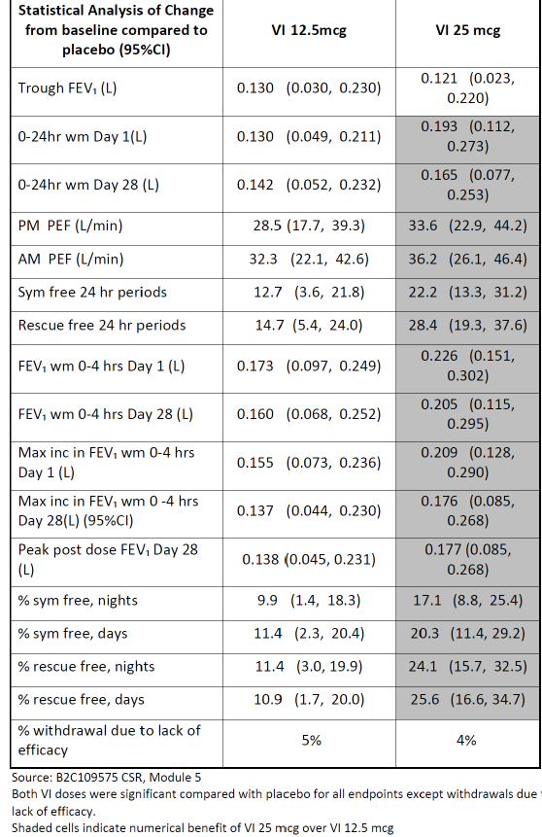
Figure 6. Absolute change from baseline in serial FEV1 (L) 0 to 4 h (ITT Population) Day 1 (top panel) and Day 28 (bottom panel)
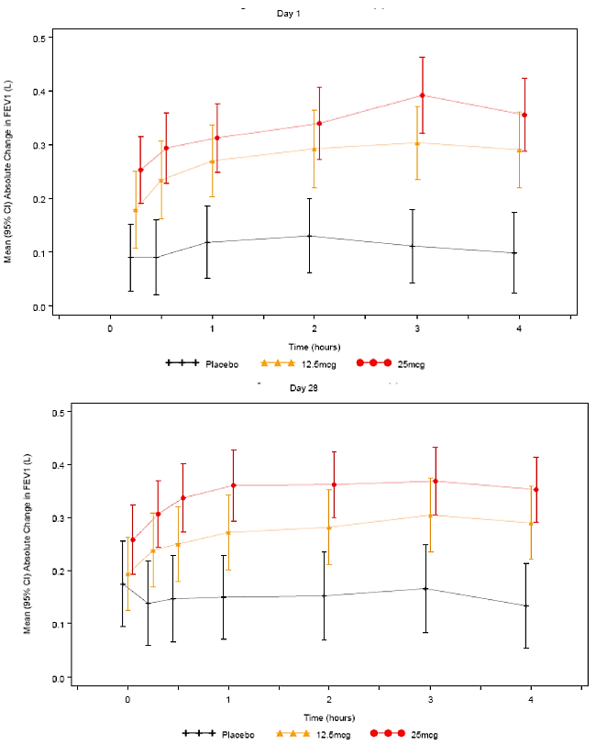
Figure 7. Proportion of subjects obtaining ≥ 200 mL and ≥12% increase from baseline FEV1 (L) 0-24 h
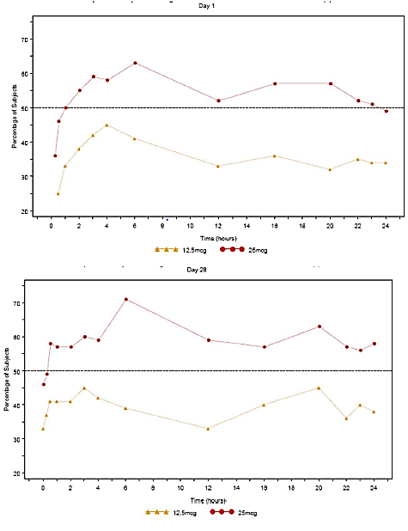
- Results in the Phase III head to head study of FF/VI 100/25 OD versus FP/salm 250/50 BD (HZA113091) suggest that the VI dose is conservative and they do not suggest that VI 25 is supratherapeutic. This view was confirmed by the FDA in their briefing document for the Pulmonary Allergy Drugs Advisory Committee Hearing on FF/VI (April 17, 2013). In HZA113091, examining the profile of FF/VI and Salm/FP over the first 4 h after first dose where neither the FF nor the FP components would be expected to have such an acute effect on FEV1, the initial time curves can be viewed as a comparison of the two LABA components and showed the effect of VI to be similar but not greater than the effect of salmeterol (Figure 8), which indicates a conservative choice of VI dose.
Figure 8. Phase III Study HZA113091. Raw mean change from baseline (95%CI) on FEV1 (L) over time after first dose (ITT).
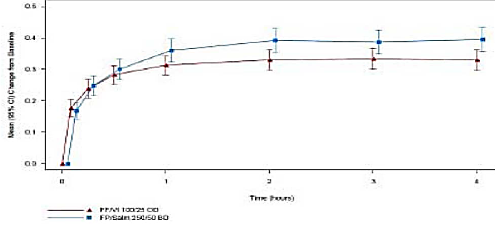
- The TGA has asserted that it is likely that patients have been administered a dose that is greater than that actually required and as LABAs may be associated with increased severity of asthma exacerbations in some patients it would be prudent to establish the minimum effective dose in patients with asthma with the option of up-titration if required in individual patients. In response to the above assertion, the sponsors state that from a safety perspective there was no evidence of pharmacologically predictable effects such as an increase in heart rate, blood glucose and effects on blood pressure or potassium levels with the VI 25 dose compared with 12.5 µg in Study B2C109575.
- GSK has also conducted a large exacerbation study, HZA106837, comparing the effect of FF/VI 100/25 and FF 100 on time to first severe asthma exacerbation and also annual rate of severe exacerbations. This study was set up to determine efficacy and also to assess if there was incremental risk with the addition of VI to FF. The study showed that FF/VI significantly reduced time to first severe exacerbation by 20% (95% CI 2,36; p=0.036) and reduced annual severe exacerbation by 25% (95% CI 5,40; p=0.014) compared to FF alone. SAE narratives for all asthma studies containing a VI or VI + ICS treatment arm were adjudicated by an independent, blinded adjudication committee. A total of 93 subjects had on-treatment SAEs that were adjudicated; of these 22 SAEs were adjudicated as being asthma related. There were no asthma related deaths or intubations on FF/VI. A common odds ratio (OR) was calculated for the asthma composite endpoint (asthma hospitalisation, intubation or death) for the treatment comparison of interest.
- For the analysis of FF/VI all doses versus non-LABA all doses, the common OR was 0.902 (95% CI: 0.345, 2.389) favouring treatment with FF/VI over treatment with non LABA containing products. The combined risk difference indicates a slight reduction in the risk of asthma related events for subjects receiving any dose of FF/VI; 2.6 subjects have avoided an asthma related event for every 10,000 subjects treated with FF/VI. For the analysis of FF/VI all doses versus ICS all doses, the common OR was 0.890 (95% CI: 0.341, 2.353) favouring treatment with FF/VI over treatment with ICS containing products (Table 14). The combined risk difference indicates a slight reduction in the risk of asthma related events for subjects receiving any dose of FF/VI; 2.8 subjects have avoided an asthma related event for every 10,000 subjects treated with FF/VI (Figure 9). The CI contains 0, implying that the analysis suggests FF/VI does not result in a statistically significant increased risk for an asthma related event.
Table 14. Statistical analysis of Composite Asthma Endpoint (ITT population)
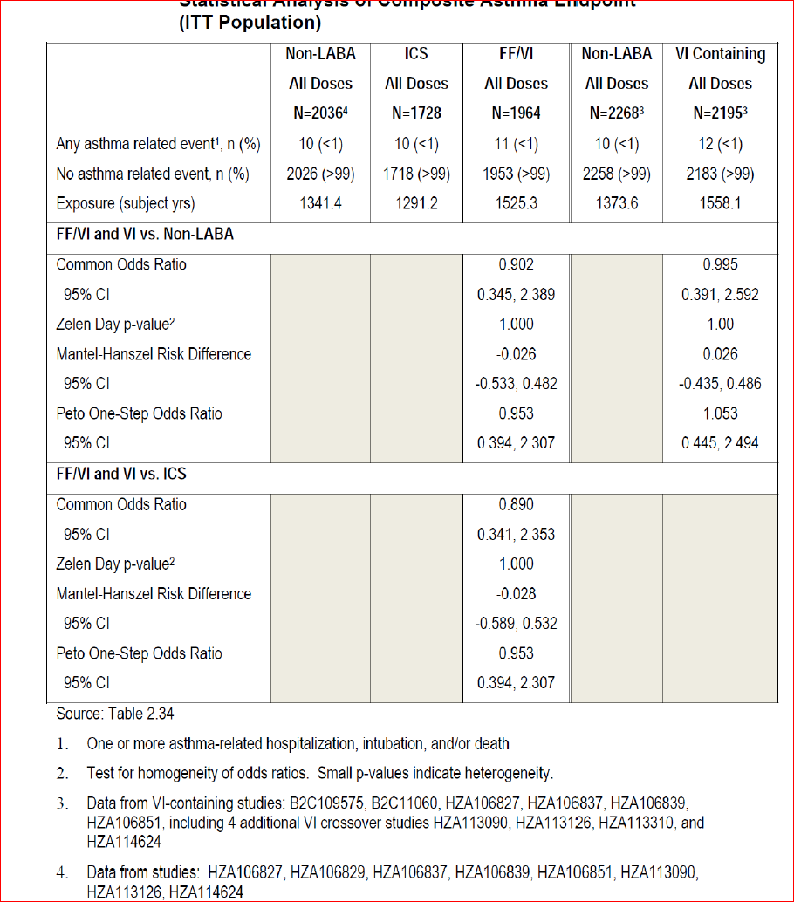
Figure 9. Asthma Composite End point, On-treatment by Study and Overall: FF/VI containing all doses versus ICS All doses
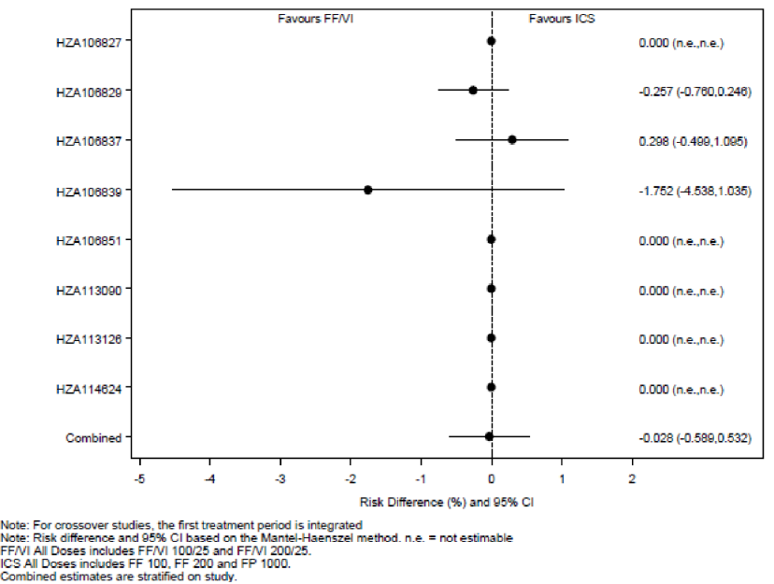

Evaluator’s comments on sponsor’s response
Efficacy in the Phase IIb Study B2C109575 was powered to show differences between each dose of VI and placebo for the primary endpoint of trough FEV1 (pre bronchodilator and pre-dose) at the end of the 28 day treatment period. Statistically significant improvements in trough FEV1 compared with placebo were found for the 12.5 µg, 25 µg and 50 µg VI doses, with mean treatment differences compared with placebo of 130 mL (p=0.011), 121mL (p= 0.016) and 162 mL (p= 0.001), respectively, despite a placebo effect of 147 mL versus baseline. For the secondary/other endpoints, statistically significant effects versus placebo were seen at both the 12.5 µg and 25 µg doses for all endpoints except withdrawals due to lack of efficacy (Table 15). The sponsors have stated that the 10 to 15% greater response in secondary efficacy endpoints of symptom-free and rescue-free 24 h periods is clinically relevant.³⁵ However, it is important to note that in the referred study³⁵, the minimal important difference (MID) in symptom and rescue-free 24 h periods in this preliminary study was determined by interviews with only 15 asthma patients using anchor-based methods in two asthma trials evaluating fluticasone furoate/vilanterol (FF/VI), HZA106827 and HZA106829. Hence, the exclusion of 12.5 µg dose of the LABA-Vilanterol (VI) based on superior efficacy observed for 25 µg in secondary endpoints (% symptom free 24 h and rescue free 24 h Periods) in a Phase II study (B2C109575) is not justified.
Table 15. Phase IIb study B2C109575. Summary of primary/secondary/other efficacy endpoints for VI 12.5 and VI 25 doses
The sponsor argues that the effect of VI 25 µg is similar but not greater than the effect of salmeterol 50 µg in Study HZA113091 following comparison of the FEV profile of FF/VI and Salm/FP as the initial time curves over the first 4 h can be viewed as a comparison of the two LABA components as neither the FF nor the FP components would be expected to have such an acute effect on FEV1 (Figure 10). Although the Phase III Study HZA113091 did not show any statistically significant difference in the initial FEV1 time curves over the first 4 h between the proposed FF/VI 100/25 µg OD and twice daily dosing with FP/salmeterol 250/50 µg, interpretation was limited due to the study design which lacked placebo control. Furthermore, non-inferiority testing would have been more appropriate for this study.
Figure 10. Phase III study HZA113091. Raw mean change from baseline (95%CI) in FEV1 (L) over time after first dose (ITT)
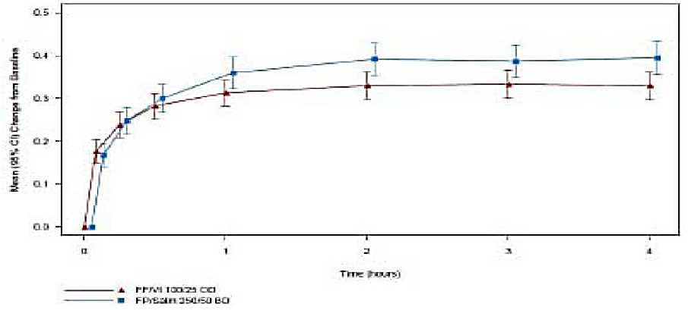
A large exacerbation study, HZA106837 showed that FF/VI (100/25 µg) significantly reduced time to first severe asthma exacerbation by 20% (95% CI 2,36; p=0.036) and reduced annual severe exacerbation by 25% (95% CI 5,40; p=0.014) compared to FF (100 µg) alone. However, interpretation was limited due to wide 95% confidence intervals. Furthermore, the other proposed dose of FF/VI 200/25 was not evaluated in this study. Furthermore, it would have been especially useful to evaluate if a lower dose of VI (12.5 µg) would have offered similar benefits but this was not done. Furthermore, the secondary endpoints of exacerbations leading to hospitalisation (FF/VI 100/25 versus FF 100: 4% versus 5%) and the mean duration of exacerbations (11.1 versus 11.3 days) were similar between treatment groups. The incidence of severe asthma exacerbations in the 7 day post treatment period was low but slightly higher in FF/VI compared with FF alone group (4 versus 1).
SAE narratives for all asthma studies containing a VI or VI + ICS treatment arm were adjudicated by an independent, blinded adjudication committee and a common odds ratio (OR) was calculated for the asthma composite endpoint (asthma hospitalisation, intubation or death) for the treatment comparison of interest. The combined risk difference indicates a slight reduction in the risk of asthma related events for subjects receiving any dose of FF/VI (Figure 11) but it is important to note that only 2.8 subjects have avoided an asthma related event for every 10,000 subjects treated with FF/VI. Furthermore, these results are mainly driven by favourable results for FF/VI in the 52 week safety Study HZA106839; the results were favourable for ICS alone compared to FF/VI combination in Study HZA106837 and vice versa in pivotal Study HZA106829, with no difference between FF/VI and ICS alone for all other studies (Figure 11). However, in the 52 week safety Study HZA106839, 12 patients experienced severe asthma exacerbations: 3 in the FF/VI 100/25 group (1%), 6 in the FF/VI 200/25 group (3%), and 3 in the FP group (3%). Hence the supposed benefit of reduction in severe asthma exacerbations is not observed with the FF/VI 200/25 dose which is also proposed for use in asthma.
Figure 11. Asthma composite end point, on-treatment, by study and overall; FF/VI containing all doses versus ICS all doses.

Question 10

Sponsor’s response
FF100 and 200 were selected as the doses for progression into Phase III for use in combination with VI based on the results of three dose ranging studies. Doses lower than 100 µg were not progressed into Phase III as they were not judged to be sufficiently efficacious to use with a LABA. International guidelines stipulate the place of an ICA/LABA as step up therapy for use when a patient is insufficiently controlled on ICS monotherapy. These patients will have more resistant asthma and require correspondingly greater efficacy from the ICS component of the combination therapy.
In the 3 dose ranging studies which assessed doses of FF from 25 µg to 800 µg, the lowest dose to demonstrate statistically significant benefit on the primary endpoint of change from baseline in trough FEV1 compared to placebo was FF 50. However the effect of FF 50 (129 mL) was approximately half that seen with FF 100 and was less than the 200 mL treatment difference for which the study was powered (Table 16), while both the 100 and 200 µg strengths showed a benefit in excess of the 200 mL. Additional support for not progressing FF 50 to be used in combination with VI comes from the post hoc analysis by baseline lung function in Study FFA109687 which showed FEV1 improvements relative to placebo of 69, 36, 267 and 190 mL with 25, 50, 100 and 200 µg FF doses, respectively (Table 17).
It is important to ensure that the dose of ICS combined with a LABA has adequate efficacy in order to avoid the masking of worsening inflammation by the LABA component. The sponsor believes that both the pre-specified and post hoc analyses suggest that FF 100 is the lowest minimal effective dose in subjects with moderate persistent asthma and that FF 50 does not constitute an adequate dose of ICS to use in combination with a LABA. However, the sponsor does recognise that different ICS strengths may be appropriate for different severities of asthma and GSK has shared with the TGA that FF 50 was taken into Phase III for use as an ICS monotherapy for patients on SABA only with milder asthma (FEV1 >60% predicted normal). In these studies which have since reported following the original submission, FF50 failed to show replicate efficacy in milder asthma. Consequently, FF 50 is also not being progressed as a strength in the development of FF as a monotherapy.
Table 16. Statistical analysis of change from baseline in trough FEV1 at Week 8 (LOCF) (FFA 109685 and FFA109687, ITT population).
Table 17. Statistical analysis of change from baseline in trough FEV1 at Week 8 (LOCF) by asthma severity (ITT population).
In the Phase II studies with FF, significant cortisol suppression was not seen at FF doses lower than 600 µg. Furthermore, there was little difference in the incidence of the most common adverse events between the 50, 100 and 200 µg doses in FFA108687 (Table 18).
Therefore from a safety perspective there were no concerns selecting FF100 and FF200 over FF50 for progression into Phase III.
Table 18. Most common AEs (3% or greater incidence in any treatment group) (FFA109687, ITT population)

Evaluator’s comments on sponsor’s response
Of the 3 FF dose ranging studies (FFA109684, FFA109685 and FFA109687), FF dose of 50 µg was only evaluated in Study FFA109687 (which evaluated doses of 25, 50, 100 and 200 µg); Study FFA109684 only evaluated FF doses of 200, 400, 600 and 800 µg while Study FFA109685 evaluated FF doses of 100, 200, 300 and 400 µg. Hence, 2 of the 3 dose ranging studies only evaluated FF doses in the flat part of the dose-response curve. In Study FFA109687, the primary endpoint of trough FEV1 showed numerically greater improvement with 200 µg FF compared to 50 µg with placebo subtracted difference of 101, 129, 204 and 230 mL with 25, 50, 100 and 200 µg FF, respectively (See Attachment 2 Table 49). However, all the secondary endpoints of change from baseline in PM PEF (See Attachment 2 Table 50), AM PEF (See Attachment 2 Table 50), percentage of symptom-free 24 h periods (See Attachment 2 Table 51), rescue-free 24 h periods (See Attachment 2 Table 52) and withdrawals due to lack of efficacy (See Attachment 2 Table 52) were numerically similar or worse in the 200 µg FF group compared with the 50 µg FF dose group. Overall, results of the primary and secondary efficacy endpoints from study FFA109687 indicated the selection of FF 50 µg as the lowest effective dose to progress to Phase III studies and this was also mentioned in the CSR of this study submitted by the sponsors. It is interesting to note that the sponsors have stated that ‘Dose selection should be based on collective evidence across all endpoints rather than relying on a single endpoint’ while justifying their decision to not evaluate the 12.5 µg dose of VI, but have not considered the same for the FF dose selection.
The sponsor has recognised that different ICS strengths may be appropriate for different severities of asthma and states that FF 50 was taken into Phase III for use as an ICS monotherapy for patients on SABA only with milder asthma (FEV1 >60% predicted normal). In these studies which have since reported following the original submission, FF50 failed to show replicate efficacy in milder asthma. The evaluators cannot comment on results of this study as the sponsors did not submit this study for evaluation as part of the S31 response. Hence, the issue of lack of evaluation of 50 µg FF in Phase III asthma studies has not been clarified adequately.

Question 11

Sponsor’s response
The sponsors have acknowledged that the FF/VI asthma Phase III program did not include a step up design. However, patient populations recruited into two of the three pivotal studies differed in terms of baseline medication. In HZA106827, which assessed the 100/25 strength, patients were required to be uncontrolled on low to mid dose ICS or low dose ICS/LABA. In HZ106829, which assessed the higher strength of 200/25 patients were required to be uncontrolled on high dose ICS or mid dose ICS/LABA. Thus, the strength of FF/VI which patients would receive will be based on their baseline medication. To facilitate initiation of combination therapy, the company proposes a table of recommended doses for inclusion in the Dosage and Administration section of the PI GSK believes the data support approval of both the FF/VI 100/25 and 200/25 strengths.
The lower strength of FF 50 was not studied as part of the FF/VI combination in Phase III since GSK believes that FF 100 is the minimally effective dose in moderate asthma (as discussed in sponsor’s response to Question 10 above).
FF 200 was developed in combination with VI as asthma guidelines [Global Initiative for Asthma (GINA), National Asthma Council (NAC) Australia] and prescribers support multiple doses of ICS and ICS/LABA combination products to ensure that strengths to treat different severities of asthma are available. In Phase II, there was evidence of a greater benefit of FF 200 compared to FF 100 especially in a post hoc analysis by baseline FEV1 (see response to Question 10 above).
Additionally, in a new Phase III study with FF monotherapy, which has reported since the original submission, patients treated with FF 200 had a 77 mL benefit in trough FEV1 and were 42% more likely to be well controlled compared to patients treated with FF 100; the treatment difference in patients uncontrolled on high dose ICS at baseline was 132mL (-0.124, 0.388).
The higher dose of FF/VI was not evaluated in HZA106837 as the objective of that study was to assess the incremental benefit and risk of adding VI to FF. However, FF/VI 100/25 and 200/25 were included in the long term safety study, HZA106839. In this study, there was minimal incremental risk with FF/VI 200/25 over 100/25 with regard to adverse events of special interest related to ICS use.
GSK has conducted additional data analyses to understand the risk of pneumonia with FF/VI including a comparison to the risk with other ICS/LABAs, namely fluticasone propionate/salmeterol (FP/salm). In order to comprehensively evaluate the pneumonia risk, the sponsor has analysed 17 studies (14 of which were included in the original submission to the TGA plus three additional FF monotherapy studies which have since reported). GSK believes it is important to include the additional FF monotherapy studies as they provide additional information for the FF 200 strength and placebo and thereby facilitate understanding the risk with the higher strength, as highlighted by the TGA. Data is presented for FF, FF/VI and also for the FP groups that were included as comparator groups in the FF/VI and FF program.
The integrated analysis was performed of all FF/VI asthma studies regardless of duration and patient population. Pneumonia, as an adverse event of special interest, was defined by a set of Medical Dictionary for Regulatory Activities (MedDRA) terms (see Attachment 2 Table 54) that were considered to be associated with an infectious aetiology. To maximise the information, available data is also presented for all FF 100 containing (FF 100 and FF/VI 100/25) arms combined, all FF 200, all FP 100 BD, all FP 250 BD and all FP 500 BD containing arms combined. The number of pneumonia events (ranging from 0.2% in placebo to 1.1% in FF/VI 200/25 group) and all serious pneumonia events (0 to 0.3%) were low in all treatment groups. Although there were some numerical differences across treatment groups, the 95% CIs for both incidence and exposure adjusted incidence were wide, showing the variability of the data for this low frequency event. The 95% CIs overlapped for all treatment groups including placebo (Table 19).
Table 19. Summary of Pneumonia AEs (17 asthma study integration)
A similar integration was also performed for all FP/salm asthma studies using the same MedDRA terms to help put the data seen with FF/VI into context. The FP/salm integration included all parallel group, controlled trials of ≥ 4 weeks duration that included a licensed dose of FP/salm in the EU for the treatment of asthma (not in combination with another drug) and included a non-FP/salm (or non-salmeterol + FP) comparator arm, in asthma subjects aged ≥12 years. The incidence of pneumonia in asthma was low in all treatment groups in both the FF/VI and the FP/salm integrated data sets. In the asthma program, the incidence of pneumonia for FF containing (that is, FF and FF/VI) groups was within the same range of incidences seen with other ICS. Importantly, the highest incidence seen in the FF/VI 200/25 group (18.4 subjects with an event per 1000 patient years) was very similar to the highest incidence (19.7 patients with an event per 1000 patient years) seen in FP/salm 250/50 BD group in the integration of the FP/salm studies (Table 20).
Table 20. Summary of Pneumonia AEs in Asthma
All FF 200 containing treatment groups showed similar incidences to that published for budesonide and FP. A published large meta-analysis of studies with placebo, budesonide and fluticasone propionate has demonstrated similar rates of pneumonia to those identified in the FF development program (19.8 per 1000 patient years across all studies, 18.1 and 17.1 per 1,000 patient years across subset of studies with both inhaled corticosteroids, respectively). While, an increased incidence of pneumonia with higher doses of ICS cannot be ruled out the absolute risk of pneumonia with FF mono appears to be very small and consistent with other ICS.
The overall data in subjects with asthma from both direct and indirect comparisons suggests that the incidence of pneumonia for FF/VI is similar to the incidence observed following treatment with a marketed ICS/LABA FP/salm. GSK therefore believes the risk of pneumonia with FF/VI 200/25 is not different from other marketed ICS/LABA products and thus should not preclude approval for the FF/VI 200/25 strength. The sponsors conclude that the safety of FF/VI 200/25 as a second strength, particularly considering the risk of pneumonia, does not preclude its use in patients whose disease severity warrant its use. The risk of pneumonia with FF/VI 200/25 is not different from other marketed ICS/LABA products.

Evaluator’s comments on sponsor’s response
Inclusion of the new table in the proposed PI would help address issues regarding transferring patients from other ICS/ LABA therapy to the proposed FF/VI treatment.
The sponsor believes that FF100 is the minimally effective dose in moderate asthma and lower doses 50 µg were not judged to be sufficiently efficacious to use with a LABA. However, of the 3 FF dose ranging studies (FFA109684, FFA109685 and FFA109687), FF dose of 50 µg was only evaluated in Study FFA109687 (which evaluated doses of 25, 50, 100 and 200 µg) and results of the primary and secondary efficacy endpoints from this study indicated the selection of FF 50 µg as the lowest effective dose to progress to Phase III studies (refer to evaluators comments to sponsor’s response to Question 10 above). This 50 µg dose of FF was not taken forward in any of the Phase III studies included in the original submission, Although GSK has mentioned that FF 50 was taken into Phase III for use as an ICS monotherapy for patients on SABA only with milder asthma (FEV1 >60% predicted normal). In these studies which have since reported following the original submission, FF50 failed to show replicate efficacy in milder asthma. The sponsors did not submit this data for evaluation by the TGA. Hence, this data should be submitted for review in order to address the issues regarding lack of adequate evaluation of 50 µg FF in Phase III asthma studies.
The sponsor suggests that there is evidence from Phase IIb of improved efficacy with FF 200 compared to FF 100. However, as discussed above, results of the Phase II study FFA109687 showed that the 200 µg dose was numerically better than 100 µg for trough FEV1, PM/ AM PEF but failed to show any numerical benefits for other secondary endpoints (see Tables 49 to 53 in Attachment 2).
Overall, results of the primary and secondary efficacy endpoints from Study FFA109687 indicated the selection of FF 50 µg as the lowest effective dose to progress to Phase III studies.
The sponsor needs to submit the additional data from a new Phase III study with FF monotherapy, which has been reported since the original submission, in which it is claimed that patients treated with FF 200 had a 77 mL benefit in trough FEV1 and were 42% more likely to be well controlled compared to patients treated with FF 100; the treatment difference in patients uncontrolled on high dose ICS at baseline was 132mL (-0.124, 0.388).
In response to the TGA’s question regarding the fact that the higher dose of 200/25 µg was not evaluated in the Phase III study HZA106837, the sponsor mentions that both FF/VI 100/25 and 200/25 were included in the long term safety Study HZA106839 which showed minimal incremental risk with FF/VI 200/25 over 100/25 with regard to adverse events of special interest related to ICS use. However, it was noted that the incidence of cardiovascular AEs (12% and 18% with FF/VI 100/25 and 200/25, respectively) and incidence of asthma exacerbations (1% and 3%, respectively) was numerically higher in the FF200/25 group compared with the FF/VI 100/25 group (Clinical safety, Long term safety Study HZA106839). Based on the new analysis of pneumonia events provided by the sponsors, the risk of pneumonia with FF/VI 200/25 does not appear to be different from other marketed ICS/LABA product.
Furthermore, the 200 µg dose of FF was associated with higher incidence of local steroid effects and pneumonia in the safety analysis involving Integrated Asthma clinical studies. For local steroid effects (particularly candidiasis, dysphonia and oropharyngeal pain), the incidence of events (adjusted for exposure) was higher in the FF/VI 200/25 (191.6/1000 subject years) and FF 200 (281.0) groups compared with Placebo (87.8) and the respective lower dose (FF/VI 100/25 =94.3 and FF100= 103.8) groups. The incidence of pneumonia (adjusted for exposure) seen with FF/VI 100/25 and FF 100 (9.6 and 8.0/1000 subject years, respectively) was similar to that seen with placebo (8.0/1000 subject years) but a higher incidence of pneumonia was observed in the FF/VI 200/25 and FF 200 arms (18.4/ and 25.5/1000 subject years, respectively). Due to the above concerns and lack of unequivocal evidence for increased benefit with the 200 µg dose of FF, the evaluators still feel that a lower 50 µg dose of FF should have been evaluated further. Based on the evidence provided in this submission, the 100 and 200 µg doses of FF selected by the sponsors are not justified.

Question 12

Sponsor’s response
In undertaking dose ranging for VI in COPD, GSK aimed to identify and select a dose at the inflection of the steep part of the FEV1 dose response curve, which also had an acceptable safety profile. Study B2C111045 was powered to detect a 130 mL difference in the point estimate in trough FEV1; a point estimate of 130 mL implies that there is a 50% chance that the treatment effect exceeds 130 mL and a 50% chance that it is below 130 mL. This treatment difference was selected to allow demonstration of an effect size similar in magnitude to that obtained with tiotropium bromide (a long-acting anticholinergic). Furthermore, selection of 130 mL allowed the company to select a dose where the probability of the treatment effect exceeded 100 mL was 80% (assuming a standard deviation (SD) of 250 mL) GSK consulted the United States Food and Drug Administration (FDA) regarding the design of the B2C111045 study during the Pre- Investigational New Drug (IND) Application Meeting on 31 January 2007 (with follow-up teleconference on 05 February 2007), prior to initiation of the study on 21 February 2008.
The B2C111045 study demonstrated an increase in trough FEV1 with increasing dose. The maximum effective dose was not demonstrated. The greatest efficacy was seen with the 50 µg dose. Based upon the primary and secondary endpoints, as well as the safety profile, 25 µg was considered an appropriate dose to progress in the FF/VI combination for the Phase III COPD Clinical Development Program. Although all VI doses were statistically significantly different from placebo for the primary endpoint of trough FEV1, compared with placebo, adjusted mean treatment differences of ≥130 mL (the treatment difference on which the study was powered) were only observed with VI 25 and VI 50 but not with lower doses. Also, a post hoc analysis based on subjects’ reversibility to salbutamol at Screening was conducted to further evaluate the effect of VI, since the COPD population is comprised of reversible and non-reversible subjects. This analysis demonstrated that in the non-reversible population (subjects with FEV1 change after salbutamol of <200 mL or ≥200 mL increase that was <12% from pre salbutamol baseline; 64% of the subjects), only subjects in the VI 25 µg and VI 50 µg groups achieved a clinically relevant 100 mL improvement in adjusted mean change from placebo in trough FEV1 (mean treatment differences compared with placebo of 113 mL [95% CI: 47, 180] and 118 mL [95% CI: 52, 183], respectively) In the VI 12.5 µg group, while subjects in the reversible population demonstrated a clinically meaningful improvement in trough FEV1 of 162 mL [95% CI: 76, 249] on Day 29 compared with placebo, in the non-reversible population, the response (77 mL [95% CI: 11, 143]) was less than half of that observed in the reversible population (Figure 12).
Figure 12. Adjusted mean differences (95%CI) from placebo in change from baseline in trough FEV1 (L) at Day 29 in subjects with COPD (ITT population and non-reversible population): VI dose ranging study in COPD (B2C111045).
Furthermore, in addition to the traditional analysis, the probability of each treatment difference (VI versus placebo) being >100 mL and > 130 mL increase from baseline in trough FEV1 on Day 29 was a pre-specified supplemental analysis of the primary endpoint. The value of 100 mL in trough FEV1 was included in this analysis as such an improvement is viewed as clinically meaningful [Cazzola, 2008, Donahue, 2004]. In further support of the 25 and 50 µg doses, this analysis demonstrated that probabilities for a >100 mL increase were more than 90% with both the 25 µg and 50 µg doses, but much lower (<64%) for the 3, 6.25, and 12.5 µg doses (Figure 12). Differences of ≥130 mL (the difference the study was powered on) on Day 29 were observed only with the 25 and 50 µg doses.
In the two, Phase III, 6 month, placebo controlled, efficacy and safety studies in 2,254 subjects with COPD (HZC112206 and HZC112207), VI 25 µg OD was well-tolerated with a similar safety profile to placebo. The frequencies of any on-treatment AE, AEs leading to study drug discontinuation or withdrawal from the study, serious AEs (SAEs) and fatal events were similar between the VI 25 µg containing groups and the placebo group.

Evaluator’s comments on sponsor’s response
The explanation provided by the sponsors for consideration of VI25 µg only for the Phase III COPD trials is acceptable, especially following results of the post hoc analysis in patients with non-reversible COPD and increased likelihood of responding with clinically significant improvement in lung function with the 25 µg dose of VI.

Question 13

Sponsor’s response
HZC102970 and HZC102871 are the first dose ranging studies that were conducted with an ICS/LABA combination product to evaluate an effect on exacerbation reduction in subjects with COPD. While the integrated data from both studies demonstrated statistically significant reduction in the annual rate of moderate and severe exacerbations for all three FF/VI strengths compared with VI (23% (95% CI: 12, 34; p<0.001), 27% (95% CI: 16, 37; p<0.001) and 16% (95% CI: 4, 27; p=0.014) for FF/VI 200/25, 100/25 and 50/25, respectively), this was not the case in the individual studies. In HZC102970, all three FF/VI strengths FF/VI 50/25, 100/25 and 200/25 did demonstrate a statistically significant (p≤0.040) and clinically relevant reduction in the annual rate of moderate and severe exacerbations compared to VI 25 (19%, 21%, and 31%; respectively). However, in Study HZC102871, the reduction in the annual rate of moderate and severe exacerbations for FF/VI 50/25, 100/25 and 200/25 was 13%, 34% and 15%, respectively with only the 100/25 dose demonstrating a reduction with a nominal p-value <0.05 (p<0.001). Thus, only the FF/VI 100/25 strength demonstrated a robust treatment effect in both studies (Figure 13).
Figure 13. Treatment differences (95%CI) for the annual rate of moderate and severe COPD exacerbations (ITT population): individual and integrated study results-1 year exacerbation studies (HZC102970 and HZC102871).
Figure 13. continued
The primary endpoint analysis from the 1 year exacerbation studies and selection of the FF/VI 100/25 strength was also supported by the individual and integrated analysis for the secondary endpoints of time to first moderate or severe COPD exacerbation (Figure 14) and annual rate of COPD exacerbations requiring systemic/oral corticosteroids (Figure 15). An examination of the data from the sub-group populations of subjects from the integrated databases, specifically those subjects with less severe COPD (as defined by a milder airflow obstruction or less frequent history of exacerbations) who might benefit from a lower strength of FF/VI and subjects with more severe disease (as defined by a more severe airflow obstruction or by a higher historical exacerbation frequency) who might benefit from a higher strength of FF/VI, also confirmed that the 100/25 dose is the optimal dose. In the non-frequent exacerbators in the year prior to screening, only FF/VI 100/25 µg produced a significant and clinically relevant reduction compared with VI alone (19%; p=0.031) and was almost double the reduction observed with the FF/VI 50/25 dose (10%, p=0.293). In the frequent exacerbator population, all strengths of FF/VI significantly reduced the moderate/severe exacerbation event rate by 21%, 31% and 28% versus VI; however the higher strength 200/25 offered no incremental benefit over the 100/25 strength. Subjects with less severe COPD (FEV1 ≥50% of predicted) treated with lower strength FF/VI 50/25 failed to demonstrate a statistically significant reduction in exacerbations while both the 100/25 and 200/25 strengths demonstrate both a clinically relevant and statistically significant reduction in exacerbations. For the 30% ≤FEV1<50% predicted group only the FF/VI 100/25 strength demonstrated a statistically significant and clinically relevant reduction in exacerbations. For subjects with the most severe COPD (FEV1<30% predicted group) all strengths demonstrated statistically significant and clinically relevant reductions in exacerbations with the 100/25 strength demonstrating the highest reduction in exacerbations and no incremental benefit with the 200/25 strength.
Figure 14. Kaplan-Meier plot of time to first on treatment moderate or severe COPD exacerbations (ITT population): integrated study results-1 year exacerbation studies (HZC102970 and HZC102871).
Figure 15. Treatment differences (95%CI) for the annual rate of COPD exacerbations requiring systemic/oral corticosteroids (ITT population):integrated study results-1 year exacerbation studies (HZC102970 and HZC102871).]
Known side effects of corticosteroids were of special interest in the COPD Breo program.
These included systemic corticosteroid effects, bone disorders, local steroid effects, pneumonia, LRTI, effects on glucose and hypersensitivity. There was an increased incidence of AEs in the local steroid effect special interest group (candidiasis and dysphonia) and in the incidence of pneumonia and bone disorders for the FF/VI groups versus VI alone. There was no indication of increased AE incidence with any of the FF/VI strengths versus VI alone for the other AE special interest groups examined. Importantly, there were no discernible differences in the FF/VI 100/25 group compared with the FF/VI 50/25 group for any event of the special interest group indicating that there is no increased safety risk with the 100/25 strength compared to the 50/25 strength.
The sponsors acknowledge the existence of individual variability and response, however a subpopulation could not be identified that would preferentially benefit from either the lower (50/25) or higher (200/25) FF/VI dose.

Evaluator’s comments on sponsor’s response
The explanation provided by the sponsors for selection of the FF/VI 100/25 µg dose for treatment of COPD is acceptable. The lower dose of FF/VI 50/25 µg did not appear to be effective in patients with less severe disease who may have been candidates for the lower dose, while the higher dose of 200/50 µg did not have provide any additional benefit and was in fact associated with increased safety risks.

Question 14

Sponsor’s response
For COPD: Both GOLD and COPDx do not recommend long-term monotherapy treatment withICS therefore the lack of availability of FF monotherapy should not present an issue for clinicians treating patients with COPD. However, it is well accepted that an ICS combined with a LABA is more effective than the individual components. As reduction in exacerbations represents the main symptomatic benefit of the combination, the proposed COPD indication reflects the patient population studied in the 1 year studies and not the broader patient population in the 6 month studies who did not have an exacerbation history. This is consistent with recommendations of treatment guidelines, which recommend inhaled corticosteroid containing products should be used in patients with severe or very severe airflow limitation or patients with frequent exacerbations despite long acting bronchodilators.^{38,}
Although VI monotherapy is not marketed it should be noted that as discussed in Response to Question 12, the improvements observed following treatment with VI are broadly consistent to those observed with other approved long-acting bronchodilators. In three 12 week COPD studies (HZC113107/HZC113109/HZC112352) and one 24 week asthma study (HZA113091), which directly compared FF/VI and Seretide, no statistically or clinically relevant differences were observed in terms of trough FEV1 or serial lung function. Since immediate effects on lung function are primarily driven by the beta-agonist and in COPD the contribution of the corticosteroid in terms of improving lung function is limited this suggests that the bronchodilatory effects of salmeterol 50 µg BD and vilanterol 25 µg OD are comparable.
The effect of VI on exacerbation rates is also very similar to the effect of salmeterol on exacerbation rates in two SERETIDE 250/50 studies SCO40043/SC0100250²⁸ which are identical in design to the two 1 year studies HZC102970/HZC102871). In the pooled data from SCO40043/SCO100250, the annual rate of moderate and severe exacerbations in patients treated with salmeterol was 1.58 which is higher than the annual rate of moderate and severe exacerbations in the VI group in the pooled data from HZC102970/HZC102871 suggests VI monotherapy is at least as effective as a marketed long-acting bronchodilator in reducing exacerbations.
Together these data suggest the effect of vilanterol 25 µg administered once daily is comparable to well established long acting beta2 agonists and muscarinic antagonists.
The sponsor contends that FF/VI 100/25 is an appropriate treatment for any COPD patient who exacerbates despite treatment with long acting bronchodilators. Nevertheless, the sponsor recognises that the ICS/LABAs are not intended to be used as first line therapy and therefore proposes to modify the indication as follows:
‘Breo is indicated for the symptomatic treatment of patients with COPD, with a FEV1 <70% predicted normal (post-bronchodilator) and an exacerbations history despite regular bronchodilator therapy.’
For Asthma: Inhaled corticosteroids are considered the most effective anti-inflammatory treatment for all severities of persistent asthma. Treatment with ICS controls asthma symptoms, improves quality of life and lung function, decreases airway hyper responsiveness, controls airway inflammation, and reduces the frequency and severity of asthma exacerbations, thereby reducing asthma morbidity and mortality. The dose of ICS is selected based on the severity of the patient’s asthma. However, add-on therapy with another controller, in particular inhaled LABA, is preferred to increasing the dose of ICS to achieve asthma control. The addition of a LABA to an ICS improves symptom scores, decreases nocturnal asthma symptoms, improves lung function and reduces the number of asthma exacerbations.
Inhaled LABA therapy may be associated with increased risk of serious asthma related events (including hospitalisation, intubation and death) and so should not be used as monotherapy in asthma⁴⁰, therefore lack of availability of VI monotherapy should not present an issue for clinicians treating patients with asthma. The subject populations for the Phase III studies were chosen to be representative of the intended patient population for an ICS/LABA combination based on subjects having asthma not controlled on ICS alone or on ICS/LABA combinations. Subjects recruited to HZA106827 were uncontrolled on low dose ICS/LABA or low to mid dose ICS alone (Table 21) whereas subjects recruited to HZA106829 were uncontrolled on mid dose ICS/LABA or high dose ICS alone (Table 22).
Table 21. ICS and ICS/LABA dosage table (top) and Summary of ICS usage Pre-treatment (ITT population)
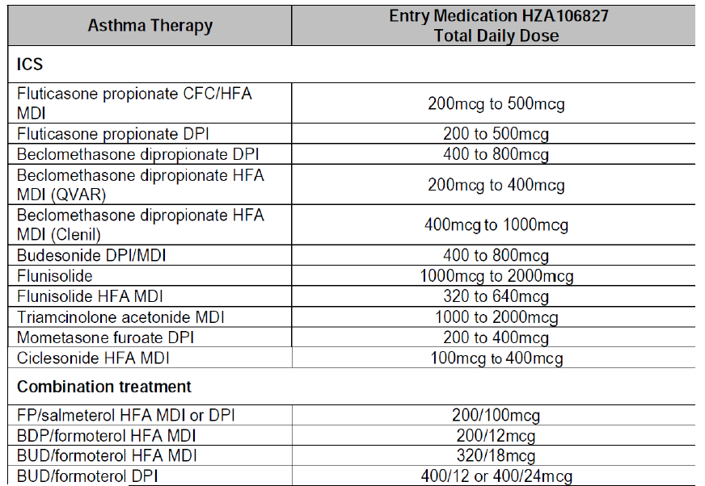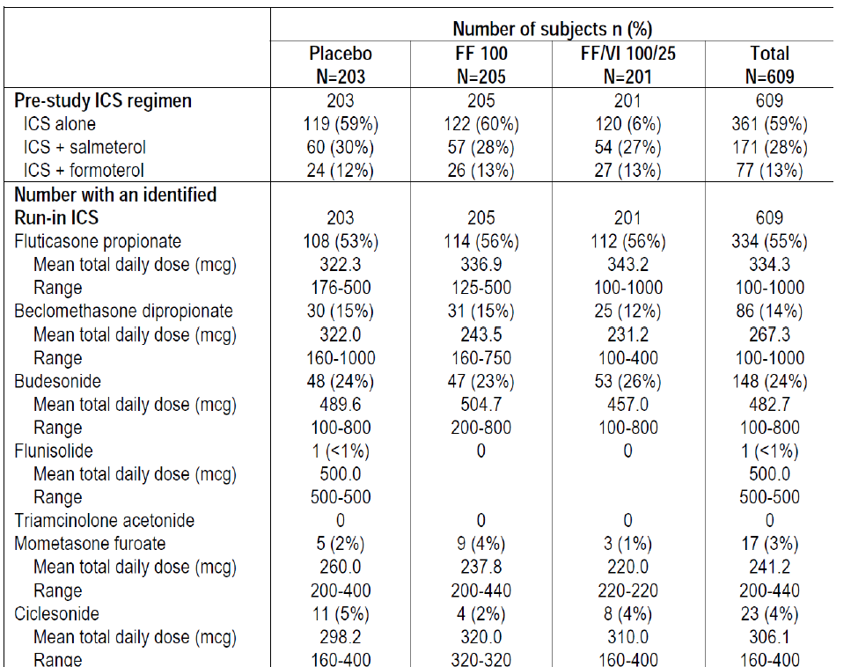
Table 22. ICS and ICS/LABA dosage table. Table continued across two pages.
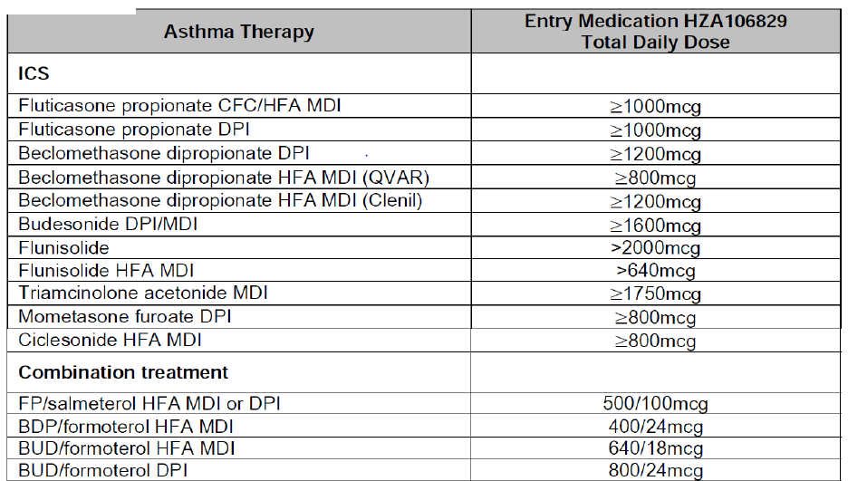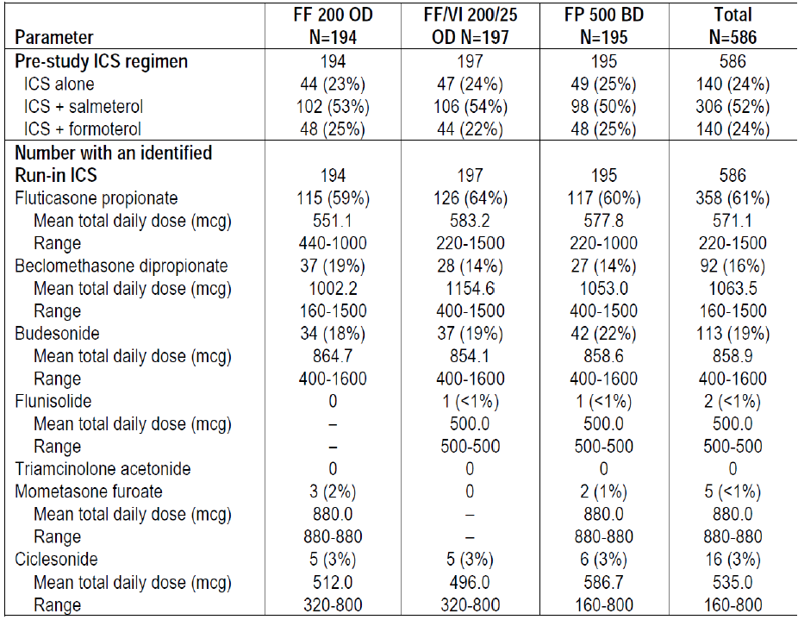
The data from Studies FFA112059/HZA106829 indicate that the efficacy of FF 100 OD daily is not different from FP 250 BD and FF 200 OD is non-inferior to FP 500 BD. This is further supported by Study HZA113091 in asthma subjects that compared FF/VI 100/25 once daily with FP/salmeterol 250/50 twice daily over 24 weeks and showed no significant difference between treatments on lung function or symptomatic endpoints. This suggests that clinicians can view the dose of FF as equivalent to 5X the total daily fluticasone propionate dose for asthma patients.
To facilitate initiation of combination therapy the company proposes to add a table to the prescribing information which has been devised based on the doses of prior therapies which were permitted in HZA106827/HZA106829 as well as the evidence of comparability to marketed products described above.

Evaluator’s comments on sponsor’s response
The explanation given by sponsors for treatment of COPD and the change to the proposed indication for treatment of COPD are acceptable with a minor change.
‘Breo is indicated for the symptomatic treatment of patients with COPD, with a FEV1 <70% predicted normal (post-bronchodilator) and history of exacerbations despite regular bronchodilator therapy.’
The proposed new table in the PI would help provide some guidelines to clinicians on dosing for treatment of asthma. However, this is not enough to overcome the reservations the evaluators have regarding the overall benefit-risk profile of Breo Ellipta for treatment of asthma (as discussed in Second round assessment of benefit-risks balance).

Second round benefit-risk assessment

Second round assessment of benefits

Asthma
After consideration of responses to clinical questions, the benefits of FF/VI (100/25 and 200/25 µg) in the proposed usage for treatment of asthma are:
- Once daily treatment with a LABA/ICS combination would potentially improve treatment compliance although this could not be ascertained in the clinical studies. The currently available LABA/ICS combinations need to be administered twice daily.
- The proposed doses of FF/VI 100/25 and 200/25 provided greater benefit in terms of improvement in lung function parameters of trough FEV1, weighted mean FEV1 (0 to 24 h), AM and PM PEF than FF alone in two out of three pivotal Phase III studies (HZA106829 and HZA106837) where this was measured, thus demonstrating the contribution of VI to the combination. FF/VI 100/25 and 200/25 were also significantly better than the equivalent dose of FF monotherapy in improving symptomatic endpoints including 24 h rescue-free/symptom-free periods, time to first severe exacerbation and severe exacerbation rate. The contribution of FF to the efficacy of the FDC was shown by assessing the efficacy and safety of FF relative to placebo in the Phase III studies and also in an allergen-challenge Phase II study HZA113126 where FF/VI was significantly better than VI alone in terms of attenuating the early and late phase asthmatic response and also the increased bronchial hyper-responsiveness (BHR) associated with allergen challenge.
- At therapeutic doses of FF/VI, no safety signals have been observed for increased incidence of severe asthma exacerbations, adrenal suppression, bone disorders, QT interval prolongation, myocardial ischemia, or metabolic, neurologic, or ocular effects based on results of clinical program to date. Safety observations are in line with the expected drug class profiles in the populations studied and no new risks have been identified.

COPD
After consideration of responses to clinical questions, the benefits of FF/VI 100/25 µg OD in the proposed usage for treatment of COPD are:
- Once daily treatment with a LABA/ICS combination would potentially improve treatment compliance. Although this could not be ascertained in the clinical studies due to study designs. The currently available LABA/ICS combinations used for treatment of COPD require twice daily administration.
- In the two pivotal 6 month studies, the proposed dose of FF/VI 100/25 µg OD showed statistically significant and clinically meaningful improvements in lung function after 24 weeks of treatment with increased adjusted mean trough FEV1 [difference from placebo was 129 mL and 83 mL with FF/VI 100/25 and VI 25, respectively; FF/VI 100/25–VI 25= 46 mL ; 95% CI: 8, 83mL, p= 0.017] and adjusted weighted mean peak FEV1 (0 to 4 h) [difference from placebo was 193 mL and 145, respectively; FF/VI 100/25-VI 25= 148 ml; 95% CI: 112, 184mL, p< 0.001]. Patients treated with the proposed FF/VI 100 /25 µg also had significantly better dyspnoea scores (although not clinically relevant), had less cough and sputum, required significantly less rescue medication as measured by number of occasions of rescue salbutamol use (per 24 h period) and number of night time awakenings requiring salbutamol (per 24 h period) compared to placebo.
- The 24 h bronchodilator effect of FF/VI was maintained from the first dose throughout a 1 year treatment period with no evidence of loss in efficacy.
- The data from the pivotal Phase III, 52 week studies demonstrated that FF provides a significant contribution to the FF/VI combination. In particular, compared with VI 25 OD alone, treatment with FF/VI 100/25 OD consistently reduced the annual rate of moderate and severe COPD exacerbations, time to exacerbations, rate of exacerbations requiring systemic corticosteroid use and also showed minor improvements in lung function (trough FEV1).
- Overall, safety of proposed dose of FF/VI 100/25 µg was evaluated in adequate number of COPD patients for treatment durations up to 1 year and was representative of the target patient population for the proposed combination. The safety profile of proposed FDC of FF/VI 100/25 µg OD was consistent with the expected AEs usually associated with LABA/ICS combination, that is, most frequent AEs were beta-adrenergic agonist AEs or local steroid effects.

Second round recommendation regarding authorisation

Second round assessment of risks

Asthma
After consideration of responses to clinical questions, the risks of FF/VI (100/25 and 200/25 µg) in the proposed usage for treatment of asthma are:
- In the PK-PD studies, dose proportionality of FF and VI was not evaluated over a wide range of doses and in fact the starting dose in the PK studies was 100 to 200 µg for FF and >25 µg for VI.
- The FDC guidelines state that rationale for a FDC development is either FDC shows better efficacy than mono components taken together or lower doses of actives given as FDC offer better risk benefit ratio. There were no studies which assessed the clinical equivalence of proposed FDC of FF/VI with concurrent therapy with FF and VI.
- The doses of the ICS (FF) and LABA (VI) selected for the FDC were based on the dose ranging mono component Phase II studies and no dose ranging studies were conducted with the proposed combination inhaler (FF/VI). Exclusion of 12.5 µg dose of the LABA Vilanterol (VI) based on superior efficacy observed for 25 µg in secondary endpoints (% symptom free 24 h and rescue free 24 h periods) in a Phase II study (B2C109575) is not justified. The study was not powered to show a difference in these endpoints. LABAs may be associated with increased severity of asthma exacerbations in some patients and hence it would be prudent to establish the minimum effective dose in patients with asthma with the option of up-titration if required in individual patients. Dose ranging studies for FF showed efficacy in the range of 50 to 200 µg but the dose of 50 µg was not evaluated in the Phase III asthma studies.
- Evidence for contribution of the VI component to the FDC (FF/VI) was not unequivocal. The pivotal Phase III study HZA106827 (which recruited subjects uncontrolled on low/mid dose ICS or on low dose ICS/LABA) failed to demonstrate statistically significant difference between the two active treatments (FF/VI 100/25 and FF 100 alone) for the co-primary endpoints of trough FEV1 and weighted FEV1 (0 to 24 h). As statistical significance was not achieved for all treatment comparisons in the first level of Hierarchy (there was no statistical significant difference between FF/VI and FF for the co-primary endpoints), the significant differences in FF/VI 100/25 compared with FF 100 for the powered secondary endpoint of percentage of rescue-free/symptom-free 24 h periods, AM and PM PEF should be interpreted as descriptive only.
- The pivotal Study HZA106829 (which recruited subjects uncontrolled on high dose ICS or on mid dose ICS/LABA) showed statistically significant improvements with FF/VI 200/25 µg compared with FF 200 alone in co-primary [trough FEV1 and weighted FEV1 (0 to 24 h)] and secondary endpoints (percentage of rescue-free/symptom-free 24 h periods and AM/PM-PEF) at the end of 24 weeks of treatment. However, a sensitivity analyses (excluding data from an investigator in the USA because of GCP issues) of the co-primary endpoint of weighted mean FEV1 (0 to 24 h) was not consistent with the ITT analysis results and failed to show statistically significant difference between FF/VI and FF200 groups Although results were consistent with ITT analysis for trough FEV1 and other secondary endpoints.
- Safety issues with use of FF/VI for treatment of asthma include local steroid effects, systemic corticosteroid effects including effect on growth, bones in adolescents (although this is being addressed by ongoing studies), cardiovascular effects and pneumonia. The incidence of pneumonia (adjusted for exposure) seen with FF/VI 100/25 and FF 100 (9.6 and 8.0/1000 subject years, respectively) was similar to that seen with placebo (8.0/1000 subject years) although a higher incidence of pneumonia was observed in the FF/VI 200/25 and FF 200 arms (18.4/ and 25.5/1000 subject years, respectively).
- A large exacerbation study, HZA106837 showed that FF/VI (100/25 µg) significantly reduced time to first severe exacerbation by 20% (95% CI 2,36; p=0.036) and reduced annual severe exacerbation by 25% (95% CI 5,40; p=0.014) compared to FF (100 µg) alone but the other proposed dose of FF/VI 200/25 was not evaluated in this study; it would have been especially useful to evaluate if a lower dose of VI (12.5 µg) would have offered similar benefits but this was not done. Furthermore, the secondary endpoints of exacerbations leading to hospitalisation (FF/VI 100/25 versus FF 100: 4% versus 5%) and the mean duration of exacerbations (11.1 versus 11.3 days) were similar between treatment groups. Furthermore, the incidence of severe asthma exacerbations in the 7 day post treatment period was low but slightly higher in FF/VI compared with FF alone group (4 versus 1).
- Long-acting beta2 adrenergic agonists (LABA) such as vilanterol, one of the active ingredients in Breo Ellipta, increase the risk of asthma related death. A placebo controlled trial with another LABA (salmeterol) showed an increase in asthma related deaths in subjects receiving salmeterol. This finding with salmeterol is considered a class effect of all LABA, including vilanterol. An analysis of asthma related serious events (deaths, hospitalisations and intubations) was done for all asthma studies containing a VI or VI+ICS treatment arm showed a slight reduction in the risk of asthma related events for patients receiving any dose of FF/VI compared to non-LABA (all doses) or ICS (all doses). However, the risk reduction was quite minimal as only 2.6 to 2.8 patients avoided an asthma related event for every 10,000 patients treated with FF/VI. Overall, evidence for safety of the proposed doses of FF/VI (100/25 and 200/25 µg) in treatment of asthma is not conclusive.

COPD
After consideration of responses to clinical questions, the risks of FF/VI (100/25 µg) in the proposed usage for treatment of COPD are:
- In the COPD clinical program, most frequent AEs were beta adrenergic agonist AEs or local steroid effects. There was a higher incidence of pneumonias (including serious and fatal pneumonias) in subjects treated with FF/VI. However, the incidence of pneumonia appeared to be more common in patients with risk factors [current smokers, patients with a history of prior pneumonia, patients with a body mass index <25 kg/m2 and patients with a FEV1<50% predicted] which have been included in the proposed labelling. It is also reassuring to see that most of these serious AEs of pneumonia were more common in patients treated with FF/VI 200/25 µg which is not the proposed dose for COPD.

Second round assessment of benefit-risk balance

Asthma
The purpose of this application is to obtain marketing approval for the use of FF/VI (100/25 and 200/25 µg OD by oral inhalation) administered once daily for the regular treatment of asthma in adults and adolescents aged 12 years and older, where use of a combination product (long-acting beta2 agonist and inhaled corticosteroid) is appropriate; asthma patients who are symptomatic with inhaled corticosteroids and 'as needed' inhaled short acting beta2 agonist or patients already on both an inhaled corticosteroid and a long-acting beta2 agonist.
Fixed Dose Combinations of ICS and LABA are well accepted and recommended treatments for asthma.⁴⁰ Current ICS/LABA combinations, including fluticasone propionate (FP)/salmeterol, beclomethasone/formoterol and budesonide/formoterol, need to be administered twice daily. Hence one of the potential benefits with the proposed ICS/LABA combination of FF/VI is improved treatment compliance due to its once daily dosing regimen. However, the Phase III clinical development program for FF/VI was conducted double-blind and where necessary, double-dummy conditions, confounding the assessment of compliance. As a result, the question of whether once daily FF/VI represents a true patient benefit requires further investigation.
Evidence for contribution of the LABA (Vilanterol) component to the FDC (FF/VI) was not unequivocal. The pivotal Phase III Study HZA106827 failed to show statistically significant difference between FF/VI 100/25 and FF 100 alone for both co-primary endpoints (trough FEV1 at end of study and weighted FEV1 (0 to 24 h) limiting interpretation and validity of the significant differences observed between FF/VI and FF for the secondary endpoints of percentage of rescue-free/symptom-free 24 h periods, AM and PM PEF. The Phase III pivotal study HZA106829, at the end of 24 weeks of treatment, FF/VI 200/25 significantly improved the co primary endpoints [trough FEV1 and weighted mean FEV1 (0 to 24 h)] and the secondary end points (percentage of rescue-free/symptom-free 24 h periods, AM and PM PEF) compared with FF 200 alone. However, these results were not robust and conclusive as the sensitivity analysis for the co-primary endpoint of weighted mean FEV1 (0 to 24 h) was not consistent with the ITT analysis results.
Another limitation of this submission relates to inadequate evaluation of a wide range of doses of FF and VI in the PK-PD or the Phase II dose ranging studies. No dose ranging studies were done with the proposed combination product in asthma and dose response information was mainly obtained from studies using FF alone or VI alone. Majority of doses evaluated seemed to lie within the flat part of the dose response curve and hence it is likely that a much higher dose than required was evaluated in the pivotal Phase III studies. The minimum effective dose of VI was not established and only one dose of VI (25 µg OD) was carried forward to the Phase III studies. FF dose of 50 µg was also not evaluated especially considering that asthma patients tend to be younger including adolescents and the known risks of long-term steroid therapy.
A major safety concern with vilanterol is linked to the selection of an appropriate dose, because beta2 adrenergic bronchodilators, particularly at high doses, have the safety concerns of severe asthma exacerbations and asthma related deaths in patients who use these drugs to treat the symptoms of asthma. Long acting beta2 adrenergic agonists (LABA) such as vilanterol, one of the active ingredients in Breo Ellipta, increase the risk of asthma related death. A placebo controlled trial with another LABA (salmeterol) showed an increase in asthma related deaths in subjects receiving salmeterol. A 28 week, placebo controlled US study comparing the safety of salmeterol with placebo, each added to usual asthma therapy, showed an increase in asthma related deaths in patients receiving salmeterol (13/13,176 in patients treated with salmeterol versus 3/13,179 in patients treated with placebo; RR 4.37, 95% CI 1.25, 15.34). This finding with salmeterol is considered a class effect of the LABA, including vilanterol, one of the active ingredients in Breo Ellipta. No study adequate to determine whether the rate of asthma related death is increased with Breo Ellipta has been conducted. Overall, evidence for safety of FF/VI in treatment of asthma is not conclusive.
There were no studies which assessed the clinical equivalence of proposed FDC of FF/VI with concurrent therapy with FF and VI. The individual components of the FDC are not to be registered for use in asthma although the sponsor has mentioned to the TGA that there are some data on FF monotherapy for treatment of asthma. The above limitations of the proposed FF/VI formulation may have been acceptable if the proposed drug was of major therapeutic benefit for which no other alternative treatments are available. Since that is not the case with this ICS/LABA formulation, the benefit-risk balance of Breo Ellipta (FF/VI 100/25 and 200/25 µg OD) given the proposed usage for treatment of asthma is unfavourable.

Treatment of COPD
The sponsor is also seeking marketing approval of FF/VI 100/25 µg OD for the modified indication of:
‘Breo is indicated for the symptomatic treatment of patients with COPD, with a
FEV1 <70% predicted normal (post-bronchodilator) and history of exacerbations despite regular bronchodilator therapy.’
Fixed Dose Combinations of ICS and LABA are well accepted and recommended treatments for COPD. Current ICS/LABA combinations, including fluticasone propionate (FP)/salmeterol, beclomethasone/formoterol and budesonide/formoterol, need to be administered twice daily. Hence one of the potential benefits with the proposed ICS/LABA combination of FF/VI is improved treatment compliance due to its once daily dosing regimen. However, the Phase III clinical development program for FF/VI was conducted under double-blind, and where necessary double-dummy conditions, confounding the assessment of compliance. As a result, the question of whether once daily FF/VI represents a true patient benefit requires further investigation.
Dose ranging studies for the proposed FF/VI FDC were conducted in both COPD and asthma patients. The regulatory precedence of performing dose ranging and dose regimen studies for bronchodilators in asthma patients has been established in order to demonstrate a large separation between doses, because the range of response is greatest in a bronchoresponsive population, such as patients with asthma. A COPD population, with some degree of fixed obstruction, has a smaller response range to a bronchodilator. The regulatory precedence of performing dose ranging and dose regimen studies in patients with asthma was followed in the development of indacaterol, a LABA that was approved for marketing in the United States in 2011 as a bronchodilator in patients with COPD.
The COPD efficacy data showed contribution of each component present in the proposed ICS LABA FDC (Breo Ellipta) and also showed that the FDC (FF/VI) provides a clinically meaningful benefit over each single ingredient present in the combination (FF and VI). FF/VI showed benefit over fluticasone furoate alone in lung function, and a benefit over vilanterol alone in COPD exacerbations.
The benefit vilanterol provides to the combination FF/VI product is demonstrated through a comparison of FF/VI 100/25 to FF 100 in the two 24 week lung function trials (2206 and 2207). In both trials, FF/VI 100/25 demonstrated a statistically significant improvement in FEV1 0 to 4h compared to FF 100 monotherapy. The efficacy of the VI mono component is also demonstrated in the same 24 week lung function trials through a comparison of VI to placebo.
Both trials demonstrate a statistically significant improvement for VI compared to placebo.
The benefit FF provides to the combination product is demonstrated by the comparison of FF/VI 100/25 to VI 25 in the exacerbation trials and lung function trials. A statistically significant improvement in the annual rate of exacerbation for FF/VI 100/25 compared to VI 25 is seen in one of the 52 week exacerbation trials with the other trial demonstrating a numerical improvement with a nominal p-value <0.05. While the second trial demonstrated a similar treatment effect, the improvement was not statistically significant based on the statistical hierarchical testing procedure. In addition to the exacerbation data, a consistent numeric improvement in trough FEV1 is demonstrated for FF/VI 100/25 compared to VI 25 monotherapy in both 24 week lung function trials as well as in the two 52 week exacerbation trials. The data do not support an efficacy advantage for doses higher than FF/VI 100/25 in terms of exacerbations or lung function.
In the COPD clinical program, most frequent AEs were beta-adrenergic agonist AEs or local steroid effects. In terms of risk, the common adverse event profile for FF/VI in COPD is similar to other ICS/LABA products in COPD. In terms of serious events, an increase in FF dose related risk for pneumonia was seen in the FF/VI development program. There was a higher incidence of pneumonias (including serious and fatal pneumonias) in subjects treated with FF/VI.
However, the incidence of pneumonia appeared to be more common in patients with risk factors [current smokers, patients with a history of prior pneumonia, patients with a body mass index <25 kg/m² and patients with a FEV1<50% predicted] which have been included in the proposed labelling. It is also reassuring to see that most of these serious AEs of pneumonia were more common in patients treated with FF/VI 200/25 µg which is not the proposed dose for COPD. Pneumonia has been seen in other ICS/LABA development programs and current product labelling for other ICS/LABA product contains warning language regarding this risk. No direct comparison to an approved product of adequate treatment duration to assess pneumonia has been performed to directly assess the risk of pneumonia of FF/VI compared to approved products.
Overall, the benefit-risk balance of Breo Ellipta (100/25 µg QD) given the proposed usage for treatment of COPD is favourable.

Second round recommendation regarding authorisation
It was recommended that Breo Ellipta (100/25 µg QD) be approved for the proposed COPD indication of:
‘Breo is indicated for the symptomatic treatment of patients with COPD, with a
FEV1 <70% predicted normal (post-bronchodilator) and history of exacerbations despite regular bronchodilator therapy.’
This recommendation of approval was subject to incorporation of suggested changes to the draft PI. It was recommended that the submission for marketing approval for Breo Ellipta (100/25 and 200/25 µg QD) be rejected for the indication of regular treatment of asthma in adults and adolescents aged 12 years and older.

V. Pharmacovigilance findings

Risk management plan
The sponsor submitted a Risk Management Plan (EU-RMP Version 1.0 (dated 1 June 2012, DLP 15/02/2012) and Australian Specific Annex (dated 2012)) which was reviewed by the TGA’s Office of Product Review (OPR).

Safety specification
The sponsor provided a summary of ongoing safety concerns which are shown at Table 23.
Table 23. Important identified and potential risks and missing information.
The evaluator noted that some safety concerns are missing (see Table 24 below).

Pharmacovigilance plan
As a routine pharmacovigilance measure, the targeted follow up questionnaire for pneumonia referred to in the EU RMP will be implemented in Australia.
The sponsor proposes routine and additional pharmacovigilance activities for important identified and potential risks and missing information.
The sponsor proposes routine pharmacovigilance activities for important identified and potential risks and missing information (as stated above). Furthermore, additional activities are planned for some of the risks and these include additional studies.
See Table 24 for the evaluator’s comments.

Risk minimisation activities
All of the concerns identified in the EU RMP are relevant for patients in Australia. All of the risk minimisation activities proposed in the EU RMP will be implemented in Australia.
Routine risk minimisation activities are proposed for Breo Ellipta. These include relevant statements in the proposed Australian PI.
Additional risk minimisation activities are proposed for Breo Ellipta in particular regard to the ‘Pneumonia in patients with COPD’ safety concern. These include prescriber education materials (including Dear Health Professional letters) and patient education materials.
See Table 24 for the evaluator’s comments.

Reconciliation of issues outlined in the RMP report
Table 24 summarises the OPR’s first round evaluation of the RMP, the sponsor’s responses to issues raised by the OPR and the OPR’s evaluation of the sponsor’s responses.
Table 24. Reconciliation of issues outlined in the RMP report
Recommendation in RMP evaluation report | Sponsor’s response (or summary of the response) |  | OPR evaluator’s comment
Safety considerations may be raised by the nonclinical and clinical evaluators through the consolidated section 31 request and/or the Nonclinical and Clinical Evaluation Reports respectively. It is important to ensure that the information provided in response to these includes a consideration of the relevance for the Risk Management Plan, and any specific information needed to address this issue in the RMP. For any safety considerations so raised, please provide information that is relevant and necessary to address the issue in the RMP. | ‘The company has not received the nonclinical and clinical evaluation reports and is therefore unable to update the RMP, in response to these documents.  The revised RMP contains a summary of the nonclinical findings. These findings are consistent with the long acting beta 2 agonist (LABA) and inhaled corticosteroid (ICS) classes, and are not considered to include any significant risks in humans.’ |  | The sponsor should address any safety considerations raised in the non-clinical and clinical evaluation reports once received.
The sponsor should add the following as safety concerns: Cerebrovascular events (already investigated in Study HZC113782); | ‘During clinical studies in asthma and COPD there were few cerebrovascular adverse events observed. The potential risk of Serious Cardiac Disorders has been expanded to include cerebrovascular events, in addition to those associated with cardiac arrhythmias, cardiac ischaemia and cardiac failure. A summary of the experience within the clinical studies, and the associated MedDRA preferred terms are included in the revised RMP (m1.13). Cerebrovascular events are included within cardiac disorders within the pharmacovigilance plan, which include an assessment of such risks within study HZC113782 (SUMMIT).’ |  | Cerebrovascular events are not a subset of cardiac disorders and should be a separate safety concern.
Local infection effects/immunosuppression (e.g. oropharyngeal candidiasis) (as presented by the sponsor data as common event during clinical studies (RMP section 1.8) and in the proposed Australian PI); | ‘Oropharyngeal candidiasis is a common adverse event associated with the use of inhaled corticosteroids. This adverse effect is reported commonly across all inhaled corticosteroids, and is included in all labelling for such products, including FF/VI.  Although often troublesome for some patients, this event of oropharyngeal candidiasis tends to be self-limiting and does not affect the overall benefit risk of the product. This is a well characterised adverse drug reaction, and does not meet the criteria for an important identified risk.  Oropharyngeal candidiasis is described within the Adverse Effects section of the Product Information (PI). In addition the following recommendation is included in the Dosage and Administration section of the PI:  ‘After inhalation, the patient should rinse their mouth with water without swallowing’  This is consistent with the approved labelling for other inhaled corticosteroids containing products.  During clinical studies, there was no suggestion of systemic immunosuppression, based on haematology parameters, or adverse events associated with infection (with the exception of pneumonia in subjects with COPD).’ |  | The OPR evaluator accepts that systemic immunosuppression does not need to be included. However, local immunosuppression/oropharyngeal candidiasis should be included.  In line with EU Guideline on good pharmacovigilance practices (GVP) Module V – Risk management systems, Important Identified Risks include conditions which can substantially affect a person’s quality of life. This is the case for oropharyngeal candidiasis.Furthermore, competitor combination products in the same class have included oropharyngeal candidiasis as an Important Identified Risk. In the interest of regulatory consistency, this should be included.
Granulocytopaenia (a rare, but known class effect); Thrombocytopaenia (a rare, but known class effect); | During clinical studies in subjects with asthma and COPD, no effect was observed on neutrophil or platelet counts [COPD studies HZC112206 and HZC112207: ISS Table 3.16, COPD Studies HZC102871 and HZC102970: ISS Table 3.18, Asthma Integration: ISS Table 2.50 as provided in original submission, see m5.3.5.3 COPD and m5.3.5.3 Asthma]. Adverse events during the COPD and Asthma clinical studies associated with the MedDRA System Organ Class of ‘Investigations’ and ‘Blood and Lymphatic disorders’ and presented below (COPD studies, Table 1 and Asthma studies Table 2).  There were no on treatment events suggestive of an episode of granulocytopenia in either asthma or COPD studies, though there was one event of neutropenia on placebo in the COPD studies. There were two events associated with thrombocytopenia in the COPD studies, and one event of ‘decreased platelet count’ in the asthma studies. These events were not serious. Two of the events were only just below the normal range, and the third had an alternative explanation for their reduced platelet count.  [Description of 3 events]  The use of inhaled corticosteroids had not been associated with a reduction in neutrophils or platelet counts. Although very high doses of systemic steroids can lead to bone marrow suppression, this is not observed with lower doses of oral steroids, or inhaled corticosteroids. |  | This is considered acceptable.
Hallucinations (a rare, but known class effect); and | ‘Psychiatric events has been added as a class effect within the revised Risk Management Plan.’ |  | This is considered acceptable.
Use115 in hepatic impairment (the sponsor presented a clinical study in the proposed Australian PI in which patients experienced an up to 3-fold increase in systemic exposure to fluticasone). | ‘Results of the hepatic impairment study (HZA111789) need to be considered in context, that the severe group received a lower dose of FF/VI 100/12.5 compared with 200/25 that was received by subjects with mild and moderate impairment as well as by the healthy subjects. The lower FF dose (100mcg) administered to the severe hepatic impairment group resulted in a large amount of non-quantifiable data on Day 1. This affected the estimate for FF accumulation in this group and is considered to be unreliable [see Section 2.1.9.3, m2.7.2 in the original submission]. Consequently dose-normalised repeat dose (Day 7) PK should be compared between the groups: in comparison with healthy subjects the increase in dose-normalised FF systemic exposure in the severe group was similar to that seen in subjects with moderate hepatic impairment. This suggests that FF accumulation seen for subjects with moderate hepatic impairment represents the maximum likely to be seen in subjects with any degree of hepatic impairment.  In subjects with moderate (Child-Pugh class B) hepatic impairment (200/25) there was an average increase of 83% in FF AUC(0-24) and an average 34% decrease in serum cortisol which was in accordance with the increased FF exposure. In subjects with severe (Child-Pugh class C) hepatic impairment (100/12.5) there was an average increase of 75% in FF AUC(0-24) and no decrease in serum cortisol (on average a 14% increase). Consequently the FF 100 dose would not be expected to result in significant cortisol suppression in any subjects with hepatic impairment. |  | The suggested PI changes are considered acceptable.  However, ‘Use in Hepatic Impairment’ should be an Ongoing Safety Concern.  From the information given by the sponsor, there seems to be lack of comparison data between different severities of hepatic impairment. This could be considered missing information and should be investigated further with appropriate additional pharmacovigilance activities.
There was no safety signals observed in the hepatic impairment study, with healthy volunteers. It should be noted that the systemic exposure to FF is limited, so a modest increase is unlikely to lead to any significant safety concerns. It is therefore not considered a specific important potential risk, though it is acknowledged that those treating patients with hepatic impairment should be aware of this increase in exposure.
The Dosage and Administration section of the PI will be revised to reflect the maximum dose in patients with Hepatic Impairment should be 100/25 micrograms (equivalent to a delivered dose of 92/22 micrograms) as follows:
A clinical pharmacology study in subjects with mild, moderate and severe hepatic impairment showed up to 3-fold increase in systemic exposure to fluticasone furoate (both Cmax and AUC) (see Special Patient Populations – Hepatic Impairment).
Caution should be exercised when dosing patients with hepatic impairment may be more at risk of systemic adverse reactions associated with corticosteroids.
For patients with moderate or severe hepatic impairment the maximum dose is 100/25 micrograms.
A warning will also be added to the Precautions section of the PI for use recommending that patients with hepatic impairment should be monitored for systemic corticosteroid related adverse reactions:
For patients with moderate to severe hepatic impairment, the 100/25 micrograms dose should be used and patients should be monitored for systemic corticosteroid-related adverse reactions (see Dosage and Administration).’
The sponsor should consider relevant pharmacovigilance activities for the additional safety concerns recommended above.
Regarding cerebrovascular events. | ‘As described in Response to Question 2, cerebrovascular events have been included within the potential risk of ‘Serious Cardiac Disorders’ within the updated RMP. Additional pharmacovigilance activities for this potential risk are described within the pharmacovigilance plan.’ | This is considered acceptable, but notwithstanding that, ‘cerebrovascular events’ should be a separate Ongoing Safety Concern’.
Regarding local infection effects. | ‘As described in Response to Question 2, oropharyngeal candidiasis is an established adverse drug reaction associated with the use of inhaled corticosteroids, and does not represent an important risk that impacts the benefit:risk of the product, or other inhaled corticosteroids. As this adverse drug reaction has been well characterised in clinical studies, only routine pharmacovigilance will be performed.’ | Routine pharmacovigilance is considered acceptable.
Regarding granulocytopenia and thrombocytopenia. | ‘As described in Response to Question 2, granuloctyopenia and thrombocytopenia were not observed during clinical studies and are not considered risks associated with inhaled corticosteroids. No additional pharmacovigilance activities are proposed.’ | This is considered acceptable.
Regarding Hallucinations. | ‘As discussed in Response to Question 2 the company does not consider hallucinations to be a potential risk. The company however accepts that this is considered a class effect by the EMA (PhVWP November 2010) and other regulatory authorities and agrees to update the Precautions section of the Product Information (PI) accordingly with the class labelling for Inhaled Corticosteroids.  Psychiatric events will be added as a class effect within the revised Risk Management Plan and will be monitored through routine pharmacovigilance activities.’ | This is considered acceptable.
Regarding use in Hepatic Impairment. | ‘As discussed in Response to Question 2, use in hepatic impairment has not been associated with any additional safety concerns.  A warning will also be added to the Precautions section of the Product Information (PI) recommending that patients with hepatic impairment should be monitored for systemic corticosteroid related adverse reactions. As a special population, adverse events in hepatic population will be monitored through routine pharmacovigilance activities.’ | As outlined in Question 2, ‘Use in Hepatic Impairment’ should be an Ongoing Safety Concern.  From the information given by the sponsor, there seems to be lack of comparison data between different severities of hepatic impairment. This could be considered missing information and should be investigated further with appropriate additional pharmacovigilance activities.
It is noted that the sponsor has assigned an asthma study (HZA115150) to the safety concern “Pneumonia in patients with COPD”. It is recommended the sponsor provide an explanation regarding the relevance of the asthma study to pneumonia in COPD patients. | The sponsor states that some subjects in the Asthma study ‘may have a diagnosis more consistent with COPD.’ | The OPR evaluator acknowledges that there is some overlap between asthma and COPD, that some patients may have both, and that some may have been misdiagnosed.  Considering that the sponsor has also assigned a COPD study (HZC115151) to this safety concern, this is considered acceptable.
The sponsor has not provided a study protocol or an activity synopsis for some of the additional activities. The sponsor is advised to submit this information as soon as possible. | The sponsor has provided the relevant study protocols or protocol synposes. | This is considered acceptable.
The sponsor should provide the details of the studies that will be used to assess serious asthma related intubations and deaths. It is noted that the only study that had been designated by the sponsor to address this does not seem to involve the use of vilanterol. | ‘There remains a continuing public health debate whether the use of a LABA with an ICS increases the risk of serious asthma outcomes’  ‘In 2011, to further evaluate the safety of LABAs when used in combination with inhaled corticosteroids for the treatment of asthma, FDA issued a request for manufacturers of LABAs to conduct five randomized, double-blind, controlled clinical trials comparing the addition of LABAs to inhaled corticosteroids versus inhaled corticosteroids alone.’  These studies were:  Four clinical trials in patients 12 years of age and older (total of 46,800 patients) investigating:  budesonide and formoterol  fluticasone and salmeterol (GSK study - AUSTRI - SAS115359)  mometasone and formoterol  formoterol  One clinical trial in paediatric patients aged 4 to 11 years investigating:  fluticasone and salmeterol (GSK study - VESTRI - SAS115358) | This is not considered acceptable.  ‘Serious asthma related intubations and deaths’ is an important Ongoing Safety Concern. The sponsor should not rely on data from drugs from the same class (formoterol and salmeterol), but conduct their own additional pharmacovigilance activities, or at least assign this Ongoing Safety Concern to an existing trial and additionally use this data in conjunction with the five clinical trials listed by the sponsor in their response.
‘At this time, there is no plan to perform a study with FF/VI to assess serious asthma related intubations and deaths as the above studies with marketed LABAs will have completed by the time FF/VI is expected to have sufficient market presence to recruit such a large post marketing study. It should be noted that the overall interpretation of the risk with an ICS/LABA will be performed through the assessment of all four studies together. The evaluation of this rare risk requires 46,800 patients, hence the current set of studies being performed together. It is therefore not possible to replicate such a study separately with a single product.
As this is a class risk, the Risk Management strategy will follow that for other ICS/LABA combinations. If the ongoing studies lead to any additional regulatory action then this will also be implemented for FF/VI.
Protocols for the two GSK fluticasone propionate/salmeterol studies are provided as an appendix to this response. As these studies do not contain FF/VI, they will not be included as part of the FF/VI RMP.
Within the FF/VI RMP, in the pharmacovigilance plan, a short summary of the ongoing LABA safety studies is described. The activity will be one of awareness of the conclusion of these studies, and any applicable findings, that would be of relevance to patients receiving FF/VI.’
Given that the sponsor has identified several important potential risks, the sponsor should provide a justification why no additional pharmacovigilance activities have been planned to investigate these further. | The sponsor has listed additonal pharmocovigilance activities in a table. | This is considered acceptable.
The sponsor should consider relevant risk minimisation activities for the additional safety concerns recommended above. | ‘The revised Risk Management Plan (m1.13) describes the proposed pharmacovigilance activities for the potential and identified risk. No additional risk minimization activities, outside of the PI are proposed.’ | This is considered acceptable.
In regard to the proposed routine risk minimisation activities, it is recommended to the Delegate that the draft product information document be revised in the sections Precautions, Interactions with other medicines and Dosage and Administration. The details of these proposed revisions are beyond the scope of this AusPAR.
It is recommended the sponsor supply the ‘How to Use Breo™ Ellipta™’ leaflet with each Ellipta inhaler device to ensure correct usage. | ‘The CMI and User Leaflet will be included as a package insert in each carton. This will provide the patient with instructions on how to correctly administer Breo using the Ellipta inhaler device.’ | This is considered acceptable.

Summary of recommendations
It was considered that the sponsor’s response to the TGA request for further information has adequately addressed some of the issues identified in the RMP evaluation report. The outstanding issues are specified below.

Outstanding issues

Ongoing safety concerns
- ‘Cerebrovascular events’ are not a subset of cardiac disorders and should be a separate safety concern.
- Local immunosuppression/oropharyngeal candidiasis should be included as an Ongoing Safety Concern.
- ‘Use in Hepatic Impairment’ should be an Ongoing Safety Concern.

Additional pharmacovigilance activities
- From the information given by the sponsor, there seems to be lack of comparison data between different severities of hepatic impairment. This could be considered missing information and should be investigated further with appropriate additional pharmacovigilance activities.
- ‘Serious asthma related intubations and deaths’ is an important Ongoing Safety Concern. The sponsor should not rely on data from drugs from the same class (formoterol and salmeterol), but conduct their own additional pharmacovigilance activities, or at least assign this Ongoing Safety Concern to an existing trial and additionally use this data in conjunction with the five clinical trials listed by the sponsor in their response.

Product information changes
- In the ‘Precautions’ section, the PI should include a statement regarding the need for an asthma or COPD action plan for any patient with asthma or COPD respectively.

Key changes to the updated RMP
EU-RMP Version 1.0 (dated 01/06/2012, data lock point (DLP) 15/02/2012) and Australian Specific Annex (dated 2012) has been superseded by:
RMP Version 3.0 (dated 17/05/2013, DLP 01/01/2013) and Australian Specific Annex Version 2.0 (undated, cover letter dated 30/05/2013).
Table 25. Summary of key changes between RMP versions
Summary of key changes between RMP versions 1.0 and 3.0
Format | Modifications have been made to reflect the new EU-RMP format.
Safety specification | New Important Potential Risks:  Adrenal Suppression (routine pharmacovigilance)  Corticosteroid Associated Eye Disorders (study assigned)  Off Label Use in children <12 years of Age (study assigned)  Off label use of the 200/25 dose in patients with COPD (study assigned)  New Important Missing Information:  Long term use >1 year in both Asthma and COPD (routine pharmacovigilance)  Safety in adolescent asthmatic patients treated with the 200/25 strength (routine pharmacovigilance)  Removed Ongoing Safety Concerns:  Safety in children less than 12 years of age (instead: Off Label Use in children <12 years of Age as Important Potential Risk)
Pharmacovigilance activities | Updates to include new Ongoing Safety Concerns  Corticosteroid Associated Eye Disorders assigned to SUMMIT Study (HZC113782)  New additional pharmacovigilance activities:  Drug utilisation study in children <12 years of age
Risk minimisation activities | Updates to include new Ongoing Safety Concerns  PI changes have been suggested to contain:  Adrenal suppression  Steroid Associated Eye Disorders

Suggested wording for conditions of registration

RMP
Implement RMP Version 3.0 (dated 17 may 2013, DLP 01 January 2013) and Australian Specific Annex Version 2.0 (undated, cover letter dated 30 May 2013), and any future updates as a condition of registration.

VI. Overall conclusion and risk/benefit assessment
The submission was summarised in the following Delegate’s overview and recommendations:

Background

Development program for fluticasone furoate (FF)/vilanterol (VI)
The development program for the fixed dose combination (FDC) of FF/VI is different from previous development programs for FDCs of ICS/LABA in asthma and COPD.
Historically, ICSs and LABAs have been developed as separate mono products first; and in asthma first. The dose and dosing frequency established for the individual mono products were carried over to the FDC product and the dose and dosing frequency for asthma were carried over to COPD.
The reason for development first in asthma patients is that asthma patients are more sensitive to both ICSs and LABAs. Although there are distinct clinical differences between asthma and COPD, the similarities between these two obstructive lung conditions (for example, COPD patients have some reversible airway obstruction) have been the basis for extrapolation of dose selection of other ICS and LABA products from asthma to COPD in the past.
Concern about severe asthma exacerbation and death with LABAs has led to development of LABAs in COPD patients. For example, indacaterol was developed for marketing in COPD patients.
Also, severe asthma exacerbation and death is a greater concern for LABAs used on their own; as opposed to their use in combination with an ICS. Consequently, the current trend is to develop LABAs in combination with ICSs.
The development program for FF/VI has taken this progression a step further: the FDC product FF/VI has been developed concurrently with development of the individual mono products; and concurrently in asthma and COPD patients. Further, neither of the mono products is currently marketed for either for asthma or COPD.
For COPD, clinical practice guidelines do not recommend long term monotherapy with ICS. Therefore the lack of a FF mono product is not a major concern for COPD. There appears to be no intention to market VI as a mono product in COPD; however, the sponsor refers to Phase III trial, which show that VI 25 µg once daily is equivalent to salmeterol 50 µg twice-daily; and this could provide a benchmark for step-up from a mono product LABA to the FDC FF/VI. The clinical evaluator considered that this was acceptable.
For asthma, once control is achieved, clinical practice guidelines recommend step down from dual-therapy with ICS/LABA to mono-therapy with ICS. Also, clinicians would need to know how to step-up from mono-therapy with ICS to dual therapy with ICS/LABA.
The sponsor has added the following table to the Dosing and Administration section of the PI:
Table 26. Recommended doses for Breo for asthma patients on existing therapies (Relvar=Breo)
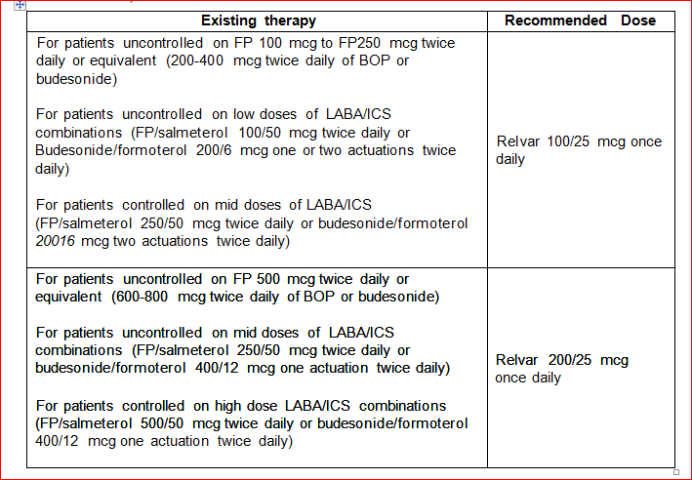
This is based on results from the Phase III Study HZA106829. FF 200 µg once daily produced similar results to FP 500 µg twice daily (BD) on trough FEV l and mean weighted FEV l [0-24 h]. The sponsor suggests that clinicians can view the dose of FF as equivalent µg-to-µg of 5 times the daily dose (that is, 10 times the BD dose) of FP in asthma patients.

Risk of severe asthma exacerbation and death with LABAs
Concern about the risk of severe asthma exacerbations and deaths with beta agonists is not new. Before any LABA reached the market; the inhaled SABA isoproterenol was linked to an increase in asthma related deaths. The mechanism remains unknown; some have hypothesised that beta agonists may increase patient sensitivity to broncho-constricting stimuli or mask symptoms of worsening asthma.
One of the first studies to show the problem for LABAs was the Salmeterol Multicentre Asthma Research Trial (SMART). In 1996 SMART reported that over the course of 28 weeks, there were 8 more asthma related deaths per 10,000 patients treated with salmeterol than among those given placebo (95% CI: 3, 13).
In 2008, the FDA conducted an individual-patient data (IPD) meta-analysis of 110 randomised trials of use of LABAs for asthma. For the composite endpoint of asthma related hospitalisation, intubation, and death there were 2.8 more such events per 1000 patients in the group that received LABAs versus the group that did not receive LABAs. A subgroup analysis by concomitant ICS use showed that the rates were 3.63 per 1000 for patients who were not using concomitant ICS and 0.25 per 1000 for patients who were using concomitant ICS. This suggests that the risk might be mitigated by concomitant ICS use.
A 2013 update of a Cochrane systematic review of safety of salmeterol with ICS concluded:
"We found no statistically significant differences in fatal or non-fatal serious adverse events in trials in which regular salmeterol was randomly allocated with ICS, in comparison to ICS alone at the same dose. Although 13,447 adults and 1862 children have now been included in trials, the frequency of adverse events is too low and the results are too imprecise to confidently rule out a relative increase in all-cause mortality or non-fatal adverse events with salmeterol used in conjunction with ICS. However, the absolute difference between groups in the risk of serious adverse events was very small.
We could not determine whether the increase in all-cause, non-fatal, serious adverse events reported in the previous meta-analysis on regular salmeterol alone is abolished by the additional use of regular ICS. We await the results of large ongoing surveillance studies mandated by the FDA to provide more information [see below]. There were no asthma-related deaths and few asthma-related serious adverse events. Clinical decisions and information for patients regarding regular use of salmeterol have to take into account the balance between known symptomatic benefits of salrneterol and the degree of uncertainty and concern associated with its potential harmful effects."
A 2012 update of a Cochrane systematic review for formoteral reported that:
"The review includes 22 studies (8032 participants) comparing regular formoterol to placebo and salbutamol. Non-fatal, serious-adverse-event data could be obtained for all participants from published studies comparing formoterol and placebo but only 80% of those comparing formoterol with salbutamol or terbutaline. Three deaths occurred on regular formoterol and none on placebo; this difference was not statistically significant. It was not possible to assess disease-specific mortality in view of the small number of deaths. Non-fatal serious adverse events were significantly increased when regular formoterol was compared with placebo (Peto odds ratio (OR) 1.57; 95% CI 1.06 to 2.31). One extra serious adverse event occurred over 16 weeks for every 149 people treated with regular formoterol (95% CI 66 to 1407 people). The increase was larger in children than in adults, but the impact of age was not statistically significant. Data submitted to the FDA indicate that the increase in asthma-related serious adverse events remained significant in patients taking regular formoterol who were also on inhaled corticosteroids. No significant increase in fatal or non-fatal serious adverse events was found when regular formoterol was compared with regular salbutamol or terbutaline.
Another 2012 Cochrane review has the specific aim of comparing formoterol with salmeterol. The review included four studies (involving 1116 adults and 156 children). All studies were open label and recruited patients who were already taking inhaled corticosteroids for their asthma, and all studies contributed data on serious adverse events. All studies compared formoterol 12 µg versus salmeterol 50 µg twice daily. The adult studies were all comparing Foradil Aerolizer with Serevent Diskus, and the children's study compared Oxis Turbohaler to Serevent Accuhaler. There was only one death in an adult (which was unrelated to asthma) and none in children, and there were no significant differences in non-fatal serious adverse events comparing formoterol to salmeterol in adults (Peto odds ratio (OR) 0.77; 95% confidence interval (CI) 0.46 to 1.28), or children (Peto OR 0.95; 95% CI 0.06 to 15.33). Over a six month period, in studies involving adults that contributed to this analysis, the percentages with serious adverse events were 5.1% for formoterol and 6.4% for salmeterol; and over a three month period the percentages of children with serious adverse events were 1.3% for formoterol and 1.3% for salmeterol.
Broadly speaking, regulators around the world have concluded that the benefits of LABAs in asthma outweigh the risks and that the agents should remain available for use in asthma patients. Product information sheets and clinical practice guidelines advise clinicians to:
- Require that LABAs are used concomitantly with ICSs, which appears to reduce but not eliminate the risk.
- Stop use of the LABA once asthma control is achieved and continue use of ICS mono product.
- Not prescribe LABAs in patients whose asthma is adequately controlled on low dose or medium dose ICS mono product.
- Not start LABAs in patients with acutely deteriorating asthma.
- Avoid LABAs in children.
In 2011, the FDA issued a request for manufacturers of LABAs marketed in the US to conduct five randomised, double-blind, controlled clinical trials comparing the addition of LABAs to ICSs versus ICSs alone. These studies are:
- Four clinical trials in patients 12 years of age and older (n=4 x 11,700=46,800 patients) investigating:
  - budesonide and formoterol (AstraZeneca)
  - fluticasone and salmeterol (GSK study-AUSTRI-SAS 115359)
  - mometasone and formoterol (Merck)
  - formoterol (Novartis)
- One clinical trial in paediatric patients aged 4 to 11 years (n=6,200) investigating:
  - fluticasone and salmeterol (GSK study-VESTRI-SAS l 15358)
The trials will be multinational, randomised, double-blind and will last 6 months. The FDA considered trials of 12 month duration; but decided, based on current clinical guidelines that some patients could have their LABAs discontinued within 12 months, and this would confound the results.
The primary endpoint will be a composite of serious asthma outcomes: asthma related death, intubation or hospitalisation. Events will be adjudicated by an independent adjudication committee. Patients will be eligible if they have a diagnosis of asthma and a history of at least 1 asthma exacerbation in the past 12 months.
Eligible patients will be randomised to treatment with LABA+ICS or ICS alone. Non­inferiority designs were used: the sample size of 11,700 in the trials for patients 12+ years will provide 90% power to rule out a doubling of risk off a baseline of 15.0 events per 1000 patient-years. The composite endpoint will be driven mainly by hospitalisations; death and intubation will be rare and the individual trials are not powered for separate analyses of components of the composite endpoint. However, the design of the trials is similar and they can be considered jointly to evaluate deaths and intubations.
The clinical trials will begin in 2011 and FDA expects to receive results in 2017 (due to the time it will take to enrol the required numbers of patients). It took 7 years to enrol 26,355 patients in the SMART trial.
Breo Ellipta is registered in the US for the COPD indication but there has been no application to the FDA for the asthma indication. No randomised, long-term safety study with VI is planned.
The asthma indication specifies that Breo Ellipta is not for use in children (< 12 years). The available evidence (for example, FDA 2008 meta-analysis) shows that the LABA associated risks for exacerbations and deaths are higher in children than adults. For completeness the conclusion from a 2012 update of a Cochrane systematic review of LABA use in children is given below:
"We do not know if regular combination therapy with formoterol or salmeterol in children alters the risk of dying from asthma. Regular combination therapy is likely to be less risky than monotherapy in children with asthma, but we cannot say that combination therapy is risk free. There are probably an additional three children per 1000 who suffer a non-fatal serious adverse event on combination therapy in comparison to ICS over three months. This is currently our best estimate of the risk of using LABA combination therapy in children and has to be balanced against the symptomatic benefit obtained for each child. We await the results of large on-going surveillance studies to further clarify the risks of combination therapy in children and adolescents with asthma. The relative safety of formoterol in comparison to salmeterol remains unclear, even when all currently available direct and indirect trial evidence is combined."

Trends in asthma mortality
Population-based analysis of trends in asthma mortality is complicated by the problem of attributing a death to asthma, based only on information written on a death certificate. (Some analyses concentrate on mortality trends in the age group 5-34 years to mitigate this problem.)
Across all ages, about 400 to 450 asthma deaths occur in Australia each year; this represents 3-in-1000 of all deaths; or a rate of 1.6 per 100,000 population. Between 1997 and 2009, the rate of asthma deaths decreased by 45%; continuing a downward trend that started in the early 1990s.
Two peaks have occurred in asthma mortality: during the 1960s and during the 1980s. The peak in the 1960s is probably due to the introduction and over reliance on a high dose formulation of the non-selective beta agonist, isoprenaline. The less marked peak in the 1980s may have been related to the introduction of fenoterol, although uptake was lower in Australia than in New Zealand.
The reason for the downward trend in mortality starting in the early 1990s is uncertain; but the downward trend has also been seen in other affluent countries; and has occurred in the face of increasing prevalence. Possible reasons include introduction of asthma management guidelines in 1989, increased use of ICS, more targeted and cautious use of LABAs, use of LABAs only with ICSs, and better diagnosis of asthma versus COPD in the elderly.
Asthma mortality rates are higher among those Australians who live in rural areas, the less affluent and Indigenous people.
Table 27. Comparison to other ICS/LABA FDC products registered in Australia
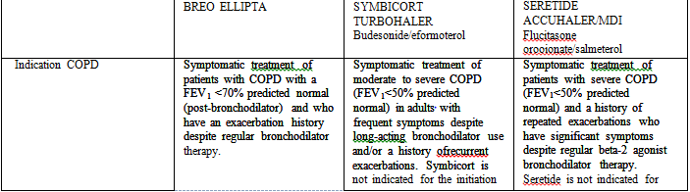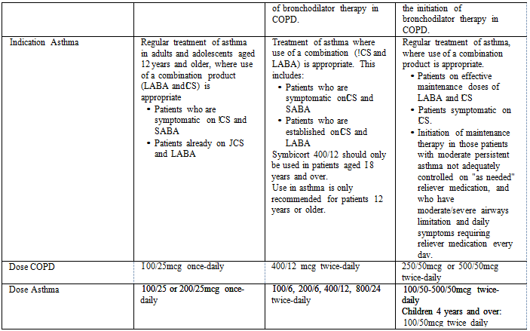

Quality
The pharmaceutical chemistry evaluator recommended registration.
The product Breo Ellipta (fluticasone furoate 100 µg and vilanterol 25 µg inhalation powder) includes a novel dry powder inhaler device, the Ellipta inhaler, which contains 2 separate double-foil blister strips inside. Each blister on one strip contains micronised fluticasone furoate (100 µg) and lactose monohydrate; and each blister on the other strip contains micronised vilanterol trifenatate (40 µg equivalent to 25 µg of vilanterol), magnesium stearate and lactose monohydrate.
The proposed commercial presentation of Breo Ellipta has 30 blisters each of fluticasone furoate and vilanterol, which will be a one month supply with a once daily dosing regimen. The device has a dose counter. The steps needed to use the product are simple and similar to some other dry powder inhaler devices. To deliver a dose, the patient will open the cover of the device. This action makes the powder from one blister containing fluticasone furoate and one blister containing vilanterol ready for inhalation at the airflow path inside the device. The patient will then inhale through the mouthpiece of the device. If a patient opens and closes the cover of the device without inhaling, the formulation powder will be held inside the device and will no longer be available to be inhaled. The Breo Ellipta device has been tested for usability, reliability and ruggedness through in vitro testing, human factor studies, and testing of devices used in the clinical program.

Nonclinical
The nonclinical evaluator had no objections to registration.
The nonclinical data were extensive and of high quality, with pivotal studies examining repeat-dose toxicity, genotoxicity, carcinogenicity and reproductive toxicity conducted under GLP conditions. Many of the submitted studies on fluticasone furoate were previously evaluated (for the nasal spray for the indication of allergic rhinitis).
In short, these data showed that fluticasone furoate and vilanterol each possessed toxicity profiles typical of their respective pharmacological classes, and studies of the combination did not suggest any major interactions or synergistic effects between the two components.

Clinical

Clinical evaluator's comments on the benefit-risk balance
For the COPD indication, the clinical evaluator considered that the benefit-risk balance for FF/VI 100/25 was favourable. For the asthma indication, the clinical evaluator raised two issues:
- results for trough FEV 1 for the 12 week trial of FF/VI 100/25 versus FF 100 were not statistically significant (the extra improvement was only 36 mL);
- only the 25 µg dose of VI was carried forward into the Phase III trials.
The sponsor's responses to these concerns are acceptable.

Submitted data/evidence
In addition to 53 clinical pharmacology studies, several suppo1ting studies, and a Phase III safety study (HZA108839), the submission included the following dose-interval, dose-finding and pivotal Phase III studies:
Table 28. Submitted studies
 | Dose-finding |  | Dose-interval Once versus twice daily |  | Pivotal Phase III
 | FF25-800mcg | VI3-50mcg | FF | VI
Asthma | FFA109684 FFA109685 FFA1 09687 | B2CI 09575 | FFA20001 FFA106783 FFA11 2 | HZA113310 B2Cl 06093 | HZA106 27 HZA106829 HZA106837 HZA113091
COPD |  | B2C I 1 1045 |  |  | HZC112206 HZC102871 HZC102970 HZC L 13107
No dose-finding studies using the proposed combination inhaler were conducted. No dose-ranging studies with FF monotherapy were conducted in COPD patients because patients with COPD show minimal bronchodilation with inhaled corticosteroids.

Pharmacology
The application included results from a comprehensive clinical pharmacology program that included studies to assess protein binding and metabolism and the pharmacokinetics after single and multiple inhaled doses of FF, VI, and FF/VI. The majority of studies were conducted in healthy volunteers, but several studies were done specifically to assess pharmacokinetics in COPD and asthma patients and the effect of renal and hepatic impairment.
Inhaled FF and VI have an absolute bioavailability of 15% and 27%, respectively. Given low oral bioavailability, systemic exposure for both components is primarily due to absorption of the inhaled portion. Any food effect would be negligible. Efficacy is due to local effects in the lung. Systemic exposures of FF and VI are more relevant for safety.
The time to peak plasma concentration (T_{max}) was reached by 0.5 to 1.0 hours for both FF and VI. FF and VI are both eliminated primarily by metabolism.
No significant effects due to age, renal, or hepatic impairment, on pharmacokinetic parameters were observed, so no dose adjustment for age, hepatic function, or renal function is recommended.
There were no clinically relevant differences in pharmacokinetics of either FF or VI when administered alone versus in combination.
In terms of drug-drug-interactions, FF and VI are metabolised principally via cytochrome P450 isozyme (CYP3A4). Co-administration with ketoconazole, a strong CYP3A4 and potent P-gp inhibitor, resulted in 36 and 33% increase in mean FF AUC₍₀₋₂₄₎ and C_{max}, respectively, and in 65% and 22% increase in mean VI AUC_{(O-t)} and C_{max}, respectively. These changes are relatively modest in comparison to drug-drug interactions observed for fluticasone propionate and salmeterol, but should be explicitly noted in the PI.
FF/VI 200/25 µg showed only minimal prolongation of QTcF. Heart rate increases were seen, with maximal effect at 10 mins after dosing (mean placebo-adjusted difference: 3.9 beats/min [90% CI: 2.7, 5.1]).
Although HPA suppression was observed with FF, serum cortisol reduction was not observed at proposed dosing.

Efficacy

Flucitasone furoate dose-finding and dose-interval studies
For both COPD and asthma patients, dose-finding and dose-interval (once versus twice daily) studies for FF were conducted in patients with asthma because the effect of ICSs cannot be reliably assessed in COPD patients using lung function parameters (for example, trough FEV 1).
Figure 16. Adjusted placebo subtracted change from baseline in trough FEV l at Week 8 (FF: flucitasone furoate; FP: flucitasone propionate)
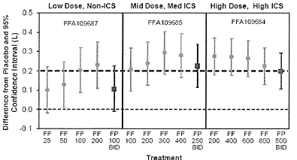
In the dose-finding studies (Figure 16), fluticasone furoate 1OO µg and 200 µg showed similar trough FEV 1 responses. Doses higher than 200 µg seemed to reach a plateau (a test for linear trend across 200 µg to 800 µg was not statistically significant). The point estimates actually suggested a small decrease in efficacy with doses > 200 µg. The 50 µg dose was also statistically significantly different from placebo, but the point estimate of the treatment effect was smaller than for 100 µg and 200 µg In short, the data support a dose response in the range of 25 µg to 200 µg; and support the selection of 50 µg as the lowest dose to progress to Phase III studies and 200 µg as the highest dose.
Figure 17. Adjusted placebo subtracted change from baseline in trough FEV I at Day 28 for QD versus BD dosing (FF: flucitasone furoate; FP: flucitasone propionate)
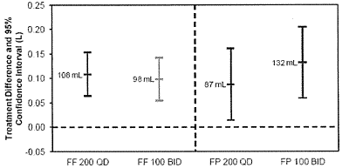
The dose-interval studies (Figure 17) support a once daily dosing regimen for fluticasone furoate.

Vilanterol dose-finding and dose-interval studies
Figure 18. Placebo-adjusted change in trough FEV 1 at Day 29 in patients with asthma (study B2Cl09575)
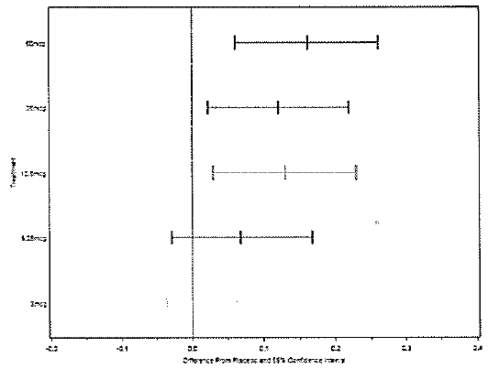
Figure 19. Placebo-adjusted change in trough FEV 1 at Day 29 in patients with COPD (study B2Cl 11045)
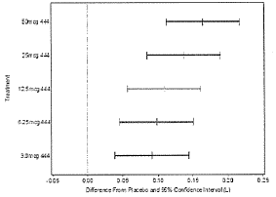
In the asthma dose ranging study (Figure 18), vilanterol 3 µg and 6.25 µg once-daily were not statistically significantly different from placebo (for the primary endpoint of trough FEV 1); 12.5 µg, 25 µg and 50 µg all resulted in a similar level of improvement and all were statistically significantly different from placebo. In the COPD dose-ranging study (Figure 19) all doses of vilanterol were statistically significantly different from placebo (for the primary endpoint of trough FEV 1), with increasing efficacy with increasing dose.
Based on the results of these studies, only the 25 µg dose was carried through to the Phase III studies in asthma and COPD patients.
For asthma patients, the clinical evaluator was concerned that the 12.5 µg dose was not evaluated in Phase III studies, given its seemingly similar efficacy on the primary endpoint in the dose-ranging study in asthma (B2C109575); and because data on other LABAs suggest an increased risk of severe asthma exacerbations and deaths that might be dose related.
The sponsor replied that dose selection was based on collective evidence across all endpoints, rather than relying on just the primary endpoint. In Study B2Cl 09575, increased benefit was reported for the 25 µg dose compared to the 12.5 µg dose on 15 of 17 endpoints analysed. In particular, there was a difference of 10% in symptom-free 24 hour periods and 14% on rescue-free 24 hour periods. (The statistical significance of these differences is difficult to assess because these were secondary endpoints, which are subject to problems of statistical multiplicity.).
(Once daily dosing of vilanterol is accepted; see CER.)

Phase III efficacy studies COPD
Table 29. Pivotal bronchodilator Phase III studies in COPD patients
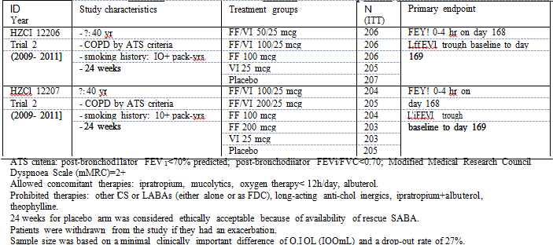
Table 30. Pivotal exacerbation Phase III studies in COPD patients
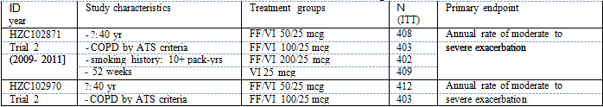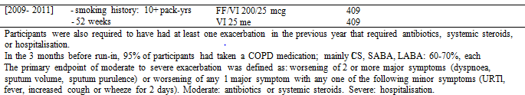
Table 31. Bronchodilator studies for COPD, Mean change (in litres) from baseline to Day 168 in weighted mean FEV 1 0-4 hour (ITT)
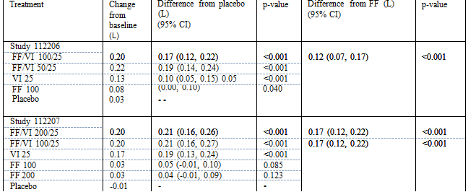
Table 32. Bronchodilator studies for COPD, Mean change (in litres) from baseline in trough FEV 1 on Day 169 (ITT)
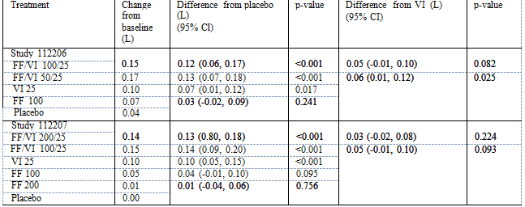
In both studies, about 25% of patients discontinued treatment, either due to adverse events or lack of efficacy. Various sensitivity analyses around these drop-outs did not materially change the statistical results.
The co-primary endpoint of change in FEV 1 0-4 hours on day 168 was intended to show the benefit of FF/VI over FF alone. The results support a claim of benefit for a bronchodilator effect of FF/VI over FF.
The co-primary endpoint of change in trough FEV 1 was intended to show benefit of FF/VI over VI alone. More specifically, trough FEV 1 is a surrogate measure intended to reflect benefit on exacerbations. The trough FEV 1 results from this study do not support the claim that FF/VI is superior to VI alone. Perhaps the long duration of action of VI is masking the effect of FF on the surrogate endpoint of trough FEV 1. Exacerbation studies (see next section) do support a claim of benefit of FF/VI over VI alone; therefore the lack of benefit of the addition of FF to VI on the surrogate endpoint of trough FEV 1 is not a concern, given benefit shown on the final outcome (that is, exacerbation); see next table.
Table 33. Exacerbation studies for COPD, Annual rate of moderate to severe exacerbations
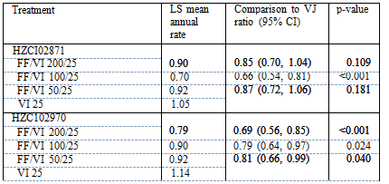
As in the bronchodilator studies, about 25% of patients discontinued treatment. The effect of this for studies of 52 weeks (that is, exacerbation studies) is more problematic than for studies of 24 weeks (that is, bronchodilator studies). The rates reported in the above table assume that exacerbations occur at the same rate pre and post discontinuation. This assumption is commonly made in such studies; but is, of course, impossible to verify with the available data.
Setting this issue aside, the exacerbation studies show a benefit of FF/VI over VI alone. There was no clear separation of the three FF/VI doses. The data are adequate to support an exacerbation claim for FF/VI 100/25 µg.

Phase-III studies in asthma patients
Table 34. Pivotal Phase III studies in asthma patients
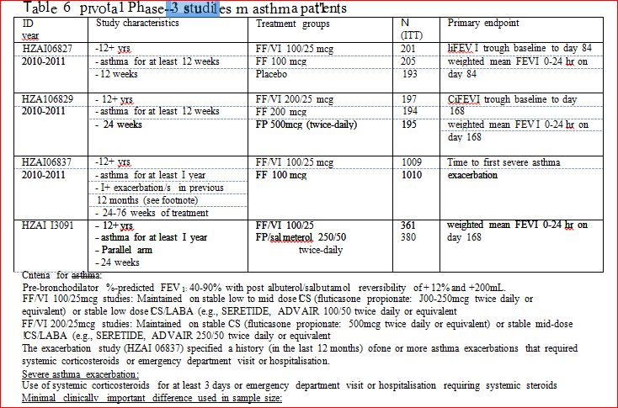
150mL in change from baseline in trough FEV 1 between FF/VI and FF alone 175mL in weighted mean serial FEV 1(0-24h) between FF/VI and FF alone 30% reduction in rate (hazard) of asthma exacerbations (HZA106837)
Both FF/VI 100/25 and FF 100 alone were statistically significantly better than placebo for both co-primary endpoints (change in trough FEV 1 and FEV 1 (0-24h) from baseline to Day 84); however, FF/VI 100/25 was not statistically significantly different from FF 100, although there was a trend favouring FF/VI 100/25 (trough FEV 1: 36 mL, weighted mean FEV 1(0-24h): 116 mL). Differences for FF/VI 100/25 versus FF 100 were observed for the secondary endpoints of rescue-free/symptom-free 24 h periods and morning (AM)/evening (PM) PEF. Statistical significance for these secondary endpoints is difficult to assess because the difference for the co-primary endpoints was not statistically significant.
Table 35. Study HZA106829. Results for co-primary endpoints: change in trough FEV 1 and change in weighted mean FEV 1 (0-24h), 24 weeks, ITT population
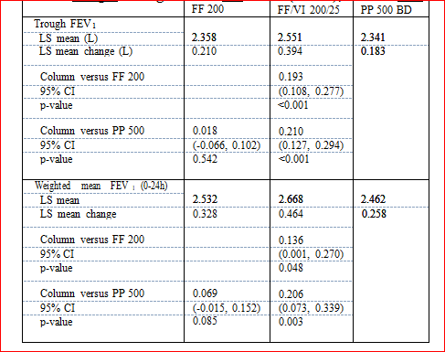

PP=FP
Compared with FF 200 mono-therapy, combination therapy with FF/VI 200/25 resulted in statistically significant improvements by 24 weeks in trough FEV 1 ( 193 mL) and weighted mean FEV 1(0-24h) (136 mL). Differences were also reported for the secondary endpoints of rescue-free/symptom-free days and PEF. Treatment with the mono-component product FF 200 µg once daily appeared to have similar efficacy to the mono-component product FP 500 µg twice-daily.
Table 36. Study HZA106837. Time to first severe asthma exacerbation
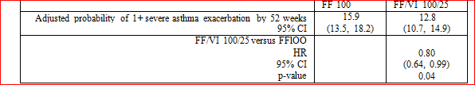
Compared with FF 100 mono-therapy, combination therapy with FF/VI 100/25 resulted in a 20% (HR=0.80) reduction in the rate (hazard) of (first) severe exacerbation. This reduction was statistically significant.
Table 37. Study HZA113091. Change in weighted mean FEV 1 (0-24h), day 168, ITT and PP (per protocol)
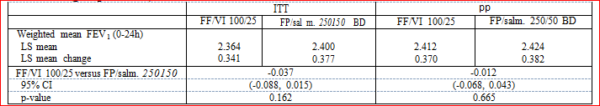
This study was not designed as a non-inferiority study, however the results (point estimates and upper limit of the 95% CI) support the claim of non-inferiority of FF/VI 100/25 to FP/salmeterol 250/50.

Summary of evidence of efficacy from the 4 pivotal asthma studies
The combination products FF/VI 100/25 and FF/VI 200/25 provide greater benefit than the FF mono-component alone, based on:
- the lung function endpoints of trough FEV 1 and weighted mean FEV 1(0-24h); and
- the symptomatic endpoints of 24 h rescue-free/symptom free periods, time to first severe exacerbation and rate of severe exacerbations.
- FF/VI 100/25 appears non-inferior to FP/salmeterol 250/50.
Caveats:
- The pivotal 12 week Phase III Study (HZA106827) did not show a benefit of FF/VI 100/25 over FF 100 for the co-primary, lung-function endpoints (trough FEV 1 and weighted mean FEV 1(0-24h)).
- No Phase III studies compared FF/VI 100/25 versus FF/VI 200/25; instead patients on different strengths of baseline therapy were recruited to the different Phase III studies that separately assessed FF/VI 100(200)/25 versus FF 100(200) alone.
- Only VI 25 µg was taken forward into the Phase III studies.

Safety
The safety database is large:
- 7850 patients in COPD studies
- 10630 patients in asthma studies (including about approximately 500 patients in the pivotal Phase III long-term safety Study HZA108839, which compared FF/VI 200/25 and 100/25 with FP 500)

COPD
Forty-three on-treatment deaths occurred in the 52 week COPD exacerbation studies and 8 on treatment deaths occurred in the 24 week bronchodilator studies. These were balanced across groups and were from expected causes (COPD exacerbation, respiratory failure, myocardial infarction).
Serious adverse events were common across study groups; they were balanced and from expected causes. As discussed, discontinuations were common and this was expected from previous studies of other therapies in COPD.
Other safety assessments, such as assessment of cardiovascular function and adrenal axis did not show any safety signals. Analysis of common adverse events and laboratory parameters also did not show any specific findings of concern.
Two safety findings of interest were pneumonia and bone fractures.
Pneumonia Inhaled corticosteroids are a known risk factor for pneumonia in patients with COPD. In two 52 week trials in 1579 patients, fluticasone propionate/salmeterol 250/50 µg had a higher incidence of pneumonia (7%) compared to salmeterol alone (3%). Similarly, the percentages of COPD patients who developed pneumonia in the 3 year TORCH trial were: fluticasone propionate/salmeterol 500/50 (16%); fluticasone propionate (14%); salmeterol (11%); placebo (9%).
For FF/VI, in the 52 week exacerbation studies, about 6% of patients developed pneumonia in all the FF/VI arms, compared with 3% in the VI alone arm (Table 38).
Table 38. Patients with pneumonia in 52-week COPD exacerbation studies.
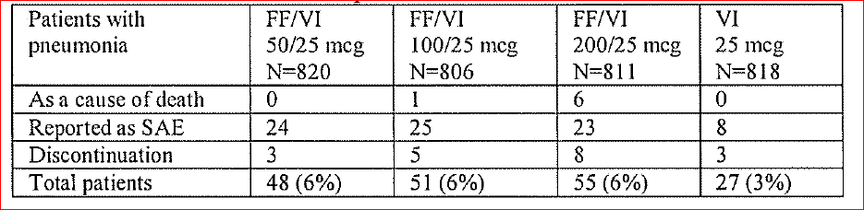
Bone fractures Inhaled corticosteroids are a known risk factor for factures in patients with COPD. The rates of fractures per 1000 person-years in the 3-year TORCH trial were: fluticasone propionate/salmeterol 500/50 (22.4); fluticasone propionate (20.3); salmeterol (20.4); placebo (18.6). An increased risk of fracture for FF/VI versus VI was also seen in the 52 week COPD exacerbation trials.
Table 39. Number of patients with fracture in 52 week COPD exacerbation studies.
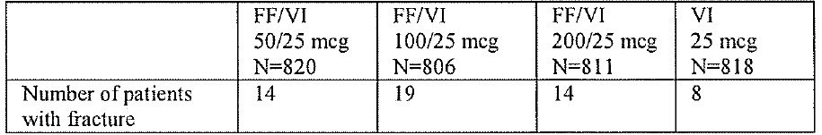

Asthma
HZA106839 was a Phase III randomised safety study of 52 weeks duration which compared FF/VI 100/25 and 200/25 with FP 500 in 500 patients with asthma. In short, no safety concerns emerged from this study. Twelve patients had a severe asthma exacerbation during treatment: FF/VI 100/25: 3 (1%); FF/VI 200/25: 6 (3%); FP 500: 3 (3%); 3 were hospitalised (1 in the FF/VI 100/25 group and 2 in the FP 500 group); none required intubation.
Across the whole asthma clinical development program only 4 deaths were reported. Based on adjudication committee assessments, none were asthma related.
The clinical evaluator made the following comment: Across the clinical development program, no safety signals have yet been observed for increased incidence of asthma exacerbations, adrenal suppression, bone disorders, QT interval prolongation, myocardial ischaemia, or metabolic neurologic or ocular effects. Safety observations are in line with the expected drug-class profiles and no new risks were identified.
The clinical evaluator had concerns about, a yet to be observed, risk of severe asthma exacerbations and deaths with LABA use (the VI 25 µg component of the FDC inhaler). That is, this is a concern that VI shares a class effect with other LABAs for increased asthma exacerbations; or perhaps has an increased or decreased risk compared with other products in the LABA class. Part of the reasoning is that the potential risk is greater with larger doses and that it would have been better to have assessed (and potentially marketed) both a FF/VI 100/12.5 µg product and a FF/VI 100/25 µg product for asthma. The evaluator's reasoning and the sponsor's response are provided in full below (Delegate’s considerations and discussion).

Risk management plan
The latest EU RMP is Version 6.0; the latest Australian Specific Annex is Version 2.0 (undated, cover letter dated 30 May 2013).
The RMP for the COPD indication is acceptable.
The sponsor was asked to provide a response to the outstanding issues from the Round 2 RMP assessment for the asthma indications. A key issue is managing and monitoring the potential risk of asthma exacerbations and deaths associated with LABAs as a class.
As discussed by the clinical evaluator: Across the clinical development program, no safety signals have yet been observed for increased incidence of asthma exacerbations. The concern is that VI shares a class effect of increased risk of asthma exacerbations and deaths with other LABAs and this effect is dose related; therefore, it might have been preferable if the sponsor had also assessed the 12.5 µg dose in Phase III trials (in addition to the 25 µg dose).
Mitigating the concern is the Phase III Study HZA106837, which showed a 20% reduction in the risk of severe asthma exacerbations in patients who used FF/VI 100/25 versus FF 100 for between 24 to 76 weeks. However, given the postmarketing experience with other LABAs, it is possible that VI could be associated with an increased risk of asthma exacerbations and deaths outside of the controlled environment of a clinical trial. Breo Ellipta is registered in the US for the COPD indication but there has been no application to the FDA for the asthma indication. No randomised, long-term safety study with VI is planned. In response to a query from the RMP evaluator about planned postmarketing studies about asthma exacerbations and deaths, the sponsor replied:
"At this time, there is no plan to perform a study with FF/VJ to assess serious asthma related intubations and deaths as the above studies with marketed LABAs will have completed by the time FF/VI is expected to have sufficient market presence to recruit such a large postmarketing study. It should be noted that the overall interpretation of the risk with an JCS/LABA will be performed through the assessment of all four studies together. The evaluation of this rare risk requires 46,800 patients, hence the current set of studies being performed together. It is therefore not possible to replicate such a study separately with a single product. As this is a class risk, the Risk Management strategy will follow that for other JCS/LABA combinations. If the ongoing studies lead to any additional regulatory action then this will also be implemented for FF/VI."
Essentially, the potential risk of asthma exacerbations and deaths is being managed by a statement in the Precautions section of the PI and through routine pharmacovigilance activities. The Precautions section of the proposed Breo PI is similar to that for Seretide and Symicort.
At this point in time and pending ACPM advice, the Delegate’s preliminary view is that (because there are currently no postmarketing data for VI; in contrast to Seretide and Symicort) the following paragraph should be added to the end of the Indications section of the PI:
“Vilanterol, an active ingredient in Breo Ellipta, is a long-acting beta2-adrenergic agonist (LABA). No post-marketing data are available for vilanterol; however, post-marketing data for other LABAs (e.g., salmeterol) show that LABAs can be associated with an increased risk of asthma death. This is considered to be a class effect of LABAs. Therefore, when treating patients with asthma, Breo Ellipta should only be used for patients not adequately controlled on a long-term, asthma­ control medication, such as an inhaled corticosteroid. Once asthma control is achieved and maintained, assess the patient at regular intervals and step-down therapy (i.e., discontinue Breo Ellipta) if possible (without loss of asthma control), and maintain patients on a long-term, asthma-control medication, such as inhaled corticosteroid. Do not use Breo Ellipta for patients whose asthma is adequately controlled on inhaled corticosteroids."
The ACPM was requested to provide advice on other aspects of the PI.
The RMP for asthma is being considered at the ACSOM meeting of 8 November 2013. The ACSOM advice will be available at the ACPM meeting.

Risk-benefit analysis

Delegate’s considerations and discussion
This is the first once daily ICS/LABA combination inhaler; all the other marketed ICS/LABA combination inhalers are twice daily. Although uptake is impossible to predict, it is possible that there will be widespread use of this product both in COPD and asthma. This is likely to be mainly substitution for other ICS/LABA products.
The once daily administration might improve compliance; however the trials did not assess this because they were blinded to ensure internal validity.

COPD FF/VI 100/25
The trial data showed that:
- FF/VI 100/25 has a benefit over FF 100 on lung function (for example, an additional improvement of 120 to 170 mL at 24 weeks was seen for weighted mean FEV 1[0- 4h]).
- FF/VI 100/25 showed a benefit over VI 25 on exacerbations (reduction in annual risk of 21-33%).
No new adverse events for ICS or LABAs were identified during the development program. Pneumonia was confirmed as a serious complication of ICS therapy in COPD.
The Delegate had no reason to say, at this time, that the application for Breo Ellipta should not be approved for registration for the COPD indication.
There was one specific question for the ACPM about the precise wording of the indication:
- The requested indication specifies that Breo Ellipta should only be used in patients with a history of exacerbations despite regular bronchodilator therapy. Symbicort and Seretide have the additional specification that they are "not indicated for the initiation of bronchodilator therapy in COPD." Should this be added to the Breo Ellipta indication; or is it redundant?

Asthma 100/25 & 200/25

Clinical evaluation
The clinical evaluator had two concerns:
- Results for trough FEV 1 for the 12 week trial of FF/VI 100/25 versus FF 100 were not statistically significant (the extra improvement was only 36 mL)
- only the 25 µg dose of VI was carried forward into the Phase III trials.
At this point in time and pending ACPM advice, the Delegate’s preliminary assessment was that the sponsor has adequately addressed (1): Although the pattern of results is not consistent across trials, the data are adequate to show a benefit of FF/VI over FF alone in terms of lung function and exacerbations. For example, in Study HZA106829, FF/VI 200/25 showed a statistically significant extra improvement of 193 mL at the end of 24 weeks on trough FEV 1 compared with FF 200 alone; but, in Study HZA106827, FF/VI 100/25 only showed an extra 36 mL improvement at 12 weeks over FF 100 alone (this small improvement was not statistically significant; the minimal clinically important difference used in sample size calculations is typically 150 to 175 mL). Also, FF 100/25 reduced the rate of severe exacerbations by 20% over FF 100 alone.
In terms of equivalence to currently registered products, the data suggest that FF 200 µg once daily is roughly equivalent to the currently registered FP 500 µg twice daily and that VI 25 µg once-daily is roughly equivalent to salmeterol 50 µg twice daily.
(2).Only the 25 µg dose of VI was carried forward to the Phase III trials. Although this is acceptable for COPD, this is problematic for asthma because of concerns about severe asthma exacerbations and deaths with products in the LABA class that are probably dose related. The clinical evaluator would have preferred that a lower dose (12.5 µg) was also assessed in the Phase III asthma trials because this might provide similar clinical effect with a lower risk of severe asthma exacerbation or death. Up-titration from 12.5 µg to 25 µg could be done, if required, in particular individual patients.
The sponsor argued that only taking the 25 µg dose forward into the Phase III trials was appropriate because:
In the Phase IIb dose-finding study in asthma patients (B2C109575), 12.5 µg, 25 µg and 50 µg all produced a similar effect on trough FEV 1 at Day 29. However, a numerical benefit of VI 25 µg over VI 12.5 µg was seen for 15 of the 17 endpoints. In particular, there was a difference of 10% in symptom-free 24 h periods and 14% on rescue-free 24 h periods. (The statistical significance of these differences is difficult to assess because these were secondary endpoints, subject to problems of statistical multiplicity.)
Results of Study HZA113091 suggest that FF/VI 100/25 is equivalent to FP/salmeterol 250/50 (twice-daily) on the endpoint of weighted mean FEV1[0-24h] at Week 24 (point estimate: -37 mL, 95% CI: -88 mL, 15 mL). According to the sponsor, these results show that the effect of VI 25 µg is similar to, but not greater than the effect of salmeterol 50 µg. If it is assumed that the increased risk of severe asthma exacerbations and deaths is a class effect of LABAs, then the inference is that VI 25 µg should be no greater risk than the already registered LABA salmeterol 50 µg twice daily.
Study HZA106837 showed a 20% reduction in time to severe exacerbation for FF/VI 100/25 over FF 100 (patients received treatment for between 24 to 76 weeks).
SAE narratives for all asthma studies containing VI or ICS/VI treatment arm were adjudicated by an independent blinded committee for any asthma related event: a composite endpoint of asthma hospitalisation, intubation, or death. The absolute risk reduction was 2.8 asthma-related events for every 10,000 patients treated with FF/VI.
In the Phase II Study, B2C109575, the VI 25 µg versus VI 12.5 µg did not show a differential effect on heart rate, blood pressure, blood glucose, or potassium.
At this point in time and pending ACPM advice, the Delegate’s preliminary assessment was that the sponsor's claim that it was appropriate to only take the 25 µg dose of VI through to the Phase III trials is acceptable.

Main question for asthma indication
Is the current plan for minimising and monitoring the risk of asthma exacerbations and deaths adequate?
Even if VI is associated with an extremely small risk of asthma death, widespread use outside of the controlled and closely-monitored environment of a clinical trial could lead to unintended consequences at a whole-of-population level. That is, the (potential) absolute risk is small, but this might not be inconsequential at a whole-of-population level, given the large numbers of patients with asthma, who could potentially receive VI (in combination with FF).
At this stage, pending ACSOM/ ACPM advice, the Delegate’s preliminary assessment was that the sponsor's contention that it is not currently feasible to conduct a large randomised postmarketing study for VI is accepted; given current stage of the VI product life-cycle. It is also accepted that any regulatory action stemming from the FDA mandated studies of salmeterol and formoterol will also be applied to VI (that is, if a safety signal is seen in the FDA mandated studies of salmeterol and formoterol, then it will be presumed that this a class effect for all LABAs that also applies to VI).
However, class effects can be difficult to predict. It is possible that VI could have a higher risk of asthma exacerbations and deaths compared to other products in the LABA class (that is, salmeterol, formoterol).
Essentially, the sponsor is proposing that the potential risk of asthma exacerbations and deaths will be minimised by adding the following paragraph to the Precautions section of the PI:
"Asthma-related adverse events and exacerbations may occur during treatment with FF/VI Patients should be asked to continue treatment but to seek medical advice if asthma symptoms remain uncontrolled or worsen after FF/VI "
This is similar in tone and content to the information in the Precautions section of the PIs for Symbicort (budesonide/formoteral) and Seretide (flucitasone/salmeterol). However, there is no postmarketing experience with FF/VI; whereas there is extensive post-marketing experience with Symbicort and Seretide.
At this point in time and pending ACPM advice, the Delegate’s preliminary view was that (because there are currently no postmarketing data for VI; in contrast to Seretide and Symicort) the following paragraph should be added to the end of the Indications section of the PI:
"Vilanterol, an active ingredient in Breo Ellipta, is a long-acting beta2-adrenergic agonist (LABA). No post-marketing data are available for vilanterol; however, post-marketing data for other LABAs (e.g., salmeterol) show that LABAs can be associated with an increased risk of asthma death. This is considered to be a class effect of LABAs. Therefore, when treating patients with asthma, Breo Ellipta should only be used for patients not adequately controlled on a long-term, asthma­ control medication, such as an inhaled corticosteroid. Once asthma control is achieved and maintained, assess the patient at regular intervals and step-down therapy (i.e., discontinue Breo Ellipta) if possible (without loss of asthma control), and maintain patients on a long-term, asthma-control medication, such as inhaled corticosteroid. Do not use Breo Ellipta for patients whose asthma is adequately controlled on inhaled corticosteroids."
ACSOM has been asked to provide advice on risk minimisation and pharmacovigilance activities for FF/VI and the advice will be provided to ACPM as a late paper.
Given the lack of a FF mono-product, is the addition of proposed table to the Dosing and Administration section of the PI sufficient information on how to step-up and step-down therapy between ICS mono products and the FF/VI FDC?

Additional information requested from the sponsor in the pre-ACPM response
Has the sponsor had any discussions with the FDA about the asthma indication; and if so, what was the feedback?
Did the FDA have input into the dose of VI (that is, 25 µg) carried forward from the Phase II dose-finding studies to the Phase III asthma studies?
Is there any change to the regulatory status of VI/FF in other jurisdictions?

Summary of issues
Separate advice is sought on the indications for COPD and asthma.
For both COPD and asthma, the once daily dosing of FF/VI is hypothetically attractive to improve compliance; but, the benefits of once daily versus twice daily dosing were not tested in the development program (because of the need for blinding). That is, there is no evidence to show improved compliance with FF/VI once-daily versus other ICS/LABA FDC products twice daily.

COPD
The clinical program has established efficacy and no new safety concerns for this particular ICS (FF) or LABA (VI) were identified for this patient population.

Asthma
More than 10,500 asthma patients have received the FDC of fluticasone furoate and vilantero l (FF/VI) during the clinical development program, including 500 patients in the Phase III long-term (52 weeks), randomised, safety study (HZA108839). That study showed that FF/VI 100/25 reduced the risk of asthma exacerbations by 20% compared to FF 100 mono therapy. Across the whole asthma clinical development program, only 4 deaths were reported. Based on adjudication committee assessments, none were asthma related.
The clinical development program showed a benefit of FF/VI over FF alone in terms of lung function. For example, in Study HZA106829, FF/VI 200/25 showed a statistically significant extra improvement of 193 mL at the end of 24 weeks on trough FEV 1 compared with FF 200 alone.
Other LABAs (such as salmeterol and formoterol) have been associated with an increased of risk of asthma exacerbations and deaths. Broadly speaking, regulators around the world have concluded that the benefits of LABAs in asthma outweigh the risks and that the agents should remain available for use in asthma patients. Use of LABAs with ICS mitigates the risk.
Across the clinical development program for VI (in combination with FF), no safety concerns have yet been identified for asthma exacerbations or deaths. However, a key issue for this application is monitoring/minimising the postmarketing risk of asthma exacerbations and deaths for VI, a new product in the LABA class. It could be that safety concerns emerge i n the postmarketing period; outside of the controlled environment of randomised premarketing trials.
The risk of asthma exacerbations and deaths for salmeterol and formoterol is being studied in 4 large (n=4 x 11,700=46,800) randomised trials. It is not currently feasible to conduct a similar trial for VI.
Fluticasone furoate (FF)/vilanterol (VI) is a new combination inhalation product comprised of an inhaled corticosteroid (ICS) and long acting beta2 agonist (LABA). Neither component is currently marketed as a single ingredient inhalation product in Australia (or in any other country).

Delegate’s proposed action
The Delegate had no reason to say, at this time, that the application for Breo Ellipta should not be approved for registration for the COPD indication.
The Delegate had no reason to say, at this time, that the application for Breo Ellipta should not be approved for registration for the asthma indication.

Summary of the Delegate’s request for ACPM advice
The committee was requested to provide advice on the following specific issues:

COPD
- The requested indication specifies that Breo Ellipta should only be used in patients with a history of exacerbation s despite regular bronchodilator therapy. Symbicort and Seretide have the additional specification that they are "not indicated f or the initiation of bronchodilator therapy in COPD." Should this be added to the Breo Ellipta Indication; or is it redundant?

Asthma
The main question this application is:
- Is the proposed plan for minimising and monitoring the risk of asthma exacerbations and deaths adequate? In particular, the ACPM was asked to comment whether the information in the PI is adequate to minimise the risk, given that we currently have no postmarketing experience with VI.

Other questions
- Given the lack of a FF mono product, does the addition of proposed table to the Dosing and Administration section of the PI adequately inform clinicians about how to step-up and step-down therapy between ICS mono product s and the FF/VI FDC?
- The committee was also requested to provide advice on any other issues that it thinks may be relevant to a decision on whether or not to approve this application.

Response from sponsor
GSK welcomed the TGA Delegate’s assessment that there are no reasons not to register Breo Ellipta (fluticasone furoate/vilanterol, hereafter also referred to as FF/VI) for asthma and COPD.
In COPD, FF/VI 100/25 has demonstrated a benefit in the reduction of COPD exacerbations compared with vilanterol (VI) 25 µg, as well as bronchodilator benefits compared with fluticasone furoate (FF). The safety profile of FF/VI 100/25 is as expected for an inhaled corticosteroid (ICS)/long-acting beta2 agonist (LABA) combination. GSK believe that adding the statement “not indicated for the initiation of bronchodilatory therapy in COPD” to the proposed indication statement is redundant.
In asthma, FF/VI 100/25 and 200/25 demonstrated benefits on lung function, rescue use, symptomatic endpoints and risk of severe exacerbations compared with FF alone. As noted by the clinical evaluator, no new safety signals have been observed and reported safety findings were as expected for an ICS/LABA combination. Concerns regarding a potential LABA class effect on severe asthma exacerbations and deaths (which the TGA Delegate acknowledges have not yet been identified for VI), are to be managed via an appropriate risk management plan and robust precautions in the Product Information (PI). Although a FF monotherapy product is currently unavailable, GSK believes that the inclusion in the PI of a table of recommended doses and a statement which describes the similarity between doses of FF to fluticasone propionate (FP), will provide clinicians with adequate information on how to step-up or step-down between Breo Ellipta and ICS monotherapy.

Development program complies with fixed combination product guidelines
FF/VI is a novel, once daily dose ICS/LABA combination for oral inhalation. Currently available ICS/LABA combinations need to be administered twice daily. Australian prescription refill data suggest that asthma patients only refill 4 to 5 canisters of Seretide a year, and COPD patients 7 to 8 canisters, compared with a fully compliant patient taking 12 canisters a year. Thus, by providing a once daily alternative, an opportunity for improved compliance exists and as a result, overall disease management.
Although neither FF nor VI is currently available as monotherapy for oral inhalation treatment, fixed dose combinations of ICS and LABA are well-accepted and recommended treatments for asthma [Global Initiative for Asthma (GINA), 2011] and COPD.^{40,42} Also, FF is the same active ingredient in the TGA registered intranasal corticosteroid (Avamys). Treatment guidelines neither recommend the use of LABA monotherapy in asthma nor ICS monotherapy in COPD.
Since neither of the components of FF/VI is registered for asthma or COPD, data was included in this application to demonstrate the effectiveness of FF and VI individually, as well as their contribution to the combination. FF/VI complies with the European Guideline on Clinical Development of Fixed Combination Medicinal Products adopted by the TGA (CPMP/EWP/240/95 Rev1) and GSK’s fixed combination product justification was accepted by the TGA prior to the submission for registration.

A comprehensive clinical program in COPD has demonstrated clinical efficacy and safety consistent with the ICS/LABA class
In COPD patients with an exacerbation history, once daily FF/VI at the proposed strength of 100/25 reduced the annual rate of moderate and severe COPD exacerbations compared with bronchodilator (VI 25) therapy, as well as reducing the time to first moderate or severe exacerbation and the annual rate of exacerbations requiring systemic/oral corticosteroids. These results are clinically important since exacerbations, particularly severe exacerbations, contribute to COPD mortality. Furthermore, the bronchodilator benefits of FF/VI 100/25, which are mainly driven by the VI component, were also evident in patients with COPD. The TGA Delegate has stated that the results support a claim of benefit for a bronchodilator effect of FF/VI over FF alone and that the data are adequate to support an exacerbation claim for FF/VI 100/25. Additionally, once daily FF/VI 100/25 also demonstrated comparable or better improvements in lung function to those seen with twice-daily FP/salmeterol 250/50 or FP/salmeterol 500/50, suggesting that once daily FF/VI is at least as effective a bronchodilator as the current twice-daily ICS/LABA standard. A respiratory physician states that “review of the current clinical trial data for Breo Ellipta clearly shows a benefit of this therapy in patients with COPD who are exacerbators”.
The clinical evaluator has stated that the safety profile of FF/VI 100/25 was consistent with expected AEs usually associated with LABA/ICS combinations. Two safety findings of interest noted by the TGA Delegate were pneumonia and bone fractures. In the FF/VI program there was a small increase in fractures in the FF/VI treatment group relative to the VI treatment group, which is consistent with what has been observed previously within the ICS-containing class. Regarding pneumonia, the totality of data in subjects with COPD from both direct and indirect comparisons suggests that the incidence of pneumonia for FF/VI is similar to the incidence observed following treatment with a marketed ICS/LABA FP/salmeterol. Therefore, GSK believes that the magnitude of the risk of pneumonia and fractures with FF/VI is similar to marketed ICS/LABA products. Indeed, the TGA Delegate has stated that inhaled corticosteroids are a known risk factor for pneumonia and fractures in COPD patients. Safety data regarding bone fractures and pneumonia has been included in the PI along with appropriate precautions for prescribers.
The TGA Delegate has stated “For the COPD indication, the clinical evaluator considered that the benefit-risk balance for FF/VI 100/25 was favourable.”

A comprehensive clinical program in asthma has demonstrated clinical efficacy and safety consistent with the ICS/LABA class
The Clinical Evaluation Report (CER) states that FF/VI 100/25 and 200/25 provided greater benefit in terms of lung function parameters (trough FEV1, weighted mean FEV1 (0-24 h), AM and PM PEF) than FF alone in two out of three pivotal Phase III studies, demonstrating the contribution of VI to the combination. Importantly, FF/VI 100/25 and 200/25 were significantly better than FF monotherapy in improving symptomatic endpoints such as 24 h rescue-free/symptom-free periods, time to first severe exacerbation and severe exacerbation rate. In HZA106837, a statistically significant 20% reduction in the risk of experiencing a severe asthma exacerbation was demonstrated in subjects receiving FF/VI 100/25 compared with FF 100. The contribution of FF was demonstrated by its efficacy relative to placebo in Phase III and in a Phase IIa allergen challenge study of FF/VI versus VI alone. In addition, the Phase III program also demonstrated that FF/VI 100/25 administered once daily was not significantly different from the currently marketed combination, FP/salmeterol 250/50 administered twice daily.
During the clinical evaluation it was noted that FF/VI 100/25 was not statistically significant compared with FF100 for trough FEV1 in a 12 week study despite the demonstration of significant differences compared with placebo. Whilst this result is inconsistent with the other trials, the TGA Delegate has agreed that overall, “the data are adequate to show a benefit of FF/VI over FF alone in terms of lung function and exacerbations”. Collectively, in patients with moderate to severe persistent asthma, once daily FF/VI 100/25 demonstrated greater efficacy than FF 100 alone across a range of efficacy endpoints.
Dose selection of VI was discussed by the clinical evaluator, however, the TGA Delegate has agreed that it was appropriate to only take the 25 µg dose of VI into Phase III. The results of the dose ranging study showed across multiple endpoints that VI 25 has better efficacy than VI 12.5, with no difference in safety or tolerability profiles. In fact the treatment effect on symptom-free and rescue-free 24 hour periods seen with VI 25 was approximately double that seen with VI 12.5 and represented a clinically relevant improvement. No further benefit was seen for VI 50 over VI 25 and therefore this dose was not progressed into Phase III. In a head to head comparison of FF/VI 100/25 versus FP/salmeterol 250/50, the effect on weighted mean FEV1 over 4 hours after the first dose was very similar suggesting the effect of VI 25 is also very similar to salmeterol 50 µg. Thus, GSK believes that the choice of VI 25 is an appropriate dose and therefore appropriate to only have included this strength in Phase III. Furthermore, as discussed with the TGA, it could be considered that based on the study which did not show a significant benefit of FF/VI 100/25 over FF100 that the VI dose could even be interpreted to be too low.
The clinical evaluator has states that at therapeutic doses of FF/VI, no safety signals have been observed for an increased incidence of severe asthma exacerbations, adrenal suppression, bone disorders, QT interval prolongation, myocardial ischaemia, or metabolic, neurologic, or ocular effects. Furthermore, those safety observations are in line with the expected drug-class profile and no new risks have been identified. The risk of severe asthma exacerbations and death associated with LABA use are addressed below.

Specific questions raised by TGA Delegate for ACPM’s advice

COPD (1)
The requested indication specifies that BREO ELLIPTA should only be used in patients with a history of exacerbations despite regular bronchodilator therapy. SYMBICORT and SERETIDE have the additional specification that they are "not indicated for the initiation of bronchodilator therapy in COPD." Should this be added to the BREO ELLIPTA indication; or is it redundant?
GSK recognises that the ICS/LABAs are not intended for use as a first line therapy and therefore a modification to the indication was proposed by GSK during the evaluation to state that Breo should be used despite regular bronchodilator therapy. Therefore GSK’s view is that the addition of the statement “not indicated for the initiation of bronchodilatory therapy in COPD” is redundant.
Professor [information redacted] concurs that the current proposed indication for COPD is suitable as follows: “the requested indication that Breo Ellipta should only be used in patients with a history of exacerbations despite regular bronchodilator therapy is a very conservative approach. As the indication states ‘despite regular bronchodilator therapy’ this makes an additional specification of ‘not for induction of bronchodilator therapy’ redundant”.

Asthma (1)
Is the proposed plan for minimising and monitoring the risk of asthma exacerbations and deaths adequate? In particular, the ACPM is asked to comment whether the information in the PI is adequate to minimise the risk, given that we currently have no post-marketing experience with Vl.
GSK recognises that there is a global public health debate about LABAs and the risk of serious asthma outcomes. However, despite the concern over the safety of LABAs the international asthma mortality rate has continued to decline since the late 1980’s. In Australia between 1997 and 2009, asthma related deaths have fallen by 45%. This reduction in asthma mortality can likely be explained through better compliance with treatment guidelines and the use of ICS. Indeed, the aim to improve compliance is a desired characteristic of once daily FF/VI. This period also coincides with the introduction of LABAs and their increased usage. Overall, on balance the available data suggests that whilst their use as a monotherapy should be avoided, LABA use combined with ICS has acceptable risks.
The safety of FF/VI has been established through an extensive clinical program and GSK continues to assess and monitor the safety of FF/VI in asthma in all ongoing studies. Indeed, the TGA Delegate has remarked that the safety database is large. Recognising that LABA safety is critically important, GSK utilised an independently adjudicated composite endpoint of asthma related hospitalisations, intubations and deaths which was used to examine the safety of FF/VI. Across all treatment groups, the total number of asthma related hospitalisations, intubations and deaths was very small (n=22/4579) with no asthma related deaths reported, substantiating how rare these events are. For the composite endpoint, the analysis of FF/VI all doses versus ICS all doses showed the common OR was 0.890 (95% CI: 0.341, 2.353) favouring treatment with FF/VI over treatment with ICS. The combined risk difference indicates a slight reduction in the risk of asthma-related events for subjects receiving any dose of FF/VI; 2.8 subjects have avoided an asthma-related event for every 10,000 subjects treated with FF/VI. Additionally, Study HZA106837 also assessed if there was incremental risk with the addition of VI to FF. The primary endpoint in this study showed that FF/VI significantly reduced time to first severe exacerbation by 20% (95% CI 2,36; p=0.036) and reduced annual severe exacerbations by 25% (95% CI 5,40; p=0.014) compared to FF alone. Therefore this particular risk was not observed during the FF/VI development program which has been acknowledged by the TGA Delegate: “Across the clinical development program for Vl (in combination with FF), no safety concerns have yet been identified for asthma exacerbations or deaths”.
At the request of the FDA, there are four ongoing large industry studies with licensed ICS/LABA combinations, with a planned total recruitment of over 46,000 adult/adolescent subjects, which is the number of subjects likely to be required to be able to show if this rare potential risk of asthma-related death, can be observed with an ICS/LABA combination compared with ICS alone. Additionally there is a single paediatric study. One adult study and the paediatric study are GSK sponsored studies with FP/salmeterol and include Australian patients. At this time, GSK does not plan to conduct a specific study with FF/VI to evaluate asthma related intubations and deaths because the large ongoing studies with other ICS/LABAs will have completed by the time FF/VI would be expected to have sufficient market presence to recruit for such a large study. Therefore it is not feasible to conduct a study with FF/VI which could report any sooner than these other ongoing studies. If the question regarding safety of LABAs in conjunction with an ICS is answered by these ongoing studies, a situation of clinical equipoise would render a further study with FF/VI unethical. Results of a further study with FF/VI would neither over-turn nor displace the conclusions from the previous studies. Therefore GSK’s position is that the overall interpretation of the risk with an ICS/LABA will be performed through the assessment of all of the currently ongoing studies with licensed ICS/LABA together. If this leads to any additional regulatory action then this will also be implemented for Breo Ellipta. This strategy is described in the EU RMP (v06), which is proposed for implementation in Australia, and was agreed by the CHMP after receiving advice from the Pharmacovigilance Risk Assessment Committee. The TGA Delegate has accepted that it is not currently feasible to conduct a large randomised post-marketing study for VI. GSK employs an ongoing proactive approach to evaluate new information and will communicate any changes to the benefit/risk profile through scheduled Periodic Benefit Risk Evaluation Reports (PBRERs) and updates to the RMP. Professor [information redacted] states “there is no evidence to suggest that vilanterol is any more toxic than existing LABAs. I do not see any justification for surveillance beyond the usual post marketing surveillance carried out for all medications”.
In order to offset the potential risks with FF/VI, adequate warnings and instructions have been added to the PI including text that serious asthma related adverse events and exacerbations may occur with FF/VI treatment and that FF/VI should not be used more often or at higher doses than recommended, or in conjunction with other LABA-containing products. Additionally, the TGA Delegate has recommended the inclusion of a paragraph in the Indications section of the PI as a risk minimisation measure due to the absence of VI postmarketing data. However, based on TGA guidance on product information (specifically Indications), and because no other LABA containing products in Australia have class statements in the Indications section regarding this risk, GSK proposes to simplify this addition to the Indications section and cross-reference to additional text proposed for the Precautions section.

Asthma (2)
Given the lack of a FF mono product, does the addition of proposed table to the Dosing and Administration section of the PI (see p5) adequately inform clinicians about how to step-up and step-down therapy between ICS mono products and the FF/VI FDC?
The patient populations recruited into two of the three pivotal studies differed in terms of baseline medication. In one study, which assessed FF/VI 100/25, patients were required to be uncontrolled on low to mid dose ICS or low dose ICS/LABA. In another study, which assessed the higher strength of 200/25, patients were required to be uncontrolled on high dose ICS or mid dose ICS/LABA. Thus, the strength of FF/VI which patients would receive will be based on their baseline medication. Utilising this information and in order to facilitate initiation of FF/VI, a table of recommended doses for inclusion in the Dosage and Administration section of the PI has been proposed during the evaluation.
Professor [information redacted] states “My view is that GSK have explained the dosage of Breo quite well in the form of a table, in the dosage and administration section of the proposed PI”.
Data from the asthma clinical program indicated that the efficacy of FF 100 OD daily is similar to FP 250 BD and FF 200 OD is non inferior to FP 500 BD; and additionally that FF/VI 100/25 once daily is similar to FP/salmeterol 250/50 twice daily. This suggests that clinicians can view the dose of FF as equivalent to 5 times the total daily fluticasone propionate dose for asthma patients. Based upon this data, GSK also proposes the addition of a statement to the Dosage and Administration section of the PI which describes the similarity between doses of FF to fluticasone propionate.
Professor [information redacted] adds: “although Fluticasone Furoate is not available on its own; I could choose to maintain the patient either on 200-400 mcg of BDP / budesonide or on 250 mcg twice daily Fluticasone Propionate. From the clinical data supplied to me by GSK, Fluticasone Furoate 100mcg once daily has been shown to be equivalent to Fluticasone Propionate 250 mcg twice daily and which is explained in the proposed PI”.
Professor [information redacted] concurs with: “As there are a variety of ICS available then the lack of a fluticasone furoate monotherapy option is not a significant concern. I believe the approach currently taken in the PI is therefore sufficient”.
Overall, GSK believes that the proposed PI provides adequate information to assist clinicians on how to step up to the appropriate Breo Ellipta dose and how to step down from Breo Ellipta to ICS therapy alone.

Questions raised by the TGA Delegate for GSK
Has the sponsor had any discussions with the FDA about the asthma indication; and if so, what was the feedback?
A pre-NDA meeting was held with FDA on April 20, 2012. Since the contribution of VI to the combination product was not demonstrated in HZA106827, this was not sufficient to satisfy the FDA’s combination rule as specified in 21 CFR 300.50. Hence the FDA recommended that GSK conduct an additional study. This study is now ongoing and GSK has not had any further discussions with FDA on the asthma indication. GSK plans to request a pre-NDA meeting with FDA following the completion of this study.
Did the FDA have input into the dose of Vl (that is, 25 µg) carried forward from the Phase II dose finding studies to the Phase III asthma studies?
An Advice Meeting to discuss LABA dose and interval was held with FDA on March 24, 2010. The FDA recommended taking more than one dose into phase III so that if safety issues arose with the higher dose, safety and efficacy data would also be available for a lower dose. The FDA stated that the clinical program will need to provide robust evidence of safety and efficacy for whatever dose is selected, and the appropriateness of the selected dose will depend on the totality of those data.
Prior to Approval of the NDA for COPD, FDA held an Advisory Committee meeting and generated a Briefing Document (March 2013) summarising their conclusions “In terms of VI, data for the nominal dose and dosing frequency in asthma appeared reasonable in support of VI 25 mcg QD. While assessment of VI’s effect on trough FEV1 in asthma suggested that a lower dose of VI 12.5 mcg OD or 6.25 mcg BD might also be efficacious, a comparison of the serial FEV1 time curves showed a numerically greater effect for the 25 mcg OD dose. These findings were further supported by VI dose exploration in COPD, which indicated that a dose as high as 50 mcg OD dose could also be considered. Therefore, the selection of VI 25 mcg OD for further study in the confirmatory trials in COPD appeared reasonable.”
The FDA also acknowledged that the FF/VI program included other trials with an active comparator to help benchmark the bronchodilatory effects of VI. Although these trials did not include VI or salmeterol alone, FDA considered review of the FEV1(0-4h) time curve after the first dose was informative since neither the FF nor FP ICS component would be expected to have such an acute effect on FEV1. The FDA noted that initial FEV1 time-curves could be viewed as a comparison of the two LABA components, VI 25 and salmeterol 50 and that the effect of VI 25 in the first 4 hours after dosing was less than or approximates the effect of salmeterol. The FDA concluded “These results indicate that the selection of the VI 25 dose is conservative”.

Product information and consumer medicines information
GSK has considered the PI recommendations from the evaluators and TGA Delegate and commits to further aligning the Consumer Medicine Information accordingly, once the PI has been finalised.

Benefit-risk assessment conclusion
In COPD, FF/VI 100/25 has demonstrated a benefit in the reduction of COPD exacerbations, a clinically relevant endpoint that contributes to COPD mortality. In addition, the clinical data have also demonstrated clear bronchodilatory benefits of FF/VI compared with FF alone. The safety profile of FF/VI 100/25 in COPD was as expected for an ICS/LABA combination.
In asthma, FF/VI 100/25 and 200/25 demonstrated benefits on lung function, rescue use, symptomatic endpoints and risk of severe exacerbations compared with FF alone. No new safety signals have been observed and the reported safety findings were as expected for an ICS/LABA combination. Safety findings and precautions regarding possible patient risks, including asthma related exacerbations and deaths have been described appropriately in the PI in order to provide relevant safety information for the prescribing physician. In addition, a comprehensive risk management plan has been developed to ensure that risks are monitored and managed appropriately in order to minimise the risk to the patient and to identify any changes in the risk profile for FF/VI.
Professor [information redacted] states: “I believe that the availability of a combination long acting beta2 agonist and an inhaled corticosteroid, combined in a single inhaler, and used on a once daily basis, will lead to significant improvements in the control of disease activity in patients with asthma and COPD”.
In conclusion, GSK contends that the data from the FF/VI development program supports a favourable benefit-risk assessment for the registration of Breo Ellipta in asthma and COPD. The registration of Breo Ellipta would also provide the first opportunity for a once daily ICS/LABA to be available which would offer patient convenience, as well as the potential for improved compliance.

Advisory committee considerations at the December 2013 meeting
The Advisory Committee on Prescription Medicines (ACPM), having considered the evaluations and the Delegate’s overview, as well as the sponsor’s response to these documents, advised the following:
The ACPM, taking into account the submitted evidence of efficacy, safety and quality, agreed with the Delegate and considered Breo Ellipta powder for inhalation containing 100 µg /25 µg of fluticasone furoate / vilanterol trifenatate to have an overall positive benefit–risk profile for the amended indication for COPD;
Symptomatic treatment of patients with COPD with a FEV1< 70% predicted and a history of exacerbations despite regular bronchodilator therapy
Breo Ellipta is not indicated for the initiation of bronchodilator therapy in COPD
In making this recommendation the ACPM:
- noted neither active ingredient is registered as monotherapy
- expressed concern that the 12.5 µg vilanterol trifenatate dose was not taken forward into the Phase III trials for COPD
- was of the view that any claim for improved compliance should rest on evidence

Proposed conditions of registration
The ACPM agreed with the Delegate on the proposed conditions of registration.

Proposed Product Information (PI)/Consumer Medicine Information (CMI) amendments
The ACPM agreed with the Delegate to the proposed amendments to the Product Information (PI) and Consumer Medicine Information (CMI).
- The PI statement on interactions with CYP3A4 inhibitors and inducers should be strengthened.
- The two statements providing advice on disposal of unused product in the CMI are contradictory and should be reconciled.

Specific advice
The ACPM provided the following specifically requested advice:
- The requested indication specifies that Breo Ellipta should only be used in patients with a history of exacerbations despite regular bronchodilator therapy.
- Symbicort and Seretide have the additional specification that they are "not indicated for the initiation of bronchodilator therapy in COPD." Should this be added to the Breo Ellipta indication; or is it redundant?
The ACPM advised there should be a precautionary statement in the PI and relevant sections of the CMI regarding use only for patients with a history of exacerbations despite regular bronchodilator therapy.
The statement that this product is...not indicated for the initiation of bronchodilator therapy in COPD...should be included in the PI and relevant sections of the CMI to emphasise the importance of the use of the lowest effective dose and titration of therapies.
The ACPM further advised RMP should highlight the potential risks of long acting beta agonists.
The ACPM advised that the implementation by the sponsor of the recommendations outlined above to the satisfaction of the TGA, in addition to the evidence of efficacy and safety provided would support the safe and effective use of these products.
The ACPM taking into account the submitted evidence of pharmaceutical efficacy, safety and quality considered this product to have an overall negative benefit–risk profile for the asthma indication;
Breo Ellipta is indicated in the regular treatment of asthma in adults and adolescents aged 12 years and older, where use of a combination product (long acting beta-2-agonist and inhaled corticosteroid) is appropriate.
- patients who are symptomatic with inhaled corticosteroids and 'as needed' inhaled short acting beta-2-agonist or
- patients already on both an inhaled corticosteroid and a long-acting beta2 agonist
The ACPM advised that as this product contained a long acting and potent corticosteroid, that despite the demonstration of efficacy, there was the potential for unnecessary safety risks because the 50 µg dose of fluticasone furoate was not evaluated in the Phase III asthma trials.
The ACPM was particularly concerned at the possible use of higher than necessary doses of fluticasone furoate (in combination with VI) in asthma patients aged 12 to 17 where there might be an effect on growth. This was especially the case because once daily dosing might be attractive to clinicians to improve compliance in adolescents.

Specific advice
The ACPM also provided the following specifically requested advice:
- Is the proposed plan for minimising and monitoring the risk of asthma exacerbations and deaths adequate? In particular, the ACPM is asked to comment whether the information in the PI is adequate to minimise the risk, given that we currently have no post-marketing experience with vilanterol trifenatate.
The ACPM advised significant strengthening of precautionary statements on asthma exacerbations was needed.
The CMI needed considerable reformatting to separate asthma and COPD instructions and information.
- Given the lack of a FF mono product, does the addition of the proposed table to the Dosing and Administration section of the PI adequately inform clinicians about how to step-up and step-down therapy between ICS mono products and the FF/VI FDC?
The ACPM advised that only marketing a limited medium to high dose range of FF may compromise safety.

Initial outcome
At the 295th ACPM meeting December 2013, the ACPM recommended approval of the COPD indication with further strengthening of the PI to emphasise that Breo Ellipta is only for patients with continuing exacerbations despite regular bronchodilator therapy and that it is not indicated for' the initiation of bronchodilator therapy.
However, the ACPM did not recommend approval of the asthma indication because:
the 50 µg dose of fluticasone furoate was not evaluated in the Phase III asthma trials and lack of a marketed 50 µg dose of fluticasone furoate could compromise patient safety.
The ACPM was particularly concerned at the possible use of a higher than necessary doses of fluticasone furoate (in combination with Vl) in asthma patients aged 12-17 where there might be an effect on growth. This was especially the case because once daily dosing might be attractive to clinicians to improve compliance in adolescents.
The sponsor was asked to respond to these concerns and the response would be considered by the ACPM at the February 20 14 meeting.
The application was referred to ACPM again at the February 2014 Meeting.

Delegate’s second overview

Background

Adverse reactions of JCS
Local effects of ICS include dysphonia (less common with DPI) and candidiasis (risk reduced by rinsing the mouth).
The main concern is about systemic effects, particularly in children and the elderly because ICSs are sometimes used over long periods of time.
The ICS components of FF/VI 100/25 and FF/VI 200125 represent a medium to high dose and could cause systemic effects.
All clinical practice guidelines for asthma include the principle that, to minimise adverse reactions, ICS should be used at the lowest dose that maintains symptom control.

Growth retardation
In clinical trials, growth in children is assessed by knemometry, which is considered a sensitive method for assessing short term leg growth. The relationship between knemomtric measurement and final height is uncertain; for example, low doses of oral glucocorticoid, which have no effect on adult height, cause suppression of knemometric parameters.
Both severe asthma and ICS cause growth restriction. Consequently, the studies can be difficult to interpret; also long term follow-up is needed, which means that contamination across groups is likely (that is, the benefits of randomisation are lost because, over an extended period of time, patients take treatments other than those they were originally assigned to). However, the available data suggest that children who require prolonged ICS have an adult height than is approximately 1.2 cm less than without ICS.

Adrenal suppression
Clinical adrenal insufficiency has been identified in a small number of children who have become acutely unwell at the time of intercurrent illness. Most of these children had been treated with high doses of ICS.
In adolescents and adults, ICSs are capable of affecting HPA axis function but this seems to be infrequent and the effects are mostly subclinical. The risk of symptomatic adrenal suppression or acute adrenal crisis appears to be rare in adolescents.

Other
Other adverse reactions include osteoporosis, increased intra-ocular pressure and cataracts.

Equivalent daily doses of FF and FP
The table below shows the Phase III studies conducted as part of the asthma development program. Two Studies HZA106829 and HZAI 13091 provide information on equivalent daily doses of fluticasone furoate and fluticasone propionate.
Table 40. Pivotal Phase III studies in asthma patients
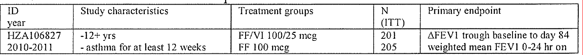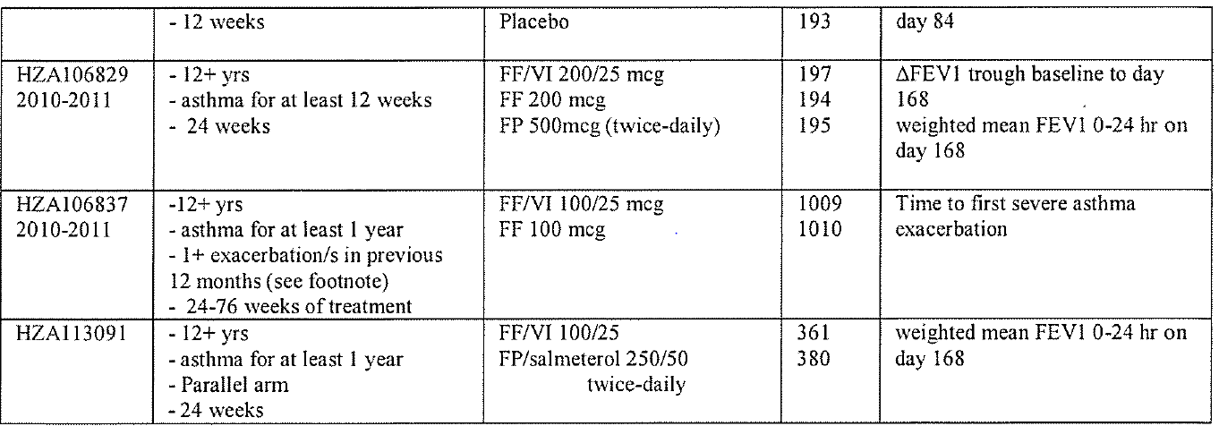
The results of Study HZA106829 support the contention that 200 µg of fluticasone furoate daily is equivalent to 1000 µg of fluticasone propionate daily (500 µg BD). For example, the difference between the two monotherapies for trough FEV1 was 18 mL (95% CI: -66, 102), p=0.542 (see table immediately below).
Table 41. Study HZA106829. Results for co-primary endpoints: change in trough FEV1 and change in weighted mean FEV 1 (0-24h), 24 weeks, ITT population
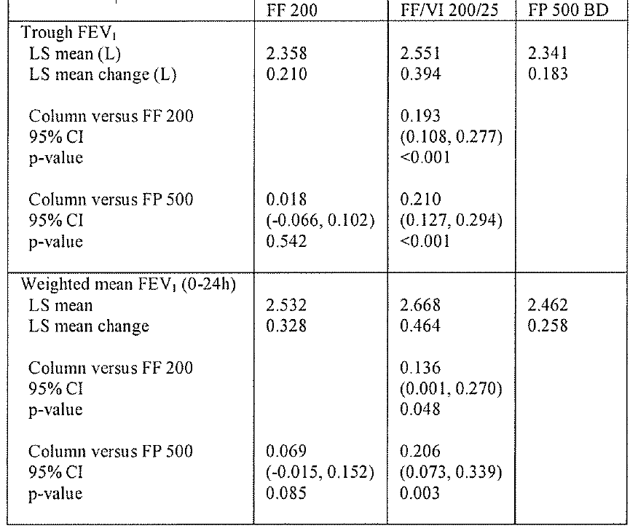
The results of Study HZAl 13091 support the contention that 100 µg of fluticasone furoate daily is equivalent to 500 µg of fluticasone propionate daily (250 µg BD), for example, the difference between FF/VI 100/25 and FP/salm. 250/50 for mean FEV 1 was -37mL (95% CI: - 88, 15), p=0.162 (see table immediately below).
Table 42. Study HzA113091. Change in weighted mean FEVj (0-24h), day 168.1TT and PP (per protocol)
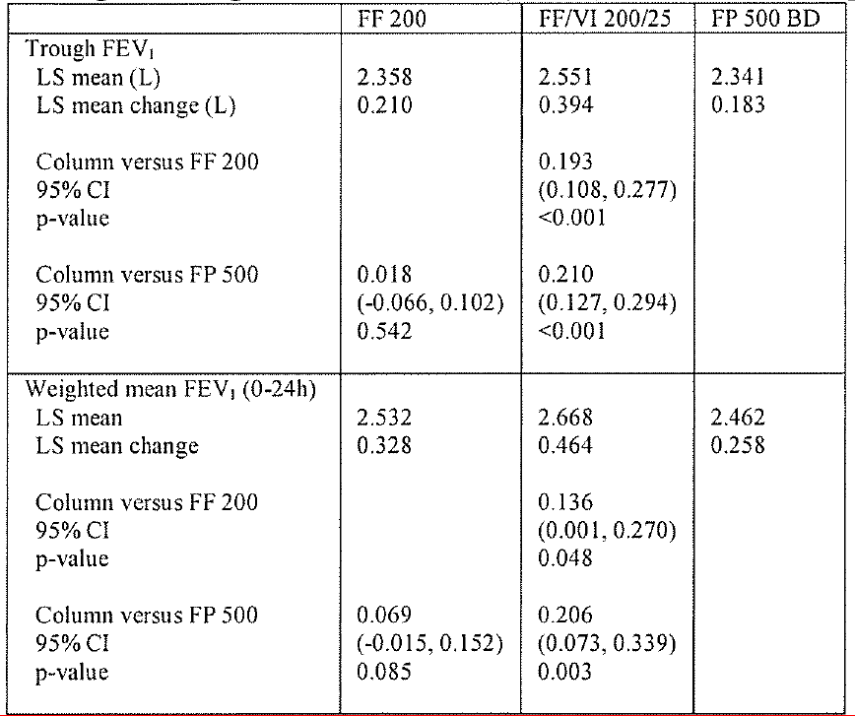
The results of Study HZA113091 support the contention that 100 µg of fluticasone furoate daily is equivalent to 500 µg of fluticasone propionate daily (250 µg BD), for example, the difference between FF/VI 100/25 and FP/salm. 250/50 for mean FEV 1 was -37mL (95% CI: - 88, 15), p=0.162 (see table immediately below).
Table 43. Study HZA113091. Change in weighted mean FEV1(0-24 h), Day 168, ITT and PP (per protocol)
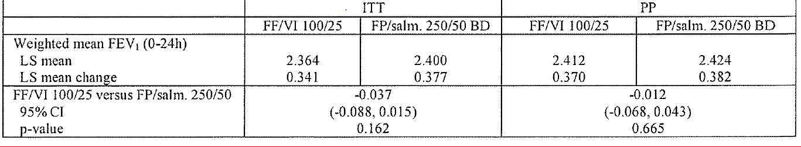
In short, it is reasonable to conclude that 1OO µg fluticasone furoate (DPI) daily is approximately equivalent to 500 µg fluticasone propionate (DPI) daily (250 µg BD); and 200 µg fluticasone furoate (DPI) daily is approximately equivalent to 1000 µg fluticasone propionate (DPI) daily (500 µg BD).
(Note: The conventions for expressing doses for MDI and DPI can vary from country to country. For example, in the US, DPI doses are often expressed as the amount of drug in the inhaler chamber, which is typically 10% more than the drug delivered at the mouthpiece.)

Steps in asthma guidelines; medium-high doses of JCS; step-up, step-down, step­ across
Several asthma guidelines are available and variously have 5 or 6 steps., Typical 6-step guidelines from UpToDate are shown below. (The Australian Asthma Management Handbook has not been updated since 2006 but has similar steps).
Figure 20. Stepwise approach for managing asthma in youths greater than or equal to 12 years of age and adults
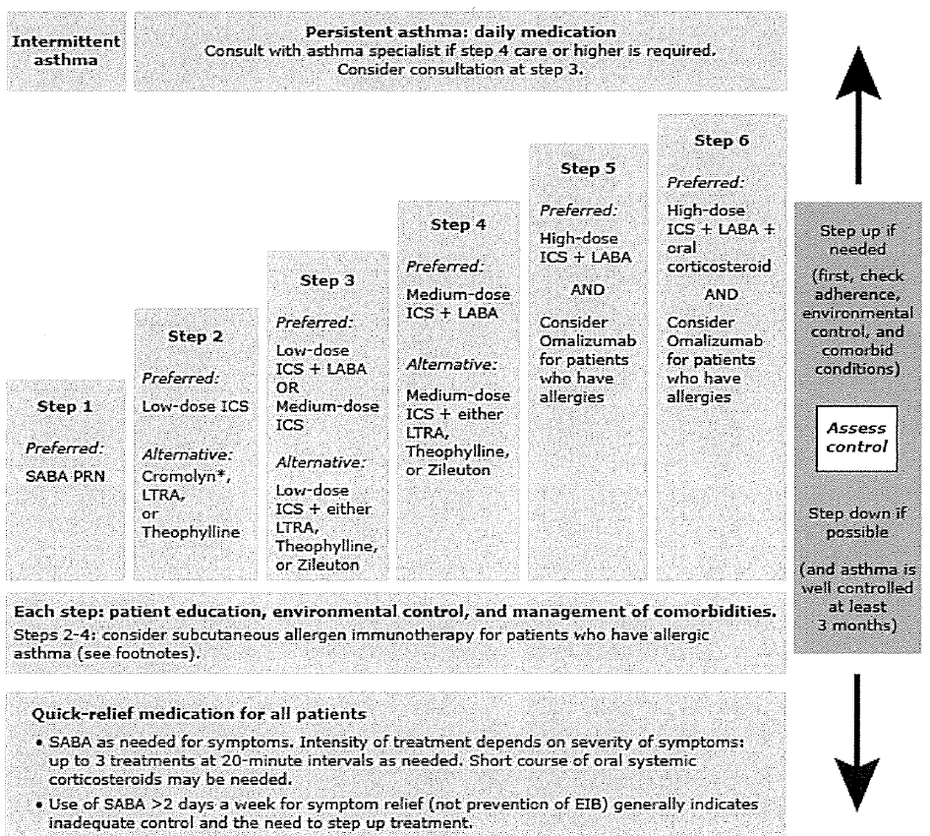
Also from UpToDate
Daily low/medium/high doses of fluticasone propionate are typically set as:
- low: FP 100 to 300 µg
- med: FP: 301 to 500 µg
- high: FP: 501 to 1000 µg
Equivalent doses daily doses (BD in brackets) for fluticasone propionate and fluticasone furoate would be:
- low: FP 100-300 µg (50 to 150 BD)= none proposed for marketing
- med: FP: 301-500 µg (151 to 250 BD) = FF 100 µg
- high: FP: 501 to 1000 µg (251-500 BD) = FF 200 µg
The sponsor has proposed that the following be included in the PI. (Relvar=Breo).
Table 44. Recommended dose (proposed Breo PI)
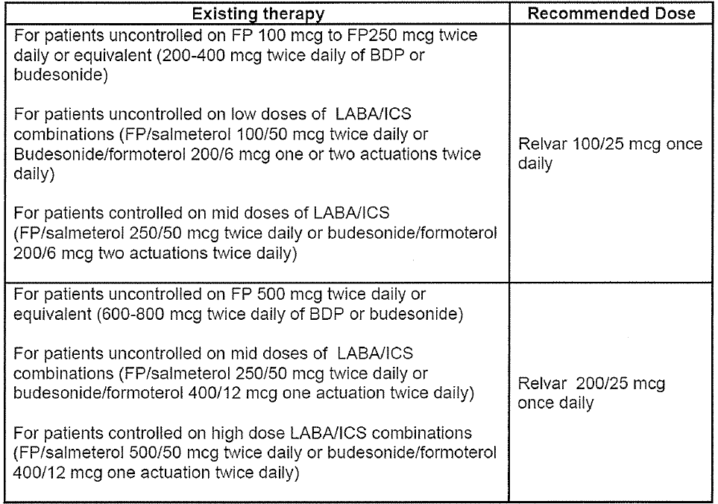
That is, FF/VI 100/25 is for use at step4 and FF/VI 200/25 is for use at steps 5/6. FF/VI 100/25 would not be suitable for use at step3. Put another way, there is no proposed strength of FF/VI suitable for use at step3; prescribers and patients stepping-down from step4 to step3 would have to change from once daily dosing with FF/VI 100/25 to twice daily dosing with FP/salmeterol 100/50 or budesonide/formoterol 200/6 (say), twice daily (or FP 250 µg twice daily).
The concern is that patients might prefer (or be advised) to stay at step4 because of the convenience and increased compliance of once daily administration; rather than step down to step3, for which there are only twice daily products on the market.
For asthma guidelines in general, there is a lack of data about what dose of inhaled steroid is the correct dose at which to add a LABA. (LABAs are thought to be safer when used in combination with ICS, than when used on their own.)
For adults with asthma the step-down from step-4 to step-3 is often to a mono product ICS [medium-dose]; whereas for adolescents the step-down might be more likely to be to a combination product ICS [low-dose]/LABA.

Summary of background
FF/VI 100/25 and 200/25 are for moderate/severe asthma and represent medium/high doses of ICS, at which systemic adverse reactions are known to occur.
A principle, included in all asthma guidelines, is to minimise adverse reactions, by using the lowest dose of ICS that maintains symptom control.
Because FF/VI is once daily dosing, prescribers and patients might be reluctant to step­ down to lower ICS dose (twice daily dosing). This could mean that patients (especially adolescents) are continued on higher doses of ICS for longer than they need, thereby exposing them to a greater risk of adverse reactions.

Sponsor's response
"GSK believes that it is important to ensure that the dose of ICS combined with a LABA has adequate efficacy in order to avoid the masking of worsening inflammation by the LABA component."

Phase II dose-finding studies
The sponsor has re-stated their claim that the three Phase II dose-finding studies show that FF 1OO µg is the lowest effective dose for patients with moderate persistent asthma.
These studies included patients with different severity of asthma; both within and across studies:
- FFA109687: symptomatic on short-acting beta agonists
- FFA109684: symptomatic on low-moderate dose ICS
- FFA109685: symptomatic on low-moderate dose ICS
Doses were tested in the range of 25 µg to 800 µg.
Marketed doses of FP were also included for assay sensitivity.
Figure 21. Results for different FF doses on trough FEV I from the 3 dose ranging studies Placebo-subtracted change from baseline, after 8 weeks
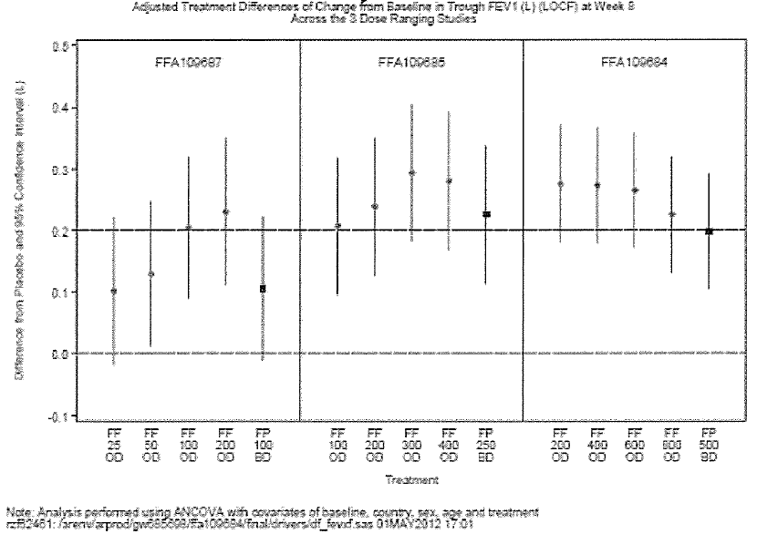
In FFA109687 (symptomatic on SABA), the FF 50 µg group failed to meet the pre­ defined 200 mL placebo-subtracted change/improvement from baseline (200 mL), although the improvement was statistically significantly different from placebo (that is, zero): 129 mL (95% CI: 11, 247).
A post hoc analysis by baseline lung function (in patients with FEVl ≤65% of predicted normal) showed that trough FEV l improvements (placebo-subtracted) were substantially lower for 50 µg (36 mL; 95%CI: -181, 253) than 100 µg (267mL; 95%CI: 70, 463), and 200 µg (190 mL 95%CI: -6, 386). As a consequence, it was concluded that FF 50 µg would not be an adequate dose for patients who would be candidates for treatment with ICS/LABA combination.
In FFA109685 (symptomatic on low/medium dose ICS), small incremental improvement for FF 200 over FF 100 was observed. A post hoc analysis (FEVl ≤65% predicted normal) showed greater improvements for 200 µg [125 mL (-83, 334)] than 100 µg: [67 mL (-141, 275)].
In FFA109684, there was no evidence of a dose response between 200 µg and 800 µg. And the subgroup analysis in patients with FEV l ≤65% predicted also showed no difference. All doses led to an improvement that was similar to FP 1000 µg daily.
EMA's CHMP agreed with the sponsor that FF 100 and FF 200 were appropriate doses to combine with LABA for the asthma populations under study in a Phase III program.

Phase-III studies of monotherapy with fluticasone furoate for milder asthma
In their response, the sponsor has provided details of two monotherapy studies: FFA115283 and FFA115285.
Table 45. FFA115283. Double-blind, parallel-group, Sep2011-Aug2012
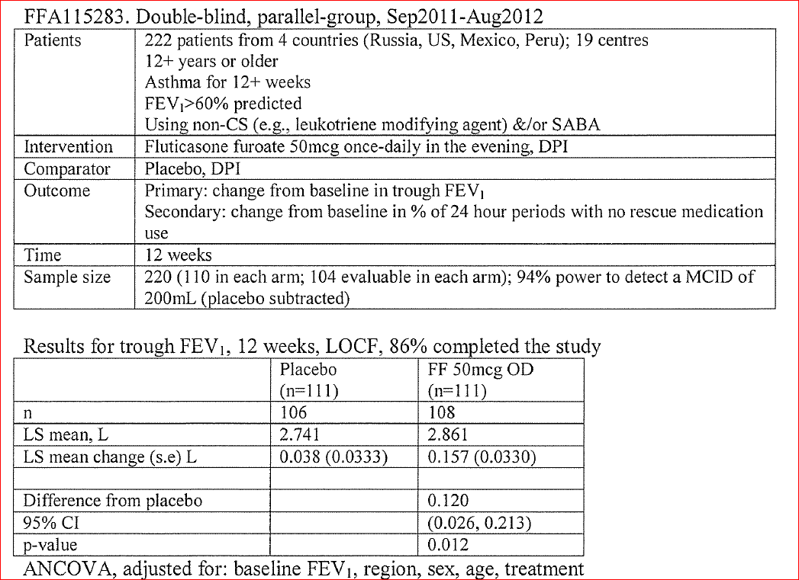
For the secondary outcome of % 24 hour periods with no rescue medications, the adjusted placebo-subtracted difference was 11.6%, p=0.004 (an additional 0.8 rescue-free 24 h periods per week). (The MCID was pre-specified as 9.1%.
Table 46. FFA115285. Double-blind, parallel-group Sep2011 -Sep2012
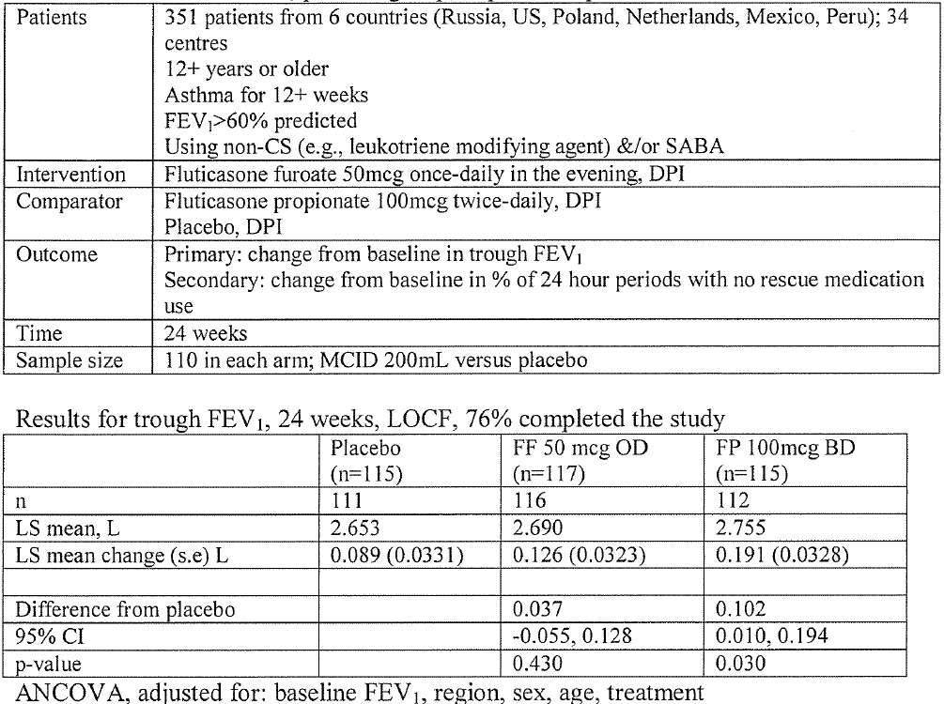
For the secondary outcome of % 24-hour periods with no rescue medications, the adjusted placebo-subtracted difference for FF (50 OD) was 7.8%, (95% CI: -1.0%, 16.7%); FP (100 BD) 10.6% (1.7%, 19.6%).

Summary of evidence about the efficacy of FF 50 µg
At 12 weeks (from Study FFA115283) FF 50 µg produced a statistically significant placebo-subtracted change from baseline FEV1 of 120 mL (95% CI: 26, 213). These results are similar to those from the Phase II Study FFA109687 (see above) at 8 weeks: 129 mL (95% CI: 11, 247). Neither of these results achieved the minimum clinically important difference (MCID)of 200 mL. Both studies were of patients at about Step-2 of the treatment algorithm. A subgroup analysis of patients with FEV 1<65% gave a result that was only 36 mL different from the placebo arm (95%CI: -181, 253).
At 24 weeks (from Study FFA115285) FF 50 µg did not produce a statistically significant placebo-subtracted change from baseline FEV1 37mL (95% CI: -55, 128); however, FP 100 µg BD did: 102 mL (10, 194).
From the sponsor's response: "International guidelines stipulate the place of an ICS/LABA as step-up therapy for use when a patient is insufficiently controlled on ICS monotherapy. These patients will have more resistant asthma and require correspondingly greater efficacy from the ICS component of a combination therapy: GSK believes that an insufficient dose of ICS has the potential to mask worsening airways inflammation through the action of LABA in isolation.... FF 50 µg did not achieve pre-specified efficacy (placebo-subtracted FEV 1 MCID=200 mL) in Phase II or subsequent Phase III studies. GSK believes that FF 50 µg is insufficiently efficacious to be combined with VI for treatment of moderate persistent asthma."
[One problem with the first sentence of this statement is that, although combination ICS/LABA products are used as step-up from mono ICS products; combination ICS[medium/high dose]/LABA products (such as FF/VI) are also used as step-up from combination ICS [low dose]/LABA products.]

Growth
The sponsor pointed out that growth retardation is listed as a safety concern in the RMP. Two studies are planned to assess growth in children: HZA114971 and HZA107112.
Some 688 patients aged 12 to 17 were included in the Phase III asthma studies of FF.
Some 103 adolescent patients have been exposed to FF/VI for > 12 months. Growth was not formally evaluated in these studies.

Delegate’s discussion

Assessment of the evidence for not progressing FF/VI 50/25 to Phase III
FF 1OO µg is a medium/high dose and FF 200 µg is a high dose of ICS. Phase III data suggest that FF 1OO µg daily is equivalent to FP 500 µg daily (250 µg BD) and that FF 200 µg daily is equivalent to FP 1000 µg daily (500 µg BD).
The 1:5 daily dose relationship between FF:FP for 100:500 and 200: 1000, as supported by the Phase III development program, suggests that a 50:250 relationship might hold. However, this has not been tested in a Phase III study. There is no reason why the 1:5 FF:FP daily-dose relationship should hold across all strengths; Phase III studies would be needed to establish the 50:250 FF:FP relationship (for example, perhaps the relationship is 75:250 or perhaps all FF doses<100 µg lack efficacy, regardless of the severity of asthma).
The sponsor decided not to test FF/VI 50/25 in a Phase III study. Study FFA115285 (Phase III, monotherapy, 24 weeks) showed that FF 50 µg did not produce a statistically significant placebo-subtracted change from baseline FEV1: 37 mL (95% CI: -55, 128). This study was in patients about step-2 on the clinical algorithm. (The results of this study are in the proposed PI.)
In contrast, the 8 week, dose-finding study and a 12 week Phase III study showed a statistically significant placebo-subtracted change from baseline FEV1 of about 120 mL. Both of these studies were also in patients at about step-2 on the clinical algorithm.
A subgroup of patients with more severe asthma (FEV1<65%) from the 8 week, dose­ finding study gave a placebo-subtracted increase from baseline of only 37 mL. Therefore, the sponsor argued that FF 50 µg was not sufficiently efficacious in patients with moderate/severe asthma, which is the requested indication.
EMA's CHMP agreed with the sponsor that FF 100 and FF 200 were appropriate doses to combine with LABA for the asthma populations under study in a Phase III program.
The Delegate agreed with the CHMP that FF/VI 100 and 200/25were appropriate doses to test in Phase III studies of moderate/severe asthma. However, the concern in Australia is around the lack of a once daily ICS [low-dose]/LABA product, with which to step-down from step-4 (ICS [medium dose]/LABA) to step-3 (ICS [low dose]/LABA). Patient/doctor preference for once daily dosing might mean that patients are maintained on a higher dose ICS for longer than they need to be. The proposed step-down from a once daily medium dose ICS/LABA (FF/VI 100/25) to twice daily low-dose ICS/LABA (such as FP/salmeterol 125/50 BD or budesonide/formoterol 200/6 BD) is problematic.
In short, the reasons for not progressing FF/VI 50125 to Phase III studies in patients with moderate/severe asthma (steps 4-6) are accepted. The concern is that FF/VI was not tested in Phase III studies in patients at step-3.

Regulatory framework
Section 25 (Evaluation and registration of therapeutic goods) of the Act provides that if an application is made for registration of therapeutic goods in relation to a person in accordance with section 23, the Secretary must evaluate the goods for registration having regard to the criteria set out in paragraphs 25(1)(d) to (k).
The relevant paragraph is:
paragraph 25(l)(d); whether the quality, safety, and efficacy of the goods for the purposes for which they are to be used have been satisfactorily established.
Given the FF/VI is being positioned by the sponsor for use in moderate/severe asthma (at steps 4-6), the Delegate didnot consider that FF/VI can be rejected because FF/VI 50/25 was not tested in patients with moderate/severe asthma. The Delegate accepted the sponsor's decision not to progress FF/VI 50/25 to Phase III trials in patients with moderate/severe asthma.
However, individual patients can move between steps in the clinical algorithm. It is possible that, because of the convenience of once daily dosing, some patients, whose asthma becomes controlled on FF/VI 100/25 (for > 3months, say), could be continued on FF/VI I 00/25 for longer than they need to be; and these particular patients could be exposed to the potential adverse effects of higher than necessary doses of ICS. This is especially the case for patients aged 12 to 17 years, where there is a risk of growth restriction and where the step-down is likely to be to a combination product ICS [low­ dose]/LABA, rather than a mono product ICS[medium-dose]. This might mean that the safety of FF/VI 100/25 has not been satisfactorily established in adolescents who had moderate/severe asthma (say, 3 months ago), but who become well-controlled and should be stepped down to a lower dose of ICS (combined with LABA).

Questions for ACPM
- Can concerns about the inability for particular patients to step-down to a once-daily ICS [low-dose]/LABA combination product be mitigated by changes to the PI?
- The ACPM is asked to provide expert clinical advice on clinical aspects of the PI relevant to concerns about lack of once-daily ICS/LABA product for use at step-3:

Indication:
The indication proposed for the Australian PI is the same as that approved by the EMA. The Delegate was reluctant to have an indication that specifically reflects detailed aspects of current treatment algorithms (for example, steps 4-6) because detailed specifics of clinical practice guidelines can change over time. However, the Indication could be made clearer; one proposal for ACPM to comment on is given below:
"Breo Ellipta is indicated for the regular treatment of moderate to severe asthma in patients who require medium to high dose inhaled corticosteroid combined with a long acting beta agonist."
- The ACPM was also asked to comment on whether restricting the age group to 18+ years would avoid concerns about the inability for particular patients to step-down to a once daily ICS/LABA product (from step-4 to step-3); that is, concerns about growth restriction in adolescents.

Delegate’s Pre ACPM preliminary assessment
At this point in time and pending ACPM advice, the Delegate’s preliminary assessment was that asthma indication could be approved, subject to strengthening of the PI.

Response from sponsor
The TGA Delegate and ACPM have already made a positive recommendation for chronic obstructive pulmonary disease (COPD). GSK welcomed the TGA Delegate’s assessment that the asthma indication could be approved subject to strengthening of the Product Information (PI). Indeed, FF/VI has been approved for indications in asthma and COPD in the European Union, New Zealand, Switzerland, Chile and Mexico. FF/VI has been approved in the United States for COPD and in Japan for asthma. To address the concerns of the TGA and ACPM, GSK has accordingly made a number of revisions throughout the PI to provide further clinical direction on the use of Breo Ellipta. As proposed by the TGA Delegate, the indication has been modified and now clearly defines that the use of FF/VI should only be in patients who require a medium to high dose inhaled corticosteroid (ICS).
The proposed indications for COPD and asthma including modifications are as follows:
COPD
Breo Ellipta is indicated for symptomatic treatment of patients with COPD with a FEV1 <70% predicted normal (post-bronchodilator) in patients with an exacerbation history despite regular bronchodilator therapy.
Breo Ellipta is not indicated for the initiation of bronchodilator therapy in COPD.
Asthma
Breo Ellipta is indicated in the regular treatment of moderate to severe asthma in patients who require a medium to high dose inhaled corticosteroid combined with a long-acting beta-2-agonist asthma in adults and adolescents aged 12 years and older, where use of a combination product (long-acting beta-2-agonist and inhaled corticosteroid) is appropriate
    - patients who are symptomatic with inhaled corticosteroids and 'as needed' inhaled short acting beta-2-agonist, or
    - patients already on both an inhaled corticosteroid and a long-acting beta-2-agonist
Vilanterol, an active ingredient in Breo Ellipta, is a long acting beta-2-agonist (LABA). A class effect of all LABAs can be an increased risk of asthma death (see Precautions in PI).
GSK believes that based on the modifications to the PI, including additional recommendations in the Dosage and Administration section, in conjunction with the availability of other once daily medicines in Australia, patients would not necessarily be more likely to continue on FF/VI 100/25 longer than required.
ACPM did not recommend approval of the asthma indication because: the 50 µg dose of fluticasone furoate was not evaluated in the Phase III asthma trials and lack of a marketed 50 µg dose of fluticasone furoate could compromise patient safety.
As summarised in the Delegate’s Request for ACPM’s Advice, the FF 50 µg dose did not meet its pre-specified efficacy in Phase II. Therefore GSK does not believe that FF 50 µg constitutes an adequate dose of ICS to use in combination with a LABA. GSK has thus concluded that FF 100 µg is the lowest minimal effective dose in combination with a LABA in patients with moderate persistent asthma.
The decision to not progress FF 50 µg in combination with vilanterol into Phase III for moderate persistent asthma has since been corroborated by the results from two further Phase III studies in which FF 50 µg monotherapy was investigated in patients receiving SABA only with milder asthma (FEV1>60% predicted normal). The efficacy of FF 50 µg monotherapy was not replicated in these two studies and therefore FF 50 µg has not been progressed for further development in mild asthma as monotherapy.
Since long-acting beta-agonists do not have any anti-inflammatory properties it is essential that patients receive an adequate dose of ICS as the combination of an insufficient dose of ICS with a LABA could lead to masking of inflammation. GSK’s view is that FF 50 µg is an insufficiently efficacious ICS dose to combine with vilanterol for the treatment of moderate persistent asthma. An experienced respiratory physician, states that “the trial data are unequivocal in that 50 µg per day of fluticasone furoate was clearly inferior with worse levels of symptom control and higher exacerbation rates”. Importantly, the TGA Delegate in particular has agreed with the CHMP that FF/VI 100/25 and 200/25 were the appropriate doses to test in Phase III studies of moderate/severe asthma and the reasons for not progressing FF/VI 50/25 are accepted.
GSK does not believe that the lack of availability of a FF 50 µg dose will compromise patient safety. As discussed in greater detail below, GSK has made further revisions to the PI which clearly articulate that FF/VI is not a low ICS-dose containing product. New wording added to the Dosage and Administration section of the PI provides guidance on the appropriate patient population for initiation of FF/VI 100/25 and recommendations that patients should be regularly reassessed by a healthcare professional so that the strength of FF/VI they are receiving remains optimal. Furthermore, in alignment with clinical guidelines,, instructions have now been incorporated into the Dosage and Administration section of the PI to describe clinical options regarding down-titration.
The ACPM was particularly concerned at the possible use of higher than necessary doses of fluticasone furoate (in combination with VI) in asthma patients aged 12 to 17 where there might be an effect on growth. This was especially the case because once daily dosing might be attractive to clinicians to improve compliance in adolescents.
The ACPM is concerned that in adolescents, where compliance issues may be of special consideration, FF/VI may have an avoidable effect on growth if the dose of ICS is not appropriately down-titrated due to the appeal of continuing to use a once daily product. GSK recognises that effects on growth retardation are a potential concern with all ICS treatment and that compliance in adolescent patients can be a challenge in clinical practice.
In recognition that growth retardation is a risk with ICS treatment, GSK has described this as a safety concern in the latest version of the RMP coupled with two planned additional studies to investigate the potential effect that FF may have on growth. As risk minimisation measures, new revisions to the Product Information (PI) including the Precautions and Dosage and Administration section have been made. The strengthened PI ensures that the long term effects of ICS are highlighted and that patients, and particularly adolescents, should be down-titrated to the lowest ICS dose that maintains control. A respiratory clinician concurs “Growth retardation concerns are therefore best addressed by obtaining good control of asthma at the lowest achievable inhaled corticosteroid dose. The key instruction to doctors, contained currently in the prescribing information, is the need to reduce the dose of ICS (step down) once good control has been obtained to the minimum dose necessary to maintain control.”
In consideration of the importance of appropriate down-titration but recognising the desirability to maintain treatment adherence, GSK believes that in accordance with clinical treatment guidelines, there are available ICS containing products indicated for asthma in Australia which could be utilised and which include the option for once-daily dosing. These options are discussed further below in response to the TGA Delegate’s specific question concerning how to step down from FF/VI 100/25.
GSK acknowledges adolescent patients represent a significant component of the asthmatic population with an important medical need. GSK believes that with appropriate guidance in the PI on how to manage adolescent patients, it is preferable that this important population has access to the benefits of Breo Ellipta, including once daily convenience, rather than restricting the indicated population to adults only (18 years and above) and risk off-label use in patients under 18 years of age. A respiratory clinician states that “As compliance with therapy is easily the biggest problem in asthma management, and even more so in adolescents, the once daily dosing of Breo Ellipta is a potentially significant advance on currently available therapeutic options.”

Specific questions raised by TGA delegate for ACPM’s advice
- Can concerns about the inability for patients to step-down to a once-daily ICS [low-dose]/LABA combination product be mitigated by changes to the PI?
- The ACPM is asked to provide expert clinical advice on clinical aspects of the PI relevant to concerns about lack of once-daily ICS/LABA product for use at step-3.
GSK’s interpretation of Step 3 in the GINA guidelines is that this step can include a low dose ICS/LABA or medium dose ICS monotherapy. Therefore, treatment guidelines would allow for step-down from FF/VI 100/25 (as a mid-dose ICS/LABA, Step 4) to either a low-dose ICS/LABA (such as FP/salmeterol 100/50 BD) or to a mid dose ICS monotherapy. Furthermore, the guidelines do not distinguish between adults or adolescents as which of these options is recommended above the other.
There is an Australian randomised controlled study which evaluated down-titration from high dose ICS/LABA combination therapy in asthma. This study reported that the mean minimum effective FP dose that was achieved in the ICS/LABA patients was 534 µg of FP. With respect to the ICS dose equivalence, this is comparable to the lowest FF/VI 100/25 µg dose form. Further, the study also reported that about 60% of patients who were on high dose ICS/LABA therapy still required a minimum effective FP dose of 500 µg or greater (as ICS/LABA combination). Extrapolating from this, the majority of patients (60%) will be able to achieve their respective minimum effective ICS dose using either FF/VI 100/25 or 200/25. For the remaining 40% of patients in the study, further down-titration of their ICS dose was achieved using existing low dose ICS/LABA or ICS monotherapy.
It is important to note that ciclesonide is a once daily ICS monotherapy which is available in Australia across a range of doses from low to high strength. Therefore, where compliance may be of concern in a particular patient, stepping-down to ciclesonide 240 µg once daily (moderate dose) would be a therapeutic option available to Australian patients and which is in accordance with treatment guidelines. When clinically appropriate, the patient could be further stepped down (step 2) to ciclesonide 160 mcg once daily (low dose).
In terms of stepping down to low dose ICS/LABA at step 3, although no FF/VI strength is available for use, the Delegate describes that patients stepping down would have to change from once daily dosing with FF/VI 100/25 to twice daily dosing with FP/salmeterol 100/50 or budesonide/formoterol 200/6 twice daily. The sponsor concurred with this and suggests that the decision whether to step down at step 3 to twice daily low dose ICS/LABA or once daily moderate dose ICS should be based upon a clinical assessment of whether the individual patient is more likely to benefit immediately from a once daily preparation, or a lower dose of ICS. Potential advantages of stepping down to medium dose once daily ICS monotherapy at step 3 are that the benefits of a once daily regimen are maintained, but also that further step down (step 2) when appropriate is facilitated by being able to remain on the same medicine, just with a lower dose, (ciclesonide 160 µg once daily) rather than having to change medicine again (twice daily low dose ICS/LABA to ICS monotherapy). A respiratory specialist has stated that ciclesonide is available in doses that are effective for once daily use.
GSK has added instructions into the Dosage and Administration section of the PI to make it clear that when deemed clinically appropriate, the ICS dose should be adjusted to the lowest dose at which effective control of asthma is maintained. Furthermore, with particular reference to adolescent patients, the PI states that when down-titrating to another product that consideration should be given to maintaining a once daily regimen to facilitate compliance.
GSK therefore believes that together with appropriate instructions in the PI and other once daily medicines available in Australia, that patients would not be more likely continue on FF/VI 100/25 longer than necessary. A health practitioner adds “...my GP colleagues do appreciate the importance of back titration and the importance of subsequent adherence to a new dosage regime and are competent in undertaking these clinical tasks.”
GSK is willing upon advice of the TGA, to update the RMP Australian Specific Annex in order to reflect that in accordance with the Medicines Australia Code of Conduct, that GSK will provide a minimum PI to accompany all medical education, advertising and promotional materials to healthcare professionals that includes a statement with appropriate instructions on down-titration.

Updates to the PI
Broadly, GSK has incorporated the recommended modifications by the TGA Delegate to the Australian PI. Additionally, GSK proposes further additions to the Dosage and Administration section of the PI in order to describe recommendations for down-titrating patients including special considerations for adolescents.

Indication
The indication for asthma has now been modified as follows:
Breo Ellipta is indicated in the regular treatment of moderate to severe asthma in patients who require a medium to high dose inhaled corticosteroid combined with a long-acting beta-2-agonist asthma in adults and adolescents aged 12 years and older, where use of a combination product (long-acting beta-2-agonist and inhaled corticosteroid) is appropriate
    - patients who are symptomatic with inhaled corticosteroids and 'as needed' inhaled short acting beta-2-agonist, or
    - patients already on both an inhaled corticosteroid and a long-acting beta-2-agonist
Vilanterol, an active ingredient in Breo Ellipta, is a long-acting beta-2-agonist (LABA). A class effect of all LABAs can be an increased risk of asthma death (see Precautions).
GSK believes that the revised indication statement is appropriate since it is now unambiguous that Breo Ellipta is only appropriate in those patients whom require a medium to high dose ICS/LABA combination product.
The indication for COPD has also been modified based on ACPM advice:
Breo Ellipta is indicated for symptomatic treatment of patients with COPD with a FEV1 <70% predicted normal (post-bronchodilator) in patients with an exacerbation history despite regular bronchodilator therapy.
Breo Ellipta is not indicated for the initiation of bronchodilator therapy in COPD.
Changes to other parts of the PI are beyond the scope of this AusPAR.
- The sponsor is asked to provide data on the number of participants older than 75 years, who have received FF/VI 200/25.
Not unexpectedly in an asthmatic population, the number of elderly subjects was relatively small. Although elderly patients were not specifically excluded from FF/VI Phase III studies in asthma, the number of subjects recruited over 65 years of age is low. It has been suggested that asthma prevalence rates decrease with advancement of age, concurrent with an increase in the prevalence of COPD across age groups and that up to 30% of asthma subjects aged 65 or greater may have co-morbid COPD. The limited number of patients over the age of 65 enrolled into the FF/VI asthma clinical development program might therefore be explained by the exclusion of patients with co morbid COPD. A total of 569 subjects were aged at least 65 years. Most of these subjects were 65 to 74 years of age and no subjects were 85 years or older. In the four primary COPD studies, 2508 subjects were aged at least 65 years.
In both the lung function studies (HZC112206 and HZC112207, RMP, Part II SIV, Table 3) and the one year exacerbation studies (HZC102871 and HZC102970, RMP, Part II SIV, Table 4) the incidence of events associated with advanced age, such as: central nervous system (CNS) (confusion/ extrapyramidal) adverse events, events related to falling, cardiovascular events, cerebrovascular events, and infections were similar across the ≤64 and 65 to 74 age categories across treatment groups, however there were too few subjects in the 75 to 84 and ≥85 age categories to make meaningful comparisons across the treatment groups. GSK therefore proposes to amend the PI to recommend that Breo Ellipta 200/25 should not be in used in elderly asthma patients over 75 years.

Product information and consumer medicines information
GSK has considered the PI recommendations from TGA Delegate and has submitted amendments. GSK commits to updating and aligning the Consumer Medicine Information accordingly once agreed wording for the PI has been finalised.

Benefit-risk assessment - conclusion
In conclusion, GSK contends that with the strengthening of the PI to address concerns regarding down-titration, that benefit-risk assessment for the registration of Breo Ellipta 100/25 and 200/25 in asthma is favourable. GSK believes that the modifications to the Indication clearly define that the use of Breo Ellipta should only be in patients who require a medium to high dose ICS. Furthermore, instructions in the Dosage and Administration section, in conjunction with the availability of other once daily medicines in Australia, means that patients should not be more likely to continue on FF/VI 100/25 longer than required. GSK welcomes the TGA Delegate’s assessment that the asthma indication could be approved subject to strengthening of the Product Information (PI).

Advisory committee considerations at the February 2014 meeting
The Advisory Committee on Prescription Medicines (ACPM), having considered the evaluations and the Delegate’s overview, as well as the sponsor’s response to these documents, advised the following:
The submission seeks to register a new combination of active ingredients.
The ACPM, taking into account the submitted evidence of efficacy, safety and quality, agreed with the Delegate and considered Breo Ellipta powder for inhalation containing 100 µg /25 µg and 200 µg / 25 µg of fluticasone furoate / vilanterol trifenatate to have an overall positive benefit–risk profile for the modified indication;
BREO ELLIPTA is indicated for the regular treatment of moderate to severe asthma in patients, aged 12 years or older, who require medium to high dose inhaled corticosteroid combined with a long acting beta agonist.
In making this recommendation the ACPM:
- noted there was some safety data in the population aged 12 to 17 years
- was of the view that an education program to emphasise that this is a more potent ICS would be beneficial.

Proposed Product Information (PI)/Consumer Medicine Information (CMI) amendments:
The ACPM agreed with the Delegate to the proposed amendments to the Product Information (PI) and Consumer Medicine Information (CMI).

Specific advice
- Can concerns about the inability for patients to step-down to a once-daily ICS [low-dose] /LABA combination product be mitigated by changes to the PI?
Stepping down from FF/VI 100/25 to twice daily low dose ICS/LABA is problematic. The ACPM agreed with PI re-wording as this is much clearer. There is clear discussion about use only in moderate and severe asthma which will reduce over dosing.
- The ACPM is also asked to provide expert clinical advice on clinical aspects of the PI. Specifically, for adults with asthma the step-down from step-4 to step-3 is often to a mono product ICS [medium-dose]; whereas for adolescents the step-down might be more likely to be to a combination product ICS [low-dose]/LABA.
See above.
The ACPM advised that the implementation by the sponsor of the recommendations outlined above to the satisfaction of the TGA, in addition to the evidence of efficacy and safety provided would support the safe and effective use of these products.

Final outcome
Based on a review of quality, safety and efficacy, TGA approved the registration of Breo Ellipta powder for inhalation containing fluticasone furoate / vilanterol (as trifenatate) 100 µg/ 25 µg and Breo Ellipta powder for inhalation containing fluticasone furoate / vilanterol (as trifenatate) 200 µg/ 25 µg.
The indications for Breo Ellipta 100/25 µg are:
COPD
Breo Ellipta is indicated for symptomatic treatment of patients with COPD with a FEV1 <70% predicted normal (post-bronchodilator) in patients with an exacerbation history despite regular bronchodilator therapy.
Breo Ellipta is not indicated for the initiation of bronchodilator therapy in COPD.
Asthma
Breo Ellipta is indicated in the regular treatment of moderate to severe asthma in patients who require a medium to high dose inhaled corticosteroid combined with a long-acting beta-2-agonist.
Vilanterol, an active ingredient in Breo Ellipta, is a long-acting beta-2-agonist (LABA). A class effect of all LABAs can be an increased risk of asthma death (see Precautions).
The approved indication for Breo Ellipta 200/25 µg is:
Asthma
Breo Ellipta is indicated in the regular treatment of moderate to severe asthma in patients who require a medium to high dose inhaled corticosteroid combined with a long-acting beta-2-agonist.
Vilanterol, an active ingredient in Breo Ellipta, is a long-acting beta-2-agonist (LABA). A class effect of all LABAs can be an increased risk of asthma death (see Precautions).

Specific conditions of registration applying to these goods
- The Breo Ellipta (fluticasone furoate / vilanterol trifenatate) EU Risk Management Plan (RMP), Version 3.0 dated 17 May 2013 [data lock point (DLP) 1 January 2013] and Australian Specific Annex Version 2.0 (undated, cover letter dated 30 May 2013), and any subsequent revisions, as agreed with the TGA will be implemented in Australia.
- Advise of TGA of the results (as soon as they are available) of post-marketing studies listed in Table 1 of section 2.3 "Studies Referenced in the EU-RMP", as specified in the Australian Specific Annex of the Risk Management Plan.
- Advise the TGA of the results (as soon as they are available) of the post-marketing studies: fluticasone propionate/salmeterol: SAS115359 (AUSTRI) in adults and adolescents, and SAS115358 (VESTRI) study in paediatrics started in 2011, expected to be completed in 2016 and early 2017, respectively.
- At least one batch per year of each strength will be tested for drug-related impurities at release (unless no batch is made during that year) and the TGA notified forthwith if the batch fails the shelf-life limits for impurities.

Attachment 1. Product Information
The Product Information approved for main TRADENAME at the time this AusPAR was published is at Attachment 1. For the most recent Product Information please refer to the TGA website at <http://www.tga.gov.au/hp/information-medicines-pi.htm>. The PI for OTHER TRADENAMES is identical except for the product name.

Attachment 2. Extract from the Clinical Evaluation Report

Therapeutic Goods Administration
PO Box 100 Woden ACT 2606 Australia
Email: info@tga.gov.au Phone: 1800 020 653 Fax: 02 6232 8605
http://www.tga.gov.au

The full indication for this product is: Flutiform inhalation is indicated in the regular treatment of asthma where the use of a combination product (an inhaled corticosteroid and a long-acting beta-2 agonist) is appropriate. It is appropriate both for patients not adequately controlled with inhaled corticosteroids and inhaled short-acting beta-2 agonist on an ?as required© basis, and for patients already adequately controlled on both an inhaled corticosteroid and a long-acting beta-2 agonist.
Nowak-Wegrzyn A, Shapiro GG, Beyer K, et al. Contamination of dry powder inhalers for asthma with milk proteins containing lactose. J. Allergy Clin. Immunol. 2004 Mar;113(3):558-60
CPMP/EWP/4151/00 Rev 1 (January 2009)
QT interval: a measure of the time between the start of the Q wave and the end of the T wave in the heart's electrical cycle. A prolonged QT interval is a risk factor for ventricular tachyarrhythmias and sudden death. The QT interval is dependent on the heart rate (the faster the heart rate, the shorter the QT interval). To correct for changes in heart rate and thereby improve the detection of patients at increased risk of ventricular arrhythmia, a heart rate-corrected QT interval QTc is often calculated.
Emery PW, Rothwell NJ, Stock MY, Winter PD. Chronic effects of beta-2 adrenergic agonists on body composition and protein synthesis in the rat. Bioscience Report. 1984;4:83-91.
Smith SR and Kendall MJ. Metabolic responses to beta stimulants. Journal of the Royal College of Physicians of London, 1984;18:190-4.
Sells DM and Gibson JP. Carcinogenicity studies with medroxalol hydrochloride in rats and mice. Toxicologic Pathology, 1987;14:457-67
Guidance on Specific Aspects of Regulatory Genotoxicity Tests for Pharmaceuticals S2A; and Guidance for Industry S2B Genotoxicity: A Standard Battery for Genotoxicity Testing of Pharmaceuticals
Rat liver S9 fraction is used to mimic the mammalian metabolic conditions so that the mutagenic potential of metabolites formed by a parent molecule in the hepatic system can be assessed, however there are differences in metabolism and mutagenicity of chemicals between human and rat.
Guidance for Industry S1C(R2) Dose Selection for Carcinogenicity Studies
Owen, K., Beck, S.L., and Damment, S.J.P. The preclinical toxicology of salmeterol hydroxynaphthoate. Hum Exp Toxicol. 2010;29(5):393-407.
F1 is a term used in genetics and selective breeding. F1 stands for Filial 1, the first filial generation animal offspring.
Category B. Drugs which have been taken by only a limited number of pregnant women and women of childbearing age, without an increase in the frequency of malformation or other direct or indirect harmful effects on the human fetus having been observed. Studies in animals have shown evidence of an increased occurrence of fetal damage, the significance of which is considered uncertain in humans.
ICH Q3B(R2)
In silico is an expression used to mean "performed on computer or via computer simulation."
GOLD (Global Initiative for Obstructive Lung Disease) Global strategy for the diagnosis, management, and prevention of chronic obstructive lung disease. Global Initiative for Obstructive Lung Disease (GOLD) 2011. Available from www.goldcopd.org.
GINA (Global Initiative for Asthma) From the Global Strategy for Asthma Management and Prevention, Global Initiative for Asthma (GINA) 2011. Available from www.ginasthma.org.
Price D, Robertson A, Bullen K, Rand C, Horne R, Staudinger H. Improved adherence with once daily versus twice-daily dosing of mometasone furoate administered via a dry powder inhaler: a randomised open-label study. BMC Pulmonary Medicine 2010; 10:1-9.
Toy EL, Beaulieu NU, McHale JM, Welland TR, Plauschinat CA, Swensen A, Duh MS. Treatment of COPD: relationships between daily dosing frequency, adherence, resource use, and costs. Respir Med 2011; 105:435-441.
Delea TE, Hagiwara M, Stempel DA, Stanford RH. Adding salmeterol to fluticasone propionate of increasing the dose of fluticasone propionate in patients with asthma. Allergy Asthma Proc 2010; 31:211-218.
Hagiwara M, Delea TE, Stanford RH, Stempel DA. Stepping down to fluticasone propionate or a lower dose of fluticasone propionate/salmeterol combination in asthma patients recently initiating combination therapy. Allergy Asthma Proc 2010; 31:203-210.
Guest JF, Davie AM, Ruiz FJ, Greener MJ. Switching asthma patients to a once-daily inhaled steroid improves compliance and reduces healthcare costs. Primary Care Respiratory J 2005; 14:88-98.
The clinical development programmes for FF/VI were designed to comply with the CHMP’ Note for Guidance on Fixed Dose Combination Medicinal Products’ [CPMP/EWP/240/95 Rev.1], the CHMP Note for Guidance on the Clinical Investigation of Medicinal Products in the Treatment of Asthma [CPMP/EWP/2922/01], the CHMP Points to Consider on Clinical Investigation of Medicinal Products in the Treatment of Patients with COPD [CPMP/EWP/562/98] and draft FDA guidance entitled “Guidance for Industry: Chronic Obstructive Pulmonary Disease: Developing Drugs for Treatment” [FDA COPD Guidance, 2007].
Sponsor comment: “These data refer to Study HZA105871 and doses of FF/VI and FF of 800/100 and 800, respectively. These effects on cortisol are only seen at supratherapeutic doses.”
In the HZC112206 and HZC112207 studies, the incidence of COPD exacerbations was considered a safety endpoint. Unlike the HZC102871/HZC102970 studies, in which subjects who experienced a moderate or severe COPD exacerbation could continue in the study, in the HZC112206 and HZC112207 studies, the protocol required that any subject who experienced a moderate or severe COPD exacerbation be withdrawn from the study.
GOLD COPD classifications are used to describe the severity of the obstruction or airflow limitation. The worse a person's airflow limitation is, the lower their FEV1. As COPD progresses, FEV1 tends to decline. GOLD COPD staging uses four categories of severity for COPD, based on the value of FEV1: 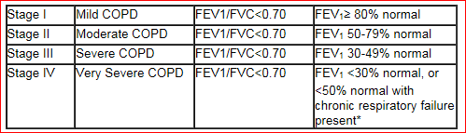 * Usually, this means requiring long-term oxygen therapy.
Due to the crossover design of Study HZC110946, in which 54 subjects were enrolled and exposed to multiple strengths of FF/VI
Ferguson GT, Anzueto A, Fei R, Emmett A, Knobil K, Kalberg C. Effect of fluticasone propionate/salmeterol (250/50 mcg) or salmeterol (50 mcg) on COPD exacerbations. Resp Med. 2008;102:1099-1108
Anzueto A, Ferguson GT, Feldman G, Chinsky K, Seibert A, Emmett A, et al. Effect of fluticasone propionate/salmeterol (250/50) on COPD exacerbations and impact on patient outcomes. COPD 2009; 6(5):320-329.
Sponsor comment: “This implies a larger than observed treatment effect and is inconsistent with the Product Information which correctly states that ‘Fluticasone furoate/vilanterol 100/25 µg increased adjusted mean weighted mean FEV1 over 0-4 hours by 148 ml compared to FF alone (95% CI: 112, 184 mL, p< 0.001).”
Harrell AW, Siederer SK, Bal J et al. Metabolism and disposition of vilanterol, a long acting β2- adrenoceptor agonist for inhalation use in humans. Drug Metab Dispos 41:89–100, January 2013.
Harrell AW, Siederer SK, Bal J et al. Metabolism and disposition of vilanterol, a long acting β2- adrenoceptor agonist for inhalation use in humans. Drug Metab Dispos 41:89–100, January 2013.
Cella et al. Br J Clin Pharmacol. 2011 September; 72(3): 454–464. Cella et al. Br J Clin Pharmacol. 2012 Sep;74(3):525-35.
CPMP/EWP/560/95/Rev.1, 2010
Svedsater H, Clark M, Martin S, Dale P, Jacques L, Bleecker ER, O'Byrne PM. Measurement Properties Of An Asthma Symptom And Rescue Medication Use Diary: A Critical Review. American Journal of Respiratory and Critical Care Medicine, Vol. 187, Meeting Abstracts, 2013 A4213
A severe exacerbation was defined as an exacerbation requiring treatment with systemic corticosteroid for at least 3 days or a hospital admission or emergency room visit for asthma that required treatment with systemic corticosteroid.
O’Byrne P, Pedersen S, Carlsson L-G, Radner F, Thoren A, Peterson S, Ernst P, and Suissa S. Risks of Pneumonia in Patients with Asthma Taking Inhaled Corticosteroids. Am J Respir Crit Care Med Vol 183. pp 589–595, 2011 – 22
Global Initiative for Obstructive Lung Disease (GOLD). Global strategy for the diagnosis, management, and prevention of chronic obstructive lung disease. Global Initiative for Obstructive Lung Disease (GOLD) 2013. Available from www.goldcopd.org.
David K McKenzie, Michael Abramson, Alan J Crockett, Eli Dabscheck, Nicholas Glasgow, Sue Jenkins, Christine McDonald, Richard Wood-Baker, Ian Yang, Peter A Frith on behalf of The Australian Lung Foundation. The COPD-X Plan: Australian and New Zealand Guidelines for the management of Chronic Obstructive Pulmonary Disease V2.30, 2011
Global Initiative for Asthma (GINA). From the Global Strategy for Asthma Management and Prevention, Global Initiative for asthma (GINA) 2011. Available from <www.ginasthma.org>.
Ducharme FM, Ni Chroinin M, Greenstone I, Lasseson TJ. Addition of long-acting beta2-agonists to inhaled steroids versus higher dose inhaled steroids in adults and children with persistent asthma. Cochrane Database Syst Rev 2010; 14 4):CD005533
Global Initiative for Obstructive Lung Disease (GOLD). Global strategy for the diagnosis, management, and prevention of chronic obstructive lung disease. Global Initiative for Obstructive Lung Disease (GOLD) 2011. Available from www.goldcopd.org.
Sponsor comment: “On 11 October 2013, GSK responded to the outstanding issues from the RMP assessment and submitted EU-RMP Version 6.0 and Australian Specific Annex 3.0.”
Sponsor comment: “On 11 October 2013, GSK responded to the outstanding issues from the RMP assessment and submitted EU-RMP Version 6.0 and Australian Specific Annex 3.0.”
Loke YK, Cavallazzi R, Singh S. Risk of Fractures with Inhaled Corticosteroids in COPD: Systematic Review and Meta-analysis of Randomised Controlled Trials and Observational Studies. Thorax. 2011. E-published
Australian Centre for Asthma Monitoring 2011. Asthma in Australia 2011. AIHW Asthma Series no. 4. Cat. no. ACM 22. Canberra: AIHW.
For example;The Childhood Asthma Management Program Research Group. N Engl J Med 2000; 343:1054. Kelly, et al. N Engl J Med 2012; 367:904
Myers TR. Guidelines for asthma management: a review and comparison of 5 current guidelines. Respir Care. 2008 Jun;53(6):751-67
GINA Guidelines (Pocket Guide to Asthma Management and Prevention. Updated 2012)
Asthma Management Handbook. National Asthma Council Australia. 2006.
Global Initiative for Asthma (GINA). From the Global Strategy for Asthma Management and Prevention, Global Initiative for Asthma (GINA) 2011. Available from www.ginasthma.org.
Reddel HK et al. Down-titration from high-dose combination therapy in asthma: Removal of long-acting β2-agonist. Respiratory Medicine 2010; 104: 1110-1120.
Oraka, E. et al. Asthma Prevalence among US Elderly by Age Groups: Age Still Matters. Journal of Asthma 2012; 49(6): 593-59.

