First round report 7 February 2013
Second round report 31 July 2013

AusPAR Attachment 2

Extract from the Clinical Evaluation Report for Fluticasone furoate/Vilanterol trifenate
  - Proprietary Product Name: Breo Ellipta
  - Sponsor: GlaxoSmithKline Australia Pty Ltd

About the Therapeutic Goods Administration (TGA)
- The Therapeutic Goods Administration (TGA) is part of the Australian Government Department of Health, and is responsible for regulating medicines and medical devices.
- The TGA administers the Therapeutic Goods Act 1989 (the Act), applying a risk management approach designed to ensure therapeutic goods supplied in Australia meet acceptable standards of quality, safety and efficacy (performance), when necessary.
- The work of the TGA is based on applying scientific and clinical expertise to decision-making, to ensure that the benefits to consumers outweigh any risks associated with the use of medicines and medical devices.
- The TGA relies on the public, healthcare professionals and industry to report problems with medicines or medical devices. TGA investigates reports received by it to determine any necessary regulatory action.
- To report a problem with a medicine or medical device, please see the information on the TGA website <http://www.tga.gov.au>.
About the Extract from the Clinical Evaluation Report
- This document provides a more detailed evaluation of the clinical findings, extracted from the Clinical Evaluation Report (CER) prepared by the TGA. This extract does not include sections from the CER regarding product documentation or post market activities.
- The words [Information redacted], where they appear in this document, indicate that confidential information has been deleted.
- For the most recent Product Information (PI), please refer to the TGA website <http://www.tga.gov.au/hp/information-medicines-pi.htm>.
Copyright
© Commonwealth of Australia 2014
This work is copyright. You may reproduce the whole or part of this work in unaltered form for your own personal use or, if you are part of an organisation, for internal use within your organisation, but only if you or your organisation do not use the reproduction for any commercial purpose and retain this copyright notice and all disclaimer notices as part of that reproduction. Apart from rights to use as permitted by the Copyright Act 1968 or allowed by this copyright notice, all other rights are reserved and you are not allowed to reproduce the whole or any part of this work in any way (electronic or otherwise) without first being given specific written permission from the Commonwealth to do so. Requests and inquiries concerning reproduction and rights are to be sent to the TGA Copyright Officer, Therapeutic Goods Administration, PO Box 100, Woden ACT 2606 or emailed to <tga.copyright@tga.gov.au>.

Contents
List of commonly used abbreviations in this CER 6
1. Clinical rationale 8
2. Contents of the clinical dossier 9
2.1. Scope of the clinical dossier 9
2.2. Paediatric data 9
2.3. Good clinical practice 10
3. Pharmacokinetics 10
3.1. Studies providing pharmacokinetic data 10
3.2. Summary of pharmacokinetics 13
3.3. Pharmacokinetics in the target population 20
3.4. Pharmacokinetics in other special populations 21
3.5. Pharmacokinetic interactions 22
3.6. Evaluator’s overall conclusions on pharmacokinetics 23
4. Pharmacodynamics 26
4.1. Studies providing pharmacodynamic data 26
4.2. Summary of pharmacodynamics 28
4.3. Pharmacodynamic effects 29
4.4. Time course of pharmacodynamic effects 36
4.5. Relationship between drug concentration and pharmacodynamic effects 36
4.6. Genetic-, gender- and age-related differences in pharmacodynamic response 36
4.7. Pharmacodynamic interactions 37
4.8. Evaluator’s overall conclusions on pharmacodynamics 37
5. Dosage selection for the pivotal studies 40
5.1. Asthma 40
5.2. COPD 47
6. Clinical efficacy 49
6.1. Asthma 49
6.2. Analyses performed across trials (pooled analyses and meta-analyses) 64
6.3. Evaluator’s conclusions on clinical efficacy for asthma 69
6.4. COPD 72
7. Clinical safety 107
7.1. Safety for indication of asthma 107
7.2. Pivotal studies that assessed safety as a primary outcome 108
7.3. Patient exposure 111
7.4. Adverse events 113
7.5. Deaths and other serious adverse events 121
7.6. Discontinuation due to adverse events 122
7.7. Laboratory tests 122
7.8. Postmarketing experience 125
7.9. Safety issues with the potential for major regulatory impact 126
7.10. Other safety issues 126
7.11. Evaluator’s overall conclusions on clinical safety in asthma 128
7.12. Safety for indication of COPD 131
7.13. Pivotal studies that assessed safety as a primary outcome 133
7.14. Patient exposure 133
7.15. Adverse events 134
7.16. Deaths and other serious adverse events 143
7.17. Discontinuation due to adverse events 145
7.18. Laboratory tests 146
7.19. Postmarketing experience 148
7.20. Safety issues with the potential for major regulatory impact 148
7.21. Other safety issues 148
7.22. Evaluator’s overall conclusions of safety of FF/VI in COPD 151
8. First round benefit-risk assessment 154
8.1. First round assessment of benefits 154
8.2. First round assessment of risks 156
8.3. First round assessment of benefit-risk balance 158
8.4. First round recommendation regarding authorisation 158
9. Clinical questions 159
9.1. Pharmacokinetics 159
9.2. Pharmacodynamics 159
9.3. Efficacy 159
9.4. Safety 160
10. Second round evaluation of clinical data submitted in response to questions 160
10.1. Pharmacokinetics 160
10.2. Pharmacodynamics questions: 164
10.3. Efficacy questions 165
11. Second round benefit-risk assessment 189
11.1. Second round assessment of benefits 189
11.2. Second round assessment of risks 190
11.3. Second round assessment of benefit-risk balance 191
12. Second round recommendation regarding authorisation 194
13. References 194

List of commonly used abbreviations in this CER
Abbreviation | Meaning
ADME | absorption, distribution, metabolism, and excretion
Ae | recovery of unchanged drug
AE | adverse event
ALT | alanine aminotransferase
AMP | Adenosine 5’-monophosphate
APSD | Aerodynamic particle size distribution
AST | aspartate aminotransferase
AUC_{(0 to 24)} | Area under the concentration-time curve over the once daily dosing interval
AUC_{(0-∞)} | area under the concentration time curve extrapolated to infinity
AUC_{(0-t)} | area under the concentration time curve to the last measurable time-point
AUC_{(0-t’)} | area under the concentration time curve to the last common measurable time-point
AUC(0-t) | Area under the concentration-time curve from time zero (pre-dose) to last time of quantifiable concentration
BA | bioavailability
BD | Twice daily
BMI | Body Mass Index
CHMP | Committee for Medicinal Products for Human Use
CI | Confidence interval
CL | Systemic clearance
CL/F | Apparent clearance following inhaled dosing
C_{max} | Maximum observed concentration
COPD | Chronic Obstructive Pulmonary Disease
CRQ-SAS | Chronic Respiratory Disease Questionnaire – Self-Administered Standardized
CYP3A4 | Cytochrome P450 3A4
DPI | dry powder inhaler
EAR | early asthmatic response
ECG | Electrocardiogram
eNo | exhaled nitric oxide
ETD | ex-throat dose
EU | European Union
FDA | Food and Drug Administration
Fe | fraction of total dose excreted unchanged
FEV1 | forced expiratory volume in 1 second
FF | Fluticasone Furoate
FF/VI | fluticasone furoate/vilanterol
FP | fluticasone propionate
FVC | Forced vital capacity
GCP | Good Clinical Practice
GINA | Global Initiative for Asthma
GOLD | Global Initiative for Obstructive Lung Disease
GSK | GlaxoSmithKline Australia Pty Ltd
GSK233705 | muscarinic receptor antagonist
GSK573719 | long acting muscarinic receptor antagonist
GW642444 | vilanterol (long acting beta2 agonist)
GW642444H | vilanterol (a-phenylcinnimate salt)
GW642444M | vilanterol (triphenylacetate salt)
GW685698X | fluticasone furoate (glucocorticoid receptor agonist)
HPA | Hypothalamic-pituitary-adrenal
ICH | International Conference on Harmonisation
ICS | Inhaled corticosteroid
IMB | Irish Medicines Board
IND | Investigational New Drug
IOP | Intraocular pressure
ITT | Intent-to-Treat
IV | Intravenous
Kg | Kilogram
LABA | long-acting, beta2-adrenergic agonist
LAR | late asthmatic response
LLQ | Lower limit of quantification
LLQ | lower limits of quantification
LOCF | Last observation carried forward
LOCS III | Lens Opacities Classification System III
LogMAR | Logarithm of the angle of resolution
MA | mean absorption time
Mcg | Micrograms
MCID | Minimal clinically important difference
Mg | Milligrams
MgSt | magnesium stearate
MHRA | Medicines and Healthcare products Regulatory Agency
MRT | mean residence time
NDA | New Drug Application
NDPI | Novel Dry Powder Inhaler
OD | Once daily
PD | Pharmacodynamics
PDCO | Paediatric Committee of the European Medicines Agency
PEF | Peak expiratory flow
P-gp | P-glycoprotein
PIP | Paediatric Investigation Plan
PK | pharmacokinetic
QTcF | QT interval corrected for heart rate according to Fredericia’s formula
QTci | QT interval individually corrected for heart rate
Ro | Observed accumulation
SABA | Short-acting beta2-agonist
SAE | Serious adverse event
SE | Standard error
t_{1/2} | terminal phase elimination half-life
T90 | the time for 90% of the total to be absorbed from the lung
TED | total emitted dose
T_{last} | time of last observed plasma concentration
T_{max} | Time of occurrence of C_{max}
ULN | upper limit of normal
URTI | Upper respiratory tract infection
US | United States
VI | Vilanterol
VIM | vilanterol formulated with magnesium stearate
Vss | volume of distribution at steady-state
WHO | World Health Organisation
WM | weighted mean

Clinical rationale
Inhaled corticosteroid/long-acting, beta2-adrenergic agonist (ICS/LABA) is now established in international treatment guidelines for Chronic Obstructive Pulmonary Disease (COPD) patients with an exacerbation history or severe airflow limitation and in moderate to severe persistent asthma patients for whom treatment with ICS alone is not sufficient [GOLD, 2011; GINA, 2011]. Fixed dose combination inhalers ensure that the LABA is always accompanied by an ICS. This greater efficacy of combination treatment compared with monotherapy with ICS led to the development of fixed dose combination inhalers such as Seretide™/Advair™ (fluticasone propionate plus salmeterol) and Symbicort (budesonide plus formoterol) and beclomethasone/ formoterol. However, currently available ICS/LABA combinations are administered twice daily. It has been demonstrated that compliance with a once daily regimen is greater than with a twice daily regimen [Price, 2010; Toy, 2011]. Prescription refill data suggest that patients only refill 40-50% of their ICS/LABA prescriptions annually [Delea, 2010; Hagiwara, 2010]. Healthcare resource utilisation costs have also been shown to be lower in patients after initiating or switching to a once daily regimen [Toy, 2011; Guest, 2005]. Thus, a once daily ICS/LABA combination has the potential to improve subject compliance, and as a result, overall disease management and the proposed novel fixed-dose combination of Fluticasone furoate/ Vilanterol Inhalation Powder (FF/VI: 100/25µg and 200/25mg) aims to address this.

Contents of the clinical dossier

Scope of the clinical dossier
FF/VI has been evaluated in two large clinical development programs: one in subjects with asthma and one in subjects with COPD. Both programs were designed taking into consideration regulatory advice and guidance obtained during development and applicable regulatory guidelines Committee for Medicinal Products for Human Use (CHMP) requires equal emphasis to be placed on symptomatic and lung function endpoints. As neither of the components is approved for asthma or COPD, the program aimed to demonstrate the effectiveness of FF and VI individually, as well as their contribution to the combination and the effectiveness of the FF/VI combination.
A total of 79 clinical and clinical pharmacology studies have been completed with FF/VI or its components. The submission contained the following clinical information:
- 52 clinical pharmacology studies, including 11 studies that have been assessed before.
- population pharmacokinetic analyses.
- Phase III pivotal efficacy/safety studies- 3 in asthma (HZA106827, HZA106829, HZA106837) and 4 in COPD patients (HZC112206, HZC112207, HZC102871, HZC102970).
- Dose-finding studies; 4 in asthma (3 for FF dose-finding- FFA109684, FFA109685 and FFA1096987); for VI dose-finding- B2C109575) ; 1 in COPD (VI dose-finding only, B2C111045).
- other efficacy/safety studies.
- other, for example pooled analyses, meta-analyses, Integrated Summary of Efficacy, Integrated Summary of Safety)

Paediatric data
The submission only included two studies (HZA112776 and HZA102942) that examined the paediatric pharmacokinetic/pharmacodynamic/safety data in children > 12 years.
GSK obtained advice from the CHMP on the paediatric clinical and nonclinical development program for FF/VI for asthma in July 2008. A Paediatric Investigation Plan (PIP), which includes a waiver in children under 5 years of age and a deferral in children aged 5 to 11 years has subsequently been agreed with the Paediatric Committee (PDCO).

Good clinical practice
All studies were undertaken in accordance with standard operating procedures of the GlaxoSmithKline Group of Companies, which comply with the principles of Good Clinical Practice (GCP). All studies were conducted with the approval of Ethics Committees or Institutional Review Boards. Informed consent was obtained for all subjects, and the studies were performed in accordance with the version of the Declaration of Helsinki that applied at the time the studies were conducted. Regulatory approval was also obtained from the relevant health authority.

Pharmacokinetics

Studies providing pharmacokinetic data
Table 1 (below) shows the studies relating to each pharmacokinetic topic.
Table 1. Submitted pharmacokinetic studies.
PK topic | Subtopic | Study ID | *
PK in healthy adults | Bioavailability | HZA102934 | BA of FF/VI
PK in healthy adults | Bioavailability | B2C106180 | VI PKs following ascending single doses of IV and oral VI and VIM
PK in healthy adults | ADME | B2C106181 | Metabolic profile of VIM in plasma, urine, duodenal bile and faeces
PK in healthy adults | General PK Single-dose | B2C10001 | VI PKs after single inhaled doses (12.5-800µg)
PK in healthy adults | Multi-dose | HZA102928 | Single dose and repeat dose PKs of GW685698X (400-800µg)
PK in healthy adults | Multi-dose | HZA102936 | VI and FF PKs following administration via NDPI.
PK in healthy adults | Dose-proportion^{y} Single-dose | HZA102932 | Dose proportionality of FF and equivalence of VI after FF/VI (50/25-200/25µg) via NDPI
PK in healthy adults | Multi-dose | B2C108784 | PKs of VIM and its metabolites following 50, 200 and 400 µg) administered for 14 days.
PK in healthy adults | Bioequivalence† Single-dose | DB1111509 | PK of GSK233705 (200µg) and VI (50µg) after single inhaled doses and in combination
PK in healthy adults | Bioequivalence† Single-dose | HZA105871 | PKs of FF and VIM following single individual doses and in combination
PK in healthy adults | Multi-dose | No Studies
PK in healthy adults | Food effect | No studies
PK in special pop^{n} | Target pop^{n}
PK in special pop^{n} | Single-dose | B2C104604 | VIM (25-400µg) PK in persistent asthmatics
PK in special pop^{n} | Single-dose | B2C106996 | PKs of VI and metabolites after VIM (25-400µg) and VIH 100µg in persistent asthmatics
PK in special pop^{n} | Single-dose | B2C101762 | VI PKs after VIH (50-200µg) and salmeterol PKs following salmeterol (50µg) in mild to moderate asthmatics
PK in special pop^{n} | Single-dose | B2C110165 | PKs of VI and its metabolites, VIM (25-100µg) in COPD patients
PK in special pop^{n} | Alt-Form^{n} | B2C111401 | VI PKs after VIM/lactose (6.25-100µg) and VIM/MgSt in persistent asthmatics
 | Alt-Form^{n} | HZA108799 | FF PK after GW685698X 800µg containing magnesium stearate in mild/moderate asthmatic patients
 | Multi-dose | B2C106093 | PK of VI and salmeterol following single and repeat doses (25-400µg once daily) and salmeterol (50µg twice daily) in persistent asthmatic subjects
 | Multi-dose | B2C108562 | PK of VIH and salmeterol following VIH (100-400µg once-daily) and salmeterol (50µg) in subjects with moderate COPD
 | Hepatic impairment | HZA111789 | Hepatic impairment on the PKs of FF and VI
 | Renal impairment | HZA113970 | Severe renal impairment on the PK of FF and VI
 | Paediatric pop^{n} | HZA112776 | VI PKs in subjects aged 5–11 years
 | Paediatric pop^{n} | HZA102942 | FF PKs in subjects aged 5–11 years
 | Elderly | No studies
 | Other pop^{n}
 | Japanese | DB1112017 | VI PKs in healthy Japanese males
 | Japanese | HZA112018 | FF PKs in healthy Japanese males
 | Japanese | DB1112146 | PKs of GSK233705 200µg and VI 50µg in healthy Japanese
 | Japanese | DB2113208 | PKs of GSK573219 500µg and VI 50µg in healthy Japanese
 | Japanese | HZA102940 | PKs of FF and VIM when delivered individually and in combination in healthy Japanese
 | Asian and Caucasian | HZA113477 | PKs of inhaled FF and IV in healthy Japanese, Korean, Chinese and Caucasian subjects
Genetic/ gender-related PK | Gender | No Studies
Genetic/ gender-related PK | Other genetic variable | No Studies
PK interact | Ketoconazole | HZA105548 | Interaction b/w ketoconazole and FF/VI in healthy subjects
PK interact | Ketoconazole | B2C112205 | PKs of VI following co-administration of repeat dose ketoconazole with single dose VIM
PK interact | Verapamil | DB2113950 | Effects of verapamil 240mg on the steady-state PKs of GSK573719 and GSK573719 in combination with inhaled VI
Pop^{n} PK analyses | Healthy subjects | 2011N130718_00 | VI and FF PPK in healthy subjects
 | Target pop^{n} | COPD 2011N122282_00 Asthma 2011N130480_00 | PPK in subjects with COPD  FF and VI PPK in subjects with asthma
* Indicates the primary aim of the study. † Bioequivalence of different formulations. § Subjects who would be eligible to receive the drug if approved for the proposed indication. No studies - indicates that no dedicated studies specifically examined this aspect of the PKs.
Table 2A lists pharmacokinetic results that were excluded from consideration due to study deficiencies.

Table 2A. Pharmacokinetic results excluded from consideration.
Study ID | Subtopic(s) | Reason results excluded
2011N130478_00 | Cortisol PK/PD | A significant number of studies included used formulations and delivery methods not intended for marketing
2011N124806_00 | Heart rate PK/PD | A significant number of studies included used formulations and delivery methods not intended for marketing

Summary of pharmacokinetics

Analysis method
During the clinical development program for FF/VI the plasma levels of active drug were determined by a validated and reliable method involving solid phase extraction and high pressure liquid chromatography with tandem mass spectrometric detection. Linearity over the range 10 to 10000 pg/mL was demonstrated for FF and over the range 10 to 15000 pg/mL for VI. The lower ends of the ranges represent lower limits of quantification (LLQ).

Pharmacokinetics in healthy subjects

Absorption

Sites and mechanisms of absorption
The absorption kinetics of FF and VI following inhaled administration of FF/VI 800/100 µg were determined using de-convolution analysis on plasma concentration-time data from Study HZA102934, which was conducted in 16 healthy subjects. The mean absorption time (MAT) of FF was 10.53 h and for VI it was 0.66 h. FF showed longer retention in the lung than VI following inhaled administration with the time for 90% of the total to be absorbed from the lung (T90) on average, 35.2 h and 3.83 h, respectively.

Bioavailability

Absolute bioavailability
One study examined the absolute bioavailability of inhaled FF/VI (Study HZA102934) and a second examined absolute bioavailability of VIM (Study B2C106180). Both studies were conducted in healthy subjects.
In Study HZA102934, following administration of single inhaled dose of FF (800 µg)/VI (100 µg), the average absolute bioavailability of FF when inhaled as the FF/VI inhalation powder relative to IV FF 250 µg was 15% (90% confidence interval (CI): 13–18%). The average absolute bioavailability of VI when inhaled as the FF/VI inhalation powder relative to IV VI 55 µg treatment was 27% (90% CI: 22–35%).
In Study B2C106180, true estimates of the oral and inhaled bioavailability of VI and VIM could not be accurately determined from plasma but based on partial plasma AUC and urinary excretion comparisons, as appropriate, these were estimated to be in the region of less than 2% and 25-30%, respectively.

Bioavailability relative to an oral solution or micronised suspension
Study B2C106181 examined the PKs of a single 200 µg oral dose of radiolabelled [¹⁴C] vilanterol in healthy male subjects. VI was well absorbed following oral administration of a solution of vilanterol M-salt. Plasma concentrations of ¹⁴C -radioactivity (total drug-related material) reached an average peak level of 2058 pg equiv/mL at 3 h post dose with an average AUC_{(0-t)} of 66015 pg.h/mL. Based on urinary recovery of radioactivity, at least 50.4% of the oral dose was absorbed via the gut.

Bioequivalence of clinical trial and market formulations
The composition and content of the FF/VI blisters used in the bioavailability study, dose proportionality study and all Phase III studies were identical to the composition and content of the blisters proposed for marketing.

Bioequivalence of different dosage forms and strengths

Healthy subjects
Study HZA105871 examined the PKs of FF and VIM when delivered as the FF/VIM combination as a single dose in comparison with the individual components in healthy subjects. Although the AUC_{(0-∞)} could not be derived for the majority of profiles due to erratic plasma concentrations in the terminal elimination phase, based on both AUC_{(0–t’)} and C_{max}, the ratio of the adjusted geometric means indicated that the AUC and C_{max} of FF were significantly lower, 15% and 17%, respectively, following the FF/VIM combination compared to when FF was administered alone. By contrast for VIM, the ratio of the adjusted geometric means for AUC_{(0–t’)} and C_{max} showed no clear evidence of a difference in VIM systemic exposure when delivered as the FF/VIM combination compared with VIM alone.

Target population single-dose
Study B2C104604 compared the PKs of 100 µg dose of VIM and GW642444H (the a-phenylcinnimate salt - VIH) in persistent asthmatic subjects. This study identified that exposure to VI was higher following administration of VIM than after VIH. C_{max} of VIM 100 µg compared with the VIH 100 µg was approximately 4.5 fold higher when assessed using the nominal dose and systemic exposure was comparable following VIM 25 µg and VIH 100 µg.
Similar results were observed in Study B2C110165 which examined PKs of VIM and VIH in patients with COPD.
Study B2C111401 evaluated the PKs of VI following single doses of VIM/lactose (6.25, 25 and 100 µg) and VIM/magnesium stearate (MgSt) (6.25, 25 and 100 µg) in persistent asthmatics. Following a 25 µg dose, the AUC_{(0-t)} and C_{max} of VIM/lactose was 6.50 pg.h/mL and 22.2 pg/mL, respectively, whereas following VIM/MgSt the values were 92.5 pg.h/mL and 91.7 pg/mL, respectively.
Study HZA108799 evaluated the PKs of FF following single inhaled doses of FF with and without MgSt in mild/moderate asthmatics. This study identified that the AUC_{(0–t)} and C_{max} of FF were approximately three times higher following a single inhaled dose of FF 800 µg formulation with magnesium stearate compared with FF 800 µg formulation without magnesium stearate. It should be noted that the formulation of FF to be used in the final market image proposed for commercialisation does not contain MgSt.

Target population repeat dose
Study B2C106093 assessed the PK of VI following single and repeat doses of inhaled VIH (25, 100 and 400 µg once daily) and salmeterol (50 µg twice daily) in persistent asthmatic subjects. VIH accumulated in plasma following once daily dosing for 14 days with C_{max} ranging from 70.3 to 91.3 for the 100 µg dose on days 1 and 14, respectively and AUC_{(0-t)} increasing from 72.5 to 91.8 from days 1 to 14, respectively for the same dose. Similar results were identified in patients with COPD (Study B2C108562) with AUC_{(0-t)} following 100 µg VIH once daily increasing from 193 to 276 pg.h/mL on days 1 and 14, respectively and C_{max} increasing from 78.9 pg/mL to 92.1 pg/mL, respectively.

Bioequivalence to relevant registered products
Not applicable.

Influence of food
The sponsor states that "at the clinical dose (≤ 200/25 µg once a day) no clinically relevant effect of food would be expected and therefore a food interaction study was not conducted. It is likely that the majority of an inhaled dose of FF/VI is eventually swallowed and therefore the presence of food in the gastrointestinal (GI) tract has the potential to influence its absorption in to the systemic circulation. Dosing with food can affect the rate and extent of drug absorption. However, any orally absorbed FF and VI from the swallowed portion undergoes extensive first pass metabolism and pharmacokinetic data up to 2000 µg and 100 µg, respectively, given once daily show no capacity limitation on the first pass effect. Data from the absolute bioavailability study show no capacity limitation on the first pass effect for either FF or VI at daily doses of up to 4 times greater than the highest clinical dose of FF/VI. Therefore, even if co-administration with food were to affect the rate and/or extent of absorption of either molecule it would not be expected to result in higher systemic exposure, compared to the fasted state, at the proposed clinical doses of FF/VI."

Dose proportionality
Study HZA102932 examined the dose proportionality of FF and equivalence of VI following single dose administration of three strengths of FF/VI (50/25 µg, 100/25 µg and 200/25 µg) via the NDPI in 24 healthy subjects. On average, the C_{max} of FF occurred at later times as the FF dose increased: FF/VI 200/100 at 5 minutes, FF/VI 400/100 at 10 minutes and FF/VI 800/100 at 60 minutes. Systemic exposure of FF, based on AUC and C_{max}, increased with increasing FF dose. Overall exposure, as measured by AUC_{(0–t’)}, was dose proportional, while C_{max} increased in a less than proportional manner over the 200 µg to 800 µg dose range. Equivalence of VI exposure across the three FF/VI dosage strengths was demonstrated.
Comment: This study did not examine dose proportionality over a wide range of doses, nor did it examine the proposed dose of FF/VI 100/25 µg.
Study B2C108784 examined the dose proportionality of inhaled VIM (50, 200 and 400 µg) in healthy subjects. VIM was rapidly absorbed into plasma, systemic exposure to VIM increasing with dose. C_{max} increased approximately dose proportionally across the dose range 25 µg to 100 µg VIM, however, dose proportionality was not calculated for AUC_{(0–t)} or AUC_{(0–t')} due to insufficient data. Doses of < 25 µg were not evaluated.

Bioavailability during multiple-dosing
Not determined.

Effect of administration timing
Although the effect of administration timing on the PDs was examined (Study HZA114624) it was not examined for the PKs of FF/VI.

Distribution

Volume of distribution
Study HZA102934 examined the volume of distribution at steady-state (Vss) following IV dosing of FF and VI. Both drugs were extensively distributed with average Vss of 661 L and 165 L for FF and VI, respectively, which is greater than the total body water for a 70 kg man (42 L).
PK profiles for VI were consistent with rapid distribution into tissues followed by a slower apparent elimination phase (Study B2C106180). Population PK analysis of Phase III data indicated that the plasma VI concentration time profile following administration of FF/VI was described by a three-compartment model with zero-order absorption and first order elimination.
By contrast, the PK disposition of FF was characterised by a 2-compartment model with first order absorption (Ka) and elimination, described by clearance (CL/F), central volume of distribution (V2/F), inter-compartmental clearance (Q/F) and peripheral volume of distribution (V3/F).

Plasma protein binding
In vitro plasma protein binding in human plasma of FF was very high with an average value of >99.6% at the lowest concentrations investigated in two studies and was predominantly bound to albumin (96%) and α1-acid glycoprotein (90%). For VI, the in vitro plasma protein binding in human plasma was moderately high with an average value of 93.9% and both plasma protein binding and blood cell binding for VI were independent of concentration. The intravenous PK of FF and VI showed high plasma clearance (on average 65.4 L/h and 108 L/h, respectively).

Erythrocyte distribution
Blood cell binding for FF was independent of concentration and the blood cell association was low with a blood-to-plasma ratio of 0.6 for man. Blood cell association was also low for VI with a blood-to-plasma ratio of 0.8 for man.

Tissue distribution
Based on the steady state volume of distribution (Vss) values both drugs were extensively distributed into tissues.

Metabolism

Interconversion between enantiomers
Not applicable.

Sites of metabolism and mechanisms/enzyme systems involved
Both FF and VI were principally eliminated via hepatic metabolism with little renal elimination. Although FF/VI is delivered directly to the lungs, a large portion of the administered dose is swallowed. For both FF and VI any drug absorbed from the GI tract undergoes first pass metabolism via cytochrome P450 isozyme CYP3A4, whereas, drug absorbed into the systemic circulation is metabolised in the liver and removed by biliary clearance.

Non-renal clearance
See Pharmacokinetics in other special population/according to other population characteristic.

Metabolites identified in humans

Fluticasone Furoate
The human metabolism of FF was investigated using faeces, urine and plasma samples collected following oral and intravenous administration of [¹⁴C]FF to 5 healthy male subjects (Study FFR10008, which was previously reviewed as part of the AVAMYS submission) and the metabolic profiles were reported in a separate study. Therefore, the discussion re: FF metabolism is taken from the sponsor’s Summary of Clinical Pharmacology. The important metabolites of FF in animals and man are summarised in Figure 1.
Figure 1. Metabolic scheme for the major in vivo metabolites of fluticasone furoate
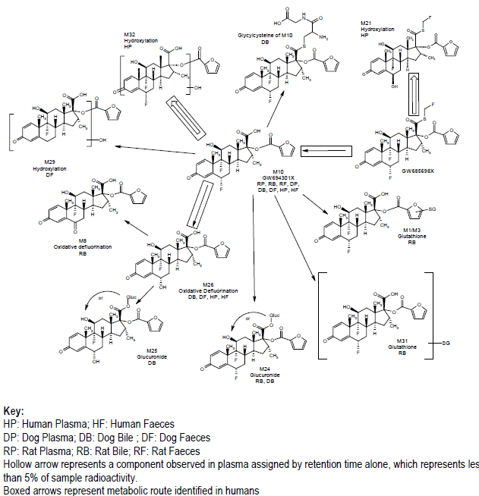
The principal route of metabolism was via hydrolysis of the S-fluoromethyl carbothioate group to form GW694301X (M10). Hydrolysis of the S-fluoromethyl carbothioate group was also a major metabolic pathway in vivo in mouse, rat and dog (the species used for toxicology testing). Two other minor drug-related components were assigned in the human faecal extracts which were formed as a result of either defluorination and hydroxylation (M26) or by hydroxylation of GW694301X(M32). Identification of other drug-related material present in human faeces was not practically possible due to the low chemical mass present in the samples.
The principal radiolabelled component in human plasma following intravenous (¹⁴C) FF administration was unchanged FF with GW694301X (M10) a minor component. Following oral administration unchanged FF and GW694301X (M10) were both minor components in plasma.
Three minor metabolites (M21, M26 and M32), representing <3% of drug-related material, were characterised in human plasma by chromatography comparisons. Due to the low circulating levels none of these metabolites have been tested for pharmacological activity.

Vilanterol
Study B2C106181 examined the metabolism of VI following oral administration of [¹⁴C] VI to 6 healthy male subjects and the metabolic profiles were reported in a separate study. The important metabolites of VI in animals and human are summarised in Figure 2.
Figure 2. Putative metabolic scheme for the important metabolites of vilanterol if animals and man.
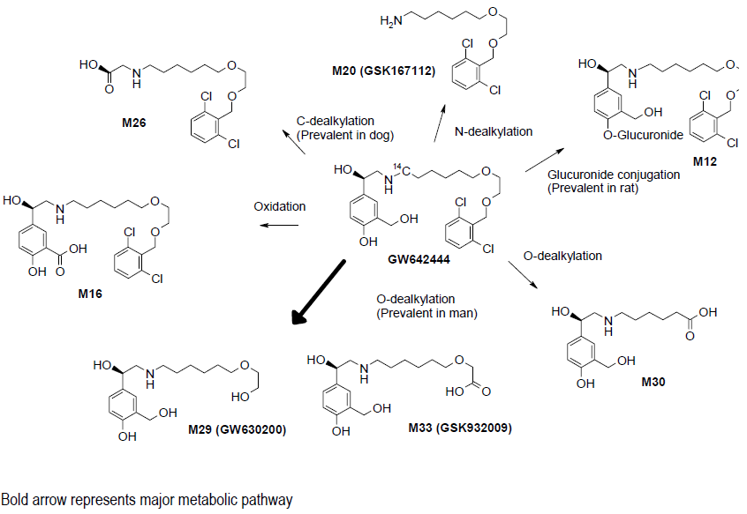
The main route of metabolism of VI was by O-dealkylation to a range of metabolites with significantly reduced β1- and β2-agonist activity that included GW630200 and GSK932009. Up to 78% of the recovered dose (in all excreta) was potentially associated with O-dealkylated metabolites which is consistent with the human in vitro metabolism of VI. N-dealkylation (to M20) and C-dealkylation (to M26) were minor pathways in human representing a combined 5% of the recovered dose. O-, N- and C-dealkylation were also routes of metabolism in the rat and dog which were species used for toxicology testing of VI. Unchanged VI in human faeces (5% of the recovered oral radioactive dose) represented either unabsorbed dose or absorbed but unchanged VI (or conjugate) secreted directly into the GI tract or via human bile. Duodenal bile collected using the exploratory EnteroTest device technique contained low levels of radioactivity.
Human plasma metabolites were also mainly the products of O- or C- dealkylation to a similar range of metabolites seen in human urine and in vitro incubations. The largest radioactive chromatographic peaks in human plasma were assigned as GW630200, M26 and a multi-component peak (containing GSK932009 and other O-dealkylated metabolites). GSK932009 and GW630200 were also detected by non-quantitative HPLC-MS (albeit at low concentrations) in human plasma following repeated inhaled administration to healthy.

Active metabolites

FF
GW694301X (M10) has been shown to have negligible pharmacological activity (at least 6000 fold lower) compared with parent FF and could not be detected (LLQ of 20 pg/mL) in plasma following inhaled FF administration to humans at doses up 4 mg (FFA10001).

VI
None of the VI metabolites are considered to be clinically relevant as both GW630200 and GSK932009 have been synthesised, tested and shown to have negligible pharmacological activity against both β1 and β2 receptors.
In addition, following oral administration of [¹⁴C] VI (200 µg) in study B2C106181 plasma concentrations of VI metabolites are likely to be considerably greater than plasma concentrations of metabolites produced after administration of the therapeutic inhaled VI dose (25 µg) and even in the presence of these higher metabolite levels, there were no changes in measured vital signs or heart rate which is indicative of a lack of metabolite beta-adrenoceptor activity.
Lastly, in human liver microsome incubations with VI, β2-activity diminished with time in proportion with the loss of VI by metabolism indicating that the β2 activity is due to the presence of parent VI.

Other metabolites
Not applicable.

Pharmacokinetics of metabolites

Healthy subjects
Study B2C10001 examined the PKs of VI and its counter-ion, α-phenylcinnamic acid following a range of single inhaled doses in 20 healthy subjects. Both VI and α-phenylcinnamic acid were quantifiable in plasma of all subjects at doses ≥ 50 µg VI following inhalation of VI peak plasma concentrations of VI were observed at the first sampling time (5 minutes post dose). Thereafter, plasma concentrations declined rapidly and were generally below the LLQ (30 pg/mL) beyond 6 h post dose. α-phenylcinnamic was first quantified in plasma 5 to 20 minutes post dose, rising to maximum observed values 0.3 to 2.0 h post dose. Exposure (C_{max} and AUC_{(0-t)}) to both VI and α-phenylcinnamic acid increased with dose. Concentrations of the counter-ion, α-phenylcinnamic acid, were approximately 35 to 45-fold higher than active compound, VI.

Target population
Study B2C104604 examined the PKs of the VI counter-ion; triphenylacetate following 100 and 200 µg doses of VIM in persistent asthmatics. Following a 100 µg dose of VIM the AUC_{(0-t)} of the counter-ion could not be calculated and the C_{max} and T_{max} were 1.19 pg/mL and 0.15 h, respectively. Following the 200 µg dose of VIM the AUC, C_{max} and T_{max} of the counter-ion were 0.426 pg.h/mL, 1.64 pg/mL and 0.14 h.
A second study in asthmatic subjects (Study B2C106996) identified that following administration of VIM 100 µg, the geometric mean C_{max} of GI179710 was 1.15 ng/mL and the median of Tmax and Tlast were 0.08 h and 0.25 h, respectively. The geometric mean of AUC_{(0-t)} was 0.29 ng.h/mL. Plasma concentrations of the metabolites, GW630200 and GSK932009, following VIM (25, 50 and 100 µg) and VIH 100 µg treatments were all non-quantifiable.
Similar results were identified in Study B2C110165 which examined PKs of VIM in patients with COPD. Following administration of VIM 25 µg, GI179710 was non-quantifiable in all subjects and only 4/19 profiles had quantifiable GI179710 concentrations (n=1 to 2) following 50 µg VIM (concentration range from non-quantifiable to 1.35 ng/mL) and AUC_{(0–t)} could not be calculated. Following VIM 100 µg, the C_{max}, T_{max} and T_{last} for GI179710 was 1.8 ng/mL, 0.17 h and 0.20 h, respectively. Plasma concentrations of the VI metabolites, GW630200 and GSK932009, following VIM (25, 50 and 100 µg) and VIH 100 µg treatments were all non-quantifiable.

Consequences of genetic polymorphism
Not investigated.

Excretion
In Study HZA102934, the t_{1/2,} (geometric mean [CV%]) following a single inhaled dose of FF/VI (800/100 µg) in healthy subjects was 23.7 (22.6%) h and 2.47 (84.0%) h for FF and VI, respectively.

Routes and mechanisms of excretion
FF metabolites were excreted almost exclusively in faeces with little urinary recovery of radioactivity, that is, < 2%, following both IV and oral administration; therefore no further urinary analysis was undertaken (Study FFR10008).
For VI the metabolites were principally excreted in urine (70% of the recovered radioactive dose, respectively) with smaller component excreted via faeces (30%).
Comment: Given the route of administration why did the studies on clearance not examine the respiratory route as a potential mechanism for FF/VI clearance?

Mass balance studies

FF
Following oral and intravenous administration of [¹⁴C] FF to healthy male subjects total radioactivity excreted was on average approximately 101% and 90% of the administered dose by 168 and 264 h post dose, respectively (Study FFR10008).

VI
Only 72% of the administered radioactive dose of VI was recovered in urine and faeces over 7 days post dose; however the elimination of VI drug-related material was essentially complete within 120 h of dosing with less than 0.2% of the administered oral radioactive dose being recovered in the 120 to 144 h and 144 to 168 h urine and faecal post dose collections (Study B2C106181).

Renal clearance
See Pharmacokinetics (in other special population/according to other population characteristic) of this report.

Intra- and inter-individual variability of pharmacokinetics
Two Phase IIb studies (Study FFA109684 and Study FFA109685) examined inter-subject variability following inhaled doses of FF administered once daily in adolescent and adult subjects 12 years of age and older with persistent asthma symptomatic on low to moderate dose ICS therapy. In these studies there was moderate inter-subject variability in the absorption rate constant of FF (ranging from 30% to 36%), population clearance had a between-subject of variability of (48% to 64%) and the volume of distribution had high between-subject variability (132% to 245%).
In Study B2C106180 population PK modelling of the data indicated that the inter-subject variability on clearance following IV and oral doses of VI in healthy subjects was 15.6% and 32%, respectively.

Pharmacokinetics in the target population

Single-dose
Study B2C104604 examined the PKs of VI following single inhaled doses of VIM (25, 100 and 400 µg) in persistent asthmatic subjects. VI was rapidly absorbed into plasma following a single inhaled administration of VIM. Exposure to VI increased with VIM dose. C_{max} increased approximately dose proportionally from VIM 25 µg to 200 µg. The AUC_{(0-t)}, C_{max} and T_{max} following a 25 µg dose in persistent asthmatics were 48.2 pg.h/mL, 68.8 pg/mL and 0.195 h, respectively.
A second study examined the PKs of VIM in persistent asthmatics (Study B2C106996) also identified that VIM was rapidly absorbed into plasma and systemic exposure to VI increased in an approximately dose proportional manner across the dose range of VIM 25 to 100 µg.
Study B2C110165 examined the PKs of VI following single doses of VIM (25, 50 and 100 µg) in chronic obstructive pulmonary disease (COPD) patients. In this study the Cmax and AUC₍₀₋₁₎ for the three doses of VIM ranged from 78.2 to 260 pg/mL and 58 to 196 pg.h/mL, respectively. VIM AUC_{(0–1)} and C_{max} appear to be approximately dose proportional across the 25 to 100 µg dose range.

Pharmacokinetics in other special populations

Pharmacokinetics in subjects with impaired hepatic function
Study HZA111789 investigated the effect of varying degrees of hepatic impairment on the PKs of FF and VI following repeat administration of FF/VI. Healthy subjects and subjects with mild or moderate hepatic impairment received FF/VI 200/25 whereas subjects with severe hepatic impairment received FF/VI 100/12.5. On Day 7 mild, moderate and severe hepatic impairment increased the AUC_{(0 to 24)} of FF by 1.34, 1.83 and 1.75 fold, respectively, compared to healthy subjects and increased the C_{max} of FF on Day 7 by 1.18, 1.43 and 1.37 fold, respectively.
For VI, the AUC_{(0 to 24)} on Day 7 was decreased by 34% and 28% in patients with mild and severe hepatic impairment compared to healthy subjects, respectively, and increased AUC_{(0 to 24)} by 33% in patients with moderate hepatic impairment compared to healthy subjects.
Comment: It is not clear why the investigators have used non-inferiority as measure of PK differences in this study and in the following study on renal impairment.

Pharmacokinetics in subjects with impaired renal function
Study HZA113970 investigated the effect of severe renal impairment on the PKs of FF and VI following repeat administration of FF/VI (200/25 µg) via NDPI. For FF, the AUC_{(0 to 24)} on Day 7 was lower (9%) in patients with severe renal impairment compared to healthy subjects and the C_{max} of FF on Day 7 was 4% lower. In healthy subjects, observed accumulation of FF was on average 86% and 97% for AUC and C_{max}, respectively, for repeated dosing compared with single dose administration. Similar extent of accumulation was seen for subjects with severe renal impairment, with values of on average 123% and 105% for AUC and C_{max}, respectively, for repeated dosing compared with single dose administration. For VI, the AUC_{(0 to 24)} on Day 7 was higher (1.56 fold; 90% CI 1.27 to 1.92) in patients with severe renal impairment compared to healthy subjects and the C_{max} of IV on Day 7 was 1.08 fold higher. For VI in healthy subjects, observed accumulation was on average 84% and 42% for AUC and C_{max}, respectively, for repeated dosing compared with single dose administration. Similar extent of accumulation was seen for subjects with severe renal impairment: on average 75% and 30% for AUC and C_{max}, respectively, for repeated dosing compared with single dose administration.

Pharmacokinetics according to age
Studies HZA112776 and HZA102942 examined in PKs of VI 25 µg and FF 100 µg, respectively, following once daily treatment for 7 to 14 days in subjects aged 5 to 11 years with persistent asthma. The AUC_{(0-t)} for VI following 7 days treatment in the paediatric population was 132.8 pg.h/mL and the C_{max} was 97.4 pg/mL. For FF, following 14 days treatment, the AUC_{(0-t)} in the paediatric population was 91.3 pg.h/mL and the C_{max} was 24.7 pg/mL.
Comment: No adults were included in this study for comparing PKs in adolescents versus adults. Furthermore, there are no dedicated PK Phase I studies in the present evaluation materials which identify the PKs of VI and FF following 7 and 14 days dosing via Novel Dry Powder Inhaler (NDPI) in adult persistent asthmatics, which would allow for comparison with these paediatric values.

Pharmacokinetics related to genetic factors
Not studied.

Pharmacokinetics (in other special population/according to other population characteristic)

Race
Studies DB1112017 and HZA112018 investigate the PKs of VI and FF, respectively, following once daily repeat inhaled doses in healthy Japanese male subjects. A further two studies (Studies DB1112146 and DB2113208) examined the PKs of two novel muscarinic receptor antagonists in combination with 50 µg VI in Japanese subjects, whereas, Study HZA102940 investigated the PKs of FF (800 µg) and VIM (50 µg) when delivered individually and in combination as a single dose in healthy Japanese subjects. In this study, based on AUC_{(0–t’)}, the ratio of the adjusted geometric means and corresponding 90% confidence intervals showed no clear evidence of a difference in FF AUC when delivered as FF/VIM combination compared with FF alone, whereas the FF C_{max} was approximately 19% lower when delivered as the FF/VIM combination compared with FF alone.
For VI AUC_{(0-t’)} the ratio of the adjusted geometric means and corresponding 90% CI indicated that the AUC was 12% higher when the FF/VIM combination was given compared with VIM alone, whereas the C_{max} of VI was similar regardless of treatment given.
Study HZA113477 evaluated the PKs of inhaled FF (200 µg and 800 µg) administered for 7 days and when given IV (IV; FF 250 µg) in healthy Japanese, Korean and Chinese subjects compared with PKs in healthy Caucasian subjects. Following 7 days treatment with 200 µg FF the ratio for the adjusted geometric mean of C_{max} for Chinese, Japanese, Korean subjects compared to Caucasian subjects was 1.64, 1.37 and 1.78, respectively. For FF AUC_{(0 to 24)} the corresponding ratios were 1.49, 1.27 and 1.44, respectively. For the 800 µg treatment on both Day 1 and Day 8 there was evidence for higher bioavailability in the three Asian groups compared with the Caucasian group with absolute bioavailability ranging from 36% to 55% higher in the Asian populations on Day 8, compared with Caucasian subjects. This was in part explained by the longer retention time of FF in the lungs of the Asian compared to Caucasian subjects, which would allow for longer exposure to active drug.

Pharmacokinetic interactions

Pharmacokinetic interactions demonstrated in human studies

Ketoconazole - a strong CYP3A4 inhibitor
Study HZA105548 examined the effects of ketoconazole 400 mg on the repeat-dose PKs of FF/VI (200/25 µg) in healthy subjects. Repeat dose co-administration of FF/VI with ketoconazole in comparison with FF/VI with placebo resulted in greater FF exposure. Mean FF AUC_{(0 to 24)} and C_{max} were increased by 36% (90% CI: 16% to 59%) and 33% (90% CI:12% to 58%), respectively. Mean VI AUC_{(0-t’)} and C_{max} were increased by 65% (90% CI: 38% to 97%) and 22% (90% CI: 8% to 38%), respectively.
A second study (Study B2C112205) examined whether co-administration of repeat dose ketoconazole (400 mg) with single dose inhaled VIM (25 µg) affected the single dose systemic PKs of VI in healthy subjects. While there was no treatment effect of ketoconazole co-administration on the VI C_{max} the AUC_{(0–t)} of VI was higher (on average 1.9 fold).

Verapamil -a moderate inhibitor of CYP3A4
Study DB2113950 assessed the effects of verapamil 240 mg once daily on the steady-state PKs of inhaled GSK573719 and inhaled GSK573719 in combination with inhaled VI in healthy subjects. There was no evidence of a difference in VI C_{max} and AUC when delivered as GSK573719/VI and verapamil combination compared with GSK573719/VI, thereby suggesting no difference in VI systemic exposure. However it should be noted that this study did not directly examine the effects of verapamil on VI PKs when given in the absence of GSK573719 and therefore it is difficult to assess the direct effects of verapamil on VI PKs in this study.
Comments: No drug-drug interaction studies for both FF and VI have been conducted with a short-acting beta 2-agonist such as salbutamol, which would be used as a rescue medication in the event of an acute asthma attack.

Clinical implications of in vitro findings
Based on in vitro data, the major routes of metabolism of both FF and VI in human are mediated primarily by CYP3A4, indicating that CYP3A4 substrates and inhibitors may affect the metabolism of both FF and VI.

Population PK
Studies 2011N130718_00, 2011N122282_00 and 2011N130480_00 represented PPK analyses in healthy subjects and subjects with COPD and asthma respectively. These studies demonstrated in all three study populations that the plasma FF concentration-time profile following FF/VI could be described by a two-compartment model with first order absorption and first order elimination, whereas, the plasma VI concentration-time profile following FF/VI could be well described by a three-compartment model with zero-order absorption and first order elimination. Following FF/VI 200/25 administration to healthy subjects the population prediction for FF C_{max} was 38.1 pg/mL and FF AUC₀₋₂₄ was 534.4 pg.h/mL and for VI C_{max} was 130.5 pg/mL and VI AUC₀₋₂₄ was 213.9 pg.h/mL and no covariates other than Study and treatment were identified.
In the COPD population, race was a significant covariate of FF CL/F and the predicted C_{max} and AUC₀₋₂₄ of FF following a dose of 100 µg in patients with COPD was 11.7 pg/mL and 181.8 pg.h/mL. For VI in patients with COPD, meta-analysis identified a decrease (27%) in CL/F over the observed age range for subjects with COPD (41 to 84 years) and a reduction (47%) in inhaled clearance was also predicted over the bodyweight range of 160 to 35 kg. The central volume (V1/F) was found to decrease (30%) with increasing age (41-84 years), to be lower (12%) in females and to be increased with smoking. The predicted C_{max} and AUC₀₋₂₄ of IV following a dose of 25 µg in patients with COPD across all studies was 43.2 pg/mL and 265.7 pg.h/mL.
In the asthma population, the only covariate found to be significant on the CL/F of FF was race. Estimates of FF AUC₀₋₂₄ for East Asian, Japanese and South Asian subjects were on average 33% to 53% higher compared with subjects of non-Asian heritage. However, the higher systemic exposure identified in the subjects of Asian descent, compared with subjects of non-Asian heritage, was not associated with greater systemic effects on 24 hour urinary cortisol excretion. Comparison of the model predicted systemic FF exposure showed no notable difference between FF/VI or FF treatment. Systemic FF exposure increased in proportion to dose for both FF/VI and FF. For VI in the asthma population, the following covariates were found to be significant: study (HZA106851) on inhaled clearance (CL/F) and the volume of the central compartment (V1/F) and race (East Asian, Japanese and South Asian) on V1/F. However, there is no evidence that this higher VI C_{max} results in an effect on observed heart rate (change from baseline) immediately post-dose (studies HA106827, HZA106829 and HZA106839). In addition, there were no notable differences between adults (≥18 years) and adolescents (11-17 years) in the estimates of AUC₀₋₂₄ or C_{max} for both FF and VI.

Evaluator’s overall conclusions on pharmacokinetics
The clinical development program for FF/VI was designed to comply with the relevant CHMP and FDA guidelines.

Absorption
The mean absorption time of FF was 10.53 h and for VI it was 0.66 h. Following inhalation FF was retained in the lung for longer than VI and the time for 90% of the total to be absorbed from the lung on average was 35.2 h and 3.83 h, respectively.

Distribution
In vitro plasma protein binding in human plasma of FF was very high with an average value of > 99.6% at the lowest concentrations investigated and was predominantly bound to albumin (96%) and α1-acid glycoprotein (90%). For VI, the in vitro plasma protein binding in human plasma was moderately high with an average value of 93.9% and both plasma protein binding and blood cell binding for VI were independent of concentration. The intravenous PK of FF and VI showed high plasma clearance (on average 65.4 L/h and 108 L/h, respectively). Blood cell binding for FF was independent of concentration and the blood cell association was low with a blood-to-plasma ratio of 0.6 for humans. Blood cell association was also low for VI with a blood-to-plasma ratio of 0.8 for humans.

Metabolism
Both FF and VI were primarily eliminated through hepatic metabolism via CYP3A4. The principal route of metabolism for FF was via hydrolysis of the S-fluoromethyl carbothioate group to form GW694301X (M10). Hydrolysis of the S-fluoromethyl carbothioate group was also a major metabolic pathway in vivo in mouse, rat and dog. The main route of metabolism of VI was by O-dealkylation to a range of metabolites. The metabolites of both FF and VI are thought to have negligible pharmacological activity.

Excretion
The t_{1/2,} (geometric mean [CV%]) following a single inhaled dose of FF/VI (800/100 µg) in healthy subjects was 23.7 (22.6%) h and 2.47 (84.0%) h for FF and VI, respectively.
FF metabolites were excreted almost exclusively in faeces following both IV and oral administration. For VI the metabolites were principally excreted in urine (70% of the recovered dose) with smaller component excreted via faeces (30%). Following oral and intravenous administration of [¹⁴C] FF to healthy male subjects, total radioactivity excreted was on average approximately 101% and 90% of the administered dose by 168 and 264 h post dose, respectively. Only 72% of the administered radioactive dose of VI was recovered in urine and faeces over 7 days post dose.

Bioavailability
Following administration of a single inhaled dose of FF/VI (800/100 µg), the average absolute bioavailability of FF relative to IV FF 250 µg was 15% (90% CI: 13–18%) and the average absolute bioavailability of VI was 27% (90% CI: 22–35%).

Bioequivalence
In healthy subjects, the AUC and C_{max} of FF were significantly lower, 15% and 17%, respectively, following administration, via the NDPI, of the FF/VIM 800 µg/100 µg combination compared to when FF was administered alone. By contrast for VIM, the AUC_{(0–t’)} and C_{max} showed no clear evidence of a difference in VIM systemic exposure when delivered via the NDPI as the FF/VIM combination compared with VIM alone. Overall, however, the difference in FF PK is unlikely to be clinically relevant and the PKs of FF and VI were not affected when administered in combination compared to when they were administered as individual components.
The sponsor states that "at the clinical dose (≤ 200/25 µg once a day) no clinically relevant effect of food would be expected and therefore a food interaction study was not conducted."
The C_{max} of FF occurred at later times as the FF dose increased and the AUC and C_{max} of FF increased with increasing dose. AUC_{(0–t’)}, was dose proportional, while C_{max} increased in a less than proportional manner over the 200 µg to 800 µg dose range. It should be noted that the proposed doses in the commercial combination product contains either 100 or 200 µg FF.
In healthy subjects, the C_{max} of VI increased approximately dose proportionally across the dose range 25 µg to 100 µg. It should be noted that only the 25 µg dose of VI is included in the combination product proposed for commercialisation.
Dose proportionality was not establish over a wide range of doses, in particular proportionality studies did not include 100 µg FF or doses of <25 µg VI.
Both FF and VI were extensively distributed with average Vss of 661 L and 165 L, respectively, which is greater than the total body water for a 70 kg man (42 L).

Target population
In persistent asthmatic subjects VI was rapidly absorbed into plasma following a single inhaled administration of VIM. Exposure to VI increased with VIM dose. C_{max} increased approximately dose proportionally from VIM doses of 25 µg to 200 µg. The AUC_{(0-t)}, C_{max} and T_{max} following a 25 µg dose in persistent asthmatics were 48.2 pg.h/mL, 68.8 pg/mL and 0.195 h, respectively.
In COPD patients VIM AUC_{(0–1)} and C_{max} appear to be approximately dose proportional across the dose range of 25 to 100 µg
Following 7 days treatment with FF 200 µg/VI 25 in subjects with mild, moderate and severe hepatic impairment the AUC_{(0 to 24)} of FF was 1.34, 1.83 and 1.75 fold higher, respectively, than in healthy subjects and the C_{max} of FF was 1.18, 1.43 and 1.37 fold higher, respectively. For VI, the AUC_{(0 to 24)} was decreased by 34% and 28% in patients with mild and severe hepatic impairment compared to healthy subjects, respectively, and increased AUC_{(0 to 24)} by 33% in patients with moderate hepatic impairment compared to healthy subjects.

Special populations
Following seven days treatment with inhaled FF/VI (200/25 µg) the AUC_{(0 to 24)} of FF was significantly lower (9%) in patients with severe renal impairment compared to healthy subjects and the C_{max} of FF was 4% lower. However, these impairment-related changes in FF PK are unlikely to be clinically relevant. For VI, the AUC_{(0 to 24)} was significantly higher (1.56-fold) in patients with severe renal impairment compared to healthy subjects and the C_{max} was 1.08-fold higher. It should be noted that the effects of haemodialysis were not investigated.
Following 7 days treatment with 25 µg VI in a paediatric population the AUC_{(0-t)} for VI was 132.8 pg.h/mL and the C_{max} was 97.4 pg/mL. For FF (100 µg), following 14 days treatment, the AUC_{(0-t)} in the paediatric population was 91.3 pg.h/mL and the C_{max} was 24.7 pg/mL.
No direct PK comparison was made between the paediatric populations and an adult population.
In healthy Japanese subjects treated with FF/VIM (800 µg/50 µg) in combination and as single doses the ratio of the adjusted geometric means for AUC_{(0–t’)} showed no clear evidence of a difference in FF AUC when delivered as FF/VIM combination compared with FF alone, whereas the FF C_{max} was approximately 19% lower when delivered as the FF/VIM combination compared with FF alone. For VI AUC_{(0-t’)} the ratio of the adjusted geometric means indicated that the AUC was 12% higher when the FF/VIM combination was given compared with VIM alone, whereas the C_{max} of VI was similar regardless of treatment given.
Following 7 days treatment with 200 µg FF the ratio for the adjusted geometric mean of C_{max} for Chinese, Japanese, Korean subjects compared to Caucasian subjects was 1.64, 1.37 and 1.78, respectively and the corresponding ratios for FF AUC_{(0 to 24)} were 1.49, 1.27 and 1.44, respectively.

Drug-drug interaction
Co-administration of FF/VI with ketoconazole resulted in clinically relevant increases in FF/VI exposure, therefore, FF/VI should not be administered with strong CYP3A4 inhibitors.
It is not clear whether the moderate CYP3A4 inhibitor verapamil affects the PKs of VI.

Population PK
PPK analyses in healthy subjects and the target population identified that the plasma FF concentration-time profile following FF/VI could be described by a two-compartment model with first order absorption and first order elimination, whereas, the plasma VI concentration-time profile following FF/VI could be well described by a three-compartment model with zero-order absorption and first order elimination.
In both the COPD and asthma populations, race was found to be a significant covariate on the CL/F of FF.
In the COPD population, meta-analysis identified decreases in VI CL/F over the observed age range (41 to 84 years) and over the bodyweight range of 160 to 35 kg. The central volume of VI was found to decrease (30%) with increasing age (41-84 years), to be lower (12%) in females and to be increased with smoking.
For VI in the asthma population, the following covariates were found to be significant: study on CL/F and the volume of the V1/F and race on V1/F. In addition, there were no notable differences in C_{max} and AUC between adults (≥18 years) and adolescents (11-17 years) for either FF or VI.

Pharmacodynamics

Studies providing pharmacodynamic data
Table 2 (below) shows the studies relating to each pharmacodynamic topic.
Table 2. Submitted pharmacodynamic studies.
PD Topic | Subtopic | Study ID | *
Primary Pharmacology  Healthy Subjects | Bronchodilation | B2C10001 | PD of VI
Primary Pharmacology  Healthy Subjects | Bronchodilation | DB1111509 | PD effects of GSK233705 (200µg) and VI (50µg) administered as single doses and in combination.
Primary Pharmacology  Healthy Subjects | Topical corticosteroid activity | ODS10004 | Effect of FF on skin blanching
Primary Pharmacology  Healthy Subjects | Topical corticosteroid activity | SIG102337 | Effect of FF on skin blanching
Primary Pharmacology  Healthy Subjects | Topical corticosteroid activity | BGS104270 | Effect of FF on skin blanching
Target population | Bronchoprotection | HZA113090 | Bronchoprotective effect of repeat inhaled doses of FF/VI combination and FF on EAR to inhaled allergen mild asthmatics
Target population | Bronchoprotection | HZA113126 | Bronchoprotective effect of repeat inhaled doses of FF/VI combination and FF or VI on EAR and LAR to inhaled allergen mild asthmatics
 | Time of dosing | HZA114624 | Time of dosing (AM or PM) on FEV1 following repeat dose FF/VI in patients with persistent bronchial asthma
 | Bronchodilation in asthmatics | B2C104604 | Effect of VI on FEV1 and PEF
 | Bronchodilation in asthmatics | B2C106996 | Effect of VI on FEV1
 | Bronchodilation in subjects with COPD | B2C110165 | Effect of VI on FEV1
 | Alt Form^{n} | B2C101762 | Effect of single dose VIH on FEV1
 | Alt Form^{n} | B2C106093 | Effect of repeat dose VIH on FEV1
 | Alt Form^{n} | B2C111401 | Comparison of VIM/lactose and VIM/MgSt
 | Alt Form^{n} | HZA108799 | FF containing magnesium stearate on serum cortisol
 | Alt Form^{n} | B2C108562 | PD profile of VIH in subjects with moderate COPD
Secondary Pharmacology  Healthy Subjects | Serum cortisol | HZA105871 | Effects of the FF/VIM in combination compared with the individual components
Secondary Pharmacology  Healthy Subjects | Serum cortisol | 102928 | Effects of 14 days repeat dosing with FF (400-800µg once-daily).
Secondary Pharmacology  Healthy Subjects | Effect on QTcF | B2C108784 | The extra-pulmonary PD effects of VIM (50-400µg)
Secondary Pharmacology  Healthy Subjects | Effect on QTcF | HZA102936 | The extra-pulmonary PD effects of FF/VIM 200/25µg
Effect of intrinsic factors on PD Response | Effect of gender | No studies
Effect of intrinsic factors on PD Response | Effect of hepatic impairment | HZA111789 | Hepatic impairment on serum cortisol suppression
Effect of intrinsic factors on PD Response | Effect of renal impairment | HZA113970 | Severe renal impairment on cortisol suppression
Effect of intrinsic factors on PD Response | Race
Effect of intrinsic factors on PD Response | Japanese subjects | DB1112017 | Systemic β-AR effect following once daily repeat doses of VIM.
Effect of intrinsic factors on PD Response | Japanese subjects | HZA112018 | Serum cortisol following single and repeat doses of FF (200-800µg).
Effect of intrinsic factors on PD Response | Japanese subjects | DB1112146 | PD effects of GSK233705 200µg and VI 50µg
Effect of intrinsic factors on PD Response | Japanese subjects | DB2113208 | PD effect of GSK573719 500µg and VI50 µg
Effect of intrinsic factors on PD Response | Japanese subjects | HZA102940 | Systemic β-AR effects of VIM individually and in combination with GW685698X
Effect of intrinsic factors on PD Response | Caucasian, Japanese, Korean and Chinese | HZA113477 | Effects on serum cortisol following repeat dose inhaled FF (200µg)
 | Effect of age -paediatric pop^{n} | HZA112776 | Repeat-dose VI (25µg) PD
 | Effect of age -paediatric pop^{n} | HZA102942 | Effect on serum cortisol following repeat-dose FF (100µg)
PD Interactions | Ketoconazole | HZA105548 | Effect of ketoconazole on PD of repeat-dose FF/VI (200/25µg)
PD Interactions | Ketoconazole | B2C112205 | Effect of ketoconazole on PD of repeat-dose VI (25µg)
PD Interactions | Verapamil | DB2113950 | Effect of verapamil on inhaled GSK573719 and VI in healthy subjects
Population PD and PK-PD analyses | Healthy subjects | Studies2011N130718_00
Population PD and PK-PD analyses | Target population | COPD 2011N122282_00 Asthma 2011N130480_00
*Indicates the primary aim of the study. § Subjects who would be eligible to receive the drug if approved for the proposed indication. ‡ And adolescents if applicable. No studies - indicates that no dedicated studies specifically examined this subtopic.
None of the pharmacodynamic studies had deficiencies that excluded their results from consideration.

Summary of pharmacodynamics
The information in the following summary is derived from conventional pharmacodynamic studies in humans unless otherwise stated.

Mechanism of action

FF
Fluticasone furoate is a synthetic trifluorinated corticosteroid with potent anti-inflammatory activity. The precise mechanism through which fluticasone furoate affects asthma and COPD symptoms is not known. Corticosteroids have been shown to have a wide range of actions on multiple cell types (for example, eosinophils, macrophages, lymphocytes) and mediators (for example, cytokines and chemokines involved in inflammation).

VI
Vilanterol trifenatate is a selective long-acting, beta2-adrenergic agonist (LABA). The pharmacologic effects of beta2-adrenoceptor agonist drugs, including vilanterol trifenatate, are at least in part attributable to stimulation of intracellular adenylate cyclase, the enzyme that catalyses the conversion of adenosine triphosphate (ATP) to cyclic-3’,5’-adenosine monophosphate (cyclic AMP). Increased cyclic AMP levels cause relaxation of bronchial smooth muscle and inhibition of release of mediators of immediate hypersensitivity from cells, especially from mast cells.

Synergy between FF and VI
Steroids activate beta2-receptor gene transcription, resulting in increased beta2-receptor numbers and sensitivity to agonists; moreover LABAs prime the glucocorticoid receptor for steroid-dependent activation and enhance cell nuclear translocation. These synergistic interactions are reflected in enhanced anti-inflammatory activity, which has been demonstrated in vitro and in vivo in a range of inflammatory cells relevant to the pathophysiology of both asthma and COPD. Airway biopsy studies have also shown the synergy between corticosteroids and LABAs to occur at clinical doses of the drugs in patients with COPD.

Pharmacodynamic effects

Primary pharmacodynamic effects

Healthy subjects

Bronchodilation
Study B2C10001 examined bronchodilation following administration of placebo or VI, over the dose range of 12.5 µg to 600 µg in healthy subjects. At 24 h post dose there was a statistically significant difference between placebo and VI 50, 100, 200, 400 and 600 µg on specific airway conductance (sGaw) values, suggesting that these doses of the drug significantly increased bronchodilation compared with placebo.

Assessment of topical corticosteroid activity (Skin Blanching)
Three studies (ODS10004, SIG102337 and BGS104270) examined the topical corticosteroid activity of FF applied to the skin compared to other novel corticosteroids by assessing blanching as a marker for the propensity of corticosteroids to cause local vasoconstriction in healthy subjects. The maximum doses of FF examined in these studies ranged from 40 ng to 1 µg, which are 100,000 and 100 times lower, respectively than the recommended inhaled dose of 100 µg FF. Dose related increases in skin blanching (17 to 48 h weighted mean) were produced by topical FF (40, 200 and 1000 ng) (SIG102337). The skin blanching produced by FF 40 ng persisted for up to 24 h compared with placebo (BGS104270) and occurred with a slower onset of action than FP (ODS10004).

Target population

Bronchoprotection
The bronchoprotective effect of FF/VI against allergen challenge in subjects with asthma was assessed compared to FF in Study HZA113090 and compared to FF and VI in Study HZA113126.
Study HZA113090 evaluated the bronchoprotective effect of treatment with repeat inhaled doses of FF/VI combination (100/25 µg) and FF 100 µg on the early asthmatic response (EAR) to inhaled allergen at 22 23 h post dose in 52 subjects with mild asthma compared with placebo. Following 28 days of treatment with FF/VI (100/25 µg) once daily, the weighted mean reduction from baseline in FEV1 (0 to 2 h) following allergen challenge was 145 mL smaller than following 28 days of placebo treatment. Similarly, a 162 mL smaller reduction in weighted mean FEV1 was seen for FF 100 µg compared with placebo. There was no evidence of a treatment difference in protection of lung function between FF/VI (100/25 µg) and FF 100 µg for any of the derived FEV1 endpoints after allergen challenge suggesting that the effect of FF/VI on the EAR was predominantly due to the FF component.
The maximum decrease in baseline (post saline) FEV1 was 25% after placebo and 13% and 14% after FF/VI (100/25 µg) and FF 100 µg, respectively. The treatment differences compared with placebo were similar for both FF/VI and FF. Whereas the minimum FEV1 (0 to 2 h) was 0.81 L lower than baseline (post saline) following allergen challenge after placebo treatment compared with 0.48 L following allergen challenge after both FF/VI and FF treatment. The treatment difference compared with placebo was the same for both FF/VI and FF (0.33 L). There was no evidence of a treatment difference between FF/VI (100/25 µg) and FF 100 µg for any of the derived FEV1 endpoints.
Study HZA113126 evaluated the bronchoprotective effect of treatment with repeat inhaled doses of inhaled FF/VI combination (100/25 µg), on both the EAR and late asthmatic response (LAR) to inhaled allergen at 1 h post dose in 22 subjects with mild asthma compared with placebo.
Adjusted mean changes from saline for minimum and weighted mean (WM) EAR were greater following FF/VI treatment. Average attenuations of 35.7% and 44.3% were seen for FF/VI treatment compared with VI for minimum and WM, respectively, whereas, for FF/VI against FF, average attenuations of 25.7% and 23.1% were seen for FF/VI treatment compared with FF for minimum and WM, respectively.
For LAR, there was a statistically significant effect (p<0.05) for combination therapy FF/VI compared with placebo as measured by both minimum and WM. Average attenuations of 70.5% and 103.8% were seen for FF/VI treatment compared with placebo for minimum and WM, respectively. Monotherapies FF and VI also showed statistically significant changes compared with placebo in both minimum and WM LAR.
In summary, the greatest effects on the EAR were seen with FF/VI compared with FF or VI alone. Whereas, both FF/VI and FF alone virtually abolished the LAR compared with VI alone which had a smaller effect. This suggests that the effect of FF/VI on the LAR was primarily due to the FF component.

Methacholine challenge
Study HZA113126 also assessed the effects of repeat dose FF/VI, FF and VI on allergen-induced bronchial hyper-reactivity following methacholine challenge 24 h after the last dose (that is, on Day 22). Reduced bronchial hyper-reactivity following administration of FF/VI was indicated by a statistically significant increase in the doubling doses of methacholine required to produce a 20% reduction in FEV1 compared with either placebo, FF alone or VI alone. In comparison with placebo, FF/VI and FF both showed evidence of reduced bronchial hyper-reactivity with significantly greater doses of methacholine required to produce a 20% fall in FEV1. VI alone did not have a significant effect on allergen-induced bronchial hyper-reactivity compared with placebo. However, a significant effect was seen when comparing FF/VI with FF alone indicating some contribution from VI when administered as the FF/VI combination. A significant effect was also seen when comparing FF/VI with VI alone indicating the contribution of FF when administered as the FF/VI combination.

Time of dosing
Study HZA114624 examined the effect of the time of dosing (morning [AM] or evening [PM]) on FEV1 following repeat dose FF/VI (100/25 µg) administered via NDPI in patients with persistent bronchial asthma.
Statistical analysis of FEV1 (L) weighted mean (Day 14; 0 to 24 h) demonstrated clinically significantly higher values for FF/VI (100/25 µg) after both AM and PM dosing compared with placebo, while values were similar for FF/VI (100/25 µg) AM and PM dosing. In comparison with placebo, the average weighted mean FEV1 was 0.377 L and 0.422 L greater with AM and PM dosing, respectively. The difference between AM and PM dosing was -0.044 L.
Both AM and PM pre-treatment FEV1 were clinically significantly higher for FF/VI (100/25 µg) AM and FF/VI 100/25 µg PM compared with placebo, while values were similar for FF/VI (100/25 µg) AM and PM dosing. In comparison with placebo, average AM pre-treatment FEV1 was 0.403 L and 0.496 L greater with AM and PM dosing, respectively. Average PM pre-treatment FEV1, in comparison with placebo, was 0.275 L and 0.309 L greater with AM and PM dosing, respectively. AM and PM pre-treatment FEV1 were both lower with AM dosing compared with PM dosing: for the AM pre-treatment FEV1 the difference was -0.094 L and for the PM pre-treatment FEV1 it was -0.034 L.
In addition, peak expiratory flow (PEF) was significantly higher following both AM and PM dosing with FF/VI over 1 to 14 days compared with placebo. The increases in PEF following FF/VI were rapid in onset (that is, the full effect appeared to be evident after the first dose) and were maintained throughout the 14 day treatment period (that is, with no sign of tachyphylaxis).
Moreover, both AM and PM dosing with FF/VI (100/25 µg) produced clinically significant increases in mean AM and PM pre-treatment PEF. AM and PM mean PEF were both lower with AM dosing compared with PM dosing: for the AM PEF the difference was -25.0 L/min and for the PM PEF it was -3.7 L/min.

FF AMP challenge
Three studies (FFA10022, FFA10026 and FFA10027) that formed part of the earlier AVAMYS submission examined the effects of inhaled FF on Adenosine 5’-monophosphate (AMP) induced bronchoconstriction in subjects with mild asthma. As these studies form part of a previous submission the following summaries are taken directly from the sponsor’s Summary of Clinical Pharmacology.
Single and repeat dose FF significantly reduced airway responsiveness to AMP (assessed two h post dose) compared with placebo as measured by provocative concentration of the stimulus required to achieve this degree of bronchoconstriction (PC20) (FFA10022). Administration of FF 250 µg (3 micron) for 6 days resulted in an increase in the AMP PC20 (doubling dose concentration (95%) CI difference from placebo) of 1.26 (0.46, 2.05). There was no significant difference in the effect on airway responsiveness between FF 150 µg (2 micron) and FF 250 µg (3 micron).
The duration of activity of single dose FF 250 µg administered 2, 14 or 26 h before AMP challenge was determined (FFA10027). FF 250 µg administered 2 or 14 h before AMP challenge significantly reduced airway hyper-responsiveness to AMP increasing the mean AMP doubling dose (95% CI) compared with placebo by 2.46 (1.70, 3.22) and 1.59 (0.83, 2.34), respectively. However, when FF 250 µg was administered 26 h prior to AMP challenge there was no statistically significant effect compared with placebo (0.23 [-0.53, 0.98]). FP 250 µg also significantly reduced hyper responsiveness to AMP at 2 and 14 h post dose (mean AMP doubling dose (95% CI) compared with placebo by 2.32 (1.57, 3.08) and 1.07 (0.30, 1.84), respectively). The difference between FF 250 µg and FP 250 µg at 14 h was not statistically significant. The FF 250 µg dose was considered to probably be too low to demonstrate an effect on airway responsiveness after 26 h when administered as a single dose and repeat dosing would probably be required to reduce airway hyper responsiveness to AMP at this dose level.
The duration of effect of FF on airway responsiveness was assessed by conducting the AMP challenge 2, 12 and 26 h after a single FF 1000 µg dose (FFA10026). The mean AMP PC20 doubling dose (95% CI) was increased by 2.18 (1.13, 3.23), 1.54 (0.48, 2.59) and 1.3 (0.26, 2.34), respectively. In comparison fluticasone propionate (FP) 1000 µg did not significantly reduce airway responsiveness to AMP compared with placebo when delivered 26 h prior to the challenge (mean AMP PC20 doubling dose [95% CI] was 0.33 [-0.69, 1.34]) compared with an increase of 1.72 (0.70, 2.75) when FP was administered 14 h before AMP challenge. These data were considered to indicate a greater duration of activity for FF compared with FP and to suggest that FF was a suitable candidate for development as a once daily inhaled corticosteroid.

Effect on exhaled nitrous oxide
Troµgh exhaled nitrous oxide (eNO) was recorded 24 h after repeat dosing with FF 75 µg and 150 µg (‘2 micron’) and FF 250 µg (‘3 micron’) for 5 days (that is, immediately before dosing on Day 6) (FFA10022). Repeat dose FF significantly reduced eNO by up to 48% with mean eNO (ppb) treatment ratios compared with placebo (95% CI) of 0.52 (0.40, 0.67), 0.67 (0.56, 0.80) and 0.67 (0.56, 0.80), respectively. The study also assessed the effects of repeat dose FP (500 µg BID), which reduced eNO compared with placebo with a treatment ratio of 0.78 (95% CI: 68, 1.01).
The effect of single and repeat dose FF (250 and 1000 µg once daily for 3 days) on eNO (0 to 24h weighted mean, minimum and trough; Day 1 and Day 3) was compared with FP 1000 µg (once daily for 3 days) and placebo (FFA10028). In comparison with placebo, there was no effect of single dose FF or FP on weighted mean or minimum eNO. Repeat dose (3 days) FF 250 µg and 1000 µg reduced both 0 to 24 h weighted mean eNO (ratio to placebo (95% CI): 0.65 (0.59, 0.72) and 0.60 (0.54, 0.65), respectively) as well as 0 to 24 h minimum eNO (ratio to placebo (95% CI): 0.65 (0.58, 0.72) and 0.58 (0.52, 0.64), respectively. In comparison, repeat dose FP 1000 µg weighted mean and minimum eNO 0 to 24 h; ratio to placebo (95% CI) were 0.71 (0.64, 0.78) and 0.68 (0.62, 0.76), respectively. There was some evidence that the duration of effect of FF 1000 µg on eNO was more prolonged compared with FP 1000 µg; at 24 and 72 h post Day 3 dose mean (SD) eNO was 35.9 ppb (20.6) and 24.7 ppb (14.7), respectively after FF 1000 µg and 47.2 ppb (29.8) and 48.7 ppb (33.7), respectively after FP 1000 µg (FFA10028).

Bronchodilation in asthmatics
Two studies (Study B2C104604 and Study B2C106996) examined the onset, duration and extent of bronchodilation following a single inhaled dose VIM (25, 100 and 400 µg) in persistent asthmatic subjects. The results indicated that all doses of VIM provided a rapid and sustained onset of bronchodilation as measured by FEV1. From 5 minutes post dose onwards there were notable increases in FEV1 for all active treatments compared with placebo (95% CIs excluded 0). Differences in adjusted means ranged from 0.184 L to 0.301 L for active treatments at 5 minutes post dose, compared with placebo. The sustained differences between active treatment and placebo were generally of this order until 26 h post dose. Peak expiratory flow rate (PEFR) values also indicated notable bronchodilation at 12 h for all active treatment groups, compared with placebo, and at 24 h post dose for VIM 100 µg and 200 µg (95% CIs excluded 0). It must be noted that doses of <25 µg VI were not examined. Dose effectiveness appears to level off between 25 and 100 µg VI but the minimum effective VI dose has not been adequately evaluated.

Bronchodilation in patients with COPD
The ability of VIM (25, 50 and 100 µg) to induce bronchodilation was also examined in patients with COPD (Study B2C110165). As in the previous studies with asthmatics, FEV1 values COPD patients were higher following all doses of VIM than with placebo. For the 25 µg VIM dose the largest difference from placebo was 237 mL at 6 h post dose. For 50 µg VIM, adjusted mean FEV1 differences from placebo ranged between 175 mL and 292 mL from 10 minutes to 24 h. The maximum adjusted mean difference from placebo of 292 mL was observed at 6 h for 50 µg VIM. Efficacy of 100 µg VIM, as assessed by adjusted mean difference to placebo, ranged from 166 mL to 230 mL from 10 minutes to 24 h. The maximum adjusted mean difference from placebo of 230 mL was observed at 2 h for 100 µg VIM. Generally, 100 µg VIM demonstrated the greatest magnitude in response over placebo in the first 2 h.

Alternate formulations
A number of studies contained in the evaluation materials examined the PD effects of alternate, non-marketed, formulations of FF and VI, these included Study B2C101762, Study B2C106093, Study B2C111401, Study HZA108799 and Study B2C108562.

Secondary pharmacodynamic effects
Reduced serum cortisol is a common unwanted systemic effect related to exposure to high supra-therapeutic doses of corticosteroids.

Serum cortisol levels
Two studies (Study HZA105871 and Study 102928) examined the effects of FF/VIM in healthy subjects.
Study HZA105871 examined the effect on serum cortisol following administration of FF/VIM combination as a single dose in comparison with the individual components in healthy subjects. In comparison with placebo, the FF/VIM combination decreased 0 to 24 h serum cortisol weighted mean (90% CI) by 14.7% (7.8, 21.1), while the decrease from placebo with FF alone was 24.1% (18.1, 29.6). As expected VIM had no effect on serum cortisol compared to placebo.
Study 102928 investigated the effects of 14 days repeat dosing with FF (400, 600, 800 µg once-daily) containing magnesium stearate on serum cortisol in healthy subjects. The serum cortisol weighted mean indicated that, compared with placebo, there was a reduction in the serum cortisol (0 to 24 h) with FF 400 µg, 600 µg and 800 µg. of 51%, 66% and 69%, respectively.
A further study (HZA102942) examined the effects on serum cortisol following administration of FF 100 µg once daily for 14 days in asthmatic subjects 5 to 11 years of age. In this study serum cortisol levels were 16% lower following dosing with FF than following placebo.
The potential adverse systemic beta-adrenergic effects of therapeutic and supra-therapeutic doses of VI were assessed by measurement of blood (or plasma or serum) potassium and glucose and vital signs (heart rate and blood pressure) in healthy subjects as well as in subjects with renal impairment, hepatic impairment, COPD and asthma (including paediatric subjects).
Two studies examined the effects of FF and VIM on QT, blood pressure and heart rate in healthy subjects.
Study B2C108784 evaluated the extra-pulmonary PD effects of VIM (50, 200 and 400 µg) administered once daily for 14 days in healthy subjects. A clinically relevant increase in weighted mean and maximum heart rate (0 to 4h) between VIM 100 µg and placebo on Days 1 and 7 and in maximum heart rate (0 to 4h) between VIM 25 µg and placebo on Day 1 was observed. However, the increase in maximum heart rate observed between VIM 25 µg and placebo on Day 1 was greater than the response observed between VIM 50 µg and placebo on Day 1. On Days 1 and 7, VIM 50 and 100 µg increased weighted mean and maximum QTc(B) and QTc(F) compared with placebo. VIM 100 µg also increased all four parameters on Day 14 compared with placebo. There were no apparent differences in minimum and weighted mean diastolic blood pressure or maximum and weighted mean systolic blood pressure between any dose of VIM and placebo. Maximum glucose levels were higher after VIM than placebo on Days 1, 7 and 14. There were no differences in minimum or weighted mean potassium between GW642444M and placebo on Days 1, 7 and 14.
Study HZA102936 was a thorough QTc study and examined the secondary PD effects of FF/VIM (200/25 µg and 800/ 100 µg) compared with placebo after 7 days’ dosing in healthy subjects. In this study, all time-matched QTcF mean differences from placebo (0 to 24 h) were less than 5 ms with no upper 90% CI values greater than 10 ms. At a dose representing four times the proposed upper therapeutic FF/VI dose (800/100 µg for 7 days), there was an effect on QTcF during the first h after dosing. The largest mean time-matched difference from placebo was 9.6 ms (90% CI: 7.2, 12.0) seen 30 minutes after dosing. This was the only time point where the upper 90% CI exceeded 10 ms. There was little effect on QTc at both doses of FF/VI: all time-matched mean difference from placebo values were less than 5 ms with no 90% CI values greater than 10 ms. There were no QTcF values >450 ms recorded 0 to 24 h after dosing with FF/VI (200/25 µg or 800/100 µg for 7 days). There were no maximum QTcF changes from baseline >30 ms after dosing with FF/VI (200/25 µg). QTcF changes of 30–60 ms were seen in three subjects (4%) after dosing with FF/VI (800/100 µg) with no changes greater than 60 ms. Increases in time-matched heart rate were seen at both FF/VI doses with maximum effects seen 10 minutes after dosing. This was particularly evident for the FF/VI (800/100 µg) dose where the mean heart rate increased by 17 bpm compared with placebo. In comparison with placebo, mean maximum heart rate (0 to 4h) increased by 4 beats per minute (bpm) and 12 bpm after dosing with FF/VI (200/25 µg and 800/100 µg), respectively, while weighted mean heart rate was increased by 3 bpm and 8 bpm, respectively.
A number of other studies also examined the weighted mean heart rate (0-4h) and the maximum heart rate (0-4 h) following repeat and single doses of VI or VI/FF in healthy subjects (Studies B2C104604, DB1111509, DB1112146, DB2113208, HZA105871 and HZA102940) and in subjects with asthma (B2C106996 and B2C111401) or COPD (B2C110165). The results from these studies are summarised in Table 3A (below). A short summary of the results from studies in healthy subjects and asthma patients that utilised the NDPI is provided below.
Table 3A. Heart rate (0-4 h weighted mean and maximum: difference from placebo) Recorded after single and repeat administration of VI or VI/FF in healthy subjects and in subjects with asthma or COPD (B2C108787, B2C106996, B2C110165, B2C104604, DB1111509, DB1112146, DB2113208, HZA105871, HZA102940, B2C111401)
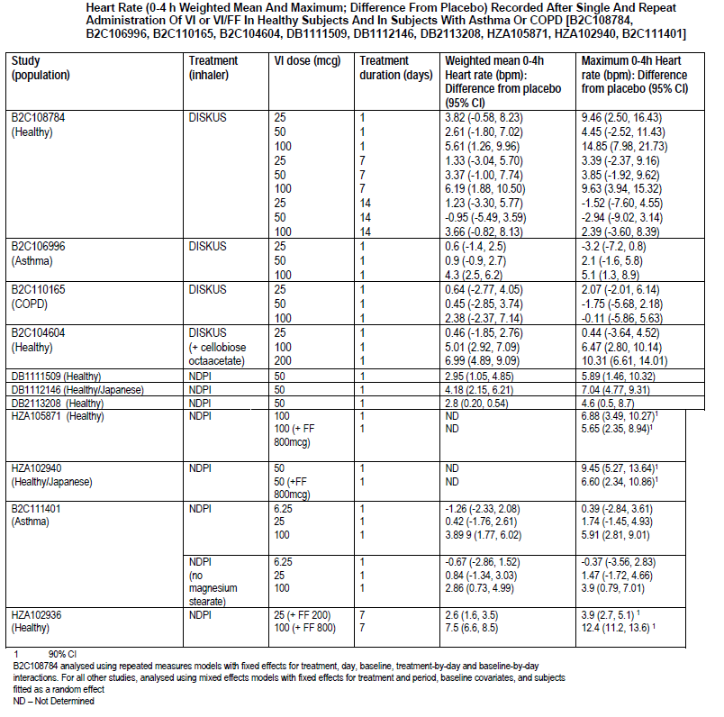

HR in healthy subjects
Following single doses of 50 µg or 100 µg VI via NDPI in healthy subjects there was a statistically significant increase in maximum heart rate of <9.5 bpm compared to placebo (Table 3A, above). Administration of a single dose of FF/VI in healthy subjects (800/100 µg or 800/50 µg [Japanese subjects]) via the NDPI (Studies HZA105871 and HZA102940) was associated with an increase in mean maximum heart rate (difference from placebo) of <7 bpm. In both studies co-administration of VI with FF did not result in a greater effect on heart rate compared with administration of VI alone.

HR in asthma
In subjects with asthma, a single dose of VI (6.25 µg or 25 µg) administered via NDPI (Study B2C111401) had little to no effect on either weighted mean or maximum heart rate compared with placebo. By contrast, a dose of 100 µg VI resulted small (<6 bpm) but statistically significant increases in weighted mean and maximum heart rate compared with placebo.

Time course of pharmacodynamic effects
In Study HZA114624, FF/VI (100/25 µg) dosed AM and PM to subjects with asthma resulted in clinically significant increases in FEV1 compared with placebo at all time points 0 to 24 h following 14 days of dosing. The bronchodilator effect of VI was assessed in subjects with asthma and subjects with COPD. In asthmatics and subjects with COPD single dose VI (25, 50 and 100 µg) demonstrated efficacy compared with placebo as measured by FEV1 from 30 minutes to 24 h post dose. The bronchodilation produced by VI persisted over the 24 h period: mean FEV1 (difference from baseline) 23 to 24 h after dosing was at least 200 mL greater than placebo for all VI doses suggesting a 24 h duration of action after a single dose.

Relationship between drug concentration and pharmacodynamic effects
For FF, a relationship between FF AUC(0 to 24) and effect on weighted mean serum cortisol over 24 h and 24 h urinary cortisol excretion has been established.
For VIM, both maximum QTcF and maximum heart rate were linearly related to VI C_{max} Study HZA102936.

Genetic-, gender- and age-related differences in pharmacodynamic response

Hepatic impairment
Study HZA111789 investigated the effect of varying degrees of hepatic impairment on serum cortisol suppression following repeat administration of FF/VI. Healthy subjects and subjects with mild or moderate hepatic impairment received FF/VI 200/25 whereas subjects with severe hepatic impairment received FF/VI 100/12.5. Serum cortisol weighted mean on Day 7 (0 to 24 h) appeared to differ for the subjects with moderate hepatic impairment compared with healthy subjects, and was, on average, 34% lower (90% CI: 11% lower to 51% lower). For the mild hepatic and severe hepatic impairment groups, serum cortisol weighted mean (0 to 24 h) was on average 13% higher (90% CI: 15% lower to 50% higher) and 14% higher (90% CI: 16% lower to 55% higher) respectively, compared with healthy subjects.

Severe renal impairment
Study HZA113970 investigated the effect of severe renal impairment on cortisol suppression following repeat administration of FF/VI (200/25 µg). In this study there was no difference between healthy subjects and patients with severe renal impairment in regard to maximum heart rate (0 to 4 h), minimum serum potassium (0 to 4 h) and serum cortisol levels (0 to 24 h).

Race
Five studies (DB1112017, HZA112018, DB1112146, DB2113208 and HZA102940) examined the PD effects of VIM and FF in healthy Japanese subjects.
These studies identified that following a single dose of FF/VI (800/50 µg) in combination and each of the active components alone in Japanese subjects maximum heart rate over 0 to 4 h was increased compared to placebo by 2.87 bpm following FF, 9.45 bpm following VIM and 6.6 bpm following the combination.
For serum cortisol (0 to 24 h), compared to placebo, FF alone decreased cortisol levels by 0.34 nmol/L and the combination decreased cortisol by 0.29 nmol/L , whereas VIM increased cortisol by 0.08 nmol/L.
There were comparable increases from baseline in weighted mean heart rate following treatment with FF/VIM combination (5.0 bpm) and VIM alone (5.4 bpm).
Weighted mean whole blood potassium (0 to 4 h) was lower for VIM alone than for the other treatments, but placebo and the GW685698X/VIM combination gave similar results.
Study HZA113477 serum cortisol levels following repeat dose inhaled FF (200 µg) in healthy Caucasian, Japanese, Korean and Chinese subjects. There was no evidence for a difference in serum cortisol weighted mean between Caucasians and Chinese or Korean healthy subjects following 7 days of once daily inhaled FF 200 µg. By contrast, there was an average 22% (90% CI: 12–30%) lower serum cortisol weighted mean in Japanese subjects compared with Caucasian subjects.

Paediatric subjects
Two studies (Study HZA112776 and Study HZA102942) examined the PD effects of repeat-dose VI 25 µg and FF 100 µg in asthmatic subjects, aged 5 to 11 years. In Study HZA112776 no statistically or clinically relevant differences between VI and placebo were observed for PD endpoints of maximum heart rate, mean heart rate, maximum QTcF, mean QTcF, maximum glucose, mean glucose, minimum potassium and mean potassium levels. In Study HZA102942, there was an average 16% reduction serum cortisol weighted mean (0 to 12 h), with the true mean ratio ranging from 30% lower to 1% higher, following repeat dosing with FF 100 µg compared with placebo.

Pharmacodynamic interactions

Ketoconazole
Study HZA105548 examined the PD effects following once daily administration of oral ketoconazole 400 mg with co-administration of inhaled FF/VI (200/25 µg). Co-administration of ketoconazole with FF/VI did not affect maximum heart rate (0 to 4 h) or minimum blood potassium (0 to 4 h) compared to when FF/VI was administered with placebo. By contrast, there was an average 27% reduction in weighted mean serum cortisol following repeat dosing of FF/VI with ketoconazole compared with FF/VI with placebo, with the true reduction (based on 90% confidence interval) likely between 14% and 38%. There was no evidence of a difference following repeat dosing with FF/VI with ketoconazole compared with FF/VI with placebo for minimum diastolic blood pressure (0 to 4 h) or maximum systolic blood pressure (0–4 h); however, maximum QTcF (0 to 4 h) was, on average, 7.55 ms higher following repeat dosing with FF/VI with ketoconazole compared with FF/VI with placebo.
Study B2C112205 examined whether co-administration of repeat dose ketoconazole (400 mg) with single dose inhaled VIM (25 µg) had an effect on the single dose systemic PDs of VIM. There was no evidence of a treatment effect (VIM + ketoconazole versus VIM + placebo) on the 0 to 4 h primary endpoints of maximum and weighted mean heart rate. There was no evidence of a treatment effect (VIM + ketoconazole versus VIM + placebo) on the 0 to 4 h primary endpoints of minimum and weighted mean potassium. For the secondary endpoints of 0 to 4 h maximum QTc(F) or QTc(B) the 90% CIs for the treatment difference included zero. The mean differences were 3.1 and 5.4 ms, respectively. For 0 to 4 h weighted mean QTc(F) or QTc(B) the 90% CIs for the treatment difference did not include zero. The mean differences were 4.7 and 7.0 ms, respectively.

Evaluator’s overall conclusions on pharmacodynamics
Fluticasone furoate is a synthetic trifluorinated corticosteroid with potent anti-inflammatory activity. Vilanterol trifenatate is a selective long-acting, beta2-adrenergic agonist.

Healthy subjects – primary PD
In healthy subjects, VI over the dose range of 50 µg to 600 µg significantly increased bronchodilation compared with placebo 24 h post dose.

Healthy subjects – secondary PD
FF induced dose related increases in skin blanching in healthy subjects that persisted for up to 24 h compared with placebo and occurred with a slower onset of action than FP.
Two studies examined the effects of FF and VIM on QT, blood pressure and heart rate in healthy subjects. Following administration of VIM (50, 200 and 400 µg) once daily for 14 days in healthy subjects there were clinically relevant increases in weighted mean and maximum heart rate (0 to 4 h) between VIM 100 µg and placebo on Days 1 and 7 and in maximum heart rate (0 to 4 h) between VIM 25 µg and placebo on Day 1. In addition, on Days 1 and 7, VIM 50 and 100 µg increased weighted mean and maximum QTc(B) and QTc(F) compared with placebo. VIM 100 µg also increased all four parameters on Day 14 compared with placebo. By contrast, there were no apparent differences in minimum and weighted mean diastolic blood pressure or maximum and weighted mean systolic blood pressure between any dose of VIM and placebo, whereas, maximum glucose levels were higher after VIM than placebo on Days 1, 7 and 14. In comparison with placebo, the FF/VIM combination decreased 0 to 24 h serum cortisol weighted mean (90% CI) by 14.7% (7.8, 21.1), while the decrease from placebo with FF alone was 24.1% (18.1, 29.6). VIM alone had no effect on serum cortisol compared to placebo.

Target population – primary PD
In mild asthmatics, following 28 days of treatment with FF/VI (100/25 µg) once daily, the mean reduction from baseline in FEV1 (0 to 2 h) following allergen challenge was 145 mL smaller than following 28 days of placebo treatment. For 100 µg a 162 mL reduction in mean FEV1 was seen for FF 100 µg compared with placebo. The effect of FF/VI on the EAR was predominantly due to the FF component.
For LAR in mild asthmatics, there was a statistically significant effect (p<0.05) for combination therapy FF/VI (100/25 µg) compared with placebo as measured by both minimum and WM. Average attenuations of 70.5% and 103.8% were seen for FF/VI treatment compared with placebo for minimum and WM, respectively. Monotherapies FF and VI also showed statistically significant changes compared with placebo in both minimum and WM LAR.
In mild asthmatics, FF/VI (100/25 µg) reduced bronchial hyper reactivity induced by methacholine. In comparison with placebo, FF/VI and FF both showed evidence of reduced bronchial hyper-reactivity with significantly greater doses of methacholine required to produce a 20% fall in FEV1, whereas, VI alone did not have a significant effect on allergen-induced bronchial hyper-reactivity compared with placebo.
In persistent asthmatics and patients with COPD, VIM provided a rapid and sustained onset of bronchodilation, as measured by FEV1. From 5 minutes post dose onwards there were notable increases in FEV1 for all active treatments compared with placebo (95% CIs excluded 0). The sustained differences between active treatment and placebo were generally of this order until 24 to 26 h post dose.
In asthmatics and subjects with COPD single dose VI (25, 50 and 100 µg) demonstrated efficacy compared with placebo as measured by FEV1 from 30 minutes to 24 h post dose. The bronchodilation produced by VI persisted over the 24 h period: mean FEV1 (difference from baseline) 23 to 24 h after dosing was at least 200 mL greater than placebo for all VI doses suggesting a 24 h duration of action after a single dose.

Target population – primary PD – time of dosing
In subjects with persistent bronchial asthma, statistical analysis of FEV1 (L) weighted mean (Day 14; 0–24 h) demonstrated clinically significantly higher values for FF/VI (100/25 µg) after both AM and PM dosing compared with placebo, while values were similar for FF/VI (100/25 µg) AM and PM dosing.
Both AM and PM pretreatment FEV1 were clinically significantly higher for FF/VI (100/25 µg) AM and FF/VI (100/25 µg) PM compared with placebo, while values were similar for FF/VI (100/25 µg) AM and PM dosing.
In addition, PEF was significantly higher following both AM and PM dosing with FF/VI over 1 to 14 days compared with placebo. The increases in PEF following FF/VI were rapid in onset (that is, the full effect appeared to be evident after the first dose) and were maintained throughout the 14 day treatment period (that is, with no sign of tachyphylaxis).

Target population – secondary PD
The potential adverse systemic beta-adrenergic effects of therapeutic and supra therapeutic doses of VI were assessed by measurement of blood (or plasma or serum) potassium and glucose and vital signs (heart rate and blood pressure) in healthy subjects as well as in subjects with renal impairment, hepatic impairment, COPD and asthma (including paediatric subjects).
For FF, a relationship between FF AUC_{(0 to 24)} and effect on weighted mean serum cortisol over 24 h and 24 h urinary cortisol excretion has been established.
For VIM, both maximum QTcF and maximum heart rate were linearly related to VI C_{max}.

Special populations
Serum cortisol weighted mean on Day 7 (0 to 24 h) appeared to differ for subjects with moderate hepatic impairment compared with healthy subjects, and was, on average, 34% lower (90% CI: 11% lower to 51% lower). For the mild hepatic (FF/VI 200/25) and severe hepatic (FF/VI 100/12.5) impairment groups, serum cortisol weighted mean (0 to 24 h) was on average 13% higher (90% CI: 15% lower to 50% higher) and 14% higher (90% CI: 16% lower to 55% higher) respectively, compared with healthy subjects (FF/VI 200/25).
Following repeat administration of FF/VI (200/25 µg) there was no difference between healthy subjects and patients with severe renal impairment in regard to maximum heart rate (0 to 4 h), minimum serum potassium (0 to 4 h) and serum cortisol levels (0 to 24 h).
In asthmatic subjects 5 to 11 years of age serum cortisol levels were 16% lower following dosing with FF 100 µg once daily for 14 days than following placebo Following repeat-dose VI 25 µg or FF 100 µg in asthmatic subjects, aged 5 to 11 years there were no relevant differences between VI and placebo for PD endpoints of maximum heart rate, mean heart rate, maximum QTcF, mean QTcF, maximum glucose, mean glucose, minimum potassium and mean potassium levels, whereas, there was an average 16% reduction serum cortisol weighted mean (0 to 12 h).

Pharmacodynamic interactions
There was no evidence for a difference in serum cortisol weighted mean between Caucasians and Chinese or Korean healthy subjects following 7 days of once daily inhaled FF 200 µg. By contrast, there was an average 22% (90% CI: 12 to 30%) lower serum cortisol weighted mean in Japanese subjects compared with Caucasian subjects.

Drug interactions
Co-administration of ketoconazole with FF/VI did not affect maximum heart rate (0 to 4 h) or minimum blood potassium (0 to 4 h) compared to when FF/VI was administered with placebo By contrast,
There was an average 27% reduction in weighted mean serum cortisol following repeat dosing of FF/VI with ketoconazole compared with FF/VI with placebo, with the true reduction (based on 90% confidence interval) likely between 14% and 38%. In addition maximum QTcF (0 to 4 h) was, on average, 7.55 ms higher following repeat dosing with FF/VI with ketoconazole compared with FF/VI with placebo.

Dosage selection for the pivotal studies

Asthma
There were 4 dose-ranging Phase II studies including 3 studies which evaluated various fluticasone furoate (FF) doses ranging from 25 to 800 µg (FFA109684, FFA109685 and FFA109687) and 1 study (B2C109575) evaluating vilanterol (VI) doses (ranging from 3 to 50 µg). Effect of time of dose (morning versus evening) and dosing interval (OD versus BD) was evaluated in 3 Phase II studies of FF alone (FFA20001, FFA106783 and FFA11202) and 2 studies of VI alone (HZA113310 and B2C106093).
Comments: There were no dose-ranging studies using the proposed combination inhaler (FF/VI).

FF-alone studies

AM versus PM and once- versus twice-daily dosing studies (FFA20001, FFA112202 and FFA106783)
FFA20001 was a multi-center, randomised, double-blind, placebo-controlled, parallel group study to evaluate the efficacy and safety of FF 100 µg administered OD either in the AM or the PM, and FF 250 µg administered OD in the PM for 28 days in 575 subjects with asthma. Subjects were symptomatic on SABAs alone and had a mean percentage predicted FEV1 of 81.0% at baseline.
For the primary treatment comparison, the difference between FF100 µg AM and FF100 µg p.m. was 13 L/min (95%CI: 2, 24) suggesting greater improvements in through PEF with morning compared to evening dosing. However, both AM and PM dosing with FF 100 µg resulted in statistically significant improvements in through PEF compared with placebo (19L/min and 16 L/min respectively). Therefore, in terms of comparison with placebo, the 100 µg AM group demonstrated a 3L/min improvement over the 100 µg PM group suggesting that morning and evening dosing were comparable for this endpoint.
Comments: However, in addition to the true treatment effect of FF, the AM through values may have been confounded by the placebo response that was greater in the morning than evening. The width of the confidence interval was slightly wider than the 20L/min width that the study was designed to show due to a higher variability in through PEF (47 L/min) than had been assumed (40L/min).
All FF dosing regimens demonstrated improvements over placebo for the secondary efficacy endpoints of daily AM and PM PEF, percentage of symptom-free 24 h periods and percentage of rescue-free 24 h periods (except withdrawals due to lack of efficacy, of which only three occurred, two in the placebo group and one in the GW685698X 100 µg AM group). Although, GW685698X 250 µg PM had a slightly greater effect on clinic-measured FEV1/PEF, asthma symptom scores 100 µg given either in the morning or evening, these benefits were relatively small and all three active treatments were statistically significantly better than placebo.
FFA112202 was a multi-center, randomised, placebo-controlled, double-blind, cross-over study to assess non-inferiority of through FEV1 with FF 200 µg OD in the PM compared with FF 200 µg (as 100 BD) for 28 days in 190 subjects with asthma. FP (given as 100 twice a day (BD) or 200 once a day (OD)) was included for assay sensitivity and as an active control for comparison against placebo. Subjects were symptomatic on SABAs or non-ICS therapy and had a mean percentage predicted FEV1 of 69.4% at baseline. Subjects meeting the eligibility criteria were randomised to one of 12 sequences outlined in Table 3.
Table 3. Treatment administration
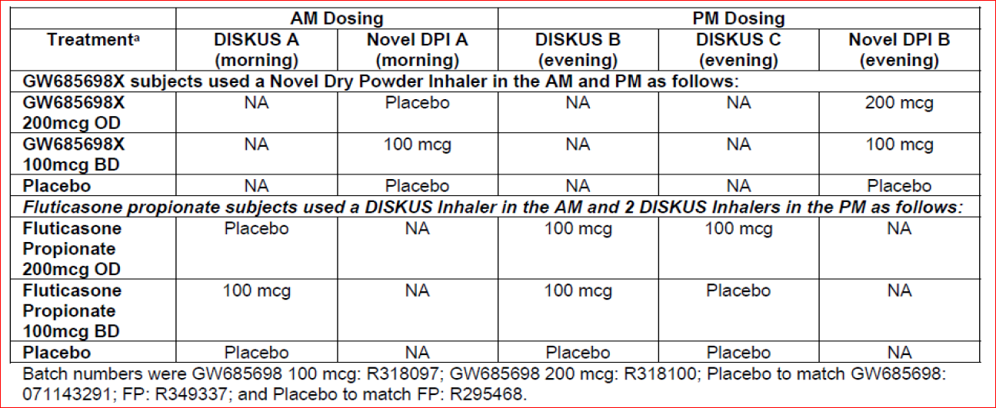
Statistical analyses of the primary endpoint showed that the adjusted treatment difference from Placebo in through FEV1 for FF 200 OD (108 mL; 95% CI 64, 153; p<0.001) was non-inferior to FF 100 BD (98 mL; 95% CI 54, 142; p<0.001). The adjusted treatment difference from placebo in through FEV1 was 87 mL (95% CI 14, 161; p=0.020) and 132 mL (95% CI 59, 205; p<0.001) for the FP 200 OD and FP 100 BD groups, respectively, indicating assay sensitivity. The adjusted treatment difference in FEV1 change from baseline between FF 200 OD and FF 100 BD was 11 mL (95% CI -35, 56; p=0.641) in the Intent-to-Treat (ITT) Population and 0 ml (95% CI -49, 49; p=0.996) in the PP Population.
Comments: Results of this well-conducted study demonstrated that the efficacy of FF200 µg once daily was not inferior to the efficacy of FF 100 µg twice daily. The study also showed that both the once daily and twice daily FF and FP groups had a statistically significantly greater improvement in through FEV1 at Day 28 compared with placebo. The results of the comparative FP treatments provided assay sensitivity and demonstrated that the study was capable of differentiating between once daily and twice daily dosing.
FFA106783 was a multicenter, randomised, double-blind, parallel group, placebo-controlled study to evaluate the relative efficacy and safety of OD and BD dosing and AM and PM dosing of FF (400 µg in AM and PM, 200 µg in AM and PM and 200 µg BD) for 8 weeks in 646 subjects with persistent asthma who remained symptomatic on low-dose ICS (symptomatic on FP 250 µg/day or equivalent at baseline) and had a baseline mean percentage predicted FEV1 of 67.4%. All treatments were delivered by inhalation via the Diskus/Accuhaler. The most common reason for withdrawal from the ITT population was lack of efficacy, which occurred in 21 (21%) subjects in the placebo group and in 7 to 13 subjects (6% to 13%) across the FF groups.
For the primary efficacy endpoint of mean change from baseline in through FEV1 at Week 8, a statistically significant difference was seen with each FF group compared with placebo (124 mL to 315 mL, p ≤ 0.033). The treatment effect exceeded a 200 mL difference (threshold for which the study was powered) for FF400 µg given in the morning or evening or in a divided twice-daily dose but not FF 200 µg given in the morning or the evening. Placebo-adjusted improvements in through FEV1 were comparable for FF 400 PM (240 mL; 95% CI 129, 351) and FF 200 BD (235 mL; 95% CI 123, 346) but improvements were greater for FF 200 BD (315 mL; 95% CI 208, 421) compared with FF 400 AM (202 mL; 95% CI 96, 307). FF 200 AM and PM led to improvements of 174 mL (95% CI 67, 282) and 124 mL (95% CI 10, 238), respectively. The adjusted improvement from baseline in through FEV1 compared with placebo was 202 mL for FF 400 µg given once-daily in the morning and 240 mL for FF 400 µg given once-daily in the evening.
The relative treatment effect of all FF treatment groups were generally lower in the Per Protocol analysis as compared to the primary ITT analysis, however the Per Protocol analysis was consistent with the ITT analysis in the evening dosing group.
Comments: FF400 µg once-daily in the morning, FF 400 µg once-daily in the evening and FF 200 µg twice-daily each resulted in clinically and statistically significant improvements in through FEV1 (≥ 200 mL) after 8 weeks of dosing. Furthermore, FF 400 µg once-daily in the evening and FF 200 µg twice daily resulted in comparable, placebo adjusted improvements in through FEV1 after 8 weeks of dosing (240 mL and 235 mL, respectively).However, 200 µg twice-daily resulted in greater improvements in placebo adjusted through FEV1 than 400 µg once-daily in the morning (315 mL and 202mL, respectively). Furthermore, proposed dose of FF 200 µg once-daily in the morning or evening did not meet the pre-defined threshold of 200 mL in through FEV1 over placebo after 8 weeks of dosing. Interpretation of these results were limited by the fact that the proposed device (NDPI) was not used in the study.

Dose-ranging studies (FFA109684, FFA109685 and FFA109687)

Study FFA109684
FFA109684 was a multi-center, randomised, double-blind, double-dummy, parallel group, placebo-controlled study to evaluate the dose response, efficacy and safety of four dosage regimens of FF (200, 400, 600 and 800 µg) administered once daily in the evening for 8 weeks in 622 adolescent and adult subjects 12 years of age and older with persistent uncontrolled asthma. A total daily dose of FP 1000 was included for assay sensitivity and to allow assessment of the relative magnitude of response of doses of FF compared with FP.
Mean overall treatment compliance was high and ranged from 93.4% to 96.0% for the Diskus, and 97.8% to 99.7% for the Novel DPI with slightly higher incidence of over-compliance (>100% treatment compliance) for the Novel DPI (26% to 34%) than for the Diskus (5% to 13%). The majority of subjects who were over compliant had compliance levels between 100% and 110%. Very few subjects had compliance values in excess of 110% (approximately 1% of subjects for the Diskus and 3% for the Novel DPI).
Baseline FEV1 was similar across all six treatment groups, with a mean FEV1 ranging from 2.087 L to 2.153 L across the individual treatment groups. At Week 8, the placebo group had a mean decrease in FEV1 from baseline of 0.054 L. All active treatment groups had a mean increase in FEV1 from baseline ranging from 0.155 L in the FP 500 µg group to 0.246 L in the FF 200 µg group. The primary analysis, the test of linear trend in dose response in through FEV1 at Week 8 including placebo, showed a statistically significant result (95% CI 0.112, 0.333; p<0.001), thus allowing further pair wise comparisons across the treatment groups. Two-sided hypothesis tests of change from baseline in through FEV1 using LOCF demonstrated superiority (p<0.001) relative to placebo of all individual FF doses (275 mL [95% CI: 178, 367] in the FF 200 group, 272 mL [95% CI 178, 367] in the FF 400 group, 264 mL [95% CI 171, 357] in the FF 600 group and 225 mL [95% CI 131, 320] in the FF 800 group). A total daily dose of FP 1000 demonstrated a 198 mL (95% CI 105, 291; p<0.001) adjusted treatment difference compared with Placebo.
Over Weeks 1 to 8, subjects in all FF treatment groups and in the FP 500 µg group demonstrated an increase from baseline in PM PEF and AM PEF compared with a decrease from baseline in AM and PM PEF for the placebo group. Mean symptom-free 24 h periods increased over Weeks 1 to 8 and for each time interval in all treatment groups including placebo with the greater increases observed in the FF 200, 400 and 600 µg groups (20.1%, 19.6%, and 18.5%, respectively). Over Weeks 1 to 8, the percentage of rescue-free 24 h periods showed the greatest increases in the FF 800 and 400 µg groups (22.3% and 21.2%) compared to the FF 200 µg, FF 600 µg, and the FP 500 µg BD groups (17.9%, 17.4% and 16.7% change, respectively). Statistically significantly higher percentage of subjects were withdrawn due to lack of efficacy from the placebo group (33%) compared with the active treatment groups (11%, 6%, 10%, 12% and 7% in the FF 200, 400, 600, 800 µg and FP 500 µg BD groups, respectively). The difference in the mean change in percentage of symptom-free days and nights for all active treatment groups was statistically significantly greater than placebo. The FF groups and FP group had a greater mean change from baseline in the percentage of rescue-free days and nights over Weeks 1 to 8 compared with placebo with the largest increases observed in the FF 400 and 800 µg groups (22.4% and 22.6%). Over Weeks 1 to 8, mean 24 h symptom scores decreased to a greater extent in all active treatment groups compared with placebo. Across all FF groups, the mean change from baseline in 24 h symptom scores decreased from 0.5 to 0.7 compared with a decrease of 0.5 in the FP 500 µg group and a decrease of 0.1 in the placebo group.
Comment: A test for linear trend excluding placebo was not significant, and therefore there was no evidence of a dose response between 200, 400, 600 and 800 µg doses of FF. In fact the numerical improvements in through FEV1 were slightly lower for the 400, 600 and 800 µg doses of FF while the incidence of AEs was higher in the FF 600 µg, FF 800 µg and FP 500 µg BD groups. The statistical analyses for all secondary efficacy endpoints (change from baseline in AM and PM PEF and rescue- and symptom-free 24 h periods and number of subjects withdrawn due to lack of efficacy) showed that all active treatment groups had statistically significantly greater improvements compared with placebo. Hence, the doses evaluated in this study appear to be in the flat part of the dose response curve as no definite dose dependent trends were observed.

Study FFA109685
FFA109685 was a multi-center, randomised, double-blind, double-dummy, parallel group, placebo-controlled study to evaluate the dose response, efficacy and safety of FF OD at doses of 100, 200, 300 and 400 µg versus Placebo for 8 weeks in 615 subjects with persistent asthma uncontrolled on low dose of ICS (FP ≤ 200 µg/day or equivalent). A total daily dose of FP 500 was included for assay sensitivity and to allow assessment of the relative magnitude of response of doses of FF compared with FP. Mean overall treatment compliance was high, and ranged from 93.5% to 96.4% for the DISKUS, and 96.5% to 98.6% for the Novel DPI although over-compliance (>100% treatment compliance) was greater for the Novel DPI (20% to 36%) than for the DISKUS (8% to 15%). The majority of subjects who were over compliant had compliance levels between 100% and 110%.
The primary analysis, the test of linear trend in dose response in trough FEV1 at Week 8 including Placebo, showed a statistically significant result (95% CI 0.391, 0.900; p<0.001), thus allowing further pair wise comparisons across the treatment groups. Two-sided hypothesis tests of change from baseline in trough FEV1 using LOCF demonstrated superiority (p<0.001) relative to Placebo of all individual FF doses (207 mL [95% CI 96, 318] in the FF 100 group, 238 mL [95% CI 127, 349] in the FF 200 group, 293 mL [95% CI 182, 404] in the FF 300 group and 279 mL [95% CI 167, 392] in the FF 400 group). A total daily dose of FP 500 demonstrated a 225 mL (95% CI 114, 337; p<0.001) adjusted treatment difference compared with Placebo.
A test for linear trend excluding placebo was not significant, and therefore there was no evidence of a dose response between the 100 µg, 200 µg, 300 µg and 400 µg dosages of FF. Over Weeks 1 to 8, subjects in all FF treatment groups demonstrated a statistically significant increase from baseline in PM PEF compared with a decrease from baseline for the placebo group with smallest increase in the FF 100 µg group (9.1 L/min), while the FF 200, 300 and 400 µg groups had a greater increase in change from baseline in PM PEF (14.8 L/min, 15.1 L/min and 21.0 L/min) which was similar to that of the FP 250 µg BD group (18.2 L/min). Similar changes from baseline were observed for AM PEF.
The statistical analyses for secondary efficacy endpoints showed that all active treatment groups had statistically significantly greater improvement compared with placebo, with the exception of symptom-free and rescue-free 24 h periods. For symptom-free 24 h periods, only the FF 400 µg group and the FP250 µg groups showed statistically significantly greater improvement compared with placebo. For rescue-free 24 h periods, all active treatment groups except the FF 200 µg group showed statistically significantly greater improvement compared with placebo. A statistically significantly higher percentage of subjects were withdrawn due to lack of efficacy from the placebo group (33% of subjects) compared with the active treatment groups (7% to 14% of subjects). Over the 8 week treatment period, mean 24 h symptom scores decreased to a greater extent in all active treatment groups compared with placebo. Over the 8 week study period, the placebo group had a decrease in total daily rescue medication use of 0.5 actuations, while the FF treatment groups had a 1.1 to 1.3 actuation per day decrease in mean total daily rescue medication use. (FP 250 µg group had a decrease of 1.5 actuations).
Comments: Overall, there was no evidence of dose-response between the 100, 200, 300 and 400 µg doses of FF. The numerical improvements in through FEV1 were greater for FF 200 µg than for FF 100 µg at most time points throughout the 8-week dosing interval. FF 200 µg also demonstrated greater improvements in PM (trough) PEF than FF 100 µg. FF 300 µg produced the greatest improvements in through FEV1, but produced almost identical changes to FF 200 µg in PM PEF (change from baseline 14.8 L/min versus 15.1 L/min) and was associated with more reports of dysphonia and pharyngitis than either FF 100 or 200 µg. Furthermore, the efficacy of once-daily FF was similar to the efficacy of FP 250 µg given twice daily for most efficacy parameters. Hence, results of this study suggest that the efficacy and tolerability profile FF 100 µg and 200 µg dosages are considered the most effective doses for this population of asthmatics, although the benefit of increasing the dose to 200 µg from 100 µg is not clear.
FFA109687 was a multi-center, randomised, double-blind, double-dummy, parallel group, placebo-controlled study to evaluate the dose response, efficacy and safety of FF OD at doses of 25, 50, 100 and 200 µg versus Placebo for 8 weeks in subjects with asthma uncontrolled on SABAs or non-ICS therapy. A total daily dose of FP 200 was included for assay sensitivity and to allow assessment of the relative magnitude of response of doses of FF compared with FP. Mean overall compliance for the treatment groups was high, and ranged from 92.4% to 97.0% for the Diskus, and 96.0% to 101.0% for the Novel DPI; over compliance (>100% treatment compliance) was greater for The Novel DPI (23% to 33%) than for DISKUS (6% to 19%). The majority of subjects who were over-compliant had compliance levels between 100% and 110%. Few subjects had compliance values in excess of 110% (<1% of subjects for the Diskus and <3% of subjects for the Novel DPI).
The primary analysis, the test of linear trend in dose response in through FEV1 at Week 8 showed a statistically significant result (95% CI 0.472, 1.559; p<0.001) thus allowing further pair wise comparisons across the treatment groups. The test of linear trend was also significant in the absence of placebo, indicating a dose response across the doses studied. Two-sided hypothesis tests of change from baseline in through FEV1 using LOCF demonstrated superiority (p≤0.033) of all individual FF doses relative to Placebo (129 mL [95% CI 11, 247] in the FF 50 group, 204 mL [95% CI 89, 319] in the FF 100 group and 230 mL [95% CI 111, 349] in the FF 200 group) with the exception of FF 25 (101 mL; 95% CI -18, 221) and FP 100 µg BD (106 mL; 95% CI -10, 223).
The secondary efficacy endpoints of change from baseline in PM PEF and AM PEF showed that all active treatment groups had greater improvements compared with Placebo. Change from baseline in symptom-free and rescue-free 24 h periods demonstrated significantly greater improvements with all active treatment groups compared with Placebo, with the exception of FF 25 µg OD. All active treatment groups, with the exception of FF 25, FF 200 and FP 100 BD showed significantly fewer withdrawals due to lack of efficacy compared with Placebo (15%, 9%, 3%, 5%, 6% and 11% with placebo, FF 25, 50, 100, 200 µg OD and FP100 µg BD groups, respectively). The difference in the mean change in percentage of symptom-free days and symptom-free nights for all active treatment groups except the 25 µg group was statistically significantly greater than placebo. At Baseline, the mean total daily rescue medication use was similar across all treatment groups, averaging approximately 3 to 4 actuations per day. Over the 8 week study period, the decrease in mean total daily rescue medication use (1.1 to 1.6 actuations) was similar across the active treatment groups and placebo over the 8 week study period with the exception of the 200 µg (2.0 actuations).
Comments: Results of this study support the profile of FF as a well-tolerated and effective once-daily inhaled corticosteroid at doses of 50-200 µg per day versus placebo, with evidence of a dose response between the range of 25 µg and 200 µg doses. There was no evidence of a dose response in any of the most commonly reported AEs in the FF groups and the incidence of drug-related AEs reported was low. The results of this study support the selection of FF 50 µg as the lowest effective dose to progress to Phase III studies.

Vilanterol (VI) alone studies
HZA113310 was a multicenter, double-blind, placebo-controlled, cross-over study to evaluate the relative effects on through FEV1 compared with Placebo of VI (6.25, 12.5 and 25 OD in the PM and 6.25 BD) for 7 days in 75 subjects with persistent asthma symptomatic on FP ≤ 1000 µg/ day or equivalent at baseline. Overall, treatment compliance was high and similar between the treatment groups for both the AM dosing (>99% in each treatment group) and the PM dosing (>98% in each treatment group). There was a statistically significant (p < 0.001) increase in bronchodilation for all VI doses and dosing regimens compared to placebo on Day 7 with respect to through FEV1 (difference in through FEV1 compared to placebo ranged from 94 to 140 mL). This analysis showed a dose-dependent improvement in through FEV1 for all once-daily doses, with 25 µg OD>12.5 µg OD>6.25 µg OD (placebo subtracted improvement in FEV1 was 94, 102 and 125 ml with 6.25, 12.5 and 25 µg, respectively). All active treatments significantly improved the weighted mean 24 h serial FEV1 compared with placebo with the greatest increase seen in the 25 µg once daily treatment group (185 ml). Results for the weighted mean 24 h serial FEV1 on Day 7 relative to placebo also showed comparable treatment differences between the 12.5 µg once daily group (168 ml) and with the 6.25 µg twice daily group (166 ml), indicating comparable improvements following the same total nominal dose given once daily or divided twice daily. The study demonstrated an observed 19 mL improvement in weighted mean FEV1 over the 24 h period for 25 µg once-daily compared to 6.25 µg twice-daily, but clinical relevance of this difference is not clear. The percentage of subjects obtaining the 200 mL and 12% threshold ranged from 19 to 38% in the active treatment groups over 24 h post dose compared to 12-22% in the placebo group.
Comments: Compared to placebo, improvement in through FEV1 with 6.25 µg BD was slightly greater than that seen with 12.5 µg OD (140 and 102 ml, respectively). This study was conducted to substantiate the data supporting VI as an effective once daily inhaled LABA and provided information on whether a lower total daily dose was effective if given twice daily compared with a once daily dosing regimen but it failed to provide conclusive evidence.
B2C109575 was a multicenter, randomised, double-blind, placebo-controlled, parallel group study to evaluate the dose response and efficacy of VI OD in the PM at doses of 3, 6.25, 12.5, 25 and 50 µg versus placebo for 28 days in 607 subjects with asthma symptomatic on FP ≤1000 µg/day or equivalent at baseline.
The sample size of 594 subjects (99 subjects per group) with at least one pre-dose or 23 to 24 h post dose FEV1 assessment on or after nominal Day 7 had 97% power to detect a slope of 4 mL/µg(a dose response effect of 200 mL improvement in FEV1 per 50 µg of FF), assuming a standard deviation of 430 mL based on previous studies and significance declared at the two-sided 5% level. Similarly, there was >99% power to detect slopes of 8 mL/µg (200 mL improvement per 25 µg dose), 16 mL/µg (200 ml improvement per 12.5 µg dose) and 32 mL/ µg (200 mL improvement per 6.25 µg dose). The 3 µg dose was assumed to be a non-effective dose and the study had approximately 96% power to detect a 200 mL effect between this dose and the 50 µg dose, excluding placebo from the dose-response analysis. Mean overall compliance for the treatment groups was high and similar across the treatment groups, and ranged from 98.9% to 107%. The different treatment showed similar baseline disease and demographic characteristics. The incidence of major protocol deviations was similar across all the treatment groups.
The primary analysis, the test of linear trend in dose response in through FEV1, was statistically significant (p=0.003). Two-sided hypothesis tests of change from baseline in the primary endpoint of through FEV1 of each VI dose showed statistically significant superiority of the three highest VI doses (12.5, 25 and 50 µg) compared with Placebo on Day 28 with FEV1 increases of 130 mL (95% CI 30, 230; p=0.011), 121 mL (95% CI 23, 220; p=0.016) and 162 mL (95% CI 62, 261; p=0.001) relative to placebo, respectively; the lower doses of 3 and 6.25 µg were not significantly different from placebo. Consistency of the VI dose-response relationship in terms of the change from baseline in through FEV1 at the end of the treatment period was shown for the different asthma disease severities.
Comment: lt is interesting to note that in patients with more severe asthma (FEV1 predicted >40% ≤65%) showed highest numerical improvement over placebo in the 12.5 and 50 µg groups and not for the proposed 25 µg dose (-49, 37, 109, 72 and 139 mL in VI 3, 6.25, 12.5, 25 and 50 µg groups, respectively). In patients with baseline FEV1 predicted >65% <90%, improvements over placebo in through FEV1 were 149, 161 and 178 mL in the 12.5, 25 and 50 µg groups respectively. Although it is acknowledged that the study was not powered to assess such differences it does highlight the fact that the 12.5 µg dose of VI was not evaluated adequately in Phase III studies although it seemed to show similar efficacy to the proposed 25 µg dose.
Weighted mean FEV1 (0 to 24 h) demonstrated statistically significant (p≤0.023) adjusted treatment differences for all doses of VI compared with Placebo (difference from placebo was 151, 103, 142, 165 and 172 mL in 3, 6.25, 12.5, 25 and 50 µg groups, respectively). All VI doses significantly improved AM and PM PEF. Except for the 3 µg VI dose, for which no statistically significant increase in symptom-free 24 h periods was found, all VI treatments statistically significantly increased the percentage of symptom-free and rescue-free 24 h periods versus placebo over the 28 day treatment period. The greatest improvements were recorded for the 25 and 50 µg VI groups, with a dose-response effect up to 25 µg VI for both symptom-free and rescue-free 24 h periods (22.2% and 28.4%, respectively). No further increments were seen with 50 µg VI. The proportion of subjects obtaining ≥200 mL and ≥12% increase from baseline in FEV1 (0 to 4 h post dose) increased with VI dose on Day 1 (35 to 36% of subjects on 25 and 50 µg VI) and Day 28 (46% of subjects on 25-50 µg VI). A numerically higher percentage of subjects were withdrawn due to lack of efficacy from the 3 µg VI and the placebo group compared with the other VI treatment groups (9%, 12%, 3%, 5%, 4% and 0% in placebo, VI 3, 6.25, 12.5, 25 and 50 µg groups, respectively).
Comments: Overall efficacy of VI was demonstrated by a statistically significant linear trend test in dose response in through FEV1. Once-daily treatment with VI resulted in a sustained 24 h improvement in lung function which was statistically significantly greater than that seen with placebo at 12.5 µg, 25 µg and 50 µg doses, supporting once-daily dosing. Results from this study suggest that VI doses >12.5 µg OD were effective in producing significant improvements in lung function and symptomatic parameters. Although the proposed 25 µg dose did produce slightly better response for the secondary endpoints of symptom-free and rescue-free 24 h periods, this is not enough to justify use of only the 25 µg dose of VI in the Phase III studies, especially since through FEV1 or weighted mean FEV1 (0 to 24h) did not show any difference between the 12.5 and 25 µg doses.
B2C106093 was a multi-center, randomised, double-blind, placebo-controlled, four-way incomplete block cross-over study to evaluate the efficacy and safety of single and repeat (14 day) administration of GW642444H (an earlier form of VI) 25, 100 and 400 OD and a total daily dose of salmeterol (SALM) 100 µg (given as 50 µg bd) versus Placebo in 56 subjects with asthma receiving FP 200 to 500 µg/day or equivalent at baseline. Majority of subjects were male and White with a mean age of 44 years and the mean percentage predicted FEV1 was 76.7% at baseline. The primary efficacy measure was mean change from baseline in through FEV1 on Day 14. On Day 1 and Day 14, the mean treatment difference for through FEV1 from Placebo for each dose of GW642444H was greater than 200 mL (205 mL to 418 mL) (p<0.001). A trend towards a dose response was observed on Days 1, 7, and 14 for the GW642444H treatments. The SALM mean treatment difference from Placebo on Day 1 and Day 14 was 296 mL and 158 mL, respectively (p<0.001). Mean AM and PM PEF values over 14 days were statistically significantly greater for all GW642444H treatment groups and the SALM treatment group (p<0.001) compared with Placebo.
Comment: Results showing dose response for VI (25, 100 and 400 µg) can only be considered supportive as this study did not use the proposed formulation of vilanterol (GW642444M

COPD
The proposed dosage of FF/VI for COPD is 100/25 µg once daily (nominal blister content equivalent to delivered dose of 92/22 µg).
B2C111045 was a Phase IIb, multi-center, randomised, double-blind, placebo-controlled, parallel group study in 602 subjects with COPD to evaluate the dose response, efficacy and safety of five dosage regimens of VI (3, 6.25, 12.5, 25, and 50 µg) to determine the selection of doses for use in further clinical COPD studies.
Majority of the 602 subjects included in the ITT Population completed the study (84% to 92%), Although the withdrawal rate was slightly higher in the placebo group (16%) compared with vilanterol groups (8% to 11%). Overall, the most common primary reason for premature withdrawal was protocol deviation (3%). Overall, 76 subjects (13%) had full protocol deviations and 4 subjects had partial deviations with similar incidence across the treatment groups. The baseline lung function parameters were similar across treatment groups. Fluticasone propionate and budesonide were used most often during the three (run-in, treatment and post-treatment) study periods and were used by similar proportions of subjects across the treatment groups. Mean treatment compliance was high during the study (≥99% in each treatment group) and at least 50% of subjects in each treatment group were 100% compliant.
The primary analysis of adjusted mean change from baseline in clinic visit through FEV1 on Day 29 demonstrated statistically significant (p<0.001) differences in favour of vilantaerol for all five doses compared with placebo (92, 98, 110, 137 and 165 ml with 3.25, 6.25, 12.5, 25 and 50 µg, respectively). Clinically relevant differences of ≥100 mL in through FEV1 [Donohue, 2005] were observed in the 12.5, 25, and 50 µg groups, while differences of ≥130 mL (the difference the study was powered on) were observed only in the 25 and 50 µg groups. In the PP analysis, adjusted mean differences compared with placebo of ≥100 mL and ≥130 mL in through FEV1 were only observed in the 25 and 50 µg groups. The results of the repeated measures analysis of the change from baseline in through FEV1 on Day 29 were consistent with those of the analysis of covariance (ANCOVA) analysis using LOCF.
The adjusted mean change from baseline in 0 to 24 h weighted mean FEV1 values on Days 1 and 28 demonstrated statistically significant (p≤0.003) differences for all five doses of VI compared with placebo (105, 125, 142, 158 and 177 ml, respectively). Clinically relevant differences of ≥100 mL in 0 to 24 h weighted mean FEV1 values were observed on both days at all dose levels except for 3 µg on Day 1. Differences of ≥130 mL were observed on both days only with the 25 and 50 µg doses. On Day 1, a greater proportion of subjects in the active treatment groups (13% to 43%) achieved a ≥12% increase from baseline FEV1 within 5 minutes after dosing compared with the placebo group (3%) and the greatest proportion of subjects achieving this increase was in the 50 µg group. More than half of the subjects in the 25 and 50 µg groups achieved a ≥12% increase within 15 minutes post dose compared with only 8% in the placebo group. Through 4 h post dose on Day 1, only 27% of subjects in the placebo group achieved a ≥12% increase from baseline FEV1 compared with 64% to 81% of subjects in the active treatment groups. Analysis of the time to subjects achieving a ≥12% increase from baseline FEV1 over the first 4 h post dose on Day 1 in each VI dose group compared with the placebo group using a log rank test was statistically significant (p<0.001) with the most rapid onset of effect observed in the 25 µg and 50 µg groups (18 and 16 minutes, respectively). On Day 1, a greater proportion of subjects in all the active treatment groups achieved a ≥100 mL increase from baseline FEV1 within 5 minutes after dosing compared with placebo and the proportion of subjects increased with increasing dose (8%, 19%, 42%, 48%, 60% and 64% in placebo VI, 6.25, 12.5, 25, and 50 µg groups, respectively). The median time to achieve a ≥100 mL increase in FEV1 was the shortest in the 25 and 50 µg dose groups (6 minutes each).
Weighted mean changes from baseline FEV1 (0 to 24 h) on Days 1 and 28 demonstrated statistically significant (p≤0.003) dose-dependent adjusted mean treatment differences for VI compared with placebo.. Repeated measures analysis of serial FEV1 on Days 1, 14, and 28 showed increasing adjusted mean treatment differences from placebo with increasing dose. Compared with placebo, none of the confidence intervals for the adjusted mean differences contained zero except at two isolated timepoints (Day 1 at 23 h and Day 28 predose) with the 3 µg dose. These results support the 24 h duration of effect of VI on pulmonary function improvement. Evidence of the 24 h bronchodilation was also observed in daily morning pre-dose PEF which showed statistically significant (p<0.001) differences in the adjusted mean treatment differences between each dose of VI and placebo. Clinically relevant differences ≥15 L/min were observed in the 12.5, 25, and 50 µg groups; however, the 25 and 50 µg doses produced differences of 21-22 L/min.
The above results were supported by increase from baseline in percentage of rescue-free 24 h periods in all VI treatment groups (12% to 16%) compared with the placebo group (3%); statistically significantly (p≤0.035), greater decreases in mean change from baseline rescue salbutamol use (occasions/24 h) were observed in all VI dose groups (except 6.25 µg) compared with the placebo group with the adjusted mean difference from placebo ranging from -0.3 to -0.5 occasions per day. Furthermore, the mean change from baseline in percentage of specific (cough, sputum, and breathlessness) symptom-free 24 h periods was generally higher in each of the VI dose groups compared with the placebo group, except for cough in the 6.25 µg group and sputum in the 3 µg group.
Comments: Treatment with vilanterol once daily for 28 days produced statistically significant dose- dependent improvements in pulmonary function compared with placebo. Symptomatic improvement was observed for all VI doses except for 6.25 µg. A sustained, 24 h duration of action of VI throughout the 28-day treatment period was demonstrated at all doses. Results from this study formed the basis for the selection of the VI 25 µg OD dose that was carried into the Phase III program for COPD. However, VI doses of 12.5 to 50 µg appeared to produce significant improvement in lung function and symptomatic endpoints and so the use of only 25 µg dose in the Phase III studies is not justified.

Clinical efficacy

Asthma

Pivotal efficacy studies

Study HZA106827

Study design, objectives, locations and dates
This was a randomised, double-blind, placebo-controlled (with rescue medication), parallel group multi-centre study conducted from 20 August 2010 to 19 October 2011 at 64 centres in 6 countries (Germany, USA, Japan, Poland, Romania, Ukraine). The primary objective of the study was to compare the efficacy and safety of FF/VI Inhalation Powder 100/25 µg and FF 100 µg both administered once daily in the evening in adolescent and adult subjects 12 years of age and older with persistent bronchial asthma over a 12 week treatment period.

Inclusion and exclusion criteria
The main inclusion criteria were: male and female outpatients (where female patients are of non-childbearing potential or of childbearing potential using an acceptable method of birth control consistently and correctly), ≥ 12 years old (or ≥ 18 years old in certain countries to meet country regulations), with a current asthma diagnosis for at least 12 weeks: pre-bronchodilator percentage (%) predicted FEV1 of 40-90% with post-albuterol/salbutamol reversibility ≥ 12% and ≥200 mL, using a stable dose of ICS or ICS/LABA combination for at least 12 weeks prior to screening. Subjects were symptomatic on FP 200 to 500 µg/day or FP/SALM 200/100 µg/day or equivalent at baseline.
Main exclusion criteria were: Subjects with other diagnosed respiratory disorders, exacerbations requiring oral corticosteroids within 12 weeks of screening and other concurrent abnormalities (laboratory, electrocardiogram (ECG) or other medical disorders) that in the opinion of the investigator, would put the safety of the subject at risk through study participation or would confound the interpretation of the efficacy results if the condition/disease exacerbated during the study.

Study treatments
Subjects meeting the randomisation criteria received one of the following three study treatments via a Novel Dry Powder Inhaler (NDPI) once daily in the evening for 84 days (12 weeks): FF/VI Inhalation Powder 100/25 µg; FF Inhalation Powder 100 µg or placebo.

Efficacy variables and outcomes
The co-primary efficacy endpoints were: (1) Mean change from baseline in clinic visit through (pre-bronchodilator and pre-dose) FEV1 at the end of the 84 day treatment period in all subjects, and (2) Weighted mean serial FEV1 over 0 to 24 h post dose calculated in the subset of subjects performing serial FEV1 at the end of the double-blind treatment period. The Powered secondary efficacy endpoint was ‘mean change from baseline in the percentage of rescue-free 24 h periods during the 12 week treatment period’. Other secondary efficacy endpoints were: Change from baseline in the percentage of symptom-free 24 h periods, Change from baseline in total Asthma Quality of Life Questionnaire (AQLQ (+12)) score and the number of withdrawals due to lack of efficacy during the 12-week treatment period; Weighted mean serial FEV1 over 0 to 24 h and 0 to 4 h post dose calculated in a subset of subjects; Time to onset of bronchodilator effect (the time point when FEV1 first exceeded 12.0% and 200 mL increase over baseline); Mean change from baseline in daily AM PEF and PM PEF averaged over the 12 week treatment period; Change from baseline in Asthma Control Test (ACT) at the end of the 12 week treatment period; Global Assessment of Change at the end of 4, 8 and 12 weeks of treatment; Unscheduled healthcare contacts/resource utilisation (for severe asthma exacerbations and other asthma related health care); Ease of use questions on inhaler at end of 4 weeks of treatment.
FEV1 was measured, electronically by spirometry, in the evening at the clinic at Screening (Visit 1), at the end of Run-in (prior to randomisation) and at the scheduled on treatment clinic visits (Visits 3 through 7). The highest of three technically acceptable measurements were recorded. Subjects were issued an electronic diary (eDiary) for daily use throughout the study from Run-in to Follow up and recorded the following parameters in the eDiary: Morning PEF; Evening PEF; Day-time and night-time asthma symptom scores; Number of inhalations of rescue salbutamol/albuterol inhalation aerosol used during the day and night.
The primary treatment comparisons were FF/VI versus placebo, FF/VI versus FF and FF versus placebo for the co-primary efficacy endpoints of mean change from baseline in Clinic Visit through FEV1 and weighted mean FEV1 over 0 to 24 h at the end of the 84 day treatment period.

Randomisation and blinding methods
Approximately 570 subjects were randomised in a ratio of 1:1:1 to give 190 randomised subjects per arm. Subjects meeting the randomisation criteria were stratified according to their medication ([ICS/LABA combination) at Visit 1 and then randomised to the treatment phase of the study. This was a double-blind study so neither the subject nor the investigator knew which study medication the subject was receiving. This study utilised IVRS for emergency unblinding.

Analysis populations
The Intent-to-Treat (ITT) Population comprised all subjects randomised to treatment and who received at least one dose of study medication and was the primary population for all efficacy and safety analyses (excluding urinary cortisol analyses which had a separate, urinary cortisol (UC) Population. The primary comparisons were supported by the Per Protocol (PP) Population which comprised all subjects in the ITT Population who did not have any full protocol deviations. Table 4 summarises number of patients in each of the analysis populations.
Table 4. Summary of Subject Populations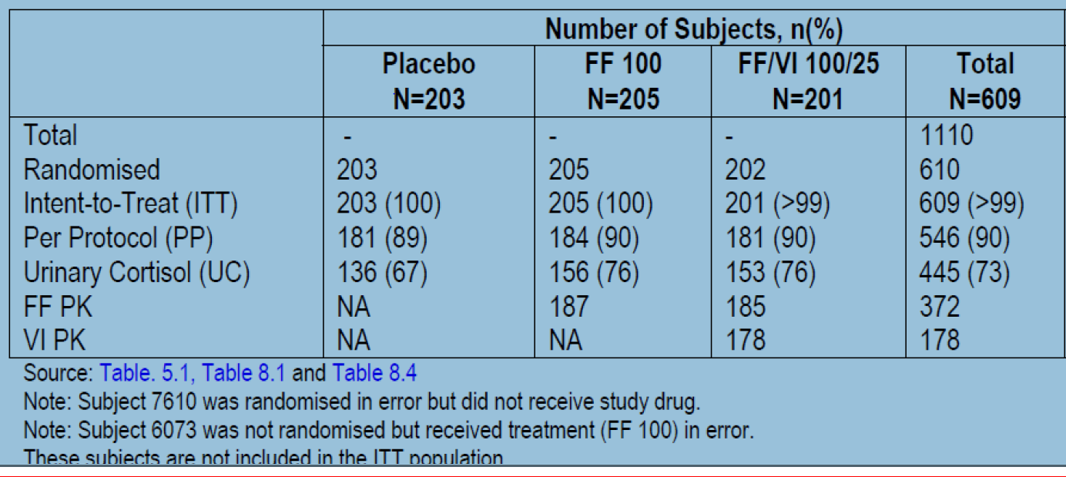

Sample size
The sample size calculation assumed a 5% withdrawal rate in the first 2 weeks of the study and a 15% withdrawal rate over the whole treatment period of the study. This ensured 180 subjects per arm for analysis of through FEV1 and % rescue free 24 h periods, and ensured 96 subjects per arm for analysis of weighted mean serial FEV1 over 0 to 24 h in Week 12 in a subset population. The overall power of the study to detect treatment differences across the specified treatment comparisons for the co-primary endpoints and the nominated secondary endpoint was 83%.

Statistical methods
The primary treatment comparisons were between FF/VI versus placebo, FF/VI versus FF and FF versus placebo for the co-primary efficacy endpoints. The primary analyses were performed using Analysis of Covariance (ANCOVA). For the analysis of through FEV1, Last Observation Carried Forward (LOCF) was used to impute missing data. A supporting analysis was also performed using a Repeated Measures Mixed Model. Missing data were not implicitly imputed in this analysis; however, all non-missing data for a subject were used within the analysis to estimate the Day 84 treatment effects. For the co-primary endpoints, estimated treatment differences for treatment comparisons were presented together with 95% Confidence Intervals (CIs) for the mean differences and p-values for comparison. All models used for the efficacy and safety analyses were adjusted for baseline, region, sex, age, and treatment group.

Participant flow
A total of 1110 subjects were screened for this study of which 610 were randomised to treatment and 609 received study medication and were therefore in the ITT population. A total of 515 (85%) completed and 94 (15%) withdrew prematurely. The most common primary reason for withdrawal was lack of efficacy which was higher in the placebo group (16%) compared to the FF 100 and FF/VI 100/25 groups (3% each).

Major protocol violations/deviations
The overall incidence of protocol deviations was 15-18% in the 3 treatment groups and the total number of subjects in the ITT population with inclusion/exclusion criteria deviations reported by the investigator was low (n=23, 4%) with a similar incidence of deviations across the treatment groups (2% to 5%). The number of subjects with full protocol deviations was 63 (10%) with similar percentages across the treatment groups, ranging from 10% to 11%.

Baseline data
Majority of subjects in the ITT population were female (58%), White (84%) with duration of asthma of 11-13 years. The mean age was 39.7 years and 82 subjects (13%) were adolescents (>12, < 18 years). The overall percentage predicted FEV1 was 67.59% at screening, with an improvement to 70.43% at baseline. Subjects had similar reversibility to salbutamol across the treatments, with an overall mean FEV1 reversibility of 28.71%, and absolute reversibility of 614.2 mL. Overall baseline demographics and disease characteristics were similar across treatment groups. Short-acting beta-agonist, salbutamol was the most frequently reported asthma medication taken pre-treatment across all the treatment groups (66% to 72%). ICS taken alone (FP=47-53%; budenoside=20-25%) or in combination with a LABA (FP/salmeterol=24% to 27%; budenoside/ formoterol= 7% to 9%). Overall treatment compliance was high (98.3%) with similar compliance across all treatments (97.5% to 98.8%).

Results for the primary efficacy outcome
Troµgh FEV1 at week 12 showed statistically significant differences (p<0.05) in favour of both the FF/VI 100/25 and FF 100 treatments relative to placebo, but no statistically significant difference was observed between the FF/VI 100/25 and FF 100 treatments. A repeated measures analysis of through FEV1 (adjusted for baseline, region, sex, age, treatment, visit, visit by baseline interaction and visit by treatment interaction) was consistent with the primary analysis and showed statistically significant differences between FF 100 and placebo and between FF/VI 100/25 and placebo at all timepoints with no statistically significant difference between the two active treatments throughout the study (Figure 3). Similar results were observed for the co-primary endpoint of change from baseline in weighted mean FEV1 (0 to 24 h) at week 12 with difference of 116 ml between FF/VI and FF100 treatment groups, but this difference was not statistically significant (p=0.060; 95% CI=-5, 236).
Figure 3. Statistical analysis of change from baseline in through FEV1 (L) using repeated measures (ITT population)
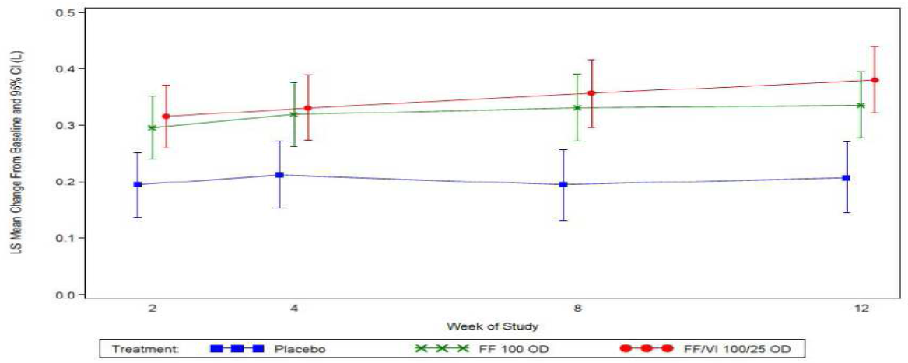

Results for other efficacy outcomes
The percentage of rescue-free 24 h periods was 13.4% to 15.3% at baseline and increased over Weeks 1 to 12 with the highest percentage observed following treatment with FF/VI 100/25 (50.9%), followed by FF 100 (40.9%) and then placebo (32.8%). The same trend was observed during Follow-up (first 14 days off treatment), with reported values of 58.4% (FF/VI), 51.0% (FF) and 47.6% (placebo). The mean change for FF/VI 100/25 was 19.3% higher than placebo (equivalent to 1.3 rescue-free 24 h periods per week) and the mean change for FF 100 was 8.7% higher than for placebo (equivalent to additional 0.6 rescue-free 24 h periods per week). The treatment difference between FF/VI 100/25 and FF 100 was 10.6% (CI: 4.3 to 16.8), which equated to additional 0.7 rescue-free 24 h periods per week. A low percentage of subjects were withdrawn due to lack of efficacy in the FF/VI 100/25 and FF 100 groups (3% of subjects in each) compared to 16% in the placebo group.
Lung function results: Compared with placebo, the change from baseline in weighted mean 0 to 4 h FEV1 treatment difference for FF/VI 100/25 was 0.134 L on Day 0, rising to 0.297 L on Day 84 and for FF 100, it was 0.257 L on Day 0 rising to 0.397L on Day 84; on day 84 Although both FF/VI and FF produced significantly greater increase compared with placebo, the FF/VI group showed significantly greater increase than FF alone (diff=0.144L, p=0.019; 95%=0.023,0.265). A Subset Analysis of FEV1 (12h post dose) at Visit 7 (Day 84)) showed treatment difference for FF/VI 100/25 relative to placebo was 0.368 L and the treatment difference for FF 100 was 0.212 L; the combination treatment of FF/VI 100/25 produced significantly greater increase compared to FF 100 (diff=0.156 L, 95%CI: 0.024 to 0.288, p=0.021). Majority of subjects in each treatment group reported a bronchodilator effect, which was defined as an increase from baseline of 12% and 200 mL in FEV1 with highest response in the FF/VI group (81%, 66% and 61% in FF/Vi, FF and placebo groups, respectively).
Diary data: The highest change from baseline (3.5 to 5.8%) in the percentage of symptom-free 24 h periods was observed in the FF/VI 100/25 (32.5% and 44.2% during Weeks 1 to 12 and Follow-up, respectively) group compared to the FF 100 (19.5% and 29.8%, respectively) and placebo (15.6% and 30.7%, respectively) groups. The mean change for FF/VI 100/25 was 18.0% higher than placebo (equivalent to additional 1.3 symptom-free 24 h periods per week) and the mean change for FF 100 was 5.8% higher than for placebo (equivalent to additional 0.4 symptom-free 24 h periods per week). The treatment difference between FF/VI 100/25 and FF 100 was 12.1% (CI of 6.2 to 18.1), which equated to additional 0.8 symptom-free 24 h periods per week.
The mean change for FF/VI 100/25 was 33.3 L/min and 28.2 L/min higher than placebo for AM and PM PEF, respectively. The mean change for FF 100 was 18.7 L/min and 15.9 L/min higher than placebo for AM and PM PEF, respectively. The increase was significantly (p<0.001) greater with FF/Vi compared with FF for both AM PEF (diff=14.6 L/min, 95%CI: 7.9 to 21.3) and PM PEF (diff=12.3 L/min, 95%CI: 5.8 to 18.8).
Questionnaires: All treatment groups had similar baseline total AQLQ (+12) scores, ranging from 4.69 to 4.78. The highest total score and the highest score for each individual domain (activity limitation, symptoms, emotional function and environmental stimuli) was seen following treatment with FF/VI 100/25 and the lowest was observed with placebo with greater improvement with FF/VI 100/25 compared with FF 100, Although the difference was not statistically significant (diff= 0.15, 95%CI: -0.01 to 0.30, p=0.059).
Majority of subjects reported mean ACT scores of less than 20 at screening (72% in each treatment group) and at baseline (85-89%) indicating that subjects were not well controlled at the start of the study. At Week 12, the majority of subjects in the FF/VI 100/25 and FF 100 groups had scores of 20 or more (61% and 54%, respectively) compared to a minority in the placebo group (41%).
Utilisation of healthcare resources was extremely low and for those categories where utilisation visits were reported, physician office/practice visits and number of urgent care/outpatient clinic visits, the lowest number of subjects with these visits was observed following FF/VI 100/25 treatment (<1% and 0, respectively) compared to FF 100 (2% and <1%, respectively) and placebo (3% and <1%, respectively).
At Baseline (Week 0) the majority of subjects, with a similar proportion across treatments, were able to use the inhaler correctly (95%); of the remaining subjects who did not use the inhaler correctly after the first instruction, the majority only required one additional instruction session (71%). For those subjects who used the inhaler incorrectly, the most common error was opening the inhaler (58%). By Visit 4 (Week 2), all subjects used the inhaler correctly and this was unchanged at Visit 5, the majority of subjects (91%) rated the inhaler as “easy/very easy” to use and a majority of subjects reported that it was “easy/very easy” to tell how many doses of medication were left on the inhaler (96%).
Comments: Although both FF/VI 100/25 µg and FF 100 µg were statistically significantly better than placebo for both co-primary endpoints of FEV1 at end of study and weighted FEV1 (0 to 24h), there was no significant difference between the two active treatments (FF/VI and FF alone). Furthermore, weighted serial mean FEV1 (0 to 4 h) and (0-12h) did show statistically significant greater improvement with the proposed combination of FF/VI 100/25 compared with FF100 alone. Significant differences in FF/VI 100/25 compared with FF 100 were observed for the powered secondary endpoint of percentage of rescue-free 24 h periods and secondary endpoints of percentage of symptom-free 24 h periods, AM and PM PEF but not for AQLQ.
However, statistical significance was not achieved for all treatment comparisons in the first level of Hierarchy, that is, there was no statistical significant difference between FF/VI and FF for the co-primary endpoints and hence the statistically significant treatment differences between FF/VI and FF for secondary and other efficacy endpoints should be interpreted as descriptive only.

Study HZA106829

Study design, objectives, locations and dates
HZA106829 was a Phase III, multi-center, stratified, randomised, double-blind, double-dummy, active-controlled, parallel group study in 586 subjects with asthma. The primary objective of this study was to compare the efficacy and safety of FF/VI inhalation powder 200/25 µg administered once daily (OD) each evening to FF inhalation powder 200 µg administered alone once daily each evening in adolescent and adult subjects 12 years of age and older with persistent bronchial asthma over a 24 week Treatment Period. The secondary objective of this study was to compare the efficacy of FF 200 µg administered once daily each evening with fluticasone propionate (FP) 500 µg administered twice daily (BD).The study was conducted from 10 June 2010 to 18 October 2011 at 63 centres in 6 countries (Russia, US, Romania, Germany, Poland and Japan).

Inclusion and exclusion criteria
These were similar to those described for Study HZA106827. However, subjects in this study were to either have been maintained on a stable ICS dose (FP 500 BD or equivalent) for 4 weeks prior to Visit 1, or were to have been maintained on a stable dose of an ICS/LABA mid-dose combination product (for example, SERETIDE/ADVAIR 250/50 twice daily or equivalent via other combination products or via separate inhalers) for at least 4 weeks prior to Visit 1.

Study treatments
Subjects meeting the eligibility criteria were stratified according to their medication (ICS or ICS/LABA) at Screening. Once stratified, subjects were randomised (1:1:1) to receive one of the following three treatments for 168 days (24 weeks):-FF/VI inhalation powder 200 µg/25 µg via a novel dry powder inhaler (NDPI) once daily in the evening plus placebo Diskus™/ Accuhaler™ twice daily (morning and evening); - FF 200 µg inhalation powder via a NDPI once daily in the evening plus placebo DISKUS/ACCUHALER twice daily (morning and evening); - FP 500 µg inhalation powder via DISKUS/ACCUHALER twice daily plus placebo NDPI once daily in the evening.. Short-acting beta2-agonist (SABA) inhalation aerosol (albuterol/ salbutamol) was provided to be used as needed for symptomatic relief of asthma symptoms during both the Run-in and Treatment Periods.

Efficacy variables and outcomes
These were similar to those described above for study HZA106827 with exception that all endpoints were measured at end of a 168 day (24 week) treatment period compared with 84 days (12 weeks) in Study 827.

Randomisation and blinding methods
These were similar to those described above for Study HZA106827.

Analysis populations
These were mainly similar to those described above for study HZA106827. However, after the blind was broken, a sensitivity analysis was conducted for the co-primary and powered secondary efficacy endpoints that excluded Investigator 040688 (who randomised 48 subjects to the ITT Population) due to GCP issues identified during a sponsor audit.
Of the 586 subjects in the ITT population, 515 (88%) were included in the PP Population. The PP Population was of equal importance to the ITT population in assessing non-inferiority of FF 200 OD to FP 500 BD on change from baseline in clinic visit through FEV1. It was otherwise only used for confirmatory analyses of the co-primary and powered secondary efficacy endpoints.

Sample size
With 188 subjects per arm with a through FEV1 value, this study had 95% power to detect a treatment difference of 150 mL in change from baseline in through FEV1 between the FF/VI combination and FF alone assuming a SD of 405 mL (based on previous studies) and at the 2-sided 5% significance level. From the subset of 60% of randomised subjects, 99 subjects per arm were expected to complete the Treatment Period giving this study 96% power to detect a treatment difference of 175 mL in weighted mean serial FEV1 over 0 to 24 h between the FF/VI combination and FF alone. This assumed a common SD of 325 mL (based on previous studies) and at the two-sided 5% significance level. The overall power of the study to detect treatment differences for both primary endpoints and the nominated secondary endpoint was 92%. Assuming the SD of 405 mL and a 2.5% one-sided significance level, this sample size would give 80% power for the single non-inferiority comparison of FF 200 OD to FP 500 BD on change from baseline in clinic visit through FEV1.

Statistical methods
These were similar to those described above for Study HZA106827. In order to account for multiplicity across treatment comparisons and key endpoints, a step-down testing procedure was applied, whereby the primary treatment comparison was required to be significant at the 0.05 level for both co-primary endpoints, in order to infer on the secondary endpoints, and inference for a test in the pre-defined hierarchy of secondary endpoints was dependent upon statistical significance having been achieved for the previous comparison in the hierarchy of secondary endpoints.

Participant flow
Of the 586 patients in the ITT population (197, 194 and 195 subjects in the FF/VI200/25 OD, FF200OD and FF 500BD groups, respectively), 81% of subjects across the treatment groups completed the study. A slightly higher percentage of subjects withdrew from the FF 200 OD treatment group (25%) compared with the FF/VI 200/25 OD group (14%) and the FP 500 BD group (17%). Lack of efficacy resulted in premature withdrawal of 11% of subjects in the FF 200 OD group, compared with 3% of the FF/VI 200/25 OD group and 9% of the FP 500 BD group.

Major protocol violations/deviations
A total of 18% of the ITT Population had at least one protocol deviation during the study with similar incidence between treatment groups; 71 subjects (12%) having full deviations and 40 subjects (7%) having partial deviations. The most common reasons for full deviations were for failure of inclusion/exclusion criteria with 39 subjects (7%) overall, and failure to comply with treatment (compliance not in the range 80% to 120%) for 27 subjects (5%) overall. The most common partial deviations were for subjects remaining in the study after falling below the PEF stability limit (16 subjects [3%] overall). Subjects with full protocol deviations were completely excluded from the PP Population. Subjects with partial protocol deviations were considered part of the PP Population but their data were excluded from the PP Population analysis from the time of their deviation onwards.

Baseline data
Majority of the subjects were White (84%), female (59%) with duration of asthma ≥10 years (60%). The mean age was 46 years with 23 adolescents (4%) at Screening. The baseline demographics and disease characteristics (including baseline lung function parameters) were similar across treatment groups. The most frequently taken concomitant asthma medications were FP (58% to 64%), salmeterol xinafoate + FP (36% to 41%) and salbutamol (35% to 39%), and the incidence of use was broadly similar across the treatment groups The most common pre-study ICS regimen was ICS + salmeterol (52% overall) and the most frequently used ICS during the Run-in Period of the study was FP (61%) with mean daily FP dose similar over the three groups and ranging from 551.1 to 583.2 µg. Mean overall compliance rate with the NDPI and Diskus/Accuhaler was high and comparable across the treatment groups (97.9% to 98.5%, and 95.2% to 97.0%, respectively); majority of subjects in each treatment group were between 95% and 105% compliant with the use of the NDPI (79% to 84%) and the Diskus/Accuhaler (72% to 76%).

Results for the primary efficacy outcome
Mean baseline pre-bronchodilator FEV1 was well balanced across the treatment groups, ranging from 2.13 L in the FF/VI 200/25 OD group to 2.2 L in the FF 200 OD group. At Week 24, the FF/VI 200/25 group showed a least squares (LS) mean change from baseline improvement in FEV1 of 193 mL greater than the FF 200 OD group and 210 mL greater than the FP500 BD group. This difference was clinically meaningful and statistically significant (p<0.001) for each comparison. The non-inferiority of FF 200 OD to FP 500 BD was demonstrated as the lower bound of the 95% CI for through FEV1 was greater than the predefined non-inferiority margin of -125 mL in the ITT analysis (treatment difference of 18 mL [CI: -66 mL, 102 mL]) with results confirmed in the PP Population (treatment difference of 43 mL [CI: -48 mL, 133 mL]). The increased benefit of FF/VI 200/25 OD versus FF 200 OD and FP 500 BD was evident by Week 2 and was sustained throughout the duration of the study (Figure 4). FF/VI 200/25 also demonstrated significantly greater efficacy than FF 200 for weighted mean FEV1 (0 to 24 h) (adjusted treatment difference 136 mL; 95% CI 1, 270; p=0.048).
Figure 4. Repeated measures analysis of change from baseline in through FEV1 (L) (HZA106829, ITT population)
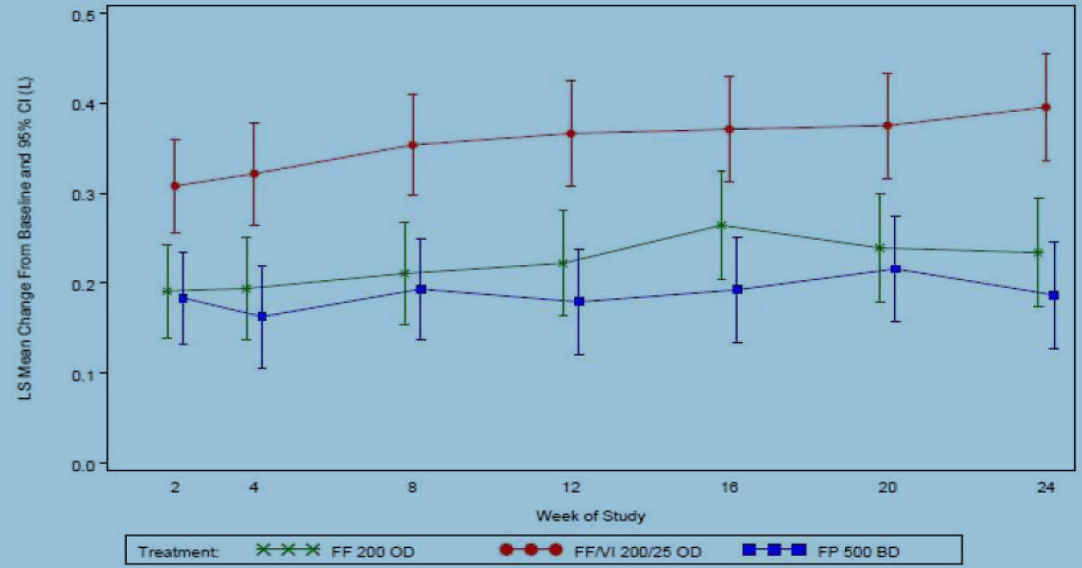

Results for other efficacy outcomes
For the weighted mean 0 to 4 h FEV1 measurement, the FF/VI 200/25 OD group showed a statistically significant greater mean improvement of 142 mL compared with FF 200 OD group (p=0.038) and 198 mL greater than the FP 500 BD group (p=0.004. For the 12-h post dose FEV1 at week 24, The adjusted treatment difference was statistically significantly greater for the FF/VI 200/25 OD group compared with the FF 200 OD group (167 mL, p=0.019) and the FP 500 BD group (254 mL, p<0.001).
Over the 24 week Treatment Period, the percentage of rescue-free 24 h periods greatly improved for subjects in all three treatment groups, increasing by the greatest level versus baseline in the FF/VI 200/25 OD group (38.2%), followed by the FP 500 BD group (31.9%) and the FF 200 OD group (26.6%). The FF/VI 200/25 OD group demonstrated a LS mean improvement of 11.7% greater than the FF 200 OD group (p<0.001) and 6.3% greater than the FP 500 BD group (p=0.067). The improvement in percentage of rescue-free 24 h periods equated to 2.7 days per week for subjects receiving FF/VI 200/25 OD compared with baseline. When the FF/VI 200/25 OD group was compared with FF 200 OD and FP 500 BD, this equated to an LS mean difference of 0.8 days per week and 0.4 days per week, respectively. The analysis that excluded Investigator 040688 for the change from baseline in percentage of rescue-free 24 h periods gave consistent results with those obtained from the primary (full ITT) population, Although the FF/VI 200/25 OD versus FP 500 BD comparison became statistically significant (p=0.046 compared with p=0.067 for the full ITT population).
Over the 24 week treatment period, the percentage of symptom-free 24 h periods greatly improved from baseline in all three treatment groups, with the greatest increase observed in the FF/VI 200/25 OD group (29.3%), followed by the FP 500 BD group (24.5%) and the FF 200 OD group (21.0%). The FF/VI 200/25 OD group demonstrated a significant mean improvement of 8.4% greater than the FF 200 OD group (p<0.010), but the 4.9% greater improvement over FP 500 BD group was not statistically significant (p=0.137). At both Week 12 and Week 24, there was little difference between the treatment groups in mean change from baseline in the total AQLQ (12+) score or the individual categories of the AQLQ (‘activity limitation”, “symptoms”, “emotional function” or “environmental stimuli”).
Over Weeks 1 to 24, an increase from baseline in AM PEF was observed in all treatment groups. The FF 200 OD and the FP 500 BD groups again had similar results for mean change from baseline (18.2 L/min and 18.8 L/min, respectively), and the FF/VI 200/25 OD group was higher (51.8 L/min). For Weeks 1 to 24 the adjusted treatment difference for FF/VI 200/25 OD versus FF 200 OD was 33.5 L/min (CI: 25.3 to 41.7 [p<0.001]) and for FF/VI 200/25 OD versus FP 500 BD it was 32.9 L/min (CI: 24.8 to 41.1 [p<0.001]). There was little difference between results obtained for the Week 1 to 12 time interval and the Week 1 to 24 time interval. Similar results were observed for PM-PEF with an LS mean change difference ranging from 24.0 L/min for FF/VI 200/25 compared with FP 500 BD at Weeks 1 to 12, to 30.7 L/min for the comparison against FF 200 OD at Weeks 1 to 24. More patients were withdrawn due to lack of efficacy from both the FF 200 OD (11%) (p=0.003) and FP 500 BD (9%) (p=0.012) groups compared with the FF/VI 200/25 OD group (3%). The statistical analysis of the change from baseline in ACT score showed a treatment difference between FF/VI 200/25 OD and FF 200 OD of 0.9 at Week 12 (p=0.019) and 0.3 at Week 24 (p=0.484) and a treatment difference between FF/VI 200/25 OD and FP 500 BD of 0.9 at Week 12 (p=0.030) and 0.7 at Week 24 (p=0.069).
The statistical analysis of responders based on asthma symptoms showed significant odds ratios for FF/VI 200/25 OD versus FF 200 OD of 1.91 at Week 4 (p=0.015), 1.97 at Week 12 (p=0.033), but not at Week 24 (1.07; p=0.860). For FF/VI 200/25 OD versus FP 500 BD the odds ratios were significant only at week 4 (2.07, p=0.005) but not at Week 12 (1.31, p=0.408) and Week 24 (1.77, p=0.083). Similarly, statistical analysis of responders based on rescue medication showed significant odds ratios for FF/VI 200/25 OD versus FF 200 OD at Week 4 only (2.33, p=0.001), but not at Week 12 (1.39, p=0.234) and Week 24 (0.89, p=0.762). Similar results were observed for FF/VI 200/25 OD versus FP 500 BD.
After the blind was broken and following a site audit a decision was made to conduct sensitivity analyses excluding data from an investigator [information redacted] in the USA because of GCP issues. The sensitivity analysis of the co-primary endpoint of through FEV1 and powered secondary endpoint of rescue free 24 h period gave consistent results with those obtained from the primary (full ITT) population. However, the sensitivity analysis for the co-primary endpoint of weighted mean FEV1 (0 to 24 h) was not consistent with the ITT analysis results; the treatment difference for FF/VI 200/25 versus FF 200 was 78 mL (compared with 136 mL in the ITT Population) and was no longer statistically significant (p=0.230). The treatment difference for FF/VI 200/25 versus a total daily dose of FP 1000 was 124 mL (compared with 206 mL in the ITT Population), which remained statistically significant (p=0.047).

Study HZA106837

Study design, objectives, locations and dates
HZA106837 was a Phase IIIa, multi-center, randomised, double-blind, active-controlled, parallel group study in 2019 subjects with asthma. The objective of this study was to demonstrate that treatment with fluticasone furoate/vilanterol once daily administered in the evening significantly decreased the risk of severe asthma exacerbations as measured by time to first severe asthma exacerbation when compared with the same dose of FF alone administered once-daily in the evening in subjects 12 years of age and older with asthma. The study was conducted from 22 Feb 2010 to 15 Sept 2011 at 167 centres in 11 countries (US, Russia, Romania, Germany, Ukraine, Poland, Japan, Argentina, Mexico, Philippines and Australia).

Inclusion and exclusion criteria
This study included subjects 12 years of age and older with a history of asthma for at least 1 year prior to screening (Visit 1) using fluticasone propionate 200 to 1000 µg/day or equivalent or fluticasone propionate/salmeterol 200/100 to 500/100 µg/day or equivalent for at least 12 weeks prior to Visit 1 and a history of one or more asthma exacerbations that required treatment with oral/systemic corticosteroids or emergency department visit or in-patient hospitalization for the treatment of asthma within 12 months prior to Visit 1. Other inclusion and exclusion criteria were similar to those described for study HZA106827.

Study treatments
Subjects who met the eligibility criteria were required to stop their ICS therapy for the duration of the treatment period and were randomised to receive either FF/VI 100/25 via Novel Dry Powder Inhaler (NDPI) once-daily in the evening or FF 100 via NDPI once-daily in the evening. The duration of the treatment period was variable and was dependent on the number of events (number of subjects with one or more severe asthma exacerbations) that occurred. The study continued until 330 events occurred. Treatment duration was at least 24 weeks and did not exceed 76 weeks for any completed subject. Subjects attended up to 11 on-treatment visits (Visits 3, 4, 5, 6, 7, 8, 9, 10, 11, 12 and 13/End of Study [EOS]) occurring at Weeks 2, 6, 12, 20, 28, 36, 44, 52, 60, 68 and 76. Short-acting beta2-agonist inhalation aerosol albuterol/ salbutamol) was provided to be used as needed for symptomatic relief of asthma symptoms during both the run-in and the treatment periods.

Efficacy variables and outcomes
The primary efficacy endpoint was the time to first severe asthma exacerbation. A severe asthma exacerbation was defined as deterioration of asthma requiring the use of systemic corticosteroids (tablets, suspension, or injection) for at least 3 days or an in-patient hospitalization or emergency department visit due to asthma that required systemic corticosteroids. Secondary efficacy endpoints included the rate of severe asthma exacerbation per subject per year and change from baseline at Week 36 in evening pre-dose through FEV1.
Other efficacy endpoints included characterisation of severe asthma exacerbations through exploration of use of rescue medication ±14 days around the onset of a severe asthma exacerbation, change from baseline at Week 12, Week 52 and Endpoint in evening pre-dose through FEV1, proportion of subjects with an Asthma Control Questionnaire (ACQ7) score ≤0.75 at Week 12 and 36.

Randomisation and blinding methods
Subjects who were eligible for the treatment phase were assigned to study treatment following a telephone call to the Interactive Voice Response System (IVRS), in accordance with the computer generated randomisation schedule. The treatments in this study were double-blind. Neither the investigator nor the subject knew which treatment the subject was receiving.

Analysis populations
These were mainly similar to those described above for Study HZA106827.

Sample size
This event-driven study was designed to have 90% power to detect the following reductions (see table below) in the risk of experiencing a severe asthma exacerbation for FF/VI compared with FF.
Table 5. Number of events required to detect selected hazard ratios at various significance levels
Since subjects were followed for a variable length of time (up to at most 18 months), the following assumptions were made to calculate the approximate number of subjects to be randomised: - 10% of subjects in each treatment group lost to follow-up during one year; -20% of subjects within the FF treatment arm would have one or more severe asthma exacerbation within a year (based on rated observed in ICS-alone arms in similar studies). The proposed sample size of approximately 2000 (1000 per arm) would provide 90% power based on the above assumptions, with a recruitment period of 8.7months and total study duration of approximately 17 months.

Statistical methods
The time to first severe asthma exacerbation was analysed using a Cox proportional hazards regression model, including terms for baseline disease severity (FEV1 measured at randomization), sex, age, and region, for the ITT and PP populations. The rate of severe asthma exacerbations per subject per year over the treatment period was analysed using a negative binomial regression model with log time on treatment as an offset variable. The response variable was the number of on-treatment severe asthma exacerbations experienced per subject. The model included adjustment for effects due to baseline disease severity (FEV1 measured at randomization), sex, age, and region. Change from baseline in Week 12, Week 36, Week 52 and Endpoint evening pre-dose FEV1 was analysed using an ANCOVA model with effects due to FEV1 measured at randomization, sex, age and region. Mean daily rescue albuterol/salbutamol use on the 14 days before and after the onset of a severe asthma exacerbation and mean change from baseline in rescue albuterol/salbutamol use averaged weekly for each subject were plotted. Change from baseline in ACQ7 score at Weeks 12, 36 and Endpoint were summarized and analysed using ANCOVA models with effects due to baseline ACQ7 score, sex, age and region.
In order to account for multiplicity across the primary endpoint of time to first severe asthma exacerbation and the secondary endpoints of rate of severe asthma exacerbations and FEV1, a step-down closed testing procedure was applied. If superiority was concluded for the primary endpoint, then testing was performed for the secondary endpoint of rate of severe asthma exacerbations. If superiority was concluded for rate of severe asthma exacerbations, then testing was performed for the secondary endpoint of FEV1. However, if superiority was not concluded for the primary endpoint, then testing for the secondary efficacy endpoints would be interpreted as descriptive only.

Participant flow
Overall 2019 patients were included in the ITT population (FF/VI= 1009; FF=1010) and majority of the subjects (87%) completed the study. The most common primary reason for withdrawal was withdrawing consent (5%). One subject in the FF/VI 100/25 group was withdrawn due to meeting liver function abnormality protocol-defined stopping.

Major protocol violations/deviations
Overall, 24% of subjects had protocol deviations and the incidence of full and partial protocol deviations was similar across treatment groups. The most frequent full protocol deviation was failure to meet eligibility criteria (8%). Seven subjects (4 subjects in the FF 100 group and 3 subjects in the FF/VI 100/25 group) received an incorrect treatment at some point in the study. Each of these incidents were considered partial deviations.

Baseline data
Majority of the subjects were White (73%) and female (67%) with mean age of approximately 42 years. Adolescents (subjects 12 to 17 years of age) comprised 14% of the ITT Population. Overall, 59% had experienced a duration of asthma of ≥10 years with mean duration of 15.54 years (range: 1 year to 70 years) and all but one subject had an exacerbation in the year prior to study entry. Mean baseline FEV1 percentage predicted was 71.9%. The incidence of co-morbid medical conditions was low (30%) with hypertension (23%) being most common. Majority of subjects enrolled in the study had never smoked (86%).The baseline demographics and disease characteristics (including baseline lung function parameters) were similar across treatment groups. Concomitant asthma medications were taken pre-treatment by 100% of subjects and the most frequently taken concomitant asthma medications were fluticasone propionate, salbutamol, and fluticasone propionate/salmeterol combination. Concomitant asthma medications were taken by a smaller proportion of subjects during treatment with 19% of subjects in the FF 100 group and 16% of subjects in the FF/VI 100/25 group taking a concomitant asthma medication during this period The most frequently taken concomitant asthma medications during double-blind treatment were prednisone and prednisolone used for asthma exacerbations. Mean overall compliance rate was high and comparable across the treatment groups (98.3% in the FF 100 group and 98.0% in the FF/VI 100/25 group). The majority of subjects in each treatment group were between 95% and 105% compliant (84% in the FF 100 group and 83% in the FF/VI 100/25 group).

Results for the primary efficacy outcome
A high rate of agreement was seen between the data entered in the eCRF and the Adjudication Committee for severe asthma exacerbations (>99% in both the FF 100 and FF/VI 100/25 groups). Only instances of corticosteroid use for events other than severe asthma exacerbation identified by investigators were adjudicated by the Adjudication Committee. In those instances, the Adjudication Committee determined that the corticosteroid use met the definition of a severe asthma exacerbation in more instances than the data entered into the eCRF (28% of instances of systemic corticosteroid use in the FF 100 group and 27% of instances of systemic corticosteroid use in the FF/VI 100/25 group).
Comments: The sponsors justify that the above discrepancy may have been due in part to the use of the severe asthma exacerbation definition in the protocol where investigators were asked to use the definition verbatim (corticosteroid use had to be a minimum of 3 days even if IM or IV regardless of potency because of difficulties in standardization across countries) while the adjudicators used medical judgment in determination of IM or IV corticosteroid use for determination of severe asthma exacerbations.
The hazard ratio from the Cox Model (adjusted for the interim analysis) for FF/VI 100/25 versus FF 100 was 0.795 (95% CI 0.642, 0.985) representing a statistically significant 20% reduction in the risk of experiencing a severe asthma exacerbation for subjects treated with FF/VI 100/25 compared with FF 100 (p=0.036). The PP population analysis supported the ITT results (hazard ratio for FF/VI 100/25 versus FF 100 of 0.722; 95% CI 0.548, 0.950; 28% reduction, p=0.020). A sensitivity analysis excluding all subjects enrolled by Investigator 171806 and Investigator 040688 (because of study conduct irregularities at these sites) were consistent with the results seen for the ITT population. Kaplan-Meier cumulative incidence curve for time to first severe asthma exacerbation showed that fewer subjects treated with FF/VI (15.2% [95% CI 13.0%, 17.6%]) had one or more severe asthma exacerbation by 52 weeks than subjects treated with FF alone (19.3% [95% CI 16.9%, 22.0%]), Although difference was not significant with overlapping 95% CI (Figure 5).
Figure 5. Kaplan-Meier plot cumulative incidecen curve for time to first severe asthma exacerbation (HZA106837, ITT population).
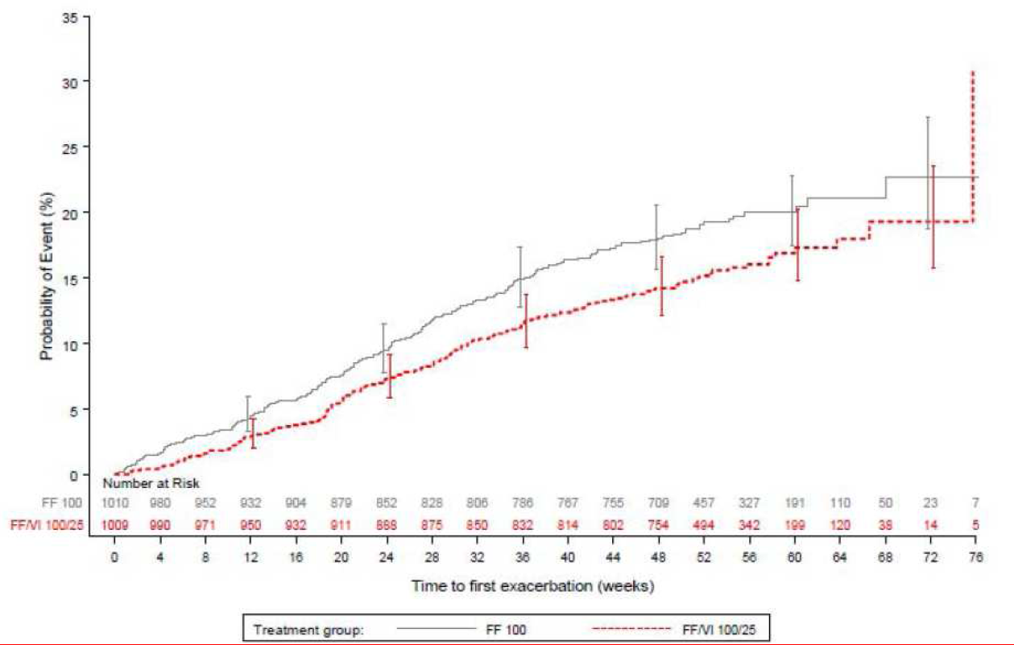

Results for other efficacy outcomes
Over the course of the active treatment period, 200 and 271 exacerbations occurred in subjects treated with FF/VI 100/25 and FF 100, respectively. Exacerbations leading to hospitalization (FF/VI 100/25 versus FF 100: 5% versus 4%) and the mean duration (11.3 versus 11.1 days) were similar between treatment groups and no subjects in either group were intubated due to a severe asthma exacerbation. Few severe asthma exacerbations occurred in the 7 day post-treatment period with slightly higher incidence in FF/VI group (4 versus 1). No clear trends were noted between treatment groups during treatment in the reasons that led to the diagnosis of a severe asthma exacerbation and the most common reasons were worsening of daytime symptoms (67% versus 69%), clinical examination (47% versus 50%), and worsening of night-time symptoms and increasing rescue medication use (40% versus 46%). The rate of severe asthma exacerbations per subject per year was 0.19 in the FF 100 group (approximately 1 in every 5 years) and 0.14 in the FF/VI 100/25 group (approximately 1 in every 7 years). The ratio of the exacerbation rate from the negative binomial analysis for FF/VI 100/25 versus FF 100 was 0.755 (95% CI 0.603, 0.945) representing a statistically significant 25% reduction in the rate of severe asthma exacerbations for subjects treated with FF/VI 100/25 compared with FF 100 (p=0.014). Rescue albuterol/ salbutamol use increased dramatically over the 14 days leading up to an exacerbation and decreased at a similar rate in the 14 days following an exacerbation in both treatment arms for subjects who experienced a severe asthma exacerbation (Figure 6). FF/VI 100/25 consistently demonstrated 83 mL to 95 mL improvements in through FEV1 at Weeks 12, 36 and 52 and Endpoint compared with FF 100, p<0.001 at all timepoints).
Figure 6. Mean daily rescue use (puffs/day) 14 days before and after the onset of a severe asthma exacerbation.
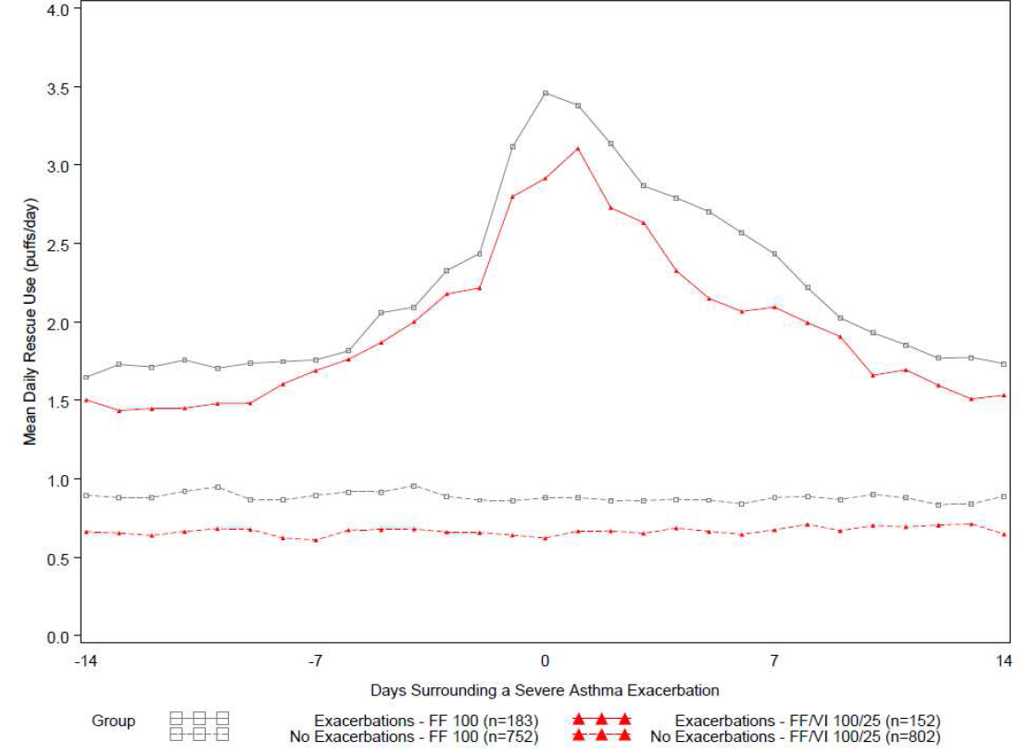
At baseline, the proportion of subjects with an ACQ7 score >0.75 and an ACQ7 score ≤0.75 was similar between treatment groups. Subjects in the FF/VI 100/25 group were approximately 50% more likely to be well controlled (ACQ7 ≤0.75) at each timepoint than subjects in the FF 100 group. Of subjects who were not well controlled (ACQ7 >0.75) at baseline, a greater percentage became well controlled (ACQ7 ≤0.75) at all timepoints in the FF/VI 100/25 group (35% to 44%) compared with the FF 100 group (27% to 35).
Comments: Results from this well-conducted study showed that FF/VI 100/25 significantly reduced the risk of severe asthma exacerbations by about 20%, significantly improved lung function (trough FEV1) and led to greater asthma control (as assessed by the ACQ7) compared with FF 100 when administered for 24 to 76 weeks. The definition of severe asthma exacerbation used in this study was a robust definition that has been validated by the ATS/ERS Taskforce. In addition, an Adjudication Committee was utilized in this study providing a blinded review to ensure all severe asthma exacerbations were identified and included in the primary measure.

Other efficacy studies

Study HZA113091
HZA113091 was a Phase III, multi-center, randomised, double-blind, double-dummy, parallel group study to compare the efficacy and safety of FF/VI Inhalation Powder 100/25 µg administered once daily in the evening with FP/salmeterol Inhalation Powder 250/50 µg administered twice daily for 24 weeks in 806 subjects with persistent asthma who were receiving FP 500 µg/day or equivalent at baseline. The study was conducted from 16 June 2010 to 27 July 2011 at 65 centres in the United States, Argentina, Chile, Netherlands, Philippines and South Korea. Patients had an FEV1 of 40-85% of predicted normal and other inclusion/ exclusion criteria were similar to those described for study HZA106827. Demographics were similar in both groups, and the majority of subjects were female (61%) and White (59%; Asian=31%) with a mean age of 43 years and mean percentage predicted FEV1 of 68.4% at baseline. Overall, 89% of the patients completed the study and the main reasons for withdrawal were withdrew consent (FF/VI versus FP/salmeterol: 11.1% versus 11%), lack of efficacy (5% versus 3%) and AEs (1% versus 2%). Overall, a total of 100 (12%) subjects had protocol deviations that were considered to affect interpretation of the efficacy results with slightly higher incidence in the FF/VI group compared with the FP/salmeterol group (10% versus 6%) and these subjects were not included in the PP Population.
The primary endpoint was weighted mean FEV1 0 to 24 h post dose at the end of the 24 week double-blind treatment period which showed clinically relevant improvements from baseline in weighted mean serial FEV1 (0 to 24 h) of 341 mL and 377 mL in the FF/VI and FP/salmeterol groups, respectively. The difference between FF/VI 100/25 and a total daily dose of FP/SALM 500/100 was not statistically significant (adjusted treatment difference of -37 mL; 95% CI -88, 15; p=0.162). These results were confirmed in the PP population.
The secondary endpoint of Individual serial FEV1 assessments at the end of the treatment period (including 12-h and 24 h post dose through values) demonstrated sustained 24 h duration of action for both once-daily FF/VI and twice-daily FP/salmeterol treatments at all timepoints; Adjusted mean treatment differences between the FF/VI and FP/salmeterol groups of 2 mL to 58 mL were found, which were not statistically significantly different at any time point (95% CIs included 0, and p>0.05 for the 12 h and 24 h time points), except at 14 h and 16 h post dose where the respective treatment differences of 57 mL and 58 mL in favour of FP/salmeterol had 95% CIs excluding 0 (Figure 7). The onset of bronchodilatory effect was also similar for both treatment groups. At 5 minutes post dose, 100 (25%) subjects in the FF/VI group and 85 (21%) subjects in the FP/salmeterol group had achieved ≥12% and ≥200 mL increase over baseline FEV1. A Kaplan-Meier plot showing the cumulative estimated onset of bronchodilatory effect showed that 50% of subjects in the FF/VI group achieved ≥12% and ≥200 mL increase over baseline FEV1 after 61minutes compared to 59 minutes in the FP/salmeterol group. Log-rank analysis showed that the 2-minute difference between the groups was not statistically significant (p=0.264) There was no difference between the treatment groups for time to onset as measured after the first dosing at the randomisation visit (61min and 59 minutes for the FF/VI 100/25 and FP/salmeterol groups, respectively; Cox proportional hazards analysis p=0.547, hazard ratio 0.948), or the proportion of subjects achieving ≥12% and ≥200 mL increase from baseline at the end of the treatment period in FEV1 at 12 h (FF/VI versus FP/salmeterol: 56% versus 50%) and 24 h (51% versus 50%).
Figure 7. Adjusted mean change from baseline (95%CI) in FEV1 (L) over time at Day 168/Week 24 (ITT population).
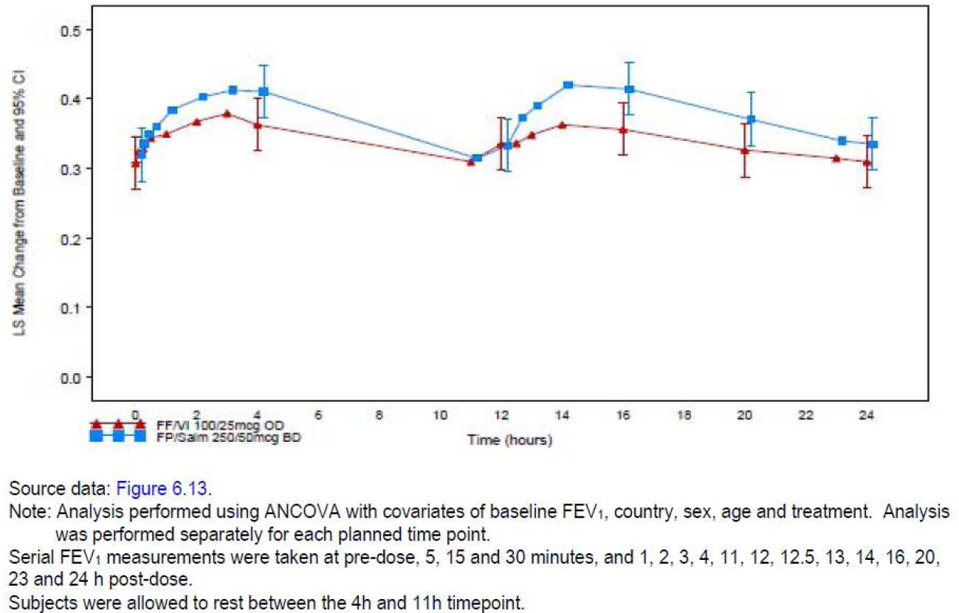
Subjects in the FP/salmeterol group achieved a greater LS mean change from baseline in through FEV1 than subjects in the FF/VI group (300 mL and 281 mL, respectively), Although the difference in adjusted mean of 19 mL was not statistically significant (p=0.485). There was no statistically significant difference between FF/VI 100/25 compared with a total daily dose of FP/SALM 500/100 for the “Other” endpoints of AQLQ score, ACT score or EQ-5D score.
Comments: Although this Phase III study did not show any statistically significant difference between the proposed FF/VI 100/25 µg OD and twice daily dosing with FP/salmeterol 250/50 µg, interpretation was limited due to the study design which lacked placebo control. Furthermore, non-inferiority testing would have been more appropriate for this study. Hence, results from this study can only be considered supportive.

Study FFA112059
FFA112059 was a multi-center, randomised, placebo-controlled, double-blind, double-dummy, parallel group study to compare the efficacy and safety of FF 100 and a total daily dose of FP500 with placebo over 24 weeks in 343 subjects with persistent asthma. The study was conducted from 30 June 2010 to 16 January 2012 at 56 centres in 5 countries (US, Germany, Romania, Poland and Belgium). Subjects were symptomatic on FP 100 to 500 µg/day or equivalent at baseline. Overall, 74% of the subjects completed the study and the incidence of withdrawals was higher in the placebo group (35%) compared with FF 100 OD (19%) or FP250 BD (23%) groups. The incidence of protocol violations was similar in all treatment groups. Majority of subjects were White (79%), female (59%) with mean duration of asthma ≥10years (67%); the mean age was 41 years (13% were adolescents) and mean percentage predicted FEV1 of 72.5% at baseline. Baseline demographics and disease characteristics were similar in all treatment groups. Almost all patients took asthma medication pre-study (98-100%) and the most frequently taken concomitant medications were FP (42% to 48%), salbutamol (34% to 38%) and budesonide (26% to 29%); the incidence of use was similar across the treatment groups.
The primary endpoint was change from baseline in clinic visit through FEV1 at the end of the 24 week treatment period and the primary treatment comparison for this and all other efficacy endpoints was FF100 OD versus placebo. At the end of 24 weeks of treatment, FF100 significantly improved through FEV1 compared with Placebo (adjusted treatment difference 146 mL; 95% CI 36, 257; p=0.009). Similar results were demonstrated for the treatment comparison of a total daily dose of FP 500 to Placebo (adjusted treatment difference 145 mL; 95% CI 33, 257; p=0.011). For the powered secondary endpoint of percentage of rescue-free 24 h periods, significant differences were observed for FF 100 compared with Placebo (adjusted treatment difference 14.8%, 95% CI 6.9, 22.7; p<0.001) and for a total daily dose of FP 500 compared with Placebo (adjusted treatment difference 17.9%; 95% CI 10.0, 25.7; p<0.001). Significant differences were observed for FF 100 compared with Placebo for the secondary endpoints of percentage of symptom-free 24 h periods (adjusted treatment difference 8.9%; 95% CI 1.1, 16.7; p=0.025), total AQLQ score (adjusted treatment difference 0.33; 95% CI 0.09, 0.57; p=0.007) and Asthma Control Test (ACT) score (adjusted treatment difference 1.4; 95% CI 0.4, 2.5; p=0.006). No significant differences were seen in the comparison of FF 100 to Placebo for the secondary endpoints of AM and PM PEF.
Comments: There were no planned statistical comparisons between FF100 OD and FP 250 BD treatment groups. Provided the FF and FP treatment regimens both demonstrated a statistically significant difference relative to placebo; the relative effects of FF and FP were evaluated by assessing the degree of overlap between the 95% CI relating to their treatment differences with placebo which showed comparable efficacy of FF100 OD and FP250 BD.

Study B2C112060
B2C112060 was a multi-center, randomised, stratified, double-blind, double-dummy, parallel group, placebo-controlled study to evaluate the efficacy and safety of VI 25 OD and a total daily dose of SALM 100 compared with Placebo for 12 weeks in 347 subjects with asthma. Subjects were symptomatic on FP 200 to 1000 µg/day or equivalent at baseline. Majority of subjects were female and White with a mean age of 41 years. Mean percentage predicted FEV1 was 68.9% at baseline.
The primary endpoint of change from baseline in weighted mean FEV1 (0 to 24 h) at the end of the 12 week treatment period failed to show a statistically significant difference between placebo and VI 25 (adjusted treatment difference 70 mL; 95% CI -48, 188; p=0.244) or a total daily dose of SALM 100 (adjusted treatment difference -6 mL; 95% CI -124, 113; p=0.926). The placebo response was pronounced (289 mL); however, the reason for this placebo effect is unclear. The inability of SALM, a well-established bronchodilator for the treatment of asthma, to show any improvement on the primary endpoint of weighted mean FEV1 (0 to 24 h) as well as on a number of secondary endpoints such as PM PEF and symptom-free 24 h periods compared with placebo limits interpretation of results from this study.

HZA106851
The primary endpoint of the 6-week, randomised, double-blind, parallel group, placebo- and active-controlled study HZA106851 in 185 subjects with asthma was a PD endpoint (effect on HPA axis), FEV1 measurements were performed during the study. FEV1 measurements remained reasonably stable over the course of the study in the Placebo and prednisolone groups, but improved in the two FF/VI groups. At Days 14, 28, and 42 (end of treatment), the FF/VI groups showed greater mean changes from baseline in FEV1 (218 mL to 335 mL) compared with the Placebo (54 mL to 88 mL) and prednisolone (-27 mL to 41 mL) groups.

Analyses performed across trials (pooled analyses and meta-analyses)
The grouping of efficacy studies included for subject-level integration referred to as the Integrated Asthma Clinical Studies included four parallel-group Phase III studies with FF/VI (HZA106827, HZA106829, HZA106837 and HZA106851) and one parallel-group Phase III study with FF alone (FFA112059) involving 3742 asthma patients. The final formulation/final device (NDPI) was used for all the Integrated Asthma Clinical Studies. Although Study FFA112059 did not include an FF/VI arm, it was included in subject-level integration since it provided information on the comparison of FF 100 with Placebo as well as a total daily dose of FP 500.
Majority of the 3742 subjects with asthma completed the studies (85%), with between 75% and 89% of subjects in any treatment group completing their respective treatment periods. Across the treatment groups, withdrawals were highest in the Placebo and FF 200 groups (25% each) and FP 500 group (23%). Withdrawals were lowest in the FF/VI 100/25 and 200/25 groups (12% and 11%, respectively), with 14% withdrawals reported for FF 100. The most common primary reason for premature withdrawal was ‘lack of efficacy’ (5% overall but highest in placebo group-15%)(Table 6). Majority of the subjects were female (62%), White (79%) with mean duration of asthma ≥10 years (58%) and mean FEV1 68.3% of the predicted normal value (range 39.8% to 112.9%). The mean age ranged between 38 and 47 years with majority aged between 18 and 64 years (80-89%) with relatively few adolescents (12-17-year old subjects) in the FF/VI 200/25, FF 200 and FP 1000groups (≤6%). Baseline demographics and disease characteristics were similar across all treatment groups.
Table 6. Integrated efficacy analyses of pivotal Asthma studies
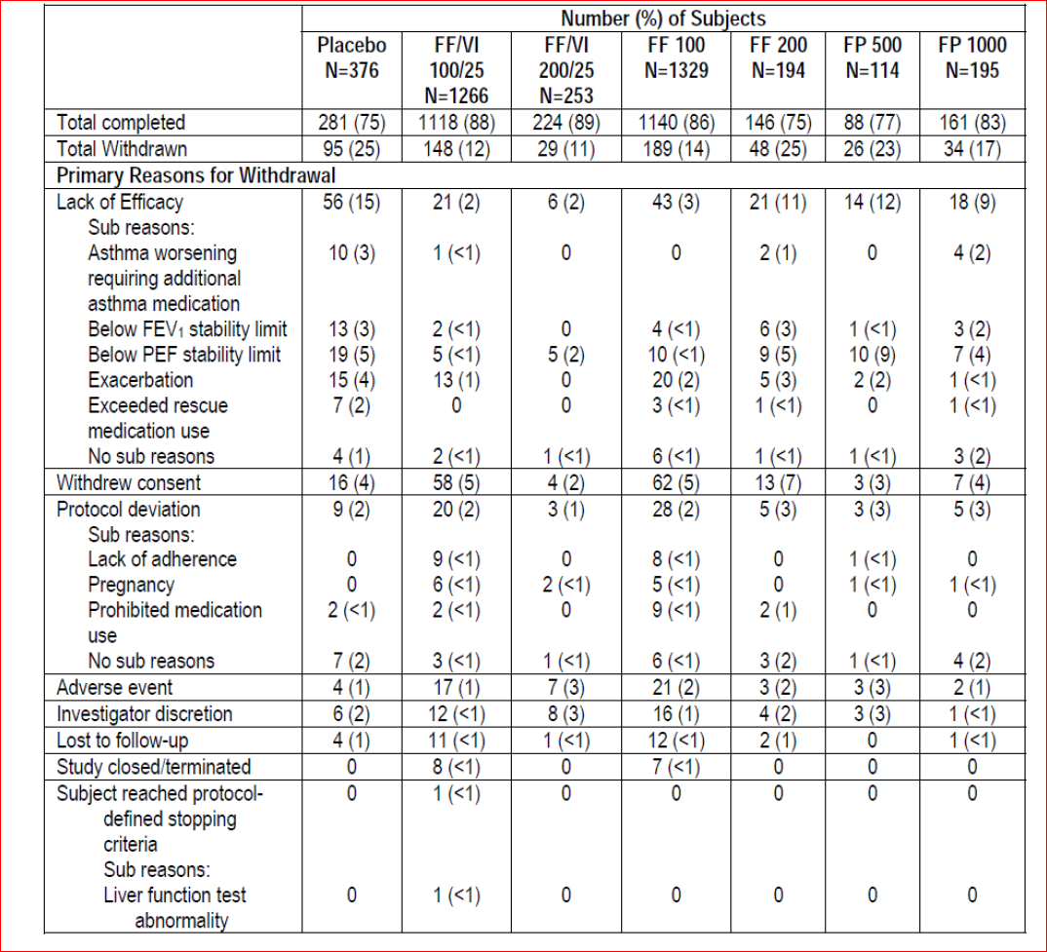
LS mean changes for the primary efficacy endpoint of change from baseline in through FEV1 at week 12 showed that the active treatments were approximately two to three times greater (217 to 294 mL) than placebo (118 mL). Comparisons of FF/VI 100/25 and FF 100 with Placebo demonstrated significantly greater improvements with these active treatments (p<0.001). Overall, FF/VI 100/25 also showed significantly greater improvement than FF 100 (p<0.001) (Table 7). Change from baseline in through FEV1 at Week 24 was similar to that seen at Week 12 with all active doses producing greater (145 to 388 mL) improvements than Placebo (23 mL), thus demonstrating that the efficacy of FF/VI and FF was maintained up to 24 weeks (Table 8).
Table 7. Statistical analysis of change from baseline at Week 12 in trough FEV1 (L) (integrated asthma clinical studies, ITT population).
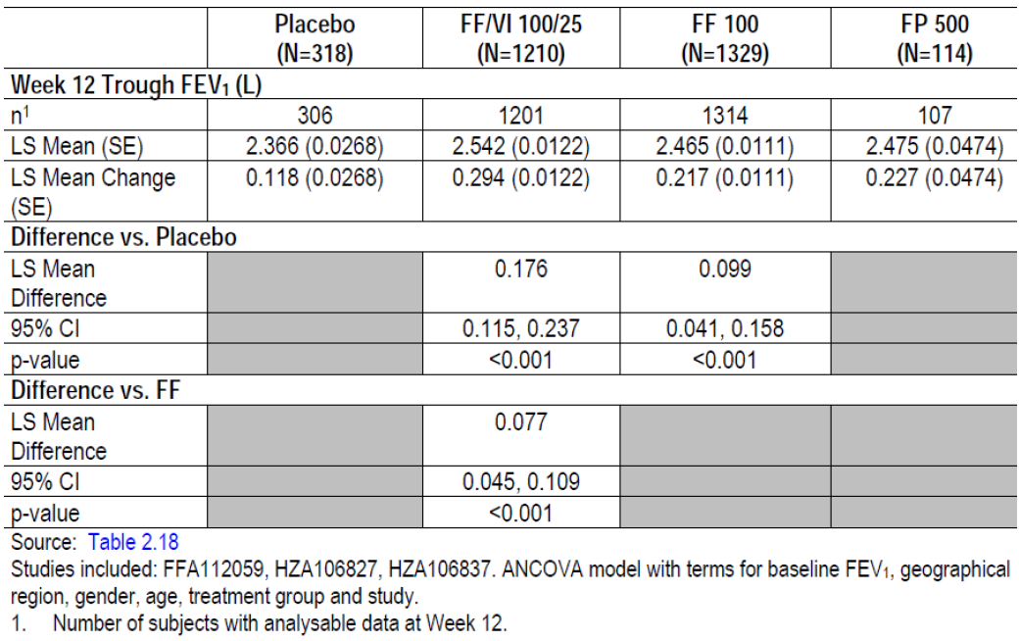
Table 8. Summary of trough FEV1 (L) at Week 24 (integrated asthma clinical studies, ITT population).
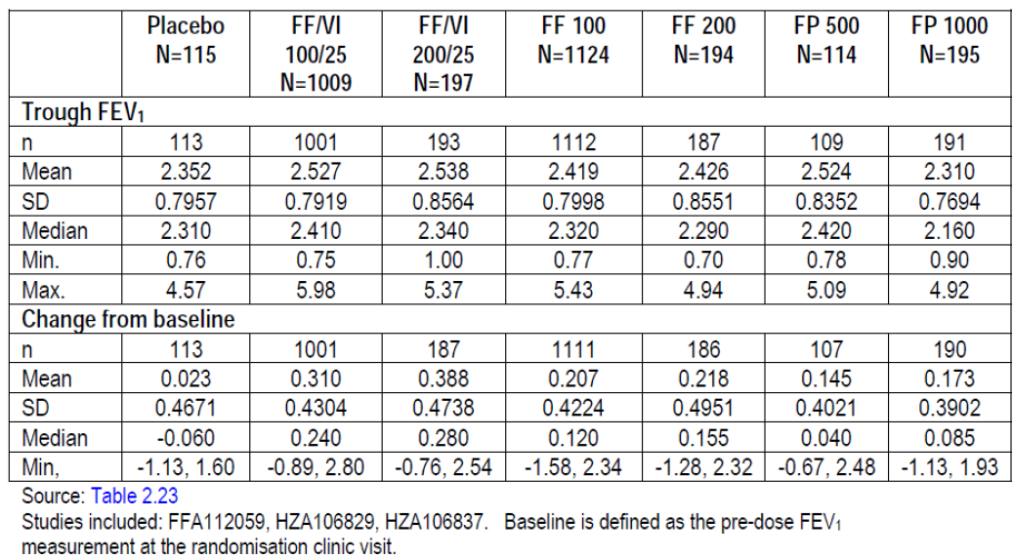
In the individual Phase III studies, improvements in the percentage of rescue-free 24- h periods were statistically significantly greater for FF/VI (100/25) and FF (100 and 200) compared with Placebo (FF/VI 100/25 versus Placebo [1 study]; FF 100 versus Placebo [2 studies]) and for FF/VI compared with FF (FF/VI 100/25 versus FF 100 [1 study]; FF/VI 200/25 versus FF 200 [1 study]). However, the difference in the percentage of rescue-free 24 h periods for FF/VI 200/25 compared with a total daily dose of FP 1000 was not statistically significant.
Studies FFA112059, FFA109687 and FFA20001 demonstrated statistically significant improvements in percentage of symptom-free 24 h periods for FF 100 compared with Placebo ranging from 8.9% to 20.2%. FF 100 demonstrated a non-significant increase in percentage of symptom-free 24 h periods compared with Placebo (5.8% and 4.2% in Studies HZA106827 and FFA109685, respectively).
In the individual Phase III studies, where improvements in AM PEF were statistically significantly greater for FF/VI, FF and VI compared with Placebo (FF/VI 100/25 versus Placebo [1 study]; FF 100 versus Placebo [1 out of 2 studies]; VI 25 +ICS versus Placebo +ICS [1 study]) and between FF/VI and FF (FF/VI 100/25 versus FF 100 [1 study]; FF/VI 200/25 versus FF 200[1 study]). FF/VI 200/25 provided significantly greater improvements in AM PEF compared with a total daily dose of FP 1000. Similar results were observed for PM PEF.
Statistically significant improvements in total AQLQ were demonstrated for FF/VI 100/25 compared with Placebo (1 study) and FF 100 compared with Placebo (1 out of 2 studies); however, none of the improvements met the Minimal Important Difference of 0.5.
Asthma control was assessed in four Phase III studies; Study HZA106837 using the ACQ and studies HZA106827, HZA106829 and FFA112059 using ACT. Improvement in asthma control was demonstrated for FF/VI 100/25 compared with Placebo (1 study) and FF 100 compared with Placebo (2 studies). In study HZA106837, ACT odds ratio of FF/VI 100/25 compared with FF 100 was 1.50 (95%CI 1.23, 1.82; p<0.001). While there was a small improvement in asthma control for FF/VI 100/25 compared with FF 100 and FF/VI 200/25 compared with FF 200 the difference was not statistically significant.

Efficacy in subpopulations
The primary endpoint of change from baseline in through FEV1 at 2 weeks, 12 weeks and 24 weeks of treatment was summarised by subgroups (by gender, age, race and geographical region) of the Integrated Asthma Clinical Studies to determine if there were differences between subgroups and the overall population of subjects in these studies. Overall among treatment arms, more females (62%, range 40-66%) than males (38%, range 34-60%) participated in the Integrated Asthma Clinical Studies. The majority of subjects were White (79%, range 76-100%) and lived in Other Region (40%, up to 49% of subjects in any treatment group). The majority of subjects were 18-64 years of age (81%, range 80-93%), and 12% (range 4-15%) of subjects were adolescents.
There were no statistically significant interactions of gender, age, race or geographical region by treatment at Weeks 2 or 12 for the primary efficacy endpoint of through FEV1 (no statistical analysis was done at Week 24). The magnitude of treatment effects was larger for females than for males at Week 2, 12 and 24; a noticeably larger response to placebo was observed in males than in females (Table 9). Across all treatment groups, mean changes from baseline in through FEV1 at Week 2, 12 and 24 were greatest in the adolescents group (12-17 years) and lowest in the elderly group (≥65years). No statistical analyses by age subgroup were performed due to small sample sizes in some treatment groups in the adolescents and elderly groups. The mean changes from baseline for the White subgroup reflected those of the ITT Population at Week 2, 12 and 24. Although, mean changes from baseline in the FF/VI 100/25 and FF 100 treatment groups were lower for the African American/African Heritage subgroup than the White subgroup, the small numbers across treatment groups in non-White subgroups precluded meaningful interpretation of data and there was no evidence of a statistically significant interaction of treatment with race subgroup.
Table 9. Statistical Analysis of trough FEV1 (L) at Week 2 by gender subgroup (Integrated Asthma Clinical Studies, ITT population).
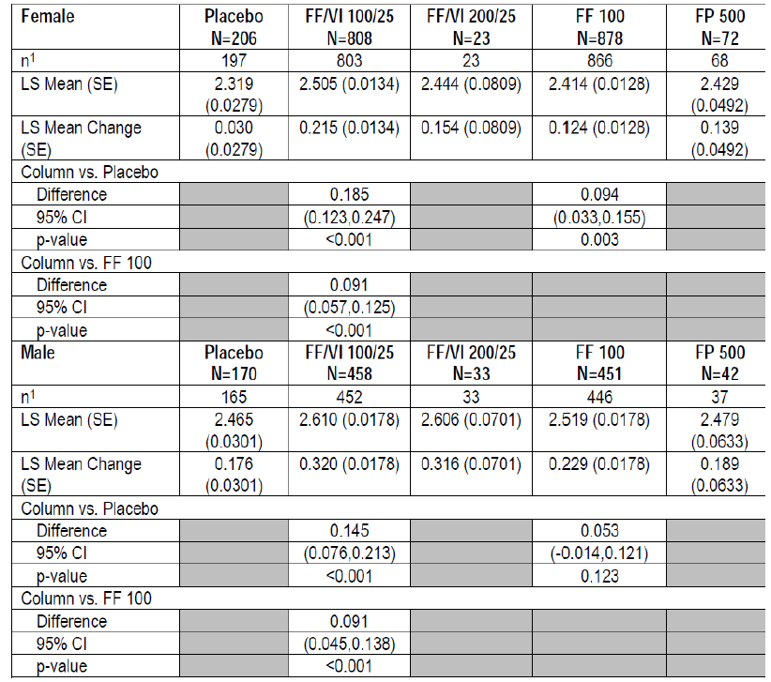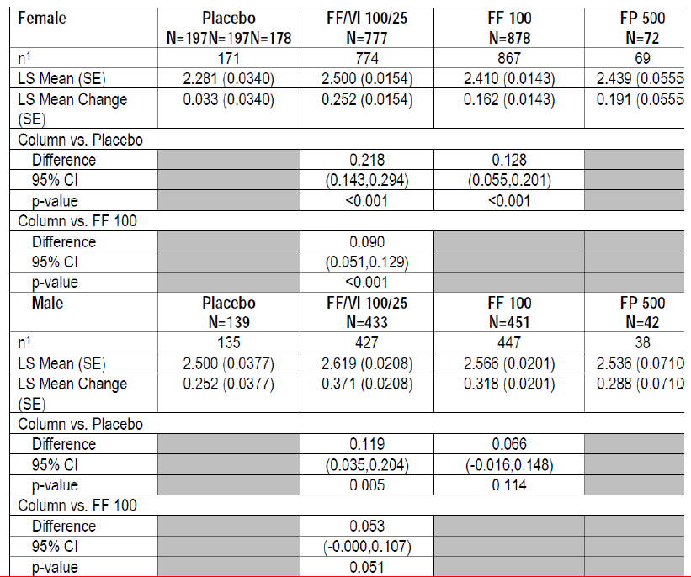
Table 9 continued. Statistical Analysis of trough FEV1 (L) at week 24 by gender subgroup (Integrated Asthma Clinical Studies, ITT population).
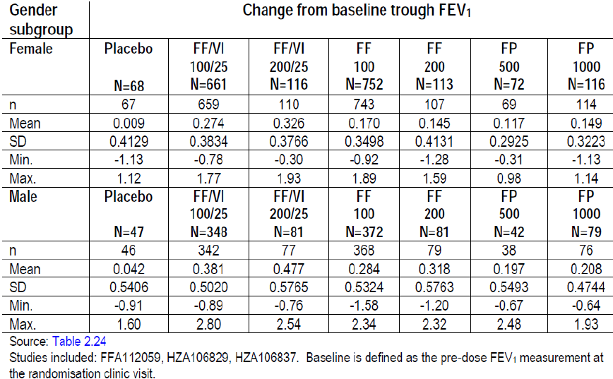
The LS mean changes from baseline were generally similar across geographical regions and reflected those of the ITT Population except for the Placebo arm where the LS mean change from baseline was lower in the Other [ROW] region (USA 80 mL; EU 101 mL; ROW 2 mL; ITT Population 160 mL). Hence, the magnitude of treatment effects for the treatment comparisons of FF/VI 100/25 and of FF 100 to Placebo appeared to be larger in the ROW region than in the overall population.
Similar to the ITT Population, withdrawals in most subgroups (except Placebo in 12 to 17 year olds and FF/VI 100/25 and FF 100 in African Americans) were lowest in the FF/VI 100/25 and FF 100 groups. Compared with the ITT Population, a greater proportion of subgroup subjects in the following treatment groups were withdrawn:
Age: Adolescents 12 to 17 years – FF/VI 100/25 (18% versus 12%), FF 200 (43% versus 25%)
Race: African American/African Heritage – FF/VI 100/25 (26% versus 12%), FF 100 (25% versus 14%)
Region: USA – FF/VI 100/25 (22% versus 12%), FF 100 (24% versus 14%); Other (ROW) – Placebo (43% versus 25%).

Evaluator’s conclusions on clinical efficacy for asthma

Dose-ranging studies
The proposed dosages of FF/VI for asthma are 100/25 µg and 200/25 µg once daily. Two doses of FF (100 µg and 200 µg once-daily) and a single VI dose (25 µg once-daily) were selected for the combination product to take into Phase III studies based upon results of four FF and two VI Phase IIb studies in patients ≥12 years of age with persistent asthma. No further dose ranging studies of the fixed dose combination was conducted in the Phase III asthma studies. Three dose ranging studies were conducted which tested a range of FF doses (25 to 800 OD) and FP doses (100, 250 and 500 BD), the strength of which was determined by the severity of the population enrolled in each study (see Table 10 below).
Table 10. Baseline asthma medication and treatment arms: Studies FFA109687, FFA109685 and FFA109684 (ITT Population)
No dose-response was demonstrated for FF doses ranging from 100-800 µg OD in Phase II studies FFA109684 (200, 400, 600 and 800 µg) and FFA108685 (100,200,300 and 400 µg OD); however, it is important to note that these studies seemed to evaluate FF doses which were in the flat part of the dose-response curve with not much difference in the effects on through FEV1 between these doses. Although results from study FFA108685 did suggest that the 100 and 200 µg OD doses of FF showed the best efficacy and tolerability profile, the benefit of the 200 µg over the 100 µg was not clear. In Study FFA109687, FF 100 and 200 OD met the pre-defined value of 200 mL difference relative to Placebo and had statistically significant mean increases in through FEV1 from baseline compared with Placebo. Both the FF 25 OD and FP 100 BD groups failed to show statistically significant differences relative to Placebo. The FF 50 group failed to meet the pre-defined 200 mL difference from Placebo (129 mL; 95% CI 11, 247) but was statistically significant compared with Placebo (p=0.033). Hence, results from this study justified use of 50 µg as the lowest FF dose to be used in the FF/VI combination in the Phase III studies. Results of the Phase II study FFA112202 demonstrated that FF 200 OD in the PM was non-inferior to FF 100 BD (LS mean treatment difference of through FEV1= 11 mL; 95% CI: -35, 56 in the ITT Population and 0 mL; 95% CI: -49, 49 in the PP Population) indicating similar efficacy following once daily or twice daily dosing with total daily dose of FF 200 µg.
The selection of the VI dose for inclusion in Phase III asthma studies was based upon data available from dose-interval (OD versus BD) and dose-ranging studies. As LABAs are not recommended for the treatment of asthma when used without concurrent ICS therapy, the Phase IIb studies to inform dose selection and dose interval (HZA113310 and B2C109575) for Phase III evaluated the effect of VI in subjects who were also receiving treatment with an ICS. Study HZA113310 evaluated VI doses of 6.25 OD, 12.5 OD, 25 OD and 6.25 BD for 7 days and demonstrated that all VI doses produced statistically significant improvements in pulmonary function compared with placebo, both in terms of through FEV1 (94, 102, 125 and 140 mL improvements over placebo in 6.25 OD, 12.5 OD, 25 OD and 6.25 BD groups, respectively) and weighted mean FEV1 (0 to 24 h) in subjects with persistent asthma. Weighted mean FEV1 is a better measure than through FEV1 to compare relative effects of OD and BD dosing as there are two troughs in a 24 h interval when a drug is dosed BD. In this study, there was minimal difference in weighted mean FEV1 (0 to 24 h) between VI 12.5 OD and 6.25 BD (LS mean difference from placebo was 168 and 166 mL, respectively), demonstrating no advantage for BD dosing over OD dosing for the same total daily dose.
Study B2C109575 evaluated doses of 3 to 50 µg VI OD in subjects with asthma and showed that OD dosing in the PM with VI produced sustained, dose-dependent improvements in lung function, with VI 12.5, 25 and 50 showing statistically significant, improvements in through FEV1 compared with placebo (130, 121 and 162ml over placebo in VI 6.25, 12.5 and 25 µg OD groups, respectively). However, weighted mean FEV1 (0 to 24 h) showed statistically significant improvements over placebo for all VI groups (151, 103, 142, 165 and 172 ml in 3, 6.25, 12.5, 25 and 50 µg groups, respectively). The dose-ranging data of VI in asthma were supported by similar data from study B2C111045 in subjects with COPD following 4 weeks treatment with VI doses of 3 to 50 VI OD. ). There was a dose-dependent increase in through FEV1 in this study (92, 98, 110, 137 and 165 mL with VI 3, 6.25, 12.5, 25 and 50 µg OD).
VI 25 was selected as the optimal dose to progress to Phase III, as greater efficacy across a range of secondary symptomatic endpoints was seen with V1 25 compared to lower doses and no greater efficacy was seen with VI 50 compared to VI 25. However, exclusion of 12.5 µg based on superior efficacy observed for 25 µg in secondary endpoints (% symptom free 24 h and rescue free 24 h periods) in a Phase II study (B2C109575) is not justified. The study was not powered to show a difference in these endpoints. It is likely that the patients have been administered a dose that is greater than that actually required. LABAs may be associated with increased severity of asthma exacerbations in some patients and hence it would be prudent to establish the minimum effective dose in patients with asthma with the option of up-titration if required in individual patients. Dose finding for VI would be required to be demonstrated in the larger Phase III trials, but this was not done as only a single dose of VI (25 µg) was used in all pivotal Phase III studies. Furthermore, as the mono components (FF and VI) are not yet registered for use in asthma, it will be difficult for clinicians to make the transition to the new fixed dose combination product.

Pivotal Phase III studies
The efficacy of VI 25 was further explored in the Phase III program by assessing the contribution of VI to the effect of FF/VI. Three studies analysed the incremental benefit of adding VI to doses of FF 100 or 200 (HZA106827, HZA106829 and HZA106837).
In the pivotal Phase III study HZA106827 (which recruited subjects uncontrolled on low/mid dose ICS or on low dose ICS/LABA), Although both FF/VI 100/25 µg and FF 100 µg were statistically significantly better than placebo for both co-primary endpoints (trough FEV1 at end of study and weighted FEV1 (0 to 24h), there was no significant difference between the two active treatments (FF/VI and FF alone). Hence this study failed to demonstrate efficacy of the VI component in the proposed combination. Significant differences in FF/VI 100/25 compared with FF 100 were only observed for the powered secondary endpoint of percentage of rescue-free/symptom-free 24 h periods, AM and PM PEF (but not for AQLQ) . However, statistical significance was not achieved for all treatment comparisons in the first level of Hierarchy, that is, there was no statistical significant difference between FF/VI and FF for the co-primary endpoints and hence the statistically significant treatment differences between FF/VI and FF for secondary and other efficacy endpoints should be interpreted as descriptive only.
In the Phase III pivotal Study HZA106829 (which recruited subjects uncontrolled on high dose ICS or on mid dose ICS/LABA), at the end of 24 weeks of treatment, compared with FF 200 alone, FF/VI 200/25 significantly improved through FEV1 (adjusted treatment difference 193 mL; 95% CI 108, 277; p<0.001) and weighted mean FEV1 (0 to 24 h) (adjusted treatment difference 136 mL; 95% CI 1, 270; p=0.048). Significant differences in FF/VI 200/25 compared with FF 200 were also observed for the powered secondary endpoint of percentage of rescue-free/ symptom-free 24 h periods, AM and PM PEF but not for AQLQ. After the blind was broken and following a site audit a decision was made to conduct sensitivity analyses excluding data from an investigator [information redacted] in the USA because of GCP issues. The sensitivity analysis of the co-primary endpoint of through FEV1 and powered secondary endpoint of rescue free 24 h period gave consistent results with those obtained from the primary (full ITT) population. However, the sensitivity analysis for the co-primary endpoint of weighted mean FEV1 (0 to 24 h) was not consistent with the ITT analysis results; the treatment difference for FF/VI 200/25 versus FF 200 was 78 mL (compared with 136 mL in the ITT Population) and was no longer statistically significant (p=0.230). Non-inferiority of FF 200 to FP 500 BD (a non-inferiority margin of -125 mL had been pre-defined) was demonstrated for change from baseline through FEV1 in the ITT Population (treatment difference from FP 500 BD = 18 mL; 95% CI -66, 102); these results were supported by the PP Population results. While this study did not include formal treatment comparisons of FF 200 with FP 500 BD on symptomatic endpoints, the similarity in the magnitude of effect on symptomatic endpoints of the two treatment arms supports the efficacy of FF 200.
Results from the well-conducted Phase III study (HZA106837) showed that FF/VI 100/25 significantly reduced the risk of severe asthma exacerbations by about 20%, significantly improved lung function (trough FEV1) and led to greater asthma control (as assessed by the ACQ7) compared with FF 100 when administered for 24 to 76 weeks. The definition of severe asthma exacerbation used in this study was a robust definition that has been validated by the ATS/ERS Taskforce. In addition, an Adjudication Committee was utilised in this study providing a blinded review to ensure all severe asthma exacerbations were identified and included in the primary measure.
Individual study results and subject-level integration of data have demonstrated that FF 100 and 200 are effective in improving lung function and symptomatic endpoints, showing similar efficacy to equivalent doses of FP (250 BD and 500 BD, respectively). Efficacy was not affected by age, gender, race or geographical region.
Additionally, the comparison of FF/VI 100/25 and FP/SALM 250/50 BD showed no significant treatment differences for the primary endpoint of weighted mean FEV1 (24 h) or on asthma control or quality of life endpoints (HZA113091), Although interpretation was limited as it was not a non-inferiority study.
No Phase III studies were conducted comparing FF/VI 100/25 and 200/25; instead subjects on different baseline therapy who would be candidates for either the higher or the lower strengths were recruited into the relevant studies. However, it is not clear how subjects would be titrated to these doses as none of the individual drugs (FF or VI) are registered for treatment of asthma and titration of the FDC was not evaluated in any of the clinical studies.
Overall, the proposed doses of FF/VI 100/25 and 200/25 have provided greater benefit in terms of improvement in lung function parameters of through FEV1, weighted mean FEV1 (0 to 24 h), AM and PM PEF than FF alone in two out of three pivotal Phase III studies (HZA106829 and HZA106837) where this was measured, thus demonstrating the contribution of VI to the combination. FF/VI 100/25 and 200/25 were also significantly better than the equivalent dose of FF monotherapy in improving symptomatic endpoints including 24 h rescue-free/symptom-free periods, time to first severe exacerbation and severe exacerbation rate. The contribution of FF to the efficacy of the combination was shown in an allergen-challenge Study HZA113126 (refer section Primary Pharmacodynamic effects) where FF/VI was significantly better than VI alone in terms of attenuating the early and late phase asthmatic response and also the increased bronchial hyper-responsiveness (BHR) associated with allergen challenge.

COPD
Overall, 11 studies were submitted for COPD including four, Phase IIIa studies with FF/VI Inhalation Powder (HZC112206, HZC112207, HZC102871, and HZC102970) which were considered pivotal studies for the COPD indication. Five studies that provided additional efficacy and safety data were considered supportive; four studies with FF/VI Inhalation Powder (HZC110946, HZC113107, HZC113109 and HZC112352) and one study with VI Inhalation Powder monotherapy (B2C111045).

Pivotal efficacy studies

24 week study HZC112206

Study design, objectives, locations and dates
HZC112206 was a Phase III, multi-center, randomised (1:1:1:1:1), stratified, placebo-controlled, double-blind, parallel-group study involving 1622 subjects with COPD. The primary objective of the study was to evaluate the efficacy and safety of FF/VI (50/25 µg), FF/VI (100/25 µg), FF 100 µg, VI 25 µg and when administered via the novel dry powder inhaler (NDPI) over a 24 week treatment period. The study was conducted from 19 October 2009 to 16 February 2011 at 221 centers in 9 countries (Chile, Estonia, Germany, Japan, Korea, Philippines, Poland, Russian Federation and the United States).
Comments: No FF 50 alone treatment group was included in the 24 week studies HZC112206 and HZC112207 and the contribution of VI 25 was assessed by comparing the relevant combination doses with FF 100 and FF 200; as FF 50 was considered to be a no-effect/low effect dose, the sponsors felt that the contribution of VI did not need to be assessed with this dose.

Inclusion and exclusion criteria
The main inclusion criteria were: male or female (non-pregnant/ lactating) aged > 40 years, confirmed diagnosis of COPD with a measured post-albuterol/salbutamol FEV1/FVC ratio of ≤0.70 at Screening, current or past smoker (> 10 pack years), Achieved a score of ≥2 on the Modified Medical Research Council Dyspnea Scale (mMRC) at Screening. The main exclusion criteria were: if subjects had been hospitalised due to poorly controlled COPD within 12 weeks of Screening and/or had poorly controlled COPD (defined as acute worsening of COPD that was managed by the subject with corticosteroids or antibiotics or that required treatment prescribed by a physician) within 6 weeks prior to Screening and/or had experienced a lower respiratory tract infection that required the use of antibiotics within 6 weeks prior to Screening: current diagnosis of asthma. (Subjects with a prior history of asthma were eligible if they had a current diagnosis of COPD); α1-antitrypsin deficiency; Other respiratory disorders: Subjects with active tuberculosis, lung cancer, bronchiectasis, sarcoidosis, lung fibrosis, pulmonary hypertension, interstitial lung diseases or other active pulmonary diseases; patients on long-term oxygen therapy; Subjects with lung volume reduction surgery within the 12 months prior to Screening; Subjects with a chest X-ray (or CT scan) that revealed evidence of clinically significant abnormalities not believed to be due to the presence of COPD.

Study treatments
Following the 2-week Run-In period, eligible subjects were randomised (1:1:1:1:1) to one of the following 5 possible treatments, administered as one inhalation each morning (OD dosing) for 24 weeks: FF/VI Inhalation Powder 50/25 µg and 100/25 µg; FF Inhalation Powder 100 µg ; VI Inhalation Powder 25 µg and Placebo Inhalation Powder. A placebo arm was included in this study to allow for a quantitative assessment of the drug effect of each of the two FF/VI combinations (50/25 µg and 100/25 µg) and the individual components compared with an inactive control. Rescue albuterol use was permitted as needed by all subjects in the study. In addition ipratropium bromide alone was permitted, provided that the subject was on a stable dose from Screening (Visit 1) and remained on the stable dose throughout the study. Albuterol and ipratropium were withheld for 4 h prior to and during spirometry testing at each clinic visit.

Efficacy variables and outcomes
The co-primary efficacy endpoints for this study were: Weighted mean Clinic Visit FEV1 (0-4) h post dose (to evaluate the contribution of VI) on Treatment Day 168 (Visit 11); Change from baseline in Clinic Visit through FEV1 (pre-bronchodilator and pre-dose), (to evaluate the contribution of FF and the 24 h effect of VI) on Treatment Day 169 (Visit 12).
The Dyspnea Domain of the CRQ-SAS was defined as a secondary endpoint, except in the US where this endpoint was regarded as an “other” endpoint. Other secondary efficacy endpoints for this study were: Peak FEV1 on Treatment Day 1 and Time to onset (increase of 100 mL above baseline in FEV1) on Treatment Day 1. Other efficacy endpoints were: Time to 12% change from baseline in FEV1 on Day 1; Weighted mean clinic visit FEV1 0 to 4 h post dose on Treatment Days 1, 14, 56 and 84 (added as other endpoint since not explicitly stated in the protocol); Change from baseline in clinic visit through FEV1 on Treatment Days 2, 7, 14, 28, 56, 84, 112 and 140 (added as other endpoint since not explicitly stated in the protocol). Assessment of the following during each week of treatment and over the entire 24 week treatment period:- Percentage of symptom-free 24 h periods, Percentage of rescue-free 24 h periods, Symptom scores (breathlessness, cough and sputum production), Number of occasions rescue albuterol/salbutamol used, percentage of nights with no night time awakenings requiring albuterol/salbutamol, number of night time awakenings requiring albuterol/ salbutamol, Mean AM PEF and CRQ-SAS (total score and other domains). Efficacy endpoints were outlined for the 6-month COPD efficacy and safety studies.
For the individual studies and for the integrated analyses of HZC112206/HZC112207, the primary treatment comparisons for the 2 co-primary endpoints were:- VI versus placebo;-Each FF/VI dose versus Placebo; Each FF/VI dose versus VI alone. The following comparisons were supportive:-Each FF dose versus placebo; -Each FF/VI dose versus the relevant FF alone dose.
For the individual studies and for the integrated analyses of HZC112206/HZC112207, the primary treatment comparisons for the secondary endpoints were: - Each FF/VI dose versus Placebo. The following comparisons were supportive: VI versus placebo; -Each FF/VI dose versus the relevant FF alone dose; Each FF/VI dose versus VI alone;- Each FF dose versus placebo.

Randomisation and blinding methods
Subjects were centrally randomised using RAMOS, an Interactive Voice Response System (IVRS). Study Medication taken during the 24 week treatment period was double-blind; neither the subject nor the study physician knew which study medication the subject was receiving.

Analysis populations
The ITT Population was the population of primary interest for all efficacy endpoints. The Per Protocol Population was used for confirmatory analyses of the primary efficacy endpoints only.

Sample size
Sample size calculations were based on the co-primary endpoints of post dose FEV1 assessed by weighted mean (WM) over the first 0 to 4 h on Treatment Day 168 and change from baseline in through FEV1 on Treatment Day 169 using an estimate of residual standard deviation of 210 mL (based upon the Phase IIb study B2C111045A of VI in COPD subjects). The sample size of this study had at least 90% power to detect an 80 mL difference between FF/VI and VI in through FEV1 on Day 169 (using a two-sample t-test and two-sided 5% significance level). A 100 mL difference was considered appropriate for comparisons of VI versus placebo and FF/VI versus placebo for both through FEV1 and WM 0 to 4 h FEV1 and of FF/VI versus FF for WM 0 to 4 h FEV1 and this study had at least 98% power to detect this difference.

Statistical methods
As the randomisation was stratified by smoking status at Visit 1, this was included as a covariate to all analysis models. In order to account for multiplicity across treatment comparisons and key endpoints, a step-down testing procedure was applied whereby inference for a test in the pre-defined hierarchy was dependent upon statistical significance having been achieved for the previous tests in the hierarchy. In addition, for a given FF/VI combination dose, the secondary endpoints (CRQ-SAS dyspnea, peak FEV1, and time to 100 mL change from baseline in FEV1) were nested under the primary endpoints. The primary analysis was performed using mixed model repeated measures (MMRM) and had covariates of baseline FEV1, smoking status (stratum), Day, centre grouping, treatment, Day by baseline interaction and Day by treatment interaction, where Day is nominal. Similar statistical methods were used for analysis of the secondary efficacy endpoints. No formal statistical analysis of sub-groups of the populations was performed.

Participant flow
Of the 1804 subjects who were screened, 1030 subjects were randomised and received at least one dose of study treatment. Of the 1030 subjects in the ITT population, 983 (95%) were included in the Per Protocol population. Approximately 70% of subjects across the treatment groups) completed the study. Most common primary reason for premature withdrawal was AEs with similar incidence in the FF/VI groups (7% to 8%) and placebo (7%) groups which were lower than in the FF 100 (11%) and VI 25 (12%) groups. Lack of efficacy (mainly due to COPD exacerbations) resulted in premature withdrawal of 6% of subjects in the FF/VI groups compared with 10% of the placebo group and 7% and 9% of the VI and FF groups, respectively.

Major protocol violations/deviations
Approximately one-third of the ITT Population had at least one protocol deviation during the study, with 47 subjects (5%) having full deviations and 89 subjects (9%) having partial deviations; additionally, 275 subjects (27%) had through FEV1 evaluations out of the protocol-defined time window for the assessment. The most common reasons for full deviations were for use of disallowed medication prior to treatment (29 subjects, 3%). The most common partial deviations included disallowed medication use during treatment (78 subjects, 8%). The percentages of subjects with protocol deviations were generally similar across the treatment groups.

Baseline data
Majority of the subjects were White (72%), male (67%), with GOLD Stage II or III at screening (90%; only 10% of the population was GOLD Stage IV) and non-reversible COPD (66%). The mean age was 63 years (and the mean body mass index (BMI) of 26.1 kg/m² suggests that subjects tended to be slightly overweight Baseline demographics, disease characteristics were similar in all 4 treatment groups. However, there was slight imbalance across the treatment groups in baseline FEV1 with lower mean values recorded for the FF 100 group and the FF/VI 50/25 group. Overall, 97% of the subjects fell into two grades on the mMRC dyspnea scale: Grade 2 (walking slower than others of the same age on level because of breathlessness [67%]) or Grade 3 (stopping to breathe after walking about 100yards or after a few minutes on level [30%]). Overall, 80% of the ITT population had taken COPD medications prior to double-blind treatment (55% had taken short-acting beta2-agonists (55%), short-acting anticholinergics (35%) and long-acting beta2-agonists (32%), long-acting anticholinergics (26%) and inhaled corticosteroids (23%). During the treatment period, 34% of subjects used COPD concomitant medications (30% to 37%) of subjects across with the most common medications being short-acting anticholinergics (24%) during the treatment period, and were used by a higher percentage of subjects in the placebo group compared with the remaining treatment groups. Post-treatment COPD medication use was reported by 51% of the ITT Population, with short-acting anticholinergics (22%), long-acting beta2-agonists (20%), short-acting beta2- agonists (18%) and long-acting anticholinergics (18%) being the most widely used classes of medication. Mean overall compliance to randomised treatment was high during the study (>98% across all treatment groups). Greater than 80% of subjects in all treatment groups were ≥95% to ≤105% compliant to their assigned treatment regimen.

Results for the primary efficacy outcome
Compared with placebo, LS mean improvement in weighted FEV1 (0 to 4 h) was statistically significantly (p<0.001) better in the FF/VI 100/25 (placebo adjusted change=173 mL), FF 50/25 (192 mL) and VI 25 (103 mL) groups. Furthermore, the FF/VI 100/25 group demonstrated a statistically significant LS mean improvement of 120 mL compared with the FF 100 group, demonstrating the relative contribution of VI on lung function. Although not designated primary treatment comparisons, both FF/VI groups demonstrated improvements compared with the VI group (p≤0.006) as did the FF 100 group compared with the placebo group (p=0.040) (Table 11).
Table 11. Summary of 0 to 4 h weighted mean FEV1 (L) ITT Population
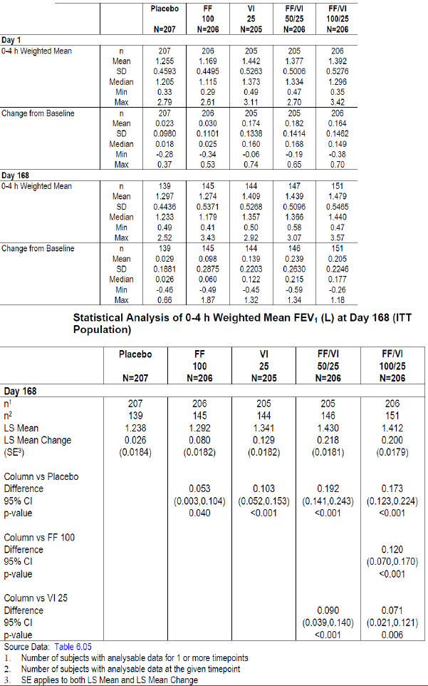
Compared with the placebo group, LS mean change from baseline in through FEV1 was statistically significantly (p<0.001) better in the FF/VI 100/25 (placebo-adjusted change=115 mL) and VI 25 (ml) groups. The FF/VI 100/25 group did not show a statistically significant improvement compared with the VI group. Although there was a numerical improvement of 48 mL As a result of the primary comparison of FF/VI 100/25 against VI not achieving statistical significance at the 5% level for the co-primary endpoint of through FEV1 at Day 169, the restrictions of the step-down testing procedure have not been met and therefore the results of all further statistical analyses were interpreted descriptively. However, the FF/VI 50/25 group showed improvement in LS mean change from baseline through FEV1 compared with both placebo (p<0.001) and the VI group (p=0.025). Although not designated a primary treatment comparison, the FF/VI 100/25 group also demonstrated an improvement in LS mean change from baseline through FEV1 compared with the FF 100 group (p=0.003) (Table 12). After Day 1, both FF/VI groups demonstrated greater improvements versus placebo in both co-primary endpoints (LS mean weighted mean FEV1 0 to 4 h and through FEV1 at day 169) compared with the FF and VI alone groups for the remainder of the 6-month treatment period with no evidence of a dose response between the FF/VI 50/25 and 100/25 groups (Figure 8).
Table 12. Summary of trough FEV1 (L) ITT Population
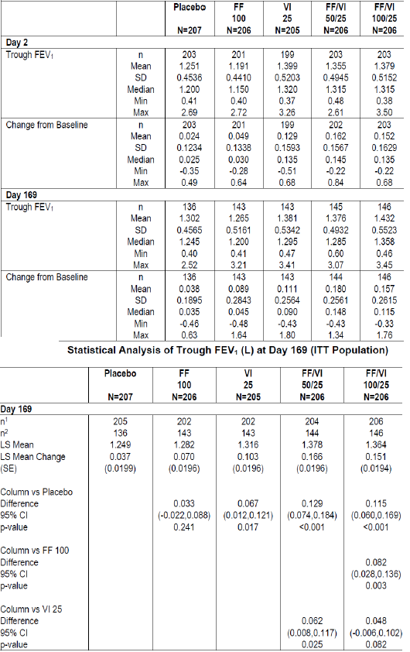
Figure 8. Least squares means (95%CI) in 0 to 4 h weighted mean FEV1 (ITT population, Mixed Model repeated measures) and Least squares means change from baseline (95%CI) in trough FEV1 (L) (ITT population, Mixed Model repeated measures).
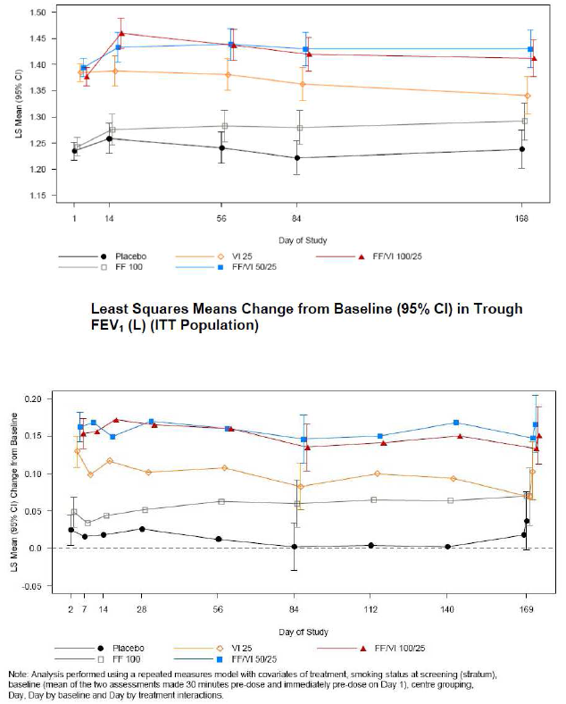

Results for other efficacy outcomes
At Day 168, differences were seen in LS mean change from baseline CRQ-SAS dyspnoea scores between FF/VI 100/25 and placebo (0.30, p=0.014) and between FF/VI 100/25 and FF 100 (0.24, p=0.044); for other comparisons p>0.05. None of the treatment comparisons achieved the minimal clinically important difference (>0.5 point improvement) in mean CRQ-SAS Dyspnoea Domain scores. There was no evidence of a dose response between the FF/VI 50/25 and 100/25 groups prior to Day 84, but from Day 84 onward, the magnitude of effect (difference from placebo) was greater for the FF/VI 100/25 compared with the FF/VI 50/25 µg group (Figure 9). At Day 168, the odds of being a responder compared to a non-responder was 1.57 times greater for VI 25 than placebo (p=0.045) and 2.04 times higher for FF/VI 100/25 than placebo (p=0.002) (p=0.002); for all other comparisons p>0.05. However, none of the treatment comparisons achieved a minimal clinically important difference (>0.5 point improvement) in mean CRQ-SAS Total Score.
Figure 9. Least squares means change from baseline (95%CI) in CRQ-SAS dyspnea domain (ITT population).
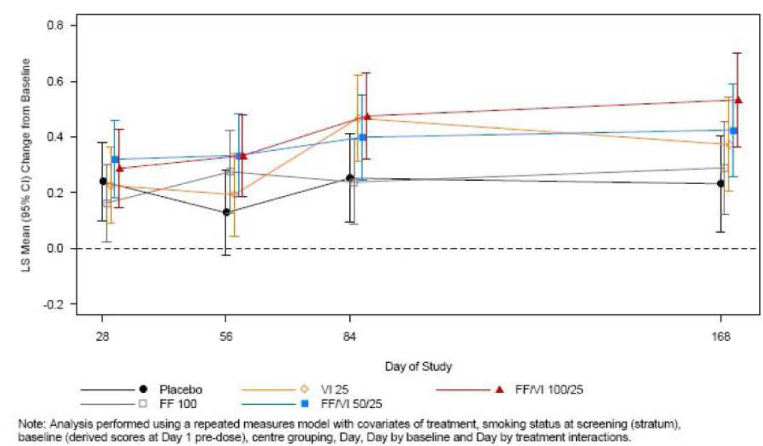
LS mean changes from baseline in peak FEV1 on Day 1 were similar for the placebo and FF 100 groups (106 mL and 118 mL, respectively), but they were higher for the VI 25, FF/VI 50/25, and FF/VI 100/25 groups (247 mL, 253 mL and 245 mL, respectively, p<0.001 versus placebo). There were no differences in the mean peak FEV1 at Day 1 between the FF/VI combination groups and the VI 25 group or between the FF 100 group and placebo.
Overall, 85% of the subjects in the VI 25, FF/VI 50/25, and FF/VI 100/25 groups achieved their first increase of a 100 mL or more from baseline in FEV1within the 5 minute to 4-h post dose time points, while over 50% of the subjects in the placebo and FF 100 groups did not. The median (actual) time to onset was 16 to 17 minutes post-dosing for treatment groups containing VI 25. P-values for differences from placebo in time to onset were <0.001 for the VI 25, FF/VI 50/25, and FF/VI 100/25 groups, as was the difference between the FF/VI 100/25 group and FF 100 group . There were no differences in the time to onset between either FF/VI combination group and the VI 25 group or between FF 100 and placebo (Table 13).
Table 13. Summary of time to 100 mL increase from baseline in 0 to 4 h post dose FEV1 at Day 1 (ITT population) and Log rank analysis of time to 100 mL or more increase from baseline in 0-4 h post dose FEV1 at Day 1 (ITT population)
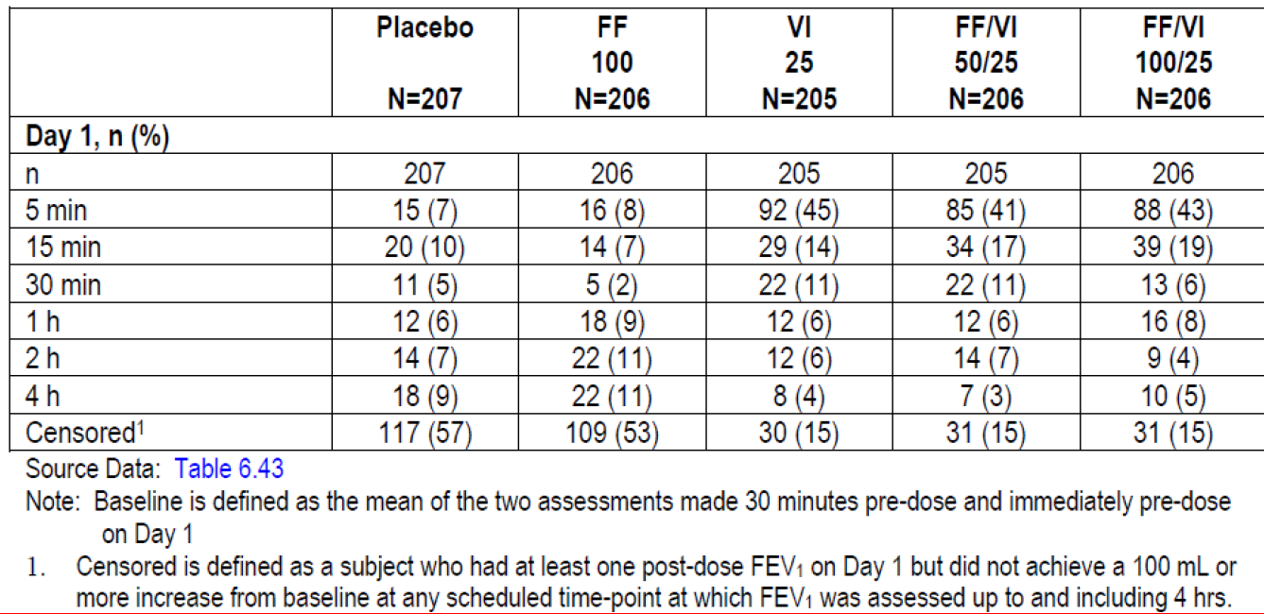
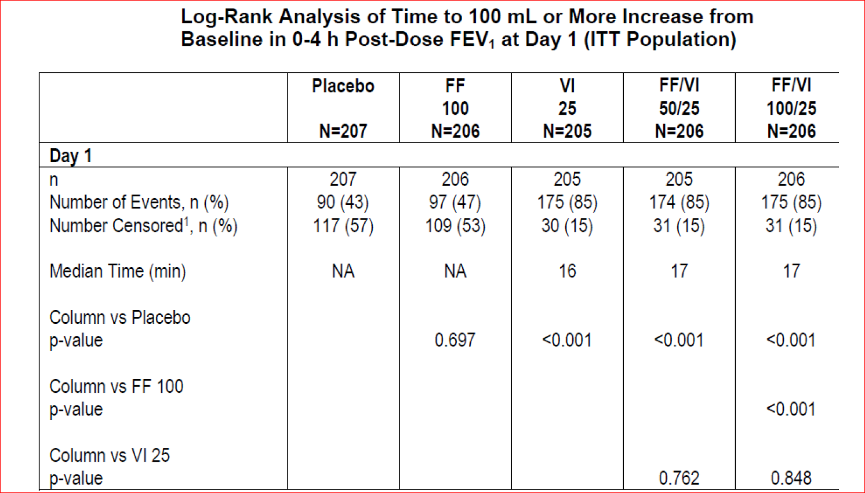
The data show that ≥72% of the subjects in the VI 25, FF/VI 50/25, and FF/VI 100/25 groups achieved their first increase of 12% or more from baseline in FEV1 within the 5 minute to 4-h post dose time points, while over 60% of the subjects in the placebo and FF 100 groups did not achieve a 12% increase from baseline in FEV1 at any scheduled post dose time point (up to 4 h post dose). The median (actual) time to a 12% increase was 32 and 30 minutes for the VI 25 and FF/VI 50/25 treatment groups and 59 minutes for the FF/VI 100/25 group.
There were no differences in the time to at least a 12% increase from baseline in FEV1 between either FF/VI combination group and the VI 25 group or between FF 100 and placebo (Table 14).
Table 14. Summary of Time to 12% increase or more from baseline in 0 to 4 h post dse FEV1 at Day 1 (ITT population).
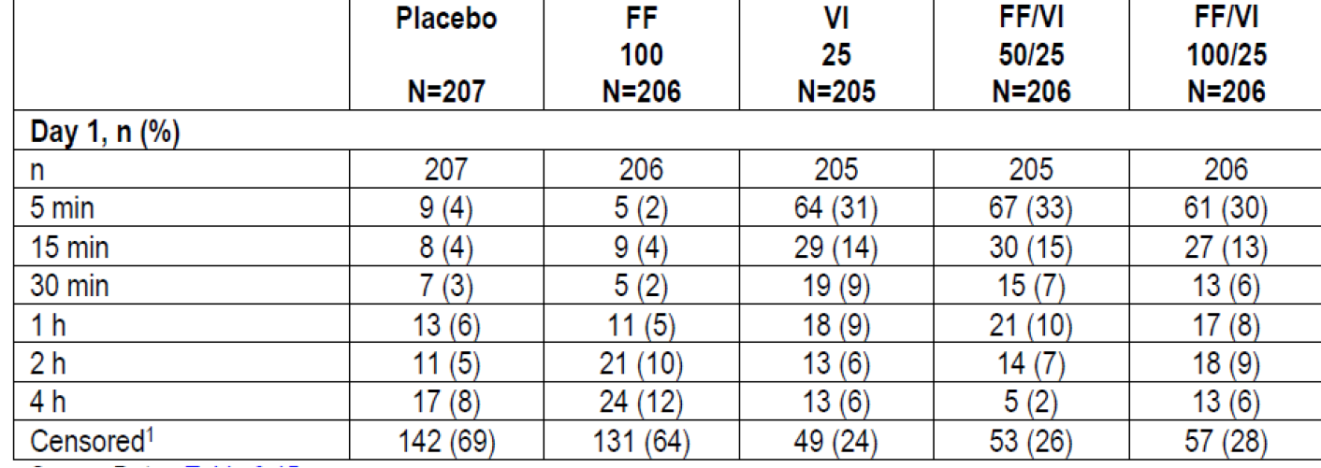
Log rank analysis of time to 12% increase or more from baseline in 0 to 4 h post dose FEV1 at day 1 (ITT population)
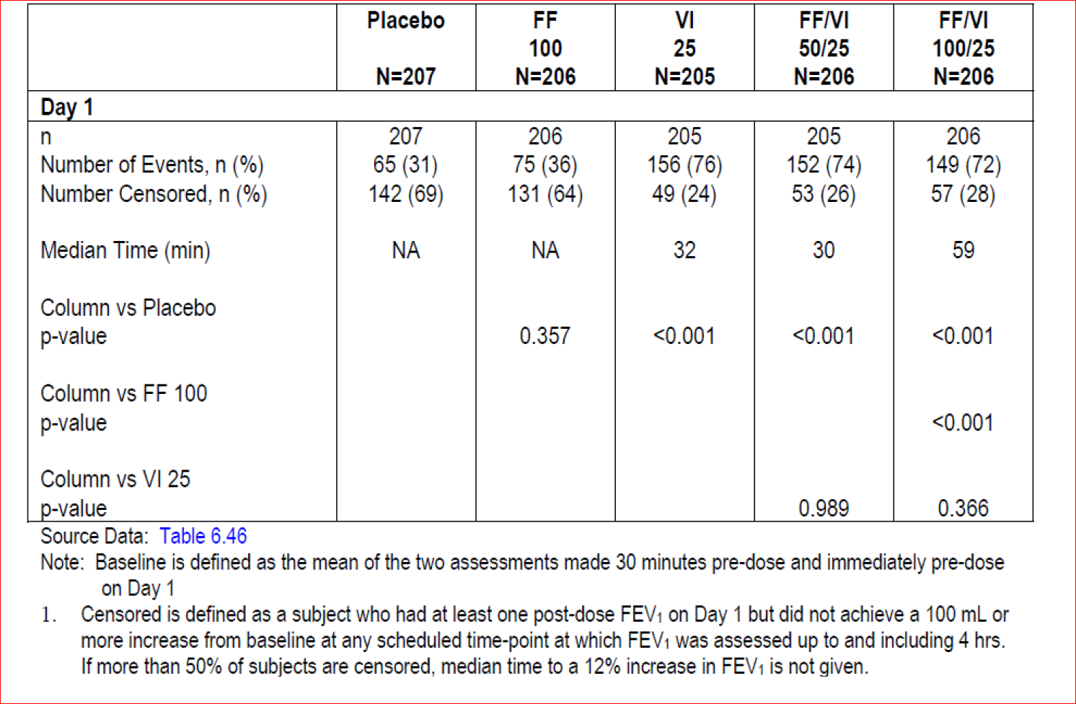

Other efficacy endpoints
The percentages of symptom-free 24 h periods during Week 1 to 24 were higher in all active treatment groups compared with placebo for all endpoints. Over the entire 24 week period, there were decreases in LS mean values from placebo for the cough scores in the VI 25, FF/VI 50/25, and FF/VI 100/25 groups (differences of -0.13, -0.21 and -0.20, respectively; p≤0.010); mean sputum scores show decreases from placebo (p≤0.021) for the FF/VI 50/25 and FF/VI 100/25 groups and the mean breathlessness scores show decreases from placebo (p≤0.045) for all active treatment groups.
Analyses of the mean number of occasions of rescue medication use show decreases from placebo over the entire 24 week period for all active treatment groups (p<0.001), as well as a decrease in the mean number of occasions of rescue medication use for the FF/VI 100/25 group compared with the FF 100 group (p<0.001). There was also a decrease in the FF/VI 100/25 group compared with the VI 25 group (p=0.001). There was no difference between the FF/VI 50/25 group and the VI 25 group Analyses of the mean number of night time awakenings requiring rescue medication show decreases from placebo over the entire 24 week period for both FF/VI treatment groups (p≤0.001), but no difference (p>0.05) for the FF 100 and VI groups. There was also a decrease in the mean number of night-time awakenings requiring rescue medication for the FF/VI 100/25 group compared with the FF 100 group (p=0.040), as well as a decrease in the FF/VI 100/25 group compared with the VI 25 group (p=0.040). Analyses of AM PEF showed improvements from placebo over the entire 24 week period for all active treatment groups (p≤0.017). There was also a difference in AM PEF between the FF/VI 100/25 group and the FF 100 group (p<0.001).

24 week study HZC112207
HZC112207 was similar to study HZC112206 with the only difference between them being that the HZC112206 study included a lower strength (50/25 µg) of FF/VI Inhalation Powder, while the HZC112207 study included a higher strength (200/25 µg) of FF/VI Inhalation Powder and the corresponding strength of FF (200 µg) as a monotherapy arm.
The primary objective of the study was to evaluate the efficacy and safety of once daily dosing with FF/VI 100/25 µg, FF/VI 200/25 µg, FF 100 µg, FF 200 µg , VI 25 µg and placebo when administered via the novel dry powder inhaler (NDPI) over a 24 week treatment period in subjects with COPD. The study was conducted from 19 Oct 2009 to 16 Mar 2011 at 138 centres in 8 countries (Czech Republic, Germany, Japan, Poland, Romania, Russian Federation, Ukraine and the United States). Other features of study design, inclusion/ exclusion criteria, statistical methods were similar to those described for pivotal study HZC112206 above.

Participant flow
Of the 1909 screened subjects, 1224 were randomised and received at least one dose of study medication (ITT population). Of the subjects in the ITT population, 1159 (95%) were included in the PP population. Overall, 75% of patients across all treatment groups completed the study and withdrawal rates were slightly higher in the FF/VI 100/25 group (29%) compared to other active groups but it was similar to the placebo group.

Major protocol violations/deviations
Overall, 31 to 41% of subjects had at least one protocol deviation during the study, with 65 subjects (5%) having full deviations and an identical number having partial deviations; another 359 subjects (29%) had a time-point specific deviation. The most common reasons for full deviations were for overall compliance being < 80% or >120% (27 subjects, 2%) and for use of a medication prohibited in the protocol (22 subjects, 2%). The most common partial deviation was use of prohibited medications (59 subjects, 5%). The percentages of subjects with protocol deviations were generally similar across the treatment groups. Subjects with full protocol deviations were completely excluded from the Per-protocol (PP) Population.

Baseline data
Majority of the subjects were White (94%), male (72%) with irreversible COPD (71%) with duration of COPD of 1 to 5 years (38%) or 5-10 years (30%) and GOLD Stage II or III (90%); the mean age was approximately 62 years and the mean body mass index (BMI) of 26.5 kg/m² suggests that subjects tended to be slightly overweight. The mean mMRC dyspnea scale score of the ITT Population at screening was 2.4 with the majority (98%) having Grade 2 (walking slower than others of the same age on level because of breathlessness [63%]) or Grade 3 (stopping to breathe after walking about 100 yards or after a few minutes on level [35%]). Overall, baseline demographics and disease characteristics were similar across treatment groups. Although there was slight imbalance across the treatment groups in screening pre-bronchodilator and baseline FEV1 with lower mean values recorded for the FF 200 group and the FF/VI 200/25 group. At baseline the lowest mean value was recorded for the FF/VI 200/25 group (1.311) compared to the highest mean value of 1.387 recorded for the FF 100 group. Adjustments for baseline in the statistical analysis models were defined a priori in the RAP with baseline FEV1 being included as a covariate in the analysis of FEV1 endpoints.
Overall, 88% of the ITT population had taken COPD medications prior to Day 1 of double-blind treatment with the majority having taken short-acting beta2 agonists (62%), Short-acting anticholinergics (34%) and long-acting beta2 agonists (35%), long-acting anticholinergics (24%) and inhaled corticosteroids (24%). During the treatment period, 26% of subjects used COPD concomitant medications, and the use was similar across the treatments (21% to 29%) with short-acting anticholinergics used most commonly (20%). Post-treatment COPD medication use was reported by 39% of the ITT Population, with short-acting anticholinergics (21%), long-acting beta2-agonists (15%), short-acting beta2- agonists (11%), inhaled corticosteroids (9%) and long-acting anticholinergics (9%) being the most widely used classes of medication. Mean overall compliance to randomised treatments was high and similar across treatment groups during the study (>97% across all treatment groups). Greater than 84% of subjects in all treatment groups were ≥95% to ≤105% compliant to their assigned treatment regimen.

Results for the primary efficacy outcome
On Treatment Day 168, clinically meaningful, statistically significant (p<0.001) improvements compared with placebo in weighted mean FEV1 0 to 4 h post dose were demonstrated in the FF/VI 200/25 (209 mL), FF/VI 100/25 (214 mL), VI 25 (185 mL) and FF100 (168 mL) treatment groups. Furthermore, both the FF/VI 200/25 and 100/25 groups showed a clinically meaningful, statistically significant LS mean improvement of 168 mL each compared with the FF 200 and FF 100 groups, respectively which demonstrated the relative contribution of VI on lung function.
On Treatment Day 169, clinically meaningful, statistically significant improvements in through FEV1 compared with placebo were demonstrated in the VI 25 (100 mL) , FF/VI 200/25 (131 mL) and FF/VI 100/25 treatment groups. However, the FF/VI 200/25 and 100/25 groups did not show a statistically significant improvement in LS mean change from baseline through FEV1 compared with the VI group, although there was a numerical improvement of 32 and 48 mL, respectively. As a result of the primary comparison of FF/VI 200/25 against VI not achieving statistical significance at the 5% level for the co-primary endpoint of through FEV1 at Day 169, the restrictions of the step-down testing procedure have not been met and therefore the results of all further statistical analyses are interpreted descriptively. Although not designated a primary treatment comparison, the FF/VI 200/25 and 100/25 groups both also demonstrated an improvement in LS mean change from baseline through FEV1 compared with the FF 200 and FF 100 groups respectively (p<0.001). After Day 1, both FF/VI groups demonstrated greater improvements versus placebo in both co-primary endpoints (LS mean weighted mean FEV1 0 to 4 h and through FEV1 at day 169) compared with the FF and VI alone groups for the remainder of the 6-month treatment period with no evidence of a dose response between the FF/VI 100/25 and 200/25 groups (Figure 10).
Figure 10. Least squares means (95%CI) changes
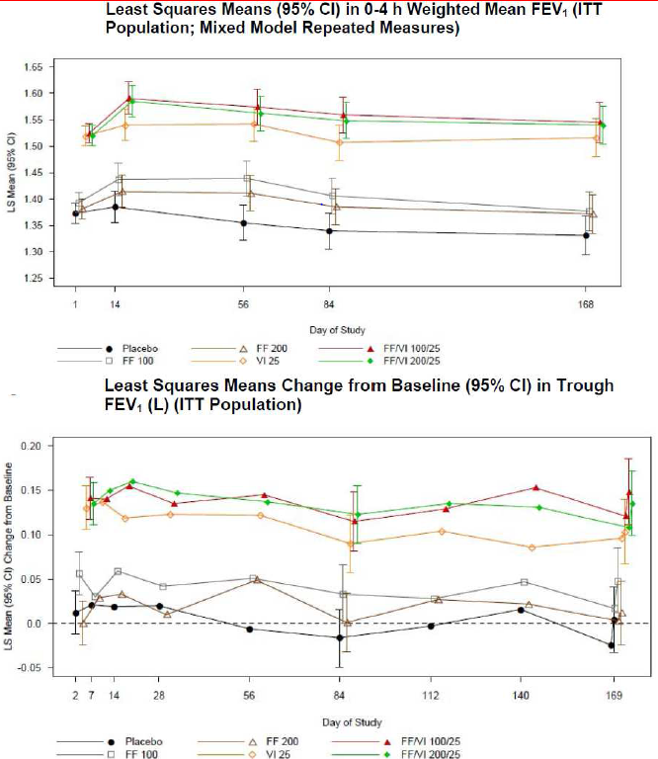

Results for other efficacy outcomes

Secondary efficacy endpoints
At Day 168, statistically significant improvements in LS mean change from baseline CRQ-SAS dyspnoea scores were only seen between FF/VI 100/25 and placebo (0.24, p=0.029) and between FF/VI 100/25 and FF 100 (0.36, p=0.001); for all other treatment comparisons p>0.05 with none of the treatment comparisons achieved a minimal clinically important difference (>0.5 point improvement) in mean CRQ-SAS Dyspnoea Domain scores. At Day 168, the odds of being a responder compared to a non-responder was 1.67 times greater for FF/VI 100/25 than placebo (p=0.019); for all other treatment comparisons p>0.05. Although there were slight statistically significant improvements in Total CRQ-SAS scores and the Fatigue and Emotional sub scores with FF/VI 100/25 compared with placebo, none of the treatment comparisons achieved a minimal clinically important difference (>0.5 point improvement).
LS mean changes from baseline in peak FEV1 on Day 1 were similar for the placebo and FF 200 group (120 mL and 127 mL, respectively), and slightly higher for the FF 100 group (145 mL). LS mean changes from baseline in peak FEV1 were higher for the VI 25, FF/VI 100/25, and FF/VI 200/25 groups (266 mL, 271 mL and 261 mL, respectively). P-values for the LS mean differences from placebo in peak FEV1 were <0.001 for the VI 25, FF/VI 100/25, and FF/VI 200/25 groups, as were the p-values for the mean differences between the FF/VI 100/25 group and FF 100 group and the FF/VI 200/25 group and the FF 200 group. There were no differences in the LS mean peak FEV1 at Day 1 between the FF/VI combination groups and the VI 25 group or between FF groups and placebo. These data confirm the contribution of VI to the increase in FEV1 on Day 1.
Overall, 85% or more of the subjects in the VI 25, FF/VI 100/25, and FF/VI 200/25 groups achieved their first increase of at least 100 mL or more from baseline in FEV1 within the 5 minute to 4 h post dose timepoints while more than 40% of the subjects in the placebo and FF 100 and FF 200 groups did not. The median (actual) time to onset was 16-17 minutes post-dosing for treatment groups containing VI 25; P-values for differences from placebo in time to achieve a 100 mL increase in FEV1 were <0.001 for the VI 25, FF/VI 100/25 and 200/25 groups, as were the differences between the FF/VI groups and the respective FF 100 and FF 200 groups. There were no differences in the time to onset between either FF/VI combination group and the VI 25 group or between either FF group and the placebo group.

Other efficacy endpoints
Overall, ≥70% of the subjects in the VI 25, FF/VI 100/25, and FF/VI 200/25 groups achieved their first increase of at least 12% or more from baseline in FEV1 within the 5 minute to 4 h post dose timepoints, while 65% or more of the subjects in the placebo, FF 100 and FF 200 groups did not. The median (actual) time to a 12% increase was 35 and 33 minutes for the VI 25 and FF/VI 100/25 treatment groups respectively and 61 minutes for the FF/VI 200/25 group. P values for differences from placebo in time achieve a 12% increase in FEV1 were <0.001 for the VI 25, FF/VI 100/25, and FF/VI 200/25 groups, as were the differences between the FF/VI groups and FF 100 and FF 200 groups. There were no differences in the time to at least a 12% increase from baseline in FEV1 between either of the FF/VI combination groups and the VI 25 group or between either FF group and the placebo group.
The percentages of symptom-free 24 h periods during Week 1-24 were higher in all active treatment groups compared with the placebo group for all endpoints. In general, the FF/VI 100/25 group had a higher percentage of symptom-free days than the other active treatment groups and placebo (Table 15). Over the 24 week treatment period, the percentage of rescue-free 24 h periods remained essentially unchanged for subjects in the placebo group and FF 100 and FF 200 groups and increased in the other active treatment groups, with the FF/VI groups having the highest percentage of rescue free 24 h periods (Table 16).
Table 15. Percentage of symptom free 24 h periods (ITT population)
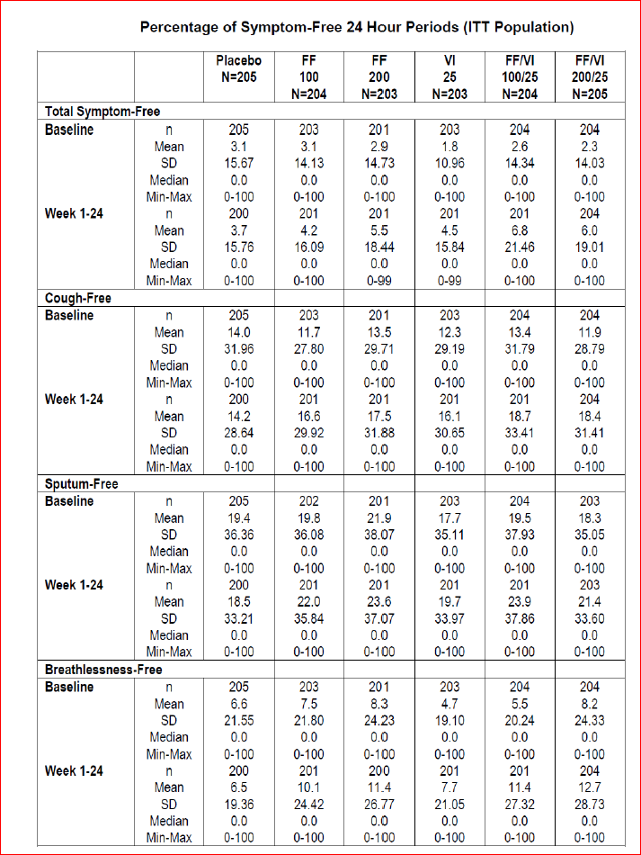
Table 16. Percentage of rescue free 24 h periods (ITT population)
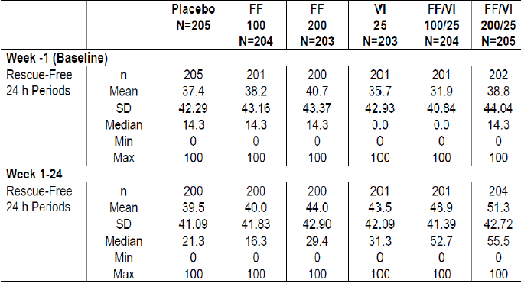
Analyses of the mean number of occasions of rescue medication use show decreases from placebo over the entire 24 week period for all VI-containing treatment groups (p< 0.001) as well as a decrease in the mean number of occasions of rescue medication use for the FF/VI groups compared with the respective FF group (p<0.002). There was also a decrease in the FF/VI 100/25 group compared with the VI 25 group (p=0.012) but there was no difference between the FF/VI 200/25 group and the VI 25 Group. Over the 24 week treatment period, the percentages of nights with no awakenings requiring rescue medication remained relatively unchanged in the placebo, FF 100 and FF 200 groups, while there were improvements in the VI and FF/VI 100/25 and 200/25 groups. Similarly, analyses of the mean number of night-time awakenings requiring rescue medication show decreases from placebo over the entire 24 week period for both FF/VI treatment groups, the VI group and the FF 100 group (p≤0.012) but no difference (p=0.461) for the FF 200 group (Table 17). Statistical analysis of AM PEF over the 24 week treatment period, showed the AM PEF was higher in all of the active treatment groups compared with the placebo group. There was also an improvement in AM PEF between the FF/VI 100/25 group and the FF 100 group and between the FF/VI 200/25 group and FF 200. There was no difference between either of the FF/VI groups and the VI 25 group in AM PEF over the 24 week treatment period.
Table 17. Percentage of no night time awakenings requiring rescue medication use (ITT population)
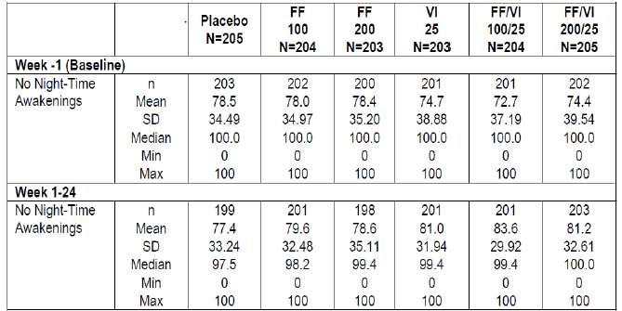
Comments: Both FF/VI treatments provided clinically meaningful improvements compared with placebo and the respective FF monotherapy (comparison between FF/VI 200/25 and FF 200 and between FF 100/25 and FF 100) for both co-primary endpoints. Therefore, these results demonstrate the contribution of VI in the FF/VI combination. The current study was unable to demonstrate statistically the contribution of FF in the FF/VI combination for the co-primary endpoint of change from baseline in through FEV1 on Treatment Day 169 (Visit 12) [the endpoint selected to evaluate the contribution of FF in the combination]. As described earlier, both FF/VI groups showed clinically meaningful improvements in LS mean change from baseline through FEV1 compared with the placebo group. However the comparisons between the two FF/VI groups and the VI 25 group were not statistically significant. While the FF/VI 200/25 group demonstrated a numerically greater improvement in LS mean change from baseline through FEV1 compared with VI 25 group, the difference (32 mL; 95% CI -19, 83; p=0.224) was not statistically significant. Likewise, while the FF/VI 100/25 group demonstrated a numerically greater improvement in LS mean change from baseline through FEV1 compared with the VI 25 group, the difference (45 mL; 95% CI -8, 97; p=0.093) was not statistically significant. It is not unexpected that no FF dose-related effect was seen for either co-primary efficacy endpoint, as it is recognised that spirometry may not be the optimal modality to dose range an ICS in subjects with COPD. However, other secondary endpoints such as dyspnoea domain of CRQ-SAS also failed to show clinically relevant improvements with combination FF/VI over VI alone.

52-week study HZC102871 and HZC102970

Study design, objectives, locations and dates
This was a Phase III, multi-center, randomised, double-blind, parallel-group study in 1622 subjects with COPD. The primary objective of this study was to evaluate safety and efficacy of FF/VI 50/25 µg, 100/25 µg and 200/25 µg versus VI 25 µg on the annual rate of moderate and severe exacerbations in subjects with COPD over a 52-week treatment period. All dosing was once-daily in the morning. This study evaluated the contribution of the ICS component on reducing the annual rate of moderate-severe exacerbations when used in combination with a fixed dose of the LABA in subjects with COPD. Secondary objectives in this study were to evaluate long term safety and other efficacy assessments and to further investigate any reported cases of pneumonia in subjects with COPD. The study was conducted from 25 Sept 2009 to 31 Oct 2011 at 167 centres in 15 countries (Argentina, Australia, Canada, Chile, Estonia, Germany, Italy, Mexico, Netherlands, Peru, Philippines, South Africa, Sweden, UK, and USA).

Inclusion and exclusion criteria
The main inclusion criteria were: ≥40 years of age and had a clinical history of COPD in accordance with the definition of the American Thoracic Society/European Respiratory Society, a current or prior history of at least 10 pack-years of cigarette smoking with a post-albuterol/ salbutamol FEV1/ FVC ratio of ≤0.70 of predicted normal and a post-albuterol/ salbutamol FEV1 ≤70% of predicted normal, a documented history of at least one COPD exacerbation in the 12 months prior to screening Visit 1 that required either systemic/oral corticosteroids, antibiotics and/or hospitalisation.
The main exclusion criteria were: current diagnosis of asthma (subjects with a prior history of asthma were eligible if they had a current diagnosis of COPD); α1-antitrypsin deficiency as the underlying cause of COPD; other respiratory disorders; lung volume reduction surgery; chest X-ray revealing evidence of pneumonia or a clinically significant abnormality not believed to be due to the presence of COPD or the presence of a radiographic process that would preclude the determination of pneumonia should it occur during the conduct of the clinical trial; immune suppression or other risk factors for pneumonia; a moderate or severe COPD exacerbation that had not resolved at least 14 days prior to screening or for which the last dose of oral corticosteroids was not at least 30 days prior to screening; pneumonia and/or moderate or severe COPD exacerbation at screening Visit 1; uncontrolled other diseases/abnormalities; carcinoma not in complete remission for 5 years; known or suspected history of alcohol or drug abuse within the last 2 years; medically unable to withhold albuterol/salbutamol or ipratropium for the 4-h period required prior to spirometry testing at each study visit; receiving treatment with long-term oxygen therapy or nocturnal oxygen therapy required for ≥12 h a day; clinically significant sleep apnoea.

Study treatments
Following screening to assess eligibility and a 4 week run-in period during which all subjects received open-label Fluticasone Propionate/Salmeterol (FP/SAL) 250/50 to establish a stable baseline, subjects were randomised (1:1:1:1) to one of the double-blind treatments (FF/VI 50/25 µg, FF/VI 100/25 µg, FF/VI 200/25 µg, or VI 25 µg), delivered via Novel Dry Powder Inhaler (NDPI) once daily in the morning for 52 weeks. Randomisation was stratified based on smoking status.

Efficacy variables and outcomes
The primary efficacy endpoint was the annual rate of moderate and severe exacerbations. The secondary efficacy endpoints were:
- Time to first moderate or severe exacerbation; Annual rate of exacerbations requiring systemic/oral corticosteroids; Change from baseline in through FEV1 at Visit 11.
Other efficacy endpoints included:
- Annual rate of severe exacerbations
- Annual rate of all exacerbations (mild, moderate, severe)
- Time to onset of multiple moderate and severe exacerbations
- Change from baseline in through FEV1 at Visits 3 to 10.
The following were assessed over each 4 week treatment interval and over the entire 52 week treatment period:
- Number of night-time awakenings due to symptoms of COPD
- Percentage of nights with no night-time awakenings due to symptoms of COPD
- Number of occasions of rescue albuterol/ salbutamol used during a 24 h period
- Percentage of rescue free 24 h periods
- Mean dyspnea score
- Percentage of 24 h periods with increased sputum and with increase in yellow/green sputum colour.
This was a superiority study. The primary comparisons of interest were the pair-wise comparisons of each dose regimen of FF/VI with VI alone for the primary endpoint the annual rate of moderate and severe exacerbations. Inference was restricted by the stepdown multiplicity strategy. All primary comparisons were performed at the 5% significance level and used the ITT Population. Pair-wise comparisons of each dose regimen of FF/VI with VI alone were performed for all secondary endpoints, some other efficacy endpoints and some safety endpoints.

Randomisation and blinding methods
Subjects were randomised using Registration and Medication Ordering System (RAMOS): an automated, IVRS which was used by the investigator or designee to register the subject, andomise the subject and receive medication assignment information. Following the run-in period, eligible subjects were randomised (1:1:1:1) to one of four double-blind treatments delivered by NDPI once daily in the morning for 52 weeks (FF/VI 50/25, FF/VI 100/25, FF/VI 200/25, or VI 25). Randomisation was stratified by smoking status. It was a double-blind study; Neither the subject nor the investigator knew which study medication the subject was receiving.

Analysis populations
The ITT population was the population of primary interest for all efficacy and safety endpoints. The Per Protocol (PP) population was used for confirmatory analyses of the primary efficacy endpoint only. The PP Population comprised 95% (1545 subjects) of the ITT Population.

Sample size
The annual rate of moderate and severe exacerbations in the VI treatment arm was assumed to be 1.4 based on estimates of 1.40 to 1.59 from the salmeterol arms of the FP/SAL combination studies [Kardos, 2007; [Ferguson, 2008]. A study with 390 evaluable subjects per arm had 90% power to detect a 25% reduction in the annual rate of moderate and severe exacerbations on a FF/VI combination arm compared with the VI-alone arm. Calculations were based on a Negative Binomial regression and used a two-sided 5% significance level. No adjustments in the type I error for multiplicity were made due to the step-down testing procedure employed.

Statistical methods
The primary analysis of the primary efficacy endpoint of the annual rate of moderate and severe exacerbations was performed on the ITT population using a generalized linear model, assuming the Negative Binomial distribution. The response variable was the number of recorded, on-treatment, moderate and severe exacerbations experienced per subject. The explanatory variables were treatment group, smoking status at screening (stratification variable), baseline disease severity (as percentage predicted FEV1) and center grouping. The model also included the logarithm of time on treatment per subject (derived from exposure start and stop) as an offset variable. A supportive analysis was also performed on the ITT population whereby the number of moderate/severe exacerbations was analysed using a Poisson regression model with deviance over-dispersion correction. Both the negative binomial and Poisson analyses were repeated for the PP Population. In order to account for multiplicity across treatment comparisons and key endpoints, a stepdown testing procedure was applied whereby inference for the primary efficacy endpoint for the FF/VI 100/25 combination dose versus VI 25 was dependent upon statistical significance at the 5% level having first been achieved for the primary efficacy endpoints for the FF/VI 200/25 versus VI. For a given FF/VI combination dose, the secondary endpoints were nested under the primary endpoint. Hence, in order to make inferences on the secondary endpoints at a given strength, statistical significance at the 5% level had to have been demonstrated for the primary efficacy endpoint for that combination strength.

Participant flow
Of the 2631 subjects who were screened, 1622 subjects were randomised and received at least 1 dose (and were thus included in the intent-to-treat [ITT] population). Of these 1622, 1222 (75%) of subjects completed the study and 400 (25%) of subjects were prematurely withdrawn. The most common primary reason for premature withdrawal was AEs (5-8%) and withdrew consent (4-8%) with similar incidence in different treatment groups. Overall, 42 subjects (3%) withdrew for a primary reason of lack of efficacy with a sub-reason of exacerbation with the highest incidence in the VI and FF/VI 200/25 groups (4%, 2%, <1% and 3% in the VI 25 group, FF/VI 50/25, FF/VI 100/and FF/VI 200/25 groups, respectively).

Major protocol violations/deviations
Overall, a total of 269 (17%) subjects had protocol deviations with 77subjects (5%) having full deviations (that is, excluded from the PP Population) that were most commonly due to a <80% or >120% compliance with the double-blind study medication, failed inclusion, exclusion, or randomisation criteria, or due to taking prohibited medications prior to or at the start of the treatment period. Three subjects (<1%) were excluded from the PP Population due to a moderate or severe COPD exacerbation or pneumonia during the run-in period immediately prior to randomization. For 199 subjects (12%) partial deviations were reported (that is, subjects were considered part of the PP Population but from the date of their deviation onwards, their data were excluded from the PP Population analysis). These deviations were most commonly due to a use of protocol-defined prohibited medication during the treatment period for a duration of time that could potentially have affected the primary endpoint. The incidence of full and partial protocol deviations was similar across the treatment groups.

Baseline data
Majority of the subjects were White (82%), males (59%), former smokers (61%, 39% current smokers) and had a COPD diagnosis for between 1 and <10 years (≥1 and <5 years: 37%; ≥5 and <10 years: 31%); the mean age was 63.6 years (40-90years) and the mean body mass index (BMI) of 26.69 kg/m² suggesting that subjects tended to be overweight. The study population overall had moderate to severely impaired pulmonary function with mean percentage predicted post-bronchodilator FEV1 of 45.2% (range 12 to 73%) and a mean post-bronchodilator FEV1/FVC ratio of 45.6% (range: 19 to 81%). The demographic and baseline disease characteristics were similar across the treatment groups. Overall, 95% of the ITT population had taken at least one COPD medication pre-run-in, up to 3 months prior to the start of the study and majority of these subjects had taken inhaled corticosteroids (68%), short-acting beta2 agonists (64%) and long-acting beta2 agonists (63%). During the run-in period of the study, 35% of subjects took COPD concomitant medications in addition to their study supplied salbutamol/albuterol rescue medication and run-in FP/SAL; the most common medications included short-acting anticholinergics (26%; all of which contained ipratropium) and short-acting beta2 agonists (7%; most commonly salbutamol, 6%). During the treatment period, of the subjects taking concomitant medications for a moderate exacerbation (40% of all ITT subjects), the majority took an antibiotic and/or a systemic corticosteroid (36% and 32% of all ITT subjects, respectively. Mean on-treatment compliance was high during the treatment phase (≥98.0% in each treatment group) and at least 72% of subjects in any treatment group were ≥95 to ≤105% compliant.
The incidence of COPD medications taken post-treatment (total 52% of subjects) was similar across the treatment groups; inhaled corticosteroids (27%); short-acting anticholinergics (26%; all of which contained ipratropium) and long-acting beta2 agonists (25%) and short-acting beta2 agonists (25%) were used most commonly.

Results for the primary efficacy outcome
Compared with VI 25, statistically significant reductions in rate of moderate/severe COPD exacerbation was observed only with FF/VI 100/25 µg (34%, p<0.001) but not with 50/25 µg (13%, p=0.181) or 200/25 µg (15%, p=0.109). A Poisson analysis of moderate and severe exacerbations (using the ITT population) confirmed the results of the negative binomial analysis above, showing a numerical reduction in the annual rate of exacerbations with an 12% (p=0.148), 31% (p<0.001) and 14% (p=0.116) reduction for FF/VI 50/25, 100/25 and 200/25, respectively. The number of subjects with one or more exacerbations was lowest for the FF/VI 100/25 and 200/25 groups (161 [40%] and 178 [44%], respectively) followed by FF/VI 50/25 and VI 25 (190 [47%] and 203 [50%], respectively).
Comments: As statistical significance was not achieved for the comparison of FF/VI 200/25 versus VI 25 for the primary efficacy endpoint, the statistically significant reduction observed with FF/VI 100/25 can only be inferential and does not provide conclusive evidence for reduction of exacerbation with FF/VI in COPD patients.

Results for other efficacy outcomes

Secondary endpoints:
Time to first moderate or severe exacerbation showed that the FF/VI groups numerically lowered the risk versus VI 25 with the highest improvement in the FF/VI 100/25 group (28% risk reduction [p=0.002]); the risk reduction versus VI 25 was 8% (p=0.430) in the FF/VI 50/25 group and 15% (p=0.114) in the FF/VI 200/25 group (Figure 11).
Figure 11. Kaplan-Meier Plot of time to first moderate or severe exacerbation (ITT population
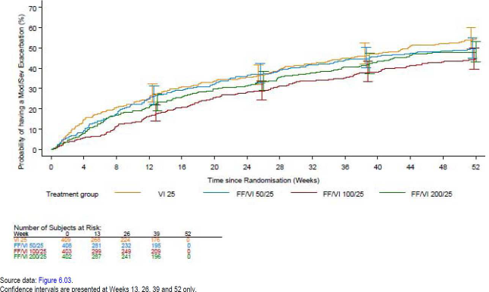
Compared with the VI 25 group, the annual rate of exacerbations requiring systemic or oral corticosteroids over the 52-week treatment period showed statistically significant reductions in the FF/VI 100/25 (38% reduction, p<0.001), but not in the FF/VI 50/25 (16%, p=0.125) or 200/25 (19%, p=0.064) groups. The number of subjects with one or more exacerbations was lowest for the FF/VI 100/25 group (31%) compared with the VI 25 group (43%), FF/VI 50/25 (38%), FF/VI200/25 )37%) groups. The proportion of exacerbation severities (mild, moderate, and severe) was similar across the treatments with the majority of the exacerbations (82 to 86%) reported as moderate.
During the 4 week run-in period during which all subjects received open-label FP/SAL, lung function (as measured by FEV1 values) improved from screening (pre bronchodilator FEV1 was 1.120 L in the VI 25 group and ranged from 1.141 L to 1.159 L in the FF/VI groups) to baseline (FEV1 was 1.204 L in the VI 25 group and ranged from 1.217 L to 1.234 L in the FF/VI groups). At Week 52, continued numerical improvements were seen when comparing the FF/VI strengths versus VI 25 in LS mean through FEV1: FF/VI 50/25: 41 mL (p=0.011); FF/VI 100/25: 58 mL (p<0.001); FF/VI 200/25: 64 mL (p<0.001).

Other efficacy endpoints
Compared with VI 25, treatment with FF/VI at all strengths provided a numeric improvement in the LS mean annual rate of severe exacerbations, with 28% (p=0.259), 28% (p<0.254), and 21% (p=0.422) reductions for FF/VI 50/25, 100/25 and 200/25, respectively. Consistent with the primary endpoint, only FF/VI 100/25 provided statistically significant reduction in the annual rate of all on-treatment exacerbations (mild, moderate and severe) compared with VI25 (32% reduction, p<0.001), but not FF/VI50/25 (14%,p=0.130) or FF/VI 200/25 (1%; p=0.904). Overall, the most common primary causes of exacerbations were upper respiratory infection (21% in the VI 25 group and 17 to 23% in the FF/VI groups, respectively) and cause of unknown etiology (21% in the VI 25 group and 20 to 22% in the FF/VI groups, respectively). One subject each in the VI 25 and FF/VI 100/25 groups, two subjects in the FF/VI 50/25 group, and eight subjects in the FF/VI 200/25 group had a fatal on-treatment exacerbation, all but one of which were recorded as severe exacerbations (one subject in the FF VI 50/25 group had a moderate exacerbation recorded as fatal and a fatal SAE of myocardial infarction)). Fatal on-treatment pneumonia was also reported for six of these eight subjects in the FF/VI 200/25 group.
The total number of moderate and severe exacerbations during the 1 week follow-up period was similar across the treatment groups during this period (three subjects in the VI 25 group and three to four subjects in the FF/VI groups). One fatal exacerbation (<1%) was reported, in the FF/VI 50/25 group.
Across the 52 week treatment period, FF/VI 100/25 (range 36 to 63 mL, p≤0.009 at all timepoints) and FF/VI 200/25 (range 26 to 71 mL, p≤0.055 at all timepoints) consistently provided the greatest numerical improvement in LS mean change from baseline in through FEV1 versus VI 25. FF/VI 50/25 showed improvements in LS mean change from baseline in through FEV1 versus VI 25 in the range of 4 to 40 mL (p-values in the range of 0.007 to 0.754).
All FF/VI strengths also showed small numerical improvements in COPD symptoms compared with VI 25 as measured by the LS mean number of occasions of rescue albuterol/salbutamol use and the LS mean dyspnea score. Patients treated with FF/VI 100/25 also showed improvements compared with VI 25 in the LS mean number of night-time awakenings due to symptoms of COPD. There was no clear difference between the treatment groups in healthcare utilization for any type of exacerbation.
Comments: Interpretation of results from this study was limited due to failure to demonstrate superiority of FF/VI 200/25 over VI 25 in reducing moderate to severe exacerbations, Although all 3 FF/VI groups (200/25, 100/25 and 50/25) showed numerical improvements over VI25 for the primary and key secondary efficacy endpoints. However, the proposed dose of FF/VI 100/25 did show significant improvements in both primary and secondary endpoints.
Across the treatment groups, few subjects suffered severe exacerbations (30 to 32 subjects per arm, 7 to 8%); the low incidence of severe exacerbations limited interpretation of annual severe exacerbation rates and time to first severe exacerbation.
When examining the percentage reduction of the annual rate of mild, moderate and severe exacerbations versus VI 25, the greatest numerical improvement was noted in the FF/VI 100/25 group (32% reduction [p<0.001]). The percentage reduction versus VI 25 was 14% (p=0.130) for FF/VI 50/25 and no reduction was noted for FF/VI 200/25 (1%; p=0.904). The lack of reduction in the FF/VI 200/25 group was driven by a higher proportion of exacerbations that were mild in this group (30%) compared with the other groups (18% in the VI 25 group, and 19% and 22% in the FF/VI 50/25 and 100/25 groups).
Consistent with the primary endpoint of the annual rate of moderate and severe exacerbations, the greatest numerical improvement in lowering the risk versus VI 25 in the time to onset of multiple moderate and severe on treatment exacerbations was noted in the FF/VI 100/25 group (risk reduction of 32% [p<0.001]). The risk reduction versus VI 25 was 13% (p=0.165) for FF/VI 50/25 and 14% (p=0.129) for FF/VI 200/25.

Study HZC102970
This Phase III study was conducted from 25 September 2009 to 17 October 2011 at 183 centres in 15 countries (USA, Denmark, Germany, Italy, Netherlands, Spain, Sweden, UK, Argentina, Chile, Mexico, Peru, Australia, Canada, South Africa). It was identical to Study HZC102871 described above in terms of study design, inclusion/ exclusion criteria, study treatment efficacy endpoints, statistical methods.

Participant flow
Of the 2635 subjects who were screened, 1633 were included in the ITT population. Overall, 73% of the subjects completed the study and the most common reason for premature withdrawal was AEs (122 subjects, 7%) and Withdrew consent (102 subjects, 6%) with similar incidence across treatment groups. Overall, 44 subjects (3%) withdrew for lack of efficacy due to an exacerbation with higher incidence in the VI 25 group (20 subjects, 5%) compared with the FF/VI groups (7 to 9 subjects, 2%).

Major protocol violations/deviations
Overall, a total of 327 (20%) subjects had protocol deviations that could potentially have affected interpretation of the primary efficacy results; 95 subjects (6%) had full deviations (that is, excluded from the PP Population) that were most commonly due to a <80% or >120% compliance with the double blind study medication or due to taking prohibited medications prior to or at the start of the treatment period. The PP Population comprised 94% (1538 subjects) of the ITT Population. For 243 subjects (15%) partial deviations were reported and the most common deviations were due to use of protocol-defined prohibited medication during the treatment period for a duration of time that could potentially have affected the primary endpoint. The incidence of full and partial protocol deviations was similar across the treatment groups.

Baseline data
Majority of the subjects were White (88%), male (56%) with COPD diagnosis of 1 to 10years (≥1 and <5 years: 33%; ≥5 and <10 years: 32%) and were former smokers (55%; 45% were current smokers). The mean age was 63.7 years and the mean body mass index (BMI) of 27.05 kg/m² suggesting that the subjects tended to be overweight. The study population overall had moderate to severely impaired pulmonary function with mean percentage predicted post-bronchodilator FEV1 of 45.7% (range 13% to 91%) and a mean post-bronchodilator FEV1/FVC ratio of 45.5% (range 17% to 72%). The demographic and baseline disease characteristics were similar across the treatment groups. Overall, 96% of the ITT population had taken at least one COPD medication pre-run-in with the majority having taken ICS (74%), short-acting beta2 agonists (69%) and long-acting beta2 agonists (69%). During the run-in period of the study, 39% of subjects took COPD concomitant medications in addition to their study supplied salbutamol/albuterol rescue medication and run-in FP/SAL; short-acting anticholinergics (27%- all ipratropium) and short-acting beta2 agonists (10%- mostly salbutamol) were used most commonly. During the treatment period, of the subjects taking concomitant medications for a moderate exacerbation (41% of all ITT subjects) the majority took an antibiotic and/or a systemic corticosteroid (37% and 31% of all ITT subjects, respectively). The incidence of COPD medications taken during follow-up (total 57% of subjects) was similar across the treatment groups. The majority of subjects (28%) took LABAs as COPD medication; other medications most commonly taken included ICS and short-acting anticholinergics (all of which contained ipratropium) (27%) and short-acting beta2 agonists (25%). Mean on-treatment compliance was high during the treatment phase (≥98.00% in each treatment group). At least 69% of subjects in any treatment group were ≥95 to ≤105% compliant.

Results for the primary efficacy outcome
For the primary analysis (ITT population using a negative binomial model) of the primary endpoint, compared with VI 25, treatment with FF/VI at all strengths provided a statistically significant improvement in the Least Squares (LS) mean annual rate of moderate and severe exacerbations, with a 19% (p=0.040), 21% (p=0.024) and 31% (p<0.001) reduction for FF/VI 50/25, 100/25 and 200/25, respectively. This was confirmed in the Poisson analysis of moderate and severe exacerbations (using the ITT population) which also showed a statistically significant reduction in the annual rate of exacerbations with an 18% (p=0.037), 19% (p=0.023) and 28% (p<0.001) reduction for FF/VI 50/25, 100/25 and 200/25, respectively. The number of subjects with one or more exacerbations was lowest for the FF/VI 100/25 and 200/25 groups (177 [44%] and 160 [39%], respectively) followed by VI 25 and FF/VI 50/25 (197 and 198, respectively, 48% each). The majority of moderate/severe exacerbations (90% in the VI 25 group and 87 to 90% in the FF/VI groups) were moderate in intensity.

Results for other efficacy outcomes

Secondary endpoints
Compared with VI 25, FF/VI 100/25 and 200/25 statistically significantly lowered the risk for time to first moderate/severe exacerbation (p=0.036 and p<0.001, respectively; hazard ratio of 0.80 and 0.66, respectively, corresponding to a risk reduction of 20% and 34%, respectively) but not for FF/VI 50/25 (13%, p=0.177).
Over the 52 week treatment period, the annual rate of exacerbations requiring systemic or oral corticosteroids showed statistically significant reductions compared with VI25 for FF/VI 100/25 (23%, p=0.041) and FF/VI 200/25 (35%, p<0.001), but not for FF/VI 50/25 (16%, p=0.154). The number of subjects with one or more exacerbations was lowest for the FF/VI 100/25 and 200/25 groups (136 [34%] and 125 [31%] respectively) compared with the FF/VI 50/25 and VI 25 groups (163 [40%] and 160 [39%]). The proportion of exacerbation severities (mild, moderate and severe) was similar across the treatments and majority of the exacerbations (83 to 88%) were reported as moderate.
Pair-wise comparisons for each strength of FF/VI compared with VI demonstrated that, at the end of the 52 week treatment period, there was no statistically significant difference between FF/VI 100/25 or 200/25 versus VI 25 in LS mean through FEV1 (24 mL [p=0.143] and 26 mL [p=0.115], respectively) Treatment with FF/VI 50/25 versus VI 25 showed a numerical improvement of 34 mL (p=0.034).

Other efficacy endpoints
The lowest mean annual rate of severe exacerbations was reported for the VI 25 group (0.13), with mean rates of 0.22, 0.17 and 0.18 for the FF/VI 50/25, 100/25 and 200/25 groups, respectively. Consistent with the primary endpoint, FF/VI 50/25, 100/25 and 200/25 provided numerical improvements in the annual rate of all on-treatment exacerbations (mild, moderate and severe), with a reduction in the annual rate of 15% [p=0.094], 19% [p=0.034] and 31% [p<0.001] versus VI 25, respectively. The incidence of subjects with one or more exacerbations was similar in the VI (54%) and three FF/VI treatment groups (47% to 53%). The proportion of exacerbations which were mild, moderate and severe was similar across the treatments with the majority of exacerbations (63 to 68%) being moderate, 25% to 28% being mild, and 7% to 10% being severe. Fatal on-treatment exacerbations were reported for 4 subjects (2 in VI25 group and 1 each in FF/VI 50/25 and FF/VI 100/25 groups). The number of subjects with one or more moderate exacerbations during the treatment period was lowest for the FF/VI 200/25 group (46%, 44%, 39% and 37% in the VI 25, FF/VI 50/25, 100/25 and 200/25 groups, respectively) and very few moderate exacerbations led to withdrawal, with most withdrawals reported for VI 25 group (4%, 2%, 2% and 2%, respectively). The mean duration of a moderate exacerbation was 13.5 days in the VI 25 arm and 13.6 to 14.5 days in the FF/VI arms. Overall, >98% of all moderate exacerbations in each treatment group had resolved by the end of the study. The number of subjects with one or more severe exacerbations during the treatment period was low across the treatment groups (7%, 7%, 9% and 6%, respectively) and most of these severe exacerbations (≥97%) led to hospitalisation.
Consistent with the primary endpoint of the annual rate of moderate and severe exacerbations, both FF/VI 100/25 and 200/25 provided numerical reductions in the risk versus VI 25 for the time to onset of multiple moderate and severe on treatment exacerbations (risk reductions of 20% [p=0.035] and 28% [p=0.004], respectively). There was an 18% risk reduction [p=0.052] for FF/VI 50/25 versus VI 25.
Additional efficacy data showed that FF/VI at all strengths versus VI 25 improved COPD symptoms as measured by the LS mean number of night-time awakenings due to symptoms of COPD and the LS mean number of occasions of rescue albuterol/salbutamol use. FF/VI 100/25 and 200/25 also showed improvements compared with VI 25 in the LS mean dyspnoea score, mean percentage of 24 h with increased sputum production or increased green yellow sputum production.
Comments: In this study, superiority of FF/VI 200/25 over VI 25 in reducing moderate to severe exacerbations was confirmed and so results of significant reductions with proposed dose of FF/VI 100/25 µg were statistically valid.

Other efficacy studies

12 week studies comparing FF/VI with FP/salmeterol
HZC113107 was a multi-center, randomised, stratified (reversibility to salbutamol), double-blind, double-dummy, 12-week parallel group study to evaluate the efficacy and safety of treatment with FF/VI 100/25 OD (in the morning) versus FP/salmeterol 500/50 BD on lung function in 528 subjects with COPD. The study was conducted from 9 Feb 2011 to 19 Oct 2011 at 61 centres in 9 countries (Belgium, France, Germany, Italy, Philippines, Poland Russia, Spain and Ukraine). Demographics and baseline disease characteristics were generally comparable across the treatment groups, with exception of slightly greater percentage of current smokers in the FF/VI group (47%) compared to the FP/salmeterol (37%) group. Majority of subjects were White (81%), male (82%), mean duration of COPD >1 and <10 years and the mean age of the ITT population was 63 years (39 to 84years). During the on-treatment period, 25% and 27% of subjects in the FF/VI 100/25 OD and the salmeterol/FP 50/500 BD treatment groups, respectively, used COPD concomitant medications (ipratropium used most commonly: 11% versus 12%). Majority of subjects (>90%) in both treatment groups were ≥90% compliant to their assigned treatment regimen.
The study was unable to demonstrate a statistically significant improvement for the primary endpoint, change from baseline through in 24 h weighted mean FEV1 on Treatment Day 84, for the FF/VI 100/25 OD treatment group compared with the FP/salmeterol 500/50 BD treatment group (diff=0.022 L, 95% CI: -0.018, 0.063, p=0.282). The PP analysis showed similar results.
Secondary endpoints were nested under the primary endpoint and because statistical significance was not demonstrated for the primary endpoint, strict statistical inferences could not be made for the secondary and other endpoints. No difference was found between the treatment groups for the median time to onset on Treatment Day 1 (16 and 28 minutes post-dosing for the FF/VI 100/25 OD and FP/salmeterol 500/50 BD treatment groups, respectively) or in the proportion of patients achieved their first increase of ≥100 mL from baseline in FEV1within the 5 minute to 4 h post dose time points (80% and 78%, respectively). Change from baseline in through FEV1 on Treatment Day 85 (24 h assessment at Visit 5) also failed to show significant difference (111 mL and 88 mL, respectively).
Although, there was a clinically meaningful (change of ≥4 points) mean improvement in SGRQ-C Total Score after 12 weeks of treatment for the FF/VI 100/25 OD treatment group (LS mean -4.78 versus -3.29 for FP/salmeterol), there was no statistical difference between the treatment groups; 47% and 41% of subjects were classed as responders in the FF/VI 100/25 OD and salmeterol/FP 50/500 BD treatment groups, respectively. There was a nominal statistical difference in favour of the FP/salmeterol 500/50 BD treatment group, compared with the FF/VI 100/25 OD treatment group, in the percentage of responders for the anxiety/depression dimension of the EuroQol Questionnaire (EQ-5D) at Visit 5 (p=0.049) with no statistical differences between the 2 treatment groups for the other dimensions of EQ-5D.There were no differences seen between the 2 treatment groups for supplemental salbutamol use, IC, serial FVC and weighted mean FVC. From a health resource utilisation perspective, there were very few instances of unscheduled contact due to an exacerbation (3 and 1 cases in the FF/VI 100/25 OD and salmeterol/FP 50/500 BD treatment groups, respectively). No unscheduled home, ICU or office visits were reported.
Comments: Both FF/VI 100/25 OD and FP/ salmeterol 500/50 BD demonstrated improvements from baseline in lung function in subjects with COPD. However, the difference between treatments was neither statistically significant nor clinically meaningful. One of the limitations of this study was that it was designed as a superiority study and not a non-inferiority study which would have been more appropriate.
Study HZC113109 was identical in design to HZC113107 with the exception of the comparator being FP/salmeterol 250/50, and safety evaluation additionally included urine cortisol measurements. The study involved 519 patients with COPD and was conducted from 18 mar 2011 to 14 Dec 2011 at 51 centres in 6 countries (Czech Republic, Germany, Romania, Russia, Poland and US). Baseline demographics and disease characteristics were generally comparable across the treatment groups. Majority of subjects were White (97%), male (64%), mean duration of COPD >1 and <10 years and the mean age of the ITT population was 63 years (39-84 years). During the on-treatment period, 17% and 14% of subjects in the FF/VI 100/25 OD and the FP/salmeterol 250/50 BD treatment groups, respectively, used COPD concomitant medications (ipratropium, 9% in each treatment group was used most commonly).
This study demonstrated a statistically significant improvement for the primary endpoint, change from baseline through in 24 h WM FEV1 on Treatment Day 84, between the FF/VI 100/25 OD treatment group and the FP/salmeterol 250/50 BD treatment group (diff=0.08 L; 95% CI: 0.037, 0.124, p<0.001). No PP sensitivity analysis was performed as 95% of the ITT Population was included in the PP Population.
A statistically significant difference was found between the treatment groups for the secondary efficacy parameter of median time to onset on Treatment Day 1 (15 and 30 minutes post dose for the FF/VI 100/25 OD and FP/salmeterol 250/50 BD treatment groups, respectively, p=0.012). Overall, 79% and 76% of subjects in the FF/VI 100/25 OD and FP/salmeterol 250/50 BD treatment groups, respectively, achieved their first increase of ≥100 mL from baseline in FEV1 within the 5 minute to 4 h post dose timepoints.
The LS mean change from baseline through in 24 h weighted-mean FVC on Treatment Day 84 was also statistically significant greater in the FF/VI 100/25 OD group compared with the FP/salmeterol 250/50 BD treatment group (152 mL versus 59 mL, p=0.003). There was no statistical improvement in the FF/VI 100/25 OD treatment group compared with the FP/salmeterol 250/50 BD treatment group for pre-dose IC. There were no differences seen between the two treatment groups for supplemental use of albuterol (salbutamol) and supplemental albuterol (salbutamol) rescue-free days. No QOL measurements were done in this study.
Comments: The current study demonstrated a statistically significant improvement for the primary endpoint, change from baseline through in 24 h weighted-mean FEV1 and also showed significantly faster onset of action for the FF/VI 100/25 group compared with FP/salmeterol 250/50. However, there was no difference in % of responders with >100 mL increase in FEV1 over first 4 h post dose (79% and 76%, respectively) or in supplemental use of albuterol and pre-dose IC.
Study HZC112352 was identical in design to study HZC113109. The study was conducted from 18 March 2011 to 26 January 2012 at 48 centres in 5 countries (Ukraine, South Africa, Spain, Italy, and US). A total of 511 subjects were randomised and included in the ITT Population. Baseline demographics and disease characteristics were generally comparable across the treatment groups. Majority of subjects were White (94%), male (68%), current smokers (47-52%) with duration of COPD <10 years (64%).The mean age was 62 years (41-87 years) and mean BMI of 27.5 kg/m². During the treatment period, 9% and 7% of subjects in the FF/VI 100/25 OD and the FP/salmeterol 250/50 BD treatment groups, respectively, used COPD concomitant Medications (ipratropium most common: 5% versus 3%). Mean overall compliance to randomised treatment was high during the study with majority of subjects (>90%) in both treatment groups were ≥90% compliant to their treatment regimen.
The study was unable to demonstrate a statistically significant improvement for the primary endpoint, change from baseline through in 24 h WM FEV1 on Treatment Day 84, for the FF/VI 100/25 OD treatment group compared with the FP/salmeterol 250/50 BD treatment group (diff=0.029; 95% CI:-0.022, 0.080, p=0.267;). No PP sensitivity analysis was performed as the PP Population constituted 94% of the ITT Population.
The secondary endpoint was nested under the primary endpoint; therefore, as statistical significance was not demonstrated for the primary endpoint, strict statistical inferences could not be made for the secondary and other endpoints. No differences were found between the treatment groups for the secondary efficacy parameter of median time to onset on Treatment Day 1 (16 and 30 minutes post-dosing for the FF/VI 100/25 OD and FP/salmeterol 250/50 BD treatment groups, respectively; p=0.526). Overall, 76% and 77% of subjects in the FF/VI 100/25 OD and FP/salmeterol 250/50 BD treatment groups, respectively, achieved their first increase of ≥100 mL from baseline in FEV1within the 5 minute to 4 h post dose timepoints. The other efficacy endpoints of pre-dose IC and supplemental salbutamol use/ rescue-free days were similar between the treatment groups.
Comments: Results of this study were not consistent with study 109 above with no statistically significant difference for the primary or secondary endpoints between FF/VI 100/25 and FP/salmeterol 250/50 groups.

Other supportive studies
Study HZC110946 was a Phase III, multi-center, randomised, double-blind, placebo-controlled, three-way incomplete block crossover study to evaluate the effects of once-daily in the morning treatment for 28 days with FF/VI (50/25, 100/25, 200/25 µg) and placebo on lung function in 54 patients with COPD (66% had duration of 1 to 10 years). Using an incomplete block cross-over design (with all subjects receiving placebo and 2 of 3 strengths of FF/VI), it was estimated that a total of 27 subjects with evaluable data from all three periods would provide 90% power to detect a difference of 130 mL between an FF/VI dose and placebo in 0 to 24h weighted mean FEV1 at the two-sided 5% significance level (assuming SD of 123 mL). Majority of the subjects were White (89%), female (54%), current smokers (76-87%) with duration of COPD of 1 to 10 years (66%); the mean age was 57.9 years (44-82 years)and mean BMI was 28.03 kg/m².
The primary analysis was pair-wise comparisons of each of the three FF/VI strengths with placebo for weighted mean serial FEV1 (0 to 24 h) at the end of each treatment period and demonstrated statistically significant increases in FEV1 for FF/VI with LS mean treatment differences of 220 to 236 mL compared with placebo (all p<0.001). For the secondary endpoint of 0 to 25 h serial FEV1, there were increases in the LS mean of 147 to 301 mL (all p<0.001) at each time point compared with placebo (Figure 12). Analysis of peak FEV1 0 to 4 h post dose on Day 28 showed a greater than 200 mL increase in FEV1 compared with placebo for all three FF/VI strengths (all p<0.001).
Figure 12. Change from period baseline in serial FEV1 (0-25 h) over period Days 28 and 29 (ITT population). Treatment differences from placebo.
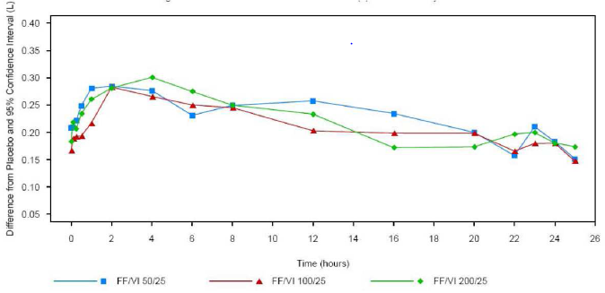
Comments: Serial (0 to 24 h) and through measures of FEV1 in this study demonstrated that treatment with FF/VI for 28 days markedly improved lung function overall (weighted mean) and at each time point measured over a 0 to 24 h profile. There was no suggestion of a FF-related dose-response effect for any of the lung function parameters. This was not unexpected over a 4-week treatment period where all strengths of the FF/VI combination contained the same dose of VI. Population dose-response analyses of 0 to 24 h weighted mean FEV1 and through FEV1 at the end of treatment and PD modeling of the time course of FEV1 were not conducted.

Analyses performed across trials (pooled analyses and meta-analyses)
Integrated efficacy results were done with pooling of data from the 2 pivotal 24 week studies (HZC112206 and HZC112207) and the 2 pivotal 52-week studies (HZC102671 and HZC102970).

24 week studies HZC112206 and HZC112207
In the integrated dataset, the majority of the 2254 COPD subjects (73%) completed the studies; withdrawals were highest in the placebo group (31%), followed by the FF/VI 50/25 (29%), FF/VI 100/25 (28%), FF 100 (27%) and VI25 (26%) groups. The most common primary reason for premature withdrawal was AEs with similar incidence in the FF/VI groups (8% to 9%), the placebo (8%) and the monotherapy FF 100, FF 200 and VI 25 groups (7% -10%. Lack of efficacy as a reason for withdrawal was slightly higher in the placebo group (8%) than the active treatment groups (3% to 6%) and the majority of the premature withdrawals from lack of efficacy were due to COPD exacerbation. Majority of the patients were male (70%), White (89%), current smokers (54%) with irreversible COPD (73%) and mean COPD duration of 1 to 10 years (69%). Overall, 59% of the subjects were <64years, 41% >64 and 22% >70 years) and patients had moderate to very severely impaired airflow obstruction [mean percentage predicted post-bronchodilator FEV1 of 48.1% (range of 14-87%) and mean post-bronchodilator FEV1/FVC ratio of 47.2% (range of 17-88%)].Overall, baseline demographics and disease characteristics were similar across treatment groups with exception of imbalance across the treatment groups in baseline FEV1 with lowest value in the FF/VI 50/25 group (1.195 L) compared with the highest mean value of 1.317 L recorded for the FF200 group.
Results for the integrated analyses for these two studies were consistent with the results for the individual studies for the co-primary endpoints of weighted mean FEV1 (0 to 4 h post dose) at the end of the 6 month treatment period (Table 18) and change from baseline in trough FEV1 after 6 months treatment (Table 19).
Table 18. Statistical analysis of 0 to 4 h weighted mean FEV1 (L) at day 168 (ITT population). Integrated study results: HZC112206 and HZC112207
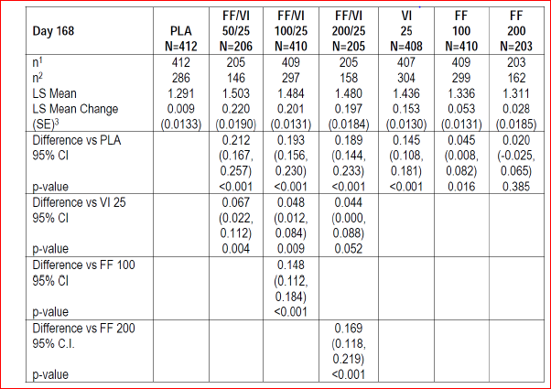
Table 19. Statistical analysis of trough FEV1 (L) (ITT population). Integrated study results: HZC112206 and HZC112207
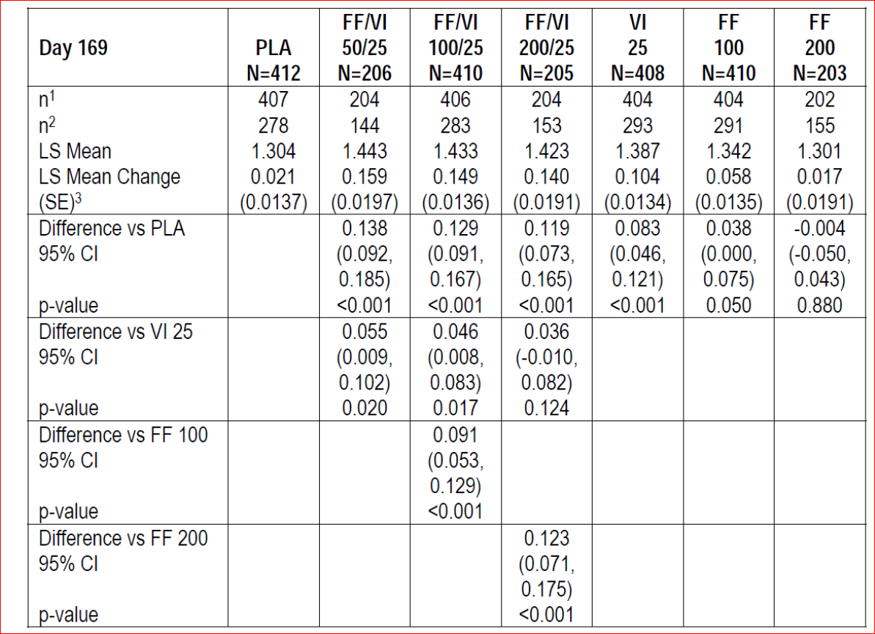
FF/VI (50/25, 100/25 and 200/25) and VI 25 treatment groups demonstrated clinically meaningful and statistically significant improvements in weighted mean FEV1 0 to 4 h post dose compared with the placebo group;
FF/VI 100/25 and 200/25 groups demonstrated clinically meaningful and statistically significant improvements in weighted mean FEV1 0 to 4 h postdose compared with the respective FF group, demonstrating the relative contribution of VI on lung function;
Although not designated as primary comparisons, the FF/VI 50/25 and 100/25 groups demonstrated improvements in weighted mean FEV1 0 to 4 h post dose compared with the VI 25 group (p<0.05), providing evidence of an effect of FF on lung function, albeit small; the p-value for the difference between the FF/VI 200/25 and VI 25 groups was 0.052.
There was no evidence of a dose response between the FF/VI 50/25, 100/25 and 200/25 groups.
All three FF/VI combination groups and the VI 25 group demonstrated statistically significant improvements in the LS mean change from baseline through FEV1 compared with the placebo group. The improvements were generally similar across the FF/VI 50/25, FF/VI 100/25 and FF/VI 200/25 groups, 138 mL 129 mL and 119 mL, respectively.
Consistent with the HZC112206 results, the integrated analysis showed that the FF/VI 50/25 group demonstrated an improvement of 55 mL compared with the VI 25 group (p=0.020).
The FF/VI 100/25 group demonstrated an improvement of 46 mL compared with the VI 25 group (p=0.017), while the p-values for the improvement observed between the FF/VI 100/25 and VI 25 groups (45-48 mL) are 0.093 and 0.082, respectively, for the individual studies.
Consistent with the results of the HZC112207 results, the integrated analysis showed that the 36 mL increase for FF/VI 200/25 compared with VI 25 alone was not statistically significant (p=0.124).
Although not defined as a primary treatment comparison, the FF/VI 100/25 and FF/VI 200/25 groups also showed improvements of 91mL and 123 mL, respectively, compared with the respective FF alone group (p<0.001). There was no evidence of a dose-response relationship between any of the FF/VI groups.
Peak FEV1: Consistent with the results of the individual studies, the integrated analyses showed that compared with the placebo group, clinically meaningful differences in LS mean changes from baseline in peak FEV1 were higher for the three FF/VI groups and the VI 25 group. The differences from placebo were 137 mL (95% CI: 110, 163) to151 mL (95% CI: 110, 163) across the FF/VI groups and 143 mL (95% CI: 125, 177) for the VI 25 group (all p values <0.001). In addition, the integrated results showed that the LS mean changes from baseline in peak FEV1 were higher for the FF/VI 100/25 and FF/VI 200/25 groups compared with the respective FF groups (129 mL [95% CI: 109, 150] and 132 mL [95% CI: 103, 161], respectively; both p<0.001).
Time to onset: The integrated results were consistent with the results of the individual studies; 85% or more of the subjects in the FF/VI (50/25, 100 25 and 200/25) and VI 25 groups achieved their first increase of at least 100 mL or more from baseline in FEV1 within the 5-minute to 4-h post dose timepoints (with more than 40% of the subjects in each of these groups demonstrating an increase of at least 100 mL within 5 minutes of dosing) compared with about 53% in the placebo and FF 100 and FF 200 groups.
CRQ-SAS Dyspnea At Day 168, consistent with the results for the individual studies, the results of the integrated analysis showed differences in LS mean change from baseline CRQ-SAS – dyspnoea scores between the FF/VI 100/25 and placebo groups (0.27; 95% CI: 0.11, 0.43, p<0.001) and between the FF/VI 100/25 and FF 100 groups (0.30; 95% CI: 0.14, 0.46, p<0.001).
Unlike the individual studies, the integrated analysis also showed a difference in LS mean change from baseline between the FF/VI 50/25 and placebo groups (0.21; 95% CI: 0.01, 0.41, p=0.041) and between the FF/VI 100/25 and VI 25 groups (0.17; 95% CI: 0.01, 0.32, p=0.040); this was due to the increased sample size (and so reduced standard error mean [SEM]) for these comparisons in the integrated analysis as the magnitude of the effects were similar to the individual studies. Similar to results of the individual studies, none of the treatment comparisons achieved a minimally clinically important difference (>0.5 point improvement) in mean CRQ-SAS Dyspnoea Domain scores.
In both the HZC112206 and HZC112207 studies, over the entire 24 week treatment period the mean number of occasions of rescue medication use (occasions/24 h) was lower in the FF/VI and VI 25 groups compared with the placebo groups (p<0.001). In addition, in both studies, the mean number of occasions of rescue medication use was lower in the FF/VI 100/25 groups compared with the VI 25 groups (p≤0.012); whereas, there was no difference between the FF/VI 50/25 group and the VI 25 group (HZC112206) or between the FF/VI 200/25 group and the VI 25 group (HZC112207).

52 week studies HZC102671 and HZC102970
Of the 3255 patients in this pooled 52 week analysis, majority (74%) completed the study. Withdrawals were highest in the VI 25 group (29%) followed by 25% of subjects in each of the other treatment groups and the most common primary reason for premature withdrawal was AEs with similar incidence across groups (6%-8%). Lack of efficacy as a reason for withdrawal was slightly higher in the VI 25 group (7%) compared with the other treatment groups (3%-4%).Majority of the subjects were male (57%), White (85%), former smokers (56%) with irreversible COPD (70%) and mean COPD duration of 1 to 10 years (67%). Overall, 51% of the subjects were <64years (49% >64 and 27% >70 years). Overall, 10% of subjects in the HZC102871 study were Asian, compared with <1% of subjects in the HZC102970 study. There were no other disparities in any of the race categories between the two studies. The subjects in this integrated analysis showed similar baseline lung function parameters with all patients having moderate to severe airflow obstruction.
The pooled analysis demonstrated that all three strengths of FF/VI provided significantly (p≤0.014) greater reductions in the LS mean annual rate of moderate or severe COPD exacerbations compared with VI 25 treatment alone, with the FF/VI 100/25 group demonstrating the greatest reduction (27%; p<0.001). The percentage reduction in the FF/VI 50/25-treated group (16%; p=0.014) was less than that observed in the FF/VI 100/25-treated group and that there was no efficacy advantage of the FF/VI 200/25 strength over the 100/25 strength.
The pooled analysis demonstrated that subjects in the FF/VI groups demonstrated significantly greater improvements in through FEV1 at Week 52 compared with the VI 25 group, with differences ranging from 38 to 46 mL (p<0.001 for all comparisons) which was consistent with the results for the individual studies.
Time to first moderate or severe exacerbation was a secondary endpoint in the two, 1 year exacerbation studies (HZC102871 and HZC102970). The pooled analysis demonstrated that treatment with FF/VI 100/25 and FF/VI 200/25 significantly lowered the risk of the time to first moderate or severe COPD exacerbation compared with VI 25 treatment (risk reductions of 24 and 25%, respectively [both p<0.001]). Treatment with FF/VI 50/25 also lowered the risk of the time to first moderate or severe COPD exacerbation (risk reduction 11%) compared with treatment with VI 25 alone; however, again the difference was not significant (p=0.114). All three FF/VI treatments significantly decreased the annual rate of COPD exacerbations requiring systemic/oral corticosteroids compared with treatment with VI 25, with the greatest decrease observed in the FF/VI 100/25 group compared with the VI 25 group (30%; p<0.001). The percentage reduction with FF/VI 50/25 (compared with VI) was nearly half that observed with FF/VI 100/25 and there was no efficacy advantage of FF/VI 200/25 over the 100/25 strength.

Efficacy in subpopulations
The population subgroups used for analysis are described separately for the 6 month studies (HZC112206 and HZC112207) and the 12 month studies (HZC102871 and HZC102970). For the 6 month lung-function studies (HZC112206/HZC112207), p-values for continuous covariate and categorical covariate interactions with treatment for 0 to 4 h weighted mean FEV1 and through FEV1 were analysed. For the 12 month exacerbation studies (HZC102871/HZC102970), continuous and categorical interactions for annual rate of moderate and severe exacerbations and through FEV1 were analysed.
Age: There was no evidence of a statistically significant interaction of treatment with age or age group for the primary treatment comparisons of FF/VI versus placebo, VI versus placebo, and FF/VI versus FF, efficacy was demonstrated in both of the age groups (<64 years and >65 years) for change from baseline in 0 to 4 h weighted mean FEV1 and through FEV1 (Although there was a larger treatment effect of the FF/VI 200/25 group relative to placebo or the monotherapy components in the ≥65 group compared to the ≤64 group). For HZC102871 and HZC102970, on-treatment moderate/severe COPD exacerbations did not show any evidence of a statistically significant interaction of treatment with age or age group; the magnitude of effect for all strengths of FF/VI versus VI was greater in subjects ≤64 years of age; however, the direction of treatment effect was the same in the ≥65 age group.
Gender: There was no evidence of a statistically significant interaction of treatment with gender for change in weighted mean FEV1 (0 to 4 h) at Day 168. In general, the magnitude of the effect observed for each strength of FF/VI versus placebo and VI versus placebo was larger in females than in males; however, for the primary treatment comparisons of FF/VI versus Placebo, VI versus placebo and FF/VI versus FF, efficacy was demonstrated in both genders. Similar results were observed for through FEV1 with exception that in the 52 week studies, the magnitude of effect on through FEV1 at week 52 was larger in males. Gender did not have any effect on the reduction of moderate/ severe exacerbations observed with FF/VI in the 52 week studies.
Race: Race did not have any significant effect on the efficacy of FF/VI. There was no evidence of a statistically significant interaction of treatment for White versus all other race groups for weighted mean FEV (0 to 4 h), through FEV1 and rate of moderate/ severe COPD exacerbations. However, the small numbers in the African American and American Indian subgroups precludes drawing any meaningful comparisons with these subgroups.
Smoking status: There was no evidence of a statistically significant interaction of treatment with smoking status (former smokers versus current smokers) for weighted mean FEV1 0 to 4 h, through FEV1 or rate of annual moderate/ severe COPD exacerbations. However, a larger magnitude of effect was observed for all strengths of FF/VI compared with VI in former smokers than in current smokers.
Geographic region: There was no evidence of a statistically significant interaction of treatment with geographical region of US versus non-US and similar levels of efficacy were observed for the across all 3 regions.
Reversibility: There was evidence of a statistically significant interaction at the 10% level at Day 168 of treatment with reversibility (p=0.098) and a larger magnitude of effect on change from baseline in weighted mean FEV1 (0 to 4 h) was observed in reversible subjects across all treatment comparisons compared to non-reversible subjects. This effect was generally consistent across all time points. For the primary treatment comparisons of FF/VI versus placebo, VI versus placebo and FF/VI versus FF, efficacy was demonstrated in both reversible and non-reversible subjects (Figure 13). Similar results were observed for trough FEV1 at 24 (Figure 14) and 52 weeks (Figure 15).
Figure 13. LS means treatment difference (95%CI) in 0-4 h weighted mean FEV1 (L) at Day 168 by reversibility subgroup (HZC112206 and HZC112207)
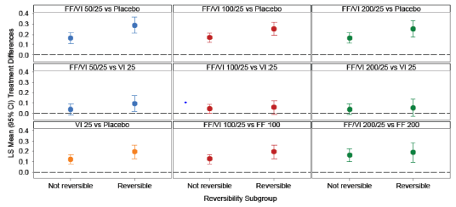
Figure 14. LS means treatment difference (95%CI) in trough FEV1 (L) at Day 169 by reversibility subgroup (HZC112206 and HZC112207)
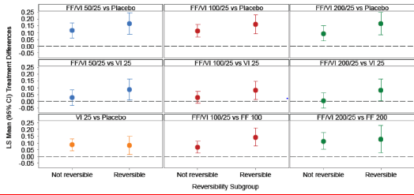
Figure 15. LS means treatment difference (95%CI) in trough FEV1 (L) Week 52 by reversibility subgroup (HZC102871/HZC102970)
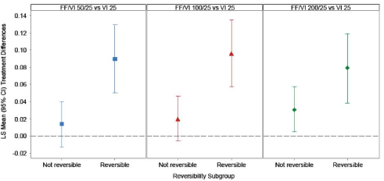
Percentage predicted FEV1: Consistency of treatment effect across percentage-predicted FEV1 was investigated for the primary efficacy endpoint(s) for each pair of studies. A statistically significant interaction was found for through FEV1 for Studies HZC102871 and HZC102970.
Combined with reduced efficacy in subjects with GOLD categories III and IV; Least square mean differences for the comparisons of FF/VI 50/25, 100/25 and 200/25 versus VI 25 for GOLD stage I+II combined were 0.048L, 0.079L and 0.078L, respectively. For GOLD stage III they were 0.040L, 0.031L and 0.036L, respectively, and for GOLD stage IV they were -0.015L, -0.032L and -0.003L, respectively. All other endpoints examined demonstrated no evidence of any statistically significant interaction.
CV risk factors: There was evidence of a statistically significant interaction for weighted mean FEV1 (0 to 4 h) at the 10% level of treatment with CVR subgroup (p=0.090) at Day 168. A smaller effect was observed in subjects with no CVR history compared to those with a CVR history for the FF/VI 200/25 versus placebo and VI 25 component. However, the magnitude of these effects was similar in both subgroup categories for the other two strengths. Similar magnitudes of effect were seen for VI versus placebo for both those with CVR and those with no CVR There was no evidence of a statistically significant interaction of treatment with CVR for through FEV1 or annual rate of moderate/severe exacerbations.

Evaluator’s comments on efficacy of FF/VI for indication of COPD
In order to select the appropriate combination doses of FF/VI for the COPD Phase III clinical program, FF and VI doses were selected independently on the basis of separate Phase IIb studies in asthma and COPD. No dose ranging studies with FF monotherapy were conducted in in COPD as patients with COPD demonstrate minimal bronchodilation with inhaled corticosteroids. Dose ranging studies in asthma were used to inform the choice of FF doses for study in the FF/VI Phase III program in COPD. The 25 µg dose of VI was selected based on results of the Phase II study B2C111045. Three doses of FF (50, 100 and 200 µg) in the FF/VI combination were investigated in Phase III COPD studies to determine the appropriate dose for use in patients with COPD. However, only one dose of VI (25 µg) was evaluated in the FF/VI Phase III studies.
HZC112206 and HZC112207 were Phase IIIa, 6 month studies designed to evaluate the efficacy, safety, tolerability, PK and PD profile of two strengths of FF/VI Inhalation Powder administered OD, the individual components (FF and VI) administered OD, and placebo in 2254 subjects with COPD. The studies were randomised, double-blind, placebo-controlled, parallel-group, multi-center studies. Both studies assessed the efficacy of VI 25 as monotherapy and the effect of VI 25 when added to FF 100. The HZC112206 study also assessed the effect of FF 50 and FF 100 when added to VI 25, whereas the HZC112207 study assessed the effect of FF 100 and FF 200 when added to VI 25. All three FF/VI combination groups and the VI 25 group demonstrated statistically significant improvements in the LS mean change from baseline through FEV1 compared with the placebo group. The improvements were generally similar across the FF/VI 50/25, FF/VI 100/25 and FF/VI 200/25 groups, 138 mL 129 mL and 119 mL, respectively. Although not defined as a primary treatment comparison, the FF/VI 100/25 and FF/VI 200/25 groups also showed improvements of 91mL and 123 mL, respectively, compared with the respective FF alone group (p<0.001) Although this was not defined as a primary treatment comparison in both studies. FF 50 µg was not evaluated in these Phase III studies. There was no evidence of a dose response relationship between any of the FF/VI groups. The contribution of VI in the FF/VI combination was demonstrated by the improvements in lung function effects (measured by weighted mean FEV1 0 to 4 h post dose and through FEV1) between subjects who received FF/VI treatment and subjects who received FF alone. The integrated results showed that the LS mean changes from baseline in peak FEV1 were higher for the FF/VI 100/25 and FF/VI 200/25 groups compared with the respective FF groups (129 mL [95% CI: 109, 150] and 132 mL [95% CI: 103, 161], respectively; both p<0.001). Overall, 85% or more of the subjects in the FF/VI (50/25, 100 25 and 200/25) and VI 25 groups achieved their first increase of at least 100 mL or more from baseline in FEV1 within the 5 minute to 4 h post dose time-points (with more than 40% of the subjects in each of these groups demonstrating an increase of at least 100 mL within 5 minutes of dosing) compared with about 53% in the placebo and FF 100 and FF 200 groups. Results of both 6 month lung function studies (HZC112206 and HZC112207) also demonstrated differences in LS mean change from baseline CRQ-SAS dyspnoea scores between the FF/VI 100/25 and placebo groups and between the FF/VI 100/25 and FF 100 groups at the end of the 6 month treatment period Although none of the treatment comparisons achieved the reported minimal clinically important difference (MCID, >0.5 point improvement). Patients treated with the proposed FF/VI 100 /25 µg also had significantly less cough and sputum, required significantly less rescue medication as measured by number of occasions of rescue salbutamol use (per 24 h period) and number of night time awakenings requiring salbutamol (per 24 h period) compared to placebo.
ICSs demonstrate small effects on lung function in subjects with COPD and the most important effects are those on symptomatic endpoints, such as reduction in COPD exacerbations. Therefore, the primary emphasis for evaluation of the contribution of different doses of FF to the FF/VI combination was done in the 1 year exacerbation studies (HZC102871 and HZC102970) involving 3255 patients with COPD with a post bronchodilator FEV1 of ≤70% predicted and an exacerbation history. Both of the 1 year exacerbation studies showed that all three strengths of FF/VI OD were more efficacious than VI 25 OD alone in reducing the annual rate of moderate and severe COPD exacerbations (the primary [symptomatic] endpoint), thereby demonstrating the benefit of the FF/VI combination and the contribution of FF in the combination. Interpretation of results from Study HZC102871was limited due to failure to demonstrate superiority of FF/VI 200/25 over VI 25 in reducing moderate to severe exacerbations, Although all 3 FF/VI groups (200/25, 100/25 and 50/25) showed numerical improvements over VI25 for the primary and key secondary efficacy endpoints. However, the proposed dose of FF/VI 100/25 did show significant improvements in both primary and secondary endpoints. However, superiority of FF/VI 200/25 over VI 25 in reducing moderate to severe exacerbations was confirmed in the other 52 week Study HZC102970 and so results of significant reductions with proposed dose of FF/VI 100/25 µg were statistically valid.
The pooled analysis demonstrated that all three strengths of FF/VI provided significantly (p≤0.014) greater reductions in the LS mean annual rate of moderate or severe COPD exacerbations compared with VI 25 treatment alone, with the greatest reduction observed in the FF/VI 100/25 group the (27%; p<0.001). The percentage reduction in the FF/VI 50/25-treated group (16%; p=0.014) was less than that observed in the FF/VI 100/25-treated group and that there was no efficacy advantage of the FF/VI 200/25 (23 % risk reduction, p<0.001) strength over the 100/25 strength. Time to first moderate or severe exacerbation was a secondary endpoint in the two, 1 year exacerbation studies (HZC102871 and HZC102970). The pooled analysis demonstrated that treatment with FF/VI 100/25 and FF/VI 200/25 significantly lowered the risk of the time to first moderate or severe COPD exacerbation compared with VI 25 treatment (risk reductions of 24 and 25%, respectively [both p<0.001]), while the 11% risk reduction observed in the FF/VI 50/25 group was not significant (p=0.114). All three FF/VI treatments significantly decreased the annual rate of COPD exacerbations requiring systemic/oral corticosteroids compared with treatment with VI 25, with the greatest decrease observed in the FF/VI 100/25 group compared with the VI 25 group (30%; p<0.001). The percentage reduction with FF/VI 50/25 (compared with VI) was nearly half that observed with FF/VI 100/25 and there was no efficacy advantage of FF/VI 200/25 over the 100/25 strength. The data from these studies demonstrated that FF provides a significant contribution to the FF/VI combination, primarily exhibited by the reduction in the annual rate of moderate and severe COPD exacerbations, supported by the reduction in the time to first moderate or severe exacerbation and those exacerbations requiring systemic corticosteroid use, together with small improvements seen in lung function (trough FEV1).
The 24 h bronchodilator effect of FF/VI was maintained from the first dose throughout a one year treatment period with no evidence of loss in efficacy. In the two, 6 month, lung function studies as well as in the two, 1 year exacerbation studies, there was no evidence of a dose response relationship across the FF/VI strengths (50/25, 100/25 or 200/25 µg) for lung function endpoints.
Age, gender, race or geographical regions did not have significant effect on efficacy of FF/VI in terms of effects on lung function (6 month studies) or reduction of COPD exacerbations (12 month studies). Subjects with reversible disease, past smokers, GOLD stage II showed greater treatment effects.
Results of the 5 supportive studies provide further support for the consistency of effects on lung function with FF/VI 100/25 treatment (HZC110946, HZC113107, HZC113109, and HZC112352) and VI 25 treatment (B2C111045). Three 12 week studies compared efficacy of proposed FF/VI 100/25 µg OD with twice daily dosing with FP/salmeterol (500/50 µg and 250/50 µg). The primary efficacy endpoint in these studies was weighted mean FEV1 (0 to 24 h) and proposed FF/VI 100/25 µg OD showed similar efficacy to FP/salmeterol 500/50 µg BD (Study HZC113107) and 250/50 µg BD (Study HZC112352) but was statistically significantly superior to 250/50 µg BD in Study HZC113109. However, the above results can only be considered supportive as the studies lacked placebo control and were not designed to show non-inferiority of FF/VI 100/25 to the approved ICS/LABA combination of FP/salmeterol.

Clinical safety

Safety for indication of asthma

Studies providing evaluable safety data for indication of asthma
Evaluable safety data was obtained from 68 completed clinical studies including 8 Phase II, 8 Phase III studies and 52 completed clinical pharmacology studies with FF/VI and/or the individual components and involving over 10,000 subjects with asthma. The cut-off date for the safety data was 15 February 2012. For the assessment of FF/VI safety in asthma, the clinical studies are grouped into four sets: Integrated Asthma Clinical Studies, Non-integrated Asthma Clinical Studies, Ongoing Asthma Clinical Studies, and Clinical Pharmacology Studies. The Integrated Asthma Clinical Studies include all completed parallel-group Phase II and III studies conducted with the final formulation and inhaler, and safety data common to these studies have been integrated. The Non-integrated Asthma Clinical Studies are Phase II and III studies summarised individually and not integrated because they had a different design (for example, crossover study), a unique comparator arm (that is, HZA113091 which is the only study that contains the comparator arm Advair™/Seretide™) or did not use the final formulation and/or inhaler. For the 6 Phase III and 2 clinical pharmacology Ongoing Asthma Clinical studies, limited SAEs data was available.
Safety assessments were conducted in the Integrated and Non-integrated Asthma Clinical Studies. AEs were coded and grouped by System Organ Class (SOC) and Preferred Term using the Medical Dictionary for Regulatory Activities (MedDRA, Version 14.1). Results were displayed in the order of decreasing frequency, both across primary SOC and within primary SOC. The number of subjects with one or more events of any type was also calculated. For long-term studies HZA106837 and HZA106839, on-treatment AEs were presented by time of onset (≤6 months, >6 months). The number of subjects with each AE adjusted for duration of exposure (number of subjects with an event [at least one AE] per 1000 subject-years of exposure) was summarised for on-treatment AEs, most frequent AEs (≥ 3%), serious on-treatment AEs, on-treatment AEs leading to permanent discontinuation of study drug or withdrawal and AEs of Special Interest. AE groups of special interest were defined a priori as AEs which reflect LABA and/or corticosteroid pharmacologic effects (Table 20).
Table 20. Groupings of AEs of special interest
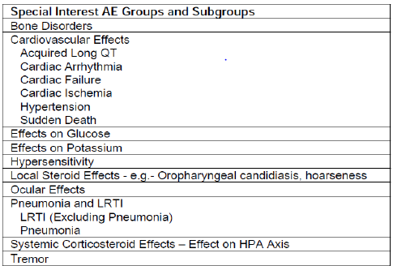
For the Phase III studies, a standardised definition of severe asthma exacerbation was used and the time to first on-treatment asthma exacerbation was analysed using a Cox proportional hazards regression model stratified by study, including terms for baseline disease severity (pre-dose FEV1 measured at randomization), region, sex, age and treatment group. The estimated hazard ratios (HRs) for treatment comparisons were presented together with a 95% CI and p-value. The asthma composite endpoint of asthma related hospitalisations, intubations and deaths was determined across the FF/VI program by an independent, blinded adjudication committee. SAE narratives were adjudicated for all asthma studies that had a VI or VI + ICS treatment arm.
Pivotal studies that assessed safety as a primary outcome included studies HZA106851 and HZA106839 which are described below.
Clinical pharmacology studies: The 52 completed clinical pharmacology studies (Phase I and IIa) were conducted in healthy subjects (including East Asians), subjects with asthma (including paediatric subjects 5-11 years of age), subjects with COPD and subjects with hepatic or renal impairment. Assessments included safety measures, pharmacokinetics, pharmacodynamics, bioavailability and indicators of efficacy including bronchoprotection. Product administration was either single dose or repeat dose of short duration (≤28 days). Many of these studies were performed with either FF or VI alone and administered via earlier product formulations and inhalers other than the NDPI. The proposed NDPI was used in 11 of the clinical pharmacology studies.

Pivotal studies that assessed safety as a primary outcome

6 Week HPA-Axis Study (HZA106851)
HZA106851 was a Phase III, multi-center, randomised, double-blind, parallel group, placebo- and active-controlled study involving 185 subjects with asthma to assess the effect of 6 weeks of treatment with FF/VI 100/25 (n=56) and FF/VI 200/25 OD (n=56) on the HPA-axis system compared with Placebo (n=58) and prednisolone (n=15). It was conducted from 25 March 2010 to 24 September 2010 at 16 centres in three countries (Poland, Germany and US). The primary objective of this study was to assess the effect of 6 weeks treatment with the two proposed once-daily strengths of inhaled FF/VI on the hypothalamic-pituitary-adrenal (HPA) axis system compared with placebo. A 7 day course of oral prednisolone (10 mg) was included as an active control to ensure sufficient sensitivity of the assay. Pharmacodynamics was evaluated by serum cortisol levels and urinary-free cortisol excretion assessed from the 24 h blood and urine collections. Safety assessments included AE reporting, laboratory evaluations and vital sign assessments.
The primary endpoint for this study was the ratio to baseline of the 0 to 24 h weighted mean serum cortisol at the end of the 6-week treatment period. The primary objective was to show non-inferiority of each FF/VI dose to placebo on this endpoint. Majority of subjects were male (53%) and White (97%) with a mean age of 35 years and mean percentage predicted FEV1 of 80.2% at baseline. Demographics were similar across the four treatment groups.
Non-inferiority was demonstrated for the primary endpoint of (0 to 24 h) serum cortisol weighted mean at the end of the 6 week treatment period) as the lower limit of the two-sided 95% CI for the geometric mean ratio of each dose of FF/VI versus placebo was greater than 0.8. Analysis of serum cortisol AUC and through showed numerically lower limits for the 2-sided 95% CIs for the geometric mean ratio of the FF/VI 100/25 and FF/VI 200/25 groups versus placebo AUC: 0.87 and 0.86, respectively; trough: 0.69 and 0.59, respectively, Although non-inferiority criteria were not set for these secondary endpoints. Analysis of the adjusted geometric means showed no statistically significant differences in 24 h urinary cortisol excretion ratio to baseline between the placebo (0.85) and the FF/VI groups (1.08 for FF/VI 100/25 and 0.92 for FF/VI 200/25) but there was a significant difference (p<0.001) between the prednisolone group (0.37) and placebo. Results for serum and urinary cortisol endpoints were as expected for the active control group, prednisolone, with significant suppression at Day 42.

Long term safety study HZA106839
HZA106839 was a Phase III multi-center, randomised, double-blind, parallel-group study which assessed the safety and tolerability of 52 weeks of treatment with FF/VI 200/25 and FF/VI 100/25 compared with FP 500in 503 subjects with asthma. Following screening and 2 week run-in period, eligible subjects were required to stop their regular maintenance asthma therapy for the duration of the treatment period and were randomly assigned to receive one of the following 3 double-blind treatments in a 2:2:1 ratio:
- FF/VI 100/25 OD plus Placebo BD
- FF/VI 200/25 OD plus Placebo BD
- FP 500 BD plus Placebo OD
Subjects attended nine on-treatment clinic visits occurring at Weeks 2, 4, 8, 12, 20, 28, 36, 44 and 52. The study was conducted from 19 October 2009 to 12 May 2011 at 45 centers in 4 countries (USA, Germany, Ukraine, and Thailand).
Majority of subjects in the ITT Population were White (67%), female (63%) had asthma for at least 10 years (60%; mean duration of asthma was 15.3 years). The mean age was 39 years (16% being adolescents), mean pre-dose FEV1 was 2.37 L (range: 0.97 L to 5.02 L) and mean percentage predicted FEV1 was 76.3% (range: 50% to 133%) and 21% of subjects had one asthma exacerbation within the prior 12 months. Baseline demographics and disease characteristics were similar across treatment groups. The overall incidence of AEs during treatment was 69%, 66% and 73% in the FF/VI 100/25, 200/25 and FP groups, respectively. While the incidence of AEs was greater in the FP group compared with the two FF/VI groups, the incidence of drug-related AEs (13% to 14%), post-treatment AEs (<1% to 2%), SAEs (<1% to 7%) and withdrawals due to AEs (1% to 6%) was similar across the treatment groups. No deaths occurred during the study.
The FP500 group had higher incidences of AEs during treatment in the Infections and Infestations SOC (43%, 36% and 46% in the FF/VI 100/25, 200/25 and FP groups, respectively) and the ‘Respiratory, thoracic and mediastinal’ SOC (18%, 18% and 25%, respectively). %). The FF/VI groups showed higher incidence of Gastrointestinal AEs (15%, 17% and 10%, respectively); Cardiac AEs were higher in the FF/VI 200/25 group (15%) compared with the FF/VI 100/25 (8%) and FP (7%) groups. The incidence of Nervous system AEs (20% to 29%) and musculoskeletal AEs were similar across the treatment groups (9% to 11%).The most frequently reported AEs during the treatment period across all treatment groups were headache (17% to 23%), upper respiratory tract infection (URTI) (15% to 18%), and nasopharyngitis (9% to 12%). The incidence of headache was slightly higher in the FP group (23%) than in the FF/VI groups (19% and 17%). The FP group also had higher incidences of cough, oropharyngeal pain and respiratory tract infection compared with the FF/VI groups. The FF/VI groups had a higher incidence of oral candidiasis, upper abdominal pain and extrasystoles (FF/VI 200/25 group only) compared with the FP group.
The most frequently reported drug-related AEs included oral candidiasis (1% to 4%), dysphonia (0% to 3%) and extrasystoles (0% to 2%); all occurred with a higher incidence in the FF/VI groups compared with the FP group. There were no deaths reported in the study and 11 non-fatal SAEs were reported for 11 subjects during the treatment period (3 in the FF/VI 100/25 group, 1 in the FF/VI 200/25 group, and 7 in the FP group) and one SAE for one subject (FF/VI 100/25 group) during the post-treatment period. Ten of the 12 subjects had SAEs that resolved. Five subjects were withdrawn from the study due to their SAEs (1 in the FF/VI 100/25 group and 4 in the FP group). Overall, 14 subjects were withdrawn from study drug/ the study due to AEs: 5 in the FF/VI 100/25 group, 3 in the FF/VI 200/25 group, and 6 in the FP group; in 10 of 14 subjects, AEs that led to withdrawal were considered drug-related by the investigator (5 SAEs) All of the non-serious AEs that led to withdrawal resolved.
Of the AEs of special interest, cardiovascular effects were most common and occurred with a higher incidence in the FF/VI 200/25 group (18%) compared with the FF/VI 100/25 (12%) and FP (10%) groups and this difference was primarily driven by a higher incidence of extrasystoles in the FF/VI 200/25 group. Supraventricular extrasystoles, ventricular extrasystoles, supraventricular tachycardia, sinus tachycardia, angina pectoris and peripheral edema, which occurred at a low incidence (≤2%), were only noted in the FF/VI groups. One subject in the FF/VI 200/25 group experienced atrial fibrillation. The overall incidence of local steroid effects was similar across the treatment groups (12% to 15%) but the incidence of oral candidiasis was higher in the FF/VI groups (6% and 5%) compared with the FP group (2%) and the incidence of oropharyngeal pain was higher in the FP group (11%) compared with the FF/VI groups (3% and 6%). Hypersensitivity events (for example, rash, urticaria, and allergic dermatitis) only occurred in the FF/VI groups (3% to 5%). Of these events, only one (urticaria) was considered related to study treatment by the investigator. Twelve subjects experienced severe asthma exacerbations during the treatment period: 3 in the FF/VI 100/25 group (1%), 6 in the FF/VI 200/25 group (3%), and 3 in the FP group (3%); 3 of these subjects were hospitalized (1 subject, FF/VI 100/25 group and 2 subjects, FP group); none required intubation. Majority of subjects across the treatment groups in the ITT Population had normal 24 h urine-free cortisol excretion at any visit post-baseline (66% to 77%) A greater proportion of subjects in the FP group (22%) had low 24 h urine-free cortisol excretion at any visit post-baseline compared with the FF/VI groups (6-10%). Similarly, changes from baseline to low at any visit post-baseline also occurred with a higher incidence in the FP group (20%) compared with the FF/VI groups (8% and 6%). A small, but greater proportion of subjects in the FF/VI groups (7% and 8%) tended to have ECG findings of potential clinical importance at any post-baseline visit compared with the FP group (5%) and abnormalities of depolarization were most common. A new finding of sinus tachycardia was reported for 3 subjects in the FF/VI 200/25 group (Table 21). There were no findings of concern for haematology or clinical chemistry parameters, including glucose and potassium levels. There was no evidence of a dose related increase in either IOP or lens opacification and most subjects had little or no change in IOP.
Table 21. ECG findings of potential clinical importance at any time post-baseline (Study HZA106839, ITT population).
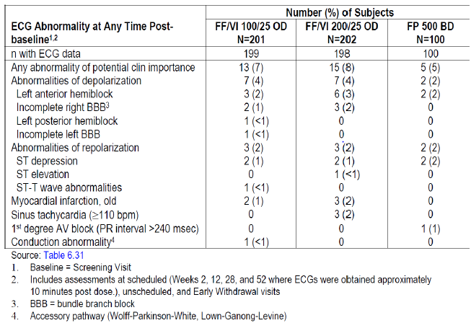

Patient exposure
A total of 10,630 subjects received at least one dose of study medication in the FF/VI clinical development program: 7034 in the Integrated Asthma Clinical Studies, 2292 in the Non-integrated Asthma Clinical Studies, and 1304 in the Clinical Pharmacology Studies. Of these subjects, 2652 were treated with FF/VI, 4432 were treated with FF, and 987 were treated with VI (all administered by oral inhalation). As of the 15 February 2012 data cut-off date, 686 subjects ≥12 years of age were participating in the six Ongoing Clinical Asthma Studies. A total of 599 elderly subjects (≥65 to 85 years) were enrolled in the FF/VI Asthma Clinical Development Program: 569 in the Clinical Studies (Integrated and Non-integrated Clinical Studies) and 30 in Clinical Pharmacology Studies (Table 22).
Table 22. Elderly subject exposures in FF/VI asthma clinical studies and adult clinical pharmacology studies (ITT population, Key treatment groups)
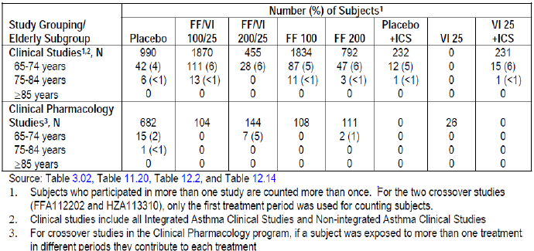
Of the 5944 subjects randomised in the 11 Integrated Asthma Clinical Studies, 5921 (>99%) received at least one dose of study medication (ITT Population). The largest numbers of subjects in the Integrated Asthma Clinical Studies were exposed to FF 100 or FF/VI 100/25 mainly because these treatments were administered in the large, long-term exacerbation study HZA106837 for up to 76 weeks. A total of 5069 subjects were included in the seven key treatment groups of interest in the ITT Population and the majority of subjects were exposed to FF 100 (1544 subjects) or FF/VI 100/25 (1467 subjects). Of the key treatment groups, the fewest number of subjects were exposed to VI 25 + ICS or Placebo + ICS (216 and 218 subjects, respectively) since these treatments were only included in two studies. Treatment exposure varied widely across the key treatment groups from 32 to 1252 subject years. Exposure was greatest for FF/VI 100/25 (1252 subject years) and FF 100 (1128 subject years) followed by FF/VI 200/25 (271 subject years), which was administered in the 1 year safety study HZA106839 (Table 23). In the Non-integrated Asthma Clinical Studies, 403 subjects received FF/VI 100/25, 1119 subjects received total daily doses of FF ranging from 100 to 400 µg and 74 subjects received total daily doses of VI ranging from 6.25 to 25 µg. Median treatment exposure across the Non-integrated Asthma Clinical Studies ranged from 9 days (Study HZA113310) to 169 days (Study HZA113091).
Table 23. Treatment exposure (integrated asthma clinical studies, key treatment groups)
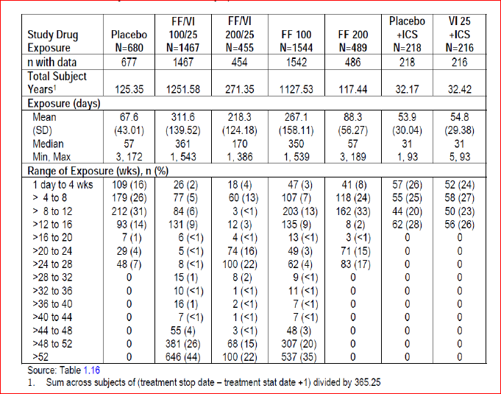
Across the key treatment groups in the Integrated Asthma Clinical Studies, premature withdrawals ranged from 10% in the VI 25 + ICS group to 28% in the Placebo group. Lack of efficacy was the most common reason for withdrawal, particularly in the Placebo (20%) and FF 200 (10%) groups. Consent withdrawn and protocol deviations were the next most frequent reasons for withdrawal. Subject withdrawals due to AEs were low across the key treatment groups (<1% to 2%). In the Non-integrated Asthma Clinical Studies, majority of the subjects completed treatment (80% to 100%). The most common reasons for withdrawal were lack of efficacy/ asthma exacerbation or withdrawal of consent. Few subjects (1% to 2%) withdrew due to AEs and no subjects were withdrawn due to AEs in studies FFA112202 or HZA113310. Majority of subjects in the key treatment groups in the Integrated Asthma Clinical Studies were White (65% to 77%), female (55% to 65%) (60%) had asthma for ≥10 years; 2% of subjects in the ITT Population had asthma for less than 1 year. The mean duration of asthma was 16 years in the ITT Population majority of subjects in the Non-integrated Asthma Clinical Studies were White (59% to 88%) and female (57% to 68%). The mean age of the study populations was 32 to 45 years (age range 12 to 85 years). Overall, the study populations evaluated for safety of FF/VI were representative of the proposed target population.

Adverse events

All adverse events (irrespective of relationship to study treatment)

Integrated asthma studies
The overall incidence of AEs was higher in the FF/VI100/25 (58%), 200/25 (54%) and FF 100 (55%) groups compared with FF200 (37%), placebo (27%), ICS+placebo (39%) and VI25+ICS (36%) groups. However, the exposure-adjusted data showed highest incidence for Placebo + ICS and VI 25 + ICS groups compared to the other five treatment groups for most of the common AEs because these groups had the least total subject-years of exposure, thus these two groups are best compared with each other and not with the other treatment groups. Overall, incidence of AEs (exposure-adjusted) was similar in all groups containing FF (FF/VI- 100/25, 200/25 and FF100, 200 groups) and lower than that in the placebo group.
Comments: Since these studies were of disparate durations (6 to 76 weeks) and treatment groups had variable sample sizes (216 to 1544 subjects), the exposure adjusted data are more informative than incidence data for assessment of AEs. Of note, there was limited placebo exposure in the Integrated Asthma Clinical Studies (placebo administered in 6 of the 11 studies) and most subjects were exposed to placebo for less than 16 weeks.
Headache, nasopharyngitis, upper respiratory tract infection (URTI), bronchitis, and oropharyngeal pain were the most commonly reported AEs. Headache, nasopharyngitis, and URTI continued to occur over time, whereas the incidence of other most frequent AEs tended to reach a plateau in the key treatment groups. Compared with the Placebo group, there were fewer subjects in the FF/VI and FF groups with an event per 1000 treatment years for headache, nasopharyngitis (except FF 200), bronchitis, and pharyngitis. However, the incidence (event per 1000 treatment years) of URTI (except FF 200), back pain, influenza, pyrexia, and oral candidiasis was higher in the FF/VI and FF groups compared with the Placebo group. Furthermore, the FF/VI 200/25 group had higher incidence of extrasystoles compared with all the other treatment groups. The number of subjects with an event per 1000 treatment years was higher in the FF 200 group for oropharyngeal pain, cough, sinusitis and dysphonia compared with the Placebo group. The number of subjects with an event per 1000 treatment years was higher in the VI 25 + ICS group compared with the Placebo + ICS group for headache, back pain, allergic rhinitis, and pyrexia. Other than dysphonia and oral candidiasis which were more common at higher doses of FF, there did not appear to be any clear treatment or dose related trends in the occurrence of common AEs. The FP 200, FP 500, and FP 1000 treatment groups also showed a similar AE profile with headache, nasopharyngitis, and URTI being reported most frequently.
With exposure adjusted data, the number of subjects with an event per 1000 treatment years tended to be higher in the Placebo + ICS and VI 25 + ICS treatment groups for most SOCs. The number of subjects with an event per 1000 treatment years in the FF/VI 100/25, FF/VI 200/25, and FF 100 groups was similar or less than the Placebo group in most SOCs except General Disorders and Cardiac Disorders for the FF/VI 200/25 group, mainly due to higher numbers of subjects with pyrexia and extrasystoles per 1000 treatment years in the FF/VI 200/25 group. The number of subjects with an event per 1000 treatment years was higher in the FF 200 group in the Infections and Infestations, Respiratory, Thoracic, and Mediastinal Disorders, Gastrointestinal Disorders, and General Disorders SOCs compared with Placebo, which had a similar number of subject-years exposure. These differences were primarily due to higher numbers of subjects with oropharyngeal pain, cough, dysphonia, toothache, diarrhoea, and pyrexia per 1000 treatment years in the FF 200 group (Table 24).
Table 24. On treatment system organ class AEs (≥3% incidence in any key treatment group) (Integrated asthma clinical studies)
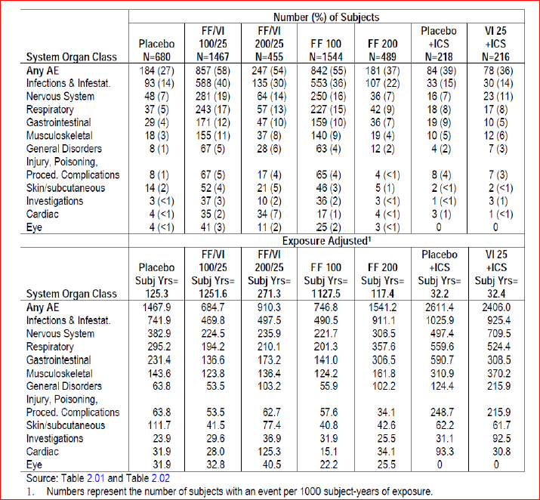

Non-integrated asthma studies
The most common AEs in the Non-integrated Asthma Clinical Studies were headache, nasopharyngitis, and URTI. Asthma (exacerbation) was the second most common AE reported in Study FFA20001. This event was considered an AE in older clinical studies but is now reported as lack of efficacy, unless the event met the definition of a SAE. There was no dose-relationship in the incidence of AEs with FF or VI. In Studies FFA20001 and FFA106783, which evaluated AM versus PM Dosing with FF, the incidence of AEs was similar across treatment groups with headache more common in FF groups and asthma more common in the placebo group (Table 25). In studies FFA112202 and HZA113310 which evaluated OD versus BD dosing, incidence of AEs was similar for the FF treatment groups (16% to 18%) compared with the Placebo group (14%), but lower for the FP treatment groups (5% to 7%). The most frequently reported AE was URTI, which occurred with a higher incidence in the FF groups (5%) compared with the Placebo group (1%). No subjects in the FP groups experienced URTI (Table 25). The overall incidence of any on-treatment AE in Study HZA113091 was similar in both FF/VI 100/25 and FP/SALM 250/50 treatment groups (53% and 49%) and the most frequently reported AEs were nasopharyngitis (11% each group) and headache (8-10%). The incidence of each of the most frequent AEs was similar between the treatment groups (Table 26). Across the Non-integrated Asthma Clinical Studies, AEs in the Infections and Infestations SOC occurred most often and the incidence was generally similar between the active treatment groups and Placebo. Nasopharyngitis and URTI were the most frequently reported AEs in this SOC. There were no consistent trends in the incidence of AEs in any SOC between the active treatment and Placebo groups. There was no evidence of a dose relationship for any SOC (Table 27).
Table 25. Most frequent AEs (≥3% in any treatment group) on treatment AEs (Study FFA2001, ITT population)
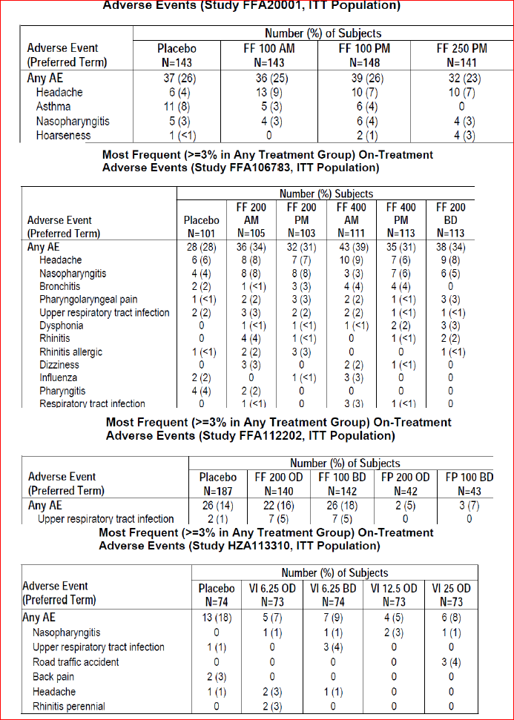
Table 26. Most frequent (≥3% in any treatment group) on-treatment AEs (Study HZA113091, ITT population).
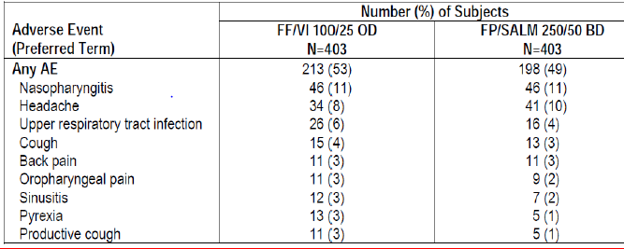
Table 27. On-treatment System Organ Class AEs
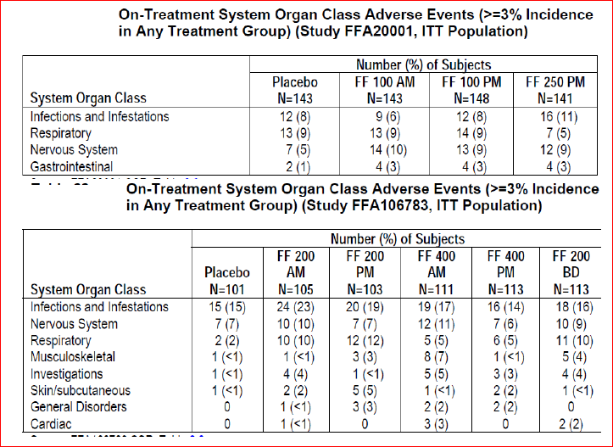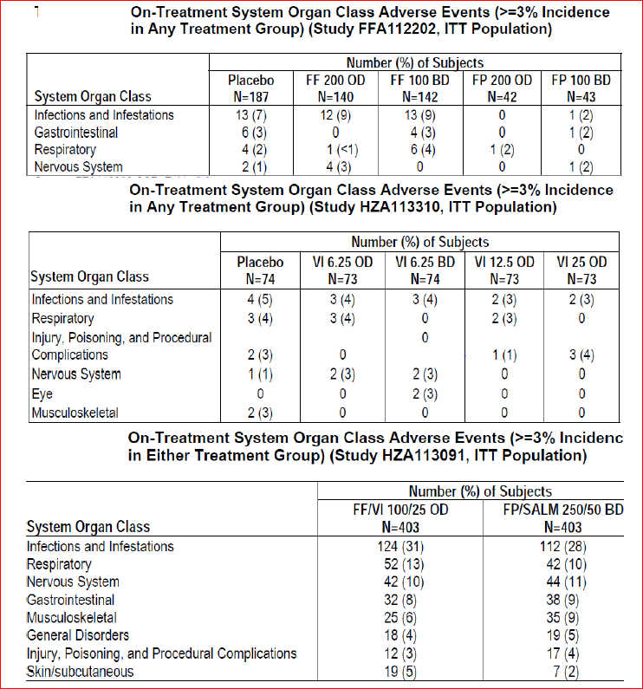

Treatment-related adverse events (adverse drug reactions)

Integrated asthma studies
Across the key treatment groups, the incidence of drug-related AEs ranged from 2% (in the Placebo and VI 25 + ICS groups) to 11% (FF/VI 200/25 group). The incidence of individual AEs was not more than 2% in any treatment group. Dysphonia and candidiasis (combination of oral, oropharyngeal, or unspecified) were the most frequently reported drug-related AEs and occurred predominantly in the FF-containing treatments (Table 28).
Table 28. Most frequent drug related AEs
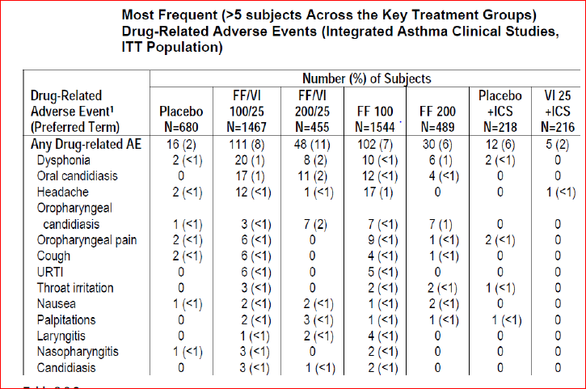
Across the key treatment groups, the incidence of drug-related AEs in any SOC was low (≤4%) with the highest incidence being in the Infections and Infestations and Respiratory, Thoracic, and Mediastinal Disorders SOCs and incidence was slightly higher in the FF/VI and FF groups (2% to 4% and 2% to 3%, respectively) compared with the Placebo group (<1% each) possibly because these treatments were administered for a longer duration. The FF/VI 200/25 group had a higher incidence of drug-related AEs in the Cardiac Disorders SOC than all the other treatment groups (Table 29), mainly due to a higher incidence of extrasystoles reported for this treatment group in Study HZA106839, which included Holter monitoring.
Table 29. On-treatment drug-related System Organ Class AEs
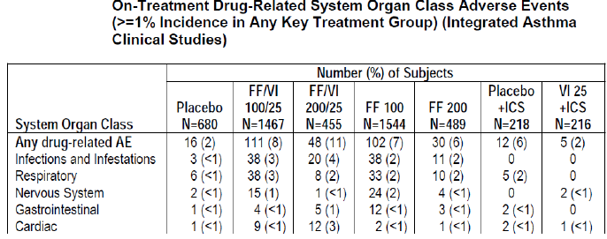

Non-integrated asthma studies
The most common drug-related AEs reported in the Non-integrated Asthma Clinical Studies were headache, dysphonia/hoarseness, and candidiasis. No drug-related AEs were recorded in the VI study HZA113310. Generally, the incidence of drug-related AEs was similar across the Placebo and active treatment groups. In Study FFA106783, the incidence of drug-related AEs was slightly higher with the FF 200 BD dose regimen (12%) compared with FF 400 OD dose regimens (5%, 8%). In the AM versus PM Dosing studies (FFA20001 and FFA106783) and the OD versus BD dosing Study FFA112202, incidence of drug-related AEs was low and similar across treatment groups. None of the AEs reported in Study HZA113310 were considered drug-related. The incidence of drug-related AEs in Study HZA113091 was low and similar between the FF/VI and FP/SALM treatment groups (5% and 4%).

Adverse events of special interest

Integrated asthma studies
Across the key treatment groups in the Integrated Asthma Clinical studies, the most frequent types of AEs of Special Interest were local steroid effects (2% to 11%), pneumonia and lower respiratory tract infection (LRTI) (0% to 7%), and cardiovascular effects (1% to 9%). Bronchitis (0% to 5%) and oropharyngeal pain (1% to 4%) were also reported frequently. Pneumonia was reported by a total of 31 subjects (<1%) in the Integrated Asthma Clinical Studies and the incidence was not greater than 1% in any treatment group. For local steroid effects (particularly candidiasis, dysphonia and oropharyngeal pain), the incidence of events (adjusted for exposure) was higher in the FF/VI 200/25 (191.6/1000 subject years) and FF 200 (281.0) groups compared with Placebo (87.8) and the respective lower dose (FF100=94.3 and FF200= 103.8) groups. The incidence of pneumonia (adjusted for exposure) seen with FF/VI 100/25 and FF 100 (9.6 and 8.0/1000 subject years, respectively) was similar to that seen with placebo (8.0/1000 subject years) although a slightly higher incidence of pneumonia was observed in the FF/VI 200/25 and FF 200 arms (18.4/ and 25.5/1000 subject years, respectively). For cardiovascular effects, the incidence of events (adjusted for exposure) was higher in the FF/VI 200/25 group (154.8/1000 subject years) than in the FF/VI 100/25 group (65.5/1000 subject years); this was due to a higher incidence of extrasystoles in Study HZA106839 that included Holter monitoring.

Non-integrated asthma studies
AEs of Special Interest were only categorised for studies using study medication in the final formulation/final inhaler (NDPI), which included one Non-integrated Asthma Clinical Study, HZA113091. In Study HZA113091, the most frequent types of AEs of Special Interest were local steroid effects, LRTI (excluding pneumonia), and cardiovascular effects; the incidence of AEs in each of these categories was low and similar between the treatment groups (<1% to 5%). Oropharyngeal pain and bronchitis were reported most often (2% to 3% in each treatment group). Hypersensitivity events were more frequent in the FF/VI 100/25 group (12 subjects, 3%) compared with the FP/SALM 250/50 group (6 subjects, 1%). LRTI, blood pressure increased, chest discomfort, skeletal injury, and pneumonia were reported in the FP/SALM 250/50 group, but not in the FF/VI 100/25 group.
Teeth effects with FF and ovarian and uterine tumour effects with VI (GW642444M) were observed in some of the nonclinical studies. To investigate whether similar effects could be seen in humans, preferred AE terms related to teeth and ovarian and uterine tumour effects were examined for the Integrated and Non-integrated Asthma Clinical Studies. Based on the FF/VI Phase II and III clinical development program, there is no evidence that the teeth effects seen in rodents have translated into an increased risk in adults or adolescents. The clinical database supports ovarian and uterine effects not being relevant to humans and were rodent specific. Thus, the effects seen in the nonclinical studies have not been substantiated in the clinical studies.

Asthma exacerbations

Integrated asthma studies
Subjects treated with FF/VI 100/25 had a 24% reduction in the risk of experiencing a severe asthma exacerbation compared with subjects treated with FF 100 (HR=0.762, 95% CI: 0.618, 0.941, p=0.011). Subjects treated with FF/VI 200/25 had a 59% reduction in the risk of experiencing a severe asthma exacerbation compared with subjects treated with FF 200 (HR=0.415, 95% CI: 0.138, 1.252, p=0.119). This reduction was not statistically significant; however, the number of subjects treated with FF/VI 200/25 and FF 200 were not large enough to enable the detection of a difference in the reduction to the risk of asthma exacerbations.
The hazard ratio from the Cox Model for FF 100 versus Placebo was 0.358 (95% CI: 0.190, 0.675) and for FF 200 versus Placebo was 0.468 (95% CI: 0.246, 0.893), representing a 64% (p=0.002) and 53% (p=0.021) reduction in the risk of experiencing a severe asthma exacerbation for subjects treated with FF 100 and FF 200 compared with Placebo, respectively The hazard ratio from the Cox Model for VI 25 + ICS versus Placebo + ICS was 0.916 (95% CI: 0.264, 3.171), representing a 8% reduction in the risk of experiencing a severe asthma exacerbation for subjects treated with VI 25 + ICS compared with Placebo + ICS (p=0.890).

Non-integrated asthma studies
The definition for severe asthma exacerbations was standardised for all asthma studies at the start of Phase III. For studies conducted prior to the start of Phase III, asthma exacerbations were not necessarily classified as severe and the definitions of asthma exacerbations varied. Overall, asthma exacerbations occurred more frequently in the Placebo group compared with the active treatment groups. In the AM versus PM Dosing study FFA106783, 29 subjects (5%) experienced asthma exacerbations: 14 subjects (14%) in the Placebo group, 4 subjects (4%) each in the FF 400 AM, FF 200 PM, and FF 400 PM groups, 2 subjects (2%) in the FF 200 AM group and 1 subject (<1%) in the FF 200 BD group. Most of the asthma exacerbations occurred within the first 2 weeks of treatment (18 of the 29 asthma exacerbations) and all but four of the asthma exacerbations had resolved by the conclusion of the study. None of the subjects experiencing exacerbations required hospitalization.
In OD versus BD dosing Study FFA112202, 6 subjects (3%) experienced asthma exacerbations during treatment: 5 subjects (3%) in the Placebo group and 1 subject (<1%) in the FF 200 group Most of the asthma exacerbations occurred within the first 2 weeks of treatment (5 of the 6 asthma exacerbations) and all but two of the asthma exacerbations had resolved by the end of the study. Three of the five asthma exacerbations in the Placebo group and the asthma exacerbation in the FF 200 group were treated with corticosteroids and none of the 6 subjects with asthma exacerbations required emergency room (ER) treatment or hospitalisation. In the other OD versus BD dosing Study HZA113310, 2 subjects (3%) experienced an asthma exacerbation during treatment: 1 subject (1%) in the Placebo group and 1 subject (1%) in the VI 12.5 group. Both asthma exacerbations occurred within the first 2 weeks of treatment and the asthma exacerbation in the VI 12.5 group remained unresolved at study end. Both subjects received treatment with corticosteroids and neither subject required ER treatment or hospitalisation. In Study HZA113091, 22 subjects (3%) experienced a severe asthma exacerbation during treatment: 12 subjects (3%) in the FP/SALM 250/50 BD group and 10 subjects (2%) in the FF/VI 100/25 OD group all of whom received treatment with oral/ systemic corticosteroids. In accordance with the protocol, the majority of these subjects were withdrawn due to their severe exacerbation (8 of 10 in the FF/VI group and 7 of 12 in the FP/SALM group). Six subjects (2 in the FF/VI group and 4 in the FP/SALM group) required treatment in the ER; of these, 1 subject in FF/VI group and 2 subjects in the FP/SALM group were hospitalised. All exacerbations except one in the FF/VI group (subject not hospitalised) were reported as resolved.

Asthma composite endpoint
SAE narratives for all asthma studies containing a VI or VI + ICS treatment arm were adjudicated by an independent, blinded adjudication committee which included classification of SAEs as deaths, hospitalisations and/or intubations and then for each category, the adjudication committee determined whether the SAE was respiratory related or not respiratory related.
For SAEs that were considered respiratory related, the adjudication committee further determined the cause: asthma related, COPD related, pneumonia related or other respiratory related. In addition to the seven VI-containing studies included for subject level integration (B2C109575, B2C112060, HZA106827, HZA106829, HZA106837, HZA106389, and HZA106851), four crossover studies were included for integration of adjudicated events because they contained VI doses in the formulation and device used in Phase III studies.
HZA113126, HZA114624, HZA113090 and HZA113310. For these four additional studies, only the first treatment period was integrated. The adjudication results from the Phase III study HZA113091 were not integrated since this study did not have a treatment comparison of interest a VI group) and so results were presented separately.
A total of 93 subjects had on-treatment SAEs that were adjudicated (59 subjects had events not respiratory related and 35 subjects had respiratory related). No SAEs were reported in the VI 25 alone treatment group from Study HZA113126. Of the 35 subjects with SAEs adjudicated as respiratory related, 22 subjects had SAEs adjudicated as asthma related, 11 subjects had SAEs adjudicated as pneumonia related and 3 subjects had SAEs adjudicated as other respiratory related. Three of the SAEs were deaths (2 were adjudicated as not respiratory related; 1 each in the FF/VI 100/25 and Placebo + ICS groups and one was adjudicated as respiratory related-FF 100 group, pneumonia related). A total of 87 subjects reported SAEs that were hospitalisations (54 not respiratory related and 34 subjects were adjudicated as respiratory related) Three subjects had intubations (1 not respiratory related and 2 were respiratory related). No subjects had SAEs that were adjudicated as COPD-related.
Nine subjects in Study HZA113091 had SAEs that were adjudicated; none were deaths or intubations. One subject had an SAE which did not involve hospitalisation, 5 subjects had SAEs that were adjudicated as not respiratory related, and 4 subjects had SAEs that were adjudicated as respiratory related (3 asthma related and 1 pneumonia-related). A total of 8 subjects reported SAEs that were hospitalisations; 4 not respiratory related and 4 respiratory related- 3 of which were asthma related (2 in the FP/SALM group and 1 in the FF/VI 100/25 group) and pneumonia-related for 1 subject (FF/VI 100/25 group).
For the analysis of FF/VI all doses versus non-LABA all doses, the common OR was 0.902 (95% CI: 0.345, 2.389) favouring treatment with FF/VI over treatment with non- LABA containing products. The combined risk difference indicates a slight reduction in the risk of asthma related events for subjects receiving any dose of FF/VI; 2.6 subjects have avoided an asthma related event for every 10,000 subjects treated with FF/VI. For the analysis of FF/VI all doses versus ICS all doses, the common OR was 0.890 (95% CI: 0.341, 2.353) favouring treatment with FF/VI over treatment with non-LABA containing products. The combined risk difference indicates a slight reduction in the risk of asthma related events for subjects receiving any dose of FF/VI; 2.8 subjects have avoided an asthma related event for every 10,000 subjects treated with FF/VI. All CIs for the individual studies contained 0, implying that there were no studies where the analysis suggested FF/VI resulted in a statistically significant increased risk for an asthma related event.

Long-term safety
In order to determine if there were differences in the AE profile as time on treatment increased and to identify the occurrence of new AEs that could be associated with increased exposure to study drug, the profile of AEs with an onset ≤6 months was compared with the profile of AEs with an onset of >6 months in the two long-term studies (HZA106839 and HZA106837).
In the long-term safety Study HZA106839, the overall incidence of subjects reporting the onset of an AE during the first 6 months was higher in both the FF/VI 100/25 and FF/VI 200/25 groups (55% and 52%, respectively) compared with those reporting the onset of an AE during the second 6 months (50% and 46%, respectively), especially for headache (<6 months (mths) versus >6 mths: FF/VI 100/25 =16% versus10%; FF/VI 200/25=13% versus 8%), URTI (FF/VI 100/25=12% versus 6%) and back pain (FF/VI 200/25= 6% versus 2%); however, the opposite was seen for the FF/VI 100/25 group with higher incidence of nasopharyngitis (8% versus 4%) and extrasystoles (6% versus <1%). However, it should be noted that Holter monitoring was only performed at Day 1 during the first 6 months but at Week 28 and Week 52 during the second 6 months. In the Exacerbation Study HZA106837, the overall incidence of subjects reporting an onset of an AE during the first 6 months was higher in both the FF 100 and FF/VI 100/25 groups (54% and 53%, respectively) compared with reporting an onset of an AE in the latter part of the study (38% and 41%, respectively), especially for headache (<6 mths versus >6 mths: FF100= 16% versus 6%; FF/VI 100/25 =15% versus 8%) and nasopharyngitis (FF/VI 100/25=12% versus 7%). Overall, no significant trends were observed for increased incidence of overall AEs or specific AEs with increase in duration of treatment.

Deaths and other serious adverse events
Four deaths occurred in the Integrated Asthma Clinical Studies: 2 subjects in the FF 100 group (due to lung cancer occurred post treatment; pneumonia related death), 1 subject in the FF/VI 100/25 group (car accident) and 1 subject in the Placebo group (sudden death). Review of the death narratives suggested that the deaths were not likely to be related to study medication. . No deaths occurred during the conduct of any of the Non-integrated Asthma Clinical Studies. No deaths have occurred in the ongoing asthma clinical studies as of the data cut-off date of 15 February 2012.
In the Integrated Asthma Clinical Studies, 94 subjects in the key treatment groups reported SAEs (<1% to 3% across treatment groups) with the highest incidence occurring in the FF/VI 100/25 group. The most frequent SAE was asthma (exacerbations), reported by 12 subjects in the FF/VI 100/25 group, 9 subjects in the FF 100 group and 1 subject each in the Placebo, FF 200 and VI 25 + ICS groups. The placebo treatment arm was included only in shorter-term studies where the risk of exacerbations was less, while the FF/VI 100/25 and FF 100 treatment arms were included in the exacerbation study (HZA106837) with duration of up to 76 weeks and which, unlike the other studies in the program, recruited subjects with a severe asthma exacerbation history. Two subjects reported SAEs of hypertension: 1 subject (<1%) each in the FF/VI 100/25 and FF 100 groups. Two subjects (<1%) receiving FP 1000 reported SAEs (hemoptysis and hepatitis). Five subjects in the key treatment groups had SAEs that were considered to be related to study medication by the investigator: 1 subject in the FF/VI 100/25 group (severe grade 3 cardiac tachyarrhythmia), 1 subject in the FF/VI 200/25 group (severe grade 3 atrial fibrillation) and 3 subjects in the FF 100 group (severe grade 3 community acquired pneumonia/pleurisy; severe grade 3 acute asthma exacerbation; severe dehydration and chest pain).
In the Non-integrated Asthma Clinical Studies, the only SAE reported for more than one subject was asthma (exacerbation) (5 subjects). This event occurred in subjects in the Placebo, FF 100, FF/VI 100/25, and FP/SALM 250/50 treatment groups. Three subjects experienced cardiovascular SAEs: supraventricular arrhythmia (FF 100 AM group, considered due to prohibited concomitant medications), atrial fibrillation (FF 400 AM group, subject had pre-existing history) and myocardial ischemia (FF/VI 100/25 group, considered triggered by anxiety). Each of these three events resolved before the end of the study and none was considered related to study drug by the investigator.
Five double-blind efficacy and safety studies (HZA113714, HZA113719, FFA115283, FFA115285 and FFA114496) and one open-label safety study in Japanese subjects (HZA113989) were ongoing as of the cut-off date (15 February 2012). At the cut-off date, two SAEs were reported in 1 subject in Study FFA114196 and 20 SAEs were reported in 12 subjects in Study HZA113989. There were no SAEs reported in Studies HZA113714, HZA113719, FFA115283 or FFA115285. Only two of the SAEs reported occurred in more than one subject: pneumonia (one subject receiving FF/VI 100/25 and one subject receiving FF/VI 200/25 in Study HZA113989) and sleep apnoea syndrome (both subjects receiving FF/VI 100/25 in Study HZA113989). One SAE, pneumonia in a 76 year old male in Study HZA113989, was considered drug-related by the investigator. Due to an increase in pneumonia-related events in the Japanese COPD safety study, AEs of pneumonia in Study HZA113989 are described below for full disclosure. AEs were reported by 56 subjects (93%) receiving FF/VI 100/25 (N=60), 86 subjects (92%) receiving FF/VI 200/25 (N=93) and 76 subject (84%) receiving FF 100 (N=90) in Study HZA113989. Pneumonia was reported in this study by 3 subjects (5%) treated with FF/VI 100/25, 4 subjects (4%) treated with FF/VI 200/25 and 1 subject (1%) receiving FF 100.

Discontinuation due to adverse events
In the Integrated Asthma Clinical Studies, 80 subjects in the key treatment groups reported AEs that led to withdrawal (<1% to 2% across treatment groups) which was similar to the incidence of withdrawal due to AEs in the FP treatment groups (2% to 3%). The most frequent AE leading to withdrawal was asthma (exacerbation), reported by 3 subjects each in the FF/VI 100/25 and FF 100 groups and 1 subject each in the Placebo, FF 200 and VI 25 + ICS groups. Other common AEs leading to withdrawal *all <1% incidence) were dysphonia (3 subjects in the FF/VI 100/25 group and 1 subject in the FF 100 group), pneumonia (2 subjects in the FF 100 group and 1 subject in the FF 200 group), oral candidiasis (1 subject each in the FF/VI 200/25 and the FF 100 groups), palpitations (1 subject each in the FF/VI 200/25 and the FF 100 groups), hypertension (1 subject each in the FF/VI 100/25 and VI 25 + ICS groups). No subjects in any of the FP treatment groups reported AEs of dysphonia, pneumonia or oral candidiasis that led to withdrawal.
The incidence of AEs leading to withdrawal in the Non-integrated Asthma Clinical Studies was low (0% to 4%). Two studies had no withdrawals due to AEs (FFA112202 and HZA113310). Overall withdrawal rate due to AEs was 4% in Study FFA20001 and most of the withdrawals (20/24) were due to asthma exacerbation. For the remaining two studies, AEs leading to withdrawal were varied. In Study FFA106783, 11 subjects experienced AEs that led to withdrawal. Each AE leading to withdrawal in this study was a single event. In Study HZA113091, two subjects each were withdrawn for asthma exacerbation and chest discomfort; the remaining AEs were single events. The majority of AEs leading to withdrawal were resolved at the time of the last subject contact.

Laboratory tests

Liver function
In the Integrated Asthma Clinical Studies, 11 subjects exhibited elevated LFTs which were considered of potential clinical concern by the investigator. There were no trends for the occurrence of these abnormalities as the subjects received different study treatments (Placebo, FF, VI, FF/VI, or FP). No abnormal LFTs meeting the predefined criteria for potential clinical concern were observed in Studies HZA106827, HZA106829, HZA106851, FFA112059, FFA109685 or B2C112060. Two subjects in the Non-integrated Asthma Clinical Studies (FP and FP/SALM treatment groups) were withdrawn for liver events. No abnormal LFTs meeting the predefined criteria for potential clinical concern were observed in Studies FFA20001, FFA112202 and HZA113310.

Kidney function
FF/VI did not appear to have any significant effect on renal function (see Other clinical chemistry below).

Other clinical chemistry
The majority of subjects in the key treatment groups had shifts to normal or no change in clinical chemistry parameters from baseline to any visit post baseline. Changes from baseline (>5% incidence in any treatment group) to high were observed for chloride, cholesterol, GGT, glucose and phosphorus; changes to low were noted in bicarbonate, creatinine and glucose Generally, the percentage of subjects with changes from baseline to outside normal range were similar (≤4% difference) between the active and Placebo groups, except for low bicarbonate in the FF/VI groups (16% to18% versus 7%), low creatinine in the FF/VI groups (7% each versus 2%) and fasting glucose in the FF/VI 100/25 group (11% versus 5% and 6%). For fasting glucose, then incidence of shifts to high was the same as the incidence of shifts to low (13 subjects, 11% each). Overall, there did not appear to be any treatment or dose related effects for any of the clinical chemistry parameters.
Since hyperglycaemia and hypokalemia are known pharmacologic effects of the ICS and/or LABA components, effects on glucose and potassium were closely monitored in the Integrated Asthma Clinical Studies. Since glucose and potassium were collected at different time points across these studies, maximum post treatment glucose values and minimum potassium values over the treatment period were assessed. The majority of subjects across the key treatment groups (78% to 90%) in the 8 studies that included glucose measures either had changes to normal or no change in their glucose value from baseline to any time post baseline. Increases in glucose were observed in 7% (FF 200) to 13% (FF/VI 100/25) of subjects. Although the FF/VI 100/25 group had the largest percentage of subjects with increases in glucose, this group also had the largest percentage of subjects with decreases in glucose (9% versus 3% to 8%). In the Integrated Asthma Clinical Studies, glucose related AEs were reported for a total of 20 subjects: 6 subjects (<1%) in the FF/VI 100/25 group, 4 subjects (<1%) in the FF/VI 200/25 group, 8 subjects (<1%) in the FF 100 group and 2 subjects (<1%) in the FF 200 group. None of these were serious or led to withdrawal. Mean changes from baseline in serum potassium were minimal and ranged from -0.24 to -0.05 mmol/L. In the Integrated Asthma Clinical Studies, an AE of hypokalemia was reported for one subject (FF 100 group). This AE was not serious and did not lead to withdrawal. Glucose and potassium were not analysed in any of the Non-integrated Asthma Clinical Studies but values were obtained as part of the routine laboratory testing. Abnormal values which were deemed clinically significant in the judgment of the investigator were reported as AEs. Very few (4 subjects) glucose related AEs were reported in the Non-integrated Asthma Clinical Studies.

Haematology
The majority of subjects in the key treatment groups had shifts to normal or no change in haematology parameters from baseline to any visit post baseline Since the sample sizes of treatment groups were notably different for some analytes, there tended to be variability in the incidence of abnormal changes across the treatment groups making comparisons difficult. The most prominent changes from baseline were to low monocytes in the FF 100 group (30%), FF/VI 100/25 group (20%), and VI 25 + ICS group (20%), and to low haemoglobin in the VI 25 + ICS group (24%). Overall, there did not appear to be any treatment or dose related effect for haematology parameters.

Analysis of 24 hour urinary cortisol excretion
The Urine Cortisol (UC) Population was included in eight of the 11 Integrated Asthma Clinical Studies; these data were not collected in the two VI studies (B2C109575 and B2C112060) or the long-term exacerbation study (HZA106837). A total of 2308 subjects comprised the UC Population of whom 1804 were in the five key treatment groups of interest: Placebo (412 subjects), FF/VI 100/25 (343 subjects), FF/VI 200/25 (336 subjects), FF 100 (372 subjects) and FF 200 (341 subjects) At the end of treatment, the geometric means for 24 h urinary cortisol excretion were similar to baseline and all geometric mean ratios to baseline were close to 1. Analysis of the adjusted geometric means showed there were no statistically significant differences in 24 h urinary cortisol excretion ratio to baseline between each of the FF groups and Placebo or between the FF/VI groups and FF groups at the end of treatment. The majority of subjects across the treatment groups in the UC Population had normal 24 h urine-free cortisol excretion (84% to 86% at baseline and 84% to 88% End of treatment). Few subjects had a change from baseline to low in 24 h urine-free cortisol excretion and the incidence was similar between the Placebo (3%) and active treatment groups (2% to 4%).
FF/VI and FF had no apparent effect on 24 h urinary cortisol excretion in the Non-integrated Asthma Clinical Studies with the exception of Study FFA112202. In Study FFA112202, the 24 h urinary cortisol excretion ratios (Day 28/Baseline) for the FF 200 groups were slightly lower compared with Placebo and there was a statistically significant difference in the active versus Placebo ratio for both FF groups.

Vital signs
Integrated asthma studies: Mean change from baseline in through pulse rate ranged from 5.9 beats per minute (bpm) in the Placebo group to 8.1 bpm in the FF/VI 100/25 group and none of the treatment comparisons were statistically significant. Mean change from baseline in 0-30 minute post dose pulse rate was slightly higher than through pulse rate and ranged from 4.6 bpm in the Placebo + ICS group to 10.1 bpm in the FF/VI 100/25 group. This increase is not unexpected as the post dose time period (0-30 min) corresponds with the T_{max} of VI. In Study B2C112060, which compared VI 25 and SALM 100 with Placebo (all with concurrent ICS), no statistically significant differences were observed between the active treatment groups and placebo in 20-30 minute post dose pulse rate, at Day 1.
Mean changes from baseline in through systolic and diastolic blood pressure ranged from 4.8 mmHg in the VI 25 + ICS group to 9.1 mmHg in the FF/VI 100/25 group for systolic blood pressure and -7.4 mmHg in the FF/VI 100/25 group to -4.4 mmHg in the Placebo group for diastolic blood pressure and none of the treatment comparisons were statistically significant. Similar changes were observed for post dose systolic and diastolic blood pressure.
In the Non-integrated Asthma Clinical Studies, changes from baseline in vital signs (pulse/heart rate or systolic and diastolic blood pressure) were minimal across the active and Placebo treatment groups and none of the changes were considered clinically relevant.

Electrocardiograph
Nearly all subjects in the key treatment groups had QTc(F) values ≤450 ms at baseline and for their maximum measure at trough. The percentage of subjects who had maximum increases ≥30 to <60 ms from baseline was similar between the FF/VI, FF and Placebo groups and similar between the Placebo + ICS and VI 25 + ICS groups. Nearly all subjects in the key treatment groups had QTc(F) values ≤450 ms at baseline and for their maximum measure at 0-30 minutes post dose. The percentage of subjects who had maximum increases ≥30 to <60 ms from baseline was slightly higher in the FF/VI groups (7% to 8%) and the FF 100 group (7%) compared with the Placebo group (1%). The largest percentages of subjects showing this range of increases were observed in the Placebo + ICS (12%) and VI 25 + ICS groups (13%). These two groups had the lowest baseline QTc(F) values (Table 30).
Table 30. Frequency of QTc(F) post dose (integrated asthma clinical studies, key treatment groups)
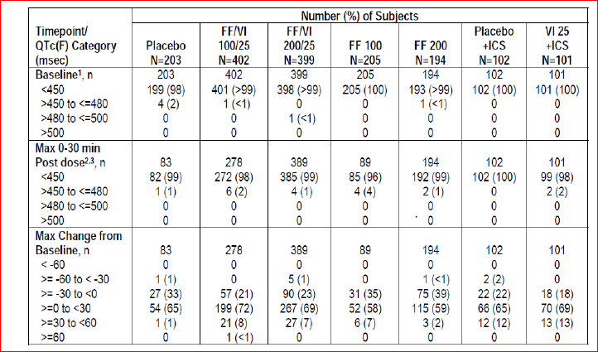
For post dose heart rate (by ECG), mean values ranged from 69 to 73 bpm at baseline and from 72 to 80 bpm for maximum 0-30 minutes post-baseline. Mean changes from baseline at 0-30 minutes post dose were larger than at through since the measures were obtained at the time of T_{max} for VI. Mean changes ≥6 bpm were observed in both FF/VI groups (6.0 and 9.5 bpm) and the VI 25 + ICS group (7.6 bpm) (Table 31).
Table 31. Mean and mean change in post dose heart rate 9bpm) (Integrated asthma studies, key treatment groups)
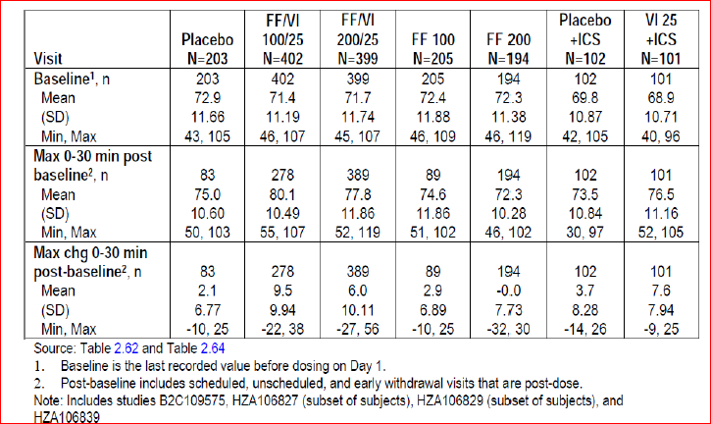
Most of the abnormal findings observed at baseline were also seen at any time post dose with the exception of tachycardia (sinus tachycardia ≥110 bpm, for 3 subjects in the FF/VI 200/25 group). This abnormality was not observed in any of the other VI containing treatment groups. Partial bundle branch block and abnormal repolarization were observed in a few more (1 to 5) subjects in the FF/VI 100/25 and FF/VI 200/25 group at any time post dose (multiple ECG recordings) compared with baseline (single ECG recording).
In Study HZA106839, 24 h Holter monitoring was performed in a subset of subjects (≥50% in each treatment group) at selected study centers at screening, Day 1, Week 28 and Week 52. At the post baseline visits, the proportion of subjects having no VEs fluctuated for all three treatment groups (33% to 47% FF/VI 100/25, 40% to 51% FF/VI 200/25, and 44% to 60% FP 500) For subjects who had VEs, the median number of VEs remained low and was similar to screening across the three treatment groups at the post baseline visits (range: 0 to1). In all three treatment groups, the proportion of subjects having >50 VEs (any type), ≥1 ventricular singlet, and ≥1 ventricular couplet at the post baseline visits, as well as the maximum number of VEs, were similar to those observed at screening. A small, but greater proportion of subjects in the FF/VI groups (7 subjects, 6% each group) had treatment-emergent Holter findings of potential clinical importance at any post-baseline visit compared with only one subject in the FP group (2%). Ventricular arrhythmias were observed in both FF/VI groups. Three of the 4 subjects with non-sustained VT experienced a single episode of between 3 and 7 beats while one subject experienced two episodes lasting 3 and 4 beats. There were no events of sustained ventricular tachycardia. Sustained supraventricular tachycardia was observed only in the FF/VI 200/25 group (2 subjects). Sinus pause was observed for 3 subjects in the FF/VI 100/25 group and 1 subject in the FP group, but no subjects in the FF/VI 200/25 group. The longest sinus pause was 2.4 seconds and occurred in the FP group.

Postmarketing experience
There is no postmarketing data as the combination FF/VI or its individual components (FF and VI) are not approved for marketing in any country to date.

Safety issues with the potential for major regulatory impact

Liver toxicity
None

Haematological toxicity
None

Serious skin reactions
None

Cardiovascular safety
Refer sections Vital signs and Electrocardiograph above.

Unwanted immunological events
None

Other safety issues

Safety in special populations
Safety in the Integrated Asthma Clinical Studies was examined by gender, age, race, and geographical region subgroups. The majority of the ITT Population was aged 18 to 64 years (4869 subjects, 82%), White (4403 subjects, 74%), and female (3669 subjects, 62%). Adolescent (age 12 to 17 years) and elderly (age ≥65) subjects comprised 12% and 6% of the ITT Population, respectively. The largest minority race was Asian (11%) followed by African American/African Heritage and Mixed Race (6% each). Subjects from the Other (ROW) geographic region comprised 41% of the ITT Population. The proportion of subjects from the USA and EU regions was similar (27% and 31%, respectively). Generally, the overall incidences of AEs across the key treatment groups in the gender, age, race, and region subgroups were similar to the incidence in the overall population, with the exception of Asian subjects. A greater proportion of subgroup subjects in the following treatment groups reported higher AE incidences compared with the overall population:
- Adolescents (12-17 years): VI 25 + ICS (48% versus 36%)
- Elderly (≥65 years): Placebo + ICS (54% versus 39%)
- Asian: Placebo (40% versus 27%), FF/VI 100/25 (66% versus 58%), and FF/VI 200/25 (73% versus 54%)
- USA: FF/VI 100/25 (66% versus 58%), VI 25 + ICS (44% versus 36%).
Gender: the proportion of females reporting Nervous System AEs (primarily headache) was greater than males in the FF/VI 100/25 (23% versus 13%), FF 100 (19% versus 10%), and VI 25 + ICS (15% versus 5%) groups.
Age: The SOC AE profiles for subjects aged 12-17 years, 18-64 years and ≥65 years in the key treatment groups of the Integrated Asthma Clinical Studies followed a similar trend to the overall population despite the varying sample sizes. There did not appear to be treatment or dose-related effects on the incidence of SOC AEs in adolescents or the elderly. For individual common AEs, a slightly higher incidence (≥3%) of bronchitis, cough, and dysphonia were noted in elderly subjects compared with the overall population in the following treatment groups: Bronchitis: Placebo (5% versus 2%) and FF/VI 100/25 (8% versus 5%); Cough: Placebo (5% versus 1%) and FF/VI 200/25 (7% versus 3%); Dysphonia: Placebo (3% versus <1%) and FF/VI 100/25 (11% versus 3%).
Race: Compared with the overall population, greater proportions of Asian subjects in the Placebo and FF/VI 200/25 groups reported Infections & Infestations (23% versus 14% and 51% versus 30%, respectively) and greater proportions in the FF/VI 100/25 and FF 100 groups reported AEs in the Respiratory, Thoracic, and Mediastinal SOC (24% versus 17% and 25% versus 15%), respectively. However, interpretation was limited by varying and small sample sizes.
Geographical region: In the USA region, a larger percentage of subjects in the FF/VI 100/25 and VI 25 + ICS groups reported AEs in the Infections and Infestations SOC (47% and 20%, respectively) compared with the overall population (40% and 14%, respectively) and fewer subjects in the Placebo + ICS group reported AEs in the Gastrointestinal Disorders SOC (no subjects) compared with the overall population (9%). In the EU region, a larger percentage of subjects in the Placebo + ICS group reported AEs in the Nervous System Disorders SOC (13%) compared with the overall population (7%), fewer subjects in the FF/VI 100/25 and 200/25 groups reported AEs in the Infections and Infestations SOC (34% and 22%, respectively) compared with the overall population (40% and 30%, respectively) and fewer subjects in the VI 25 + ICS group reported AEs in the Respiratory, Thoracic and Mediastinal Disorders SOC (2%) compared with the overall population (8%). In the Other (ROW) region, a larger percentage of subjects in the FF/VI 200/25 group reported AEs in the Infections and Infestations SOC (36%) compared with the overall population (30%) and a larger percentage of subjects in the Placebo + ICS group reported AEs in the Gastrointestinal Disorders SOC (15%) compared with the overall population (9%).
Hepatic/ renal impairment: In Study HZA111789, 7 days of administration of FF/VI 200/25 was well tolerated in 18 subjects with mild to moderate hepatic impairment and FF/VI 100/12.5 was well tolerated in 8 subjects with severe hepatic impairment. One subject (11%) with moderate hepatic impairment treated with FF/VI 100/25 experienced mild nasopharyngitis that was not considered drug-related by the investigator. No other AEs were reported for subjects with hepatic impairment. There were no clinically significant laboratory test results, vital signs or ECG findings in hepatic impaired subjects. In Study HZA113970, 7 days of administration of FF/VI 200/25 was well tolerated in 9 subjects with severe renal impairment (mean [SD] calculated creatinine clearance 26.0±7.8 mL/min). No AEs were reported during the study and no clinically significant abnormalities were noted for any safety parameter.

Safety related to drug-drug interactions and other interactions
Two drug interaction studies were conducted to investigate the pharmacokinetic and pharmacodynamic effects of co-administration of FF/VI (Study HZA105548) or VI (Study B2C1122050) with ketoconazole. The results of Study B2C112205 were consistent with the results of Study HZA105548. The co-administration of VI with ketoconazole did not significantly affect the pharmacodynamics or tolerability of VI in healthy subjects. Concomitant administration of ketoconazole increased VI systemic exposure (AUC) compared with VI and placebo but there was no evidence for an increase in C_{max}, consistent with a lack of effect of the proposed FF/VI combination on pharmacodynamic endpoints.

Pregnancy/lactation; overdose; withdrawal/rebound effects
As of 15 February 2012, 36 pregnancies were reported from the completed FF/VI asthma clinical studies. At that time, the outcome for 7 pregnancies was unknown. Of the 29 known outcomes, 16 pregnancies resulted in live births (one set of twins), 9 were spontaneous abortions, 2 were stillbirths and 2 were electively terminated.
As of the 15 February 2012 data cut-off date, there were no AE reports of overdose with FF/VI, FF or VI in the asthma clinical development program. There is no evidence for and no anticipation of patient abuse of FF/VI or the individual components FF or VI.
Unless other appropriate asthma medications are prescribed upon discontinuation of treatment, the expected effect of withdrawal of study medication is an increase in signs and symptoms of asthma. The clinical trials in the FF/VI development program were designed with a post treatment follow-up period (1 to 2 weeks in length) to evaluate AEs following discontinuation of study treatment. At this time, subjects were prescribed alternate asthma medication but this information was not captured, which makes interpretation of post treatment AE data difficult. During the post treatment follow-up period, the incidence of AEs was low (<1% to 4%) across all clinical studies. There was no indication of rebound effects, as evidenced by no increase in the frequency of AEs or asthma exacerbations following withdrawal of the study medication. There were no clinically remarkable differences between subjects treated with active therapy (FF/VI, FF or VI) and subjects treated with placebo in the types of adverse events reported following discontinuation of study therapy.
There is no evidence of and no expectation that the use of FF/VI or the components of this combination (FF or VI) affects the ability to drive or operate machinery or to otherwise impair mental ability. There was no indication of an increase in AEs such as somnolence, yawning, fatigue, malaise or lethargy with FF/VI treatment compared with treatment with Placebo and these specific events were reported in7% or fewer subjects in the active and placebo groups.

Evaluator’s overall conclusions on clinical safety in asthma
Evaluable safety data was obtained from 68 completed clinical studies including 8 Phase II, 8 Phase III studies and 52 completed clinical pharmacology studies with FF/VI and/or the individual components and involving 10,630 subjects who received at least one dose of study medication in the FF/VI clinical development program: 7034 in the Integrated Asthma Clinical Studies, 2292 in the Non-integrated Asthma Clinical Studies, and 1304 in the Clinical Pharmacology Studies (Table 32). Of these subjects, 2652 were treated with FF/VI, 4432 were treated with FF, and 987 were treated with VI (all administered by oral inhalation).
Table 32. Total subject exposure in the FF/VI asthma clinical program (completed studies)
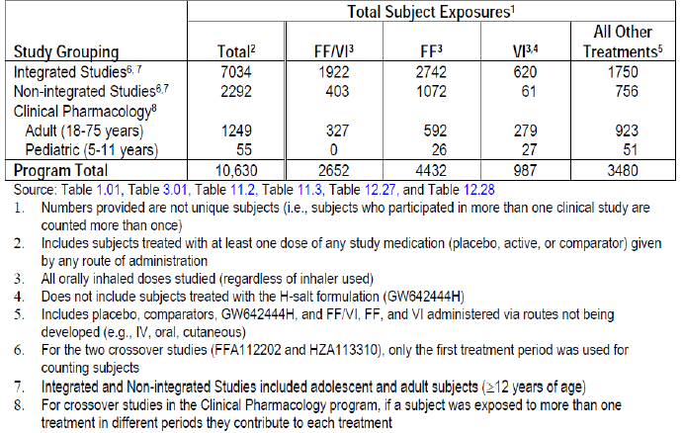
Majority of subjects in the key treatment groups in the Integrated Asthma Clinical Studies were White (65% to 77%), female (55% to 65%) (60%) had asthma for ≥10 years; 2% of subjects in the ITT Population had asthma for less than 1 year. The mean duration of asthma was 16 years in the ITT Population majority of subjects in the Non-integrated Asthma Clinical Studies were White (59% to 88%) and female (57% to 68%). The mean age of the study populations was 32 to 45 years (age range 12 to 85 years). Overall, the study populations evaluated for safety of FF/VI were representative of the proposed target population.
Overall, incidence of AEs (exposure-adjusted) was similar in all groups containing FF (FF/VI- 100/25, 200/25 and FF100, 200 groups) and lower than that in the placebo group. Since these studies were of disparate durations (6 to 76 weeks) and treatment groups had variable sample sizes (216 to 1544 subjects), the exposure adjusted data were more informative than incidence data for assessment of AEs. The most common AEs observed were headache, nasopharyngitis, URTI, bronchitis, and oropharyngeal pain. Except for dysphonia and oral candidiasis which consistently occurred at a higher incidence with higher doses of FF alone and in combination, no other AEs had a clear dose relationship. These AEs are common in an asthmatic population and have been documented in various ICS and ICS/LABA prescribing information.
Only 4 deaths were reported in the FF/VI asthma clinical development program (1 in the placebo group, 1 in the FF/VI 100/25 group, and 2 in the FF 100 group); based on adjudication committee assessments, none were asthma related.
Overall, the data from the Integrated and Non-integrated Asthma Clinical Studies with FF/VI and the individual components were well tolerated, with low incidence of SAEs (0% to 3%) and withdrawals due to AEs (0% to 4%). The most frequent SAE was asthma (exacerbations), reported by 12 subjects in the FF/VI 100/25 group, 9 subjects in the FF 100 group and 1 subject each in the Placebo, FF 200 and VI 25 + ICS groups. The placebo treatment arm was included only in shorter-term studies where the risk of exacerbations was less, while the FF/VI 100/25 and FF 100 treatment arms were included in the exacerbation study (HZA106837) with duration of up to 76 weeks and which, unlike the other studies in the program, recruited subjects with a severe asthma exacerbation history. The incidence of withdrawals due to AEs was very low and similar across treatment groups (<1% to 2% across treatment groups) and the most frequent AE leading to withdrawal was asthma (exacerbation), reported by 3 subjects each in the FF/VI 100/25 and FF 100 groups and 1 subject each in the Placebo, FF 200 and VI 25 + ICS groups. Other common AEs leading to withdrawal (all <1% incidence) were dysphonia, pneumonia, oral candidiasis, palpitations and hypertension.
Across the key treatment groups in the Integrated Asthma Clinical studies, the most frequent types of AEs of Special Interest were local steroid effects (2% to 11%), pneumonia and LRTI (0% to 7%), and cardiovascular effects (1% to 9%). Bronchitis (0% to 5%) and oropharyngeal pain (1% to 4%) were also reported frequently. Pneumonia was reported by a total of 31 subjects (<1%) in the Integrated Asthma Clinical Studies and the incidence was not greater than 1% in any treatment group. For local steroid effects (particularly candidiasis, dysphonia and oropharyngeal pain), the incidence of events (adjusted for exposure) was higher in the FF/VI 200/25 (191.6/1000 subject years) and FF 200 (281.0) groups compared with Placebo (87.8) and the respective lower dose (FF/VI 100/25=94.3 and FF100= 103.8) groups. The incidence of pneumonia (adjusted for exposure) seen with FF/VI 100/25 and FF 100 (9.6 and 8.0/1000 subject years, respectively) was similar to that seen with placebo (8.0/1000 subject years) but a higher incidence of pneumonia was observed in the FF/VI 200/25 and FF 200 arms (18.4/ and 25.5/1000 subject years, respectively). For cardiovascular effects, the incidence of events (adjusted for exposure) was higher in the FF/VI 200/25 group (154.8/1000 subject years) than in the FF/VI 100/25 group (65.5/1000 subject years); this was mainly due to a higher incidence of extrasystoles in Study HZA106839 that included Holter monitoring.
Pneumonia was reported by a total of 31 subjects (<1%) in the Integrated Asthma Clinical Studies and the incidence was not greater than 1% in any treatment group. With exposure adjusted data, the number of subjects with an event per 1000 treatment years was similar among the FF/VI 100/25, FF 100 and placebo groups (8.0 each) but a higher incidence was observed in the FF/VI 200/25 (18.4) and FF 200 (25.5) groups. Hospitalisations due to pneumonia were not increased in the higher dose groups. Although no pneumonias which led to hospitalisation were observed in the placebo group compared with 4 events in both groups containing FF 100 and 1 event in both groups containing FF 200, the interpretation of these data are confounded by differences in duration of treatment with maximum treatment duration of 12 weeks for the Placebo group compared with a maximum of 76 weeks in the FF/VI 100/25 and FF 100 groups, 12 months for the FF/VI 200/25 group and 6 months for the FF 200 group.
The addition of the LABA component did not increase the frequency of severe asthma exacerbations requiring hospitalisation as demonstrated by no significant difference in this composite endpoint between the FF/VI group and the ICS group or non-LABA group. In addition, subjects treated with FF/VI 100/25 had a 24% reduction in the risk of experiencing a severe asthma exacerbation compared with subjects treated with FF 100 (HR=0.762, 95% CI: 0.618, 0.941, p=0.011).
For the Asthma Composite Endpoint, there was no significant difference between the FF/VI group and the ICS group or non-LABA group, demonstrating no increased risk when adding a LABA to an ICS. For the analysis of FF/VI all doses versus non-LABA all doses, the combined risk difference indicates a slight reduction in the risk of asthma related events for subjects receiving any dose of FF/VI; 2.6 subjects have avoided an asthma related event for every 10,000 subjects treated with FF/VI.
The incidence of cardiovascular AEs of special interest was higher in FF/VI 200/25 group, primarily due to a higher incidence of terms coding to extrasystoles on Holter recordings performed in the long-term safety Study HZA106839. There were no associated clinical symptoms (for example, palpitations) temporally reported with these extrasystole events. According to current medical literature, in the absence of underlying structural heart disease, ventricular ectopy is not generally regarded as being clinically significant, and does not require treatment unless patients are symptomatic. These Holter findings did not meet the predefined criteria for a potentially clinically important finding.
No apparent effects on ophthalmic examinations, including lens opacification and intra ocular pressure (IOP), were observed with 12 month administration of FF/VI.
With administration of therapeutic doses, no clinically relevant effects on potassium and glucose have been observed in the clinical program to date. No treatment or dose related effects on haematology or clinical chemistry analytes were observed.
The well conducted Phase III, placebo-controlled Study HZA106851 involving 185 asthma subjects showed that 6 weeks treatment with proposed OD dosing with FF/VI 100/25 and 200/25 did not lead to significant suppression of the HPA axis (as determined by serum and urinary cortisol levels). Furthermore, analysis of the Urine Cortisol (UC) Population in 2308 subjects from 8 of the 11 Integrated Asthma Clinical Studies (data were not collected in the two VI Studies B2C109575 and B2C112060 or the long term exacerbation study (HZA106837) showed there were no statistically or clinically significant differences in 24 h urinary cortisol excretion ratio to baseline between each of the FF groups and Placebo or between the FF/VI groups and FF groups at the end of treatment.
Teeth effects with FF and ovarian and uterine tumour effects with VI (GW642444M) were observed in some of the nonclinical studies but these effects have not been substantiated in the clinical studies.

Long-term safety
The Phase III pivotal, long-term safety Study HZA108839 involving 503 asthma subjects demonstrated that long-term safety of the two proposed doses of FF/VI (200/25, 100/25 µg) for asthma was generally comparable to that observed with FP500 with similar incidence of AEs, drug related AEs, SAEs and withdrawals due to AEs. Majority of the AEs were as expected with a steroid and beta agonist inhaler combination and although incidence of some of the AEs (oral candidiasis, abdominal pain and extrasystoles) were slightly higher in the FF/VI groups compared with FP, there were no major safety concerns following 1 year treatment with the proposed combination.
In order to determine if there were differences in the AE profile as time on treatment increased and to identify the occurrence of new AEs that could be associated with increased exposure to study drug, the profile of AEs with an onset ≤6 months was compared with the profile of AEs with an onset of >6 months in the two long term studies (HZA106839 and HZA106837). Overall, no significant trends were observed for increased incidence of overall AEs or specific AEs with increase in duration of treatment. With long-term FF/VI and FF treatment, the incidence of most AEs tended to decline as time on treatment increased.
Examination of AEs by gender, age, race and geographic region subgroups revealed similar trends to the overall population.
At therapeutic doses of FF/VI, no safety signals have been observed for increased incidence of severe asthma exacerbations, adrenal suppression, bone disorders, QT interval prolongation, myocardial ischemia, or metabolic, neurologic, or ocular effects based on results of clinical program to date. Safety observations are in line with the expected drug-class profiles in the populations studied and no new risks have been identified.

Safety for indication of COPD

Studies providing evaluable safety data for indication of COPD
Ten Phase IIa-IIIb studies in adult subjects (40 years of age and older) with COPD provided data on safety of FF/VI for treatment of COPD (see Figure 16 below).
Figure 16. Key safety studies in FF/VI COPD clinical development program
Six trials evaluated the FF/VI Inhalation Powder combination across a range of FF doses (50/25, 100/25, 200/25, and 400/25 µg) while one Phase IIb trial evaluated VI Inhalation Powder monotherapy across a range of doses (3 µg to 50 µg). Four of the FF/VI studies also included a VI 25 µg monotherapy arm, and two of the studies included an FF 100 µg or FF 200 µg monotherapy arm. Three additional studies included FF/VI 100/25 arms in comparison to FP/salmeterol 500/50 or 250/50 arms.
Four Phase IIIa studies with FF/VI Inhalation Powder are considered primary studies for the COPD indication; two 6 month lung function Studies HZC112206 and HZC112207) and two 12 month exacerbation Studies HZC102871 and HZC102970. In addition to providing primary efficacy data, the HZC112206 and HZC112207 studies provide safety data (including 24 h urinary cortisol excretion, 24 h Holter monitoring, and 12-lead ECGs), pharmacodynamic (PD) and population PK data over a 6 month treatment period.
Six studies are considered supportive studies for the COPD indication. Two studies, a Phase IIIa Study HZC110946 and a Phase IIa Study HZC111348, assessed FF/VI Inhalation Powder. One additional Phase IIb Study B2C111045 assessed VI Inhalation Powder. In addition to providing supportive efficacy data, Study HZC110946 provides additional safety data (24 h serum cortisol and 12-lead ECG) and 24 h serial PK data. Study HZC111348 provides efficacy data, as well as supportive safety data (including 24 h Holter monitoring and 12-lead ECG) and PK data. Three Phase IIIb Advair/Seretide comparator studies (HZC112352, HZC113107 and HZC113109) evaluated the 24 h spirometric effect (FEV1) of FF/VI (100/25 µg) once daily compared with fluticasone propionate/salmeterol (500/50 µg twice daily in HZC113107 and 250/50 µg twice daily in HZC112352 and HZC113109) over a 12 week treatment period in subjects with COPD.
The Clinical Development Program to support the approval of FF/VI Inhalation Powder in subjects with COPD is further supported by safety data from the Clinical Development Program in asthma (including studies evaluating FF/VI and studies evaluating the FF and VI mono components). The safety data for subjects with asthma are not integrated with COPD data as these are distinct patient populations with different co-morbidities but detailed evaluations of the safety of FF/VI in subjects with asthma is provided in Safety for indication of asthma above.
Safety was assessed in the following datasets:
- Subject level integration of Studies HZC112206 and HZC112207 for summaries of overall AEs , SAEs, Fatal AEs, AEs leading to permanent discontinuation of study drug or withdrawal, Most Frequent AEs , AEs of Special Interest, pneumonias, summary of shifts for clinical laboratory tests (including liver function tests (LFT), glucose, potassium), ECG, Holter, urinary cortisol (UC) and vital sign measurements.
- Subject level integration of Studies HZC102871 and HZC102970 for summaries of overall AEs , SAEs, Fatal AEs, AEs leading to permanent discontinuation of study drug or withdrawal, Most Frequent AEs , AEs of Special Interest, pneumonias, summary of shifts for clinical laboratory tests (including liver function tests (LFT), glucose, potassium),ECG and vital sign measurements.
- Subject level integration of seven COPD Studies (HZC112206, HZC112207, HZC102871, HZC102970, HZC110946, HZC111348, and B2C111045) for summaries of overall AEs , SAEs, Fatal AEs, AEs leading to permanent discontinuation of study drug or withdrawal, Most Frequent AEs , AEs of Special Interest, pneumonias.
Key safety data for Studies HZC110946, HZC111348, and B2C111045 were not integrated and will be described separately as will the safety data for the three Advair/Seretide comparator studies (HZC112352, HZC113107 and HZC113109). B2C108562 was conducted to evaluate the safety, tolerability, pharmacodynamics and pharmacokinetics of the H salt of VI compared with salmeterol (the primary formulation of VI studied in the COPD development program was the M salt).
Safety assessments conducted in the 10 COPD clinical Studies: AEs were coded and grouped by System Organ Class (SOC) and Preferred Term using the Medical Dictionary for Regulatory Activities (MedDRA). However, slight differences in the numbers and percentages of a small number of individual AEs between some individual clinical study reports and the integrated summary tables that summarize AEs from multiple studies may have been due to the different versions of the MedDRA dictionary used for the individual CSRs and the integrated database. However, these differences were minimal, affecting only a few AEs that were seen infrequently across the studies. MedDRA versions used in the CSRs and in the safety summary are summarized in Table 33.
Table 33. MedDRA version used in each study
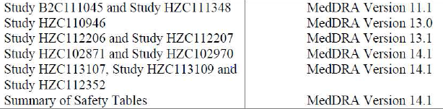

Pivotal studies that assessed safety as a primary outcome
None.

Patient exposure
In total, 6237 subjects were randomised in the seven integrated studies of the FF/VI COPD clinical development program and majority of the subjects (5518 subjects) were enrolled in the primary COPD studies (HZC112206, HZC112207, HZC102871, and HZC102970). In the ITT Population, 3396 received treatment with the various FF/VI combination dosages (subjects who received more than one dose in HZC110946 were counted more than once and were counted under each strength received), 1727 subjects received treatment with VI alone, 613 with FF alone, and 584 with placebo. Mean exposure ranged from 27.0 to 268.3 days (median 29.0 to 362.0 days) across the treatment groups. The differences in exposure across the treatment groups are a reflection of the different durations of the treatment periods for the individual studies in the integrated population (that is, 4 week Phase IIb and Phase IIa supporting studies and the six-month and one-year Phase IIIa studies).
Overall, the 6225 subjects randomised and who took at least one dose of study medication in these seven studies provided 3640 subject-years of exposure, with 2377 subject-years of exposure across the various strengths of FF/VI, 860 subject-years of exposure to the various dosages of VI alone, and 237 subject-years of exposure across the dosages of FF alone; placebo exposure was 166 subject-years. A total of 1867 subjects were treated with the various strengths of FF/VI for more than 48 weeks, and 686 subjects were treated with the various strengths of FF/VI for more than 52 weeks. A total of 381 subjects were treated with VI 25 for 48 to 52 weeks, and 209 subjects were treated with VI 25 for 52 weeks or more. The 2254 subjects randomised and who took at least one dose of study medication in the two 6 month Studies HZC112206, HZC112207 provided 870 subject-years of exposure, with 318 subject-years of exposure across the various strengths of FF/VI, 161 subject-years of exposure to VI alone, and 237 subject-years of exposure across the various strengths of FF alone; placebo exposure was 154 subject-years. Overall, the 3255 subjects randomised and who took at least one dose of study medication in the 1 year exacerbation studies HZC102871, and HZC102970 provided over 2700 subject-years of exposure, with 2048 subject-years of exposure across the various strengths of FF/VI and 661 subject-years of exposure to VI alone. In addition, 1558 subjects were enrolled and comprised the ITT Population in the three ADVAIR/SERETIDE comparator studies that were not included in the overall integrated population. Of these 785 subjects received FF/VI and 773 subjects received ADVAIR/SERETIDE. Thus, across the seven integrated studies and the three Advair/Seretide comparator studies, overall, over 7700 subjects comprised the ITT Population in the FF/VI COPD clinical development program, of which over 4150 subjects have been treated with the various strengths of FF/VI.
Of the 6225 subjects in the ITT Population of the seven integrated COPD studies, at least 73% of subjects in each treatment group completed the studies. The percentages of subjects withdrawn from the studies ranged from 3% to 27% across the active treatment groups, proportions that were similar to or lower than the percentage withdrawn from the placebo group (26%). Irrespective of study duration, the most common primary reasons for premature withdrawal were AEs (6 to 9% across treatment groups) and ‘Lack of efficacy’ (4% in active treatment groups versus 6% in placebo group and most commonly due to COPD exacerbation). The percentages of subjects withdrawn prematurely due to other reasons were low and similar across the treatment groups. Similar results were observed in the primary 6 month studies and the 12 month exacerbation studies.

Adverse events

All adverse events (irrespective of relationship to study treatment)
Six month pivotal COPD studies (HZC112206/HZC112207): The overall incidence of subjects reporting any on-treatment AE was similar across most active treatment groups (ranging from 45% to 50%) and similar to that reported for subjects in the placebo group (48%), with the exception that subjects in the FF/VI 50/25 group had a slightly higher incidence (55%). The Infections and Infestations SOC had the highest incidence of AEs with highest incidences reported for subjects in the FF/VI 50/25 (30%), 100/25 (28%), FF100 (26%) and FF200 (27%) groups compared to the FF/VI 200/25 (21%) and placebo (22%) groups. AEs that were reported at an incidence of ≥5% within any treatment group included nasopharyngitis (6% to 10%), upper respiratory tract infection (2% to 8%), and oropharyngeal candidiasis (5% in the FF/VI 50/25 group, 3% in the FF 200 group, and <1% to 2% across all other treatment groups). The incidence of Nervous System Disorders (8-11%), Respiratory, Thoracic and Mediastinal Disorders SOC were reported at similar incidences in all active treatment groups (7% to 9%) were reported at a similar incidence in the active treatment groups and in the placebo group. Gastrointestinal disorders occurred at the highest incidence in the FF/VI 200/25 group (10%) and at similar incidences in the remaining active treatment groups (4% to 8%) and placebo (7%) with nausea, diarrhoea, toothache, dyspepsia and vomiting being most common. Nasopharyngitis was the most frequently reported AE and occurred at similar incidences in the active treatment groups (6% to 10%) compared with placebo (8%). Headache occurred at a higher incidence in the VI 25 group (9%) and the incidence of upper respiratory tract infection (URTI) was higher in the FF/VI 50/25 and FF/VI 100/25 groups (8% and 7%, respectively) compared with the remaining active treatment groups (2% to 5%) and placebo (3%). AEs related to oral/oropharyngeal candidiasis occurred at higher incidences in the FF/VI groups (4% to 10%), the FF 200 group (6%), compared with the FF 100 (3%), placebo (2%) and the VI 25 (2%) groups. Back pain (<1% to 3%), COPD (0 to 3%), hypertension (<1% to 3%) occurred at low incidences across all active treatment groups and at similar incidences compared with the placebo group. Lower respiratory tract infection (LRTI) occurred more frequently in the placebo group (3%) than in the active treatment groups (<1% to 2%). The patterns of exposure-adjusted numbers for the most frequently reported AEs were similar to the patterns described above for the unadjusted incidence of these AEs.
12 month exacerbation studies (HZC102871/HZC102970): The overall incidence of subjects reporting any on-treatment AE was similar across the FF/VI treatment groups (76% to 77%) and somewhat higher than for the VI 25 group alone (70%). The incidence of reported AEs was highest in the Infections and Infestations SOC with the highest incidences in the FF/VI groups (50% to 55%) compared with the VI 25 group (44%) and included nasopharyngitis (14% to 19%), upper respiratory tract infection (9% to 11%), oral candidiasis (6% in the VI 25 group compared with 9% to 10% in the FF/VI groups), bronchitis (5% to 6%), sinusitis (4% to 6%) and pneumonia (6% in each of the FF/VI groups compared with 3% in the VI 25 group). AEs within the Respiratory, Thoracic and Mediastinal Disorders SOC were reported at similar incidences in all treatment groups (23% to 25%). COPD (6% to 7%), cough (4%), and oropharyngeal pain (4% to 5%) were the most frequently reported events in this category. Musculoskeletal and Connective Tissue Disorders were reported at a similar incidence in all treatment groups (18% to 21%). Gastrointestinal disorders occurred at similar incidences in all treatment groups (15% to 17%) with most common AEs being diarrhoea, nausea, constipation, upper abdominal pain, gastritis, vomiting and gastroesophageal reflux disease. Nasopharyngitis was the most frequently reported AE and occurred at similar incidences in the FF/VI groups (14% to 19%) compared with VI 25 (14%) with an increased risk (lower limit of 95% CI for HR >1) only for the FF/VI 200/25 group compared with VI 25. Compared to the VI25 group, the FF/VI groups showed higher incidence and increased risk of AEs related to oral/ oropharyngeal candidiasis (FF/VI versus VI25: 11-13% versus 7%), pneumonia (6% versus 3%), urinary tract infections (2-4% versus 2%) and pyrexia (2-3% versus 1%). The FF/VI and VI25 groups showed similar incidence of upper respiratory tract infection (FF/VI versus VI 25: 9% to 11% versus 10%), headache (7-8% versus 8%), COPD (6 to 7% across all treatment groups), back pain [5% to 7%], bronchitis [5% to 6%] and sinusitis [4% to 6%].The patterns of exposure adjusted numbers for the most frequently reported AEs were similar to the patterns described above for the unadjusted incidence of these AEs.

Integrated COPD safety (7 studies)
The overall incidence of subjects reporting any on-treatment AE was similar across the FF/VI treatment groups (66% to 70%) and similar to that reported for subjects in the VI 25 group (61%). The overall incidence of subjects reporting any on-treatment AE was lower in the FF 100 and FF 200 groups (49% and 47%, respectively) compared with the FF/VI groups but slightly higher than the incidence in the placebo group (42%). The exposure-adjusted numbers of subjects reporting any on-treatment AE were similar across the FF/VI 50/25, FF/VI 100/25, FF/VI 200/25 and the VI 25 treatment groups (ranging from 933.5 to 990.0 subjects with an event/1000 subject years) and lower compared with the FF 100 and FF 200 groups (1279.6 and 1204.6 subjects with an event/1000 subject years, respectively). The placebo group had the highest exposure adjusted number of subjects reporting any on-treatment AE (1467.7 subjects with an event/1000 subject years). The Infections and Infestations SOC had the highest incidence. Nasopharyngitis was the most frequently reported AE with higher unadjusted incidence in the FF/VI groups (12% to 16%) and the VI 25 group (12%) compared with placebo (6%). However, exposure-adjusted numbers of subjects reporting nasopharyngitis were similar in the FF/VI 50/25, 100/25 and VI25 groups and lower than in the FF/VI 200/25 and placebo groups. Although the unadjusted incidence of headache, the next most frequently reported AE, was similar for all treatment groups, exposure adjusted incidence was higher in the placebo and VI25 groups compared with the FF/VI groups. Exposure adjusted numbers of subjects indicated that URTI occurred at a higher number across the FF/VI groups and the VI 25 group compared with placebo. Numbers of subjects reporting URTI did not appear to be related to dosage, as this event occurred less frequently in the higher FF/VI dosage group compared with the lower dosages. Oral candidiasis was reported at a higher incidence across the FF/VI groups (7% to 8%) compared with the incidence in the VI 25 group (4%) and in the placebo group (<1%), as was oropharyngeal candidiasis (1% to 4% in the FF/VI groups compared with <1% in the VI 25 and placebo groups). Exposure-adjusted numbers of subjects reporting oral candidiasis were also higher for subjects in the FF/VI groups compared with VI 25 and placebo. Oral and oropharyngeal candidiasis did not appear to be related to the dosage of FF. COPD was reported at low and similar incidences in the FF/VI treatment groups (5% to 6%) and the VI group (5%) but at a higher incidence than for placebo (1%). Review of the most frequent AEs in the Infections and Infestations SOC shows that the incidence of sinusitis, pneumonia, bronchitis, influenza, and pharyngitis occurred in higher exposure-adjusted numbers of subjects in the FF/VI groups compared with placebo but in numbers similar to that seen with VI 25. Pneumonia was reported at a higher incidence across the FF/VI groups (4% to 5%) compared with the VI 25 group (2%) and the placebo group (<1%) with similar results for exposure adjusted incidence of pneumonia. There were no clinically important differences for the remaining most frequent on-treatment AEs across the treatment groups.
Comments: In the integrated safety dataset, results must be interpreted with caution and exposure-related incidence are more important due to the longer duration of treatment and hence higher number of subject years of exposure to FF/VI 50/25, 100/25 and 200/25and VI 25 compared with placebo and FF 100 and FF 200. Furthermore, only FF/VI and VI treatment groups were included in the one-year studies in subjects with an exacerbation history and thus more severe disease.
Advair/Seretide Comparator Studies: In Study HZC113107, the overall incidence of subjects reporting any on-treatment AE was similar in both treatment groups (FF/VI100/25 OD versus salmeterol/FP 50/500 BD= 27% versus 26%). The SOCs with the highest frequency of AEs were Infections and infestations (FF/VI 100/25 versus salmeterol/FP 50/500 BD: 8% versus 11%) and nervous system disorders (8% versus 7%). Cardiac disorders occurred in 2% of subjects in the FF/VI 100/25 group, with all individual events occurring in one or two subjects. No cardiac events were reported in the salmeterol/FP 50/500 BD group. Headache was the most frequently reported AE and occurred with similar frequency in both treatment groups (8% versus 7%). The only other AEs reported by at least 3% of subjects in either treatment group during the study were back pain (4% versus 1%), nasopharyngitis (3% versus 5%) and cough (1% versus 3%).
In Study HZC113109, the overall incidence of subjects reporting any on-treatment AE was 25% in both the FF/VI 100/25 and FP/salmeterol 250/50 BD treatment groups. The SOCs with the highest frequency of AEs were Infections and infestations (FF/VI 100/25OD versus FP/salmeterol 250/50 BD=7% versus 9%), Nervous system disorders (7% in both treatment groups) and Cardiac disorders (2% in each group). The most frequent AEs were headache (6% versus 4%) and nasopharygitis (3% in each group).
In Study HZC112352, the overall incidence of subjects reporting any on-treatment AE was 20% in the FF/VI 100/25 treatment group and 23% in the FP/salmeterol 250/50 BD treatment group. The SOCs with the highest frequency of AEs were Infections and infestations (8% versus 12%), Nervous system disorders (6% versus 4%) and Cardiac disorders (<1% in both groups). The most common AEs were headache (5% versus 4%), oropharyngeal candidiasis (2% versus 3%) and oral candidiasis (<1% versus 3%).

Treatment-related adverse events (adverse drug reactions)
6 month pivotal COPD studies: The overall incidence of subjects with any on-treatment drug related AE was highest in the FF 200 (13%) and the FF/VI 50/25 (12%) groups compared with the placebo group (8%) and FF 100, VI 25 and the FF/VI 100/25 and FF/VI 200/25 groups
(8%-10%). Drug-related AEs in the Infections and Infestations SOC were reported at the highest incidence (4-8% overall) and the most commonly reported events considered drug-related were oral candidiasis, oropharyngeal candidiasis and candidiasis. Drug-related Cardiac disorders occurred at very low and similar incidences across all the active treatment groups (<1% to 2%) and placebo (2%) and the most commonly reported events in this category included ventricular extrasystoles, ventricular tachycardia and atrial fibrillation. Drug related AEs within the Respiratory, Thoracic and Mediastinal Disorders SOC were reported at similar incidences across all active treatment groups (<1% to 2%) and placebo (<1%). COPD, dysphonia, oropharyngeal pain, and dry throat were the events reported most frequently in this SOC, and the rates of these events were low across all treatment groups (<1%). Drug-related AEs in the remaining SOCs occurred at low and similar incidences (≤1%) across the active treatment groups and placebo. Oral and Oropharyngeal candidiasis were the only two most frequently occurring drug-related AEs (overall incidence of <1% to 4%) and occurred more frequently in the groups treated with the FF/VI 50/25 (3-4%), 100/25 combinations (1-3%) and the FF 200 group (2%) compared with the VI 25 (<1%), the FF/VI 200/25 (1%) and the FF 100 groups (<1%).
12 month COPD exacerbation studies: The overall incidence of subjects with any drug-related AE was slightly higher in the FFVI 50/25 group (21%) compared with the FF/VI 100/25 and FF/VI 200/25 groups (17%); the overall incidence of subjects with any drug-related AE was higher in all FF/VI groups compared with the VI 25 group (14%). Drug-related AEs in the Infections and Infestations SOC were reported at the highest incidence and the overall incidence of AEs in this SOC was higher in all FF/VI groups (10% to 13%) compared with the VI 25 group (6%) and the most common AEs were oral candidiasis, oropharyngeal candidiasis and pneumonia. Oral candidiasis and oropharyngeal candidiasis occurred at higher incidences in the FF/VI groups (7% to 13%) compared with VI (5% to 6%). However, the occurrence of both oral and oropharyngeal candidiasis did not appear to be related to the dosage of FF he incidence of drug related pneumonia was similar across all treatment groups (<1% to 1%). Drug-related AEs within the Respiratory, Thoracic and Mediastinal Disorders SOC were reported at similar incidences across all active treatment groups (3% to 4%). Dysphonia, oropharyngeal pain, dyspnea, cough, COPD and throat irritation were reported most frequently and the rates of these events were low across all treatment groups (<1% to 1%). Individual drug-related AEs in the remaining SOCs occurred at low and similar incidences (<1%) across the FF/VI treatment groups and the VI 25 treatment group.
Advair/Seretide Comparator Studies: In Study HZC113107, the overall incidence of subjects with any on-treatment drug-related AE was low and similar in the 2 treatment groups (2% and 3% in the FF/VI 100/25 and salmeterol/FP 50/500 BD treatment groups, respectively); the only drug related AEs occurring in more than 1 subject in any treatment group were oral candidiasis and oropharyngeal candidiasis (with increased incidence on salmeterol/FP). Similar results were observed in studies HZC113109 and HZC112352.

Adverse events of special interest
6 month pivotal COPD studies: Individual AEs of special interest related to beta-adrenergic stimulation occurred at low incidences across all treatment groups. Cardiovascular effects (including arrhythmias, hypertension, cardiac ischaemia, cardiac failure, QT prolongation) occurred at low and similar incidences in the active treatment groups compared with placebo. There was no indication of increases in blood pressure, tachycardia, palpitations or other cardiac arrhythmias. No increased incidence of tremor was noted. Results of the analyses of the most common (≥3% of subjects in any treatment group) cardiac events (cardiac arrhythmia and hypertension) showed no increased risk (that is, all 95% CI for hazard ratio [HR] include unity) for these events in any treatment group. Local corticosteroid effects including oropharyngeal candidiasis, oral candidiasis and candidiasis tended to occur at higher incidences in the treatment groups with FF alone (4% to 8%) or FF in combination with VI (6% to 12%) compared with VI 25 alone (3%) and placebo (4%). However, these effects did not appear to be dose related as the highest incidences of oropharyngeal and oral candidiasis were noted in the FF/VI 50/25 group (5% and 4%, respectively) and these events occurred at lower incidences in the FF/VI 100/25 and 200/25 groups (2% to 3%). Dysphonia occurred at very low incidences (<1%) across all active treatment groups and was not reported in subjects in the placebo group. Analysis of local steroid effects reported by ≥3% of subjects in any treatment group showed an increased risk (lower limit of 95% CI for HR >1) for local steroid effects in the FF/VI 50/25 group and the FF 200 group compared with placebo and in the FF/VI 50/25 and 100/25 groups compared with VI 25. Lower respiratory tract infections excluding pneumonia occurred at a higher or equal incidence in the placebo group (4%) compared with the active treatment groups (<1% to 4%). The remaining AEs of special interest occurred in <3% of the subjects across all treatment groups.
Overall, there were no remarkable differences among the treatment groups in the incidence of pneumonia in the six month lung function studies (<1% to 2% across all treatment groups). Exposure adjusted numbers of subjects reporting pneumonia were higher for the active treatment groups (37.6 to 48.7 subjects with an event/1000 treatment years) compared with placebo (19.5 subjects with an event/1000 treatment years). Overall, 32 subjects had pneumonia recorded as an AE with a slightly higher incidence in the FF/VI 200/25 and the VI 25 groups (2%) compared with the remaining active treatment groups (1%) and placebo (<1%). In the six month lung function studies, subjects were to be withdrawn if pneumonia (presumptive diagnosis or radiographically confirmed) occurred; 16 of the 32 subjects’ pneumonia was considered serious but there were no pneumonia-related fatalities. Events related to hypersensitivity, such as pruritus and rash, occurred at similar incidences in the active treatment groups (<1% to 2%) and placebo (<1%) and there appeared to be no increased risk of drug associated hypersensitivity. Bone disorders occurred at similar incidences in the active treatment groups (0 to 1%) compared with placebo (<1%), except for a higher incidence in the FF 200 treatment group (2%). Ocular effects and AEs related to decreased cortisol concentrations occurred at similar incidences in the active treatment groups and the placebo group. Effects on glucose were noted at a slightly higher incidence in the FF/VI 100/25 group (2%) compared with placebo (<1%) and the remaining treatment groups (1%). There did not appear to be an increased incidence of potassium abnormalities in any treatment group.
12 month exacerbation studies: Individual AEs of special interest related to beta-adrenergic stimulation occurred at low incidences across all treatment groups. Cardiovascular effects (including arrhythmias, hypertension, cardiac ischaemia, cardiac failure, QT prolongation) occurred at low and similar incidences in the FF/VI treatment groups compared with the VI 25 group. There were no remarkable differences between the FF/VI groups and the VI 25 group in blood pressure, tachycardia, palpitations or other cardiac arrhythmias. The incidence of tremor was low and similar across all treatment groups. Overall, any individual AEs suggestive of LABA effects occurred at low incidences across all treatment groups during the treatment period, although it is difficult to assess LABA related events in these studies as all treatments included VI. Analyses of cardiac arrhythmia, cardiac ischemia and hypertension (events that occurred at an incidence of ≥3% in any treatment group, indicated no increased risk (all 95% CI for hazard ratio [HR] include unity) for these events for any FF/VI strength compared with VI 25. Analyses of cardiac failure showed less risk (95% CI for hazard ratio [HR] did not include unity) for this category for the FF/VI 200/25 strength compared with VI 25. Local corticosteroid effects including oropharyngeal candidiasis (1% to 4%) or oral candidiasis (9% to 10%) occurred at higher incidences in the FF/VI groups compared with VI 25 alone (<1% for oropharyngeal candidiasis and 6% for oral candidiasis). However, these effects did not appear to be related to the dosage of FF, as the highest incidences of oropharyngeal and oral candidiasis were noted in the FF/VI 50/25 group (4% and 10%, respectively) and these events occurred at lower incidences in the FF/VI 100/25 and 200/25 groups. Analysis of local steroid effects indicated an increased risk (lower limit of 95% CI for HR >1) for these events in the FF/VI 50/25 and 200/25 groups compared with the VI 25 group. Dysphonia occurred at low incidences (<1% to 2%) across all the treatment groups, but was most frequent in the FF/VI 200/25 group (2%) compared with the lower FF/VI dosage groups (<1% and 1% in the FF/VI 50/25 and FF/VI 100/25 groups, respectively). There were no AEs related to systemic steroid effects such as hypersensitivity (FF/VI groups versus VI25: 4-5% versus 3%), ocular effects (<1% versus 1%), abnormally raised glucose levels (2-3% across treatment groups), hypokalemia (<1%) and bone disorders (3% versus 1%). Bone fractures were the most common AEs in the bone disorders and its incidence was low in all treatment groups, with a higher incidence in all FF/VI groups (2%) compared with the VI 25 group (<1%). The majority of fractures were due to trauma in the FF/VI 50/25, FF/VI 100/25 and VI 25 groups (68% to 75%) while the majority of fractures were non-traumatic in the FF/VI 200/25 group (62%). There were few bone fractures (a total of 3 subjects, one each in the FF/VI 50/25, the FF/VI 200/25 and the VI 25 group) during the post-treatment period of these studies Although there were more fractures in the FF/VI groups compared with the VI 25 group, fractures customarily associated with corticosteroid use (for example, spinal compression/ thoracolumbar vertebral fractures, hip and acetabular fractures) occurred in <1% of the FF/VI and VI treatment arms. Lower respiratory tract infections excluding pneumonia occurred at similar incidences across all treatment groups (7% to 8%) and analysis showed no increased risk for these events (all 95% CI for hazard ratio [HR] include unity) in the FF/VI groups compared with the VI 25 group. On-treatment AEs associated with the special MedDRA SMQs for cardiac arrhythmias, anaphylactic reaction, angioedema, ischemic heart disease and cardiac failure in the one year exacerbation studies showed similar incidence across treatment groups.
Pneumonia occurred at an incidence of 6% to 7% across the FF/VI treatment groups compared with 3% in the VI 25 group and analysis showed an increased risk (lower limit of 95% CI for HR >1) for time to pneumonia in all FF/VI treatment groups compared with the VI 25 group. There was no indication of a dose response observed between FF/VI 50/25, 100/25 and 200/25 strengths for the overall incidence of pneumonia or for serious pneumonia in the one year exacerbation studies. Exposure adjusted numbers of subjects reporting pneumonia were higher for the FF/VI treatment groups (69.8 to 80.3 subjects with an event/1000 treatment years) compared with the VI 25 treatment group (40.8 subjects with an event/1000 treatment years). In the FF/VI groups, 3% of the subjects had pneumonia that was considered serious compared with <1% of the subjects in the VI 25 group. Exposure adjusted numbers of subjects reporting serious pneumonia ranged from 33.6 to 37.0 subjects with an event/1000 treatment years in the FF/VI groups compared with 12.1 subjects with an event/1000 treatment years for the VI 25 treatment group. Seven subjects had fatal pneumonia reported as an adverse event across the two 1 year exacerbation studies, one subject in the FF/VI 100/25 treatment group and 6 subjects in the FF/VI 200/25 treatment group. The exposure adjusted numbers of subjects with fatal pneumonia in the FF/VI 100/25 group was 1.5 subjects with an event/1000 treatment years compared with 8.8 subjects with an event/1000 treatment years for the FF/VI 200/25 treatment group. Asian subjects, subjects with more severe COPD (that is, GOLD Stages III [30% to <50% predicted FEV1] or IV [<30% predicted FEV1]), subjects with lower BMI (that is, ≤21 kg/m²), subjects with a history of pneumonia at screening and current smokers experienced a higher proportion of pneumonia adverse events; these subgroups also tended to experience a higher proportion of serious pneumonia adverse events. Increased risk (HR ≥2 for all FF/VI doses compared with VI alone) for subjects who were current smokers, those with a prior history of pneumonia (as opposed to those with no prior history), subjects with an FEV1 <50% predicted, and for subjects with a BMI of <25 kg/m² (as opposed to a BMI >25 kg/m²). Overall, evaluation of subjects with fatal adverse events of pneumonia or who had pneumonia concurrently with a fatal COPD exacerbation indicated that the majority (7 of 8) had a BMI of <25 kg/m², with 5 having a BMI of <21 kg/m². The majority (6 of 7 had an FEV1 of <40% predicted, with 4 having an FEV1 of <30% predicted. Four of the 8 subjects had a prior history of COPD exacerbation requiring corticosteroids and/or hospitalisation prior to the fatal event, and all had at least one exacerbation prior to randomisation in the study. In addition, 3 of the 8 subjects had a prior pneumonia event in the study prior to the fatal event and 7 of the 8 subjects had an exacerbations described as an SAE at or prior to the pneumonia event.
Integrated COPD studies: In the integrated COPD database, some of the differences in the occurrence of AEs of special interest across the treatment groups may be a reflection of the many differences in the study design (combination of short-term and long-term studies) and study populations (patients had more severe COPD in the 1 year studies compared with the shorter studies) (Table 34). However, the incidence of pneumonia was also higher in the FDF/VI groups compared to the other treatment groups in the integrated COPD safety database (Table 35).
Table 34. Summary of on treatment AEs
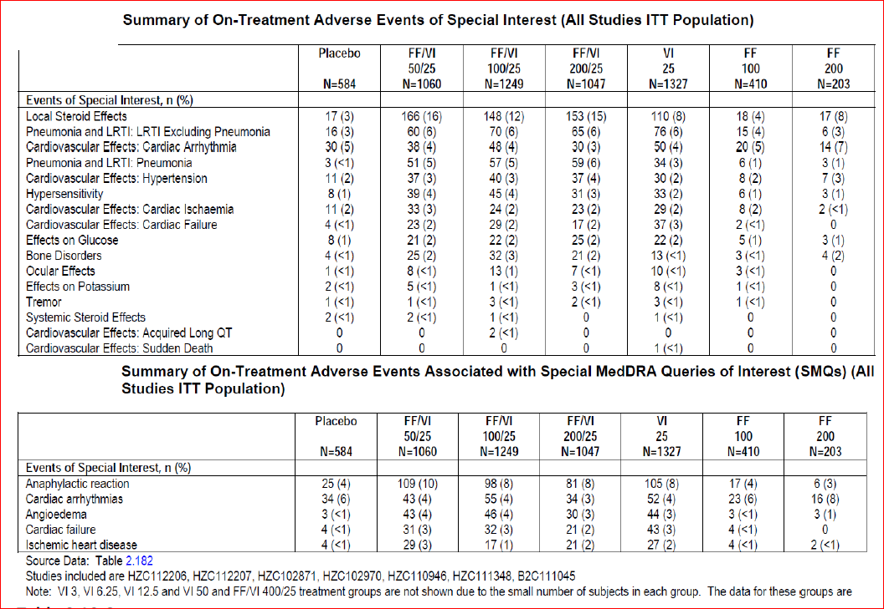
Table 35. Summary of on treatment pneumonia (All studies ITT population)
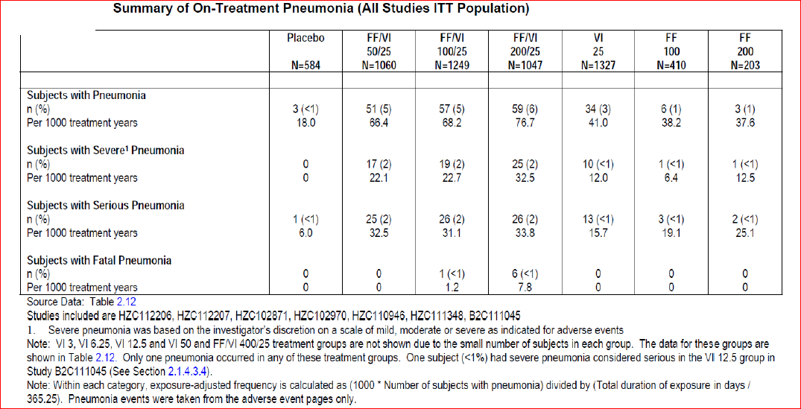
Advair/Seretide Comparator Studies: In Study HZC113107, the most commonly reported AEs of special interest were in the cardiovascular effects category for the FF/VI 100/25 group and in the local steroid effects category in the salmeterol/FP 50/500 BD group. The percentage of AEs in each of the other special interest categories was low and similar across the treatment groups (Table 36). The incidence of pneumonia was low and similar in the 2 treatment groups: 3 subjects had a total of 4 events of pneumonia (1 subject [<1%] and 2 subjects [<1%] in the FF/VI 100/25 and salmeterol/FP 50/500 BD groups, respectively). All 3 subjects had SAEs of pneumonia (3 SAEs of pneumonia in total), which lead to permanent discontinuation of study drug or withdrawal from the study; there were no pneumonia-related fatalities.
Table 36. Summary of on treatment AEs of special interest (reported by ≥2 subjects in any treatment group by preferred term (HZC113107 ITT population)
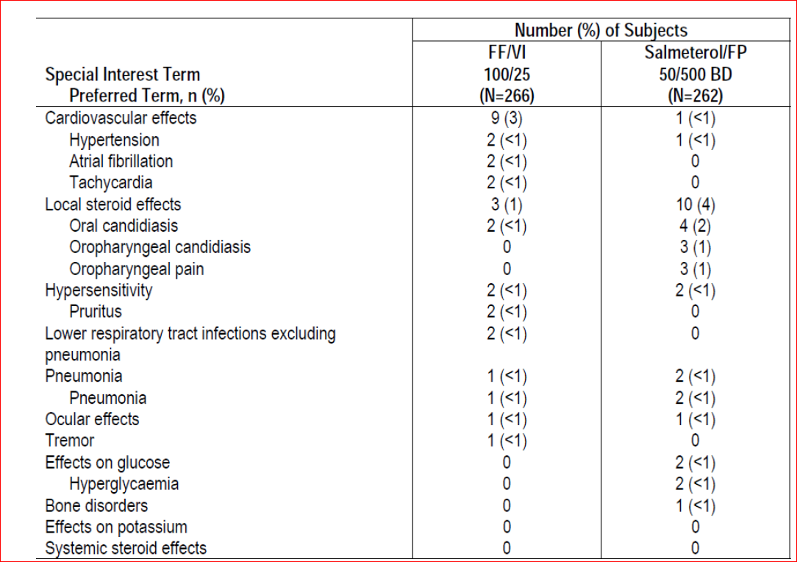
In Study HZC113109, the most commonly reported AEs of special interest were in the cardiovascular effects category for the FP/salmeterol 250/50 BD group and in the local steroid effects category also for the FP/salmeterol 250/50 group. The percentage of AEs in each of the other special interest categories was low and similar across the treatment groups (Table 37). One subject in the FF/VI 100/25 group was diagnosed with an AE of tuberculosis that was categorized in the AE of special interest category of “pneumonia.
Table 37. Summary of all categories and on treatment AEs of special interest (reported by ≥2 subjects in any treatment group by preferred term) (HZC 113109 ITT population)
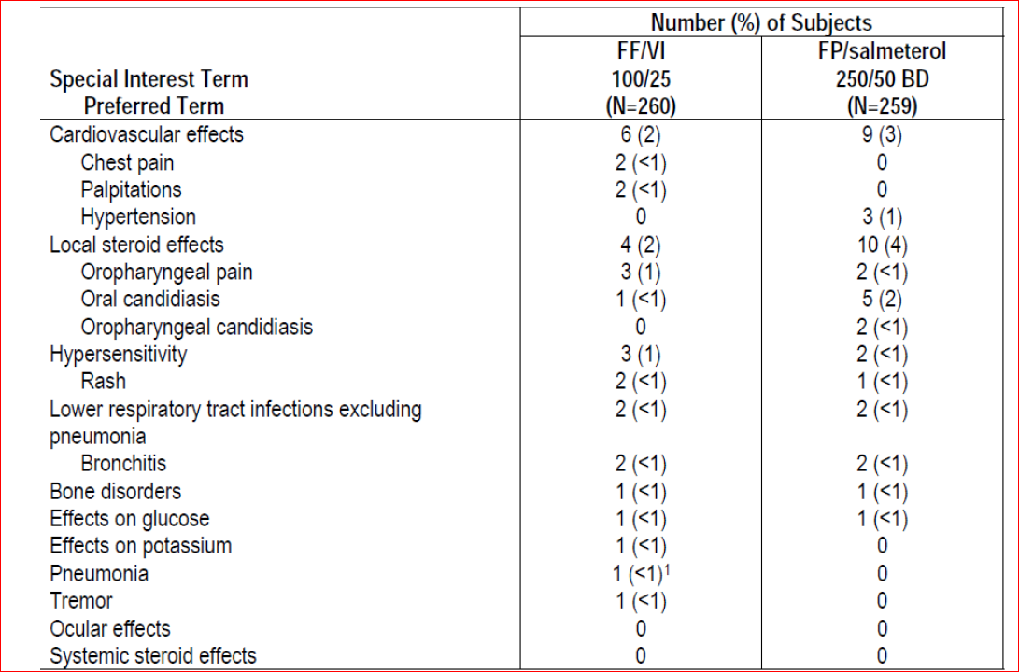
In Study HZC112352, the most commonly reported AEs of special interest were in the local steroid effects category. The percentage of AEs in each of the other special interest categories was low and similar across the treatment groups (Table 38). Only 2 subjects [<1%] in the FF/VI 100/25 group and 0 subjects in the FP/salmeterol 250/50 BD group), none of which were SAEs and there were no pneumonia-related fatalities.
Table 38. Summary of all categories and on treatment AEs of special interest (reported by ≥2 subjects in any treatment group by preferred term) (HZC 112352 ITT population)
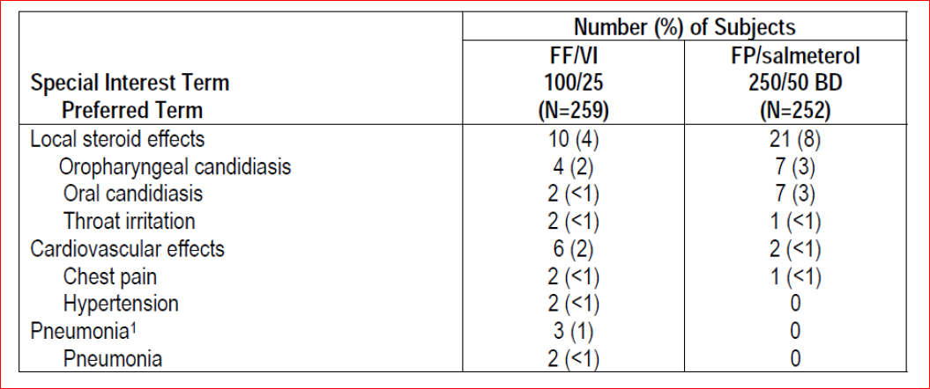

Long-term safety
The long-term safety of FF/VI was evaluated with the data from the 1 year exacerbation studies, as these were the only studies with treatment periods greater than six months. In order to determine if there were differences in the AE profile as time on treatment increased and to identify the occurrence of new AEs that could be associated with increased exposure to study drug, the profile of AEs with an onset of ≤6 months was compared with the profile of AEs with an onset of >6 months. The overall incidence of subjects reporting any on treatment AE during the first six months was similar across the FF/VI treatment groups (66% to 68%) and slightly higher than for the VI 25 group alone (61%). The percentages of subjects reporting AEs with onset after six months were lower across all FF/VI groups (47% to 50%) and also lower for the VI 25 group (40%), and this relationship (that is, lower incidences when onset is after six months) held true within each of the SOCs (Table 39). Overall, there did not appear to be differences in the AE profile across the treatment groups as time on treatment increased. The most frequent AEs that occurred within each SOC were similar whether onset occurred during the first six months of treatment or after six months of treatment. Although there were individual AEs that occurred during the first six months of treatment that did not occur after six months and also individual AEs that occurred after six months of treatment that did not occur during the first six months of treatment, the incidence of these events was very low. There was no pattern of occurrence that would suggest a difference in the AE profile with shorter or longer exposure to the study drug.
Table 39. Summary of on treatment AEs by time of onset (HZC102871/HZC102970 ITT population)
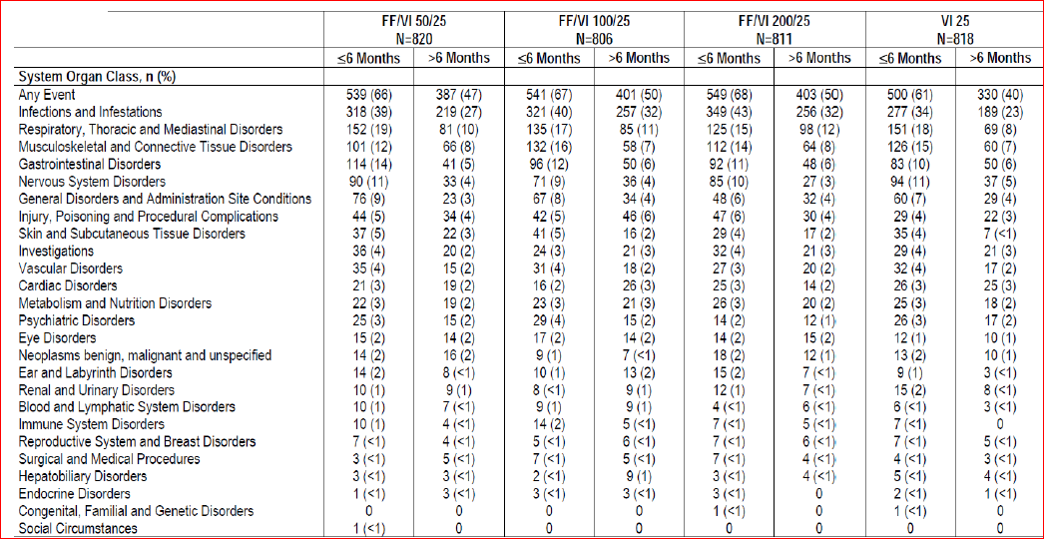

Deaths and other serious adverse events
Deaths: The occurrence of on-treatment or post-treatment fatal events was low in both the 6 month lung function studies, with no remarkable differences in the incidence of fatal events across the treatment groups with the exception that no fatal events occurred in the FF 200 treatment group. Eleven subjects died during the treatment or post-treatment study periods, 8 (3 in the VI 25 group, 2 in the FF/VI 50/25 group and one each in the placebo, FF/VI 100/25 and 200/25 groups) during the treatment period, and 3 (1 each in the placebo, FF 100 and FF/VI 100/25 group) during the post-treatment follow-up period. None of the fatal events were considered related to treatment by the investigators and most were attributed to ongoing medical conditions. In the 12 month exacerbation studies (HZC102871/ HZC102970), 53 subjects died during the treatment or post-treatment study periods; 43 subjects had fatal events that occurred during the treatment period (29 subjects in Study HZC102871 and 14 subjects in Study HZC102970), and 13 subjects had fatal events during the post-treatment period (9 in Study HZC102871 and 4 in Study HZC102970). Overall, the occurrence of on-treatment or post-treatment fatal events was low (1% to 2%) across both one-year exacerbation studies. With the exception of the occurrence of 6 deaths due to pneumonia in the FF/VI 200/25 group, there were no remarkable differences in the incidence of fatal events across the treatment groups. Overall, 65 fatal events occurred across the seven integrated studies, 11 in the 6 month studies, 53 in the 1 year studies, and one in Study B2C111045. Fatal events occurred at low and similar incidences (2% or less) across all active treatment groups and placebo in the seven integrated studies The exposure-adjusted number of subjects with fatal events was highest in the FF/VI 50/25 group (23.4, 14.3 and 19.5, 19.3, 6.4, 0 and 12 subjects with an event/1000 subject years in the FF/VI 50/25, FF/VI 100/25, FF/VI 200/25, VI 25, FF100, FF200 and placebo groups, respectively) With the exception of a higher exposure-adjusted incidence of fatal pneumonia in the FF/VI 200/25 group compared with the remaining groups (7.8 subjects with an event/1000 subjects years for FF/VI 200/25 compared with 0-1.2 subjects with an event in the remaining treatment groups), there were no remarkable differences in the exposure adjusted numbers for individual fatal events across the treatment groups. There was one death in each of the three ADVAIR/SERETIDE Comparator Studies (HZC113107, HZC113109 and HZC112352); 2 deaths in the FF/VI 100/25 group (congestive cardiac failure and cardiac failure/ respiratory failure/ myocardial infarction) and 1 death in the FP/ salmeterol group (cardio-respiratory arrest), none of which were considered to be related to study treatment.
SAEs: In the 6 month COPD studies, the incidence of SAEs was lowest in the FF/VI 50/25 group (3%) and higher in the FF/VI 100/25, FF/VI 200/25 and the VI 25 groups (6%, 7% and 8%, respectively) than for placebo (5%), while the incidence of SAEs was similar for both the FF 100 and FF 200 groups (5%) to that of placebo. COPD exacerbation was the most common SAE reported, with an incidence slightly higher in the VI 25 group (3%) compared with the remaining treatment groups (0 to 2%) and placebo (2%). Pneumonia was the next most frequent SAE, and was reported at a similar incidence across the active treatment groups and placebo (<1% to 1%). All other individual SAEs were reported by <1% of subjects each with no indication of treatment differences. Exposure-adjusted numbers of subjects reporting these individual SAEs followed a similar pattern to the unadjusted incidences. The incidence of on-treatment SAEs that were considered possibly related to study treatment by the investigators was low (10 subjects, <1%); 7 subjects (two each in the placebo, FF/VI 100/25 and VI25 groups, one subject in the FF/VI 200/50 group) experienced a severe exacerbation of COPD considered possibly related to study treatment. Three subjects (one each in the FF/VI 200/25, VI 25 and FF 200 treatment groups) experienced pneumonia that was considered possibly related to study treatment. One additional subject (FF 200 treatment group) experienced atrial fibrillation that was considered possibly related to treatment.
In the 12 month COPD studies, the incidence of on-treatment SAEs was similar for all FF/VI treatment groups (15% to 17%) and for the VI 25 group (15%). SAEs within the Respiratory, Thoracic and Mediastinal Disorders SOC were the most frequently reported and were reported at similar incidences across all active treatment groups (7% to 8%). COPD exacerbation was the most common SAE with similar incidence in the FF/VI groups (6% to 7%) and the VI 25 group (6%). The remaining SAEs in this SOC occurred at an incidence of <1% within each individual treatment group. The overall incidence of SAEs in the ‘Infections and infestations’ SOC was higher in all FF/VI groups (4% to 5%) compared with the VI 25 group (2%). Pneumonia was the most frequent SAE in this category, and was reported at a higher incidence across the FF/VI treatment groups (3%) than in the VI 25 group (<1%). All other individual SAEs in this SOC were reported by <1% of the subjects. The incidence of drug-related SAEs was low (<1% to 1%) in all treatment groups with the most common SAEs being pneumonia and COPD exacerbations.
In the integrated COPD studies, the incidence of on-treatment SAEs was similar for all FF/VI treatment groups (12% to 13%) and for the VI 25 group (12%), while it was lower in the placebo group (4%) and the FF 100 and FF 200 treatment groups (5% in each group). COPD exacerbations and pneumonia were the most common SAEs (Table 40). Exposure-adjusted numbers of subjects reporting SAEs within each SOC overall and for the individual SAEs within the SOCs followed a similar pattern to the unadjusted incidences.
Table 40. Summary of on treatment serious adverse events (All studies ITT population).
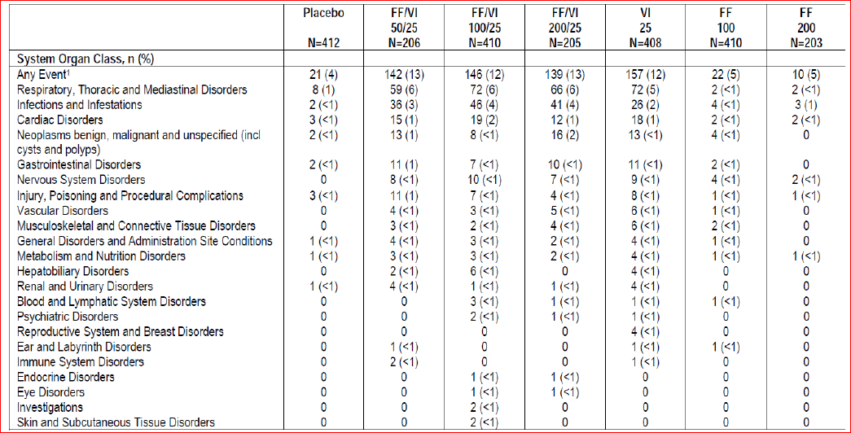
Advair/Seretide Comparator Studies: In Study HZC113107, the incidence of on-treatment non-fatal SAEs was low and similar in the 2 treatment groups (FF/VI 100/25 versus salmeterol/ FP 50/500 BD =2% versus 1%). Pneumonia and atrial fibrillation were the only SAEs reported by more than 1 subject in either treatment group (atrial fibrillation was reported by 2 subjects [<1%] in the FF/VI 100/25 group and pneumonia was reported for 1 subject [<1%] and 2 subjects [<1%] in the FF/VI 100/25 and salmeterol/FP 50/500 BD groups, respectively); all other SAEs were only reported for 1 subject overall. In Study HZC113109, the incidence of on-treatment non-fatal SAEs was low in both treatment groups (1% versus 3%) and COPD exacerbation was the only SAE reported by more than 1 subject in either treatment group (3 subjects [1%]) in the FP/salmeterol 250/50 BD treatment group, and none in the FF/VI 100/25 treatment group). Atrial fibrillation was reported by 1 subject (<1%) in both the FF/VI 100/25 and FP/salmeterol 250/50 BD groups; all other SAEs were only reported for 1 subject overall. In Study HZC112352, the incidence of on-treatment non-fatal SAEs was low in both treatment groups (2% versus 1%); the SAE of chronic bronchitis in the FF/VI 100/25 OD treatment group, was the only SAE considered related to study treatment by the investigators.
In the four concluded/ongoing studies, a total of 133 SAEs have been reported. Overall, the types of SAEs reported most frequently in these studies were similar to those reported in the completed clinical studies, with the most frequent SAEs being in the Respiratory, Thoracic and Mediastinal Disorders category. The most common SAE in this category has been COPD (34 events). SAEs in the Infections and Infestations SOC were reported at the next highest frequency, with the majority of these SAEs being pneumonia (15 events). The remaining SAEs in these 4 studies were reported for <3 subjects each, with most individual SAEs being reported for 1 subject each.

Discontinuation due to adverse events
In the 6 month studies, the incidence of AEs leading to permanent discontinuation of study drug or withdrawal was similar across all active treatment groups (9% to 11%) and placebo (9%) with the exception of a slightly lower incidence in the FF 200 group (7%). The SOCs with the highest incidence of AEs being reported as leading to permanent discontinuation of study drug or withdrawal were the Infections and Infestations SOC (3-4%; pneumonia, upper respiratory tract infection and lower respiratory tract infection were the most common events), Cardiac disorders SOC (2-4%; most common events within this category were ventricular tachycardia and ventricular extrasystoles) and Respiratory, thoracic and mediastinal disorders SOC (0-2%; COPD exacerbation most common with higher incidence in placebo group).
In the 12 month studies, the incidence of AEs leading to permanent discontinuation of study drug or withdrawal was similar across all FF/VI treatment groups (6% to 8%) and the VI 25 treatment group (6%). The SOCs with the highest incidence of AEs being reported as leading to permanent discontinuation of study drug or withdrawal were the ‘ Respiratory, Thoracic and Mediastinal disorders’ SOC (COPD exacerbation most common event: 1-2%), ‘Cardiac disorders’ SOC (1% to 2% in the FF/VI treatment groups compared with <1% in VI 25 group; atrial fibrillation and myocardial infarction most common with similar incidences across the treatment groups) and the ‘Infections and Infestations SOC’ (<1%, 1% and 2% in the FF/VI 50/25, 100/25 and 200/25 groups compared with <1% in the VI 25 group; pneumonia most common).
The incidence of any AE leading to permanent discontinuation of study drug or withdrawal from the integrated COPD population was similar across the FF/VI treatment groups (7% to 8%), the VI 25 group (6%), the FF treatment groups (7% to 9%) and placebo (8%). However, exposure-adjusted numbers of subjects were lower for the FF/VI 50/25, 100/25 and 200/25 treatment groups (93.7 to 117.2 subjects with an event/1000 subject years) and the VI 25 group (102.4 subjects with an event /1000 subject years) compared with placebo (264.7 subjects with an event /1000 subject years). In the FF 100 and FF 200 groups, exposure-adjusted numbers of subjects were also lower than exposure-adjusted numbers for placebo (235.5 and 188.2 subjects with an event /1000 subject years, respectively.
Advair/Seretide Comparator Studies: In Study HZC113107, the incidence of AEs leading to withdrawal from the study was low and similar in the FF/VI 100/25 and salmeterol/FP 50/500 BD groups (2% versus 1%); pneumonia was the most common event, Although its incidence was <1% in both treatment groups. In study HZC113109, the incidence of AEs leading to withdrawal from the study was low and similar in the FF/VI 100/25 and FP/salmeterol 250/50 BD groups (2% versus 3%); the Respiratory, Thoracic and Mediastinal Disorders SOC had the highest incidence of AEs being reported as leading to permanent discontinuation of study drug or withdrawal from the study (COPD exacerbation was the most common event, Although it only occurred in the FP/salmeterol 250/50 BD group (3 subjects [1%]). All other AEs leading to permanent discontinuation were only reported for 1 subject overall. Similar results were observed in study HZC112352 (FF/VI 100/25 versus FP/salmeterol 250/50 BD: 2% versus <1%).

Laboratory tests

Liver function
Overall, no FF/VI or VI associated liver concerns were observed in the COPD clinical development program. The few episodes of liver abnormalities were generally transient or confounded by concurrent medical problems or concomitant medications.

Kidney function
FF/VI did not appear to have any significant effect on renal function.

Other clinical chemistry
The percentages of subjects with abnormal laboratory values were low and similar across the treatment period. There were no remarkable differences across the FF/VI groups or between the VI 25 and any FF/VI treatment group in the percentages of subjects with clinical chemistry values outside the normal range at any time post-baseline.
Hypokalemia and hyperglycaemia are recognised systemic effects with beta2 agonists and corticosteroids (hyperglycemia only) and are generally related to systemic exposure. There was no indication from the laboratory evaluations in the COPD program of an effect on glucose or potassium in these studies with inhaled FF/VI.

Haematology
The percentages of subject with abnormal haematology values were low and similar across the treatment period. There were no remarkable differences between placebo and any active treatment group in the percentages of subjects with haematology values outside the normal range at any time post-baseline.

Urinary and serum cortisol

24 hour urinary cortisol excretion
Urine collection for analysis of cortisol was performed in a subset of subjects at selected sites in the six-month lung function studies (HZC112206 and HZC112207) and in a subset of subjects at selected sites in the two, replicate, Advair/Seretide comparator studies (HZC113107 and HZC112352). Urinary cortisol evaluations were not conducted in the one-year exacerbation studies (HZC102871/HZC102970) or in studies HZC110946, HZC111348, B2C111045 or HZC113107.
In the 6 month studies, 10 subjects were outliers due to decreases from baseline below the lower fence (the 25th percentile minus 1.5 times the interquartile range): three placebo subjects, one VI 25 subject, one FF/VI 50/25 subject, two subjects in the FF/VI 200/25 group, and three subjects in the FF 100 group. These isolated decreases were seen across most treatments including placebo and did not appear to be FF dose-dependent. The adjusted geometric mean urinary cortisol ratios to baseline ranged from a 12% decrease for the FF 100 group to a 1% increase for the FF/VI 100/25 group. There were no statistically significant differences in 24 h urinary cortisol excretion between the FF/VI 100/25 group and the FF 100 group, the FF/VI 200/25 group and the FF 200 group, nor were there any statistically significant differences between any FF/VI combination group and the VI 25 group.
Advair/Seretide Comparator Studies: In Study HZC113109, majority of subjects in both treatment groups in the Urinary Cortisol Population had 24 h urine-free cortisol excretion within the normal range at Week 12 (89% and 95% for the FF/VI 100/25 and FP/salmeterol 250/50 BD treatment groups, respectively). There was little difference between the treatment groups for the proportion of subjects reporting changes from baseline to low at Week 12 (2% and 1% for the FF/VI 100/25 and FP/salmeterol 250/50 BD treatment groups, respectively). Similar results were observed in Study HZC112352 as majority of subjects in both treatment groups in the Urinary Cortisol Population had normal 24 h urine-free cortisol excretion at Week 12 (82% and 88% for the FF/VI 100/25 and FP/salmeterol 250/50 BD treatment groups, respectively) and the proportion of subjects reporting changes from baseline to low at Week 12 was 2% and 4% for the FF/VI 100/25 and FP/salmeterol 250/50 BD treatment groups, respectively.
Serum cortisol: Analysis of serum cortisol was only performed in subjects in Study HZC110946 on Day 28 of each treatment period. Serum cortisol was not assessed any of the other studies. In Study HZC110946, statistical analysis of 0 to 24 h weighted mean serum cortisol over Days 28 to 29 did not show statistically or clinically significant decrease with FF/VI compared with placebo (FF/VI 50/25 µg [4%], 100/25 µg [2%] and 200/25 µg [11%]).

Vital signs
In the 6 month COPD studies, changes in vital signs (diastolic, systolic blood pressure and pulse rate) were small and similar across the treatment groups, with no clinically significant differences across the treatment groups. Similar results were observed in the 12 month studies and in the Advair/Seretide comparator studies.

Electrocardiograph
In the 6 month studies, there was no statistically or clinically significant difference between treatment groups in the change in Qtc(F) interval change from baseline. The percentages of subjects with one or more prolonged QTc(F) intervals (that is, greater than 450 ms) at any time post-baseline (including scheduled, unscheduled and Early Withdrawal visits) were low and similar across all active treatment groups (3% to 6%) and only slightly higher than placebo (2%). No subjects in any group had a prolonged QTc(F) value >500 ms. Heart rate measured by ECG also failed to show any significant difference between treatment groups. The FF/VI 200/25 group had the highest percentage of subjects with abnormalities of potential clinical importance, and this was true prior to the first dose of treatment and also during the assessment times during treatment. However, the numbers of subjects with an abnormality of potential clinical importance were in general similar across the treatment groups and that the categories of ECG changes of potential clinical importance observed were similar across the treatment groups (Table 41).
Table 41. Categories of ECG findings of potential clinical importance at any time post baseline (HZC112206/HZC112207)
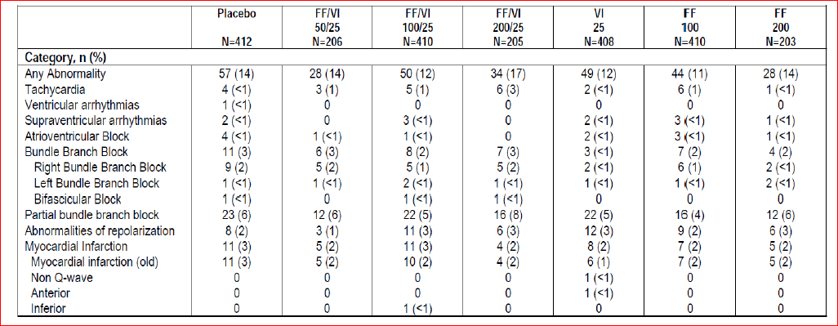
In the 12 month studies, the percentages of subjects with one or more prolonged QTc(F) intervals (that is, greater than 450 ms) at any time post-baseline were low and similar across the FF/VI treatment groups (3% to 4%) and the VI 25 treatment group (4%). No subjects in any group had a prolonged QTc(F) value >500 ms. The most common abnormalities of potential clinical importance at Week 12, Week 28 and Week 52 were similar to those noted prior to the first dose and tended to be reported at lower incidences than at pretreatment. The occurrence of other ECG abnormalities, including bradycardia/tachycardia, arrhythmias, abnormalities of repolarization, or conduction defects were noted at low incidences.

24 h Holter monitoring
At the end of the 6 month COPD studies (on Day 168), subjects in the FF/VI 100/25 groups had the highest percentage of subjects with abnormalities of potential clinical importance (8%), and the FF 200 the lowest (0) compared with 6% for placebo and 4% to 5% for the remaining treatment groups. At Day 1, Day 84 and Day 168, the most frequent abnormalities of potential concern were ventricular arrhythmias, most commonly non-sustained ventricular tachycardia that occurred at similar incidences in the active treatment groups compared with placebo, except that the incidence was lower in the FF 200 group. Other abnormalities occurred at low incidences with no clinically importance differences across the treatment groups. Holter abnormalities of potential clinical importance at any time post-randomisation occurred at slightly higher incidence across the FF/VI combination groups (13% -15%) and FF 100 (14%) groups compared with the placebo (10%), VI 25 (11%) and FF 200 groups (6%).

Postmarketing experience
There is no postmarketing data as the combination FF/VI or its individual components (FF and VI) are not approved for marketing in any country to date.

Safety issues with the potential for major regulatory impact

Liver toxicity
None.

Haematological toxicity
None.

Serious skin reactions
None.

Cardiovascular safety
Refer sections Vital signs and Electrocardiography above.

Unwanted immunological events
None.

Other safety issues

Safety in special populations
AEs by gender: In the 6 month COPD studies, although higher percentages of female subjects reported AEs in most treatment groups, there appeared to be no treatment-related trends in the occurrence of AEs based on gender; similar results were observed in the 12 month studies.
AEs by age: In the 6 month studies, the incidence of AEs was similar to the ITT Population across all age categories except for a slightly higher incidence in older subjects in the FF/VI 50/25 group and VI 25 group; this similar incidence of AEs across the age categories was evident across most SOCs there appeared to be no distinct pattern of differences across the age groups, although small numbers in different subgroups make interpretation difficult. Similar results were observed in the 12 month studies and the most frequent individual AEs (nasopharyngitis, URTI, oral candidiasis) were similar in subjects ≤64 years of age, in subjects ≥65 years of age, and in subjects ≥70 years of age and were similar to those of the ITT Population.
AEs by Race: In the 6 month studies, lower numbers of Non-White subjects limit interpretations regarding AE comparisons across the race subgroups or between the treatment groups compared with the ITT Population. Overall, there was no indication of treatment-related trends in the occurrence of AEs by race among White subjects, while Asian subjects tended to have higher incidence of AEs overall with FF 200 (either monotherapy or in the FF/VI combination). However, these data must be interpreted with caution due to the lower numbers of Asian subjects and the fact that the FF 200 strengths were only included in one of the two 6 month studies that had few Asian sites. Similar results were observed in the 12 month studies.
AEs by reversibility of lung function: In the 6 month studies, there were no notable differences in the occurrence of AEs by reversibility subgroup, with the exception that the reversible subjects in the FF 200 group had a higher incidence of AEs overall compared with the ITT Population. There were no remarkable differences based on reversibility for the incidence of on-treatment SAEs, drug-related AEs or incidence of withdrawals dur to AEs. Similar results were observed in the 12-month studies.
AEs by Percentage Predicted FEV1- GOLD Classification: In the 6 month studies, there was no indication of treatment-related trends in the occurrence of AEs based on GOLD stage, with the exception that there was a higher overall incidence of AEs in GOLD Stage III subjects compared with the ITT Population and GOLD Stage II and IV subjects in the FF/VI 50/25 treatment group and a higher incidence of AEs in GOLD Stage IV subjects compared with the ITT Population and GOLD Stage II and III subjects in the FF/VI 100/25 treatment group. GOLD Stage IV subjects had a higher incidence of on-treatment SAEs in some treatment groups compared with the ITT Population and GOLD Stage II and III subjects most frequent individual AEs were similar in GOLD Stage II, III and IV subjects. There were too few subjects with GOLD stage I to draw meaningful conclusions. Similar results were observed in the 12 month studies with the following exception: GOLD Stages III and IV subjects had a higher incidence of on treatment SAEs compared with the ITT Population and GOLD Stage II subjects, mainly due to a higher incidence of COPD events and pneumonia. The GOLD Stage IV subjects had a higher incidence of AEs leading to premature discontinuation of study drug or withdrawal from the study compared with GOLD Stage II and III subjects in the Vilanterol (VI) treatment group. These higher incidences of events leading to withdrawal (most that were categorized in the Respiratory, Thoracic and Mediastinal Disorders category such as COPD) reflects the severity of disease in the GOLD IV subgroup.
AEs by CV history/risk: Overall in the 6 month studies, those with and without a CV history/risk had similar AE profiles based on the most frequent AEs within each SOC category compared with the ITT Population. In particular, with the exception of the FF monotherapy groups, the occurrence of AEs was similar for subjects with no CV history/risk factors in the cardiac disorders category (5% to 6%) compared with those with CV history/risk factors in the cardiac disorders category (4% to 9%) in all treatment groups. Subjects with CV history/risk factors treated with either FF 100 or FF 200 had a slightly higher incidence of any AE (8% and 9%, respectively) compared with subjects in these treatment groups who had no CV history/risk factors (4% and 6%, respectively). There were no treatment-related trends in the occurrence of AEs, SAEs or withdrawals due to AEs based on the presence or absence of cardiovascular history/risk factors. Similar results were observed in the 12 month studies.
AEs by BMI (<25 kg/m2 or ≥25 kg/m2): BMI did not affect the incidence of AEs, SAEs or withdrawals due to AEs in the 6 month or the 12 month studies.
AEs by history of pneumonia: In the 6 month studies, subjects with a history of pneumonia had a higher incidence of any AE compared with subjects with no history of pneumonia. This trend was less obvious with the SAEs, drug-related AEs and AEs leading to discontinuation of study drug or withdrawal from the study, possibly due to the lower number of subjects in the history of pneumonia subgroups in these AE categories making it difficult to make meaningful AE comparisons across the subgroups or between the treatment groups compared with the ITT Population. In the 12 month studies, subjects with a history of pneumonia had a higher incidence of any AE, on-treatment SAEs, and on-treatment drug-related AEs compared with subjects with no history of pneumonia. There were no remarkable differences between these subgroups in the incidence of AEs leading to premature discontinuation of study drug or withdrawal from the study. A higher incidence of any AE was observed with FF/VI at any strength versus VI regardless of history of pneumonia subgroup which was similar to that observed in the ITT population. In addition, a higher incidence of any drug-related AE and on-treatment serious AE was observed with FF/VI at any strength versus VI in the prior history of pneumonia subgroup (Table 42). Furthermore, subjects with a history of pneumonia were found to have a greater risk of subsequent pneumonia in this subject population.
Table 42. Summary of on-treatment adverse events by history of pneumonia at screening (HZC102871/HZC102970 ITT population)
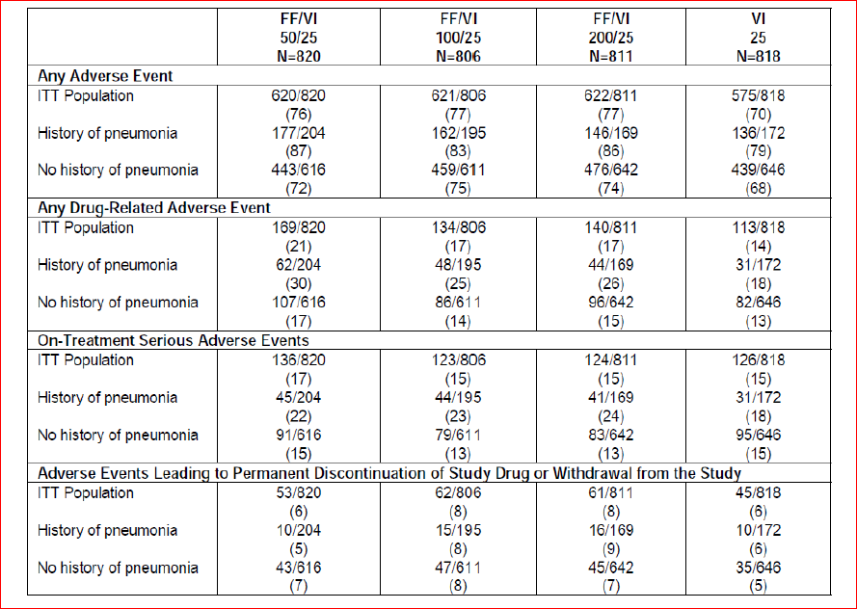
AEs by smoking status: In the 6 month studies, there were no treatment related trends in the occurrence of AEs, drug-related AEs, SAEs or withdrawals due to AEs based on smoking status with similar results in the 12-month studies.
AEs by geographical region: In the 6 month studies, there were no treatment-related trends in the occurrence of AEs, drug-related AEs, SAEs or withdrawals due to AEs based on geographical region; the most frequent individual AEs were similar in subjects across the geographical regions, with the European Union reporting a lower incidence of the most frequent AEs. Similar results were observed in the 12 month studies Although subjects from the EU and “Other 1” region tended to report a lower incidence of any AE compared with the ITT Population and subjects in the US and “Other 2” region tended to report a higher incidence of AEs, although the types of events that were reported were similar across all regions within each SOC category events compared with the remaining regions.

Safety related to drug-drug interactions and other interactions
Refer to section Safety related drug-drug interactions and other interactions.

Pregnancy/lactation
No pregnancies occurred in any subject in the COPD clinical development program, and there are no adequate and well controlled studies to assess safety of FF/VI and each of the individual components (FF and VI), in pregnant women. Subjects in the COPD population are less likely to become pregnant since they tend to be older subjects. FF/VI, FF and VI should be used during pregnancy only if the potential benefit justifies the potential risk to the fetus. Since there are no data from controlled trials on the use of FF/VI by nursing mothers, a decision should be made whether to discontinue nursing or to discontinue FF/VI, taking into account the importance of FF/VI to the mother.

Evaluator’s overall conclusions of safety of FF/VI in COPD
The study population in the COPD clinical development program was extensive and representative of the overall population of subjects with COPD. Across the ten studies in the COPD clinical development program, over 7700 subjects comprised the ITT Population with over 4150 subjects treated with the various strengths of FF/VI. Overall, there have been over 3800 subject-years of exposure to study medications, with approximately 2500 subject-years of exposure to the various strengths of FF/VI, 860 subject-years of exposure to the various dosages of VI alone, and about 237 subject-years of exposure to the various dosages of FF alone.
The overall incidence of subjects reporting any on-treatment AE in the six-month lung function studies (HZC112206/HZC112207) was similar across most active treatment groups (ranging from 45% to 50%) and similar to that reported for subjects in the placebo group (48%), with the exception that subjects in the FF/VI 50/25 group had a slightly higher incidence of any on-treatment AE (55%). In comparison, the overall incidence of subjects reporting any on-treatment AE was higher in the one-year exacerbation studies (HZC102871/HZC102970), but was similar across the FF/VI treatment groups (76% to 77%) and somewhat higher than for the VI 25 group alone (70%). Across both 6-month and 12-month studies, the most frequently reported AEs included nasopharyngitis, headache and oral/oropharyngeal candidiasis. In the 6-month studies, URTI, back pain and LRTI were also reported. These AEs are common in a COPD population and, with the exception of back pain, have been documented in various ICS prescribing information in asthma and ICS/LABA prescribing information. No notable differences across treatments in the incidence of nasopharyngitis were reported Although the incidence was higher in the 12-month studies, which may have been a consequence of the longer treatment period. The incidence of headache in the 6-month studies was higher in the VI arm than any other treatment group, but no differences were observed between treatments in the 12-month studies where all subjects received VI containing treatments. Not surprisingly, oral/oropharyngeal candidiasis, a local corticosteroid side effect, occurred at higher incidences in the FF containing groups compared with placebo and the VI 25 groups. In general, the incidence of back pain, LRTI and hypertension in the combination arms was similar to or lower than the incidence in the placebo group. In the 12-month studies, pyrexia occurred at a slightly higher incidence in the FF/VI groups (2%-3%) compared with the VI 25 group (1%).
Adverse Events of Special Interest: The main safety concerns with FF/VI relate to the known ICS and LABA effects. Pharmacologic class effects of ICS include bone disorders (osteoporosis, fracture, decreased bone mineral density), HPA axis effects (adrenal suppression, decreased serum cortisol, Cushing’s syndrome), local oropharyngeal effects (candidiasis, hoarseness, irritation/inflammation, cough), pneumonia and ocular effects (cataracts, increased intraocular pressure, glaucoma). Pharmacologic class effects of LABAs include cardiovascular (increased heart rate, prolonged QT interval, cardiac rhythm abnormalities, palpitations, myocardial ischemia), metabolic (low potassium, elevated glucose), and neurologic (tremor) effects. These class effects were proactively addressed in the FF/VI COPD clinical development program through an evaluation of AEs of special interest as well as objective assessments of 24 h serum cortisol, 24 h urinary cortisol, oropharyngeal examinations, chest x-rays, pulse, heart rate, 12-lead ECGs, 24 h Holter monitoring and biochemical bone markers.
Events related to local corticosteroid effects, pneumonia and bone disorders are discussed above. Individual AEs of special interest related to beta-adrenergic stimulation occurred at low incidences across all treatment groups in both the six-month and one-year studies. Cardiovascular effects (including arrhythmias [3% to 5%], hypertension [<1 to 4%], cardiac ischaemia [<1% to 4%], cardiac failure [<1 to 4%], QT prolongation [0 to <1%]) occurred at low and similar incidences. There was no indication of increases in blood pressure, tachycardia, palpitations or other cardiac arrhythmias. The incidence of tremor was low and similar (0 to <1%) across all treatment groups. Results of the analyses of the most common (≥3% of subjects in any treatment group) cardiac events (cardiac arrhythmia and hypertension in the six-month studies and cardiac arrhythmia, cardiac failure, cardiac ischemia and hypertension in the one-year studies) showed no increased risk for these events in any treatment group. Overall, any individual AEs suggestive of LABA effects occurred at low incidences across all treatment groups. However, it is difficult to interpret these effects in the one-year studies since all treatment groups included VI 25 exposure. Lower respiratory tract infections excluding pneumonia occurred at similar incidences across all treatment groups and trended toward a decreased risk in the FF/VI groups compared with VI 25 and FF alone. Events related to hypersensitivity, such as pruritus and rash, occurred at low incidences in the active treatment groups (<1% to 2%) and placebo (<1%) in the six-month studies and at slightly higher incidences in the FF/VI groups (4% to 5%) and the VI 25 group (3%) in the one-year studies. There appeared to be no increased risk of drug-associated hypersensitivity and no reports of anaphylactic reactions that were attributed to FF or VI. In both the six-month and one-year studies, ocular effects occurred at low and similar incidences across all treatment groups, and AEs related to decreased cortisol concentrations occurred at similar incidences across all treatment groups. In the six-month studies, effects on glucose were noted at a slightly higher incidence in the FF/VI 100/25 group (2%) compared with placebo (<1%) and the remaining treatment groups (1%). In the one-year studies, effects on glucose were noted at a similar incidence in the FF/VI groups (2% to 3%) compared with the VI 25 group (2%). There did not appear to be an increased incidence of potassium abnormalities (hypokalemia or blood potassium decreased) in any treatment group across all studies.
Pneumonia: Pneumonia is commonly seen in patients with COPD. Overall, there were no significant differences among the treatment groups in the incidence of pneumonia in the 6-month lung function studies. Pneumonia occurred at a low incidence (<1% to 2% of subjects) across all treatment groups. However, an increased incidence of pneumonia, including hospitalisations, was observed in the 12- month studies in COPD at all strengths of FF/VI compared with VI alone. The incidence of pneumonia was 6%, 6% and 7% for FF/VI 50/25, 100/25 and 200/25, respectively compared with 3% for VI 25, and the incidence of serious pneumonia was 3% in each FF/VI group compared with <1% in the VI 25 group. Risk factors for pneumonia in patients with COPD receiving FF/VI compared with VI were investigated and included current smokers, patients with a history of prior pneumonia, patients with a body mass index <25 kg/m² and patients with an FEV1<50% predicted. This information is reflected in the proposed labelling. The incidence of pneumonia with FF/VI was similar to the incidence reported in 12-month studies of similar design in patients treated with FP/salmeterol [Ferguson, 2008; Anzueto, 2009]. The percentage of these pneumonias that were serious was comparable for FF/VI (24/65 events, 36.9% to 29/58 events, 50.0%) and for FP/salmeterol (58.9%). However, the hazard ratio between the combination and its respective LABA was higher for FF/VI versus VI 25 (2.8, 3.0 and 2.7 for FF/VI 50/25, 100/25 and 200/25, respectively) than for FP/salmeterol versus salmeterol (1.6) as the percentage of pneumonias that were serious was considerably lower for VI 25 (8/28 events, 28.6%) compared with salmeterol (70.4%). Nine fatal cases with pneumonia were reported during the 1-year exacerbation studies. Of these, seven were reported during treatment with FF/VI 200/25, one during treatment with FF/VI 100/25 and one post-treatment with VI. All 7 cases in the FF/VI 200/25 treatment group were observed in one study (HZC102871) and four of these cases were reported from one site in the Philippines. The number of fatal cases was too small to allow investigation of risk factors for fatal pneumonia. The reason(s) behind the cluster of deaths at one site is unclear.
Bone Disorders: Reduction in bone density, and the subsequent risk of fractures is a potential risk with corticosteroids. In the 12-month studies in COPD the incidence of bone disorders was 1% in the VI 25 group compared with 3% in each of the FF/VI 50/25, FF/VI 100/25 and FF/VI 200/25 groups, respectively. The incidence of bone fractures overall was low in all treatment groups, with a higher incidence in all FF/VI groups (2%) compared with the VI 25 group (<1%). The majority of on-treatment fractures were due to trauma in the FF/VI 50/25 (11/15, 73%), FF/VI 100/25 (13/19, 68%) and VI 25 groups (6/8, 75%) while majority of fractures were non-traumatic in the FF/VI 200/25 group (8/13, 62%). However, fractures customarily associated with corticosteroid use (spinal compression/ thoracolumbar vertebral fractures, hip and acetabular fractures) occurred in <1% of subjects in all treatment arms. Biochemical markers of bone metabolism (carboxy terminal cross-linking telopeptide of bone collagen [CTX] and osteocalcin) were evaluated during study HZC102871. CTX is considered to be a biomarker of bone resorption, and osteocalcin a marker of bone formation and no consistent changes were noted at the end of study compared with baseline across the study period or across the treatment groups for CTX or osteocalcin. However, there was a statistically significant decrease (9%) in serum osteocalcin with FF 200/25.
Fatal Events: Overall, 65 fatal events occurred across the seven integrated studies, 11 fatal events in the six-month lung function studies, 53 fatal events in the one-year exacerbation studies, and one fatal event in Study B2C111045. In addition, three fatal events occurred in the three ADVAIR/SERETIDE comparator studies, two with FF/VI 100/25 and one with FP/salmeterol. Fatal events occurred at low and similar incidences (2% or less) across all active treatment groups and placebo in the seven integrated studies. The most common fatal events were events that commonly occur in an older population of subjects (cardiac disorders that were pre-existing in this population, malignancies) and/or that are frequently seen in subjects with COPD. There was no increased incidence in exposure-adjusted fatal events that were cardiovascular in nature in VI-containing groups. The exposure-adjusted numbers of subjects with fatal events that were CV in nature was 6.5 to 11.7 subjects with an event/1000 subject years on VI containing arms compared with 12.0 subjects with an event/1000 subject years in the placebo group. Overall, the occurrence of on-treatment or post-treatment fatal events was low (<1% in all treatment groups with the exception that no fatal events occurred in the FF 200 group) in both six-month lung function studies (HZC112206/HZC112207). The majority of fatal events were reported in the one-year exacerbation studies (HZC102871/HZC102970), which is perhaps not surprising given this was the longest exposure to treatment and the most severe COPD patient population studied. Overall, the occurrence of on-treatment or post-treatment fatal events was low (1% to 2%) in both one-year exacerbation studies with no apparent differences between the treatment groups. With the exception of the occurrence of 7 deaths due to pneumonia in the FF/VI 200/25 group (see pneumonia discussion above), there were no remarkable differences in the incidence of fatal events across the treatment groups. Overall, none of the fatal events were considered related to treatment by the investigators.
Serious Adverse Events: In the six-month studies, the incidence of SAEs was lowest in the FF/VI 50/25 group (3%) and higher in the FF/VI 100/25, FF/VI 200/25 and the VI 25 groups (6%, 7% and 8%, respectively) than for placebo (5%), while the incidence of SAEs was similar for both the FF 100 and FF 200 groups (5%) to that of placebo. COPD exacerbation was the most common SAE reported, with an incidence slightly higher in the VI 25 group (3%) compared with the remaining treatment groups (0 to 2%) and placebo (2%). Pneumonia was the next most frequent SAE, and was reported at a similar incidence across the active treatment groups and placebo (<1% to 1%). All other individual SAEs were reported by 2 or fewer subjects each with no indication of treatment differences. In the one-year studies, the incidence of on-treatment SAEs was similar for all FF/VI treatment groups (15% to 17%) and for the VI 25 group (15%). COPD exacerbation was the most common SAE reported, with an incidence similar in the FF/VI groups (6% to 7%) compared with the VI25 group (6%). Pneumonia was the next most frequently reported SAE, and was reported at a higher incidence across the FF/VI treatment groups (3%) than in the VI 25 group (<1%). Individual SAEs in the remaining SOCs occurred at low and similar incidences (<1%) across the FF/VI treatment groups and the VI 25 treatment group.
Discontinuations/ study withdrawals due to AEs: The incidence of AEs leading to permanent discontinuation of study drug or withdrawal from the six-month lung function studies was 9% to 11% across all active treatment groups compared with 9% for placebo and lower for the FF 200 group (7%). The incidence of AEs leading to permanent discontinuation of study drug or withdrawal from the one-year exacerbation studies was lower than in the six-month studies but similar across all FF/VI treatment groups (6% to 8%) and the VI 25 treatment group (6%).
Clinical Laboratory Findings/vital signs: Based on the review of shifts with respect to the normal reference range for haematology and clinical chemistry analytes, no trends were observed suggesting an effect of FF/VI or its individual components (FF and VI) on the occurrence of laboratory values outside the normal range. FF/VI did not have any clinically significant effect on Vital Signs, ECG and 24 h Holter monitoring.
Serum and Urinary Cortisol: Analysis of 24 h serum cortisol was performed in subjects in Study HZC110946 on Day 28 of each treatment period which demonstrated decreases in weighted mean serum cortisol levels with FF/VI compared with placebo (FF/VI 50/25 µg [4%], 100/25 µg [2%] and 200/25 µg [11%]) were not statistically significant. These decreases compared with placebo in weighted mean serum cortisol are also not considered to be clinically relevant. Furthermore, 24 h urine collection for analysis of cortisol excretion in a subset of subjects at selected sites in the six-month lung function studies showed no statistically or clinically significant differences from placebo for all active treatment groups. There were also no statistically significant differences in 24 h urinary cortisol excretion between the FF/VI 100/25 group and the FF 100 group, the FF/VI 200/25 group and the FF 200 group, nor were there any statistically significant differences between any FF/VI combination group and the VI 25 group, thus suggesting no increased systemic exposure with the co-administration of VI. Urinary cortisol was also assessed at selected centers in two of the ADVAIR/SERETIDE comparator studies (HZC113109/HZC112352). No statistically significant differences in urinary cortisol excretion were observed. No AEs were reported that would be considered related to decreases in serum cortisol.
Safety in FF/VI - Advair/Seretide Comparator Studies Although the studies were only 12 weeks in duration and do not allow for a detailed safety comparison between them, there were no obvious differences in safety profile between FF/VI and ADVAIR/ SERETIDE in the three comparator studies conducted during the FF/VI clinical development program.
Overall, safety of proposed dose of FF/VI 100/25 µg was evaluated in adequate number of COPD patients for treatment durations up to 1 year and was representative of the target patient population for the proposed combination. Overall, the safety profile was consistent with the expected AEs usually associated with LABA/ICS combination, that is, most frequent AEs were beta-adrenergic agonist AEs or local steroid effects. The only alarming safety concern detected in the COPD clinical program was the higher incidence of pneumonias (including serious and fatal pneumonias) in subjects treated with FF/VI. However, the incidence of pneumonia appeared to be more common in patients with risk factors which have been included in the proposed labelling. It is also reassuring to see that most of these serious AEs of pneumonia were more common in patients treated with FF/VI 200/25 µg which is not the proposed dose for COPD.

First round benefit-risk assessment

First round assessment of benefits

Asthma
The benefits of FF/VI (100/25 and 200/25 µg) in the proposed usage for treatment of asthma are:
- Once daily treatment with a LABA/ICS combination would potentially improve treatment compliance although this could not be ascertained in the clinical studies. The currently available LABA/ICS combinations need to be administered twice daily.
- The proposed doses of FF/VI 100/25 and 200/25 provided greater benefit in terms of improvement in lung function parameters of through FEV1, weighted mean FEV1 (0 to 24h), AM and PM PEF than FF alone in two out of three pivotal Phase III studies (HZA106829 and HZA106837) where this was measured, thus demonstrating the contribution of VI to the combination. FF/VI 100/25 and 200/25 were also significantly better than the equivalent dose of FF monotherapy in improving symptomatic endpoints including 24 h rescue-free/ symptom-free periods, time to first severe exacerbation and severe exacerbation rate. The contribution of FF to the efficacy of the FDC was shown by assessing the efficacy and safety of FF relative to placebo in the Phase III studies and also in an allergen-challenge Phase II study HZA113126 (refer section 5.2.2.1, page 47 of this report) where FF/VI was significantly better than VI alone in terms of attenuating the early and late phase asthmatic response and also the increased bronchial hyper-responsiveness (BHR) associated with allergen challenge.
- At therapeutic doses of FF/VI, no safety signals have been observed for increased incidence of severe asthma exacerbations, adrenal suppression, bone disorders, QT interval prolongation, myocardial ischemia, or metabolic, neurologic, or ocular effects based on results of clinical program to date. Safety observations are in line with the expected drug-class profiles in the populations studied and no new risks have been identified.
- The addition of the LABA component did not increase the frequency of severe asthma exacerbations requiring hospitalization as demonstrated by no significant difference in the Asthma composite endpoint between the FF/VI group and the ICS group or non-LABA group. In addition, subjects treated with FF/VI 100/25 had a 20% reduction in the risk of experiencing a severe asthma exacerbation compared with subjects treated with FF 100 alone.

COPD
The benefits of FF/VI 100/25 µg OD in the proposed usage for treatment of COPD are:
- Once daily treatment with a LABA/ICS combination would potentially improve treatment compliance although this could not be ascertained in the clinical studies due to study designs. The currently available LABA/ICS combinations used for treatment of COPD require twice daily administration.
- In the two pivotal 6-month studies, the proposed dose of FF/VI 100/25 µg OD showed statistically significant and clinically meaningful improvements in lung function after 24 weeks of treatment with increased adjusted mean through FEV1 [difference from placebo was 129mL and 83 mL with FF/VI 100/25 and VI 25, respectively; FF/VI 100/25–VI 25= 46mL; 95% CI: 8, 83mL, p= 0.017] and adjusted weighted mean peak FEV1 (0 to 4 h) [difference from placebo was 193mL and 145, respectively; FF/VI 100/25-VI 25= 148 ml; 95% CI: 112, 184mL, p< 0.001]. Patients treated with the proposed FF/VI 100 /25 µg also had significantly better dyspnoea scores (Although not clinically relevant), had less coµgh and sputum, required significantly less rescue medication as measured by number of occasions of rescue salbutamol use (per 24 h period) and number of night time awakenings requiring salbutamol (per 24 h period) compared to placebo.
- The 24 h bronchodilator effect of FF/VI was maintained from the first dose throughout a one-year treatment period with no evidence of loss in efficacy.
- The data from the pivotal Phase III, 52-week studies demonstrated that FF provides a significant contribution to the FF/VI combination. In particular, compared with VI 25 OD alone, treatment with FF/VI 100/25 OD consistently reduced the annual rate of moderate and severe COPD exacerbations, time to exacerbations, rate of exacerbations requiring systemic corticosteroid use and also showed minor improvements in lung function (troµgh FEV1).
- Overall, safety of proposed dose of FF/VI 100/25 µg was evaluated in adequate number of COPD patients for treatment durations up to 1 year and was representative of the target patient population for the proposed combination. The safety profile of proposed FDC of FF/VI 100/25 µg OD was consistent with the expected AEs usually associated with LABA/ICS combination, that is, most frequent AEs were beta-adrenergic agonist AEs or local steroid effects.

First round assessment of risks

Asthma
The risks of FF/VI (100/25 and 200/25 µg) in the proposed usage for treatment of asthma are:
- In the PK-PD studies, dose proportionality of FF and VI was not evaluated over a wide range of doses and in fact the starting dose in the PK studies was 100-200 µg for FF and >25 µg for VI.
- Exclusion of 12.5 µg dose of the LABA-Vilanterol (VI) based on superior efficacy observed for 25 µg in secondary endpoints (% symptom free 24hr and rescue free 24 h periods) in a Phase II study (B2C109575) is not justified. The study was not powered to show a difference in these endpoints. It is likely that the patients have been administered a dose that is greater than that actually required. LABAs may be associated with increased severity of asthma exacerbations in some patients and hence it would be prudent to establish the minimum effective dose in patients with asthma with the option of up-titration if required in individual patients. Dose finding for VI would be required to be demonstrated in the larger Phase III trials, but this was not done as only a single dose of VI (25 µg) was used in all pivotal Phase III studies. Furthermore, as the mono components (FF and VI) are not to be registered for use in asthma, it will be difficult for clinicians to make the transition to the new fixed dose combination product.
- Dose-ranging studies for FF showed efficacy in the range of 50-200µg but the dose of 50µg was not evaluated in the Phase III asthma studies. This is especially important because many local steroid effects are dose-related and if a lower dose of 50µg is effective in the combination, then the risks associated with steroid therapy may be reduced.
- No Phase III studies were conducted comparing FF/VI 100/25 and 200/25; instead subjects on different baseline therapy who would be candidates for either the higher or the lower strengths were recruited into the relevant studies. However, it is not clear how subjects would be titrated to these doses as none of the individual drugs (FF or VI) are registered for treatment of asthma and titration of the FDC was not evaluated in any of the clinical studies.
- The FDC guidelines state that rationale for a FDC development is either FDC shows better efficacy than mono components taken together or lower doses of actives given as FDC offer better risk benefit ratio. The doses of the ICS and LABA selected for the FDC were based on the dose ranging mono component Phase II studies and no dose-ranging studies were conducted with the proposed combination inhaler (FF/VI). Based on the Phase II studies presented it is not clear whether a lower or higher FDC combination would be appropriate.
- Evidence for contribution of the VI component to the FDC (FF/VI) was not unequivocal. The pivotal Phase III study HZA106827 (which recruited subjects uncontrolled on low/mid dose ICS or on low dose ICS/LABA) failed to demonstrate statistically significant difference between the two active treatments (FF/VI and FF alone) for the co-primary endpoints of through FEV1 and weighted FEV1 (0 to 24h). As statistical significance was not achieved for all treatment comparisons in the first level of Hierarchy (there was no statistical significant difference between FF/VI and FF for the co-primary endpoints), the significant differences in FF/VI 100/25 compared with FF 100 for the powered secondary endpoint of percentage of rescue-free/ symptom-free 24 h periods, AM and PM PEF should be interpreted as descriptive only. The pivotal study HZA106829 (which recruited subjects uncontrolled on high dose ICS or on mid dose ICS/LABA) showed statistically significant improvements with FF/VI 200/25 µg compared with FF 200 alone in co-primary [troµgh FEV1 and weighted FEV1 (0 to 24h)] and secondary endpoints (percentage of rescue-free/ symptom-free 24 h periods and AM/ PM- PEF) at the end of 24 weeks of treatment. However, a sensitivity analyses (excluding data from an investigator in the USA because of GCP issues) of the co-primary endpoint of weighted mean FEV1 (0 to 24 h) was not consistent with the ITT analysis results and failed to show statistically significant difference between FF/VI and FF200 groups Although results were consistent with ITT analysis for through FEV1 and other secondary endpoints.
- Safety issues with use of FF/VI for treatment of asthma such as local steroid effects, systemic corticosteroid effects including effect on growth, bones in adolescents (Although this is being addressed by ongoing studies), cardiovascular effects and pneumonia. The incidence of pneumonia (adjusted for exposure) seen with FF/VI 100/25 and FF 100 (9.6 and 8.0/1000 subject years, respectively) was similar to that seen with placebo (8.0/1000 subject years) although a higher incidence of pneumonia was observed in the FF/VI 200/25 and FF 200 arms (18.4/ and 25.5/1000 subject years, respectively).
- The results observed in the Phase III clinical asthma program for the proposed FDC combinations 100/25 or 200/25 µg do not clearly justify the need for both strengths, especially the higher dose as there is no stepping up design included. Furthermore, the higher dose of 200/25 µg was not evaluated in the Phase III study HZA106837 which showed that FF/VI 100/25 significantly reduced the risk of severe asthma exacerbations, improved lung function (trough FEV1) and led to greater asthma control (as assessed by the ACQ7) compared with FF 100 when administered for 24 to 76 weeks.

COPD
The risks of FF/VI (100/25 µg) in the proposed usage for treatment of COPD are:
- In the dose-ranging study B2C111045 in COPD subjects, all VI doses of 3.25, 6.25, 12.5, 25 and 50 µg OD produced statistically significant improvements over placebo in lung function parameters of through FEV1 (92, 98, 110, 137 and 165 mL with 3.25, 6.25, 12.5, 25 and 50 µg OD, respectively) and weighted mean FEV1 (0 to 24h) (105, 125, 142, 158 and 177ml, respectively). Symptomatic endpoints also showed improvements with all VI doses compared with placebo. Hence, exclusion of 12.5 µg dose of the LABA- Vilanterol (VI) was not justified based on >130 mL improvement over placebo in through FEV1. Dose finding for VI would be required to be demonstrated in the larger Phase III trials, but this was not done as only a single dose of VI (25 µg) was used in all pivotal Phase III studies.
- The 52-week Phase III studies showed that incidence of moderate/ severe COPD exacerbations was statistically significantly reduced with all three dose of FF/VI (50/25, 100/25 and 200/25 µg) compared with VI 25 µg. Although risk reduction was slightly greater with the proposed dose of FF/VI 100/25 (27%) compared with 200/25 (23%) and 50/25 (16%), all of them were statistically significantly greater than VI 25 µg. As the sponsor only proposes to register one dose of FF/VI 100/25 µg OD for treatment of COPD, there is no option for titration in an individual patient to a lower or higher dose of the FDC.
- As mono components of the proposed FDC (FF and VI) will not be registered for use in COPD, there are no guidelines available for clinicians to make the transition to the new fixed dose combination product.
- In the COPD clinical program, most frequent AEs were beta-adrenergic agonist AEs or local steroid effects. There was a higher incidence of pneumonias (including serious and fatal pneumonias) in subjects treated with FF/VI. However, the incidence of pneumonia appeared to be more common in patients with risk factors [current smokers, patients with a history of prior pneumonia, patients with a body mass index <25 kg/m2 and patients with a FEV1<50% predicted] which have been included in the proposed labelling.

First round assessment of benefit-risk balance
The purpose of this application is to obtain marketing approval for the use of FF/VI (100/25 and 200/25 µg OD by oral inhalation) administered once daily for the regular treatment of asthma in adults and adolescents aged 12 years and older, where use of a combination product (long-acting beta-2-agonist and inhaled corticosteroid) is appropriate; asthma patients who are symptomatic with inhaled corticosteroids and 'as needed' inhaled short acting beta-2-agonist or patients already on both an inhaled corticosteroid and a long-acting beta-2-agonist. The sponsor is also seeking marketing approval of only FF/VI 100/25 µg OD for symptomatic treatment of patients with COPD with a FEV1 <70% predicted normal (post-bronchodilator) in patients with an exacerbation history.
Fixed Dose Combinations of ICS and LABA are well-accepted and recommended treatments for asthma [Global Initiative for Asthma (GINA), 2011] and COPD [Global Initiative for Chronic Obstructive Lung Disease (GOLD), 2011]. Current ICS/LABA combinations, including fluticasone propionate (FP)/salmeterol, beclomethasone/formoterol and budesonide/formoterol, need to be administered twice daily. Hence one of the potential benefits with the proposed ICS/LABA combination of FF/VI is improved treatment compliance due to its once daily dosing regimen. However, the Phase III clinical development program for FF/VI was conducted under double-blind, and where necessary, double-dummy conditions, confounding the assessment of compliance. As a result, the question of whether once-daily FF/VI represents a true patient benefit requires further investigation.
The main limitations of this submission relate to inadequate evaluation of a wide range of doses of FF and VI in the PK-PD or the Phase II dose-ranging studies. Majority of doses evaluated seemed to lie within the flat part of the dose-response curve and hence it is likely that a much higher dose than required was evaluated in the pivotal Phase III studies. The minimum effective dose of VI was not established and only one dose of VI (25 µg OD) was carried forward to the Phase III studies. No dose-ranging studies were done with the proposed combination product in asthma and dose–response information was mainly obtained from studies using FF alone or VI alone.
Furthermore, the individual components of the FDC are not to be registered for use in asthma or COPD and it will be very difficult for clinicians to make the transition to the new FDC product.
Limitations of inadequate dose-response evaluation of the dose of FF and VI in the proposed FF/VI formulation may be acceptable if the proposed drug is of major therapeutic benefit for which no other alternative treatments are available. Since that is not the case with this ICS/LABA formulation, the benefit-risk balance of Relvar Ellipta (FF/VI 100/25 and 200/25 µg OD) given the proposed usage is unfavourable.

First round recommendation regarding authorisation
Due to the limitations of this submission as outlined above, it is recommended that Relvar Ellipta (FF/VI 100/25 and 200/25 µg OD) be rejected at this stage.

Clinical questions

Pharmacokinetics
- Given the route of administration why didn't the studies on clearance examine the respiratory route as a potential mechanism for FF/VI clearance. This may be especially important for VI as only 72% of radioactive dose was recovered after 7 days post dosing.
- It is not clear why the investigators have used non-inferiority as measure of PK differences in the studies on hepatic and renal impairment. Can the sponsor please justify its use in Studies HZA111789 and HZA113970.
- Are there dedicated Phase I PK studies which examine the PKs of VI and FF following 7 and 14 days dosing via NDPI in adult persistent asthmatics, respectively, which would allow for comparison with the paediatric values?
- No drug-drug interaction studies for both FF and VI have been conducted with a short-acting beta 2-agonist such as salbutamol, which would be used as a rescue medication in the event of an acute asthma attack. Can the sponsor please justify this omission?
- The lowest dose of VI examined in the PK studies was 25 µg. Why have lower doses of VI not been examined?
- Although Study HZA102932 examined the dose proportionality of FF and equivalence of VI following single dose administration in healthy subjects, this study did not examine dose proportionality over a wide range of doses, nor was the proposed dose of FF/VI 100/25 µg examined. Can the sponsor please justify why the dose of FF/VI 100/25 µg was not investigated as part of this study?

Pharmacodynamics
- No PD drug-drug interaction studies for both FF and VI have been conducted with a short-acting beta 2-agonist such as salbutamol, which would be used as a rescue medication in the event of an acute asthma attack. Can the sponsor please justify this omission?
- Why was the minimum effective dose of VI not established? Can the sponsor please justify why studies only examined the PD effects of VI doses >25 µg which appeared to be in the flat phase of the dose-response curve?

Efficacy
- Exclusion of 12.5 µg dose of the LABA-Vilanterol (VI) based on superior efficacy observed for 25 µg in secondary endpoints (% symptom free 24hr and rescue free 24 h periods) in a Phase II study (B2C109575) is not justified. The study was not powered to show a difference in these endpoints. It is likely that the patients have been administered a dose that is greater than that actually required. LABAs may be associated with increased severity of asthma exacerbations in some patients and hence it would be prudent to establish the minimum effective dose in patients with asthma with the option of up-titration if required in individual patients. Dose finding for VI would be required to be demonstrated in the larger Phase III trials, but this was not done. Can the sponsors justify use of only a single dose of VI (25 µg) in the pivotal Phase III studies?
- Although dose-ranging studies for FF suggested efficacy over the range of 50 to 200 µg OD, the 50 µg dose of FF was not evaluated in the Phase III asthma studies. Can the sponsors justify exclusion of the 50 µg FF dose in the FDC in the Phase III asthma clinical studies.
- The results observed in the Phase III clinical asthma program for the proposed FDC combinations 100/25 or 200/25 µg do not clearly justify the need for both strengths especially the higher dose as there is no stepping up design included. Furthermore, the higher dose of 200/25 µg was not evaluated in the Phase III Study HZA106837 which showed that FF/VI 100/25 significantly reduced the risk of severe asthma exacerbations, improved lung function (trough FEV1) and led to greater asthma control (as assessed by the ACQ7) compared with FF 100 when administered for 24 to 76 weeks. Due to risks associated with the higher dose of ICS (including increased risk of pneumonia), can the sponsors justify the need for the higher dose of FF/VI. Why was the lower strength of FF/VI 50/25 µg not evaluated further in the Phase III asthma studies?
- In the dose-ranging Study B2C111045 in COPD subjects, all VI doses of 3.25, 6.25, 12.5, 25 and 50 µg OD produced statistically significant improvements over placebo in lung function parameters of through FEV1 (92, 98, 110, 137 and 165 mL with 3.25, 6.25, 12.5, 25 and 50 µg OD, respectively) and weighted mean FEV1 (0 to 24h) (105, 125, 142, 158 and 177 mL, respectively). Symptomatic endpoints also showed improvements with all VI doses compared with placebo (refer Dosage selection for the pivotal studies; COPD). Hence, exclusion of 12.5 µg dose of the LABA-Vilanterol (VI) was not justified based on >130 mL improvement over placebo in through FEV1. Dose finding for VI would be required to be demonstrated in the larger Phase III trials but this was not done as only a single dose of VI (25 µg) was used in all pivotal Phase III studies. Hence, can the sponsors justify selection of only one dose of VI (25 µg) for the pivotal Phase III COPD studies?
- The 52-week Phase III studies showed that incidence of moderate/ severe COPD exacerbations was statistically significantly reduced with all three dose of FF/VI (50/25, 100/25 and 200/25 µg) compared with VI 25 µg. Although risk reduction was slightly greater with the proposed dose of FF/VI 100/25 (27%) compared with 200/25 (23%) and 50/25 (16%), all of them were statistically significantly greater than VI 25 µg. As the sponsor only proposes to register one dose of FF/VI 100/25 µg OD for treatment of COPD, there is no option for titration to a lower of higher dose of the FDC which may have been effective in an individual patient. Can the sponsor justify this?
- The individual components of the proposed FDC (FF and VI) will not be registered for use in asthma or COPD but no guidelines are available for clinicians to make the transition to the new fixed dose combination product from their current asthma or COPD therapy. Can the sponsors clarify how the patients are to be initiated on treatment with the proposed FDC?

Safety
None.

Second round evaluation of clinical data submitted in response to questions
Only the sponsor’s response and then the evaluator’s comments on the sponsor’s response are shown below. Please refer to Clinical questions above for details of question asked.

Pharmacokinetics

Question 1

Sponsor’s response
There are a number of reasons why dosing radiolabel by the inhalation route is not the best or most feasible approach to study clearance for inhaled molecules. Exhalation of radioactive drug after inhalation administration makes it impossible to reliably determine administered radioactivity that is needed to fully interpret excretion and metabolism data. The low doses of inhaled drugs limit the radioactive dose and leads to biologic samples containing very low concentrations of both metabolite chemical mass and radioactivity, thereby impairing the ability to measure and identify metabolites. Finally, quantitative information derived from an inhalation administration of a radioactive analogue is very unlikely to be representative of the commercial clinical formulation in its device.
FF: The mechanism of clearance of FF was studied following intravenous and oral administration, representing the lung deposited and swallowed portions of an inhalation dose, respectively. Since intravenous administration delivers drug directly to the lung (via the heart) prior to any other body organ it can be considered to be representative of the lung dose. The main route of clearance of FF in human and all animal species investigated (both in vitro and in vivo) was via metabolic hydrolysis of the S-fluoromethyl carbothioate group. There was no evidence for metabolism of FF by human lung microsome or s9 preparations suggesting there are no additional routes of clearance following inhaled administration.
VI: The mechanism of clearance of VI was studied following oral administration in a human ADME study. Radiolysis of the [14C] isotope resulted in material which was unstable over the periods required to support manufacture and release of either intravenous or inhalation formulations, effectively ruling out these routes for investigation.
The main route of clearance of VI in human (in vitro and in vivo) was metabolism via Odealkylation. O-dealkylation was also a major route in all animal species investigated. There was no evidence for metabolism of VI by human lung microsomes suggesting there are no additional routes of clearance following inhalation administration.
The precise cause of the relatively low total recovery of radioactivity (72% of the administered radioactivity) is unknown but is likely related to the low sample radioactive and chemical concentrations as a consequence of the low radioactivity and chemical doses administered (see above). The radioactive dose was approximately 25 to 50-fold lower than is typically used in similar experiments and necessitated both liquid scintillation counting and accelerator mass spectrometry as methods of radioassay. Low mass concentrations, in particular, result in radioassay data which would be very sensitive to even low levels of non-specific binding to the apparatus used. The data generated, however, does not support significant clearance of drug related material beyond 7 days post dosing. Elimination of radioactivity was essentially complete by 4 days after dosing (>99% of the recovered radioactivity) with <0.3% of recovered radioactivity being excreted between Days 5 and 7.

Evaluator’s comments on sponsor’s response
The sponsor has misinterpreted the question asked by the PK/PD evaluator. The evaluator was not questioning the mode of drug administration but the fact that expired breath was not collected or examined following drug administration, as this may have contained some of the 28% of radioactive dose not accounted for following VI dosing.

Question 2

Sponsor’s response
For both FF and VI any clinically relevant effects of either hepatic or renal impairment would be anticipated to be as a consequence of increased systemic exposure. Since systemic exposure to both FF and VI drive unwanted systemic class related pharmacodynamic effects it was important to understand if systemic exposure to either molecule was increased in subjects with hepatic or renal impairment to provide dosage recommendations for these populations.
Therefore the approach used in these studies was to look at non-inferiority using pre-defined criteria that would provide information for labelling.

Evaluator’s comments on sponsor’s response
As studies HZA111789 and HZA113970 are dedicated PK studies, the evaluator has used PK parameters, such as AUC and C_{max}, in the first round report to determine the changes in systemic exposure resulting from hepatic and renal impairment and he believes that the use of terms such as non-inferiority are misleading in regards to these Phase I trials. More importantly, the evaluator believes that his comments regarding changes to the PI regarding hepatic and renal impairment are still valid.

Question 3

Sponsor’s response
No there are no dedicated Phase I PK studies in adult subjects with asthma. To provide PK data across a broad asthma patient population the characterisation of PK in adolescent/adult subjects with asthma has been conducted on samples collected from Phase II and III efficacy and safety studies. In addition Study HZA106851 includes PK assessments which can be used for preliminary comparison with the paediatric data. However, population pharmacokinetic analysis which uses specific methodology to handle non-quantifiable data provides the definitive PK data for adolescent/adult subjects with asthma. A population PK analysis for paediatric subjects with asthma will be conducted on Phase IIb data and provide definitive data for comparison to adolescent/adults.

Evaluator’s comments on sponsor’s response
Recent studies⁴⁰ suggest that population PK models may not suffice to predict parameter distributions and drug exposure across paediatric populations. Therefore the evaluator believes that, although extremely useful in the development of paediatric study design, population PK analysis in itself is not sufficient to justify dosage requirements in children. In addition, given that the paediatric studies conducted to date, HZA112776 and HZA102942, have only examined the monotherapies alone the evaluator believes that the use of Relvar Ellipta in the paediatric population should not be approved, at least until the results of the first study of FF/VI in paediatric subjects (HZA112777) are known.

Question 4

Sponsor’s response
Drug-drug interaction studies for FF and VI have not been conducted with a short acting beta-2- agonist such as salbutamol. The metabolism of salbutamol (for example, sulfation) differs from that of FF or VI (CYP3A4 metabolism), while the drug interaction (perpetrator) potential of FF or VI are considered to be negligible at clinical exposures. Perpetrator interactions are rarely a concern for drugs which are administered at extremely low dose levels such as FF (inhaled clinical dose ≤200 µg) and VI (inhaled clinical dose 25 µg).
Using the approach recommended by the FDA in its guidance on drug interactions [Huang, 2007], I/Ki ratio values for FF and VI were estimated to be 0.0002 and 0.0003 for cytochrome P450 isozyme CYP3A4, which are both considerably lower than the threshold of concern of 0.1. For FF the resulting I/Ki ratio of 0.002 for the worst case 50% inhibitory concentration (IC₅₀) (in this case 100 nM for OATP1B1) was also considerably lower than the FDA threshold of concern of 0.1 and, therefore, the perpetrator interaction potential of both FF and VI is negligible.
Similar conclusions were made using CPMP guidance. Using the approach recommended by the EMA in its draft guidance [CPMP/EWP/560/95/Rev.1, 2010] the C_{max} of FF (<0.2 nM) corresponds to a free concentration of <0.0008 nM (assuming protein binding of 99.6%). The estimated Ki for OATP1B1 (100 nM), as a worse case, is 125,000 fold higher than the unbound C_{max}. The C_{max} of VI (<0.5 nM) corresponds to a free concentration of < 0.03 nM (assuming protein binding of 93.9%). The estimated Ki for CYP3A4 as a worse case (2 mcM) is 70,000 fold higher than the unbound C_{max}. Therefore, further clinical investigation of either FF or VI was not warranted since these values are considerably greater than the threshold of concern in this guidance (<50 fold higher).
The negligible perpetrator interaction potential for CYP3A4 was further substantiated by the lack of pharmacokinetic and pharmacodynamic changes when single supratherapeutic doses of FF and VI (both CYP3A4 substrates) were dosed alone and in combination to healthy subjects (HZA105871 and HZA102940). Both FF and VI are metabolised primarily by CYP 3A4 and since no clinically relevant effect with co-administration of the strong CYP 3A4 inhibitor ketoconazole was seen on the pharmacokinetics of either molecule, no further drug-drug interaction studies were considered necessary.

Evaluator’s comments on sponsor’s response
The sponsor’s answer has provided grounds for not providing PK drug-drug interactions studies with rescue medications commonly used in the treatment of asthma based upon drug metabolism. Therefore the DDI studies in regards to PK interactions between salbutamol and Relvar Ellipta are not warranted.

Question 5

Sponsor’s response
Lower doses of VI have been studied in the Phase IIb dose ranging studies conducted in subjects with COPD (B2C111045) and in subjects with asthma (B2C109575). Both studies evaluated VI doses of 3 µg, 6.25 µg, 12.5 µg, 25 µg and 50 µg. Sparse blood samples for pharmacokinetic analysis were collected pre-dose and within specific windows (2 to 10 minutes, 10 to 30 minutes, 30 minutes to 2 h and 2 to 4 h post dose) from all subjects over 4 visits (Days 1, 7, 14 and 28) in study B2C111045 and pre-dose, between 2 and 10 minutes, between 10 and 30 minutes, between 30 minutes and 2 h and between 2 and 4 h post dose (Day 1 and Day 28) and pre-dose (Day 7) and between 2 minutes and 1 h post dose (Day 14) in study B2C109575. The percentage of samples below the LLQ (30 pg/mL) was high across all time-points and visits following doses of 3-12.5 µg VI in both subjects with COPD (3 µg; ≥97%: 6.25 µg; ≥91%: 12.5 µg; ≥49%) and subjects with asthma ((3 µg; 97%: 6.25 µg; 90%: 12.5 µg; 74%). As a result it has not been possible to characterise the pharmacokinetics of VI at doses below 25 µg. Even at 25 µg VI, concentrations fell below the lower limit of quantification in the majority of samples beyond 2 h following repeat dosing to both subjects with COPD and subjects with asthma as well as healthy subjects.

Evaluator’s comments on sponsor’s response
The sponsor has identified the difficulties in detecting VI in samples following doses of lower than 25 µg and therefore they appear justified in not providing a full PK analysis for these doses.

Question 6

Sponsor’s response
At clinical doses of FF/VI (≤200/25 µg), plasma concentrations of FF are at or below the lower limit of quantification (LLQ: 10pg/mL) and plasma concentrations of VI are only above the LLQ (10 pg/mL) for a transient time post dose (approximately 1 h). In order to produce measurable FF and VI plasma concentrations to provide robust pharmacokinetic data to meet study objectives, some clinical pharmacology studies, including HZA102932, were conducted with supra-therapeutic doses of FF/VI. Due to the linear time-independent pharmacokinetic characteristics of both FF and VI, PK data from higher doses can be extrapolated to the clinical doses.

Evaluator’s comments on sponsor’s response
As in their preceding response, the sponsor has highlighted the difficulties in detecting FF and IV in samples following administration of low doses of both drugs. Therefore, they appear to be justified in not investigating the PKs of the proposed FF/VI (100/25 µg) dose.

Pharmacodynamics questions

Question 1

Sponsor’s response
A specific pharmacodynamic drug-drug interaction study with salbutamol and FF/VI was not considered to be necessary based on the pharmacodynamic profile of FF/VI in patients with asthma or COPD as well as on the extensive clinical experience of co-administration of salbutamol and LABA/ICS combinations. Furthermore a pharmacokinetic interaction was considered to be unlikely. However, the potential for chronic use of vilanterol to result in reduced responsiveness to rescue medication (salbutamol) was assessed: no decrease in responsiveness was seen.

Potential for pharmacodynamic interactions
Clinically salbutamol is used extensively as a rescue medication in patients with asthma or COPD who are also receiving LABA/ICS combinations; this has not been associated with safety concerns. FF/VI (100/25 or 200/25) is not associated with marked beta-agonist related systemic pharmacodynamic effects in patients with asthma or COPD and any effects seen are considered to be comparable to those of established SABAs, LABAs or ICS/LABA combinations (see below). Consequently there is no reason to believe that the pharmacodynamic effects of coadministration of salbutamol and FF/VI would be any different or greater than between salbutamol and established ICS/LABAs in widespread clinical use.
Inhaled beta2-agonists can be associated with cardiovascular effects including tachycardia, arrhythmias and QT prolongation. In patients with asthma and COPD the cardiovascular safety profile of FF/VI and VI was broadly consistent with the known pharmacology of LABAs.
Overall FF/VI (100/25 or 200/25) or VI (25) was not associated with clinically significant beta-agonist mediated systemic effects in subjects with asthma or COPD.
Consequently significant pharmacodynamic interactions with salbutamol were not anticipated.
Furthermore, rescue medication (including salbutamol) was used throughout the FF/VI clinical development program. This was not associated with reports of clinically significant interactions.

Potential for pharmacokinetic interactions
A pharmacokinetic drug-drug interaction between salbutamol and VI or FF is considered to be highly unlikely. The metabolism of salbutamol (for example, sulfation) differs from VI or FF (CYP3A4 metabolism) while the drug interaction (perpetrator) potential of FF or VI are considered to be negligible at clinical exposures. The low potential for a pharmacokinetic drug interaction between FF/VI and salbutamol is also discussed in the Response to Pharmacokinetic Question 4.

Potential development of tolerance to bronchodilatory responsiveness
A potential concern with chronic use of LABAs is that they could lead to a decreased responsiveness to beta-agonist rescue medication (that is, the development of tolerance). This was specifically studied in the Phase II study B2C109575 by assessing the ability of subjects with asthma to respond to salbutamol (400 µg) pre-treatment and 24 h after the first and last dose of 4 weeks of treatment with VI (3 to 50 µg). The results showed that tolerance to the bronchodilator effects of salbutamol had not developed over the 28-day treatment period.

Evaluator’s comments on sponsor’s response
The sponsors have adequately addressed the issue of salbutamol drug interaction in their response.

Question 2

Sponsor’s response
The minimum effective dose of VI was established separately both in subjects with asthma and in subjects with COPD. The efficacy, safety, tolerability, systemic pharmacodynamics and pharmacokinetics of VI were studied over a wide dose range including doses <25 µg.

Efficacy
The dose-response relationship for VI efficacy was fully evaluated in two Phase II studies in both asthma (B2C109575 Asthma) and COPD (B2C111045 COPD). These studies described the efficacy of VI over a wide dose range (3 to 50 µg) and established VI 25 µg as the optimal dose for assessment in FF/VI in phase III studies both asthma and COPD (see Response to Efficacy Question 1 and Response to Efficacy Question 4).

Systemic pharmacodynamic effects
The systemic pharmacodynamic effects of VI were examined across a wide dose range from 3 µg to 100 µg. In early clinical pharmacology studies (that is, prior to Phase II) the GW642444H salt was administered at doses as low as 12.5 µg which was equivalent to a VI dose of 3 µg based on the approximately four-fold lower exposure for GW642444H compared with VI (MAA). A single dose of VI 6.25 µg was also studied in an early clinical pharmacology study in subjects with asthma (B2C111401).
These VI doses <25 µg were without significant systemic pharmacodynamic effects. In the repeat dose (28 day) phase II VI studies in asthma (B2C109575 Asthma) and in COPD (B2C111045 COPD) a wide range of doses were studied (3 to 50 µg). These studies also included assessment of post dose systemic pharmacodynamic effects of VI in the relevant patient populations including measurement of QTcF, blood pressure, pulse rate and blood potassium and glucose around T_{max} (as the systemic pharmacodynamic effects of LABAs are known to be related to C_{max} rather than AUC).
The results demonstrated that there were no clinically relevant effects of VI on any of these parameters at any of the doses studied. Based on these data, and following the selection of the VI 25 µg dose for phase III studies, the pharmacodynamic effects of VI at doses <25 µg were not studied further as they would not be anticipated to be any greater than the minimal effects seen with VI 25 µg. In the later clinical pharmacology studies VI was administered either as FF/VI or VI alone at doses from 25 to 100 µg. VI 25 µg was typically studied where it was important to generate pharmacodynamic and/or pharmacokinetic data at the clinical dose (for example, in the FF/VI renal and hepatic impairment studies). Higher VI doses up to 100 µg were administered in a number of studies to fully characterise the pharmacodynamic profile of VI, typically to meet regulatory requirements for pharmacodynamic safety data at high exposures (for example, in the FF/VI Thorough QT study [HZA102936]).

Pharmacokinetics
The pharmacokinetics of VI at doses below 25 µg were evaluated in the VI Phase II studies in subjects with asthma (B2C109575) and COPD (B2C111045). However, the pharmacokinetic data was limited despite the sensitive assay used: for example after dosing with 12.5 µg VI for 28 days VI plasma concentrations were below the assay lower limit of quantification in approximately 90% of the samples collected between 30 min and 2 h post dose in both populations. Consequently it was necessary to administer VI doses >25 µg (up to 100 µg) in a number of studies to produce robust pharmacokinetic data (for example, in the FF/VI Absolute Bioavailability study [HZA102934]).

Evaluator’s comments on sponsor’s response
Please see the clinical evaluator’s responses to the sponsor’s answers to Efficacy Question 1 and Efficacy Question 4.

Efficacy questions

Question 1

Sponsor’s response
The sponsors (GSK) believe that it was appropriate to progress a single 25 µg dose of VI into Phase III as this represented the optimal dose based on the following:
- Dose selection should be based on collective evidence across all endpoints rather than relying on a single endpoint and the weight of evidence across multiple endpoints indicates a strong trend towards improved efficacy with VI 25 compared to VI 12.5. In the Phase IIb study B2C109575, a numerical benefit for VI 25 was seen compared to that seen with the VI 12.5 dose in 15 out of the 17 endpoints analysed, (Table 43). In particular, the effect seen on symptom and rescue free 24 h periods with the VI 25 dose was approximately double that seen with the VI 12.5 dose. The difference of 10% in symptom free 24 h periods and 14% rescue free 24 h periods would be considered as a clinically relevant difference [Svedsater, 2013]. The VI 50 dose was not considered for progression to Phase III as no incremental benefit was seen for this dose over the VI 25 dose. The absolute change from baseline in serial FEV1 (L) 0 to 4 h (ITT Population) on Day 1 and Day 28 and clearly demonstrates greater bronchodilation with the VI 25 dose compared with VI 12.5 (Figure 17). Additionally dose dependent improvements were seen, with the greater improvements observed in the 25 µg compared to the 12.5 µg dose in the proportion of subjects achieving ≥200 mL and ≥12% increase in FEV1 on Day 1 and Day 28 (Figure 18). In conclusion, assessment of VI’s effect on through FEV1 suggested that a dose of VI 12.5 µg QD might also be efficacious. However, a comparison of the serial FEV1 time curves showed a numerically greater effect for the 25 µg QD dose.
Table 43. Summary of primary/secondary/other efficacy end points for VI 12.5 and VI 25 doses
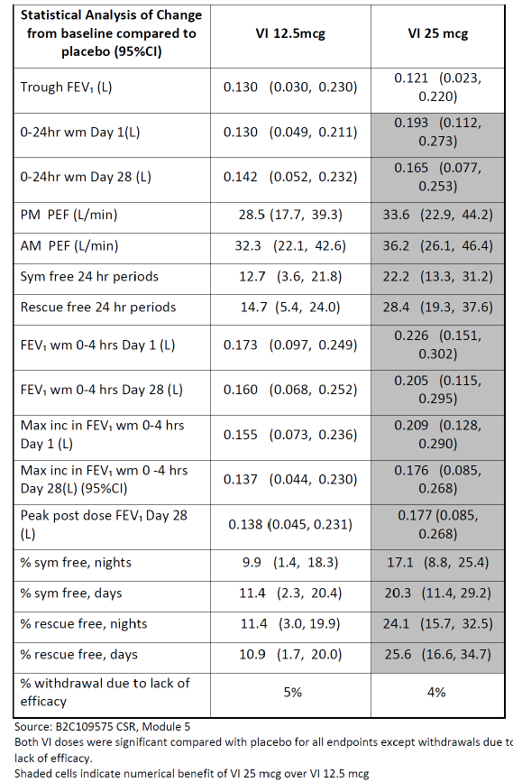
Figure 17. Absolute change from baseline in serial FEV1 (L) 0 to 4 h (ITT Population) Day 1 (tope panel) and Day 28 (bottom panel)
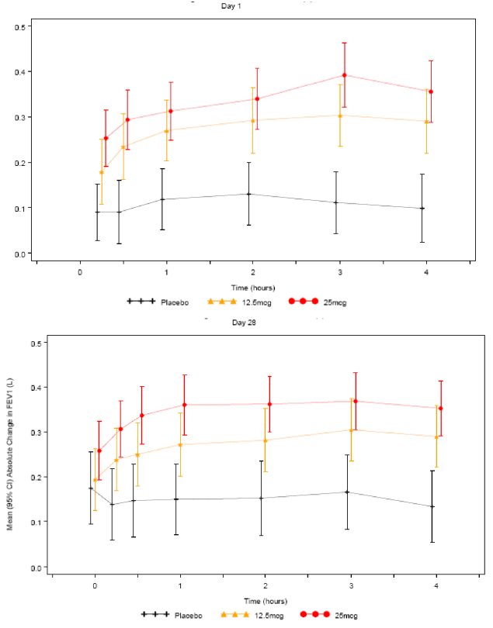
Figure 18. Proportion of subjects obtaining ≥ 200 mL and ≥12% increase from baseline FEV1 (L) 0-24 h
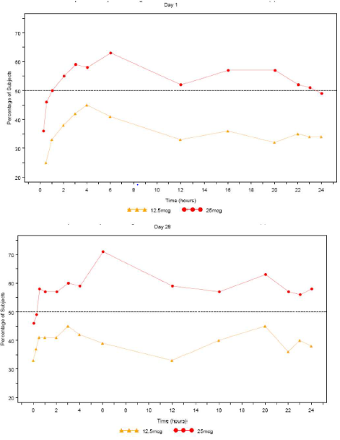
- Results in the Phase III head to head study of FF/VI 100/25 QD versus FP/salm 250/50BD (HZA113091) suggest that the VI dose is conservative and they do not suggest that VI 25 is supratherapeutic. This view was confirmed by the FDA in their briefing document for the Pulmonary Allergy Drugs Advisory Committee Hearing on FF/VI (April 17th, 2013). In HZA113091, examining the profile of FF/VI and Salm/FP over the first 4 h after first dose where neither the FF nor the FP components would be expected to have such an acute effect on FEV1, the initial time curves can be viewed as a comparison of the two LABA components and showed the effect of VI to be similar but not greater than the effect of salmeterol (Figure 19), which indicates a conservative choice of VI dose.
Figure 19. Phase III Study HZA113091. Raw mean change from baseline (95%CI) on FEV1 (L) over time after first dose (ITT).
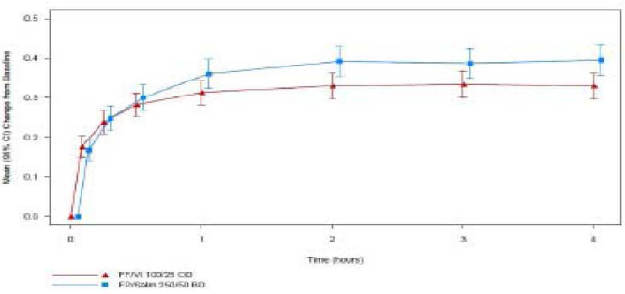
- The TGA’s have asserted that it is likely that patients have been administered a dose that is greater than that actually required and as LABAs may be associated with increased severity of asthma exacerbations in some patients it would be prudent to establish the minimum effective dose in patients with asthma with the option of up-titration if required in individual patients. In response to the above assertion, the sponsors state that from a safety perspective there was no evidence of pharmacologically predictable effects such as an increase in heart rate, blood glucose and effects on blood pressure or potassium levels with the VI 25 dose compared with 12.5 µg in Study B2C109575. GSK has also conducted a large exacerbation study, HZA106837, comparing the effect of FF/VI 100/25 and FF 100 on time to first severe asthma exacerbation and also annual rate of severe exacerbations. This study was set up to determine efficacy and also to assess if there was incremental risk with the addition of VI to FF. The study showed that FF/VI significantly reduced time to first severe exacerbation by 20% (95% CI 2,36; p=0.036) and reduced annual severe exacerbation by 25% (95% CI 5,40; p=0.014) compared to FF alone. SAE narratives for all asthma studies containing a VI or VI + ICS treatment arm were adjudicated by an independent, blinded adjudication committee. A total of 93 subjects had on-treatment SAEs that were adjudicated; of these 22 SAEs were adjudicated as being asthma related. There were no asthma related deaths or intubations on FF/VI. A common odds ratio (OR) was calculated for the asthma composite endpoint (asthma hospitalization, intubation or death) for the treatment comparison of interest. For the analysis of FF/VI all doses versus non-LABA all doses, the common OR was 0.902 (95% CI: 0.345, 2.389) favouring treatment with FF/VI over treatment with non-LABA containing products. The combined risk difference indicates a slight reduction in the risk of asthma related events for subjects receiving any dose of FF/VI; 2.6 subjects have avoided an asthma related event for every 10,000 subjects treated with FF/VI. For the analysis of FF/VI all doses versus ICS all doses, the common OR was 0.890 (95% CI: 0.341, 2.353) favouring treatment with FF/VI over treatment with ICS containing products (Table 44). The combined risk difference indicates a slight reduction in the risk of asthma related events for subjects receiving any dose of FF/VI; 2.8 subjects have avoided an asthma related event for every 10,000 subjects treated with FF/VI (Figure 20). The CI contains 0, implying that the analysis suggests FF/VI does not result in a statistically significant increased risk for an asthma related event.
Table 44. Statistical analysis of Composite Asthma Endpoint (ITT population)
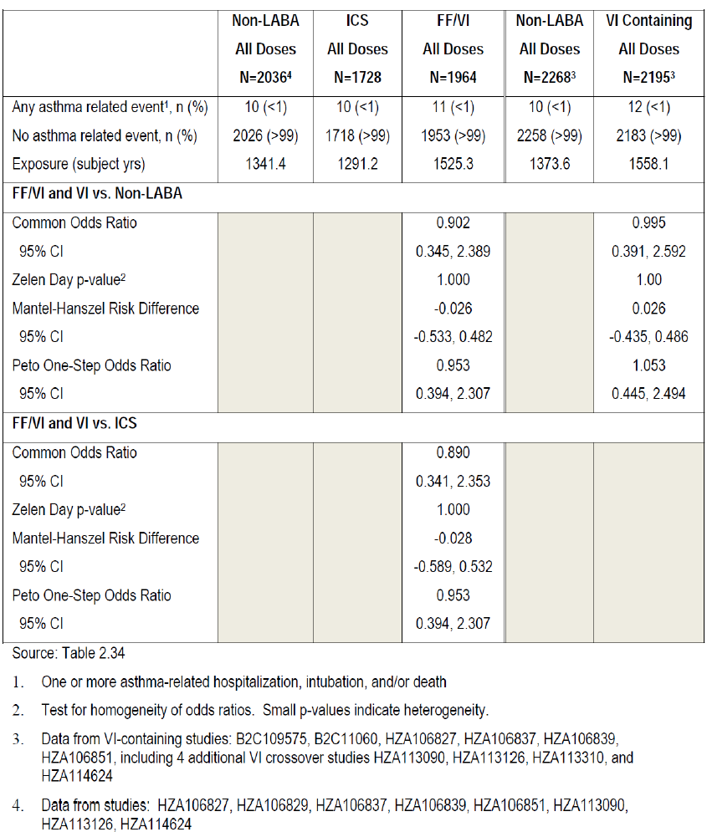
Figure 20. Asthma Composite End point, On-treatment by Study and Overall: FF/VI containing all doses versus ICS All doses
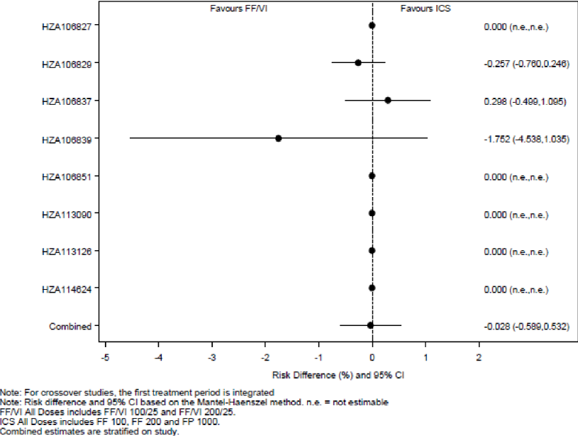

Evaluator’s comments on sponsor’s response
Efficacy in the Phase IIb study B2C109575 was powered to show differences between each dose of VI and placebo for the primary endpoint of through FEV1 (pre bronchodilator and pre-dose) at the end of the 28 day treatment period. Statistically significant improvements in through FEV1 compared with placebo were found for the 12.5 µg, 25 µg and 50 µg VI doses, with mean treatment differences compared with placebo of 130 mL (p=0.011), 121mL (p= 0.016) and 162 mL (p= 0.001), respectively, despite a placebo effect of 147mL versus baseline. For the secondary/other endpoints, statistically significant effects versus placebo were seen at both the 12.5 µg and 25 µg doses for all endpoints except withdrawals due to lack of efficacy (Table 45). The sponsors have stated that the 10 to 15% greater response in secondary efficacy endpoints of symptom-free and rescue-free 24 h periods is clinically relevant (Svedstar, 2013). However, it is important to note that in the referred study (Svedstar), the minimal important difference (MID) in symptom and rescue-free 24 h periods in this preliminary study was determined by interviews with only 15 asthma patients using anchor-based methods in two asthma trials evaluating fluticasone furoate/vilanterol (FF/VI), HZA106827 and HZA106829. Hence, the exclusion of 12.5 µg dose of the LABA-Vilanterol (VI) based on superior efficacy observed for 25 µg in secondary endpoints (% symptom free 24 h and rescue free 24 h Periods) in a Phase II study (B2C109575) is not justified.
Table 45. Phase IIb study B2C109575. Summary of primary/secondary/other efficacy endpoints for VI 12.5 and VI 25 doses
The sponsors argue that the effect of VI 25 µg is similar but not greater than the effect of salmeterol 50 µg in Study HZA113091 following comparison of the FEV profile of FF/VI and Salm/FP as the initial time curves over the first 4 h can be viewed as a comparison of the two LABA components as neither the FF nor the FP components would be expected to have such an acute effect on FEV1 (Figure 21). Although the Phase III study HZA113091 did not show any statistically significant difference in the initial FEV1 time curves over the first 4 h between the proposed FF/VI 100/25 µg OD and twice daily dosing with FP/salmeterol 250/50 µg, interpretation was limited due to the study design which lacked placebo control. Furthermore, non-inferiority testing would have been more appropriate for this study.
Figure 21. Phase III study HZA113091. Raw mean change from baseline (95%CI) in FEV1 (L) over time after first dose (ITT)
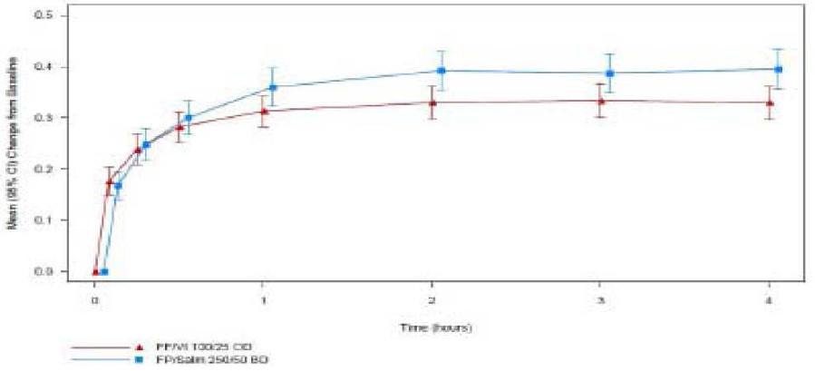
A large exacerbation study, HZA106837 showed that FF/VI (100/25 µg) significantly reduced time to first severe asthma exacerbation by 20% (95% CI 2,36; p=0.036) and reduced annual severe exacerbation by 25% (95% CI 5,40; p=0.014) compared to FF (100 µg) alone. However, interpretation was limited due to wide 95% confidence intervals. Furthermore, the other proposed dose of FF/VI 200/25 was not evaluated in this study. Furthermore, it would have been especially useful to evaluate if a lower dose of VI (12.5 µg) would have offered similar benefits but this was not done. Furthermore, the secondary endpoints of exacerbations leading to hospitalisation (FF/VI 100/25 versus FF 100: 4% versus 5%) and the mean duration of exacerbations (11.1 versus 11.3 days) were similar between treatment groups. The incidence of severe asthma exacerbations in the 7 day post treatment period was low but slightly higher in FF/VI compared with FF alone group (4 versus 1).
SAE narratives for all asthma studies containing a VI or VI + ICS treatment arm were adjudicated by an independent, blinded adjudication committee and a common odds ratio (OR) was calculated for the asthma composite endpoint (asthma hospitalisation, intubation or death) for the treatment comparison of interest. The combined risk difference indicates a slight reduction in the risk of asthma related events for subjects receiving any dose of FF/VI but it is important to note that only 2.8 subjects have avoided an asthma related event for every 10,000 subjects treated with FF/VI. Furthermore, these results are mainly driven by favourable results for FF/VI in the 52 week safety Study HZA106839; the results were favourable for ICS alone compared to FF/VI combination in Study HZA106837 and vice versa in pivotal Study HZA106829, with no difference between FF/VI and ICS alone for all other studies (Figure 22). However, in the 52 week safety Study HZA106839, 12 patients experienced severe asthma exacerbations: 3 in the FF/VI 100/25 group (1%), 6 in the FF/VI 200/25 group (3%), and 3 in the FP group (3%). Hence the supposed benefit of reduction in severe asthma exacerbations is not observed with the FF/VI 200/25 dose which is also proposed for use in asthma.
Figure 22. Asthma composite end point, on-treatment, by study and overall; FF/VI containing all doses versus ICS all doses.

Question 2

Sponsor’s response
FF100 and 200 were selected as the doses for progression into Phase III for use in combination with VI based on the results of three dose ranging studies. Doses lower than 100 µg were not progressed into Phase III as they were not judged to be sufficiently efficacious to use with a LABA. International guidelines stipulate the place of an ICA/LABA as step up therapy for use when a patient is insufficiently controlled on ICS monotherapy. These patients will have more resistant asthma and require correspondingly greater efficacy from the ICS component of the combination therapy.
In the three dose-ranging studies which assessed doses of FF from 25 µg to 800 µg, the lowest dose to demonstrate statistically significant benefit on the primary endpoint of change from baseline in through FEV1 compared to placebo was FF 50. However the effect of FF 50 (129 mL) was approximately half that seen with FF 100 and was less than the 200 mL treatment difference for which the study was powered (Table 46), while both the 100 and 200 µg strengths showed a benefit in excess of the 200 mL. Additional support for not progressing FF 50 to be used in combination with VI comes from the post hoc analysis by baseline lung function in Study FFA109687 which showed FEV1 improvements relative to placebo of 69, 36, 267 and 190 mL with 25, 50, 100 and 200 µg FF doses, respectively (Table 47).
It is important to ensure that the dose of ICS combined with a LABA has adequate efficacy in order to avoid the masking of worsening inflammation by the LABA component. The sponsor believes that both the pre-specified and post-hoc analyses suggest that FF 100 is the lowest minimal effective dose in subjects with moderate persistent asthma and that FF 50 does not constitute an adequate dose of ICS to use in combination with a LABA. However, the sponsor does recognise that different ICS strengths may be appropriate for different severities of asthma and GSK has shared with the TGA that FF 50 was taken into Phase III for use as an ICS monotherapy for patients on SABA only with milder asthma (FEV1 >60% predicted normal). In these studies which have since reported following the original submission, FF50 failed to show replicate efficacy in milder asthma. Consequently, FF 50 is also not being progressed as a strength in the development of FF as a monotherapy.
Table 46. Statistical analysis of change from baseline in trough FEV1 at Week 8 (LOCF) (FFA 109685 and FFA109687, ITT population).
Table 47. Statistical analysis of change from baseline in trough FEV1 at Week 8 (LOCF) by asthma severity (ITT population).
In the Phase II studies with FF, significant cortisol suppression was not seen at FF doses lower than 600 µg. Furthermore, there was little difference in the incidence of the most common adverse events between the 50, 100 and 200 µg doses in FFA108687 (Table 48).
Therefore from a safety perspective there were no concerns selecting FF100 and FF200 over FF50 for progression into Phase III.
Table 48. Most common AEs (3% or greater incidence in any treatment group) (FFA109687, ITT population)

Evaluator’s comments on sponsor’s response
Of the 3 FF dose-ranging studies (FFA109684, FFA109685 and FFA109687), FF dose of 50 µg was only evaluated in study FFA109687 (which evaluated doses of 25, 50, 100 and 200 µg); study FFA109684 only evaluated FF doses of 200, 400, 600 and 800 µg while study FFA109685 evaluated FF doses of 100, 200, 300 and 400 µg. Hence, 2 of the 3 dose-ranging studies only evaluated FF doses in the flat part of the dose-response curve. In study FFA109687, the primary endpoint of trough FEV1 showed numerically greater improvement with 200 µg FF compared to 50 µg with placebo-subtracted difference of 101, 129, 204 and 230 mL with 25, 50, 100 and 200 µg FF, respectively (Table 49). However, all the secondary endpoints of change from baseline in PM PEF (Table 50), AM PEF (Table 50), percentage of symptom-free 24 h periods (Table 51), rescue-free 24 h periods (Table 52) and withdrawals due to lack of efficacy (Table 53) were numerically similar or worse in the 200 µg FF group compared with the 50 µg FF dose group. Overall, results of the primary and secondary efficacy endpoints from study FFA109687 indicated the selection of FF 50 µg as the lowest effective dose to progress to Phase III studies and this was also mentioned in the CSR of this study submitted by the sponsors. It is interesting to note that the sponsors have stated that ‘Dose selection should be based on collective evidence across all endpoints rather than relying on a single endpoint’ while justifying their decision to not evaluate the 12.5 µg dose of VI, but have not considered the same for the FF dose selection.
The sponsor has recognised that different ICS strengths may be appropriate for different severities of asthma and states that FF 50 was taken into Phase III for use as an ICS monotherapy for patients on SABA only with milder asthma (FEV1 >60% predicted normal). In these studies which have since reported following the original submission, FF50 failed to show replicate efficacy in milder asthma. The evaluators cannot comment on results of this study as the sponsors did not submit this study for evaluation as part of the S31 response. Hence, the issue of lack of evaluation of 50 µg FF in Phase III asthma studies has not been clarified adequately.
Table 49. Statistical analysis of change from baseline in trough FEV1 at Week 8 (LOCF)-FFA109687 ITT population and Linear trend test of change from baseline in trough FEV1-FFA109687 ITT population
Table 50. Statistical analysis of change from baseline in PM PEF (L/min)-FFA109687 ITT population and Statistical analysis of change from baseline in AM PEF (L/min)-FFA109687 ITT population
Table 51. Statistical analysis of change from baseline in percentage of symptom free 24 h periods-FFA109687 ITT population
Table 52. Statistical analysis of change from baseline in percentage of rescue free 24 h periods-FFA109687 ITT population
Table 53. Statistical analysis of withdrawals due to lack of efficacy

Question 3

Sponsor’s response
The sponsors have acknowledged that the FF/VI asthma Phase III program did not include a step up design. However, patient populations recruited into two of the three pivotal studies differed in terms of baseline medication. In HZA106827, which assessed the 100/25 strength, patients were required to be uncontrolled on low to mid dose ICS or low dose ICS/LABA. In HZ106829, which assessed the higher strength of 200/25 patients were required to be uncontrolled on high dose ICS or mid dose ICS/LABA. Thus, the strength of FF/VI which patients would receive will be based on their baseline medication. To facilitate initiation of combination therapy, the company proposes a table of recommended doses for inclusion in the Dosage and Administration section of the PIGSK believes the data support approval of both the FF/VI 100/25 and 200/25 strengths.
The lower strength of FF 50 was not studied as part of the FF/VI combination in Phase III since GSK believes that FF 100 is the minimally effective dose in moderate asthma (as discussed in sponsor’s response to Question 2 above).
FF 200 was developed in combination with VI as asthma guidelines [GINA, National Asthma Council (NAC) Australia] and prescribers support multiple doses of ICS and ICS/LABA combination products to ensure that strengths to treat different severities of asthma are available. In Phase II, there was evidence of a greater benefit of FF 200 compared to FF 100 especially in a post hoc analysis by baseline FEV1 (see response to Question 2 above).
Additionally, in a new Phase III study with FF monotherapy, which has reported since the original submission, patients treated with FF 200 had a 77 mL benefit in through FEV1 and were 42% more likely to be well controlled compared to patients treated with FF 100; the treatment difference in patients uncontrolled on high dose ICS at baseline was 132mL (-0.124, 0.388).
The higher dose of FF/VI was not evaluated in HZA106837 as the objective of that study was to assess the incremental benefit and risk of adding VI to FF. However, both FF/VI 100/25 and 200/25 were included in the long term safety study, HZA106839. In this study, there was minimal incremental risk with FF/VI 200/25 over 100/25 with regard to adverse events of special interest related to ICS use.
GSK has conducted additional data analyses to understand the risk of pneumonia with FF/VI including a comparison to the risk with other ICS/LABAs, namely fluticasonepropionate/salmeterol (FP/salm). In order to comprehensively evaluate the pneumonia risk, the sponsor has analysed 17 studies (14 of which were included in the original submission to the TGA plus three additional FF monotherapy studies which have since reported). GSK believes it is important to include the additional FF monotherapy studies as they provide additional information for the FF 200 strength and placebo and thereby facilitate understanding the risk with the higher strength, as highlighted by the TGA. Data is presented for FF, FF/VI and also for the FP groups that were included as comparator groups in the FF/VI and FF program.
The integrated analysis was performed of all FF/VI asthma studies regardless of duration and patient population. Pneumonia, as an adverse event of special interest, was defined by a set of MedDRA terms (Table 54) that were considered to be associated with an infectious aetiology. To maximise the information, available data is also presented for all FF 100 containing (FF 100 and FF/VI 100/25) arms combined, all FF 200, all FP 100 BD, all FP 250 BD and all FP 500 BD containing arms combined. The number of pneumonia events (ranging from 0.2% in placebo to 1.1% in FF/VI 200/25 group) and all serious pneumonia events (0 to 0.3%) were low in all treatment groups. Although there were some numerical differences across treatment groups, the 95% CIs for both incidence and exposure adjusted incidence were wide, showing the variability of the data for this low frequency event. The 95% CIs overlapped for all treatment groups including placebo (Table 55).
Table 54. MedDRA preferred terms
Table 55. Summary pf Pneumonia AEs (17 asthma study integration)
A similar integration was also performed for all FP/salm asthma studies using the same MedDRA terms to help put the data seen with FF/VI into context. The FP/salm integration included all parallel group, controlled trials of ≥ 4 weeks duration that included a licensed dose of FP/salm in the EU for the treatment of asthma (not in combination with another drug) and included a non-FP/salm (or non-salmeterol + FP) comparator arm, in asthma subjects aged ≥12 years. The incidence of pneumonia in asthma was low in all treatment groups in both the FF/VI and the FP/salm integrated data sets. In the asthma program, the incidence of pneumonia for FF containing (that is, FF and FF/VI) groups was within the same range of incidences seen with other ICS. Importantly, the highest incidence seen in the FF/VI 200/25 group (18.4 subjects with an event per 1000 patient years) was very similar to the highest incidence (19.7 patients with an event per 1000 patient years) seen in FP/salm 250/50 BD group in the integration of the FP/salm studies (Table 56).
Table 56. Summary of Pneumonia AEs in Asthma
All FF 200 containing treatment groups showed similar incidences to that published for budesonide and FP. A published large meta-analysis of studies with placebo, budesonide and fluticasone propionate has demonstrated similar rates of pneumonia to those identified in the FF development program (19.8 per 1000 patient years across all studies, 18.1 and 17.1 per 1,000 patient years across subset of studies with both inhaled corticosteroids, respectively) [O'Byrne 2011].While, an increased incidence of pneumonia with higher doses of ICS cannot be ruled out the absolute risk of pneumonia with FF-mono appears to be very small and consistent with other ICS.
The overall data in subjects with asthma from both direct and indirect comparisons suggests that the incidence of pneumonia for FF/VI is similar to the incidence observed following treatment with a marketed ICS/LABA FP/salm. GSK therefore believes the risk of pneumonia with FF/VI 200/25 is not different from other marketed ICS/LABA products and thus should not preclude approval for the FF/VI 200/25 strength. The sponsors conclude that the safety of FF/VI 200/25 as a second strength, particularly considering the risk of pneumonia, does not preclude its use in patients whose disease severity warrant its use. The risk of pneumonia with FF/VI 200/25 is not different from other marketed ICS/LABA products.

Evaluator’s comments on sponsor’s response
Inclusion of the new table in the proposed PI would help address issues regarding transferring patients from other ICS/ LABA therapy to the proposed FF/VI treatment.
The sponsor believes that FF100 is the minimally effective dose in moderate asthma and lower doses 50 µg were not judged to be sufficiently efficacious to use with a LABA. However, of the 3 FF dose ranging studies (FFA109684, FFA109685 and FFA109687), FF dose of 50 µg was only evaluated in study FFA109687 (which evaluated doses of 25, 50, 100 and 200 µg) and results of the primary and secondary efficacy endpoints from this study indicated the selection of FF 50 µg as the lowest effective dose to progress to Phase III studies (refer to evaluators comments to sponsor’s response to Question 2 above). This 50 µg dose of FF was not taken forward in any of the Phase III studies included in the original submission, Although GSK has mentioned that FF 50 was taken into Phase III for use as an ICS monotherapy for patients on SABA only with milder asthma (FEV1 >60% predicted normal). In these studies which have since reported following the original submission, FF50 failed to show replicate efficacy in milder asthma. The sponsors did not submit this data for evaluation by the TGA. Hence, this data should be submitted for review in order to address the issues regarding lack of adequate evaluation of 50 µg FF in Phase III asthma studies.
The sponsors suggest that there is evidence from Phase IIb of improved efficacy with FF 200 compared to FF 100. However, as discussed above, results of the Phase II study FFA109687 showed that the 200 µg dose was numerically better than 100 µg for through FEV1, PM/ AM PEF but failed to show any numerical benefits for other secondary endpoints (Tables 49 to 53).
Overall, results of the primary and secondary efficacy endpoints from Study FFA109687 indicated the selection of FF 50 µg as the lowest effective dose to progress to Phase III studies.
The sponsors need to submit the additional data from a new Phase III study with FF monotherapy, which has been reported since the original submission, in which it is claimed that patients treated with FF 200 had a 77 mL benefit in through FEV1 and were 42% more likely to be well controlled compared to patients treated with FF 100; the treatment difference in patients uncontrolled on high dose ICS at baseline was 132mL (-0.124, 0.388).
In response to the TGA’s question regarding the fact that the higher dose of 200/25 µg was not evaluated in the Phase III study HZA106837, the sponsors mentions that both FF/VI 100/25 and 200/25 were included in the long term safety Study HZA106839 which showed minimal incremental risk with FF/VI 200/25 over 100/25 with regard to adverse events of special interest related to ICS use. However, it was noted that the incidence of cardiovascular AEs (12% and 18% with FF/VI 100/25 and 200/25, respectively) and incidence of asthma exacerbations (1% and 3%, respectively) was numerically higher in the FF200/25 group compared with the FF/VI 100/25 group (Clinical safety, Long term safety study HZA108839). Based on the new analysis of pneumonia events provided by the sponsors, the risk of pneumonia with FF/VI 200/25 does not appear to be different from other marketed ICS/LABA product.
Furthermore, the 200 µg dose of FF was associated with higher incidence of local steroid effects and pneumonia in the safety analysis involving Integrated Asthma clinical studies. For local steroid effects (particularly candidiasis, dysphonia and oropharyngeal pain), the incidence of events (adjusted for exposure) was higher in the FF/VI 200/25 (191.6/1000 subject years) and FF 200 (281.0) groups compared with Placebo (87.8) and the respective lower dose (FF/VI 100/25 =94.3 and FF100= 103.8) groups. The incidence of pneumonia (adjusted for exposure) seen with FF/VI 100/25 and FF 100 (9.6 and 8.0/1000 subject years, respectively) was similar to that seen with placebo (8.0/1000 subject years) but a higher incidence of pneumonia was observed in the FF/VI 200/25 and FF 200 arms (18.4/ and 25.5/1000 subject years, respectively). Due to the above concerns and lack of unequivocal evidence for increased benefit with the 200 µg dose of FF, the evaluators still feel that a lower 50 µg dose of FF should have been evaluated further. Based on the evidence provided in this submission, the 100 and 200 µg doses of FF selected by the sponsors are not justified.

Question 4

Sponsor’s response
In undertaking dose-ranging for VI in COPD, GSK aimed to identify and select a dose at the inflection of the steep part of the FEV1 dose response curve, which also had an acceptable safety profile. Study B2C111045 was powered to detect a 130 mL difference in the point estimate in trough FEV1; a point estimate of 130 mL implies that there is a 50% chance that the treatment effect exceeds 130 mL and a 50% chance that it is below 130 mL. This treatment difference was selected to allow demonstration of an effect size similar in magnitude to that obtained with tiotropium bromide (a long-acting anticholinergic). Furthermore, selection of 130 mL allowed the company to select a dose where the probability of the treatment effect exceeded 100 mL was 80% (assuming an SD of 250 mL) GSK consulted the United States Food and Drug Administration (FDA) regarding the design of the B2C111045 study during the Pre- Investigational New Drug (IND) Application Meeting on 31 January 2007 (with follow-up teleconference on 05 February 2007), prior to initiation of the study on 21 February 2008.
The B2C111045 study demonstrated an increase in through FEV1 with increasing dose. The maximum effective dose was not demonstrated. The greatest efficacy was seen with the 50 µg dose. Based upon the primary and secondary endpoints, as well as the safety profile, 25 µg was considered an appropriate dose to progress in the FF/VI combination for the Phase III COPD Clinical Development Program. Although all VI doses were statistically significantly different from placebo for the primary endpoint of through FEV1, compared with placebo, adjusted mean treatment differences of ≥130 mL (the treatment difference on which the study was powered) were only observed with VI 25 and VI 50 but not with lower doses. Also, a post hoc analysis based on subjects’ reversibility to salbutamol at Screening was conducted to further evaluate the effect of VI, since the COPD population is comprised of reversible and non-reversible subjects. This analysis demonstrated that in the non-reversible population (subjects with FEV1 change after salbutamol of <200 mL or ≥200 mL increase that was <12% from pre salbutamol baseline; 64% of the subjects), only subjects in the VI 25 µg and VI 50 µg groups achieved a clinically relevant 100 mL improvement in adjusted mean change from placebo in trough FEV1 (mean treatment differences compared with placebo of 113 mL [95% CI: 47, 180] and 118 mL [95% CI: 52, 183], respectively). In the VI 12.5 µg group, while subjects in the reversible population demonstrated a clinically meaningful improvement in through FEV1 of 162 mL [95% CI: 76, 249] on Day 29 compared with placebo, in the non-reversible population, the response (77 mL [95% CI: 11, 143]) was less than half of that observed in the reversible population (Figure 23).
Figure 23. Adjusted mean differences (95%CI) from placebo in change from baseline in trough FEV1 (L) at Day 29 in subjects with COPD (ITT population and non-reversible population): VI dose ranging study in COPD (B2C111045).
Furthermore, in addition to the traditional analysis, the probability of each treatment difference
(VI versus placebo) being >100 mL and > 130 mL increase from baseline in through FEV1 on Day 29 was a pre-specified supplemental analysis of the primary endpoint. The value of 100 mL in trough FEV1 was included in this analysis as such an improvement is viewed as clinically meaningful [Cazzola, 2008, Donahue, 2004]. In further support of the 25 and 50 µg doses, this analysis demonstrated that probabilities for a >100 mL increase were more than 90% with both the 25 µg and 50 µg doses, but much lower (<64%) for the 3, 6.25 and 12.5 µg doses (Figure 23). Differences of ≥130 mL (the difference the study was powered on) on Day 29 were observed only with the 25 and 50 µg doses.
In the two, Phase III, 6 month, placebo-controlled, efficacy and safety studies in 2,254 subjects with COPD (HZC112206 and HZC112207), VI 25 µg OD was well-tolerated with a similar safety profile to placebo. The frequencies of any on-treatment AE, AEs leading to study drug discontinuation or withdrawal from the study, serious AEs (SAEs) and fatal events were similar between the VI 25 µg containing groups and the placebo group.

Evaluator’s comments on sponsor’s response
The explanation provided by the sponsors for consideration of VI25 µg only for the Phase III COPD trials is acceptable, especially following results of the post-hoc analysis in patients with non-reversible COPD and increased likelihood of responding with clinically significant improvement in lung function with the 25 µg dose of VI.

Question 5

Sponsor’s response
HZC102970 and HZC102871 are the first dose ranging studies that were conducted with an ICS/LABA combination product to evaluate an effect on exacerbation reduction in subjects with COPD. While the integrated data from both studies demonstrated statistically significant reduction in the annual rate of moderate and severe exacerbations for all three FF/VI strengths compared with VI (23% (95% CI: 12, 34; p<0.001), 27% (95% CI: 16, 37; p<0.001) and 16% (95% CI: 4, 27; p=0.014) for FF/VI 200/25, 100/25 and 50/25, respectively), this was not the case in the individual studies. In HZC102970, all three FF/VI strengths FF/VI 50/25, 100/25 and 200/25 did demonstrate a statistically significant (p≤0.040) and clinically relevant reduction in the annual rate of moderate and severe exacerbations compared to VI 25 (19%, 21%, and 31%; respectively). However, in Study HZC102871, the reduction in the annual rate of moderate and severe exacerbations for FF/VI 50/25, 100/25 and 200/25 was 13%, 34% and 15%, respectively with only the 100/25 dose demonstrating a reduction with a nominal p-value <0.05 (p<0.001). Thus, only the FF/VI 100/25 strength demonstrated a robust treatment effect in both studies (Figure 24).
Figure 24. Treatment differences (95%CI) for the annual rate of moderate and severe COPD exacerbations (ITT population): individual and integrated study results-1 year exacerbation studies (HZC102970 and HZC102871).
The primary endpoint analysis from the 1 year exacerbation studies and selection of the FF/VI 100/25 strength was also supported by the individual and integrated analysis for the secondary endpoints of time to first moderate or severe COPD exacerbation (Figure 25) and annual rate of COPD exacerbations requiring systemic/oral corticosteroids (Figure 26). An examination of the data from the sub-group populations of subjects from the integrated databases, specifically those subjects with less severe COPD (as defined by a milder airflow obstruction or less frequent history of exacerbations) who might benefit from a lower strength of FF/VI and subjects with more severe disease (as defined by a more severe airflow obstruction or by a higher historical exacerbation frequency) who might benefit from a higher strength of FF/VI, also confirmed that the 100/25 dose is the optimal dose. In the non-frequent exacerbators in the year prior to screening, only FF/VI 100/25 µg produced a significant and clinically relevant reduction compared with VI alone (19%; p=0.031) and was almost double the reduction observed with the FF/VI 50/25 dose (10%, p=0.293). In the frequent exacerbator population, all strengths of FF/VI significantly reduced the moderate/severe exacerbation event rate by 21%, 31% and 28% versus VI; however the higher strength 200/25 offered no incremental benefit over the 100/25 strength. Subjects with less severe COPD (FEV1 ≥50% of predicted) treated with lower strength FF/VI 50/25 failed to demonstrate a statistically significant reduction in exacerbations while both the 100/25 and 200/25 strengths demonstrate both a clinically relevant and statistically significant reduction in exacerbations. For the 30%≤FEV1<50% predicted group only the FF/VI 100/25 strength demonstrated a statistically significant and clinically relevant reduction in exacerbations. For subjects with the most severe COPD (FEV1<30% predicted group) all strengths demonstrated statistically significant and clinically relevant reductions in exacerbations with the 100/25 strength demonstrating the highest reduction in exacerbations and no incremental benefit with the 200/25 strength.
Figure 25. Kaplan-Meier plot of time to first on treatment moderate or severe COPD exacerbations (ITT population): integrated study results-1 year exacerbation studies (HZC102970 and HZC102871).
Figure 26. Treatment differences (95%CI) for the annual rate of COPD exacerbations requiring systemic/oral corticosteroids (ITT population):integrated study results-1 year exacerbation studies (HZC102970 and HZC102871).]
Known side effects of corticosteroids were of special interest in the COPD RELVAR program. These included systemic corticosteroid effects, bone disorders, local steroid effects, pneumonia, LRTI, effects on glucose and hypersensitivity. There was an increased incidence of AEs in the local steroid effect special interest group (candidiasis and dysphonia) and in the incidence of pneumonia and bone disorders for the FF/VI groups versus VI alone. There was no indication of increased AE incidence with any of the FF/VI strengths versus VI alone for the other AE special interest groups examined. Importantly, there were no discernible differences in the FF/VI 100/25 group compared with the FF/VI 50/25 group for any event of the special interest group indicating that there is no increased safety risk with the 100/25 strength compared to the 50/25 strength.
The sponsors acknowledge the existence of individual variability and response, however a subpopulation could not be identified that would preferentially benefit from either the lower (50/25) or higher (200/25) FF/VI dose.

Evaluator’s comments on sponsor’s response
The explanation provided by the sponsors for selection of the FF/VI 100/25 µg dose for treatment of COPD is acceptable. The lower dose of FF/VI 50/25 µg did not appear to be effective in patients with less severe disease who may have been candidates for the lower dose, while the higher dose of 200/50 µg did not have provide any additional benefit and was in fact associated with increased safety risks.

Question 6

Sponsor’s response
For COPD: Both GOLD and COPDx do not recommend long-term monotherapy treatment with ICS therefore the lack of availability of FF monotherapy should not present an issue for clinicians treating patients with COPD. However, it is well accepted that an ICS combined with a LABA is more effective than the individual components [GOLD, 2013]. As reduction in exacerbations represents the main symptomatic benefit of the combination, the proposed COPD indication reflects the patient population studied in the 1 year studies and not the broader patient population in the 6 month studies who did not have an exacerbation history. This is consistent with recommendations of treatment guidelines, which recommend inhaled corticosteroid containing products should be used in patients with severe or very severe airflow limitation or patients with frequent exacerbations despite long acting bronchodilators [GOLD, 2013 COPDx 2011].
Although VI monotherapy is not marketed it should be noted that as discussed in Response to Question 4, the improvements observed following treatment with VI are broadly consistent to those observed with other approved long-acting bronchodilators. In three 12 week COPD studies (HZC113107/HZC113109/HZC112352) and one 24 week asthma study (HZA113091), which directly compared FF/VI and Seretide, no statistically or clinically relevant differences were observed in terms of through FEV1 or serial lung function. Since immediate effects on lung function are primarily driven by the beta-agonist and in COPD the contribution of the corticosteroid in terms of improving lung function is limited this suggests that the bronchodilatory effects of salmeterol 50 µg bd and vilanterol 25 µg OD are comparable.
The effect of VI on exacerbation rates is also very similar to the effect of salmeterol on exacerbation rates in two SERETIDE 250/50 studies SCO40043/SC0100250 (Anzueto, 2009; Ferguson, 2008) which are identical in design to the two 1 year studies HZC102970/HZC102871). In the pooled data from SCO40043/SCO100250, the annual rate of moderate and severe exacerbations in patients treated with salmeterol was 1.58 which is higher than the annual rate of moderate and severe exacerbations in the VI group in the pooled data from HZC102970/HZC102871 suggests VI monotherapy is at least as effective as a marketed long-acting bronchodilator in reducing exacerbations.
Together these data suggest the effect of vilanterol 25 µg administered once daily is comparable to well established long acting beta-2- agonists and muscarinic antagonists. The sponsor contends that FF/VI 100/25 is an appropriate treatment for any COPD patient who exacerbates despite treatment with long-acting bronchodilators. Nevertheless, the sponsor recognises that the ICS/LABAs are not intended to be used as first line therapy and therefore proposes to modify the indication as follows:
‘Relvar is indicated for the symptomatic treatment of patients with COPD, with a FEV1 <70% predicted normal (post-bronchodilator) and an exacerbations history despite regular bronchodilator therapy.’
For Asthma: Inhaled corticosteroids are considered the most effective anti-inflammatory treatment for all severities of persistent asthma [GINA, 2011]. Treatment with ICS controls asthma symptoms, improves quality of life and lung function, decreases airway.
Hyper responsiveness, controls airway inflammation, and reduces the frequency and severity of asthma exacerbations, thereby reducing asthma morbidity and mortality. The dose of ICS is selected based on the severity of the patient’s asthma. However, add-on therapy with another controller, in particular inhaled LABA, is preferred to increasing the dose of ICS to achieve asthma control. The addition of a LABA to an ICS improves symptom scores, decreases nocturnal asthma symptoms, improves lung function and reduces the number of asthma exacerbations [Ducharme, 2010]. Inhaled LABA therapy may be associated with increased risk of serious asthma related events (including hospitalisation, intubation and death) and so should not be used as monotherapy in asthma [GINA, 2011], therefore lack of availability of VI monotherapy should not present an issue for clinicians treating patients with asthma.[information redacted] The subject populations for the Phase III studies were chosen to be representative of the intended patient population for an ICS/LABA combination based on subjects having asthma not controlled on ICS alone or on ICS/LABA combinations. Subjects recruited to HZA106827 were uncontrolled on low dose ICS/LABA or low to mid dose ICS alone (Table 57) whereas subjects recruited to HZA106829 were uncontrolled on mid dose ICS/LABA or high dose ICS alone (Table 58).
Table 57. ICS and ICS/LABA dosage table
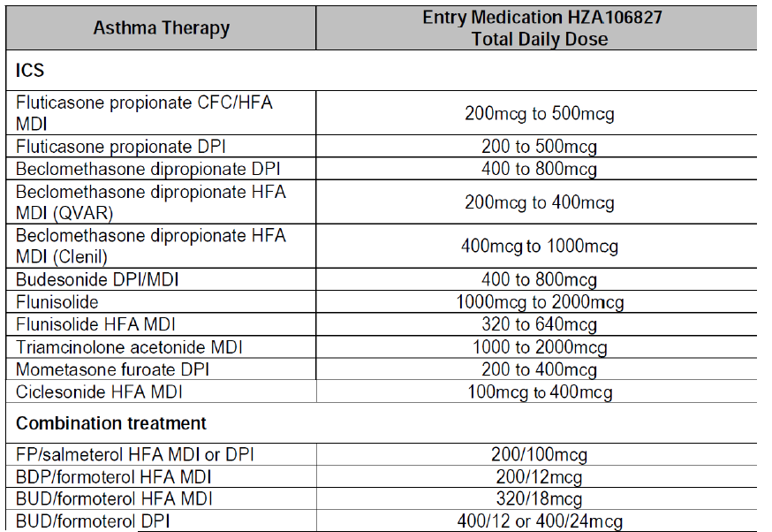
Table 57 continued. Summary of ICS usage Pre-treatment (ITT population)
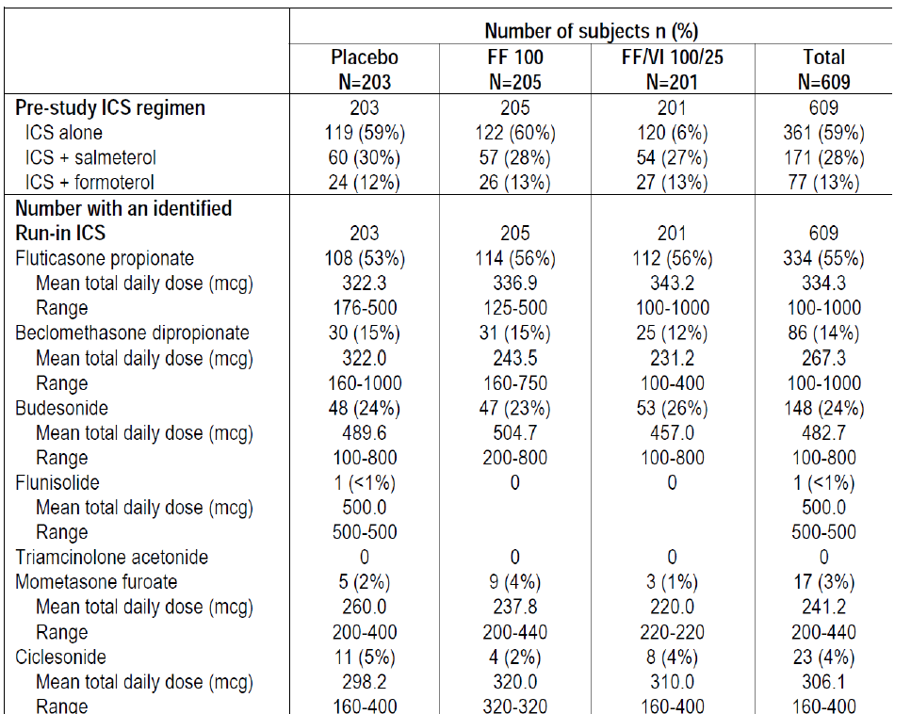
Table 58. ICS and ICS/LABA dosage table
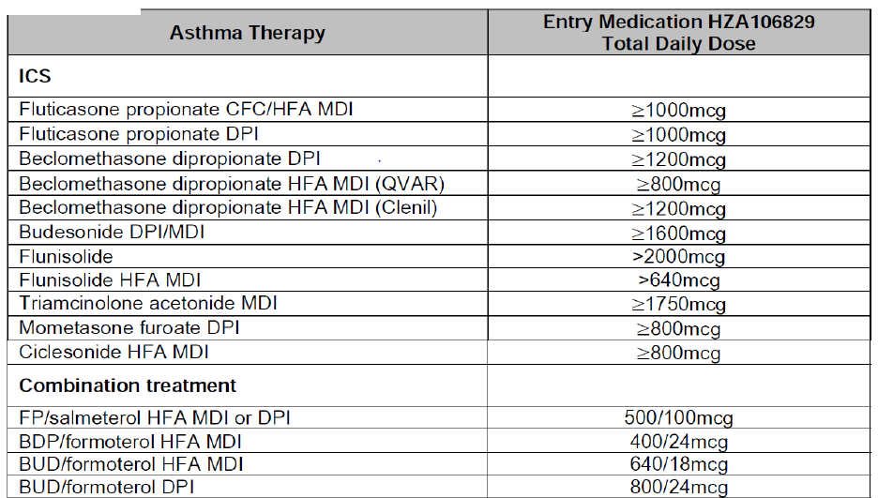
Table 58 continued. Pre-study and run-in ICS medications (HZA106829, ITT population).
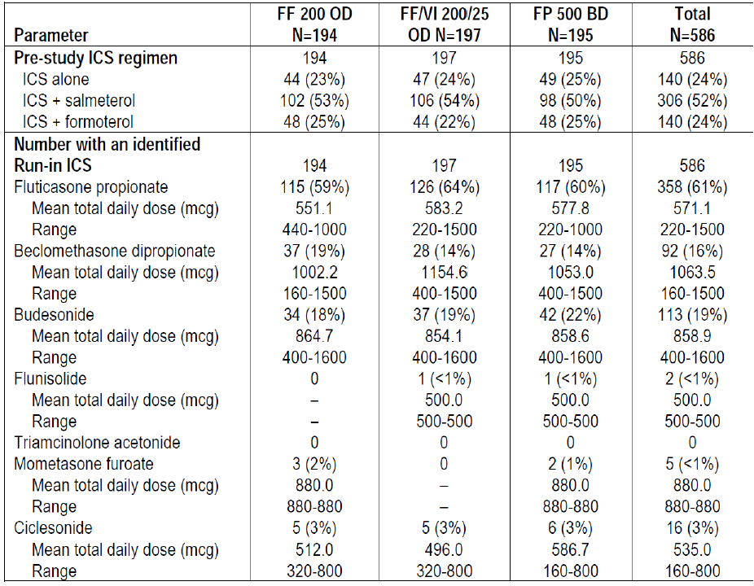
The data from Studies HZA106827/HZA106829 indicate that the efficacy of FF 100 OD daily is not different from FP 250 BD and FF 200 OD is non-inferior to FP 500 BD. This is further supported by study HZA113091 in asthma subjects that compared FF/VI 100/25 once daily with FP/salmeterol 250/50 twice daily over 24 weeks and showed no significant difference between treatments on lung function or symptomatic endpoints. This suggests that clinicians can view the dose of FF as equivalent to 5X the total daily fluticasone propionate dose for asthma patients.
To facilitate initiation of combination therapy the company proposes to add a table to the prescribing information which has been devised based on the doses of prior therapies which were permitted in HZA106827/HZA106829 as well as the evidence of comparability to marketed products described above.

Evaluator’s comments on sponsor’s response
The explanation given by sponsors for treatment of COPD and the change to the proposed indication for treatment of COPD are acceptable with a minor change.
‘Relvar is indicated for the symptomatic treatment of patients with COPD, with a FEV1 <70% predicted normal (post-bronchodilator) and history of exacerbations despite regular bronchodilator therapy.’
The proposed new table in the PI would help provide some guidelines to clinicians on dosing for treatment of asthma. However, this is not enough to overcome the reservations the evaluators have regarding the overall benefit-risk profile of Relvar Ellipta for treatment of asthma (as discussed in Second round assessment of benefit-risks balance).

Second round benefit-risk assessment

Second round assessment of benefits

Asthma
After consideration of responses to clinical questions, the benefits of FF/VI (100/25 and 200/25 µg) in the proposed usage for treatment of asthma are:
- Once daily treatment with a LABA/ICS combination would potentially improve treatment compliance Although this could not be ascertained in the clinical studies. The currently available LABA/ICS combinations need to be administered twice daily.
- The proposed doses of FF/VI 100/25 and 200/25 provided greater benefit in terms of improvement in lung function parameters of through FEV1, weighted mean FEV1 (0 to 24h), AM and PM PEF than FF alone in two out of three pivotal Phase III studies (HZA106829 and HZA106837) where this was measured, thus demonstrating the contribution of VI to the combination. FF/VI 100/25 and 200/25 were also significantly better than the equivalent dose of FF monotherapy in improving symptomatic endpoints including 24 h rescue-free/ symptom-free periods, time to first severe exacerbation and severe exacerbation rate. The contribution of FF to the efficacy of the FDC was shown by assessing the efficacy and safety of FF relative to placebo in the Phase III studies and also in an allergen-challenge Phase II study HZA113126 where FF/VI was significantly better than VI alone in terms of attenuating the early and late phase asthmatic response and also the increased bronchial hyper-responsiveness (BHR) associated with allergen challenge.
- At therapeutic doses of FF/VI, no safety signals have been observed for increased incidence of severe asthma exacerbations, adrenal suppression, bone disorders, QT interval prolongation, myocardial ischemia, or metabolic, neurologic, or ocular effects based on results of clinical program to date. Safety observations are in line with the expected drug class profiles in the populations studied and no new risks have been identified.

COPD
After consideration of responses to clinical questions, the benefits of FF/VI 100/25 µg OD in the proposed usage for treatment of COPD are:
- Once daily treatment with a LABA/ICS combination would potentially improve treatment compliance. Although this could not be ascertained in the clinical studies due to study designs. The currently available LABA/ICS combinations used for treatment of COPD require twice daily administration.
In the two pivotal 6 month studies, the proposed dose of FF/VI 100/25 µg OD showed statistically significant and clinically meaningful improvements in lung function after 24 weeks of treatment with increased adjusted mean through FEV1 [difference from placebo was 129mL and 83 mL with FF/VI 100/25 and VI 25, respectively; FF/VI 100/25–VI 25= 46 mL; 95% CI: 8, 83mL, p= 0.017] and adjusted weighted mean peak FEV1 (0 to 4 h) [difference from placebo was 193mL and 145, respectively; FF/VI 100/25-VI 25= 148 ml; 95% CI: 112, 184mL, p< 0.001]. Patients treated with the proposed FF/VI 100 /25 µg also had significantly better dyspnoea scores (Although not clinically relevant), had less cough and sputum, required significantly less rescue medication as measured by number of occasions of rescue salbutamol use (per 24 h period) and number of night time awakenings requiring salbutamol (per 24 h period) compared to placebo.
- The 24 h bronchodilator effect of FF/VI was maintained from the first dose throughout a one-year treatment period with no evidence of loss in efficacy.
- The data from the pivotal Phase III, 52-week studies demonstrated that FF provides a significant contribution to the FF/VI combination. In particular, compared with VI 25 OD alone, treatment with FF/VI 100/25 OD consistently reduced the annual rate of moderate and severe COPD exacerbations, time to exacerbations, rate of exacerbations requiring systemic corticosteroid use and also showed minor improvements in lung function (trough FEV1).
- Overall, safety of proposed dose of FF/VI 100/25 µg was evaluated in adequate number of COPD patients for treatment durations up to 1 year and was representative of the target patient population for the proposed combination. The safety profile of proposed FDC of FF/VI 100/25 µg OD was consistent with the expected AEs usually associated with LABA/ICS combination, that is, most frequent AEs were beta-adrenergic agonist AEs or local steroid effects.

Second round assessment of risks

Asthma
After consideration of responses to clinical questions, the risks of FF/VI (100/25 and 200/25 µg) in the proposed usage for treatment of asthma are:
- In the PK-PD studies, dose proportionality of FF and VI was not evaluated over a wide range of doses and in fact the starting dose in the PK studies was 100-200 µg for FF and >25 µg for VI.
- The FDC guidelines state that rationale for a FDC development is either FDC shows better efficacy than mono components taken together or lower doses of actives given as FDC offer better risk benefit ratio. There were no studies which assessed the clinical equivalence of proposed FDC of FF/VI with concurrent therapy with FF and VI.
- The doses of the ICS (FF) and LABA (VI) selected for the FDC were based on the dose ranging mono component Phase II studies and no dose-ranging studies were conducted with the proposed combination inhaler (FF/VI). Exclusion of 12.5 µg dose of the LABA Vilanterol (VI) based on superior efficacy observed for 25 µg in secondary endpoints (% symptom free 24 h and rescue free 24 h periods) in a Phase II study (B2C109575) is not justified. The study was not powered to show a difference in these endpoints. LABAs may be associated with increased severity of asthma exacerbations in some patients and hence it would be prudent to establish the minimum effective dose in patients with asthma with the option of up-titration if required in individual patients. Dose-ranging studies for FF showed efficacy in the range of 50 to 200µg but the dose of 50 µg was not evaluated in the Phase III asthma studies.
- Evidence for contribution of the VI component to the FDC (FF/VI) was not unequivocal. The pivotal Phase III study HZA106827 (which recruited subjects uncontrolled on low/mid dose ICS or on low dose ICS/LABA) failed to demonstrate statistically significant difference between the two active treatments (FF/VI 100/25 and FF 100 alone) for the co-primary endpoints of through FEV1 and weighted FEV1 (0 to 24h). As statistical significance was not achieved for all treatment comparisons in the first level of Hierarchy (there was no statistical significant difference between FF/VI and FF for the co-primary endpoints), the significant differences in FF/VI 100/25 compared with FF 100 for the powered secondary endpoint of percentage of rescue-free/ symptom-free 24 h periods, AM and PM PEF should be interpreted as descriptive only.
- The pivotal Study HZA106829 (which recruited subjects uncontrolled on high dose ICS or on mid dose ICS/LABA) showed statistically significant improvements with FF/VI 200/25 µg compared with FF 200 alone in co-primary [trough FEV1 and weighted FEV1 (0 to 24h)] and secondary endpoints (percentage of rescue-free/ symptom-free 24 h periods and AM/PM-PEF) at the end of 24 weeks of treatment. However, a sensitivity analyses (excluding data from an investigator in the USA because of GCP issues) of the co-primary endpoint of weighted mean FEV1 (0 to 24 h) was not consistent with the ITT analysis results and failed to show statistically significant difference between FF/VI and FF200 groups Although results were consistent with ITT analysis for through FEV1 and other secondary endpoints.
- Safety issues with use of FF/VI for treatment of asthma include local steroid effects, systemic corticosteroid effects including effect on growth, bones in adolescents (Although this is being addressed by ongoing studies), cardiovascular effects and pneumonia. The incidence of pneumonia (adjusted for exposure) seen with FF/VI 100/25 and FF 100 (9.6 and 8.0/1000 subject years, respectively) was similar to that seen with placebo (8.0/1000 subject years).Although a higher incidence of pneumonia was observed in the FF/VI 200/25 and FF 200 arms (18.4/ and 25.5/1000 subject years, respectively).
- A large exacerbation study, HZA106837 showed that FF/VI (100/25 µg) significantly reduced time to first severe exacerbation by 20% (95% CI 2,36; p=0.036) and reduced annual severe exacerbation by 25% (95% CI 5,40; p=0.014) compared to FF (100 µg) alone but the other proposed dose of FF/VI 200/25 was not evaluated in this study; it would have been especially useful to evaluate if a lower dose of VI (12.5 µg) would have offered similar benefits but this was not done. Furthermore, the secondary endpoints of exacerbations leading to hospitalization (FF/VI 100/25 versus FF 100: 4% versus 5%) and the mean duration of exacerbations (11.1 versus 11.3 days) were similar between treatment groups. Furthermore, the incidence of severe asthma exacerbations in the 7 day post treatment period was low but slightly higher in FF/VI compared with FF alone group (4 versus 1).
- Long-acting beta2-adrenergic agonists (LABA) such as vilanterol, one of the active ingredients in RELVAR ELLIPTA, increase the risk of asthma related death. A placebo controlled trial with another LABA (salmeterol) showed an increase in asthma related deaths in subjects receiving salmeterol. This finding with salmeterol is considered a class effect of all LABA, including vilanterol. An analysis of asthma related serious events (deaths, hospitalisations and intubations) was done for all asthma studies containing a VI or VI+ICS treatment arm showed a slight reduction in the risk of asthma related events for patients receiving any dose of FF/VI compared to non-LABA (all doses) or ICS (all doses). However, the risk reduction was quite minimal as only 2.6 to 2.8 patients avoided an asthma related event for every 10,000 patients treated with FF/VI. Overall, evidence for safety of the proposed doses of FF/VI (100/25 and 200/25 µg) in treatment of asthma is not conclusive.

COPD
After consideration of responses to clinical questions, the risks of FF/VI (100/25 µg) in the proposed usage for treatment of COPD are:
- In the COPD clinical program, most frequent AEs were beta-adrenergic agonist AEs or local steroid effects. There was a higher incidence of pneumonias (including serious and fatal pneumonias) in subjects treated with FF/VI. However, the incidence of pneumonia appeared to be more common in patients with risk factors [current smokers, patients with a history of prior pneumonia, patients with a body mass index <25 kg/m2 and patients with a FEV1<50% predicted] which have been included in the proposed labelling. It is also reassuring to see that most of these serious AEs of pneumonia were more common in patients treated with FF/VI 200/25 µg which is not the proposed dose for COPD.

Second round assessment of benefit-risk balance

Asthma
The purpose of this application is to obtain marketing approval for the use of FF/VI (100/25 and 200/25 µg OD by oral inhalation) administered once daily for the regular treatment of asthma in adults and adolescents aged 12 years and older, where use of a combination product (long-acting beta-2-agonist and inhaled corticosteroid) is appropriate; asthma patients who are symptomatic with inhaled corticosteroids and 'as needed' inhaled short acting beta-2-agonist or patients already on both an inhaled corticosteroid and a long-acting beta-2-agonist.
Fixed Dose Combinations of ICS and LABA are well accepted and recommended treatments for asthma [Global Initiative for Asthma (GINA), 2011]. Current ICS/LABA combinations, including fluticasone propionate (FP)/salmeterol, beclomethasone/formoterol and budesonide/formoterol, need to be administered twice daily. Hence one of the potential benefits with the proposed ICS/LABA combination of FF/VI is improved treatment compliance due to its once daily dosing regimen. However, the Phase III clinical development program for FF/VI was conducted double-blind and where necessary, double-dummy conditions, confounding the assessment of compliance. As a result, the question of whether once-daily FF/VI represents a true patient benefit requires further investigation.
Evidence for contribution of the LABA (Vilanterol) component to the FDC (FF/VI) was not unequivocal. The pivotal Phase III Study HZA106827 failed to show statistically significant difference between FF/VI 100/25 and FF 100 alone for both co-primary endpoints (trough FEV1 at end of study and weighted FEV1 (0 to 24h) limiting interpretation and validity of the significant differences observed between FF/VI and FF for the secondary endpoints of percentage of rescue-free/symptom-free 24 h periods, AM and PM PEF. The Phase III pivotal study HZA106829, at the end of 24 weeks of treatment, FF/VI 200/25 significantly improved the co primary endpoints [trough FEV1 and weighted mean FEV1 (0 to 24 h)] and the secondary end points (percentage of rescue-free/ symptom-free 24 h periods, AM and PM PEF) compared with FF 200 alone. However, these results were not robust and conclusive as the sensitivity analysis for the co-primary endpoint of weighted mean FEV1 (0 to 24 h) was not consistent with the ITT analysis results.
Another limitation of this submission relates to inadequate evaluation of a wide range of doses of FF and VI in the PK-PD or the Phase II dose-ranging studies. No dose-ranging studies were done with the proposed combination product in asthma and dose–response information was mainly obtained from studies using FF alone or VI alone. Majority of doses evaluated seemed to lie within the flat part of the dose-response curve and hence it is likely that a much higher dose than required was evaluated in the pivotal Phase III studies. The minimum effective dose of VI was not established and only one dose of VI (25 µg OD) was carried forward to the Phase III studies. FF dose of 50 µg was also not evaluated especially considering that asthma patients tend to be younger including adolescents and the known risks of long-term steroid therapy.
A major safety concern with vilanterol is linked to the selection of an appropriate dose, because beta-2 adrenergic bronchodilators, particularly at high doses, have the safety concerns of severe asthma exacerbations and asthma related deaths in patients who use these drugs to treat the symptoms of asthma. Long-acting beta2-adrenergic agonists (LABA) such as vilanterol, one of the active ingredients in Relvar Ellipta, increase the risk of asthma related death. A placebo-controlled trial with another LABA (salmeterol) showed an increase in asthma related deaths in subjects receiving salmeterol. A 28 week, placebo controlled US study comparing the safety of salmeterol with placebo, each added to usual asthma therapy, showed an increase in asthma related deaths in patients receiving salmeterol (13/13,176 in patients treated with salmeterol versus 3/13,179 in patients treated with placebo; RR 4.37, 95% CI 1.25, 15.34). This finding with salmeterol is considered a class effect of the LABA, including vilanterol, one of the active ingredients in Relvar Ellipta. No study adequate to determine whether the rate of asthma related death is increased with Relvar Ellipta has been conducted. Overall, evidence for safety of FF/VI in treatment of asthma is not conclusive.
There were no studies which assessed the clinical equivalence of proposed FDC of FF/VI with concurrent therapy with FF and VI. The individual components of the FDC are not to be registered for use in asthma although the sponsor has mentioned to the TGA that there are some data on FF monotherapy for treatment of asthma. The above limitations of the proposed FF/VI formulation may have been acceptable if the proposed drug was of major therapeutic benefit for which no other alternative treatments are available. Since that is not the case with this ICS/LABA formulation, the benefit-risk balance of Relvar Ellipta (FF/VI 100/25 and 200/25 µg OD) given the proposed usage for treatment of asthma is unfavourable.

Treatment of COPD
The sponsor is also seeking marketing approval of FF/VI 100/25 µg OD for the modified indication of:
‘Relvar is indicated for the symptomatic treatment of patients with COPD, with a
FEV1 <70% predicted normal (post-bronchodilator) and history of exacerbations despite regular bronchodilator therapy.’
Fixed Dose Combinations of ICS and LABA are well-accepted and recommended treatments for COPD [Global Initiative for Chronic Obstructive Lung Disease (GOLD), 2011]. Current ICS/LABA combinations, including fluticasone propionate (FP)/salmeterol, beclomethasone/formoterol and budesonide/formoterol, need to be administered twice daily. Hence one of the potential benefits with the proposed ICS/LABA combination of FF/VI is improved treatment compliance due to its once daily dosing regimen. However, the Phase III clinical development program for FF/VI was conducted under double-blind, and where necessary, double-dummy conditions, confounding the assessment of compliance. As a result, the question of whether once-daily FF/VI represents a true patient benefit requires further investigation.
Dose-ranging studies for the proposed FF/VI FDC were conducted in both COPD and asthma patients. The regulatory precedence of performing dose ranging and dose regimen studies for bronchodilators in asthma patients has been established in order to demonstrate a large separation between doses, because the range of response is greatest in a bronchoresponsive population, such as patients with asthma. A COPD population, with some degree of fixed obstruction, has a smaller response range to a bronchodilator. The regulatory precedence of performing dose ranging and dose regimen studies in patients with asthma was followed in the development of indacaterol, a LABA that was approved for marketing in the United States in 2011 as a bronchodilator in patients with COPD.
The COPD efficacy data showed contribution of each component present in the proposed ICS LABA FDC (Relvar Ellipta) and also showed that the FDC (FF/VI) provides a clinically meaningful benefit over each single ingredient present in the combination (FF and VI). FF/VI showed benefit over fluticasone furoate alone in lung function, and a benefit over vilanterol alone in COPD exacerbations.
The benefit vilanterol provides to the combination FF/VI product is demonstrated through a comparison of FF/VI 100/25 to FF 100 in the two 24 week lung function trials (2206 and 2207).
In both trials, FF/VI 100/25 demonstrated a statistically significant improvement in FEV1 0 to 4 h compared to FF 100 monotherapy. The efficacy of the VI mono component is also demonstrated in the same 24 week lung function trials through a comparison of VI to placebo.
Both trials demonstrate a statistically significant improvement for VI compared to placebo.
The benefit FF provides to the combination product is demonstrated by the comparison of FF/VI 100/25 to VI 25 in the exacerbation trials and lung function trials. A statistically significant improvement in the annual rate of exacerbation for FF/VI 100/25 compared to VI 25 is seen in one of the 52 week exacerbation trials with the other trial demonstrating a numerical improvement with a nominal p-value <0.05. While the second trial demonstrated a similar treatment effect, the improvement was not statistically significant based on the statistical hierarchical testing procedure. In addition to the exacerbation data, a consistent numeric improvement in through FEV1 is demonstrated for FF/VI 100/25 compared to VI 25 monotherapy in both 24 week lung function trials as well as in the two 52-week exacerbation trials. The data do not support an efficacy advantage for doses higher than FF/VI 100/25 in terms of exacerbations or lung function.
In the COPD clinical program, most frequent AEs were beta-adrenergic agonist AEs or local steroid effects. In terms of risk, the common adverse event profile for FF/VI in COPD is similar to other ICS/LABA products in COPD. In terms of serious events, an increase in FF dose-related risk for pneumonia was seen in the FF/VI development program. There was a higher incidence of pneumonias (including serious and fatal pneumonias) in subjects treated with FF/VI.
However, the incidence of pneumonia appeared to be more common in patients with risk factors [current smokers, patients with a history of prior pneumonia, patients with a body mass index <25 kg/m2 and patients with a FEV1<50% predicted] which have been included in the proposed labelling. It is also reassuring to see that most of these serious AEs of pneumonia were more common in patients treated with FF/VI 200/25 µg which is not the proposed dose for COPD. Pneumonia has been seen in other ICS/LABA development programs and current product labelling for other ICS/LABA product contains warning language regarding this risk. No direct comparison to an approved product of adequate treatment duration to assess pneumonia has been performed to directly assess the risk of pneumonia of FF/VI compared to approved products.
Overall, the benefit-risk balance of Relvar Ellipta (100/25 µg QD) given the proposed usage for treatment of COPD is favourable.

Second round recommendation regarding authorisation
It is recommended that Relvar Ellipta (100/25 µg QD) be approved for the proposed COPD indication of:
‘Relvar is indicated for the symptomatic treatment of patients with COPD, with a FEV1 <70% predicted normal (post-bronchodilator) and history of exacerbations despite regular bronchodilator therapy.’
This approval is subject to incorporation of suggested changes to the draft PI.
It is recommended that the submission for marketing approval for Relvar Ellipta (100/25 and 200/25 µg QD) be rejected for the indication of regular treatment of asthma in adults and adolescents aged 12 years and older.

References
- Anzueto A, Ferguson GT, Feldman G, Chinsky K, Seibert A, Emmett A, et al. Effect of fluticasone propionate/salmeterol (250/50) on COPD exacerbations and impact on patient outcomes. COPD 2009; 6(5):320-329.
- Cazzola M, MacNee W, Martinez FJ, et al. Outcomes for COPD pharmacological trials: from lung function to biomarkers. Eur Respir J 2008; 31: 416–468.
- CPMP/EWP/240/95 Rev.1. Guideline on fixed combination medicinal products. London, 21 February 2008.
- CPMP/EWP/2922/01. Note for guidance on the clinical investigation of medicinal products in the treatment of asthma. London, 21 November 2002.
- CPMP/EWP/562/98. Points to consider on clinical investigation of medicinal products in the chronic treatment of patients with chronic obstructive pulmonary disease (COPD). London, 19 May 1999.
- Delea TE, Hagiwara M, Stempel DA, Stanford RH. Adding salmeterol to fluticasone propionate of increasing the dose of fluticasone propionate in patients with asthma. Allergy Asthma Proc 2010; 31:211-218.
- Donahue JF. Minimal clinically important differences in COPD lung function. J COPD 2004, 111- 124.
- Donohue, JF. Minimal Clinically Important Differences in COPD Lung Function. COPD: Journal of Chronic Obstructive Pulmonary Disease. 2005;2:111-124.
- Ducharme FM, Ni Chroinin M, Greenstone I, Lasseson TJ. Addition of long-acting beta2-agonists to inhaled steroids versus higher dose inhaled steroids in adults and children with persistent asthma. Cochrane Database Syst Rev 2010; 14 4):CD005533
- FDA COPD Guidance. Guidance for Industry Chronic Obstructive Pulmonary Disease: Developing Drugs for Treatment. U.S. Department of Health and Human Services, Food and Drug Administration, Center for Drug Evaluation and Research (CDER). November 2007.
- Global Initiative for Asthma (GINA). From the Global Strategy for Asthma Management and Prevention, Global Initiative for Asthma (GINA) 2011. Available from www.ginasthma.org.
- Global Initiative for Obstructive Lung Disease (GOLD). Global strategy for the diagnosis, management, and prevention of chronic obstructive lung disease. Global Initiative for Obstructive Lung Disease (GOLD) 2013. Available from www.goldcopd.org.
- Global Initiative for Obstructive Lung Disease (GOLD). Global strategy for the diagnosis, management, and prevention of chronic obstructive lung disease. Global Initiative for Obstructive Lung Disease (GOLD) 2011. Available from www.goldcopd.org.
- Guest JF, Davie AM, Ruiz FJ, Greener MJ. Switching asthma patients to a once-daily inhaled steroid improves compliance and reduces healthcare costs. Primary Care Respiratory J 2005; 14:88-98.
- Hagiwara M, Delea TE, Stanford RH, Stempel DA. Stepping down to fluticasone propionate or a lower dose of fluticasone propionate/salmeterol combination in asthma patients recently initiating combination therapy. Allergy Asthma Proc 2010; 31:203-210.
- McKenzie DK, Abramson M, Crockett AJ, Dabscheck E, Glasgow N, Jenkins S, McDonald C, Wood- Baker R, Yang I, Frith PA on behalf of The Australian Lung Foundation. The COPD-X Plan: Australian and New Zealand Guidelines for the management of Chronic Obstructive Pulmonary Disease V2.30, 2011
- O’Byrne P, Pedersen S, Carlsson L-G, Radner F, Thoren A, Peterson S, Ernst P, and Suissa S. Risks of Pneumonia in Patients with Asthma Taking Inhaled Corticosteroids. Am J Respir Crit Care Med Vol 183. pp 589–595, 2011 – 22
- Price D, Robertson A, Bullen K, Rand C, Horne R, Staudinger H. Improved adherence with once daily versus twice-daily dosing of mometasone furoate administered via a dry powder inhaler: a randomised open-label study. BMC Pulmonary Medicine 2010; 10:1-9.
- Svedsater H, Clark M, Martin S, Dale P, Jacques L, Bleecker ER, O'Byrne PM. Measurement Properties Of An Asthma Symptom And Rescue Medication Use Diary: A Critical Review. American Journal of Respiratory and Critical Care Medicine, Vol. 187, Meeting Abstracts, 2013 A4213
- Toy EL, Beaulieu NU, McHale JM, Welland TR, Plauschinat CA, Swensen A, Duh MS. Treatment of COPD: relationships between daily dosing frequency, adherence, resource use, and costs. Respir Med 2011; 105:435-441.

Therapeutic Goods Administration
PO Box 100 Woden ACT 2606 Australia
Email: info@tga.gov.au Phone: 1800 020 653 Fax: 02 6232 8605
http://www.tga.gov.au

The clinical development programmes for FF/VI were designed to comply with the CHMP’ Note for Guidance on Fixed Dose Combination Medicinal Products’ [CPMP/EWP/240/95 Rev.1], the CHMP Note for Guidance on the Clinical Investigation of Medicinal Products in the Treatment of Asthma [CPMP/EWP/2922/01], the CHMP Points to Consider on Clinical Investigation of Medicinal Products in the Treatment of Patients with COPD [CPMP/EWP/562/98] and draft FDA guidance entitled “Guidance for Industry: Chronic Obstructive Pulmonary Disease: Developing Drugs for Treatment” [FDA COPD Guidance, 2007].
Sponsor correction: 52
Taylor and Hancox Interactions between corticosteroids and β agonists Thorax 2000;55:595-602
Sponsor comment: “These data refer to Study HZA105871 and doses of FF/VI and FF of 800/100 and 800, respectively. These effects on cortisol are only seen at supratherapeutic doses.”
Asthma uncontrolled on medium doses of ICS (FP >200 µg/day to ≤ 500 (µg/day or equivalent).
The primary treatment comparison was a test for linear dose response in trough (pre-dose and pre-rescue bronchodilator) PM FEV1 at Week 8 across the four doses of FF and placebo in order to demonstrate overall efficacy of FR. Only if this test was statistically significant would each dose of FF be compared with placebo to identify effective doses. The primary linear trend test has approximately 96% power to detect a slope of 0.25 mL/µg (a dose response effect of 200 mL improvement in FEV1 per 800 µg of FF). Additionally, the study has 90% power to detect a difference of 200 mL in pairwise comparisons of change from baseline in trough FEV1 between any active dose and placebo.
Day 7 at trough that is, 23-24 hours post-dosing for all the once daily treatment regimens and at 11-12 hours post-dosing for the twice daily regimen.
The primary analysis was performed on the ITT Population, using an analysis of covariance (ANCOVA) model with covariates baseline trough FEV1, reversibility stratum, sex, age, smoking status at screening and VI dose. Missing data were imputed (where possible) using last observation carried forward (LOCF). A step-down closed testing procedure was applied, whereby a statistical comparison of the highest vilanterol dose with placebo was initially performed and subsequent comparisons at lower doses continued in a step-down manner only if the preceding comparison was significant at the 5% level.
All subjects were either to have been maintained on a stable low to mid ICS dose (Fluticasone Propionate (FP) 100 - 250 µg twice daily or equivalent) for at least 4 weeks prior to Visit 1, or to have been maintained on a stable dose of an ICS/LABA low-dose combination product (such as Seretide™/Advair™ 100/50 twice-daily or equivalent via other combination products or via separate inhalers) for at least 4 weeks prior to Visit.
24 hour serial FEV1 will include pre-dose assessment within 5 minutes prior to dosing, and post dose assessments after 5, 15, 30 minutes and 1, 2, 3, 4, 5, 12, 16, 20, 23 and 24 hours.
Protocol deviations could be either full or partial. Subjects with only partial deviations were considered part of the PP Population but from the date of their deviation onwards, their data were excluded
An adjudication committee was utilized to determine if serious adverse events were classified as respiratory-related and to ensure that all severe asthma exacerbations were captured as defined in the protocol.
The ACQ is a seven item questionnaire which was developed as a measure of patient’s asthma control that can be quickly and easily completed in clinical practice [Juniper, 1999; Juniper, 2000].
This primary analysis was performed using an Analysis of Covariance (ANCOVA) model allowing for the effects due to baseline FEV1, region, sex, age and treatment group. A two-sided 5% risk (significance level) associated with incorrectly rejecting the null hypothesis was considered acceptable for this study.
Trough FEV1 on Treatment Day 169 was defined as the mean of the FEV1 values obtained 23 and 24 hours after dosing on Treatment Day 168, measured at Visit 12.
When completing this instrument, subjects rated their experience on a 7-point scale, ranging from 1 (maximum impairment) to 7 (no impairment). The CRQ-SAS questionnaire was administered at Day 1 (baseline), and Days 28, 56, 84, and 168.
Specifically, if the defined primary treatment comparisons for the higher FF/VI 100/25 combination dose demonstrated statistical significance at the 5% level across the co-primary efficacy endpoints then the same set of defined primary treatment comparisons for the lower FF/VI 50/25 combination dose across the co-primary efficacy endpoints were tested.
34% of the population was reversible (FEV1 of ≥12% and ≥200 mL following administration of albuterol/salbutamol)
Subjects were classified as a responder at a given visit if they had a change from baseline at that visit of >0.5 point improvement (a minimal clinically important difference) for the CRQSAS Dyspnea Domain.
Each COPD exacerbation was categorized by the investigator based on severity as follows: a. Mild: Worsening symptoms of COPD that were self-managed by the subject. Mild exacerbations were not associated with the use of oral corticosteroids or antibiotics; b. Moderate: Worsening symptoms of COPD that required treatment with oral corticosteroids and/or antibiotics; c. Severe: Worsening symptoms of COPD that required treatment with in-patient hospitalization.
The least squares (LS) mean exacerbation rates per year, pair-wise treatment ratios for each FF/VI strength against VI alone, and associated p-values and 95% confidence limits were presented. Percentage reduction in exacerbation rates per year and associated 95% confidence intervals (CIs) were also presented.
The primary analysis used an analysis of covariance (ANCOVA) model. Covariates included baseline FEV1, reversibility stratum, smoking status (at Screening) and treatment. The sample size in this study had 90%power to detect a difference between FF/VI and salmeterol/FP of 60 mL in weighted mean FEV1 at Week 12, assuming a standard deviation of 190 mL and a 2-sided, 5% significance level.
The PP Population comprised 89% (468 subjects) of the ITT Population, with 60 subjects in the ITT Population having protocol deviations.
Subjects were classified as a responder at Week 12 if they had an improvement from baseline of 4 points or more (a minimal clinically important difference) for the SGRQ-C total score.
The primary analysis used an analysis of covariance (ANCOVA) model. Covariates included baseline FEV1, reversibility stratum, smoking status (at screening), country and treatment.90% power to detect a difference between a FF/VI inhalation powder dose and FP/salmeterol inhalation powder of 60 mL in weighted-mean FEV1 at Week 12, assuming a standard deviation (SD) of 190 mL and a 2-sided, 5% significance level.
Overall, 33 subjects (6%) had at least 1 protocol deviation during the study, which resulted in their exclusion from the PP Population (FF/VI vs FP/salmeterol BD: 8% versus 5%) and most common reason for exclusion was due to exacerbation (4% versus 2%).
2-week run-in period during which all subjects received placebo to establish a stable baseline, subjects were randomised to receive 2 of the 3 strengths of FF/VI and placebo delivered via an Investigational Product Inhaler. Following the first treatment period, subjects had a 2-week washout period and then received one of the other two regimens for 28 days. Following another 2-week washout, subjects received the final of the 3 regimens for 28 days.
In the HZC112206 and HZC112207 studies, the incidence of COPD exacerbations was considered a safety endpoint. Unlike the HZC102871/HZC102970 studies, in which subjects who experienced a moderate or severe COPD exacerbation could continue in the study, in the HZC112206 and HZC112207 studies, the protocol required that any subject who experienced a moderate or severe COPD exacerbation be withdrawn from the study.
Deterioration of asthma requiring the use of systemic or oral corticosteroids (tablets, suspension, or injection) for at least 3 days or an in-patient hospitalization or emergency department visit due to asthma that required systemic corticosteroids.
Four additional crossover studies were included in the integrated analysis for this endpoint: one Non-integrated Asthma Clinical Study, HZA113310, and three clinical pharmacology studies, HZA113090, HZA113126, and HZA114624.
Noninferiority would be demonstrated if the lower limit of the two-sided 95% confidence interval (CI) for the geometric mean ratio of each strength of FF/VI and placebo was greater than 0.80. Assuming a standard deviation (SD) of 0.30 based on previous studies, with full data available from 40 subjects on each strength of FF/VI and 40 subjects on placebo, this study would have approximately 90% power to demonstrate non-inferiority. In addition, with 10 subjects on prednisolone, the study would have approximately 90% power to detect a geometric mean decrease in 0 to 24hour weighted mean serum cortisol of ≥30% when comparing prednisolone with placebo.
In Studies FFA112202 and FFA106783, a clinical asthma exacerbation was defined as worsening of asthma requiring emergency intervention, hospitalization, or treatment with an asthma medication not allowed by the protocol. In Study HZA113310, an exacerbation was defined as any worsening of asthma requiring treatment with oral/systemic corticosteroids or emergency department visit or in-patient hospitalization for the treatment of asthma. In Study HZA113091, the standardized Phase III severe asthma exacerbation definition was used. Asthma exacerbations were not defined or captured in Study FFA20001.
Of the 16 live births, one neonate had a congenital anomaly (patent ductus arteriosus, ventricular septal defect) and one was premature. For the neonate with the congenital anomaly (FF/VI 100/25 group), there was a family history of ductus as it was also present in the neonate’s sister. The premature baby (FF/VI 100/25 group) had acute respiratory distress syndrome and died 5 days after birth.
HZC110946 was a four-week crossover study in 54 subjects with differences in frequency and timings of measurements. The dosage of FF/VI in HZC111348 was 400/25, which was not investigated in other studies. B2C111045 was a Phase IIb four week dose ranging study with VI only. HZC112352, HZC113107 and HZC113109 contained differing comparator arms (fluticasone propionate/salmeterol) than other studies.
due to the crossover design of Study HZC110946, in which 54 subjects were enrolled and exposed to multiple strengths of FF/VI
Oropharyngeal candidiasis occurred more frequently in the groups treated with the FF/VI combination (2% to 5%) and the FF 200 group (3%) compared with the FF 100 group (<1%), the VI 25 group (<1%) and placebo (1%). The pattern was similar for oral candidiasis and the highest incidences of oropharyngeal candidiasis and oral candidiasis were in the FF/VI 50/25 group.
The primary efficacy analysis for these studies was the annual rate of moderate and severe exacerbations of COPD, and thus investigators were discouraged from reporting COPD exacerbations unless they met the definition of an SAE. Thus, the comparisons of this event across treatment groups may be difficult to interpret.
It is of note that 3 of the 9 subjects with fatal events during the post-treatment period in Study HZC102871 had events that led to death that began during the on-treatment period, but the subjects’ deaths occurred during the post-treatment period.
one of these subjects (VI 25 group) experienced a severe COPD exacerbation and community acquired pneumonia (both with the same start and stop date) considered possibly related to the study.
Twelve-lead ECGs were conducted for all subjects at Screening, Day 1 (pre- and 10min post dose), Day 84 (pre- and 10min post dose) and Day 168 (pre-dose only since it was anticipated that any effects would be seen by 3 months of treatment) in the six-month lung function studies.
Cardiovascular history/risk was defined as subjects having at least one of the following past or current medical conditions at screening: coronary artery disease, myocardial infarction, arrhythmia, congestive heart failure, hypertension, cerebrovascular accident, diabetes, or hypercholesterolemia.
Sponsor comment: “This implies a larger than observed treatment effect and is inconsistent with the Product Information which correctly states that ‘Fluticasone furoate/vilanterol 100/25 µg increased adjusted mean weighted mean FEV1 over 0-4 hours by 148 ml compared to FF alone (95% CI: 112, 184 mL, p< 0.001).”
Harrell AW, Siederer SK, Bal J et al. Metabolism and disposition of vilanterol, a long acting β2- adrenoceptor agonist for inhalation use in humans. Drug Metab Dispos 41:89–100, January 2013.
Cella et al. Br J Clin Pharmacol. 2011 September; 72(3): 454–464. Cella et al. Br J Clin Pharmacol. 2012 Sep;74(3):525-35.
A severe exacerbation was defined as an exacerbation requiring treatment with systemic corticosteroid for at least 3 days or a hospital admission or emergency room visit for asthma that required treatment with systemic corticosteroid.

