May 2021

Australian Public Assessment Report for Filgotinib maleate
  - Proprietary Product Name: Jyseleca
  - Sponsor: Gilead Sciences Pty Ltd

About the Therapeutic Goods Administration (TGA)
- The Therapeutic Goods Administration (TGA) is part of the Australian Government Department of Health and is responsible for regulating medicines and medical devices.
- The TGA administers the Therapeutic Goods Act 1989 (the Act), applying a risk management approach designed to ensure therapeutic goods supplied in Australia meet acceptable standards of quality, safety and efficacy (performance) when necessary.
- The work of the TGA is based on applying scientific and clinical expertise to decision-making, to ensure that the benefits to consumers outweigh any risks associated with the use of medicines and medical devices.
- The TGA relies on the public, healthcare professionals and industry to report problems with medicines or medical devices. TGA investigates reports received by it to determine any necessary regulatory action.
- To report a problem with a medicine or medical device, please see the information on the TGA website <https://www.tga.gov.au>.

About AusPARs
- An Australian Public Assessment Report (AusPAR) provides information about the evaluation of a prescription medicine and the considerations that led the TGA to approve or not approve a prescription medicine submission.
- AusPARs are prepared and published by the TGA.
- An AusPAR is prepared for submissions that relate to new chemical entities, generic medicines, major variations and extensions of indications.
- An AusPAR is a static document; it provides information that relates to a submission at a particular point in time.
- A new AusPAR will be developed to reflect changes to indications and/or major variations to a prescription medicine subject to evaluation by the TGA.

Copyright
© Commonwealth of Australia 2021
This work is copyright. You may reproduce the whole or part of this work in unaltered form for your own personal use or, if you are part of an organisation, for internal use within your organisation, but only if you or your organisation do not use the reproduction for any commercial purpose and retain this copyright notice and all disclaimer notices as part of that reproduction. Apart from rights to use as permitted by the Copyright Act 1968 or allowed by this copyright notice, all other rights are reserved and you are not allowed to reproduce the whole or any part of this work in any way (electronic or otherwise) without first being given specific written permission from the Commonwealth to do so. Requests and inquiries concerning reproduction and rights are to be sent to the TGA Copyright Officer, Therapeutic Goods Administration, PO Box 100, Woden ACT 2606 or emailed to <tga.copyright@tga.gov.au>.

Contents
List of abbreviations 4
I. Introduction to product submission 8
Submission details 8
Product background 9
Regulatory status 10
II. Registration timeline 11
III. Submission overview and risk/benefit assessment 12
Quality 12
Nonclinical 13
Clinical 15
Risk management plan 30
Risk-benefit analysis 32
Outcome 38

List of abbreviations
Abbreviation | Meaning
ACM | Advisory Committee on Medicines
ARTG | Australian Register of Therapeutic Goods
ACR | American College of Rheumatology
ACR20 | American College of Rheumatology 20% improvement
AE | Adverse event
API | Active pharmaceutical ingredient
ASA | Australian-specific Annex
ATP | Adenosine triphosphate
AUC | Area under the plasma concentration time curve
AUC_{eff} | Effective area under the plasma concentration time curve
AUC_{tau} | Area under the plasma concentration time curve over a dosing interval
bDMARD | Biological disease modifying anti-rheumatic drug
CCP | Cyclic citrullinated peptide
CES | Carboxylesterase
CHMP | Committee for Medicinal Products for Human use (European Union)
CI | Confidence interval
C_{max} | Maximum plasma concentration
CNS | Central nervous system
CPK | Creatine phosphokinase
CPMP | Committee for Proprietary Medicinal Products (European Union), now CHMP (Committee for Medicinal Products for Human Use)
CrCL | Creatinine clearance
CRP | C-reactive protein
csDMARD | Conventional synthetic disease modifying anti-rheumatic drug
C_{tau} | Trough concentration
DAS | Disease Activity Score
DLP | Data lock point
DMARD | Disease modifying anti-rheumatic drug
DNA | Deoxyribonucleic acid
DVT | Deep vein thrombosis
EAIR | Exposure adjusted incidence rate
eGFR | Estimated glomerular filtration rate
EMA | European Medicines Agency
EMEA | European Medicines Evaluation Agency (European Union)
EPAR | European public assessment report
ERAUC | Exposure ration based on area under the plasma concentration time curve
EU | European Union
EULAR | European League Against Rheumatism
FDA | Food and Drug Administration (USA)
GLP | Good Laboratory Practice
GMP | Good Manufacturing Practice(s)
GSI | Gilead Sciences, Inc.
HAQ-DI | Health Assessment Questionnaire – Disability Index
HBV | Hepatitis B virus
IL | Interleukin
JAK | Janus kinase
LDL | Low density lipoprotein
LK | Liver kinase
MACE | Major adverse cardiovascular event(s)
mTSS | Modified Total Sharp Score
MTX | Methotrexate
NMSC | Non-melanoma skin cancer
NSAID | Non-steroidal anti-inflammatory drug
PAR | Prostate apoptosis response
PD | Pharmacodynamic(s)
PE | Pulmonary embolism
P-gp | P-glycoprotein
PK | Pharmacokinetic(s)
PO | Oral (Latin: per os)
PopPK | Population pharmacokinetic(s)
PY | Patient year(s)
PYE | Patient year(s) of exposure
QTc | Corrected QT interval
RA | Rheumatoid arthritis
RF | Rheumatoid factor
RH | Relative humidity
RIOK | Serine/threonine protein kinases
RMP | Risk management plan
SmPC | Summary of Product Characteristics
SRPK | Serine/threonine protein kinases
STAT | Signal transducer and activator of transcription
STK | Serine/threonine kinase
T_{1/2} | Terminal drug half life
TB | Tuberculosis
Tmax | Time at maximum concentration
TNF | Tumour necrosis factor
tsDMARD | Targeted synthetic disease modifying anti-rheumatic drug
TYK | Tyrosine kinase
URTI | Upper respiratory tract infection
USA | United States of America
VEGF | Vascular endothelial growth factor
VTE | Venous thromboembolism

I. Introduction to product submission

Submission details
Type of submission: | New chemical entity
Product name: | Jyseleca
Active ingredient: | Filgotinib maleate
Decision: | Withdrawn
Date of decision: | Not applicable
Date of entry onto ARTG: | Not applicable
ARTG number: | Not applicable
Black Triangle Scheme: | Not applicable
Sponsor’s name and address: | Gilead Sciences Pty Ltd  Level 6, 417 St Kilda Road,  Melbourne, 3004
Dose form: | Film coated tablet
Strengths: | 100 mg and 200 mg
Container: | Bottle
Pack size: | 30
Approved therapeutic use: | Not applicable
Route of administration: | Oral
Dosage: | The recommended dose of Jyseleca for adult patients with rheumatoid arthritis (RA) is 200 mg once daily. A dose of 100 mg of Jyseleca once daily is recommended for patients with moderate (eGFR 30 to < 60 mL/min/1.73 m²) or severe renal impairment (eGFR 15 to < 30 mL/min/1.73 m²). Jyseleca may be used as monotherapy or in combination with methotrexate or other conventional synthetic disease modifying anti-rheumatic drugs (csDMARDs).  No dose adjustment is required for elderly patients. Clinical studies included 722 patients with RA aged 65 years and over who received Jyseleca (N = 405 received Jyseleca 200 mg once daily and N = 317 received Jyseleca 100 mg once daily). No differences in safety or efficacy have been observed between elderly patients and those less than 65 years of age. There are limited data in patients aged 75 years and older.  For further information regarding dosage, refer to the Product Information.
Pregnancy category: | Not applicable

Product background
This AusPAR describes the application by Gilead Sciences Pty Ltd (the sponsor) to register Jyseleca (filgotinib maleate) 100 mg and 200 mg, film coated tablet for the following proposed indication:
Jyseleca is indicated for the treatment of adult patients with moderately to severely active rheumatoid arthritis (RA). It may be used as monotherapy, or in combination with methotrexate (MTX) or other conventional synthetic DMARDs (csDMARDs).
Rheumatoid arthritis (RA) is an autoimmune systemic inflammatory disorder of unknown aetiology that typically presents as a bilateral symmetrical polyarthropathy of the peripheral synovial joints, but may also present as a monoarthritis, or with non-specific systemic features including myalgia, fatigue, low grade fever and weight loss before progressing to a more typical polyarthritis. As RA progresses, it may involve more proximal joints and be associated with a number of systemic and non-articular manifestations. The initial symptoms and signs are typically joint pain and swelling, morning joint stiffness and decreased grip strength. Progression results in disabling joint deformities within 10 to 20 years. The prevalence of RA is about 1%, with women more commonly affected than men.
Early detection and treatment of RA with disease modifying therapy is critical to control symptoms, normalise physical function, enable participation in social and work activities, prevent joint damage and minimise cardiovascular complications. Drug treatment options for RA include many otherwise unrelated agents that together are categorised as disease-modifying anti-rheumatic drugs (DMARDs). DMARDs can be subcategorised into i) synthetic DMARDs (sDMARDs), itself divided into conventional synthetic DMARDs (csDMARDs) and targeted synthetic DMARDs (tsDMARDs); and ii) the biological DMARDs (bDMARDs).
The most frequently used csDMARD is methotrexate, but others include sulfasalazine, hydroxychloroquine and leflunomide, with or without the use of a corticosteroid. A range of bDMARDs and tsDMARDs have been included on the Australian Register of Therapeutic Goods (ARTG) as second line agents. Currently registered bDMARDs in Australia include the tumour necrosis factor (TNF) inhibitors adalimumab, certolizumab pegol, golimumab, infliximab and etanercept, the interleukin (IL)-6 inhibitor tocilizumab and other immunomodulators including abatacept. The bDMARDs are all administered by subcutaneous injection or intravenous infusion at periods ranging from weekly to eight weekly depending on the drug and the disease severity. The bDMARDs share a range of adverse effects including increased risk of infections and infestations, reactivation of pulmonary tuberculosis (TB), blood dyscrasias, demyelinating syndromes, lymphoproliferative disease and precipitation of cardiac failure.
More recently, oral anti-cytokine treatments, the Janus kinase (JAK) inhibitors entered the market. JAK inhibitors are classified by the European League Against Rheumatism (EULAR) as tsDMARDs. The JAK proteins are intracellular molecules involved in signal transduction of Type I and II cytokine receptors including the IL6 receptor. There are four JAK isoforms, JAK1, JAK2, JAK3 and tyrosine kinase (TYK)2, which act in pairs to phosphorylate other intracellular proteins including members of the signal transducer and activator of transcription (STAT) family of deoxyribonucleic acid (DNA) binding proteins. Phosphorylation of STATs promotes their translocation to the cell nucleus and subsequent gene transcription. Thus JAKs are directly and indirectly involved in a range of immune and homeostatic functions, which may be interrupted or modified by the JAK inhibitors.
The selectivity of the JAK inhibitors for particular JAKs influences the type and severity of on-target and off-target effects, and thus the safety profiles of these drugs. JAK1 is preferentially expressed in T-lymphocytes and mediates the common γ chain cytokines, including IL2, IL4, IL7, IL9, IL15 and IL21, which are integral to lymphocyte activation, proliferation and function. The sponsor submits that owing to its selectivity for JAK1, filgotinib presents a safety advantage over tofacitinib, with relative selectivity for JAK1 and JAK3, and over baricitinib, with relative selectivity for JAK1 and JAK2.
Inhibition of JAK mediated pathways is an established treatment approach for adult RA patients with three current JAK inhibitors (tofacitinib, baricitinib and upadacitinib) already approved in Australia for this indication. Filgotinib is a potent inhibitor of the JAK family of kinases, with greater affinity for the JAK1 isoform (in vitro) and less potency for the JAK2, JAK3 and TYK2 enzyme systems. The JAK system is an intracellular pathway regulatory system that affects the release of cytokines and amplification of the inflammatory response. The JAKs phosphorylate their associated STATs resulting in STAT activation, which in turn leads to the expression of several genes important for cell activation, survival and proliferation. Filgotinib modulates the JAK-STAT pathway by transiently occupying the adenosine triphosphate (ATP) binding pocket of the JAK, thereby preventing the kinase from phosphorylating other JAKs or STATs. Inhibition of either monomer of the JAK dimer blocks the production and signalling of several pro-inflammatory cytokines such as IL6, as well as gamma interferon. In combination, these effects decrease lymphocyte activation, proliferation and function, which are key immune response targets in successfully treating active RA. The sponsor hypothesises that the enhanced selectivity of filgotinib against JAK1 improves the benefit risk profile in RA patients compared with less selective JAK inhibitors (for example, baricitinib mainly inhibits the JAK1 and JAK2 isoforms; and tofacitinib is regarded as a pan-JAK inhibitor). The JAK1 enzyme system is particularly important in the signalling of IL6 and interferon-gamma induced inflammation, while having a reduced impact upon JAK2 and JAK3 pathways that are associated with haemopoietic growth factor signalling (in particular, erythropoietin) and host defence via the common gamma chain receptor signalling pathway.

Regulatory status
This product is considered a new chemical medicine for Australian regulatory purposes.
At the time the TGA considered this application, a similar application had been approved in European Union (EU) (on 24 September 2020) and Japan (on 25 September 2020). A similar application was withdrawn in Canada (on 6 January 2021). A similar application has received a Complete Response Letter in the United States of America (USA) (on 18 August 2020). A similar application was under consideration in Switzerland (submitted on 16 March 2020).
Table 1: International regulatory status
Region | Submission date | Status | Approved indications
United States of America | 18 December  2019 | Complete Response letter² received on 18 August 2020 | Not applicable
European Union | 24 July 2019 | Approved on 24 September 2020 | Jyseleca is indicated for the treatment of moderate to severe active rheumatoid arthritis in adult patients who have responded inadequately to, or who are intolerant to one or more disease modifying anti-rheumatic drugs (DMARDs). Jyseleca may be used as monotherapy or in combination with methotrexate (MTX).
Japan | 8 October 2019 | Approved on 25 September 2020 | Rheumatoid arthritis in patients who had an inadequate response to conventional therapies (including prevention of structural damage to joints).
Canada | 16 January 2020 | Withdrawn on 6 January 2021 | Not applicable
Switzerland | 16 March 2020 | Under consideration | Under consideration

II. Registration timeline
The following table captures the key steps and dates for this application and which are detailed and discussed in this AusPAR.
Table 2: Timeline for Submission PM-2020-00153-1-3
Description | Date
Submission dossier accepted and first round evaluation commenced | 2 March 2020
First round evaluation completed | 11 August 2020
Sponsor provides responses on questions raised in first round evaluation | 11 September 2020
Second round evaluation completed | 2 December 2020
Delegate’s Overall benefit-risk assessment and request for Advisory Committee advice | 5 January 2021
Sponsor’s pre-Advisory Committee response | 19 January 2021
Advisory Committee meeting | 4 and 5 February 2021
Registration decision (Outcome) | Not applicable; withdrawn by sponsor on 27 February 2021
Completion of administrative activities and registration on the ARTG | Not applicable
Number of working days from submission dossier acceptance to registration decision* | Not applicable
*Statutory timeframe for standard applications is 255 working days

III. Submission overview and risk/benefit assessment
The submission was summarised in the following Delegate’s overview and recommendations.
Relevant guidelines or guidance documents referred to by the Delegate are listed below:
- European Medicines Evaluation Agency (EMEA), Committee for Proprietary Medicinal Products (CPMP), 17 December 2003. Points to Consider on Clinical Investigation of Medicinal Products Other Than NSAIDs for the Treatment of Rheumatoid Arthritis. CPMP/EWP/556/95 rev 1/Final.
- EMEA, CPMP, June 1995. ICH Topic E1 Population Exposure: The Extent of Population Exposure to Assess Clinical Safety. CPMP/ICH/375/95.
- European Medicines Agency (EMA), CPMP, December 2009 ICH guideline M3 (R2) on Non-clinical Safety Studies for the Conduct of Human Clinical Trials and Marketing Authorisation for Pharmaceuticals. EMA/CPMP/ICH/286/1995.
- EMA, Committee for Medicinal Products for Human use (CHMP), 17 December 2015. Guideline on the Evaluation of the Pharmacokinetics of Medicinal Products in Patients with Decreased Renal Function. EMA/CHMP/83874/2014.

Quality
The manufacturing process, packaging, quality control, biopharmaceutical chemistry, shelf life and storage conditions were assessed by the quality evaluator, and responses to most questions raised by TGA in the first round evaluation were considered acceptable. The sponsor has accepted and incorporated changes to the PI arising from the first round evaluation.
The quality evaluator confirmed that filgotinib is a new chemical entity. The molecule is structurally related to other JAK inhibitors approved for the treatment of RA, including baricitinib, which has particular affinity for JAK1 and JAK2, and tofacitinib, which has particular affinity for JAK1 and JAK3. Upadacitinib, which is a selective JAK1 inhibitor, also has some structural similarity with filgotinib (Figure 1).
Figure 1: Comparative structures of filgotinib, tofacitinib, baricitinib and upadacitinib
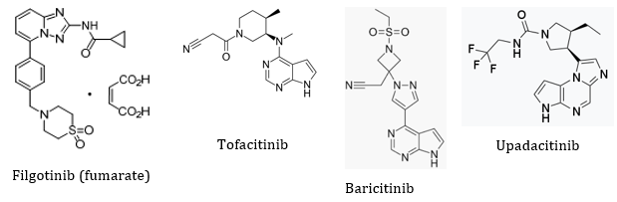
Filgotinib is formulated as filgotinib maleate (254.48 mg filgotinib maleate containing 200 mg of the base) in capsule shaped, film coated tablets, debossed with Gilead Sciences, Inc. (GSI) (the sponsor) and the dose, either 100 mg or 200 mg.
One recommendation regarding the dissolution profile is outstanding: [information redacted].
A second issue, with regard to drug quality testing, has been referred to the TGA. The finished product manufacturer performs only microbial tests on drug substance batches obtained from the active pharmaceutical ingredient (API) manufacturers. The quality evaluator does not consider that this testing alone is sufficient to assure quality, stating: the sponsor’s response is satisfactory with respect to limited tests performed by the finished product manufacturer on quality testing of the API, however, the following should be noted. The qualification of a supplier can be considered a Good Manufacturing Practices (GMP) issue. It will be raised so that they have this matter investigated specifically on the next GMP inspection.

Quality related proposed conditions of registration
The sponsor’s post-approval stability commitment indicates that the stability studies still in progress in the primary stability study will be continued up to at least 36 months with a possible extension to 48 and 60 months under the same conditions.
The sponsor further commits to conducting long term stability studies at 30ºC/75% relative humidity (RH) up to 36 months with possible extension to 48 and 60 months, and accelerated stability studies at 40ºC/75% RH up to six months, on the first three commercial batches of filgotinib maleate.
In addition, at least one commercial batch will be placed on long term stability each year and tested 12 monthly to at least 36 months.

Nonclinical
Registration of filgotinib is not supported by the nonclinical evaluation. The nonclinical evaluators raised a number of concerns regarding the safety profile of filgotinib. The evaluation considers the safety profile of filgotinib inferior to currently registered JAK inhibitors because:
- the nonclinical studies indicate significant male reproductive toxicity, which has not been reported with other JAK inhibitors. Ongoing studies in human males (Study GS-US-418-4279 (the MANTA trial) in inflammatory bowel disease and Study GLPG0634-CL-227 (the MANTA-RAY trial) in RA, psoriatic arthritis, ankylosing spondylitis and non-radiographic axial spondyloarthritis) are examining effects on semen parameters.
- adverse effects on the enamel of rat incisor teeth suggest possible off-target activity with filgotinib, which has not been reported with other JAK inhibitors and warrants further study.
The nonclinical evaluators noted that the overall quality of nonclinical evaluation was high and compliant with the relevant ICH; M3 (R2) guideline. All pivotal safety related studies were conducted under Good Laboratory Practice (GLP); conditions using the proposed clinical route and dosing regimen. Pharmacology, pharmacokinetic (PK) and toxicology studies were conducted with filgotinib and its active major human metabolite GS-829845. Safety pharmacology studies assessed effects on the cardiovascular, respiratory and central nervous systems (CNS). No adverse effects on corrected QT interval (QTc), respiratory or CNS function are predicted during clinical use. Some patients may experience effects on blood pressure (decrease) and heart rate (increase).
Filgotinib is predominantly metabolised by carboxylesterase (CES)-2. Based on the in vitro studies, potential PK drug interactions with inhibitors or inducers of CES-2 may affect exposure to filgotinib. In addition, filgotinib and/or GS-829845 may potentially alter the PK of orally administered drugs via interaction with a number of cellular transport proteins.
Potential off-target sites for filgotinib included a number of serine/threonine protein kinases (SRPK) including liver kinase (LK)B1 (also known as serine/threonine kinase (STK)11 and prostate apoptosis response (PAR)4, known to play a role in spermatogenesis), SRPK-1, (known to be involved in regulating vascular endothelial growth factor (VEGF), a splice variants), STK16 and YSK4. Potential off-target sites for GS-829845 are serine/threonine protein kinases (RIOK)1, RIOK3 and SRPK1. The nonclinical evaluators are concerned that the sponsor has not adequately considered the potential off-target activity of filgotinib, noting that the European public assessment report (EPAR) for filgotinib reached a similar conclusion.
The nonclinical evaluator identified the following target organs for toxicity in all species (including mice, rats and dogs): the lymphoid organs, the erythropoietic organs, male reproductive organs, and the gastrointestinal tract.
Additionally enamel abnormalities were noted in the incisor teeth of rats.
All findings were reversible, except for the reproductive organ effects at high doses. The effects on lymphoid tissues and erythropoiesis are considered clinically relevant. Due to decreases in circulating and tissue lymphocytes, immunosuppression in patients may increase risks of infection and malignancies.
The nonclinical evaluator considered that the effects on the male reproductive organs are of clinical concern. At lower filgotinib exposures, the effects included minimal or slight microscopic changes in the testes consisting of germ cell depletion, germ cell degeneration, and/or tubular vacuolation, associated with reduced sperm content and increased cell debris changes in the epididymides. More severe effects at increased exposure levels (which were not completely reversible) included decreased testis weight, tubular atrophy, sloughed germinal cells, decreased seminology parameters, and impaired fertility. Histopathological effects were seen in the absence of notable changes in hormone levels.
Fertility was markedly impaired in male rats at filgotinib exposure ration based on area under the plasma concentration time curve (ERAUC) 7.1, but female fertility was unaffected. Filgotinib and the metabolite GS-829845 were teratogenic in both rats and rabbits, causing eye, CNS (filgotinib only) and lung, cardiovascular and skeletal malformations (in both species). Reduced fetal viability due to increases in resorptions and postimplantation loss, as well as reduced fetal body weight, was seen in both species following maternal dosing with filgotinib (100 mg/kg/day the treatment is taken orally (PO) in rats, and 60 mg/kg/day PO in rabbits; ERAUC 13.4 and 20.6, respectively). The evaluation concluded that the mechanism of the adverse effects on the male reproductive system is unknown, but that the data indicate off-target effects with filgotinib not seen with the other JAK inhibitors. Dosing with the metabolite GS-829845 did not have any adverse effects on the male reproductive system in any species.
The sponsor response to the nonclinical evaluation report acknowledged the potential risk to males of reproductive potential and proposed to include a special warning in the Australian PI:
‘Fertility
In animal studies, decreased fertility, impaired spermatogenesis, and histopathological effects on male reproductive organs were observed (see Section 5.3). The potential effect of filgotinib on sperm production and male fertility in humans is currently unknown. The reversibility of these potential effects is unknown. The potential risk of reduced fertility or infertility should be discussed with male patients before initiating treatment.’
The sponsor also proposed to communicate the potential risk information via a Healthcare Professional Guide and a Patient Alert Card. The nonclinical evaluation referred review of this proposed action to the risk management plan (RMP) evaluators and the Delegate for consideration.

Clinical
The clinical dossier consisted of the following studies:
- 12 clinical pharmacology studies;
- 4 Phase II studies, Study GLPG0634-CL-201, Study GLPG0634-CL-202, the DARWIN 1, and DARWIN 2 trials; a single open label extension trial of the Phase II trials, the DARWIN 3 trial;
- 3 pivotal Phase III efficacy/safety studies, the FINCH 1, 2 and 3 trials.
The clinical evaluator recommends approval of the submission to register filgotinib as monotherapy or in combination with csDMARDs for the treatment of moderate to severely active RA in adult female patients who have failed to respond to, or are intolerant of at least one DMARD. However, in view of concerns with regard to the potential effect of filgotinib on spermatogenesis, the evaluator does not support approval of filgotinib for the treatment of adult males with RA.
The submission included 19 completed clinical studies comprising 12 clinical pharmacology studies (including bioavailability studies and ten PK trials), four Phase II studies and three Phase III studies in RA patients. In addition, efficacy and safety data from an ongoing long term extension study was also included.
At the data cut-off date for this submission, approximately 3000 participants had received at least one dose of filgotinib in the Phase II or III studies. Doses of filgotinib investigated in the Phase IIb program ranged between 25 mg twice daily to 200 mg once daily. The Phase IIa trials assessed daily doses of filgotinib ranging from 30 mg to 450 mg. The Phase II trials supported the choice of the 100 mg and 200 mg once daily dose regimens for evaluation in the Phase III studies.
The Phase III studies examined the efficacy and safety of filgotinib in different populations (methotrexate naïve, inadequate responders to csDMARDs (predominantly methotrexate) and inadequate responders to bDMARDs) at two dose levels (100 mg and 200 mg once daily). Depending on the study, efficacy outcomes were compared to common and established active comparators (low dose oral methotrexate taken weekly, or 40 mg adalimumab given fortnightly by subcutaneous injection). No statistical comparisons were performed between the two doses of filgotinib.
Persistence of the clinical response to filgotinib was examined in an open label extension study (up to extension Week 156), in which patients continued to receive filgotinib 100 mg or 200 mg once daily.

Pharmacology

Pharmacokinetics
Orally administered filgotinib is rapidly absorbed with median time at maximum concentration (T_{max}) ranging from 0.5 to 3 hours under fasting and non-fasting conditions. It demonstrates low binding to human plasma proteins and the mean apparent terminal drug half life (T_{1/2}) of filgotinib in plasma ranges from 5 to 11 hours. Filgotinib is metabolised mainly by CES-2, and to a lesser extent by CES-1. There are at least 7 to 8 metabolites, with the main metabolite (GS-829845) having one tenth of the biologic activity of the parent, but a longer T_{1/2}. Filgotinib and its metabolites are predominantly renally excreted. A small percentage of the drug and metabolites are excreted in the faeces. Steady state concentrations of filgotinib are achieved in two to three days with negligible accumulation after once daily administration. Steady state concentrations of GS-829845 are achieved in four days with approximately two fold accumulation after once daily dosing of filgotinib. Exposure to filgotinib increases in a proportional manner in the daily dose range of 10 to 450 mg.
Age, gender, ethnicity and body weight do not appear to substantially affect the PK of filgotinib, and area under the plasma concentration time curve (AUC) and maximum plasma concentration (C_{max}) are similar in healthy volunteers and adult participants with active RA, with moderate to high degrees of intra- and inter-subject variability across the tested dose range. Most common medications do not have clinically significant effects on the PK of filgotinib when given concomitantly, and vice versa. However, based on AUC data, itraconazole (a strong P-glycoprotein (P-gp) inhibitor) increases exposure to filgotinib by 45% and rifampin (a strong P-gp inducer) moderately reduces exposure to both filgotinib and GS-829845.
Point estimates for AUC of filgotinib are 60% higher in adults with moderate hepatic impairment (Child-Pugh-Turcotte Scores; of 7 to 9) compared to healthy volunteers with normal hepatic function. The clinical studies excluded patients with severe hepatic impairment.
Based on an early Phase I study (Study GLPG0634-CL-106), AUC in participants with moderate (creatinine clearance (CrCL) 30 to < 60 mL/min) renal impairment is approximately 45% higher compared to those with normal renal function. Participants with mild renal impairment (CrCL 60 to < 90 mL/min) have only small increases in AUC compared to those with normal renal function. A deficiency of the PK studies is that only three, otherwise healthy, participants with severe renal impairment were included in the Phase I studies. In this limited population, the sponsor states that the effective AUC (AUC_{eff}, a compound variable for combined AUC of filgotinib and GS-829845) following a 100 mg dose of filgotinib was approximately 2.2 fold greater than in healthy control participants following a 100 mg dose, and similar to the AUC_{eff} reported in patients with RA and normal renal function treated with 200 mg in the Phase II and Phase III studies. The sponsor proposed a 100 mg once daily dose in RA patients with severe renal impairment. No dose adjustment was recommended for patients with moderate renal impairment.

Population pharmacokinetic data
Data from seven Phase I studies in healthy participants, four Phase II studies in participants with RA, and three Phase III studies in participants with RA contributed to the Population PK (PopPK) analysis. The aims of the study were to provide a quantitative description of the PK of filgotinib and GS-829845 over a dose range of 25 mg to 450 mg filgotinib, to assess the impact of potential covariates, and to describe inter-individual variability in PK and exposure.
PK models were described for both filgotinib and GS-829845. The PopPK evaluator noted that the model for filgotinib inconsistently under and over predicted filgotinib concentrations, especially at the fifth and ninety-fifth percentiles. The model did not adequately describe observed between-subject variability, indicating that the variability may be due to covariates other than those included in the analysis, or to other physiological factors. The evaluator concluded that the predictive performance of the PopPK model is limited and model derived simulated exposures should be used with caution. Deficiencies were also identified with the model for GS-829845, again indicating that the final model did not adequately describe the variability. Simulated PK parameters for filgotinib and GS-829845 in healthy participants and participants with RA, based on the PopPK analysis, are included in Table 3 and Table 4.
Table 3: Simulated filgotinib pharmacokinetic parameters following filgotinib 200 mg in participants with rheumatoid arthritis and healthy participants (demographic pharmacokinetic analysis set)
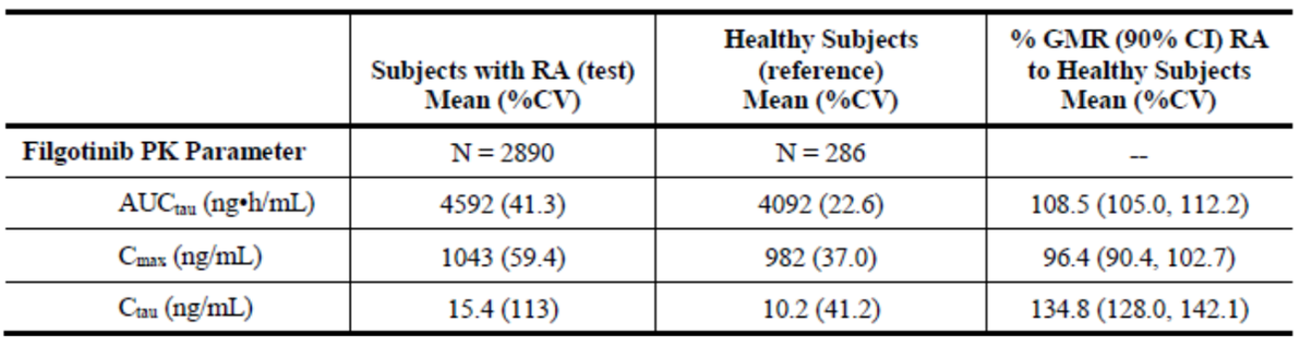
RA = rheumatoid arthritis; CV = percentage coefficient of variation; GMR = geometric mean ratio, CI = confidence interval; PK = pharmacokinetic; AUC_{tau} = area under the plasma concentration time curve over a dosing interval; C_{max} = maximum plasma concentration; C_{tau} = trough concentration
Demographic PopPK Analysis Set included subjects with RA and healthy subjects who were simulated with filgotinib 200 mg and had evaluable parameters from PopPK.
Table 4: Simulated filgotinib metabolite (GS-829845) pharmacokinetic parameters following filgotinib 200 mg in participants with rheumatoid arthritis and healthy participants (demographic pharmacokinetic analysis set)
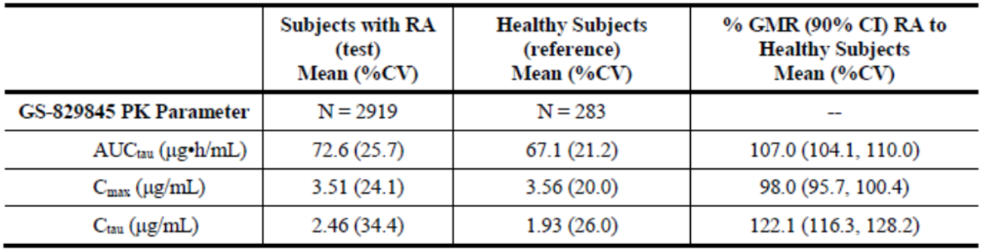
RA = rheumatoid arthritis; CV = percentage coefficient of variation; GMR = geometric mean ratio, CI = confidence interval; PK = pharmacokinetic; AUC_{tau} = area under the plasma concentration time curve over a dosing interval; C_{max} = maximum plasma concentration; C_{tau} = trough concentration
Demographic PopPK Analysis Set included subjects with RA and healthy subjects who were simulated with filgotinib 200 mg and had evaluable parameters from PopPK.
The clinical evaluator noted that in the PopPK analysis, the AUC of metabolite GS-829845 was approximately 25% higher in participants with moderate renal impairment compared with participants with normal renal function, concluding that this is a modest increase and may not warrant a dose reduction. Only three patients with moderate renal function (3%) experienced GS-829845 exposures (AUC) above the range observed in patients with normal renal function. All estimates of C_{max} in patients with moderate renal impairment fell within the range of C_{max} in patients with normal renal function. Data from patients with severely impaired renal function (CrCL < 30 mL/min) were not included in the PopPK analysis. Simulated PK parameters for filgotinib and GS-829845 in participants with normal renal function, mild renal impairment or moderate renal impairment, based on the PopPK analysis, are included in Table 5 and Table 6.
Table 5: Simulated filgotinib pharmacokinetic parameters following filgotinib 200 mg in participants with rheumatoid arthritis with normal or impaired renal function (demographic pharmacokinetic analysis set)
 | Normal renal function | Mild renal impairment |  | Moderate renal impairment
 |  | PK parameters | %GMR (90% CI) | PK parameters | %GMR (90% CI)
Filgotinib PK parameter
CL_{CR} (mL/min: min, median, max) | 90.0, 121.9, 311.8 | 60.0, 78.5, 90.0 |  | 36.6, 54.7, 59.8
No of subjects (%) | 2118 (73%) | 677 (23%) |  | 95 (3%)
AUC_{tau} µg.h/mL (%CV) | 4.55 (42.9%) | 4.70 (37.5%) |  | 4.86 (29.4%)
C_{max} µg/mL (%CV) | 1.03 (61.3) | 1.07 (55.6%) |  | 1.16 (45.6%)
C_{tau} µg/mL  (%CV) | 0.15 (121.1) | 0.16 (92.6%) |  | 0.16 (46.7%)
GMR = geometric mean ratio, CI = confidence interval; CV = percentage coefficient of variation; PK = pharmacokinetic; CL_{CR} = creatinine clearance; AUC_{tau} = area under the plasma concentration time curve over a dosing interval; C_{max} = maximum plasma concentration; C_{tau} = trough concentration
Demographic PopPK Analysis Set included subjects with rheumatoid arthritis and healthy subjects who were simulated with filgotinib 200 mg and had evaluable parameters from PopPK.
The categories were based on estimated baseline CL_{CR} (normal: CL_{CR} ≥ 90 mL/min; mild: CL_{CR} = 60 to < 90 mL/min; and moderate: CL_{CR} = 30 to < 60 mL/min).
Table 6: Simulated GS-829845 pharmacokinetic parameters following filgotinib 200 mg in participants with rheumatoid arthritis with normal or impaired renal function (demographic pharmacokinetic analysis set)
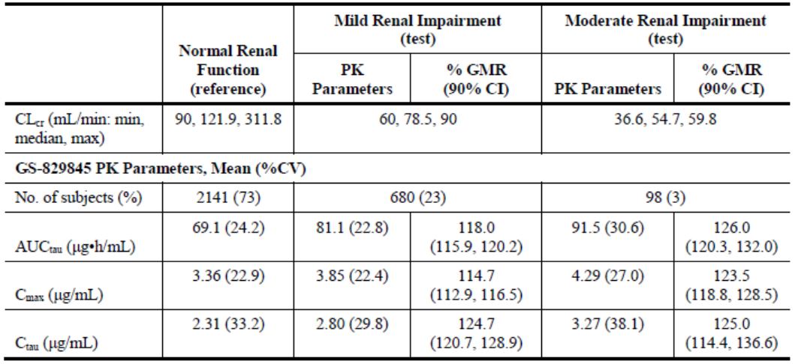
GMR = geometric mean ratio, CI = confidence interval; CV = percentage coefficient of variation; PK = pharmacokinetic; CL_{CR} = creatinine clearance; AUC_{tau} = area under the plasma concentration time curve over a dosing interval; C_{max} = maximum plasma concentration; C_{tau} = trough concentration
Demographic PopPK Analysis Set included subjects with rheumatoid arthritis and healthy subjects who were simulated with filgotinib 200 mg and had evaluable parameters from PopPK.
The categories were based on estimated baseline CL_{CR} (normal: CL_{CR} ≥ 90 mL/min; mild: CL_{CR} = 60 to < 90 mL/min; and moderate: CL_{CR} = 30 to < 60 mL/min).

Pharmacodynamics
The pharmacodynamic (PD) studies used measures of IL-induced STAT phosphorylation to confirm that filgotinib inhibited JAK1 activity, and had no apparent effect on JAK2 activity, at doses of 50 mg to 450 mg daily. Inhibition of the JAK1/STAT pathway was reversible, with onset by two hours after administration and recovery by 12 hours after administration. At supratherapeutic levels (300 mg and 450 mg filgotinib daily for 10 days) inhibition of the JAK1/STAT pathway appeared to be dose dependent and near complete.
Compared to the rapid changes in biomarker studies, the clinical effects of filgotinib were detected at around two weeks after initiation of therapy. Potential effects with regard to safety (decrease in haemoglobin, decrease in lymphocyte count) took up to four weeks to detect. Exposure response analysis demonstrated that efficacy plateaued with the 200 mg daily dose and higher exposures were not expected to achieve clinically meaningful additional benefit. There was no apparent concentration relationship for the 100 and 200 mg dose levels on the safety endpoints of anaemia or neutropenia.
The evaluator noted that no study examined co-administration of filgotinib with bDMARDs. Based on the mechanism of action of JAK inhibition, co-administration of filgotinib with bDMARDs is not recommended. Similarly, no study examined the effect of filgotinib on response to live vaccines. Because inhibition of JAK1 affects T-cell function, co-administration of filgotinib with live vaccines is not recommended.

Efficacy
Three completed Phase III studies (the FINCH 1, 2, and 3 trials) and two completed Phase IIb studies (the DARWIN 1 and 2 trials) examined the efficacy of filgotinib in the treatment of RA. Efficacy data from a Phase II open label extension study (the DARWIN 3 trial) was also included in the submission for evaluation of efficacy. Table 7 summarises the studies.
Table 7: Basic study designs of the FINCH and DARWIN trials
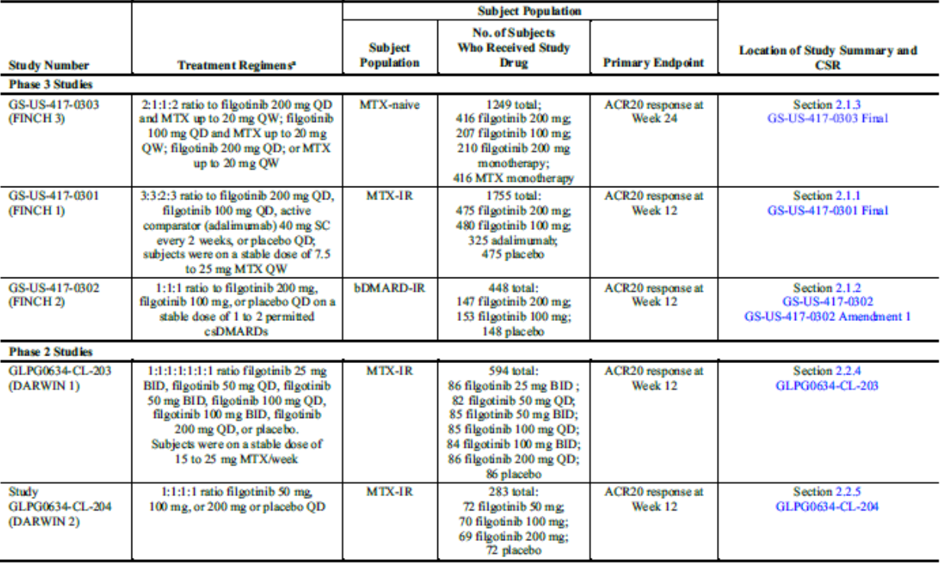
CSR = clinical study report; MTX = methotrexate; QD = once daily; QW = once weekly; ACR20 = American College of Rheumatology 20% improvement; SC = subcutaneous; csDMARDs = conventional synthetic disease modifying anti-rheumatic drug; BID = twice daily.

Phase III studies: the FINCH 1, 2 and 3 trials
All three FINCH trials were randomised, double blind, active (adalimumab or methotrexate) and/or placebo controlled trials in adults with moderately to severely active RA at Baseline, as defined by the American College of Rheumatology (ACR)/ EULAR 2010 Criteria For Classification of RA. Patients were required to have at least six tender and swollen joints (of 68 joints examined for tenderness and 66 joints examined for swelling, respectively) plus a C-reactive protein (CRP) reading > 6 mg/L (central laboratory) at screening in the FINCH 1 trial, or > 4 mg/L in the FINCH 2 and 3 trials.
In the FINCH 1 trial, patients also needed to have at least one RA related bone erosion (by central reading) if seropositive for either rheumatoid factor (RF) or anti-cyclic citrullinated peptide (CCP) autoantibodies at screening (central laboratory); or at least three joint erosions (by central reading) in the absence of a documented positive test for either of these RA associated antibodies. In the FINCH 3 trial, patients could be included if they had one or more confirmed joint erosion, or were positive for RF or anti-CCP antibodies, even if CRP was < 4 mg/L.
The FINCH 1 trial (in methotrexate inadequate responder patients) was conducted with 1755 patients with active RA who had failed to respond to at least 12 weeks of methotrexate at 7.5 to 25 mg/week. Methotrexate inadequate responder patients with limited exposure (< 3 months duration and cessation not due to lack of efficacy) to one prior bDMARD (excluding adalimumab) were permitted to enrol, this subset represented only 2.7% of participants.
The FINCH 2 trial (in bDMARD inadequate responder patients) was conducted with 448 patients with active RA who had failed to respond to, or were intolerant of, at least one biologic treatment. Prior exposure to anti-TNF drugs and non-TNF biological medicines was reported for 84.6% and 46.9% of patients, respectively. Overall, 23.4% of participants were previously exposed to three or more bDMARDs. The FINCH 2 trial population may have received stable background treatment with one or two cDMARD agents for at least four weeks prior their first dose of study medication. Participants in the FINCH 1 and FINCH 2 trials were allowed stable doses of background cDMARD during the study period in addition to the randomised investigational therapy (filgotinib 100 mg daily, filgotinib 200 mg daily, and placebo in both studies, and adalimumab once fortnightly in the FINCH 1 trial).
The FINCH 3 trial (methotrexate naive patients) was conducted with 1249 patients with active RA who had received no more than three weekly doses of methotrexate and no bDMARD therapy at study entry. Enrolled participants had a median (first, third quartile) disease duration of 0.4 (0.1, 2.0) years with 54.9% having RA for < 6 months and 33.9% for > 1 year. Prior limited exposure to methotrexate was reported for 6.6% of participants and prior limited exposure to csDMARDs other than methotrexate was reported for 17.8% of participants. Investigational treatment groups were filgotinib 200 mg + low dose methotrexate (commencing at 10 mg weekly and escalating to a maximum of 20 mg weekly), filgotinib 100 mg + low dose methotrexate, filgotinib 200 mg monotherapy and low dose methotrexate monotherapy. The mean weekly methotrexate dose at week 8 was 17 mg for participants in the filgotinib 200 mg + methotrexate group, 17 mg for patients in the filgotinib 100 mg + methotrexate arm and 16.9 mg for those in the methotrexate monotherapy group. At Week 24, the mean methotrexate dose administered was 18.3 mg for participants in the filgotinib 200 mg + methotrexate group, 18.1 mg for patients in the filgotinib 100 mg + methotrexate arm and 18.4 mg for participants in the methotrexate monotherapy group. While the FINCH 3 trial was intended to support filgotinib as an alternative therapy to methotrexate as first line therapy, the evaluator concluded that the methotrexate doses achieved in the study did not constitute an appropriate active control in the Australian clinical context.
In all three studies, the concomitant use of oral corticosteroids was permitted for participants taking stable doses of prednisone < 10 mg/day (or equivalent) for at least four weeks prior to randomisation. The dose of corticosteroids was to remain stable up to week 24 of each study. Concomitant non-steroidal anti-inflammatory drugs (NSAID) were also permitted during the trials, provided participants were on a stable dose for at least two weeks prior to randomisation. All three studies had early exit/rescue therapy protocols, and re-randomisation of placebo patients to filgotinib therapies after assessment of the primary and major secondary efficacy outcomes. No protocol amendments were assessed to have impacted the integrity of the results.
Investigational treatments for each of the studies are summarised in Table 7 (note that the first study in the table describes the FINCH 3 trial, the methotrexate naive population). The primary efficacy endpoint was the American College of Rheumatology 20% improvement (ACR20) response at Week 12 for the FINCH 1 and 2 trials, and ACR20 response at Week 24 for the FINCH 3 trial. The ACR20 response rate for filgotinib 200 mg once daily was compared with placebo for a superiority test at the two sided 0.05 level. A logistic regression analysis with treatment groups and stratification factors in the model was used. Participants who did not have sufficient measurements to establish efficacy at Week 12 or 24 (depending on the study) were considered non-responders. Key secondary efficacy endpoints in the Phase III RA study program for filgotinib included:
- proportion of participants who achieved Disease Activity Score (DAS) for 28 joint count; using CRP (DAS28-CRP) score of < 3.2 and/or < 2.6 at Week 12 or 24,
- change from Baseline in the Health Assessment Questionnaire – Disability Index (HAQ-DI) at Week 12 or 24,
- change from Baseline in Van der Heijde modified Total Sharp Score (mTSS) at Week 24 (the FINCH 1 and 3 trials),
- change from Baseline in 36 Item Short Form Survey Physical Component Summary at Week 12 or 24, and
- change from Baseline in Functional Assessment of Chronic Illness Therapy Fatigue at Week 12 or 24.
A hierarchical testing sequence was applied to the secondary endpoints.
Across the three FINCH trials, around 20 to 24% of participants discontinued, the most frequent reasons were lack of efficacy, participant choice and adverse events (AEs). In the FINCH 3 trial, AEs, lack of efficacy and participant choice were higher among the groups with methotrexate as part of the investigational treatment.
Protocol violations were reported in around 30% of participants in all of the studies. Deviations were distributed evenly across treatment groups in each study, and were predominantly violations of inclusion/exclusion criteria or management not in accordance with criteria. The evaluator concluded that these were unlikely to have affected the overall study data quality. The evaluator also concluded that the baseline demographic and disease characteristics of the enrolled patients in the Phase III RA studies were consistent with the targeted patient population in each individual study, well balanced between the treatment groups and comparable with the registration studies for other advanced therapies recently approved for the treatment of moderately to severely active RA.
In FINCH 1 and FINCH 2 treatment with filgotinib 200 mg or filgotinib 100 mg resulted in statistically significantly greater ACR20 responses over placebo at 12 weeks (the FINCH 1 trial, see Table 8; the FINCH 2 trial, see Table 9). Sensitivity analyses supported the results. The primary outcome measure of ACR20 in filgotinib treated cohorts was not statistically tested compared to adalimumab.
In the FINCH 3 trial, filgotinib 200 mg and filgotinib 100 mg, in combination with methotrexate, resulted in significantly greater ACR20 responses at 24 weeks over methotrexate monotherapy (Table 10). A numerical superiority of filgotinib monotherapy over methotrexate monotherapy did not reach statistical significance.
Table 8: The FINCH 1 trial American College of Rheumatology 20 response rates at Week 12 in methotrexate inadequate responder patients (composite estimate)
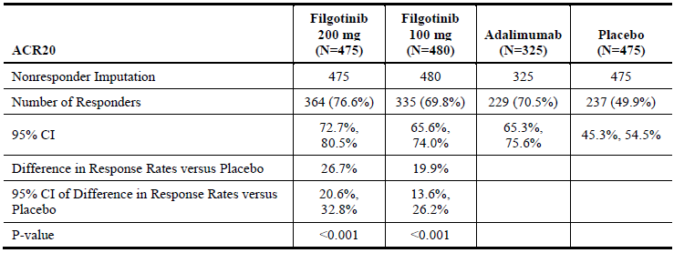
ARC20 = American College of Rheumatology 20% improvement; CI = confidence interval.
Table 9: The FINCH 2 trial American College of Rheumatology 20 response rates at Week 12 in bDMARD inadequate responder patients (full analysis set with non-responder imputation)
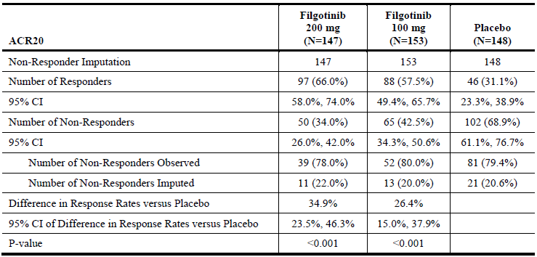
ARC20 = American College of Rheumatology 20% improvement; bDMARD = biological disease modifying anti-rheumatic drug; CI = confidence interval.
Table 10: The FINCH 3 trial American College of Rheumatology 20 response rates at Week 24 in methotrexate naive patients (composite estimate)
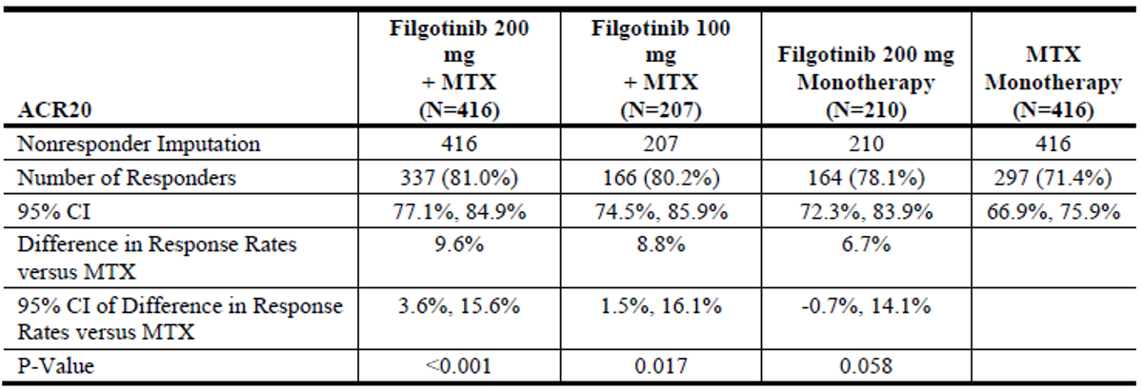
ARC20 = American College of Rheumatology 20% improvement; MTX = methotrexate; CI = confidence interval.
Full analysis set includes subjects who were randomised and received at least one does of study drug.
Non-responder imputation: subjects with missing outcomes were set as non-responders for binary response measurements.
95% CI for response rate and difference in response rates were based on normal approximation method with a continuity correction.
P-value was calculated from logistic regression with treatment groups and stratification factors in the model.
Response rates, difference in response rates, and 95% CI were expressed as the percentage.
Results of analyses of secondary efficacy outcomes predominantly aligned with the primary efficacy outcomes of each of the studies. In the FINCH 1 trial the superiority of filgotinib 200 mg and 100 mg once daily versus placebo was demonstrated for all efficacy endpoints in the hierarchical statistical analysis plans up to and including the mean change from baseline in (radiographic assessment of joint damage) mTSS score at Week 24. Numerically small but statistically significant differences were noted in the change in mTSS at Week 24. In the first comparison of filgotinib versus adalimumab in the hierarchy (the percentage of participants achieving a DAS28-CRP score < 3.2 at Week 12), the filgotinib 200 mg once daily therapy was statistically non-inferior to adalimumab (p < 0.001). The non-inferiority test for filgotinib 100 mg once daily versus adalimumab for the proportion of participants who achieved DAS28-CRP score ≤ 3.2 at Week 12 did not reach statistical significance (p = 0.054). According to hierarchical testing rules, numerical differences in the remaining secondary outcomes could not be considered statistically significant.
In the FINCH 2 trial the superiority of both doses of filgotinib over placebo was demonstrated for all efficacy endpoints in the hierarchical statistical analysis plan. A numerical benefit of filgotinib 200 mg over 100 mg dosing was not statistically tested.
In the FINCH 3 trial the superiority of filgotinib 200 mg + methotrexate and filgotinib 100 mg + methotrexate over methotrexate monotherapy was demonstrated for all efficacy endpoints in the hierarchical statistical analysis plan up to and including the comparison of filgotinib 100 mg + methotrexate versus methotrexate monotherapy for the proportion of participants achieving DAS28-CRP score < 2.6 at Week 24. Numerical superiority in assessment of change in the mTSS at Week 24 was not statistically significant. According to hierarchical testing rules, numerical differences in the remaining secondary outcomes could not be considered statistically significant.
The evaluator concluded that the efficacy data from the three FINCH trials over 24 to 52 weeks duration demonstrated the clinical benefit of filgotinib 100 mg and 200 mg once daily with or without methotrexate or other conventional DMARDs in adult patients with moderately to severely active RA. Efficacy has been assessed in terms of improving the symptoms and signs of the disease (via ACR response criteria), achieving reasonably high (and comparable to other active therapies) rates of low disease activity and clinical remission and improving physical function (as described by changes from baseline in HAQ-DI score). The evaluator also agreed with the sponsor that the efficacy data supports the numerical superiority of filgotinib 200 mg once daily over filgotinib 100 mg once daily across most of the outcomes of interest, although this was not statistically tested.
The Phase IIb DARWIN 1 and DARWIN 2 trials provided supportive efficacy data.
In the DARWIN 1 trial, 594 adult patients with moderately to severely active RA were randomised to one of six filgotinib dose regimens. The primary endpoint of the study was met. The differences in ACR20 response at Week 12 versus placebo were statistically significant for the filgotinib 100 mg once daily (63.5%, p = 0.0435), 200 mg once daily (68.6%, p = 0.0068), and 100 mg twice daily dose groups (78.6%, p < 0.0001), versus 44.2% in the placebo group. Response rates in once daily and twice daily regimens resulting in the same total daily dose were not significantly different. Secondary efficacy outcomes supported the primary outcomes.
In the DARWIN 2 trial 283 adults with moderately to severely active RA were randomised to once daily dosing with filgotinib 50 mg, 100 mg or 200 mg, or placebo. Participants had a history of inadequate response or toxicity to methotrexate. The primary endpoint of the study was met. At Week 12, the percentage of ACR20 responders was statistically significantly higher in all three filgotinib treatment groups compared with placebo (p < 0.001 for each pairwise comparison of filgotinib versus placebo). The Week 12 ACR20 response rates were 66.7% (48/72) in the filgotinib 50 mg once daily group, 65.7% (46/70) in the filgotinib 100 mg once daily arm and 72.5% (50/69) in the filgotinib 200 mg once daily group compared with 29.2% (21/72) in the placebo arm. Secondary efficacy outcomes supported the primary outcomes.
The DARWIN 3 trial is an ongoing Phase II, open label, long term follow up safety and efficacy continuation trial that was offered to participants after they completed the DARWIN 1 or 2 trial. Participants who received 24 weeks of placebo therapy during the DARWIN 1 trial were randomised in a 1:1 ratio to receive either filgotinib 200 mg once daily or 100 mg twice daily. All other participants (except male participants in the USA) started this long term extension trial with filgotinib 200 mg per day, administered in the same dosing regimen as they had received during the preceding studies (200 mg once daily or 100 mg twice daily). Male participants in the USA were limited to dosing with filgotinib 100 mg once daily due to a Food and Drug Administration (FDA) requirement; based on nonclinical concerns with spermatogenesis. Observed data presented with this submission indicated that the ACR20 response rates at extension baseline (77.4% (380/491) for filgotinib with methotrexate and 79.6% (187/235) for filgotinib monotherapy) increased in both treatment cohorts through to extension Week 156 (87.2% (252/289) for filgotinib with methotrexate and 89.7% (122/136) for filgotinib monotherapy), supporting the Phase III studies.
Pooled efficacy analyses including data from FINCH 1, 2 and 3 trials, and from the DARWIN 1 trial examined the comparative clinical efficacy of filgotinib 100 mg and 200 mg once daily, and the efficacy of filgotinib at 12 weeks in a range of subgroups based on seropositivity, disease severity at Baseline, baseline corticosteroids use and duration of RA. The evaluator agreed that the pooled analyses supported a dose-response relationship across multiple efficacy endpoints and time points, in both magnitude and time to onset of treatment effect, including measures of signs and symptoms of disease (including remission) and physical functioning. No significant treatment response differences were noted based on the identified subgroup parameters.

Safety
Three integrated analysis sets, using data from FINCH 1, 2, and 3 trials, DARWIN 1 and 2 trials, and extension studies (the FINCH 4 and DARWIN 3 trials), provided safety data for the submission. Supportive safety information was also provided from interim study reports of trials in Crohn’s disease, psoriatic arthritis and ankylosing spondylitis.
The placebo controlled safety analysis set included safety data collected up to 12 weeks of therapy in DARWIN 1 and 2 trials, and the FINCH 2 trial, and up to 24 weeks of therapy in the FINCH 1 trial. The active controlled safety analysis set collates safety information from the FINCH 1 and 3 trials (up to Week 52) for comparison between filgotinib and adalimumab in the FINCH 1 trial and methotrexate monotherapy in the FINCH 3 trial. The active controlled dataset reports data up to Weeks 12, 24 and 52. The dataset includes AE reports for patients switched from placebo to filgotinib after the initial blinded phases of each study. The integrated safety dataset combines safety data from the DARWIN 1 and 2 trials, the FINCH 1 to 3 trials as well as the FINCH 4 and the DARWIN 3 trials up to the date of data cut off relevant to each trial, including AE reports from patients switched from placebo to filgotinib after re-randomisation. The majority of filgotinib treated patients in the integrated (all exposure) dataset received concurrent methotrexate, with more than half taking concomitant NSAID and/or concurrent low dose oral corticosteroids. In the integrated dataset, safety data was reported ‘whilst on treatment’, and included all patients with any exposure to filgotinib. The sponsor applied a Poisson regression model to estimate within group exposure adjusted incidence rates (EAIRs), with treatment group as a covariate, in the integrated dataset.
The sponsor provided additional safety data in response to a TGA request for information, specifically addressing concerns raised by the FDA regarding the risk of impaired male fertility,¹¹ and the relative benefit risk profile of 200 mg filgotinib. These are presented under the heading ‘Adverse events of special interest’.
The sponsor stated that at 22 July 2019, 4033 study participants with RA had received at least one dose of filgotinib across all of the Phase II and III RA studies, for a total 5975.4 patient years of exposure (PYE). Of these, 2402 participants had received any dose of filgotinib for over one year (representing 5176 PYE, Table 11).
Table 11: Summary of all exposure to filgotinib in rheumatoid arthritis studies
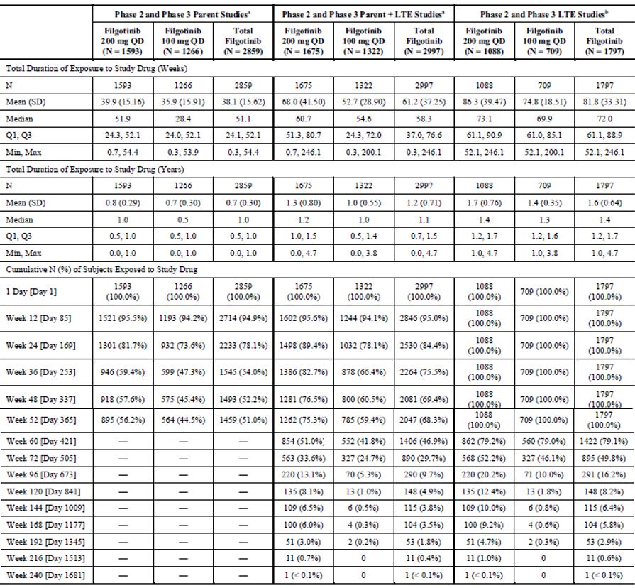
LTE = long term exposure; Q1 = first quartile; Q3 = third quartile, QD = once daily; SD = standard deviation.
- As randomised subjects includes data from the subject’s original assigned study treatment, but censors data after subjects were randomised or assigned to a different treatment at Week 12/14 or Week 24 or at rollover to the LTE studies with the exception that placebo subjects who were randomised to filgotinib were included in corresponding filgotinib group (exposure started from first dose of filgotinib).
- The data was restricted to patients who remained on the same dose of filgotinib for consecutively 52 weeks at what was initially being taken at the beginning of the parent study within the exception that placebo subjects who were randomised to filgotinib were include in corresponding filgotinib group (exposure started from first dose of filgotinib).
Compared to placebo, filgotinib was associated with a numerically higher incidence of serious infectious AEs and AEs resulting in temporary treatment discontinuation. Some of the AE types (mainly, laboratory abnormalities including increased serum creatine phosphokinase (CPK) levels and increased serum transaminases) occurred at a higher incidence in the higher dose filgotinib treatment cohort (200 mg once daily versus 100 mg once daily). Infection was the most common AE reported with filgotinib and occurred at a higher frequency with filgotinib 200 and 100 mg once daily treatment versus placebo (first 12 to 24 weeks for the pivotal Phase III trials). The majority of infections were mild in severity, self limiting, and were predominately either upper respiratory tract infection (URTI), nasopharyngitis or bronchitis. The use of concurrent methotrexate did not appear to increase the overall risk of AEs, including infection related AEs (integrated safety dataset). Reports of nausea (often in the absence of other gastrointestinal symptoms) were more frequent with filgotinib 200 mg/day therapy versus placebo, and approximately half of all cases occurred within four weeks of commencing treatment. Hypertension was also reported more frequently in the filgotinib 200 mg group, affecting 3.3% of patients.
In the integrated safety dataset populations, there was a small increased incidence and EAIR of serious infection with both doses of filgotinib versus placebo. There was no clear dose dependent effect of filgotinib on the incidence of serious and opportunistic infection. Although there was no clear signal of an increased risk of opportunistic infection with filgotinib, in the long term safety population several cases of TB (pulmonary, lymph node and meninges) were recorded. Additionally, one case of cryptococcal pneumonia was reported in a patient receiving filgotinib 200 mg, and three non-serious cases of oesophageal candidiasis. During the controlled trial periods, several filgotinib treated patients and one patient receiving adalimumab were identified as having latent TB. All observed TB cases occurred in countries where TB is prevalent, and the sponsor has included a warning about the risk of TB and screening pre-treatment in the proposed PI. In the long term exposure population, a small number of patients recorded detectable hepatitis B virus (HBV) DNA after receiving filgotinib. There was a clear increased risk of herpes zoster infection with filgotinib versus placebo. A filgotinib dose effect was observed for the risk of herpes zoster infection. The majority of herpetic infections were of mild or moderate severity and responded to standard treatment.
Permanent discontinuations from treatment owing to AEs up to 24 and 52 weeks occurred at a similar frequency with both doses of filgotinib versus placebo, methotrexate and adalimumab. However, temporary treatment interruptions were reported more frequently for patients taking filgotinib versus placebo. The AEs resulting in temporary treatment interruption showed a similar pattern to the most common types of overall AEs, mostly, minor infections, gastrointestinal upset and/or transient laboratory test abnormalities.
A total of 25 deaths were reported in filgotinib treated subjects in the updated integrated safety analysis. These including nine major adverse cardiovascular events (MACE), seven infection related and three cancer related deaths in filgotinib treated subjects. Mortality rates and causes of death were similar between filgotinib and placebo or comparator therapies (methotrexate and adalimumab) in relatively short term treatment follow up (up to three years).
Increases in serum CPK values and serum lipid levels are recognised safety concerns with JAK inhibition and were observed with filgotinib in the RA treatment studies. Up to 24 weeks, the overall incidence of low density lipoprotein (LDL)-cholesterol values > 3.36 mmol/L was higher with filgotinib 200 mg/day treatment compared with placebo; and was also numerically greater compared to the active comparators methotrexate monotherapy and adalimumab. The long term clinical consequences, if any, of atherogenic lipid profiles associated with filgotinib are unknown. Small to moderate increases in serum CPK values were frequent with filgotinib therapy but the percentage of patients who recorded Grade 3 or higher elevations in CPK were only 0.8 to 1.5% (slightly higher incidence with filgotinib 200 mg versus 100 mg). There was also a slightly higher incidence of Grade 2 neutropaenia as well as lymphopaenia observed with both doses compared to placebo as well as to active comparator treatment with methotrexate and adalimumab. There was also a slightly higher incidence of thrombocytosis (platelet count > 600 x 109/L) observed in patients treated with filgotinib.
The evaluator concluded that there was limited long term safety data in the submission to assess the risk of some types of AEs such as malignancy and MACE, which will require additional longitudinal safety follow up. There are some significant safety concerns with filgotinib therapy including the risk of infection, opportunistic infection (mainly, herpes zoster infection), increased serum CPK values, anaemia, neutropaenia, thrombocytosis, abnormal liver function tests (raised serum transaminases) and dyslipidaemia. These safety concerns are consistent with the known profile of JAK inhibitor therapy in adult patients with RA. Significant pharmacovigilance will be required if approval is granted for registration of filgotinib for the treatment of RA. This would include vigilance for serious and opportunistic infections, MACE and malignancy (particularly, non-melanoma skin cancers).

Adverse events of special interest
The sponsor provided analyses for positively adjudicated events of MACE for each of the safety populations. In the placebo controlled safety analysis set, the EAIRs for positively adjudicated MACE were similar across the filgotinib and placebo treatment groups. In the active controlled studies, no patient in the filgotinib 200 mg group, two patients in the filgotinib 100 mg group (one cardiovascular death, one non-fatal stroke) and one patient in the adalimumab group (non-fatal myocardial infarction) experienced adjudicated MACE events. In the integrated safety analysis, 13 patients in the filgotinib 200 mg group (EAIR 0.3 per 100 patient years (PY), seven non-fatal strokes, five cardiovascular deaths, two non-fatal myocardial infarctions) and nine patients in the filgotinib 100 mg group (EAIR 0.6 per 100 PY) experienced adjudicated MACE.
The sponsor provided analyses for positively adjudicated events of venous thromboembolism (VTE) (pulmonary embolism (PE); and deep vein thrombosis (DVT)) for each of the safety populations. In the integrated safety analysis set, the EAIR of VTE for all filgotinib patients was 0.1 per 100 PY (four PE and four DVT in five patients treated with 200 mg filgotinib, and one PE in a patient treated with 100 mg filgotinib), most occurring during long term extension studies. All of the affected patients had at least one additional accepted risk factor for VTE.
In the placebo and active controlled studies, the EAIRs of malignancy (excluding non-melanoma skin cancer (NMSC)) were similar in the filgotinib groups (up to 0.4 per 100 PY for 200 mg and up to 0.6 per 100 PY for 100 mg), the placebo groups (EAIR of 1.0 per 100 PY at 24 weeks), and the active comparator groups: adalimumab (0.6 per 100 PY at 52 weeks) and methotrexate monotherapy (1.1 per 100 PY at 52 weeks). In the long term combined safety dataset, the EAIRs of malignancies were similar between the two filgotinib dose groups at 0.4 per 100 PY for 200 mg once daily and 0.7 per 100 PY for 100 mg once daily. There were no differences in the EAIRs of NMSCs across treatment groups in the long term all filgotinib treated safety analysis sets.
In the integrated safety analysis set three participants, all receiving treatment with filgotinib 200 mg (0.1 per 100 PY) experienced gastrointestinal perforation (one case each of gastric, duodenal and colonic diverticulum perforation). Two of the affected individuals had additional risk factors for perforation.
At the safety data cut off date of 24 September 2019, 19 pregnancies in women with filgotinib exposure and one partner pregnancy had been recorded. The outcome of the 19 pregnancies include seven spontaneous abortions, six live births, one elective abortion and one ectopic pregnancy. Three women were yet to complete the pregnancy and one woman was lost to follow up, as was the partner pregnancy. Of the seven pregnancies that resulted in fetal loss (spontaneous abortion), five women were taking concurrent methotrexate and one woman was taking sodium valproate. One live birth resulted in a congenital abnormality (pentalogy of Fallot).

Impaired spermatogenesis
In its response to a TGA request for information, the sponsor confirmed that owing to concerns regarding testicular toxicity observed in nonclinical studies, the FDA mandated that male participants in the DARWIN 3 trial should only be treated with filgotinib 100 mg once daily dosing. The sponsor asserted that during the end of Phase II meeting discussion, the FDA agreed that the filgotinib 200 mg once daily dose could be acceptable for both men and women, with an appropriate justification and mitigation strategy including adequate informed consent, and disclosure of the testicular toxicity information and risk. The sponsor is currently conducting randomised, double blind placebo controlled studies evaluating the potential testicular toxicity of filgotinib in adult males with active inflammatory bowel disease, and in adult males with RA, psoriatic arthritis, or axial spondyloarthritis. However, the delegate notes that the sponsor has decided not to seek marketing approval for filgotinib in the USA for the treatment of RA.

Dose dependent toxicity
In the additional response material submitted in response to a request for information, the sponsor provided the most recent safety data reports for the DARWIN 3 trial (with data cut off date of 26 April 2019) and the FINCH 4 trial(with data cut off date of 16 September 2019) studies. Numeric differences were observed in the filgotinib clinical development program between the dose groups with some AEs of special interest showing a numerically higher rate with the 200 mg once daily dose (such as herpes zoster infection) while other AEs showed a numerically higher rate in 100 mg dose group (for examples, TB). The sponsor asserted that no consistent dose dependent trend was observed across key safety endpoints, and provided a detailed response to each of the major AEs of special interest. With respect to death, VTE and cases of lymphoma, the sponsor stated that EAIRs were similar between the two filgotinib dose arms, with overlapping 95% confidence intervals (CIs).
In the updated safety set, a total of 25 deaths had been reported in filgotinib treated subjects. Of which, 19 (0.8% of 2267) subjects who received at least one dose of filgotinib 200 mg and six (0.4% of 1647) patients who received filgotinib 100 mg therapy. The EAIR of death per 100 PY with filgotinib 200 mg is 0.5 (95% CI: 0.3, 0.7) and with filgotinib 100 mg is 0.3 (95% CI: 0.1, 0.7). For comparison, the EAIRs of death in the updated filgotinib program safety set for adalimumab was 0.3 per 100 PY (95% CI: 0.0, 2.4; one death from 325 subjects) and for placebo was 0.7 per 100 PY (95% CI: 0.2, 2.6; two deaths in 781 subjects). The mortality EAIRs in the extended safety set are consistent with the EAIRs reported for the safety dataset as part of the original application.

Clinical evaluator’s recommendation
The clinical evaluator was satisfied that any potential increased risk with the 200 mg dose of filgotinib is offset by the incremental efficacy benefit.

Risk management plan
The sponsor has submitted EU-RMP version 0.1 (dated 16 July 2019; data lock point (DLP) 8 October 2018) and Australian-specific Annex (ASA) version 0.1 (dated January 2020) in support of this application. In response to a TGA request for information, the sponsor provided an updated EU-RMP version 1.0 (date 21 July 2020; DLP 16 September 2020) and an ASA version 0.2 (dated September 2020). At the third round evaluation, the sponsor provided ASA version 0.3 (date December 2020). At the fourth round evaluation, prior to the Advisory Committee on Medicines (ACM) meeting, the sponsor submitted ASA version 0.4 (dated January 2021) related to EU-RMP version 1.0 (dated 21 July 2020; DLP 16 September 2020).
The summary of safety concerns and their associated risk monitoring and mitigation strategies are summarised in Table 12.
Table 12: Summary of safety concerns
Summary of safety concerns |  | Pharmacovigilance |  | Risk Minimisation
 |  | Routine | Additional | Routine | Additional
Important identified risks | Serious and opportunistic infections | * | ^{§ ǁ} |  | ¶ ∞
Important identified risks | Herpes zoster | * | ^{§ ǁ} | – | –
Important potential risks | Embryolethality and teratogenicity | † | – |  | ¶ ∞
Important potential risks | Impaired spermatogenesis leading to possible reduction in male fertility | * | ‡ |  | ¶ ∞
Important potential risks | Malignancy | * | ^{§ ǁ} |  | –
Important potential risks | Venous thromboembolism (deep venous thrombosis and pulmonary embolism) | * | ^{§ ǁ} | – | –
Important potential risks | Gastrointestinal perforation | * | ^{§ ǁ} | – | –
Important potential risks | Non-melanoma skin cancer | * | ^{§ ǁ} |  | –
Important potential risks | Major adverse cardiovascular events | * | ^{§ ǁ} | – | –
Important potential risks | Hyperlipidaemia | * | ^{§ ǁ} | – | –
Important potential risks | Varicella zoster | * | ^{§ ǁ} | – | –
Missing information | Use in patients with evidence of untreated chronic infection with hepatitis B or C |  | – | – | –
Missing information | Effect on vaccination efficacy |  | – |  | –
Missing information | Use in the very elderly (>75 years) |  | ^{§ ǁ} |  | ¶
* Specific adverse reaction follow-up questionnaire
† Pregnancy report and outcomes forms
‡ Safety study
§ Long term extension study
ǁ Non-interventional EU post authorisation safety studies (PASS) study
Health control plan (HCP) Guide
∞ Patient Alert Card
- The summary of safety concerns in the ASA was amended by the sponsor at the second round evaluation to include safety concerns which were included in the EU-RMP at the request of CHMP. The summary of safety concerns proposed by the sponsor at the second round evaluation is considered acceptable from an RMP perspective at the fourth round evaluation.
- The proposed pharmacovigilance plan through routine and additional pharmacovigilance activities is considered acceptable at the fourth round evaluation from the RMP evaluator’s perspective.
- The sponsor has proposed routine risk minimisation activities for some but not all safety concerns. Additional risk minimisation activities in the form of a Healthcare Professional Guide and a Patient Alert Card have been proposed for the safety concerns ‘serious and opportunistic infections’, ‘embryolethality and teratogenicity’ and ‘impaired spermatogenesis leading to possible reduction in male fertility’. The currently proposed risk minimisation plan is not considered acceptable from an RMP perspective. The sponsor has declined to implement routine risk minimisation through the PI for the following safety concerns: ‘herpes zoster’, ‘venous thromboembolism (deep venous thrombosis and pulmonary embolism)’, ‘gastrointestinal perforation’, ‘hyperlipidaemia’, ‘MACE’, ‘varicella zoster’ and ‘use in patients with evidence of untreated chronic infection with hepatitis B or C’. The RMP evaluator does not agree with the sponsor’s justification for non-inclusion of routine risk minimisation through the PI and this issue has been raised to the attention of the delegate for consideration and decision. ACM, at the February 2021 meeting agreed with the RMP evaluators’ concerns that potential risks were not adequately addressed in the RMP. The CMI and additional risk minimisation materials should be aligned with any updates made to the PI and be submitted to the TGA for review at least six weeks prior to launch.

Risk-benefit analysis

Delegate’s considerations

Recommended dose
The sponsor has proposed a recommended dose of 200 mg daily for most patients, based on statistical superiority of 200 mg filgotinib over placebo over a range of clinical outcome measures in the FINCH 1 and FINCH 2 trials, statistical superiority of combined therapy of 200 mg filgotinib and methotrexate over methotrexate monotherapy in the FINCH 3 trial, and non-inferiority of filgotinib 200 mg compared to adalimumab in the proportion of patients achieving a DAS28-CRP score < 3.2 at Week 12. Numerically superior outcomes with the 200 mg filgotinib dose over the 100 mg dose were not tested. The submitted data indicates that overall response rates to 100 mg doses increased over time and there is a possibility that over the longer term this may continue to improve. However, non-inferiority to adalimumab was not statistically achieved with the 100 mg regime. The safety evaluation also is unclear with regard to the relative risks of 200 mg dosing compared to 100 mg dosing. The sponsor argues that in the submitted data there is no particular pattern with regard to the comparative risks of 200 mg versus 100 mg. However, there appear to be longer term signals that suggest that dose dependent safety risks may develop. The FDA have expressed concern with the 200 mg dose, but the EMA have accepted both 100 mg and 200 mg dosing regimes for treating RA. It may be appropriate in the Australian context to support the application for the lower dose of 100 mg daily, as the lower tested effective dose.

Dosing in adults with severe renal impairment
The sponsor proposed a 100 mg once daily dose in RA patients with severe renal impairment, although the experience of filgotinib in severe renal impairment is limited to three otherwise healthy patients in early Phase I trials. The Phase II and III clinical study program and population PK analysis excluded RA patients with severe renal impairment. Additionally, the population PK evaluator considered the predictive value of the population PK analysis unreliable. The EMA requested dosage adjustments for patients with severe renal impairment and with moderate renal impairment.¹³
In the Phase I study aimed at examining the PK of filgotinib in patients with renal impairment, recruitment of patients with severe renal impairment was limited to three owing to the following stopping rule: ‘In case a substantial effect on the PK in severe renal impaired subjects compared to subjects with normal renal function (defined as at least 2-fold increase in area under the plasma concentration time curve during 24 hours (AUC_{0-24hr}) of GLPG0634 (filgotinib) and/or at least 4-fold increase in AUC_{0-24hr} of G254445 (GS-829845) in at least 1 subject) was observed on Day 10.’
The sponsor reported that ‘at the preliminary analysis after repeated dosing with (filgotinib) two subjects with severe renal impairment showed AUC_{0-24hr} > 2, and none showed AUC_{0-24hr} of the active metabolite ≥ 4, compared to matched healthy participants’. This appeared to be a miscalculation by the investigator. While the values for AUC_{0-24hr} of filgotinib were > 2 in two patients, compared to age and weight matched participants with normal renal function, neither a two fold increase in AUC_{0-24hr} of filgotinib, nor a four fold increase in AUC_{0-24hr} of the metabolite, were reported in any of the participants with severe renal impairment.
In the completed study, severe renal impairment resulted in an average 45% increase in AUC_{0-24hr} of filgotinib, which was comparable to the result in moderate renal impairment. Severe renal impairment was also associated with a mean 2.1 fold increase in C_{max}, and mean 2.7 fold increase in AUC_{0-24hr}, of the active metabolite, compared to participants with normal renal function. The sponsor calculated that the AUC_{eff} (effective exposure, a compound variable based on the exposures of filgotinib and GS-829845) after 100 mg filgotinib orally for 10 days was 2.2 fold greater in severe renal impairment compared to normal renal function. The sponsor further reasoned that as this level of exposure is similar to the AUC_{eff} reported in patients with RA and normal renal function treated with 200 mg filgotinib, a dose reduction is appropriate in severe renal impairment. The EMA appears to have interpreted the data differently. In the Jyseleca European public assessment report,¹³ it is noted that ‘In subjects with severe renal impairment (CrCL 15 to < 30 mL/min), filgotinib exposure (AUC) increased by 2.2 fold and GS 829845 exposure significantly increased by 3.5 fold leading to a 3-fold increase in AUC_{eff}’.
The recommended dose of filgotinib in the Summary of Product Characteristics (SmPC) for adults with RA and severely impaired renal function is 100 mg daily. This dose reduction is also applied to patients with moderately impaired (30 to < 60 mL/min/1.73m2) renal function.
The TGA adopted EMA guideline EMA/CHMP/83874/2014; outlines that
‘Depending on the characteristics of the drug, a lack of information regarding influence of decreased renal function on the pharmacokinetics could result in a contraindication (Section 4.3) or warning (Section 4.4) below a certain degree of renal function. Lack of data alone should generally not lead to a contra-indication unless there is a specific safety concern. For drugs with a narrow therapeutic index the possibility of therapeutic drug monitoring or monitoring of exposure based on clinical markers for efficacy and/or safety may be considered.’
The Delegate concurs with the sponsor that filgotinib does not have a narrow therapeutic index. Drug monitoring or exposure monitoring is not required in this case. Similarly, the PK data with regard to patients with severe renal impairment does not require a contraindication. However, the delegate seeks the opinion of the committee in assessing whether data collected from three patients with severe renal impairment, is sufficient to support a recommended dose reduction, or whether a precautionary statement in the PI and a recommendation not to use filgotinib in severe renal impairment is more appropriate.

Reproductive toxicity
While the clinical efficacy of filgotinib has been satisfactorily established, the nonclinical, clinical and RMP evaluators have all raised safety concerns. Arguably, the clinically most important of these is the potential for off target effects on spermatogenesis. While nonclinical studies have reported germ cell depletion, germ cell degeneration, and/or tubular vacuolation in the testes, associated with reduced sperm content and increased cell debris changes in the epididymidis at doses around twice the maximum recommended human dose, and impaired fertility at higher doses, clinical studies did not assess this question. The sponsor has committed to completing two specific safety studies, examining sperm health and other semen parameters, in 2021. The sponsor has also committed to including information about the potential risk to male fertility in a healthcare practitioner guide and a patient alert card, as well as additional information in the Australian PI regarding effects on male fertility. The sponsor has not agreed to impose an informed consent process for male patients commencing filgotinib, noting that rheumatologists are familiar with prescribing products with risks to fertility, including the csDMARDs methotrexate and sulfasalazine. Both of these medicines have precautionary warnings in their respective PIs.
In view of concerns with regard to the potential effect of filgotinib on spermatogenesis, the clinical evaluator does not support approval of filgotinib for the treatment of adult males with RA, and non-clinical evaluation does not support approval of filgotinib at all. The sponsor argues that restricting treatment with filgotinib to female patients, pending data from the additional safety studies, is unnecessarily restricting access to an efficacious treatment for men who have no desire to father children in the future. The median age of participants in the pivotal FINCH trials was in the early to mid fifties, with between 18.9% and 25.2% aged over 65 years. The mean duration of RA from diagnosis was 7.8 years in the FINCH 1 trial and 12.4 years in the FINCH 2 trial, both studies enrolling patients who had intolerance or poor response to previous DMARD therapies, including both csDMARDs and bDMARDs. Some 20% of participants in the clinical studies were men, and there is no reason to suspect that the age distribution in men would be different to that in the overall population. The Delegate notes that while approval for marketing in the United States has been deferred until results of the safety studies are complete, the EMA has approved marketing in the EU to both men and women, at the higher dose of 200 mg daily.¹³ The Delegate also notes that other JAK inhibitors are available for the treatment of RA, which do not have any apparent male reproductive toxicity.

Special precautions and warnings in the product information
The sponsor has argued that the safety profile of filgotinib, notwithstanding the potential risk of testicular toxicity, exceeds that of currently registered bDMARDs, and more specifically, the alternative JAK inhibitors tofacitinib, baricitinib and upadacitinib. The sponsor submitted indirect comparisons with published data from other studies, RA registries and reviews support this stance. The sponsor also argues that the specificity of filgotinib for JAK1 contributes to its safety profile. A 2019 review of JAK inhibitor reports that while filgotinib is indeed selective for JAK1 over other JAK isoforms, its relative potency is lower than the alternative JAK1 inhibitor upadacitinib. The sponsor of upadacitinib has included class specific potential risks in the product information. It would be appropriate for the sponsor of filgotinib to also include class-specific potential risks at this stage.
The nonclinical evaluation has identified that filgotinib may have adverse effects on the lymphoid organs, the erythropoietic organs and the gastrointestinal tract, as well as the reproductive system, and the other JAK inhibitors have reports of AEs affecting all of these systems. Furthermore, changes in lipid profiles and other laboratory abnormalities have been seen with filgotinib, as have more serious events including MACE and thromboembolic disorders, which are recognised class effects. For this reason, despite the stance of the sponsor, the clinical evaluation and RMP evaluation concur that the RMP and/or the PI should address a number of known and potential risks of JAK inhibitors, including filgotinib. These include:
- increased incidence of serious infection (including pneumonia) versus placebo and methotrexate;
- increased incidence of nausea and headache versus placebo;
- increased incidence of temporary treatment discontinuations owing to AE with filgotinib, methotrexate and adalimumab, versus placebo;
- higher rates of opportunistic infection and reactivation (including herpes zoster, varicella zoster, TB);
- increased incidence of haematologic abnormalities (usually low grade) including anaemia, neutropenia and lymphopaenia versus placebo and adalimumab;
- oncreased rates of raised total cholesterol, no increase in rates of MACE in medium term;
- increased rates of raised serum CPK (known class effect for JAK inhibitors);
- increased rates of serum transaminases (known class effect for JAK inhibitors).
The clinical evaluation noted that in the median term overall mortality, VTE, MACE and malignancy rates in filgotinib, placebo, methotrexate and adalimumab treated groups were comparable. While the sponsor has argued that filgotinib is associated with lower rates of AE with filgotinib compared to published data for other JAK inhibitors, the filgotinib studies have to date been relatively short term and enrolled limited patient numbers. It is possible that there has not yet been sufficient exposure to identify rare adverse reactions, or those related to long term exposure. In this relative uncertainty, it would be appropriate for the sponsor to align with the other registered JAK inhibitors and include reference to potential class effects of VTE, MACE and malignancies.

Proposed action
The Delegate agrees that filgotinib has demonstrated efficacy in the treatment of moderate to severe RA in adult patients who have not responded to, or are intolerant of, other DMARDs, both conventional and biological. There is some evidence that the 200 mg dosage has comparable efficacy to the bDMARD adalimumab in a population of patients resistant to or intolerant of methotrexate.
In placebo controlled trials, use of filgotinib has been associated with increased incidence of serious infections, nausea, headaches, herpes zoster and other opportunistic infections and with a higher rate of temporary treatment discontinuations owing to AEs. Similar AEs have been seen with filgotinib as have been reported with other JAK inhibtors, including haematological abnormalities, altered lipid profiles and elevated serum enzyme concentrations including the liver transaminases and CPK.
Some uncertainties remain with regard to the potential human consequences of off target effects noted in animal studies, particularly male testicular toxicity, that have not been reported with other JAK inhibitors. Nevertheless, pending advice from the ACM, the delegate is inclined to approve registration of filgotinib for the treatment of moderate to severe RA, subject to implementation of adequate processes to minimise known and potential risks, and monitoring and pharmacovigilance processes to identify new and confirm potential risks of filgotinib.

Questions for the sponsor
The sponsor provided the following response to questions from the Delegate.
- The quality evaluators have accepted a dissolution limit of Q80% in 20 minutes in this case, but have requested that the sponsor take action to tighten the dissolution limit to Q75% in 15 minutes following testing of more production batches. Please advise how the sponsor will work to achieve this requested target.
The sponsor’s response is located in a separate document within the quality module in sponsor submitted dossier titled ‘Questions for the Sponsor’.¹¹
- Please confirm the numbers (%) of patients in trials FINCH 1 and FINCH 2 that were taking csDMARDs (other than methotrexate) during the trial period, and specify which csDMARDs were used.
For FINCH 1, all the patients were taking concurrent methotrexate as per the study protocol.
For FINCH 2, there was 447/448 (99.8%) of patients that had concurrent csDMARDs use and 81/448 (18%) patients did not have concurrent methotrexate use. A break down by csDMARDs was not specified within the study.
- Please provide reasoning why dosage adjustment for moderate renal impairment (estimated glomerular filtration rate (eGFR) ≥ 30 mL/min/1.73m2) was included in the EMA SmPC, but the Australian PI does not include a similar dosage adjustment.
The sponsor agrees to update the Jyseleca PI with the dosage adjustment to 100 mg once daily for moderate renal impairment patients (eGFR ≥ 30 mL/min/1.73m²), as per the approved EU SmPC.

Advisory Committee considerations
The ACM, having considered the evaluations and the Delegate’s overview, as well as the sponsor’s response to these documents, advised the following.

Specific advice to the Delegate
- What is the opinion of the committee regarding the benefit risk profile of the 200 mg daily dosing regime?
In view of uncertainties regarding the safety of filgotinib, the ACM considered the benefit risk profile for the 200 mg dose regime to be unfavourable.
The ACM highlighted that the efficacy studies all demonstrated a numerical improvement in outcome measures for the 200 mg dose over the 100 mg dose, however noted that in the absence of formal statistical analysis, the efficacy difference appeared unlikely to be significant, therefore the ACM was not convinced that the 200 mg dose provided a meaningful benefit over the 100 mg dose.
Additionally, the ACM noted the presence of some dose responsive adverse events within the studies, further considering that it was plausible that effects on spermatogenesis in humans may also be dose related.
- What is the opinion of the committee with regard to including a recommended dose of filgotinib (100 mg daily) in patients with RA and moderate or severe renal dysfunction?
The ACM discussed the evidence base for proposed dose modifications in moderate and severe renal disease. The committee was of the opinion that the submitted clinical data did not satisfactorily investigate dose modifications.
The ACM noted that the experience with filgotinib in severe renal impairment is limited to three otherwise healthy patients in early Phase I trials. The Phase II and III clinical study program and population PK analysis excluded RA patients with severe renal impairment.
The ACM noted that the definition of moderate renal failure encompasses a large range of eGFR (30 to 59 mL/min/1.73 m²). It acknowledged the advice that within the speciality of nephrology, this is commonly split into the appropriate chronic kidney disease stages, Stage 3a (45 to 59 mL/min/1.73 m²) and Stage 3b (30 to 44 mL/min/1.73 m²), to allow for more targeted treatment.
In the absence of analysis on this basis, the ACM considered the following advice regarding dosing in renal disease, based on the PopPK study:
- 30 to 59 mL/min/1.73 m²: half dose (100 mg) may be more appropriate; and
- 15 to 29 mL/min/1.73 m²: filgotinib should not be recommend for use in these patients.
Additionally, the ACM advised that should filgotinib be registered for the treatment of RA, dose modification in the very elderly population (> 75 years) would also be appropriate on the basis that renal function tended to deteriorate with increasing age.
- What is the opinion of the committee regarding the management plan for the potential risk of male reproductive toxicity?
The ACM did not consider the risk management plan for male reproductive toxicity to be adequate, given the uncertainty regarding the potential nature and severity of male reproductive toxicity flagged by the nonclinical studies.
The ACM acknowledged that studies (MANTA and MANTA-Ray trials) are under way to examine the effect of filgotinib on male fertility in humans and discussed the importance of these trials to obtain a clearer view on the male toxicity profile of this product.
The inadequate characterisation of nonclinical reproductive effects and the absence of clinical data presented a significant uncertainty in the benefit risk profile. Given this uncertainty, and the absence of a clear efficacy benefit of filgotinib over other currently available therapies, the ACM was of the view that there was a negative risk benefit balance for the proposed indication.
- What is the opinion of the committee regarding warnings or precautions for use in the Australian PI for: anaemia, neutropenia, viral reactivation, altered lipid profiles, elevated serum transaminases, thromboembolic disorders (arterial or venous) and cardiovascular events?
The ACM noted that there were no clear safety signals in regards to some of the listed potential adverse events, however agreed that both viral reactivation and neutropaenia are likely to be class effects and should have a warning in Section 4.4 of the PI.
No clear safety signals for major adverse cardiovascular events, venous thromboembolism, malignancy and gastrointestinal perforations were identified in the filgotinib clinical trials. The ACM did, however, note that it would be appropriate to align warnings and precautions with other JAK inhibitors pending longer term study follow up.
The ACM also recommended numerous amendments to the CMI including better addressing the infectious and reproductive risks, and additional advice regarding immunisation requirements.

Conclusion
The proposed indication considered by the ACM was:
Jyseleca is indicated for the treatment of adult patients with moderately to severely active rheumatoid arthritis (RA) who have responded inadequately to, or who are intolerant to one or more disease-modifying anti-rheumatic drugs (DMARDs). It may be used as monotherapy, or in combination with methotrexate (MTX) or other conventional synthetic DMARDs (csDMARDs).
The ACM agreed that Jyseleca had an overall negative benefit risk profile for the proposed indication, as the evidence submitted did not satisfactorily establish the safety of the product. The committee primarily based this conclusion on concerns regarding male reproductive toxicity.
In providing this recommendation the ACM considered the absence of a clear efficacy benefit of filgotinib over other currently available therapies, as well as the uncertainty regarding safety based on inadequate characterisation of serious and potentially severe risks.

Outcome
The sponsor withdrew their submission on 27 February 2021 before a decision had been made by the TGA.

Therapeutic Goods Administration
PO Box 100 Woden ACT 2606 Australia
Email: info@tga.gov.au Phone: 1800 020 653 Fax: 02 6232 8605
https://www.tga.gov.au

The Black Triangle Scheme provides a simple means for practitioners and patients to identify certain types of new prescription medicines, including those being used in new ways and to encourage the reporting of adverse events associated with their use. The Black Triangle does not denote that there are known safety problems, just that the TGA is encouraging adverse event reporting to help us build up the full picture of a medicine's safety profile.
Complete response letter: The US FDA will send the applicant (the sponsor) a complete response letter if the agency determines that they will not approve the application or abbreviated application in its present form for one or more of the reasons given in § 314.125 [Refusal to approve an NDA [New Drug Application]] or § 314.127 [Refusal to approve an ANDA [abbreviated new drug application]], respectively. After receiving a complete response letter, the applicant must take one of following actions: 1) resubmission; 2) withdrawal; or 3) request a hearing.
The International Council for Harmonisation of Technical Requirements for Registration of Pharmaceuticals for Human Use (ICH) brings together regulatory authorities and the pharmaceutical industry. It makes recommendations towards achieving greater harmonisation in the interpretation and application of technical guidelines and requirements for pharmaceutical product registration.
EMA, CPMP, December 2009 ICH guideline M3 (R2) on Non-clinical Safety Studies for the Conduct of Human Clinical Trials and Marketing Authorisation for Pharmaceuticals. EMA/CPMP/ICH/286/1995.
Good Laboratory Practice is a code of standards following the International Council on Harmonisation (ICH) relevant to testing of medicines in laboratories during drug development.
The QT interval is the time from the start of the QRS wave complex to the end of the corresponding T wave. It approximates to the time taken for ventricular depolarisation and repolarisation, that is to say, the period of ventricular systole from ventricular isovolumetric contraction to isovolumetric relaxation. The corrected QT interval (QTc) estimates the QT interval at a standard heart rate. This allows comparison of QT values over time at different heart rates and improves detection of patients at increased risk of arrhythmias.
The Child-Pugh score is used to assess the prognosis of chronic liver disease. The score employs five clinical measures of liver disease. Each measure is scored 1 to 3, with 3 indicating most severe derangement. Class A: 5 to 6 points, least severe liver disease, one to five year survival rate of 95%. Class B: 7 to 9 points, moderately severe liver disease, one to five year survival of 75%. Class C: 10 to 15 points, most severe liver disease, 1 to 5 year survival rate 50%.
EULAR response criteria = The European League against Rheumatism (EULAR) response criteria are based on the assessment of disease activity using the Disease Activity Score (DAS), a statistically-derived index consisting of number of tender joints, number of swollen joints, erythrocyte sedimentation rate, and global disease activity.
The ACR (American College of Rheumatology) criteria are a standardised measure of disease improvement widely used in rheumatology trials, but less so clinically. The ACR20 is a composite measure defined as both improvement of 20% in the number of tender and number of swollen joints, and a 20% improvement in three of the following five criteria: patient global assessment, physician global assessment, a patient functional ability measure (most often the Health Assessment Questionnaire (HAQ), Visual Analog Scale (VAS) for Pain, and erythrocyte sedimentation rate (ESR) or C-reactive protein (CRP).
The Disease Activity Score 28 (DAS28) is a system developed and validated by the European League Against Rheumatism (EULAR) to measure the progress and improvement of rheumatoid arthritis. Calculation of a DAS28 score involves the combination of an examination of 28 specified joints for tenderness upon touching and swelling, the erythrocyte sedimentation rate (ESR) via blood sample, and the patient’s subjective assessment of disease activity during the preceding 7 days on a scale between 0 (‘no activity’)and 100 (‘highest activity possible’. DAS28 is often used in clinical trials for the development of rheumatoid arthritis (RA). DAS28 values range from 2.0 to 10.0; higher values mean a higher disease activity.
The information is beyond the scope of this AusPAR.
Routine risk minimisation activities may be limited to ensuring that suitable warnings are included in the product information or by careful use of labelling and packaging. Routine pharmacovigilance practices involve the following activities: - All suspected adverse reactions that are reported to the personnel of the company are collected and collated in an accessible manner; - Reporting to regulatory authorities; - Continuous monitoring of the safety profiles of approved products including signal detection and updating of labelling; - Submission of PSURs; - Meeting other local regulatory agency requirements.
EMA, European Public Assessment Report (EPAR), Jyseleca (filgotinib), EMA/424374/2020, 23 July 2020. Available from the EMA website.
EMA, CHMP, 17 December 2015. Guideline on the Evaluation of the Pharmacokinetics of Medicinal Products in Patients with Decreased Renal Function. EMA/CHMP/83874/2014.
Choy EH (2019) Clinical significance of Janus Kinase inhibitor selectivity Rheumatology 58:953-62
The ACM provides independent medical and scientific advice to the Minister for Health and the Therapeutic Goods Administration (TGA) on issues relating to the safety, quality and efficacy of medicines supplied in Australia including issues relating to pre-market and post-market functions for medicines. The Committee is established under Regulation 35 of the Therapeutic Goods Regulations 1990. Members are appointed by the Minister. The ACM was established in January 2017 replacing Advisory Committee on Prescription Medicines (ACPM) which was formed in January 2010. ACM encompass pre and post-market advice for medicines, following the consolidation of the previous functions of the Advisory Committee on Prescription Medicines (ACPM), the Advisory Committee on the Safety of Medicines (ACSOM) and the Advisory Committee on Non-Prescription Medicines (ACNM). Membership comprises of professionals with specific scientific, medical or clinical expertise, as well as appropriate consumer health issues relating to medicines.
Not included in this AusPAR.

