First round report: 20 January 2017
Second round report: 23 June 2017

AusPAR Attachment 2

Extract from the Clinical Evaluation Report for Ferric derisomaltose
  - Proprietary Product Name: Monofer
  - Sponsor: Link Medical Products Pty Ltd T/A Link Pharmaceuticals

About the Therapeutic Goods Administration (TGA)
- The Therapeutic Goods Administration (TGA) is part of the Australian Government Department of Healthours, and is responsible for regulating medicines and medical devices.
- The TGA administers the Therapeutic Goods Act 1989 (the Act), applying a risk management approach designed to ensure therapeutic goods supplied in Australia meet acceptable standards of quality, safety and efficacy (performance), when necessary.
- The work of the TGA is based on applying scientific and clinical expertise to decision-making, to ensure that the benefits to consumers outweigh any risks associated with the use of medicines and medical devices.
- The TGA relies on the public, healthcare professionals and industry to report problems with medicines or medical devices. TGA investigates reports received by it to determine any necessary regulatory action.
- To report a problem with a medicine or medical device, please see the information on the TGA website <https://www.tga.gov.au>.
About the Extract from the Clinical Evaluation Report
- This document provides a more detailed evaluation of the clinical findings, extracted from the Clinical Evaluation Report (CER) prepared by the TGA. This extract does not include sections from the CER regarding product documentation or post market activities.
- The words [Information redacted], where they appear in this document, indicate that confidential information has been deleted.
- For the most recent Product Information (PI), please refer to the TGA website <https://www.tga.gov.au/product-information-pi>.
Copyright
© Commonwealth of Australia 2018
This work is copyright. You may reproduce the whole or part of this work in unaltered form for your own personal use or, if you are part of an organisation, for internal use within your organisation, but only if you or your organisation do not use the reproduction for any commercial purpose and retain this copyright notice and all disclaimer notices as part of that reproduction. Apart from rights to use as permitted by the Copyright Act 1968 or allowed by this copyright notice, all other rights are reserved and you are not allowed to reproduce the whole or any part of this work in any way (electronic or otherwise) without first being given specific written permission from the Commonwealth to do so. Requests and inquiries concerning reproduction and rights are to be sent to the TGA Copyright Officer, Therapeutic Goods Administration, PO Box 100, Woden ACT 2606 or emailed to < tga.copyright@tga.gov.au> .

Contents
List of abbreviations 5
1. Introduction 9
1.1. Submission type 9
1.2. Drug class and therapeutic indication 9
1.3. Dosage forms and strengths 9
1.4. Dosage and administration 9
1.5. Information on the condition being treated 12
1.6. Current treatment options 12
2. Clinical rationale 13
2.1. Evaluator’s commentary on the background information 13
3. Contents of the clinical dossier 13
3.1. Scope of the clinical dossier 13
3.2. Paediatric data 14
3.3. Good clinical practice 14
3.4. Evaluator’s commentary on the clinical dossier 15
4. Pharmacokinetics 15
4.1. Studies providing pharmacokinetic information 15
4.2. Summary of pharmacokinetics 17
4.3. Pharmacokinetics in healthy subjects 17
4.4. Pharmacokinetics in the target population 18
4.5. Pharmacokinetics in special populations 20
4.6. Population pharmacokinetics 21
4.7. Pharmacokinetic interactions 21
4.8. Evaluator’s overall conclusions on pharmacokinetics 21
5. Pharmacodynamics 22
5.1. Studies providing pharmacodynamic information 22
5.2. Summary of pharmacodynamics 23
5.3. Evaluator’s overall conclusions on pharmacodynamics 24
6. Dosage selection for the pivotal studies 24
6.1. Pharmacokinetics and pharmacodynamics: dose finding studies 24
6.2. Phase III pivotal studies investigating more than one dose regimen 25
6.3. Evaluator’s conclusions on dose finding for the pivotal studies 26
7. Clinical efficacy 27
7.1. Studies providing evaluable efficacy data 27
7.2. Pivotal or main efficacy studies 28
7.3. Evaluator’s conclusions on clinical efficacy 137
8. Clinical safety 138
8.1. Studies providing evaluable safety data 138
8.2. Studies that assessed safety as the sole primary outcome 148
8.3. Patient exposure 158
8.4. Adverse events 160
8.5. Evaluation of issues with possible regulatory impact 167
8.6. Other safety issues 170
8.7. Post marketing experience 170
8.8. Evaluator’s overall conclusions on clinical safety 170
9. First round benefit-risk assessment 171
9.1. First round assessment of benefits 171
9.2. First round assessment of risks 173
9.3. First round assessment of benefit-risk balance 174
10. First round recommendation regarding authorisation 174
11. Clinical questions 174
12. Second round evaluation of clinical data submitted in response to questions 174
13. Second round benefit-risk assessment 175
13.1. Second round assessment of benefits 175
13.2. Second round assessment of risks 175
13.3. Second round assessment of benefit-risk balance 175
14. Second round recommendation regarding authorisation 175
15. References 176

List of abbreviations
Abbreviation | Meaning
ADR | Adverse drug reaction
AE | Adverse event
ALAT | Alanine aminotransferase
ANCOVA | Analysis of co-variance
ASAT | Aspartate aminotransferase
BP | Blood pressure
BUN | Blood urea nitrogen
CABG | Coronary artery bypass graft surgery
CHF | Congestive heart failure
CIA | Chemotherapy induced anaemia
CFR | Code of Federal Regulations of the United States of America
CHr | Reticulocyte haemoglobin concentration
CI | Confidence interval
CKD | Chronic kidney disease
CMO | Chief Medical Officer
CRA | Clinical Research Associate
CRO | Contract research organisation
CRP | C-reactive protein
CSR | Clinical study report
DBL | Data base lock
ECG | Electrocardiogram
eCRF | Electronic case report form
eGFR | Estimated glomerular filtration rate
EDC | Electronic data capture
EOS | End of study
EOT | End-of-text
EU | European Union
FACIT | Functional assessment of chronic illness therapy
FAS | Full analysis set
FDA | Food and Drug Administration
FSFV | Food and Drug Administration
Hb | Haemoglobin
HUB | Heavy uterine bleeding
IBD | Inflammatory bowel disease
ICF | Informed consent form
ICH-GCP | International Conference on Harmonisation-Good Clinical Practice
IDA | Iron deficiency anaemia
IRB | Institutional Review Board
IV | Intravenous
LSLV | Last subject last visit
MCH | Mean corpuscular haemoglobin
MCHC | Mean corpuscular haemoglobin concentration
MCV | Mean corpuscular volume
MedDRA | Medical Dictionary for Regulatory Activities
N | Number of subjects
N/A | Not applicable
NDD-CKD | Non-dialysis dependent chronic kidney disease
NMR | Nuclear magnetic resonance
NYHA | New York Heart Association
p | Probability value
PD | Protocol deviation
PK | Pharmacokinetics
PP | Per protocol
PPH | Post-partum haemorrhage
PT | Preferred term
QoL | Quality of life
QPPV | Qualified Person of Pharmacovigilance
RBC | Red blood cell
RES | Reticuloendothelial system
s | Serum
SAE | Serious adverse event
SAP | Statistical analysis plan
SAR | Serious adverse reaction
SD | Standard deviation
SF-36 | Short Form-36 quality of life questionnaire
SmPC | Summary of Product Characteristics
SMQs | Standardised MedDRA queries
SOC | System organ class
SUSAR | Suspected unexpected serious adverse reaction
TEAE | Treatment emergent adverse event
TIBC | Total iron binding capacity
TSAT | Transferrin saturation
WBC | White blood cells
WHO | World Health Organisation
Abbreviation | Meaning

Introduction

Submission type
This is an application to register a new chemical entity; Monofer, ferric derisomaltose.

Drug class and therapeutic indication
Ferric derisomaltose (or iron isomaltoside) belongs to the Anatomical Therapeutic Chemical Classification System (ATC) class: B03AC (iron, parenteral preparations). Ferric derisomaltose solution for injection is a colloid with strongly bound iron in spheroidal iron-carbohydrate particles. The structure of the ferric derisomaltose particle has been characterised by Nuclear Magnetic Resonance (NMR) spectroscopic analysis which shows the complex forms a stable matrix-type structure with about 10 iron (III) atoms to one molecule of isomaltoside pentamer, with the iron (III) bound in cavities of the 3-D structure of isomaltoside pentamers. The isomaltoside 1,000 component consists of 3-5 glucose units with an average molecular weight of approximately 1,000 kDa. The iron is available in a non-ionic water soluble form in an aqueous solution with pH between 5.0 and 7.0.
The proposed indication is:
Monofer is indicated for the treatment of iron deficiency in the following conditions:
- When oral iron preparations are ineffective or cannot be used
- Where there is a clinical need to deliver iron rapidly
The diagnosis must be based on laboratory tests.
Comment: Throughout the dossier, the active ingredient is referred to by the names 'iron isomaltoside' or 'iron isomaltoside 1,000' or 'iron III isomaltoside 1,000'. These names are synonyms for ferric derisomaltose and may be used interchangeably.
The draft PI specifies a chemical name of: Iron (III) hydroxide isomaltoside 1,000
Throughout this document, including in study titles, ‘ferric derisomaltose’ has been substituted for ‘iron isomaltoside 1,000’.

Dosage forms and strengths
The submission proposes registration of the following dosage form and strength:
Ferric derisomaltose (‘Monofer’) 100 mg/mL solution for injection.
Pack sizes (not all pack sizes may be marketed):
- 1, 5 or 10 x 1 mL
- 5 or 10 x 2 mL
- 1, 2 or 5 x 5 mL
- 1, 2 or 5 x 10 mL

Dosage and administration
The dosage and administration as set out in the proposed Product Information are:

Iron replacement in patients with iron deficiency:
The dose of Monofer is expressed in mg of elemental iron. The iron need and the administration schedule for Monofer must be individually established for each patient. The optimal haemoglobin target level and iron stores may vary in different patient groups and between patients. The cumulative iron need can be determined using either the Ganzoni formula or a simplified table (Table 1). It is recommended to use the Ganzoni formula in patients who are likely to require individually adjusted dosing such as patients with anorexia nervosa, cachexia, obesity, pregnancy or anaemia due to bleeding.

Table 1: Simplified table for iron need
Hb (g/dL) | Patients with bodyweight 50 kg to < 70 kg | Patients with body weight ≥ 70 kg
≥ 10 | 1,000 mg | 1,500 mg
< 10 | 1,500 mg | 2000 mg

Iron replacement for blood loss:
Iron therapy in patients with blood loss should supply an amount of iron equivalent to the amount of iron represented in the blood loss.
If the Hb level is reduced: Use the Ganzoni formula considering that the depot iron does not need to be restored:
Iron need = Body weight x (Target Hb – Actual Hb) x 0.24 (mg iron) (kg) (g/L)
If the volume of blood lost is known: The administration of 200 mg Monofer results in an increase of haemoglobin which is equivalent to 1 unit blood:
Iron to be replaced = Number of units blood lost x 200 (mg iron)

Administration:

Intravenous bolus injection:
Monofer may be administered as an intravenous bolus injection up to 500 mg up to three times a week at an administration rate of up to 250 mg iron/minute. It may be administered undiluted or diluted in maximum 20 ml sterile 0.9% sodium chloride.

Intravenous drip infusion:
The cumulative iron dose required may be administered in a single Monofer infusion up to 20 mg iron/kg body weight or as weekly infusions until the cumulative iron dose has been administered.
If the cumulative iron dose exceeds 20 mg iron/kg body weight, the dose must be split in two administrations with an interval of at least one week. It is recommended whenever possible to give 20 mg iron/kg body weight in the first administration. Dependent on clinical judgement the second administration could await follow-up laboratory tests.
Doses up to 1,000 mg must be administered over more than 15 minutes.
Doses exceeding 1,000 mg must be administered over 30 minutes or more.
Monofer should be added to maximum 500 ml sterile 0.9% sodium chloride.

Injection into dialyser:
Monofer may be administered during a haemodialysis session directly into the venous limb of the dialyser under the same procedures as outlined for intravenous bolus injection.

Special Populations

Children and adolescents:
Monofer is not recommended for use in children and adolescents < 18 years due to insufficient data on safety and efficacy.

Effects on fertility
Iron complexes have been reported to be teratogenic and embryocidal in non-anaemic pregnant animals at high single doses above 125 mg iron/kg body weight. The highest recommended dose in clinical use is 20 mg iron/kg body weight.

Use in pregnancy

Pregnancy Category B3
There are no adequate and well controlled trials of ferric derisomaltose in pregnant women. A careful risk/benefit evaluation is therefore required before use during pregnancy and ferric derisomaltose should not be used during pregnancy unless clearly necessary. Treatment with ferric derisomaltose should be confined to second and third trimester if the benefit is judged to outweigh the potential risk for both the mother and the foetus.

Use in lactation
A clinical study showed that transfer of iron from ferric derisomaltose to human milk was negligible. Based on available data in breast-feeding women it is unlikely that ferric derisomaltose represents a risk to the breast-fed child.

Use in the elderly
No specific adjustment is required for use in the elderly

Genotoxicity
Ferric derisomaltose is not considered to be genotoxic.

Carcinogenicity
Carcinogenicity studies were not conducted.

Information on the condition being treated

Iron deficiency anaemia
Iron deficiency develops when:
- iron intake is inadequate for needs (for example during growth spurts or during pregnancy);
- there is malabsorption of iron;
- there is increased loss of iron, usually consequent on gastrointestinal or uterine blood loss;
- there is renal loss of haemosiderin, as a result of chronic intravascular haemolysis;
- there is a combination of these factors; or, rarely,
- there is sequestration of iron at an inaccessible site, as in idiopathic pulmonary haemosiderosis.
Anaemia occurs when a lack of reticuloendothelial storage iron and an inadequate rate of delivery of iron to developing erythroid cells in the marrow leads to reduced synthesis of haem and therefore reduced production of haemoglobin and red blood cells.
Clinical features include those attributable to anaemia, such as fatigue, pallor and exertional dyspnoea. More specific features of iron deficiency, apparent only when iron deficiency is severe, include koilonychia (spoon-shaped nails), angular cheilosis (cracks in the skin at the corners of the mouth) and glossitis (inflammation of the tongue).

Current treatment options
The goal of therapy for iron deficiency anaemia is to supply sufficient iron to reverse the haemoglobin deficit and replenish storage iron. Generally, iron therapy for iron deficiency can be deferred until the underlying cause of the lack of iron has been identified. Oral iron is the treatment of choice for most patients because of its effectiveness, safety, and economy and should always be given preference over parenteral iron for initial treatment. The risk of local and systemic adverse reactions restricts the use of parenteral iron to patients who are unable to absorb or tolerate adequate amounts of oral iron. Rarely, red blood cell transfusions are needed to prevent cardiac or cerebral ischemia in patients with severe anaemia or to support patients whose chronic rate of iron loss exceeds the rate of replacement possible with parenteral therapy.
Most patients can tolerate oral iron therapy, but 10% to 20% have symptoms attributable to iron. The most common side effects are gastrointestinal. Decreasing the amount of iron in each dose usually is effective in controlling side effects. Iron preparations with other additives, polysaccharide–iron complexes, or enteric coatings or in sustained-release forms do not offer any advantages that cannot be achieved by reducing the dose of plain ferrous salts.
Parenteral iron therapy should be reserved for the exceptional patient who:
- remains intolerant of oral iron despite repeated modifications in dosage regimen;
- has iron needs that cannot be met by oral therapy because of either chronic uncontrollable bleeding or other sources of blood loss
- has malabsorption of iron.
Iron polymaltose and iron sucrose are approved by the TGA for parenteral iron replacement. Both have been widely used, often in haemodialysis patients receiving recombinant human erythropoietin, but neither prospective, randomized controlled comparisons among the agents or long-term safety studies have been done. Although infrequent, immediate life-threatening anaphylactic reactions are the most serious risk associated with use of either intramuscular or intravenous iron preparations; these may have a fatal outcome, and can occur with all parenteral iron preparations. Delayed but severe serum sickness–like reactions may also develop, with fever, urticaria, adenopathy, myalgias, and arthralgias.
The prognosis for iron deficiency itself is excellent, and the response to oral or parenteral iron also is excellent. Clinical and subjective indications of constitutional improvement are observed within the first few days of treatment, with the patient reporting an enhanced sense of wellbeing and increased vigour and appetite. A reticulocytosis begins within 3 to 5 days, is maximal by 8 to 10 days, and then declines. The Hb concentration begins to increase after the first week and usually returns to normal within 6 weeks. Complete recovery from microcytosis may take up to 4 months. With oral iron dosage totalling 200 mg/day or less, the plasma ferritin concentration usually remains less than 120 µg/L until the anaemia is corrected and then gradually rises as storage iron is replaced over the next several months. Although epithelial abnormalities begin to improve promptly with treatment, resolution of glossitis and koilonychia may take several months. The overall prognosis depends on the underlying disorder responsible for the iron deficiency.
Failure to obtain a complete and characteristic response to iron therapy necessitates a re-evaluation of the patient. A common problem is mistaking the anaemia of chronic disease for the anaemia of iron deficiency. Co-existing conditions, such as other nutritional deficiencies; hepatic or renal disease; or infectious, inflammatory, or malignant disorders, may slow recovery and continuing occult blood loss may be responsible for an incomplete response. With oral iron therapy, the adequacy of the form and dose of iron used should be reconsidered; compliance with the treatment regimen reviewed, and the possibility of malabsorption considered.

Clinical rationale
Oral iron therapy is often limited by poor patient compliance. Up to 40% of iron treated patients complain of abdominal pain, nausea, vomiting, or constipation often leading to non-compliance. Complicating illness may also interfere with response to iron therapy. Inflammatory illness can suppress iron absorption and reticulo-endothelial system (RES) release.

Evaluator’s commentary on the background information
There were no questions or concerns with regards to the background information provided.

Contents of the clinical dossier

Scope of the clinical dossier
The clinical dossier documented a full clinical development program of pharmacology, efficacy and safety studies.
The indication being sought for this new drug application is supported primarily by safety and efficacy results from 9 pivotal, controlled studies:
- P-IDA-01
- P-CKD-02
- P-CKD-03
- P-IBD-01
- P-IBD-01-ext
- P-CABG-01
- P-CIA-01
- P-PP-01
- P-PP-02
The indication being sought for this new drug application is supported by results from 2 safety studies:
- P-CKD-01/P-CHF-01
- P-IBD-02
Biopharmaceutic and clinical pharmacology studies included the following 6 studies:
- PK-IBD-01 (COSMOS-01)
- PK-IBD-02
- PK-CKD-05
- PK-CKD-03
- PK-CIA-06
- PK-CIA-04
In addition, there are post-marketing data and periodic safety update report documents provided for evaluation.
The submission also included; Clinical Overview, Summary of Clinical Pharmacology, Summary of Clinical Efficacy, Summary of Clinical Safety, Quality Overall Summaries of ferric derisomaltose tabulations, and statistical analysis plan and literature references.

Paediatric data
The reviewer noted that no paediatric data was provided. The sponsor has an agreed Paediatric Plan under the Pediatric Research Equity Act (PREA) in the USA. The date on which the sponsor is first required to submit a Paediatric Assessment is July 2021. The reason for deferral of the requirements for the age group 0 to < 18 years was recorded as ‘Paediatric studies should be delayed until additional safety and efficacy in the adult population are found acceptable by FDA (CKD adults).’
The Reviewer considers that Monofer has potential clinical value in paediatric patients.

Good clinical practice
The clinical study reports in the submission complied with CPMP/ICH/135/95 Note for Guidance on Good Clinical Practice. There were no notable GCP deviations.
The protocol, consent form, study subject information sheets, and advertisements were submitted by each investigator to a duly constituted Institutional Review Board for review and approval before study initiation. All patients provided written informed consent after adequate explanation of the aims, methods, objectives, and potential hazards of the study and before undertaking any study-related procedures

Evaluator’s commentary on the clinical dossier
The development program showed no shortcomings and the submission was well presented.
The reviewer noted there were no paediatric data. The sponsor has an agreed Pediatric Plan under the Pediatric Research Equity Act (PREA) in the USA. The date on which the sponsor is first required to submit a Paediatric Assessment is July 2021. The reason for deferral of the requirements for the age group 0 to < 18 years was recorded as ‘Pediatric studies should be delayed until additional safety and efficacy in the adult population are found acceptable by FDA (CKD adults).’
The Reviewer considers that Monofer has potential clinical value in paediatric patients.

Pharmacokinetics

Studies providing pharmacokinetic information
The 6 clinical studies contributing to the clinical pharmacology evaluation of ferric derisomaltose are listed in Table 2.

Table 2: Studies providing pharmacokinetic information
Subtopic | Study ID | Aim of the study | Synopsis
PK in special populations
Target population § | PK-IBD-01 (COSMOS-01) | The primary objective of this trial was to provide PK data from 12 subjects with an established diagnosis of inflammatory bowel disease (IBD) after IV bolus injection of iron oligosaccharide (Monofer).* | An open label, randomised, cross over, single centre, pharmacokinetic trial of iron oligosaccharide 100 mg and 200 mg administered by intravenous bolus dose to subjects with Inflammatory Bowel Disease (IBD).
Target population § | PK-IBD-02 | To assess PK properties of higher doses (500 mg and 1,000 mg) of ferric derisomaltose in IBD subjects.* | Open label pharmacokinetic study of ferric derisomaltose (Monofer) administered by 500 mg intravenous bolus injection or 1,000 mg intravenous infusion to subjects with IBD.
Target population § | PK-CIA-06 | To assess PK properties (s-iron) of 250 mg and 500 mg doses of ferric derisomaltose in patients diagnosed with non-haematological malignancies (solid tumours only) associated with CIA.* | A prospective, open label randomised PK trial of ferric derisomaltose conducted at 2 centres in the USA. A total of 11 patients were randomised in a 1:1 ratio to either 250 mg IV bolus injection or 500 mg IV infusion of ferric derisomaltose.
Target population § | PK-CIA-04 | To assess PK properties of escalating doses (500 mg IV bolus and 1,000 mg IV infusion) of ferric derisomaltose in patients with CIA.* | A prospective, open label randomised PK trial of ferric derisomaltose conducted at 4 centres in India. A total of 16 patients were randomised 1:1 to either 500 mg IV bolus or 1,000 mg IV infusion treatment.
Renal impairment | PK-CKD-05 | To assess PK properties (s-iron) of 100 mg, 200 mg, and 500 mg doses of ferric derisomaltose in patients with CKD stage 5D.* | A prospective, open label randomised PK trial of ferric derisomaltose conducted at a single centre in the USA. A total of 18 patients were 1:1:1 randomised to 100 mg, 200 mg, and 500 mg IV bolus treatment.
Renal impairment | PK-CKD-03 | To assess PK properties (s-iron) of 500 mg and 1,000 mg doses of ferric derisomaltose in patients with NDD-CKD.* | A prospective, open label randomised PK trial of ferric derisomaltose conducted at 6 centres in India. A total of 16 patients were randomised in a 1:1 ratio to either 500 mg IV bolus injection or 1,000 mg IV infusion of ferric derisomaltose.
Genetic/gender related PK
Other genetic variable | PK-IBD-02 | To assess PK properties of higher doses (500 mg and 1,000 mg) of ferric derisomaltose in IBD subjects. All 16 patients were Asian | Open label pharmacokinetic study of ferric derisomaltose (Monofer) administered by 500 mg intravenous bolus injection or 1000 mg intravenous infusion to subjects with IBD.
Other genetic variable | PK-CKD-05 | To assess PK properties (s-iron) of 100 mg, 200 mg, and 500 mg doses of ferric derisomaltose in patients with CKD stage 5D. All 18 patients were African-American | A prospective, open label randomised PK trial of ferric derisomaltose conducted at a single centre in the USA. A total of 18 patients were 1:1:1 randomised to 100 mg, 200 mg, and 500 mg IV bolus treatment.
Other genetic variable | PK-CKD-03 | To assess PK properties (s-iron) of 500 mg and 1,000 mg doses of ferric derisomaltose in patients with NDD-CKD. All 16 patients were Asian. | A prospective, open label randomised PK trial of ferric derisomaltose conducted at 6 centres in India. A total of 16 patients were randomised in a 1:1 ratio to either 500 mg IV bolus injection or 1,000 mg IV infusion of ferric derisomaltose.
* Indicates the primary PK aim of the study. § Subjects who would be eligible to receive the drug if approved for the proposed indication.

Summary of pharmacokinetics

Physicochemical characteristics of the active substance
Monofer is a sterile colloidal solution of ferric hydroxide in complex with isomaltoside 1,000 (mean molecular weight 1,000 Daltons) for injection. It is available in a 10% solution for injection. The carbohydrate in Monofer is a chemical modification of Dextran 1 and consists predominantly of 3-5 glucose units. In contrast to dextran in iron dextran, isomaltoside 1,000 is linear and unbranched. Replacing higher molecular weight dextran with a modification of Dextran 1 is likely to significantly reduce the risk of severe hypersensitivity reactions and fatalities. Hence, the rationale for developing Monofer was that the risk for hypersensitivity may be reduced with Monofer compared to the marketed iron dextran formulations. Monofer is a stable complex. Iron(III) is strongly bound in the carbohydrate matrix and the content of labile (weakly bound) and free iron is very low.
The Monofer formulation is manufactured by Pharmacosmos and is a non-pharmacopoieal product. One mL contains iron(III)-hydroxide isomaltoside 1,000 corresponding to 100 mg iron in sterile water, pH 5.0-7.0. The ferric derisomaltose solution has a low content of free iron. The specification limits for iron content are 9.5 to 10.5% and non-volatile residue is 37.0 to 43.0%. Total free iron should be ≤ 0.1%.
ABT-870 is an earlier development formulation with the same mean molecular weight of 1,000 Da. ABT-870 was used in most of the nonclinical studies. The iron oligosaccharide complex in ABT-870 is less strong than the iron oligosaccharide complex in ferric derisomaltose (Monofer) due to a higher glucose versus iron atom ratio (0.85 versus 0.66) and a lower apparent peak molecular weight (125 kDa versus 165 kDa). The content of free iron(III) was higher in ABT-870 than it is in Monofer (0.01% versus 0.004%). The content of labile (weakly bound) iron was also expected to be higher in ABT-870. ABT-870 was relatively unstable in human serum compared with Venofer (iron sucrose), Infed (iron dextran) and Ferrlecit (iron gluconate). In addition, ABT-870 showed a higher renal excretion of free iron in Beagle dogs, as compared with Venofer (iron sucrose), at doses of 2.9 mg Fe/kg. In humans, 13% of the administered iron dose after administration of ABT-870 was renally excreted as free iron, while after administration of Monofer, the renal excretion of free iron was < 1% of the administered dose.
There are no known impurities in the drug product that requires qualification; the degradation products may be carbohydrates and/or lower molecular weight complexes. There are no new excipients in the drug product that necessitate additional nonclinical studies. The excipients of the formulation are water for injection as solvent and hydrochloric acid or sodium hydroxide for pH adjustment.

Pharmacokinetics in healthy subjects
PK has been investigated mainly in the target population. The reference: ‘ICTR M02-476. Horn PT. Evaluation of the safety, tolerability, and pharmacokinetic profile of single rising doses of intravenous injections of iron(III)-hydroxide oligosaccharide in healthy adult volunteers. Report dated: 24 February 2004’, is cited, however this report could not be found in the submission.
In vitro investigations of the stability of ABT-870 in human serum demonstrated a relative instability of the complex compared with Venofer (iron sucrose), Infed (iron dextran) and Ferrlecit (iron gluconate) leading to higher concentrations of free iron after a 3 hours incubation in human serum (Study Covance 6161-267). Additionally, in Beagle dogs, ABT-870 showed a higher renal excretion of free iron compared with Venofer (iron sucrose) at a dose of 2.9 mg Fe/kg (Study TB03-121).
Pharmacokinetics of iron(III) isomaltoside 1,000 were evaluated in rat and rabbit reproductive toxicology studies. Due to assay problems, only the study in rabbits produced reliable data.PK was investigated mainly in the target population and is reported.

Pharmacokinetics in the target population

Absorption

Sites and mechanisms of absorption
Following IV administration, ferric derisomaltose is rapidly taken up by the cells in the reticuloendothelial system (RES), particularly in the liver and spleen, from where iron is slowly released for use. The plasma half-life is 20 to 32 hours (Studies PK-IBD-01, PK-IBD-02). Circulating ferric derisomaltose is removed from the plasma by cells of the RES, which split the complex into iron and isomaltoside. The isomaltoside moiety is either metabolized or excreted. Iron is immediately bound and stored, mainly in ferritin. The iron replenishes Hb and depleted iron stores as well as being important for many biological processes including the electron transport chain and tricarboxylic acid cycle.

Bioavailability

Absolute bioavailability
Not applicable. Monofer is administered intravenously.

Distribution

Volume of distribution
In IBD patients, the apparent volume of distribution ranged from 3.0 to 3.5 L.

Erythrocyte distribution
Approximately 1% of the ferric derisomaltose doses administered was excreted and eliminated in the urine leaving almost the full iron pool available for new red blood cell (RBC) growth.

Metabolism
No specific studies have been performed with radioactive labelled ferric derisomaltose. However, studies with ⁵⁹Fe iron dextran intravenously administered to iron deficient patients have shown a T½ of approximately 5 hours in the circulation. Circulating iron carbohydrate complexes are removed from plasma by cells of the RES, mainly in the liver, which splits the complex into its components of iron and carbohydrate. The released iron is sequestered by ferritin or removed from the cytoplasm by the action of intracellular iron transporters such as Fe-ATPase. Macrophages return most of the iron to the transferrin compartment and about four-fifths of the iron passing through the transferrin compartment each day is flowing to erythropoiesis under normal conditions. Negligible amounts of iron are lost via the urinary or alimentary pathways. Similarly, iron is usually not detected in the dialysate when administered during dialysis treatment (valid for both haemodialysis and peritoneal dialysis). The remaining carbohydrate is either metabolized or excreted.

Excretion

Routes and mechanisms of excretion
Approximately 1% of the ferric derisomaltose doses administered was excreted and eliminated in the urine leaving almost the full iron pool available for new red blood cell (RBC) growth.

Intra and inter individual variability of pharmacokinetics

Summary of results of individual trials

IBD; dosages 100 and 200 mg
Study PK-IBD-01 was an open label, randomised, cross over, single centre trial conducted in 12 patients with IBD. The patients were allocated to 1 of 2 single-dose treatment sequences. Ferric derisomaltose was given as a single bolus dose of 100 mg or 200 mg administered at maximum 50 mg of iron/minutes with 4 weeks interval between the 2 consecutive doses (100 mg + 200 mg or 200 mg + 100 mg). Seven (58.3%) patients were women, and the mean age was 39 years.
The concentration versus time relationship for IBI and TI showed first-order kinetics with small deviations for dose linearity. The PK parameters for IBI were close to that of TI. The T½ values for TI were between 23.2 and 23.5 hours and time to maximum concentration (T_{max}) between 0.46 and 0.63 hours. The apparent volume of distribution ranged from 3.0 to 3.5 L. Approximately 1% of the ferric derisomaltose doses administered was excreted and eliminated in the urine leaving almost the full iron pool available for new red blood cell (RBC) growth. As the PK parameters for IBI were close to that of TI, it was concluded that for future PK trials TI could be used as surrogate for IBI.

IBD; dosages 500 and 1,000 mg
Study PK-IBD-02 was a prospective, open label, randomised PK trial of ferric derisomaltose conducted at 5 centres in India. The trial aimed to assess PK properties (s-iron) of 500 mg and 1,000 mg doses of ferric derisomaltose in patients diagnosed with IBD (Crohn’s disease or ulcerative colitis) and iron deficiency anaemia (IDA) (Hb < 12 g/dL and transferrin saturation (TSAT) < 20%). A total of 16 patients were enrolled and randomised in a 1:1 ratio to either 500 mg intravenous (IV) bolus injection or 1,000 mg IV infusion of ferric derisomaltose. All 16 patients were Asian, 8 (50%) patients were men, and the mean age was 43 years. Both treatment groups were comparable in terms of demographic characteristics. There was a statistical significant dose dependent increase in area under the curve (AUC), AUC_{0-t}, and maximal concentration (C_{max}) and a statistical significant dose dependent decrease in elimination constant (K_{e}). There was a dose dependent numerical increase in T½ but the difference was not statistical significant. T½ was between 34.64 and 83.08 hours, and T_{max} was between 1.66 and 2.12 hours.

CKD stage 5D; dosages 100, 200 and 500 mg
Study PK-CKD-05 was a prospective, open label, randomised PK trial of ferric derisomaltose conducted at a single centre in the USA. The trial aimed to assess PK properties (s-iron) of 100 mg, 200 mg, and 500 mg doses of ferric derisomaltose in patients with CKD stage 5D. A total of 18 patients were 1:1:1 randomised to 100 mg, 200 mg, and 500 mg IV bolus treatment. All 18 patients were African-American, 12 (66.7%) patients were men, and the mean age was 53 years. All 3 treatment groups were comparable in terms of demographic characteristics.
The trial demonstrated an expected increase in the PK levels of total s-iron with escalating doses of ferric derisomaltose from the time of drug administration to 7 days post dose. Hence, the PK data showed a dose dependent increase in AUC, AUC_{0-t}, and C_{max} with no difference in K_{e} and T½ between the 100, 200, and 500 mg IV bolus dose of iron iso maltoside. The T½ was between 28.86 and 31.14 hours and T_{max} was between 0.57 and 1 hour.

NDD-CKD; dosages 500 and 1,000 mg
Study PK-CKD-03 was a prospective, open label, randomised PK trial of ferric derisomaltose conducted at 6 centres in India. The trial aimed to assess PK properties (s-iron) of 500 mg and 1,000 mg doses of ferric derisomaltose in patients with non-dialysis dependent-chronic kidney disease (NDD-CKD). A total of 16 patients were randomised in a 1:1 ratio to either 500 mg IV bolus injection or 1,000 mg IV infusion of ferric derisomaltose. All 16 patients were Asian, 11 (68.8%) patients were men, and the mean age was 57 years. Both treatment groups were comparable in terms of demographic characteristics. There was a statistical significant dose dependent increase in AUC_{0-t} and a statistical significant dose dependent decrease in K_{e}. A numerical but not statistically significant higher AUC, T_{max}, and T½ was observed with the 1,000 mg dose compared to 500 mg dose of ferric derisomaltose. A numerical but not statistically significant higher mean C_{max} was observed with the 500 mg dose compared to 1,000 mg dose of ferric derisomaltose; however this was most likely due to one outlier in the 500 mg IV bolus group and both geometric mean and median of C_{max} was higher in the 1,000 mg IV infusion group compared to the 500 mg IV bolus group. T½ was between 39.87 and 87.87 hours, and T_{max} was between 1.13 and 1.53 hours.

Oncology patients with CIA; dosages 250 and 500 mg
Study PK-CIA-06 was a prospective, open label, randomised PK trial of ferric derisomaltose conducted at 2 centres in the USA. The trial aimed to assess PK properties (s-iron) of 250 mg and 500 mg doses of ferric derisomaltose in patients diagnosed with non-haematological malignancies (solid tumours only) associated with CIA. A total of 11 patients were randomised in a 1:1 ratio to either 250 mg IV bolus injection or 500 mg IV infusion of ferric derisomaltose. 10 patients were White and 1 was Black, 6 (54.5%) patients were men, and the mean age was 62 years. Both treatment groups were comparable in terms of demographic characteristics. 9 (81.8%) patients received prior therapy where all of them were on chemotherapy and 2 were on radiotherapy. All 11 enrolled patients were currently on chemotherapy.
A numerical but not statistically significant higher AUC and AUC_{0-t} was observed in the 500 mg IV infusion group compared to the 250 mg IV bolus group. There was a statistical significant dose dependent increase in C_{max} between the treatment groups. T½, T_{max}, and K_{e} were comparable between the treatment groups and no statistical significant differences were observed between treatment groups. T½ was between 37.5 and 42.49 hours, and T_{max} was between 1.07 and 1.37 hours.

Oncology patients with CIA; dosages 500 and 1,000 mg
Study PK-CIA-04 was a prospective, open label, randomised PK trial of ferric derisomaltose conducted at 4 centres in India. The trial aimed to assess PK properties of escalating doses (500 mg IV bolus and 1,000 mg IV infusion) of ferric derisomaltose in patients with CIA. A total of 16 patients were randomised 1:1 to either 500 mg IV bolus or 1,000 mg IV infusion treatment. 81.3% of the trial population was women, and the mean age of the patients was 48 years. Both treatment groups were comparable in terms of their demographic characteristics. All 16 patients were currently on chemotherapy.
The PK data of the 500 mg IV bolus and 1,000 mg IV infusion groups showed a dose dependent increase in AUC, AUC_{0-t}, and C_{max} with T½ between 33 and 47 hours and similar K_{e} in patients with CIA. T_{max} was between 0.76 and 1.04 hours.

Pharmacokinetics in special populations

Pharmacokinetics in subjects with impaired hepatic function
Patients with severe liver impairment (decompensated liver cirrhosis or viral hepatitis (alanine aminotransferase (ALAT) > 3 times UNL)) were excluded from the finalized clinical trials since there were no adequate and controlled safety data from the use of ferric derisomaltose and due to the potential risk of liver toxicity in these populations.

Pharmacokinetics in subjects with impaired renal function
One of the 5 PK trials included subjects with impaired renal function (Study PK-CKD-03). T½ in this trial did not differ significantly from subjects with normal renal function. Clinical trials included patients with CKD (both dialysis dependent and non-dialysis dependent) and no safety issues in this patient population were identified when compared to other therapeutic areas.

Pharmacokinetics according to age
Age and sex did not affect the PK of ferric derisomaltose. No dose adjustment is required for use in the elderly.

Pharmacokinetics related to genetic factors
Monofer is not metabolized by drug metabolizing enzymes (for example NAT2, CYP2D6 and CYP2C19).

Pharmacokinetics in other special population / with other population characteristic

Use in pregnancy
There were no controlled trials of ferric derisomaltose in pregnant women.

Use in lactation
A clinical study showed that transfer of iron from ferric derisomaltose to human milk was negligible.

Population pharmacokinetics
A population PK analysis was not provided.

Pharmacokinetic interactions
No drug interactions studies involving ferric derisomaltose have been conducted. Ferric derisomaltose may reduce the absorption of concomitantly administered oral iron preparations. Other potential concomitant medications utilized in this patient population were erythropoiesis-stimulating agents, vitamin D analogues, phosphate binders, hypertensive agents and/or hypoglycaemic agents.

Evaluator’s overall conclusions on pharmacokinetics
The application included detailed characterizations of the clinical pharmacology of ferric derisomaltose, which were based on preclinical studies and clinical development in 5 Phase I open label, randomised trials and 1 cross over trial; in subjects with inflammatory bowel disease, chronic kidney disease, and cancer. Pharmacokinetic assessments included PK variables, S-iron (free and bound) and U-iron; and PK endpoints, AUC0-end, C_{max}, T_{max}, K_{e} and T_{½}, and AUC_{inf}. PK blood sampling schedule was performed at appropriate time intervals before and after dosing.
Following IV administration, ferric derisomaltose is taken up by the cells in the RES, mainly in the liver and spleen, from where iron is slowly released for use in haemoglobin production. Cells of the RES split the complex into iron and isomaltoside. The isomaltoside moiety is either metabolized or excreted and iron is immediately bound and stored in ferritin. Negligible amounts of iron are lost via the urinary or alimentary pathways. Similarly, iron is usually not detectable in the dialysate when administered during dialysis treatment (valid for both haemodialysis and peritoneal dialysis).
Six clinical PK trials were conducted with different dosages (100, 200, 250, 500, 1,000 mg) of ferric derisomaltose. There was a dose dependent increase in AUC and C_{max} which was observed within all 3 indications; IBD, CKD, and CIA. T½ varies between 23.2 to 87.87 hours with the highest value observed for patients dosed with 1,000 mg ferric derisomaltose.
The design of each of the 6 PK studies was in accordance with accepted guidelines for ferric derisomaltose and the objectives relevant to the indications for this product for use in treating iron deficiency in a range of clinical settings. It is generally accepted that in equivalent dosages, IV iron compounds are likely to lead to comparable efficacy as measured by the ability to increase Hb. The doses selected for the PK studies, ranging from 100 to 1,000 mg, were standardised for subjects with iron deficiency anaemia. Subject groups were chosen to ensure safety and PK values in a subject group relevant for a future potential indication of ferric derisomaltose and where a possible benefit could be envisaged. Sample sizes were adequate and the duration of each study was generalizable to usual practice. For all provided studies inclusion/exclusion criteria were appropriate and compliance with treatment was acceptable.
All studies were conducted as planned and protocol deviations and violations were provided. All patients were accounted for throughout each of the studies and subjects were compliant with treatment. Collection and storage of samples were described and adequate. The assays used to determine blood and urine concentrations were adequately described and validated.
The proposed PI is an adequate summary of the PK data presented in the submission.

Pharmacodynamics

Studies providing pharmacodynamic information
Five clinical pharmacokinetic trials measured pharmacodynamics as secondary endpoints trials have been carried out with different dosages of ferric derisomaltose in inflammatory bowel disease (IBD) patients, chronic kidney disease (CKD) patients, and oncology patient with chemotherapy induced anaemia (CIA) to establish the PK profile of ferric derisomaltose across relevant therapeutic areas and different dosages (Table 3). Total s-iron has been used as the PK parameter in these trials.

Table 3: Pharmacodynamics trials
Trial ID | Phase | Patients | Location | Dosage  (mg) | Number of patients
PK-IBD-02 | PK | IBD | India | 500, 1,000 | 16
PK-CKD-03 | PK | Non-dialysis Dependent chronic kidney disease (NDD-CKD) | India | 500, 1,000 | 16
PK-CKD-05 | PK | Haemodialysis CKD | USA | 100, 200, 500 | 18
PK-CIA-04 | PK | CIA | India | 500, 1,000 | 16
PK-CIA-06 | PK | CIA | USA | 250, 500 | 11

Summary of pharmacodynamics

Mechanism of action
Following IV administration, ferric derisomaltose is rapidly taken up by the cells in the reticuloendothelial system (RES), particularly in the liver and spleen, from where iron is slowly released for use. Circulating ferric derisomaltose is removed from the plasma by cells of the RES, which split the complex into iron and isomaltoside. The isomaltoside moiety is either metabolized or excreted. Iron is immediately bound and stored, mainly in ferritin. The iron replenishes haemoglobin (Hb) and depleted iron stores as well as being important for many biological processes including the electron transport chain and tricarboxylic acid cycle.

Pharmacodynamic effects

Primary pharmacodynamic effects
Ferric derisomaltose replenishes haemoglobin (Hb) and depleted iron stores, which are measured using concentrations of reticulocyte count, Hb, s-ferritin, total iron binding capacity (TIBC), and transferrin saturation (TSAT).

Time course and relationship between drug concentration and pharmacodynamic effects
In inflammatory bowel disease (Study PK-IBD-02), a statistically significant rise in reticulocyte count was observed after 72 hours post dose in both the 500 mg IV bolus and 1,000 mg IV infusion treatment groups. A statistically significant increase in s-ferritin was observed after 24 hours in both treatment groups; a significant rapid increase in TIBC and TSAT was observed after 4 hours in both treatment groups.
In chronic kidney disease (Study PK-CKD-05), an increase in Hb concentration was observed after 48 hours in 100 mg IV bolus group, and 8 hours in 200 mg and 500 mg IV bolus groups. A statistical significant increase in s-ferritin was observed after 48 hours in the 100 mg and 500 mg IV bolus groups, and after 8 hours in the 200 mg IV bolus group. A statistical significant increase in TSAT concentration was observed after 4 hours in the 3 treatment groups. In PK-CKD-03, a statistical significant increase in reticulocyte count was observed from IP administration to 72 hours post dose within the 500 mg IV bolus group; a rapid statistical significant increase in Hb was observed after 8 hours within the 500 mg IV bolus group and after 4 hours within the 1,000 mg IV infusion group. A rapid statistical significant increase in s-ferritin was observed after 48 hours within the 500 mg IV bolus group and after 24 hours within the 1,000 mg IV infusion group. A rapid statistical significant increase in TIBC and TSAT concentration was observed after 4 hours within both treatment groups.
In cancer patients (Study PK-CIA-06), a statistical significant rise in reticulocyte count was observed after 7 days and a statistical significant increase in s-ferritin was observed after 48 hours in the 500 mg IV infusion group. In Study PK-CIA-04, a statistical significant increase in reticulocyte count was observed from IP administration to 72 hours post dose (EOS) within the 500 mg IV bolus treatment group; a statistical significant increase in Hb concentration was observed from IP administration to 48 hours within the 500 mg IV bolus group; a rapid statistical significant increase in s-ferritin was observed after 48 hours within the 500 mg IV bolus group and after 24 hours within the 1,000 mg IV infusion group; and an increase in TIBC and TSAT concentration was observed after 4 hours within both treatment groups.

Evaluator’s overall conclusions on pharmacodynamics
Evidence of a therapeutic response, based on raised reticulocyte count and Hb, was observed within 48 hours of administration of ferric derisomaltose. Following the slow release of bioavailable iron, serum ferritin peaks within days after an intravenous dose of ferric derisomaltose and slowly returns to Baseline after weeks.
All studies were conducted as planned, and protocol deviations and violations were provided. Collection and storage of samples were described and adequate. The assays used to determine blood and urine concentrations were adequately described and validated. For all provided studies inclusion/exclusion criteria were appropriate and compliance with treatment was acceptable.
The variables measured to assess PD outcomes were in accord with accepted practice and guidelines for iron replacement in iron deficiency anaemia and the study duration was adequate for assessment of effect.
There were no deficiencies in the design or conduct of any of the submitted PK/PD studies and the results are valid and generalizable to the proposed indications for ferric derisomaltose.
The proposed PI is an adequate summary of the PD data presented in the submission.

Dosage selection for the pivotal studies

Pharmacokinetics and pharmacodynamics: dose finding studies
Table 4 shows dosages for each PK study.

Table 4: Dosages for PK studies
Trial identifier | Trial design and type of control | Test products Dosage Regimen Route of administration | Diagnosis of patients
PK-IBD-01(COSMOS-01) | Cross over trial | 100, 200 mg ferric derisomaltose, two doses, IV | IBD patients
PK-IBD-02 | Open label, randomized trial | 500, 1,000 mg ferric derisomaltose, single dose, IV | IBD patients
PK-CKD-05 | Open label, randomized trial | 100, 200, 500 mg ferric derisomaltose, single dose, IV | CKD patients in dialysis
PK-CKD-03 | Open label, randomized trial | 500, 1,000 mg ferric derisomaltose, single dose, IV | NDD-CKD patients
PK-CIA-06 | Open label, randomized trial | 250, 500 mg ferric derisomaltose, single dose, IV | Cancer patients with CIA
PK-CIA-04 | Open label, randomized trial | 500, 1,000 mg ferric derisomaltose, single dose, IV | Cancer patients with CIA

Phase III pivotal studies investigating more than one dose regimen
Table 5 shows dosages for efficacy studies.

Table 5: Dosages used in efficacy studies
Trial | Trial design and control | Test products Dosage Regimen Route of administration | Diagnosis
P-IDA-01 | Open label, randomized, comparative, non inferiority | The cumulative dose of ferric derisomaltose depended on the Hb level and body weight. Doses were 1000 (Hb ≥ 10 g/dL, < 70 kg), 1500 (Hb ≥ 10 g/dL, ≥ 70 kg or Hb < 10 g/dL, < 70 kg), or 2,000 (Hb < 10 g/dL, ≥ 70 kg) mg. Iron sucrose was dosed according to the prescribing information. | IDA of different aetiology
P-CKD-02 | Open label, randomized, comparative, non inferiority trial | An adapted Ganzoni formula was used for calculating the iron need. Ferric derisomaltose was administered as maximum 1,000 mg as single doses or bolus injections of 500 mg once weekly. Oral iron was administered as 200 mg daily for 8 weeks | NDD-CKD
P-CKD-03 | Open label, randomized, comparative, non inferiority trial | Ferric derisomaltose was administered either as a single bolus injection of 500 mg or as 500 mg split bolus doses of 100 mg, 200 mg, and 200 mg. Iron sucrose was administered as 500 mg split bolus doses of 100 mg, 200 mg, and 200 mg. | HD-CKD
P-IBD-01 | Open label, randomized, comparative, non inferiority trial | An adapted Ganzoni formula was used for calculating the iron need. Ferric derisomaltose was administered as maximum 1,000 mg as single doses or bolus injections of 500 mg once weekly. Oral iron was administered as 200 mg daily for 8 weeks. | IBD patients
P-IBD-01/Ext | prospective, open-label, multi-centre, non-randomised, observational extension trial of the lead-in trial (P-IBD-01) | Ferric derisomaltose was administered according to either a simplified dosing regimen (iron deficiency anaemia criteria) (Hb < 12.0 g/dL, TSAT < 20 %, and s-ferritin < 500 μg/L) or a maintenance dosing regimen (iron deficiency criteria) (stable Hb (Hb ≥ 12.0 g/dL), TSAT < 20 %, and s-ferritin < 500 μg/L). | IBD patients
P-CABG-01 | Double blind, randomized, placebo controlled, comparative trial | Ferric derisomaltose was administered as a single infusion of 1,000 mg (maximum 20 mg/kg). 100 mL saline was used as placebo. | Non-anaemic patients undergoing elective or sub-acute CABG, valve replacement, or a combination thereof
P-CIA-01 | Open label, randomized, comparative, non inferiority trial | An adapted Ganzoni formula was used for calculating the iron need. Ferric derisomaltose was administered as maximum 1,000 mg as single doses or bolus injections of 500 mg once weekly | Cancer patients with CIA
P-PP-01 | Open label, randomized trial | Allocated to either a single dose of 1200mg of IV ferric derisomaltose or standard medical care with oral iron. | Post-partum bleeding
P-PP-02 | Open label, randomized trial | Allocated to either a single dose of 1,500 mg of IV ferric derisomaltose or 1 to 2 units of RBC transfusion. | Post-partum bleeding

Evaluator’s conclusions on dose finding for the pivotal studies
Currently, there is no consensus regarding the most appropriate iron deficit repletion dosing in patients with IDA, partly because the iron dosing selected for virtually all trials has been based largely on clinical judgment, clinical guidelines in nephrology, or estimates from past studies. A patient’s total body iron deficit can be calculated using the Ganzoni formula (total iron dose = (actual body weight x (15 -actual Hb)) x 2.4 + iron stores).¹ However, because iron product labels state specific dosing regimens, this formula is not consistently used in clinical practice.² In clinical practice, doses are chosen based on approved product labels and local protocols, which may be weight and Hb-based tables or a total cumulative dose.
It is common practice to administer a cumulative dose of approximately 1,000 mg of IV iron for the treatment of IDA. In RCTs reviewed to develop the Kidney Disease Outcomes Quality Initiative and Kidney Disease: Improving Global Outcomes (KDIGO) practice guidelines, a cumulative dose of 1,000 mg of IV iron was utilized.³ Therefore, based on current literature and published guidelines, this reviewer considers that the choice of cumulative dosages used in the PK/PD studies, which ranged from 100 to 1,000 mg, was appropriate.
Although 1,000 mg has become the standard therapeutic dose for iron deficiency of various aetiologies, this dose may not provide sufficient repletion of iron, and retreatment may be required. In many clinical situations, the treatment of IDA with IV iron has not been limited to a cumulative dose of 1,000 mg. In oncology patients, two reported RCTs have used a total of up to 3,000 mg iron administered in weekly doses of 100 mg. ⁴ In another RCT, patients with chemotherapy related anaemia received cumulative doses of IV iron ranging from 1,000 to 3,000 mg. ⁵ For the management of IDA in inflammatory bowel disease (IBD), guidelines state that anaemic patients rarely present with total iron deficits below 1,000 mg and recommend to use the Ganzoni formula to estimate iron replacement needs. RCTs for iron replacement in IBD have shown up to 3600 mg of iron sucrose can be safely administered. ⁶ There is also evidence that iron requirements of 1,000 to 1,500 mg or higher may be required in patients with non dialysis dependent CKD to attain target ferritin and Hb levels; and in menorrhagia, up to 2,000 mg may be required to correct iron deficiency. ⁷
Based on the results of the PK/PD studies and current guidelines and published reports, the pivotal efficacy and safety studies in IDA, IBD, CHF, CIA, CKD, post-partum haemorrhage, and post-CABG, used either an adapted Ganzoni formula or a simplified formula based on Hb and weight to calculate iron requirements, or a fixed dose. A cumulative dose of up to 3,000 mg was used in the Study P-IBD-02 safety study.
For calculation of the cumulative amount of iron required to replete iron stores, either the Ganzoni method or the Simplified Method can be used, however it is noted that, to date, only the product information (PI) of Ferinject incorporates the Simplified Method and it is recommended that the PI contain the following statement:
‘Caution is recommended with the simplified method since it is based on experience in a single trial in adults with median Hb 104 g/L (range 61 to 146 g/L) and body weight greater than or equal to 35 kg. ⁸’
For the indication, ‘Replacement for blood loss’, the sponsor is requested to provide evidence/justification for the statement:
‘If the volume of blood lost is known: The administration of 200 mg Monofer results in an increase of Hb which is equivalent to 1 unit blood:
Iron to be replaced = Number of units blood lost x 200. (mg iron)’.

Clinical efficacy

Studies providing evaluable efficacy data
The indication being sought for this new drug application is supported primarily by efficacy results from 9 pivotal, controlled studies:
- P-IDA-01
- P-CKD-02
- P-CKD-03
- P-IBD-01
- P-IBD-01-ext
- P-CABG-01
- P-CIA-01
- P-PP-01
- P-PP-02

Pivotal or main efficacy studies

P-Monofer-IDA-01
A Phase III, randomised, open label, comparative study of intravenous ferric derisomaltose (Monofer) and iron sucrose in subjects with iron deficiency anaemia and who are intolerant or unresponsive to oral iron therapy or who need iron rapidly (PROVIDE).

Study design, objectives, locations and dates

Trial design
This Phase III trial was a randomised, open label, comparative trial. The duration of the trial was 16 months which included a 15 months enrolment period (from May 2014 to July 2015). The trial duration for the individual subject was approximately 5 to 7 weeks and each subject completing the trial according to plan attended a minimum of 7 visits. The subject could attend additional 5 treatment visits (T2-T6), if necessary to achieve the total cumulated iron sucrose dose.
The subjects were randomised 2:1 to 1 of the following treatment groups:
Group A: ferric derisomaltose (Monofer)
Group B: iron sucrose (Venofer).

Objectives

Primary efficacy objective
The primary objective of the trial was to evaluate and compare the effect of ferric derisomaltose to iron sucrose in its ability to increase haemoglobin (Hb) in subjects with iron deficiency anaemia (IDA) when oral iron preparations are ineffective or cannot be used or where there is a clinical need to deliver iron rapidly.

Secondary efficacy objectives
The secondary objectives were to compare the effect of ferric derisomaltose and iron sucrose on:
- Other relevant iron related biochemical parameters
- Fatigue symptoms
- Quality of Life (QoL).

Safety objectives
The safety objective of the trial was to evaluate the safety of ferric derisomaltose compared to iron sucrose.

Trial centre(s)
The trial was conducted at 48 centres in USA. An additional 4 centres were initiated but did not recruit any subjects.

Studied period
First subject first visit: 15 May 2014. Last subject last visit: 18 August 2015.

Inclusion and exclusion criteria

Inclusion criteria
A subject was eligible for inclusion in the trial if he/she fulfilled the following criteria:
- Men or women ≥ 18 years having IDA caused by different aetiologies* such as abnormal uterine bleeding, gastrointestinal diseases, cancer, bariatric procedures (gastric bypass operations), and other conditions leading to significant blood loss and with a documented history of intolerance or unresponsiveness to oral iron therapy** for at least one month*** prior to trial enrolment or where there at investigator’s judgment was a clinical need to deliver iron rapidly
- Hb < 11 g/dL
- TSAT < 20%
- S-ferritin < 100 ng/mL
- Willingness to participate and signing the informed consent form.
*The aetiology for IDA should be documented in the medical history and verified in the source document.
**The intolerance and non response to oral iron treatment should be documented with sign and symptoms in the medical history and verified in the source document.
***There should be a documentation of at least one month of intolerance or unresponsiveness to oral iron therapy per investigator’s judgment within the last 2 years and they would not be candidates for oral iron again.

Exclusion criteria
A subject was not eligible for inclusion in this trial if he/she fulfilled any of the following criteria:
- Anaemia predominantly caused by factors other than IDA (for example anaemia with untreated vitamin B12 or folate deficiency, haemolytic anaemia)
- Iron overload or disturbances in utilisation of iron (for example haemochromatosis and haemosiderosis)
- Decompensated liver cirrhosis or active hepatitis (ALAT > 3 times upper limit of normal)
- Active acute or chronic infections (assessed by clinical judgement supplied with WBCs and CRP)
- Body weight < 50 kg
- Rheumatoid arthritis with symptoms or signs of active inflammation
- Pregnant or nursing women. In order to avoid pregnancy, women of childbearing potential had to use adequate contraception (for example intrauterine devices, hormonal contraceptives, or double barrier method) during the whole trial period and 7 days after the last dosing
- Known hypersensitivity to parenteral iron or any excipients in the investigational drug products
- Erythropoietin treatment within 8 weeks prior to the screening Visit
- Other intravenous (IV) iron treatment or blood transfusion within 4 weeks prior to the screening Visit
- Planned elective surgery during the trial
- Participation in any other interventional trial within 3 months prior to screening
- Any other medical condition that, in the opinion of investigator, may have caused the subject to be unsuitable for the completion of the trial or placed the subject at potential risk from being in the trial, for example history of multiple allergies, uncontrolled hypertension, unstable ischaemic heart disease, or uncontrolled diabetes mellitus.

Study treatments
Monofer (ferric derisomaltose) was the test product in this trial. The products used were 5 mL vials and 10 mL vials.
Ferric derisomaltose was administered as IV infusion of 1,000 mg over approximately 15 minutes (range 12 to 18 minutes) or IV injection of maximum 500 mg over 2 minutes (range 1 to 3 minutes), in an individual dose up to a maximum cumulative dose of 2,000 mg.
The comparator in this trial was Venofer (iron sucrose). The products used were 5 mL vials. Iron sucrose was administered as IV infusion of 200 mg/infusion, in an individual dose up to a maximum cumulative dose of 2,000 mg.

Duration of treatment
Subjects in the ferric derisomaltose group were treated at the Baseline Visit and, if needed to receive the cumulative dose, again after 1 week. Subjects in the iron sucrose group were treated at the Baseline Visit, and could be treated twice weekly for up to 5 weeks to receive the cumulative dose.

Efficacy variables and outcomes

Primary efficacy endpoint
The primary efficacy endpoint of the trial was the proportion of subjects with an Hb increase of ≥ 2 g/dL from Baseline at any time from Week 1 to Week 5.

Secondary efficacy endpoints
The secondary endpoints were to compare the following between the treatment arms:
- Time to Hb (increase) ≥ 2 g/dL
- Number of subjects who achieve Hb levels of > 12 g/dL; or achieve increase in Hb concentration > 3 g/dL; or serum (s-) ferritin increase of at least 160 ng/mL; or achieve a transferrin saturation (TSAT) of 20 to 50% at Week 2, 4, or 5
- Change in Hb concentration from Baseline to Week 2, 4, and 5
- Change in concentrations of s-ferritin, TSAT, and s-iron from Baseline to Week 1, 2, 4, and 5
- Change in fatigue symptoms from Baseline to Week 2 and 5 measured by the Functional
- Assessment of Chronic Illness Therapy (FACIT) Fatigue Scale
- Change in QoL from Baseline to Week 2 and 5 measured by Short Form (SF)-36 questionnaire.

Randomisation and blinding methods
A total of 511 subjects were randomised 2:1 to the following groups:
- Group A: Ferric derisomaltose, IV administration (342 subjects)
- Group B: Iron sucrose, IV administration (169 subjects)
The randomisation to treatment groups A and B was stratified by screening Hb (Hb < 10.0 g/dL and Hb ≥ 10.0 g/dL) and type of underlying disease (gastroenterology, gynaecology, oncology, and ‘other’).
The sites used an Interactive Web Response System for randomisation of the subjects.

Analysis populations
A total of 342 subjects were randomised to ferric derisomaltose and 169 subjects were randomised to iron sucrose.
The following data sets were defined:
- Safety analysis set (N = 501): The safety analysis set included all subjects who were randomised and received at least one dose of the trial drug.
- FAS (N = 491): The FAS consisted of all subjects who were randomised, received at least one dose of the trial drug, and had at least one post-Baseline Hb assessment.
- PP analysis set (N = 454): The PP analysis set included all subjects in the FAS, who did not have any major PD.
A summary of demographics as determined at screening for the 491 subjects in the FAS are presented in Table 6.

Table 6: Summary of subject demographics full analysis set (FAS)
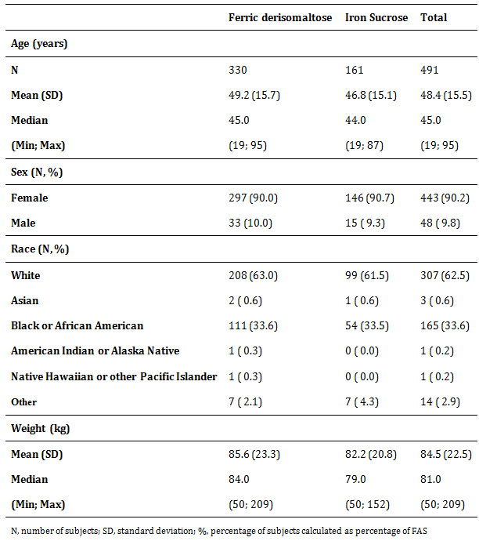

Sample size
The sample size calculation was based on comparison between Group A and B of the proportion of subjects able to increase Hb at least 2 g/dL at any time point during the trial.
In another trial with ferric derisomaltose in another population (Study P-IBD-01), subjects were treated for 8 weeks with ferric derisomaltose. In this trial, with an average cumulative dose of approximately 900 mg, 67% of the subjects treated with ferric derisomaltose had an increase in Hb ≥ 2 g/dL. In the present trial, the planned cumulative dose was between 1,000 and 2,000 mg. Therefore, a higher response rate was expected. In the P-IBD-01 trial, the response rate was above 90% in the subjects receiving a cumulative dose greater than 1,000 mg.
It was assumed that 80% of subjects would be able to increase Hb at least 2 g/dL. The same was assumed for the iron sucrose treatment group. ⁹ With a 2:1 randomisation and a 2-sided significance level of 5%, there would be approximately 90% power to demonstrate non inferiority when using an absolute non inferiority margin of 12.5% points with 300 subjects in Group A and 150 subjects in Group B. The non inferiority margin was based on the following:
Study IDA-301 was a double blind, placebo controlled trial designed to compare the safety and efficacy of 1,000 mg IV ferumoxytol to placebo. ¹⁰ In this trial, 608 subjects were treated with ferumoxytol and 200 received placebo, with demographics and all Baseline parameters well balanced between the two treatment groups. The primary efficacy endpoint for regulators in the USA was the proportion of subjects who achieved a ≥ 2.0 g/dL increase in Hb at any time from Baseline to Week 5 whereas the primary efficacy endpoint for the European Union (EU) regulators was the mean change in Hb from Baseline to Week 5. In the IDA-301 trial, ferumoxytol achieved both primary efficacy endpoints. More than 80% of the trial participants treated with ferumoxytol achieved an increase of ≥ 2.0 g/dL in Hb compared to only 5.5% of the subjects who received placebo.
From the IDA-301 trial, the treatment effect of IV ferumoxytol (that is the difference between ferumoxytol and placebo) was estimated to be approximately 75% points (80% versus 5%) with a 95% CI ranging from 70% to 80%. The point estimate was used as estimate of the treatment effect. Preserving more than 80% of this effect was believed to provide reasonable assurance that ferric derisomaltose is efficacious. Hence, using 83% as preservation fraction, the non inferiority margin was set to (1-0.83) x 75% approximately 12.5% points.
The primary analysis was performed for the FAS. Secondary, the same analysis was performed for the PP analysis set. Both analyses should lead to similar conclusions, and therefore analysis for both analysis sets needed to be powered properly. With approximately 10% (anticipated) of subjects expected to have major protocol violations, a total of 500 subjects had to be randomised.

Statistical methods
All statistical analyses were performed using SAS version 9.4 (SAS Institute, Cary, NC, USA).
All statistical tests were carried out as 2-sided and performed on a 5% significance level unless otherwise stated. Estimated treatment differences and 95% confidence intervals (CIs) were presented together with the corresponding p value.
Categorical data were summarised by treatment, using number and percentages of subjects. For calculation of percentages the denominator was the number of subjects in the analysis set. Continuous data were presented using the number of subjects (N), mean, standard deviation (SD), median, lower quartile, upper quartile, and minimum and maximum. Both the absolute values and the change from Baseline were presented.
Baseline was defined as the last assessment with available data prior to the first administration of trial drug.
Descriptive statistics for all endpoints were presented by treatment group and week (if applicable).
Descriptive statistics and statistical analyses for all endpoints, except the FACIT scale and the SF-36 questionnaire, were performed using observed cases that is no imputation of missing data was performed. For the FACIT scale and SF-36 missing values were imputed using the average of the non-missing items for the subject and visit if less than 50% of the items were missing. Missing events of time to Hb increase ≥ 2 g/dL were handled using censoring.

Participant flow

Table 7: Trial flowchart
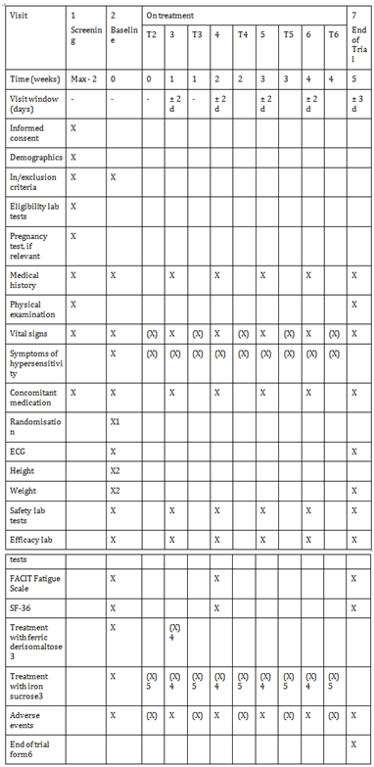
ECG, electrocardiogram; FACIT, Functional Assessment of Chronic Illness Therapy; SF-36, short-form 36 questionnaire; T2-T6, optional treatment visits 1 Randomisation may be performed the day before the Baseline Visit if deemed necessary 2 Height and weight may be measured between the screening and Baseline Visit 3 All trial assessments conducted during Visit 2-6 should be done before administration of the trial drug 4 Dosing will be done if required to receive cumulative dose 5 All T visits are optional treatment visit for dosing with iron sucrose, if required in order to achieve the cumulative dose 6 The end of trial form may be filled in at any time of the trial if the subject is withdrawn from the trial

Major protocol violations/deviations
A total of 37 subjects in the FAS, 19 in the ferric derisomaltose group and 18 in the iron sucrose group were excluded from the PP set. Major PDs leading to exclusion from the PP set are summarised in Table 8. Additionally, 11 subjects, who were withdrawn from the trial and were not included in the FAS due to missing data for primary endpoint, had major deviations related to administration of trial drug.

Table 8: Protocol deviations leading to exclusion from the PP analysis set
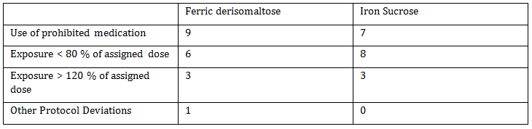

Baseline data
A summary of subgroups by type of disease causing IDA and distribution of subjects within the 8 strata is provided in Table 9, and a summary of Baseline Hb, s-ferritin and TSAT is provided in Table 10.

Table 9: Summary of subgroups by type of disease
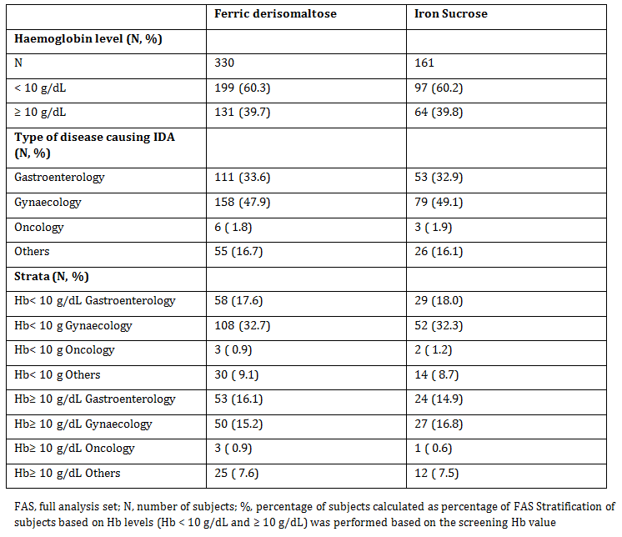

Table 10: Summary of Baseline haemoglobin, s-ferritin, and TSAT (FAS)
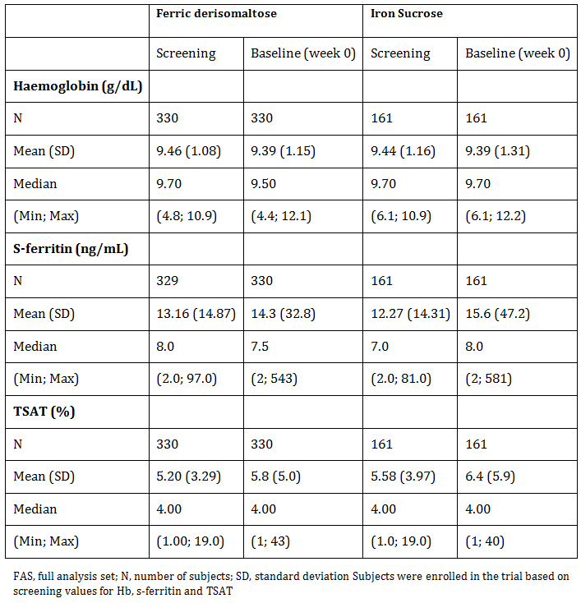

Results for the primary efficacy outcome
The primary endpoint in this trial was proportion of subjects with an Hb increase of ≥ 2 g/dL from Baseline at any time from Week 1 to Week 5.
In the FAS, the largest increase in Hb from Baseline to any time from Week 1 to Week 5 (mean (SD)) was 2.74 (1.32) g/dL in the ferric derisomaltose group and 2.20 (1.20) g/dL in the iron sucrose group. Increases in Hb in the PP analysis set were comparable.
A summary of the primary efficacy analysis in the FAS and PP analysis set is provided in Table 11. There were more responders (that is subjects with an increase in Hb of ≥ 2 g/dL from Baseline at any time from Week 1 to Week 5) in the ferric derisomaltose group compared to the iron sucrose group and a risk difference of 16.7% points in the FAS and 15.9% points in the PP set. Since the lower end of the 95% CI for the risk difference was above 12.5% points in both the FAS and PP analysis set, non inferiority of ferric derisomaltose to iron sucrose could be claimed.
Since non inferiority was claimed, the test for superiority was performed, confirming superiority of ferric derisomaltose over iron sucrose (p < 0.0001, Table 12).

Table 11: Analysis of proportion of subjects with Hb increase ≥ 2 g/dL (FAS and PP)
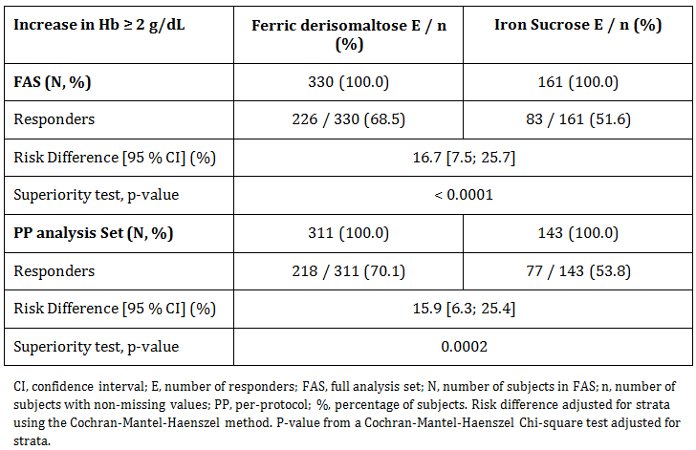

Results for other efficacy outcomes

Time to Haemoglobin Increase ≥ 2 g/dL
The median time to Hb increase ≥ 2 g/dL was 26 days in the ferric derisomaltose group and 37 days in the iron sucrose group. A Kaplan-Meier plot of time to increase is shown in Figure 1.
Analysis of time to Hb increase ≥ 2 g/dL showed a statistically significantly shorter time to Hb increase ≥ 2 g/dL in the ferric derisomaltose group compared to the iron sucrose group with a hazard ratio (HR) (95% CI) of 2.488 (1.916; 3.230).
Figure 1: Kaplan-Meier plot of time to increase in haemoglobin of ≥ 2 g/dL (FAS)
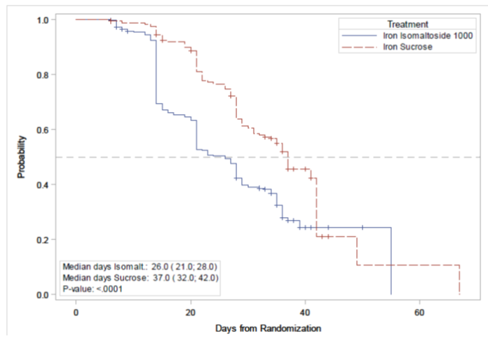

Exploratory analysis of time to haemoglobin increase ≥ 2 g/dL by Stratum
Exploratory analyses of time to Hb increase ≥ 2 g/dL was performed for each of the 8 strata. Compared to the overall result, the median time to Hb increase ≥ 2 g/dL were generally shorter in the gastroenterology, gynaecology, and ‘other’ strata with low screening Hb (< 10 g/dL). In the gastroenterology and gynaecology strata with screening Hb < 10 g/dL, the time to Hb increase ≥ 2 g/dL was statistically significantly shorter in the ferric derisomaltose group compared to the iron sucrose group (log-rank test, p = 0.0020 and p = 0.0002, respectively).
In the strata with screening Hb ≥ 10 g/dL, the time to Hb increase ≥ 2 g/dL was generally longer than in the corresponding strata with lower screening Hb. Exploratory Cox proportional hazard analyses showed statistically significantly longer time to Hb increase ≥ 2 g/dL in the gynaecology stratum with screening Hb ≥ 10 g/dL compared to the reference stratum, gynaecology with screening Hb < 10 g/dL.

Composite endpoint of haemoglobin, S-ferritin and TSAT
The proportion of subjects reaching the composite secondary endpoint described as Hb > 12 g/dL, or Hb increase > 3 g/dL, or s-ferritin increase ≥ 160 ng/mL, or TSAT of 20 to 50% at Week 2, 4, or 5 was very high in both treatment groups, and was higher in the ferric derisomaltose group (98.2%) than in the iron sucrose group (85.7%). There was a statistically significant difference in number of responders (that is a subject reaching at least one of the criteria at least one of the weeks) between the ferric derisomaltose group and the iron sucrose group.

Exploratory analysis of composite secondary endpoint
Separate analyses were made for proportion of subjects achieving Hb > 12 g/dL, Hb increase > 3 g/dL, and a composite exploratory endpoint of s-ferritin increase ≥ 160 ng/mL and TSAT level of 20 to 50%. The results of these exploratory analyses are summarised in Table 12. All 3 exploratory analyses showed a statistically significantly higher number of responders in the ferric derisomaltose group compared to the iron sucrose group.

Table 12: Exploratory analyses of proportion of subjects reaching the separate elements of the composite secondary endpoint (FAS)
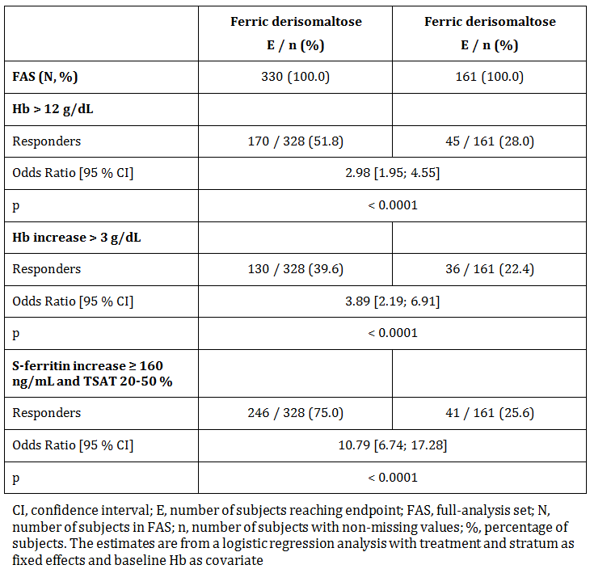

Change in haemoglobin concentration
In both treatment groups, the Hb concentration increased from Baseline until Week 5. In the ferric derisomaltose group, the largest increase occurred from Baseline to Week 2, with a smaller and diminishing increase from Week 2 to Week 5. In the iron sucrose group, there was a small increase in Hb concentration from Baseline to Week 1, and a larger and constant increase from Week 1 to Week 5. The mean Hb concentration from Baseline to Week 5 is shown in Figure 2. The change from Baseline was statistically significantly higher in the ferric derisomaltose group compared to the iron sucrose group at each time point analysed.
Figure 2: Mean Hb concentration from Baseline to Week 5 (FAS)
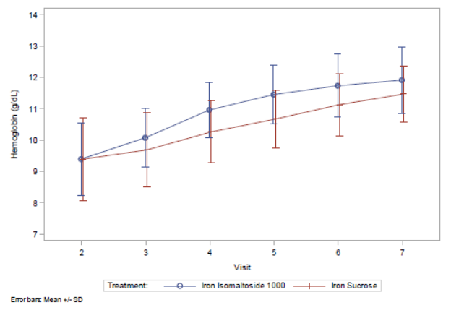

Change in S-ferritin concentration
In both treatment groups, the s-ferritin concentration increased from Baseline until Week 5. In the ferric derisomaltose group the s-ferritin concentration increased markedly from Baseline to Week 2, followed by a decrease from Week 2 to Week 5. In the iron sucrose group, there was an increase in s-ferritin concentration from Baseline to Week 4, and no change thereafter. The mean s-ferritin concentration from Baseline to Week 5 is shown in Figure 3. The change from Baseline in s-ferritin was statistically significantly higher in the ferric derisomaltose group than in the iron sucrose group at Week 2.
Figure 3: Mean s-ferritin concentration from Baseline to Week 5 (FAS)
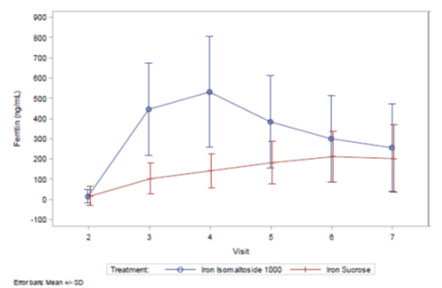

Change in fatigue symptoms
At Baseline, most subjects had severe fatigue. In both treatment groups, the FACIT scores increased (that is fatigue decreased) from Baseline to Weeks 2 and 5. At Week 5, most subjects did no longer have severe fatigue both treatment groups. There was no difference between treatments in change from Baseline to Weeks 2 and 5 in fatigue scores.

Change in quality of life
In both treatment groups, the SF-36 scores in the 8 health domains as well as for the 2 composite scores improved from Baseline to Weeks 2 and 5.
There were no differences between treatments in change from Baseline to Weeks 2 and 5 in any of the 8 health domains or 2 composite scores.

Evaluator commentary
This trial was a randomised, open label, comparative, multi-centre trial in subjects with IDA who were intolerant or unresponsive to oral iron therapy or who needed iron rapidly. Subjects received ferric derisomaltose (Monofer) as IV infusion (1,000 mg/infusion) or IV injection (500 mg/injection) as 1 to 2 dose administrations over a period of 1 to 2 weeks, or iron sucrose (Venofer) as IV infusion (200 mg/infusion) as up to 10 dose administrations over a period of up to 5 weeks.
This trial was designed in accordance with the accepted guidelines for use of Monofer and iron sucrose was a valid comparator, with both trial drugs given in an individual dose up to a maximum cumulative dose of 2,000 mg.
Exclusion/inclusion criteria were reasonable given the target population for Monofer. The trial included a broad population of subjects with different IDA aetiologies. This included a proportion of pre-menopausal women with menorrhagia who were otherwise healthy. IDA was confirmed in all subjects based on low values of Hb, TSAT, and s-ferritin.
The study protocol was followed and all patients were accounted for throughout the study and follow-up period. Protocol violations and deviations were balanced between treatments and patients were compliant with treatments.
The Baseline characteristics between study groups were balanced and the study objectives achieved. For the primary endpoint, proportion of subjects reaching an Hb increase from Baseline of ≥ 2 g/dL at any time between Week 1 and 5, both non inferiority and superiority was confirmed for ferric derisomaltose compared to iron sucrose. Furthermore, shorter time to Hb increase ≥ 2 g/dL was observed with ferric derisomaltose compared to iron sucrose. In general, a both faster and greater biochemical response was seen in subjects with low screening Hb compared to subjects with a higher screening Hb, which could be expected given that subjects with low screening Hb received a higher iron dose.
The investigators satisfactorily demonstrated in subjects with IDA who were intolerant or unresponsive to oral iron therapy or who needed iron rapidly, treatment with ferric derisomaltose, as compared with iron sucrose, was as effective and was well tolerated.

P-Monofer-CKD-02
A Phase III, randomised, comparative, open label study of intravenous ferric derisomaltose (Monofer) administered by infusions or repeated bolus injections in comparison with oral iron sulphate in subjects with non-dialysis dependent chronic kidney disease and with renal related anaemia.

Study design, objectives, locations and dates
The study was a prospective, open label, randomised, comparative, multi-centre, non inferiority study conducted in subjects with non-dialysis dependent chronic kidney disease (NDDCKD) and with renal related anaemia. The enrolment period of the study was approximately 3½ years (July 2010 to February 2014). The study duration for the individual subject was approximately 8 weeks and each subject attended 7 visits (screening visit (Visit 1), Baseline (Visit 2), 4 on-treatment visits (Visit 3 to 6), and 1 end of study (EOS) visit (Visit 7). The subjects were randomised to 1 of the following treatment groups:
- Group A: Ferric derisomaltose (Monofer)
  - Group A1: administered as intravenous (IV) infusions
  - Group A2: administered as IV bolus injections
- Group B: Iron sulphate administered orally

Primary efficacy objective
To demonstrate that IV ferric derisomaltose is non-inferior to oral iron sulphate in reducing renal related anaemia in subjects with NDD-CKD, determined as ability to increase haemoglobin (Hb)

Secondary efficacy objectives
- To assess other relevant haematology and biochemical parameters during the study
- Quality of life (QoL) assessment by linear analogue scale assessment (LASA)
- To assess restless leg syndrome (RLS) symptoms and change in these symptoms during the study.

Safety objective
- To assess safety of IV ferric derisomaltose compared to oral iron sulphate
The study was conducted at 67 centres, including 17 in India, 10 in Germany, 7 each in United Kingdom, Austria, and Russia, 5 in Poland, 4 in Denmark, 3 each in Romania and USA, and 2 each in Sweden and Ireland.

Inclusion and exclusion criteria

Inclusion criteria
- Men and women aged > 18 years
- Subjects diagnosed with NDD-CKD with modification of diet in renal disease calculated eGFR between 15 to 59 mL/min
- Hb < 11.0 g/dL (6.80 mmol/L)
- Either or both of the following iron stores indicators below target (s-ferritin < 200 μg/L and TSAT < 20%)
- Life expectancy beyond 12 months by principal investigator’s (PI’s) judgement
- Willingness to participate after signing informed consent and any authorisation as required by local law (for example protected health information for North America)

Exclusion criteria
- Anaemia predominantly caused by factors other than renal impairment or iron deficiency (according to PI’s judgment)
- Iron overload or disturbances in utilisation of iron (for example haemochromatosis and haemosiderosis)
- Drug hypersensitivity (that is previous hypersensitivity to iron dextran or iron mono- or disaccharide complexes or iron sulphate or any excipients of the study drug
- History of multiple allergies
- Decompensated liver cirrhosis or active hepatitis (ALAT > 3 times upper normal limit).
- Active acute or chronic infections (assessed by clinical judgement), supplied with WBC and CRP
- Rheumatoid arthritis with symptoms or signs of active joint inflammation
- Pregnancy or nursing. In order to avoid pregnancy, women had to be post-menopausal (at least 12 months since last menstruation), surgically sterile, or women of child bearing potential must have used one of the following contraceptives during the whole study period and after the study had ended for at least 5 times plasma biological halflife of the investigational medicinal product (5 days): contraceptive pills, intrauterine devices, contraceptive depot injections (prolonged release gestagen), subdermal implantation, vaginal ring, and transdermal patches
- Extensive active bleeding necessitating blood transfusion
- Planned elective surgery during the study
- Participation in any other clinical study within 3 months prior to screening
- Known intolerance to oral iron treatment
- Untreated B12 or folate deficiency
- IV or oral iron treatment or blood transfusion within 4 weeks prior to screening visit
- Erythropoiesis stimulating agent treatment within 8 weeks prior to screening visit
- S-ferritin > 500 μg/L
- Any other medical condition that, in the opinion of PI, may have caused the subject to be unsuitable for the completion of the study or placed the subject at potential risk from being in the study or interfere with study drug evaluation (for example uncontrolled hypertension, unstable ischemic heart disease, or uncontrolled diabetes mellitus)
- Body weight < 30 kg

Study treatments
Ferric derisomaltose (Monofer) was the test product in this study.

Group A1: Ferric derisomaltose; IV infusion
The full iron replacement dose of ferric derisomaltose was given in weekly doses for up to 2 weeks, administered as infusions of maximum 1,000 mg iron each week until full replacement dose was achieved (if the subject weight was between 35.1 to 45 kg maximum 750 mg iron/infusion and if the subject weight was between 30 to 35 kg maximum 500 mg iron/infusion). The infusion was diluted in 100 mL 0.9% sodium chloride and given over approximately 15 minutes.

Group A2: Ferric derisomaltose; IV bolus injection
The full iron replacement dose of ferric derisomaltose was administered as bolus injections of 500 mg administered undiluted over approximately 2 minutes, once per week until full replacement dose was achieved. In some cases, the remaining dose on the last dosing day may have been 250 mg, for example on Visit 4 if the full replacement dose was 1,250 mg, then this remaining dose was administered undiluted over approximately 2 minutes. No single dose of ferric derisomaltose exceeded 1,000 mg iron or 20 mg iron/kg. No test dose was applied.
Ferro Duretter was the reference therapy that was administered orally at a dose of 100 mg elementary iron twice a day (200 mg daily) for 8 weeks.

Duration of treatment
Duration of treatment varied according to the treatment group. Subjects randomised to Group A1 were treated with a total of 1 or 2 doses with 1 week between doses. Subjects randomised to Group A2 were treated once weekly until full replacement dose was achieved. Subjects randomised to Group B were treated daily for 8 weeks.

Efficacy variables and outcomes

Primary efficacy objective
To demonstrate that IV ferric derisomaltose is non-inferior to oral iron sulphate in reducing renal related anaemia in subjects with NDD-CKD, determined as ability to increase haemoglobin (Hb)

Secondary efficacy objectives
To assess other relevant haematology and biochemical parameters during the study
Quality of life (QoL) assessment by linear analogue scale assessment (LASA)
To assess restless leg syndrome (RLS) symptoms and change in these symptoms during the study

Safety objective
To assess safety of IV ferric derisomaltose compared to oral iron sulphate

Randomisation and blinding methods
Subjects were randomised 2:1 to either Group A (ferric derisomaltose) or Group B (iron sulphate). The subjects randomised to ferric derisomaltose were equally divided into groups A1 (ferric derisomaltose IV infusion) and Group A2 (ferric derisomaltose IV bolus injection). The randomisation of subjects was stratified by whether the subjects received IV iron treatment in the past or not and whether current eGFR was between 15 to 45 mL/minute or 46 to 59 mL/minute. No blinding was performed.

Analysis populations
A total of 233 subjects were randomised to the ferric derisomaltose group and 118 subjects were randomised to the iron sulphate group. Of the 233 subjects enrolled in the ferric derisomaltose group, 117 subjects were randomised to the ferric derisomaltose infusion subgroup and 116 subjects were randomised to the ferric derisomaltose bolus subgroup. The following data sets were analysed:
- Randomised population (N = 351): The randomised population included all subjects who were randomised into the study as per study protocol criteria
- Safety analysis set (N = 345): The safety population included all subjects who were randomised and received at least one dose of the study drug. The safety analyses were performed on the safety population
- Full analysis set (N = 340): The FAS included all subjects who were randomised into the study, received at least one dose of the study drug, and had at least one post-Baseline Hb assessment. The subjects were included as randomised, regardless of which treatment they received. The primary and secondary efficacy analyses were performed on the FAS population
- Per protocol analysis set (N = 327): The PP analysis set included all subjects in the FAS who did not have any major protocol deviation of clinical or statistical significance. The primary efficacy analysis was performed on the PP population.
Out of 351 randomised subjects, 195 (55.6%) were women and 156 (44.4%) were men. 203 (57.8%) subjects were Asian and 134 (38.2%) subjects were Caucasian. 93.4% of the subjects were non-smokers. The mean (SD) age, weight, height, and body mass index (BMI) of the subject population was 58 (16) years, 68 (19) kg, 162 (10) cm, and 26 (7) kg/m², respectively (Table 13).

Table 13: Summary of subject demographics; randomised population. Study P-Monofer-CKD-02
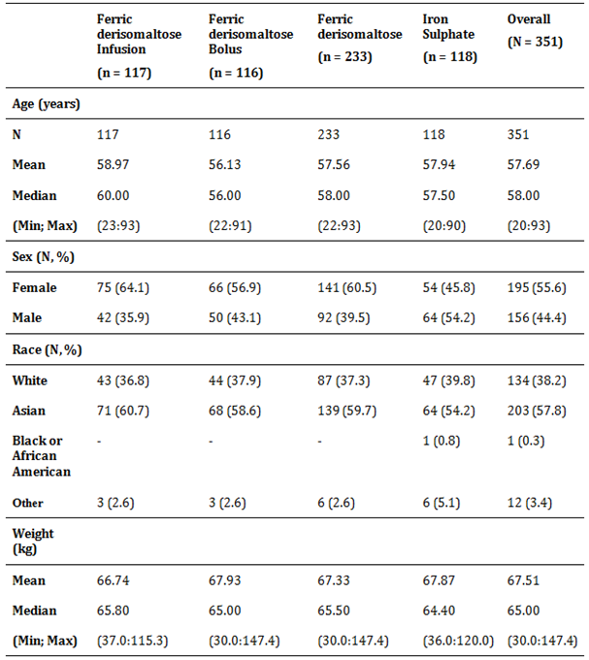

Sample size
The sample size calculation was based on absolute change in Hb from Baseline to Week 4. The non inferiority margin was set as -0.5 g/dL. This margin was in line with previous studies and was regarded as clinically relevant. A two-sided significance level of 5% was used and the power was set to 80%.
Based on available literature and previous studies with ferric derisomaltose, the SD for change in Hb was assumed to be approximately 1.5 g/dL. Based on this, a total of 321 subjects were to be included in the efficacy analyses (that is, provide post-randomisation Hb measurements).
As the study was designed to demonstrate non inferiority, both analyses of the full analysis set (FAS) and the per protocol (PP) analysis set would lead to similar conclusions. Therefore, analyses for both analysis sets were powered properly. With approximately 10% (anticipated) of subject population expected to have major protocol violations, a total of 350 subjects were to be randomised.

Statistical methods
All statistical analyses were performed using SAS version 9.1.3. All statistical tests were carried out as two-sided on a 5% level of significance unless otherwise stated. The descriptive statistics for continuous variables was presented with number (n) of non-missing observations, mean, standard deviation (SD), median, minimum, and maximum and the categorical data was presented with counts and percentages.

Participant flow
All efficacy and safety assessments were performed per the study flowchart (Table 14).

Table14: Study flowchart. Study P-Monofer-CKD-02
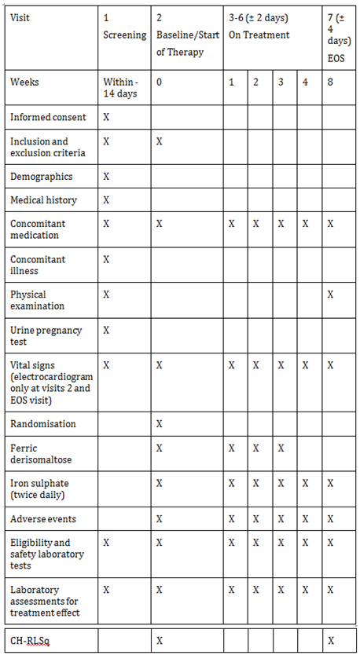

Major protocol violations/deviations
A number of randomised subjects were excluded from the Safety FAS and PP populations.as they did not receive at least one dose of the study drug. Others were excluded as they did not have any post Baseline Hb measurement.
A total of 13 major protocol deviations were reported during the study and the subjects were excluded from the PP population.
A total of 445 minor protocol deviations were reported in the study which did not lead to exclusion of subjects from the datasets, since none of these protocol deviations were evaluated to be important for the outcome of the trial, the data interpretation, or the safety of the subjects.

Baseline data
All the haematological parameters (Hb, s-ferritin, s-iron, TSAT, and TIBC) and eGFR score were comparable between the ferric derisomaltose and iron sulphate groups at Baseline (Table 15).

Table 15: Summary of haematological parameters and estimated glomerular filtration rate at Baseline; full analysis set
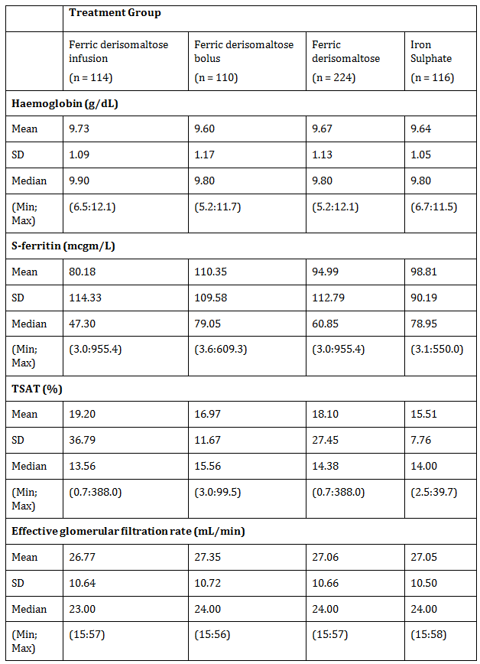

Results for the primary efficacy outcome
The average change in Hb concentration from Baseline to Week 4 is summarised in Table 16 for the FAS, and Table 17 for the PP population. Non inferiority tested the distribution of difference estimate by a non inferiority margin of -0.5 and tested the equality between the treatment groups by deriving a p value. The test for non inferiority showed that ferric derisomaltose was non-inferior to iron sulphate in its ability to increase Hb from Baseline to Week 4 in both FAS and PP datasets (FAS: difference estimate: 0.2216, 95% CI: 0.012:0.431, p < 0.0001; PP: difference estimate: 0.2176, 95% CI: 0.003:0.432, p < 0.0001). Similar results were observed when the ferric derisomaltose infusion and bolus subgroups were compared to the iron sulphate group in both FAS and PP datasets (FAS: infusion subgroup: difference estimate: 0.2744, 95% CI: 0.015:0.534, p < 0.0001; bolus subgroup: difference estimate: 0.1688, 95% CI: -0.055:0.392, p < 0.0001; PP: infusion subgroup: difference estimate: 0.2717, 95% CI: 0.007:0.536, p < 0.0001; bolus subgroup: difference estimate: 0.1636, 95% CI: -0.066:0.394, p < 0.0001).
In addition to showing non inferiority, ferric derisomaltose showed superiority over iron sulphate in terms of a significant higher increase in Hb concentration from Baseline to Week 4 (FAS: p = 0.0385; PP: p = 0.0471). A similar result was observed when the ferric derisomaltose infusion subgroup was compared to the iron sulphate group (FAS: p = 0.0382; PP: p = 0.0440). There was no statistical significant difference in the change in Hb concentration from Baseline to Week 4 between the ferric derisomaltose bolus subgroup and the iron sulphate group and between the infusion and bolus subgroups in both FAS and PP datasets.

Table 16: Average change in haemoglobin concentration (g/dL) from Baseline to Week 4; full analysis set
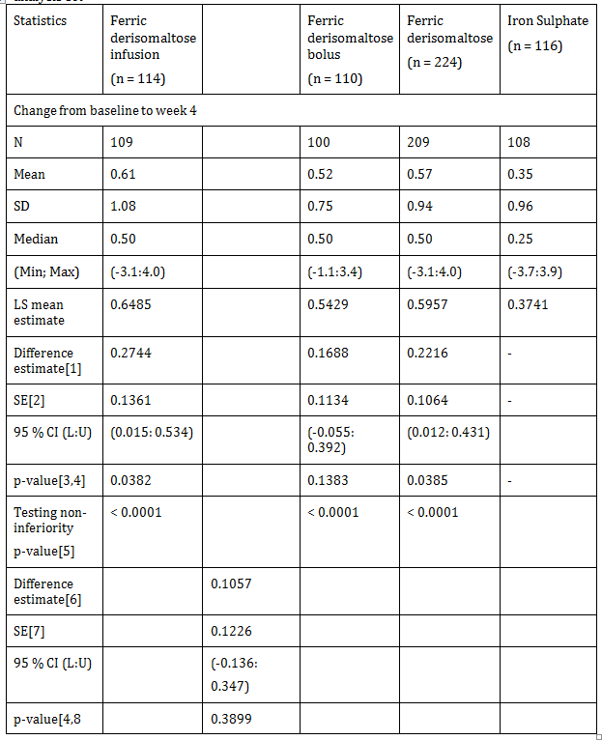
Note: (1) Difference estimate for infusion, bolus and ferric derisomaltose group indicates (infusion iron sulphate), (bolus iron sulphate), and (ferric derisomaltose-iron sulphate), respectively. (2) SE of infusion, bolus and ferric derisomaltose group indicates standard error of differences. (3) p value for infusion, bolus and ferric derisomaltose group indicates for significance of treatment differences. (4) MMRM includes treatment, country and stratum (past treatment with parenteral iron (Yes/No) and current eGFR between 15 to 45 mL/minute or between 46 to 59 mL/minute) as factors and Baseline value as covariates using PROC Mixed procedure of SAS software. (5)Non inferiority was tested by shifting the distribution of difference estimate by a non inferiority margin -0.5 and tested the equality between treatment groups by deriving p value. (6) Difference estimate for infusion and bolus group indicates (infusion-bolus), respectively.

Table18: Average change in haemoglobin concentration (g/dL) from Baseline to Week 4; per protocol population
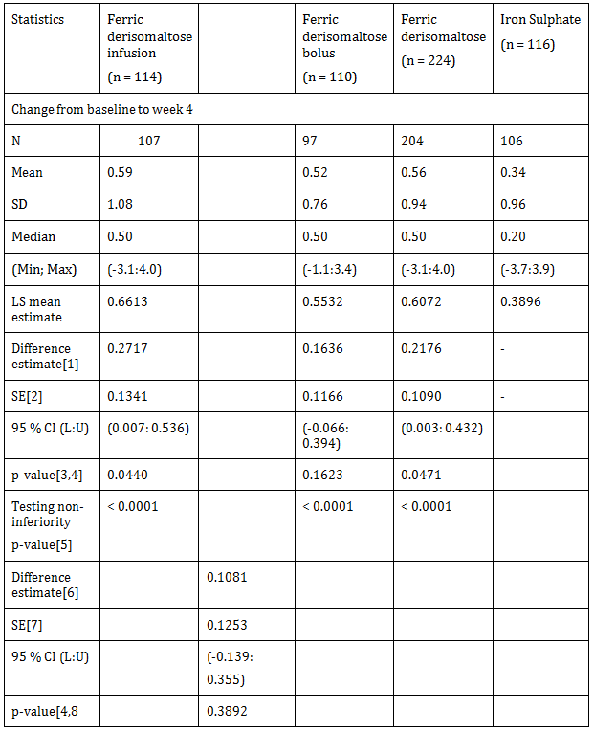
Note: (1) Difference estimate for infusion, bolus and ferric derisomaltose group indicates (infusion-iron sulphate), (bolus-iron sulphate), and (ferric derisomaltose-iron sulphate), respectively. (2) SE of infusion, bolus and ferric derisomaltose group indicates standard error of differences. (3) p value for infusion, bolus and ferric derisomaltose group indicates the significance of treatment differences. (4) MMRM included treatment, country and stratum (past treatment with parenteral iron (Yes/No) and current eGFR between 15 to 45 mL/minute or between 46 to 59 mL/minute) as factors and Baseline value as covariates using PROC Mixed procedure of SAS software. (5) Non inferiority was tested by shifting the distribution of difference estimate by a non inferiority margin -0.5 and testing the equality between treatment groups by deriving p value. (6) Difference estimate for infusion and bolus group indicates (infusion-bolus), respectively. (7) Standard error of infusion and bolus group indicates standard error of difference (infusion-bolus), respectively. (8) p value for infusion and bolus group indicates for significance of treatment difference (infusion-bolus), respectively. General Note: L: lower limit; U: upper limit. SE: standard error, CI: confidence interval. Baseline missing values were imputed from screening visit

Results for other efficacy outcomes

Number of subjects who had a change in haemoglobin concentration ≥ 1.0 g/dL from Baseline to Week 2, 4, or 8
There was no statistical significant difference in the proportion of subjects who had a change in Hb ≥ 1.0 g/dL from Baseline to Week 2 or Week 4 between the ferric derisomaltose and iron sulphate groups (Week 2: p = 0.9727; Week 4: p = 0.3944). Similar results were observed when the ferric derisomaltose infusion and bolus subgroups were compared to the iron sulphate group and when the ferric derisomaltose infusion and bolus subgroups were compared.
A statistical significant higher proportion of subjects in the ferric derisomaltose group had a change in Hb ≥ 1.0 g/dL from Baseline to Week 8 compared to the iron sulphate group (41.4% versus 26.8%, p = 0.0056). Similar results were observed when the ferric derisomaltose infusion subgroup was compared to the iron sulphate group (48.1% versus 26.8%, p = 0.0007). There was a statistical significant higher proportion of subjects in the ferric derisomaltose infusion subgroup who had a change in Hb ≥ 1.0 g/dL from Baseline to Week 8 compared to the ferric derisomaltose bolus subgroup (48.1% versus 34.6%, p = 0.0321).
There was no statistical significant difference in the proportion of subjects who had a change in Hb ≥ 1.0 g/dL from Baseline to Week 2, 4, or 8 (combined data, that is subjects with a change in Hb ≥ 1.0 g/dL at either one of the time points) between the ferric derisomaltose and iron sulphate groups (p = 0.1464). However, a statistical significant higher proportion of subjects had a change in Hb ≥ 1.0 g/dL from Baseline to Week 2, 4, or 8 in the ferric derisomaltose infusion subgroup compared to the iron sulphate group (51.8% subjects versus 37.1% subjects, p = 0.0122). In addition, a statistical significant higher proportion of subjects had a change in Hb ≥ 1.0 g/dL from Baseline to Week 2, 4, or 8 in the ferric derisomaltose infusion subgroup compared to the ferric derisomaltose bolus subgroup (51.8% subjects versus 36.4% subjects, p = 0.0111) (Table 19).

Table 18: Summary of subjects with change in haemoglobin concentration ≥ 1.0 g/dL from Baseline; full analysis set
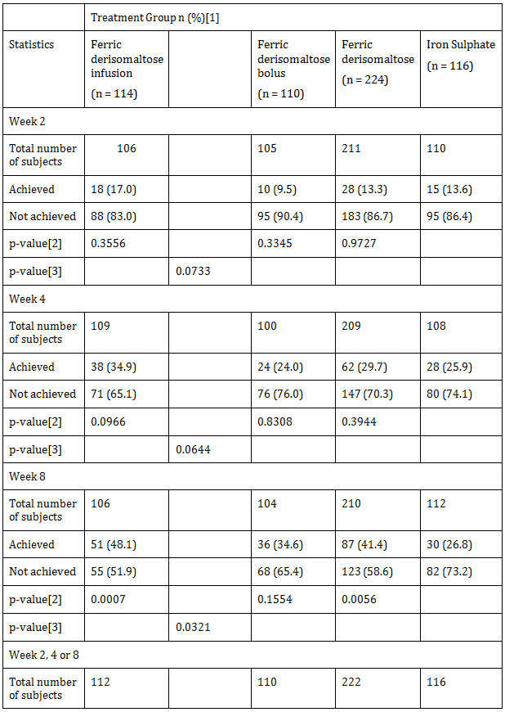
Note: (1) Percentage was calculated by taking count of corresponding visit population of treatment group as denominator. (2) p value was calculated by logistic regression with treatment and stratum as factors and Baseline values as covariates using PROC LOGISTIC procedure of SAS for infusion, bolus and ferric derisomaltose group indicates (infusion–iron sulphate), (bolus-iron sulphate), and (ferric derisomaltose-iron sulphate) respectively. (3) p value was calculated by logistic regression with treatment and stratum as factors and Baseline values as covariates using PROC LOGISTIC procedure of SAS software for infusion and bolus group indicates (infusion-bolus) respectively. General Note: Subjects were considered to achieve target limits of Hb at particular visit, that is if change in Hb ≥ 1.0 g/dL.

Number of subjects who had a change in haemoglobin concentration ≥ 2.0 g/dL from baseline to Week 2, 4, or 8
The proportion of subjects with a change in Hb ≥ 2.0 g/dL from Baseline to Week 2 was comparable between the ferric derisomaltose and iron sulphate groups (ferric derisomaltose: 2.8%; iron sulphate: 3.6%). The p value could not be determined due to the low number of subjects in both treatment groups.
There was no statistical significant difference in the proportion of subjects who had a change in Hb ≥ 2.0 g/dL from Baseline to Week 4 between the ferric derisomaltose and iron sulphate groups (p = 0.1477). Similar results were observed when the ferric derisomaltose infusion and bolus subgroups were compared to the iron sulphate group and when the ferric derisomaltose infusion and bolus subgroups were compared.
A statistical significant higher proportion of subjects had a change in Hb ≥ 2.0 g/dL from Baseline to Week 8 in the ferric derisomaltose group compared to the iron sulphate group (14.8% versus 7.1%, p = 0.0286). Similar results were observed when the ferric derisomaltose infusion subgroup was compared to the iron sulphate group (17.0% versus 7.1%, p = 0.0100). There was no statistical significant difference in the proportion of subjects with a change in Hb ≥ 2.0 g/dL from Baseline to Week 8 when the ferric derisomaltose bolus subgroup was compared to the iron sulphate group and when the ferric derisomaltose infusion and bolus subgroups were compared.
There was no statistical significant difference in the proportion of subjects who had a change in Hb ≥ 2.0 g/dL from Baseline to Week 2, 4, or 8 (combined data, that is subjects with a change in Hb ≥ 2.0 g/dL at either one of the time points) between the ferric derisomaltose and iron sulphate groups (p = 0.1792). Similar results were observed when the ferric derisomaltose infusion and bolus subgroups were compared to the iron sulphate group and when the ferric derisomaltose infusion and bolus subgroups were compared (Table 19).

Table 19: Summary of subjects with change in haemoglobin concentration ≥ 2.0 g/dL from Baseline; full analysis set
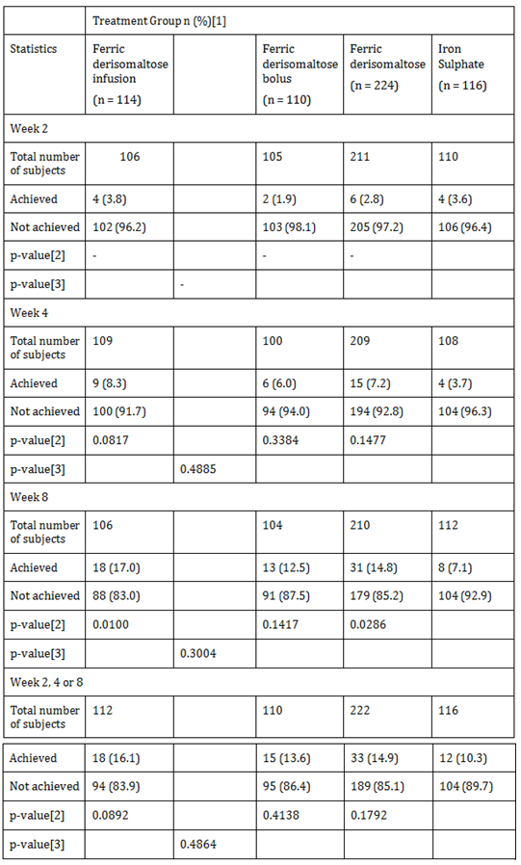
Note: (1) Percentage was calculated by taking count of corresponding visit population of treatment group as denominator. (2) p value was calculated by logistic regression with treatment and stratum as factors and Baseline values as covariates using PROC LOGISTIC procedure of SAS for infusion, bolus and ferric derisomaltose group indicates (infusion-iron sulphate), (bolus-iron sulphate), and (ferric derisomaltose-iron sulphate), respectively. (3) p value was calculated by logistic regression with treatment and stratum as factors and Baseline values as covariates using PROC LOGISTIC procedure of SAS software for infusion and bolus group indicates (infusion-bolus), respectively. General Note: Subjects were considered to achieve target limits of Hb at particular visit, that is if change in Hb ≥ 2.0 g/dL.

Number of subjects who had haemoglobin > 11 g/dL (6.80 mmol/L), serum ferritin level of 200 to 800 μg/L, and had achieved a transferrin saturation of 20 to 50% at Week 2, 4, or 8
There was no statistical significant difference in the proportion of responders (subjects who had achieved target limits of Hb (> 11 g/dL (6.80 mmol/L)), a s-ferritin level of 200 to 800 μg/L, and a TSAT of 20 to 50%) between the ferric derisomaltose and iron sulphate groups at Week 2 (p = 0.0673). The p value could not be determined for ferric derisomaltose infusion and bolus subgroups versus iron sulphate group due to the low number of subjects in both ferric derisomaltose infusion and bolus subgroups. There was no statistical significant difference in the proportion of responders between the ferric derisomaltose infusion and bolus subgroups at Week 2.
There was a statistical significant higher proportion of responders in the ferric derisomaltose group compared to the iron sulphate group at Week 4 and 8 (Week 4: 9.1% versus 2.8%, p = 0.0335; Week 8: 9.5% versus 2.7%, p = 0.0349). A statistical significant higher proportion of responders was observed in the ferric derisomaltose infusion subgroup compared to the iron sulphate group at Week 4 or 8 (Week 4: 10.1% versus 2.8%, p = 0.0283; Week 8: 10.4% versus 2.7%, p = 0.0304). There was no statistical significant difference in the proportion of responders between the ferric derisomaltose infusion and bolus subgroups at Week 4 or 8.
A statistical significant higher proportion of responders were observed in the ferric derisomaltose group compared to the iron sulphate group at Week 2, 4, or 8 (combined data, that is subjects fulfilling the responder criteria at either one of the time points) (18.0% subjects versus 5.2% subjects, p = 0.0019). Similar results were observed when the ferric derisomaltose infusion subgroup was compared to the iron sulphate group (19.6% subjects versus 5.2% subjects, p = 0.0016). There was no statistical significant change in the proportion of responders between ferric derisomaltose infusion and bolus subgroups (Table 20).

Table 20: Summary of subjects who achieved all target limits of haemoglobin, serum ferritin, and transferrin saturation; full analysis set
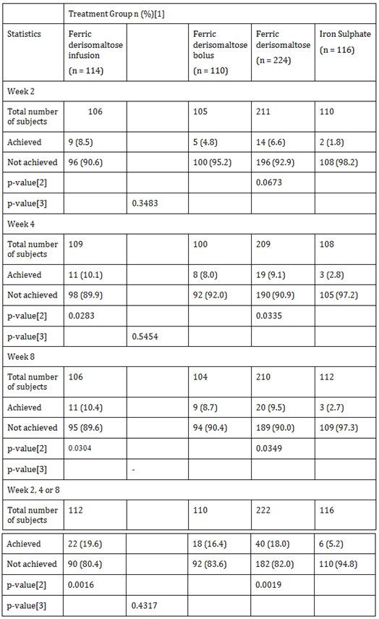
Note: (1) Percentage was calculated by taking count of corresponding visit population of treatment group as denominator. (2) p value was calculated by logistic regression with treatment and stratum as factors and Baseline values as covariates using PROC LOGISTIC procedure of SAS for infusion, bolus and ferric derisomaltose group indicates (infusion-iron sulphate), (bolus-iron sulphate), and (ferric derisomaltose-iron sulphate), respectively. (3) p value was calculated by logistic regression with treatment and stratum as factors and Baseline values as covariates using PROC LOGISTIC procedure of SAS software for infusion and bolus group indicates (infusion-bolus), respectively. General Note: If subject met following target limits of Hb, s-ferritin and TSAT at Week 2, Week 4 or Week 8, then the subject was classified in achieved’ category else classified in ‘not achieved’ category. Hb > 11 g/dL (6.80 mmol/L). s-ferritin: (200-800). TSAT: (20 to 50%).

Number of subjects who had a haemoglobin > 11 g/dL (6.80 mmol/L) at Week 2, 4, or 8
There was no statistical significant difference in the proportion of subjects achieving Hb ≥ 11 g/dL at Week 2, 4, or 8 between the ferric derisomaltose and iron sulphate groups (Week 2: p = 0.8044; Week 4: p = 0.0721; Week 8: p = 0.1617). A statistical significant higher proportion of subjects achieved Hb ≥ 11 g/dL at Week 4 in the ferric derisomaltose infusion subgroup compared to the iron sulphate group (28.4% versus 14.8%, p = 0.0166). There was no statistical significant difference in the proportion of subjects achieving Hb ≥ 11 g/dL at Week 2, 4, or 8 between the ferric derisomaltose infusion and bolus subgroups.
There was no statistical significant difference in the proportion of subjects achieving Hb≥ 11 g/dL at Week 2, 4, or 8 (combined data, that is subjects with a Hb > 11.0 g/dL at either one of the time points) between the ferric derisomaltose and iron sulphate groups (p = 0.1741). Similar results were observed when the ferric derisomaltose infusion and bolus subgroups were compared to the iron sulphate group and when the ferric derisomaltose infusion and bolus subgroups were compared.

Number of subjects who had a serum ferritin level of 200 to 800 μg/L at Week 2, 4, or 8
There was a statistical significant higher proportion of subjects who had a s-ferritin level of 200 to 800 μg/L in the ferric derisomaltose group compared to the iron sulphate group at Week 2, 4, or 8 (Week 2: 87.6% versus 12.7%, p < 0.0001; Week 4: 75.5% versus 13.9%, p < 0.0001; Week 8: 63.2% versus 23.2%, p < 0.0001). Similar results were observed when the ferric derisomaltose infusion and bolus subgroups were compared to the iron sulphate group at Weeks 2, 4, and 8 (ferric derisomaltose infusion versus iron sulphate: Week 2: 91.3% versus 12.7%, p < 0.0001; Week 4: 75.9% versus 13.9%, p < 0.0001; Week 8: 60.4% versus 23.2%, p < 0.0001; ferric derisomaltose bolus versus iron sulphate: Week 2: 83.8% versus 12.7%, p < 0.0001; Week 4: 75.0% versus 13.9%, p < 0.0001; Week 8: 66.0% versus 23.2%, p < 0.0001). There was no statistical significant difference in the proportion of subjects who had a s-ferritin level of 200 to 800 μg/L between the ferric derisomaltose infusion and bolus subgroups at Week 2, 4, or 8.
A statistical significant higher proportion of subjects had a s-ferritin level of 200 to 800 μg/L in the ferric derisomaltose group compared to the iron sulphate group at Week 2, 4, or 8 (combined data, that is subjects with a s-ferritin level of 200 to 800 μg/L at either one of the time points) (92.3% versus 25.9%, p < 0.0001). Similar results were observed when the ferric derisomaltose infusion and bolus subgroups were compared to the iron sulphate group (ferric derisomaltose infusion versus iron sulphate: 95.5% versus 25.9%, p < 0.0001; ferric derisomaltose bolus versus iron sulphate: 89.1% versus 25.9%, p < 0.0001). There was no statistical significant difference in the proportion of subjects who had a s-ferritin level of 200 to 800 μg/L at Week 2, 4, or 8 between the ferric derisomaltose infusion and bolus subgroups.

Change in haemoglobin concentration from Baseline to Week 2 and 8
There was an increase in Hb concentration from Baseline to Week 2 and 8 within the ferric derisomaltose and iron sulphate groups. There was a statistical significant increase in Hb concentration from Baseline to Week 8 in the ferric derisomaltose group compared to the iron sulphate group (0.92 ± 1.19 versus 0.45 ± 1.04, p = 0.0004). Similar results were observed when the ferric derisomaltose infusion and bolus subgroups were compared to the iron sulphate group (ferric derisomaltose infusion versus iron sulphate: 0.97 ± 1.26 versus 0.45 ± 1.04, p = 0.0013; ferric derisomaltose bolus versus iron sulphate: 0.86 ± 1.12 versus 0.45 ± 1.04, p = 0.0066).
No statistical significant change in Hb concentration from Baseline to Week 2 was observed between the ferric derisomaltose and iron sulphate groups (p = 0.4902). There was no statistical significant change in Hb concentration from Baseline to Week 2 when the ferric derisomaltose infusion and bolus subgroups were compared to the iron sulphate group and when the ferric derisomaltose infusion and bolus subgroups were compared at Week 2 and Week 8

Change in concentrations of serum ferritin from baseline to Week 1, 2, 4, and 8
There was a statistical significant increase in s-ferritin concentration from Baseline to Weeks 1, 2, 4, and 8 in the ferric derisomaltose group compared to the iron sulphate group (Week 1: 352.79 ± 184.12 versus 9.42 ± 33.30, p < 0.0001; Week 2: 390.08 ± 212.67 versus 56.83 ± 434.25, p < 0.0001; Week 4: 280.96 ± 175.51 versus 58.44 ± 337.50, p < 0.0001; Week 8: 217.71 ± 160.34 versus 67.88 ± 250.21, p < 0.0001). Similar results were observed when the ferric derisomaltose infusion and bolus subgroups were compared to the iron sulphate group (ferric derisomaltose infusion versus iron sulphate: Week 1: 429.64 ± 205.40 versus 9.42 ± 33.30, p < 0.0001; Week 2: 377.48 ± 180.93 versus 56.83 ± 434.25, p < 0.0001; Week 4: 266.18 ± 179.60 versus 58.44 ± 337.50, p < 0.0001; Week 8: 198.01 ± 151.94 versus 67.88 ± 250.21, p < 0.0001; ferric derisomaltose bolus versus iron sulphate: Week 1: 275.22 ± 117.29 versus 9.42 ± 33.30, p < 0.0001; Week 2: 402.56 ± 240.25 versus 56.83 ± 434.25, p < 0.0001; Week 4: 296.91 ± 170.45 versus 58.44 ± 337.50, p < 0.0001; Week 8: 237.99 ± 166.86 versus 67.88 ± 250.21, p < 0.0001). There was a statistical significant increase in s-ferritin concentration from Baseline to Week 1 in the ferric derisomaltose infusion subgroup compared to the bolus subgroup (429.64 ± 205.40 versus 275.22 ± 117.29, p < 0.0001). No statistical significant changes in s-ferritin concentration were observed from Baseline to Weeks 2, 4, and 8 between the ferric derisomaltose infusion and bolus subgroups.

Change in total quality of life score from baseline to Week 4 and 8
There was an increase in subject’s energy level, ability to do daily activities, and overall QoL from Baseline to Week 4 and 8 in both treatment groups. No statistical significant difference in the subject’s energy level, ability to do daily activities, and overall QoL was observed from Baseline to Week 4 and 8 between the ferric derisomaltose and iron sulphate groups (Week 4: subject’s energy level: p = 0.6754, ability to do daily activities: p = 0.2788, overall QoL: p = 0.3905; Week 8: subject’s energy level: p = 0.9625, ability to do daily activities: p = 0.3303, overall QoL: p = 0.4723). Similar results were observed when the ferric derisomaltose infusion and bolus subgroups were compared to the iron sulphate group and when the ferric derisomaltose infusion and bolus subgroups were compared.

Change in estimated glomerular filtration rate from baseline to Week 8
There was no statistical significant decrease in eGFR from Baseline to Week 8 between the ferric derisomaltose and iron sulphate groups (p = 0.4493). Similar results were observed when the ferric derisomaltose infusion and bolus subgroups were compared to the iron sulphate group and when the ferric derisomaltose infusion and bolus subgroups were compared.

Evaluator commentary
The objective of the study was to evaluate the efficacy and safety of IV ferric derisomaltose administered by infusions or repeated bolus injections in comparison to oral iron sulphate in NDD-CKD subjects with renal related anaemia.
This trial was designed in accordance with the accepted guidelines for use of Monofer and Iron sulphate was selected as the comparator in this study since it has been widely used in IDA and has been used as a comparator in the previous studies in NDD-CKD subjects.
Exclusion/inclusion criteria were reasonable given the target population for Monofer.
The study protocol was followed and all patients were accounted for throughout the study and follow-up period. Protocol violations and deviations were balanced between treatments and patients were compliant with treatments.
The Baseline characteristics between study groups were balanced and the study objectives achieved.
Non inferiority tested the distribution of difference estimate by a non inferiority margin of -0.5 and tested the equality between the treatment groups by deriving a p value. The test for non inferiority showed that ferric derisomaltose was non-inferior to iron sulphate in its ability to increase Hb from Baseline to Week 4 in both FAS and PP datasets (FAS: difference estimate: 0.2216, 95% CI: 0.012:0.431, p < 0.0001; PP: difference estimate: 0.2176, 95% CI: 0.003:0.432, p < 0.0001). Similar results were observed when the ferric derisomaltose infusion and bolus subgroups were compared to the iron sulphate group in both FAS and PP datasets.
In addition to showing non inferiority, ferric derisomaltose showed superiority over iron sulphate in terms of a significant higher increase in Hb concentration from Baseline to Week 4 (FAS: p = 0.0385; PP: p = 0.0471). Similar result was observed when the ferric derisomaltose infusion subgroup was compared to the iron sulphate group (FAS: p = 0.0382; PP: p = 0.0440). There was no statistical significant difference in the change in Hb concentration from Baseline to Week 4 between the ferric derisomaltose bolus subgroup and iron sulphate group and between the infusion and bolus subgroups in both FAS and PP datasets. To establish whether the conclusions drawn from the primary analyses were robust, sensitivity analyses were performed. As per sensitivity analysis with LOCF, ferric derisomaltose was found to be non-inferior to iron sulphate in its ability to increase Hb from Baseline to Week 4 in the FAS population (difference estimate: 0.2033, 95% CI: -0.010:0.416, p < 0.0001).
The sponsor has demonstrated that ferric derisomaltose was more efficacious than oral iron in increasing Hb and proved to be better tolerated than oral iron at the tested dose levels in NDD-CKD patients.

P-Monofer-CKD-03
A Phase III, randomised, comparative, open label study of intravenous ferric derisomaltose (Monofer) administered as maintenance therapy by single or repeated bolus injections in comparison with intravenous iron sucrose in subjects with stage 5 chronic kidney disease on dialysis therapy (CKD-5D).

Study design, objectives, locations and dates
The study was a prospective, open label, randomised, comparative, multi-centre, non inferiority study conducted in subjects with CKD-5D in haemodialysis and on erythropoiesis stimulating agent (ESA) treatment. The enrolment period of the study was 28 months (June 2011 to September 2013). The study duration for the individual subject was approximately 8 Weeks and each subject attended 6 visits during the study (screening visit (Visit 1) divided in 2 visits – Visit 1a and 1b, Baseline (Visit 2), three on-treatment and follow-up visits (Visit 3-5), and one end of study (EOS) visit (Visit 6)). The subjects were randomised 2:1 into Group A and Group B; with 1:1 randomisation between subgroup A1 and A2. The following were the 2 treatment groups:
- Group A: Ferric derisomaltose (Monofer)
  - Subgroup A1: administered as a 500 mg intravenous (IV) single bolus injection
  - Subgroup A2: administered as 500 mg fractionated (100 mg + 200 mg + 200 mg) IV bolus injections
- Group B: Iron sucrose (Venofer) administered as 500 mg fractionated (100 mg + 200 mg + 200 mg) IV bolus injections
The study was conducted at 48 centres, including 16 centres in India, 14 centres in UK, 4 centres each in Russia and Poland, 3 centres each in Sweden and Switzerland, 2 centres in Romania, and 1 centre each in Denmark and USA.

Studied period
- First subject first visit : 14 June 2011
- Last subject last visit : 28 October 2013

Inclusion and exclusion criteria

Inclusion criteria
- Women and men aged ≥ 18 years
- Subjects diagnosed with CKD-5D and in haemodialysis therapy for at least 90 days
- Life expectancy beyond 12 months by principal investigator’s (PI’s) judgement
- Willingness and ability to participate after signing informed consent
- Hb concentrations between 9.5 g/dL and 12.5 g/dL (both values included) both at screening Visit 1a and at screening Visit 1b (screening Visit 1a and Visit 1b was separated by at least 1 week
- S-ferritin < 800 ng/mL
- TSAT < 35%
- Subjects receiving erythropoiesis stimulating agent treatment with dose stable for the previous 4 weeks prior to screening (with only 1 missed dose allowed. Dose was kept stable during the study period)
- Subjects receiving no IV iron or an average of no more than 100 mg/week for the previous 4 weeks (with only 1 missed dose allowed)

Exclusion criteria
- Anaemia caused primarily by factors other than renal related anaemia
- Iron overload or disturbances in utilisation of iron (for example haemochromatosis and haemosiderosis)
- Subjects who were currently undergoing treatment with immunosuppressives (low dose steroids were allowed during the study conduct for dosages no more than 10 mg prednisolone/day or equivalent. If possible the dosage was kept constant through the study)
- Difference of Hb ≥ 1.0 g/dL between screening Visit 1a and 1b
- Subject with a history of multiple allergies
- Decompensated liver cirrhosis or active hepatitis (ALAT > 3 times normal) or history of hepatitis B or C
- Active acute or chronic infections (assessed by clinical judgement), supplied with WBC and CRP
- Rheumatoid arthritis with symptoms or signs of active joint inflammation
- Pregnancy or nursing. In order to avoid pregnancy, women had to be postmenopausal (at least 12 months since last menstruation), surgically sterile, or women of child bearing potential must use one of the following contraceptives during the whole study period and after the study had ended for at least 5 times plasma biological half-life of the investigational medicinal product: contraceptive pills, intrauterine devices, contraceptive depot injections (prolonged release gestagen), subdermal implantation, vaginal ring, and transdermal patches
- Blood transfusion within the previous 12 weeks
- Planned elective surgery in the next 8 weeks
- Participation in any other clinical study within the past 30 days, or if longer, where the study drug has not passed five half-lives prior to screening
- Untreated vitamin B12 or folate deficiency
- Any other medical condition that, in the opinion of PI, may cause the subject to be unsuitable for the completion of the study or place the subject at potential risk from being in the study, for example uncontrolled hypertension, unstable ischemic heart disease, or uncontrolled diabetes mellitus

Study treatments
Monofer was the test product in this study.
Drug dosage and mode of administration was as follows:

Subgroup A1: Ferric derisomaltose – 500 mg IV bolus injection
Ferric derisomaltose was administered undiluted as a single IV bolus injection of 500 mg over approximately 2 minutes at Baseline.

Subgroup A2: Ferric derisomaltose; 500 mg (100 mg + 200 mg + 200 mg) fractionated IV bolus injections
Ferric derisomaltose was administered undiluted in fractionated doses of 100 mg at Baseline and 200 mg each at Week 2 and Week 4. The doses were administered as IV bolus injections over approximately 2 minutes.
No test dose was administered.
All dosages were administered during dialysis, at least 30 minutes after the start and at least 1 hour before the end of dialysis.

Reference therapy
Venofer was the reference therapy in this study. It was provided as 20 mg/mL iron as iron (III)-hydroxide sucrose complex/mL of sterile 0.9% m/V sodium chloride solution.
Drug dosage and mode of administration was as follows:

Group B: Iron sucrose – 500 mg (100 mg + 200 mg + 200 mg) fractionated IV bolus injections
Iron sucrose was administered undiluted in fractionated doses of 100 mg at Baseline and 200 mg each at Week 2 and Week 4. The doses were administered as per local summary of product characteristics (SmPC) in Europe and package insert in USA and/or local hospital guidelines, as applicable.
For iron sucrose, a test dose was administered if recommended or compulsory according to the local SmPC or package insert and/or local hospital guidelines, as applicable.

Efficacy variables and outcomes

Primary efficacy endpoint
Proportion of subjects who could maintain Hb between 9.5 and 12.5 g/dL (both values included) at Week 6

Secondary efficacy endpoints
- Change in Hb concentration from Baseline to Week 2, 4, and 6
- Change in concentrations of s-iron, TSAT, s-ferritin, and reticulocyte count from Baseline to Week 1, 2, 4, and 6
- Number of subjects in each randomisation group who discontinued study because of lack of response or intolerance of investigational drugs
- Change in total QoL score (LASA) from Baseline to Week 4 and 6
- Change in RLS symptoms (Cambridge Hopkins-RLS questionnaire (CH-RLSq) score) from Baseline to Week 6 in subjects with RLS symptoms at Baseline

Safety endpoints
- Number of subjects who experienced any adverse drug reaction (ADR), including any suspected unexpected serious adverse reaction (SUSAR)
- Safety laboratory assessments at Baseline and at 1, 2, 4, and 6 weeks.

Exploratory (post-hoc) efficacy endpoint
Proportion of subjects who could maintain Hb ≥ 9.5 g/dL at Week 6.

Randomisation and blinding methods
The subjects were randomised 2:1 to either ferric derisomaltose or iron sucrose. The subjects randomised to ferric derisomaltose were equally divided into subgroups A1 and A2. The randomisation of subject to treatment was stratified by s-ferritin (< 100 ng/mL versus ≥ 100 ng/mL).
A stratified block randomisation methodology was used in the study.

Analysis populations
Of the 351 randomised subjects, 323 (92%) subjects completed the study and 28 (8%) subjects were discontinued from the study. Of the discontinued subjects, 24 (10.1%) subjects were in ferric derisomaltose group and 4 (3.4%) subjects were in the iron sucrose group. The reasons for pre-mature discontinuation included AE (ferric derisomaltose: 11 (4.7%) subjects; iron sucrose: 1 (0.85%) subject), withdrawal of consent (ferric derisomaltose: 6 (2.56%) subjects; iron sucrose: 2 (1.70%) subjects), as per investigator’s decision (ferric derisomaltose: 1 (0.43%) subject), screen failures on not meeting inclusion criterion 9 and meeting exclusion criteria no. 7 and 13 (ferric derisomaltose: 3 (1.28%) subjects), and other reasons (ferric derisomaltose: 3 (1.28%) subjects; iron sucrose: 1 (0.85%) subject) (Table 21).

Table 21: Summary of analysis population and study completion; randomised population
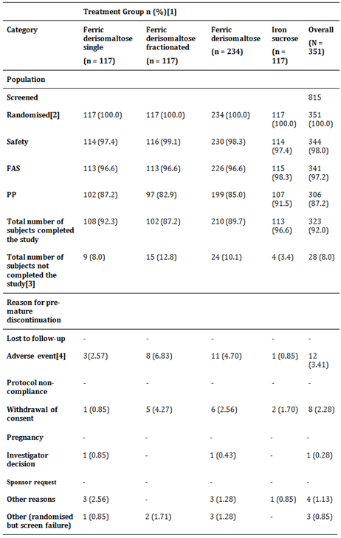
Note: (1) Percentage was calculated taking respective column header group count as denominator.

Sample size
The sample size calculation was based on comparison of the percentage of subjects able to maintain Hb between 9.5 and 12.5 g/dL (both values included) at Week 6 between Group A and B. In the P-Monofer-CKD-01 study, the subjects were treated with ferric derisomaltose for 8 weeks. 81% of the subjects, who switched from existing iron therapy, were treated with IV bolus injections (400 mg in average) and had a Baseline Hb between 9.5 and 12.5 g/dL, maintained Hb between 9.5 and 12.5 g/dL at Week 8.
In this study, the treatment duration was 6 weeks, and the planned cumulative dose was 500 mg. Therefore, a higher response rate was expected. It was assumed that approximately 90% of subjects would be able to maintain Hb between 9.5 and 12.5 g/dL at Week 6. Defining a non inferiority margin that was maintained at 90% of this response seemed reasonable that is 0.9 x 0.9 = 0.81 corresponding to a non inferiority margin of 9% points. Therefore, a non inferiority margin of 10% points was used.
With a 2:1 randomisation, a two-sided significance level of 0.05, and a non inferiority margin of 10% points, there was approximately 80% power to demonstrate non inferiority with 214 subjects in Group A and 107 subjects in Group B. A few drop-outs were expected. As the study was designed to demonstrate non inferiority, the analyses of the full analysis set (FAS) and the PP population would lead to similar conclusions and therefore the analyses for both analyses sets needed to be powered properly. With approximately 10% (anticipated) of subjects having major protocol violations, a total of 351 subjects were to be randomised (234 to ferric derisomaltose and 117 to iron sucrose).

Statistical methods
All statistical tests were carried out as two-sided on a 5% level of significance unless otherwise stated. Continuous variables were summarised using descriptive statistics (number of non-missing observations, mean, standard deviation (SD), median, minimum, and maximum). Categorical data were summarised with number of exposed subjects and number with percentage of observations in the various categories of the endpoint, where percentage was based on the exposed subjects.
Demographic variables that were measured on a continuous scale, such as the age of the subject at the time of screening, number of non-missing observations, mean, median, SD, minimum, and maximum were summarised using descriptive statistics. Variables that were measured on a categorical scale, such as gender, were summarised using number and percentages. Screening medical history was tabulated by body system and summarised by using number and percentages. Concomitant medications, concurrent illnesses, and medical history were listed by subject.
The efficacy analyses (both primary and secondary) were conducted on FAS and per protocol (PP) populations and the safety analyses were conducted on the safety population. To check the robustness of the efficacy outputs, the primary analysis was also performed on the PP population.

Primary efficacy analyses
The primary analysis was to assess non inferiority between treatment Group A and B on the primary efficacy endpoint. A generalised linear model using the identity link function was used to compare the proportion of subjects with Hb concentration between 9.5 and 12.5 g/dL (both values included) at Week 6 using the last observation carried forward approach (LOCF) for the FAS and PP population. Treatment and stratum were used as factors and Baseline value as a covariate. Country was to be used as a factor as per the planned analysis, but it was omitted in the final analysis due to non-convergence of the initial model. All tests were two-tailed and the significance level was 0.05. The primary efficacy data were summarised using number and percentage of subjects, including a 95% confidence interval (CI) of the difference between treatment groups.

Participant flow
A study flowchart of the study assessments performed at the visits is shown in Table 22.

Table 22: Study flowchart
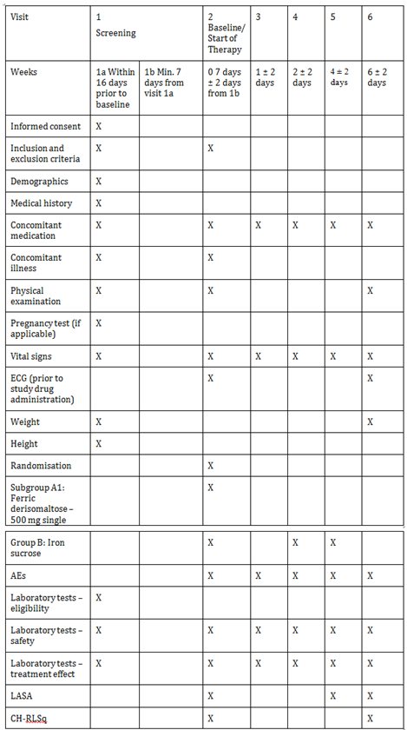

Major protocol violations/deviations
A total of 57 major protocol deviations were reported which lead to exclusion of subjects from the PP dataset.
Based on an evaluation of the protocol deviations, including GCP deviation that occurred during the study, it can be concluded that the study has been conducted in compliance with the ICHGCP guideline.

Baseline data
Out of 351 randomised subjects, 119 (33.9%) were women and 232 (66.1%) were men. 228 (65%) subjects were Caucasian and 101 (28.8%) subjects were Asian. 88.9% of the subjects were non-smokers. The mean age, weight, height, and BMI of the subject population was 60 years (SD: 16 years), 77 (19) kg, 167 (10) cm, and 28 (7) kg/m², respectively. The mean dialysis time before entering the study was 3.50 ± 3.98 years. 247 (70.4%) subjects had hypertension, 119 (33.9%) subjects had diabetes mellitus, and 40 (11.4%) subjects had ischaemic heart disease (Table 23).

Table 23: Summary of subject demographics; randomised population
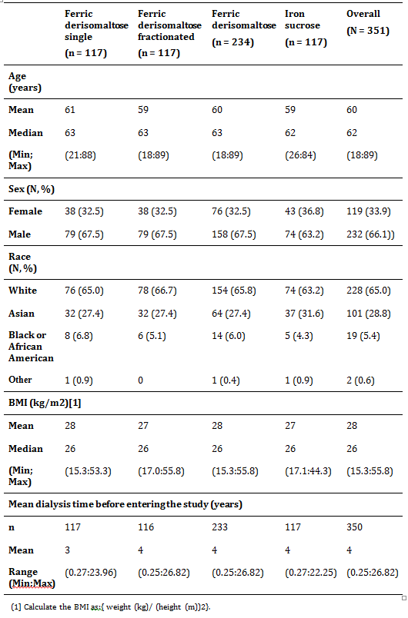

Results for the primary efficacy outcome
The primary analysis adjusted with LOCF approach as defined in the protocol showed that in the FAS, 187 (82.7%) subjects treated with ferric derisomaltose and 95 (82.6%) subjects treated with iron sucrose could maintain Hb between 9.5 and 12.5 g/dL (both values included) at Week 6. In the PP population, 167 (83.9%) subjects treated with ferric derisomaltose and 88 (82.2%) subjects treated with iron sucrose could maintain Hb between 9.5 and 12.5 g/dL (both values included) at Week 6. The adjusted risk difference was 1%-point (95% CI: -7.4%:9.4%) in the FAS and 2.2% points (95% CI: (-6.4%:10.9%) in the PP population for treatment differences between ferric derisomaltose and iron sucrose group. The test for non inferiority showed that ferric derisomaltose was non-inferior to iron sucrose (FAS: p = 0.0106; PP: p = 0.0057) (Table 24).

Table 24: Percentage of subjects who maintain haemoglobin between 9.5 and 12.5 g/dL at 6 Weeks (adjusted analysis with last observation carried forward approach); full analysis set and per protocol analysis
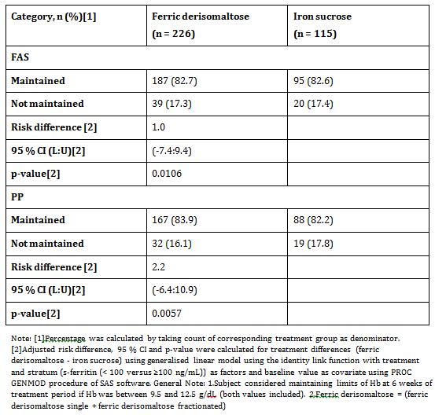
Maintenance of Hb between 9.5 and 12.5 g/dL was similar in both ferric derisomaltose subgroups. In the FAS, 92 (81.4%) subjects treated with single dose of ferric derisomaltose and 95 (84.1%) subjects treated with fractionated doses of ferric derisomaltose and in the PP population, 84 (82.4%) in ferric derisomaltose single subgroup and 83 (85.6%) subjects in isomaltoside 1,000 fractionated subgroup could maintain Hb between 9.5 and 12.5 g/dL (both values included) at Week 6. In the FAS and PP populations, the adjusted risk difference was -3.2% (FAS: 95% CI: (-12.9%:6.4%); PP: 95% CI: -13.2%:6.8%) for treatment differences between ferric derisomaltose single and ferric derisomaltose fractionated.
For both FAS and PP, the 95% CIs include 0, and hence no statistically significant difference between the subgroups was noted.

Sensitivity analysis
Overall, ferric derisomaltose was shown to be non-inferior to iron sucrose. In the FAS, the test for non inferiority showed that ferric derisomaltose was non-inferior to iron sucrose using unadjusted (unadjusted with LOCF approach p = 0.0194; observed cases p = 0.0224) and adjusted (adjusted p = 0.0096) analysis. The unadjusted analysis with missing values imputed as failures did not show non inferiority of ferric derisomaltose over iron sucrose. The risk difference between ferric derisomaltose and iron sucrose group in this case was -2.1% (95% CI: -11.1%:6.8%) which lay outside of -10%. This could be attributed to a higher number of missing values in the ferric derisomaltose group as compared to the iron sucrose group (9.0% versus 3.4%); which may be due to AEs (4.7% versus 0.85%), withdrawal of consent (2.56% versus 1.70%), as per investigator’s decision (0.43% subjects in the ferric derisomaltose group), and other reasons (1.28% versus 0.85%).
In the PP population, ferric derisomaltose was non-inferior to iron sucrose using unadjusted (unadjusted analysis with LOCF approach p = 0.0098, unadjusted analysis with missing values as failures p = 0.0144, observed cases p = 0.0082) and adjusted analysis (adjusted with imputed missing value as failure approach p = 0.0082; adjusted p = 0.0040).
No statistically significant differences were observed in the proportion of subjects maintaining Hb between 9.5 and 12.5 g/dL at 6 Weeks when ferric derisomaltose single subgroup was compared with iron sucrose and ferric derisomaltose fractionated subgroup was compared with iron sucrose. Test for non inferiority showed that ferric derisomaltose administered in fractionated doses was non-inferior to iron sucrose (FAS: adjusted p = 0.0080, unadjusted with LOCF p = 0.0202, observed cases p = 0.0212; PP: adjusted p = 0.0028, adjusted analysis with missing values imputed as failure p = 0.0044, unadjusted with LOCF p = 0.0094, unadjusted with missing values imputed as failure p = 0.0076, observed cases p = 0.0052). Test for non inferiority showed that ferric derisomaltose given as a single dose was non-inferior to iron sucrose (adjusted analysis p = 0.0453). It should be noted that these tests were not powered to demonstrate non inferiority. The logistic regression analysis did not show any difference between ferric derisomaltose and iron sucrose group.

Proportion of subjects who maintained haemoglobin ≥ 9.5 g/dL at Week 6
In the FAS, the percentage of subjects that could maintain Hb ≥ 9.5 g/dL at Week 6 was similar in both treatment groups. The test for non inferiority with unadjusted analysis using LOCF approach, or with missing values imputed as failure approach, or observed cases showed that ferric derisomaltose was non-inferior to iron sucrose (unadjusted p = 0.0006, unadjusted with LOCF p = 0.0008, adjusted with imputed missing value as failure approach p = 0.0202).
In the PP population, the test for non inferiority in unadjusted analysis, unadjusted analysis with LOCF approach, and adjusted analysis with missing values imputed as failure approach showed that ferric derisomaltose was non-inferior to iron sucrose. Similar results were observed when ferric derisomaltose single and fractionated subgroup were compared with iron sucrose (unadjusted p = 0.0006; unadjusted with LOCF p = 0.0008, adjusted with imputed missing value as failure approach p = 0.0028) (Table 25).

Table 25: Percentage of subjects who maintained haemoglobin ≥ 9.5 g/dL at 6 Weeks treatment; full analysis set
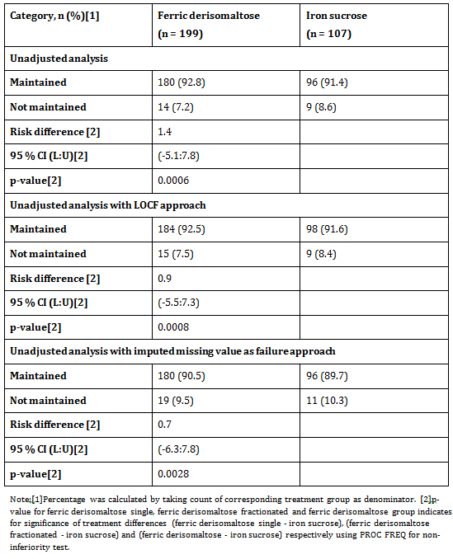

Results for other efficacy outcomes

Change in haemoglobin concentration from baseline to Week 2, 4, and 6
There was no statistical significant change in Hb concentration from Baseline to Week 2, 4, and 6 between ferric derisomaltose and iron sucrose group. Similar results were observed when ferric derisomaltose group was divided into ferric derisomaltose single and fractionated subgroups except at Week 2 where the increase in Hb concentration from Baseline to Week 2 was significantly higher in the ferric derisomaltose single subgroup compared to the iron sucrose group (p = 0.0447) (Table 26).

Table 26: Change in haemoglobin (g/dL) concentration from Baseline to Week 6; full analysis set
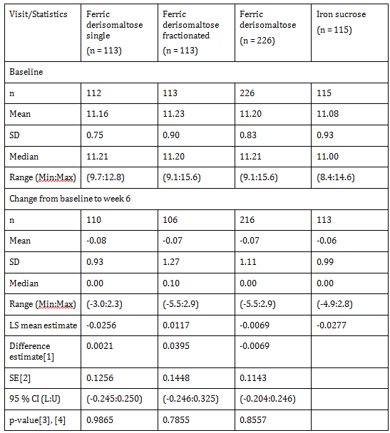

Change in concentrations of serum iron, transferrin saturation, serum ferritin, and reticulocyte count from Baseline to Week 1, 2, 4, and 6
There was an increase in s-iron and TSAT concentration from Baseline to Week 1, 2, 4, and 6 in both ferric derisomaltose and iron sucrose groups. However, there were no statistical significant changes in s-iron and TSAT concentration observed from Baseline to Week 1, 2, 4, and 6 between ferric derisomaltose and iron sucrose group. There was a statistical significant increase in s-iron concentration from Baseline to Week 1 in the ferric derisomaltose single subgroup compared to the iron sucrose group (p < 0.0001). The comparison of ferric derisomaltose subgroups to iron sucrose demonstrated no statistical significant changes in TSAT concentration from Baseline to Week 1, 2, 4, and 6 when ferric derisomaltose group was divided into ferric derisomaltose single and fractionated subgroups.
There was a statistical significant higher increase in s-ferritin concentration from Baseline to Week 1, 2, and 4 in the ferric derisomaltose group compared to the iron sucrose group (Week 1 and Week 2: p < 0.0001; Week 4: p = 0.0020). No statistical significant change in s-ferritin concentration was observed from Baseline to Week 6 between ferric derisomaltose and iron sucrose group. Similar results were observed for the ferric derisomaltose single subgroup (Week 1 and Week 2: p < 0.0001; Week 4: p = 0.0002) but not for the ferric derisomaltose fractionated subgroup when compared to the iron sucrose group (Table 27).
There was a statistical significant increase in reticulocyte count from Baseline to Week 1 in the ferric derisomaltose group compared to the iron sucrose group (p = 0.0006). No statistical significant changes in reticulocyte counts were observed from Baseline to Week 2, 4, and 6 between ferric derisomaltose and iron sucrose group. Similar results were observed when ferric derisomaltose subgroups (single and fractionated) were compared to the iron sucrose group (ferric derisomaltose single: p = 0.0006; ferric derisomaltose fractionated: p = 0.0227).

Table 27: Change in serum ferritin concentration (μg/L) from Baseline to Week 6; full analysis set
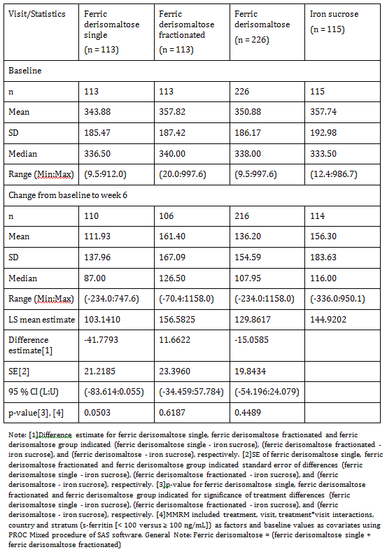

Number of subjects in each randomisation group who discontinued study because of lack of response or intolerance of investigational drugs
In the FAS, 18 subjects discontinued the study of which 1 (0.9%) subject (subject [information redacted]) in the ferric derisomaltose fractionated subgroup discontinued the study due to intolerance to the study drug and the remaining 17 subjects (ferric derisomaltose single: 5 (4.4%); ferric derisomaltose fractionated: 10 (8.8%); and iron sucrose: 2 (1.7%)) discontinued the study for reasons other than lack of response or intolerance to the study drug.

Change in total quality of life score (linear analogue scale assessment) from Baseline to Week 4 and 6
There was no statistical significant difference in subject’s energy level, ability to do daily activities, and overall QoL from Baseline to Week 4 and Week 6 between ferric derisomaltose and iron sucrose group using the LASA questionnaire.

Change in restless leg syndrome symptoms (Cambridge Hopkins-Restless Leg Syndrome Questionnaire Score) from baseline to Week 6 in subjects with restless leg syndrome symptoms at baseline
The average decrease in CH-RLS score from Baseline to Week 6 was not statistical significant between ferric derisomaltose and iron sucrose group.

Evaluator commentary
This randomised, open label study was planned to compare the efficacy and safety of IV ferric derisomaltose as iron maintenance therapy administered by single or repeated bolus injections in comparison to IV iron sucrose in CKD-5D subjects. The study was conducted at 46 centres. 351 subjects were randomised 2:1 into ferric derisomaltose (234 subjects) and iron sucrose (117 subjects) groups.
This trial was designed in accordance with the accepted guidelines for use of Monofer and iron sucrose was a valid comparator since it has been widely used in iron deficiency anaemia and has also been used as a comparator in a previous non inferiority study in CKD subjects.
Exclusion/inclusion criteria were reasonable given the target population for Monofer. The study protocol was followed and all patients were accounted for throughout the study and follow-up period. Protocol violations and deviations were balanced between treatments and patients were compliant with treatments.
The Baseline characteristics between study groups were balanced. The primary efficacy endpoint of the study was to assess the non inferiority of ferric derisomaltose over iron sucrose in its ability to maintain Hb between 9.5 and 12.5 g/dL at Week 6 using the LOCF model in both FAS and PP populations. In addition, the primary analysis was also conducted with missing values imputed as failures and for observed cases in the FAS and PP populations. More than 82% of the subjects in both treatment groups could maintain Hb between 9.5 and 12.5 g/ at Week 6 in the FAS and PP populations. The data adjusted or unadjusted with the LOCF approach suggested that ferric derisomaltose in both FAS and PP populations was non-inferior to iron sucrose in terms of maintaining Hb between 9.5 and 12.5 g/dL at Week 6. Only the data adjusted with imputed missing value as failure approach demonstrated CI extending just below 10% and therefore outside the pre-specified definition of non inferiority of ferric derisomaltose over iron sucrose in the FAS population. An apparent reason for this is a higher proportion of discontinuations in the ferric derisomaltose group compared to the iron sucrose group (9% versus 3.4%). However, data adjusted/unadjusted with imputed missing value as failure approach suggested non inferiority of ferric derisomaltose over iron sucrose in the PP population. Similar results were obtained when ferric derisomaltose subgroups were compared with iron sucrose.
The investigators satisfactorily demonstrated non inferiority of IV ferric derisomaltose to IV iron sucrose, determined as the ability to maintain Hb between 9.5 and 12.5 g/dL (p = 0.01) in patients with CKD receiving haemodialysis. Based on the data presented, ferric derisomaltose and iron sucrose have comparative efficacy in maintaining Hb concentrations in this population and that both preparations were well tolerated with a similar short-term safety profile.

P-Monofer-IBD-01
A Phase III, randomised, comparative, open label study of intravenous iron oligosaccharide* (Monofer) administered by infusions or repeated bolus injections in comparison with oral iron sulphate in inflammatory bowel disease subjects with iron deficiency anaemia.

Study design, objectives, locations and dates
The study was a Phase III study. The study was conducted in subjects diagnosed with Inflammatory Bowel Disease (IBD) with Iron Deficiency Anaemia (IDA). The enrolment period of the study was more than 2 years (December 2009-May 2012). The study duration for the individual subject was approximately 8 weeks and each subject attended 7 visits. The subjects were randomised to 1 of 3 treatment groups:
- Group A: Ferric derisomaltose
  - Group A1: administered as Intravenous (IV) infusions
  - Group A2: administered as IV bolus injections
- Group B: Iron sulphate administered orally

Objectives

Primary objective
To demonstrate that IV ferric derisomaltose is non-inferior to oral iron sulphate in reducing IDA secondary to IBD, evaluated as the ability to increase Haemoglobin (Hb)

Secondary objectives
- To assess other relevant haematology and biochemical parameters during the study
- Quality of Life (QoL) assessment by questionnaire
- Assessment of Restless Legs Syndrome (RLS) symptoms and change in these symptoms during the study.

Safety objective
To assess safety of IV ferric derisomaltose compared to oral iron sulphate

Study centres
The study was conducted at 36 centres, including 4 centres in Austria, 1 centre in United Kingdom, 5 centres each in Denmark and Hungary, and 21 centres in India.

Inclusion and exclusion criteria

Inclusion criteria
- Men and women aged more than 18 years
- Subjects diagnosed with IBD and mild to moderate disease activity (defined as a score of less than or equal to 5 on the Harvey-Bradshaw index for Crohn’s disease and a Mayo score (sub-score without endoscopy) of less than or equal to 6 for ulcerative colitis)
- Hb < 12 g/dL (7.45 mmol/L)
- TSAT < 20%
- Life expectancy beyond 12 months
- Willingness to participate after signing informed consent
S-ferritin was chosen not to be an inclusion criterion as the cut-off level was highly dependent upon the disease.

Exclusion criteria
- Anaemia predominantly caused by factors other than IDA
- Iron overload or disturbances in utilisation of iron (for example haemochromatosis and haemosiderosis)
- Drug hypersensitivity (that is previous hypersensitivity to iron dextran, iron mono- or disaccharide complexes, or to iron sulphate)
- Known hypersensitivity to any excipient(s) in the investigational drug products
- History of multiple allergies
- Active intestinal tuberculosis
- Active intestinal amoebic infections
- Decompensated liver cirrhosis and hepatitis (alanine aminotransferase > 3 times upper limit of normal)
- Acute infections (assessed by clinical judgement) supported with White blood cells and C-reactive protein
- Rheumatoid arthritis with symptoms or signs of active joint inflammation
- Pregnancy or nursing. To avoid pregnancy, women had to be postmenopausal, surgically sterile, or women of child bearing potential must have used one of the following contraceptives during the whole study period and after the study had ended for at least 5 times plasma biological half-life of the investigational medicinal product: contraceptive pills, intrauterine devices, contraceptive injections (prolonged release gestagen), subdermal implantation, vaginal ring, and transdermal patches
- Extensive active bleeding necessitating blood transfusion
- Planned elective surgery during the study
- Participation in any other clinical study within 3 months prior to screening
- Intolerance to oral iron treatment
- Untreated vitamin B12 or folate deficiency
- Other IV or oral iron treatment or blood transfusion within 4 weeks prior to the screening
- Treated with erythropoietin within 8 weeks prior to the screening
- Diagnosis of Hepatitis B and/or C, confirmed by appropriate laboratory test
- Any other medical condition that, in the opinion of Investigator, may cause the subject to be unsuitable for the completion of the study or placed the subject at potential risk from being in the study, for example uncontrolled hypertension, unstable ischemic heart disease, or uncontrolled diabetes mellitus
- History of immunocompromise, including positive human immunodeficiency virus test results

Study treatments

Test product
Monofer was the test product in this study. Full iron replacement dose with ferric derisomaltose was calculated based on the following Ganzoni formula:
Total iron dose (mg) = body weight (kg) x targeted Hb – actual Hb (g/dL) x 2.4 + depot iron (mg) where
- Depot iron: 500 mg
- Targeted Hb: 13.0 g/dL
Drug dosage and mode of administration were as follows:

Group A1: Ferric derisomaltose; IV infusion
The full iron replacement dose of ferric derisomaltose was administered as IV infusion of maximum 1,000 mg* ferric derisomaltose as single doses over 15 minutes. The full iron replacement was achieved by 1 or up to 2 doses at weekly intervals.

Group A2: Ferric derisomaltose; bolus IV injection
The full iron replacement dose was administered as IV bolus injections of 500 mg ferric derisomaltose over 2 minutes once weekly until full replacement dose was achieved. In some cases, the remaining dose on the last dosing day was 250 mg. For example, if the full replacement dose was 1250 mg, on Visit 4 the remaining 250 mg was administered.
* The maximum dose per infusion was 1,000 mg for subjects with a weight > 45 kg, 750 mg for subjects with a weight between 35 and 45 kg, and 500 mg for subjects with a weight < 35 kg.

Duration of treatment
Duration of treatment varied per the treatment group. Subjects randomised to Group A1 were treated with 1or 2 doses in total with 1 week between the doses. Subjects randomised to Group A2 were treated 1 to 4 times during 3 weeks, and subjects randomised to Group B were treated daily for 8 weeks.

Reference therapy
Ferro Duretter was the reference therapy that was administered orally at a dose of 100 mg elementary iron twice a day (200 mg daily) for 8 weeks.

Efficacy variables and outcomes

Efficacy assessments
- Hb concentration
- Concentrations of s-ferritin s-iron and TSAT
- QoL
- Change in RLS symptoms, if these were present in a subject

Randomisation and blinding methods
The subjects were randomised 2:1 to either ferric derisomaltose or oral iron sulphate. The subjects randomised to ferric derisomaltose were equally divided into Group A1 and Group A2.
The randomisation of subject to treatment groups was stratified by whether the subject had received IV iron treatment in the past or not.
A permuted block randomisation methodology was used in the study. No blinding was performed.

Analysis populations
A total of 560 subjects with IBD were screened. Of these, 220 were screen failures and 2 were randomisation failures. The remaining 338 subjects were randomised in the study. Table 28 Analysis population summarises the subject disposition. The study population were divided into 3 datasets; Safety (332 subjects), FAS (327 subjects), and PP (299 subjects) populations. 296 (87.6%) subjects completed the study and 42 (12.4%) subjects were withdrawn during the study (Table 28).

Table 28: Analysis population
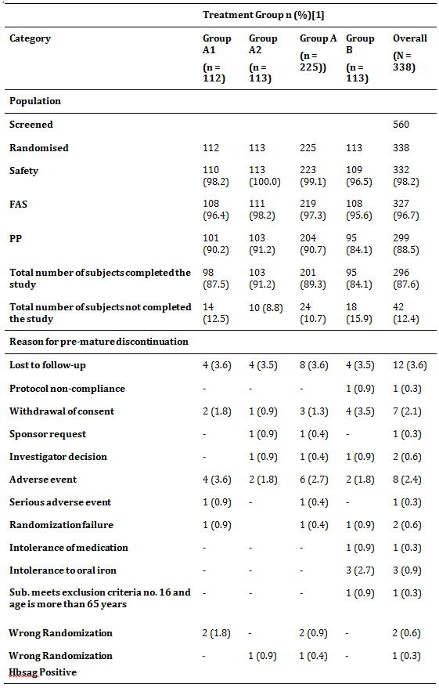

Sample size
The sample size calculation was based on absolute change in Hb from Baseline to Week 8. The non inferiority margin was set as 0.5 g/dL. This margin was in line with previous studies and was regarded as clinically relevant. A two-sided significance level of 5% was used and the power was set to 80%.
Based on available literature and previous studies with ferric derisomaltose, the SD in change in Hb was assumed to be approximately 1.5 g/dL. Based on this, a total of 321 subjects were to be included in the efficacy analyses (that is provide post-randomisation Hb measurements). A few drop-outs were expected during the study. As the study was designed to demonstrate non inferiority, both the analyses of the Full Analysis Set (FAS) and the Per Protocol (PP) analysis set would lead to similar conclusions, and therefore analyses for both analysis sets were powered properly. With approximately 10% (anticipated) of subject population expected to have major protocol violations, a total of 350 subjects were to be randomised.

Statistical methods
Descriptive statistics for continuous variables were presented with number (N) of non-missing observations, mean, Standard Deviation (SD), median, minimum, maximum, least square mean, if necessary. For categorical data, descriptive statistics was presented with ‘N’ and with percentages. All statistical tests were carried out as two-sided with a 5% level of significance unless otherwise stated. All Confidence Intervals (CIs) were 95% intervals. It was considered not to be relevant to adjust for multiplicity.

Participant flow
All efficacy and safety assessments were performed per the evaluation schedule in Table 29.

Table 29: Study flowchart
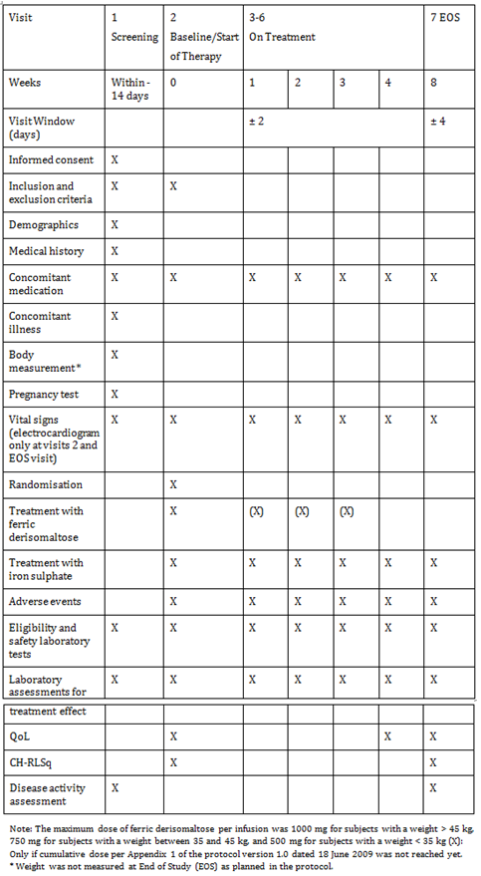

Major protocol violations/deviations
A total of 39 major protocol deviations were reported in the study; of which 6 deviations led to subject exclusion from the safety analysis set, 5 deviations from the FAS, and 28 deviations led to exclusion of subjects from the PP analysis set.
Based on an evaluation of the protocol deviations that occurred during the study it can be concluded that the study has been conducted in compliance with the ICH-GCP Guideline.

Baseline data

Table 30: Baseline data
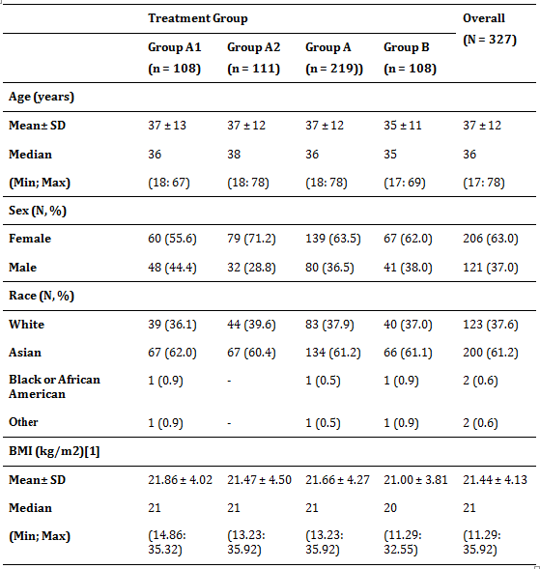
The mean cumulative dose of ferric derisomaltose administered to the subjects in Group A1 and A2 in the safety analysis set were 885 mg (SD: 238 mg, range: 195:1,500) and 883 mg (SD: 296 mg, range: 350:2,500), respectively. A total of 129 infusions of ferric derisomaltose were administered to 110 subjects in the Group A1 and 227 bolus injections of ferric derisomaltose were given to 113 subjects in Group A2. Oral iron was administered as 200 mg iron sulphate daily for 8 weeks (11,200 mg in total for subjects completing 8 weeks oral treatment).

Results for the primary efficacy outcome
Non inferiority could not be statistically demonstrated on the primary endpoint which was comparison of change in Hb concentration from Baseline to Week 8 between Group A and B (FAS: p = 0.0945; PP: p = 0.0355). The present study demonstrated an increase in Hb concentration from a mean (SD) of 9.64 (1.65) g/dL at Baseline to 12.23 (1.33) g/dL at Week 8 in subjects treated with ferric derisomaltose and an increase from 9.61 (1.82) g/dL at Baseline to 12.59 (1.91) g/dL at Week 8 in subjects treated with oral iron sulphate. Oral iron sulphate demonstrated a trend to a higher increase from Baseline in Hb at Week 8 in this study (3.04 g/dL versus 2.58 g/dL) and Asian subjects had a pronounced response to oral iron sulphate. No statistical differences in efficacy between Group A1 and A2 as compared to Group B were found on the primary endpoint (Table 31).
There was no statistically significant difference in the increase in Hb from Baseline to Week 2 and 4 between Group A and Group B. Similar results were obtained when Group A was divided into Group A1 and A2.
Within the IV arm (Group A) an indication of a dose relationship was found. Ferric derisomaltose was found to be more efficacious with cumulative doses of ≥ 1,000 mg in both the overall subject population as well as in the European population.

Table 31: Average change in haemoglobin concentration from Baseline to Week 8 (Full Analysis Set)
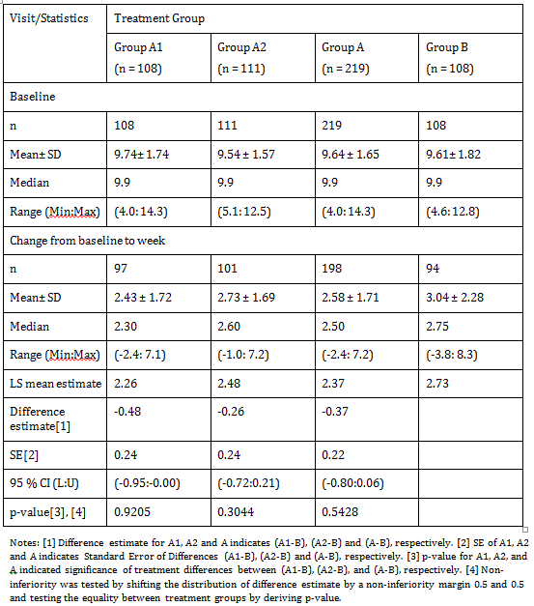

Results for other efficacy outcomes

Number of responders
Subjects achieving target limits of Hb (13 to 18 g/dL in men and 12 to 16 g/dL in women), s-ferritin (100 to 800 μg/L), TSAT (20 to 50%), and a change in Hb concentration > 1.0 g/dL were significantly higher in subjects in Group A at Week 2 (p < 0.0001) and at Week 4 (p = 0.0227) compared to Group B. At Week 8, there was no statistically significant difference in the number of responders in Group A compared to Group B.
Though, non inferiority of ferric derisomaltose to iron sulphate could not be established, the efficacy of ferric derisomaltose was supported by the response rate of Hb increase > 2 g/dL which was observed in 64% of the subjects treated with IV iron (Group A) compared to 61% in subjects treated with oral iron (Group B).

Change in S-ironS-ferritin, and TSAT
The mean (SD) change in s-iron concentration from Baseline to Week 8 was significantly lower in Group A compared to Group B (p < 0.0001).
Treatment with ferric derisomaltose resulted in a better response in terms of s-ferritin concentration as compared to treatment with oral iron sulphate. Subjects treated with ferric derisomaltose had a significantly higher increase in s-ferritin concentration from Baseline to Week 1, 2, 4, and 8 in comparison to subjects treated with oral iron sulphate.
An increase in TSAT was observed with treatment with both ferric derisomaltose and iron sulphate. However, the change in TSAT from Baseline to Week 8 was significantly lower in Group A compared to Group B.

Number of subjects who discontinued study because of lack of response or intolerance to investigational drugs
None of the subjects in Group A discontinued the study due to lack of response or intolerance to ferric derisomaltose. In Group B, 3.7% of the subjects discontinued the study due to lack of response or intolerance to iron sulphate. The difference in the number of subjects between Group A and B was not statistically significant.

Change in total quality of life score
An increase in QoL score from Baseline to Week 4 and 8 was observed across both treatment groups. There was no significant difference in the increase in the QoL score from Baseline to Week 4 and Week 8 between the treatment groups.

Evaluator commentary
This study was a Phase III, prospective, randomised, open label, comparative, multicentre study comparing IV ferric derisomaltose with oral iron sulphate. A total of 338 IBD subjects with IDA were enrolled.
This trial was designed in accordance with the accepted guidelines for use of Monofer and oral iron sulphate was a valid comparator. Exclusion/inclusion criteria were reasonable given the target population for Monofer. The study protocol was followed and all patients were accounted for throughout the study and follow-up period. Protocol violations and deviations were balanced between treatments and patients were compliant with treatments. The Baseline characteristics between study groups were balanced and the study objectives achieved.
The mean cumulative dose of ferric derisomaltose in the infusion and the bolus groups was 885 mg (SD: 238 mg, range: 195 to 1,500 mg) and 883 mg (SD: 296 mg, range: 350 to 2,500 mg), respectively. Non inferiority could not be demonstrated with respect to the primary endpoint. As the mean cumulative Ganzoni calculated ferric derisomaltose dose administered was not more than 885 mg. Patients receiving more than 1,000 mg ferric derisomaltose (mean: 1,313 mg) had a response rate (Hb increase of ≥ 2 g/dL) of 93% (p 0.001 when compared with oral iron). In trials with other IV iron compounds in IBD patients, the mean cumulative dosages have been higher. Thus, the cumulative dosages may have been too low in this trial, considering doses of up to 3,600 mg iron are required in anaemic IBD patients to correct the deficit. ⁷

P-Monofer-IBD-01-Extension
An open label, multi-centre, non-randomised extension study to assess the ability to maintain a stable haemoglobin and to assess safety of ferric derisomaltose (Monofer) in subjects with inflammatory bowel disease

Study design, objectives, locations and dates
The study was a prospective, open label, multi-centre, non-randomised, observational extension study of the lead-in study in inflammatory bowel disease (IBD) subjects with iron deficiency anaemia (IDA) (P-Monofer-IBD-01). The enrolment period of the study was 6 months (June to November 2011). The study duration for the individual subject was approximately 12 months and each subject attended 5 visits (one screening/Baseline visit (Visit 1), three treatment/ follow-up visits (Visit 2 to 4), and one end of study (EOS) visit (Visit 5)).
The study was initiated at 4 centres (4301 and 4302 in Austria and 3603 and 3604 in Hungary). However, no subjects were screened at centre 4302 in Austria. Hence, the subjects were enrolled at the remaining 3 centres (4301, 3603, and 3604).

Primary efficacy objectives
- To assess the long-term efficacy of ferric derisomaltose by means of the ability to maintain stable haemoglobin (Hb) (defined as Hb ≥ 12.0 g/dL) in subjects with Hb ≥ 12.0 g/dL at Baseline of the extension study
- To assess the ability to achieve stable Hb (Hb ≥ 12.0 g/dL) at Month 3 visit of the extension study and then to maintain the stable Hb thereafter in subjects with Hb < 12.0 g/dL at Baseline of the extension study

Secondary efficacy objectives
- To assess the dosage and frequency of additional ferric derisomaltose, if administered
- To assess the change in other relevant biochemical parameters (serum (s)-iron, s-ferritin, total iron binding capacity (TIBC), and transferrin saturation (TSAT))
- To assess quality of life (QoL) by inflammatory bowel disease questionnaire (IBDQ)
- To assess the change in restless leg syndrome (RLS) score by Cambridge-Hopkins RLS questionnaire (CH-RLSq) in subjects with RLS symptoms in the lead-in study.
- To assess disease activity status using Harvey-Bradshaw Index for Crohn’s disease or partial Mayo score (excluding endoscopy sub-score) for ulcerative colitis
- To assess the change in platelet count

Safety objective
To assess the long term safety of ferric derisomaltose maintenance.

Inclusion and exclusion criteria

Inclusion criteria
- Completed the lead-in study or discontinued from the lead-in study due to intolerance to oral iron
- Life expectancy beyond 18 months by investigator’s judgement
- Willingness to participate after signing informed consent.

Exclusion criteria
- Discontinuation from the lead-in study (except for due to intolerance to oral therapy)
- Any major protocol deviation in the lead-in study
- Pregnancy and nursing (to avoid pregnancy, women had to be postmenopausal, surgically sterile, or women of child bearing potential must have used one of the following contraceptives during the whole study period and after the study had ended for at least 5 times plasma biological half-life of the investigational medicinal product (5 days): contraceptive pills, intrauterine devices, contraceptive injections (prolonged release gestagen), subdermal implantation, vaginal ring, and transdermal patches)
- Any other medical condition that, in the opinion of the investigator, may have caused the subject to be unsuitable for completion of the study or has placed the subject at potential risk from being in the study
- Subjects with a Harvey-Bradshaw Index > 8 or partial Mayo score (excluding endoscopy sub-score) > 6 at EOS (Visit 7) of the lead-in study.

Study treatments
Monofer (ferric derisomaltose) was the test product in this study.
No fixed interval of drug administration was planned for the study since the extension study was primarily planned to observe the long-term efficacy and safety of ferric derisomaltose in subjects on treatment in the lead-in study. For subjects with Hb < 12.0 g/dL, TSAT < 20%, and s-ferritin < 500 μg/L at any single visit of the extension study, ferric derisomaltose was administered as a single dose infusion (loading dose) per the following loading dosing regimen, considering the Hb levels and weight at the extension study Baseline*:

Table 32: Dosage loading dosing regimen
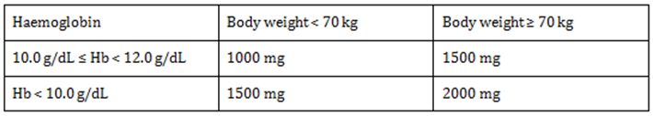
*In case of centre 4301, ferric derisomaltose was administered as a single dose infusion per loading dosing regimen to 5 subjects [information redacted] considering their actual body weight on the visit date.
For subjects with a stable Hb (Hb ≥ 12.0 g/dL), TSAT < 20% and s-ferritin < 500 μg/L at any single extension study visit (except EOS (Visit 5) of the extension study), ferric derisomaltose was administered as a maintenance dose per the following fixed maintenance dosing regimen:

Table 33: Fixed maintenance dosing regimen
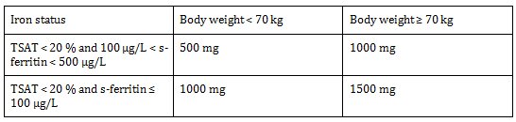

Efficacy variables and outcomes

Primary efficacy endpoints
- Number of subjects (with Hb ≥ 12.0 g/dL at Baseline of the extension study) who maintained stable Hb (defined as Hb ≥ 12.0 g/dL) at all visits of the extension study
- Number of subjects (with Hb ≥ 12.0 g/dL at Month 3 visit of the extension study) who maintained stable Hb (defined as Hb ≥ 12.0 g/dL) at all visits from Month 3 visit of the extension study in subjects with Hb < 12.0 g/dL at Baseline of the extension study.*
* The formulation of this endpoint in the protocol was not entirely clear. The subjects only needed to have a Hb < 12.0 g/dL at Baseline and not a Hb ≥ 12.0 g/dL at Month 3 in order to be included in the endpoint. Thus, the endpoint evaluated the number of subjects who maintained stable Hb (defined as Hb ≥ 12.0 g/dL) at all visits from Month 3 visit of the extension study in subjects with Hb < 12.0 g/dL at Baseline of the extension study.

Exploratory efficacy endpoints
- Time to Hb < 12.0 g/dL in subjects with Baseline Hb ≥ 12 g/dL or reaching Hb ≥ 12.0g/dL during the study
- Time (from start of extension study) to change (from Baseline in lead-in study) in Hb < 2 g/dL for responders (subjects with change in Hb ≥ 2.0 g/dL at any visit in the lead-in study)

Secondary efficacy endpoints
- Number of subjects who achieved stable Hb (Hb ≥ 12.0 g/dL) at any single visit
- Number of consecutive visits for which stable Hb (Hb ≥ 12.0 g/dL) was maintainedDosage of ferric derisomaltose re-administered, if required
- Frequency of additional dosing of ferric derisomaltose, if required
- Change in concentrations of s-iron, s-ferritin, TIBC, and TSAT from Baseline to EOS (Visit 5) of the extension study
- Change in total QoL score (IBDQ score) from Baseline to Month 6 and EOS (Visit 5) of the extension study
- Change in disease activity status using Harvey-Bradshaw Index for Crohn’s disease, or partial Mayo score (excluding endoscopy sub-score) for ulcerative colitis from Baseline to Month 6 and EOS (Visit 5) of the extension study
- Number of subjects who discontinued study because of lack of response or intolerance to investigational drug
- Change in platelet count from Baseline to Month 6 and EOS (Visit 5) of the extension study.

Safety endpoint
Number of subjects who experienced any adverse drug reaction (ADR) including any suspected unexpected serious adverse reaction (SUSAR).

Randomisation and blinding methods
Completed the lead-in study or discontinued from the lead-in study due to intolerance to oral iron. No blinding was performed.

Analysis populations
The study population was divided into 3 datasets; safety analysis set (39 subjects), full analysis set (FAS) (35 subjects), and per protocol (PP) (25 subjects) analysis set. Of the 35 subjects included in the FAS, 13 subjects were treated with IV infusions of ferric derisomaltose (Group A1) and 11 subjects each were treated with bolus injections of ferric derisomaltose (Group A2) and oral iron sulphate (Group B), respectively, in the lead-in study. Table 34 summarises the subject disposition.

Table 34: Summary of analysis populations and study completion; all enrolled subjects
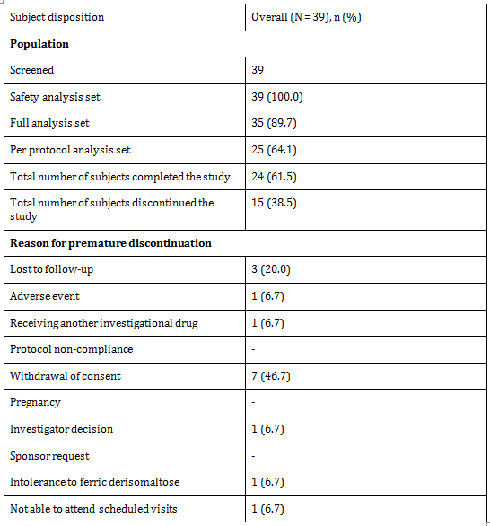

Sample size
No sample size calculations were performed. Based on the assumption that all subjects from the lead-in study could be enrolled into the extension study, irrespective of the treatment provided in the lead-in study, it was anticipated to include approximately 50 subjects in the study.

Statistical methods
All statistical tests were carried out as two-sided on a 5% level of significance unless otherwise stated. Continuous variables were summarised using descriptive statistics (number of non missing observations, mean, standard deviation (SD), median, minimum, and maximum). Categorical data were summarised with number of (exposed) subjects and number with percentage of observations in various categories of the endpoint. Demographic variables that were measured on a continuous scale like age of the subject were summarised using descriptive statistics and the categorical variables like gender were summarised using frequencies and percentages. Screening medical history was tabulated by body system and summarised by using frequencies and percentages.

Primary analyses
The number of subjects who achieved a stable Hb (Hb ≥ 12.0 g/dL) at any extension study visit was summarised descriptively with frequency and percentage of subjects for categorical data. In addition to the descriptive displays, subjects with missing observations were censored and Kaplan-Meier methodology was used to estimate the probability for maintaining stable Hb (Hb ≥ 12.0 g/dL) for 1 year. Subgroups per the lead-in treatment were compared. There were two subgroups
- subjects with Hb ≥ 12.0 g/dL at Baseline
- subjects with Hb < 12.0 g/dL at Baseline.
Kaplan-Meier analysis was performed on these subgroups only as primary endpoint analysis. Exploratory analyses were further conducted on the primary endpoints involving two subgroups:
- subjects with Hb ≥ 12.0 g/dL at Baseline or at any visit
- subjects with change in Hb ≥ 2.0 g/dL at any visit during the lead-in study.
Kaplan-Meier plot was used to estimate the probability for maintaining stable Hb (Hb ≥ 12.0 g/dL) for 1 year and for maintaining a change in Hb ≥ 2.0 g/dL for 1 year.

Secondary analyses
The number of subjects who achieved Hb ≥ 12.0 g/dL at any single visit was summarised descriptively with frequency and percentage of subjects. Number of visits for which stable Hb (Hb ≥ 12.0 g/dL) was maintained was summarised descriptively. Dosage and frequency of additional dosing of ferric derisomaltose, concentrations of s-iron, s-ferritin, TIBC, and TSAT at each visit of the study were summarised. Paired t-test was used to compare mean concentrations at Baseline and 12 months (EOS) at 5% level of significance. The changes in total QoL scores, CH-RLSq scores, disease activity status using Harvey-Bradshaw Index for Crohn’s disease, or partial Mayo score for ulcerative colitis, and platelet count were summarised and compared using paired t-test from Baseline to 6 months and 12 months (EOS). Number of subjects who discontinued the study because of lack of response or intolerance to investigational product were summarised descriptively with frequency and percentage of subjects. Longitudinal response profile of primary, secondary, and other continuous endpoints were displayed by plotting means (± 95% confidence interval (CI)) of treatment using a line/bar chart over study visits/period.

Participant flow
The subjects attended five visits. A study flowchart of the study assessments performed at the visits is shown in Table 35.

Table 35: Study flowchart
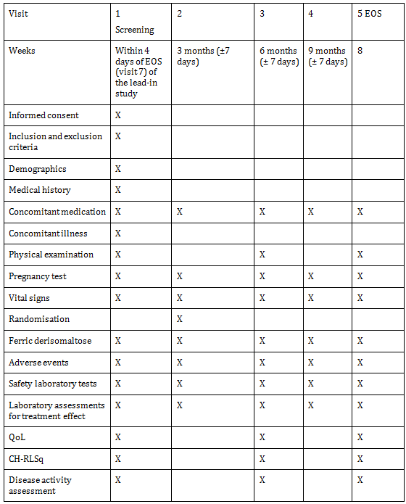

Major protocol violations/deviations
The following subjects were excluded from the FAS and PP analysis set based on the following protocol deviations, which were related to conduct of the study or subject management.

Full analysis set
Four subjects.

Per protocol analysis set
A total of 13 major protocol deviations were reported during the study which lead to exclusion of subjects from the PP analysis set:

Baseline data
Out of 39 enrolled subjects, 30 (76.9%) were women and 9 (23.1%) were men. 36 (92.3%) subjects were White and 1 (2.6%) subject each was Black, Asian, and Mexican. The mean (SD) age, weight, height, and BMI were 38 (14) years, 66 (14) kg, 166 (7) cm, and 24 (5) kg/m², respectively. In the study population, 33 (84.6%) subjects were non-smokers and the remaining 6 (15.4%) were current smokers (Table 36).

Table 36: Summary of subject demographics at Baseline; all enrolled subjects
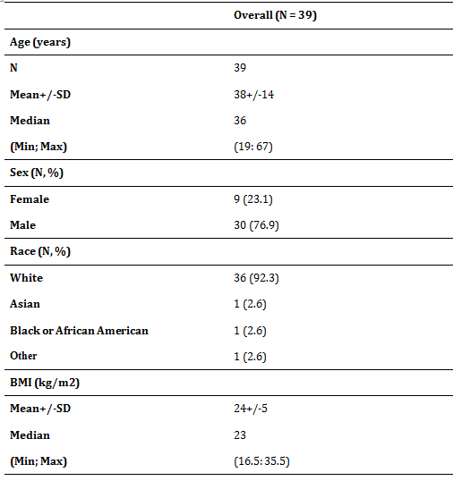

Results for the primary efficacy outcome

Maintenance of stable haemoglobin ≥ 12.0 g/dL in subjects with haemoglobin ≥ 12.0 g/dL at Baseline
Out of 23 (65.7%) subjects with Hb ≥ 12.0 g/dL at Baseline, 15 subjects had received ferric derisomaltose (infusion: 8; bolus: 7) and 8 subjects had received oral iron sulphate in the lead-in study. Of these subjects, 8 (4: IV ferric derisomaltose in lead-in study, 4: oral iron sulphate in lead-in study) maintained a stable Hb (Hb ≥ 12.0 g/dL) at all follow-up visits, 6 subjects had a Hb < 12.0 g/dL at one or more follow-up visit(s), and the remaining 9 subjects either withdrew consent, were lost to follow-up, dropped out, had an AE, or had a missed visit without experiencing a Hb value < 12.0 g/dL. The crude last observation carried forward (LOCF) estimate was 17/23 (74%) of subjects with Hb ≥ 12.0 g/dL at Baseline were able to maintain Hb ≥ 12.0 g/dL during the study (Table 37).

Table 37: Summary of analysis of time to occurrence of haemoglobin < 12.0 g/dL for subjects with haemoglobin ≥ 12.0 g/dL Baseline; full analysis set
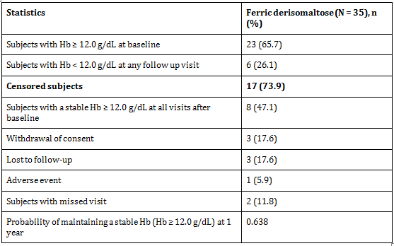
The Kaplan-Meier plot of time to a Hb < 12.0 g/dL estimated that 17 of the 23 subjects with a Hb ≥ 12.0 g/dL at Baseline would maintain a Hb ≥ 12.0 g/dL up to 1 year with a probability of 0.638. This was in line with the crude LOCF estimate.

Achievement and maintenance of stable haemoglobin ≥ 12.0 g/dL in subjects with haemoglobin < 12.0 g/dL at Baseline
The primary analysis also included assessment of achievement and maintenance of a stable Hb (Hb ≥ 12.0 g/dL) at all visits after Baseline in subjects with a Hb < 12.0 g/dL at Baseline. Out of 12 (34.3%) subjects with a Hb < 12.0 g/dL at Baseline, 9 subjects had received ferric derisomaltose (infusion: 5; bolus: 4) and 3 subjects had received oral iron sulphate in the lead-in study. Of these subjects, 3 (2: IV ferric derisomaltose in lead-in study, 1: oral iron sulphate in lead-in study) maintained a stable Hb (Hb ≥ 12.0 g/dL) at all follow-up visits, 8 subjects had a Hb < 12.0 g/dL at one or more follow-up visit(s), and 1 subject withdrew consent. The crude LOCF estimate was 4/12 (33.3%) of subjects with Hb < 12.0 g/dL at Baseline could maintain Hb ≥ 12.0 g/dL during the study Table 38.

Table 38: Summary of analysis of time to occurrence of haemoglobin < 12.0 g/dL for subjects having haemoglobin < 12.0 g/dL at Baseline; full analysis set
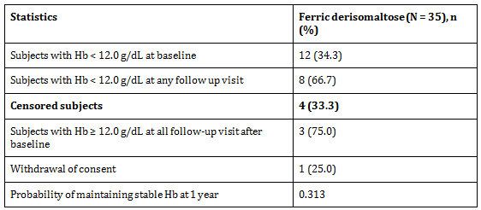
The probability of maintaining a Hb ≥ 12.0 g/dL at 1 year in subjects with Hb < 12.0 g/dL at Baseline was 0.313 which was predominantly due to subjects not achieving Hb ≥ 12.0 g/dL at the Month 3 visit. The LOCF estimate was in line with the Kaplan-Meier estimate.

Results for other efficacy outcomes

Achievement and maintenance of stable haemoglobin ≥ 12.0 g/dL in subjects with Baseline Hb ≥ 12 g/dL or reaching Hb ≥ 12.0 g/dL during the study
Out of 32 subjects with a Hb ≥ 12.0 g/dL at Baseline or any follow-up visit, 24 (75%) subjects maintained a Hb ≥ 12.0 g/dL at all study visits and 8 (25%) had a Hb < 12.0 g/dL at one or more follow up visit(s) during the study. The Kaplan-Meier plot of time to occurrence of Hb < 12.0 g/dL for subjects with Baseline Hb ≥ 12 g/dL or reaching Hb ≥ 12.0 g/dL during the study estimated that 24 subjects would maintain a Hb ≥ 12.0 g/dL at 1 year with a probability of 0.628.

Achievement and maintenance of change in Hb ≥ 2.0 g/dL in subjects that had a response of Hb ≥ 2.0 g/dL at any visit in the lead-in study
Out of 23 subjects that had a response of Hb ≥ 2.0 g/dL at any visit in the lead-in study, 17 out of 35 (48.6%) subjects had a change in Hb ≥ 2.0 g/dL at any visit and 6 out of 35 (17.1%) subjects had a change in Hb < 2.0 g/dL during the study. The Kaplan-Meier plot of time to a change in Hb < 2.0 g/dL estimated that 17 of the 23 subjects would maintain a change in Hb ≥ 2.0 g/dL up to 1 year with a probability of 0.707.

Number of subjects who achieved haemoglobin ≥ 12.0 g/dL at any single visit
Overall, 23/35 (65.7%) subjects at Baseline, 26/34 (76.5%) subjects at 3 months, 20/27 (74.1%) subjects at 6 months, 19/25 (76.0%) subjects at 9 months, and 20/26 (76.9%) subjects at 12 months (EOS) had Hb ≥ 12.0 g/dL.
Out of 23 subjects with Hb ≥ 12.0 g/dL at Baseline, 21/22 (95.5%) subjects at 3 months, 12/15 (80.0%) subjects at 6 months, 12/14 (85.7%) subjects at 9 months, and 13/16 (81.3%) subjects at 12 months (EOS) achieved Hb ≥ 12.0 g/dL. The proportion of subjects with Hb ≥ 12.0 g/dL was similar between follow-up visits.
Out of 12 subjects with Hb < 12.0 g/dL at Baseline, 5/12 (41.7%) subjects at 3 months, 8/12 (66.7%) subjects at 6 months, 7/11 (63.6%) subjects at 9 months, and 7/10 (70.0%) subjects at 12 months (EOS) achieved Hb ≥ 12.0 g/dL. The proportion of subjects with Hb ≥ 12.0 g/dL increased from Baseline to 12 months (EOS).

Number of consecutive visits with stable haemoglobin maintained
Of the 35 subjects in the FAS, 33 (94.3%) had a Hb ≥ 12.0 g/dL at any single visit, 22 out of 27 (81.5%) subjects had a Hb ≥ 12.0 g/dL at any 2 consecutive visits, 15 out of 25 (60%) subjects had a Hb ≥ 12.0 g/dL at any 3 consecutive visits, and 11 out of 24 (45.8%) subjects had a Hb ≥ 12.0 g/dL at any 4 consecutive visits (including Baseline).

Dosage of ferric derisomaltose re-administered
Of 39 subjects enrolled, 34 required re-dosing with ferric derisomaltose at any visit during the study; 27 subjects were re-dosed at Baseline, 16 subjects at 3 months, 13 subjects at 6 months, and 12 subjects were re-dosed at 9 months (Table 39). It is to be noted that 6 of 27 re-dosed subjects at Baseline were re-dosed at 3, 6, and 9 months.

Table 39: Summary of subjects required re-dosing of ferric derisomaltose; safety analysis set
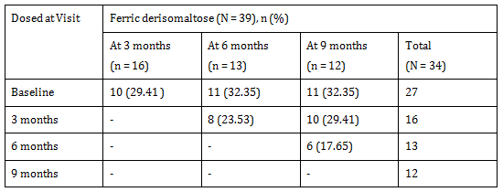

Frequency of additional dosing of ferric derisomaltose
Out of 34 re-dosed subjects, 15 were dosed once, 10 were dosed twice, 3 were dosed thrice, and 6 subjects were dosed four times. Out of the subjects that were dosed once, 6 out of the 7 subjects, who were followed for all visits till Month 12, had Hb ≥ 12.0 g/dL at Month 12. Out of the subjects that were dosed twice 9 subjects of 10 subjects, who were followed for all visits till Month 12, had Hb ≥ 12.0 g/dL at Month 12. Out of the subjects that were dosed thrice, all 3 subjects who were followed for all visits till Month 12 had Hb ≥ 12.0 g/dL at Month 12. Out of the subjects that were dosed four times 1 subject out of 5 subjects who were followed for all visits till Month 12 had Hb ≥ 12.0 g/dL at Month 12.

Change in concentrations of serum iron, serum ferritin, total iron binding concentration, and transferrin saturation from Baseline to end of study
A rapid increase in s-iron, s-ferritin, and TSAT concentration was observed from Baseline to 3 months followed by a gradual increase at 6 months, 9 months, and 12 months (EOS). There was a statistical significant increase in s-iron (p = 0.0029), s-ferritin (p < 0.0001), and TSAT (p = 0.0003) concentration from Baseline to 12 months (EOS). The TIBC concentration decreased from Baseline to 3 months, 6 months, 9 months, and 12 months (EOS) but the decrease was not statistical significant (p = 0.2116).

Change in total quality of life score
There was an increase in total QoL score from Baseline to 6 months and 12 months (EOS), however, the increase was not statistical significant (6 months: p = 0.4828; 12 months (EOS): p = 0.1895).

Change in restless leg syndrome score
The mean (SD) CH-RLSq score increased from 12.25 (4.57) at Baseline to 13.50 (6.36) at 6 months and 14.50 (12.02) at 12 months (EOS) (higher values indicate a worsening of symptoms). However, the increase was not statistical significant from Baseline to 6 months (p = 0.6392) or 12 months (EOS) (p = 0.7184). Of the 8 subjects diagnosed with definite or probable RLS in the lead study, 4 subjects had definite or probable RLS symptoms at Baseline in this study. Due to the low number of subjects in the analysis, the change in CH-RLS score should be interpreted with caution.

Change in disease activity status using Harvey-Bradshaw index for Crohn’s disease or partial Mayo score for ulcerative colitis from Baseline to Month 6 and End of Study
There were no major changes in disease activity status using Harvey-Bradshaw index for Crohn’s disease and partial Mayo score for ulcerative colitis from Baseline to 6 months and 12 months (EOS).

Change in platelet count from Baseline to Month 6 and end of study
There were no statistical significant changes in platelet count from Baseline to 6 months (p = 0.5760) and 12 months (EOS) (p = 0.3020).

Evaluator commentary
The sponsor has reported a 1 year extension trial of P-IBD-01 trial evaluating the need for additional IV ferric derisomaltose doses to maintain a stable Hb. In patients with Hb ≥ 12.0 g/dL at Baseline; 74% were able to maintain their Hb ≥ 12.0 g/dL during 1 year. The sponsor has demonstrated that repeated treatment of iron deficiency with ferric derisomaltose can avoid episodes of IDA without major safety issues.

P-Monofer-CABG-01
A randomised, prospective, double blind, comparative placebo controlled study of intravenous ferric derisomaltose (Monofer) administered by infusions to non anaemic patients undergoing elective or sub-acute CABG, valve replacement, or a combination thereof.

Study design, objectives, locations and dates
The study was a prospective, double blind, placebo controlled, randomised comparative, single centre study. It was conducted in Denmark. The enrolment period of the study was 8 months (December 2012 to July 2013). For each individual patient, the study duration was approximately 4 weeks (4 visits). The non-anaemic patients were randomised to 1 of 2 treatment groups:
- Ferric derisomaltose administered as an intravenous (IV) infusion of 1,000 mg
- Placebo (0.9% saline) administered as IV infusions

Objectives

Primary efficacy objective
To demonstrate that IV ferric derisomaltose is superior compared to placebo in leading to a less decrease in the haemoglobin (Hb) level in non-anaemic patients undergoing cardiac surgery.

Secondary efficacy objectives
To compare the effect of ferric derisomaltose to placebo on:
- Need of blood transfusion
- Iron related parameters
- Time of hospitalisation
- Functional capacity.

Safety objective
To compare the safety of ferric derisomaltose with placebo.

Inclusion and exclusion criteria

Inclusion criteria
- Women and men aged ≥ 18 years
- Patients undergoing elective or sub-acute coronary artery bypass graft (CABG), valve replacement, or a combination thereof
- Women Hb ≥ 12.0 g/dL (7.45 mmol/L) and men Hb ≥ 13.0 g/dL (8.1 mmol/L)
- Willingness to participate after signing the informed consent form.

Exclusion criteria
- Patients who received blood transfusion less than 30 days before screening and/or during the elective or sub-acute CABG, valve replacement, or a combination thereof
- Iron overload or disturbances in utilisation of iron (for example haemochromatosis and haemosiderosis)
- S-ferritin > 800 ng/mL
- Known hypersensitivity to any excipients in the investigational drug products
- History of multiple allergies
- Decompensated liver cirrhosis and hepatitis
- ALAT > 3 times normal upper value
- Acute infections (assessed by clinical judgement)
- Rheumatoid arthritis with symptoms or signs of active joint inflammation
- Patients who were pregnant or nursing. In order to avoid pregnancy, women had to be postmenopausal (at least 12 months since last menstruation), surgically sterile, or women of child bearing potential used one of the following contraceptives during the whole study period and after the study had ended for at least 5 times plasma biological half-life of the investigational medicinal product: contraceptive pills, intrauterine devices, contraceptive depot injections (prolonged release gestagen), subdermal implantation, vaginal ring, and transdermal patches
- Participation in any other clinical trial where the study drug has not passed five half-lives prior to screening
- Untreated vitamin B12 or folate deficiency
- Other IV or oral iron treatment within 4 weeks prior to screening visit
- Erythropoietin treatment within 4 weeks prior to screening visit
- Impaired renal function defined by s-creatinine > 150 μmol/L

Study treatments

Test product
Ferric derisomaltose was administered as a single infusion of 1,000 mg (maximum 20 mg/kg) over 15 minutes.

Reference therapy
Saline, ‘Natriumklorid 9 mg/mL, Fresenius Kabi, infusionsvæske, opløsning’, was used as placebo. A dose of 100 mL was administered as an infusion over 15 minutes.

Efficacy variables and outcomes

Primary efficacy endpoint
Change in Hb concentrations from Baseline (preoperatively; the day before surgery or the same day) to 4 weeks postoperatively.

Secondary efficacy endpoints
- Proportion of patients that were anaemic (women < 12 g/dL and men < 13 g/dL) at Day 5 and Week 4
- Proportion of patients who were able to maintain Hb between 9.5 and 12.5 g/dL (both values included) at Day 5 and Week 4
- Number of patients in each treatment group who needed blood transfusion and number of transfusions administered
- Change from Baseline (preoperatively – the day before surgery or the same day) in concentrations of serum (s)-ferritin, s-iron transferrin saturation (TfS), and reticulocytes at Day 5 and Week 4
- Number of postoperative days to discharge
- Changes in New York Heart Association (NYHA) classification from Baseline to 4 weeks postoperatively.

Safety endpoint
Number of patients in each treatment group who experienced any study drug related adverse events (AEs)/serious adverse events/suspected unexpected serious adverse reactions (SUSARs).

Randomisation and blinding methods
The patients were randomised 1:1 to either ferric derisomaltose or placebo. The randomisation was done by using an electronic system called interactive web response system. A file including the randomisation list was kept in a locked cupboard by personnel otherwise unrelated to the study (study nurse, department of cardiothoracic surgery).
The study drug was administered while the patient was in anaesthesia in order to keep the patient blinded. The randomisation, preparation, connection of infusions, and removal of used infusion material was handled by personnel otherwise unrelated to the study. The infusion bags of ferric derisomaltose and placebo were of similar sizes and brand.
A file including the randomisation list was kept in a locked cupboard by personnel otherwise unrelated to the study (study nurse, department of cardiothoracic surgery). Unblinding was performed by the study nurse on request from the investigator using an ‘Unblinding Request Form’

Analysis populations
A total of 64 patients were screened in the study. Of these, 4 were screen failures and the remaining 60 patients were 1:1 randomised in the study (Table 40). Out of 60 patients, 38 underwent CABG (18 had elective CABG and 20 had sub-acute CABG), 20 patients had valve replacement, and 2 patients had a combination thereof. The study population was divided into 3 datasets; safety analysis set (60 patients), FAS (51 patients), and PP (43 patients) populations.

Table 40: Summary of patient disposition
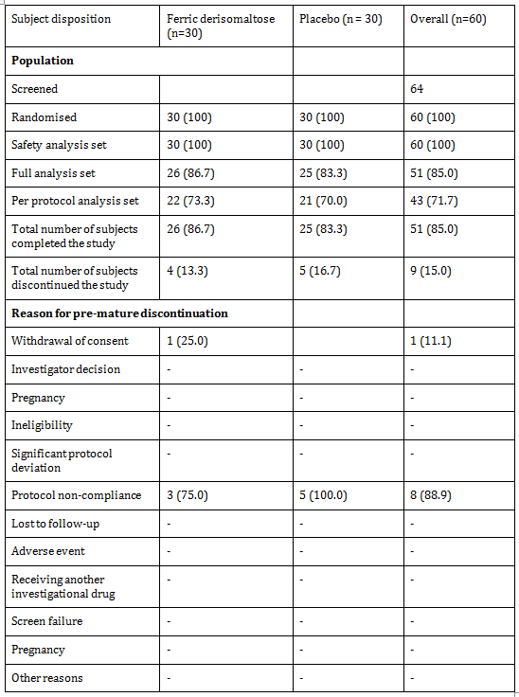

Sample size
The sample size calculation was based on superiority analysis, normally distributed data, Type I error = 5%, 2-sided test, and power of 80%.
Sixty patients were randomised 1:1 to either ferric derisomaltose (Group A; 30 patients) or placebo (Group B; 30 patients). Since blood transfusions influence the primary endpoint and for medical reasons needs to be allowed and anticipated to occur peri-operatively in a substantial proportion of patients, the nature of the study was considered explorative and regarded as a pilot study for future powering of confirmatory studies. With a sample size of 30 patients/treatment group and an assumed SD of 1.50, the study could detect a difference of 1.1 g/dL in change from Baseline in Hb between the treatment groups at 4 weeks postoperatively.

Statistical methods

Primary analysis
The primary efficacy data was evaluated using n, mean, standard deviation (SD), minimum, maximum, and 95% confidence interval. Analysis of Covariance (ANCOVA) was used to compare the average change in Hb concentration from Baseline to 4 weeks postoperatively with diagnostic group (diagnostic groups were defined as elective CABG, sub-acute CABG, valve replacement, or a combination thereof) and treatment as factor and Baseline Hb value as covariate. All tests were two-tailed and the significance level was 0.05. Proc Mixed procedure of SAS was used for ANCOVA analysis with the model factor. The least square mean and estimate statements were used for treatment estimates and contrasts between the treatments, respectively. This analysis was performed on the full analysis set (FAS) and per protocol (PP) population.

Secondary analysis
Categorical data like proportion of patients who were anaemic, proportion of patients able to maintain Hb between 9.5 and 12.5 g/dL, number of patients who needed blood transfusion, and number of blood transfusion were summarised by frequency and percentage compared between treatment groups using chi-square test or Wilcoxon rank sum test. Change in s-ferritin, s-iron TfS, and reticulocytes from Baseline to each visit was summarised by descriptive statistics. ANCOVA model was used to compare the average change in s-ferritin, s-iron TfS, and reticulocytes from Baseline to Day 5 and Week 4 of the study. Number of postoperative days to discharge was summarised by descriptive statistics and compared using Wilcoxon rank sum test between the two treatment groups. Chi-square test was used to compare the change in NYHA classification from Baseline to 4 weeks postoperatively and number of patients who experienced any drug related AEs/SAEs/SUSARs between treatment groups.

Participant flow

Table 41: Study flowchart
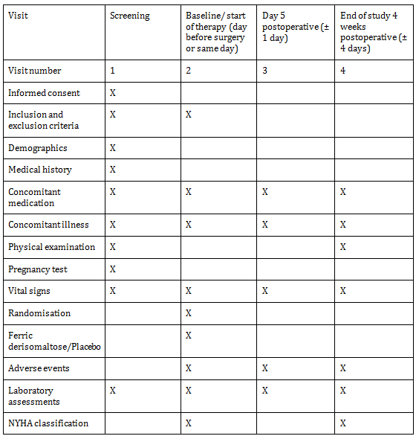

Major protocol violations/deviations
A total of 13 major protocol deviations were reported leading to exclusion of patients from the PP analysis set.

Baseline data
Out of 60 enrolled patients, 52 (87%) were men and 8 (13%) were women. 57 (95%) patients were Caucasian and 3 (5.0%) patients were categorised as other. The mean (SD) age, weight, height, and BMI were 65 (9) years, 88 (20) kg, 177 (8) cm, and 28 (5) kg/m², respectively. In the study population, 45 (75%) patients were non-smokers and the remaining 15 (25%) were current smokers (Table 42).

Table 42: Summary of patient demographics at screening; randomised population
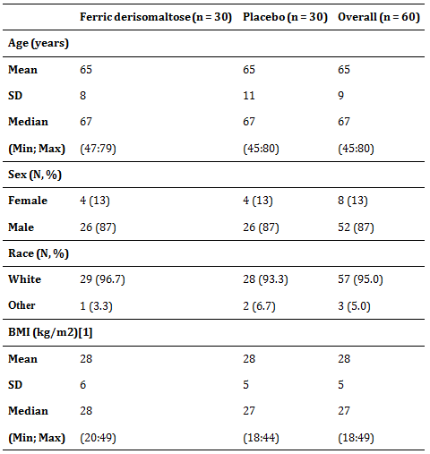

Results for the primary efficacy outcome

Primary analysis
Change in haemoglobin concentrations from Baseline to 4 weeks postoperatively.
There was a decrease in Hb concentration from Baseline to Week 4 in both treatment groups in both the FAS and PP populations. The difference estimate between the groups was FAS: 0.7728 g/dL (95% CI: 0.18:1.37) and PP: 1.0825 g/dL (95% CI: 0.50:1.67). The decrease in Hb concentration from Baseline to Week 4 was significantly lower in the ferric derisomaltose group as compared to the placebo group (FAS: p = 0.0124, PP: p = 0.0006) (Table 43).

Table 43: Summary of actual and change in haemoglobin (g/dL) concentration from Baseline to each visit; full analysis set
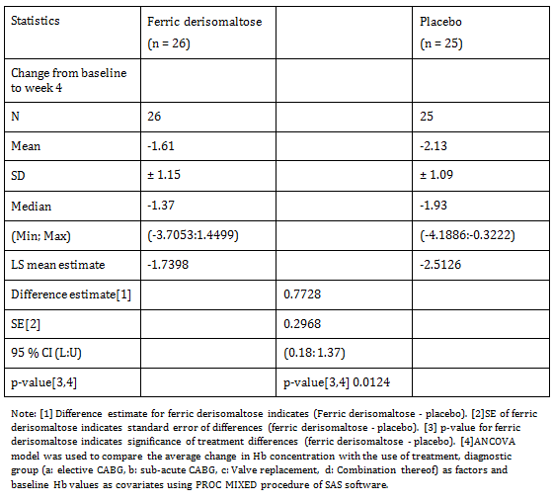

Results for other efficacy outcomes

Proportion of patients that were anaemic (women < 12 g/dL and men < 13 g/dL) at Day 5 and Week 4
The proportion of anaemic patients at Week 4 was significantly lower in the ferric derisomaltose group compared to the placebo group in the FAS (p = 0.0188). At Day 5, there was no statistical significant difference in the proportion of anaemic patients in the ferric derisomaltose group compared to the placebo group in the FAS.

Proportion of patients who were able to maintain haemoglobin between 9.5 and 12.5 g/dL (both values included) at Day 5 and Week 4
The proportion of patients who could maintain Hb between 9.5 and 12.5 g/dL was statistically significantly lower in the ferric derisomaltose group compared to the placebo group at Week 4 in the FAS (p = 0.0291) since a higher number of patients reached a Hb > 12.5 g/dL in the ferric derisomaltose group as compared to the placebo group at Week 4 (14 patients (53.8%) versus 6 patients (24.0%); (p = 0.0291). At Day 5, there was no statistical significant difference in the proportion of patients who could maintain Hb between 9.5 and 12.5 g/dL between the treatment groups.

Number of patients in each treatment group who needed blood transfusion and number of transfusions administered
This analysis was conducted not only on the FAS population but also on the safety population as a patient had to have a Hb assessment at Visit 4 to qualify for inclusion in the FAS dataset. Out of 60 patients in the safety population, 10 patients (ferric derisomaltose: 4; placebo: 6) received a blood transfusion. Of these, 9 patients (ferric derisomaltose: 4; placebo: 5) received blood transfusion between the day of surgery to Day 5 post operation and 1 patient in the placebo group received blood transfusion between Day 5 and Week 4 postoperatively. 7 (ferric derisomaltose: 4; placebo: 3) of the 51 patients in the FAS population received a blood transfusion where 6 patients (ferric derisomaltose: 4; placebo: 2) received blood transfusion after the conduct of surgery to Day 5 post operation and 1 patient in the placebo group received blood transfusion between Day 5 and Week 4 post operatively. It is to be noted, that 7 patients were included in both FAS and safety population and 3 patients [information redacted] in the placebo group were not included in the FAS dataset, as they did not have Hb assessment at Visit 4.
There was no statistical significant difference in the number of patients who needed blood transfusion at Day 5 or Week 4 in both safety population and FAS. At Day 5, the mean (SD) number of blood transfusions in the ferric derisomaltose group was 1.25 (0.50) in both safety population and FAS and 2.20 (1.64) and 3.00 (2.83) in the placebo group of safety population and FAS, respectively. At Week 4, there was no blood transfusion in the ferric derisomaltose group, but 1 patient in the placebo group received a blood transfusion between Day 5 and Week 4 postoperatively. The patient was included in both the FAS and the safety population.

Change from baseline (preoperatively; the day before surgery or the same day) in concentrations of serum iron at Day 5 and Week 4
There was a statistical significant lower decrease in s-iron concentration from Baseline to Day 5 and Week 4 in the ferric derisomaltose group as compared to the placebo group (Day 5: p < 0.0001; Week 4: p = 0.0299).

Change from baseline (preoperatively; the day before surgery or the same day) in concentrations of serum ferritin at Day 5 and Week 4
There was a statistical significant higher increase in s-ferritin concentration from Baseline to Day 5 and Week 4 in the ferric derisomaltose group compared to the placebo group (p < 0.0001).

Change from baseline (preoperatively; the day before surgery or the same day) in concentrations of transferrin saturation at Day 5 and Week 4
There was a statistical significant higher increase in TfS concentration from Baseline to Day 5 and Week 4 in the ferric derisomaltose group compared to the placebo group (Day 5: p < 0.0001; Week 4: p = 0.0015).

Change from baseline (preoperatively; the day before surgery or the same day) in concentrations of reticulocytes at Day 5 and Week 4
There was a statistical significant higher increase in reticulocyte counts from Baseline to Day 5 in the ferric derisomaltose group compared to the placebo group (p = 0.0157) but no significant changes were observed between the treatment groups from Baseline to Week 4.

Number of postoperative days to discharge
There was no statistical significant difference in the number of postoperative days to discharge between the treatment groups. In both treatment groups, patients were discharged around 8 days post operation.

Changes in New York Heart Association (NYHA) classification from Baseline to 4 Weeks post operatively
7 (53.8%) patients in the ferric derisomaltose group and 6 (50.0%) patients in the placebo group had a decrease in NYHA class which was not statistical significant between the treatment groups.

Evaluator commentary
This prospective, randomised, placebo controlled, double blind study was planned to evaluate the effect of IV ferric derisomaltose in comparison with placebo in non-anaemic patients undergoing cardiac surgery. The study was conducted at 1 centre in Denmark.
This trial was designed in accordance with the accepted guidelines for use of Monofer and iron sucrose was a valid comparator, with both trial drugs given in an individual dose up to a maximum cumulative dose of 2,000 mg.
Exclusion/inclusion criteria were reasonable given the target population for Monofer. The study protocol was followed and all patients were accounted for throughout the study and follow-up period. Protocol violations and deviations were balanced between treatments and patients were compliant with treatments.
The Baseline characteristics between study groups were balanced and the study objectives achieved. The primary efficacy endpoint of the study was to assess the change in Hb concentration from Baseline to 4 weeks postoperatively in both the FAS and PP populations. There was an expected decrease in Hb from Baseline to week 4 in both treatment groups, but it was significantly less pronounced in the ferric derisomaltose group compared to the placebo group (p = 0.012), and the proportion of non anaemic patients at Week 4 was significantly higher in the ferric derisomaltose group (38.5% versus 8%; p = 0.05).
The investigators satisfactorily demonstrated that ferric derisomaltose could be used safely and effectively to prevent anaemia after cardiac surgery and that the haematopoietic response is evident at Day 5.

P-Monofer-CIA-01
A Phase III, randomised, open label study of intravenous ferric derisomaltose (Monofer) as monotherapy (without erythropoiesis stimulating agents) in comparison with oral iron sulphate in subjects with non-myeloid malignancies associated with chemotherapy induced anaemia (CIA).

Study design, objectives, locations and dates
The study was a prospective, open label, randomised, comparative, multi-centre, Non inferiority study conducted in subjects with a diagnosis of non-myeloid cancer receiving chemotherapy at least 1 day prior to screening. The subjects were going to receive at least 2 more chemotherapy cycles and they were also diagnosed with either absolute or potential functional iron deficiency anaemia (IDA).
The total duration of the study was 42 months, including 36 months of enrolment period. For an individual subject, the duration of the study was approximately 24 weeks. Each subject attended a total of 8 visits during the study. The treatment duration was 12 weeks with primary endpoint assessment after 4 weeks and an additional follow up visit after 24 weeks to assess safety, laboratory assessments of treatment effects, and to detect any impact of the study drugs upon the ability to complete the planned chemotherapy as well as the response to the chemotherapy.
The subjects were randomised 2:1 into Group A and Group B; with 1:1 randomisation between subgroup A1 and A2. The following were the treatment groups:
- Group A: Ferric derisomaltose (Monofer)
  - Subgroup A1: administered as intravenous (IV) infusions
  - Subgroup A2: administered as IV bolus injections
- Group B: Iron sulphate administered orally

Objectives

Primary efficacy objective
To demonstrate that IV ferric derisomaltose is non inferior to oral iron sulphate in the ability to increase/maintain haemoglobin (Hb) concentration in patients with CIA and either absolute or functional iron deficiency

Secondary efficacy objectives
- To compare iron related haematological parameters (Hb, transferrin saturation (TSAT), serum (s-)iron, total iron binding capacity (TIBC), and s-ferritin levels)
- To assess subjects who discontinued study due to lack of response or intolerance
- To assess quality of life (QoL)
- Assessment of restless leg syndrome (RLS) symptoms and change in these symptoms during the study
- To detect the impact of the study drug upon the ability to complete the planned chemotherapy
- To detect the impact of the study drug upon response to the chemotherapy.

Safety objectives
- To obtain safety reassurance with the use of ferric derisomaltose in subjects with non-myeloid malignancies and CIA
- To compare study drug related adverse events (AEs) after ferric derisomaltose to study drug related AEs in subjects treated with oral iron sulphate.
The study was conducted at 47 sites, including 18 sites in India, 9 sites in Russia, 7 sites in Poland, 4 sites in Germany, 3 sites in USA, 2 sites each in Sweden and Spain, and 1 site each in Denmark and UK.

Studied period
First subject first visit: 28 October 2010
Last subject last visit: 23 April 2014

Inclusion and exclusion criteria

Inclusion criteria
- Women and men aged ≥ 18 years
- Subjects diagnosed with non-myeloid malignancies (including all solid tumours, low grade lymphoma, high grade lymphoma, chronic lymphatic leukaemia, and myeloma) receiving chemotherapy at least 1 day prior to screening and who were going to receive at least 2 more chemotherapy cycles
- Hb < 12 g/dL (7.4 mmol/L)
- TSAT < 50%
- S-ferritin < 800 ng/mL
- An eastern cooperative oncology group performance status of 0 to 2
- Willingness to participate after signing informed consent (including Health insurance portability and accountability act, if applicable)

Exclusion criteria
- Anaemia caused primarily by other factors than CIA
- IV or oral iron treatment within 4 weeks prior to screening visit
- Erythropoietin treatment within 4 weeks prior to screening visit
- Blood transfusion within 4 weeks prior to screening visit
- Imminent expectation of blood transfusion on part of treating physician
- Iron overload or disturbances in utilisation of iron (for example hemochromatosis and haemosiderosis)
- Drug hypersensitivity (that is previous hypersensitivity to iron dextran or iron mono- or disaccharide complexes or to iron sulphate)
- Known hypersensitivity to any excipients in the investigational drug products
- Subjects with a history of multiple allergies
- Decompensated liver cirrhosis or active hepatitis (ALAT > 3 times upper normal limit)
- Active acute or chronic infections (assessed by clinical judgement and if deemed necessary by investigator supplied with WBC and CRP)
- Rheumatoid arthritis with symptoms or signs of active joint inflammation
- Pregnancy and nursing. In order to avoid pregnancy, women had to be postmenopausal (at least 12 months since last menstruation), surgically sterile, or women of child bearing potential had to use one of the following contraceptives during the whole study period and after the study had ended for at least 5 times plasma biological half-life of the investigational medicinal product: contraceptive pills, intrauterine devices, contraceptive depot injections (prolonged release gestagen), subdermal implantation, vaginal ring, and transdermal patches
- Planned elective surgery during the study
- Participation in any other clinical study (except chemotherapy protocol) within 3 months prior to screening
- Known intolerance to oral iron treatment
- Untreated vitamin B12 or folate deficiency
- Any other medical condition that, in the opinion of the principal investigator, may have caused the subject to be unsuitable for the completion of the study or placed the subject at potential risk from being in the study, for example uncontrolled hypertension, unstable ischaemic heart disease, or uncontrolled diabetes mellitus.

Study treatments

Test product
Monofer was the test product in this study.
Full iron replacement dose with ferric derisomaltose was calculated based on the following Ganzoni formula:
Total iron dose (mg) = body weight (kg) x (targeted Hb - actual Hb (g/dL)) x 2.4 + depot iron (mg) where
Depot iron: 500 mg
Targeted Hb: 13.0 g/dL
Drug dosage and mode of administration were as follows:

Group A1: Ferric derisomaltose; IV infusion
Subjects randomised to subgroup A1 were treated with 1or 2 doses in total with 1 week between the doses. The full iron replacement dose of ferric derisomaltose was administered as IV infusion of maximum 1,000 mg* ferric derisomaltose until full replacement dose was achieved. The infusion was diluted in 100 mL 0.9% sodium chloride and was given approximately over 15 minutes.
*The maximum dose per infusion was 1,000 mg for subjects with a weight > 45 kg, 750 mg for subjects with a weight between 35 and 45 kg, and 500 mg for subjects with a weight < 35 kg

Group A2: Ferric derisomaltose; bolus IV injection
Subjects randomised to subgroup A2 were treated 1 to 4 times during 4 weeks. The full iron replacement dose of ferric derisomaltose was administered as IV bolus injections of 500 mg administered undiluted approximately over 2 minutes once per week until full replacement dose was achieved. In some cases, the remaining dose on the last dosing day was 250 mg which was administered undiluted approximately over 2 minutes.
No test dose was applied.

Reference therapy
Ferro Duretter was the reference therapy. Subjects randomised to Group B were treated with a dose of 100 mg elementary iron twice a day (200 mg daily) for 12 weeks.

Efficacy variables and outcomes

Primary efficacy endpoint
Change in Hb concentration from Baseline to Week 4

Secondary efficacy endpoints
- Proportion of subjects who achieved target limits of Hb (men 13 to 18 g/dL, women 12 to 16 g/dL) and had change in Hb concentration ≥ 1.0 g/dL at Week 2, 4, 8, or 12
- Proportion of subjects who had a change in Hb concentration ≥ 2.0 g/dL at Week 2 or 4
- Proportion of subjects who had a change in Hb concentration ≥ 2.0 g/dL at Week 2, 4, 8, or 12
- Number of subjects receiving transfusions
- Change from Baseline in Hb at Week 1, 2, 8, 12, and 24
- Change from Baseline in TSAT, s-iron, TIBC, and s-ferritin measured at Week 1, 2, 4, 8, 12, and 24
- Number of subjects in each randomisation group who discontinued study because of lack of response or intolerance of investigational drugs
- Changes in QoL from Baseline to 4 and 12 weeks
- Change in RLS symptoms (RLS score) from Baseline to Week 12 in subjects with RLS symptoms at Baseline
- Impact of study drug on ability to complete chemotherapy assessed as yes or no response at 24 weeks
- Impact of study drug on response to chemotherapy, assessed as complete remission, partial remission, stable remission, and progressive disease as per the investigator discretion at 24 weeks.

Safety endpoints
Safety laboratory assessments were at Baseline and 1, 2, 4, 8, 12, and 24 weeks.
- Number of study drug related AEs (including serious adverse reactions) in ferric derisomaltose group and iron sulphate group
- Number of AEs of special interest (that is hypersensitivity reactions or hypotension at pre-specified time points in relation to administration of study drug).

Randomisation and blinding methods
The subjects were randomised 2:1 into ferric derisomaltose and iron sulphate; with 1:1 randomisation between subgroup A1 and A2.
The randomisation of subject to treatment was stratified by Baseline Hb (Hb < 10 g/dL versus Hb ≥ 10 g/dL), s-ferritin (< 20 ng/mL versus 20 ≤ s-ferritin < 100 ng/mL versus ≥ 100 ng/dL), TSAT (< 15% versus ≥ 15%), and whether the subject was receiving platinum-based chemotherapy or not.

Analysis populations

Table 44: Summary of analysis population and study completion: randomised population
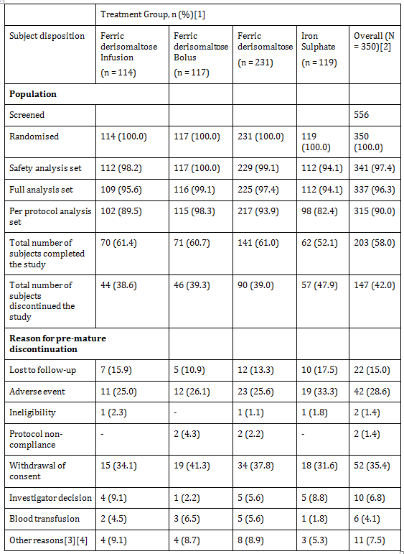
Note: (1) Percentage was calculated taking corresponding column header group as denominator. (2) Overall represented the sum of ferric derisomaltose and iron sulphate groups. (3) Subject [information redacted] was incorrectly randomised. Thus, the subject did not complete the study and no reason was given on the end of study form. (4) Subject [information redacted] was withdrawn due to ‘other reasons’ but the investigator specified that it was due to an SAE.

Sample size
The sample size calculation was based on absolute change in Hb from Baseline to Week 4. The non inferiority margin was set at -0.5 g/dL. This margin was in line with previous studies and regarded as clinically relevant. A two-sided significance level of 5% was used and the power was set to 80%.
Based on available literature and previous studies with ferric derisomaltose, the SD in change in Hb was assumed to be approximately 1.5 g/dL. With a 2:1 randomisation, a two-sided significance level of 0.05, and a non inferiority margin of -0.5 g/dL, there was approximately 80% power to demonstrate non inferiority with 321 subjects included in the efficacy analyses (that is provide post-randomisation Hb measurements).
A few drop-outs were expected. As the study was designed to demonstrate Non inferiority, the analyses of FAS and PP population would lead to similar conclusions and therefore the analyses for both analysis sets needed to be powered properly. With approximately 10% (anticipated) of subjects having major protocol violations, a total of 350 subjects were to be randomised (234 to ferric derisomaltose and 116 to iron sulphate).

Statistical methods

Primary efficacy analysis
The primary efficacy analysis was conducted on the full analysis set (FAS) and per protocol (PP) population. The primary analysis was to assess non inferiority between treatment Group A and B. The primary efficacy data was tabulated using n, mean, SD, median, minimum, maximum, and 95% confidence interval (CI). A mixed model for repeated measures (MMRM) was used to compare the average change in Hb concentration from Baseline to Week 4 with the use of treatment, visit, treatment*visit interactions, platinum based chemotherapy (Yes/No), and country as factors and Baseline Hb values as covariates. Treatment visit estimated at Week 4 was used as an estimate from model. The Proc Mixed procedure of SAS was used for the analysis with the model factor mentioned above. LSMEANS and ESIMATE statements were used for treatment estimates and contrasts between the treatments, respectively.
The primary analysis was Group A versus Group B, where Group A consisted of pooled data of both A1 and A2. Additional supportive analysis was comparing treatment Group A1 versus Group B, subgroup A2 versus Group B, and subgroup A1 versus subgroup A2. With this distinction of primary and supportive analyses, no corrections for multiplicity were imposed, and all tests were two-tailed and the significance level was 0.05. The primary analysis was to assess non inferiority. The non inferiority margin was set as - 0.5 g/dL. In case the 95% CI lay entirely above 0, this was evidence of superiority in terms of statistical significance at the 5% level. In that case, the p value associated with a test of superiority was calculated and evaluated whether this was sufficiently small to reject the hypothesis of no difference.

Secondary efficacy analyses
The secondary efficacy analyses were conducted on the FAS. The logistic regression model was used to compare the subjects who achieved the target level of Hb (men 13 to 18 g/dL, women 12 to 16 g/dL) and change in Hb concentration (≥ 1.0 g/dL) from Baseline to Week 2, 4, 8, or 12 using treatment and platinum based chemotherapy (Yes/No) as factors and Baseline values as covariates. The same model was used for change in Hb concentration (≥ 2.0 g/dL) from Baseline to Week 2, 4, 8, or 12 using treatment and platinum based chemotherapy (Yes/No) as factors and Baseline values as covariates.
Number of subjects receiving transfusions were summarised by using descriptive statistics and chi-square/fisher exact test was used for the comparison between the treatment groups. A repeated measures model was used to compare the average change in Hb concentration from Baseline to Week 1, 2, 8, 12, and 24 with the use of treatment, visit, treatment visit interactions, platinum based chemotherapy (Yes/No), and country as factors and Baseline values as covariates. Visit treatment estimate at the relevant week was used as the estimate model. The same method was used to compare the change in TSAT, s-iron, TIBC, and s-ferritin from Baseline to Week 1, 2, 4, 8, 12, and 24 and to compare change in QoL (using FACIT-Fatigue questionnaire) score from Baseline to Week 4 and 12.
Subjects who were withdrawn due to lack of efficacy or intolerance were identified manually by reviewing the data for (i) reason for premature discontinuation on the end of study forms and (ii) AE forms with the action taken ‘withdrawal from study’. Subjects for whom reasons for withdrawal could be categorised as lack of effect or who withdrew due to an ADR categorised as intolerance to treatment were considered as fulfilling the endpoint. The Fisher’s exact test was used to calculate the p value between the treatment groups for intolerance/lack of response at a 5% level of significance.
An analysis of covariance (ANCOVA) model was used to compare the changes in RLS symptoms (RLS score) from Baseline to Week 12 in subjects with RLS symptoms present at Baseline with the use of treatment, platinum based chemotherapy (Yes/No), and country as factors and Baseline values as covariates. The Proc Mixed procedure of SAS was used for the ANCOVA repeated measure with the model factor mentioned above and LSMEANS and ESTIMATE statements for treatment estimates and contrasts between the treatments, respectively. All tests were two-tailed and the significance level was set to 0.05.
The impact of study drug on ability to complete chemotherapy and impact of study drug on response to chemotherapy were summarised by using frequencies and percentages.

Participant flow
The subjects attended 8 visits. A study flowchart of the study assessments performed at the visits is shown in Table 45.

Table 45: Study flowchart
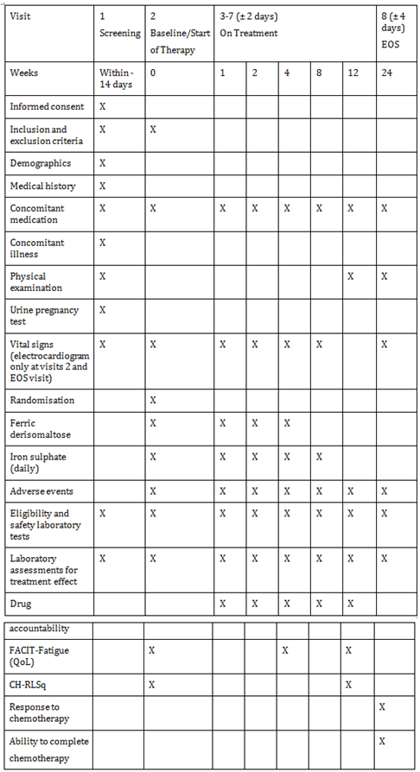

Major protocol violations/deviations
A total of 22 major protocol deviations were reported during the study which lead to exclusion of the subjects from the PP population:
Based on an evaluation of the protocol deviations, including GCP deviation that occurred during the study it can be concluded that the study has been conducted in compliance with the ICH-GCP guideline.

Baseline data
Out of 350 randomised subjects, 241 (68.9%) were women and 109 (31.1%) were men. 204 (58.3%) subjects were Asian and 143 (40.9%) subjects were Caucasian. 332 (94.9%) subjects were non-smokers. The mean (SD) age, weight, height, and body mass index (BMI) of the subject population were 55 (11) years, 61 (17) kg, 161 (10) cm, and 24 (6) kg/m², respectively. The demographic variables were comparable between the treatment groups (Table 46).

Table 46: Summary of subject demographics; randomised population
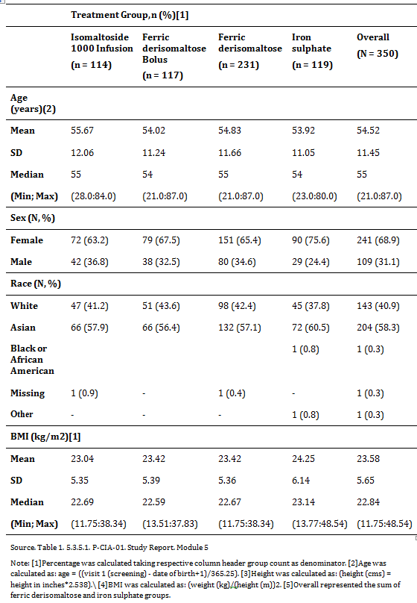

Results for the primary efficacy outcome

Primary endpoint

Change in haemoglobin concentration from Baseline to Week 4
The difference between treatment groups were compared for non inferiority using a non inferiority margin of -0.5. In addition, p values for testing for superiority were derived. The test for non inferiority showed that ferric derisomaltose was non-inferior to iron sulphate in its ability to increase Hb from Baseline to Week 4 in both FAS and PP datasets (FAS: difference estimate: 0.0161, 95% CI: -0.261:0.293, p = 0.0002; PP: difference estimate: -0.0071, 95% CI: -0.291:0.276, p = 0.0006). However, ferric derisomaltose did not show superiority over iron sulphate in terms of change in Hb concentration from Baseline to Week 4 in either FAS or PP analysis sets (FAS: p = 0.9092; PP: p = 0.9609). Similar results were observed when the ferric derisomaltose infusion and bolus subgroups were compared in both FAS and PP datasets (Table 47).

Table 47: Average change in haemoglobin (g/dL) concentration from Baseline to Week 4; full analysis set
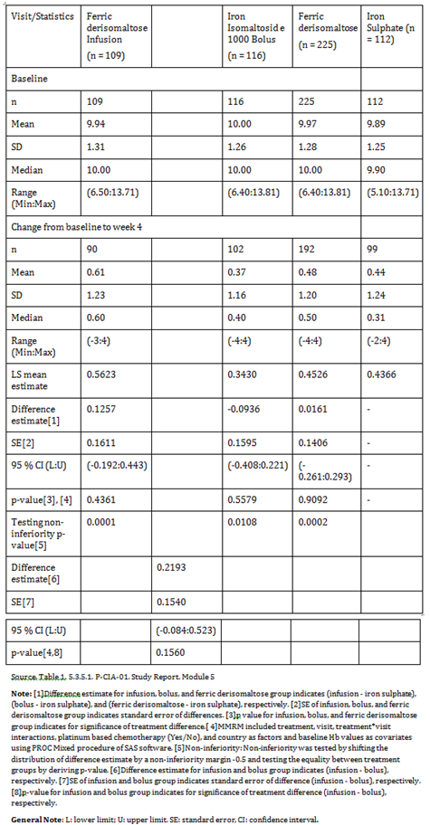

Results for other efficacy outcomes

Proportion of subjects who achieved target limits of haemoglobin (men 13 to 18 g/dL, women 12 to 16 g/dL) and had change in haemoglobin concentration ≥ 1.0 g/dL at Week 2, 4, 8, or 12
There was no statistical significant difference in the proportion of subjects who achieved target limits of Hb (men 13 to 18 g/dL, women 12 to 16 g/dL) and had a change in Hb ≥ 1.0 g/dL from Baseline to either Week 2, 4, 8, or 12 between the ferric derisomaltose and iron sulphate groups (p = 0.7772). Similar results were observed when the ferric derisomaltose infusion and bolus subgroups were compared.

Proportion of subjects who had a change in haemoglobin concentration ≥ 2.0 g/dL at Week 2 or 4
There was no statistical significant difference in the proportion of subjects who had a change in Hb ≥ 2.0 g/dL from Baseline to Week 2 or 4 between the ferric derisomaltose and iron sulphate groups (p = 0.1193). There was no statistical significant difference in the proportion of subjects who had a change in Hb ≥ 2.0 g/dL from Baseline to Week 2 or 4 when the ferric derisomaltose infusion and bolus subgroups were compared.

Proportion of subjects who had a change in haemoglobin concentration ≥ 2.0 g/dL at Week 2, 4, 8, or 12
There was no statistical significant difference in the proportion of subjects who had a change in Hb ≥ 2.0 g/dL from Baseline to Week 2, 4, 8, or 12 between the ferric derisomaltose and iron sulphate groups (p = 0.8372). A statistical significant higher proportion of subjects had a change in Hb ≥ 2.0 g/dL from Baseline to Week 2, 4, 8, or 12 in the ferric derisomaltose infusion subgroup compared to the ferric derisomaltose bolus subgroup (p = 0.0338).

Number of subjects receiving transfusions
23 subjects (ferric derisomaltose group: 17 (infusion: 8; bolus: 9); iron sulphate group: 6) received blood transfusion during the study. There was no statistical significant difference in the proportion of subjects receiving blood transfusion between the ferric derisomaltose and iron sulphate groups (p = 0.4509). Similar results were obtained when the ferric derisomaltose infusion and bolus subgroups were compared.

Change in haemoglobin from baseline to Week 1, 2, 8, 12, and 24
Hb increased significantly from Baseline in both the ferric derisomaltose and iron sulphate treatment groups but there was no statistical significant difference in Hb concentration from Baseline to Week 1, 2, 8, 12, and 24 between the ferric derisomaltose and iron sulphate groups. Similar results were observed when the ferric derisomaltose infusion and bolus subgroups were compared and when these sub-goups were compared to the iron sulphate group except at Week 1 where the difference in Hb concentration from Baseline was significantly higher in the ferric derisomaltose infusion subgroup compared to the iron sulphate group (p = 0.0291).

Change in transferrin saturation, serum iron, total iron binding capacity, and serum ferritin from baseline to Week 1, 2, 4, 8, 12, and 24
There was a statistical significant increase in TSAT concentration from Baseline to Week 1 in the ferric derisomaltose group compared to the iron sulphate group (p = 0.0025), and no statistical significant difference in TSAT concentration was reported from Baseline to Week 2, 4, 8, 12, and 24 between the ferric derisomaltose and iron sulphate groups. There was no statistical significant difference in TSAT concentration from Baseline to Week 1, 2, 4, 8, 12, and 24 when the ferric derisomaltose infusion and bolus subgroups were compared.
There was a statistical significant increase in s-iron concentration from Baseline to Week 1 in the ferric derisomaltose group compared to the iron sulphate group (p = 0.0130), and no statistical significant difference in s-iron concentration was reported from Baseline to Week 2, 4, 8, 12, and 24 between the ferric derisomaltose and iron sulphate group. There was no statistical significant difference in s-iron concentration from Baseline to Week 1, 2, 4, 8, 12, and 24 when the ferric derisomaltose infusion and bolus subgroups were compared.
There was a statistical significant higher decrease in TIBC from Baseline to Week 1, 2, 4, 8, and 24 in the ferric derisomaltose group compared to the iron sulphate group (Week 1: p = 0.0030; Week 2: p < 0.0001; Week 4: p < 0.0001; Week 8: p = 0.0278; Week 24: p = 0.0396). No statistical significant difference in TIBC concentration was observed from Baseline to Week 1, 2, 4, 8, 12, and 24 when the ferric derisomaltose infusion and bolus subgroups were compared.
There was a statistical significant increase in s-ferritin concentration from Baseline to Week 1, 2, 4, 8, 12, and 24 in the ferric derisomaltose group compared to the iron sulphate group (Week 1: p < 0.0001; Week 2: p < 0.0001; Week 4: p < 0.0001; Week 8: p < 0.0001; Week 12: p < 0.0001; Week 24: p = 0.0003). No statistical significant difference in s-ferritin concentration was observed when the ferric derisomaltose infusion and bolus subgroups were compared except at Week 1 where there was a statistical significant increase in s-ferritin concentration in the ferric derisomaltose infusion subgroup compared to the bolus subgroup (p = 0.0005) (Table 48).

Table 48: Average change in serum ferritin (μg/L) concentration from Baseline to Week 24; full analysis set
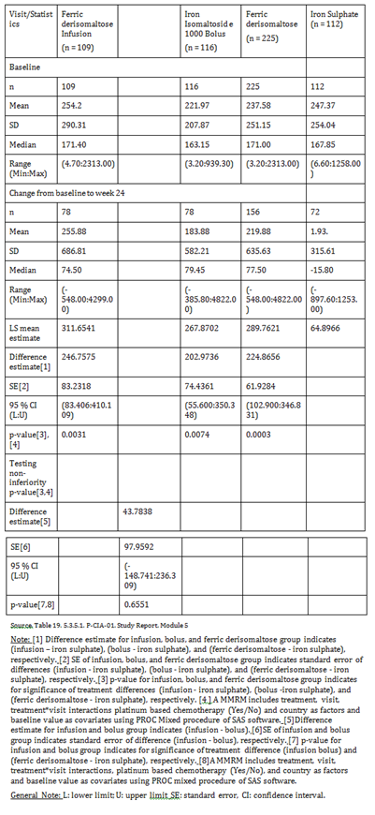

Number of subjects in each randomisation group who discontinued study because of lack of response or intolerance of investigational drugs
A statistical significant higher proportion of subjects in the iron sulphate group discontinued the study due to intolerance/lack of response of investigational drug as compared to the ferric derisomaltose group (p = 0.0007). 11 subjects (ferric derisomaltose group: 2 (0.9%); iron sulphate group: 9 (8.0%)) were withdrawn due to intolerance to the study drug and 1 (0.9%) subject in the iron sulphate group withdrew due to lack of response. No statistical significant difference was observed in the proportion of subjects who discontinued due to intolerance/lack of response when the ferric derisomaltose infusion and bolus subgroups were compared.

Changes in quality of life from baseline to 4 and 12 weeks
There was no statistical significant difference in overall QoL from Baseline to Week 4 and Week 12 between the ferric derisomaltose and iron sulphate group (Week 4: p = 0.9224; Week 12: p = 0.2527). Similar results were observed when the ferric derisomaltose infusion and bolus subgroups were compared.

Change in restless leg syndrome symptoms (Cambridge Hopkins-Restless Leg Syndrome Questionnaire Score) from baseline to Week 12 in subjects with restless leg syndrome symptoms at Baseline
There was an average decrease in CH-RLS score from Baseline to Week 12 in the ferric derisomaltose group and an average increase in CH-RLS score from Baseline to Week 12 in the iron sulphate group in subjects with RLS at Baseline. Due to the low number of subjects in both treatment groups, a p value could not be calculated.

Impact of study drug on ability to complete chemotherapy assessed as yes or no response at 24 Weeks
There was no statistical significant difference in the proportion of subjects who were able to complete chemotherapy at Week 24 between the ferric derisomaltose and iron sulphate groups (p = 0.9112). Similar results were obtained when the ferric derisomaltose infusion and bolus subgroups were compared.

Impact of study drug on response to chemotherapy, assessed as complete remission, partial remission, stable remission, and progressive disease as per the investigator discretion at 24 weeks
There was no statistical significant impact of study drug on response to chemotherapy as per investigator discretion at 24 weeks between the ferric derisomaltose and iron sulphate groups (p = 0.3909). Similar results were obtained when the ferric derisomaltose infusion and bolus subgroups were compared.

Evaluator commentary
In 2012, National Comprehensive Cancer Network suggested the consideration of IV iron in subjects with functional iron deficiency and s-ferritin levels up to 800 ng/mL if TSAT < 20%. The current submitted study examines whether subjects with CIA with s-ferritin < 800 ng/mL (that is no iron overload) and TSAT up to 50% benefits from IV ferric derisomaltose alone (without ESA supplementation) compared to oral iron alone (that is, without ESA) over a 24 week period.
This trial was designed in accordance with the accepted guidelines for use of Monofer.
Exclusion/inclusion criteria were reasonable given the target population for Monofer. The study protocol was followed and all patients were accounted for throughout the study and follow-up period. Protocol violations and deviations were balanced between treatments and patients were compliant with treatments.
The Baseline characteristics between study groups were balanced.
The investigators satisfactorily demonstrated ferric derisomaltose was non-inferior to iron sulphate in its ability to increase Hb from Baseline to Week 4 (p = 0.0002). In addition, there was a faster onset of the Hb response in the IV ferric derisomaltose infusion group compared to oral iron group at Week 1 (p = 0.03) and a sustained effect on Hb in both groups until Week 24.
In subjects with CIA, the trial demonstrated a comparable sustained increase in Hb over time with both ferric derisomaltose and oral iron; and that more adverse drug reactions were reported for oral iron.

P-Monofer-PP-01
A randomized comparative, open label study of intravenous ferric derisomaltose (monofer) administered by high single dose infusions or standard medical care in women after postpartum haemorrhage.

Study design, objectives, locations and dates
The trial was a randomised, comparative, open label single centre trial conducted in women after postpartum haemorrhage (PPH). The enrolment period of the trial was approximately 17 months. For each individual subject, duration of the trial was approximately 12 weeks. Each subject attended 6 visits (a Baseline Visit (including screening, randomisation and treatment with trial drug), 4 subsequent evaluation visits, and an end of trial visit).
The subjects were randomised to 1 of 2 treatment groups:
- Ferric derisomaltose (Monofer; 100 mg/mL), 1200 mg administered as a single intravenous (IV) infusion
- Standard medical care

Objectives

Primary efficacy objective
The primary objective of this trial was to compare efficacy of IV high single dose infusion of ferric derisomaltose to standard medical care in women with PPH evaluated as physical fatigue.

Secondary efficacy objectives
The secondary efficacy objectives of the trial were to evaluate the effect of ferric derisomaltose compared to standard medical care on:
- Ability to increase haemoglobin (Hb)
- Other relevant iron and red blood cell (RBC) related biochemical parameters
- Other fatigue symptoms
- Symptoms of postpartum depression
- Time of postpartum lactogenesis
- Time of discontinuation of breastfeeding
- Transfusion of allogenic RBCs

Safety objectives
The safety objectives of the trial were to evaluate the safety of ferric derisomaltose compared to standard medical care by:
- Discontinuation due to intolerance
- Adverse events (AEs)
- Vital signs
- Biochemical safety parameters

Other objectives
- Validation of the postpartum questionnaire
- Maternal milk iron level
- Anaemia and gastrointestinal symptoms.

Trial centre
Department of Obstetrics, Copenhagen University Hospital, Denmark

Studied period
First subject first visit: 3 May 2013
Last subject last visit: 16 December 2014

Inclusion and exclusion criteria

Inclusion criteria
A subject was eligible for inclusion in the trial if she fulfilled the following criteria:
- Women with PPH ≥ 700 and ≤ 1,000 mL or PPH > 1,000 mL and Hb > 6.5 g/dL (4.0 mmol/L) measured > 12 hours after delivery
- Willingness to participate and signed the informed consent form

Exclusion criteria
A subject was not eligible for inclusion in this trial if she fulfilled any of the following criteria:
- Women aged < 18 years
- Multiple births
- Peri partum RBC transfusion
- Known iron overload or disturbances in utilisation of iron (for example haemochromatosis and haemosiderosis)
- Known hypersensitivity to parenteral iron or any excipients in the investigational drug products
- Women with a history of active asthma within the last 5 years or a history of multiple allergies
- Known decompensated liver cirrhosis or active hepatitis
- Women with HELLP (Haemolysis Elevated Liver enzymes Low Platelet count) syndrome (defined according to the Danish Society of Obstetrics and Gynaecology guidelines)
- Active acute infection assessed by clinical judgement
- Rheumatoid arthritis with symptoms or signs of active joint inflammation
- History of anaemia caused by for example thalassemia, hypersplenism or haemolytic anaemia (known haematologic disorder other than iron deficiency)
- Not able to read, speak and understand the Danish language
- Participation in any other clinical trial where the trial drug has not passed 5 half-lives prior to the Baseline
- Any other medical condition that, in the opinion of the investigator, may cause the subject to be unsuitable for completion of the trial or place the subject at potential risk from being in the trial. For example, absolute indication for RBC transfusion, a malignancy, uncontrolled hypertension, unstable ischaemic heart disease, or uncontrolled diabetes mellitus.

Study treatments

Test product
Ferric derisomaltose (Monofer; 100 mg/mL) was the test product in this trial.
The iron replacement dose of ferric derisomaltose for the individual subject was set to 1,200 mg. The dose was diluted in 100 mL 0.9% sodium chloride (100 mL bags) and administered over approximately 15 minutes using IV drip infusion.

Duration of treatment
In the ferric derisomaltose treatment group, a single dose was administered at the Baseline Visit. In the standard medical care treatment group, current practice was applied for the entire trial period (12 weeks) in each subject.

Reference therapy
Standard medical care was the reference therapy in this trial. Current practice at the Department of Obstetrics, Copenhagen University Hospital, was used. This is usually to recommend women with PPH to continue oral iron supplementation as recommended during pregnancy or to advise the women to take 100 mg oral iron 1 to 2 times per day for a variable unspecified time.

Efficacy variables and outcomes

Primary efficacy endpoint
The primary endpoint of the trial was to measure and compare the aggregated change in physical fatigue score from Baseline to Week 12 (area under the curve (AUC)) in the 2 treatment arms measured by the Multidimensional Fatigue Inventory (MFI).

Secondary efficacy endpoints
The secondary endpoints were to measure and compare the following in the 2 treatment arms:
- Change in Hb concentration from Baseline to Week 1, 3, 8, and 12
- Proportion of women who achieve or maintain Hb levels of > 10 g/dL (6.2 mmol/L) at any time
- Proportion of women who achieve increase from Baseline in Hb concentration ≥ 2.0 g/dL (1.2 mmol/L) at any time
- Proportion of women with decrease from Baseline in Hb concentration ≥ 2.0 g/dL (1.2 mmol/L) at any time
- Change in concentrations of p-ferritin, p-iron, p-transferrin, transferrin saturation (TSAT), reticulocyte count, and reticulocyte mean haemoglobin content (CHr) from Baseline to Day 3, Week 1, 3, 8, and 12
- Change in MFI physical fatigue symptoms from Baseline to Day 3, Week 1, 3, 8 and 12
- Change in other MFI fatigue symptoms from Day 3 to Week 1, 3, 8, and 12
- Change in fatigue symptoms measured by the postpartum questionnaire from Baseline to Day 3, Week 1, 3, 8, and 12
- Change in postpartum depression symptoms measured by the Edinburgh Postnatal Depression Scale (EPDS) from Week 1 to Week 3, 8, and 12
- Time to postpartum lactogenesis
- Time to discontinuation of breastfeeding
- Proportion of women who has received 1 or more allogenic RBC transfusions and the number of units of RBC transfused per transfused subject during the trial.

Randomisation and blinding methods
A total of 200 subjects were randomised 1:1 to 1 of the following 2 treatment groups:
- Ferric derisomaltose (100 subjects)
- Standard medical care (100 subjects)
The randomisation to treatment arms was stratified to balance the following:
PPH 700 mL to 1,000 mL
PPH > 1,000 mL
No blinding was performed in this trial.

Analysis populations
Subject disposition is summarised in Table 49. A total of 211 subjects were screened and 200 subjects were included in the trial, randomised (100 subjects in each of the 2 treatment groups) and thus part of the intention to treat (ITT) population. Out of these 200 subjects, 2 subjects in the ferric derisomaltose group withdrew before dosing, hence 98 subjects in the ferric derisomaltose group and 100 subjects in the standard medical care group received treatment and were included in the safety analysis set. A total of 97 subjects in the ferric derisomaltose group and 99 subjects in the standard medical care group completed the trial.

Table 49: Subject disposition
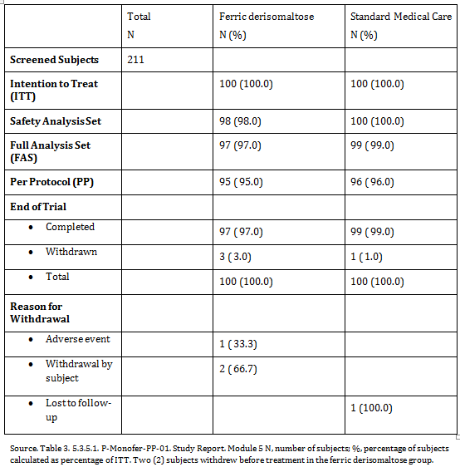

Sample size
The sample size calculation was based on the primary endpoint, aggregated change in physical fatigue score from Baseline to Visit 6 (Week 12). A 2-sided significance level of 5% was used and the power was set to 80%.
In a previous non inferiority study using the physical fatigue subscale of MFI in a similar population, the non inferiority margin was set to 1.3. ¹¹ The use of the physical fatigue subscale of MFI allows a maximum change of 16 points, and for proclaiming superiority the minimum clinically relevant difference in the current trial was set to 1.8. In a previous study, the SD was found to be approximately 4.2. ¹² Hence, 87 subjects per treatment group were needed for demonstrating superiority.
To account for subject withdrawals, a total of 200 subjects were randomised 1:1 to the following treatments:
- Ferric derisomaltose (Monofer; 100 mg/mL), 1200 mg administered as a single IV infusion
- Standard medical care

Statistical methods

Primary efficacy analysis
The primary efficacy endpoint of the trial was aggregated change in physical fatigue score from Baseline to Visit 6 (Week 12) assessed by the MFI.
Change in physical fatigue score was calculated as the AUC of the change from Baseline to Visit 6 using the linear trapezoidal method and scheduled days. The AUC of the change corresponded to calculating the AUC of the scores, for which the part of the AUC below the Baseline value would contribute with a negative area. In order to adjust for the observation period, the AUC was divided by the number of scheduled days used in the calculation (last day minus first day).
The primary endpoint was analysed using an analysis of covariance (ANCOVA) model, with treatment and PPH (700 to1,000 mL, > 1,000 mL) as factors and Baseline MFI physical fatigue score as covariate. The estimated treatment differences (ferric derisomaltose ; standard medical care) expressed as contrasts of the adjusted means were presented with corresponding 95% CI and p value. Ferric derisomaltose was concluded to be superior to standard medical care if the lower limit of the 95% CI was below 0.
The primary analysis was performed for both the full analysis set (FAS) and PP populations with the analysis on the FAS being considered of primary importance.
An additional analysis of the primary endpoint was performed for the FAS excluding those subjects who received ‘rescue’ allogenic RBC transfusion.
A sensitivity analysis was performed including only subjects observed for the full 12 weeks without any missing measurements of physical fatigue scores.
The homogeneity of the treatment effect on change in physical fatigue score across the 2 PPH groups was evaluated in an ANCOVA model including an interaction term of treatment and PPH (700 to 1,000 mL, > 1,000 mL) as factor and Baseline MFI physical fatigue score as covariate. The treatment effect within each PPH group was estimated. The AUC of change in physical fatigue score was evaluated against the estimated PPH level by a scatter plot.

Secondary efficacy analyses
In general, continuous secondary endpoints were analysed by a mixed model for repeated measurements (MMRM) including visit, treatment by visit, and PPH (700 to 1,000 mL, > 1,000 mL) as factors, Baseline value as covariate, and subject as random effect. In case no Baseline value was measured for the endpoint in question, the endpoint was analysed by a MMRM with treatment by visit and PPH level as factors and subject as random effect. A variance component covariance was used to model the within subject errors and the estimation method was a restricted maximum likelihood based approach. Endpoints on proportion of subjects were analysed by logistic regression with treatment and PPH level as factors and Baseline value as covariate. Endpoints on proportion of subjects by visit were analysed by logistic regression with treatment by visit and PPH level as factors and Baseline value as covariate. Where relevant, the Baseline value of the parameter in question was included as covariate.

Haemoglobin
Change in Hb concentration from Baseline to Day 3, Week 1, 3, 8, and 12 was analysed using a MMRM with visit, treatment by visit, and PPH level as factors and Baseline value as covariate.
Proportion of subjects who achieved an increase from Baseline in Hb concentration ≥ 2.0 g/dL (1.2 mmol/L) at any time was analysed by logistic regression with treatment and PPH level as factors and Baseline value as covariate.
Proportion of subjects who achieved an increase from Baseline in Hb concentration ≥ 2.0 g/dL (1.2 mmol/L) by visit was analysed by logistic regression with treatment by visit and PPH level as factors and Baseline value as covariate.
Change in Hb from Baseline to Week 1 versus Baseline PPH was presented in a scatter plot.

Other efficacy laboratory parameters
Change in concentrations of p-ferritin, p-iron, p-transferrin, TSAT, reticulocyte count, and CHr from Baseline to Day 3, Week 1, 3, 8, and 12 were each analysed using a MMRM with visit, treatment by visit, and PPH level as factors and Baseline value as covariate.

MFI
Change in MFI physical fatigue symptoms from Baseline to Day 3, Week 1, 3, 8, and 12 was analysed using a MMRM with visit, treatment by visit, and PPH level as factors and Baseline value as covariate.
Other MFI fatigue symptoms were general fatigue, reduced activity, reduced motivation, and mental fatigue. These symptoms were not measured at Baseline. Thus, other MFI fatigue symptoms on Day 3, Week 1, 3, 8, and 12 were analysed by a MMRM with treatment by visit and PPH level as factors and subject as random effect.

Postpartum questionnaire
Change in fatigue symptoms measured by the VAS from Baseline to Day 3, Week 1, 3, 8, and 12 was analysed using a MMRM with visit, treatment by visit, and PPH level as factors and Baseline value as covariate.
Change in fatigue symptoms measured by the postpartum questions 1 and 2 was evaluated by shift tables from Baseline (or Day 3 where applicable) by treatment and visit. The shift tables included number and percentages of subjects in each category. For calculation of the percentages, the denominator was the number of subjects within each category at Baseline (or Day 3). Questions 1 and 2 in the postpartum questionnaire were analysed by a chi-square test.
The last 3 questions of the postpartum questionnaire were scored from 4 to 1, that is higher scores corresponded to more tiredness. Based on the 3 individual scores, a total score ranging from 3 to 12 was calculated. If 1 of the questions was missing, the total score was not calculated. Since these questions were not assessed at Baseline, fatigue symptoms measured by the total score of questions 3, 4, and 5 on Day 3, Week 1, 3, 8, and 12 were analysed by a MMRM with treatment by visit and PPH level as factors and subject as random effect.

Edinburgh postnatal depression scale
Postpartum depression symptoms measured by the EPDS at Week 1, 3, 8, and 12 were analysed by a MMRM with treatment by visit and PPH level as factors and subject as random effect.

Lactogenesis and breastfeeding
Time to postpartum lactogenesis was calculated as date and time of onset minus date and time of delivery. Time to discontinuation of breastfeeding was calculated as date of discontinuation minus date of delivery plus 1.
Time to postpartum lactogenesis and time to discontinuation of breastfeeding were both assessed and analysed by Kaplan-Meier curves and compared between treatments by a log-rank test.

Red blood cell transfusions
Proportion of subjects who have received 1 or more ‘rescue’ allogenic RBC transfusions was analysed by a Fisher’s exact test.

Participant flow
All efficacy and safety assessments were performed per the trial flowchart (Table 51).

Table 51: Trial flowchart
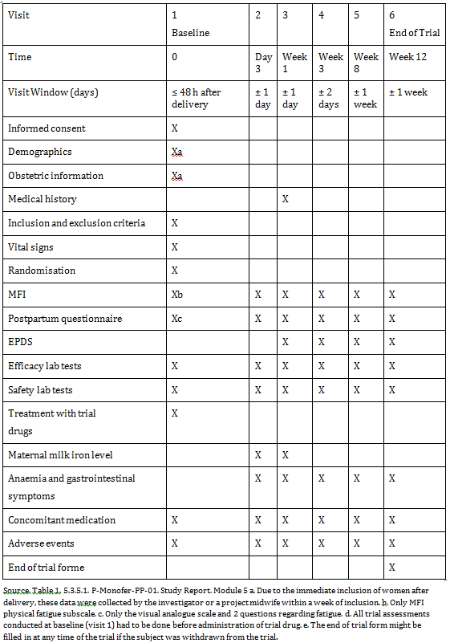
An additional analysis of the primary endpoint was performed for the FAS excluding those subjects who received ‘rescue’ allogenic RBC transfusion.
A sensitivity analysis was performed including only subjects observed for the full 12 weeks without any missing measurements of physical fatigue scores.
The homogeneity of the treatment effect on change in physical fatigue score across the 2 PPH groups was evaluated in an ANCOVA model including an interaction term of treatment and PPH (700 to 1,000 mL, > 1,000 mL) as factor and Baseline MFI physical fatigue score as covariate. The treatment effect within each PPH group was estimated. The AUC of change in physical fatigue score was evaluated against the estimated PPH level by a scatter plot.

Secondary efficacy analyses
In general, continuous secondary endpoints were analysed by a mixed model for repeated measurements (MMRM) including visit, treatment by visit, and PPH (700 to 1,000 mL, > 1,000 mL) as factors, Baseline value as covariate, and subject as random effect. In case no Baseline value was measured for the endpoint in question, the endpoint was analysed by a MMRM with treatment by visit and PPH level as factors and subject as random effect. A variance component covariance was used to model the within subject errors and the estimation method was a restricted maximum likelihood based approach. Endpoints on proportion of subjects were analysed by logistic regression with treatment and PPH level as factors and Baseline value as covariate. Endpoints on proportion of subjects by visit were analysed by logistic regression with treatment by visit and PPH level as factors and Baseline value as covariate. Where relevant, the Baseline value of the parameter in question was included as covariate.

Haemoglobin
Change in Hb concentration from Baseline to Day 3, Week 1, 3, 8, and 12 was analysed using a MMRM with visit, treatment by visit, and PPH level as factors and Baseline value as covariate.
Proportion of subjects who achieved an increase from Baseline in Hb concentration ≥ 2.0 g/dL (1.2 mmol/L) at any time was analysed by logistic regression with treatment and PPH level as factors and Baseline value as covariate.
Proportion of subjects who achieved an increase from Baseline in Hb concentration ≥ 2.0 g/dL (1.2 mmol/L) by visit was analysed by logistic regression with treatment by visit and PPH level as factors and Baseline value as covariate.
Change in Hb from Baseline to Week 1 versus Baseline PPH was presented in a scatter plot.

Other efficacy laboratory parameters
Change in concentrations of p-ferritin, p-iron, p-transferrin, TSAT, reticulocyte count, and CHr from Baseline to Day 3, Week 1, 3, 8, and 12 were each analysed using a MMRM with visit, treatment by visit, and PPH level as factors and Baseline value as covariate.

MFI
Change in MFI physical fatigue symptoms from Baseline to Day 3, Week 1, 3, 8, and 12 was analysed using a MMRM with visit, treatment by visit, and PPH level as factors and Baseline value as covariate.
Other MFI fatigue symptoms were general fatigue, reduced activity, reduced motivation, and mental fatigue. These symptoms were not measured at Baseline. Thus, other MFI fatigue symptoms on Day 3, Week 1, 3, 8, and 12 were analysed by a MMRM with treatment by visit and PPH level as factors and subject as random effect.

Postpartum questionnaire
Change in fatigue symptoms measured by the VAS from Baseline to Day 3, Week 1, 3, 8, and 12 was analysed using a MMRM with visit, treatment by visit, and PPH level as factors and Baseline value as covariate.
Change in fatigue symptoms measured by the postpartum questions 1 and 2 was evaluated by shift tables from Baseline (or Day 3 where applicable) by treatment and visit. The shift tables included number and percentages of subjects in each category. For calculation of the percentages, the denominator was the number of subjects within each category at Baseline (or Day 3). Questions 1 and 2 in the postpartum questionnaire were analysed by a chi-square test.
The last 3 questions of the postpartum questionnaire were scored from 4 to 1, that is higher scores corresponded to more tiredness. Based on the 3 individual scores, a total score ranging from 3 to 12 was calculated. If 1 of the questions was missing, the total score was not calculated. Since these questions were not assessed at Baseline, fatigue symptoms measured by the total score of questions 3, 4, and 5 on Day 3, Week 1, 3, 8, and 12 were analysed by a MMRM with treatment by visit and PPH level as factors and subject as random effect.

Edinburgh postnatal depression scale
Postpartum depression symptoms measured by the EPDS at Week 1, 3, 8, and 12 were analysed by a MMRM with treatment by visit and PPH level as factors and subject as random effect.

Lactogenesis and breastfeeding
Time to postpartum lactogenesis was calculated as date and time of onset minus date and time of delivery. Time to discontinuation of breastfeeding was calculated as date of discontinuation minus date of delivery plus 1.
Time to postpartum lactogenesis and time to discontinuation of breastfeeding were both assessed and analysed by Kaplan-Meier curves and compared between treatments by a log-rank test.

Red blood cell transfusions
Proportion of subjects who have received 1 or more ‘rescue’ allogenic RBC transfusions was analysed by a Fisher’s exact test.

Participant flow
All efficacy and safety assessments were performed per the trial flowchart (Table 50).

Table 50: Trial flowchart

Major protocol violations/deviations
A total of 5 major protocol deviations lead to exclusion of subjects from the PP analysis set. No GCP deviations were reported during the trial.
Based on an evaluation of the protocol deviations that occurred during the trial it was concluded that the trial has been conducted in compliance with the ICH-GCP Guideline.

Baseline data
A summary of demographics as determined at screening for the 196 subjects in the FAS are presented in Table 51.

Table 51: Summary of subject demographics (FAS)
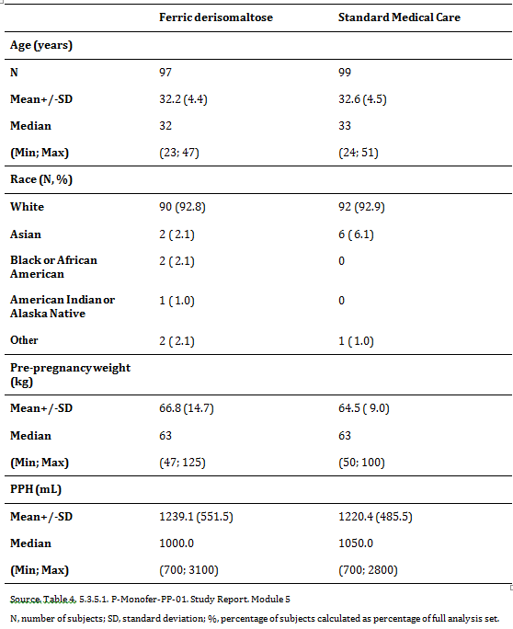

Results for the primary efficacy outcome

Primary endpoint
In the ferric derisomaltose group, physical fatigue score (as assessed by MFI) decreased at each visit from Baseline (mean score of 13.7) to Week 12 (9.1), while in the standard medical care group physical fatigue score increased from Baseline (14.1) to Day 3 (14.4) and then decreased at each subsequent visit until Week 12 (9.5).
AUC of change in physical fatigue score (primary endpoint) was statistically significantly smaller for ferric derisomaltose (least square mean of -3.60) compared with standard medical care (-2.63) (p = 0.0060). Thus, subjects suffered from less physical fatigue during the trial when treated with ferric derisomaltose as compared with standard medical care. However, the estimated difference (and 95% CI) of -0.97 (-1.65; -0.28)95% CI in physical fatigue score between ferric derisomaltose and standard medical care was less than the pre-defined minimum clinically relevant difference of 1.8 required for claiming superiority.
Statistical analysis of AUC of change in physical fatigue score specifically for the PPH subgroups showed that in the 700-1,000 mL PPH subgroup, the difference between treatments of -0.81 (-1.78; 0.16)95% CI in favour of ferric derisomaltose did not reach statistical significance (p = 0.1023), while in the > 1,000 mL PPH subgroup, the difference between treatments of -1.13 (-2.10; -0.15)95% CI also in favour of ferric derisomaltose was statistically significant (p = 0.0235).
The Baseline-adjusted mean physical fatigue score was statistically significantly lower (by 0.9 to 1.2) in the ferric derisomaltose group compared with the standard medical care group at Day 3 (p = 0.0221), Week 1 (p = 0.0391), Week 3 (p = 0.0074), and Week 8 (p = 0.0309). There was no statistically significant difference between treatment groups at Week 12 (p = 0.4396).

Results for other efficacy outcomes
The increase from Baseline in Hb concentration was statistically significantly greater (by 0.28 to 0.61 g/dL) in the ferric derisomaltose group compared with the standard medical care group at Day 3 (p = 0.0022), Week 1 (p = 0.0198), Week 3 (p < 0.0001), Week 8 (p = 0.0002), and Week 12 (p < 0.0001).
All subjects in both treatment groups achieved or maintained Hb concentrations of > 10 g/dL (6.2 mmol/L) during the trial. A total of 94.7% of subjects in the ferric derisomaltose group and 93.9% of subjects in the standard medical care group achieved an increase in Hb concentration ≥ 2.0 g/dL (1.2 mmol/L) at any time (odds ratio ferric derisomaltose/standard medical care was 2.39 (0.43; 13.30)95% CI, p = 0.3188). At Week 3, a greater proportion of subjects in the ferric derisomaltose group (83.9%) than in the standard medical care group (66.0%) had achieved an increase in Hb concentration ≥ 2.0 g/dL (1.2 mmol/L) (odds ratio ferric derisomaltose/standard medical care was 4.39 (1.94; 9.91)95% CI, p = 0.0004). At all other time points, the proportion of subjects achieving an increase in Hb concentration ≥ 2.0 g/dL (1.2 mmol/L) was comparable between ferric derisomaltose and standard medical care. There was only 1 subject (standard medical care group) with a decrease from Baseline in Hb concentration ≥ 2.0 g/dL (1.2 mmol/L) at any time.
The increase from Baseline was statistically significantly greater for ferric derisomaltose than for standard medical care for p-ferritin (all time points), p-iron (all time points except Week 8), TSAT (all time points), reticulocyte count (Day 3 and Week 1), and CHr (all time points), and the decrease from Baseline was statistically significantly greater for ferric derisomaltose than for standard medical care for p-transferrin (all time points).
Other fatigue symptoms (as assessed by MFI) decreased at each visit from Day 3 to Week 12 in both treatment groups. Statistically significantly lower absolute fatigue scores were seen in the ferric derisomaltose group than in the standard medical care group for general fatigue (all time points except Week 12), reduced activity (all time points except Day 3), reduced motivation (all time points), and mental fatigue (Day 3 and Week 1).
The Baseline-adjusted mean tiredness on VAS scale (as assessed by the postpartum questionnaire) was statistically significantly lower (by 7.9-10.4 mm) in the ferric derisomaltose group compared with the standard medical care group at Day 3 (p = 0.0020), Week 1 (p = 0.0198), and Week 8 (p = 0.0123). At Week 3 and Week 12, the lower tiredness on VAS scale in the ferric derisomaltose group (by 1.9 to 4.3 mm) did not reach statistical significance (p = 0.2047 and p = 0.5729, respectively). Tiredness affecting breastfeeding, contact with child, and nappy changing (as assessed by the postpartum questionnaire items 4 to 6) was statistically significantly lower in the ferric derisomaltose group compared with the standard medical care group at Day 3 (p = 0.0027), Week 1 (p = 0.0060) and Week 3 (p = 0.0076), with no statistically significant difference between treatment groups at Week 8 (p = 0.1357) and 12 (p = 0.1099).
The EPDS score was statistically significantly lower in the ferric derisomaltose group compared with the standard medical care group at Week 1 (p < 0.0001), Week 3 (p = 0.0135), and Week 8 (p = 0.0276). There was no statistically significant difference between treatment groups at Week 12 (p = 0.1139).
Time from delivery to postpartum lactogenesis did not differ statistically significantly between ferric derisomaltose (median time 71.9 hours) and standard medical care (75.6 hours) (p = 0.7751).
The proportion of subjects who were breastfeeding declined from close to 100% at 3 Days after inclusion into the trial to approximately 85% at Week 12 with no apparent differences between the ferric derisomaltose group and the standard medical care group. Time to discontinuation of breastfeeding did not differ statistically significantly between treatments (p = 0.5178).
One subject (1.0%) in the ferric derisomaltose group and 3 subjects (3.0%) in the standard medical care group received ‘rescue’ allogenic RBC transfusions during the trial with no statistically significant difference between treatments (p = 0.6212).

Evaluator commentary
This was a Phase III, randomised, comparative, open label single centre trial in 200 women after PPH. Subjects received either a single dose of IV ferric derisomaltose or up to 12 weeks of standard medical care treatment (oral iron supplementation).
This trial was designed in accordance with the accepted guidelines for use of Monofer and oral iron supplementation was a valid comparator.
Exclusion/inclusion criteria were reasonable given the target population for Monofer. The study protocol was followed and all patients were accounted for throughout the study and follow-up period. Protocol violations and deviations were balanced between treatments and patients were compliant with treatments.
The Baseline characteristics between study groups were balanced.
The primary outcome was the aggregated change in physical fatigue within 12 weeks postpartum, which showed a statistical difference in favour of ferric derisomaltose. In addition, the iron content in maternal milk samples was assessed in 65 women (30 treated with IV iron and 35 with standard medical care). Mean (± SD) iron content in maternal milk 3 days after intervention was 0.72 ± 0.27 and 0.40 ± 0.18 mg/L (p < 0.001) in the two treatment arms, respectively. One week after intervention, the mean iron in maternal milk was 0.47 ± 0.17 and 0.44 ± 0.25 mg/L (p> 0.05), respectively. These mean values were all within the normal reference range for iron content in breast milk.
When compared to oral iron, the investigators satisfactorily demonstrated high dose ferric derisomaltose was associated with less fatigue within 12 weeks after postpartum haemorrhage.

P-Monofer-PP-02
A randomized comparative, open label study of intravenous ferric derisomaltose (Monofer) administered by high single dose infusions or red blood cell transfusion in women with severe postpartum iron deficiency anaemia.

Study design, objectives, locations and dates
The trial was a randomised, comparative, open label single centre trial conducted in women with severe postpartum iron deficiency anaemia (PP-IDA) after severe postpartum haemorrhage (PPH). The enrolment period of the trial was approximately 20 months. For each individual subject, duration of the trial was approximately 12 weeks. Each subject attended 11 visits (a Baseline Visit (including screening, randomisation, and treatment with trial drug), 9 subsequent evaluation visits, and an end of trial visit).

Primary efficacy objective
The primary objective of this trial was to get explorative information about IV high single dose infusion of ferric derisomaltose compared to RBC transfusion in the treatment of severe PP-IDA evaluated as physical fatigue.

Secondary efficacy objectives
The secondary efficacy objectives of the trial were to evaluate the effect of ferric derisomaltose compared to RBC transfusion on:
- Ability to increase Hb
- Other relevant iron and RBC related biochemical parameters
- Other fatigue symptoms
- Symptoms of postpartum depression
- Time of postpartum lactogenesis
- Time of discontinuation of breastfeeding.

Trial centre
The trial was conducted at 1 site in Denmark.

Studied period
First subject first visit: 6 August 2013, Last subject last visit: 4 July 2015.

Inclusion and exclusion criteria

Inclusion criteria
A subject was eligible for inclusion in the trial if she fulfilled the following criteria within 2 days after delivery:
- PPH > 1,000 mL
- Hb ≥ 5.5 and ≤ 8.0 g/dL (≥ 3.5 and ≤ 5.0 mmol/L)
- Willingness to participate and sign the informed consent form

Exclusion criteria
A subject was not eligible for inclusion in this trial if she fulfilled any of the following criteria:
- Women aged < 18 years
- Multiple birth
- Peripartum RBC transfusion
- Known iron overload or disturbances in utilisation of iron (for example haemochromatosis and haemosiderosis)
- Known hypersensitivity to parenteral iron or any excipients in the investigational drug products
- Women with a history of active asthma within the last 5 years or a history of multiple allergies
- Known decompensated liver cirrhosis or active hepatitis
- Women with HELLP (Haemolysis Elevated Liver enzymes Low Platelet count) syndrome
- Active acute infection assessed by clinical judgement
- Rheumatoid arthritis with symptoms or signs of active joint inflammation
- History of anaemia caused by for example thalassemia, hypersplenism, or haemolytic anaemia (known haematologic disorder other than iron deficiency)
- Not able to read, speak, and understand the Danish language
- Participation in any other clinical trial where the trial drug has not passed 5 half-lives prior to the Baseline
- Any other medical condition that, in the opinion of investigator, may cause the subject to be unsuitable for completion of the trial or place the subject at potential risk from being in the trial. For example, a malignancy, uncontrolled hypertension, unstable ischaemic heart disease, or uncontrolled diabetes mellitus.

Study treatments

Test product
Ferric derisomaltose (Monofer; 100 mg/mL) was the test product in this trial.
The iron replacement dose of ferric derisomaltose for the individual subject was set to 1,500 mg, or to 1,000 mg in women with a pre-pregnancy weight below 45 kg. The dose was diluted in 100 mL 0.9% sodium chloride and administered over approximately 15 minutes using IV drip infusion.
In the ferric derisomaltose treatment group, a single dose was administered at the Baseline visit. In the RBC transfusion group, subjects received 1 or 2 units of RBC administered at the Baseline Visit per the hospital’s standard operating procedure.

Reference therapy
RBC transfusion was the reference therapy in this trial. RBCs were prepared per current standard procedure from the local blood bank and dosed per the following trigger Hb levels:
- Subjects with Hb 5.5-6.4 g/dL received 2 units of RBC
- Subjects with Hb 6.5-8.0 g/dL received 1 unit of RBC

Efficacy variables and outcomes

Primary efficacy endpoint
The primary endpoint of the trial was to measure and compare the aggregated change in physical fatigue score from Baseline to Week 12 (area under the curve (AUC)) in the 2 treatment arms measured by the Multidimensional Fatigue Inventory (MFI).

Secondary efficacy endpoints
The secondary efficacy endpoints were to measure and compare the following in the two treatment arms:
- Change in Hb concentration from Baseline to Day 1, 2, 3, 4, 5, 6, and 7, Week 3, 8, and 12
- Proportion of women who achieve or maintain Hb levels of > 10 g/dL (6.2 mmol/L) at any time
- Proportion of women who achieve increase from Baseline in Hb concentration ≥ 2.0 g/dL (1.2 mmol/L) at any time
- Change in concentrations of p-ferritin, p-iron, p-transferrin, transferrin saturation (TSAT), reticulocyte count, and mean reticulocyte haemoglobin content (CHr) from Baseline to Day 1, 2, 3, 4, 5, 6, and 7, Week 3, 8, and 12
- Change in MFI physical fatigue symptoms from Baseline to Day 1, 2, 3, 4, 5, 6, and 7, Week 3, 8, and 12
- Change in other MFI fatigue symptoms from Day 1 to Day 2, 3, 4, 5, 6, and 7, Week 3, 8, and 12
- Change in fatigue symptoms measured by the postpartum questionnaire from Baseline to Day 1, 2, 3, 4, 5, 6, and 7, Week 3, 8, and 12
- Change in postpartum depression symptoms measured by the Edinburgh Postnatal Depression Scale (EPDS) from Week 1 to Week 3, 8, and 12
- Time to postpartum lactogenesis
- Time to discontinuation of breastfeeding.

Randomisation and blinding methods
A total of 13 subjects were randomised 1:1 to 1 of the following 2 treatment groups:
- Ferric derisomaltose (7 subjects)
- RBC transfusion (6 subjects)
No blinding was performed in this trial.

Analysis populations
A summary of demographics as determined at screening for the 13 subjects in the FAS are presented in Table 52. Demographic data were comparable between the ferric derisomaltose group and the RBC transfusion group, although subjects in the RBC transfusion group were on average approximately 4 years older than subjects in the ferric derisomaltose group.

Table 52: Summary of subject demographics (FAS)
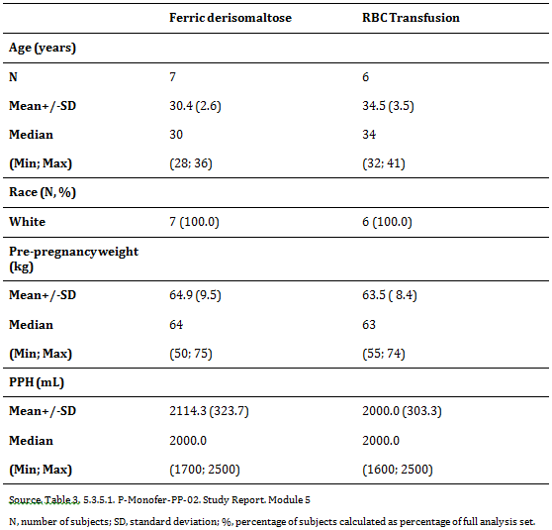

Sample size
The nature of the trial was considered explorative and regarded as a pilot for future powering of confirmatory studies. Hence, no power calculation was performed.. 13 women were enrolled and randomised 1:1 to ferric derisomaltose and RBC transfusion, respectively, within the available recruitment period of 18 months.

Statistical methods

Primary efficacy analysis
The primary endpoint of the trial, aggregated change in physical fatigue score from Baseline to Visit 11 (Week 12) assessed by the MFI, was calculated as the AUC of the change from Baseline to Visit 11 using the linear trapezoidal method and adjusting for the observation period.
The primary endpoint was analysed using an analysis of covariance (ANCOVA) model, with treatment as factor and Baseline MFI physical fatigue score as covariate. The estimated treatment differences (IV ferric derisomaltose - RBC transfusion) expressed as contrasts of the adjusted means were presented with corresponding 95% CI. The p value from the test of no treatment difference was included.
The primary analysis was performed for both the full analysis set (FAS) and per protocol (PP) populations with the analysis on the FAS being considered of primary importance. A sensitivity analysis was performed including only subjects observed for the full 12 weeks without any missing measurements of physical fatigue scores. The AUC of change in physical fatigue score was evaluated against the estimated PPH level by a scatter plot.

Secondary efficacy analyses
The secondary efficacy endpoints were only evaluated by descriptive statistics, except for Hb and p-ferritin.
Change in Hb and change in p-ferritin were analysed using a mixed model for repeated measurements (MMRM) with treatment by visit as factor, Baseline value as covariate, and subject as random effect. A variance component structure was used to model the errors and the estimation method was a restricted maximum likelihood based approach. Estimated treatment differences with 95% confidence limits and corresponding p values were presented by visit.
Change in Hb from Baseline to Week 1 versus Baseline PPH was presented in a scatter plot. Time to postpartum lactogenesis was assessed and compared between treatments by Kaplan-Meier curves. Other efficacy laboratory parameters, individual MFI fatigue symptoms, fatigue symptoms based on the postpartum questionnaire, and EPDS total score were summarised descriptively by visit and treatment.

Major protocol violations/deviations
A total of 3 major PDs occurred in the trial which lead to exclusion of subjects from the PP analysis set. and they all included subjects who received ‘rescue’ allogenic RBC transfusion.
Based on an evaluation of the protocol deviations that occurred during the trial it can be concluded that the trial has been conducted in compliance with the ICH-GCP Guideline.

Baseline data
All the iron and RBC related biochemical parameters (Hb, p-ferritin, p-iron, p-transferrin, TSAT, reticulocyte count, and CHr) were comparable between the ferric derisomaltose and RBC transfusion groups at Baseline (Table 53).

Table 53: Summary of iron and RBC related biochemical parameters at Baseline (FAS)
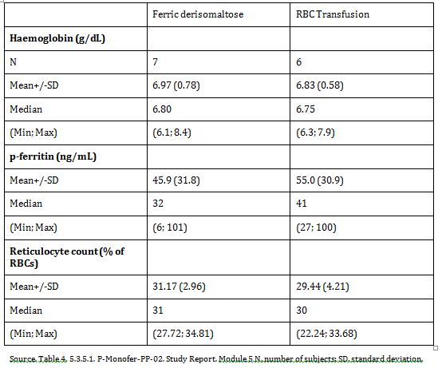

Results for the primary efficacy outcome

Primary endpoint
In the ferric derisomaltose group, physical fatigue score (as assessed by MFI) did not change between Baseline (mean (SD) score of 13.7 (4.1)) and Week 1 (13.9 (3.7)) and thereafter decreased to Week 12 (9.4 (3.3)) (Figure 4). Likewise, in the RBC transfusion group physical fatigue score was essentially unchanged from Baseline (15.5 (4.8)) to Week 1 (16.3 (4.6)) and then decreased at each subsequent visit until Week 12 (8.5 (2.3)).
Figure4: Mean change from Baseline in physical fatigue score based on MFI (FAS)
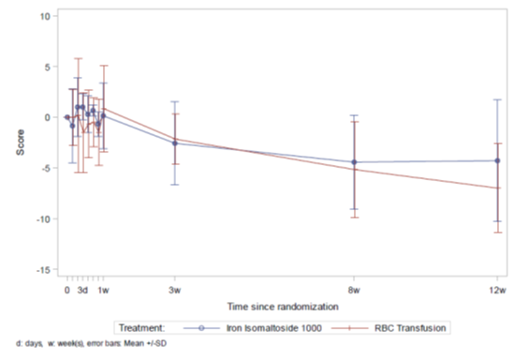
There was no statistically significant difference between the 2 treatment groups in AUC of change in physical fatigue score from Baseline to Week 12 (primary endpoint) (estimated difference ferric derisomaltose - RBC transfusion (95% CI): -0.63 (-3.28; 2.02), p = 0.6051) (Table 54).

Table 54: Analysis of AUC of change in physical fatigue score from Baseline to Week 12 (FAS)
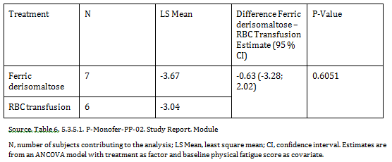
Results of sensitivity analyses on the primary endpoint (for the PP population and for subjects with a complete set of data on physical fatigue score) resulted in the same conclusion as the analysis for the FAS, that is, showing no statistically significant difference between the 2 treatments.

Results for other efficacy outcomes

Secondary efficacy endpoints
- At Baseline, mean (SD) Hb concentration was 6.97 (0.78) g/dL and 6.83 (0.58) g/dL in the ferric derisomaltose and RBC transfusion groups, respectively, and increased in both treatment groups to Week 12 (13.23 (0.63) g/dL and 11.97 (1.18) g/dL, respectively). The increase from Baseline in Hb concentration was statistically significantly greater (by 1.02 g/dL) in the RBC transfusion group compared to the ferric derisomaltose group at Day 1 (p = 0.0411) and statistically significantly greater (by 1.09 to 1.26 g/dL) in the ferric derisomaltose group compared with the RBC transfusion group at Week 3 (p = 0.0295), Week 8 (p = 0.0122), and Week 12 (p = 0.0115).
- All subjects in both treatment groups achieved or maintained Hb concentrations of > 10 g/dL (6.2 mmol/L) and achieved an increase in Hb concentration ≥ 2.0 g/dL (1.2 mmol/L) at any time during the trial.
- In the ferric derisomaltose group, the p-ferritin concentration increased markedly from Baseline (mean (SD) 45.9 (31.8) ng/mL) to Day 5 (1320.2 (340.9) ng/mL) and thereafter decreased to Week 12 (141.1 (62.5) ng/mL). In the RBC transfusion group, the p-ferritin concentration appeared to decrease overall from Baseline (55.0 (30.9) ng/mL) to Week 12 (12.2 (6.4) ng/mL). The increase from Baseline in p-ferritin was statistically significantly greater for ferric derisomaltose than for RBC transfusion at Day 1 (by 399 ng/mL, p = 0.0156), and at each time point from Day 2 to Week 1 (by 745-1229 ng/mL, all p < 0.0001).

Evaluator commentary
This was a randomised, comparative, open label single centre trial in 13 women with severe PP-IDA after severe PPH. Subjects received either a single dose of IV ferric derisomaltose (Monofer) or RBC transfusion per standard procedures.
This trial was designed in accordance with the accepted guidelines for use of Monofer and red blood cell transfusion was a valid comparator.
The study protocol was followed and all patients were accounted for throughout the study and follow-up period. Protocol violations and deviations were balanced between treatments and patients were compliant with treatments.
The Baseline characteristics between study groups were balanced.
Improvements in fatigue symptoms and depression state did not differ between a single IV ferric derisomaltose administration and RBC transfusion in the current trial in puerperal women after severe PPH. The comparable results on fatigue symptoms and depression state in the 2 treatment groups were observed despite an apparently faster replenishment of iron stores, and greater improvement in Hb concentration in the ferric derisomaltose treatment group. IV ferric derisomaltose administration was well tolerated in treatment of severe PP-IDA in women with severe PPH.

Evaluator’s conclusions on clinical efficacy
For the treatment of iron deficiency when oral iron preparations are ineffective or cannot be used and/or where there is a clinical need to deliver iron rapidly, the sponsor has provided nine Phase III studies, involving 2,213 subjects. The sponsor has demonstrated that ferric derisomaltose was well tolerated and improved markers of IDA in patients receiving dialysis, those with non-dialysis-dependent chronic kidney disease, those with chronic heart failure, inflammatory bowel disease, and underlying cancer, those undergoing cardiac surgery, and women with postpartum haemorrhage. Ferric derisomaltose has been shown to be effective in treating IDA compared to placebo, IV iron sucrose, and oral iron. Monofer has a low immunogenic potential, a low potential to release labile iron, and was not associated with clinically significant hypophosphatemia.
Overall, the submitted trials were designed in accordance with the accepted guidelines for use of Monofer and all comparator were valid. It was noted that for Study P-IBD-01, non inferiority could not be demonstrated with respect to the primary endpoint, which may have resulted from underestimation of the required iron dose and low cumulative IV dosing.
Exclusion/inclusion criteria were reasonable given the target population for Monofer. The trial included a broad population of subjects with different IDA aetiologies. IDA was confirmed in all subjects based on low values of Hb, TSAT, and s-ferritin.
The study protocols were followed and all patients were accounted for throughout the study and follow-up period. Protocol violations and deviations were balanced between treatments and patients were compliant with treatments.
The Baseline characteristics between study groups were balanced.
The external validity of the findings was high and support the proposed indications. Please refer to Section 6.3 for the evaluator’s comments on dosing.

Clinical safety

Studies providing evaluable safety data

Pivotal studies that assessed safety as the sole primary outcome
Pivotal studies in which safety was assessed as the sole primary outcome:
- P-CKD-01/P-CHF-01
- P-IBD-02

Pivotal and/or main efficacy studies
Pivotal/main efficacy studies in which safety was assessed:
- P-IDA-01
- P-CKD-02
- P-CKD-03
- P-IBD-01
- P-IBD-01-ext
- P-CABG-01
- P-CIA-01
- P-PP-01
- P-PP-02

P-IDA-01
A Phase III, randomised, open label, comparative study of intravenous ferric derisomaltose (Monofer) and iron sucrose in subjects with iron deficiency anaemia and who are intolerant or unresponsive to oral iron therapy or who need iron rapidly (PROVIDE)

Safety objectives
The safety objective of the trial was to evaluate the safety of ferric derisomaltose compared to iron sucrose.

Safety analyses
Safety was considered for subjects included in the safety analysis set and reported by actual received treatment.
All safety endpoints except hypersensitivity reactions were presented using descriptive statistics and no formal statistical tests were applied. For serious or severe hypersensitivity/allergic reactions the risk difference and corresponding 95% CI were presented.
AEs were coded using the Medical Dictionary for Regulatory Activities (MedDRA) version 17.0. AEs were regarded as treatment emergent AEs (TEAEs) if they occurred after administration of randomised treatment. Non-treatment emergent AEs (non-TEAE) were defined as AEs occurring before dosing including AEs reported in randomised subjects who were never exposed to trial drug. Related or possible related AEs were defined as ADRs. All TEAEs were summarised. The summaries included number of events, number of subjects, and proportion of subjects reporting these events. TEAEs were tabulated by system organ class (SOC) and preferred term (PT), by treatment for AEs, SAEs, AEs by severity (mild, moderate, severe), ADRs, and AEs by relationship (related, possible related, unlikely related, not related).
Hypersensitivity symptoms were assessed at Visit 2, 0 to 10 minutes before infusion, during infusion, 5 to 15 minutes and 20 to 40 minutes after end of infusion, and at subsequent visits if the subject was treated with trial drug. Number and percentages of subjects reporting hypersensitivity symptoms were summarised by visit and time point.
In addition to the hypersensitivity symptoms defined in the protocol, Standardised MedDRA Queries (SMQs) for hypersensitivity/allergic reactions were evaluated. Hypersensitivity/ allergic reactions were defined by the anaphylactic SMQs plus syncope, unresponsiveness, loss of consciousness, and seizure. All hypersensitivity AEs were listed and summarised by SOC and PT.
Furthermore, hypersensitivity AEs were divided into the following groups:
- Group A: Narrow terms pertaining to hypersensitivity reactions
- Group B: Broad terms pertaining to respiratory reactions potentially related to hypersensitivity
- Group C: Broad terms pertaining to skin reactions potentially related to hypersensitivity
- Group D: Broad terms pertaining to cardiovascular reactions potentially related to hypersensitivity
- Group E: Broad terms pertaining to other reactions potentially related to hypersensitivity
The number and percentages of subjects with at least 1 serious or severe hypersensitivity/ allergic reaction on the day of dosing or the day after dosing were listed and presented in a summary table including overall number and percentages of subjects by Groups B and C, Groups B and D, and Groups B, C, and D. Furthermore, number and percentages of subjects were presented by group and PT. The estimated risk difference between treatments and corresponding 95% CI were presented for each group and PT.
Vital signs at each visit (pre-infusion values when infusion was given and plain measurement from visits with no infusion) were presented in summary tables by treatment and visit and included absolute change during infusion. Vital signs were also presented in a box plot (pre-infusion values, during infusion, 5 to 15 minutes after, and 20 to 40 minutes after infusion) by visit showing inter-quartile range and including outliers.

Summary of safety results
Overall, treatment with ferric derisomaltose, as compared with iron sucrose, in subjects with IDA who were intolerant or unresponsive to oral iron therapy or who needed iron rapidly was well tolerated. In both treatment groups, 0.6% of subjects had a SAR. Non-serious ADRs and allergy/hypersensitivity reactions, especially rash and pruritus, were more common in the ferric derisomaltose group than in the iron sucrose group, and ADRs of dysgeusia, nausea, vomiting, diarrhoea, and dyspepsia were more common in the iron sucrose group than in the ferric derisomaltose group. Otherwise, no differences in AEs or any other safety parameters were noted.

P-CKD-02
A Phase III, randomised, comparative, open label study of intravenous ferric derisomaltose (Monofer) administered by infusions or repeated bolus injections in comparison with oral iron sulphate in subjects with non-dialysis dependent chronic kidney disease and with renal related anaemia.

Safety endpoints
- Number of subjects who experienced any adverse drug reaction (ADR) including any suspected unexpected serious adverse reactions
- Number of adverse events (AEs) of special interest (that is hypersensitivity reactions or hypotension at pre-specified time points in relation to administration of study drug)

Safety analyses
All AEs were coded by low level term in the Medical Dictionary for Regulatory Activities version 17.0. The AEs were divided and presented as AEs occurring after the subject had signed the informed consent form and before dosing (non-treatment emergent AEs (non- TEAEs)) and as AEs with onset date on or after dosing (TEAEs). AEs were collected, evaluated, and tabulated by relation to study drug, seriousness, severity, action taken, and outcome by preferred term and system organ class for each treatment group. The number of AEs of special interest (that is hypersensitivity reactions or hypotension at pre-specified time points in relation to administration of study drug) was tabulated by frequency for each treatment group.
Vital signs were measured at all visits and ECG was measured at Baseline Visit and at the EOS Visit and were summarised as described for categorical data. The laboratory parameters were summarised at each visit and by change from Baseline to each visit. Actual values for each parameter were also listed by subject. Shift tables for each laboratory parameter were prepared to represent the shift from Baseline to EOS.

Summary of safety results
There was no statistical significant difference in the proportion of subjects experiencing a TEAE between the ferric derisomaltose and iron sulphate groups (41.7% versus 45.3%, respectively). Similar results were observed when the ferric derisomaltose infusion and bolus subgroups were compared. In terms of severity, causality, and outcome, the TEAEs were comparable between the ferric derisomaltose and the iron sulphate group. Overall, 14 (5.3%) of 266 TEAEs were severe where 9 (4.8%) severe TEAEs were observed in the ferric derisomaltose group and 5 (6.3%) TEAEs were observed in the iron sulphate group. 4 serious TEAEs in 3 subjects (myocardial infarction (MI), pneumonia, cardiac failure, and cardiac failure congestive) in the ferric derisomaltose group were fatal. None of the fatal TEAEs were related to ferric derisomaltose and in all 3 subjects, advanced age (all subjects were aged ≥ 82 years) and a medical history of cardiac disease (ischaemic heart disease, chronic heart failure, MI, congestive heart failure, ventricular arrhythmia) may have contributed the event. None of the serious TEAEs in the iron sulphate group led to a fatal outcome.
AEs of special interest were defined as hypersensitivity or hypotension at prespecified time points in relation to study drug administration; that is infusion: during infusion, approximately 5 minutes and 30 minutes after each infusion; bolus: approximately 5 minutes and 30 minutes after each injection. In total, 3 events of hypersensitivity have been reported in the ferric derisomaltose group where 2 events were serious and fulfilled the protocol defined criteria for AEs of special interest. A third non-serious event of local injection reaction occurring 4 days after bolus injection was further described since it was reported as hypersensitivity by the investigator. All the 3 events were recovered without sequelae.

P-CKD-03
A Phase III, randomised, comparative, open label study of intravenous ferric derisomaltose (Monofer) administered as maintenance therapy by single or repeated bolus injections in comparison with intravenous iron sucrose in subjects with stage 5 chronic kidney disease on dialysis therapy (CKD-5D).

Safety objectives
- To obtain safety reassurance with the use of ferric derisomaltose for the maintenance of Hb in subjects with CKD-5D who were on maintenance iron therapy
- To evaluate the safety of IV ferric derisomaltose in comparison with iron sucrose administered intravenously in subjects with CKD-5D.

Safety analyses
AEs were collected and evaluated for relatedness, severity, seriousness, and expectedness. AEs were coded by system organ class and preferred term using medical dictionary for drug regulatory activities body system version 16.1 and tabulated by indicating number and percentage of subjects and number of events. The number of subjects who experienced any ADR, including any SUSAR was summarised for each treatment group.
The analyses of standard laboratory parameters, physical examination, weight, vital signs, and ECG were based on descriptive statistics as described for continuous and categorical variables.

Summary of safety results
A total of 343 AEs were reported of which 56 were non TEAEs which occurred from signing the informed consent and until the subject received the study drug and 287 were TEAEs. The non TEAEs were either mild or moderate, not related to the study drug and were either recovered, recovering, recovered with sequelae, or not recovered. 1 subject in the iron sucrose group withdrew from the study due to infected fistula. 9 non TEAEs were considered as serious where 1 was recovered with sequelae and other non TEAEs were recovered.
In terms of severity, causality, and outcome the TEAEs were comparable between the ferric derisomaltose and iron sucrose group and the two ferric derisomaltose subgroups. Overall, 3.1% of the TEAEs were severe. 3 serious TEAEs with fatal outcome (sudden death, vascular graft occlusion, and brain stem infarction) were observed in the ferric derisomaltose group where sudden death and vascular graft occlusion were considered as not related to the study drug and brain stem infarction to be unlikely related to the study drug. None of the serious TEAEs in the iron sucrose group led to a fatal outcome. 2 similar cases of hypersensitivity were reported as serious adverse reactions in ferric derisomaltose (hypersensitivity) and iron sucrose group (dyspnoea). In both cases the subjects made a full recovery. Based on the temporal relationship, the event of hypersensitivity was considered as probably related to ferric derisomaltose and dyspnoea was considered as possibly related to iron sucrose by the investigators. In addition to these a case of staphylococcal bacteraemia was also reported as a related serious adverse event (SAE) in the iron sucrose group. No SAEs were reported more than once in either of the treatment groups.

P-IBD-01 and P-IBD-01-ext
A Phase III, randomised, comparative, open label study of intravenous iron oligosaccharide (Monofer) administered by infusions or repeated bolus injections in comparison with oral iron sulphate in inflammatory bowel disease subjects with iron deficiency anaemia.

Safety objective
To assess safety of IV ferric derisomaltose compared to oral iron sulphate.
The subjects were randomised to 1 of 3 treatment groups:
- Group A: Ferric derisomaltose
  - Group A1: administered as Intravenous (IV) infusions
  - Group A2: administered as IV bolus injections
- Group B: Iron sulphate administered orally.

Summary of safety results
The safety profile of ferric derisomaltose in this study showed no differences in safety between Group A and B.
Overall, 121 subjects (Group A: 85 (38.1%); Group B: 36 (33.0%)) reported a total of 202 TEAEs (Group A: 146; Group B: 56) during the study. Of these 202 TEAEs, 9 were serious and 193 were non-serious. The 9 SAEs were reported in a total of 8 subjects (3.6%) in Group A. The number of mild and moderate AEs was comparable between the treatment groups. Severe AEs (n = 5) were only reported in Group A for a total of 4 (1.8%) subjects. A total of 6 subjects (3 subjects each in Group A and Group B) who had been treated with the study drug discontinued from the study due to 8 TEAEs (Group A: 5; Group B: 3).
Most TEAEs were recovered without sequelae (Group A: 117 (80.1%); Group B: 40 (71.4%)), 39 TEAEs (Group A: 23 (15.8%); Group B: 16 (28.6%)) were ongoing at the time and follow-up was not necessary, and 1 (0.7%) TEAE in Group A was recovered with sequelae. Two (1.4%) TEAEs (respiratory distress and hypotension) led to fatal outcome in a subject (0.9%) treated with ferric derisomaltose who died during the study due to causes unrelated to study treatment. A total of 9 SAEs occurred of which 8 were not related to the study drug. A single SAE of grand mal seizure was probable related to ferric derisomaltose. The event resolved spontaneously and the subject was withdrawn. The 3 months follow-up did not show any re-occurrence of seizure and the outcome was recovered without any sequelae. All other SAEs were considered unlikely or not related to the study drug by the Investigator.
In the extension study, 57 AEs were reported by 26 (66.7%) subjects during the study. Of these 57 AEs, 4 (perianal abscess, miliary tuberculosis, nephrolithiasis, and worsening of ulcerative colitis) were serious and 53 were non-serious AEs. All SAEs were not related to ferric derisomaltose and the subjects recovered without sequelae except worsening of ulcerative colitis, which recovered with sequelae (bloody stools and increased bowel movement). Of 39 subjects, 17 (43.6%) reported 28 mild AEs, 18 (46.2%) reported 28 moderate AEs, and 1 (2.6%) reported a severe AE (miliary tuberculosis) which was not related to the study drug and the subject recovered without sequelae. The majority (96.5%) of the AEs were not related to the study drug. Of 39 subjects, 2 (5.1%) reported 2 AEs (anaphylactoid reaction and hypersensitivity) which were probable related to ferric derisomaltose.

P-CABG-01
A randomised, prospective, double blind, comparative placebo controlled study of intravenous ferric derisomaltose (Monofer) administered by infusions to non-anaemic patients undergoing elective or sub-acute CABG, valve replacement, or a combination thereof.

Safety objective
To compare the safety of ferric derisomaltose with placebo.

Safety analyses
AEs were coded by system organ class (SOC) and preferred term using version 16.1 of Medical Dictionary for Regulatory Activities body system. All AEs were listed and categorised by AEs before dosing and AEs after dosing (treatment emergent AEs (TEAEs)). The TEAEs were tabulated by indicating number and percentage of patients and number of events. The number of patients who experienced any adverse drug reactions, including any SUSAR was summarised for each treatment group. AEs were collected, evaluated, and tabulated by relation to study drug, seriousness, severity, action taken, outcome, SOC, and preferred term for each treatment group. Chi-square test was used to compare the number of patients who experienced any drug related AEs/SAEs/SUSARs between the treatment groups. All the laboratory parameters were summarised for actual values at each visit, and change from Baseline to each visit. Actual values for each parameter were listed by patient. Shift tables for each laboratory parameter were prepared to represent the shift from Baseline to end of study (Visit 4).
Vital signs, including systolic BP, diastolic BP, and pulse rate were summarised by descriptive statistics. Electrocardiogram was summarised by frequency and percentage. Urine pregnancy test, concomitant medications, concurrent illnesses, and medical history were listed by patient. Physical examination was tabulated by body system with frequency and percentage. Weight data was summarised by descriptive statistics for screening and 4 weeks postoperative.

Summary of safety results
All 60 patients, except 1 in the ferric derisomaltose group had a mean duration of infusion of 15 minutes. Overall, 52 patients (ferric derisomaltose: 25; placebo: 27) reported 144 AEs (ferric derisomaltose: 76; placebo: 68). Of 144 AEs, 139 were TEAEs and 5 were non TEAEs. There was no statistical significant difference in the number of patients with at least 1 TEAE between the treatment groups. 19 of 139 TEAEs were serious (ferric derisomaltose: 9; placebo: 10) and 120 were non-serious TEAEs (ferric derisomaltose: 64; placebo: 56). All AEs were not related to the study drug.
17 patients (ferric derisomaltose: 8; placebo: 9) reported 19 SAEs (ferric derisomaltose: 9; placebo: 10). There was no statistical significant difference in the number of SAEs observed between treatment groups. Out of 19 SAEs, 2 SAEs in the ferric derisomaltose group (pleural effusion and dyspnoea) in 2 patients and 2 SAEs in the placebo group (post procedural haemorrhage) in 2 patients were severe. All SAEs were not related to study drug and recovered except 1 SAE (cerebrovascular accident) which did not recover. None of the SAEs was fatal.
All haematology and biochemistry parameters except CRP were comparable at each visit between the treatment groups by visual inspection. The level of CRP was numerically higher at screening and Baseline in the placebo group compared to the ferric derisomaltose group. However, the CRP levels were comparable at Day 5 and Week 4. Hypophosphatemia was not observed in any patients.
The vital signs were comparable across visits between the treatment groups. Abnormal clinically significant observations in physical examination at Week 4 which were not present at screening visit were captured as AEs in the study. Abnormal, clinically significant ECG was reported in 7 patients (ferric derisomaltose: 4; placebo: 3) at Baseline and in 4 patients at Week 4. The change in mean body weight from screening to Week 4 was comparable between the treatment groups.

P-CIA-01
A Phase III, randomised, open label study of intravenous ferric derisomaltose (Monofer) as monotherapy (without erythropoiesis stimulating agents) in comparison with oral iron sulphate in subjects with non-myeloid malignancies associated with chemotherapy induced anaemia (CIA).

Safety objectives
- To obtain safety reassurance with the use of ferric derisomaltose in subjects with non-myeloid malignancies and CIA
- To compare study drug related adverse events (AEs) after ferric derisomaltose to study drug related AEs in subjects treated with oral iron sulphate.
The study population was divided into 4 datasets; randomised population, safety population, full analysis set (FAS), and per protocol (PP) population. The safety population included all subjects who were randomised and received at least one dose of ferric derisomaltose or iron sulphate. The safety analyses were performed on the safety population

Safety analyses
The safety analyses were conducted on the safety population. The AEs were collected and evaluated for relation to study drug, seriousness, severity, relatedness, action taken, and outcome. All AEs were coded by low level term in the Medical Dictionary for Regulatory Activities version 17.0 and presented by preferred term and system organ class. AEs were tabulated by number and percentage of subjects and number of events. The number of subjects who experienced any ADR, including any suspected unexpected serious adverse reaction was summarised for each treatment group.
The number of AEs of special interest (that is hypersensitivity reactions or hypotension at pre-specified time points in relation to administration of study drug; that is infusion: during infusion, approximately 5 minutes and 30 minutes after each infusion; bolus: approximately 5 minutes and 30 minutes after each injection) were summarised by using descriptive statistics. The p value was calculated using log-rank test for treatment groups using Proc Lifetest procedure of SAS software.
The analyses of standard laboratory parameters, physical examination, vital signs, and ECG were based on descriptive statistics as described for continuous and categorical variables.

Summary of safety results
There was no statistical significant difference in the proportion of subjects experiencing a TEAE between the ferric derisomaltose and iron sulphate groups (p = 0.6455, Fisher exact test). Similar results were observed when the ferric derisomaltose infusion and bolus subgroups were compared. In terms of severity and outcome, the proportion of TEAEs was comparable between the ferric derisomaltose and the iron sulphate groups. Overall, 94 (10.5%) of 899 TEAEs were severe where 66 (11.3%) severe TEAEs were observed in the ferric derisomaltose group and 28 (8.9%) TEAEs were observed in the iron sulphate group. A statistical significant lower proportion of subjects in the ferric derisomaltose group reported ADRs as compared to the iron sulphate group (p = 0.0003). 1 SAR was reported in 1 subject out of 229 (0.4%) randomised subjects in the ferric derisomaltose group. 10% of the subjects in the ferric derisomaltose group withdrew due to AEs to 15.2% of the subjects in the iron sulphate group; however the difference was not statistically significant (p = 0.1232).
12 (2.1%) serious TEAEs in the ferric derisomaltose group were fatal in 11 (4.8%) subjects (the events were malignant neoplasm progression, procedural complication, acute respiratory failure, sudden death, metastases to lung, pneumonia aspiration). None of the fatal TEAEs were possible or probably related to ferric derisomaltose. 11 (3.5%) serious TEAEs in the iron sulphate group were fatal in 10 (8.9%) subjects (the events were malignant neoplasm progression, anaemia, metastases to meninges, convulsion, and respiratory distress). None of the fatal TEAEs were possible or probably related to iron sulphate. There was no statistical significant difference in the proportion of subjects reporting fatal AEs between the treatment groups (p = 0.1110).
AEs of special interest were defined as hypersensitivity or hypotension at prespecified time points in relation to study drug administration; that is infusion: during infusion, approximately 5 minutes and 30 minutes after each infusion; bolus: approximately 5 minutes and 30 minutes after each injection. In total, 2 events of hypersensitivity have been reported in the ferric derisomaltose group (1 event in the infusion subgroup and 1 event in the bolus subgroup).
The mean values of all haematological parameters at each study visit were comparable between ferric derisomaltose and iron sulphate groups by visual inspection except the mean value of s-ferritin which was found to be higher in the ferric derisomaltose group compared to the iron sulphate group at Week 1 to Week 12. The mean values of all biochemistry parameters at each study visit were comparable between the ferric derisomaltose and iron sulphate groups by visual inspection.
2 subjects in the ferric derisomaltose group had either ALAT/ASAT > 3 x ULN and concurrent bilirubin > 2 x ULN post Baseline and 1 subject in the iron sulphate group had an increase in the transaminases > 3 x ULN 2 weeks post Baseline and bilirubin > 2 x ULN at Week 4 where the transaminases no longer were > 3 x ULN.
Hypophosphataemia (defined as < 2 mg/dL) was reported in 24 subjects (ferric derisomaltose infusion: 8; ferric derisomaltose bolus: 10; iron sulphate group: 6) at any visit. No event of hypophosphataemia was considered as an AE.
The vital signs (systolic BP, diastolic BP, and pulse rate) were comparable between treatment groups across different visits. No episode of hypotension was reported at pre-specified time points (infusion: during infusion, approximately 5 minutes and 30 minutes after each infusion; bolus: approximately 5 minutes and 30 minutes after each injection) in relation to administration of study drug. There were 3 episodes of hypotension reported during the study; all the 3 events were non-serious, not or unlikely related, mild or moderate, and recovered without sequelae. 2 abnormal, clinically significant ECG findings (one in each treatment group) at Week 12 were captured as AEs (ferric derisomaltose group: ischemia; iron sulphate group: atrial fibrillation).

P-PP-01
A randomized comparative, open label study of intravenous ferric derisomaltose (Monofer) administered by high single dose infusions or standard medical care in women after postpartum haemorrhage.

Safety objectives
The safety objectives of the trial were to evaluate the safety of ferric derisomaltose compared to standard medical care by:
- Discontinuation due to intolerance
- Adverse events (AEs)
- Vital signs
- Biochemical safety parameters.

Safety analyses
Difference between treatment groups in proportion of subjects who discontinued due to lack of response or due to intolerance was evaluated using Fisher’s exact test.
AEs were coded using the Medical Dictionary for Regulatory Activities (MedDRA) version 16.0. AEs were regarded as treatment emergent AEs (TEAEs) if they occurred after administration of randomised treatment. Related or possible related AEs were defined as ADRs. All TEAEs were summarised including number of events, number of subjects, and proportion of subjects reporting these events and were tabulated by system organ class (SOC), preferred term (PT), and by treatment for AEs, SAEs, AEs by severity (mild, moderate, severe), and AEs by relationship (related, possible related, unlikely related, not related, unknown). AEs of special interest (hypersensitivity reactions and hypotension), ADRs (including SUSARs), and AEs leading to dose reduction or withdrawal from treatment were listed.
Vital signs were summarised by time point and treatment including change from pre-infusion. Laboratory safety parameters were summarised using descriptive statistics, including mean, median, SD, and minimum and maximum by time point and treatment, including changes from Baseline. In addition, laboratory safety parameters were plotted using boxplots by time point and treatment.

Summary of safety results
In general, single dose IV administration of ferric derisomaltose, as compared to standard medical care, was well tolerated in treatment of iron deficiency with or without anaemia in women with PPH:
In the ferric derisomaltose group, 143 TEAEs were reported in 71 subjects (72.4% of subjects), while in the standard medical care group, 126 TEAEs were reported in 72 subjects (72.0% of subjects).
The most frequently reported TEAEs were constipation (18.4% and 19.0% of subjects in the ferric derisomaltose and standard medical care groups, respectively), haemorrhoids (13.3% and 8.0%), mastitis (11.2% and 8.0%), headache (10.2% and 8.0%), cystitis (8.2% and 3.0%), fungal infection (7.1% and 3.0%), and vaginal haemorrhage (3.1% and 5.0%).
Most TEAEs were mild (142 TEAEs in 71 subjects in the ferric derisomaltose group and 125 TEAEs in 71 subjects in the standard medical care group). One (1) TEAE in each treatment group was moderate (appendicitis and hypoglycaemia, respectively). No severe TEAEs were reported in any of the 2 treatment groups.
Most of the TEAEs were assessed by the investigator not to be related to trial drug (122 TEAEs in 63 subjects in the ferric derisomaltose group and 101 TEAEs in 62 subjects in the standard medical care group) or to be unlikely related to trial drug (6 TEAEs in 5 subjects in the ferric derisomaltose group and none in the standard medical care group). In the ferric derisomaltose group, 4 TEAEs in 3 subjects were assessed to be possibly related to trial drug (2 administration site conditions, 1 event of pyrexia, and 1 event of myalgia), while in the standard medical care group, 24 TEAEs in 21 subjects were assessed to be possibly related to trial drug (17 events of constipation and 7 events of haemorrhoids). A total of 11 TEAEs in 10 subjects in the ferric derisomaltose group were assessed to be related to trial drug (7 administration site conditions, 2 events of pain, 1 event of phlebitis, and 1 event of paraesthesia oral), while 1 TEAE was assessed to be related to trial drug in the standard medical care group (constipation).

P-PP-02
A randomized comparative, open label study of intravenous ferric derisomaltose (Monofer ) administered by high single dose infusions or red blood cell transfusion in women with severe postpartum iron deficiency anaemia.

Safety objectives
The safety objectives of the trial were to evaluate the safety of ferric derisomaltose compared to RBC transfusion by:
- Adverse events (AEs)
- Vital signs
- Biochemical safety parameters

Safety analyses
AEs were coded using the Medical Dictionary for Regulatory Activities (MedDRA) version 16.0. AEs were regarded as treatment emergent AEs (TEAEs) if they occurred after administration of randomised treatment. Related or possible related AEs were defined as ADRs. All TEAEs were summarised including number of events, number of subjects, and proportion of subjects reporting these events and were tabulated by system organ class (SOC), preferred term (PT), and by treatment for AEs, SAEs, AEs by severity (mild, moderate, severe), and AEs by relationship (related, possible related, unlikely related, not related, unknown). AEs of special interest (hypersensitivity reactions and hypotension), ADRs (including SUSARs), and AEs leading to dose reduction or withdrawal from treatment were listed. Side effects to RBC transfusion per the ISBT 2011 standard registration were listed.
Vital signs were summarised by time point and treatment including change from pre-infusion. Laboratory safety parameters were summarised using descriptive statistics, including mean, median, SD, and minimum and maximum by time point and treatment, including changes from Baseline. In addition, laboratory safety parameters were plotted using boxplots by time point and treatment.

Summary of safety results
- In general, single-dose IV administration of ferric derisomaltose, as compared to RBC transfusion, was well tolerated in treatment of women with severe PP-IDA after severe PPH.
- In the ferric derisomaltose group, 10 TEAEs were reported in 5 subjects (71.4% of subjects), while in the RBC transfusion group, 14 TEAEs were reported in 5 subjects (83.3% of subjects).
- The most frequently reported TEAEs were pyrexia (1 and 3 subjects in the ferric derisomaltose and RBC transfusion groups, respectively), haemorrhoids (2 subjects in each group), and cystitis and anaemia (each 1 and 2 subjects in the ferric derisomaltose and RBC transfusion groups, respectively).
- Most TEAEs were mild (9 TEAEs in 5 subjects in the ferric derisomaltose group and 13 TEAEs in 5 subjects in the RBC transfusion group). One (1) TEAE in each treatment group was of moderate severity (anaemia in both groups). No severe TEAEs were reported in any of the 2 treatment groups.
- Most of the TEAEs were assessed by the investigator to be not related to trial drug (7 TEAEs in 4 subjects in the ferric derisomaltose group and 11 TEAEs in 5 subjects in the RBC transfusion group). In the ferric derisomaltose group, 3 TEAEs in 3 subjects were assessed as related to trial drug (3 administration site conditions), while no events in the RBC transfusion group were assessed as related. In the ferric derisomaltose group, no events were assessed as possible related to trial drug, while in the RBC transfusion group 3 TEAEs in 2 subjects were possible related (2 events of pyrexia and 1 event of back pain).
- Overall, the incidence of ADRs (that is TEAEs related or possible related to trial drug) was similar between the ferric derisomaltose and the RBC transfusion groups.

Studies that assessed safety as the sole primary outcome

P-CKD-01/P-CHF-01
This study was a non comparative open label study of Monofer in patients with either chronic kidney disease or congestive heart failure with a need for parenteral iron.

Study design, objectives, locations and dates

Objectives
The primary objective of the studies was to obtain safety reassurance with the use of Monofer given either as repeated IV boluses or as total dose infusion (TDI) for correction/maintenance therapy of anaemia in patients with CKD or CHF with a need for parenteral iron due to either absolute or functional iron deficiency anaemia to ensure that Monofer would not lead to unexpected adverse events (AEs) in these patients.
The secondary objectives were to compare haemoglobin (Hb), haematocrit (Hct), transferrin saturation (TSAT), s-iron, and s-ferritin levels 1, 2, 4, and 8 weeks after treatment start to Baseline levels. In addition, the P-CHF-01 study included a linear analogue scale assessment (LASA) quality of life (QoL) questionnaire comparing QoL at Baseline and 4 and 8 weeks after Baseline.

Trial centres
P-CKD-01 study (15 centres): Denmark, Sweden and UK
P-CHF-01 study (9 centres): Denmark and Sweden

Trial Period (years)
Date of first patient first visit: 31 May 2007. Date of last patient last visit: 26 August 2008.

Inclusion and exclusion criteria

Inclusion
P-CKD-01: Patients with CKD and anaemia (Hb < 110 g/L (6.8 mmol/L) and s-ferritin < 800 μg/L for patient not treated with parenteral iron and Hb ≤ 130 g/L (8.1 mmol/L) and s-ferritin > 200 μg/L1 but < 800 μg/L for patient in treatment with parenteral iron).
P-CHF-01: Patient with CHF and anaemia (Hb < 110 g/L2 (6.8 mmol/L) and s-ferritin < 800 μg/L).

Exclusion
A subject was not eligible for inclusion in the P-CKD-01 or P-CHF-01 studies if any of the following criteria applied:
- Non iron deficiency anaemia
- Iron overload or disturbances in utilisation of iron (for example haemochromatosis or haemosiderosis)
- Previous hypersensitivity to iron dextran or iron mono or disaccharide complexes
- Patients with a history of multiple allergies
- Decompensated liver cirrhosis and hepatitis (ALAT > 3 times normal)
- Acute or chronic infections, evaluated clinically and supported by blood tests (White blood cells (WBC), C-reactive protein (CRP)) if necessary.
- Rheumatoid arthritis with symptoms or signs of active inflammation
- Pregnancy or nursing. To avoid pregnancy, women must be postmenopausal, surgically sterile, sexually inactive or practice reliable contraception
- Active bleeding
- Planned elective surgery during the study where significant blood loss was expected
- Participation in any other clinical trial within 3 months prior to screening.

Study treatments
Monofer (iron oligosaccharide) given either as a fractionated IV bolus injections (slow injection rate; max 50 mg iron/minutes) of 100 to 200 mg iron at Baseline and at 1, 2, and 4 weeks after Baseline (Visit 2, 3, 4, and 5 respectively; the last treatment may be a TDI if the total dose exceeded 800 mg) or as an IV TDI of up to 20 mg iron/kg given over 30 to 60 minutes (0 to 10 mg iron/kg over 30 minutes, 11-20 mg iron/kg over 60 minutes) at Baseline (Visit 2). If the TDI exceeded 20 mg iron/kg it was split in 2 and given with 1 week interval. Patients may receive additional iron treatments between Week 4 and 8 if their s-ferritin concentration was less than 300 μg/L.

Duration of treatment
8 weeks.

Safety variables and outcomes
The safety primary endpoints) for the studies were:
- AEs (number and type of AEs)
- Serious adverse events (SAEs)
- Physical examination
- Vital signs (including electrocardiogram (ECG))
- Clinical laboratory analyses (biochemistry (sodium, potassium, creatinine, albumin, urea, bilirubin, and ALAT, haematology (leucocytes, complete blood cell count with differentials, platelets)).

Randomisation and blinding methods
Both studies were prospective, open label, non-comparative, multi-centre studies.

Analysis populations

P-CKD-01
Of the 182 patients included in trial, 128 (70.3%) were men and 54 (29.7%) were women. 181 (99.5%) patients were White and 1 (0.5%) was of other origin. The mean age was 63 years (SD: 14 years, range: 21 to 91 years).
The mean total calculated dose during the trial was 725 mg (SD: 333 mg, range: 400 to 1,800 mg)

P-CHF-01
Of the 20 patients included in trial, 10 (50%) were men and 10 (50%) were women. All 20 patients were White of origin. The mean age was 75 years (SD: 9 years, range: 61 to 88 years).
The mean total calculated dose during the trial was 868 mg (SD: 102 mg, range: 650 to 1,000 mg.

Sample size
No sample size calculation was performed. The number of patients to include was based on discussions with the Swedish MPA at a scientific advice meeting held the 19 December, 2006. The MPA encouraged generation of a general safety population of approximately 200 patients who have been exposed to Monofer in non-comparator safety studies in humans.

Statistical methods
Safety analyses (primary analyses): The analyses for vital signs (blood pressure (BP), pulse, and weight) and laboratory data were based on descriptive statistics as described for continuous variables above. Physical examination was tabulated by body system and normal/abnormal categories as described for categorical data above. ECG data was tabulated in the same way. AEs were summary tabulated by MedDRA body system and preferred term indicating number and percentage of patients and number of events. The same tabulation was also done by severity (mild, moderate, and severe). Vital signs and laboratory data were also tabulated and summarized with values of change from Baseline.

Participant flow
The study flow chart is shown in Table 55.

Table 55: Study flow chart
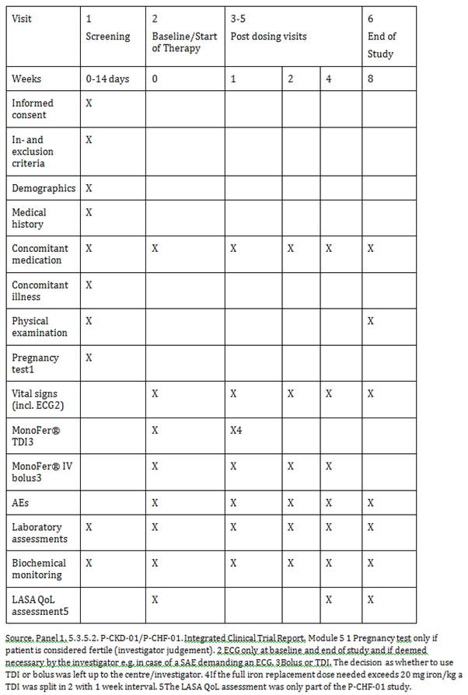

Major protocol violations/deviations

P-CKD-01
182 patients entered the trial and had at least 1 dose of Monofer, and hence constituted the safety analysis set (intention to treat (ITT)). 16 patients were withdrawn from the trial. 5 patients withdrew due to an AE, 3 patients due to non-compliance with protocol, and 8 due to other reasons.

P-CHF-01
20 patients entered the trial and had at least 1 dose of Monofer, and hence constituted the ITT analysis set. 2 patients were withdrawn due to other reasons.

Baseline data

P-CKD-01
Of the 182 patients included in trial, 128 (70.3%) were men and 54 (29.7%) were women. 181 (99.5%) patients were White and 1 (0.5%) was of other origin. The mean age was 63 years (SD: 14 years, range: 21 to 91 years). The mean total calculated dose during the trial was 725 mg (SD: 333 mg, range: 400 to 1,800 mg).

P-CHF-01
Of the 20 patients included in trial, 10 (50%) were men and 10 (50%) were women. All 20 patients were White. The mean age was 75 years (SD: 9 years, range: 61 to 88 years). The mean total calculated dose during the trial was 868 mg (SD: 102 mg, range: 650 to 1,000 mg.

Results for the primary safety outcome

P-CKD-01
A total of 244 AEs were observed. 192 events were non serious of which 17 were probable or possible related to Monofer (that is adverse reactions). 5 of these probable or possible related events were mild, 10 were moderate, and 2 were severe. The 2 severe AEs were severe headache (patient [information redacted]) and haemorrhagic cyst (patient [information redacted]). The most frequent related events were gastrointestinal side effects which were observed in 6 patients (7 events). Furthermore, 52 SAEs were observed of which 2 were possible related according to the investigator and reported as suspected unexpected serious adverse reactions (SUSARs). The 2 SUSARs were sepsis with Staphylococcus aureus and unstable angina. Both events were evaluated as unlikely related to Monofer by the medical monitor.

P-CHF-01
In the P-CHF-01 study, a total of 25 AEs were observed. 18 events were non serious and 7 were SAEs. None of these were recorded as probable or possible related to Monofer and none were severe. No acute anaphylactic/anaphylactoid or delayed allergic reactions were observed in either CKD or CHF patients.

Evaluator commentary
The patient populations included reflected clinically relevant CKD and CHF population. They were exposed to a relevant range of iron doses and both the total dose infusion and the bolus injections were tested. No significant unexpected safety findings were observed and Monofer was well tolerated in these studies. No acute anaphylactic/anaphylactoid or delayed allergic reactions were observed in either CKD or CHF patients.

P-IBD-02
A prospective, non-controlled, safety study of intravenous ferric derisomaltose (Monofer) administered by a high dosing regimen in subjects with inflammatory bowel disease (PROMISE).

Study design, objectives, locations and dates

Objectives

Primary safety objective
The primary safety objective was to evaluate the safety of a high IV iron dosing regimen of ferric derisomaltose in subjects with IDA secondary to IBD.

Study design
The trial was a prospective, non-controlled, open label, multi-centre, pilot safety trial of ferric derisomaltose (Monofer) administered as a high dosing regimen to subjects with iron deficiency anaemia (IDA) and inflammatory bowel disease (IBD). Based upon the haemoglobin (Hb) level and body weight (BW), the subjects were divided into 2 treatment groups based on Hb and ferric derisomaltose dose was given per body weight.
Treatment Group A received a total dose of 1,500 mg or 2,000 mg intravenous (IV) ferric derisomaltose where the 1,500 mg dose was administered as a single infusion at Baseline and the 2,000 mg dose was divided into 2 administrations; one administration of 1,500 mg at Baseline and another administration of 500 mg 1 week later.
Treatment Group B received a total dose of 2,500 mg or 3,000 mg IV ferric derisomaltose divided into 2 administrations; one administration of 1,500 mg at Baseline and another administration of 1,000 or 1,500 mg 8 weeks later. The total duration of the trial was 28 months, including 25 months of enrolment period. For an individual subject in treatment Group A, the trial duration was approximately 10 weeks and each subject attended 5 visits (screening, Baseline, Week 1, Week 4, and Week 8). For an individual subject in treatment Group B, the trial duration was approximately 18 weeks and each subject attended 8 visits (screening, Baseline, Week 1, Week 4, Week 8, Week 9, Week 12, and Week 16).

Trial sites
The trial was initiated at 6 sites, including 3 in Sweden, 2 in Denmark, and 1 in Netherlands. 2 of the 3 sites in Sweden did not enrol subjects (2 subjects were screened but not randomised at 1 of the Swedish sites and no subject was screened at another Swedish site).

Studied period
First subject first visit: 24 July 2012, last subject last visit: 27 November 2014.

Inclusion and exclusion criteria

Inclusion criteria
A subject was eligible for inclusion in the trial if he/she fulfilled the following criteria:
- Subjects aged ≥ 18 years
- Subjects diagnosed with IBD either in remission or active
- Hb < 12 g/dL for women and Hb < 13 g/dL for men
- Subjects with a CRP above upper limit of normality with ferritin below 100 μg/L or subjects with a CRP below or equal to upper limit of normality with ferritin below 30 μg/L
- Willingness to participate after signing informed consent form.

Exclusion criteria
A subject was not eligible for inclusion in the trial if he/she fulfilled any of the following criteria:
- Subject judged by the physician to need surgery due to Crohn´s disease or ulcerative colitis within the next 2 months
- Anaemia predominantly caused by factors other than IDA
- Iron overload or disturbance in utilisation of iron (for example haemochromatosis and haemosiderosis)
- Known hypersensitivity to any excipients of ferric derisomaltose
- History of multiple allergies
- Decompensated liver cirrhosis or active hepatitis (defined as ALAT > 3 times upper limit of normal)
- Acute and/or chronic infections
- BW < 50 kg
- Rheumatoid arthritis with symptoms or signs of active joint inflammation
- Pregnancy and nursing. To avoid pregnancy, women had to be postmenopausal, surgically sterile, or used one of the following contraceptives during the whole trial period and 5 days after the trial has ended (that is 5 times plasma biological half-life of the investigational medicinal product): intrauterine devices and hormonal contraceptives (contraceptive pills, implants, transdermal patches, hormonal vaginal devices, or injections with prolonged release)
- Blood transfusion within the previous 12 weeks
- Subjects with a history of asthma, allergic eczema, or other atopic allergy
- Planned elective surgery during the trial
- Untreated vitamin B12 or folate deficiency, defined as values below the lower reference range
- Participation in any other clinical trial within 3 months prior to screening
- IV iron treatment within 8 weeks prior to screening
- Oral iron treatment within 1 week prior to screening
- Erythropoiesis stimulating agent treatment within 8 weeks prior to screening
- Any other medical condition that, in the opinion of investigator, may have caused the subject to be unsuitable for the completion of the trial or place the subject at potential risk from being in the trial.

Study treatments
Ferric derisomaltose (Monofer) was the test product in this trial. Subjects in treatment Group A received a total dose of 1,500 mg or 2,000 mg IV ferric derisomaltose and subjects in treatment Group B received a total dose of 2,500 mg or 3,000 mg IV ferric derisomaltose. All the doses were diluted in 100 mL normal saline (0.9% sodium chloride) and were administered by infusion over approximately 15 minutes

Safety variables and outcomes

Primary safety endpoint
The primary safety endpoint was type and incidence of adverse drug reactions (ADRs).

Secondary safety endpoints
- Number of adverse events (AEs) of special interest (that is hypersensitivity reactions or hypotension at pre-specified time points in relation to administration of trial drug)
- Change in complete blood count, serum (s)-sodium, s-potassium, scalcium, s-phosphate, s-urea, s-creatinine, s-albumin, s-bilirubin, aspartate aminotransferase (ASAT), and alanine aminotransferase (ALAT) from Baseline to Week 1, 4, and 8 in treatment Group A and B and to Week 9, 12, and 16 in treatment Group B
- Change in vital signs (pulse and blood pressure (BP)) from Baseline to Week 1, 4, and 8 in treatment Group A and B and to Week 9, 12, and 16 in treatment Group B
- Change in electrocardiogram (ECG) from Baseline to Week 8 in treatment Group A and to Week 16 in treatment Group B
- Change in weight from Baseline to Week 8 in treatment Group A and to Week 16 in treatment Group B
- Change in physical condition from screening to Week 8 in treatment Group A and to Week 16 in treatment Group B.

Randomisation and blinding methods
No randomisation or blinding.

Analysis populations
Thirty-nine subjects were screened in the trial (no subject was re-screened); 16 were screen failures due to inability to meet the eligibility criteria, 2 subjects [information redacted] and [information redacted] were screened but were not treated due to withdrawal of consent, and the remaining 21 subjects were allocated to either treatment Group A (1,500 mg group: 7 subjects; 2,000 mg group: 8 subjects) or treatment Group B (2,500 mg group: 4 subjects; 3,000 mg group: 2 subjects). All 21 enrolled subjects were included in the safety population. Out of 21 subjects, 20 (95.2%) subjects completed the trial and 1 (4.8%) subject 310103 in the 1,500 mg group did not complete the trial due to protocol non-compliance.

Sample size
This was a pilot trial and the sample size was set to 30 subjects.

Statistical methods

Primary analyses
AEs were coded by Medical Dictionary for Regulatory Activities version 17.0 and were summarised by system organ class and preferred term, indicating number and percentage of subjects and number of events for the primary analysis. Number of subjects who experienced any ADR, including any suspected unexpected serious adverse reaction, and number of subjects who discontinued the trial because of lack of response or intolerance to the investigational product were summarised. In addition to the crude incidence of AE’s, incidence rates in the two treatment groups were calculated.

Secondary analyses
AEs of special interest (that is hypersensitivity reactions or hypotension) were presented by number of subjects and percentage of observations in the various dosing categories, where percentage was based on the subjects for whom relevant measurement was obtained.
The actual values of laboratory parameters (both complete blood count and biochemistry) and changes from Baseline to Week 1, 4 and 8 in treatment Group A and B and to Week 9, 12 and 16 in treatment Group B were summarised by descriptive statistics.
The actual values of vitals and changes from Baseline to Week 1, 4, and 8 in treatment Group A and B and to Week 9, 12, and 16 in treatment Group B were summarised by descriptive statistics.
ECG was summarised at Baseline and Week 8 in treatment Group A and Week 16 in treatment Group B by number of subjects and percentage of observations in the various categories, where percentage was based on the subjects for whom relevant measurement was obtained. Changes in ECG from Baseline to Week 8 in treatment Group A and Week 16 in treatment Group B were summarised by treatment group.
The actual weight and changes from Baseline to Week 8 in treatment Group A, and to Week 16 in treatment Group B were summarised by descriptive statistics.
Physical condition within the body systems was presented at screening and Week 8 in treatment Group A and Week 16 in treatment Group B by number of subjects and percentage of observations in the various categories, where percentage was based on the subjects for whom relevant measurement was obtained. Change in physical condition from screening to Week 8 in treatment Group A and Week 16 in treatment Group B was summarised in a similar way.

Participant flow
The study flow chart is shown in Table 56.

Table 56: Trial flowchart for treatment Group B*
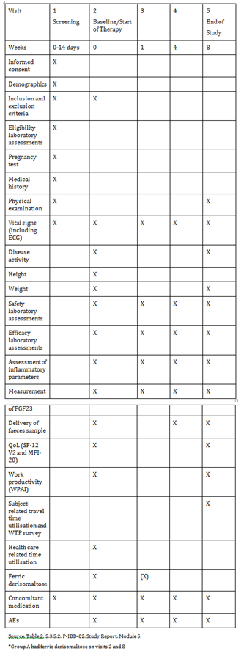

Major protocol violations/deviations
A total of 42 protocol deviations were reported in the trial where 40 were minor protocol deviations and the following 2 deviations were major protocol deviations:
- Subject [Information redacted] (1,500 mg group) met exclusion criterion 12 (had a history of asthma) but was enrolled in the trial. The subject did not complete the trial as per protocol and was terminated from the trial.
- Subject [Information redacted] (2000 mg group) met exclusion criterion 12 (had a history of asthma) but was still enrolled in the trial. As the subject completed all trial visits, no action was taken.
The following 3 GCP violations (all were considered as major violations) were reported during the trial:
- The power of attorney was signed and dated after subjects [information redacted] and [information redacted] were recorded as screen failures
- For subject [information redacted] (1,500 mg group) the sub-investigator signed the CRF for screening visit without being authorised for this task.
Based on an evaluation of the protocol and GCP deviations that occurred during the trial it can be concluded that the trial has been conducted in compliance with the ICH GCP Guideline.

Baseline data
Out of 21 enrolled subjects, 16 (76.2%) were women and 5 (23.8%) were men. 19 (90.5%) subjects were Caucasian and 20 (95.2%) were non-smokers. The higher (90.5%) proportion of subjects were aged 18 to 64 years. The mean (SD) age and height of the subject population were 43 (15) years and 168 (7) cm, respectively. The demographic variables were comparable across treatment groups A and B.
Of 21 subjects with IBD, 15 (71.4%) subjects were diagnosed with Crohn’s disease (1,500 mg group: 7 (100%) subjects; 2,000 mg group: 3 (37.5%) subjects; 2,500 mg group: 3 (75%) subjects; 3,000 mg group: 2 (100%) subjects) and 6 (28.6%) subjects were diagnosed with ulcerative colitis (1,500 mg group: 0; 2,000 mg group: 5 (62.5%) subjects; 2,500 mg group: 1 (25%) subjects; 3,000 mg group: 0)

Results for the primary safety outcome
Overall, 43 TEAEs were reported by 17 (81%) subjects in the trial. The higher proportion of TEAEs was mild (74.4%), not related to the trial drug (79%), and recovered (72.1%). No severe TEAE or serious adverse event was reported, despite high doses of ferric derisomaltose. Type and incidence of adverse drug reactions 9 (21%) ADRs were reported in 4 (19%) subjects and all the ADRs were non-serious, mild or moderate, and recovered.

Results for other safety outcomes
One event of eye allergy was reported in the 3,000 mg group and was considered as an AE of special interest as it was reported within 10 minutes of trial drug administration. This event of eye allergy was non-serious, moderate, probable related to the trial drug, and was recovered on the same day. No event of hypotension was reported in the trial.
There was no change in the haematology and biochemistry parameters from Baseline to Week 1, 4, and 8 in treatment Group A and B and to Week 9, 12, and 16 in treatment Group B by visual inspection. None of the subjects showed phosphate levels lower than the minimum laboratory range at Week 8 (for treatment Group A) and Week 16 (for treatment Group B) with normal/high levels of phosphate at Baseline.
There was no change in the haematology and biochemistry parameters from Baseline to Week 1, 4, and 8 in treatment Group A and B and to Week 9, 12, and 16 in treatment Group B by visual inspection. None of the subjects showed phosphate levels lower than the minimum laboratory range at Week 8 (for treatment Group A) and Week 16 (for treatment Group B) with normal/high levels of phosphate at Baseline.
There was no change in vital signs from Baseline to Week 1, 4, and 8 in treatment Group A and B and to Week 9, 12, and 16 in treatment Group B.
There was no change in ECG from Baseline to Week 8 in treatment Group A and to Week 16 in treatment Group B.
There was no change in BW from Baseline to Week 8 in treatment Group A and to Week 16 in treatment Group B.
There was no change in physical examination from Baseline to Week 8 in treatment Group A, and to Week 16 in treatment Group B.

Evaluator commentary
Single high doses of ferric derisomaltose, up to 2,000 mg, within 15 minutes, were well tolerated and safe in subjects with IDA secondary to IBD. The safety profile in high dosing regimen was consistent with safety data on ferric derisomaltose in lower dosing regimens. Nine (21%) ADRs (all were non serious, mild or moderate, and recovered) were reported in 4 (19%) subjects. One event of eye allergy (non-serious, moderate, probable related to the trial drug) was reported within 10 minutes of trial drug administration and was considered as an event of special interest. No safety issues were observed in laboratory parameters, vital signs, and BW. No clinically significant abnormal finding in physical condition or ECG was reported.

Patient exposure
Overall, 2396 patients have been exposed to trial drug in the clinical trials with ferric derisomaltose including 89 patients in dedicated PK trials of ferric derisomaltose (Table 57). In the Phase II-III clinical trials, a total of 1640 patients received ferric derisomaltose either as bolus injections up to (or above) 500 mg per single administration (714 patients) or as IV infusions up to 20 mg/kg per single administration (926 patients). The comparator group has included 756 patients treated with oral iron sulphate (338 patients), IV iron sucrose (282 patients), IV placebo (30 patients), Standard medical care (100 patients), or RBC (6 patients).

Table 57: Patient exposure to Ferric derisomaltose
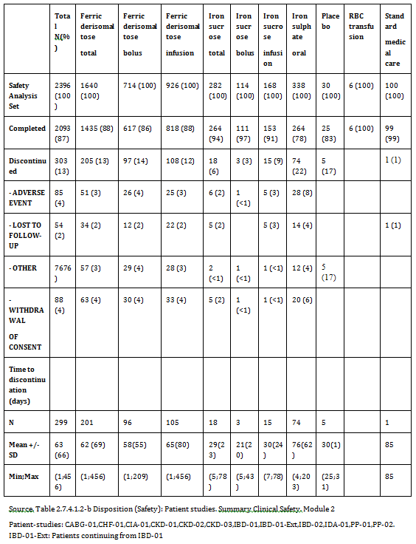
Of 89 patients treated in the PK trial, all but one patient completed the trial. This patient was discontinued due to an AE. Of the completed patients, 59 patients were treated with a ferric derisomaltose bolus injection and 29 with an ferric derisomaltose infusion (Table 58).

Table 58: Disposition (Safety); PK studies
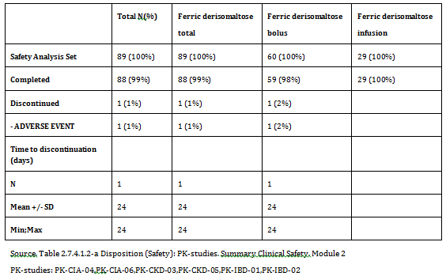
There was no difference in the number of completed patients or discontinued due to an AE with mode of administration (bolus: completed 617 (86%), AE 26 (4%); infusion: completed 818 (88%), AE 25 (3%)).
There was no difference in the percentage of patients who completed the studies among therapeutic areas (IDA 823 (85%); NDD-CKD 229 (92%); CKD in dialysis 357 (91%); CABG 26 (87%)). There were no differences in the number of patients who discontinued due to an AE ((IDA 38 (4%); NDD-CKD 2 (< 1%); CKD in dialysis 12 (3%) patients; CABG 0).

Adverse events

All adverse events (irrespective of relationship to study treatment)
All patients who received at least one dose of either ferric derisomaltose or comparator in completed clinical trials on ferric derisomaltose were included in the safety analysis set. Overall, 2,396 patients have been exposed to trial drug in the clinical trials with ferric derisomaltose including 89 patients in dedicated PK trials of ferric derisomaltose (Table 59).

Table 59: Incidence of TAEs (≥ 1%) by system-organ class and preferred term (Safety); Patient studies
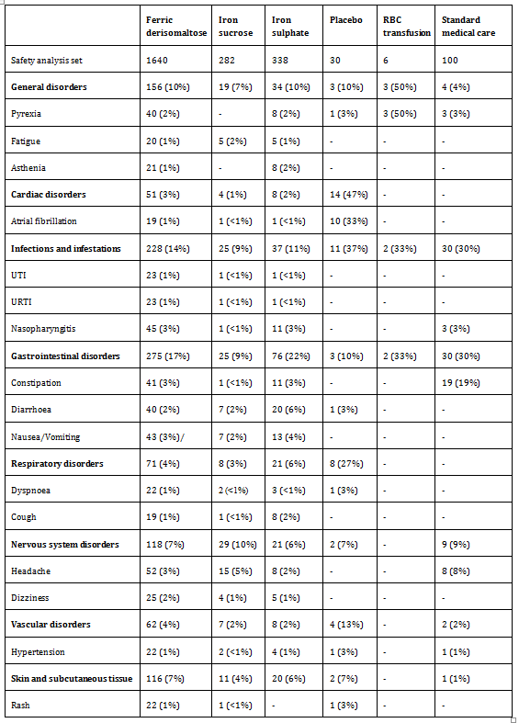
AEs observed in the ferric derisomaltose PK trials by SOC and PT are shown in Table 60. The proportion of patients reporting any AE were highest within the SOC of General Disorders and administration site conditions (9 patients (10%)), Metabolism and Nutrition Disorders (7 patients (8%)), and Gastrointestinal Disorders (7 patients (8%)). The most frequently reported AEs were hypophosphatemia, nausea, and leukopenia, which were reported in 4 patients each (4%). Due to the overall number of patients experiencing AEs (25 patients (28%)), and with only 6 patients experiencing AEs in the infusion group, it was not possible to compare the 2 treatment modes, bolus and infusion.

Table 60: Incidence of (TAEs) ≥ 5% by system-organ class and preferred term (Safety); PK-studies
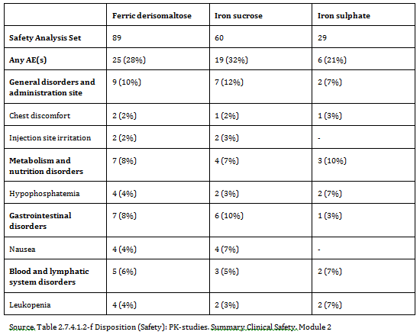

Integrated safety analyses
Due to differences in randomisation, in- and exclusion criteria, and therefore trial populations, safety data were analysed, where relevant, across trials using the same comparator to rule out potential bias from trial designs and the population studied corresponding to:
- All Patient-studies with iron sucrose comparator: P-CKD-03, P-IDA-01
- All Patient-studies with iron sulphate oral as comparator: P-CIA-01, P-CKD-02, P-IBD-01
- All Patient-studies using comparator: P-CABG-01, P-CIA-01, P-CKD-02, P-CKD-03, PIBD-01, P-IDA-01, P-PP-01, P-PP-02
Safety data was also analysed, where relevant, per therapeutic areas to determine if there were any differences in safety by underlying disease:
- IDA: P-IBD-01, P- IBD-01-extension, P-IBD-02, P-IDA-01, P-CIA-01, P-CHF-01, P-PP-01, P-PP-02
- NDD-CKD: P-CKD-02, P-CKD-01 (pre-dialysis)
- CKD in dialysis: P-CKD-03, P-CKD-01 (dialysis)
- CABG: P-CABG-01

Main/pivotal studies that assessed safety as the sole primary outcome

P-Monofer-IBD-02
Overall, 43 TEAEs were reported by 17 (81%) subjects in the trial. The higher proportion of TEAEs was mild (74.4%), not related to the trial drug (79%), and recovered (72.1%). No severe TEAE or SAE was reported, despite high doses of ferric derisomaltose.
Nine (21%) ADRs were reported in 4 (19%) subjects and all the ADRs were non-serious, mild or moderate, and recovered.
One event of eye allergy was reported in the 3,000 mg group and was considered as an AE of special interest as it was reported within 10 minutes of trial drug administration. This event of eye allergy was non-serious, moderate, probable related to the trial drug, and was recovered on the same day. No event of hypotension was reported in the trial.
Ferric derisomaltose at total cumulative doses of 1,500 to 3,000 mg were well tolerated. A higher proportion of TEAEs in both groups were mild, not related to the trial drug, and recovered. No severe AE, SAE, or subject withdrawal due to AE was reported in the trial.

P-CKD-01/P-CHF-01
In the P-CKD-01 study, a total of 244 AEs were observed. 192 events were non-serious of which 17 were probable or possible related to Monofer (adverse reactions). 5 of these possible or probable related events were mild, 10 were moderate, and 2 were severe. The 2 severe AEs were severe headache (patient [information redacted]) and haemorrhagic cyst (patient [information redacted]). The most frequent related events were gastrointestinal side effects which were observed in 6 patients (7 events). Furthermore, 52 SAEs were observed of which 2 were possible related per the investigator. The 2 possible related SAEs were sepsis with Staphylococcus aureus and unstable angina. Both events were evaluated as unlikely related to Monofer by the the medical monitor at aCROnordic A/S.
In the P-CHF-01 study, a total of 25 AEs were observed. 18 events were non-serious and 7 were SAEs. None of these were recorded as probable or possible related to Monofer and non were severe.
Based on these data, no significant unexpected safety findings of concern were observed when Monofer was administered as TDI or bolus injections. No acute anaphylactic/anaphylactoid or delayed allergic reactions were observed in either CKD or CHF patients.

Pivotal and/or main efficacy studies
Of 2,396 patients in the Phase II-III clinical trials, 2093 (87%) completed the trial. In the 3 main treatment groups (ferric derisomaltose, iron sucrose, oral iron sulphate), the number of patients who discontinued was highest in the oral iron sulphate group (74 (22%) patients) followed by the ferric derisomaltose group (205 (13%) patients) and the iron sucrose group (18 (6%) patients). The reasons for withdrawal (AE, lost to follow-up, withdrawal of consent, and other) were similar for the 3 treatment groups though a slightly higher percentage reported ‘AE’ as reason for withdrawal in the oral iron group (ferric derisomaltose (51 (3%)); iron sucrose (6 (2%)); oral iron sulphate (28 (8%)). The mean time to discontinuation was 62 days for ferric derisomaltose, 29 for iron sucrose, and 76 for oral iron sulphate (Table 57).
When analysing patient disposition for trials using the same comparator, the discrepancy in number of patients who completed the trial and discontinued the trial due to an AE was balanced. For trials using iron sucrose as comparator, 94% of patients in both the ferric derisomaltose group (528 patients) and the iron sucrose group (264 patients) completed the trial and 2% in each group discontinued due to an AE.
A similar trend was observed for trials in which oral iron sulphate was the comparator, where 549 (81%) patients in the ferric derisomaltose group and 264 (78%) in the oral iron group completed the trial. There was still a slightly higher percentage of patients in the oral iron group who discontinued due to an AE (ferric derisomaltose 32 (5%); oral iron sulphate 28 (8%)). When comparing ferric derisomaltose to all comparators pooled, there was no difference in any patient disposition parameters.
There was no difference in the number of completed patients or discontinued due to an AE with mode of administration (bolus: completed 617 (86%), AE 26 (4%); infusion: completed 818 (88%), AE 25 (3%)) (Table 57). There was no difference in the percentage of patients who completed the studies among therapeutic areas (IDA 823 (85%); NDD-CKD 229 (92%); CKD in dialysis 357 (91%); CABG 26 (87%)). Nor was there any marked difference in the number of patients who discontinued due to an AE ((IDA 38 (4%); NDD-CKD 2 (< 1%); CKD in dialysis 12 (3%) patients; CABG 0).

Treatment related adverse events (adverse drug reactions)

Pivotal and/or main efficacy studies
Table 62 summarizes the number of AEs observed in the pooled analysis of all Patient Studies. A patient may have reported more than 1 AE. Out of 2,396 patients, 1,252 (52%) patients reported a total of 2,972 AEs during the study where 869 (53%) patients in the ferric derisomaltose group reported 2,048 AEs, 112 (40%) patients in the iron sucrose group reported 267 AEs, 167 (49%) patients in the iron sulphate group reported 451 AEs, 27 (90%) patients in the placebo group reported 66 AEs, 5 (83%) patients in the RBC group reported 14 AEs, and finally 72 (72%) patients in the Standard medical care group reported 126 AEs. Overall, a numerical slightly higher number of patients experienced any AE in the ferric derisomaltose and oral iron sulphate group compared to iron sucrose (Table 61).
The percentage of patients with mild AEs was similar, though slightly lower for iron sucrose, across the 3 main treatment groups (ferric derisomaltose, 675 (41%) patients; iron sucrose, 88 (31%) patients; iron sulphate, 136 (40%) patients). A slightly lower percentage of patients reported moderate AEs in iron sucrose group compared to the other 2 treatment groups (ferric derisomaltose, 360 (22%) patients; iron sucrose, 40 (14%) patients; iron sulphate, 68 (20%) patients). Similarly, the percentage of patients with severe AEs was lower for iron sucrose than for ferric derisomaltose and oral iron sulphate (ferric derisomaltose, 80 (5%) patients; iron sucrose, 5 (2%); iron sulphate, 24 (7%) patients).

Table 61: Summary of treatment-emergent adverse events (Safety); Patient studies
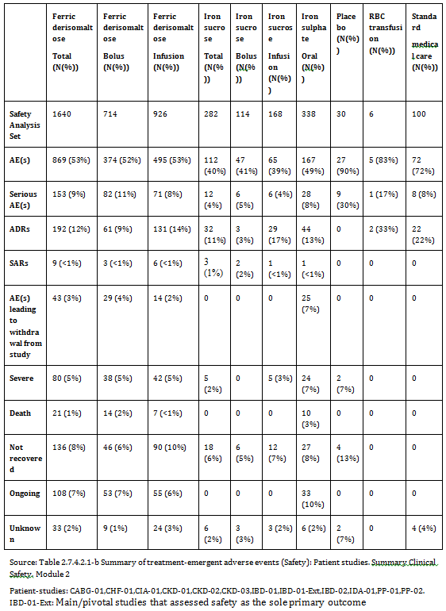

P-CKD-01/P-CHF-01
Two SAEs were found possibly related to Monofer in the P-CKD-01 study. Both SAEs were mild in severity and the relatedness can be questioned. One was a case of angina pectoris in a subject with pre-existing ischaemic heart disease, and the other was a case of Staphylococcus aureus bacteraemia in a subject presenting with gout, which was evaluated as unlikely related to Monofer by the medical monitor at aCROnordic A/S.

P-Monofer-IBD-02
Overall, 43 TEAEs were reported by 17 (81%) subjects in the trial. The higher proportion of TEAEs was mild (74.4%), not related to the trial drug (79%), and recovered (72.1%). No severe TEAE or SAE was reported, despite high doses of ferric derisomaltose. Nine (21%) ADRs were reported in 4 (19%) subjects and all the ADRs were non-serious, mild or moderate, and recovered. There were no suspected unsuspected serious adverse reactions.

Deaths and other serious adverse events

Integrated safety analyses
Of the 2,972 AEs, 261 (8.8%) AEs were serious and 2,711 (91.2%) were non-serious. The 261 SAEs were reported in 211 (7.7%) patients where 153 (9%) patients in the ferric derisomaltose group reported 193 SAEs, 12 (4%) patients in the iron sucrose group reported 12 SAEs, 28 (8%) patients in the iron sulphate group reported 36 SAEs, 9 (30%) patients in the placebo group reported 10 SAEs, 1 (17%) patient in the RBC group reported 1 SAE, and finally 8 (8%) patients in the standard medical care group reported 9 SAEs. The proportion of patients reporting any SAE was slightly higher for ferric derisomaltose and oral iron sulphate group compared to iron sucrose (Table 61). The number was highest for placebo and RBC transfusion.
Out of 2,396 patients, a total of 31 patients died, 21 (1%) deaths were reported in the ferric derisomaltose group and 10 deaths in the iron sulphate group (3%). None of the AEs with fatal outcome were considered related to the study drug.

Main/pivotal studies that assessed safety as the sole primary outcome

P-CKD-01/P-CHF-01
In total, 244 events (192 non-serious AEs and 52 SAEs) were observed in Monofer treated patients. Table 64 shows SAEs observed in the P-CKD-01 trial defined by severity and relatedness.

Table 62: SAEs (52 events) observed in the P-CKD-01 study defined by severity and relatedness
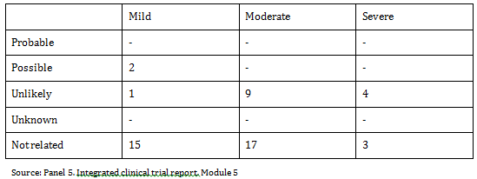
There were 2 deaths reported in P-CKD-01, both of which were considered as unlikely to be related to the trial product. There were no deaths reported in P-CHF-01.

P-Monofer-IBD-02
No SAE was reported in the trial.

Discontinuations due to adverse events

Pivotal and/or main efficacy studies
Of 2,396 patients, 2,093 (87%) completed the trial. In the 3 main treatment groups (ferric derisomaltose, iron sucrose, oral iron sulphate), the number of patients who discontinued was highest in the oral iron sulphate group (74 (22%) patients) followed by the ferric derisomaltose group (205 (13%) patients) and the iron sucrose group (18 (6%) patients). The reasons for withdrawal (AE, lost to follow-up, withdrawal of consent, and other) were similar for the 3 treatment groups though a slightly higher percentage reported ‘AE’ as reason for withdrawal in the oral iron group (ferric derisomaltose (51 (3%)); iron sucrose (6 (2%)); oral iron sulphate (28 (8%)). The mean time to discontinuation was 62 days for ferric derisomaltose, 29 for iron sucrose, and 76 for oral iron sulphate (Table 61).
When analysing patient disposition for trials using the same comparator, the discrepancy in number of patients who completed the trial and discontinued the trial due to an AE was balanced. For trials using iron sucrose as comparator, 94% of patients in both the ferric derisomaltose group (528 patients) and the iron sucrose group (264 patients) completed the trial and 2% in each group discontinued due to an AE.
A similar tendency was seen for trials in which oral iron sulphate was the comparator, where 549 (81%) patients in the ferric derisomaltose group and 264 (78%) in the oral iron group completed the trial. There was still a slightly higher percentage of patients in the oral iron group who discontinued due to an AE (ferric derisomaltose 32 (5%); oral iron sulphate 28 (8%)). When comparing ferric derisomaltose to all comparators pooled, there was no difference in any patient disposition parameters (Table 61).

Evaluation of issues with possible regulatory impact
Hypophosphatemia can be associated with several complications and IV iron complexes differ in their capability to induce unintended hypophosphatemia. The frequency of hypophosphatemia in ferric derisomaltose treated patients was low and when recognised, was transient and minor. The frequency of observed serious hypersensitivity reactions was very low. However, milder infusion related reactions may occur.

Liver function and liver toxicity

Main/pivotal studies that assessed safety as the sole primary outcome
A transient increase in hepatic enzymes in 4 patients treated with ferric derisomaltose in the P-IBD-01 trial was not above the 3 times ULN for hepatic. In the P-CIA-01 trial, 2 (< 1%) patients in the ferric derisomaltose group had alanine aminotransferase (ALAT) and aspartate aminotransferase (ASAT) > 3 x ULN and concurrent bilirubin > 2 x ULN post Baseline. In comparison, one orally treated patient (< 1%) in this study had an increase in the transaminases > 3 x ULN 2 weeks post Baseline and bilirubin > 2 x ULN at the next visit (Week 4) where the transaminases no longer were > 3 x ULN (hence no simultaneous increase).

Pivotal and/or main efficacy studies
A search across all patient studies for increases in ALAT/ASAT and bilirubin has been performed to see if there was a difference between treatments and no other events of ALAT/ASAT > 3 x ULN and concurrent bilirubin > 2 x ULN post Baseline was observed for any treatment.
Circulating iron carbohydrate complexes are removed from plasma by cells of the RES, mainly in the liver, which splits the complex into its components of iron and carbohydrate. Patients with severe liver impairment (decompensated liver cirrhosis or viral hepatitis (alanine aminotransferase (ALAT) > 3 times UNL)) were excluded from the finalized clinical trials since there are no adequate and controlled safety data from the use of ferric derisomaltose and due to the potential risk of liver toxicity in these populations.

Renal function and renal toxicity

Pivotal and/or main efficacy studies
Clinical trials included patients with CKD (both dialysis dependent and non-dialysis dependent) and no safety issues in this patient population were identified when compared to other therapeutic areas

Other clinical chemistry

Main/pivotal studies that assessed safety as the sole primary outcome
Overall, no differences in the changes in laboratory values were observed in the PK-trials.

Pivotal and/or main efficacy studies
Except for the liver parameters and phosphate, there were no relevant differences in the changes in laboratory values over time between treatment groups and therapeutic areas in the patient trials by visual inspection.
Overall, there was a slight difference in the frequency of patients experiencing an increase in ALAT and ASAT between treatment groups. Fifteen (15%), 7%, and 17% reported an increase in ASAT and 16%, 7%, and 9% in ALAT from a normal to low value at Baseline to above ULN at any post Baseline Visit in the ferric derisomaltose, iron sucrose, and oral iron sulphate groups, respectively.
The same tendency could be observed for the IDA indication where 22% in the ferric derisomaltose group experienced an increase in ALAT compared to 11% and 12% in the iron sucrose and oral iron sulphate groups, respectively. ASAT increased in 20% in the ferric derisomaltose group compared to 10% and 23% in the iron sucrose and oral iron sulphate groups, respectively. No differences between treatment groups in the change of ALAT or ASAT could be observed for other therapeutic areas.
The effect of ferric derisomaltose on s-phosphate was and is being measured in all completed and ongoing studies of ferric derisomaltose except CHF- 01, CKD-01 and PK-IBD-01. S-phosphate is measured prior to iron administration and after administration. Generally, the frequencies of a transient drop in phosphate have been 5 to 7% in patients treated with ferric derisomaltose from the studies in cancer, post-partum haemorrhage and IBD and 1 to 2% in CKD patients. Nadir was in the first weeks. No cases of osteomalacia after ferric derisomaltose use have been received.
Reviewing the overall pooled analysis, there was a slightly higher proportion of patients who experienced a shift in phosphate values from normal or low to below lower limit in the ferric derisomaltose group than in the iron sucrose and oral iron sulphate groups. A total of 16% of patients in the ferric derisomaltose group experienced a decrease from normal or low phosphate values at Baseline to below lower limit of normal at any post Baseline Visit compared to 10% and 5% for iron sucrose and oral iron sulphate, respectively. The same pattern was observed in the IDA indication where 23% of ferric derisomaltose patients compared to 15% and 7% from iron sucrose and oral iron sulphate groups. For the CABG population 47% of patients experienced a decrease in phosphate values compared to 24% in the placebo group. In the CKD indication, no differences in the change of phosphate between treatment groups could be observed, which can be explained by the underlying disease and concomitant medication.

Haematology and haematological toxicity

Main/pivotal studies that assessed safety as the sole primary outcome
There were no cases of agranulocytosis, aplastic anaemia or severe thrombocytopenia in the safety studies.

Pivotal and/or main efficacy studies
There were no cases of agranulocytosis, aplastic anaemia or severe thrombocytopenia in the clinical studies.

Electrocardiograph findings and cardiovascular safety

Main/pivotal studies that assessed safety as the sole primary outcome
In study P-CHF-01, ECGs were read by cardiologists. In all other studies, the ECGs were read by the treating physicians. ECG monitoring at Baseline, 2 to 5 minutes, 15 minutes, 30 minutes, 1, 2, 3, 6, 24, and 72 hours after administration of single doses between 100 to 1,000 mg ferric derisomaltose was performed. These time points for ECG monitoring cover the relevant ranges of T_{max} found in the PK studies.
There were no clinically significant abnormalities on ECG for any patients.

Pivotal and/or main efficacy studies
In clinical trials, ECG monitoring was performed at screening or Baseline and at the end of the study between 4 and 12 weeks after dosing. Specific to evaluating QT prolongation at time points around C_{max}, there were no clinically significant abnormalities on ECG for any patients in any of the other clinical trials at any time point.

Vital signs and clinical examination findings

Pivotal studies that assessed safety as the sole primary outcome
Vital signs included BP, pulse rate, and ECG for all patients included in the trials. In the PK trials 20% of patients experienced an increase in BP (> =180 mmHg with > =20 mmHg). No relevant changes were observed for other parameters.

Pivotal and/or main efficacy studies
Overall for the patient studies, there was a slight increase in the number of patients with an increase in BP (> =180 mmHg with > =20 mmHg) in the isomaltoside (4%) and iron sucrose (4%) groups compared to the oral iron sulphate group (< 1%). No other differences in vital signs were observed overall. Within the CKD dialysis population, the percentage of patients with an increase in BP was also increased for ferric derisomaltose (10%) compared to iron sucrose (5%). An opposite effect was observed in the CABG population where 20% in the placebo group experienced an increase in BP compared to 0% in the ferric derisomaltose group.

Immunogenicity and immunological events
Non regulatory studies applying flow-cytometry and miRNA expression analysis to morphologically and functionally characterize monocytic differentiation to M1/M2 macrophages in order to investigate substance-specific impacts of different IV iron preparations on monocytic function and differentiation have demonstrated that distinct IV iron preparations substance-specifically affect the in vitro differentiation of monocytes towards macrophages and dendritic cells and identified iron sucrose and sodium ferric gluconate which are characterised as less stable IV iron preparations to strongly change phenotype and function of M1 macrophages, M2 macrophages, and dendritic cells. More stable IV iron preparations and ferric derisomaltose had no measurable effects.

Serious skin reactions
There were no cases of photosensitivity, erythema multiforme, Stevens Johnson syndrome, drug reaction with eosinophilia and systemic symptoms (DRESS) or toxic epidermal necrolysis reported in the clinical studies.

Other safety parameters
There were no other safety issues of significance reported.

Other safety issues

Safety in special populations
No safety issues related to ethnic origin were identified.
There are no adequate and well controlled trials of ferric derisomaltose in pregnant women. Pregnant or nursing women were excluded from all the initial clinical trials since substantial adequate and controlled data from the use of ferric derisomaltose in non pregnant women were warranted before exposing pregnant women.

Safety related to drug-drug interactions and other interactions
No drug interactions studies involving ferric derisomaltose have been conducted. Ferric derisomaltose may reduce the absorption of concomitantly administered oral iron preparations. Other potential concomitant medications utilized in this patient population are erythropoiesis-stimulating agents, vitamin D analogues, phosphate binders, hypertensive agents and/or hypoglycaemic agents.

Post marketing experience
From the time the product was placed on the market and up to the 31 December 2015, a total of 839 ICSRs including 2,892 event terms have been reported for ferric derisomaltose. Based on a total sale of approximately 3.4 mill 100 mg doses, this yields an overall reporting rate of 0.0002 (839/3,400,000).
Of the 839 ICSRs, a total of 614 (73%) were reported as serious and 225 (27%) as non-serious. The outcome was reported as Recovered/resolved in 583 cases (69%), Recovering/ Resolving in 22 cases (3%), Recovered/ Resolved with sequela in 5 cases (0.6%), Not recovered/ Not resolved in 22 cases (3%), Unknown in 203 cases 24%), and finally, 1 case (0.1%) with fatal outcome was reported (A line listing of all ICSRs is available on request).
Within the SOC general disorders and administration site conditions, the most frequently reported terms were chest discomfort (139 AEs) and chest pain (64 AEs). Within the SOC respiratory, thoracic and mediastinal disorders, the far most frequently reported events were dyspnoea (292 AEs). Within the SOC Skin and subcutaneous tissue disorders, the most common AEs were erythema (66 AEs), and hyperhidrosis and rash (36 AEs each).
A few cases of unlisted skin discolouration have been identified and considered a safety signal. Skin discoloration related to IM iron treatment is well recognized. Skin discolouration is a permanent or long lasting cosmetic inconvenience of relevance to the patients. Pharmacosmos has amended the ferric derisomaltose SmPC with a warning that caution should be exercised to avoid paravenous leakage when administrating ferric derisomaltose and that paravenous leakage may lead to long lasting brown discolouration at the site of injection.
No other relevant unlisted cases or others signal have been identified as part of the ongoing safety evaluation.

Evaluator’s overall conclusions on clinical safety
For the treatment of iron deficiency when oral iron preparations are ineffective or cannot be used and/or where there is a clinical need to deliver iron rapidly, the sponsor has provided 2 safety/efficacy studies, involving 203 patients, 9 Phase III studies, involving 2,213 subjects, and 6 PK studies, involving 89 patients. Overall, 2,396 patients have been exposed to trial drug in the clinical trials with ferric derisomaltose. In the Phase II-III clinical trials, a total of 1,640 patients received ferric derisomaltose either as bolus injections up to (or above) 500 mg per single administration (714 patients) or as IV infusions up to 20 mg/kg per single administration (926 patients). The comparator group has included 756 patients treated with oral iron sulphate (338 patients), IV iron sucrose (282 patients), IV placebo (30 patients), Standard medical care (100 patients), or RBC (6 patients).
AEs observed in the ferric derisomaltose PK trials by SOC and PT are shown in Table 60. The proportion of patients reporting any AE were highest within the SOC of General Disorders and administration site conditions (9 patients (10%)), Metabolism and Nutrition Disorders (7 patients (8%)), and Gastrointestinal Disorders (7 patients (8%)). The most frequently reported AEs were hypophosphatemia, nausea, and leukopenia, which were reported in 4 patients each (4%). Due to the overall number of patients experiencing AEs (25 patients (28%)), and with only 6 patients experiencing AEs in the infusion group, it was not possible to compare the 2 treatment modes, bolus and infusion.
Overall, there were no significant safety issues identified when analysing safety data of all clinical trials on ferric derisomaltose in patients with IDA, NDD-CKD, CKD in dialysis, and CABG. Overall, there was no difference in the number of patients experiencing any AE, the number of SAE, deaths and dropouts between ferric derisomaltose and the comparator treatments. There was no relation between AEs and mode of administration or total dose administered of ferric derisomaltose, although the highest percentage of subjects reported AEs and ADRs with doses above 1,000 mg. No related fatal cases for ferric derisomaltose or any comparator was reported.

First round benefit-risk assessment

First round assessment of benefits

Table 63: First round assessment of benefits
Indication
Monofer is indicated for the treatment of iron deficiency in the following conditions:
• When oral iron preparations are ineffective or cannot be used
• Where there is a clinical need to deliver iron rapidly
Benefits | Strengths and Uncertainties
Nephrology | NDD-CKD and with renal related anaemia: Increase in s-ferritin concentration with ferric derisomaltose compared to iron sulphate from Baseline to Weeks 1, 2, 4 and 8 (all p < 0.0001). Increase in Hb and a decrease in total iron binding capacity (TIBC) concentration from Baseline to Week 4 (FAS: p = 0.0385; PP: p = 0.0471). for ferric derisomaltose compared to iron sulphate. Significant increase in s-ferritin concentration from Baseline to Week 1, 2, and 4 for ferric derisomaltose compared to iron sucrose (Week 1 and Week 2: p < 0.0001; Week 4: p = 0.0002).  CKD patients in pre-dialysis or haemodialysis: Increase in reticulocyte counts from Baseline to Week 1 for ferric derisomaltose (p = 0.0006) compared to iron sucrose. No statistical significant changes in reticulocyte counts from Baseline to Week 2, 4, and 6 between treatments.  CKD patients in haemodialysis: Increase in s-ferritin concentration from Baseline to Week 1, 2, and 4 compared to iron sucrose (Week 1 and Week 2: p < 0.0001; Week 4: p = 0.0002). Increase in reticulocyte counts from Baseline to Week 1 for ferric derisomaltose (p = 0.0006) as compared to iron sucrose.
Cardiology | In patients with chronic heart failure: No adverse drug reaction and no acute or delayed hypersensitivity reactions. No significant changes in routine clinical safety laboratory tests or vital signs. Hb and iron parameters increased at every visit compared with Baseline. QoL assessments showed a significant increase 4 weeks after Baseline.
Inflammatory Bowel Disease | The efficacy of ferric derisomaltose versus oral iron in reducing IDA, evaluated as the ability to increase Hb at Week 8 in patients with IBD and IDA: The mean cumulative dose of ferric derisomaltose in the infusion and the bolus groups was 885 mg (SD: 238 mg, range: 195 to 1,500 mg) and 883 mg (SD: 296 mg, range: 350 to 2,500 mg), respectively. Non inferiority could not be demonstrated with respect to the primary endpoint. As the mean cumulative Ganzoni calculated ferric derisomaltose dose administered was not more than 885 mg, the calculation itself might have led to an underestimation of the required iron dose. Such that patients receiving 1,000 mg ferric derisomaltose (mean: 1,313 mg) had a response rate (Hb increase of ≥ 2 g/dL) of 93% (P.0.001 when compared with oral iron).  A 1 year extension trial of this IBD trial evaluating the need for additional IV ferric derisomaltose doses to maintain a stable Hb.19 in patients with Hb ≥ 12.0 g/dL at Baseline; 74% could maintain their Hb ≥ 12.0 g/dL during 1 year.  Infusions of high dose IV ferric derisomaltose, administered as single doses of up to 2,000 mg and cumulative doses of up to 3,000 mg over a short duration, were completed without safety concerns and were efficacious in increasing Hb levels in patients with IBD.
Surgery | Change Hb from Baseline to 4 weeks in elective or subacute coronary artery bypass graft, valve replacement, or a combination thereof: Ferric derisomaltose compared to placebo showed less pronounced anaemia (p = 0.012), and the proportion of non-anaemic patients at Week 4 was significantly higher in the ferric derisomaltose group (38.5% versus 8%; P,0.05). No difference in the number of patients who needed blood transfusion and the number of postoperative days to discharge between treatment groups.  Ferric derisomaltose can be used safely to prevent anaemia after cardiac surgery and a haemopoietic response is evident at Day 5.
Chemotherapy induced anaemia/cancer related anaemia | IV ferric derisomaltose compared to oral iron sulphate in anaemic cancer patients, efficacy determined as change in Hb from Baseline to Week 4: ferric derisomaltose is non-inferior to iron sulphate, (p = 0.0002). In addition, there is a faster onset of the Hb response in the IV ferric derisomaltose infusion group compared to oral iron group at Week 1 (p = 0.03) and a sustained effect on Hb in both groups until Week 24. There is a comparable sustained increase in Hb over time with both ferric derisomaltose and oral iron but more adverse drug reactions for oral iron.
Postpartum haemorrhage | Women with postpartum haemorrhage: aggregated change in physical fatigue within 12 weeks postpartum, in favour of ferric derisomaltose compared to standard medical care. In addition, the iron content in maternal milk samples: mean (± SD) iron content in maternal milk 3 days after intervention was 0.72 ± 0.27 and 0.40 ± 0.18 mg/L (p = 0.001) in the two treatment arms, respectively. One week after intervention, the mean iron in maternal milk was 0.47 ± 0.17 and 0.44 ± 0.25 mg/L (p = 0.05), respectively. These mean values were all within the normal reference range for iron content in breast milk.

First round assessment of risks

Table 64: First round assessment of risks
Indication
Monofer is indicated for the treatment of iron deficiency in the following conditions:
• When oral iron preparations are ineffective or cannot be used
• Where there is a clinical need to deliver iron rapidly
The diagnosis must be based on laboratory tests
Risks | Strengths and Uncertainties
Hypophosphatemia | Frequencies of a transient drop in phosphate were 5 to 7% in patients treated with ferric derisomaltose from the studies in cancer, post-partum haemorrhage and IBD and 1 to 2% in CKD patients. Nadir was in the first weeks.
Hypersensitivity | One of the main areas of concern for IV iron in general is the risk of acute ADRs related to the free iron and immunogenicity of the carbohydrate moiety. Overall in clinical trials, a total of 23 (0.96%) out of 2,396 patients reported a hypersensitivity reaction at any time point after dosing. 17 (1.04%) patients in the ferric derisomaltose group, 3 (1.06%) patients in the iron sucrose group, 2 (0.59%) patients in the iron sulphate group, and 1 (3.33%) patient receiving placebo. the frequency of serious or severe hypersensitivity events associated with ferric derisomaltose treatment is very low and comparable with comparators within all the investigated therapeutic areas.  Ferric derisomaltose has a low immunogenic potential, and a low potential to release labile iron.
Nausea | Overall 4% in ferric derisomaltose groups.
Tachycardia | Overall 4% in ferric derisomaltose groups

First round assessment of benefit-risk balance
The benefit-risk balance of Monofer for the treatment of iron deficiency when oral iron preparations are ineffective or cannot be used and/or where there is a clinical need to deliver iron rapidly, is favourable.
The sponsor has presented evidence that ferric derisomaltose is effective in treating IDA across multiple therapeutic patient groups and compared to placebo, IV iron sucrose, and oral iron. Ferric derisomaltose has a low immunogenic potential, a low potential to release labile iron, and does not appear to be associated with clinically significant hypophosphatemia. The frequency of observed serious hypersensitivity reactions in submitted clinical trials with ferric derisomaltose was low and comparable with comparators within all the investigated therapeutic areas. Milder infusion-related reactions, including nausea and leukopenia, may occur.

First round recommendation regarding authorisation
Approval of ferric derisomaltose (Monofer) is recommended for:
The treatment of iron deficiency in the following conditions:
- When oral iron preparations are ineffective or cannot be used
- Where there is a clinical need to deliver iron rapidly
The diagnosis must be based on laboratory tests
A condition of the approval is modification of the PI as described in the evaluation report.

Clinical questions
For the indication, ‘Replacement for blood loss’, the sponsor is requested to provide evidence/justification for the statement:
‘If the volume of blood lost is known: The administration of 200 mg Monofer results in an increase of Hb which is equivalent to 1 unit blood:
Iron to be replaced = Number of units blood lost x 200 (mg iron)’

Second round evaluation of clinical data submitted in response to questions
For ‘Replacement for blood loss’, the sponsor is requested to provide evidence/justification for the statement:
‘If the volume of blood lost is known: The administration of 200 mg Monofer results in an increase of Hb which is equivalent to 1 unit blood:
Iron to be replaced = Number of units blood lost x 200 (mg iron)’.
Sponsor’s response:
In the Danish Medicines Agency's report ‘Guidelines on blood transfusion’ from 2015 is (provided) stated ‘One bag of erythrocytes contains approximately 200 mg iron’. In Saleh M. Abdullahours, Blood Transfus. 2011 Apr; 9(2): 167–171 is stated ‘Each 1.0 mL of blood contains approximately 0.5 mg of iron. A unit of donated blood therefore contains approximately 250 mg of iron and a single donation of one unit of blood can lead to the loss of 236 mg iron in men and 213 mg in women’ and several other publication include statements of one bag of blood containing 200 to 250 mg of iron (http://emedicine.medscape.com/article/1389732-overview, http://www.irondisorders.org/transfusion, etc.
Evaluation of response:
It was considered that the sponsor’s response was satisfactory.

Second round benefit-risk assessment

Second round assessment of benefits
The second round assessment of benefits is the same as those stated in the first round.

Second round assessment of risks
The second round assessment of risks is the same as those stated in the first round.

Second round assessment of benefit-risk balance
The second round assessment of benefit-risk balance is the same as that stated in the first round

Second round recommendation regarding authorisation
Approval of ferric derisomaltose (Monofer) is recommended for:
The treatment of iron deficiency in the following conditions:
- When oral iron preparations are ineffective or cannot be used
- Where there is a clinical need to deliver iron rapidly
The diagnosis must be based on laboratory tests.

References
- A. M. Ganzoni, ‘Intravenous iron-dextran: therapeutic and experimental possibilities,’ Schweizerische Medizinische Wochenschrift, 1970; 100: 301–303
- Kulnigg, S. et al., ‘Anovel intravenous iron formulation for treatment of anemia in inflammatory bowel disease: the ferric carboxymaltose (FERINJECT) randomized controlled trial,’ The American Journal of Gastroenterology 2008; 103: 1182–1192
- National Kidney Foundation. KDOQI, ‘Clinical practice guidelines and clinical practice recommendations for anemia in chronic kidney disease,’ American Journal of Kidney Diseases, 2006; 47: S1–S145, and Kidney Disease: Improving Global Outcomes (KDIGO) Anemia Work group, ‘KDIGO clinical practice guideline for anemia in chronic kidney disease,’ Kidney International Supplements, 2012; 2: S279–S335
- Aapro,M et al ‘Prevalence and management of cancer-related anaemia, iron deficiency and the specific role of I.V. iron,’ Annals of Oncology 2012; 23: 1954–1962
- Auerbachours, M et al., ‘Intravenous iron optimizes the response to recombinant human erythropoietin in cancer patients with chemotherapy related anemia: a multicenter, open label, randomized trial,’ Journal of Clinical Oncology 2004; 22: 1301–1307
- Gasche, C et al., ‘Guidelines on the diagnosis and management of iron deficiency and anemia in inflammatory bowel diseases,’ Inflammatory Bowel Diseases 2007; 13: 1545–1553
- Gozzard, D ‘When is high dose intravenous iron repletion needed? Assessing new treatment options,’ Drug Design, Development and Therapy 2011; 5: 51–60
- Evstatiev, R., et al. (2011). "FERGIcor, a randomized controlled trial on ferric carboxymaltose for iron deficiency anemia in inflammatory bowel disease." Gastroenterology 2011; 141: 846-853 e841-842
- Van Wyck, D. B., et al. (2009). "Large-dose intravenous ferric carboxymaltose injection for iron deficiency anemia in heavy uterine bleeding: a randomized, controlled trial." Transfusion 2009; 49: 2719-2728
- Vadhan-Raj, S., et al. (2014). "Efficacy and safety of IV ferumoxytol for adults with iron deficiency anemia previously unresponsive to or unable to tolerate oral iron." Am J Hematol 2014; 89: 7-12
- Prick BW et al. Well being of obstetric patients on minimal blood transfusions (WOMB trial). BMC Pregnancy Childbirth 2010; 10: 83
- Jansen AJ, et al. Psychometric evaluation of healthrelated quality of life measures in women after different types of delivery. J Psychosom Res 2007; 63: 275-281

Therapeutic Goods Administration
PO Box 100 Woden ACT 2606 Australia
Email: info@tga.gov.au Phone: 1800 020 653 Fax: 02 6232 8605
https://www.tga.gov.au

The Ganzoni formula is; Iron need = Body weight(A) x (Target Hb(E) – Actual Hb)(B) x 2.4(C) + Iron for iron stores(D) [mg iron] [kg] [g/dL] [mg iron] (A) It is recommended to use the patient’s ideal body weight for obese patients or pre-pregnancy weight for pregnant women. Ideal body weight may be calculated in a number of ways e.g. by calculating weight at BMI 25 i.e. ideal body weight = 25 * (height in m)2 (B) To convert Hb [mM] to Hb [g/dL] you should multiply Hb [mM] by factor 1.61145 (C) Factor 0.24 = 0.0034 x 0.07 x 10,000 0.0034: Iron content of Hb is 0.34% 0.07: Blood volume 70 mL/kg of body weight ≈ 7% of body weight 10,000: The conversion factor 1 g/L = 1000 mg/L (D) For a person with a body weight above 35 kg, the iron stores are 500 mg or above. Iron stores of 500 mg are at the lower limit normal for small women. Some guidelines suggest using 10-15 mg iron /kg body weight. (E) Default Hb target is 15 g/dL in the Ganzoni formula. In special cases such as pregnancy consider using a lower Hb target.

