October 2019

Australian Public Assessment Report for Ferric carboxymaltose
  - Proprietary Product Name: Ferinject
  - Sponsor: Vifor Pharma Pty Ltd

About the Therapeutic Goods Administration (TGA)
- The Therapeutic Goods Administration (TGA) is part of the Australian Government Department of Health and is responsible for regulating medicines and medical devices.
- The TGA administers the Therapeutic Goods Act 1989 (the Act), applying a risk management approach designed to ensure therapeutic goods supplied in Australia meet acceptable standards of quality, safety and efficacy (performance) when necessary.
- The work of the TGA is based on applying scientific and clinical expertise to decision-making, to ensure that the benefits to consumers outweigh any risks associated with the use of medicines and medical devices.
- The TGA relies on the public, healthcare professionals and industry to report problems with medicines or medical devices. TGA investigates reports received by it to determine any necessary regulatory action.
- To report a problem with a medicine or medical device, please see the information on the TGA website <https://www.tga.gov.au>.
About AusPARs
- An Australian Public Assessment Report (AusPAR) provides information about the evaluation of a prescription medicine and the considerations that led the TGA to approve or not approve a prescription medicine submission.
- AusPARs are prepared and published by the TGA.
- An AusPAR is prepared for submissions that relate to new chemical entities, generic medicines, major variations and extensions of indications.
- An AusPAR is a static document; it provides information that relates to a submission at a particular point in time.
- A new AusPAR will be developed to reflect changes to indications and/or major variations to a prescription medicine subject to evaluation by the TGA.
Copyright
© Commonwealth of Australia 2019
This work is copyright. You may reproduce the whole or part of this work in unaltered form for your own personal use or, if you are part of an organisation, for internal use within your organisation, but only if you or your organisation do not use the reproduction for any commercial purpose and retain this copyright notice and all disclaimer notices as part of that reproduction. Apart from rights to use as permitted by the Copyright Act 1968 or allowed by this copyright notice, all other rights are reserved and you are not allowed to reproduce the whole or any part of this work in any way (electronic or otherwise) without first being given specific written permission from the Commonwealth to do so. Requests and inquiries concerning reproduction and rights are to be sent to the TGA Copyright Officer, Therapeutic Goods Administration, PO Box 100, Woden ACT 2606 or emailed to <tga.copyright@tga.gov.au>.

Contents
Common abbreviations 4
I. Introduction to product submission 6
Submission details 6
Product background 7
Regulatory status 7
Product Information 8
II. Registration time line 8
III. Quality findings 9
Introduction 9
Drug substance (active ingredient) 9
Drug product 9
Quality summary and conclusions 10
IV. Nonclinical findings 10
V. Clinical findings 10
Introduction 10
Pharmacokinetics 11
Pharmacodynamics 11
Dosage selection for the pivotal studies 12
Efficacy 12
Safety 14
First Round Benefit-Risk Assessment 24
First Round Recommendation Regarding Authorisation 26
Clinical Questions and Second Round Evaluation 26
Second Round Benefit-Risk Assessment 37
VI. Pharmacovigilance findings 37
VII. Overall conclusion and risk/benefit assessment 37
Background 37
Quality 40
Nonclinical 40
Clinical 40
Risk management plan 46
Outcome 56
Attachment 1. Product Information 57

Common abbreviations
Abbreviation | Meaning
6MWT | 6-Minute Walk Test
AE | Adverse event
AlkP | Alkaline phosphatase
ALT | Alanine transaminase
AST | Aspartate transaminase
BNP | Brain natriuretic peptide
CHF | Chronic heart failure
CI | Confidence interval
CMI | Consumer Medicines Information
ECG | Electrocardiograph
eGFR | Estimated glomerular filtration rate
EMA | European Medicines Agency (EU)
EQ-5D | EuroQol five dimension questionnaire
ESA | Erythropoeisis stimulating agent
EU | European Union
FCM | Ferric carboxymaltose
FDA | Food and Drug Administration (USA)
GCP | Good Clinical Practice
GGT | Gamma glutamyl transferase
Hb | Haemoglobin
ID | Iron deficiency
IDA | Iron deficiency anaemia
IRLS | International restless leg syndrome study group rating scale
ITT | Intention to treat
IV | Intravenous
KCCQ | Kansas City cardiomyopathy questionnaire
L | Litre(s)
LFT | Liver function test
LVEF | Left ventricular ejection fraction
MCS | Mental component summary (SF-36 questionnaire)
MedDRA | Medical dictionary for regulatory activities
mg | Milligram
mL | Millilitre
NT-proBNP | N-terminal pro b-type natriuretic peptide
NYHA | New York Heart Association
PCS | Physical component summary (SF-36 questionnaire)
PD | Pharmacodynamic(s)
PGA | Patient Global Assessment
PI | Product Information
PGA | Patient Global Assessment
PK | Pharmacokinetic(s)
PP | Per protocol
PSUR | Periodic Safety Update Report
QoL | Quality of Life
RSL | Restless leg syndrome
SAE | Serious adverse event
TEAE | Treatment-emergent adverse event
TGA | Therapeutic Goods Administration
TIBC | Total iron binding capacity
TSAT | Transferrin saturation
STR | Soluble transferrin receptor
VAS | Visual Analog Scale

I. Introduction to product submission

Submission details
Type of submission: | Major variation (new strength)
Decision: | Approved
Date of decision: | 29 May 2018
Date of entry onto ARTG: | 5 June 2018
ARTG number: | 289045
Black Triangle Scheme | No

Active ingredient: | Ferric carboxymaltose
Product name: | Ferinject
Sponsor’s name and address: | Vifor Pharma Pty Ltd  Level 8 / 80 Dorcas Street  Southbank VIC 3006
Dose form: | Solution for injection
Strength: | 1000 mg in 20 mL
Container: | Glass vial
Pack size: | 1 x 20 mL
Approved therapeutic use: | Ferinject is indicated for treatment of iron deficiency when oral iron preparations are ineffective or cannot be used. The diagnosis must be based on laboratory tests.
Route of administration: | Intravenous injection or infusion
Dosage: | It is recommended that the maximum cumulative dose in pregnant patients is restricted to 1000 mg or 1500 mg depending on baseline haemoglobin concentration and body weight. See the Product Information (PI) for details.

Product background
This AusPAR describes the application by Vifor Pharma Pty Ltd (the sponsor) to register a new strength of Ferinject 1000 mg ferric carboxymaltose in 20 mL for the indication:
Ferinject is indicated for treatment of iron deficiency when oral iron preparations are ineffective or cannot be used. The diagnosis must be based on laboratory tests.
Included in the application is a recommendation for the treatment of pregnant patients:
Pregnancy: It is recommended that the maximum cumulative dose in pregnant patients is restricted to 1500 mg
Iron deficiency and iron deficiency anaemia are common conditions which can result from inadequate dietary intake of iron, chronic blood loss or malabsorption. Symptoms include weakness, fatigue and poor concentration.
The initial treatment of iron deficiency and iron deficiency anaemia typically involves the use of oral iron preparations such as ferrous sulfate, ferrous fumarate or oral iron polymaltose. Several such products are available in Australia.
In situations where oral iron therapy is not suitable, parenteral iron therapy is recommended. Products available in Australia besides ferric carboxymaltose include iron polymaltose (Ferrosig or Ferrum H) and iron sucrose (Venofer).
Blood transfusion is used to treat severe iron deficiency anaemia that is causing cardiovascular symptoms.¹
This submission proposed to include the first prescribing advice of any product for intravenous use in iron deficiency anaemia in pregnancy.
The submission also included an update to the PI for all strengths to add
- Clinical trial data on use for iron deficiency anaemia in pregnancy
- Amendment to the clinical trial section on use for iron deficiency anaemia associated with heart-failure
- Dosing and administration advice for use in pregnancy.

Regulatory status
Ferinject was first approved in Australia in 5 April 2011 as a solution containing 100 mg in 2 mL (AUST R 162636) and 500 mg in 10 mL (AUST R 162641) presentations.
At the time the TGA considered this application, similar applications had been approved in other countries or regions as shown in Table 1.
Table 1: International regulatory status
Country | Product Name | Approved Indications
European Union (Mutual recognition process); Ferinject (Reference Member State UK) | 1000 mg in 50 mL  Submitted 27 March 2013  Approved 14 October 2013 | Ferinject is indicated for treatment of iron deficiency when oral iron preparations are ineffective or cannot be used. The diagnosis of iron deficiency must be based on laboratory tests.
PI change
Submission 14 March 2016
Approved 29 March 2017
Switzerland Ferinject | 1000 mg in 50 mL  Submitted 03 July 2014  Approved 28 July 2015 | Iron deficiency in patients in whom oral iron therapy is not sufficiently effective, is ineffective or cannot be undertaken, such as cases where oral iron preparations cannot be tolerated or in the presence of inflammatory gastrointestinal diseases, for example ulcerative colitis, which may be exacerbated by oral iron therapy, or in the case of treatment- refractory iron-deficiency states where it is suspected that the oral iron preparations are being taken unreliably. Ferinject should only be administered if the diagnosis of iron deficiency has been established and confirmed through appropriate laboratory investigations.
Switzerland Ferinject | PI change  Submission 22 March 2016  Approved 01 March 2017
Russia Ferinject | PI change  Submission 01 December 2015  Approved 04 July 2016 | Iron deficiency anaemia when oral iron medicinal products are ineffective or cannot be used. The diagnosis must be confirmed by laboratory tests.
Brazil Ferinject | PI change  Submission 25 August 2015  Approved 25 August 2015 | Ferric carboxymaltose is indicated for the treatment of iron deficiency when oral iron preparations may not be effective or cannot be used. The diagnosis of iron deficiency must be based on laboratory tests.

Product Information
The Product Information (PI) approved with the submission which is described in this AusPAR can be found as Attachment 1. For the most recent PI, please refer to the TGA website at <https://www.tga.gov.au/product-information-pi>.

II. Registration time line
The following table captures the key steps and dates for this application and which are detailed and discussed in this AusPAR.
Table 2: Timeline for Submission PM-2017-00846-1-4
Description | Date
Submission dossier accepted and first round evaluation commenced | 31 May 2017
First round evaluation completed | 2 November 2017
Sponsor provides responses on questions raised in first round evaluation | 21 December 2017
Second round evaluation completed | 10 January 2018
Delegate’s Overall benefit-risk assessment and request for Advisory Committee advice | 26 February 2018
Sponsor’s pre-Advisory Committee response | 13 March 2018
Advisory Committee meeting | 5-6 April 2018
Registration decision (Outcome) | 29 May 2018
Completion of administrative activities and registration on ARTG | 5 June 2018
Number of working days from submission dossier acceptance to registration decision* | 212
*Statutory timeframe for standard applications is 255 working days
Evaluations included under Quality findings and Nonclinical findings incorporate both the first and second round evaluations.

III. Quality findings

Introduction
Ferinject ferric carboxymaltose 50 mg/mL solution for intravenous infusion was first approved in 2011 as 100 mg in 2 mL and 500 mg in 10 mL vials. This submission is to add an additional vial size to the range, 1000 mg in 20 mL.

Drug substance (active ingredient)
All aspects of drug substance manufacture are referred to the currently registered details of Ferinject. No changes are proposed. As the new product is identical to the currently registered Ferinject products, apart from fill volume, all aspects of the drug substance will be accepted without further evaluation.

Drug product
There are no monographs for the proposed product in the USP or BP. There are related monographs published for other iron complex injections.
Ferinject is a sterile dark brown, non-transparent solution for injection contained in 2 mL, 10 mL and 20 mL type I clear glass vials with a rubber stopper and an aluminium flip off cap. The products are practically free from visible particles. The vials are distinguished by fill volume and labels.
The proposed 20 mL strength is a new fill volume of the currently registered solutions of Ferinject.
The batch formula is consistent with the registered formulations for the 10 mL and 2 mL vials. The amount of active used is adjusted based on the iron content of the active powder; the iron content of the solution is also measured as an in-process control. The batch size is acceptable.
The finished product specification is the same as those approved for the 10 mL and 2 mL, apart from the addition of an extractable volume test and limit for the 20 mL vial. The same limits are applied at release and at shelf-life except for pH. The specification is acceptable.

Quality summary and conclusions
A number of deficiencies in the application data were identified during the assessment. Registration of the product for distribution in Australia is not recommended until each of questions are satisfactorily resolved.

IV. Nonclinical findings
There was no requirement for a nonclinical evaluation in a submission of this type.

V. Clinical findings
A summary of the clinical findings is presented in this section.

Introduction
Ferric carboxymaltose (ferric carboxymaltose) is an iron carbohydrate preparation for the intravenous administration of iron in patients with iron deficiency. The currently approved indication is:
Ferinject is indicated for treatment of iron deficiency when oral iron preparations are ineffective or cannot be used. The diagnosis must be based on laboratory tests.
No change to the indication is proposed in the current submission.
Iron deficiency and iron deficiency anaemia are common conditions which can result from inadequate dietary intake of iron, chronic blood loss or malabsorption. Symptoms include weakness, fatigue and poor concentration.¹
The initial treatment of iron deficiency and iron deficiency anaemia typically involves the use of oral iron preparations such as ferrous sulfate, ferrous fumarate or oral iron polymaltose. Several such products are available in Australia.
In situations where oral iron therapy is not suitable, parenteral iron therapy is recommended. Products available in Australia besides ferric carboxymaltose include iron polymaltose (Ferrosig or Ferrum H) and iron sucrose (Venofer).
Blood transfusion is used to treat severe iron deficiency anaemia causing cardiovascular symptoms.¹

Clinical rationale
Ferric carboxymaltose is already registered for the treatment of iron deficiency and iron deficiency anaemia. With this application, the sponsor is seeking to add new information in the ‘Clinical Trials’ section of the PI to support the existing indication. The new information is derived from two new studies.
Ferinject was initially registered in Australia in 2011. Subsequent applications have resulted in additional text being included in the ‘Clinical Trials’ section of the PI but the indications for the product have remained unchanged.
There are currently two other iron carbohydrate presentations registered in Australia for parenteral use; iron polymaltose (Ferrosig or Ferrum H) and iron sucrose (Venofer). Ferrum H was originally registered in 1999, Ferrosig in 2002 and Venofer in 2004.
At the time of lodgement of the current submission with the TGA (May 2017), submissions for the new 1000 mg in 20 mL presentation had been lodged in the European Union (EU) in March 2013 and in Switzerland in July 2014. Both applications were approved, although dates of approval were not provided. An assurance was given that the application has not been refused market approval or withdrawn in any region or country.
No details were provided regarding overseas approval of the proposed PI changes. However, the European prescribing information includes information from the two new clinical studies.

Guidance
There are currently no European Medicines Agency (EMA) guidelines regarding clinical trials in subjects with anaemia or iron deficiency.

Contents of the clinical dossier
- 1 Phase III clinical trial (Study FER-ASAP-2009-01) conducted in subjects in late pregnancy with iron deficiency anaemia.
- 1 Phase IV clinical trial (Study FER-CARS-05) conducted in subjects with chronic heart failure and iron deficiency.
- 1 meta-analysis of 4 clinical studies conducted in subjects with chronic heart failure and iron deficiency.
- 1 Periodic Safety Update Report (PSUR).

Paediatric data
No new paediatric data were included in the submission. The current PI states that the use of Ferinject has not been studied in children and therefore it is not recommended in subjects aged under 14 years.

Good clinical practice
The study reports for the two clinical trials in the submission both included an assurance that the study was conducted in compliance with the International Conference on Harmonisation (ICH) E6 Guideline for Good Clinical Practice (GCP).

Pharmacokinetics
No new information

Pharmacodynamics
No new information

Dosage selection for the pivotal studies
Two methods of calculating the total dose are described in the current PI; the Ganzoni formula; and the simplified method. With both methods, the total dose administered is dependent upon the subject’s weight and baseline haemoglobin level.
In Study FER-ASAP-2009-01, a novel dosage regimen was used. Dosage was still dependent upon patient weight and baseline haemoglobin, but maximum total dose administered was lower than that which would have been administered with the Ganzoni or simplified methods. The submission did not include any discussion on the reasons for implementing the novel dosage regimen. Presumably lower total doses were used because of concerns relating to possible adverse effects on the foetus.
In Study FER-CARS-05, the dosage regimen used was very similar to the Simplified method described in the current PI. However, for subjects with high baseline haemoglobin (> 140 g/L) a reduced total dose (500 mg was used). No discussion on the reasons for the choice of dosage method was included in the study report.

Efficacy

Studies providing efficacy data
Two clinical trials that examined the efficacy of ferric carboxymaltose were included in the submission Study FER-ASAP-2009-01 in subjects in late pregnancy with iron deficiency anaemia and Study FER-CARS-05 in subjects with heart failure and iron deficiency. In addition, a meta-analysis of four studies in subjects with heart failure and iron deficiency was provided.
The submission included a meta-analysis of four studies of FCM conducted in subjects with heart failure. The sponsor is not proposing to include any information from this analysis in the PI, and therefore the analysis will only be described in brief. The analysis has been published.
The studies included were:
- Study FER-CARS-01. A randomised, double-blind pilot study with three parallel groups (FCM versus iron sucrose versus placebo) over 12 weeks. This study was submitted with application number PM-2009-01623-3-4. A total of 72 subjects were randomised.
- Study FER-CARS-02 (Study FAIR-HF). A randomised, double-blind Phase III study with two parallel groups (FCM versus placebo) over 26 weeks. This study was submitted with application number PM-2014-03130-1-4. A total of 459 subjects were randomised.
- Study FER-CARS-03. A randomised, single-blind Phase III study with two parallel groups (FCM versus placebo) over 26 weeks. This study was submitted with application number PM-2014-03130-1-4. A total of 35 subjects were randomised before the study was terminated due to low recruitment.
- Study FER-CARS-05. This study was submitted with the current application.

Evaluator’s conclusions on efficacy

Study FER-ASAP-2009-01
The study was well designed and executed and the endpoints chosen to measure efficacy were appropriate. The comparator chosen for the study, oral ferrous sulfate, is marketed in Australia and the dose of 200 mg of iron daily used in the study is consistent with current Australian guidelines for the treatment of iron deficiency anaemia in maternity patients.
The study failed to demonstrate superiority of ferric carboxymaltose over oral iron based on the primary endpoint. However, the approved indication for ferric carboxymaltose is restricted to use in patients who are unable take oral iron. Therefore, the failure to demonstrate superiority is not considered a deficiency in the submission. The data from the study demonstrate that ferric carboxymaltose has at least comparable efficacy to oral iron.
The dosage regimen used in the study for ferric carboxymaltose was not consistent with the regimens described in the PI. Dosages administered in the study would have generally been lower than those recommended in the PI. The maximum cumulative dose used in the study was 1500 mg. Using the Ganzoni or simplified dosage methods, higher doses would be administered in most subjects (for example, for a 100 kg individual with a baseline haemoglobin of 80 g/L, the prescribed dose would be 2100 mg with the Ganzoni method and 2000 mg with the simplified method). Although these lower doses demonstrated efficacy in the study, the use of higher doses in pregnant patients may have safety implications.
The sponsor is proposing to include the following statement in the Clinical Trials section of the PI:
‘Overall, quality of life assessments (based on SF-36 acute form) were more positive for the ferric carboxymaltose group than for the oral iron group, with statistically significant improvements in favour of the ferric carboxymaltose group for social functioning (p = 0.049) and vitality (p = 0.025) at the last visit prior to delivery.’
The inclusion of this statement is not supported, for the following reasons:
- The study failed to meet its primary efficacy outcome;
- quality of life assessments were secondary outcomes; the study was not powered to demonstrate a pre-specified difference between treatment arms;
- the overall impression from the quality of life data is that the two treatments were comparable, as a significant difference between treatments was only demonstrated for 2 out of 10 domains tested. For each of these 2 domains, a significant effect was demonstrated at only 1 of 2 time points;
- the absolute difference in scores (for each of the two statistically significant results) was small and of dubious clinical significance;
- there was no adjustment of statistical testing to account for multiple comparisons;
- the result for the social functioning domain was of marginal statistical significance (p = 0.049);
- subjects were not blinded to treatment and this may have introduced some bias in favour of ferric carboxymaltose.

Study FER-CARS-05 (‘CONFIRM-HF’ trial)
The sponsor has previously submitted a randomised Phase III trial (Study FER-CARS-02 or the FAIR-HF trial) comparing ferric carboxymaltose with placebo in subjects with heart failure and iron deficiency. Results of this study are included in the current approved PI. The duration of this study was 24 weeks.
The sponsor’s rationale for performing Study FER-CARS-05 was to provide additional long term evidence of the beneficial effects of IV iron in iron-deficient patients with congestive heart failure. The design of the study was very similar to that employed in Study FER-CARS-02, with the same comparator and similar study endpoints. The study was well designed and executed. Study duration was 52 weeks.
The findings of the study were similar to those of FER-CARS-02, with significant benefits being demonstrated for ferric carboxymaltose on the 6 minute walk test (6MWT), New York Heart Association (NYHA) functional classification and patient global assessment. There were also statistically significant benefits demonstrated on a number of quality of life measures, although these were clinically modest.
The dosage regimen used in the new study was similar to the simplified method described in the current PI, although a lower cumulative dose (500 mg) was used for initial correction in subjects with a haemoglobin > 14 g/dL. The previously evaluated Study FER-CARS-02 had used the Ganzoni formula for dosing.
Overall, the study provides confirmatory long term (up to 52 weeks) evidence of the beneficial effects of ferric carboxymaltose in the treatment of iron deficiency in subjects with heart failure. Inclusion of data from the study in the ‘Clinical Trials’ section of the PI is considered appropriate.

Overall conclusion
Study FER-ASAP-2009-01 provided adequate evidence of efficacy for the use of ferric carboxymaltose in the treatment of iron deficiency anaemia in late pregnancy (≥ 16 weeks gestation). Efficacy was at least comparable to that of oral ferrous sulfate. Inclusion of information from the study in the ‘Clinical Trials’ section of the PI is considered appropriate.
Study FER-CARS-05 provided adequate evidence of the efficacy of ferric carboxymaltose in the treatment of iron deficiency in subjects with heart failure. The study confirmed the efficacy benefits previously demonstrated in Study FER-CARS-02. Data from the meta-analysis of four studies in heart failure confirmed the findings of these two studies and provided some evidence for a beneficial effect of ferric carboxymaltose on the incidence of cardiovascular hospitalisations and deaths. Inclusion of information from Study FER-CARS-05 in the ‘Clinical Trials’ section of the PI is considered appropriate.

Safety

Studies providing safety data
Safety data were available from the following studies in the submission:
- Study FER-ASAP-2009-01 in subjects with iron deficiency anaemia in late pregnancy;
- Study FER-CARS-05 in subjects with iron deficiency and heart failure;
- The meta-analysis of 4 studies in subjects with iron deficiency and heart failure.
Three of the four studies included in the meta-analysis have been previously reviewed by the TGA. The safety findings from the meta-analysis will therefore only be briefly reviewed.

Patient exposure
In Study FER-ASAP-2009-01, a total of 123 subjects were treated with ferric carboxymaltose and 124 subjects with oral iron. 65.9% of subjects received 2 infusions of ferric carboxymaltose and 27.6% received 1 infusion. The median number of exposure days was 5.0 in the ferric carboxymaltose arm and 65.0 in the oral iron arm.
In Study FER-CARS-05, a total of 152 subjects were treated with ferric carboxymaltose and 152 with placebo. Most subjects in the ferric carboxymaltose arm received 1 or 2 infusions, whereas most subjects in the placebo arm received at least 3 infusions.

Safety issues with the potential for major regulatory impact

Deaths and other serious adverse events

Study FER-ASAP-2009-01
There were no deaths in this study.
The incidence of serious adverse events (SAE) was 18.7% in the ferric carboxymaltose arm and 8.1% in the oral iron arm. The pattern of SAEs was similar to that observed for all adverse events (AE), with an excess of pregnancy related SAEs in the ferric carboxymaltose arm. Only 1 of the SAEs was assessed as being treatment-related; an episode of bronchospasm in a subject treated with ferric carboxymaltose.
Table 3: Study FER-ASAP; Serious treatment emergent adverse events (TEAE by System Organ Class (SOC) and Preferred Term (PT) (Safety set, N=247)
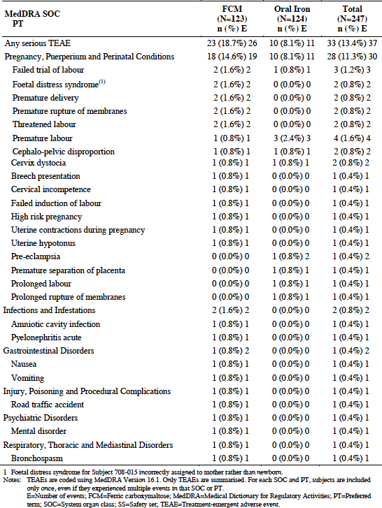

Study FER-CARS-05
There were 27 subjects that experienced fatal AEs during the study, during the follow-up period or within 30 days of the last dose of study drug, 13 (8.6%) in the ferric carboxymaltose group and 14 (9.2%) in the placebo group. There was no clear difference between the groups in the causes of death. None of the deaths were assessed by the investigator as being related to study drug.
The incidence of SAEs was 28.3% in the ferric carboxymaltose arm and 34.9% in the placebo arm. The SAEs reported are listed in Table 4. Serious cardiac events, mainly cardiac failure events, were more common in the placebo arm. Other types of SAEs occurred with comparable frequency in the two arms.
Table 4: Study FER-CARS-05; SAEs by SOC and PT
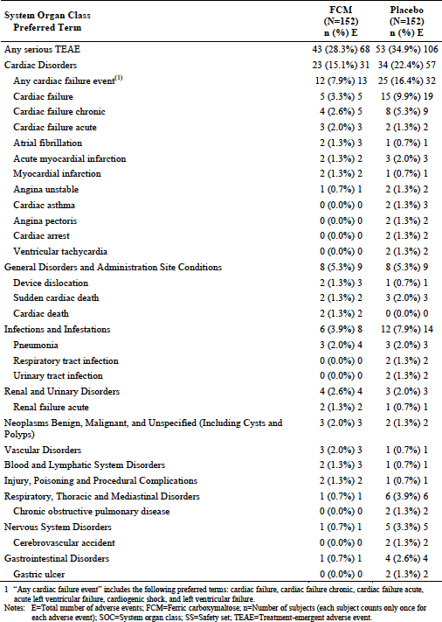

Meta-analysis
A total of 38 subjects died 19 (3.7%) subjects in the ferric carboxymaltose group and 19 (5.7%) subjects in the placebo group. Most of these deaths occurred in Study FER-CARS-05. There was no clear difference between the groups in the causes of death, and none of the deaths were assessed by the investigators as being related to study drug.
The incidence of SAEs was 17.0% in the ferric carboxymaltose group and 23.6% in the placebo group. SAEs reported in more than 1 subject are listed in Table 5. None of the individual events occurred with a notably higher frequency in the ferric carboxymaltose group. Cardiac events, especially serious cardiac failure events were more common in the placebo group.
Table 5: Meta-analysis; Serious TEAEs reported by > 1 subject in either treatment group, according to SOC and PT (Saftey set, N = 842)
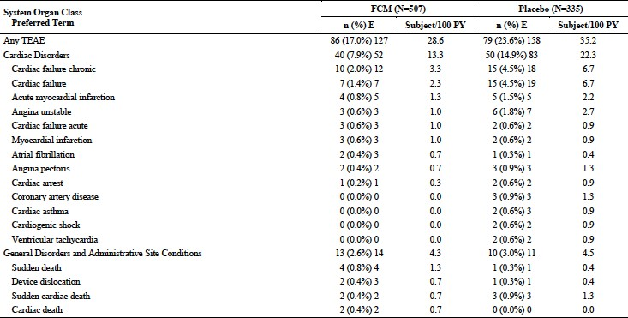

Liver function and liver toxicity
Liver function test abnormalities are listed in the current PI as known adverse drug reactions with ferric carboxymaltose.

Study FER-ASAP-2009-01
No analyses were presented on the incidence of clinically significant shifts from Baseline in liver function tests. Laboratory results considered to be clinically significant by the investigators were to be reported as adverse events. In the ferric carboxymaltose arm there was once such AE reported (as ‘liver disorder’) compared with none in the oral iron arm. Average values (mean, median) for liver function tests parameters were presented for each study visit. There were no clinically significant changes in these average values.
Aside from the one report of ‘liver disorder’ there were no other hepatobiliary AEs reported during the study.

Study FER-CARS-05
Abnormalities on liver function testing were more common in the ferric carboxymaltose arm. This was most notable for gamma glutamyl transferase (GGT). For example, of subjects who had a normal GGT at Baseline, 18.6% in the ferric carboxymaltose arm had a high reading at Week 36. The corresponding figure in the placebo arm was 4.5%. A higher incidence of abnormalities was also seen for alanine transaminase (ALT) and aspartate transaminase (AST). Mean values for GGT were also higher in the ferric carboxymaltose arm compared to the placebo arm.
Hepatobiliary AEs were reported in 3.3% of subjects in the ferric carboxymaltose arm and 1.3% of subjects in the placebo arm. There were no serious hepatic AEs reported.

Meta-analysis
An analysis of the incidence of clinically significant changes in liver function tests was not presented. ALT increased was reported as an AE for 5 (1.0%) of ferric carboxymaltose subjects (1.7 subjects per 100 patient-years) compared with 0 placebo subjects. AST increased was reported as an AE for 4 (0.8%) ferric carboxymaltose subjects (1.3 subjects per 100 patient-years) compared with 0 placebo subjects. No SAEs were reported for liver enzymes increased, ALT increase, nor AST increase.
Mean values for change from Baseline in AST and ALT were mildly higher in the ferric carboxymaltose group at Weeks 4 and 12.
Hepatobiliary AEs were reported in 1.4% of ferric carboxymaltose subjects (3.0 subjects per 100 patient-years) compared with 1.2% of placebo subjects (1.8 subjects per 100 patient-years). There were no serious hepatic AEs reported.

Renal function and renal toxicity

Study FER-ASAP-2009-01
No analyses were presented on the incidence of clinically significant shifts from Baseline in serum creatinine. Laboratory results considered to be clinically significant by the investigators were to be reported as AEs. There were no such reports suggestive of impaired renal function. Average values (mean, median) for serum creatinine were presented for each study visit. There were no clinically significant changes in these average values. There were no AEs suggestive of renal impairment reported during the study.

Study FER-CARS-05
For serum creatinine and blood urea nitrogen, the incidence of shifts from normal at baseline, to high during the study, was comparable between the two treatment arms. For estimated glomerular filtration rate (eGFR), the incidence of shifts from normal at baseline, to low during the study, was also comparable. AEs of renal impairment/renal failure occurred with similar frequency in the two arms.

Meta-analysis
No analyses of serum creatinine were presented. There were no clinically significant differences between groups in mean values for eGFR over 24 weeks. AEs of renal impairment/renal failure occurred with similar frequency in the two groups.

Phosphorous
Hypophosphataemia is listed in the current PI as a common adverse drug reaction to ferric carboxymaltose.

Study FER-ASAP-2009-01
Abnormally low phosphorous levels (< 0.81 mmol/L) occurred in 34 ferric carboxymaltose treated subjects (27.6%) and 2 placebo treated subjects (1.6%). Mean phosphorous levels decreased from baseline at Week 3 in the ferric carboxymaltose arm (mean decrease = 0.148 mmol/L) but not in the oral iron arm. Mean concentrations were similar and normalised in the two arms at Week 6 and beyond.

Study FER-CARS-05
Abnormally low phosphorous levels (0.3 to 0.6 mmol/L) occurred in 12 ferric carboxymaltose treated subjects (7.9%) and 1 placebo treated subject (0.7%). Mean phosphorous levels decreased from baseline at Weeks 6 and 12 in the ferric carboxymaltose arm but not in the placebo arm. Mean concentrations were similar and normalised in the two arms at Week 24 and beyond.

Meta-analysis
Mean phosphorous levels decreased from baseline at Weeks 4 and 12 in the ferric carboxymaltose group but not in the placebo group. Mean concentrations were similar and normalised in the two groups at Week 24.

Other clinical chemistry

Study FER-ASAP-2009-01
No analyses were presented on the incidence of clinically significant shifts from baseline in other biochemistry parameters. There were no AE reports indicative of abnormalities of other biochemistry parameters. There were no clinically significant changes in the average values for these biochemistry parameters over the course of the study.

Study FER-CARS-05
Shifts from baseline in other biochemistry parameters were comparable in the two treatment arms.

Meta-analysis
There were no clinically significant changes in the average values for sodium and potassium over the course of the study. Data for other biochemical parameters were not presented.

Haematology and haematological toxicity

Study FER-ASAP-2009-01
No analyses were presented on the incidence of clinically significant shifts from Baseline in haematology parameters. As discussed in the efficacy section of this report, average haemoglobin levels increased in both arms over the course of the study.
The only haematological AE reported during the study was 1 case of haemorrhagic anaemia in the oral iron arm.

Study FER-CARS-05
As discussed (in the clinical evaluation report) haemoglobin levels increased in the ferric carboxymaltose arm. Shifts from baseline in white cell and platelet counts were comparable in the two treatment arms.
The incidence of blood and lymphatic system AEs was 2.0% in the ferric carboxymaltose arm and 3.9% in the placebo arm.

Meta-analysis
Average haemoglobin levels increased in the ferric carboxymaltose arm. No data were presented on white cells or platelets.
The incidence of blood and lymphatic system AEs was 2.8% in ferric carboxymaltose subjects (4.7 subjects per 100 patient-years) compared with 4.2% of placebo subjects (6.2 subjects per 100 patient-years).

Electrocardiograph findings and cardiovascular safety

Study FER-ASAP-2009-01
Electrocardiograms (ECG) were not routinely collected in this study. In the ferric carboxymaltose arm, there was 1 case of foetal bradycardia and 1 of supraventricular extrasystoles. There were no cardiac AEs in the oral iron arm. Vascular AEs in the ferric carboxymaltose arm were flushing (1), hypotension (1) and varicose vein (1). In the oral arm, there was 1 report of varicose vein.

Study FER-CARS-05
Electrocardiograms: Tabulations were presented for overall interpretation of ECGs (normal versus abnormal) at each visit. Most subjects had abnormal ECGs at Baseline (91.4% in the ferric carboxymaltose arm versus 90.1% in the placebo arm). This proportion remained high in both treatment arms throughout the study, with no notable differences between the arms. The proportion of subjects who shifted from normal to abnormal was also comparable.
There were no notable differences between treatment groups in mean values for ECG intervals (PR interval, QRS interval and so on) over the course of the study.
The incidence of QTcF prolongation; (for example, absolute value > 500 ms or increase from Baseline of > 60 ms) was comparable in the two treatment arms over the course of the study.
Cardiac AEs: Cardiac AEs reported in this study are listed in Table 6. The overall incidence of cardiac events was comparable in the two arms (38.2% versus 37.5%). However, events suggestive of cardiac failure were more frequent in the placebo arm. Of the remaining events, sinus bradycardia (3.9% versus 0.7%) and bradycardia (2.0% versus 0.7%) were notably more common in the ferric carboxymaltose arm.
Table 6: Study FER-CARS-05; Cardiac AEs
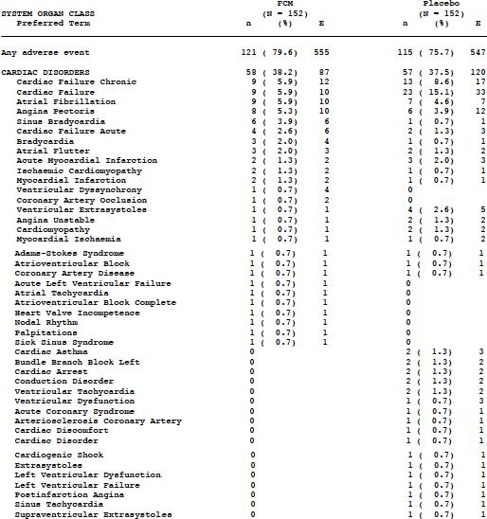
Vascular AEs: Vascular AEs reported in this study are listed in Table 7. The incidence of these events was similar in the two arms.
Table 7: Study FER-CARS-05; Vascular AEs
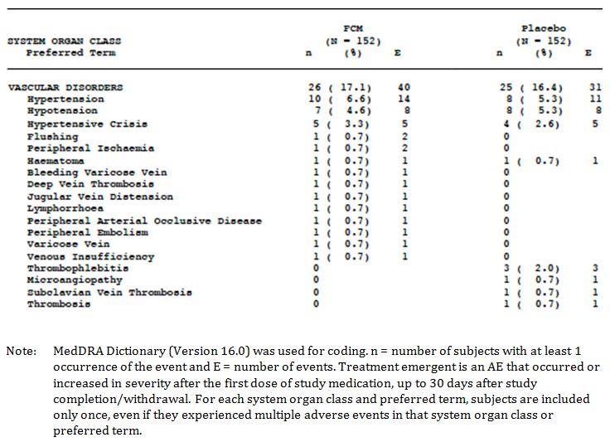

Meta-analysis
No analysis of ECGs was presented.
Cardiac AEs: The overall incidence of cardiac AEs was 20.7% (34.9 subjects per 100 patient-years) in the ferric carboxymaltose group 29.0% (43.2 subjects per 100 patient-years) in the placebo group. The pattern of events was similar to that observed in Study FER-CARS-05. The incidence of sinus bradycardia was 1.6% (2.7 subjects per 100 patient-years) in the ferric carboxymaltose group and 0.3% (0.4 subjects per 100 patient-years) in the placebo group. For bradycardia, the difference between groups was small.
Vascular AEs: The overall incidence of vascular AEs was 10.3% (17.3 subjects per 100 patient-years) in the ferric carboxymaltose group 11.6%% (17.4 subjects per 100 patient-years) in the placebo group. The pattern of events was similar in the two groups.

Vital signs and clinical examination findings

Study FER-ASAP-2009-01
There were no clinically significant changes in average values for vital sign parameters over the course of the study. An analysis of the incidence of clinically significant abnormalities was not presented.

Study FER-CARS-05
There were no clinically significant changes in average values for vital sign parameters over the course of the study. Again, an analysis of the incidence of clinically significant abnormalities was not presented.

Meta-analysis
There were no clinically significant changes in average values for vital sign parameters over the course of the study. Again, an analysis of the incidence of clinically significant abnormalities was not presented.

Immunogenicity and immunological events
The current PI contains a precaution regarding the potential for hypersensitivity reactions, including fatal events.

Study FER-ASAP-2009-01
There were no immunological events reported in this study.

Study FER-CARS-05
There were 2 cases of hypersensitivity/drug hypersensitivity in the ferric carboxymaltose arm and 1 case of hypersensitivity in the placebo arm.

Meta-analysis
There were 4 cases of hypersensitivity/drug hypersensitivity in the ferric carboxymaltose group and 1 case of hypersensitivity in the placebo group.

Serious skin reactions

Study FER-ASAP-2009-01 and Study FER-CARS-05
There were no serious skin disorders reported in these studies.

Meta-analysis
There were no serious skin disorders reported in the ferric carboxymaltose group and 1 event (a dermal cyst) in the placebo group.

Post marketing data
The submission included one periodic safety update report (PSUR) that reviewed adverse event reports received by the sponsor over a 12 month period between 2 January 2015 and 1 January 2016. Ferric carboxymaltose was first approved in the Netherlands in 2007. The sponsor estimated that the cumulative exposure to marketed product up to December 2015 was over 3 million patient-years.
Over the period covered by the PSUR, there were no significant safety-related actions taken against the product by regulatory agencies.
During the period covered by the report the sponsor investigated the safety signal of ‘pain in the extremity’, based on 19 reports from clinical trials and 72 post-marketing cases. The sponsor confirmed this as an adverse drug reaction (ADR) and included it in prescribing information documents, including the Australian PI.
The sponsor also identified ‘thrombocytopaenia’ as a possible ADR, based on a documented association with Venofer (iron sucrose). An association with ferric carboxymaltose was not confirmed. No details of the analysis were provided but the sponsor is continuing to monitor AE reports.
No other new safety concerns were raised.

Evaluator’s conclusions on safety
Overall, the safety profile observed for ferric carboxymaltose in the two new clinical trials was consistent with that previously documented for the drug. The most common AEs observed were consistent with those listed in the current Australian PI; headache, dizziness, hypertension, flushing, gastrointestinal disorders such as nausea, vomiting and constipation, musculoskeletal complaints, fatigue and liver function test abnormalities.
Study FER-CARS-05 did not raise any new safety issues regarding the use of ferric carboxymaltose in heart failure subjects with iron deficiency. The safety of ferric carboxymaltose in this setting was comparable to that of placebo.
Safety issues raised by Study FER-ASAP-2009-01, in subjects in late pregnancy were:
- There was an excess of pregnancy related AEs in the ferric carboxymaltose arm compared to the oral iron arm (21.1% versus 11.3%). Many of the excess AEs reported were suggestive of premature labour; premature rupture of membranes (3.3% versus 0%), threatened labour, premature delivery and uterine contractions during pregnancy (all 1.6% versus 0%), although the incidence of the AE term ‘premature labour’ was 2.4% in both arms. The sponsor should be requested to provide an analysis of any other available data (for example, post marketing reports, published literature, other clinical trials) that addresses the safety of ferric carboxymaltose in late pregnancy, with a particular focus on the risk of premature labour.
- The study excluded subjects at < 16 weeks gestation and the safety of ferric carboxymaltose in this population has therefore not been determined.
- Cumulative dosages administered in Study FER-ASAP-2009-01 would have generally been lower than those recommended in the proposed PI. The maximum cumulative dose used in the study was 1500 mg. Using the Ganzoni or simplified dosage methods contained in the PI, higher doses would be administered in most subjects (for example, for a 100 kg individual with a baseline haemoglobin of 80 g/L, the prescribed dose would be 2100 mg with the Ganzoni method and 2000 mg with the simplified method). As the safety of higher doses has not been tested, it is recommended that the maximum cumulative dose in pregnant patients should be restricted to 1500 mg.

First Round Benefit-Risk Assessment

First round assessment of benefits
Table 8, shown below, summarises the first round assessment of benefits of Ferinject ferric carboxymaltose in the patient population proposed in this submission.
Table 8: First round assessment of benefits
Benefits | Strengths and Uncertainties
Treatment with ferric carboxymaltose was associated with:  - clinically significant increases in haemoglobin concentration. Least squares mean increase from Baseline were 1.16 g/dL (11.6 g/L) at Week 3 and 2.57 g/dL (25.7 g/L) at Week 12. The increases were comparable to those obtained with oral iron;  - improvements in iron status parameters. These improvements were generally greater than those obtained with oral iron;  - an increase in the proportion of subjects achieving anaemia correction at any time during the study (83.5% in the ferric carboxymaltose arm versus 70.2% in the oral iron arm; odds ratio 2.06 (95%CI: 1.07 to 3.97) p = 0.031). | Strengths:  - On many of the efficacy parameters, improvements were significantly greater than those obtained with oral iron.  Uncertainties:  - Effects on quality of life measures were small and probably not clinically significant.  - The dosage regimen used in the submitted study was not consistent with those proposed in the PI, in that lower doses were used. The safety of the doses recommended in the PI is uncertain.
Compared to placebo, treatment with ferric carboxymaltose was associated with:  - clinically significant improvements in the 6 minute walk test;  - a reduction in the risk of deterioration in NYHA heart failure class;  - improvements in various quality of life measures;  - a reduced risk of hospitalisation due to worsening of heart failure;  - improvements in haemoglobin concentration and iron status parameters. | Strengths:  - Improvement in 6 minute walk test was observed across a wide range of subgroups.  - The findings of the study were consistent with those obtained in a previously evaluated study (Study FER-CARS-02).

First round assessment of risks
Table 9, shown below, summarises the first round assessment of risks of Ferinject ferric carboxymaltose in the patient population proposed in this submission.
Table 9: First round assessment of risks
Risks | Strengths and Uncertainties
- Ferric carboxymaltose treatment was associated with a number of adverse events, which have previously been documented for the drug - headache, dizziness, hypertension, flushing, gastrointestinal disorders such as nausea, vomiting and constipation, musculoskeletal complaints, fatigue and liver function test abnormalities.  - Hypersensitivity events were uncommon. | Uncertainties:  - In the pregnancy setting there was an increased incidence of pregnancy related events. The clinical significance of this finding is uncertain.  - There are no safety data available for the use of ferric carboxymaltose in early pregnancy (< 16 weeks gestation).

First round assessment of benefit-risk balance
The overall risk-benefit balance of ferric carboxymaltose in the treatment of:
- iron deficiency anaemia in late pregnancy; and
- iron deficiency in chronic heart failure; is considered positive.

First Round Recommendation Regarding Authorisation
It is recommended that the application to include data from the two new studies in the PI be approved.
There are no clinical objections to the proposed new strength (1000 mg of iron in 20 mL) as it is a direct scale of the existing strengths and the new presentation is consistent with the recommended dosage regimens.

Clinical Questions and Second Round Evaluation

Efficacy

Question 1
In Study FER-ASAP-2009-01, what proportion of eligible patients completed each of the SF-36 subsections; at each time-point?

Sponsor’s response
Table 10: Number of patients that completed each of the SF-36 subsections in the full analysis set population (n = 236)
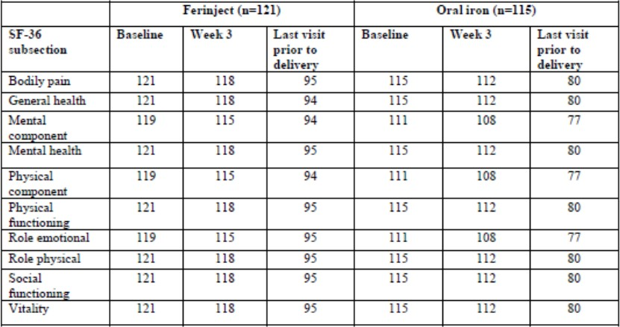

Evaluation of response
For the Ferinject treatment arm, the proportion of patients completing the SF-36 at last visit prior to delivery ranged from 78.5 to 79.0%.
For the oral iron treatment arm, the proportion of patients completing the SF-36 at last visit prior to delivery ranged from 69.4% to 69.6%.
For both treatment arms, there is a significant reduction in the proportion of patients who completed the SF-36 over time, yielding a substantial and discrepant difference within and between treatment groups. Given the substantial magnitude of missing data, no conclusions can be drawn from these assessments.
The evaluator notes the statement in the proposed PI regarding quality of life measures has been removed by the sponsor.

Safety

Question 2
In Study FER-ASAP-2009-01 there was an excess of pregnancy related AEs in the ferric carboxymaltose arm compared to the oral iron arm (incidence 21.1% versus 11.3%). Many of the excess AEs reported were suggestive of premature labour; premature rupture of membranes (3.3% versus 0%), threatened labour, premature delivery and uterine contractions during pregnancy (all 1.6% versus 0%), although the incidence of the AE term ‘premature labour’ was 2.4% in both arms.
Please provide an analysis of any other available data (for example, post marketing reports, published literature, other clinical trials) that addresses the safety of ferric carboxymaltose in late pregnancy, with a particular focus on the risk of premature labour and premature delivery separately.

Sponsor’s response
Apart from clinical Study FER-ASAP-2009-01, there are no other sponsor-sponsored, or partner sponsored clinical trials investigating the use of Ferinject in pregnancy. The sponsor is performing a weekly worldwide literature screening and is capturing all cases of exposure during pregnancy in the global safety database.
An analysis of all post marketing data (including spontaneous reports, published literature, post marketing studies, investigator initiated studies etcetera) is provided below.
By the data lock point (DLP) of 31 October 2017, a total of [information redacted] Ferinject 100 mg iron equivalent units corresponding to 4,842,608 patient years (based on a yearly total dose of [information redacted] iron as Ferinject per patient) had been sold.
The following search strategy was used in order to retrieve pregnancy category cases from the company global post-marketing safety database for Ferinject cases up to the set DLP:
- Pregnancy value is set to YES in the global safety database.
- Medical Dictionary for Regulatory Activities (MedDRA) preferred terms (PTs): Exposure during pregnancy; Foetal exposure during pregnancy; Maternal exposure during pregnancy; Pregnancy; Maternal drugs affecting foetus; and Exposure via father.
- All report type cases except the sponsor’s clinical trials, irrespective of seriousness.
A total of 1,793 cases containing 3,970 reported AEs were retrieved using the above search strategy. The source of these cases included health authority (3 cases), literature (14 cases), consumer (1 case), spontaneous (1306 cases), post-marketed study (462 cases), solicited (1 case) while the source of cases ‘Others’ includes investigator-initiated studies and non-sponsor studies (6 cases).
The event ‘Exposure during pregnancy’ was entered in 1,716 of 1,793 (96%) pregnancy cases.
Among the 1,793 cases there were 38 cases with event term ‘Foetal exposure during pregnancy’.
These cases were created as per the sponsor’s standard case processing convention for mother-baby pair cases. Per this convention, when a pregnant female receives Ferinject and if there is an occurrence of any AE in the fetus or baby (including impact on foetal development), a separate fetal or baby case is created in the post-marketing global safety database. In such cases, the fetus or baby was not primarily exposed to Ferinject but is considered to have foetal exposure during pregnancy and therefore entered as a non-serious event term unless reported with a seriousness criteria. These cases are also retrieved from the search strategy used to review cases for Ferinject use in pregnancy.
The remaining 39 out of 1,793 cases contained AE terms describing events occurring after Ferinject exposure, where pregnancy radio button was marked based on standard case processing convention at the time of case creation, without addition of a specific PT related to Drug exposure during pregnancy.
In 506 of 1,793 cases it was reported that the patient did not experience any AE after Ferinject administration and therefore event term ‘No adverse event’ was also entered as second event term per standard case processing convention at the sponsor’s global drug safety department.
In some cases, clusters of patients exposed to Ferinject during pregnancy were reported, without the possibility of attributing the reported events to a specified patient. The patients received Ferinject mostly at single dose, generally in third trimester of pregnancy, and at different dosage strengths. Wherever available, the sponsor has provided a distinct count of number of identifiable patients. A high-level overview of these cases is presented in Table 11.
Table 11 Overview of cluster cases of pregnant patients exposed to Ferinject
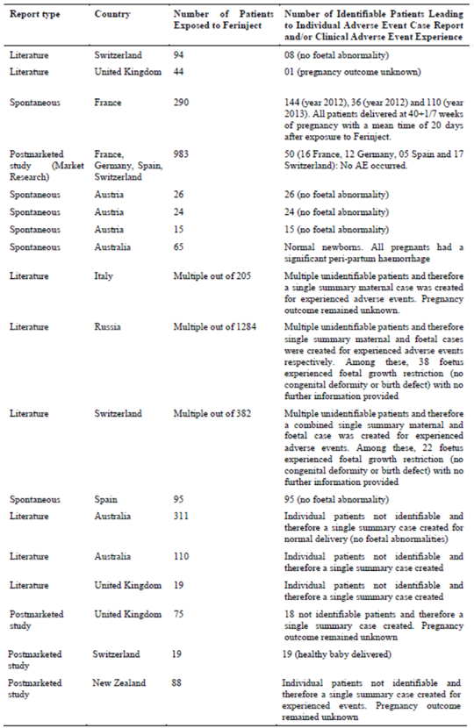
Of note, a high-level summary of a total of 290 pregnant patients who received Ferinject IV infusion at a single dose of 1000 mg at home from 01 October 2011 to 30 September 2013 was presented by a French anaesthesiologist in a French congress (SFAR: French Society for Anaesthesia and Resuscitation). This refers to third cluster of cases in Table 11 above. These cases were received by the sponsor in a lot of 144 and 36 cases in 2012 and 110 cases in 2013. Per the presentation, all patients delivered at 40 weeks + 1 day of pregnancy with a mean time of 20 days between Ferinject administration and delivery. In 263 of 290 cases, no information was provided on the course of pregnancy, nor any information on complication before or during the delivery or any foetal malformation/ anomaly. In the remaining 27 of 290 cases, the outcome of pregnancy was reported as: normal delivery with no information on course of pregnancy after Ferinject administration until delivery or any foetal malformation/ anomaly in 19 cases; elective (planned) caesarean section delivery in 1 case, no information was reported about the newborn; caesarean section delivery (urgent or planned unspecified) in 6 cases, with no information reported about the newborn; fetal death (Case [information redacted]: also presented below under abnormal outcome of pregnancies section).
From the 1,793 cases, 52 cases were not considered for further review for the below reason:
- twenty-two (22) cases were created for the fetus/ newborn as part of the sponsor’s standard case processing convention. The maternal cases will be taken into consideration for further assessment; in 17 cases the mother was exposed to Ferinject after the delivery with ongoing breastfeeding that constituted an ‘Exposure during breast feeding’ for the newborn;
- in one case, the patient was diagnosed with ‘Pregnancy’ after Ferinject administration;
- in one case, Ferinject was administered in the post-partum period;
- in one case, Ferinject was administered during labour;
- in one case, there was an intercepted drug prescribing error (prescription by a non-hospital physician) and therefore Ferinject was not dispensed for administration;
- in one case, the clear time period between Ferinject administration and pregnancy status was unknown, nor it could be estimated from the reported information;
- in one case, during the first trimester of pregnancy the patient was planned for Ferinject administration, but it was not confirmed if Ferinject was administered or not (this case report was received as part of treating physician’s inquiry on Ferinject administration in first trimester of pregnancy). The outcome of the pregnancy remained unknown in this case;
- in one case, Fer Mylan (intravenous iron sucrose) was administered to pregnant female instead of Ferinject;
- in one case, for the third trimester of pregnancy exposure it was not confirmed if the pregnant female was administered with Ferinject or Venofer (iron sucrose) but a healthy baby was delivered via caesarean section at full-term (38 weeks + 6 days weeks of pregnancy);
- in one case, for the third trimester of pregnancy exposure with Ferinject it was not confirmed if the pregnant female was administered with Ferinject or Venofer (iron sucrose). The outcome of the pregnancy remained unknown in this case and no information was provided on the course of pregnancy and fetal development;
- in one case, it was not confirmed if the pregnant female was administered with Ferinject either during pregnancy (most probably near to delivery date) or in immediate period after the delivery. The outcome of the pregnancy remained unknown in this case and no information was provided on the course of pregnancy and fetal development;
- in one case, it was not clear if Ferinject was given before or after the normal vaginal delivery but was confirmed to be given on the same day of normal vaginal delivery. No details provided for the newborn in terms of birth weight, APGAR score; and others
- in one case Ferinject was not dispensed by the inquiring pharmacist and therefore it was not confirmed if Ferinject was administered to the pregnant female or not, but a healthy baby was delivered at full-term via normal delivery
- in one case it was not confirmed if Ferinject was administered to the pregnant female or not. The outcome of the pregnancy remained unknown
Therefore, after excluding the above summarised 52 cases, total number of cases considered for this assessment were 1,741 (1,793 minus 52). Table 12 below presents the distribution of these 1,741 cases by trimester of pregnancy.
Table 12: Ferinject post marketing database; distribution of pregnancy cases by trimester exposure (DLP; 31 October 2017)
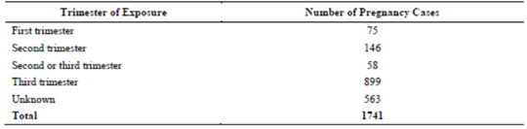
From Table 12 above, in 58 cases it was reported that Ferinject was administered in ‘second or third’ trimester of pregnancy with no detail provided to clearly distinguish the exact trimester of pregnancy in any given case report. Among these 58 cases, one case was reported from a market research program from Finland while the remaining 57 cases were from a literature publication for a non-company sponsored study in a UK teaching hospital. The pregnancy outcome remained unknown in all 58 cases with no information provided on course of the pregnancy, nor information on any complication during the late stages of pregnancy, nor any foetal abnormality or anomaly (if any based on radiological imaging study). Also, none of these 58 pregnant females experienced any adverse event in both during and immediate period after Ferinject administration.
A total of 899 pregnancy cases (52% of 1,741 pregnancy cases considered for assessment) were suggestive of third trimester of pregnancy exposure to Ferinject.
Considering the concern on the safety of Ferinject in third trimester of pregnancy, Table 13 below shows the distribution of the pregnancy outcomes for the late pregnancy Ferinject exposures:
Table 13: Outcome of third trimester exposure pregnancies
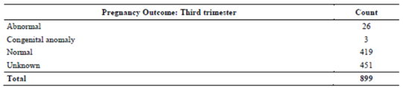
From Table 13 above, among the cases with unknown outcome of pregnancy, in 4 of 451 cases the pregnancy was ongoing with an expected date of delivery after the reporting date of Ferinject exposure during pregnancy. For these cases, no follow-up information has been received by the sponsor for the final outcome of the pregnancy at the time of this assessment. In the remaining 447 of 451 cases the outcome of the pregnancy remained unknown.
In 419 of 899 cases the pregnancy concluded with a delivery of a healthy baby without any complication during the course of the pregnancy or during the labour process. Wherever reported, all newborns had an adequate birth weight and did not present with any congenital malformation or anomaly.
For the third trimester pregnancy exposure, there were only three cases reported with seriousness criteria of congenital anomaly or birth defect. Table 14 below provides a summary of these three congenital anomaly cases (0.17% of total 1,741 pregnancy cases; and 0.33 % of third trimester exposure cases).
Table 14: Cases with reported ‘congenital anomaly/birth defect’ seriousness indicator after maternal exposure to Ferinject
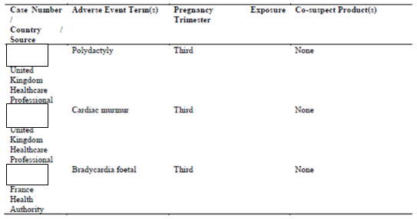
Please find below a summary of these 3 cases:
[Information redacted]
Discussion
The limitations and difficulties in interpretation of data from post-marketing are well known. Nevertheless, the sponsor has taken a conservative approach when assessing all cases.
Overall, the most frequently reported AEs in all pregnancy cases were similar to the AEs reported with Ferinject in the general population. Except for the AEs that are specific to pregnancy exposure, the remaining reported events were listed as per the Company Core Data Sheet.
This review has also summarised Ferinject use in approximately 3,500 pregnant patients (considering the number of patients reported in cluster cases captured as invalid in the Global Drug Safety Database) treated with different doses of Ferinject during different periods of gestation and did not suggest any effect on foetal development. Many of these cluster reports remained inadequately documented with limited information provided but none reported an occurrence of foetal anomaly or malformation.
Among the cases reported with a seriousness criteria of congenital anomaly, in one case [information redacted] Ferinject administration occurred after the known completion of embryonic development of reported anatomical abnormality (did not correspond to foetal intrauterine development time period). In another case [information redacted] the reported abnormality was assessed as not-related by the reporting healthcare professional; this case did not report any structural/ anatomical defect but an adverse event usually seen during pregnancy and therefore not considered as a true congenital defect or anomaly by the sponsor. In last case [information redacted] event bradycardia foetal was reported but does not represent a true congenital defect.
Cumulatively, no case qualified as a true congenital anomaly or malformation that could be related to the use of Ferinject.
Nine out of 12 cases with a late trimester Ferinject exposure with abnormal outcome (except premature delivery and premature labour) were assessed as not related by the reporting healthcare professionals, and only in 3 cases there was a suspicion of causal relationship. In one case [information redacted] the occurrence of still-birth was heavily confounded by the co-suspect enoxaparin sodium subcutaneous intake while its indication of unspecified grade of phlebitis could constitute an additional risk factor. In another case [information redacted], the premature rupture of membranes occurred at full-term of pregnancy. In the third case [information redacted] the foetal death was confounded by the maternal medical history of multigravida and high glycosylated haemoglobin at 36% among others.
Among cases with premature delivery, in three cases [information redacted] information on newborn maturity parameters did not suggest any prematurity and the newborns were mature per birth weight and APGAR score. In two cases [information redacted] the delivery was within one week time of clinically defined 37 completed weeks of pregnancy; also the birth weight and APGAR score were within normal range. Seven cases [information redacted] for premature delivery were assessed as not related by the reporting healthcare professionals to Ferinject administration based on the available information and better understanding of the pregnant females’ characteristics and underlying conditions. In two twin pregnancy cases [information redacted] the outcome of pregnancy and health status of newborn was not different from what is clinically known. In one case [information redacted] a high-risk pregnancy patient experienced placenta praevia in the current pregnancy before Ferinject administration. In one case [information redacted] the risk factors for premature delivery were gestational diabetes, multiple previous pregnancies with a similar delivery status. One case [information redacted] remained inadequately documented on exact delivery period and newborn maturity parameters and precluded a meaningful medical assessment. A summary case [information redacted] remained inadequately documented for a meaningful medical assessment.
From the cases with premature labour, in one case [information redacted] the event was managed on tocolytics but no information provided on its impact on the foetal well-being; nor the outcome of the pregnancy was provided. Three cases [information redacted] remained inadequately documented overall and therefore precluded a meaningful medical assessment. In the remaining case [information redacted] the event was suspected in view of stress (emotional or physician or other: unspecified).
In summary, majority of cases for premature delivery were assessed as not related to Ferinject administration by the reporting healthcare professionals all across the globe, followed by deliveries conducted within a week before the expected date of delivery, followed by newborns with normal maturity parameters. Two cases had underlying maternal risk factors while another two cases were inadequately documented. Cases for premature labour remained inconclusive in view of inadequate documentation.
Conclusion
Post-marketing data for Ferinject reviewed until 31 October 2017 (for almost 3,500 pregnant patients) did not highlight any congenital anomaly or birth defect irrespective of period of pregnancy at the time of Ferinject administration. There is no evidence supporting a causal relationship between Ferinject administration and occurrence of premature delivery, or suggesting a negative impact on the newborn with respect to prematurity criteria.
As stated previously, apart from clinical study FER-ASAP-2009-01, there are no other sponsor or partner sponsored clinical trials investigating the use of Ferinject in pregnancy. The sponsor is continuously performing a weekly worldwide literature screening and is capturing all cases of exposure during pregnancy in the global safety database.
The Ferinject Australian product information states that ID during pregnancy should in the first instance be treated with oral iron. It further states that if IV iron treatment is considered necessary (after a careful benefit-risk evaluation) it should be confined to the second and third trimester.
Based on the availability of data from the clinical study FER-ASAP-2009-01, the proposed Ferinject Australian product information now informs that there is limited data from the use of Ferinject in pregnant women, as opposed to the current stating that there is no data.

Evaluation of response
The sponsor has provided a limited assessment of the effects of Ferinject in the third trimester of pregnancy. No data has been presented regarding the pregnancy or infant outcomes for the 221 women reported to have received Ferinject in the first or second trimester. Indeed, this number of patients may be larger as there is a separate pool of patients who received either second or third trimester exposure, but have not been reported either.
The current PI states that iron released from ferric carboxymaltose can cross the placenta in rats.
The sponsor has confused the definitions of preterm (the preferred term) and prematurity in their response. The sole definition of preterm delivery is one occurring before 37 completed weeks’ gestation, and the estimated date of delivery is 40 weeks gestation. A delivery occurring any time after 37 completed weeks’ gestation is considered term.
Neither the Apgar score, nor birthweight defines whether an infant is preterm. The Apgar score is a measure of clinical condition at delivery, and need for, and response to, initial resuscitation. Indeed, infants born prematurely may have a satisfactory Apgar score at delivery, and term infants may have a poor Apgar score, depending on the circumstances of delivery. Similarly, birthweight is a measure of pre-natal growth and is affected by (but not exclusively) placental function, conditions such as maternal diabetes causing foetal macrosomia, or a variety of foetal conditions which may lead to hydrops foetalis or chromosomal aberrations. Birthweight is increasingly variable with advancing gestation and alone is not a reliable assessment of a pre-term delivery.
The assessment of gestational age can be assessed antenatally by last menstrual period date, ultrasound-assessed foetal age (with known last menstrual period date); postnatally, gestation can be estimated by the Dubowitz score.
The sponsors’ repeated assertion for several instances that an infant “is not a true premature case” based on the birthweight and/or Apgar score, is incorrect.
Congenital malformation
Congenital malformations arise during organogenesis in the first and early second trimester. The sponsor has only reported the babies born with a congenital malformation following third trimester exposure to Ferinject. No post-marketing pregnancy or infant outcome data has been presented for women who received Ferinject in the first or second trimester which would be the population at risk of induced foetal abnormality. Consequently, the risk following Ferinject exposure cannot be compared to the background risk.
Of the two cases reported as ‘congenital malformation’ following third trimester exposure, the infant with a ‘heart murmur’ (a clinical sign) does not have a specific diagnosis and cannot therefore be considered further.
It is biologically implausible that exposure to Ferinject in the third trimester causally resulted in the finding of polydactyly described in one infant.
The current PI states that embryo toxicity and skeletal anomalies were seen in animals. In order to ascertain the risk of human congenital malformation due to Ferinject, the outcomes of infants born following first and second trimester Ferinject exposure should be more thoroughly reported to establish the risk of Ferinject administration.
The safety of Ferinject in the second trimester has not, therefore been established to the satisfaction of the evaluator.
Outcomes following third trimester (sponsors’ assignation) exposure
The sponsor has included infants with second trimester exposure (trimester 2 occurring between 13 weeks and 28 weeks gestation).
Among the cases described by the sponsor, three are concerning for a causal link to an adverse event.
[Information redacted]
Other cases were considered to not have a causal relationship.
[Information redacted]
Preterm delivery and premature labour
Two events of uterine contractions or uterine hypertonia following third trimester Ferinject administration are described, both of which are temporally associated, occurring 30 minutes (Case 15) and 4 hours (Case 14) after injection.
The causality assessment of the reporter of Case 14 described Ferinject as related to the event of uterine hypertonia, which preceded delivery by 3 weeks. The sponsor’s assertion that the delivery at 35 weeks plus 4 days ‘did not represent a true premature delivery case’ is incorrect.
The event of uterine contractions in Case 15 occurred in the seventh month of pregnancy (possibly related), 30 minutes after Ferinject injection, and was sufficient for administration of tocolytic agents. The sponsor has stated ‘Reported information; confirm a plausible temporal relationship between administration of Ferinject and occurrence of uterine contractions.’
For this case, the sponsor has stated ‘however, there were no other events reported associated with Ferinject infusion’. This statement is incorrect as Case 14 also experienced Ferinject related uterine hypertonia in the third trimester.
These events of uterine hypertonia/contractions should be reported in the PI.
Three post-marketing events of anaphylaxis and hypersensitivity were described in separate patients; the current PI states these events as identified risks. There is insufficient post-marketing data presented to assess whether pregnant women are at greater risk of immune-related reactions to Ferinject.
One case report describes an interval of approximately 2 months between Ferinject administration and preterm delivery 6 weeks before the estimated date of delivery. The evaluator considers the delivery to be unrelated to Ferinject. The evaluator disagrees with the sponsors’ assertion that ‘this case did not represent a true premature delivery case, nor a premature newborn’.
One spontaneous case describes an interval of approximately 6 weeks between Ferinject administration and delivery. The evaluator considers this to be unrelated.
One case report describes an interval of almost 2 months between Ferinject administration and delivery; the evaluator considers this to be unrelated.
One case report describes Ferinject administration at 28 weeks’ gestation, with premature delivery at 31 weeks in the setting of placenta praevia. The evaluator considers the premature delivery unrelated to Ferinject.
One report does not contain the birth gestation of the infant, and therefore no further assessment can be made.
One case report describes a spontaneous delivery at 35+5/7 weeks’ gestation following administration of Ferinject at 34 weeks. The evaluator considers this to be unrelated.
For one case details are inadequate to provide a causal assessment with Ferinject administration.
One case report describes a woman with pre-eclampsia who received Ferinject at 25 weeks’ gestation then proceeded to require delivery at 26 weeks. Given the medications being administered for the pre-eclampsia, it would be unlikely that her symptoms would have resolved without delivery of the baby. The evaluator considers this premature delivery to be unrelated to Ferinject.
For this case, the administration of Ferinject at 19 weeks gestation was unrelated to the delivery at 34 weeks’ gestation. The evaluator disagrees with the sponsors’ assertion that ‘this case did not represent a true premature newborn’.
One pre-term delivery of the infant at 36 weeks following a fall was unrelated to administration of Ferinject at 26 weeks. The evaluator disagrees with the sponsors’ assertion that ‘this case did not represent a true premature newborn’ as delivery occurred before 37 completed weeks’ gestation
For this case the is an incomplete description of the timing of the second dose of Ferinject in relation to delivery at 36 weeks’ gestation, therefore no causality can be assessed. The evaluator considers the sponsors’ comment regarding prematurity incorrect, as the infant was delivered before 37 completed weeks’ gestation.
For this case there was an 18 week interval between Ferinject administration and delivery at 32 weeks gestation; this event is considered unrelated to Ferinject.
One case report describes an interval of 7 weeks between Ferinject exposure and premature delivery at 33 weeks’ gestation. The evaluator considers this to be unrelated.
One case report describes an interval of 4 weeks between Ferinject administration and delivery at 35+4/7 weeks. The evaluator considers this to be unrelated.

Premature labour cases
Three cases were inadequately described to assess causality.
One case describes an interval of 4 weeks between Ferinject and temporary onset of contractions; subsequent delivery occurred at term. The evaluator considers this to be unrelated.

Conclusion
- Given the data presented, the product information for Ferinject should be amended to include a statement regarding the non-causal association with isolated events of ductus venosus thrombosis, uterine contractions and fetal demise.
- The absence of a full description of the post-marketing data pertaining to the pregnancy and infant outcomes of second trimester Ferinject exposure does not support the PI statement:
‘If the benefit of Ferinject treatment is judged to outweigh the potential risk to the fetus, it is recommended that treatment should be confined to the second and third trimester.’
This statement should be amended to:
‘If the benefit of Ferinject treatment is judged to outweigh the potential risk to the fetus, it is recommended that treatment should be confined to the third trimester.’

Second Round Benefit-Risk Assessment
The risk benefit assessment for the use of Ferinject for use in patients with iron deficiency in chronic heart failure remains unchanged from the first round assessment.

VI. Pharmacovigilance findings
The TGA granted a waiver from the requirement for a Risk Management Plan (RMP) for this application.

VII. Overall conclusion and risk/benefit assessment
The submission was summarised in the following Delegate’s overview and recommendations:

Background

Use of intravenous iron preparations in pregnancy
The definition of ‘anaemia’ according to haemoglobin concentration varies throughout pregnancy according to gestational age, changing between trimesters, given the physiological adaptations which occur over time.
The reference range of haemoglobin concentration, in comparison to non-pregnant females, has been described as shown in Table 15.
Table 15: reference range of haemoglobin concentration, in comparison to non-pregnant females
 | Non-pregnant female |  | 1st trimester | 2nd trimester | 3rd trimester
Haemoglobin g/L | 120 -158 |  | 116 – 139 | 97 - 148 | 95 – 150
Ferritin, ng/mL | 10 -150 |  | 6 – 130 | 2 - 230 | 0 – 166
The National Blood Authority of Australia has provided a Guidance document entitled ‘Iron product and dose calculation for adults. Guidance for Australian Health Providers’ published in March 2016.
Three registered intravenous iron therapies are described within: ferric carboxymaltose (Ferinject), Iron Polymaltose (Ferrosig) and iron sucrose (Venofer). This guidance does not contain specific advice for the management of anaemia in pregnancy. There is no dosage and administration advice for use in pregnancy within the currently approved PI for Ferrosig or Venofer.
Since this Guidance was written, a fourth product has been registered in Australia; ferric derisomaltose (Monofer). The currently approved PI for Monofer describes clinical usage for women with post-partum haemorrhage, but not for antenatal use.
In 2013, as a result of a request by the French medicines regulator in response to the adverse effect profile of intravenous iron preparation, the Committee of Medical Products for Human Use (CHMP) of the EMA conducted a review which made the following recommendations:
- All intravenous iron preparations can cause serious hypersensitivity reactions which can be fatal.
- As there are data indicating that allergic reactions may still occur in patients who have not reacted to a test dose, a test dose is no longer recommended. Instead caution is warranted with every dose of intravenous iron that is given, even if previous administrations have been well tolerated.
- Intravenous iron medicines should only be administered when staff trained to evaluate and manage anaphylactic and anaphylactoid reactions are immediately available as well as resuscitation facilities. Patients should be closely observed for signs and symptoms of hypersensitivity reactions during and for at least 30 minutes following each injection of an intravenous iron medicine.
- In case of hypersensitivity reactions, healthcare professionals should immediately stop the iron administration and consider appropriate treatment for the hypersensitivity reaction.
- Intravenous iron-containing products are contraindicated in patients with hypersensitivity to the active substance or excipients. Intravenous iron-containing products must also not be used in patients with serious hypersensitivity to other parenteral iron products.
- The risk of hypersensitivity is increased in patients with known allergies or immune or inflammatory conditions and in patients with a history of severe asthma, eczema or other atopic allergy.
- Intravenous iron products should not be used during pregnancy unless clearly necessary. Treatment should be confined to the second or third trimester, provided the benefits of treatment clearly outweigh the potential serious risks to the fetus such as anoxia and fetal distress.
- All prescribers should inform patients of the risk and seriousness of a hypersensitivity reaction and the importance of seeking medical attention if a reaction occurs.
Data on the risk of hypersensitivity comes mainly from post-marketing spontaneous reports and the total number of life-threatening and fatal events reported is low. Although the data show a clear association of intravenous iron medicines and hypersensitivity reactions, the data cannot be used to detect any differences in the safety profile of the different iron medicines.
The risk of a severe hypersensitivity reaction or anaphylaxis occurring during pregnancy has the potential to adversely affect the foetus and may necessitate expedited or early delivery.

Use of intravenous iron preparations in chronic heart failure
Ferinject is currently indicated for patients who have confirmed iron deficiency anaemia who are intolerant of oral iron therapy.
The aim of iron treatment in such patients is to achieve an increase in haemoglobin concentration and to alleviate associated symptoms.

Overseas status
At the time of lodgement of the current submission with the TGA (May 2017), submissions for the new 1000 mg in 20 mL presentation had been lodged in the EU (March 2013) and Switzerland (July 2014). Both applications were approved, although dates of approval were not provided. An assurance was given that the application has not been refused market approval or withdrawn in any region or country.
No details were provided regarding overseas approval of the proposed PI changes. However, the European prescribing information includes information from the two new clinical studies. The sponsor should provide an update to the overseas status of Ferinject in their pre-ACM response.

Guidance
No specific EMA guidance document exists for the class of injectable iron treatments. However, the CHMP reviewed and made recommendations for managing the risks of allergic reactions with intravenous iron- containing products June 2013.
The recommendations for health professionals arising from this guidance are:
- All intravenous iron preparations can cause serious hypersensitivity reactions which can be fatal.
- As there are data indicating that allergic reactions may still occur in patients who have not reacted to a test dose, a test dose is no longer recommended. Instead caution is warranted with every dose of intravenous iron that is given, even if previous administrations have been well tolerated.
- Intravenous iron medicines should only be administered when staff trained to evaluate and manage anaphylactic and anaphylactoid reactions are immediately available as well as resuscitation facilities. Patients should be closely observed for signs and symptoms of hypersensitivity reactions during and for at least 30 minutes following each injection of an intravenous iron medicine.
- In case of hypersensitivity reactions, healthcare professionals should immediately stop the iron administration and consider appropriate treatment for the hypersensitivity reaction.
- Intravenous iron-containing products are contraindicated in patients with hypersensitivity to the active substance or excipients. Intravenous iron-containing products must also not be used in patients with serious hypersensitivity to other parenteral iron products.
- The risk of hypersensitivity is increased in patients with known allergies or immune or inflammatory conditions and in patients with a history of severe asthma, eczema or other atopic allergy.
- Intravenous iron products should not be used during pregnancy unless clearly necessary. Treatment should be confined to the second or third trimester, provided the benefits of treatment clearly outweigh the potential serious risks to the foetus such as anoxia and fetal distress.
- All prescribers should inform patients of the risk and seriousness of a hypersensitivity reaction and the importance of seeking medical attention if a reaction occurs.
- Data on the risk of hypersensitivity comes mainly from post-marketing spontaneous reports and the total number of life-threatening and fatal events reported is low. Although the data show a clear association of intravenous iron medicines and hypersensitivity reactions, the data cannot be used to detect any differences in the safety profile of the different iron medicines.
- In view of the limitations of the data the (CHMP) Committee recommended further activities, including yearly reviews of allergic reaction reports and a study to confirm the safety of intravenous iron medicines

Quality
The first round evaluation reported a number of deficiencies. A final recommendation on the issues raised and the sponsors’ response is awaited.

Nonclinical
There was no requirement for a nonclinical evaluation in a submission of this type.
It is noted in the currently approved PI that ferric carboxymaltose states:
‘Studies in rats have shown that iron released from ferric carboxymaltose can cross the placental barrier. In pregnant and iron-replete rabbits and rats, embryotoxicity (decreased placental or litter weights and increased resorptions) and increases in foetal skeletal abnormalities (thickened/kinked ribs in rats and cranial, forepaw and/or limb abnormalities in rabbits) were observed at maternally toxic IV iron doses from 9 or 30 mg/kg/day, respectively given during organogenesis (1 to 2 times the maximum weekly clinical dose, based on body surface area (BSA)). No effects were observed at IV iron doses up to 4.5 or 9 mg/kg/day, respectively (0.5 times the maximum weekly clinical dose, based on body surface area)’.

Clinical

Pharmacology
No new data was provided for evaluation.

Efficacy

Study FER-ASAP-2009-01 in pregnant women with iron deficiency anaemia
This study was a Phase IIIb randomised open label study of superiority, comparing ferric carboxymaltose and oral iron therapy in women with confirmed iron deficiency anaemia in pregnancy. The screening definition of anaemia for this study was a serum ferritin concentration of < 20 µg/L and haemoglobin concentration between ≥ 8.0 g/dL and ≤ 10.4 g/dL during gestational weeks 16 to 26 or ≤ 11.0 g/dL during gestational Weeks 27 to 33. Of note, in this study, there were no women who received ferric carboxymaltose in the gestation range 13 weeks to 15 weeks and 6 days, that is, that period encompassing the beginning of the second trimester.
Patients were randomised 1:1 to receive either ferrous sulfate (a commercially available product containing 100 mg of iron) twice a day orally continued up to Day 63 (Visit 5) or ferric carboxymaltose administered IV. The total (cumulative) dose of ferric carboxymaltose to be administered was between 1000 and 1500 mg, dependent upon the subject’s bodyweight and haemoglobin level (stratified at 9 g/L) at Baseline. The maximum dose that could be administered at any one time was either 500 or 1000 mg depending on the subject’s bodyweight, with completion of ferric carboxymaltose administration by Day 21 (Visit 3).
This study failed its primary outcome.
The magnitude of change in haemoglobin concentration for the ferric carboxymaltose arm from baseline to Week 3 was 11.4 g/L (95% CI 9.8 to 13.0); the change for the oral iron arm was 10.1 g/L (95% CI 8.5 to 11.8), which did not demonstrate superiority of ferric carboxymaltose.
The sponsor has presented a number of study secondary end-points, which are considered exploratory by the Delegate, given the failure of the primary end-point.

Study FER-CARS-05 in subjects with heart failure and iron deficiency
This was a Phase IV randomised, placebo controlled trial, in patients with chronic heart failure (NYHA II to III functional class; on stable therapy) and iron deficiency.

Inclusion and exclusion criteria

Inclusion criteria
- Subjects with stable CHF (NYHA II to III functional class) on optimal background therapy (as determined by the Investigator) for at least 4 weeks with no dose changes of heart failure drugs during the last 2 weeks prior to screening (with the exception of diuretics). In general, optimal pharmacological treatment should include an angiotensin-converting enzyme inhibitor or angiotensin II receptor blocker and a beta-blocker, unless contraindicated or not tolerated, and a diuretic if indicated.
- Subjects with left ventricular ejection fraction (LVEF) ≤ 45% determined during the screening visit (historical value could be used if performed within 3 months of screening visit); this had to be performed at least 12 weeks after commencement of stable beta-blocker therapy or (resynchronisation) device implantation.
- Subjects with brain natriuretic peptide (BNP) > 100 pg/mL and/or NT-proBNP > 400 pg/mL at the screening visit.
- Subjects capable of completing the 6MWT.
- Subjects with screening serum ferritin < 100 ng/mL, or 100 to 300 ng/mL with TSAT < 20%.
- Subjects at least 18 years of age.
- Before any study specific procedure, the appropriate written informed consent had to be obtained.

Exclusion criteria
- Subjects with known sensitivity to any of the products to be administered during dosing.
- Subjects with history of acquired iron overload.
- Subjects with history of erythropoiesis stimulating agent (ESA) use, IV iron therapy, and/or blood transfusion in previous 6 weeks prior to randomisation.
- Subjects receiving oral iron therapy at doses >100 mg/day in the 1 week prior to randomisation. Note: Ongoing use of multivitamins containing iron < 75 mg/day are permitted.
- Subjects with body weight ≤ 35 kg.
- Subjects in an exercise training program(s) in the 3 months prior to screening or planned in the next 6 months.
- Subjects in an immediate need of transfusion, or with Hb ≥ 15 g/dL.
- Subjects with known active bacterial infection.
- Subjects with chronic liver disease (including active hepatitis) and/or screening alanine aminotransferase (ALT) or aspartate aminotransferase (AST) above 3 times the upper limit of the normal range.
- Subjects with known hepatitis B surface antigen positivity and/or hepatitis C virus ribonucleic acid positivity.
- Subjects with anaemia due to reasons other than ID (e.g., haemoglobinopathy). Subjects with Vitamin B12 or folic acid deficiency who in the opinion of the Investigator are stable and asymptomatic will be permitted.
- Subjects with known seropositivity to human immunodeficiency virus.
- Subjects with clinical evidence of current malignancy, with the exception of basal cell or squamous cell carcinoma of the skin, and cervical intraepithelial neoplasia.
- Subjects currently receiving systemic chemotherapy and/or radiotherapy.
- Subjects on renal dialysis (previous, current, or planned within the next 6 months).
- Subjects with unstable angina pectoris as judged by the Investigator; severe valvular or left ventricular outflow obstruction disease needing intervention; atrial fibrillation/flutter with a mean ventricular response rate at rest >100 beats per minute.
- Subjects with acute myocardial infarction or acute coronary syndrome, transient ischaemic attack or stroke within the 3 months prior to randomisation.
- Subjects with coronary artery bypass graft, percutaneous intervention (e.g., cardiac, cerebrovascular, aortic; diagnostic catheters are allowed) or major surgery, including thoracic and cardiac surgery, within the 3 months prior to randomisation.
- Subjects currently enrolled in or who had not yet completed at least 30 days since ending other investigational device or drug study(ies), or who were receiving other investigational agent(s).
- Subjects of child-bearing potential who were pregnant (e.g., positive human chorionic gonadotropin test) or breast feeding.
- Subjects not willing to use adequate contraceptive precautions during the study and for up to 5 days after the last scheduled dose of study medication.
- Subjects previously randomised to this study. Note: Subjects could be rescreened if they failed any of the screening procedures. If rescreened, all tests had to fall inside the maximum specified screening windows for each criterion.
- Subjects who would not be available for all protocol specified assessments.
- Subjects with any kind of disorder that compromises the ability of the subject to give written informed consent and/or to comply with study procedures.

Study design
Patients were randomised 1:1 to receive either ferric carboxymaltose or saline infusion; the dose of ferric carboxymaltose was adjusted according to baseline haemoglobin concentration and screening bodyweight. Treatment was administered on Days 1 and 6 and Weeks 12, 24 and 36 thereafter.
The primary outcome was the change in 6 minute walking test between baseline and week 24 of treatment.
There was a statistically significant and clinically meaningful difference in 6 minute walking test in favour of treatment with ferric carboxymaltose (Figure 1).
Figure 1: Mean (± standard error) change in 6 minute walking test distance (m) from Baseline to Week 24 (full analysis set)
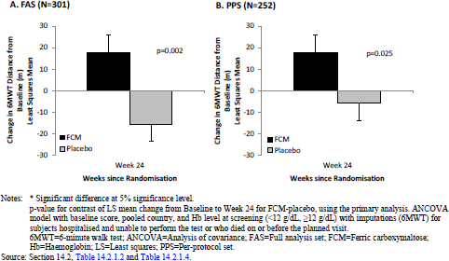
A statistically significant difference in 6 minute walking test was not observed at Week 6 or Week 12. Beyond Week 24, the change in 6 minute walking test remained statistically significantly different.
An analysis of the primary outcome by pre-defined subgroups demonstrated the point estimates of the treatment effect to consistently be in favour of ferric carboxymaltose treatment; however, the 95% confidence interval of the difference in 6 minute walking test crossed the line of unity for a number of subgroups (Figure 2).
Figure 2: Study FER-CARS-05. 6 minute walking test results at 24 weeks; subgroup analyses
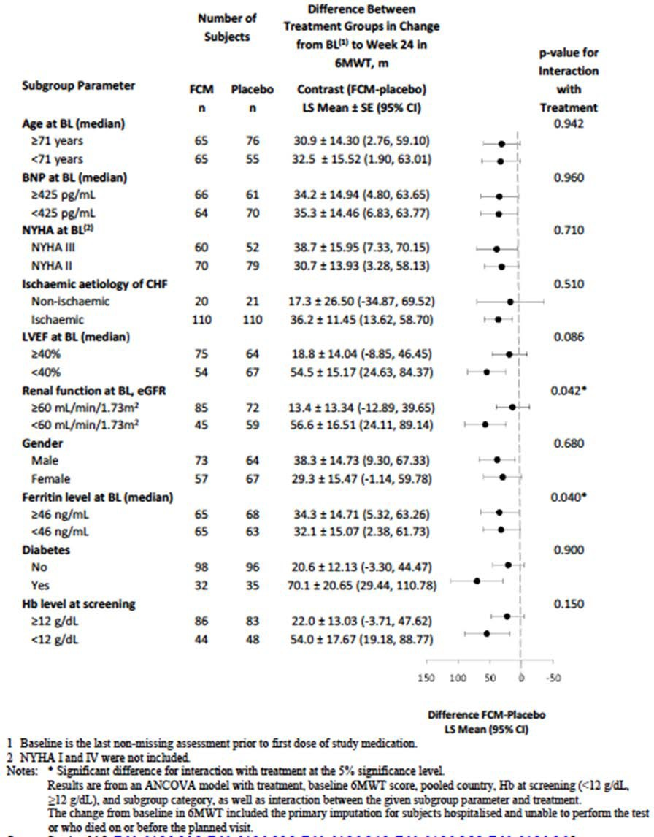
At Week 52, a number of subgroups had results which did not demonstrate statistical significance.

Safety

Safety arising from use in pregnancy
Safety data was available for 123 patients in Study FER-ASAP-2009-01 and 1793 patients who received Ferinject in pregnancy.
In the pivotal study, the incidence of AEs was 48.8% in the ferric carboxymaltose arm and 40.3% in the oral iron arm.
Pregnancy related AEs were more common in the ferric carboxymaltose arm (21.1%) as compared to the oral iron arm (11.3%).
Listing of the AEs occurring in at least 2 patients is shown in Table 16.
Table 16: Study FER-ASAP; Treatment-related AEs (≥ 2 subjects)
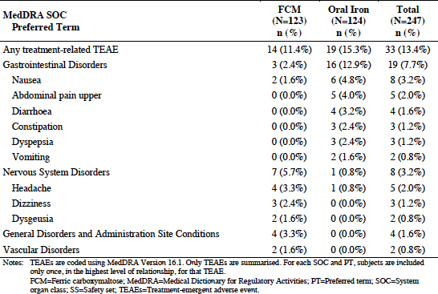
AEs that were more common in the ferric carboxymaltose arm included headache (8.1% versus 0.8%), dizziness (4.1% versus 1.6%) and musculoskeletal/connective tissue AEs (6.5% versus 1.6%). These AEs are listed in the current PI as common or uncommon adverse drug reactions associated with ferric carboxymaltose.
The incidence of gastrointestinal AEs was higher in the oral iron arm, with a notable increase in the incidence of dyspepsia (0.8% versus 6.5%) and upper abdominal pain (0.8% versus 4.8%).
The incidence of treatment related AEs was 11.4% in the ferric carboxymaltose arm and 15.3% in the oral iron arm.
No deaths on-study occurred. Ferric carboxymaltose discontinuation occurred due to the incidence of treatment related bronchospasm.
In post-marketing use, the top 15 adverse events were presented by the sponsor in the response to first round questions by the clinical evaluator.
Table 17: Top 15 reported adverse events in pregnancy cases after Ferinject exposure
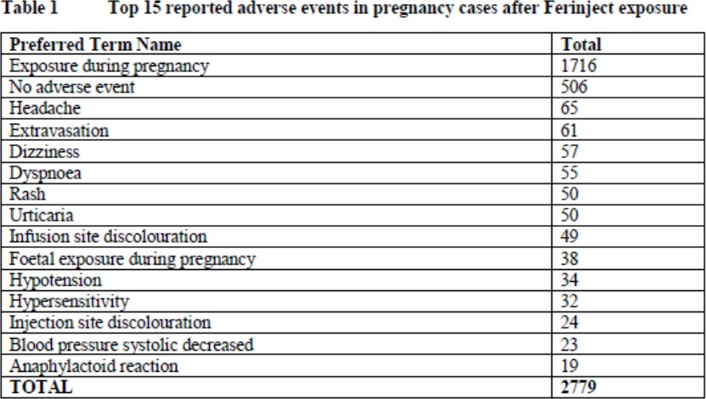
It was stated that 506 of 1793 (28%) women did not have an adverse event with ferric carboxymaltose exposure in pregnancy; that is the majority, 72%, did have an AE. This proportion is approximately 1.5 times that reported in the pivotal study.
Of note, there are events of hypotension and anaphylactoid reactions. The severity of these events is not fully reported by the sponsor.
Ferric carboxymaltose exposure of women beyond the sixteenth week of pregnancy was not associated with congenital malformation.
Ferric carboxymaltose exposure in women beyond the sixteenth week of pregnancy was related to events of uterine contractions/uterine hypertonia requiring tocolysis.
One event of antenatal fetal ductus venosus thrombosis was reported, leading to fetal demise.

Risk management plan
No RMP was presented to support the use of Ferinject in pregnant women

Delegate’s considerations

Efficacy

FER-ASAP-2009-01
This study was a Phase IIIb randomised open label study comparing ferric carboxymaltose and oral iron therapy in women who were not intolerant of oral iron therapy; this study was designed to demonstrate superiority of Ferinject, but failed to do so.
There were no data presented for the use of ferric carboxymaltose in pregnant women who were intolerant of oral iron therapy – this is the population proposed to be included in the dosing and administration section of the product information.
The magnitude of change in haemoglobin concentration for the ferric carboxymaltose arm from baseline to Week 3 was 11.4 g/L (95% CI 9.8 to 13.0); the change for the oral iron arm was 10.1 g/L (95% CI 8.5 to 11.8).
No statistically significant difference in change in haemoglobin concentration was observed between study arms. The failure to demonstrate a statistically significant difference in haemoglobin concentration at the primary analysis time-point at Week 3 (difference of 0.13 g/dL (95% CI for the difference -0.09 to 0.34)), or demonstrate a consistent difference beyond Week 3. This is likely due to the study design as the study did not adjust the outcome of change in haemoglobin according to the gestational age at study entry, or the effect of expected physiological change in haemoglobin with advancing gestation after study entry. The effect of study therapy assessed at Week 3 will be confounded by the relative change in haemoglobin due to the physiological change in maternal circulating volume over this period, which is not consistent across gestations. Similarly, within the oral iron treatment arm, the duration of daily oral iron therapy will vary owing to the gestation at study entry and gestation at delivery (end of study); this variation in treatment duration has not been considered adequately.
The evaluator noted the fixed doses of ferric carboxymaltose used in this study are lower than those estimated for adult patients according to body-weight based dosing. This needs to be clearly documented in the PI, which is not done so in the proposed document. This relative under-dosing may explain the lack of observed difference in haemoglobin concentration at Week 3 on study. However, there is no data presented to support the weight-based dosing in pregnant women and therefore the clinical trials section of the PI should be amended to include the dose regimen utilised in this trial.
This study is described as being performed in women in ‘late pregnancy’; this is an undefined term. It included those in the second trimester (defined as Weeks 13 to 28 gestation); the demographics of the included participants included 9.9% of the ferric carboxymaltose arm and 7.8% of the oral iron arm showed the actual baseline gestational age between 16 and 20 weeks; these patients cannot be considered to be in ‘late pregnancy’. There were no patients who received either treatment between 13 and 15 weeks gestation. The data for women in the gestation range of 16 to 20 weeks represents a small proportion of the total, and outcomes have not been shown to be similar to those receiving treatment beyond 20 weeks gestation.
There is an absence of data for women throughout the whole of the second trimester, and extrapolation of the data from women receiving Ferinject beyond Week 16 to earlier gestations in the second trimester is not appropriate.
The pivotal study in pregnant women was designed as a superiority study. The failure of the study to demonstrate superiority does not mean that the two treatments are non- inferior. Switching this study to one of non-inferiority has not been formally justified by the sponsor. A non-inferiority margin was not pre-defined, nor was it designed to demonstrate non-inferiority.
Taken in isolation, the change in haemoglobin concentration from baseline to Week 3 did show an increase of 11.4 g/L, with the 95% confidence interval not crossing the null value. This measure was not the primary end-point of the study, but does indicate there may be a benefit from ferric carboxymaltose in women beyond Week 16 of pregnancy who are unable to tolerate, or have an inadequate response to oral iron therapy.
Given the failure of the study to meet the primary outcome, all secondary outcomes cannot be considered supportive the primary outcome and should thus be removed from the clinical trial description in the PI.
This study was not powered to determine a difference in quality of life assessments; the Delegate notes sponsor has removed their proposed statement regarding such assessments from the PI.

Safety

Study FER-ASAP-2009-01
The Delegate notes the lack of safety information in the proposed PI in regard to ferric carboxymaltose use in pregnancy.
Among the 123 pregnant women in this study who received ferric carboxymaltose, 65.9% of subjects received 2 infusions of ferric carboxymaltose and 27.6% received 1 infusion.

Maternal adverse events
The incidence of all AEs irrespective of relationship to study treatment was higher in the ferric carboxymaltose arm as compared to those receiving oral iron; a difference of 8.4%. No patients died in the course of this study.
The MedDRA system organ class events which occurred with a higher incidence in the ferric carboxymaltose arm were: nervous system disorders (13.0% versus 3.2%) of headache (8.1% versus 0.8%), dizziness (4.1% versus 1.6%) and musculoskeletal/ connective tissue AEs (6.5% versus 1.6%). There was a higher incidence of pregnancy, puerperium and perinatal conditions in the ferric carboxymaltose arm (21.1% compared to the oral iron arm (11.3%).
Those occurring with a higher incidence in the oral iron arm were: gastrointestinal AEs was higher in the oral iron arm (20.2% versus 14.6%), with an increase in the incidence of dyspepsia (0.8% versus 6.5%) and upper abdominal pain (0.8% versus 4.8%).
The incidence of serious treatment emergent AEs was higher in the ferric carboxymaltose arm (18.7%) as compared to those receiving oral iron (8.1%). However, the incidence of treatment-related AEs was lower in the ferric carboxymaltose arm (11.4%) as compared to the oral iron arm (15.3%). Among the treatment-related AEs, headache, dizziness and dysgeusia had a higher incidence in the ferric carboxymaltose arm, whereas the events of nausea, upper abdominal pain, diarrhoea, constipation, dyspepsia and vomiting had a higher incidence in the oral iron arm (as shown in Table 18).
Table 18: Treatment-related TEAEs by SOCs and PT, occurring in ≥ 2 subjects in either treatment group (safety set, N = 247)
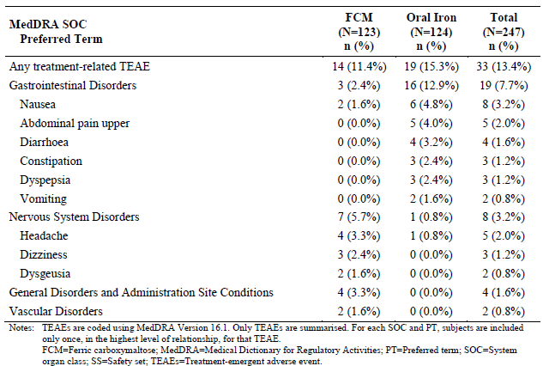
Discontinuation of study therapy occurred for one patient in the ferric carboxymaltose arm and seven patients in the oral iron arm.
Events of hypophosphatemia were higher in the ferric carboxymaltose arm (n = 10) compared to the oral iron arm (n = 1).

Newborn safety
The incidence of treatment emergent AEs was seven infants in the ferric carboxymaltose arm and five infants in the oral iron arm. None of these events was considered related to either treatment.
The sponsor has presented the Apgar scores for each treatment arm, but these are of little value in assessing the neonatal outcomes for the ferric carboxymaltose arm since the time between administration and delivery have not been presented.
While the birth weight data has been presented, and shows no difference between treatment arms, the birth weight data is confounded by the gestation at delivery and cannot be interpreted in isolation.
Two cases of congenital malformation were reported following third trimester exposure; neither of which is considered related to ferric carboxymaltose. Given the small number of pregnant women who received ferric carboxymaltose during the period of organogenesis in the beginning of the second trimester, there is inadequate evidence to confirm a lack of effect on the developing foetus.
One event of antenatal ductus venosus thrombosis was temporally related to ferric carboxymaltose administration. Given the rare incidence of ductus venosus thrombosis, and the small number of women who received ferric carboxymaltose, the risk cannot be further quantified. However, this event should be reported in the product information.
Two events, one of possibly related uterine contraction in the seventh month of pregnancy and one of Ferinject-related uterine hypertonia at 35 weeks + 4 days were reported. One event of foetal demise occurring 2 days following Ferinject administration at 27 weeks and 6 days of pregnancy was reported. The mother in this case was reported to have co- existent phlebitis and was receiving enoxaparin. Whilst the sponsor has stated that the event of phlebitis is a confounder, the Delegate considers that the foetal demise was possibly related, not just temporally related, to Ferinject administration.
The 2013 review of intravenous iron products by the EMA concluded at that time that despite the incidence of allergic and anaphylactic events, a test dose of product was not recommended in males and non-pregnant females.
The Delegate considers however, the need for a test dose in individual pregnant women who may be at risk cannot be excluded. The risk from events of anaphylaxis or severe hypersensitivity occurring in pregnancy includes the impact on foetal well-being, and thus the incidence should be reported separately from the overall safety data.

Study FER-CARS-05
This study comprised 152 patients treated with ferric carboxymaltose and 152 with saline placebo.
The rate of death in this study was similar between treatment arms: 8.6% in the ferric carboxymaltose arm and 9.2% in the placebo arm.
Overall, the pattern of AEs in this study was similar to those currently described in the approved PI.
The incidence of SAEs was comparable between study arms; discontinuations due to AEs were higher in the placebo arm (12.5%) as compared to ferric carboxymaltose (9.2%). Events of liver enzyme derangement occurred with a higher incidence in the ferric carboxymaltose arm; the currently approved PI states such events as occurring at an uncommon frequency.
The incidence of renal failure was similar between treatment arms.
Hypophosphataemia was reported for 7.9% of the ferric carboxymaltose arm and 0.7% of the placebo arm.

Dose
The dose regimen of ferric carboxymaltose employed in Study FER-ASAP-2009-01 must be clearly documented in the product information as it is substantially dissimilar to that currently approved, and that proposed.

Indication
The current submission has not proposed to amend the approved indications. Use of ferric carboxymaltose in pregnancy is tacitly incorporated in the current wording.

Proposed action
The Delegate considers the data to support the use of ferric carboxymaltose in pregnancy to be limited. The sponsor has not proposed to document any adverse event data arising from Ferinject use in pregnancy; the Delegate considers this inadequate to enable prescribers to satisfactorily gain informed consent from their patients. This is particularly of importance given the existing practice of use of Ferinject, and lack of approved use of any other intravenous iron preparation for use in pregnancy.
The sponsor has not proposed to amend the indication to specifically include the use of Ferinject in pregnant women, rather to amend other parts of the product information. Providing the product information is amended, and the outstanding pharmaceutical issues have been resolved, the Delegate had no reason to say, at this time, that the application for ferric carboxymaltose should not be approved for registration.

Request for ACM advice
- What is the opinion of the Committee regarding the efficacy of Ferinject use, noting the failure of the primary end-point of the pivotal superiority study?
- What is the opinion of the Committee regarding the safety of Ferinject use during pregnancy?
- Does the Committee consider the proposed product information and consumer medicines information satisfactorily represent the dosing regimen, efficacy and safety of Ferinject for the proposed use in pregnant women with iron deficiency anaemia?
- Regarding Ferinject use in pregnancy, does the Committee consider there to be any other risk minimisation measures necessary for the safe implementation of the medicine?

Response from Sponsor
The sponsor refers to the Delegate’s Overview and Request for ACM’s advice, and concurs with the Delegate’s preliminary assessment that there is “no reason to say, at this time, that ferric carboxymaltose should not be approved for registration”.
The sponsor advises that two changes to the dosage and administration compared to the original application are proposed, as follows:
- Additional information for determining the dosage using the simplified method:
For patients with haemoglobin value ≥ 140 g/L, an initial dose of 500 mg iron should be given and iron parameters should be checked prior to repeat dosing.
- Additional section on dosage in pregnancy:
It is recommended that the maximum cumulative dose in pregnant patients is restricted to 1000 mg or 1500 mg depending on baseline haemoglobin concentration and body weight.
Recommended maximum cumulative dose in pregnancy is as follows in Table 19.
Table 19: Recommended maximum cumulative dose in pregnancy
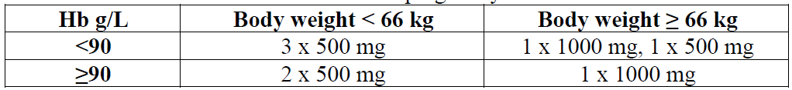
We note the Delegate’s questions to the ACM regarding the proposed changes to the Product Information. The sponsor’s response to the questions and additional comments raised by the Delegate are provided below.
- What is the opinion of the Committee regarding the efficacy of Ferinject use, noting the failure of the primary end-point of the pivotal superiority study?
Although the primary efficacy endpoint of the study was not met, treatment of iron deficiency anaemia (IDA) during the second and/or third trimester of pregnancy with IV ferric carboxymaltose, using a simplified dosing regimen for iron replenishment based on body weight and screening haemoglobin, resulted in higher mean haemoglobin levels at each time point compared to oral iron treatment. Also, subjects in the ferric carboxymaltose group were twice as likely to achieve anaemia correction by delivery (p = 0.031) and clinically relevant and statistically significant increases in serum ferritin were also observed. Although haemoglobin concentration was not the primary end-point of the study, this does indicate there may be a benefit from ferric carboxymaltose in women beyond Week 16 of pregnancy who are unable to tolerate or have an inadequate response to oral iron therapy.
The proposed PI recommends dosing in pregnancy which aligns with the clinical trial protocol and provides information to allow the prescriber to assess the benefit of Ferinject use in pregnancy.
- What is the opinion of the Committee regarding the safety of Ferinject use during pregnancy?
Anaemia during pregnancy is associated with an increased risk of complications, including premature delivery, and greater maternal and infant morbidity and mortality. According to the World Health Organization, over a third of pregnant women worldwide are anaemic, and of these approximately half are also suffering from iron deficiency.
The safety and efficacy of ferric carboxymaltose for the treatment of iron deficiency anaemia in women during the second and third trimester of pregnancy has been evaluated in a single randomised clinical trial conducted by the sponsor, Study FER-ASAP-2009-01. Despite a higher frequency of serious treatment emergent AEs in the ferric carboxymaltose group of this study, the overall tolerability of ferric carboxymaltose was similar to oral iron in this study, and the majority of treatment emergent AEs were mild in both treatment groups. There were no new or unexpected safety findings in mothers or newborns. Based on the data from this study, ferric carboxymaltose is considered well-tolerated for the treatment of iron deficiency anaemia in pregnant women beyond Week 16 of pregnancy. Oral iron is the standard treatment for iron deficiency anaemia in pregnancy and the safety findings in this study demonstrate that ferric carboxymaltose is as safe and well tolerated as oral iron.
The proposed PI provides information to allow the prescriber to assess the benefit-risk of Ferinject based on the gestation period and provides a list of reported adverse events. The safety profile in pregnancy does not differ from that of the general population. The PI also includes recommended dosing in pregnancy adjusted for baseline haemoglobin and body weight.
- Does the Committee consider the proposed product information and consumer medicines information satisfactorily represent the dosing regimen, efficacy and safety of Ferinject for the proposed use in pregnant women with iron deficiency anaemia?
The sponsor considers that the proposed product information and consumer medicines information satisfactorily represent the dosing regimen, efficacy and safety of Ferinject for the proposed use in pregnant women with iron deficiency anaemia. The proposed PI reflects the dosage regimen as used in Study FER-ASAP-2009-1 and provides the prescriber specific gestational period guidance regarding availability of data to support the safety and efficacy of the use of Ferinject during these periods.
- Regarding Ferinject use in pregnancy, does the Committee consider there to be any other risk minimisation measures necessary for the safe implementation of the medicine?
Although not included with this application, RMP v9.1 and the Australian Specific Annex were provided to the TGA on 19 July 2017. These documents include use in pregnant or lactating women as Missing Information (due to limitations of the clinical trial program). Routine pharmacovigilance activities and routine risk minimisation measures (‘Use in pregnancy’ (Category B3); and the ‘Use in lactation’ sections of the PI) are implemented to manage this safety concern.
In addition, routine pharmacovigilance activities and routine risk minimisation measures (’Precautions: Hypersensitivity Reactions’ section of the PI) are implemented for the Important Identified Risk of Hypersensitivity/ anaphylactoid reaction which is also relevant for the use in pregnancy:
Routine: included in Australian PI
‘Precautions: Hypersensitivity Reactions
Parenterally administered iron preparations can cause hypersensitivity reactions including anaphylactoid reactions, which may be fatal. Therefore, facilities for cardio-pulmonary resuscitation must be available. If allergic reactions or signs of intolerance occur during administration, the treatment must be stopped immediately. Hypersensitivity reactions have also been reported after previously uneventful doses of any parenteral iron complexes, including ferric carboxymaltose. Each patient should be observed for adverse effects for at least 30 minutes following each Ferinject injection.’
The pre-ACM report has referred to the ‘CHMP recommendations including yearly reviews of allergic reaction reports and a study to confirm the safety of IV iron medicines’; as per the RMP v9.1 this has been actioned. The annual reviews are submitted every year by end of March as requested by CHMP/EMA.
The sponsor considers that the currently implemented pharmacovigilance activities and risk minimisation measures adequately address the safety concern of Ferinject use in pregnancy.

Other issues
- The sponsor has not proposed to amend the RMP for Ferinject to reflect the use in pregnancy.
Please refer to response to Advice Sought, Question 4 above.
- The sponsor should provide an update to the overseas status of Ferinject in their pre- ACM response.
An update to the overseas status of Ferinject was provided.
- Study FER-ASAP-2009-01: Of note there are events of hypotension and anaphylactoid reactions. The severity of these events is not fully reported by the sponsor.
In Study FER-ASAP-2009-1, one patient in her 32nd week of pregnancy experienced a moderate bronchospasm and non-serious hypotension immediately after initiation of administration. The infusion was stopped, and the patient recovered spontaneously within 6 minutes. This is reflected in the clinical study report submitted.
- The 2013 review of intravenous iron products by the EMA concluded at that time that despite the incidence of allergic and anaphylactic events, a test dose of product was not recommended in males and non-pregnant females.
The Delegate considers however, the need for a test dose in individual pregnant women who may be at risk cannot be excluded.
The conclusion of the 2013 review of intravenous iron products by the EMA regarding the test dose referred to all IV iron products, and did not differentiate between special populations:
‘As data from the post marketing reporting showed that a successful test dose may give false assurance to the professionals dealing with the product administration, no test dose should be applied. Instead caution should be exercised in each iron administration even in the cases or repeat administrations according to the CHMP recommendations.’
The Ferinject PI currently addresses the above recommendation with a precaution stating that ‘each patient should be observed for adverse effects for at least 30 minutes following each Ferinject injection’.
Furthermore, the EMA review highlights one pregnancy case where a test dose did not prevent the occurrence of severe reactions:
‘The test-dose does not seem to prevent the occurrence of severe reactions. This is illustrated for example, by one case in United States where a pregnant woman had a test-dose of sodium ferric gluconate without complications one week before experiencing an anaphylactoid reaction after a unique infusion.’
This aligns with the current PI text stating that ‘hypersensitivity reactions have also been reported after previously uneventful doses of any parenteral iron complexes, including ferric carboxymaltose’.
The sponsor considers that the need for a test dose in individual pregnant women who may be at risk can therefore be excluded.
- The risk from events of anaphylaxis or severe hypersensitivity occurring in pregnancy includes the impact on foetal well-being, and thus the incidence should be reported separately from the overall safety data.
In pregnancy clinical trials, only one related event of mild bronchospasm and hypotension was reported for Ferinject (refer to response to request 3 above). A section on post marketing spontaneous reports in pregnancy cases is now provided in the PI, which includes hypersensitivity and anaphylactoid reaction.

Advisory Committee Considerations
The Advisory Committee on Medicines (ACM), having considered the evaluations and the Delegate’s overview, as well as the sponsor’s response to these documents, advised the following:
The ACM taking into account the submitted evidence of efficacy, safety and quality, agreed with the Delegate and considered Ferinject containing 1000 mg of ferric carboxymaltose in 20 mL solution for IV administration to have an overall positive benefit-risk profile for the current indication;
‘Ferinject is indicated for treatment of iron deficiency when oral iron preparations are ineffective or cannot be used.
The diagnosis must be based on laboratory tests.’

Changes to Product Information for a currently registered product:
In addition, the ACM considered the submitted evidence of efficacy, safety and quality, for the use of Ferinject ferric carboxymaltose in pregnancy and agreed with the Delegate to alter the proposed change to the dosing section of the PI and relevant areas in the CMI.
The proposed dosage changes as requested Pre-ACM by the sponsor:
‘Pregnancy:
It is recommended that the maximum cumulative dose in pregnant patients is restricted to 1500 mg’.
The ACM advised that the following statement would be more appropriate with the inclusion of the dosing table (shown above as Table 19) as proposed by the sponsor:
‘Pregnancy
It is recommended that the maximum cumulative dose in pregnant patients is restricted to 1000 mg or 1500 mg depending on baseline haemoglobin concentration and body weight.’

Delegate’s decision
The Delegate had no reason to say, at this time, that the application to register a new strength for ferric carboxymaltose should not be approved for registration.

Proposed conditions of registration
The ACM agreed with the delegate on the proposed conditions of registration and advised on the inclusion of the following:
- Subject to satisfactory implementation of the Risk Management Plan negotiated by the TGA.
- Negotiation of the PI and CMI to the satisfaction of the TGA.

Proposed Product Information (PI)/ Consumer Medicine Information (CMI) amendments
The ACM agreed with the Delegate to the proposed amendments to the PI and CMI and specifically advised on the inclusion of the following:
- As discussed previously for the Dosing section, the ACM have recommended changes with the sponsor’s proposed statement regarding pregnancy and the inclusion of a dosing table.
- Inclusion of a contraindication to the use of ferric carboxymaltose in the first trimester of pregnancy.
- The PI should include a statement regarding the individual case reports of events including: antenatal fetal ductus venous thrombosis, uterine hypertonia or contractions, and fetal demise when Ferinject has been used in pregnancy.

Specific Advice
The ACM advised the following in response to the Delegate’s specific questions on the submission:
- What is the opinion of the Committee regarding the efficacy of Ferinject use, noting the failure of the primary end-point of the pivotal superiority study?
The opinion of the Committee regarding the efficacy of Ferinject use in the pivotal superiority study was that while it did not show superiority it did show improvement in: anaemia correction, ferritin, reticulocyte, haemoglobin, and quality of life measures with total iron dosing tenfold less than the oral preparation. The ACM did note that although the pivotal study failed the primary end-point of the study, which did lower the quality of the evidence, it was enough evidence to demonstrate efficacy.
- What is the opinion of the Committee regarding the safety of Ferinject use during pregnancy?
Based on the pivotal study, the ACM concluded that while there was evidence supporting the use of Ferinject in pregnancy from 16 weeks onwards. As a result of the adverse preclinical findings in pregnancy, the Committee consider it appropriate to contraindicate the use of ferric carboxymaltose in the first trimester of pregnancy in humans.
- Does the Committee consider the proposed product information and consumer medicines information satisfactorily represent the dosing regimen, efficacy and safety of Ferinject for the proposed use in pregnant women with iron deficiency anaemia?
The Committee agrees that the amended proposed product information and consumer medicines information presented in the sponsor’s Pre-ACM document to satisfactorily represents the dosing regimen, efficacy and safety of Ferinject for the proposed use in pregnant women with iron deficiency anaemia, providing the contraindication (above) is included.
- Regarding Ferinject use in pregnancy, does the Committee consider there to be any other risk minimisation measures necessary for the safe implementation of the medicine?
The Committee considers the following risk minimisation measures to be necessary for the safe implementation of the medicine:
- To ensure adequate resuscitation procedures are in place for the possibility of the event of anaphylaxis or severe hypersensitivity occurring in pregnant women.
- To ensure that there is adequate care and monitoring for pregnant women following ferric carboxymaltose IV infusion.
- While a test dose is unnecessary, it is important to regard and treat all IV doses of Ferinject as a test dose as events of hypersensitivity or anaphylaxis have been reported beyond the first IV infusion.
The ACM advised that implementation by the sponsor of the recommendations outlined above to the satisfaction of the TGA, in addition to the evidence of efficacy and safety provided would support the safe and effective use of this product.

Outcome
Based on a review of quality, safety and efficacy, TGA approved the registration of Ferinject ferric carboxymaltose 1000 mg in 20 mL for intravenous infusion.
The approved indication is:
‘Ferinject is indicated for treatment of iron deficiency when oral iron preparations are ineffective or cannot be used.
The diagnosis must be based on laboratory tests.’

Specific conditions of registration applying to these goods
- This approval does not impose any requirement for the submission of Periodic Safety Update Reports. You should note that it is a requirement that all existing requirements for the submission of PSURs as a consequence of the initial registration or subsequent changes must be completed.

Attachment 1. Product Information
The PI for Ferinject approved with the submission which is described in this AusPAR is at Attachment 1. For the most recent PI, please refer to the TGA website at <https://www.tga.gov.au/product-information-pi>.

Therapeutic Goods Administration
PO Box 100 Woden ACT 2606 Australia
Email: info@tga.gov.au Phone: 1800 020 653 Fax: 02 6232 8605
https://www.tga.gov.au

Camaschella C. Iron-deficiency anemia. N Engl J Med. 2015; 372: 1832-1843
Total body iron deficit/cumulative iron dose (mg) = body weight (kg) x (target Hb – actual Hb in g/L) x 0.24 + iron depot (mg). Use ideal body weight in overweight patients. If underweight, use actual body weight. The factor 0.24= 0.0034 x 0.07 x 1,000: For this calculation the iron content of haemoglobin = 0.34%, blood volume = 7% of the bodyweight, and 1,000 is the conversion from g to mg. Iron depot: < 35 kg body weight: iron depot = 15 mg/kg body weight; ≥ 35 kg body weight: iron depot = 500 mg.
Estimated cumulative iron dose Hb g/L Body weight 35 kg to < 70 kg* Body weight ≥ 70 kg < 100 g/L 1500 mg 2000 mg ≥ 100 g/L 1000 mg 1500 mg *Use ideal body weight in overweight patients. If underweight, use actual body weight
Anker SD et al. Effects of ferric carboxymaltose on hospitalisations and mortality rates in iron-deficient heart failure patients: an individual patient data meta-analysis. Eur J Heart Fail. 2018; 20: 125-133.
QTcF: QT interval corrected for heart rate using Fridericia's correction formula
SF-36: Short form 36 questionnaire, a 36 item patient reported health survey.
APGAR score or ‘Appearance, Pulse, Grimace, Activity, and Respiration’ score is an index used to evaluate the condition of a newborn infant based on a scoring of 0, 1 or 2 in each of 5 domains, with a maximum culmulative score of 10.
Abbassi-Ghanavati M, et al. Pregnancy and laboratory studies: a reference table for clinicians. Obstet Gynecol. 2009; 114: 1326-1331
http://www.ema.europa.eu/docs/en_GB/document_library/Press_release/2013/06/WC5 00144874.pdf
NYHA Functional Class II: Slight limitation of physical activity. Ordinary physical activity results in fatigue, palpitation, dyspnoea or angina pectoris (mild CHF); Class III Marked limitation of physical activity. Less than ordinary physical activity leads to symptoms (moderate CHF).
CPMP/EWP/482/99 Committee for Proprietary Medicinal Products. Points to consider on switching between superiority and non-inferiority.
Pregnancy Category B3 is defined as: Drugs which have been taken by only a limited number of pregnant women and women of childbearing age, without an increase in the frequency of malformation or other direct or indirect harmful effects on the human fetus having been observed. Studies in animals have shown evidence of an increased occurrence of fetal damage, the significance of which is considered uncertain in humans.
EMA Article 31 referral procedure number EMEA/H/A-31/1322, page 27/44 of the CHMP referral assessment report
EMA Article 31 referral procedure number EMEA/H/A-31/1322, page 15/44 of the CHMP referral assessment report
The ACM provides independent medical and scientific advice to the Minister for Health and the Therapeutic Goods Administration (TGA) on issues relating to the safety, quality and efficacy of medicines supplied in Australia including issues relating to pre-market and post-market functions for medicines. The Committee is established under Regulation 35 of the Therapeutic Goods Regulations 1990. Members are appointed by the Minister. The ACM was established in January 2017 replacing Advisory Committee on Prescription Medicines (ACPM) which was formed in January 2010. ACM encompass pre and post-market advice for medicines, following the consolidation of the previous functions of the Advisory Committee on Prescription Medicines (ACPM), the Advisory Committee on the Safety of Medicines (ACSOM) and the Advisory Committee on Non-Prescription Medicines (ACNM). Membership comprises of professionals with specific scientific, medical or clinical expertise, as well as appropriate consumer health issues relating to medicines.
Clarification: with regard to the proposed PI changes the Delegate stated in correspondence dated 15 May 2018: ‘My overview for this submission did not recommend inclusion of a contraindication, which is consistent with the decision of the previous Delegate. In view of the data contained in the dossier, and the information received today, my position is to not include a contraindication, given the product information has sufficient detail as to which patients ferric carboxymaltose have data regarding efficacy and safety, together with the newly included table of reported adverse events in pregnancy.’

