AusPAR Attachment 2

Extract from the Clinical Evaluation Report for ezetimibe and atorvastatin
  - Proprietary Product Name: Atozet / Zeteze
  - Sponsor: Merck Sharp & Dohme Australia Pty Ltd
Date of first round report: 8 August 2016
Date of second round report: 28 September 2016

About the Therapeutic Goods Administration (TGA)
- The Therapeutic Goods Administration (TGA) is part of the Australian Government Department of Health, and is responsible for regulating medicines and medical devices.
- The TGA administers the Therapeutic Goods Act 1989 (the Act), applying a risk management approach designed to ensure therapeutic goods supplied in Australia meet acceptable standards of quality, safety and efficacy (performance), when necessary.
- The work of the TGA is based on applying scientific and clinical expertise to decision-making, to ensure that the benefits to consumers outweigh any risks associated with the use of medicines and medical devices.
- The TGA relies on the public, healthcare professionals and industry to report problems with medicines or medical devices. TGA investigates reports received by it to determine any necessary regulatory action.
- To report a problem with a medicine or medical device, please see the information on the TGA website <https://www.tga.gov.au>.
About the Extract from the Clinical Evaluation Report
- This document provides a more detailed evaluation of the clinical findings, extracted from the Clinical Evaluation Report (CER) prepared by the TGA. This extract does not include sections from the CER regarding product documentation or post market activities.
- The words [Information redacted], where they appear in this document, indicate that confidential information has been deleted.
- For the most recent Product Information (PI), please refer to the TGA website <https://www.tga.gov.au/product-information-pi>.
Copyright
© Commonwealth of Australia 2017
This work is copyright. You may reproduce the whole or part of this work in unaltered form for your own personal use or, if you are part of an organisation, for internal use within your organisation, but only if you or your organisation do not use the reproduction for any commercial purpose and retain this copyright notice and all disclaimer notices as part of that reproduction. Apart from rights to use as permitted by the Copyright Act 1968 or allowed by this copyright notice, all other rights are reserved and you are not allowed to reproduce the whole or any part of this work in any way (electronic or otherwise) without first being given specific written permission from the Commonwealth to do so. Requests and inquiries concerning reproduction and rights are to be sent to the TGA Copyright Officer, Therapeutic Goods Administration, PO Box 100, Woden ACT 2606 or emailed to <tga.copyright@tga.gov.au>.

Contents
List of abbreviations 5
1. Introduction 7
1.1. Drug class and therapeutic indication 7
1.2. Dosage forms and strengths 8
1.3. Dosage and administration 8
2. Clinical rationale 9
3. Contents of the clinical dossier 9
3.1. Scope of the clinical dossier 9
3.2. Paediatric data 10
3.3. Good clinical practice 10
4. Pharmacokinetics 10
4.1. Studies providing pharmacokinetic information 10
5. Pharmacodynamics 10
5.1. Studies providing pharmacodynamic information 10
6. Dosage selection for the pivotal studies 10
7. Clinical efficacy 10
7.1. Studies providing evaluable efficacy data 10
7.2. Pivotal or main efficacy studies 11
7.3. Other efficacy studies 27
7.4. Analyses performed across trials: pooled and meta analyses 27
7.5. Evaluator’s conclusions on clinical efficacy 27
8. Clinical safety 29
8.1. Studies providing evaluable safety data 29
8.2. Studies that assessed safety as the sole primary outcome 30
8.3. Patient exposure 30
8.4. Adverse events 30
8.5. Evaluation of issues with possible regulatory impact 33
8.6. Other safety issues 39
8.7. Post marketing experience 39
8.8. Evaluator’s overall conclusions on clinical safety 40
9. First round benefit-risk assessment 41
9.1. First round assessment of benefits 41
9.2. First round assessment of risks 41
9.3. First round assessment of benefit-risk balance 42
10. First round recommendation regarding authorisation 42
11. Clinical questions 43
11.1. General 43
11.2. Efficacy 43
11.3. Safety 43
12. Second round evaluation in response to questions 43
12.1. General 43
12.2. Efficacy 47
12.3. Safety 51
13. Second round benefit-risk assessment 52
13.1. Second round assessment of benefits 52
13.2. Second round assessment of risks 52
13.3. Second round assessment of benefit-risk balance 52
14. Second round recommendation regarding authorisation 52

List of abbreviations
Abbreviations | Meaning
ACPM | Advisory Committee on Prescription Medicines
ACS | Acute coronary syndrome
AE | Adverse event
AESI | Adverse event of special interest
AMI | Acute myocardial infarction
ARGPM | Australian Regulatory Guidelines for Prescription Medicines
ARR | Absolute risk reduction
ARTG | Australian Register of Therapeutic Goods
CABG | Coronary artery bypass graft
CHD | Coronary heart disease
CK | Creatine kinase
CK-MB | Creatine kinase-MB fraction
CMI | Consumer Medicines Information
CSR | Clinical Study Report
CTT | Cholesterol Treatment Trialists
CVD | Cardiovascular disease
DSMB | Data and Safety Monitoring Board
ECG | Electrocardiogram
EU SPC | European Union Summary of Product Characteristics
HeFH | Heterozygous Familial Hypercholesterolaemia
HMG-CoA | hydroxymethylglutaryl coenzyme A
HoFH | Homozygous Familial Hypercholesterolaemia
hs-CRP | High sensitivity C-reactive protein
ITT | Intention to treat
LDL-C | Low density lipoprotein cholesterol
LMC | LDL-C Monitoring Committee
MI | Myocardial infarction
NNT | Number needed to treat
NPC1L1 | Niemann-Pick C1-Like transporter
NSTE-ACS | Non-ST Segment Elevation Acute Coronary Syndrome
NSTEMI | Non-ST Segment Elevation Myocardial Infarction
PCI | Percutaneous coronary intervention
PI | Product information
RMP | Risk Management Plan
SAE | Serious adverse event
SMQ | Standardised MedDRA query
STEMI | ST-Elevation Myocardial Infarction
TG | Triglycerides
TIA | Transient ischaemic attack
UA | Unstable angina
USPI | United States Prescribing Information

Introduction
This is an application to extend the indications for Atozet and Zeteze (ezetimibe/atorvastatin) tablets to include the following indication:
Prevention of Cardiovascular Disease
ATOZET/ZETEZE is indicated to reduce the risk of cardiovascular events (cardiovascular death, nonfatal myocardial infarction, nonfatal stroke, hospitalization for unstable angina, or need for revascularization) in patients with coronary heart disease (CHD).
This application is related to the submissions currently under TGA evaluation to extend the indications for Ezetrol (ezetimibe) PM-2015-01524-1-3 and Vytorin (ezetimibe/simvastatin) PM-2015-01525-1-3 to include prevention of cardiovascular disease.

Drug class and therapeutic indication
The current approved indications for the combination product Atozet are:
Primary Hypercholesterolaemia
ATOZET is indicated as adjunctive therapy to diet in patients with primary (heterozygous familial and non-familial) hypercholesterolaemia where use of a combination product is appropriate in those patients:
    - not appropriately controlled with atorvastatin or ezetimibe alone; or
    - already treated with atorvastatin and ezetimibe
Homozygous Familial Hypercholesterolaemia (HoFH)
ATOZET is indicated in patients with HoFH. Patients may also receive adjunctive treatments (e.g. LDL apheresis).
As outlined in the AusPAR for Atozet, ezetimibe inhibits the intestinal absorption of cholesterol and atorvastatin is a synthetic lipid lowering agent. Ezetimibe targets the sterol transporter, Niemann-Pick C1-Like (NPC1L1), which is responsible for the intestinal uptake of cholesterol and phytosterols.
The current approved indications for ezetimibe are:
Adults (≥ 18 Years)
Primary Hypercholesterolaemia
EZETROL administered alone, or with an HMG-CoA reductase inhibitor (statin), is indicated as adjunctive therapy to diet in patients with primary (heterozygous familial and non-familial) hypercholesterolaemia.
Homozygous Familial Hypercholesterolaemia (HoFH)
EZETROL, administered with a statin, is indicated for patients with HoFH. Patients may also receive adjunctive treatments (e.g., LDL apheresis).
Homozygous Sitosterolaemia (Phytosterolaemia)
EZETROL is indicated for the reduction of elevated sitosterol and campesterol levels in patients with homozygous familial sitosterolaemia.
Children and Adolescents 10-17 Years (pubertal status: boys Tanner Stage II and above and girls who are at least one year post-menarche)
Heterozygous Familial Hypercholesterolaemia (HeFH)
EZETROL co-administered with simvastatin (doses up to 40 mg) is indicated as an adjunctive therapy to diet in adolescent patients (10-17 years old) with heterozygous familial hypercholesterolaemia where use of a combination product is appropriate:
    - Patients not appropriately controlled with a statin or ezetimibe alone
    - Patients already treated with a statin and ezetimibe
Homozygous Familial Hypercholesterolaemia (HoFH)
EZETROL co-administered with simvastatin (doses up to 40 mg) is indicated in adolescent patients (10-17 years old) with HoFH. Patients may also receive adjunctive treatments (e.g. LDL apheresis).
Atorvastatin inhibits hydroxymethylglutaryl coenzyme A (HMG-CoA) reductase, the rate limiting enzyme that converts 3-hydroxy-3-methyl-glutaryl-coenzyme A to mevalonate, a precursor of sterols, including cholesterol.
The current approved indications of Lipitor (atorvastatin) are:
LIPITOR is indicated as an adjunct to diet for the treatment of patients with hypercholesterolaemia.
Prior to initiating therapy with atorvastatin, secondary causes of hypercholesterolaemia (e.g. poorly controlled diabetes mellitus, hypothyroidism, nephrotic syndrome, dysproteinaemias, obstructive liver disease, other drug therapy, and alcoholism) should be identified and treated.
LIPITOR is indicated in hypertensive patients with multiple risk factors for coronary heart disease (CHD) which may include diabetes, history of stroke or other cerebrovascular disease, peripheral vascular disease or existing asymptomatic CHD (see CLINICAL TRIALS, Prevention of Cardiovascular Disease) to reduce the risk of non-fatal myocardial infarction and non-fatal stroke.
These effects do not replace the need to independently control known causes of cardiovascular mortality and morbidity such as hypertension, diabetes and smoking. as an adjunct to diet for the treatment of patients with hypercholesterolaemia.

Dosage forms and strengths
No new dosage forms or strengths are proposed for Atozet or Zeteze. It is noted that the application cover letter lists only the combination product and does not include the composite pack ARTG numbers. This issue should be clarified with the Sponsor.

Dosage and administration
No changes to the dosage and administration instructions have been proposed but the Sponsor has introduced a new heading in this section in relation to the proposed indication. The proposed heading would indicate that the general dosage instructions relate to the existing primary hypercholesterolaemia and the proposed CHD indications. The separate dosage instructions for patients with HoFH and special patient populations remain unchanged.
The current dosage instructions in this section are:
ATOZET can be administered within the dosage range of 10/10 mg to 10/80 mg as a single daily dose. The recommended starting dose of ATOZET 10/10 mg or 10/20 mg once daily. ATOZET can be administered at any time of the day, with or without food. Therapy should be individualised according to the target lipid levels, the recommended goal of therapy, and the patient's response. After initiation and/or upon titration of ATOZET, lipid levels should be re‐analysed within 2 or more weeks and dosage adjusted according to the patient's response.
The proposed heading would indicate that doses within the range of 10/10mg to 10/80mg as a single daily dose would be efficacious for the prevention of cardiovascular events.

Clinical rationale
The Sponsor states that the IMPROVE-IT study demonstrated that the addition of ezetimibe to simvastatin reduced the risk of cardiovascular (CV) events in subjects with coronary heart disease (CHD) beyond that produced by simvastatin alone. Based on the results from study, the Sponsor is seeking an indication for ezetimibe (when used with a statin), ezetimibe/simvastatin, and ezetimibe/atorvastatin to reduce the risk of CV events in patients with CHD. The Sponsor argues that although IMPROVE-IT studied patients presenting with acute coronary syndrome (ACS), used simvastatin as the background statin, and entered patients with defined low density lipoprotein cholesterol (LDL-C) levels the conclusions apply to patients with chronic CHD, those receiving any statin, and to subjects with a broad range of LDL-C levels.
In the Pre-submission overview the Sponsor argues that the results of IMPROVE-IT are generalizable to statins due to the demonstrated effect of statins on cardiovascular outcomes, the demonstrated additive effect of ezetimibe on LDL lowering with statins and the demonstrated relationship between LDL-C lowering and reduction in cardiovascular risk across all statins. The Sponsor states that ezetimibe supports a consistent proportional additive decrease in LDL‐C levels when added to or co‐administered with any statin. In pooled analyses of clinical trials, a 25% relative reduction in LDL‐C is observed when ezetimibe is added to ongoing statin therapy, an observation generally independent of statin type, potency and dose, and patient characteristics.
The Sponsor states that in January 2015, in a pre‐submission consultation with the German Federal Institute for Drugs and Medical Devices (BfArM), the BfArM concurred that the incremental benefit exhibited with ezetimibe was seen as a group effect and could be applied to all statins.
The Cholesterol Treatment Trialists’ (CTT) meta‐analysis from 26 large, randomised, double‐blind, placebo‐controlled studies is reported to have shown that statin therapy reduces cardiovascular risk by about 20% per 1 mmol/L LDL‐C reduction. The relationship of reduction in LDL‐C to reduction in CV events observed in IMPROVE‐IT is reported to be consistent with the CTT findings. The Sponsor states that the findings of an additive effect of NPC1L1 and HMGCoA reductase genetic variants on LDL lowering and the additive CV risk reduction associated with presence of both NPC1L1 and HMGCoA reductase genetic variants is consistent with the IMPROVE‐IT result demonstrating the additive outcomes benefit of ezetimibe and simvastatin, targeting NPC1L1 and HMGCoA reductase, respectively. The Sponsor concludes that co‐administration of ezetimibe with an inhibitor of HMG CoA reductase will have additive benefit on CV risk reduction.

Contents of the clinical dossier

Scope of the clinical dossier
The submission contained the following clinical information:
- One efficacy and safety study- IMPROVE-IT
- An analysis of post market safety including CIOMS reports for various adverse events (AEs)
- 147 literature references

Paediatric data
The submission did not include paediatric data.

Good clinical practice
The IMPROVE-IT clinical study report states that the trial was conducted in conformance with GCP standards and applicable country and/or local statutes and regulations regarding ethical committee review, informed consent, and the protection of human subjects participating in biomedical research. The report states that throughout the trial, study sites noted to have GCP non-compliance issues were reviewed at GCP compliance committee. A total of 24 sites were reported to this committee, of which there were 7 where serious GCP non-compliance issues were noted. The report indicates that the principle of Intention-to-Treat was followed and no subject’s data were excluded from the efficacy analyses on the basis of GCP violations.

Pharmacokinetics

Studies providing pharmacokinetic information
No new pharmacokinetic studies were included in the submission.

Pharmacodynamics

Studies providing pharmacodynamic information
No new pharmacodynamics studies were included in the submission.

Dosage selection for the pivotal studies
The CSR for the pivotal study IMPROVE-IT states that all subjects were to be dosed with study drug in the evening, consistent with the ezetimibe/simvastatin combination label and simvastatin label. More detailed information regarding the study treatments is below. The Sponsor is applying to have the proposed indication applied to Atozet products with a range of strengths for the atorvastatin component (10-80mg).

Clinical efficacy

Studies providing evaluable efficacy data
The Sponsor has not provided any clinical data that directly support the proposed indication for Atozet.
The Sponsor has relied on clinical data provided in one efficacy study, Study P04103 (IMPROVE-IT), to support the proposed indication. The IMPROVE-IT study examined the efficacy of ezetimibe/simvastatin compared to simvastatin monotherapy in high risk patients with ACS. The Sponsor argues that although IMPROVE-IT studied patients presenting with ACS, used simvastatin as the background statin and entered patients with defined LDL-C levels, the results provide sufficient information to support the application of the conclusions to patients with chronic CHD, those receiving any statin and to patients with a broad range of LDL-C levels. TGA has evaluated this study in submissions PM-2015-01524-1-3 and PM-2015-01525-1-3, but – at the time of the writing of this clinical evaluation report – is yet to finalise a decision about approval of the requested extension of indication.
The Sponsor has relied on extrapolation of these data to support its requested extension of indication for Atozet.

Pivotal or main efficacy studies

Study P04103 (IMPROVE IT)

Study design, objectives, locations and dates
Study P04103 (IMPROVE-IT) was a multicentre, randomised, double-blind, active-control, Phase 3b trial comparing the efficacy of ezetimibe plus simvastatin and simvastatin monotherapy in high risk subjects with stabilised ACS. The trial had 1147 centres that allocated subjects to study treatments in 39 countries.
The primary objective of the study was to evaluate the clinical benefit of ezetimibe/simvastatin combination compared with simvastatin in stabilized ACS subjects defined as the reduction in the risk of the occurrence of the composite endpoint of CV death, major coronary events, and non-fatal stroke. Major coronary events included non-fatal MI, documented unstable angina (UA) that required admission into a hospital, and all coronary revascularization with either percutaneous coronary intervention (PCI) or coronary artery bypass grafting (CABG) occurring at least 30 days after randomized treatment assignment.
The study had three secondary objectives evaluating the clinical benefit of ezetimibe/simvastatin combination compared with simvastatin in stabilized ACS subjects on the following composite endpoints:
- Death due to any cause, major coronary events, or non-fatal stroke.
- Death due to CHD, non-fatal MI, and urgent coronary revascularization (either PCI or CABG occurring at least 30 days after randomization).
- CV death, non-fatal myocardial infarction (MI), documented UA that requires admission into a hospital, all revascularization (including both coronary and non-coronary) occurring at least 30 days after randomization, and non-fatal stroke.
The study the following tertiary objectives:
- To evaluate the clinical benefit of ezetimibe/simvastatin combination compared with simvastatin in stabilized ACS subjects on each of the following endpoints analysed individually:
- death from any cause
- CHD death
- CV death
- MI
- documented UA that requires admission into a hospital
- all coronary revascularization with either PCI or CABG occurring at least 30 days after randomization
- urgent coronary revascularization with either PCI or CABG (occurring at least 30 days after randomization
- all revascularization (including both coronary and non-coronary) occurring at least 30 days after randomization
- stroke
- any cardiovascular event leading to admission into a hospital
- CHF that requires hospitalization occurring at least 30 days after randomization
- To evaluate the proportion of subjects achieving reductions in LDL-C and hs-CRP:
- To evaluate the percentage of subjects achieving endpoint concentrations of LDL-C of <70 mg/dL (<1.8 mmol/L) and hs-CRP of <2.0 mg/L following 1 month and 4 months of treatment with ezetimibe/simvastatin combination compared with simvastatin.
- To evaluate the potential relationship between the risk of occurrence of any primary endpoint event and the concentrations of LDL-C and high sensitivity-C-reactive protein (hs-CRP) following 1 month and 4 months of treatment with ezetimibe/simvastatin combination or simvastatin.
- To evaluate the safety and tolerability of ezetimibe/simvastatin combination compared with simvastatin.
The study included the additional pre-specified exploratory analyses:
- Composite of CV death, non-fatal MI, and non-fatal Stroke
- Composite of coronary death, MI, and coronary revascularization
- Composite of CHD Death or Non-fatal MI
- Composite of Cardiovascular Death or Non-fatal MI

Inclusion and exclusion criteria
The inclusion and exclusion criteria for the IMPROVE IT study were extensive, a summary of the key criteria is provided in this report. The study included adult male and female subjects presenting with NSTE-ACS (unstable angina or NSTEMI) or STEMI, for whom a PCI was planned for the qualifying event. A subject should have undergone PCI prior to randomization and within the 10-day period after initial hospitalization for the qualifying event. The study included both lipid-therapy naïve patients and patients receiving chronic prescription lipid-lowering therapy. A subject was considered to be receiving chronic prescription lipid-lowering therapy if he/she had been receiving any prescription lipid-lowering therapy continuously for >4 weeks prior to and continuing until the qualifying ACS hospital admission. Planned PCIs that were known at the time of screening must have been completed within 30 days of randomization. Subject must have had NSTE-ACS or STEMI according to the following criteria:
- A NSTE-ACS subject participating in the EARLY-ACS Trial who had been clinically stabilized was to be eligible for entry in IMPROVE-IT ≤10 days (≤240 hours) of presenting to the hospital. The subject must have completed the 96-hour primary endpoint of the acute segment of EARLY-ACS treatment and have been clinically stable before enrolling in IMPROVE-IT;
OR
- A subject not participating in the EARLY-ACS Trial, but who was defined as NSTE-ACS by meeting all of the following criteria, and had been clinically stable for at least 24 hours prior to screening/randomization, was to be eligible to enter directly into the current trial ≤10 days (≤240 hours) of acute admittance into a hospital:
  - The subject had experienced symptoms of cardiac ischemia at rest prompting acute care hospitalization with at least one episode lasting at least 10 minutes;
  - $≥$50 years of age; and
  - Any 1 of the following criteria:
    - Electrocardiogram (ECG) changes characterized by either new or presumably new ST-segment depression ≥0.1 mV in at least 2 contiguous ECG leads; or transient (<30 minutes) ST-segment elevation ≥0.1 mV in at least 2 contiguous ECG leads.
    - Any of the following cardiovascular biomarkers elevated above the upper limit of normal (ULN): Troponin I; Troponin T; and/or Creatine kinase-MB fraction (CK-MB).
    - Diabetes mellitus;
    - History of prior MI;
    - History of peripheral arterial disease;
    - History of cerebrovascular disease;
    - History of CABG ≥3 years prior to entry; or
    - Multivessel coronary artery disease previously documented by catheterization (2 or 3 vessels with ≥50% stenosis) including the catheterization performed during the index admission for the qualifying event.
- Subject must have met the following criteria for LDL-C concentrations at the time of admittance into a hospital (each measurement of LDL-C performed within the first 24 hours of admittance must have met the criteria):
  - A subject receiving chronic prescription lipid-lowering therapy must have been receiving therapy with a lipid-lowering potency equal to or less than simvastatin 40 mg daily. All other subjects (including those who initiate prescription lipid-lowering therapy after the qualifying ACS hospital admission) were considered to be lipid-therapy naïve.
  - A lipid-therapy naïve subject was to be eligible to enrol if his/her LDL-C concentration was ≥50 mg/dL (≥1.3 mmol/L) and ≤125 mg/dL (≤3.2 mmol/L);
  - A subject receiving chronic prescription lipid-lowering therapy was to be eligible to enrol, if his/her LDL-C concentration was ≥50 mg/dL (≥1.3 mmol/L) and ≤100 mg/dL (≤2.6 mmol/L);of admission)
  - The following conditions concerning lipid concentrations and experience with chronic prescription lipid-lowering therapy were applied:
    - Blood lipid levels, including LDL-C, were to have been measured as close as possible to the subject’s presentation to a hospital, but no later than 24 hours after admission. A subject’s baseline LDL-C and lipid-lowering-therapy status were to be based on the subject’s status at the time of the initial acute event leading to admittance into a hospital;
    - The specimens did not need to be obtained after fasting. In addition if the blood lipid levels were not measured at the time of admittance, they may have been determined later on blood from the subject that was obtained at the time of admittance into the hospital;
    - If a recent lipid panel (<6 months prior to presentation) was available, the values may have been used for subject screening and determination of eligibility if the subject’s therapy had not changed since the lipid measurement and if no specimen was drawn within the first 24 hours after admission to a hospital;
    - If only a total cholesterol (TC) level was available at the time of admission, the subject was still eligible if TC concentrations met the following criteria at the time of admission and repeat lipid measurements are obtained as soon as possible (preferably within 24 hours of admission) meet the above LDL-C criteria:
    - TC concentration ≤190 mg/dL (≤4.9 mmol/L) for a lipid-therapy naïve subject;
    - TC concentration ≤150 mg/dL (≤3.9 mmol/L) for a subject receiving chronic prescription lipid-lowering therapy.
    - Subject must have had a plasma triglyceride (TG) level ≤350 mg/dL (≤4.0 mmol/L). A subject found to have had a non-fasting TG >350 mg/dL (>4.0 mmol/L) but <1500 mg/dL (<17.0 mmol/L), upon admittance into a hospital, must have had TG ≤350 mg/dL (≤4.0 mmol/L) on a fasting specimen obtained as soon as possible (preferably within 24 hours of admission);
    - Subject’s clinical laboratory tests must have been within reference ranges or clinically acceptable to the investigator/sponsor;
Other inclusion criteria included agreement to use a medically accepted method of contraception for woman of child-bearing potential while receiving protocol-specified medication and for 6 weeks after stopping the medication.
As outlined above the IMPROVE-IT study criteria were extensive. The main exclusion criteria were clinically unstable subjects with haemodynamic events (hypotension – sustained systolic blood pressure <90mmHg due to cardiac failure with associated symptoms, unstable or severe pulmonary oedema/decompensated CHF, acute mitral regurgitation, acute ventricular septal defect), recurrent symptoms of cardiac ischemia, stroke or transient ischemic attack (TIA) or arrhythmic events. Subjects who planned or underwent CABG in response to the initial episode of ACS were also excluded. Subjects who continued to receive prohibited medications were excluded from the trial. Other exclusion criteria included receiving chronic prescription lipid-lowering therapy with greater LDL-C lowering potency than simvastatin 40 mg, active liver disease or persistent serum transaminase elevations (≥2 x ULN), a calculated creatinine clearance (CrCl) <30 mL/min or dialysis within 30 days, a history of alcohol and/or drug abuse, pregnant or lactating women and women intending to become pregnant, any clinically significant condition that would have interfered with the trial evaluations or participation in the trial, use of any investigational drugs within 30 days of screening/randomisation, participating in other clinical trials (with certain exceptions).

Study treatments
Subjects were randomised to treatment arms in a 1:1 ratio to either an ezetimibe/simvastatin combination 10mg/40mg daily or simvastatin 40mg daily. To preserve blinding treatment was provided in three bottles and subjects were instructed to take one tablet from each bottle in the evening. At the time of treatment assignment one bottle contained the assigned treatment and the other two bottles contained matching placebos.
Prior to Amendment 5, the IMPROVE-IT protocol allowed for the simvastatin dose to be increased in a blinded manner to the maximum dose of 80 mg in either treatment group. In order to increase in the simvastatin dose to 80 mg without unblinding treatment, a simvastatin 40 mg tablet was to replace a simvastatin 40 mg placebo tablet in the dosing regimen. The following algorithm was applied to determine whether to increase the simvastatin dose:
- If a subject was found to have an LDL-C concentration of >79 mg/dL (>2.0 mmol/L) at any visit (in the absence of non-compliance with dosing and diet), that subject was to be instructed to return in 2 months for a repeat blood draw.
  - If the LDL-C concentration from the repeat blood draw was confirmed to be >79 mg/dL (>2.0 mmol/L) at 2 consecutive observations in the absence of noncompliance with dosing and diet, that subject was to have his/her simvastatin dose increased to 80 mg in a double-blind manner at the next visit.
  - If a subject, whose simvastatin dose had already been increased to 80 mg due to LDL-C >79 mg/dL (>2.0 mmol/L), was found to have an LDL-C concentration >100 mg/dL (>2.6 mmol/L) in the absence of noncompliance with dosing and diet and the observation was confirmed to be >100 mg/dL (>2.6 mmol/L) on 2 consecutive measurements, the subject was to be discontinued from study medication at the investigator’s and subject’s discretion, but was to be monitored for any endpoint event until the termination of the study.
Changes to the simvastatin prescribing information, prompted dose restrictions on simvastatin as outlined in Amendment 5 to IMPROVE-IT. Specifically, use of simvastatin 80 mg in the study was modified as follows:
- No additional subjects were to have their simvastatin dose increased to 80 mg;
- Subjects who had been taking the simvastatin dose of 80 mg for less than 12 months were to have their dose decreased to 40 mg;
- Subjects who were taking simvastatin 80 mg and also amlodipine or ranolazine and were not able stop those concomitant treatments or change to an alternative were to have their simvastatin dose decreased to 40 mg;
- Subjects who had been tolerating the simvastatin dose of 80 mg for 12 months or longer without evidence of significant toxicity and were also not receiving amlodipine or ranolazine were to continue on the 80 mg dose.
In June-2011, the FDA communicated changes to simvastatin labelling based on findings from large clinical trials and other databases that suggested that the risk of serious muscle toxicity with simvastatin 80 mg is greater than that seen with certain newer statins that produce similar or greater LDL-C lowering. The increased risk was noted to be greatest during the first year of treatment. Efficacy variables and outcomes

Randomisation and blinding methods
Subjects were randomised to study treatment arms in a 1:1 ratio. Subjects were assigned a randomisation number corresponding to an initial treatment group according to their sequential entrance into the trial. This randomisation number was determined by a computer-generated random code. It was provided to the trial site by the Central Randomization Centre at the time the subject received randomised treatment assignment. Treatment was to be started as close as possible to the date in which randomized treatment is assigned. Randomised treatment assignment for this trial was stratified by the following three factors to obtain balance across the treatment groups:
- Participation in the EARLY-ACS trial (P03684);
- Receiving chronic prescription lipid-lowering therapy for >4 weeks prior to the qualifying ACS event;
- Qualifying diagnosis of NSTE-ACS or STEMI.
No further stratification of randomised treatment assignment based on age, sex, or other characteristics was performed.
IMPROVE-IT was a double-blind study in which the sponsor, investigator, study personnel, and study participants were blinded with respect to treatment. Treatment was to be prepared according to the randomisation schedule provided by the sponsor and dispensed in a blinded fashion by a third party for administration by the investigator/designee.
An independent statistician was the only individual with access to the randomisation code and unblinded study data, for the sole purpose of preparing reports for the Data and Safety Monitoring Board (DSMB) and the LDL-C Monitoring Committee (LMC).
In the event of a SUSAR the treatment code was to be unblinded by the Sponsor’s Pharmacovigilance Group. No personnel involved directly in the conduct of the study had access to the treatment codes. The randomisation schedule for blinding of treatments was maintained by the Sponsor, provided to the Central Randomization Centre, and disclosed only after study completion and database closure. Unblinding was to occur only in the event of an emergency or adverse event for which it was necessary to know the study treatment to determine an appropriate course of therapy for the subject.

Analysis populations
All efficacy analyses were based on the protocol-defined intention to treat (ITT) population regardless of protocol violation or discontinuation of study medication. The protocol-defined ITT population included all subjects who received randomized treatment assignment. The following rules were used to assign protocol-defined ITT treatment group:
- The randomised treatment group was used if the subject took at least one dose of study drug to which subject was randomized, even if the subject took incorrect study drug at some other point in the study
- The randomised treatment group if subject never took study drug
- The other treatment group (i.e., not the treatment group to which subject was randomised) was assigned if the subject took incorrect study drug for their entire time on treatment in the trial
The main safety analyses were based on the ITT population. The safety parameters serious AEs, myopathy/rhabdomyolysis, LFT elevations and CK elevations were also analysed excluding subjects who never took the study drug and limiting the time period to ≤ 30 days after the last dose of study drug.

Sample size
The trial began with a sample size of 10,000 patients with approximately 5000 subjects per treatment group. It was assumed that the expected 15 mg/dl difference in LDL-C between the treatment groups would translate into a 10% reduction in risk at 2 years and it was estimated that a total of 2955 primary endpoint events were needed to show this difference with 90% power. With an enrolment phase of about 2 years, a specified minimum follow-up of 2.5 years, and a 2-year event rate in the control arm of 23.5%, it was estimated that the full trial duration would be no longer than 5 years (60 months).
The publication of the Cholesterol Treatment Trialists (CTT) meta-analysis and a meta-analysis of the four intensive vs. standard-dose statin trials led to a review of the statistical assumptions for the total number of events required and total sample size in the study. The relationship between LDL reduction and clinical benefit was estimated as a 1.6 mg/dl LDL change translating into a 1% benefit. Accordingly, the expected 15 mg/dl difference in LDL between the two groups would translate into a 9.375% risk reduction (as opposed to the initial estimate of 10%). A review of event curves from many of the stable CAD/primary prevention placebo-controlled trials in the CTT showed that the treatment effect in the first 12 months appeared to be lower than that beyond 12 months, with the difference seen most in the first 6 months. At the same time, it was noted that a more rapid onset of full benefit was seen in the PROVE IT-TIMI 22 trial in the post ACS setting. As a result the relative treatment effect in the first six months was ‘discounted’ arbitrarily to be a 50% lower treatment benefit in the first 6 months.
After trial initiation the sample size was changed from an original size of 10,000 subjects to up to 18,000 subjects with trial continuing until accrual of approximately 5250 primary endpoint events and a minimum follow-up of 2.5 years in order to maintain trial power at approximately 90%. This sample size was determined using a statistical model approach based on pooled blinded endpoint rates and evaluation of the effects of a reduced treatment effect in the first 6 months, enrolment rate, follow-up duration, lag in event rate reporting, differences in population event rates (STEMI and NSTE-ACS), and dropout on power and total event accumulation during the trial.

Statistical methods
The primary hypothesis was that in stabilised high risk ACS subjects, the administration of ezetimibe/simvastatin will reduce the incidence of the composite endpoint of CV death, major coronary events and non-fatal stroke. The hypothesis was evaluated using a Cox proportional-hazard (COX PH) model with covariates of treatment and stratification factors. Treatment difference was to be tested at alpha level of 0.0438 accounting for the two pre-specified interim analyses. Estimates of the hazard ratio and associated 95% confidence interval comparing simvastatin with ezetimibe/simvastatin combination were generated. Event curves by treatment group were presented based on Kaplan-Meier estimates. Revascularization occurring up to 30 days after randomization is not included in the primary endpoint. A sensitivity analysis including these events in the primary endpoint was performed using the same COX PH model. The hazards proportionality assumption of Cox model for the primary endpoint was assessed by testing interaction between treatment and follow-up time in the Cox model at a level of 5%. If the proportionality assumption was not satisfied, the estimate of the hazard ratio for the primary endpoint was interpreted as an average treatment effect over the time range of the study. An exploratory analysis using non-PH models was planned for the primary endpoint if the proportionality assumption was not satisfied. Due to the imbalance between two treatment groups in number of patients titrated to higher statin dose, the treatment effect may be under-estimated. To explore the impact of the titration effect, the same COX PH model specified for the primary endpoint was performed by including all subjects’ non-titrated experience with titrated subjects censored at time of titration.
The hypothesis for each secondary endpoint is that Ezetimibe/Simvastatin combination compared with simvastatin will reduce the incidence of the composite secondary endpoint. Treatment difference was tested using the same COX PH model specified for the primary endpoint. Estimates of hazard ratios and associated 95% confidence intervals between the two treatments were provided with the use of this model. Kaplan-Meier estimates for the time to each of the secondary endpoints were plotted.
The individual tertiary endpoint events were analysed by the same COX PH model specified for the primary endpoint. For the other tertiary efficacy endpoints, the CMH test adjusting for the stratification factors was used to compare the two treatment groups with respect to the percent of subjects achieving concentrations of LDL-C<70 mg/dL in addition to hs-CRP<2.0 mg/L at month 1. The primary endpoint in comparison of the group of subjects achieving concentrations of LDL-C<70 mg/dL in addition to hs-CRP <2.0 mg/L at month 1 versus the group that do not achieve the goal for LDL-C and hs-CRP at month one, regardless of treatment, were analysed using a COX PH model with covariate of target goal indicator (achieved goal for both LDL-C<70 mg/dL and hs-CRP <2.0 mg/L, vs. not). These tests were repeated for LDL-C and CRP achieved at month four. The actual, change and percent change from baseline in lipid parameters and CRP were summarised by treatment group at each scheduled visits when applicable. P-values for treatment differences based on a non-parametric approach using a one-way ANOVA model on the ranks extracting treatment effects were provided.
There was no additional adjustment for multiplicity for the primary hypothesis, other than accounting for the two pre- specified interim analyses, as there was a single primary efficacy endpoint and one primary comparison.
Hochberg’s method was used to adjust for multiplicity for the secondary hypotheses to control the overall alpha level at 0.05. The secondary analyses were to be performed only if the primary analysis was statistically significant.
Analyses of all tertiary and exploratory variables were intended to be supportive of the primary and secondary endpoints. No additional multiplicity adjustment was applied.

Participant flow
The study enrolled 18,144 subjects at 1147 study sites in 39 countries. There was no formal tracking or summary of subjects who were screened but not randomised. The intention-to-treat (ITT) population consisted of all subjects randomised to ezetimibe/simvastatin and to simvastatin monotherapy including 438 subjects who were never administered the study drug. The ITT included 9067 subjects in the ezetimibe/simvastatin group and 9077 subjects in the simvastatin monotherapy group. The patient disposition was similar between the two treatment arms. There were 13728 (75.7%) subjects who completed the study. A total of 8462 (46.6%) completed on study drug and 5108 (28.2%) completed the study off study drug.
A total of 1932 subjects died before their final visit. There were 2484 subjects who did not complete a final visit. Of these subjects 1603 had withdrawn consent but vital status was determined for 1043 of these subjects. Vital status could not be determined for an additional 75 subjects who came from sites that had been closed. There were 93 patients lost to follow-up. The median clinical follow-up achieved during the trial was 71.4 months (mean=64.7 months) resulting in a total of 97,822 patient-years of follow-up. The median length of on-treatment follow-up for the primary endpoint was 40 months (3.3 years).
Overall, data relating to 8.8% of potential follow-up time for the primary endpoint in the protocol-defined ITT population and 2.6% of potential follow-up for all-cause mortality were missing.

Major protocol violations/deviations
The primary analysis of IMPROVE-IT was based on the ITT and there were no criteria for identifying an ‘evaluable population’ by excluding subjects for protocol deviations. Minor protocol deviations were not tracked beyond determination whether the protocol-specified entry criteria were met. The following five protocol deviations were identified as important for overall assessment of compliance with the protocol and standards for the conduct of the study, however, they did not lead to exclusion from the analysis:
- The subject did not sign the ICF prior to being randomized, taking study medication, or participating in any trial activities;
- The investigator indicated on the CRF that the subject did not meet the entry criteria, but the subject was randomised in the trial;
- The subject did not receive the correct treatment kit corresponding to his/her assigned treatment;
- The subject was randomised more than 10 days after being hospitalised with the index ACS event;
- An instance of GCP non-compliance was found at a site.
During the course of the study, 8 subjects were unblinded at the request of the investigator.

Baseline data
A total of 1791 patients (28.7%) were on atorvastatin prior to a qualifying event. There were slightly more patients on atorvastatin in the simvastatin arm than the ezetimibe plus simvastatin treatment arm.
Demographic and baseline disease characteristics were similar between the two treatment. Mean age at baseline was 63.6 years. Patients ranged in age from 22 to 98 years. One-quarter of subjects randomized into the trial were female. There were slightly more women in the ezetimibe/simvastatin arm compared to the simvastatin arm (24.5% vs. 24.1%). Approximately two-thirds of subjects qualified for the study with NSTEACS, and approximately one-third qualified with a STEMI event. Mean time from qualifying event to randomisation was 5.4 days. One-third of subjects reported prior prescription lipid lowering therapy experience.
Approximately 61% of subjects had a history of hypertension (61.5% in the ezetimibe/simvastatin group vs. 61.2% in the simvastatin only group). Twenty-one percent of subjects had a previously documented MI, 26.6% had a history of CHD, with 29.2% exhibiting disease in 3 vessels. A history of diabetes was reported by 27.2% of the protocol- defined ITT population and 20.4% of subjects were treated with antidiabetic medications. Prior to the qualifying event, 19% of subjects reported a previous PCI and 9.3% of previously underwent CABG. Nearly 4% of subjects reported a history of stroke. Prior to randomisation into the study, 8.3% of subjects reported a history of gallbladder disease.
Sixty-four percent of subjects in the protocol defined ITT population (64.3% in the ezetimibe/simvastatin group and 64.5 % in the simvastatin group) were naïve to lipid lowering therapy prior to their qualifying ACS event. Statin use accounted for almost all of those on lipid lowering therapy at baseline.
The numbers of subjects who had their dose of simvastatin increased from 40 to 80 mg per day was greater in the simvastatin group compared to the ezetimibe/simvastatin group (6.2% in the ezetimibe/simvastatin and 27.0% in the simvastatin monotherapy group).

Results for the primary efficacy outcome
Treatment with ezetimibe/simvastatin resulted in a 6.4% relative risk reduction in the primary efficacy endpoint compared to treatment with simvastatin monotherapy (Hazard Ratio [HR] 0.936; 95% CI 0.887, 0.988; p=0.016). The primary endpoint occurred in 2,572 of 9,067 subjects (7-year Kaplan-Meier [KM] rate 32.72%) in the ezetimibe/simvastatin group and 2,742 of 9,077 subjects (7-year KM rate 34.67%) in the simvastatin monotherapy group in the ITT population. The Sponsor states that the results for the components of the primary endpoint generally align with the results for the composite endpoint. The analysis of the components of the primary composite endpoint in Table 1 captures only the first event in each category that contributed to the primary composite. Analysis of the component categories independent of whether they represented a first primary endpoint composite event for a subject was specified in the protocol as a tertiary endpoint. The effects of treatment with ezetimibe/simvastatin compared with simvastatin monotherapy on the primary endpoint are shown in a Kaplan-Meier plot in Figure 1 which shows the treatment group event rates appear to separate at about one year.

Table 1: IMPROVE-IT study: Analysis of the Primary Composite Endpoint (ITT population).
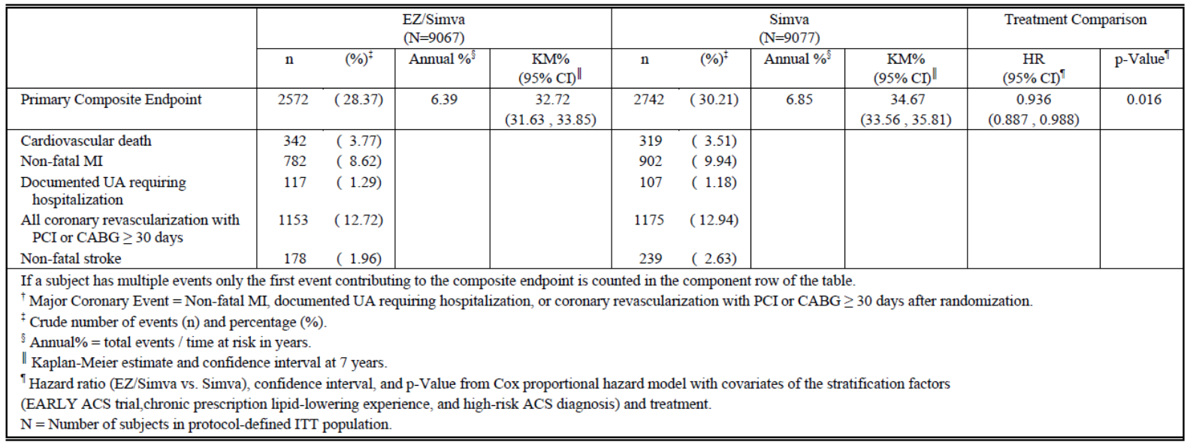
Figure 1: IMPROVE-IT study: Cumulative incidence rate of the primary composite endpoint (ITT population).
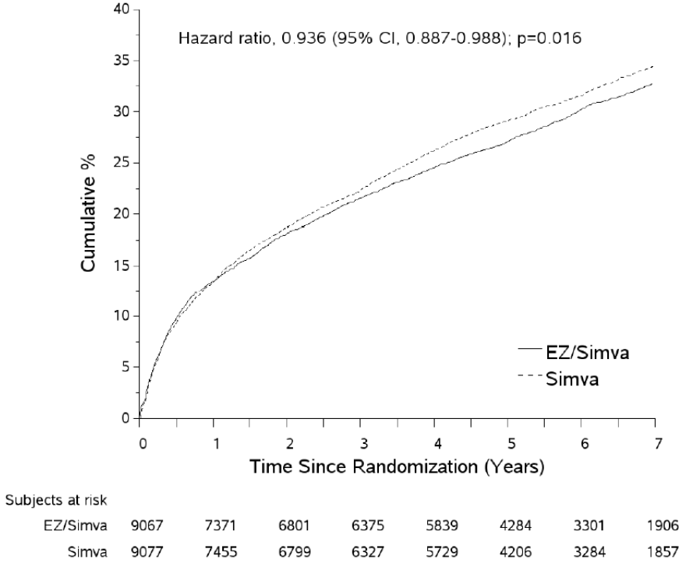

Sensitivity analyses
A pre-specified sensitivity analysis of the primary composite endpoint including all coronary revascularisation events (i.e., not excluding those that occurred within 30 days of the qualifying ACS event) revealed similar findings with HR 0.947 (95% CI 0.900, 0.996; p=0.036) (Table 6). The Sponsor states that the results of a sensitivity analysis of the primary composite endpoint where subjects were censored at the time of simvastatin uptitration were consistent with these findings (HR 0.949; 95% CI 0.896, 1.006; p=0.077, Table 7).

Subgroup analyses
The consistency of the treatment effect across over 20 pre-specified subgroups was assessed for the primary endpoint. It should be noted that the study was not powered to adequately assess subgroup differences, and no adjustment for multiplicity for the subgroup analyses was applied. The effect of ezetimibe/simvastatin compared to simvastatin alone was similar for the majority of subgroups analysed. The HRs of the subgroups were almost all less than one, and the confidence intervals were broadly overlapping. The unadjusted interaction p-values for age (<75 years vs. ≥ 75 years) and diabetes (Yes vs. No) were < 0.05 (p=0.005 and p=0.023, respectively).

Results for other efficacy outcomes

Secondary efficacy outcomes
The first secondary endpoint was a composite of death from any cause, major coronary event and non-fatal stroke. Ezetimibe/simvastatin reduced the incidence of this composite endpoint (7-year KM rate for the ezetimibe/simvastatin group vs. the simvastatin monotherapy group 38.65% vs. 40.25% (HR 0.948, 95% CI 0.903–0.996; p=0.035) (Figure 2).
Figure 2: IMPROVE-IT study: Cumulative Incidence Rate of Secondary Composite Endpoint: Death from Any Cause, Major Coronary Event, or Non-fatal Stroke (ITT Population).
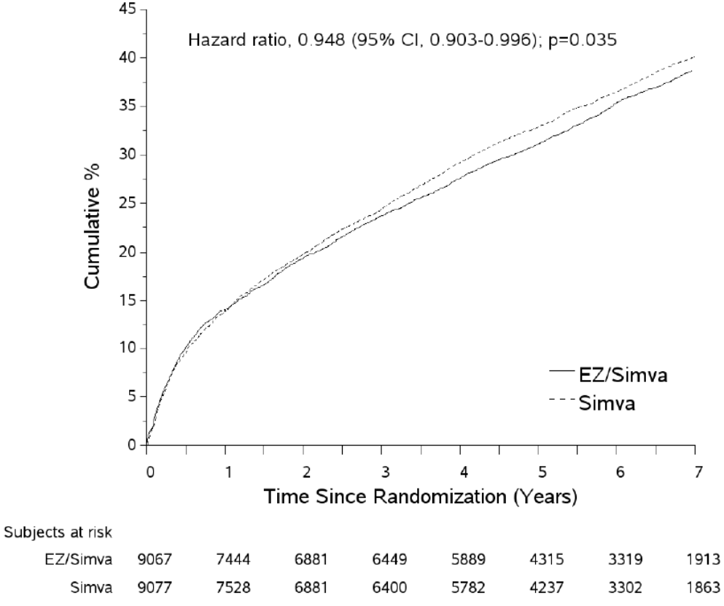
The second secondary endpoint was a composite endpoint of death due to CHD, non-fatal MI, and urgent coronary revascularisation with either PCI or CABG occurring at least 30 days after randomisation. Ezetimibe/simvastatin reduced the incidence of this composite endpoint (7-year KM rate for the ezetimibe/simvastatin group vs. simvastatin monotherapy group 17.52% vs. 18.88% (HR 0.912, 95% CI 0.847–0.983; p=0.016) (Figure 3).
Figure 3: IMPROVE-IT study: Cumulative Incidence of Secondary Composite Endpoint: CHD Death, Non-fatal MI, or Urgent Coronary Revascularization with PCI or CABG ≥ 30 Days after randomization (ITT Population).
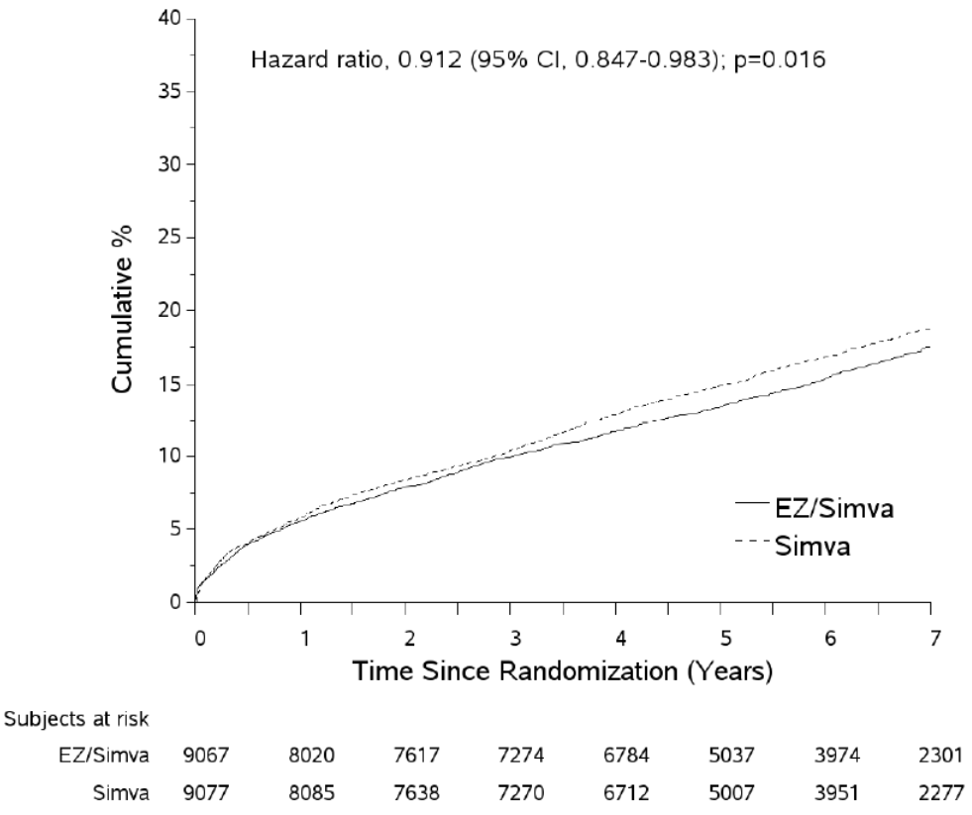
The third secondary endpoint was a composite endpoint of cardiovascular death, non-fatal MI, documented unstable angina that requires admission into a hospital, all revascularisation (including non-coronary) occurring at least 30 days after randomisation, and non-fatal stroke. Ezetimibe/simvastatin reduced the incidence of the composite endpoint (7-year KM rate for the ezetimibe/simvastatin group vs. simvastatin monotherapy group 34.49% vs. 36.20% (HR 0.945, 95% CI 0.897–0.996; p=0.035) (Figure 4).
Figure 4: IMPROVE-IT study: Cumulative Incidence Rate of Secondary Composite Endpoint: CV Death, Non-fatal MI, Documented UA Requiring Hospitalization, All Revascularization, or Non-fatal Stroke (ITT Population).
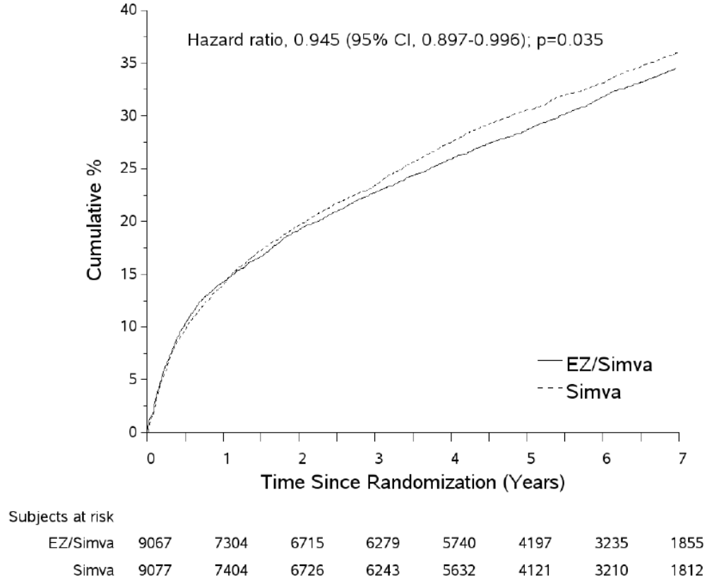

Tertiary efficacy outcomes
The analysis of tertiary efficacy outcomes included evaluation of the time to first occurrence of individual events, while for composite endpoint results subsequent events were censored after one of the composite endpoint events occurred. There was no adjustment for multiplicity for the tertiary endpoints. Due to issues of competing risk, the results need to be interpreted with caution.
The rate of death from any cause was similar between the two treatment arms (overall 13.40% vs. 13.56%, KM 15.36% vs. 15.28%; HR 0.989 95% CI 0.914, 1.070; p=0.782).
Treatment with ezetimibe/simvastatin was associated with a reduced rate of MI (fatal or non-fatal); HR 0.872, 95% CI 0.800 -0.950; p=0.002. The 7-year KM rate for non-fatal MI was 12.77% in the ezetimibe/simvastatin group compared to 14.41% in the simvastatin monotherapy group (HR 0.871 95% CI 0.798, 0.950; p=0.002). The rate of fatal MI was low and similar between the treatment groups (HR 0.839 95% CI 0.554, 1.270; p=0.406).
In the ezetimibe/simvastatin group 296 of 9,067 subjects experienced a stroke event (fatal or non-fatal) compared to 345 of 9,077 in the simvastatin monotherapy group; HR 0.857, 95% CI 0.734 – 1.001; p=0.052. The 7 year KM rate for non-fatal stroke was 3.49% compared to 4.24% in the simvastatin monotherapy group (HR 0.802 95% CI 0.678 – 0.949; p=0.010). The rate of fatal stroke was low and similar between the treatment groups (HR 1.217 95% CI 0.812, 1.823). The rate of non-haemorrhagic stroke or unknown stroke was reduced in the ezetimibe/simvastatin group (7- year KM rate 3.48% vs. 4.23%; HR 0.793, 95% CI 0.670, 0.939; p=0.007). The incidence of haemorrhagic stroke was higher in the ezetimibe/simvastatin group compared to the simvastatin monotherapy group (59 vs. 43; HR 1.377, 95% CI 0.930, 2.040; p=0.110) but the number of haemorrhagic strokes was relatively small.
No differences were noted between the treatment groups in unstable angina requiring hospitalisation or all coronary revascularization with PCI or CABG (> 30 days after randomisation).

Exploratory efficacy analyses
Additional exploratory efficacy analyses were performed including other composite endpoints, on-treatment analyses, analysis of total events and landmark analyses. The following exploratory composite endpoints pre-specified in the Statistical Considerations Memo were examined:
- Composite of CV death, non-fatal MI, and non-fatal Stroke
- Composite of coronary death, MI, and coronary revascularization
- Composite of CHD Death or Non-fatal MI
- Composite of Cardiovascular Death or Non-fatal MI
Treatment with ezetimibe/simvastatin was noted to reduce the risk of all 4 exploratory composite endpoints, and the results are generally consistent with the primary and other endpoints presented previously. Ezetimibe/simvastatin treatment was associated with a 9.9% reduction in risk for the occurrence of CV death, non-fatal MI, and stroke endpoint (HR 0.901; 0.841 – 0.965, p=0.003).
As a large number of study subjects discontinued study treatment pre-specified on-treatment analyses were performed on the primary composite and key secondary composite endpoints. These analyses should be interpreted with caution as they represent a non-randomised comparison.
Results for the primary composite endpoint with events censored at 30 days after the date of permanent discontinuation of study drug were supportive of the primary efficacy analysis. A 7.60% reduction in risk for the primary composite endpoint was noted (HR 0.924; 0.868-0.983, p=0.012).
Results for the primary composite endpoint with events censored at 6 months and 12 months after the date of permanent discontinuation of study drug were consistent with the ITT results.

Lipid, lipoproteins, apolipoproteins and hs-CRP
The LS mean LDL-C at the time of the qualifying event was 93.8 mg/dL (2.43 mmol/L) in both treatment groups. LDL-C lowering was observed at 1 month, and generally was sustained over the duration of follow-up. The corresponding LS mean LDL-C levels at 1 year were 55.0 mg/dL in the ezetimibe/simvastatin group vs. 71.8 mg/dl in the simvastatin group, representing a 16.8 mg/dL between group difference (95% CI -17.5 to -16.0; p<0.001). The between-group difference remained relatively similar at all time-points, reflecting a consistency of the treatment effect of the study medication and the fact that lipids were generally measured only on subjects continuing on study drug. Averaged over the course of the trial and with inclusion of all available lipid values (ITT), the ezetimibe/simvastatin treatment group achieved an additional mean reduction in LDL-C of 14.2 mg/dL (0.367mmol/L) or 15.9% (95% CI -16.7 to 15.2, p<0.001) relative to the simvastatin treatment group LDL-C. At one-year, the average LDL-C for patients continuing on therapy was 53.2 mg/dL (1.4 mmol/L) for the ezetimibe/simvastatin group and 69.9 mg/dL (1.8 mmol/L) for the simvastatin monotherapy group. Figure 5 shows the changes in LDL-C over time by treatment group (including all values through the final or discontinuation study visit). The average measured LDL-C levels at the time of randomization were lower than the values obtained at the time of presentation with the index ACS event. The Sponsor states that this may be due to confounding effects of the ACS acute coronary event/hospitalisation, in addition to substantial numbers of subjects started statin therapy as part of their medical care during the interval between presentation and randomisation.
Figure 5: IMPROVE-IT study: LDL-C (mg/dL) Observed Mean (+/-SE) Over Time (ITT population).
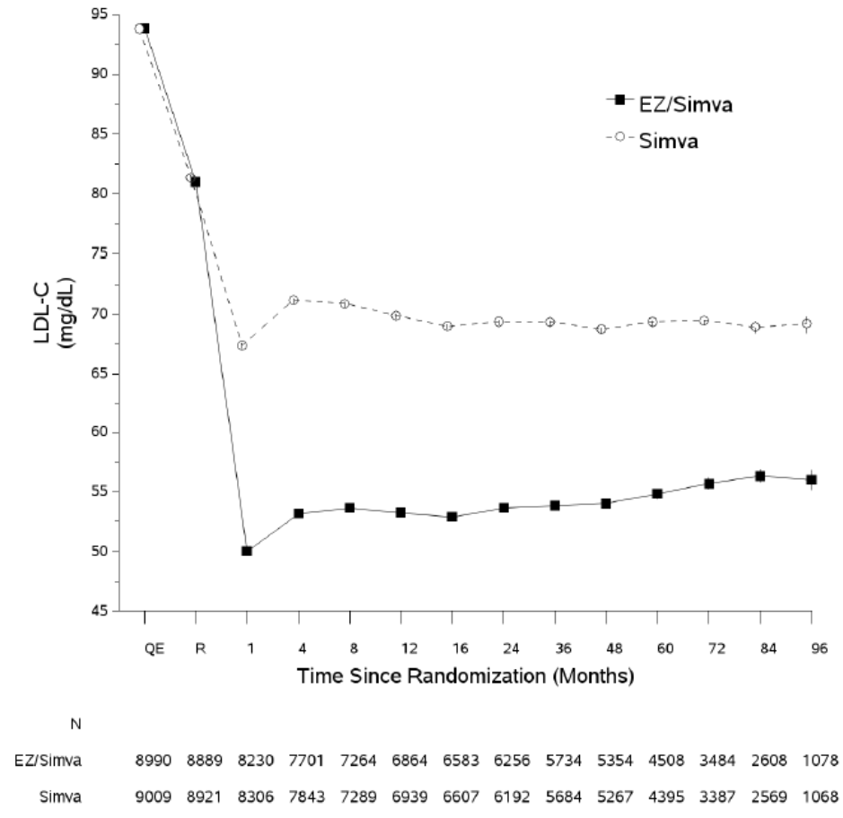
Analysis of lipid levels from the time of qualifying event to year 1 by treatment group is presented in Table 2. Compared with simvastatin, ezetimibe/simvastatin produced significant between-group reductions of Total C, Non-HDL-C, and TG at 12 months. The Sponsor states that compared with simvastatin, ezetimibe/simvastatin produced a significant between-group reductions of TC, non-HDL-C, Apo B, hs-CRP, Apo B/Apo A-I ratio, TC/HDL-C ratio and non-HDL-C/HDL-C ratio.

Table 2: IMPROVE-IT study: Analysis of Lipids at 12 months Baseline Measured at Time of Qualifying Event (ITT population).
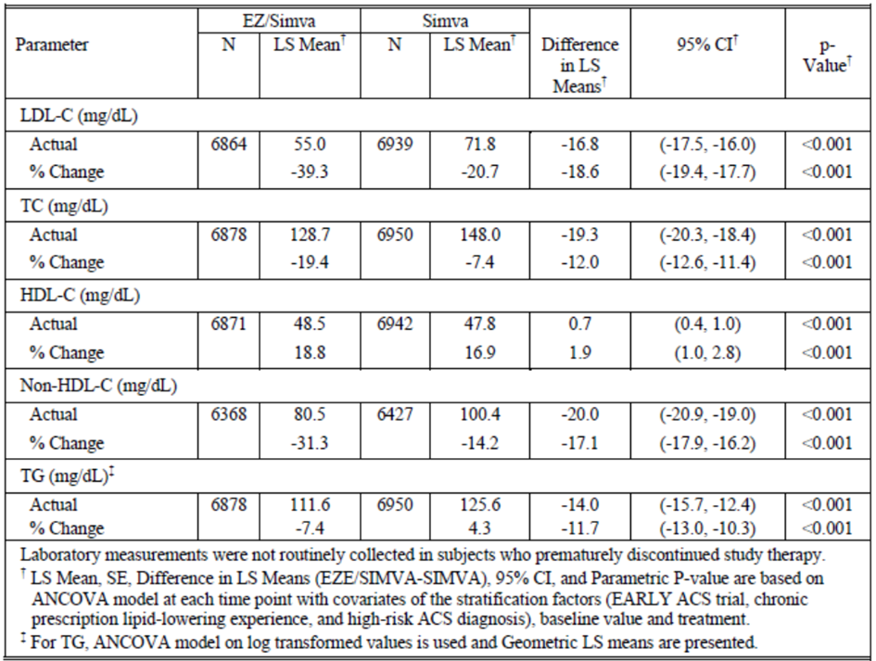
At the one and four month time points, more subjects in the ezetimibe/simvastatin group achieved LDL-C<70 mg/dL and hs-CRP <2.0 mg/L compared to those subjects receiving simvastatin monotherapy. An analysis of the primary composite endpoint based on the achievement of both LDL-C <70 mg/dL and hs-CRP <2 mg/L at 1 month and 4 found a lower event rate for subjects who achieved both LDL-C <70 mg/dL and hs-CRP <2 mg/L. Note that this is not a randomised comparison and the p-value and CI should be viewed with caution.
The relationship between LDL-C reduction and outcomes treatment benefit was assessed through analysis of observed reductions in CV events per 1.0 mmol/L reduction in LDL-C using a composite endpoint consistent with the CTT major vascular event endpoint (CTT-MVE: namely CHD death, non-fatal MI, coronary revascularization that occurred ≥ 30 days after randomization and stroke; e.g. the primary endpoint of IMPROVE IT excluding unstable angina) was identified and assessed. Imputation of baseline LDL-C values was performed for subjects with missing LDL-C values at 1-year. The imputed LDL-C difference at 1 year was 12.8 mg/dL (0.33 mmol/L). The HR for clinical benefit per mmol of LDL-C reduction with ezetimibe in IMPROVE IT was 0.80.

Evaluator commentary
The result for the primary composite endpoint found a 6.4% relative risk reduction in the primary efficacy endpoint compared to treatment with simvastatin monotherapy. However, the results were not suggestive of a reduction in the risk of all the composite endpoints. There was a slightly higher rate of CV death and documented UA requiring hospitalisation in the ezetimibe/simvastatin group compared to the simvastatin monotherapy group (3.77% vs. 3.51% and 1.29% vs. 1.18%, respectively. The benefits observed for the composite primary efficacy outcome appear to be due to reductions in non-fatal MI and non-fatal stroke (8.62% vs. 9.94% and 1.96% vs. 2.63% respectively). The absolute risk reduction (ARR) and the number needed to treat (NNT) to prevent an occurrence of the primary composite endpoint has not been discussed in the study report.
The sensitivity analysis of the primary composite endpoint censoring subjects at the time of titration appears to show a higher overall event rate in the ezetimibe/simvastatin group than the simvastatin group (27.14% vs. 24.29%). In this analysis the rates of CV death, non-fatal MI, documented UA requiring hospitalisation and all coronary revascularisation with PCI or CABG ≥30 days were all higher in the ezetimibe/simvastatin treatment arm. The annual rate of the composite primary endpoint was lower in the ezetemibe/simvastatin group compared to the simvastatin group (6.43% vs. 7.22%) and the HR whilst not statistically significant was suggestive of a lower incidence in the ezetimibe/simvastatin group. This result does not appear to be consistent with the analysis of the primary composite endpoint as stated. It is unclear why the overall event rate was higher in the ezetimibe/simvastatin group.
The subgroup analysis did not identify a significant reduction in the occurrence of the primary composite endpoint with ezetimibe/simvastatin therapy for male patients despite a high proportion of male patients included in the study. The subgroup analysis included two age group analyses the cut-off for the analyses was 65 and 75. It is noted that the study included at least two patients in their 20s. The pathogenesis of ACS in this patient in this age group could vary significantly from the older patient population. It is unclear how many patients under the age of 50 were included in the study.
The risk of each of the composite secondary endpoints was decreased in the ezetimibe/simvastatin group compared to the simvastatin monotherapy group. Similar to the primary composite endpoint analysis, the analysis of each of the secondary endpoints found the death rate (any cause, CHD death and CV death respectively) to be higher in the ezetimibe/simvastatin group than the simvastatin monotherapy group. This is of concern given the higher death rate noted in the analysis of the composite primary endpoint The tertiary outcome analysis of the rate of death from any cause was similar between the two treatment arms (overall 13.40% vs. 13.56%, KM 15.36% vs. 15.28%; HR 0.989 95% CI 0.914, 1.070; p=0.782). However, the overall rate of non-cardiovascular death was higher in the ezetimibe/simvastatin arm but the associated confidence intervals included 1.000. Similarly, the risks of documented UA requiring hospitalisation, fatal stroke, haemorrhagic stroke and CHF requiring hospitalisation were also slightly higher in the ezetimibe/simvastatin group but the associated confidence intervals included 1.000. It should be noted that there was no adjustment for multiplicity in the analysis of the tertiary endpoints.
The numbers of subjects who had their dose of simvastatin increased from 40 to 80 mg per day was greater in the simvastatin group compared to the ezetimibe/simvastatin group (6.2% in the ezetimibe/simvastatin and 27.0% in the simvastatin monotherapy group). A sensitivity analysis was conducted censoring patients at the time of dose titration but the results were suggestive of higher rates of CV death, documented UA requiring hospitalisation and all coronary revascularisation with PCI or CABG ≥30days in patients in the ezetimibe/simvastatin group.

Other efficacy studies
There were 147 literature references. These articles were not individually analysed as this was not a literature based submission. References were checked for consistency with the results reported in the submission where relevant.

Analyses performed across trials: pooled and meta analyses
Not applicable.

Evaluator’s conclusions on clinical efficacy
The Sponsor has not submitted any data to support the efficacy of atorvastatin with ezetimibe for the proposed indication but has relied on the clinical evidence that relates to simvastatin. The Sponsor has requested the same indication requested for simvastatin/ezetimibe and ezetimibe in submissions PM-2015-01524-1-3 and PM-2015-01525-1-3 be extrapolated to Atozet products. The Sponsor has relied heavily on the similar mechanism of action of statins to support the extrapolation of results from the IMPROVE-IT study to Atozet. A comparison of the efficacy of simvastatin and atorvastatin in lowering cardiovascular event rates has not been included in the submission. It is therefore difficult to confirm that the outcome would be similar if atorvastatin were substituted for simvastatin. Whilst statins have the same mechanism of action, they have different efficacy and safety profiles as demonstrated by the difference in approved indications and adverse event profiles. The statin cerivastatin was withdrawn from sale worldwide due to concerns that severe muscle effects were more common with cerivastatin than other statins. Due to these differences in efficacy and safety it is not possible to extrapolate the results from one study involving one statin to all statins. It is important that the claims for each statin be assessed individually.
The TGA adopted EU guideline on Points to Consider on Application with 1. Meta-Analyses; 2. One Pivotal Study CPMP/EWP/2330/99 state that where confirmatory evidence is provided by one pivotal study only, ‘In the exceptional event of a submission with only one pivotal study, this has to be particularly compelling with respect to internal and external validity, clinical relevance, statistical significance, data quality and internal consistency.’ The IMPROVE-IT study did not examine the effect of ezetimibe/atorvastatin on cardiovascular risk and therefore does not meet the external validity criteria as the results cannot be generalised to a different statin. The clinical relevance of the observed benefit is unclear as the number needed to treat has not been stated and the study population has been selected to exclude patients with LDL-C levels above a certain threshold and those who were not responsive to treatment. In addition, the subgroup analysis did not identify a significant reduction in the occurrence of the primary composite endpoint with ezetimibe/simvastatin therapy for male patients despite a high proportion of male patients included in the study. This may indicate a lack of internal consistency. In conclusion, the criteria outlined in the EU guidelines regarding the submission of a single pivotal study have not been met and the results of the IMPROVE-IT study are not considered compelling.
The Sponsor has proposed that the new indication be applied to all strengths of Atozet without providing a supporting justification. The strength of atorvastatin in Atozet products range between 10-80mg and the proposed dosage instructions for this indication imply that Atozet is efficacious at preventing cardiovascular events across the entire dosage range. However, no data has been submitted to support the efficacy of any dose of atorvastatin with ezetimibe in preventing cardiovascular events. In the IMPROVE-IT study patients were commenced on 40mg simvastatin and were uptitrated to 80mg as required regardless of whether they were on ezetimibe. Changes to the simvastatin prescribing information, prompted dose restrictions on simvastatin as outlined in Protocol Amendment 5 to IMPROVE-IT. No additional subjects were to have their simvastatin dose increased to 80 mg and subjects taking the simvastatin dose of 80 mg for less than 12 months were to have their dose decreased to 40 mg. As a result, the majority of the study participants received either ezetimibe or ezetimibe and simvastatin 40 mg and only a small proportion of the study population received the 80mg simvastatin dose. It is therefore difficult to extrapolate the results of the study to other doses of simvastatin and then further extrapolate to all doses of atorvastatin. The effect of the various combinations on cardiovascular outcome is potentially related to LDL-C levels but it has not been demonstrated that a higher statin dose has any further incremental benefit in cardiovascular outcome. In addition, there is the potential that a higher statin dose could increase adverse events or lead to a higher drop-out rate that could offset any potential cardiovascular benefit in this population. It is possible that at the lower atorvastatin doses (eg. 10mg) the effect of Atozet on the risk of cardiovascular events is not clinically or statistically significant. Therefore, the effect on cardiovascular outcome cannot be extrapolated to all strengths of the ezetimibe/simvastatin combination product and then to all strengths of the Atozet products.
The IMPROVE-IT study excluded patients with LDL-C levels above a certain threshold and patients who did not achieve adequate LDL-C control were withdrawn from the study. The criteria for withdrawal based on LDL-C levels were modified as part of Protocol amendment 5. A total of 149 patients were withdrawn due to LDL-C levels. Whilst it would not be ethical to continue ineffective treatment, these limitations on the study population may have introduced bias by selecting the patients most likely to respond to treatment and therefore reduce the generalizability of the study.
The result for the primary composite endpoint found a modest relative risk reduction in the primary efficacy endpoint compared to treatment with simvastatin monotherapy. However, the results were not suggestive of a reduction in the risk across all the composite endpoints. The rates of CV death and documented UA requiring hospitalisation were slightly higher in the ezetimibe/simvastatin group compared to the simvastatin monotherapy group. The benefits observed for the composite primary efficacy outcome appear to be due to reductions in non-fatal MI and non-fatal stroke.

Clinical safety

Studies providing evaluable safety data

Pivotal studies that assessed safety as the sole primary outcome
No studies were submitted that assessed safety as the sole primary outcome.

Pivotal and/or main efficacy studies
The IMPROVE-IT study was designed to evaluate the safety and tolerability of ezetimibe/simvastatin combination compared with simvastatin. This study did not include patients taking atorvastatin or ezetimibe/atorvastatin.
Safety variables assessed included safety laboratory tests (including liver function tests and CK levels), physical examinations, adverse events, and clinic evaluations. Safety analyses were based on the ITT population. The protocol did not require the reporting of AEs that occurred more than 30 days after permanent discontinuation of the study drug unless they were considered AEs of special interest. The study included an analysis of all AEs, treatment related AEs, serious adverse events (SAEs), AEs leading to discontinuation of treatment and the following AEs of Special Interest:
- Defined increases in AST, ALT
- Defined increases in CK
- All AEs reflective of gallbladder-disease
- All cholecystectomies
- All occurrences of myopathy and rhabdomyolysis
- Cancer
Select safety parameters were also analysed excluding study patients who never took study drug and excluding study subjects who never took the drug and limited to the 30 day time period after the last dose of study drug.

Other studies
No other safety studies were included in the submission but the Sponsor has provided a review of cumulative post-marketing data from 2013 to 31 December 2014 for the following eight events of interest with the use of the ezetimibe/atorvastatin combination:
- rhabdomyolysis/myopathy
- malignancies
- gallbladder disorders
- interstitial lung disease
- haemorrhagic stroke
- pancreatitis
- acute renal failure
- hypersensitivity
The results of this analysis are discussed.

Studies that assessed safety as the sole primary outcome
Not applicable.

Patient exposure
No patients were exposed to ezetimibe/atorvastatin or atorvastatin during the IMPROVE-IT study. The median duration of exposure for the ezetimibe/simvastatin and simvastatin groups was 1389 and 1427 days respectively. A total of 5710 subjects were on treatment for at least 72 months.
A total of 1989 patients had their dose of simvastatin titrated to 80mg (332 in the ezetimibe/simvastatin group and 1657 in the simvastatin monotherapy group). A total of 1018 patients receiving 80mg of simvastatin had their dose titrated back down to 40mg (229 in the ezetimibe/simvastatin group and 789 in the simvastatin group). The mean duration of exposure to the 80mg simvastatin dose was 38.0 months (30.3 in the ezetimibe/simvastatin group and 39.8 in the simvastatin group).

Adverse events

All adverse events (irrespective of relationship to study treatment)

Pivotal and/or main efficacy studies
In the IMPROVE-IT study 15516 (85.5%) randomised study subjects experienced one or more AEs. The proportion of subjects who experienced one or more AEs was similar between the two treatment arms (7763 (85.6%) subjects in the ezetimibe/simvastatin group and 753 (85.4%) in the simvastatin group). The most common AEs were musculoskeletal and connective tissue disorders (46.1%), infections and infestations (37.6%) and gastrointestinal disorders (33.9%).

Treatment related adverse events (adverse drug reactions)

Pivotal and/or main efficacy studies
In the IMPROVE-IT study 4818 (26.6%) of patients experienced a drug-related AE, 2431 (26.8%) in the ezetimibe/simvastatin group vs. 2387 (26.3%) in the simvastatin group. Table 3 shows the number of patients with specific AEs (incidence ≥ 2.0% in one or more treatment groups) by SOC that were considered by the investigator to be related to study therapy during the double-blind treatment period. The adverse event rate is slightly higher in the ezetimibe/simvastatin group for each of the SOCs and adverse events listed in Table 3.

Table 3: IMPROVE-IT study: Drug related adverse events with incidence ≥2% in one or more treatment groups.
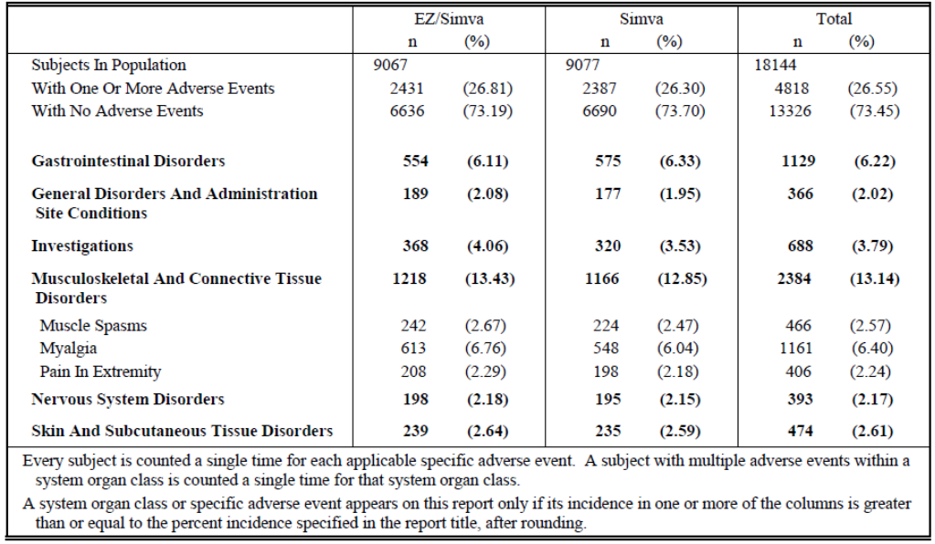

Deaths and other serious adverse events

Pivotal and/or main efficacy studies
Of the 18,144 subjects in the ITT population, 2446 (13.48%) died during the course of the study: 1215 (13.40%) who were assigned ezetimibe/simvastatin and 1231 (13.56%) who were assigned simvastatin. Table 4 provides a summary of Clinical Event Committee adjudicated deaths. The Sponsor reports that no meaningful differences were noted between the two treatment groups in CV death or Non-CV death.

Table 4: IMPROVE-IT study: Summary of CEC adjudicated deaths.
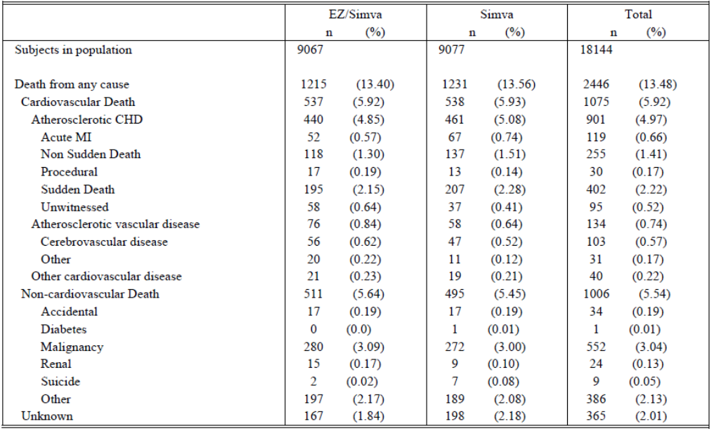
In the IMPROVE-IT study AEs resulting in death occurred in 672 (3.7%) subjects, 347 (3.8%) in the ezetimibe/simvastatin group vs. 325 (3.6%) in the simvastatin group. Since death was considered a study endpoint, death was not routinely reported as a SAE. As a result, the number of adverse events resulting in death differs from the number of CEC reported deaths in the efficacy analysis (the tertiary efficacy outcome analysis reported 2446 deaths in the trial 1215 in the ezetimibe/simvastatin arm and 1231 in the simvastatin arm).
Overall, 7289 (40.17%) subjects experienced a SAE, 3640 (40.15%) in the ezetimibe/simvastatin group compared with 3649 (40.20%) in the simvastatin group. The most common SAEs were neoplasms benign, malignant and unspecified, infections and infestations, gastrointestinal disorders and musculoskeletal disorders (Table 5).

Table 5: IMPROVE-IT study: Serious adverse events with incidence ≥2% in one or more treatment groups.
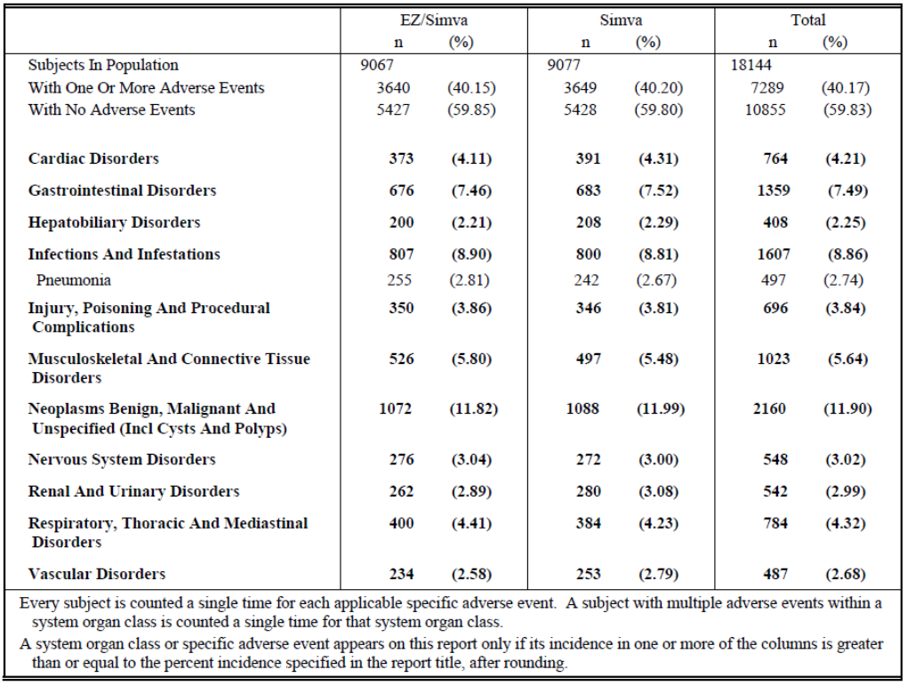

Discontinuations due to adverse events

Pivotal and/or main efficacy studies
In the IMPROVE-IT study, a total of 1880 (10.4%) subjects had an AE that led to study drug discontinuation during the double-blind treatment period. A slightly higher proportion of patients in the ezetimibe/simvastatin group had an AE that led to study drug discontinuation (962 (10.6%) vs. 918 (10.1%)). However, the proportion of patients who discontinued due to a drug-related AE or discontinued due to a serious AE was similar across the treatment groups (7.0% vs. 6.8% and 2.0% vs. 1.9% respectively).

Evaluation of issues with possible regulatory impact

Liver function and liver toxicity

Pivotal and/or main efficacy studies
Adverse event of special interest (AESI) related to liver function and liver toxicity included defined increases in AST, ALT and all cholecystectomies.
At screening, subjects with active liver disease or persistent unexplained serum transaminase elevations (≥2 x ULN) were ineligible for the study. Subjects with transient increases in serum transaminases due to the index MI were eligible for the study.
Per protocol, ALT and AST testing was performed at screening/randomization, Month1, Month 4, Month 8, Month 16, annually and at study completion/early discontinuation. Total bilirubin and alkaline phosphatase were evaluated only at the screening/randomization visit, the annual visit, and at the time of study completion/early discontinuation.
If a subject was found to have an ALT and/or AST measurement ≥3 x ULN believed to be related to study drug, then the subject was to have repeat laboratories performed within 1 week. If the same transaminase activity was ≥3 x ULN on two consecutive occasions, the study medication was interrupted. Investigative sites were instructed to repeat the subject’s laboratory tests approximately every 2 weeks until the transaminase activity decreased to <2 x ULN, at which time study drug could be restarted at the discretion of the investigator, following discussion with the sponsor’s clinical monitor. A subject who had a second episode of two consecutive observations of transaminase activity ≥3 x ULN believed to be related to study drug was to be discontinued from study medication, but would be monitored for any clinical endpoint event until the termination of the trial.
There were 14 deaths related to hepatic causes (9 subjects in the ezetimibe/simvastatin group and 5 in the simvastatin group). Limited information is available relating to these cases. Most available laboratory information does not provide evidence of serious liver injury. Only one case from the ezetimibe/simvastatin group met the laboratory criteria to be considered a potential DILI case. Of the 9 subjects in the ezetimibe/simvastatin group with a hepatic cause of death, 5 cases were related to non-alcoholic cirrhosis. One death occurred within 30 days of permanent discontinuation of study therapy. This [information redacted] patient developed a surgical wound infection post Coronary Artery Bypass Graft (CABG) and subsequently ‘oedematous ascetic syndrome caused by hepatic cirrhosis.’ The investigator considered the liver failure which resulted in death unlikely related to study drug. The remainder of the deaths due to non-alcoholic cirrhosis occurred between 1 and 5 years after discontinuation of study therapy.
Alcoholic cirrhosis was listed as the cause of death for one case and hepatitis B carrier status and alcohol abuse contributed to liver failure in another case. In two cases where the patient had withdrawn consent to participate in the study the cause of death was listed as liver failure. In both these cases the death occurred more than one year after permanent discontinuation of study therapy. In 4 of the 5 subject deaths in the simvastatin treatment group, non-alcoholic steatohepatitis was a contributing factor and one death was related to cirrhosis.
A total of 49 subjects, 26/8027 (0.3%) in the ezetimibe/simvastatin group and 23/8068 (0.3%) in the simvastatin group, met the biochemical criteria for potential DILI. An alternative explanation for the elevated transaminase level was identified for all but 3 cases. Limited clinical information was available for these three patients. Two of the subjects received ezetimibe/simvastatin. One subject was a [information redacted] patient with elevated bilirubin on randomisation who was hospitalized with elevated transaminases and weakness approximately one month later. The patient was diagnosed with an MI one week later and subsequently died. The other subject was a [information redacted] patient on aspirin and beta blocker who developed transaminase elevations approximately 1.5 years after randomisation and presented with weakness, malaise and anaemia. The study drug was stopped and she underwent colonoscopy and transaminase elevations resolved. One subject was assigned to treatment with simvastatin 40mg. This subject was a [information redacted] patient who developed transaminase elevations approximately one month after randomisation. Medications included aspirin and beta blocker and one year following study drug discontinuation, the subject presented with cholelithiasis and pancreatitis and underwent cholecystectomy.
Defined increases in ALT and AST are presented in Table 6. The incidence of elevations in ALT and AST with or without bilirubin elevations was generally similar between the ezetimibe/simvastatin and simvastatin treatment groups across the different range of elevations. The largest numbers of elevations occurred during the first 4 months of treatment, dropped and remained fairly constant over the rest of the first year and then dropped further in the subsequent years. There was no apparent difference in the time course between treatment groups.

Table 6: IMPROVE-IT study: Analysis of adverse events of special interest.
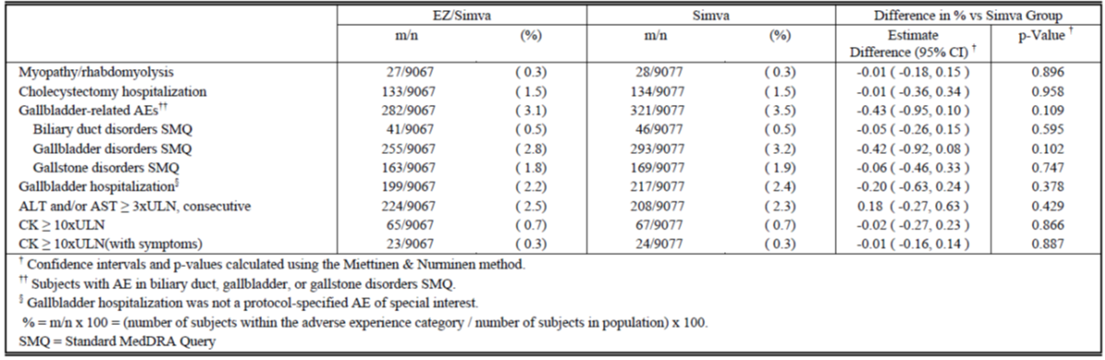
Approximately 17% of randomized subjects were up-titrated to simvastatin 80mg during the trial (27% in the simvastatin treatment group, and 6% in the ezetimibe/simvastatin treatment group). Given the imbalance in the treatment groups for those uptitrated to simvastatin 80 mg, exposure-adjusted analyses for instances of ALT/AST elevations > 3X ULN consecutive were also conducted. This assessment was not randomised but the exposure adjusted rate of consecutive ALT or AST ≥3xULN was similar between the treatment groups in subjects taking simvastatin at a dose of 40 mg. Comparisons at the 80 mg dose are limited by the lesser use and thus the smaller number of cases in the ezetimibe/simvastatin group, however the risk appeared similar between the treatment groups.
Standardized MedDRA Queries (SMQs) were used to identify the preferred terms that were representative of gallbladder related events. The rate of gallbladder adverse events was generally similar between the treatment groups (3.11% vs. 3.54% in the ezetimibe/simvastatin and simvastatin groups respectively). A similar number of patients in each treatment arm experienced ‘cholecystectomy hospitalisation’ (133 in the ezetimibe/simvastatin group vs. 134 in the group and in the simvastatin group.

Renal function and renal toxicity

Pivotal and/or main efficacy studies
No clinically meaningful changes in creatinine clearance were noted over the course of the study in either treatment group. In addition, there was no apparent difference in creatinine clearance between the treatment groups at any point in time.
Additional analyses of creatinine clearance over time were also performed by categories of LDL-C level at the time of qualifying event (< 70 mg/dL, 70 to 100 mg/dL, >100 mg/dL). Creatinine clearance at baseline was slightly different between the three groups examined, with the higher LDL-C groups exhibiting slightly greater creatinine clearance at baseline. However, there was a lot of variability around the point estimates. In any of the three LDL-C categories, there were no differences in creatinine clearance between the two treatment groups and no apparent change in creatinine clearance over time. Thus, no clinically meaningful changes in renal function were noted in any of the baseline LDL-C categories examined.

Other clinical chemistry

Pivotal and/or main efficacy studies
There was little change in CK from baseline over time and no apparent difference in change from baseline in CK between the treatment groups.

Haematology and haematological toxicity

Pivotal and/or main efficacy studies
The CSR does not discuss changes in the haematology laboratory parameters observed in the IMPROVE-IT study. The table of AEs with an incidence of ≥2% in one or more treatment groups indicates that the incidence of anaemia was slightly higher in the ezetimibe/simvastatin group (3.92% vs. 3.60%).

Other laboratory tests

Pivotal and/or main efficacy studies

Rhabdomyolysis
The rate of the AESI of myopathy/rhabdomyolysis was similar between the treatment groups (0.3% in each treatment group). In the ITT population there were 13 subjects (0.1%) in the ezetimibe/simvastatin group that developed rhabdomyolysis compared to 18 subjects (0.2%) in the simvastatin group. In the on-treatment analysis there were 12 subjects who experienced rhabdomyolysis in the ezetimibe/simvastatin group and 18 in the simvastatin monotherapy group. Of the 12 patients in the ezetimibe/simvastatin group, 9 patients experienced rhabdomyolysis with renal involvement and one subject was taking the 80mg simvastatin dose and five subjects were taking concomitant therapies that may have contributed to the rhabdomyolysis and renal impairment. In two other subjects there were alternate explanations or contributing factors such as a fall or accidental overdose of study drug. Alternate aetiology was not described for two patients, a [information redacted] patient with onset of muscle pain and rhabdomyolysis within one month of starting study drug and a [information redacted] patient with diabetic nephropathy whose event occurred one week following discontinuation of study drug due to elevated creatine kinase. The subject was not placed on haemodialysis and died 15 days later due to end stage renal disease.
Of the 9 subjects with an event of rhabdomyolysis associated with renal involvement receiving simvastatin monotherapy, 4 subjects received the 40mg does and 5 subjects received the 80mg dose. There were contributing factors of alternate explanations for 7 subjects. A [information redacted] patient received 80mg of simvastatin for 1.6 years prior to the event. They were diagnosed with idiopathic pulmonary fibrosis and a secondary diagnosis of right lobar pneumonia was made at the time of the rhabdomyolysis event. The subject recovered from the rhabdomyolysis approximately 16 days after ceasing the study drug but was hospitalised 12 days later and experienced progressive respiratory insufficiency and persistent fever, they later had a cardiac and respiratory arrest and died. The adjudicated cause of death was severe respiratory insufficiency.
There were 3 subjects in the ezetimibe/simvastatin and 9 subjects in the simvastatin monotherapy groups who had CEC reported events of rhabdomyolysis without renal involvement. The 3 subjects in the ezetimibe/simvastatin group were both receiving ezetimibe/simvastatin 40 mg at the time of the event. In two of the subjects, the event of rhabdomyolysis occurred within approximately one month from the start of study drug. In these cases, study drug was permanently discontinued and the event resolved.
There were 9 subjects with the event of rhabdomyolysis without renal involvement in the simvastatin monotherapy arm, 4 were receiving simvastatin 40 mg and 5 were receiving simvastatin 80 mg at the time of the event. All subjects permanently discontinued study therapy and recovered from the event. Among the subjects on simvastatin monotherapy, 5 were found to have contributing factors or alternate explanations which might have contributed to these events.

Myopathy
There were 13 cases of myopathy in patients in the ezetimibe/simvastatin group and 9 in the simvastatin group. On subject in the ezetimibe/simvastatin group was receiving 80mg simvastatin compared to 5 in the simvastatin group.

Myalgia without myopathy
A total of 3,171 cases of unexplained myalgia were reported by the investigators during IMPROVE-IT. Excluding the cases that were adjudicated as meeting the criteria for myopathy or rhabdomyolysis (56 [0.3%]), the remaining cases potentially represent unexplained myalgia in subjects taking statins. Over the course of the IMPROVE-IT trial, there were 1607 (17.7%) subjects who experienced this type of myalgia in the ezetimibe/simvastatin group compared with 1564 (17.2%) subjects in the simvastatin group. This result is reported to indicate no contribution from ezetimibe to the incidence of this AE. The rate of adverse events with the preferred term of myalgia was similar between the treatment groups (10.68% in the ezetimibe/simvastatin group and 10.08% in the simvastatin group). Adverse events with the preferred term of myalgia led to discontinuation in 209 (2.31%) subjects in the ezetimibe/simvastatin group and 201 (2.21%) of subjects in the simvastatin monotherapy group.

Electrocardiograph findings and cardiovascular safety

Pivotal and/or main efficacy studies
The IMPROVE-IT study included ECG criteria for study inclusion, as described above, but there is little detail regarding whether follow-up ECGs were performed and if any changes in ECG were noted in the two treatment arms.

Vital signs and clinical examination findings

Pivotal and/or main efficacy studies
Change from baseline for vital signs including pulse, systolic, and diastolic blood pressure was assessed. No clinically meaningful differences were noted.

Immunogenicity and immunological events

Pivotal and/or main efficacy studies
There were no meaningful differences between the treatment groups related to hypersensitivity reaction related adverse events. There were 735 (8.11%) subjects in the ezetimibe/simvastatin group and 748 (8.24%) in the simvastatin monotherapy group who had an adverse event related to hypersensitivity reactions.

Serious skin reactions

Pivotal and/or main efficacy studies
There was one report of Stevens-Johnson syndrome in the simvastatin treatment arm and two cases or erythema multiforme in the ezetimibe/simvastatin treatment arm. These cases are not discussed in detail in the CSR.

Other safety parameters

Pivotal and/or main efficacy studies

Malignancy
Investigators were required to report detailed information for any malignancy/neoplasm that was newly diagnosed after randomization (regardless of the timing of the last dose of study drug), as well as pre-existing malignancies that worsened, relapsed, or caused a new AE after randomization. All cases were submitted for adjudication by oncology members of the CEC. These events were classified as to whether or not they were malignant, site of origin, extent of disease involvement, and relationship to vital status.
The analysis of CEC-adjudicated new cancers and death due to cancer is shown in Figures 6 and 7. The analysis found that the overall incidence of new cancers or death due to cancer did not meaningfully differ between the treatment groups as the associated hazard ratios for these endpoints were all near 1.0 (range 0.993-1.032).
Figure 6: IMPROVE-IT study: Cumulative incidence rate of any new, relapsing. or progressing CEC determined malignancy (excluding non-melanotic skin cancer).
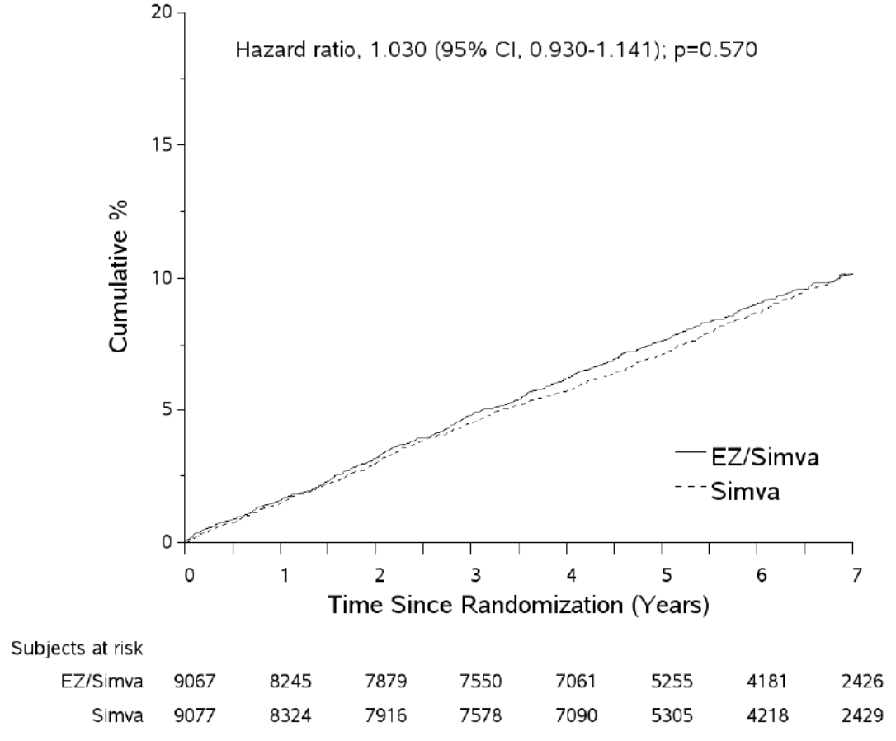
Figure 7: IMPROVE-IT study: Cumulative incidence rate of any death due to CEC determined malignancy.
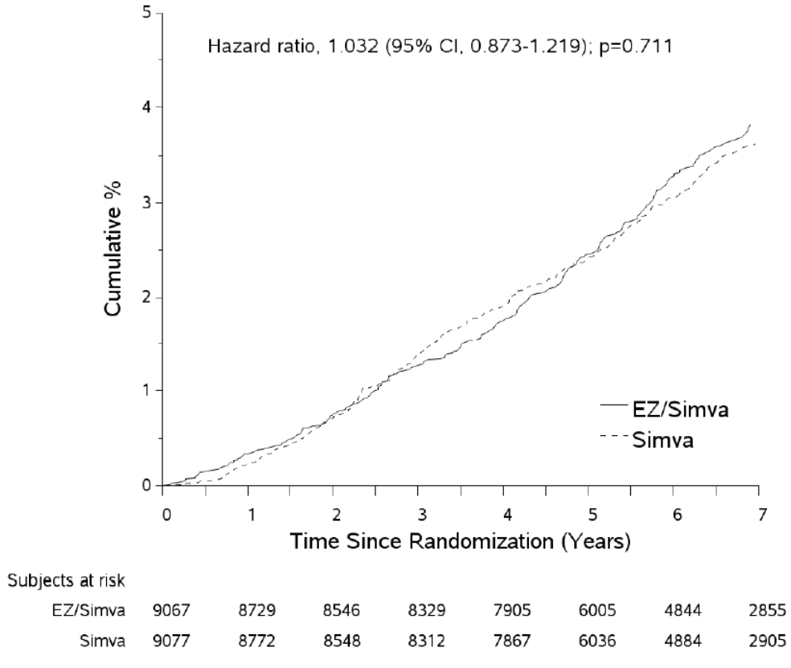

New onset diabetes
Approximately 7.2% of subjects were either reported or deduced to have developed diabetes over the course of the trial. No clinically meaningful differences between treatment groups were noted; there were 650 (7.2%) subjects with New Onset Diabetes in the ezetimibe/simvastatin group and 659 (7.3%) in the simvastatin group.

Pancreatitis
No clinically meaningful differences between treatment groups in specific pancreatitis related adverse experiences were noted; there were 57 (0.63%) subjects with an AE of pancreatitis in the ezetimibe/simvastatin group and 58 (0.64%) in the simvastatin group.

Acute renal failure
There were no meaningful differences between treatment groups in specific renal failure related adverse experiences. There were 259 (2.86%) subjects with acute renal failure in the ezetimibe/simvastatin group vs. 235 (2.59%) in the simvastatin group.

Interstitial lung disease
No meaningful differences between the treatment groups related to interstitial lung disease were identified. There were 34 (0.37%) subjects in the ezetimibe/simvastatin group and 40 (0.44%) in the simvastatin group who had an adverse event related to interstitial lung disease.

Haemorrhagic stroke
In the ITT analysis, there were 59 haemorrhagic strokes in the ezetimibe/simvastatin group and 43 in the simvastatin group, with an annualized rate of 0.12 and 0.09, respectively. At 7 years, the KM estimates were 0.77% in the ezetimibe/simvastatin group and 0.59% in the simvastatin group (HR 1.377; 0.930-2.040; p=0.110). In the on-treatment analysis which censored events occurring beyond 30 days after the date of permanent discontinuation of study drug, there were 32 haemorrhagic stroke events in the ezetimibe/simvastatin group compared with 34 in the simvastatin group. The Sponsor states that these findings indicate that a large proportion of the haemorrhagic stroke events occurring in subjects allocated to ezetimibe/simvastatin occurred after the subjects had discontinued study therapy.

Other safety issues

Safety in special populations
No new information regarding the safety of Atozet in special populations was included in the submission.

Safety related to drug-drug interactions and other interactions
No new information regarding drug-drug interactions was included in the submission.

Post marketing experience
The Sponsor estimates the post market exposure for ezetimibe/atorvastatin from 2013 to 31 December 2014 to be 16,422,093 tablets distributed with an estimated 44,992 patient-treatment years of use of ezetimibe/atorvastatin.
The Sponsor has provided an analysis of post market reports for eight adverse events of interest. A cumulative search of the company global pharmacovigilance database through 31 December 2014 was performed for all medically confirmed spontaneous reports including literature cases and cases from regulatory agencies with at least one preferred term form the standardised MedDRA queries (SMQ). Only narrow terms were included in the search. A separate search was run to retrieve consumer reports.

Rhabdomyolysis/myopathy
The Sponsor reports that there were two medically confirmed cases retrieved using the rhabdomyolysis/myopathy SMQ. There was one serious case of rhabdomyolysis and one non-serious case of myopathy. The outcome was unknown for both cases.

Malignancy
There were no reports of malignancy.

Gallbladder disorders
The SMQs gallbladder related disorders, gallstone related disorders, biliary tract disorders, biliary system related investigations, signs and symptoms were used to identify cases of gallbladder disorder. The strategy identified two medically confirmed cases. There was one case of cholelithiasis and one case of cholestasis and the reported outcomes were unknown and not recovered, respectively.

Interstitial lung disease
There were no reports of interstitial lung disease.

Haemorrhagic stroke
There was one medically confirmed case of cerebrovascular accident and the reported outcome was fatal. The report states that there was not enough information to allow for a meaningful assessment.

Pancreatitis
There were no reports of pancreatitis.

Acute renal failure
There was one serious report of renal failure with an unknown outcome. The report states that there was not enough information to allow for a meaningful assessment.

Hypersensitivity
There were nine cases of hypersensitivity. This figure includes both medically confirmed cases and consumer reports. Eight reports containing 10 events within the SMQ were received from healthcare professionals. Three cases were considered serious and five cases were non-serious. Four of the adverse events were classified as serious including two events of urticarial and one event of immune thrombocytopenic purpura and rash pruritic. There were six non-serious events including four events of rash and one event each of drug hypersensitivity and rash generalised. None of the cases had a fatal outcome. The outcome was unknown in five cases, recovered in two and one patient did not recover. There on serious report of urticarial received from a consumer. There outcome was reported as recovered.

Evaluator’s overall conclusions on clinical safety
The safety results of the IMPROVE-IT study were evaluated in submissions PM-2015-01524-1-3 and PM-2015-01525-1-3. The overall safety profile for ezetimibe/simvastatin in the IMPROVE-IT study is consistent with the known safety profile for this combination therapy.
As outlined above, the IMPROVE-IT study did not include ezetimibe/atorvastatin therapy in either treatment arm. As a result, the safety results from this study cannot readily be extrapolated to the Atozet therapy.
The results of the analysis of post-market experience did not identify any new safety issues or significantly alter the expected frequency of known adverse events associated with Atozet therapy. However, it should be noted that the search strategy only identified patients treated with ezetimibe/atorvastatin and did not include cases where patients were treated with ezetimibe or atorvastatin alone.

First round benefit-risk assessment

First round assessment of benefits
- Indication: Prevention of cardiovascular disease
ATOZET/ZETEZE is indicated to reduce the risk of cardiovascular events (cardiovascular death, nonfatal myocardial infarction, nonfatal stroke, hospitalization for unstable angina, or need for revascularization) in patients with coronary heart disease (CHD)).
Theoretical reduction in cardiovascular events: The Sponsor has stated that treatment with ezetimibe/simvastatin resulted in a 6.4% relative risk reduction (RRR) in the primary composite efficacy endpoint (cardiovascular death, non-fatal MI, documented UA requiring hospitalisation, all coronary revascularisation and non-fatal stroke) compared to treatment with simvastatin monotherapy (Hazard Ratio [HR] 0.936; 95% CI: 0.887 - 0.988; p=0.016). However, the incidence of several of the composite endpoints was actually higher in the ezetimibe/simvastatin treatment arm and the clinical significance of a relative risk reduction of 6.4% has not been clearly demonstrated. Critically, the results of the IMPROVE-IT study relate to a different statin and cannot be extrapolated to all other statins at all doses.

First round assessment of risks
The risks of ATOZET/ZETEZE in the proposed usage are:
- The lack of direct evidence to support the efficacy and safety of Atozet for the proposed indication: The efficacy of ezetimibe/atorvastatin was not evaluated in the IMPROVE IT study. No clinical data to support the efficacy or safety of Atozet in the prevention of cardiovascular events has been presented in the submission.
- Insufficient justification to support reliance on indirect evidence for the proposed indication: The justification to extrapolate the results of the IMPROVE-IT study to other statins is not sufficiently robust to support the proposed indication for Atozet. The clinical relevance of the results of the IMPROVE-IT study has not been clearly demonstrated. Not all statins have the same efficacy and safety profiles and the results of the IMPROVE-IT study cannot be readily extrapolated to all statins. In addition, the study examined only one dose combination but the Sponsor wishes to extrapolate the results to all the available dose combinations for Atozet.
- The efficacy across all dosage strengths has not been demonstrated: The proposed indication implies that Atozet reduces the risk of cardiovascular events at all dosage strengths but the vast majority of patients in the IMPROVE-IT received the ezetimibe/simvastatin 10/40mg. It has not been demonstrated that other doses of simvastatin would provide a similar benefit. It has not been demonstrated that any strength of Atozet would provide a similar benefit. This is not appropriate as alternate dosage regimens may be associated with a worse safety profile or a non-significant impact on cardiovascular events.
- One pivotal study: Only one pivotal study has been included in the submission and it is not considered sufficiently compelling to support the proposed indication.
- The clinical significance of the IMPROVE-IT study results has not been clearly defined: The submission has not discussed the absolute risk reduction and NNT to allow the assessment of the clinical relevance of the 6.4% relative risk reduction in CV events observed with ezetimibe/ simvastatin compared to simvastatin monotherapy in patients with CHD in the IMPROVE-IT study.
- Higher rates of CV death and documented UA requiring hospitalisation in the ezetimibe/simvastatin arm: The result for the primary composite endpoint found a 6.4% relative risk reduction in the primary efficacy endpoint compared to treatment with simvastatin monotherapy. However, the results were not suggestive of a reduction in the risk of all the composite endpoints. There was a slightly higher rate of CV death and documented UA requiring hospitalisation in the ezetimibe/simvastatin group compared to the simvastatin monotherapy group. The benefits observed for the composite primary efficacy outcome appear to be due to reductions in non-fatal MI and non-fatal stroke.

First round assessment of benefit-risk balance
Overall the benefit-risk balance of Atozet and Zeteze for the proposed indication is unfavourable. No direct evidence has been submitted to support the efficacy and safety of atorvastatin combined with ezetimibe for the proposed indication. In addition, no evidence has been submitted of the efficacy and safety of all dose strength combinations of atorvastatin and ezetimibe, as requested by the sponsor, for the proposed indication.
In lieu of direct evidence, the sponsor has submitted a justification to extrapolate the efficacy and safety of simvastatin with ezetimibe to atorvastatin with ezetimibe at all dose strength combinations. This justification is based on similarity between simvastatin and atorvastatin and on a single pivotal study examining cardiovascular outcomes in patients on simvastatin and ezetimibe at a fixed dose of 40/10mg. The IMPROVE-IT study found a modest relative risk reduction for the primary composite endpoint for ezetimibe/simvastatin when compared to simvastatin monotherapy. However, the results did not demonstrate a risk reduction across all the composite endpoints. The rates of CV death and documented UA requiring hospitalisation were slightly higher in the ezetimibe/simvastatin group compared to the simvastatin monotherapy group. The benefits observed for the composite primary efficacy outcome appear to be due to reductions in non-fatal MI and non-fatal stroke. The Sponsor has not clearly demonstrated that these results can be extrapolated to Atozet therapy. In conclusion the results of the one pivotal study are not considered compelling. The justification for extrapolation is also not considered acceptable because the clinical relevance of the results have not been clearly demonstrated, not all statins have the same efficacy and safety profiles and the pivotal study examined only one dose combination but the Sponsor wishes to extrapolate the results to all the available dose combinations for Atozet.
Atozet and Zeteze are approved in Australia for the treatment of primary hypercholesterolaemia and HoFH. The proposed indication does not increase the patient population eligible to receive Atozet therapy but would extend the claims made by the Sponsor to include reduction in cardiovascular events. The rejection of the proposed indication would not restrict access to this combination therapy, therefore rejection would not disadvantage patients and would have no impact on public health.

First round recommendation regarding authorisation
It is recommended that the submission to register Atozet and Zeteze for the proposed indication relating to the prevention of cardiovascular disease be rejected. The main reasons for rejection are the lack of direct evidence for Atozet for the proposed indication, the insufficient justification to support the use of indirect evidence, the extrapolation of the justification to all doses of Atozet, the inclusion of only one pivotal study that was insufficiently compelling and the questionable clinical significance of the IMPROVE-IT study results.

Clinical questions

General
- Provide an update on the international regulatory status of the submission.
- The application cover letter lists only the combination product and does not include the composite pack ARTG numbers. Does the Sponsor intend to extend the indications for both the combination product and composite pack product?
- What evidence is there to support the statement that the CV risk reduction associated with presence of both NPC1L1 and HMGCoA reductase genetic variants is additive?
- Indicate which of the GCP breaches listed were considered serious breaches in the CSR.

Efficacy
- Clarify the age range of the IMPROVE-IT study patient population and state how many patients were aged less than 50 years of age in each treatment arm.
- Specify the NNT and the ARR for the primary composite endpoint in the IMPROVE-IT study.
- The sensitivity analysis for the primary composite endpoint censoring subjects at the time of dose titration does not appear to be consistent with the analysis of the composite primary endpoint. The sensitivity analysis shows higher event rates in the simvastatin/ezetimibe group for each of the composite endpoints except for non-fatal stroke and a higher overall event rate for this treatment group. Clarify the source of this discrepancy and discuss how the findings impact interpretation of the results for the composite primary endpoint analysis.
- Provide the analysis of between group change in the non-HDL-C/HDL-C ratio or identify the associated table in the submission.

Safety
- Specify the time period covered by the post market review of safety.

Second round evaluation in response to questions

General

Question 1
Provide an update on the international regulatory status of the submission.

Sponsor response
The Sponsor states that, as of 6 September 2016, marketing applications for ezetimibe/atorvastatin tablets for the prevention of cardiovascular disease have been submitted worldwide as outlined in Table 7. The Sponsor states that marketing applications for ezetimibe/atorvastatin tablets for cardiovascular risk reduction have not been deferred, withdrawn or rejected in any country.
Table 7: International regulatory status for ezetimibe/atorvastatin.
Country / region | Submission date | Status | Approved indications
US | Not planned | n/a | n/a
EU (DCP) | 8 May 2015 | Approved, 5 Feb 2016 | Prevention of Cardiovascular Events  [TRADEMARK] is indicated to reduce the risk of cardiovascular events in patients with coronary heart disease (CHD) and a history of acute coronary syndrome (ACS), either previously treated with a statin or not.
Canada | Not planned | n/a | n/a
Switzerland | 15 Dec 2015 | Under review
Netherlands | Refer to EU above | Approved, 15 Mar 2016
Sweden | Refer to EU above | Approved, 25 Feb 2016
UK | Refer to EU above | Approved, 16 Feb 2016
New Zealand | Not planned | n/a | n/a
Singapore | 26 May 2016 | Under review

Evaluation of response
It is noted that the wording of the approved indication in the EU not identical to that proposed for the Australian Atozet PI. A copy of the Atozet SmPC published on the MHRA website includes the indication outlined. The UK SmPC includes the following description of the IMPROVE-IT study (text that differs from the proposed description in the Australian PI are indicated in blue text):
- In an ezetimibe/simvastatin, multicenter, randomized, double-blind, active-control study, 18,144 patients enrolled within 10 days of hospitalization for acute coronary syndrome (ACS; either acute myocardial infarction [MI] or unstable angina [UA]). All patients were randomized in a 1:1 ratio to receive either ezetimibe/simvastatin 10/40 mg (n=9067) or simvastatin 40 mg (n=9077) and followed for a median of 6.0 years.
- Patients had a mean age of 63.6 years; 76% were male, 84% were Caucasian, and 27% were diabetic. The average LDL-C value at the time of study qualifying event was 80 mg/dL (2.1 mmol/L) for those on lipid-lowering therapy (n=6390) and 101 mg/dL (2.6 mmol/L) for those not on previous lipid-lowering therapy (n=11594). Prior to the hospitalization for the qualifying ACS event, 34% of the patients were on statin therapy. At one-year, the average LDL-C for patients continuing on therapy was 53.2 mg/dL (1.4 mmol/L) for the ezetimibe/simvastatin group and 69.9 mg/dL (1.8 mmol/L) for the simvastatin monotherapy group.
- The primary endpoint was a composite consisting of cardiovascular death, major coronary events (MCE; defined as non-fatal myocardial infarction, documented unstable angina that required hospitalization, or any coronary revascularization procedure occurring at least 30 days after randomized treatment assignment) and nonfatal stroke. The study demonstrated that treatment with ezetimibe/simvastatin provided incremental benefit in reducing the primary composite endpoint of cardiovascular death, MCE, and non-fatal stroke compared with simvastatin alone (relative risk reduction of 6.4%, p=0.016). The primary endpoint occurred in 2572 of 9067 patients (7-year KM rate 32.72%) in the ezetimibe/simvastatin group and 2742 of 9077 patients (7-year KM rate 34.67%) in the simvastatin alone group. This incremental benefit is expected to be similar with coadministration of ezetimibe and atorvastatin.
- Total mortality was unchanged in this high risk group.
- There was an overall benefit for all strokes; however there was a small nonsignificant increase in hemorrhagic stroke in the ezetimibe-simvastatin group compared with simvastatin alone. The risk of hemorrhagic stroke for ezetimibe coadministered with higher potency statins in long-term outcome studies has not been evaluated.
- The treatment effect of ezetimibe/simvastatin was generally consistent with the overall results across many subgroups, including sex, age, race, medical history of diabetes mellitus, baseline lipid levels, prior statin therapy, prior stroke, and hypertension.
The EU SmPC highlights several clinical issues with the IMPROVE-IT study that have not been addressed in the draft Atozet PI including total mortality and the risk of haemorrhagic stroke. As outlined above, the incidence of haemorrhagic stroke was higher in the ezetimibe/simvastatin group compared to the simvastatin monotherapy group (59 vs. 43; HR 1.377, 95% CI 0.930, 2.040; p=0.110) but the number of haemorrhagic strokes was relatively small. It is noted that the Sponsor does not plan to submit an application in the US or Canada. The current US PI for Zetia (ezetimibe) contains the following statement:
Limitations of Use (1.4)
  - The effect of ZETIA on cardiovascular morbidity and mortality has not been determined.
Liptruzet (ezetimibe and atorvastatin) contains the following statement regarding cardiovascular benefit in the Indications and Usage section:
Limitations of Use
  - No incremental benefit of LIPTRUZET on cardiovascular morbidity and mortality over and above that demonstrated for atorvastatin has been established. LIPTRUZET has not been studied in Fredrickson Type I, III, IV, and V dyslipidemias.
The US PI for Vytorin (ezetimibe/simvastatin) contains a similar statement. The Health Canada Product Monograph for Ezetrol (ezetimibe) includes the following statement in bold text in the section on Mechanism of Action:
  - The effects of ezetimibe given either alone or in addition to a statin or fenofibrate on cardiovascular morbidity and mortality have not been established.
The reasons for not submitting a similar application to Canada and the US are not stated. However, it appears the ezetimibe/atorvastatin combination product is not registered in Canada.

Question 2
The application cover letter lists only the combination product and does not include the composite pack ARTG numbers. Does the Sponsor intend to extend the indications for both the combination product and composite pack product?

Sponsor response
The Sponsor states that the composite packs have been deregistered in Australia and the Sponsor will not be applying this extension of indication to the products other than those specified in the application cover letter Table 8.
Table 8: Atozet/Zeteze products listed in the application cover letter.
AUST R | Product name
216961 | Atozet ezetimibe/atorvastatin 10 mg/10 mg tablet blister pack
216956 | Atozet ezetimibe/atorvastatin 10 mg/20 mg tablet blister pack
216958 | Atozet ezetimibe/atorvastatin 10 mg/40 mg tablet blister pack
216962 | Atozet ezetimibe/atorvastatin 10 mg/80 mg tablet blister pack
216963 | Zeteze ezetimibe/atorvastatin 10 mg/10 mg tablet blister pack
216960 | Zeteze ezetimibe/atorvastatin 10 mg/20 mg tablet blister pack
216957 | Zeteze ezetimibe/atorvastatin 10 mg/40 mg tablet blister pack
216959 | Zeteze ezetimibe/atorvastatin 10 mg/80 mg tablet blister pack

Evaluation of response
The Sponsor’s response is considered acceptable. The list of products in Table 8 is consistent with the products currently entered on the register.

Question 3
What evidence is there to support the statement that the CV risk reduction associated with presence of both NPC1L1 and HMGCoA reductase genetic variants is additive?

Sponsor response
The Sponsor states that recent studies have found that individuals with genetic variants associated with lower LDL-C levels demonstrated decreased CV risk. These studies included a wide range of genetic variants related to different aspects of cholesterol metabolism, including HMG CoA reductase, the LDL receptor and NPC1L1.
The data indicating that polymorphisms in NPC1L1 and HMG CoA reductase are additive comes from a study by Ference et. al. (2015). This study evaluated the effect of naturally occurring polymorphisms in the NPC1L1 gene and the HMG CoA reductase gene on LDL-C levels and the risk of CHD in 10,464 subjects with CHD and 108, 376 controls.
Ference et. al. found that genetic variants of NPC1L1 and HMG CoA reductase were associated with lower LDL-C levels and lower CHD risk, and that the CHD risk reduction was proportional to the degree of LDL-C lowering. For example, the OR for the HMG CoA reductase genetic variants was 0.828/10 mg/dL LDL-C change and 0.823/10 mg/dL LDL-C change for the NPC1L1 genetic variants). The risk reductions per mg of LDL-C lowering are noted to be larger than those observed in IMPROVE IT and may be due to the life time reduction in LDL-C with the gene variants compared to the approximately 7 years of treatment in IMPROVE-IT.
Individuals who expressed both NPC1L1 and HMG CoA reductase genetic variants had LDL-C level reductions equal to the sum of the LDL-C reduction associated with each variant alone, and had a similarly additive reduction in CHD risk. Specifically, subjects with the HMGCoA reductase variant alone had LDL-C levels that were 2.9 mg/dL lower than controls, those with NPC1L1 variants alone had LDL-C levels 2.4 mg/dL lower than controls and those with polymorphisms in both genes had LDL-C levels 5.8 mg/dL lower than controls. With regard to CV risk, the ORs for NPC1L1 and HMG CoA reductase variants alone were 0.947 and 0.952, respectively, while individuals with both variants had had a 10.8% lower risk for CHD (OR 0.892; p= 2.5 x 10-7) compared to controls.

Evaluation of response
There are several issues with the study including the limited information regarding the source population and their associated level of CVD risk, the methodology and the characterisation of the study group allocation as naturally random. It is unclear how long patients were followed for CHD events and whether the study had a retrospective or prospective design. It is unclear what proportion of patients were commenced on lipid lowering therapy over the course of the study. The paper investigated the effect of lower LDL-C mediated by genetic polymorphisms rather than the effect of pharmacotherapy and states:
The effect of treatments designed to inhibit NPC1L1 and HMGCR may not have the same effect as polymorphisms in the genes encoding the targets of these treatments.
The paper provides an interesting assessment of genetics and LDL-C but the results cannot be extrapolated to LDL-lowering via pharmacotherapy.

Question 4
Indicate which of the GCP breaches listed were considered serious breaches in the CSR.

Sponsor response
The Sponsor has provided a summary of the eight GCP breaches that were considered serious breaches. The Sponsor states that no subject’s data were excluded from the efficacy analysis on the basis of GCP violations.

Evaluation of response
The Sponsor’s response is considered acceptable.

Efficacy

Question 5
Clarify the age range of the IMPROVE-IT study patient population and state how many patients were aged less than 50 years of age in each treatment arm.

Sponsor response
The Sponsor states that about 4% of subjects in the IMPROVE-IT trial were < 50 years of age and they were evenly distributed by treatment group (Table 9). The majority of subjects who were < 50 years of age qualified as STEMI subjects with anterior wall myocardial infarction (Table 10).
Table 9: Summary of subjects < 50 years old in the IMPROVE-IT trial.
Table 10: Summary of subjects < 50 years old by qualifying ACS diagnosis.

Evaluation of response
It is noted that the trial included four patients aged less than 30 (two in each treatment arm) and that only 3.8% of the trial population was aged less than 50. It is unclear why subjects not enrolled in the EARLY-ACS trial had to be ≥50 years of age but those enrolled in the EARLY-ACS were not subject to a similar age requirement. The population of subjects experiencing NSTE-ACS or STEMI at < 30 or <40 years of age may constitute a subpopulation with a different aetiology or risk factors compared to the general population.

Question 6
Specify the NNT and the ARR for the primary composite endpoint in the IMPROVE-IT study.

Sponsor response
The NNT, based on the primary efficacy endpoint in IMPROVE-IT for total trial follow-up of approximately 7 years is 50 and the ARR for the primary composite endpoint is 2%. The Sponsor states that a NNT of 50 over 7 years is reasonable given the study population, the well-controlled lipid values at baseline, and the minimal risks of ezetimibe as an add-on therapy for the prevention of CV events.
The Sponsor states that it is helpful to put the IMPROVE-IT 7-year NNT into context with a comparison to the NNT of the TNT trial (Treating to New Targets). The TNT trial evaluated Atorvastatin 80mg vs. Atorvastatin 10mg, with a primary endpoint of occurrence of first CV event of coronary death, non-fatal MI, resuscitated cardiac arrest or stroke. TNT had a median follow-up of 4.9 years, and an NNT of 45.

Evaluation of response
The reported 2% ARR for the IMPROVE-IT study is considered low. The comparison of NNTs across these two trials is not acceptable as there is not enough information to compare the study population baseline risk at trial commencement, the interventions are not equivalent and the median duration of follow-up was different.
The IMPROVE-IT study compared simvastatin alone with simvastatin plus ezetimibe and it is unknown whether any additional cardiovascular benefit is conferred for the atorvastatin plus ezetimibe combination over atorvastatin alone. There is a risk that the addition of ezetimibe to atorvastatin therapy may not significantly reduce the ARR.
It cannot be assumed that combining ezetimibe with any statin will result in a 2% ARR for the combination therapy compared to statin monotherapy. There remains the potential for a synergistic interaction that may not apply to ezetimibe therapy alone or to other ezetimibe statin combinations. Alternately the effect of ezetimibe on cardiovascular events could potentially be ‘washed-out’ when combined with a more potent statin.

Question 7
The sensitivity analysis for the primary composite endpoint censoring subjects at the time of dose titration does not appear to be consistent with the analysis of the composite primary endpoint. The sensitivity analysis shows higher event rates in the simvastatin/ezetimibe group for each of the composite endpoints except for non-fatal stroke and a higher overall event rate for this treatment group. Clarify the source of this discrepancy and discuss how the findings impact interpretation of the results for the composite primary endpoint analysis.

Sponsor response
The Sponsor states that the key issues that affected the sensitivity analysis were the large discrepancy in titration rates between the ezetimibe/simvastatin and simvastatin only groups and the number of events that were eliminated from the analysis when censored at the time of titration. A total of 111 events in the ezetimibe/simvastatin group were eliminated from the sensitivity analysis compared to 537 events in the simvastatin only group. The Sponsor notes that the raw percentage is subject to bias due to the differential follow-up between the ezetimibe/simvastatin and simvastatin only groups caused by censoring at the time of titration. The Sponsor considers the annualized percentage, which takes into account the amount of time at risk, and the Kaplan-Meier rate, which takes into account the time to event and time to censoring to be more appropriate measures than the raw percentage. The annualized percentage and the KM rate were lower in the ezetimibe/simvastatin group compared to the simvastatin only group in the sensitivity analysis and were generally consistent with the primary analysis [KM rates = (32.35% vs. 33.78%); annualized percentages = (6.43 vs. 7.22 events per 100 patient years)].

Evaluation of response
The Sponsor’s response is considered acceptable. It is noted that many more events were eliminated from the simvastatin only group compared to the ezetimibe plus simvastatin group.

Question 8
Provide the analysis of between group change in the non-HDL-C/HDL-C ratio or identify the associated table in the submission.

Sponsor response
The Sponsor has provided the analysis of change in non-HDL-C:HDL-C Ratio (Table 11).
Table 11: Analysis of non-HDL-C:HDL-C Ratio, Baseline Measured at Time of Qualifying Event (Protocol-defined ITT Population).
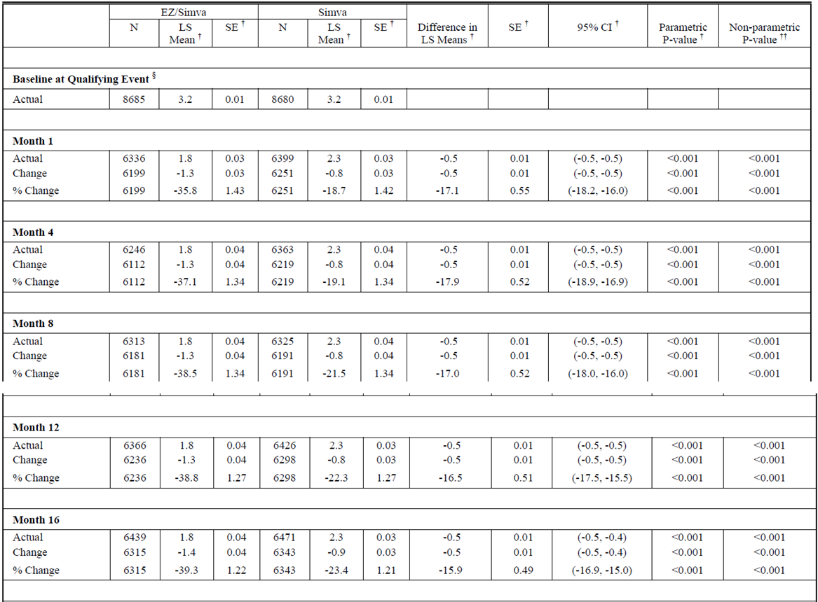
Table 11 (continued): Analysis of non-HDL-C:HDL-C Ratio, Baseline Measured at Time of Qualifying Event (Protocol-defined ITT Population).
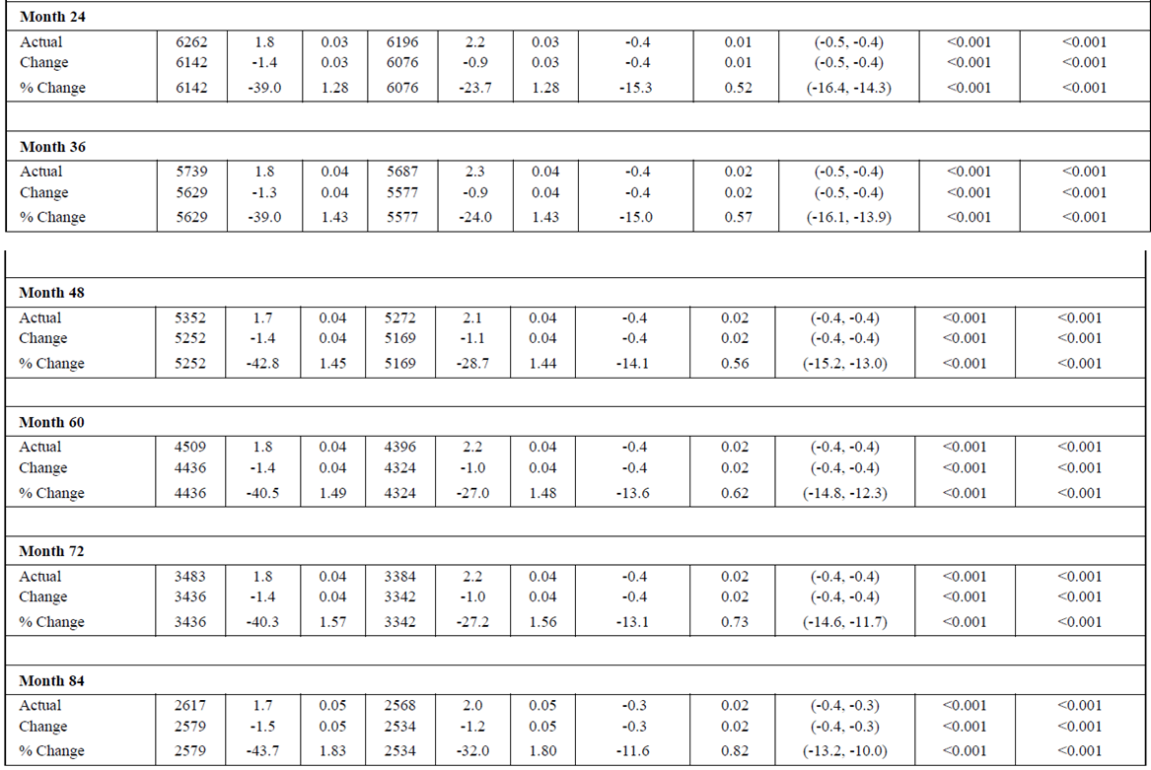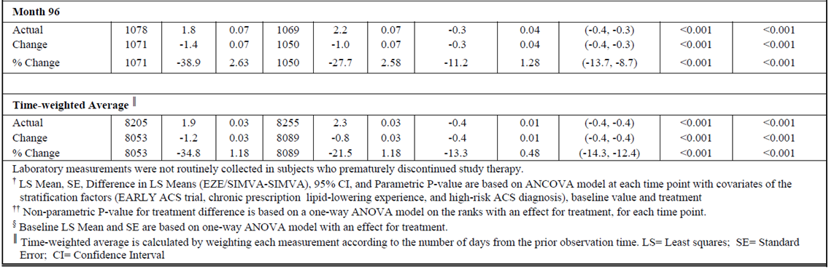

Evaluation of response:
The Sponsor’s response is considered acceptable.

Safety

Question 9
Specify the time period covered by the post market review of safety.

Sponsor response
The post-marketing safety write-up covered the time period 18 January 2013 (the international birth date of the composite pack in Australia) through 31 December 2014.

Evaluation of response
It is assumed that 18 January 2013 is considered the international birth date of the composite pack rather than the date of first entry into the ARTG. Ezetimibe was first entered into the ARTG 26 June 2003. It is unclear why the post-market review of safety did not include reports relating to atorvastatin and ezetimibe from the international birthdate of ezetimibe.

Second round benefit-risk assessment

Second round assessment of benefits
After consideration of the responses to clinical questions, the benefits of Atozet/Zeteze in the proposed usage are unchanged from those identified in the first round.

Second round assessment of risks
After consideration of the responses to clinical questions, the risks of Atozet/Zeteze in the proposed usage are unchanged from those identified in the first round.

Second round assessment of benefit-risk balance
The benefit-risk balance of Atozet/Zeteze (ezetimibe plus atorvastatin) given the proposed usage, is unfavourable. As described in the first round, no direct evidence has been submitted to support the efficacy and safety of atorvastatin combined with ezetimibe for the proposed indication. The Sponsor has requested the indication apply to all dose strength combinations of atorvastatin and ezetimibe but no evidence has been submitted to support of the efficacy and safety of all dose strength combinations.
The Sponsor has submitted a justification to extrapolate the efficacy and safety of simvastatin with ezetimibe to atorvastatin with ezetimibe at all dose strength combinations but as discussed in the first round, the results of the IMPROVE-IT study cannot be extrapolated to Atozet therapy.
The rejection of the proposed indication would not restrict access to this combination therapy, therefore rejection would not disadvantage patients and would have no impact on public health.

Second round recommendation regarding authorisation
Approval of Atozet/Zeteze (ezetimibe plus atorvastatin) is not recommended for the proposed indication:
Prevention of Cardiovascular Disease
ATOZET/ZETEZE is indicated to reduce the risk of cardiovascular events (cardiovascular death, nonfatal myocardial infarction, nonfatal stroke, hospitalization for unstable angina, or need for revascularization) in patients with coronary heart disease (CHD)).
After consideration of the responses to clinical questions, the benefits of Atozet/Zeteze in the proposed usage are unchanged from those identified in the first round. As stated above, the main reasons for rejection are the lack of direct evidence for Atozet/Zeteze for the proposed indication, the insufficient justification to support the use of indirect evidence, the extrapolation of the justification to all doses of Atozet/Zeteze. TGA has previously determined that the IMPROVE-IT study was not sufficient evidence to support the requested extension of indication for Vytorin and Ezetrol (decision letter dated 11 August 2016). The current submission included the same study and requested a similar extension of indication apply to all dosage strength of Atozet/Zeteze. The submission relied on extrapolation of the IMPROVE-IT study results to other statins without additional clinical data.

Therapeutic Goods Administration
PO Box 100 Woden ACT 2606 Australia
Email: info@tga.gov.au Phone: 1800 020 653 Fax: 02 6232 8605
https://www.tga.gov.au

