November 2018

Australian Public Assessment Report for Everolimus
  - Proprietary Product Name: Afinitor
  - Sponsor: Novartis Pharmaceuticals Australia Pty Ltd

About the Therapeutic Goods Administration (TGA)
- The Therapeutic Goods Administration (TGA) is part of the Australian Government Department of Health and is responsible for regulating medicines and medical devices.
- The TGA administers the Therapeutic Goods Act 1989 (the Act), applying a risk management approach designed to ensure therapeutic goods supplied in Australia meet acceptable standards of quality, safety and efficacy (performance) when necessary.
- The work of the TGA is based on applying scientific and clinical expertise to decision-making, to ensure that the benefits to consumers outweigh any risks associated with the use of medicines and medical devices.
- The TGA relies on the public, healthcare professionals and industry to report problems with medicines or medical devices. TGA investigates reports received by it to determine any necessary regulatory action.
- To report a problem with a medicine or medical device, please see the information on the TGA website < https://www.tga.gov.au>.
About AusPARs
- An Australian Public Assessment Report (AusPAR) provides information about the evaluation of a prescription medicine and the considerations that led the TGA to approve or not approve a prescription medicine submission.
- AusPARs are prepared and published by the TGA.
- An AusPAR is prepared for submissions that relate to new chemical entities, generic medicines, major variations and extensions of indications.
- An AusPAR is a static document; it provides information that relates to a submission at a particular point in time.
- A new AusPAR will be developed to reflect changes to indications and/or major variations to a prescription medicine subject to evaluation by the TGA.
Copyright
© Commonwealth of Australia 2018
This work is copyright. You may reproduce the whole or part of this work in unaltered form for your own personal use or, if you are part of an organisation, for internal use within your organisation, but only if you or your organisation do not use the reproduction for any commercial purpose and retain this copyright notice and all disclaimer notices as part of that reproduction. Apart from rights to use as permitted by the Copyright Act 1968 or allowed by this copyright notice, all other rights are reserved and you are not allowed to reproduce the whole or any part of this work in any way (electronic or otherwise) without first being given specific written permission from the Commonwealth to do so. Requests and inquiries concerning reproduction and rights are to be sent to the TGA Copyright Officer, Therapeutic Goods Administration, PO Box 100, Woden ACT 2606 or emailed to < tga.copyright@tga.gov.au>.

Contents
Common abbreviations 4
I. Introduction to product submission 6
Submission details 6
Product background 6
Regulatory status 7
Product Information 8
II. Registration time line 8
III. Quality findings 9
IV. Nonclinical findings 9
Introduction 9
Pharmacology 10
Nonclinical summary and conclusions 20
V. Clinical findings 20
Introduction 20
Pharmacokinetics 23
Pharmacodynamics 26
Dosage selection for the pivotal studies 28
Efficacy 29
Safety 30
First round benefit-risk assessment 39
First round recommendation regarding authorisation 39
Second round evaluation 40
VI. Pharmacovigilance findings 40
Risk management plan 40
VII. Overall conclusion and risk/benefit assessment 43
Background 43
Quality 46
Nonclinical 46
Clinical 46
Risk management plan 65
Risk-benefit analysis 66
Outcome 72
Attachment 1. Product Information 73
Attachment 2. Extract from the Clinical Evaluation Report 73

Common abbreviations
Abbreviation | Meaning
ADR | Adverse drug reaction
AEDs | Anti-epileptic drugs
ALT | Alanine aminotransferase
ASA | Australian Specific Annex
AST | Aspartate aminotransferase
BSA | Body surface area (m²)
CI | Confidence interval
CL/F | The apparent systemic (or total body) clearance from plasma (or serum or blood) following extravascular administration
C_{min} | Minimum steady state drug concentration during multiple dosing (ng/mL)
CSR | Clinical Study Report
CYP3A4 | Cytochrome P450 3A4; enzyme involved in drug metabolism
ER | Oestrogen receptor
EU | European Union
fEPSPs | Evoked field excitatory postsynaptic potentials
GFAP | Glial-fibrillary acidic protein promoter
HR | Hazards ratio
HT | High trough range treatment arm with targeted C_{min} range of 9 to 15 ng/mL
IP | Intraperitoneal
IRT | Interactive Response Technology
KA | Rate constant
LT | Low trough range treatment arm with targeted C_{min} range of 3 to 7 ng/mL
mTOR | Mammalian target of rapamycin
mTORC1 | Mammalian target of rapamycin complex 1
NCI | National Cancer Institute
NETs | Neuroendocrine tumours
pDab1 | Phospho-disabled homolog 1
PK | Pharmacokinetic
PgP | P-glycoprotein; enzyme involved in drug metabolism
pGSK3β | Phospho-glycogen synthase kinase 3
PIP | Paediatric Investigation Plan
PopPK | Population pharmacokinetics
PTEN | Phosphatase tensin homolog
QF | Two compartment model intercompartmental clearance
RAD001 | Everolimus (drug development name)
%Red | Percentage reduction from Baseline in average weekly seizure frequency during the Core phase Maintenance period
RMP | Risk management plan
SDS | Standard deviation scores
SEGA | Sub-ependymal giant cell astrocytoma
SFB | Average weekly seizure frequency in the 8 week Baseline phase
SFM | Average weekly seizure frequency in the Core phase Maintenance period
TSC | Tuberous sclerosis complex
TSC1 | Tuberous sclerosis 1 gene
TSC2 | Tuberous sclerosis 2 gene
TN-C_{min} | Time normalised C_{min}
USA | United States of America
V2/F | Two compartment PK parameter for central volume
V3/F | Two compartment PK parameter for peripheral volume
VNS | Vagal nerve stimulation

I. Introduction to product submission

Submission details
Type of submission: | Major variation (new indication)
Decision: | Approved
Date of decision: | 22 December 2017
Date of entry onto ARTG: | 3 January 2018
ARTG numbers: | 177648, 154661, 154663, 200203, 200204 and 200205

Active ingredient: | Everolimus
Product name: | Afinitor
Sponsor’s name and address: | Novartis Pharmaceuticals Australia Pty Ltd  PO Box 101  North Ryde NSW 1670
Dose forms: | Tablet and dispersible tablet
Strengths: | 2.5 mg, 5 mg, 10 mg (tablet) 2 mg, 3 mg, and 5 mg (dispersible tablet)
Container: | Blister pack
Pack sizes: | 30, 50, 60, 100, and 120 tablets: (2 mg and 5 mg dispersible tablets; and 5 mg and 10 mg tablet)  10, 30 and 90 tablets: (2.5 mg tablet)
Approved therapeutic use: | Adjunctive treatment of patients aged 2 years and older with TSC and associated refractory seizures.
Route of administration: | Oral
Dosage: | For details of dosage please see the Product Information

Product background
This AusPAR describes the application by Novartis Pharmaceuticals Australia Pty Ltd (the sponsor) to register Afinitor everolimus for the following indication:
Adjunctive treatment of patients aged 2 years and older with TSC and refractory seizures.
Patients with tuberous sclerosis complex (TSC) and refractory seizures are treated with dispersible tablets only.
Tuberous sclerosis complex is a rare multisystem genetic disease that causes benign tumours to grow in the brain and on other vital organs. TSC has a prevalence approaching 1 in 6,000 live births and is an autosomal dominant genetic condition involving mutations in either the tuberous sclerosis 1 gene (TSC1) and/or the tuberous sclerosis 2 gene (TSC2). Normally, these two genes, TSC1 and TSC2, code for the proteins hamartin and tuberin, respectively, which form tumour growth suppressor complex which regulates cell proliferation and differentiation. When either TSC1 or TSC2 are deficient, mammalian target of rapamycin complex 1 (mTORC1) is upregulated. mTORC1 is a key serine-threonine kinase playing a central role in the regulation of cell growth, proliferation and survival and its upregulation results in a variety of benign tumours or hamartomas in multiple organ systems: lesions in the kidney, brain, skin, lung, heart and eye.
Everolimus is a signal transduction inhibitor targeting mTORC1 and it exerts its activity through high affinity interaction with the intracellular receptor protein FKBP12. Everolimus is an inhibitor of the growth and proliferation of tumour cells, endothelial cells, fibroblasts and blood vessel associated smooth muscle cells. In a mouse neuronal model of TSC (in which TSC1 is ablated in most neurons during cortical development), everolimus was shown to markedly improve survival and neurological function following repeated intraperitoneal administration.
About 85% of children and adolescents with TSC have neurological manifestations including epilepsy, cognitive impairment and behavioural problems, whereas a subset of affected adults have no signs of cerebral manifestations and have a normal mental status. Up to 90% of individuals with TSC are affected by a variety of epileptic seizure types, typically occurring in the first year of life (with 82% before 3 years of age); however, up to 12% of adult patients with TSC develop epilepsy as adults.
Seizures associated with TSC are poorly controlled by anti-epileptic drugs (AEDs), epilepsy surgery, vagal nerve stimulation (VNS) and ketogenic diet. Up to 60% of patients fail to demonstrate improvement in seizure frequency with the available therapies.
In patients with TSC, the mechanisms causing epilepsy are not entirely understood. Dysregulation of development and maintenance of cortical structure and function because of mTOR dependent processes may play a role in the development of epilepsy and neuropsychiatric disorders.

Regulatory status
The product received initial registration on the Australian Register of Therapeutic Goods (ARTG) on 6 August 2009.
Everolimus was first registered in Australia on 6 August 2009 for the treatment of advanced renal cell carcinoma.
At the time of this submission was considered the approved indication for Afinitor was:
Treatment of Subependymal giant cell astrocytoma SEGA) associated with tuberous sclerosis complex (TSC) who require therapeutic intervention but are not candidates for curative surgical resection.
Treatment of patients with tuberous sclerosis complex (TSC) who have renal angiomyolipoma not requiring immediate surgery.
Treatment of postmenopausal women with hormone receptor-positive, HER2 negative advanced breast cancer in combination with exemestane after failure of treatment with letrozole or anastrozole.
Treatment of progressive, unresectable or metastatic, well or moderately differentiated neuroendocrine tumours (NETs) of pancreatic origin.
Treatment of progressive, unresectable or metastatic, well-differentiated, non- functional neuroendocrine tumours (NET) of gastrointestinal or lung origin in adults.
Treatment of advanced renal cell carcinoma after failure of treatment with sorafenib or sunitinib.
Afinitor was granted Orphan drug designation under the old guidelines for TSC on 26 July 2010 in Australia.
For overseas regulatory status, similar applications for the TSC seizures indication had been submitted in European Union (EU) (centralised procedure): submitted 30 May 2016 and approved 27 January 2017 for:
Adjunctive treatment of patients aged 2 years and older whose refractory partial onset seizures, with or without secondary generalisation, are associated with tuberous sclerosis complex (TSC).
Submissions were also under consideration in the United States of America (USA) (submitted 10 March 2017), Canada (submitted 1 December 2016) and Switzerland (submitted 28 June 2016).

Product Information
The Product Information (PI) approved with the submission which is described in this AusPAR can be found as Attachment 1. For the most recent PI, please refer to the TGA website at <https://www.tga.gov.au/product-information-pi>.

II. Registration time line
Table 1 captures the key steps and dates for this application and which are detailed and discussed in this AusPAR and Attachment 2.

Table 1: Timeline for Submission PM-2016-03871-1-1
Description | Date
Submission dossier accepted and first round evaluation commenced | 31 January 2017
First round evaluation completed | 30 June 2017
Sponsor provides responses on questions raised in first round evaluation | 31 August 2017
Second round evaluation completed | 11 October 2017
Delegate’s Overall benefit-risk assessment and request for Advisory Committee advice | 31 October 2017
Sponsor’s pre-Advisory Committee response | 13 November 2017
Advisory Committee meeting | 30 November to 1 December 2017
Registration decision (Outcome) | 22 December 2017
Completion of administrative activities and registration on ARTG | 3 January 2018
Number of working days from submission dossier acceptance to registration decision* | 182
*Statutory timeframe is 255 working days

III. Quality findings
There was no requirement for a quality evaluation in a submission of this type.

IV. Nonclinical findings

Introduction

Rationale and mechanism of action
The following is from the sponsor’s summary:
‘The specific cellular mechanisms by which mTOR hyperactivation elicits epileptogenesis are less certain. Components of the mTOR signalling pathway are widely expressed in the nervous system and TSC proteins are also highly abundant in the adult central nervous system. mTOR signalling is involved in regulating cell proliferation, autophagy, metabolism, synaptogenesis and growth of dendrites and axons, hence is important during brain development and in maintaining mature brain functions. Progress has been made in identifying potential mechanisms of epileptogenesis, namely the pathophysiologic changes that occur in nervous system tissue that predispose to spontaneous seizures. A general concept to explain epileptogenesis is that epilepsy results from an imbalance between excitatory and inhibitory forces in the brain. A defect in the involved mechanisms secondary to cellular changes induced by mTOR hyperactivation could disrupt this physiologic balance and lead to epileptogenesis and seizure generation. The TSC1 and TSC2 genes regulate the activity of the mTOR pathway. Tuberous sclerosis is caused by mutations in either the TSC1 or TSC2 genes with consequent mTOR hyperactivation.’
Figure 1: Diagram of the mTOR pathway (RAD001 = everolimus)
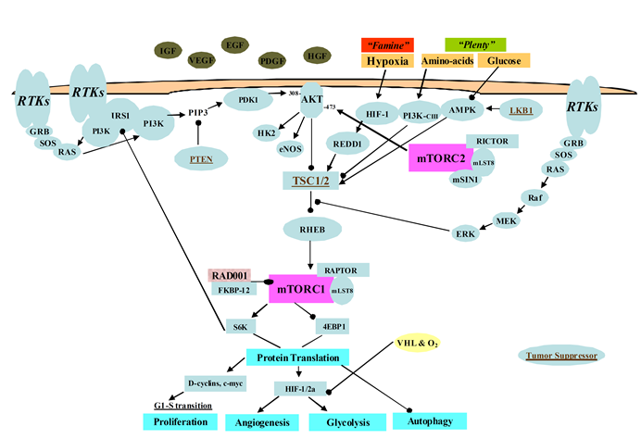
There are no new animal data and no designated nonclinical component for this submission. The sponsor has submitted 115 literature publications (cited in the Nonclinical Overview and the Pharmacology Written Summary) supporting the newly proposed preclinical statements. Of these, those considered to be of particular relevance to this application have been briefly assessed and reported below.

Pharmacology

Everolimus (RAD001) and mTOR inhibitors in TSC seizure and other seizure models
Tuberous sclerosis patients have heterozygous mutations in either the tuberous sclerosis complex 1 (TSC1) or TSC2 gene and seizure activity arises from focal epileptogenic lesions in or near cortical tubers with biallelic deletion of TSC1 or TSC2.
The studies below include animal models with similar genetic and molecular features of TSC (including seizures) using mice with mostly conditional homozygous deletion of TSC1 or TSC2 genes using the cyclisation recombination locus of X-over P1 (Cre–LoxP) system.
The mTOR inhibitors rapamycin and everlolimus (laboratory code: RAD001) demonstrated anti-seizure effects in these mouse models of TSC.

In vitro and in vivo studies
Table 2: In vitro studies
Genetic alterations of TSC genes results in genetic and hyper-activation of mTOR signaling pathway in neurons: abnormalities in cellular processes, neuronal excitability and epileptogenesis
Publication and Study Details | Results
Reugg et al., 2007;  In vitro  Effects of mTor inhibitor (rapamycin) on neuronal excitability  Electrophysiology studies using whole-cell patch clamp analysis of currents recorded from neurons in cultures of SD rat hippocampal neurons | A relatively high dose (200 nM; 10 - 50 min incubation) of rapamycin used (supra-maximal, based on previous studies in hippocampal cultures) for mTOR inhibition with findings of a general lack of consistent effects.  Neuronal firing. Spontaneous firing frequency of neurons (single action potentials and/or short bursts of action potentials) was unaffected by rapamycin or there was a slight decrease.  Voltage-gated currents. There was no change in sodium or potassium currents in preparations where synaptic activity was inhibited (with a combination of inhibitors of GABA_{A}, AMPA, and NMDA receptors).  Synaptic events. Similarly, there was general lack of consistent effects of rapamycin on excitatory glutamatergic currents following addition of a GABA_{A} receptor antagonist (bicuculline, 10 μM). There was no effect in some preparations while in others; rapamycin decreased the induced burst activity.  Conclusion. The findings are not consistent with rapamycin producing significant acute effects on neuronal firing to an extent which could result in marked antiseizure activity observed in TSC knockout models (see below).
Daoud et al., 2007  In vitro Effects of rapamycin on neuronal excitability  Extracellular field potentials recorded with glass microelectrodes in CA1 hippocampal neurons | Under control conditions, no spontaneous epileptiform activity observed. The amplitude of evoked field excitatory postsynaptic potentials (fEPSPs) induced by stimulation of Schaffer collaterals in the CA1 area with single pulses applied every 5 minutes was unaffected by rapamycin up to 250 nM.  At ≥ 500 nM of rapamycin, fEPSPs increased, but this is not consistent with its anti-seizure activity.  Conclusion. Based on findings at ≤ 250 nM of rapamycin, no significant acute effects were evident on neuronal firing (excitatory neurotransmission).
Bateup et al., 2013  In vitro Effects of rapamycin on  neural network activity in cultured hippocampal neurons from conditional TSC1 knockout mice | Firing rate in neuronal cultures reflecting synaptic activity and intrinsic excitability (driven by ion channel expression and function) of neurons from TSC1 knockout (KO) mice was significantly elevated compared to wild-type neurons.  Loss of TSC1 in hippocampal CA1 pyramidal neurons led to an altered ratio of excitatory and inhibitory synaptic transmission leading to hyper-excitability.  Rapamycin (50 nM ) resulted in a gradual and marked decrease in firing rate in TSC1 KO neurons (with only a very modest effect in the wild type).  The rapamycin-induced decrease in firing frequency in TSC1 KO neurons occurred after two days with maximum effects seen in 4 to 5 days. This slow onset of action is in accord with corrections in transcriptional/translational changes induced by mTOR hyperactivity.  Conclusion. The mechanism of action of mTOR inhibitors such as rapamycin against seizures in TSC is probably due to normalization of mTOR.
McMahon et al., 2012; Mouse model with forebrain deficient in autophagy following conditional deletion of ATG7 (a regulator of autophagy) | Autophagy was also suppressed in brain tissues of forebrain specific conditional TSC1 knock-out (KO) and phosphatase/tensin homolog (PTEN) KO mice (both of which display aberrant mTOR activation and seizures as early as 5 weeks of age with associated increased mortality especially between postnatal Weeks 6 and 8). Mice with conditional deletion of ATG7 also exhibited spontaneous recurrent seizures.  Conclusion. Impaired autophagy may contribute to epileptogenesis in TSC.
Meikle et al., 2007;  Mouse neuronal model of TSC - Tsc1^{Synapsin} . Conditional knockout (CKO) mouse using synapsin-1 promoter to drive Cre recombinase and generate homozygous deletion of Tsc1 in most postmitotic neurons during cortical development | Poor growth (delayed development) and premature death by 65 days of life. Mice showed neuropathologic abnormalities in many cortical and hippocampal neurons (ectopic, enlarged and dysmorphic neurons similar to dysmorphic neurons observed in TSC cortical tubers; increased levels of phosphorylated S6, a common marker of mTOR activation).  Spontaneous seizures seen in a few mutants correlated with abnormal electroencephalographic activity.  Handling-induced seizures in a larger proportion of mice.  Tsc1^{Synapsin} CKO mice also showed severe myelination defects and neuronal cell enlargement and dysplastic features (for example, accumulation of non-phosphorylated neurofilaments and abnormal dendrite orientation).  Conclusion. Genetic alterations of TSC genes resulted in hyper-activation of mTOR signaling, seizures and abnormalities including myelination and morphology.
Moon et al., 2015;  Conditional Tsc2 knockout mice  Tsc2flox/flox mice bred to Emx1-Cre or Nestin-Cre mice | TSC2 deletion resulted in abnormal leading process morphology of migrating neurons and migration defects of cortical neurons and Purkinje cells associated with impaired Reelin-Dab1 signalling.  The increased mTOR signalling (which upregulates the expression of Cul5, a ubiquitin ligase responsible for pDab1 degradation) suggests one possible mechanism for neuronal migration deficit in TSC.  Prenatal treatment with rapamycin (IP, at 0.3 mg/kg daily to pregnant females from embryonic day E13.5) rescues migration (restores normal leading processes and positioning of migrating neurons) and reduces expression of Dab1 and Cul5.  Conclusion. Genetic alterations of TSC genes, hyper-activation of mTOR signalling in neurons and associated abnormalities may alter neuronal network function resulting in epileptogenesis.
Feliciano et al., 2011; Mouse- Tsc1 ablated in discrete neuronal populations  TSC deletion in tuberous sclerosis tubers by in utero electroporation (2 plasmids electro-porated at E15-E16.5 following injection of DNA at E15 or E16) in embryos of mice heterozygous for a mutant Tsc1 allele to inactivate TSC1 in cortical neural progenitor cells | Mice showed a reduced seizure threshold (that is , reduced seizure latency; approximately 25%) in response to injections of the GABA_{A} receptor antagonist, pentylenetetrazole (albeit without spontaneous seizures) and brain lesions with discrete, cortical tuber-like lesions (that is, mice showed white matter heterotopic nodules and discrete cortical tuber-like lesions containing cytomegalic and multinucleated neurons with abnormal dendritic trees resembling giant cells).  Knockout of TSC1 in single cells resulted in increased mTOR activity and increased soma size in the affected neurons. Phospho-S6 immunoreactivity was not upregulated in TSC1-null astrocytes despite a lower seizure threshold.  Conclusion. Tuberous sclerosis complex (TSC) is an autosomal dominant disorder characterized by mutations in TSC1 or TSC2 that lead to mTOR hyperactivity. The focal nature of biallelic TSC deletion in tuberous sclerosis tubers was replicated in mice using a ‘double-hit strategy’ to ablate TSC1 in discrete neuronal populations resulting in cortical hyperexcitability.
Lim et al., 2015; Introduction of mTOR mutations into mouse cerebral cortex Electroporation in utero at E14following injection of 2 to 3 mg of mTOR mutant plasmids in embryos of mice (pCIG-mTOR wild type and p.Leu2427Pro) | Mutations were based on ‘focal cortical dysplasia type II’ (FCDII), a sporadic developmental malformation of the cerebral cortex characterized by dysmorphic neurons, dyslamination and medically refractory epilepsy.  FCD is considered to be caused by somatic mutations in affected regions.  Focal cortical expression of mutant mTOR inducing the hyperactivation of mTOR kinase by in utero electroporation in mice resulted in disrupted neuronal migration, cytomegalic neurons and spontaneous seizures (about 6 weeks after birth with approximately 6 events per day). Seizures in mice and cytomegalic neurons were inhibited by treatment with the mTOR inhibitor rapamycin (daily IP injection protocol for 2 weeks at 10 mg/kg).  Conclusion. Hyperactivation of mTOR resulted in induction of epilepsy. Rapamycin (mTOR inhibitor) reduced seizure activity by mTOR inhibition.

Table 3: In vivo studies
Preclinical studies in models of mTOR dysregulation
Publication and Study Details | Results
Uhlmann et al., 2002;  Tsc1 ^{GFAP} conditional knockout (CKO) mice  Homozygous CKO mice with deletion of the Tsc1 gene mediated by Cre expression (Tsc1^{GFAP}CKO) in astrocytes and a subset of neurons.  Created by breeding mice with an insertion of LoxP sites flanking exons 17 and 18 of TSC1, and mice expressing Cre recombinase under the glial-fibrillary acidic protein promoter (GFAP) | Pathological and behavioural alterations included numbers of astrocytes found in the cerebral neocortex and hippocampus (leading to abnormal neuronal organization in the hippocampus between 3 and 5 weeks of age); increased brain size, neuronal cell death, dramatic astrogliosis (hypertrophy and increased numbers/proliferation), but preserved lamination and preserved overall histoarchitecture of the brain.  Progressive electroencephalographic seizures started at about 1 to 2 months of age and premature deaths started between 3 and 6 months of age. Tsc1^{GFAP}CKO mice showed abnormalities in interictal (that is, period between seizures) EEG background and progressive encephalopathy also starting between 1 and 2 months of age.  Conclusion. Model considered one of the best characterized examples of TSC in terms of morphological, physiological, cellular and molecular changes.  Animals showed well documented spontaneous seizures that increase in frequency over time and a shortened lifespan.
Erbayat-Altay et al., 2007;  Tsc1 ^{GFAP} conditional knockout (CKO) mice | In addition to seizures (starting around 4 to 6 weeks of age), Tsc1^{GFAP}CKO mice develop an encephalopathy correlating with abnormalities in interictal EEG background. All mice died by 3 months.
Zeng et al., 2008;  Effect of an mTOR inhibitor (rapamycin) to prevent or reverse seizures  Tsc1 ^{GFAP} conditional knockout (CKO) mice | Activated mTOR activity was observed with increased pS6 levels (3 to 5 fold) in the neocortex and hippocampus. In addition to well documented spontaneous seizures, mice showed a progressive encephalopathy and abnormalities in interictal EEG background, starting between 1 and 2 months of age. Increased numbers of astrocytes (astrogliosis) were also found in the cerebral neocortex as well as the hippocampus. Animals showed and a shortened lifespan (all mice dead by 4 months).  Mice treated daily with rapamycin (3 mg/kg IP, 5 days/week) starting at postnatal day 14 (early treatment; 2 weeks prior to the onset of spontaneous seizures and continued for 15 weeks) did not develop seizures or histopathological alterations (astrogliosis, hippocampal pyramidal cell dispersion, neuronal enlargement were reduced and brain volume was decreased) and survived longer, compared to controls. Phosphorylation of S6 protein (downstream mediator of TOR pathway) was reduced by rapamycin.  Similarly, in mice that were dosed at 6 weeks after birth (corresponding to the onset of neurological abnormalities; that is, late treatment), the frequency of seizures that had developed were also reduced. Treatment also partially reversed the histopathologic changes observed in astrocytes and hippocampal pyramidal cells (to a lesser extent when given earlier).  When rapamycin treatment was discontinued, there appeared to be a delayed re-emergence of the neurological phenotype and seizures, suggestive of a need for long-term, continued treatment.  Conclusion. Rapamycin prevented or reversed seizures and the underlying cellular and molecular brain abnormalities in mice, indicating that the seizures and the underlying pathology are sensitive to mTOR inhibition.
Meikle et al., 2008;  Tsc1^{Synapsin} conditional TSC1 knockout (CKO) mouse model of TSC.  Effect of 2 mTOR inhibitors: rapamycin and RAD001 (everlolimus) on molecular, clinical and histological abnormalities Treatment for 23 days: started early on Postnatal Day 7 to Postnatal Day 30 with: rapamycin (6 mg/kg IP, every 2 days)or everlolimus (3 or 6 mg/kg IP, every 2 days) | Early (that is, postnatal treatment) with both mTOR inhibitor agents resulted in the absence of spontaneous seizures. However, minimal experimental protocols or raw data were presented for seizure monitoring. Rapamycin and everlolimus prolonged survival from around 33 days to more than 100 days.  Rapamycin and everlolimus decreased pS6 levels in brain lysates and restored phospho-Akt and phospho-glycogen synthase kinase 3 (pGSK3β) levels. The latter effect is consistent with restoration of Akt function after blocking mTORC1 signaling. Both showed brain penetration and tissue accumulation (higher in younger mice: higher at PND 10 cf. PND 30-45).  Due to similar effects on survival and ablation of seizures, effects of mTOR inhibition on cortical organization, dysplasia, cell size enlargement and myelination was only was only investigated with rapamycin treatment. Histopathological changes such as neuronal hypertrophy (cell enlargement), neurofilament abnormalities and reduced myelination were prevented, despite persistence of some neuronal structural abnormalities (abnormal orientation of apical dendrites in layer V of somatosensory cortex).  When rapamycin and/or everlolimus treatment were discontinued, there was a delayed re-emergence of seizures and/or neurological phenotypes, indicating the a need for long-term, continued treatment.  Conclusion. Early treatment of mice with the mTOR inhibitors everolimus and rapamycin abolished seizures and prolonged survival. In further studies only with rapamycin, there was a reversal of neuronal cell size defects and impaired myelination in Tsc1^{Synapsin} knockout mice.
Carson et al., 2012;  Tsc1 ^{Emx1–Cre} conditional knockout (CKO) mice  Mice are homozygous for the Tsc1 floxed allele and heterozygous for Emx1–Cre.  Mice express Cre recombinase by E10.5 in dorsal neural progenitor cells which give rise to almost all excitatory neurons of the cortex as well as astrocytes and a subset of oligodendrocytes | Spontaneous seizures were consistently observed in mutants by Day 13 and premature deaths seen by 25 days of age. Pathological changes of an increase in brain size, prominent large cells within the cerebral cortex with increased mTORC1 and decreased mTORC2 signalling (that is, increased levels of phosphor-S6 and decreased phospho-Akt, respectively), severe defects of cortical lamination, enlarged dysmorphic astrocytes and decreased myelination were observed. Postnatal rapamycin treatment (3 mg/kg, IP, 5 days a week) starting on Days 13 to 15 completely abolished premature deaths, increased cortical myelination and largely reversed glia pathology (abnormalities of astrocytes) but not the extensive neuronal pathology (abnormal neuronal lamination).  Conclusion. Mutants showed a greatly shortened lifespan and extensive neuronal as well as glial cell histopathology. Early treatment with rapamycin prevented early death and some neuronal pathology.
Goto et al., 2011;  Tsc1CC NestinrtTA+ TetOp-cre+ model (mosaic induction of loss of TSC1 in embryonic neural progenitor cells) by doxycycline given on Days E8-16 | By Day 21, mice exhibited spontaneous seizures (and in response to physical stimulation such as handling and noise), macrocephaly by Week 6, and premature death (as early as in the first week). Hyper activation of mTORC1 (as assessed by pS6 expression) was prominent in both neurons and enlarged astrocytes. Postnatal rapamycin dosing (1 to 3 mg/kg, IP; 5 days/week) on Day 8 suppressed seizures and prolonged survival. Brain enlargement and cortical cell enlargement were reversed by rapamycin. Similarly hyper activation of mTORC1 (as measured by downstream phospho-S6 levels) and decreased astrogliosis (as measured by GFAP levels) were also reversed by treatment. As with Tsc1^{GFAP} CKO mice, when rapamycin treatment was withdrawn, the mutant animals developed neurological symptoms and died (within 2 weeks of drug withdrawal), suggesting continued rapamycin treatment is required.
Wong et al., 2003;  Tsc1 ^{GFAP} conditional knockout (CKO) mice  Homozygous CKO mice with deletion of the Tsc1 gene mediated by Cre expression (Tsc1^{GFAP}CKO) | Cellular alterations in these mice included reduced expression of the astrocyte-specific glutamate transporters, Glt-1 and GLAST (transporters involved in clearance from synaptic cleft) and likely contributing to increased levels of extracellular glutamate, excitotoxicity and decreased seizure threshold. Electrophysiology studies showed a decrease in glutamate transport currents in astrocytes in hippocampal slices and cultures.  Conclusion. It is not clear if the findings are a cause or effect of seizure activity.
Zeng et al., 2011;  Tsc2 ^{GFAP} conditional knockout (CKO) mice  Comparison of neurological phenotypes with Tsc1^{GFAP}CKO mice described above by Uhlmann et al 2002. | Tsc2^{GFAP}CKO mice also showed increased pS6 expression (in brain), displayed seizures, early death, progressive megencephaly, diffuse glial proliferation, and dispersion of hippocampal pyramidal cells (these mutants showed earlier onset and greater occurrence of seizures, death occurred earlier and more severe histolopathology in brain than Tsc1GFAPCKO mice).  A comparison of mTOR activation between the two mutants indicated pS6 expression was significantly greater in this model (1.45-fold at 3 weeks of age; p< 0.05) possibly explaining more severe histopathological findings.  As in Tsc1^{GFAP}CKO mice (see Wong et al., 2003 above), reduced astrocyte glutamate transporter Glt-1 expression was observed, but this was not significantly different between the two models.  Rapamycin (3 mg/kg/day, 5 days/week, route not specified) given at 2 weeks of age produced inhibition of seizure number and frequency (by 3 weeks of age), prolonged survival, decreased megencephaly and number/ proliferation of astrocytes and reduced dispersion of the pyramidal cell layer in hippocampus. The increase in pS6 in Tsc2^{GFAP}CKO mice was also inhibited as in Tsc1^{GFAP}CKO mice (described above by Zeng et al. 2008).  Conclusion. Similar to Tsc1^{GFAP}CKO mice, Tsc2^{GFAP}CKO mice exhibited epilepsy, premature death megencephaly and altered histopathologic phenotypes. Seizures of greater severity may be related to the degree to which Tsc1 and Tsc2 inactivation causes abnormal mTOR activation.
Hartman et al., 2012;  NIH Swiss mice (wild type) | pS6 was dramatically suppressed at 3 hours and 6 hours after a single dose of rapamycin (4.5 mg/kg, IP) in both cortex and hippocampus.  The only test where acute rapamycin treatment (within 6 h of a single dose of 4.5 mg/kg, IP) protected against seizures (slight effect only, based on number of animals, seizure THLE scores, seizure duration) was in the maximal electroshock threshold (MES-T) against tonic hindlimb extensions. Rapamycin (4.5 to 6.0 mg/kg, IP).did not acutely reduce seizure severity induced by kainic acid (glutamatergic agonist), pentylenetetrazol (GABAergic antagonist) or 6 Hz corneal electrical stimulation.  Conclusion. Limited antiseizure effect of rapamycin observed under acute dosing conditions in wild type animals.
Way et al., 2009;  Conditional knockout (CKO) mouse model of TSC2 Homozygous deletion of TSC2 in radial glial (and their neuronal and glial progeny; hGFAP promoter to drive Cre recombinase) | TSC2 gene deleted from radial glial progenitor cells in the developing cerebral cortex and hippocampus. Seizures and early postnatal death  (3 to 4 weeks) observed in mice. Mutants presented with brain enlargement, ectopic cells, myelination deficits and widespread neuropathological features throughout the entire cerebral cortex, such as cortical thickening and enlarged cells, astrogliosis and lamination defects (features associated with cortical tubers). mTOR activation was demonstrated by increased pS6 levels in brain lysates and tissue sections.
Way et al., 2012;  Tsc2-hGFAP neuroglial mouse model of TSC  Loss of Tsc2 in radial glial progenitor cells results in brain manifestations of TSC. | TSC2-hGFAP animals typically show cortical and cellular hypertrophy, heterotopias, defects in lamination and myelination, astrogliosis and die at about one month of age. Extended pre- and post-natal rapamycin treatment (0.1 mg/kg intra peritoneal (IP), daily) almost completely prevented/reversed neuronal and glial pathologies (and improved health, weight gain and longevity), while prenatal or postnatal treatment alone yielded less complete but significant improvements in brain histology.  Conclusion. The mTOR inhibitor rapamycin prevented early death and altered histopathologic phenotypes such as astrogliosis.
Zeng et al., 2009;  Rat model of temporal lobe epilepsy initiated by status epilepticus  Acute effects of rapamycin on the mTOR pathway and kainic acid induced seizures | Whilst rapamycin pretreatment (6 mg/kg) produced an acute decrease in S6 phosphorylation, rapamycin did not acutely decrease kainic acid (glutamatergic agonist) induced seizures (severity, latency and duration).  Conclusion. Rapamycin shows limited antiseizure effect under acute dosing conditions in these (wild type) animals, suggesting that it does not acutely alter neuronal and synaptic activity and protect against seizures acutely.
Table 4: S6K1 phosphorylation of the oestrogen receptor
Publication and Study Details | Results
Holz 2012;  The role of S6K1 in oestrogen receptor (ER)-positive breast cancer | 40S ribosomal S6 kinase 1 (S6K1) is a serine/threonine protein kinase  S6K1: principal kinase effector downstream of mTORC1  sensitive to numerous signalling inputs, including growth factors, amino acids, energy levels and hypoxia  therefore influences oncogenic processes, cell growth, proliferation, survival, apoptosis and cell migration/ invasion  S6K1 directly phosphorylates and activates ERα (that is, directly phosphorylating ERα on Ser167 resulting in ERα activation and increased S6K1 expression by a positive feedback loop)  Phosphorylation of Ser167 is sensitive to growth factor stimuli and is mediated primarily by S6K1 (p90Rsk, Akt may play role)  S6K1 expression is oestrogenically regulated  S6K1 expression is regulated in human breast cancer cell lines and murine mammary epithelia by oestrogen/ERα involving transcription factor GATA-3  Endocrine resistance associated with ligand-independent activation of ERα signalling due to hyper activation of mTORC1 signalling pathway  Conclusion. S6K1 directly phosphorylates ERα leading to ligand independent activation. Thus, hyperactivation of mTORC1/S6K1 signalling is relevant to ER-positive status in breast cancer.

Preclinical studies in models of angiomyolipoma (AML)
Table 5: Preclinical studies in models of angiomyolipoma (AML)
Publication and Study Details | Results
Woodrum et al., 2010;  Spontaneous AJ mouse (TSC2+/-) kidney tumour angiomyolipoma progression  Comparison of 3 rapamycin treatment schedules  n = 4/group (3 to 9 months of age)  All animals started treatment at 9 months of age and sacrificed 12 weeks later  Dosing route: IP  Dose: 8 mg/kg  Dosing duration: 4 to 12 weeks  (Tumour volume, body weight) | - Severity of kidney angiomyolipomas increasing with age  - Rapamycin treatment schedules (8 mg/kg, IP):  - daily for 4 weeks: 66% ↓ in tumour burden  - daily for 4 weeks followed by weekly for 8 weeks: 82% decreasing  - weekly for 12 weeks: 81% ↓  Duration of rapamycin treatment is of greater importance than dose frequency of administration  Conclusion. Duration of rapamycin treatment is of greater importance cf. dose frequency.
Kenerson et al., 2007;  Angiomyolipoma (AML) perivascular epithelioid cell tumours linked with TSC 1/2 mutations display sustained activation of mTOR signalling  Human kidney AML samples  (Immunohistochemical, biochemical analyses) | - Angiomyolipoma (AML) also known as perivascular epithelioid cell tumours (PEComas)  - Clonal in nature & association with tuberous sclerosis  - Genetic analyses indicate allelic imbalance at TSC2 locus on 16p13  - Findings in 15 of 15 non-TSC AMLs of increase levels of phospho-p70S6K (marker of mTOR activity), with associated decrease phospho-AKT expression (that is, consistent with disruption of TSC1/2 function).  - Western blot analysis confirmed mTOR activation with the loss of TSC2 (and not TSC1) in sporadic AMLs  - increase Phospho-p70S6K and decrease phospho-AKT expression detected in 14 of 15 cases of extrarenal PEComas.  Conclusion. mTOR activation is common to sporadic, non-TSC-related AMLs and PEComas.
El-Hashemite et al., 2003  Mutation in TSC2 and activation of mTOR signalling in renal angiomyolipoma (AML)  Human kidney AML samples  5 tuberous sclerosis patients, with germline mutations in TSC2 (n = 4) and/or loss of heterozygosity for TSC2 in tumours (n = 2). Strong expression of phospho-S6 (Ser235/236) in smooth muscle cells of angiomyolipoma  Investigations of phosphorylation of p70 S6 kinase and ribosomal S6 protein occurring in angiomyolipomas in tuberous sclerosis.  (Immunoblotting, immunohistochemical analysis) | - In all samples, S6K and hamartin (encoded by TSC1) was expressed  - Tuberin (TSC2) was weak or absent in angiomyolipomas, but present in healthy kidney  - Phosphorylated p70 S6 kinase and p56 observed in angiomyolipomas only  Conclusion. Activation of a mammalian target of rapamycin metabolic pathway (mTOR) contributes to the growth of angiomyolipomas (AMLs)

Nonclinical summary and conclusions
The proposed changes to the draft PI require nonclinical evaluation. No new animal data with everolimus were submitted. In support of the proposed changes to the PI, the nonclinical dossier comprised 115 literature publications. Of these, 20 were considered to be of particular relevance to this application.
The revised and/or new ‘Mechanism of Action’ nonclinical statements in the draft PI were either supported by data reviewed in earlier evaluation reports and/or were supported by newly submitted published data. Details of the studies which were evaluated to support the Mechanism of Action (Pharmacodynamics) section of the PI are included above.
The nonclinical statements in the proposed PI are acceptable.
There are no nonclinical objections to the proposed extension of indications.

V. Clinical findings

Introduction
Everolimus was initially developed for the prophylaxis of organ transplant rejection. It was first registered in Australia in 2009 for treatment of advanced renal cell carcinoma. Everolimus has multiple indications with the most recent extension for the treatment of progressive, unresectable or metastatic, well differentiated, non-functional neuroendocrine tumours (NET) of gastrointestinal or lung origin. That submission (Submission PM-2015-03569-1-4) was approved on 13 January 2017.
Of particular note for paediatric use:
- Everolimus is not recommended for use in paediatric cancer patients.
- Everolimus is not recommended for use in paediatric patients with TSC who have renal angiomyolipoma in the absence of subependymal giant cell astrocytoma (SEGA).
- Everolimus has not been studied in paediatric patients < 1 year of age with TSC who have SEGA.
- Dosing recommendations for paediatric patients with TSC who have SEGA are consistent with those for the corresponding adult population with the exception of those patients with hepatic impairment. Everolimus is not recommended for patients < 18 years of age with TSC who have SEGA and hepatic impairment.
This submission represents that first proposed use of everolimus for a non-oncology indication. Additionally it is proposed for use in a paediatric population.
About 85% of children and adolescents with TSC have neurological manifestations including epilepsy, cognitive impairment and behavioural problems, whereas a subset of affected adults have no signs of cerebral manifestations and have a normal mental status. Brain lesions mainly consist of cortical tubers, subependymal nodules and subependymal giant-cell astrocytomas, whose growth is a fearful complication.

Clinical rationale

Information on the condition being treated
Tuberous sclerosis complex has a prevalence approaching 1 in 6000 live births. It is an autosomal dominant genetic condition involving the TSC1 and/or the TSC2 gene, mutations of which are found in 80% to 85% of patients.
Products from these two genes form a tumour suppressor complex. When either TSC1 or TSC2 are deficient, mammalian target of rapamycin complex 1 (mTORC1) is upregulated leading to abnormal cellular growth, proliferation, and protein synthesis. This results in a variety of benign tumours, or hamartomas, in multiple organ systems: lesions in the kidney, brain, skin, lung, heart, and eye.
Up to 20% of hamartomas in the brain (usually subependymal nodules) demonstrate progressive growth becoming subependymal giant-cell astrocytomas (SEGA). As they enlarge, symptoms of increased intracranial pressure, new neurologic deficits, or deterioration of seizure control may be observed.
Development can occur of early onset epilepsy and other neuro psychiatric problems such as developmental delay, mental retardation, and autism.
In patients with TSC, the mechanisms causing epilepsy are not entirely understood; dysregulation of development and maintenance of cortical structure and function because of mTOR dependent processes may play a role in the development of epilepsy and neuropsychiatric disorders.

Seizures
Up to 90% of individuals with TSC are affected by a variety of seizure types of epilepsy, typically occurring in the first year of life (with 82% before 3 years of age); however, up to 12% of adult patients with TSC develop epilepsy as adults.
Patients with seizure onset before the age of 4 years, particularly when the seizures are frequent or refractory, have a substantially increased risk of subsequent mental retardation or autism.

Current treatment options and clinical rationale
SEGA are seen more frequently in childhood and adolescence; however, they have been reported in patients in their 30s and 40s. Historically, surgical resection has been used as standard of care to treat patients with TSC with SEGA. Despite its chances for success, a considerable level of risk of peri and post-operative complications exists for such patients.
Seizures in patients with TSC may be controlled by medication such as antiepileptic drugs (AEDs) or methods such as epilepsy surgery, vagal nerve stimulator or ketogenic diet. However seizures associated with TSC are poorly controlled by AEDs or epilepsy surgery, vagal nerve stimulation (VNS) or ketogenic diet and up to 60% of patients with TSC associated epilepsy fail to demonstrate improvement in seizure frequency with available therapies.

Clinical rationale
Pre-clinical results established the critical role of mTOR in TSC related seizures and underlying epileptogenesis mechanisms and suggested inhibiting mTOR is a promising mechanism based seizure reduction and antiepileptogenic therapy for treating TSC related epilepsy. On the basis of these pre-clinical results and preliminary clinical efficacy data, Novartis initiated a Phase III study to investigate the safety and efficacy of everolimus in patients with TSC and refractory seizures.

Guidance
- CHMP/EWP/566/98 Rev.2/Corr Guideline on Clinical Investigation of Medicinal Products in the Treatment of Epileptic Disorders Effective: 17 December 2010.
- CPMP/EWP/2330/99 Points to Consider on Application with 1. Meta-Analyses; 2. One Pivotal Study Effective: 27 March 2002 TGA annotation: Sponsors are reminded that they should submit all available new safety data that are relevant to the intended treatment population.
- CPMP/EWP/908/99 Points to Consider on Multiplicity Issues in Clinical Trials.
- CPMP/ICH/375/95 ICH Topic E 1 Note for Guidance on Population Exposure: The Extent of Population Exposure to Assess Clinical Safety.
- CPMP/ICH/377/95; Note for Guidance on Clinical Safety Data Management Definitions and Standards for Expedited Reporting. Annotated with TGA Comments.

Contents of the clinical dossier
The submission contained the following clinical information:
- Comparative BA and Bioequivalence (BE) study reports
  - Study X2111: A randomised, open label, two way crossover study investigating the bioequivalence of everolimus (RAD001) 2 x 5 mg dispersible tablets in suspension and 5 x 2 mg dispersible tablets in suspension, in healthy male subjects.
- Pharmacokinetic study reports
  - Study M2301: M2301 PK Expert Report A randomised, double blind, placebo controlled study of everolimus in the treatment of patients with subependymal giant cell astrocytomas (SEGA) associated with tuberous sclerosis complex (TSC).
- Population pharmacokinetic analyses.
  - Study M2301: Population pharmacokinetics of everolimus in the treatment of patients with subependymal giant cell astrocytomas associated with tuberous sclerosis complex 5 year update (Modelling Report).
- Efficacy/safety studies.
  - Study M2304: Parts 1 2 and 3; A three arm, randomised, double blind, placebo controlled study of the efficacy and safety of two trough ranges of everolimus as adjunctive therapy in patients with tuberous sclerosis complex (TSC) who have refractory partial onset seizures.
The submission also contained: Clinical Overview, Summary of Clinical Pharmacology Studies Summary of Clinical Efficacy; Summary of Clinical Safety Synopses of Individual Studies and literature references.

Paediatric data
The EMA approved deferral to the Paediatric Investigation Plan (PIP) was to be completed by March 2020.

Good clinical practice
All studies were conducted in full compliance with current Good Clinical Practice.

Pharmacokinetics

Studies providing pharmacokinetic data
New clinical pharmacology information from three studies, including data in patients with refractory TSC seizures from the pivotal Phase III Study M2304 and the 5 year updated data in patients with TSC who have SEGA from previously reported studies (Study C2485 and Study M2301).

Table 6: Submitted pharmacokinetic studies
PK topic | Subtopic | Study ID | *
PK in healthy adults | Bioequivalence; Single dose | X2111 | *
Population PK analyses | Target population§ | M2301 | *
PK interactions | Antiepileptic drugs | M2304
* Indicates the primary PK aim of the study. § Subjects who would be eligible to receive the drug if approved for the proposed indication.

PopPK analysis Study M2301
Population pharmacokinetics (PopPK) of everolimus in the treatment of patients with sub-ependymal giant cell astrocytoma (SEGA) associated with TSC; 5 year update.
This was a 5 year update of the previous model based on 3 year data up to 11 January 2013. Study M2301 consisted of a double blind randomised phase and an extension phase, in which treatment was expected to run 4 years after the last patient was randomised. Patients were allowed to crossover from placebo to everolimus at SEGA progression or after the unblinding of the investigator on 13 May 2011.
The analysis population included 111 patients who ranged from age 1.0 to 27.4 years at the start of everolimus. This included the 78 patients in the previous analysis randomised to everolimus plus 33 new patients randomised to placebo who switched to everolimus and contributed pharmacokinetic (PK) samples. They contributed 2,580 everolimus blood concentrations to the PopPK analysis.
The previous PopPK model (based on data cut-off date 11 January 2013) was a two compartment model with first order input (rate constant KA), apparent clearances (CL/F and Q/F; and apparent volumes (V2/F and V3/F). The typical values of some of the PK parameters depended on body surface area (BSA, m²) and an indicator for the presence or absence of CYP3A4; or P-glycoprotein (PgP) inducers.
The previous PK model parameter estimates were updated with the 5 year data set and then compared with those existing from the 3 year data.
Since the use of additional covariates showed larger % error in predictions of trough levels, the 5 year model with no additional covariates (to those of the existing 3 year model) was adopted.
Typical steady state trough level was predicted to be near the midpoint of the target range of 5 to 15 ng/mL for an adult on a 4.5 mg/m² dose with absence of CYP3A4 or PgP enzyme inducers. The presence of inducer was associated with numerically greater decrease in trough levels for adults compared to children. Typical steady state trough levels are predicted to be near the lower limit of the target range for a child or anyone with presence of CYP3A4 or PgP enzyme inducers.
Thus: Children or anyone with presence of inducers may need a dose increase from 4.5 mg/m² to maintain steady state trough levels within the target range
Steady state P-glycoprotein; enzyme involved in drug metabolism based on a higher starting dose was simulated for children 1 year to less than 3 years to deliver typical initial steady state C_{min}; higher than 5 ng/mL across the BSA range observed in the trial at time of first everolimus dose (0.42 m² to 0.74m²). A higher starting dose of 7 mg/m² based on the dispersible tablet or the regular tablet is suggested for children 1 to < 3 years to help minimize blood draws in these youngest children by reducing the number of dose titrations to attain the C_{min} within the target range of 5 to 15 ng/mL. See Figure 2.
Figure 2: Typical steady state concentration time profiles by BSA and absence/presence of inducer based on a dose of 4.5 mg/m²
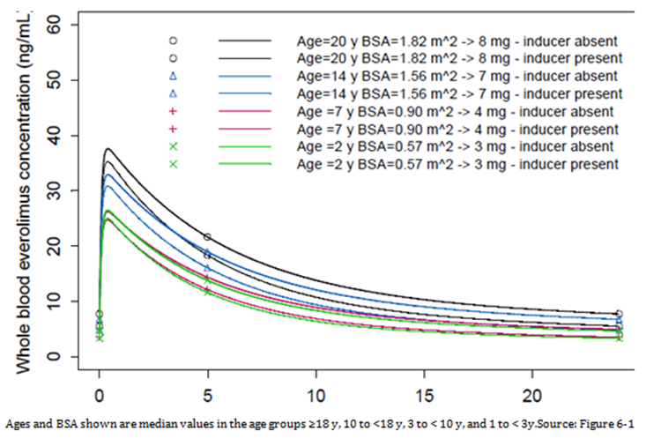

Pharmacokinetic interactions Study M2304

Table 7: Concomitant antiepileptic therapy; Study M2304 Core phase (Safety Set)
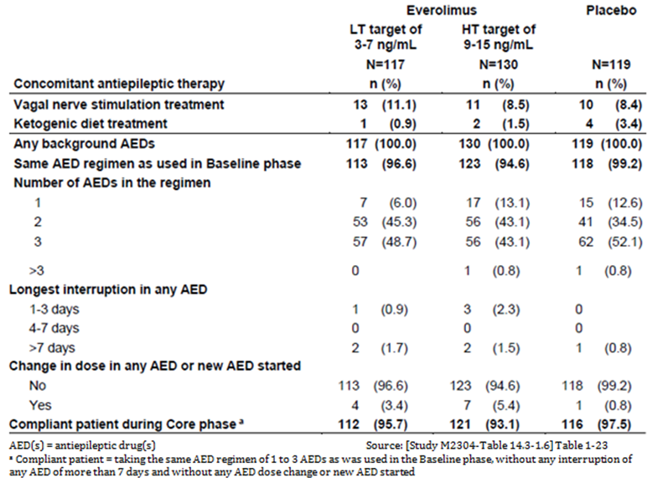
In Study M2304 the concentration levels of 12 commonly prescribed AEDs were assessed:
- Inducers of CYP3A4: carbamazepine, oxcarbazepine, phenobarbital, phenytoin, primidone, clobazam, topiramate
- Substrates of CYP3A4: clonazepam, diazepam, felbamate, zonisamide
- Not substrate or inducer of CYP3A4: valproic acid.
The impact of everolimus on the exposure of the AEDs was assessed via linear mixed models to compare the exposure of the AEDs before and after the administration of everolimus.
Separately for each AED, a linear mixed model was fitted to the log transformed concentrations, and included period (before and after everolimus administration) as a fixed effect and patient as a random effect. Geometric mean ratios of the concentrations with and without everolimus (as reference) and the 90% confidence intervals (CIs) were calculated from the model.
The above analyses were repeated considering patients exposed to only one of the 12 AEDs of interest to investigate any potential confounding effect. Model based analysis was performed on those AEDs taken by a minimum of 6 patients with valid concentrations for both everolimus and the corresponding AED.

Results of the statistical analysis
Treatment with everolimus was associated with minor increases in the concentrations of:
- Carbamazepine (geometric mean ratio of AED concentrations was 1.108 (90% CI: 1.016, 1.208)
- Clobazam (geometric mean ratio 1.093 (90% CI: 1.037, 1.153))
- Metabolite of clobazam (N-desmethylclobazam) (geometric mean ratio 1.071 (90% CI: 1.017, 1.127)).
‘The increases in the pre-dose concentrations of these AEDs may not be clinically significant although dose adjustment for carbamazepine, a drug with a narrow therapeutic index, may be considered. Everolimus had no impact on the other AEDs evaluated in the study.’

Table 8: Impact of everolimus on AED concentrations; Study M2304 Core phase Safety Set (Confirmed PK Sample Set)
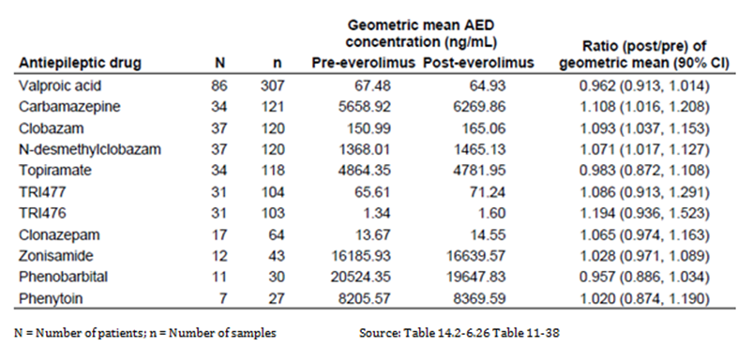

Pharmacodynamics

Exposure efficacy relationship
In Study M2304, the relationship between everolimus exposure and the two primary efficacy endpoints of response rate and percentage change from Baseline in seizure frequency was investigated. No significant difference in response rate or seizure frequency reduction in relation to C_{min} level was shown.

Table 9: Response rate and percentage reduction from Baseline in seizure frequency by TN-C_{min}; Study M2304 Core phase Safety Set (Confirmed PK Sample Set)
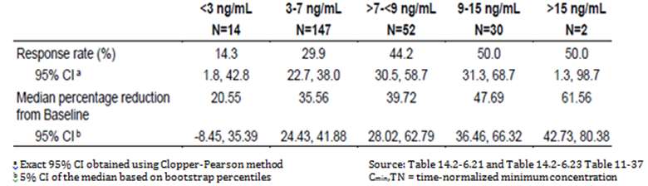
For response rate, logistic regression was used to model the probability of response. The model included terms for time normalised C_{min} (log-transformed) in the Maintenance period of the Core phase (defined as from Study Day 43 until the last day of study medication in the Core phase), and Baseline seizure frequency. The model was stratified by age subgroup and adjusted for additional risk factors if appropriate.
The conditional logistic regression analysis for the probability of seizure response versus time normalised C_{min} (TN-C_{min}) stratified by age subgroup indicated that a 2 fold increase in TN-C_{min} was associated with a 2.17 fold increase (95% CI: 1.339, 3.524) in the odds for a response. In addition to TN-C_{min}, baseline seizure frequency was also a significant factor in the seizure response with an odds ratio of 0.978 (95% CI: 0.959, 0.998).

Table 10: Relationship for a 2 fold increase in everolimus exposure, between response rate and time normalised everolimus concentration at trough (TN-C_{min}) Study M2304 Core phase Safety set (Confirmed PK Sample Set*)
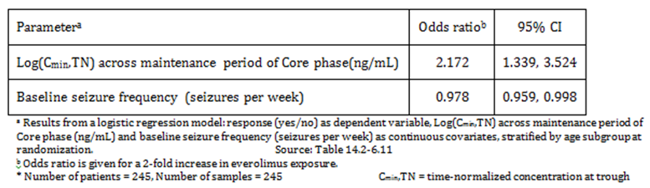
A linear regression model was used to characterize the impact of exposure on the post Baseline average weekly seizure frequency. The model includes Baseline seizure frequency and TN-C_{min} in the Maintenance period of the Core phase, both in log scale as covariates. Moreover, an additional linear mixed model with repeated measurements was used to link the post Baseline average weekly seizure frequency to the TN-C_{min} in defined time intervals during the Core phase. The model was adjusted by the Baseline seizure frequency. The linear regression model predicting the log of absolute seizure frequency during the Maintenance period of the Core phase indicated that for a 2 fold increase in TN-C_{min} there was a statistically significant 28% reduction (95% CI: 12%, 42%) in seizure frequency. Baseline seizure frequency and TN-C_{min} were both significant factors.

Table 11: Relationship between % reduction from baseline in seizure frequency and time normalised everolimus concentration at trough; Study M2304 Core phase Safety Set (Confirmed PK Sample Set)
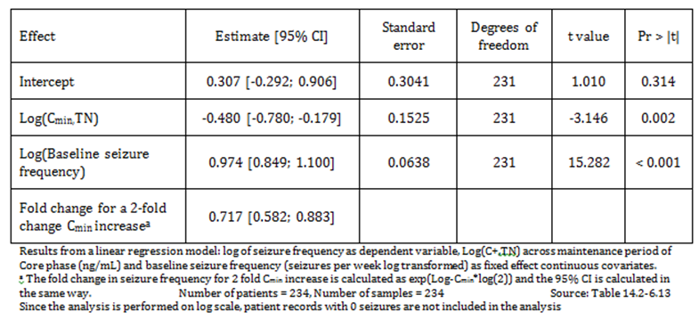

Minimum efficacious concentration
To find the lowest exposure (as TN-C_{min}) for which the 95% CIs of predicted change from baseline seizure frequency are not overlapping between everolimus and placebo, first a multiplicative linear regression model of seizure frequency predicted by TN-C_{min} was fit on everolimus data from the Maintenance phase of the Core phase.
Predictions were made for the adjusted ‘log fold change in seizure frequency from baseline’ across the observed range of TN-C_{min} values during the Core phase.
The ‘log fold change in seizure frequency from baseline’ and its 95% CIs were computed for both everolimus and placebo across the range of observed TN-C_{min} values. The lowest TN-C_{min} for which these CIs were not overlapping was then determined and considered as an estimate of the minimum efficacious concentration.
Figure 3: Relationship between percent reduction from baseline in seizure frequency and TN-C_{min} during Maintenance period of the Core phase Study M2304
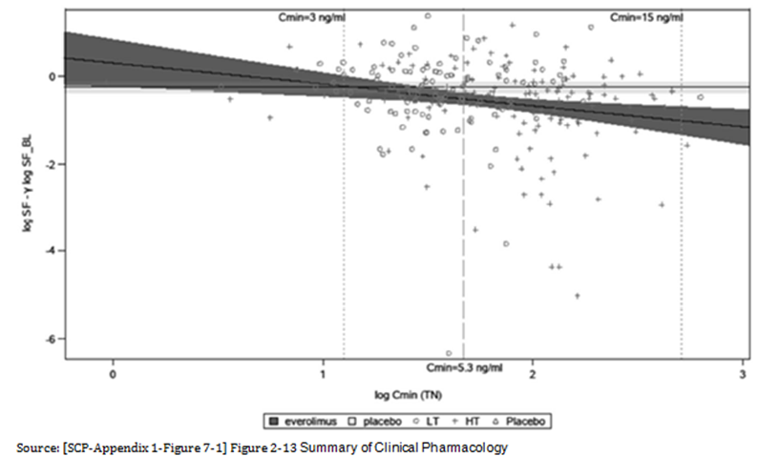

Table 12: Baseline adjusted change of seizure frequency by TN-C_{min} during the Maintenance phase of the Core phase
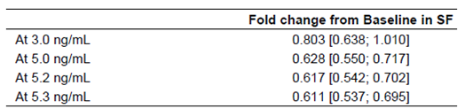

Dosage selection for the pivotal studies
The PI proposed target C_{min} exposure range is 5 to 15 ng/mL and it is based on data of seizure response and overall safety observable across this range.
Starting dose was derived from the patient’s age and concomitant use of CYP3A4/ P-glycoprotein (PgP) inducers.
It was based on the patients’ body surface area (BSA) and on previously submitted results in Study C2485 and Study M2301 involving largely paediatric, TSC patients with SEGA lesions.
Table 13: Study M2304 Starting dose
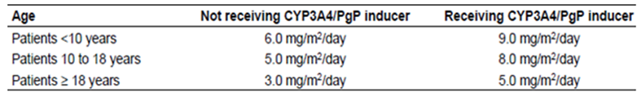

Efficacy

Studies providing efficacy data

Study M2304
An interim Clinical Study Report (CSR) was submitted.
This interim CSR summarises all patient data during the Baseline and Core phases as well as partial Extension phase data, as of the 2 October 2015 data cut-off date.
Study M2304 was a three arm, randomised, double blind, placebo controlled study of the efficacy and safety of two trough ranges of everolimus as adjunctive therapy in patients with tuberous sclerosis complex (TSC) who have refractory partial onset seizures
For the full details of the evaluation of efficacy please see Attachment 2.

Evaluator’s conclusions on efficacy
The response rate in the Primary endpoint was 15.1% (95% CI: 9.2, 22.8) for the placebo arm, 28.2% (95% CI: 20.3, 37.3) for the C_{min} 3 to 7 ng/mL arm and 40.0% (95% CI: 31.5, 49.0) for the C_{min} 9 to 15 ng/mL arm. The 95%CIs for placebo and the 3 to 7 ng/mL arm overlap. However the odds ratio 95%Cis, do not include 1.0.
A similar result was seen for the supporting endpoint:
The median percent reduction in weekly seizure frequency was 29.3% (95% CI: 18.8, 41.9) and 39.6% (95% CI: 35.0, 48.7) for the everolimus low trough range and high trough range arms, respectively, compared with 14.9% (95% CI: 0.1, 21.7) for the placebo arm, thus although the high trough range results are clearly superior to those of placebo, the 95% CIs for the low trough range and placebo overlap. However the 95% CIs for the difference from placebo are all above 0.
The CPMP/EWP/2330/99 Points to Consider on Application with 1. Meta-Analyses; 2. One Pivotal Study states:
Prerequisites for one pivotal study applications:
The degree of statistical significance. Statistical evidence considerably stronger than p < 0.05 is usually required, accompanied by precise estimates of treatment effects that is narrow confidence intervals. Tile required degree of significance will depend on factors such as the therapeutic indication, the primary endpoint, the amount of supportive data and whether the alternative analyses demonstrating consistency are pre-specified.
The proposed dosage is to maintain C_{min} at 5 to 15 ng/mL.
Then lower end of the range for C_{min} of the clearly significant result was 9ng/mL.
The recommended target C_{min} range is 5 to 15 ng/mL based on the following considerations:
The time normalized C_{min} of 5.3ng/mL is the threshold concentration above which the 95% confidence interval of predicted change from baseline seizure frequency is not overlapping with the 95% confidence interval of predicted change from baseline SF of placebo patients. This indicates a lower bound of the therapeutic range.
The modelling of efficacy to C_{min} shows a relationship between C_{min} time normalised and a response.
For those subjects who would currently be eligible for everolimus treatment due to concurrent TSC-related conditions that is SEGA and renal angiomyolipoma, the 95% CIs for all 3 treatment groups overlapped, the numbers were small.

Safety

Studies providing safety data
The Summary of Clinical Safety is based on safety data from Study M2304 and three other studies that evaluated multi-year everolimus exposure in patients with TSC; completed Studies C2485, M2301, and M2302 (n = 251).
The sponsor graded AEs severity in accordance with the National Cancer Institute’s (NCI) Common Terminology Criteria for Adverse Events:
- Grade 1 Mild AE
- Grade 2 Moderate AE
- Grade 3 Severe AE
- Grade 4 Life-threatening or disabling AE
- Grade 5 Death related to AE.

Patient exposure

Table 14: Study sizes safety database
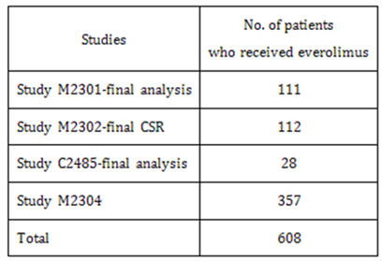

Table 15: Duration of exposure to everolimus; TSC pooled studies including Study M2304 (Long-term Evaluation Safety Set)
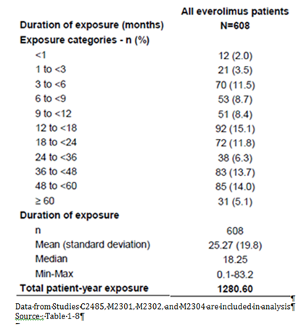

Table 16: Cumulative dose and dose intensity of study drug; Study M2304 Core phase (Safety Set)
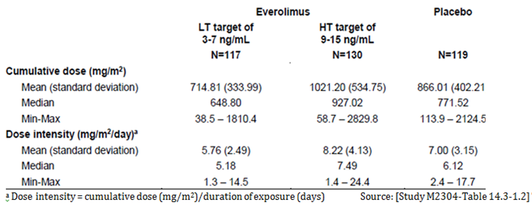

Table 17: Cumulative dose and dose intensity of study drug; Study M2304 Core and Extension phases (Long-term Evaluation Safety Set)
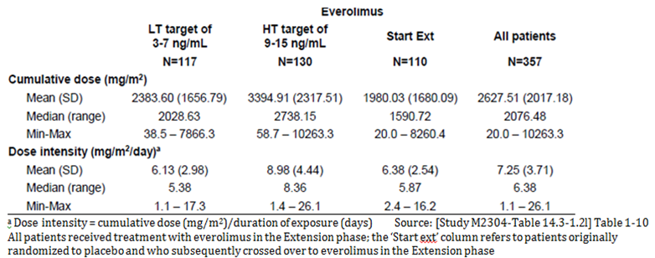

Table 18: Everolimus concentration at trough (C_{min}) by time window; Study M2304 Core phase (Safety Set; Confirmed PK Sample Set)
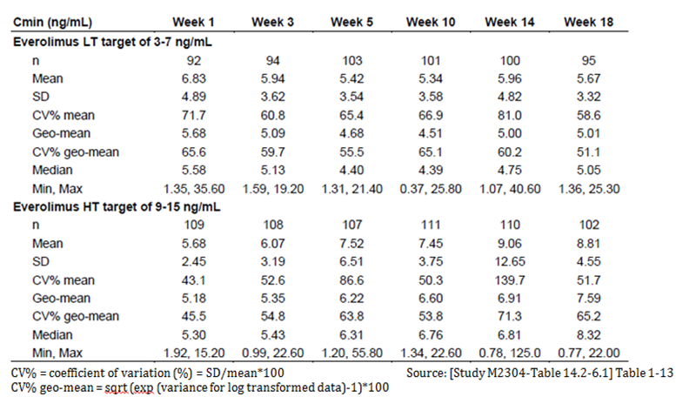
For the full details of the evaluation of safety aspects please see Attachment 2.

Safety issues with the potential for major regulatory impact

Infections

Study M2304 Core phase
Everolimus possesses immunosuppressive properties. In 54.7% and 64.6% of patients in the everolimus LT and HT treatment groups and 45.4% in the placebo group infections were diagnosed, especially upper respiratory infections (for example nasopharyngitis, upper respiratory tract infection). SAEs of infections were seen in 6.0% of patients in the everolimus LT group, 6.9% in the HT group, respectively relative to placebo, most commonly pneumonia but also including gastroenteritis and urinary tract infection. In the placebo group 0% had infections. Single cases of pneumonia in the everolimus HT group and viral respiratory tract infection in the placebo group led to treatment discontinuation.

Non-infectious pneumonitis

Study M2304 Core phase
One case of Grade 2 non-infectious pneumonitis was reported in the everolimus HT treatment group.

Stomatitis

Study M2304 Core phase
Stomatitis related events were more frequently reported in the everolimus treatment groups than with placebo (54.7%, 63.8%, and 9.2% in the everolimus LT, HT, and placebo groups, respectively). The most common AEs reported included:
Stomatitis (28.2%, 30.8%, and 3.4% in the everolimus LT, HT, and placebo groups,
Mouth ulceration (23.9%, 21.5%, and 4.2%)
Aphthous ulcer (4.3%, 14.6%, and 1.7%).
Most cases were Grade 1 or 2, and were suspected to be drug related in the majority of cases. Grade 3 events were reported in 3.4% and 3.8% of patients in the everolimus LT and HT groups, respectively. No Grade 4 events were reported. These events tended to appear within the first 2 to 3 weeks of treatment.

Hypersensitivity (anaphylactic reaction)

Study M2304 Core phase
Across the three treatment groups (13.7% and 15.4% of patients in the everolimus LT and HT treatment groups compared with 6.7% in the placebo group) had hypersensitivity-related events.
One patient (0.9%) in the everolimus LT treatment group reported Grade 3 urticaria requiring dose adjustment while a further three patients (one (0.9%) in everolimus LT group and 2 (1.5%) in everolimus HT group) experienced cases of Grade 1/2 rash that necessitated dose adjustment. There were no cases of severe hypersensitivity or anaphylaxis.
One case of pharyngeal oedema in the everolimus LT treatment group was Grade 2 in intensity.

Hepatic toxicity
The CSR did not have a separate section on this. The Summary of Clinical Safety had known risks with everolimus therapy that require close monitoring and evaluation include: and safety in patients with hepatic impairment.
The sponsor has proposed multiple hepatic impairment insertions in relation to which the sponsor has consistently referred.
In reviewing the summary results of the trial 23 to 25% had abnormal liver enzymes (see Table 41, Attachment 2) (2 at least were Grade3/4 (see Table 42, Attachment 2)). One adverse drug reaction (ADR) of raised enzyme was reported (also 1 on placebo) raised alanine aminotransferase (ALT). Due to raised alkaline phosphatase there was 1 discontinuation (Table 38, Attachment 2), and 1 interruption or adjustment to dose (see Table 39, Attachment 2).

Renal toxicities

Study M2304 Core phase
Renal toxicities were reported 0.9% versus 3.8% versus 2.5% for the everolimus LT, HT, and placebo treatment groups, respectively, with 1 patient from the everolimus HT group experiencing a Grade 3 elevation in blood creatinine (no action was taken and this event resolved after 23days).

Effects of everolimus on brain growth and development, particularly in patients under 3 years of age

Study M2304 Core phase
Five patients in the everolimus treatment groups (four, (50.0%) in the LT and one patient (14.3%) in the HT group) experienced events. A single case (12.5%) of Grade 4 status epilepticus was reported in a 2 year old patient in the everolimus LT group, which resolved after 16 days.

Table 19: Clinical impact of effects of everolimus on brain growth and development, particularly in patients under 3 years of age; Study M2304 Core phase (Safety Set)
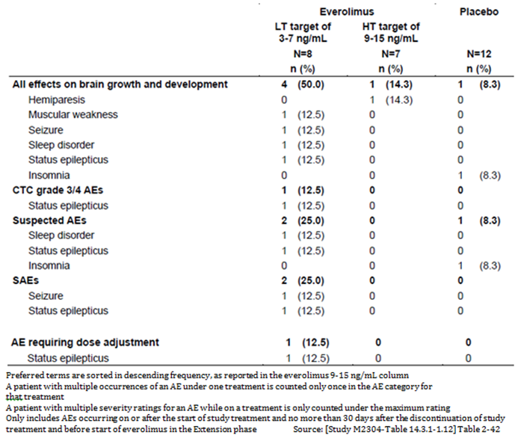

Female fertility (including secondary amenorrhea) in female patients aged 10 to 55 years

Study M2304 Core phase
The incidence of events related to female fertility (irregular menstruation and amenorrhoea) was similar across the three treatment groups.

Haemorrhages

Study M2304 Core phase
The incidence of haemorrhage was higher in the everolimus treatment groups (6.0% and 11.5% for LT and HT groups, respectively) compared to the placebo group (3.4%). About 50% of the Grade 1/2 haemorrhage cases reported among the patients treated with everolimus were described as epistaxis. There was a single case (0.9%) of menorrhagia in the everolimus LT group (in a 44 year old patient) that fulfilled the criteria for an SAE; this event resolved after 26 days.

Haematology and haematological toxicity

Study M2304 Core phase
Haematology abnormalities that were more frequently reported in the everolimus treatment groups (with differences of ≥ 10% relative to placebo) included:
Absolute neutrophils (hypo) (difference +2.1% and +14.2% for the everolimus LT and HT treatment groups, respectively)
Absolute lymphocytes (hyper) (difference +15.6% and +1.7%).
All Grade 3/4 cases resolved prior to the data cut-off date.

Cytopaenia
The incidence of cytopaenia was similar across the three treatment groups (7.7%, 7.7%, and 7.6% for the everolimus LT, HT, and placebo treatment groups, respectively). The majority of the AEs in this category were neutropaenia, anaemia, and decreased neutrophil count.

Other laboratory tests
There were a higher incidence of Grade3/4 abnormal values for potassium (hyper) (3.1% Study M2304 All patients versus 0.8% TSC Pool without M2304) and sodium (hyper) (4.2% versus 1.6%).
Among all abnormal clinical chemistry values in Study M2304 All patients results most had a similar or higher incidence than in the TSC Pool without M2304, except the liver enzymes, phosphate (inorganic phosphorus) (hypo), glucose (fasting) (hypo), sodium (hypo) and potassium (hypo) magnesium (hyper) (40.9% Study M2304 All patients versus 3.6% TSC Pool without M2304) and creatinine (hyper) (30.3% versus 12.0%) showed considerable differences.

Table 20: Abnormal clinical chemistry values; Study M2304 Core and Extension phase and TSC pooled studies excluding Study M2304
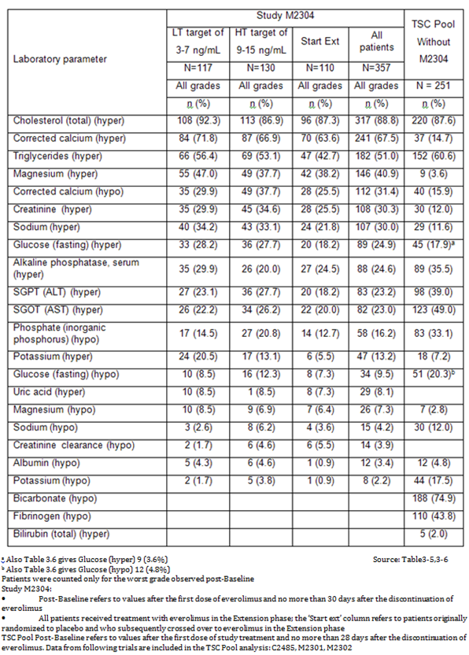

Dyslipidaemia in paediatric population

Study M2304 Core phase
Dyslipidaemia related events occurred in 12.5% and 17.8% of paediatric patients in the everolimus LT and HT treatment groups compared with a 5.2% in the placebo group. Most cases were Grade 1 or 2, and were suspected to be drug related in the majority of cases.

Table 21: Clinical impact of dyslipidaemia in paediatric population; Study M2304 Core phase (Safety Set)
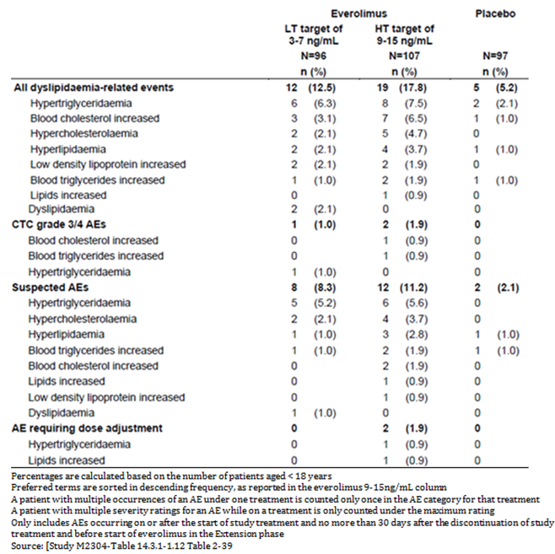

Hyperglycaemia/new-onset diabetes mellitus

Study M2304 Core phase
One case of Grade 1 hyperglycaemia was reported in a patient in the everolimus LT treatment group. No cases of new onset diabetes mellitus were reported across the three treatment groups.

Vital signs and clinical examination findings

Study M2304 Core phase

Growth; height and weight
Standard deviation scores (SDS) for height, height velocity, body mass index, and weight velocity in patients aged < 18 years at study initiation were comparable both prior to and after starting treatment with everolimus. Based on N = 96 at week 72, 29 at 96 and 1 at 120 weeks the proportions of patients with SDS values < 5th percentile or > 95th percentile on height, height velocity, body mass index, and weight velocity did not increase significantly after the start of everolimus therapy (see Table 44, Attachment 2).

Puberty
Overall, considering the patients at risk of delayed puberty at start date of everolimus, puberty appeared to be delayed for three patients (two females and one male). However, following a detailed medical review of these cases, there was no indication of delayed puberty for the two females.

Neuropsychological data
The sponsor attempted to collect information using the Vineland-II Adaptive Behaviour Composite Score and the Wechsler Nonverbal Composite Score, however most groups had data for less than 50% of subjects at Baseline, with even less at end of Core phase.

Post-marketing data
At the time of the Summary of Clinical Safety the total worldwide cumulative market exposure to everolimus in the oncology and TSC settings combined through 31 March 2015 was estimated to be 84,021 patient-treatment-years.
The total cumulative worldwide patient exposure (until 31 March 2015) based on the worldwide sales of tablets sold per defined daily dose, has been estimated at 79,056 patient-treatment years for the oncology setting (Oncology PSUR 9; 18 May 2015) and 4,965 patient-treatment years for the TSC setting (TSC PSUR 7; 19 May 2015).

Evaluator’s conclusions on safety
Comparing previous experience with Study M2304:
- Under 6 Months, the overall incidence of emerging AEs was higher in the previous Pool versus Study M2304 (87.6% versus 74.5%), as were the incidences of stomatitis (+11.9%) and hypercholesterolemia (+9.5%). Other events were reported with a similar frequency between the two datasets.
- Between Months 6 to 12, the overall incidence of emerging AEs was higher in the previous Pool versus Study M2304 (53.1% versus 37.8%). The incidence of specific AEs was in general similar.
- Between Months 12 to 24 the overall incidence of emerging AEs was higher in the previous Pool versus Study M2304 (67.5% versus 33.9%). Stomatitis (7.9%) and mouth ulceration (5.0%) were both reported more frequently in the previous Pool.
There were some differences from the previous experience, the sponsor’s explanation for these related to the difference in age composition with 2 of the earlier trials confined to adults.
There appeared to be no major difference from the previous safety experience of everolimus in TSC patients.

First round benefit-risk assessment

First round assessment of benefits
Table 22, shown below, summarises the assessment of benefits at the first round.

Table 22: First round assessment of benefits
Benefits | Strengths and Uncertainties
Up to 60% of patients with TSC associated epilepsy fail to demonstrate improvement in seizure frequency with available therapies.  The response rate in the Primary endpoint was 15.1% for the placebo arm, 28.2% for the C_{min} 3 to 7 ng/mL arm and 40.0% for the C_{min} 9 to 15 ng/mL arm. | The 95% CIs for the C_{min} 9 to 15 ng/mL arm and placebo clearly separate.  The 95%CIs for placebo and the 3 to 7 ng/mL arm overlap. However the Odds ratio 95%CIs do not include 1.0.  By modelling the sponsor ascertained the lowest C_{min} at which the 95% CIs were still separated from placebo.

First round assessment of risks
Table 23, shown below, summarises the assessment of risks at the first round.

Table 23: First round assessment of risks
Risks | Strengths and Uncertainties
Exposure is increased from previously recommended for TSC.  The exact mechanism of action is unclear. | There are no major changes in adverse reactions from those already reported in other TSC trials.  Regression analyses of the time to first event of stomatitis and infections and infestations versus TN-C_{min} indicated that 2 fold increases in TN-C_{min} were not associated with statistically significant increases in the risk of either of these events during the core phase (stomatitis: hazards ration(HR) 1.092; 95% CI: 0.866, 1.376; infections and infestations: HR 1.060; 95% CI: 0.848, 1.325).

First round assessment of benefit-risk balance
The benefit-risk balance is considered favourable.

First round recommendation regarding authorisation
It is not recommended that the proposed indication for everolimus be approved.
It is recommended that everolimus be approved subject to a satisfactory PI for the modified indication of:
Afinitor is indicated for the Adjunctive treatment of patients aged 2 years and older with TSC and associated refractory seizures.
It was a requirement for inclusion in Study M2034 that patients have a ‘Clinically definite diagnosis of TSC.’ Refractory seizures alone (a possible interpretation), was not included in the submission. The additional insertion clarifies this.

Second round evaluation
There was no second round clinical evaluation for this submission.

VI. Pharmacovigilance findings

Risk management plan

Summary of the RMP evaluation
- Afinitor is currently approved for the treatment of breast cancer, neuroendocrine tumours (NET) of pancreatic, gastrointestinal or lung origin, renal cell carcinoma, SEGA associated with TSC, and patients with TSC who have renal angiomyolipoma. Patients with the above conditions may be treated with either tablets or dispersible tablets. The dosage forms are not interchangeable and the dose must be adjusted to the closest mg strength with trough concentrations monitored.
- The most recently evaluated risk management plan (RMP) was EU-RMP Version 12.1 (Afinitor)/11 (Votubia) (dated 25 April 2016, data lock point (DLP) 31 March 2015) and Australian Specific Annex (ASA) Version 7.0 (dated 11 July 2016) for application PM-2015- 03569-1-4 to extend the indication to include treatment of patients with non-functioning NET of gastrointestinal or lung origin.
- In support of the extended indications (TSC and refractory seizures), the sponsor has submitted EU-RMP version 12.1 (dated 7 October 2016; DLP 2 October 2015 (seizure population) and 31 March 2016 (CT dataset for pooled TSC setting)) and ASA version 8.0 (dated 15 December 2016). In its post-first round response, the sponsor submitted EU-RMP version 13.0 (dated 16 February 2017, DLP as above) and ASA version 9.0 (dated 21 July 2017) to support the application.
- The proposed Summary of Safety Concerns and their associated risk monitoring and mitigation strategies are summarised below (differences from the previously accepted summary of safety concerns are in bold):

Table 24: Summary of Safety Concerns and associated risk monitoring and mitigation strategies
Summary of safety concerns |  | Pharmacovigilance |  | Risk Minimisation
 |  | Routine | Additional | Routine | Additional
Important identified risks | Non-infectious pneumonitis |  | – |  | –
Important identified risks | Severe infections |  | – |  | –
Important identified risks | Hypersensitivity (anaphylactic reactions) |  | – |  | –
Important identified risks | Stomatitis |  | – |  | –
Important identified risks | Wound healing complications |  | – |  | –
Important identified risks | Increased creatinine / proteinuria / renal failure |  | – |  | –
Important identified risks | Hyperglycemia / new onset diabetes mellitus |  | – |  | –
Important identified risks | Dyslipidemia |  | – |  | –
Important identified risks | Hypophosphatemia |  | – |  | –
Important identified risks | Cardiac failure |  | – |  | –
Important identified risks | Cytopenia |  | – |  | –
Important identified risks | Hemorrhages |  | – |  | –
Important identified risks | Thrombotic and embolic events |  | – |  | –
Important identified risks | Female fertility (including secondary amenorrhea) |  | – |  | –
Important identified risks | Pre-existing infection (reactivation, aggravation, or exacerbation) |  | – |  | –
Important identified risks | Safety in patients with hepatic impairment |  | – |  | –
Important Identified Interactions | Strong CYP3A4 inhibitors and PgP inhibitors |  | – |  | –
Important Identified Interactions | Moderate CYP3A4 inhibitors and PgP inhibitor |  | – |  | –
Important Identified Interactions | Strong CYP3A4 inducers and PgP inducers |  | – |  | –
Important Identified Interactions | CYP3A4 substrates and PgP substrates |  | – |  | –
Important Identified Interactions | Increased risk for angioedema when combining mTOR inhibitors and ACE inhibitors |  | – |  | –
Important potential risks | Postnatal developmental toxicity |  |  |  | –
Important potential risks | Pregnant or breast-feeding women |  | – |  | –
Important potential risks | Male infertility |  |  |  | –
Important potential risks | Muscle-wasting / muscle-loss |  | – |  | –
Important Potential  Interactions | Everolimus with concomitant exemestane use (Oncology setting only) |  |  |  | –
Missing information | Off-label use in pediatric and adolescent patients |  | – |  | –
Missing information | Long-term safety |  |  | – | –
Missing information | Onset of benign or malignant tumours |  | – | – | –
Missing information | Patients with uncontrolled cardiac disease (Oncology setting only) |  | – | – | –
Missing information | Comparative safety of everolimus and exemestane therapy versus everolimus monotherapy (Oncology setting only) |  | – |  | –
Missing information | Safety in breast cancer patients pre-treated with cytotoxic therapies (Oncology setting only) |  | – | – | –
Missing information | Effects of everolimus on brain growth and development, particularly in patients under 3 years of age (TSC –setting only) |  | – | – | –
Missing information | Neurocognitive and sexual development in paediatric patients (TSC setting only) |  |  | – | –
- Additional pharmacovigilance activities include clinical trials (Studies CRAD001J2301, CRAD001W2301 and CRAD001Y2201), a post authorisation study (Study CRAD001M2305) and an international disease registry to collect data in patients with tuberous sclerosis complex (Study CRAD001MIC03).
- There are no additional risk minimisation activities which is consistent with previous applications.

New and outstanding recommendations from second round evaluation
The recommendations made in the first round evaluation, along with consideration of the sponsor response was provided.
There are no outstanding recommendations from the second round evaluation.

Proposed wording for conditions of registration
Any changes to which the sponsor has agreed should be included in a revised RMP and ASA. However, irrespective of whether or not they are included in the currently available version of the RMP document, the agreed changes become part of the risk management system.
The suggested wording is:
Implement EU-RMP (version 13.0, date 16 February 2017, data lock point 2 October 2015 and 31 March 2016 for TSC seizures population and CT dataset for pooled TSC setting respectively) with Australian Specific Annex (version 9.0, dated 21 July 2017) and any future updates as a condition of registration.

VII. Overall conclusion and risk/benefit assessment
The submission was summarised in the following Delegate’s overview and recommendations:

Background
Everolimus was initially developed for the prophylaxis of organ transplant rejection. It was first registered in Australia in 2009 for treatment of advanced renal cell carcinoma and now has other currently approved indications:
Subependymal giant cell astrocytoma (SEGA) associated with tuberous sclerosis complex (TSC) who require therapeutic intervention but are not candidates for curative surgical resection.
Patients with tuberous sclerosis complex (TSC) who have renal angiomyolipoma not requiring immediate surgery.
Postmenopausal women with hormone receptor-positive, HER2 negative advanced breast cancer in combination with exemestane after failure of treatment with letrozole or anastrozole.
Progressive, unresectable or metastatic, well or moderately differentiated neuroendocrine tumours (NETs) of pancreatic origin.
Progressive, unresectable or metastatic, well differentiated, non-functional neuroendocrine tumours (NET) of gastrointestinal or lung origin in adults.
Advanced renal cell carcinoma after failure of treatment with sorafenib or sunitinib.
Tuberous sclerosis complex is a rare multisystem genetic disease that causes benign tumours to grow in the brain and on other vital organs such as kidneys, heart, liver, eyes, lungs and skin. The clinical evaluation report (CER) stated that TSC has a prevalence approaching 1 in 6000 live births and that, it is an autosomal dominant genetic condition involving the tuberous sclerosis 1 gene (TSC1) and/or the tuberous sclerosis 2 gene (TSC2) mutations. The latter is found in 80% to 85% of TSC patients. Normally, these two genes, TSC1 and TSC2, code for the proteins hamartin and tuberin, respectively. These proteins form tumour growth suppressor complex which regulates cell proliferation and differentiation. When either TSC1 or TSC2 are deficient due to mutation, mammalian target of rapamycin complex 1 (mTORC1) is upregulated leading to abnormal cellular growth, proliferation and protein synthesis. Mammalian target of rapamycin (mTOR) or more specifically, mammalian 'target of rapamycin' complex 1 (mTORC1) is a key serine-threonine kinase playing a central role in the regulation of cell growth, proliferation and survival. Upregulation of mTORC1 results in a variety of benign tumours or hamartomas in multiple organ systems: lesions in the kidney, brain, skin, lung, heart and eye.
Everolimus:
- is a signal transduction inhibitor targeting mTORC1.
- exerts its activity through high affinity interaction with the intracellular receptor protein FKBP12.
- is an inhibitor of the growth and proliferation of tumour cells, endothelial cells, fibroblasts and blood vessel associated smooth muscle cells.
- in a mouse neuronal model of TSC (in which TSC1 is ablated in most neurons during cortical development), was shown to markedly improve survival and neurological function following repeated intraperitoneal administration.
As per the CER, about 85% of children and adolescents with TSC have neurological manifestations including epilepsy, cognitive impairment and behavioural problems, whereas a subset of affected adults have no signs of cerebral manifestations and have a normal mental status. Brain lesions mainly consist of cortical tubers and hamartomas. Up to 20% of the hamartomas (usually subependymal nodules) demonstrate progressive growth into subependymal giant-cell astrocytomas (SEGAs). As they enlarge, symptoms of increased intracranial pressure, new neurological deficits/neuro-psychiatric problems (such as developmental delay, mental retardation and autism) and early onset epilepsy or seizure control deterioration may occur.
In patients with TSC, the mechanisms causing epilepsy are not entirely understood. Dysregulation of development and maintenance of cortical structure and function because of mTOR dependent processes may play a role in the development of epilepsy and neuropsychiatric disorders.
Regarding seizures, the CER stated that up to 90% of individuals with TSC are affected by a variety of epileptic seizure types, typically occurring in the first year of life (with 82% before 3 years of age); however, up to 12% of adult patients with TSC develop epilepsy as adults.
Patients with seizure onset before the age of 4 years, particularly when the seizures are frequent or refractory, have a substantially increased risk of subsequent mental retardation or autism.
As to the current treatment, the CE stated that seizures associated with TSC are poorly controlled by AEDs, epilepsy surgery, vagal nerve stimulation (VNS) and ketogenic diet. Up to 60% of patients fail to demonstrate improvement in seizure frequency with the available therapies.
Proposed extension of indications:
Adjunctive treatment of patients aged 2years and older with TSC and refractory seizures.
Note: Of relevance to the extension of indications, everolimus is not recommended for use in paediatric patients with:
- Cancer.
- TSC who have renal angiomyolipoma in the absence of SEGA.
- Everolimus has not been studied in paediatric patients < 1 year of age with TSC who have SEGA.
Proposed dosage form and strengths are shown in Table 25.

Table 25: Proposed dosage form and strengths
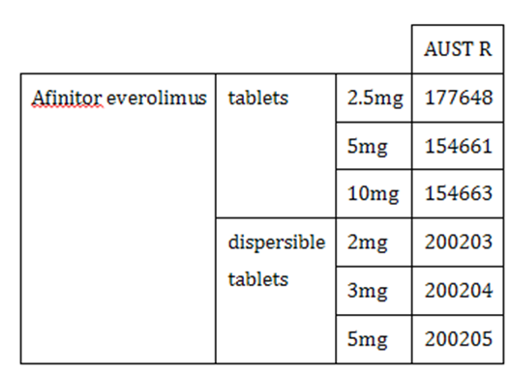
Note: The PI contains the following information on the relative bioavailability of dispersible tablets to the standard tablets:
The AUC_{0-∞} of the Afinitor dispersible tablets when administered as a suspension in water was equivalent to that of Afinitor tablets (85% to 91% of that associated with Afinitor tablets). The predicted trough concentrations of everolimus at steady state after daily administration were similar for both dosage forms. The C_{max} of everolimus associated with the Afinitor dispersible tablets was, however, somewhat lower (64% to 80% relative to that associated with Afinitor tablets).
Proposed dosage and administration regimen with relevance to the extension of indications as per the clinical evaluator (CE):
The dosage and administration section runs to 7 pages in the submitted dossier.
Afinitor should be administered orally once daily at the same time every day (preferably in the morning), either consistently with or consistently without food (see Pharmacokinetics). Afinitor is available in two formulations: tablets (Afinitor Tablets) and dispersible tablets (Afinitor Dispersible Tablets).
The changes proposed to dosage and Administration in the PI mostly relate to the proposed new Indication. However, there are some changes made to the dosage in the proposed PI and not in the annotated copy.
Note: Other prescribing aspects of everolimus from the approved PI:
- Dosing recommendations for paediatric patients (> 1 year) with TSC who have SEGA are consistent with those for the corresponding adult population with the exception of those patients with hepatic impairment.
- Everolimus is not recommended for patients < 18 years of age with TSC who have SEGA and hepatic impairment.
The submission also included other proposed changes to the product documentation as follows:
- changes to the mechanism of action
- adding to the exposure response relationships under pharmacodynamic properties
- adding to the paediatrics pharmacokinetics
- adding Tuberous sclerosis complex (TSC) with refractory seizures to clinical trials
- adding to the precautions hepatic impairment
- amending the precautions paediatric use
- adding to the interactions with other medicines - agents whose plasma concentration may be altered by everolimus
- updating the Adverse Effects.

Present application
Pre-clinical results established the critical role of mTOR in TSC related seizures and the underlying epileptogenesis mechanisms. The results suggested that inhibiting mTOR is a promising mechanism based seizure reduction and an antiepileptogenic therapy for treating TSC related epilepsy. On the basis of these pre-clinical results and preliminary clinical efficacy data, Novartis initiated a Phase III study to investigate the safety and efficacy of everolimus in patients with TSC and refractory seizures.
This current submission represents the first proposed use of everolimus for a non-oncology indication. Additionally it is proposed for use in a paediatric population.

Quality
There was no requirement for a quality evaluation in a submission of this type.

Nonclinical
The revised and/or new ‘mechanism of action’ nonclinical statements in the draft PI were either supported by data reviewed in earlier evaluation reports and/or were supported by newly submitted published data. Details of the studies which were evaluated to support the mechanism of action (pharmacodynamics) section are included in the nonclinical evaluation report.
The nonclinical statements in the proposed PI are acceptable.
There were no nonclinical objections to the proposed extension of indications.

Clinical

Pharmacokinetics
Studies identified by clinical evaluator as providing pharmacokinetic (PK) information are shown in Table 6 above.

Summary of PK from the CER

Population PK
- Analysis relied on a 5 year update of the previous model based on 3 year data (the previous PopPK model was a two-compartment model with first-order input (rate constant KA), apparent clearances (CL/F and Q/F), and apparent volumes (V2/F and V3/F). The typical values of some of the PK parameters depended on body surface area (BSA, m²) and an indicator for the presence or absence of CYP3A4 or PgP inducers. Since the use of additional covariates showed larger % error in predictions of trough levels, the 5 year model with no additional covariates (to those of the existing 3 year model) was adopted).
- Typical steady state trough level was predicted to be near the midpoint of the target range of 5 to 15 ng/mL for an adult on a 4.5 mg/m² dose with absence of CYP3A4 or PgP enzyme inducers. The presence of inducer was associated with numerically greater decrease in trough levels for adults compared to children. Typical steady state trough levels are predicted to be near the lower limit of the target range for a child or anyone with presence of CYP3A4 or PgP enzyme inducers. Thus:
  - Children or anyone with presence of inducers may need a dose increase from 4.5mg/m² to maintain steady state trough levels within the target range.
- Steady state C_{min} based on a higher starting dose was simulated for children 1 year to less than 3 years to deliver typical initial steady state C_{min} higher than 5 ng/mL across the BSA range observed in the trial at time of first everolimus dose (0.42 m² to 0.74m²). Thus:
  - A higher starting dose of 7 mg/m² based on the dispersible tablet or the regular tablet is suggested for children 1 to < 3 years to help minimise blood draws in these youngest children by reducing the number of dose titrations to attain the C_{min} within the target range of 5 to 15 ng/mL.
Please see Figure 2 above.

Pharmacokinetic interactions
Treatment with everolimus was associated with minor increases in the concentrations of:
- Carbamazepine (geometric mean ratio of AED concentrations was 1.108 (90% CI: 1.016, 1.208))
- Clobazam (geometric mean ratio 1.093 (90% CI: 1.037, 1.153))
- Metabolite of clobazam (N-desmethylclobazam) (geometric mean ratio 1.071 (90% CI: 1.017, 1.127)).
It is stated in the CER that ‘the increases in the pre-dose concentrations of these AEDs may not be clinically significant although dose adjustment for carbamazepine, a drug with a narrow therapeutic index, may be considered. Everolimus had no impact on the other AEDs evaluated in the study’ (see Table 7 above).

Pharmacodynamics
Studies identified by the clinical evaluator as providing pharmacodynamic (PD) information:
- In Study M2304, the relationship between everolimus exposure and the two primary efficacy endpoints of response rate and percentage change from baseline in seizure frequency was investigated.

Summary of PD from the CER
There was no significant difference in response rate or seizure frequency reduction in relation to C_{min} level.
Studies identified by the the clinical evaluator as providing dosage selection information for the pivotal study
The PI proposed target C_{min} exposure range is 5 to 15 ng/mL and it is based on data of seizure response and overall safety observable across this range.
Starting dose was derived from the patient’s age and concomitant use of CYP3A4/P-glycoprotein (PgP) inducers.
It was based on the patients’ body surface area (BSA) and on previously submitted results in Study C2485 and Study M2301 involving largely paediatric, TSC patients with SEGA lesions. Please see Table 12 above for the Study M2304 starting dose.

Efficacy
The pivotal or main clinical efficacy study was Study M2304.

Study M2304
This was a three arm, randomised, double blind, placebo-controlled, multicentre study of the efficacy and safety of two trough-ranges of everolimus as adjunctive therapy in patients with tuberous sclerosis complex (TSC) who have refractory partial onset seizures.

Study objectives and endpoints
The objectives of the study were as outlined in Table 10 in Attachment 2.

Inclusion criteria
The inclusion criteria were:
- Male or female between the ages of 2 and 65 years (except in Europe where the minimum age will be 1 at the request of the EMA). (A minimum number of paediatric patients will be randomised in the following age groups: 1 to < 6 years (40 patients), 6 to < 12 years (40 patients), and 12 to < 18 years (40 patients).)
- Clinically definite diagnosis of TSC (modified Gomez criteria) defined as either two major features or one major feature plus two minor features as described in Table 26.

Table 26: Major features and minor features definitions
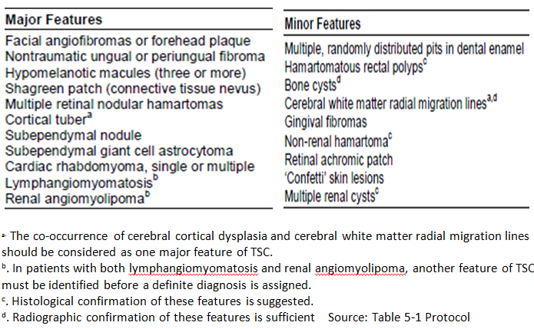
- Diagnosis of partial onset epilepsy according to the classification of the International League Against Epilepsy (Commission on Classification and Terminology of the International League Against Epilepsy, 1989) and revised in 2009. This classification is further modified for the purpose of capturing clinical details, and defines partial onset seizures in patients with TSC on the basis of the pathophysiology of TSC as either:
- any seizure that has been definitively shown to be partial onset on ictal EEG, or
- any probable seizure with motor signs (non-sensory) that has not been documented to be a primary generalised seizure on ictal EEG.
- Uncontrolled partial onset seizures; must meet the following:
- At least 16 reported quantifiable (no cluster or innumerable seizures) partial onset seizures (as defined in Inclusion Criteria 3) over the Baseline period (56 days, 8 weeks) with no continuous 21 day seizure free period between Visit 1 (Screening Visit) and Visit 2 (Randomisation visit), as per data captured in daily seizure diaries.
- Prior history of failure to control partial onset seizures despite having been treated with two or more sequential regimens of single or combined antiepileptic drugs.
- Prior or concurrent use of vagal nerve stimulator (VNS) is allowed. If the patient is using VNS, device stimulator parameters must remain constant throughout the study.
- Prior epilepsy surgery is allowed if performed at least 12 months before study entry.
- Must be receiving one, two, or three AEDs at a stable dose for at least 4 weeks at the start of the 8 week prospective Baseline phase, remain on the same regimen throughout the Baseline phase, and intend to continue the same regimen throughout the 18 week double blind Core phase (rescue medications are permitted). No more than one of these can be a strong CYP3A4 inducer (for example, carbamazepine, oxcarbazepine, phenobarbital, phenytoin, primidone).
- If female of child bearing potential, documentation of negative pregnancy test at time of informed consent. Females of child bearing potential, defined as all women physiologically capable of becoming pregnant, must use highly effective contraception during the study and for 8 weeks after stopping treatment. Highly effective contraception is defined as either:
- Total abstinence: When this is in line with the preferred and usual lifestyle of the subject. (Periodic abstinence (for example, calendar, ovulation, symptothermal, post-ovulation methods) and withdrawal are not acceptable methods of contraception).
- Sterilisation: have had surgical bilateral oophorectomy (with or without hysterectomy) or tubal ligation at least six weeks before taking study treatment. In case of oophorectomy alone, only when the reproductive status of the woman has been confirmed by follow up hormone level assessment.
- Male partner sterilisation, at least 6 months prior to screening visit, (with the appropriate post-vasectomy documentation of the absence of sperm in the ejaculate). (For female subjects on the study, the vasectomised male partner should be the sole partner for that subject).
- Use of a combination of any two of the following (a+b or a+c or b+c):
- Use of oral, injected or implanted hormonal methods of contraception
- Placement of an intrauterine device (IUD) or intrauterine system (IUS)
- Barrier methods of contraception: Condom or Occlusive cap (diaphragm or cervical/vault caps) with spermicidal foam/gel/film/cream/vaginal suppository In case of use of oral contraception women should have been stable on the oral agent before taking study treatment for at least 3 months.
- Sexually active males must use a condom during intercourse while taking study drug, and for 8 weeks after stopping study treatment. They should not father a child during this period. A condom is required to be used also by vasectomised men in order to prevent delivery of the drug via seminal fluid.
- Hepatic, renal and blood laboratory values within the following range at screening:
- AST and ALT levels < 2.5 x ULN,
- serum bilirubin < 1.5 × ULN (this limit does not apply to patients with an elevated indirect bilirubin, if they have Gilbert’s Syndrome),
- serum creatinine < 1.5 x ULN,
- haemoglobin ≥ 9 g/dL,
- platelets ≥ 80,000/mm³,
- absolute neutrophil count ≥ 1,000/mm³.
- Written informed consent. Subjects or their legal guardians must have the ability to comprehend the informed consent form and be willing to provide informed consent. For subjects who are too young or unable to comprehend the written consent, a legal guardian who is able to describe and provide an understanding of the informed consent to the subject must sign the consent form on behalf of the subject. In all cases, the informed consent process will follow the local rules and regulations.
- Patient or caregiver must be able to reliably record seizures and keep a daily diary and recall adverse events.

Exclusion criteria
The exclusion criteria were:
- Patients with seizures secondary to metabolic, toxic, infectious or psychogenic disorder or drug abuse or current seizures related to an acute medical illness.
- Presence of only non-motor partial seizures (criteria not applicable per Amendment 2).
- Patients with TSC who have SEGA in need of immediate surgical intervention.
- Patients under 2 years of age with untreated infantile spasms.
- Within 52 weeks prior to study entry, an episode of status epilepticus, defined as:
- in adults and children 5 years and older; continuous or intermittent, convulsive seizures lasting more than 10 minutes and requiring additional medical intervention such as with rescue medication not commonly used in the home (that is, a convulsive seizure or series of convulsive seizures not within the patient’s typical seizure pattern and management).
- in children less than 5 years of age; continuous or intermittent, convulsive seizures lasting more than 10 minutes and requiring significant additional medical intervention such as hospitalisation (note: It is recognised that some young patients may be sent for emergency care despite having experienced a seizure within their typical seizure pattern and management. Only the more severe episodes of prolonged convulsive seizures in such patient, such as those leading to hospitalisation, would qualify as status epilepticus).
- Patients with history of seizure clusters (where individual seizures cannot be accurately counted according to the judgment of the investigator) occurring within 26 weeks prior to study entry.
- Patients who require rescue medication during the Baseline phase for more than 6 days.
- Patients with non-TSC related progressive encephalopathy.
- Patients who weigh less than 12 kg.
- Patients with coexisting malignancies within the 3 years prior to randomisation, except for adequately treated carcinoma of the cervix or basal or squamous cell carcinomas of the skin.
- Patients with any severe and/or uncontrolled medical conditions at randomisation such as:
- Symptomatic congestive heart failure of New York Heart Association Class III or IV, history of left ventricular ejection fraction (LVEF) < 50%, QTc interval > 460ms, congenital QT syndrome, unstable angina pectoris, myocardial infarction within 6 months of study entry, serious uncontrolled cardiac arrhythmia or any other clinically significant cardiac disease.
- Significant symptomatic deterioration of lung function. If clinically indicated, pulmonary function tests including measures of predicted lung volumes, DLco, O₂ saturation at rest on room air should be considered to exclude restrictive pulmonary disease, pneumonitis or pulmonary infiltrates.
- Impairment of gastrointestinal function or gastrointestinal disease that may significantly alter the absorption of everolimus (for example, ulcerative disease, malabsorption syndrome or small bowel resection).
- liver disease such as cirrhosis, decompensated liver disease, and chronic hepatitis (that is quantifiable HBV-DNA and/or positive HbsAg, quantifiable HCV-RNA),
- Uncontrolled diabetes as defined by fasting serum glucose > 1.5 x ULN.
- Active skin, mucosa, ocular or GI disorders of Grade > 1.
- Active (acute or chronic) or uncontrolled severe infections.
- A known history of HIV seropositivity or other active viral infections.
- Patients with an active, bleeding diathesis.
- Patient with uncontrolled hyperlipidaemia: fasting serum cholesterol > 300 mg/dL or > 7.75 mmol/L and fasting triglycerides > 2.5 x ULN.
- Patients who have had a major surgery or significant traumatic injury within 4 weeks of study entry. Patients who have not recovered from the side effects of any major surgery (defined as requiring general anaesthesia), or patients that may require major surgery during the course of the study.
- Patients with a prior history of organ transplant.
- Patients receiving more than 3 antiepileptic drugs at any time in the baseline phase or at randomisation or who change the dose of the AEDs during 4 weeks before screening or during the baseline period.
- Patients being treated with felbamate, unless treatment has been continuous for ≥ 1 year.
- Patients currently receiving anticancer therapies or who have received anticancer therapies within 4 weeks of study entry (including chemotherapy, radiation therapy, antibody based therapy, et cetera).
- Prior treatment with any investigational drug within the preceding 4 weeks prior to study entry.
- Patients receiving chronic, systemic treatment with corticosteroids or another immunosuppressive agent at study entry. Topical or inhaled corticosteroids are allowed.
- Patients who have received prior treatment with a systemic mTOR inhibitor (sirolimus, temsirolimus, everolimus) within 24 months of study entry. Patients who have received prior treatment with a topical mTOR inhibitor (sirolimus, temsirolimus, everolimus) within 4 weeks of study entry.
- Patients with a known hypersensitivity to everolimus or other rapamycin-analogues (sirolimus, temsirolimus) or to its excipients
- Patients with a history of non-compliance to medical regimens or who are considered potentially unreliable or will not be able to complete the entire study.
- Pregnant or nursing (lactating) women, where pregnancy is defined as the state of a female after conception and until the termination of gestation, confirmed by a positive hCG laboratory test.
- Patients with a Score of 4 or 5 on the Suicidal Ideation item within 2 years of Screening, or any ‘yes’ on the Suicidal Behaviour item of the Columbia-Suicide Severity Rating Scale at Screening or Baseline who upon follow up with a healthcare professional are found to be severely depressed or suicidal.
- Maintenance of a diet consisting of < 40 g of carbohydrate per day within 3 months of screening.

Study treatment
Treatment consisted of three phases:
- Baseline phase; from Screening Week -8 (V1) to Randomisation visit at Week 0 (V2).
During the Baseline phase, patients were to complete a seizure diary for a total of ≥ 8 weeks, which was considered long enough to provide reliable data on the Baseline seizure frequency of patients taking 1 to 3 AEDs.
- Core (Double blind, placebo controlled) phase; from Randomisation at Week 0 (V2) to Week 18 (V11).
In this Core phase, patients received either:
- Placebo or
- Everolimus with titration to achieve a trough range of 3 to 7 ng/mL or
- Everolimus with titration to achieve a trough range of 9 to 15 ng/mL.
Note: The titration period was 6 weeks during which, up to 3 dose adjustments could be made to reach the targeted everolimus trough range. This was followed by a Maintenance period of 12 weeks duration, making a total of 18 weeks for the core period.
- Extension phase: from Week 18 (V11) until 48 weeks after the last patient has completed the Core phase, with all patients receiving everolimus at entry and with blinding of the original randomisation arm maintained.
In the Extension phase, all patients (that is placebo and treated) received everolimus. There was an initial 8 weeks Transition period to bring all patients to the common 6 to 10 ng/mL trough range followed, by a Titration period in which the investigators had the option to control everolimus dosing, targeting the broad 3 to 15 ng/mL dose range.
Note: The study formulation used the dispersible tablets for oral suspension.
Figure 4: Study M2304 study design
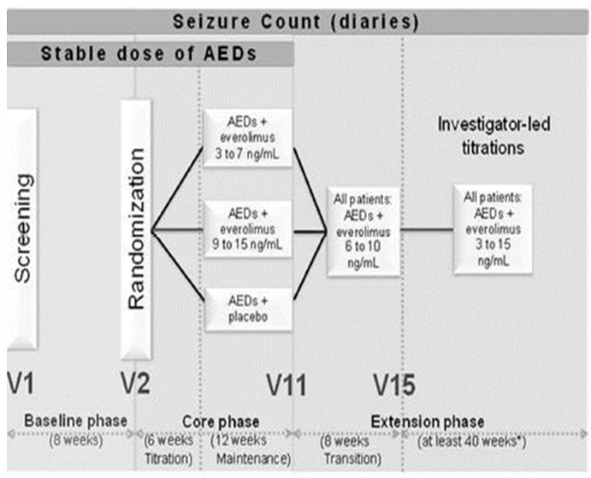

Efficacy outcomes variables
The primary efficacy endpoint was given as either the response rate; (EMA version) or the percentage reduction in seizure frequency (FDA version).
CE’s comment: Given that the TGA has adopted EMA guidelines, this evaluator proposes to use the response rate as the primary variable. The protocol indicates that the statistical analysis was not to be set up for co-primary endpoints.
Seizure frequency was determined using counts of seizures, based on seizure diaries that were completed by the patient or caregiver throughout the trial.
During the Baseline phase (and if new seizures occurred during the study), the investigator reviewed the known seizure types of each patient with the Epilepsy Study Consortium. Only events thought to have a high probability of being seizures with approval from the Epilepsy Study Consortium and agreement from the investigator were entered into the eCRF and counted as partial onset seizures and generalised-onset seizures.
Calculation areas are shown in Figure 5, below.
Figure 5: Definitions of seizures
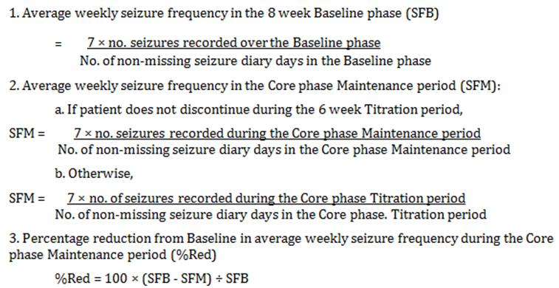
A responder was a patient with ≥ 50% reduction from Baseline in average weekly seizure frequency during the Maintenance period of the Core phase, that is when %reduction ≥ 50%.

Analysis of populations
- Full Analysis Set (FAS) comprised all patients to whom study treatment was assigned by randomisation.
- Pharmacokinetic analyses were performed on the Confirmed PK Sample Set from all everolimus treated patients in the Safety Set and Long-term Evaluation Safety Set, which was defined as follows:
C_{min} collected prior to dose administration on the same treatment day and 20 to 28 hours after the previous dose, at steady state, and with no evidence of vomiting within 4 hours of the previous dose.
- The Long-term Evaluation (LTE) Sets (Efficacy and Safety) comprise all patient data on everolimus in the study during the Core phase and Extension phase. Each LTE set consists of all patients who received at least one dose of everolimus and had at least one efficacy/safety assessment.

Sample size
The sample size calculation was based exclusively on response rate, the primary endpoint used by the EMA, but it was also expected to provide sufficient patients for the power of the FDA primary endpoint, percentage reduction in seizure frequency.
It was assumed that response rates would be 15% in the placebo arm and 35% in each of the two everolimus arms. That is, there was no a priori strong expectation that the higher targeted trough everolimus arm 9 to 15 ng/mL would deliver a higher response rate than the lower targeted trough everolimus arm 3 to 7 ng/mL, as better efficacy may be mitigated by worse tolerability. For this reason, the testing strategy was to simultaneously compare each pairwise comparison, splitting the significance level, rather than testing hierarchically starting with the higher trough arm for example. It was determined that a sample size of 355 patients would ensure 90% power for each of the primary comparisons of each everolimus arm versus placebo, assuming one-sided 1.25% significance levels for each Cochran-Mantel-Haenszel chi-square test, and assuming balanced randomisation (that is 115 patients per randomisation arm).
Due to a mistake in the titration recommendations it was decided to increase the sample size in the everolimus 9 to 15 ng/mL arm by 10 patients, that is 125 patients in total in that arm.

Statistical methods
For the chosen primary endpoint, response rate was compared between each everolimus arm versus the placebo arm in the Full Analysis Set using Cochran-Mantel-Haenszel (CMH) chi-square tests stratified by age subgroup. The Bonferroni-Holm procedure was used to ensure an overall family-wise Type I error rate of 2.5% one sided. Response rates were provided with exact 95% CIs, and the odds ratio for each everolimus arm versus placebo was obtained from logistic regression models stratified by age subgroup.
EMA and FDA will use its preferred variable as the primary variable, with the other (now non-primary) variable being used in a supportive analysis. As either EMA or FDA will only use its preferred primary variable to make a decision on the primary objective, the full alpha level can be used for each Agency’s primary variable, without correction for multiplicity.
As per earlier, the clinical evaluator stated that:
Given that the TGA has adopted EMA guidelines, this evaluator proposes to use the response rate as the primary variable. The protocol indicates that the statistical analysis was not to be set up for co-primary endpoints
Statistical analysis methods of the multiple supportive and secondary endpoints are listed elsewhere in the CER.

Protocol amendments
Protocol amendments (second) after trial start (14 March 2014) included:
- Among the Inclusion criteria, the definition of TSC seizures was modified to include sensory seizures as the sole seizure type if confirmed to be partial onset by ictal EEG.
- Addition to the Exclusion criteria, in relation to patients on a ketogenic diet (defined as < 40 g of carbohydrate/day).
- Allowing investigator’s discretion to manage everolimus titrations in the Extension phase.
- Subsequent recognition of the inappropriateness of the approach plan in the original protocol, to define the Safety Population using actual C_{min} values.

Major protocol violations/deviations

Table 27: Protocol deviations – Full Analysis Set Study M2304
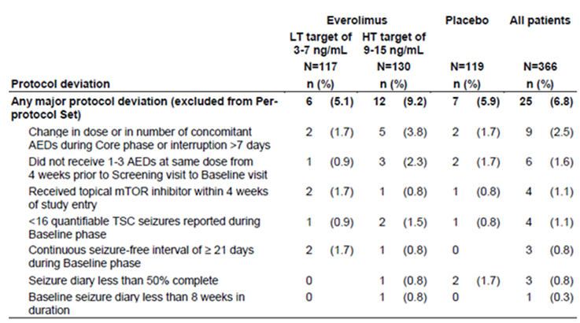
AEDs = antiepileptic drugs; mTOR = mammalian target of rapamycin
Source located in the submitted data. A patient may have multiple protocol deviations

Baseline data
The baseline characteristics were similar in all the three randomised arms (that is everolimus low target of 3 to 7 ng/mL, everolimus high target of 9 to 15 ng/mL and placebo) with respect to age range (2.2 to 56.3 years), percent gender ratio (about 51.3% males to 48.7% females), body surface area range (12 to 147.9 m²), TSC diagnosis using > major features as per Gomez criteria (n = 100% in each arm),time range from initial diagnosis of TSC seizures until randomisation (0.3 to 51.4 years) and background seizure history (complex partial seizure, secondarily generalised seizure etcetera.). Slightly more patients had prior epilepsy surgery, prior ketogenic diet, number of AEDs failed prior to study start in the everolimus high target of 9 to 15 ng/mL .For patients treated, n = 117 for everolimus low target of 3 to 7 ng/mL, n = 130 for everolimus high target of 9 to 15 ng/mL and n = 119 for placebo.
For discontinuations n = 7 for everolimus low target of 3 to 7 ng/mL, n = 8 for everolimus high target of 9 to 15 ng/mL and n = 5 for placebo. The primary reasons for end of treatment in the core phase were adverse events (n = 5 for everolimus low target of 3 to 7 ng/mL, n = 4 for everolimus high target of 9 to 15 ng/mL and n = 2 for placebo) and lack of efficacy ( n = 0 for everolimus low target of 3 to 7 ng/mL, n = 2 for everolimus high target of 9 to 15 ng/mL and n = 2 for placebo).

Randomisation
At the end of the Baseline phase, patients who met the eligibility criteria were randomised in an approximate ratio of 1:1:1 to receive treatment:
- A (Placebo);
- B (everolimus low target of 3 to 7 ng/mL); or
- C (everolimus high target of 9 to 15 ng/mL).
Randomisation was stratified by age group:
- 1 to < 6 years;
- 6 to < 12 years;
- 12 to < 18 years; and
- ≥ 18 years
Due to a mistake in the titration recommendations discovered early in the trial, preventing dose titrations despite C_{min} values outside the targeted trough range, it was decided to increase the sample size in the everolimus 9 to 15 ng/mL arm by 10 patients, that is 125 patients in total.
This sample size increase of 10 patients was made by inserting a number of blocks with randomisation ratio of 1:2:1 in favour of the everolimus 9 to 15 ng/mL arm, with the planned sample size becoming 355 patients (115 patients in the everolimus 3 to 7 ng/mL arm, 125 patients in the everolimus 9 to 15 ng/mL arm, and 115 in the placebo arm; overall randomisation ratio of 1:1.09:1).

Blinding methods
During the initial titration period of the Base phase, dose was titrated via Interactive Response Technology (IRT) in a blinded fashion until each patient reached their assigned target trough range.
Patients on placebo had random increases and decreases in the number of tablets taken to simulate titration and to maintain the blind. Patients in the low trough group also had random increases and decreases in placebo tablets to simulate titration for the high trough group.
During the extension phase, placebo dose changes were possible at the start of dose transition. Starting at the visit at which everolimus concentrations were disclosed, placebo tablets were no longer dispensed.
This interim CSR summarizes all patient data during the Baseline and Core phases as well as partial Extension phase data, as of the 2 October 2015 data cut-off date.

Primary efficacy outcome
Primary efficacy outcome (as per the EMA primary efficacy variable version):
- For seizure frequency response rate:
  - Response rates were 28.2% (95% CI: 20.3, 37.3) and 40.0% (95% CI: 31.5, 49.0) for the everolimus low trough range and high trough range arms compared with 15.1% (95% CI: 9.2, 22.8) for the placebo arm. Thus, although the high trough range results are clearly superior to those of placebo, the 95% CIs for the low trough range and placebo overlap. However, the odds ratios 95% CIs for both active arms compared to placebo are both above 1.0.
  - The sensitivity analyses support these observations.
Table 28: Seizure frequency response rate, Full Analysis Set; Study M2304
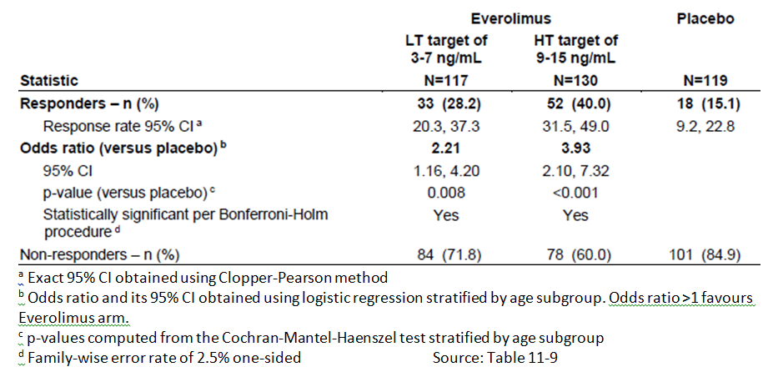
Figure 6: Seizure frequency response rate, Full Analysis Set
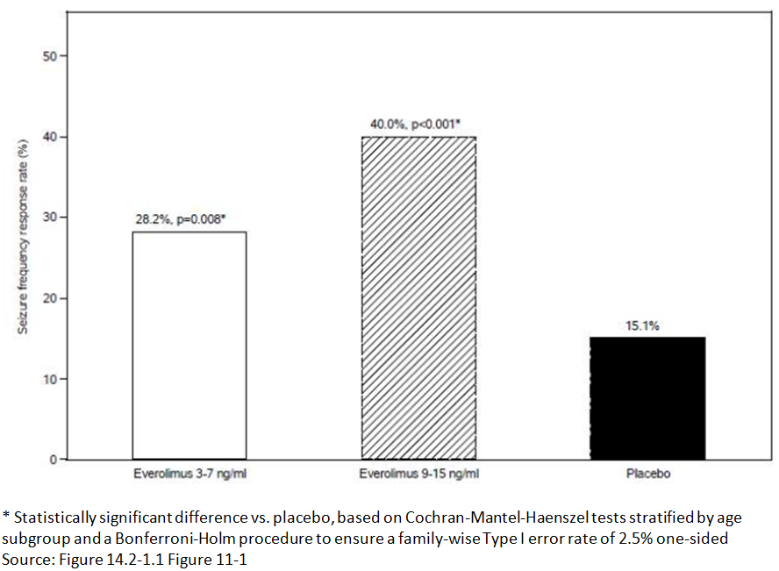

Other efficacy outcomes

For the percentage reduction from baseline in seizure frequency
The median percent reduction in weekly seizure frequency was 29.3% (95% CI: 18.8, 41.9) and 39.6% (95% CI: 35.0, 48.7) for the everolimus low trough range and high trough range arms, respectively, compared with 14.9% (95% CI: 0.1, 21.7) for the placebo arm. Thus, although the high trough range results are clearly superior to those of placebo, the 95% CIs for the low trough range and placebo overlap. However, the 95% CIs for the difference from placebo are all above 0.
Table 29: Percentage reduction from Baseline in weekly seizure frequency, Full Analysis Set
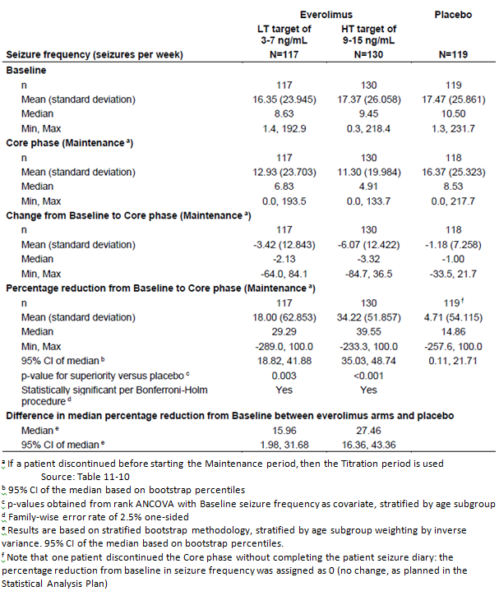
Table 30: Secondary endpoints
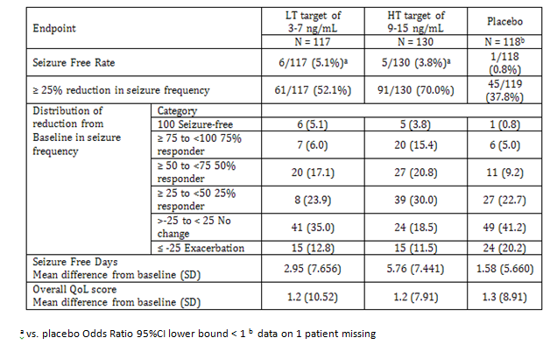
Figure 7: Percentage reduction in seizure frequency over time across all everolimus patients, Long-term Evaluation Efficacy Set
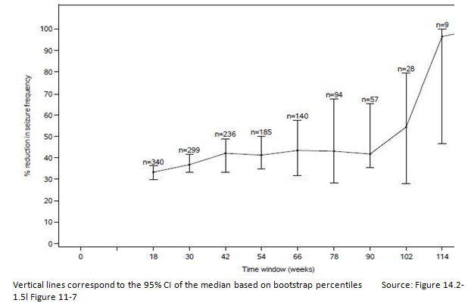
Figure 8: Kaplan-Meier curves of time to treatment discontinuation, Full Analysis Set
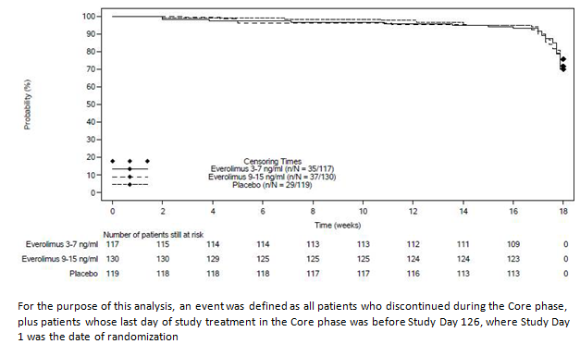

Clinical evaluator’s conclusions and comments on clinical efficacy

Primary endpoint
The response rate was 15.1% (95% CI: 9.2, 22.8) for the placebo arm, 28.2% (95% CI: 20.3, 37.3) for the C_{min} 3 to 7 ng/mL arm and 40.0% (95% CI: 31.5, 49.0) for the C_{min} 9 to 15 ng/mL arm. The 95%CIs for placebo and the 3 to 7 ng/mL arm overlap. However, the Odds ratio of the 95%CIs does not include 1.0.

Supporting endpoint
A similar result was seen: The median percent reduction in weekly seizure frequency was 29.3% (95% CI: 18.8, 41.9) and 39.6% (95% CI: 35.0, 48.7) for the everolimus low trough range and high trough range arms respectively, compared with 14.9% (95% CI: 0.1, 21.7) for the placebo arm. Thus, although the high trough range results are clearly superior to those of placebo, the 95% CIs for the low trough range and placebo overlap. However, the 95% CIs for the difference from placebo are all above 0.

Guideline
The CPMP/EWP/2330/99 Points to Consider on Application with 1. Meta-Analyses; 2. One Pivotal Study has:
- Prerequisites for one pivotal study applications:
  - The degree of statistical significance:
    - Statistical evidence considerably stronger than p< 0.05 is usually required, accompanied by precise estimates of treatment effects that is narrow confidence intervals. Tile required degree of significance will depend on factors such as the therapeutic indication, the primary endpoint, the amount of supportive data and whether the alternative analyses demonstrating consistency are pre-specified.

Proposed dosage
- The proposed dosage is to maintain C_{min} at 5 to 15 ng/mL.
- The lower end of the range for C_{min} of the clearly significant result was found to be 9 ng/mL.
- The recommended target C_{min} range is 5 to 15 ng/mL, based on the following considerations:
  - The time-normalised C_{min} of 5.3ng/mL is the threshold concentration above which the 95% confidence interval of predicted change from baseline seizure frequency is not overlapping with the 95% confidence interval of predicted change from baseline SF of placebo patients. This indicates a lower bound of the therapeutic range.
- The modelling of efficacy to C_{min} mentioned under Pharmacodynamics in the CER (See Attachment 2, Section 5) shows a relationship between C_{min} time normalised and a response.
- For those subjects who would currently be eligible for everolimus treatment due to concurrent TSC related conditions that is SEGA and renal angiomyolipoma, the 95% CIs for all 3 treatment groups overlapped, the numbers were small.

Safety
Regarding the overall conclusions on clinical safety, the clinical evaluator stated that:

Comparing previous experience with Study M2304
- Under 6 months, the overall incidence of emerging AEs was higher in the previous Pool versus Study M2304 (87.6% versus 74.5%), as were the incidences of stomatitis (+11.9%) and hypercholesterolemia (+9.5%). Other events were reported with a similar frequency between the two datasets.
- Between Months 6 to 12, the overall incidence of emerging AEs was higher in the previous Pool versus Study M2304 (53.1% versus 37.8%). The incidence of specific AEs was in general similar.
- Between Months 12 to 24 the overall incidence of emerging AEs was higher in the previous Pool versus Study M2304 (67.5% versus 33.9%). Stomatitis (7.9%) and mouth ulceration (5.0%) were both reported more frequently in the previous Pool.

Clinical evaluator’s overall comments on safety
- There were some differences from the previous experience, the sponsor’s explanation for these related to the difference in age composition with 2 of the earlier trials confined to adults.
- There appeared to be no major difference from the previous safety experience of everolimus in TSC patients.

Assessment of benefits as per the clinical evaluator (first round)
Please see Table 22 above for the clinical evaluator’s assessment of benefits, strengths and uncertainties.

Assessment of risks as per the clinical evaluator (first round)
Please see Table 23 above for the clinical evaluator’s assessment of risks strengths and uncertainties.

Assessment of benefit-risk balance as per the clinical evaluator (first round)
The benefit-risk balance is considered favourable.

Clinical evaluator’s recommendation as per the the clinical evaluator (first round)
Recommendation regarding authorisation:
It is not recommended that the proposed Indication for everolimus be approved.
It is recommended that everolimus be approved subject to a satisfactory PI for the modified indication of:
Afinitor is indicated for the Adjunctive treatment of patients aged 2 years and older with TSC and associated refractory seizures.
Rationale for the modified indication: It was a requirement for inclusion in Study M2034 that patients have a ‘Clinically definite diagnosis of TSC.’ Treatment of ‘Refractory seizures alone’ (a possible interpretation) was not included in the submission. The additional insertion clarifies this.
The clinical aspects of the RMP appear satisfactory. It is anticipated that this will include additional long term efficacy and safety data from further analyses of the pivotal Study M2304

Clinical questions posed to the sponsor by the clinical evaluator post first round evaluation and responses provided by the sponsor for second evaluation

Question on Hepatic toxicity:
The Clinical Study Report did not have a separate section on this. The Summary of Clinical Safety had under 1.1.1 Safety aspects of the product ‘Additional known risks with everolimus therapy that require close monitoring and evaluation include: and safety in patients with hepatic impairment’.
The sponsor has proposed multiple hepatic impairment insertions in relation to which the sponsor has consistently referred to 2.7.2 Summary of Clinical Pharmacology. The only relevant statement found therein is:
‘3.2.9 Impaired hepatic function: No new information was generated in support of this indication’.
In the summary results of the trial, 23 to 25% had abnormal liver enzymes (Table 20) (2 at least were Grade3/4 (Table 43 Attachment 2)). One ADR of raised enzyme was reported (also 1 on placebo)) raised ALT. Due to raised alkaline phosphatase there was 1 discontinuation (Table 39 Attachment 2), and 1 interruption or adjustment to dose (Table 40 Attachment 2).
- Please review and comment.
- Please justify the proposed insertions.
Sponsor’s response:
The sponsor acknowledges the evaluators comment with regards to hepatic toxicity.
Abnormalities in liver enzymes were observed during Study M2304, which were consistent with the known adverse events of everolimus. In measured laboratory results during the double blind phase, ALT and AST increases were seen more frequently (with ≥ 10% TSC seizures differences) in everolimus treated patients than the placebo group. However, there were no Grade 3/4 abnormalities in either group. While alkaline phosphatase (ALP) increases, all Grade 1/2, were slightly more frequent in the placebo group compared to the everolimus group. In the long term phase, the overall frequency of increases in ALT, AST and ALP remained consistent to that seen during double blind phase with Grade 3/4 ALT increases in 2 patients and Grade 3/4 AST increase in one patient.
As per protocol, laboratory abnormalities that constituted an adverse event (AE) in their own right (that is were considered clinically significant, induced clinical signs or symptoms, required concomitant therapy or required changes in study treatment), were to be recorded on the Adverse Events CRF. Laboratory abnormality was reported as an adverse event (ALT increased, Grade 1/2) in only one patient from everolimus treated patients and in one patient (AST increased, Grade 1/2) from the placebo group. There was no dose adjustment/interruption or discontinuation due to liver enzyme abnormality in Study M2304.
The abnormalities whether measured on laboratory investigations or reported during the study constituted abnormal liver function tests without any concomitant evidence or events (clinical or laboratory) corresponding to the required criteria for Child-Pugh score. Hence, none of these cases fulfilled the criteria suggestive of liver damage of any Grade according to the Child-Pugh scoring.
The empirical evidence from this study supports the statement in the Summary of Clinical Pharmacology that there were no patients with hepatic impairment as per Child-Pugh criteria, exposed to everolimus in this study. No additional hepatic impairment study was performed in TSC seizures patients specifically. The impact of hepatic impairment on pharmacokinetics (PK) is expected to be the same across the different indications/tumours as the liver is the main organ for everolimus metabolism, and not the TSC tumours. The proposal is therefore to apply the same dosing recommendations for TSC SEGA and TSC seizures patients in case of concomitant hepatic impairment.
Note: The sponsor also respectfully wishes to point out that in the TGA report Table 41 presents data from the TSC pooled studies without M2304. Moreover, it also noticed that Table 42 in the TGA report contains the same data as in Table 41, despite different table headings.
Delegate’s comment: Satisfactory.

Risk management plan

Reconciliation of first round recommendations
- The table in the ASA comparing the wording of the EU SmPC and the proposed Australian PI for all of the specified ongoing safety concerns and missing information should be updated and include the actual wording when the SmPC is available and the wording of the Australian PI has been agreed by the TGA
Sponsor’s response:
The sponsor acknowledges the above request from the evaluator. An updated table comparing the wording in the Australian PI and EU SmPC for all of the specified ongoing safety concerns and missing information, in line with the EU-RMP, can be included in the next application requiring submission of a RMP. The content of this table will be based on the most recent TGA approved Australian PI.
RMP evaluator’s comment:
The sponsor’s response is acceptable.
- Patients with impaired GI function (oncology setting only) remains in the ASA and the sponsor should remove this at the next updated version of the ASA.
Sponsor’s response:
The sponsor confirms theASA has been updated accordingly.
RMP evaluator’s comment:
The sponsor has removed the above safety concern from the ASA.
- It is noted that the intention to provide a leaflet regarding the preparation of a suspension of Afinitor from the dispersible tablets has been removed from the ASA. The sponsor should clarify how appropriate instructions for the preparation of the suspension will be provided to patients.
Sponsor’s response:
During the evaluation of the application to register dispersible tablets as a new dosage form (submission number PM-2012-01931-3-4), the TGA’s RMP evaluator made the following recommendation to the Delegate in the first RMP evaluation report: ‘It is recommended to the Delegate that for the preparation of Afinitor dispersible tablets that the sponsor incorporates graphical representation of instructions into the consumer medicine information documents to help minimise medication error (for example; see FDA Patient information leaflet).’
In the response to questions, dated 3 April 2013, the sponsor proposed to incorporate a leaflet in the Afinitor dispersible tablet packs of ‘How to prepare Afinitor suspension’.
Afinitor dispersible tablets are not currently available in Australia. The sponsor hereby provides an assurance that such leaflet will be included in the pack upon product launch in Australia. The proposed label is included. As this leaflet is an activity to support patients in the appropriate administration of Afinitor, and medication error is not an ongoing safety concern in the EU RMP/ASA, it is considered that this is an activity outside the RMP frame work. Consequently, reference to this leaflet has been removed from the ASA.
RMP evaluator’s comment:
The removal is acceptable as ‘Medication Error’ is not listed as a safety concern, and the activity is considered a stated risk minimisation activity rather than an additional risk minimisation activity. The proposed leaflet is acceptable.
- The sponsor should provide the proposed SmPC for TSC and the dispersible tablets
Sponsor’s response:
In Europe, everolimus dispersible tablets for the treatment of ‘Refractory seizures associated with tuberous sclerosis complex (TSC)’ are registered under the trade name Votubia. The approved EU SmPC for Votubia dispersible tablets is provided.
RMP evaluator’s comment:
The EU SmPC has been supplied. No further action is required.

Risk-benefit analysis

Delegate’s considerations
All the three evaluators raised no objection to the approvability of everolimus.
The clinical evaluator’s non-objection was subject to the sponsor’s draft PI being acceptable to the TGA and to the sponsor, accepting the modified proposed indication from:
‘Afinitor is indicated for the Adjunctive treatment of patients aged 2years and older with TSC and refractory seizures’
to:
‘Afinitor is indicated for the Adjunctive treatment of patients aged 2 years and older with TSC and associated refractory seizures’.
The sponsor has accepted the clinical evaluator’s modification to its proposed indication.
The Delegate also agrees with the clinical evaluator’s slight modification to the sponsor’s proposed EOI. The Delegate is of the opinion that the latter is approvable as it will fulfil an area of unmet medical need for difficult to manage seizures associated with TSC, especially in children.
The sponsor has also accepted and incorporated the nonclinical recommended modifications to the draft PI.
The clinical evaluator stated that there appeared to be no major difference from the previous safety experience of everolimus in TSC patients.

Proposed action
Based on the available evidence from the evaluated submitted data, the Delegate was inclined at this stage to favour the approval of the application subject to resolving issues, arising from the ACM deliberations and finalising matters pertaining to the draft PI, to the satisfaction of the TGA.

Request for ACM advice
The Delegate requested the ACM advice on the following issues:
- Consideration and acceptability by the committee of the slight modification to the sponsor’s proposed indication.
- Approvability of the Type C component of the application.
The Delegate also requested for the committee to provide advice on any other issues, that it thinks may be relevant to a decision on whether or not to approve this application

Response from sponsor
The sponsor welcomes the TGA Delegate, RMP, nonclinical and clinical evaluator’s recommendation to extend the use of everolimus for the treatment of tuberous sclerosis complex (TSC) with associated refractory seizures.
The sponsor brings to the attention of the ACM that an alternative wording of the indication was recommended as part of the clinical evaluation report (CER) dated 14 March 2017. The sponsor accepts the proposed wording. The amended proposed indication for ACM consideration is:
‘Afinitor is indicated for the Adjunctive treatment of patients aged 2 years and older with TSC and associated refractory seizures’
The Delegate has sought the ACM’s advice on two specific issues relating to this application. Novartis will take this opportunity to present below our responses on each of these specific issues for consideration by the ACM.

ACM advice sought on specific issues
- Approvability of the Type C component of the application
With this application, the sponsor wishes to extend the indications of everolimus for the treatment of refractory TSC associated seizures.
TSC is a potentially devastating disorder with a prevalence approaching 1 in 6,000 live births. In Australia, TSC was granted orphan status on 30 March 2012. Worldwide, approximately 1 million people are known to be affected by TSC and up to 90% of these individuals suffer from epilepsy. It should be noted that multiple seizure types are observed in most TSC patients and that the onset of seizures typically occurs in the first year of life (with 82% before 3 years of age). Adults remain nonetheless at risk and up to 12% of adult patients with TSC develop epilepsy, indicating that TSC patients are at an increased risk of epilepsy throughout their lifetime. Seizures experienced by patients with TSC may be more refractory than those experienced by patients with other genetic or pathological conditions associated with their seizures. Patients with seizure onset before the age of 4 years, particularly when the seizures are frequent or refractory, have a substantially increased risk of subsequent mental retardation or autism.
In many cases seizures in patients with TSC (‘TSC seizures’) may be controlled by medication such as antiepileptic drugs (AEDs) or methods such as epilepsy surgery, vagal nerve stimulator or ketogenic diet. The published literature indicates that TSC seizures may respond to one of several AEDs approved for the treatment of partial seizures (topiramate, lamotrigine, levetiracetam, oxcarbazepine, and clobazam), however these AEDs do not distinguish among different seizure aetiologies. There is no consensus on the most effective AED in TSC, except for vigabatrin in infantile spasms. Moreover, seizures associated with TSC are poorly controlled by AEDs or epilepsy surgery, vagal nerve stimulation (VNS) or ketogenic diet and up to 60% of patients with TSC associated epilepsy fail to demonstrate improvement in seizure frequency with available therapies. No approved AEDs target mTOR pathway as a means of addressing the underlying disease causing seizures (mTOR hyperactivity as a result of TSC1/2 mutations and being a mechanism to TSC). A treatment that manages seizures by modifying the unique pathophysiology of TSC (multifocal mTOR activation) therefore addresses an unmet medical need in this rare disease population.
To support the proposed indication of everolimus for the adjunctive treatment of patients with refractory TSC associated seizures, Study M2304 was conducted taking into consideration relevant current guidelines and guidance from the ICH on technical requirements for registration of pharmaceuticals for human use (ICH), from the EMA Committee for Medical Products for Human use (CHMP), and from the US Food and Drug Administration (FDA). The study was a double blind, randomised, multicentre, Phase III trial evaluating the efficacy and safety of everolimus in patients (1 to 65 years in Europe, and 2 to 65 years for the rest of the world) who have refractory TSC seizures. 366 patients with clinically confirmed refractory TSC seizures were randomised to everolimus through target of 3 to 7 ng/mL (n = 117) (everolimus low through (LT) arm) or to everolimus through target of 9 to 15 ng/mL (n = 130) (everolimus high through (HT) arm) or to matching placebo (n = 119) (placebo arm). All patients were receiving concomitant treatment of 1 to 3 AEDs. Treatment arms were generally well balanced with regard to medical history, demographic and disease characteristics at baseline, although a number of small to moderate chance imbalances were evident between arms at the time of unblinding. The population recruited was 2.2 to 56.3 years of age, predominantly (82%) paediatric with a median age of 10.06 years, by class of age: < 6 years: n = 104 (28.4%), 6 to < 12 years: n = 113 (30.9%), 12 to < 18 years: n = 82 (22.4%), ≥ 18 years: n = 67 (18.3%). All patients had failed at least two AEDs therapies prior to randomisation, most patients (> 95%) had failed at least three AEDs and 38.5% patients had failed more than six AEDs therapies. The majority of patients (94.5%) completed the core phase of the study. Total patient-year exposures in the core phase were 39.23, 43.67 and 40.33 in the everolimus LT, everolimus HT and placebo arms, respectively. As of the October 2015 data cut-off, 342 patients (93.4%) had entered the extension phase, 292 of whom (79.8%) continued to receive study treatment, patient-year exposure at data cut-off (including patients randomised to placebo who received everolimus in the extension phase) was 353.46.
The study met its primary objective for the seizure frequency response rate, where response means at least a 50% reduction from baseline during the maintenance phase, excluding titration phase (excepted for patient who discontinued during titration), in accordance with TGA adopted guidelines. In addition, the study met its supporting endpoint for the percentage reduction from baseline in seizure frequency, in the two everolimus trough + concomitant AEDs arms over the placebo + concomitant AEDs arm.
Moreover, superiority was demonstrated for everolimus LT and HT relative to placebo for the primary efficacy endpoint of response rate (p = 0.008 and p < 0.001), where response rate corresponded to a ≥ 50% reduction from baseline in TSC-seizure frequency. Response rates were 28.2% (95% CI: 20.3, 37.3) and 40.0% (95% CI: 31.5, 49.0) for the everolimus LT and HT arms, respectively compared with 15.1% (95% CI: 9.2, 22.8) for the placebo arm. The estimated odds of patients experiencing ≥ 50% reductions from baseline in seizure frequency were respectively 2.21 fold and 3.93 fold higher in the everolimus LT and HT arms, relative to placebo.
In addition, superiority was demonstrated for everolimus relative to placebo for the supporting endpoint of the percentage reduction from baseline in TSC seizures frequency (p = 0.003 and p < 0.001, in LT and HT arm, respectively, relative to placebo). The median percent reduction in seizure frequency was 29.3% (95% CI: 18.8, 41.9) and 39.6% (95% CI: 35.0, 48.7) for the everolimus LT and HT arms, respectively compared with 14.9% (95% CI: 0.1, 21.7) for the placebo arm. The differences between the median percentage reduction from baseline between each of the everolimus treatment arms and placebo were respectively 16.0 (95% CI: 2.0, 31.7) and 27.5 (95% CI: 16.4, 43.4) in favour of the everolimus LT and HT arms.
Results of secondary efficacy endpoints such as proportion of patients with ≥ 25% reduction from baseline in average weekly frequency of TSC seizures, and distribution of reduction in seizure frequency were supportive of the primary analyses. Patient reported outcomes were assessed using three age specific quality of life questionnaires (QoL) and no deterioration was evident in the overall QoL of patients who received treatment with everolimus.
The safety profile of everolimus in patients aged ≥ 2 years with refractory seizures associated with TSC has been well characterised in Study M2304 and is consistent with previous experience in the TSC setting. Everolimus is associated with an acceptable safety profile for patients with TSC seizures. The adverse event (AE) profile is characterised by predictable, primarily low Grade (mild or moderate) events. The most common AEs, with an incidence of ≥ 10% relative to placebo during the core phase of the study, were stomatitis, mouth ulceration, diarrhoea, aphthous ulcer and pyrexia. Grade 3 to 4 AEs reported with an incidence of ≥ 2% relative to placebo during the Core phase were stomatitis, pneumonia and menstruation irregular (each 2.3% in the HT arm). These events are generally manageable with dose reduction/interruption and/or use of concomitant medication. Importantly, the safety profile of everolimus is non-overlapping with that of other anti-epileptic drugs (AEDs) commonly prescribed in the indicated population. The longer term analyses supporting the safety related request submitted to the TGA on 30 May 2017 showed that everolimus continued to have an acceptable safety profile in this population, with labelling changes proposed in order to reflect key safety information for the treating healthcare provider (see (Adverse Reactions Update) for more information).
In summary, the study robustly and consistently demonstrate a clinically meaningful and highly statistically significant clinical outcome for patients with TSC and refractory seizures compared to placebo at the proposed target exposure range of C_{min} at 5 to 15 ng/mL. The extension of the indication addresses an unmet medical need for TSC patients, especially in children; suffering from TSC associated seizures that are refractory to currently available treatments. The proposed PI fully characterises both efficacy and safety to enable the appropriate use of Afinitor in patients with refractory TSC associated seizures to maximise benefit while minimising risk to patients, to the satisfaction of the three evaluators and the Delegate. The data provided in this application and the full description of these data in the PI, support the use of everolimus in the proposed indication.
- Consideration and acceptability by the committee of the slight modification to the sponsor’s proposed indication.
In the first round CER dated 14 March 2017, the TGA clinical evaluator (CE) recommended the following addition to the wording of the application:
Afinitor is indicated for the Adjunctive treatment of patients aged 2 years and older with TSC and associated refractory seizures.
The proposed indication is based on the above described Phase III study that demonstrates the benefit of everolimus for the treatment of patients with TSC who have refractory partial onset seizures. Efficacy and safety results from this current trial, presented above, provide compelling data to support the proposed indication. In this study, 366 patients with clinically confirmed refractory TSC seizures were randomised to everolimus through target of 3 to 7 ng/mL (n = 117) (everolimus LT arm) or to everolimus through target of 9 to 15 ng/mL (n = 130) (everolimus HT arm) or to matching placebo (n = 119) (placebo arm).
Given that the trial inclusion criteria specified that patients were required to have a ‘clinically definite diagnosis of TSC’, the clinical evaluator recommended the insertion of the word ‘associated’ in the proposed indication to avoid a possible interpretation as treatment of ‘refractory seizures alone’ which was not the subject of this application. The sponsor fully agrees with the clinical evaluator’s modification and believes that the proposed indication wording for everolimus addresses concerns around the target population to be treated for this indication.
In view of the points discussed above, the sponsor considers that the proposed wording is appropriate and warranted based on the body of submitted clinical evidence.

Sponsor’s conclusion
The sponsor believes that the proposed extension of indication is warranted on the basis that:
- The benefits of everolimus outweigh the risks for its intended use in patients with refractory TSC associated seizures
- Everolimus meets an important unmet medical need in this patient population
- The supportive data from the primary analysis of Study M2304 received approval from the European Commission on 27 January 2017.
Furthermore, the sponsor welcomes the Delegate’s recommendation to approve a revised wording of the indication specifically stating that everolimus is to be indicated for the treatment of TSC with associated refractory seizures.

Advisory committee considerations
The Advisory Committee for Medicines (ACM), having considered the evaluations and the Delegate’s overview, as well as the sponsor’s response to these documents, advised the following:
Based on the available evidence from the evaluated submitted data, the Delegate is inclined at this stage to favour the approval of the application subject to resolving issues, arising from the ACM deliberations and finalising matters pertaining to the draft PI, as already accepted by the sponsor, to the satisfaction of the TGA.
The ACM taking into account the submitted evidence of efficacy, safety and quality, agreed with the Delegate and considered Afinitor standard tablets (available in 2.5 mg, 5 mg and 10 mg strengths) and dispersible tablets (available in 2 mg, 3 mg and 5 mg) of everolimus to have an overall positive benefit-risk profile with the Delegate’s amended indication:
Afinitor is indicated for the adjunctive treatment of patients aged 2 years and older with TSC and associated refractory seizures.
The additional term ‘associated’ was included when compared to sponsor’s proposed indication.
In making this recommendation the ACM:
- noted that the application has been approved in the EU and Singapore, and under evaluation in the USA, Canada and Switzerland.
- noted the wide range of approved uses for Afinitor, the current approved indications are:
  - Subependymal giant cell astrocytoma (SEGA) associated with tuberous sclerosis complex (TSC) who require therapeutic intervention but are not candidates for curative surgical resection.
  - Patients with tuberous sclerosis complex (TSC) who have renal angiomyolipoma not requiring immediate surgery.
  - Postmenopausal women with hormone receptor-positive, HER2 negative advanced breast cancer in combination with exemestane after failure of treatment with letrozole or anastrozole.
  - Progressive, unresectable or metastatic, well or moderately differentiated neuroendocrine tumours (NETs) of pancreatic origin.
  - Progressive, unresectable or metastatic, well differentiated, non-functional neuroendocrine tumours (NET) of gastrointestinal or lung origin in adults.
  - Advanced renal cell carcinoma after failure of treatment with sorafenib or sunitinib.
- noted there was no new safety data submitted and the next PSUR in the TSC setting will be available in May 2018. However, the committee also noted that exposure of the paediatric population was so far limited, especially with longer term uses and younger ages of exposure.

Proposed conditions of registration
The ACM agreed with the Delegate on the proposed conditions of registration and advised on the inclusion of the following:
- Negotiation of the PI and Consumer Medicine Information to the satisfaction of the TGA.
- Recommendations for ongoing proactive pharmacovigilance, especially in the paediatric subgroup.

Proposed Product Information (PI)/ Consumer Medicine Information (CMI) amendments
The ACM agreed with the Delegate to the proposed amendments to the Product Information (PI) and Consumer Medicine information (CMI).

Specific advice
The ACM advised the following in response to the Delegate’s specific questions on the submission:
- Consideration and acceptability by the committee of the slight modification to the sponsor’s proposed indication.
The ACM accepted the Delegate’s amendment to the sponsor’s proposed indication.
- Approvability of the Type C component of the application.
The ACM noted that there was satisfactory evidence of efficacy provided by the pivotal study and has no objections to the approvability of the Type C component of the application.
- Request for the committee to provide advice on any other issues, that it thinks may be relevant to a decision on whether or not to approve this application.
The ACM recommended for ongoing proactive pharmacovigilance surveillance, especially in the paediatric subgroup, given the longer anticipated duration of therapy for this indication.
The ACM also recommended that information on the approved indication and population to be treated should be bolstered in the PI and CMI.
The ACM advised that implementation by the sponsor of the recommendations outlined above to the satisfaction of the TGA, and that the evidence of efficacy and safety provided would support the safe and effective use of these products.

Outcome
Based on a review of quality, safety and efficacy, TGA approved the registration of:
- Afinitor everolimus 5 mg tablet blister pack;
- Afinitor everolimus 10 mg tablet blister pack;
- Afinitor everolimus 2.5 mg tablet blister pack;
- Afinitor everolimus 2 mg dispersible tablet blister pack;
- Afinitor everolimus 3 mg dispersible tablet blister pack; and
- Afinitor everolimus 5 mg dispersible tablet blister pack
indicated for:
‘Adjunctive treatment of patients aged 2 years and older with TSC and associated refractory seizures.’

Specific conditions of registration applying to these goods
The everolimus Risk Management Plan (RMP), EU-RMP (version 13.0, date 16 February 2017, data lock point 2 October 2015 and 31 March 2016 for TSC seizures population and CT dataset for pooled TSC setting respectively) with Australian Specific Annex (version 9.0, dated 21 July 2017) and any subsequent revisions, as agreed with the TGA will be implemented in Australia.

Post approval PI negotiation
Post approval the sponsor and the Delegate entered into negotiation regarding revision of the PI to include a black triangle warning. A reformatted PI was proposed and accepted by the Delegate and it is that which is provided as Attachment 1.

Attachment 1. Product Information
The PI for Afinitor approved with the submission which is described in this AusPAR is at Attachment 1. For the most recent PI, please refer to the TGA website at <https://www.tga.gov.au/product-information-pi>.

Attachment 2. Extract from the Clinical Evaluation Report

Therapeutic Goods Administration
PO Box 100 Woden ACT 2606 Australia
Email: info@tga.gov.au Phone: 1800 020 653 Fax: 02 6232 8605
https://www.tga.gov.au

Crino, P.B. (2010), The pathophysiology of tuberous sclerosis complex. Epilepsia, 2010; 51(Suppl. 1): 27–29.
Ruegg S., et al (2007) Effects of rapamycin on gene expression, morphology, and electrophysiological properties of rat hippocampal neurons. Epilepsy Research 2007; 77: 85-92
GABAA, an ionotropic receptor and ligand-gated ion channel. Its endogenous ligand is γ-aminobutyric acid (GABA); AMPA: α-amino-3-hydroxy-5-methyl-4-isoxazolepropionic acid receptor is an ionotropic transmembrane receptor for glutamate; NMDA NMDA receptor is very important for controlling synaptic plasticity and memory function. The NMDAR is a specific type of ionotropic glutamate receptor; the agonist molecule N-methyl-D-aspartate (NMDA) binds selectively to it, and not to other glutamate receptors.
Daoud D. et al. (2007) Rapamycin: brain excitability studied in vitro. Epilepsia 2007; 48: 834-836
Bateup H.S., et al. (2013)] Excitatory/inhibitory synaptic imbalance leads to hippocampal hyperexcitability in mouse models of tuberous sclerosis. Neuron 2013; 78: 510-522
McMahon J., et al. (2012) Impaired autophagy in neurons after disinhibition of mammalian target of rapamycin and its contribution to epileptogenesis. J. Neurosciences 2012; 32: 15704-15714
Meikle L., et al. (2007) A mouse model of tuberous sclerosis: neuronal loss of Tsc1 causes dysplastic and ectopic neurons, reduced myelination, seizure activity, and limited survival. J. Neurosci.2007; 27: 5546–5558
Moon U.Y., et al. (2015) Impaired Reelin-Dab1 Signaling Contributes to Neuronal Migration Deficits of Tuberous Sclerosis Complex. Cell Rep. 2015; 12 : 965-978
Feliciano D.M., et al (2011). Single-cell Tsc1 knockout during corticogenesis generates tuber-like lesions and reduces seizure threshold in mice. Journal of Clinical Investigation 2011; 121: 1596-1607
Lim J.S., et al. (2015) Brain somatic mutations in MTOR cause focal cortical dysplasia type II leading to intractable epilepsy. Nat. Med. 2015; 21: 395-400
Uhlmann E.J., et al. (2002) Astrocyte-specific TSC1 conditional knockout mice exhibit abnormal neuronal organization and seizures. Ann. Neurol. 2002; 52: 285–296
Erbayat-Altay E., et al. (2007) The natural history and treatment of epilepsy in a murine model of tuberous sclerosis. Epilepsia 2007; 48: 1470–1476
Zeng L.H., et al. (2008) Rapamycin prevents epilepsy in a mouse model of tuberous sclerosis complex. Ann. Neurol. 2008; 63: 444–453
Meikle L., et al. (2008) Response of a neuronal model of tuberous sclerosis to mammalian target of rapamycin mTOR) inhibitors: effects on mTORC1 and Akt signaling lead to improved survival and function. J. Neurosci. 2008; 28: 5422–5432
Carson R.P., et al. (2012) Neuronal and glia abnormalities in Tsc1-deficient forebrain and partial rescue by rapamycin. Neurobiol. Dis. 2012; 45: 369-380
Goto J., et al;. (2011) Regulable neural progenitor-specific Tsc1 loss yields giant cells with organellar dysfunction in a model of tuberous sclerosis complex. Proc. Natl. Acad. Sci. USA. 2011; 108: E1070-1079.
Wong M., et al. (2003) Impaired astrocyte glutamate transport in a mouse epilepsy model of tuberous sclerosis complex. Ann. Neurol. 2003; 54: 251–256
Zeng L.H., et al. (2011) Tsc2 gene inactivation causes a more severe epilepsy phenotype than Tsc1 inactivation in a mouse model of Tuberous Sclerosis Complex. Human Molecular Genetics 2011; 20: 445-454
Hartman A.L. et al. (2012) The mTOR inhibitor rapamycin has limited acute anticonvulsant effects in mice. PLoS One. 2012; 7: e45156
Way S.W., et al. (2009) Loss of Tsc2 in radial glia models the brain pathology of tuberous sclerosis complex in the mouse. Hum. Mol. Genet. 2009; 18: 1252–1265
Way S.W., et al. (2012) The differential effects of prenatal and/or postnatal rapamycin on neurodevelopmental defects and cognition in a neuroglial mouse model of tuberous sclerosis complex. Hum. Mol. Genet.2012; 21: 3226-3236
Zeng L.H., et al (2009) The Mammalian Target of Rapamycin Signaling Pathway Mediates Epileptogenesis in a Model of Temporal Lobe Epilepsy. Journal of Neuroscience 2009; 29: 6964-6972
Holz M.K. (2012) The role of S6K1 in ER-positive breast cancer. Cell Cycle 2012; 11: 3159-3165
Woodrum C., et al (2010) Comparison of three rapamycin dosing schedules in A/J Tsc2+/2 mice and improved survival with angiogenesis inhibitor or asparaginase treatment in mice with subcutaneous tuberous sclerosis related tumors. Journal of Translational Medicine 2010; 8:14
Kenerson H., et al. (2007) Activation of the mTOR pathway in sporadic angiomyolipomas and other perivascular epithelioid cell neoplasms. Hum. Pathol. 2007; 38:1361-1371
El-Hashemite N., et al. (2003) Mutation in TSC2 and activation of mammalian target of rapamycin signalling pathway in renal angiomyolipoma. Lancet 2003; 361: 1348–1349
Pirson Y. Tuberous sclerosis complex-associated kidney angiomyolipoma: from contemplation to action. Nephrol Dial Transplant 2013; 28: 1680-1685.
CL/F: The apparent systemic (or total body) clearance from plasma (or serum or blood) following extravascular administration. Q/F: Two compartment model inter compartmental clearance
V2/F Two compartment PK parameter for central volume; V3/F Two compartment PK parameter for peripheral volume
CYP3A4 Cytochrome P₄₅₀ 3A4; enzyme involved in drug metabolism
C_{min}; Minimum steady-state drug concentration during multiple dosing [ng/mL]
https://ctep.cancer.gov/protocoldevelopment/electronic_applications/docs/ctcaev3.pdf
everolimus LT and HT treatment; LT Low trough range treatment arm with targeted C_{min} range of 3 to 7 ng/mL HT High trough range treatment arm with targeted C_{min} range of 9 to 15 ng/mL
Routine risk minimisation activities may be limited to ensuring that suitable warnings are included in the product information or by careful use of labelling and packaging. Routine pharmacovigilance practices involve the following activities: - All suspected adverse reactions that are reported to the personnel of the company are collected and collated in an accessible manner; - Reporting to regulatory authorities; - Continuous monitoring of the safety profiles of approved products including signal detection and updating of labeling; - Submission of PSURs; - Meeting other local regulatory agency requirements.
Berg AT, et al. (2010) Revised terminology and concepts for organization of the epilepsies: Report of the Commission on Classification and Terminology. Epilepsia; 2010; 51: 676–685
Response rate is the percentage of responders in a treatment group
Protocol; each Agency will use their preferred variable as the primary variable, with the other (non-primary) variable being used in a supportive analysis. As each Agency will only use their preferred primary variable to make a decision on the primary objective, the full alpha level can be used for each Agency’s primary variable, without correction for multiplicity.
The ESC is an independent group of Scientific Investigators from academic medical research, dedicated to accelerating the development of new therapies in epilepsy to improve patient care.
Where a patient discontinued the trial without completing the patient seizure diary, then the %Red was assigned as equal to 0 and this patient was considered as a non-responder.
Please see Summary of Clinical Pharmacology
CHMP/EWP/566/98 Rev.2/Corr 22 July 2010. Guideline on clinical investigation of medicinal products in the treatment of epileptic disorder
The ACM provides independent medical and scientific advice to the Minister for Health and the Therapeutic Goods Administration (TGA) on issues relating to the safety, quality and efficacy of medicines supplied in Australia including issues relating to pre-market and post-market functions for medicines. The Committee is established under Regulation 35 of the Therapeutic Goods Regulations 1990. Members are appointed by the Minister. The ACM was established in January 2017 replacing Advisory Committee on Prescription Medicines (ACPM) which was formed in January 2010. ACM encompass pre and post-market advice for medicines, following the consolidation of the previous functions of the Advisory Committee on Prescription Medicines (ACPM), the Advisory Committee on the Safety of Medicines (ACSOM) and the Advisory Committee on Non-Prescription Medicines (ACNM). Membership comprises of professionals with specific scientific, medical or clinical expertise, as well as appropriate consumer health issues relating to medicines.
Please see the comment regarding post approval PI negotiation.

