14 March 2017

AusPAR Attachment 2

Extract from the Clinical Evaluation Report for Everolimus
  - Proprietary Product Name: Afinitor
  - Sponsor: Novartis Pharmaceuticals Australia Pty Ltd

About the Therapeutic Goods Administration (TGA)
- The Therapeutic Goods Administration (TGA) is part of the Australian Government Department of Health, and is responsible for regulating medicines and medical devices.
- The TGA administers the Therapeutic Goods Act 1989 (the Act), applying a risk management approach designed to ensure therapeutic goods supplied in Australia meet acceptable standards of quality, safety and efficacy (performance), when necessary.
- The work of the TGA is based on applying scientific and clinical expertise to decision-making, to ensure that the benefits to consumers outweigh any risks associated with the use of medicines and medical devices.
- The TGA relies on the public, healthcare professionals and industry to report problems with medicines or medical devices. TGA investigates reports received by it to determine any necessary regulatory action.
- To report a problem with a medicine or medical device, please see the information on the TGA website <https://www.tga.gov.au>.
About the Extract from the Clinical Evaluation Report
- This document provides a more detailed evaluation of the clinical findings, extracted from the Clinical Evaluation Report (CER) prepared by the TGA. This extract does not include sections from the CER regarding product documentation or post market activities.
- The words [Information redacted], where they appear in this document, indicate that confidential information has been deleted.
- For the most recent Product Information (PI), please refer to the TGA website <https://www.tga.gov.au/product-information-pi>.
Copyright
© Commonwealth of Australia 2018
This work is copyright. You may reproduce the whole or part of this work in unaltered form for your own personal use or, if you are part of an organisation, for internal use within your organisation, but only if you or your organisation do not use the reproduction for any commercial purpose and retain this copyright notice and all disclaimer notices as part of that reproduction. Apart from rights to use as permitted by the Copyright Act 1968 or allowed by this copyright notice, all other rights are reserved and you are not allowed to reproduce the whole or any part of this work in any way (electronic or otherwise) without first being given specific written permission from the Commonwealth to do so. Requests and inquiries concerning reproduction and rights are to be sent to the TGA Copyright Officer, Therapeutic Goods Administration, PO Box 100, Woden ACT 2606 or emailed to < tga.copyright@tga.gov.au>.

Contents
List of abbreviations 5
1. Introduction 6
1.1. Submission type 6
1.2. Drug class and therapeutic indication 6
1.3. Dosage forms and strengths 7
1.4. Dosage and administration 7
1.5. Proposed changes to the product documentation 7
1.6. Background 8
1.7. Information on the condition being treated 8
1.8. Current treatment options and clinical rationale 9
2. Clinical rationale 9
2.1. Regulatory history 9
2.2. Guidance 10
3. Contents of the clinical dossier 10
3.1. Scope of the clinical dossier 10
3.2. Paediatric data 11
3.3. Good clinical practice 11
4. Pharmacokinetics 11
4.1. Studies providing pharmacokinetic information 11
4.2. Summary of pharmacokinetics 11
5. Pharmacodynamics 15
5.1. Exposure efficacy relationship 15
5.2. Minimum efficacious concentration 16
6. Dosage selection for the pivotal studies 17
7. Clinical efficacy 18
7.1. Study M2304 18
7.2. Evaluator’s conclusions on clinical efficacy 39
8. Clinical safety 40
8.1. Patient exposure 40
8.2. Evaluation of issues with possible regulatory impact 55
8.3. Vital signs and clinical examination findings 61
8.4. Other safety issues 62
8.5. Safety in special populations 66
8.6. Post marketing experience 67
8.7. Evaluator’s overall conclusions on clinical safety 67
9. First round benefit-risk assessment 68
9.1. First round assessment of benefits 68
9.2. First round assessment of risks 68
9.3. First round assessment of benefit-risk balance 69
10. First round recommendation regarding authorisation 69
11. Clinical questions 69
11.1. Hepatic toxicity 69
12. Second round evaluation of clinical data submitted in response to questions 69

List of abbreviations
Abbreviation | Meaning
RAD001 | Everolimus
%Red | Percentage reduction from Baseline in average weekly seizure frequency during the Core phase Maintenance period
SFB | Average weekly seizure frequency in the 8 week Baseline phase
SFM | Average weekly seizure frequency in the Core phase Maintenance period
TSC | Tuberous sclerosis complex
TN-C_{min} | Time normalised C_{min}

Introduction

Submission type
This is a full application to extend the indications of Afinitor (everolimus) and to update the Clinical Trials section of the Product Information.

Drug class and therapeutic indication
Everolimus is a signal transduction inhibitor targeting mTOR (mammalian target of rapamycin), or more specifically, mTORC1 (mammalian 'target of rapamycin' complex 1). mTOR is a key serine-threonine kinase playing a central role in the regulation of cell growth, proliferation and survival.
Everolimus exerts its activity through high affinity interaction with the intracellular receptor protein FKBP12.
Everolimus is an inhibitor of the growth and proliferation of tumour cells, endothelial cells, fibroblasts and blood vessel-associated smooth muscle cells.
In a mouse neuronal model of TSC in which TSC1 is ablated in most neurons during cortical development, everolimus was shown to markedly improve survival and neurological function following repeated intraperitoneal administration.
Current Indications are:
Subependymal giant cell astrocytoma (SEGA) associated with tuberous sclerosis complex (TSC) who require therapeutic intervention but are not candidates for curative surgical resection.
Patients with tuberous sclerosis complex (TSC) who have renal angiomyolipoma not requiring immediate surgery.
Postmenopausal women with hormone receptor-positive, HER2 negative advanced breast cancer in combination with exemestane after failure of treatment with letrozole or anastrozole.
Progressive, unresectable or metastatic, well or moderately differentiated neuroendocrine tumours (NETs) of pancreatic origin.
Progressive, unresectable or metastatic, well-differentiated, non-functional neuroendocrine tumours (NET) of gastrointestinal or lung origin in adults.
Advanced renal cell carcinoma after failure of treatment with sorafenib or sunitinib.
The sponsor proposes to add the Indication:
Adjunctive treatment of patients aged 2years and older with TSC and refractory seizures.

Dosage forms and strengths

Table 1: Dosage forms and strengths
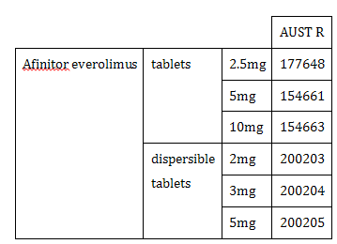
It is noted that the PI contains:
Relative bioavailability of dispersible tablets
The AUC_{0-∞} of the Afinitor Dispersible Tablets when administered as a suspension in water was equivalent to that of Afinitor Tablets (85% to 91% of that associated with Afinitor Tablets). The predicted trough concentrations of everolimus at steady state after daily administration were similar for both dosage forms. The C_{max} of everolimus associated with the Afinitor Dispersible Tablets was, however, somewhat lower (64% to 80% relative to that associated with Afinitor Tablets).

Dosage and administration
The dosage and administration section runs to 7 pages.
Afinitor should be administered orally once daily at the same time every day (preferably in the morning), either consistently with or consistently without food (see Pharmacokinetics). Afinitor is available in two formulations: tablets (Afinitor Tablets) and dispersible tablets (Afinitor Dispersible Tablets).
The changes proposed to dosage and Administration in the PI mostly relate to the proposed new indication. However there are some changes made to dosage Table 16/22 not in the annotated copy.

Proposed changes to the product documentation
The sponsor also proposes for the following sections:
- changes to the Mechanism of Action
- adding to the Exposure-response relationships under Pharmacodynamic properties
- adding to the Paediatrics Pharmacokinetics
- adding Tuberous sclerosis complex (TSC) with refractory seizures to Clinical Trials
- adding to the Precautions Hepatic Impairment
- amending the Precautions Paediatric use
- adding to the Interactions with Other Medicines - Agents whose plasma concentration may be altered by everolimus
- updating the Adverse Effects.

Background
Everolimus was initially developed for the prophylaxis of organ transplant rejection. It was first registered in Australia in 2009 for treatment of advanced renal cell carcinoma. Everolimus has multiple indications with the most recent extension for the treatment of progressive, unresectable or metastatic, well-differentiated, non-functional neuroendocrine tumours (NET) of gastrointestinal or lung origin. That submission (PM-2015-03569-1-4) was approved on 13 January 2017.
Of particular note for paediatric use:
- Everolimus is not recommended for use in paediatric cancer patients.
- Everolimus is not recommended for use in paediatric patients with TSC who have renal angiomyolipoma in the absence of SEGA.
- Everolimus has not been studied in paediatric patients < 1 year of age with TSC who have sub ependymal giant cell astrocytoma (SEGA).
- Dosing recommendations for paediatric patients with TSC who have SEGA are consistent with those for the corresponding adult population with the exception of those patients with hepatic impairment. Everolimus is not recommended for patients < 18 years of age with TSC who have SEGA and hepatic impairment.
This submission represents that first proposed use of everolimus for a non-oncology indication. Additionally it is proposed for use in a paediatric population.
About 85% of children and adolescents with TSC have neurological manifestations including epilepsy, cognitive impairment and behavioural problems, whereas a subset of affected adults have no signs of cerebral manifestations and have a normal mental status. Brain lesions mainly consist of cortical tubers, subependymal nodules and subependymal giant-cell astrocytomas, whose growth is a fearful complication.

Information on the condition being treated
Tuberous sclerosis complex has a prevalence approaching 1 in 6000 live births. It is an autosomal dominant genetic condition involving the tuberous sclerosis 1 gene (TSC1) and/or the tuberous sclerosis 2 gene (TSC2), mutations of which are found in 80% to 85% of patients.
Products from these two genes form a tumour suppressor complex. When either TSC1 or TSC2 are deficient, mammalian target of rapamycin complex 1 (mTORC1) is upregulated leading to abnormal cellular growth, proliferation, and protein synthesis. This results in a variety of benign tumours, or hamartomas, in multiple organ systems: lesions in the kidney, brain, skin, lung, heart, and eye.
Up to 20% of hamartomas in the brain (usually subependymal nodules) demonstrate progressive growth becoming subependymal giant-cell astrocytomas (SEGAs). As they enlarge, symptoms of increased intracranial pressure, new neurologic deficits, or deterioration of seizure control may be observed.
Development can occur of early-onset epilepsy and other neuro-psychiatric problems such as developmental delay, mental retardation, and autism.
In patients with TSC, the mechanisms causing epilepsy are not entirely understood; dysregulation of development and maintenance of cortical structure and function because of mTOR dependent processes may play a role in the development of epilepsy and neuropsychiatric disorders.

Seizures
Up to 90% of individuals with TSC are affected by a variety of seizure types of epilepsy, typically occurring in the first year of life (with 82% before 3 years of age); however, up to 12% of adult patients with TSC develop epilepsy as adults.
Patients with seizure onset before the age of 4 years, particularly when the seizures are frequent or refractory, have a substantially increased risk of subsequent mental retardation or autism.

Current treatment options and clinical rationale
SEGA are seen more frequently in childhood and adolescence; however, they have been reported in patients in their 30s and 40s. Historically, surgical resection has been used as standard of care to treat patients with TSC with SEGA. Despite its chances for success, a considerable level of risk of peri-and post-operative complications exists for such patients.
Seizures in patients with TSC (‘TSC-seizures’) may be controlled by medication such as antiepileptic drugs (AEDs) or methods such as epilepsy surgery, vagal nerve stimulator or ketogenic diet.
However seizures associated with TSC are poorly controlled by AEDs or epilepsy surgery, vagal nerve stimulation (VNS) or ketogenic diet and up to 60% of patients with TSC associated epilepsy fail to demonstrate improvement in seizure frequency with available therapies.

Clinical rationale
Pre-clinical results established the critical role of mTOR in TSC -related seizures and underlying epileptogenesis mechanisms and suggested inhibiting mTOR is a promising mechanism-based seizure reduction and antiepileptogenic therapy for treating TSC related epilepsy. On the basis of these pre-clinical results and preliminary clinical efficacy data, the sponsor initiated a Phase III study to investigate the safety and efficacy of everolimus in patients with TSC and refractory seizures.

Regulatory history

Australian regulatory history
First registered 6 August 2009.

Orphan drug designation
TGA orphan designation of TSC was obtained on 26 July 2010.

Related submissions
These studies were submitted with the most recent submission PM-2015-03569-1-4 and previously submitted to TGA:
- Study M2302; patients with TSC who have angiomyolipoma, previously submitted in Submission No: PM-2012-0193 1-3-4
- Study M2301; patients with TSC who have SEGA, previously submitted in Submission No: PM-2012-01931-3-4
- Study C2485; patients with TSC who have SEGA, initially submitted in Submission No: PM-2010-03193-3-4 and updated data submitted in Submission No: PM-2012-01931-3-4.

Overseas regulatory history
A similar application was submitted in EU, Canada and Switzerland for the TSC seizures application. No approvals of the proposed indication have been granted to date.

Guidance
CHMP/EWP/566/98 Rev.2/Corr Guideline on Clinical Investigation of Medicinal Products in the Treatment of Epileptic Disorders Effective: 17 December 2010.
CPMP/EWP/2330/99 Points to Consider on Application with 1. Meta-Analyses; 2. One Pivotal Study Effective: 27 March 2002 TGA annotation: Sponsors are reminded that they should submit all available new safety data that are relevant to the intended treatment population.
CPMP/EWP/908/99 Points to Consider on Multiplicity Issues in Clinical Trials.
CPMP/ICH/375/95 ICH Topic E 1 Note for Guidance on Population Exposure: The Extent of Population Exposure to Assess Clinical Safety.
Note for Guidance on Clinical Safety Data Management Definitions and Standards for Expedited Reporting (CPMP/ICH/377/95) Annotated with TGA Comments.

Contents of the clinical dossier

Scope of the clinical dossier
The submission contained the following clinical information:
- Comparative BA and Bioequivalence (BE) Study Reports
  - Study X2111: A randomised, open label, two way crossover study investigating the bioequivalence of everolimus (RAD001) 2 x 5 mg dispersible tablets in suspension and 5 x 2 mg dispersible tablets in suspension, in healthy male subjects
- Pharmacokinetic Study Reports
  - Study M2301: M2301 PK Expert Report A randomised, double blind, placebo controlled study of everolimus in the treatment of patients with subependymal giant cell astrocytomas (SEGA) associated with tuberous sclerosis complex (TSC)
- Population pharmacokinetic analyses.
  - Study M2301: Population pharmacokinetics of everolimus in the treatment of patients with subependymal giant cell astrocytomas associated with tuberous sclerosis complex 5 year update (Modelling Report)
- Efficacy/safety studies.
  - Study M2304: Parts 1 2 and 3; A three arm, randomised, double blind, placebo controlled study of the efficacy and safety of two trough ranges of everolimus as adjunctive therapy in patients with tuberous sclerosis complex (TSC) who have refractory partial onset seizures.
The submission also contained: Clinical Overview, Summary of Clinical Pharmacology Studies Summary of Clinical Efficacy, Summary of Clinical Safety Synopses of Individual Studies and literature references.

Paediatric data
The EMA approved deferral to the Paediatric Investigation Plan (PIP) was to be completed by March 2020.

Good clinical practice
All studies were conducted in full compliance with current Good Clinical Practice.

Pharmacokinetics
New clinical pharmacology information from three studies, including data in patients with refractory TSC seizures from the pivotal Phase III study M2304 and the 5 year updated data in patients with TSC who have SEGA from previously reported studies (Study C2485 and Study M2301).
Comment: Justification for the inclusion of Study X2111 could not be found, reference to the study was found only in Table 3-1 Everolimus pharmacokinetic comparison between oncology patients and healthy subjects, but of this table the sponsor, just above the table, said:
No new information was added to Table 3-1 since the last sNDA/type II variation application (Afinitor neuroendocrine tumour of GI or lung origin submission).
Reviewing submission 2015-03569 the study was not included in that dossier. The study report was dated 22-May-2013.
The Study was not reviewed.

Studies providing pharmacokinetic information

Table 2: Submitted pharmacokinetic studies
PK topic | Subtopic | Study ID | *
PK in healthy adults | Bioequivalence; Single dose | X2111 | *
Population PK analyses | Target population§ | M2301 | *
PK interactions | Antiepileptic drugs | M2304
* Indicates the primary PK aim of the study. § Subjects who would be eligible to receive the drug if approved for the proposed indication.

Summary of pharmacokinetics

Population pharmacokinetics

PopPK analysis Study M2301
Population pharmacokinetics of everolimus in the treatment of patients with sub-ependymal giant cell astrocytomas associated with tuberous sclerosis complex; 5 year update.
This was a 5 year update of the previous model based on 3 year data up to 11 January 2013. Study M2301 consisted of a double blind randomised phase and an extension phase, in which treatment was expected to run 4 years after the last patient was randomised. Patients were allowed to crossover from placebo to everolimus at SEGA progression or after the unblinding of the investigator on 13 May 2011.
The analysis population included 111 patients who ranged from age 1.0 to 27.4 years at the start of everolimus. This included the 78 patients in the previous analysis randomised to everolimus plus 33 new patients randomised to placebo who switched to everolimus and contributed PK samples. They contributed 2580 everolimus blood concentrations to the PopPK analysis.
The previous PopPK model (based on data cut-off date 11 January 2013) was a two compartment model with first order input (rate constant KA), apparent clearances (CL/F and Q/F), and apparent volumes (V2/F and V3/F). The typical values of some of the PK parameters depended on body surface area (BSA, m²) and an indicator for the presence or absence of CYP3A4 or PgP inducers.
The previous PK model parameter estimates were updated with the 5 year data set and then compared with those existing from the 3 year data.
Since the use of additional covariates showed larger % error in predictions of trough levels, the 5 year model with no additional covariates (to those of the existing 3 year model) was adopted.
Typical steady state trough level was predicted to be near the midpoint of the target range of 5 to 15 ng/mL for an adult on a 4.5 mg/m² dose with absence of CYP3A4 or PgP enzyme inducers. The presence of inducer was associated with numerically greater decrease in trough levels for adults compared to children. Typical steady state trough levels are predicted to be near the lower limit of the target range for a child or anyone with presence of CYP3A4 or PgP enzyme inducers.
Thus: Children or anyone with presence of inducers may need a dose increase from 4.5 mg/m² to maintain steady state trough levels within the target range
Steady state C_{min} based on a higher starting dose was simulated for children 1 year to less than 3 years to deliver typical initial steady state C_{min} higher than 5 ng/mL across the BSA range observed in the trial at time of first everolimus dose (0.42 m² to 0.74m²). A higher starting dose of 7 mg/m² based on the dispersible tablet or the regular tablet is suggested for children 1 to < 3 years to help minimize blood draws in these youngest children by reducing the number of dose titrations to attain the C_{min} within the target range of 5 to 15 ng/mL. See Figure 1.
Figure 1: Typical steady state concentration time profiles by BSA and absence/presence of inducer based on a dose of 4.5 mg/m²
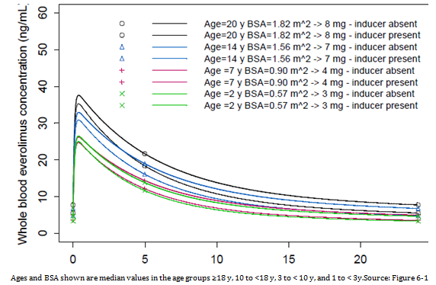

Pharmacokinetic interactions Study M2304

Table 3: Concomitant antiepileptic therapy; Study M2304 Core phase (Safety Set)
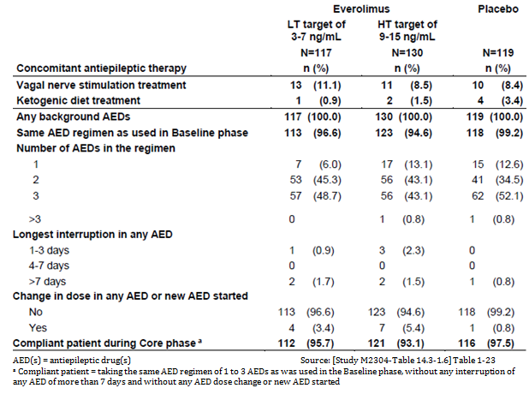
In Study 2304 the concentration levels of 12 commonly prescribed AEDs were assessed:
- Inducers of CYP3A4: carbamazepine, oxcarbazepine, phenobarbital, phenytoin, primidone, clobazam, topiramate
- Substrates of CYP3A4: clonazepam, diazepam, felbamate, zonisamide
- Not substrate or inducer of CYP3A4: valproic acid.
The impact of everolimus on the exposure of the AEDs was assessed via linear mixed models to compare the exposure of the AEDs before and after the administration of everolimus.
Separately for each AED, a linear mixed model was fitted to the log transformed concentrations, and included period (before and after everolimus administration) as a fixed effect and patient as a random effect. Geometric mean ratios of the concentrations with and without everolimus (as reference) and the 90% CIs were calculated from the model.
The above analyses were repeated considering patients exposed to only one of the 12 AEDs of interest to investigate any potential confounding effect. Model based analysis was performed on those AEDs taken by a minimum of 6 patients with valid concentrations for both everolimus and the corresponding AED.

Results of the statistical analysis
Treatment with everolimus was associated with minor increases in the concentrations of:
- Carbamazepine (geometric mean ratio of AED concentrations was 1.108 (90% CI: 1.016, 1.208))
- Clobazam (geometric mean ratio 1.093 (90% CI: 1.037, 1.153))
- Metabolite of clobazam (N-desmethylclobazam) (geometric mean ratio 1.071 (90% CI: 1.017, 1.127)).
‘The increases in the pre-dose concentrations of these AEDs may not be clinically significant although dose adjustment for carbamazepine, a drug with a narrow therapeutic index, may be considered. Everolimus had no impact on the other AEDs evaluated in the study.’

Table 4: Impact of everolimus on AED concentrations; Study M2304 Core phase Safety Set (Confirmed PK Sample Set)
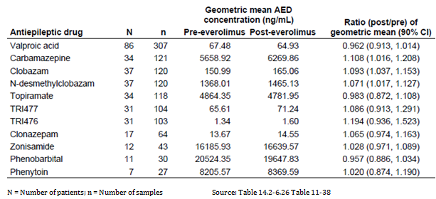

Pharmacodynamics

Exposure efficacy relationship
In study M2304, the relationship between everolimus exposure and the two primary efficacy endpoints of response rate and percentage change from Baseline in seizure frequency was investigated. No significant difference in response rate or seizure frequency reduction in relation to C_{min} level was shown.

Table 5: Response rate and percentage reduction from Baseline in seizure frequency by TN-C_{min}; Safety Set Study M2304 Core phase (Confirmed PK Sample Set)
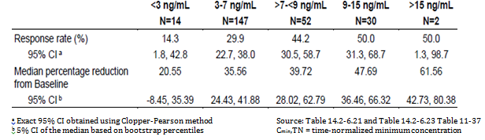
For response rate, logistic regression was used to model the probability of response. The model included terms for time normalised C_{min} (log transformed) in the Maintenance period of the Core phase (defined as from Study Day 43 until the last day of study medication in the Core phase), and Baseline seizure frequency. The model was stratified by age subgroup and adjusted for additional risk factors if appropriate.
The conditional logistic regression analysis for the probability of seizure response versus time normalised C_{min} (TN-C_{min}) stratified by age subgroup indicated that a 2 fold increase in TN-C_{min} was associated with a 2.17 fold increase (95% CI: 1.339, 3.524) in the odds for a response. In addition to TN-C_{min}, baseline seizure frequency was also a significant factor in the seizure response with an Odds Ratio of 0.978 (95% CI: 0.959, 0.998).

Table 6: Relationship for a 2 fold increase in everolimus exposure, between response rate and time normalised everolimus concentration at trough (TN-C_{min}) Study M2304 Core phase Safety Set (Confirmed PK Sample Set*)
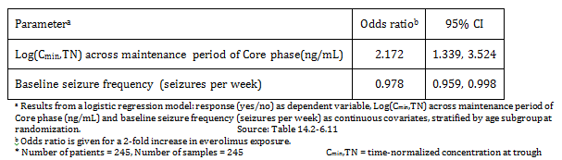
A linear regression model was used to characterise the impact of exposure on the post Baseline average weekly seizure frequency. The model includes Baseline seizure frequency and TN-C_{min} in the Maintenance period of the Core phase, both in log scale as covariates. Moreover, an additional linear mixed model with repeated measurements was used to link the post Baseline average weekly seizure frequency to the TN-C_{min} in defined time intervals during the Core phase. The model was adjusted by the Baseline seizure frequency. The linear regression model predicting the log of absolute seizure frequency during the Maintenance period of the Core phase indicated that for a 2 fold increase in TN-C_{min} there was a statistically significant 28% reduction (95% CI: 12%, 42%) in seizure frequency. Baseline seizure frequency and TN-C_{min} were both significant factors.

Table 7: Relationship between % reduction from baseline in seizure frequency and time normalised everolimus concentration at trough; Study M2304 Core phase Safety Set (Confirmed PK Sample Set)
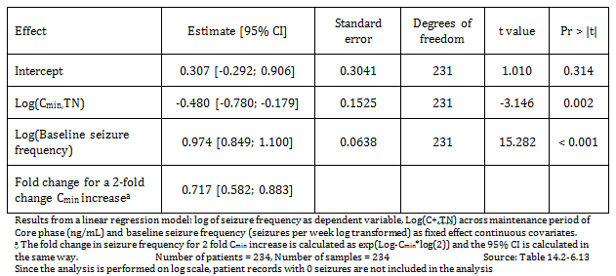

Minimum efficacious concentration
To find the lowest exposure (as TN-C_{min}) for which the 95% CIs of predicted change from baseline seizure frequency are not overlapping between everolimus and placebo, first a multiplicative linear regression model of seizure frequency predicted by TN-C_{min} was fit on everolimus data from the Maintenance phase of the Core phase.
Predictions were made for the adjusted ‘log fold change in seizure frequency from baseline’ across the observed range of TN-C_{min} values during the Core phase.
The ‘log fold change in seizure frequency from baseline’ and its 95% CIs were computed for both everolimus and placebo across the range of observed TN-C_{min} values. The lowest TN-C_{min} for which these CIs were not overlapping was then determined and considered as an estimate of the minimum efficacious concentration.
Figure 2: Relationship between percent reduction from baseline in seizure frequency and TN-C_{min} during Maintenance period of the Core phase Study M2304
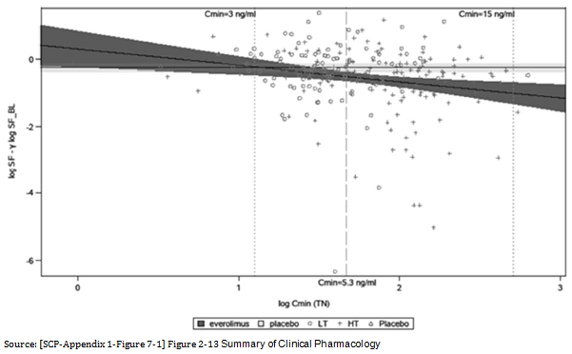

Table 8: Baseline adjusted change of seizure frequency by TN-C_{min} during the Maintenance phase of the Core phase
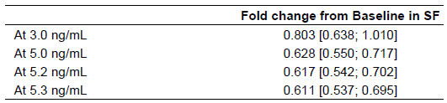

Dosage selection for the pivotal studies
The PI proposed target C_{min} exposure range is 5 to 15 ng/mL and it is based on data of seizure response and overall safety observable across this range.
Starting dose was derived from the patient’s age and concomitant use of CYP3A4/ P-glycoprotein (PgP) inducers.
It was based on the patients’ body surface area (BSA) and on previously submitted results in Study C2485 and Study M2301 involving largely paediatric, TSC patients with SEGA lesions.

Table 9: Study M2304 Starting dose
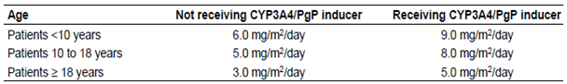

Clinical efficacy

Study M2304
An Interim Clinical Study Report was submitted.
This interim CSR summarises all patient data during the Baseline and Core phases as well as partial Extension phase data, as of the 2 October 2015 data cut-off date.
Study M2304 A three arm, randomised, double blind, placebo controlled study of the efficacy and safety of two trough ranges of everolimus as adjunctive therapy in patients with tuberous sclerosis complex (TSC) who have refractory partial onset seizures

Study design, objectives, locations and dates
This randomised, double blind, placebo controlled study consisted of three phases:
- Baseline phase: From Screening Week 8 (V1) to randomisation visit at Week 0 (V2)
- Core phase: Double blind, placebo controlled, from randomisation at Week 0 (V2) to Week 18 (V11).
- Extension phase: From Week 18 (V11) until 48 weeks after the last patient has completed the Core phase, with all patients receiving everolimus at entry with blinding of the original randomisation arm maintained
During the Baseline phase, patients were to complete a seizure diary for a total of ≥ 8 weeks, which was considered long enough to provide reliable data on the Baseline seizure frequency of patients taking 1 to 3 AEDs.
During the Core phase patients received either:
- Placebo or
- everolimus with titration to achieve a trough range of 3 to 7 ng/mL, or
- everolimus with titration to achieve a trough range of 9 to 15 ng/mL.
Patients entered the Core phase starting with a 6 week Titration period during which up to 3 dose adjustments could be made to reach the targeted everolimus trough range. This was followed by a Maintenance period of 12 weeks duration.
The Extension phase, in which all patients received everolimus, included an initial 8 weeks Transition period to bring patients to the common 6 to 10 ng/mL trough range followed by the Titration period with the option for Investigators to control everolimus dosing targeting the broad 3 to 15 ng/mL range.
The study formulation used was the tablets for oral suspension (dispersible tablets).
Figure 3: Study design
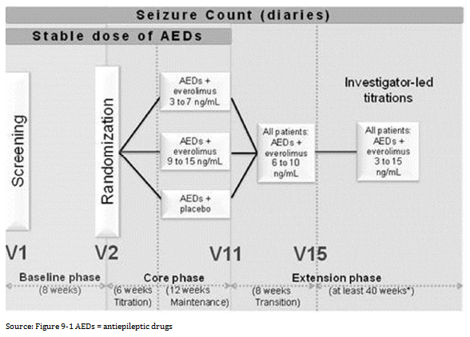

Objectives

Primary
To compare the reduction in frequency of TSC seizures on each of two trough ranges of everolimus (3 to 7 ng/mL and 9 to 15 ng/mL) versus placebo in patients with TSC who are taking one to three antiepileptic drugs (AEDs).

Secondary Objectives
There were multiple Secondary Objectives
- To compare each of the two everolimus trough ranges versus placebo with respect to:
- Ability to completely suppress TSC seizures
- Proportion of patients with ≥ 25% reduction from Baseline in average weekly frequency of TSC seizures
- Distribution of reduction from Baseline in seizure Frequency
- Seizure free days
- Treatment duration
- Quality of life (QoL).
- To assess everolimus in relation to neurocognitive, neurobehavioral, and neurodevelopmental measures using the Vineland Adaptive Behaviour Scales-II and the Wechsler Non-Verbal Scale of Ability.
- To assess the relationship between everolimus concentration and efficacy/safety endpoints.
- To evaluate the impact of everolimus on the pre-dose exposure of AEDs.
- To evaluate the effect of the two everolimus trough ranges on long term seizure reduction.
- To evaluate the safety and tolerability of each everolimus trough range in the study population.
- To evaluate the impact of everolimus on the risk of suicidality using the Columbia Suicide Severity Rating Scale (C-SSRS).

Exploratory objectives
There were another 4 exploratory objectives.

Locations and date
The study was conducted in multiple countries in Europe, Asia, North America and Russia and in multiple centres including 3 in Australia.
The study commenced 29 April 2013 and the cut-off date for this report was 2 October 2015.

Protocol amendments after trial start
14 March 2014
The second Protocol amendment included:
- Among the Inclusion criteria the definition of TSC seizures was modified to include sensory seizures as the sole seizure type if confirmed to be partial onset by ictal EEG.
- To the Exclusion criteria there was one added in relation to patients on a ketogenic diet (defined as < 40 g of carbohydrate/day).
- Allowing investigator discretion to manage everolimus titrations in the Extension phase.
- The Safety Population in the original protocol was planned to be defined using actual C_{min} values; however, that approach was subsequently recognized to be inappropriate.

Inclusion criteria
There were multiple inclusion criteria including age 2 to 65 years old (except in Europe where the minimum age was 1 year) with a clinically definitive diagnosis of TSC and treatment resistant epilepsy with ≥ 16 reported quantifiable seizures (with no continuous 21 day Seizure free period) during the 8 week Baseline phase.
Patients eligible for inclusion in this study have to meet all of the following criteria:
- Male or female between the ages of 2 and 65 years (except in Europe where the minimum age will be 1 at the request of the EMA). (A minimum number of paediatric patients will be randomised in the following age groups: 1 to <6 years (40 patients), 6 to < 12 years (40 patients), and 12 to < 18 years (40 patients).)
- Clinically definite diagnosis of TSC (modified Gomez criteria)
- Diagnosis of partial onset epilepsy according to the classification of the International League Against Epilepsy (Commission on Classification and Terminology of the International League Against Epilepsy, 1989) and revised in 2009 (Berg 2010). This classification is further modified for the purpose of capturing clinical details, and defines partial onset seizures in patients with TSC on the basis of the pathophysiology of TSC as either:
- any seizure that has been definitively shown to be partial onset on ictal EEG, or
- any probable seizure with motor signs (non-sensory) that has not been documented to be a primary generalised seizure on ictal EEG.
- Uncontrolled partial onset seizures; must meet the following:
- At least 16 reported quantifiable (no cluster or innumerable seizures) partial onset seizures (as defined in Inclusion Criteria 3) over the Baseline period (56 days, 8 weeks) with no continuous 21 day seizure free period between Visit 1 (Screening Visit) and Visit 2 (Randomization visit), as per data captured in daily seizure diaries.
- Prior history of failure to control partial onset seizures despite having been treated with two or more sequential regimens of single or combined antiepileptic drugs
- Prior or concurrent use of vagal nerve stimulator (VNS) is allowed. If the patient is using VNS, device stimulator parameters must remain constant throughout the study.
- Prior epilepsy surgery is allowed if performed at least 12 months before study entry.
- Must be receiving one, two, or three AEDs at a stable dose for at least 4 weeks at the start of the 8 week prospective Baseline phase, remain on the same regimen throughout the Baseline phase, and intend to continue the same regimen throughout the 18 week double blind Core phase (rescue medications are permitted). No more than one of these can be a strong CYP3A4 inducer (for example, Carbamazepine, Oxcarbazepine, Phenobarbital, Phenytoin, Primidone)
- If female of child bearing potential, documentation of negative pregnancy test at time of informed consent. Females of child bearing potential, defined as all women physiologically capable of becoming pregnant, must use highly effective contraception during the study and for 8 weeks after stopping treatment. Highly effective contraception is defined as either:
- Total abstinence: When this is in line with the preferred and usual lifestyle of the subject. (Periodic abstinence (for example, calendar, ovulation, symptothermal, post ovulation methods) and withdrawal are not acceptable methods of contraception)
- Sterilization: have had surgical bilateral oophorectomy (with or without hysterectomy) or tubal ligation at least six weeks before taking study treatment. In case of oophorectomy alone, only when the reproductive status of the woman has been confirmed by follow up hormone level assessment
- Male partner sterilization, at least 6 months prior to screening visit, (with the appropriate post vasectomy documentation of the absence of sperm in the ejaculate). (For female subjects on the study, the vasectomized male partner should be the sole partner for that subject).
- Use of a combination of any two of the following (a+b or a+c or b+c):
- Use of oral, injected or implanted hormonal methods of contraception
- Placement of an intrauterine device (IUD) or intrauterine system (IUS)
- Barrier methods of contraception: Condom or Occlusive cap (diaphragm or cervical/vault caps) with spermicidal foam/gel/film/cream/vaginal suppository In case of use of oral contraception women should have been stable on the oral agent before taking study treatment for at least 3 months.
- Sexually active males must use a condom during intercourse while taking study drug, and for 8 weeks after stopping study treatment. They should not father a child during this period. A condom is required to be used also by vasectomized men in order to prevent delivery of the drug via seminal fluid.
- Hepatic, renal and blood laboratory values within the following range at screening:
- AST and ALT levels < 2.5 x ULN
- serum bilirubin < 1.5 x ULN (this limit does not apply to patients with an elevated indirect bilirubin, if they have Gilbert’s Syndrome),
- serum creatinine < 1.5 x ULN,
- haemoglobin ≥ 9 g/dL,
- platelets ≥ 80,000/mm³,
- absolute neutrophil count ≥ 1,000/mm³
- Written informed consent: Subjects or their legal guardians must have the ability to comprehend the informed consent form and be willing to provide informed consent. For subjects who are too young or unable to comprehend the written consent, a legal guardian who is able to describe and provide an understanding of the informed consent to the subject must sign the consent form on behalf of the subject. In all cases, the informed consent process will follow the local rules and regulations.
- Patient or caregiver must be able to reliably record seizures and keep a daily diary and recall adverse events.

Exclusion criteria
There were multiple exclusion criteria including weight less than 12 kg, an episode of status epilepticus in the last year and a history of seizure clusters.
Patients eligible for this study must not meet any of the following criteria:
- Patients with seizures secondary to metabolic, toxic, infectious or psychogenic disorder or drug abuse or current seizures related to an acute medical illness.
- Presence of only non-motor partial seizures (Criteria Not Applicable per Amendment 2)
- Patients with TSC who have SEGA in need of immediate surgical intervention.
- Patients under 2 years of age with untreated infantile spasms.
- Within 52 weeks prior to study entry, an episode of status epilepticus, defined as:
- in adults and children 5 years and older ; continuous or intermittent, convulsive seizures lasting more than 10 minutes and requiring additional medical intervention such as with rescue medication not commonly used in the home (that is, a convulsive seizure or series of convulsive seizures not within the patient’s typical seizure pattern and management)
- in children less than 5 years of age; continuous or intermittent, convulsive seizures lasting more than 10 minutes and requiring significant additional medical intervention such as hospitalization (note: It is recognised that some young patients may be sent for emergency care despite having experienced a seizure within their typical seizure pattern and management. Only the more severe episodes of prolonged convulsive seizures in such patient, such as those leading to hospitalisation, would qualify as status epilepticus).
- Patients with history of seizure clusters (where individual seizures cannot be accurately counted according to the judgment of the investigator) occurring within 26 weeks prior to study entry.
- Patients who require rescue medication during the Baseline phase for more than 6 days.
- Patients with non TSC related progressive encephalopathy.
- Patients who weigh less than 12 kg.
- Patients with coexisting malignancies within the 3 years prior to randomisation, except for adequately treated carcinoma of the cervix or basal or squamous cell carcinomas of the skin.
- Patients with any severe and/or uncontrolled medical conditions at randomisation such as:
- Symptomatic congestive heart failure of New York Heart Association Class III or IV, history of left ventricular ejection fraction (LVEF) < 50%, QTc interval > 460 ms, congenital QT syndrome, unstable angina pectoris, myocardial infarction within 6 months of study entry, serious uncontrolled cardiac arrhythmia or any other clinically significant cardiac disease
- Significant symptomatic deterioration of lung function. If clinically indicated, pulmonary function tests including measures of predicted lung volumes, DLco, O₂ saturation at rest on room air should be considered to exclude restrictive pulmonary disease, pneumonitis or pulmonary infiltrates
- Impairment of gastrointestinal function or gastrointestinal disease that may significantly alter the absorption of everolimus (for example, ulcerative disease, malabsorption syndrome or small bowel resection)
- liver disease such as cirrhosis, decompensated liver disease, and chronic hepatitis (that is quantifiable HBV-DNA and/or positive HbsAg, quantifiable HCV-RNA)
- Uncontrolled diabetes as defined by fasting serum glucose > 1.5 x ULN
- Active skin, mucosa, ocular or GI disorders of Grade > 1
- Active (acute or chronic) or uncontrolled severe infections
- A known history of HIV seropositivity or other active viral infections.
- Patients with an active, bleeding diathesis.
- Patient with uncontrolled hyperlipidaemia: fasting serum cholesterol > 300 mg/dL
or >7.75 mmol/L AND fasting triglycerides > 2.5 x ULN.
- Patients who have had a major surgery or significant traumatic injury within 4 weeks of study entry. Patients who have not recovered from the side effects of any major surgery (defined as requiring general anaesthesia), or patients that may require major surgery during the course of the study.
- Patients with a prior history of organ transplant.
- Patients receiving more than 3 antiepileptic drugs at any time in the baseline phase or at randomisation or who change the dose of the AEDs during 4 weeks before screening or during the baseline period.
- Patients being treated with felbamate, unless treatment has been continuous for ≥ 1 year.
- Patients currently receiving anticancer therapies or who have received anticancer therapies within 4 weeks of study entry (including chemotherapy, radiation therapy, antibody based therapy, etcetera).
- Prior treatment with any investigational drug within the preceding 4 weeks prior to study entry.
- Patients receiving chronic, systemic treatment with corticosteroids or another immunosuppressive agent at study entry. Topical or inhaled corticosteroids are allowed.
- Patients who have received prior treatment with a systemic mTOR inhibitor (sirolimus, temsirolimus, everolimus) within 24 months of study entry. Patients who have received prior treatment with a topical mTOR inhibitor (sirolimus, temsirolimus, everolimus) within 4 weeks of study entry.
- Patients with a known hypersensitivity to everolimus or other rapamycin-analogues (sirolimus, temsirolimus) or to its excipients.
- Patients with a history of non-compliance to medical regimens or who are considered potentially unreliable or will not be able to complete the entire study.
- Pregnant or nursing (lactating) women, where pregnancy is defined as the state of a female after conception and until the termination of gestation, confirmed by a positive hCG laboratory test.
- Patients with a Score of 4 or 5 on the Suicidal Ideation item within 2 years of Screening, or any ‘yes’ on the Suicidal Behaviour item of the Columbia-Suicide Severity Rating Scale at Screening or Baseline who upon follow up with a healthcare professional are found to be severely depressed or suicidal.
- Maintenance of a diet consisting of < 40 g of carbohydrate per day within 3 months of screening

Efficacy variables and outcomes
The endpoints were multiple including differing Primary endpoints for the EMA and FDA. The EMA primary variable was the response rate while that for the FDA was the percentage reduction in seizure frequency.
Comment: Given that the TGA has adopted EMA guidelines this evaluator proposes to use the response rate as the primary variable. The protocol indicates that the statistical analysis was not to be set up for co-primary endpoints.
Seizure frequency was determined using counts of seizures, based on seizure diaries that were completed by the patient or caregiver throughout the trial.
During the Baseline phase (and if new seizures occurred during the study) the Investigator reviewed the known seizure types of each patient with the Epilepsy Study Consortium. Only events thought to have a high probability of being seizures with approval from the Epilepsy Study Consortium and agreement from the Investigator were entered into the eCRF and counted as partial onset seizures and generalised onset seizures as shown in Figure 4.
Figure 4: Definitions of seizures
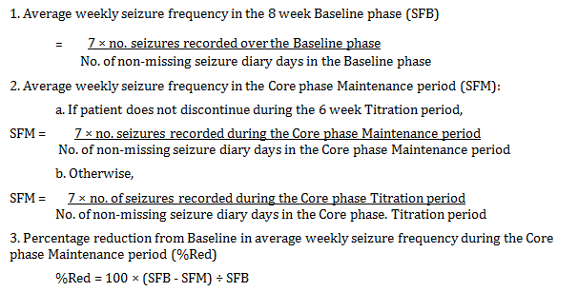
A responder was a patient with ≥ 50% reduction from Baseline in average weekly seizure frequency during the Maintenance period of the Core phase, that is when %reduction ≥ 50.

Table 10: Study objectives
Objective | Endpoint
Primary  To compare the reduction in frequency of TSC seizures on each of two trough ranges of everolimus (3-7 ng/mL and 9-15 ng/mL) versus placebo in patients with TSC who are taking one to three antiepileptic drugs (AEDs) | EMA: Response rate, where response means at least a 50% reduction from Baseline in TSC seizure frequency during Maintenance period of the Core phase  FDA: Percentage reduction from Baseline in partial onset seizure frequency during Maintenance period of the Core phase
Supportive
As above
Secondary  To compare each of the two everolimus trough ranges versus placebo with respect to:  (1) Ability to completely suppress TSC seizures  (2) Proportion of patients with ≥ 25% reduction from Baseline in average weekly frequency of TSC seizures  (3) Distribution of reduction from Baseline in seizure frequency  (4) Seizure-free days  (5) Treatment duration  (6) Quality of life (QoL)  To assess everolimus in relation to neurocognitive, neurobehavioral, and neurodevelopmental measures using the Vineland Adaptive Behavior Scales-II and the Wechsler Non-Verbal Scale of Ability  To assess the relationship between everolimus concentration and efficacy/safety endpoints  To evaluate the impact of everolimus on the pre-dose exposure of AEDs  To evaluate the effect of the two everolimus trough ranges on long-term seizure reduction  To evaluate the safety and tolerability of each everolimus trough range in the study population  To evaluate the impact of everolimus on the risk of suicidality using the Columbia Suicide Severity Rating Scale (C-SSRS) | (1) Seizure-free rate, where seizure-free means a 100% reduction in TSC seizure frequency during Maintenance period of the Core phase  (2) Proportion of patients with at least a 25% reduction from Baseline in TSC seizure frequency during Maintenance period of the Core phase  (3) Categorical variable of six levels of reduction from Baseline in TSC seizure frequency during Maintenance period of the Core phase (≤ -25% (exacerbation); >-25% to < 25% (no change); ≥ 25% to <50%; ≥ 50% to <75%; ≥ 75% to <100%; 100% (seizure-freedom))  (4) Frequency of seizure-free days during Maintenance period of the Core phase  (5) Time from randomisation until treatment discontinuation in the Core phase  (6) Overall QoL global scores from the 3 age-specific questionnaires  Change from Baseline of sub-test scores  Percentage reduction in seizure frequency/frequency of selected adverse events (AEs)  Pre-dose concentrations of AEDs at Baseline (AEDs alone) and at post-Baseline (AEDs plus everolimus)  50% response rate, percent reduction from Baseline, and seizure free-days in TSC seizure by time interval over the Extension phase  Frequency of AEs/abnormal laboratory values  Frequency C-SSRS outcomes, frequency of serious adverse events (SAEs) referring to a positive suicidal evaluation
Exploratory  Explore the relationship between patient age and reduction from Baseline in TSC seizure frequency  Compare each of the two everolimus trough ranges versus placebo with respect to reduction from Baseline in seizure frequency for each of three TSC seizure types (type IA, type IB, type IC)  Compare each of the two everolimus trough ranges versus placebo with respect to reduction from Baseline in seizure frequency for all types of seizures grouped (I, II)  Explore relationship between TSC1/TSC2 mutation status and reduction from Baseline in TSC seizure frequency | Response rate and percentage reduction in TSC seizure frequency during Maintenance period of Core phase  Response rate and percentage reduction in seizure frequency during Maintenance period of Core phase  Response rate and percentage reduction in seizure frequency during Maintenance period of Core phase  Response rate and percentage reduction in TSC seizure frequency during Maintenance period of Core phase

Randomisation
At the end of the Baseline phase, patients who met the eligibility criteria were randomised in an approximate ratio of 1:1:1 to receive treatment A, B or C.
Randomisation was stratified by age group:
- 1 to < 6 years
- 6 to < 12 years
- 12 to < 18 years
- ≥ 18 years
Due to a mistake in the titration recommendations discovered early in the trial, preventing dose titrations despite C_{min} values outside the targeted trough range, it was decided to increase the sample size in the everolimus 9 to 15 ng/mL arm by 10 patients, that is 125 patients in total.
This sample size increase of 10 patients was made by inserting a number of blocks with randomisation ratio of 1:2:1 in favour of the everolimus 9 to 15 ng/mL arm, with the planned sample size becoming 355 patients (115 patients in the everolimus 3 to 7 ng/mL arm, 125 patients in the everolimus 9 to 15 ng/mL arm, and 115 in the placebo arm; overall randomisation ratio of 1:1.09:1).

Blinding methods
During the initial titration period of the Base phase dose was titrated via Interactive Response Technology (IRT) in a blinded fashion until each patient reached their assigned target trough range.
Patients on placebo had random increases and decreases in the number of tablets taken to simulate titration and to maintain the blind. Patients in the low trough group also had random increases and decreases in placebo tablets to simulate titration for the high trough group.
During the extension phase, placebo dose changes were possible at the start of dose transition. Starting at the visit at which everolimus concentrations were disclosed, placebo tablets were no longer dispensed.

Analysis populations
Full Analysis Set (FAS) comprised all patients to whom study treatment was assigned by randomisation.
Pharmacokinetic analyses were performed on the Confirmed PK Sample Set from all everolimus-treated patients in the Safety Set and Long-term Evaluation Safety Set, which was defined as follows:
C_{min} collected prior to dose administration on the same treatment day and 20 to 28 hours after the previous dose, at steady state, and with no evidence of vomiting within 4 hours of the previous dose.
The Long-term Evaluation (LTE) Sets (Efficacy and Safety) comprise all patient data on everolimus in the study during the Core phase and Extension phase. Each LTE set consists of all patients who received at least one dose of everolimus and had at least one efficacy/safety assessment.

Sample size
The sample size calculation was based exclusively on response rate, the primary endpoint used by the EMA, but it was also expected to provide sufficient patients for the power of the FDA primary endpoint, percentage reduction in seizure frequency.
It was assumed that response rates would be 15% in the placebo arm and 35% in each of the two everolimus arms. That is, there was no a priori strong expectation that the higher targeted trough everolimus arm 9 to 15 ng/mL would deliver a higher response rate than the lower targeted trough everolimus arm 3 to 7 ng/mL, as better efficacy may be mitigated by worse tolerability. For this reason, the testing strategy was to simultaneously compare each pairwise comparison, splitting the significance level, rather than testing hierarchically starting with the higher trough arm for example. It was determined that a sample size of 355 patients would ensure 90% power for each of the primary comparisons of each everolimus arm versus placebo, assuming one-sided 1.25% significance levels for each Cochran-Mantel-Haenszelchi-square test, and assuming balanced randomisation (that is 115 patients per randomisation arm).
Due to a mistake in the titration recommendations it was decided to increase the sample size in the everolimus 9 to 15 ng/mL arm by 10 patients, that is 125 patients in total in that arm.

Statistical methods

Primary endpoint
Response rate was compared between each everolimus arm versus the placebo arm in the Full Analysis Set using Cochran-Mantel-Haenszel (CMH) chi-square tests stratified by age subgroup. The Bonferroni-Holm procedure was used to ensure an overall family-wise Type I error rate of 2.5% one-sided. Response rates were provided with exact 95% CIs, and the odds ratio for each everolimus arm versus placebo was obtained from logistic regression models stratified by age subgroup.
Each Agency will use their preferred variable as the primary variable, with the other (non-primary) variable being used in a supportive analysis. As each Agency will only use their preferred primary variable to make a decision on the primary objective, the full alpha level can be used for each Agency’s primary variable, without correction for multiplicity.
Comment: Given that the TGA has adopted EMA guidelines this evaluator proposes to use the response rate as the primary variable. The protocol indicates as above that the statistical analysis was not to be set up for co-primary endpoints.
Statistical analysis methods of the multiple supportive and secondary endpoints are described below.
FDA primary endpoint Percentage reduction in seizure frequency was compared between each everolimus arm vs. the placebo arm in the Full Analysis Set using rank analysis of covariance (ANCOVA), with Baseline average weekly seizure frequency as a covariate, and stratified by age subgroup. The Bonferroni-Holm procedure was used as a multiplicity correction to ensure an overall family wise Type I error rate of 2.5% one-sided. The median percentage reduction from Baseline is presented for each treatment group, along with 95% bootstrap CIs.
- The seizure-free rates for each treatment arm in the FAS are presented along with exact 95% CIs, and the odds ratio for each everolimus arm versus placebo was derived from logistic regression models stratified by age subgroup.
- The proportions of patients with at least 25% reduction in seizure frequency are presented in each treatment arm along with exact 95% CIs, and odds ratios for each everolimus arm versus placebo (plus Wald 95% CI) from logistic regression models stratified by age subgroup.
- The distribution of reduction from Baseline in seizure frequency was categorised into six levels using the variable percentage reduction (%Red), the proportions of patients in each category are presented for each treatment arm.
- The change from Baseline in frequency of seizure-free days per 28 days was summarised by treatment arm (mean, SD, range). Mean differences between each everolimus arm and the placebo arm in change from Baseline in frequency of seizure-free days are presented, along with the 95% CI.
- Times from randomisation to treatment discontinuation in each arm are presented descriptively in the Full Analysis Set using Kaplan-Meier curves, from which summary statistics were determined. These statistics were given as point estimates with 95% CIs. The hazard ratio (and two-sided 95% CI) for each everolimus arm versus placebo was obtained from a Cox proportional hazards model stratified by age subgroup.
- A long term evaluation of efficacy over the Extension phase for percentage reduction from Baseline in TSC seizure frequency, response rate and seizure free days, was computed by time interval using the LTE Efficacy Set.
- Change from Baseline to the end of the Core phase in the overall quality-of-life scores are analysed using an ANCOVA model including terms for treatment and Baseline overall quality of life score. The differences in least square means between each everolimus arm and placebo, and the corresponding two-sided 95% CI, are presented.

Participant flow

Table 11: Patient disposition; Full Analysis Set
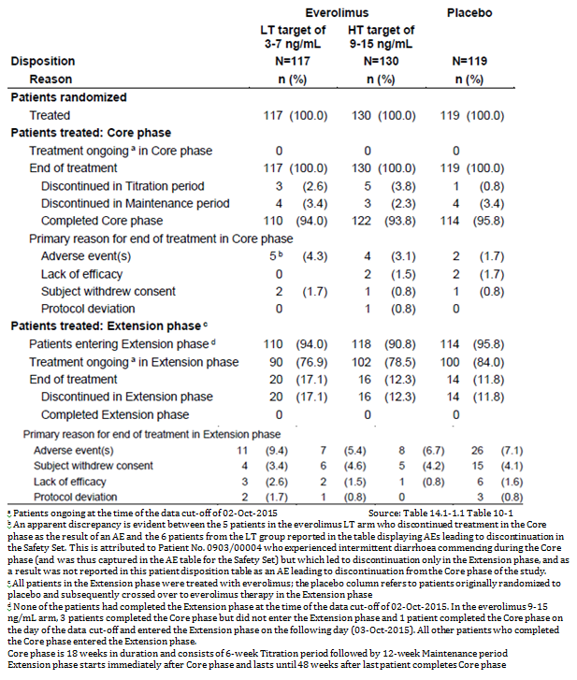

Table 12: Analysis sets by stratum
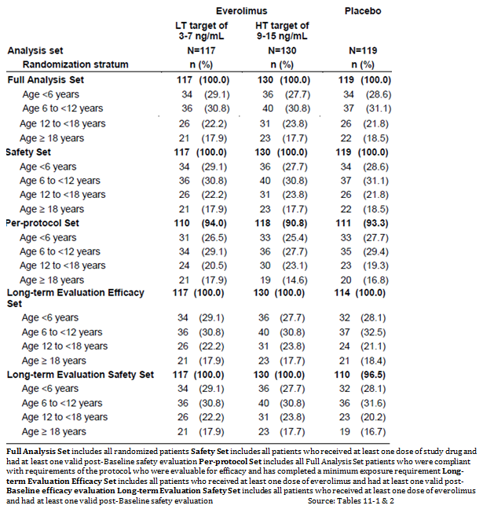

Major protocol violations/deviations

Table 13: Protocol deviations; Full Analysis Set
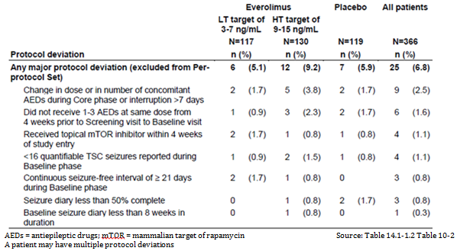

Baseline data

Table 14: Demographic characteristics at Baseline; Full Analysis Set
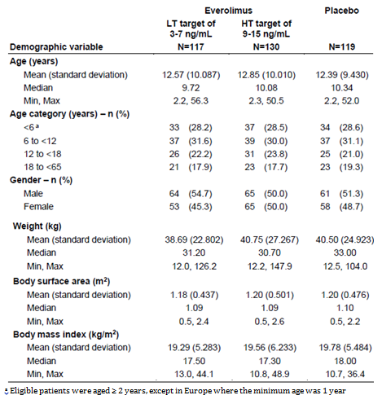

Table 15: Tuberous Sclerosis Complex diagnosis; Full Analysis Set
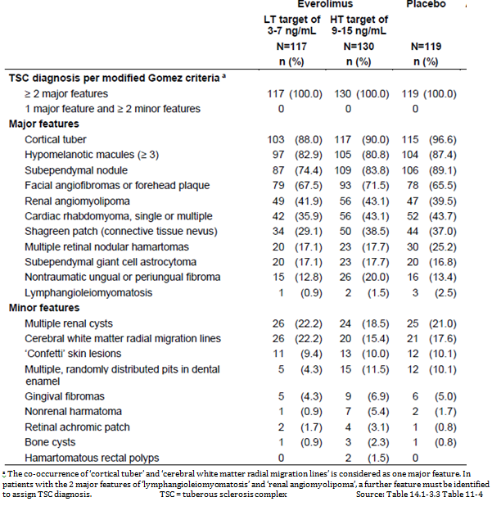

Table 16: Epilepsy background and seizure history; Full Analysis Set
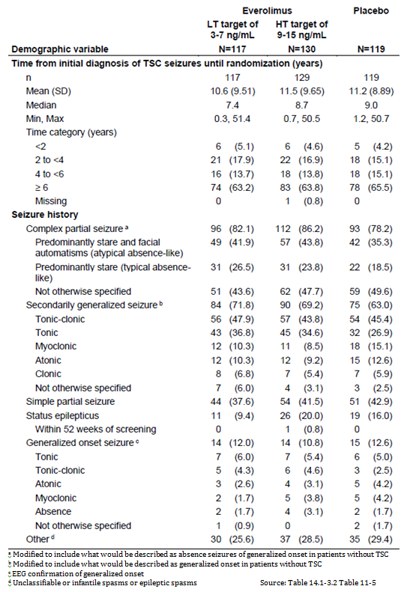

Table 17: Prior antiepileptic therapy before the Baseline phase; Full Analysis Set
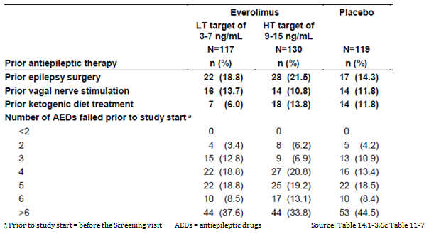

Table 18: Antiepileptic therapy during the Baseline phase; Full Analysis Set
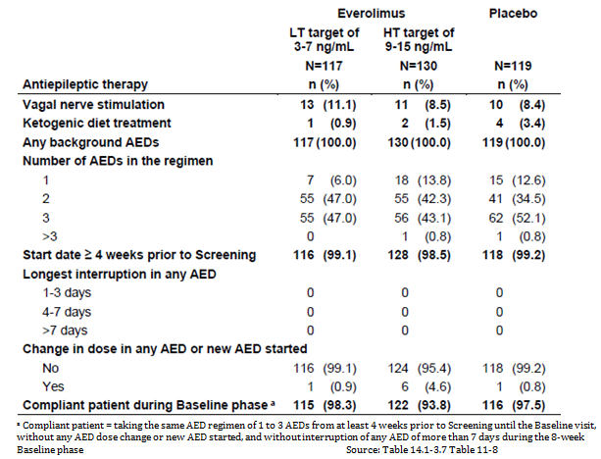

Results for the primary efficacy outcome (EMA)
Comment: Given that the TGA has adopted EMA guidelines this evaluator proposes to use the response rate as the primary variable. The protocol indicates that the statistical analysis was not to be set up for co-primary endpoints.

Seizure Frequency Response Rate
Response rates were 28.2% (95% CI: 20.3, 37.3) and 40.0% (95% CI: 31.5, 49.0) for the everolimus low trough range and high trough range arms compared with 15.1% (95% CI: 9.2, 22.8) for the placebo arm, thus although the high trough range results are clearly superior to those of placebo, the 95% CIs for the low trough range and placebo overlap. However the Odds Ratios 95% CIs for both active arms compared to placebo are both above 1.0.
The sensitivity analyses support these observations.

Table 19: Seizure frequency response rate; Full Analysis Set
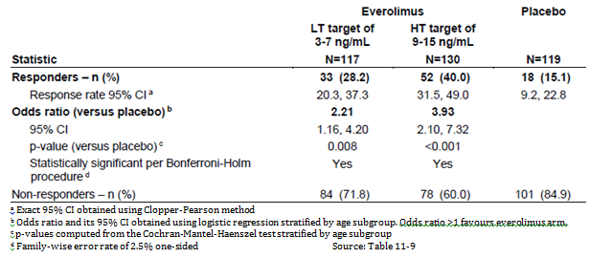
Figure 5: Seizure frequency response rate; Full Analysis Set
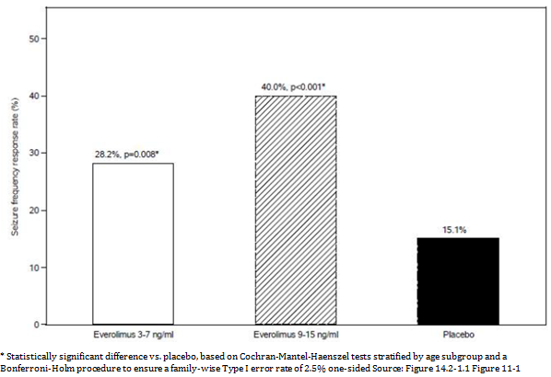

Results for other efficacy outcomes

Percentage Reduction from Baseline in Seizure Frequency
The median percent reduction in weekly seizure frequency was 29.3% (95% CI: 18.8, 41.9) and 39.6% (95% CI: 35.0, 48.7) for the everolimus low trough range and high trough range arms, respectively, compared with 14.9% (95% CI: 0.1, 21.7) for the placebo arm, thus although the high trough range results are clearly superior to those of placebo, the 95% CIs for the low trough range and placebo overlap. However the 95% CIs for the difference from placebo are all above 0.

Table 20: Percentage reduction from Baseline in weekly seizure frequency; Full Analysis Set
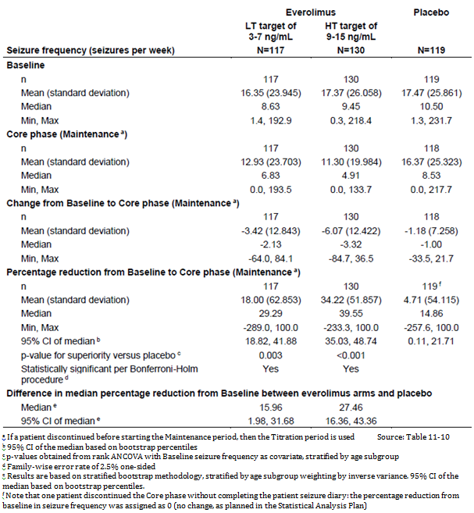

Table 21: Secondary Endpoints
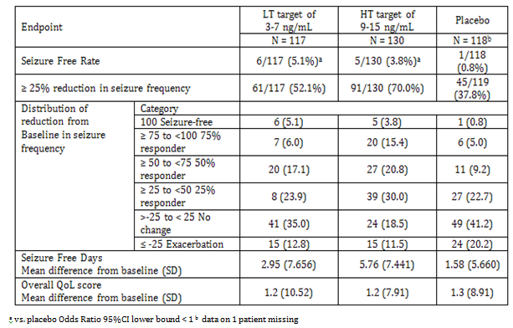
Figure 6: Percentage reduction in seizure frequency over time across all everolimus patients; Long-term Evaluation Efficacy Set
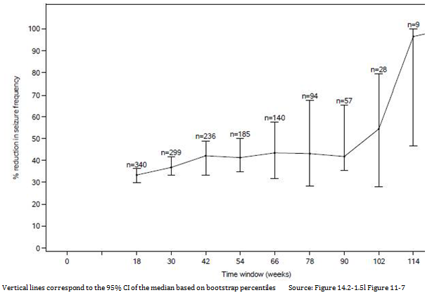
Figure 7: Kaplan-Meier curves of time to treatment discontinuation; Full Analysis Set
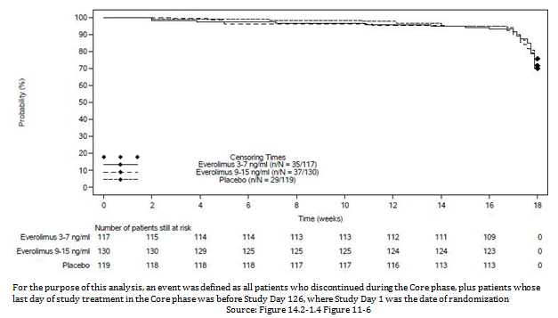

Evaluator’s conclusions on clinical efficacy
The response rate in the Primary endpoint was 15.1% (95% CI: 9.2, 22.8) for the placebo arm, 28.2% (95% CI: 20.3, 37.3) for the C_{min} 3 to 7 ng/mL arm and 40.0% (95% CI: 31.5, 49.0) for the C_{min} 9 to 15 ng/mL arm. The 95%CIs for placebo and the 3 to 7 ng/mL arm overlap. However the Odds ratio 95%CIs do not include 1.0.
A similar result was seen for the supporting endpoint:
The median percent reduction in weekly seizure frequency was 29.3% (95% CI: 18.8, 41.9) and 39.6% (95% CI: 35.0, 48.7) for the everolimus low trough range and high trough range arms, respectively, compared with 14.9% (95% CI: 0.1, 21.7) for the placebo arm, thus although the high trough range results are clearly superior to those of placebo, the 95% CIs for the low trough range and placebo overlap. However the 95% CIs for the difference from placebo are all above 0.
The CPMP/EWP/2330/99 Points to Consider on Application with 1. Meta-Analyses; 2. One Pivotal Study has:
Prerequisites for one pivotal study applications
The degree of statistical significance. Statistical evidence considerably stronger than p < 0.05 is usually required, accompanied by precise estimates of treatment effects that is narrow confidence intervals. Tile required degree of significance will depend on factors such as the therapeutic indication, the primary endpoint, the amount of supportive data and whether the alternative analyses demonstrating consistency are pre-specified.
The proposed dosage is to maintain C_{min} at 5 to 15 ng/mL.
Then lower end of the range for C_{min} of the clearly significant result was 9ng/mL.
The recommended target C_{min} range is 5 to 15 ng/mL based on the following considerations:
The time normalised C_{min} of 5.3ng/mL is the threshold concentration above which the 95% confidence interval of predicted change from baseline seizure frequency is not overlapping with the 95% confidence interval of predicted change from baseline SF of placebo patients. This indicates a lower bound of the therapeutic range.
The modelling of efficacy to C_{min} (see Section 5 above) shows a relationship between C_{min} time normalised and a response.
For those subjects who would currently be eligible for everolimus treatment due to concurrent TSC-related conditions that is SEGA and renal angiomyolipoma, the 95% CIs for all 3 treatment groups overlapped, the numbers were small.

Clinical safety
The sponsor graded AEs severity in accordance with the National Cancer Institute’s (NCI) Common Terminology Criteria for Adverse Events.
- Grade 1 Mild AE
- Grade 2 Moderate AE
- Grade 3 Severe AE
- Grade 4 Life-threatening or disabling AE
- Grade 5 Death related to AE

Patient exposure

Demographics
Whereas in Study M2304 the median age of patients was 10.1 years (min-max: 2.2 to 56.3 years) the previously existing study safety pool was 19.0 years (min-max: 1 to 61), reflecting a difference in Inclusion criteria in some of the previous studies. As a result there were a higher proportion of patients previously who were aged ≥ 18 years (54.2% versus 18.3% in Study M2304).

Exposure
The Summary of Clinical Safety is based on safety data from Study M2304 and three other studies that evaluated multi-year everolimus exposure in patients with TSC - completed Studies C2485, M2301, and M2302 (N=251).

Table 22: Study sizes safety database
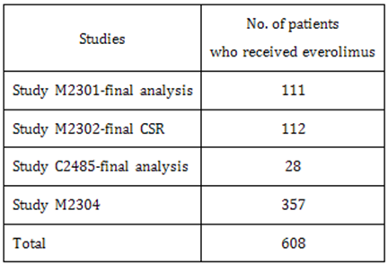

Table 23: Duration of exposure to everolimus; TSC pooled studies including M2304 (Long-term Evaluation Safety Set)
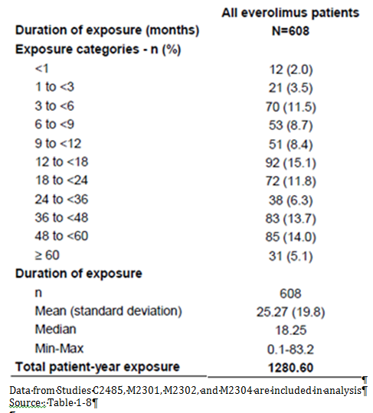

Table 24: Cumulative dose and dose intensity of study drug; Study M2304 Core phase (Safety Set)
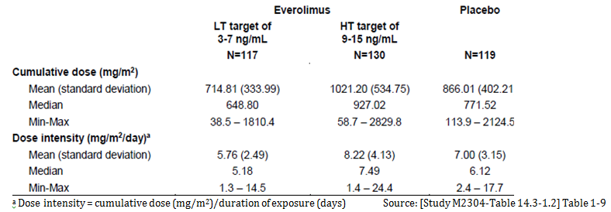

Table 25: Cumulative dose and dose intensity of study drug; Study M2304 Core and Extension phases (Long-term Evaluation Safety Set)
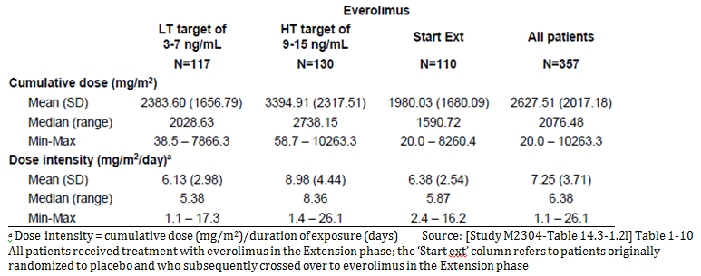

Table 26: Everolimus concentration at trough (C_{min}) by time window; Study M2304 Core phase (Safety Set; Confirmed PK Sample Set)
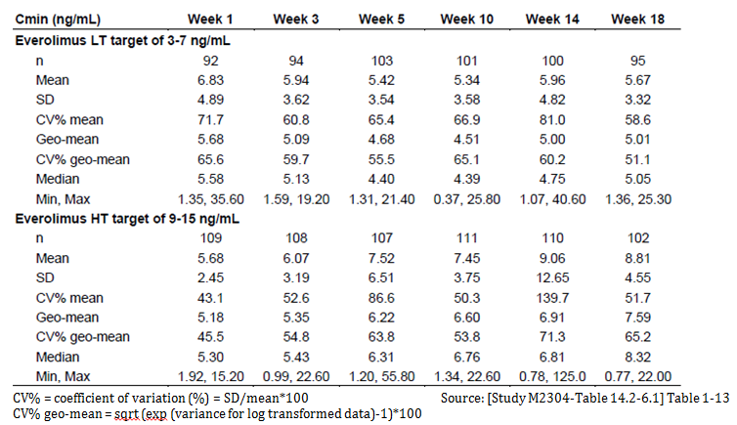

Table 27: Number of patients requiring study drug dose interruptions and/or reductions; Study M2304 Core and Extension phase (Long-term Evaluation Safety Set)
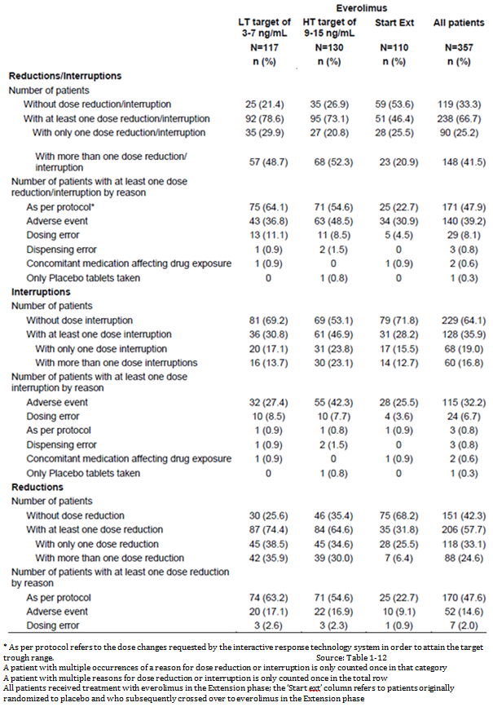

All adverse events (irrespective of relationship to study treatment)

Table 28: Summary of deaths and adverse events; TSC pooled studies excluding Study M2304 (Long-term Evaluation Safety Set)
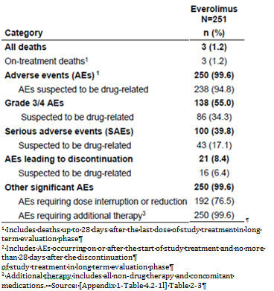

Table 29: Summary of adverse events; Study M2304 Core phase (Safety Set)
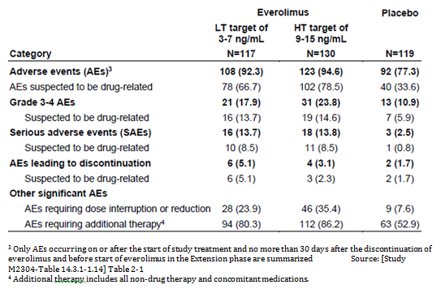

Table 30: Summary of deaths and adverse events; Study M2304 Core and Extension phase (Long-term Evaluation Safety Set)
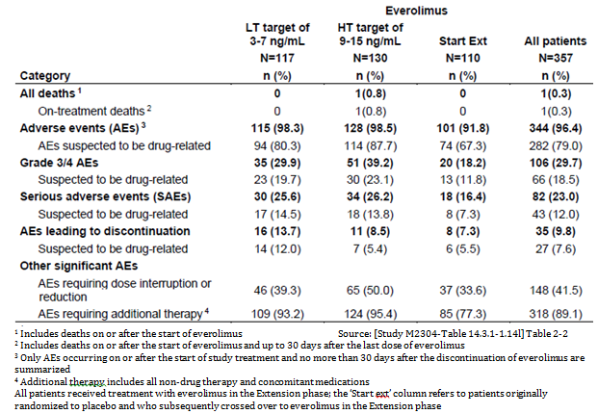

Treatment related adverse events (adverse drug reactions)

Main/pivotal study
Twenty-one patients from the everolimus treatment groups (10 (8.5%)) from the LT group and 11 (8.5%) from the HT group) experienced SAEs that were suspected by the Investigator to be related to study drug (Study M2304). The most commonly reported treatment-related SAEs were pneumonia (0.9% versus 2.3% versus 0% for the LT, HT, and placebo groups, respectively) and status epilepticus (1.7% versus 0.8% versus 0%).
Adverse events suspected to be related to everolimus were less frequently reported in the everolimus LT compared to the everolimus HT group (66.7% versus 78.5%). The most common AEs suspected to be related to everolimus where a higher proportion of everolimus-treated patients reported events (and where there was a ≥ 10% difference relative to placebo) included:
- Stomatitis (+20.5% and +27.4% for the LT and HT groups, respectively)
- Mouth ulceration (+19.7% and +15.0%)
- Aphthous ulcer (+2.6% and +11.4%)
The AEs suspected to be related to everolimus treatment are consistent with the known safety profile of everolimus.
As for overall AEs, the incidence of most of the emerging AEs suspected by the Investigators to be drug-related was high during the first 6 months of treatment, and consistently decreased thereafter. Reasons might include dropouts from AEs, recoding of events only once as well as increased tolerance.

Table 31: Adverse events with suspected relationship to study drug by preferred term (in at least 1% of patients in any group); Study M2304 Core phase (Safety Set)
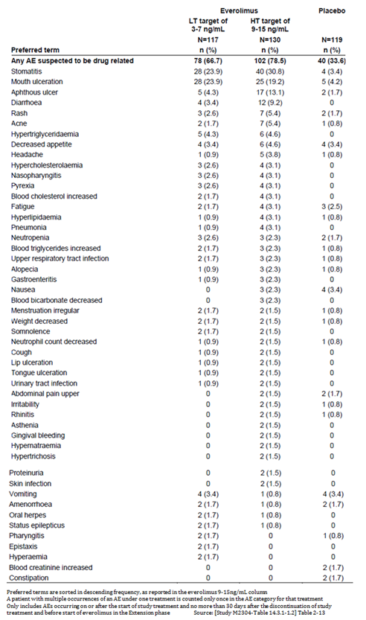

Table 32: AEs with suspected relationship to study drug, by preferred term and period of emergence (with a frequency of at least 2% in less than or equal to Month 6); Study M2304 Core and Extension phase (Long-term Evaluation Safety Set)
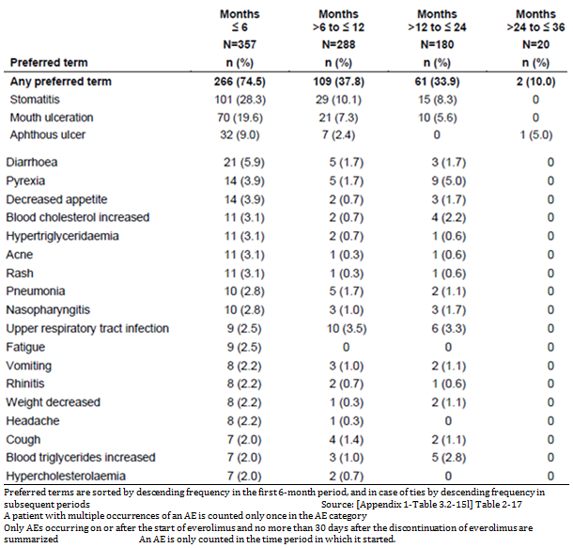
The sponsor highlighted that considering the previous long-term exposure results (that is TSC studies excluding Study M2304), the incidence of most of the emerging AEs suspected by the Investigators to be drug-related was highest during the first 6 months of treatment, and consistently decreased thereafter. The incidence of emerging AEs decreased from 87.6% in the first 6 months to 36.8% for exposure beyond Month 48
Comparing with Study M2304:
- Under 6 Months, the overall incidence of emerging AEs was higher in the previous Pool versus Study M2304 (87.6% versus 74.5%), as were the incidences of stomatitis (+11.9%) and hypercholesterolemia (+9.5%). Other events were reported with a similar frequency between the two datasets.
- Between Months 6 to 12, the overall incidence of emerging AEs was higher in the previous Pool versus Study M2304 (53.1% versus 37.8%). The incidence of specific AEs was in general similar.
- Between Months 12 to 24 the overall incidence of emerging AEs was higher in the previous Pool versus Study M2304 (67.5% versus 33.9%). Stomatitis (7.9%) and mouth ulceration (5.0%) were both reported more frequently in the previous Pool.

Deaths

Integrated safety analyses
Three deaths were reported in the previous TSC Pool, none of which was considered to be related to everolimus:
- asphyxia (accidental strangulation)
- epilepsy (in the fifth year of the study)
- seizure disorder (complication of TSC).

Pivotal and/or main efficacy studies
One patient, initially randomised to the HT treatment group, died during the Extension phase of the study (9.5 months after start of therapy). Sudden unexpected death in epilepsy (SUDEP) was assessed as the cause of death (Study M2304); this was not suspected by the Investigator to be drug related.

Serious adverse events
Only pneumonia (4.8%) and seizures (3.4%) were reported as SAEs in more than 2% of patients in the long-term Study M2304 evaluation (Core and Extension phase combined).

Table 33: SAEs irrespective of causality by preferred term; Study M2304 Core phase (Safety Set) Everolimus
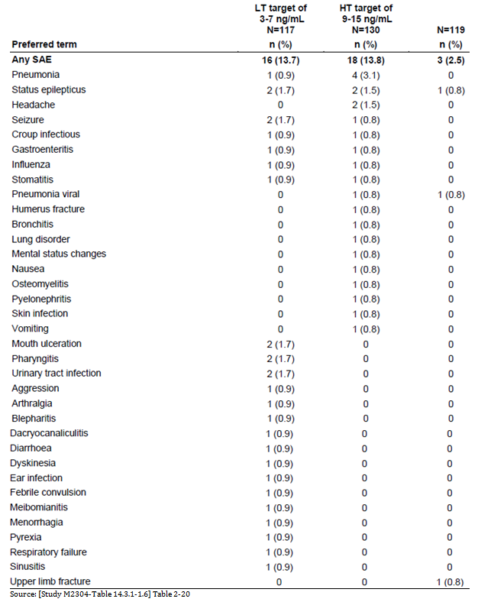

Table 34: SAEs irrespective of causality by preferred term (with a frequency cut-off of 1%); TSC pooled studies excluding Study M2304
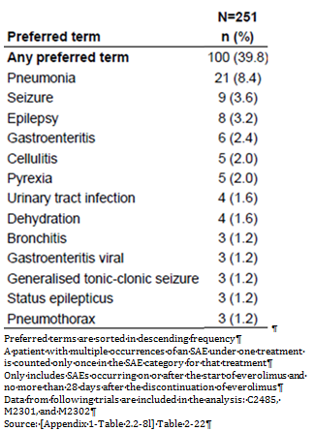

Table 35: SAEs irrespective of causality by preferred term (with a frequency cut-off of 1% in any everolimus patient group); Study M2304 Core and Extension phase
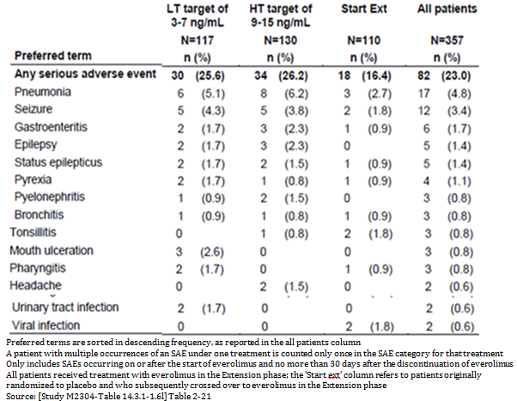

Discontinuations due to adverse events

Main/pivotal studies
Of the 35 drug discontinuations, the most common AEs leading to study drug discontinuation were stomatitis (five patients), pneumonia (four patients), and pyrexia (two patients). The previous TSC database Pool only had one AE per term causing discontinuation.

Table 36: Adverse events leading to study drug discontinuation irrespective of causality by preferred term; Study M2304 Core phase (Safety Set)
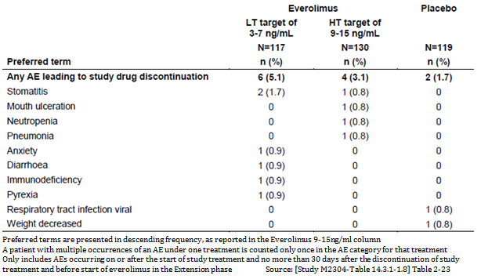

Table 37: AEs leading to study drug discontinuation irrespective of causality by preferred term; Study M2304 Core and Extension phase (Long-term Evaluation Safety Set)
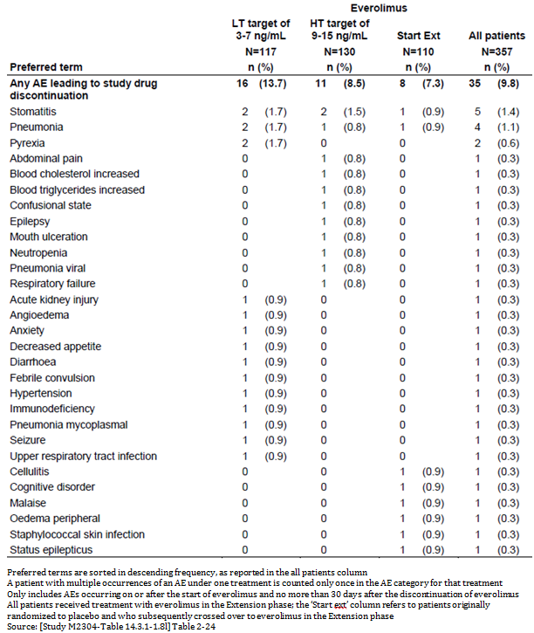

Table 38: AEs leading to study drug discontinuation irrespective of causality by preferred term; TSC pooled studies excluding Study M2304 (Long-term Evaluation Safety Set)
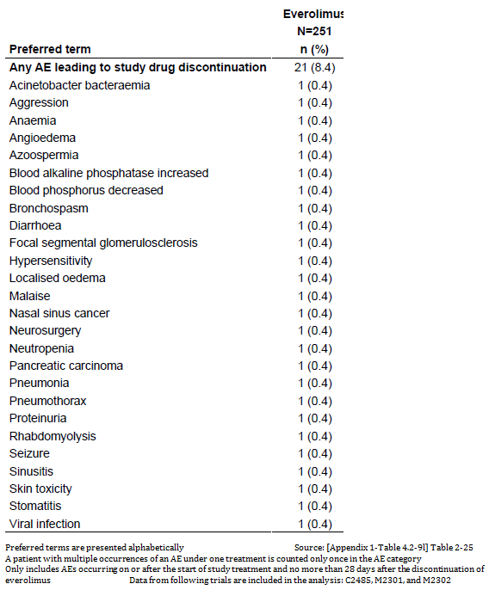
The overall profile of AEs leading to dose interruption or adjustment was similar to the previous Pool. The incidence of some AEs was higher in the previous TSC Safety Pool compared with Study M2304. Stomatitis (17.1%), upper respiratory tract infection (13.5%), pneumonia (12.7%), mouth ulceration (11.2%), and sinusitis (10.4%) were the most frequently occurring AEs that necessitated dose adjustment or study drug interruption in the previous Pool.

Table 39: AEs requiring dose adjustment or interruption, regardless of study drug relationship by primary system organ class, preferred term and treatment Study M2304 Core and Extension phase (Safety Set)
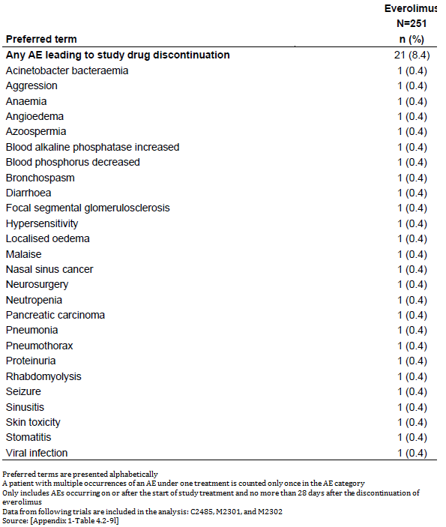

Evaluation of issues with possible regulatory impact

Infections

Study M2304 Core phase
Everolimus possesses immunosuppressive properties. In 54.7% and 64.6% of patients in the everolimus LT and HT treatment groups and 45.4% in the placebo group infections were diagnosed, especially upper respiratory infections (for example nasopharyngitis, upper respiratory tract infection). SAEs of infections were seen in 6.0% of patients in the everolimus LT group, 6.9% in the HT group, respectively relative to placebo, most commonly pneumonia but also including gastroenteritis and urinary tract infection. In the placebo group 0% had infections. Single cases of pneumonia in the everolimus HT group and viral respiratory tract infection in the placebo group led to treatment discontinuation.

Non-infectious pneumonitis

Study M2304 Core phase
One case of Grade 2 non-infectious pneumonitis was reported in the everolimus HT treatment group.

Stomatitis

Study M2304 Core phase
Stomatitis related events were more frequently reported in the everolimus treatment groups than with placebo (54.7%, 63.8%, and 9.2% in the everolimus LT, HT, and placebo groups, respectively). The most common AEs reported included:
- Stomatitis (28.2%, 30.8%, and 3.4% in the everolimus LT, HT, and placebo groups,
- Mouth ulceration (23.9%, 21.5%, and 4.2%)
- Aphthous ulcer (4.3%, 14.6%, and 1.7%).
Most cases were grade 1 or 2, and were suspected to be drug related in the majority of cases. Grade 3 events were reported in 3.4% and 3.8% of patients in the everolimus LT and HT groups, respectively. No grade 4 events were reported. These events tended to appear within the first 2 to 3 weeks of treatment.

Hypersensitivity (anaphylactic reaction)

Study M2304 Core phase
Across the three treatment groups (13.7% and 15.4% of patients in the everolimus LT and HT treatment groups compared with 6.7% in the placebo group) had hypersensitivity-related events.
One patient (0.9%) in the everolimus LT treatment group reported grade 3 urticaria requiring dose adjustment while a further three patients (one (0.9%) in everolimus LT group and 2 (1.5%) in everolimus HT group) experienced cases of grade 1/2 rash that necessitated dose adjustment. There were no cases of severe hypersensitivity or anaphylaxis.
One case of pharyngeal oedema in the everolimus LT treatment group was grade 2 in intensity.

Hepatic toxicity
The Clinical Study Report did not have a separate section on this.
The sponsor has proposed multiple hepatic impairment insertions in relation to which the sponsor has consistently referred to ‘2.7.2 Summary of Clinical Pharmacology’. The only relevant statement found therein is:
Impaired hepatic function: No new information was generated in support of this indication.
In reviewing the summary results of the trial 23 to 25% had abnormal liver enzymes (Table 41) (2 at least were grade3/4 (Table 42)). One ADR of raised enzyme was reported (also 1 on placebo) raised ALT. Due to raised Alkaline phosphatase there was 1 discontinuation (Table 38), and 1 interruption or adjustment to dose (Table 39).

Renal toxicities

Study M2304 Core phase
Renal toxicities were reported 0.9% versus 3.8% versus 2.5% for the everolimus LT, HT, and placebo treatment groups, respectively, with 1 patient from the everolimus HT group experiencing a grade 3 elevation in blood creatinine (no action was taken and this event resolved after 23days).

Effects of everolimus on brain growth and development, particularly in patients under 3 years of age

Study M2304 Core phase
Five patients in the everolimus treatment groups (four (50.0%) in the LT and one patient (14.3%) in the HT group) experienced events. A single case (12.5%) of grade 4 status epilepticus was reported in a 2 year old patient in the everolimus LT group, which resolved after 16 days.

Table 40: Clinical impact of effects of everolimus on brain growth and development, particularly in patients under 3 years of age; Study M2304 Core phase (Safety Set)
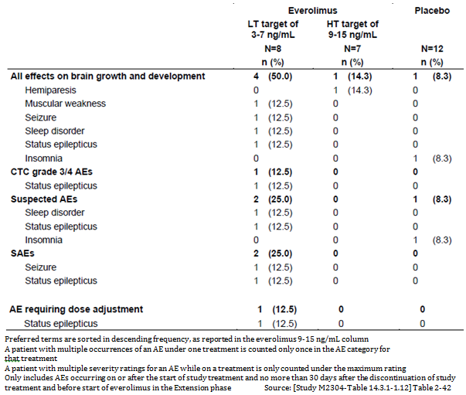

Female fertility (including secondary amenorrhea) in female patients aged 10 to 55 years

Study M2304 Core phase
The incidence of events related to female fertility (irregular menstruation and amenorrhoea) was similar across the three treatment groups.

Haemorrhages

Study M2304 Core phase
The incidence of haemorrhage was higher in the everolimus treatment groups (6.0% and 11.5% for LT and HT groups, respectively) compared to the placebo group (3.4%). About 50% of the grade 1/2 haemorrhage cases reported among the patients treated with everolimus were described as epistaxis. There was a single case (0.9%) of menorrhagia in the everolimus LT group (in a 44 year old patient) that fulfilled the criteria for an SAE; this event resolved after 26 days.

Haematology and haematological toxicity

Study M2304 Core phase
Haematology abnormalities that were more frequently reported in the everolimus treatment groups (with differences of ≥ 10% relative to placebo) included:
- Absolute neutrophils (hypo) (difference +2.1% and +14.2% for the everolimus LT and HT treatment groups, respectively)
- Absolute lymphocytes (hyper) (difference +15.6% and +1.7%).
All grade 3/4 cases resolved prior to the data cut-off date.

Cytopaenia
The incidence of Cytopaenia was similar across the three treatment groups (7.7%, 7.7%, and 7.6% for the everolimus LT, HT, and placebo treatment groups, respectively). The majority of the AEs in this category were neutropaenia, anaemia, and decreased neutrophil count.

Other laboratory tests
There were a higher incidence of Grade3/4 abnormal values for Potassium (hyper) (3.1% Study M2304 All patients versus 0.8% TSC Pool without M2304) and Sodium (hyper) ((4.2% versus 1.6%).
Among all abnormal clinical chemistry values in Study M2304 All patients results most had a similar or higher incidence than in the TSC Pool without M2304, except the liver enzymes, Phosphate (inorganic phosphorus) (hypo), Glucose (fasting) (hypo), Sodium (hypo) and Potassium (hypo). Magnesium (hyper) (40.9% Study M2304 All patients versus 3.6% TSC Pool without M2304) and Creatinine (hyper) (30.3% versus 12.0%) showed considerable differences.

Table 41: Abnormal Clinical Chemistry Values; Study M2304 Core and Extension phase and TSC pooled studies excluding Study M2304
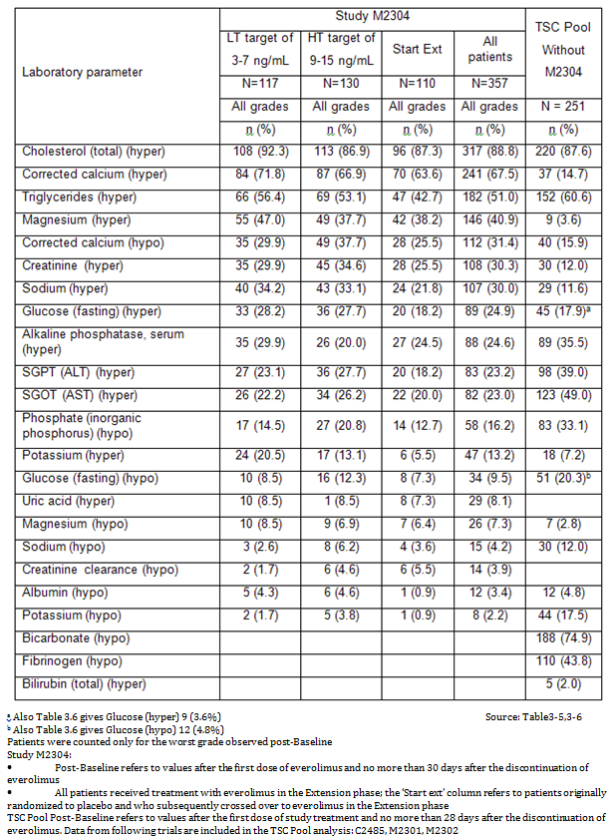

Table 42: Grade 3/4 Abnormal Clinical Chemistry Values; Study M2304 Core and Extension phase and TSC pooled studies excluding Study M2304
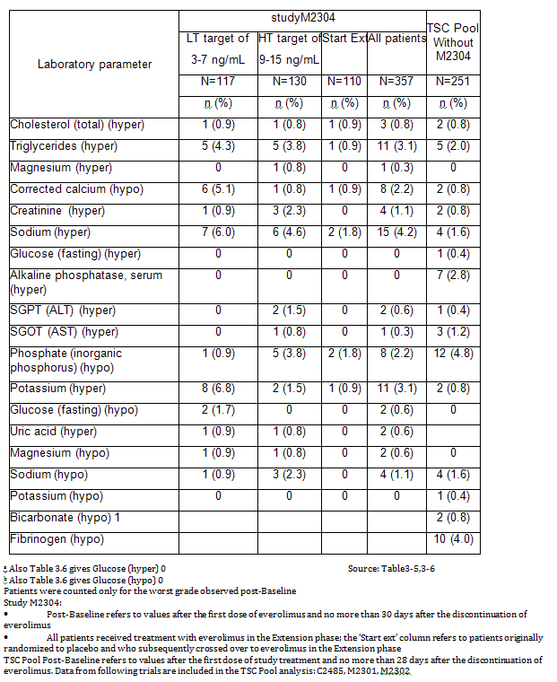

Dyslipidaemia in paediatric population

Study M2304 Core phase
Dyslipidaemia related events occurred in 12.5% and 17.8% of paediatric patients in the everolimus LT and HT treatment groups compared with a 5.2% in the placebo group. Most cases were grade 1 or 2, and were suspected to be drug related in the majority of cases.

Table 43: Clinical impact of dyslipidaemia in paediatric population; Study M2304 Core phase (Safety Set)
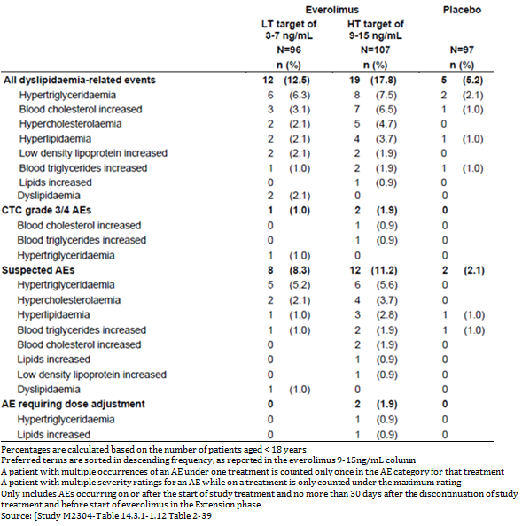

Hyperglycaemia/new-onset diabetes mellitus

Study M2304 Core phase
One case of grade 1 hyperglycaemia was reported in a patient in the everolimus LT treatment group. No cases of new-onset diabetes mellitus were reported across the three treatment groups.

Vital signs and clinical examination findings

Study M2304 Core phase

Growth – height and weight
Standard deviation scores (SDS) for height, height velocity, body mass index, and weight velocity in patients aged < 18 years at study initiation were comparable both prior to and after starting treatment with everolimus. Based on N = 96 at week 72, 29 at 96 and 1 at 120 weeks the proportions of patients with SDS values < 5th percentile or > 95th percentile on height, height velocity, body mass index, and weight velocity did not increase significantly after the start of everolimus therapy.

Table 44: Summary of growth data by time window; Study M2304 Core and Extension phase (Long-term Evaluation Safety Set)
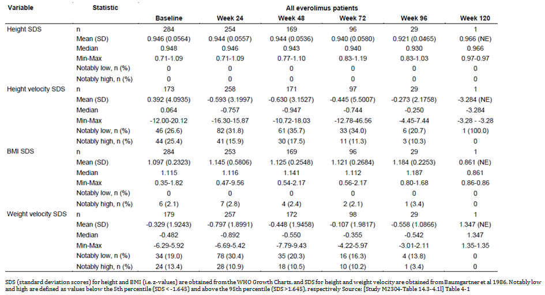

Puberty
Overall, considering the patients at risk of delayed puberty at start date of everolimus, puberty appeared to be delayed for three patients (two females and one male). However, following a detailed medical review of these cases, there was no indication of delayed puberty for the two females.

Neuropsychological data
The sponsor attempted to collect information using the Vineland-II Adaptive Behaviour Composite Score and the Wechsler Nonverbal Composite Score, however most groups had data for less than 50% of subjects at Baseline, with even less at end of Core phase.

Other safety issues
The sponsor rather than use the trial report data proposes:
In accordance with the Novartis Business Guidance, frequency category assessment of the identified ADRs in the updated TSC safety pool has been based upon overall incidence rates (all AEs irrespective of causality assessment) as opposed to those AEs reported as suspected by the investigators. In order to conduct an appropriate comparative analysis with the new safety data pool, the previous safety pool was updated according to the revised strategy.
The strategy applied for screening (detection) of AEs for ADR candidates and identification (causality assessment) of ADRs based on reported AEs:
- Review of all AEs, irrespective of relationship to study medication, from Study M2304 was performed as follows:
- Double blind phase: those reported at a higher frequency (≥ 1%) in the everolimus treated patients compared to placebo treated patients; and
- Open label extension phase: those reported in ≥ 1% patients, overall.
- Review of exposure adjusted data in everolimus treated patients double blind + open label phases of Study M2304 compared to the current TSC safety pool (Studies C2485/M2301/M2302): AEs were screened based upon absolute difference in incidence of ≥ 2%. The objective was to overcome any potential bias in frequency category assessment due to difference in exposure duration in the new study compared to the current safety pool.
- The updated safety pool from TSC studies (including Study M2304) was compared to the current TSC safety pool, comparing rates of all AEs.
- Any newly reported AE was medically assessed for identification as ADRs using standard Bradford-Hill criteria.
- Final list of identified ADRs was cross-referenced with the ADR list from the current CDS to ascertain:
  - Potential change in frequency category of existing ADRs
  - Potential change in ADR definition (preferred term in the ADR table and footnote)
  - Potential addition of new ADRs (population specific or target indication specific)
  - Additional ADR assessment criteria:
As an additional assessment criterion, all SAEs were also generally considered unless known to be associated with the patient’s disease or noted as part of prior medical history.

Table 45: Adverse Reactions; Comparison of trial results versus sponsor proposed interpretation of results N = 608
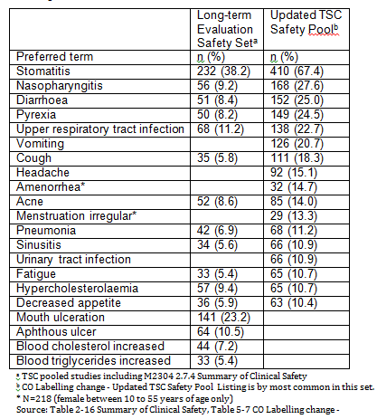
CPMP/ICH/375/95 ICH Topic E 1 Note for Guidance on Population Exposure: The Extent of Population Exposure to Assess Clinical Safety:
Regulatory standards for the safety evaluation of drugs should be based on previous experience with the occurrence and detection of adverse drug events (ADEs), statistical considerations of the probability of detecting specified frequencies of ADEs, and practical considerations.
The Form for Providing Product Information for a Restricted Medicine or Other Medicine in Relation to which The Secretary Requires Product Information to be Provided has:
ix) Adverse effects
Severity, clinical importance and frequency of adverse effects.
Note: For clarity and consistency, the following format is preferred:
- A table of adverse events (not adverse reactions) at a cut-off of, for example, 1% comparing the frequency of adverse events (n(%) or (%)) on drug with placebo/active comparator (if studies support this comparison) (usually very common and common);
- A line listing of adverse reactions that fall below the cut-off by System Organ Classes (SOC) using CIOMS3 frequencies (usually uncommon, rare); and
- A post-marketing section of adverse reactions by system organ class using CIOMS frequencies (usually rare or very rare).
Note for Guidance on Clinical Safety Data Management Definitions and Standards for Expedited Reporting (CPMP/ICH/377/95) Annotated with TGA Comments has:
2. Adverse Drug Reaction (ADR)
In the pre-approval clinical experience with a new medicinal product or its new usages, particularly as the therapeutic dose(s) may not be established:
all noxious and unintended responses to a medicinal product related to any dose should be considered adverse drug reactions.
The phrase "responses to a medicinal products" means that a causal relationship between a medicinal product and an adverse event is at least a reasonable possibility, that is, the relationship cannot be ruled out.
Regarding marketed medicinal products, a well-accepted definition of an adverse drug reaction in the post-marketing setting is found in WHO Technical Report 498 (1972) and reads as follows:
A response to a drug which is noxious and unintended and which occurs at doses normally used in man for prophylaxis, diagnosis, or therapy of disease or for modification of physiological function.
The recent NHMC document Safety monitoring and reporting in clinical trials involving therapeutic goods (November 2016) has the following in relation to ADRs:
Adverse Reaction (AR)
Any untoward and unintended response to an investigational medicinal product related to any dose administered.
Comment: All adverse events judged by either the reporting investigator or the sponsor as having a reasonable possibility of a causal relationship to an investigational medicinal product would qualify as adverse reactions. The expression ‘reasonable causal relationship’ means to convey, in general, that there is evidence or argument to suggest a causal relationship.
Note: The following are examples of types of evidence that would suggest a causal relationship between the investigational product and the adverse event:
- A single occurrence of an event that is uncommon and known to be strongly associated with drug exposure (for example, angioedema, hepatic injury, Stevens-Johnson Syndrome)
- One or more occurrences of an event that is not commonly associated with drug exposure, but is otherwise uncommon in the population exposed to the drug (for example, tendon rupture).
- An aggregate analysis of specific events observed in a clinical trial (such as known consequences of the underlying disease or condition under investigation or other events that commonly occur in the study population independent of drug therapy) that indicates those events occur more frequently in the drug treatment group than in a concurrent or historical control group
Comment: The current and proposed PIs contain only a Table labelled:
Adverse drug reactions from clinical trials in TSC reported at a higher rate in the Afinitor arm than in the placebo arm in TSC studies.
Given that the definition includes both AEs considered related by the investigator or those considered related the sponsor, the decision process needs to be distinguished in the PI.
The sponsor’s approach seems broadly reasonable, although there are some pitfalls with unthinking application of exposure-adjusted incidence, for example anaphylaxis might be better analysed as a crude frequency. Other factors that are relevant might be captured under ‘Bradford Hill criteria’ but that’s open to interpretation.

Safety in special populations

Age
The sponsor attempted to relate the incidence of AEs to age groups, especially < 3 years, but the numbers were small.

Gender
The incidence of most AEs was generally similar for both males and females, with the exception of vomiting (+10.7% higher in females relative to males).

Table 46: AEs irrespective of causality by gender (with a frequency cut-off of 10% in any group) (Long-term Evaluation Safety Set)
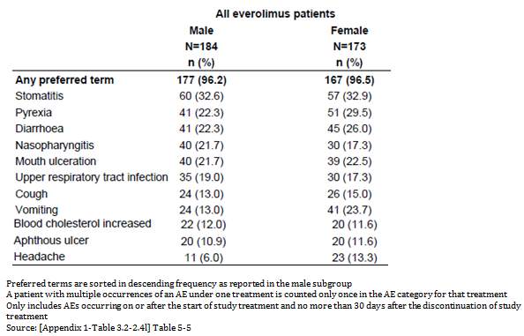

Concomitant AEDs
The numbers of patients with only 1 concomitant AED were limited and therefore results for this subgrouping need to be interpreted with caution.

Adverse Reactions Comparison of Populations

Table 47: Adverse Reactions - Comparison of Study M2304 results, cross trial results and sponsor proposed interpretation of results N = 608
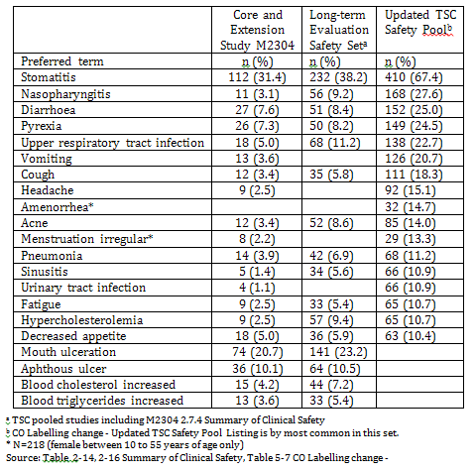

Post marketing experience
At the time of the Summary of Clinical Safety the total worldwide cumulative market exposure to everolimus in the Oncology and TSC settings combined through 31 March 2015 was estimated to be 84021 patient-treatment-years.
The total cumulative worldwide patient exposure (until 31 March 2015) based on the worldwide sales of tablets sold per defined daily dose, has been estimated at 79056 patient-treatment years for the Oncology setting (Oncology PSUR 9; 18 May 2015) and 4965 patient-treatment years for the TSC setting (TSC PSUR 7; 19 May 2015).

Evaluator’s overall conclusions on clinical safety
Comparing previous experience with Study M2304:
- Under 6 Months, the overall incidence of emerging AEs was higher in the previous Pool versus Study M2304 (87.6% versus 74.5%), as were the incidences of stomatitis (+11.9%) and hypercholesterolemia (+9.5%). Other events were reported with a similar frequency between the two datasets.
- Between Months 6 to 12, the overall incidence of emerging AEs was higher in the previous Pool versus Study M2304 (53.1% versus 37.8%). The incidence of specific AEs was in general similar.
- Between Months 12 to 24 the overall incidence of emerging AEs was higher in the previous Pool versus Study M2304 (67.5% versus 33.9%). Stomatitis (7.9%) and mouth ulceration (5.0%) were both reported more frequently in the previous pool.
There were some differences from the previous experience, the sponsor’s explanation for these related to the difference in age composition with 2 of the earlier trials confined to adults.
There appeared to be no major difference from the previous safety experience of everolimus in TSC patients.

First round benefit-risk assessment

First round assessment of benefits

Table 48: First round assessment of benefits
Indication
Benefits | Strengths and Uncertainties
Up to 60% of patients with TSC associated epilepsy fail to demonstrate improvement in seizure frequency with available therapies.  The response rate in the Primary endpoint was 15.1% for the placebo arm, 28.2% for the C_{min} 3 to 7 ng/mL arm and 40.0% for the C_{min} 9 to 15 ng/mL arm. | The 95% CIs for the C_{min} 9 to 15 ng/mL arm and placebo clearly separate.  The 95%CIs for placebo and the 3 to 7 ng/mL arm overlap. However the Odds ratio 95%CIs do not include 1.0.  By modelling the sponsor ascertained the lowest C_{min} at which the 95% CIs were still separated from placebo.

First round assessment of risks

Table 49: First round assessment of risks
Risks | Strengths and Uncertainties
Exposure is increased from previously recommended for TSC.  The exact mechanism of action is unclear. | There are no major changes in adverse reactions from those already reported in other TSC trials.  Regression analyses of the time to first event of stomatitis and infections and infestations versus TN-C_{min} indicated that 2 fold increases in TN-C_{min} were not associated with statistically significant increases in the risk of either of these events during the core phase (stomatitis: HR 1.092; 95% CI: 0.866, 1.376; infections and infestations: HR 1.060; 95% CI: 0.848, 1.325).

First round assessment of benefit-risk balance
The benefit-risk balance is considered favourable.

First round recommendation regarding authorisation
It is not recommended that the proposed indication everolimus be approved.
It is recommended that everolimus be approved subject to a satisfactory PI for the modified indication of:
Afinitor is indicated for the Adjunctive treatment of patients aged 2 years and older with TSC and associated refractory seizures.
It was a requirement for inclusion in Study M2034 that patients have a ‘Clinically definite diagnosis of TSC.’ Refractory seizures alone (a possible interpretation), was not included in the submission. The additional insertion clarifies this.

Clinical questions

Hepatic toxicity
The Clinical Study Report did not have a separate section on this. The Summary of Clinical Safety had under 1.1.1Safety aspects of the product Additional known risks with everolimus therapy that require close monitoring and evaluation include: and safety in patients with hepatic impairment.
The sponsor has proposed multiple hepatic impairment insertions in relation to which the sponsor has consistently referred to 2.7.2 Summary of Clinical Pharmacology. The only relevant statement found therein is:
3.2.9 Impaired hepatic function: No new information was generated in support of this indication.
In the summary results of the trial 23 to 25% had abnormal liver enzymes (Table 41) (2 at least were grade3/4 (Table 42)). One ADR of raised enzyme was reported (also 1 on placebo) raised ALT. Due to raised Alkaline phosphatase there was 1 discontinuation (Table 38), and 1 interruption or adjustment to dose (Table 39).
- Please review and comment.
- Please justify the proposed insertions.

Second round evaluation of clinical data submitted in response to questions
There was no second round clinical evaluation. The response to the question raised is in the AusPAR document in the Delegates discussion.

Therapeutic Goods Administration
PO Box 100 Woden ACT 2606 Australia
Email: info@tga.gov.au Phone: 1800 020 653 Fax: 02 6232 8605
https://www.tga.gov.au

All from current PI
Tuberous sclerosis complex the abbreviation is defined in the preceding Indication: patients with tuberous sclerosis complex (TSC) who have renal angiomyolipoma not requiring immediate surgery.
Pirson Y. Tuberous sclerosis complex-associated kidney angiomyolipoma: from contemplation to action. Nephrol Dial Transplant 2013; 28: 1680-1685.
Interim Clinical Study Report
Response rate is the percentage of responders in a treatment group
Protocol;each Agency will use their preferred variable as the primary variable, with the other (non-primary) variable being used in a supportive analysis. As each Agency will only use their preferred primary variable to make a decision on the primary objective, the full alpha level can be used for each Agency’s primary variable, without correction for multiplicity.
The ESC is an independent group of Scientific Investigators from academic medical research, dedicated to accelerating the development of new therapies in epilepsy to improve patient care.
where a patient discontinued the trial without completing the patient seizure diary, then the %Red was assigned as equal to 0 and this patient was considered as a non-responder.
Protocol; each Agency will use their preferred variable as the primary variable, with the other (non-primary) variable being used in a supportive analysis. As each Agency will only use their preferred primary variable to make a decision on the primary objective, the full alpha level can be used for each Agency’s primary variable, without correction for multiplicity. Similar statement in SAP (Interim CSR)
https://ctep.cancer.gov/protocoldevelopment/electronic_applications/docs/ctcaev3.pdf
The sponsor defined them as: - Old TSC Safety Pool including currently completed TSC Studies C2485, M2301, and M2302 (N=251), i.e. long-term exposure excluding Study M2304. - New TSC Safety Pool including all available safety data from the Core and Extension phases of Study M2304 added to the ‘Old TSC Safety Pool’ (N=608), i.e. long-term exposure including Study M2304.
CO Labelling change - Updated TSC Safety Pool page 9
https://www.nhmrc.gov.au/research/clinical-trials/nhmrc-clinical-trials-initiatives/promoting-consistency-in-safety-monitoring
‘Selected examples taken from Extract from FDA Safety Reporting Guidance clarifying the types of evidence that would suggest a causal relationship between the investigational medicinal product and the adverse event.’ Footnote from NHMRC document

