AusPAR Attachment 2

Extract from the Clinical Evaluation Report for etanercept
  - Proprietary Product Name: Erelzi
  - Sponsor: Novartis Pharmaceuticals Australia Pty Ltd
First round report: June 2017
Second round report: August 2017

About the Therapeutic Goods Administration (TGA)
- The Therapeutic Goods Administration (TGA) is part of the Australian Government Department of Health and is responsible for regulating medicines and medical devices.
- The TGA administers the Therapeutic Goods Act 1989 (the Act), applying a risk management approach designed to ensure therapeutic goods supplied in Australia meet acceptable standards of quality, safety and efficacy (performance) when necessary.
- The work of the TGA is based on applying scientific and clinical expertise to decision-making, to ensure that the benefits to consumers outweigh any risks associated with the use of medicines and medical devices.
- The TGA relies on the public, healthcare professionals and industry to report problems with medicines or medical devices. TGA investigates reports received by it to determine any necessary regulatory action.
- To report a problem with a medicine or medical device, please see the information on the TGA website <https://www.tga.gov.au>.
About AusPARs
- An Australian Public Assessment Report (AusPAR) provides information about the evaluation of a prescription medicine and the considerations that led the TGA to approve or not approve a prescription medicine submission.
- AusPARs are prepared and published by the TGA.
- An AusPAR is prepared for submissions that relate to new chemical entities, generic medicines, major variations and extensions of indications.
- An AusPAR is a static document; it provides information that relates to a submission at a particular point in time.
- A new AusPAR will be developed to reflect changes to indications and/or major variations to a prescription medicine subject to evaluation by the TGA.
Copyright
© Commonwealth of Australia 2018
This work is copyright. You may reproduce the whole or part of this work in unaltered form for your own personal use or, if you are part of an organisation, for internal use within your organisation, but only if you or your organisation do not use the reproduction for any commercial purpose and retain this copyright notice and all disclaimer notices as part of that reproduction. Apart from rights to use as permitted by the Copyright Act 1968 or allowed by this copyright notice, all other rights are reserved and you are not allowed to reproduce the whole or any part of this work in any way (electronic or otherwise) without first being given specific written permission from the Commonwealth to do so. Requests and inquiries concerning reproduction and rights are to be sent to the TGA Copyright Officer, Therapeutic Goods Administration, PO Box 100, Woden ACT 2606 or emailed to <tga.copyright@tga.gov.au>.
Contents
List of abbreviations 5
1. Submission details 8
1.1. Submission type 8
1.2. Drug class and therapeutic indication 8
1.3. Dosage forms and strengths 9
1.4. Dosage and administration 10
2. Background 10
2.1. Information on the condition being treated 10
2.2. Current treatment options 11
2.3. Clinical rationale 12
2.4. Guidance 13
2.5. Evaluator’s commentary on the background information 14
3. Contents of the clinical dossier 14
3.1. Scope of the clinical dossier 14
3.2. Paediatric data 14
3.3. Good clinical practice 15
3.4. Evaluator’s commentary on the clinical dossier 15
4. Pharmacokinetics 15
4.1. Studies providing pharmacokinetic information 15
4.2. Summary of pharmacokinetics 38
4.3. Evaluator’s overall conclusions on pharmacokinetics 40
5. Pharmacodynamics 41
6. Dosage selection for the pivotal studies 41
7. Clinical efficacy 41
7.1. Studies providing evaluable efficacy data 41
7.2. Pivotal or main efficacy studies 42
7.3. Justification for extrapolation to other indications approved for the reference product 65
7.4. Evaluator’s conclusions on clinical efficacy 66
8. Clinical safety 67
8.1. Studies providing evaluable safety data 67
8.2. Patient exposure 69
8.3. Adverse events 70
8.4. Evaluation of issues with possible regulatory impact 75
8.5. Post marketing experience 80
8.6. Evaluator’s overall conclusions on clinical safety 80
9. First round benefit-risk assessment 81
9.1. First round assessment of benefits 81
9.2. First round assessment of risks 82
9.3. First round assessment of benefit-risk balance 83
10. First round recommendation regarding authorisation 83
11. Clinical questions 84
11.1. Clinical questions 84
12. First round evaluation errata 85
12.1. Minor editorial changes 85
12.2. Minor errors of fact 85
12.3. Significant errors of fact 86
13. Second round evaluation 86
14. Second round benefit-risk assessment 97
14.1. Second round assessment of benefits 97
14.2. Second round assessment of risks 97
14.3. Second round assessment of benefit-risk balance 97
15. Second round recommendation regarding authorisation 97
16. References 98

List of abbreviations
Abbreviation | Meaning
Ab | Antibody
ABN | Australian Biological Name
ACM | Advisory Committee on Medicines
ADA | Anti-drug antibody
AE | Adverse event (not necessarily treatment-related)
Anti-CCP | Anti-cyclic citrullinated peptide
ALT | Alanine aminotransferase
ARTG | Australian Register of Therapeutic Goods
AST | Aspartate aminotransferase
ATE | Averaged treatment effect
BCC | Basal cell carcinoma
BDRM | Blinded data review meeting
BMI | Body-mass index
BSA | Body surface area
CNS | Central nervous system
COX-2 | Cyclooxygenase-2
CPU | Clinical pharmacology unit
CRP | C-reactive protein
CSR | Clinical study report
CTCAE | Common Terminology Criteria for Adverse Events
DAS28-CRP | Disease Activity Score 28-CRP
DBL | Database lock
DLQI | Dermatology Life Quality Index
DMARD | Disease-modifying anti-rheumatic drug
ECG | Electrocardiogram
EQ-5DTM | EuroQoL five dimensions questionnaire
ESR | Erythrocyte sedimentation rate
IP | Investigational product
IV | Intravenous
HAQ-DI© | Health assessment questionnaire disability index
Hb | Haemoglobin
HBsAg | Hepatitis B virus surface antigen
HBV | Hepatitis B virus
HCV | Hepatitis C virus
HIV | Human immunodeficiency virus
HRQoL | Health-related quality of life
IMP | Investigational medicinal product
INN | International Non-proprietary Name
LLOQ | Lower limit of quantification
LOCF | Last observation carried forward
LPLV | Last patient, last visit
mbTNF-α | transmembrane TNF alpha
MedDRA | Medical Dictionary for Regulatory Activities
MMRM | Mixed-model repeated measures
MTX | Methotrexate
NSAID | Non-steroidal anti-inflammatory drug
NYHA | New York Heart Association
OA | Overall analysis (in the EGALITY trial)
PASI | Psoriasis Area and Severity Index
PBRER | Periodic benefit-risk evaluation report
PsA | Psoriatic arthritis
PSUR | Periodic safety update report
RA | Rheumatoid arthritis
RF | Rheumatoid factor
SAE | Serious adverse event
SAP | Statistical analysis plan
SC | Subcutaneous(ly)
SCC | Squamous cell carcinoma
SD | Standard deviation
sPGA | static Physician’s Global Assessment
sTNF-α | soluble tumour necrosis factor alpha
TB | Tuberculosis
TEAE | Treatment emergent adverse event
TNF | Tumour necrosis factor
ULN | Upper limit of normal
UVB | Ultraviolet B
VAS | Visual analogue scale

Submission details

Submission type
This is an application to register Erelzi as a medicinal product biosimilar to Enbrel. Throughout the dossier, the sponsor also refers to Erelzi as Erelzi. Consequently, for the purposes of this report, Erelzi and Erelzi can be and are used interchangeably.

Drug class and therapeutic indication
Etanercept is a human tumour necrosis factor receptor p75 Fc fusion protein produced by recombinant DNA technology in a Chinese hamster ovary (CHO) mammalian expression system. Etanercept is a dimer of a protein genetically engineered by fusing the extracellular ligand-binding domain of human tumour necrosis factor receptor-2 (TNFR2/p75) to the Fc domain of human IgG1. This Fc component contains the hinge, CH2 and CH3 regions but not the CH1 region of IgG1.
The sponsor states that the proposed indications for Erelzi are aligned with those currently approved for Enbrel in Australia, namely:
- Rheumatoid Arthritis (adults);
- Psoriatic Arthritis (adults);
- Plaque psoriasis (adults);
- Ankylosing Spondylitis (adults);
- Non-radiographic Axial Spondyloarthritis (adults);
- Polyarticular Juvenile Idiopathic Arthritis (children and adolescents); and
- Paediatric plaque psoriasis (children and adolescents).
The proposed indications for Erelzi as outlined in the proposed product information (PI) document, are as follows (identical to the approved indications for Enbrel):
Erelzi is indicated for the treatment of:
Adults
Rheumatoid Arthritis
Active, adult rheumatoid arthritis (RA) in patients who have had inadequate response to one or more disease-modifying antirheumatic drugs (DMARDs). Erelzi can be used in combination with methotrexate.
Severe, active rheumatoid arthritis in adults to slow progression of disease-associated structural damage in patients at high risk of erosive disease.
Psoriatic Arthritis
The signs and symptoms of active and progressive psoriatic arthritis in adults, when the response to previous disease-modifying antirheumatic therapy has been inadequate. Erelzi has been shown to reduce the rate of progression of joint damage as measured by X-ray and to improve physical function.
Plaque Psoriasis
Adult patients with moderate to severe chronic plaque psoriasis, who are candidates for phototherapy or systemic therapy.
Ankylosing Spondylitis
The signs and symptoms of active ankylosing spondylitis in adults.
Non-radiographic Axial Spondyloarthritis
Treatment of adults with active* non-radiographic axial spondyloarthritis with objective signs of inflammation as indicated by elevated C-reactive protein (CRP) and/or MRI change who have had an inadequate response to NSAIDs.
*Active disease is defined as a Bath Ankylosing Spondylitis Disease Activity Index (BASDAI) score of ≥ 4.
Children and Adolescents
Juvenile Idiopathic Arthritis
Active polyarthritis (rheumatoid factor positive or negative) in children and adolescents, aged 2 to 17 years, who have had an inadequate response to one or more DMARDs.
Active extended oligoarthritis in children and adolescents, aged 2 to 17 years, who have had an inadequate response to, or who have proved intolerant to, methotrexate.
Active enthesitis-related arthritis in adolescents, aged 12 to 17 years, who have had an inadequate response to, or who have proved intolerant to, conventional therapy.
Active psoriatic arthritis in adolescents, aged 12 to 17 years, who have had an inadequate response to, or who have proved intolerant to, methotrexate.
Etanercept has not been studied in children aged less than 2 years.
Paediatric Plaque Psoriasis
Chronic, severe plaque psoriasis in children and adolescents from 4 to 17 years, who are inadequately controlled by, or are intolerant to, other systemic therapies or phototherapies. Duration of therapy to be no longer than 24 weeks and treatment to be ceased after 12 weeks if a significant PASI response is not achieved.

Dosage forms and strengths
Table below compares the dosage form and strengths for Enbrel and Erelzi. Erelzi has the same presentations as Enbrel, except for the powder for injection. Furthermore, the sponsor states that not all pack sizes may be marketed in Australia.
Table 1: Comparison of dosage forms and strengths for Enbrel and Erelzi.
 | Enbrel Reference product | Erelzi Biosimilar medicine to Enbrel
Dosage forms | Pre-filled syringe (solution for injection) (25 mg^ and 50 mg)  Pre-filled syringe (auto-injector) (50 mg)  Powder for injection* (25 mg and 50 mg^) | Pre-filled syringe (solution for injection) (25 and 50 mg)  Pre-filled syringe (auto-injector) (50 mg)
Strengths | 25 mg, 50 mg | 25 mg, 50 mg
*not available for Erelzi ^not marketed

Dosage and administration
The recommended dosages for the proposed indications of Erelzi/current indications of Enbrel are shown. It is noted that there is no suitable Erelzi presentation is available for paediatric patients weighing 62.5 kg or less.
Table 2: Recommended dosages for the proposed indications of Erelzi/current indications of Enbrel.
Indication | Stage | Dose
Rheumatoid arthritis, psoriatic arthritis, non-radiographic axial spondyloarthritis, ankylosing spondylitis | N/A | 50 mg per week, given as a subcutaneous injection, EITHER once weekly as a single 50 mg injection OR twice weekly as two separate 25 mg injections given 3-4 days apart.
Plaque psoriasis | Induction (optional) | 50 mg given twice weekly for up to 12 weeks.
Plaque psoriasis | Maintenance | 50 mg per week, given as a subcutaneous injection, EITHER once weekly as a single 50 mg injection OR twice weekly as two separate 25 mg injections given 3-4 days apart.
Juvenile idiopathic arthritis (age 2 years and above)* | N/A | 0.8 mg/kg (up to a maximum of 50 mg per dose) given once weekly as a subcutaneous injection, or 0.4 mg/kg (up to a maximum of 25 mg), given twice weekly with an interval of 3-4 days between doses.
Paediatric plaque psoriasis (age 4 years and above)* | N/A | 0.8 mg/kg (up to a maximum of 50 mg per dose), given once weekly as a subcutaneous injection for up to 24 weeks.
*no suitable Erelzi presentation is available for paediatric patients weighing less than 62.5 kg.

Background

Information on the condition being treated

Rheumatoid arthritis
Rheumatoid arthritis (RA) is an autoimmune multi-system disease, but mainly affects the small joints, symmetrically on both sides. Its main feature is persistent synovitis, leading to irreversible damage to soft tissues and bones in later stages.

Ankylosing spondylitis
Ankylosing spondylitis (AS) is a chronic inflammatory spondyloarthritis of unknown aetiology, but with genetic predisposition. It mainly affects the axial skeleton including the sacroiliac region. Its main clinical features are back pain and progressive stiffness of the spine.

Psoriasis and psoriatic arthritis
Psoriasis is a chronic inflammatory skin disorder mainly characterised by erythematous papules and plaques with a silvery scale (plaque psoriasis). However, the disease may also manifest itself as guttate psoriasis, pustular psoriasis, inverse psoriasis, erythrodermic psoriasis, or nail psoriasis. In some individuals, the inflammatory changes extend into joints, leading to psoriatic arthritis.

Non-radiographic axial spondyloarthritis
Ankylosing spondylitis (AS) is a form of spondyloarthritis (SpA). It is a chronic, inflammatory disease of the axial skeleton characterised by back pain and progressive spinal stiffness, even though other joints and extra articular structures can be involved (e.g. uveitis).

Polyarticular juvenile idiopathic arthritis
Polyarticular juvenile idiopathic is a subset of juvenile idiopathic arthritis (JIA) and is defined by the presence of more than four affected joints during the first six months of disease. JIA can be further classified into polyarthritis rheumatoid factor-negative or polyarthritis rheumatoid factor-positive.

Current treatment options

Rheumatoid arthritis
Pharmacological treatment options include:
- Anti-inflammatory medications, e.g. nonsteroidal anti-inflammatory drugs (NSAIDs) and glucocorticoids
- Non-biological disease-modifying antirheumatic drugs (DMARDs) (e.g. methotrexate, hydroxychloroquine, sulfasalazine, and leflunomide)
- Biological DMARDs:
  - Tumour necrosis factor (TNF)-alpha inhibitors (e.g. infliximab, adalimumab, etanercept, golimumab, and certolizumab pegol)
  - Interleukin-1 (IL-1) receptor antagonists (e.g. anakinra)
  - Interleukin-6 (IL-6) receptor antagonists (e.g. tocilizumab)
  - T-cell co-stimulation modulators (e.g. abatacept)
  - Anti-CD20 monoclonal antibodies (e.g. rituximab)
  - Janus kinase inhibitors (e.g. tofacitinib)

Ankylosing spondylitis
Pharmacological treatment options include:
- Anti-inflammatory medications, e.g. nonsteroidal anti-inflammatory drugs (NSAIDs), selective COX-2 inhibitors, and glucocorticoids
- Non-biological disease-modifying antirheumatic drugs (DMARDs), often only in conjunction with biological DMARDs
- Biological DMARDs:
  - Tumour necrosis factor (TNF)-alpha inhibitors (e.g. infliximab, adalimumab, etanercept, golimumab, and certolizumab pegol)

Psoriasis and psoriatic arthritis
Treatment options include:
- Topical corticosteroids and emollients
- Vitamin D analogues (e.g. calcipotriene, calcitriol)
- Topical/systemic retinoids (e.g. tazarotene)
- Topical tacrolimus or pimecrolimus
- UVB phototherapy
- Non-biological agents (e.g. methotrexate, cyclosporine, apremilast)
- Biological immunomodulators (e.g. infliximab, adalimumab, etanercept, ustekinumab secukinumab, ixekizumab)

Non-radiographic axial spondyloarthritis
Pharmacological treatment options include:
- Anti-inflammatory medications, e.g. nonsteroidal anti-inflammatory drugs (NSAIDs), selective COX-2 inhibitors, and glucocorticoids
- Non-biological disease-modifying antirheumatic drugs (DMARDs), often only in conjunction with biological DMARDs
- Biological DMARDs:
  - Tumour necrosis factor (TNF)-alpha inhibitors (e.g. infliximab, adalimumab, etanercept, and golimumab)

Polyarticular juvenile idiopathic arthritis
Pharmacological treatment options include:
- Anti-inflammatory medications, e.g. nonsteroidal anti-inflammatory drugs (NSAIDs) and glucocorticoids
- Folic acid supplementation
- Non-biological disease-modifying antirheumatic drugs (DMARDs)(e.g. methotrexate, hydroxychloroquine, sulfasalazine, and leflunomide)
- Biological DMARDs:
  - Tumour necrosis factor (TNF)-alpha inhibitors (e.g. infliximab, adalimumab, etanercept)
  - Interleukin-6 (IL-6) receptor antagonists (e.g. tocilizumab)
  - T-cell co-stimulation modulators (e.g. abatacept)
  - Anti-CD20 monoclonal antibodies (e.g. rituximab)

Clinical rationale
Erelzi has been developed by the sponsor as a similar biological product to the reference product Enbrel. It can serve as an alternative to the reference product, if found to be biosimilar.

Guidance
The following guidelines have been considered in relation to this submission.
- General guidelines
  - CPMP/ICH/135/95: Note for guidance on good clinical practice (CPMP/ICH/135/95 - Annotated with TGA comments)
- Guidelines regarding similar biological medicinal products
  - TGA guidance on regulation of biosimilar medicines, Version 2.0, December 2015
  - CHMP/437/04 Rev. 1: Guideline on similar biological medicinal products.
  - EMEA/CHMP/BMWP/42832/2005 Rev1: Guideline on similar biological medicinal products containing biotechnology-derived proteins as active substance: non-clinical and clinical issues.
  - EMA/CHMP/BWP/247713/2012: Guideline on similar biological medicinal products containing biotechnology-derived proteins as active substance: quality issues (revision 1)
  - EMA/CHMP/BMWP/403543/2010: Guideline on similar biological medicinal products containing monoclonal antibodies - non-clinical and clinical issues.
  - CPMP/EWP/QWP/1401/98 Rev. 1/ Corr: Guideline on the Investigation of Bioequivalence.
- General guidelines regarding biological medicinal products/therapeutic proteins
  - EMEA/CHMP/BMWP/101695/2006: Guideline on Comparability of Biotechnology-Derived Medicinal Products after a change in the Manufacturing Process - Non-Clinical and Clinical Issues.
  - EMEA/CHMP/BMWP/14327/2006: Guideline on Immunogenicity Assessment of Biotechnology-Derived Therapeutic Proteins.
  - CHMP/EWP/14327/2004: Guideline on the Clinical Investigation of the Pharmacokinetics of Therapeutic Proteins.
- Guidelines regarding products containing monoclonal antibodies
  - EMA/CHMP/BMWP/86289/2010: Guideline on immunogenicity assessment of monoclonal antibodies intended for in vivo clinical use.
  - CPMP/ICH/5721/03: ICH Topic Q 5 E: Comparability of Biotechnological/ Biological Products (Note for Guidance on Biotechnological/Biological Products Subject to Changes in their Manufacturing Process).
- Indication-specific guidelines
  - CHMP/EWP/2454/02 corr: Guideline on clinical investigation of medicinal products indicated for the treatment of Psoriasis.
- Guidelines regarding products for long-term use
  - Rules 1998 (3C) - 3CC6a: Clinical Investigation of Medicinal Products for Long-Term Use.
- Specific guidance for this submission: Pre-submission advice was sought in August 2016. The main items included:
  - There were no objections to the trade name Erelzi at the time of the meeting.
  - The bridging study report comparing the Australian batches to overseas-sourced batches of the reference product (Enbrel).
  - The proposed PI will state that powder for injection vials of Erelzi will not be available for use in weight-based dosage adjustments for children and adolescents weighing below 62.5 kg.

Evaluator’s commentary on the background information
The provided background information is acceptable overall.

Contents of the clinical dossier

Scope of the clinical dossier
The dossier does not contain a full development program. The sponsor supports their biosimilar application with bioequivalence and equivalence studies that compare their product, Erelzi, to the reference product, Enbrel.
- Four pharmacokinetic studies (in healthy subjects); and
- One efficacy study in patients with plaque psoriasis.
Clinical study reports were included for:
- PK studies
  - GP15-101: A randomized, double-blind, two-way cross-over study to determine the pharmacokinetics and safety of Erelzi and Enbrel® (EU-licensed) following a single subcutaneous injection in healthy subjects.
  - GP15-102: A randomized, double-blind, two-way cross-over study to determine the pharmacokinetics and safety of Erelzi and Enbrel® (US-licensed) following a single subcutaneous injection in healthy subjects.
  - GP15-103: A randomized, open label, two-way cross-over study to determine the pharmacokinetics and safety of Erelzi following a single subcutaneous injection by an autoinjector and by a pre-filled syringe in healthy male subjects.
  - GP15-104 (PIVOTAL): A randomized, double blind, two-way cross-over study to determine the pharmacokinetics and safety of Erelzi and Enbrel (EU-licensed) following a single dose of 50 mg subcutaneous injection in healthy male subjects.
- Efficacy studies
  - GP15-302 (PIVOTAL): A randomized, double-blind, multicenter study to demonstrate equivalent efficacy and to compare safety and immunogenicity of a biosimilar etanercept (Erelzi) and Enbrel in patients with moderate to severe chronic plaque type psoriasis (EGALITY).

Paediatric data
The provided studies did not include paediatric patients.

Good clinical practice
All studies contained a statement claiming compliance with good clinical practice guidelines or ethical principles of the Declaration of Helsinki.

Evaluator’s commentary on the clinical dossier

Extrapolation of indications
The sponsor has conducted equivalence trials in patients with plaque psoriasis only. The sponsor has proposed the extrapolation to all reference indications and has provided a rather short justification for this.

Clinical overviews
It is noted that no ISE or ISS has been provided. The Summary of Clinical Safety only contained efficacy study data up to Week 30. A supplementary document provided study data until Week 52. Ideally, these documents should have been combined into one Summary of Clinical Safety.

Paediatric data
No specific paediatric data have been provided.

Pharmacokinetics

Studies providing pharmacokinetic information
Studies GP15-101, GP15-102, GP15-103, GP15-104, and GP15-302 provided PK data. Studies GP15-101, GP15-102, GP15-103, GP15-104 were dedicated PK studies in healthy subjects. Study GP15-302 was an equivalence study that compared Erelzi to Enbrel with regard to efficacy in plaque psoriasis. The PK component of that study was limited to a comparison of steady state trough concentrations.
Table 3: Summary of clinical pharmacology studies of Erelzi.

PK Study GP15-104 (PXL216311)

Title
A randomized, double blind, two-way cross-over study to determine the pharmacokinetics and safety of Erelzi and Enbrel (EU-licensed) following a single dose of 50 mg subcutaneous injection in healthy male subjects.

Objectives
Primary objective:
- To determine bioequivalence between Erelzi and Enbrel in terms of the pharmacokinetic (PK) parameters C_{max}, AUC_{0-tlast}, AUC_{0-inf} and following a single subcutaneous (s.c.) administration of 50 mg.
Secondary objectives:
- To compare remaining PK parameters t_{max}, k_{el}, t_{½} between Erelzi and Enbrel.
- To compare the immunogenicity of both products.
- To evaluate and compare the overall safety, tolerability and local tolerance of Erelzi and Enbrel.

Methodology
Design: Phase 1, double-blind, randomised, two-way crossover study in healthy adult male subjects undertaken in one centre in the United Kingdom. Subjects, investigator staff, persons performing the assessments, laboratory personnel and data analysts were blinded. Allocation concealment did occur.
There were two protocol changes and one analysis change (three de facto protocol changes):
- Before study start: open-label design was changed to a double-blind design (documentation error only, as the study was not intended to be open-label); minor alterations to measurement times.
- After study start before DBL: ANOVA was changed to ANCOVA to include protein content of the administered dose as a covariate; details on syringe weight analysis were provided.
- Analysis change (after DBL): ANCOVA was changed back to ANOVA; the sponsor states that “[m]ajor assumptions of ANCOVA were violated which invalidated the fitting of the model as planned. Therefore, the primary PK parameters (C_{max}, AUC_{0-tlast}, and AUC_{0-inf}) were normalized by the protein content (multiplying PK parameter values by 50/[protein content value]) before fitting the model and not as planned by including the protein content as a covariate in the ANCOVA model.”
Inclusion criteria: The main inclusion criteria included:
- Subjects had to give written informed consent before any study-related assessment was performed;
- Male subjects, aged 18 to 49 years inclusive;
- Physically and mentally healthy, as determined by physical examination and safety laboratory assessments;
- Body weight between 50 to 99.9 kg and body mass index (BMI) between 19.0 to 29.9 kg/m² inclusively;
- Non-smoker or ex-smoker, defined as not having smoked for at least 6 months before IP administration.
Treatments: Each subject received a single dose of 50 mg SC injection (highest approved dose of etanercept) of Erelzi or Enbrel into the abdomen in the morning on day 1 following an overnight (at least 8 hours) fast. Subjects were randomised on Day 1 of Period 1. The allocation was concealed. The syringes (including cap, label and needle) were weighed before and after administration to determine the actual dose given.
PK sampling and analysis: A study design and treatment schema is shown. The single dose was given on Day 1. Pharmacokinetic (PK) blood sample (3.5 mL) collection occurred pre-dose (-0.5 hours), then 6, 12. 24, 36, 48, 60, 72, 84 hours post-dose, and then on days 5, 6, 8, 10, 12, 15, 19, 29 post-dose. The serum concentration of etanercept was determined using a validated enzyme linked immunosorbent assay (ELISA). The lower limit of quantification (LLOQ) for etanercept levels was 6.7 ng/mL. The lower limit of quantification (LLOQ) for immunogenicity purposes was 200 ng/mL. The following sampling windows were allowed:
- ± 5% of the nominal time after dosing until Day 15 inclusive.
- ± 1 day at Day 19 and Day 29 (Period 2).
The following PK parameters were measured/calculated from serum etanercept concentration data using non-compartmental methods:
Primary PK parameters:
- C_{max}: The maximum observed serum concentration (ng/mL);
- AUC_{0-tlast}: The area under the serum concentration-time curve measured from the time of dosing to the last measurable concentration (ng.h/mL); and
- AUC_{0-inf}: The area under the serum concentration-time curve measured from the time of dosing and extrapolated to infinity (ng.h/mL).
Secondary PK parameters:
- %AUC_{extra}: Percentage of AUC_{0-inf} obtained by extrapolation;
- CL_{0-inf}: Apparent clearance calculated as dose/AUC_{0-inf};
- k_{el}: Elimination rate constant (h⁻¹);
- t_{max}: The time to the maximum observed serum concentration (h); and
- t_{½}: The apparent terminal half-life of elimination phase (h).
Figure 1: Study GP15-104. Study design and treatment schema.
Statistical Analysis Plan (SAP): An analysis of variance (ANOVA) was used for statistical analysis of ln transformed C_{max}, AUC_{0-tlast}, AUC_{0-inf}. The ANOVA model included sequence, treatment and period as fixed effects, and subject nested within sequence as a random effect. The secondary PK parameters were only analysed descriptively. There were no covariates (e.g. weight or protein content).
The null and alternative hypotheses were:
- H₀: μ_{PK,T}/μ_{PK,R} < 0.80 and μ_{PK,T}/μ_{PK,R} > 1.25
- H₁: 0.80 ≤ μ_{PK,T}/μ_{PK,R} ≤ 1.25
Subgroup/sensitivity analyses: A sensitivity analysis was conducted for uncorrected (nominal dose PK analysis) log-transformed pharmacokinetic parameters (the main analysis considered normalised doses based on syringe weight differences).
Safety analyses: adverse events (AEs), vital signs, 12-lead Electrocardiogram (ECG) parameters, clinical laboratory, physical examination findings and immunogenicity were recorded. Only treatment emergent adverse events (TEAEs) were reported. Immunogenicity blood samples were collected at -0.5 hour pre-dose on Day 1 of each period and on Day 29 of Period 2.

Study participants
- Enrolled: N=54 (n=27 in each group)
- Completed: N=54
- Analysed (Pharmacokinetic Analysis Set): N=54
- Analysed (Safety Analysis Set): N=54
A summary of baseline characteristics – the following terminology was used:
- Pharmacokinetic Analysis Set: All subjects who received IP and completed the study without a major protocol deviation and for whom the primary PK parameters (C_{max}, AUC_{0-tlast}, and AUC_{0-inf}) could be calculated.
- Safety Analysis Set: All randomised subjects who received Erelzi or Enbrel at least once and had at least one post-baseline safety assessment.
- Normalised dose: referred to the actual dose given based on syringe weight differences.
- Nominal dose: 50 mg.

PK Results – primary analysis
The concentration-time profiles (linear and semi-logarithmic) comparing Erelzi and Enbrel (EU) are shown (normalised dose).
Figure 2: Study GP15-104. Concentration-time profiles (linear and semi-logarithmic) comparing the arithmetic means (+SD) of each treatment group (normalised dose, Pharmacokinetic Analysis Set).
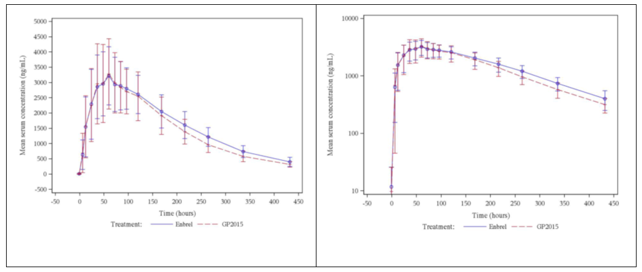
A statistical analysis of the primary PK parameters (C_{max}, AUC_{0-tlast}, AUC_{0-inf}) (normalised dose) is shown: The 90% CIs of the mean parameter ratios (Erelzi/Enbrel) were contained within the pre-specified limits of 0.8 to 1.25. Intra-individual CV values are also shown. Inter-individual CV values were provided by the sponsor after Round 1.
Table 4: Study GP15-104. Statistical analyses of primary PK parameters (normalised dose, Pharmacokinetic Analysis Set).

PK results – subgroup/sensitivity analyses
Only one sensitivity analysis was conducted, i.e. the consideration of the nominal dose rather than the normalised dose (i.e. without adjustment for different protein content). The results of this analysis are shown in this subsection.
The concentration-time profiles (linear and semi-logarithmic) comparing Erelzi and Enbrel (EU) are shown (nominal dose).
Figure 3: Study GP15-104. Concentration-time profiles (linear and semi-logarithmic) comparing the arithmetic means (+SD) of each treatment group (nominal dose, Pharmacokinetic Analysis Set).
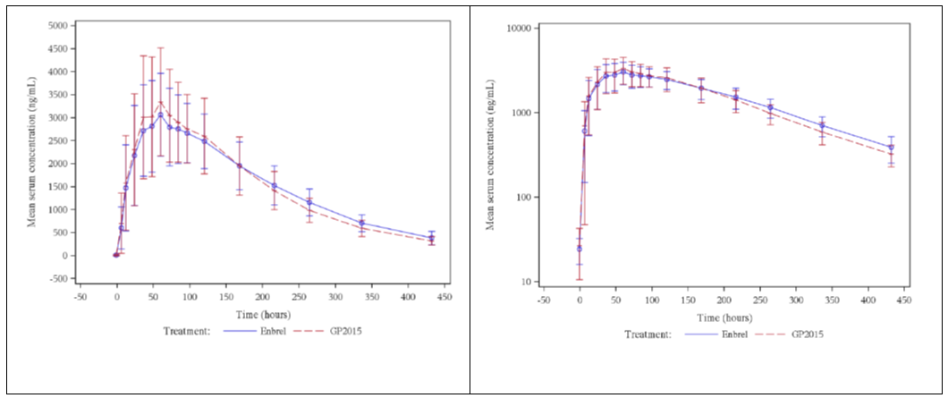
A statistical analysis of the primary PK parameters (C_{max}, AUC_{0-tlast}, AUC_{0-inf}) (nominal dose) is shown: The 90% CIs of the mean parameter ratios (Erelzi/Enbrel) were contained within the pre-specified limits of 0.8 to 1.25. Intra-individual CV values are also shown. Inter-individual CV values were provided by the sponsor after Round 1.
Table 5: Study GP15-104. Statistical analyses of primary PK parameters (nominal dose, Pharmacokinetic Analysis Set).

Immunogenicity
All pre-dose samples were negative. 3 subjects (and additionally 1 indeterminate) had confirmed binding anti-etanercept antibodies on Day 65, but the concentrations were below the LLOQ. None of the detected ADAs were neutralising. No sensitivity analysis for ADA positive subjects was conducted.
Comment: Design: The crossover design is acceptable. However, the switch may have increased the risk of immunogenicity for individual subjects. The inclusion and exclusion criteria are acceptable. The use of one strength (in this case the higher strength) is acceptable in a drug displaying linear pharmacokinetics.
Blinding: The blinding methods are acceptable. Subjects, investigator staff, persons performing the assessments, laboratory personnel and data analysts were blinded. There was allocation concealment.
Dosing: This was a single-dose study only. Analyses of bioequivalence at steady state during the maintenance phase were not possible. Results from the clinical equivalence studies allowed a comparison of steady state PK.
PK sampling and analysis: was acceptable. Regarding sampling windows, there was no information given whether the actual sampling time was considered in the data analysis.
Statistical methods: The statistical methods used are compliant with regulatory guidance.
Methodology: The use of the 50 mg dose was acceptable due to relevant etanercept dose proportionality.
The methodology had some deficiencies (e.g. single dosing only, protocol changes, changes to the data analysis methodology post hoc). Most of the protocol changes were minor and would not have affected the study results. However, the post hoc changes were not ideal (with regard to protein adjustment/dose normalisation). However, the sponsor has provided both sets of results (adjusted and unadjusted).
Immunogenicity: All pre-dose samples were negative. 3 subjects (and additionally 1 indeterminate) had confirmed binding anti-etanercept antibodies on Day 65, but the concentrations were below the LLOQ. None of the detected ADAs were neutralising. Based on the results, a sensitivity analysis of ADA positive subjects would not have been practical.
Results: The results support bioequivalence of Erelzi to Enbrel (EU). When comparing Erelzi to Enbrel (EU), C_{max}, AUC_{0-tlast}, AUC_{0-inf} were, on average, 11% higher, 2% lower, and 4% lower respectively, in Erelzi subjects. Inter-individual variability values were low to medium and similar between groups. PK parameter results unadjusted for protein content are usually preferred. However, both the adjusted and the unadjusted results were provided. Of note, the protein adjustment appeared to have been based on the normalised dosing calculations rather than serum protein measurements.
Summary: Overall, the bioequivalence criteria for Erelzi were met. The parameters assessed are within the prescribed bioequivalence margins and support bioequivalence.

PK Study GP15-101

Title
A randomized, double-blind, two-way cross-over study to determine the pharmacokinetics and safety of Erelzi and Enbrel (EU-licensed) following a single subcutaneous injection in healthy subjects.

Objectives
Primary objective:
- To determine bioequivalence between Erelzi and Enbrel in terms of the pharmacokinetic parameters AUC_{0-tlast} and C_{max}, and following a single subcutaneous injection of 50 mg.
Secondary objectives:
- To further compare Erelzi and Enbrel® with respect to the following criteria:
  - Remaining pharmacokinetic parameters (AUC_{0-∞}, t_{max}, k_{el} and t_{½}).
  - Immunogenicity of both products.
  - Overall safety and local tolerance.

Methodology
Design: Phase 1, double-blind, randomised, two-way crossover study in healthy, male and female, adult subjects undertaken in one centre in Leeds, United Kingdom. Subjects, investigator staff, persons performing the assessments, laboratory personnel, and data analysts were blinded. Allocation concealment did occur. Only non-substantial protocol changes occurred. However, a post hoc analysis changed was implemented: an additional analysis (that considered operator differences, i.e. the operator that administered Enbrel or Erelzi to subjects) was created.
Inclusion criteria: the main inclusion criteria included:
- Subjects must give written informed consent before any study-related assessment is performed.
- Male or female subjects, aged 18 to 49 years inclusive.
- Physically and mentally healthy, as determined by physical examination and safety laboratory assessments.
- Body weight between 50 to 99.9 kg and body mass index (BMI) between 19.0 to 29.9 kg/m² inclusively.
- Non-smoker or ex-smoker, defined as not having smoked for at least 6 months before IMP administration.
Treatments: Subjects were randomly assigned in a 1:1 ratio to one of the following treatment sequences:
- 50 mg Erelzi in Period I and 50 mg Enbrel® in Period II.
- 50 mg Enbrel in Period I and 50 mg Erelzi in Period II.
The single dose was given on Day 1. Pharmacokinetic (PK) blood sample (3.5 mL) collection occurred pre-dose, then 6, 12, 24, 36, 48, 60, 72, 84, 96, 120, 168, 216, 264, 336, and 432 hours post-dose in each period.
The serum concentration of etanercept was determined using a validated enzyme linked immunosorbent assay (ELISA). The lower limit of quantification (LLOQ) for etanercept levels was 8 ng/mL. The lower limit of quantification (LLOQ) for immunogenicity purposes was 200 ng/mL.
The following PK parameters were measured/calculated from serum etanercept concentration data using non-compartmental methods.
Table 6: PK parameters measured/calculated from serum etanercept concentration data.
Figure 4: Study GP15-101. Study design and treatment schema.
Statistical Analysis Plan (SAP): An analysis of variance (ANOVA) was used for statistical analysis of ln transformed C_{max} and AUC_{0-tlast}. The ANOVA model included sequence, treatment and period as fixed effects, and subject nested within sequence as a random effect. All other PK parameters were only analysed descriptively. There were no covariates (e.g. weight or protein content).
Subgroup/sensitivity analyses: None were planned originally, but then an ‘ad hoc analysis’ was conducted post hoc which considered the of operator effect on PK parameters.
Safety analyses: adverse events (AEs), vital signs, ECG parameters, clinical laboratory, physical examination findings, local tolerance and immunogenicity were recorded.

Study participants
- Enrolled: N=54
- Completed: N=51
- Analysed (Per-protocol Analysis Set): N=49 (50 for some parameters)
- Analysed (Safety Analysis Set): N=53
A summary of baseline characteristics – the following terminology was used:
- Per-protocol Analysis Set: all subjects who received both IMPs, provided a pharmacokinetic profile for each IMP, and completed the study without a major protocol violation.
- Safety Analysis Set: All randomised subjects who received study medication at least once were included in the safety evaluation. Subjects were analysed according to treatment received.

PK results – overview
Two sets of analyses were conducted: a primary analysis and a secondary analysis (termed ‘ad hoc analysis’ by the sponsor). The sponsor chose to use the results of the ad hoc analysis, as they support bioequivalence, whereas the results of the primary analysis are narrowly outside the pre-specified interval of 80 to 125%.

PK results – primary analysis
A statistical analysis of PK parameters is shown. Not all 90% CIs of the mean parameter ratios (Erelzi/Enbrel) were contained within the pre-specified limits of 0.8 to 1.25: AUC_{0-tlast} and AUC_{0-∞} were slightly outside that range.
Table 7: Study GP15-101. Statistical analyses of PK parameters (without operator adjustment, Per-protocol Analysis Set).

PK Results – ad hoc analysis
Only one secondary analysis was conducted, i.e. the consideration of operator effect on PK parameters. The results of this analysis are shown in this subsection.
A statistical analysis of the main PK parameters (C_{max} and AUC_{0-tlast},) (with operator adjustment) is shown: The 90% CIs of the mean parameter ratios (Erelzi/Enbrel) were contained within the pre-specified limits of 0.8 to 1.25. AUC_{0-∞} was not reported.
Table 8: Study GP15-104. Statistical analyses of primary PK parameters (nominal dose, Pharmacokinetic Analysis Set).

Immunogenicity
The sponsor states that all antibody results were negative.
Comment: Design: The crossover design is acceptable. However, the switch may have increased the risk of immunogenicity for individual subjects. The inclusion and exclusion criteria are acceptable. The use of one strength (in this case the higher strength) is acceptable in a drug displaying linear pharmacokinetics.
Blinding: The blinding methods are acceptable. Subjects, investigator staff, persons performing the assessments, laboratory personnel and data analysts were blinded. There was allocation concealment.
Dosing: This was a single-dose study only. Analyses of bioequivalence at steady state during the maintenance phase were not possible. Results from the clinical equivalence studies allowed a comparison of steady state PK.
PK sampling and analysis: was acceptable. Regarding sampling windows, there was no information given whether the actual sampling time was considered in the data analysis.
Statistical methods: The statistical methods used are compliant with regulatory guidance.
Methodology: The methodology had many deficiencies. The main deficiency is the post hoc changes to the analysis to introduce operator adjustment. The sponsor provided the following justification:
Not all subjects were dosed by the same operator in Periods I and II. The subjects who were dosed by different operators in Periods I and II revealed different pharmacokinetic profiles and subsequently exposure. As a small volume of etanercept of approximately 1 mL had to be injected, any minor deviation might have an impact on the exposure.
The operator adjustment rationale and the adjustment process (after the primary analysis had revealed PK parameters outside the pre-determined range) were difficult to follow and would have affected the internal validity. Consequently, the PK results from this study were excluded from consideration. It is noted that the issues with methodology lead to the design of another PK study which became the pivotal bioequivalence PK study for this submission.
Immunogenicity: All samples were negative.
Summary: The PK results were not used for the purposes of this evaluation due to issues with the methodology. However, the safety data could still be used.

PK Study GP15-102

Title
A randomized, double-blind, two-way cross-over study to determine the pharmacokinetics and safety of Erelzi and Enbrel® (US-licensed) following a single subcutaneous injection in healthy subjects.

Objectives
Primary objective:
- To determine bioequivalence between Erelzi and Enbrel in terms of the pharmacokinetic parameters area under the serum concentration-time curve measured from the time of dosing to the last measurable concentration (AUC_{0-tlast}) and maximum observed serum concentration (C_{max}) following a single subcutaneous injection of 50 mg.
Secondary objectives:
- To further compare Erelzi and Enbrel® with respect to the following criteria:
  - Remaining pharmacokinetic parameters (AUC_{0-∞}, t_{max}, k_{el} and t_{½}).
  - Immunogenicity of both products.
  - Overall safety and local tolerance.

Methodology
Design: Phase 1, double-blind, randomised, two-way crossover study in healthy, male and female, adult subjects undertaken in one centre in Leeds, United Kingdom, in 2012. Subjects, investigator staff, persons performing the assessments, laboratory personnel, and data analysts were blinded. Allocation concealment did occur.
No protocol changes occurred after the start of the study.
Inclusion criteria: The main inclusion criteria included:
- Subjects must give written informed consent before any study-related assessment is performed.
- Male or female subjects, aged 18 to 49 years inclusive.
- Physically and mentally healthy, as determined by physical examination and safety laboratory assessments.
- Body weight between 50 to 99.9 kg and body mass index (BMI) between 19.0 to 29.9 kg/m² inclusively.
- Non-smoker or ex-smoker, defined as not having smoked for at least 6 months before IMP administration.
Treatments: Subjects were randomly assigned in a 1:1 ratio to one of the following treatment sequences:
- 50 mg Erelzi in Period I and 50 mg Enbrel® in Period II
- 50 mg Enbrel® in Period I and 50 mg Erelzi in Period II
PK sampling and analysis: A study design and treatment schema is shown.
The single dose was given on Day 1. Pharmacokinetic (PK) blood sample (3.5 mL) collection occurred pre-dose, then 6, 12. 24, 36, 48, 60, 72, 84, 96, 120, 168, 216, 264, 336, and 432 hours post-dose in each period.
The serum concentration of etanercept was determined using a validated enzyme linked immunosorbent assay (ELISA). The lower limit of quantification (LLOQ) for etanercept levels was 8 ng/mL. The lower limit of quantification (LLOQ) for immunogenicity purposes was 200 ng/mL.
The following PK parameters were measured/calculated from serum etanercept concentration data using non-compartmental methods.
Table 9: PK parameters measured/calculated from serum etanercept concentration data.
Figure 5: Study GP15-101. Study design and treatment schema.
Statistical Analysis Plan (SAP): An analysis of variance (ANOVA) was used for statistical analysis of ln transformed C_{max} and AUC_{0-tlast}. The ANOVA model included sequence, treatment, operator and period as fixed effects, and subject nested within sequence as a random effect. All other PK parameters were only analysed descriptively. There were no covariates (e.g. weight or protein content). The inclusion of operator effect was added due to the experience in study GP15-101.
The remaining pharmacokinetic parameters were analysed descriptively. Additional non-parametric analyses were conducted using the Wilcoxon-Mann-Whitney two one-sided test procedures including the calculation of distribution-free CIs based on the Hodges-Lehman estimator.
Subgroup/sensitivity analyses: A sensitivity analysis that excluded operator effect was performed.
Safety analyses: adverse events (AEs), vital signs, ECG parameters, clinical laboratory, physical examination findings, local tolerance and immunogenicity were recorded.

Study participants
- Enrolled: N=57
- Completed: N=54
- Analysed (Per-protocol Analysis Set): N=53 (54 for AUC_{0-tlast})
- Analysed (Safety Analysis Set): N=57 (Erelzi: N=55; Enbrel (US): N=56)
A summary of baseline characteristics – the following terminology was used:
- Per-protocol Analysis Set: all subjects who received both IMPs, provided a pharmacokinetic profile for each IMP, and completed the study without a major protocol violation.
- Safety Analysis Set: All randomised subjects who received study medication at least once were included in the safety evaluation. Subjects were analysed according to treatment received.

PK results – overview
Two sets of analyses were conducted: a primary analysis (consideration of operator effect) and a sensitivity analysis (no consideration of operator effect).

PK results – primary analysis
The concentration-time profiles (linear and semi-logarithmic) comparing Erelzi and Enbrel (US) are shown.
Figure 6: Study GP15-102. Concentration-time profiles (linear and semi-logarithmic) comparing the arithmetic means (+SD) of each treatment group (Per-protocol Analysis Set)
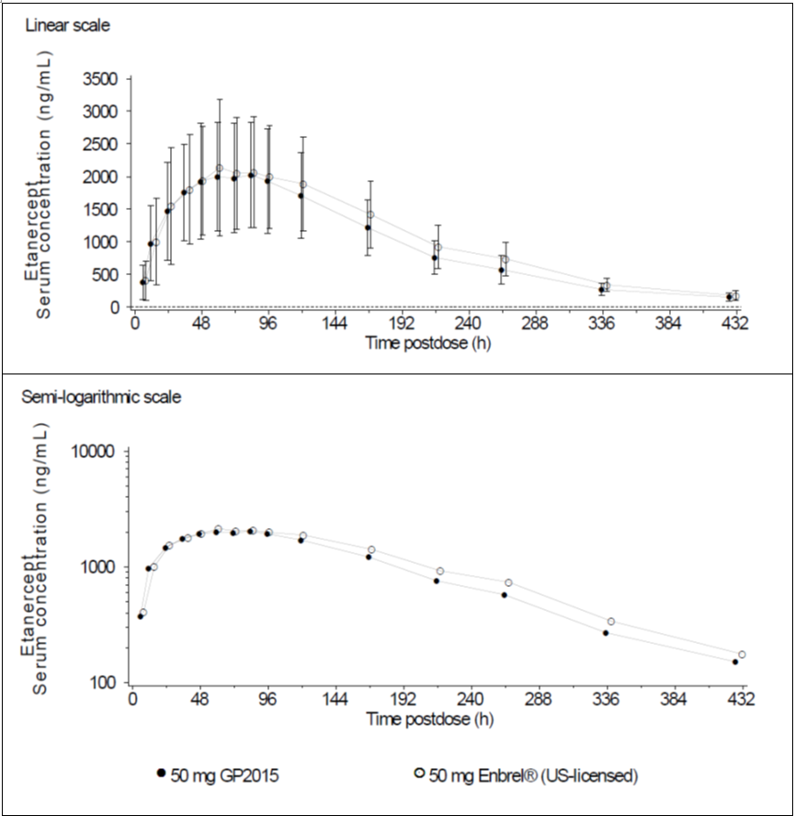
All measured/calculated PK parameters (Per-protocol Analysis Set) are shown. A statistical analysis of the primary PK parameters is shown: All 90% CIs of the mean parameter ratios (Erelzi/Enbrel (US)) were contained within the pre-specified limits of 0.8 to 1.25.
Table 10: Study GP15-102. Statistical analyses of PK parameters (with operator adjustment, Per-protocol Analysis Set).

PK results – sensitivity analysis
Only one sensitivity analysis was conducted, i.e. the non-consideration of operator effect on PK parameters. The results of this analysis are shown in this subsection.
The statistical analysis of the main PK parameters (C_{max}, AUC_{0-∞}, and AUC_{0-tlast}) (without operator adjustment) is shown. The 90% CIs of the mean parameter ratios (Erelzi/Enbrel (US)) were contained within the pre-specified limits of 0.8 to 1.25.
Table 11: Study GP15-102. Statistical analyses of PK parameters (without operator adjustment, Per-protocol Analysis Set).
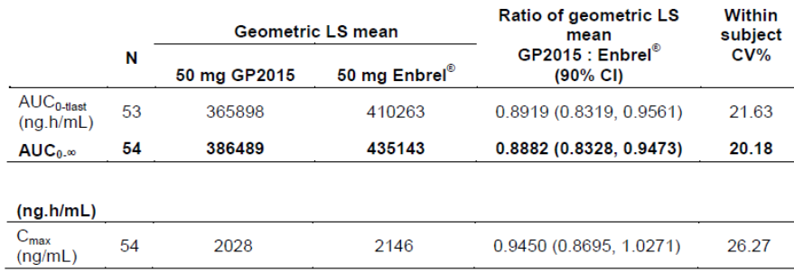

Immunogenicity
The sponsor states that all antibody results were negative.
Comment: Design: The crossover design is acceptable. However, the switch may have increased the risk of immunogenicity for individual subjects. The inclusion and exclusion criteria are acceptable. The use of one strength (in this case the higher strength) is acceptable in a drug displaying linear pharmacokinetics.
Blinding: The blinding methods were acceptable. Subjects, investigator staff, persons performing the assessments, laboratory personnel and data analysts were blinded. There was allocation concealment.
Dosing: This was a single-dose study only. Analyses of bioequivalence at steady state during the maintenance phase were not possible. Results from the clinical equivalence studies allowed a comparison of steady state PK.
PK sampling and analysis: was acceptable. Regarding sampling windows, there was no information given whether the actual sampling time was considered in the data analysis.
Statistical methods: The statistical methods used are compliant with regulatory guidance.
Methodology: The study is very similar to study GP15-101 and was conducted in the same centre. The deficiencies in methodology of GP15-101 were addressed in GP15-102. Operator effect was included in the analysis, but the sponsor has also conducted a sensitivity analysis of the results without operator effect. In both analyses, the 90% CIs of the mean parameter ratios (Erelzi/Enbrel (US)) were contained within the pre-specified limits of 0.8 to 1.25. This supports bioequivalence between Erelzi and Enbrel (US).
Immunogenicity: All samples were negative.
Summary: Overall, the bioequivalence criteria for Erelzi (compared to Enbrel (US) were met. The parameters assessed are within the prescribed bioequivalence margins and support bioequivalence. However, the results are only supportive, as the reference product, Enbrel (US), was not tested against the Australian Enbrel product.

PK Study GP15-103

Title
A randomized, open label, two-way cross-over study to determine the pharmacokinetics and safety of Erelzi following a single subcutaneous injection by an autoinjector and by a pre-filled syringe in healthy male subjects.

Objectives
Primary objective: To demonstrate bioequivalence of Erelzi administered by an autoinjector (delta-Erelzi_50) and a pre-filled syringe (PFS) as single subcutaneous (s.c.) injection of 50 mg to healthy adult male subjects in terms of the PK parameters AUC_{0-last}, AUC_{0-inf} and C_{max}.
Secondary objectives:
- To study and compare the primary PK parameters AUC_{0-last}, AUC_{0-inf} and C_{max}, by weight category (low: 50.0-79.9 kg, medium: 80.0-99.9 kg, and high: 100.0-140.0 kg) between delta-Erelzi_50 and PFS, when Erelzi was administered as a single s.c. injection of 50 mg.
- To compare remaining PK parameters t_{max}, k_{el}, t_{1/2} between delta-Erelzi_50 and PFS, both administered Erelzi as a single s.c. injection of 50 mg, across the total population as well as by weight categories.
- To evaluate and compare the overall safety, tolerability and local tolerance of Erelzi administered by delta-Erelzi_50 and PFS as a single s.c. injection of 50 mg.

Methodology
Design: Phase 1, open-label, randomised, two-way crossover study in healthy adult male subjects undertaken in one centre in The Netherlands in 2014.
There were only minor protocol changes prior to study commencement. One analysis change occurred post hoc: one outlier subject was removed from analysis (the subject was the subject with the highest body mass in the study; the PK parameters were significantly lower compared to the other subjects).
Inclusion criteria: The inclusion criteria were:
- Subjects were to provide written informed consent before any assessment was performed;
- Male subjects, aged 18 to 45 years inclusive;
- Physically and mentally healthy, as determined by physical examination and safety laboratory [assessments];
- Body weight between 50 to 140 kg and body mass index (BMI) between 18.5 to 49.9 kg/m² inclusively;
- Non-smoker or ex-smoker, defined as a subject who did not smoke for at least 6 months before IMP administration.
Treatments: Each subject received a single dose of Erelzi via PFS followed by a single injection of Erelzi via autoinjector, or vice versa. The CSR did not specify whether the syringes were weighed before and after administration to determine the actual dose given.
Table 12: Study GP15-103. Comparison of PFS and autoinjector treatments.
PK sampling and analysis: A study design and treatment schema is shown. The single dose was given on Day 1. Pharmacokinetic (PK) blood sample (3.5 mL) collection occurred pre-dose, then on days 1, 2, 3, 4, 5, 6, 8, 10, 12, 15, 19, 29 post-dose. The serum concentration of etanercept was determined using a validated enzyme linked immunosorbent assay (ELISA). . The lower limit of quantification (LLOQ) for etanercept levels was 6.7 ng/mL. The lower limit of quantification (LLOQ) for immunogenicity purposes was 200 ng/mL.
The following sampling windows were allowed:
- ± 5% of the nominal time after dosing until Day 15 inclusive.
- ± 1 day at Day 19 and Day 29 (Period 2).
The following PK parameters were measured/calculated from serum etanercept concentration data using non-compartmental methods:
- C_{max}: Maximum observed serum concentration (ng/mL);
- t_{max}: Time to the maximum observed serum concentration (h);
- AUC_{0-last}: Area under the serum concentration-time curve measured from the time of dosing to the last measurable concentration (ng.h/mL);
- AUC_{0-inf}: Area under the serum concentration-time curve measured from the time of dosing and extrapolated to infinity (ng.h/mL);
- AUC_{extra}: Percentage of AUC_{0-inf} obtained by extrapolation;
- k_{el}: Elimination rate constant (h⁻¹);
- t_{½}: Apparent terminal half-life of elimination phase (h); and
- CL_{0-inf}: Apparent clearance calculated as dose/AUC_{0-inf}.
Figure 7: Study GP15-103. Study design and treatment schema.
Statistical Analysis Plan (SAP): An analysis of covariance (ANCOVA) was used for statistical analysis of ln transformed C_{max}, AUC_{0-tlast}, AUC_{0-inf}. The ANCOVA model included treatment administration, sequence and period as fixed effects, and subject nested within sequence as a random effect. The subject’s weight was the covariate. Each ANCOVA included least-squares means (LSM) calculation for the treatment administered and LSM ratios were calculated. If non-normal distribution became apparent, a non-parametric analysis was to be performed (two 1-sided tests). The Hodges-Lehmann estimator associated with the Wilcoxon’s signed rank test was used to calculate a distribution-free CI for the difference in treatment administrations.
The null and alternative hypotheses were:
- H₀: μ_{PK,T}/μ_{PK,R} < 0.80 and μ_{PK,T}/μ_{PK,R} > 1.25
- H₁: 0.80 ≤ μ_{PK,T}/μ_{PK,R} ≤ 1.25
The secondary PK parameters were mainly analysed descriptively. For t_{½}, the same analysis as for the primary endpoints was applied. For t_{max}, the Hodges-Lehmann estimates for the differences between treatment administrations and the corresponding 90% CIs according to Tukey were computed.
Subgroup/sensitivity analyses: Subgroup analyses were conducted using different body mass categories (Low (50.0-79.9 kg); Medium (80.0-99.9 kg); High (100.0-140.0 kg)). Within that subgroup analyses, a sensitivity analysis was conducted that involved removing a subject with outlier results.
Safety analyses: adverse events (AEs), vital signs, Electrocardiogram (ECG) parameters, clinical laboratory, physical examination findings, local tolerance at the injection site and immunogenicity (including whether ADAs were neutralising) were recorded.

Study participants
The study disposition was as follows:
- Enrolled: N=51
- Completed: N=49
- Analysed (Pharmacokinetic Analysis Set): N=48 (one subject was found to have a have a pre-dose PK concentration of >5% of Cmax in Period 2 and was excluded from the Pharmacokinetic Analysis Set).
- Analysed (Safety Analysis Set): N=51
Table 13: Study GP15-103. Subject disposition.
A summary of baseline characteristics – the following terminology was used:
- Pharmacokinetic Analysis Set: all subjects completing both study periods, i.e. subject received both IMPs and completed Period 1 and Period 2 to the follow-up visit after the last IMP administration.
- Safety Analysis Set: All randomised subjects who received Erelzi at least once and had at least one post-baseline safety assessment were included in the safety evaluation. Subjects were analysed according to the administration method they actually received.

PK Results – primary analysis
The concentration-time profiles (linear and semi-logarithmic) comparing PFS and autoinjector are shown.
Figure 8: Study GP15-103. Concentration-time profiles (linear and semi-logarithmic) comparing the arithmetic means (+SD) of each treatment group (Pharmacokinetic Analysis Set).
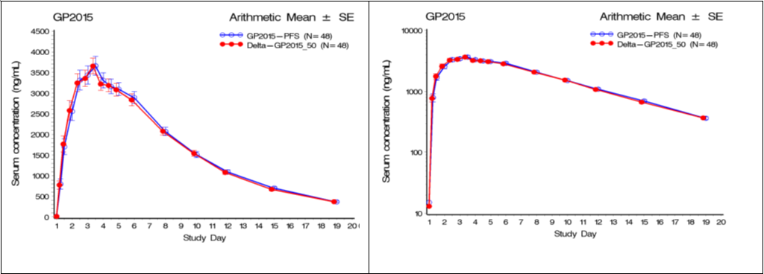
A statistical analysis of the primary PK parameters (C_{max}, AUC_{0-last}, AUC_{0-inf}) is shown. The 90% CIs of the mean parameter ratios (autoinjector/PFS) were contained within the pre-specified limits of 0.8 to 1.25.
Table 14: Study GP15-103. Statistical analyses of primary PK parameters (normalised dose, Pharmacokinetic Analysis Set).

PK Results – subgroup/sensitivity analyses
Subgroup analyses were conducted using different body mass categories (Low (50.0-79.9 kg); Medium (80.0-99.9 kg); High (100.0-140.0 kg)). Within that subgroup analyses, a sensitivity analysis was conducted that involved removing a subject with outlier results. The results are shown in this subsection.
The statistical analysis of the main PK parameters (C_{max}, AUC_{0-last}, AUC_{0-inf}) stratified by body mass (with the outlying subject included) is shown (Table 15). The 90% CIs of the mean parameter ratios (autoinjector/PFS) were contained within the pre-specified limits of 0.8 to 1.25 in the low and medium body mass strata. In the high body mass stratum, C_{max} and AUC_{0-last} ratio CIs were not contained within the target interval (the upper bound was 1.29 and 1.26, respectively), whereas the AUC_{0-inf} CIs were.
The statistical analysis of the main PK parameters (C_{max}, AUC_{0-last}, AUC_{0-inf}) stratified by body mass (with the outlying subject excluded) is shown (Table 16). The 90% CIs of the mean parameter ratios (autoinjector/PFS) were contained within the pre-specified limits of 0.8 to 1.25 in all three body mass strata.
Table 15: Study GP15-103. Statistical analyses of primary PK parameters (Pharmacokinetic Analysis Set) stratified by body mass (with the outlying subject included).
Table 16: Study GP15-103. Statistical analyses of primary PK parameters (Pharmacokinetic Analysis Set) stratified by body mass (with the outlying subject excluded).

Immunogenicity
All subjects had negative ADA results on Day 1 of both treatment periods and at follow-up.
Comment: Design: The crossover design is acceptable. However, the switch may have increased the risk of immunogenicity for individual subjects. The inclusion and exclusion criteria are acceptable. The use of one strength (in this case the higher strength) is acceptable in a drug displaying linear pharmacokinetics.
Dosing: This was a single-dose study only. Analyses of bioequivalence at steady state during the maintenance phase were not possible.
PK sampling and analysis: was acceptable. Regarding sampling windows, there was no information given whether the actual sampling time was considered in the data analysis.
Statistical methods: The statistical methods used were acceptable.
Methodology: The use of the 50 mg dose was acceptable due to relevant etanercept dose proportionality. A blinded study would have been advantageous, but given that this was mainly dependent on objective serum concentration measurements, the open-label approach is acceptable.
Results: The primary results support bioequivalence of PFS compared to the autoinjector. In the subgroup analyses of different body mass categories (Low (50.0-79.9 kg); Medium (80.0-99.9 kg); High (100.0-140.0 kg)), the 90% CIs of the mean parameter ratios (autoinjector/PFS) were contained within the pre-specified limits of 0.8 to 1.25 in the low and medium body mass strata. In the high body mass stratum, C_{max} and AUC_{0-last} ratios were not contained within the target interval (the upper bound was 1.29 and 1.26, respectively), but AUC_{0-inf} was within the target. The C_{max} and AUC_{0-last} ratios were only slightly over the target interval. Furthermore, AUC_{0-inf} is generally the more important and meaningful parameter (when compared to C_{max}). A sensitivity analysis of the same parameters excluded one obvious outlier. The exclusion is acceptable. The sensitivity analysis of the same PK parameters (C_{max}, AUC_{0-last}, AUC_{0-inf}) stratified by body mass (with the outlying subject excluded) revealed that 90% CIs of the mean parameter ratios (autoinjector/PFS) were contained within the pre-specified limits in all three body mass strata.
Summary: Overall, the bioequivalence criteria comparing the PFS and the autoinjector were met. The primary parameters assessed are within the prescribed bioequivalence margins and support bioequivalence.

Study GP15-302 (PK study data only)
Supportive PK data were supplied by study GP15-302. One of the secondary objectives was to compare the pharmacokinetics (PK) of Erelzi and Enbrel in terms of trough serum concentrations in a subset of 100 patients. However, 147 patients were enrolled, as more consent forms were received after the required patient number had been reached.
Trough serum concentrations of etanercept were determined in a subset of 147 patients (72 patients treated with Erelzi and 75 patients treated with Enbrel) at baseline (Day 1) and at Weeks 2, 4, 8, and 12.
The PK Analysis Set was used to analyse the data. The PK Analysis Set included patients with quantifiable PK measurements of etanercept. Patients with major protocol deviations related to PK sampling as determined in the BDRM were excluded from the PK analysis set. Patients were analysed according to the actual treatment they received.
Trough serum concentration levels after multiple dosing of Erelzi 50 mg or Enbrel 50 mg at Weeks 2, 4, 8 and 12 were similar in the two treatment groups.
Table 17: Study GP15-302. Arithmetic Mean Summary of Trough Serum Pharmacokinetics Concentrations (ng/mL) by Visit and Treatment (PK Analysis Set).
Table 18: Study GP15-302. Geometric LS Mean Summary of Trough Serum Pharmacokinetics Concentrations (ng/mL) and Ratios by Visit and Treatment (PK Analysis Set).
Comment: Trough serum concentration levels after multiple dosing of Erelzi 50 mg or Enbrel 50 mg at Weeks 2, 4, 8 and 12 appeared to be similar in the two treatment groups. They were contained within the 0.80-1.25 ratio range for Weeks 2, 4, and 12, but not for Week 8. Nevertheless, the results are supportive of bioequivalence.

Pharmacokinetic results excluded from consideration
A summary of pharmacokinetic results excluded from consideration are listed. The PK results in Study GP15-101 were not used for the purposes of this evaluation due to issues with the methodology.
Table 19: Pharmacokinetic results excluded from consideration.
Study ID | Subtopics | PK results excluded
GP15-101 | PK data | PK data

Summary of pharmacokinetics

Physicochemical characteristics of the active substance
The following information on physicochemical characteristics is derived from the proposed PI document for Erelzi and refers to the reference product Enbrel. The section with regard to physicochemical characteristics is essentially identical to the corresponding section in the reference product PI document.
Etanercept is a human tumour necrosis factor receptor p75 Fc fusion protein produced by recombinant DNA technology in a Chinese hamster ovary (CHO) mammalian expression system. Etanercept is a dimer of a protein genetically engineered by fusing the extracellular ligand-binding domain of human tumour necrosis factor receptor-2 (TNFR2/p75) to the Fc domain of human IgG1. This Fc component contains the hinge, CH2 and CH3 regions but not the CH1 region of IgG1. Etanercept contains 934 amino acids and has an apparent molecular weight of approximately 150 kilodaltons. Erelzi is manufactured using a serum-free process.

Pharmacokinetics in healthy subjects, the target population, and special populations
The following information on pharmacokinetics is derived from the proposed PI document for Erelzi and refers to the reference product Enbrel. The section with regard to pharmacokinetics is essentially identical to the corresponding section in the reference product PI document.
Absorption
Etanercept is slowly absorbed from the site of subcutaneous (SC) injection, reaching maximum concentration between 24 and 96 hours after a single dose. The absolute bioavailability is 76% as calculated in a population pharmacokinetic analysis of several studies. With twice weekly doses, it is anticipated that steady-state concentrations may be two to five-fold greater than those observed after single doses. After a single SC dose of 25 mg etanercept, the average maximum serum concentration observed in healthy volunteers was 1.65 ± 0.66 mg/L, and area under the curve was 235 ± 96.6 mg.hr/L. Dose proportionality has not been formally evaluated, but there is no apparent saturation of clearance across the dosing range.
Distribution
A bi-exponential curve is required to describe the concentration time curve of etanercept. The central volume of distribution of etanercept is 7.6 L, while the volume of distribution at steady state is 10.4 L.
After continued dosing of RA patients (n = 25) with etanercept for 6 months with 25 mg twice weekly, the median observed level was 3.0 mg/L (range 1.7 to 5.6 mg/L).
Excretion
Etanercept is cleared slowly from the body. The half-life is approximately 80 hours. Clearance is approximately 0.066 L/hr in patients with RA, somewhat lower than the value of 0.11 L/hr observed in healthy volunteers. Additionally, the pharmacokinetics of etanercept in rheumatoid arthritis patients, plaque psoriasis and ankylosing spondylitis patients are similar.
Serum concentration profiles at steady state were comparable among patients with RA treated with 50 mg etanercept powder for injection formulation once weekly and those treated with 25 mg etanercept powder for injection formulation twice weekly. A single 50 mg/mL injection of etanercept was also found to be bioequivalent to two simultaneous injections of 25 mg/mL. The mean (± standard deviation) C_{max}, C_{min} and partial AUC were 2.4 ± 1.5 mg/L, 1.2 ± 0.7 mg/L and 297 ± 166 mg.h/L, respectively, for patients treated with 50 mg etanercept once weekly (n = 21); and 2.6 ± 1.2 mg/L, 1.4 ± 0.7 mg/L and 316 ± 135 mg.h/L for patients treated with 25 mg etanercept twice weekly (n = 16). Serum concentrations in patients with RA have not been measured for periods of dosing that exceed 6 months. In an open-label, single-dose, two treatment crossover study in healthy volunteers, etanercept administered as a single injection of etanercept 50 mg solution for injection was found to be bioequivalent to two simultaneous injections of etanercept 25 mg powder for injection formulation. The mean (± standard deviation) C_{max} and AUC_{(0-t)} are expressed in the table below.
Table 20: The mean (± standard deviation) Cmax and AUC(0-t) from two treatment crossover study in healthy volunteers
Although there is elimination of radioactivity in urine after administration of radiolabelled etanercept to patients and volunteers, increased etanercept concentrations were not observed in patients with acute renal or hepatic failure. The presence of renal and hepatic impairment should not require a change in dosage. There is no apparent pharmacokinetic difference between men and women.
No formal pharmacokinetic studies have been conducted to examine the metabolism of etanercept or the effects of renal or hepatic impairment. Methotrexate has no effect on the pharmacokinetics of etanercept. The effect of etanercept on the human pharmacokinetics of methotrexate has not been investigated.
The data described above were derived from studies using etanercept manufactured using a serum-based process.
Special populations
Elderly (>65 years)
The impact of advanced age was studied in the population pharmacokinetic analysis of etanercept serum concentrations. Clearance and volume estimates in patients aged 65 to 87 years were similar to estimates in patients less than 65 years of age.
Patients with juvenile idiopathic arthritis
In a polyarticular juvenile idiopathic arthritis (JIA) trial with etanercept, 69 patients (age 4 to 17 years) were administered 0.4 mg etanercept/kg twice weekly for three months. Serum concentration profiles were similar to those seen in adult rheumatoid arthritis patients. The youngest children (4 years of age) had reduced clearance (increased clearance when normalised by weight) compared with older children (12 years of age) and adults. Simulation of dosing suggests that while older children (10-17 years of age) will have serum levels close to those seen in adults, younger children will have appreciably lower levels.
Paediatric patients with plaque psoriasis
Patients with paediatric plaque psoriasis (aged 4 to 17 years) were administered 0.8 mg/kg (up to a maximum dose of 50 mg per week) of etanercept once weekly for up to 48 weeks. The mean serum steady state trough concentrations ranged from 1.6 to 2.1 mg/L at weeks 12, 24, and 48. These mean concentrations in patients with paediatric plaque psoriasis were similar to the concentrations observed in patients with juvenile idiopathic arthritis (treated with 0.4 mg/kg etanercept twice weekly, up to maximum dose of 50 mg per week). These mean concentrations were similar to those seen in adult patients with plaque psoriasis treated with 25 mg etanercept twice weekly.

Evaluator’s overall conclusions on pharmacokinetics
Overall, the bioequivalence criteria for Erelzi were met. The main results were within the prescribed bioequivalence margins and are acceptable.
Enbrel is currently approved in Australia and its PK study data and their description in the product information (PI) document have previously been accepted by the TGA. Consequently, the product information (PI) document of any approved biosimilar to Enbrel without separate PK studies should contain the identical information with regard to pharmacokinetics. The proposed PI document for Erelzi fulfils this requirement. However, in the ‘Pharmacology’ section, in the ‘Pharmacokinetics’ subsection, under a ‘Comparability of Erelzi with Enbrel’ subheading, comparability data should be added.
Nearly no subjects in the PK studies developed ADAs. More detail and questions are directed to the sponsor.
As stated above, the clinical efficacy study reporting did not show the trough concentration mean ratios and associated 90% CIs. All of the information necessary is presented in tables.

Pharmacodynamics
Pharmacodynamic data pertaining to Enbrel are proposed to be included in the Erelzi PI. In the proposed PI for Erelzi, the section with regard to pharmacodynamic data is identical to the corresponding section in the reference product PI document. However, in the ‘Pharmacology’ section, in the ‘Pharmacodynamics’ subsection, under a ‘Comparability of Erelzi with Enbrel’ subheading, comparability data should be added.
Study GP15-302 had a small pharmacodynamic component, in which high sensitivity C-reactive protein (hsCRP) was used as a pharmacodynamic marker. This marker was compared between the treatment groups at baseline, and at Weeks 4 and 12.
The mean hsCRP levels (± SD) (Erelzi vs. Enbrel) were 4.390 ± 5.8540 mg/L vs. 4.529 ± 12.0969 mg/L, 1.993 ± 3.5787 mg/L vs 1.810 ± 2.6836 mg/L, and 1.889 ± 2.7920 mg/L vs. 1.747 ± 3.0309 mg/L at baseline, Week 4, and Week 12, respectively. The proportions of patients with high hsCRP levels as well as the mean hsCRP levels were similar between the Erelzi and Enbrel groups.
The results are generally supportive of biosimilarity, but a pharmacodynamic assessment was not necessarily required to establish this.

Dosage selection for the pivotal studies
The doses used in clinical equivalence study were identical to the usual recommended dosing regimen for the respective adult indications in the reference product Enbrel.

Clinical efficacy

Studies providing evaluable efficacy data
One study provided evaluable efficacy data for plaque psoriasis:
- Study GP15-302: a phase 3, double-blind, randomised, active comparator-controlled study in 531 subjects with moderate to severe psoriasis evaluating the efficacy and safety of Erelzi compared with Enbrel (EU).

Pivotal or main efficacy studies

Study GP15-302 (EGALITY)

Title
A randomized, double-blind, multicenter study to demonstrate equivalent efficacy and to compare safety and immunogenicity of a biosimilar etanercept (Erelzi) and Enbrel in patients with moderate to severe chronic plaque-type psoriasis (EGALITY).

Design
A phase 3, double-blind, randomised, active comparator-controlled study in 774 subjects with moderate to severe psoriasis evaluating the efficacy and safety of Erelzi compared with Enbrel (EU).
Figure 9: Study GP15-302: Study design schema.
The outline of the study design is shown. The total duration of the study was up to 52 weeks:
- Screening period: Subjects were screened and randomised before drug administration.
- Treatment Period 1 (12 weeks): Subjects received Erelzi (Group 1) or Enbrel (Group 2).
  - The primary efficacy endpoint was assessed at Week 12. The subjects that showed a PASI 50 response (50% or better improvement) continued in the study until up to Week 52. Subjects without a PASI 50 response at week 12 were discontinued from the study.
- Treatment Period 2 (Week 12 to 30):
  - Group 1 was split:
    - Group 1a continued on Erelzi.
    - Group 1b switched to Enbrel at Week 12, then switched to Erelzi at Week 18, then switched to Enbrel at Week 24.
  - Group 2 was split:
    - Group 2a continued on Enbrel.
    - Group 2b switched to Erelzi at Week 12, then switched to Enbrel at Week 18, then switched to Erelzi at Week 24.
- Extension Period (Week 30 to 52):
  - Group 1a continued on Erelzi.
  - Group 1b continued on Enbrel.
  - Group 2a continued on Enbrel.
  - Group 2b continued on Erelzi.

Objectives
Primary Study Objective: to demonstrate equivalent efficacy of Erelzi and Enbrel (EU-authorized) in patients with moderate to severe chronic plaque-type psoriasis with respect to Psoriasis Area and Severity Index (PASI) 75 response rate at Week 12.
Secondary Study Objectives in Treatment Period 1 (TP1) (up to Week 12):
- To compare PASI 50, PASI 75, and PASI 90 response rates of Erelzi and Enbrel.
- To compare the response of patients treated with Erelzi and Enbrel over time based on the PASI score.
- To compare the response rates of Erelzi and Enbrel determined by the Investigator’s Global Assessment (IGA) of disease activity.
- To compare the health-related quality of life (HRQoL) during treatment with Erelzi and Enbrel by the Dermatology Life Quality Index (DLQI) and the EuroQol 5-Dimension Health Status Questionnaire (EQ-5D).
- To compare functional ability by the Health Assessment Questionnaire-Disability Index
- (HAQ-DI) only in patients with a medical history of psoriatic arthritis (PsA).
- To compare the clinical safety and tolerability of Erelzi and Enbrel as assessed by vital signs, clinical laboratory variables, electrocardiograms (ECGs), and adverse event (AE) monitoring.
- To compare injection site reactions (ISRs).
- To compare the pharmacokinetics (PK) of Erelzi and Enbrel in terms of trough serum concentrations in a subset of 100 patients [Appendix 16.1.1-Protocol amendment 1].
- To compare immunogenicity as determined by measuring the rate of anti-drug antibody (ADA) formation against Erelzi and Enbrel.
Secondary Study Objectives in Treatment Period 2 (TP2) (Week 12 to Week 30):
- To compare efficacy, safety, and immunogenicity data from patients who were continually treated with Erelzi (Group 1a) versus those from patients who were continually treated with Enbrel (Group 2a).
- To compare efficacy, safety, and immunogenicity of pooled data from patients who underwent repeated switches (Groups 1b and 2b; pooled switched) with pooled data from patients who were continually treated with Erelzi and Enbrel (Groups 1a and 2a; pooled continued).
Secondary Study Objectives in the Extension Period (EP) (Week 30 to 52):
- To compare efficacy, long term safety, and immunogenicity data from patients who were continually treated with Erelzi (Group 1a) versus those of patients who were continually treated with Enbrel (Group 2a) after Week 30 up to Week 52 [Appendix 16.1.1-Protocol amendment 1].
- To compare efficacy, long term safety, and immunogenicity of pooled data from patients who underwent repeated switches and then continued with the last treatment after Week 30 for a further 22 weeks (Groups 1b and 2b; pooled switched) with pooled data from patients who were continually treated with Erelzi and Enbrel (Groups 1a and 2a; pooled continued) for 52 weeks.

Location and dates
The study was conducted at 71 centres in Bulgaria, Czech Republic, Estonia, Germany, Hungary, Poland, Romania, Russia, Slovakia, South Africa, United Kingdom and Ukraine, between 24 June 2013 (first patient first visit) and 30 March 2015 (last patient last visit).

Inclusion and exclusion criteria
The inclusion criteria were:
- Patients had to be able to understand and communicate with the investigator and comply with the requirements of the study (including administration of s.c. injections at home) and had to give a written, signed and dated informed consent before any study related activity was performed. Where relevant, a legal representative was also to sign the informed study consent according to local laws and regulations.
- Men or women at least 18 years of age at time of screening.
- Chronic plaque-type psoriasis diagnosed at least 6 months before baseline.
- Moderate to severe psoriasis as defined at baseline by:
  - PASI score of 10 or greater and,
  - IGA score of 3 or greater (based on a scale of 0 - 4) and,
  - BSA affected by plaque-type psoriasis of 10% or greater.
- Chronic plaque-type psoriasis patients who had previously received phototherapy or systemic psoriasis therapy at least once or who were candidates for such therapies in the opinion of the investigator.
The exclusion criteria included:
- Forms of psoriasis other than chronic plaque-type.
- Ongoing use of prohibited psoriasis treatments (e.g., topical corticosteroids, UV-therapy) or other non-psoriasis prohibited treatments.
- Previous exposure to etanercept.
- Pregnant or nursing (lactating) women.
- Women of child-bearing potential, unless they used effective contraception during the study and for 4 weeks after stopping treatment, such as: barrier methods, total abstinence, female or male sterilisation, or hormonal methods of contraception, intrauterine device or intrauterine system.
- Active ongoing inflammatory diseases other than psoriasis that could confound the evaluation of the benefit of treatment with etanercept.
- Underlying condition which significantly immunocompromised the patient and/or placed the patient at unacceptable risk for receiving an immunomodulatory therapy.
- History of clinically significant liver disease or liver injury.
- Pre-existing or recent-onset central or peripheral nervous system demyelinating disorders or patients who were considered to have an increased risk of developing a demyelinating disease.
- Significant cardiovascular problems.
- Patients with a serum creatinine level exceeding 176.8 μmol/L (2.0 mg/dL).
- Screening total white blood cell count < 3500/μL, or neutrophils < 2000/μL or platelets < 125000/μL or hemoglobin < 10.0 g/dL.
- Radiographic evidence of ongoing infectious or malignant process obtained within 3 months prior to baseline.
- History of an ongoing, chronic or recurrent infectious disease (including tuberculosis (TB), HIV, hepatitis B or hepatitis C.
- Active systemic infections during the last 2 weeks (exception: common cold) or patients with a history or evidence of opportunistic infections.
- History of lymphoproliferative disease or any known malignancy or history of malignancy of any organ system (except some skin and cervical conditions).
- Current severe progressive or uncontrolled disease, or any medical or psychiatric condition which, could preclude the participant from adhering to the protocol or completing the study per protocol.
- History of hypersensitivity to any recombinant protein drugs or any of the excipients used in Erelzi or Enbrel, or to rubber or latex.
- History or evidence of ongoing alcohol or drug abuse, within the last 6 months before baseline.
- Plans for administration of live vaccines during the study period or live vaccination within 6 weeks prior to baseline.
- Use of investigational treatment within 4 weeks before screening, or within a period of 5 half-lives of the investigational treatment, whichever was longer.
- Patients not willing to limit UV light exposure during the course of the study.
Comment: The inclusion and exclusion criteria that were used in the study are acceptable, as they provide a reasonable balance between internal and external validity.
The main inclusion criteria in the two pivotal trials for etanercept in plaque psoriasis (Leonardi, et al. (2003) and Papp, et al. (2005)) were very similar to the main inclusion criteria in EGALITY

Study treatments
Both Erelzi and Enbrel (EU) were administered by subcutaneous injection at a dose of 50 mg twice weekly for the first 12 weeks and 50 mg once weekly thereafter. Both products were supplied as pre-filled syringes of identical appearance.
The dosing regimen in the currently registered PI document for Enbrel specifies:
The recommended dose of Enbrel is 50 mg per week, given once weekly (single 50 mg injection) or twice weekly (single 25 mg injections given 3-4 days apart) as a subcutaneous injection. Higher responses may be achieved from initial treatment for up to 12 weeks with a dose of 50 mg given twice weekly, after which, the dose should be reduced to the standard dose of 50 mg per week. Treatment should be discontinued in patients who do not show a significant PASI response after 12 weeks. If re-treatment with Enbrel is indicated, the dose used should be 50 mg per week.
Therefore, the dosing schedule in EGALITY was identical to the higher dosing regimen in currently registered Enbrel PI document.
During the screening period, certain active topical treatments limited to mild or moderate potency corticosteroids on face, scalp, and genitoanal area were permitted. These treatments had to cease at the randomisation stage. Topical treatments used on other body areas were subject to a 2 week washout. Furthermore, patients were to be advised to limit exposure to UV light (including sunbathing and/or use of UV tanning devices) during the study to avoid possible effects on psoriasis. Prohibited treatments are listed.
Table 21: Study GP15-302. Prohibited treatments.
Comment: The dosing schedule and rules were appropriate. The choice of comparator was appropriate. The list of prohibited medications was reasonable and strengthened internal validity. In contrast, the two pivotal trials for Enbrel in plaque psoriasis (Leonardi, et al. (2003) and Papp, et al. (2005)) both permitted patients to continue on stable doses of topical steroids only on the scalp, axilla, and groin during the study.
The 50 mg twice weekly regimen for the first 12 weeks was one of the regimens used in the Enbrel pivotal trials. The pivotal trials also included treatment arms with lower doses, but they were found to be less efficacious

PASI score
For the purposes of this study, the PASI score was used a key psoriasis assessment tool. The PASI measures the average redness (erythema), thickness (induration), and scaliness (each graded on a 0 to 4 scale) of psoriasis lesions, weighted by the area of involvement (Fredriksson & Pettersson, 1978; Feldman & Krueger, 2005; Spuls et al., 2010.). This will result in a score from 0 (no disease) to 72 (maximal disease), but that the upper end of the scale is rarely used. Typically, a PASI score ≤ 10 is considered to be mild disease, and a score of 10-20 moderate, and a score > 20 is considered severe. In this study, the assessments for a given subject were made by the same observer whenever possible.
To be eligible for the study, a PASI score of ≥ 10 and ≥ 10% total BSA involved was required at baseline.

Investigator’s global assessment
The investigator’s global assessment scoring system was also used. The system used was static, i.e. no comparison with previous states was used. In this study, the assessments for a given subject were made by the same observer whenever possible.
To be eligible to participate in the study an IGA score of 3 or 4 at baseline was necessary. Patients were considered IGA responders if they achieved a score of 0 (“clear”) or 1 (“almost clear”) and improved by at least 2 points compared to baseline.

Primary efficacy variable (endpoint)
The primary efficacy endpoint was the proportion of PASI 75 responders at Week 12 (TP1).

Secondary efficacy variables (endpoints)
The secondary efficacy endpoints up to Week 12 (TP1) were:
- PASI percent improvement from baseline up to Week 12 (TP1) (MMRM analysis and mean ATE).
The secondary efficacy endpoints in all study periods (TP1, TP2, EP, and in the overall analysis (OA)) were:
- PASI 50, 75, and 90 response proportions.
- Percentage change from baseline in PASI scores.
- IGA (proportion of patients achieving clear (0) or almost clear (1) disease state).
- HRQoL as assessed with regard to relative changes in the DLQI, the EQ-5DTM, and the proportion of patients achieving a DLQI of 0 or 1.
- Functional ability in patients with a medical history of PsA as assessed with regard to relative changes in the HAQ-DI and visual analogue scale (VAS) of pain.
Comment: There are multiple known issues with the PASI score, including: uncertain clinical significance of a change in PASI score; reduced usefulness beyond a PASI score of 30; overestimation of the surface area affected. However, there are no widely accepted alternatives and the PASI score has been commonly used in the past and allows for comparison with historical trials.
The PASI score is an indicator for psoriasis that had been used in the reference product pivotal trials (Leonardi, et al. (2003) and Papp, et al. (2005) as the primary endpoint in each trial: both used the proportion of PASI 75 responders at Week 12.
It could be argued that, for an equivalence trial, the use of a continuous PASI variable, e.g. Percentage change from baseline, is more suitable to detect smaller differences in treatment effect than a categorical variable, e.g. PASI 75.
The relevant EU guidance “Guideline on the clinical investigation of medicinal products indicated for the treatment of psoriasis (CHMP/EWP/2454/02 corr)” specifies that the PASI score alone is not sufficient to evaluate psoriasis severity. Consequently, in EGALITY, the secondary endpoints include other scoring systems, e.g. static IGA, DLQI, EQ-5D, HAQ-DI and a pain VAS. Global assessments were also used in the pivotal trials, with one of the trials using a physician assessment (similar to EGALITY) (Papp, et al. (2005)), but the other trial used a patient’s global assessments (Leonardi, et al. (2003)).
It is noted that BSA was not a separate endpoint which is unusual for a psoriasis trial. However, the PASI score includes a BSA component. Both the PASI score and another validated score for psoriasis assessment (e.g. the IGA score) should be used to adequately assess efficacy. But given that this equivalence trial did not aim to establish efficacy de novo, but aimed to establish equivalence, and given that the results for scores other than PASI have been provided, the chosen endpoints are acceptable for the purposes of this study

Randomisation
On Treatment Day 1 (Visit 2), all eligible patients were randomised via the Interactive Response Technology (IRT) in a 1:1 ratio to one of two treatment arms for TP1.
At Week 12 (Visit 6), PASI 50 responders were to be re-assigned via IRT to one of four treatment arms:
- Patients from Group 1 were to be randomised 6:1 to Group 1a or Group 1b.
- Patients from Group 2 were to be randomised 6:1 to Group 2a or Group 2b.
This would have given a ratio of 3:1 (continuous treatment : alternating treatment).
The re-assignment ratio of 6:1 was set up in the IRT system to obtain an overall randomisation ratio of 3:1 (at Week 12) between the continuous versus the alternating treatment arms to balance the initial re-assignment ratio of 1:1. However, this ratio could not be reached. The sponsor provided the following justification for this:
Due to the fact that in the IRT system the re-assignment rate of 6:1 was effective relatively late into the study only for patients who had signed the amended ICF and when such ICF signature had been registered in the IRT system, the intended overall randomization ratio of 3:1 could not be reached. Finally, an actual randomization ratio of about 3:2 was reached.
For TP1, randomisation was stratified by body mass (< 90 kg; ≥ 90 kg) and prior systemic therapy (no prior systemic therapy, any prior systemic therapy including biologic immunomodulating agents but no prior treatment with a TNF antagonist, or prior treatment with a TNF antagonist). The re-assignment at Week 12 (Visit 6) was not stratified.

Blinding
The following were blinded from the time of randomisation until final database lock: patients, investigator staff, persons performing the assessments, and data analysts.
After all patients had completed Week 12, designated sponsor team members were unblinded to the treatment assignment at baseline (Visit 2). Blinded and unblinded sponsor teams were maintained until the end of the study.
The study drug was to be discontinued for any patient whose treatment code had been broken by the investigator for any reason.

Allocation concealment
Allocation concealment was implemented.
Comment: The randomisation methods were adequate

PP population (primary analysis sets)
The primary efficacy analysis was conducted using the per-protocol (PP) population. Patients were analysed according to the actual treatment they received. Any patients incorrectly assigned to a stratum were analysed as per the actual stratum as determined by the clinical database.
- Treatment Period 1 Per-protocol Set (TP1 PPS): all patients that completed the study until Week 12 without major protocol deviations. Dropouts due to unsatisfactory therapeutic effect were included in the TP1 PPS as non-responders provided they received at least 4 weeks of treatment. Potential exclusions based on missed applications were assessed during the blinded data review meeting prior to unblinding.
- Treatment Period 2 Per-protocol Set (TP2 PPS): all patients in the TP2 FAS who completed the study until Week 30 without major protocol deviations. Dropouts due to unsatisfactory therapeutic effect were to be included in the TP2 PPS as non-responders. Potential exclusions based on missed treatment applications were to be assessed during the blinded data review meeting prior to unblinding.
- Extension Period Per-protocol Set (EP PPS): all patients in the EP FAS who completed the study until Week 52 without major protocol deviations. Dropouts during the EP due to unsatisfactory therapeutic effect were included in the EP PPS as non-responders.
- Overall Analysis Per-protocol Set (OA PPS): all patients that completed the study (Week 52) without major protocol deviations. All patients with major protocol deviations during any of the treatment periods were excluded from the OA PPS. Dropouts due to unsatisfactory therapeutic effect were included in the PPS as non-responders provided they received at least 4 weeks of treatment. The OA PPS was not planned in the protocol or amendments but was added in an OA SAP (CSR Appendix 16.1.9) before final database lock in order to provide cumulative analyses across all of the treatment periods.

ITT population
The intention to treat analysis populations consisted of the following:
- Treatment Period 1 Full Analysis Set (TP1 FAS): all randomised patients to whom study treatment was assigned. Patients were analysed according to the treatment assigned to at randomisation.
- Treatment Period 2 Full Analysis Set (TP2 FAS): all patients who underwent re-assignment at Week 12 and who took at least one dose of study treatment during TP2.
- Extension Period Full Analysis Set (EP FAS): all patients who underwent re-assignment at Week 12 and who took at least one dose of study treatment during the EP after Week 30.
- Overall Analysis Full Analysis Set (OA FAS): all patients to whom study treatment was assigned in TP1. Patients were analysed according to the treatment assigned to at randomisation.
For TP1 FAS and OA FAS: If the actual stratum was different from the assigned stratum in the IRT, patients were to be analysed as per the actual stratum as determined by the clinical database.

Safety population
All patients were analysed according to treatment received.
- Treatment Period 1 Safety Set (TP1 Safety set): all patients who took at least 1 dose of study treatment during the treatment period.
- Treatment Period 2 Safety Set (TP2 Safety set): all patients who took at least 1 dose of study treatment during TP2.
- Extension Period Safety Set (EP Safety set): all patients who took at least 1 dose of study treatment during the EP.
- Overall Analysis Safety Set (OA Safety set): all patients who took at least 1 dose of study treatment during the study. The OA safety set was not planned in the protocol or amendments but was added in an OA SAP (CSR Appendix 16.1.9) before final database lock in order to provide cumulative analyses across all of the treatment periods.

Immunogenicity population
Patients were analysed according to the actual treatment they received.
- Treatment Period 1 Immunogenicity Set: Patients who provided data for ADA assessment of etanercept at baseline Visit were included in the TP1 Immunogenicity set.
- Treatment Period 2 Immunogenicity Set: All patients in the TP2 FAS were included in the TP2 Immunogenicity set, which is the same as TP2 FAS.
- Extension Period Immunogenicity Set: All patients in the EP Safety set were included in the EP Immunogenicity set, which is the same as EP Safety set.

Pharmacokinetic population
Patients were analysed according to the actual treatment they received.
PK Analysis Set: Patients with quantifiable PK measurements of etanercept were to be included in the PK analysis set. Patients with major protocol deviations related to PK sampling as determined in the blinded data review meeting were excluded from the PK analysis set.
Comment: The primary efficacy analysis was conducted using the per-protocol (PP) population and is the usually preferred method for equivalence trials. There is no overall consensus on whether intention-to-treat population (ITT) or per-protocol (PP) population is preferable for equivalence trials. ITT analyses often tend to bias the results toward equivalence. The preferred method is to provide analyses of both PP and ITT population sets, and the sponsor has done so.
The main analysis population matched the population specified in the study protocol.

Treatment period 1
The equivalence margin for the PASI 75 response at Week 12 was based on response proportions from the two pivotal trials (difference in response proportion: 46% (Papp, et al. (2005), and 45% (Leonardi, et al. (2003)).
The following assumptions appeared to have been made:
- 1:1 randomisation (Erelzi : Enbrel (EU)) (until week 12 only) (assumed assumption).
- Power > 90%.
- Equivalence margin of ±18% (for with a significance level of 0.025).
The sponsor stated that based on the assumptions made, a sample size of approximately 546 patients (to maintain 464 evaluable patients with an assumed drop-out and major protocol deviation rate of 15%) was needed. Due to the low dropout rate, only 531 patients were randomised.

Treatment period 2
The sponsor assumed that 20% of patients would drop out before the first switch (if PASI 50 not achieved) and 5% of patients dropped out at each of the three switching periods resulting in 236 patients under continued treatment (groups 1a and 2a) and 78 patients under switched treatment (groups 1b and 2b) after 30 weeks. The sponsor stated that with these sample sizes, equivalence within margins of ± 18% could still be shown with a power of 63% (as opposed to a power of 90% with 232 evaluable patients per arm for the primary analysis at Week 12) provided that the response rate remained at the same level (49%) over time and no difference was expected.

Extension period
The sample size determination would be the same as for the end of Treatment Period 2, as patients continued in the same treatment groups as in the last part of Treatment Period 2.

Secondary endpoints
The sponsor used MMRM and ATE to perform power calculations for the key secondary efficacy analyses (in TP1 only). Given the greater sensitivity of percent PASI change as compared to PASI 75, an assumed equivalence margin of 15% was used.
Comment: The assumptions used for determining the sample size are reasonable.

Statistical methods
Summary statistics for continuous variables included N, mean, standard deviation (SD), minimum, median, and maximum. Summary statistics for discrete variables were presented in contingency tables and included absolute and relative frequencies. Unless otherwise specified, p-values were presented as 2-sided p-values with 2-sided confidence intervals (CIs).

Primary endpoint
An equivalence margin of 18% was used to test equivalence on the primary variable, namely the proportion of PASI 75 responders at Week 12 using a 2-sided 95% confidence interval.
The primary analysis was performed adjusting for stratification factors using logistic regression. For TP1 only, stratification factors were: body mass (< 90 kg; ≥ 90 kg) and prior systemic therapy (no prior systemic therapy, any prior systemic therapy including biologic immunomodulating agents but no prior treatment with a TNF antagonist, or prior treatment with a TNF antagonist). Additionally, summary tables were stratified descriptively by country.
No imputation for missing PASI scores and components of PASI score was performed for the main analysis; for a sensitivity analysis, missing data was imputed as non-response.

Secondary endpoint
The secondary efficacy endpoints up to Week 12 (TP1) were:
- PASI percent improvement from baseline up to Week 12 (TP1):
  - MMRM analysis was conducted on the Full Analysis Set and the Per-protocol Set; the factors were: treatment group (Erelzi or Enbrel), body mass (< 90 kg; ≥ 90 kg), and prior systemic therapy (no prior systemic therapy, any prior systemic therapy including biologic immunomodulating agents but no prior treatment with a TNF antagonist, or prior treatment with a TNF antagonist); the baseline PASI score was fitted as a continuous covariate).
  - Mean ATE was conducted on the Full Analysis Set and the Per-protocol Set; an ANCOVA was conducted using treatment group (Erelzi or Enbrel), body mass (< 90 kg; ≥ 90 kg), and prior systemic therapy (no prior systemic therapy, any prior systemic therapy including biologic immunomodulating agents but no prior treatment with a TNF antagonist, or prior treatment with a TNF antagonist) as factors, and baseline PASI score as covariate).
The secondary efficacy endpoints in all study periods (TP1, TP2, EP, and in the overall analysis (OA)) were:
- PASI 50, 75, and 90 response proportions (logistic regression model adjusting for the stratification factors: treatment group, body mass, and prior systemic therapy).
- Percentage change from baseline in PASI scores (summary statistics).
- IGA (proportion of patients achieving clear (0) or almost clear (1) disease state) (summary statistics).
- Change from baseline in IGA (summary statistics).
- HRQoL as assessed with regard to relative changes in the DLQI, the EQ-5DTM, and the proportion of patients achieving a DLQI of 0 or 1 (summary statistics).
- Functional ability in patients with a medical history of PsA as assessed with regard to relative changes in the HAQ-DI and visual analogue scale (VAS) of pain (summary statistics).

Primary endpoint equivalence margin
As stated in the previous section, there is not much information on the methodology that was used to determine the primary endpoint equivalence margin.
Comment: The sponsor’s proposed methodology in the statistical analysis plan is acceptable, with a few exceptions, outlined below:
An equivalence margin of 18% in both directions is too wide, even when a categorical variable such as PASI 75 rather than PASI improvement from baseline is involved. For psoriasis, using the PASI score, a maximum equivalence margin of 15% would usually be acceptable.
Only descriptive statistics were provided for the endpoints other than those involving PASI scores. Given that any psoriasis trial assessment should not solely rely on PASI scores, it is important to also provide an appropriate statistical analysis of the other endpoints, i.e. data comparing the treatment groups, and comparing the pooled continued group and the pooled switched group (difference and 95% Cis).

Participant flow
Patients who were prematurely withdrawn from the study were not replaced.
The participant flow and analysis sets are shown in the following figures/tables:
- Treatment period 1 (TP1)
- Treatment period 2 (TP2)
- Extension period (EP)
- Combined analysis (overall) (OA)
Table 22: Study GP15-302. Analysis sets (TP1).
Figure 10: Study GP15-302. Patient disposition (TP1).
Table 23: Study GP15-302. Analysis sets (TP2).
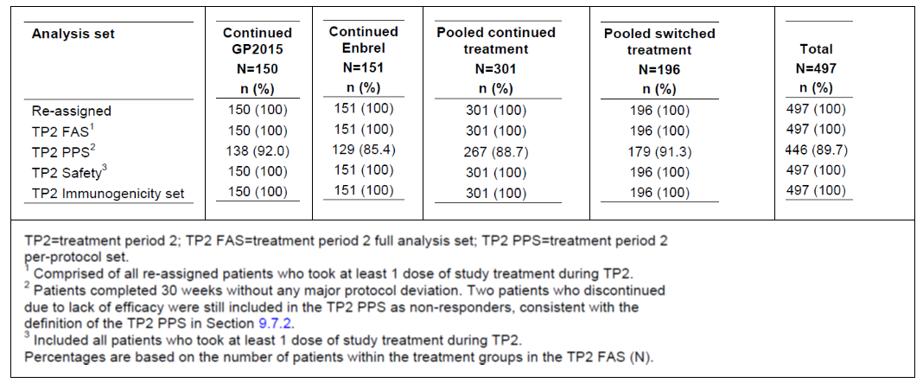
Figure 11: Study GP15-302. Patient disposition (TP2)
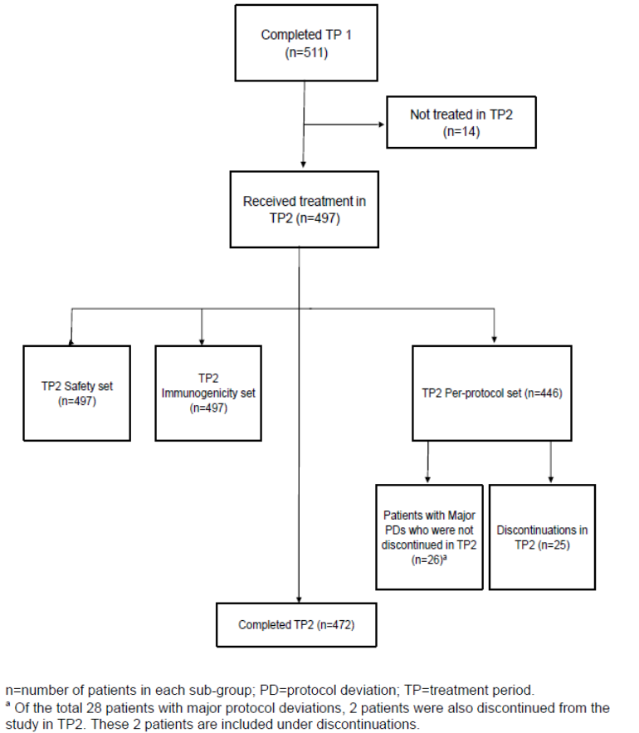
Table 24: Study GP15-302. Analysis sets (EP).
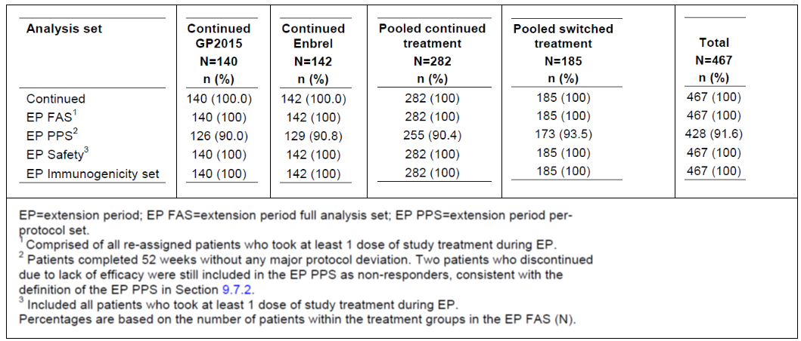
Figure 12: Study GP15-302. Patient disposition (EP)
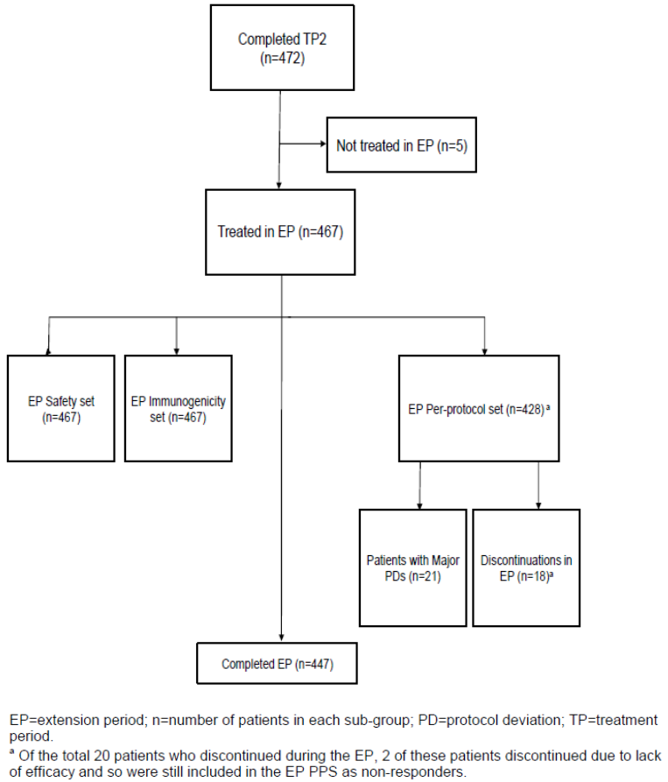
Table 25: Study GP15-302. Analysis sets (overall).
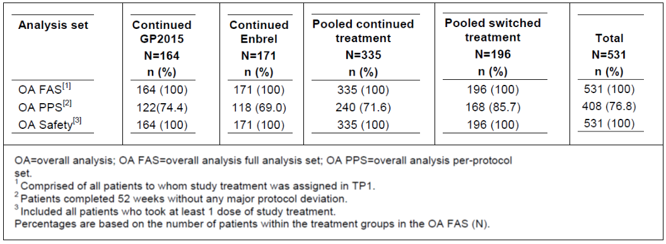
Figure 13: Study GP15-302. Patient disposition (combined analysis – all periods).
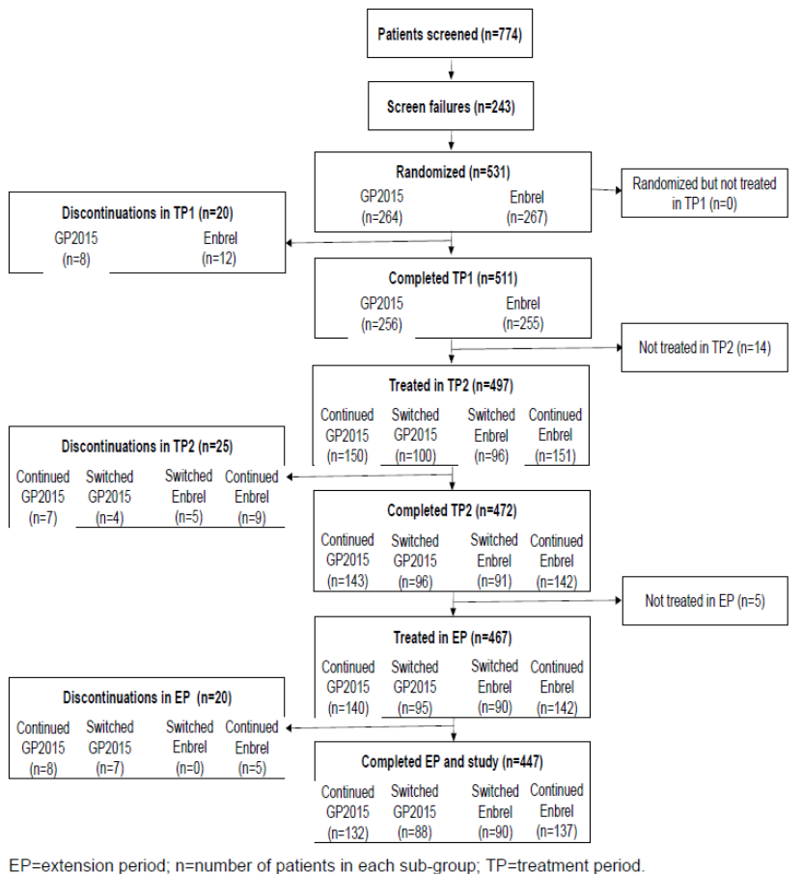
Table 26: Study GP15-302. Patient disposition (combined analysis – all periods).
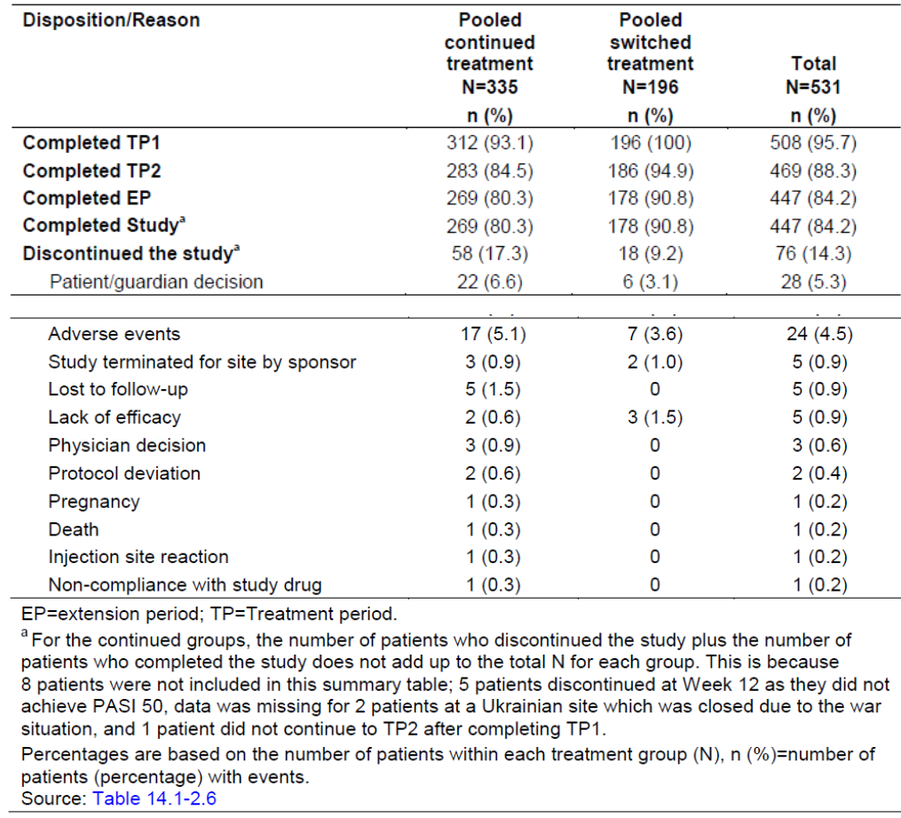
Comment: The most important part of this equivalence trial was Treatment period 1, as it provided the results for the primary endpoint. In that period, discontinuations were minimal (96.2% of randomised patients completed TP1) and relatively similar between treatment groups.
It is noted that, for TP1, the per-protocol population is much smaller than the intention-to-treat population (N=511 vs. N=480) due to patients with major protocol deviations being excluded.
Overall, 76 (of 531) (14.3%) discontinued from the study (17.3% in the pooled continued group and 9.2% in the pooled switched group) which is a reasonable proportion in a 52-week study.

Major protocol violations/deviations
In Treatment Period 1, 34 out of 531 patients (6.4%) had one or more major protocol violations, and the proportion was reasonably similar in each group (6.8% in the Erelzi group, and 6.0% in the Enbrel group.
Table 27: Study GP15-302. Protocol deviations in TP1.
Overall (baseline to Week 52), 57 out of 531 patients (10.7%) had one or more major protocol violations. In the pooled continued treatment group, 44 out of 335 (13.1%) had one or more major protocol violations; in the pooled switched treatment group 13 out of 169 (6.6%).
Within the pooled continued treatment group, the proportion of patients with at least one deviation was higher in the continued Enbrel groups (vs. the continued Erelzi group) (15.8% vs. 10.4%).
Table 28: Study GP15-302. Protocol deviations by continued treatment groups from baseline to Week 52.
Table 29: Study GP15-302. Protocol deviations by pooled treatment groups from baseline to Week 52.
Comment: The most important part of this equivalence trial was Treatment period 1, as it provided the results for the primary endpoint. In that period, 34 out of 531 patients had one or more major protocol deviations (6.8% in the Erelzi group vs. 6.0% in the Enbrel group). Both major and minor deviations were similar in the different treatment groups. The overall amount of minor deviations is rather high (86.4% of patients overall).

Baseline data
The sponsor has provided multiple tables with baseline characteristics. Nearly all baseline tables used a Full Analysis Set. Baseline characteristics for the Per-protocol Set (PPS) were only provided for TP1.
The following data refer to the Full Analysis Set in Treatment Period 1 (TP1) (i.e. the largest analysis set.
The overall mean age was 42.4 years (range 18 to 78 years). The majority of subjects were male (62.0%, 329/531). The majority of subjects were Caucasian (99.2%, 527/531). 321 (60.5%) had a weight <90kg, and 210 (39.5%) ≥90 kg. The mean BMI was 28.509±5.7809 kg/m². The duration of psoriasis refers to the time since diagnosis. The mean duration was 17.688±11.5623 years and the median duration was 15.97 years (range: 0.64 to 55.01 years).
The mean PASI score was 22.51±9.218 (a PASI score > 20 is considered severe disease) and the median score was 20.3 (range 9.4 to 55.2) (a PASI score of 10-20 is considered moderate disease). The mean BSA affected by psoriasis was 30.70% and the median score was 28.5% (range 8.7 to 77%). With regard to sPGA/IGA scores (clear, almost clear, mild, moderate, severe, very severe), the number of subjects were: 1 (mild), 377 (moderate), and 153 (severe).
68.9% of subjects did not have prior systemic therapy for psoriasis, 30.1% had some prior systemic therapy, and 0.9% had prior systemic therapy with a TNF antagonist.
The characteristics were reasonably balanced between groups, and as the trial progressed (with the usual discontinuations) the balance remained.
Comment: As EGALITY is an equivalence study, the Per-protocol Set was used for the primary analysis. However, nearly all baseline data is provided using the Full Analysis Set, but the baseline patient characteristics in the Per-protocol Set were very similar to the Full Analysis Set.
The sets in Treatment Period 1 (first 12 weeks) are the most relevant sets, as they can be directly compared to the primary outcomes in the two etanercept psoriasis pivotal trials (Papp, et al. (2005); Leonardi, et al. (2003)).
The characteristics shown reflect the population of patients with moderate to severe psoriasis reasonably well (e.g. when comparing the study population to the population described in Daudén et al. (2013), which assessed the characteristics of 1217 patients with moderate to severe psoriasis in 123 centres in Spain) even though the Spanish study had more patients with milder psoriasis, and a smaller mean body mass. The similarity with the Spanish study is supporting the external validity of the study.
The baseline characteristics were also similar to the pivotal etanercept psoriasis trials. However, the other trials had patients with slightly lower PASI scores (median 16.4; range: 7.8-62.4 in Papp, et al. (2005) and a mean in the 50 mg twice weekly group of 18.4 in Leonardi, et al. (2003) compared to a mean of 22.51 and a median of 20.3 in EGALITY).
In summary, the baseline data is sufficiently balanced between treatment groups and sufficiently similar to the pivotal etanercept trials for psoriasis to support internal validity and sufficiently similar to a real-world moderate to severe psoriasis population to support external validity.

Results for the primary efficacy outcome
The primary efficacy endpoint was the proportion of PASI 75 responders at Week 12 (TP1). The result for this endpoint is shown. Relevant sensitivity/subgroup analyses for the primary endpoint are summarised.
Table 30: Study GP15-302. Primary endpoint: Logistic regression analysis on PASI 75 response at Week 12 (TP1 PPS).
Table 31: Study GP15-302. Primary endpoint: sensitivity/subgroup analyses.
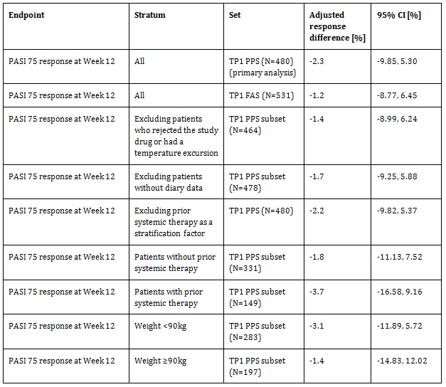
Comment: The sponsor’s criterion for establishing equivalence between Erelzi and Enbrel for patients with moderate to severe psoriasis is for the 95% CI of the primary endpoint from the PPS population to fall within the pre-determined margin of (±18%). The results fulfil the stated criterion. However, in the evaluator’s option the 18% margin is too wide and only a maximum of 15% is acceptable. However, the results fall within a 15% margin as well. All sensitivity/subgroup analyses (with the exception of patients with prior systemic therapy) are confined within a 15% equivalence margin.
From the available primary endpoint data, equivalence between Erelzi and Enbrel for patients with moderate to severe psoriasis, was established

Results for other efficacy outcomes
The secondary efficacy endpoints up to Week 12 (TP1) were:
- PASI percent improvement from baseline up to Week 12 (TP1) (MMRM analysis and mean ATE).
The secondary efficacy endpoints in all study periods (TP1, TP2, EP, and in the overall analysis (OA)) were:
- Percentage change from baseline in PASI scores.
- PASI 50, 75, and 90 response proportions.
- IGA (proportion of patients achieving clear (0) or almost clear (1) disease state).
- HRQoL as assessed with regard to relative changes in the DLQI, the EQ-5DTM, and the proportion of patients achieving a DLQI of 0 or 1.
- Functional ability in patients with a medical history of PsA as assessed with regard to relative changes in the HAQ-DI© and visual analogue scale (VAS) of pain.
For the secondary efficacy endpoints (other than PASI percent improvement from baseline up to Week 12 and PASI 50/75/90 responders for all time periods), only descriptive statistics were provided originally, i.e. no adjusted response difference and corresponding 95% CI were supplied. The sponsor has provided some the analyses for the Round 2 report.

Percentage change from baseline in PASI scores
See table below.
Table 32: Study GP15-302. Secondary endpoints: PASI percent improvement from baseline up to Week 12 with sensitivity analyses.
Endpoint | Stratum/analysis type | Set | Adjusted response difference [%] | 95% CI [%]
PASI percent improvement from baseline up to Week 12 | MMRM | TP1 PPS (N=480) | -0.64 | -3.474, 2.204
PASI percent improvement from baseline up to Week 12 | Mean ATE using ANCOVA | TP1 PPS (N=480) | -0.88 | -3.610, 1.845
PASI percent improvement from baseline up to Week 12 | MMRM | TP1 FAS subset (N=530) | -1.59 | -4.367, 1.178
PASI percent improvement from baseline up to Week 12 | Mean ATE using ANCOVA | TP1 FAS subset (N=530) | -2.14 | -4.966, 0.686
PASI percent improvement from baseline up to Week 12 | MMRM excluding prior systemic therapy as a stratification factor | TP1 PPS (N=480) | -0.63 | -3.475, 2.212
PASI percent improvement from baseline up to Week 12 | Mean ATE using ANCOVA excluding prior systemic therapy as a stratification factor | TP1 PPS (N=480) | -0.88 | -3.608, 1.851
The results with regard to PASI percent improvement from baseline up to Week 12 (TP1) (MMRM analysis and mean ATE) were supportive of equivalence (all 95% CIs contained within a 15% margin).

PASI 50, 75, and 90 response
Nearly all 95% CIs for the PASI 50, 75, and 90 responder differences are contained within the 15% equivalence margin.
Furthermore, an additional analysis that compared the responder proportion difference between pooled switched and pooled continued treatment receivers was conducted, the 95% CIs of which are all contained within the 15% equivalence margin.

PASI percent improvement outside TP1
PASI percent improvement results outside TP1 were only provided for the OA Set.

IGA
An overall analysis (baseline to Week 52) was not conducted for the IGA scores, even though such analysis was part of the study protocol.

HRQoL and functional ability
Only descriptive statistics were originally provided which is not sufficient to evaluate the data. The sponsor was asked to provide additional statistical analysis. For the Round 2 report, results for the OA Set were provided. Overall, HRQoL and functional ability generally improved, and there appeared to be no significant differences between treatment groups.
Comment: The results are generally supportive of equivalence. There were no significant differences between comparison groups. IGA/PGA is a categorical variable and hence not as sensitive to smaller changes, but may still detect significant or clinically meaningful changes.
Furthermore, these results cannot really be correlated with immunogenicity, as no Erelzi patient developed ADAs (and only a very small proportion in the Enbrel group). A comment on the immunogenicity results is provided in the safety section of this report.

Evaluator commentary
Evaluator’s comments are provided under each subsection (where applicable) and are not repeated here.

Justification for extrapolation to other indications approved for the reference product
The sponsor has provided a justification for extrapolation of indications located in the Clinical Overview:
At the initial EMA Scientific Advice Meeting (02-Dec-2010), the EMA assessed that when therapeutic equivalence is demonstrated in a sufficiently sensitive population in an indication where pathogenesis appears to be dominated by soluble TNFα, such as plaque PsO or RA, extrapolation to other indications with similar pathogenesis, such as AS or PsA, is considered acceptable. Robust analytical data to demonstrate a high degree of comparability between Erelzi and Enbrel/EU are provided.
As elaborated in detail, based on the published literature evidence, the indications for which Enbrel/EU is approved are immune-mediated inflammatory diseases. Although these diseases have different clinical manifestations, their immunologic backgrounds are comparable as TNFα plays a major role in disease development and progression. The pharmacological activity by which etanercept modulates disease activity is the same in all indications i.e. inhibition of TNFα binding to its receptor.
It is considered justified to assume comparable efficacy of Erelzi to Enbrel/EU across all indications for which Enbrel/EU is approved for the following reasons:
- The totality of the evidence shows comparability of Erelzi and Enbrel/EU on an analytical level, which is supported by nonclinical data and substantiated by comparable PK properties of Erelzi and the reference product Enbrel/EU.
- Efficacy of Erelzi was shown to be comparable to Enbrel/EU in a sensitive indication (PsO). The rationale behind selecting PsO as the sensitive indication is presented. In addition, the safety and immunogenicity profile of Erelzi was shown to be comparable to Enbrel/EU in the plaque-type PsO indication.
In summary, Erelzi clinical development program supports extrapolation across all indications in accordance with the EMA Guideline (EMA/CHMP/437/04 Rev.1), as well as the US-FDA Guidance for Industry Scientific considerations in demonstrating biosimilarity to a reference product (2015).
Comment: For extrapolation purposes, the factors to be considered for choosing appropriate indications to investigate the biosimilar candidate include:
- The expected/historical placebo-adjusted response rate in a particular indication under investigation
- A valid clinical model for this class of drug
- An identical (or at least highly similar) dosing regimen
- An identical (or at least highly similar) mechanism of action
- A population that is sufficiently sensitive to immunogenicity
- Generalisability (external validity) of the study sample with regard to relevant populations (including paediatric populations)
The sponsor’s justification does not address all of the above considerations, but the whole dossier was considered by the evaluator.
The highest placebo-adjusted response rate (i.e. the best signal-to noise ratio) should be used to detect differences between treatments (Lee, 2014). The sponsor has chosen an appropriate clinical study population (indication) to enable extrapolation to the other approved indications of the reference product. The choice plaque psoriasis as the indication in the equivalence study provided a better signal-to noise ratio and also a younger population more sensitive to immunogenicity making it better for extrapolation.
As a comparison, the signal-to noise ratio in rheumatoid arthritis would have been inferior to the relatively high ratio in a psoriasis study population. However, despite its potentially lower signal-to noise ratio and concomitant immunomodulator (methotrexate) administration, an equivalence study in rheumatoid arthritis would have arguably had a more precise scoring system and the potential to include radiographic data.
The dosing regimen is very similar for all approved reference product adult indications. However, no paediatric population was investigated. Malignancies (in particular lymphoma) have been associated with children and adolescents treated with TNF-α antagonists, including etanercept. This is currently outlined in the reference product product information.
Overall, taking into account the clinical equivalence study and the PK study, extrapolation to all currently approved indications of the reference product is supported from a clinical evaluation point of view. However, safety concerns remain that require appropriate monitoring in the post-authorisation phase (especially regarding immunogenicity, and paediatric indications).

Evaluator’s conclusions on clinical efficacy
The submission relies on one efficacy study to demonstrate biosimilarity, namely study GP15-302 (EGALITY) (a phase 3, double-blind, randomised, active comparator-controlled study in 531 subjects with moderate to severe plaque psoriasis evaluating the efficacy and safety of Erelzi compared with Enbrel (EU)). 531 patients were part of the study, and this number was sufficient. The study was set up to follow patients for up to 52 weeks, with the primary assessment being conducted at the end of Week 12 (identical to the pivotal psoriasis trials with Enbrel).
The doses used in GP15-302 were at the upper end of clinically used adult doses for Enbrel (50 mg twice weekly for 12 weeks, then 50 mg weekly). This dosage regimen was also used in the pivotal trials (in at least one treatment arm). This is considered appropriate. The study design was acceptable overall.
The characteristics of the EGALITY study population were sufficiently similar to the populations in the Enbrel pivotal trials, as well as a general psoriasis population. This supported the internal and external validity of the study.
EGALITY appropriately used a per-protocol population as the main analysis population. PASI75 response at Week 12 was the primary endpoint which was also used by both pivotal reference product trials (Leonardi, et al. (2003) and Papp, et al. (2005)). Arguably, for an equivalence trial, the use of a continuous PASI variable, e.g. Percentage change from baseline, is more suitable to detect smaller differences in treatment effect than a categorical variable. The sponsor has also included continuous PASI variables as secondary endpoints. This is considered favourable, as this made both a comparison to pivotal trial endpoints and a suitable accommodation for equivalence trial design through use of continuous variables possible.
Only descriptive statistics were provided for the endpoints other than those involving PASI scores. Given that any psoriasis trial assessment should not solely rely on PASI scores, it is important to also provide an appropriate statistical analysis of the other endpoints, i.e. data comparing the treatment groups, and comparing the pooled continued group and the pooled switched group (difference and 95% CIs).
Most trials of TNF-α antagonist biosimilars used rheumatoid arthritis as their main study indication (Lai & La Noce, 2016). For Erelzi, the sponsor has chosen psoriasis as the target indication for their equivalence study (GP15-302). There are advantages and disadvantages with regard to that choice.
The investigation of medicines for rheumatoid arthritis has a better choice of endpoints: the ACR score, for example, is highly validated and is also a composite endpoint. Additionally, biomarkers and radiographic evidence can be used for rheumatoid arthritis.
The psoriasis assessment tools are often considered a limitation of clinical trials in psoriasis patients. Psoriasis assessments appear to be more subjective with clinicians often overestimating body surface area affected. The patient experience of severity is also rather subjective. The PASI is still considered the gold standard and widely used in psoriasis clinical trials, including the reference product pivotal trials. The PASI’s disadvantages are that the upper end of the scale is rarely used (the highest score in study GP15-302 was 55.2/72), and may have low response distribution and no consensus on interpretability, whereas PGA/IGA may not necessarily discriminate small change and may not have a robust range (Feldman & Kruger, 2005; Spuls et al., 2010). In the relevant EU guideline (CHMP/EWP/2454/02 corr), a combination of endpoint measures is recommended (e.g. PASI and sPGA or PASI and BSA) which was used in study GP15-302. The use of the combination eliminates many of the disadvantages associated with psoriasis assessments.
The advantage of a psoriasis trial is that the population will be comparatively younger with fewer co-morbidities and fewer co-medications, and thus providing a better signal-to noise ratio. Therefore, the use of a psoriasis target population can be considered as a valid population for the purposes of assessing biosimilarity and especially with regard to extrapolation.
Based on the evidence available, the approval of extrapolation to the other reference product indications is considered reasonable in conjunction with appropriate pharmacovigilance activities (e.g. participation in relevant disease registries) and risk minimisation activities.
There is sufficient evidence to support clinical efficacy of Erelzi in psoriasis, and also biosimilarity of Erelzi to the reference product Enbrel, pending a satisfactory sponsor response to the outstanding issues.

Clinical safety

Studies providing evaluable safety data
All five studies (four PK bioequivalence studies and one equivalence study in psoriasis patients) included in this submission provided safety data:
- Study GP15-302: a phase 3, double-blind, randomised, active comparator-controlled study in 531 subjects with moderate to severe psoriasis evaluating the efficacy and safety of Erelzi compared with Enbrel (EU).
- Study GP15-104: a randomized, double blind, two-way cross-over study to determine the pharmacokinetics and safety of Erelzi and Enbrel (EU-licensed) following a single dose of 50 mg subcutaneous injection in healthy male subjects.
- Study GP15-101: a randomized, double-blind, two-way cross-over study to determine the pharmacokinetics and safety of Erelzi and Enbrel® (EU-licensed) following a single subcutaneous injection in healthy subjects.
- Study GP15-102: A randomized, double-blind, two-way cross-over study to determine the pharmacokinetics and safety of Erelzi and Enbrel® (US-licensed) following a single subcutaneous injection in healthy subjects.
- Study GP15-103: A randomized, open label, two-way cross-over study to determine the pharmacokinetics and safety of Erelzi following a single subcutaneous injection by an autoinjector and by a pre-filled syringe in healthy male subjects.
A summary of the studies providing safety data is below.
Table 33: Overview of studies providing evaluable safety data.
No formal hypotheses were tested in the safety parts of the studies. The safety endpoints mainly related to overall safety, local tolerance, and immunogenicity.
The Medical Dictionary for Regulatory Activities (MedDRA) was used for coding (v14.1 for GP15-101 and GP15-102; v17.0 for GP15-104, GP15-103, and GP15-302).
Comment: As this is a biosimilar application, the main purpose of the clinical safety section was to evaluate whether there were significant differences between the biosimilar and the reference product. The efficacy and safety of the reference product has been previously established for the currently approved indications. The list of TEAEs of special interest is acceptable.

Patient exposure
All subjects in the PK studies were exposed to single 50 mg doses of Erelzi and Enbrel (EU). The baseline demographics were reasonably balanced in the studies. Subjects were exposed to both treatments; hence the treatment groups were balanced automatically (subject to no dropouts after period I).
Table 34: Exposure to Erelzi and comparators in PK studies.
All patients in the clinical equivalence study had plaque psoriasis and were exposed to 50 mg of Erelzi or Enbrel (EU) twice weekly. The baseline demographics were reasonably balanced between the treatment groups.
Table 35: Exposure to Erelzi and comparators in the clinical equivalence study.
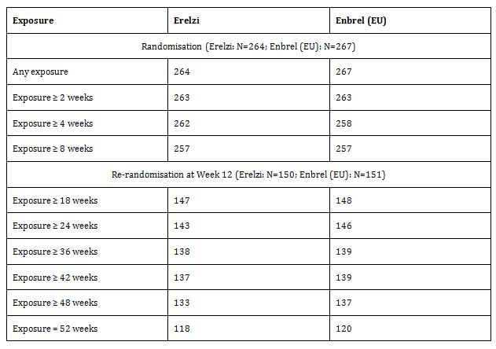The maximum duration of IMP exposure was 52 weeks in the clinical psoriasis study (GP15-302) which was reached by 118 patients (Erelzi) and 120 patients (Enbrel). Within the OA Safety Set, patients were exposed (Erelzi vs. Enbrel) for a mean 318.3 days (vs. 309.9 days), for a median 358.0 days (vs. 358.0 days). Within the OA Safety Set, patients were exposed (pooled continued group vs. pooled switched group) for a mean 314.0 days (vs. 346.2 days), for a median 358.0 days (vs. 358.0 days). The exposure was sufficient for comparability purposes. The clinical studies were not powered to detect rarer adverse events.
Comment: Patient exposure was adequate to show comparability to the reference product. Furthermore, a subset of study GP15-302 switched three times from one product to the other between Week 12 and Week 30 providing data for a small group of subjects until week 52 (40 weeks of data after the first switch).

Adverse events

Analysis sets

Pivotal efficacy study
Unless indicated otherwise, the data reported for all studies uses the Safety Analysis Set, defined by the sponsor as follows:
The safety (SAF) population consisted of all randomized subjects who received at least one dose of study drug. This was determined as flagged in the individual study data. Subjects were analyzed according to the treatment they received.
All patients were analysed according to treatment received.
- Treatment Period 1 Safety Set (TP1 Safety Set): all patients who took at least 1 dose of study treatment during the treatment period.
- Teatment Period 2 Safety Set (TP2 Safety Set): all patients who took at least 1 dose of study treatment during TP2.
- Extension Period Safety Set (EP Safety Set): all patients who took at least 1 dose of study treatment during the EP.
- Overall Analysis Safety Set (OA Safety Set): all patients who took at least 1 dose of study treatment during the study. The OA Safety Set was not planned in the protocol or amendments but was added in an OA SAP (CSR Appendix 16.1.9) before final database lock in order to provide cumulative analyses across all of the treatment periods.
Both the EP Safety Set and the OA Safety Set analysis was comprised of two comparisons: a comparison of the continued Erelzi population vs. the continued Enbrel population; and a comparison of the pooled continued population vs. the pooled switched population.
Furthermore, a post hoc analysis comparing TP2 continued treatment groups from baseline to the end of TP2 was also conducted.

PK studies in healthy volunteers
The Safety Analysis Set was used for the pooled safety analyses of the PK studies in healthy volunteers. The set consisted of all randomised subjects who received at least one dose of study drug. Subjects were analysed according to the treatment they received.
TEAEs were assigned to each period using the following criteria:
- Period I: AEs starting after the first period dosing of IMP but before second period dosing of IMP; and
- Period II – AEs starting after the second period dosing of IMP.

Treatment related adverse events (regardless of study drug relationship)
This section relates to treatment related adverse events (regardless of study drug relationship), i.e. includes adverse events that are unrelated to the IMP.

Pivotal efficacy study
Overall, treatment related adverse events (regardless of study drug relationship) were reasonably balanced between Erelzi and Enbrel (EU) treatment groups (including the comparison between pooled continued and pooled switched groups) in all sets. The most commonly reported TEAEs were ‘infections and infestations’, ‘skin and subcutaneous tissue disorders’, ‘gastrointestinal disorders’, and ‘musculoskeletal and connective tissue disorders’. The majority of events were mild or moderate in severity.
Table 36: Study GP15-302. Summary comments on treatment related adverse events (regardless of study drug relationship).
Set | Comment
TP1 | There appear to be no overt clinically significant differences between the two groups~.
TP2 | There appear to be no overt clinically significant differences between the two groups~.
TP2^ | There appear to be no overt clinically significant differences between the two groups~.
EP* | There appear to be no overt clinically significant differences between the two groups~.
EP# | There appear to be no overt clinically significant differences between the two groups~.
OA* | There appear to be no overt clinically significant differences between the two groups~.
OA# | There appear to be no overt clinically significant differences between the two groups~.
^ Post hoc analysis comparing TP2 continued treatment groups from baseline to the end of TP2; * Continued Erelzi population vs. continued Enbrel population comparison; # Pooled continued population vs. pooled switched population comparison; ~ The study was not powered to detect rarer adverse events or to make meaningful conclusions about incidence and this should be taken into consideration.

PK studies in healthy volunteers
An overview of adverse events in the PK studies showed no serious events occurred in any study.
TEAEs (regardless of study drug relationship) were most frequently reported in SOCs of blood and lymphatic system disorders, nervous system disorders, and respiratory, thoracic and mediastinal disorders. The most frequently reported TEAEs were neutropenia, headache, nasopharyngitis and oropharyngeal pain. The TEAEs (regardless of study drug relationship) were reasonably balanced between Erelzi and Enbrel (EU/US) treatment groups. Most TEAEs were of mild or moderate severity.
Table 37: Pooled PK studies. Overall Summary of Adverse Events by Treatment.

Treatment related adverse events (with suspected relationship to the study drugs (adverse drug reactions))

Pivotal efficacy study
Overall, treatment related adverse events (with suspected relationship to the study drugs) were reasonably balanced between Erelzi and Enbrel (EU) treatment groups (including the comparison between pooled continued and pooled switched groups) in all sets. The most commonly affected SOCs included ‘infections and infestations’ and ‘skin and subcutaneous tissue disorders’.
Table 38: Study GP15-302. Summary comments on treatment related adverse events (with suspected relationship to the study drugs (adverse drug reactions)).
Set | Comment
TP1 | There appear to be no overt clinically significant differences between the two groups~.
TP2 | There appear to be no overt clinically significant differences between the two groups~. It is assumed that ‘psoriasis’ in the Enbrel group refers to lack of efficacy.
TP2^ | There appear to be no overt clinically significant differences between the two groups~.
EP* | There appear to be no overt clinically significant differences between the two groups~.
EP# | There appear to be no overt clinically significant differences between the two groups~.
OA* | There appear to be no overt clinically significant differences between the two groups~.
OA# | There appear to be no overt clinically significant differences between the two groups~.
^ Post hoc analysis comparing TP2 continued treatment groups from baseline to the end of TP2; * Continued Erelzi population vs. continued Enbrel population comparison; # Pooled continued population vs. pooled switched population comparison; ~ The study was not powered to detect rarer adverse events or to make meaningful conclusions about incidence and this should be taken into consideration.

PK studies in healthy volunteers
A list of TEAEs (with suspected relationship to the study drugs (adverse drug reactions)) is shown. The most frequently reported TEAEs (with suspected relationship to the study drugs) were neutropenia, headache, nasopharyngitis and oropharyngeal pain. The TEAEs were reasonably balanced between Erelzi and Enbrel (EU/US) treatment groups. Most TEAEs were of mild or moderate severity.

Deaths and other serious adverse events

Pivotal efficacy study

Deaths
One death occurred during study GP15-302. One patient in the Enbrel group died during TP1 as a result of cardiopulmonary failure. The patient had a history of type II diabetes mellitus and was receiving concomitant glimepiride and metformin treatment. The death was considered unrelated to study medication.

Serious adverse events (regardless of study drug relationship)
Overall, serious adverse events (SAEs) were reasonably balanced between Erelzi and Enbrel (EU) treatment groups (including the comparison between pooled continued and pooled switched groups) in all sets. There appeared to not have been any clustering of specific SAEs. Additional comments are made.
Serious adverse events (SAEs) considered related to the study drugs were as follows:
- 1 patient (treatment sequence in Group 1b: Erelzi > Enbrel > Erelzi > Enbrel) experienced a severe event of multiple sclerosis (suspected to be related to study drug), 1 year, 1 month, and 7 days after the first dose of study drug. The event occurred outside the study period and was reported to be resolved.
- 1 patient (treatment sequence in Group 2: Enbrel) experienced a severe event of drug induced toxic hepatitis (suspected to be related to study drug) apparent through deranged liver function tests in TP1. Hepatitis B surface antigen (HBsAg), IgM toxoplasma (blood IgM), and anti-hepatitis C virus (HCV) showed negative results. The study drug was discontinued. The event resolved with treatment.
Table 39: Study GP15-302. Summary comments on serious adverse events (SAEs) (regardless of study drug relationship).
Set | Comment
TP1 | There were 4 (1.5%) and 3 (1.1%) patients with SAEs in the Erelzi and Enbrel groups, respectively. 1 (0.4%) patient in the Enbrel group died of cardiopulmonary failure. Retinal detachment (unlikely related), appendicitis and DILI (likely related and leading to discontinuation) occurred in 1 patient each (0.4%) in the Enbrel group. A malignant melanoma in 1 (0.4%) Erelzi patient lead to discontinuation. Milk allergy and lower limb fracture were less likely related to IMP.
TP2 | 1 (0.7%) patient in the Enbrel group experienced pneumonia.
TP2^ | The same SAEs from TP1 and TP2 set appeared again in this set.
EP* | Both the continued Erelzi group and the continued Enbrel group had 3 patients with SAEs (2.1%). There appear to be no overt clinically significant differences between the two groups~.
EP# | There appear to be no overt clinically significant differences between the two groups~.
OA* | There appear to be no overt clinically significant differences between the two groups~.
OA# | There appear to be no overt clinically significant differences between the two groups~. Of note is that more patients in the pooled continued groups had more serious infections and infestation when compared to the pooled switched groups (6 (1.8%) vs. 2 (1.0%)), but given the low absolute numbers overall, this is not likely clinically significant.
^ Post hoc analysis comparing TP2 continued treatment groups from baseline to the end of TP2; * Continued Erelzi population vs. continued Enbrel population comparison; # Pooled continued population vs. pooled switched population comparison; ~ The study was not powered to detect rarer adverse events or to make meaningful conclusions about incidence and this should be taken into consideration.

PK studies in healthy volunteers
There were no deaths in the PK studies in healthy volunteers. No serious adverse events deemed related to the IMP occurred. One severe TEAE in study GP15-101 was not suspected to be related to the study drug.

Discontinuations due to adverse events

Pivotal efficacy study
Discontinuations due to TEAEs were infrequent and reasonably balanced between treatment groups.
Table 40: Study GP15-302. Summary comments on discontinuations due to adverse events.
Set | Comment
TP1 | There appear to be no overt clinically significant differences between the two groups~.
TP2 | There appear to be no overt clinically significant differences between the two groups~.
TP2^ | There appear to be no overt clinically significant differences between the two groups~.
EP* | There appear to be no overt clinically significant differences between the two groups~.
EP# | Nearly twice as many discontinuations occurred in the pooled continued group compared to the pooled switched group (2.5% vs. 1.1%), but they were infrequent in absolute terms.
OA* | There were slightly more discontinuations in the continued Erelzi group compared to the continued Enbrel group (11/164 (6.7%) vs. 8/171 (4.7%), but the difference is only small and overall, the groups were reasonably balanced.
OA# | The discontinuations shown in the EP# set were reflected in this set.
^ Post hoc analysis comparing TP2 continued treatment groups from baseline to the end of TP2; * Continued Erelzi population vs. continued Enbrel population comparison; # Pooled continued population vs. pooled switched population comparison; ~ The study was not powered to detect rarer adverse events or to make meaningful conclusions about incidence and this should be taken into consideration.

PK studies in healthy volunteers
In the PK studies, a total of 3 subjects discontinued the studies due to TEAEs. In GP15-101, there were 2 discontinuations (1 subject receiving Erelzi with neutropenia, and 1 subject receiving Enbrel/EU with body tinea), both of which were suspected to be related to the IMP. In GP15-102, 1 subject receiving Erelzi discontinued IMP due to a TEAE of rash, but this event was not suspected to be related to the IMP.

Evaluation of issues with possible regulatory impact

TEAEs of special interest
The sponsor defined adverse events of special interest based on special warnings and precautions given in the Enbrel product label.
Specific adverse events of interest for the safety analysis of the phase 3 study are listed
Table 41: TEAEs of special interest.
Adverse events of special interest (AESIs) were relatively infrequent in all treatment groups. Individual AESIs did not occur in more than one patient in any group. Overall, even though the numbers are too small to determine a trend, infections and neoplasms/malignancies appeared to occur more frequently in the continued Erelzi group, whereas hypersensitivity and associated reactions occurred more often in the continued Enbrel group.
Table 42: Study GP15-302. Summary comments on TEAEs of special interest.
Set | Comment
TP1 | There were slightly more patients with TEAEs of special interest in the Erelzi group (9 (3.4%) vs. 5 (1.9%), mainly due to a slightly bigger number of neoplasms (only 1 malignant) in the Erelzi group (5 (1.9%) patients vs. 1 (0.4%) patient) with low absolute numbers. However, here appear to be no overt clinically significant differences between the two groups~.
TP2 | Infections and infestations (herpes simplex, blastomycosis, oral candidiasis, and tinea) occurred in the Erelzi group, and urticaria and hypersensitivity in the Enbrel group. The absolute numbers were rather low (one patient for each condition).
TP2^ | This set essentially combines the results for TP1 and TP2.
EP* | As per TP1 and TP2 results, infections were more frequent in the continued Erelzi group (additionally onychomycosis and single case of sepsis in the Erelzi group, and herpes zoster in the Enbrel group).
EP# | There appear to be no overt clinically significant differences between the two groups~.
OA* | There appear to be no overt clinically significant differences between the two groups~, even though as for the previous sets, infections (mostly mild) and neoplasms (only 1 malignant) occurred more frequently in the continued Erelzi group, whereas hypersensitivity and associated reactions occurred more often in the continued Enbrel group. Absolute numbers were small.
OA# | There appear to be no overt clinically significant differences between the two groups~.
^ Post hoc analysis comparing TP2 continued treatment groups from baseline to the end of TP2; * Continued Erelzi population vs. continued Enbrel population comparison; # Pooled continued population vs. pooled switched population comparison; ~ The study was not powered to detect rarer adverse events or to make meaningful conclusions about incidence and this should be taken into consideration.

Liver function and liver toxicity

Pivotal efficacy study
There were a small number of liver-related events, the most significant of which are described below:
- One patient (treatment sequence in Group 2: Enbrel) experienced a severe event of drug induced toxic hepatitis (suspected to be related to study drug) apparent through deranged liver function tests in TP1. Hepatitis B surface antigen (HBsAg), IgM toxoplasma (blood IgM), and anti-hepatitis C virus (HCV) testing showed negative results. The study drug was discontinued. The event resolved with treatment. This was an isolated incidence that did not occur in Erelzi, but in Enbrel.
- One patient (treatment sequence in Group 1b: Erelzi > Enbrel > Erelzi) experienced a moderate event of hepatic steatosis (suspected to be related to study drug) in TP2. The study drug was discontinued. The event resolved.
- One patient (Group 1: Erelzi) experienced a mild event of hepatic steatosis (suspected to be related to study drug) in EP. The study drug was discontinued. The event was considered ongoing at the end of the study.
- There was another liver event not deemed related to the study drugs: cholelithiasis in Group 1b.

PK studies in healthy volunteers
In the PK studies, some liver function test derangements occurred: 1 subject experienced an elevation of AST on Day 14 after dosing with Erelzi (GP15-101) (deemed related to IMP);1 subject experienced elevated ALT and AST approximately 41 days after Enbrel treatment in Period I (GP15-101) (deemed unrated to IMP); 1 subject had elevated AST and ALT values on Day 7 of Period II following Erelzi treatment (GP15-102). In GP15-103, several values outside the reference range were observed, but none were considered to be clinically significant.
There appears to be no evidence for Erelzi to be different to Enbrel with regard to liver function and liver toxicity events.

Renal function and renal toxicity
There were a small number of haematuria events in GP15-302, e.g. 3 (1.8%) in the continued Erelzi group, and 1 (0.6%) in the continued Enbrel group (OA Set). One acute renal failure event occurred:
- One patient (treatment sequence in Group 1b: Erelzi > Enbrel > Erelzi > Enbrel) experienced several severe events of acute renal failure with anaemia, respiratory failure, and acid-base balance disorder. The acute renal failure (and the other severe adverse events) in this patient were not suspected to be related to the study drug.
There appears to be no evidence for Erelzi to be different to Enbrel with regard to renal function and renal toxicity events.

Other clinical chemistry

Pivotal efficacy study
Overall, there were also no notable differences between the treatment groups.

PK studies in healthy volunteers
In the PK studies, some liver function test derangement occurred.

Haematology and haematological toxicity

Pivotal efficacy study
Overall, there were also no notable differences between the treatment groups, and only a small number of neutropaenia events.

PK studies in healthy volunteers
In GP15-104, there were 18 occurrences of mild TEAEs of neutropenia (related to the IMP) which resolved. GP15-102 and GP15-103 had a small number of neutropaenia. In GP15-101, there was a case of clinically significant neutropenia which resolved 2 months after dosing.

Electrocardiograph findings and cardiovascular safety
The onset of new or the worsening of existing congestive heart failure is associated with TNF blockers, including etanercept. The reference product PI states:
There have been post-marketing reports of worsening of congestive heart failure (CHF), with and without identifiable precipitating factors, in patients taking Enbrel. There have also been rare (< 0.1%) reports of new onset CHF, including CHF in patients without known pre-existing cardiovascular disease.

Pivotal efficacy study
A standard 12-lead ECG was performed at screening, Week 12 and Week 52. Therefore, only limited ECG data were available. ECG findings were comparable for the Erelzi and Enbrel treatment groups.
One death occurred during study GP15-302. One patient in the Enbrel group died during TP1 as a result of cardiopulmonary failure. The patient had a history of type II diabetes mellitus and was receiving concomitant glimepiride and metformin treatment. The death was considered unrelated to the study medication.
There appears to be no evidence for Erelzi to be different to Enbrel with regard to cardiovascular safety.

PK studies in healthy volunteers
In the PK studies in healthy volunteers, 12-lead ECGs were performed at screening, pre-dose (only pre-dose of period II in GP15-103 study) and the follow-up visit. No clinically important findings in ECG morphology, heart rate or intervals were apparent in any of the studies.

Vital signs and clinical examination findings
In both the PK studies and the efficacy study, there were no clinically meaningful differences with regard to vital signs and clinical examination findings in the different treatment groups.

Immunogenicity and immunological events

Pivotal efficacy study
The lower limit of quantification (LLOQ) for immunogenicity purposes was 150 ng/mL. All patients in the Erelzi treatment group had negative ADA results and a total of 5 patients (1.9%) in the Enbrel group had a confirmed positive ADA result in TP1. None of the ADAs were neutralising. No new patients with ADAs were detected in TP2. One ADA positive result was detected at one time-point during the treatment with Erelzi in the EP, in a patient from the pooled switched group.

PK studies in healthy volunteers
No binding ADAs were detected in the GP15-101, GP15-102, and GP15-103 studies. In the GP15-104 study, 3 subjects had confirmed binding ADAs at the follow-up visit (Day 65) with titres slightly above the detection limit. All 3 subjects were in the treatment sequence of Erelzi > Enbrel (EU) (i.e. Erelzi in period I and Enbrel (EU) in Period II). None of the ADAs were neutralising.
The sponsor stated that the binding ADA positive results were not considered clinically meaningful due to the very low titres and that there were no other safety concerns with respect to the ADA results.
Comment: Immunogenicity is one of the most important safety concerns in a biosimilar evaluation. Immunogenicity (through both neutralising and non-neutralising anti-drug-antibodies (ADAs)) has the potential to alter both efficacy and safety. However, the clinical significance of ADAs remains uncertain. Limited data shows that ADA positive patients are more likely to experience infusion reactions. The development of ADAs is not necessarily linked to non-responder patients. However, when comparing etanercept to adalimumab in rheumatoid arthritis patients, it appears that adalimumab patients who develop ADAs have worse clinical outcome compared to those who do not develop ADAs (Krieckaert et al., 2012). Consequently, ADAs in etanercept do not seem to be as clinically significant as in adalimumab in rheumatoid arthritis.
The psoriasis study population (no RA equivalence study was conducted) was better suited to detect any potential differences between treatment groups. A small literature review of anti-etanercept antibodies (Hsu et al., 2014) revealed a proportion range of 0–18.3% of subjects tested. However, when considering larger RCTs only, the range was 2.7–18.3%. The immunogenicity results from EGALITY seem to be within the data provided by the literature, albeit on the lower end of the spectrum. Different testing methods in the literature review studies may have contributed to different ADA proportions.
With regard to the methodology, the sponsor stated the following:
Immunogenicity of etanercept as determined by the formation of antibodies against the drug will be evaluated by using validated immunoassays. The validation procedure and serum sample analysis will follow international guidelines. The study samples will be screened for anti-etanercept antibodies. Evaluation of potential anti-etanercept antibodies will be done by testing specificity and neutralizing effect. The assays will be performed by the study sponsor. A detailed description of the analytical method will be further described in the laboratory manual.

Serious skin reactions
Local tolerability was generally comparable between treatment groups in both PK studies and the efficacy study.
In GP15-302 (EGALITY), injection site reactions were reported in a lower proportion of patients in the Erelzi group (4.9%), compared with the Enbrel group (14.2%) in TP1, with the majority being mild. The proportion of patients with a reaction was reasonably balanced in TP2 and the EP. No injection site reactions were classified as an SAE.

Post marketing experience
In the Summary of Clinical Safety, the sponsor states:
There are no data on post-marketing exposure as Erelzi has not yet been marketed in any region.

Evaluator’s overall conclusions on clinical safety
The reference product, etanercept (Enbrel) has been marketed for more than a decade and the efficacy and safety has been established for the currently approved indications.
As this is a biosimilar application, the main purpose of the clinical safety section is to evaluate whether there are significant differences between the biosimilar and the reference product.
The sponsor has not provided an integrated safety summary, but presented the safety data for each study individually. The safety results from the clinical study was considered more representative with regard to target population and administration duration compared to the PK study which only administered a single dose in healthy subjects.
The maximum duration of IMP exposure was 52 weeks in the clinical psoriasis study (GP15-302) which was reached by 118 patients (Erelzi) and 120 patients (Enbrel). Within the OA Safety Set, patients were exposed (Erelzi vs. Enbrel) for a mean 318.3 days (vs. 309.9 days), for a median 358.0 days (vs. 358.0 days). Within the OA Safety Set, patients were exposed (pooled continued group vs. pooled switched group) for a mean 314.0 days (vs. 346.2 days), for a median 358.0 days (vs. 358.0 days). The exposure was sufficient for comparability purposes. The clinical studies were not powered to detect rarer adverse events though.
Overall, the adverse event profile was fairly similar in all treatment groups. The safety data from the clinical studies and the PK study demonstrated that there were no clinically meaningful differences between Erelzi and the reference product Enbrel. Furthermore, there appears to be no evidence of clinically meaningful differences between the pooled continued group and the pooled switched group, indicating no apparent safety disadvantages from switching. However, the clinical studies were not powered sufficiently to provide statistical evidence of differences in less common adverse events.
The proportion of patients that developed ADAs was rather low.
The absence of a difference in the studies not powered for uncommon events does not provide evidence for the absence of safety concerns. There may be the possibility that the following are different in Erelzi (Erelzi) and this should be particularly monitored in the post-market environment and presented in PBRERs/PSURs: infections; malignancies (in particular in children and adolescents). Post-market monitoring is essential and the role of the risk management plan crucial in that regard. Furthermore, disease registries should be utilised as well.

First round benefit-risk assessment

First round assessment of benefits
See below.
Table 43: First round assessment of benefits.
Psoriasis
Benefits | Strengths and Uncertainties
Equivalence of Erelzi to Enbrel was shown for patients in moderate to severe plaque psoriasis (efficacy and safety). | Strengths  Study GP15-302 (EGALITY) was very similar to the reference product pivotal trial with regard to study population and endpoints. The study design and its endpoints were mainly based on the current gold standard for psoriasis clinical trials, the PASI score.  The primary endpoint, most of the primary endpoint sensitivity analyses, and the PASI secondary endpoints were supportive of equivalence based on a 15% margin.  The primary endpoint was identical to the reference product pivotal trial primary endpoint.  Continuous PASI based endpoints were also used and supportive of equivalence.  Longer term data were available, namely until Week 52.  The study did not allow subjects to use concomitant systemic immunomodulators. The placebo-adjusted response rate (i.e. signal-to noise ratio) with regard to treatment effect was larger than in a study that allowed concomitant immunomodulators.  The equivalence is supported by the PK study results.  The study provided sufficient data on switching from Enbrel to Erelzi (and vice versa; this included 3 switches in the switching group).  Uncertainties  The psoriasis assessment tools are often considered a limitation of psoriasis clinical trials. Psoriasis assessments appear to be more subjective with clinicians often overestimating body surface area affected. The patient experience of severity is also rather subjective. The PASI’s disadvantages are that the upper end of the scale is rarely used and may have low response distribution and no consensus on interpretability, whereas PGA/IGA may not necessarily discriminate small change and may not have a robust range. However, the combination of validated psoriasis scores can mitigate most of the limitations.  No data beyond 52 weeks are available.
Table 44: Indications approved for the reference product Enbrel (other than psoriasis).
Indications approved for the reference product Enbrel (other than psoriasis)
Benefits | Strengths and Uncertainties
Efficacy can be reasonably extrapolated from the conducted studies to the other indications approved for the reference product Enbrel | Strengths  A high signal-to noise ratio indication (psoriasis) was used to detect potential differences between treatments, i.e. to evaluate for equivalence.  The dosing regimen used in the clinical studies was within the recommended dose range for all approved reference product adult indications.  The other approved indications have a similar mechanism of action (e.g. no approved IBD indication).  Uncertainties  Not all indications were investigated.  The dosing regimen used in the clinical studies differed from the approved reference product paediatric indications.  Malignancies (in particular lymphoma) have been associated with children and adolescents treated with TNF-α antagonists, including etanercept.

First round assessment of risks
See below.
Table 45: First round assessment of risks.
Risks | Strengths and Uncertainties
Concerns that efficacy and safety are not equivalent to the reference product in a real world setting | Strengths  The clinical studies provided robust efficacy and safety data in the target indications.  Appropriate pharmacovigilance and risk minimisation measures should be implemented to detect, monitor and mitigate the risks.  Uncertainties  The clinical studies were not powered to detect more rare adverse events.  Uncertainties remain with regard to extrapolation to paediatric indications.  No data beyond 52 weeks are available.  Other unknown risks not detected in the provided studies, including loss of efficacy or new emerging safety signals.

First round assessment of benefit-risk balance
Overall, the benefit-risk balance of Erelzi (etanercept) for the proposed usage is favourable. This assessment is based on data evaluated from a clinical point of view. The assessment was made by weighing up the risks and benefits as outlined in this evaluation report and summarised in the previous section. However, the favourable assessment is dependent on the satisfactory response to the evaluator questions, the agreement to implement an appropriate risk management plan, and a favourable assessment by the quality, toxicology, and RMP evaluators.

First round recommendation regarding authorisation
Approval of Erelzi (etanercept) is recommended for the following indications (as per proposed Erelzi PI document):
Rheumatoid Arthritis
Active, adult rheumatoid arthritis (RA) in patients who have had inadequate response to one or more disease-modifying antirheumatic drugs (DMARDs). Erelzi can be used in combination with methotrexate.
Severe, active rheumatoid arthritis in adults to slow progression of disease-associated structural damage in patients at high risk of erosive disease.
Psoriatic Arthritis
The signs and symptoms of active and progressive psoriatic arthritis in adults, when the response to previous disease-modifying antirheumatic therapy has been inadequate. Erelzi has been shown to reduce the rate of progression of joint damage as measured by X-ray and to improve physical function.
Plaque Psoriasis
Adult patients with moderate to severe chronic plaque psoriasis, who are candidates for phototherapy or systemic therapy.
Ankylosing Spondylitis
The signs and symptoms of active ankylosing spondylitis in adults.
Non-radiographic Axial Spondyloarthritis
Treatment of adults with active* non-radiographic axial spondyloarthritis with objective signs of inflammation as indicated by elevated C-reactive protein (CRP) and/or MRI change who have had an inadequate response to NSAIDs.
*Active disease is defined as a Bath Ankylosing Spondylitis Disease Activity Index (BASDAI) score of ≥ 4.
Children and Adolescents
Juvenile Idiopathic Arthritis
Active polyarthritis (rheumatoid factor positive or negative) in children and adolescents, aged 2 to 17 years, who have had an inadequate response to one or more DMARDs.
Active extended oligoarthritis in children and adolescents, aged 2 to 17 years, who have had an inadequate response to, or who have proved intolerant to, methotrexate.
Active enthesitis-related arthritis in adolescents, aged 12 to 17 years, who have had an inadequate response to, or who have proved intolerant to, conventional therapy.
Active psoriatic arthritis in adolescents, aged 12 to 17 years, who have had an inadequate response to, or who have proved intolerant to, methotrexate.
Etanercept has not been studied in children aged less than 2 years.
Paediatric Plaque Psoriasis
Chronic, severe plaque psoriasis in children and adolescents from 4 to 17 years, who are inadequately controlled by, or are intolerant to, other systemic therapies or phototherapies. Duration of therapy to be no longer than 24 weeks and treatment to be ceased after 12 weeks if a significant PASI response is not achieved.
However, the approval recommendation is dependent on the satisfactory response to the evaluator questions, the agreement to implement an appropriate risk management plan, and a favourable assessment by the quality, toxicology, and RMP evaluators.

Clinical questions

Clinical questions

Pharmacokinetics
- In study GP15-104, intra-individual variability values were given, but not inter-individual variability values. The sponsor should provide those for the primary PK parameters.
- In study GP15-102, no analysis of AUC_{0-∞} was reported in the sensitivity analysis. The sponsor should provide these results.
- In study GP15-103, it was noted that the design and methodology strongly resembled protocol, GP15-104. That study included an adjustment for the given dose, in which the actual dose was obtained by weighing the syringe before and after administration. This seems not to have occurred in study GP15-103. The sponsor should provide a compelling justification why this was not deemed necessary in this study.
- In study GP15-302, the trough concentration mean ratios and associated 90% CIs were not provided by the sponsor. The sponsor should provide those results.
- With regard to all PK studies: the clinical evaluator was unable to locate the Lower Limit of Quantification (LLOQ) in some of the PK studies. For all four PK studies provided, the sponsor should provide the LLOQ for PK parameter purposes.

Pharmacodynamics
No questions.

Efficacy
- For study GP15-302, the sponsor should provide more information on the role of the designated unblinded sponsor team members at Week 12.
- For study GP15-302, the determination of the equivalence margin (18% for PASI 75 responders and 15% for PASI improvement) requires more detail and explanation (including the use or more than the two pivotal comparator trials, at least as a sensitivity analysis, and a clinical assessment). The sponsor is asked to provide this information.
- For study GP15-302, the sponsor should provide statistical data comparing the treatment groups, and comparing the pooled continued group and the pooled switched group (difference and 95% CIs) for the following (for all study periods and an overall analysis):
    - PASI percent improvement results outside of Treatment Period 1;
    - IGA results; and
    - HRQoL and functional ability results.

Safety
- The evaluator was unable to locate the laboratory manual for the EGALITY (GP15-302). The evaluator could only locate the lower limit of quantification (LLOQ) (for ADA measurements) in study GS15-104 which was given as 200 ng/mL. The sponsor should provide, for all five studies, a summary of the methods used to measure ADAs (including LLOQs).
- In the Summary of Clinical Safety, the sponsor states: “There are no data on post-marketing exposure as Erelzi has not yet been marketed in any region.” However, Erelzi has been approved in the US on 30 August 2016. The sponsor should provide a summary of post-marketing safety data, including PSURs/PBRERs (if available).

First round evaluation errata

Minor editorial changes
Not applicable.

Minor errors of fact
The sponsor has provided a document with sponsor comments and errors. They were addressed by the evaluator.

Significant errors of fact
Not applicable.

Second round evaluation

Pharmacokinetics
- In study GP15-104, intra-individual variability values were given, but not inter-individual variability values. The sponsor should provide those for the primary PK parameters.
Sponsor response
Inter-individual variability (% CV) has been added to the summary statistics of key PK parameters after dose normalization as well as for nominal doses in the CSR summary as shown below.
Table 46: PK parameters by treatment.
Comment: The response has been noted. Relevant changes to the report body were made.
- In study GP15-102, no analysis of AUC_{0-∞} was reported in the sensitivity analysis. The sponsor should provide these results.
Sponsor response
For study GP15-102, a sensitivity analyses was performed where operator was not included in the statistical model, the results were presented in the CSR. AUC(0-∞) has now been added to this sensitivity analysis table as shown below.
Table 47: PK parameters, per protocol set.
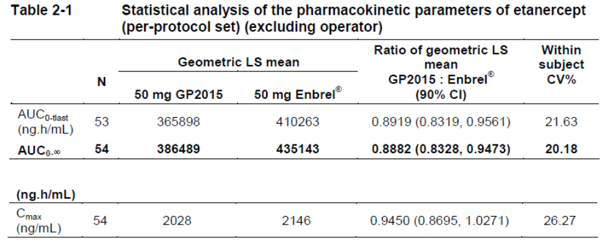
The results of the sensitivity analyses of all log transformed parameters showed that 50 mg Erelzi was bioequivalent to 50 mg Enbrel. The 90% CIs for the mean estimated ratios were entirely contained within the acceptance interval (0.80 to 1.25) required to declare bioequivalence.
Comment: The response has been noted. Relevant changes to the report body were made.
- In study GP15-103, it was noted that the design and methodology strongly resembled protocol, GP15-104. That study included an adjustment for the given dose, in which the actual dose was obtained by weighing the syringe before and after administration. This seems not to have occurred in study GP15-103. The sponsor should provide a compelling justification why this was not deemed necessary in this study.
Sponsor response
In contrast to studies GP15-101, -102 and -104, the objective of study GP15-103 was to compare the PK resulting from Erelzi being administered with two different administration devices, i.e. the pre-filled syringe (PFS) and the autoinjector (AI). As such, the study aimed to detect differences related to the two devices, which included differences in the actual dose administered. Therefore, the statistical analysis has not been corrected for differences in the actual administered dose. In order to minimize product related variability, a single drug substance batch was used in study, in order to increase the sensitivity of detecting possible differences between the two devices studied.
Therefore, the data set presented for the PK parameters and analysis of study GP15-103 was uncorrected for protein content, reflecting the nominal doses.
Comment: The response has been noted. Relevant changes to the report body were made.
- In study GP15-302, the trough concentration mean ratios and associated 90% CIs were not provided by the sponsor. The sponsor should provide those results.
Sponsor response
PK measurements in study GP15-302 were scheduled at Week 2, 4, 8 and 12 in study GP15-302.
Table 48: C_{trough} levels in study GP15-302.
The study was neither planned nor powered for a direct comparison of the pre-dose serum concentrations (C_{trough} values) nor was it pre-specified in the study protocol that the 90% CIs for ratios of geometric means of Erelzi C_{trough} -levels over Enbrel/EU should be entirely contained within the range of 0.80 – 1.25. However, the 90% CIs during weeks 2, 8 and 12 were entirely contained within the range of 0.80 – 1.25, whereas Erelzi C_{trough} -levels were higher for samples collected at Week 4.
Comment: The response has been noted. Relevant changes to the report body were made.
- With regard to all PK studies: the clinical evaluator was unable to locate the Lower Limit of Quantification (LLOQ) in some of the PK studies. For all four PK studies provided, the sponsor should provide the LLOQ for PK parameter purposes.
Sponsor response
The sponsor acknowledges that the information regarding LLOQ may not have been located and would therefore like to guide the reviewer to the relevant sections in our submission. The LLOQ of the PK methods applied in all four PK studies is provided in “Summary of Biopharmaceutic Studies and Associated Analytical Methods” and in the respective bioanalytical validation reports.
Table 49: LLOQ data for PK studies.
Comment: The response has been noted. Relevant changes to the report body were made.

Pharmacodynamics
No questions.

Efficacy
- For study GP15-302, the sponsor should provide more information on the role of the designated unblinded sponsor team members at Week 12.
Sponsor response
In order to maintain a blinded conduct of study GP15-302 until Week 52 an unblinded sponsor team has been established after the Week 12 database lock for the preparation of the Erelzi dossier submissions to FDA and EMA which were based on two interim GP15-302 CSRs (Week 12 and Week 30).
The role of the unblinded sponsor team members is additionally described in the Unblinded Team Charter. Please find the latest version of this Charter.
The adherence of the unblinded sponsor team to the processes as outlined in the Unblinded Team Charter ensured that all patients, investigators and their staff, blinded CRO team members, and blinded Sponsor’s Clinical Trial Team members remained blinded until final database lock at the end of study GP15-302.
Comment: The response has been noted.
- For study GP15-302, the determination of the equivalence margin (18% for PASI 75 responders and 15% for PASI improvement) requires more detail and explanation (including the use or more than the two pivotal comparator trials, at least as a sensitivity analysis, and a clinical assessment). The sponsor is asked to provide this information.
Sponsor response
As predefined in the protocol, therapeutic equivalence for the primary endpoint, PASI 75 response rate at Week 12, was demonstrated if the 95% CI for the difference was contained within the specified interval (-18%, 18%) after the first 12 weeks of treatment (TP1) for the PPS. Selection of equivalence margins was based on response rates reported in earlier, double-blind, placebo-controlled trials of the reference product (Leonardi et al 2003, Papp et al 2005, Papp et al 2005). Based on a treatment effect size of 45%-46% observed in the Enbrel pivotal studies referenced below, an equivalence margin of 18% was regarded as appropriate because it ensures that at least 60% of the treatment effect observed for Enbrel can be maintained.
In addition to the above protocol statement the 18% margin for equivalence was justified on two grounds: Clinical and Statistical. For the statistical justification a meta-analysis of the PASI 75 response rate of the two historical randomized double-blind, placebo controlled trials in a similar population was performed by the sponsor.
Table 50: Meta analysis of PASI 75 response rate.
The selected margin of 18% retained more than 50% of treatment effect demonstrated by the lower limit of the confidence interval of the meta-analysis, which is a generally accepted approach to ensure that the biosimilar is substantially superior to placebo. Assuming a sample size of 232 evaluable patients per treatment group in the per-protocol set and the 95% confidence interval for difference in treatment groups remaining within predefined margin range of +/-18% the PASI 75 response between treatment groups may maximally differ by 9%. This maximum difference of 9% for PASI 75 response rates between treatment groups is not considered clinically relevant and within the natural fluctuation in clinical studies in this indication.
Figure 14: Consideration for equivalence approach.
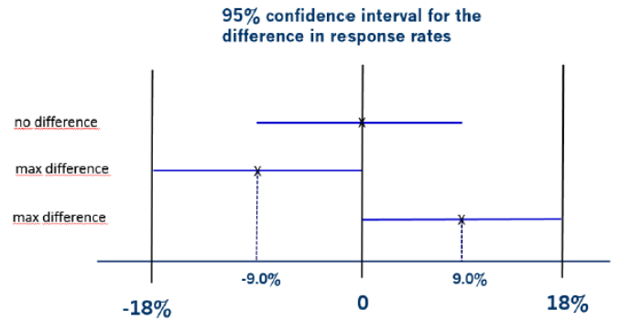
Based on the above details it can be concluded that the 18% margin is well justified based on careful considerations of clinical and statistical aspects.
Because of the greater sensitivity of percent PASI change as compared to PASI 75, an equivalence margin of 15% (reduced from 18% for the PASI 75 equivalence test) was proposed. Power values corresponding to this particular margin as presented in the study protocol confirmed that the two methods allowed for a highly sensitive comparison of the treatment effects of Erelzi and Enbrel over the whole course of the treatment period with the calculated sample size.
Comment: The response has been noted. There is no definite objection to the sponsor’s approach of determining the equivalence margin. However, in the evaluator’s option a margin of 18% is too large and 15% would generally the acceptable maximum depending on the circumstances. It is acknowledged that PASI score determination is rather subjective and may suffer a smaller than usual inter-rater reliability, and a large margin may be possible, or a scoring system with a larger inter-rater reliability could be used. With regard to significance, as an example, a percentage difference of 9% may not be clinically significant in an individual patient, but may be clinically significant on a population level.
Relevant changes to the report body were made
- For study GP15-302, the sponsor should provide statistical data comparing the treatment groups, and comparing the pooled continued group and the pooled switched group (difference and 95% CIs) for the following (for all study periods and an overall analysis):
- PASI percent improvement results outside of Treatment Period 1;
- IGA results; and
- HRQoL and functional ability results.
Sponsor response
Study GP15-302 is a biosimilar study aiming to show similar efficacy, safety and immunogenicity between Erelzi and Enbrel. Additionally the study aimed to show that switching between the two treatments had no meaningful impact on efficacy, safety and immunogenicity in the sense that the pooled continued and pooled switched groups behaved similarly.
In order to show similarity a clinical meaningful equivalence margin for each comparison would be required. However, such margins were only defined for the primary and key secondary endpoints and the study was only powered for those. The main objectives of the study were not defined to detect differences for all endpoints. In addition, the likelihood is very high that some false-positive differences would have been identified just by chance due to many statistical testings were performed.
Due to these reasons and to avoid misinterpretations of statistically significant differences it is the sponsor’s strategy not to provide differences and 95% confidence intervals (CIs) for the differences for all parameters. The sponsor considers descriptive analyses for other endpoints as described in the Clinical Study Reports as adequate to demonstrate the totality of the evidence for biosimilarity between Erelzi and Enbrel without these differences and 95% CIs. Hence, the requested differences and 95% CIs have never been calculated for the parameters of interest.
In response to your request, the sponsor selected some relevant efficacy parameters: PASI percent change from baseline, the Investigator’s Global Assessment (IGA) responders and the Dermatology life quality index (DLQI) total score for the Per-Protocol Set (PPS) up to Week 52. For those three efficacy parameters the following tables present the differences and 95% CIs as requested for the comparison of the two continued groups as well as for the pooled continued versus pooled switched groups.
Table 51: Summary of % change from baseline in PASI score by visit for continued treatment groups (OA PPS).
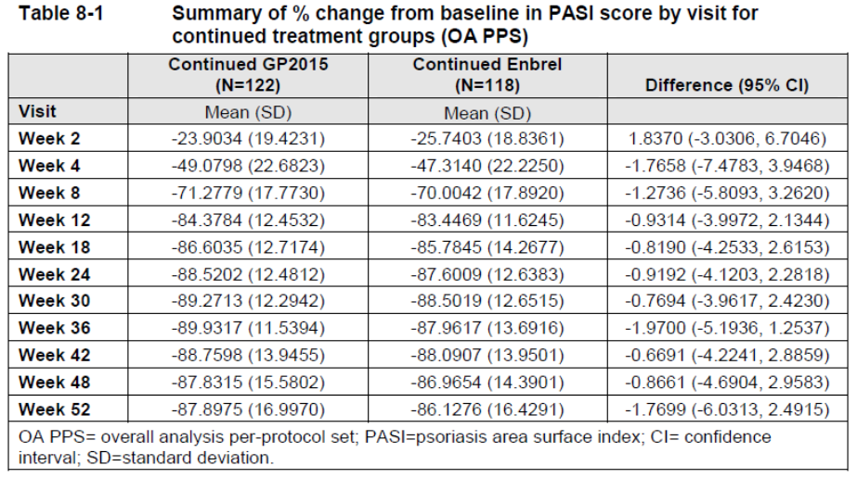
Table 52: Summary of % change from baseline in PASI score by visit for pooled treatment groups (OA PPS).
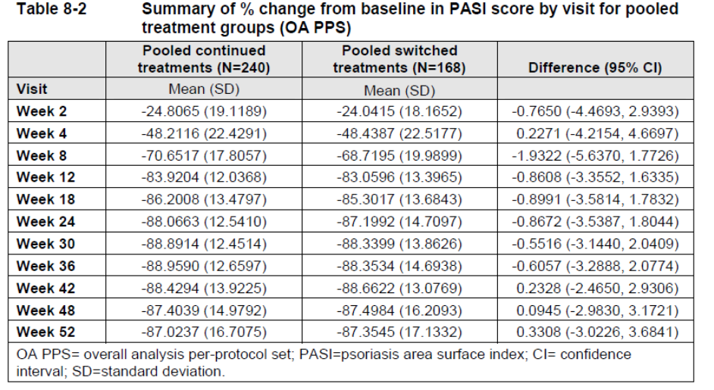
As described in the Week 52 CSR the proportion of patients achieving a response reported as clear or almost clear (IGA 0 or 1), i.e., IGA response data, was not analyzed overall for the OA PPS or OA FAS. Therefore, this parameter is provided for TP2 PPS and EP PPS separately as shown in the CSR.
Table 53: Summary of IGA responders by visit for continued treatment groups (TP2 PPS).
Table 54: Summary of patients with IGA response by visit for continued treatment groups (EP PPS).
Table 55: Summary of IGA responders by visit for pooled treatment groups (TP2 PPS).
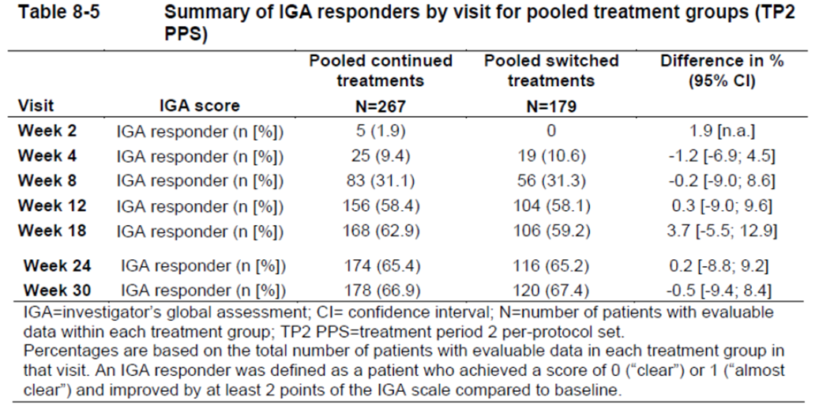
Table 56: Summary of patients with IGA response by visit for pooled treatment groups (EP PPS).
Table 57: Summary of % change from baseline in DLQI overall score by visit for continued treatment groups (OA PPS).
Table 58: Summary of % change from baseline in DLQI overall score by visit for pooled treatment groups (OA PPS).
Comment: The response has been noted. Relevant changes to the report body and supporting tables were made.

Safety
- The evaluator was unable to locate the laboratory manual for the EGALITY (GP15-302). The evaluator could only locate the lower limit of quantification (LLOQ) (for ADA measurements) in study GS15-104 which was given as 200 ng/mL. The sponsor should provide, for all five studies, a summary of the methods used to measure ADAs (including LLOQs).
Sponsor response
The methods to detect anti-drug antibodies in human serum applied in clinical PK studies and the EGALITY study followed the same principles, i.e. an electro-chemo-luminescence (ECL) bridging assay format including acid dissociation steps. In order to ensure that the assay is suitable for intended use, i.e. the detection of ADAs in human serum of healthy volunteers (PK studies) or psoriasis patients (EGALITY study), two assays were developed, validated and included into the dossier. The assay setup is described as below.
In brief, complexes of anti-etanercept antibodies and etanercept in the serum were first dissociated by an acid treatment. In a subsequent step anti-etanercept antibodies were bound to a plate pre-coated with etanercept (i.e. Erelzi). After over-night incubation residual etanercept was removed by a washing step. Anti-etanercept antibodies were then dissociated from the plate by a second acid treatment step. Neutralization was carried out in the presence of two differently labeled etanercept (i.e. Erelzi) molecules, Erelzi-Biotin and Erelzi- SulfoTag, respectively. Consequently, the anti-etanercept antibody established a bridge between the two labeled Erelzi molecules. Thereafter, the immune complex Erelzi-Biotin – anti-etanercept antibody – Erelzi-SulfoTag bound to a Streptavidin MSD plate. The readout was achieved by an ECL reaction and was measured with the Sector Imager from MSD. The number of measured counts correlated with the number of anti-etanercept antibodies in the serum.
A summary of the lower limit of quantification (LLOQ) data of the ADA methods applied for all five studies is provided. LLOQ was the lowest amount of anti-etanercept antibodies in a sample that could be quantitatively determined with pre-specified accuracy and precision. Of note, assay sensitivity (limit of detection or LOD) is the concentration of anti-etanercept antibodies at the screening cut-point and is described in ADA method validation report.
Table 59: Summary of LLOQ data for all five studies.
Comment: The response has been noted. Relevant changes to the report body were made.
- In the Summary of Clinical Safety, the sponsor states: “There are no data on post-marketing exposure as Erelzi has not yet been marketed in any region.” However, Erelzi has been approved in the US on 30 August 2016. The sponsor should provide a summary of post-marketing safety data, including PSURs/PBRERs (if available).
Sponsor response
Erelzi has been approved in the US on 30-Aug-2016 but has not been launched on the US market to date due to US-specific intellectual property reasons. In the EU, the product is planned to be launched starting end of June 2017 (positive EC decision received on 23 June) in a few countries. Thus, no post-marketing safety data of Erelzi are available yet.
Comment: The response has been noted. Relevant changes to the report body were made.

Second round benefit-risk assessment

Second round assessment of benefits
After consideration of the responses to clinical questions, the benefits of Erelzi in the proposed usage are unchanged from those identified in the first round.

Second round assessment of risks
After consideration of the responses to clinical questions, the risks of Erelzi in the proposed usage are unchanged from those identified in the first round.

Second round assessment of benefit-risk balance
The benefit-risk balance of Erelzi, given the proposed usage, is favourable. This assessment is based on the data evaluated from a clinical point of view. The assessment was made by weighing up the risks and benefits as outlined in this evaluation report.

Second round recommendation regarding authorisation
Approval of Erelzi (etanercept, Erelzi) is recommended for the following indications (as per proposed Erelzi product information document):
Rheumatoid Arthritis
Active, adult rheumatoid arthritis (RA) in patients who have had inadequate response to one or more disease-modifying antirheumatic drugs (DMARDs). Erelzi can be used in combination with methotrexate.
Severe, active rheumatoid arthritis in adults to slow progression of disease-associated structural damage in patients at high risk of erosive disease.
Psoriatic Arthritis
The signs and symptoms of active and progressive psoriatic arthritis in adults, when the response to previous disease-modifying antirheumatic therapy has been inadequate. Erelzi has been shown to reduce the rate of progression of joint damage as measured by X-ray and to improve physical function.
Plaque Psoriasis
Adult patients with moderate to severe chronic plaque psoriasis, who are candidates for phototherapy or systemic therapy.
Ankylosing Spondylitis
The signs and symptoms of active ankylosing spondylitis in adults.
Non-radiographic Axial Spondyloarthritis
Treatment of adults with active* non-radiographic axial spondyloarthritis with objective signs of inflammation as indicated by elevated C-reactive protein (CRP) and/or MRI change who have had an inadequate response to NSAIDs.
*Active disease is defined as a Bath Ankylosing Spondylitis Disease Activity Index (BASDAI) score of ≥ 4.
Children and Adolescents
Juvenile Idiopathic Arthritis
Active polyarthritis (rheumatoid factor positive or negative) in children and adolescents, aged 2 to 17 years, who have had an inadequate response to one or more DMARDs.
Active extended oligoarthritis in children and adolescents, aged 2 to 17 years, who have had an inadequate response to, or who have proved intolerant to, methotrexate.
Active enthesitis-related arthritis in adolescents, aged 12 to 17 years, who have had an inadequate response to, or who have proved intolerant to, conventional therapy.
Active psoriatic arthritis in adolescents, aged 12 to 17 years, who have had an inadequate response to, or who have proved intolerant to, methotrexate.
Etanercept has not been studied in children aged less than 2 years.
Paediatric Plaque Psoriasis
Chronic, severe plaque psoriasis in children and adolescents from 4 to 17 years, who are inadequately controlled by, or are intolerant to, other systemic therapies or phototherapies. Duration of therapy to be no longer than 24 weeks and treatment to be ceased after 12 weeks if a significant PASI response is not achieved.
However, the approval recommendation is dependent on the agreement to implement an appropriate risk management plan, and a favourable assessment by the quality, toxicology, and RMP evaluators.

References
- Daudén E, Pujol RM, Sánchez-Carazo JL, Toribio J, Vanaclocha F, Puig L, Yébenes M, Sabater E, Casado MA, Caloto MT, Aragón B; VACAP Study Investigators 2013. Demographic characteristics and health-related quality of life of patients with moderate-to-severe psoriasis: The VACAP study. Actas Dermosifiliogr 104(9):807–814.
- Feldman S, Krueger G 2005. Psoriasis assessment tools in clinical trials. Ann Rheum Dis 64(Suppl 2): ii65–ii68.
- Fredriksson T, Pettersson U 1978. Severe psoriasis – oral therapy with a new retinoid. Dermatologica 157(4):238–244.
- Gottlieb AB, Mease PJ, Mark Jackson J, Eisen D, Amy Xia H, Asare C, Stevens SR 2006. Clinical characteristics of psoriatic arthritis and psoriasis in dermatologists' offices. J Dermatolog Treat 17(5):279–287.
- Hsu L, Snodgrass BT, Armstrong AW 2014. Antidrug antibodies in psoriasis: a systematic review. Br J Dermatol 170(2):261–73.
- Krieckaert CL, Jamnitski A, Nurmohamed MT, Kostense PJ, Boers M, Wolbink G 2012. Comparison of long-term clinical outcome with etanercept treatment and adalimumab treatment of rheumatoid arthritis with respect to immunogenicity. Arthritis Rheum 64(12):3850–3855.
- Lai Z, La Noce A 2016. Key design considerations on comparative clinical efficacy studies for biosimilars: adalimumab as an example. RMD Open 2(1):e000154.
- Lee H 2014. Is extrapolation of the safety and efficacy data in one indication to another appropriate for biosimilars? AAPS J 16(1):22–26.
- Leonardi CL, Powers JL, Matheson RT, Goffe BS, Zitnik R, Wang A, Gottlieb AB; Etanercept Psoriasis Study Group 2003. Etanercept as monotherapy in patients with psoriasis. N Engl J Med 349(21):2014-22.
- Papp KA, Tyring S, Lahfa M, Prinz J, Griffiths CE, Nakanishi AM, Zitnik R, van de Kerkhof PC, Melvin L; Etanercept Psoriasis Study Group 2005. A global phase III randomized controlled trial of etanercept in psoriasis: safety, efficacy, and effect of dose reduction. Br J Dermatol 152(6):1304-12.
- Spuls PI, Lecluse LL, Poulsen ML, Bos JD, Stern RS, Nijsten T 2010. How good are clinical severity and outcome measures for psoriasis?: quantitative evaluation in a systematic review. J Invest Dermatol 130(4):933–943.

Therapeutic Goods Administration
PO Box 100 Woden ACT 2606 Australia
Email: info@tga.gov.au Phone: 1800 020 653 Fax: 02 6232 8605
https://www.tga.gov.au

The sponsor points out that this was agreed with other health authorities.

