Date of first round CER: 31 May 2013
Date of second round CER: 15 October 2013

AusPAR Attachment 2

Extract from the Clinical Evaluation Report for etanercept (rch)
  - Proprietary Product Name: Enbrel
  - Sponsor: Pfizer Australia Pty Ltd

About the Therapeutic Goods Administration (TGA)
- The Therapeutic Goods Administration (TGA) is part of the Australian Government Department of Health, and is responsible for regulating medicines and medical devices.
- The TGA administers the Therapeutic Goods Act 1989 (the Act), applying a risk management approach designed to ensure therapeutic goods supplied in Australia meet acceptable standards of quality, safety and efficacy (performance), when necessary.
- The work of the TGA is based on applying scientific and clinical expertise to decision-making, to ensure that the benefits to consumers outweigh any risks associated with the use of medicines and medical devices.
- The TGA relies on the public, healthcare professionals and industry to report problems with medicines or medical devices. TGA investigates reports received by it to determine any necessary regulatory action.
- To report a problem with a medicine or medical device, please see the information on the TGA website <http://www.tga.gov.au>.
About the Extract from the Clinical Evaluation Report
- This document provides a more detailed evaluation of the clinical findings, extracted from the Clinical Evaluation Report (CER) prepared by the TGA. This extract does not include sections from the CER regarding product documentation or post market activities.
- The words (Information redacted), where they appear in this document, indicate that confidential information has been deleted.
- For the most recent Product Information (PI), please refer to the TGA website <http://www.tga.gov.au/hp/information-medicines-pi.htm>.
Copyright
© Commonwealth of Australia 2014
This work is copyright. You may reproduce the whole or part of this work in unaltered form for your own personal use or, if you are part of an organisation, for internal use within your organisation, but only if you or your organisation do not use the reproduction for any commercial purpose and retain this copyright notice and all disclaimer notices as part of that reproduction. Apart from rights to use as permitted by the Copyright Act 1968 or allowed by this copyright notice, all other rights are reserved and you are not allowed to reproduce the whole or any part of this work in any way (electronic or otherwise) without first being given specific written permission from the Commonwealth to do so. Requests and inquiries concerning reproduction and rights are to be sent to the TGA Copyright Officer, Therapeutic Goods Administration, PO Box 100, Woden ACT 2606 or emailed to <tga.copyright@tga.gov.au>.

Contents
List of abbreviations 5
1. Introduction 7
2. Clinical rationale 7
2.1. Guidance 9
2.2. Overseas regulatory history 10
3. Contents of the clinical dossier 10
3.1. Scope of the clinical dossier 10
3.2. Paediatric data 10
3.3. Good clinical practice 11
4. Pharmacokinetics 11
4.1. Studies providing pharmacokinetic data 11
4.2. Summary of pharmacokinetics 11
4.3. Physicochemical characteristics of the active substance 11
4.4. Pharmacokinetics in the target population 12
4.5. Evaluator’s overall conclusions on pharmacokinetics 12
5. Pharmacodynamics 12
5.1. Studies providing pharmacodynamic data 12
5.2. Summary of pharmacodynamics 12
5.3. Mechanism of action 12
5.4. Pharmacodynamic effects 12
5.5. Evaluator’s overall conclusions on pharmacodynamics 12
6. Dosage selection for the pivotal studies 12
7. Clinical efficacy 13
7.1. Pivotal efficacy study 13
7.2. Evaluator’s conclusions on the clinical efficacy 34
8. Clinical safety 36
8.1. Studies providing evaluable safety data 36
8.2. Adverse events 37
8.3. Laboratory tests 49
8.4. Post-marketing experience 51
8.5. Safety issues with the potential for major regulatory impact 53
8.6. Evaluator’s overall conclusions on clinical safety 54
9. First round benefit-risk assessment 55
9.1. First round assessment of benefits 55
9.2. First round assessment of risks 55
9.3. First round assessment of benefit-risk balance 55
9.4. First round recommendation regarding authorisation 56
10. Clinical questions 56
10.1. Pharmacokinetics 56
10.2. Pharmacodynamics 56
10.3. Efficacy 56
10.4. Safety 56
11. Second round evaluation of clinical data submitted in response to questions 57
11.1. Please provide any PK data available in younger subjects (aged 2-4 years of age) to support the hypotheses for ETN dosing in this younger subgroup of patients? 57
11.2. Please provide an update (if available) on the efficacy data collected in Part 2 of Study 0881A1-3338? 57
11.3. Please provide an update on the safety data collected in Part 2 of Study 0881A1-3338, and if not available, comment as to why provision of the information should not be a specific condition of approval of this submission? 59
11.4. Please present the safety data for Parts 1 and 2 of Study 0881A1-3338 in a tabular format, which identified those adverse events that were considered to be related to study treatment? 62
11.5. In Part 1 of Study 0881A1-3338, 2 subjects (a 6 year old female with eoJIA experiencing bronchopneumonia, and a 17 year old female with PsJIA suffering pyelocystitis) developed serious infections requiring hospitalization, treatment with IV antibiotics, and discontinuation from study medication. Both events were considered by the site investigators to be mild in severity, and unrelated to study drug. The sponsor is requested to provide comment on the justification for the severity grading, and the assessment of causal relationship to study medication? 63
11.6. In Study 20021618, 2 paediatric subjects with systemic JIA developed macrophage activation syndrome. Please provide comment on whether etanercept was continued or not in these patients, and were the adverse events considered to be drug related? 63
12. Second round benefit-risk assessment 63
12.1. Second round assessment of benefits 63
12.2. Second round assessment of risks 63
12.3. Second round assessment of benefit-risk balance 63
12.4. Second round recommendation regarding authorisation 64
13. References 64

List of abbreviations
Abbreviation | Meaning
ACR | American College of Rheumatology
AE | Adverse Event
AS | Ankylosing Spondylitis
ANA | Antinuclear Antibody
BSA | Body Surface Area
CHAQ | Childhood Health Assessment Questionnaire
CI | Confidence interval
CRP | C-Reactive Protein
CS | Corticosteroid
DMARD | Disease Modifying Anti-Rheumatic Drug
eoJIA | extended oligoarticular Juvenile Idiopathic Arthritis
ERA | Enthesitis Related Arthritis
ESR | Erythrocyte Sedimentation Ratio
ETN | Etanercept
GCP | Good Clinical Practice
ILAR | International League of Associations for Rheumatology
ISR | Injection Site Reaction
ITT | Intention-to-Treat
JIA | Juvenile Idiopathic Arthritis
JRA | Juvenile Rheumatoid Arthritis
LOCF | Last Observation Carried Forward
LOM | Limitation of Movement
MTX | Methotrexate
NRI | Non-Responder Imputation
NSAID | Non-Steroidal Anti-inflammatory Drug
PD | Pharmacodynamic
PedsQL | Paediatric Quality of Life
PGA | Physician Global Assessment
pJIA | Polyarticular Juvenile Idiopathic Arthritis
PsJIA | Psoriatic Juvenile Idiopathic Arthritis
PK | Pharmacokinetic
RA | Rheumatoid Arthritis
RF | Rheumatoid Factor
SAE | Serious adverse event
SC | Subcutaneous
SD | Standard Deviation
SOC | System Organ Class
TNF | Tissue Necrosis Factor
TEAE | Treatment Emergent Adverse Effect
ULN | Upper Limit of Normal
URTI | Upper Respiratory Tract Infection
VAS | Visual Analogue Scale
VFE | Valid For Efficacy

Introduction
ETN is a recombinant, humanized tumour necrosis factor (TNF) receptor fusion protein, which has high affinity binding to TNF and blocks its interaction with cell surface TNF receptors.
The current approved JIA treatment indication for ETN in Australia is:
active polyarticular-course juvenile idiopathic arthritis in patients (4-17 years) who have had an inadequate response to one or more disease-modifying anti-rheumatic drugs. Enbrel has not been studied in children less than 4 years of age.
The proposed amended indication in JIA is:
Juvenile Idiopathic Arthritis
- Active polyarthritis (rheumatoid factor positive or negative) in children and adolescents, aged 2 to 17 years of age, who have had an inadequate response to one or more DMARDs.
- Active extended oligoarthritis in children and adolescents, aged 2 to 17 years of age, who have had an inadequate response to, or proved intolerant to, methotrexate.
- Active enthesitis-related arthritis in adolescents, aged 12 to 17 years, who have had an inadequate response to, or proved intolerant to, conventional therapy.
- Active psoriatic arthritis in adolescents, aged 12 to 17 years, who have had an inadequate response to, or proved intolerant to, methotrexate.
Enbrel has not been studied in children less than 2 years.
ETN also has several other approved treatment indications in Australia such as active RA, PsA, and AS in adult patients; as well plaque psoriasis in children, adolescents and adults.
ETN is currently registered for supply in Australia as a 25 mg powder for injection, and a 50 mg solution (in 1 mL) for injection in either a pre-filled syringe or auto-injector device. No new dosage forms or strengths are proposed in this submission.

Clinical rationale
JIA encompasses a diverse group of arthritic conditions of unknown etiology that begin before the sixteenth birthday, and persist for at least 6 weeks. It is one of the most physically disabling conditions of childhood, with a prevalence in Australia of 0.3% according to the Australian Institute of Health and Welfare 2012 report. JIA is a heterogeneous disorder, and the subtypes have varying clinical and laboratory features that may reflect distinct immunopathogenic processes. The pathogenesis of each subtype is multifactorial and likely to be triggered by environmental stimuli in genetically susceptible individuals. JIA is a WHO endorsed, internationally accepted umbrella term that has replaced all previously used nomenclatures such as juvenile rheumatoid arthritis (JRA) and juvenile chronic arthritis (JCA). Historically, 3 different validated sets of criteria have been published to define the chronic forms of arthritis seen in children, that is the EULAR (European) criteria, the ACR (American) criteria, and the more recent International League of Associations for Rheumatology (ILAR) definition of JIA. The ILAR classification criteria were first developed in 1997, and were revised in 2001. It includes 7 categories of the JIA (Table 1 below; taken from Petty et al, 2004) and has become the internationally accepted nomenclature. The current ETN product information (PI) does not classify JIA according to the ILAR criteria as the pivotal JIA licensing study (16.0016) commenced in 1997, that is prior to the development of the ILAR classification. Study 16.0016 enrolled children with polyarticular course JIA, the majority of whom would be now classified as having either Rheumatoid Factor (RF)-positive or RF-negative polyarthritis. The sponsor proposes amending the current PI to reflect the accepted contemporary classification of JIA, which has international consistency. This evaluator concurs with this proposal.
Table 1 Frequency, Age at Onset and Gender Distribution of the ILAR Categories of JIA
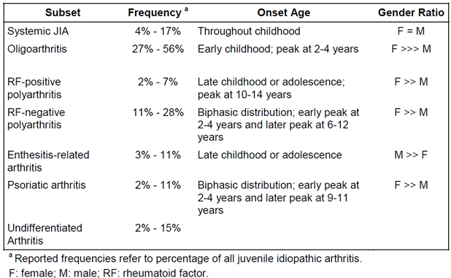
In this submission, 3 subtypes of JIA population were studied in the pivotal study (0881A1-3338): Enthesitis-related arthritis (ERA), psoriatic arthritis (PsJIA) and extended oligoarthritis (eoJIA). The sponsor has also provided open-label extension data (Study 20021618) for paediatric subjects who participated in the initial ETN JIA study (16.0016). This trial predominately enrolled children with active RF-positive or RF-negative polyarthritis. The sponsor is requesting a broadening of JIA treatment indication to include 5 of the 8 disease subtypes. Summaries of each JIA subtype being requested in the treatment indication are provided.
Oligoarthritis (involving 4 or fewer joints in the first 6 months of disease) accounts for up to half of all cases of JIA, and is sub-divided into those with persistent or extended disease. The sub-division is based on the number of additional joints involved beyond the first 6 months. It mainly affects preschool Caucasian girls with a female: male ratio of 5:1. The knee is the most frequently affected joint, followed by the ankle and wrist. The hip joint is rarely affected. One third to half of children with oligoarthritis (that is whose disease during the first 6 months affects 4 or less joints) continue to develop arthritis in additional joints thereafter, hence the nomenclature, “extended”. Many of these children (up to 30%) may develop chronic anterior uveitis, which typically is asymptomatic and insidiously progressive without specific treatment and monitoring. These patients have a different immunogenetic background (positive antinuclear antibody (ANA) in 60-80%) compared to those with persistent oligoarthritis. The eoJIA subtype carries a long-term prognosis similar to those with polyarthritis.
Polyarticular JIA is defined as involving 5 or more joints, and is sub-divided into RF-positive or RF-negative polyarthritis, based on the presence or absence of RF. RF-negative polyarthritis accounts for approximately one-quarter of all cases of JIA and usually affects preschool girls with a predominately symmetrical arthritis of the upper and lower limbs. Chronic anterior uveitis (10-15%) and growth disturbance are important potential complications. However, the subtype has a variable disease onset and course, which contributes to the heterogeneity in this JIA subgroup. RF-positive polyarthritis is a condition similar in clinical features, immunogenetic characteristics and prognosis to adult RA. It primarily affects girls and usually presents in late childhood or adolescence. Although it only affects about 5% of all patients with JIA it can be rapidly progressive and destructive. Up to 75% of RF-positive polyarthritis patients also have a positive ANA test.
Enthesitis-related arthritis (ERA) typically begins after the age of 6 years, and more commonly affects boys. It is characterised initially by lower limb arthritis and enthesitis (inflammation of the point where a tendon, ligament or fascia inserts into the bone). The most common sites of enthesitis are the insertions of the plantar fascia, Achilles tendon, and around and below the patella. Symptoms of sacroiliitis and spinal arthritis are uncommon at presentation but may become involved later in the disease course (10-15 years after disease onset). Uveitis affects these patients as well, but it tends to be symptomatic (painful, red eye). There is often a family history of similar illness or AS. The HLA-B27 antigen is found in 50% of patients, but ANA is usually negative.
Psoriatic JIA (PsJIA) is characterized by the presence of arthritis, dactylitis and skin psoriasis (including nail changes such as pitting or oncholysis). However, the arthritis may predate skin involvement by many years, and is not required for diagnosis. PsJIA has 2 phenotypic subgroups. The first group has similar characteristics to oligoarticular JIA, occurring typically in young ANA-positive girls with a high risk of asymptomatic anterior uveitis. However, unlike oligoarticular JIA, dactylitis and involvement of the small joints may occur. The second group resembles ERA, occurs in older children and adolescents, has a male predominance, and is associated with an increased risk of spondyloarthritis.
In contrast, there is increasing evidence that systemic JIA is an autoinflammatory disease, primarily involving the innate immune system versus the adaptive immune system pathogenesis for most of the other subtypes of JIA. Systemic JIA does not have HLA gene or autoantibody associations.
TNF is a pro-inflammatory cytokine, which is present in significantly elevated serum and synovial concentrations in patients with most JIA subtypes. It affects a variety of pathophysiological processes including activation of T-cells, induction of acute phase proteins, and stimulation of haemopoietic precursor cell growth and differentiation. ETN is a recombinant, humanized TNF receptor fusion protein, which has high affinity binding to TNF and blocks its interaction with cell surface TNF receptors. Current approved treatment options in Australia for moderately to severely active JIA include NSAIDs, corticosteroids (CS), and non-biological DMARDs (mainly MTX). However, a proportion of patients fail to respond to these treatment options and as such there is an unmet need for additional therapies for active, treatment refractory JIA.
The sponsor has not made a previous submission in Australia for extension of treatment indication in JIA subjects; or requested changes in posology and lowering the age limit of treatment indication in JIA.

Guidance
The TGA has recommended review and consideration of 1 specific regulatory guideline pertaining to the requested extension of indication. The TGA has adopted the EU guideline CPMP/EWP/422/04 “Guideline on Clinical Investigation of Medicinal Products for the Treatment of Juvenile Idiopathic Arthritis” (effective 26 June 2009).
The sponsor has recommended consideration of 2 related guidelines in reviewing this submission: CHMP guidelines on Clinical Trials in Small Populations (July 2006) and ICH guidelines on Choice of Control Group in Clinical Trials (January 2001).
Other relevant EU guidelines, adopted by the TGA are: CPMP/ICH/2711/99 “Note for Guidance on Clinical Investigation of Medicinal Products in the Paediatric Population” (effective 19 April 2001), EMEA/CHMP/PEG/194810/2005 “Reflection Paper: Formulations of Choice for the Paediatric Population” (effective 29 June 2009) and CHMP/EWP/147013/2004 “Guideline on the role of Pharmacokinetics in the Development of Medicinal Products in the Paediatric Population” (effective 24 August 2009).

Overseas regulatory history
An application for the extension of JIA indication to include the treatment of active ERA or PsJIA from the age of 12 years, and eoJIA from the age of 2 years was approved in Europe under the centralised process (UK was the rapporteur, and Spain was the co-rapporteur) on 31 July 2012. The approved application also included changes to the dosage regimen to allow once weekly dosing across all JIA indications. The third element of this proposed extension of indication, that is, the lowering of the age limit to 2 years for polyarticular JIA, was approved in the EU in 2010 following submission of the registry study 20021626. All 3 of the EU approved changes are similar in wording to the Australian proposed extension of indication.
At the time of this submission, in the USA, no application has been filed in relation to the extension of the JIA treatment indications. However, once weekly dosing with ETN across all treatment indications (including JIA) is approved in the USA.
Consistent with the Australian application, the approved EU indication also has a specific description for ETN in terms of its place in therapy. It specifies that ETN can be used in those ‘who have responded inadequately to, or who proved intolerant of, previous therapy with MTX (pJIA, PsJIA and eoJIA) or conventional therapy (ERA).’

Contents of the clinical dossier

Scope of the clinical dossier
The submission contained the following clinical information:
- 1 pivotal efficacy/safety trial (Study 0881A1-3338) evaluating the efficacy and safety of ETN in patients with eoJIA, ERA and PsJIA.
- No specific dose-finding studies.
- 1 supporting, open-label trial of up to 10 years duration (Study 20021618) providing efficacy/safety data in patients with polyarticular JIA. This is a long-term extension trial of the previously submitted pivotal ETN treatment study in patients with active polyarticular JIA (Study 16.0016).
- 1 Phase IV registry study of 36 months duration in patients with active polyarticular or systemic JIA (Study 20021626), which provided supporting safety and efficacy data, particularly in children 2-4 years of age at the commencement of ETN treatment.
- The sponsor’s Clinical Overview, Summary of Clinical Efficacy, Summary of Clinical Safety and literature references.
- There was no new clinical pharmacology information.

Paediatric data
The submission included paediatric efficacy and safety data as the requested extension of treatment indication is for patients aged 2-17 years (depending on JIA subtype).

Good clinical practice
The pivotal clinical trial (Study 0881A1-3338) and the 2 supporting trials (Studies 20021618 and 20021626) evaluating the use of ETN in children and adolescents with active JIA were conducted in accordance with the principles of Good Clinical Practice (GCP) and compliance with ethical requirements was met.

Pharmacokinetics

Studies providing pharmacokinetic data
No new pharmacokinetic (PK) data was provided in this submission.

Summary of pharmacokinetics
The information in the following summary is derived from conventional PK studies in humans. The following information is derived from the sponsor’s summaries, as well as the currently approved product information.
ETN is slowly absorbed from the site of SC injection, reaching maximum serum concentration 2-3 days after administration. As calculated in population PK analyses, absolute bioavailability is approximately 76%, and the apparent volume of distribution at steady state in children with JIA is 7.9 L. The half-life of ETN is approximately 80 hours.
In a study of patients with polyarticular JIA, serum concentration profiles in older children (10-17 years of age) were similar to those observed in adult patients with RA; however, in younger children (4-10 years of age) serum concentration profiles were appreciably lower reflecting a relative increased clearance when normalised by weight (as per the current PI wording – page 3 of 33). In JIA subjects aged 4 years of age and older, ETN clearance has been shown to be related to body weight and age, and thus it is recommended that ETN be administered according to body weight at 0.4 mg/kg (up to 25 mg) twice weekly. The 0.4 mg/kg twice weekly ETN dosing regimen was examined in Study 16.0016 (initial licensing trial in JIA). Simulation using data collected in children with JIA shows that once weekly dosing would be expected to achieve a steady state peak ETN concentration 11% higher, and a steady state trough ETN concentration 18% lower, compared with twice weekly dosing, albeit with a large overlap of concentration profiles (Yim et al, 2005).
No direct PK data has been presented, or probably collected in children aged 2 to < 4 years with JIA. The sponsor justifies the same ETN dosing regimen in younger children (2-4 years of age) by extrapolation of information. It is estimated that the typical 2-4 year old weighs between 10-15 kg. Body weight is expected to increase with age in male and female patients. Using a linear adjustment to parameters of subject weight and ETN clearance, the sponsor asserts that same dose adjustment principle for ETN use in 4-17 year old patients can be applied to 2-4 year old subjects based on their smaller body weight.

Physicochemical characteristics of the active substance
ETN is a genetically engineered, human TNF receptor p75 fusion protein with an approximate molecular weight of 150 kD. It has a dimer composition, fusing the extracellular ligand binding domain of human tumour necrosis receptor-2 (TNFR-2/p75) to the Fc domain of human IgG1. It binds with high affinity to TNF and blocks its interaction with cell surface TNF receptors found on a variety of cells in the body. The sponsor does not propose any change to the physiochemical structure or manufacturing process with this application for extension of indication.

Pharmacokinetics in the target population
No new PK information was included in this submission.

Evaluator’s overall conclusions on pharmacokinetics
The PK properties of ETN in patients aged 4-17 years with active polyarticular JIA have been previously assessed. No new PK data was provided in this submission and the sponsor is not proposing any changes to the PK section of the current PI. For subjects aged 2 to < 4 years of age, no PK data for ETN has ever been presented, or probably investigated.

Pharmacodynamics

Studies providing pharmacodynamic data
No new pharmacodynamic (PD) data was provided in this submission.

Summary of pharmacodynamics
The information in the following summary is derived from conventional PD studies in humans. The following information is derived from the sponsor’s summaries, as well as the currently approved product information.

Mechanism of action
ETN binds competitively and specifically to TNF and blocks its interaction with cell surface TNF receptors. The actions of TNF are diverse and include induction of immunoglobulin secretion, T-lymphocyte activation, induction of hepatic acute phase proteins, and stimulation of haematopoiesis.
There are 2 distinct receptors for TNF, a 55 kilodalton protein (p55) and a 75 kilodalton protein (p75), which exist on cell surfaces and in soluble forms. The activity of TNF is dependent upon its binding to either of the cell surface TNF receptors. ETN is a dimeric soluble form of the p75 TNF receptor which can bind to 2 TNF molecules. ETN inhibits the binding of both TNFα and TNFβ (lymphotoxin) to cell surface TNF receptors, rendering TNF biologically inactive. Cells expressing transmembrane TNF, which may bind to ETN, are not lysed.

Pharmacodynamic effects
No new information has been provided in this submission.

Evaluator’s overall conclusions on pharmacodynamics
The PD properties of ETN when used in patients aged 4-17 years with active polyarticular JIA have been previously assessed. No new PD data was presented in this submission and the sponsor is not proposing any changes to the PD section of the current PI.

Dosage selection for the pivotal studies
Although no specific dose-finding studies have been performed for patients with JIA, the dose and administration frequency of ETN used in the pivotal study (0881A1-3338), and proposed by the sponsor for licensing, have been reasonably justified.
The sponsor is proposing that ETN be administered by SC injection at a weekly dose of 0.8 mg/kg (up to a maximum weekly dose of 50 mg). The therapy can be given either twice weekly (3-4 days apart) at a dose of 0.4 mg/kg (as per the currently approved posology in children with JIA), or once weekly at a dose 0.8 mg/kg. In the pivotal trial (Study 0881A1-3338) patients received ETN at a dose of 0.8 mg/kg once weekly. The once weekly dosing regimen is also approved for children and adolescents with plaque psoriasis; and for adults with RA, psoriasis and AS. Based on PK modelling data, simulation results suggest that ETN 0.8 mg/kg/week given by once weekly injection versus twice weekly 0.4 mg/kg achieves a comparable drug exposure. The doses of background treatment with MTX, corticosteroids and NSAID when used by patients in the pivotal study (0881A1-3338) were appropriate, and consistent with contemporary clinical practice in Australia.

Clinical efficacy
The sponsor proposes the additional indication:
Enbrel is indicated for the treatment of active polyarthritis, and extended oligoarthritis in patients 2-17 years of age. Enbrel is indicated for the treatment of active enthesitis-related and psoriatic arthritis in adolescents aged 12-17 years.

Pivotal efficacy study

Study 0881A1-3338 (also known as Study B1801014)

Study design, objectives, locations and dates
Study 0881A1-3338 was a Phase 3b, single treatment, open-label trial conducted in 2 parts to evaluate the efficacy and safety of ETN in children and adolescents with eoJIA, ERA or PsJIA. Part 1 (first 12 weeks) was primarily designed to assess the clinical efficacy of ETN, while Part 2 (up to Week 96; that is another 84 weeks of treatment follow-up) was mainly designed to assess the long-term safety of ETN. The study was initiated in November 2009, with the last subject completing their Week 12 assessment (Part 1 - main efficacy analysis) in June 2011. Part 2 is ongoing and no efficacy results for this phase of the trial were presented in the current submission. The study was to be conducted at 38 sites in 19 countries in Europe, Australia and Latin America. However, only 26 of the sites actively recruited subjects (ranging from 1-7 subjects per study centre).
The main objective of the study was to evaluate the efficacy and safety of ETN in children and adolescents with active eoJIA, ERA or PsJIA with a history of intolerance or inadequate response to at least a 3 month course of at least 1 conventional DMARD (MTX, sulfasalazine, chloroquine or hydroxychloroquine), who were receiving the standard of care with or without NSAID, low dose corticosteroid, or at least 1 concomitant DMARD as listed above. The primary efficacy outcome was the proportion of patients on ETN who achieved ACR Paediatric 30 (Pedi 30) response at Week 12. The result was compared to historical control data. The sponsor states that the open-label nature of the study is an acceptable design to demonstrate efficacy and safety, as long as adequate attention is paid to selection of the external control group, minimization of biases, and appropriate statistical comparisons. This approach is consistent with regulatory guidelines, notably CHMP guidelines on Clinical Trials in Small Populations (July 2006) and ICH guidelines on Choice of Control Group in Clinical Trials (January 2001). The sponsor also states that it considered it to be unethical to randomise patients with active JIA to placebo in this study. However, the design of other pivotal trials examining the efficacy of biologic DMARD in patients with active JIA have utilised an active treatment, then withdrawal design to reduce the risk to paediatric patients of prolonged, untreated active disease, while maintaining data integrity because of using a randomization process leading into Part 2. The active treatment then withdrawal design is the recommended approach in the TGA adopted EU guideline CPMP/EWP/422/04 “Guideline on Clinical Investigation of Medicinal Products for the Treatment of Juvenile Idiopathic Arthritis” (effective 26 June 2009).
Study 0881A1-3338 is a 2-year trial conducted in 2 phases. Part 1 consisted of a 12-week, active-treatment period whereby all eligible patients were to receive SC ETN 0.8 mg/kg (to a maximum dose of 50 mg) once weekly. Part 1 was preceded by a screening phase of up to 4 weeks. At Week 12, patients who completed treatment with ETN were eligible to enter into Part 2 (another 84 weeks of follow-up). Once patients completed 96 weeks of treatment and follow-up (that is Parts 1 and 2), they could participate in an 8-year extension trial (Study B1801023). At the time of was not presented.
Prior to the last subject visit for Part 1 of the study, 2 protocol amendments were implemented. Amendment 1 was a global change, and Amendment 2 was a single, site-specific change to the lower age limit for inclusion (increased from 2 to 4 years). Neither of the protocol amendments altered the study’s overall integrity.

Inclusion and exclusion criteria
To be eligible for inclusion, patients had to be at least 2 years of age but less than 17 years at the time of enrolment for eoJIA, and between the ages of 12 and 17 years for ERA and PsJIA. They had to fulfil the ILAR criteria for the 3 subtypes of JIA being studied (as outlined previously, that is eoJIA, or ERA, or PsJIA). The JIA had to be clinically active at screening with at least 2 active peripheral joints (that is swollen and/or limited movement with accompanying pain or tenderness). Patients were required to have a history of either inadequate response or intolerance to at least a 3-month course of at least 1 conventional DMARD (MTX, sulfasalazine, anti-malarials) at adequate dose. For the ERA subtype only, an alternative prior qualifying treatment was at least a 1-month course of NSAID at appropriate dose. Background conventional DMARD treatment (single therapy only) could be continued on study in those receiving it in a stable dose for at least 8 weeks prior to study entry. In particular, MTX could be continued at a stable dose not exceeding 15 mg/m2 (maximum of 20 mg/week; oral or parenteral). Continuing treatment with NSAID and low dose prednisone (no more than 10 mg/day or 0.2 mg/kg/day, whichever was less) was also permitted if the patient had received a stable dose for the 2 weeks prior to baseline. Prior treatment with any biological DMARD therapy was not allowed. If appropriate, female patients were required to use contraception.
The exclusion criteria involved 3 domains and patients meeting any 1 of the criterion were excluded:
- Co-morbidities – active infection; history of recurrent infection, immunodeficiency, blood dyscrasia, demyelinating disease, macrophage activation syndrome or pustular psoriasis; active uveitis within 6 months of baseline; evidence of latent or previously treated tuberculosis, and any history of malignancy;
- Baseline laboratory results – haemoglobin < 8.5 g/dL, total WCC < 3500/mm3, neutrophil count < 1000/mm3, Platelet count < 125,000/mm3, ALT or AST > 1.5 upper limit of normal (ULN), presence of IgM Rheumatoid Factor; and positive hepatitis B surface antigen, hepatitis B core antibody, or hepatitis C antibody;
- Past treatments – prior treatment with any biological DMARD at any time point; prior treatment with azathioprine, cyclosporine, or leflunomide within the last 6 months; and live or attenuated vaccines within 2 months of baseline visit.

Study treatments
ETN was given by subcutaneous (SC) injection at a dose of 0.8 mg/kg (up to a maximum dose of 50 mg once weekly) for 12 weeks in Part 1 of the study and for up to an additional 84 weeks in Part 2 of the study. The dose of ETN was based on the subject’s weight assessed at each study visit, including increases and decreases in dose. Each vial of ETN contained 25 mg of active drug. Therefore, patients weighing > 31 kg received 2 SC injections per dose, and for those weighing < 31 kg a single SC injection was given. No change in concurrent NSAID, CS or MTX dosing was permitted during Part 1, except for documented safety reasons.

Efficacy variables and outcomes
The main efficacy variables were:
- ACR Pedi 30 Response
- ACR Pedi core components
The primary efficacy endpoint in Study 0881A1-3338 was the proportion of subjects achieving the ACR Pedi 30 criteria at Week 12. The ACR Pedi response is derived from 6 variables:
- Parent/patient global assessment of disease activity (range of 0 to 10 on a 21-circle Visual Analogue Scale (VAS) with 0 = very well and 10 = very poor).
- Physician Global Assessment (PGA) of disease activity (range of 0 to 10 on a 21-circle VAS with 0 = no activity and 10 = maximum activity).
- Number of joints with active arthritis (defined as joints with swelling; or in the absence of swelling, joints with limitation of movement (LOM) and concurrent pain and/or tenderness). Joint assessors assessed 68 joints for swelling, and 75 joints for pain and/or tenderness.
- Number of joints with LOM (n = 69 joints).
- Functional ability determined by Childhood Health Assessment Questionnaire (CHAQ). The parent of a paediatric subject is asked to report the child’s ability to perform activities of daily living, over the past week, in 8 domains including dressing, arising, eating, walking, hygiene, reach, grip, and common activities among a total of 30 items. Each item within a domain is scored on a 4-point Likert scale from 0 to 3 with 0 = no difficulty, 1 = some difficulty, 2 = much difficulty and 3 = unable to do. The CHAQ score is calculated as the mean of the 8 functional areas. The CHAQ is derived from the adult HAQ, and is a validated assessment of functional disability in subjects with JIA.
- C-Reactive Protein (CRP) in mg/L.
The patient is considered to have attained an ACR Pedi 30 response if at least 3 of the 6 core variables had improved by at least 30% from baseline, and no more than 1 of the other variables had worsened by more than 30%. The ACR Pedi 30 index is a validated, internationally accepted disease activity measure in JIA.
Secondary efficacy outcomes included:
- ACR Pedi 30 response at all time points other than Week 12 (that is Weeks 4, 8, 24, 36, 48, 60, 72, 84 and 96).
- ACR Pedi 50, 70, 90 and 100 response rates; and the individual core components of the ACR Pedi criteria at Week 12. For the varying degrees of overall ACR Pedi response, the same criteria as the ACR Pedi 30 response were applied, but at a higher percentage level.
- Proportion of patients with inactive disease at Week 12. Inactive disease was defined as no joints with active arthritis, normal CRP, and PGA of disease activity equal to or less than 1 (range: 0-10).
- Mean change from baseline to Week 12 in the duration of morning stiffness (recorded in minutes) and pain assessment (range: 0-10 on a 21-circle VAS).
- Evaluation of clinical benefit in 2 of the 3 JIA subtypes was assessed by the following additional secondary efficacy variables:
  - ERA – Tender entheseal assessment (n = 66 joints with 0 = no tenderness and 1 = any tenderness), overall back pain and nocturnal back pain (0 to 100 mm VAS for both variables), and Modified Schober’s test (in cm).
  - PsJIA – Percentage of BSA affected by psoriasis, and PGA of psoriasis (scale of 0 to 5).

Randomisation and blinding methods
All patients received open-label treatment with ETN, so randomization to treatment groups was not undertaken. The study was not blinded.

Analysis populations
The primary efficacy analysis was based on the modified Intention-to-Treat (mITT) population, which included all subjects who received at least 1 dose of ETN. The secondary efficacy analysis was performed on the per-protocol (or VFE, Valid for Efficacy) population. This consisted of all patients who received at least 1dose of ETN, and excluded any patient who experienced a major protocol deviation as determined by the sponsor. Table 2 summarizes the number of subjects in each analysis population for the 12 week assessment.
Table 2 Number of Subjects in each Analysis Population for Study 0881A1-3338
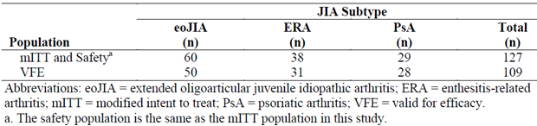

Sample size
The sample size was not based on any statistical hypothesis testing or power calculations. It was anticipated that approximately 100 subjects would be enrolled into the study. With this expected recruitment, the half-width of the 95% CI would be no more than 10% for estimation of the ACR Pedi 30 response rate.

Statistical methods
For the combined population as well as each of the 3 JIA subtypes, the primary efficacy analysis was based on the observed data. Sensitivity analyses were also performed using alternative methods for handling missing data such as a Last Observation Carried Forward (LOCF) approach as well as a Non-Responder Imputation (NRI) strategy. Descriptive summary statistics were applied for each efficacy endpoint analysed at 2 time points (Week 12 and 96). For patients in the eoJIA subtype, ACR Pedi response rates were additionally analysed by 3 pre-specified age brackets (2-4 years, 5-11 years, and 12-17 years of age at baseline).
In the primary analysis of the ACR Pedi 30 response rate at Week 12, results obtained in Study 0881A1-3338 were compared to both historical and active control data. The historical placebo control data was derived from a meta-analysis of 6 studies published by Ruperto et al, 2003. The active historical control data was compared to the results of a single trial (Study 16.0016; published by Lovell et al, 2000). The Lovell et al study was a 12-week, open-label ETN treatment study of subjects with polyarticular JIA. For both of the historical control data comparisons, an odds ratio and 95% CI was computed for the overall population, as well as the 3 JIA subtypes. Two methods were used for comparing the ACR 30 Pedi responses to the historical control data. The 6 studies in the meta-analysis were treated individually in the logistic regression model (that is adjusted) and were also pooled as 1 (that is unadjusted). For the ERA subtype, an additional analysis was conducted in a similar manner using the ACR Pedi 30 response rate from the Burgos-Vargas study (published 2008) of juvenile-onset spondyloarthritis. When the ACR Pedi 30 response data from Study 0881A1-3338 was compared to the active control data (Study 16.0016) a logistic regression analysis was applied using factors such as baseline age, gender, duration of disease, age of disease onset, and the baseline values of all 6 ACR Pedi 30 core components.
Three minor changes were made to the statistical analysis plan after the commencement of the study, none of which had the potential to affect the data analysis.

Participant flow
A total of 127 patients were enrolled in the study and received at least 1 dose of study medication: 60 subjects with eoJIA (including 15 patients in the 2-4 year age bracket, 23 in the 5-11 age group and 22 in the 12-17 year age range), 38 subjects with ERA, and 29 patients with PsJIA. Most subjects (96.0%; 122/127) completed 12 weeks (Part 1) of follow-up. There were 2 withdrawals each from the eoJIA and ERA subgroups, as well as 1 subject prematurely withdrawing before 12 weeks from the PsJIA subtype arm. Four of the 5 subject withdrawals were because of adverse events (AEs), and 1 patient in the eoJIA group prematurely discontinued because of a protocol deviation.
Of the 122 patients who received ETN during Part 2 (mITT cohort), 109 subjects were included in the VFE analysis (50 patients with eoJIA, 31 with ERA, and 28 with PsJIA). Reasons for exclusion of 18 patients from the primary efficacy analysis included 7 subjects taking a concurrent dose of MTX exceeding 15 mg/m2 (or 20 mg/week), 7 patients taking 2 or more concurrent NSAID during the 12 week treatment period, 1 subject receiving a parenteral CS injection and 3 patients for other reasons.

Major protocol violations/deviations
There were many protocol deviations involving several areas of the study protocol:
- 23 subjects had deviations from the inclusion/exclusion criterion – such as unclear diagnosis (n = 2), < 2 active joints at baseline (n = 2), inappropriate DMARD use (n = 6),
- 24 patients had deviations involving incorrect use of ETN – such as incorrect dose administered (n = 3),
- 35 subjects had deviations of concomitant medicine use – such as dose of MTX > 15 mg/m2 (n = 7), 2 or more NSAID used on trial (n = 7), receipt of parenteral CS injection (n = 1),
- 15 patients with errors of laboratory evaluation – such as no collection of relevant screening or safety related tests, and
- 48 subjects having errors of documentation.
As outlined in this report, a total of 18 subjects (14.2% of 127) had their data excluded from the VFE analysis because of concerns that such protocol deviations may have potentially impacted upon the efficacy results.

Baseline data
Table 3 summarizes the key baseline demographic characteristics of the patients involved in Study 0881A1-3338. The overall mean age was 11.7 years with a range of 2-17 years. Fifteen patients (11.8%) were aged 2-4 years, 23 subjects (18.1%) were aged 5-11 years and 89 patients (70.1%) were aged 12-17 years. As expected, the mean age of subjects in the eoJIA group was lower due to the inclusion of patients aged 2-17 years compared with 12-17 years in the other 2 JIA subtypes. The majority of patients were female (56.77%), and of Caucasian ethnicity (90.55%). Patients in the eoJIA group had a median baseline weight of 29.25 kg, whereas those in the other 2 JIA subtypes were older children (median baseline weight of 54.4 kg for the ERA group, and 56.6 kg for the PsJIA group).
Table 3 Key Demographic Characteristics of Patients at Baseline in Study 0881A1-3338
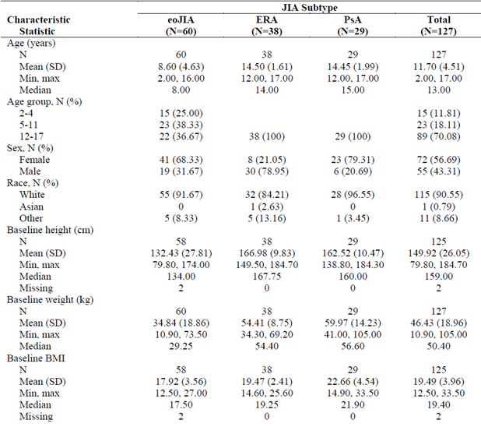
Table 4 summarizes the key baseline disease characteristics of the patients involved in Study 0881A1-3338. The mean disease duration at baseline was 26.8 months. Younger subjects had a shorter median duration of illness at baseline: 13.9 months for those aged 2-4 years, 32.7 months for 5-11 years, and 42.6 months for subjects aged 12-17 years. Prior to the study, all but 2 subjects with ERA (1.6% of 127) had received at least 1 DMARD, and most (85.8%; 109/127) were taking DMARD therapy at baseline. Overall, 67.7% (86/127) of subjects were taking MTX at baseline. The background rate of MTX use at baseline was higher in the younger age groups (93.3% in those aged 2-4 years and 82.6% in 5-11 years). Other DMARD therapy at baseline in the overall population included sulfasalazine (15.0%) and hydroxychloroquine (2.4%). In the ERA group, the proportion of subjects taking MTX (47.4%) and sulfasalazine (31.6%) at baseline was somewhat different to the overall cohort. NSAID use at baseline was recorded in 53.5% of subjects, and 12.6% of patients were receiving oral CS at baseline. However, in the PsJIA subtype only 1 subject (3.5% of 29) was taking oral CS at enrolment.
Table 4 Key Baseline Disease Characteristics of Subjects in Study 0881A1-3338
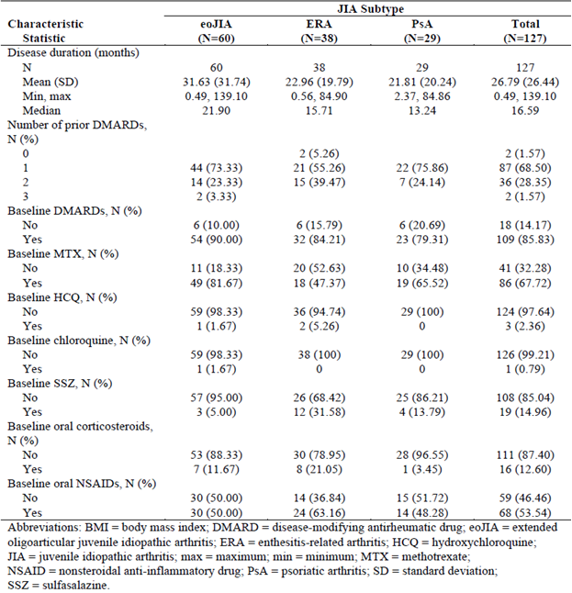
Table 5 summarizes the JIA disease activity at baseline. In general, patients had moderately active JIA at baseline with the mean number of active joints being 6.74, mean patient/parent global assessment VAS score being 4.96 (range: 0-10), mean physician global assessment VAS score being 5.02 (range: 0-10), and the mean CHAQ score being 0.80 (range: 0-3). Patients with ERA had a numerically lower mean number of active joints at baseline (5.21) compared to subjects with eoJIA (7.58 joints) and PsJIA (7.0 joints). The other disease parameters assessing joints (joints with LOM, pain/tenderness, swelling) showed a similar trend. The mean duration of morning stiffness at baseline was shorter in those affected by PsJIA (54.3 minutes) compared to subjects with eoJIA (72.8 minutes) and ERA (89.3 minutes). Mean baseline CRP was higher in patients with ERA (15.3 mg/L) compared to those with eoJIA (6.3 mg/L) and PsJIA (3.2 mg/L). Expectedly, a higher proportion of subjects with ERA were HLA-B27 positive (68.4%) compared to patients with eoJIA (15.0%) and PsJIA (10.3%).
Table 5 JIA Disease Activity at baseline in Study 0881A1-3338
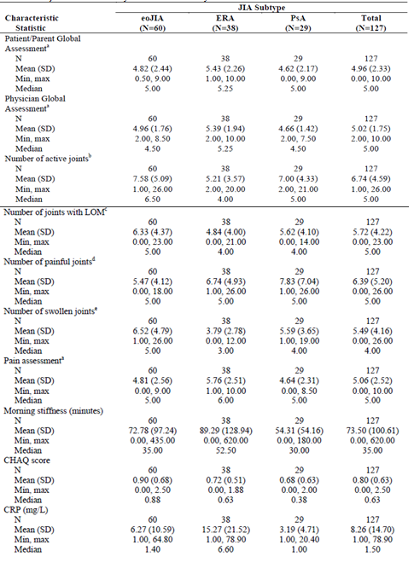

Results for the primary efficacy outcome
The primary efficacy outcome was the proportion of subjects who achieved an ACR Pedi 30 response at Week 12. For the mITT population, 88.6% of patients (109/127; 95% CI 81.6%, 93.6%) achieved an ACR Pedi 30 response at 12 weeks. The rate of ACR Pedi 30 response for each of the JIA subtypes was 89.7% (52/58; 95% CI 78.8%, 96.1%) for eoJIA, 83.3% (30/36; 95% CI 67.2%, 93.6%) for ERA and 93.1% (27/29; 95% CI 77.2%, 99.2%) for PsJIA. Supporting analyses of the primary efficacy endpoint, such as alternative missing data imputation (LOCF and NRI data), and using the per-protocol population, detected a similar treatment response.
The results of Study 0881A1-3338 (overall, and for each of the 3 JIA subtypes) were compared to historical placebo control data (meta-analysis of 6 studies published by Ruperto et al 2003), as well as an active historical control (Study 16.0016; Lovell et al, 2000). The ACR Pedi 30 response rate at Week 12 for subjects (overall as well as each of the 3 JIA subtypes) in Study 0881A1-3338 were compared with the mean composite response rate observed in a historical placebo dataset. Table 6 shows the response rates, odds ratios and 95% CI for the comparison between ETN and a meta-analysis of 6 historical control studies with data considered as pooled (unadjusted) or treated individually (adjusted). For the ERA subtype, the ACR Pedi 30 response rate at Week 12 was also compared to that from a single study by Burgos-Vargas et al (2008). All odds ratios and the lower bound of the 95% CI were greater than 1, indicating the ACR Pedi 30 response rate in Study 0881A1-3338 was significantly higher than observed in historical controls.
Table 6 ACR Pedi 30 Response Rates at Week 12 in Study 0881A1-3338 (observed cases) compared to Historical Placebo Control
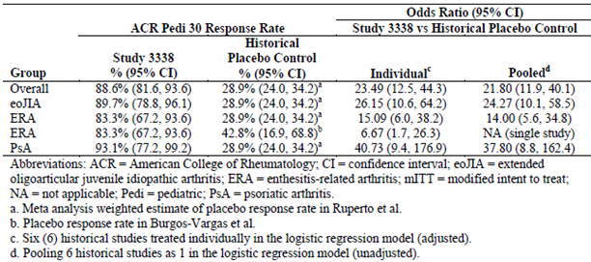
The initial 12 week, open-label ETN treatment phase of Study 16.0016 was used as an active historical control dataset for Study 0881A1-3338. Table 7 shows the response rates, odds ratios and 95% CI for the comparison between ETN treatment in this trial and patients who received ETN in Study 16.0016. The 95% CI of each of the odds ratios included 1, indicating that the ACR Pedi 30 response rate observed in Study 0881A1-3338 was comparable to that recorded in Study 16.0016.
Table 7 ACR Pedi 30 Response Rates at Week 12 in Study 0881A1-3338 (observed cases) compared to Historical Active Control (Study 16.0016)
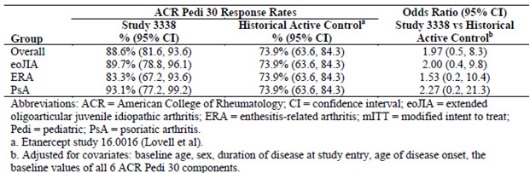
The rate of achieving an ACR Pedi 30 response at Week 12 in Study 0881A1-3338 was not presented according to prior or concurrent treatments of interest (that is potential factors associated with treatment response), such as concurrent MTX (67.7% of subjects) and oral CS use (12.6% of patients) at baseline.

Results for other efficacy outcomes

ACR Pedi 50/70/90/100 responses at week 12
After 12 weeks of open-label ETN treatment, 81.1% (99/122) of patients achieved at least an ACR Pedi 50 response, 61.5% (75/122) achieved an ACR Pedi 70 response, 29.8% (36/121) of patients attained an ACR Pedi 90 response, and 23.0% (28/122) obtained an ACR Pedi 100 response – Table 8. Within each ACR Pedi response level, the proportion of patients with each of the 3 JIA subtypes who achieved a response at 12 weeks was similar.
Table 8 Patients with ACR Pedi 50/70/90/100 Responses at Week 12 (mITT population) in Study 0881A1-3338
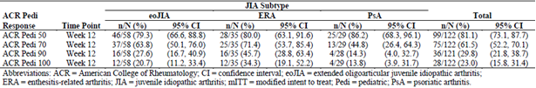
Within the eoJIA subtype, subjects were of a broader age range (2-17 years) than the other 2 JIA subtypes (12-17 years). When considering subjects only with eoJIA, the proportion of patients in each of 3 pre-specified age brackets (2-4 years, 5-11 years, and 12-17 years) that achieved ACR Pedi responses at Week 12 were similar, irrespective of age of subject at baseline - Table 9.
Table 9 Proportion of Patients with eoJIA who achieved ACR Pedi 30/50/70/90/100 Responses at Week 12 (mITT population) in Study 0881A1-3338
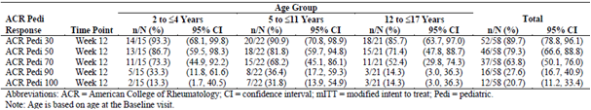

ACR Pedi core components at week 12 in Study 0881A1-3338
Table 10 presents a summary of the mean changes from baseline to Week 12 for each of the 6 ACR Pedi components. Overall, the mean values at Week 12 were improved from baseline in all 6 variables for both the total mITT population, as well as each of the 3 JIA subtypes. After 12 weeks of open-label ETN treatment, the mean overall change from baseline in each of the 6 components comprising the ACR Pedi criteria were:
- Number of active joints (baseline mean 6.74): -5.05 joints (95% CI -5.83, -4.27),
- Number of joints with LOM (baseline mean 5.72): -4.10 joints (95% CI -4.77, -3.44),
- Patient/Parent Global VAS assessment (baseline mean 4.96): -2.71 (95% CI -3.14, -2.28),
- Physician Global VAS assessment (baseline mean 5.02): -3.51 (95% CI -3.81, -3.21),
- CHAQ score (baseline mean 0.80): -0.48 (95% CI -0.57, -0.39), and
- CRP (baseline mean 8.26 mg/L): -5.38 mg/L (95% CI -7.81, -2.94).
Table 10 Mean Change (95% CI) from baseline in ACR Pedi Core Components at Week 12 in the mITT Population of Study 0881A1-3338
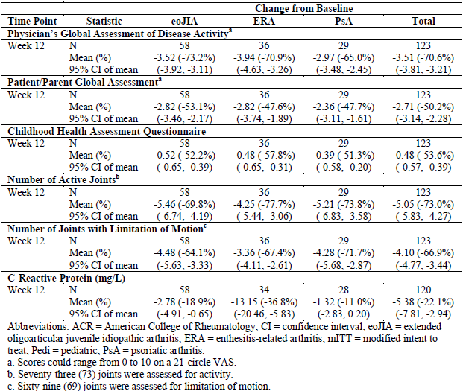

Patients with inactive disease status at week 12
Inactive disease was defined as no joints with active arthritis (that is no pain, swelling, or LOM), CRP reading within normal limits (< 1 mg/L), and a PGA score of 0. Overall, 15 subjects (12.1% of 124; 95% CI: 6.9, 19.2) fulfilled the criteria for inactive disease at Week 12. The proportion of patients in each of the 3 JIA subtypes with inactive disease at Week 12 of ETN therapy was similar: 11.9% (7/59; 95% CI: 4.9, 22.9) for eoJIA, 6.9% (2/29; 95% CI: 0.8, 22.8) for ERA, and 16.7% (6/36; 95% CI: 6.4, 32.8) for PsJIA.

Duration of morning stiffness at week 12
The mean duration of morning stiffness improved from baseline in all 3 JIA subtypes. The mean decrease in morning stiffness from baseline to Week 12 in eoJIA (n = 58) was 60.3 minutes (baseline 72.8 minutes), in patients with ERA (n = 36) was 65.6 minutes (baseline 89.3 minutes), and in subjects with PsJIA (n = 29) was 47.9 minutes (baseline 54.3 minutes).

Pain VAS at week 12
The mean pain VAS score at baseline was 5.06 (range: 0-10), and for patients in each of the 3 JIA subgroups, pain lessened by a similar magnitude by Week 12 (-3.15 for subjects in the eoJIA group, -3.21 for patients in the ERA arm, and -2.60 for subjects in the PsJIA subtype).

Specific efficacy endpoints for JIA subtype at week 12
In subjects with ERA, the mean change from baseline to Week 12 in 4 additional secondary efficacy endpoints was assessed in 36 of 38 potential subjects. After 12 weeks of ETN treatment, the mean tender entheseal score reduced by 4.36 (baseline mean 5.87), overall back pain reduced by 12.5 mm (baseline mean of 25.9 mm), nocturnal back pain reduced by 8.9 mm (baseline mean 16.4 mm), and the modified Schober’s test improved by 0.35 cm (baseline mean 15.0 cm).
In subjects with PsJIA, the mean change from baseline to Week 12 in 2 additional secondary efficacy endpoints was assessed in 29 subjects. After 12 weeks of ETN treatment, the mean percentage of BSA affected by psoriasis reduced by 6.72% (baseline mean 10.41%), and the PGA of psoriasis improved by 0.96 (baseline mean 1.83).

Study 20021618

Study design, objectives, locations and dates
Study 20021618 was a long-term (up to 10 years), open-label, extension study for paediatric subjects with active DMARD-refractory JIA who previously participated in the initial ETN JIA treatment study (16.0016). It was conducted in 38 North American centres (36 in USA, and 2 in Canada) between July 1997 and December 2008. The primary objective of the study was to evaluate the long-term safety of ETN in paediatric patients with active DMARD refractory JIA, but efficacy outcomes were also collected as a secondary objective. There was no blinding or control group.
Patients with JIA received a 0.8 mg/kg weekly SC dose of ETN (maximum weekly dose of 50 mg), either once weekly or a 0.4 mg/kg SC dose administered twice weekly (given 3 or 4 days apart).

Inclusion and exclusion criteria
To be included in Study 20021618 patients had to complete the forerunner study (16.0016) without any clinically significant adverse events considered to be due to ETN. As Study 20021618 was an open-label extension of the preceding trial (16.0016), the same original inclusion and exclusion criteria were applicable. Study 16.0016 was a 2-part, active treatment (initial 3 months), then randomized withdrawal trial (subsequent 4 months of follow-up) of ETN for patients between the ages of 2 and 17 years at entry, with the onset of arthritis symptoms before their 16th birthday, who had moderately-severely active polyarticular course JIA that was either refractory to, or intolerant, of MTX. Polyarticular JIA included subjects with 1 of 3 subtypes (as per the 1986 ACR classification): polyarthritis, pauciarthritis, or systemic onset. If the 1997 ILAR classification criteria of JIA were applied to subjects involved in Study 20021618, then no subjects would have met the ILAR diagnostic criteria for ERA or PsJIA, and 5 patients would have been classified as having eoJIA.

Study treatments
Active treatment in Study 20021618 consisted of ETN 0.8 mg/kg/week given by SC injection. Therapy could be administered as 2 x 0.4 mg/kg SC injections (up to a maximum dose of 25 mg per injection) on the same day of the week or 3-4 days apart, or as a single 0.8 mg/kg injection. Patients were followed for a median of 6 years. The continuation rates for paediatric patients at yearly intervals were: 58 (100%) at year 1, 52 (89.7%) at year 2, 48 (82.8%) at year, 42 (72.4%) at year 4, 37 (63.8%) at year 5, 34 (58.6%) at year 6, 31 (53.4%) at year 7, 26 (44.8%) at year 8, 22 (37.9%)at year 9 and 18 (31.0%) at year 10.
In contrast to Study 0881A1-3338, concurrent MTX use was not permitted in Studies 16.0016 and 20021618. However, patients were allowed to continue NSAID and low dose oral corticosteroid therapy in all of the trials as long as therapy had been received in a stable dose for at least 4 weeks prior to baseline.

Efficacy variables and outcomes
The main efficacy variable for Study 20021618 was the ACR Pedi 30 response rate at 3 months. This was compared to the ACR Pedi 30 response rate on the last day of observation (that is Day 210) in Part 2 of Study 16.0016. At the time of protocol writing, the ACR Pedi 30 response was known as the JRA-DOI. The change in terminology of the efficacy measure did not involve any changes to its individual components or its calculation as a composite index.
Secondary endpoints assessed:
- Proportion of patients achieving ACR Pedi 30, 50 and 70 responses at yearly time points through to 10 years;
- Mean change with time in the individual components of the ACR Pedi criteria; and
- Mean change over time in subject’s rating of pain by VAS.

Randomisation and blinding methods
This was an open-label study, and hence no blinding or randomization was performed. No blinded joint assessor was used in Study 20021618 (in contrast to Study 16.0016).

Analysis populations
A total of 58 patients enrolled in Study 20021618, and all were included in the efficacy and safety analysis. No per-protocol analysis was conducted in this open-label extension trial.

Sample size
Sample size was not calculated as Study 20021618 as this was an open-label, extension trial of patients completing Study 16.0016.

Statistical methods
No formal statistical analysis was performed on the dataset. Each individual subject’s baseline data for Study 20021618 was that recorded at baseline in Study 16.0016. Response rates were tabulated and analysed in a descriptive form. No imputation or estimation methods were used for missing values during the study.

Participant flow
Overall, 58 patients (84.1%) enrolled into Study 20021618 out of a possible 69 eligible subjects. Fifteen (25.9% of 58) patients completed the 10 year study treatment period. Of the 43 patients (74.1% of 58) who discontinued study follow-up: 11 patients (19.0% of 58) withdrew because of lack of efficacy, 5 patients (8.6% of 58) discontinued because of an AE, and the remainder of subjects withdrew due to various reasons including withdrawal of consent, lost to follow-up, and protocol issues. In general, the withdrawal rate was highest in the first 3 years, and then relatively stable for the remainder of the 10 year study follow-up period. The rates of continuation in Study 20021618 were 86.2% (50/58) at 1 year, 79.3% (46/58) at 2 years, 70.0% (40/58) at 3 years, 60.3% (35/58) at 5 years, and 39.7% (23/58) at 8 years.

Major protocol violations/deviations
Three paediatric patients in Study 20021618 experienced significant protocol deviations including incorrect dose of ETN administered and receiving an excluded concurrent medication.

Baseline data
The mean age of the JIA population at baseline in Study 20021618 was 10.52 years (range: 4 to 17 years). One patient was 4 years old (1.7%), 28 (48.3%) were 5-11 years of age at onset, and 29 (50.0%) subjects were 12-17 years of age at baseline. Regarding JIA subtypes, 34 patients (58.6%) had polyarticular-onset JIA, 19 (32.8%) had systemic-onset JIA, and 5 (8.6%) had pauciarticular disease. Study 20021618 predominately enrolled females (67.2%; 39/58) of Caucasian ethnicity (74.1%; 43/58). The mean baseline weight of patients was 35.9 kg (range: 13.5-124.7 kg).
The mean disease duration was 5.96 years (range: 0.7 to 12.4 years). Most patients (63.8%; 37/58) had a negative RF status at baseline. Patients had severely active JIA at baseline in the forerunner trial (Study 16.0016). The mean baseline CRP was 6.7 mg/dL and mean ESR was 42.4 mm/hr. The mean number of active joints at baseline was 39.4 (range: 10 – 70) and the mean number of joints with LOM was 27.5 (range: 0 –60). The mean PGA score was 6.4 (range of 1-10), and the mean CHAQ score being 1.9 (range: 0-3.3).
All 58 patients in Study 20021618 had previously taken low dose MTX at a dose of at least 10 mg/m2/week: 84.5% (49/58) were deemed to be non-responsive to this therapy, and 22.4% (13/58) were intolerant of MTX. Subjects had taken a median of 2 DMARDs (range: 1-7 medicines) in the past. Twenty-two patients (37.9% of 58) were taking low dose oral CS at baseline, and the majority (96.6%; 56/58) were taking NSAID.
There are significant differences between the baseline disease characteristics and populations involved in Study 20021618 versus Study 0881A1-3338. Study 20021618 recruited subjects with more severe arthritis at baseline, and investigated different JIA subtypes. It is proposed that the 2 studies are complementary to demonstrating the efficacy of ETN in treating a broad range of JIA subtypes.

Results for the primary efficacy outcome
At 3 months in Study 20021618, 42 subjects (79.2% of 58) recorded an ACR Pedi 30 response, which was consistent with rate of response (79.7%; 55/69) seen at the end of Part 2 of Study 16.0016 in those who received ETN.

Results for other efficacy outcomes

ACR Pedi 30, 50 and 70 response rates at yearly intervals up to 10 years
In Study 20021618, the rate of clinical improvement was relatively stable over 10 years of follow-up – refer to Table 11.
Table 11 ACR Pedi 30, 50 and 70 Response Rates at Yearly Intervals to 10 Years in Study 20021618
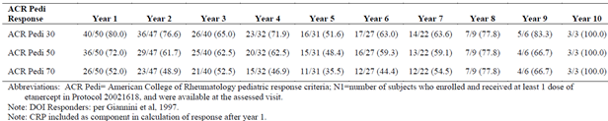
The rate of ACR Pedi 30 response was 80.0% (40/50 patients) at 1 year, 76.6% (36/47) at 2 years, 65.0% (26/40) at 3 years, and fluctuated between 51.6% and 83.3% for years 4 through to 10 (excluding patient withdrawals at each time point). As previously mentioned, 11 subjects (19.0% of 58) withdrew because of lack of efficacy and this may have enriched the population of responders with time. Furthermore, after 6 years of treatment, the overall number of continuing subjects was low and less than half the original cohort (46.6%; 27/58), which may have biased the efficacy results.
The ACR Pedi 50 and 70 response rates showed a similar trend over 10 years of follow-up in Study 20021618. At 1 year of follow-up, the ACR Pedi 50 response rate was 72.0% (36/50 patients) and the ACR Pedi 70 response rate was 52.0% (26/50 subjects). The rates of ACR Pedi 50 and 70 response were maintained over the first 3 years of follow-up, but fluctuated thereafter due to the above reasons.

Mean change in JIA ACR core set variables
Apart from some fluctuation in the mean percent improvement from baseline in CRP values in the later years of follow-up (years 7-10), all 6 of the JIA ACR core set variables showed a relatively stable and sustained pattern of improvement from baseline in Study 20021618 (see Table 12), which continued through to10 years of follow-up. One of the key secondary objectives of Study 20021618 was to evaluate the improvement in physical functioning/disability with continued ETN therapy. The mean percent improvement from baseline in the CHAQ score at 1 year was 48.4% (n = 46), which was stable at 2 and 3 years of follow-up (approximately 51% mean improvement from baseline; n = 42 and 32, respectively), and then increased slightly over the last 7 years of observation (albeit small patient numbers contributing data; n = 13-21).
Table 12 Percent Improvement from Baseline for the Individual Components of the ACR Pedi Response Criteria over time in Study 20021618
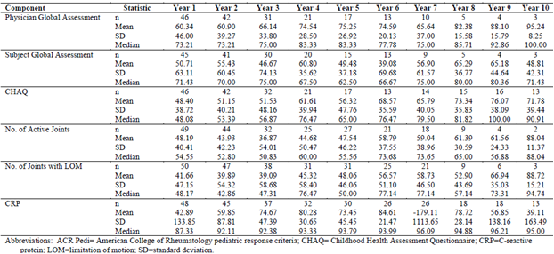

Mean change in pain VAS
Arthritis related pain, as assessed by VAS, showed a relatively sustained improvement over time after the commencement of ETN. The mean (+/- SD) baseline VAS pain score was 3.7 (+/- 2.5), and this decreased by 55.8% (+/- 68.3%) at 1 year (n = 44). The improvement in the mean pain VAS score was maintained until 4 years, but thereafter the number of evaluable patients contributing data became too low to make meaningful interpretation (n = 13 or less).

Other efficacy studies – Study 20021626

Study design, objectives, locations and dates
Study 20021626 was an open-label, non-randomized, Phase IV registry study for children aged 2-18 years with a diagnosis of polyarticular or systemic JIA who were recently commenced upon or currently receiving ETN alone, or in combination with MTX +/- other non-biological DMARDs. Subjects who satisfied all eligibility criteria were allocated into 1 of 3 cohorts based on their baseline treatment (ETN alone, MTX alone, or ETN + MTX). The study was conducted in 32 North American centres (28 in USA, and 4 in Canada) between April 2000 and January 2008.
The primary objective of the study was to evaluate the long-term safety of ETN, administered with or without other DMARDs (mostly MTX), compared to control cohort receiving MTX alone +/- other non-biological DMARDs. Efficacy measures were also collected as a secondary objective of the trial. Patients receiving SC ETN were given a dose of 0.8 mg/kg weekly (maximum weekly dose of 50 mg) for up to 36 months. When used, MTX was dosed at the discretion of the investigator at a dose of at least 10 mg/m2/week (but not greater than 1 mg/kg/week). Subjects who enrolled into the study on MTX could be switched to ETN (alone or in combination with MTX or other DMARDs) at any time point prior to 30 months. At the time of treatment re-assignment, a new baseline of values was established at the time of re-enrolment for these patients. In contrast, subjects who enrolled into the study on ETN were not eligible for re-assignment to the MTX arm at any time.
There were 5 protocol amendments to this study, the first 2 of which were implemented prior to trial commencement. None of the changes affected the integrity of the study’s reported outcomes.
In this submission, the sponsor provided an addendum report for the study, which examined the subgroup of patients, aged 2 to < 4 years of age in support of its proposal to reduce the lower age limit for ETN treatment from 4 to 2 years age. In this report, the data for this registry study will be presented as a whole cohort (all subjects), as well as the very young age subgroup (2 to < 4 years of age at the time of enrolment).

Inclusion and exclusion criteria
To be included in Study 20021626 patients had to be between the ages of 2 and 18 years at enrolment with a diagnosis of either polyarticular or systemic JRA (according to the ACR criteria valid at the time of design). Patients were required to have active arthritis at baseline, defined as 3 or more active joints. The JIA disease duration had to be sufficiently long enough for the subject to have received a prior trial of NSAID and/or CS treatment. For both ETN and MTX, treatment could either be newly started at baseline or within 6 months of enrolment into the study. Significant exclusion criterion were: past history of receiving any biologic DMARD (including any other anti-TNF therapy), malignancy within 5 years, history of substance abuse, and serious concurrent medical conditions (acute or chronic, and including infections) that compromise the subject from safely receiving ETN.

Study treatments
Treatment in Study 20021626 consisted of ETN 0.8 mg/kg/week given by SC injection (up to a maximum dose of 50 mg per week). Patients receiving MTX were prescribed a minimum dose of 10 mg/m2/week (~0.3 mg/kg/week; maximum dose of 1 mg/kg/week). Concomitant folic or folinic acid was at the discretion of the investigator. Patients were also allowed to continue NSAID and low dose oral CS therapy (10 mg/day or 0.2 mg/kg/day, whichever was less) as long as this therapy had been received in a stable dose for at least 4 weeks prior to baseline. Drug administration information was not collected in the registry dataset.

Efficacy variables and outcomes
A limited set of efficacy measures (of equal weighting) were collected and these included:
- Physician Global Assessment (PGA) of disease activity – collected at baseline, months 3, 6, 9, 12 18, 24, 30 and 36 months;
- Joint assessment (number of active joints and number of joints with LOM) – collected at baseline and every 6 months up until 36 months; and
- Paediatric Quality of Life (PedsQL) – collected at the same times as the PGA.
The PedsQL inventory scale is a reliable and validated way of measuring health-related quality of life outcomes via 23 items in children aged 2-18 years. For children aged 5 years or older, it assesses 4 domains (physical functioning, emotional functioning social functioning and school functioning). For toddlers there are only 3 sub-domains. The tool has a number of developmentally appropriate child self-report and parent proxy-report versions.

Randomisation and blinding methods
This was an open-label registry study with no blinding or randomization process.

Analysis populations
A total of 594 patients enrolled in Study 20021626, and all were included in the efficacy and safety analysis. A subgroup analysis included all subjects (n = 47) with polyarticular JIA who were between the ages of 2 to < 4 years at the time of enrolment. The subgroup analysis is of particular interest in this current submission as the sponsor is providing this data as evidence supporting the request to lower the current age limit of ETN treatment from 4 to 2 years of age.

Sample size
Sample size was not calculated as Study 20021626 as this was an open-label, registry study. However, the study plan aimed to enrol 600 subjects in this trial. At full enrolment (400 patients receiving ETN and 200 subjects in the MTX alone arm), it was calculated that the registry study had 80% power to detect an increase from 0.10 to 0.19 in the proportion of subjects experiencing an adverse event (relative risk = 1.9; using a 2-sided, 95% CI for the difference in proportions). No power calculations were done for efficacy outcomes.

Statistical methods
No formal statistical analysis was performed on the dataset. Outcomes were tabulated and analysed in a descriptive form. No imputation or estimation methods were used for missing values during the study. Because many subjects (> 98% in each the 3 treatment groups) were receiving their active treatment at baseline, a comparison of efficacy between the treatment groups was considered to not be meaningful.

Participant flow
Overall, 594 patients enrolled into Study 20021626: 197 subjects received MTX alone, 103 patients received ETN alone, and 294 subjects were given ETN + MTX. As per the protocol, 32 (16.2% of 197) patients switched from MTX alone to ETN (alone (n = 8), or in the combination with continued MTX (n = 24)) before 30 months of follow-up. Less than half of subjects in each of the 3 treatment cohorts completed 36 months of follow-up: 33.5% (66/197) for MTX only, 45.6% (47/103) for ETN alone, and 44.9% (132/294) for ETN + MTX. A higher proportion of subjects discontinued from the study because of insufficient therapeutic benefit in the MTX alone (18.3%; 36/197) and ETN + MTX (20.1%; 59/294) groups compared to the ETN alone arm (7.8%; 8/103). Following “other reasons”, remission was the third most common reason for study discontinuation. Remission was recorded at a higher frequency in the MTX alone arm (12.2%; 24/197) compared to the 2 ETN treatment cohorts (7.8% (8/103) for ETN alone; and 4.1% (12/294) for ETN + MTX).
A total of 47 subjects were included in the 2 to < 4 years of age subgroup analysis: 22 received MTX only, 6 received ETN alone, and 19 were given ETN + MTX. Of the 6 polyarticular JIA subjects aged 2 to < 4 years who received ETN alone and the 19 patients aged 2 to < 4 years who received ETN + MTX at any time during the registry trial, 2 subjects had switched from MTX alone to ETN monotherapy, and 6 subjects had switched from MTX alone to ETN + MTX. As such, although data was collected on 47 patients across the 3 treatment cohorts, there were only 39 unique subjects included in this subgroup analysis because 8 subjects in the MTX alone group re-enrolled in the ETN treatment arms (alone, or in combination with MTX). The completion rates at 36 months were: 27.3% (6/22) for MTX alone, 66.7% (4/6) for ETN only, and 63.2% (12/19) for ETN + MTX. The 8 subjects from the MTX group who were re-enrolled into 1 of the ETN treatment groups were counted as treatment discontinuations. Two of those patients also discontinued from their new treatment assignment (ETN + MTX) before the study conclusion. The most common reasons for discontinuation were insufficient therapeutic benefit (27.3% (6/22) for MTX alone; 10.5% (2/19) for ETN + MTX; and zero for ETN only); and “other reasons” (18.2% (4/22) for MTX alone; 10.5% (2/19) for ETN + MTX; and 16.7% (1/6) for ETN only).

Major protocol violations/deviations
In total, 72 patients (12.1% of 594) in Study 20021626 were recorded to have important protocol deviations: 50 subjects (8.4%) missed a scheduled study assessment, 19 patients (3.2%) took excluded medicines, and 3 subjects (0.5%) failed to meet the eligibility criteria of being at least 2 years of age at enrolment. In the subgroup analysis of children aged 2 to < 4 years, 1 patient in each of the 3 treatment groups were deemed to have important protocol deviations.

Baseline data
The median age of the JRA population at baseline in Study 20021626 was 9.0 years in the MTX only group, 11.0 years in the ETN alone group and 10.0 years in the ETN + MTX cohort (range: 1 to 18 years in all 3 treatment groups). Overall, 94 patients (15.8% of 594) were 4 or less years of age at baseline, 112 (18.9% of 594) were 5-7 years of age, 192 (32.3%) subjects were 8-12 years of age, and 196 (33.0%) patients were 13-18 years of age. Regarding JIA subtypes, 350 patients (58.9%) had polyarticular-onset JIA, 92 (15.5%) had systemic-onset JIA, 130 (21.9%) had pauciarticular disease, and for 22 subjects (3.7% of 594) the onset and course of disease was unknown. Study 20021626 predominately enrolled females (74.4%; 442/594) of Caucasian ethnicity (74.6%; 443/594). The median baseline weight of patients was 33.8 kg (range: 9.4-119.6 kg) in the MTX alone group, 38.65 kg (range: 10.9-151.0 kg) in the ETN alone arm and 38.2 kg (range: 9.5-120.0 kg) in the MTX + ETN group.
The median disease duration was longest in the ETN only group at 50.2 months (range: 1.9-179.0 months) and shortest in the MTX alone arm at 8.9 months (range: 0.2-189.5 months). Patients in the combination treatment cohort had a median duration of JRA of 21.9 months (range: 0.3-199.5 months). Most patients (78.3%; 465/594) had a negative RF status at baseline.
Patients had at least moderately active JRA at baseline with the mean number of active joints at entry being 8.4-9.5 (range: 0 – 59) across the 3 treatment groups, and the mean number of joints with LOM was 5.7-7.5 (range: 0 –68) in the 3 cohorts.
All patients in the MTX alone and MTX + ETN groups of Study 20021626 were taking MTX at a dose of at least 10 mg/m2/week. The incidence of other DMARD therapy use at baseline in the overall population was very low (for example sulfasalazine use was 2.5%, and hydroxychloroquine use was 4.9%). Low dose oral CS use at baseline was recorded in 18.3% (36/197) of subjects in the MTX alone group, 20.4% (21/103) of subjects in ETN alone arm, and 26.5% (78/294) of patients in the ETN + MTX group. In addition, most patients (72.8% (75/103) in the ETN alone arm, 84.7% (249/294) in the ETN + MTX group, and 91.4% (180/197) in the MTX only arm) were taking NSAID at baseline, which was continued on study. Folic or folinic acid was taken by 60.9% (120/197) of patients in the MTX alone group and 68.0% (200/294) of subjects in the MTX + ETN arm.
The baseline demographics, disease characteristics, and prior DMARD history of the polyarticular JIA subjects aged 2 and < 4 years were similar between the 3 treatment groups. In the younger subgroup, the mean age of patients was similar at 2.36-2.83 years, and the mean baseline weight was 13.07-13.74 kg. Gender and ethnicity across the 3 treatment groups were consistent with a higher percentage of females (83.0% (39/47) for the subgroup versus 74% for the overall study population) and Caucasians (85.1% (40/47) for the subgroup versus 75% for the overall population). Duration of disease activity for the subpopulation was considerably less than that for the overall population because of the young age of this group. The mean duration of JIA for subjects aged 2 to < 4 years was 7.51 months, 13.94 months, and 13.32 months for the MTX only, ETN alone, and ETN + MTX treatment arms, respectively. This is consistent with the overall population for whom the disease duration was approximately 2 times longer for subjects receiving ETN only and ETN + MTX, compared with those receiving MTX only. All polyarticular JIA subjects aged 2 to < 4 years were already on treatment at baseline into the registry. Subjects in the ETN monotherapy and ETN + MTX groups received MTX for a longer period of time before entering the registry as compared to the MTX only arm (158.8, 273.5, and 63.7 days, respectively). Subjects in the ETN + MTX arm had the greatest prior MTX exposure. The duration of prior MTX use is consistent with the longer disease duration in the ETN alone and ETN + MTX arms as compared to the MTX only group. Consistent with the overall population, the mean number of active joints at baseline for subjects aged 2 to < 4 years was 13.7, 5.3, and 10.4 for the MTX alone, ETN only, and ETN + MTX treatment arms, respectively.

Results for the primary efficacy outcome
At 3 years of follow-up in Study 20021626, the mean percentage improvement in the PGA of disease activity was similar across the 3 treatment groups: 60.7% for the MTX alone arm, 60.9% for the ETN only group, and 55.4% for the combination ETN + MTX group – refer to Table 13.
Table 13 Percentage Improvement in Physician Global Assessment in Study 20021626
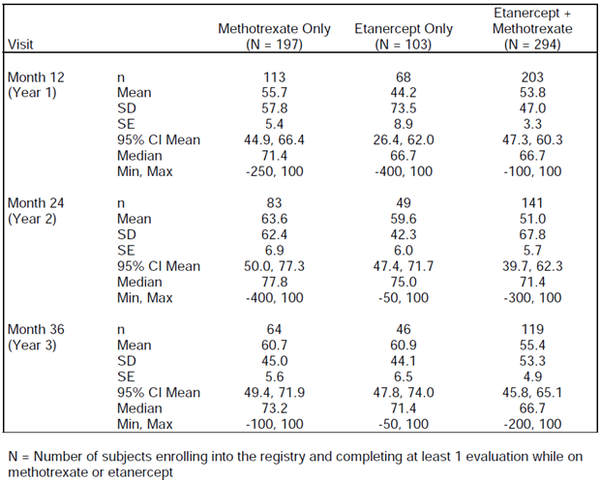
At year 3, the mean percentage improvement in the PGA for JIA subjects aged 2 to < 4 years was higher for both ETN treatment arms compared with the MTX only group (albeit very small patient numbers): 91.7% for the ETN only arm and 89.6% for the ETN + MTX group versus 66.7% for the MTX alone arm – refer to Table 14. At 1 year of follow-up, when there were more subjects with available PGA data, the mean percentage improvement in the PGA was 62.5% for the ETN only arm and 68.5% for the ETN + MTX group versus 26.0% for the MTX alone arm. At year 3, the mean percentage improvement in the PGA for the 8 of 22 subjects originally in the MTX alone cohort who then re-enrolled in either if the ETN treatment groups was similar to that for the subjects who were originally assigned to the ETN only or ETN + MTX arms.
Table 14 Percentage Improvement in Physician Global Assessment in Study 20021626 for Subjects aged 2-4 Years
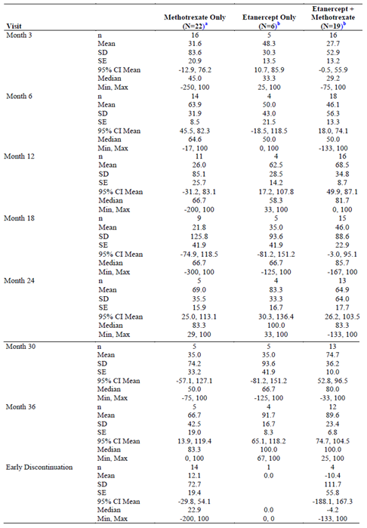

Results for other efficacy outcomes
At 3 years of follow-up in Study 20021626, the mean percentage improvement in the number of active joints was similar between the 3 treatment groups: 57.0% for the MTX alone arm, 63.2% for the ETN only group, and 58.9% for the combination ETN + MTX group – refer to Table 15.
Table 15 Percentage Improvement in Active Joint Count over time in Study 20021626
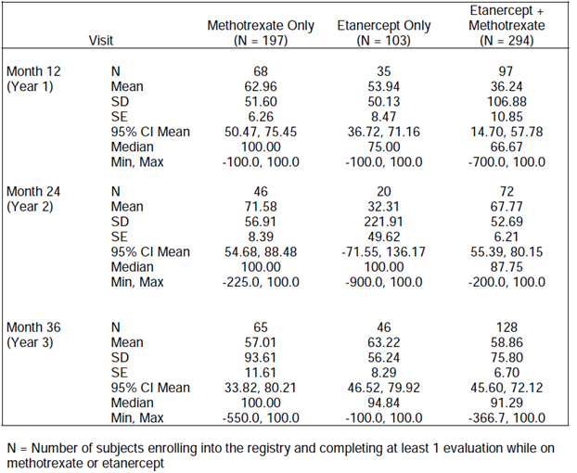
At Year 3, the mean percentage improvement in the number of active joints with LOM was numerically higher in the MTX alone arm (57.5%) than in the groups who received ETN (23.2% for the ETN only group, and 42.8% for the ETN + MTX group). At baseline, subjects in the 3 treatment cohorts had similar PedsQL scores. Following treatment, patients in all 3 groups showed improvement in all domains including physical, social, emotional and school functioning. Results of additional analysis by age and treatment arm were consistent with the overall findings.
For the subgroup analysis of JIA subjects aged 2 to < 4 years, the year 3 mean percentage improvement in the number of active joints was 81.1% for the MTX only arm (n = 6), 100% for the ETN alone group (n = 4), and 90.4% for the ETN + MTX arm (n = 12). At year 3, the mean percentage improvement in joints with LOM was 91.1% for the MTX only arm (n = 6), 87.5% for the ETN alone group (n = 4), and 80.0% for the ETN + MTX arm (n = 12). For the toddler age group of 2 to < 4 years, the PedsQL scale is amended and summarized by 3 sub-domains (daily activities, pain and hurt, and treatment). Following 3 years of treatment, polyarticular JIA subjects aged 2 to < 4 years in all 3 treatment cohorts had similar improvements in the 3 sub-domain scores. For the 8 patients who underwent a treatment switch from MTX alone to 1 of the ETN treatment groups (alone, or in combination with MTX), a similar level of response to all of the above efficacy outcomes was observed compared to those who received those ETN containing treatments at baseline.

Analyses performed across trials (pooled analyses and meta-analyses)
Appropriately, a pooled analysis was not performed between the pivotal Study 0881A1-3338 and the supporting studies (20021618 and 20021626) as there were major differences in study design, duration and subtypes of JIA that were evaluated in each of the trials.

Evaluator’s conclusions on the clinical efficacy
For etanercept for the treatment of active juvenile idiopathic arthritis in patients aged 2 years and older.
Juvenile idiopathic arthritis affects approximately 1 in 1000 children in Australia, and the majority of cases are one of the 5 subtypes included in this submission. There is significant unmet need for additional effective therapies as response to current treatment options is variable. In support of the extension of indication of ETN to include the treatment of active extended oligarticular juvenile idiopathic arthritis in patients 2 years of age and older; and active enthesitis-related arthritis and psoriatic arthritis in patients 12 years of age and older, the sponsor has provided data from a single pivotal Phase III trial (Study 0881A1-3338) which had a 12-week, open-label, active treatment period; followed by a long-term extension phase which was not included in this submission. The study recruited 127 patients who had demonstrated an inadequate response to conventional DMARD treatment (typically MTX), or appropriate prior therapy for study participants with ERA. Supportive evidence of efficacy was provided by a 10 year, open-label study (Study 20021618) which enrolled 58 paediatric subjects with polyarticular JIA; and a 36 month registry trial (Study 20021626) whereby 397 paediatric patients received ETN, either alone or in combination with MTX. The registry study included 47 subjects aged between 2-4 years with polyarticular JIA. The submission has gained approval in the European Union and is consistent with the sponsor recommended guidelines of interest (that is CHMP guidelines on Clinical Trials in Small Populations (July 2006) and ICH guidelines on Choice of Control Group in Clinical Trials (January 2001)). However, the submission is not entirely consistent with the TGA adopted regulatory guideline pertaining to the requested extension of indication: EU guideline CPMP/EWP/422/04 “Guideline on Clinical Investigation of Medicinal Products for the Treatment of Juvenile Idiopathic Arthritis” (effective 26 June 2009). In particular the lack of an active treatment then randomised treatment withdrawal design is not evident in the pivotal study. Otherwise, the 3 trials collectively provide a sufficient exposure for evaluation of efficacy that is appropriate for the claimed indications. Furthermore, a sufficient number of patients have been studied for an acceptable duration of therapy. For Study 0881A1-3338, the choice of efficacy endpoints and statistical analysis were appropriately performed. Because all the trials were open-label, strategies to maintain blinding and randomisation procedures were not considered.
The baseline demographic and disease related characteristics of patients in the JIA ETN treatment studies are similar to those in the anticipated Australian patient cohort, and therefore generalisation of these results to the Australian context is expected. The majority of patients were female, of Caucasian ethnicity with a broad age range between 2 and 17 years. However, there are some caveats to the generalizability of the treatment population. For example, Study 0881A1-3338 excluded patients who were at a significant risk of infection, or who had various abnormal laboratory results at baseline (for example abnormal haematology or liver function tests).
The pivotal trial (Study 0881A1-3338) enrolled patients with moderately active JIA (of 3 different subtypes), and demonstrated that ETN is an effective treatment in those who have either failed to respond to conventional treatment options, such as DMARDs (often MTX) and/or NSAIDs. The primary efficacy endpoint of Study 0881A1-3338 was the proportion of subjects who achieved an ACR Pedi 30 response at 12 weeks of open-label ETN treatment. Overall, 88.6% of patients (109/127; 95% CI 81.6%, 93.6%) achieved this outcome. The rate of ACR Pedi 30 response for each of the 3 examined JIA subtypes was 89.7% (52/58; 95% CI 78.8%, 96.1%) for eoJIA, 83.3% (30/36; 95% CI 67.2%, 93.6%) for ERA and 93.1% (27/29; 95% CI 77.2%, 99.2%) for PsJIA indicating a similar treatment response among the JIA subtypes. The results of Study 0881A1-3338 (overall, and for each of the 3 JIA subtypes) compared favourably to historical placebo control data (meta-analysis of 6 studies published by Ruperto et al 2003), as well as an active historical control (Study 16.0016; Lovell et al, 2000). The odds ratios and 95% CIs for both comparisons (Study 0881A1-3338 versus placebo, and then active historical control data) showed a statistically significant difference in the rate of ACR Pedi 30 response at Week 12 compared with historical placebo; and a comparable treatment effect with ETN therapy when Study 0881A1-3338 was compared to an historical control group. These results represent a clinically meaningful, treatment related outcome. Results for the secondary efficacy endpoint analyses in Study 0881A1-3338 also showed a consistent and significant treatment with ETN. The rates of achieving an ACR Pedi 50 response at Week 12 were high at 81.1% (99/122), and the majority of patients were observed to achieve an even higher level of clinical response (ACR Pedi 70 response was 61.5% (75/122) at 12 weeks). Response to ETN treatment was also seen using different efficacy measures such as each of the 6 core components comprising the ACR Pedi criteria, duration of morning stiffness and pain VAS scores. Moreover, a proportion of patients (12.1% (15/124)) achieved inactive disease status at Week 12. The pivotal study also did a subgroup analysis of treatment response to ETN in 3 different age brackets (2-4 years, 5-11 years, and 12-17 years) of patients with eoJIA. No difference in the rate of ACR Pedi 30 response was observed in patients according to age at enrolment.
Studies 20021618 (10 year, open-label extension trial) and 20021626 (registry data) are supportive of the key efficacy findings of the pivotal trial by demonstrating:
- Persistence of efficacy response for up to 10 years with continued ETN therapy in Study 20021618. For example, the rate of ACR Pedi 30 response was consistently > 50% at all yearly intervals up until 7 years, which is the last year whereby the number of ongoing assessable patients was > 20.
- The mean improvements from baseline in all 6 of the JIA ACR core set variables showed a relatively stable and sustained pattern of improvement over time (94.7%) in Study 20021618, apart from some fluctuation in CRP values between years 7-10.
- At 3 years of follow-up in Study 20021626, the mean percentage improvement in PGA of disease activity, number of active joints, and paediatric quality of life was significant in those who received ETN, either alone or in combination with MTX.
- Study 20021626 also showed that in a subgroup analysis of patients aged 2 to < 4 years, the treatment effect of ETN was comparable to older aged subjects.
Overall the efficacy data in this submission supports the efficacy of ETN in the treatment of 5 subtypes of juvenile idiopathic arthritis (as per the ILAR criteria), with moderate-severe disease active at baseline, with or without concurrent DMARD (often MTX), in patients aged 2 years to 17 years. In addition to the current approved ETN dosing regimen of 0.4 mg/kg twice weekly, many patients in the trial program received 0.8 mg/kg once weekly with no significant variability in treatment response being observed. The program also included a significant number of patients 2-4 years of age at the commencement of ETN (that is younger than the currently approved 4 years of ages) and no difference in treatment response has been identified.

Clinical safety

Studies providing evaluable safety data
The following studies provided evaluable safety data:

Pivotal efficacy studies
There was a single pivotal efficacy study (0881A1-3338), which collected the following safety data:
- General Adverse Events (AEs) were assessed by AE reporting and clinical assessment performed at screening, Day 1 and Weeks 4, 8 and 12 during Part 1; and every 12 weeks during Part 2 of the study (up to 96 weeks).
- AEs of special interest, including opportunistic infections, lymphoma, malignancy, blood dyscrasias, demyelinating disease, and autoimmune disorders, were assessed by their overall rate and number of individual events.
- Laboratory tests, including haematology, chemistry and urinalysis performed at baseline, and every 4 weeks in Part 1 the trial; and then every 12 weeks for Part 2 of the study.
- Anti-ETN antibodies were assessed at baseline, and weeks 12, 48, and 96, or upon early withdrawal (at any time point) from the study.
AE reporting was standardised by the sponsor for analysis by assigning preferred terms as set out in the Medical Dictionary for Regulatory Activities (MedDRA) version 14.0. All adverse events were summarized by System Organ Class (SOC), preferred term, and graded according to the National cancer Institute’s Common Terminology Criteria (version 4.03). In this submission, no safety data (including any interim data) for Part 2 of Study 0881A1-3338 was included. This is a significant deficiency of the current submission.

Pivotal studies that assessed safety as a primary outcome
There were no studies that assessed safety as the primary outcome.

Dose-response and non-pivotal safety studies
No specific dose-response studies have been conducted but additional safety data was provided by 2 non-pivotal, efficacy trials. Study 20021618 is an open-label, long-term extension study for paediatric patients with active DMARD refractory JIA, who previously participated in the initial ETN JIA Study (16.0016). Throughout the first year of Study 20021618, all AEs (serious and non-serious) were collected. However, after 12 months, only AEs that met the serious criteria (SAEs) were collected along with predefined events of interest (hospitalizations, deaths, serious infections, malignancy, and new signs or symptoms of other connective tissue disease). In this trial, AEs were classified according to a modified version of the Coding Symbols for a Thesaurus of Adverse Events Terms (COSTART) dictionary. Anti-ETN antibodies were a pre-specified safety endpoint in the protocol, but the analysis was not conducted.
Supporting safety data collected as part of a single registry study (20021626) was also presented in this submission. Study 20021626 is an open-label, multicentre registry study examining the long-term safety of ETN compared to MTX in subjects with JIA.

Other studies evaluable for safety only
Not applicable.

Pivotal studies that assessed safety as a primary outcome
Not applicable.

Patient exposure
In the pivotal Study 0881A1-3338, 127 subjects received at least 1 dose of ETN in Part 1 (first 12 weeks): 60 patients with eoJIA, 38 subjects with ERA, and 29 patients with PsJIA. The 60 subjects with eoJIA consisted of 15 subjects in the 2-4 year age group, 23 subjects in the 5-11 years age group, and 22 subjects in the 12-17 year age group. The mean duration (SD) of ETN treatment in Part 1 of Study 0881A1-3338 was 12.61 weeks (1.61 weeks), with a range of 1 to 15 weeks (median 13.0 weeks). Overall ETN exposure in the pivotal trial population was 29.16 subject-years – refer to Table 16. The mean (SD) weekly ETN dose was 34.97 mg (13.12 mg), and ranged from 8.0 to 56.0 mg. Consistent with the lower mean baseline age and weight for the subjects with eoJIA, the mean weekly ETN dose was lower for this JIA subtype (26.5 mg) compared with the ERA (42.6 mg) and PsJIA (42.5 mg) subtypes.
Of the 69 paediatric subjects who participated in the double-blind study 16.0016, 58 subjects received at least 1 dose of ETN in the long-term, open-label, extension trial 20021618 (up to 10 years of follow-up). Patients in this study received ETN as either 0.4 mg/kg twice weekly or 0.8 mg/kg once weekly, up to a maximum weekly dose of 50 mg. The overall ETN exposure for the 58 subjects in Study 20021618 was 341.98 subject-years. The mean exposure to ETN was 614 doses administered over a mean period of 2153 days.
Table 16 Summary of Exposure to ETN for JIA Subjects in Studies 0881A1-3338 and 20021618
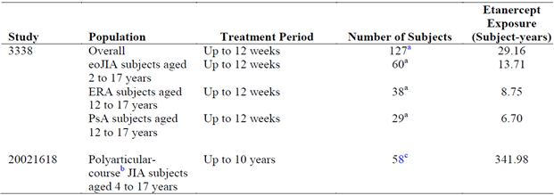
In the registry trial (Study 20021626), a total of 594 subjects were included in the safety analysis: 197 received MTX alone, 103 received ETN monotherapy, and 294 were given ETN + MTX. Drug administration information was not collected in the study and therefore exposure of ETN and MTX were estimated from the reported drug start date and end date, assuming the subject took the drug as prescribed. The mean (and SD) years of exposure for each arm in the registry program was as follows: 1.97 years (1.09) for the MTX only arm, 2.17 years (1.04) for the ETN alone group, and 2.16 years (1.02) for the ETN + MTX arm. The median (and range) number of years exposed was 2.18 years (0.1 to 3.7) for the MTX only arm, 2.84 years (0.2 to 3.8 years) for the ETN alone group, and 2.79 years (0.1 to 3.5) for the ETN + MTX arm. The overall patient exposure in Study 20021626 to MTX was estimated to be 387.8 patient-years and 859.3 patient-years for ETN (alone, and in combination with MTX).

Adverse events

All adverse events (irrespective of relationship to study treatment)

Pivotal study
The sponsor has presented AE data collected during Part 1 of Study 0881A1-3338 (first 12 weeks of treatment follow-up), but has not included in this submission any safety data collected in Part 2 of the trial. Table 17 provides a summary of the profile of AEs observed in Study 0881A1-3338.
Table 17 Number of Subjects and Types of Adverse Events in Study 0881A1-3338
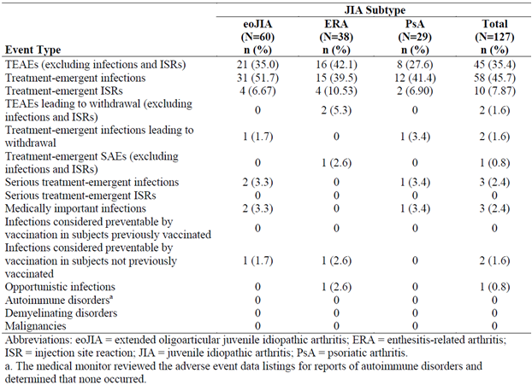
In Part 1 of Study 0881A1-3338, 45 subjects (35.4% of 127) reported at least 1 Treatment –Emergent Adverse Event (TEAE). Infections and Injection Site Reactions (ISRs) were presented by the sponsor as being separate AEs. Excluding infections and ISRs, the most common TEAEs reported were headache (7 subjects, 5.5%), followed by fatigue, pyrexia, abdominal pain, and diarrhoea (4 subjects each, 3.1%). No clinically meaningful differences were observed across JIA subtypes. The overall exposure-adjusted rate of TEAEs, excluding infections and ISRs, across the 3 JIA subtypes was 3.74 TEAEs per patient-year (2.77 TEAEs per patient-year for eoJIA, 5.48 TEAEs per subject-year for ERA, and 3.43 TEAEs per patient-year for PsJIA). The majority of TEAEs were mild and resolved spontaneously. The most common types of AEs by system organ classes (SOC) are summarized in Table 18.
Table 18 Number and Types of Adverse Events > 3% incidence by SOC (excluding infections and injection site reactions) in Study 0881A1-3338
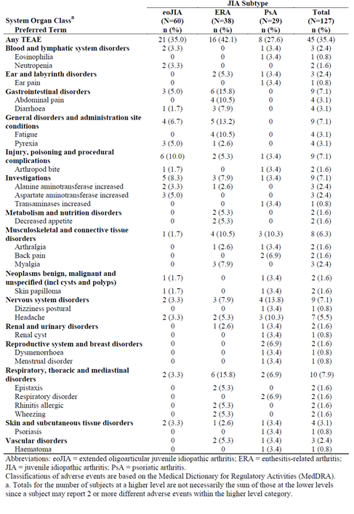

Infections
In Part 1 of Study 0881A1-3338, 58 subjects (45.7% of 127) recorded treatment-emergent infections – refer to Table 19. The most common types of infection involved the upper respiratory tract infection (18 subjects, 14.2%), followed by pharyngitis (15 subjects, 11.8%), rhinitis (8 subjects, 6.3%), gastroenteritis (5 subjects, 3.9%) and bronchitis (4 subjects, 3.1%). No significant differences in incidence or type of infection were observed across the 3 JIA subtypes. The overall exposure-adjusted rate of treatment-emergent infections was 3.33 AEs per subject-year (4.09 AEs per subject-year for eoJIA, 2.29 AEs per subject-year for ERA, and 3.13 AEs per subject-year for PsJIA).
Table 19 Treatment Emergent Infections of greater than or equal to 3% incidence in Study 0881A1-3338
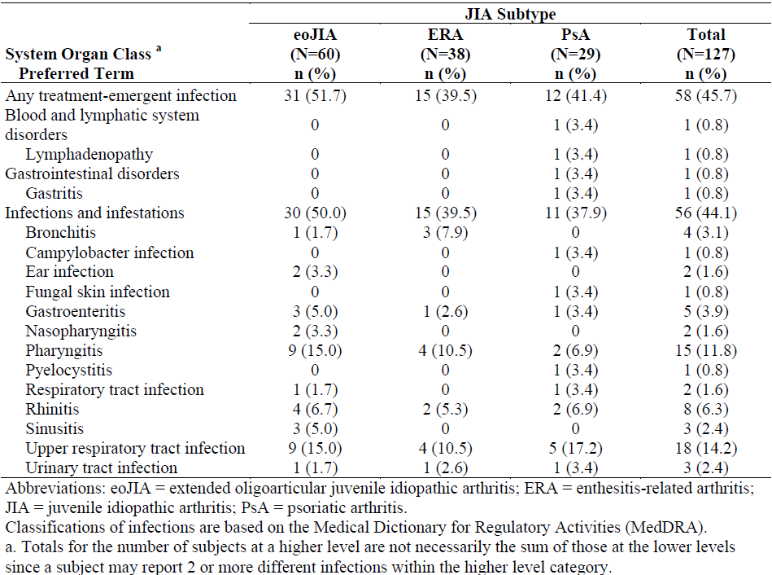

Injection site reactions
In Part 1 of Study 0881A1-3338, 10 patients (7.9% of 127) reported at least 1 treatment-emergent ISR. The overall exposure-adjusted rate of ISR was 0.79 AEs per subject-year (0.37 AEs per subject-year for eoJIA (6.7%; 4 out of 60), 0.80 AEs per subject-year for ERA (10.5%; 4/38), and 1.64 AEs per subject-year for PsJIA (6.9%; 2/29)).

Other special interest AEs
No cases of malignancy, lymphoma, demyelinating or autoimmune disease were reported in Part 1 of Study 0881A1-3338.

Other studies

Study 20021618
In total, 50 of 58 paediatric subjects (86.2%) reported at least 1 TEAE during year 1 of the study.
The exposure-adjusted rate of TEAEs during year 1 of Study 20021618, including infections and ISRs, was 798.5 events per 100 patient-years. The most common TEAEs reported were ISR (112 AEs at a rate of 210.93 events per 100 subject-years), upper respiratory infection (68 AEs at a rate of 128.06 events per 100 subject-years), headache (44 AEs at a rate of 82.86 events per 100 subject-years), and abdominal pain (20 AEs at a rate of 37.67 events per 100 subject-years).

Infections
In total, 44 subjects (75.9% of 58) reported at least 1 treatment-emergent infection during year 1 of the study. The exposure-adjusted rate of treatment-emergent infections in paediatric subjects during year 1 of the study was 237.29 AEs per 100 subject-years. The most common treatment-emergent infections reported were upper respiratory infection (68 AEs; 128.06 events per 100 subject-years), pharyngitis (9 AEs; 16.95 events per 100 subject-years) and influenza syndrome (9 AEs, 16.95 events per 100 subject-years).

Injection site reactions
A total of 11 subjects (19.0% of 58) reported at least 1 ISR during study 20021618. Non-serious ISRs were to be collected only during year 1 of the study. The exposure-adjusted rate of ISRs during year 1 was 210.93 AEs per 100 subject-years.

Other special interest AEs
No cases of malignancy, lymphoma, or demyelinating disease were recorded in Study 20021618. Three patients developed autoimmune conditions: 2 developed scleroderma (1 with morphea, and the other had scleroderma limited to 1 leg), and 1 subject experienced uveitis (10 year old female with pauciarticular JIA – onset 2 years into study treatment). The case of uveitis is likely to reflect a failure of therapy in controlling the associated inflammatory eye disease, than a drug related AE. The 2 subjects who developed scleroderma were female (aged 7 and 11 years) with polyarticular JIA. The aetiological relationship between ETN and scleroderma is unclear.

Study 20021626
Overall, the exposure-adjusted rate of AEs was similar between the MTX only arm (18.3 AEs per 100 patient-years) and the ETN treatment groups (combined – 20.8 AEs per 100 patient-years). The number of subjects reporting an AE was 43 (21.8%) for the MTX only arm, 26 (25.2%) for the ETN only group, and 78 (26.5%) for the ETN + MTX arm – refer to Table 20.
Table 20 Summary of Number and Incidence of Adverse Events in Study 20021626
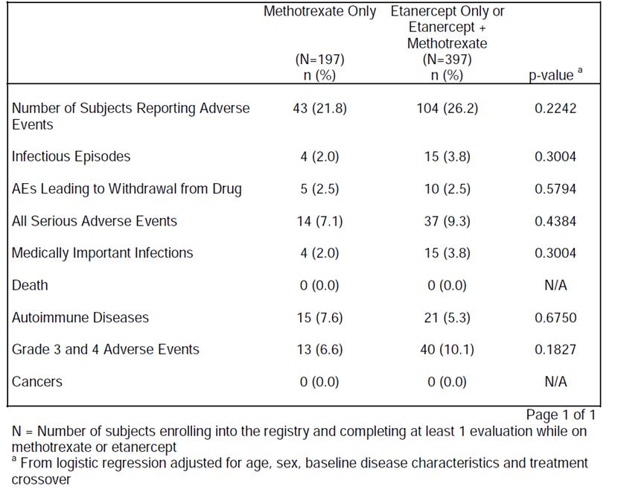
Nervous system AEs had the highest exposure-adjusted event rates affecting all 3 treatment cohorts at a similar frequency. Abnormal liver functions occurred at a higher exposure-adjusted rate (2.06/100 subject-years) in the MTX monotherapy group. No other commonly reported AE (> 0.5 per 100 patient-years in any of the 3 treatment groups) were observed to be correlated with any specific treatment regimen.
Table 21 Exposure-adjusted Adverse Event Rates (>0.5 per 100 patient-years) in Study 20021626
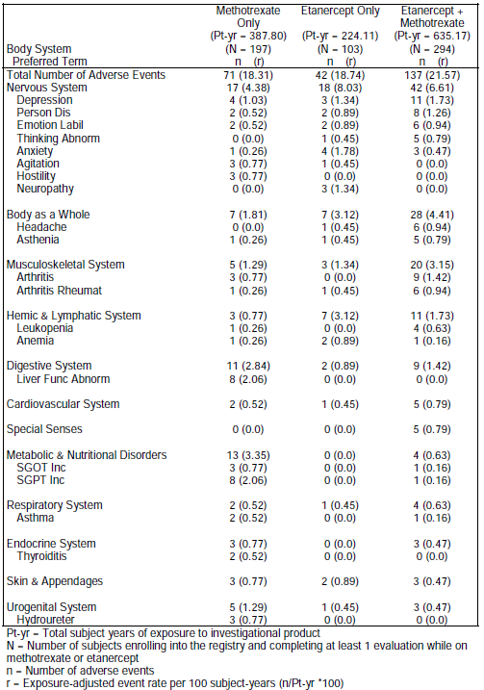

Infections
The overall exposure-adjusted rates for infections were similar across the 3 treatment arms in Study 20021626: 1.29/100 patient-years for the MTX only group, 1.78/100 patient-years for the ETN only arm, and 2.05/100 patient-years for the ETN + MTX cohort. Table 22 provides a summary of the infections recorded during Study 20021626 by body system and preferred term (in descending order of occurrence). Because of the small number of infectious AEs, no discernible pattern of treatment related infections can be identified. All 22 of the infectious AEs (in 19 subjects) were recorded as being medically important infections (that is requiring hospitalization and/or intravenous antibiotics). The infectious AEs reported by more than 1 subject were abscess (n=3), pyelonephritis (n=3), and herpes zoster (2 (0.7%) subjects each in the ETN + MTX arm; and 1 patient in the MTX alone group), and “infection” (2 (1.9%) subjects in the ETN only arm).
Table 22 Infectious Adverse Events recorded in Study 20021626
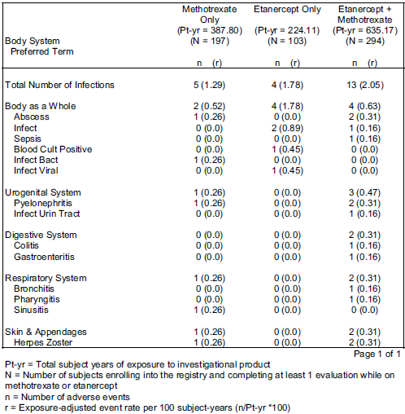

Subgroup of patients 2-4 years of age
In Study 20021626, the exposure-adjusted rate of AEs, excluding infections, for polyarticular JIA subjects aged 2 to < 4 years was 22.02 per 100 patient-years for the MTX only arm, 0.0 per 100 patient-years for the ETN only arm, and 4.22 per 100 patient-years for the ETN + MTX group (2 AEs in 2 patients) – refer to Table 23. The majority of the AEs occurred in the MTX only arm (8 AEs in 6 subjects), and were often either liver or gastrointestinal related (6 AEs), as would be expected with MTX treatment. The incidence of AEs is comparable to the overall paediatric population in this registry trial. The exposure-adjusted rate of non-infectious AEs for the overall population was 18.3 per 100 patient-years for the MTX only arm, 18.7 per 100 patient-years for the ETN only arm, and 21.6 per 100 patient-years for the ETN + MTX group.
Table 23 Exposure Adjusted Rates of Adverse Events in Polyarticular JIA Subject 2-4 Years of Age in Study 20021626
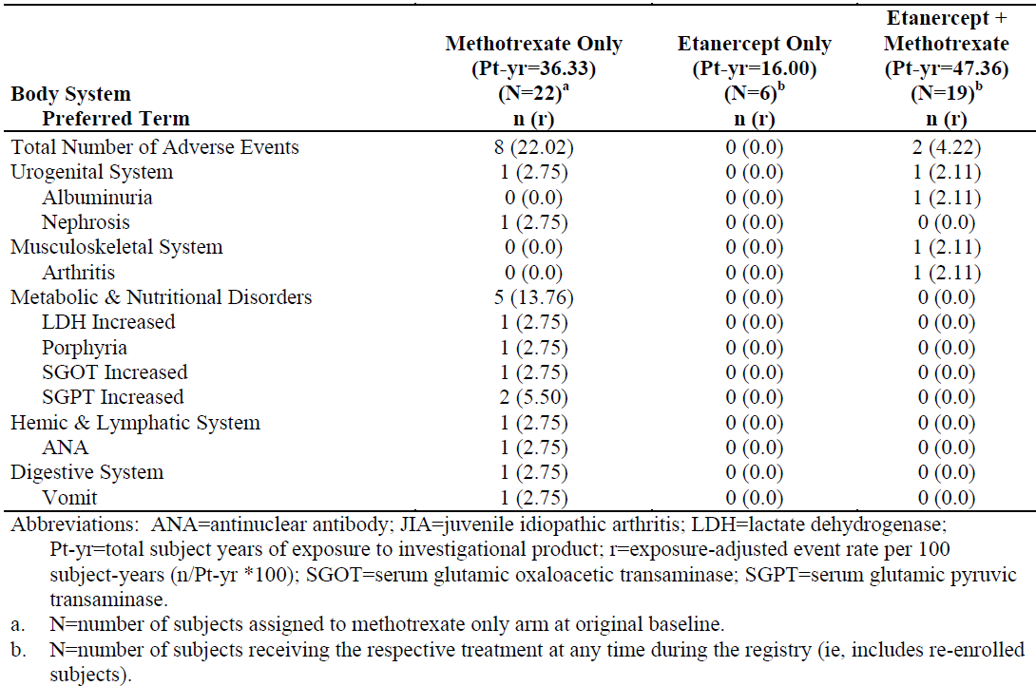

Treatment-related adverse events

Pivotal study
The submission did not present AE data in a tabular format according to relationship to ETN treatment. As the pivotal study (0881A1-3338) was open-label with a single active treatment (ETN), the investigator determined relationship between AE and treatment is of limited additional value to the treatment emergent reporting of AEs. The validity and reliability of the investigator determined relationship between an AE and study medication is linked to the study design. Blinded assessments of a potential causal relationship are the preferred method of AE reporting in regulatory guidelines. For open-label trials, the temporal association between AEs and study medication is considered sufficient in the reporting of the clinical safety dataset.
In addition, the determination of relationship between study drug (ETN) and AE was assessed by the study site investigator, and appears to have been inconsistently applied in Study 0881A1-3338. For example, commonly occurring infections were inconsistently attributed (no relationship versus possible or probable relationship) to ETN.

Other studies
As Study 20021618 was an open-label, multi-year extension trial of patients receiving ETN (i.e. no active comparator treatment) there is limited additional value in reviewing the investigator determined relationship between AE and treatment, versus the treatment emergent reporting of AEs, which has already been presented.
Study 20021626 was an open-label, registry with 3 treatment cohorts (MTX alone, and ETN +/- MTX) and didn’t specifically present AE data by relationship to therapy (investigator, or study monitor determined).

Deaths and other serious adverse events

Pivotal study
No deaths have been reported in the all exposure population of Study 0881A1-3338. In Part 1 of Study 0881A1-3338, 4 subjects (3.1% of 127) experienced 4 SAEs, including 3 suffering from serious infections. One subject reported a non-infectious SAE. This case involved a 16 year old female with ERA who required admission to hospital for abdominal pain. Study medication was continued and the SAE resolved 9 days later without sequelae. The SAE was considered by the investigator to be moderate in severity, and unrelated to ETN. The overall exposure-adjusted rate of non-infectious SAEs was 0.034 events per subject-year (0.114 events per subject-year for ERA).
The 3 subjects who experienced serious infections included:
- A 6 year old female with eoJIA developing bronchopneumonia on day 38. This SAE required hospitalization and treatment with IV antibiotics. Study medicine was withdrawn. The SAE resolved after 7 days without complications. Strangely, the SAE was considered by the investigator to be mild in severity, and unrelated to study drug.
- A 17 year old female with PsJIA developed pyelocystitis on Day 52. The event led to withdrawal of study medication, hospitalization and treatment with IV antibiotics. The event resolved 7 days later. Again, the SAE was considered by the investigator to be mild in severity, and unrelated to study drug.
- A 5 year old female with eoJIA experienced gastroenteritis on Day 10. The event led to hospitalization and supportive treatment was given. The child did not receive antibiotics. Study medicine was continued and the SAE resolved 2 days later without sequelae. This SAE was considered by the investigator to be severe in severity, but unrelated to study drug.
The overall exposure-adjusted rate of infectious SAEs was 0.103 events per subject-year (0.146 events per subject-year for eoJIA; and 0.149 events per subject-year for PsJIA).

Other studies

Study 20021618
No deaths were recorded in Study 20021618. Throughout the 10-year study period, 44 SAEs were reported in 16 subjects (27.6% of 58). The exposure-adjusted rate of SAEs, including infections, in paediatric subjects through to 10 years of follow-up in Study 20021618 was 12.87 SAEs per 100 subject-years. The exposure adjusted rate of SAEs was highest in the first 3 years of treatment, and appeared to become less frequent with time on ETN therapy – refer to Table 24.
Table 24 Exposure adjusted Serious Adverse Events over time in Study 20021618 (Number of Events per 100 Patient-Years)
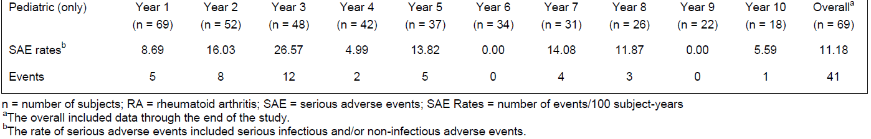
The individual types of non-infectious SAEs (by preferred term) occurring in more than 1 subject were RA (6 patients; 10.3%); and abdominal pain and arthralgia which occurred in 2 (3.4%) subjects each. In addition, 2 subjects (5 and 9 years of age), both with systemic JIA, developed macrophage activation syndrome as a non-infectious SAE. Both events resolved within 6-17 days of onset (Study Day 922 and 1115). Macrophage activation syndrome may occur as a disease related complication of systemic JIA.
Throughout the 10 year study period, 11 serious infections were recorded in 8 subjects (13.8%). The exposure-adjusted rate of serious infections in paediatric subjects through to 10 years in Study 20021618 was 3.22 SAEs per 100 subject-years. The rate of serious infection related AEs was highest in the first 2 years of treatment, and was zero in 6 of the last 8 years of the study – refer to Table 25.
Table 25 Exposure adjusted Serious Infection Related Adverse Events over time in Study 20021618 (Number of Events per 100 Patient-Years)
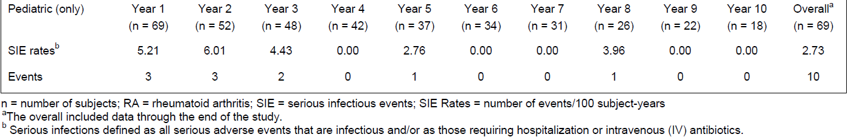
The following types of serious infection occurred:
- Varicella zoster infection in a 10 year male with systemic JIA. This occurred 14.5 months into study treatment and resolved 1 week later with acyclovir.
- Wound infection of the hand, following stitches for trauma, in a 6 year old female with polyarticular JIA. This occurred 15 months into study treatment and resolved within 2 days of IV antibiotics.
- Herpes Zoster infection and pyelonephritis in a 13 year old female with polyarticular JIA. The onset was 44 months into therapy and promptly resolved with acyclovir and IV antibiotics.
- Appendicitis and peritonitis in a16 year old male with polyarticular JIA (Study Days 113 and 116, respectively).
- Bacterial infection at surgical site following TMJ implant surgery (Study Day 402) in a 14 year old female with polyarticular JIA. The implant was removed and the infection resolved with antibiotics after 23 days. The same subject was hospitalized 5 months later when she developed type 1 diabetes mellitus.
- Periodontal abscess and periorbital cellulitis requiring hospitalization (approximately 20 months into study treatment) occurred in a 14 year old female with polyarticular JIA. The patient improved following extraction of the infected tooth and IV antibiotics.
- Aseptic meningitis following varicella zoster infection (Study Day 81) in a 14 year old male systemic JIA.
- Sepsis due to Group A β-haemolytic streptococcus (Study Day 725) complicated by shock, disseminated intravascular coagulopathy, purpura fulminans, and respiratory distress syndrome requiring mechanical ventilation in a 8 year old female with polyarticular JIA. The event resolved after 6 days of intensive care treatment but ischaemia of the left foot and distal leg resulted in dry gangrene requiring left foot and mid-calf amputation.

Study 20021626
No deaths were recorded in Study 20021626. The overall exposure-adjusted rate for SAEs was 4.64/100 patient-years for the MTX only arm, 7.14/100 patient-years for the ETN only group, and 5.98/100 patient-years for the ETN + MTX arm – refer to Table 26. Fourteen (7.1%) subjects in the MTX only group experienced 18 SAEs, 9 (8.7%) subjects in the ETN only arm developed 16 SAEs, and 28 (9.5%) subjects in the ETN + MTX arm reported 38 SAEs.
Table 26 Serious Adverse Events in Study 20021626
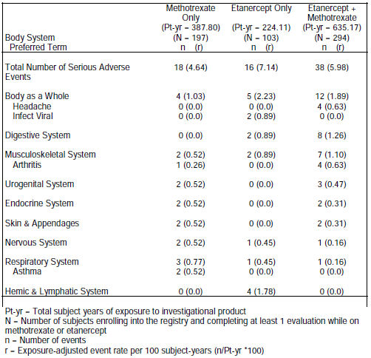
The body system with the highest exposure-adjusted SAE rate was “body as a whole”. The individual SAE types with the highest exposure-adjusted rates were viral infection (0.89/100 patient-years for the ETN only arm), headache and arthritis (both at 0.63/100 subject-years for the ETN + MTX group).
In Study 20021626, 19 subjects reported 22 infectious AEs, all of which were considered medically important infections. One subject in the ETN + MTX arm had a grade 4 (life-threatening) sepsis. Grade 3 (severe) infectious events were reported in 1 subject in the MTX only arm (abscess + sinusitis), 3 subjects in the ETN only group (“infection”, positive blood culture, and viral infection), and 4 subjects in the ETN + MTX arm (abscess, pyelonephritis, colitis and urinary tract infection).
No malignancies were reported in Study 20021626.

Subgroup of patients 2-4 years of age
Two JIA subjects aged 2 to < 4 years experienced SAEs: nephritic syndrome in a 2-year-old female subject in the MTX only arm (who subsequently switched to the ETN + MTX group) and arthritis flare in a 2-year-old female subject in the ETN + MTX arm. The SAE of nephrotic syndrome started on day 187 while receiving MTX, lasted for 138 days, and was considered unrelated to MTX. No medically important infections were reported in polyarticular JIA subjects aged 2 to < 4 years.

Discontinuation due to adverse events

Pivotal study
In Part 1 of Study 0881A1-3338, 4 subjects (3.1% of 127) withdrew from study drug due to AEs.
Two subjects withdrew due to non-infectious TEAEs. A 13 year old male with ERA, experienced asthenia and pyrexia on day 37 that led to his withdrawal from the study. The AE was considered by the investigator to be severe in intensity, and unrelated to ETN. A 16 year old female with ERA, experienced fatigue, dizziness and wheezing on day 54 that led to withdrawal. This AE was considered by the investigator to be of moderate severity, and related to study drug. Both of these non-infectious AEs resolved without sequelae. The overall exposure-adjusted rate of TEAEs leading to withdrawal, excluding infections and ISRs, was 0.171 AEs per subject-year (and 0.571 AEs per subject-year for ERA).
Another 2 subjects withdrew due to infections, both of which met the seriousness criteria. A 6 year old girl with eoJIA was hospitalized on study day 38 with bronchopneumonia. The AE resolved without complications, but was considered by the investigator to be of mild intensity, and unrelated to study drug. A 17-year old female with PsJIA was hospitalized on day 52 with pyleocystitis. The infection resolved within 7 days, and again was considered by the investigator to be mild and unrelated to study drug. The overall exposure-adjusted rate of treatment-emergent infections leading to withdrawal was 0.069 AEs per subject-year (0.073 AEs per subject-year for eoJIA and 0.149 AEs per subject-year for PsJIA).
No subjects discontinued study drug due to an ISR.

Other studies

Study 20021618
The exposure-adjusted rate of AEs leading to withdrawal in paediatric subjects through to 10 years of follow-up in Study 20021618 was 2.05 AEs per 100 subjects-years. During the 10-year study period, 7 AEs leading to withdrawal were reported in 3 paediatric subjects (5.2%). An additional 2 subjects also discontinued because of AEs, but these events were only identified at the study conclusion. One subject withdrew because of flare of JRA, and the other patient experienced severe infection. If the additional 2 subjects were included in the analysis, then the rate of AEs leading to withdrawal in Study 20021618 is 2.09 AEs per 100 subject-years.
Overall, 5 paediatric subjects withdrew from Study 20021618 due to AEs:
- JRA flare in 1 subject (5 year old female),
- Purpura fulminans on day 725 (associated with SAEs of sepsis, shock, coagulation disorder, respiratory distress) in 8 year old female with polyarticular JIA,
- Skin disorder (suspected morphea) and fibro tendon disorder (suspected fasciitis) in a 12 year old female with polyarticular JIA (approximate onset – study day 1244),
- Post-operative wound infection of shin and super-infection (both shins) in 14 year old male subject with systemic onset JIA (unclear day of onset), and
- Diarrhoea, vomiting, bone disorder and aseptic meningitis in 14 year old male with systemic onset JIA (onset on Study Day 81).

Study 20021626
In Study 20021626, 15 subjects experienced AEs leading to withdrawal of treatment medication: 5 (2.5%) in the MTX monotherapy group, 1 (1.0%) in the ETN only arm, and 9 (3.1%) in the ETN + MTX group. The only AEs reported more than once within a treatment group were abnormal liver function tests (2 cases (1.0%) in the MTX only group), and flare of arthritis (3cases (1.0%) in the ETN + MTX arm). Most subjects who discontinued study treatment with MTX and/or ETN stayed in the study for follow-up to 36 months. However, 6 subjects withdrew due to AEs: 3 (1.5%) in the MTX only arm (1 case of skin rash, and 2 cases of elevated liver transaminases), 2 patients (1.9%) in the ETN monotherapy group (1 subject with headache following each injection of ETN, and 1 patient developing an overlap syndrome with juvenile dermatomyositis), and 1 subject (0.3%) in the ETN + MTX arm (injection site reaction). Only 1 polyarticular JIA subject aged 2 to < 4 years withdrew from the registry trial because of an AE (vomiting). This patient was receiving combination treatment with ETN and MTX.

Laboratory tests

Liver function

Pivotal study
A total of 12 subjects (9.5%) recorded abnormal liver function test values in Part 1 of Study 0881A1-3338. During routine laboratory monitoring conducted every 4 weeks, elevation in ALT ≥ 2 × ULN occurred in 7.1% (9/126) of patients, and elevation in AST ≥ 2 × ULN occurred in < 1% of patients (0.8%; 1/126). One patient also developed a mild elevation in serum bilirubin (> x 2 but < x 3 ULN), and another subject developed > x 3 ULN elevation of serum alkaline phosphatase. No significant differences in the incidence and pattern of abnormal liver function tests were observed across the 3 JIA subtypes. Of particular note is 2 subjects (9 year old male with eoJIA, and 16 year old female with PsJIA) who recorded increases in ALT > 3 x ULN. Both occurred at week 12 of therapy in patients receiving concurrent parenteral MTX (17.5-20 mg/week). Both AEs resolved between weeks 12 and 24 of follow-up with either cessation of, or dose reduction by half of MTX. None of the abnormalities of liver function tests prompted cessation of ETN. No subject had laboratory values that met the criteria for Hy’s Law.

Other studies
Up to 52 months of follow-up in Study 20021618, no patient developed a grade 3 or 4 abnormality of liver function tests.
Routine laboratory assessments were not part of the study protocol of Study 20021626 and physicians practiced the standard of care for monitoring toxicities related to MTX and other DMARDs. Two subjects in the MTX only arm withdrew from the study due to abnormal liver function tests.

Kidney function

Pivotal study
No significant impact upon renal function was noted during the 12 week study period.

Other studies
No significant changes in renal function were observed in Studies 20021618 and 20021626.

Other clinical chemistry

Pivotal study
No other significant changes in clinical chemistry parameters were noted in Study 0881A1-3338.

Other studies
No other significant changes in clinical chemistry were identified in Studies 20021618 and 20021626.

Haematology

Pivotal study
During Part 1 of Study 0881A1-3338, 3 subjects developed grade 3 reductions in neutrophil count, and these results were reported as TEAEs of neutropenia in 2 of the subjects. By the week 12 visit, the neutrophil counts had returned to within normal limits for all 3 subjects. None of the patients were reported to experience infection related SAEs at the same time as the neutropenia was identified.
Consistent with control of active systemic inflammation, mean platelet counts decreased with ETN treatment during Study 0881A1-3338.

Other studies
In Study 20021618, 3 paediatric subjects experienced a single episode of grade 3 decrease in haemoglobin. The AEs occurred on study days 1, 253, and 924. None of these subjects had any additional changes in haemoglobin results during the study. No AE attributable to thrombocytopenia or neutropenia was recorded in Study 20021618. No significant haematological AEs were recorded in Study 20021626.

Anti-Etanercept antibodies

Pivotal study
Serum samples for analysis of anti-ETN antibodies and neutralizing antibodies were collected at baseline and week 12 of Study 0881A1-3338, or at any time upon early subject withdrawal. Testing was performed with a validated semi-quantitative ELISA technique. Assay precision, expressed as the between batch coefficients of variation was less than 10.1% for the positive control (monkey serum) and 11.2% for the negative control (pooled normal human serum). A total of 7 subjects (5.6% of 124) tested positive for anti-ETN antibodies at either Week 12 or upon early withdrawal. Of the 7 subjects, 5 had ERA and 2 had PsJIA. None of the subjects who were positive for anti-ETN antibodies tested positive for neutralizing antibodies. The presence of anti-ETN antibodies did not adversely affect efficacy outcome at Week 12 as 6 of the 7 subjects with anti-ETN antibodies achieved the ACR Pedi 30 response criteria at Week 12. One subject withdrew due to AEs of fatigue, dizziness, and wheezing. At their last on-treatment visit (Week 8), this subject met the ACR Pedi 30 response criteria. However, 6 of the 7 subjects who tested positive for anti-ETN antibodies experienced TEAEs. One of these subjects experienced an SAE of abdominal pain. No serious infections were reported in subjects who tested positive for anti-ETN antibodies. No clear pattern in the type of AEs was observed in subjects who tested positive for anti-ETN antibodies.

Other studies
Although the measurement of anti-ETN antibodies was included as a safety endpoint in the protocol of Study 20021618, no analysis was presented or performed. As Study 20021626 was a registry trial, anti-ETN antibodies were not assessed.

Vital signs and physical findings

Pivotal study
During Part 1 of Study 0881A1-3338, mean values for vital signs remained stable in the all exposure population. The incidence of individual values outside the normal range (high or low) for systolic blood pressure was 3.9% (5/127), and for diastolic blood pressure was 0.8% (1/127). No patients withdrew from the trial because of blood pressure abnormalities. Overall, growth data measurements (height, weight, body mass index and Tanner assessment of sexual maturity) reflected the expected changes as a result of normal growth in children.

Other studies
In Study 20021618, no significant changes were seen in vital signs. Growth measurements were recorded up to 52 months and demonstrated the expected changes for paediatric subjects.

Post-marketing experience

Overall experience in those under 18 years of age
Among patients under the age of 18 years treated with ETN for any indication, a total of 23 deaths and 11 malignancies have been recorded. The malignancies included Hodgkin’s disease (4 cases), Acute Lymphocytic Leukaemia (2 cases), Acute Myeloid Leukaemia (1 patient), Leukaemia – not otherwise specified (1 subject), Lymphoma (1 case), renal cancer (1 patient), and colon cancer (1 case). Malignancies were reported in 7 patients with JIA. These included cases of Hodgkin’s disease (4), Acute Lymphocytic Leukaemia (2) and Leukaemia – not otherwise categorized (1). In June 2008, the FDA issued an early communication regarding a possible association between use of TNF inhibitors in children and young adults, and the subsequent development of malignancies. Further analysis of the background rates of malignancy in paediatric/juvenile patients with inflammatory arthritis suggested that there is a potential increased risk of malignancy in paediatric patients with JIA. The sponsor regards the issue of paediatric malignancy as an identified safety concern for ETN, and has added information to the warnings and precautions section of the PI to include a specific precaution.
The types and reporting proportion of infections in JIA patients were generally similar to those reported for all ETN users. Many of the viral infections that were reported in juvenile patients treated with ETN are common in children in the general population. The comparison of the distribution of adult RA and juvenile JIA infections revealed no unexpected findings.
There have been reports of inflammatory bowel disease occurring in JIA patients and other paediatric patients who received ETN. The PI contains a precaution regarding reports of inflammatory bowel disease occurring in JIA patients being treated with ETN. The PI also states that ETN is not an effective treatment for inflammatory bowel disease, and that a causal relationship with ETN is unclear because clinical manifestations of bowel inflammation have been observed in untreated JIA patients.
To identify the potential effects of TNF inhibition upon the vaccination response in juveniles, the sponsor’s pharmacovigilance database was searched for any reports up until 2 February 2011 in patients less than 17 years of age for reports of vaccination failure, vaccine complication, vaccine breakthrough infection (using the standardized MedDRA query (SMQ) terms for lack of efficacy or effect). Two reports with a vaccine as a co-suspect medication were identified; but neither case involved a lack of efficacy or reduced efficacy of the vaccine. The current ETN PI addresses the issue of paediatric immunization in the “Precautions” section, stating, “If possible, bring paediatric patients up to date with immunizations according to current local guidelines before beginning etanercept therapy”.
Other safety concerns identified in the post-marketing period which have resulted in modifications to the current PI include:
- Enhancement of special warnings and/or precautions regarding infections including fatal infections, tuberculosis (with recommendations for testing, prophylaxis and monitoring), sepsis and opportunistic infections (including invasive fungal infections, and the possibility of unrecognized fungal infection resulting in death).
- Information regarding hepatitis B reactivation and worsening of hepatitis C.
- Additional warnings and precautions regarding several haematologic reactions (including sometimes fatal aplastic anaemia and pancytopenia), neurologic events (central demyelination disorders and peripheral demyelinating polyneuropathies (including Guillain-Barre syndrome), autoantibody formation, cardiac disorders (worsening congestive heart failure), and the possibility of hypoglycaemia in diabetic etanercept users.
- Additional adverse reactions have been added: autoimmune events (such as development of autoantibodies, lupus-like syndrome, autoimmune hepatitis, systemic vasculitis including anti-neutrophil cytoplasmic antibody (ANCA) positive vasculitis, cutaneous vasculitis (including leucocytoclastic vasculitis)), elevated liver enzymes, interstitial lung disease (including pulmonary fibrosis and pneumonitis), macrophage activation syndrome (MAS), erythema multiforme, psoriasis (all types; new onset, and exacerbations including all subtypes) and psoriasiform rash, pruritus, rash, seizures, Stevens-Johnson syndrome, toxic epidermal necrolysis, and uveitis.

Literature reports of ETN use in patients aged 17 years or below
Literature database publications were searched and support the good tolerability, as well as effective control and remission of JIA with ETN. There have been reports of improved growth in patients with JIA treated with ETN. Other safety information has included a 6-year study in which 127 patients (mean age 13.7 years) with JIA received ETN for a mean duration of 24.1 months. Several types of AEs rarely described previously were noted. Neuropsychiatric AEs (30 cases in total) including non-specific signs (headaches, vertigo, fatigue, hyperactivity, nervousness, and anxiety), behavioural alterations (aggressiveness), neuropsychiatric syndromes (pain amplification, panic attacks, depression, anorexia nervosa) and rare organic signs (hypoglossal paralysis). In many cases, the patients were non-responders and the dose had been increased. All of the AEs resolved with dose reduction, and less frequently with discontinuation of ETN or neuropharmacological therapy. Five cases of inflammatory bowel disease were observed in the above trial including 2 cases diagnosed as Crohn’s disease. All cases resolved with discontinuation of ETN. Thrombocytopenia and/or leucopenia (2 patients) resulted in 1 patient discontinuing ETN treatment, although both cases were considered to be drug-related. Relapses of chronic iridocyclitis (4 cases) were also observed in this study and 1 patient discontinued ETN because of this AE.
Other AEs reported in the literature include the development of extra-capillary glomerulonephritis in a 15 year old girl. The AE resolved after discontinuation of ETN and treatment with prednisone. Other case reports in the literature include:
- Crohn’s disease developing in an 11 year old female. This resolved after discontinuation of ETN,
- Urachal cyst requiring surgery in a 17 year old male, and
- Macrophage Activation Syndrome developing in a 10 year old male. This resolved after discontinuation of ETN and treatment with prednisone and cyclosporine A.

Spontaneous reports in JIA patients
Up until 2 February 2011, a total of 1937 spontaneous, medically confirmed events (occurring in 671 cases) were reported in patients under the age of 18 who received ETN for the treatment of JIA. The patients varied in age from < 1 year to 17 years (mean 10.66 years, median 11.0 years). The type of AEs reported in JIA subjects were similar to those received for the overall ETN-treated paediatric population. The most frequently reported AEs were aggravation of arthritis, injection site reactions, and pyrexia. The most frequently reported SAEs were aggravation of underlying medical condition and pyrexia (20 events each); and uveitis and injection site reactions (16 events each). The cases of uveitis would frequently resolve with discontinuation of ETN, however, uveitis is often associated with JIA itself, and therefore these events probably represent a form of treatment failure rather than a drug-related AE. Similarly, fever often accompanies common childhood illnesses, including active JIA, and as such these reports are confounded by alternative aetiological explanations versus drug-related.

Experience in patients aged less than 4 years
ETN was not approved anywhere in the world for children younger than 4 years of age until 2008 in USA. Up until 2 February 2009, a total of 121 AEs have been identified from 38 reports in children below 4 years of age who had received ETN. The type of AEs recorded was similar to that seen in juvenile patients, apart from accidental overdose in 4 patients (including 2 errors in dosing by healthcare professionals). As the recommended dosing of ETN in children is weight based, there is the potential for incorrect dose calculations. The sponsor proposes a communication plan to healthcare professionals about dosing.
Two deaths have been reported in children under the age of 4 years with JIA. One fatality occurred in a 2 year old female with interstitial lung disease who died of sepsis 3 months after receiving their last treatment with ETN. The other death occurred in a 3 year old female. She died of a subarachnoid haemorrhage in the setting of seizures and respiratory tract infection. In addition, there is 1 report of malignancy in the < 4 year old age category. A 3.5 year old male developed Acute Lymphocytic Leukaemia after receiving less than 12 doses of ETN (exact duration of therapy unclear). The outcome of the malignancy is unknown.
The German JIA registry has recorded data on 25 JIA patients below the age of 4 years, 10 of whom had non-systemic subtypes of JIA. This cohort has received ETN for a mean duration of 19 months. Two AEs (varicella zoster infection and fever) have been reported. No SAEs or treatment discontinuations due to medication intolerance have been recorded.

Safety issues with the potential for major regulatory impact

Liver toxicity
This has already been addressed in this report.

Malignancy potential
This has been covered in this evaluation report.

Injection site reactions
This has already been addressed in this report.

Risk of opportunistic infection
In Part 1 of Study 0881A1-3338, no patient who had a history of appropriate vaccination developed a preventable infection. However, 2 subjects with no history of vaccination experienced varicella-zoster infection and met the pre-specified study protocol criteria for opportunistic infection. A 13 year old female with ERA developed herpes zoster infection affecting 2 dermatomes on day 16. No specific treatment was given and ETN was continued. The AE resolved after 12 days without complications. A 6 year old female with eoJIA experienced varicella infection 1 day prior to being hospitalized with bronchopneumonia (Study Day 38). Both infections resolved with treatment, and it is unclear whether the 2 infectious episodes were linked.
A total of 4 subjects experienced varicella-zoster infection in Study 20021618. Two of the 4 cases were recorded as SAEs, and 2 of the cases occurred during the first year of the trial. At least 3 of the 4 affected subjects had not been vaccinated against varicella.
Screening for tuberculosis was a requirement of screening at baseline in both studies. No patients experienced tuberculosis during either study.

Evaluator’s overall conclusions on clinical safety
In this submission, the total clinical safety dataset for the use of ETN in patients aged 2-18 years with active JIA consists of 582 patients in 3 studies, all of whom received ETN 0.8 mg/kg/week (either once weekly by SC injection, or 0.4 mg/kg twice weekly). Most of the patients in the dataset received concurrent MTX and/or NSAID, and just over 10% were taking concurrent low dose oral CS. A total of 62 patients aged between 2 and 4 years of age at the commencement of ETN therapy are included within to the total JIA paediatric exposure population. In the pivotal Study 0881A1-3338, the overall exposure to ETN was 29.16 patient-years, and the total exposure to ETN in the long-term, open-label extension trial (Study 20021618) was 342 patient-years. In the supporting registry trial (Study 20021626) the total exposure to ETN cannot be accurately determined because drug administration information was not collected. Nonetheless, there is sufficient data to make a meaningful assessment of safety at least for up to 3 years of treatment in the paediatric population with polyarticular JIA.
Infection was the most common AE recognised in the ETN JIA studies with 45.7% of patients (58/127) in the pivotal study experiencing an infection related AE. The majority of infections were mild in severity, self-limiting, and predominately involved either the upper respiratory tract or gastrointestinal system. However, 3 infectious SAEs at a rate of 0.103 per 100 patient-years in Study 0881A1-3338 were reported. Four patients in the pivotal study developed varicella-zoster infections. It is unclear if the use of concurrent MTX and/or CS increases the risk of infection associated with ETN. Subject age did not appear to be a determinant of the risk of infection (as evidenced by the subgroup analysis of younger patients (2-4 years of age) in Study 20021626. The rate of serious infection appears to be highest in the first 2 years of ETN treatment, and becomes less frequent in extended periods of treatment (as observed in the 10 year Study 20021618).
Injection site reactions were common type of AE occurring in patients given ETN. In Study 0881A1-3338, 10 subjects (7.9% of 127) experienced an ISR, and 11 patients (19.0% of 58) reported this type of AE in Study 20021618. The majority of injection site reactions were mild, resolved without specific intervention and did not result in discontinuation from ETN treatment.
No deaths were reported in the pivotal or supporting studies. However, a few paediatric deaths were identified in the post-marketing surveillance, of which infection was contributory in at least 2 of these cases.
Elevations in hepatic transaminases (AST and ALT) were recorded in up to 9.5% of patients treated with ETN in the pivotal study (0881A1-3338). The majority of these changes in liver function tests were mild and without associated clinical implications.
The incidence of JIA subjects developing anti-ETN antibodies is low (4.8% - using the combined incidence observed in Studies 0881A1-3338 and 16.0016) and their clinical relevance is yet to be defined with no discernible link to the risk of infection, infusion related reactions or loss of efficacy.
In summary, the safety data indicates that ETN has an acceptable overall short-term safety profile in the treatment of 5 subtypes of JIA in patients aged 2 to 18 years with moderately to severely active disease. In polyarticular JIA (RF positive or negative) there is sufficient long-term safety data in the current submission but for the newly requested JIA subtypes (eoJIA, ERA and PsJIA) there is limited longitudinal safety follow-up. There are some significant safety concerns including the risk of serious infection, opportunistic infection, injection site reactions, and abnormal liver function tests. Significant pharmacovigilance would be required if approval is granted for extension of indication in JIA. This would include vigilance for opportunistic infections and malignancy.

First round benefit-risk assessment

First round assessment of benefits
The benefits of ETN in the proposed usage are:
- Significant rates of clinically meaningful JIA ACR responses (ACR Pedi 30, 50, 70 and 90) were seen in the first 12 weeks of treatment with ETN in Study 0881A1-3338, as well as for extended periods of treatment in Studies 20021618 (up to 10 years) and 20021626 (up to 36 months).
- Pivotal study (0881A1-3338) showed a responder rate of 88.6% (109/127) at 12 weeks in the ACR Pedi 30 response (primary efficacy endpoint) which was a statistically significant and clinically meaningful higher rate of ACR Pedi 30 response compared to historical placebo control data, and an equivalent efficacy response to an active historical control dataset.
- An alternative SC dosing strategy of 0.8 mg/kg once weekly versus 0.4 mg/kg twice weekly is clinically comparable and offers flexibility in posology for patients receiving ETN.
- Younger patients (2-4 years of age) who are not within the current approved treatment indication appear to have ETN treatment responses comparable to older paediatric patients affected by JIA.
- ETN offers an alternative treatment strategy for patients with moderately-severely active JIA (5 of the 8 subtypes), which currently have limited treatment options and a significant unmet therapeutic need.

First round assessment of risks
The risks of ETN in the proposed usage are:
- ETN treatment carries an increased risk of infection, and serious infection. While most infections are mild and self-limiting, it is likely to ETN therapy will lead to cases of serious infection and potentially death. No deaths were reported in the clinical studies, however post-marketing experience has identified deaths with infection as a contributing factor.
- Increased risk of opportunistic infections, in particular varicella-zoster infection, was observed in the pivotal study (0881A1-3338).
- ETN carries a risk of injection site reactions (7.9% of 127 patients in Study 0881A1-3338).
- Changes in laboratory parameters, in particular abnormal liver function tests, were seen in the studies involving JIA patients. These were of no clinical significance to the majority of subjects in the studies, but some individual patients develop clinically significant laboratory abnormalities.
- Limited numbers of paediatric patients with certain subtypes of JIA (eoJIA, ERA and PsJIA) have received long-term (multi-year) treatment with ETN. This may be important for safety issues such as development of malignancy and autoimmune disorders.

First round assessment of benefit-risk balance
The short-term, benefit-risk balance of ETN in the target population of subjects aged 2-17 years with active JIA (covering 5 of the 8 subtypes) is favourable. ETN is administered by subcutaneous injection, either weekly or every 3-4 days, and the sponsor has proposed a weekly dose of 0.8 mg/kg (up to maximum weekly dose of 50 mg). This dosing regimen has been justified in this submission, based primarily on the results of the single pivotal trial (Study 0881A1-3338). In addition, the sponsor request to extend the use of ETN as a therapy option in younger children (aged 2-4 years) has been justified in this submission by non-randomized data collection in this subgroup of patients.

First round recommendation regarding authorisation
The evaluator recommends acceptance of the sponsor’s proposed areas of extension of indication for ETN to include the treatment of additional subtypes of JIA (in accordance with the contemporary ILAR classification of JIA), lowering the age limit of treatment from the currently approved 4 years of age to 2 years of age for those patients with extended oligoarticular and polyarticular JIA, and the addition of a once weekly dosing regimen (0.8 mg/kg, up to a maximum of 50 mg) as an alternative treatment posology for patients with JIA, subject to:
- Satisfactory response to the questions in this report,
- Regular periodic safety update reports, and
- The sponsor providing the TGA with an interim clinical study report of the safety data for Part 2 of Study 0881A1-3338.

Clinical questions

Pharmacokinetics
The sponsor is requested to provide any PK data available in younger subjects (aged 2-4 years of age) to support the hypotheses for ETN dosing in this younger subgroup of patients.

Pharmacodynamics
Nil

Efficacy
The sponsor is requested to provide an update (if available) on the efficacy data collected in Part 2 of Study 0881A1-3338.

Safety
The submission did not present any safety data (including any interim data) collected in Part 2 of Study 0881A1-3338, which is the pivotal trial supporting the extension of JIA indication to 3 additional subtypes. The sponsor is requested to provide an update on the availability of the safety data in Part 2, and if this data is unavailable then provide comment as to why provision of the information should not be a specific condition of approval of this submission.
The sponsor is requested to present the safety data for Parts 1 and 2 of Study 0881A1-3338 in a tabular format, which identifies those adverse events that were considered to be related to study treatment.
In Part 1 of Study 0881A1-3338, 2 subjects (a 6 year old female with eoJIA experiencing bronchopneumonia, and a 17 year old female with PsJIA suffering pyelocystitis) developed serious infections requiring hospitalization, treatment with IV antibiotics, and discontinuation from study medication. Both events were considered by the site investigators to be mild in severity, and unrelated to study drug. The sponsor is requested to provide comment on the justification for the severity grading, and the assessment of causal relationship to study medication.
In Study 20021618, 2 paediatric patients with systemic JIA developed macrophage activation syndrome. The sponsor is requested to provide comment on whether etanercept was continued or not in these patients, and were the adverse events considered to be drug related.

Second round evaluation of clinical data submitted in response to questions
The sponsor’s response dated 28 August 2013 addresses 6 questions that were raised in the first round clinical assessment. Each of these responses will be assessed in order.

Please provide any PK data available in younger subjects (aged 2-4 years of age) to support the hypotheses for ETN dosing in this younger subgroup of patients?
The sponsor concurs that no direct PK data has been obtained in children aged 2-4 years. In the initial pivotal licensing study (16.0016), PK data was collected from 69 children with JIA aged between 4 and 17 years. The sponsor states that a modest extrapolation of the PK data (that is the relationship between age or body weight, and ETN clearance) would seem to be a reasonable assumption for children aged 2-4 years. THE EVALUATOR does not concur with this assumption as the PK of drugs in this younger age cohort (2-4 years) is highly variable and can be significantly different to older children. This opinion is expressed in the EMA guideline CHMP/EWP/147013/2004 “Guideline on the role of Pharmacokinetics in the Development of Medicinal Products in the Paediatric Population” (effective 24 August 2009).
In addition, the sponsor asserts that the PK reasoning supporting posology appears to be supported by the efficacy and safety observations in these younger children. Polyarticular JIA subjects aged 2 to < 4 years, were observed to have a similar incidence and type of AEs as older children, and demonstrated similar mean improvements in various efficacy outcomes as older subjects. This observation is valid to some degree but the overall extent of ETN exposure in the youngest age group (2-4 years) is limited in experience thus far.

Please provide an update (if available) on the efficacy data collected in Part 2 of Study 0881A1-3338?

Study design, endpoints and disposition
Study 0881A1-3338 was a Phase 3, single treatment, open-label trial conducted in 2 parts in children and adolescents with eoJIA, ERA or PsJIA. Part 1 was primarily designed to assess the efficacy of ETN over 12 weeks. At Week 12, patients who completed treatment with ETN were eligible to enter into Part 2 (another 84 weeks of follow-up). In Part 2 of the study, patients continued to receive SC ETN 0.8 mg/kg (to a maximum dose of 50 mg) once weekly. The inclusion/exclusion criteria and study centres involved in Part 2 were identical to those of Part 1. Once patients completed 96 weeks of treatment and follow-up (that is Parts 1 and 2), they could participate in an 8-year extension trial (Study B1801023).
Efficacy endpoints were a secondary outcome in Part 2 of the trial with assessments of clinical benefit being performed every 12 weeks between weeks 12 and 96. The efficacy endpoints included rates of ACR Pedi response (30/50/70/90/100), each of the individual components comprising the ACR Pedi criteria, inactive disease status, pain assessment, duration of morning stiffness, and variables relating specifically to the ERA (tender entheseal score, overall back pain, nocturnal back pain, and modified Schober’s test) and PsJIA subtypes (percentage of BSA affected by psoriasis, and PGA of psoriasis).
The baseline demographic and disease related characteristics of the population who continued into Part 2 of the study were identical to those reported at entry into Part 1 of the trial.
The final clinical study report (dated 28 June 2013) for Parts 1 and 2 of Study 0881A1-3338 was included in the sponsor response. The last patient observation was completed on 30 January 2013. All 127 patients who received at least 1 dose of ETN during the trial were included in the mITT population for the primary efficacy analysis. A total of 18 of 127 (14.2%) subjects discontinued from ETN before Week 96 of the trial – 5 in Part 1 (4 because of AEs and 1 due to protocol violation), and 13 in Part 2. Of the 13 patients who discontinued in Part 2, 5 did so because of insufficient efficacy (2 subjects in each in the eoJIA and ERA subgroups, and 1 subject with PsJIA). In addition, 2 patients (1 in the ERA subgroup, and the other in the PsJIA cohort) experienced significant protocol violations and were excluded from the efficacy analysis of Part 2.

Statistical considerations
For the combined population as well as each of the 3 JIA subtypes, the efficacy analyses in Part 2 were based on the observed data recorded in the mITT cohort. Descriptive summary statistics were provided for each efficacy endpoint analysed at all time points in the study (that is every 12 weeks between weeks 12 and 96). For the ACR Pedi responses, sensitivity analyses were also performed using alternative methods for handling missing data such as a Last Observation Carried Forward (LOCF) approach as well as a Non-Responder Imputation (NRI) strategy. No sample size calculation was undertaken.

Efficacy results
The primary efficacy endpoint in Part 1 was the ACR Pedi 30 response at Week 12 in the overall cohort. At weeks 24, 48 and 96, the rate of ACR Pedi 30 responses were at least maintained or slightly better in the continuing treatment cohort (94.3% (115/122) at Week 24, 94.1% (112/119) at Week 48, and 99.1% (107/108) at Week 96) than that observed at Week 12 (88.6%; 109/123) – refer to Table 27. Moreover, ACR Pedi 30 response rates were similar in each of the 3 JIA subtypes.
Table 27 ACR Pedi 30 Response Rates at Weeks 12, 24, 48 and 96 in Study 0881A1-3338
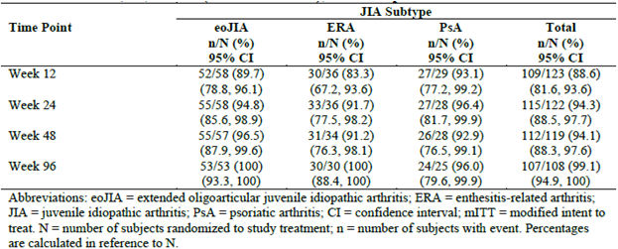
For the higher levels of ACR Pedi response (50, 70, 90 and 100), the proportion of subjects in the overall population who achieved these endpoints was consistently higher with each visit between weeks 12 and 96. For example, approximately twice as many subjects achieved an ACR Pedi 90 response at Week 96 (65.4%; 70/107) compared to Week 12 (29.8%; 36/121). When considering only the subjects with eoJIA, the percentages of subjects in each age group (n = 15 for 2-4 years, n = 23 for 5-11 years, and n = 22 for 12-17 years) who achieved ACR Pedi 30 response at weeks 12, 24, 48 and 96 were similar. In addition, each of the individual components comprising the ACR Pedi variable showed sustained mean improvements from baseline in all JIA subtypes up to Week 96. For example, the mean CHAQ score at Week 96 reduced by 74.2% (absolute reduction of 0.61 from a mean baseline score of 0.80; n = 109 subjects).
At Week 12, 15 subjects (12.1% of 124) fulfilled the criteria for inactive disease. This outcome improved to 24.8% (30/121) at Week 24, 29.7% (35/118) at Week 48, and 34.0% (36/106) at Week 96. The mean pain assessment scores and duration of early morning stiffness also improved from baseline in all JIA subtypes at sequential visits up to Week 96. The mean pain VAS score at baseline was 5.06 (range: 0-10), and for patients in each of the 3 JIA subgroups, pain reduced significantly by Week 96 (-3.80 for subjects in the eoJIA group (n = 53), -4.72 for patients in the ERA arm (n = 30), and -3.58 for subjects in the PsJIA subtype (n = 25)). The mean percentage decrease in morning stiffness from baseline to Week 96 in eoJIA (n = 54) was 64.15% (baseline 72.8 minutes), in patients with ERA (n = 30) was 86.9% (baseline 89.3 minutes), and in subjects with PsJIA (n = 25) was 45.0% (baseline 54.3 minutes).
The secondary efficacy variables relating specifically to the ERA (tender entheseal score, overall back pain, nocturnal back pain, and modified Schober’s test) and PsJIA subtypes (percentage of BSA affected by psoriasis, and PGA of psoriasis) improved from baseline at all time points up to Week 96.
In subjects with ERA, the mean change from baseline to Week 96 in 4 additional secondary efficacy endpoints were assessed in 30 of 38 potential subjects. After 96 weeks of ETN treatment, the mean reduction in the tender entheseal score was 5.03 (baseline mean 5.87), overall back pain reduced by 14.1 mm (baseline mean of 25.9 mm), nocturnal back pain reduced by 6.74 mm (baseline mean 16.4 mm), and the modified Schober’s test improved by 0.27 cm (baseline mean 15.0 cm). In subjects with PsJIA, the mean change from baseline to Week 96 in 2 additional secondary efficacy endpoints were assessed in 25 subjects. After 96 weeks of ETN treatment, the mean percentage of BSA affected by psoriasis reduced by 7.88% (baseline mean 10.41%), and the PGA of psoriasis improved by 1.28 (baseline mean 1.83).

Evaluator assessment
The Part 2 efficacy results of Study 0881A1-3338 indicate that ETN can produce sustained responses (up to 96 weeks of follow-up) in the majority of subjects, which are clinically significant. All 3 JIA subtypes demonstrated response to ETN, which was also similar across a broad age range in the eoJIA subset. The inclusion of the Part 2 efficacy data supports the sponsor application for extension of indication for ETN in JIA by providing data on the maintenance of response over 96 weeks of follow-up.

Please provide an update on the safety data collected in Part 2 of Study 0881A1-3338, and if not available, comment as to why provision of the information should not be a specific condition of approval of this submission?

Dataset and exposure
The sponsor has submitted the final clinical study report for Parts 1 and 2 of Study 0881A1-3338 which includes the safety data for patients who continued to receive ETN for up to 96 weeks. The mean duration of ETN treatment in Parts 1 and 2 of Study 0881A1-3338 was 89.1 weeks, with a range of 1 to 100 weeks (median 96.0 weeks). Overall ETN exposure in the pivotal trial population was 215.1 patient-years – 103.6 in the eoJIA group, 61.3 in the ERA subtype, and 50.2 in the PsJIA cohort. The mean weekly dose of ETN was 37.85 mg, with a range of 10.0-50.0 mg (median 44.0 mg). Consistent with the Part 1 data, subjects with eoJIA had a lower mean baseline age and weight, and therefore received a lower mean weekly dose of ETN (29.5 mg) compared to the other 2 JIA subtypes (46.5 mg for the ERA group, and 46.0 mg for the PsJIA arm).

Overview of adverse events (including Common AEs)
Table 28 presents a summary of the key safety outcomes observed in Parts 1 and 2 of Study 0881A1-3338. Overall, 300 AEs (excluding infections and ISRs) were experienced by 73.2% (93/127) of subjects at an event rate of 1.395 AEs per patient year (total exposure of 215.1 patient-years). The most common types of AE were headache (0.107 per patient year), followed by pyrexia (0.056 per patient year), and diarrhoea (0.046 per patient year). No significant differences for the incidence and type of AEs were observed across the JIA subtypes. In the eoJIA population which included children across a broad age range (2-17 years), AEs occurred at a higher frequency in the 2 younger cohorts (1.54 per patient year for 2-4 year old subjects, and 1.45 per patient year for 5-11 year old children) compared to older patients (1.01 per patient year for 12-17 year old subjects).
Table 28 Summary of Adverse Events in Parts 1 and 2 of Study 0881A1-3338
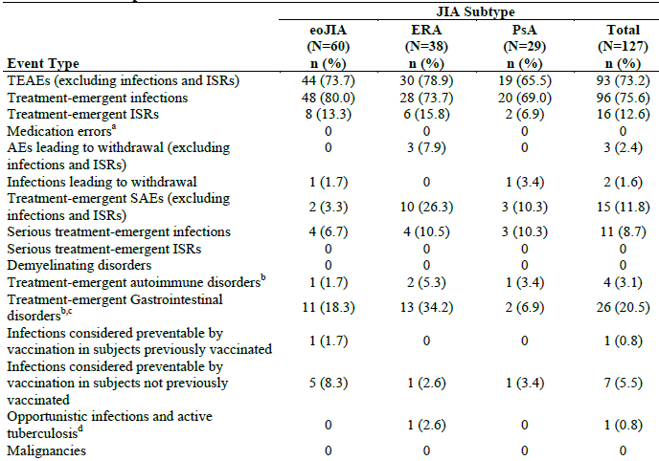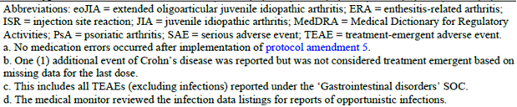

Infections
Overall, 355 treatment-emergent infections were recorded in 73.2% (93/127) of subjects at an event rate of 1.65 infections per patient year during the 96-week study. The most common types of infection were upper respiratory tract infection (0.386 per patient year), followed by pharyngitis (0.232 per patient year), and gastroenteritis (0.102 per patient year). No significant differences for the incidence and type of AEs were observed across the JIA subtypes. In the eoJIA population which included children across a broad age range, infections occurred at a higher frequency in the 2 youngest cohorts (3.31 per patient year for 2-4 year old subjects, and 2.25 per patient year for 5-11 year old children) compared to older patients (1.14 per patient year for 12-17 year old subjects).

Injection site reactions
In total, 63 ISRs were recorded in 16 (12.6% of 127) subjects at an event rate of 0.293 ISRs per patient year during Parts 1 and 2 of the study. The incidence and severity of ISRs was similar between the 3 JIA subtypes. Most ISRs were rated as mild or moderate in severity, and none resulted in a subject withdrawing from ETN.

Discontinuations due to adverse events
Three subjects (2.4% of 127) withdrew due to AEs in the 96-week trial, 2 of which were due to significant infections (bronchopneumonia and pyelocystitis). Both of the infection-related withdrawals occurred in Part 1 of the study. The third subject who permanently discontinued ETN on Day 29 was a 13 year old male who developed fever, asthenia and weight loss on Day 16. A diagnosis of Crohn’s disease was confirmed by endoscopy on Day 66.

Serious adverse events (including serious and opportunistic infections)
A total of 15 subjects (11.8% of 127) reported 16 SAEs (excluding infections) during the study. All were single types of SAEs except for 2 cases of JIA flare. In addition, 11 subjects (8.7% of 127) experienced 11 serious infections. All were single types of serious infection apart from 3 cases of gastrointestinal infection. In addition, 8 subjects suffered infections considered preventable by vaccination, 7 of whom were not vaccinated. These preventable infections included 4 cases of varicella (all in young subjects with eoJIA), 2 cases of herpes zoster (1 each in the ERA and PsJIA groups), and single reports of influenza and rubella (both in the eoJIA cohort). One of herpes zoster cases affected 2 dermatomes. One patient with ERA developed latent tuberculosis during the trial, which was detected by a routine follow-up PPD test becoming positive (negative at baseline).

Death and malignancy
No fatalities or cancers were observed in Parts 1 and 2 of Study 0881A1-3338.

Autoimmune disorders
Four patients (3.1% of 127) developed autoimmune disorders - 2 cases of uveitis, and single cases of iridocyclitis and Crohn’s disease. All of these events are likely to represent disease associated manifestations rather than drug related AEs.
In addition, 3 subjects were recorded as developing Crohn’s disease during the trial (including 1 case which was diagnosed 3 months after ceasing ETN). The relationship between ETN and the development of Crohn’s disease is unclear as adolescent patients with JIA are at risk of developing the condition as part of the associated disease spectrum.

Laboratory abnormalities
Overall, 10 subjects (7.9% of 127) recorded Grade 3 or 4 abnormalities of laboratory tests during the trial. This included 4 subjects with leucopenia (3 eoJIA, and 1 PsJIA patient), and 6 subjects had abnormalities of liver function tests (3 eoJIA, 2 ERA and 1 PsJIA patients). However, over the course of the 96-week study, a total of 26 subjects (20.6% of 127) developed liver function test abnormalities – 14 patients had increases of serum transaminases and/or bilirubin between x 2-3 fold ULN, and 12 subjects had abnormalities of liver function > x 3 ULN. All 26 subjects with abnormalities of liver function tests were taking concurrent DMARD therapy – 21 were taking MTX and 5 were receiving sulfasalazine. In addition, 13 of the 26 patients were taking concurrent NSAID. The frequency of abnormal function tests was higher in the eoJIA group (27.1%; 16/59) compared to the 2 other JIA subtypes (15.8% (6/38) for ERA, and 13.8% (4/29) for PsJIA).

Immunogenicity
Serum for anti-ETN antibodies was collected at baseline; weeks 12, 48 and 96; or upon early withdrawal in Study 881A1-3338. In total, 26 subjects (20.5% of 127) tested positive for anti-ETN antibodies on at least 1 occasion during the trial, of which 10 subjects (7.9% of 127) tested positive on at least 2 occasions. None of the subjects with positive anti-ETN antibody results tested positive for neutralizing antibodies. Fourteen of the patients developed positive anti-ETN antibodies for the first time at Week 48, and 6 did so at Week 12. There was no clear correlation between the occurrence of anti-ETN antibodies and the development of AEs.

Vital signs and growth parameters
Overall, 12 subjects (9.5%) developed changes in blood pressure readings over the course of the study. This included 3 cases of reduced blood pressure (systolic or diastolic) and 9 reports of increased blood pressure, most of which were transient in nature. There was no evidence of a decline in expected growth as measured by changes in height, weight or BMI from baseline to Week 96.

Evaluator assessment
The safety of ETN in children and adolescents over 96 weeks of treatment follow-up in Study 0881A1-3338 demonstrates an acceptable profile with no new safety signals becoming evident. In addition, the incidence of expected AEs (for example risk of infection and injection site reactions) did not differ from the known frequency and pattern. The submission of the Part 2 safety data supports the sponsor application for extension of indication for ETN in JIA, and exceeds the recommendations of the relevant regulatory guidelines in terms of providing sufficient patient experience in a juvenile treatment population.

Please present the safety data for Parts 1 and 2 of Study 0881A1-3338 in a tabular format, which identified those adverse events that were considered to be related to study treatment?
The sponsor response has referred to 2 tables in the final clinical study report for Study 0881A1-3338, which present the incidence and SOC type of treatment emergent AEs by severity and relationship to ETN for the all exposure safety population (n = 127), as well as each of the 3 JIA subtypes involved in Study 0881A1-3338. The site investigator assessed the determination of relationship between ETN and AE.
In Parts 1 and 2 (combined) of Study 0881A1-3338, 96 subjects (75.6% of 127) recorded infections, of which 16.5% (21/127) were considered to be treatment related. Most of the treatment related infections were mild (13 subjects, 10.2%) or moderate in severity (7 subjects, 5.5%). Similar to the Part 1 data, the most common sites of treatment related infections involved the upper respiratory tract (n = 11), ear (n = 5), gastrointestinal system (n = 3) and skin and soft tissues (n = 2). No significant differences in the incidence or severity of infection were observed across the 3 JIA subtypes.
Excluding infections, the combined safety data in Parts 1 and 2 of Study 0881A1-3338, observed 93 subjects (73.2% of 127) experiencing treatment emergent AEs, of which 14.2% (18/127) were considered to be treatment related. Most of the treatment related non-infectious AEs were mild (12 subjects, 9.4%) or moderate in severity (6 subjects, 4.7%). The incidence and type of treatment related AEs showed a similar pattern to that observed in the overall AE assessment (irrespective of relationship to study medication - section 8.4.1.1.1 of this report). The most common individual types of AEs that were assessed as being treatment related included investigation abnormalities (n = 5; mainly abnormal liver function tests), nervous system disorders (n = 5; headache and dizziness), general disorders (n = 3; fatigue and asthenia), and ear complaints (n = 3; vertigo and tinnitus). No significant differences in incidence or severity of infection were observed across the 3 JIA subtypes.

In Part 1 of Study 0881A1-3338, 2 subjects (a 6 year old female with eoJIA experiencing bronchopneumonia, and a 17 year old female with PsJIA suffering pyelocystitis) developed serious infections requiring hospitalization, treatment with IV antibiotics, and discontinuation from study medication. Both events were considered by the site investigators to be mild in severity, and unrelated to study drug. The sponsor is requested to provide comment on the justification for the severity grading, and the assessment of causal relationship to study medication?
The sponsor concurs that the site investigators rated both of these serious infections as being mild in severity, and unrelated to study medication. However, the sponsor states that it assessed the bronchopneumonia SAE as being medication related. The sponsor has made no specific comment about its assessment of a causal relationship between ETN therapy and the SAE of pyelocystitis. The sponsor also states that it does not assess the severity of AEs, and infections represent a known risk associated with ETN, which is included in the current PI. In my opinion, both infectious SAEs have an association with ETN, and this is a known risk with anti-TNF therapy.

In Study 20021618, 2 paediatric subjects with systemic JIA developed macrophage activation syndrome. Please provide comment on whether etanercept was continued or not in these patients, and were the adverse events considered to be drug related?
The sponsor has provided additional case details for both cases (8 year old female, and 11 year old male) that experienced macrophage activation syndrome in Study 20021618. Neither event was considered to be drug related by the investigator. ETN was temporarily ceased in both subjects, and the AE resolved after 6-17 days following hospitalization and additional supportive treatment. Macrophage activation syndrome may occur as a disease related complication of systemic JIA, and is included in the PI for ETN. The evaluator concurs with the sponsor response on this question, in that macrophage activation syndrome is most likely to be a disease related manifestation of JIA than be drug related.

Second round benefit-risk assessment

Second round assessment of benefits
After consideration of the responses to clinical questions, the benefits of ETN in the proposed usage are unchanged from those identified.

Second round assessment of risks
After consideration of the responses to clinical questions, the benefits of ETN in the proposed usage are unchanged from those identified.

Second round assessment of benefit-risk balance
The benefit-risk balance of ETN, given the proposed usage, is favourable.

Second round recommendation regarding authorisation
The submitted data indicates a favourable, short and medium-term benefit-risk assessment for ETN in the proposed usage, and this evaluator would recommend acceptance of the sponsor’s proposed extension of indication for ETN to include the treatment of additional subtypes of JIA. In addition, this evaluator would recommend accepting the proposal to lower the age limit of treatment from the currently approved 4 years of age to 2 years of age for those patients with extended oligoarticular and polyarticular JIA, as well as the addition of a once weekly dosing regimen (0.8 mg/kg, up to a maximum of 50 mg) as an alternative treatment regimen. The current ETN product information (PI) does not classify JIA according to the ILAR criteria as the pivotal JIA licensing study (16.0016) commenced in 1997, that is prior to the development of the ILAR classification. However, the evaluator concurs with the sponsor’s proposal to amend the current PI to incorporate the internationally accepted contemporary classification of JIA by the ILAR criteria. The submitted data in this application is consistent with adopting this proposal.
If this submission is approved, a recommended condition of registration is the provision of regular periodic safety update reports by the sponsor.

References
AIHW 2013. A snapshot of juvenile arthritis. AIHW bulletin no. 113. Cat. no. AUS 168. Canberra: AIHW.
Burgos-Vargas R, Casasola J. A twelve-week, randomized, double-blind, placebo-controlled trial to determine the efficacy and safety of infliximab in juvenile-onset spondyoarthropathies (JO-SPA). Ann Rheum Dis 2008 ; 67 (Suppl II) : S69.
Giannini EH, Ruperto N, Ravelli A, et al. Preliminary definition of improvement in juvenile arthritis. Arthritis Rheum 1997; 40: 1202-1209.
Lovell DJ, Giannini EH, Reiff A, et al. Etanercept in children with polyarticular juvenile rheumatoid arthritis. N Engl J Med 2000; 342: 763-769.
Petty RE, Southwood TR, Manners P, et al. International League of Associations for Rheumatology (ILAR): ILAR classification of juvenile idiopathic arthritis: second version. J Rheumatol 2004; 31: 390-392.
Ravelli A and Martini A. Juvenile Idiopathic Arthritis. Lancet 2007; 369: 767-778.
Ruperto N, Pistorio A, Martini A, et al. A meta-analysis to estimate the “real” placebo effect in juvenile rheumatoid arthritis (JRA) trials (abstract). Arthritis Rheum 2003; 48 Suppl 9: S90.
Yim DS, Zhou H, Buckwalter M, et al. Population pharmacokinetic analysis and simulation of the time-concentration profile of etanercept in paediatric patients with juvenile rheumatoid arthritis. J Clin Pharmacol 2005; 45(3): 246-256.

Therapeutic Goods Administration
PO Box 100 Woden ACT 2606 Australia
Email: info@tga.gov.au Phone: 1800 020 653 Fax: 02 6232 8605
http://www.tga.gov.au

Up to a maximum of 50mg.

