HALAVEN PRODUCT INFORMATION

Name of the MEDICINE
HALAVEN
Eribulin mesilate

Chemical Structure
The chemical name for eribulin mesilate is 11,15:18,21:24,28-triepoxy-7,9-ethano-12,15-methano-9H,15H-furo[3,2-i]furo[2',3':5,6]pyrano[4,3-b][1,4]dioxacyclopentacosin-5(4H)-one, 2-[(2S)-3-amino-2-hydroxypropyl]hexacosahydro-3-methoxy-26-methyl-20,27-bis(methylene)-, (2R,3R,3aS,7R,8aS,9S,10aR,11S,12R,13aR,13bS,15S,18S,21S,24S,26R,28R, 29aS)-, methanesulfonate (salt). It has a molecular weight of 826.0 (729.9 for free base).
The empirical formula is C₄₀H₅₉NO₁₁•CH₄O₃S.
Eribulin mesilate has the following structural formula:
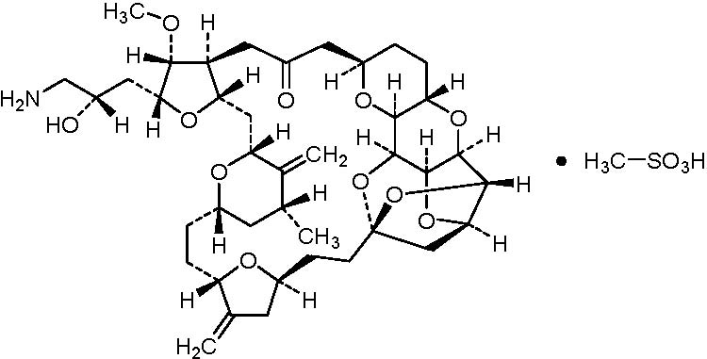
CAS Number: 441045-17-6

DESCRIPTION
HALAVEN is a clear, colourless aqueous solution for injection. HALAVEN contains eribulin mesilate 1 mg in 2 mL (equivalent to eribulin free base 0.88 mg in 2 mL) as the active ingredient. It also contains ethanol - absolute 0.1 mL, hydrochloric acid qs, sodium hydroxide qs and water for injection qs.

PHARMACOLOGY

Pharmacodynamic properties
HALAVEN (eribulin mesilate) is a first-in-class halichondrin B-based, microtubule dynamics inhibitor. It is a structurally simplified synthetic analogue of halichondrin B, a natural product isolated from the marine sponge Halichondria okadai.
Eribulin inhibits the growth phase of microtubules without affecting the shortening phase and sequesters tubulin into non-productive aggregates. Eribulin exerts its effects via a tubulin-based antimitotic mechanism leading to G2/M cell-cycle block, disruption of mitotic spindles and, ultimately, apoptotic cell death after prolonged and irreversible mitotic blockage.
Eribulin also affects the tumour microenvironment and tumour phenotype by mechanisms that are not linked to its antimitotic effects. These additional effects of eribulin include: (i) tumour vasculature remodelling whereby inner tumour cores become better perfused and less hypoxic, and (ii) phenotypic shifts from more aggressive mesenchymal phenotypes to less aggressive epithelial phenotypes via reversal of the epithelial-mesenchymal transition (EMT).

Pharmacokinetic properties

Distribution
The pharmacokinetics of eribulin are characterised by a rapid distribution phase followed by a prolonged elimination phase, with a mean terminal half-life of approximately 40 h. It has a large volume of distribution (range of means 43 to 114 L/m²).
Eribulin is weakly bound to plasma proteins. The plasma protein binding of eribulin (5-1000 ng/mL) ranged from 49% to 67% in human plasma.

Biotransformation
Unchanged eribulin was the major circulating species in plasma following administration of ¹⁴C-eribulin to patients. Metabolite concentrations represented <0.6% of parent compound, confirming that there are no major human metabolites of eribulin.

Elimination
Eribulin has a low clearance (range of means 1.16 to 2.42 L/h/m²). No significant accumulation of eribulin is observed on weekly administration. The pharmacokinetic properties are not dose or time dependent in the range of eribulin mesilate doses of 0.25 to 4.0 mg/m².
Eribulin is eliminated primarily by biliary excretion. The transport protein involved in the excretion is presently unknown. Preclinical studies indicate that eribulin is transported by Pgp. However, it is unknown whether Pgp is contributing to the biliary excretion of eribulin.
After administration of ¹⁴C-eribulin to patients, approximately 82% of the dose was eliminated in faeces and 9% in urine indicating that renal clearance is not a significant route of eribulin elimination.
Unchanged eribulin represented most of the total radioactivity in faeces and urine.

Hepatic impairment
A study evaluated the PK of eribulin in patients with mild (Child-Pugh A; n=7) and moderate (Child-Pugh B; n=5) hepatic impairment due to liver metastases. Compared to patients with normal hepatic function (n=6), eribulin exposure increased 1.8-fold and 2.5-fold in patients with mild and moderate hepatic impairment, respectively. Administration of HALAVEN at a dose of 1.1mg/m² to patients with mild hepatic impairment and 0.7mg/m² to patients with moderate hepatic impairment resulted in a somewhat higher exposure than after a dose of 1.4 mg/m² to patients with normal hepatic function. HALAVEN was not studied in patients with severe hepatic impairment (Child-Pugh C). There is no study in patients with hepatic impairment due to cirrhosis. See section Dosage and Administration for dosage recommendation.

Renal impairment
The pharmacokinetics of eribulin were evaluated in a Phase 1 study in patients with stage 2 chronic kidney disease (GFR 60 - 89 mL/min/1.73m²), stage 3 chronic kidney disease (GFR 30 - 59 mL/min/1.73m²), or stage 4-5 chronic kidney disease (GFR <30 mL/min/1.73m²). Increase in dose-normalised C_{max} was 1.31-fold (90% CI 0.84-2.05) for stage 3 chronic kidney disease and 2.02-fold (90% CI 1.27-3.21) for stage 4-5 chronic kidney disease compared to normal renal function. Stage 3 chronic kidney disease and stage 4-5 chronic kidney disease increased mean dose-normalised AUC _{(0-inf)} 1.49-fold (90% CI 0.9-2.45) compared to normal renal function. Renal impairment therefore has an up to three fold effect on eribulin exposure and dosing modifications and extra haematology monitoring should be undertaken.
Refer to Dosage and Administration section for treatment recommendations in renal impairment.

CLINICAL TRIALS

Breast Cancer
The efficacy of HALAVEN in breast cancer is primarily supported by two randomised Phase 3 comparative studies.
The 762 patients in the pivotal Phase 3 EMBRACE (Study 305) study had locally recurrent or metastatic breast cancer, and had previously received at least two and a maximum of five chemotherapy regimens, including an anthracycline and a taxane (unless contraindicated). Patients must have progressed within 6 months of their last chemotherapeutic regimen. They were randomised 2:1 to receive either HALAVEN at a dose of 1.4 mg/m² on Days 1 and 8 in a 21-day cycle administered intravenously over 2 to 5 minutes, or treatment of physician’s choice (TPC), defined as any single-agent chemotherapy, hormonal treatment, or biologic therapy approved for the treatment of cancer; or palliative treatment or radiotherapy, reflecting local practice. The TPC arm consisted of 97% chemotherapy (26% vinorelbine, 18% gemcitabine, 18% capecitabine, 16% taxane, 9% anthracycline, 10% other chemotherapy), or 3% hormonal therapy. The median duration of treatment (range) for each treatment group was: vinorelbine 1.6 months (0-13.1 months); gemcitabine 2.3 months (0-14.5 months); capecitabine 3.9 months (0-21.2 months); taxane 2.9 months (0-14.5 months); anthracycline 1.9 months (0-6.5 months) and HALAVEN 3.9 months (0.7-16.3 months).
The primary endpoint, overall survival, was significantly better with HALAVEN than TPC (See Table 1).
Table 1: Efficacy of HALAVEN versus Treatment of Physician’s Choice – Primary and Updated Survival Analysis in the ITT Population
Efficacy Parameter | HALAVEN  (n = 508) | TPC  (n = 254)
Primary Overall Survival
Number of Events (%) | 274 (53.9%) | 148 (58.3%)
Median, months (95% CI ) | 13.1 (11.8, 14.3) | 10.6 (9.3, 12.5)
Hazard Ratio (95% CI)ª | 0.809 (0.660, 0.991)
P-value (log-rank)^{b} | 0.041
Updated Overall Survival
Number of Events | 386 (76.0%) | 203 (79.9%)
Median, months (95% CI) | 13.2 (12.1, 14.4) | 10.6 (9.2, 12.0)
Hazard Ratio (95% CI)ª | 0.805 (0.677, 0.958)
Nominal P-value (log-rank^{)b} | 0.014
CI = confidence interval
ª Based on Cox proportional hazards model stratified by geographic region, HER2 status, and prior capecitabine therapy.
^{b} Based on a log-rank test stratified by geographic region, HER2 status, and prior capecitabine therapy.
Figure 1: Kaplan-Meier Analysis of OS-Update Data (ITT Population)
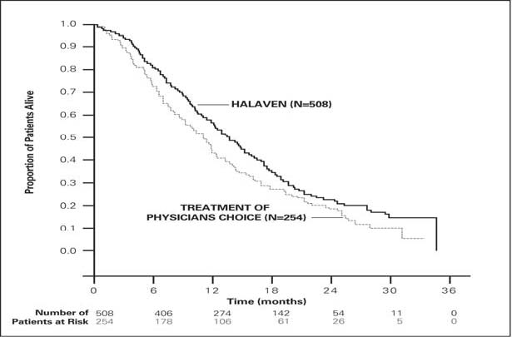
At the time of the original cut-off, analysis of progression free survival by independent and investigator review is shown in Table 2below.
Table 2: Efficacy of HALAVEN versus Treatment of Physician’s Choice – Progression Free Survival
 | HALAVEN (n=508) | TPC (n=254)
Independent
Number of events | 357 (70.3%) | 164 (64.6%)
Median, months (95% CI) | 3.7 (3.3, 3.9) | 2.2 (2.1, 3.8)
Hazard Ratioª (95% CI) | 0.865 (0.714 – 1.048)
p-value^{b} (Log rank) | 0.137
Investigator
Number of events | 429 (84.4%) | 206 (81.1%)
Median, months (95%CI) | 3.6 (3.3, 3.7) | 2.2 (2.0, 2.6)
Hazard Ratioª (95% CI) | 0.757 (0.638 – 0.900)
p-value^{b} (Log rank) | 0.002
ª For the hazard ratio, a value less than 1.00 favours HALAVEN
^{b} Stratified by geographic region, HER2/neu status, and prior capecitabine use.
In response evaluable patients who received HALAVEN, the objective response rate by the RECIST criteria was 12.2% (95% CI: 9.4%, 15.5%) by independent review and 13.2% (95% CI: 10.3%, 16.7%) by investigator review. The median response duration in this population by independent review was 4.2 months (95% CI: 3.8, 5.0 months).
The positive effect on OS and PFS was seen in both taxane-refractory and non-refractory groups of patients. In the OS update, the HR for HALAVEN versus TPC was 0.90 (95% CI 0.71, 1.14) in favour of HALAVEN for taxane-refractory patients and 0.73 (95% CI 0.56, 0.96) for patients not taxane-refractory. In the investigator assessment-based analysis of PFS (based on original data cut-off), the HR was 0.77 (95% CI 0.61, 0.97) for taxane-refractory patients and 0.76 (95% CI 0.58, 0.99) for patients not taxane-refractory.
The positive effect on OS was seen both in capecitabine-naïve and in capecitabine pre-treated patient groups. The analysis of updated OS showed a survival benefit for the HALAVEN group compared to TPC both in capecitabine pre-treated patients with a HR of 0.787 (95% CI 0.645, 0.961), and for the 11 capecitabine-naïve patients with a corresponding HR of 0.865 (95% CI 0.606, 1.233). Investigator assessment-based analysis of PFS (based on original data cut-off), also showed a positive effect in the capecitabine pre-treated group with a HR of 0.68 (0.56, 0.83). For the capecitabine-naïve group the corresponding HR was 1.03 (0.73, 1.45).
The second Phase 3 study (study 301) in earlier line metastatic breast cancer, was an open-label, randomised, study in patients (n=1102) with locally advanced or metastatic breast cancer to investigate the efficacy of HALAVEN monotherapy compared to capecitabine monotherapy in terms of OS and PFS as co-primary endpoint. Patients had previously received up to three prior chemotherapy regimens, including both an anthracycline and a taxane and a maximum of two for advanced disease, with the percentage who had received 0, 1 or 2 prior chemotherapy treatments for metastatic breast cancer being 20.0%, 52.0% or 27.2% respectively. The HER2 status of the patients was: 15.3% positive, 68.5% negative and 16.2% unknown, whilst 25.8% of patients were triple negative.
Figure 2: Study 301 - Overall Survival (ITT Population)
PROBABILITY OF SURVIVAL | 1.0  0.9  0.8  0.7  0.6  0.5  0.4  0.3  0.2  0.1  0.0 | 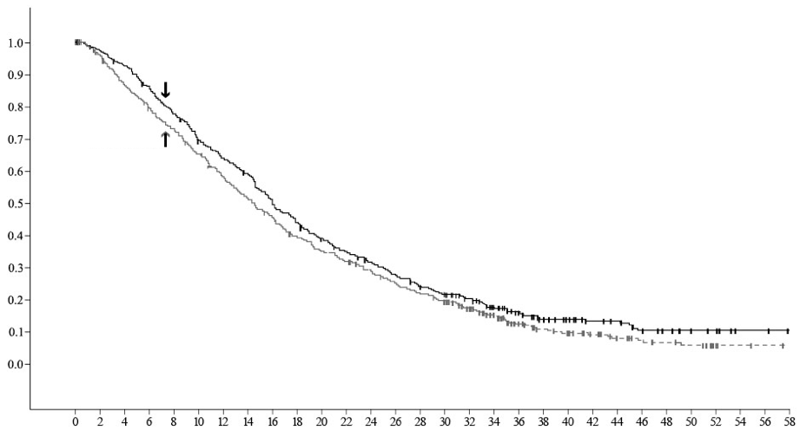  HALAVEN  Capecitabine
  Efficacy Parameter | OS in ITT Population
   | HALAVEN  (n=554) | Capecitabine  (n=548)
  Number of Events | 446 | 459
  Median (months) | 15.9 | 14.5
  Hazard Ratio (95% CI)ª | 0.879 (0.770, 1.003)
  P value (log rank) | 0.056^{b}
  ªCox proportional hazard
  ^{b}Stratified by geographic region, HER2/neu status

TIME (months)
NUMBER OF PATIENTS AT RISK
HALAVEN | 554 | 530 | 505 | 464 | 423 | 378 | 349 | 320 | 268 | 243 | 214 | 193 | 173 | 151 | 133 | 119 | 99 | 77 | 52 | 38 | 32 | 26 | 22 | 15 | 13 | 9 | 7 | 2 | 2 | 0
Capecitabine | 548 | 513 | 466 | 426 | 391 | 352 | 308 | 277 | 242 | 214 | 191 | 175 | 155 | 135 | 122 | 108 | 81 | 62 | 42 | 33 | 27 | 23 | 17 | 13 | 12 | 10 | 2 | 2 | 1 | 0
Progression free survival assessed by independent review was similar between HALAVEN and capecitabine with medians of 4.1 months vs 4.2 months (HR 1.08; [95% CI: 0.932, 1.250]) respectively. Objective response rate as assessed by independent review was also similar between HALAVEN and capecitabine; 11.0% (95% CI: 8.5, 13.9) in the HALAVEN group and 11.5% (95% CI: 8.9, 14.5) in the capecitabine group.

Liposarcoma
In liposarcoma the efficacy of HALAVEN is supported by the pivotal Phase 3 sarcoma study (Study 309). The patients (n=452) in this study had locally recurrent, inoperable and/or metastatic soft tissue sarcoma of one of two subtypes – leiomyosarcoma or liposarcoma. Patients had received at least two prior chemotherapy regimens, one of which must have been an anthracycline (unless contraindicated). Enrolment was stratified by histology, number of prior therapies and geographic region.
Patients must have progressed within 6 months of their last chemotherapeutic regimen. They were randomised 1:1 to receive either HALAVEN 1.4 mg/m² on days 1 and 8 of a 21 day cycle or dacarbazine 850 mg/m², 1000 mg/m² or 1200 mg/m² (dose determined by the investigator prior to randomisation), every 21 days. Treatment continued until disease progression or unacceptable toxicity.
In Study 309, a statistically significant improvement in OS was observed in patients randomised to the HALAVEN arm compared to the control arm. This translated into a 2 month improvement in median OS (13.5 months for HALAVEN treated patients vs. 11.5 months for dacarbazine treated patients). There was no significant difference in progression-free survival or overall response rate between the treatment arms in the overall population.
Treatment effects of HALAVEN were limited to patients with liposarcoma (45% dedifferentiated, 37% myxoid/round cell and 18% pleomorphic in Study 309) based on pre-planned subgroup analyses of OS and PFS. There was no difference in efficacy between HALAVEN and dacarbazine in patients with advanced or metastatic leiomyosarcoma.
Table 3: Efficacy of HALAVEN versus dacarbazine in liposarcoma
 | Study 309  Liposarcoma Subgroup |  | Study 309  Leiomyosarcoma Subgroup |  | Study 309  ITT Population
 | HALAVEN  (n=71) | Dacarbazine  (n=72) | HALAVEN  (n=157) | Dacarbazine  (n=152) | HALAVEN  (n=228) | Dacarbazine  (n=224)
Overall survival
Number of Events | 52 | 63 | 124 | 118 | 176 | 181
Median months | 15.6 | 8.4 | 12.7 | 13.0 | 13.5 | 11.5
Hazard Ratio (95% CI) | 0.511 (0.346, 0.753) |  | 0.927 (0.714, 1.203) |  | 0.768 (0.618, 0.954)
Nominal p-value | 0.0006 |  | 0.5730 |  | 0.0169
Progression-free survival
Number of Events | 57 | 59 | 140 | 129 | 197 | 188
Median months | 2.9 | 1.7 | 2.2 | 2.6 | 2.6 | 2.6
Hazard Ratio (95% CI) | 0.521 (0.346, 0.784) |  | 1.072 (0.835, 1.375) |  | 0.877 (0.710, 1.085)
Nominal p-value | 0.0015 |  | 0.5848 |  | 0.2287

Figure 3: Study 309 - Overall Survival in the Liposarcoma Subgroup
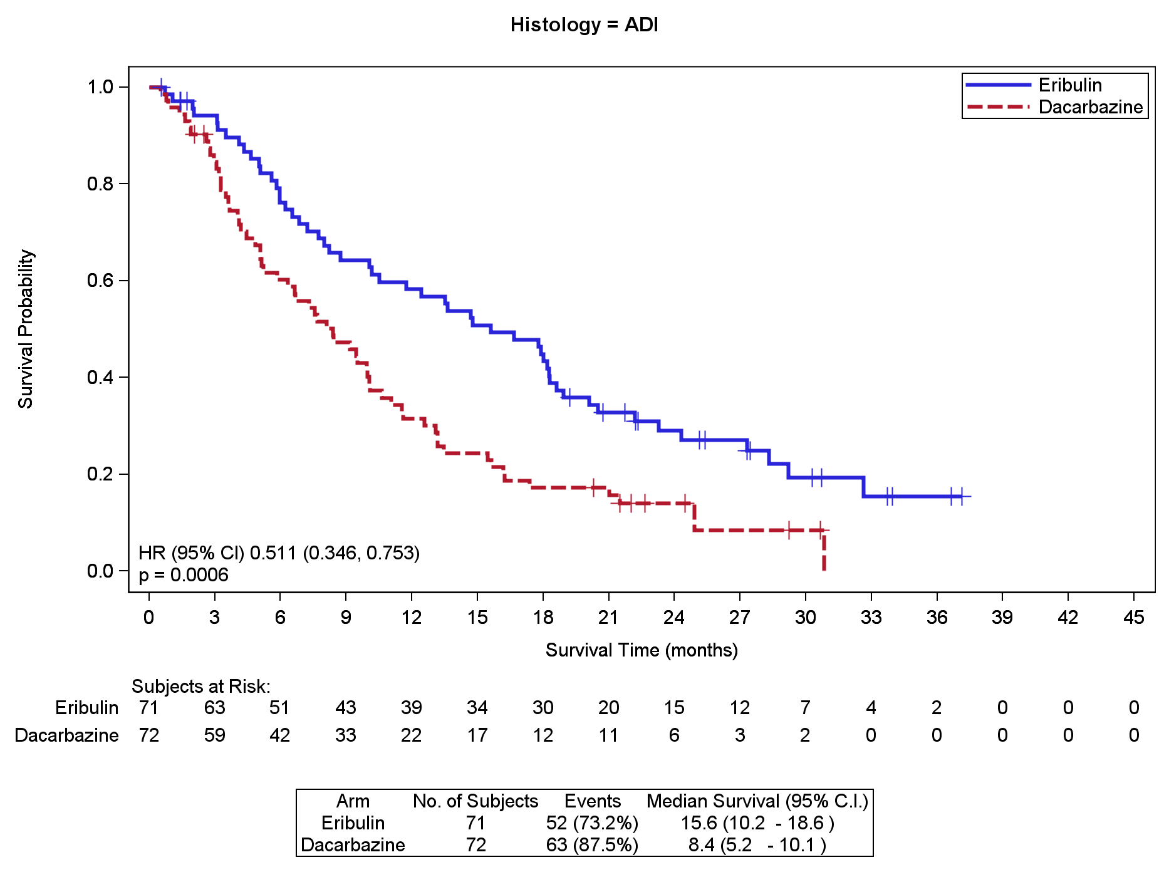
Figure 4: Study 309 – Progression Free Survival in the Liposarcoma Subgroup
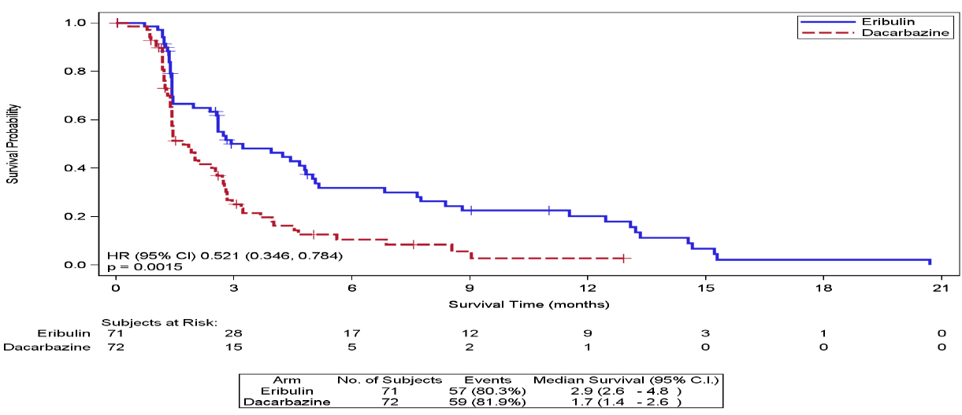

Paediatric population
No studies have been undertaken in the paediatric population in the indication of breast cancer.
No studies have been undertaken in the paediatric population in the indication of soft tissue sarcoma.

INDICATIONS
HALAVEN is indicated for the treatment of patients with locally advanced or metastatic breast cancer who have progressed after at least one chemotherapeutic regimen for advanced disease. Prior therapy should have included an anthracycline and a taxane in either the adjuvant or metastatic setting unless these are contraindicated.
HALAVEN is indicated for the treatment of patients with unresectable liposarcoma who have received prior chemotherapy for advanced or metastatic disease.

CONTRAINDICATIONS
Hypersensitivity to eribulin mesilate or to any of the other ingredients.
Breast feeding

PRECAUTIONS

Haematology
Myelosuppression is dose dependent and primarily manifested as neutropenia. In the EMBRACE study, neutropenia occurred in 82% of breast cancer patients treated with HALAVEN, with severe neutropenia (>Grade 3) in 57% of patients leading to discontinuation in <1% of patients (See Adverse Effects). In the patients treated with eribulin in soft tissue sarcoma studies (STS population), neutropenia (adverse events and laboratory abnormalities) occurred in 76.0%, with severe neutropenia (≥Grade 3) in 53% of patients.
Monitoring of complete blood counts should be performed on all patients prior to each dose of HALAVEN. Treatment with HALAVEN should only be initiated in patients with ANC values ≥1.5 x 10⁹/L and platelets >100 x 10⁹/L.
Febrile neutropenia occurred in <5% of patients treated with HALAVEN. Patients experiencing febrile neutropenia, severe neutropenia or thrombocytopenia, should be treated according to the recommended doses (See Dosage and Administration).
Patients with ALT or AST >3 x ULN experienced a higher incidence of Grade 4 neutropenia and febrile neutropenia. Although data are limited, patients with bilirubin >1.5 x ULN also have a higher incidence of Grade 4 neutropenia and febrile neutropenia.
During clinical studies, a higher proportion of Asian and Pacific Islander subjects reported events of neutropenia and/or shifts in laboratory values for neutrophil count decreased compared with White subjects (See ADVERSE EFFECTS).
Severe neutropenia may be managed by the use of G-CSF or equivalent at the physician’s discretion in accordance with relevant guidelines.

Peripheral neuropathy
In the EMBRACE study, peripheral neuropathy occurred in 35% of breast cancer patients treated with HALAVEN. Severe peripheral neuropathy (>Grade 3) occurred in 8% of patients, leading to discontinuation in 5% of patients (See Adverse Effects).
Patients should be closely monitored prior to each dose for signs of peripheral motor and sensory neuropathy. The development of severe peripheral neurotoxicity requires a delay or reduction of dose (see Dosage and Administration).
In clinical trials, patients with pre-existing neuropathy greater than Grade 2 were excluded.

QT prolongation
In an uncontrolled open-label ECG study in 26 patients, QT prolongation was observed on Day 8, independent of HALAVEN concentration, with no QT prolongation observed on Day 1. ECG monitoring is recommended if therapy is initiated in patients with congestive heart failure, bradyarrhythmias or concomitant treatment with medicinal products known to prolong the QT interval, including Class Ia and III antiarrhythmics, and electrolyte abnormalities. Hypokalaemia or hypomagnesemia should be corrected prior to initiating HALAVEN and these electrolytes should be monitored periodically during therapy. HALAVEN should be avoided in patients with congenital long QT syndrome.

Use in combination with anti-HER2 therapy
The efficacy and safety of using HALAVEN in combination with anti-HER2 therapy have not been established.

Excipients
This medicinal product contains small amounts of ethanol (alcohol), 0.1 mL per vial.

Effects on Fertility
A fertility study was not conducted with HALAVEN, but based on non-clinical findings in repeated-dose studies where testicular toxicity was observed in both rats (hypocellularity of seminiferous epithelium with hypospermia/aspermia) and dogs (testicular hypocellularity and epididymal hypospermia/aspermia) at less than one third of the expected clinical exposure (based on AUC data), male fertility may be compromised by treatment with HALAVEN.
Male patients should seek advice on conservation of sperm prior to treatment because of the possibility of irreversible infertility due to therapy with HALAVEN.

Use in Pregnancy (Category D)
There is no information on the use of HALAVEN in pregnant women. Eribulin is embryotoxic, foetotoxic, and teratogenic in rats at less than the recommended human dose (based on body surface area, mg/m²). HALAVEN should not be used during pregnancy.
Women of childbearing age must be advised to avoid becoming pregnant whilst they or their male partner are receiving HALAVEN and should use effective contraception during and up to 3 months after treatment.
In a developmental and reproductive toxicity study, pregnant rats received IV bolus injection of eribulin mesilate during organogenesis on gestation days 8, 10 and 12. Severe external or soft tissue malformations in offspring (absence of lower jaw, tongue, stomach and spleen) were observed at 0.15 mg/kg (0.64 times the recommended human dose based on body surface area, mg/m²) and increased embryofoetal death/early resorptions and decreased foetal weights were recorded at ≥0.1 mg/kg (≥0.43 times the recommended human dose based on body surface area). Maternal toxicity was observed at ≥0.43 times the recommended human dose based on body surface area, and included enlarged spleen, reduced body weight gain and decreased food consumption.

Use in Lactation
There is no information on the excretion of eribulin or its metabolites in human or animal breast milk. A risk to newborns or infants cannot be excluded and therefore HALAVEN must not be used during breastfeeding (see Contraindications).

Carcinogenicity
No carcinogenicity studies have been conducted with eribulin.

Genotoxicity
Eribulin was not mutagenic in the in vitro bacterial reverse mutation assay (Ames test). Eribulin was positive in the in vitro mouse lymphoma mutagenesis assay and was clastogenic in the in vivo rat micronucleus assay.

INTERACTIONS WITH OTHER MEDICINES
Effects of other drugs on eribulin
No drug-drug interactions are expected with CYP3A4 inhibitors, CYP3A4 inducers or P-glycoprotein (Pgp) inhibitors. Clinically meaningful differences in exposure (AUC) were not observed in patients with advanced solid tumours when HALAVEN was administered with or without ketoconazole (a strong inhibitor of CYP3A4 and a Pgp inhibitor) and when HALAVEN was administered with or without rifampicin (a CYP3A4 inducer).
Eribulin is a substrate of Pgp but not a substrate of BCRP, BSEP, MRP2 or MATE1 in vitro. Eribulin is mainly (up to 70%) eliminated through biliary excretion. The transport protein involved in this process is unknown (see Pharmacology, Elimination). Based on a study of coadministration of HALAVEN and ketoconazole (a Pgp inhibitor), eribulin exposure is unlikely to be increased with substances inhibiting Pgp. However, coadministration of HALAVEN with substances inhibiting other hepatic transport proteins (e.g. organic anion transporting proteins, multidrug resistance proteins) may increase eribulin exposure. Such coadministration is not recommended at the present time.

Effects of eribulin on other drugs
Eribulin is a CYP3A4 inhibitor in vitro, with IC₅₀/Ki values ranging from 2 to 50 μM depending on the substrate. No in vivo data are available. Caution and monitoring for adverse events is recommended when HALAVEN is used with substances that have a narrow therapeutic window and that are eliminated mainly via CYP3A4-mediated metabolism.
Eribulin does not inhibit CYP1A2, CYP2B6, CYP2C8, CYP2C9, CYP2C19, CYP2D6 or CYP2E1 enzymes or induce CYP1A2, CYP2B6, CYP2C9, CYP2C19 or CYP3A4 enzymes at relevant clinical concentrations. Eribulin is not expected to alter the plasma concentrations of drugs that are substrates of these enzymes. Eribulin down-regulated CYP2B6 and CYP1A2 expression in human hepatocytes in vitro, and the clinical relevance of this effect is unclear.

ADVERSE EFFECTS

Summary of safety profile
The most commonly reported undesirable effects related to HALAVEN, are bone marrow suppression manifested as neutropenia, leukopenia, anaemia, thrombocytopenia with associated infections. New onset or worsening of pre-existing peripheral neuropathy has also been reported. Gastrointestinal toxicities, manifested as anorexia, nausea, vomiting, diarrhoea, constipation, and stomatitis are among reported undesirable effects. Other undesirable effects include fatigue, alopecia, increased liver enzymes, sepsis and musculoskeletal pain syndrome.

Clinical Trials

Breast Cancer
In the EMBRACE study (Study 305), 750 patients were randomised (2:1) to receive either HALAVEN (1.4 mg/m² on Days 1 and 8 of a 21-day cycle) or single agent treatment chosen by their physician (control group). A total of 503 patients received HALAVEN, and 247 patients in the control group received therapy consisting of chemotherapy [total 97% (anthracyclines 9%, capecitabine 18%, gemcitabine 18%, taxanes 16%, vinorelbine 26%, other chemotherapies 10%)] or hormonal therapy (3%). The median duration of exposure was 118 days for patients receiving HALAVEN and 63 days for patients receiving control therapy. Table 4below reports the most common adverse events occurring in at least 10% of patients in either group.
Table 4: Very Common (≥10%) Adverse Events in the EMBRACE Trial
HALAVEN |  |  | Control Group
MedDRA ver 10.0 | n=503 |  | n=247
 | All Grades | ≥Grade 3 | All Grades | ≥Grade 3
Infections and Infestations
Urinary Tract Infection | 10% | 1% | 5% | 0
Blood and Lymphatic System Disorders ª
Neutropenia | 82% | 57% | 53% | 23%
Anaemia | 58% | 2% | 55% | 4%
Metabolism and nutrition disorders
Anorexia | 20% | 1% | 13% | 1%
Nervous system disorders
Peripheral neuropathy^{b} | 35% | 8% | 16% | 2%
Headache | 19% | <1% | 12% | <1%
Respiratory, thoracic, and mediastinal disorders
Cough | 14% | 0 | 9% | 0
Dyspnoea | 16% | 4% | 13% | 4%
Gastrointestinal disorders
Constipation | 25% | 1% | 21% | 1%
Diarrhoea | 18% | 0 | 18% | 0
Nausea | 35% | 1% | 28% | 3%
Vomiting | 18% | 1% | 18% | 1%
Skin and subcutaneous tissue disorders
Alopecia | 45% | NA^{c} | 10% | NA^{c}
Musculoskeletal and connective tissue disorders
Arthralgia/Myalgia | 22% | <1% | 12% | 1%
Back pain | 16% | 1% | 7% | 2%
Bone pain | 12% | 2% | 9% | 2%
Pain in extremity | 11% | 1% | 10% | 1%
General disorders and administration site conditions
Asthenia/Fatigue | 54% | 10% | 40% | 11%
Mucosal inflammation | 9% | 1% | 10% | 2%
Pyrexia | 21% | <1% | 13% | <1%
Investigations
Weight decreased | 21% | 1% | 14% | <1%
^{a.} based upon laboratory data.
^{b} includes neuropathy peripheral, neuropathy, peripheral motor neuropathy, polyneuropathy, peripheral sensory neuropathy, and paraesthesia.
^{c} not applicable; (grading system does not specify >Grade 2 for alopecia).
In Study 301, 1102 patients were randomised (1:1) to receive either HALAVEN (1.4 mg/m² on Days 1 and 8 of a 21-day cycle) or capecitabine (1.25 g/m² twice daily from days 1-14 of a 21 day cycle). 12 patients in the study did not receive study treatment, so a total of 544 patients received HALAVEN, and 546 patients received capecitabine. The median duration of exposure was 125 days for patients receiving HALAVEN and 119 days for patients receiving capecitabine. Table 5below reports the most common adverse events occurring in at least 10% of patients in either group.
Table 5: Very Common (≥10%) Adverse Events in Study 301
HALAVEN |  |  | Capecitabine
 | n=544 |  | n=546
 | All Grades | ≥Grade 3 | All Grades | ≥Grade 3
Blood and Lymphatic System Disorders
Neutropenia | 54.2% | 45.8% | 15.9% | 4.9%
Leukopenia | 31.4% | 15.1% | 10.4% | 2.0%
Anaemia | 19.1% | 2.0% | 17.6% | 1.1%
General Disorders and Administration Site Conditions
Fatigue | 16.7% | 2.0% | 15.4% | 2.4%
Asthenia | 15.3% | 4.2% | 14.5% | 3.7%
Pyrexia | 12.9% | 0.4% | 5.7% | 0.5%
Gastrointestinal Disorders
Nausea | 22.2% | 0.2% | 24.4% | 1.6%
Diarrhoea | 14.3% | 1.1% | 28.8% | 5.3%
Vomiting | 11.9% | 0.4% | 16.8% | 2.2%
Skin and Subcutaneous Tissue Disorders
Alopecia | 34.6% | NAª | 4.0% | NAª
Palmar-plantar erythrodysaesthesia | 0.2% | 0 | 45.1% | 14.5%
Nervous System Disorders
Peripheral neuropathy^{b} | 21.3% | 6.1% | 10.8% | 0.7%
Headache | 12.7% | 0.7% | 10.4% | 0.5%
Musculoskeletal and Connective Tissue Disorders
Back pain | 10.3% | 1.5% | 7.9% | 0.5%
Respiratory, Thoracic, and Mediastinal Disorders
Dyspnoea | 10.3% | 2.9% | 10.8% | 4.4%
Metabolism and Nutrition Disorders
Decreased appetite | 12.5% | 0.6% | 14.8% | 1.6%
a: Not applicable; (grading system does not specify >Grade 2 for alopecia).
b: Peripheral neuropathy includes neuropathy peripheral, peripheral motor neuropathy, peripheral sensory neuropathy, peripheral sensorimotor neuropathy, polyneuropathy and paraesthesia.
Soft Tissue Sarcoma
In Study 309, patients with soft tissue sarcoma were randomised (1:1) to receive either HALAVEN (1.4 mg/m² on Days 1 and 8 of a 21-day cycle) or dacarbazine (850 mg/m2, 1000 mg/m², or 1,200 mg/m² as selected by the investigator prior to randomization according to the subject’s clinical status). A total of 226 patients received HALAVEN, and 224 patients received dacarbazine. The median duration of exposure was 10.0 weeks for patients receiving HALAVEN and 9.0 weeks for patients receiving dacarbazine. Table 6below reports the most common adverse events occurring in at least 10% of patients in either group.
Table 6: Very Common (≥10%) Adverse Events in Study 309
HALAVEN |  |  | Dacarbazine
 | n=226 |  | n=224
 | All Grades | ≥Grade 3 | All Grades | ≥Grade 3
Blood and Lymphatic System Disorders
Neutropenia | 43.8% | 35.4% | 23.7% | 15.6%
Anaemia | 29.6% | 6.9% | 30.8% | 12.1%
Leukopenia | 15.9% | 10.2% | 10.3% | 4.5%
Thrombocytopenia | 5.8% | 0.4% | 27.7% | 15.2%
General Disorders and Administration Site Conditions
Asthenia/Fatigue | 64.6% | 4.8% | 61.2% | 4.4%
Pyrexia | 27.9% | 0.9% | 13.8% | 0.4%
Peripheral oedema | 11.9% | 0 | 7.6% | 0
Gastrointestinal Disorders
Nausea | 40.3% | 0.9% | 47.3% | 0.4%
Constipation | 31.4% | 0.9% | 25.9% | 0.4%
Abdominal painª | 28.3% | 1.7% | 21.8% | 3.6%
Vomiting | 19.0% | 0.9% | 22.3% | 0.4%
Diarrhoea | 16.8% | 0.4% | 16.1% | 0
Stomatitis | 13.7% | 0.9% | 4.9% | 0.4%
Skin and Subcutaneous Tissue Disorders
Alopecia | 35.0% | NA^{b} | 2.7% | NA^{b}
Nervous System Disorders
Peripheral neuropathy^{c} | 33.1% | 0 | 7.5% | 0
Headache | 18.1% | 0 | 9.4% | 0
Musculoskeletal and Connective Tissue Disorders
Arthralgia/Myalgia | 18.6% | 0 | 13.4% | 1.3%
Back pain | 15.5% | 1.8% | 13.8% | 1.3%
Respiratory, Thoracic, and Mediastinal Disorders
Cough | 18.6% | 0 | 13.4% | 0
Dyspnoea | 16.8% | 2.2% | 18.3% | 2.2%
Metabolism and Nutrition Disorders
Decreased appetite | 19.0% | 0.4% | 19.2% | 0
Hypokalaemia | 10.2% | 2.7% | 4.0% | 1.8%
Infections
Urinary Tract Infections | 11.5% | 2.2% | 5.3% | 0.4%
a: includes abdominal pain, upper abdominal pain, lower abdominal pain, abdominal discomfort.
b: Not applicable; (grading system does not specify >Grade 2 for alopecia).
c: Peripheral neuropathy includes neuropathy peripheral, peripheral motor neuropathy, peripheral sensory neuropathy, peripheral sensormotor neuropathy, polyneuropathy and paraesthesia.
Table 7 provides a listing of Very Common (≥10%), common (≥1% to <10%) and uncommon (≥0.1% to <1%) adverse reactions observed in breast cancer and soft tissue sarcoma patients who received the recommended dose in Phase 2 and Phase 3studies.
Table 7: Very Common (≥10%), Common (≥1% to <10%) and Uncommon (≥0.1 to <1%) Adverse Reactions to HALAVEN in Pooled Data from Phase 3 trials and phase 2 trials
System Organ Class | Adverse Reactions – all Grades
 | Very Common | Common | Uncommon
Infections and infestations |  | Urinary tract infection  Pneumonia  Oral candidiasis  Oral herpes  Upper respiratory tract infection  Nasopharyngitis  Rhinitis  Herpes zoster | Sepsis  Neutropenic sepsis  Septic Shock
Blood and lymphatic disorders | Neutropenia  Leukopenia  Anaemia | Febrile neutropenia Thrombocytopenia  Lymphopenia
Metabolism and nutrition disorders | Decreased appetite | Hypokalaemia  Hypomagnesaemia  Dehydration  Hyperglycaemia  Hypophosphataemia  Hypocalcaemia
Psychiatric disorders |  | Insomnia  Depression
Nervous system disorders | Peripheral neuropathy Headache | Dysgeusia  Dizziness  Hypoaesthesia  Lethargy  Neurotoxicity
Eye disorders |  | Lacrimation increased  Conjunctivitis
Ear and Labyrinth Disorders |  | Vertigo  Tinnitus
Cardiac disorders |  | Tachycardia
Vascular disorders |  | Hot flush  Pulmonary embolism | Deep vein thrombosis
Respiratory, thoracic and mediastinal disorders | Dyspnoea  Cough | Oropharyngeal pain  Epistaxis  Rhinorrhoea | Interstitial lung disease
Gastrointestinal disorders | Nausea  Constipation  Diarrhoea  Vomiting | Abdominal pain  Stomatitis  Dry mouth  Dyspepsia  Gastrooesophageal reflux disease  Abdominal distension | Mouth ulceration
Hepatobiliary disorders |  | Alanine aminotransferase increased  Aspartate aminotransferase increased  Hyperbilirubinaemia  Gamma glutamyl transferase increased | Hepatotoxicity
Skin and subcutaneous tissue disorders | Alopecia | Rash  Pruritus  Nail disorder  Night sweats  Dry skin  Erythema  Hyperhidrosis  Palmar plantar erythrodysaesthesia | Angioedema
Musculoskeletal and connective tissue disorders | Arthralgia and Myalgia  Back pain  Pain in extremity | Bone pain  Muscle spasms  Musculoskeletal pain  Musculoskeletal chest pain  Muscular weakness
Renal and urinary disorders |  | Dysuria | Haematuria  Proteinuria  Renal failure
General disorders  and administration site conditions | Fatigue/Asthenia  Pyrexia | Mucosal inflammation  Peripheral oedema  Pain  Chills  Chest pain  Influenza like illness
Investigations | Weight decreased

Post Marketing Experience
Spontaneously reported adverse effects, presented in the table below, are reported voluntarily and it is not always possible to reliably establish frequency or a causal relationship to drug exposure.
Table 8: Adverse drug reactions derived from spontaneous reports
Blood and lymphatic disorders | Disseminated intravascular coagulation
Gastrointestinal disorders | Pancreatitis
Respiratory, thoracic and mediastinal disorders | Interstitial lung disease
Skin and subcutaneous tissue disorders | Stevens-Johnson syndrome, Toxic epidermal necrolysis
Overall, the safety profiles in the breast cancer and soft tissue sarcoma patient populations were similar.

Selected adverse reactions
Neutropenia
The neutropenia observed was reversible and not cumulative; the mean time to nadir was 13 days and the mean time to recovery from severe neutropenia (<0.5 x 109/L) was 8 days.
Neutrophil counts of < 0.5 x 10⁹/l that lasted for more than 7 days occurred in 13% of breast cancer patients treated with eribulin in the EMBRACE study.
Neutropenia was reported as a Treatment Emergent Adverse Event (TEAE) in 151/404 (37.4% for all grades) in the STS population, compared with 902/1559 (57.9% for all grades) in the breast cancer population. The combined grouped TEAE and neutrophil laboratory abnormality frequencies were 307/404 (76.0%) and 1314/1559 (84.3%), respectively. The median duration of treatment was 12.0 weeks for sarcoma patients and 15.9 weeks for breast cancer patients. The incidence of Grade 3 or higher neutropenia was more common in Asian/Pacific Islander subjects (81.4%, n = 70) than in white subjects (41.0%, n = 161).
Fatal cases of febrile neutropenia, neutropenic sepsis, sepsis and septic shock have been reported. Out of 1963 breast cancer and soft tissue sarcoma patients who received HALAVEN at the recommended dose in clinical trials there was one fatal event each of neutropenic sepsis (0.1%) and febrile neutropenia (0.1%). In addition there were 3 fatal events of sepsis (0.2%) and one of septic shock (0.1%).
In the phase 3 EMBRACE clinical study for breast cancer, Grade 3 neutropenia occurred in 28% (143/503) of patients and Grade 4 neutropenia occurred in 29% (144/503) of patients who received HALAVEN. Dose reduction due to neutropenia was required in 12% (62/503) of patients. In patients with breast cancer treated with HALAVEN, TEAEs of Grade 3 neutropenia occurred in 23% (358/1559) of patients and Grade 4 neutropenia occurred in 27% (419/1559) of patients who received HALAVEN. In patients with Soft Tissue Sarcoma treated with HALAVEN, TEAEs of Grade 3 neutropenia occurred in 13% (51/404) of patients and Grade 4 neutropenia occurred in 19% (75/404) of patients who received HALAVEN.
Severe neutropenia may be managed by the use of G-CSF or equivalent at the physician’s discretion in accordance with relevant guidelines.
In a phase 3 study of breast cancer patients treated with HALAVEN, 18% received G-CSF, compared to 26% of the HALAVEN treated sarcoma patients in Study 309 (See Precautions, Haematology).
Neutropenia resulted in discontinuation in <1% of patients receiving eribulin.

Disseminated intravascular coagulation
Cases of disseminated intravascular coagulation have been reported, typically in association with neutropenia and/or sepsis.

Peripheral neuropathy
In the pivotal clinical study, 17 % of enrolled patients had Grade 1 peripheral neuropathy and 3% of patients had Grade 2 peripheral neuropathy at baseline. Dose reduction due to peripheral neuropathy was required by 3% (14/503) of patients who received HALAVEN. Four percent (20/503) of patients experienced peripheral motor neuropathy of any grade and 2% (8/503) of patients developed Grade 3 peripheral motor neuropathy.
From the pooled data on the 1559 breast cancer patients in the Phase 2 and Phase 3 studies, the most common adverse reaction resulting in discontinuation of treatment with HALAVEN was peripheral neuropathy (3.4%). The median time to Grade 2 peripheral neuropathy was 12.6 weeks (post 4 cycles), with the median time to Grade 2 or greater being 53 weeks. Out of the 404 sarcoma patients, 2 patients discontinued treatment with HALAVEN due to peripheral neuropathy. The median time to Grade 2 peripheral neuropathy was 18.4 weeks
Development of Grade 3 or 4 peripheral neuropathy occurred in 7.4% of HALAVEN treated breast cancer patients and 3.5% of HALAVEN treated sarcoma patients. In clinical trials, patients with pre-existing neuropathy were as likely to develop new or worsening symptoms as those who entered the study without the condition.
In breast cancer patients with pre-existing Grade 1 or 2 peripheral neuropathy the frequency of treatment-emergent Grade 3 peripheral neuropathy was 14%. From the limited data available the median time to resolution of all peripheral neuropathy after the last dose was about 13 weeks (See Precautions, Peripheral Neuropathy).

Liver Function Test Abnormalities
Among patients with Grade 0 or 1 ALT levels at baseline, 18% of HALAVEN-treated patients experienced Grade 2 or greater ALT elevation. One HALAVEN-treated patient without documented liver metastases had concomitant Grade 2 elevations in bilirubin and ALT; these abnormalities resolved and did not recur with re-exposure to HALAVEN.

Special populations

Elderly population
Of the 1559 breast cancer patients treated with the recommended dose of HALAVEN, 283 patients (18.2%) were ≥65 years of age. In the 404 sarcoma patient population, 90 patients (22.3%) treated with HALAVEN were ≥ 65 years of age. The safety profile of HALAVEN in elderly patients (>65 years of age) was similar to that of patients ≤65 years of age except for asthenia/fatigue which showed an increasing trend with age. No dose adjustments are recommended for the elderly population.

Hepatic impairment
Patients with ALT or AST >3 x ULN experienced a higher incidence of Grade 4 neutropenia and febrile neutropenia. Although data are limited, patients with bilirubin >1.5 x ULN also have a higher incidence of Grade 4 neutropenia and febrile neutropenia (see also pharmacokinetic and Dosage and Administration sections).

DOSAGE AND ADMINISTRATION
HALAVEN should only be administered under the supervision of a qualified physician experienced in the appropriate use of cytotoxic medicinal products.
The recommended dose of HALAVEN as the ready to use solution is 1.4 mg/m² which should be administered intravenously over 2 to 5 minutes on Days 1 and 8 of every 21-day cycle.
Patients may experience nausea or vomiting. Antiemetic prophylaxis including corticosteroids should be considered.
Dose delays during therapy
The administration of HALAVEN should be delayed on Day 1 or Day 8, for a maximum of 1 week, for any of the following:
− Absolute neutrophil count (ANC) <1 x 10⁹/L
− Platelets <75 x 10⁹/L
− Grade 3 or 4 non-haematological toxicities.
If toxicities do not resolve or improve to ≤ grade 2 severity by Day 15, omit the dose.
If toxicities resolve or improve to ≤ grade 2 severity by Day 15, administer HALAVEN at a reduced dose (see dose reduction table below) and initiate the next cycle no sooner than 2 weeks later.
Dose reduction during therapy
Dose reduction recommendations for retreatment are shown in table 9.
Table 9: Dose reduction recommendations
Adverse reaction after previous HALAVEN administration | Recommended dose
Haematological:
ANC <0.5 x 10⁹/L lasting more than 7 days | 1.1 mg/m²
ANC <1 x 10⁹/L neutropenia complicated by fever or infection | 1.1 mg/m²
Platelets <25 x 10⁹/L thrombocytopenia | 1.1 mg/m²
Platelets <50 x 10⁹/L thrombocytopenia complicated by haemorrhage or requiring blood or platelet transfusion | 1.1 mg/m²
Non-haematological: | 1.1 mg/m²
Any Grade 3 or 4 in the previous cycle | 1.1 mg/m²
Reoccurrence of any haematological or non-haematological adverse reactions as specified above
Despite reduction to 1.1 mg/m² | 0.7 mg/m²
Despite reduction to 0.7 mg/m² | Consider discontinuation
Do not re-escalate the HALAVEN dose after it has been reduced.

Hepatic impairment
Impaired liver function due to metastases:
The recommended dose of HALAVEN in patients with mild hepatic impairment (Child-Pugh A) is 1.1 mg/m² administered intravenously over 2 to 5 minutes on Days 1 and 8 of a 21-day cycle.
The recommended dose of HALAVEN in patients with moderate hepatic impairment (Child-Pugh B) is 0.7 mg/m² administered intravenously over 2 to 5 minutes on Days 1 and 8 of a 21-day cycle.
Severe hepatic impairment (Child-Pugh C) has not been studied but it is expected that a more marked dose reduction is needed if HALAVEN is used in these patients.

Impaired liver function due to cirrhosis:
This patient group has not been studied. The doses above may be used in mild and moderate impairment but close monitoring is advised as the doses may need readjustment.

Renal impairment
No dose adjustment is needed in patients with stage 2 chronic kidney disease (GFR 60 - 89 mL/min/1.73m²).
In patients with moderate or severe renal impairment, reduction of the starting dose should be considered.
Physicians should exercise caution in the use of HALAVEN in patients with stage 3-5 chronic kidney disease (GFR <60 mL/min/1.73m²). The recommended HALAVEN dose in patients with stage 3 chronic kidney disease (GFR 30-59 mL/min/1.73m²) or stage 4-5 chronic kidney disease (GFR <30 mL/min/1.73m2) is 0.7 mg/m² administered over 2 to 5 minutes on Days 1 and 8 of a 21-day cycle (See Pharmacology, Renal Impairment).

Elderly patients
No specific dose adjustments are recommended based on the age of the patient (see Adverse Effects).

Paediatric patients
There is no relevant use of HALAVEN in children and adolescents in the indication of breast cancer.
The safety and efficacy of HALAVEN in children from birth to 18 years of age have not yet been established in soft tissue sarcoma. No data are available.

Method of administration
HALAVEN is a ready to use solution and may be used undiluted, or the dose may be diluted in up to 100 mL of sodium chloride 9 mg/mL (0.9%) solution for injection. It should not be diluted in glucose 5% infusion solution. Good peripheral venous access, or a patent central line, should be ensured prior to administration. There is no evidence that HALAVEN is a vesicant or an irritant. In the event of extravasation, treatment should be symptomatic.
During HALAVEN administration via infusion, a substantial part of the solution may be lost as a result of gravity flow therefore flush the intravenous line to ensure administration of the complete dose.

Special precautions for disposal and other handling
HALAVEN is a cytotoxic anticancer medicinal product and, as with other toxic compounds, caution should be exercised in its handling. The use of gloves, goggles, and protective clothing is recommended. If the skin comes into contact with the solution it should be washed immediately and thoroughly with soap and water. If it contacts mucous membranes, the membranes should be flushed thoroughly with water. HALAVEN should only be prepared and administered by personnel appropriately trained in handling of cytotoxic agents. Pregnant staff should not handle HALAVEN.
Using aseptic technique HALAVEN can be diluted up to 100 mL with sodium chloride 9 mg/mL (0.9%) solution for injection. It must not be mixed with other medicinal products and should not be diluted in glucose 5% infusion solution.
Any unused product or waste material should be disposed of in accordance with local requirements.

OVERDOSAGE
In one case of overdose the patient inadvertently received 8.6 mg of HALAVEN (approximately 4 times the planned dose) and subsequently developed a hypersensitivity reaction (Grade 3) on Day 3 and neutropenia (Grade 3) on Day 7. Both adverse reactions resolved with supportive care.
There is no known antidote for HALAVEN overdose. In the event of an overdose, the patient should be closely monitored. Management of overdose should include supportive medical interventions to treat the presenting clinical manifestations.
In the event of overdosage, please contact the Poisons Information Centre on 13 11 26.

PRESENTATION AND STORAGE CONDITIONS

Presentations
HALAVEN is a clear, colourless aqueous solution for injection. HALAVEN contains eribulin mesilate 1 mg in 2 mL (equivalent to eribulin free base 0.88 mg in 2 mL) as the active ingredient in a type I glass vial, with teflon-coated, butyl rubber stopper and flip-off aluminium over seal. The pack sizes are cartons of 1 or 6 vials. Not all pack sizes may be marketed. (AUST R 187136)

Storage
Store below 25ºC.

In use storage
From a microbiological point of view unless the method of opening precludes the risk of microbial contamination the product should be used immediately. If not used immediately, in-use storage times and conditions are the responsibility of the user.
If not used immediately HALAVEN as the undiluted solution in a syringe should not normally be stored longer than 4 hours at 25°C and ambient lighting, or 24 hours at 2°C - 8°C.
Diluted solutions of HALAVEN (0.02 mg/mL to 0.2mg/mL in sodium chloride 9 mg/mL (0.9%)) solution for injection should not be stored longer than 24 hours at 2°C - 8°C.
The product is for single use in one patient only. Discard any unused residue.

name and address of the sponsor
Eisai Australia Pty Ltd
Level 2, 437 St Kilda Road
Melbourne,
VICTORIA 3004

POISON SCHEDULE OF THE MEDICINE
S4

DATE OF FIRST INCLUSION IN THE AUSTRALIAN REGISTER OF THERAPEUTIC GOODS (THE ARTG)
30 August 2012

DATE OF MOST RECENT AMENDMENT
17 November 2016

