AusPAR Attachment 2

Extract from the Clinical Evaluation Report for Eribulin Mesilate
  - Proprietary Product Name: Halaven
  - Sponsor: Eisai Australia Pty Ltd
Date of first round report: 06 May 2016
Date of second round report: Not applicable

About the Therapeutic Goods Administration (TGA)
- The Therapeutic Goods Administration (TGA) is part of the Australian Government Department of Health, and is responsible for regulating medicines and medical devices.
- The TGA administers the Therapeutic Goods Act 1989 (the Act), applying a risk management approach designed to ensure therapeutic goods supplied in Australia meet acceptable standards of quality, safety and efficacy (performance), when necessary.
- The work of the TGA is based on applying scientific and clinical expertise to decision-making, to ensure that the benefits to consumers outweigh any risks associated with the use of medicines and medical devices.
- The TGA relies on the public, healthcare professionals and industry to report problems with medicines or medical devices. TGA investigates reports received by it to determine any necessary regulatory action.
- To report a problem with a medicine or medical device, please see the information on the TGA website <https://www.tga.gov.au>.
About the Extract from the Clinical Evaluation Report
- This document provides a more detailed evaluation of the clinical findings, extracted from the Clinical Evaluation Report (CER) prepared by the TGA. This extract does not include sections from the CER regarding product documentation or post market activities.
- The words [Information redacted], where they appear in this document, indicate that confidential information has been deleted.
- For the most recent Product Information (PI), please refer to the TGA website <https://www.tga.gov.au/product-information-pi>.
Copyright
© Commonwealth of Australia 2016
This work is copyright. You may reproduce the whole or part of this work in unaltered form for your own personal use or, if you are part of an organisation, for internal use within your organisation, but only if you or your organisation do not use the reproduction for any commercial purpose and retain this copyright notice and all disclaimer notices as part of that reproduction. Apart from rights to use as permitted by the Copyright Act 1968 or allowed by this copyright notice, all other rights are reserved and you are not allowed to reproduce the whole or any part of this work in any way (electronic or otherwise) without first being given specific written permission from the Commonwealth to do so. Requests and inquiries concerning reproduction and rights are to be sent to the TGA Copyright Officer, Therapeutic Goods Administration, PO Box 100, Woden ACT 2606 or emailed to <tga.copyright@tga.gov.au>.

Contents
List of common abbreviations 5
1. Introduction 8
1.1. Drug class and therapeutic indication 8
1.2. Dosage forms and strengths 8
1.3. Dosage and administration 8
1.4. Other proposed changes to the PI 8
2. Clinical rationale 8
2.1. Treatment 10
3. Contents of the clinical dossier 11
3.1. Scope of the clinical dossier 11
3.2. Paediatric data 11
3.3. Good clinical practice 11
4. Pharmacokinetics 11
4.1. Studies providing pharmacokinetic data 11
4.2. Evaluator’s overall conclusions on pharmacokinetics 12
5. Pharmacodynamics 12
6. Dosage selection for the pivotal studies 12
7. Clinical efficacy 13
7.1. Pivotal efficacy study (Study 309) 13
7.2. Other efficacy studies 28
7.3. Analyses performed across trials (pooled analyses and meta-analyses) 33
7.4. Evaluator’s conclusions on clinical efficacy for STS 34
8. Clinical safety 35
8.1. Studies providing evaluable safety data 36
8.2. Patient exposure 37
8.3. Adverse events 38
8.4. Laboratory tests 46
8.5. Post-marketing experience 47
8.6. Safety issues with the potential for major regulatory impact 48
8.7. Other safety issues 48
8.8. Evaluator’s overall conclusions on clinical safety 49
9. First round benefit-risk assessment 49
9.1. First round assessment of benefits 49
9.2. First round assessment of risks 49
9.3. First round assessment of benefit-risk balance 49
10. First round recommendation regarding authorisation 50
11. Clinical questions 50
11.1. Efficacy 50
12. Second round evaluation of clinical data submitted in response to questions 50
13. Second round benefit-risk assessment 50
14. Second round recommendation regarding authorisation 50
15. References 50

List of common abbreviations
Abbreviations | Meaning
AE | Adverse Event
AESI | Adverse event of special interest
AJCC | American Joint Committee on Cancer
ALKP | Alkaline Phosphatase
ALT | Alanine Transaminase
ANC | Absolute neutrophil count
ARTG | Australian Register of Therapeutic Goods
AST | Aspartate Transaminase
AUC | Area under the curve
BIL | Bilirubin
BUN | Blood urea nitrogen
CBR | Clinical Benefit Rate
CI | Confidence interval
Cmax | Maximum concentration
Cmin | Minimum concentration
CMI | Consumer Medicines Information
CL | Clearance
CR | Complete Response
CrCl | Creatinine clearance
CT | X-Ray Computed Tomography
CTCAE | Common terminology criteria for adverse events
CV | Coefficient of variation
DCR | Disease Control Rate
dSD | Durable stable disease
ECG | Electrocardiograph
EMA | European Medicines Agency
EORTC | European Organisation for Research and Treatment of Cancer
FDA | Food and Drug Administration
GCP | Good Clinical Practice
GIT | Gastrointestinal tract
ICH | International Conference on Harmonisation
L | Litre(s)
LDH | Lactate Dehydrogenase
LFTs | Liver function tests
MBC | Metastatic breast cancer
MEDRA | Medical dictionary for regulatory activities
MRI | Magnetic Resonance Imaging
NCCN | National Comprehensive Cancer Network
ORR | Objective response rate
OS | Overall Survival
PD | Pharmacodynamics
PFR12wks | Progression-free survival rate at 12 weeks
PFS | Progression free survival
PI | Product Information
PK | Pharmacokinetics
PR | Partial Response
PS | Performance status
QoL | Quality of Life
RECIST | Response evaluation criteria in solid tumours
SAE | Serious Adverse Event
SD | Stable Disease
STS | Soft Tissue Sarcoma
TGA | Therapeutic Goods Administration
Tmax | Time of maximum concentration
WHO | World Health Organisation

Introduction
This is an abbreviated submission to extend the indications of the product.

Drug class and therapeutic indication
Eribulin is a cytotoxic agent, which acts by binding to tubulin, thereby blocking formation of microtubules and preventing mitosis and cell proliferation.
The currently approved indication is:
‘For the treatment of patients with locally advanced or metastatic breast cancer, who have progressed after at least one chemotherapeutic regimen for advanced disease. Prior therapy should have included an anthracycline and a taxane in either the adjuvant or metastatic setting unless these are contraindicated.’
The proposed additional indication is:
‘For the treatment of patients with unresectable soft tissue sarcoma (STS), who have received prior chemotherapy for advanced or metastatic disease. Efficacy and safety have been established primarily in patients with leiomyosarcoma and liposarcoma.’

Dosage forms and strengths
The only dosage form/strength currently registered is a 1 mg in 2 mL solution for injection. No new dosage forms or strengths are proposed.

Dosage and administration
The proposed starting dose for the new indication is 1.4 mg/m² administered IV over 2 to 5 minutes on Days 1 and 8 of a 21 day cycle. This is the same dose currently approved for use in breast cancer.

Other proposed changes to the PI
Most of the proposed changes to the PI are based on new clinical data submitted in support of the new indication. Some additional minor editorial changes are also proposed throughout the PI.

Clinical rationale
Soft tissue sarcomas (STS) are a heterogeneous group of malignant tumours arising in tissues derived from the embryonic mesoderm (for example, skeletal muscle, smooth muscle, adipose tissue and blood vessels). The 2002 World Health Organisation (WHO) classification of soft tissue tumours (both benign and malignant) lists over 50 separate soft tissue malignancies. The most common of these subtypes in adults are undifferentiated pleomorphic sarcoma, liposarcoma, leiomyosarcoma and synovial sarcoma (1).
Comment: The WHO classification system was revised in 2013. However, the 2002 system would have been current at the time the studies in this submission were performed.
STS can develop anywhere in the body but most commonly occurs in the limbs and limb girdles and in the abdomen. They are rare, comprising about 1% of all malignancies in adults and 7-10% of paediatric cancers. The tumours usually present as a painless slowly enlarging mass (1, 2). There are various systems used for the grading and staging of STS. A commonly used one is that produced by the American Joint Committee on Cancer (AJCC). The AJCC system used for the pivotal study in this submission is shown in Table 1: American Joint Committee on Cancer Staging of Soft Tissue Sarcoma. Peripheral STS most commonly metastasize to the lungs while those arising in the abdomen commonly spread to the liver and peritoneum (1).
Table 1: American Joint Committee on Cancer Staging of Soft Tissue Sarcoma
Tumour Grade (G)
GX | Grade cannot be assessed
G1 | Well differentiated
G2 | Moderately differentiated
G3 | Poorly differentiated
G4 | Poorly differentiated or undifferentiated
Primary Tumour (T)
TX | Primary tumour cannot be assessed
T0 | No evidence of primary tumour
T1 | Tumour 5 cm or less in greatest dimension
T1 | T1a | Superficial tumour
T1 | T1b | Deep tumour
T2 | Tumour 5 cm or larger in greatest dimension
T2 | T2a | Superficial tumour
T2 | T2b | Deep tumour
[Note: Superficial tumour is located exclusively above the superficial fascia without invasion of the fascia; deep tumour is located either exclusively beneath the superficial fascia, or superficial to the fascia with invasion of or through the fascia, or both superficial yet beneath the fascia. Retroperitoneal, mediastinal, and pelvic sarcomas are classified as deep tumours.]
Regional lymph nodes (N)*
NX | Regional lymph nodes cannot be assessed
N0 | No regional lymph node metastases
N1 | Regional lymph node metastasis  [Note: Presence of positive nodes (N1) is considered stage IV]
Distant Metastasis (M)
MX | Distant metastasis cannot be assessed
M0 | No distant metastasis
M1 | Distant metastasis

AJCC Stage Groupings
Stage I | G1 | T1a | N0 | M0
Stage I | G1 | T1b | N0 | M0
Stage I | G1 | T2a | N0 | M0
Stage I | G1 | T2b | N0 | M0
Stage I | G2 | T1a | N0 | M0
Stage I | G2 | T1b | N0 | M0
Stage I | G2 | T2a | N0 | M0
Stage I | G2 | T2b | N0 | M0
Stage II | G3 | T1a | N0 | M0
Stage II | G3 | T1b | N0 | M0
Stage II | G3 | T2a | N0 | M0
Stage II | G4 | T1a | N0 | M0
Stage II | G4 | T1b | N0 | M0
Stage II | G4 | T2a | N0 | M0
Stage III | G3 | T2b | N0 | M0
Stage III | G4 | T2b | N0 | M0
Stage IV | Any G | Any T | N1 | M0
Stage IV | Any G | Any T | N0 | M1
AJCC, American Joint Committee on Cancer; TNM, tumour node metastasis.
*Laterality does not affect the N classification. If a lymph node dissection is performed, then pathologic evaluation would ordinarily include at least eight nodes.
Soft tissue sarcoma. In: American Joint Committee on Cancer. AJCC Cancer Staging Manual. 6th Ed. New York, NY: Springer, 2002, pp 193-197.
Adverse prognostic factors in subjects with STS include large tumour size, high grade, advanced stage, older age and histological subtype (3).

Treatment
A number of current clinical practice guidelines provide evidence-based recommendations regarding appropriate treatment of STS in adults. These include guidelines produced by:
- The National Comprehensive Cancer Network (NCCN) in the United States (2016) (1);
- The Cancer Council of Australia in collaboration with the Australasian Sarcoma Study Group (2014) (1).
- The European Society of Medical Oncology (2014)(2);
The mainstay of treatment for STS is surgery. Radiotherapy improves local control in subjects with resectable disease and can be used alone in subjects in whom surgery is considered inappropriate (2, 3). Systemic chemotherapy is used in subjects with unresectable disease.
The current clinical practice guidelines generally recommend anthracycline-based chemotherapy as first-line treatment for unresectable/ metastatic STS. The Australian guideline recommends doxorubicin, either alone or in combination with ifosfamide. There is no standard second or later line treatment. The various guidelines refer to a large number of agents that can be considered for second or later-line therapy. These include ifosfamide (if not used in first line), trabectedin (not registered in Australia), gemcitabine, dacarbazine and pazopanib (excluding subjects with adipocytic sarcomas). The Australian guidelines recommend ifosfamide (if not used in first-line) and then dacarbazine.
In Australia, agents registered for the treatment of STS include various grandfathered agents such as doxorubicin, epirubicin, ifosfamide and dacarbazine. These agents all have a broad STS indication, not restricted by line of therapy or histological subtype. The tyrosine kinase inhibitor pazopanib is registered for use as second or later line therapy of STS, excluding GIST and adipocytic sarcomas.
The rationale for the submission is based on the lack of established therapies for STS after failure of first line therapy.

Contents of the clinical dossier

Scope of the clinical dossier
The submission contained the following clinical information:
- One pivotal Phase III randomised controlled trial in subjects with STS (Study 309);
- Two single-arm Phase II studies in subjects with STS (studies 207 and 217);
- One single-arm Phase II study in subjects with breast cancer (Study 206). This study contained safety data not previously reviewed by the TGA.
- Two population pharmacokinetic analyses.
- Literature references.

Paediatric data
The submission did not include paediatric data. The sponsor has a paediatric investigation plan (PIP) agreed with the EMA, which involves the conduct of three clinical studies in children with STS. The plan is due to be completed by 2029 (10). According to the TGA submission, an initial report is due to be submitted by September 2017.In the United States, the sponsor has a waiver from the FDA for paediatric data. The waiver was granted on the grounds that the FDA has designated eribulin as an orphan drug for the treatment of STS.

Good clinical practice
The clinical study reports included in the submission all included an assurance that the studies were conducted in compliance with the ICH E6 Guideline for Good Clinical Practice and the principles of the Declaration of Helsinki.

Pharmacokinetics

Studies providing pharmacokinetic data
The submission included three clinical studies in STS: 207, 217 and 309. In each of these studies sparse PK sampling was performed as follows:
- Study 207: a total of 7 samples were collected from each subject in Cycle 1 only. Time points for collection were: prior to eribulin administration, and then at any time within each of the following time windows after the end eribulin administration – 5-10 minutes, 15-90 minutes, 2-4 h, 4-7 h, 7-14 h and 16-50 h.
- Study 217: trough samples were collected prior to eribulin administration on Days 1 and 8 of cycles 1 and 2.
- Study 309 (eribulin arm only): samples were collected on Cycle 1/Day 1 (end of infusion, and at 0.5-6 h and 24-120 h after the end of the infusion), Cycle 1/Day 8 (pre-dose and at the end of the infusion), Cycle 2/Day 1 (end of infusion, and at 0.5-6 h and 24-120 h after the end of the infusion), and Cycle 2/Day 8 (pre-dose and at the end of the infusion).
Eribulin was quantified using a validated liquid chromatography/tandem mass spectrometry (LC/MS/MS) method.
The PK data collected were used in two population PK and PK/PD analyses:
- Report No CPMS-E7389-003R (dated 17 April 2013) combined data from Study 207 with data from eight previously evaluated Phase I and Phase II studies.
- Report No CPMS-E7389-005R (dated 18 June 2015) combined data from studies 207, 217 and 309 with data from seven other previously evaluated Phase I and Phase II studies.

Evaluator’s overall conclusions on pharmacokinetics
The PK properties of eribulin as described by the population PK analyses were consistent with those previously determined. Findings included the following:
- Typical clearance was estimated to be approximately 2.8 L/h.
- Markers of impaired hepatic function (decreased albumin, increased LFTs) were associated with increased exposure to eribulin.
- Tumour type (sarcoma versus other tumours) or type of sarcoma did not affect eribulin PK.
- Eribulin PK was not affected by age, gender, race, ECOG status or creatinine clearance.
A number of population PK/PD analyses were also undertaken. Findings of these analyses included the following:
- No relationship was identified between eribulin exposure and efficacy endpoints (PFS, overall survival, overall response or reduction in tumour size);
- Subjects who developed certain AEs (neuropathy, fatigue) had higher eribulin exposure compared to other subjects;
- A model was developed that adequately described the effect of eribulin on absolute neutrophil count. Inhibition of neutrophil proliferation by eribulin was higher in Japanese subjects and in subjects receiving G-CSF treatment.
- No relationship was identified between eribulin exposure and QT interval.

Pharmacodynamics
Apart from the PK/PD analyses, no new clinical pharmacodynamic data were included in the submission.

Dosage selection for the pivotal studies
The dose of eribulin selected for all the STS studies was 1.4 mg/m² IV over 2-5 minutes on Days 1 and 8 of a 21 day cycle.
The choice was based on findings of Phase I and Phase II studies conducted prior to the STS studies. The maximum tolerated dose (MTD) of eribulin was determined to be 1.4 mg/m² when administered as a bolus on Days 1, 8, and 15 of a 28 day cycle. However, in subsequent Phase II studies, the Day 15 dose in the 28 day cycle had to be omitted in more than 50% of cases due to hematologic toxicity. Efficacy was not affected by skipping the Day 15 dose. It was therefore concluded that 1.4 mg/m² on Days 1 and 8 of a 21 day cycle was likely to be the optimal dose and schedule. This was the dosage regimen approved for use in breast cancer.

Clinical efficacy

Pivotal efficacy study (Study 309)

Study design, objectives, locations and dates
Study 309 was a randomised, open-label, Phase III trial with two parallel groups; eribulin (Arm A) versus dacarbazine (Arm B). A study schema is shown in Figure 1.
Figure 1: Study 309 Study schema
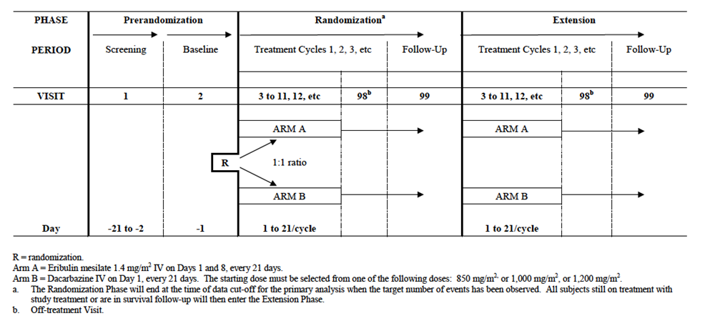
The study included:
- A pre-randomisation phase, consisting of a screening visit (between days -21 and -2) and a baseline visit (either Day -1 or Day 1 of Cycle 1);
- A randomisation phase during which subjects in both arms received treatment in 21 day cycles until disease progression or unacceptable toxicity. Clinic visits occurred on Days 1, 8 15 of each 21 day cycle. Subjects who discontinued treatment had an ‘off treatment visit’ within 30 days following their final dose of study treatment. They then entered a follow-up period.
The ‘randomisation phase’ lasted until the time of data cut-off for the primary analysis (that is, until the target number of events had been observed). Subjects were then considered to be in an ‘extension phase’. However, the visit schedule etc. did not change from that used in the randomisation phase.
The primary objective of the study was to compare overall survival (OS) in subjects with advanced STS (adipocytic sarcoma or leiomyosarcoma) when treated with eribulin (Arm A) or dacarbazine (Arm B).
Secondary objectives were to:
- Compare progression-free survival (PFS) between Arm A and Arm B;
- Compare PFS rate at 12 weeks (PFR12wks) between Arm A and Arm B;
- Compare the clinical benefit rate (CBR) between Arm A and Arm B;
- Compare the safety and tolerability between Arm A and Arm B;
- Characterize the population PK of eribulin in subjects with STS.
Exploratory objectives were to:
- Compare objective response rate (ORR), disease control rate (DCR), and durable stable disease (dSD) rate, between Arm A and Arm B;
- Explore the relationship between exposure to eribulin and pharmacodynamics biomarkers and efficacy;
- Explore the relationship between exposure to eribulin and AEs;
- Investigate and identify blood and tumour biomarkers which can be correlated with safety and efficacy endpoints;
- Compare quality of life (QoL) scores between Arm A and Arm B.
The study was conducted at 110 centres in 22 countries: USA (31 centres) Canada (3), Australia (3), Austria (2), Belgium (3), Denmark (1), France (8), Germany (7), Israel (4), Italy (9), Netherlands (2), Spain (7), UK (4), Argentina (1), Brazil (8), Czech Republic (4), Poland (1), Korea (5), Romania (2), Russia (1), Singapore (1) and Thailand (3).
The trial commenced in March 2011. The date for data cut-off for inclusion in the study report was 2 January 2015 and the study report itself was dated 22 June 2015. The study has been published (1).

Inclusion and exclusion criteria
Enrolment was restricted to adult subjects with liposarcoma or leiomyosarcoma, who had received at least two prior lines of therapy and had advanced disease incurable by surgery or radiotherapy. The restriction to subjects with liposarcoma or leiomyosarcoma was based on the findings of earlier phase II studies (see below). A subject was required to have tumour samples or slides available for an independent histological review (IHR). Enrolment was also restricted to subjects with good performance status (ECOG performance status of 0, 1 or 2; Table 2).
Table 2: Study 309 - Eastern Cooperative Oncology Group (ECOG) Performance Status
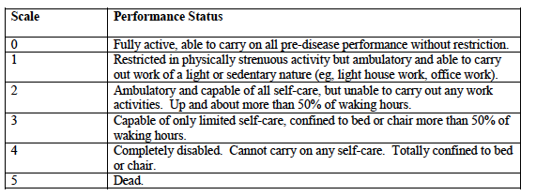
Comment: The proposed indication is not restricted to subjects with liposarcoma or leiomyosarcoma. It also does not restrict treatment to subjects who have received at least two prior lines of systemic therapy.

Study treatments
Subjects were randomised (1:1) to receive one of the following two treatments:
- Eribulin 1.4 mg/m² IV over 2-5 minutes on Days 1 and 8 of a 21 day cycle. The dose could be injected as the undiluted solution (0.5 mg/ mL) or diluted in up to 100 mL of normal saline.
- Dacarbazine IV over 15-60 minutes on Day 1 of a 21 day cycle. The investigator could choose one of three starting doses: 850, 1,000 or 1,200 mg/m². The dose had to be selected for each subject prior to randomisation. The chosen dose was diluted to a final volume of 200-500 mL in normal saline or 5% glucose. The sponsor provided a commercially available formulation of dacarbazine (powder for injection) that was manufactured in Germany.
Doses of eribulin could be delayed or permanently reduced in the event of toxicity. Two levels of dose reduction were permissible: to 1.1 mg/m² and then to 0.7 mg/m². For dacarbazine, dose delays and dose reductions were in accordance with the prescribing information.
Treatment was to be continued until disease progression, development of unacceptable toxicity, withdrawal of consent, or sponsor discontinuation of the study. Subjects in the dacarbazine arm who developed progressive disease were not permitted to receive eribulin.
The sponsor justified the choice of dacarbazine as the comparator agent on the following grounds:
- Dacarbazine has been demonstrated to have activity in STS in several published studies;
- The drug is widely available and hence appropriate for a multinational trial;
- It was listed as a treatment option in both the NCCN and ESMO clinical practice guidelines for STS;
- The sponsor convened a global advisory board of experts in the field of sarcoma who agreed that dacarbazine was an acceptable comparator in the setting of advanced STS in subjects who have failed other standard therapies;
- The use of dacarbazine as the comparator was agreed with the FDA and EMA prior to the initiation of the study.
Comment: Published studies that have used dacarbazine as monotherapy in the treatment of STS are summarised in Table 3. The drug’s reputation for efficacy in STS appears to have been based on early single-arm Phase II studies where the drug produced response rates of up to 18%. The drug has not been shown to produce a survival benefit. More recent studies have used dacarbazine as the comparator arm in trials of novel therapies. Response rates obtained with dacarbazine in these studies have been less impressive.
Dacarbazine continues to be listed in the NCCN and ESMO guidelines as an option for 2nd or later line chemotherapy. In addition, the current Australian guideline recommends the following: For patients who have been exposed to both doxorubicin and ifosfamide, dacarbazine is considered the next most active approved agent.
It is also noteworthy that other regulatory authorities with similar standards to the TGA, such as the FDA and EMA, have accepted dacarbazine monotherapy as an acceptable comparator given their approvals for trabectedin and eribulin.
As noted above, dacarbazine is registered in Australia for the treatment of STS. Overall it is considered that the sponsor’s choice of dacarbazine monotherapy as the comparator agent in the pivotal study is acceptable.
Table 3: Published studies of dacarbazine monotherapy in STS
Study | Design | Indication | N | Dacarbazine regimen | ORR | Median  PFS | Median  OS
Gottlieb  1976 | Phase II  Single-arm | STS | 53 | Various | 17% | - | -
Buesa  1991 | Phase II  Single-arm | STS – various  2nd line | 44 | 1200 mg/m²  Day 1 of a 21-day cycle | 18%  (95% CI: 7-29%) | - | -
Holstein  1996 | Retrospective  Case series | STS – various  2nd line | 14 | 1200 mg/m²  Day 1 of a 21-day cycle | 0% | - | 5  mths
Zucali  2008 | Retrospective  Case series | STS – various  2nd line | 40 | 800 mg/m² on day 1; or  400 mg/m² on days 1 and 2; or  300 mg/m² on days 1, 2 and 3. 21-day cycle for all | 7.5% | 2  mths | 13  mths
Garcia-del-Muro  2011 | Phase II RCT  Vs. gemcitabine + dacarbazine | STS – various  2nd line | 52 | 1200 mg/m²  Day 1 of a 21-day cycle | 4%  (95% CI: 0-13%) | 2  mths | 8.2  mths
Demetri  2016 | Phase III RCT  Vs. trabectedin | Liposarcoma  Leimyosarcoma  2nd line | 173 | 1000 mg/m²  Day 1 of a 21-day cycle | 6.9% | 1.5  mths | 12.9  mths
The design of the study was unusual in that it allowed investigators to choose one of three doses of dacarbazine. The sponsor justified this design on the following grounds:
- There is no generally accepted global consensus among physicians treating STS patients regarding the appropriate dose for dacarbazine;
- Although the highest response rate with dacarbazine was obtained with 1200 mg/m², haematological toxicity was dose limiting in some patients. Therefore investigators were provided with the option of using lower starting doses depending upon the subject’s clinical status on entry to the study.
- The dacarbazine dosing was agreed with the FDA and EMA prior to the initiation of the study.
Comment: As shown in Table 3, a variety of dosage regimens have been used in published studies. None of the studies compared efficacy results between doses. Using cross-trial comparison there does not appear to be any obvious pattern of reduced efficacy with lower doses.

Efficacy variables and outcomes
The main efficacy variables were:
- Survival;
- Change in tumour size;
- Quality of life.
The primary efficacy outcome was overall survival (OS), measured from the date of randomisation until the date of death from any cause.
Secondary efficacy outcomes were:
- Progression-free survival (PFS), defined as the time from the date of randomisation to the date of first documentation of disease progression or date of death from any cause (whichever occurs first).
- The progression-free rate at 12 weeks (PFR12wks), defined as the proportion of subjects who are still alive without disease progression at 12 weeks from the date of randomization. Subjects were considered to be progression-free if the tumour assessment performed during Week 12 indicated stable disease (SD), partial response (PR), or complete response (CR). Anything else including a missing value was considered as not meeting progression-free status;
- Clinical benefit rate (CBR) defined as the proportion of subjects who had a best overall response of CR or PR or dSD (durable SD; that is, SD ≥ 11 weeks) during study.
Exploratory efficacy outcomes were:
- Objective response rate (ORR) defined as the proportion of subjects who have overall response of CR or PR.
- Disease control rate (DCR) defined as the proportion of subjects who have best overall response of CR, or PR, or SD.
- The durable stable disease (dSD) rate, defined as the proportion of subjects who have duration of SD ≥ 11 weeks.
- Quality of life (QoL) scores measured using the QLQ-C30 and the EQ-5D questionnaires.
Disease progression and response were assessed using the Response Evaluation Criteria In Solid Tumours (RECIST) version 1.1 (1), as assessed by the investigators. There was no central or blinded assessment of imaging.
PFR12wks is a novel endpoint originally proposed by the EORTC Soft Tissue and Bone Sarcoma Group in 2002¹³. It is intended for use in Phase II studies to identify activity in new drugs, including those that may have only a cytostatic effect (that is, inhibition of tumour growth). Conventional response rate criteria typically only identify activity in drugs that have a cytoreductive effect (that is, cause tumour shrinkage). Based on previously published data the EORTC Group estimated that for second-line therapy in STS, a PFR12wks of ≥ 40% would suggest drug activity, and ≤ 20% would suggest inactivity.
Comment: PFR12wks was used as the primary endpoint in the Phase II studies of eribulin (see below), and was presumably included as a secondary endpoint in the pivotal study to allow comparison between trials.
The EORTC QLQ-C30 questionnaire is a validated cancer-specific 30-item questionnaire. It incorporates five functional scales (physical, role, cognitive, emotional and social) covered by 16 questions, three symptom scales (fatigue, pain and nausea/vomiting) covered by 6 questions, six single-question items (constipation, diarrhoea, sleep, dyspnoea, appetite and financial difficulties) and two questions addressing global health status. All scales and single-item measures range in score from 0 to 100. A high score on a functional scale represents a high level of functioning. A high score on global quality of life represents a high quality of life. A high score on the symptom scale or item represents a high level of symptomatic problems. A minimal clinically important difference is considered to be 5-10 points on the 100-point scale.
The EQ-5D is a generic measure of QoL. It consists of a questionnaire and a visual analogue scale (VAS). The questionnaire has five domains (mobility, self-care, usual activities, pain/discomfort and anxiety/depression). Each domain consists of one question for which the subject can choose one of three responses (for example, no problems, some problems, severe problems). Responses to the five domains were used to generate the Health Utility Index (HUI) which is scored between -1 (worst imaginable health state) and 1 (best imaginable health state). The VAS asks the subject to rate his or her current health state from 0 (‘worst imaginable health state’) to 100 (‘best imaginable health state’).
Tumour assessments (CT or MRI of chest/abdomen/pelvis and other areas of known disease at screening plus any areas of newly suspected disease) were to be performed every 6 weeks (for the 1st 12 weeks), and then every 9 weeks, or sooner if clinically indicated, until disease progression was confirmed. Subjects who discontinued study treatment without disease progression underwent tumour assessment according to the same schedule, until disease progression or commencement of another anticancer therapy. Subjects were followed up for survival every 12 weeks after the off-treatment visit. The QoL questionnaires were administered at baseline, on Day 1 of each treatment cycle and at the off-treatment visit.
Comment: Apart from PFS12wks the endpoints chosen for the study were standard for oncology studies. Assessment of disease response and progression was not blinded to treatment allocation and hence the secondary endpoints may have been open to some bias.

Randomisation and blinding methods
Subjects were randomised (1:1) to either eribulin or dacarbazine. Randomisation was stratified by:
- Histology (adipocytic sarcoma or leiomyosarcoma);
- Geographical region (Region 1: USA and Canada; or Region 2: Western Europe, Australia and Israel; or Region 3: Eastern Europe, Latin America and Asia); and
- Number of prior regimens for advanced STS (2 or >2 prior regimens).
An independent statistician provided the randomisation schedule. Subjects were allocated via an interactive voice/web response system (IV/WRS).
There was no blinding to treatment allocation in the study.

Analysis populations
The following analysis sets were defined:
- The Full Analysis Set (Intent-to-treat [ITT] Analysis Set) included all subjects who were randomised. This was the primary analysis set for all efficacy evaluations. For analyses subjects were included in the treatment arm to which they were randomised.
- The Per Protocol Analysis Set included those subjects who received at least one dose of study treatment, and had no major protocol violations, which included but were not limited to the following:
- Deviation from inclusion criteria #1 to 3;
- Treated with the incorrect study treatment instead of the randomised treatment;
- Subjects who were found to be ineligible based upon independent histologic review were excluded from this analysis set.
- This was the secondary analysis set for all efficacy evaluations.
- The Safety Analysis Set included all subjects who were randomised, received at least one dose of the study treatment and had at least one post-baseline safety evaluation. Subjects were analysed in the treatment arm for the study drug they actually received (in Cycle 1) if it was different from the treatment to which they had been randomised. This was the analysis set for all safety evaluations.

Sample size
The survival time in the dacarbazine arm was estimated to be approximately 6 months. An increase by 2.5 months to 8.5 months in the eribulin arm was considered to be clinically important. This correlated to an estimated hazard ratio of 0.706. With a significance level of 0.05 using a two-sided test and a power of 90%, it was estimated that a total of 353 deaths would be required. Assuming an enrolment rate of 20 subjects per month, it was estimated that a total of 450 subjects (225 in each arm) would have to be randomised in order to observe the required number of deaths.

Statistical methods
Overall survival was summarised using Kaplan-Meier estimates. A stratified log-rank test was used to compare the two treatment arms. A hazard ratio (with 95% CI) was estimated using a stratified Cox regression model. Three sensitivity analyses were planned (an analysis using the per-protocol set, analysis without any stratification and an analysis with censoring of subjects starting new anticancer treatment). Subgroup analyses were also planned.
An interim analysis of overall survival was planned after approximately 70% (247) of the required 353 deaths had occurred. Significance levels were 0.0148 for the interim analysis and 0.0455 for the final analysis.
PFS was analysed using similar methods to OS. PFR12wks and CBR were analysed using a stratified Cochran-Mantel-Haenszel (CMH) Chi-square test. No statistical adjustment of the secondary endpoint analyses was performed to allow for multiple comparisons. No subgroup analyses of secondary endpoints were performed. There were no formal statistical analyses planned for the exploratory endpoints.

Participant flow
A total of 594 subjects were screened for the study and 452 subjects were randomised. Failure to meet inclusion and exclusion criteria was the most common reason for non-randomisation (106/142). A total of 228 subjects were randomised to eribulin and 224 to dacarbazine.
Subject disposition is summarised in Table 4. At the time of data cut-off only 2 subjects were still receiving randomised treatment and 79% of subjects had died. Analysis sets are summarised in Table 5.
Table 4: Study 309 Subject disposition
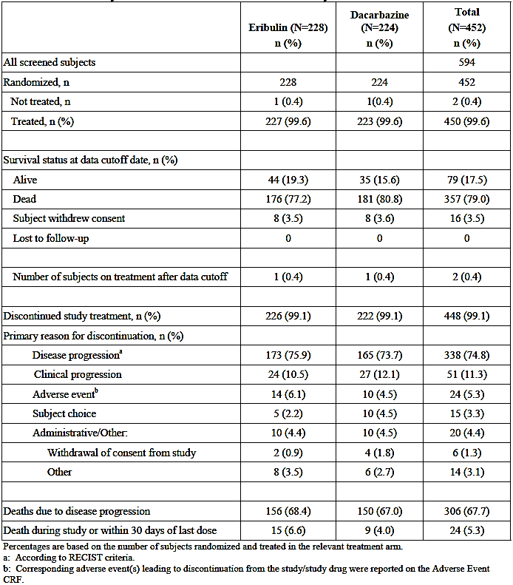
Table 5: Study 309 Analysis sets
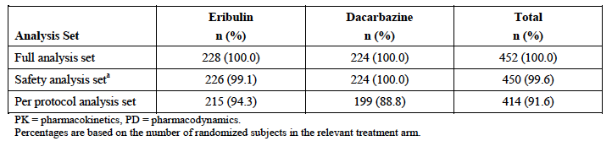

Major protocol violations/deviations
Protocol deviations resulting in exclusion from the per-protocol set was summarised: The incidence of violations was higher in the dacarbazine arm (11.2% versus 5.7%). Violations that occurred with a notably higher incidence in the dacarbazine arm were failure to meet inclusion criteria #3 (at least two prior systemic regimens) and failure to meet exclusion criteria #3 (no previous treatment with dacarbazine, temozolomide or eribulin). The only violation that occurred with a notably higher incidence in the eribulin arm was failure to meet exclusion criteria #1 (anticancer therapy in the 21 days prior to randomisation).
Comment: The differences between treatment arms were small and it is unlikely that they would have affected interpretation of the efficacy outcomes.

Baseline data
Approximately 66% of subjects had leiomyosarcoma and 34% had adipocytic sarcoma. Median age was 56 years and most subjects were White (73.0%). The two arms were generally well balanced although the eribulin arm had slightly better ECOG performance status (PS=0: 48.7% versus 40.2%).
The enrolled population was a heavily pre-treated one with 98.9% of subjects having received at least 2 prior lines of therapy and 51.1% having received 3 or more lines of therapy. The most commonly previously used chemotherapy agents were doxorubicin (77.9%), gemcitabine (53.3%), ifosfamide (50.0%) and trabectedin (48.5%). A total of 52.2% had received previous radiotherapy. An analysis of prior surgery for STS was not provided.
Comment: Overall the two arms were generally well balanced with respect to baseline characteristics, although the eribulin arm had slightly better ECOG performance status (PS=0: 48.7% versus 40.2%).

Results for the primary efficacy outcome
The interim analysis of efficacy was conducted after 247 deaths, with a data cut-off of 20 October 2013. The data monitoring committee for the trial recommended that the study continue without modification.
The final analysis was conducted after a total of 357 deaths had occurred. Results are summarised in Table 6and Figure 2. Treatment with eribulin was associated with a statistically significant improvement in overall survival compared with dacarbazine treatment (Hazard Ratio [HR] = 0.768 [95%CI: 0.618 – 0.954]; p = 0.0169). Median OS was improved by approximately 2 months (13.5 versus 11.5 months). The estimated proportion of subjects alive after 12 months was increased from 47.5% to 54.8%.
Table 6: Study 309 Overall survival (primary endpoint)
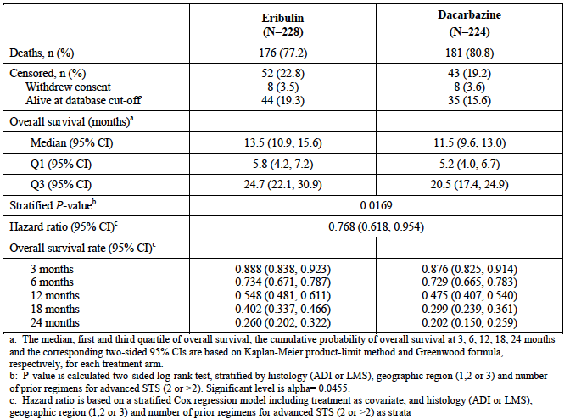
Figure 2: Study 309 Overall survival (primary endpoint)
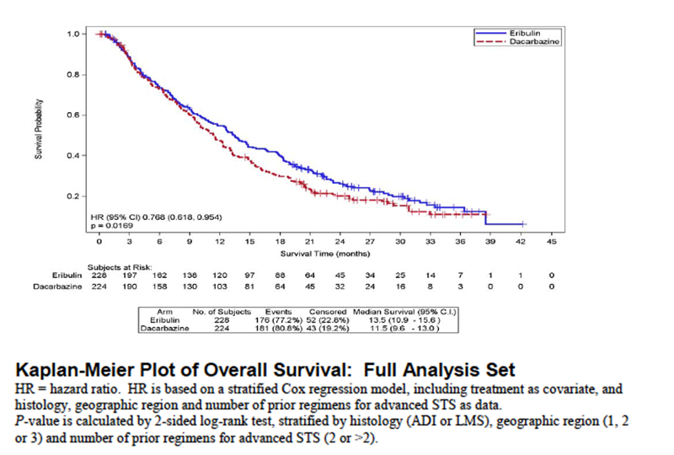
Results of the sensitivity analyses were:
- The per-protocol analysis gave results consistent with the primary analysis (HR = 0.747 [95%CI: 0.596 – 0.937]; p = 0.0115);
- When subjects were censored at the time of commencement of new anticancer therapy, the analysis also gave results consistent with the primary analysis (HR = 0.645 [95%CI: 0.442 – 0.941]; p = 0.0223);
- Using an unstratified analysis, the difference between treatments was not statistically significant (HR = 0.843 [95%CI: 0.685 – 1.038]; p = 0.1087)
Table 7shows therapies received by subjects after randomised treatment. 69.3% of subjects in the eribulin arm and 62.9% of subjects in the dacarbazine arm received further chemotherapy. Post –trial therapy with dacarbazine was used in 34.2% of subjects in the eribulin arm compared with only 7.6% in the dacarbazine arm. This imbalance could have theoretically favoured the eribulin arm with respect to survival. However, the above sensitivity analysis suggested a survival benefit with eribulin regardless of post-trial therapy. Post–trial therapy with eribulin was used in 1.3% of subjects in the eribulin arm compared with 2.7% in the dacarbazine arm.
Results of pre-planned subgroup analyses are shown in Figure 3.
Table 7: Study 309 Post-study anticancer therapy
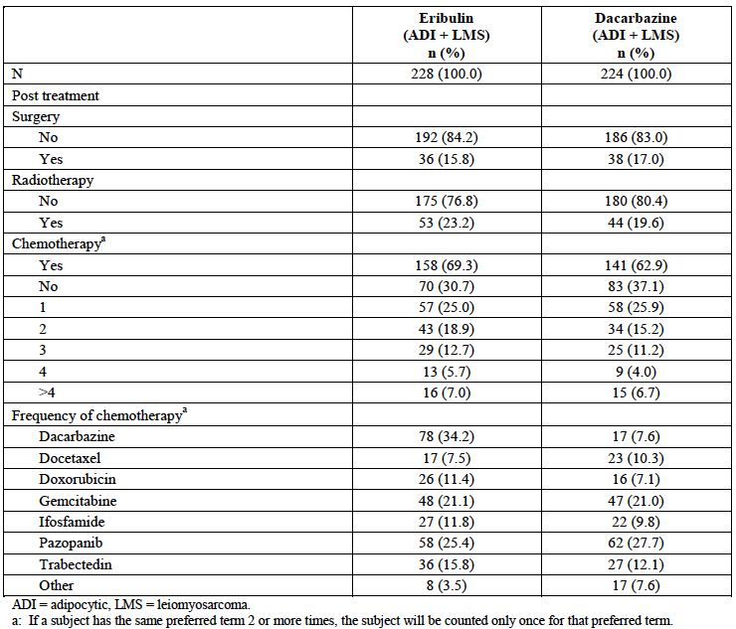
Figure 3: Study 309 Subgroup analyses of overall survival
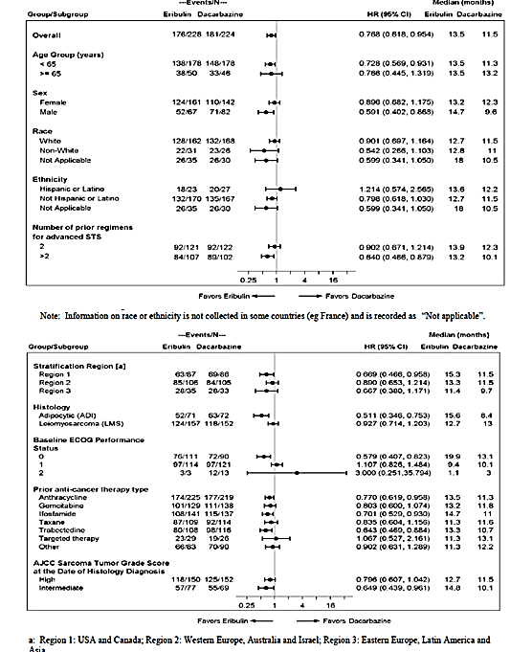
Comment: The study was not powered to detect significant differences between treatments within subgroups. However, in general, the analyses suggested efficacy in most subgroups in that hazard ratios were less than 1.0. In most subgroups that had a HR > 1.0, subject numbers were small. An exception was the group of subjects with ECOG PS=1 (n=235) - HR = 1.107 (95%CI: 0.826 – 1.484).
Even though the study was not powered to detect significant differences in subgroups, a significant effect was demonstrated for the subgroup of subjects with adipocytic sarcoma (HR = 0.511 [95%CI: 0.346 – 0.753]). In this subgroup median survival was prolonged by approximately 7 months (15.6 versus 8.4 months). In contrast, the HR in the leiomyosarcoma subgroup was 0.927 (95%CI: 0.714 – 1.203), with no increase in median survival.
Kaplan-Meier curves for OS by dacarbazine starting dose are shown in Figure 4. Lower doses were not associated with reduced survival.
Figure 4: Study 309 – Overall survival by dacarbazine dose
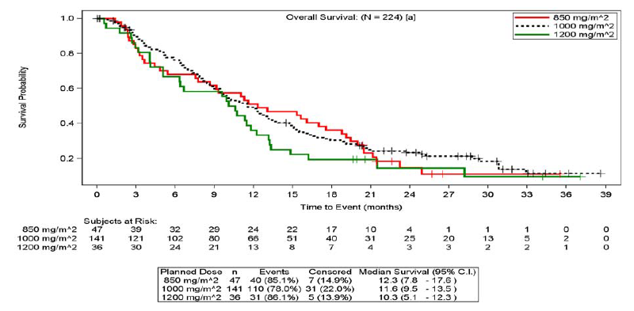

Results for secondary efficacy outcomes

Progression-free survival
Results for PFS are summarised in Table 8and Figure 5. There were no significant differences between the two treatments. Subgroup analysis by histology subgroups demonstrated a statistically significant benefit for eribulin treatment in liposarcoma subjects, but not in leiomyosarcoma subjects (Table 9).
Table 8: Study 309 Progression-free survival
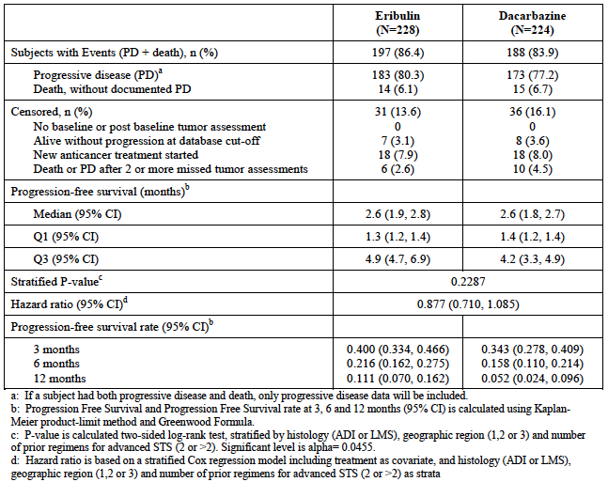
Figure 5: Study 309 Progression-free survival
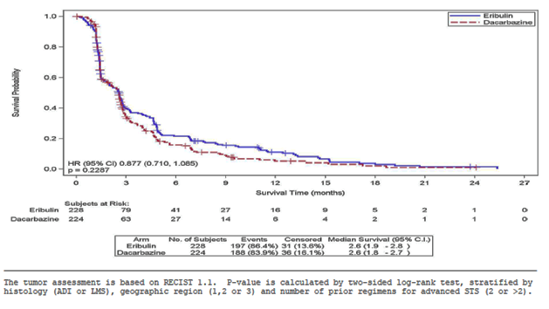
Table 9: Study 309 Progression-free survival by histology subgroup
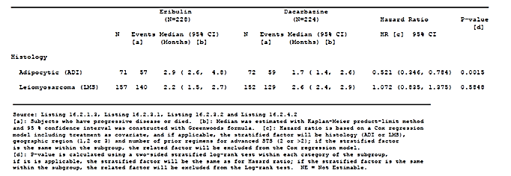

PFR12wks
The rate was 33.3% in the eribulin group and 28.6% in the dacarbazine group. The difference was not statistically significant.
Comment: It is of note that the PFR12wks in both groups was < 40%, the level proposed by the EORTC for determining drug activity in 2nd line therapy. Subjects in this trial were receiving 3rd or later line therapy, so this finding may not be relevant. However, it would be of interest to know the PFR12wks for each of the two histological groups included in the trial.

Clinical Benefit Rate
The rate was 46.1% in the eribulin group and 47.8% in the dacarbazine group. The difference was not statistically significant.

Results for exploratory efficacy outcomes

Objective response rate, disease control rate and durable stable disease
Results for these endpoints are summarised in Table 10. There were no significant differences between treatment groups. Objective response rates were low in both groups (3.9% with eribulin and 4.9% with dacarbazine). All responses were partial responses.
Table 10: Study 309 ORR, DCR and dSD results
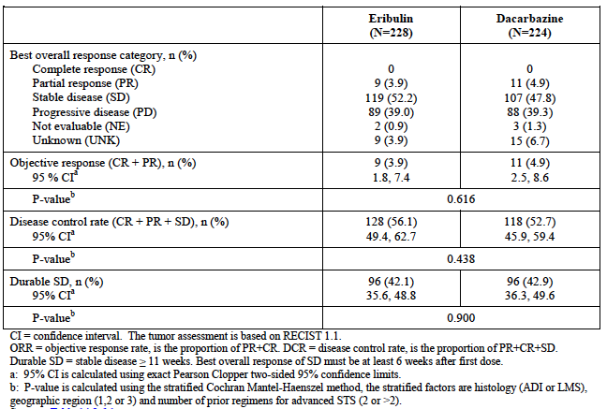

Quality of life
The sponsor provided a separate report on the QoL variables, which contained a large number of analyses. Patient numbers remaining in the trial decreased over time and hence many of the analyses focussed on results up to and including Cycle 9 of treatment. Compliance rates were high with > 80% of subjects completing questionnaires during the first 9 cycles.
There were no significant differences between the two study arms at baseline. The overall conclusions of the QoL analyses were that there were no significant differences in outcomes between treatment arms. There were sporadic statistically significant differences between treatments on various measures but these were not consistent over time. For example, Figure 6 shows results for mean scores for the QLQ C-30 at Cycle 3, and Figure 6B shows results for the EQ-5D Health Utility Index and VAS over time. Subgroup analyses of the QoL outcomes were presented for the two histological subgroups enrolled in the trial. No consistent differences were demonstrated between the treatment groups.
Figure 6A: Study 309 EORTC QLQ-C30 results (at Cycle 3). QLQ-C30 Mean symptom and profile scores at Cycle 3
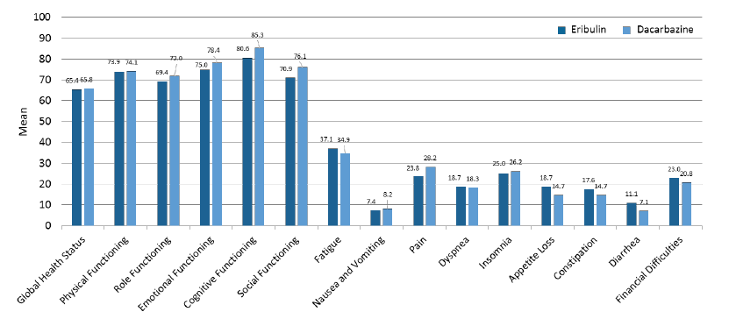
Figure 6B: Study 309 EQ-5D results
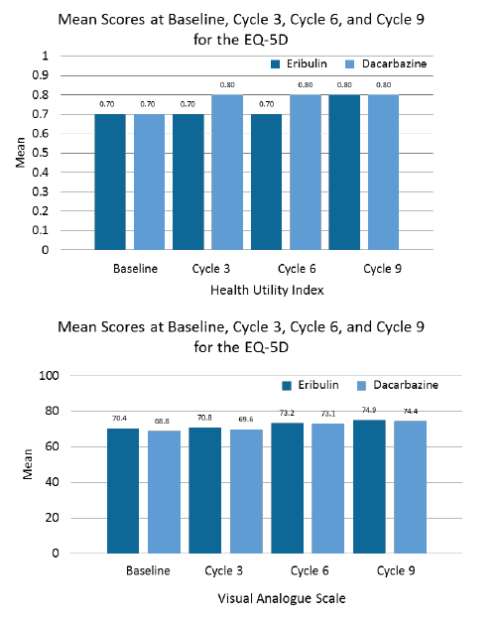

Other efficacy studies

Study 207
Study 207 was an open-label, single-arm, Phase II trial. The primary objective of the study was to evaluate the therapeutic activity and safety of eribulin in subjects with advanced and/or metastatic STS who had relapsed following standard therapies. It was conducted at 14 centres in Europe between December 2006 and June 2012. The study report provided was dated 24 June 2013. The study has been published.¹⁴
The study enrolled subjects with histologically confirmed advanced or metastatic STS, with evidence of disease progression in the previous 6 months. Subjects could have received only one prior combination regimen or two single agent cytotoxic drugs for metastatic disease. Subjects were all treated with eribulin 1.4 mg/m² IV over 2-5 minutes on Days 1 and 8 of a 21 day cycle. Treatment was continued until disease progression or unacceptable toxicity.
The primary endpoint was the rate of progression-free survival at 12 weeks (PFR12wks). Secondary endpoints included overall PFS, overall survival and response rate. Tumour response and progression were assessed using RECIST version 1.0 criteria. The trial enrolled subjects into one of four strata: leiomyosarcoma, adipocytic sarcoma, synovial sarcoma and ‘other’ sarcoma. With each stratum, a two-stage design was applied. A total of 17 subjects would be enrolled in each stratum, and if 4 of the initial 17 subjects (23.5%) were progression-free at 12 months, enrolment would continue up to 37 subjects in each stratum. If 11 of the 37 subjects (30%) were progression-free at 12 months, it would be concluded that eribulin would warrant further investigation in that histological subtype.
A total of 128 subjects were enrolled in the study. One subject did not receive treatment and 12 subjects received treatment but were subsequently deemed ineligible on central histology review. Therefore 115 subjects were evaluable for efficacy. The analysis sets in the study are summarised in Table 11. In all four strata there were at least 4 of the initial 17 subjects who were progression-free at 12 weeks. Further enrolment therefore proceeded in all four strata however a total of 37 subjects were only reached for leiomyosarcoma and adipocytic sarcoma.
Table 11: Study 207 Analysis sets.
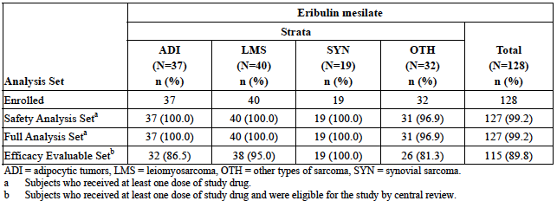
For the 127 treated subjects median age was 56.0 years and 52% were female. 55.9% had received 2 prior anticancer regimens and 12.6% had received more than 2. The most commonly used prior chemotherapy agents were doxorubicin (89.8% of subjects), ifosfamide (52.0%), trabectedin (6.3%), dacarbazine (5.5%) and gemcitabine (5.5%).
Results for the primary endpoint (PFR12wks) are summarised in Table 12. The predefined efficacy rate of >30% was reached in the adipocytic sarcoma (46.9%) and leiomyosarcoma (31.6%) strata. PFS rate was lower in the other two strata however the number of subjects enrolled was low.
Table 12: Study 207 PFS at 12 weeks (primary endpoint)
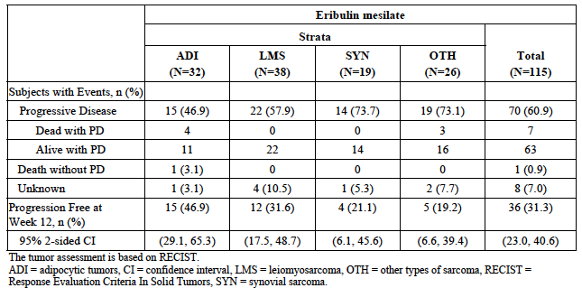
Results for overall PFS are summarised in Table 13. Median PFS for the whole efficacy population was 82 days (2.7 months). The synovial sarcoma and other sarcoma groups had lower PFS rates at most time points. Results for overall survival are summarised in Table 14. Median OS for the whole efficacy population was 359 days (11.8 months). As with PFS, the synovial sarcoma and other sarcoma groups had lower survival rates at most time points. Results for objective response rate are summarised in Table 15. Response rates were low (<5.5%) in all strata.
Table 13: Study 207 Overall progression-free survival
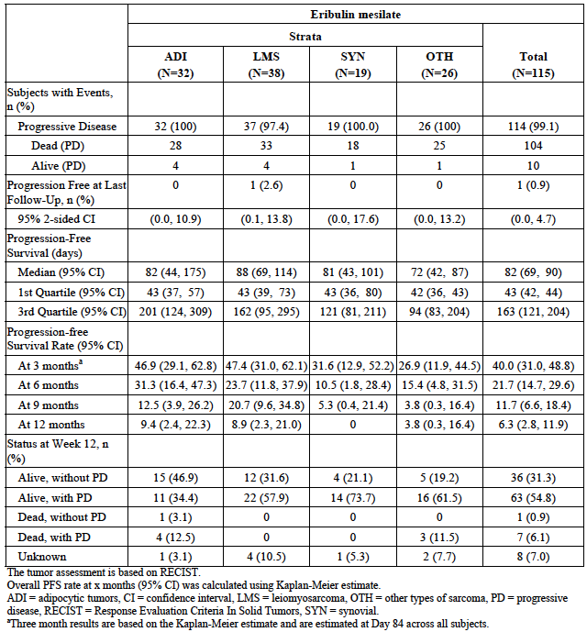
Table 14: Study 207 Overall survival
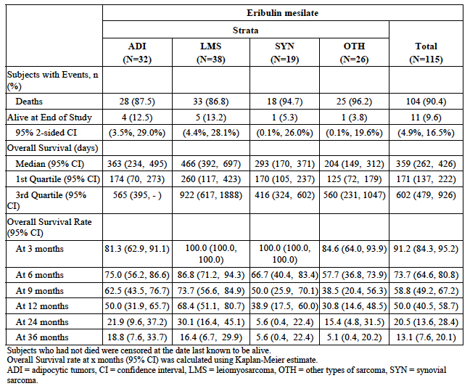
Table 15: Study 207 Response rates
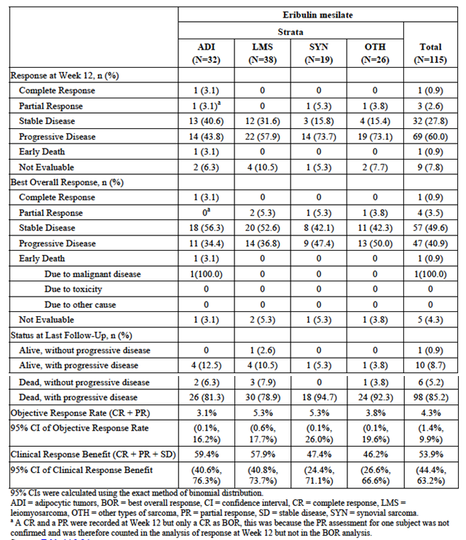

Study 217
Study 217 was an open-label, single-arm, Phase II trial. The primary objective of the study was to evaluate the efficacy of eribulin, as measured by PFR12wks, in subjects with advanced STS previously treated with chemotherapy. It was conducted at 12 sites in Japan between November 2011 and November 2014. The study report provided was dated 25 May 2015. The study has not been published.
The study enrolled subjects with histologically confirmed advanced or metastatic STS of high or intermediate grade, with evidence of disease progression in the previous 6 months. Subjects should have received at least one prior standard chemotherapy regimen (an anthracycline or ifosfamide as monotherapy, or a combination regimen). Subjects were all treated with eribulin 1.4 mg/m² IV over 2-5 minutes on Days 1 and 8 of a 21 day cycle. Treatment was continued until disease progression or unacceptable toxicity.
The primary endpoint was the rate of progression-free survival at 12 weeks (PFR12wks). Secondary endpoints included overall PFS, overall survival and response rate. Tumour response and progression were assessed using RECIST version 1.1 criteria. The trial enrolled subjects into one of two strata: 1) leiomyosarcoma or adipocytic sarcoma and 2) ‘other’ sarcomas. It was planned to enrol 35 subjects in the first stratum and 16-20 in the second.
A total of 51 subjects were enrolled and treated in the study: 35 subjects in the first stratum (adipocytic sarcoma n=16 and leiomyosarcoma n=19) and 16 subjects in the other sarcoma stratum. For the entire population median age was 52 years and 54.9% were female. 66.7% had received 2 prior anticancer regimens and 33.3% had received more than 2. The most commonly used prior chemotherapy agents were anthracyclines (100% of subjects, predominantly doxorubicin), ifosfamide (70.6%), docetaxel (43.1%) and gemcitabine (41.2%).
Results for the primary endpoint (PFR12wks) are summarised in Table 16.
In PFR12wks was 81.3% for adipocytic sarcoma, 42.1% for leiomyosarcoma and 31.3% for other sarcomas. Results for objective response rate are also summarised in Table 16. No responses were observed.
Table 16: Study 217 PFS at 12 weeks (primary endpoint) and Objective Response Rate
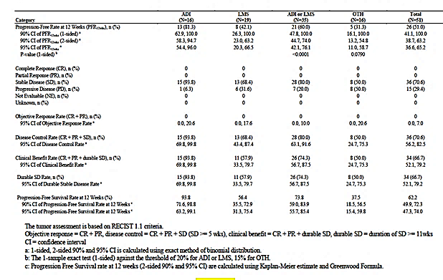
Results for overall PFS are summarised in Table 17. Median PFS for the whole efficacy population was 4.07 months. Patients with leiomyosarcoma or adipocytic sarcoma had longer PFS than those with other sarcomas. Results for overall survival are summarised in Table 18. Median OS for the whole population was 13.17 months. As with PFS, subjects in the other sarcoma stratum had lower survival rates.
Table 17: Study 217 Overall progression-free survival
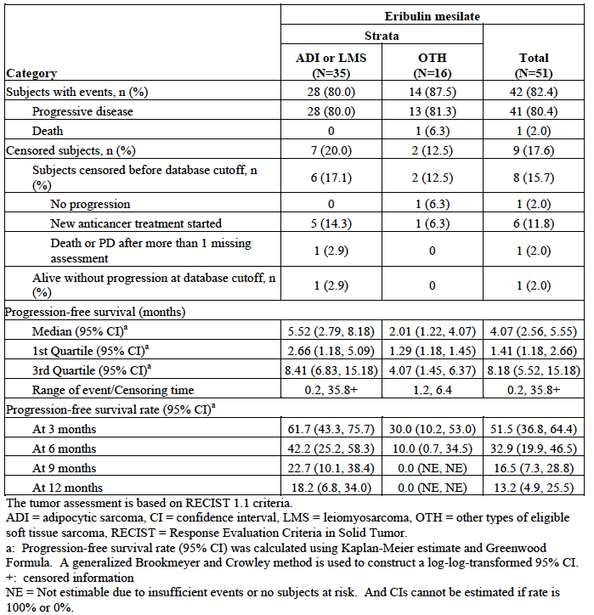
Table 18: Study 217 Overall survival
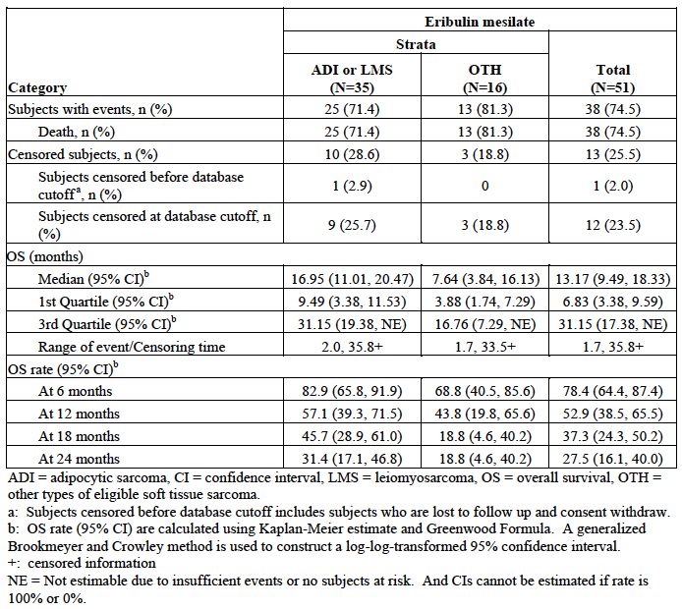

Analyses performed across trials (pooled analyses and meta-analyses)
There were no pooled analyses or meta-analyses of efficacy data presented in the submission. The sponsor’s summary of Clinical Efficacy included a summary tabulation of efficacy results across the three STS studies. This is shown in Table 19.
Table 19: Summary of efficacy results
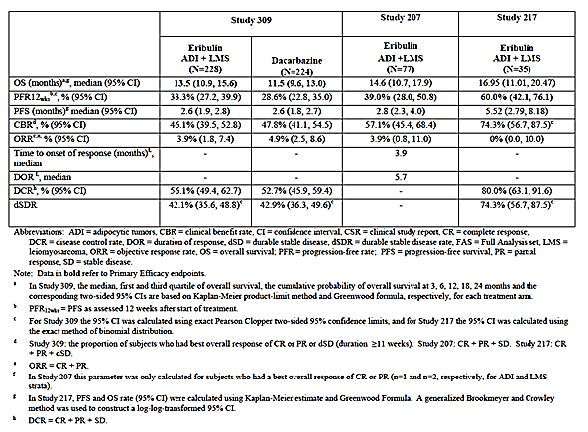

Evaluator’s conclusions on clinical efficacy for STS
The pivotal study in the submission was well designed and well executed. The design complied with the recommendations of the EMA guideline on anticancer agents (6) that has been adopted by the TGA. The choice of dacarbazine as the comparator agent was reasonable.
The study demonstrated a statistically significant increase in survival with eribulin compared to dacarbazine (HR = 0.768 [95%CI: 0.618 – 0.954]; p = 0.0169). Median survival was increased by approximately 2 months. The magnitude of the survival benefit is clinically significant. The TGA has in recent years approved pazopanib for advanced STS, and the pivotal study for this drug demonstrated a prolongation of PFS by approximately 3 months compared with placebo, with no demonstrated improvement in overall survival.
Eribulin was not associated with significant benefits on the other efficacy endpoints studied such as PFS or response rates. These endpoints are generally considered to be surrogates for the gold standard of overall survival. In the presence of a demonstrated overall survival benefit, the absence of a demonstrated effect of eribulin on these endpoints is not considered important. Eribulin treatment was not associated with any improvement or impairment of QoL compared to dacarbazine.
The indication proposed by the sponsor would permit use of eribulin in all forms of STS. Enrolment in the pivotal study was restricted to subjects with liposarcoma or leiomyosarcoma, as the Phase II study did not demonstrate convincing evidence of activity for eribulin in other histological subtypes. There is therefore no adequate evidence to support use of eribulin in histological subtypes other than liposarcoma or leiomyosarcoma. If a new STS indication is to be approved the other subtypes should be excluded.
Although a statistically significant effect on overall survival was demonstrated in the pivotal study, subgroup analysis indicated that there was a notable difference between the two STS subtypes. The overall survival benefit was driven by a marked survival benefit in the liposarcoma subgroup. (HR = 0.511 [95%CI: 0.346 – 0.753]). In this subgroup median survival was prolonged by approximately 7 months (15.6 versus 8.4 months). In contrast, the HR in the leiomyosarcoma subgroup was 0.927 (95%CI: 0.714 – 1.203), with no increase in median survival. However, the study was not powered to demonstrate a significant effect on survival in the leiomyosarcoma subgroup. It might be concluded that the efficacy of eribulin in leiomyosarcoma is approximately comparable to that of dacarbazine. However, dacarbazine has not been demonstrated to produce a survival benefit in STS. Evidence of efficacy in liposarcoma is therefore convincing, while evidence for efficacy in leiomyosarcoma is uncertain.
The two Phase II studies used the novel endpoint of PFR12wks and were single-arm, non-comparative studies. In both studies PFR12wks was higher among liposarcoma subjects than among leiomyosarcoma subjects, a finding that is consistent with the efficacy results of the pivotal study. According to the EORTC Sarcoma group a PFR12wks > 40% indicates activity of a drug in the 2nd line STS setting. Using this criterion, activity in liposarcoma was demonstrated in both studies (46.9% in Study 207 and 81.3% in Study 217) and activity in leiomyosarcoma was demonstrated in one of the studies (31.6% in Study 207 and 42.1% in Study 217). It should be noted that most subjects in these studies were receiving eribulin as 3rd or later line therapy and therefore the cut-off of 40% may not be applicable.
The indication proposed by the sponsor would permit use of eribulin as 2nd or later line therapy. In the pivotal study only 9.2% of eribulin-treated subjects had received only one line of prior treatment for their advanced disease. In Study 207 the proportion was 30.7% and in Study 217 it was 35.3%. Therefore the majority of patients in the clinical trial program received eribulin as 3rd or later line therapy, and it could be argued that the proposed indication should be revised to reflect this. However, this reviewer would support an indication that does not exclude 2nd line use for the following reasons:
- There is no generally agreed standard for 2nd line therapy of STS;
- The current Australian clinical practice guideline for STS (4) recommends the use of dacarbazine after failure of doxorubicin and ifosfamide. Doxorubicin and ifosfamide are often used in combination as first-line therapy, and in this scenario dacarbazine would be recommended as 2nd line therapy. The pivotal study would suggest that eribulin is clearly superior to dacarbazine, at least for liposarcoma;
- Cytotoxic agents generally have greater efficacy in less heavily pre-treated subjects.
The submission for the new indication is based on a single pivotal study and the TGA has adopted an EMA guideline that deals with this situation (7). This guideline sets out certain ‘prerequisites’ that must be met for approval of such a submission. In the opinion of this reviewer, the design and results of the pivotal study allow the conclusion that these prerequisites have been met, at least for liposarcoma.
Overall the evidence submitted to support the efficacy of eribulin for liposarcoma is considered acceptable. Evidence for efficacy in leiomyosarcoma is uncertain. There is no adequate evidence for efficacy in other histological subtypes.

Clinical safety
Eribulin is known to be associated with the following toxicities, as described in the current PI:
- Myelosuppression, mainly manifesting as neutropaenia but also including anaemia, thrombocytopaenia and febrile neutropaenia;
- Peripheral neuropathy;
- QT prolongation;
- Gastrointestinal toxicity including anorexia, nausea, vomiting, diarrhoea, constipation, and stomatitis;
- Liver function test abnormalities;
- Fatigue, alopecia, and musculoskeletal pain.

Studies providing evaluable safety data
The following studies provided evaluable safety data:

Pivotal efficacy study (Study 309)
In the pivotal efficacy study, the following safety data were collected:
- General adverse events (AEs) were recorded throughout the study. AEs were coded into standardized terminology using the Medical Dictionary for Regulatory Activities (MedDRA) and were graded according to the Common Terminology Criteria for Adverse Events (CTCAE) version 4.
- Comprehensive physical examinations were conducted at baseline, on Day 1 of each cycle and at the off-treatment visit. Symptom-directed examinations were conducted at other study visits.
- Laboratory tests were performed at baseline, Days 8 and 15 of Cycle 1, Days 1, 8 15 of Cycle 2, Days 1 and 8 of subsequent cycles and at the off-treatment visit. Parameters tested were:
- Haematology: haematocrit, haemoglobin, RBC, platelet count, WBC with differential count (bands, basophils, eosinophils, lymphocytes, monocytes, neutrophils, [ANC]), MCH, MCHC and MCV.
- Biochemistry: chloride, potassium, sodium, BUN or urea, serum creatinine, magnesium, phosphorus, calcium, albumin, total protein, ALP, ALT, AST, conjugated (direct) and total bilirubin, LDH.
- Urinalysis (glucose, haemoglobin (or blood), ketones, pH, protein and specific gravity) was performed on Day 1 of each cycle.
- ECGs were collected at baseline, Cycle 1/Day 1 pre-dose and end of infusion (Arm A and Arm B), Cycle 1/ Day 8 pre-dose and end of infusion (Arm A only), Cycle 2/Day 1 pre-dose and end of infusion (Arm A and Arm B), Cycle 2/Day 8 pre-dose and end of infusion (Arm A only), Cycle 3 and all subsequent cycles on Day 1 pre-dose (Arm A and Arm B), and Day 8 pre-dose (Arm A only) and at the off-treatment Visit (Arm A and Arm B).

Phase II efficacy studies (studies 207 and 217)
Safety data collected in the two Phase II studies was similar in nature and extent to that collected in the pivotal study.

Other safety data
The sponsor’s Summary of Clinical Safety (SCS) presented safety data for the following populations:
- The pivotal study (Study 309 - eribulin versus dacarbazine);
- A pooled population of sarcoma patients who received eribulin in Studies 207, 217 and 309 (n=404);
- A pooled population of metastatic breast cancer (MBC) patients who had received eribulin (n=1559). Most of these patients had participated in studies previously evaluated by the TGA. However the population included 56 subjects who had participated in a single-arm Phase II study (Study 206) that had not been reviewed previously by the TGA. The safety findings from this study are reviewed in section Study 206.
- A pooled population of sarcoma and MBC subjects (n=1963).
The data presented in the SCS has been used for the review of safety in this report. The SCS also analysed a collection of adverse events of special interest (AESI), based on MedDRA terms. These are listed in Table 20.
Table 20: Adverse events of special interest A number of sponsor derived queries) SDQs) have been used in this document to describe AEs of special interest (AESIs). These SDQs are described below.
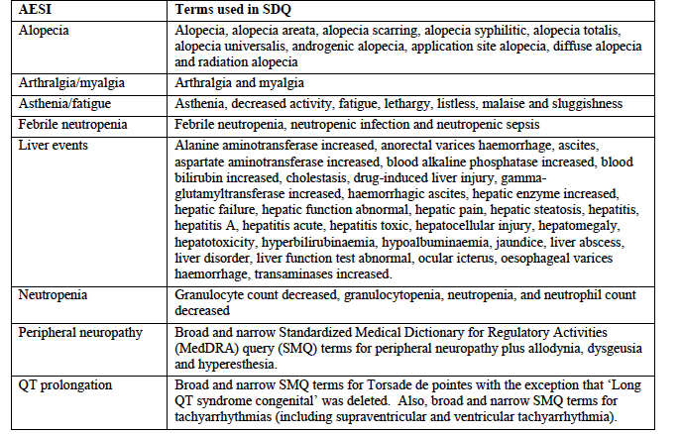

Patient exposure
Patient exposure is summarised in Table 21. A total of 404 subjects with STS were treated with eribulin in the submitted studies. The median duration of exposure was 12 weeks or 4 cycles. Median relative dose intensity was 93.4% of the planned dose. 40.8% of subjects require a dose delay and 25.7% required a dose reduction.
Table 21: Extent of exposure
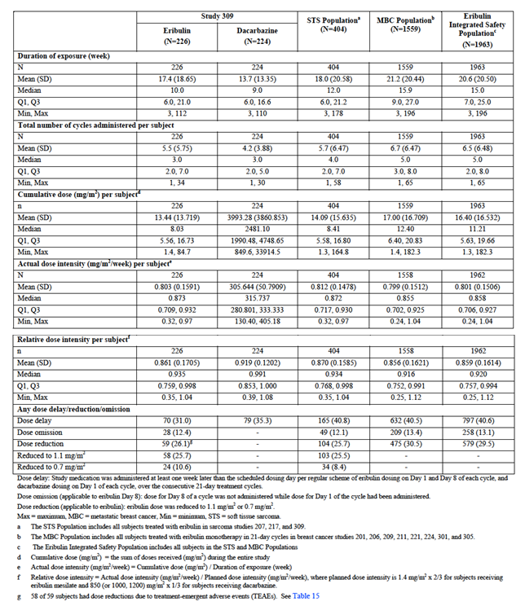

Adverse events
An overall summary of the incidence of AEs, SAEs etc. is shown in Table 22.
Table 22: Overview of AEs, SAEs etc.
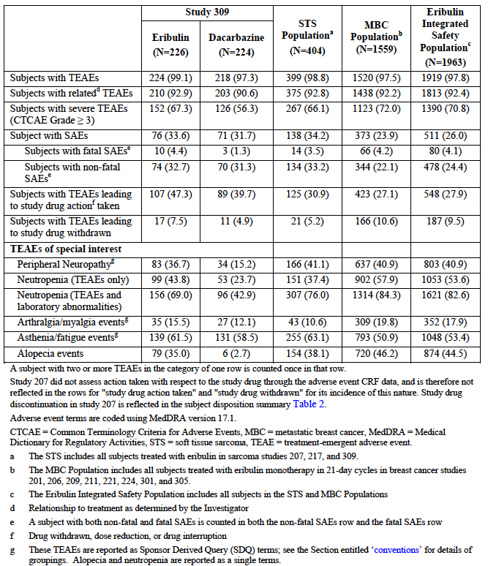

All adverse events (irrespective of relationship to study treatment)

Pivotal study
AEs occurred in 99.1% of subjects in the eribulin arm and 97.3% of subjects in the dacarbazine arm. AEs that were notably more common in the eribulin arm included neutropaenia (43.8% versus 23.7%), peripheral neuropathy (36.7% versus 15.2%), alopecia (35.0% versus 2.7%), pyrexia (27.9% versus 13.8%), stomatitis (13.7% versus 4.9%) and headache (18.1% versus 9.4%). Thrombocytopaenia was notably more common with dacarbazine treatment (27.7% versus 5.8%).
Grade 3 or higher AEs occurred in 67.3% of subjects in the eribulin arm and 56.3% of subjects in the dacarbazine arm. Grade ≥ 3 AEs occurring in at least 1% of subjects are summarised in Table 23. The pattern of these events was similar to that observed for all AEs with neutropaenia, infections and peripheral neuropathy being more common in the eribulin arm and thrombocytopaenia more common with dacarbazine.
Table 23: Grade ≥ 3 AEs (incidence ≥ 1%)
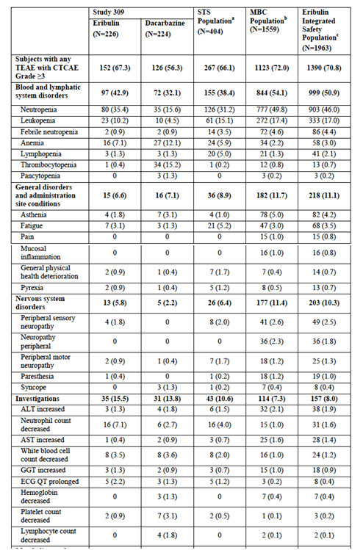
Table 23 continued: Grade ≥ 3 AEs (incidence ≥ 1%)
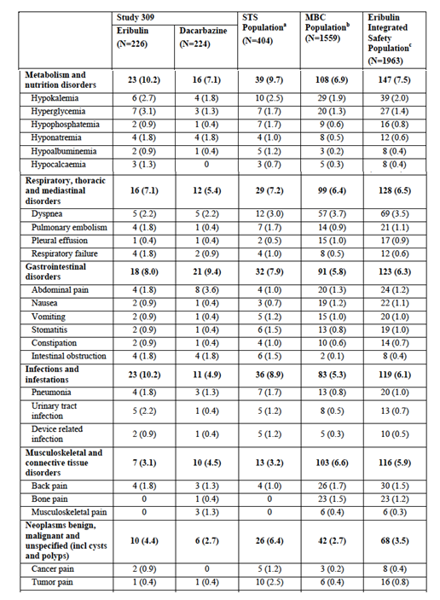
Table 23 continued: Grade ≥ 3 AEs (incidence ≥ 1%)
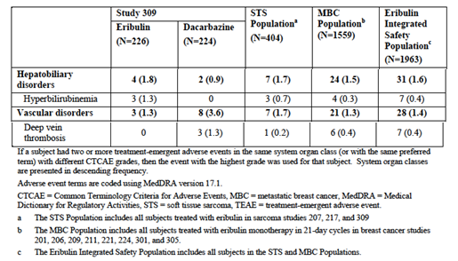

Other studies
The incidence of AEs in the pooled STS population was 98.8%. The pattern of AEs was similar to that observed in the pivotal study. The incidence of Grade ≥ 3 AEs in the pooled STS population was 66.1%, with a pattern of events similar to the pivotal study. The incidence of Grade ≥ 3 AEs in the STS population appeared slightly lower than the incidence in the pooled MBC population (66.1% versus 72.0%).

Treatment-related adverse events (adverse drug reactions)

Pivotal study
Treatment-related AEs occurred in 92.9% of subjects in the eribulin arm and 90.6% of subjects in the dacarbazine arm. Grade 3 or higher treatment-related AEs occurred in 54.4% of subjects in the eribulin arm and 40.2% of subjects in the dacarbazine arm. The pattern of treatment-related AEs was very similar to that observed for all AEs.

Other studies
In the pooled STS population the incidence of treatment-related AEs was 92.8% and the incidence of Grade ≥ 3 treatment-related AEs was 50.5%. The pattern of treatment-related AEs was again very similar to that observed for all AEs.

Deaths and other serious adverse events

Deaths

Pivotal study
The overall incidence of death (in the safety analysis set) was 77.0% (174/226) for the eribulin arm and 81.3% (182/224) in the dacarbazine arm. Most deaths were due to progressive disease (68.1% for eribulin and 67.4% for dacarbazine).
There were 10 subjects in the eribulin arm and 3 subjects in the dacarbazine arm who had AEs leading to death. All of these deaths occurred within 30 days of the last dose of study drug.
None of the 3 deaths in the dacarbazine arm were assessed as being related to study drug. One of the deaths in the eribulin arm was investigator-assessed by the as being possibly treatment-related. This subject [information redacted] White female with uterine leiomyosarcoma who presented with Grade 4 neutropaenia and sepsis on Day 54 of treatment and died 9 days later. Another subject [information redacted] White female with liposarcoma, presented with Grade 4 neutropaenia and septic shock on Day 59 of treatment and died on Day 60. Although the investigator did not consider the death to be treatment-related, the sponsor considered it was possibly related.

Other studies
In Study 207, 113/127 subjects (89.0%) had died by the date of data cut-off. Three subjects had an adverse event leading to death. Only one of these was assessed as being related to eribulin. This was a 76 year-old female with leiomyosarcoma who received 3 cycles or eribulin. She developed cerebral ischaemia on Day 66 of treatment and died approximately 1 month later. Prior to enrolment in the study she had a past history of hypertension, hypercholesterolaemia and ischaemic heart disease. The investigator considered that the event was possibly related to eribulin. The sponsor considered that a relationship was unlikely given the subject’s previous medical history.
In Study 217, 39/51 subjects (76.5%) had died by the date of data cut-off. Of these, 36 were due to progressive disease. One subject had an adverse event that led to death (cardiac failure). The event was assessed as being unrelated to eribulin.
AEs leading to death in the Phase II studies are summarised in Table 24.
Table 24: Studies 207 and 217 AEs leading to death
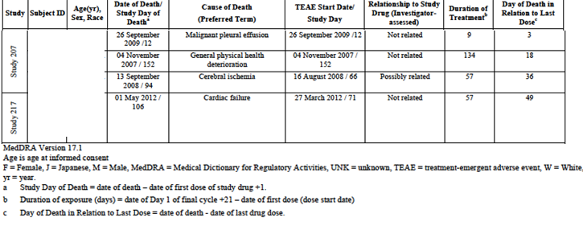

Serious AEs (SAEs)
An SAE was defined as any adverse experience that resulted in death; was life threatening; required inpatient hospitalization or prolongation of a hospitalization; resulted in persistent or significant disability/incapacity; resulted in a congenital anomaly/birth defect; or was an important medical event that could jeopardize the subject and required medical or surgical intervention to prevent any of the outcomes listed above.

Pivotal study
The overall incidence of SAEs (other than AEs leading to death) was similar in the two arms (32.7% versus 31.3%). Non-fatal SAEs occurring in at least 1% of subjects are summarised in Table 25.
Serious infections were more common with eribulin (8.8% versus 3.6%) as were serious events of pyrexia (4.4% versus 1.8%). Serious haematological events were slightly more common in the dacarbazine arm (7.5% versus 11.6%) mainly due to a higher incidence of severe thrombocytopaenia (0% versus 5.8%).
Table 25: Serious AEs (Incidence ≥ 1%)
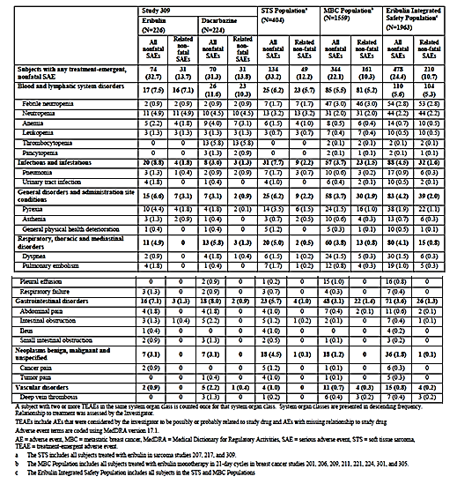

Other studies
In the pooled STS population the overall incidence of non-fatal SAEs was 33.2%. SAEs appeared to be more common in the pooled STS population than in the pooled MBC population (33.2% versus 22.1%). However, the incidence of related SAEs was comparable (12.2% versus 10.3%). The pattern of SAEs in these populations was similar to that observed in the pivotal study.

Discontinuation due to adverse events

Pivotal study
The overall incidence of AEs leading to discontinuation was slightly higher in the eribulin arm (7.5% versus 4.9%). Infections were a more common cause of discontinuation with eribulin (3 versus 0). Discontinuations due to haematological toxicity and neuropathy occurred with comparable frequency in the two arms.

Other studies
In the pooled STS population the overall incidence of AEs leading to discontinuation was 5.2%. This compared favourably with the incidence in the pooled MBC population (10.6%).

AEs of special interest

Peripheral neuropathy
Peripheral neuropathy events occurred more frequently with eribulin than with dacarbazine (36.7% versus 15.2%). With eribulin, approximately 10% of cases were assessed as being Grade ≥ 3 AEs. Median time to onset was approximately 20 weeks and only a minority of subjects had resolution of the event at 60 days post treatment.

Neutropaenia
Neutropaenia occurred more commonly with eribulin than with dacarbazine. However, the incidence of febrile neutropaenia was comparable. In the pooled STS population, 87.3% of subjects who developed grade 3 or 4 neutropaenia recovered to grade 0 or 1. Median recovery time was 8.0 days.

Arthralgia/myalgia
AEs of arthralgia/myalgia were slightly more common with eribulin than with dacarbazine. However, no events of Grade 3 or higher were reported in the STS studies.

Asthenia/fatigue
AEs of asthenia/fatigue occurred with similar frequency in the two arms of the pivotal study.

Alopecia
AEs of alopecia occurred more frequently with eribulin.

Liver events
In the pivotal study liver events were reported in 19.5% of subjects in the eribulin arm and 12.1% of subjects in the dacarbazine arm. Grade 3 or higher events were reported in 5.8% and 3.1% of subjects respectively. Most of the events were abnormal LFT results. Results of LFTs are summarised in Laboratory tests, Liver function below.

QT prolongation
AEs of QT prolongation are summarised in Table 26. Treatment-related AEs of QT prolongation were slightly more common with eribulin in the pivotal study (6.2% versus 4.9%). Most of the events were ECG abnormalities. There were no episodes of sudden death, cardiac arrest etc. in the STS studies. ECG findings with respect to QT prolongation are summarised in section Laboratory tests, Electrocardiograph.
Table 26: AEs within the SDQ term for QT prolongation
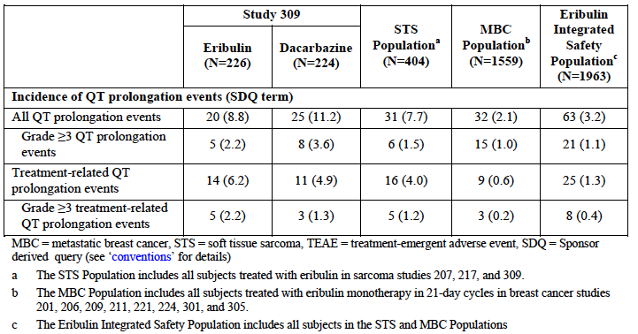

Laboratory tests

Liver function
The incidences of Grade 3 or 4 abnormalities of liver function tests were infrequent and occurred with comparable frequency in the two treatment arms in the pivotal study. Dacarbazine is known to be associated with hepatic toxicity.
In the STS studies there were a total of 8 eribulin-treated subjects with concurrent elevations of bilirubin (≥ 1.5 x ULN) and AST or ALT (≥ 3 x ULN). Six of these subjects had hepatic disease involvement (at baseline), 1 had ischaemic hepatic necrosis and 1 had hepatic congestion associated with cardiac failure. None of the cases met Hy’s law criteria for severe drug-induced liver injury.

Kidney function
In the pivotal study there was no Grade 3 or 4 increases in serum creatinine in either treatment group. Grade 1 and 2 abnormalities occurred with similar frequency in the two groups. The incidence of grade 3 or 4 increases in serum creatinine in the pooled STS population was 0.7%, which is similar to that observed in the pooled MBC population (0.9%).

Other clinical chemistry
Decreased calcium, decreased potassium and hyperglycaemia occurred more commonly in the eribulin arm of the pivotal study.
Comment: Hypokalaemia, hypomagnesaemia, hyperglycaemia and hypophosphataemia are currently listed in the eribulin PI as common adverse reactions. Hypocalcaemia is not currently listed.

Haematology
Grade 3 or 4 abnormalities of haematology parameters: Neutropaenia and leukocytopaenia were more common with eribulin in the pivotal study. Thrombocytopaenia was more common with dacarbazine.

Urinalysis
According to the Summary of Clinical Safety, eribulin had no notable effects on urinalysis parameters. The study report for Study 309 did not present any analyses of urinalysis parameters.

Electrocardiograph
Events of QT interval prolongation on ECG occurred with comparable frequency in the two arms of the pivotal study. The comparator dacarbazine is not known to be associated with significant QT prolongation.
Comment: These data do not clearly demonstrate an effect of eribulin on the QT interval. Also, a PK/PD analysis did not demonstrate a relationship between eribulin systemic exposure and QT interval. However, the current PI contains a warning statement regarding QT prolongation. In the absence of a ‘Thorough QT study’ an effect has not been excluded and it is appropriate to retain the warning.

Vital signs
Over the course of the pivotal study there were no clinically significant differences between the treatment arms in average values for blood pressure (systolic and diastolic), pulse rate, temperature or weight.

Study 206
The current submission included a study report for a Phase II trial in breast cancer (Study 206) that had not previously been reviewed by the TGA. The safety findings of this study are briefly reviewed here for completeness.
The study was a Phase II, single-arm trial of eribulin as monotherapy in the first line treatment of locally recurrent or metastatic human epidermal growth factor receptor two (HER2) negative breast cancer. It was conducted between 2011 and 2013 at 16 centres in the United States. All subjects received eribulin 1.4 mg/m² IV over 2-5 minutes on Days 1 and 8 of a 21 day cycle until progressive disease occurred.
A total of 56 subjects were treated. Median duration of treatment was 4.5 months. An overall summary of AEs, SAEs etc. is shown in Table 27. The pattern of toxicity was consistent with that previously associated with eribulin treatment, with cytopaenias, peripheral neuropathy, GIT events, fatigue, alopecia and musculoskeletal events being common. Neutropaenia was the most common serious AE. There were two deaths during the study. One subject died after developing a pericardial effusion, which was secondary to disease progression. The other died of disease progression. Neither death was assessed as being related to eribulin. Laboratory testing results were consistent with the known adverse event profile of eribulin.
Comment: Overall the safety findings of this study were consistent with the toxicity profile previously identified for eribulin in patients with breast cancer.
Table 27: Study 206 Overall incidence of AEs, SAEs etc
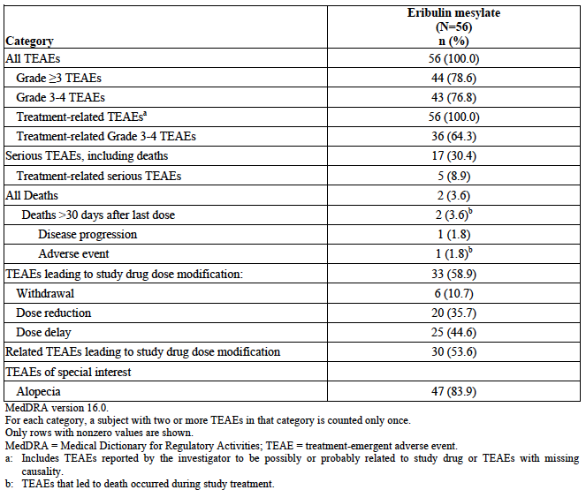

Post-marketing experience
No post-marketing data were included in the clinical module of the submission.

Safety issues with the potential for major regulatory impact

Liver toxicity
Eribulin is known to be associated with hepatic toxicity. In the pivotal study the incidence of LFT abnormalities was comparable to that observed with dacarbazine, another agent known to be associated with hepatotoxicity. In the STS studies there were no cases meeting the criteria for Hy’s law, which is predictive of severe drug-induced liver injury. There was one case of serious hepatotoxicity in the eribulin arm of the pivotal study. This was found to be due to disease progression with biliary obstruction and was assessed as unrelated to study drug. There were no serious hepatic AEs in Study 206.

Haematological toxicity
Bone marrow suppression is a known adverse reaction with eribulin and was very common in the STS studies and Study 206. There were no cases of serious pancytopaenia reported in the STS studies or Study 206.

Serious skin reactions
The current PI for eribulin lists Stevens-Johnson syndrome and toxic epidermal necrolysis (TEN) as adverse reactions that have been observed with eribulin in the post-market setting. There was no serious skin AEs reported in the STS studies or in Study 206.

Cardiovascular safety
The current PI for eribulin lists QT prolongation, tachycardia, hot flushes, deep venous thrombosis and pulmonary embolism as cardiovascular adverse reactions associated with eribulin.
Data from the STS studies on QT prolongation are described in Laboratory tests, Electrocardiograph above. In the pivotal study serious cardiac disorders occurred in 0.9% of subjects in both arms. Serious cardiac events in the eribulin arm were atrial fibrillation (1) and pericardial effusion (1). In the Phase II studies there was one additional report of serious pericardial effusion and one of serious cardiac failure.
Serious vascular disorders were more common with dacarbazine (2.2% versus 0.9%). Serious vascular events in the eribulin arm were superior vena cava syndrome (1) and vena cava thrombosis (1). In the Phase II studies there were two additional serious AEs of thrombosis.

Unwanted immunological events
Two subjects in the STS studies experienced a Grade 1 hypersensitivity reaction to eribulin. One event was classified as serious. This subject had symptoms of cough, sweating and hot flashes. The event resolved in one day and the subject continued further treatment with the drug.

Other safety issues

Safety in special populations
The sponsor’s Summary of Clinical Safety presented analyses of safety in various subgroups. For the pooled STS population, findings included the following:
- Incidence of AEs, SAEs etc. was generally similar in subjects aged < 65 years (n=314) and those aged ≥ 65 years (n=90). However, discontinuations due to AEs were more common in the elderly (8.9% versus 4.1%).
- The incidence of Grade 3 or higher neutropaenia was more common in Asian/Pacific Islander subjects (n=70) than in white subjects (n=161) – 81.4% versus 41.0%.
- Incidence of AEs, SAEs etc. was generally similar in male (n=151) and female (n=253) subjects. However, discontinuations due to AEs were more common in women (7.1% versus 2.0%).

Evaluator’s overall conclusions on clinical safety
In STS subjects, the toxicity profile of eribulin was consistent with that previously documented in breast cancer subjects. No new safety issues were identified in the STS studies. Common adverse events observed in STS subjects treated with eribulin were haematological toxicities (especially neutropaenia), peripheral neuropathy, GIT events, fatigue and alopecia.
The drug was moderately more toxic than dacarbazine with a higher incidence of Grade ≥ 3 AEs (67.3% versus 56.3%) and AEs leading to withdrawal (7.5% versus 4.9%). Also, there were 2 deaths in the pivotal study that appeared to be related to eribulin, compared to none related to dacarbazine. Both deaths followed the development of severe neutropaenia. However, the overall effect of eribulin on mortality is favourable compared to dacarbazine, at least in the subpopulation of patients with liposarcoma.
The relatively low incidence of discontinuation due to AEs (7.5%) suggests that the toxicity of eribulin was manageable.
Previously treated unresectable STS is a serious, life-threatening condition, as evidenced by a median survival of only 11.5 months with dacarbazine treatment in the pivotal study. For such a patient group the toxicity of eribulin, as described above, is considered acceptable.

First round benefit-risk assessment

First round assessment of benefits
The benefits of eribulin in subjects with liposarcoma are:
- A statistically and clinically significant reduction in the risk of death, with a hazard ratio of 0.511 (95%CI: 0.346 – 0.753) and a prolongation of median survival by approximately 7 months (15.6 versus 8.4 months), compared to dacarbazine treatment.
The benefits of eribulin in subjects with leiomyosarcoma are uncertain. The evidence to support a beneficial effect of eribulin in other histological subtypes of STS, compared to dacarbazine, is inadequate.
Eribulin is not associated with significant quality of life benefits compared to dacarbazine.

First round assessment of risks
The risks of eribulin in the treatment of soft tissue sarcoma are:
- Various risks previously documented with use of the drug. These include haematological toxicities, peripheral neuropathy, GIT events, fatigue and alopecia.
The overall risks with eribulin treatment for STS are moderately greater than those for dacarbazine.

First round assessment of benefit-risk balance
The benefit-risk balance of eribulin in the treatment of liposarcoma is favourable. Given the uncertainty of the drug’s efficacy in leiomyosarcoma, a favourable benefit-risk balance for this indication cannot be concluded. The benefit-risk balance of eribulin for other subtypes of STS is unfavourable.

First round recommendation regarding authorisation
It is recommended that eribulin be approved for the following indication only:
For the treatment of patients with unresectable liposarcoma, who have received prior chemotherapy for advanced or metastatic disease.

Clinical questions

Efficacy
- In Study 309, what was the PFS rate at 12 weeks for the two histological groups included in the trial (for both eribulin and dacarbazine)?

Second round evaluation of clinical data submitted in response to questions
Not applicable.

Second round benefit-risk assessment
Not applicable.

Second round recommendation regarding authorisation
Not applicable.

References
- National Comprehensive Cancer Network (NCCN). NCCN Clinical Practice Guidelines in Oncology. Soft Tissue Sarcoma. Version 2.2016; 2016. Available from: http://www.nccn.org/professionals/physician_gls/f_guidelines.asp#site
- Clark MA, Fisher C, Judson I, Thomas JM. Soft-tissue sarcomas in adults. N Engl J Med. 2005; 353 (7): 701-11.
- Shiba S, Peach A Howard S. Diagnosis and management of soft tissue sarcoma BMJ 2010; 341: c7170
- Cancer Council Australia Sarcoma Guidelines Working Party. Clinical practice guidelines for the management of adult onset sarcoma. Sydney: Cancer Council Australia. [Version URL: http://wiki.cancer.org.au/australiawiki/index.php?oldid=106741, cited 2016 Apr 13]. Available from: http://wiki.cancer.org.au/australia/Guidelines:Sarcoma
- ESMO/European Sarcoma Network Working Group. Soft tissue and visceral sarcomas: ESMO Clinical Practice Guidelines for diagnosis, treatment and follow-up. Ann Oncol. 2014; 25 Suppl 3: iii102-12.
- European Medicines Agency. Guideline on the evaluation of anticancer medicinal products in man. EMA/CHMP/205/95/Rev.4; (2012). Available from: http://www.tga.gov.au/clinical-efficacy-and-safety-guidelines
- European Medicines Agency. Points to consider on application with 1. Meta-analyses; 2. One pivotal study; CPMP/EWP/2330/99 (2001). Available from: http://www.tga.gov.au/clinical-efficacy-and-safety-guidelines
- U.S. Food and Drug Administration. FDA News Release. FDA approves first drug to show survival benefit in liposarcoma. 28 January 2016. Available from: http://www.fda.gov/NewsEvents/Newsroom/PressAnnouncements/ucm483714.htm
- European Medicines Agency. Summary of opinion (post authorisation). Halaven eribulin. 1 April 2016. Available from: http://www.ema.europa.eu/ema/index.jsp?curl=pages/medicines/human/medicines/002084/smops/Positive/human_smop_000955.jsp&mid=WC0b01ac058001d127&source=homeMedSearch&category=human.
- European Medicines Agency. EMA decision P/0136/2015. 15 June 2015. Available from: http://www.ema.europa.eu/ema/index.jsp?curl=pages/medicines/pips/EMEA-001261-PIP01-11-M02/pip_000981.jsp&mid=WC0b01ac058001d129&source=homeMedSearch
- Schöffski P, Chawla S, Maki RG et al. Eribulin versus dacarbazine in previously treated patients with advanced liposarcoma or leiomyosarcoma: a randomised, open-label, multicentre, phase 3 trial. Lancet. 2016 Feb 10. pii: S0140-6736(15)01283-0. doi: 10.1016/S0140-6736(15)01283-0. [Epub ahead of print].
- Eisenhauer EA et al. New response evaluation criteria in solid tumours: Revised RECIST guideline (version 1.1). Eur J Cancer. 2009, 45: 228-247.
- Van Glabbeke M, Verweij J, Judson I, Nielsen OS, EORTC Soft Tissue and Bone Sarcoma Group. Progression-free rate as at the principal end-point for phase II trials in soft-tissue sarcomas. Eur J Cancer. 2002; 38: 543-9.
- Schöffski P, Ray-Coquard IL, Cioffi A, et al. Activity of eribulin mesylate in patients with soft-tissue sarcoma: a phase 2 study in four independent histological subtypes. Lancet Oncol. 2011; 12 (11): 1045-52.

Therapeutic Goods Administration
PO Box 100 Woden ACT 2606 Australia
Email: info@tga.gov.au Phone: 1800 020 653 Fax: 02 6232 8605
https://www.tga.gov.au

1. Histologically confirmed diagnosis of STS of high or intermediate grade with one of the following histological subtypes: Adipocytic sarcoma, including i) dedifferentiated, ii) myxoid, iii) round cell, iv) pleomorphic subtype; or leiomyosarcoma, Tumour histology performed at diagnosis for study entry, although formalin-fixed paraffin embedded (FFPE) tumour blocks and/or representative slides must be available and provided to the sponsor for independent histological review (IHR). IHR is not required prior to randomisation. 2. Documented evidence of advanced (locally recurrent, locally advanced and/or metastatic) adipocytic sarcoma (restricted to subtypes listed in Inclusion 1) or leiomyosarcoma, incurable by surgery or radiotherapy. 3. Subjects should have received at least two standard systemic regimens for advanced STS, one of which must have included an anthracycline (unless contraindicated).

