This medicinal product is subject to additional monitoring in Australia. This will allow quick identification of new safety information. Healthcare professionals are asked to report any suspected adverse events at www.tga.gov.au/reporting-problems.
▼

Australian Product Information – VYEPTI®(eptinezumab) Concentrated injection

Name of the medicine
Eptinezumab

Qualitative and quantitative composition
Each single-dose vial contains 100 mg/mL eptinezumab.
Eptinezumab is a humanised monoclonal immunoglobulin G1 (IgG1) antibody.
For the full list of excipients, see Section 6.1 List of excipients.

Pharmaceutical form
Concentrated injection for dilution for infusion.
The solution is clear to slightly opalescent, colourless to brownish-yellow.

Clinical particulars

Therapeutic indications
VYEPTI® is indicated for the preventive treatment of migraine in adults.

Dose and method of administration
As for other infusion treatments, VYEPTI® treatment should be initiated and supervised by a healthcare professional.
Dosage
The recommended dosage is 100 mg administered by intravenous infusion every 12 weeks. Some patients may benefit from a dosage of 300 mg administered by intravenous infusion every 12 weeks.
The treatment benefit should be assessed 3-6 months after initiation of the treatment. The need for dose escalation should be assessed within 12 weeks after initiation of the treatment. The decision to continue with treatment should be made on an individual patient basis, determined prior to each dose.
Method of administration
VYEPTI® is for intravenous infusion only after dilution.
The product requires dilution prior to administration. The dilution should be prepared by a healthcare professional using aseptic technique to ensure the sterility of the prepared solution for infusion.
The product contains no preservative and is intended for single use only. Discard unused portion remaining in the vial.
Prior to dilution, the product (solution in the vials) should be inspected visually; do not use if the solution contains visible particulate matter or is cloudy or discoloured (other than clear to slightly opalescent, colourless to brownish-yellow).
For both the 100 mg and the 300 mg dose, a 100 mL bag of 0.9% Sodium Chloride for Injection should be used to prepare the VYEPTI® solution for infusion as described below. No other IV diluents or volume may be used to prepare the VYEPTI® solution for infusion.
Gently invert the VYEPTI®solution for infusion to mix completely. Do not shake.
Following dilution, VYEPTI® solution for infusion must be infused within 8 hours. To reduce microbiological hazard, use as soon as practicable after dilution. After dilution, VYEPTI®solution for infusion may be stored at room temperature or refrigerated at 2 to 8°C. If stored at 2 to 8°C, allow the VYEPTI®solution for infusion to warm to room temperature prior to infusion. DO NOT FREEZE.
100 mg dose:
To prepare the VYEPTI® solution for infusion, withdraw 1.0 mL of VYEPTI® from a single-use vial using a sterile needle and syringe. Inject the 1.0 mL content into a 100 mL bag of 0.9% Sodium Chloride for Injection.
300 mg dose:
To prepare the VYEPTI® solution for infusion, withdraw 1.0 mL of VYEPTI® from each of three (3) single-use vials using a sterile needle and syringe. Inject the resulting 3.0 mL content into a 100 mL bag of 0.9% Sodium Chloride for Injection.
For the full storage details, see Section 6.4 Special precautions for storage.
Administration Instructions
Parenteral drug products should be inspected visually for particulate matter and discoloration prior to administration, whenever solution and container permit. Do not use if the liquid contains visible particulate matter or is cloudy or discoloured.
The treating Physician should observe or monitor patients during and after the infusion in accordance with normal clinical practice (see Section 4.4 Special Warnings and Precautions for Use on Serious Hypersensitivity).
Infuse over approximately 30 minutes. Use an intravenous infusion set with a 0.2 micron (μm) or 0.22 micron (μm) in-line or add-on sterile filter. After the infusion is complete, flush the line with 20 mL of 0.9% Sodium Chloride for Injection.
Do not administer VYEPTI® as a bolus injection, it is for intravenous infusion only after dilution.
No other medications should be administered through the infusion set or mixed with VYEPTI®.

Contraindications
VYEPTI® is contraindicated in patients with hypersensitivity to eptinezumab or to any of the excipients in VYEPTI® (see Sections 4.4 Special Warnings and Precautions for use, 4.8 Adverse Effects (Undesirable effects) and 6.1 List of excipients).

Special warnings and precautions for use

Traceability
In order to improve the traceability of biological medicinal products, the name and the batch number of the administered product should be clearly recorded.

Cardiovascular risk
Patients with a history of cardiovascular disease were excluded from clinical studies. No safety data are available in these patients.

Serious hypersensitivity
Serious hypersensitivity reactions, including anaphylactic reactions, have been reported and may develop within minutes of the infusion. Angioedema, urticaria, facial flushing, and rash, have occurred with VYEPTI® in clinical studies. In clinical studies, most hypersensitivity reactions occurred during infusion and were not serious, but often led to discontinuation or required treatment (see Section 4.8 Adverse effects (Undesirable effects)). If a serious hypersensitivity reaction occurs, administration of VYEPTI® should be discontinued immediately and appropriate therapy initiated (see Section 4.3 Contraindications).
If a serious hypersensitivity reaction occurs with the infusion of VYEPTI®, further treatment with VYEPTI® should be discontinued. If the hypersensitivity reaction is less severe, continuation of further treatment with VYEPTI® is up to the discretion of the treating physician.

Use in the elderly
Insufficient clinical data is available for patients aged 65 and older. Clinical studies with VYEPTI® did not include sufficient number of patients in this age group to determine whether they respond differently from younger patients. There is no dose adjustment recommendation available for this population group.

Paediatric use
The safety and efficacy of eptinezumab in patients below the age of 18 years has not yet been established. Currently no data are available.

Effects on laboratory tests
Interference of VYEPTI®with laboratory and/or diagnostic tests has not been studied.

Interactions with other medicines and other forms of interactions
Eptinezumab is not metabolised by cytochrome P450 enzymes. Therefore, interactions by eptinezumab with concomitant medications that are substrates, inducers, or inhibitors of cytochrome P450 enzymes are considered unlikely.
In healthy subjects, co-administration of a single dose of 300 mg eptinezumab administered as an intravenous infusion (over a period of 1 hour ± 15 min) with a single dose of 6 mg sumatriptan administered subcutaneously did not alter the pharmacokinetics of eptinezumab or sumatriptan.
Interactions with other medicines have not been studied.

Fertility, Pregnancy and Lactation

Effects on fertility
The effect of eptinezumab on human fertility has not been evaluated. There were no adverse effects on female or male fertility in rats treated with dose levels up to 150 mg/kg IV weekly (25 times the MRHD in a 50 kg patient) prior to and during mating, continuing in females to the time of implantation.

Use in pregnancy – Pregnancy Category B1
There is a very limited amount of data from the use of eptinezumab in pregnant women. In studies in rats and rabbits, there were no effects on embryofetal development when eptinezumab was dosed throughout the period of organogenesis at doses up to 150 mg/kg (25 times the MRHD in a 50 kg patient).
Human IgG is known to cross the placental barrier; therefore, eptinezumab may be transmitted from the mother to the developing foetus.
VYEPTI® should not be used by pregnant women unless the expected benefit to the mother justifies the potential risk to the foetus.

Use in lactation.
There are no data on the presence of eptinezumab in human milk, the effects on the breastfed infant, or the effects on milk production. Human IgG is known to be excreted in breast milk; therefore, eptinezumab may be transmitted from the mother to the breastfed infant. The developmental and health benefits of breastfeeding should be considered along with the mother’s clinical need for VYEPTI® and any potential effects on the breastfed infant.

Effects on ability to drive and use machines
Eptinezumab is expected to have no or negligible influence on the ability to drive and use machines.

Adverse effects (Undesirable effects)
Summary of the safety profile
A total of over 2000 patients (more than 1,600 patient years) have been treated with eptinezumab in clinical studies. Of these, approximately 1,500 patients were exposed to 100 mg or 300 mg. Across all doses, 1872 patients were exposed for at least 24 weeks (two doses), 991 patients were exposed for 48 weeks (four doses), and 101 patients were exposed for up to two years (eight doses). In the placebo-controlled clinical studies (PROMISE 1 and PROMISE 2), 1372 patients received at least one dose of VYEPTI®(including 579 patients receiving at least one dose of VYEPTI®100 mg and 574 patients receiving at least one dose of VYEPTI®300 mg), and 588 patients received placebo. Approximately 86% were female, 89% were white, and the mean age was 40.4 years at study entry.
Patients with a history of cardiovascular disease, neurological disease, cerebrovascular disease, morbid obesity and diabetes were excluded from clinical studies.
The most common adverse reactions in the placebo-controlled clinical studies (PROMISE 1 and PROMISE 2) for the preventive treatment of migraine were nasopharyngitis and hypersensitivity (see below). Most hypersensitivity reactions occurred during infusion and were not serious (see Section 4.4 Special warnings and precautions for use).
Infusion site-related adverse events occurred infrequently and in similar proportions of VYEPTI® and placebo patients (< 2%) with no apparent relationship to VYEPTI® dose. The most frequently occurring infusion-site related adverse event was infusion site extravasation, which occurred in < 1% of VYEPTI® and placebo patients in PROMISE 1 and PROMISE 2.
Tabulated list of adverse reactions
The table presented below is according to the MedDRA system organ classification. Frequencies have been evaluated according to the following convention: very common (≥1/10); common (≥1/100 to <1/10); uncommon (≥1/1,000 to <1/100; rare (≥1/10,000 to <1/1,000; very rare (<1/10,000).
Table 1: List of Adverse Reactions in Clinical Studies and Post-marketing Reports (PROMISE 1 and PROMISE 2)
System Organ Class | Adverse Reaction Preferred Term | Frequency Category
Infections and Infestations | Nasopharyngitis | Common
Immune system disorders | Hypersensitivity reactions | Common
Immune system disorders | Anaphylactic Reactions¹ | Rare
¹ Not reported in PROMISE 1 and PROMISE 2, but reported in other studies and in the post-marketing setting.
Description of selected adverse reaction
Nasopharyngitis
Approximately 8% of patients on 300 mg, 6% of patients on 100 mg and 6% of patients on placebo in PROMISE 1 and PROMISE 2 experienced nasopharyngitis. Nasopharyngitis was most frequent after the first dose of eptinezumab at any dose. The incidence decreased with subsequent doses and remained fairly steady thereafter.

Hypersensitivity Reactions
Serious hypersensitivity reactions, including anaphylactic reactions, have been reported and may develop within minutes of the infusion (see Section 4.4 Special warnings and precautions for use). The reported anaphylactic reactions have included symptoms of hypotension and respiratory difficulties, and have led to discontinuation of VYEPTI®. Other hypersensitivity reactions, including angioedema, urticaria, flushing, rash and pruritus, were reported in approximately 4% of patients on 300 mg, 3% of patients on 100 mg and 1% of patients on placebo in PROMISE 1 and PROMISE 2.
Immunogenicity
In placebo-controlled pivotal clinical studies, PROMISE 1 and PROMISE 2, the incidence of anti-eptinezumab antibodies across both studies was 18% (105/579) and 20% (115/574) in patients receiving 100 mg and 300 mg every 12 weeks dosing, respectively. In both studies, the incidence of anti-eptinezumab antibodies peaked at Week 24, and thereafter showed a steady decline even after subsequent dosing every 12 weeks. The incidence of antibodies with neutralizing potential across both studies was 8.3% (48/579) and 6.1% (35/574) for the 100 mg and 300 mg treatment groups, respectively.
A long-term open label repeat dose study, PREVAIL, in 128 patients with chronic migraine consisted of a primary and secondary treatment phase in which up to eight IV infusions of VYEPTI®300 mg were administered over an 84-week period (one infusion every 12 weeks). Overall, 119 patients completed the primary treatment phase (4 infusions, from baseline up to 48 weeks) and 101 patients completed the secondary treatment phase (8 infusions, from baseline up to 96 weeks). Anti-drug antibodies (ADA) developed in 18% (23/128) of patients with an overall incidence of antibodies with neutralizing potential of 7% (9/128). 5.3% patients were ADA positive at week 48, 4% were ADA positive at week 72, and all patients, except one patient lost to follow-up, were ADA negative at week 104 (the last assessment in the study).
There was no evidence of an effect of anti-eptinezumab antibody development on efficacy or safety in any of the clinical studies.

Reporting suspected adverse effects
Reporting suspected adverse reactions after registration of the medicinal product is important. It allows continued monitoring of the benefit-risk balance of the medicinal product. Healthcare professionals are asked to report any suspected adverse reactions at www.tga.gov.au/reporting-problems.

Overdose
There has been no experience of overdose with VYEPTI®. Doses up to 1000 mg have been administered intravenously to humans without tolerability issues or clinically significant adverse reactions.
In the event of an overdose, the patient should be treated symptomatically and supportive measures instituted as required.
For information on the management of overdose, contact the Poisons Information Centre on 13 11 26 (Australia).

Pharmacological properties

Pharmacodynamic properties
Pharmacodynamic activity characterized by inhibition of α-CGRP-mediated neurogenic vasodilation induced by topical capsaicin relative to baseline was evaluated following single or multiple administrations of eptinezumab in human volunteers. Mean neurogenic induced vasodilation was reduced by 41% following intravenous 100 mg eptinezumab administration compared to an increase of 12% for placebo on the day following treatment. For up to 12 weeks, the reduction persisted ranging from 20% to 50% for 100 mg eptinezumab while placebo ranged from a 20% increase to 0.20% reduction during the same period.

Mechanism of action
Eptinezumab is a humanised immunoglobulin G1 (IgG1) antibody that binds to α- and β- forms of human calcitonin gene-related peptide (CGRP) ligand with low picomolar affinity preventing its activation of the CGRP receptors. Elevated blood concentrations of CGRP have been associated with migraine.
Eptinezumab is highly selective and does not bind to any of the related neuropeptides amylin, calcitonin, adrenomedullin and intermedin.

Clinical trials
VYEPTI® was evaluated for the preventive treatment of migraine in two pivotal placebo-controlled studies: PROMISE 1 was conducted in patients with episodic migraine (n=888) and PROMISE 2 in patients with chronic migraine (n=1072). In PROMISE 1 episodic migraine was defined as ≥4 and ≤14 headache days of which at least 4 had to be migraine days in each 28-day period in the 3 months prior to screening. In PROMISE 2 chronic migraine was defined as ≥ 15 to ≤ 26 headache days, of which ≥ 8 were assessed as migraine days. VYEPTI® was administered by intravenous infusion every 12 weeks in both studies. Enrolled patients had a history of migraine (with or without aura) of at least 12 months, according to the International Classification of Headache Disorders (ICHD-II or III) diagnostic criteria. Patients over 75 years and patients with a history of cardiovascular disease (hypertension, ischaemic heart disease), neurological disease, cerebrovascular disease, and diabetes were excluded.
PROMISE 1: Episodic Migraine
PROMISE 1 was a parallel group, double-blind, placebo-controlled global study to evaluate the efficacy and safety of VYEPTI® for the preventive treatment of episodic migraine in adults. A total of 665 patients were randomized and received placebo (N=222), 100 mg eptinezumab (N=221), or 300 mg eptinezumab (N=222) every 12 weeks for 48 weeks (4 infusions). Patients were allowed to use concurrent acute migraine or headache medications, including migraine-specific medications (i.e., triptans, ergotamine derivatives), during the study. Regular use (greater than 7 days per month) of other treatments for the prevention of migraine was not allowed.
The primary efficacy endpoint was the change from baseline in mean monthly migraine days (MMD) over Weeks 1-12. The key secondary endpoints included ≥ 50% and ≥ 75% migraine responder rates defined as the proportion of patients achieving at least the specified percent reduction in migraine days over Weeks 1-12, ≥ 75% migraine responder rate over Weeks 1-4, and the percentage of subjects with a migraine on the day after the first dosing (Day 1).
Patients had a mean age of 40 years (range: 18 to 71 years), 84% were female, and 84% were white. The mean number of migraine days per month at baseline was 8.6 and the rate of patients with a migraine on a given day was 30.7% during the screening period; both were similar across treatment groups.
The 4-week results over Weeks 1-48, following four quarterly infusions of VYEPTI® treatment are presented as changes from baseline in mean MMD (Figure 1). Both VYEPTI®100 mg and 300 mg treatment groups demonstrated statistically significant and clinically meaningful greater improvements from baseline to week 1-12 compared to placebo on mean MMD. For both doses of VYEPTI®, a greater mean decrease in MMDs compared to placebo was sustained for all timepoints through to Week 48.
Figure 1: Mean Changes from Baseline in Mean Monthly Migraine Days over Time in PROMISE 1 – Weeks 1-48
The daily results over the first week after the initial infusion of VYEPTI® treatment are presented as percentages of subjects with a migraine (Figure 2). For both doses of VYEPTI® the preventive treatment benefit over placebo was observed as early as Day 1 post-infusion.
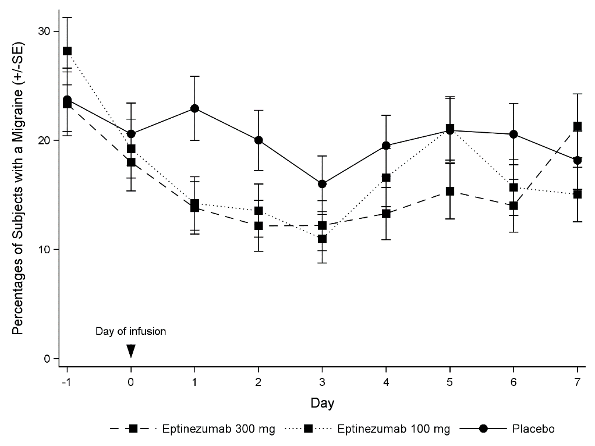
Figure 2: Percentages of Subjects with a Migraine from Day -1 (Day Prior to Infusion) to Day 7 in
PROMISE 1 – Days 1-7

VYEPTI® treatment demonstrated statistically significant and clinically meaningful improvements for primary and key secondary efficacy endpoints, as summarized in Table 2.
Table 2: Primary and Key Secondary Efficacy Endpoint Results in PROMISE 1 (Episodic Migraine)
 | VYEPTI®  100 mg  N=221 | VYEPTI®  300 mg  N=222 | Placebo  N=222
Monthly Migraine Days (MMD) – Weeks 1-12
Baseline | 8.7 | 8.6 | 8.4
Mean Change | -3.9 | -4.3 | -3.2
Difference from placebo | -0.7 | -1.1
CI_{95%} | (-1.3, -0.1) | (-1.7, -0.5)
p-value vs placebo | 0.0182 | 0.0001
≥ 75% MMD responders – Weeks 1-4
Responders | 30.8% | 31.5% | 20.3%
Difference from placebo | 10.5% | 11.3%
p-value vs placebo | 0.0112 | 0.0066
≥ 75% MMD responders – Weeks 1-12
Responders | 22.2% | 29.7% | 16.2%
Difference from placebo | 6.0% | 13.5%
p-value vs placebo | 0.1126 | 0.0007
≥ 50% MMD responders – Weeks 1-12
Responders | 49.8% | 56.3% | 37.4%
Difference from placebo | 12.4% | 18.9%
p-value vs placebo | 0.0085 | 0.0001
Percent of Subjects with a Migraine on the Day After Dosing
Migraine during the Baseline Periodª | 31.0% | 30.8% | 29.8%
Day 1 | 14.8% | 13.9% | 22.5%
p-value vs placebo | 0.0312 | 0.0159
ª A baseline was the average over the 28-day screening period prior to receiving treatment.
PROMISE 2: Chronic Migraine
PROMISE 2 was a parallel-group, double-blind, placebo-controlled global study to evaluate the efficacy and safety of VYEPTI®for the preventive treatment of chronic migraine in adults. A total of 1,072 patients were randomized and received placebo (N=366), 100 mg eptinezumab (N=356), or 300 mg eptinezumab (N=350) every 12 weeks for 24 weeks (2 infusions). During the study, patients were allowed to use acute or preventive medication for migraine or headache on an established stable regimen (except for onabotulinumtoxin A). Patients with a dual diagnosis of chronic migraine and medication overuse headache (associated with the overuse of triptans, ergotamine, or combination analgesics > 10 days/month, or paracetamol, aspirin, or non-steroidal anti-inflammatory drugs ≥ 15 days/month) were included in the study population. Patients taking opioids or butalbital containing products > 4 days/month were excluded.
The primary efficacy endpoint was the change from baseline in mean MMD over Weeks 1-12. The key secondary endpoints included ≥ 50% and ≥ 75% migraine responder rates defined as the proportion of patients achieving the specified percent reduction in migraine days over Weeks 1-12, ≥ 75% migraine responder rate over Weeks 1-4, the percentage of subjects with a migraine on the day after dosing, the reduction in migraine prevalence from baseline to Week 4, the change from baseline in the total score on the Headache Impact Test (HIT-6) at Week 12 (300 mg dose only), and the change from baseline in acute monthly migraine medication days, mean over Weeks 1-12 (300 mg dose only). The HIT-6 is a self-administered questionnaire assessing the impact of headache on the functional status of patients with migraine. Interpretation of the impact of migraine on daily function by total score is as follows: 60-78 = Severe; 56-59 = Substantial, 50-55 = Some, and 36-49 = little to none.
Patients had a mean age of 41 years (range: 18 to 65 years), 88% were female, and 91% were white. Forty-one percent of patients were taking concomitant preventive medication for migraine. The mean number of migraine days per month at baseline was 16.1 and the rate of patients with a migraine on a given day was 57.6% during the screening period; both were similar across treatment groups.
The monthly results over Weeks 1-24, following two quarterly infusions of VYEPTI® treatment are presented as changes from baseline in mean MMD (Figure 3). Both VYEPTI®100 mg and 300 mg treatment groups demonstrated statistically significant and clinically meaningful greater improvements from baseline to week 1-12 compared to placebo on mean MMD. For both doses of VYEPTI®, greater mean decrease in MMDs compared to placebo were sustained for all timepoints through to Week 24.
Figure 3: Mean Changes from Baseline in Mean Monthly Migraine Days in PROMISE 2 - Weeks 1-24

The daily results over the first week after the initial infusion of VYEPTI® treatment are presented as percentages of subjects with a migraine (Figure 4). A preventive treatment benefit over placebo for both doses of VYEPTI® was observed as early as Day 1 post-infusion.
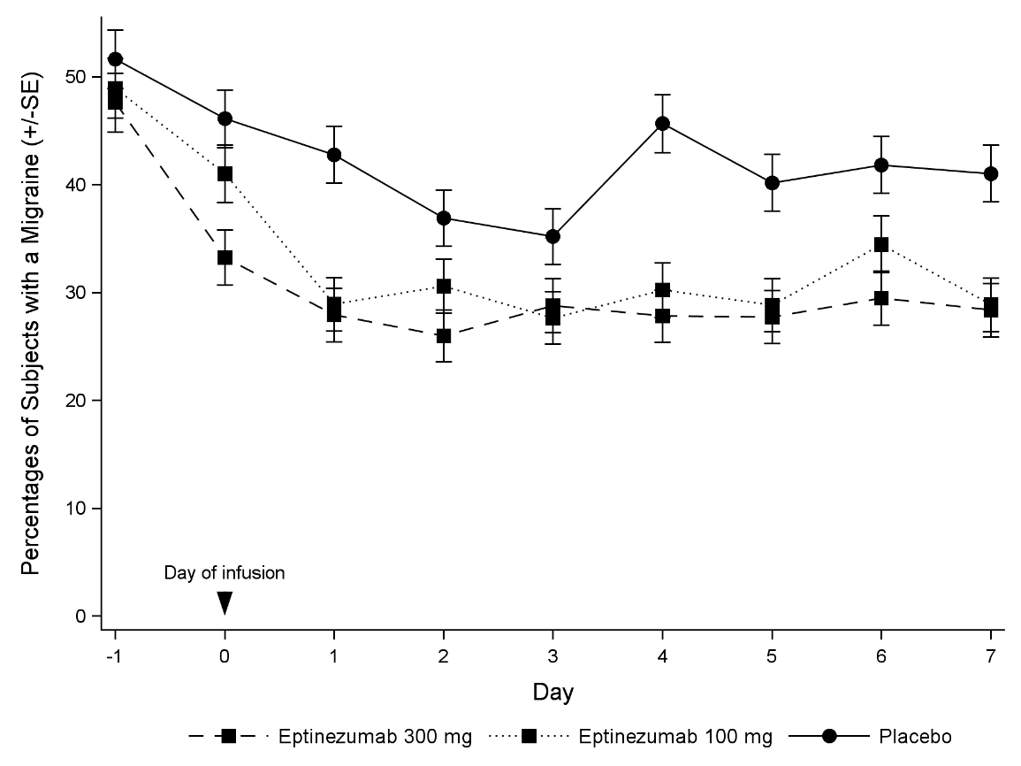
Figure 4: Percentages of Subjects with a Migraine from Day -1 (Day Prior to Infusion) to Day in PROMISE 2 – Days 1-7
Eptinezumab treatment demonstrated statistically significant and clinically meaningful improvements for key efficacy endpoints as summarized in Table 3.
Table 3: Primary and Key Secondary Efficacy Endpoint Results in PROMISE 2 (Chronic Migraine)
 | VYEPTI®  100 mg  N=356 | VYEPTI®  300 mg  N=350 | Placebo  N=366
Monthly Migraine Days (MMD) – Weeks 1-12
Baseline | 16.1 | 16.1 | 16.2
Mean Change | -7.7 | -8.2 | -5.6
Difference from placebo | -2.0 | -2.6
CI_{95%} | (-2.9, -1.2) | (-3.5, -1.7)
p-value vs placebo | < 0.0001 | < 0.0001
≥ 75% MMD responders – Weeks 1-4
Responders | 30.9% | 36.9% | 15.6%
Difference from placebo | 15.3% | 21.3%
p-value vs placebo | < 0.0001 | < 0.0001
≥ 75% MMD responders – Weeks 1-12
Responders | 26.7% | 33.1% | 15.0%
Difference from placebo | 11.7% | 18.1%
p-value vs placebo | 0.0001 | < 0.0001
≥ 50% MMD responders – Weeks 1-12
Responders | 57.6% | 61.4% | 39.3%
Difference from placebo | 18.2% | 22.1%
p-value vs placebo | < 0.0001 | < 0.0001
Percent of Subjects with a Migraine on the Day After Dosing
Migraine during the Baseline Periodª | 57.5% | 57.4% | 58.0%
Day 1 | 28.6% | 27.8% | 42.3%
p-value vs placebo | < 0.0001 | < 0.001
Reduction in Migraine Prevalence^{b} – Weeks 1-4
Mean Change | -27.1% | -29.8% | -18.8%
Difference from placebo | -8.3% | -11.0%
CI_{95%} | (-11.5%, -5.1%) | (-14.2%, -7.8%)
p-value vs placebo | < 0.0001 | < 0.0001
HIT-6 Score – Week 12^{c}
Baseline | 65.0 | 65.1 | 64.8
Mean Change | -6.2 | -7.3 | -4.5
Difference from placebo | -1.7 | -2.9
CI_{95%} | (-2.8, -0.7) | (-3.9, -1.8)
p-value vs placebo | 0.0010 | < 0.0001
Days per month with Acute Medication Use – Weeks 1-12^{a,c}
Baseline | 6.6 | 6.7 | 6.2
Mean Change | -3.3 | -3.5 | -1.9
Difference from placebo | -1.2 | -1.4
CI_{95%} | (-1.7, -0.7) | (-1.9, -0.9)
p-value vs placebo | < 0.0001 | < 0.0001
ª A baseline was the average over the 28-day screening period prior to receiving treatment
^{b} Migraine prevalence: The average percent of subjects with a migraine on any given day during baseline and the equivalent average rates over weeks 1, 2, 3, and 4
^{c} The endpoint for the 100 mg dose was not a pre-specified key secondary endpoint.
Subjects with medication overuse headache (MOH), other than those using opioids or butalbital > 4 days/month, were enrolled in PROMISE 2: at baseline, 40.2% of the patients had MOH. In subjects with chronic migraine, similar reductions in MMD (Mean for Weeks 1-12) were observed in subjects with and without MOH at baseline. The mean change from baseline in MMD (Weeks 1-12) for the subjects with MOH was for 300 mg: -8.6, 100 mg: -8.4, placebo: -5.4 and for subjects without MOH was 300 mg: -8.1, 100 mg: -7.4, placebo:-6.1.The mean difference to placebo in change from baseline in MMD (Weeks 1-12) for the subjects with MOH was (300 mg: -3.2 [95% CI: -4.75; -1.70], 100 mg: -3.0 [-4.52; -1.49]) and for subjects without MOH was (300 mg: -2.4 [-3.59; -1.12], 100 mg: -1.5 [-2.70; -0.31]).
In the 431 (40%) patients from PROMISE 2 diagnosed with medication overuse headache, the difference in the reduction of mean monthly migraine headache days (MMD) observed between VYEPTI® and placebo was -3.0 [95% CI: -4.52; -1.49] days and 3.2 [95% CI: 4.75; -1.70] for 100 mg and 300 mg, respectively.
PREVAIL: Long-term study
VYEPTI®300 mg was administered every 12 weeks by IV infusion for up to 96 weeks in 128 subjects with chronic migraine. The primary objective was to evaluate the long-term safety following repeated doses of VYEPTI®. Secondary objectives included characterization of the PK and immunogenicity profiles for VYEPTI® (section 4.8) and evaluation of the therapeutic effect of VYEPTI® on several patient reported outcomes relating to migraine and quality of life, including the Headache Impact Test (HIT-6). Subjects had a mean age of 41.5 years (range: 18 to 65 years), 85% were female, and 95% were white, and 36% took concomitant preventive medication for migraine. The mean number of migraine days per 28-day period in the 3 months preceding screening was 14.1 days. In total, 100 patients (78.1%) completed the study (Week 104). The safety profile was consistent with the safety profiles observed in randomized, placebo-controlled studies, and a sustained effect on patient-relevant outcomes was observed for up to 96 weeks.

Pharmacokinetic properties
As eptinezumab is administered intravenously, it is 100% bioavailable. Eptinezumab exhibits linear pharmacokinetics and exposure increases proportionally with doses from 1 to 1000 mg. Steady-state is attained after the first dose during a once every 12 weeks dosing schedule. Median time to maximum concentration (C_{max}) is 30 minutes (end-of-infusion), and the average terminal elimination half-life is 27 days. The mean accumulation ratios based on C_{max} and AUC_{0-tau} are 1.08 and 1.15, respectively.

Absorption
Eptinezumab is administered by intravenous infusion which bypasses extravascular absorption and is 100% bioavailable. Median time to peak concentration was attained at the end of infusion (30 minutes).

Distribution
The central volume of distribution (Vc) for eptinezumab was approximately 3.7 litres.

Metabolism
Eptinezumab is expected to be degraded by proteolytic enzymes into small peptides and amino acids.

Excretion
Eptinezumab apparent clearance was 0.15 L/day, and the terminal elimination half-life was approximately 27 days.

Special populations
Age, Gender, Race
The pharmacokinetics of eptinezumab were not affected by age, gender, or race based on population pharmacokinetics. Therefore, no dose adjustment is needed based on either age, sex or race.
Renal or Hepatic Impairment
No dedicated hepatic and renal impairment studies were conducted to assess the effects of hepatic and renal impairment upon the pharmacokinetics of eptinezumab. Population pharmacokinetic analysis of integrated data from the VYEPTI® clinical studies including biomarkers for hepatic and renal function as covariates revealed no differences that would require dose adjustments.

Preclinical safety data

Genotoxicity
The genotoxic potential of eptinezumab has not been evaluated; however, monoclonal antibodies are not expected to alter DNA or chromosomes.

Carcinogenicity
Carcinogenicity studies have not been conducted with eptinezumab, as eptinezumab is a monoclonal antibody.

Pharmaceutical particulars

List of excipients
- Histidine
- Histidine hydrochloride monohydrate
- Polysorbate 80
- Sorbitol
- Water for Injections

Incompatibilities
In the absence of compatibility studies, this medicinal product must not be mixed with other medicinal products.
No other medications should be administered through the infusion set or mixed with VYEPTI®, see Section 4.2 Dose and method of administration.

Shelf life
In Australia, information on the shelf life can be found on the public summary of the Australian Register of Therapeutic Goods (ARTG). The expiry date can be found on the packaging.
Following dilution, the VYEPTI® solution for infusion (VYEPTI® and 0.9% Sodium Chloride for Injection) must be infused within 8 hours (see Section 6.4 Special precautions for storage).

Special precautions for storage
Store refrigerated at 2 to 8°C.
Keep the vial in the outer carton in order to protect from light
Do not freeze or shake.
Following dilution, the VYEPTI® solution for infusion (VYEPTI® and 0.9% Sodium Chloride for Injection) may be stored at room temperature or refrigerated at 2 to 8°C for up to 8 hours.
VYEPTI® is for single use in one patient only. Discard any residue.

Nature and contents of container
1 mL solution in a Type I glass vial with chlorobutyl rubber stopper. The vial stopper is not made with natural rubber latex.

Each carton contains one vial.

Special precautions for disposal
In Australia, any unused medicine or waste material should be disposed of in accordance with local requirements.

Physicochemical properties

Chemical Abstract Index Name:
Immunoglobulin G1, anti-(calcitonin gene-related peptide) (human-Oryctolagus cuniculus monoclonal ALD403 heavy chain), disulfide with human-Oryctolagus cuniculus monoclonal ALD403 κ-chain, dimer

CAS number:
1644539-04-7

Chemical Structure
C₆₃₅₂H₉₈₃₈N₁₆₉₄O₁₉₉₂S₄₆

Medicine schedule (Poisons Standard)
Schedule 4 – Prescription Medicine

Sponsor
Lundbeck Australia Pty Limited
1 Innovation Road
North Ryde NSW 2113
Ph: 02 8669 1000

Date of first approval
16th June 2021

Date of revision

Summary table of changes
Section Changed | Summary of new information

