October 2017

Australian Public Assessment Report for Empagliflozin
  - Proprietary Product Name: Jardiance
  - Sponsor: Boehringer Ingelheim Pty Ltd

About the Therapeutic Goods Administration (TGA)
- The Therapeutic Goods Administration (TGA) is part of the Australian Government Department of Health and is responsible for regulating medicines and medical devices.
- The TGA administers the Therapeutic Goods Act 1989 (the Act), applying a risk management approach designed to ensure therapeutic goods supplied in Australia meet acceptable standards of quality, safety and efficacy (performance) when necessary.
- The work of the TGA is based on applying scientific and clinical expertise to decision-making, to ensure that the benefits to consumers outweigh any risks associated with the use of medicines and medical devices.
- The TGA relies on the public, healthcare professionals and industry to report problems with medicines or medical devices. TGA investigates reports received by it to determine any necessary regulatory action.
- To report a problem with a medicine or medical device, please see the information on the TGA website <https://www.tga.gov.au>.
About AusPARs
- An Australian Public Assessment Report (AusPAR) provides information about the evaluation of a prescription medicine and the considerations that led the TGA to approve or not approve a prescription medicine submission.
- AusPARs are prepared and published by the TGA.
- An AusPAR is prepared for submissions that relate to new chemical entities, generic medicines, major variations and extensions of indications.
- An AusPAR is a static document; it provides information that relates to a submission at a particular point in time.
- A new AusPAR will be developed to reflect changes to indications and/or major variations to a prescription medicine subject to evaluation by the TGA.
Copyright
© Commonwealth of Australia 2017
This work is copyright. You may reproduce the whole or part of this work in unaltered form for your own personal use or, if you are part of an organisation, for internal use within your organisation, but only if you or your organisation do not use the reproduction for any commercial purpose and retain this copyright notice and all disclaimer notices as part of that reproduction. Apart from rights to use as permitted by the Copyright Act 1968 or allowed by this copyright notice, all other rights are reserved and you are not allowed to reproduce the whole or any part of this work in any way (electronic or otherwise) without first being given specific written permission from the Commonwealth to do so. Requests and inquiries concerning reproduction and rights are to be sent to the TGA Copyright Officer, Therapeutic Goods Administration, PO Box 100, Woden ACT 2606 or emailed to <tga.copyright@tga.gov.au>.

Contents
Common abbreviations 4
I. Introduction to product submission 7
Submission details 7
Product background 7
Regulatory status 9
Product Information 9
II. Quality findings 9
III. Nonclinical findings 9
IV. Clinical findings 9
Introduction 10
Pharmacokinetics 12
Pharmacodynamics 12
Dosage selection for the pivotal studies 12
Efficacy 12
Safety 15
First Round Benefit-Risk Assessment 17
First Round Recommendation Regarding Authorisation 18
Clinical Questions 20
Second Round Evaluation of clinical data submitted in response to questions 20
Second Round Benefit-Risk Assessment 20
V. Pharmacovigilance findings 22
Risk management plan 22
VI. Overall conclusion and risk/benefit assessment 23
Quality 23
Nonclinical 23
Clinical 24
Efficacy 24
Safety 31
Risk Management Plan 35
Risk-benefit analysis 35
Outcome 45
Attachment 1. Product Information 46
Attachment 2. Extract from the Clinical Evaluation Report 46

Common abbreviations
Abbreviation | Meaning
ACEi | Angiotensin converting enzyme inhibitor
AESI | Adverse events of special interest
ARB | Angiotensin receptor blocker
ARTG | Australian Register of Therapeutic Goods
ASA | Australian Specific Annexe
BMI | Body mass index
BP | Blood pressure
CAC | Coronary artery calcification
CDER | Centers for Drug Evaluation and Research (US)
CKD | Chronic kidney disease
CT | Computerised tomography
CV | Cardiovascular
DBP | Diastolic blood pressure
DCCT | Diabetes Control and Complications Trial
DKA | Diabetic ketoacidosis
DPP-4 | Dipeptidyl peptidase-4
ECG | Electrocardiograph
EDIC | Epidemiology of Diabetes Interventions and Complications study
eGFR | Estimated glomerular filtrate rate
EMA | European Medicines Agency
ESRD | End stage renal disease
EU | European Union
FDA | Food and Drug Administration (US)
GCP | Good Clinical Practice
GLP-1 | Glucagon-like peptide-1
HbA1c | Glycosylated haemoglobin
HDL | High density lipoprotein
IC₅₀ | Half maximal inhibitory concentration
ICH | International Conference on Harmonisation
IEC | Independent Ethics Committee
IRB | Institutional Review Board
LDL | Low density lipoprotein
MACE | Major Adverse Cardiac Event
MI | Myocardial infarction
MMRM | Mixed model repeated measures
MRFIT | Multiple Risk Factor Intervention Trial
NNH | Number needed to harm
NNT | Number needed to treat
PDCO | Paediatric Committee (EMA)
PI | Product Information
PIP | Paediatric investigation plan
PVD | Peripheral vascular disease
RCT | Randomised control trial
SBP | Systolic blood pressure
SGLT1 | Sodium-glucose cotransporter-1
SGLT2 | Sodium-glucose cotransporter-2
STI | Sexually transmitted infection
T2DM | Type 2 diabetes mellitus
TIA | Transient ischemic attack
t_{max} | Time to maximal concentration
UACR | Urine albumin to creatinine ratio
UKPDS | United Kingdom Prospective Diabetes Study
US | United States
UTI | Urinary tract infection

I. Introduction to product submission

Submission details
Type of submission: | Extension of indication
Decision: | Approved
Date of decision: | 6 January 2017
Date of entry onto ARTG | 18 January 2017
Active ingredient: | Empagliflozin
Product name: | Jardiance
Sponsor’s name and address: | Boehringer Ingelheim Pty Ltd  78 Waterloo Road  North Ryde NSW 2113
Dose form(s): | Film-coated tablet
Strength(s): | 10 mg, and 25 mg
Container(s): | Blister pack
Pack size(s): | 10, and 30 tablets
Approved therapeutic use: | ‘Jardiance is indicated in patients with type 2 diabetes mellitus and established cardiovascular disease to reduce the risk of cardiovascular death (see Clinical Trials)  To prevent cardiovascular deaths, Jardiance should be used in conjunction with other measures to reduce cardiovascular risk in line with the current standard of care.’
Route of administration: | Oral
Dosage: | The recommended starting dose of Jardiance is 10 mg once daily. In patients tolerating empagliflozin 10 mg once daily and requiring additional glycaemic control, the dose can be increased to 25 mg once daily.
ARTG numbers: | AUST R 208829  AUST R 208827

Product background
This AusPAR describes the application by the sponsor to register empagliflozin for the following indication:
‘Prevention of cardiovascular events
Jardiance is indicated in patients with type 2 diabetes mellitus and high cardiovascular risk to reduce the risk of:
All-cause mortality by reducing cardiovascular death
Cardiovascular death or hospitalisation for heart failure.’
The sponsor also proposes to:
‘widen the usage of Jardiance to include patients with moderate renal impairment (eGFR ≥ 30 mL/min/1.73 m²).’
Empagliflozin was listed on the Australian Register of Therapeutic Goods (ARTG) in April 2014 for use in type 2 diabetes mellitus (T2DM) to improve glycaemic control. Current clinical guidelines for treatment of diabetes suggest initial therapy with metformin. Empagliflozin and other sodium-glucose cotransporter-2 (SGLT2) inhibitors are second line therapy (along with sulphonylureas, dipeptidyl peptidase-4 (DPP-4) inhibitors, glucagon-like peptide-1 (GLP-1) agonists, thiazolidinediones and insulin).,
Drugs used in T2DM have historically been approved for the indication of improvement in glycaemic control. This could be considered a surrogate endpoint. The prevention of morbidity and mortality in diabetes also involves reducing the risk of microvascular and macrovascular disease. In the Diabetes Control and Complications Trial (DCCT) and Epidemiology of Diabetes Interventions and Complications (EDIC) studies, improvements in glycaemic control were shown to reduce the progression of microvascular disease. Until recently, there have been very few well conducted studies evaluating the cardiovascular benefits of blood glucose lowering medications. In the United Kingdom Prospective Diabetes Study (UKPDS), metformin was shown to reduce cardiovascular outcomes in newly diagnosed patients T2DM followed for 10 years. However other studies have not replicated these findings. A number of studies have shown a reduction in weight, blood pressure (BP), lipids and surrogate markers of insulin resistance and endothelial dysfunction.
There are a number of factors which could explain differing results observational cohorts and clinical trials, including year of study (and how intensive cardiovascular risk reduction was at that time), early versus late diabetes, baseline cardiovascular risk, allocation bias as the therapy, use of active versus placebo controls and duration of follow up. There has been no randomised control trial (RCT) of sulphonylurea therapy on cardiovascular outcomes; the available evidence suggests a neutral or negative effect. The alpha glucosidase inhibitors have had a positive effect on cardiovascular events in patients with impaired glucose tolerance. Rosiglitazone has been associated with an increased risk of heart failure but is probably neutral in terms of macrovascular disease. In the PROactive study, Pioglitazone (compared to placebo) showed a numerical but not statistically significant reduction in all-cause mortality, non-fatal myocardial infarction (MI), acute coronary syndrome, stroke, coronary or limb arteries endovascular or surgical intervention and amputation; but a positive result for the secondary endpoint composite all-cause mortality, non-fatal MI and stroke. It could be that this study was not powered for the primary outcome.
In 2008, the United States (US) Food and Drug Administration (FDA) mandated that all new drugs registered for T2DM have a long-term study aimed at confirming non-inferiority to placebo for cardiovascular safety. That is, T2DM medicines are approved in the United States via a 2-step FDA process:
- At the point of approval, data from the pre-market studies should show that the upper limit of the confidence interval for the risk ratio (versus comparators) for cardiovascular events is less than 1.8.
- Post-approval (post-market), the FDA guidelines mandate that more randomised data should be collected to show that the upper bound is less than 1.3.
Three post-marketing studies have been reported on for three of the gliptins (EXAMINE, SAVOR, TECOS) and, broadly speaking, have shown non-inferiority to placebo for cardiovascular safety. The EMPA-REG study for empagliflozin is the first randomised post-approval (post-marketing) study for a SGLT2 inhibitor. A long-term study for canagliflozin (CANVAS) and dapagliflozin is currently underway. A reduction in all-cause mortality and cardiovascular mortality was also demonstrated for liraglutide (a GLP-1 agonist) in the LEADER study.

Regulatory status
The product received initial registration on the ARTG on April 2015.
Similar submissions to extend the indications of empagliflozin for cardiovascular protection and use in renal impairment have been made by the sponsor to the European Medicines Agency (EMA), FDA, Health Canada and SwissMedic. The Delegate has considered the EMA’s 120 day report and the sponsor’s response.
The proposed indication in the European Union (EU) is:
‘Prevention of cardiovascular events:
Jardiance is indicated as adjunct to standard care therapy in patients with type 2 diabetes and established cardiovascular disease to reduce the risk of
    - all-cause mortality by reducing cardiovascular death; and
    - cardiovascular death or hospitalisation for heart failure.’

Product Information
The Product Information (PI) approved with the submission which is described in this AusPAR can be found as Attachment 1. For the most recent PI, please refer to the TGA website at <https://www.tga.gov.au/product-information-pi>.

II. Quality findings
There was no requirement for a quality evaluation in a submission of this type.

III. Nonclinical findings
There was no requirement for a nonclinical evaluation in a submission of this type.

IV. Clinical findings
A summary of the clinical findings is presented in this section. Further details of these clinical findings can be found in Attachment 2.

Introduction

Clinical rationale
T2DM is a major risk factor for cardiovascular disease. It is estimated that 70 to 75% of all deaths in people with diabetes can be attributed to cardiovascular complications. The presence of both T2DM and cardiovascular disease is associated with increased morbidity and mortality. Despite a number of large clinical trials, there is minimal evidence that lowering blood glucose reduces the risk of cardiovascular events. There is a concern that intensive glucose lowering or the use of specific glucose lowering drugs can be associated with adverse cardiovascular outcomes, particularly in the elderly.
Compared to individuals without diabetes, those with diabetes have a higher prevalence of coronary artery disease, a greater extent of coronary ischemia, and are more likely to have myocardial ischemia and silent myocardial ischemia. In the Framingham Heart Study, the presence of diabetes doubled the age adjusted risk for cardiovascular disease in men and tripled it in women. In the Multiple Risk Factor Intervention Trial (MRFIT), among 5163 men who reported taking medication for diabetes, 9.7 % died from cardiovascular disease over a 12-year period, this compares to 2.6% of 342,815 men not taking medication for diabetes. This difference was independent on age, ethnic group, cholesterol level, systolic blood pressure (SBP), and smoking. In addition to cardiovascular events, patients with T2DM have a high rate of asymptomatic coronary artery disease (as determined by the presence of coronary artery calcification (CAC) on electron beam computerised tomography (CT) scanning and inducible cardiac ischemia on stress imaging. Patients with T2DM have reduced myocardial flow reserve, a reflection of coronary vasodilator capacity, which is inversely related to glycaemic control. Silent ischemia in diabetes is thought to be caused at least in part by autonomic denervation of the heart.
The risk of heart failure in diabetes is increased 2.4-fold in men and 5-fold in women. It is associated with, but not entirely explained by, the presence of coronary artery disease. Other risk factors include age, duration of diabetes, poor glycaemic control and renal disease. Among patients with diabetes, those with heart failure have a greatly increased risk of death (around 10-fold) than those without. The 5-year survival rate for heart failure with diabetes is around 12.5%.
Most guidelines for diabetes suggest a therapeutic target goal for glycosylated haemoglobin (HbA1c) should be 6.5 to 7%, however this can be difficult to achieve for many patients, particularly those with longstanding disease.
Apart from its ability to lower blood glucose through a decrease in renal glucose absorption, empagliflozin is associated with weight loss and a reduction in BP without increases in heart rate. Empagliflozin also has favourable effects on markers of arterial stiffness and vascular resistance, visceral adiposity, albuminuria and plasma urate as well as increase in low density lipoproteins (LDL) and high density lipoproteins (HDL). It increases rather than decreases glucagon.
The rational for the extension of indications for use to prevent cardiovascular disease comes from positive results from the EMPA-REG OUTCOME study.
The rational for widening the use of Jardiance in renal impairment comes from greater experience of the use of Jardiance in patients with moderate renal impairment in a clinical trial setting. In an analysis of patients in the EMPA-REG OUTCOME study with chronic kidney disease (CKD) stage 3A (estimated glomerular filtration rate (eGFR) 45 to 60 mL/min/1.73 m²) and stage 3B (eGFR 30 to 45mL/min/1.73 m²), all cardiovascular and renal benefits were also seen with similar effect sizes and safety profiles. In Study 1245.36, in patients with CKD stage 2 (eGFR 60 to 89 mL/min/1.73 m²) and CKD stage 3, beneficial effects in glycaemic control, body weight and BP were shown.
Empagliflozin is a reversible, highly potent and selective competitive inhibitor of SGLT2 with a half maximal inhibitory concentration (IC₅₀) of 1.3 nM. It is highly selective over SGLT1 and other glucose transporters. Empagliflozin improves glycaemic control in patients with T2DM by reducing glucose reabsorption. The amount of glucose removed by the kidney is dependent on the blood glucose concentration and GFR. Urinary glucose loss is accompanied by a reduction in body weight, presumably due to caloric loss. The glycosuria is also associated with a sustained and modest reduction in BP.

Guidance
The trial design and analysis strategy for the EMPA-REG OUTCOME study was based on FDA and EMA diabetes guidance outcome documents.
The sponsor refers to the document:
- Guidance for industry: Diabetes mellitus: evaluating cardiovascular risk in new antidiabetic therapies to treat type 2 diabetes (December 2008). Silver Spring: U.S. Department of Health and Human Services, FDA, Centers for Drug Evaluation and Research (CDER). 2008.
The evaluator used the guidance document:
- EMEA/CHMP/EWP/311890/2007: Guideline on the evaluation of medicinal products for cardiovascular disease prevention.

Contents of the clinical dossier
The submission contained the following clinical information:
- Study 1245.25 (also known as the EMPA-REG OUTCOME study): A Phase III, multicentre, international, randomised, parallel group, double blind cardiovascular safety study of BI 10773 (10 and 25 mg administered orally once daily) compared to usual care in type 2 diabetes mellitus patients with increased cardiovascular risk.
- A Clinical Overview and Clinical Summary.

Paediatric data
There was no paediatric data submitted. Empagliflozin is currently not registered for use in children.
In the EU, a paediatric investigation plan (PIP) waiver request for cardiovascular protection was submitted in December 2014. This was subsequently withdrawn based on information received from the Paediatric Committee (PDCO) of the EMA in March 2015. The proposed indication in adults: ‘Reduction of cardiovascular morbidity in adults with type 2 diabetes mellitus who also have CV risk factors or established CV disease’ was considered by PDCO to be covered by the condition. ‘Treatment of type 2 diabetes mellitus’ in the already agreed PIP as the target population will not change.
In the US, the sponsor does not have a paediatric plan under the paediatric research equity act in the US. The sponsor submitted a request for a full waiver on 16 September 2015, and it is under review. The sponsor does not have an ‘agreed plan’ as of yet.
Children as young as 10 years do develop T2DM, most commonly when there are other risk factors such as obesity, family history and racial factors. Currently only metformin and insulin are approved for use in children. Although the investigation of the use of empagliflozin and other drugs for the management of T2DM is important, it is likely that glycaemic control and surrogate cardiovascular endpoints will be used in clinical trials. The age at which agents be used to treat other cardiovascular risk factors (such as obesity, hyperlipidaemia and hypertension) is not well established and tends to be based on surrogate markers, relatively short periods of follow up and extrapolation of adult data.

Good clinical practice
Prior to the start of Study 1245.25/EMPA-REG OUTCOME study, the clinical trial protocol, patient review information leaflet, consent form and other documents were reviewed by the Independent Ethics Committee (IEC)/Institutional Review Boards (IRB) for each participating site. The IEC and IRBs met the requirements of the International Conference on Harmonisation (ICH) Harmonised Tripartite Guideline for Good Clinical Practice (GCP).

Pharmacokinetics
No new data was submitted.

Pharmacodynamics
No new data was submitted.

Dosage selection for the pivotal studies
Randomisation of dosing was 1:1:1 to placebo, empagliflozin 10 mg and 25 mg.
The dosing guidelines in the Product Information (PI) suggest a starting dose of 10 mg and to up titrate the dose on the basis of poor glycaemic control. There were no significant dose effects for the prevention of ‘cardiovascular events’.
The dosing used for the clinical trial and in the PI is acceptable for this proposed extension of indication.

Efficacy

Studies providing efficacy data
The EMPA-REG OUTCOME study provided efficacy data.

Evaluator’s conclusions on efficacy

Use for the prevention of cardiovascular events
The EMPA-REG OUTCOME study was a large, multicentre, randomised controlled trial (RCT) initially designed as a non-inferiority study to assess the cardiovascular safety of empagliflozin in the management of patients with T2DM and poor glycaemic control. The methodology and conduct of the trial was robust. The primary end point was the 3-point Major Adverse Cardiac Event (MACE) score. The main secondary endpoint was the 4-point MACE. Additional secondary endpoints included the components of the MACE, hospitalisation for heart failure, causes of cardiovascular death, glycaemic control, BP, weight. Subgroup analysis was performed but was explorative in nature.
The main inclusion criteria were having T2DM with poor glycaemic control (HbA1c > 7%), eGFR > 30 mL/min/1.73 m², and greater than one cardiac risk factor. The cardiac risk factors were mainly risk factors for macrovascular disease. It is noted that only 10% of patients had a documented history of heart failure at Baseline. There were no screening tests for cardiac function performed so the true prevalence may be different to this.
The study demonstrated that empagliflozin was non-inferior to placebo in the prevention of 3 and 4-point MACE, and also demonstrated superiority to placebo for combined 3-point MACE. On analysis of individual/component endpoints this was driven by a reduction in cardiovascular mortality and heart failure. The greatest relative risk reduction was in hospitalisation for heart failure, death due to heart failure but the number of events and absolute risk reduction was small.
There were more patients in the empagliflozin group who had silent MI. However no significant different when silent MI and all MI are considered together. The significance of the silent MI group could be questioned due to inability to prove electrocardiogram (ECG) changes are due to infarction, and exclusion of a large number of patients in the analysis.
The reduction in cardiovascular mortality occurred early after the onset of the study, within 90 days, and persisted for the duration. It was largely attributed to a reduction in deaths due to worsening of heart failure. There was also a statistically significant reduction in hospitalisation due to heart failure. There was no significant difference in the rates of MI or coronary revascularisation procedures. There was no significant difference in the incidence of stroke or transient ischemic attack (TIA) between the empagliflozin and placebo groups. Numerically, there were more in strokes in the empagliflozin group, but more deaths due to stroke in the placebo group.
Treatment with empagliflozin resulted in a significant reduction in new onset and worsening or nephropathy and stabilisation of eGFR. There are plausible pathophysiological mechanisms by which the SGLT2 inhibitors may be beneficial to the kidney in patients with diabetes. In patients with diabetes, hyperglycaemia leads to increased filtered glucose load at the proximal tubule and an increased SGLT2 messenger Ribonucleic Acid (mRNA) expression. This causes more glucose and sodium reabsorption, reduced sodium delivery to the macular densa, less Adenosine triphosphate (ATP), less vasoconstriction, and hyperfiltration. SGLT2 inhibitors have been shown to reverse this in animal and human trials, with an associated decrease then plateau of GFR.
There was no significant difference in the development or progression of diabetic eye disease.
There was an initial improvement in HbA1c in the empagliflozin treatment group, flowed by a slow increase in HbA1c. Weight and systolic BP (SBP) had a similar pattern. More patients in the placebo group received rescue medication for poor glycaemic control (50% compared with 34%), it is noted that there were more patients in the placebo group who commenced treatment with insulin, dipeptidyl peptidase 4 (DPP-4) inhibitors, glucose-dependent insulinotropic peptide (GLP-1) agonists or a glitazone. Some of these drugs are known to cause fluid retention and may have exacerbated any heart failure.
Although an improvement in cardiovascular mortality cannot be disputed, the absolute risk reduction is small (around 2%). There were a large number of patients who died from a cardiovascular event where the cause of the event was unknown. The greatest risk reduction appeared to be in the prevention of deterioration of heart failure and hospitalisation due to heart failure, but these numbers were small. Haemodynamic effects of empagliflozin in reducing pre- and after-load are likely to be responsible for this. This would not only reduce death due to heart failure from fluid overload, but also reduce the rate of sudden death from arrhythmia due to less ‘stretch’. Unlike other diuretics, there was no increase in potassium, heart rate of uric acid. There does not appear to be a significant effect of the rate of macrovascular disease (Myocardial infarction (MI), unstable angina, and need for revascularisation procedures) between the two groups.
The cardiovascular benefits seen with empagliflozin are in addition to the use of other medications to reduce cardiovascular risk (that is, statins, angiotensin converting enzyme inhibitors (ACEi) or angiotensin receptor blockers (ARB) and/or beta blockers). This needs to be highlighted in the PI.
The investigators chose subjects with high cardiovascular risk defined as prior MI or coronary artery disease, evidence of stroke of peripheral vascular disease. However, having diabetes is also considered to be a cardiovascular risk. The absolute risk reduction in cardiovascular deaths would be lower in populations of lower baseline cardiovascular risk. A significant proportion of subjects with diabetes have silent cardiac ischemia. Heart failure in diabetes is thought to be multifactorial and not entirely explained by coronary artery disease. Other risk factors include age, duration of diabetes, use of insulin, ischemic heart disease, peripheral arterial disease, elevated serum creatinine, poor glycaemic control and microalbuminuria. The pathophysiology of heart failure in diabetes is related to not only coronary artery disease but also hypertension, diabetic cardiomyopathy and extracellular fluid volume expansion.
Of the other hypoglycaemic drugs: thiazolidinedione’s, sulphonylureas and insulin have been associated with an increased risk of heart failure. The clinical trials of GLP-1 agonists and DPP-4 inhibitors have shown inconsistent results. Metformin has not been associated with an increased risk of heart failure. However from a physiological perspective, any drugs that cause hypoglycaemia have the potential to exacerbate heart failure by the physiological mechanism of sympathetic stimulation and also reduced energy substrate delivery to the myocardium.
The sponsor has proposed a new indication in T2DM for the prevention of cardiovascular death as the effects of empagliflozin are independent of the effects on glycaemic control. Evidence in support of this includes the early onset of changes in cardiac endpoints, lack of significant effect on cardiac mortality seen in other trials of glucose lowering therapy. This is reasonable. However, in the EMPA-REG OUTCOME study only 6% (424) of patient had HbA1c < 7%. Analysis of subgroups like these needs to be cautious, we cannot be sure that there was adequate randomisation for this subgroup, and the study was not powered for subgroup analysis. It is also noteworthy that there was an extra-ordinarily high rate of events in the placebo group. Thus, although efficacy in patients with T2DM and poor glycaemic control has been satisfactorily established, efficacy in those who have reached their HbA1c target remains questionable.
The sponsor has proposed the words ‘cardiovascular death’ rather than 3-point MACE to be used in the indication based on the significant benefits seen on this endpoint. The sponsor’s rationale was that it is an important and objective endpoint and statistically significant benefits were seen. Furthermore, there was no significant improvement in macrovascular outcomes, so the inclusion of other components of the 3-point MACE (MI or stroke) is potentially misleading. The evaluator considers it reasonable to include prevention of cardiac failure in the indication as there is reasonable evidence based on analysis of the secondary endpoints and knowledge of the mechanism of action of empagliflozin.
The sponsor included both 10 mg and 25 mg doses of empagliflozin in the efficacy analysis. This was pre-specified. The dose proposed for cardiovascular prevention is 10 mg, increasing to 25 mg in patients with poor glycaemic control. This is reasonable.

Use in renal failure
The improvement in HbA1c with empagliflozin in patients with impaired renal function was less than that observed in patients with normal renal function. However, in these patients, improved glycaemic control is probably less important than overall mortality. empagliflozin showed numerical trends towards efficacy in these endpoints. These were not statistically significant, most likely due to low patient numbers.

Safety

Studies providing safety data
The EMPA-REG OUTCOME study provided safety data.

Patient exposure
The mean observation time on treatment was 2.91 years in the placebo group and 2.96 years in the empagliflozin group. There were 3 patients who received empagliflozin for more than 260 weeks, 385 who received empagliflozin for greater than 208 weeks, and 2464 patients who received empagliflozin for more than 156 weeks (see Table 1, below).
Table 1. Patient exposure (N (%) Treatment set)

Safety issues with the potential for major regulatory impact
Adverse events of special interest (AESI) are given in Table 2 below. A full discussion of all AESI listed in this table is available in Attachment 2.
Table 2. AESI (Treatment set)

Post-marketing data
There have been concerns raised about the risk of diabetic ketoacidosis (DKA) and urosepsis with empagliflozin and other SGLT2 inhibitors. This has led to statements on the TGA (and EMA and FDA) websites, a letter to health care professionals and updates to the PI.

Evaluator’s conclusions on safety
The safety profile in the study was consistent with the known safety profile of empagliflozin.
The reported rates of DKA, genital infections and urosepsis were lower than have been reported in a post market setting. This is most likely due to increased vigilance of these problems and appropriate management in a clinical trial setting. The risk of these problems is likely to be increased in a real-life setting.
There were high rates of hypoglycaemia (around 28%) in the placebo and empagliflozin groups.
There was a reduction in diastolic BP (DBP) in both placebo and empagliflozin groups. This was greater in the empagliflozin group. There was a modest increase in haemoglobin and haematocrit during the trial, possibly due to volume depletion. This may be significant given the numerical increased risk of non-haemorrhagic stroke. The sponsor performed intensive subgroup analysis looking at the rate of stroke in those on diuretics, those with increased haematocrit and those with signs of volume depletion. There were no significant interactions seen. However such analysis was exploratory and based on self-reported or subjective symptoms/signs.
More patients with renal impairment had serious adverse events in both empagliflozin and placebo groups.
A safety signal for amputation for another drug of this class (Canagliflozin) has recently been issued from interim results of a long-term safety study (CANVAS and CANVAS-R). There was no significant different in peripheral arterial disease in the EMPA-REG OUTCOME study. Possible reasons for the discrepancy include differences in reporting of adverse events, difference in populations studied, and shorter duration of the trial in the EMPA-REG OUTCOME study.
Overall, there was no significant difference in the frequency of malignancy between the placebo and empagliflozin groups. However, there was a discrepancy in the number of cases of bladder cancer and pancreatic cancer. But these numbers need to be interpreted with caution as the number of cases was small, and the number of subgroups large.

First Round Benefit-Risk Assessment

First round assessment of benefits
The benefits of empagliflozin for the prevention in ‘the prevention of cardiovascular events’ has been demonstrated in patients with T2DM, poor glycaemic control and macrovascular risk factors. This study has demonstrated the following benefits in this treatment group:
- Non-inferiority and superiority of empagliflozin over placebo for 3-point MACE
- Non-inferiority for 4-point MACE
- Reduced cardiovascular mortality
- Reduced hospitalisation for heart failure
- Reduced worsening and new nephropathy
- No significant increased risk of hypoglycaemia
There was no statistically of clinically significant difference in the rate of MI, hospitalisation for angina, stroke or revascularisation procedures to support benefits on macrovascular disease. However it is acknowledged these were secondary endpoints and subject to statistical problems of multiplicity, compounded by small numbers. There was no statistically significant difference in retinopathy.
The benefits occurred early in the trial.
It is likely that the benefits are independent of glycaemic control.

First round assessment of risks
The risks of empagliflozin for the prevention of cardiovascular events are:
- A potential increase in the risk of stroke. This may be driven by a reduction in intravascular volume (higher haematocrit).
- A higher rate of serious adverse events in patients with moderate renal impairment.
- Increased risk of genital infections and urinary sepsis (known risks)
There was no evidence of benefit for MI, stroke, unstable angina, or revascularisation procedure.

Unknowns
Empagliflozin has not been studied in Indigenous people of Australia. This group have a high baseline risk of renal disease and infections, in particular sexually transmitted diseases. However, they also have a high rate of diabetes related morbidity and mortality. The benefit risk ratio may be different in this population.
Interactions encountered with other medications in the prevention of cardiovascular death. The study was not powered to determine if concomitant treatment with ACEi, beta blockers, calcium channel blockers, or diuretics altered the efficacy.

First round assessment of benefit-risk balance
Overall, the risk-benefit ratio for the current indications is favourable. The EMPA-REG OUTCOME study demonstrated that empagliflozin has advantages over other glucose lowering drugs in the reduction in cardiovascular mortality in T2DM.
In addition, there is sufficient evidence to support the efficacy and safety in patients with mild and moderate renal impairment.

First Round Recommendation Regarding Authorisation

Use to prevent cardiovascular events
The clinical evaluator would recommend approval for this indication. The Delegate may consider rewording of the indication with consideration to the following issues:
- Is the patient group (patients with type 2 diabetes and poor glycaemic control) different than the population of patients for which empagliflozin is currently indicated for?
The sponsor has performed a large, well conducted, clinical study to support the safety and efficacy of empagliflozin in patients with T2DM and high cardiovascular risk. Unlike many other drugs used to treat T2DM, a reduction in cardiovascular death was demonstrated. Although patients in the empagliflozin arm also experienced an improvement in glycaemic control, weight and BP, other studies that have examined the effects of improved glycaemic control on cardiovascular outcomes have not shown similar benefits. Thus, the effects of cardiovascular death are probably separate to the effect on glycaemic control. However, to include the prevention of cardiovascular death as a new indication would allow treatment with empagliflozin in patients with T2DM and adequate glycaemic control (HbA1c < 7%). This was not the primary aim of the study, thus the evidence for this relies upon results of subgroup analysis of a relatively small patient group with multiple possible confounding factors.
- The term high cardiovascular risk is not well defined in the PI, and may be interpreted to mean different things to prescribers.
The clinical trial included patients with a history of coronary artery disease, cerebrovascular disease and peripheral vascular disease. Some may consider all patients with T2DM to have high cardiovascular risk. The study results cannot be reliably extrapolated to a population with lower cardiovascular risk as this group will have a lower absolute risk reduction. The EU recommended using the inclusion criteria for the trial to better define the indication. However the evaluator is concerned about promoting the use of empagliflozin in patients with high risk of cerebrovascular and peripheral vascular disease (but lower risk of coronary artery disease) due to the imbalance in adverse events of stroke and amputation (for another drug in this class).
- There needs to be greater emphasis on the use of empagliflozin in the context of other measures to reduce cardiovascular risk (such as lipid lowering drugs, ACEi, aspirin, weight reduction and smoking cessation).
Comparison to other drugs used for cardiovascular prevention: The sponsor has stated that the magnitude of the effect demonstrated in the EMPA-REG OUTCOME study is numerically similar to or greater than those seen in the outcome trials that established the use of statins or ACEi/ARBs. In the Scandinavian Simvastatin Survival Study in patients with high cardiovascular risk, the risk of death was reduced by 30% with simvastatin compared with placebo, with a number need to treat (NNT) of 30 to prevent 1 death in 5 years. Reported in 2000, the ‘HOPE’ study in patients with high cardiovascular risk demonstrated that ramipril (an ACEi) reduced the risk of death by 16% and cardiovascular death by 26%, with an NNT of 56 to prevent 1 death in 5 years.
The evaluator notes that the indications for ramipril include:
‘treatment of hypertension;
reducing the risk of myocardial infraction, stroke, cardiovascular death or the need for revascularisation procedures in patients 55 years of age or more who have clinical evidence of coronary artery disease, stroke or peripheral vascular disease;
reducing the risk of myocardial infarction, stroke, cardiovascular death or revascularisation procedures in diabetic patients 55 years or more with one or more of the following risk factors: systolic blood pressure > 160 mmHg or diastolic BP > 90 mmHg (or on antihypertensive treatment), total cholesterol > 5.2mmol/L or HDL ,0.9mmol/L, current smoker, known microalbuminuria, and evidence or previous vascular disease.’
In the pivotal clinical trials for the cardiovascular indications, hypertension was not a compulsory inclusion criteria (thus the hypertension indication would not have covered this patient group) and the improvement in cardiovascular outcomes were significant for all subcomponents of the 3-point MACE (cardiovascular death, MI and stroke).
The indications for simvastatin include:
‘as an adjunct to diet for the treatment of hypercholesterolaemia;
in patients at high risk of CHD (with or without hypercholesterolaemia) including patients with diabetes, history of stroke or other cerebrovascular disease, peripheral vascular disease, or with existing CHD to reduce the risk of cardiovascular death, major cardiovascular events including stroke and hospitalisation due to angina pectoris.’
In the pivotal study for the cardiovascular outcomes, the baseline LDL was less than 2.6 mmol/L in about 17% and between 2.6 and 3.4 mmol/L in about 35%; for total cholesterol about 19% had levels less than 5.0 mmol/L and 38% had levels between 5 to 6.0 mmol/L (therefore would not have been covered by the hypercholesterolaemia indication). There were statistically significant benefits in mortality, coronary heart disease mortality, major vascular event composite measure, major coronary event composite measure, coronary revascularisation and hospitalisation for angina.

Use in moderate renal impairment
The EMPA-REG OUTCOME study included a relatively large group of patients with moderate renal impairment. In this group, there were more modest benefits in glycaemic control and cardiovascular events. A statistically significant improvement in the rate of new and worsening nephropathy was demonstrated. There were more serious adverse events in both the placebo and treatment arm of this subgroup. The evaluator would recommend relaxing the precautions around use in patients with moderate renal impairment.

Clinical Questions

Efficacy
Q1) The proposed indication would include patients with T2DM with adequate and inadequate glycaemic control. Could the sponsor justify the use of empagliflozin in patients with adequate glycaemic control (that is, HbA1c < 7%)?

Safety
Q2) What criteria were used to discontinue patients due to adverse events?
Q3) Was there any correlation between HbA1c and hypoglycaemia?
Q4) Do any animal studies suggest an association between empagliflozin and cancer? Have there been any signals for bladder or pancreatic cancer in previous clinical trials of empagliflozin or other SGLT2 inhibitors?
Q5) Have any clinical trials with empagliflozin demonstrated an increased risk of amputations or peripheral vascular disease?

Second Round Evaluation of clinical data submitted in response to questions
For details of the sponsor’s responses and the evaluation of these responses please see Attachment 2.

Second Round Benefit-Risk Assessment

Second round assessment of benefits

Cardiovascular events
The benefits of empagliflozin for the prevention of cardiovascular death have been described above.
The second round response has not changed the evaluator’s views on the efficacy.
There is some uncertainty about the cardiovascular protection in patients with HbA1c < 7% as these patients represented only a small subset of patients in the EMPA-REG OUTCOME study and are likely to have a history of previous period of poor glycaemic control. Efficacy in patients with recent onset T2DM is unknown.

Use in renal impairment
The efficacy of empagliflozin is dependent upon renal function. The evidence from use in renal impairment suggests less improvement in HbA1c, but similar improvement in cardiovascular events in patients with severe renal impairment. In addition there are additional benefits in terms of prevention of deterioration of renal disease.
Dapagliflozin is contraindicated in patients with eGFR < 60 mL/min/1.73 m² and canagliflozin contraindicated in patients with eGFR < 45 mL/min/1.73 m². The contraindications for use in renal impairment relate to concerns about efficacy rather than based on safety or increased exposure due to reduced elimination.
There has been a recent safety communication from the FDA in relation to cases of acute renal injury in patients taking dapagliflozin and canagliflozin.

Second round assessment of risks
The risks associated with the use of empagliflozin have been better characterised as a result of the EMPA-REG OUTCOME study.
There is also some uncertainty about whether the term ‘high cardiovascular risk’ needs further defining. This is probably better mentioned in the Precautions section that is how well the results can be extrapolated to patients with higher/lower risk than those in the study. Possibilities may include factors similar to the inclusion/exclusion criteria for the study. There are possible safety signals for peripheral vascular disease (PVD) and stroke, does extra care need to be given to patients with pre-existing PVD or cerebrovascular disease.
It is uncertain whether the SGLT2 inhibitors may lead to an increased risk of PVD, stroke or bladder cancer. These potential risks should be included in the Risk Management Plan (RMP) and PI.

Second round assessment of benefit-risk balance
Overall, the risk/benefit balance for the use of empagliflozin in patients with T2DM and poor glycaemic control for cardiovascular prevention is positive.

Second round recommendation regarding authorisation
The evaluator would recommend approval of:
- Extension of indication to include the prevention of cardiovascular events:
‘Jardiance is indicated in patients with type 2 diabetes mellitus and high cardiovascular risk to reduce the risk of:
    - All-cause mortality by reducing cardiovascular death
    - Cardiovascular death or hospitalisation for heart failure
To prevent cardiovascular events, Jardiance should be used in conjunction with other measures to reduce cardiovascular risk in line with the current standard of care.
Note: Benefits in patients with recent onset T2DM and HbA1c < 7% has not been established.’
- Extension of use in patients with severe renal disease, by changing the contraindication to eGFR < 30 mL/min/m².

V. Pharmacovigilance findings

Risk management plan
The most recently evaluated Risk Management Plan (RMP), EU RMP version 5.0 dated 25 June 2015 and Australian Specific Annexe (ASA) version 2.0 dated 9 December 2015 for a previous Jardiance submission. A first round RMP evaluation was not conducted for this submission. In the sponsor’s response to TGA questions for this current submission, the sponsor responded to the first round clinical evaluation report for both this and the first round RMP evaluation report for the earlier submission. The updated EU RMP version 9.0 dated 10 May 2016 (data lock point 25 April 2016) and ASA version 3.1 dated 8 June 2016 were also submitted in the sponsor’s response to TGA questions.

Safety specification
- The proposed Summary of Safety Concerns and their associated risk monitoring and mitigation strategies are summarised below *R=routine and A=additional):
Table 3: Summary of ongoing safety concerns
Summary of safety concerns |  | Pharmacovigilance |  | Risk Minimisation
 |  | R | A | R | A
Important identified risks | Urinary tract infection |  | ¹ |  | –
Important identified risks | Genital infection |  | ¹ |  | –
Important identified risks | Volume depletion |  | – |  | –
Important identified risks | Diabetic ketoacidosis with atypical presentation |  | ^{2,3} |  | –
Important identified risks | Hypoglycaemia (with insulin and/or sulphonylurea) |  | – |  | –
Important potential risks | Urinary tract carcinogenicity |  | ¹ |  | –
Important potential risks | Liver injury |  | ¹ |  | –
Important potential risks | Off-label use (e.g. for weight loss in non-T2DM patients) |  | ⁴ |  | –
Missing information | Paediatric patients |  | – |  | –
Missing information | Elderly patients (≥85 years) |  | – |  | –
Missing information | Pregnancy/breast-feeding |  | – |  | –
Missing information | Use in indigenous Australians (ASA) |  | – |  | –
Missing information | Use in patients with severe hepatic impairment |  | – |  | –
¹PASS studies, ² Enhanced pharmacovigilance study; ³ Non-clinical experiments; ⁴ Drug utilisation study

Summary of recommendations

Safety Specification
Recommendation 1: Any additional safety concerns identified by the clinical evaluator that impacts on the safety specifications should be addressed in a revised RMP.
Recommendation 2: It is noted that there is no age restriction to the newly proposed indication. Although T2DM with a high cardiovascular risk is rare in patients under the age of 18 years, this is still important given that safety of Jardiance in this population have not been established. It is recommended that the TGA Delegate considers adding ‘adults’ to this indication to provide clarity.
Recommendation 3: The Delegate has informed the RMP evaluator that there are outstanding issues on the safety concerns after considering the sponsor’s response to TGA questions. The RMP evaluator supports the Delegate’s recommendations. The sponsor should add ‘amputation’, ‘acute kidney injury’, ‘stroke’ and ‘peripheral vascular disease’ as important potential risks to the ASA. ‘Interaction of empagliflozin with other medications in the prevention of cardiovascular events’ should be added as missing information to the ASA.

Risk Minimisation plan
Recommendation 4: The sponsor has provided response to the RMP evaluator’s recommendations on PI changes for a previous Jardiance submission. The following recommendation remains for the Delegate’s consideration:
- The EU Summary of Product Characteristics (SmPC) includes the following additional statement relevant to the missing information item ‘Use in patients with severe hepatic impairment’
- Empagliflozin exposure is increased in patients with severe hepatic impairment. Therapeutic experience in patients with severe hepatic impairment is limited and therefore not recommended for use in this population
Recommendation 5: The content of the CMI should be updated to align with that of the PI.

VI. Overall conclusion and risk/benefit assessment
The submission was summarised in the following Delegate’s overview and recommendations:

Quality
There was no requirement for a quality evaluation in a submission of this type.

Nonclinical
There was no requirement for a nonclinical evaluation in a submission of this type.

Clinical

Pharmacology
No new data was submitted.
Empagliflozin is rapidly absorbed after oral administration with a time to maximal concentration (t_{max}) of 1.5 hours. Systemic exposure increased in a dose dependent fashion. The apparent steady state volume of distribution was 73.8 L. The red blood cell partitioning was 36.8% and plasma protein binding 86.2%. No major metabolites were detected in human plasma. System exposure of each metabolite was < 10% of total drug related material. In vitro studies suggest that the primary route of metabolism of empagliflozin in humans is by the uridine 5’diphospho-glucuronyltransferases UGT2B7, UGT1A3, UGT1A8 and UGT1A9. The apparent terminal elimination half-life was estimated to be 12.4 hours and apparent oral clearance was 10.6 hours. Following administration of an oral (¹⁴C)-empagliflozin solution to healthy subjects, 41.2% of the drug related radioactivity was eliminated in the faeces and 54.4% in the urine. The majority of the drug related radioactivity recovered in the faeces was unchanged parent drug and approximately half of the drug related radioactivity in the urine was unchanged parent drug.

Pharmacokinetics in renal impairment
In patients with mild, moderate or severe renal impairment (eGFR < 30 to < 90 mL/min/1.73 m²) and patients with kidney failure/end stage renal disease (ESRD), area under the plasma concentration versus time curve (AUC) of empagliflozin increased by approximately 18%, 20%, 66%, and 48%, respectively compared to subjects with normal renal function. Peak plasma levels of empagliflozin were similar in subjects with moderate renal impairment and kidney failure/ESRD compared to patients with normal renal function. Peak plasma levels of empagliflozin were roughly 20% higher in subjects with mild and severe renal impairment as compared to subjects with normal renal function.

Efficacy
See also Attachment 2.

EMPA-REG study
This study was a randomised, double blind, placebo controlled trial to assess the effect of once daily empagliflozin (at a dose of either 10 mg or 25 mg) versus placebo on cardiovascular events in adults with T2DM at high cardiovascular risk against standard care. The primary objective of this study was to determine non-inferiority (non-inferiority margin of 1.3, as per FDA guidelines) of the treatment with 2 pooled doses of empagliflozin versus placebo on the composite of 3-point MACE (cardiovascular death, non-fatal stroke or non-fatal myocardial infarction). If non-inferiority of empagliflozin was established for the primary endpoint and for the key secondary endpoint the hierarchical statistical analysis was to continue to evaluate the superiority of empagliflozin versus placebo for the primary endpoint and thereafter for the key secondary endpoints.

Inclusion and exclusion criteria are listed in Attachment 2, EMPA-REG OUTCOME Study, Inclusion and exclusion criteria.

Baseline features
Overall, 7020 subjects were randomised, 2333 to placebo, 2345 to empagliflozin 10 mg and 2342 to empagliflozin 25 mg. Most (71.5%) were men. Most were white, 21.6% were Asian and 5.1% were Black. The mean age was 63.1 years. A small proportion, 6.3%, was less than 50 years and 9.3% were more than 75 years. The majority had been diagnosed with T2DM for more than 10 years, only 1.8% were treatment naïve.
Of the enrolled patients, 75.6% had coronary artery disease, 23.3% had a history of stroke and 20.8% had peripheral artery disease. Most (91.4%) had hypertension. Diabetic retinopathy was present in 31.3%, nephropathy in 19.5%. Approximately 10% were known to have heart failure.

Efficacy data
Primary and secondary cardiovascular outcome data and numbers needed to treat with absolute risk reduction for the primary efficacy endpoints are described below in Tables 4 and 5 respectively.
Table 4. Primary and secondary cardiovascular outcomes
Table 5. Point estimates NNT and absolute risk reduction for primary efficacy endpoints and subcomponents
 | Placebo  N = 2333 | Empagliflozin 10/25 mg  N = 4687 | Risk difference/ absolute risk reduction | NNT (approximate over 3 years)
3-point MACE | 282 (12.1%) | 490 (10.5%) | 1.6% | 62.5
4-point MACE | 333 (14.3%) | 599 (12.8%) | 2% | 50
CV death | 107 (4.6%) | 143 (3.1%) | 1.5% | 67
Non-fatal MI | 120 (5.1%) | 208 (4.4%) | 0.7% | 143
Non-fatal stroke | 55 (2.4%) | 142 (3.0) | -0.6% | NNH = 167
All-cause mortality | 137 (5.9%) | 172 (3.7%) | 2.2% | 45
HF requiring hospitalisation | 91 (4.1%) | 126 (2.7%) | 1.4% | 71
HF requiring hospitalisation with CV death | 198 (8.5%) | 265 (5.7%) | 2.8% | 36
HF requiring hospitalisation with HF death | 104 (4.5%) | 129 (2.8%) | 1.7% | 59
NNT = number needed to treat; NNH = number needed to harm; CV = cardiovascular; HF = heart failure
It is important to note that a history of heart failure at Baseline was dependent upon self-report. Any analysis of heart failure in the efficacy analysis was exploratory. There were no physiological tests of heart failure performed.
Only patients with HbA1c > 7% (that is, above target) were recruited, but at Baseline, 6% had HbA1c < 7%. The outcome in these patients was similar to the entire cohort. Cardiovascular event rate according to baseline HbA1c is shown below in Figure 1.
Figure 1. Cardiovascular event rate according to baseline HbA1c
There was a significant reduction in cardiovascular deaths, as shown below in Table 6.
Table 6. Patients (N (%)) with adjudicated cardiovascular death by subcategory
The risk of stroke was numerically but not statistically significantly greater in the empagliflozin group; data is shown below in Figure 2. The risk of stroke did not correlate with risk of markers of volume depletion (haematocrit, BP). However, overall during the study there was an increase in haematocrit and decrease in BP in the empagliflozin treatment group. Mild volume depletion and dehydration, particularly when chronic, may be hard to detect in the elderly and may be associated with a range of hormonal, haemodynamic and other compensatory mechanisms.
Figure 2. Sensitivity analyses for stroke (fatal/non-fatal), all empagliflozin versus placebo

Justification for a separate indication
The sponsor has justified the use of empagliflozin as a separate indication as:
- there is no clear association between glucose lowering and cardiovascular protection
- the reduction in mortality cannot be fully explained by the improved glycaemic control
- the reduction in risk occurred early (within 90 days) of the start of the trial.
This is reasonable.

Justification for indications
The sponsor has proposed the indication prevention of cardiovascular death as this was the only statistically significant component of the 3-point MACE endpoint that was significant. In addition, it was considered to be a reliable, non-biased and clinically relevant endpoint.

Use in renal failure
The data from clinical trials would suggest that the glucose lowering effect of empagliflozin in patients with a reduced GFR is lower than in patients with normal renal function. This is presumably due to less glycosuria.
However patients with renal impairment seem to have similar benefits in terms of cardiovascular protection.
The empagliflozin groups displayed an initial drop in eGFR that was fully reversible 30 days after treatment discontinuation, even after a median treatment duration of 2.6 years, as shown below in Figure 3. The placebo group in contrast showed a steady decrease in eGFR indicative of natural disease progression. The analysis of urine albumin to creatinine ratio (UACR) values over time showed a reduction in both empagliflozin groups compared with placebo over time in patients with abnormally high baseline UACR (≥ 30 mg/g), as shown below in Figure 4 and Table 7.
The reversible early change in eGFR observed with empagliflozin is likely to be haemodynamic in nature and not a result of structural kidney damage.
Figure 3. eGFR (mL/min/1.73 m²) MMRM results over time
Figure 4. UACR (mg/g) MMRM results over time
Table 7. Nephropathy endpoints and reversibility of albuminaemia (Cox regression)
Figure 5. Forest plots of Cox regression of time to first event by CKD status for selected endpoints, all empagliflozin versus placebo
There was a decrease in both SBP and DBP with empagliflozin, followed by a slow increase in SBP and a stability of decrease in DBP, as shown below in Figures 6 and 7. It is also noted that there was a decrease in DBP in the placebo group; possible reasons include more BP medications or a physiological decrease with age.
Figure 6. Adjusted mean SBP (mmHg) from Baseline over time
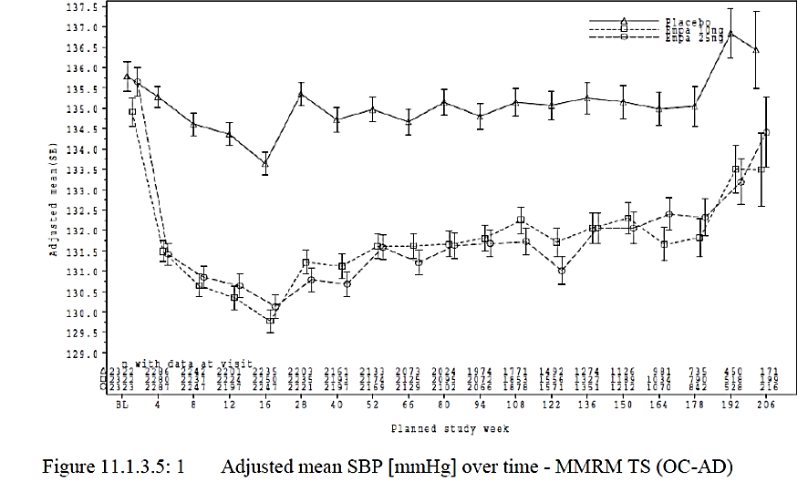
Note: MMRM (Treatment set)
Figure 7. Adjusted mean DBP (mmHg) from Baseline over time
Note: MMRM (Treatment set)

Safety
Overall, the safety profile was consistent with the known safety profile of empagliflozin and can be seen in Table 8, below.
Approximately 28% of patients in the empagliflozin and placebo arm had hypoglycaemia, 1.5% of patients had severe hypoglycaemia. The prevalence of DKA was low (< 1%).
Table 8. Summary of adverse events
There was an imbalance in the number of patients with malignancy, as shown below in Table 9. More patients treated with empagliflozin than placebo developed bladder and pancreatic cancer; however, the numbers were small (all single digits) and the imbalance is difficult to interpret because of the problem of statistical multiplicity. Bladder cancer has also been associated with dapagliflozin.
Table 9. Frequency of patients with malignancies
MedDRA = Medical Dictionary for Regulatory Activities; HLT = High level term; PT = Preferred term
An increased risk of amputations has been associated with the use of canagliflozin in long term Studies CANVAS and CANVAS-R. These studies differ from the EMPA-REG OUTCOME study in that they are of longer duration, and included patients with peripheral vascular disease.
The sponsor was requested by the evaluator to examine the risk of amputations and peripheral vascular disease in the EMPA-REG OUTCOME study. The data from amputations was limited as this was not a pre-defined safety endpoint. Data in relation to peripheral vascular disease was generated by searching a number of related terms and can be seen in Table 10, below. The table below does suggest a small imbalance in the number of new cases of peripheral arterial disease in the empagliflozin group.
Table 10. Frequency of peripheral arterial diseases adverse events
PY = Patient years
Table 11. Median values for haematology parameters (normalised values)
RBC = Red blood cell/count
Table 12. Incidence rates for adverse events of venous embolic and thrombotic adverse events (narrow SMQ), sorted by frequency
MedDRA = Medical Dictionary for Regulatory Activities; PT = Preferred term. Note exposure-adjusted rates are presented, with rate per 100 patient years (pt-yrs).

Risk Management Plan
See also Table 3 (Sponsor’s summary of ongoing safety concerns).
The sponsor has agreed to add use in Indigenous populations in the missing information in the ASA. There are no planned pharmacovigilance or risk minimisation activities in this group.
Table 13 describes the sponsor’s studies in the post-authorisation plan.
Table 13: Studies in the post-authorisation plan.

Risk-benefit analysis

Delegate’s considerations

Cardiovascular protection
Overall, the EMPA-REG study was a robust study which demonstrated a reduction of cardiovascular events with the use of empagliflozin in patients with cardiovascular risk factors and poor glycaemic control. The external validity of the trial, particularly when extended to all patients with type 2 diabetes is questionable. There were few patients with recently diagnosed T2DM, HbA1c < 7%, age < 50 years or > 75 years in the clinical trial.
The mechanism of action of empagliflozin for this indication is likely to be due to its diuretic and haemodynamic effects, rather than its glucose lowering effects.
It is questionable if the prevention of cardiovascular events is a new indication as the patient population studied were patients with T2DM and poor glycaemic control. The new indication is a subpopulation of the current population with ‘high cardiovascular risk’. The Delegate would prefer the EMA’s term ‘established cardiovascular disease’ as it better describes the patient population in the clinical trial. The same risk benefit demonstrated in the EMPA-REG OUTCOME study cannot be assumed for patients with lower cardiovascular risk.
The use of separate indications for glycaemic control and reduction in cardiovascular events would be similar to the situation with the statins which are indicated for hyperlipidaemia and cardiovascular protection.

Use in renal impairment
The efficacy of empagliflozin on glycaemic control is reduced in the presence of renal failure. However it’s efficacy for cardiovascular protection appears to be also present in the subgroup of patients with renal impairment. The kidney is involved in the elimination of empagliflozin, the extent of this is unclear but it probably contributes to about 50%.
There have been cases of acute renal impairment in the context of use of dapagliflozin and canagliflozin. In recent communication with the TGA in relation to the cases of acute renal injury with SGLT2 inhibitors, the sponsor considers that the results of the EMPA-REG study indicate that this is not a concern with empagliflozin. However the Delegate is unconvinced as in the EMPA-REG OUTCOME study, eGFR decreased in the first 4 weeks when the cases of acute renal injury were observed in the post market data for canagliflozin and dapagliflozin.
In the EMPA-REG OUTCOME study, use of empagliflozin was associated with an initial decrease in eGFR then steady preservation of renal function and reduction in progression of microalbuminuria and macroalbuminuria compared to placebo.
Overall, the risk benefit balance in renal impairment is positive but renal function needs to be monitored.

Potential safety signals
In the EMPA-REG study there has been a numerical imbalance in the number of patients with stroke, cancer and amputations. The significance of this is unclear. The safety data for amputations and peripheral vascular disease from the EMPA-REG OUTCOME study may not be entirely accurate due to the absence of specific codes and because peripheral arterial disease was an exclusion factor.
Although it is unclear if the use of empagliflozin is associated with the risk of amputations, amputations are serious events and could be mitigated by advice in the PI to remind prescribers of the need for regular foot examinations.
There have also been a number of safety signals for this class of drugs based on post-market data. These include DKA, urosepsis, and acute renal injury.,, DKA and urosepsis has been included in the PI and RMP.

Use in the Indigenous population
Indigenous Australians have high rates of diabetes and renal disease and complications due to these problems. However, they are also at high risk of infections (including chlamydia and gonorrhoea). Like many people with poor living conditions, hygiene can be suboptimal. The risk/benefit ratio in this important population is likely to be positive but subject to uncertainty.

Delegate’s summary
The evidence for the use in cardiovascular prevention is based on the EMPA-REG study. This was a large RCT initially designed and performed as a requirement of the FDA to ensure there were no cardiovascular risks, however the trial demonstrated superiority for 3-point MACE driven by reduced cardiovascular mortality, cardiovascular death and reduced heart failure.
The first area of uncertainty is the extrapolation of the results to the proposed indication which potentially includes patients with adequate glycaemic control (although in the community this may be few) and high cardiovascular risk (which is poorly defined and could potentially include patients who were excluded from the clinical trial).
The second areas of uncertainty are safety signals from EMPA-REG OUTCOME study and other safety signal with other SGLT2 inhibitors.
Until now, the SGLT2 inhibitors have been contraindicated in moderate to severe renal impairment because these patients were excluded from the pre-market clinical trials and because their efficacy for improving glycaemic control is less than in those with normal renal function (presumable due to the mechanism of action). The benefits for cardiovascular protection seem similar or greater in those with renal disease. There may be additional benefits in terms of preservation of renal function. Perhaps more caution is needed in the context of a recent safety alert for acute renal impairment for other drugs in this class.

Proposed action
The Delegate had no reason to say, at the time of writing, that the application for the extension of indications for empagliflozin should not be approved.

Request for ACPM advice
- Please comment on the proposed indication:
  - Is a new indication justified?
  - Does high cardiovascular risk need further defining (either as an indication or precaution). Is it appropriate to have patients with peripheral vascular disease and cerebrovascular disease included in the indication if there is uncertainty about safety signals in this population?
  - Can we be sure about the risk/benefit balance in patients with early onset T2DM and good glycaemic control?
- Is the imbalance in stroke significant? Does this need to be added to the RMP?
- Please comment on the appropriateness for use in renal impairment in the context of the risk of renal injury with other SGLT2 inhibitors.
- Please comment on the absence of data for Indigenous Australian’s and the TGA’s role in supporting this.
The committee is requested to provide advice on any other issues that it thinks may be relevant to a decision on whether or not to approve this application.

Response from sponsor
Presented here is the sponsor’s pre-ACPM response to the Delegate’s Request for ACPM’s Advice in relation to the application to extend the current approved Jardiance (empagliflozin) indications to include the new indication for ‘Prevention of cardiovascular events’, and to widening usage in patients with moderate renal impairment.

Sponsor’s response to pre-ACPM Question 1
- Q1a) Please comment on the proposed indication: Is a new indication justified?
As agreed on by the Delegate, it is reasonable to have a separate indication as:
- there is no clear association between glucose lowering and cardiovascular protection;
- the reduction in mortality cannot be fully explained by the improved glycaemic control;
- the reduction in risk occurred early (within 90 days) after the start of the trial.
Also mentioned by the Delegate, this would be similar to the situation with the statins (in Australian PIs) which are indicated for hyperlipidaemia and cardiovascular protection. For example, the simvastatin (Zocor) PI separates the indications ‘treatment of hypercholesterolaemia’ based on trials investigating serum lipids and ‘reducing the risk of CV events’ based on dedicated cardiovascular outcome trials. On the contrary, the only indication in the pitavastatin (Livalo) PI is for the treatment of hypercholesterolaemia, as no outcome studies were included in the pitavastatin clinical programme. Parallel to the fact that lowering of serum cholesterol is not necessarily equivalent to the reduction of cardiovascular risk, lowering of blood glucose may not be considered as a general surrogate for cardiovascular outcome improvement.
Therefore, separating glycaemic and cardiovascular indications as 2 distinct indications more objectively reflects the results of the EMPA-REG OUTCOME trial, is in line with other drug labels in Australia, and will better guide clinical practice by providing clearer information to prescribers.
As pointed out by the Delegate, ‘Cardiovascular death was the only statistically significant component of the 3-point MACE endpoint. In addition it was considered to be a reliable, non-biased and clinically relevant endpoint’.
The Delegate commented that ‘the mechanism of action of empagliflozin for this indication is likely to be due to its diuretic and haemodynamic effects, rather than its glucose lowering effects’. Furthermore, the pathophysiological concept of cardio-renal axis links together the findings from the EMPA-REG OUTCOME trial, which showed reductions in the risk of cardiovascular death, heart failure, and progression of renal disease over time.,,,,.
Therefore, to inform prescribers of the most clinically relevant and statistically robust finding in this trial, the sponsor focuses the indication statement on cardiovascular death results, with all-cause mortality results providing the context (that is, no increase in non-cardiovascular deaths) and heart failure results providing a pharmacodynamic mechanism via the cardio-renal axis.
- Q1b) Does high cardiovascular risk need further defining (either as an indication or precaution). Is it appropriate to have patients with peripheral vascular disease and cerebrovascular disease included in the indication if there is uncertainty about safety signals in this population?
The Delegate raised the concern in discussion with the sponsor that the term ‘established cardiovascular disease’ better describes the patient population in the clinical trial. The sponsor agrees to replace ‘high cardiovascular risk’ with ‘established cardiovascular disease’ in the indication statement.
The sponsor considers it appropriate to have patients with peripheral vascular disease and cerebrovascular disease included in the indication, since the trial inclusion criterion 7 specifically stated these conditions, and a large number of such patients were included in the trial (1461 patients (20.8%) with peripheral artery disease; 1637 patients (23.3%) with history of stroke). The analyses by history of stroke and by peripheral artery disease showed higher incidence rates of cardiovascular events in patients with these conditions than those without, but consistent benefits with empagliflozin treatment were seen across all subgroups (see Figure 8, below).
Figure 8. Comparison between empagliflozin versus placebo in cardiovascular death, all-cause mortality, and hospitalisation due to cardiovascular disease or heart failure
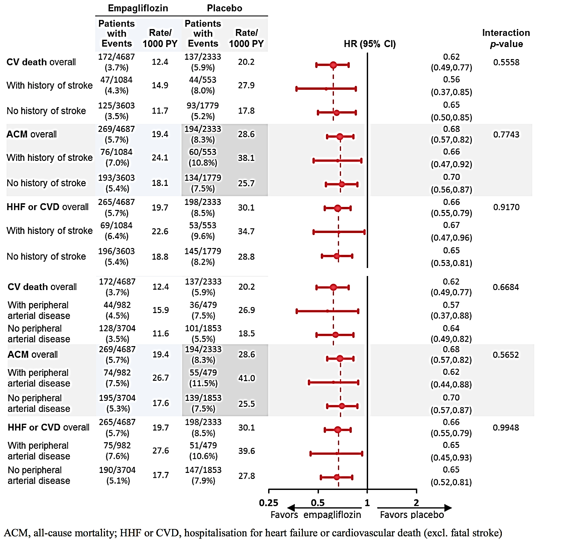
- Q1c) Can we be sure about the risk/benefit balance in patients with early onset T2DM and good glycaemic control?
Although the trial was not designed to specifically investigate patients with early onset T2DM and good glycaemic control, patients with early onset T2DM (180 patients (2.6%) ≤ 1 year and 1083 (15.4%) > 1 to 5 years since diagnosis) or good glycaemic control (424 patients (6.0%) with baseline HbA1c < 7.0%) were included in the trial. The benefits with empagliflozin were consistent regardless of these baseline characteristics (see Figures 9 and 10 below).
Figure 9. Cardiovascular death, all-cause mortality and hospitalisation with heart failure or cardiovascular death according to time since T2DM diagnosis
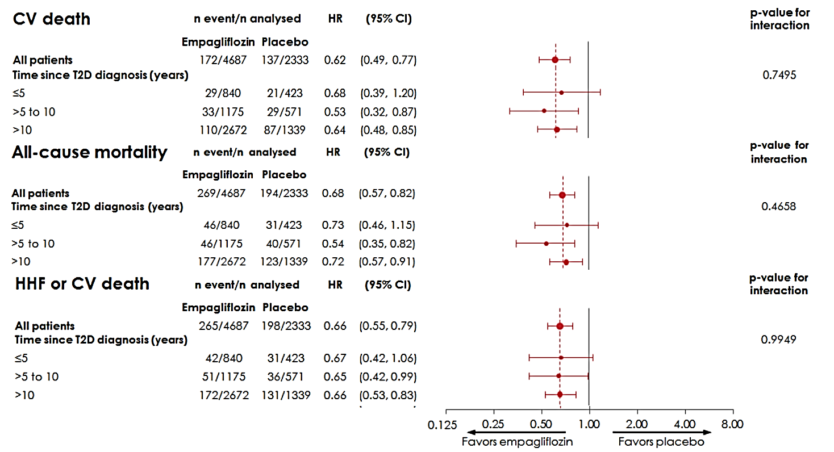
Figure 10. Cardiovascular death, all-cause mortality and hospitalisation with heart failure or cardiovascular death according to baseline glycaemic control
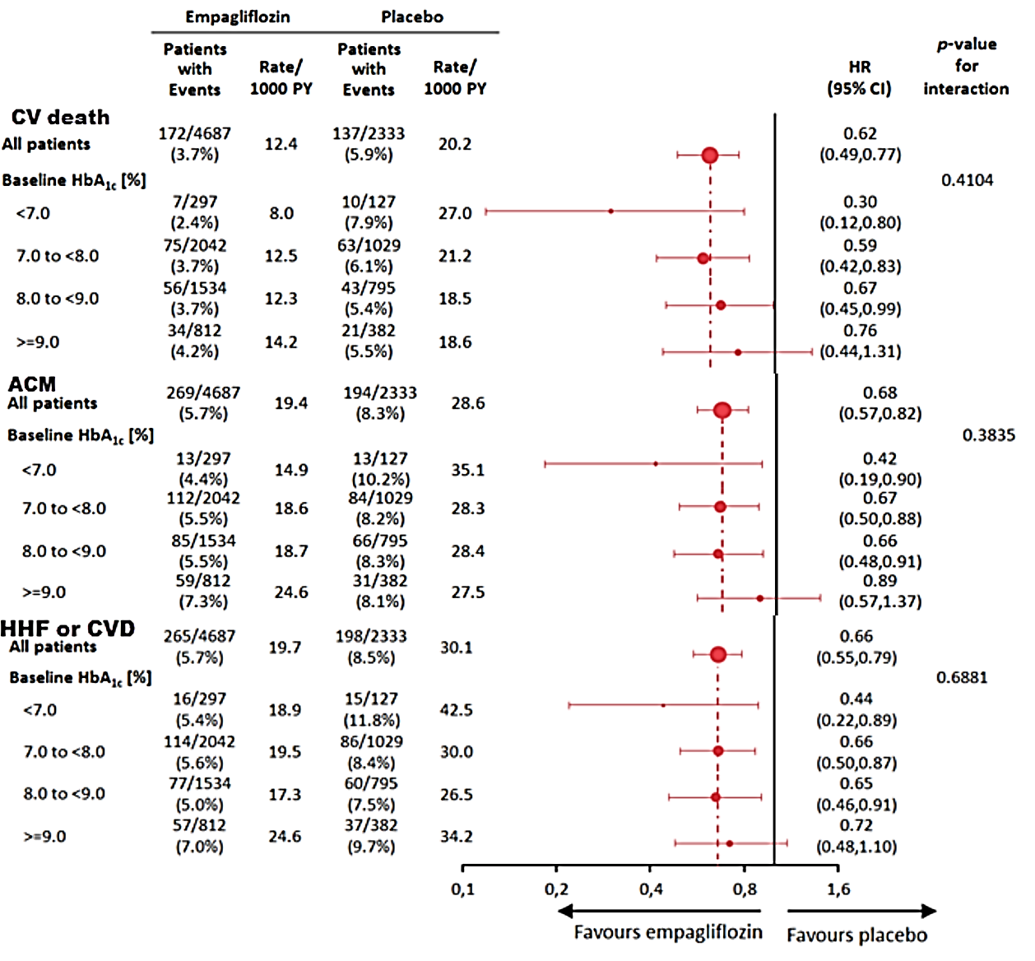

Sponsor’s response to pre-ACPM Question 2
- Q2) Is the imbalance in stroke significant? Does this need to be added to the RMP?
The data of the trial do not show a significant imbalance of stroke and do not reflect a risk that requires inclusion in the RMP. The reasons are as follows:
- The difference between empagliflozin and placebo for stroke (fatal/non-fatal) was not significant (HR = 1.18, 95% CI 0.89 to 1.56, p = 0.257).
- There was no increase in treatment-emergent strokes, as shown in the analysis of on-treatment strokes using a cut-off of 90 days for the observation period after treatment stop (see Figure 11, below).
Figure 11. Kaplan-Meier plot of the HR for treatment emergent strokes, empagliflozin versus placebo
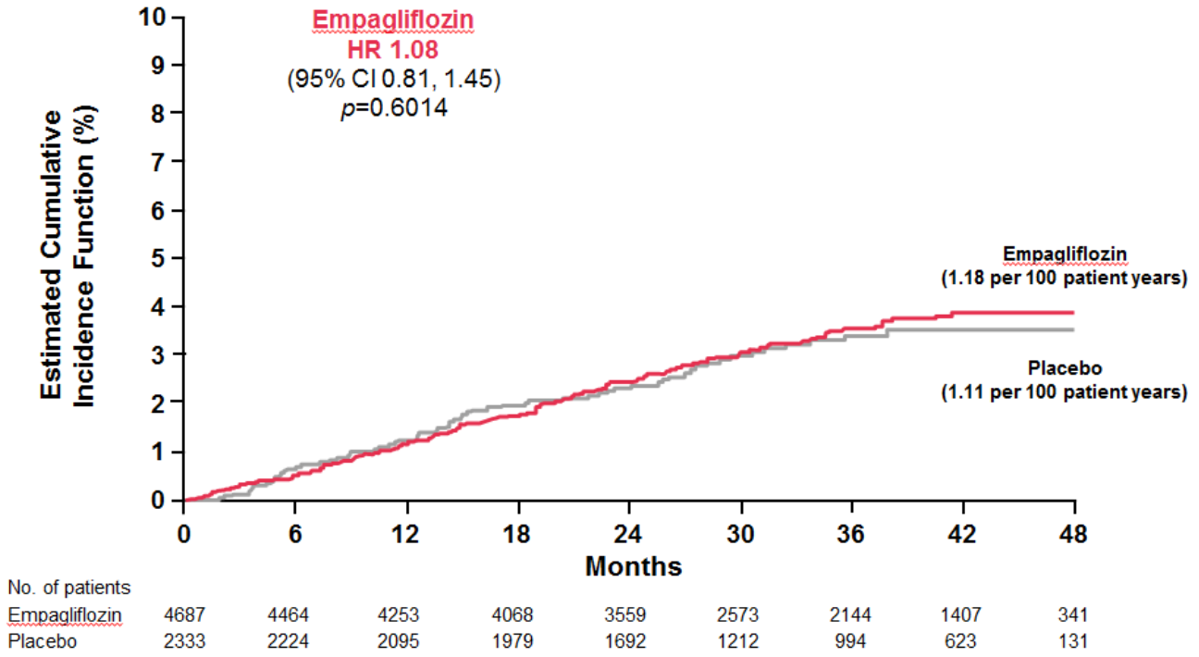
- The frequencies of recurrent strokes were low and balanced (empagliflozin 0.3%, placebo 0.3%)
- Disabling strokes (as reported by the investigators) or fatal strokes were infrequent and balanced (see the Figure 12, below)
- No significant treatment difference was observed for TIA (transient ischaemic attack), which has a similar pathophysiology as stroke (also see Figure 12, below)
Figure 12. Comparison in all stroke, fatal and non-fatal stoke and TIA for empagliflozin versus placebo
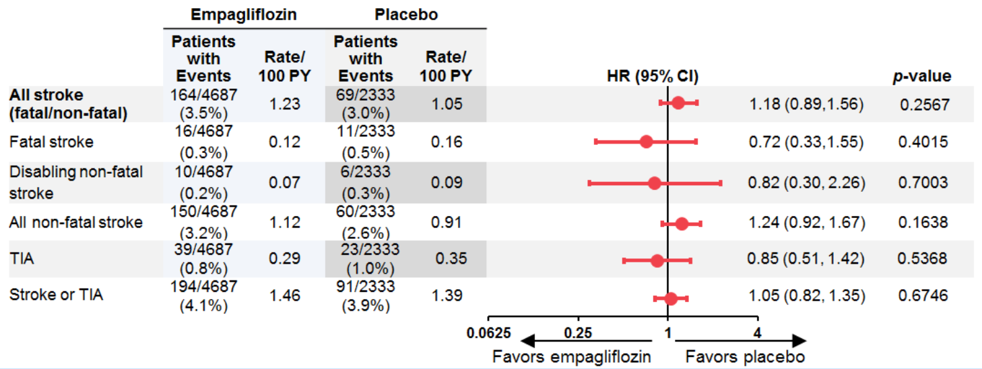
- There was no isolated imbalance of any type of stroke (based on different mechanisms) that drove the treatment difference for ischemic stroke (see Table 14, below).
Table 14. Comparison of type of stroke based on underlying mechanisms
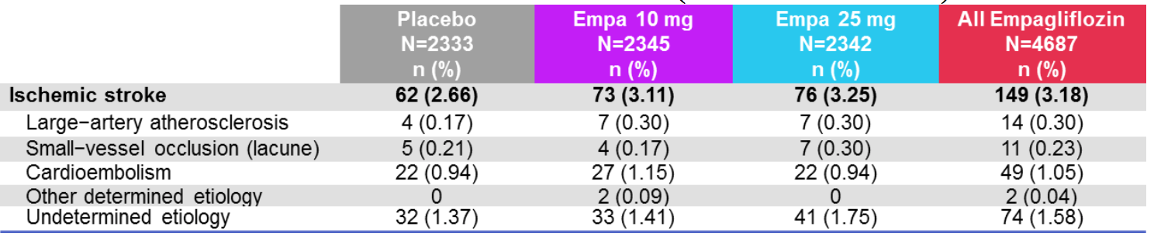

Sponsor’s response to pre-ACPM Question 3
- Q3) Please comment on the appropriateness for use in renal impairment in the context of the risk of renal injury with other SGLT2 inhibitors.
As pointed out by the Delegate, ‘patients with renal impairment seem to have similar benefits in terms of cardiovascular protection’ (also see Figure 13 below).
Figure 13. Hazard ratios for cardiovascular death, all-cause mortality and hospitalisation for heart failure or cardiovascular death according to eGFR category
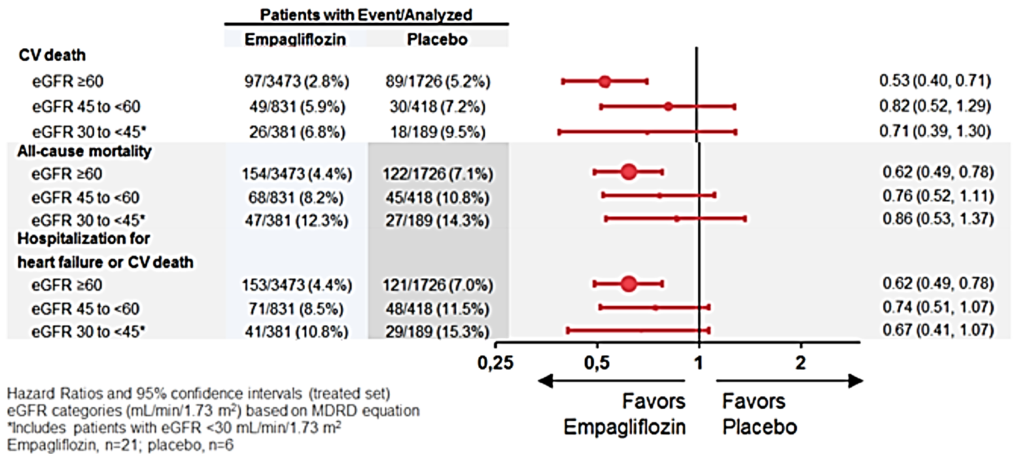
The safety profile in patients with renal impairment was similar to the overall study population. Specifically for renal safety, decreased renal function adverse events and hyperkalaemia were reported with similar or lower frequencies on empagliflozin than placebo, also in patients with renal impairment (see Figure 14 below).
Figure 14. Incidence rate ratios for decreased renal function and hyperkalaemia according to eGFR status
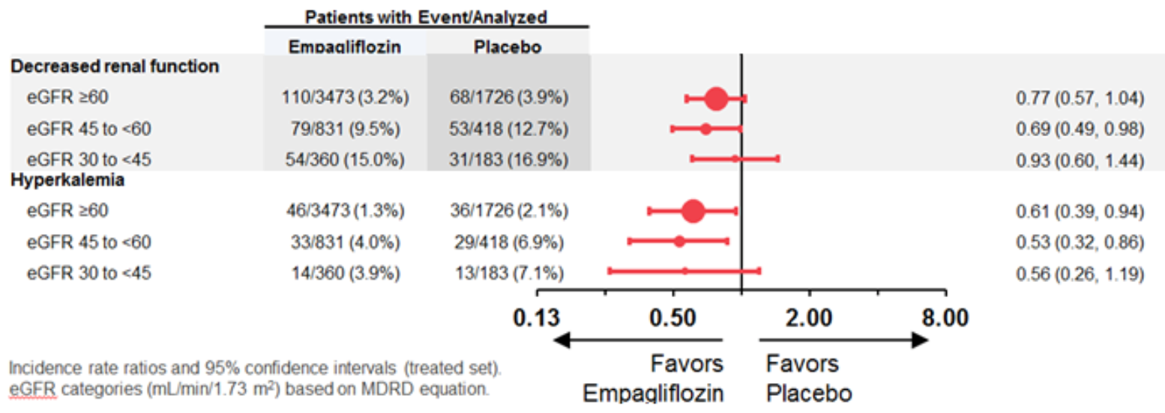
As pointed out by the Delegate, ‘the reversible early change in eGFR observed with empagliflozin is likely to be haemodynamic in nature and not a result of structural kidney damage’, a conclusion also supported by no relevant difference in the renal safety results described above. In fact, empagliflozin treatment may slow the progression of renal disease over time, as shown by the stable eGFR over time and the reversibility of eGFR after discontinuation of empagliflozin. In line with this, the benefit on the composite renal outcome ‘new or worsening nephropathy’ in patients with renal impairment (see Figure 15, below) was consistent with the overall study population (HR 0.61, 95% CI 0.53 to 0.70).
Figure 15. Hazard ratios for new onset or worsening nephropathy according to eGFR status
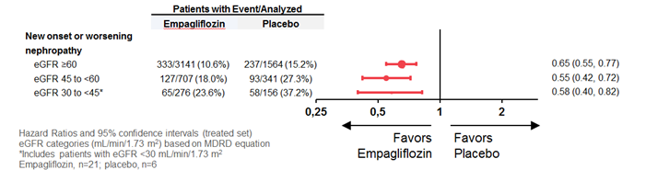
More information on renal safety was provided by the sponsor in response to TGA request for information related to the recent FDA report of acute kidney injury with dapagliflozin and canagliflozin. The sponsor has no comment on the other SGLT2 inhibitors.
These results indicate consistent benefits without increased risk with empagliflozin treatment in patients with renal impairment, compared with the overall study population. This is in agreement with the Delegate’s assessment: ‘overall, the risk benefit balance in renal impairment is positive’. Since renal impairment is considered a cardiovascular risk equivalent in international guidelines and these patients have very limited treatment options, the use of empagliflozin in these patients is appropriate and addresses an unmet medical need.

Sponsor’s response to pre-ACPM Question 4
- Q4) Please comment on the absence of data for Indigenous Australian’s and the TGA’s role in supporting this.
The sponsor has no comment.

Advisory Committee considerations
The Advisory Committee on Prescription Medicines (ACPM) resolved to recommend to the TGA delegate of the Secretary that taking into account the submitted evidence of efficacy, safety and quality, agreed with the Delegate and considered Jardiance film-coated tablets containing 10 mg and 25 mg of empagliflozin to have an overall positive benefit–risk profile for the amended indication:
‘Jardiance is indicated in patients with type 2 diabetes mellitus and established cardiovascular disease to reduce the risk of:
All-cause mortality by reducing cardiovascular death
Cardiovascular death or hospitalisation for heart failure.
To prevent cardiovascular events, Jardiance should be used in conjunction with other measures to reduce cardiovascular risk in line with the current standard of care.
In making this recommendation the ACPM:
- noted that through the EMPA-REG study (the first post-market RCT involving a drug from the SGLT-2 inhibitor class) the beneficial effects on cardiovascular endpoints were independent of their glucose lowering effects, but the patient population likely to benefit from this indication is narrower than the current indication.
- Noted that reduction in cardiovascular death as part of the 3-point MACE endpoint of the EMPA-REG study was considered to be of significant clinical benefit, and was considered to be a reliable, non-biased and clinically relevant endpoint.
- stressed that reduction of cardiovascular risk in established cardiovascular disease should be in conjunction with a range of other measures including BP management, lipid control and anti-platelet therapy where clinically indicated. The committee was satisfied by the reference to this in the final paragraph of the amended indication.
- noted that the indication for use in ‘established cardiovascular disease’ should reflect the disease inclusion criteria as per the EMPA-REG study.

Proposed conditions of registration
The ACPM agreed with the Delegate on the proposed conditions of registration and advised on the inclusion of the following:
- Inclusion of raised creatine kinase, stroke, and amputations in the RMP
- The committee strongly urged the consideration of further studies to include investigating the safety and efficacy of empagliflozin in the Aboriginal and Torres Strait Islander populations. This and similar populations were not well represented in the EMPA-REG study. The committee noted that Indigenous Australians and Torres Straight Islanders have high rates of T2DM and renal disease, with an increased rate of complications due to T2DM and/or renal disease, thus may be one population most likely to benefit from empagliflozin. At the same time, this population group are also at increased risk of urinary tract infections (UTI) and sexually transmitted infections (STI), thus further information regarding the overall risk-benefit balance is urged.

Specific Advice
The ACPM advised the following in response to the Delegate’s specific questions on this submission:
- Please comment on the proposed indication:
- Is a new indication justified?
The proposed (modified) indication is acceptable. The committee agrees that the use of empagliflozin in secondary cardiovascular event prevention should be as a part of care that may include a range of other measures including tight glycaemic control, BP regulation, lipid control and potentially anti-platelet therapy (as and when clinically indicated).
- Does high cardiovascular risk need further defining (either as an indication or precaution). Is it appropriate to have patients with peripheral vascular disease and cerebrovascular disease included in the indication if there is uncertainty about safety signals in this population?
The proposed (modified) indication with specific mention of established cardiovascular disease as opposed to high cardiovascular risk (but without established disease) is acceptable. The committee recommended that the inclusion criteria of the EMPA-REG study be detailed in the PI and referred to in the indications.
- Can we be sure about the risk/benefit balance in patients with early onset T2DM and good glycaemic control?
The cardiovascular benefit of empagliflozin in established cardiovascular disease appears to be independent of its effect on glycaemic control.
- Is the imbalance in stroke significant? Does this need to be added to the RMP?
Whilst the potential imbalance in stroke does not appear significant, the ACPM encouraged outcomes related to stroke as a safety signal that should be addressed in future periodic safety update reports.
- Please comment on the appropriateness for use in renal impairment in the context of the risk of renal injury with other SGLT-2 inhibitors.
The ACPM noted that empagliflozin (as with other drugs in its class) is associated with reduced clinical effectiveness in glycaemic control in patients with eGFRs in CKD Stage 3, particularly below < 45 mL/min/1.73 m². The committee also noted that a cardiovascular benefit appeared to be present in this population sub-group independent of glycaemic effect as well as a possible benefit in terms of steady preservation of renal function and reduction in progression of micro and macroalbuminaemia. The committee noted however that an acute short lived drop in eGFR followed treatment initiation and careful renal monitoring must be in place during and shortly after initiation of treatment. The committee recognised that DKA and urosepsis have been included in the PI, but have included several other points as mentioned above.
- Please comment on the absence of data for Indigenous Australian’s and the TGA’s role in supporting this. The committee is requested to provide advice on any other issues that it think may be relevant to a decision on whether or not to approve this application.
Whilst beyond the powers of the ACPM to make the following a condition of registration, the felt that whilst the study population was similar to the populations some localities in Australia, it was not reflective of Indigenous Australians and Torres Straight Islanders and the committee strongly urged the consideration of further studies to include investigating the safety and efficacy of empagliflozin in such populations. The committee noted that Indigenous Australians and Torres Straight Islanders have high rates of T2DM and renal disease, with an increased rate of complications due to T2DM and/or renal disease thus may be one population most likely to benefit from empagliflozin. At the same time, this population group are also at increased risk of UTI and STI, thus further information regarding the overall risk-benefit balance is urged.
The ACPM advised that implementation by the sponsor of the recommendations outlined above to the satisfaction of the TGA, in addition to the evidence of efficacy and safety provided would support the safe and effective use of these products.

Outcome
Based on a review of quality, safety and efficacy, TGA approved the registration of Jardiance empagliflozin 10 mg and 25 mg film-coated tablet blister packs indicated for:
‘Prevention of cardiovascular death
Jardiance is indicated in patients with type 2 diabetes mellitus and established cardiovascular disease to reduce the risk of cardiovascular death (see Clinical Trials)
To prevent cardiovascular deaths, Jardiance should be used in conjunction with other measures to reduce cardiovascular risk in line with the current standard of care.’
The full indications are now:
‘Glycaemic control
Jardiance is indicated in the treatment of type 2 diabetes mellitus to improve glycaemic control in adults as:
Monotherapy
When diet and exercise alone do not provide adequate glycaemic control in patients for whom use of metformin is considered inappropriate due to intolerance.
Add-on combination therapy
In combination with other glucose–lowering medicinal products including insulin, when these, together with diet and exercise, do not provide adequate glycaemic control (see Clinical Trials).
‘Prevention of cardiovascular death
Jardiance is indicated in patients with type 2 diabetes mellitus and established cardiovascular disease to reduce the risk of cardiovascular death (see Clinical Trials)
To prevent cardiovascular deaths, Jardiance should be used in conjunction with other measures to reduce cardiovascular risk in line with the current standard of care.’

Specific conditions of registration applying to these goods
The Jardiance (empagliflozin) EU Risk Management Plan (RMP), version 9.0, dated 10 May 2016 with the Australian Specific Annex, version 3.2, dated 7 December 2016, and any subsequent revisions, as agreed with the TGA will be implemented in Australia.

Attachment 1. Product Information
The PI for Jardiance approved with the submission which is described in this AusPAR is at Attachment 1. For the most recent PI, please refer to the TGA website at <https://www.tga.gov.au/product-information-pi>.

Attachment 2. Extract from the Clinical Evaluation Report

Therapeutic Goods Administration
PO Box 100 Woden ACT 2606 Australia
Email: info@tga.gov.au Phone: 1800 020 653 Fax: 02 6232 8605
https://www.tga.gov.au

Gunton J, et al. A new blood glucose management algorithm for type 2 diabetes. A position statement of the Australian Diabetes Society. MJA 201(11) 2014. 650-653.
Chamberlain J, et al. Diagnosis and Management of Diabetes: Synopsis of the 2016 American Diabetes Association Standards of Medical care in Diabetes.
Marso S, et al. Liraglutide and cardiovascular outcomes in T2DM (2016)
The Multiple Risk Factor Intervention Trial (MRFIT). A national study of primary prevention of coronary heart disease. (1976) JAMA. 235(8):825-827.
FDA granted a full waiver of the Pediatric Research Equity Act requirements for empagliflozin for reducing cardiovascular risk on 10 December 2015.
Skrtic M, Cherney DZI. Sodium-glucose cotransporter-2 inhibition and the potential for renal protection in diabetic nephropathy. Curr Opin Nephrol Hypertens 2015;24(1):96-103.
Abdul-Ghani M, et al. SGLT2 Inhibitors and Cardiovascular Risk: Lessons Learned From the EMPA-REG OUTCOME study. Diabetes Care 2016; 39: 717-725.
FDA Drug Safety Communication: FDA strengthens kidney warnings for diabetes medicines canagliflozin (Invokana, Invokamet) and dapagliflozin (Farxiga, Xigduo XR). 14 June 2016
FDA Drug Safety Communication: Interim clinical trial results find increased risk of leg and foot amputations, mostly affecting the toes, with the diabetes medicine canagliflozin (Invokana, Invokamet); FDA to investigate. 18 May 2016
FDA Drug Safety Communication: FDA revises labels of SGLT2 inhibitors for diabetes to include warnings about too much acid in the blood and serious urinary tract infections. 15 May 2015
Ronco C et al. Cardio-renal syndromes: report from the consensus conference of the Acute Dialysis Quality Initiative. Eur Heart J 2010;31(6):703
Sattar N et al. SGLT2 Inhibition and cardiovascular events: why did EMPA-REG Outcomes surprise and what were the likely mechanisms? Diabetologia, published online 25 April 2016
Viswanathan G and Gilbert S. Review Article The Cardiorenal Syndrome: Making the ConnInt J Nephrol 2011:283137
Fitchett D et al. Heart failure outcomes with empagliflozin in patients with type 2 diabetes at high cardiovascular risk: results of the EMPA-REG OUTCOME® trial. Eur Heart J 2016;37(19):1526
Wanner C et al. Empagliflozin and Progression of Kidney Disease in Type 2 DiabetesN Engl J Med 2016; 375:323-33.
KDIGO. 2012 clinical practice guideline for the evaluation and management of chronic kidney disease. Kidney Int Suppl 2013;3(1):1
Note: The committee was in agreement that ‘established cardiovascular disease’ should be reflective of the CVD inclusion criteria in the EMPA-REG study

