First round report: 3 January 2017
Second round report: 25 May 2017

AusPAR Attachment 1

Extract from the Clinical Evaluation Report for Eluxadoline
  - Proprietary Product Name: Viberzi
  - Sponsor: Allergan Australia Pty Ltd

About the Therapeutic Goods Administration (TGA)
- The Therapeutic Goods Administration (TGA) is part of the Australian Government Department of Health, and is responsible for regulating medicines and medical devices.
- The TGA administers the Therapeutic Goods Act 1989 (the Act), applying a risk management approach designed to ensure therapeutic goods supplied in Australia meet acceptable standards of quality, safety and efficacy (performance), when necessary.
- The work of the TGA is based on applying scientific and clinical expertise to decision-making, to ensure that the benefits to consumers outweigh any risks associated with the use of medicines and medical devices.
- The TGA relies on the public, healthcare professionals and industry to report problems with medicines or medical devices. TGA investigates reports received by it to determine any necessary regulatory action.
- To report a problem with a medicine or medical device, please see the information on the TGA website <https://www.tga.gov.au>.
About the Extract from the Clinical Evaluation Report
- This document provides a more detailed evaluation of the clinical findings, extracted from the Clinical Evaluation Report (CER) prepared by the TGA. This extract does not include sections from the CER regarding product documentation or post market activities.
- The words [Information redacted], where they appear in this document, indicate that confidential information has been deleted.
- For the most recent Product Information (PI), please refer to the TGA website <https://www.tga.gov.au/product-information-pi>.
Copyright
© Commonwealth of Australia 2018
This work is copyright. You may reproduce the whole or part of this work in unaltered form for your own personal use or, if you are part of an organisation, for internal use within your organisation, but only if you or your organisation do not use the reproduction for any commercial purpose and retain this copyright notice and all disclaimer notices as part of that reproduction. Apart from rights to use as permitted by the Copyright Act 1968 or allowed by this copyright notice, all other rights are reserved and you are not allowed to reproduce the whole or any part of this work in any way (electronic or otherwise) without first being given specific written permission from the Commonwealth to do so. Requests and inquiries concerning reproduction and rights are to be sent to the TGA Copyright Officer, Therapeutic Goods Administration, PO Box 100, Woden ACT 2606 or emailed to <tga.copyright@tga.gov.au>.

Contents
List of common abbreviations 5
1. Submission details 6
1.1. Identifying information 6
1.2. Submission type 6
1.3. Drug class and therapeutic indication 6
1.4. Dosage forms and strengths 6
1.5. Dosage and administration 6
2. Background 7
2.1. Information on the condition being treated 7
2.2. Current treatment options 7
2.3. Clinical rationale 7
2.4. Guidance 8
3. Contents of the clinical dossier 8
3.1. Scope of the clinical dossier 8
3.2. Justification for not providing biopharmaceutic studies 10
3.3. Paediatric data 10
3.4. Good clinical practice 10
3.5. Evaluator’s commentary on the clinical dossier 10
4. Pharmacokinetics 11
4.1. Studies providing pharmacokinetic information 11
4.2. Summary of pharmacokinetics 11
4.3. Evaluator’s overall conclusions on pharmacokinetics 15
5. Pharmacodynamics 15
5.1. Studies providing pharmacodynamic information 16
5.2. Summary of pharmacodynamics 16
5.3. Evaluator’s overall conclusions on pharmacodynamics 17
6. Dosage selection for the pivotal studies 17
7. Clinical efficacy 17
7.1. Studies providing evaluable efficacy data 17
7.2. Pivotal or main efficacy studies 18
7.3. Other efficacy studies 28
7.4. Analyses performed across trials: pooled and meta-analyses 42
7.5. Evaluator’s conclusions on clinical efficacy 46
8. Clinical safety 49
8.1. Studies providing evaluable safety data 49
8.2. Studies that assessed safety as the sole primary outcome 50
8.3. Patient exposure 50
8.1. Adverse events 52
8.2. Evaluation of issues with possible regulatory impact 58
8.3. Other safety issues 62
8.4. Post marketing experience 63
8.5. Evaluator’s overall conclusions on clinical safety 63
9. First round benefit-risk assessment 63
9.1. First round assessment of benefits 63
9.2. First round assessment of risks 64
9.3. First round assessment of benefit-risk balance 65
10. First round recommendation regarding authorisation 65
11. Clinical questions 65
11.1. Safety 65
12. First round evaluation errata 66
13. Second round evaluation 66
13.1. Question 1 66
13.2. Question 2 67
13.3. First round recommendation of unfavourable benefit-risk balance 68
14. Second round benefit-risk assessment 69
14.1. Second round assessment of benefits 69
14.2. Second round assessment of risks 70
14.3. Second round assessment of benefit-risk balance 70
15. Second round recommendation regarding authorisation 70
16. References 70

List of common abbreviations
Abbreviation | Meaning
AE | Adverse event
ARCI | Addiction Research Centre Inventory
AUC | Area under the plasma concentration versus time curve
BD | Twice daily
BSS | Bristol Stool Score The patient-reported BSS consistency score was based on a 1 to 7 scale where 1 corresponded to a hard stool and 7 corresponded to watery diarrhoea.
C_{max} | Peak plasma concentration
CMH | Cochran-Mantel-Haenszel Analysis
Fe | Fraction of dose excreted in urine
GI | Gastrointestinal
IBS-d | Irritable bowel syndrome, diarrhoea predominant
IBS-c | Irritable bowel syndrome, constipation predominant
IBS-m | Irritable bowel syndrome, mixed constipation and diarrhoea
JNJ-27018966 | Eluxadoline
LFT | Liver function test
PK | Pharmacokinetic(s)
Xu | Total amount of radioactivity excreted in urine or faeces
MOR | Mu-opioid receptor/ µ-opioid receptor
DOR | Delta-opioid receptor/ δ-opioid receptor

Submission details

Identifying information
Submission number | PM-2016-02313-1-1
Sponsor | Allergan Australia
Trade name | Viberzi
Active substance | Eluxadoline

Submission type
This was an application to register eluxadoline as a new chemical entity under the proposed trade name Viberzi.

Drug class and therapeutic indication
A locally acting mixed µ-opioid receptor (MOR) agonist/ δ-opioid receptor (DOR) antagonist with low oral bioavailability. Eluxadoline has been developed for the treatment in adults of irritable bowel syndrome with diarrhoea (IBS-d).
The mixed opioid pharmacology of eluxadoline appears to confer on it the ability to effectively improve abdominal pain and stool consistency in IBS-d patients while mitigating the risk of constipation.
The proposed Indication is:
‘Viberzi (eluxadoline) is indicated in adults for the treatment of irritable bowel syndrome with diarrhoea (IBS-d)’.

Dosage forms and strengths
The proposed film-coated tablets will contain eluxadoline 75 mg and 100 mg.

Dosage and administration

100 mg strength
The recommended dosage of Viberzi is 100 mg taken orally twice daily with food.

75 mg strength
The recommended dosage of Viberzi is 75 mg taken orally twice daily with food in patients who:
- do not have a gallbladder;
- are unable to tolerate the 100 mg dose;
- have mild (Child-Pugh Class A) or moderate (Child-Pugh Class B) hepatic impairment;
- are receiving concomitant OATP1B1 inhibitors.

Patients with renal impairment
No dose adjustment is necessary based on renal function.

Paediatric population
The safety and efficacy of eluxadoline in children aged 0 to18 years have not yet been established. No data are available.
For oral use: The tablets should be taken with food. Patients should be instructed if they miss a dose (by > 4 h) to take the next dose at the regular time and not to take 2 doses at the same time to make up for a missed dose.

Background

Information on the condition being treated
Irritable bowel syndrome (IBS) is a functional gastrointestinal (GI) disorder that is characterised by symptoms of abdominal discomfort or pain associated with altered bowel movement characteristics including chronic or recurrent: diarrhoea (IBS-d); constipation (IBS-c); a mixture of constipation and diarrhoea (IBS-m).
Abdominal pain or discomfort is common to all forms of IBS.

Current treatment options
These include low FODMAP diet, high fibre diet, laxatives, analgesics, antispasmodic agents, antidepressants, and, in patients with IBS-d, antimotility agents for diarrhoea. The sponsor states:
‘The selective serotonin 5-HT3 receptor antagonist alosetron is approved for the treatment of chronic IBS-d in the United States, but only for women with severe IBS-d and under restricted distribution due to safety concerns.
While the locally acting µOR agonist loperamide is effective in treating diarrhoea, it has limited effectiveness in IBS-d due to lack of effect on abdominal pain and global symptoms and the possibility for constipation’.
Comment: The sponsor has submitted no comparative study with either treatment.

Clinical rationale
Pharmacological agents with mixed MOR agonism/DOR antagonism possess increased analgesic potency with different GI effects as compared to pure MOR agonists. The low bioavailability of eluxadoline may reduce systemic side effects as well as the potential for abuse and dependence.
In vitro, eluxadoline reduces contractility of intestinal tissue and inhibits neurogenically mediated secretion. In vivo, eluxadoline reduces GI transit and faecal output in stressed and non-stressed mice over a wide dose-range without fully inhibiting GI transit.
Comment: The sponsor here argues for this being a different class from loperamide being both MOR agonist and DOR antagonist however in relation to treatment related adverse events (AE) the sponsor only considers selected AEs based on known class effects of MOR agonists and opioids.

Guidance
- CPMP/EWP/785/97 Rev. 1 Guideline on the evaluation of medicinal products for the treatment of irritable bowel syndrome. Effective: 25 May 2015.
- 15.3 Medicines that do not require Biopharmaceutic Data ‘We do not require biopharmaceutic data or a justification for not providing this data. Note: A study or justification may be required if there is doubt as to whether absorption occurs’. pp. 127-132 of Rules 1998 (3C) - 3CC6a Clinical Investigation of Medicinal Products for Long-Term Use Replaces: pp. 163 - 165 of Rules 1989.
- CHMP/ICH/2/04 ICH Topic E 14 Note for Guidance on Clinical Evaluation of QT/QTc Interval Prolongation and Proarrhythmic Potential for Non-Antiarrhythmic Drugs.
- Note for Guidance on Clinical Evaluation of QT/QTc Interval Prolongation and Proarrhythmic Potential for Non-Antiarrhythmic Drugs.
- CPMP/EWP/560/95/Rev. 1 Corr.* Guideline on the Investigation of Drug Interactions Replaces: CPMP/EWP/560/95 (Adopted by TGA 19 April 2001), and EMEA/CHMP/EWP/297931/2008 Concept Paper on this topic.
- CPMP/EWP/908/99 Points to Consider on Multiplicity Issues in Clinical Trials.
- CPMP/ICH/363/96 ICH Topic E9 Note for Guidance on Statistical Principles for Clinical Trials.
- CPMP/EWP/2339/02 Guideline on the Evaluation of the Pharmacokinetics of Medicinal Products in Patients with Impaired Hepatic Function.

Contents of the clinical dossier

Scope of the clinical dossier
The submission contained the following clinical information:
- Bioavailability Study Reports:
  - Study CPS-1009: A Phase I, open label, single dose crossover study to determine the effects of a high-fat meal on the pharmacokinetics of eluxadoline in healthy normal volunteers.
  - Study EDl-1002: An open label, randomised study to compare the pharmacokinetic profiles of eluxadoline in the fed state after the high fat/high calorie breakfast versus the fasted state following the oral administration of a single 500 mg dose in tablet form to healthy adult subjects.
- Metabolism:
  - Study FK6533: In vivo metabolism of eluxadoline in humans.
  - Study FK5826: In vitro metabolism of eluxadoline in cryopreserved rat, dog, monkey and human hepatocytes.
- Healthy subject pharmacokinetic and initial tolerability Study Reports:
  - Study EDl-1001: A double blind, placebo controlled, randomised, single and multiple ascending dose study to investigate the safety, tolerability and pharmacokinetics of eluxadoline.
  - Study EDl-1003: A single centre study to evaluate the mass balance and metabolic disposition of eluxadoline in healthy male subjects.
- Intrinsic factor pharmacokinetic Study Reports:
  - Study CPS-1005: An open label evaluation of the single dose pharmacokinetics of eluxadoline in subjects with and without hepatic impairment (study-meta-anal-intrins): meta-analysis of pooled Phase I pharmacokinetics by intrinsic factors: gender, age, race, and BMI.
- Extrinsic factor pharmacokinetic Study Reports:
  - Study CPS-1007: An open label study to evaluate the pharmacokinetics and pharmacodynamics of an oral contraceptive containing norethindrone and ethinyl estradiol when co-administered with eluxadoline in healthy adult female subjects.
  - Study CPS-1011: A Phase I, open label, single dose crossover study to determine the effects of cyclosporine and probenecid on the pharmacokinetics of eluxadoline in healthy normal volunteers.
  - Study CPS-1012: An open label, crossover study to determine the effects of multiple doses of eluxadoline on the pharmacokinetics of a single dose of rosuvastatin in healthy normal volunteers.
- Drug interactions in vitro:
  - Study FK5731: The potential effects of eluxadoline in the induction of CYP1A2, CYP2C9, CYP2C19 and CYP3A4 cryopreserved human hepatocytes.
  - Study FK5873: An in vitro study of the potential of eluxadoline to inhibit CYP1A2, CYP2A6, CYP2B6, CYP2C9, CYP2C19, CYP2D6 CYP2E1 and CYP3A4.
- Reports of human pharmacodynamic studies:
  - Healthy subject pharmacodynamic and pharmacokinetic/pharmacodynamic Study Reports.
  - Study CPS-1006: A randomised, double blind, placebo and active controlled study to evaluate the relative abuse potential and safety of orally administered eluxadoline in non-dependent recreational opioid users.
  - Study CPS-1008: A randomised, evaluator blinded, placebo and positive controlled 4 period crossover study to evaluate the effect of single, oral doses of eluxadoline on cardiac repolarisation in healthy male and female adult subjects.
  - Study CPS-1010: A randomised, blinded, placebo and active controlled study to evaluate the relative abuse potential and safety of intra-nasally administered eluxadoline in non-dependent recreational opioid users.
- Reports of efficacy and safety studies:
  - Study Reports of controlled clinical studies pertinent to the claimed indication
  - Study IBS-2001: A randomised, double blind, placebo controlled, parallel group, dose-ranging, multicentre study to evaluate the efficacy, safety, and tolerability of eluxadoline in the treatment of patients with irritable bowel syndrome with diarrhoea.
  - Study IBS-3001: A Randomised, double blind, placebo controlled, Phase III study to evaluate the efficacy safely, and tolerability of eluxadoline in the treatment of patients with diarrhoea-predominant irritable bowel syndrome.
  - Study IBS-3002. A Randomised, double blind, placebo controlled Phase III study to evaluate the efficacy safety, and tolerability of eluxadoline in the treatment in patients with diarrhoea-predominant irritable bowel syndrome.
- Reports of analyses of data from more than one study:
  - Hepatobiliary and pancreatitis Adjudication Committee Summary of Findings
  - Integrated Summary of Efficacy
  - Integrated Summary of Safety
- Meta-analysis of pooled Phase I eluxadoline adverse events by mean systemic exposure
- Literature References

Justification for not providing biopharmaceutic studies
Since an intravenous formulation was not developed for use in humans, a formal absolute bioavailability study in humans has not been performed; however, the results from the radiolabelled absorption, distribution, metabolism, and excretion Study EDI-1003 and predictions from human pharmacokinetic (PK) studies, using a human systemic clearance value estimated by allometric PK scaling, are consistent and indicate poor oral bioavailability in humans, which is favourable for a locally acting GI drug. The poor oral bioavailability is primarily due to poor GI permeability, but is also due to moderate hepatic first pass extraction.

Paediatric data
The EMA Paediatric Committee agreed to grant a waiver for paediatric population from birth to less than 6 years as well as a deferral for paediatric population above 6 years.
The FDA in addition to the two clinical studies approved in the Paediatric Investigation Plan, requested an open label extension safety study.

Good clinical practice
All clinical trials were conducted in compliance with Good Clinical Practice (GCP).

Evaluator’s commentary on the clinical dossier
In the Declaration of Compliance with Pre-submission Planning Form and Planning Letter where a Table of Contents was specifically asked for the sponsor has claimed to have done so; however, this could not be found in the submission.

Pharmacokinetics

Studies providing pharmacokinetic information
Table 1: Submitted pharmacokinetic studies
PK topic | Subtopic | Study ID | *
PK in healthy adults | General PK (Single dose) | CPS-1009
PK in healthy adults | General PK (Single dose) | EDl-1002
PK in healthy adults | General PK (Single dose) | EDl-1001
PK in healthy adults | General PK (Multi-dose) | EDl-1001 | *
PK in healthy adults | Mass Balance Study | EDl-1003 | *
PK in healthy adults | Food effect | CPS-1009 | *
PK in healthy adults |  | EDl-1002 | *
PK in special populations | Target population § (Multi-dose) | IBS2001
PK in special populations | Hepatic impairment | CPS-1005 | *
PK in special populations | Abuse potential | CPS-1006 | *
Genetic/gender related PK | Males versus females | EDl-1001
PK interactions | Norethindrone and ethinyl estradiol | CPS-1007 | *
PK interactions | Cyclosporine | CPS-1011 | *
PK interactions | Probenecid | CPS-1011 | *
PK interactions | Rosuvastatin | CPS-1012 | *
Population PK analyses | Healthy subjects: gender, age, race, BMI | meta-anal-intrins | *
Population PK analyses | Target population | IBS-2001
* Indicates the primary PK aim of the study; § Subjects who would be eligible to receive the drug if approved for the proposed indication.

Summary of pharmacokinetics

Physicochemical characteristics of the active substance
The lowest measured solubility of eluxadoline was at least 3 mg/mL at approximately pH 4.5, and it is therefore, classified as highly soluble. Based on in vitro (cell and membrane) studies, eluxadoline has low absorption potential and did not have a significant efflux potential.
Eluxadoline is a polar molecule that can exist as positively or negatively charged species or as zwitterion, depending on the prevalent pH.
Eluxadoline is bound to plasma proteins (81% in human pooled plasma samples) with no concentration-dependent changes.

Pharmacokinetics in healthy subjects

Absorption
The mass balance Study EDI-1003 showed limited absorption occurred. In faeces, 82.21% (range 49.70% to 104.63%) of the administered dose was recovered after 336 h. Individual data indicated that approximately 90% or more of the administered dose was recovered in 4 of 8 subjects. In one subject only 50% was recovered. Following oral administration of 300 mg ¹⁴C the cumulative amount of radioactivity excreted in faeces was approximately 250 mg Eq. The cumulative amount of radioactivity excreted in urine was less than 1mg Eq eluxadoline. On average, 0.12% (0.00% to 0.42%) of the administered dose was recovered in urine after 192 h. From the food based Study CPS1009, the median T_{max} value was 1.5 h (range: 1 to 8 h) under fed conditions and 2 h (range: 0.5 to 6 h) under fasting.

Bioavailability

Absolute bioavailability
There were no absolute bioavailability studies.

Bioequivalence of clinical trial and market formulations
There were no relative bioavailability studies for the different formulations.

Influence of food
The results for Study CPS 1009 (treatment single dose 100 mg eluxadoline) show after a high fat meal, a decrease of 65% in mean AUC_{0-inf} and 60% in LSM AUC_{0-inf} while mean C_{max} decreased by 59% and LSM C_{max} by 51%. In Study CPS-1009 median T_{max} fasted was 2 h (range 0.5 to 6 h), fed was 1.5 h (range 1 to 8 h).

Dose proportionality
The original Study EDI-1001 Clinical Study Report said a plot of dose versus exposure parameters (C_{max} and AUC) did not demonstrate a clear relationship and the correlation coefficient was quite poor in the dose range of 100 to 500 mg both for C_{max} and AUC. However, a post hoc analysis stated that non-linear kinetics was suggested for C_{max} based on the R² from a regression model and no dose proportionality testing was done for total exposure (AUC). This reanalysis claimed that both peak (C_{max}) and total (AUC₂₄) exposure were linear across the dose range tested.

Bioavailability during multiple-dosing (original Study EDI-1001)
The original Study EDI-1001 Clinical Study Report said minimal accumulation was seen, C_{max} and AUC_{12h} values were lower on Day 7 compared with Day 1. The post hoc analysis stated that the initial report claimed steady state conditions were not attained, but no analysis was performed; thus, this conclusion was based on visual inspection.
The reanalysis claimed that steady state conditions were reached for all doses tested and while C_{max} values were markedly lower on Day 7 as compared to Day 1, the results indicated that AUC_{12h} was unchanged with repeat dosing.

Distribution

Volume of distribution
From Study CPS-1009 V/F was 38025.65 L (CV = 83.4).

Metabolism
However, the rate of metabolism/intrinsic metabolic clearance was very slow (4 h incubation in 10 mcM eluxadoline resulted in M11 formation at 1% of the parent).
Unchanged drug was the only drug-related component identified in the systemic circulation and accounted for 100% of total drug-derived materials in pooled 0.25 to 8 h plasma samples. In urine, unchanged drug accounted for 94% and 78% of total drug-derived materials in pooled 0 to 8 h and 8 to 24 h samples, respectively. M11 (the acyl glucuronide) accounted for 6% and 22% of total drug-derived materials in pooled 0 to 8 h and 8 to 24 h urine samples, respectively. Thus, the M11 metabolite accounts for < 0.1% of the total dose given.

Consequences of genetic polymorphism
OATP1B1-genotyping of patients with sparse PK samples from Study IBS2001; suggests a gene-dose-response relationship in median exposures. Based on visual inspection of the medians of the post-hoc AUC results summarized by haplotype there was a gene-dose response relationship that would be expected mechanistically, that is, poor function haplotype median exposures being 2 to 3 fold higher than normal/intermediate function haplotypes. However, there was large inter-patient variability across all groups and exceedingly small sample size of the poor function haplotype (n = 1 or 2 per arm); thus, no statistically significant differences emerged. These exposure differences trend in the same direction as co-administration of cyclosporine in Study CPS-1011 (approximately 4 to 6 fold elevations); supporting the hypothesis that OATP1B1-inhibition is the main mechanism of interaction between cyclosporine and eluxadoline.

Excretion

Routes and mechanisms of excretion
The percentage of dose recovered in the urine as unchanged drug was very low (< 0.14%). This could be due to poor absorption of eluxadoline or limited renal elimination (metabolism and/or non-renal excretion may be the major route of elimination). The renal clearance of unchanged drug was about 10 L/h. However, these data should be interpreted with caution, as the 24 h collection interval may not have been sufficient to capture the entire urine concentration time profile.

Intra and inter individual variability of pharmacokinetics
In most studies, the between subject variability observed in the PK parameters was quite large. Low F_{oral} is likely as a major source of between-subject variability in eluxadoline exposures.

Pharmacokinetics in the target population
Separate data were not submitted. There was a PopPK study that evaluated PK data from Study 2001 but it included data from 2 studies in healthy volunteers.

Pharmacokinetics in special populations

Pharmacokinetics in subjects with impaired hepatic function
Study CPS-1005 showed there were increased peak and total exposures of eluxadoline in subjects with impaired hepatic function following oral administration of a single 100 mg dose of eluxadoline. Mean concentrations in the hepatic impairment cohorts were higher than in the normal hepatic function cohort. Subjects with severe hepatic impairment had higher mean plasma concentrations compared with the other cohorts. From Study 1005 following a single oral 100 mg dose in subjects with varying degrees of liver impairment and healthy subjects, mean eluxadoline plasma exposure was 6 fold, 4 fold, and 16 fold higher in mild, moderate, and severe hepatically impaired subjects (Child-Pugh Class A, B, C), respectively, compared to the subjects with normal liver function.

Pharmacokinetics in subjects with impaired renal function
‘Based on the low oral bioavailability of eluxadoline and limited renal elimination, a renal impairment study was not conducted’.
After oral administration, only approximately 0.12% of the total dose is excreted via urine in mass balance Study EDl-1003.

Pharmacokinetics with other population characteristics

Meta-analysis of pooled Phase I PK studies by intrinsic factors: gender, age, race, and BMI
The PK parameters were determined after a single 100 mg dose of eluxadoline given to fasted healthy subjects from Studies 1005, 1008, 1009 and 1011. The observed variability of PK parameters for all the intrinsic factors listed above was quite large with a substantial overlap of the data ranges. No meaningful differences in the PK parameters among any of the intrinsic factors were apparent.
Comment: Age was stratified by < 40 years and ≥ 40 years and also by < 25 years and ≥ 25 years. It should be noted that there were few elderly subjects in these studies and full PK data on only 31 subjects aged ≥ 40 years were included in these pooled results compared with 75 subjects aged < 40 years.

Population pharmacokinetics

PopPK analysis Study IBS-2001
This was a population pharmacokinetic-pharmacodynamic modelling report.

Pharmacokinetic interactions

Brevicon (oral contraceptive)
Study CPS-1007 confirmed there is no clinically meaningful drug interaction between eluxadoline and Brevicon.

Cyclosporine and Probenecid
Study CPS-1011 demonstrated that co-administration of cyclosporine elevates plasma levels of eluxadoline, supporting the conclusions that eluxadoline is an in vivo substrate of OATP1B1, and that OATP1B1 plays a major role in the oral absorption (hepatic first-pass extraction) and excretion (biliary clearance) of eluxadoline. Study CPS-1011 also demonstrated that CLr is primarily an OAT3-mediated minor (relative to biliary excretion) excretion pathway for eluxadoline.

Rosuvastatin
The sponsor proposes the following sections under ‘Interactions with other Medicines’:
OATP1B1 substrates
Eluxadoline is an inhibitor of the hepatic uptake transporter OATP1B1. Co-administration of eluxadoline with rosuvastatin (an OATP1B1 substrate) resulted in an up to 1.4 fold increase in exposure of rosuvastatin and the major active metabolite, n-desmethyl rosuvastatin compared to administration of rosuvastatin alone. No dose adjustment is necessary for co-administered OATP1B1 substrates.
Co-administration of eluxadoline results in a mild drug-interaction on rosuvastatin PKs (an approximate 1.4 fold increase in AUC) of no clinical relevance (Study CPS1012; see above).
Exposures for rosuvastatin were higher when co-administered with eluxadoline. Ratios of geometric LS means and corresponding 90% CIs of total (AUC_{0-inf} and AUC_{0-t}) and peak (C_{max}) exposures of rosuvastatin (B/A) were 1.41 (1.278 to 1.544), 1.37 (1.253 to 1.507), and 1.18 (1.037 to 1.348), respectively. There was no statistically significant difference shown in median T_{max} values.

Clinical implications of in vitro findings
Study FK5731 of the potential effects of eluxadoline in cryopreserved human hepatocytes showed no induction of CYP1A2, CYP2C9, CYP2C19, and CYP3A4.
Study FK5873 showed little ability of eluxadoline to inhibit the major human cytochrome P450 (CYP) isoenzymes CYP1A2, CYP2A6, CYP2B6, CYP2C9, CYP2C19, CYP2D6 and CYP2E1. Eluxadoline has some potential for the inactivation of human CYP3A4.

Evaluator’s overall conclusions on pharmacokinetics
The submission does not contain a full review of PKs, the sponsor justifying this based on the low oral bioavailability. Hepatic metabolism is minimal but sufficient occurs for genetic effects to be demonstrated by slow metabolisers (numbers too small for statistical significance) and hepatic impairment results in greater exposure (mean eluxadoline plasma exposure was 6 fold, 4 fold, and 16 fold higher in mild, moderate, and severe hepatically impaired subjects (Child Pugh Class A, B, C) respectively).

Pharmacodynamics
The relationship between eluxadoline’s systemic exposure and beneficial effects are not entirely clear. Eluxadoline has a very low oral bioavailability and works locally within the GI tract. Despite a suggested correlation between systemic exposure and clinical response in a post hoc PK/PD model using data from the Phase II Study IBS-2001, overall the data demonstrated no true PK/PD relationship. This is especially true when considering that increasing exposures above those achieved with 100 mg bd did not produce corresponding increases in efficacy. This further supports the hypothesis that eluxadoline's beneficial effects are mediated through local action in the GI tract.

Studies providing pharmacodynamic information
Table 2: Submitted pharmacodynamic studies
PD Topic | Subtopic | Study ID | *
Primary Pharmacology | Effect on Bowel function | EDI-1001 | *
Secondary Pharmacology | Effect on cardiac repolarisation | CPS-1008 | *
Secondary Pharmacology | Effect on pupillometry | EDI-1001
Secondary Pharmacology | Abuse potential | CPS-1006 and CPS-1010 | *
Population PD and PK-PD analyses  Target population | PK/PD Effect on Bowel function | IBS 2001
Population PD and PK-PD analyses  Target population | PK/PD Effect on pain score | IBS 2001
* Indicates the primary PD aim of the study.

Summary of pharmacodynamics

Effect on cardiac repolarisation
The primary endpoint (placebo-adjusted change of QTcI from Baseline), maximally 4.10 ms at 1 h after dosing for the 1000 mg eluxadoline treatment with a one-sided 95% upper confidence bound of 5.81 ms, did not reach the threshold for significance for QT interval prolongation. The largest mean time-matched difference in change from Baseline, from placebo for the eluxadoline 100 mg dose was 1.20 ms at 0.5 h after dosing, with a one sided 95% upper confidence bound of 2.91 ms.

Abuse potential

CPS-1006
Mean Drug Liking VAS scores for all doses of eluxadoline doses remained near neutral (50) across time points (mean scores for E_{max} ranged from 56.8 to 60.0 across all eluxadoline doses, with approximately a 24% CV). Placebo scores remained close to the neutral mark (50), showing very little change across the sampling period, with a mean E_{max} (%CV) of 54.3 (17.5).
Mean E_{max} scores for eluxadoline showed minimal increase (< 5 points) with increasing eluxadoline dose.
All 3 eluxadoline doses (100 mg, 300 mg, and 1000 mg) showed significantly lower Drug Liking VAS E_{max} values compared to both doses of Oxycodone IR (30 mg and 60 mg; P < 0.0001 for all). Significant differences were observed between the 2 higher doses of eluxadoline (300 mg and 1000 mg) and placebo (P < 0.05 for both ‘not believed to be as meaningful as alternative approaches of analysing data’).

CPS-1010
Drug Liking VAS scores following both placebo lactose and placebo eluxadoline doses remained slightly below neutral (50) across time points. Drug Liking VAS scores for both doses of eluxadoline were much lower than both doses of oxycodone and lower than both placebo doses with scores in the ‘disliking’ range (< 50) until approximately 12 h post-dose.
Eluxadoline 100 mg and 200 mg E_{max} values were similar to both placebo doses; however, mean and median E_{min} values (for example, maximum ‘disliking’) for eluxadoline 100 mg and 200 mg were markedly lower, compared to both placebo doses and oxycodone IR 15 mg and 30 mg.
Drug Liking VAS E_{max} scores were significantly lower for eluxadoline (100 mg and 200 mg) compared to oxycodone IR (15 mg and 30 mg, P < 0.0001 for all). There were no significant differences for Drug Liking VAS E_{max} between eluxadoline (100 mg and 200 mg) and either placebo dose (lactose and eluxadoline 200 mg).

Evaluator’s overall conclusions on pharmacodynamics
The sponsor attempted to show a separate relationship between PKs and pain score or bowel function (Bristol Stool Score (BSS)), but failed to do so. Only in a post hoc analysis of both combined could a relationship to AUC be shown.
The sponsor proposes to insert under the Pharmacodynamics section in the PI only statements on the mechanism of action; those statements being derived from animal and in vitro studies.

Dosage selection for the pivotal studies
Study IBS-2001 (see below) a 12 week, double blind, placebo controlled, dose ranging, Phase II study showed no improvement in response seen between 100 and 200 mg doses and had a higher incidence of adverse events seen at the 200 mg dose. This led to the decision to use the 100 mg dose as the maximum clinically relevant dose.
Although the efficacy of 75 mg bd was not specifically explored in the Phase II study, this dose was included based on efficacy trends and the favourable safety profile of doses up to 100 mg bd.

Clinical efficacy

Studies providing evaluable efficacy data
- Study IBS-3001: A randomised, double blind, placebo controlled, Phase III study to evaluate the efficacy safely, and tolerability of eluxadoline in the treatment of patients with diarrhoea-predominant irritable bowel syndrome.
- Study IB5-3002: a randomised, double blind, placebo controlled Phase III study to evaluate the efficacy safety, and tolerability of eluxadoline in the treatment in patients with diarrhoea-predominant irritable bowel syndrome.
- Study IBS-2001: A randomised, double blind, placebo controlled, parallel group, dose ranging, multicentre study to evaluate the efficacy, safety, and tolerability of eluxadoline in the treatment of patients with irritable bowel syndrome with diarrhoea.

Pivotal or main efficacy studies

Study IBS-3001
‘A randomised, double blind, placebo controlled, Phase III study to evaluate the efficacy, safety, and tolerability of eluxadoline in the treatment of patients with diarrhoea-predominant irritable bowel syndrome(IBS-d).’

Study design, objectives, locations and dates
- This was a randomised, double blind, placebo controlled, parallel group, multicentre study to evaluate the efficacy and safety of orally eluxadoline in patients with IBS-d.
- Conducted in 295 sites in the US, Canada, and the UK between 29 May 2012 and July 2014.
- The study consisted of a pre-treatment period (consisting of an up to 1 week pre-screening period and an up to 3 week screening period), a 52 week double blind treatment period, and a 2 week post-treatment follow-up period.
The primary objectives were:
- To evaluate the clinical response of patients with diarrhoea predominant irritable bowel syndrome (IBS-d) to eluxadoline, relative to placebo.
- To evaluate the overall safety and tolerability of eluxadoline in the treatment of IBS-d for up to 52 weeks.
The secondary objective of was to further evaluate the treatment effect of eluxadoline relative to placebo based on patient reports of IBS-d symptoms (abdominal pain, abdominal discomfort, abdominal bloating, stool consistency, global symptom scores, adequate relief), bowel functioning, and quality of life.

Protocol changes
There were considerable changes in the protocol during the conduct of the trial, these were said to be mostly the result of direction from EMA and FDA.
The most major changes were in Amendment 4, dated 04 December 2013:
- The composite responder status over 26 weeks became the primary efficacy endpoint rather than the previous co-primary endpoints of pain responder status and global symptom responder status.
- Extraction of data would occur once all patients had completed at least 26 weeks of treatment and at least 100 patients had completed 52 weeks of treatment, rather than the previous extraction of efficacy data conducted once all patients completed 12 weeks of treatment and an additional extraction of efficacy and safety data when 100 patients completed 52 weeks of treatment.
Amendment 1, dated 4 June 2012; included extension of the duration of electronic diary collection and notifications from 12 weeks to 26 weeks and added daily assessment of abdominal discomfort to electronic diary collection.

Inclusion criteria
Included:
- Patients 18 to 80 years of age.
- With a diagnosis of IBS with a subtype of diarrhoea by the Rome III criteria.
- With screening and baseline criteria for:
  - Pain (average of daily worst abdominal pain scores > 3.0 [scale 0-10] in the week prior to randomisation);
  - Stool consistency (average BSS score of ≥ 5.5 (scale 1 to 7) and at least 5 days with a BSS score ≥ 5 the week prior to randomisation); and
  - IBS-d global symptoms (IBS-d score ≥ 2.0 (scale 0to 4) the week prior to randomisation).
- Had had a colonoscopy performed:
  - if patient was at least 50 years of age; or
    - Had documented weight loss within the past 6 months;
    - Had nocturnal symptoms;
    - Had a familial history of first-degree relatives with colon cancer;
    - Had blood mixed with their stool.
- Had not used any loperamide rescue medication within 14 days prior to randomisation.

Exclusion criteria
Included:
- A diagnosis of IBS with a subtype of constipation, mixed IBS, or unsubtyped IBS by the Rome III criteria;
- A history of inflammatory or immune-mediated gastrointestinal (GI) disorders;
- Had a history of intestinal obstruction, stricture, toxic megacolon, gastrointestinal perforation, faecal impaction, gastric banding, bariatric surgery, adhesions, ischemic colitis, or impaired intestinal circulation;
- Patients with a prior or concomitant condition that may interfere with study treatments or evaluations (including cholecystitis within the last 6 months, pancreatitis, biliary duct disease, sphincter of Oddi dysfunction, elevated serum lipase > 2 ULN, laxative abuse and clinically significant hepatic disease) were excluded.

Study treatments
All medications were taken orally with food. Patients were randomly assigned to 1 of 3 treatment groups:
- 100 mg eluxadoline bd
- 75 mg eluxadoline bd
- Placebo bd
Patients took study drug for 52 weeks.
During the first 12 weeks of the double blind treatment phase of the study, patients were allowed to take loperamide rescue medication for the acute treatment of uncontrolled diarrhoea.
Loperamide at a unit dose of 2mg could be taken once approximately every 6 h with the following guidelines:
- No more than 4 unit doses over a continuous 24 h time period (8 mg/day);
- No more than 7 unit doses over a continuous 48 h time period (14 mg over 2 days);
- No more than 11 unit doses over a continuous 7 day time period.
Excessive use of loperamide rescue medication could be a cause for study discontinuation but was not considered a protocol violation.

Efficacy variables and outcomes
The primary efficacy endpoint was the composite responder proportion (evaluated over the initial 12 weeks of double-blind treatment for the FDA and over the initial 26 weeks of treatment for the EMA).
Responder rates were compared based on patients who met the daily composite response criteria (pain and stool consistency) for at least 50% of the days with diary entries from Weeks 1 to 12 and Weeks 1 to 26. Responder rates were not determined after Week 26.
A patient must have met both of the following criteria on any given day to be a daily responder:
- Daily pain response: worst abdominal pain scores in the past 24 h improved by ≥ 30% compared to baseline pain (average of week prior to randomisation)
- Daily stool consistency response: BSS score < 5 or the absence of a bowel movement if accompanied by ≥ 30% improvement in worst abdominal pain compared to baseline.
To be a composite responder, a patient must have had, in addition, a minimum of 60 days of diary entries over Weeks 1 to 12 and a minimum of 110 days of diary entries over Weeks 1 to 26.

Secondary endpoints
Pain responders were patients who met the daily pain response criterion (as described above for composite response) for at least 50% of the days over each interval and, in addition, must have had a minimum of 60 days of diary entries over Weeks 1 to 12 and a minimum of 110 days of diary entries over Weeks 1 to 26.
A stool consistency responder was a patient who met the stool consistency response criteria (as described above for composite response) for at least 50% of the days over each interval and, in addition, must have had a minimum of 60 days of diary entries over Weeks 1 to 12 and a minimum of 110 days of diary entries over Weeks 1 to 26.
Other responder endpoints:
- IBS-d global symptom responders
- IBS-QoL responders
- IBS-AR responders.
A responder was defined as a patient who met the response criteria for at least 50% of the days (or weeks for IBS-AR) over each interval. Patients who achieved at least a 14 point improvement in IBS-QoL total score from baseline to the visit were IBS-QoL responders.
Other symptoms:
- Other abdominal symptoms: abdominal bloating and abdominal discomfort.
- Other bowel symptoms: frequency of bowel movements, urgency, and incontinence.

Randomisation and blinding methods
Patients were randomised in a 1:1:1 ratio with the overall randomisation stratified by country.

Analysis populations
Table 3: Analysis sets (Enrolled set)
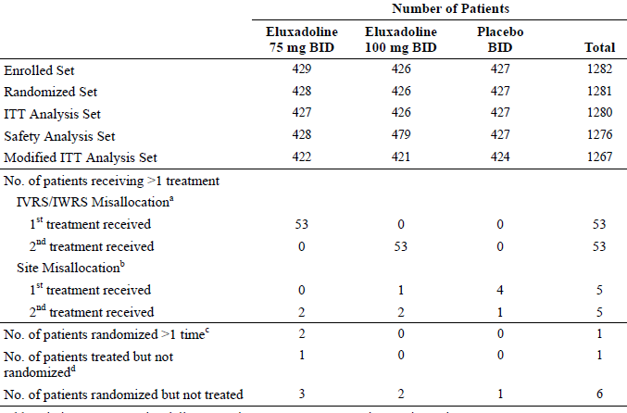
IVRS = interactive voice response system; IWRS = interactive web response system. a) For details of IVRS/IWRS misallocation refer to protocol deviations. ^{b} Site misallocations occurred when a site dispensed an incorrect kit. ^{c} A single individual was randomised twice into the study and assigned 2 patient IDs the data for [information redacted] is included in the ITT analysis set and data from [information redacted] is excluded from the ITT analysis set. All available data was included in the safety analysis set. ^{d} Patient [information redacted] received eluxadoline 75 mg bd, but was never randomised.

Sample size
Approximately 375 patients per treatment group were planned for enrolment. Assuming a placebo responder proportion for the primary efficacy endpoint of 14% and a 10% treatment effect over placebo for any active group, 375 patients yields approximately 90% power for a 2 sided CMH test at an α level of 0.025. The α-level of 0.025 was assumed to account for the multiplicity of testing both active treatments versus placebo. Should the placebo responder proportion rise as high as 20% and a 10% treatment effect be observed, the current study would yield > 80% power.

Statistical methods
Treatment effect was assessed via pair-wise, 2-sided Cochran-Mantel-Haenszel (CMH) tests for active treatments (75 mg bd or 100 mg bd eluxadoline) versus placebo for composite responders (Weeks 1 to 12 and Weeks 1 to 26). To account for 2 active treatment groups, multiplicity of hypothesis tests for the primary endpoints was controlled for by employing the Bonferroni procedure, thereby maintaining the family-wise α-level. The primary analysis was of the ITT population.
As supportive analyses, the proportion of composite responders was also evaluated using a logistic regression model (Weeks 1 to 12 and 1 to 26) and longitudinal analysis of daily responses was performed.
As a secondary analysis, composite response was evaluated over the intervals of Weeks 1 to 4, 5 to 8, 9 to 12, 13 to 16, 17 to 20, and 21 to 24 using the same CMH analysis (ITT and MITT). Supportive analyses of composite responders by interval were also evaluated using logistic regression models. Sensitivity analyses were performed on the composite responder endpoint using a worst case scenario, using 2 weekly responder definitions, and using a subset of patients with no dose interruptions.
The same analyses performed for the composite endpoint were also performed for secondary responder endpoints.
The primary analysis based on a CMH analysis does not account for baseline covariates. The supportive logistic regression and longitudinal models have appropriate baseline covariate adjustments included.
The primary endpoint automatically includes adjustments for dropouts and missing data, hence no additional adjustments to the analyses were necessary.

Patient flow
Table 4: Disposition (Enrolled set)
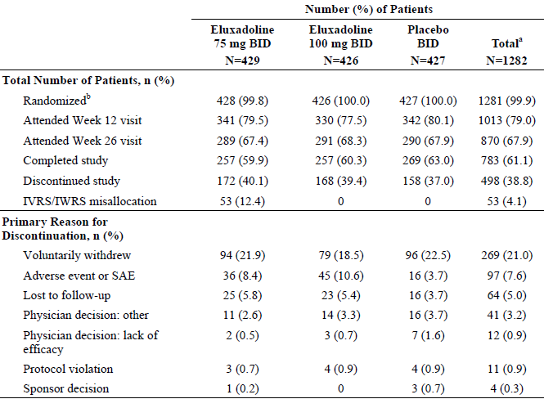
IVRS = interactive voice response system; IWRS = interactive web response system; a) the total number of patients enrolled includes patients who were randomised or who received at least one dose of study drug; b) One patient received study drug but was never randomised ([information redacted]). For one patient that was inadvertently randomised and was never dispensed investigational product, data not available for final disposition ([information redacted]).

Major protocol violations/deviations
There were multiple protocol violations and 11 (0.9%) patients discontinued the study due to a protocol violation.
Of the entrance criteria violations these were not thought to have influenced the efficacy evaluation of the study.
There were 58 patients randomised to the 75 mg treatment arm were dispensed the wrong treatment kits at the Week 18 visit because of an error in the system used. 10 patients took the incorrect study drug for 50 to 59 days and 17 patients took the incorrect study drug for ≥ 60 to < 132 days.
5 patients received the incorrect treatment for 28 to 69 days due to dispensation errors by site personnel.
Some staff members at one site were making patient diary entries into the system on their patient’s behalf using the patient’s personal ID number that is, the site staff knew the patient’s daily symptom scores.

Baseline data
Table 5: Demographic characteristics (Enrolled set)
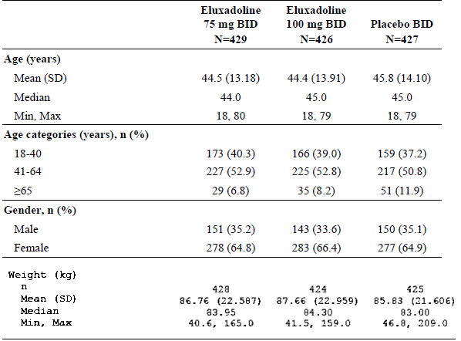
Table 6: Baseline IBS characteristics (Enrolled set)
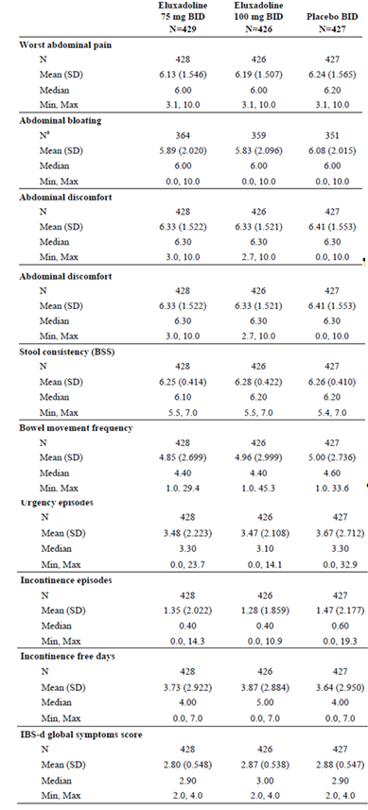
a) The abdominal bloating question was not available on the Spanish language electronic diary. 3 Baseline is defined as the mean value of the last 7 days prior to Day 1, except for incontinence free days, which is the total count over the 7 days prior to Day 1 IBS-d = diarrhoea-predominant irritable bowel syndrome.

Results for the primary efficacy outcome
While both the 75 and 100 mg groups showed statistically superiority to placebo in the percentage of composite responders at 12 weeks, only the 100 mg dose did so at 26 weeks.
Table 7: Cochran-Mantel-Haenszel analysis of composite responders (Daily response criteria; ITT set)
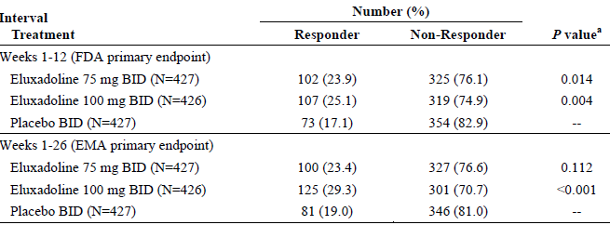
a) P value is based on Chi-square test statistic. The Bonferroni adjustment was applied to the composite responder analysis over Weeks 1 to 12 (primary FDA endpoint) and Weeks 1 to 26 (primary EMA endpoint) to preserve the family-wise error rate and hence each active group versus placebo comparison was assessed at the 0.025 significance level. Composite responder = patient who met the daily pain response AND the daily stool consistency response criteria on at least 50% of days during the interval; and for the 12 week interval had a minimum of 60 days of diary data from Weeks 1 to 12 or for the 26 week interval had a minimum of 110 days of diary data from Weeks 1 to 26. Daily pain response = worst abdominal pain scores in the past 24 h improved by ≥ 30% compared to baseline pain Daily stool consistency response = BSS score < 5, or a diary entry reporting the absence of a bowel movement if accompanied by ≥30% improvement in worst abdominal pain compared to baseline pain BSS = Bristol Stool Scale.

Results for other efficacy outcomes
There was an initial early response to all treatments and by the end of the first week eluxadoline showed greater improvement than placebo. The improvement with all treatments continued up to about 12 weeks when the least difference from placebo was shown, the difference increasing again out to 26 weeks from slightly more improvement with eluxadoline.
Comment: Absolute differences in composite responder rates for eluxadoline versus placebo at 12 weeks were 6.8% for 75 mg and 8% for 100 mg, while at 26 weeks they were 4.4% and 10.3% respectively.
Figure 1: Line plot of percentage of daily composite responders versus days (ITT set)
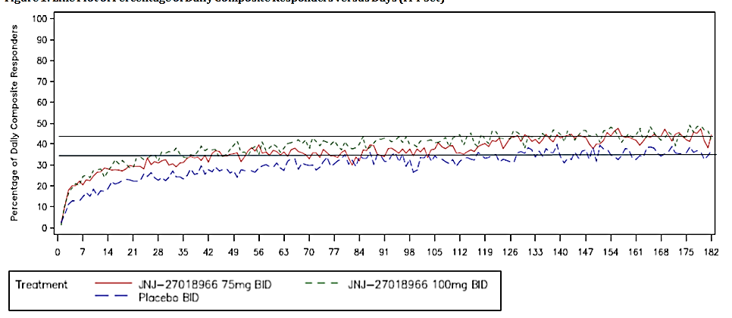
The lines have no significance but were inserted by this evaluator parallel to the axis to assist in visual interpretation.
Table 8: Cochran Mantel-Haenszel analysis of composite responders by interval (Daily response criteria; ITT set)
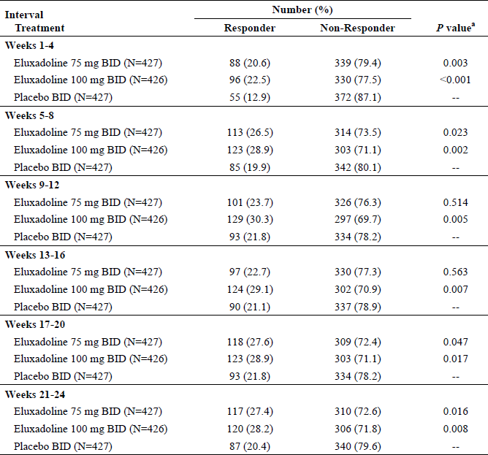
a) P value is based on Chi-square test statistic. Composite responder = patient who met the daily pain response and the daily stool consistency response criteria on at least 50% of days during the interval and had a minimum of 20 days of diary data for the 4 week interval. Daily pain response = worst abdominal pain score in the past 24 h improved by ≥ 30% compared to baseline pain. Daily stool consistency response = BSS score < 5, or a diary entry reporting the absence of a bowel movement if accompanied by ≥ 30% improvement in worst abdominal pain compared to baseline pain BSS = Bristol Stool Scale.
The proportion of pain responders was about 40% in all treatment groups including placebo. For the 75 mg and 100 mg treatment groups, it was higher than placebo over the 3 month interval (Weeks 1 to 12) and the 6 month interval (Weeks 1 to 26); however, these differences were not statistically significant (P value ranged from 0.284 to 0.582).
Table 9: Cochran Mantel-Haenszel analysis of pain responders (Daily response criterion; ITT set)
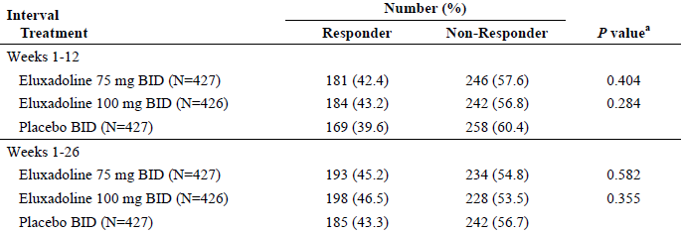
ª P value is based on Chi-square test. Pain responder = a patient who met the daily pain response criterion on at least 50% of days during the interval and for the 12 week interval had a minimum of 60 days of diary data from Weeks 1 to 12 OR for the 26 week interval had a minimum of 110 days of diary data from Weeks 1 to 26. Daily pain response = worst abdominal pain score in the past 24 h improved by ≥30% compared to baseline pain
The proportion of stool consistency responders for the 100 mg treatment group was significantly superior to that of placebo over the 3 month interval (Weeks 1 to 12, 34.3 versus 22.0, P < 0.001) and the 6 month interval (Weeks 1 to 26, 34.0 versus 24.1, P = 0.001) and was significantly higher than placebo for the 75 mg treatment group over the 3 month interval.
Comment: For the proposed dose of eluxadoline of 100 mg bd, there were 9.9% more study participants reporting stool response according to the BSS response criteria during the 26 weeks of efficacy assessment. For the placebo/75 mg eluxadoline comparison the between treatment difference in stool responder rates was 4% over the same time period.
Table 10: Cochran-Mantel-Haenszel analysis of stool consistency responders (daily response criterion; ITT set)
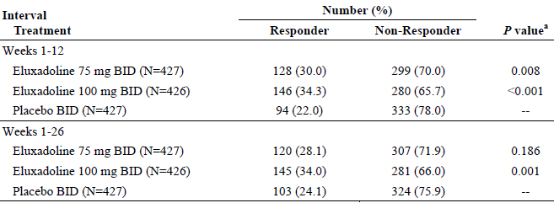
a) P value is based on Chi-square test. Stool consistency responder = a patient who met the daily stool consistency response criterion on at least 50% of days during the interval and for the 12 week interval had a minimum of 60 days of diary data from Weeks 1 to 12; or for the 26 week interval had a minimum of 110 days of diary data from Weeks 1 to 26. Daily stool consistency response = BSS score < 5, or a diary entry reporting the absence of a bowel movement if accompanied by ≥ 30% improvement in worst abdominal pain compared to baseline pain.
Table 11: Cochran-Mantel-Haenszel Analysis of IBS-d Global Symptom Responders (Daily Response Criterion; ITT Set)
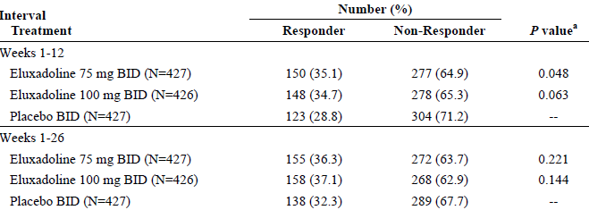
IBS-d = diarrhoea-predominant irritable bowel syndrome; a P value is based on Chi-square test. IBS-d global symptom responder = a patient who met the daily IBS-d global symptom response criterion on at least 50% of days during the interval and for the 12 week interval had a minimum of 60 days of diary data from Weeks 1 to 12; or for the 26 week interval had a minimum of 110 days of diary data from Weeks 1 to 26. Daily IBS-d global symptom response = IBS-d global symptom score of 0 (none) or 1 (mild); or a daily IBD-d global symptom score improved by ≥ 2.0 compared to the baseline average.
There was no statistical difference in global symptom response over either the first 12 weeks or the whole 26 weeks for the proposed dose of eluxadoline. This should be specifically stated rather than just presented with no interpretation in a table as above.
The proportion of patients with adequate relief of their IBS symptoms (assessed once weekly by patients) for the 100 mg treatment group was statistically superior (P ≤ 0.005) to placebo over the 3 month interval (Weeks 1 to 12) and the 6 month interval (Weeks 1 to 26). For the 75 mg treatment group, the proportion of IBS-AR responders was statistically superior (P = 0.008) to placebo over the 3 month interval (Weeks 1 to 12), but not the 6 month interval (Weeks 1 to 26).
The Cochran-Mantel-Haenszel analysis of IBS Quality of Life responders, for the 100 mg group, the proportion of IBS-QoL was significantly higher than placebo only at Weeks 4 and 8.

Evaluator commentary
While both the 75 and 100 mg groups showed statistically superiority to placebo in the percentage of composite responders at 12 weeks, only the 100 mg dose did so at 26 weeks.
During the first 3 weeks of treatment, use of loperamide for diarrhoea was uncommon and averaged < 1 unit dose per week for both eluxadoline treatment groups as well as placebo. From Weeks 4 to 26, the average unit doses used per week were even lower.
The significant pain response requires a 2 unit change down from the median of 6 and 3 units from the upper limit of 10; this is consistent with Initiative on Methods, Measurement, and Pain Assessment in Clinical Trials (IMMPACT). This differs from the significant change in acute pain (1.3). The sponsor undertook several different analyses of pain scores some achieving a statistically significant effect.
The patient enrolment criteria for both pain and stool consistency allowed inclusion of patients with relatively mild disease and thus limited potential to meet the requirements for the primary efficacy endpoint. The results for secondary outcomes suggest that where superiority in the composite primary endpoint is shown it is from a modest improvement in BSS rather than pain score.
The primary results for other secondary outcomes are generally supportive; it is noted that the IMMPACT statement in relation to chronic pain recommends (as well as assessment of pain scores) the assessment of:
- usage of rescue analgesics;
- physical functioning;
- emotional functioning; and
- participant ratings of global improvement and satisfaction with treatment.

Other efficacy studies

Study IBS-3002

Study design, objectives, locations and dates
Similar in duration, population and countries to Study 3001, this study was conducted at 295 sites. However, this study did not include 26 weeks of safety assessment after the efficacy assessments were concluded as occurred in Study 3001.
The objectives were the same except for the duration of safety assessment. The study consisted of a pre-treatment period (consisting of an up to 1 week pre-screening period and an up to 3 week screening period), a 26 week double-blind treatment period, and a 4 week single blinded withdrawal period. There was no blinded withdrawal period in Study 3001.

Inclusion and exclusion criteria
Similar to Study 3001.

Study treatments
Similar to Study 3001.

Efficacy variables and outcomes
Similar to Study 3001.

Randomisation and blinding methods
Similar to Study 3001.

Analysis populations
Table 12: Analysis sets (Enrolled set)
IVRS = interactive voice response system; IWRS = interactive web response system; a) For details of IVRS misallocation refer to protocol deviations; b) site misallocations occurred when a site dispensed an incorrect kit; c) a single individual was randomised twice into the study, the data for [identifier redacted] are included in the ITT analysis set and data from [the same subject, identifier redacted] are excluded from the ITT analysis set. All available data are included in the Safety analysis set. Site misallocation occurred when a site dispensed an incorrect kit.

Sample size
Similar to Study 3001.

Statistical methods
Similar to Study 3001.

Participant flow
Table 13: Disposition (Enrolled set)
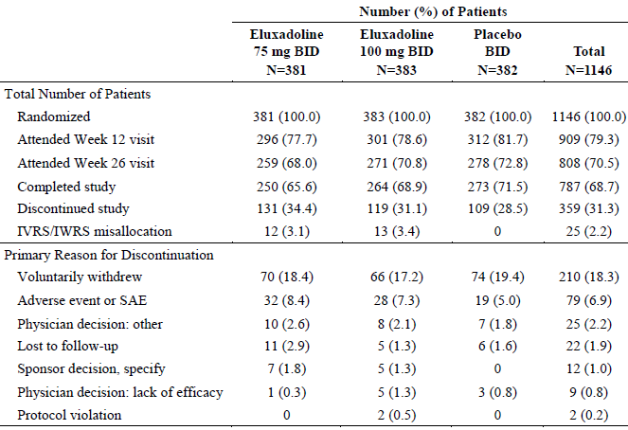
IVRS = interactive voice response system; IWRS = interactive web response system; For the Enrolled Set, data are presented for patients based on their randomisation.

Major protocol violations/deviations
There were multiple protocol violations similar to Study 3001, and 2 (0.2%) patients discontinued the study due to a protocol violation.

Baseline data
Table 14: Demographic characteristics (Enrolled set)
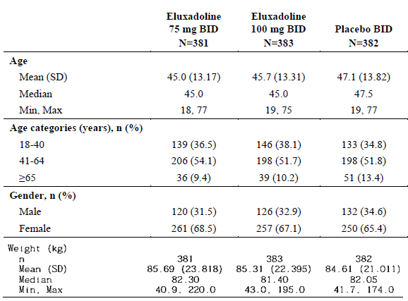
Table 15: Baseline IBS characteristics (Enrolled set)
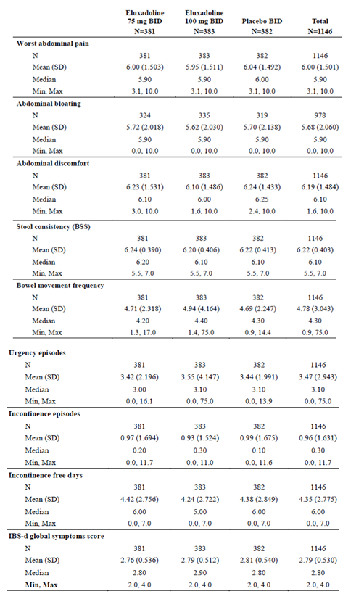
BSS = Bristol Stool Scale; IBS-d = diarrhoea-predominant irritable bowel syndrome. Baseline is defined as the mean value of the last 7 days prior to Day 1, except for incontinence free days which is the total count in the 7 days prior to Day 1. Abdominal bloating question is not available on the Spanish language electronic diary.

Results for the primary efficacy outcome
The proportion of composite responders for the 75 mg and 100 mg treatment groups was statistically superior to placebo for Weeks 1 to 12 (P < 0.001) and Weeks 1 to 26 (P ≤ 0.001).
Table 16: Cochran-Mantel-Haenszel; analysis of composite responders (Daily response criteria; ITT set)
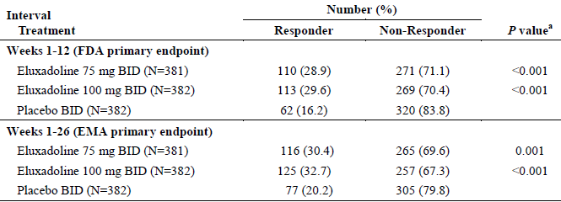
a) P value is based on Chi-square test statistic. The Bonferroni adjustment was applied to the composite responder analysis over Weeks 1 to 12 (primary FDA endpoint) and Weeks 1 to 26 (primary EMA endpoint) to preserve the family-wise error rate and hence each active group versus placebo comparison was assessed at the 0.025 significance level. Composite responder = patient who met the daily pain response; and the daily stool consistency response criteria on at least 50% of days during the interval; and for the 12 week interval had a minimum of 60 days of diary data from Weeks 1 to 12; or for the 26 week interval had a minimum of 110 days of diary data from Weeks 1 to 26. Daily pain response = worst abdominal pain scores in the past 24 h improved by ≥ 30% compared to baseline pain. Daily stool consistency response = BSS score < 5, or a diary entry reporting the absence of a bowel movement if accompanied by ≥ 30% improvement in worst abdominal pain compared to baseline pain BSS = Bristol Stool Scale.

Results for other efficacy outcomes
There was an initial early response to all treatments and by the end of the first week eluxadoline showed greater improvement than placebo. The improvement with all treatments continued up to about 12 weeks.
Comment: Absolute differences in composite responder rates for eluxadoline versus placebo at 12 weeks were 12.7% for 75 mg and 13.4% for 100 mg, while at 26 weeks they were 10.2% and 12.5% respectively.
Figure 2: Line plot of percentage of daily composite responders (ITT set)
Note: The lines have no significance but were inserted by this evaluator parallel to the axis to assist in visual interpretation.
Table 17: Cochran-Mantel-Haenszel analysis of composite responders by interval (Daily response criteria; ITT set)
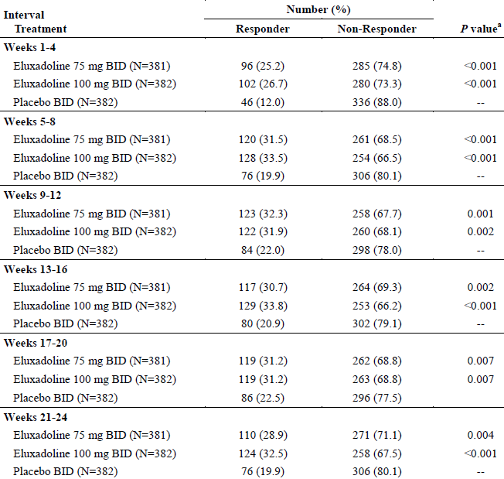
a) P value is based on Chi-square test statistic BSS = Bristol Stool Scale; Composite responder = patient who met the daily pain response; and the daily stool consistency response criteria on at least 50% of days during the interval and had a minimum of 20 days of diary data for the 4 week interval, Daily pain response = worst abdominal pain score in the past 24 h improved by ≥ 30% compared to baseline pain, Daily stool consistency response = BSS score < 5, or a diary entry reporting the absence of a bowel movement if accompanied by ≥ 30% improvement in worst abdominal pain compared to Baseline.
Table 18: Cochran-Mantel-Haenszel analysis of pain responders (Daily response criterion; ITT Set)
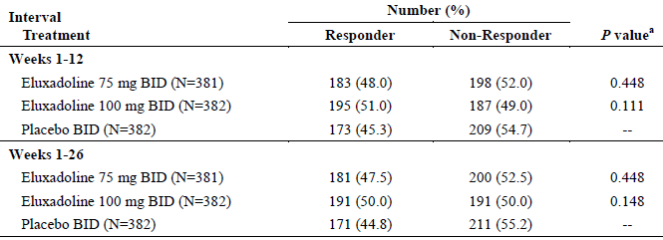
a) P value is based on Chi-square test Pain responder = a patient who met the daily pain response criterion on at least 50% of days during the interval and for the 12 week interval had a minimum of 60 days of diary data from Weeks 1 to 12; or for the 26 week interval had a minimum of 110 days of diary data from Weeks 1 to 26. Daily pain response = worst abdominal pain score in the past 24 h improved by ≥ 30% compared to baseline pain.
Table 19: Cochran-Mantel-Haenszel analysis of stool consistency responders (Daily response criterion; ITT set)
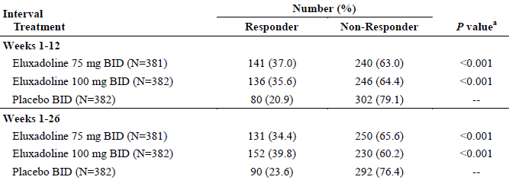
BSS = Bristol Stool Scale; a) P value is based on Chi-square test. Stool consistency responder = a patient who met the daily stool consistency response criterion on at least 50% of days during the interval and for the 12 week interval had a minimum of 60 days of diary data from Weeks 1 to 12; or for the 26 week interval had a minimum of 110 days of diary data from Weeks 1 to 26. Daily stool consistency response = BSS score < 5, or a diary entry reporting the absence of a bowel movement if accompanied by ≥ 30% improvement in worst abdominal pain compared to baseline pain.
Table 20: Cochran-Mantel-Haenszel Analysis of IBS-d global symptom responders (Daily response criterion; ITT set)
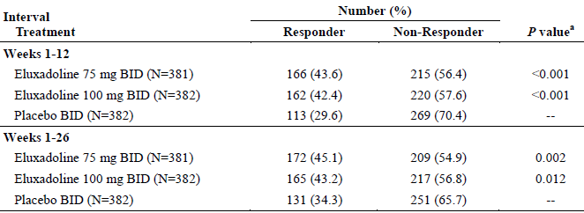
IBS-d = diarrhoea-predominant irritable bowel syndrome; a) P value is based on Chi-square test. IBS-d global symptom responder = a patient who met the daily IBS-d global symptom response criterion on at least 50% of days during the interval and for the 12 week interval had a minimum of 60 days of diary data from Weeks 1 to 12; or for the 26 week interval had a minimum of 110 days of diary data from Weeks 1 to 26. Daily IBS-d global symptom response = IBS-d global symptom score of 0 (none) or 1 (mild); or a daily IBD-d global symptom score improved by ≥ 2.0 compared to the baseline average.
The proportion of patients with adequate relief of their IBS symptoms for the 75 mg and 100 mg treatment groups was statistically superior (P ≤ 0.013) to that of placebo over the 3 month interval (Weeks 1 to 12) and the 6 month interval (Weeks 1 to 26).
Using the Cochran-Mantel-Haenszel analysis for both the 75 mg and the 100 mg treatment groups, the proportion of IBS-QoL total score responders was higher than placebo at each week evaluated; however, none of the differences were statistically significant.

Blinded withdrawal
After Week 26 (that is, during the 4 week blinded withdrawal period), the average daily pain scores remained consistently lower for the eluxadoline groups than placebo for each week. The average daily pain scores at Weeks 27, 28, 29, and 30 were all lower than the Baseline scores.
After Week 26 (that is, during the 4 week blinded withdrawal period), the average daily stool consistency scores remained consistently lower for the eluxadoline groups than placebo at each week. The average daily BSS scores at Weeks 27, 28, 29, and 30 were all lower than the Baseline score.
After Week 26 (that is, during the 4 week blinded withdrawal period), the average daily IBS-d global symptom scores remained consistently lower for the eluxadoline groups than placebo at each week. The average daily global symptom scores at Weeks 27, 28, 29, and 30 were all lower than the baseline scores.
Figure 3: Changes in daily abdominal pain and stool consistency scores upon cessation of double blind treatment (Study IBS-3002)
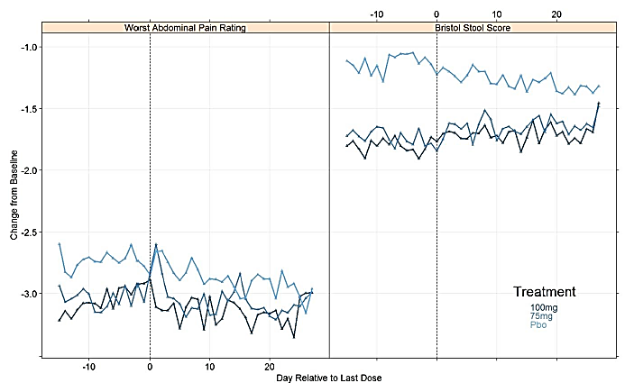

Evaluator commentary
The primary endpoint, the proportion of composite responders for the 75 mg and 100 mg treatment groups, was statistically superior to placebo for Weeks 1 to 12 (P < 0.001) and Weeks 1 to 26 (P ≤ 0.001).
During the first week, the average total unit doses of loperamide rescue medication used were 0.7, 1.0, and 1.2 doses in the 75 mg, 100 mg, and placebo groups, respectively. From Week 2 through Week 26 the use of loperamide for diarrhoea was uncommon and averaged < 1 unit dose per week for both eluxadoline treatment groups as well as placebo.
During the 4 week blinded withdrawal period (Week 26 to Week 30), the use of loperamide averaged < 1 unit dose per week for both eluxadoline treatment groups as well as placebo.
As with Study 3001, the patient enrolment criteria for both pain and stool consistency allowed inclusion of patients with relatively mild disease and thus limited potential to meet the requirements for the primary efficacy endpoint. The results for secondary outcomes suggest that where superiority in the composite primary endpoint is shown it is from a modest improvement in BSS rather than pain score.

Study IBS-2001

Study design, objectives, locations and dates
A Phase II, randomised, double blind, placebo controlled, parallel group, dose ranging, multicentre study to evaluate the efficacy, safety, tolerability, and pharmacokinetics of orally administered eluxadoline in patients with IBS-d.
The study was conducted at 208 sites in the US between April 2010 and July 2011.
The primary objectives were:
- To evaluate the clinical response relative to placebo of different doses of eluxadoline in patients with irritable bowel syndrome with diarrhoea
- To evaluate the overall safety and tolerability of eluxadoline in the treatment of IBS-d.
The secondary objectives were:
- To evaluate the treatment effect of eluxadoline relative to placebo based on pain, stool consistency, and frequency; and
- To assess the effect of covariates such as body weight, age, sex, concomitant medications, disease severity, and ethnicity on the PK characteristics to characterise the pharmacokinetic (PK) profile of eluxadoline.
Protocol amendments:
- Protocol Amendment 3, dated 6 January 2011, modified the eligibility criteria to exclude patients who may have had a predisposition toward opioid-induced pancreatitis, following 4 SAEs of pancreatitis, each of which resolved rapidly and was without serious sequelae.

Inclusion and exclusion criteria
Similar to Study 3001.

Study treatments
Up to 850 patients were planned for randomisation (in a 1:1:1:1:1 ratio) to 1 of 5 treatment Groups:
- Group 1: eluxadoline oral tablets at a dose of 5 mg twice daily
- Group 2: eluxadoline oral tablets at a dose of 25 mg twice daily
- Group 3: eluxadoline oral tablets at a dose of 100 mg twice daily
- Group 4: eluxadoline oral tablets at a dose of 200 mg twice daily
- Group 5: matching placebo oral tablets twice daily.
An interim analysis was planned when approximately 425 patients (85 per treatment group) had completed at least 4 weeks of treatment. Using the results of the interim analysis, a decision was to be made to either continue with all 5 treatment groups, deselect up to 3 active treatment groups, or discontinue the study. The following were to be considered in making the decision:
- A significant safety concern in the active treatment group(s).
- Tolerability, as assessed by the rate of clinically important GI related AEs (for example, constipation, abdominal pain, abdominal discomfort) experienced in the active treatment group(s) compared with placebo.
- Efficacy trending, as evaluated by the dose-response curves for average of daily pain scores and stool consistency scores.
- Other administrative or business considerations.
Upon completion of the planned interim analysis, the 5 mg bd eluxadoline treatment group was deselected (for business reasons).
The identity and specific reasons for deselecting of the 5 mg arm was kept blinded to the investigators and operational staff directly involved in the conduct of the trial until after final database lock.
Randomisation continued only in the remaining treatment groups until a cumulative sample size of approximately 170 patients was achieved in each of the remaining treatment groups.
Additionally, all patients were supplied with a certain amount of single-blind loperamide placebo rescue medication (28 count unit doses (white capsules) in bottles) during the first 4 weeks of treatment. After the first 4 weeks of treatment through the end of the study, all patients were given single blind loperamide (blister card containing 12 unit doses (white caplets)).

Rescue treatments
During the up to 3 week screening period, no rescue medications for diarrhoea, pain, or constipation were allowed.
During the treatment phase of the study, patients were allowed to take rescue medication to treat diarrhoea, pain, or constipation.
Rescue medication for diarrhoea were:
- Single blind loperamide placebo with a maximum dose of 4 unit doses over a continuous 24 h time period. Patients requiring more than:
  - 4 unit doses over a continuous 24 h time period;
  - 8 or more unit doses over a continuous 48 h time period; or
  - 12 or more unit doses over a continuous 7 day time period, were to be discontinued from the study.
Rescue medication for pain:
- paracetamol with a recommended maximum dose of 2400 mg/day.
Rescue medication for constipation:
- lactulose with a recommended maximum dose of 30 mL/day.

Efficacy variables and outcomes
The primary efficacy endpoint was the primary responder status evaluated at Week 4 and Week 12; where a patient was counted as a primary responder if they completed 5/7 days diary entry and met both of the following criteria:
- average of daily pain scores over the past week improved by ≥ 30% and at least 2 points as compared with the baseline average pain score.
- BSS consistency score of 3 or 4 on > 66% of reported days in the past week.
Secondary efficacy endpoints were:
- Pain: the proportion of patients with average of daily pain scores over the past week improved by ≥ 30% and at least 2 points.
- Stool consistency: the proportion of patients with BSS consistency score of 3 or 4 on >66% of reported days in the past week.
- Frequency: average number of bowel movements per day over the past week.

Analysis populations
Table 21: Analysis sets (All randomised patients)
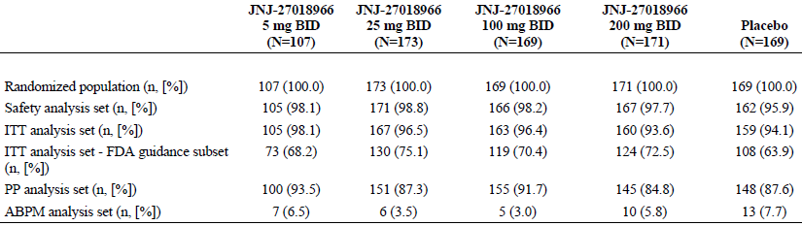
ABPM = ambulatory blood pressure monitoring.

Sample size
Assuming ≥ 30% success rate for at least 1 eluxadoline treatment group, a 15% success rate for placebo, and a 2-sided α-level of 0.05, these assumptions, with a sample size of 150 patients per treatment group, yields approximately 85% power for comparing any single eluxadoline treatment group to placebo employing a Fisher Exact Test. Further, with similar assumptions as above, a 20% placebo response rate compared with a 35% active treatment response rate was still expected to yield 80% power for assessing treatment effects.
Assuming a 4 week dropout rate of approximately 13% based on published IBS-d studies, 170 patients per treatment group were planned for enrolment.

Statistical methods

Primary efficacy endpoint
Logistic regression employing a generalised linear mixed effects model framework with centre as a random effect, baseline pain and baseline BSS scores as covariates, with the assumption that the random effects were normally distributed, was used to analyse the primary responder status at Week 4 and Week 12. No adjustment for Type I error was made for multiple comparisons.
Pain and BSS responders were individually analysed in the same way as described for the primary responder endpoint using a generalized linear mixed model to analyse the proportion of patients classed as responders at the Week 4 and Week 12 visits.

Participant flow
Table 22: Disposition (All randomised patients)
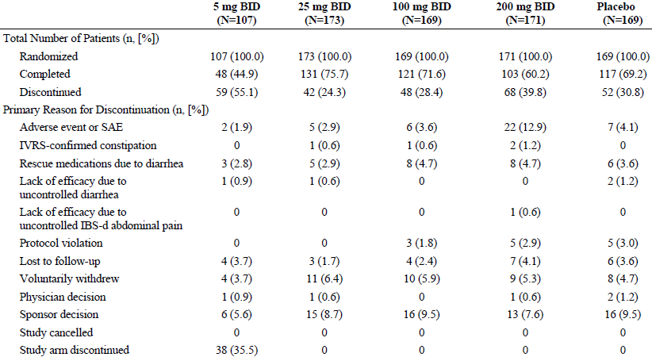
IBS-d = diarrhoea-predominant irritable bowel syndrome; IVRS = interactive voice response system

Major protocol violations/deviations
Major protocol violations included the use of prohibited medications and failure to meet all key inclusion and exclusion criteria, they were reported for 90 patients (these patients were excluded from the PP analysis set).
9 patients were identified as having been randomised more than once in the study, enrolling at a second (or third) site after discontinuation from the first site.
Potential scientific misconduct was identified during the course of the study at one research site. The findings included questionable data captured in the IVRS and subject questionnaires as well as backdated drug accountability entries. Because of the questionable accuracy and integrity of the source data, all data from this site were excluded from all analysis sets, including the randomised set.
Potential scientific misconduct was identified after completion of the study at another research site. The findings, related to the discovery of falsely signed documents, were identified after the database was locked, analysis was complete, and the study was being closed. Overall, 16 separate signatures affecting 2 patients were noted as having been falsified by a study coordinator who was terminated before the false signature discovery. The primary investigator considered the findings unlikely to affect the study outcomes and believed patient welfare was not impacted. Data from this site is included in all analysis sets.

Baseline data
Table 23: Demographics (All randomised patients)
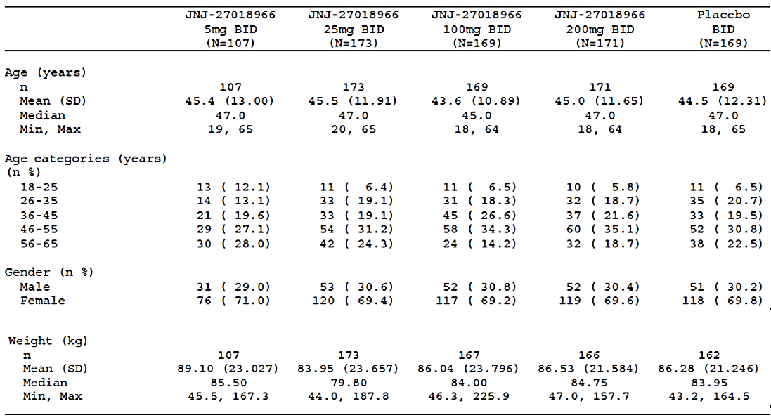
Table 24: Baseline IBS characteristics (ITT set)
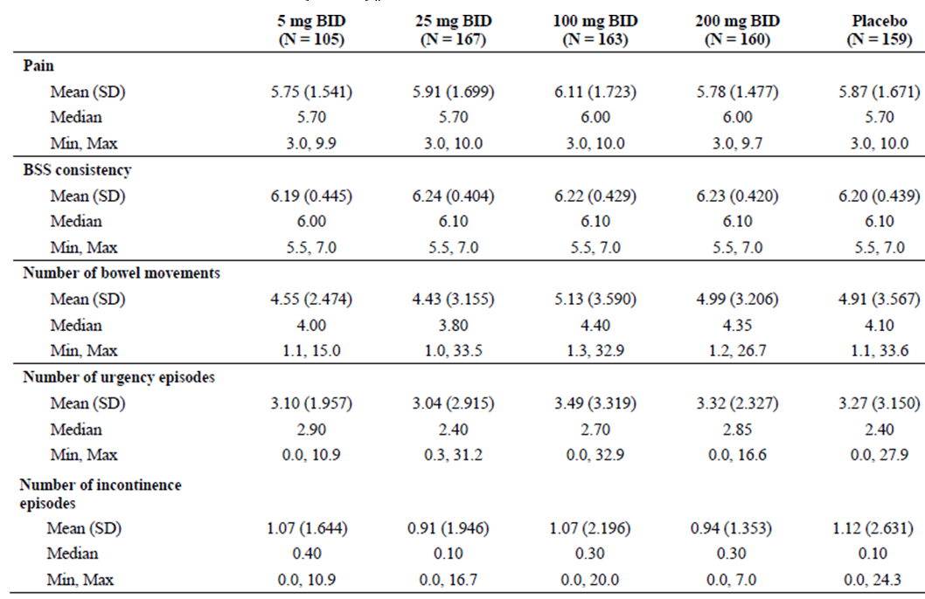

Results for the primary efficacy outcome
At Week 4, primary response rates were statistically superior to that of placebo only for the 25 mg and 200 mg treatment groups. While at Week 12 only the 100 mg treatment group was statistically superior to placebo.
Using the FDA criteria only the 100 mg treatment group at Week 12 was statistically superior to placebo.
Using the C Path criteria, no significant differences from placebo in the rates of overall responders were seen.
Table 25: Analysis of response rates using primary responder definition (ITT set)
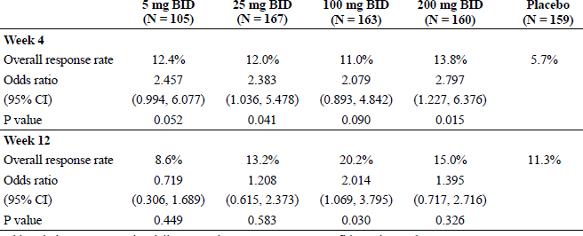

Results for other efficacy outcomes
Table 26: Analysis of pain response rates based on the pain component of the primary responder definition (ITT set)
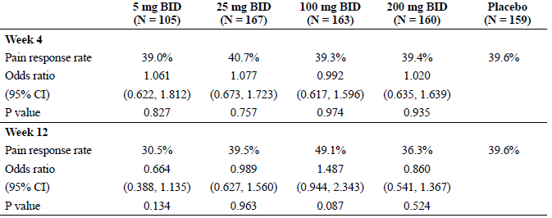
Table 27: Analysis of BSS response rates based on the BSS component of the primary responder definition (ITT set)
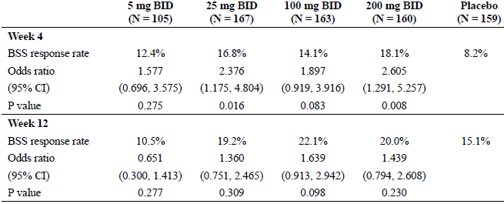
BSS = Bristol Stool Scale
At Week 4, the percentage of patients reporting adequate relief of their IBS-d symptoms was significantly greater for all eluxadoline treatment groups compared with placebo. At Week 12, the percentage of patients reporting adequate relief of their IBS-d symptoms was significantly greater only for the 100 mg and 200 mg treatment groups compared with placebo.
Only at Week 12, was the change from Baseline in IBS-QoL total score significantly different than placebo and only for the 100 mg treatment group (P = 0.029).

Evaluator commentary
This was a dose ranging Phase II trial with multiple amendments after commencement.
At Week 4, primary response rates were statistically superior to that of placebo only for the 25 mg and 200 mg treatment groups. While at Week 12 only the 100 mg treatment group was statistically superior to placebo. The response rates both for eluxadoline and placebo were less than used in the population calculations.
An effect of eluxadoline on abdominal pain was not apparent for any dose. The effect of eluxadoline on IBD-d composite score appeared to be due for the most part on its effect on BSS scores.

Analyses performed across trials: pooled and meta-analyses
The sponsor’s Summary of Clinical Efficacy included a meta-analysis of Studies 3001 and 3002.
With the pooled data, no significant difference in pain responders was seen with 75 mg or 100 mg eluxadoline.
In the pooled data analysis by baseline pain severity of composite responders, as this increased so response was less likely that is, those with more severe pain at Baseline were less likely to be responders.
Table 28: Cochran-Mantel-Haenszel Analysis of composite responders (ITT set); Pooled Phase III studies
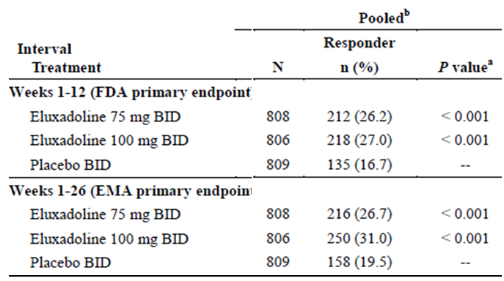
a) value is based on Chi-square test statistic. The Bonferroni adjustment was applied to the composite responder analyses to preserve the family-wise error rate and hence each active group versus placebo comparison was assessed at the 0.025 significance level; b) the pooled data include unique patient data. Data for patients randomised to a treatment group more than once in an individual study or who were randomised in both Phase III studies were only counted once (first randomisation). Duplicate data were excluded from the ITT Analysis Set. Composite responder = patient who met the daily abdominal pain response AND the daily stool consistency response criteria on at least 50% of days with diary entries during the interval; and for the 12 week interval had a minimum of 60 days of diary data from Weeks 1 to 12; or for the 26 week interval had a minimum of 110 days of diary data from Weeks 1 to 26. Daily abdominal pain response = worst abdominal pain scores in the past 24 h improved by ≥ 30% compared to Baseline abdominal pain. Daily stool consistency response = BSS score < 5, or a diary entry reporting the absence of a bowel movement if accompanied by ≥ 30% improvement in worst abdominal pain compared to Baseline abdominal pain.
Table 29: Cochran-Mantel-Haenszel analysis of composite responders by baseline pain (ITT Set) Weeks 1 to 12, pooled Phase III studies
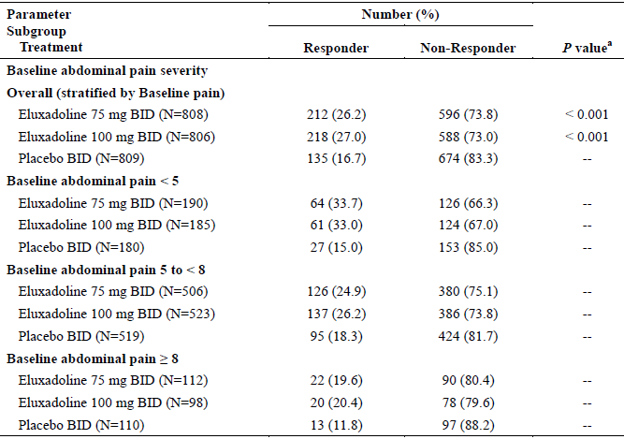
a) P value is based on Chi-square test statistic
Overall, 1615 (543 of 808; 554 of 806, and 518 of 809 patients in the 75 mg, 100 mg, and placebo groups, respectively) patients did not use rescue medication during the 26 week interval. The results of the CMH analysis for patients who did not use rescue medication were consistent with the main CMH findings for composite response over Weeks 1 to 26. When a non-response was imputed for each day a patient took a dose of loperamide rescue medication, the results of the CMH analysis of composite response were also consistent with the main CMH findings for composite response over Weeks 1 to 26.
These results demonstrate that the use of rescue medication did not have an impact on the findings for composite response over Weeks 1 to 26.
Table 30: Cochran-Mantel-Haenszel analysis of composite responders by baseline pain (ITT Set) Weeks 1 to 26 pooled Phase III studies
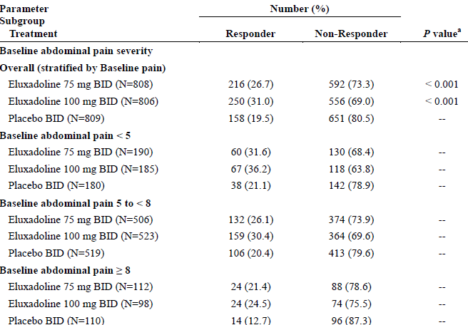
a) P value is based on Chi-square test statistic.
For the pooled data ANCOVA analyses demonstrate that the LS mean changes from Baseline in IBS-QoL total scores were significantly greater than placebo at Week 12 and Week 26 for both the 75 mg (P < 0.001) and 100 mg (P < 0.001) treatment groups.
Table 31: Cochran-Mantel-Haenszel; analysis of abdominal pain responders (ITT set); Pooled Phase III studies
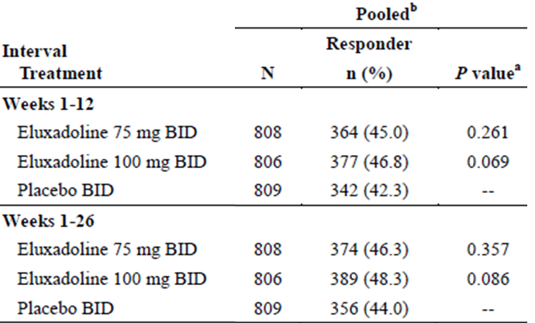
a) P value is based on Chi-square test statistic; b) The pooled data include unique patient data. Data for patients randomised more than once in an individual study or who were randomised in both Phase III studies were only counted once (first randomisation). Duplicate data were excluded from the ITT Analysis Set. Abdominal pain responder = a patient who met the daily abdominal pain response criterion (worst abdominal pain score in the past 24 h improved by ≥ 30% compared to Baseline abdominal pain) on at least 50% of days with diary entries during the interval and for the 12 week interval had a minimum of 60 days of diary data from Weeks 1 to 12 OR for the 26 week interval had a minimum of 110 days of diary data from Weeks 1 to 26.
Table 32: Cochran-Mantel-Haenszel analysis of abdominal pain responders using ≥ 50% improvement from Baseline (ITT Set); pooled Phase III studies
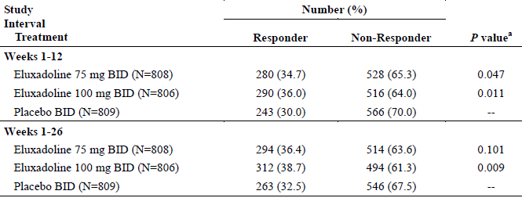
a) P value is based on Chi-square test statistic. Abdominal pain responder = a patient who met the daily abdominal pain response criterion (worst abdominal pain score in the past 24 h improved by ≥ 50% compared to Baseline abdominal pain) on at least 50% of days with diary entries during the interval and for the 12 week interval had a minimum of 60 days of diary data from Weeks 1 to 12; or for the 26 week interval had a minimum of 110 days of diary data from Weeks 1 to 26.
Table 33: Cochran-Mantel-Haenszel analysis of stool consistency responders (ITT set); pooled Phase III studies
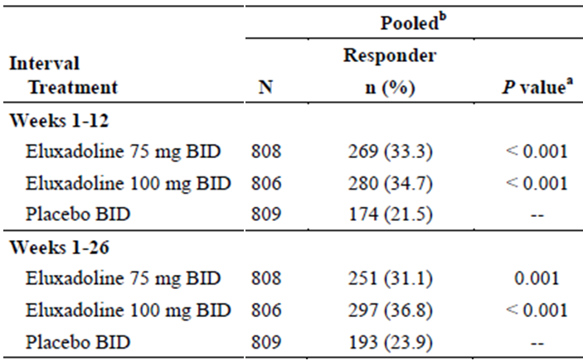
a) P value is based on Chi-square test statistic. B⁾ The pooled data include unique patient data. Data for patients randomised more than once in an individual study or who were randomised in both Phase III studies were only counted once (first randomisation). Duplicate data were excluded from the ITT Analysis Set. Stool consistency responder = a patient who met the daily stool consistency response criterion (BSS score < 5, or a diary entry reporting the absence of a bowel movement if accompanied by ≥ 30% improvement in worst abdominal pain compared to Baseline abdominal pain) on at least 50% of days with diary entries during the interval and for the 12 week interval had a minimum of 60 days of diary data from Weeks 1 to 12 OR for the 26 week interval had a minimum of 110 days of diary data from Weeks 1 to 26.
Table 34: ANCOVA analysis of change from Baseline in IBS-d global symptom scores (ITT set), pooled Phase III studies
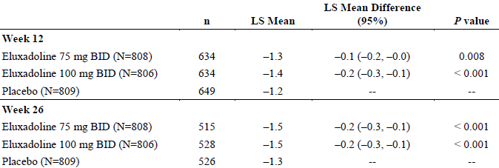
Week 12/26 score is the average of the IBS-d global symptom score recorded during Week 12/26. LS Mean, LS Mean difference, confidence interval (CI), and P value are from an ANCOVA model containing a term for treatment and Baseline IBS-d global symptom score as a covariate.

Evaluator’s conclusions on clinical efficacy
In Study 3001, while both the 75 and 100 mg groups showed statistically superiority to placebo in the percentage of composite responders at 12 weeks, only the 100 mg dose did so at 26 weeks.
In Study 3002, the primary endpoint, the proportion of composite responders for the 75 mg and 100 mg treatment groups, was statistically superior to placebo for Weeks 1 to 12 (P < 0.001) and Weeks 1 to 26 (P ≤ 0.001).
The absolute responder rate results for the placebo group were similar in both Studies 3001 and 3002, the difference between the studies reflecting a difference in absolute responder rates results for the eluxadoline groups.
In Study 2001, at Week 4, primary response rates were statistically superior to that of placebo only for the 25 mg and 200 mg treatment groups. While at Week 12 only the 100 mg treatment group was statistically superior to placebo. The response rates both for eluxadoline and placebo were less than used in the population calculations.
In the meta-analysis both 75 mg and 100 mg showed statistical superiority at Weeks 12 and 26.
Thus, evidence for efficacy based on statistical superiority of the primary endpoints favours eluxadoline 100 mg bd.
Among those on 100 mg bd with baseline pain scores < 5 (67/250) only 36.2% achieved a 30% (that is, < 2) reduction in their score, in those with scores of 5 to < 8 (159/250) 30.4% achieved a reduction in their score of 30% (1.7 or more) and of those with scores of ≥ 8 (24/250) 24.5% achieved a reduction in their score of 30% (2.7 or more).
‘Decreases in individuals’ pain intensity of approximately 1 cm (or 1.0 point) or 15% to 20% represent ‘minimal’ or ‘little’ change, whereas decreases of 2.0 to 2.7 points or 30% to 41% have more meaning to patients, for example, being associated with not requesting rescue medication or ratings of ‘much’ or ‘some’ change. This research also supports the importance of taking baseline pain into account when evaluating these change scores.’
The sponsor attempted to assess use of acetaminophen (Tylenol, Panadol, paracetamol) as rescue medication in Study 2001.
The original protocol dated 29 March 2010 had:
‘If rescue medication for pain is required, the following may be taken by the patient after randomisation: During Weeks 1 through 12: Tylenol with a recommended maximum dose of 2400 mg/day. The use of Tylenol should be recorded by the patients in their daily telephone diary’.
The CSR said the use of Tylenol as rescue for abdominal pain, was rarely reported by patients in any treatment group.
Table 35: Number (%) of patients taking Tylenol concomitant medications (Safety set), Study 2001
 | 100 mg bd (N = 165) | Placebo bd (N = 159)
Paracetamol | 18 (10.9%) | 19 (11.9%)
Tylenol PM | 1 (0.6%) | 3 (1.9%)
Patients may have more than one medication per preferred term. A patient was counted once if the patient reported one or more medications. Concomitant medications are medications that are ongoing or that start on or after the date of the first dose of study drug and until the end of treatment date (Week 12 visit)
Similar to Study 3001 a variety of concomitant analgesics/opiates was seen. The use of Tylenol was reported as the number of days in a week used giving a consistently low result.
Pain rescue was not defined in the protocol for Study 3001. The following extract from the list of used concomitant medicine’s shows the variety of opiates alone and compounded and paracetamol alone and compounded.
The CSRs in commenting on concomitant medication said:
- Study 2001: The use of the ibuprofen, paracetamol, and acetylsalicylic acid, all of which could impact the efficacy endpoint of worst abdominal pain, was similar across all treatment groups.
- Study 3001: The proportion of patients taking omeprazole, ibuprofen, paracetamol, and acetylsalicylic acid was similar across treatment groups.
Table 36: Number (%) of patients taking concomitant medications enrolled set, Study 3001
 | 75 mg bd (N = 429) | 100 mg bd (N = 426) | Placebo bd (N = 427) | Total (N = 1282)
Co-Tylenol | 0 | 0 | 1 (0.2%) | 1 (0.1%)
Cough And Cold Preparations | 5 (1.2%) | 6 (1.4%) | 5 (1.2%) | 16 (1.2%)
Codeine phosphate | 0 | 0 | 1 (0.2%) | 1 (0.1%)
Dextromethorphan | 0 | 4 (0.9%) | 1 (0.2%) | 5 (0.4%)
Dextromethorphan hydrobromide | 0 | 3 (0.7%) | 1 (0.2%) | 4 (0.3%)
Dihydrocodeine | 0 | 0 | 1 (0.2%) | 1 (0.1%)
Dozol | 2 (0.5%) | 1 (0.2%) | 3 (0.7%) | 6 (0.5%)
Fentanyl | 3 (0.7%) | 5 (1.2%) | 6 (1.4%) | 14 (1.1%)
Fentanyl citrate | 0 | 1 (0.2%) | 0 | 1 (0.1%)
Gabapentin | 20 (4.7%) | 16 (3.8%) | 19 (4.4%) | 55 (4.3%)
Hydrocodone | 6 (1.4%) | 2 (0.5%) | 2 (0.5%) | 10 (0.8%)
Hydromorphone | 1 (0.2%) | 4 (0.9%) | 2 (0.5%) | 7 (0.5%)
Hydromorphone hydrochloride | 5 (1.2%) | 9 (2.1%) | 3 (0.7%) | 17 (1.3%)
Lomotil | 0 | 3 (0.7%) | 1 (0.2%) | 4 (0.3%)
Loperamide Hydrochloride | 4 (0.9%) | 5 (1.2%) | 8 (1.9%) | 17 (1.3%)
Loperamide W/Simeticone | 0 | 1 (0.2%) | 0 | 1 (0.1%)
Morphine | 3 (0.7%) | 11 (2.6%) | 5 (1.2%) | 19 (1.5%)
Morphine sulfate | 3 (0.7%) | 3 (0.7%) | 0 | 6 (0.5%)
Nite-Time Cold Medicine | 2 (0.5%) | 0 | 1 (0.2%) | 3 (0.2%)
Opium and belladonna | 0 | 1 (0.2%) | 0 | 1 (0.1%)
Oxycodone | 0 | 1 (0.2%) | 2 (0.5%) | 3 (0.2%)
Oxycodone hydrochloride | 0 | 2 (0.5%) | 0 | 2 (0.2%
Panadeine Co | 2 (0.5%) | 2 (0.5%) | 5 (1.2%) | 9 (0.7%)
Paracetamol | 45 (10.5%) | 60 (14.1%) | 56 (13.1%) | 161 (12.6%)
Pethidine | 1 (0.2%) | 1 (0.2%) | 0 | 2 (0.2%)
Pethidine Hydrochloride | 0 | 2 (0.5%) | 1 (0.2%) | 3 (0.2%)
Solpadeine | 0 | 0 | 1 (0.2%) | 1 (0.1%)
Tramadol | 6 (1.4%) | 3 (0.7%) | 5 (1.2%) | 14 (1.1%)
Tramadol Hydrochloride | 1 (0.2%) | 0 | 0 | 1 (0.1%)
Tussin Dm | 3 (0.7%) | 2 (0.5%) | 0 | 5 (0.4%)
Tussionex | 0 | 1 (0.2%) | 0 | 1 (0.1%)
Tussionex Pennkinetic | 0 | 2 (0.5%) | 1 (0.2%) | 3 (0.2%)
Tylenol Sinus Medication | 0 | 2 (0.5%) | 2 (0.5%) | 4 (0.3%)
Patients may have more than one medication per preferred term. At each level of patient summarisation, a patient was counted once if the patient reported one or more medications. Concomitant medications presented are medications that are ongoing or that start on or after the date of first dose of study drug and up to and including 7 days after the date of the last study medication. Percentages are of the number of patient in that treatment group.
The improvement in some outcomes was modest compared with placebo, however for those whose problems are not going to spontaneously resolve, it may be considered an efficacy option.
The sponsor in an overview of clinical efficacy has stated the following:
‘While the locally acting mu-opioid receptor agonist loperamide is effective in treating diarrhoea, it has limited effectiveness in IBS-d due to lack of effect on abdominal pain and global symptoms and the possibility for excessive constipation. By contrast, the mixed opioid pharmacology of eluxadoline appears to confer on it the ability to effectively improve abdominal pain and stool consistency in IBS-d patients while mitigating the risk of constipation’.
However:
‘While the proportion of abdominal pain responders for the active treatment groups was higher than placebo over both intervals, the differences were not statistically significant (P > 0.05) for the individual studies or the pooled analyses’.
Thus the modestly effective combined endpoint relies on the results on stool consistency and the sponsor’s claim of pain relief; appears not to be statistically supported.
The primary results for other secondary outcomes are modest, but generally supportive, although without statistical allowance for multiplicity.
It is noted that the IMMPACT statement in relation to chronic pain recommends as well as assessment of pain scores assessment of:
- Usage of rescue analgesics,
- Physical functioning,
- Emotional functioning,
- Participant ratings of global improvement and satisfaction with treatment.

Clinical safety

Studies providing evaluable safety data

Pivotal and/or main efficacy studies
- Study 3001 was extended beyond the 6 months for efficacy, to provide a further 6 months of safety data.
- Study 3002 likewise had an extension; a 4 week single-blinded withdrawal period.

Studies that assessed safety as the sole primary outcome
Not applicable.

Patient exposure
Study drug was received for at least one year for 245 and 243 patients in the 75 mg and 100 mg eluxadoline groups respectively.
Table 37: Disposition, pooled analysis of Phase II and III studies
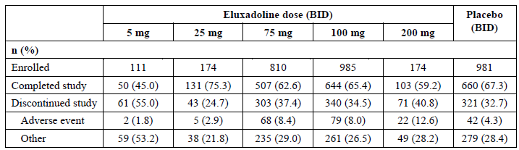
Patient base: Enrolled subjects
Table 38: Total exposure (Safety set) pooled analysis Phase I (Oral administration studies), II, and III; number of patients any eluxadoline exposure;ª
Phase | N
Phase I oral administration studies^{b} | 330
Phase II | 617
Phase III | 1615
Overall | 2562
a) Subjects/patients who received at least 1 dose of eluxadoline were counted. Any individual who was randomised more than once was counted only in the first study to which they were randomised. Any individual who was randomised to placebo but received eluxadoline as a misallocated treatment was also counted. Individuals were counted within the phase of study they first received eluxadoline. If an individual was randomised in both Phase II and III studies and only received eluxadoline for the first time during Phase III then this individual was counted only in Phase III. Similarly, if an individual received eluxadoline in both Phase II and III they were counted only in Phase II since they first received eluxadoline during that phase; b) the Phase I row included data from 10 Phase 1 oral administration studies. Study CPS-1010 was an intranasal administration study and, therefore, was not included.
Table 39: Duration of exposure (Days) by demographic factors (Enrolled set), pooled analysis of Phase II and III studies
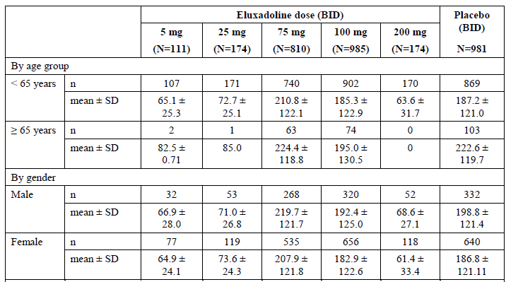
Patient Base: Patients in the Enrolled Set who received at least 1 dose of study drug; the treatment group is based on the treatment to which the patient was randomised. For any nonrandomised patients who received study drug, it was based on the treatment received at Day 1.
Table 40: Duration of exposure (Safety set); pooled analysis, Phase II and III studies
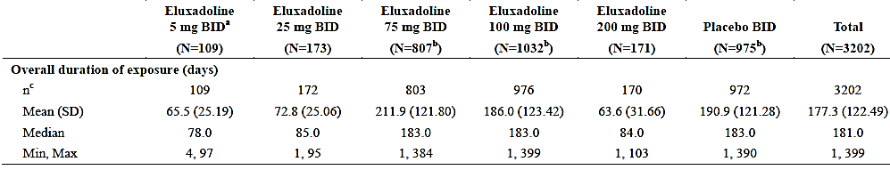
Patient base: Safety analysis set (all patients who received at least 1 dose of study drug; based on the treatment actually received at the time the measurement was taken, regardless of assigned treatment according to the planned randomisation) IVRS = interactive voice response system; IWRS = interactive web response system; NA = not applicable; a) After the interim analysis for Study IBS-2001, the 5 mg treatment group was deselected for lack of efficacy and patients subsequently enrolled were randomly assigned to 1 of the 4 remaining treatment groups (25 mg, 100 mg, or 200 mg eluxadoline or placebo). B) N reflects the safety set and includes all patients who received at least 1 dose of study drug (that is, number of patients randomised + number of patients who received the treatment due to IVRS/IWRS misallocation or site misallocation). ^{c} n used in the determination of overall duration of exposure does not include patients who received study drug due to IVRS/IWRS misallocation or site misallocation. Exposure was defined as the total days the patient was exposed to study drug, excluding any days where it was recorded that an interruption had occurred. If the last dose date was missing or incomplete, the following steps were implemented to impute the exposure duration: 1) If the latest kit dispensed had a complete return date, the return date to calculate exposure was used. 2) If the partial information on the last dose date was UK-MMM-YYYY, the last day of the appropriate month as the end date was assumed. 3) Otherwise, the latest kit dispensed date and the number of tablets was used to impute an end date assuming the patient took the tablets with 100% compliance, that is, divided the total tablets by 4 to determine the number of days and added this to the dispensed date.

Adverse events

All adverse events (irrespective of relationship to study treatment)
Overall, AEs were most commonly reported within the GI disorders (25.2% of patients overall) and infections and infestations SOCs (22.5% of patients). The overall incidence of GI disorders AEs was 30.0% and 26.5% at eluxadoline doses of 75 mg and 100 mg, respectively, compared to 19.0% for placebo. The overall incidences of infections and infestations AEs were similar for 75 mg and 100 mg eluxadoline and placebo (24.7%, 21.5%, and 23.6%, respectively).
Table 41: Overview of AEs (Safety set), pooled Phase II and III studies
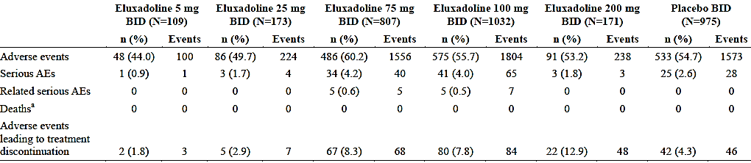
Patient base: Safety Analysis Set (all patients who received at least 1 dose of study drug; based on the treatment actually received at the time the measurement was taken, regardless of assigned treatment according to the planned randomisation). Related SAEs include SAEs that were possible, probable, or definite. All AEs with a start date between treatment start date and date of last study visit inclusive are included. All AEs with a start date between treatment start date and date of last study visit inclusive and with a study drug action taken of ‘permanently discontinued’ are included. a) One patient death (Patient [information redacted]) was reported after the date of the patient’s last study visit; therefore, this patient was not included in the data based on the conventions for AE/SAE recording set for the study.
Within the first 2 weeks of dosing, the most commonly reported AEs were related to the GI disorders SOC. The incidence of GI disorders AEs was comparable between the 75 mg (16.0%) and 100 mg (14.8%) eluxadoline groups during this time. Nausea was the most commonly reported GI AE and was experienced by 4.7%, 4.6%, and 2.8% of patients who received 75 mg eluxadoline, 100 mg eluxadoline, and placebo, respectively During the first 2 weeks of dosing, constipation was reported for 4.3%, 3.7%, and 0.7% of patients, respectively, and abdominal pain was reported for 1.7%, 2.8%, and 0.7% of patients, respectively, in these 3 groups. A higher proportion of patients treated with 200 mg eluxadoline experienced GI events within the first and second week of dosing (19.9% and 21.1% of patients, respectively). Likewise, higher proportions of patients in this group had events of nausea (7.6%) and abdominal pain (7.0%) within the first 2 weeks of treatment compared with the other groups.
Table 42: Incidence of AEs by interval (Safety set), pooled Phase II and III studies
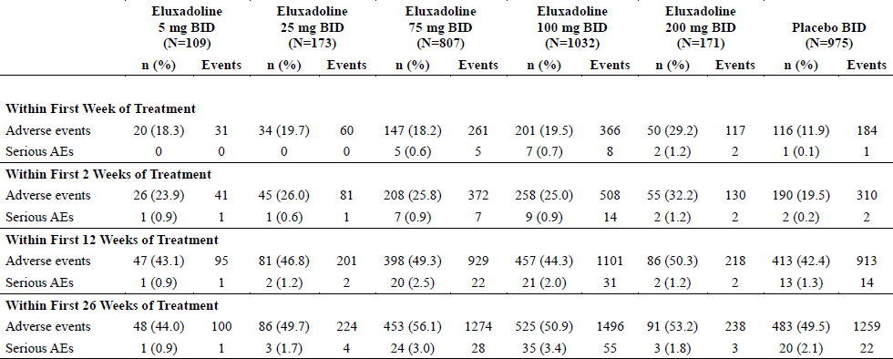
Patient base: Safety analysis set (all patients who received at least 1 dose of study drug; based on the treatment actually received at the time the measurement was taken, regardless of assigned treatment according to the planned randomisation). The Phase II study evaluated doses of 5 mg, 25 mg, 100 mg, and 200 mg eluxadoline and placebo for up to 12 weeks.
Table 43: AEs reported by ≥ 2% of patients in any eluxadoline treatment group and at a greater incidence than placebo (Safety set); pooled Phase II and III studies
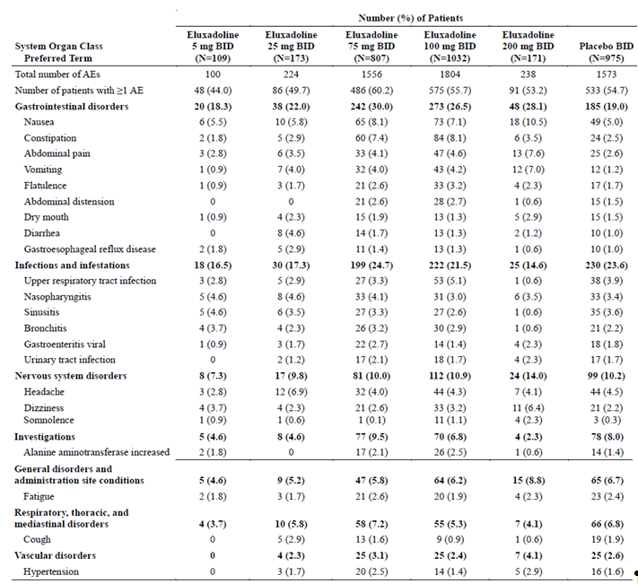
Patient base: Safety analysis set (all patients who received at least 1 dose of study drug; based on the treatment actually received at the time the measurement was taken, regardless of assigned treatment according to the planned randomisation). For the SOC and preferred term level summaries, multiple occurrences of an SOC or preferred term within a patient are counted once only. All occurrences of a preferred term are included in the total number of AEs. All AEs with a start date between treatment start date and date of last study visit inclusive (or last contact date if last study visit was missing) are included.
Table 44: Overall incidence of AEs and gastrointestinal AEs by interval (Safety set); pooled Phase II and III studies
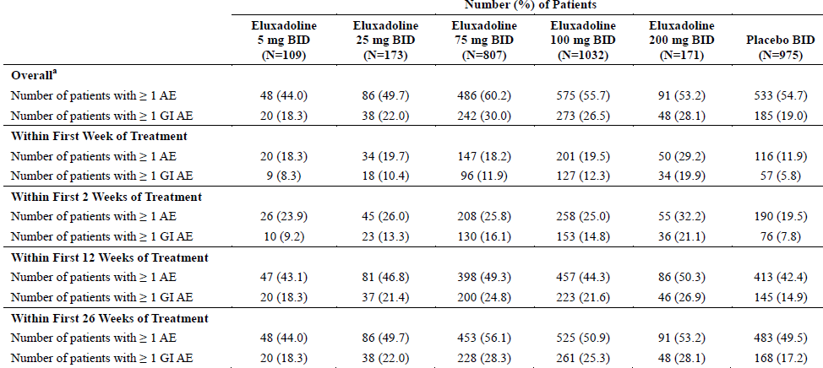
Patient base: Safety analysis set (all patients who received at least 1 dose of study drug; based on the treatment actually received at the time the measurement was taken, regardless of assigned treatment according to the planned randomisation). Multiple occurrences of AEs in the GI SOC within a patient are counted once only. The Phase II study evaluated doses of 5 mg, 2mg, 100 mg, and 200 mg eluxadoline and placebo for up to 12 weeks. a) All AEs with a start date between treatment start date and date of last study visit inclusive (or last contact date if last study visit was missing) are included.

Treatment related adverse events (adverse drug reactions)
No overall or individual clinical trial assessment of treatment related adverse events (or adverse reactions) were submitted.
The Applicant has identified certain AEs of special interest related to the pharmacological class of eluxadoline (mixed opioid agonist), including known adverse reactions for the drug class, special considerations related to abuse potential, and specific requests from regulatory agencies (for example, cardiac and chest pain events). These include AEs consistent with SO (Sphincter of Oddi) spasm, other pancreatitis and hepatic events, constipation events, events of fall, syncope, road traffic accident, cardiac and chest pain events, and events of rash and pruritus.
The proposed PI contains a table of common and uncommon adverse reactions but the accompanying references do not support this.
[A table (not reproduced here)] from the Integrated Summary of Safety has a 25 page listing of SAEs by relationship to study drug.
There were 5 with 75 mg and 7 with 100 mg and none with any other group including placebo.
Table 45: Related SAEs; pooled analysis Phase II and III (all studies); Safety set
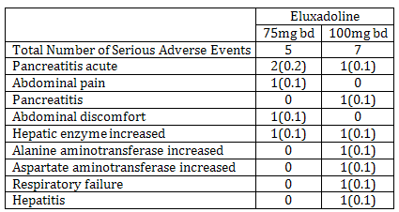
For the summaries, multiple occurrences of a system organ class or preferred term within a subject are counted once only, at the Related = missing, possible, probable, definite; All serious adverse events with a start date between treatment start date and date of last study visit inclusive (or last contact date if last study visit is missing) are included.

Deaths
The sole death was 21 days after receiving the last dose of study drug, due to arteriosclerotic cardiovascular disease.

Other serious adverse events

Integrated safety analyses
The proportions of patients with SAEs were 75 mg (4.2%), 100 mg (4.0%), and placebo (2.6%).
GI disorders were the most often reported SAEs and occurred in 0% and 1.3%, of the 75 mg and 100 mg treatment groups respectively, compared with 0.4% of placebo patients.
The SAE with the overall highest incidence while taking eluxadoline was pancreatitis; reported in 11 patients. Nine were independently adjudicated as pancreatitis. Similar proportions of patients who received 75 mg and 100 mg eluxadoline experienced SAEs of acute pancreatitis (0.2% and 0.3%, respectively) and pancreatitis (0.1% in both groups).
One (0.6%) patient who received the 200 mg eluxadoline dose experienced an SAE of alcoholic pancreatitis. 1 event occurred after discontinuation from study drug.
Except for the 5 mg dose GI SAEs increased in incidence with dose.
Table 46: Overall incidence of new serious adverse events and serious gastrointestinal adverse events by interval (Safety set); Pooled Phase II and III studies
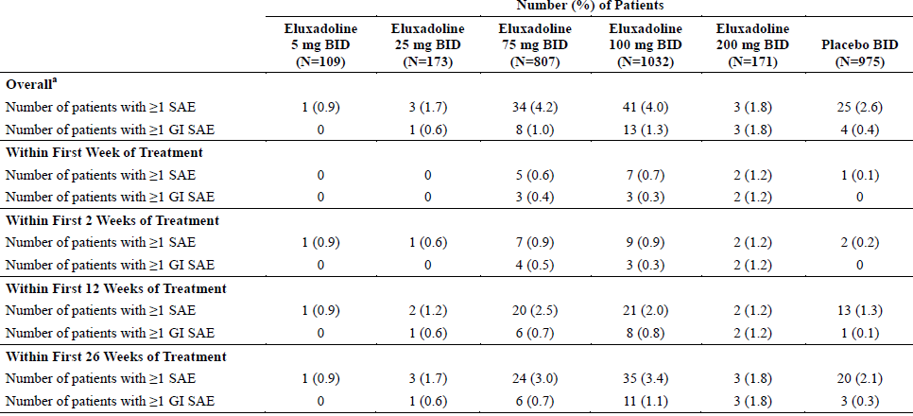
Notes: Multiple occurrences of an SOC within a patient are counted once only. The Phase II study evaluated doses of 5 mg, 25 mg, 100 mg, and 200 mg eluxadoline and placebo for up to 12 weeks. Patient base: Safety analysis set (all patients who received at least 1 dose of study drug; based on the treatment actually received at the time the measurement was taken, regardless of assigned treatment according to the planned randomisation); a) All SAEs with a start date between treatment start date and date of last study visit inclusive (or last contact date if last study visit was missing) are included.

Discontinuations due to adverse events

Integrated safety analyses
Most discontinuations occurred with the 200 mg dose.
Except for headache, the common discontinuations showed a greater incidence in the 100 mg dose group rather than the 75 mg group.
Table 47: Adverse events leading to treatment discontinuation for ≥ 1% of patients in any treatment group (Safety Set); Pooled Phase II and III studies
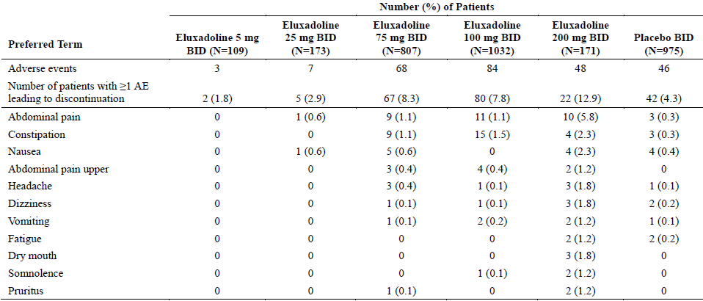
Patient base: Safety Analysis Set (all patients who received at least 1 dose of study drug; based on the treatment actually received at the time the measurement was taken, regardless of assigned treatment according to the planned randomisation). Multiple occurrences of an SOC are counted once only. All AEs with a start date between treatment start date and date of last study visit inclusive (or last contact date if last study visit was missing) are included.

Evaluation of issues with possible regulatory impact
Rather than reviewing all treatment related AEs the sponsor considered selected AES that were considered class related.
Comment: The sponsor argues for this being a different class from loperamide being both MOR agonist and DOR antagonist however in relation to treatment related AEs the sponsor only considers selected AEs based on known class effects of MOR agonists and opioids in the initial section relating to Pharmacologic Class but under Other Significant Adverse Events says the sponsor has:
’Identified certain AEs of special interest related to the pharmacological class of eluxadoline (mixed opioid agonist).’
and lists the following:
    - ‘AEs consistent with Sphincter of Oddi spasm,
    - other and hepatic events,
    - constipation events,
    - events of fall, syncope,
    - road traffic accident,
    - cardiac and chest pain events,
    - events of rash and pruritus’.

Sphincter of Oddi spasm
Of 11 pancreatitis cases on the eluxadoline database; 9 were felt to be pancreatitis of which 3 were felt associated with Sphincter of Oddi spasm. All 3 patients had prior cholecystectomy, events, were transient and occurred during the first day of treatment.
There were 9 cases of acute hepatobiliary events with all having sphincter of Oddi spasm associated. All had absent gall bladders. All events were transient and rapidly resolved on stopping therapy, however 1 patient was hospitalised briefly for control of nausea and vomiting. Patients presented with either epigastric/abdominal or biliary type pain, often with symptoms of nausea. 7 patients reported their first onset of symptoms within the first week of treatment.

Pancreatitis
Among the above 9 adjudicated cases, there were 6 cases of pancreatitis that were felt not consistent with sphincter of Oddi spasm. 4 of these AEs involved patients with known alcohol abuse or increased alcohol intake.

Liver function and liver toxicity
Four additional patients, (all having had cholecystectomy) had elevated ALT/AST levels and experienced symptoms of an acute biliary type syndrome having some of the characteristics of the sphincter of Oddi spasm.
The sponsor presented considerable analysis of LFTs including the effect of prior cholecystectomy.
Table 48: Post-randomisation increase in parameter ALT (Safety analysis set), pooled analysis of all Phase II and III studies
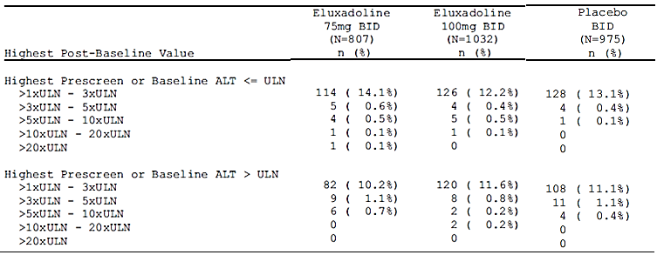
Percentages are calculated using the safety analysis set as denominator. Subjects were eligible for study entry with ALT up to 3xULN. Incidence rates of ALT elevations are presented separately for those subjects with baseline values below ULN and those with baseline values above ULN. Subject [information redacted] unscheduled pre-treatment ALT measurement has been used and is summarised within the > ULN category for this integrated safety summary. Study 3001 summarises subject [information redacted] within the ≤ ULN category as only scheduled visits are considered
Table 49: Post-randomisation increase in parameter alkaline phosphatase (Safety analysis set), pooled analysis Phase II and III (all studies)
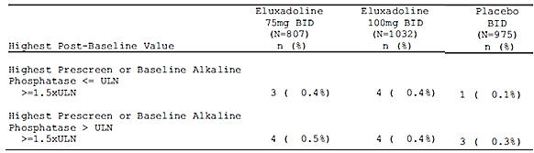
Percentages are calculated using the safety analysis set as denominator. Incidence rates of alkaline phosphatase elevations are presented separately for those subjects with baseline values below ULN and those with baseline values above ULN.
Table 50: Post-randomisation increase in parameter total bilirubin (Safety analysis set), pooled analysis Phase II and III (all studies)
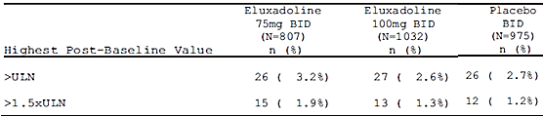
Percentages are calculated using the safety analysis set as denominator. Subjects were eligible for study entry with total bilirubin up to 3 mg/dL.
Table 51: Post-randomisation increase in ALT by prior cholecystectomy status (Safety analysis set); pooled analysis of Phase III studies; number (%) of patients
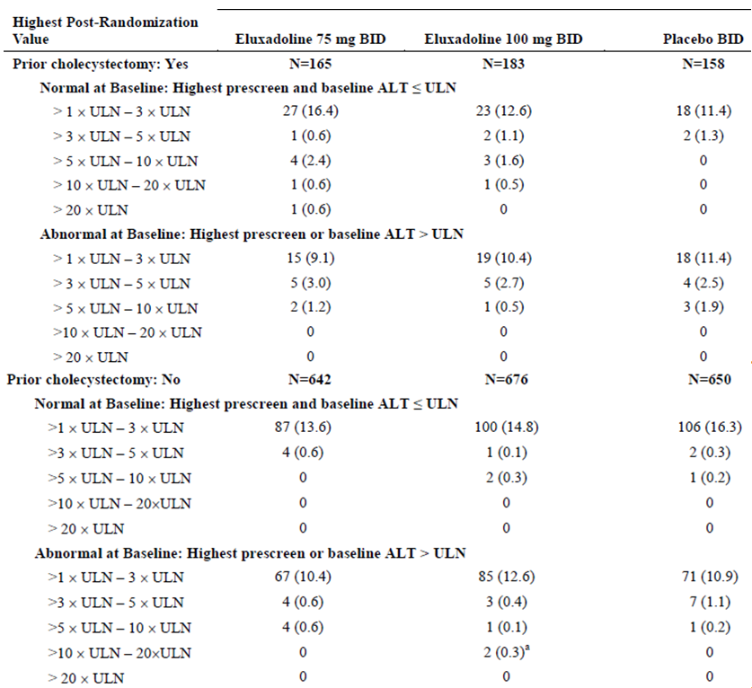
Patient base: Safety analysis set (all patients who received at least 1 dose of study drug; based on the treatment actually received at the time the measurement was taken, regardless of assigned treatment according to the planned randomisation); a) includes Patient [information redacted] with congenital agenesis of the gallbladder and Patient [information redacted] with laboratory values that were suspicious for specimen errors. Percentages were calculated using the number of patients with or without a prior cholecystectomy (Safety Analysis Set) as the denominator. Patients were eligible for study entry with ALT up to 3 x ULN. Incidence rates of ALT elevations were presented separately for those patients with baseline values below ULN and those with baseline values above ULN. Prior cholecystectomy status was only collected in Phase III studies.

Constipation
The overall incidence of constipation AEs was 7.4% in patients who received 75 mg eluxadoline, 8.1% for 100 mg, and 2.5% with placebo patients.
Of the patients in the 75 mg and 100 mg groups who ever reported AEs of constipation, approximately 82.9% reported constipation AEs within the first 13 weeks of treatment.
Constipation was seen in higher proportions of female than male patients treated with 75 mg (8.0% and 6.3%, respectively) and 100 mg (9.0% and 6.4%, respectively) eluxadoline and in placebo patients (2.6% and 2.1%, respectively).

Fall, syncope
AEs of fall were reported in 1.6%, 0.9%, and 0.4% of patients across the 75 mg, 100 mg, and placebo groups, respectively; no patient in the 5 mg, 25 mg, or 200 mg groups experienced a fall event. No major injuries occurred as a result of a fall event, none of the events of fall was considered serious, and none led to discontinuation of study.

Road traffic accident
Road traffic accidents occurred with 8 eluxadoline patients (5 and 3 patients who received 75 mg and 100 mg, respectively) and 2 placebo patients. 2 patients on eluxadoline were passengers.

Electrocardiograph findings and cardiovascular safety
Angina pectoris was reported in 0.5% (4/807), 0.4% (4/1032), and 0.1% (1/975) of patients who received 75 mg eluxadoline, 100 mg eluxadoline, and placebo, respectively. Palpitations were reported in 0.1% (1/807), 0.4% (4/1032), and 0.2% (2/975) of patients in the 75 mg, 100 mg, and placebo groups, respectively. All other cardiac disorders AEs were reported in ≤ 3 patients in any treatment group. Cardiac disorders SAEs were reported across the 75 mg, 100 mg, and placebo groups (0.4%, 0.4%, and 0.2%, respectively).
Non-cardiac chest pain was reported in 0, 0.6% (6/1032), and 0.3% (3/975) patients in the 75 mg, 100 mg, and placebo groups, respectively; chest pain was reported for 0.5% (4/807), 0.5% (5/1032), and 0.2% (2/975) patients, respectively; and chest discomfort was reported for 0.1% (1/807), 0.3% (3/1032), and 0.2% (2/975) patients, respectively. 4 patients had chest pain that resulted in hospitalisation.
AEs that led to discontinuation included sinus tachycardia, coronary artery disease, angina pectoris (2 events), myocardial infarction and chest discomfort. There was one death.
For Study CPS-1008 the primary endpoint (placebo adjusted change of QTcI from Baseline), maximally 4.10 ms at 1 h after dosing for the 100 mg eluxadoline treatment with a one-sided 95% upper confidence bound of 5.81 ms, did not reach the threshold for significance for QT interval prolongation. The largest mean time-matched difference in change from Baseline from placebo for the eluxadoline 100 mg dose was 1.20 ms at 0.5h after dosing, with a one sided 95% upper confidence bound of 2.91 ms.
AEs of prolonged QT interval occurred in 1 patient each in the 25 mg and 75 mg groups, 3 patients in the 100 mg group, and 3 patients in the placebo group. ECG signs of myocardial ischemia occurred for 3 patients in the placebo group. Abnormal ST segment, abnormal T wave, and T wave inversion occurred for 1 patient each in the 100 mg group and the placebo group. All other ECG-related AEs occurred for only 1 patient overall and included abnormal ECG (75 mg), QRS complex abnormal (placebo), ST segment elevation (75 mg), ST-T change (25 mg), and increased T wave amplitude (100 mg).

Serious skin reactions
Of the 75 mg, 100 mg eluxadoline and placebo patient: rash was reported for 1.2%, 0.9%, and 0.6% of patients, and pruritus was reported for 0.6%, 0.4%, and 0.6% of patients, respectively.
2 patients each (0.2%) of patients who received 75 mg and 100 mg eluxadoline and 1 (0.1%) placebo patient were discontinued due to skin and subcutaneous tissue disorders AEs, including pruritus, urticaria, alopecia, and rash.

Renal function and renal toxicity
Patients with renal dysfunction were not excluded in the Phase III program albeit haematology requirements could have (and did) exclude patients with end stage renal disease.
Across the 75 mg, 100 mg and placebo groups, 96, 119, and 132 patients, respectively, had mild renal dysfunction at baseline and 6, 6, and 12 patients, respectively, had moderate renal dysfunction at Baseline.
Patients with mild renal dysfunction most often reported AEs of nausea, which were seen in 10.4%, 10.1% and 6.1% of patients in the 75 mg, 100 mg, and placebo groups, respectively. The number of patients with moderate renal dysfunction is too small to interpret this stratum. No increase in the incidence of AEs based on renal dysfunction status (mild or moderate) was observed.

Haematology and haematological toxicity
No treatment-related trends were observed in mean haematology results over time and the mean values observed at EOT/Early Withdrawal were similar to those observed at Baseline for each treatment group.

Vital signs and clinical examination findings
In the first-in-human dose escalation study (Study EDI-1001) and the initial food effect study (Study EDI-1002), there was an increased incidence of orthostatic hypotension in subjects administered doses ≥ 500 mg of eluxadoline compared with placebo.
For the Phase II Study IBS-2001, the incidence of a priori defined asymptomatic orthostatic hypotension was comparable across treatment groups at every assessment time point. Mean ambulatory blood pressure results were similar between treatment groups (eluxadoline 5, 25, 100, and 200 mg bd; placebo), and the mean values observed at Week 2 were similar to those observed at Baseline.

Other safety issues

Safety in special populations

Gender
Higher proportions of female patients (N = 2145) than male patients (N = 1057) experienced AEs (60.0% and 49.3%), GI disorders AEs (27.3% and 20.8%), and AEs that led to discontinuation (7.8% and 4.7%). Similar proportions of male and female patients reported SAEs (2.3% and 3.9%) and GI SAEs (0.6% and 1.1%). Constipation was seen in higher proportions of female than male patients treated with 75 mg (8.0% and 6.3%, respectively) and 100 mg (9.0% and 6.4%, respectively) eluxadoline and in placebo patients (2.6% and 2.1%, respectively).

Age
Across the Phase II and III studies, 2989 (92.4%) patients < 65 years of age and 246 (7.6%) patients ≥ 65 years of age were enrolled. Higher proportions of older patients than younger patients experienced AEs (66.7% and 55.6%), SAEs (7.0% and 3.0%), AEs that led to discontinuation (11.9% and 6.4%), GI AEs (34.2% and 24.4%), and serious GI AEs (1.2% and 0.9%).

Drug abuse
There are no known instances of purposeful drug abuse with eluxadoline during the clinical drug development program. A 1000 mg dose of eluxadoline (10 x the proposed dose) given orally had a ‘negative likeability compared to placebo (study CPS1006) when given to non-dependent recreational opioid users and when given intranasally at doses of 100 mg and 200 mg drug like for both doses was lower than drug liking for placebo with both scores in the disliking range (Study CPS1010).
Studies CPS-1006 and CPS-1010 looked at abuse potential, their results were supportive of there not being such potential.
The overall incidence of patients with AEs potentially related to abuse was similar across the 75 mg, 100 mg, and placebo treatment groups (7.9%, 9.6%, and 8.1%, respectively).

Post marketing experience
Not applicable.

Evaluator’s overall conclusions on clinical safety
For the 75 mg and 100 mg treatment groups AEs were similar in incidence but higher than placebo (8.4%, 8.0% and 4.3% respectively); discontinuations were within 5% of each other (37.4%, 34.5%, 32.7%). For SAEs related to treatment there were 5 on 75 mg and 7 on 100 mg.
However, the incidence and a summary of treatment related AEs (Adverse Reactions) were not submitted. Instead selected AEs were reviewed including liver and pancreatitis events and their relationship to cholecystectomy and Sphincter of Oddi spasm, constipation, syncope, urticaria and rash.
The major risks of serious adverse effects from use appear to be increased potential for pancreatitis, spasm in the sphincter of Oddi and hepatobiliary abnormalities. The adverse events that were more frequently reported by patients taking eluxadoline compared with placebo are listed in Table 44 and include for the 100 mg bd eluxadoline dose regimen versus placebo comparison in the pooled Phase II and III studies: constipation (8% versus 2%); nausea (7% versus 5%); abdominal pain (7% versus 4%); and vomiting 4% versus 1%).
The major risks of serious adverse effects from use appear to be increased potential for pancreatitis, spasm in the sphincter of Oddi and hepatobiliary abnormalities.
The adverse events that were more frequently reported by patients taking eluxadoline compared with placebo are listed in Table 43 and include for the 100 mg bd eluxadoline dose regimen versus placebo comparison in the pooled Phase II and III studies: constipation (8% versus 2%); nausea (7% versus 5%); abdominal pain (7% versus 4%); and vomiting 4% versus 1%).
The potential for abuse appears low.

First round benefit-risk assessment

First round assessment of benefits
Table 52, shown below, summarises the assessment of benefits at the First round.
Table 52. First round assessment of benefits
Indications
Benefits | Strengths and Uncertainties
In Study 3001, while both the 75 and 100 mg groups showed statistically superiority to placebo in the percentage of composite responders at 12 weeks, only the 100 mg dose did so at 26 weeks. | The response rates in Study 2001 both for eluxadoline and placebo were less than used in calculating the study population.  The clinical significance of the modest improvement in some outcomes compared with placebo was not discussed, however for those whose problems are not going to spontaneously resolve, it may be considered an efficacy option.  The sponsor has undertaken subgroup analyses in an effort to identify an appropriate population but without successful result.
In Study 3002, the primary endpoint, the proportion of composite responders for the 75 mg and 100 mg treatment groups, was statistically superior to placebo for Weeks 1 to 12 (P < 0.001) and Weeks 1 to 26 (P ≤ 0.001).
In Study 2001, at Week 4, primary response rates were statistically superior to that of placebo only for the 25 mg and 200 mg treatment groups. While at Week 12 only the 100 mg treatment group was statistically superior to placebo.
In the meta-analysis both 75 mg and 100 mg showed statistical superiority at Weeks 12 and 26.
The primary results for other secondary outcomes are generally supportive | The IMMPACT statement in relation to chronic pain recommends as well as assessment of pain scores assessment of:  - Usage of rescue analgesics,  - Physical functioning,  - Emotional functioning,  - Participant ratings of global improvement and satisfaction with treatment.  The sponsor has successfully reviewed many of these components.

First round assessment of risks
Table 53, shown below, summarises the assessment of risks at the First round.
Table 53. First round assessment of risks
Risks | Strengths and Uncertainties
The incidence and a summary of treatment related AEs (Adverse Reactions) were not submitted. | The sponsor proposes that since the class related effects were well known rather than reviewing all treatment related AEs the sponsor considered selected AEs that were considered class related. The class definition has varied from the specific µ opioid receptor agonist/δ opioid receptor antagonist to opioid. No comparative list of class related AEs was submitted.  While the specific systemic effects likely to cause problems with a µ opioid receptor agonist and of δ opioid receptor antagonist although not submitted may be known, the adverse reactions of a mu opioid receptor agonist/delta opioid receptor antagonist with poor oral availability cannot be known since the sponsor is proposing its uniqueness as a treatment.  It is interesting to note that, while in the Clinical Overview and Clinical Summaries no mention is made of any kappa receptor activity, it is mentioned in the PI and in the sponsor’s Nonclinical Overview that there is weak kappa OR agonist activity.  There is a list of AEs with an incidence ≥ 2% and higher than in placebo group. However, it is not particularly sensitive as for example it misses all pancreas and liver events except raised ALT.
Constipation and Pain are intrinsic to IBS | The sponsor has made no comparative studies with alternative treatments for IBS - diarrhoea predominant though claiming advantage over loperamide and alosetron (not on ARTG).  The sponsor in this submission has made a comparison in those whose historical data showed inadequate symptom control with lamotrigine between those on placebo and those on eluxadoline, this evaluator however gives it little weight as it is not a direct comparison of efficacy with lamotrigine.
Abuse potential | Based on submitted trial data the potential for abuse appears low.
Spasm of sphincter of Oddi | The sponsor has shown that this is particularly a problem in those whose gallbladder is absent.

First round assessment of benefit-risk balance
The overall risk benefit balance is considered unfavourable.
- With the modest improvement compared with placebo the limited benefit needs to be balanced by a comparable risk.
- The lack of a clear presentation of the risk of all treatment related AEs makes the comparison unfavourable.

First round recommendation regarding authorisation
It is not recommended that the proposed authorisation be approved.
- The lack of a clear presentation of the risk of all treatment related AEs makes the comparison unfavourable with the modest improvement seen compared with placebo.

Clinical questions

Safety
- Please indicate where in the submission to find an overall summary of Adverse Reactions or supply such a table. This being needed to enable the preparation of a line listing of adverse reactions that fall below the cut-off by System Organ Classes (SOC) using CIOMS3 frequencies (usually uncommon, rare).
- The sponsor has identified certain AEs of special interest related to the pharmacological class of eluxadoline (mixed opioid agonist), including known adverse reactions for the drug class, special considerations related to abuse potential, and specific requests from regulatory agencies (for example, cardiac and chest pain events). These include AEs consistent with SO spasm, other pancreatitis and hepatic events, constipation events, events of fall, syncope, road traffic accident, cardiac and chest pain events, and events of rash and pruritus. Pharmacological agents with mixed MOR agonism/DOR antagonism possess increased analgesic potency with different GI effects as compared to pure MOR agonists. The low bioavailability of eluxadoline may reduce systemic side effects as well as the potential for abuse and dependence.
Please indicate which drugs currently registered in Australia are being referred to as having solely mixed MOR agonism/DOR antagonism. Do any of these display low oral bioavailability?

First round evaluation errata
None notified by sponsor.

Second round evaluation
The sponsor submitted responses to 2 clinical questions and provided reasons, for the clinical evaluator recommending that the overall risk benefit balance for eluxadoline was unfavourable. The sponsor’s responses are discussed.

Question 1

Sponsor response
The sponsor answered as follows:
The sponsor would like to clarify that no table of adverse reactions was programmatically generated and included within the submission for eluxadoline. Rather, the determination of what constitutes a true adverse reaction to eluxadoline was based on a comprehensive review of all available adverse event and other safety data within the eluxadoline clinical program, and application of the standard regulatory considerations in determining what adverse events were likely caused by the drug.
Further elaboration was then provided.

Second round evaluator comment
The evaluator notes that the clinical studies presented treatment-emergent adverse events. The safety summary also reported adverse events and separately, adverse events considered to be treatment-related. The evaluator notes that for treatment-emergent adverse events shown in the safety summary nausea, constipation, vomiting and abdominal pain all had small increases in incidence in patients given eluxadoline compared with patients given placebo.

Question 2

Sponsor response
The sponsor answered as follows:
Despite considerable scientific interest in compounds with mixed MOR agonism/ DOR antagonism, no reference products with such a pharmacological profile had been or have been approved in Australia, the United States, or the rest of the world prior to eluxadoline. Therefore, as described in our response to Module 5 Question 1, the sponsor used the class-effects associated with pure MOR agonists in identifying specific adverse events of interest, as these effects are well-established in literature and serve as the closest means of comparison.
Eluxadoline was selected for clinical development in IBS-d because of its mixed MOR agonism/DOR antagonism. While activation of ƙOR could also contribute to attenuation of visceral nociception and exert anti-inflammatory effects in the GI tract (Joshi et al 2000; Sobzak et al 2014); effects potentially advantageous in treating IBS-d – eluxadoline was shown to only weakly activate the kOR. The desirability of a single compound with mixed MOR agonism/DOR antagonism lies in the functional interaction between the MOR and DOR subtypes.
Various nonclinical evaluations have demonstrated that DOR modulates the function of MOR. With centrally-acting opioids, DOR plays an important role in the development of opioid tolerance and dependence upon chronic administration of MOR agonists (Gomes et al. 2004; Daniels et al. 2005; Dietis et al. 2009). Specifically, experiments using DOR knockout models and experiments using DOR antagonists have demonstrated the prevention or lessening of tolerance development and dependence to chronic morphine exposure (Abdelhamid et al. 1991; Nitsche et al. 2002). It is postulated that DOR modulation functions through heterodimerisation of the receptor subtypes with resultant changes in signal transduction and cellular trafficking. Activation by MOR agonists alone on heterodimers signals less readily through classic G-protein modulation and more readily activates β-arrestin 2 signaling; the latter pathway plays an important role in morphine tolerance and in the development of constipation seen with morphine and loperamide (Bohn et al 1999; Bohn et al. 2000). A combination of MOR and δ-OR agonists/antagonists drives signaling back through the classic G-protein pathway (Rozenfeld and Devi, 2007).
While efforts have been undertaken to develop centrally-acting analgesics with mixed MOR agonist/DOR antagonist profiles, there has been little focus on exploiting the peripheral activities of such compounds. Eluxadoline was developed specifically for its peripheral effects given its low oral bioavailability. The primary pharmacological hypothesis for the development of eluxadoline for IBS-d was that agonism at the MOR inhibits GI transit while antagonism at the DOR prevents excessive inhibition of GI motility that is seen with pure MOR agonists.
Additionally, the combination of these modalities might better reduce the hyperalgesia associated with IBS-d than pure locally acting MOR agonists (Ananthan, 2006; Dietis et al, 2009). In addition to characterizing the toxicity of eluxadoline, the focus of the nonclinical program was to characterise eluxadoline’s OR activity. Results of in vivo rodent stress-induced diarrhea studies were consistent with the primary hypothesis as eluxadoline had a much larger therapeutic window than the pure MOR agonist loperamide (DD07356, DD07351, Wade et al 2012). In addition, eluxadoline exhibited a distinctly different profile from a pure MOR agonist in experimental systems where both MOR and DOR are expressed (wild type mice or cells transfected with MOR and DOR) as it signals through the MOR - DOR heterodimer (Fujita et al 2014).

Second round evaluator comment
The sponsor’s response is satisfactory. While the class effects identified as being of particular interest are associated with MOR agonism these are the AEs of most concern with opioid agonists.

First round recommendation of unfavourable benefit-risk balance
The First round clinical evaluator stated that the lack of a clear presentation of the risk of all treatment related AEs makes the comparison unfavourable with the modest improvement seen compared with placebo.

Second round benefit-risk assessment
The sponsor has responded to the effect that:
- Clinical evidence clearly supports the effectiveness of eluxadoline to treat the multiple abdominal and bowel symptoms of IBS-d and that its availability will provide a much-needed new treatment option for patients with IBS-d.
- In assessing clinical benefit the magnitude of the effects demonstrated for the primary endpoint and the consistency of findings across the multiple secondary endpoints should be considered.
- There is no well-established or widely-accepted clinically meaningful effect size for endpoints in IBS clinical trials.
- The composite response endpoint of improvement in abdominal pain and stool consistency which applied in the pivotal clinical trials for eluxadoline was endorsed by the US FDA and the EMA.
- The eluxadoline trials were the first to use the daily composite response criteria. There are no historical trials against which to directly compare the results. However, a recent retreatment trial of rifaximin for IBS-d was conducted contemporaneously with the eluxadoline trials to support an approval for this indication in the United States. That trial utilised a weekly composite response endpoint that was also consistent with the recommendations of the FDA and EMA.
- Treatment-effect size for the daily composite endpoint was particularly sensitive to missing data. At the suggestion of the EMA sensitivity analyses were conducted as part of the eluxadoline program.
For the primary analysis, patients had to meet the daily composite response criteria for 50% of days with diary data over the interval of Weeks 1 to 12 and Weeks 1 to 26 with a minimum of 60 or 110 days of compliance, respectively for the 2 intervals. This analysis was stringent in that patients with fewer than the necessary days of diary compliance were deemed as non-responders, irrespective of any improvements in symptoms these patients may have been experiencing. As a sensitivity analysis, a ‘worst-case’ analysis was conducted whereby a patient was required to have 42 positive days over the Weeks 1 to 12 interval or 91 positive response days over the Weeks 1 to 26 interval irrespective of compliance (that is, effectively imputing non-response to any missing day). This analysis was therefore even more stringent than the primary analysis as no missing data was allowed – though it should be noted that a patient could be a responder in the worst case responder with even fewer diary entries than required for the primary analysis provided they had 42 or 91 positive diary entries. A final prospectively conducted sensitivity analysis was a multiple imputation approach where missing data were imputed.
These various permutations of composite response analyses were intended specifically to ensure that no false inference was made as to the ultimate effectiveness of eluxadoline based on the missing data handling convention, that is, that the primary analysis convention was sufficiently conservative.
- The placebo response for the abdominal pain responder criteria was quite high in Studies IBS-3001 and IBS-3002, exceeding 40% in each Phase III trial. Exploratory prospective analyses evaluating abdominal pain response using 40% and 50% improvements from Baseline showed lower placebo response rates and a larger differentiation of effect of eluxadoline over placebo in reducing daily pain from Baseline as shown below. Note these are exploratory analyses.
Figure 4: Percentage of patients achieving various levels of abdominal pain improvement over Weeks 1 to 12 and Weeks 1 to 26

Second round benefit-risk assessment

Second round assessment of benefits
While the sponsor has further elucidated the extent and consistency of the extent of benefit from treatment with eluxadoline, the overall benefit in the treatment of IBS-d remains modest. The clinical trial data suggest that clinically significant improvement in symptoms can be expected in from 8 to 13% of patients. The major effect is in improving stool consistency.

Second round assessment of risks
Eluxadoline appears to have a similar risk profile to other opioid agonists with less risk of CNS effects. The major concerns are an increased risk of pancreatitis and pain due to sphincter of Oddi spasm. These risks can be minimised by adherence to the proposed contraindications to use and precautionary statements in the PI and CMI and by reducing the dose to 75 mg daily for patients without a gall bladder.
The risk of AEs due to higher exposure in some patient groups can also be addressed by reducing the dose of eluxadoline in these groups (patients with mild or moderate hepatic impairment, and patients taking concomitant OATP1B1 inhibitors.

Second round assessment of benefit-risk balance
On review of the additional information supplied by the sponsor, the evaluator considers the benefit-risk balance is favourable for eluxadoline in the following indication:
‘Viberzi (eluxadoline) is indicated in adults for the treatment of irritable bowel syndrome with diarrhoea (IBS-d)’.

Second round recommendation regarding authorisation
The evaluator recommends that eluxadoline (Viberzi) be approved for the following indication:
‘Viberzi (eluxadoline) is indicated in adults for the treatment of irritable bowel syndrome with diarrhoea (IBS-d)’.

References
Abdelhamid E E et al Selective Blockage of Delta Opioid Receptors Prevents the Development of Morphine Tolerance and Dependence in Mice1the Journal of Pharmacology and Experimental Therapeutics 1991 258; 299-303
Ananthan S. Opioid ligands with mixed μ/δ opioid receptor interactions: an emerging approach to novel analgesics. AAPS J. 2006 Mar;8(1):E118-E125.
Bohn L M et al 1999 Enhanced Morphine Analgesia in Mice Lacking b-Arrestin 2 Science 286, 2495- 2498 (1999)
Bohn LM et al 2000 m-Opioid receptor desensitization by b-arrestin-2 determines morphine tolerance but not dependence Nature 2000 |VOL 408 |720-723
Daniels, Opioid-induced tolerance and dependence in mice is modulated by the distance between pharmacophores in a bivalent ligand series. 19208–19213 PNAS December 27, 2005 vol. 102 no. 52Dietis N et al 2009 Simultaneous targeting of multiple opioid receptors: a strategy to improve side-effect profile British Journal of Anaesthesia 103 (1): 38–49 (2009)
Fujita W, Gomes I, Dove LS, Prohaska D, McIntyre G, Devi LA. Molecular characterization of eluxadoline as a potential ligand targeting mu-delta opioid receptor heteromers. Biochem Pharmacol. 2014 Dec 1;92(3): 448-56.
Gomes, A role for heterodimerization of µ and δ opiate receptors in enhancing morphine analgesia. 5135–5139 PNAS April 6, 2004 vol. 101 no. 14
Joshi SK, Su X, Porreca F, et al. kappa -opioid receptor agonists modulate visceral nociception at a novel, peripheral site of action. J Neurosci 2000; 20:5874–5879.
Nitsche JF et al 2002 Genetic Dissociation of Opiate Tolerance and Physical Dependence in delta-Opioid Receptor-1 and Preproenkephalin Knock-Out Mice J. Neurosci., December 15, 2002, 22(24):10906–10913
Rosenfeld R and Devi L A 2007 Receptor heterodimerization leads to a switch in signaling: beta-arrestin2-mediated ERK activation by mu-delta_ opioid receptor heterodimers The FASEB Journal 21; 2455-2465
Sobczak M, Salaga M, Storr MA, et al. Physiology, signaling, and pharmacology of opioid receptors and their ligands in the gastrointestinal tract: current concepts and future perspectives. J Gastroenterol 2014; 49:24–45.
Wade PR et al 2012 Modulation of gastrointestinal function by MuDelta, a mixed m opioid receptor agonist/ m opioid receptor antagonist British Journal of Pharmacology (2012) 167 1111–1125 1111

Therapeutic Goods Administration
PO Box 100 Woden ACT 2606 Australia
Email: info@tga.gov.au Phone: 1800 020 653 Fax: 02 6232 8605
https://www.tga.gov.au

Fermentable Oligosaccharides, Disaccharides, Monosaccharides and Polyols. FODMAPs have an osmotic effect (draw fluid) in the gut that results in increased delivery of water through the bowel. FODMAPs are also poorly absorbed in the small intestine. They continue along the digestive tract to the large intestine where they are fermented by bacteria in the large intestine, which produces gas. Source: Gastroenterological Society of Australia http://www.gesa.org.au/files/editor_upload/File/Consumer%20Brochures/2014/IBS.pdf
Replaces: CPMP/EWP/785/97 Points to consider on the evaluation of medicinal products for the treatment of Irritable Bowel Syndrome (adopted by TGA September 2004).
434 subjects were identified as having normal function haplotypes; 155 as intermediate function haplotypes; and 18 as poor function haplotypes
That is, 6 days into trial
A score of 3 is consistent with an annoying to uncomfortable pain sensation.
A score of 5 on the BSS is consistent with a stool forming soft blobs with clear cut edges and a score of 6 is consistent with a mushy stool containing fluffy pieces with ragged edges. A score of 7 is an entirely liquid stool
Loperamide inhibits the release of acetylcholine and prostaglandins, thereby reducing propulsive peristalsis and increasing intestinal transit time. Studies suggest that loperamide may increase the tone of the anal sphincter, reducing incontinence and urgency AUST R PI
While for the lowest worst pain score at Baseline (3.1), a change of only 0.9 units was needed.
Dworkin R et al., Core outcome measures for chronic pain clinical trials: IMMPACT recommendations. Pain. 2005 Jan; 113 (2005) 9–19.
Acute Pain Scientific Guidelines ANZCA
This was in the original protocol and was modified twice in the CSR based on the relevant FDA draft guidance and the Critical Path Institute meeting. While the study protocol did not incorporate either of these alternative responder definitions, prior to database lock, the statistical analysis plan prospectively included an evaluation of the FDA-defined ITT subset patients meeting the overall responder definitions described in the draft guidance and discussed at the Critical Path Institute meeting.
Dworkin et al., Consensus Statement Interpreting the Clinical Importance of Treatment Outcomes in Chronic Pain Clinical Trials: IMMPACT Recommendations; The Journal of Pain, Vol 9, No 2 (February), 2008: pp 105-121.
2.2 Introduction ‘the mixed opioid pharmacology of eluxadoline appears to confer on it the ability to effectively improve abdominal pain and stool consistency in IBS-d patients while mitigating the risk of constipation’.
These were submitted to adjudication by a committee.
Of the others :1 was associated with biliary sludge, 1 pancreatitis event occurred after the patient’s withdrawal from Study IBS-2001.
As required by the Form for Providing Product Information for a Restricted Medicine or Other Medicine in Relation to which The Secretary Requires Product Information to be Provided

