First round evaluation: 20 March 2014
Second round evaluation: 4 August 2014

AusPAR Attachment 2

Extract from the Clinical Evaluation Report for elosulfase alfa (rch)
  - Proprietary Product Name: Vimizim
  - Sponsor: BioMarin Pharmaceutical Australia Pty Ltd

About the Therapeutic Goods Administration (TGA)
- The Therapeutic Goods Administration (TGA) is part of the Australian Government Department of Health, and is responsible for regulating medicines and medical devices.
- The TGA administers the Therapeutic Goods Act 1989 (the Act), applying a risk management approach designed to ensure therapeutic goods supplied in Australia meet acceptable standards of quality, safety and efficacy (performance), when necessary.
- The work of the TGA is based on applying scientific and clinical expertise to decision-making, to ensure that the benefits to consumers outweigh any risks associated with the use of medicines and medical devices.
- The TGA relies on the public, healthcare professionals and industry to report problems with medicines or medical devices. TGA investigates reports received by it to determine any necessary regulatory action.
- To report a problem with a medicine or medical device, please see the information on the TGA website <https://www.tga.gov.au>.
About the Extract from the Clinical Evaluation Report
- This document provides a more detailed evaluation of the clinical findings, extracted from the Clinical Evaluation Report (CER) prepared by the TGA. This extract does not include sections from the CER regarding product documentation or post market activities.
- The words [Information redacted], where they appear in this document, indicate that confidential information has been deleted.
- For the most recent Product Information (PI), please refer to the TGA website <https://www.tga.gov.au/product-information-pi>.
Copyright
© Commonwealth of Australia 2015
This work is copyright. You may reproduce the whole or part of this work in unaltered form for your own personal use or, if you are part of an organisation, for internal use within your organisation, but only if you or your organisation do not use the reproduction for any commercial purpose and retain this copyright notice and all disclaimer notices as part of that reproduction. Apart from rights to use as permitted by the Copyright Act 1968 or allowed by this copyright notice, all other rights are reserved and you are not allowed to reproduce the whole or any part of this work in any way (electronic or otherwise) without first being given specific written permission from the Commonwealth to do so. Requests and inquiries concerning reproduction and rights are to be sent to the TGA Copyright Officer, Therapeutic Goods Administration, PO Box 100, Woden ACT 2606 or emailed to <tga.copyright@tga.gov.au>.

Contents
List of the most common abbreviations 5
1. Clinical rationale 8
1.1. MPS IVA (from UpToDate, accessed 2 January 2014) 8
2. Contents of the clinical dossier 8
2.1. Scope of the clinical dossier 8
2.2. Paediatric data 9
2.3. Good clinical practice 9
2.4. Orphan drug designation 9
3. Pharmacokinetics 9
3.1. Studies providing pharmacokinetic data 9
3.2. Summary of pharmacokinetics 9
3.3. Evaluator’s overall conclusions on pharmacokinetics 15
4. Pharmacodynamics 15
4.1. Studies providing pharmacodynamic data 15
4.2. Summary of pharmacodynamics 16
4.3. Evaluator’s overall conclusions on pharmacodynamics 20
5. Dosage selection for the pivotal studies 20
6. Clinical efficacy 20
6.1. Treatment of Mucopolysaccharidosis IVA 20
6.2. Analyses performed across trials (pooled analyses and meta-analyses) 46
6.3. Evaluator’s conclusions on clinical efficacy for the treatment of MPS IVA 46
7. Clinical safety 47
7.1. Studies providing evaluable safety data 47
7.2. Pivotal efficacy studies 47
7.3. Pivotal studies that assessed safety as a primary outcome 48
7.4. Dose-response and non-pivotal efficacy studies 48
7.5. Pivotal studies that assessed safety as a primary outcome 48
7.6. Adverse events 48
7.7. Laboratory tests 55
7.8. Post-marketing experience 63
7.9. Safety issues with the potential for major regulatory impact 63
7.10. Other safety issues 63
7.11. Evaluator’s overall conclusions on clinical safety 63
8. First round benefit-risk assessment 64
8.1. First round assessment of benefits 64
8.2. First round assessment of risks 64
8.3. First round assessment of benefit-risk balance 64
9. First round recommendation regarding authorisation 65
10. Clinical questions 65
10.1. Additional expert input 65
10.2. Pharmacokinetics 65
10.3. Pharmacodynamics 65
10.4. Efficacy 65
10.5. Safety 66
11. Second round evaluation of clinical data submitted in response to questions 66
11.1. Additional expert input 66
11.2. Clinical questions 69
11.3. Pharmacodynamics 70
11.4. Efficacy 70
11.5. Safety 70
12. Second round benefit-risk assessment 72
12.1. Second round assessment of benefits 72
12.2. Second round assessment of risks 72
12.3. Second round assessment of benefit-risk balance 73
13. Second round recommendation regarding authorisation 73
14. References 73

List of the most common abbreviations
Abbreviation | Meaning
3MSCT | 3-minute stair-climb test
6MWT | 6-minute walk test
AE | adverse event
ANCOVA | analysis of covariance
ANOVA | analysis of variance
ARRB | Allergic Reaction Review Board
AUC_{0-∞} | area under the plasma concentration-time curve from time zero to infinity
AUC_{0-t} | area under the plasma concentration-time curve from time zero to the time of last measurable concentration
BMN | BioMarin Pharmaceutical Inc.
BMN 110 | recombinant human N-acetylgalactosamine-6-sulfatase
BMN 110 2.0 mg/kg/qow | every other week cohort
BMN 110 2.0 mg/kg/week | weekly cohort
°C | degree Celsius
C4 | complement component 4
CI-M6PR | cation-independent mannose-6-phosphate receptor
C_{max} | observed maximum plasma concentration
CL | total clearance of drug after intravenous administration
CRF | case report form
CSR | Clinical Study Report
CTX1 | type I collagen C-terminal crosslinked C-telopeptide
DMC | Data Monitoring Committee
ECG | electrocardiogram
ECHO | echocardiogram
ERT | enzyme replacement therapy
FDA | Food and Drug Administration
FET | forced expiratory time
FEV1 | forced expiratory volume in 1 second
FIVC | forced inspiratory vital capacity
FVC | forced vital capacity
GAG | glycosaminoglycan
GALNS | N-acetylgalactosamine-6-sulfatase
GCP | Good Clinical Practice
HAQ | Health Assessment Questionnaire
IAR | Infusion associated reaction
ICF | Informed Consent Form
ICH | International Conference on Harmonisation of Technical Requirements for Registration of Pharmaceuticals for Human Use
ICH E6 | ICH Harmonised Tripartite Guideline: Guideline for Good Clinical Practice E6
IEC | Independent Ethics Committee
IgE | immunoglobulin E
IgG | immunoglobulin G
IgM | immunoglobulin M
IRB | Institutional Review Board
ITT | Intent-to-treat
IV | intravenous
KS | keratan sulfate
K_{uptake} | the concentration of enzyme/ligand that yields half the maximal uptake value
LOCF | last observation carried forward
LS | least square
MedDRA | Medical Dictionary for Regulatory Activities
MPS | mucopolysaccharidosis
MPS HAQ | MPS health assessment questionnaire
MPS IVA | MPS IV type A; Morquio A Syndrome
MVV | maximum voluntary ventilation
NAb | BMN 110-specific neutralizing antibodies (that inhibit cellular receptor binding)
PIIANP | type IIA collagen N-propeptide
PD | pharmacodynamics
PK | pharmacokinetics
PP | per-protocol
qow | every other week
REB | Research Ethics Board
RFTs | respiratory function tests
SAE | serious adverse event
SAP | Statistical Analysis Plan
SD | standard deviation
SMQ | Standardised MedDRA Query
SOC | system organ class
t_{1/2} | elimination half-life
T_{max} | time to reach Cmax
TAb | total antibody
urine KS | urine keratan sulfate
US | United States
Vd_{z} | apparent volume of distribution based upon the terminal phase
Vd_{ss} | apparent volume of distribution at steady state
WHO | World Health Organization

Clinical rationale
The sponsor stated that it is developing BMN 110 as an enzyme replacement therapy (ERT) for the treatment of mucopolysaccharidosis IV, Type A (Morquio A syndrome, MPS IVA), a severely debilitating and progressive disease which is an unmet medical need.
MPS IVA is a rare, devastating, inherited disorder caused by mutations of the gene that codes for the lysosomal enzyme N-acetylgalactosamine-6-sulfatase (GALNS), which degrades glycosaminoglycans (GAGs) including keratan sulfate (KS) and chondroitin-6-sulfate (C6S).
With insufficient GALNS, GAGs progressively accumulate in multiple organs and tissues. This pervasive and progressive accumulation of GAGs leads to significant morbidities and multisystem clinical impairments resulting in diminished functional capacity, decreased endurance, impaired quality of life, and early mortality.

MPS IVA (from UpToDate, accessed 2 January 2014)
MPS type IV (Morquio syndrome) - Mucopolysaccharidosis IV (MPS IV A and B) is also known as Morquio syndrome. This disorder consists of two forms with similar clinical findings and autosomal inheritance. MPS IV A (MIM #253000) results from mutations in the gene encoding galactosamine-6-sulfatase (GALNS), located at 16q24.3. MPS IV B (MIM #253010) is due to beta-galactosidase deficiency. The clinical features result from accumulation of keratan sulfate and chondroitin-6-sulfate.
Morquio syndrome is characterized by skeletal involvement. Patients typically present at approximately one year of age with short stature, primarily due to a shortened neck and trunk, and joint laxity. Pectus carinatum (protuberant sternum) and genu valgum (knock-knee deformity) are common. Dysostosis multiplex occurs early. Other complications include spondyloepiphyseal dysplasia and severe flattening of the vertebrae (platyspondyly), odontoid dysplasia with failure to ossify which leads to atlantoaxial instability and C1-C2 subluxation. This can result in the insidious onset of cervical cord compression, beginning with fatigue and progressing to weakness. Acute cord compression and respiratory arrest may occur after minor falls. Patients may be confined to wheelchairs by their second or third decade. Respiratory problems often develop due to cord compression and the restrictive effects of skeletal disease.
Mild corneal opacities, hepatosplenomegaly, and valvular heart disease may occur in Morquio syndrome. Some patients develop progressive hearing loss. Enamel hypoplasia is seen in MPS IV A but not IV B.
Both types of Morquio syndrome can have severe or mild forms, depending upon the amount of residual enzyme activity. In the severe forms, linear growth is minimal after six or seven years of age and death usually occurs in the third or fourth decade from cardiorespiratory failure. Mildly affected patients may survive into the seventh decade.

Contents of the clinical dossier

Scope of the clinical dossier
The submission contained the following clinical information:
- 2 pivotal efficacy/safety studies, one of which included pharmacokinetic data. Pharmacodynamic data were included as part of the clinical efficacy and safety analysis.
- 4 other efficacy/safety studies, one of which included pharmacokinetic data.

Paediatric data
The submission included paediatric pharmacokinetic, pharmacodynamic, efficacy and safety data as children are expected to benefit from treatment.

Good clinical practice
The dossier stated that all of the included studies complied with GCP.

Orphan drug designation
Pursuant to subregulation 16J(2) of the Therapeutic Goods Regulations 1990 the Delegate of the Secretary has designated Elosulfase alpha as an orphan drug; the indication of which is the treatment of mucopolysaccharidosis IV type A (Morquio A syndrome, MPS IVA).

Pharmacokinetics

Studies providing pharmacokinetic data
Table 1 shows the studies relating to each pharmacokinetic topic and the location of each study summary. The PK assessment of BMN 110 was planned in the 4 clinical studies. However, PK data from only MOR-002 and MOR-004 were provided in this marketing application because PK data from MOR-005 and MOR-008 were not available as of the data cut-off date for the submission.

Table 1: Submitted pharmacokinetic studies
PK topic | Subtopic | Study ID | *
PK in target population§ (MPS IVA) | PK on Week 0 and Week 24  (2.0 mg/kg/qow; 2.0 mg/kg/week)  65 PK subjects | MOR-004 Phase 3 | Efficacy/ Safety
PK in target population§ (MPS IVA) | PK – Dose-escalation study  (0.1 mg/kg/week; 1.0 mg/kg/week; 2.0 mg/kg/week)  19 PK subjects | MOR-002 Phase 1/2 | Efficacy/ Safety
* Indicates the primary aim of the study.
† Bioequivalence of different formulations.
§ Subjects who would be eligible to receive the drug if approved for the proposed indication.
None of the pharmacokinetic studies had deficiencies that excluded their results from consideration.

Summary of pharmacokinetics
The information in the following summary is derived from conventional pharmacokinetic studies.

Physicochemical characteristics of the active substance
The following information is derived from the Sponsor’s summaries in Module 2.
The mature recombinant human N-acetylgalactosamine-6-sulfatase (rhGALNS) protein contains 496 amino acids. (The amino acid sequence of rhGALNS is identical to the endogenous lysosomal enzyme, human GALNS.) The calculated isotope average molecular mass of the peptide chain is 55412.9 Da. rhGALNS contains 8 cysteine residues, 6 of which are involved in intramolecular disulfide bridges. One cysteine residue is unpaired and one cysteine residue in the active site (C53) is enzymatically converted by the production cell into formylglycine (FGly, 2-amino-3-oxopropanoic acid; oxo–alanine.
This modification is required for enzyme activity and is conserved in all members of the sulfatase enzyme family. The FGly in rhGALNS can be hydrated to become a germinal diol. The enzyme spontaneously forms a homodimer in solutions. rhGALNS is taken up and translocated to the lysosomes of target cells by the cation independent mannose-6-phosphate receptor (CI-MPR, also known as M6P/IGF2 receptor. There are two consensus N-glycosylation sites on the rhGALNS molecule: N178 and N397. The predominant glycans are mannose structures with or without phosphorylation.
The X-ray crystal structure of human GALNS has been solved.
A schematic diagram of rhGALNS is shown in Figure 1. This schematic diagram illustrates the positions of key residues in the primary amino acid sequence.
Figure 1: Schematic Diagram of N-acetylgalactosamine-6-sulfatase Primary Sequence and Amino Acid Residues of Interest
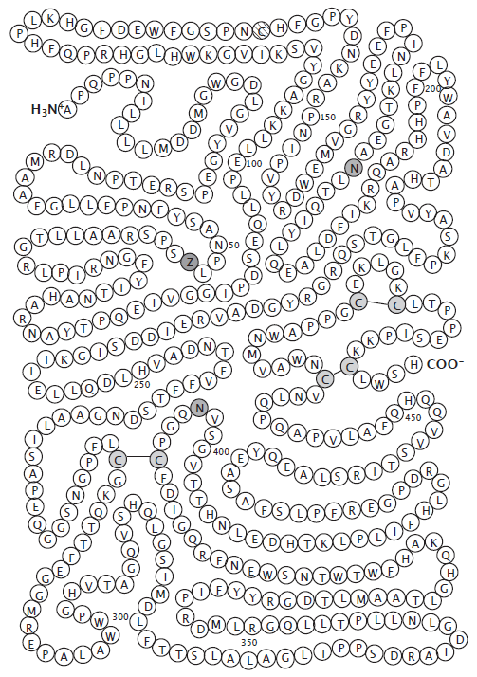

Pharmacokinetics in healthy subjects
Not Applicable.

Pharmacokinetics in the target population
Evaluations of the PK of BMN 110 are part of the designs of 4 of the 6 clinical efficacy and safety studies in the development program: MOR-002, MOR-004, MOR-005 (in Japanese subjects only), and MOR-008. As of the data cut-off of this submission, PK results were available for 2 of these studies: MOR-002 and MOR-004.

Study MOR-004 (Phase 3)
The study details are summarised in Section Clinical Efficacy, Pivotal efficacy studies. Sampling for PK analysis was performed for 65 subjects: 17 placebo, 24 BMN 110 2.0 mg/kg/qow, and 24 BMN 110 2.0 mg/kg/week. Blood samples for PK analysis were drawn at Weeks 0 and 22 predose (within 15 min before dosing), at 60 and 120 min after infusion start, within 5 min before infusion end, and at 5, 15, 30, 60, 120, and 180 min after infusion end, with the exception of 2 subjects in the BMN 110 2.0 mg/kg/qow group and 1 subject in the BMN 110 2.0 mg/kg/week group for whom blood samples were drawn at Week 20 and Week 23, respectively. One subject ([information redacted]; BMN 110 2.0 mg/kg/week) was excluded from PK analysis because only 1 pre-dose PK sample was available. PK parameters were not available due to missing samples for 1 subject in each treatment group at Week 22 and 1 subject in the BMN 110 2.0 mg/kg/week group at Week 0. The PK profile is summarised in Figure 2 and the main PK parameters are documented in Table 2.
Figure 2: BMN 110 Mean Plasma Concentration over Time in Study MOR-004

Table 2: Summary of Pharmacokinetic Parameters in Study MOR-004
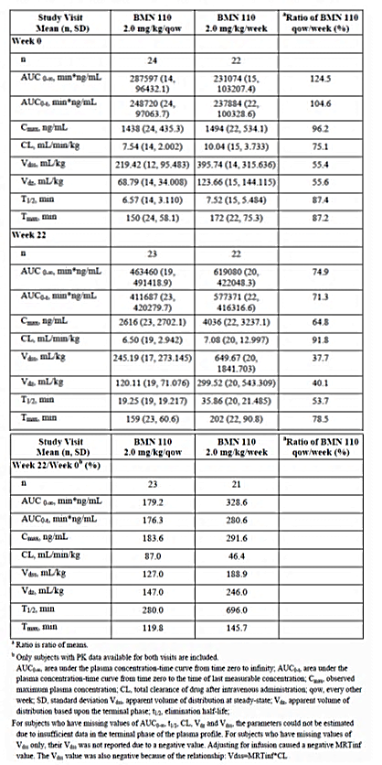

Study MOR-002 (Phase 1/2)
The study details are summarised in Section Clinical Efficacy, Pivotal efficacy studies. Sampling for PK assessments was performed on blood obtained on treatment days at Weeks 1, 12, 24, and 36 from pre-dose to 120 min post-infusion. The patients were aged between 5 and 18 years. The PK profile is summarised in Figure 3 and the main PK parameters are documented in Tables 3-4.
Figure 3: BMN 110 Mean Plasma Concentration over Time in Study MOR-002

Table 3: Summary of Pharmacokinetic Parameters in Study MOR-002
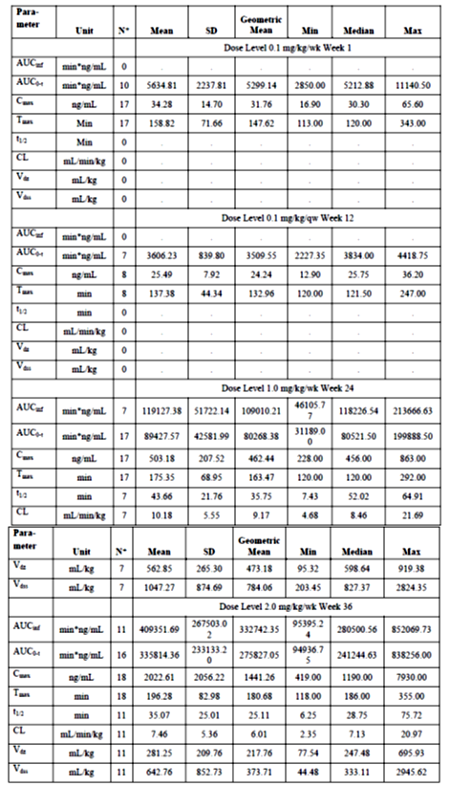

Table 4: Dose Proportionality for BMN 110 in Study MOR-002

Pharmacokinetics in other special populations
Children were the majority of subjects within the target population and are not considered separately in the evaluation.

Evaluator’s overall conclusions on pharmacokinetics
The sponsor has supplied a minimal clinical PK data set incorporating two clinical studies. The dose finding study, MOR-002, showed a non-linear dose dependent increase in plasma concentrations, in that both AUC and Cmax increased by up to 93 times when the dose was increased only 20 times (see Table 4). Study MOR-004 also did not demonstrate linear dose dependent changes in plasma concentrations when comparing weekly to second weekly infusions. This is not surprising given the relatively short plasma half-life of BMN 110; which was approximately 6 minutes with initial dosing increased to ~ 36 minutes at the end of the study (Table 2);when compared to the dosing interval (weekly or second weekly). There was a time dependent increase in half-life from week 1 to week 22 resulting from a decrease in clearance and a concurrent increase in volume of distribution over that time (Table 2). The studies are adequate to characterise the pharmacokinetics of BMN 110 including the dose proposed for administration in the product information for adults and children greater than 5 years of age. However, the pharmacokinetic data from study MOR-007, which enrolled children less than 5 years of age was not presented in the dossier. This is a deficiency in the data.

Pharmacodynamics

Studies providing pharmacodynamic data
All of the presented clinical studies collected pharmacodynamic data related to serum and urine KS as well as immunogenicity. Only studies MOR-004 and MOR-002 presented PK data and so could explore the PK–PD relationship (Table 5). All of the studies are summarised in Efficacy section of this evaluation.

Table 5: Submitted pharmacodynamic studies.
PD Topic | Subtopic (Effect on) | Study ID | *
Secondary Pharmacology§ | Efficacy (6MWT, 3MSCT, MVV) PD (urine KS reduction) | MOR-004
Secondary Pharmacology§ | Efficacy (6MWT, 3MSCT)  PD (urine KS reduction) | MOR-002
* Indicates the primary aim of the study if applicable. § Subjects who would be eligible to receive the drug if approved for the proposed indication. ‡ And adolescents if applicable.
Both pharmacodynamic studies had had some deficiencies but this did not exclude their results from consideration.

Summary of pharmacodynamics
The information in the following summary is derived from conventional pharmacodynamic studies in humans.

Mechanism of action
BMN 110 is a recombinant form of human N-acetylgalactosamine-6-sulfatase (rhGALNS), and is identical to the naturally occurring human lysosomal enzyme in terms of the amino acid sequence and N-linked glycosylation sites. BMN 110 is intended to provide exogenous GALNS that will be taken up into the lysosomes and increase the catabolism of GAGs KS and C6S. BMN 110 uptake by cells into lysosomes is most likely mediated by the binding of mannose-6-phosphate-terminated oligosaccharide chains of BMN 110 to the cation-independent mannose-6-phosphate receptor (CI-M6PR). BMN 110 internalization into the lysosome is anticipated to promote increased catabolism of keratan sulfate (KS) in affected tissues, including macrophages, hyaline cartilage, and other connective tissues. BMN 110 is therefore expected to reduce the progressive accumulation of KS and improve signs and symptoms of the disease.

Pharmacodynamic effects

Primary pharmacodynamic effects
No primary pharmacodynamic studies were conducted. Some pharmacodynamic parameters were described as part of the clinical efficacy studies (see Section Efficacy Pivotal studies for full details) and overlap with clinical efficacy outcomes.

Secondary pharmacodynamic effects
Two studies considered some pharmacodynamic parameters as outcome measures. These include the 6 minute walk time, 3 minute stair climb time, maximum voluntary ventilation and urine KS reduction.

Study MOR-004
In MOR-004, dosing regimen-dependent changes in efficacy (6MWT, 3MSCT, and maximum voluntary ventilation [MVV]) and PD (urine KS reduction) outcome measures were analysed in 47 patients. As only two dose levels were studied (2 mg/kg/week and 2 mg/kg/qow), there are a limited range of observable values on which to base the PD analysis. While there is some relationship between the dose and these measures (see Section Relationship between drug concentration and pharmacodynamic effects), there is no clear correlation between pharmacokinetic parameters and the exposure level as seen for example in the 6MWT (Figure 4) and urine KS reduction (Figure 5).
Figure 4: Association of Pharmacokinetic Parameters and Change of 6 Minute Walk Test from Baseline to Week 24
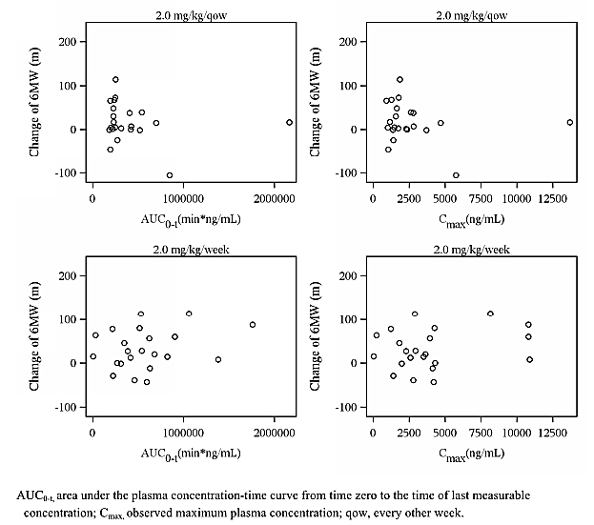
Figure 5: Association of Pharmacokinetic Parameters and Percent Change of Urine KS from Baseline to Week 24
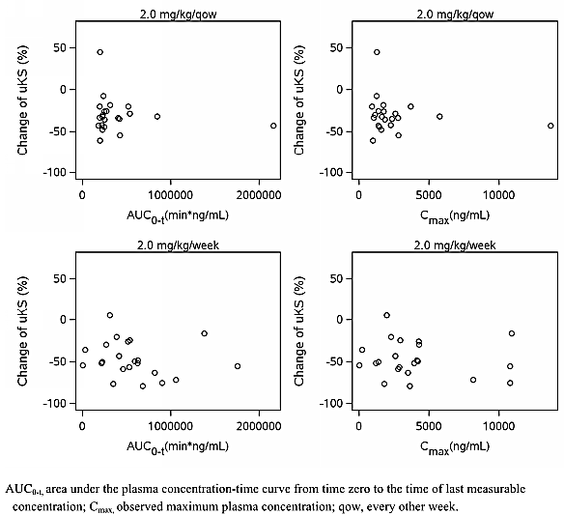

Study MOR-002
In MOR-002, dosing regimen-dependent changes in efficacy (6MWT, 3MSCT) and PD (urine KS reduction) outcome measures were analysed although the number studied was small (17 patients). There does appear to be some relationship between dose and 6MWT (Figure 6), 3MSCT (Figure 7) and urine KS reduction (Figure 8). This was not however, correlated with serum concentrations of BMN 110.
Figure 6: Mean Change from Baseline in Total Distance Walked During 6MWT vs. Study Week
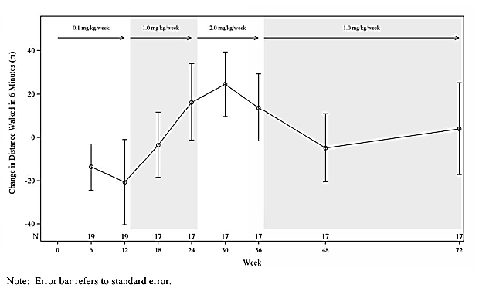
Figure 7: Mean Change from Baseline in Number of Stairs Climbed per Minute during 3-Minute Stair Climb Test versus Study Week
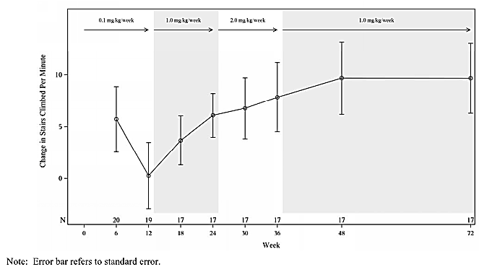
Figure 8: Normalized Urine KS versus Study Week
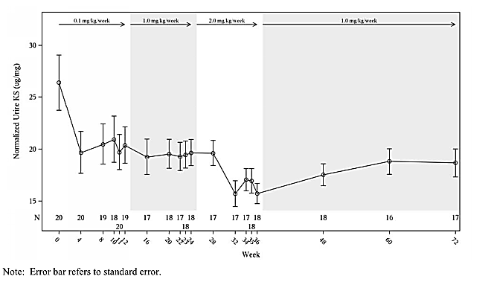

Time course of pharmacodynamic effects
The time course of pharmacodynamic effects was not explored.

Relationship between drug concentration and pharmacodynamic effects

Study MOR-004
In this study there was evidence of dosing dependent increases in efficacy (6MWT, 3MSCT, and MVV). There was also a dose dependent reduction in urine KS. The weekly treatment group exhibited a greater change in these outcomes than the every second week (qow) treatment group and the placebo group. The study however failed to demonstrate any relationship between drug exposure (based on PK) and any of these outcomes.
The mean baseline urine KS levels fell by 4.4%, 35.2%, and 45.1% for the placebo, qow and weekly dosing, respectively.
The mean change of 6MWT from Baseline was 13.5 m, 14.9 m, and 36.5 m for the placebo, qow and weekly dosing, respectively.
The mean change of 3MSCT from Baseline was 3.6, 3.4, and 4.8 stairs/min for the placebo, qow and weekly dosing, respectively.
The mean percent change of MVV from baseline was 2.4%, 6.1%, and 10.8% for placebo.
There was no clear correlation between individual PK exposure (AUC0-t and Cmax) and PD (urine KS) or efficacy (6MWT, 3MSCT, and MVV) (see Table 6).

Table 6: Summary of Pharmacokinetic Exposure, Pharmacodynamic, and Efficacy Measurements for BMN 110 in Subjects with MPS IVA in MOR-004

Study MOR-002
In this study there was again evidence of dosing dependent increases in efficacy (6MWT and 3MSCT). There were no dose-dependent changes of MVV. There was also a dose dependent reduction in urine KS. The study however failed to demonstrate any relationship between drug exposure (based on PK) and any of these outcomes. As there was no placebo group, the study was inadequately powered to assess the dose-dependent effects (see Table 7).

Table 7: Summary of Pharmacokinetic Exposure, Pharmacodynamic, and Efficacy Measurements for BMN 110 in Subjects with MPS IVA in MOR-002

Genetic-, gender- and age-related differences in pharmacodynamic response
Genetic, gender and age-related differences in pharmacodynamic response were not explored. Age and gender related data were available for analysis and this should be addressed by the sponsor. Furthermore, the data for children less than 5 years was not presented and this is a deficiency.

Pharmacodynamic interactions
Pharmacodynamic interactions were not explored.

Evaluator’s overall conclusions on pharmacodynamics
The studies failed to clearly demonstrate a concentration dependent change in any of the measured pharmacodynamic outcomes. This probably reflects the relatively modest changes effected by the medication in these parameters (see Efficacy section of this report). The sponsor should incorporate the as yet unpresented data from Studies MOR-005, MOR-100, MOR-006, MOR-007, MOR-008 and BMN 110-502. The use of population techniques with the full dataset may allow for a clearer analysis of the combined data including better defining the dose- concentration-pharmacodynamic relationship. A population analysis may also better define any effect of age and gender upon the pharmacodynamics of BMN 110.

Dosage selection for the pivotal studies
Based on the early phase studies, especially Study MOR-002 the sponsor chose 2 mg/kg/week and 2 mg/kg/qow for the pivotal study. This was an appropriate choice given the preceding data (section Relationship between drug concentration and pharmacodynamic effects). Specifically study MOR-002 demonstrated improvements in in both exercise tolerance (6MWT & 3MSCT) as well as favourable reductions in Urine KS excretion. However, a higher dose of BMN 110 was not explored to investigate whether this would be tolerated. Study MOR-008 (ongoing at the time of the report) is exploring whether a dose of 4 mg/kg/dose weekly is more efficacious in children greater than 7 years. The results of this study have not been reported.

Clinical efficacy

Treatment of Mucopolysaccharidosis IVA

Pivotal efficacy studies

MOR-004 A Phase 3, Randomized, Double-Blind, Placebo-Controlled, Multinational Clinical Study to Evaluate the Efficacy and Safety of 2.0 mg/kg/week and 2.0 mg/kg/every other week BMN 110 in Patients with Mucopolysaccharidosis IVA.

Study design, objectives, locations and dates

Study design
This was a Phase 3, randomized, double-blind, placebo-controlled, multinational study in subjects with MPS IVA. Subjects were randomized (1:1:1) to one of three treatment groups: (1) BMN 110 2.0 mg/kg/week, or (2) BMN 110 2.0 mg/kg/2nd week and placebo infusions on alternate weeks, or (3) placebo for 24 consecutive weeks (see Figure 9).
Figure 9: Study Design

Study objectives
The primary objective of this study was to evaluate the ability of 2.0 mg/kg/week BMN 110 and 2.0 mg/kg/ every other week BMN 110, compared with placebo, to enhance endurance in subjects with mucopolysaccharidosis IVA, as measured by increase in meters walked in the 6-minute walk test from Baseline to Week 24.
The secondary objectives were:
- 3-minute stair climb test (3MSCT) from Baseline to Week 24
- decrease in urine keratan sulfate (KS) levels from Baseline to Week 24
The tertiary objectives were to measure:
- pharmacokinetics
- respiratory function
- biochemical markers of inflammation and bone and cartilage
- quality of life as assessed by the MPS Health Assessment Questionnaire (MPS HAQ)
- hearing as measured by audiometry
- cardiac valve function as measured by echocardiogram
- corneal clouding as assessed by physical examination.

Study location
This study was conducted by 34 Principal Investigators at 33 study centres in 17 countries: Argentina, Brazil, Canada, Colombia, Denmark, France, Germany, Italy, Japan, Portugal, Qatar, Saudi Arabia, South Korea, Taiwan, Netherlands, United Kingdom, and the United States.

Study dates
Study Start Date: 25 January 2011 (first subject consented)
Study End Date: 23 August 2012 (last subject last visit)

Inclusion and exclusion criteria

Inclusion criteria for enrolment
- At least 5 years of age
- Documented clinical diagnosis of MPS IVA
- Written, signed informed consent
- Average Screening 6MWT distance ≥30 and ≤ 325 meters

Exclusion criteria for enrolment
- Previous hematopoietic stem cell transplant
- Previous treatment with BMN 110
- Known hypersensitivity to any component of BMN 110
- Major surgery within 3 months
- Pregnant or breastfeeding
- Use of any investigational product or medical device within 30 days

Study treatments
BMN 110 (recombinant human N‑acetylgalactosamine‑6‑sulfatase - rhGALNS) [information redacted].

Efficacy variables and outcomes
The main efficacy variables were:
Primary efficacy
- 6MWT
Secondary efficacy
- endurance tests:
  - 3MSCT
- urine KS concentration (normalized to creatinine)
Other efficacy measures
- respiratory function tests:
  - maximum voluntary ventilation (MVV)
  - forced vital capacity (FVC)
  - forced expiratory volume in 1 second (FEV1)
  - forced inspiratory vital capacity (FIVC)
  - forced expiratory time (FET)
- MPS Health Assessment Questionnaire ()
- blood inflammatory biomarkers
- blood biochemical markers of bone and cartilage metabolism
- anthropometric measurements (standing height, length, sitting height, and weight)
- skeletal radiographs of lumbar spine and lower extremity (lower extremity radiographs only in subjects ≤ 20 years of age)
- audiometry examinations
- echocardiogram
- corneal clouding
The primary outcome measures of the 6 minute walk test (6MWT) and 3 minute stair climb (3MSCT) were standardised measures of exercise tolerance, used in the assessment of patients with musculoskeletal problems including those with MPS.
The MPS Health Assessment Questionnaire is a 52-question instrument to evaluate functional capabilities and performance in children and adults with MPS. The MPS HAQ was originally developed to assess the self-care and mobility skills of patients with MPS I, and is currently used by an international MPS I Registry.

Randomisation and blinding methods
Subjects who met the study entry criteria were randomized (1:1:1) to one of three treatment groups using the interactive web or voice response system: (1) placebo, (2) BMN 110 2.0 mg/kg/qow with placebo infusions alternate weeks, or (3) BMN 110 2.0 mg/kg/week for 24 consecutive weeks. Randomization was stratified by screening 6MWT categories (≤200 meters and >200 meters) and age group (5-11, 12-18, and ≥19 years old). The randomization schedule was developed by an independent third party to ensure blinding.

Analysis populations
The efficacy populations were the intent-to-treat (ITT) population and the per-protocol (PP) populations. The ITT population consisted of all subjects who were randomized to study treatment and received at least one dose of study drug.
They also included a PP population which was used to perform sensitivity analyses for the primary, secondary, composite, and MVV endpoints. The PP population was a subset of the ITT population who were compliant with the protocol.

Sample size
- Safety population = 59 placebo; 59 BMN 110 2.0 mg/kg/qow;
58 BMN 110 2.0 mg/kg/week
- Intent-to-treat population = 59 placebo; 59 BMN 110 2.0 mg/kg/qow;
58 BMN 110 2.0 mg/kg/week
- Per-protocol population = 55 placebo; 55 BMN 110 2.0 mg/kg/qow;
52 BMN 110 2.0 mg/kg/week

Statistical methods
Approximately 162 subjects (54 subjects in each of the 3 groups) were to be enrolled to have over 90% power to detect a difference of 40 meters in mean change in the 6MWT distance between the BMN 110- groups and the placebo group, assuming that the common standard deviation (SD) was 65 meters with an overall 0.05 two-sided significance level with Hochberg method for multiplicity adjustment. The study would be considered positive if comparisons of both drug regimens to placebo result in P<0.05 or comparison of either drug regimen to placebo resulted in P<0.025.

Participant flow
A total of 204 patients were screened and 177 were randomized. Of the 27 individuals who failed screening, 22 had a Screening 6MWT distance that exceeded the allowable maximum of 325 meters, 3 withdrew consent, and 2 were not randomized for Other reasons. One randomized subject ([information redacted], placebo) was not dosed because the diagnosis of MPS IVA was not confirmed and this subject was excluded from all analyses.
Of the 176 subjects in the ITT population, 59 were randomized to placebo, 59 to BMN 110 2.0 mg/kg/qow, and 58 to BMN 110 2.0 mg/kg/week. Of the 176 subjects in the ITT population, 175 (99.4%) completed the study, 1 (0.6%) discontinued the study ([information redacted], BMN 110 2.0 mg/kg/week), and no subjects permanently discontinued study drug. See Figure 10 for details.
Figure 10: Subject Disposition

Major protocol violations/deviations
Protocol deviations are summarised in Table 8.

Table 8: Protocol Deviations - Intent-to-Treat Population
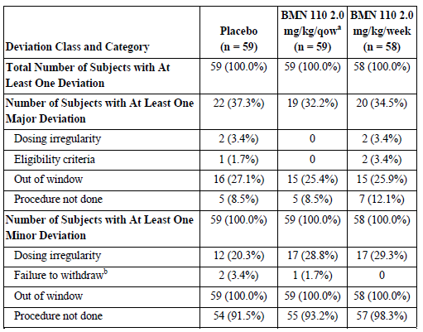
Subjects with deviations in more than one category were counted once in each category.
a qow, every other week.
b uKS samples were not first morning voids for [information redacted] subjects and investigator coded as Failure to Withdraw.
Out of window indicates that the study visit was performed outside the predetermined study time range (window).

Baseline data
Demographic data are summarised in Tables 9 and 10 below.

Table 9: Baseline Demographics -Intent-to-Treat Population

Table 10: Baseline Characteristics-Intent-to-Treat Population

Results for the primary efficacy outcome: 6-minute walk test
There was improvement from Baseline in 6MWT in the BMN 110 2.0 mg/kg/week group at Week 24 (36.5 meters [23.9%]) when compared with placebo (13.5 meters [8.7%]).
Mean changes (±SD) from Baseline at Week 24 in the ITT population were 13.5 (±50.6), 14.9 (±40.8), and 36.5 (±58.5) meters for placebo, BMN 110 2.0 mg/kg/qow, and BMN 110 2.0 mg/kg/week, respectively.
Mean percent changes (±SD) from Baseline at Week 24 were 8.7% (±28.8), 10.6% (±26.5), and 23.9% (±44.8) for placebo, BMN 110 2.0 mg/kg/qow, and BMN 110 2.0 mg/kg/week, respectively. See Table 11 and Figure 11 for details.
The primary outcome measure was analysed in accordance with the study plan. The primary efficacy endpoint was met (see Table 12). When compared with placebo, BMN 110 at a dose of 2.0 mg/kg/week demonstrated a statistically significant increase in 6MWT distance (in meters) at Week 24 (P=0.0174). It should be noted, however, that the clinical effect (an increase in walking distance of 23 metres) is modest.

Table 11: Summary of 6-Minute Walk Test - Intent-To-Treat Population
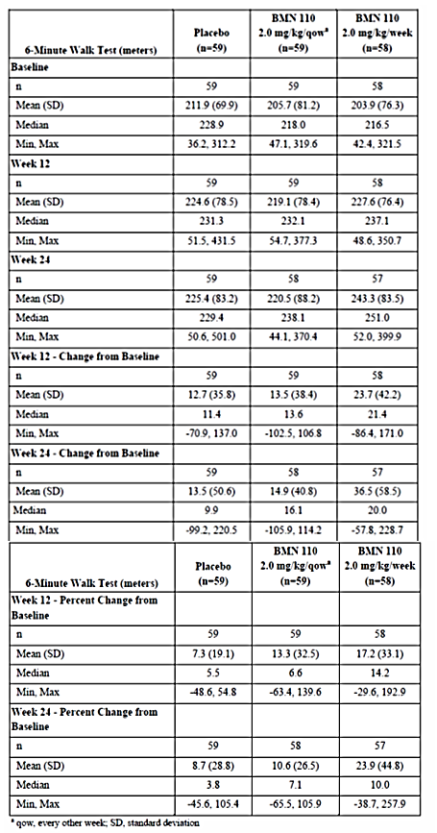
Figure 11: Repeated Measures ANCOVA Mean Change in 6-Minute Walk Test (Intent-To-Treat Population

Table 12: Primary Efficacy Analysis of the Primary Endpoint: Mean Absolute Change from Baseline in 6-Minute Walk Test at Week 24
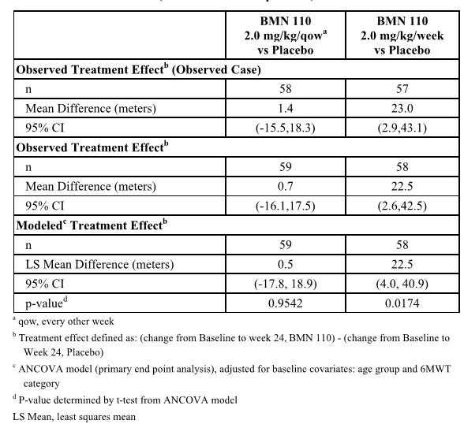

Results for other efficacy outcomes

3-minute stair-climb test
There was improvement from Baseline in 3MSCT in the BMN 110 2.0 mg/kg/week group at Week 24 (4.8 stairs/min [25.7%]) with slight advantage over placebo (3.6 stairs/min [11.4%]); a difference of only 1.1 stairs/min that was not statistically significant. See Table 13 for details.

Table 13: 3-Minute Stair-Climb Test: Mean Absolute Change from Baseline at Week 24

Urine Keratan Sulfate (normalized to creatinine)
The Mean changes (±SD) in the ITT population from Baseline at Week 24 were -2.8 µg/mg (±8.0) for placebo, -12.2 µg/mg (±16.3) for BMN 110 2.0 mg/kg/qow, and -12.6 µg/mg (±9.5) for BMN 110 2.0 mg/kg/week; these differences were statistically significant. See Table 14 for details.

Table 14: Primary Analysis of Normalized Urine Keratan Sulfate: Percent Change from Baseline at Week 24 - Intent-To-Treat Population

Maximum voluntary ventilation
The mean change (± SD) in the ITT population in MVV from Baseline at Week 24 was 0.5 L/min (± 8.7) for placebo, 1.5 L/min (± 6.0) for the BMN 110 2.0 mg/kg/qow group, and 1.5 L/min (±7.9) for the BMN 110 2.0 mg/kg/week group. These differences were not shown to be statistically significant.

Respiratory function tests
The treatment effect at Week 24 for both BMN 110 treatment groups, compared with placebo, was generally positive but the magnitude of absolute change was small. These differences were not shown to be statistically significant.

Forced vital capacity
Mean change (± SD) in the ITT population in FVC from Baseline at Week 24 was -0.0 L (±0.1) for placebo, 0.0 L (±0.1) for the BMN 110 2.0 mg/kg/qow group, and 0.0 L (±0.1) for the BMN 110 2.0 mg/kg/week group. These differences were not shown to be statistically significant.

Forced expiratory time
The mean change (± SD) in the ITT population in FET from Baseline at Week 24 was -0.0 sec (±2.72) for placebo, 0.3 sec (± 1.28) for the BMN 110 2.0 mg/kg/qow group, and -0.7 sec (±5.73) for the BMN 110 2.0 mg/kg/week group. These differences were not shown to be statistically significant.

MPS health assessment questionnaire
The mean change in the Self-Care Domain score from Baseline at Week 24 was -0.4 (± 1.19) in the placebo group, -0.5 (±1.29) in the BMN 110 2.0 mg/kg/qow group, and -0.3 (± 0.90) in the BMN 110 2.0 mg/kg/week group. These differences were not shown to be statistically significant.

Other markers
Other measures included Bone and Cartilage Metabolism Biomarkers, Anthropometric Measurements, Lower Extremity Radiographs, Audiometry, Echocardiogram, Corneal Clouding and other radiographs. Overall there were no differences in these markers between the treatment groups and the placebo group over the duration of the study.

MOR-005 A Multicentre, Multinational, Extension Study to Evaluate the Long-Term Efficacy and Safety of BMN 110 in Patients with Mucopolysaccharidosis IVA (Morquio A Syndrome) - Interim Study report – Cut-off Date 04 January 2013

Study design, objectives, locations and dates

Study design
This was a Phase 3, extension study to evaluate the long-term efficacy and safety of BMN 110 in subjects with MPS IV type A, who completed the parent study (MOR-004). The study is composed of two parts.
In Part 1, subjects initially randomized to BMN 110 remained on their assigned dose regimen of 2.0 mg/kg every week (qw) or 2.0 mg/kg every other week (qow). Subjects initially randomized to placebo were re-randomized (1:1 ratio) to one of the two BMN 110 dose regimens (2.0 mg/kg/qw or 2.0 mg/kg/qow). After analysis of the final primary efficacy and safety results in MOR-004, and based on the recommendation of the Data Monitoring Committee (DMC), the dose for Part 2 of MOR-005 (2.0 mg/kg/qw) was determined. Part 1 ended on 30 November 2012.
In Part 2, all subjects receive 2.0 mg/kg/qw.

Study objectives
To evaluate the long-term safety and efficacy of BMN 110 administration at 2.0 mg/kg/qw and 2.0 mg/kg/qow) in subjects with MPS IVA.
The secondary objectives were:
- To evaluate the long-term effect of BMN 110 administration at 2.0 mg/kg/qw and 2.0 mg/kg/qow on changes in biochemical markers of inflammation and bone and cartilage metabolism, in subjects with MPS IVA.
- To evaluate subject perception of impairment and improvement at 2.0 mg/kg/qw and 2.0 mg/kg/qow in subjects with MPS IVA.

Study location
This study was conducted by 36 principal investigators at 37 study centres in 19 countries: United Kingdom, United States, France, Canada, Brazil, Columbia, Argentina, Denmark, Germany, Italy, Japan, Netherlands, Norway, Portugal, Qatar, Saudi Arabia, South Korea, Taiwan, and Turkey.

Study dates
Study Start Date: 12 July 2011 (first subject consented)
Study End Date: Ongoing - projected date of study completion of March 2017.

Inclusion and exclusion criteria
Inclusion Criteria for Enrolment
Individuals with MPS IVA who completed MOR-004 and were expected to be able to comply with the treatment schedule.

Study treatments
BMN 110 (recombinant human N‑acetylgalactosamine‑6‑sulfatase - rhGALNS);[information redacted].

Efficacy variables and outcomes
The main efficacy variables were:
- endurance tests:
  - 6MWT
  - 3MSCT
- urine KS concentration (normalized to creatinine)
- respiratory function tests:
  - maximum voluntary ventilation (MVV)
  - forced vital capacity (FVC)
  - forced expiratory volume in 1 second (FEV1)
  - forced inspiratory vital capacity (FIVC)
  - forced expiratory time (FET)
- MPS Health Assessment Questionnaire
- anthropometric measurements (standing height, length, sitting height, and weight)
- skeletal radiographs of lumbar spine and lower extremity (lower extremity radiographs only in subjects ≤ 20 years of age)
- audiometry examinations

Randomisation and blinding methods
See Study MOR-004 design.

Analysis populations
The efficacy populations were the intent-to-treat (ITT) population and the Per Protocol (PP) populations. The ITT population consisted of all subjects who were randomized to study treatment and received at least one dose of study drug.
The PP population was used to perform sensitivity analyses for the primary, secondary, composite, and MVV endpoints. The PP population was a subset of the ITT population who were compliant with the protocol.

Sample size
Planned: up to 175
Enrolled: 173; 2 subjects who completed MOR-004 did not enrol in MOR-005
Completed: 0
The study remains ongoing. Part 1 of the study was completed on 30 November 2012; 172 subjects completed Part 1 (1 subject withdrew consent) and remain on study as of the data cut-off date of 04 January 2013. Part 2 was initiated on 01 December 2012.
Subjects receive treatment up to Week 240 or until one of the following occurs:
- the subject (or their parent or legally authorized representative) withdraws consent and the subject discontinues from the study or study treatment
- the subject is discontinued from the study or study treatment at the discretion of the Investigator or BioMarin, or the study is terminated.

Statistical methods
Up to 175 subjects with MPS IVA who completed MOR-004 were planned to be enrolled in this study. Sample Size:
Safety population = 29 PBO-QOW; 29 PBO-QW; 59 QOW-QOW; 56 QW-QW
Intent-to-treat (ITT) population = 29 PBO-QOW; 29 PBO-QW; 59 QOW-QOW; 56 QW-QW
Per-protocol (PP) population = 27 PBO-QOW; 25 PBO-QW; 51 QOW-QOW; 48 QW-QW
PBO - Placebo
QOW - Every second week
QW - Every week

Participant flow
Of the 175 subjects that completed MOR-004, 173 enrolled into MOR-005. One subject ([information redacted]) in the BMN 110 2.0 mg/kg/qw group and one subject ([information redacted]) in the placebo group of MOR-004 did not sign an informed consent for MOR-005 and did not enter the study (see Figure 12). In Part 1, 58 subjects who received placebo throughout the entire study duration of MOR-004 enrolled in MOR-005 and were randomized (1:1) to the BMN 110 2.0 mg/kg/qow (cohort PBO-QOW; n = 29) and BMN 110 at 2.0 mg/kg/qw (cohort PBO-QW; n = 29) treatment groups. A total of 59 and 56 subjects who received BMN 110 at 2.0 mg/kg/qow and 2.0 mg/kg/qw, respectively, throughout the entire study duration of MOR-004 enrolled in MOR-005. One subject in cohort QW-QW ([information redacted]) withdrew consent after completing Week 0 in Part 1 of MOR-005. All other subjects continued to receive BMN 110 2.0 mg/kg/qow (cohort QOW-QOW; n = 59) and BMN 110 2.0 mg/kg/qw (cohort QW-QW; n=55). Of the 172 remaining subjects who completed treatment in Part 1 of the study, 169 subjects were on treatment in Part 2 and 3 subjects ([information redacted]) were waiting for an infusion centre to open in their hometown, as of the data cut-off date of 04 January 2013.
Figure 12: Subject Disposition

Major protocol violations/deviations
Protocol deviations are summarised in Table 15.

Table 15: Protocol Deviations - Intent-to-Treat Population
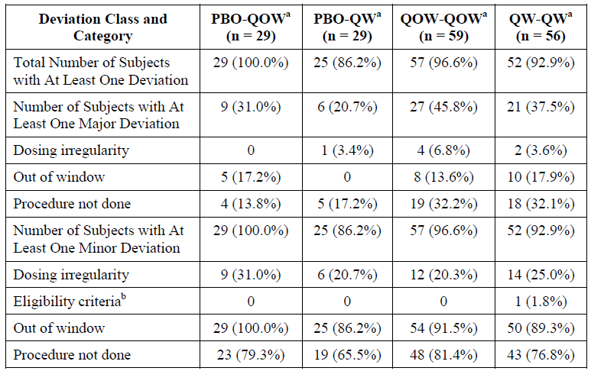
a PBO-QOW, Placebo-BMN 110 2.0 mg/kg/qow; PBO-QW, Placebo-BMN 110 2.0 mg/kg/qw; QOW-QOW,
BMN 110-BMN 110 2.0 mg/kg/qow; QW-QW, BMN 110-BMN 110 2.0 mg/kg/qw
B [information redacted] was incorrectly coded as an eligibility criteria deviation: there was no eligibility criteria deviation

Baseline data
Demographic data are summarised in Table 16.

Table 16: Baseline Demographics -Intent-to-Treat Population
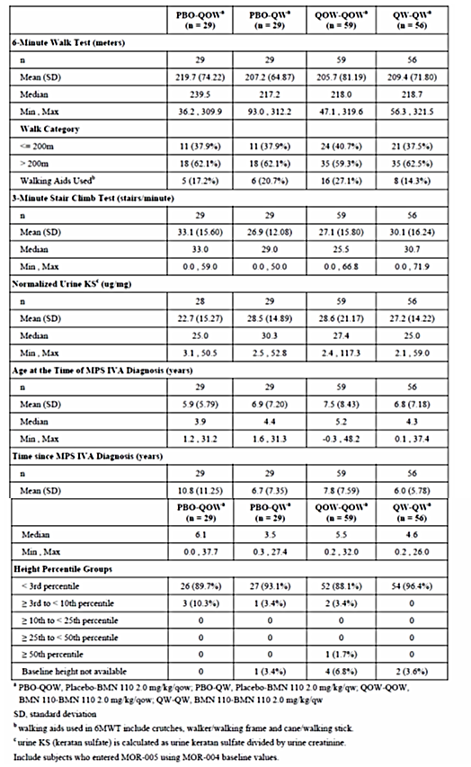

Results for the primary efficacy outcome

6-minute walk test
At Week 24, mean increases from MOR-004 Baseline in the ITT population were 14.9 and 36.5 meters for cohorts QOW-QOW (n=58) and QW-QW (n=57), respectively with greater improvement at Week 36 to 23.1 and 42.2 meters in the QOW-QOW (n=58) and QW-QW cohorts (n=54), respectively.
At Week 48, mean increases from MOR-004 Baseline for cohorts QOW-QOW (n=26) and QW-QW (n=26), respectively, were 3.7 and 33.4 meters. Fewer subjects had Week 48 assessments as a result of the switch to Part 2 of the study.
At Week 24, 1 (1.7%) subject in the QOW-QOW cohort did not perform (ie start) the test. At Week 36, all subjects performed the test; and at Week 48, 1 (1.8%) subject in the QW-QW cohort did not perform the test. At Week 36, 2 (3.4%) subjects in the QOW-QOW cohort and 3 (5.4%) subjects in the QW-QW cohort did not complete the test, and the most common reason given for failure to complete the test was pain.
At Week 48, 1 (1.7%) subject in the QOW-QOW cohort was unable to complete the test due to pain. See Table 17 and Figure 13 for details. Overall the gains from Study MOR-004 appeared to be maintained in this study up to the time of reporting.

Table 17: Summary of 6-Minute Walk Test - Intent-To-Treat Population MOR-004 and MOR-005 Part 1
Figure 13: Repeated Measures ANCOVA Mean Change in 6-Minute Walk Test (Intent-To-Treat Population MOR-004 & MOR-005 Part 1

3-minute stair-climb test
There were some improved 3MSCT results, with greater improvement in the QW-QW cohort at Week 48. Using the ANCOVA model, the least square mean changes from MOR-004 Baseline in 3MSCT results in the ITT population for the QOW-QOW and QW-QW cohorts, respectively, at Week 36 were 4.1 stairs/min and 5.9 stairs/min and at Week 48 were 2.9 stairs/min and 6.8 stairs/min). See Table 18 and Figure 14 for details. Overall the gains from Study MOR-004 appeared to be maintained in this study up to the time of reporting.

Table 18: 3-Minute Stair-Climb Test: Mean Absolute Change from Baseline at Week 24 - Intent-To-Treat Population MOR-004 and MOR-005 Part 1
Figure 14: Model Based (Repeated Measures ANCOVA) Mean Change in 3-Minute Stair-Climb Test Rate - Intent-To-Treat Population MOR-004 & MOR-005 Part 1

Other measures
Continued treatment with BMN 110 in Study MOR-005 sustained the reduction in urine KS at Weeks 36 and 48 that had been achieved in MOR-004.
Most of the changes achieved in the various respiratory measures in MOR-004 were maintained in Study MOR-005 Part 1.
There was a slight trend for the treated patents to have improved Anthropometric Measurements during Study MOR-005 Part 1 but there was a large distribution of results.
Overall the gains from Study MOR-004 appeared to be maintained in this study up to the time of reporting.

Other efficacy studies

Study MOR-002 A phase 1/2, multicentre, open-label, dose-escalation study to evaluate the safety, tolerability, and efficacy of BMN 110 in patients with mucopolysaccharidosis IVA
This was a multicentre, open-label study in MPS IVA patients ages 5 to 18 years old. The study was designed to assess safety, dose response via PK and PD assessments, and preliminary clinical efficacy. Exploratory evaluations included biochemical markers of inflammation, and bone and cartilage metabolism. The duration of the within-patient, Dose-Escalation Period was 36 weeks. During the Dose-Escalation Period, patients received a 4- to 5-hour intravenous infusion of BMN 110 once per week (qw), over three consecutive 12-week dose-escalating intervals at doses of 0.1, 1.0, and 2.0 mg/kg/qw.
The primary objective of the study was the following:
- To evaluate the safety of weekly infusions of BMN 110, administered in escalating doses, to patients with MPS IVA
The secondary objectives of the study were the following:
- To determine the PK parameters of infused BMN 110 in patients with MPS IVA
- To determine the PD parameters of infused BMN 110, as measured by change in KS in patients with MPS IVA
- To evaluate the efficacy of weekly infusions of BMN 110, administered in escalating doses, by monitoring changes in clinical measures of MPS IVA disorder
The exploratory objective of the study was the following:
- To evaluate the impact of weekly infusions of BMN 110, administered in escalating doses, by monitoring changes in biochemical markers of inflammation, and bone and cartilage metabolism, in patients with MPS IVA
Twenty patients were enrolled. The 12 male and 8 female patients ranged in age from 4 to 16 years. Due to the heterogeneity of the disease, patients had wide variation in their functional impairment and organ system involvement.
Of the 20 patients, 18 completed the Dose-Escalation and Continuation Periods. Two (10%) patients discontinued study participation early during the 0.1-mg/kg/qw dose interval, including one patient ([information redacted]) who experienced a life- threatening serious adverse event (SAE), a Type 1 hypersensitivity reaction; and one patient ([information redacted]) who had no AEs but withdrew from the study per request. Another patient ([information redacted]) discontinued treatment at Week 45 at the investigator’s discretion after recurrent immune reaction, but was not withdrawn from the study.

Results

6MWT
After initially declining at Weeks 6, 12, and 18, 6MWT distance increased at Weeks 24 and 36 of the Dose Escalation Period, with mean change from Baseline of 16.3 m at Week 24 and 13.8 m at Week 36. After decreasing the dose in the Continuation Period, the mean change from Baseline at Week 72 was 4.0 meters (see Figure 15).
Figure 15: Mean Change from Baseline in Total Distance Walked During 6-Minute Walk Test versus Study Week- Intent-to-Treat Population

3MSC test
The 3MSC test mean stair climb rate minimally changed from Baseline at end of Week 12, then increased by 6.1 stairs/min at the end of Week 24, and then by 7.8 stairs/min at the end of Week 36. After decreasing the dose in the Continuation Period, the mean change from Baseline at Week 72 was 9.7 stairs/min.

RFT
Most RFT means increased from Baseline during the 36-week Dose-Escalation Period, with continued increase through the Continuation Period (Week 72). Mean percent increases from Baseline at Week 72 were 8.4% for FEV1, 10.1% for TLC, 12.5% for FVC, 18.4% for MVV, 18.7% for FIVC, and 61.7% for FET.

Urine KS
Mean-normalized urine KS declined in a dose-dependent manner during the study, with mean percent decreases from Baseline of 23.2% at Week 12, 27.9% at Week 24, and 40.6% at Week 36. After the BMN 110 dose was reduced in the Continuation Period, mean urine KS values trended upwards, to a mean percent decrease from Baseline of 32.2% at Week 72.

Plasma KS
There was not a consistent dose-related trend in the mean changes from Baseline in plasma KS levels.

Study MOR-100 a multicentre, multinational, open-label, extension study to evaluate the long-term efficacy and sSafety of BMN 110 in patients with mucopolysaccharidosis IVA
This was an abbreviated study report with only summary data presented.
MOR-100 is an ongoing Phase 1/2 extension study of MOR-002 to evaluate the long-term efficacy and safety of BMN 110 in MPS IVA patients. The 17 subjects who received BMN 110 throughout the entire study duration of MOR-002 enrolled in MOR-100. Of the 17 subjects enrolled in MOR-100, 17 subjects have completed 74 to 87 weeks of treatment, no subjects have discontinued study participation early, and no subjects have permanently discontinued study drug. All 17 subjects are continuing treatment as of the data cut-off date of 19 July 2012. Efficacy results for variables available at the time of the data cut-off, including the 6-minute walk test (6MWT), 3-minute stair climb test (3MSCT), urine keratan sulfate (KS), and respiratory function tests (RFTs).

Efficacy
The following results are reproduced from the summary:

6MWT
After subjects were treated with BMN 110 for 72 to 84 weeks in MOR-002, an additional 84 weeks of treatment in MOR-100 led to sustained improvements in 6MWT distances at the majority of study visits.
The mean (±SD) increase in 6MWT distance in the Intent-to-Treat (ITT) population from MOR-002 Baseline to MOR-100 Baseline was 15.6 (± 88.84) meters; the mean increase from MOR-002 Baseline to MOR-100 Week 12 was 14.5(± 94.69 ) meters, to MOR-100 Week 24 was 24.5 (±101.23) meters; to MOR-100 Week 36 was 27.2 (± 62.51) meters; to MOR-100 Week 48 was 6.8 (± 98.66 ) meters; to MOR-100 Week 60 was 3.4 meters (±93.24) meters to MOR-100 Week 72 was -52.7 ( ± 133.78) meters; and to MOR-100 Week 84 was 13.9 (±116.44) meters (only 8 subjects had evaluable data at Week 84). The summary states that the decline in 6MWT at Week 72 was primarily driven by 4 subjects with orthopaedic surgery within 4 weeks prior to the Week 72 assessment.

3MSCT
After subjects were treated with BMN 110 for 72 to 84 weeks in MOR-002, an additional 84 weeks of treatment led to sustained improvements in 3MSCT at the majority of study visits.
Based on the results of the MOR-002 study, the dose was increased from 1.0 mg/kg/week to 2.0 mg/kg/week at the Baseline visit of MOR-100. The mean (± SD) increase in 3MSCT in the ITT population from MOR-002 Baseline to MOR-100 Baseline was 12.7 (± 13.96) stairs/min; to MOR-100 Week 12 was 12.9 (± 14.51 stairs/min); to MOR-100 Week 24 was 13.4 (± 17.07) stairs/min; to MOR-100 Week 36 was 9.6 ± 19.63 stairs/min; to MOR-100 Week 48 was 6.6 (±16.87) stairs/min; to MOR-100 Week 60 was 7.9 (± 17.30) stairs/min; to MOR-100 Week 72 was -3.3 (± 21.97) stairs/min; and to MOR-100 Week 84 was 12.3(±20.59) stairs/min (only 8 subjects had available data at Week 84). The summary states that the decline in 3MSCT at Week 72 was primarily driven by 4 subjects with orthopaedic surgery within 4 weeks prior to the Week 72 assessment.

Urine KS
After subjects were treated with BMN 110 for 72 to 84 weeks in MOR-002, an additional 72 to 84 weeks of treatment produced a similar level of reduction in normalized urine KS comparable to that seen during doing in MOR-002 at 2.0 mg/kg/week.
Based on the results of the MOR-002 study, the dose was increased from 1.0 mg/kg/week to 2.0 mg/kg/week at the Baseline visit of MOR-100. The mean (±SD) percent decrease in urine KS in the ITT population from MOR-002 Baseline to MOR-100 Baseline was 30.0 (± 19.23)%; the mean percent decrease from MOR-002 Baseline to MOR-100 Week 12 was 41.1 (± 20.72)%; to MOR-100 Week 24 was 43.6 (± 19.56)%; to MOR-100 Week 36 was 38.7 (± 25.73)%; to MOR-100 Week 48 was 41.9 (±19.29)%; to MOR-100 Week 60 was 43.7(± 26.92)%; and to MOR-100 Week 72 was 35.1 (±38.19)%.
The summary states that the increase in urine KS observed from Week 60 to Week 72 may have been spurious because of the small number of samples available.

Respiratory function tests
After subjects were treated with BMN 110 for 72 to 84 weeks in MOR-002, an additional 72 weeks of treatment led to sustained improvements in respiratory function at the majority of study visits.
Based on the results of the MOR-002 study, the dose was increased from 1.0 mg/kg/week to 2.0 mg/kg/week at the Baseline visit of MOR-100. The mean(±SD) percent increases in MVV and FVC in the ITT population from MOR-002 Baseline to MOR-100 Baseline were 11.1 (± 16.44)% and 11.8 (± 14.97)%, respectively; mean percent increases in MVV and FVC from MOR-002 Baseline to MOR-100 Week 24 were 9.8 (± 22.25)% and 15.3(±16.31%), respectively; to MOR-100 Week 48 were 3.5 (± 17.78 )% and 15.8(±16.56)%, respectively; and to MOR-100 Week 72 were 10.1(±27.83%) and 16.1(±21.96)%, respectively.

Study MOR-007 a phase 2, open-label, multinational clinical study to evaluate the safety and efficacy of BMN 110 in pediatric patients less than 5 years of age with mucopolysaccharidosis IVA
This was an interim study report.
MOR-007 100 is an ongoing Phase 2 study to evaluate the safety and tolerability (primary treatment phase: 52 weeks) and the long-term safety (extension treatment phase: 156 weeks) of recombinant human N-acetylgalactosamine-6-sulfatase (BMN 110). The drug is infused at a dose of 2.0 mg/kg/week in Mucopolysaccharidosis IVA subjects less than 5 years of age at the time of first study drug infusion. In addition to safety and tolerability, normalized urine KS, anthropometric measurements, and other characteristics of MPS IVA will be evaluated in this young population.
The first patient was enrolled on 24 October 2011. A total of 15 subjects were enrolled in MOR-007. As of the data cut-off date of 28 September 2012, subjects have received between 8 and 44 weeks of treatment with BMN 110. No subjects have completed the 52-week primary treatment phase. All 15 subjects are continuing treatment in the primary treatment phase of the study as of the data cut-off date.
Primary objective of the primary treatment phase.
- To evaluate safety and tolerability of infusions of BMN 110 at a dose of 2.0 mg/kg/week in MPS IVA subjects less than 5 years of age.
Secondary objectives of the primary treatment phase.
- To evaluate the ability of 2.0 mg/kg/week BMN 110 to reduce urine KS levels in MPS IVA subjects less than 5 years of age at time of first study drug infusion.
- To evaluate the ability of 2.0 mg/kg/week BMN 110 to affect growth velocity in MPS IVA subjects less than 5 years of age at time of first study drug infusion.
There were also a range of tertiary objectives including developmental assessments.

Study disposition
The study disposition is shown in Figure 16.
Figure 16: Subject Disposition

Demographic characteristics
The mean (±SD) age at the time of MPS IVA diagnosis was 2.1 ± 1.10 years and the mean (±SD) time since MPS IVA diagnosis was 1.4 ± 0.66 years. The mean (±SD) weight at Baseline was 13.1 ± 3.17 kg, the mean (±SD) subject length was 90.7 ± 9.37 cm, and the mean (±SD) standing height was 88.9 ± 8.95 cm. Baseline body length ranged from 76 to 113 cm and the baseline standing height ranged from 72 cm to 109 cm. Baseline normalized urine KS ranged from 18.8 to 56.5 µg/mg. Details are shown in Table 19.

Table 19: Demographic Characteristics

Extent of exposure
As of the data cut-off date of this report, the mean (±SD) total duration of BMN 110 exposure was 24.8 (± 9.12) weeks and ranged from 8 to 44 weeks. The mean (± SD) weekly dose received was 1.9 (±0.15) mg/kg/subject. Fifteen (100.0%) subjects received at least 1 dose of investigational product and were included in the safety analysis set.

Efficacy results
Efficacy results presented in the dossier were limited to normalized urine KS levels and anthropometric measurements. Results for 8 subjects who had completed Week 26 assessments were presented.
No other efficacy parameters were available in the report summary.
There was a decrease in mean normalized urine KS levels (calculated as urine KS divided by urine creatinine) within 2 weeks of commencing treatment and this was maintained at the 26 week time point (see Figure 17).
Figure 17: Normalized Urine Keratan Sulfate: Mean Percent Change from Baseline

Anthropometric measurements
The mean (SD) standing height increased from 87.5 (±6.48) cm at Baseline to 88.3 (±6.96) cm at Week 26 (see Figures 18 and 19). Mean normalized standing height (n=8) was 1.8 SD below normal at baseline. At the end of the 26 weeks, subject z-scores for standing height remain below normal (2.2 SD) and had further dropped, on average, 0.4 SD.
Figure 18: Standing Height: Mean Change from Baseline
Figure 19: Descriptive Summary of Mean Normalized Standing Height

Study MOR-008 a randomized, double-blind, pilot study of the safety and physiological effects of two doses of BMN 110 in patients with mucopolysaccharidosis IVA
This was an abbreviated interim study report with only summary data presented.
MOR-008 is an ongoing study to evaluate the safety of a 2.0 mg/kg/week and a 4.0 mg/kg/week dose of BMN 110 in patients with Morquio A syndrome (MPS IVA) who are able to walk at least 200 meters on the 6-minute walk test (6MWT). This pilot study is being conducted by 9 principal investigators at 9 study centres in 4 countries (Germany, United Kingdom, Canada, United States). The data cut-off date for the study report was 14 September 2012 and the study is still ongoing. The treatment duration from the beginning of the primary treatment phase through the extension treatment phase is a total of 157 weeks. Currently 25 subjects are enrolled in two cohorts. Fifteen subjects were enrolled into Cohort A and were randomized 2:1 to receive either 2.0 mg/kg/week of BMN 110 or 4.0 mg/kg/week of BMN 110. Ten subjects were enrolled into Cohort B and were randomized 1:1 to receive either 2.0 mg/kg/week of BMN 110 or 4.0 mg/kg/week of BMN 110.

Extent of exposure
Twenty-five (100%) subjects received at least 1 dose of study drug and were included in the safety analysis. The mean (± SD) weekly study drug dose per subject was 3.90 (± 0.159) mg/kg in the 2.0 mg/kg/week treatment group (combination of both BMN 110 and placebo formulations) and 3.96 (± 0.167) mg/kg in the 4.0 mg/kg/week treatment group.

Primary objective
To evaluate the safety of 2.0 and 4.0 mg/kg/week BMN 110 administered for 27 weeks

Secondary objectives
- To evaluate the effect of 2.0 and 4.0 mg/kg/week BMN 110 administered for 24 weeks to enhance endurance
- To evaluate the effect of 2.0 and 4.0 mg/kg/week BMN 110 administered for 25 weeks on overall exercise capacity (VO2 max)
- To evaluate the effect of 2.0 and 4.0 mg/kg/week BMN 110 administered for 24 weeks on respiratory function tests (RFTs)
- To evaluate the effect of 2.0 and 4.0 mg/kg/week BMN 110 administered for 25 weeks on muscle strength
- To evaluate the effect of 2.0 and 4.0 mg/kg/week BMN 110 administered for 24 weeks on cardiac function
- To evaluate the effect of 2.0 and 4.0 mg/kg/week BMN 110 administered for 24 weeks on pain
- To evaluate the effect of 2.0 and 4.0 mg/kg/week BMN 110 administered for 24 weeks on plasma and urinary keratan sulfate (KS) levels
- To determine the pharmacokinetic (PK) parameters of 2.0 mg/kg/week and 4.0 mg/kg/week BMN 110
There are also a range of tertiary objectives.

Inclusion criteria
Subjects with a documented diagnosis of MPS IVA who were older than 7 years of age, able to walk at least 200 meters in the 6MWT at screening, and had not previously had a hematopoietic stem cell transplant or been previously treated with BMN 110 were eligible to participate in this study.

Exclusion criteria
Subjects with severe untreated sleep apnoea (as measured by a home sleep testing device), a requirement for supplemental oxygen or ventilation, or any medical condition, including but not limited to symptomatic cervical spine instability or cord compression that would interfere with study participation.

Efficacy results
No efficacy data were included in the report.

Analyses performed across trials (pooled analyses and meta-analyses)
The sponsor provided an efficacy summary. There was no pooled analysis and the summary covered the key efficacy studies, MOR-004 and MOR-008. No new data were presented in the summary.

Evaluator’s conclusions on clinical efficacy for the treatment of MPS IVA
The pivotal study showed a modest improvement in exercise capacity in the treated population, that being adults and children greater than or equal to 5 years of age. In the 6 minute walk test, there was up to a 24 percent increase in the distance walked after 24 weeks of weekly therapy corresponding to 36 m in distance (Table 11). The changes in the other main efficacy parameters including stair climbing, respiratory function and health questionaires were not clinically significantly better in the treatment groups when compared to placebo. There was a significant decrease in urinary keratan sulfate excretion (Table 14) but this did not appear to translate into clinical improvement over the time of the study. The follow-up study and the supportive studies produced a similar range of results. The primary outcome measure – the 6 minute walk test is an appropriate measure for this population. Other clinical outcome measures such as 3 minute stair climb and ventilator capacity.
Overall the clinical gains from weekly treatment of BMN 110 in patients already significantly affected by MPS IVA were small. What is unknown is whether treatment will be more effective in very young children with MPS IVA who are not yet significantly impaired by the disease. The data has not been presented for children less than 5 years of age although Study MOR-007 is ongoing. The sponsor should report of the results of this study to clarify whether BMN 110 can be registered for use in this age group. Otherwise BMN 110 registration should be limited to the treatment of children greater than or equal to 5 years of age.

Clinical safety

Studies providing evaluable safety data
The following 6 studies provided evaluable safety data (Table 20):
- The completed pivotal double-blind, placebo-controlled Phase 3 study (MOR-004) and its ongoing extension study (MOR-005),
- The completed Phase 1/2 study (MOR-002) and its ongoing extension study (MOR-100), and 2 ongoing Phase 2 studies (MOR-007 and MOR-008).
Safety data up to the data cut-off dates for these 6 studies were included. Safety data from the ongoing ancillary Phase 2 study MOR-006 were not included in the submission.
The clinical safety summary was based on safety results from these 6 clinical studies in a total of 235 subjects with MPS IVA exposed to BMN 110 for up 169.7 weeks of continuous treatment. The overall mean [±SD] duration of exposure was 50.2 [± 37.03] weeks.
A total of 86 patients have received at least 48 weeks of therapy with BMN 110. This is less than the 100 patients normally required for registration of a new chemical entity but this is acceptable given it is a rare disease.

Table 20: All Exposed Population by Study
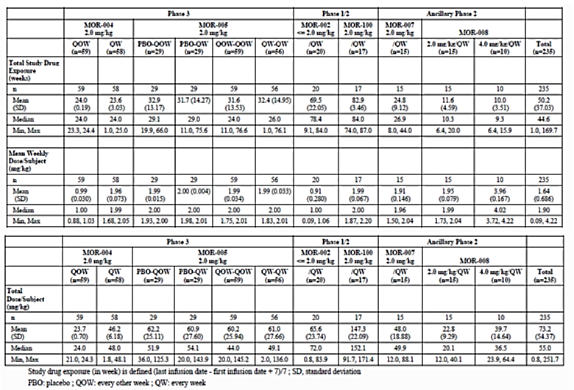

Pivotal efficacy studies
In the pivotal efficacy study MOR-004 (and its extension MOR-005), the following safety data were collected:
- AEs
- standard clinical laboratory tests (serum chemistry, haematology, and urinalysis)
- pregnancy tests
- vital signs
- ECGs
- routine physical examinations (including standard neurologic examinations)
- concomitant medications
- immunogenicity tests: BMN 110-specific total antibody (TAb), BMN 110-specific neutralizing antibodies that inhibit cellular receptor binding (NAb), drug-specific immunoglobulin E (IgE)
- demographic data (for comparison with on-study safety data)
- medical history (for comparison with on-study safety data)
- other lab assessments for subjects who experienced a serious adverse event

Pivotal studies that assessed safety as a primary outcome
No pivotal studies assessed safety as a primary outcome.

Dose-response and non-pivotal efficacy studies
In the non-pivotal studies (MOR-002, MOR-100, MOR-007 and MOR-008), the safety data included:
- AEs
- standard clinical laboratory tests (serum chemistry, haematology, and urinalysis)
- pregnancy tests (where appropriate)
- vital signs
- ECGs
- routine physical examinations (including standard neurologic examinations)
- concomitant medications
- immunogenicity tests: BMN 110-specific total antibody (TAb), BMN 110-specific neutralizing antibodies that inhibit cellular receptor binding (NAb), drug-specific immunoglobulin E (IgE)
- lab assessments for subjects who experienced a serious adverse event

Pivotal studies that assessed safety as a primary outcome
There were no studies which assessed safety as a primary outcome.

Adverse events

All adverse events (irrespective of relationship to study treatment)

Pivotal study
Adverse events for Study MOR-004 and its extension study MOR-005 are summarised in Tables 21 and 22 below. As can be seen, the majority of patients who received active drug reported one or more adverse events. However the number of SAEs was low. The commonly reported AEs are summarised in Table 23. Except for allergic reactions and local infusion reactions, most of the AEs were mild and well tolerated.

Table 21: Study MOR-004 Summary of Adverse Events

Table 22: Study MOR-005 Summary of Adverse Events

Table 23: AEs by Treatment Group: Incidence ≥ 10% in BMN 110 Subjects by Preferred Term, MOR-004

All studies
The safety summary included combined safety data for all studies (see Table 24). As with the pivotal studies, the overall studied population demonstrated a high rate of reported AEs. At least one AE was reported for 96.2% of subjects exposed to the treatment. The mean annualized frequency was 24.99 AEs per subject-year. The commonly reported AEs are summarised in Table 25.

Table 24: Safety Summary Exposed Population by Treatment Duration Interval

Table 25: Incidence (≥10%) and Frequency of Adverse Events by Preferred Term: All Exposed Population by Treatment Duration Interval
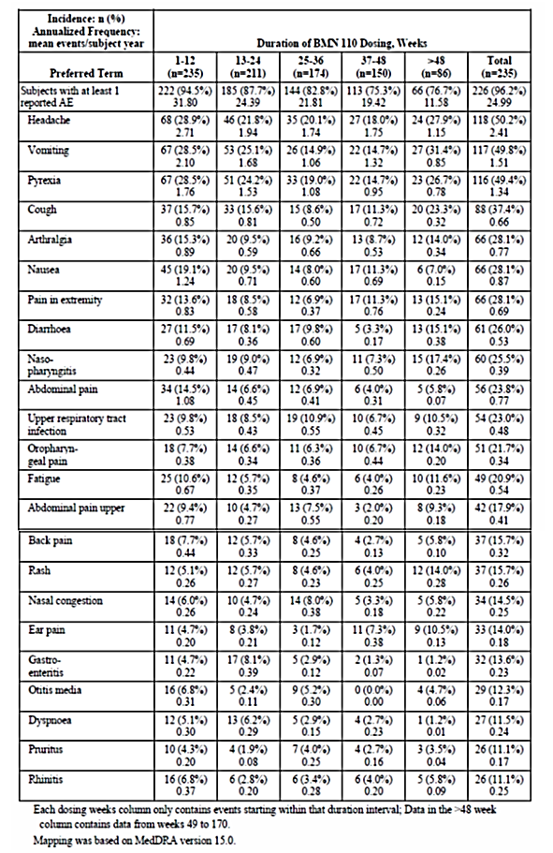

Treatment-related adverse events (adverse drug reactions)
The all studies, AEs were evaluated by relationship to study drug treatment by an investigator. Classification categories were unrelated AEs (unrelated) and possibly or probably related to study drug treatment AEs (related).

Pivotal studies
In MOR-004, drug-related AEs were reported for 36 (61.0%) subjects in the placebo group, 42 (71.2%) subjects in the BMN 110 2.0 mg/kg/qow group, and 42 (72.4%) subjects in the BMN 110 2.0 mg/kg/week group. The most common drug-related AEs are shown in Table 26.

Table 26: Study Drug Related Adverse Events by Treatment Group: Incidence (≥ 10%) MOR-004

All studies
The safety summary presented data for the All Exposed Population; drug-related AEs were reported for 74.5% of total subjects. The mean annualized frequency was 7.89 related AEs per subject-year. The most common drug-related AEs are shown in Table 27. While drug-related side-effects were common, these were in the main well-tolerated by the patients and did not result in discontinuation from the study. The rarer, but more significant drug related allergic reactions and local infusion reactions are discussed in Section Laboratory tests, Immunogenicity and Infusion associated reactions.

Table 27: Incidence (≥ 10%) and Frequency of Treatment Related Adverse Events by Preferred Term All Exposed Population by Treatment Duration Interval

Deaths and other serious adverse events

Deaths
There were no deaths reported in any of the reported studies.

SAEs
The evaluator agrees with the sponsor’s assertion that most SAEs were related to the underlying disease or to administration of intravenous therapy. The mean annualised frequencies of SAEs were similar during all treatment duration intervals. Most SAEs were assessed by an investigator to be unrelated to study drug.

Discontinuation due to adverse events

Pivotal studies
In MOR-004, no subject experienced an AE that resulted in permanent discontinuation of study drug or withdrew.

All studies
In the full study set, 1 subject in MOR-002 permanently discontinued study drug and withdrew from Study MOR-002 after Week 11 due to a type I hypersensitivity reaction.

Laboratory tests

Liver function

Pivotal studies
Two subjects in the BMN 110 2.0 mg/kg/week group in study MOR-004 had increased liver enzymes reported as AEs.
- [information redacted] had a moderate increase in liver transaminases at Study Day 140 (Week 20) that was considered possibly related to study drug and was ongoing at the last sample tested (level < 2-fold higher than the upper limit of normal).
- [information redacted] had mild increases in alanine aminotransferase and gamma glutamyl-transferase that were considered not related to study drug (concurrent with pneumonia) and resolved within 2 weeks.
The evaluator was unable to locate to exact liver enzyme measurements in these two subjects over the course of the study.
The sponsor should supply the details of the liver enzyme concentrations for the two patients with abnormalities or indicate their location in the dossier.

All studies
Few treatment-emergent increases in liver function tests were apparent in subjects treated with BMN 110 across all studies.

Kidney function

Pivotal studies
No evidence of treatment-emergent increases in kidney function abnormalities was apparent in subjects treated with BMN 110 in study MOR-004.

Other studies
No evidence of treatment-emergent increases in kidney function abnormalities was apparent in subjects treated with BMN 110 across all studies.

Other clinical chemistry

Pivotal studies
The evaluator agrees with the sponsor that no consistent or clinically meaningful changes from baseline in serum chemistry results were evident.

Other studies
The evaluator agrees with the sponsor that no consistent or clinically meaningful changes from baseline in serum chemistry results were evident.

Haematology

Pivotal studies
No clinically meaningful changes from baseline in haematology results were evident.

Other studies
No clinically meaningful changes from baseline in haematology results were evident.

Urinalysis

Pivotal studies
No clinically meaningful changes from baseline in urinalysis results were evident.

Other studies
No clinically meaningful changes from baseline in urinalysis results were evident.

Immunogenicity
The immunogenicity of BMN 110 was assessed in all clinical studies reported.
Three immunogenicity assays were developed for the determination of anti-BMN 110 antibodies: Anti-BMN 110 TAb Assay, Anti-BMN 110 CI-M6PR Neutralizing Binding Antibody (BMN 110-specific neutralizing antibodies [NAb] [that inhibit cellular receptor binding]) Assay, and Anti-BMN 110 Immunoglobulin E (IgE) Antibody Assay.
The TAb assay measures multiple anti-drug antibody isotypes in one assay utilizing the bridging method. The NAb assay detects antibodies capable of inhibiting the drug from binding to the CI-M6PR (cation-independent mannose-6-phosphate receptor). Antibodies capable of kinetically hindering or blocking the drug from binding to this receptor in vitro may be inhibiting cellular uptake of the drug in vivo, and therefore could potentially increase the plasma circulation time of the drug. Neutralizing antibodies that inhibit enzyme activity in the serum have not been measured because the drug remains inactive in the blood compartment. Instead, it is activated when it reaches the low pH environment of the lysosome. Development of NAb capable of inhibiting cellular receptor (CI-M6PR) binding was analysed in all studies, except MOR-007 due to blood sample volume restrictions in the younger subjects.

Pivotal studies
In MOR-004, a total of 6.8% (4/59) and 8.6% (5/58) of subjects tested positive for anti-BMN 110 IgE in the 2.0 mg/kg/qow group and 2.0 mg/kg/week group treatment groups, respectively. Anti-BMN 110 specific IgE antibodies were intermittent and not associated with severe Hypersensitivity AEs. A summary of hypersensitivity and antibody status is shown in Tables 28 and 29. There was no demonstrable effect of antibody status on efficacy.

Table 28: Incidence of Hypersensitivity Adverse Events in IgE Negative Subjects by TAb Response Group using Standardized MedDRA Query by Preferred Term, MOR-004

Table 29: Mean TAb Titre and Hypersensitivity Adverse Event Severity in IgE Negative Subjects, MOR-004

Other studies
Anti-BMN 110 antibody development was universal among the BMN 110-treated subjects. Tab titre levels were sustained in all subjects over the course of treatment. Higher TAb titres and NAb positivity were not associated with increased incidence or severity of Hypersensitivity AEs. Anti-BMN 110 IgE positivity was detected in approximately 10% of treated subjects and was not consistently associated with Hypersensitivity AEs.

Electrocardiograph

Pivotal studies
In study MOR-004, one subject in the BMN 110 2.0 mg/kg/week cohort, [information redacted], had a clinically significant abnormal ECG both at Baseline and at Week 24. No study subject in any cohort had a shift to a clinically significant abnormal ECG from Baseline to Week 24.

Other studies
In study MOR-005, electrocardiogram data were not available.
In study MOR-100, no subject had a clinically significant ECG abnormality as defined by an investigator.
In MOR-002, almost all subjects (≥ 90.0%) had ECG evaluations at each of the protocol-specified time points. No subjects had a clinically significant abnormal ECG, as defined by the Investigator, at any protocol-specified time point. Two of 18 (11.1%) subjects had an abnormal ECG at Screening, and 1 subject ([information redacted]) had an abnormal ECG at the Week 36 (1 of 19, 5.3%) and at Week 72 (1 of 18, 5.6%) visits.
In study MOR-007, all 15 subjects had ECGs performed at Baseline (100.0%). Ten (66.7%) were assessed as normal and 5 (33.3%) as abnormal at baseline. At Week 26, 8 subjects had ECG results and 2 (25.0%) of these subjects had abnormal ECGs, both of which were sinus tachycardia assessed by the investigators to be of no clinical significance.
In study MOR-008, post-Baseline ECGs were not reported.

Vital signs

Pivotal studies
In study MOR-004, changes in vital signs included events of bradycardia (2 subjects BMN 110 2.0 mg/kg/week); dyspnoea (3 subjects placebo; 6 subjects BMN 110 2.0 mg/kg/qow; 7 subjects BMN 110 2.0 mg/kg/week); hypotension (1 subject placebo; 2 subjects BMN 110 2.0 mg/kg/qow; 3 subjects BMN 110 2.0 mg/kg/week); and tachycardia (6 subjects placebo; 2 subjects BMN 110 2.0 mg/kg/qow; 3 subjects BMN 110 2.0 mg/kg/week). These events were all mild in severity, with the exception of 3 moderate hypotension events. All subjects’ vital signs returned to within normal ranges with no clinical sequelae.

Other studies
In Part 1 of MOR-005, no notable changes were evident from pre-infusion, during infusion, and post-infusion assessments that indicated abnormal or out of range vital sign values (heart rate, respiratory rate, diastolic blood pressure, or systolic blood pressure). In Part 2, vital sign AEs included 1 event of hypertension, 3 events of systolic blood pressure increased, 2 events of diastolic blood pressure increased, 2 events of increased blood pressure, and 1 event of increased body temperature.
In MOR-002, a few reports of vital sign findings in individual subjects were recorded as AEs. Of these, several were considered possibly or probably study drug-related, and were of mild or moderate severity: 3 AEs of decreased oxygen saturation occurred in 1 subject on 3 separate occasions, 1 of hypotension, and a number of events of pyrexia.
In MOR-008, no notable changes from Baseline were observed that resulted in abnormal or out of range vital sign values.

Hypersensitivity adverse events
Hypersensitivity reactions are a particular problem with the intravenous administration of biological agents including enzyme replacement therapies. In the current dossier, hypersensitivity AEs were identified by utilizing the broad Anaphylactic Reaction algorithmic Standardized MedDRA query and a broad Angioedema Standardized MedDRA query.

Pivotal studies
In study MOR-004, 7 (11.9%) subjects in the placebo group, 16 (27.1%) subjects in the BMN 110 every other week group and 12 (20.7%) subjects in the BMN 110 weekly group reported at least 1 Hypersensitivity event.
The following 2 events were classified as severe Hypersensitivity AEs:
- [information redacted] (BMN 110 2.0 mg/kg/qow) had an anaphylactic reaction at week 6 that was classified as an SAE and a severe Hypersensitivity AE. It was thought to be drug related.
- [information redacted] (BMN 110 2.0 mg/kg/week) had a hypersensitivity event at week 4 that was classified as an SAE and a severe Hypersensitivity AE. It was also thought to be drug related.
Hypersensitivity AEs experienced by subjects in MOR-004 are presented in Table 30.

All studies
In the total study population, Hypersensitivity AEs were reported for 27.2% of subjects.
The mean annualised frequency was 0.92 Hypersensitivity AEs per subject-year.

Table 30: Hypersensitivity Adverse Events using Standardized MedDRA Queries, MOR-004

Infusion associated reactions
Infusion associated reactions (IARs) were defined in each protocol as all AEs (regardless of relationship to study drug) that occurred either after infusion onset and within 1 day after infusion end (MOR-004/005, MOR-002/100, MOR-008) or within 1 day after infusion onset (MOR-007). The dossier stated that subjects were monitored closely during and after infusion for any AEs, and appropriate clinical management was instituted as needed, which could include infusion interruption (i.e. the infusion was stopped and eventually completed at that visit), infusion discontinuation (i.e. that visit’s infusion was never completed), medical intervention (defined as administration of intravenous steroids, intravenous antihistamines, intravenous fluids, or oxygen), or permanent study drug discontinuation.

Pivotal studies
In study MOR-004, the number of subjects reported that at least 1 reported IAR was 54 (91.5%) subjects with 291 events in the placebo group, 56 (94.9%) subjects and 393 events in the BMN 110 2.0 mg/kg/qow group, and 52 (89.7%) subjects and 511 events in the BMN 110 2.0 mg/kg/week group.
4 severe IARs were reported in this study:
- [information redacted] (placebo): cervical cord compression was also reported as an SAE.
- [information redacted] (BMN 110 2.0 mg/kg/qow): anaphylactic reaction that was also reported as an SAE and classified as a severe.
- [information redacted] (BMN 110 2.0 mg/kg/week): hypersensitivity that was also reported as an SAE and classified as a severe.
- [information redacted] (BMN 110 2.0 mg/kg/week): chills that resolved the same day with infusion rate reduction.
IAR AEs are presented in Table 31.

Table 31: Summary of Infusion Associated Reactions, MOR-004

All studies
In the total population, IARs were reported for 92.8% of subjects. The mean annualised frequency was 12.92 IARs per subject-year. There were steady decreases with duration of treatment in the mean subject-year frequencies of IARs and IARs during infusion. Mean annualized frequencies of IARs leading to infusion interruption and of IARs requiring medical intervention decreased after the 1 to 12-week treatment duration interval (Tables 32 and 33).

Table 32: Overall Summary of Infusion Associated Reactions by Treatment Duration Interval
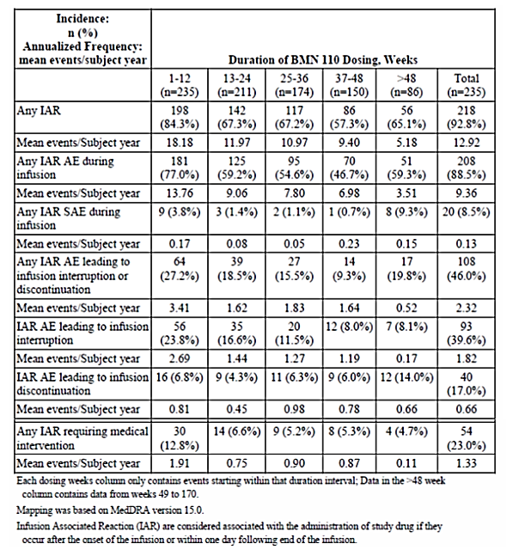

Table 33: Infusions Interrupted or Discontinued due to Adverse Events that Required Medical Intervention

Post-marketing experience
No post-marketing data were submitted.

Safety issues with the potential for major regulatory impact

Liver toxicity
No liver related safety issues with the potential for major regulatory impact were identified.

Haematological toxicity
No haematological related safety issues with the potential for major regulatory impact were identified.

Serious skin reactions
No skin related safety issues with the potential for major regulatory impact were identified.

Cardiovascular safety
No cardiovascular safety issues with the potential for major regulatory impact were identified.

Unwanted immunological events
Immunological phenomena were commonly reported events in patients receiving BMN 110. These events included Type I sensitivity reactions including anaphylaxis, infusion reactions and antibody development against BMN 110. These potential reactions need to be clearly described in the PI and CMI. Furthermore, specific advice on managing these events needs to be included in the PI.

Other safety issues

Safety in special populations
No particular safety issues in special populations were identified. However, data were limited in children less than 5 years; albeit that these limited data did not reveal any unexpected events.

Safety related to drug-drug interactions and other interactions
No significant drug-drug interactions were identified.

Evaluator’s overall conclusions on clinical safety
Overall, the safety of BMN 110 is comparable with other biologics used for enzyme replacement in the mucopolysaccharide storage disorders. The main concerns are the immunological sequelae with the development of antibodies and the risk of local and generalised immune reactions, especially during infusions. There is the acute, life-threatening risk of a severe reaction during the infusion. However, the evaluator notes that there were no deaths reported in the study. There is also the long-term implications that a particular patient may be excluded from future treatment if they develop a severe recurrent allergic reaction to therapy with BMN 110. This risk was not apparent in the current dossier. Pre-treatment of patients may be effective in reducing allergic reactions but practice varied across the studies. No desensitisation protocol was developed for the use of BMN 110 although such protocols are available for other biologics.
There was almost universal development of an antibody to BMN 110 in patients receiving therapy. The implications of antibody development are uncertain however, there was no correlation between antibodies and adverse events or changes in efficacy. There was an increase in the exposure to BMN 110 with ongoing therapy but it is unclear whether this was related to antibody development.
Overall the safety of BMN 110 is comparable to other biological agents used in a range of similar diseases.

First round benefit-risk assessment

First round assessment of benefits
The main efficacy outcomes of the pivotal and supportive studies are appropriate, those being assessments of exercise tolerance. There are limited data on growth and development. Those data do suggest that there may be some improvement in linear growth but the studies were unable to demonstrate clinical or statistical improvement over the duration of the studies. Any significant improvements in linear growth and development would be expected within the first 5 years of life. These data are not currently available. Dosing data are only currently supported by the pharmacokinetic and clinical studies in children over 5 years of age. Exposure data over the longer term is limited with only 86 patients reported to have exposure up to 48 weeks. The benefits of BMN 110 in the proposed usage are:
- A modest improvement in 6 minute walk distance
- A decrease in the excretion of urinary keratan sulfate.

First round assessment of risks
The risks of BMN 110 in the proposed usage are:
- The risk of immunological reactions
- A high general rate of infusion related side-effects
- The universal development of antibodies and the long-term impact upon therapy
- Pharmacokinetic data indicates a non-linear relationship between dose and plasma concentrations. While this does not appear to have a direct impact upon patient safety or efficacy, this needs to be monitored in the ongoing studies
- The Pharmacokinetic, safety and efficacy data do not support the use of BMN 110 in children less than 5 years of age
- Pharmacodynamic data have not demonstrated a relationship between dose, concentration and pharmacodynamic measures.

First round assessment of benefit-risk balance
MPS IVA is a debilitating and relentlessly progressive disease for which there is currently no effective therapy. BMN 110 offers the first specific enzyme replacement which may offer some improvement in the physical limitations imposed by the disease. The current data set has some significant deficiencies in the supportive kinetic and dynamic data. This includes the nonlinearity of the pharmacokinetics and more especially, the inability to demonstrate a relationship between dose, concentration and clinical outcome. However the modest improvement in the 6 minute walk distance, in adults and children greater than or equal to 5 years of age, as well as the trend to improvement in other physiological outcomes offers some hope to these patients. The safety profile is acceptable given the severity of the disease although the issue around the management of hypersensitivity and antibody development needs to be clarified.
In conclusions, the benefit-risk balance of BMN 110, given the proposed usage, is favourable in adults and children greater than or equal to 5 years of age, given the severity of the underlying disease and the lack of any other effective therapies.

First round recommendation regarding authorisation
The evaluator recommends that Vimizim be approved for the following indication:
Vimizim is indicated for the treatment of mucopolysaccharidosis type IVA (MPS IVA; Morquio A syndrome) in adults and children greater than or equal to the age of 5 years.
The age range could be extended if the final results of Study MOR-007 and Study BMN 110-502 become available and so adequate efficacy and safety for children less than 5 years of age.

Clinical questions

Additional expert input
The demonstrated clinical benefits of BMN 110 are modest.
The sponsor should provide updates from all of the ongoing studies for which there are only interim reports. This should include updates in pharmacokinetic, pharmacodynamic and efficacy parameters as well as safety data. Specifically, the sponsor should submit the as yet unpresented data from Studies MOR-005, MOR-100, MOR-006, MOR-007, MOR-008 and BMN 110-502.

Pharmacokinetics
The sponsor should further address the time-dependent kinetics of BMN 110. What are possible mechanisms to explain this? Are there further changes in exposure with even longer periods of exposure? Within this response, the sponsor should address the following observations:
- The dose finding study, MOR-002, showed a non-linear dose dependent increase in plasma concentrations, in that both AUC and C_{max} increased by up to 93 times when the dose was increased only 20 times (see Table 4).
- In Study MOR-004 there was a time dependent increase in half-life from week 1 to week 22 resulting from a decrease in clearance and a concurrent increase in volume of distribution over that time (Table 2).

Pharmacodynamics
The sponsor should incorporate the as yet unpresented data from Studies MOR-005, MOR-100, MOR-006, MOR-007, MOR-008 and BMN 110-502 in the pharmacodynamic analysis.
The use of population techniques with the full dataset may allow for a clearer analysis of the combined data including better defining the dose- concentration-pharmacodynamic relationship. A population analysis may also better define any effect of age and gender upon the pharmacodynamics of BMN 110.

Efficacy
The data has not been presented for children less than 5 years of age although Study MOR-007 is ongoing. The sponsor should report of the results of this study to clarify whether BMN 110 can be registered for use in this age group. Otherwise BMN 110 registration should be limited to the treatment of children greater than or equal to 5 years of age.

Safety
The sponsor should provide the individual liver function data for the two patients with abnormalities in their liver function as indicated in Section Liver function above.
The sponsor should reanalyse their current safety database to develop recommended prophylactic antihistamine and steroid regimens for infusion and hypersensitivity reactions. This should be provided for review in the second round.

Second round evaluation of clinical data submitted in response to questions

Additional expert input
The demonstrated clinical benefits of BMN 110 are modest. The sponsor should provide updates from all of the ongoing studies for which there are only interim reports. This should include updates in pharmacokinetic, pharmacodynamic and efficacy parameters as well as safety data. Specifically, the sponsor should submit the as yet unpresented data from Studies MOR-005, MOR-100, MOR-006, MOR-007, MOR-008 and BMN 110-502.
The sponsor submits ‘that the mean effect on 6MWT seen in study MOR-004 translates into extensive clinical benefit to the patients.
New data in support of the sponsor’s assertion as follows.

Discussion of study design and endpoint considerations
The sponsor reiterated that the rarity of MPS IVA and the severity of the disease make clinically meaningful endpoints difficult to show via large improvements in measures of mobility.
The evaluator accepts that this is the case.

Change in 6MWT - Study MOR-001
The response stated that:
Recently available preliminary longitudinal data from patients who have been enrolled in MOR-001 and completed annual assessments demonstrate the progressive deterioration of this measure over time. Data from Visits 1, 2, and 3 were analysed using a repeated measure regression model. The annualized estimate of change in 6MWT from Visit 1 across all subjects in MOR-001 was -4.9 meters (CI95, -11.3, 1.6). The annualized estimate of change in 6MWT from Visit 1 was -6.8 meters (95% CI, -17.5, 3.9) in the subset of patients selected to match the MOR-004 study population (age ≥ 5 years, 6WMT between 30 and 325 meters at Visit 1 (data on file; publication being drafted). These data confirm and extend our understanding that patients with MPS IVA experience a chronic, progressively debilitating decline in performance as measured by 6MWT. Although these data suggest that there is a large impact of placebo in the course of the randomized clinical trial (patients treated with placebo in MOR-004 showed a mean increase in distance walked of 13.5 meters at Week 24 compared to Baseline), the treatment effect on 6MWT in Study MOR-004 against placebo (22.5 meters at Week 24 compared to Baseline) was statistically significant in patients receiving weekly doses of BMN 110.
The evaluator accepts that the natural history of patients with MPS IVA includes deterioration in 6MWT. However, the improvement in 6MWT of 22.5 metres at Week 24 (compared to Baseline) is hard to characterise as “translates into extensive clinical benefit”. This is however statistically significantly different to the placebo improvement of 13.5 metres at Week 24 (compared to Baseline).

Definition of an MCID and responder analyses - Study MOR-004
The sponsor identifies the responder definition thresholds, expressed as the percent change improvement from Baseline after 24 weeks of treatment, were as follows:
- A 15% change for the 6MWT
- A 20% change for the 3MSCT
- A 20% change for MVV.
Responder analyses, based on these thresholds for 6MWT, 3MSCT, and MVV showed a higher proportion of responders in the weekly group compared with the placebo group for all three measures (MOR-004 CSR):
- 6MWT (weekly vs. Placebo): 45.6% vs. 30.5%; P=0.0603
- 3MSCT (weekly vs. Placebo): 45.6% vs. 25.4%; P=0.0228
- MVV (weekly vs. Placebo): 28.6% vs. 12.0%; P=0.0576
The evaluator accepts that there was a trend to improvement in other clinical parameters including 3MSCT and MVV.

Long-term efficacy data - Study MOR-005
The sponsor has provided more long term efficacy data from Study MOR-005. These new data supports ongoing improvement of 6MWT up to 48 weeks in open label follow-up (see Figure 20). Other secondary outcomes showed similar trends to improvements were maintained in the newly provided data. In this extension study, no control group was available for comparative statistical analysis.

6MWT
Using the primary analysis ANCOVA model in the ITT population, the least square mean changes from MOR-004 Baseline for the QOW-QOW and QW-QW cohorts, respectively, at Week 36 were 22.7 (CI95, 9.8, 35.5) and 40.9 (CI95, 27.8, 54.0) metres, at Week 48 were 11.0 (CI95, -9.6, 31.7) and 29.1 (CI95, 8.5, 49.7) metres, and at Week 72 were 26.3 (CI95, 9.1, 43.5) and 30.1 (CI95, 12.6, 47.6) metres.

3MSCT
Using the primary analysis ANCOVA model in the ITT population, the least square mean change from MOR-004 Baseline in 3MSCT results for the QOW-QOW and QW-QW cohorts, respectively, at Week 36 were 4.1 stairs/min (CI95, 1.4, 6.8) and 5.8 stairs/min (CI95, 3.0, 8.5), at Week 48 were 2.9 stairs/min (CI95, -0.9, 6.8) and 6.9 stairs/min (CI95, 3.0, 10.8), and at Week 72 were 5.0 stairs/min (CI95, 2.1, 7.9) and 5.3 stairs/min (CI95, 2.3, 8.2)

Urine KS
At Week 24, mean percent changes from MOR-004 Baseline for cohorts QOW-QOW and QW-QW in the ITT population were -34.6% and -45.5%, respectively. Using the primary analysis ANCOVA model in the ITT population, the least square mean percent changes in urine KS levels from MOR-004 Baseline at Week 48 were -45.0% (CI95, -49.0, -41.1) and -51.5% (CI95, -55.7, -47.3) for the QOW-QOW and QW-QW cohorts, respectively. At Week 72, when most subjects were receiving the same weekly regimen (2.0 mg/kg/week), the least square mean percent changes from MOR-004 Baseline were -53.8% (CI95, -57.4, -50.1) and -54.3% (CI95, -58.3, -50.3) for the QOW-QOW and QW-QW cohorts, respectively.
Figure 20: Analysis of 6MWT: Repeated Measures Model Analysis Population: Intent-to-Treat

Additional quality-of-life assessments and clinical improvements - Study MOR-004
The sponsor provided further analysis of the quality of life data for Study MOR-004. The data included that in regard to wheelchair use, there was a net increase of 5 (8.8%) patients in the placebo group using a wheelchair at Week 24 versus 0 (0%) in the BMN 110 weekly dose group, as compared to Baseline. Assessments of several other essential daily activities showed similar treatment-associated improvements, with a positive shift at Week 24 in the number of subjects on weekly BMN 110 compared to placebo who were able to perform important activities of daily living, such as transferring to and from the bathtub, toilet, furniture and car, as well as some independent dressing and feeding skills.

Variability of patient response - Study MOR-004
The sponsor noted that there was variability in patient response to treatment with BMN 110; for example a positive response in the 6MWT did not predict a positive response in the 3MSCTor the MVV. Also a positive response in the 3MSCTor the MVV did not appear to be predictive of a positive response in the 6MWT.
The sponsor did not provide any new data from the ongoing clinical studies listed above. A summary of the anticipated completion dates is shown in Table 34.

Table 34: Anticipated Completion Dates for the CSRs of Ongoing Clinical Studies
The sponsor also provided safety updates for the following studies for the time periods listed below:
- MOR-005: 05 January 2013 – 11 March 2013
- MOR-006: 23 August 2012 – 11 March 2013
- MOR-007: 29 September 2012 – 11 March 2013
- MOR-008: 15 September 2012 – 11 March 2013
- MOR-100: 20 July 2012 – 11 March 2013.
No new safety findings were identified over the period of these reports.

Clinical questions

Pharmacokinetics
The sponsor should further address the time-dependent kinetics of BMN 110. What are possible mechanisms to explain this? Are there further changes in exposure with even longer periods of exposure? Within this response, the sponsor should address the following observations:
The dose finding study, MOR-002, showed a non-linear dose dependent increase in plasma concentrations, in that both AUC and Cmax increased by up to 93 times when the dose was increased only 20 times (see Table 4).
In Study MOR-004 there was a time dependent increase in half-life from week 1 to week 22 resulting from a decrease in clearance and a concurrent increase in volume of distribution over that time (Table 2).
The sponsor identified that the exact mechanism causing time-dependent kinetics of BMN 110 is unknown but postulated that anti-BMN 110 antibodies were a major factor. The sponsor also failed to identify the mechanism of the non-linear dose dependent increase in plasma concentrations. Furthermore, the sponsor did not address whether there are further changes in exposure with even longer periods of exposure.

Pharmacodynamics
The sponsor should incorporate the as yet unpresented data from Studies MOR-005, MOR-100, MOR-006, MOR-007, MOR-008 and BMN 110-502 in the pharmacodynamic analysis.
The use of population techniques with the full dataset may allow for a clearer analysis of the combined data including better defining the dose- concentration-pharmacodynamic relationship. A population analysis may also better define any effect of age and gender upon the pharmacodynamics of BMN 110.
The sponsor did present some new pharmacodynamic data including evidence of normalized urine KS levels and a trend towards stabilization of normalized standing height z-scores. However, the sponsor did not reanalyse the data to better define the dose- concentration-pharmacodynamic relationship.

Efficacy
The data has not been presented for children less than 5 years of age although Study MOR-007 is ongoing. The sponsor should report of the results of this study to clarify whether BMN 110 can be registered for use in this age group. Otherwise BMN 110 registration should be limited to the treatment of children greater than or equal to 5 years of age.
The sponsor did not present any new efficacy data or analysis related to the efficacy of BMN 110 in children less than 5 years. However, the sponsor did present some new pharmacodynamic data including evidence of normalized urine KS levels and a trend towards stabilization of normalized standing height z-scores.

Urine KS levels
Treatment with BMN 110 led to a decrease in mean normalized urine KS levels within 2 weeks and the decreased levels were maintained over 52 weeks. The mean (± SD) percent change from Baseline in urine KS was -30.2% (±12.68; n=15) at 2 weeks, and -39.9% (± 24.03; n=15) at 26 weeks, and -43.5% (± 22.15; n=10) at 52 weeks.

Normalized growth rate z-scores
The mean normalized growth rate z-scores improved for all subjects (n=15) and for the subgroup of subjects ≥ 2 years of age (n=12) indicating a trend towards improved growth rates with long term BMN 110 treatment. The Baseline and Week 52 mean (± SD) normalized growth rate z-scores were -0.6 (± 0.64) and -0.4 (± 0.53), respectively, for all subjects and -0.8 (± 0.78) and -0.3 (± 0.53), respectively, for subjects ≥ 2 years of age.
While these data are useful, they are insufficient to address the evaluators concerns about the use of BMN 110 in children less than 5 years of age.

Safety
The sponsor should provide the individual liver function data for the two patients with abnormalities in their liver function.
The sponsor should reanalyse their current safety database to develop recommended prophylactic antihistamine and steroid regimens for infusion and hypersensitivity reactions. This should be provided for review in the second round.
- [information redacted]
Data up to the Week 120 study visit of MOR-004/005 combined show that [information redacted] who had elevated liver enzymes at Week 6 did not have abnormally high aminotransferase levels at any subsequent time point tested and the associated AE was considered recovered/resolved two weeks after onset.
- [information redacted]
[information redacted] completed the Week 96 study visit (MOR-004/MOR-005 combined) and continues to receive study treatment. A summary of this subject’s liver enzymes is provided in Table 35; liver enzymes were continuously elevated from Week 18 though Week 96. The associated AE of elevated liver transaminases reported at Week 20 is therefore listed as “Not Recovered/Not Resolved. In addition, the patient was diagnosed with hepato-lenticular degeneration (Wilson’s disease) on the same day as the AE of elevated liver transaminases (01MAR2012), which is a rare autosomal recessive disorder of copper metabolism that may lead to liver failure and explains the persistent elevated liver enzymes.

Table 35: Serum Chemistry Results through Week 96 for subject [information redacted]
The evaluator agrees that the sponsor has adequately addressed this question on liver function.
The sponsor provided no new information to support their recommended pre-treatment regimen:
- Recommendations applicable to all patients regarding pre-treatment (antihistamines with or without antipyretics 30-60 minutes prior to start of infusion)
- Additional pre-treatment (i.e., additional prophylactic antihistamines and prophylactic corticosteroids for severe reactions) for patients who previously experienced infusion reactions
The sponsor has not addressed the evaluators request for analysis of their database in support of a recommended prophylactic antihistamine and steroid regimens for infusion and hypersensitivity reactions.
An update of safety data was available related to the use of BMN 110 in children less than 5 years. The sponsor anticipates that initiation of Enzyme Replacement Therapy (ERT) early in the course of the disease (< 5 years of age) will maximize the potential skeletal benefits and prevent other irreversible morbidities which increase in frequency with age.

Second round benefit-risk assessment

Second round assessment of benefits
After consideration of the responses to clinical questions, the benefits of BMN 110 in the proposed usage, additional to those identified in the First Round evaluation are:
The sponsor has included pharmacodynamic data from study MOR-007 as evidence of potential benefit in the treatment of children less than 5 years of age.
The evaluator acknowledges these new data but finds that these data are insufficient to recommend that the indication be extended to children less than 5 years of age.
The sponsor has provided more long term efficacy data from Study MOR-005. These new data supports ongoing improvement of 6MWT up to 48 weeks in open label follow-up. Other secondary outcomes showed similar trends to improvements were maintained in the newly provided data. In this extension study, no control group was available for comparative statistical analysis.
The evaluator finds that these new data support that BMN 110 has evidence of ongoing benefit in patients.
There are several ongoing studies for which the sponsor did not provide any new data.
The evaluator recommends that these new data are submitted as they become available.
The sponsor identified that the exact mechanism causing time-dependent kinetics of BMN 110 is unknown but postulated that anti-BMN 110 antibodies were a major factor. The sponsor also failed to identify the mechanism of the non-linear dose dependent increase in plasma concentrations. Furthermore, the sponsor did not address whether there are further changes in exposure with even longer periods of exposure.
The evaluator recommends that the sponsor address these deficiencies in the pharmacokinetic analysis of BMN 110.
The sponsor has not reanalysed the available data to better define the dose-concentration-pharmacodynamic relationship of BMN 110.
The evaluator recommends that the sponsor reanalysed the available data in an attempt to better define the dose-concentration-pharmacodynamic relationship of BMN 110.

Second round assessment of risks
After consideration of the responses to clinical questions, the risks of BMN 110 in the proposed usage, additional to those identified in the First Round evaluation are:
The safety data from study MOR-007 in the treatment of children less than 5 years of age are included in the risk assessment.
The sponsor provided no new information to support their recommended pre-treatment regimen:
- Recommendations applicable to all patients regarding pre-treatment (antihistamines with or without antipyretics 30-60 minutes prior to start of infusion)
- Additional pre-treatment (i.e., additional prophylactic antihistamines and prophylactic corticosteroids for severe reactions) for patients who previously experienced infusion reactions
The sponsor should monitor their safety database to develop a specific recommended prophylactic antihistamine and steroid regimens for the management of infusion and hypersensitivity reactions.

Second round assessment of benefit-risk balance
Despite the deficiencies identified in the dossier and the sponsor’s responses to the first round evaluation report, the benefit-risk balance of BMN 110 given the proposed usage is favourable in adults and children 5 years of age or older.

Second round recommendation regarding authorisation
The evaluator recommends that Vimizim (elosulfase alfa) be approved for the following indication:
Vimizim is indicated for the treatment of mucopolysaccharidosis type IVA (MPS IVA; Morquio A syndrome) in adults and children greater than or equal to the age of 5 years.
The evaluator recommends that the pharmacodynamic and safety data from study MOR-007 be included as evidence of potential benefit in the treatment of children less than 5 years of age. However, the evaluator does not recommend that the indication be extended to children less than 5 years until further evidence of efficacy is available.

References
None listed.

Therapeutic Goods Administration
PO Box 100 Woden ACT 2606 Australia
Email: info@tga.gov.au Phone: 1800 020 653 Fax: 02 6232 8605
https://www.tga.gov.au

