June 2021

Australian Public Assessment Report for Elexacaftor/tezacaftor/ivacaftor and ivacaftor
  - Proprietary Product Name: Trikafta
  - Sponsor: Vertex Pharmaceuticals (Australia) Pty Ltd

About the Therapeutic Goods Administration (TGA)
- The Therapeutic Goods Administration (TGA) is part of the Australian Government Department of Health and is responsible for regulating medicines and medical devices.
- The TGA administers the Therapeutic Goods Act 1989 (the Act), applying a risk management approach designed to ensure therapeutic goods supplied in Australia meet acceptable standards of quality, safety and efficacy (performance) when necessary.
- The work of the TGA is based on applying scientific and clinical expertise to decision-making, to ensure that the benefits to consumers outweigh any risks associated with the use of medicines and medical devices.
- The TGA relies on the public, healthcare professionals and industry to report problems with medicines or medical devices. TGA investigates reports received by it to determine any necessary regulatory action.
- To report a problem with a medicine or medical device, please see the information on the TGA website <https://www.tga.gov.au>.

About AusPARs
- An Australian Public Assessment Report (AusPAR) provides information about the evaluation of a prescription medicine and the considerations that led the TGA to approve or not approve a prescription medicine submission.
- AusPARs are prepared and published by the TGA.
- An AusPAR is prepared for submissions that relate to new chemical entities, generic medicines, major variations and extensions of indications.
- An AusPAR is a static document; it provides information that relates to a submission at a particular point in time.
- A new AusPAR will be developed to reflect changes to indications and/or major variations to a prescription medicine subject to evaluation by the TGA.

Copyright
© Commonwealth of Australia 2021
This work is copyright. You may reproduce the whole or part of this work in unaltered form for your own personal use or, if you are part of an organisation, for internal use within your organisation, but only if you or your organisation do not use the reproduction for any commercial purpose and retain this copyright notice and all disclaimer notices as part of that reproduction. Apart from rights to use as permitted by the Copyright Act 1968 or allowed by this copyright notice, all other rights are reserved and you are not allowed to reproduce the whole or any part of this work in any way (electronic or otherwise) without first being given specific written permission from the Commonwealth to do so. Requests and inquiries concerning reproduction and rights are to be sent to the TGA Copyright Officer, Therapeutic Goods Administration, PO Box 100, Woden ACT 2606 or emailed to <tga.copyright@tga.gov.au>.

Contents
List of abbreviations 4
I. Introduction to product submission 7
Submission details 7
Product background 8
Regulatory status 10
Product Information 11
II. Registration timeline 11
III. Submission overview and risk/benefit assessment 12
Quality 13
Nonclinical 13
Clinical 15
Risk management plan 25
Risk-benefit analysis 27
Outcome 32
Attachment 1. Product Information 33

List of abbreviations
Abbreviation | Meaning
ACM | Advisory Committee on Medicines
ADR | Adverse drug reaction
AE | Adverse event
ALT | Alanine transaminase
ARTG | Australian Register of Therapeutic Goods
ASA | Australia Specific annex
AST | Aspartate transaminase
AUC | Area under the plasma concentration time curve
AUC_{0-inf} | Area under the plasma concentration time curve from the time of dosing extrapolated to infinity
BID | Twice daily (Latin: bis in die)
BMI | Body mass index
CF | Cystic fibrosis
CFQ-R | Cystic Fibrosis Questionnaire-Revised
CFTR | Cystic fibrosis transmembrane conductance regulator
CHMP | Committee for Medicinal Products for Human Use
CI | Confidence interval
CK | Creatine kinase
C_{max} | Maximum plasma concentration
CMI | Consumer Medicines Information
CPMP | Committee for Proprietary Medicinal Products
CYP | Cytochrome P450
CysLT1 | Cysteinyl leukotriene receptor 1
DDI | Drug-drug interaction
DLP | Data lock point
DP2 | Prostaglandin D2 receptor
EMA | European Medicines Agency
E_{max} | Maximum effect
EP1 | Prostaglandin E2 receptor
EPAR | European public assessment report
EU | European Union
F508del | Phenylalanine 508 deletion
F/F | Homozygous for F508del mutation
F/G | Heterozygous for F508del mutation and a gating mutation
F/MF | Heterozygous for F508del mutation and an MF mutation
F/RF | Heterozygous for F508del mutation and a residual function mutation
FDC | Fixed dose combination
FEV₁ | Forced expiratory volume in one second
GABA_{A} | Gamma aminobutyric acid A
GLP | Good Laboratory Practice
GVP | Good Pharmacovigilance Practices
HBE | Human bronchial epithelial
ICH | International Conference on Harmonisation
LFT | Liver function test
LS | Least squares
MF | Minimal function
NONMEM | Nonlinear mixed effect modelling
OATP1 | Organic anion transporting polypeptide
PASS | Post authorisation Safety Study
PCTFE | Polychlorotrifluoroethylene
PD | Pharmacodynamic(s)
PI | Product Information
PK | Pharmacokinetic(s)
popPK | Population pharmacokinetic(s)
ppFEV₁ | Percent predicted forced expiratory volume in one second
PSUR | Periodic safety update report
PVC | Polyvinyl chloride
PY | Patient year(s)
QT | Q-T interval
QTc | Corrected Q-T interval
RD | Respiratory Domain
RMP | Risk management plan
SE | Standard error
SmPC | Summary of Product Characteristics
SOC | System Organ Class
SwCl | Sweat chloride
TRAE | Treatment-related adverse event
USA | United States of America
VX-445 | Elexacaftor

I. Introduction to product submission

Submission details
Type of submission: | New chemical entity in a fixed dose combination
Product name: | Trikafta
Active ingredients: | Elexacaftor/tezacaftor/ivacaftor, and ivacaftor
Decision: | Approved
Date of decision: | 17 March 2021
Date of entry onto ARTG: | 24 March 2021
ARTG number: | 330423
Black Triangle Scheme: | Yes  This product will remain in the scheme for 5 years, starting on the date the product is first supplied in Australia.
Sponsor’s name and address: | Vertex Pharmaceuticals (Australia) Pty Ltd  Suite 3, Level 3, 601 Pacific Highway,  St Leonards, NSW 2065, Australia
Dose form: | Tablet, film coated
Strengths: | 100 mg elexacaftor/50 mg tezacaftor/75 mg ivacaftor as a fixed dose combination tablet; and 150 mg ivacaftor as a single-agent tablet
Container: | Composite blister pack
Pack size: | 84 tablet pack containing 56 elexacaftor/tezacaftor/ivacaftor fixed dose combination tablets, and 28 ivacaftor (150 mg) tablets
Approved therapeutic use: | Trikafta is indicated for the treatment of cystic fibrosis (CF) in patients aged 12 years and older who have at least one F508del mutation in the cystic fibrosis transmembrane conductance regulator (CFTR) gene.
Route of administration: | Oral
Dosage: | Adults, adolescents, and children aged 12 years and older  The recommended dose is two tablets (each containing elexacaftor 100 mg/tezacaftor 50 mg/ivacaftor 75 mg) taken in the morning and one tablet (containing ivacaftor 150 mg) taken in the evening, approximately 12 hours apart.  For further information regarding dosage, refer to the Product Information.
Pregnancy category: | B3  Drugs which have been taken by only a limited number of pregnant women and women of childbearing age, without an increase in the frequency of malformation or other direct or indirect harmful effects on the human fetus having been observed.  Studies in animals have shown evidence of an increased occurrence of fetal damage, the significance of which is considered uncertain in humans.  The use of any medicine during pregnancy requires careful consideration of both risks and benefits by the treating health professional. This must not be used as the sole basis of decision making in the use of medicines during pregnancy. The TGA does not provide advice on the use of medicines in pregnancy for specific cases. More information is available from obstetric drug information services in your State or Territory.

Product background
This AusPAR describes the application by Vertex Pharmaceuticals (Australia) Pty Ltd (the sponsor) to register Trikafta (elexacaftor/tezacaftor/ivacaftor and ivacaftor) 100 mg elexacaftor/50 mg tezacaftor/75 mg ivacaftor and 150 mg ivacaftor, film coated tablet for the following proposed indication:
Trikafta is indicated for the treatment of cystic fibrosis (CF) in patients aged 12 years and older who have at least one F508del mutation in the cystic fibrosis transmembrane conductance regulator (CFTR) gene.
In Australia in 2017, there were 3151 patients with cystic fibrosis (CF), resulting in an overall prevalence of 1.3 per 10000 people, and approximately 1 in 3700 children in Australia were born with CF in that year., The annual mortality rate in Australia in 2017 due to CF was 0.6% and the reported median age at death was 35.6 years.
Cystic fibrosis is a genetic disease caused by decreased quantity and/or function of the cystic fibrosis transmembrane conductance regulator (CFTR) protein due to mutations in the CFTR gene. The CFTR is an ion channel that regulates the flow of chloride and other ions across epithelia in various tissues, including the lungs, pancreas and other gastrointestinal organs, and sweat glands. Decreased CFTR quantity or function results in failure to regulate chloride transport in these tissues leading to the multisystem pathology associated with CF. Progressive loss of lung function is the leading cause of mortality in patients with CF. Severity of CF is determined by the extent of the loss of CFTR mediated chloride transport caused by the two CFTR mutant alleles.
The most common disease causing mutation in the CTFR gene is the phenylalanine 508 deletion (F508del), with approximately 85.8% of CF patients in the United States of America (USA) and 82.4% of CF patients in Europe having at least one F508del allele. The F508del mutation causes severe defects in processing and trafficking of the CFTR protein resulting in little-to-no F508del-CFTR protein at the epithelial cell surface. The small amount of F508del-CFTR protein that does reach the cell surface has defective channel gating activity. These decreases in both the quantity and function of the F508del-CFTR protein at the cell surface result in the complete or near complete loss of CFTR mediated chloride transport.
The sponsor has justified the indication by stating that medicines that effect the F508del-CFTR protein enables the grouping of patients with CF to be simplified from the previous categorisations (for example, the class system) to a system based upon whether or not they have an F508del allele.
There is currently no cure for CF. Existing treatments for CF can be broadly classified into two groups: therapies that manage the symptoms, complications, and comorbidities of the disease (such as, antibiotics, mucolytics and pancreatic enzyme replacement therapy); and CFTR modulators (that is, correctors and potentiators) which target the underlying cause of the disease.
CFTR modulators (for example, ivacaftor, and the combinations of lumacaftor/ivacaftor, and tezacaftor/ivacaftor) represent a major advancement in the treatment of CF because they target the underlying cause of CF and have been shown to modify the disease course. However, they are only approved for use in patients with specific mutations; there are many patients who do not have an approved CFTR modulator regimen, including CF patients heterozygous for the F508del mutation and a minimal function (MF) mutation. The currently approved CFTR modulators lumacaftor/ivacaftor and tezacaftor/ivacaftor were investigated in patients heterozygous for the F508del mutation and a MF mutation and were found not to be clinically effective. Therefore, the sponsor states that here is an urgent need for treatments that target the underlying cause of CF in patients heterozygous for the F508del mutation and a MF mutation who currently rely on adjunctive treatments and symptomatic therapies to manage their CF disease.
Patients who have specific mutations treated with approved CFTR modulators, including patients with the most common genotype (homozygous for F508del mutation (F/F)), continue to have signs and symptoms of CF as well as a progressive decline in lung function, albeit at a slower rate than those without these treatments. Therefore, there is a continuing unmet need in patients treated with approved CFTR modulators, including patients who are homozygous (F/F) and patients with other F508del-containing genotypes (heterozygous for the F508del mutation and a gating mutation (F/G) or heterozygous for the F508del mutation and a residual function mutation (F/RF)). Ivacaftor and tezacaftor/ivacaftor primarily target gating and residual function alleles, with generally limited modulation of the single F508del allele in patients with F/G and F/RF genotypes. As a consequence, the activity of approved CFTR modulators in F/G and F/RF patients is predominantly driven by the modulator’s ability to restore the function of the CFTR protein derived from the non-F508del allele. Currently approved therapies do not fully leverage the F508del-CFTR protein.
The sponsor postulates that substantial leveraging of the F508del-CFTR protein with triple combination therapy in F/G and F/RF patients, added to the responsiveness of the protein product of the gating or residual function allele, should lead to increases in CFTR function and improvements in clinical efficacy as compared to the currently approved CFTR modulators.
Elexacaftor has both a different chemical structure and a different mechanism of action from first generation CFTR correctors such as tezacaftor; and from the CFTR potentiators, like ivacaftor. Elexacaftor and tezacaftor bind directly to the CFTR channel at different sites to facilitate the processing and trafficking of F508del-CFTR protein. The F508del-CFTR protein delivered to the cell surface by elexacaftor and tezacaftor has defective channel gating activity that can be potentiated by ivacaftor. The triple combination of elexacaftor/tezacaftor/ivacaftor provides the greatest increase in the amount and function of CFTR protein compared to the individual CFTR modulators alone or any dual CFTR modulator combination.
The elexacaftor (VX-445)/tezacaftor/ivacaftor development program was based on in vitro evidence from a well-established human bronchial epithelial (HBE) cell chloride transport assay that demonstrated substantially increased efficacy and potency of the triple combination regimen on F508del-CFTR compared to previous monotherapy (ivacaftor) or dual therapies (lumacaftor/ivacaftor and tezacaftor/ivacaftor).

Regulatory status
This product is considered to be a new chemical entity (elexacaftor) in a fixed dose combination for Australian regulatory purposes.
Ivacaftor (as Kalydeco) was first approved in July 2013 as a single agent product, and has the following indications:,
Kalydeco is indicated for the treatment of cystic fibrosis (CF) in patients aged 12 months and older who have one of the following gating (class III) mutations in the CFTR gene: G551D, G1244E, G1349D, G178R, G551S, S1251N, S1255P, S549N or S549R.
Kalydeco is indicated for the treatment of cystic fibrosis (CF) in patients aged 6 years and older who have an R117H mutation in the CFTR gene.
Tezacaftor (as a new chemical entity, in a fixed dose combination (Symdeko) with ivacaftor) was first approved in March 2019 for the following indication:
Symdeko is indicated for the treatment of patients with cystic fibrosis (CF) aged 12 years and older who are homozygous for the F508del mutation or who have at least one mutation in the cystic fibrosis transmembrane conductance regulator (CFTR) gene that is responsive to tezacaftor/ivacaftor based on in vitro data and/or clinical evidence.
At the time the TGA considered this application, similar applications had been approved in the European Union (EU) (approved on 21 August 2020) and the USA (approved on 21 October 2019). Similar applications were under consideration in the United Kingdom (UK) (submitted on 26 August 2020) and Canada (submitted on 4 December 2020).
Table 1, shown below, summarises these applications and provides the indications where approved.
Table 1: International regulatory status
Region | Submission date | Status | Approved indications
European Union | 10 October 2019 | Approved on 21 August 2020 | Kaftrio is indicated in a combination regimen with ivacaftor 150 mg tablets for the treatment of cystic fibrosis (CF) in patients aged 12 years and older who are homozygous for the F508del mutation in the cystic fibrosis transmembrane conductance regulator (CFTR) gene or heterozygous for F508del in the CFTR gene with a minimal function (MF) mutation.
United Kingdom | 26 August 2020 | Under consideration | Under consideration
United States of America | 19 July 2019 | Approved on 21 October 2019 | Trikafta is a combination of ivacaftor, a CFTR potentiator, tezacaftor, and elexacaftor indicated for the treatment of cystic fibrosis (CF) in patients aged 12 years and older who have at least one F508del mutation in the CFTR gene or a mutation in the CFTR gene that is responsive based on in vitro data. If the patient’s genotype is unknown, an FDA-cleared CF mutation test should be used to confirm the presence of at least one F508del mutation or a mutation that is responsive based on in vitro data.
Canada | 4 December 2020 | Under consideration | Under consideration

Product Information
The Product Information (PI) approved with the submission which is described in this AusPAR can be found as Attachment 1. For the most recent PI, please refer to the TGA website at <https://www.tga.gov.au/product-information-pi>.

II. Registration timeline
The following table captures the key steps and dates for this application and which are detailed and discussed in this AusPAR.
Table 2: Timeline for Submission PM-2020-00642-1-5
Description | Date
Designation (Orphan) | 11 December 2019
Submission dossier accepted and first round evaluation commenced | 31 March 2020
First round evaluation completed | 31 August 2020
Sponsor provides responses on questions raised in first round evaluation | 30 September 2020
Second round evaluation completed | 12 November 2020
Delegate’s Overall benefit-risk assessment and request for Advisory Committee advice | 23 December 2020
Sponsor’s pre-Advisory Committee response | 18 January 2021
Advisory Committee meeting | 4 and 5 February 2021
Registration decision (Outcome) | 17 March 2021
Completion of administrative activities and registration on the ARTG | 24 March 2021
Number of working days from submission dossier acceptance to registration decision* | 218
*Statutory timeframe for standard applications is 255 working days

III. Submission overview and risk/benefit assessment
The submission was summarised in the following Delegate’s overview and recommendations.
The following guidance document is of relevance to the submission:
- European Medicines Agency (EMA), Committee for Proprietary Medicinal Products (CPMP) adopted ICH Guideline M3 (R2) on Non-clinical Safety Studies for the Conduct of Human Clinical Trials and Marketing Authorisation for Pharmaceuticals, EMA/CPMP/ICH/286/1995, effective date (EU): December 2009.

Quality
The quality evaluators had no concerns about manufacturing, specification limits, stability and storage.
The chemical structures of elexacaftor, tezacaftor and ivacaftor are shown in Figure 1.
Figure 1: Chemical structures of elexacaftor, tezacaftor and ivacaftor
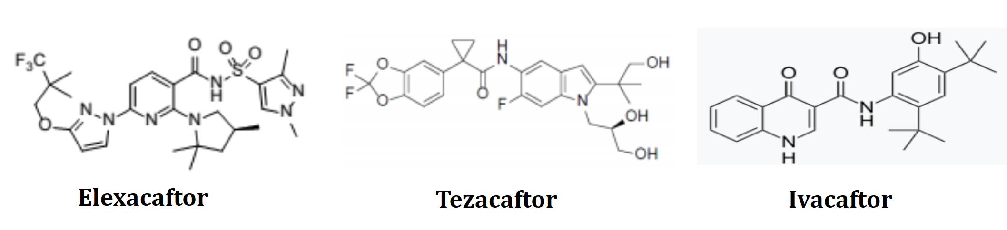
Trikafta is to be packed in polychlorotrifluoroethylene (PCTFE)/polyvinyl chloride (PVC)/Al blister packs of 84 tablets (56 elexacaftor/tezacaftor/ivacaftor tablets and 28 ivacaftor tablets), equivalent to four week use.
The fixed dose combination (FDC) of the product used in the clinical studies was the same as the product proposed to be marketed. The manufacturing process requires dry granulation of elexacaftor/ivacaftor and tezacaftor.

Nonclinical
There are no nonclinical objections to the registration of Trikafta for the proposed indication.
The nonclinical module contained studies with the single agent elexacaftor and elexacaftor/tezacaftor/ivacaftor in combination, as well as previously evaluated data for tezacaftor and ivacaftor as single agents. The nonclinical module was of high quality, with the scope of the nonclinical program consistent with the relevant TGA-adopted International Conference on Harmonisation (ICH) guideline M3 (R2), and all pivotal safety-related studies were Good Laboratory Practice (GLP) compliant.
Elexacaftor and tezacaftor are not structurally related, and bind to CFTR at distinct sites.
Elexacaftor was shown to promote CFTR processing and trafficking in vitro in HBE cells from CF donors with homozygous F508del-CFTR and heterozygous mutations F508del/G542X. Additive enhancement was observed when elexacaftor was combined with tezacaftor. Elexacaftor increased chloride channel open probability in excised membrane patches from Fischer rat thyroid cells expressing F508del-CFTR, which was further enhanced by tezacaftor co-treatment and by the acute addition of ivacaftor. Chloride transport in HBE cells from F508del heterozygous and homozygous donors was increased by elexacaftor, with further enhancement obtained with elexacaftor in dual combination with either tezacaftor or ivacaftor, and a yet greater increase obtained with elexacaftor, tezacaftor and ivacaftor in triple combination.
The major circulating metabolite of elexacaftor in humans, M23-elexacaftor, is pharmacologically active and is expected to make some contribution to efficacy in patients. The plasma area under the plasma concentration time curve (AUC) for M23-elexacaftor in patients is almost 40% of that for the parent drug.
Secondary pharmacodynamic (PD) studies indicate that elexacaftor is not a general protein corrector, with five other misfolded mutant proteins not rescued by the drug. elexacaftor was found to additionally possess antagonist activity at cysteinyl leukotriene receptor 1 (CysLT1), prostanoid prostaglandin E2 receptor (EP1), prostanoid prostaglandin D2 receptor (DP2) and angiotensin 2 receptors and at the gamma aminobutyric acid A (GABA_{A}) chloride channel, but no clinical relevance is seen based on comparison of potency and the peak free plasma concentration in patients. Safety pharmacology studies with elexacaftor did not indicate likely acute effects on central nervous system, cardiovascular or respiratory function in patients.
The pharmacokinetic (PK) profile of elexacaftor in the key laboratory animal species used in the nonclinical program (rats and dogs) was sufficiently similar to allow them to serve as appropriate models for the assessment of elexacaftor toxicity in humans. This was characterised by slow oral absorption, moderate oral bioavailability, generally dose proportional exposure, short to moderate plasma half-life, very high plasma protein binding, metabolism chiefly by the cytochrome P450 (CYP); isozyme 3A4/5, and excretion predominantly via the faeces. Tissue distribution of [¹⁴C]-elexacaftor-derived radioactivity was rapid and wide in rats, with some penetration of the blood-brain barrier and no melanin binding evident.
In vitro studies indicated no relevant inhibition of systemic CYPs or P-glycoprotein by elexacaftor or M23-elexacaftor, nor CYP induction. Inhibition of organic anion transporting polypeptide (OATP1)B1 is expected and inhibition of OATP1B3 is possible in patients. Elexacaftor and the M23-elexacaftor metabolite are substrates of P-glycoprotein.
A moderate to low order of acute toxicity by the oral route was evident for elexacaftor in mice, rats and dogs.
Pivotal repeat-dose toxicity studies with elexacaftor were conducted by the oral route in rats (six months duration) and dogs (nine months). The major target organs for toxicity by elexacaftor identified were the gastrointestinal tract, bone marrow, adrenal, thymus, spleen, and male and female reproductive tract. Elexacaftor was much better tolerated in dogs compared to rats. Repeat-dose toxicity studies with elexacaftor, tezacaftor and ivacaftor in combination were performed in rats (up to three months in duration) and in dogs (four weeks), and revealed no novel toxicity compared to that for the individual components. The studies demonstrate adequate safety.
Elexacaftor was not genotoxic in the standard battery of tests, and not carcinogenic in a six months study in transgenic mice. A two-year duration carcinogenicity study with elexacaftor in rats is currently underway. Given the serious nature of the indication, registration of Trikafta may proceed prior to completion of this study, but the final report should be provided to the TGA in a timely manner once available (expected in May 2021; and submitted as part of an application to update the Product Information document in accordance with the findings).
Elexacaftor was shown to impair fertility in male and female rats. Elexacaftor was not teratogenic in either the rat or the rabbit. Observed developmental effects with elexacaftor were limited to reduced body weight (of fetuses, pups at birth, and postnatally). Pregnancy Category B3, as the sponsor proposes, is supported.
The impurity specification is considered to be toxicologically acceptable.

Clinical
The clinical dossier consisted of:
- six clinical pharmacology Phase I studies in healthy subjects:
  - Study 001 (first in human study of safety tolerability and PK);
  - Study 005 (relative bioavailability and food effect study);
  - Study 003 (absorption, distribution, metabolism, and excretions mass balance study);
  - Study 002 (drug-drug-interaction (DDI) study to assess the effects of VX-445/tezacaftor/ivacaftor on the PK of ethinyl estradiol and levonorgestrel);
  - Study 006 (DDI study to assess the effects of itraconazole on the PK of VX 445/tezacaftor/ivacaftor); and
  - Study 009(thorough Q-T interval (QT)/corrected Q-T interval (QTc) study).
- one Phase II dose escalation study in subjects with CF: Study 001.
- two Phase III pivotal studies in subjects with CF: Study 102 (F/MF) and Study 103 (F/F).
- one long term Phase III open label extension study in patients rolled over from the two pivotal studies (Study 102, Study 103): Study 105
- six population pharmacokinetic (popPK), PK/PD modelling reports:
  - N279 (popPK/PD of tezacaftor and ivacaftor in subjects with CF incorporating data from Study 109 (previously submitted study));
  - O166 (VX-445 popPK/PD analyses for Study 001);
  - O303 (VX-445 popPK model evaluation with Phase III data (Study 102 and Study 103);
  - O350 (popPK/PD modelling of tezacaftor and ivacaftor in subjects with CF aged 6 to less than 12 years);
  - O401 (popPK and exposure-response analysis of VX-445 in patients with CF); and
  - P044 (popPK model of tezacaftor and ivacaftor in the presence of VX-445 in Phase III Studies 102 and 103).
- pooled safety analysis for VX-445 from Phase I studies; integrated safety analysis for VX-445/tezacaftor/ivacaftor from Phase III studies; physiologically based pharmacokinetic analysis of VX-445 to evaluate the effect of moderate CYP3A inhibition on the PK of VX-445.
- reports of bioanalytical and analytical methods for the human studies.
- literature references.

Pharmacology
Elexacaftor has a total molecular weight of 597.66 g/mol. It has low solubility and high permeability. It is a substrate for the P-glycoprotein efflux transporter. The absolute bioavailability of elexacaftor was approximately 80% in a fed state, and 34% in a fasted state.

Pharmacokinetics
Single dose administration of the elexacaftor tablet in the fed state with a moderate-fat meal (approximately 20 g) resulted in an approximately 2.5 fold higher AUC from the time of dosing extrapolated to infinity (AUC_{0-inf}) and an approximately 3.6 fold higher maximum plasma concentration (C_{max}) relative to the fasted state.
Following administration of elexacaftor as monotherapy for ten days, the mean terminal half-life ranged from approximately 17.6 to 27.9 hours. Based on visual inspection of trough plasma concentration, for the 60 and 120 mg elexacaftor tablets, steady state was reached at Day 10.
Elexacaftor is metabolised mainly by CYP3A4 and CYP3A5.¹¹
There were no studies of elexacaftor in hepatic impairments, however based on data from ivacaftor and tezacaftor, it is likely that there will be increased exposure to elexacaftor in patients with hepatic impairment.
Elexacaftor and its metabolite M23-445 are reported to be P-glycoprotein substrates, but not substrates for the uptake transporters OATP1B1 or OATP1B3. Based on in vitro results, elexacaftor and M23-445 are reported to have a low potential to inhibit P-glycoprotein. Elexacaftor and M23-445 may inhibit OATP1B1 and OAT1B3 in vitro.

Population pharmacokinetic data
PopPK data demonstrated similar PK parameters in healthy patients and the CF population.

Pharmacodynamics
Change in sweat chloride (SwCl) was the primary PD endpoint.
In Study 001, in patients given 200 mg triple combination therapy, the change in SwCl from Baseline in patients with F508 and MF mutations was -39.1 mmol/L. The change in sweat chloride in patients homozygous for F508 was -39.6 mmol/L.
The PK/PD models for percent predicted forced expiratory volume in one second (ppFEV₁) and SwCl showed a flat response across VX-445 exposure at the Phase III VX-445 dose of 200 mg, indicating that this dose is on the plateau region of the exposure-response relationship for both response parameters.

Efficacy
The elexacaftor dose selection was based upon Study 001 and the exposure-response analysis from popPK Report O166.
Study 001 (Parts D, E and F) was a Phase II, randomised, double blind, controlled, parallel group, multicentre study in male and female CF patients with F508 and MF mutations and homozygous for F508 aged at least 18 years with ppFEV₁ ≥ 40% and ≤ 90%. The primary objectives of Parts D, E and F were to evaluate the safety, tolerability and efficacy of elexacaftor in triple combination with tezacaftor/ivacaftor in subjects with CF.
In Part D, subjects with F508/MF mutations received triple combination elexacaftor (either 50, 100, or 200 mg daily) with tezacaftor 100 mg daily/ivacaftor 150 mg twice daily (BID) (or placebo) for four weeks in the treatment period, followed by tezacaftor 100 mg daily/ivacaftor 150 mg BID (or placebo) for one week in the elexacaftor washout period, followed by safety follow-up for four weeks. All doses of elexacaftor, tezacaftor and ivacaftor were administered with food.
In Part E, subjects with homozygous F508 subjects received tezacaftor 100 mg daily/ivacaftor 150 mg BID for four weeks during the run-in period, followed by triple combination elexacaftor 200 mg daily with tezacaftor 100 mg daily/ivacaftor 150 mg BID (or placebo + tezacaftor 100 mg daily/ivacaftor 150 mg BID) for four weeks in the treatment period, followed by tezacaftor 100 mg daily/ivacaftor 150 mg BID for four weeks in the elexacaftor washout period, followed by safety follow-up for four weeks. All doses of elexacaftor, tezacaftor and ivacaftor were administered with food.
The primary efficacy endpoint was percent predicted forced expiratory volume in one second (ppFEV₁). The secondary endpoint was change in Cystic Fibrosis Questionnaire-Revised Respiratory Domain (CFQ-R RD) score. The key PD variable was absolute change in SwCl.
Table 3: Study 001 (Part D) Key efficacy and pharmacodynamics results for heterozygous for phenylalanine 508 deletion mutation and a minimal function mutation patients, full analysis set
a These endpoints were not multiplicity controlled; therefore, P values are considered nominal.
N = population size; VX-445 = elexacaftor; TEZ = tezacaftor; IVA = ivacaftor; n = sample size; ppFEV₁ = percent predicted forced expiratory volume in one second; LS = least squares; SE = standard error; CI = confidence interval; SwCl = sweat chloride; CFQ-R = Cystic Fibrosis Questionnaire-Revised; RD = Respiratory Domain.
Table 4: Study 001 (Part E) Key efficacy and pharmacodynamics results for homozygous for phenylalanine 508 deletion mutation patients, full analysis set
a These endpoints were not multiplicity controlled; therefore, P values are considered nominal.
TEZ = tezacaftor; IVA = ivacaftor; VX-445 = elexacaftor; N = population size; n = sample size; ppFEV₁ = percent predicted forced expiratory volume in one second; LS = least squares; SE = standard error; CI = confidence interval; SwCl = sweat chloride; CFQ-R = Cystic Fibrosis Questionnaire-Revised; RD = Respiratory Domain.
Nonlinear mixed effect modelling (NONMEM) was used to construct population PK models of elexacaftor, tezacaftor, and ivacaftor. Population PK/PD models of the ppFEV₁ and SwCl responses were developed using individual predicted PK exposures.
The results indicated the 200 mg daily dose of elexacaftor resulted in almost maximal maximum effect (E_{max}) for homozygous F508 mutations and F508/MF mutations in subjects for both ppFEV₁ and SwCl.
There were no studies evaluating different tezacaftor/ivacaftor dosing regimens for use in combination with elexacaftor 200 mg for the pivotal Phase III studies. However, the sponsor stated that doses of tezacaftor 100 mg daily and ivacaftor 150 mg BID were determined to be optimal because they were in the plateau region of the dose-response curves for these drugs. In addition, the sponsor stated that doses of tezacaftor 100 mg daily/ivacaftor 150 mg BID (Symdeko)^{7,} and ivacaftor 150 mg (Kalydeco)^{5,6,} are approved doses for patients with CF and have been demonstrated to be efficacious, safe, and well-tolerated.

Study 102 (in patients with phenylalanine 508 and minimal function mutations)
This was a Phase III, randomised, double blind, placebo controlled, multinational, multicentre study evaluating the efficacy and safety of Trikafta in patients with CF who were heterozygous for the F508del mutation and a MF mutation (that is, mutations not responsive to tezacaftor, ivacaftor or tezacaftor/ivacaftor and the mutations were considered severe (on a population level not individual level)).
The primary objective was efficacy. This was measured as change in ppFEV₁ from Baseline at Week 4 and through Week 24, secondary endpoints were exacerbations, changes in SwCl, changes to CFQ-R RD, and changes in body mass index (BMI).
The secondary objectives were safety, PK and PD.
Subjects were randomised 1:1 to Trikafta and placebo. The duration of the study was 24 weeks, with an interim analysis planned to occur when at least 140 subjects had completed the Week 4 Visit and at least 100 subjects had completed the Week 12 Visit. At Week 24, subjects could enrol in a follow-on Study 105.
Study subjects were required to have F508 and a MF mutation, and have an FEV₁ 40 to 90% predicted, and not have any of the exclusion criteria. Patients were discontinued if they had persistent elevation of transaminases with no other cause.
Treatment with CYP3A inducers or inhibitors, sensitive OATP1B1 substrates and other CFTR modulators were not allowed. Patients were able to take up to 10 mg day prednisolone or 60 mg for five days acutely.
At Baseline, the mean age of patients was 26.2 years. 116 subjects were < 18 years and 287 were ≥ 18 years. Most had ppFEV₁ < 70%.

Results
There was a significant improvement in ppFEV₁ both at Week 4 and Week 24.
Table 5: Study 102 Change of percent predicted forced expiratory volume in one second between Trikafta and placebo at Week 4 and Week 24
 | Placebo %  N = 203 | Trikafta %  N = 200 | Difference compared to placebo %
Baseline | 61.3 (SD, 15.5) | 61.6 (SD, 15.0)
Absolute change at Week 4 | -0.2 (SE, 0.6) | 13.6 (SE, 0.6) | 13.8 (p < 0.0001)
Absolute change through Week 24 | -0.4 (SE, 0.5) | 13.9 (SE, 0.6) | 14.3 (p < 0.0001)
N = population size. % = percentage changes in predicted forced expiratory volume in one second, relative to Baseline; SD = standard deviation; SE = standard error (least square of the mean).
Absolute change through Week 24 is the change in percent predicted forced expiratory volume in one second, based on the average of changes relative to Baseline as measured at Week 4, Week 8, Week 12, Week 16, and Week 24.
There were less exacerbations in the Trikafta versus placebo group, rate ratio 0.37 (95% confidence interval (CI): 0.25, 0.55) p < 0.0001.
The placebo subtracted difference in SwCl was -41.2 mmol/L.
The least squares (LS) mean treatment difference for Trikafta versus placebo for the absolute change in CFQ-R from Baseline to Week 24 was 20.2 points. Improvements exceeding the minimally clinically important difference of four points were seen by Week 4.
There was a 1 kg/m² improvement in BMI in the Trikafta group compared to the placebo group by Week 24.

Study 103 (in patients with homozygous F508 mutations)
This was a Phase III, multi-national, multi-site randomised, double blind, active controlled (tezacaftor/ivacaftor) parallel group study evaluating the efficacy and safety of Trikafta in subjects with CF homozygous to F508. The treatment period was four weeks.
The primary objective was efficacy. Secondary endpoints were safety, PK and PD.
There were four periods (see Table 6).
Table 6: Study 103 Four periods included in the study design
Screening period | Run in period | Treatment period (4 weeks) | Follow-up period
Day -56 to -29 | Day -28 to -1  All patients on tezacaftor/ivacaftor | VX-445/tezacaftor/ivacaftor | Safety follow up 28 days. Patients could go on to Study 105
Day -56 to -29 | Day -28 to -1  All patients on tezacaftor/ivacaftor | tezacaftor/ivacaftor | Safety follow up 28 days. Patients could go on to Study 105
VX-445 = elexacaftor
Subjects included were age 12 years and older, with F508 homozygous mutation, and FEV₁ 40 to 90%.
There were 107 subjects who entered the treatment period: 55 randomised to Trikafta, and 52 to tezacaftor/ivacaftor.
At Baseline, the mean age was 28.4 years, 30 patients were < 18 years and 77 patients ≥ 18 years.
There was a significant improvement in ppFEV₁ at Week 4.
Table 7: Study 103 Change of percent predicted forced expiratory volume in one second between Trikafta and tezacaftor/ivacaftor at Week 4
 | Tezacaftor/ivacaftor | Trikafta | LS mean difference
Baseline (mean (SD)) | 60.2 (14.4) | 61.6 (15.4)
Change of ppFEV₁ at Week 4 (LS mean (SE)) | 0.4 (0.9) | 10.4 (0.9) | 10.0, p < 0.0001 (versus tezacaftor/ivacaftor)
ppFEV₁ = percent predicted forced expiratory volume in one second; LS = least square; SD = standard deviation; SE =standard error.
The difference in SwCl between the Trikafta and tezacaftor/ivacaftor groups at Week 4 was 45.1 mmol/L.
At Week 4, treatment with Trikafta resulted in an improvement of CFQ-R score at Week 4 of 17.4 (95% CI: 11.8, 23) points.
At the completion of the first round evaluation, the clinical evaluator proposed approval of the use of Trikafta for CF in patients homozygous for the F508 mutation or who were heterozygous for the F508 mutation with a MF mutation.
The evaluator rejected the use of Trikafta in patients aged 12 years and older who are heterozygous to the F508 mutation in the CFTR gene with a gating mutation or residual function mutation due to the lack of data in this group.
The sponsor subsequently submitted the results of Study 104 with the response to a TGA request for information.

Study 104
Study 104 was an eight weeks, randomised, double blind, active controlled, parallel group, multicentre study in CF subjects with an F508 gating mutation or F508 residual function mutation genotype to understand and quantify the benefit of VX-445/tezacaftor/ivacaftor compared to the currently approved CFTR modulator therapies (ivacaftor for F/G subjects and tezacaftor/ivacaftor for F/RF subjects).
Figure 2: VX18-445 Study 104 design
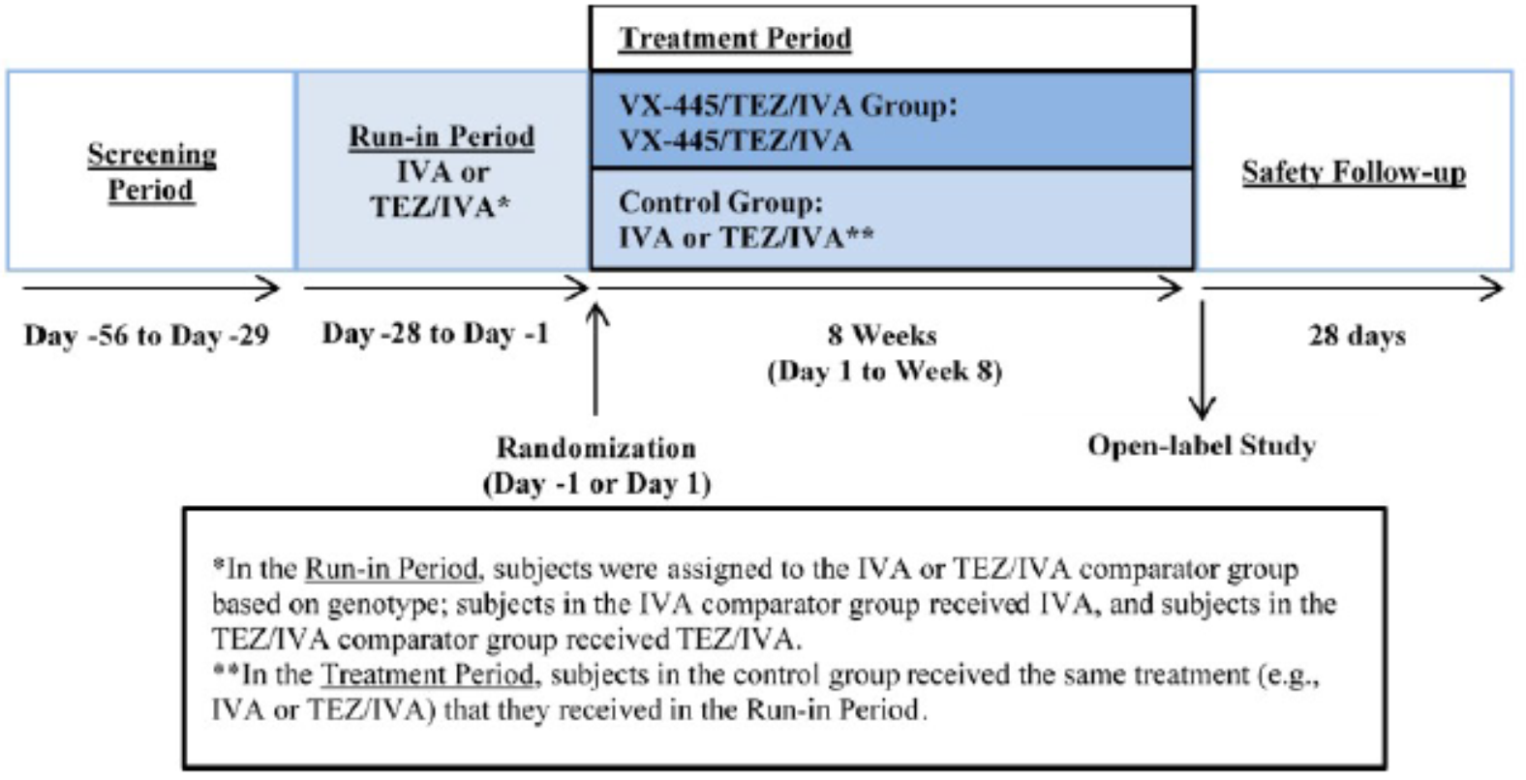
IVA = ivacaftor; TEZ = tezacaftor; VX-445 = elexacaftor.
The primary efficacy endpoint was the within group absolute change in ppFEV₁ from Baseline through Week 8 for the elexacaftor/tezacaftor/ivacaftor group. The study sample size was chosen based on power calculations for the overall elexacaftor/tezacaftor/ivacaftor group; the study was not powered for analysis of F/G and F/RF subgroups. The between-group change for the elexacaftor/tezacaftor/ivacaftor group compared to the control group was a key secondary efficacy endpoint.
Treatment with elexacaftor/tezacaftor/ivacaftor resulted in a statistically significant improvement in ppFEV₁ through Week 8, with a within group LS mean absolute change from Baseline of 3.7 percentage points (P < 0.0001) compared to baseline after a four weeks run-in period receiving ivacaftor or tezacaftor/ivacaftor. Secondary data were supportive. Results of the gating and residual function mutation groups were consistent with the primary analysis.
Table 8: Study 104 Primary, key secondary and other secondary efficacy analysis, full analysis set
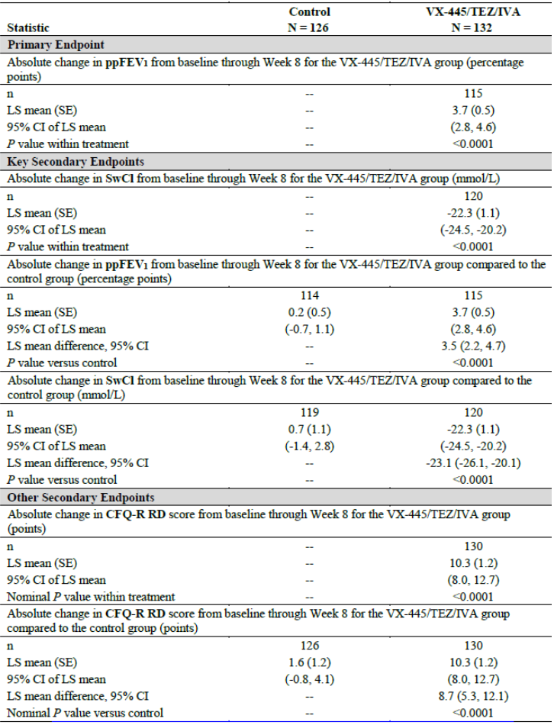
N = population size; VX-445 = elexacaftor; TEZ = tezacaftor; IVA = ivacaftor; ppFEV₁ = percent predicted forced expiratory volume in one second; n = sample size; LS = least squares; SE = standard error; CI = confidence interval; CFQ-R = Cystic Fibrosis Questionnaire-Revised; RD = Respiratory Domain.
Table 9: Study 104 Comparator group subgroup analysis, full analysis set
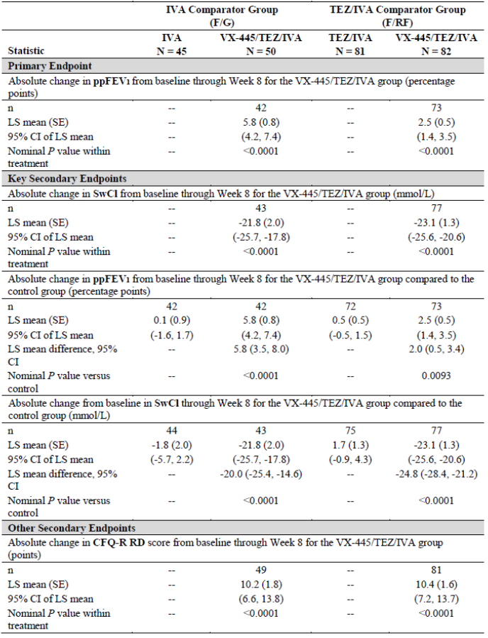
IVA = ivacaftor; TEZ = tezacaftor; VX-445 = elexacaftor; F/G = heterozygous for F508del mutation and a gating mutation; F/RF = heterozygous for F508del mutation and a residual function mutation; N = population size; ppFEV₁ = percent predicted forced expiratory volume in one second; n = sample size; LS = least squares; SE = standard error; CI = confidence interval; SwCl = sweat chloride; CFQ-R = Cystic Fibrosis Questionnaire-Revised; RD = Respiratory Domain.

Safety
The summary of clinical safety presented a comprehensive review of the safety data in support of the elexacaftor/tezacaftor/ivacaftor triple combination regimen for the treatment of CF in patients aged 12 years and older who have at least one F508del mutation in the CFTR gene. Safety data were summarised from ten clinical studies that evaluated VX-445 as monotherapy or as part of an elexacaftor/tezacaftor/ivacaftor triple combination regimen. The core safety analyses included data from Study 102 in subjects with a F/MF genotype and Study 103 in subjects with an F/F genotype and an open label extension study for subjects who completed the two pivotal controlled phase studies (Study 105), a safety and PK study in F/MF and F/F subjects aged 6 through 11 years of age (Study 106), and six pooled Phase I studies in healthy subjects.
In the elexacaftor development program, over 700 unique subjects received at least one dose of elexacaftor as monotherapy or as part of an elexacaftor/tezacaftor/ivacaftor triple combination regimen. In the Phase III program in subjects over 12 years of age with CF and one F508 mutation, 509 subjects received at least one dose of elexacaftor/tezacaftor/ivacaftor, with a total exposure of approximately 330 patient years (PY).
Common treatment-related adverse events (TRAEs) in Study 102 (occurring in five or more subjects in any treatment group) included sputum increase, alanine transaminase (ALT) increase, aspartate transaminase (AST) increase, rash, blood creatine kinase (CK) increase, headache, cough, productive cough, blood bilirubin increase, and abdominal pain upper. Common TRAEs in Study 103 (occurring in three or more subjects in any treatment group) included respiration abnormal.
In healthy subjects, related or possibly related adverse effects as assessed by the evaluator and reported in > 2% of subjects in any VX-445 group included headache, nausea and cough.
Overall, the data from Study 102 and Study 103 suggest that increased ALT, AST and bilirubin levels are causally related to treatment with elexacaftor/tezacaftor/ivacaftor triple combination therapy in subjects with CF. However, no changes in ALT, AST, or bilirubin observed with elexacaftor/tezacaftor/ivacaftor met Hy’s law; criteria for drug induced liver injury. Increased ALT, AST, and/or bilirubin adverse events in subjects in Study 102 treated with elexacaftor/tezacaftor/ivacaftor resulted in a small number of subjects interrupting treatment, but no subjects discontinued treatment due to these events. The results from Study 103 suggest that the addition of elexacaftor to ivacaftor/tezacaftor increases the risk of hepatotoxicity compared to the ivacaftor/tezacaftor combination.
Adverse events (AEs) of CK elevation occurred in 20 (9.9%) subjects in the elexacaftor/tezacaftor/ivacaftor group (18 with high CK, one with rhabdomyolysis, and one with both) and nine (4.5%) subjects in the placebo group (nine with CK increased and one with rhabdomyolysis). The sponsor reported that the majority of subjects with CK elevation events had asymptomatic laboratory elevations, many of which were preceded by exercise. The CK elevations were mostly mild or moderate in severity. A severe CK elevation was seen in five subjects in the elexacaftor/tezacaftor/ivacaftor group and no subjects in the placebo group. One subject in the elexacaftor/tezacaftor/ivacaftor group had rhabdomyolysis. AEs of CK elevation led to study drug interruption in three subjects in the VX-445/tezacaftor/ivacaftor group and no subjects in the placebo group. Most AEs of CK elevation resolved either without change to study drug dosing or after treatment interruption. No subjects discontinued treatment due to AEs of CK elevation in either treatment group.
Rashes were more common in patients in the triple therapy combination group than other groups. These were more common in females, there was an association with use of oral contraceptives.
Due to nonclinical findings of cataracts or lens opacities in a study involving ivacaftor monotherapy administered to juvenile rats, ophthalmologic examinations were performed in the VX-445 clinical program in subjects < 18 years of age. In Study 102, one subject in the elexacaftor/tezacaftor/ivacaftor group with a history of CF related diabetes and concomitant use of corticosteroids had an AE of cataract cortical and lenticular opacity. One subject in the placebo group using concomitant corticosteroids also had a cataract.
An interim analysis of long term safety data from Study 105 was provided. The median duration of exposure was 21 weeks, the maximum duration of exposure was 39 weeks. Overall, the AEs were consistent with the common manifestations of CF in patients 12 years and older and the known AEs of this product. The submission included a selected safety analysis based on the cumulative safety set data from Study 105 in 58 subjects who had received treatment with elexacaftor/tezacaftor/ivacaftor for at least 48 weeks.
The safety data from Study 104 were consistent with the safety data from Studies 102 and 104.

Risk management plan
The sponsor has submitted EU-risk management plan (RMP) version 0.1 (dated 3 October 2019; data lock point (DLP) 10 July 2019) and Australia Specific annex (ASA) version 1.0 (dated 22 January 2020) in support of this application. At the second round of evaluation, the sponsor has submitted ASA version 2.0 addressing the recommendation made at the first round of evaluation (18 September 2020). At the second round of evaluation, the sponsor has also submitted EU-RMP version 1.1 (dated 21 August 2020; DLP 20 July 2020) as it was updated to support the application to expand the Kaftrio indication in the EU to CF patients 12 years of age and older who have at least one F508del mutation in the CFTR gene.
The summary of safety concerns and their associated risk monitoring and mitigation strategies are summarised in Table 10.
Table 10: Summary of safety concerns
Summary of safety concerns |  | Pharmacovigilance |  | Risk Minimisation
 |  | Routine | Additional | Routine | Additional
Important identified risks | Susceptibility for influenza virus infections*‡ |  |  |  | –
Important potential risks | Hepatotoxicity*‡ |  |  |  | –
Important potential risks | Cataract* |  |  |  | –
Missing information | Use in pregnant and lactating women+‡ |  |  |  | –
Missing information | Long term safety*‡ |  |  |  | –
Missing information | Use in patients with moderate or severe hepatic impairment¶ |  |  |  | –
* Open-label extension study (Study 105)
‡ Post-authorisation Safety Study (PASS)
Study in patients with hepatic impairment (Study 007)
+ Targeted follow-up questionnaire
- Changes were recommended to the summary of safety concerns at the first round of evaluation and these were implemented in an acceptable manner at the second round of evaluation. The summary of safety concerns is acceptable from the RMP perspective.
- Revisions were recommended to the proposed routine pharmacovigilance activities at the first round of evaluation and these were implemented in an acceptable manner at the second round. Routine pharmacovigilance is now proposed for all safety concerns included in the summary of the safety concerns. In addition, a targeted follow-up questionnaire is proposed for missing information on use in pregnancy. Proposed additional pharmacovigilance activities include an ongoing open label extension study, a planned study in patients with hepatic impairment and planned post authorisation safety study that will include data from national CF registries. The pharmacovigilance plan is acceptable from the RMP perspective.
- Routine risk minimisation activities are proposed for all risks listed in the summary of safety concerns. Significant risk management relevant points have been highlighted to the Delegate. No additional risk minimisation activities have been proposed, and that is acceptable.

Risk-benefit analysis

Delegate’s considerations
The sponsor has submitted a comprehensive dossier to support the use of Trikafta in patients with CF and a heterozygous mutation in F508.
There were no objections to the registration by the chemistry or nonclinical evaluators.
The clinical studies involved PK, PD, efficacy and safety studies. In addition, there were a number of popPK reports to examine PK parameters and build on existing models.
In vitro studies demonstrated that medicines that are CYP3A inducers or CYP3A inhibitors may have a significant impact on the PK of Trikafta. Trikafta may affect the PK of medicines that are CYP2C9, P-glycoprotein, OATP1B1 and OATP1B3 substrates. These potential interactions have not been confirmed by in vivo studies. Understanding potential impact of Trikafta on other drugs and vice versa is important in this group of patients as they are on a number of other medications.
Efficacy was demonstrated in three studies. First Study 102 was a 24 week study in patients with MF mutation. Trikafta was associated with clinically and statistically significant improvements in ppFEV₁, SwCl and CFQ-R RD. Trikafta is the only CFTR modulator available for this group of patients.
Efficacy to support use in patients with homozygous mutations was in a four week Study 103 in comparison to Symdeko.⁷ Efficacy outcomes were ppFEV₁, SwCl and CFQ-R RD. Clinically significant benefits over Symdeko were demonstrated. Long term efficacy could be extrapolated from data from other CFTR modulator that have demonstrated that the improvements seen in clinical endpoints over the first four weeks are maintained over the following six months. There was no head to head study for Orkambi. However, studies comparing Orkambi to Symdeko have demonstrated relative greater efficacy of Symdeko.
Study 104 was performed to support use over ivacaftor in those with gating mutations and over Symdeko in those with residual function mutations. This was an eight week study. There were small statistically significant benefits in ppFEV₁, SwCl and CFQ-R RD. However the clinical significance of these changes is uncertain.
The submitted studies excluded patients with FEV₁ < 40%, and abnormal liver function tests. Thus, efficacy and safety in these population are unknown. Patients remained on existing treatments for CF complications for the duration of the study.

Proposed action
The studies submitted have demonstrated that Trikafta is efficacious in patients with heterozygous mutations of F508 and what was described by the sponsor’s previous classification system as MF mutations, residual function mutations and homozygous mutations. The relative efficacy in these populations is quite different. There is no doubt that the indications based on a single genotype are simpler than an indication based upon a function defect. However, the Delegate is concerned that this assumption that Trikafta will be more efficacious in all heterozygous F508 mutations irrespective of the other mutation and the function change at the CFTR receptor.

Comments on the label
If Trikafta refers to the FDC, then the label on the package with ivacaftor would be better described as, for example, Trikafta pack.

Comments on the Product Information
[Information redacted]

Comments on the risk management plan
Rash, particularly in relation to the use of the oral contraceptive pill, was more commonly described in patients taking Trikafta than comparator treatments. This is not listed in the summary of safety concerns. The sponsor is requested to do a detailed analysis of the events of rash identified in the periodic safety update reports (PSUR) in particular to describe further the characteristics of the rash.
There were a number of important subgroups excluded from the clinical study, most importantly patients with an FEV₁ of < 40% and those infected or colonised with Burkholderia cenocepacia, Burkholderia dolosa or Mycobacterium abscessus. These subgroups should be included under missing data in the ASA; or identified in the PSUR as subgroups of interest.

Questions for the sponsor
The sponsor provided the following responses to questions from the Delegate.
- The risk in influenza infection is listed as a serious identified risk in the summary of safety concerns. However, the clinical evaluator did not mention this adverse effect and it is not described in the PI. Please provide further information about the risk of influenza, and justify why it is not in the PI.
Influenza is included as a serious identified risk in the ASA to align with the EU-RMP at the TGA's request. Influenza was added as an adverse drug reaction (ADR) in the Summary of Product Characteristics (SmPC) in the European public assessment report (EPAR) at the request of the Committee for Medicinal Products for Human Use (CHMP).
Influenza is not included as an ADR in the PI for elexacaftor/tezacaftor/ivacaftor. The sponsor performed a thorough review of all influenza AEs and concludes that there is no causal association between influenza and elexacaftor/tezacaftor/ivacaftor treatment. ADRs described in the PI for elexacaftor/tezacaftor/ivacaftor were established based on a comprehensive review of the entire safety dataset, which included data from ten clinical studies.
Among the clinical studies in the development program, Study 102 was the primary source for the identification of ADRs because it was the placebo-controlled study with the largest number of CF subjects exposed to elexacaftor/tezacaftor/ivacaftor for the longest treatment duration (24 weeks).
The difference in the incidence of influenza AEs between treatment groups in Study 102 is likely an incidental finding and not related to elexacaftor/tezacaftor/ivacaftor. As such, the sponsor maintains the previous assessment that influenza is not considered an ADR, and as such should not be in the PI.
- Study 102 was conducted through the winter season, and as expected, most of the AEs of influenza occurred during that time. In the elexacaftor/tezacaftor/ivacaftor group, none of the AEs of influenza were considered related to study drug and all subjects continued dosing or resumed treatment after an interruption.
- In Study 105 IA2, the exposure adjusted event rate of influenza (4.58 events/100 PY) was substantially lower than the rate in the elexacaftor/tezacaftor/ivacaftor group of Study 102 (15.97 events/100 PY). Additionally, the rate of influenza in Study 105 was similar to the rate in the placebo group of Study 102 (3.00 events/100 PY).
- The difference in the incidence of influenza AEs between treatment groups in Study 102 appears to be partially due to the unusually low rate of influenza AEs in the placebo group. In placebo groups from other CFTR modulator programs, the rates of influenza AEs were higher than the rate in the placebo group in Study 102 (for example, in the tezacaftor/ivacaftor Phase III Study 661-106, the rate of influenza AEs in the placebo group was 8.81 events/100 PY; data on file).
- Moreover, the rates of AEs in the infections and infestations System Organ Class (SOC) overall were lower in the elexacaftor/tezacaftor/ivacaftor group from Study 102 (248.55 events/100 PY) and Study 105 IA2 (161.51 events/100 PY) than in the placebo group from Study 102 (333.25 events/100PY), further suggesting there is no association between elexacaftor/tezacaftor/ivacaftor and infectious events.
Overall, the sponsor believes that the safety dataset is robust, and the proposed ADRs are appropriate and representative of the elexacaftor/tezacaftor/ivacaftor safety profile.
- What is the evidence for a reduced dose in patients with moderate hepatic impairment?
Study VX18-445-007 (Study 007) evaluated the PK of elexacaftor, tezacaftor, ivacaftor, and their respective metabolites in subjects with moderate hepatic impairment. The data from this study are summarised in the sponsor’s response to advice regarding patients with moderate hepatic impairment.¹⁹ The PK data from Study 007, combined with the lack of clinical experience in patients with moderate hepatic impairment, and the higher incidence of ALT and AST elevations in the elexacaftor/tezacaftor/ivacaftor group of Study 102, led to the dosing recommendations for patients with moderate hepatic impairment. Approximately 2.1% of CF patients in Australia are reported to have cirrhosis or portal hypertension; and these patients continue to have progressive lung disease and an unmet need for CFTR modulator therapies. Although elexacaftor/tezacaftor/ivacaftor is not recommended for use in patients with moderate hepatic impairment, the sponsor considers it important to provide guidance on dosing for patients in whom there is a clear unmet medical need and for whom the benefits are expected to outweigh the risks.
- Please describe how the sponsor is planning to study the efficacy and safety of Trikafta in patients with severe respiratory disease, and those infected with burkholderia and mycobacterium. Will these things be evaluated as part of the open label extension Study 105 or the planned post authorisation safety study?
The sponsor confirms that patients with FEV₁ < 40% will be examined in an EU Post-authorisation Safety Study (PASS) as part of a standard subgroup analysis. In addition, patients with FEV₁ < 40% will be addressed in the PSUR. Patients with severe respiratory disease will not be evaluated in Study 105.
Subjects who had lung infection with organisms associated with a more rapid decline in pulmonary status (including, but not limited to, Burkholderia cenocepacia, Burkholderia dolosa, and Mycobacterium abscessus) were not included in Study 105 due to being excluded from the parent Studies 102 and 103 to avoid confounding factors; these bacteria are associated with rapid decline of lung function. Patients infected with these species will also not be evaluated in the PASS. However, the Burkholderia and Mycobacterium genus were not broadly excluded from the pivotal program; this exclusion only applied to species associated with rapid decline in pulmonary status. Safety and efficacy are expected to be the same in patients who have lung infection with organisms associated with a more rapid decline in pulmonary status due to the similar disease process. In addition, these patients will be evaluated in the PSUR.
- Is the sponsor planning any clinical studies to evaluate the clinical impact of potential drug interactions identified in the in vitro studies?
The sponsor considers that potential DDIs for the elexacaftor/tezacaftor/ivacaftor program have been adequately evaluated based on available clinical and nonclinical data. elexacaftor/tezacaftor/ivacaftor is a combination regimen consisting of three component drugs, therefore the clinical data previously generated for ivacaftor and tezacaftor/ivacaftor are also applicable for elexacaftor/tezacaftor/ivacaftor and can be used to evaluate the DDI potential of elexacaftor/tezacaftor/ivacaftor with other medicines, and guide the dose adjustment consistently with the other approved CFTR modulators. Appropriate prescribing guidance along with the studies informing the guidance have been included in the proposed label. No further clinical studies are planned. Potential DDIs and the clinical trials informing the provided prescribing guidance are provided in Table 11.
Table 11: Elexacaftor/tezacaftor/ivacaftor Drug-drug Interaction Guidance
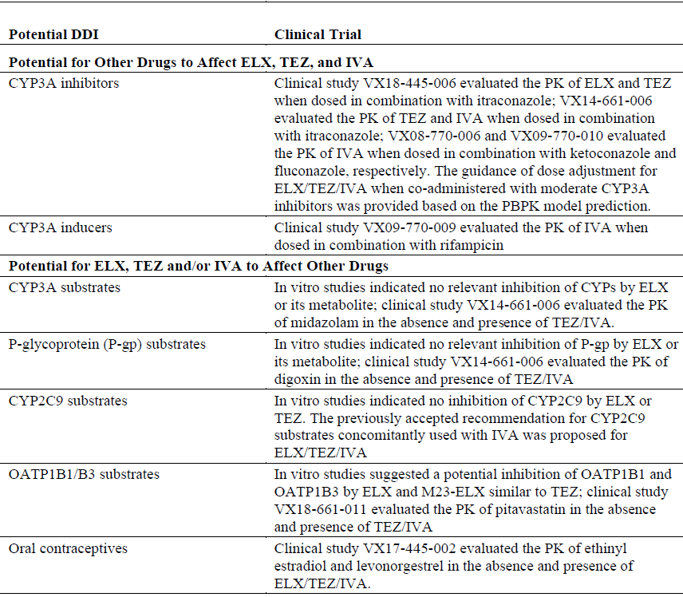

Advisory Committee considerations
The Advisory Committee on Medicines (ACM), having considered the evaluations and the Delegate’s overview, as well as the sponsor’s response to these documents, advised the following.

Specific advice to the Delegate
- The Delegate’s main concern is the indication. Although this is supported by the data, it represents a different treatment paradigm to the other CFTR modulators that require two different mutations. The Delegate would appreciate the views of the committee about this.
The ACM advised that the indication is appropriate and although a different paradigm, it is an example of a mutation specific agent with proven efficacy with the inclusion of two correctors and one potentiator. The ACM noted that this treatment will provide additional benefit on top of available treatment options.
- Please comment about the use of Trikafta in patients with moderate hepatic impairment.
The ACM advised that the use of Trikafta in patients with moderate hepatic impairment should be used with caution, with regular blood tests and a reduction in the dose if required. The ACM advised that in clinical practice patients are regularly screened every 3 months for possible elevated liver function tests (LFTs) during the first year of therapy. The ACM noted that in patients with Child Pugh; Class B liver disease there is dose adjustment and at Child Pugh Class C the medicine should be withheld.
- The Committee is also requested to provide advice on any other issues that it thinks may be relevant to a decision on whether or not to approve this application.
The ACM reiterated the need for increased education and awareness for prescribers in regards to the inclusion of more quantitative information around requirements of fatty food/medicine intake in the PI.

Conclusion
The ACM considered this product to have an overall positive benefit-risk profile for the indication:
Trikafta is indicated for the treatment of cystic fibrosis (CF) in patients aged 12 years and older who have at least one F508del mutation in the cystic fibrosis transmembrane conductance regulator (CFTR) gene.

Outcome
Based on a review of quality, safety and efficacy, the TGA approved the registration of Trikafta (elexacaftor/tezacaftor/ivacaftor and ivacaftor) 100 mg elexacaftor/50 mg tezacaftor/75 mg ivacaftor and 150 mg ivacaftor, film coated tablet, composite blister pack, indicated for:
Trikafta is indicated for the treatment of cystic fibrosis (CF) in patients aged 12 years and older who have at least one F508del mutation in the cystic fibrosis transmembrane conductance regulator (CFTR) gene.

Specific conditions of registration applying to these goods
- Trikafta (elexacaftor/tezacaftor/ivacaftor) is to be included in the Black Triangle Scheme. The PI and Consumer Medicines Information (CMI) for Trikafta must include the black triangle symbol and mandatory accompanying text for five years, which starts from the date that the sponsor notifies the TGA of supply of the product.
- The Trikafta EU-RMP (version 1.1, dated 21 August 2020; DLP dated 20 July 2020), with ASA (version 2.0, dated 18 September 2020), included with submission PM-2020-00642-1, and any subsequent revisions, as agreed with the TGA will be implemented in Australia.
An obligatory component of RMP is routine pharmacovigilance. Routine pharmacovigilance includes the submission of PSURs.
Reports are to be provided in line with the current published list of EU reference dates and frequency of submission of PSURs until the period covered by such reports is not less than three years from the date of the approval letter.
The reports are to at least meet the requirements for PSURs as described in the EMA’s Guideline on Good Pharmacovigilance Practices (GVP) Module VII-periodic safety update report (Rev 1), Part VII.B structures and processes. Note that submission of a PSUR does not constitute an application to vary the registration.

Attachment 1. Product Information
The PI for Trikafta approved with the submission which is described in this AusPAR is at Attachment 1. For the most recent PI, please refer to the TGA website at <https://www.tga.gov.au/product-information-pi>.

Therapeutic Goods Administration
PO Box 100 Woden ACT 2606 Australia
Email: info@tga.gov.au Phone: 1800 020 653 Fax: 02 6232 8605
https://www.tga.gov.au

The Black Triangle Scheme provides a simple means for practitioners and patients to identify certain types of new prescription medicines, including those being used in new ways and to encourage the reporting of adverse events associated with their use. The Black Triangle does not denote that there are known safety problems, just that the TGA is encouraging adverse event reporting to help us build up the full picture of a medicine's safety profile.
Ruseckaite, R. et al. on behalf of the Australian Cystic Fibrosis Data Registry. The Australian Cystic Fibrosis Data Registry Annual Report, 2017. Report No 20. Melbourne, Australia Monash University, Department of Epidemiology and Preventive Medicine; 2019.
United States Census Bureau. International Database. Available from the United States Census Bureau website. (Accessed by the sponsor in 2019).
VX-445 is a drug development code for elexacaftor.
AusPAR for Ivacaftor Kalydeco Vertex Pharmaceuticals Australia Pty Ltd PM-2012-01491-3-5; published online on 23 December 2013. Available at: https://www.tga.gov.au/auspar/auspar-ivacaftor
AusPAR for Ivacaftor Kalydeco Vertex Pharmaceuticals Australia Pty Ltd PM-2015-00399-1-5; published online on 19 January 2017. Available at: https://www.tga.gov.au/auspar/auspar-ivacaftor-0
AusPAR for Tezacaftor/Ivacaftor and Ivacaftor Symdeko Vertex Pharmaceuticals Australia Pty Ltd PM-2017-04765-1-5; published online on 28 October 2019. Available at: https://www.tga.gov.au/auspar/auspar-tezacaftorivacaftor-and-ivacaftor
Orphan drugs are often developed to treat small and very specific patient populations who suffer from rare diseases and conditions. In order to facilitate orphan drug access to the Australian marketplace and help offset orphan drug development costs the TGA waives application and evaluation fees for prescription medicine registration applications if a related orphan designation is in force. A medicine may be eligible for orphan drug designation if all orphan criteria set by the TGA are met. The orphan designation application precedes the registration application and the designation is specific to the sponsor, orphan indication for which designation was granted and dosage form of the medicine.
European Medicines Agency (EMA), Committee for Proprietary Medicinal Products (CPMP), ICH Guideline M3 (R2) on Non-Clinical Safety Studies for the Conduct of Human Clinical Trials and Marketing Authorisation for Pharmaceuticals, EMA/CPMP/ICH/286/1995, December 2009.
Good Laboratory Practice (GLP) is a code of standards following the International Council on Harmonisation (ICH) relevant to testing of medicines in laboratories during drug development.
Cytochrome P450 (CYP) enzymes: CYPs are the major enzymes involved in drug metabolism, accounting for large part of the total metabolism. Most drugs undergo deactivation by CYPs, either directly or by facilitated excretion from the body. Also, many substances are bioactivated by CYPs to form their active compounds. Many drugs may increase or decrease the activity of various CYP isozymes either by inducing the biosynthesis of an isozyme (enzyme induction) or by directly inhibiting the activity of the CYP (enzyme inhibition). This is a major source of adverse drug interactions, since changes in CYP enzyme activity may affect the metabolism and clearance of various drugs. Such drug interactions are especially important to take into account when using drugs of vital importance to the patient, drugs with important side-effects and drugs with small therapeutic windows, but any drug may be subject to an altered plasma concentration due to altered drug metabolism.
Pregnancy Category B3: Drugs which have been taken by only a limited number of pregnant women and women of childbearing age, without an increase in the frequency of malformation or other direct or indirect harmful effects on the human fetus having been observed. Studies in animals have shown evidence of an increased occurrence of fetal damage, the significance of which is considered uncertain in humans.
The QT interval is the time from the start of the QRS wave complex to the end of the corresponding T wave. It approximates to the time taken for ventricular depolarisation and repolarisation, that is to say, the period of ventricular systole from ventricular isovolumetric contraction to isovolumetric relaxation.
The corrected QT interval (QTc) estimates the QT interval at a standard heart rate. This allows comparison of QT values over time at different heart rates and improves detection of patients at increased risk of arrhythmias.
Symdeko was first registered on the ARTG on 5 March 2019 (ARTG number: 298329).
Kalydeco was first registered on the ARTG on 9 July 2013 (ARTG number: 198654).
Hy’s Law: Evidence of hepatocellular injury with a rise in alanine aminotransferase (ALT) and/or aspartate aminotransferase (AST) > 3 x the upper limit of normal (ULN) and total bilirubin > 2 x ULN, and no other reason to explain rise in aminotransferases and total bilirubin. Hy's law is a rule of thumb that a patient is at high risk of a fatal drug-induced liver injury if given a medication that causes hepatocellular injury with jaundice.
Routine risk minimisation activities may be limited to ensuring that suitable warnings are included in the product information or by careful use of labelling and packaging. Routine pharmacovigilance practices involve the following activities: - All suspected adverse reactions that are reported to the personnel of the company are collected and collated in an accessible manner; - Reporting to regulatory authorities; - Continuous monitoring of the safety profiles of approved products including signal detection and updating of labelling; - Submission of PSURs; - Meeting other local regulatory agency requirements.
Inclusion of these information is beyond the scope of the AusPAR.
Orkambi (lumacaftor/ivacaftor) was first registered on the ARTG on 8 March 2016 (ARTG number: 235759).
A periodic safety update report (PSUR) is a systematic review of the global safety data of an approved medicine that becomes available during a defined time period. PSURs are also referred to as periodic benefit–risk evaluation reports (PBRERs).
The Australian specific annex (ASA) enables the European Union-risk management plan (EU-RMP), or, if no current EU-RMP exists, then a core or global RMP, to be adapted to the Australian context. The ASA is required because global activities proposed in the EU-RMP may differ from those planned for Australia. For example, the sponsor may propose different wording for the Australian PI than that proposed in the EU-RMP for the European Summary of Product Characteristics (SmPC). The ASA should provide Australian‐specific information that is important in assessing the risk in Australia (and therefore appropriateness of proposed plans/activities) and the relevance of product vigilance and risk minimisation activities to Australia, and identify and explain the reasons for any differences from activities planned overseas (this includes product information statements). If an RMP activity to be conducted overseas will not include Australian data, the ASA should address the applicability of that activity to the Australian context.
Australian Cystic Fibrosis Data Registry. The Australian Cystic Fibrosis Data Registry Annual Report, 2017. Melbourne Victoria, Australia: Monash University; 2019.
The ACM provides independent medical and scientific advice to the Minister for Health and the Therapeutic Goods Administration (TGA) on issues relating to the safety, quality and efficacy of medicines supplied in Australia including issues relating to pre-market and post-market functions for medicines. The Committee is established under Regulation 35 of the Therapeutic Goods Regulations 1990. Members are appointed by the Minister. The ACM was established in January 2017 replacing Advisory Committee on Prescription Medicines (ACPM) which was formed in January 2010. ACM encompass pre and post-market advice for medicines, following the consolidation of the previous functions of the Advisory Committee on Prescription Medicines (ACPM), the Advisory Committee on the Safety of Medicines (ACSOM) and the Advisory Committee on Non-Prescription Medicines (ACNM). Membership comprises of professionals with specific scientific, medical or clinical expertise, as well as appropriate consumer health issues relating to medicines.
The Child-Pugh score is used to assess the prognosis of chronic liver disease. The score employs five clinical measures of liver disease. Each measure is scored 1 to 3, with 3 indicating most severe derangement. Class A: 5 to 6 points, least severe liver disease, one to five year survival rate of 95%. Class B: 7 to 9 points, moderately severe liver disease, one to five year survival of 75%. Class C: 10 to 15 points, most severe liver disease, 1 to 5 year survival rate 50%.

