August 2021

Australian Public Assessment Report for Elasomeran
  - Proprietary Product Name: Spikevax
  - Sponsor: Moderna Australia Pty Ltd

About the Therapeutic Goods Administration (TGA)
- The Therapeutic Goods Administration (TGA) is part of the Australian Government Department of Health and is responsible for regulating medicines and medical devices.
- The TGA administers the Therapeutic Goods Act 1989 (the Act), applying a risk management approach designed to ensure therapeutic goods supplied in Australia meet acceptable standards of quality, safety and efficacy (performance) when necessary.
- The work of the TGA is based on applying scientific and clinical expertise to decision-making, to ensure that the benefits to consumers outweigh any risks associated with the use of medicines and medical devices.
- The TGA relies on the public, healthcare professionals and industry to report problems with medicines or medical devices. TGA investigates reports received by it to determine any necessary regulatory action.
- To report a problem with a medicine or medical device, please see the information on the TGA website <https://www.tga.gov.au>.

About AusPARs
- An Australian Public Assessment Report (AusPAR) provides information about the evaluation of a prescription medicine and the considerations that led the TGA to approve or not approve a prescription medicine submission.
- AusPARs are prepared and published by the TGA.
- An AusPAR is prepared for submissions that relate to new chemical entities, generic medicines, major variations and extensions of indications.
- An AusPAR is a static document; it provides information that relates to a submission at a particular point in time.
- A new AusPAR will be developed to reflect changes to indications and/or major variations to a prescription medicine subject to evaluation by the TGA.

Copyright
© Commonwealth of Australia 2021
This work is copyright. You may reproduce the whole or part of this work in unaltered form for your own personal use or, if you are part of an organisation, for internal use within your organisation, but only if you or your organisation do not use the reproduction for any commercial purpose and retain this copyright notice and all disclaimer notices as part of that reproduction. Apart from rights to use as permitted by the Copyright Act 1968 or allowed by this copyright notice, all other rights are reserved and you are not allowed to reproduce the whole or any part of this work in any way (electronic or otherwise) without first being given specific written permission from the Commonwealth to do so. Requests and inquiries concerning reproduction and rights are to be sent to the TGA Copyright Officer, Therapeutic Goods Administration, PO Box 100, Woden ACT 2606 or emailed to <tga.copyright@tga.gov.au>.

Contents
List of abbreviations 4
I. Introduction to product submission 7
Submission details 7
Product background 8
Regulatory status 10
Product Information 11
II. Registration timeline 11
III. Submission overview and risk/benefit assessment 12
Quality 12
Nonclinical 14
Clinical 15
Risk management plan 54
Risk-benefit analysis 56
Outcome 62
Attachment 1. Product Information 65

List of abbreviations
Abbreviation | Meaning
ACV | Advisory Committee on Vaccines
AE | Adverse event
AR | Adverse reaction
ARGPM | Australian Regulatory Guidelines for Prescription Medicines
ARTG | Australian Register of Therapeutic Goods
ASA | Australian specific annex
CD4 | Cluster of differentiation 4
CDC | Centers for Disease Control and Prevention (United States of America)
CI | Confidence interval
COVID-19 | Coronavirus disease 2019
CPD | Certified Product Details
DBP | Diastolic blood pressure
DLP | Data lock point
ECMO | Extracorporeal membrane oxygenation
ELISA | Enzyme linked immunosorbent assay
EMA | European Medicines Agency (European Union)
EU | European Union
FDA | Food and Drug Administration (United States of America)
FiO₂ | Fraction of inspired oxygen
GLP | Good Laboratory Practices
GMP | Good Manufacturing Practice
HIV | Human immunodeficiency virus
HR | Heart rate
IBD | International birth date
ICD-10 | International Classification of Diseases (Tenth revision)
ICS | Intracellular cytokine staining
ICU | Intensive care unit
LNP | Lipid nanoparticle
MAH | Marketing Authorisation Holder
mITT | Modified intent-to-treat
mmHg | Millimetres above mercury
mRNA | Messenger ribonucleic acid
mRNA-1273 | Spikevax elasomeran COVID-19 vaccine drug development name
OCABR | Official Control Authority Batch Release
PaO₂ | Partial pressure of oxygen
PBMC | Peripheral blood mononuclear cell
PBRER | Periodic benefit-risk evaluation report
PI | Product Information
PT | Preferred Term
PRNT | Plaque reduction neutralisation testing
PSUR | Periodic safety update report
PsVNA | Pseudotyped lentivirus reporter single round of infection neutralisation assay
RMP | Risk management plan
RNA | Ribonucleic acid
RR | Respiratory rate
RT-PCR | Reverse transcription polymerase chain reaction
SAE | Serious adverse event
SARS-CoV-2 | Severe acute respiratory syndrome coronavirus 2
SOC | System Organ Class
SpO₂ | Blood oxygen saturation
S protein | Spike glycoprotein
S-2P | SARS-CoV-2 spike glycoprotein
TEAE | Treatment emergent adverse event
Th-1 | T-helper 1
Th-2 | T-helper 2
UK | United Kingdom
US(A) | United States (of America)
VAED | Vaccine associated enhanced disease
VAERD | Vaccine enhanced respiratory disease
VAERS | Vaccine Adverse Event Reporting System
VOC | Variants of concern
WHO | World Health Organization

I. Introduction to product submission

Submission details
Type of submission: | New biological entity
Product name: | Spikevax
Active ingredient: | Elasomeran
Decision: | Approved for provisional registration
Date of decision: | 9 August 2021
Date of entry onto ARTG: | 9 August 2021
ARTG number: | 370599
Black Triangle Scheme: | Yes  As a provisionally registered product, this medicine will remain in the Black Triangle Scheme for the duration of its provisional registration
Sponsor’s name and address: | Moderna Australia Pty Ltd  Level 6, 60 Martin Place  Sydney, NSW, 2000
Dose form: | Suspension for injection
Strength: | 0.2 mg/mL
Container: | Vial
Pack sizes: | 10
Approved therapeutic use: | Spikevax (elasomeran) COVID-19 vaccine has provisional approval for the indication below:  Active immunisation to prevent coronavirus disease 2019 (COVID-19) caused by SARS-CoV-2 in individuals 18 years of age and older.  The use of this vaccine should be in accordance with official recommendations.  The decision has been made on the basis of short-term efficacy and safety data. Continued approval depends on the evidence of longer term efficacy and safety from ongoing clinical trials and post-market assessment.
Route of administration: | Intramuscular
Dosage: | Spikevax is a vaccine intended to be administered as a course of 2 doses (0.5 mL each). It is recommended to administer the second dose 28 days after the first dose (see Section 4.4 Special warnings and precautions for use and Section 5.1 Pharmacodynamic properties in the Product Information).  There are no data available on the interchangeability of the Spikevax vaccine with other coronavirus disease 2019 (COVID-19) vaccines to complete the vaccination course. Individuals who have received the first dose of the Spikevax vaccine should receive the second dose of the Spikevax vaccine to complete the vaccination course.  For further information regarding dosage, refer to the Product Information.
Pregnancy category: | B1  Drugs which have been taken by only a limited number of pregnant women and women of childbearing age, without an increase in the frequency of malformation or other direct or indirect harmful effects on the human fetus having been observed.  Studies in animals have not shown evidence of an increased occurrence of fetal damage.  The use of any medicine during pregnancy requires careful consideration of both risks and benefits by the treating health professional. This must not be used as the sole basis of decision making in the use of medicines during pregnancy. The TGA does not provide advice on the use of medicines in pregnancy for specific cases. More information is available from obstetric drug information services in your State or Territory.

Product background
This AusPAR describes the application by Moderna Australia Pty Ltd (the sponsor) to register Spikevax (elasomeran) COVID-19 vaccine (0.2 mg/mL), suspension for injection for the following proposed indication:
Spikevax is indicated for active immunisation to prevent COVID-19 caused by SARS-CoV-2, in individuals 18 years of age and older.
Severe acute respiratory syndrome coronavirus 2 (SARS-CoV-2) has spread rapidly and globally since its emergence, causing coronavirus disease 2019 (COVID-19). The World Health Organization (WHO) declared that the outbreak constituted a public health emergency of international concern on 30 January 2020, and declared the outbreak to be a pandemic on 11 March 2020. As of 3 August 2021, more than 198,000,000 cases and 4,227,000 deaths from COVID-19 have been reported worldwide. Of these, approximately 35,000 cases and 925 deaths have been reported in Australia.
Respiratory symptoms of COVID-19 typically appear 5 to 6 days following exposure to the virus, but may appear from 2 to 14 days following exposure, with the clinical manifestations ranging from mild symptoms to severe illness or death. Based on surveillance data reported by 22 countries, an estimated 22% (country range: 3 to 60%) of reported COVID-19 cases have been hospitalised. Data from 17 countries show that a total of 9% (country range: 0 to 62%) of hospitalised patients required intensive care unit (ICU) and/or respiratory support. Viral SARS-CoV-2 ribonucleic acid (RNA) has been detected in upper respiratory samples from asymptomatic or pre-symptomatic individuals, with an increasing number of studies demonstrating that asymptomatic individuals can transmit SARS-CoV-2. Although the extent to which asymptomatic transmission occurs remains unknown, it may significantly contribute to the transmission within the community.
Australia has three vaccines on the Australian Register of Therapeutic Goods (ARTG) with provisional approval; for the prevention of COVID-19:
- COVID-19 Vaccine Comirnaty; (sponsored by Pfizer Australia Pty Ltd) was granted provisional registration for individuals over 16 years on 25 January 2021. The regimen is 2 doses administered 3 weeks apart. The extension of indication to the 12 to 15 year old age group was approved on 21 July 2021.
- COVID-19 Vaccine AstraZeneca; (sponsored by AstraZeneca Pty Ltd) was granted provisional registration for individuals over 18 years on 15 February 2021. The regimen is 2 doses 4 to 12 weeks apart. This vaccine has been linked to a rare syndrome associated with thrombosis and thrombocytopenia. As of 17 June 2021 The Australian Technical Advisory Group on Immunisation (ATAGI) has recommended to the Australian Government that the vaccine not be given as the preferred vaccine in people less than 60 years, due to potential risk of clots in the setting of low viral transmission, but that in the context of a COVID-19 outbreak where there is no immediate access to Comirnaty, the benefits versus risks should be reassessed.
- COVID-19 Vaccine Janssen; (sponsored by Janssen-Cilag Australia Pty Ltd) was granted provisional approval on 25 June 2021 but there is presently no purchasing agreement in place for its supply.
Both the Comirnaty COVID-19 vaccine and COVID-19 Vaccine AstraZeneca are being rolled out as part of the Australian Government Department of Health COVID-19 vaccination strategy.
Veklury; (remdesivir) is the only drug provisionally registered on the ARTG (registered on 10 July 2020) for the treatment of COVID-19.
Spikevax COVID-19 Vaccine (elasomeran), comprises a synthetic messenger ribonucleic acid (mRNA) encoding the pre-fusion stabilised spike glycoprotein (S protein) of SARS-CoV-2. The RNA is encapsulated in lipid nanoparticles, which enables expression of the S protein, and elicitation of both antibody and cellular immune responses.
The AusPAR describes the application of provisional registration of Spikevax (elasomeran) to prevent COVID-19 disease caused by SARS-CoV-2 virus in individuals 18 years of age and older. At the time of submission, a concurrent evaluation/submission of Spikevax elasomeran for indication in adolescents (aged 12 to 17) was underway.

Regulatory status
This product is considered a new biological entity for Australian regulatory purposes.
At the time the TGA considered this application, similar applications had been granted various authorisations internationally, including an Emergency Use Authorisation by the United States of America (USA) on 18 December 2020, an Interim Order of Authorisation granted by Canada on 23 December 2020, a Conditional Marketing Authorisation granted by the European Union (EU) on 6 January 2021, a Conditional Marketing Authorisation granted by the United Kingdom (UK) on 31 March 2021, a Temporary Authorisation granted by Switzerland on 12 January 2021 and a Pandemic Special Access Route granted by Singapore on 3 February 2021.
Table 1, shown below, summarises these applications and provides the indications where approved.
Table 1: International regulatory status
Region | Status | Approved indications
United States of America | Emergency Use Authorisation granted on 18 December 2020 | Moderna COVID-19 Vaccine is authorized for use under an Emergency Use Authorization (EUA) for active immunization to prevent coronavirus disease 2019 (COVID-19) caused by severe acute respiratory syndrome coronavirus 2 (SARS-CoV-2) in individuals 18 years of age and older.
Canada | Interim Order of Authorisation granted on 23 December 2020 | COVID-19 Vaccine Moderna (mRNA-1273 SARS-CoV-2 vaccine) is indicated for active immunization against coronavirus disease 2019 (COVID-19) caused by the severe acute respiratory syndrome coronavirus 2 (SARS-CoV-2) virus in individuals 18 years of age and older.
European Union | Conditional Marketing Authorisation granted on 6 January 2021 | Spikevax is indicated for active immunisation to prevent COVID-19 caused by SARS-CoV-2 in individuals 12 years of age and older.  The use of this vaccine should be in accordance with official recommendations.
United Kingdom | Conditional Marketing Authorisation granted on 31 March 2021 | COVID-19 Vaccine Moderna is indicated for active immunisation to prevent COVID-19 caused by SARS-CoV-2 in individuals 18 years of age and older.  The use of this vaccine should be in accordance with official recommendations.
Switzerland | Temporary Marketing Approval granted on 12 January 2021 | Spikevax is indicated for active immunisation to prevent COVID-19 caused by SARS-CoV-2 in individuals 18 years of age and older.  The use of this vaccine should be in accordance with official recommendations.
Singapore | Pandemic Special Access Route granted on 3 February 2021 | COVID-19 Vaccine Moderna is indicated for active immunisation to prevent COVID-19 disease caused by SARS-CoV-2 in individuals 18 years of age and older.  The use of this vaccine should be in accordance with official recommendations.

Product Information
The Product Information (PI) approved with the submission which is described in this AusPAR can be found as Attachment 1. For the most recent PI, please refer to the TGA website at <https://www.tga.gov.au/product-information-pi>.

II. Registration timeline
The following table captures the key steps and dates for this application and which are detailed and discussed in this AusPAR.
Data were provided as a rolling submission. Under normal circumstances, TGA's assessment (for both provisional and general registration) begins once all information to support registration is available. As part of the Department of Health's response to the pandemic, the TGA has agreed to accept rolling data for COVID-19 vaccines, to enable early evaluation of data as it comes to hand.
Table 2: Timeline for Submission PM-2021-02994-1-2
Description | Date
Designation (Provisional;⁴) | 24 June 2021
Submission dossier accepted | 8 July 2021
Evaluation completed | 5 August 2021
Delegate’s Overall benefit-risk assessment and request for Advisory Committee advice | 23 July 2021
Sponsor’s pre-Advisory Committee response | 27 July 2021
Advisory Committee meeting | 30 July 2021
Registration decision (Outcome) | 9 August 2021
Completion of administrative activities and registration on the ARTG | 9 August 2021
Number of working days from submission dossier acceptance to registration decision* | 23
*Statutory timeframe for standard applications is 255 working days

III. Submission overview and risk/benefit assessment
The submission was summarised in the following Delegate’s overview and recommendations.
The relevant guidelines or guidance document referred to by the Delegate is listed below:
- World Health Organization (WHO) (2005) WHO Guidelines on Nonclinical Evaluation of Vaccines, WHO Technical Report Series, No. 927, Annex 1.

Quality
The Spikevax COVID-19 vaccine is supplied as a multi-dose vial, with each vial containing 10 individual vaccine doses. Each vial contains a white to off-white, sterile, preservative free suspension, to be stored frozen between -25 to -15°C. The vaccine must be thawed prior to administration.
After thawing, 10 doses (0.5 mL each) can be withdrawn from each vial. Thawed but unopened vials can be stored refrigerated between 2 to 8°C for up to 30 days prior to first use. Thawed, but unopened vials may be stored between 8 to 25°C for up to 12 hours.
After the first dose has been withdrawn, the vial should be held at a temperature of between 2 to 25°C, with the vial and any remaining contents discarded after 6 hours.
Conclusion and recommendation
There are no significant issues identified from the quality evaluation of the submitted data that would indicate the product should not be provisionally registered on the basis of quality, or safety-related issues arising from the quality of the product. The manufacturing quality information submitted by the Sponsor support the provisional registration of Spikevax elasomeran 0.2 mg/mL suspension for injection vial.
However, it should be noted that there are post approval commitments that must be fully resolved before it is possible to provide assurances that the product is able to meet all of the requirements of the Therapeutics Goods Act 1989 and its associated instruments.

Proposed quality conditions of registration
Batch Release Testing and Compliance
It is a condition of registration that all independent batches of Spikevax elasomeran 0.2 mg/mL suspension for injection vial imported into Australia are not released for sale until samples and the manufacturer’s release data have been assessed and you have received notification acknowledging release from the Laboratories Branch, TGA.
For each independent batch of the product imported into Australia, the Sponsor must supply the following:
- A completed Request for Release Form, available from vaccines@health.gov.au.
- Complete summary protocols for manufacture and quality control, including all steps in production in the agreed format.
- At least 10 (ten) vials (samples) of each manufacturing batch of Spikevax elasomeran 0.2 mg/mL suspension for injection vial with the Australian approved labels, PI and packaging (unless an exemption to supply these has been granted) representative of all batches of product seeking distribution in Australia.
- At least 5 (five) vials (samples) of any further consignments of a manufacturing batch of Spikevax elasomeran 0.2 mg/mL suspension for injection vial with the Australian approved labels, PI and packaging (unless an exemption to supply these has been granted). Further consignments cover batches previously supplied to TGA for the purposes of batch release testing but are seeking to be supplied again.
- If the manufacturing batch has been released in Europe or United Kingdom a copy of the EU Official Control Authority Batch Release (OCABR) certificate (or equivalent from the UK) must be provided.
- Any reagents, reference material and standards required to undertake testing, as requested by Laboratories Branch, TGA.
Sponsors must provide all requested Samples and data in sufficient time (at least 5 business days) prior to any distribution date to allow the TGA to perform testing and review. Distribution of each batch of vaccine is conditional upon fulfilment of these conditions and receipt of a letter from the Laboratories Branch acknowledging release.
The shipments (including reagents) to TGA are the responsibility of the Australian sponsor/agent who will be required to facilitate the import and customs clearance process.
Certified Product Details
An electronic copy of the Certified Product Details (CPD) as described in Guidance 7: Certified Product Details of the Australian Regulatory Guidelines for Prescription Medicines (ARGPM) https://www.tga.gov.au/guidance-7-certified-product-details should be provided upon registration of the therapeutic good. In addition, an updated CPD, for the above products incorporating the approved changes is to be provided within one month of the date of approval letter. A template for preparation of CPD for biological prescription medicines and Vaccines can be obtained from the TGA website https://www.tga.gov.au/form/certified-product-details-cpd-biological-prescription-medicines]. The CPD should be sent as a single bookmarked PDF document to Vaccines@health.gov.au as soon as possible after registration/approval of the product or any subsequent changes as indicated above.

Post approval commitments
The sponsor must:
- submit the list of manufacturing sites and commitment from sponsor that they maintain the validity of all manufacturer Good Manufacturing Practice (GMP) clearances and adhere to the conditions of the GMP clearance approvals for the duration of product supply to Australia.
- provide the requested additional data as post-approval commitments.
- adequately address the proposed questions/requests for data when responses are available, which can be submitted as separate submissions for evaluation.

Nonclinical
The Spikevax COVID-19 mRNA-1273 vaccine in a lipid nanoparticle (LNP) formulation (2 new excipients) was immunogenic in young and old mice, rats, hamsters and rhesus macaques. A prime/booster dosing regimen (3 to 4 weeks dosing interval) induced strong humoral and cellular immune responses. Antibodies neutralised the wildtype SARS-CoV-2 virus strain isolated at the beginning of the pandemic. There were no data on activity against the new variants (for example, alpha (α), beta (β), gamma (γ) and delta (δ)). In monkeys, antibodies declined 2 weeks after the second dose, raising long-term immunity concerns.
In short term protection studies, Spikevax COVID-19 mRNA-1273 vaccine provided protection in mice (young and aged), hamsters and monkeys challenged with SARS-CoV-2 or mouse adapted SARS-CoV-2, 3 to 13 weeks after the second dose. Immunisation reduced viral loads in both the upper (nasal turbinates) and lower airways (lungs) and reduced lung pathology. Long-term immunity was not assessed.
There was no evidence of vaccine enhanced respiratory disease (VAERD) with Spikevax COVID-19 mRNA-1273 vaccine in the animal models. Instead, a robust induction of functional (neutralising) antibodies and a balanced T-helper 1 (Th-1) and T-helper 2 (Th-2) cell response was seen at optimal or suboptimal doses.
A distribution study with a surrogate mRNA (cytomegalovirus) vaccine from the same development platform showed mRNA was mainly localised at the injection site and also proximal/distal lymph nodes and spleen. Lower levels of mRNA were detected in plasma and in most other tissues analysed.
Repeat dose toxicity studies in rats with surrogate mRNA-LNP vaccines from the same development platform showed immune response related findings including: injection site inflammation (swelling, oedema, erythema and skin thickening), enlargement and inflammation of draining lymph nodes, transient increases in cytokines associated with body temperature increases, decreased cellularity of spleen and some perturbations of haematology, coagulation and clinical chemistry parameters. Hepatocyte vacuolation and Kupffer cell hypertrophy (no serum transaminases increases) were observed, which were probably due to hepatocyte uptake of LNP lipids. All effects were either partially or fully reversible after 2 weeks of recovery. A non-Good Laboratory Practices (GLP); toxicity study in rats (with no necropsy or histology) with Spikevax COVID-19 mRNA-1273 vaccine showed findings similar to those in repeat dose toxicity studies with surrogate mRNA vaccines.
No genotoxicity studies were conducted for the vaccine, in line with relevant guidelines. The components of Spikevax (mRNA and lipids) are not expected to be genotoxic.
A developmental and reproductive toxicity study was conducted in female rats with Spikevax COVID-19 mRNA-1273 vaccine. Female rats were given a human clinical dose (100 μg; ≥ 140 times the human dose on a μg/kg basis) 28 and 14 days prior to mating and on Days 1 and 13 of gestation. No effects on fertility, fetal development, fetal malformations or variations or postnatal (pre-weaning) development were observed. Exposure of fetuses and pups to vaccine specific maternal antibodies was demonstrated in this study. The effect on male fertility has not been determined.
There was no local tolerance study with Spikevax COVID-19 mRNA-1273 vaccine. However, the repeat dose toxicity studies with surrogate mRNA vaccines formulated in LNPs were well tolerated locally in rats.
The LNP formulation contains 4 lipids (2 new excipients are SM-102; PEG2000-DMG). Kinetic data in rats for a lipid similar to SM-102 (SM-86) showed rapid elimination (by 24-hours) via biliary and renal clearance after intravenous dosing. The new excipients were tested in LNP formulations in the 6 repeat dose, genotoxicity and reproductive toxicity studies. No findings (general toxicity, genotoxicity and reproductive toxicity) are attributable to the lipid excipients except for hepatocyte vacuolation, which was partially or completely reversible after 2 weeks of recovery.
The sponsor is requested to address the questions from the nonclinical evaluator post provisional approval.
The nonclinical data package is considered adequate to support provisional approval of Spikevax COVID-19 vaccine, administered as 2 intramuscular injections (100 μg) 28 days apart, for the proposed indication.
Pregnancy Category B1 is appropriate for this product, as no embryo-fetal effects have been noted in a combined reproductive and development study in rats.
Amendments to the draft PI were requested [inclusion of these requested amendments are beyond the scope of this AusPAR].

Clinical
The clinical development program consisted of the following studies:
- Study 20-0003, a dose ranging Phase I safety and immunogenicity study (abbreviated as Study 101);
- Study mRNA-1273-P201, a dose confirmation Phase IIa safety and immunogenicity study (abbreviated as Study 201);
- Study mRNA-1273-P301, a pivotal Phase III efficacy, safety, and immunogenicity study (abbreviated as Study 301).
Figure 1: Overview of the Spikevax elasomeran COVID-19 vaccine (mRNA-1273) development program
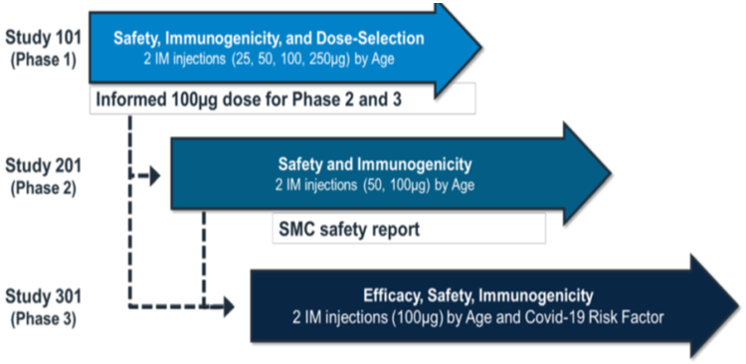
mRNA = messenger ribonucleic acid; IM = intramuscular; SMC = Safety Monitoring Committee; COVID-19 = coronavirus disease 2019.

Pharmacology
The Spikevax COVID-19 mRNA-1273 vaccine contains a nucleoside-modified mRNA encoding the viral S protein of SARS-CoV-2 formulated in lipid particles. It forms an mRNA-lipid complex (lipid nanoparticle, LNP). The mRNA encodes for the pre-fusion stabilised S protein of the 2019 novel Coronavirus (SARS-CoV-2). The four lipids protect and carry the mRNA until the mRNA is delivered to the cells where it can dictate production of the S protein. The S protein is stabilised in the so-called pre-fusion conformation by two amino acid mutations, K986P and V987P. The S protein mediates attachment and entry of the virus into host cells (by binding to the angiotensin converting enzyme 2 receptor followed by membrane fusion), making it a primary target for neutralising antibodies that prevent infection.
Upon delivery and uptake by body cells the mRNA is translated in the cytosol and SARS-CoV-2 S protein is generated by the host cell machinery. The S protein is presented and elicits an adaptive humoral and cellular immune response. Neutralising antibodies are directed against it and hence it is considered a relevant target antigen for vaccine development.

Immunogenicity (pharmacodynamics)

Study 101
Study 101;, is an ongoing, first in human, open label, dose escalation, reactogenicity, safety and immunogenicity study conducted in healthy adults (conducted in the USA). Interim analyses are available up to Day 119. Subjects received two doses (28 days apart) of either 25 µg, 50 µg, 100 µg or 250 µg. The study commenced in adults aged 18 to 55 years (n = 60), with adults aged 56 to 70 (n = 30), and > 71 years (n = 20) added to the protocol later. Subjects were not screened for SARS-CoV-2 infection before enrolment, but those with a history of COVID-19 or close contact with positive cases within 30 days prior to vaccination were excluded.
Binding antibody responses against the SARS-CoV-2 spike glycoprotein (S-2P) and the isolated receptor binding domain, located in the S1 subunit, were assessed by enzyme linked immunosorbent assay (ELISA) based on the originally documented (614D) strain. Vaccine induced neutralising activity was assessed by a pseudotyped lentivirus reporter single round of infection neutralisation assay (PsVNA) based on the 614D and 614G (or mutated) strains, and by live wildtype SARS-CoV-2 plaque reduction neutralisation testing (PRNT) assay. T-cell responses against the S protein were assessed by an intracellular cytokine staining assay. Humoral immune responses were compared with convalescent sera from 41 subjects.

Humoral immunogenicity
There were dose dependent binding and neutralising antibody responses that were consistent across age groups, with further increases observed following the second dose (see Figure 2, Figure 3, Figure 4 and Figure 5). Median titres for the 100 µg dose groups remained above median titres from convalescent sera through 3 months following the second dose (data not available beyond this time point). Data from a small number of participants (n = 33) demonstrate persistence of binding antibodies and neutralising antibodies through 6 months after the second dose.
Figure 2: Study 101 Serum immunoglobulin G enzyme-linked immunosorbent assay endpoint titre (binding antibodies, S-2P) by time point and group (per-protocol;)
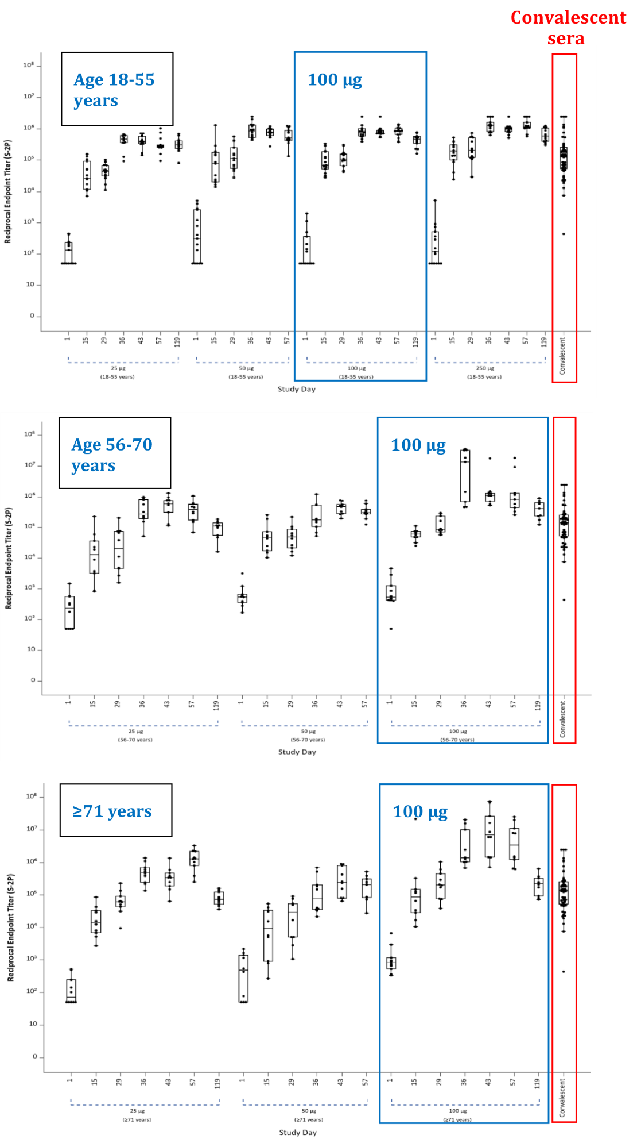
S-2P = SARS-CoV-2 spike glycoprotein.

Figure 3: Study 101 Serum immunoglobulin G enzyme-linked immunosorbent assay endpoint titre (binding antibodies, receptor binding domain) by time point and group (per-protocol)
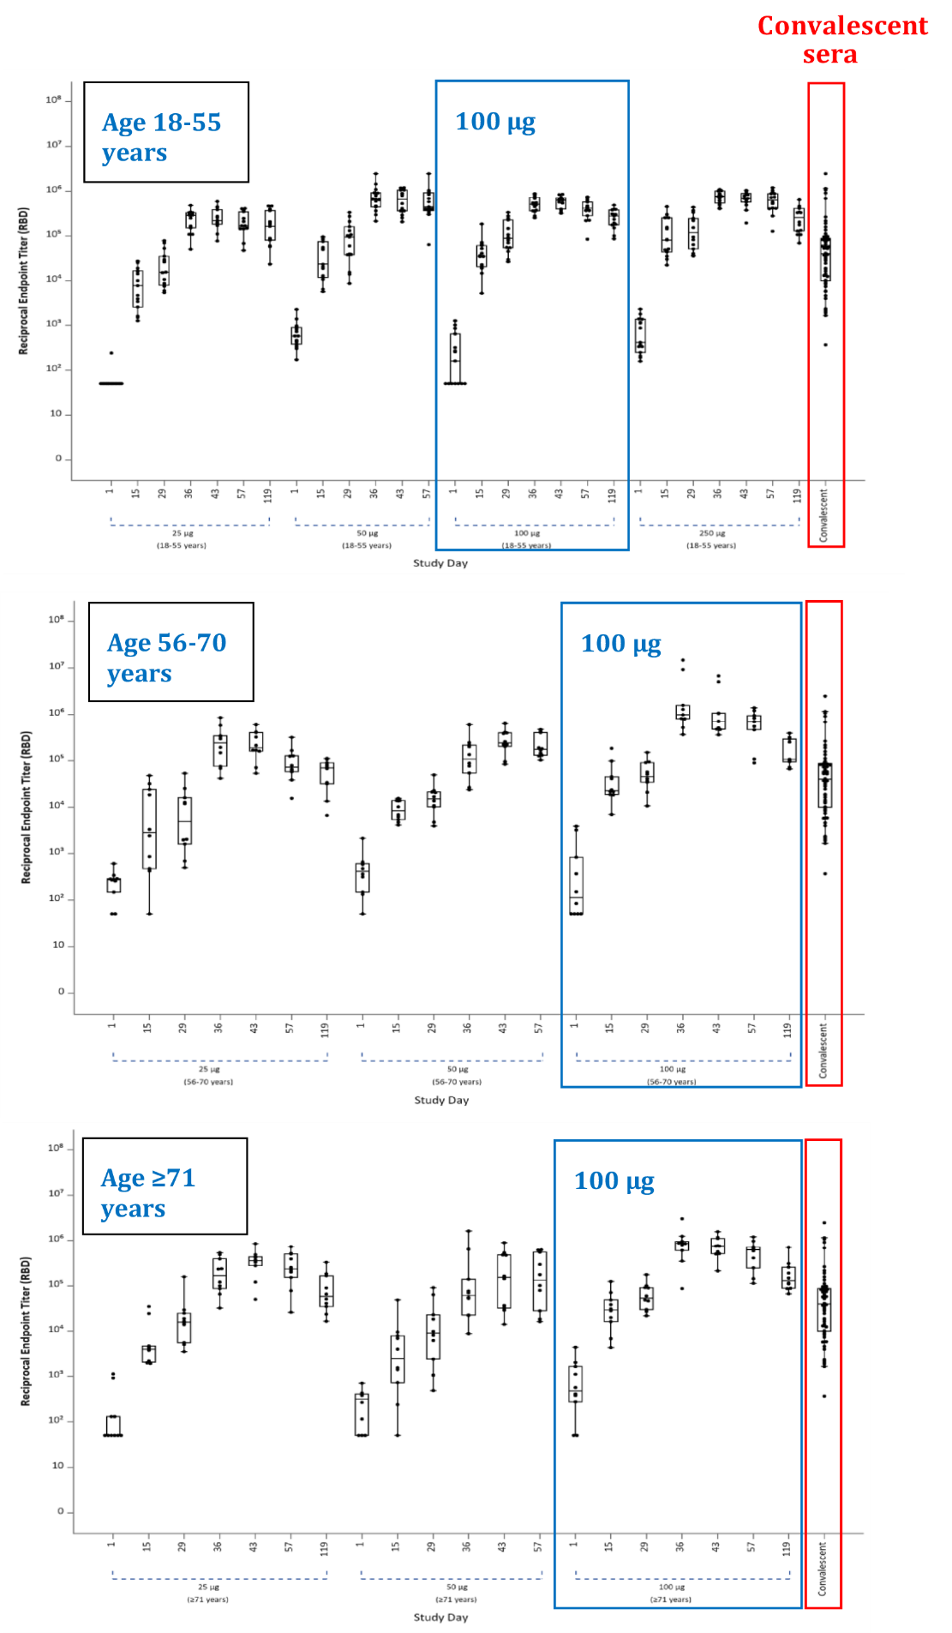
RBD = receptor binding domain
Figure 4: Study 101 Neutralising antibody (pseudotyped lentivirus single round of infection neutralisation assay) 50% inhibitory dose titres by time point and treatment group (per-protocol)
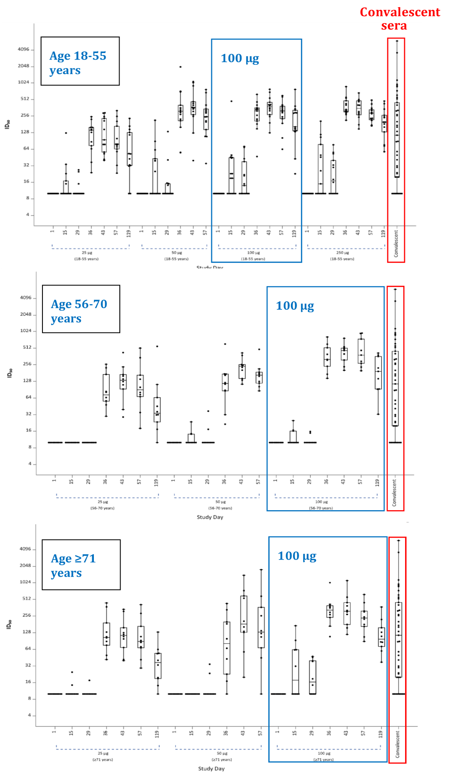
ID₅₀ = 50% inhibitory dose
Figure 5: Neutralising antibody (plaque reduction neutralisation testing) 80% inhibitory dose titres by time point and treatment group (per-protocol)
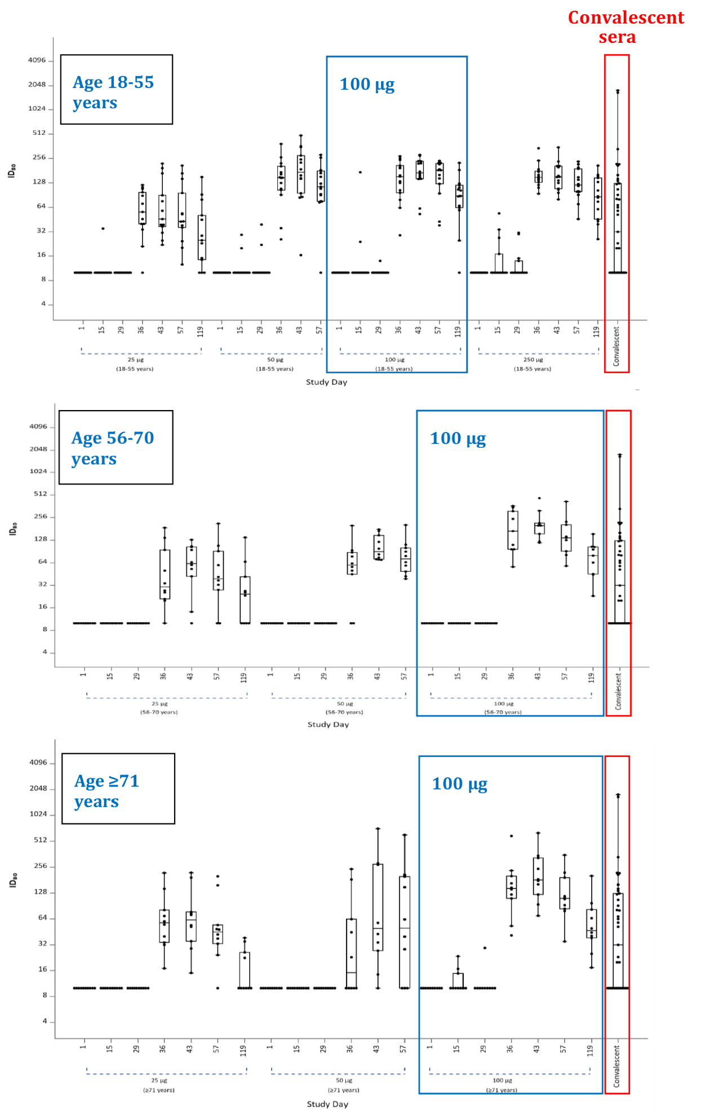
ID₈₀ = 80% inhibitory dose

Cellular immunogenicity
Specificity of the intracellular cytokine staining (ICS) assay was confirmed by comparison of convalescent sera with SARS-CoV-2-naïve peripheral blood mononuclear cell (PBMC) samples. Following dosing with the Spikevax COVID-19 mRNA-1273 vaccine, a Th-1 cell dominant, cluster of differentiation 4⁺ (CD4) T-cell response was observed.

Dose selection
On the basis of these Phase I results, the 100 μg dose of Spikevax COVID-19 mRNA-1273 vaccine was selected for further study, given its:
- greater immunogenicity compared with the 25 µg dose;
- neutralising antibody responses comparable with the 250 µg dose; and
- its reactogenicity profile more favourable compared with the 250 µg dose.

Study 201
This is an ongoing, randomised, observer blind, placebo controlled, dose confirmation study to evaluate the safety, reactogenicity, and immunogenicity of Spikevax COVID-19 mRNA-1273 vaccine in healthy adults (in the USA). Subjects received two doses (28 days apart) of either 50 µg or 100 µg of Spikevax COVID-19 mRNA-1273 vaccine, or placebo, in a 1:1:1 ratio. The study enrolled two cohorts, each with 300 subjects: Cohort 1 (≥ 18 to < 55 years old) and Cohort 2 (≥ 55 years old). Subjects were screened for SARS-CoV-2 at Baseline and during the study; those with known exposure at screening/Day 1 were excluded. No subject had SARS-CoV-2 detected at Baseline.
The primary analysis was performed when all subjects reached Day 57 (final analysis will be after 13 months). No clinical study report for the Day 57 analysis was available at the time of submission, but tables, figures and data listings were supplied.
There was a robust binding and neutralising antibody response observed after two doses of both 50 µg and 100 µg of Spikevax COVID-19 mRNA-1273 vaccine. Geometric mean antibody levels were similar across both dose levels and cohort age groups. Binding antibodies and neutralising antibodies peaked on Day 43 (14 days post Dose 2) and remained greater than convalescent sera through Day 57.
The study results were considered confirmatory of the 100 µg dosage selection for Phase III. Antibody levels and reactogenicity events were similar for the 50 µg and the 100 µg dose, but comparability of antibody persistence beyond 57 days at these two dose levels is not yet known (the 50 µg dose was added to the Phase I protocol late, so has a shorter duration of follow up data than the 100 µg dose).
Figure 6: Study 201 SARS-CoV-2 spike binding and neutralising antibody responses; per-protocol set
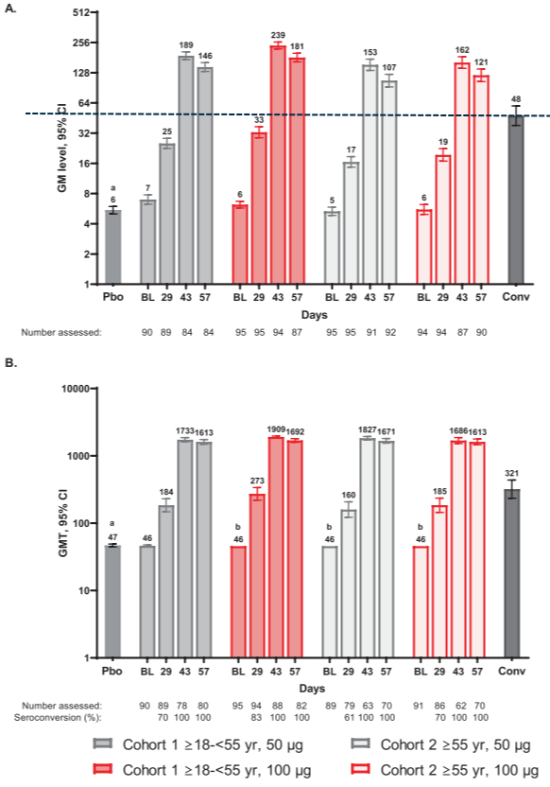
SARS-CoV-2 = Severe acute respiratory syndrome coronavirus 2; GM = geometric mean; CI = confidence interval; Pbo = placebo; BL = baseline; yr = years; Conv = human convalescent sera.
The binding antibody values reported are enzyme linked immunosorbent assay (ELISA) concentrations mg/ml and neutralising antibody values are 50% neutralisation (MN50) titres (lower limit of quantification (LLOQ) = 91.1 and upper limit of quantification (ULOQ) = 2031.9). Negative baseline values were recorded as 0.5 x LLOQ (that is, ~46 for neutralising antibodies). Conv (n = 119 (ELISA) and n = 32 (neutralising antibodies)).
A: SARS-CoV-2 spike binding antibody responses
B: SARS-CoV-2 spike neutralising antibody responses
a: placebo responses averaged across days, group and cohorts
b: 95% CI not estimable.

Study 301
Immunogenicity data for Study 301 is not provided with this submission.

Efficacy
Study 301 provides the data in support of vaccine efficacy (VE) for the Spikevax COVID-19 vaccine.

Study 301
This is an ongoing, 24 months duration (commenced on 27 July 2020), Phase III, randomised, stratified, observer blind, placebo controlled event driven study conducted across 99 centres in the USA to evaluate the efficacy, safety and immunogenicity of the Spikevax COVID-19 mRNA-1273 vaccine administered in 2 doses, 28 days apart, in adults 18 years of age and older.

Primary and main secondary objectives
The primary efficacy endpoint was efficacy of the vaccine to prevent protocol defined COVID-19 occurring at least 14 days after the second dose in participants with negative SARS-CoV-2 status at Baseline (that is, negative reverse transcription polymerase chain reaction (RT-PCR) and negative serology against SARS-CoV-2 nucleocapsid on Day 1).
Confirmed COVID-19 case was defined as: (combination of respiratory signs/symptoms or systemic symptoms with positive SARS-CoV-2 by RT-PCR)
- two of the systemic symptoms: fever (≥ 38ºC), chills, myalgia, headache, sore throat, new olfactory and taste disorder(s), or
- at least one of the respiratory signs/symptoms: cough, shortness of breath or difficulty breathing, or clinical or radiographical evidence of pneumonia; and
- nasopharyngeal swab, nasal swab, or saliva sample (or respiratory sample, if hospitalised) positive for SARS-CoV-2 by RT-PCR.
Secondary endpoints based on the per-protocol set included the efficacy of the Spikevax COVID-19 mRNA-1273 vaccine to prevent the following:
- severe COVID-19:
  - clinical signs at rest indicative of severe systemic illness (respiratory rate (RR) ≥ 30 breaths per minute, heart rate (HR) ≥ 125 beats per minute, peripheral blood oxygen saturation (SpO₂) ≤ 93% on room air at sea level (by pulse oximetry), or partial pressure of oxygen (PaO₂)/fraction of inspired oxygen (FiO₂) < 300 millimetres above mercury (mmHg)); or respiratory failure or acute respiratory distress syndrome, (defined as needing high flow oxygen, non-invasive ventilation, mechanical ventilation, or extracorporeal membrane oxygenation (ECMO)); evidence of shock (systolic blood pressure (SBP) < 90 mm Hg, diastolic blood pressure (DBP) < 60 mm Hg, or requiring vasopressors), significant acute renal, hepatic, or neurologic dysfunction; admission to an ICU; death.
- COVID-19 based on a less restrictive definition of disease (defined below) occurring at least 14 days after the second dose of vaccine:
  - positive nasopharyngeal swab, nasal swab, or saliva sample (or respiratory sample, if hospitalised) for SARS-CoV-2 by RT-PCR and one of the systemic symptoms (fever ≥ 38ºC, or chills, cough, shortness of breath or difficulty breathing, fatigue, muscle aches or body aches, headache, new loss of taste or smell, sore throat, nasal congestion or rhinorrhoea, nausea or vomiting, or diarrhoea).
- death due to COVID-19
- COVID-19 occurring at least 14 days after the first dose of vaccine (including cases that occurred after the second dose)
Vaccine efficacy of secondary endpoints was estimated from the Cox proportional hazards model when the primary endpoint reached statistical significance. Estimates based on the per-protocol set were presented with nominal two sided 95% confidence intervals (CI).

Participant selection, treatments, inclusion and exclusion criteria
The study is conducted in adults aged 18 years and older who are at risk of SARS-CoV-2 infection. Randomisation was stratified based on age (< 65 and ≥ 65 years) and risk of severe COVID-19 based on the presence of comorbid conditions (chronic lung disease or moderate to severe asthma, significant cardiac disease, severe obesity, diabetes, liver disease, or human immunodeficiency virus (HIV)). There were three strata for randomisation: ≥ 65 years, < 65 years and categorised to be at increased risk (‘at risk’) for the complications of COVID-19, and < 65 years ‘not at risk’.
A total of 30,418 individuals were randomised in a 1:1 ratio to either the Spikevax COVID-19 mRNA-1273 vaccine 100 µg or placebo (normal saline) on Day 1 and Day 29 via intramuscular injection to the deltoid muscle. Dose 2 could be administered within a predefined window allowance between Day 26 to Day 36 (-3/+7 days).
Figure 7: Study 301 design
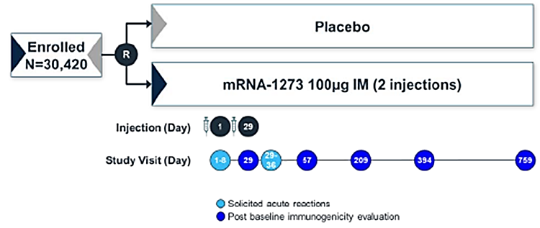
Enrolled patients were randomised in a 1:1 ratio to receive either placebo or the Spikevax mRNA-1273 vaccine.
N = population size; mRNA = messenger ribonucleic acid; IM = intramuscular; mRNA-1273 = Spikevax COVID-19 vaccine.

Key inclusion criteria:
- Adults 18 years or older, who are at risk of SARS-CoV-2 infection (locations or circumstances put them at appreciable risk of exposure to SARS-CoV-2) with no known history of SARS-CoV-2 infection.
- Healthy adults or adults with pre-existing medical conditions who are in stable condition. A stable medical condition is defined as disease not requiring significant change in therapy or hospitalisation for worsening disease during the 3 months before enrolment.

Key exclusion criteria:
- Acutely ill or febrile 72 hours prior to or at screening
- Pregnant or breastfeeding
- Known or suspected allergy or history of anaphylaxis, urticaria, or other significant adverse reaction (AR) to the vaccine or its excipients
- Bleeding disorder considered a contraindication to intramuscular injection or phlebotomy
- Received or plans to receive a non-study vaccine within 28 days prior to or after any dose of study vaccine (except for seasonal influenza vaccine which is not permitted within 14 days before or after any dose of study vaccine)
- Immunosuppressive or immunodeficient state, asplenia, recurrent severe infections (HIV-positive participants with CD4 cell count ≥ 350 cells/mm³ and an undetectable HIV viral load within the past year (low level variations from 50 to 500 viral copies which do not lead to changes in antiretroviral therapy are permitted)).
- Received systemic immunosuppressants or immune modifying drugs for > 14 days in total within 6 months prior to screening (for corticosteroids ≥ 20 mg/day of prednisone equivalent).
- Received systemic immunoglobulins or blood products within 3 months prior to the day of screening.

Study design and efficacy analysis
For analysis of the primary endpoint, the trial was designed for the null hypothesis that the efficacy of the Spikevax COVID-19 mRNA-1273 vaccine is 30% or less. A total of 151 cases of COVID-19 would provide 90% power to detect a 60% reduction in the hazard rate (that is, 60% VE), with two planned interim analyses at approximately 35% and 70% of the target total number of cases (151) and with a one sided O’Brien–Fleming boundary for efficacy and an overall one sided error rate of 0.025. The efficacy of the Spikevax COVID-19 mRNA-1273 vaccine could be demonstrated at either the interim or the primary analysis, performed when the target total number of cases had been observed.
The Lan–DeMets alpha spending function was used for calculating efficacy boundaries at each analysis. At the first interim analysis on 15 November 2020, VE had been demonstrated in accordance with the pre-specified statistical criteria. The VE estimate, based on a total of 95 adjudicated cases (63% of the target total), was 94.5%, with a one sided p-value of less than 0.001 to reject the null hypothesis that VE would be 30% or less.
The primary efficacy endpoint in the interim and primary analyses was assessed in the per-protocol population. Participants were evaluated in the treatment groups to which they were assigned.
Vaccine efficacy was defined as the percentage reduction in the hazard ratio for the primary endpoint (Spikevax COVID-19 mRNA-1273 vaccine versus placebo). A stratified Cox proportional hazards model was used to assess the VE of Spikevax COVID-19 mRNA-1273 vaccine as compared with placebo in terms of the percentage hazard reduction.

Major protocol amendments
- Protocol amendment 4 (30 September 2020) increased the upper limit for stratification of participants at risk of severe COVID-19 disease at screening from 40% to 50%.
- Protocol amendment 6 (23 December 2020) (proposed post-Emergency Use Authorization, pending the United States (US) Food and Drug Administration (FDA)’s decision)
Addition of open label observational phase (Part B)
- Allows all ongoing study participants to be informed of the availability and eligibility criteria of any COVID-19 vaccine made available under an Emergency Use Authorization, and the option to offer all ongoing study participants who request unblinding, an opportunity to schedule a participant decision clinic visit to know their original treatment assignment (Spikevax COVID-19 mRNA-1273 vaccine or placebo).
- The Spikevax COVID-19 mRNA-1273 vaccine will be offered to individuals randomised to vaccine group but who received only one dose of vaccine in the study (Dose 2 administered on day of participant decision clinic visit), and also to participants who received placebo (2 doses).

Disposition and demographic characteristics of population
Study population disposition (interim analysis cut-off: 21 November 2020)
Out of total of 30,418 randomised subjects, the majority (91.7%) completed the vaccination series of 2 doses. Median study duration post Dose 2 was 7 weeks. Both treatment groups were generally balanced across the different analysis sets. The median follow-up duration was 63 days (9 weeks) post Dose 2 (Data cut-off: 25 November 2020).
Table 3: Study 301 Study population by analysis set (data cut-off: 25 November 2020)
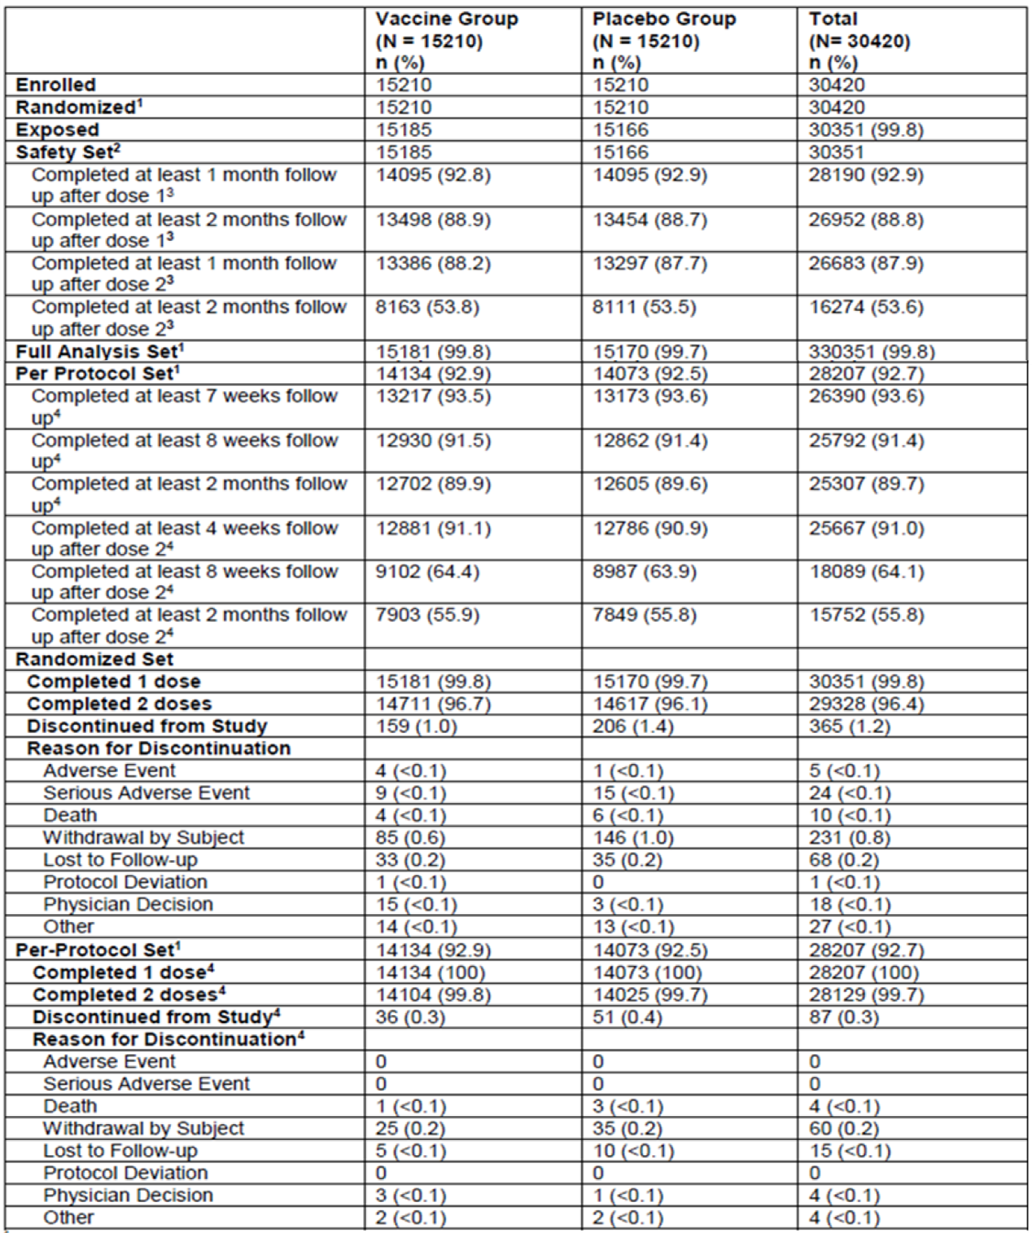
N = population size; n = sample size.
1 Numbers are based on planned treatment group and percentages are based on the number of randomised subjects.
2 Numbers are based on actual treatment group and percentages are based on the number of safety subjects.
3 Percentage based on number of subjects in the safety set.
4 Percentage based on number of subjects in the per-protocol set.

Baseline demographic data
Demographic characteristics were generally balanced between treatment groups.
The majority of the participants (82%) were considered at occupational risk for SARS-CoV-2 exposure, with 25.4% of participants being healthcare workers.
At least one protocol defined risk factor for severe disease was present in 22.2% of participants, and 4% had 2 or more high risk conditions. These included: diabetes (9.5%), chronic lung disease (4.8%), significant cardiac disease (4.9%), severe obesity (6.7%), liver disease (0.6%) and virologically suppressed HIV infection (0.6%).
A total of 2.2% of the participants were seropositive for SARS-CoV-2 at Baseline.
Table 4: Study 301 Demographic characteristics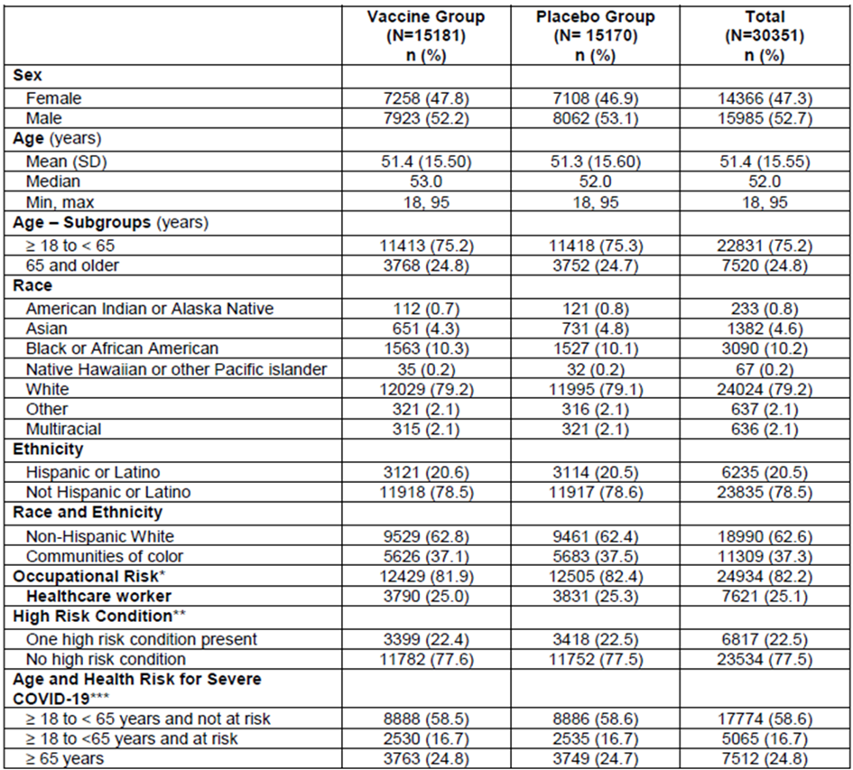
N = population size; n = sample size; SD = standard deviation; COVID-19 = coronavirus disease 2019.
Occupational risk includes: healthcare workers. emergency response. retail/restaurant operations, manufacturing and productions operations, warehouse shipping and fulfilment centres., transportation and delivery services, border protection and military personnel, and personal care and in-home services, hospitality and tourism workers, pastoral, social and public health workers, educators and students.
** High risk is defined as patients who meet at least one of the following criteria (protocol defined):
- Chronic lung disease (for example, emphysema and chronic bronchitis. idiopathic pulmonary fibrosis and cystic fibrosis) or moderate to severe asthma
- Significant cardiac disease (for example, heart failure, coronary artery disease, cardiomyopathies, and pulmonary hypertension)
- Severe obesity (body mass index ≥ 40 kg/m²)
- Diabetes (Type 2, Type 2 or gestational)
- Liver disease
- Human immunodeficiency virus infection
*** Age and health risk for severe COVID-19 is used as stratification factor for randomisation.

Distribution of risk factors for severe COVID-19 disease
This data is based on the full analysis set population (data cut-off: 25 November 2020).
The numbers of subjects with each individual protocol defined risk factor for severe COVID disease are small, especially representation of participants with liver disease and virologically suppressed HIV infection (< 1%).
Table 5 shows the distribution of risk factors among the subjects:
Table 5: Study 301 Distribution of risk factors for severe COVID-19 disease, full analysis set
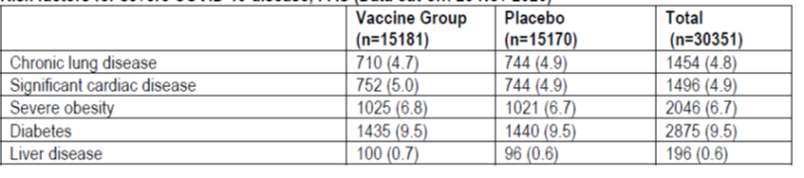
n = sample size.

Results
Primary efficacy is discussed for both first and final scheduled data cut-off points. Secondary end points are described only for the final data cut-off.

Primary efficacy endpoint – vaccine efficacy to prevent COVID-19 in participants without prior SARS-CoV-2 infection
First pre-specified interim analysis (data cut-off: 7 November 2020)
Efficacy analysis is based on the data at the first pre-specified interim analysis time point consisting of 95 adjudicated cases. There were 5 cases in the Spikevax COVID-19 mRNA-1273 vaccine group and 90 in the placebo group. The VE of Spikevax COVID-19 mRNA-1273 vaccine based on hazard ratio was 94.5% compared to placebo (95% CI: 86.5%, 97.8%). The one sided p-value was < 0.0001 to reject the null hypothesis of VE ≤ 30%, achieving the pre-specified efficacy boundary based on the one sided nominal alpha of 0.0047.
Table 6: Study 301 First interim analysis for primary efficacy endpoint, COVID-19 starting 14 days after the second dose, per-protocol set
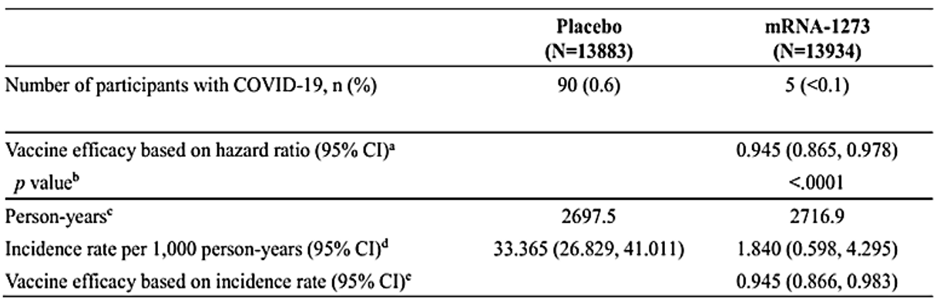
N = population size; mRNA = messenger ribonucleic acid; n = sample size; COVID-19 = coronavirus disease 2019; CI = confidence interval
a Vaccine efficacy is defined as 1 – hazard ratio (Spikevax COVID-19 mRNA-1273 vaccine versus placebo), and 95% CI was estimated using a stratified Cox proportional hazard model with Efron’s method of tie handling and with the treatment group as a covariate, adjusting for stratification factor.
b One sided p-value from stratified Cox proportional hazard model to test the null hypothesis vaccine efficacy ≤ 0.3.
c Person years is defined as the total years from randomisation date to the date of COVID-19 or last date of study participation, whichever is earlier.
d Incidence rate is defined as the number of participants with an event divided by the number of participants at risk and adjusted by person years (total time at risk) in each treatment group. The 95% CI was calculated using the exact method (Poisson distribution) and adjusted by person years.
e Vaccine efficacy is defined as 1 – ratio of incidence rate (Spikevax COVID-19 mRNA-1273 vaccine versus placebo). The 95% CI of the ratio was calculated using the exact method conditional upon the total number of cases, adjusting for person years.
In addition, there were 11 cases of severe COVID-19 14 days after the second dose. All 11 cases occurred in the placebo group and none in the Spikevax COVID-19 mRNA-1273 vaccinated group. There was one COVID-19 related death in the study to date, which occurred in the placebo group.

Final scheduled efficacy analysis
The data cut-off for the final efficacy analysis was 21 November 2020)
The median efficacy and safety follow-up for participants in the study at of the time of the final scheduled efficacy analysis (efficacy data cut-off: 21 November 2020) was 9 weeks. VE against COVID-19, 14 days after the second dose was 94.1% (95% CI: 89.3%, 96.8%) and was consistent with results obtained from the interim analysis. The VE in participants ≥ 65 years of age appears to be lower than in younger adults 18 to < 65 years (86.4% compared to 95.6%) and lower than observed in the interim analysis (100% based on a total of 15 cases).
Table 7: Study 301 Final scheduled efficacy analysis, primary endpoint, COVID-19 starting 14 days after the second dose per adjudication committee assessments, per-protocol set
COVID-19 = coronavirus disease 2019; N = population size; n = sample size; VE = vaccine efficacy; CI = confidence interval.
COVID-19: symptomatic COVID-19 requiring positive reverse transcription polymerase chain reaction (RT-PCR) result and at least two systemic symptoms or one respiratory symptom. Cases starting 14 days after the second dose. All potential COVID-19 cases starting 14 days after the second dose in the clinical database as of 21 November 2020 have been sent to adjudication committee, and have been adjudicated for this analysis (21 November 2020 is the data cut-off date for efficacy). One case (in the vaccine group) was adjudicated as a COVID-19 case by the committee but did was meet the case definition as per statistical analysis plan due to documented symptoms and positive PCR being more than 14 days apart.
21 November 2020 have been sent to adjudication committee, and have been adjudicated for this analysis (21 November 2020 is the data cut-off date for efficacy).
* Incidence rate is defined as the number of subjects with an event divided by the number of subjects at risk and adjusted by person years (total time at risk) in each treatment group. The 95% CI is calculated using the exact method (Poisson distribution) and adjusted by person years.
** VE and 95% CI from the stratified Cox proportional hazard model.
*** The one sided p-value is < 0.0001 from the stratified Cox proportional hazard model to test the null hypothesis of VE ≤ 30%, achieving the pre-specified efficacy boundary.
1 Percentage based on number of subjects in the 18 to < 65 years of age group.
2 Percentage based on number of subjects in the ≥ 65 years of age group.
Cumulative incidence rates of COVID-19 with accrual starting 14 days after the second injection in the per-protocol set are presented in Figure 8.
Figure 8: Study 301 Cumulative incidence rate of time to first occurrence of COVID-19 starting 14 days after second injection, per-protocol set
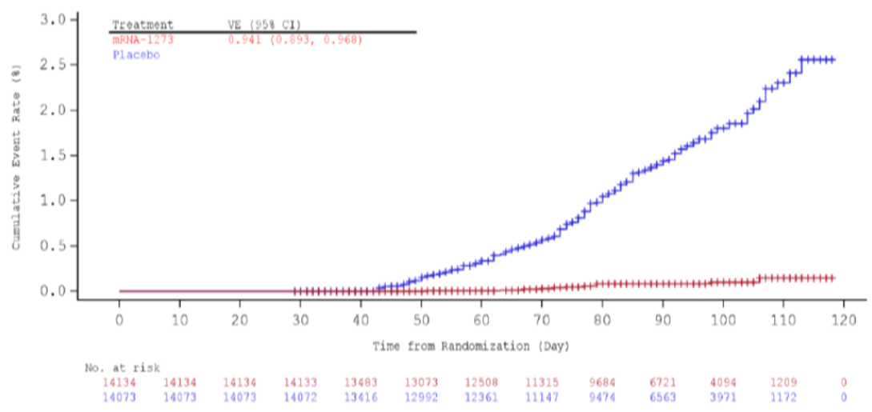
COVID-19 = coronavirus disease 2019; VE = vaccine efficacy; CI = confidence interval; mRNA = messenger ribonucleic acid.
a Primary efficacy analysis
Vaccine efficacy is defined as 1 – hazard ratio (Spikevax COVID-19 mRNA-1273 vaccine versus placebo), and 95% CI was estimated using a stratified Cox proportional hazard model with Efron’s method of tie handling and with the treatment group as a covariate, adjusting for stratification factor.

Subgroup efficacy
The efficacy of Spikevax COVID-19 mRNA-1273 vaccine for the primary efficacy endpoint was consistent across major demographic and baseline characteristic subgroups including age (≥ 18 to < 65 years, ≥ 65 years), risk factors for severe COVID-19 at screening, sex, race and ethnicity.

Subgroup analysis by age
The following is based upon the data cut-off of 21 November 2020.
The efficacy of Spikevax COVID-19 mRNA-1273 vaccine for the primary efficacy endpoint was consistent across major demographic and baseline characteristic subgroups including age. However, the number of subjects in the group above 75 years age was small (630 in vaccine and 681 in placebo).
Table 8: Study 301 Subgroup analysis of vaccine efficacy of Spikevax COVID-19 mRNA-1273 vaccine to prevent COVID-19, starting 14 days after second injection by age group (≥ 18 and < 65 years, ≥ 65 years and < 75 years, > 75 years), per-protocol set
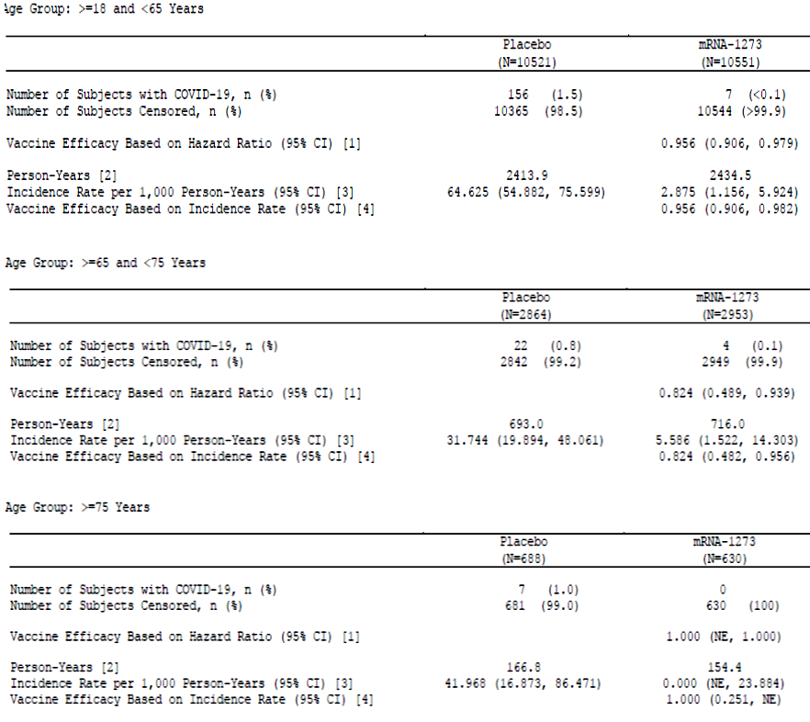
mRNA = messenger ribonucleic acid; COVID-19 = coronavirus disease 2019; N = population size; n = sample size; CI = confidence interval; NE = not estimable.
[1] Vaccine efficacy is defined as 1 – hazard ratio (Spikevax COVID-19 mRNA-1273 vaccine versus placebo), and 95% CI are estimated using a stratified Cox proportional hazard model with Efron’s method of tie handling and with the treatment group as a covariate, adjusting for stratification factor if applicable.
[2] Person years is defined as the total years from randomisation date to the date of COVID-19, last date of study participation, or efficacy data cut-off date, whichever is earlier.
[3] Incidence rate if defined as the number of subjects with an event divided by the number of subjects at risk and adjusted by person years (total time at risk) in each treatment group. The 95% CI is calculated using the exact method (Poisson distribution) and adjusted by person years.
[4] Vaccine efficacy is defined as 1 – ratio of incidence rate (Spikevax COVID-19 mRNA-1273 vaccine versus placebo). The 95% CI of the ratio is calculated using the exact method conditional upon the total number of cases, adjusting for person years.
Table 9: Study 301 A forest plot of subgroup analyses of vaccine efficacy of Spikevax COVID-19 mRNA-1273 vaccine to prevent COVID-19, per-protocol set (data cut-off: 25 November 2020)
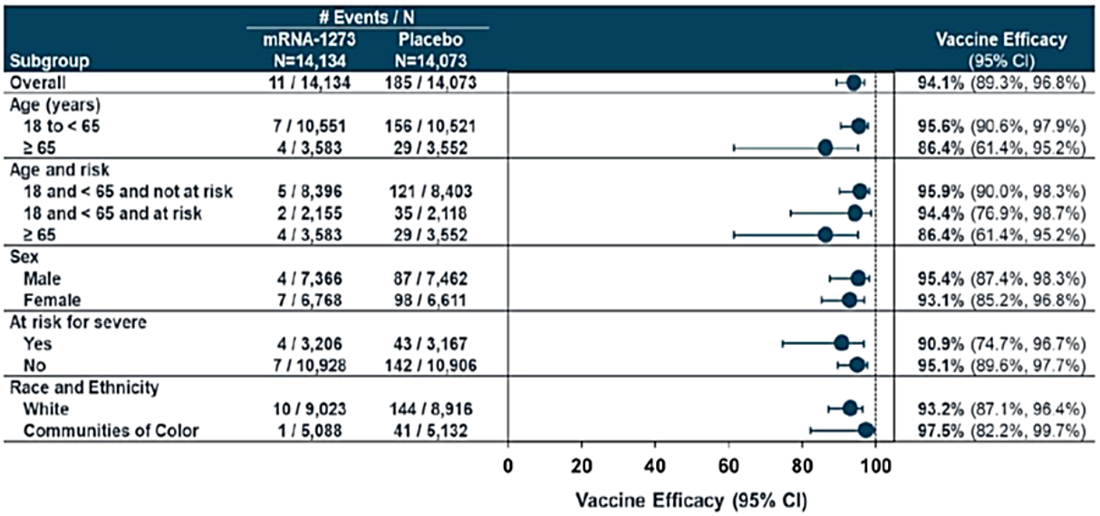
mRNA = messenger ribonucleic acid; COVID-19 = coronavirus disease 2019; N = population size; CI = confidence interval; mRNA-1273 = Spikevax COVID-19 vaccine.
a primary efficacy analysis.
White is defined as white or non-Hispanic, and communities of colour includes all other whose race or ethnicity is not unknown, unreported or missing

Vaccine efficacy by protocol defined comorbidities
Despite small sample sizes in each subgroup (except diabetes), high VE of at least 83% was observed in subjects with different comorbidities.
Given that subjects with comorbidities are at a higher risk of severe disease, the high VE observed in these subgroups is reassuring.
Data are currently lacking on immunocompromised individuals (excluded in the study) but a lower VE is expected due to a weaker immune response in this subgroup.
Table 10: Study 301 Subgroup analysis of vaccine efficacy of Spikevax COVID-19 mRNA-1273 vaccine to prevent COVID-19, by risk for severe COVID-19, per-protocol set (final cut-off: 21 November 2020)
mRNA = messenger ribonucleic acid; COVID-19 = coronavirus disease 2019; n = sample size; N = population size; CI = confidence interval; NE = not estimable.

Results for the key secondary efficacy endpoints
The VE for the Spikevax COVID-19 mRNA-1273 vaccine for the key secondary endpoints was similar to the VE for the primary endpoint, with point estimates of VE in the range of 93.5% to 100% based on hazard ratios.
The Spikevax COVID-19 mRNA-1273 vaccine prevented severe COVID-19 starting 14 days after the second injection: the point estimate of VE was 100% based on the hazard ratio, with 30 cases in the placebo group and no cases in the Spikevax COVID-19 mRNA-1273 vaccine group. Sensitivity analyses for severe COVID-19 also showed point estimates of VE of 100% based on hazard ratios, as did a sensitivity analysis for severe COVID-19 starting after randomisation using the per-protocol set based on the positive RT-PCR results and severe COVID-19 symptoms.

Vaccine efficacy against severe COVID-19 disease
The VE for prevention of severe cases of COVID-19 shows that no cases occurred in the Spikevax COVID-19 mRNA-1273 vaccine group and 30 severe COVID-19 cases in the placebo group, indicating protection from development of severe COVID-19 starting 14 days after Dose 2 up to the data cut-off.
Table 11: Study 301 Analysis of vaccine efficacy of Spikevax COVID-19 mRNA-1273 vaccine to prevent severe COVID-19, after second injection, per-protocol set (final cut-off: 21 November 2020)
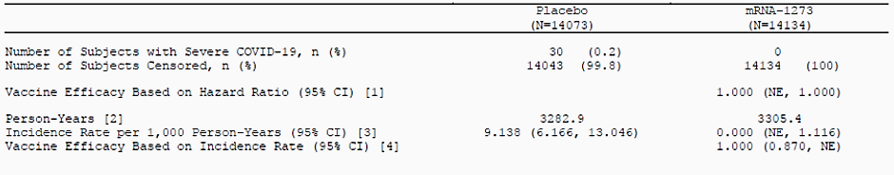
mRNA = messenger ribonucleic acid; COVID-19 = coronavirus disease 2019; N = population size; n = sample size; CI = confidence interval; NE = not estimable.
[1] Vaccine efficacy is defined as 1 – hazard ratio (Spikevax COVID-19 mRNA-1273 vaccine versus placebo), and 95% CI are estimated using a stratified Cox proportional hazard model with Efron’s method of tie handling and with the treatment group as a covariate, adjusting for stratification factor.
[2] Person years is defined as the total years from randomisation date to the date of severe COVID-19, last date of study participation, or efficacy data cut-off date, whichever is earlier.
[3] Incidence rate if defined as the number of subjects with an event divided by the number of subjects at risk and adjusted by person years (total time at risk) in each treatment group. The 95% CI is calculated using the exact method (Poisson distribution) and adjusted by person years.
[4] Vaccine efficacy is defined as 1 – ratio of incidence rate (Spikevax COVID-19 mRNA-1273 vaccine versus placebo). The 95% CI of the ratio is calculated using the exact method conditional upon the total number of cases, adjusting for person years.

Vaccine efficacy regardless of prior SARS-CoV-2 infection
The following is for the full analysis population set, with a data cut-off of 21 November 2020)
Vaccine efficacy of Spikevax COVID-19 mRNA-1273 vaccine to prevent COVID-19 regardless of evidence of prior SARS-CoV-2 infection determined by serologic titres against SARS-CoV-2 nucleocapsid, was 94%.
Table 12: Study 301 Analysis of vaccine efficacy of Spikevax COVID-19 mRNA-1273 vaccine to prevent COVID-19 starting 14 days after second injection regardless of prior SARS-CoV-2 infection, full analysis set
mRNA = messenger ribonucleic acid; COVID-19 = coronavirus disease 2019; SARS-CoV-2 = severe acute respiratory syndrome coronavirus 2; N = population size; n = sample size; CI = confidence interval.
[1] Vaccine efficacy is defined as 1 – hazard ratio (Spikevax COVID-19 mRNA-1273 vaccine versus placebo), and 95% CI are estimated using a stratified Cox proportional hazard model with Efron’s method of tie handling and with the treatment group as a covariate, adjusting for stratification factor.
[2] Person years is defined as the total years from randomisation date to the date of COVID-19, last date of study participation, or efficacy data cut-off date, whichever is earlier.
[3] Incidence rate if defined as the number of subjects with an event divided by the number of subjects at risk and adjusted by person years (total time at risk) in each treatment group. The 95% CI is calculated using the exact method (Poisson distribution) and adjusted by person years.
[4] Vaccine efficacy is defined as 1 – ratio of incidence rate (Spikevax COVID-19 mRNA-1273 vaccine versus placebo). The 95% CI of the ratio is calculated using the exact method conditional upon the total number of cases, adjusting for person years.

Vaccine efficacy by baseline positive SARS-CoV-2 status (data Cut-off: 21 November 2020)
Only 2.2% of participants had evidence of prior infection at study enrolment, and there was only one COVID-19 case starting 14 days after Dose 2 reported from this subgroup, which was in a participant in the placebo group.
Table 13: Study 301 Vaccine efficacy by positive baseline SARS-CoV-2 status, full analysis set
COVID-19 = coronavirus disease 2019; SARS-CoV-2 = severe acute respiratory syndrome coronavirus 2; N = population size; n = sample size; CI = confidence interval; NE = not estimable
[1] Vaccine efficacy is defined as 1 – hazard ratio (Spikevax COVID-19 mRNA-1273 vaccine versus placebo), and 95% CI are estimated using a stratified Cox proportional hazard model with Efron’s method of tie handling and with the treatment group as a covariate, adjusting for stratification factor if applicable.
[2] Person years is defined as the total years from randomisation date to the date of COVID-19, last date of study participation, or efficacy data cut-off date, whichever is earlier.
[3] Incidence rate if defined as the number of subjects with an event divided by the number of subjects at risk and adjusted by person years (total time at risk) in each treatment group. The 95% CI is calculated using the exact method (Poisson distribution) and adjusted by person years.
[4] Vaccine efficacy is defined as 1 – ratio of incidence rate (Spikevax COVID-19 mRNA-1273 vaccine versus placebo). The 95% CI of the ratio is calculated using the exact method conditional upon the total number of cases, adjusting for person years.

Vaccine efficacy after the first dose
Vaccine efficacy starting 14 days after the first injection in participants without immunologic and virologic evidence of previous SARS-CoV-2 infection was high at 95.2% (91.2%, 97.40%). These results are limited by the fact that > 90% of participants received a second injection of Spikevax COVID-19 mRNA-1273 vaccine within approximately 28 days after the first injection.
Table 14: Study 301 Analysis of vaccine efficacy of Spikevax COVID-19 mRNA-1273 vaccine to prevent COVID-19 starting 14 days after first injection, per-protocol set (data cut-off: 21 November 2020)
mRNA = messenger ribonucleic acid; COVID-19 = coronavirus disease 2019; SARS-CoV-2 = severe acute respiratory syndrome coronavirus 2; N = population size; n = sample size; CI = confidence interval.
[1] Vaccine efficacy is defined as 1 – hazard ratio (Spikevax COVID-19 mRNA-1273 vaccine versus placebo), and 95% CI are estimated using a stratified Cox proportional hazard model with Efron’s method of tie handling and with the treatment group as a covariate, adjusting for stratification factor.
[2] Person years is defined as the total years from randomisation date to the date of COVID-19, last date of study participation, or efficacy data cut-off date, whichever is earlier.
[3] Incidence rate if defined as the number of subjects with an event divided by the number of subjects at risk and adjusted by person years (total time at risk) in each treatment group. The 95% CI is calculated using the exact method (Poisson distribution) and adjusted by person years.
[4] Vaccine efficacy is defined as 1 – ratio of incidence rate (Spikevax COVID-19 mRNA-1273 vaccine versus placebo). The 95% CI of the ratio is calculated using the exact method conditional upon the total number of cases, adjusting for person years.
In participants in the modified intent-to-treat (mITT); set who only received one dose of the vaccine at the time of the interim analysis, VE after one dose was 80.2% (95% CI: 55.2%, 92.5%). VE starting 14 days post Dose 1 was 92.1% (68.8%, 99.1%), which suggests a good level of protection against COVID-19 disease.
These participants had a median follow-up time of 28 days (range: 1 to 108 days). The small, non-random sample and short median follow-up time (and small number of events) limits the interpretation of these results.
Table 15: Study 301 Efficacy against COVID-19 after only one dose of Spikevax COVID-19 mRNA-1273 vaccine
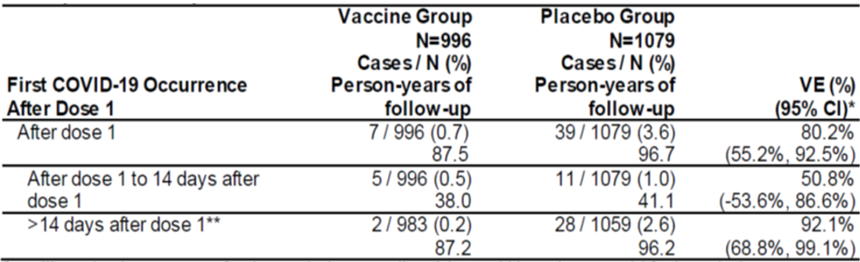
COVID-19 = coronavirus disease 2019; mRNA = messenger ribonucleic acid; N = population size; VE = vaccine efficacy; CI = confidence interval.
Surveillance in person years for given endpoints across all participants within each group risk for the endpoint.
* Vaccine efficacy is calculated as 1 – incidence rate ratio (Spikevax COVID-19 mRNA-1273 vaccine/placebo). The 95% CI of VE is calculated using the exact method conditional upon the total number of cases, adjusting for person years.
** Participants who were not at risk (cases or censored at prior time period) are excluded from this analysis.
In a similar analysis to look at VE against severe COVID-19 after one dose, of participants in the mITT group who received only one dose of vaccine, 2 participants in the Spikevax COVID-19 mRNA-1273 vaccine group and 4 participants in the placebo group developed severe COVID-19.

Deaths
There was one death due to COVID-19 at the time of the interim analysis and it happened in the placebo group.
Table 16: Study 301 Death caused by COVID-19 starting 14 days after second dose injection
COVID-19 = coronavirus disease 2019; mRNA = messenger ribonucleic acid; N = population size; CI = confidence interval; NE = not estimable.
[1] Vaccine efficacy, defined as 1 – hazard ratio (Spikevax COVID-19 mRNA-1273 vaccine versus placebo), and 95% CI are estimated using a stratified Cox proportional hazard model with Efron’s method of tie handling and with the treatment group as a covariate, adjusting for stratification factor.

Vaccine effectiveness against asymptomatic infection
The pivotal study was not designed to assess the effect of the vaccine against transmission of SARS-CoV-2 from individuals experiencing asymptomatic infections after vaccination. Protection against asymptomatic infection is currently unknown, however data will be generated during the ongoing Phase III trial on antibodies against the nucleocapsid protein (protocol amendment: 18 May 2020). The pre-defined serology endpoint from the ongoing study based on anti-nucleocapsid protein (N) antibodies would provide further evidence on protection against asymptomatic infection and will provide further understanding whether protection is superior with two doses.
Among baseline negative participants, 14 in the vaccine group and 38 in the placebo group were RT-PCR positive for SARS-CoV-2 infection at the second dose without COVID-19 symptoms; however, these data are limited by the short observation period.

Safety

Study 101
Local and systemic AR were common, but mostly mild to moderate and with a median duration of one to two days. Severity was dose dependent, with severe solicited ARs more frequent in the 250 µg dose groups than the lower dose groups. The most common local AR was injection site pain, reported in 92% of subjects aged 18 to 55-years and 80% of subjects aged over 55 years. The most commonly reported systemic ARs were fatigue, headache, myalgia and chills, with greater incidence and severity observed following the second dose. 73 to 77% of subjects reported unsolicited adverse events (AE); these were mostly mild. One subject discontinued study vaccine due to transient urticaria (mild) which was considered treatment related. There were no deaths or serious adverse events (SAE) reported. No events of anaphylaxis or myocarditis/pericarditis were reported.
On the basis of the reactogenicity observed with the 250 µg dose in adults aged 18 to 55 years, this dose level was not investigated in older adults and was not selected for further study in Phase III.
Table 17: Study 101 Summary of safety (data cut-off: 7 October 2020)
Safety category | Adults 18 to 55 years | Adults > 55 years
Local and systemic solicited AEs | Common, but mostly mild to moderate  Dose dependent  More frequent after Dose 2 than Dose 1  Events that occurred in more than half the participants included fatigue, chills, headache, myalgia, and pain at the injection site  Most common: vaccination site pain (91.7% of subjects after any dose) | Similar pattern to younger adults, but events slightly less frequent  Most common: vaccination site pain (80% of subjects after any dose)
Unsolicited AEs | Mostly mild, no obvious clustering by SOC  2 severe AEs considered related to vaccine: events of syncope and light headedness with onset Day 2 post Dose 2 in subject with severe fever and chills (250 µg group) | Mostly mild, no obvious clustering by SOC  No severe AEs considered related to vaccine
SAEs | None reported | None reported
Discontinuations | One subject (25 µg group) with transient urticaria considered related to Dose 1 (onset Day 5).  One subject (25 µg group) withdrew after known SARS-CoV-2 exposure  One subject (250 µg group) with sore throat (not deemed related to vaccine) | One subject aged 56 to 70 years (100 µg group) with paronychia onset 2 days after Dose 1. Treated with trimethoprim sulfamethoxazole. Developed diffuse maculo papular rash 7 days later, considered unrelated to vaccine
Other comments | No reports of myocarditis or pericarditis | No reports of myocarditis or pericarditis  Laboratory evaluations: Grade 2 thrombocytopenia was noted in one subject ≥ 71 years of age (clinical relevance not stated)
AE = adverse event; SOC = System Organ Class; SAE = serious adverse event; SARS-CoV-2 = severe acute respiratory syndrome coronavirus 2.

Study 201
Safety data were available up to 57 days post vaccination.
The profile of solicited ARs was consistent with what was reported in Study 301. The most frequently reported solicited AR was vaccination site pain. The incidence of solicited ARs was somewhat higher in the 100 µg dose groups compared with the 50 µg dose groups, and was similar between younger and older adult age cohorts. Most solicited events were mild to moderate and resolved in one to three days. The proportion of subjects reporting unsolicited AEs from Day 1 to Day 57 was similar between vaccine (29.5% with 100 µg, 30.5% with 50 µg) and placebo (27.5%) groups. One SAE of community acquired pneumonia with onset Day 33 (50 µg group, aged ≥ 55 years) was reported, this was not considered vaccine related. No deaths were reported. There were no reported events of anaphylaxis, myocarditis or pericarditis.
Table 18: Study 201 Summary of safety
Safety category | Adults 18 to < 55 years | Adults ≥ 55 years
Local and systemic solicited AEs | Mostly mild to moderate  More frequent with vaccine than placebo  More frequent after Dose 2 than Dose 1  Most frequent: injection site pain; 80% in 50 µg group, 90% in 100 µg group and 10% with placebo (rates after Dose 2 shown) | Similar pattern to younger adults, but generally less frequent  Most frequent: injection site pain; 79% in 50 µg group, 81% in 100 µg group and 6% with placebo (rates after Dose 2 shown)
Unsolicited AEs | Rates similar to placebo  Mostly mild or moderate | Rates similar to placebo  Mostly mild or moderate
SAEs | None reported | One community acquired pneumonia, onset Day 33 (50 µg group), not related to vaccine
Discontinuations of study vaccine due to AEs | One subject (placebo group) due to COVID-19 | One subject (50 µg group) with community acquired pneumonia (as above)
AE = adverse event; SAE = serious adverse event; COVID-19 = coronavirus disease 2019.

Study 301
Main safety data are provided by the Phase III study, Study 301. Safety analysis was presented based on cut-offs at two time points of 11 November 2020 and 25 November 2020. In this overview, mainly the safety data from 25 November 2020 cut-off is being discussed.
As of the safety cut-off date of 25 November 2020, the safety analyses comprised 30,351 subjects (15,185 in the vaccine group and 15,166 in the placebo group).
As of 25 November 2020, the median follow-up time in the study was 92 days after randomisation (Dose 1) or 63 days after Dose 2.
Table 19: Study 301 Overall exposure
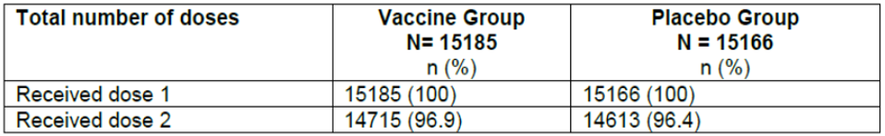
N = number of subjects in each group or in total included in the considered cohort.
n/% = number/percentage of subjects receiving the specified total number of doses.

Safety overview
As expected, AEs were reported in a higher proportion in the vaccine group as compared to the placebo group. Reactogenicity events (solicited AEs) reported in the 7 days following each dose of vaccine were much higher in the vaccine group (94.9% versus 60.1%). No clinically meaningful differences in AE frequencies were observed by age, sex, race, ethnicity and so on. Overall rate of SAEs, death, and discontinuations due to AEs were all balanced across the study groups.
Rates of AEs were generally lower in the subjects with baseline positive SARS-CoV-2, as compared to those with baseline negative SARS-CoV-2 status. However, the baseline positive SARS-CoV-2 subset was very small.
Table 20: Study 301 Safety overview, safety set
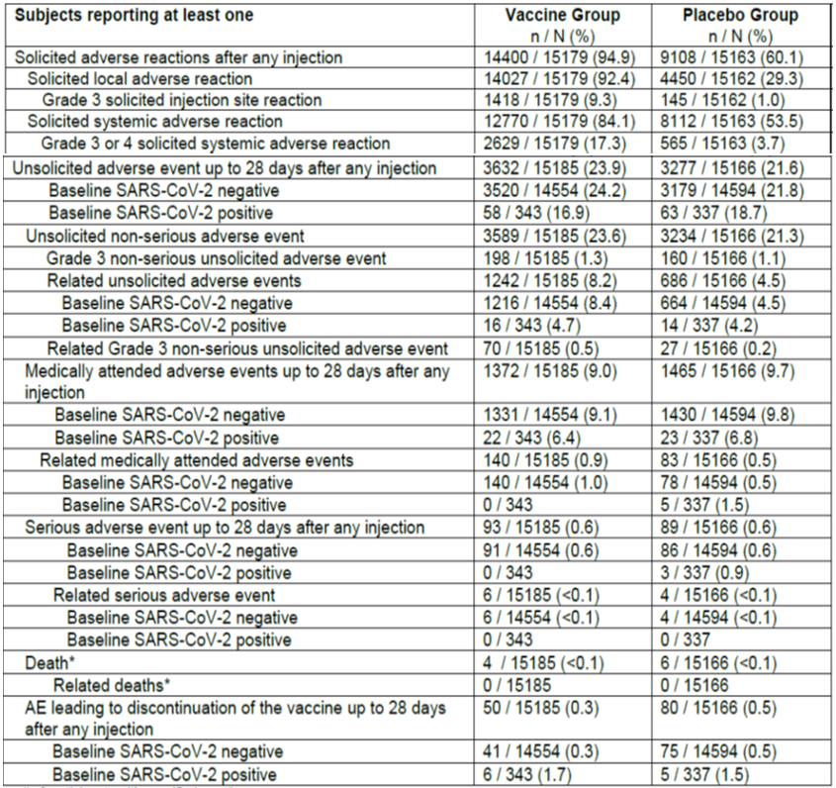
SARS-CoV-2 = Severe acute respiratory syndrome coronavirus 2; n = number of participants with specified reaction; N = number of exposed subjects who submitted any data for the event, percentages are based on n/N.
* Death reported for entire study period (overall stage) as of 25 November 2020.

Discontinuations
There were slightly more participants who discontinued study participation in the placebo versus vaccine group of the study (see Table 4). Withdrawal of consent was the most common reason for discontinuation of participants in the placebo (146 participants) versus the vaccine groups (85 participants) in the randomised set (see Table 4). AEs led to vaccine discontinuation in 80 participants in the placebo group versus 50 participants in the vaccine group (see Table 13). There was a slightly higher percentage of seropositive participants in both treatment groups who had an AE leading to withdrawal (1.7% of seropositive participants versus 0.3% of seronegative participants in the vaccine group; 1.5% of seropositive participants versus 0.5% of seronegative participants in the placebo group)

Solicited local adverse reactions
Overall, more solicited local ARs were reported in the vaccine group versus the placebo. Higher rates of local ARs were reported after Dose 2, as compared to post Dose 1.
Injection site pain was the most common local solicited AR (92.0% for the subjects in the vaccine group versus 26.6% of participants in the placebo group after any dose). Axillary swelling was noted in 19.8% subjects in the vaccine group versus 7.2% in the placebo group.
Majority of Grade 3 ARs were due to pain, in the vaccine group (6.1% versus 0.6%).
As expected, younger adult participants had a greater reactogenic profile of the study vaccine as compared to older adults.
Table 21: Study 301 Solicited local adverse reactions, safety set
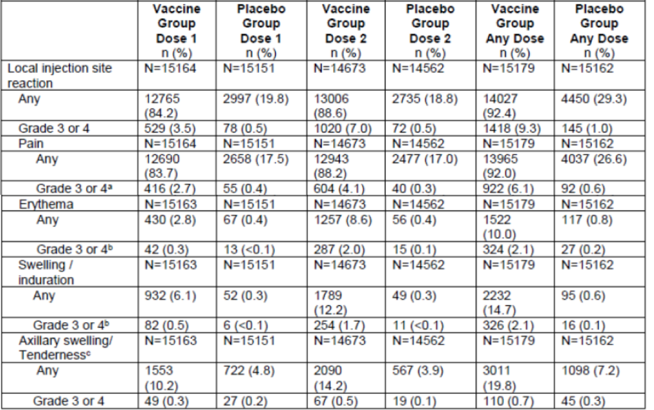
n = number of participants with specific reaction; N = number of exposed subjects who submitted any data for the event, percentages are based on n/N.
* Safety set: all randomised participants who received ≥ one vaccine or control dose.
Adverse reaction data were collected on the electronic diary (e-Diary) by participants and those collected on the European Council on Foreign Relations (eCFR) indicated as solicited adverse reactions.
a Pain - Grade 3: any used of Rx pain reliever/precents daily activity; Grade 4: requires emergency room visit or hospitalisation.
b Erythema and swelling/induration – Grade 3: > 100 mm/> 10 cm; Grade 4: necrosis/exfoliative dermatosis.
c Axillary swelling/tenderness collected as solicited local adverse reaction (lymphadenopathy,: localised axillary swelling or tenderness ipsilateral to the vaccination group) – Grade 3: any use of Rx pain reliever/prevents daily activity; Grade 4: requires emergency room visit or hospitalisation.

Solicited systemic adverse reactions
Solicited systemic ARs were reported for the majority of vaccine recipients (84.1%) and much more frequently as compared with the placebo (53.5%). Higher rates of systemic ARs were recorded post Dose 2 as compared with Dose 1.
After any dose, fatigue was the most common solicited systemic AR (70.0% of participants in the vaccine group versus 36.6% of participants in the placebo group). Headache (64.7% of subjects in the vaccine group versus 37.0% of participants in the placebo group) and myalgia (61.5% of participants in the vaccine group versus 20.5% of participants in the placebo group) were other common systemic ARs.
Grade 3 or 4 ARs were reported in 3.0% of vaccine recipients post Dose 1, which increased to 17.3% post Dose 2. Grade 3 or 4 fatigue after any dose was reported in 10.1% of participants in the vaccine group versus 1.3% of participants in the placebo group, followed by myalgia (9.1% of participants in the vaccine group versus 0.6% of participants in the placebo group) and headache (5.7% of participants in the vaccine group versus 2.2% of participants in the placebo group).
Most events occurred within the first one to two days post dose and lasted for a median duration of one to three days, and were reported with higher frequencies in younger adults (18 to < 65 years old).
Table 22: Study 301 Solicited systemic adverse events, safety set
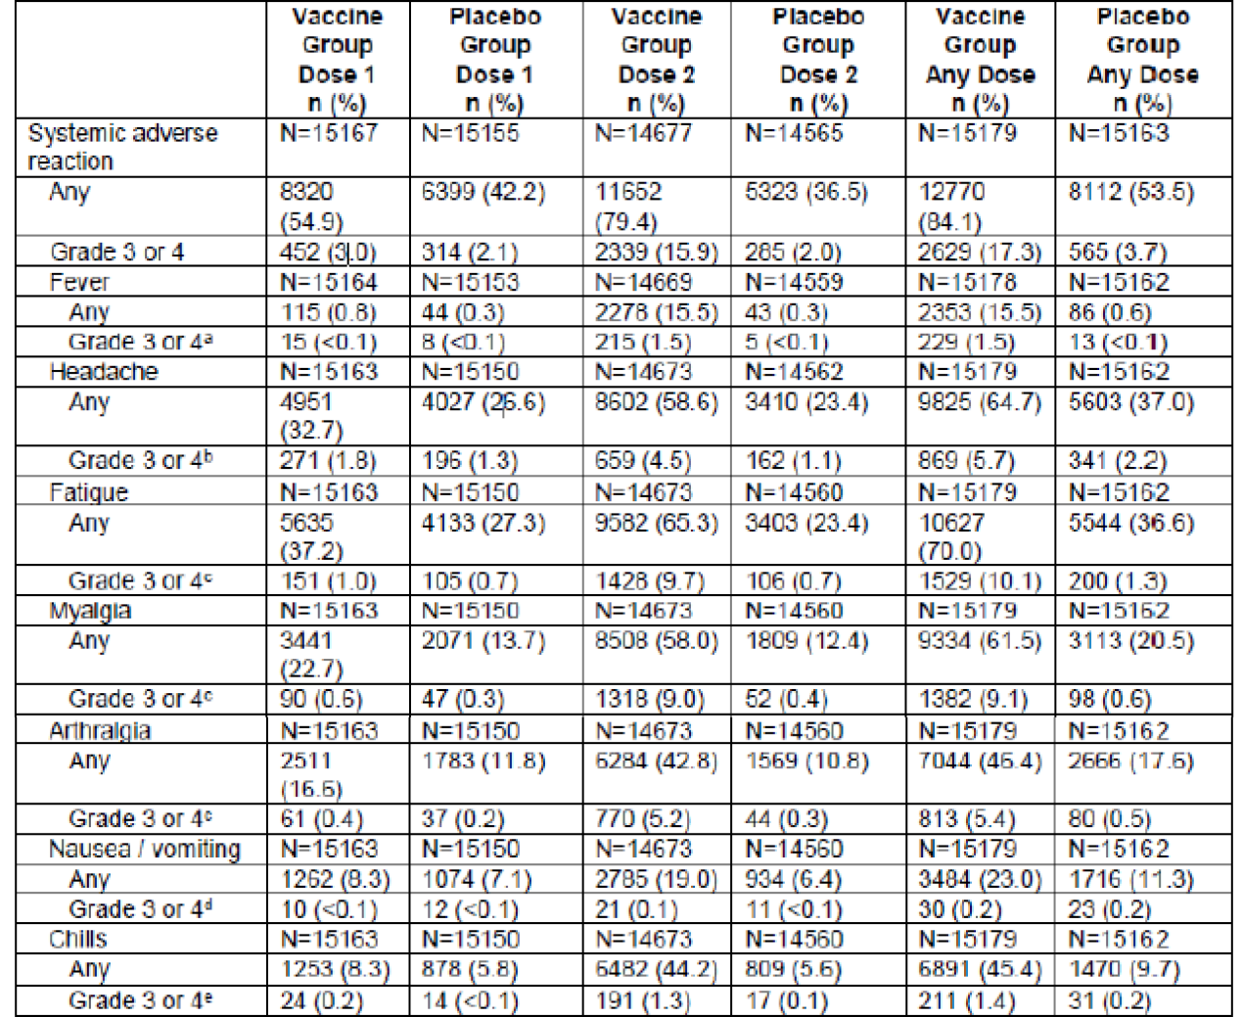
n = number of participants with specific reaction; N = number of exposed subjects who submitted any data for the event, percentages are based on n/N.
* Safety set: all randomised participants who received ≥ one vaccine or control dose.
Adverse reaction data were collected on the electronic diary (e-Diary) by participants and those collected on the European Council on Foreign Relations (eCFR) indicated as solicited adverse reactions.
a Fever – Grade 3: ≥ 39.0 to ≤ 40.0ºC; Grade 4: ≥ 40.0ºC.
b Headache – Grade 3: significant; any use of Rx pain reliever or prevents daily activity; Grade 4: requires emergency room visit or hospitalisation.
c. Fatigues, myalgia, arthralgia – Grade 3: Significant, prevents daily activity; Grade 4: requires emergency room visit or hospitalisation.
d Nausea/vomiting – Grade 3: prevents daily activity, requires outpatient intravenous hydration; Grade 4: requires emergency room visit or hospitalisation for hypotensive shock.
e Chills – Grade 3: prevents daily activity and requires medical intervention; Grade 4: requires emergency room visit or hospitalisation.

Unsolicited adverse events

Summary of unsolicited adverse events
Overall higher incidence of unsolicited AEs was reported in the vaccine group as compared to placebo across all age cohorts. In the subgroup of participants > 65 years, there were no specific clusters of AEs that accounted for the imbalance in AEs.
Table 20: Study 301 Unsolicited adverse events up to 28 days after any injection by age groups
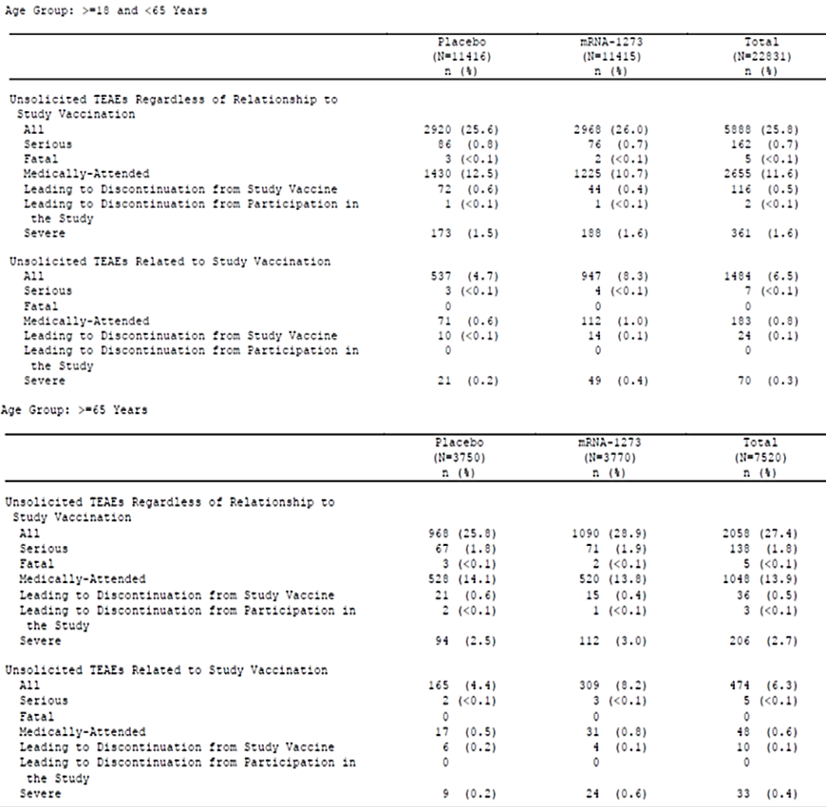
mRNA = messenger ribonucleic acid; N = population size; n = sample size.
Overall unsolicited AEs considered to be related to study vaccination were reported in 8.2% in the Spikevax COVID-19 mRNA-1273 vaccine group versus 4.5 % in placebo. In the Spikevax COVID-19 mRNA-1273 vaccine group, treatment related AEs reported in ≥ 1% of participants in the 28 days after any injection included fatigue (198 (1.3%) participants in the Spikevax COVID-19 mRNA-1273 vaccine group and 159 (1.0%) participants in the placebo group) and headache (191 (1.3%) participants in the Spikevax COVID-19 mRNA-1273 vaccine group and 122 (0.8%) participants in the placebo group).

Unsolicited System Organ Class
By System Organ Class (SOC) of the unsolicited treatment emergent adverse events (TEAEs), the number of participants experiencing skin, musculoskeletal and general disorders was more common in the vaccine group versus the placebo group. Most of the imbalance can be accounted for with solicited event terms reported as TEAEs, for example fatigue was more common in the vaccine group under the general disorders and administration site SOC.
In the Spikevax COVID-19 mRNA-1273 vaccine group, overall, general disorders and administration site AEs were the most common (6.6%); headache and fatigue were reported in ≥ 2% of subjects.
Table 23: Study 301 Percentage of subjects reporting > 1% unsolicited adverse events up to 28 days after any dose, safety set
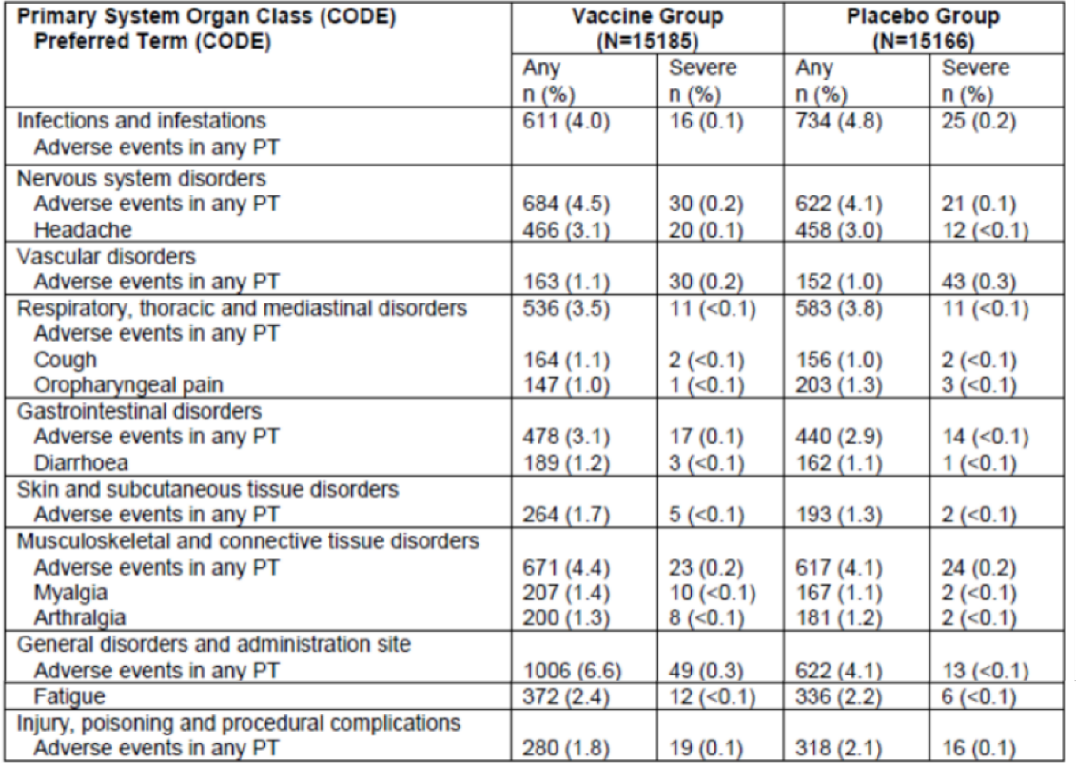
N = population size; n/% = number (percentage) of subjects reporting the adverse event at least once; PT = Preferred Term.
Percentages are based on the number of safety subjects.
* Safety set: all randomised participants who received ≥ one vaccine or control dose.
Adverse event of diarrhoea was reported in a similar incidence in the elderly: 42/3770 (1.1%) in vaccine group versus 48/3750 (1.3%) in placebo group.

Serious adverse events
The proportion of participants who reported severe unsolicited AEs was low and generally balanced in both groups (1.5% in vaccine group and 1.3% in placebo), with 0.2% and 0.5% considered treatment related respectively. The most frequently reported severe AEs in the vaccine group were consistent with reactogenic events such as headache, fatigue, myalgia arthralgia, injection site erythema and injection site swelling. The most common SAEs in the vaccine group, which were numerically higher than the placebo group, were myocardial infarction, cholecystitis and nephrolithiasis. However, causality could not be established due to the small numbers of these events. A total of 7 SAEs (4.8%) in the Spikevax COVID-19 mRNA-1273 vaccine group and 5 (3.3%) in the placebo group were assessed by the investigator as related to study vaccination.
Table 24: Study 301 Percentage of subjects reporting the occurrence serious adverse events (at least 3 subjects in either group) classified by MedDRA; primary System Organ Class and Preferred Term, safety set
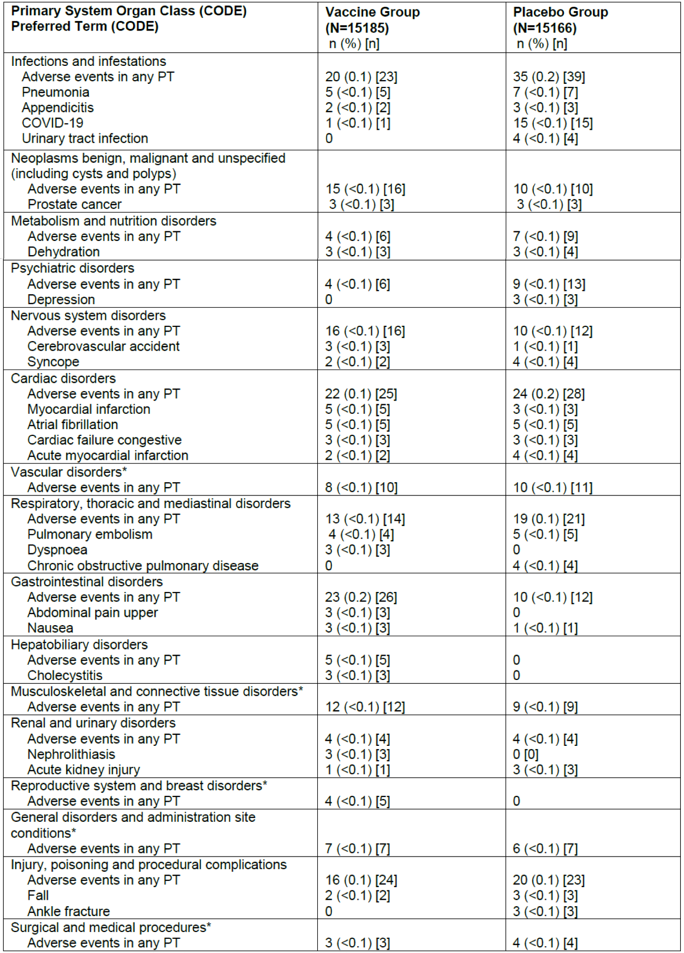
N = number of treated subjects included in each treatment group; n (%) = number (percentage) of subjects reporting the adverse event at least once; [n] = number of events reported; PT = Preferred Term.
* Safety set: all randomised participants who received ≥ one vaccine or control dose.
At least one adverse event = at least one adverse event experienced (regardless of the MedDRA Preferred Term).
Percentages are based on the number of safety subjects.
a there was no Preferred Term reported in ≥ 3 subjects in either of the treatment group.

Deaths
At the time of the final data cut-off date, 10 deaths were reported (4 in the vaccine group and 6 in the placebo group). However, based on the pharmacovigilance database which includes data from study start through 3 December 2020, there have been 13 deaths during the study. Six participants who died received Spikevax COVID-19 mRNA-1273 vaccine and 7 received placebo. The most common Preferred Term (PT) was myocardial infarction, reported by 3 participants, 2 who received placebo and one who received Spikevax COVID-19 mRNA-1273 vaccine. The participant who received Spikevax COVID-19 mRNA-1273 vaccine was a 56 year old male with a history of hypercholesterolemia and died 45 days from administration of the study product. Another death, due to cardiopulmonary arrest, occurred 21 days after Spikevax COVID-19 mRNA-1273 vaccine Dose 1 in a 78 year old with a history of cerebrovascular accident. The other causes of deaths, which were reported in participants who received Spikevax COVID-19 mRNA-1273 vaccine included suicide, head trauma due to fall, multisystem organ failure, and death due to unknown causes. None of the deaths were assessed by investigator as related to study product.

Study withdrawals due to adverse events
Adverse events led to vaccine discontinuation in 80 participants in the placebo group versus 50 participants in the vaccine group. There was a slightly higher percentage of seropositive participants in both treatment groups who had an AE leading to withdrawal (1.7% of seropositive participants versus 0.3% of seronegative participants in the vaccine group; 1.5% of seropositive participants versus 0.5% of seronegative participants in the placebo group).

Safety in special populations

Pregnancy
Pregnant subjects were excluded from Study 301; however, there have been 13 pregnancies reported during Study 301 through 3 December 2020 (reported in the pharmacovigilance database;). Six pregnancies were reported by participants, who had received Spikevax COVID-19 mRNA-1273 vaccine and 7 pregnancies were reported by participants who received placebo. Amongst the recipients of Spikevax COVID-19 mNRA-1273 vaccine, all pregnancies are continuing to term without any complications reported to date.

Breastfeeding
Breastfeeding females or those planning to breastfeed from time of first vaccination through 60 days after last vaccination were excluded from the study.

Immunocompromised individuals
Data are currently lacking on immunocompromised individuals (excluded from the study) but a lower VE is expected due to a weaker immune response in this subgroup. Subjects with HIV infection were included but they had well controlled disease.

Paediatric populations
Paediatric data from the Study 203 (the adolescent (< 18 years of age) population in a Phase III clinical trial (Teen COVE)) will be evaluated separately and to be discussed on a later date.

Adverse events of clinical interest

Delayed injection site reaction
1.2% vaccine recipients and 0.4% placebo recipients reported delayed solicited AR (defined as onset day after Day 7 after any injection), which included any of the solicited ARs of pain, erythema, swelling and lymphadenopathy (axillary swelling or tenderness).
Table 25: Study 301 Incidence of solicited adverse reaction, with onset day after Day 7, after any injection safety set
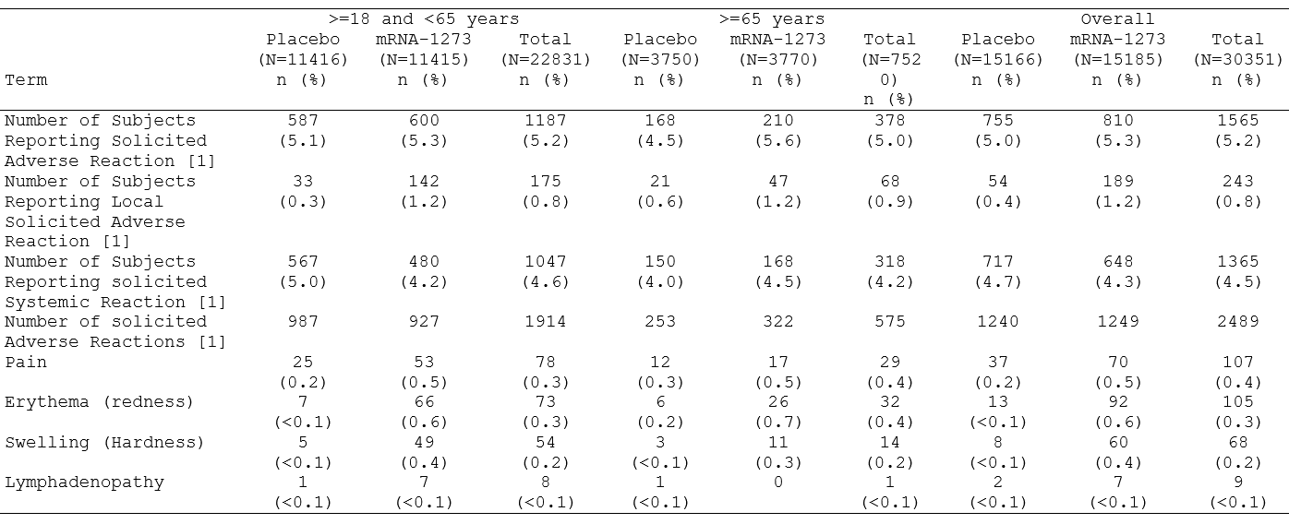
N = population size; n = sample size.

Lymphadenopathy
There was an imbalance in lymphadenopathy related events (including injection site lymphadenopathy, lymph node pain, and lymphadenitis) outside of the 7 days solicited period. 1.14% of vaccine recipients (191 events in 173 vaccine recipients) compared to 0.63% of placebo recipients (109 events in 95 participants) reported such events in the safety set. The rates reported in the older cohort (≥ 65 years) were 0.74% (28 events in 28 participants) in vaccine recipients compared to 0.35% (16 events in 13 participants) in placebo recipients. The rates reported in the younger cohort (18 to 64 years) were 1.3% (163 events in 145 participants) in vaccine recipients and 0.72% (93 events in 82 participants) in placebo recipients. These events support a plausible relationship to the study vaccination and were also reported in the evaluation of solicited local ARs.

Hypersensitivity
Hypersensitivity reactions (safety set) were seen at an incidence of 1.5% in the vaccine arm and 1.1% in the placebo arm. Imbalance was seen with numerically higher incidences of injection site rash (37 cases versus 1); injection site urticaria (15 cases versus 0); rash (45 cases versus 34) and urticaria (27 cases versus 23) in the vaccine arm compared to the placebo arm. Anaphylaxis was seen with one case in each arm and were considered unrelated.

Facial swelling
The two SAEs of facial swelling occurred in female participants with a history of dermal filler injection. In addition, there was also one event of lip angioedema 2 days after vaccination in a 29 year old female participant with history of dermal filler injection in the lips (unknown how long prior to vaccination).

Facial paralysis
An imbalance in the incidence of Bell’s palsy was observed with 3 cases in vaccine group (one SAE) (time to onset: 22, 28 and 32 days after Dose 2) and one in the placebo arm. All the cases were judged as unrelated to the vaccine, by the investigator.

Other neurological adverse events
Seizures were reported in three participants in the vaccine group versus one in the placebo. None was considered related and all participants in the vaccine group had previous history of seizures. AE of peripheral neuropathy was balanced between both groups: 6 cases in the vaccine group versus 5 in the placebo. There were 12 cases of dysgeusia in vaccine arm with 6 in the placebo arm.

Myocarditis and pericarditis
There were no reported TEAEs of myocarditis in Study 301. There were three unsolicited TEAE of pericarditis reported in Study 301; two TEAEs in the placebo arm and one in the vaccine arm of the safety set in the overall stage after any injection. No cases of myocarditis were reported during the study data cut-off of 25 November 2020. However, during post marketing surveillance, cases of myocarditis have been reported after mRNA COVID-19 vaccine doses (mainly in younger adults). 133 million vaccine second doses administered*and 636 reported myocarditis cases as of 11 June 2021.
Table 26: Post-authorisation study data, myocarditis cases reported after mRNA vaccine doses (for both the Spikevax plus Comirnaty vaccines combined)²⁹
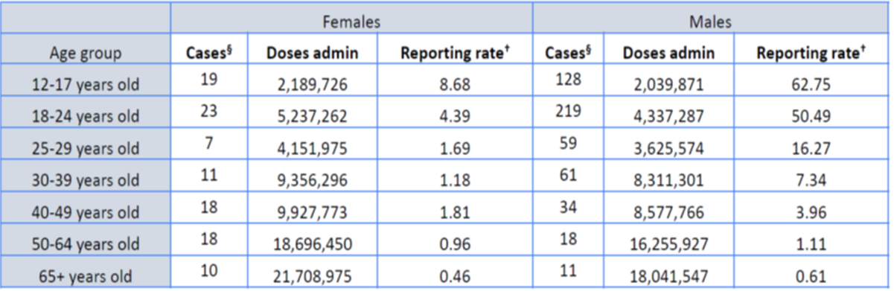
§ Cases reported through Vaccine Adverse Event Reporting System (VAERS) using a 7 day risk window.
* Source of doses administered; some age and sex specific doses administered date were imputed.
† Reporting rate = myocarditis cases per one million mRNA COVID-19 vaccine dose administered.
The data for 12 to 17 years old primarily refer to Comirnaty, as Spikevax had not been approved for use in this age group.
A review of the reports from the sponsor’s global safety database (data cut-off: 30 April 2021), identified 84 case reports (0.1% of all cases reported to the Marketing Authorisation Holder (MAH)) with the PTs of myocarditis and/or pericarditis. There were 49 cases (0.1% of all cases) reported with myocarditis related PTs, and 41 cases (0.04% of all cases) with pericarditis related PTs. There were 6 cases (0.01% of all cases) that reported both events of myocarditis and pericarditis related PTs. All 84 reports were considered serious reports. Most of the reports concerned males (65.9%), and individuals between the ages of 18 to 39 years of age (45; 52.9%).
Myocarditis and pericarditis after COVID-19 vaccination are rare. As of 12 July 2021, Vaccine Adverse Event Reporting System (VAERS) has received 1,047 reports of myocarditis or pericarditis among people ages 30 and younger who received a COVID-19 vaccine. Most cases have been reported after mRNA COVID-19 vaccination (Comirnaty or Spikevax), particularly in male adolescents and young adults. Through follow-up, including medical record reviews, Centers for Disease Control and Prevention (United States) (CDC) and FDA have confirmed 633 reports of myocarditis or pericarditis. CDC and its partners are investigating these reports to assess whether there is a relationship to COVID-19 vaccination.
Following is the vaccine safety datalink (VSD); myocarditis/pericarditis chart confirmed and the International Classification of Diseases (Tenth revision) (ICD-10); coded rates in 12 to 39 year olds, 21 day risk interval. Rate per million for the AE of myocarditis/pericarditis appears to be higher with Spikevax than with Comirnaty.
Table 27: Myocarditis/pericarditis chart confirmed rates in vaccine safety datalink in 21 day risk interval, 12 to 39 year olds
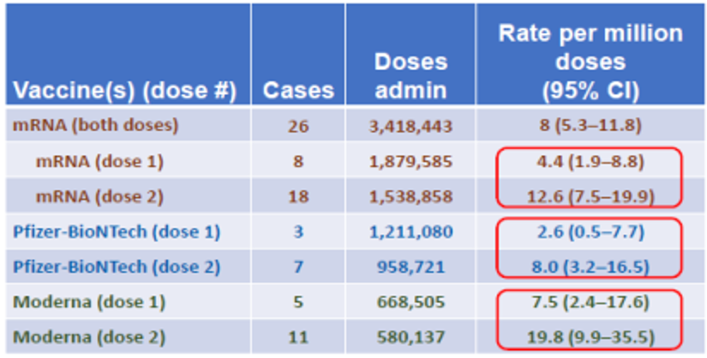
CI = confidence interval.
Through 5 June 2021.
Table 28: Myocarditis/pericarditis rates based on ICD-10 coded cases in vaccine safety datalink in 21 day risk interval, 12 to 39 year olds
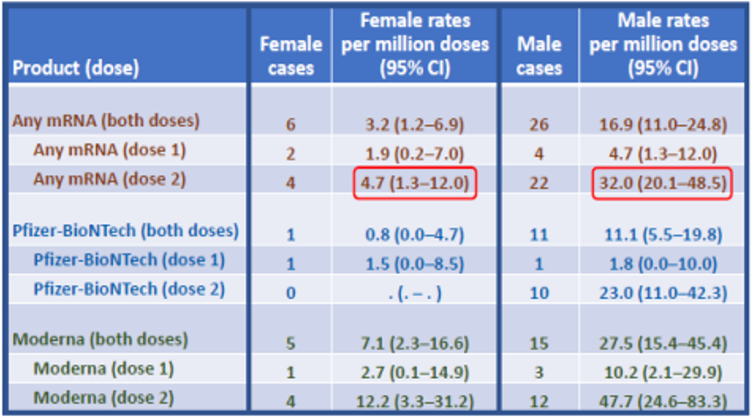
CI = confidence interval; ICD-10 = International Classification of Diseases (Tenth revision).
Through 5 June 2021.
Early US-VSD data for myocarditis/pericarditis in 12 to 39 year olds suggest:
- more cases after mRNA COVID-19 vaccination with Dose 2 versus Dose 1;
- rate of 12.6 cases per million second doses of any mRNA vaccine in the 21 days following vaccination;
- rates appear higher in males versus females;
- clustering of myocarditis/pericarditis within the week following vaccination (most likely 0 to 5 days;
- available outcome data indicate that patients generally recover from symptoms and do well.
Data are still evolving and the sponsor has been requested to provide the latest available data regarding AE of myocarditis/pericarditis after Spikevax vaccinations.

Post-marketing adverse event reports
As of the end of the reporting period (31 May 2021), a total of 155,522,108 doses of Spikevax had been administered globally.
Cumulatively, there have been 184,413 cases (713,333 events) received by the sponsor (Table 29). Of the total reported cases, 127,066 were medically confirmed, 20,636 were serious, and the majority were reported in females (135,490 versus 41,583 cases in females and males, respectively).
Table 29: Post-authorisation study data, serious cases and events totals
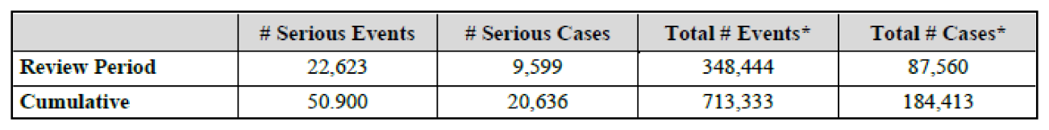
# Number
* Total event and case counts include invalid cases.
The following topics are under evaluation and will be included in in next monthly safety report (15 June 2021):
- Blindness (new request)
- Conditions aggravated (new request)
- Dizziness and tinnitus (new request)
- Hypertensive crisis (new request)
- Immune thrombocytopenia (ongoing review): cumulatively, 2,289 cases were reported involving 2,712 events. There were 2,238 serious cases. 232 cases had fatal outcome. There were 2,667 serious events, and 1849 cases were medically confirmed. The average age was 67 years. Safety analysis does not suggest a clear signal. However, given the temporal association between the use of the product and the start date of the events, a causal relationship cannot be excluded.
- Myocarditis/pericarditis (ongoing review): this is discussed in detail under the heading ‘Adverse events of clinical interest’ in this AusPAR.

Risk management plan
The initial submission included EU-risk management plan (RMP) version 1.1 (dated 1 March 2021; data lock point (DLP) 21 December 2020), tracked version 1.2 (dated 31 May 2021; DLP 21 December 2020) and tracked version 2.0 (dated 8 June 2021; DLP 8 May 2021) and Australian specific annex (ASA) version 0.1 (dated 3 July 2021). With this initial submission the sponsor was seeking approval for the use this vaccine for individuals 12 years and older. However, following discussions with the TGA, the sponsor is currently seeking approval for the target population of adults 18 years and older in the first instance.
On 16 July 2021, the sponsor provided EU-RMP version 2.1 (dated 15 July 2021; DLP 31 May 2021), in which the summary of safety concerns has been updated to include myocarditis (including myopericarditis) and pericarditis as important potential risks.
On 23 July, the sponsor provided an updated ASA version 0.2 (dated 22 July 2021), which referenced the EU-RMP version 2.1.
The summary of safety concerns and their associated risk monitoring and mitigation strategies are summarised in Table 30.
Table 30: Summary of safety concerns
Summary of safety concerns |  | Pharmacovigilance |  | Risk minimisation
 |  | Routine | Additional | Routine | Additional
Important identified risks | Anaphylaxis | ✓* | ✓† | ✓ | –
Important identified risks | Myocarditis (including myopericarditis) | ✓* | ✓† | ✓ | –
Important identified risks | Pericarditis | ✓* | ✓† | ✓ | –
Important potential risks | Vaccine-associated enhanced disease (VAED) including vaccine-associated enhanced respiratory disease (VAERD) | ✓* | ✓† | – | –
Missing information | Use in pregnancy and while breast-feeding | ✓ | ✓† | ✓ | –
Missing information | Long-term safety | ✓ | ✓† | – | –
Missing information | Use in immunocompromised subjects | ✓ | ✓† | ✓ | –
Missing information | Interaction with other vaccines | ✓ | ✓† | ✓ | –
Missing information | Use in frail subjects with unstable health conditions and co-morbidities (for example, chronic obstructive pulmonary disease (COPD), diabetes, chronic neurological disease, cardiovascular disorders) | ✓ | ✓† | ✓ | –
Missing information | Use in subjects with autoimmune or inflammatory disorders | ✓ | ✓† | ✓ | –
* Follow-up questionnaires
† Clinical studies
- At this stage, the summary of safety concerns is considered acceptable from an RMP perspective.
- The pharmacovigilance plan of the ASA should include the sponsor’s commitment to provide monthly summary safety reports until full licensure is granted, and at the minimum include the data specified in Section 3.2 of the RMP report.²⁸ The clinical evaluator/TGA Delegate will assess the acceptability of the clinical study plan that is proposed to fulfil the requirement of the provisional registration.
- Only routine risk minimisation measures are proposed. This is in line with the other COVID-19 vaccines currently approved for use in Australia. At this stage, routine risk minimisation measures, together with the risk minimisation activities launched by the Department of Health, are considered acceptable to minimise the risks associated with Spikevax COVID-19 vaccine.

Risk-benefit analysis

Delegate’s considerations

Overview
Based on the data provided by the sponsor for the COVID-19 vaccine (Spikevax), a robust and highly protective VE against COVID-19 (94.1% CI: 89.3, 96.8) was shown in individuals aged 18 years and older without evidence of prior SARS-CoV-2 infection. The VE was consistent across relevant subgroups including elderly subjects and subjects considered at increased risk of severe disease due to underlying chronic disease.
The data from the Phase III study also showed protection against severe COVID-19; however, the small number of events limited this inference. Protection against asymptomatic infection, or impact on viral transmission offered by the vaccine is presently not known. The duration of protection is also not known, due to the short follow up period.
Overall, the Spikevax COVID-19 vaccine appears safe with no major safety related issues. Recent reports of myocarditis/pericarditis in the younger population have raised some safety concerns; however, it remains very rare and mostly mild.

Public health need
Australia has relatively fewer COVID-19 cases in comparison to many other countries; however, intermittent surges of cases are still occurring. These COVID-19 outbreaks cause significant disruption to the normal life. The state of NSW is currently [at the time of AusPAR publication] having a surge of COVID-19 cases caused by the delta variant. A safe and effective vaccine is one of the most important tools in containing the COVID-19 pandemic. Three COVID-19 vaccines are currently provisionally registered in Australia (see ‘Product background’ section, above). Overall, < 10% of Australian population is immunised to date [at the time of AusPAR publishing]. There is still an urgent need for a safe and effective COVID-19 vaccine to deal with the current public health emergency. This will improve the availability of vaccine to a larger population.

Short term efficacy and safety data for provisional registration
The sponsor has submitted the short term results from the pivotal placebo controlled Phase III Study 301, to support the provisional registration of Spikevax (elasomeran) COVID-19 vaccine. The submitted pivotal study has an overall good study design, including a representative study population and acceptable statistical considerations. The Spikevax vaccine has been shown to confer high VE against symptomatic COVID-19 as well as severe COVID-19 disease in adults following two 100 µg doses of the vaccine spaced 28 days apart. While VE was observed to be slightly lower in subjects with comorbidities (VE: 90.0%) and in elderly subjects (VE: 85.4%), the observed result remains clinically meaningful in these high risk populations. Overall, The VE was consistent across age, gender, race and ethnicity demographics.
From the perspective of VE, a two month median follow-up is considered as the shortest follow-up period to achieve some confidence that any protection against COVID-19 is likely to be more than short lived. The duration of protection is not yet known and is to be assessed in the ongoing trial.
Although the vaccine efficacies against certain outcomes have been demonstrated in the pivotal study, the real world vaccine effectiveness is still not known.
As expected, the vaccine group reported a higher incidence of reactogenicity, as compared to placebo. The majority of these reactogenic ARs were mild to moderate in severity and generally resolved within a median duration of 2 to 3 days. The most common solicited ARs were injection site pain (92.4%), fatigue (70.0%), headache (64.7%), myalgia (61.5%), joint pain (46.4%) and chills (45.4%). The majority of these ARs were mild to moderate in severity. Severe solicited ARs were more common after Dose 2 than after Dose 1; and are generally less frequent in adults ≥ 65 years of age as compared to younger adults.
The majority of solicited systemic reactions persisted for a median of 3 days or less. The high incidence of reactogenicity events is not unexpected considering the high VE demonstrated with Spikevax COVID-19 mRNA-1273 vaccine.
The frequency of SAEs was low (1%), without meaningful imbalances between study arms.
The submitted safety data are short term at this stage (mean of approximately 2 months); however, the data have fulfilled the requirement as set out in the ‘Access Consortium statement on COVID-19 vaccines evidence’. The statement specified the minimum requirement that trial participants must be followed for a median of at least 2 months after receiving their final vaccine dose. It is acknowledged that most ARs to vaccines occur within 4 to 6 weeks from vaccination. The European Medicines Agency (EMA) has stated that conditional marketing authorisation for a COVID-19 vaccine could be based on review of at least 6 weeks post vaccination safety data.
The vaccine safety and efficacy in the Aboriginal Australian and Torres Strait Islander population was not studied. This could be of significance in view of the recent pharmacovigilance reports of myocarditis in younger adults, as the Aboriginal Australian and Torres Strait Islander population has a relatively higher background rate of rheumatic heart disease.

Data limitations
- Data on VE to prevent asymptomatic infection are lacking.
- Data in frail elderly with unstable health conditions and comorbidities are not available.
- No data on co-administration of Spikevax with other vaccines (for example, seasonal flu vaccines).
- There are no data available on the interchangeability of Spikevax with other COVID-19 vaccines to complete the vaccination series.
- There are no data provided by the sponsor regarding Spikevax efficacy against new variants of concern (VOC) for example, B117501.V2, P1, delta (δ) and so on. It would be of interest to know the sequences of virus isolated for the 11 patients in the vaccine group and to compare the isolated strains with the current circulating variant strains.
- Duration of protection of Spikevax COVID-19 mRNA-1273 vaccine is uncertain due to limited follow-up duration (drop in antibody titres observed in the Phase I study by Month 3, post Dose 2).
- There are no data in use of Spikevax COVID-19 mRNA-1273 vaccine in individuals with previous symptomatic COVID-19 disease as this was an exclusion criterion in Study 301.
- No safety and efficacy data in immunocompromised patients or patients with background autoimmune disease.
- No safety data on pregnant women and breastfeeding women.
- Short term safety data may not provide information on rare AEs, risk of vaccine associated enhanced disease (VAED) or VAERD as the antibodies wane over time, and there may be AEs that have a long latency period including AEs of special interest.

Proposed action
Considering the urgent public health need and noting the high short term efficacy with acceptable safety demonstrated in the submitted studies, the Delegate is of the view that provisional registration of Spikevax (elasomeran) COVID-19 vaccine is appropriate for the use of this vaccine to prevent COVID-19 disease caused by SARS-CoV-2 virus in individuals 18 years of age and older. The pivotal study is ongoing for a total of 24 months. The longer term efficacy and safety data are to be submitted to the TGA for evaluation before a full registration can be considered.
Since the Spikevax (elasomeran) COVID-19 vaccine is evaluated for use through the provisional pathway, a clear statement should be included in the PI with regards to the nature of the registration. It should also be emphasised that the decision of provisional approval is made on the basis of short term efficacy and safety data, and the continued approval depends on the evidence of longer term efficacy and safety from the ongoing and post-market assessment.
The Delegate proposes the provisional approval of this vaccine for a revised indication (proposed paediatric indication will be evaluated separately). The sponsor is requested to amend the proposed indication as following:
Proposed therapeutic indication:
Spikevax is indicated for active immunisation to prevent COVID-19 caused by SARS-CoV-2 in individuals 18 years of age and older.
The use of this vaccine should be in accordance with official recommendations.
Recommended therapeutic indication:
Spikevax (Elasomeran) COVID-19 Vaccine has provisional approval for the indication below:
Spikevax is indicated for active immunisation to prevent COVID‐19 caused by SARS-CoV-2 in individuals 18 years of age and older.
The use of this vaccine should be in accordance with official recommendations.
The decision has been made on the basis of short term efficacy and safety data. Continued approval depends on the evidence of longer term efficacy and safety from the ongoing and post-market assessment.
The Advisory Committee on Vaccine’s (ACV) advice is requested for a number of questions, including advice and comments on the wording of the indication.
The proposed conditions of the provisional registration are specified below:
Terms and conditions were imposed upon the authorisation with respect to quality, clinical, labelling, and risk management plan requirements:
Clinical conditions:
The following reports/data will have to be submitted before a definitive authorisation can be considered:
- Submit safety analysis at 6 months post Dose 2 from Phase I, II Study when the analysis is available
- Submit the clinical study report for Study 301 (Phase III) and Study 201 (Phase II) when ready. Please also submit the final report for these studies with 24 months follow up duration when it became available.
- Submit the immunogenicity data for Study 301
- When available, provide:
Further data relating to vaccine efficacy against asymptomatic disease, efficacy against SARS-CoV-2 transmission, vaccine efficacy in immunocompromised subjects, efficacy in subjects with autoimmune conditions, efficacy against variants of concern, pregnant women, lactating mothers, and information relating to post-market safety and effectiveness studies should be provided to the TGA to update the Product Information.
- Provide real world post market global/local efficacy data, when available.
This overview is submitted for the ACV advice. The final decision will be made following the ACV discussion.

Questions for the sponsor
The sponsor provided the following response to questions from the Delegate.
- Could the sponsor provide the latest data on the adverse event of myocarditis and pericarditis after administration of Spikevax doses? The provided addendum with the dossier has 30 April 2021 cut-off.
The most recent update on AEs of myocarditis and pericarditis after 30 April 2021 can be found in the monthly safety reports 5 (covering 1 to 31 May 2021) and 6 (covering 1 to 30 June 2021). Please find copies of monthly safety reports 5 and 6 enclosed with this response.²⁸
- Please provide cumulative global post market safety data from the latest cut-off, when available.
The sponsor is herewith submitting the latest monthly safety reports, covering the post-marketing data available up to 30 June 2021. The first periodic benefit-risk evaluation report (PBRER) for Spikevax (from international birth date (IBD): 18 December 2020 to 30 June 2021) is expected to be available on approximately 26 August 2021 and will be shared with the TGA.

Advisory Committee considerations
The Advisory Committee on Vaccines (ACV), having considered the evaluations and the Delegate’s overview, as well as the sponsor’s response to these documents, advised the following.

Specific advice to the Delegate
- Based on the evidence at this point in time, can the Advisory Committee on Vacccines (ACV) advise whether the benefits-risks balance is positive for the use of Spikevax (elasomeran) in individuals 18 years and older in the Australian context, to support the provisional registration?
The ACV advised that Spikevax COVID-19 vaccine has an overall positive benefit risk profile for the prevention of COVID-19, as the short-term efficacy and safety data are sufficient to support provisional registration of the vaccine in individuals 18 years and older.
The ACV noted that is there is limited or no information with Spikevax in patients with autoimmune or inflammatory disorders, immunocompromised individuals, pregnant and breastfeeding women, or in patients with a history of anaphylaxis.
The ACV discussed the concern regarding the rare risk of myocarditis and pericarditis, including the apparent increased incidence in young men (see answer to Question 4, below). While these conditions appear to be linked to mRNA vaccines, differences between the vaccines are still under evaluation.
The ACV agreed that clinical guidance will be required to assist individuals with their decision making regarding Spikevax vaccination.
- Can the ACV comment on the overall indication?
The ACV recommended the following wording for the indication to align with other COVID-19 vaccines:
Spikevax (elasomeran) COVID-19 vaccine has provisional approval for the indication below:
Spikevax is indicated for active immunisation to prevent COVID-19 caused by SARS-CoV-2 to individuals 18 years of age and older.
The use of this vaccine should be in accordance with official recommendations
The decision has been made on the basis of short-term efficacy and safety data. Continued approval depends on the evidence of longer-term efficacy and safety from ongoing clinical trials and post-market assessment.
- Can the ACV comment on overall safety? Please also advise on safety in young adults in view of the pharmacovigilance reports of myocarditis and pericarditis in younger age group. Please also provide advice for use in Aboriginal Australian and Torres Strait Islander population with medical history of rheumatic heart disease.
The ACV was of view that the overall safety of the Spikevax COVID-19 vaccine is acceptable in people aged 18 years or older.
The ACV noted national and international data on the risk of myocarditis/pericarditis in recipients of mRNA COVID-19 vaccines, particularly after second dose and most commonly in younger males. It appears that this condition is causally linked to mRNA vaccines.
As of 25 July 2021, a total of 84 cases of suspected myocarditis/pericarditis have been reported to the TGA post-approval of the Pfizer vaccine [Comirnaty]. Though most reported cases have required hospitalisation, the ACV noted that the course was usually mild and self-limiting, consistent with international reports; long-term data are not yet available. The ACV also noted that myocarditis/pericarditis is a complication of COVID-19 and agreed that the risk of developing myocarditis/pericarditis due to SARS-CoV-2 infection is substantially higher than the potential risk of developing it post-vaccination.
The ACV advised that that use of the Spikevax vaccine in patients with a history of inflammatory cardiac conditions such as rheumatic heart disease was appropriate, however those with acute rheumatic heart disease should seek specialist advice on timing of vaccination. The ACV advised that further clinical guidance on vaccination with COVID-19 vaccines would be published soon, which will include guidance on specialist cardiology involvement. This is expected to address the use of vaccines in special populations including Aboriginal Australian and Torres Strait Islander people, referral and diagnosis, and clinical management of suspected cases.
- Can the ACV comment on the proposed pharmacovigilance activities? Are any additional risk mitigation strategies required?
The ACV recommended implementation of robust safety monitoring, as per the previously approved mRNA vaccine, Comirnaty.
Use of standardised forms for data collection was supported, and ethnicity including Aboriginal and Torres Strait Islander identification should be obtained.
The ACV advised that there should be direct communication with healthcare professionals in the form of a direct healthcare professional communications letter regarding the risk of myocarditis/pericarditis after mRNA vaccines.
The ACV recommended that safety information regarding myocarditis/pericarditis be included in the Product Information and Consumer Medicines Information.
No specific measure to mitigate against the development of myocarditis/pericarditis has been identified at this time; however, early detection is important with reference to forthcoming clinical guidelines.

Conclusion
The ACV considered Spikevax elasomeran COVID-19 vaccine to have an overall positive benefit-risk profile, and therefore support provisional approval for the following:
Spikevax (elasomeran) COVID-19 vaccine has provisional approval for the indication below:
Spikevax is indicated for active immunisation to prevent COVID-19 caused by SARS-CoV-2 to individuals 18 years of age and older.
The use of this vaccine should be in accordance with official recommendationsThe decision has been made on the basis of short-term efficacy and safety data. Continued approval depends on the evidence of longer-term efficacy and safety from ongoing clinical trials and post-market assessment.

Outcome
Based on a review of quality, safety and efficacy, the TGA approved the registration of Spikevax (elasomeran) 0.2 mg/mL, suspension for injection, vial, indicated for:
Spikevax (elasomeran) COVID-19 vaccine has provisional approval for the indication below:
Active immunisation to prevent coronavirus disease 2019 (COVID-19) caused by SARS-CoV-2 in individuals 18 years of age and older.
The use of this vaccine should be in accordance with official recommendations.
The decision has been made on the basis of short-term efficacy and safety data. Continued approval depends on the evidence of longer term efficacy and safety from ongoing clinical trials and post-market assessment.

Specific conditions of registration applying to these goods
- Risk management plan
Spikevax (elasomeran) COVID-19 vaccine is to be included in the Black Triangle Scheme. The PI and CMI for Spikevax must include the black triangle symbol and mandatory accompanying text for the period of provisional registration.
The Spikevax EU-RMP (version 2.1, dated 15 July 2021; DLP 31 May 2021), with Australian Specific annex (version 0.2, dated 22 July 2021), included with submission PM-2021-02994-1-2, and any subsequent revisions, as agreed with the TGA will be implemented in Australia.
An obligatory component of risk management plans is routine pharmacovigilance. Routine pharmacovigilance includes the submission of periodic safety update reports (PSURs).
Unless agreed separately between the supplier who is the recipient of the approval and the TGA, the first report must be submitted to TGA no later than 15 calendar months after the date of the approval letter. The subsequent reports must be submitted no less frequently than annually from the date of the first submitted report until the period covered by such reports is not less than three years from the date of the approval letter, or the entire period of provisional registration, whichever is longer.
The reports are to at least meet the requirements for PSURs as described in the EMA’s Guideline on Good Pharmacovigilance Practices Module VII-Periodic Safety Update Report (Rev 1), Part VII.B Structures And Processes. Note that submission of a PSUR does not constitute an application to vary the registration. Each report must have been prepared within ninety calendar days of the data lock point for that report.
Additional to the routine submission of the routine PSURs, expedited monthly, Spikevax safety summary reports (including safety data for patients in Australia) are to be provided for the first 6 months post registration, and thereafter at intervals specified by the TGA.
- Clinical
The following reports/data will have to be submitted before a definitive authorisation can be considered:
  - Submit safety analysis at 6 months post Dose 2 from Phase I, II Study when the analysis is available
  - Submit the clinical study report for Study 301 (Phase III) and Study 201 (Phase II) when ready. Please also submit the final report for these studies with 24 months follow up duration when it became available.
  - Submit the immunogenicity data for Study 301
  - When available, please provide:
Further data relating to vaccine efficacy against asymptomatic disease, efficacy against SARS-CoV-2 transmission, vaccine efficacy in immunocompromised subjects, efficacy in subjects with autoimmune conditions, efficacy against variants of concern, pregnant women, lactating mothers, and information relating to post-market safety and effectiveness studies should be provided to the TGA to update the PI.
  - Please also provide real world post market global/local efficacy data, when available.
- Confirmatory trial data (as identified in the sponsor’s plan to submit comprehensive clinical data on the safety and efficacy of the medicine before the end of the 6 years that would start on the day that registration would commence) must be provided.
- Quality
Batch release testing and compliance
Batch release testing and compliance with the certified product details conditions of provisional registration for Spikevax.
It is a condition of registration that all independent batches of Spikevax elasomeran COVID-19 vaccine 0.2 mg/mL suspension for injection vial imported into Australia are not released for supply by or on behalf of the sponsor until samples and the manufacturer’s release data have been assessed and you have received notification acknowledging release from the Laboratories Branch, TGA.
For each independent batch of the product imported into Australia, the sponsor must supply the following:
  - A completed request for release form, available from vaccines@health.gov.au.
  - Complete summary protocols for manufacture and quality control, including all steps in production in the agreed format.
  - At least 10 (ten) vials (samples) of each manufacturing batch of Spikevax elasomeran 0.2 mg/mL suspension for injection vial with the Australian approved labels, PI and packaging (unless an exemption to supply these has been granted) representative of all batches of product seeking distribution in Australia.
  - At least 5 (five) vials (samples) of any further consignments of a manufacturing batch of Spikevax elasomeran 0.2 mg/mL suspension for injection vial with the Australian approved labels, PI and packaging (unless an exemption to supply these has been granted). Further consignments cover batches previously supplied to TGA for the purposes of batch release testing but are seeking to be supplied again.
  - If the manufacturing batch has been released in Europe or UK a copy of the EU-OCABR certificate (or equivalent from the UK) must be provided.
  - Any reagents, reference material and standards required to undertake testing, as requested by Laboratories Branch, TGA.
Sponsors must provide all requested samples and data in sufficient time (at least 5 business days) prior to any distribution date to allow the TGA to perform testing and review. Distribution of each batch of vaccine is conditional upon fulfilment of these conditions and receipt of a letter from the Laboratories Branch acknowledging release.
Samples and data should be forwarded to the Biotherapeutics Section, Laboratories Branch before release of each batch and with sufficient lead time to allow for Laboratories Branch testing.
The shipments (including reagents) to TGA are the responsibility of the Australian sponsor/agent who will be required to facilitate the import and customs clearance process.
Certified Product Details
An electronic copy of the CPD as described in Guidance 7: Certified Product Details of the Australian Regulatory Guidelines for Prescription Medicines https://www.tga.gov.au/guidance-7-certified-product-details should be provided upon registration of the therapeutic good. In addition, an updated CPD, for the above products incorporating the approved changes is to be provided within one month of the date of approval letter. A template for preparation of CPD for biological prescription medicines and vaccines can be obtained from the TGA website https://www.tga.gov.au/form/certified-product-details-cpd-biological-prescriptionmedicines. The CPD should be sent as a single bookmarked PDF document to vaccines@health.gov.au as soon as possible after registration/approval of the product or any subsequent changes as indicated above.
- Post approval commitments:
Drug substance
Sponsor to provide:
    - real time stability data within 3 months of provisional registration
    - additional data on the clinical safety and efficacy of the product
    - additional data on shipping and holding time of drug substance
    - additional data on comparative batch analysis
    - additional data on validation of analytical procedures
    - additional data on batch analysis
    - additional data on container closure system
    - additional stability data, protocol and commitment
    - additional stability data
Drug product
Sponsor to provide:
    - real time stability data within 3 months of provisional registration
    - additional data on process validation
    - additional data on control of excipients
    - additional data on batch analysis
    - additional data on stability
    - additional data on microbiology
- For all injectable products the PI must be included with the product as a package insert.

Attachment 1. Product Information
The PI for Spikevax approved with the submission which is described in this AusPAR is at Attachment 1. For the most recent PI, please refer to the TGA website at <https://www.tga.gov.au/product-information-pi>.

Therapeutic Goods Administration
PO Box 100 Woden ACT 2606 Australia
Email: info@tga.gov.au Phone: 1800 020 653 Fax: 02 6232 8605
https://www.tga.gov.au

The Black Triangle Scheme provides a simple means for practitioners and patients to identify certain types of new prescription medicines, including those being used in new ways and to encourage the reporting of adverse events associated with their use. The Black Triangle does not denote that there are known safety problems, just that the TGA is encouraging adverse event reporting to help us build up the full picture of a medicine's safety profile.
World Health Organization (WHO) (2021) WHO Coronavirus (COVID-19) Dashboard, Available at: https://covid19.who.int/ (accessed 3 August 2021).
Australian Government Department of Health (2021) Coronavirus (COVID-19) Case Numbers and Statistics, Available at: https://www.health.gov.au/news/health-alerts/novel-coronavirus-2019-ncov-health-alert/coronavirus-covid-19-case-numbers-and-statistics (accessed 3 August 2021).
As part of the provisional approval pathway, the provisional registration process will allow certain medicines to be provisionally registered in the Australian Register of Therapeutic Goods (ARTG) for a limited duration. These medicines are registered on the basis of preliminary clinical data, where there is the potential for a substantial benefit to Australian patients. The TGA will re-assess risks related to the absence of evidence through data provided at a later stage, as part of the confirmatory data. Confirmatory data should confirm the relationship between outcomes predicted by the surrogate endpoint, or other preliminary data, and the clinical benefit as demonstrated by direct clinical outcomes. The sponsor may apply to transition to full registration at any time up until the provisional registration lapse date, once they have completed the obligations outlined for the provisional registration period and complete confirmatory data on safety and efficacy are available.
Comirnaty was first registered on the ARTG on 25 January 2021 (ARTG number: 346290).
AusPAR for Comirnaty (BNT162b2 (mRNA)) new biological entity, published on 25 January 2021. https://www.tga.gov.au/auspar/auspar-bnt162b2-mrna-comirnaty
AusPAR for Comirnaty (BNT162b2 (mRNA)) extension of indications, published on 23 July 2021. https://www.tga.gov.au/auspar/auspar-bnt162b2-mrna
COVID-19 Vaccine AstraZeneca was first registered on the ARTG on 16 February 2021 (ARTG number: 349072).
AusPAR for COVID-19 Vaccine AstraZeneca (ChAdOx1-S), published on 16 February 2021. https://www.tga.gov.au/auspar/auspar-chadox1-s
Australian Technical Advisory Group on Immunisation (ATAGI) (2021) Clinical Guidance on Use of COVID-19 Vaccine in Australia in 2021 (v5.1). Available at: https://www.health.gov.au/sites/default/files/documents/2021/06/covid-19-vaccination-atagi-clinical-guidance-on-covid-19-vaccine-in-australia-in-2021_1.pdf.
COVID-19 Vaccine Janssen was first registered on the ARTG on 25 June 2021 (ARTG number: 350150).
AusPAR for COVID-19 Vaccine Janssen (Ad26.COV2.S), published on 25 June 2021, https://www.tga.gov.au/auspar/auspar-ad26cov2s
Veklury was first registered on the ARTG on 10 July 2020 (ARTG number: 338419).
AusPAR for Veklury (remdesivir), published on 21 July 2020. https://www.tga.gov.au/auspar/auspar-remdesivir
Australian Government, Department of Health, Therapeutic Goods Administration (TGA) (2021) TGA Grants Provisional Determination for the Moderna COVID-19 Vaccine, Elasomeran. Available at: https://www.tga.gov.au/media-release/tga-grants-provisional-determination-moderna-covid-19-vaccine-elasomeran.
Good Laboratory Practice is a code of standards following the International Council on Harmonisation (ICH) relevant to testing of medicines in laboratories during drug development.
World Health Organization (WHO) (2005) WHO guidelines on nonclinical evaluation of vaccines. WHO Technical Report Series, No. 927, Annex 1. Available at: https://www.who.int/biologicals/areas/vaccines/TRS_987_Annex2.pdf?ua=1.
Australian Pregnancy Category B1: Drugs which have been taken by only a limited number of pregnant women and women of childbearing age, without an increase in the frequency of malformation or other direct or indirect harmful effects on the human fetus having been observed. Studies in animals have not shown evidence of an increased occurrence of fetal damage.
Jackson, L. A. et al. An mRNA Vaccine Against SARS-CoV-2 - Preliminary Report, N Engl J Med, 2020; 383: 1920-1931.
Anderson, E. J. et al. Safety and Immunogenicity of SARS-CoV-2 mRNA-1273 Vaccine in Older Adults, N Engl J Med, 2020; 383: 2427-2438.
Widge, A. T. et al. Durability of Responses after SARS-CoV-2 mRNA-1273 Vaccination, N Engl J Med, 2021; 384: 80-82.
Doria-Rose, N. et al. Antibody Persistence through 6 Months after the Second Dose of mRNA-1273 Vaccine for Covid-19, N Engl J Med, 2021; 384: 2259-2261.
The per-protocol (PP) analysis is restricted to the participants who strictly adhered to the protocol. Also known as ‘on-treatment’ analysis.
Chu, L. et al. A Preliminary Report of a Randomized Controlled Phase 2 Trial of the Safety and Immunogenicity of mRNA-1273 SARS-CoV-2 Vaccine, Vaccine, 2021; 39(20): 2791–2799.
Randomised clinical trials analysed by the intent-to-treat (ITT) approach provide the unbiased comparisons among the treatment groups. In the ITT population, none of the patients are excluded and the patients are analysed according to the randomisation scheme.
Food and Drug Administration (FDA), Emergency Use Authorization (EUA) for an Unapproved Product Review Memorandum, Moderna COVID-19 Vaccine/mRNA-1273, 18 December 2020. Available at: https://fda.report/media/144673/Moderna+COVID-19+Vaccine+review+memo.pdf
The Medical Dictionary for Regulatory Activities (MedDRA) is a single standardised international medical terminology, developped as a project of the International Council for Harmonisation of Technical Requirements for Pharmaceuticals for Human Use (ICH) which can be used for regulatory communication and evaluation of data pertaining to medicinal products for human use. As a result, MedDRA is designed for use in the registration, documentation and safety monitoring of medicinal products through all phases of the development cycle (that is,, from clinical trials to post-marketing surveillance) supports ICH electronic communication within the ICH’s Electronic Common Technical Document (eCTD) and the E2B Individual Case Safety Report.
Inclusion of these information is beyond the scope of the AusPAR.
Center for Disease Control and Prevention (CDC) (2021) COVID-19 mRNA Vaccines in Adolescents and Young Adults: Benefit-risk discussion, Advisory Committee on Immunization Practices (ACIP) Meeting. Available at: https://www.cdc.gov/vaccines/acip/meetings/downloads/slides-2021-06/05-COVID-Wallace-508.pdf.
Center for Disease Control and Prevention (CDC) (2021) Selected Adverse Events Reported after COVID-19 Vaccination. Available at: https://www.cdc.gov/coronavirus/2019-ncov/vaccines/safety/adverse-events.html.
The Vaccine Safety Datalink (VSD) is a collaborative project maintained by the Centers for Disease Control and Prevention (CDC) and aims to monitor safety of vaccines and conduct studies on rare and serious adverse events post immunisation.
The International Classification of Diseases (ICD) is a diagnostic classification standard compiled and maintained by the World Health Organization (WHO) and is used to classify diseases and other health problems on many types of health and vital (essential to life) records, as well as death certificates. As well as enabling the storage and retrieval of diagnostic information for clinical, epidemiological (which deals with the study of the causes, distribution, and control of disease in populations) and quality purposes, ICD records also form the basis for compiling national mortality and morbidity statistics by WHO Member States.
Center for Disease Control and Prevention (CDC) (2021) COVID-19 Vaccine Safety Updates Advisory Committee on Immunization Practices (ACIP). Available at: https://www.cdc.gov/vaccines/acip/meetings/downloads/slides-2021-06/03-COVID-Shimabukuro-508.pdf.
Routine risk minimisation activities may be limited to ensuring that suitable warnings are included in the product information or by careful use of labelling and packaging. Routine pharmacovigilance practices involve the following activities: - All suspected adverse reactions that are reported to the personnel of the company are collected and collated in an accessible manner; - Reporting to regulatory authorities; - Continuous monitoring of the safety profiles of approved products including signal detection and updating of labelling; - Submission of PSURs; - Meeting other local regulatory agency requirements.
Australian Government, Department of Health, Therapeutic Goods Administration (TGA) (2020) Access Consortium Statement on COVID-19 Vaccines Evidence. Available at: https://www.tga.gov.au/access-consortium-statement-covid-19-vaccines-evidence#:~:text=Access%20Consortium%20statement%20on%20COVID%2D19%20vaccines%20evidence,-Australia%2C%20Canada%2C%20Singapore&text=The%20Access%20Consortium%20members%20rigorously,be%20specific%20to%20our%20countries.
European Medicines Agency (EMA), Committee for human medicinal products (CHMP) EMA Considerations on COVID-19 Vaccine Approval, EMA/592928/2020, 16 November 2020. Available at: https://www.ema.europa.eu/en/documents/other/ema-considerations-covid-19-vaccine-approval_en.pdf.
The Advisory Committee on Vaccines (ACV) provides independent medical and scientific advice to the Minister for Health and the Therapeutic Goods Administration (TGA) on issues relating to the safety, quality and efficacy of vaccines supplied in Australia including issues relating to pre-market assessment, post-market monitoring and safe use in national immunisation programs. The Committee is established under Regulation 39F of the Therapeutic Goods Regulations 1990 and the members are appointed by the Minister for Health. The ACV was established in January 2017, following consolidation of previous functions of the Advisory Committee on the Safety of Vaccines (ACSOV) and the pre-market functions for vaccines of the Advisory Committee on Prescription Medicines (ACPM). Membership comprises professionals with expertise in specific scientific, medical or clinical fields, or consumer health issues.
Subsequent to the ACV 30, the Australian Government published ‘Guidance on Myocarditis and pericarditis after mRNA COVID-19 Vaccines’, versions 1.0, developed jointly by the Australian Technical Advisory Group on Immunisastion (ATAGI) and the Cardiac Society of Australia and New Zealand (CSANZ).
For example, expedited monthly Comirnaty safety summary reports (including safety data for patients in Australia) for the first 6 months post registration, and thereafter at intervals specified by the TGA; specific targeted data capture aids to monitor AESIs in Australia. See https://www.tga.gov.au/sites/default/files/auspar-bnt162b2-mrna-210125.pdf

