December 2021

Australian Public Assessment Report for Elasomeran (mRNA-1273)
  - Proprietary Product Name: Spikevax
  - Sponsor: Moderna Australia Pty Ltd

About the Therapeutic Goods Administration (TGA)
- The Therapeutic Goods Administration (TGA) is part of the Australian Government Department of Health and is responsible for regulating medicines and medical devices.
- The TGA administers the Therapeutic Goods Act 1989 (the Act), applying a risk management approach designed to ensure therapeutic goods supplied in Australia meet acceptable standards of quality, safety and efficacy (performance) when necessary.
- The work of the TGA is based on applying scientific and clinical expertise to decision-making, to ensure that the benefits to consumers outweigh any risks associated with the use of medicines and medical devices.
- The TGA relies on the public, healthcare professionals and industry to report problems with medicines or medical devices. TGA investigates reports received by it to determine any necessary regulatory action.
- To report a problem with a medicine or medical device, please see the information on the TGA website <https://www.tga.gov.au>.

About AusPARs
- An Australian Public Assessment Report (AusPAR) provides information about the evaluation of a prescription medicine and the considerations that led the TGA to approve or not approve a prescription medicine submission.
- AusPARs are prepared and published by the TGA.
- An AusPAR is prepared for submissions that relate to new chemical entities, generic medicines, major variations and extensions of indications.
- An AusPAR is a static document; it provides information that relates to a submission at a particular point in time.
- A new AusPAR will be developed to reflect changes to indications and/or major variations to a prescription medicine subject to evaluation by the TGA.

Copyright
© Commonwealth of Australia 2021
This work is copyright. You may reproduce the whole or part of this work in unaltered form for your own personal use or, if you are part of an organisation, for internal use within your organisation, but only if you or your organisation do not use the reproduction for any commercial purpose and retain this copyright notice and all disclaimer notices as part of that reproduction. Apart from rights to use as permitted by the Copyright Act 1968 or allowed by this copyright notice, all other rights are reserved and you are not allowed to reproduce the whole or any part of this work in any way (electronic or otherwise) without first being given specific written permission from the Commonwealth to do so. Requests and inquiries concerning reproduction and rights are to be sent to the TGA Copyright Officer, Therapeutic Goods Administration, PO Box 100, Woden ACT 2606 or emailed to <tga.copyright@tga.gov.au>.

Contents
List of abbreviations 4
I. Introduction to product submission 7
Submission details 7
Product background 8
Regulatory status 11
Product Information 13
II. Registration timeline 14
III. Submission overview and risk/benefit assessment 14
Quality 14
Nonclinical 15
Clinical 15
Risk management plan 39
Risk-benefit analysis 41
Outcome 46
Attachment 1. Product Information 49

List of abbreviations
Abbreviation | Meaning
ACM | Advisory Committee on Medicines
ACV | Advisory Committee on Vaccines
ARTG | Australian Register of Therapeutic Goods
ASA | Australian specific annex
Ab | Antibody
AE | Adverse event
AESI | Adverse event of special interest
ANCOVA | Analysis of covariance
AR | Adverse reaction
BMI | Body mass index
bAb | Binding antibody
CDC | Centers for Disease Control and Prevention (United States of America)
CI | Confidence interval
CNS | Central nervous system
CoV | Coronavirus
COVID-19 | Coronavirus disease 2019
CSR | Clinical study report
DMID | Division of Microbiology and Infectious Diseases (United States of America)
DTaP | Diptheria, tetanus, and pertussis (vaccine)
ELISA | Enzyme-linked immunosorbent assay
EUA | Emergency Use Authorization (United States of America)
FDA | Food and Drug Administration (United States of America)
GLSM | Geometric least squares mean
GM | Geometric mean
GMFR | Geometric mean fold rise
GMT | Geometric mean titre
GMR | Geometric mean ratio
HIV | Human immunodeficiency virus
IA | Interim analysis
ID₅₀ | Median infectious dose
Ig | Immunoglobulin
IM | Intramuscular
LLOD | Lower limit of detection
LLOQ | Lower limit of quantification
LNP | Lipid nanoparticle
MAAE | Medically-attended adverse events
MERS | Middle East respiratory syndrome
mITT | Modified intent-to-treat
mRNA | Messenger ribonucleic acid
MSD | MesoScale Discovery
nAb | Neutralising antibody
NIH | National Institutes of Health (United States of America)
NIAID | National Institute of Allergy and Infectious Diseases (United States of America)
NIM | Noninferiority margin
PolyA | Polyadenylated
PP | Per-protocol
PsVNA | Pseudotyped virus neutralising assay
PT | Preferred Term
RMP | Risk management plan
RT-PCR | Reverse transcription polymerase chain reaction
SAE | Serious adverse event
SAP | Statistical analysis plan
SARS | Severe acute respiratory syndrome
SARS-CoV-2 | Severe acute respiratory syndrome coronavirus-2
SD | Standard deviation
SMQ | Standardised Medical Dictionary for Regulatory Activities (MedDRA) Query
Study P201 | Study mRNA-1273-P201
Study P301 | Study mRNA-1273-P301 (COVE)
TEAE | Treatment-emergent adverse event
ULOQ | Upper limit of quantification
US(A) | United States (of America)
UTR | Untranslated region
VE | Vaccine efficacy
VOC | Variant of concern
VOI | Variant of interest
VSV | Vesicular stomatitis virus
WT | Wild type
WHO | World Health Organization

I. Introduction to product submission

Submission details
Type of submission: | Major variation (change of dose regimen and patient group)
Product name: | Spikevax
Active ingredient: | Elasomeran (mRNA-1273)
Decision: | Approved for provisional registration
Date of decision: | 7 December 2021
Date of entry onto ARTG: | 9 December 2021
ARTG number: | 370599
Black Triangle Scheme: | Yes  As a provisionally registered product, this medicine will remain in the Black Triangle Scheme for the duration of its provisional registration
Sponsor’s name and address: | Moderna Australia Pty Ltd  60 Martin Place  Sydney, NSW 2000
Dose form: | Suspension for injection
Strength: | 0.2 mg/mL
Container: | Vial
Pack size: | 10
Approved therapeutic use: | Spikevax (elasomeran) COVID-19 vaccine has provisional approval for the indication below:  Active immunisation to prevent coronavirus disease 2019 (COVID-19) caused by SARS-CoV-2 in individuals 18 years of age and older.  The use of this vaccine should be in accordance with official recommendations.  The decision has been made on the basis of short-term efficacy and safety data. Continued approval depends on the evidence of longer term efficacy and safety from ongoing clinical trials and post-market assessment.
Route of administration: | Intramuscular
Dosage: | Booster Dose  Individuals 18 years of age and older Spikevax is administered intramuscularly as a single booster dose (0.25 mL; 50 micrograms) at least 6 months after completing a primary series.  The decision when and for whom to implement a booster (third dose) of Spikevax should be made based on available vaccine safety and effectiveness data (see sections 4.4 Special warning and precautions for use and 5.1 Pharmacodynamic properties), in accordance with official recommendations.  For further information regarding dosage, refer to the Product Information.
Pregnancy category: | B1  Drugs which have been taken by only a limited number of pregnant women and women of childbearing age, without an increase in the frequency of malformation or other direct or indirect harmful effects on the human fetus having been observed.  Studies in animals have not shown evidence of an increased occurrence of fetal damage.  The use of any medicine during pregnancy requires careful consideration of both risks and benefits by the treating health professional. This must not be used as the sole basis of decision making in the use of medicines during pregnancy. The TGA does not provide advice on the use of medicines in pregnancy for specific cases. More information is available from obstetric drug information services in your State or Territory.

Product background
This AusPAR describes the application by Moderna Australia Pty Ltd (the sponsor) to make changes to the registration of Spikevax (elasomeran (mRNA-1273)) 0.2 mg/mL suspension for injection, including changes to the dosage regimen and the Product Information (PI) as follows:
- Extension of dose regimen to include a booster dose:
A booster dose (third dose) of Spikevax may be administered in adolescents and adults aged 12 years and older who received primary COVID-19 vaccination with Spikevax or another authorised or approved COVID-19 vaccine at least 6 months prior.
- Extension of patient group and altering the dose regimen for immunocompromised individuals aged at least 18 years and over:
A third dose of Spikevax may be administered at least 28 days following the first two doses of Spikevax in individuals at least 18 years of age who have undergone solid organ transplantation, or who are diagnosed with conditions that are considered to have an equivalent level of immunocompromise.
Coronavirus disease 2019 (COVID-19) is an infectious disease with mainly respiratory symptoms caused by severe acute respiratory syndrome coronavirus 2 (SARS-CoV-2), a zoonotic virus that first emerged as a human pathogen in December 2019 and has rapidly spread around the world by human-to-human transmission.
Following the initial outbreak of pneumonia of an unknown cause, by January 2020, it became clear that a novel Coronavirus (initially named 2019-nCoV by the World Health Organization (WHO), and later designated as being SARS-CoV-2 by the International Committee on the Taxonomy of Viruses) was the underly-19ng cause. In early January 2020, the genetic sequence of SARS-CoV-2 became known to the WHO and the public, and the virus was categorised in the beta-coronavirus subfamily. By sequence analysis, the phylogenetic tree revealed a closer relationship to severe acute respiratory syndrome (SARS) virus isolates than to other coronaviruses that infect humans, including the Middle East respiratory syndrome coronavirus (MERS-CoV).
The virus causes a respiratory illness in people known as COVID-19, which is thought to spread primarily via respiratory droplets and aerosol transmission between people who are in close contact. After an incubation period of around 5 days (range: 1 to 14), common clinical manifestations include fever, cough, dyspnoea and myalgia.,
The severity of COVID ranges from asymptomatic or mild presentations, to severe cases requiring intensive care/respiratory support and the fatality rate is currently about 2%. Increasing age is a strong risk factor for morbidity and mortality associated with COVID-19 and comorbidities such as chronic kidney disease (CKD) and chronic obstructive pulmonary disease (COPD) have been found to be significantly associated with a worse prognosis.
The COVID-19 outbreak was officially declared a pandemic by WHO on 11 March 2020. Since its emergence, the SARS-CoV-2 virus has spread rapidly around the globe, affecting a growing number of countries. As of 8 December 2021, there have been over 265 million confirmed cases of COVID-19 globally, with over 5 million deaths reported to WHO. In Australia, as of 8 December 2021, there have been over 220,000 confirmed COVID-19 cases and 2,065 deaths.
In the current scenario, a critical component of the public health strategy in Australia to reduce COVID-19 related illnesses, hospitalisations, and deaths, and to help restore societal functioning, is immunisation with a safe and effective COVID-19 vaccine. At the time this submission was under consideration by the Therapeutic Goods Administration (TGA), there were 4 vaccines provisionally registered in Australia.
These provisionally registered vaccines for prevention of COVID-19 include the Pfizer-BioNTech COVID-19 vaccine Comirnaty (BNT162b2 messenger ribonucleic acid (mRNA), also known as tozinameran);,, COVID-19 Vaccine AstraZeneca (ChAdOx1-S);, COVID-19 Vaccine Janssen (Ad26.COV2.S), , and Spikevax (elasomeran) , , . Comirnaty, also commonly known as the Pfizer vaccine, has provisional approval as a booster dose in adults, and a third dose in severely immunocompromised individuals.
Spikevax (elasomeran) was the second messenger ribonucleic acid (mRNA) vaccine to receive provisional approval in Australia. mRNA vaccines use a synthetic genetic code called RNA to give cells instructions about how to make the coronavirus' unique spike protein. Once the human body has made the protein encoded by the mRNA vaccine, the body will recognise the spike protein as being foreign and will launch an immune response against it if exposed. The RNA from the vaccine does not change, or interact, with our own deoxyribonucleic acid (DNA) in any way.
At the time of this report, no COVID-19 vaccine is approved in Australia for booster vaccination of people aged under 18 years.
While over 85% of the Australian population aged 16 years and older are now doubly vaccinated, emerging data suggest a waning of immunity after around 6 to 12 months, and in addition there have been emergent variants (for example the Delta variant) with increased transmissibility and ability to partially escape immunity.,Such waning of immunity over time may place vulnerable populations at a greater risk of infection or disease. In addition, international borders have reopened, providing another avenue for the virus or variants to enter the community and circulate. The extra protection against COVID-19 afforded by booster vaccination may help mitigate the ongoing effects of the pandemic.
Currently, Spikevax is provisionally approved for active immunisation to prevent COVID-19 caused by SARS-CoV-2 virus, in individuals 12 years of age and older. In this submission the sponsor is seeking approval for extension of dose regimen to include a booster dose, extension of patient group and alteration in the dose regimen for immunocompromised individuals aged at least 18 years and over, and other updates to the safety and immunogenicity data in the PI for the existing Spikevax (elasomeran) vaccine in the Australian Register of Therapeutic Goods (ARTG).

Regulatory status
The product received initial registration (provisional) on the Australian Register of Therapeutic Goods (ARTG) on 9 August 2021 for prevention of coronavirus disease (COVID-19) in individuals 18 years of age and older. A subsequent application resulted in the approval for use in individuals 12 years of age and older.
As of 3 September 2021, the approved indications for Spikevax were
Spikevax (elasomeran) COVID-19 vaccine has provisional approval for the indication below:
Active immunisation to prevent coronavirus disease 2019 (COVID-19) caused by SARS-CoV-2 in individuals 12 years of age and older.
The use of this vaccine should be in accordance with official recommendations.
The decision has been made on the basis of short-term efficacy and safety data. Continued approval depends on the evidence of longer term efficacy and safety from ongoing clinical trials and post-market assessment.
At the time the TGA considered this application, similar applications had been approved in the United States of America (USA) on 12 August 2021 (use in immunocompromised patients) and 20 October 2021 (booster application); Switzerland on 26 October 2021 (for use in immunocompromised patients) and 26 November 2021 (for booster application); European Union (EU) on 5 October 2021 (for use in immunocompromised patients) and 29 October 2021 (for booster application); Canada on 12 November 2021 (for booster application); and in the United Kingdom on 1 December 2021 (for immunocompromised patients). A similar application was under consideration in Israel, submitted on 9 September 2021.
Table 1: International regulatory status
Region | Regulatory status | Status of booster applications | Status of use in immunocompromised patients | Approved indications
United States of America | Emergency Use Authorization (US Food and Drug Administration (FDA)) | Approved: 20 October 2021 (EUA Amendment) for selected patients  Approved: 19 November 2021 (EUA Amendment) for all individuals aged 18 years or older.  Submitted: 1 September 2021 | Approved: 12 August 2021 (EUA Amendment) | Moderna COVID-19 Vaccine is authorized for use under an Emergency Use Authorization (EUA) for active immunization to prevent coronavirus disease 2019 (COVID-19) caused by severe acute respiratory syndrome coronavirus 2 (SARS-CoV-2) in individuals 18 years of age and older.
Switzerland | Temporary Marketing Approval (SwissMedic) | Approved: 26 November 2021  Submitted: 7 September 2021 | Approved: 26 October 2021  Submitted: 7 September 2021 | Spikevax is indicated for active immunization to prevent coronavirus disease 2019 (COVID-19) caused by SARS-CoV-2 in individuals 12 years of age and older.  The use of this vaccine should be in accordance with official recommendations.
European Union | Conditional Marketing Authorisation under Regulation (EC) No. 726/2004 (EMA) | Approved: 29 October 2021 (Type II variation application)  Submitted: 3 September 2021 | Approved: 5 October 2021 (Type II variation application)  Submitted: 3 September 2021 | Spikevax is indicated for active immunisation to prevent COVID-19 caused by SARS-CoV-2 in individuals 12 years of age and older.  The use of this vaccine should be in accordance with official recommendations.
Israel | Exceptional Use Authorisation (Ministry of Health; MOH) | Submitted: 9 September 2021 | Not yet submitted | COVID-19 Vaccine Moderna is indicated for active immunisation to prevent COVID-19 caused by SARS-CoV-2 in individuals 18 years of age and older.  The use of this vaccine should be in accordance with official recommendations.
Canada | Notice of Compliance (Health Canada) | Approved: 12 November 2021  Submitted: 5 October 2021 | Approved: 12 Nov 2021  Submitted: 5 Oct 2021 | SPIKEVAX (elasomeran mRNA vaccine) is indicated for active immunization against coronavirus disease 2019 (COVID-19) caused by the severe acute respiratory syndrome coronavirus 2 (SARS-CoV-2) virus in individuals 12 years of age and older.
United Kingdom | Conditional Marketing Authorisation (Medicines and Healthcare products Regulatory Agency; MHRA) | Submitted: 29 October 2021 | Approved: 01 December 2021  Submitted 8 October 2021 | Spikevax is indicated for active immunisation to prevent COVID-19 caused by SARS-CoV-2 in individuals 12 years of age and older.  The use of this vaccine should be in accordance with official recommendations.

Product Information
The Product Information (PI) approved with the submission which is described in this AusPAR can be found as Attachment 1. For the most recent PI, please refer to the TGA website at <https://www.tga.gov.au/product-information-pi>.

II. Registration timeline
The following table captures the key steps and dates for this application, and which are detailed and discussed in this AusPAR.
Table 2: Timeline for Submission PM-2021-05131-1-2
Description | Date
Designation (Provisional) | Not applicable
Submission dossier accepted and first round evaluation commenced | 8 November 2021
First round evaluation completed | 2 December 2021
Sponsor provides responses on questions raised in first round evaluation | 18 November 2021
Delegate’s Overall benefit-risk assessment and request for Advisory Committee advice | 19 November 2021
Sponsor’s pre-Advisory Committee response | 24 November 2021
Advisory Committee meeting | 1 December 2021
Registration decision (Outcome) | 7 December 2021
Completion of administrative activities and registration on the ARTG | 9 December 2021
Number of working days from submission dossier acceptance to registration decision* | 22
*Statutory timeframe for standard applications is 255 working days

III. Submission overview and risk/benefit assessment
The submission was summarised in the following Delegate’s overview and recommendations.

Quality
There was no requirement for a quality evaluation in a submission of this type.
A full quality evaluation for Spikevax (elasomeran) was conducted for an earlier submission.

Nonclinical
There was no requirement for a nonclinical evaluation in a submission of this type.
A full nonclinical evaluation for Spikevax (elasomeran) was conducted for an earlier submission.

Clinical
The clinical dossier consisted of the clinical study report for the following studies:
- Study mRNA-1273-P201 Part A and Part B (here after abbreviated as Study P201 Parts A and B);
- Study DMID 21-0012; and
- Study mRNA-1273-P301 Part A (here after abbreviated as Study P301 (Part A)

Efficacy
The sponsor’s approach to demonstrate efficacy of a third ‘booster’ dose of 50 μg was to provide immunobridging data comparing responses one month after a booster dose (that is, Dose 3) to those 28 days following the 2-dose primary vaccination course.
Elasomeran is referred to as mRNA-1273 in this AusPAR.

Table 3: Clinical studies supporting the development of mRNA-1273 50 μg booster
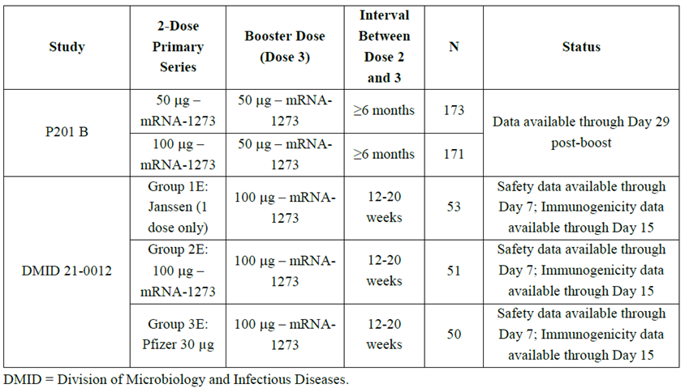
The focus of this efficacy evaluation is the safety and immunogenicity data following a 50 μg booster dose of mRNA-1273 administered to adults previously immunised with an authorised 2-dose primary series of 100 μg of mRNA-1273 in Study P201 Part A.
The primary immunogenicity analysis also included Study P201 Part B participants who received a 50 μg mRNA-1273 booster dose after an unauthorised 2-dose 50 μg mRNA-1273 primary series. For the purposes of this submission, only the assessments of serious adverse events (SAE) and adverse events (AE) of interest in this group were considered relevant (for example, myocarditis, pericarditis, neurologic, neuro-inflammatory and thrombotic events).
Additional supportive safety data were provided from an ongoing Phase I/II open-label trial (Study DMID 21-0012) conducted by the Division of Microbiology and Infectious Diseases (DMID), National Institute of Allergy and Infectious Diseases(NIAID), and National Institute of Health (NIH) all in the USA. In this study immunogenicity was evaluated only following a 100μg booster dose and no comparison with a 50 μg booster was performed. Participants included those primed with heterologous vaccines. .In addition, the neutralising antibody response was not easily comparable with the results obtained on the 50 μg booster dose in Study P201 due to the different dose and different interval between primary and booster doses.

Study design
Two parts (A and B) of ongoing Phase II Study P201 pertain to the safety and immunogenicity of mRNA-1273 vaccine administered to adults 18 years of age and older. The study took place at 10 sites in the USA and its territories.
In Part A of the study participants in the 2 age cohorts received 50 μg, 100 μg of mRNA-1273, or placebo.
Table 4: Study P201 Part A Treatment cohorts, groups and investigational products
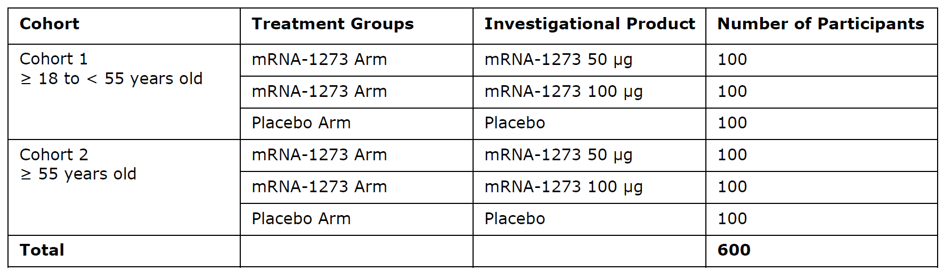
In Part B (Figure 1), the open-label interventional phase of the study, the safety and immunogenicity of a single 50 μg booster dose of mRNA-1273 was evaluated. In Part A of the study, participants who were randomised to receive the 50 μg or 100 μg mRNA-1273 vaccine were offered a single booster dose of mRNA-1273 (50 μg) at least 6 months after planned completion of the primary series. After booster dose administration in Part B (N=344), sera were collected on Days 1, 29, and 57 and at Month 6-7 to assess SARS-CoV-2 neutralising antibody titres (data are presently available to Day 29 only). Neutralising antibody titres (NAbs) titres were measured with an median infectious dose (ID₅₀) assay using a pseudovirus expressing the SARS-CoV-2 spike protein (Wild-type (WT) SARS-CoV-2); the pseudovirus neutralising assay (PsVNA) for the WT SARS-CoV-2 has been validated. Sera collected from all participants on Days 1 and 29 were also analysed using a pseudovirus neutralising antibody ID₅₀ (PsVNT₅₀) assay for measuring antibodies against the SARS-CoV-2 B.1.617.2 variant virus (Delta variant). A pre-planned analysis for the booster dose at Day 29 was conducted (database lock date 10 June 2021).
Figure 1: Study P201 Part B Open label schema
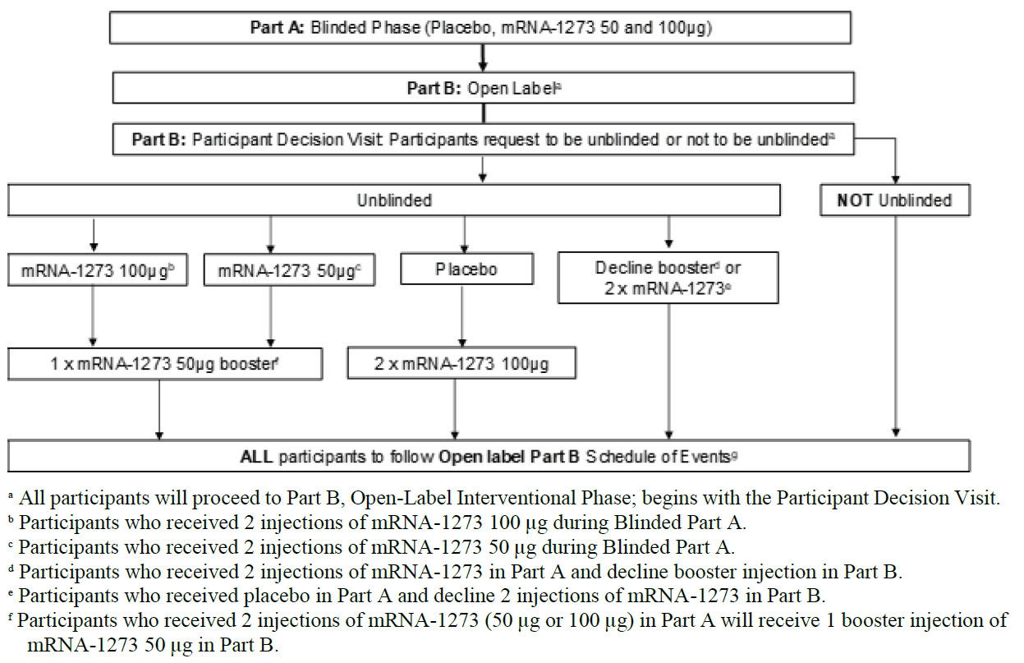

Objectives of the study (Part B) per study protocol

Primary immunogenicity objective
To evaluate the immunogenicity of 50 μg of mRNA-1273 vaccine administered as a single booster dose or 100 μg of mRNA-1273 administered as 2 doses 28 days apart, as assessed by the level of specific binding antibodies (bAb).

Secondary immunogenicity objective
To evaluate the immunogenicity of 50 μg of mRNA-1273 vaccine administered as a single booster dose or 100 μg of mRNA-1273 100 μg administered as 2 doses 28 days apart, as assessed by the titre of neutralising antibody (nAb).

Objectives per the statistical analysis plan

Against the WT SARS-CoV-2
Immune response 28 days after a single booster dose of 50 μg mRNA-1273 against the WT SARS-CoV-2 was to be assessed by Study P201 Part B participants who received a single booster dose of 50 μg mRNA-1273. Immune response 28 days after the completion of the primary series of mRNA-1273 100 μg against the wild-type SARS-CoV-2 was to be assessed in Study P301 participants on mRNA-1273 100 μg, based on the same assays.

Against the variant virus strain (B.1.617.2)
Immune response 28 days after a single booster dose of 50 μg mRNA-1273 against the variant virus stain (B.1.617.2) was assessed by Study P201 Part B participants who received a single booster dose of 50 μg mRNA-1273 based on the Duke assay against the variant virus stain (B.1.617.2, Delta). Immune response 28 days after the completion of the primary series of mRNA-1273 100 μg against the WT SARS-CoV-2 was assessed in Study P301 participants on mRNA-1273 100 μg, based on the Duke assay against the WT SARS-CoV-2. In addition, neutralising antibodies against the variant virus strain (B.1.617.2, Delta) were measured at least 6 months after the completion of the 2 dose primary series of mRNA-1273 100 µg in StudyP301 participants.

Control group
Study P301 is an ongoing pivotal randomised, observer-blind, placebo-controlled study evaluating the safety, efficacy, and immunogenicity of a 2 dose primary series of 100 μg of mRNA-1273 in over 30,000 participants ≥ 18 years of age. Immunogenicity data from a random subset of Study P301 participants were used as the comparator group for immunobridging analyses to infer vaccine effectiveness of the booster dose. Data from Study P301 supported the provisional approval for the 2 dose primary series of the 100 μg dose of mRNA-1273. The final efficacy analysis of Part A of the Study (with median follow up of 5.3 months) demonstrated vaccine efficacy (VE) of 93.2% (95% confidence interval (CI): 91.0%, 94.8%, p < 0.0001), which was consistent with results of the interim and primary analyses.

Statistical analysis
Overall, the statistical methods are considered acceptable. Although selection bias and other sources cannot be completely ruled out, given the observed results between trials and the reported results within trial P201, this is not considered of high clinical relevance.
The analyses of non-inferiority were pre-specified, but the reporting of the immunogenicity objectives was a little unclear in the documentation. The statistical methods were only described in the SAP (not the protocol) which was drafted later (SAP Version 1.0: 04 June 2021; Version 2.0: 06 August 2021). This is acceptable in the context of the evolving nature of the pandemic situation and the requirement for adaptive trial designs, although it did make clinical evaluation difficult.

Booster dose co-primary immunogenicity endpoints against the wild type SARS-CoV-2

Co-primary Endpoint 1
Geometric mean of the neutralising antibody titres against the SARS-CoV-2 WT strain measured 28 days after a single 50 μg booster dose of mRNA-1273 in Study P201 Part B versus the corresponding responses measured 28 days after receipt of the second dose of the 50 or 100 μg mRNA-1273 2-dose primary series in Study P301. The pre-specified immunobridging success criteria required both a lower limit of the 95% confidence interval for the geometric mean titre (GMT) ratio (Study P201B/Study P301) ≥ 0.67 (1.5 fold immunobridging margin) and a GMT ratio point estimate ≥ 1.0.

Co-primary Endpoint 2
Seroresponse rate against the SARS-CoV-2 WT strain 28 days after a single 50 μg booster dose of mRNA-1273 in Study P201 Part B versus the corresponding responses 28 days after the second dose of the 50 or 100 μg mRNA-1273 2-dose primary series in Study P301. The pre-specified immunobridging criterion required a lower limit of the 95% confidence interval for the difference in seroresponse rates (Study P201B versus Study P301) ≥ 10%. Seroresponse was defined as ≥ 4 fold rise in neutralising antibody titres from baseline (pre-booster dose in Study P201 Part B and pre-dose 1 in Study P301), where baseline titres < lower limit of quantification (LLOQ) are set to LLOQ for the analysis.
Immune responses to a single booster dose of 50 μg mRNA-1273 would be considered successfully bridged (that is, non-inferior) to that of the 2 dose primary series of 100 μg of mRNA-1273 if each of the immunobridging criteria above were met.

Study disposition and baseline characteristics:
The safety and immunogenicity populations analysed in Studies P201 Parts A and B, and P301 are presented below in Table 5 and 6.
A total of 149 participants from the open-label phase of Study P201 Part B and 1,055 participants from a random sub-cohort of Study P301 were included in the per-protocol immunogenicity subset for the primary immunogenicity analyses. Reasons for exclusion from the Study P201 Part B per-protocol population included a major protocol violation involving incorrect dosing at the booster dose visit (receipt of a 100 μg booster dose instead of a 50 μg booster dose) and SARS-CoV-2 infection at baseline (which was an exclusion criterion for participation in Study P301); reasons for exclusion from the Study P301 per protocol population included human immunodeficiency virus (HIV) infection (an exclusion criterion for participation in Study P201) and error in the administration of the second primary series dose (not applicable to Study P201 Part B). Of note, one 100 μg primed booster dose participant who did not receive Dose 2 of the primary series was included in the per protocol population; participants were not required to receive both primary series doses to be included in the booster dose per protocol set. This participant received Dose 1 on 4 June 2020 and a 50 μg dose on 19 February 2021 (around 8 months after Dose 1).
Table 5: Study P301 (primary series) and Study 201 Part B (booster dose, open-label phase) Immunogenicity analysis populations, participants ≥ 18 years of age
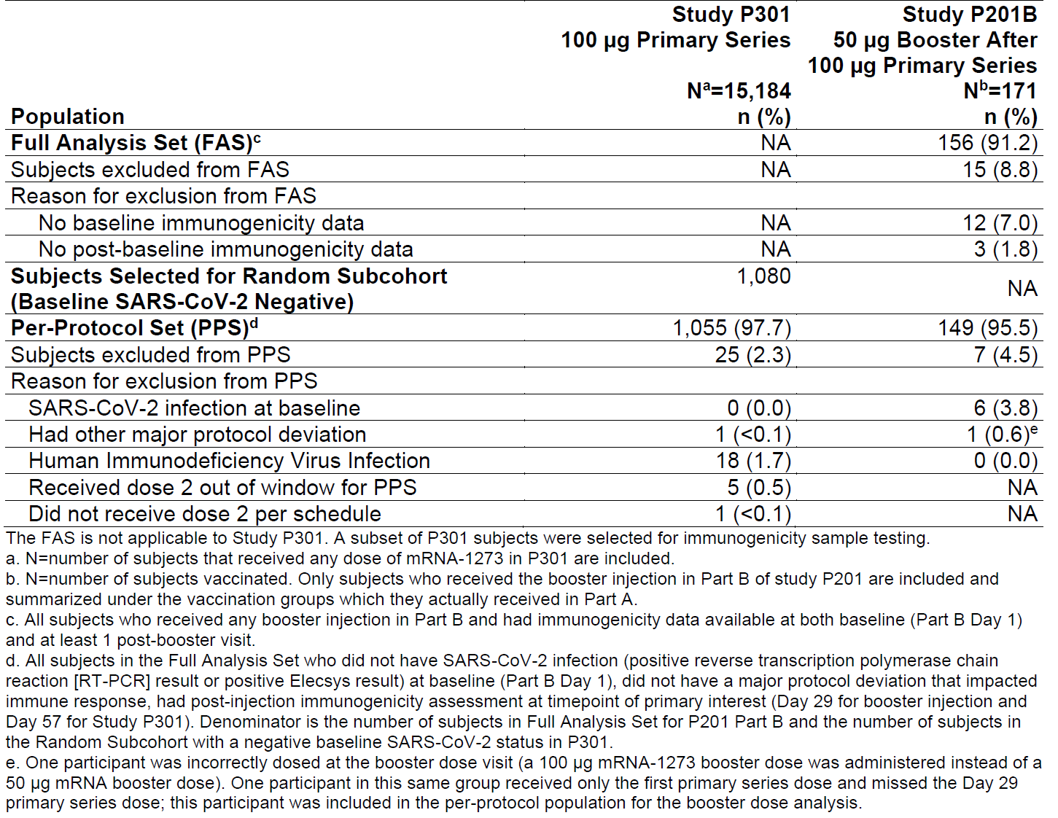
The disposition of Study P201 Part A and Study P301 participants who received a 2 dose primary series of mRNA-1273 is presented below in Table 6 (Safety population), and the disposition of Study P201 Part B participants who received a mRNA-1273 booster dose is presented in Table 7 (Safety population). There were no notable differences between the disposition of participants in Studies P201A and P301 or between the disposition of participants in each study group within Study P201 Part B.
Table 6: Study P201 Part A and Study P301 (primary series) Disposition of participants ≥ 18 years of age, Safety populations
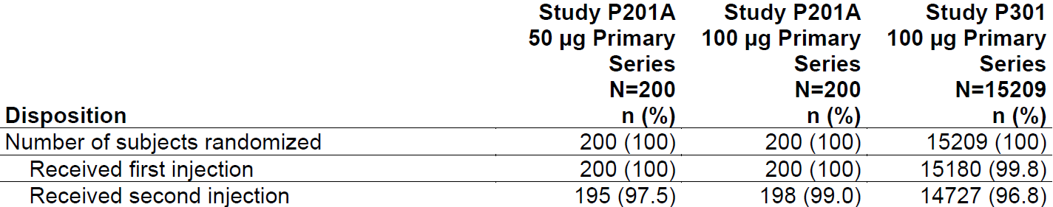
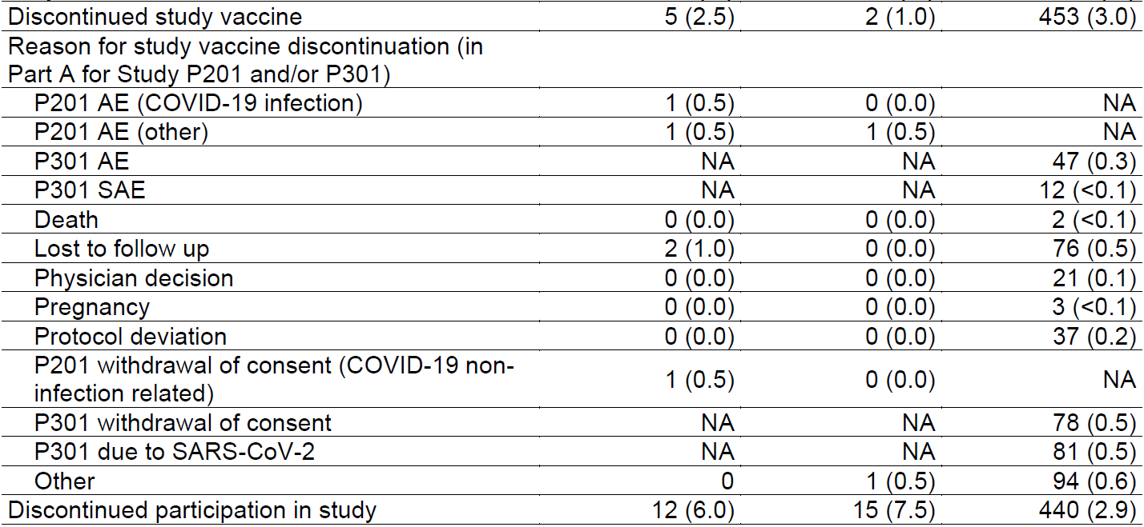
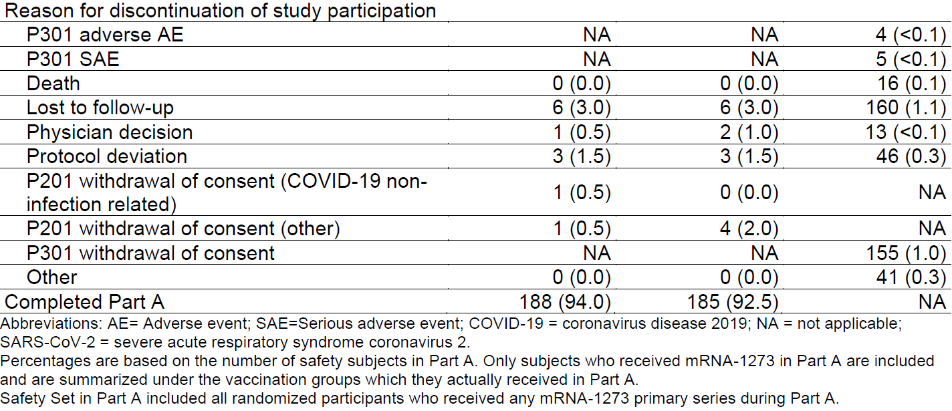
Table 7: Study P201 Part B Disposition of participants ≥18 years of age (by primary series dose), Safety populations
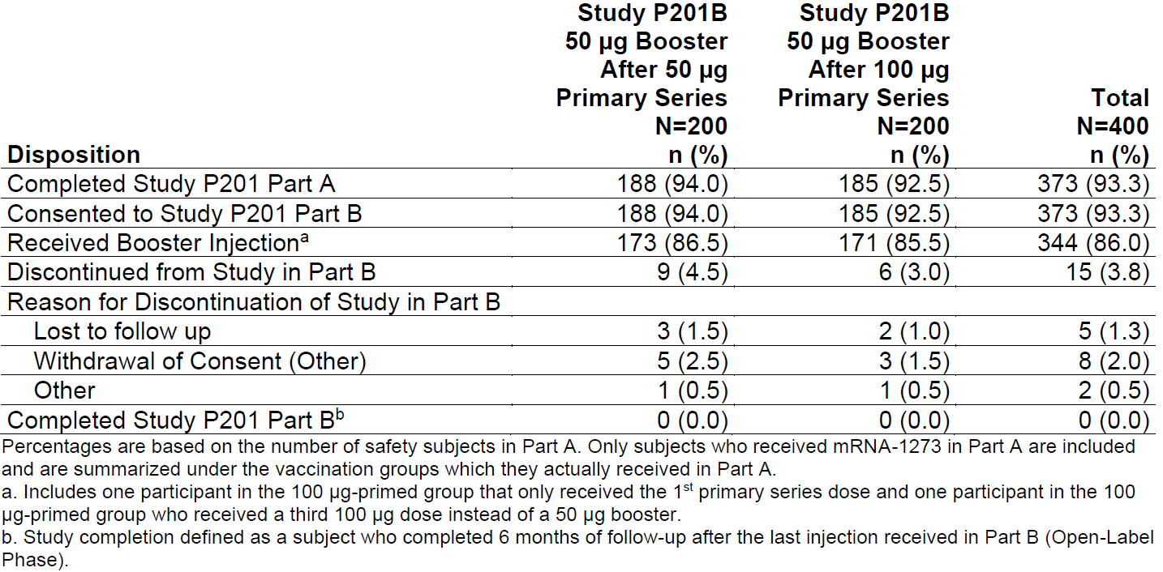
Demographic and baseline characteristics of the safety population for Studies P201 (Parts A and B) and Study P301 and the per-protocol immunogenicity subsets for Study P201 Part B and Study P301 are shown in Tables 8 and 9, respectively. Compared to Study P301, participants in Study P201 Part A and Study P201 Part B were less racially and ethnically diverse. Study P201 Part A and Study P201 Part B participants also had a lower median body mass index (BMI), a lower rate of obesity (BMI ≥ 30 kg/m²), and a lower percentage of males compared to Study P301 participants. Studies P201A, P201B and P301 had a similar median participant age and a similar proportion of participants ≥65 years of age. The noted differences in demographic characteristics between Study P201 Part B and Study P301 participants are considered unlikely to impact the clinical results from the safety and primary immunobridging analyses. The subgroup analyses of mRNA-1273 vaccine’s safety and efficacy by sex, race and ethnicity in Study P301 supported consistency in vaccine efficacy estimates across subgroups.
Individuals with a history of chronic cardiovascular disease, chronic pulmonary disease, positive serology for human immunodeficiency virus (Type 1 or 2), diabetes, and history of hypertension were excluded from participating in Study P201 Parts A and B. In Study P301 however, 22.1% of participants were at increased risk of severe COVID-19 due to at least one pre-existing medical condition (chronic lung disease, significant cardiac disease, severe obesity, diabetes, liver disease, or HIV infection).
The noted differences in pre-existing medical conditions between Study P201 and Study P301 populations are considered unlikely to impact the conclusions of the primary analyses. Based on Study P301 subgroup efficacy analyses conducted under the original provisional approval; there were no clear differences in vaccine efficacy estimates between Study P301 participants with a pre-existing condition (that is, chronic lung disease, significant cardiac disease, severe obesity (BMI ≥ 40 kg/m²), diabetes, liver disease and HIV infection) and the overall Study P301 per protocol population.
Table 8: Study P201 Part B Demographic and baseline characteristics, (booster; by primary series dose) and comparator groups (primary series only), safety population
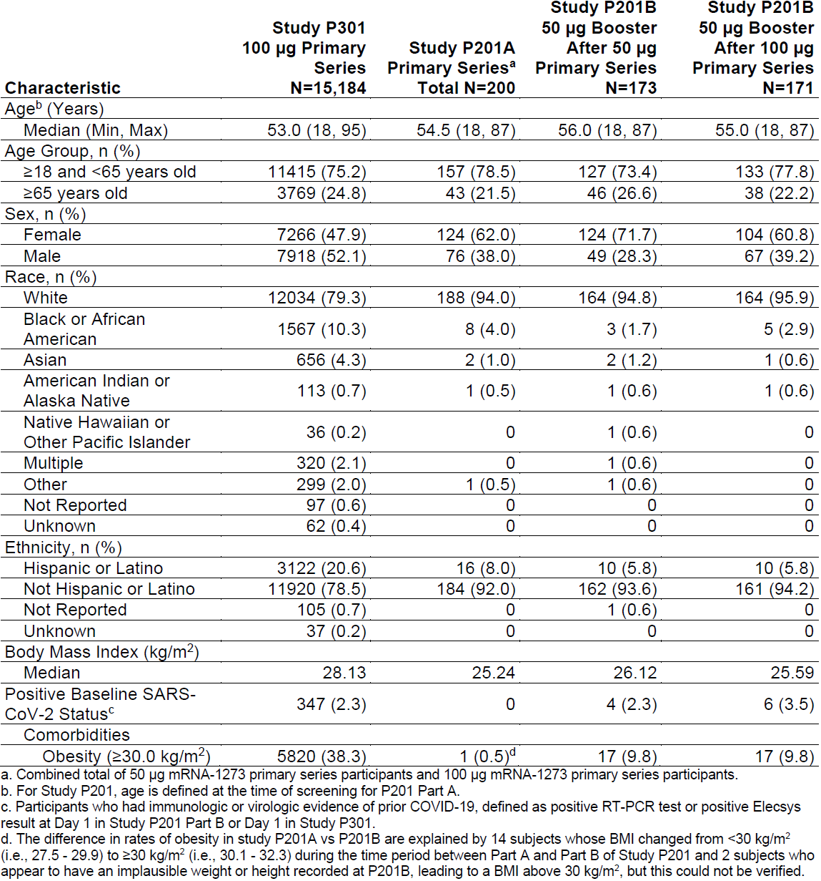
Table 9: Study P201 Part B (by primary series dose) and Study P301 comparator group (primary series only) Demographic and baseline characteristics, mRNA-1273 booster dose recipients, per-protocol immunogenicity subset
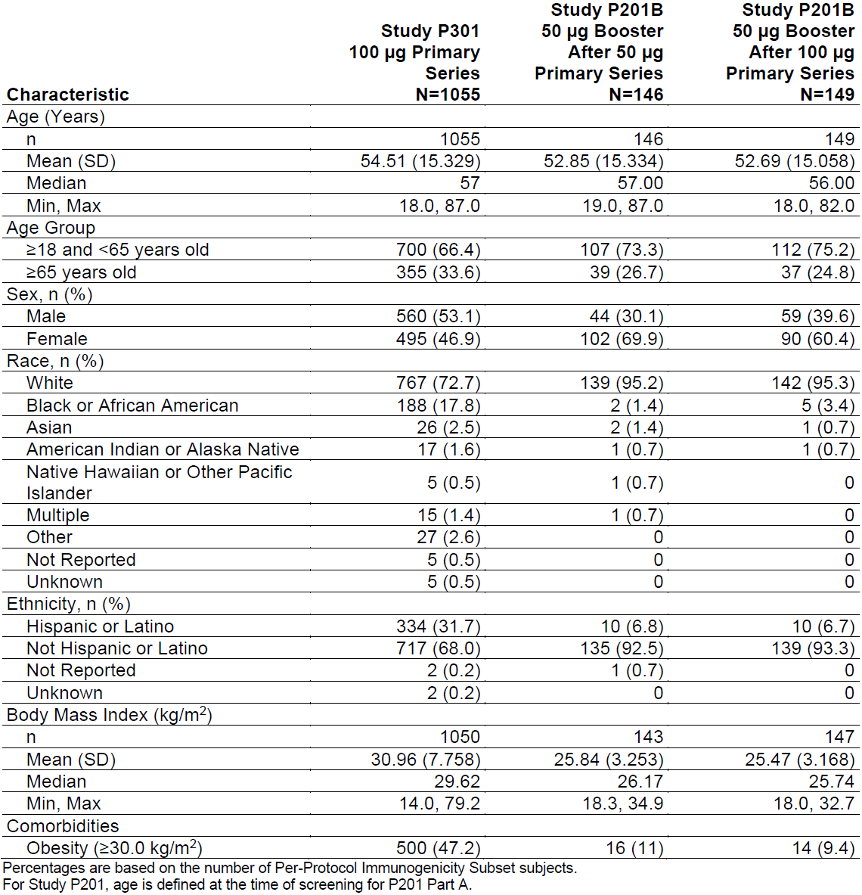

Results
Among participants previously receiving 2 doses of 100 μg mRNA-1273, the 50 μg booster led to an increase in baseline titres, geometric mean fold rise (GMFR) of 12.99 (95% CI: 11.04, 15.29). Among participants previously receiving 2 doses of 50 μg of mRNA-1273, the 50 μg booster led to a similar increase in titre GMT, with GMFR of 17.53 (95% CI: 14.94, 20.56), although the pre-booster GMT was slightly lower numerically. In both prime series groups combined, the GMFR is 15.06 at Day 29. Table 10 summarises serum nAb (PsVNA ID₅₀, WT) titres 28 days after the 50 μg booster in Study P201 Part B.
Table 10: Study 201 Part B Summary of pseudovirus neutralising antibody 50% inhibitory dose titres after 50 μg booster injection (by prime series groups)
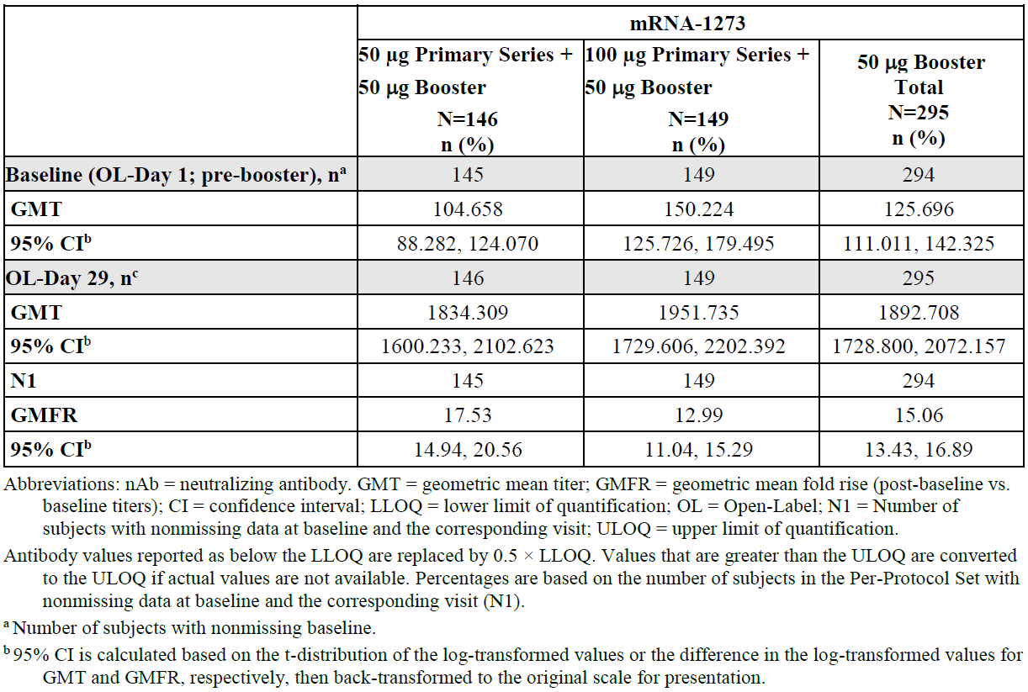
Figure 2: Study 201 Part B Box plot of pseudovirus neutralising antibody 50% inhibitory dose titres, Per-protocol set
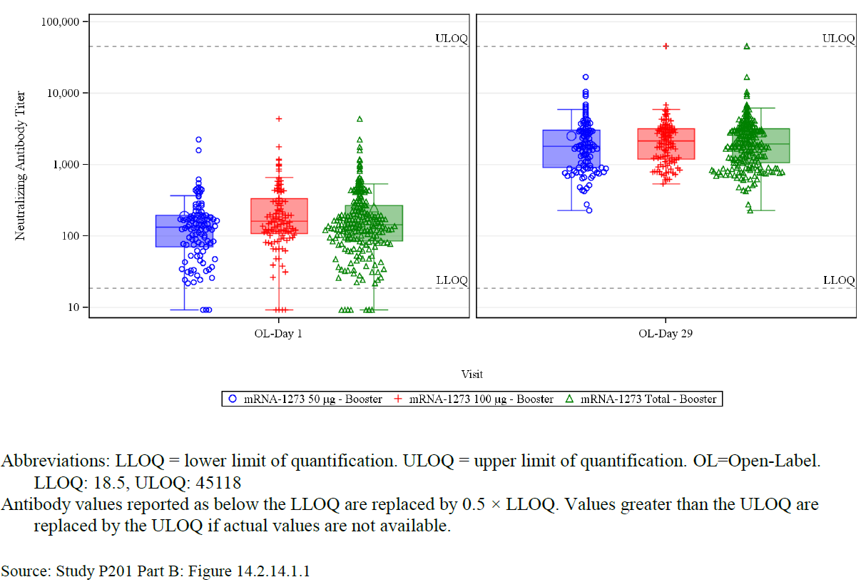
Subgroup analysis following stratification of the nAb response according to age groups and primary immunisation series is shown in Table 11. Generally, higher nAb responses (GMTs) are seen in the 18 to 55 years age group compared to the age group of the 55 years and older pre- and post-booster; however, a higher GMR is observed in subjects 55 years and older. No further subgroup analysis stratified according to other age groups (18 years and older up to and including 64 year olds or older; and those who were65 years old and above) and primary series were provided with this submission.
Table 11: Study 201 Subgroup analysis stratified according to age group and priming group
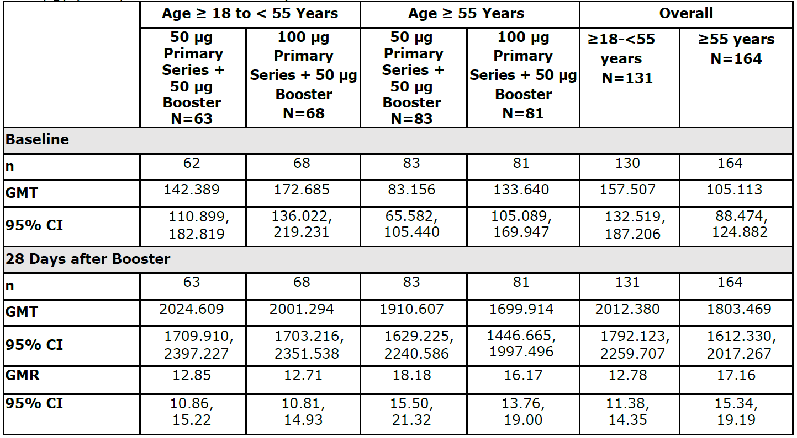

Neutralising antibody response against the Delta variant pre and post Dose 3
The nAbs response of all participants in Study 201 Part B was determined by a validated assay using a pseudovirus based on the B.1.617.2 (Delta) variant. Serum samples were obtained from participants in Study P201 Part B (at least 6 months after receiving two primary doses of either 50 or 100 μg of mRNA-1273) pre-booster and on Day 29 post booster. Results of the Pseudovirus nAb assay against the Delta variant (B.1.617.2) are presented in Table 12.
Administration of the mRNA-1273 booster (50 μg) induced an 18 fold-rise in neutralising titres against the Delta variant compared to pre-booster levels in all participants combined (GMFR=18.97; 95% CI, 16.72, 21.53; overall group, n=295). In the overall Study P201 Part B group (previously primed with 2 doses of either 50 or 100 μg mRNA-1273, n=293), the pre-booster nAb GMT (for the Delta variant) was 42.27 (95% CI, 37.19, 48.04; n=293) and 28 days post-booster the GMT was 803.51 (95% CI, 731.42, 882.70; n=295). Over 90% of booster recipients in the overall group (92.2%; 95% CI, 88.5-95.0%; n=293) met the definition of a sero response for the Delta variant (using a four-fold increase from pre-booster baseline).
Administration of the 50 μg mRNA-1273 prototype booster resulted in substantial increases in nAb responses against the Delta variant regardless of the priming dose. Participants primed with 50 μg had a GMFR of 20.89 (95% CI, 17.54, 24.87); those primed with 100 μg had a GMFR of 17.28 (95% CI, 14.38, 20.77). Numerically slightly lower GMTs pre and post Dose 3 were reported in the 50 μg priming group compared to the 100 μg priming group.
Table 12: Study 201 Part B Summary of pseudovirus neutralising antibody 50% inhibitory titres against new variant strain (B.1.617.2, Delta) per-protocol immunogenicity subset
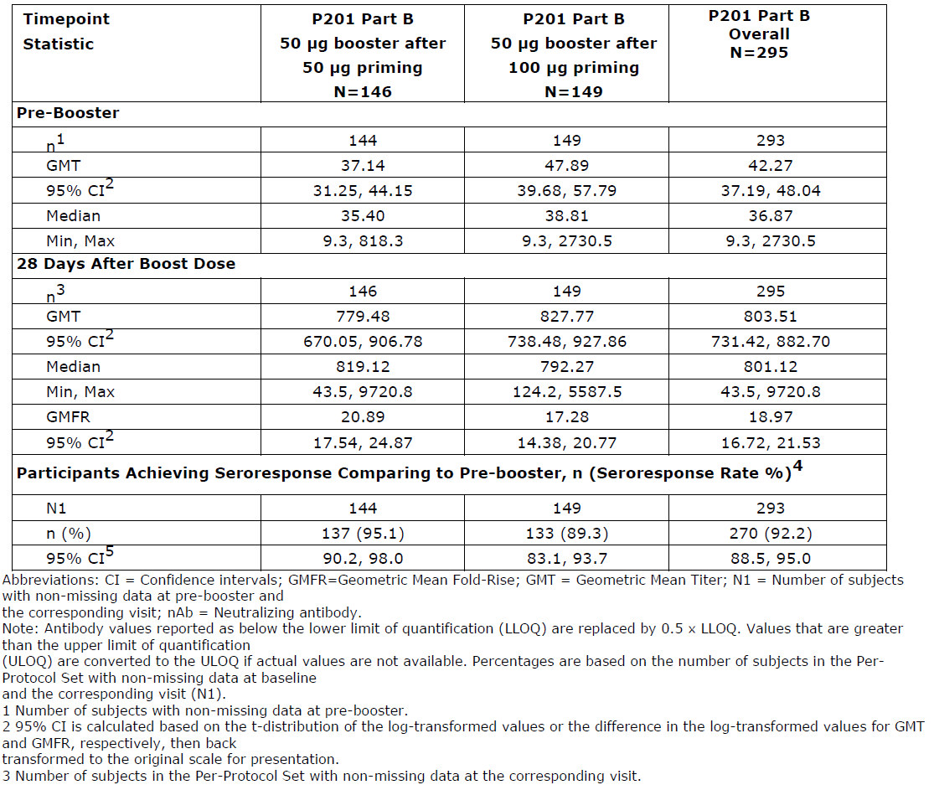
Additional analyses of Delta variant nAb GMT by age group based on all subjects included in the per protocol set are provided in Table 11 and 12. nAb responses in older adults, defined either as ≥65 or ≥55 or years, are numerically similar to those observed in the younger groups (Table 13 and Table 14; 749.94 versus 822.98 and 758.68 versus 863.39, respectively). No analyses according to primary vaccination series and age group were submitted.
Table 13: Study 201 Summary of pseudovirus neutralising antibody 50% inhibitory titres against new variant strain (B.1.617.2); by age group (≥ 18 and < 65 years old versus ≥65 years old) per-protocol immunogenicity subset
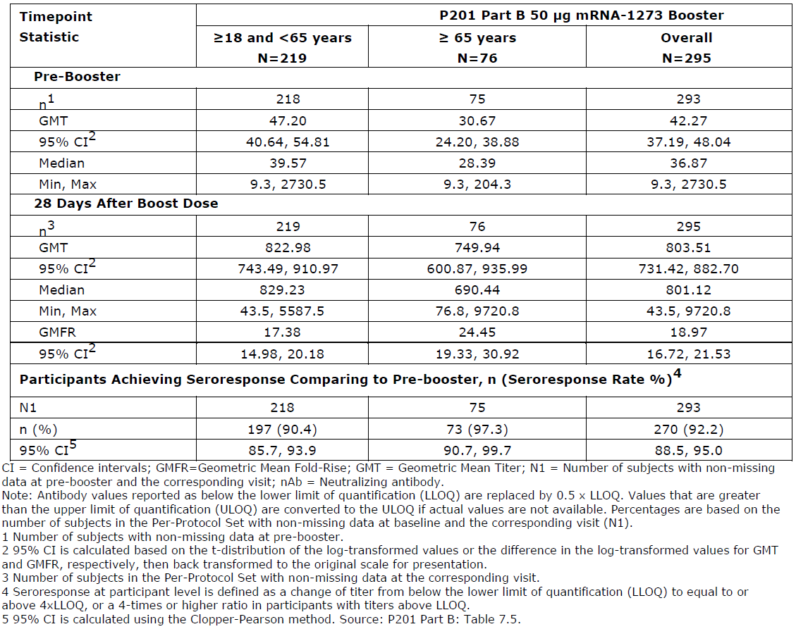
Table 14: Study 201 Summary of pseudovirus neutralising antibody 50% inhibitory concentration titres against new variant strain (B.1.617.2) by age group (≥ 18 and < 55 years old versus ≥ 55 years old) per-protocol immunogenicity subset
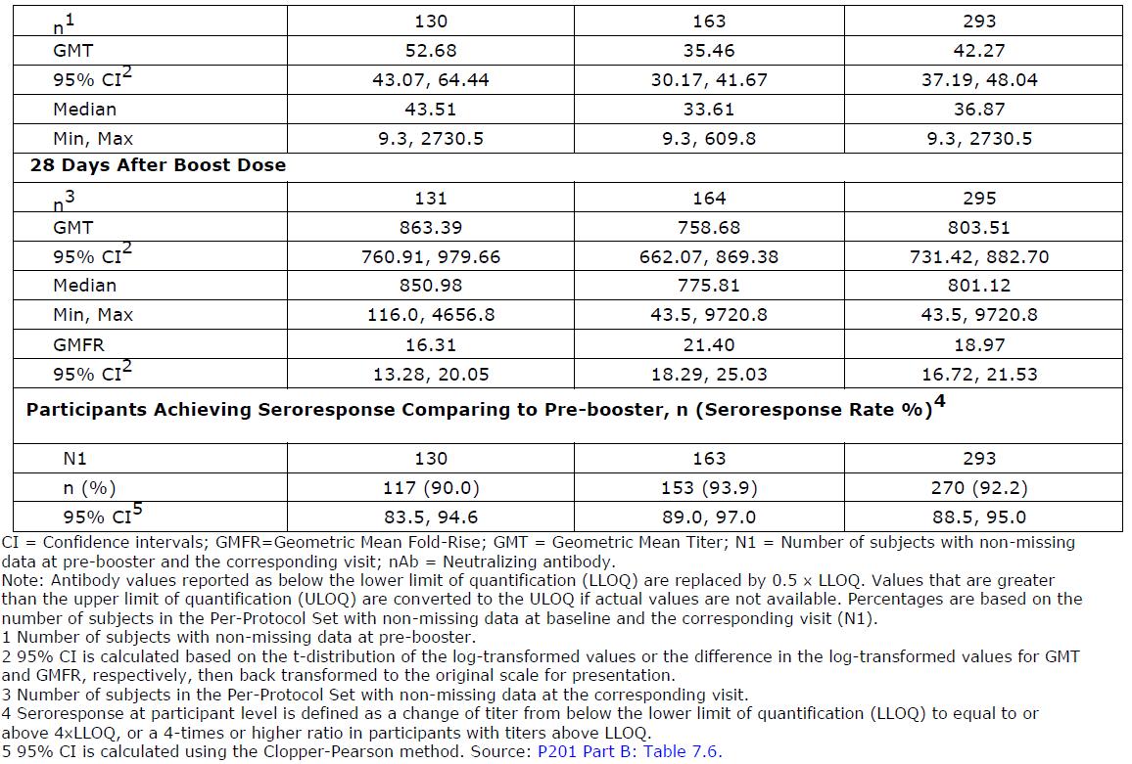

Non-inferiority analysis to compare the immunogenicity results in Study P201 post Dose 3 (booster) to the results in efficacy Study P301 post Dose 2 after the primary series

Geometric mean ratio as assessed by pseudovirus neutralising antibody 50% inhibitory titres
The primary analysis population for this coprimary endpoint (in Study P201 Part B) included all per protocol participants who received a single booster dose of 50 μg mRNA-1273 in Study P201 Part B (that is, all participants combined regardless of whether they received 50 μg or 100 μg of mRNA-1273 in the primary series).
In comparison to the peak PsVNA ID₅₀ titres in Study P301 Part A (Day 57, 28 days post Dose 2), where efficacy was demonstrated, the GMR (Study P201 Part B Day 29 versus Study P301 Day 57, against the original virus strain) was 1.71 (95% CI: 1.519, 1.929) (Table 15). The GMR estimate was 1.71 (above the prespecified threshold of 1.0), with the lower bound of the 95% CI greater than 0.67 (corresponding to noninferiority margin (NIM)=1.5). Hence, this GMR successfully met the prespecified NI criterion. A consistent trend to that observed from the analysis described above, with the 2 prime series groups combined, was also observed in the subgroup analysis (by prime series) (Table 16). The above suggests that the 50 μg booster increases nAb responses regardless of the dose (50 μg versus 100 μg) received in the primary series.
Table 15: Analysis of pseudovirus neutralising antibody 50% inhibitory concentration: mRNA-1273 post-Dose 3 (all subjects) compared with the Study P301 primary series peak titres (per-protocol (PP) immunogenicity set)
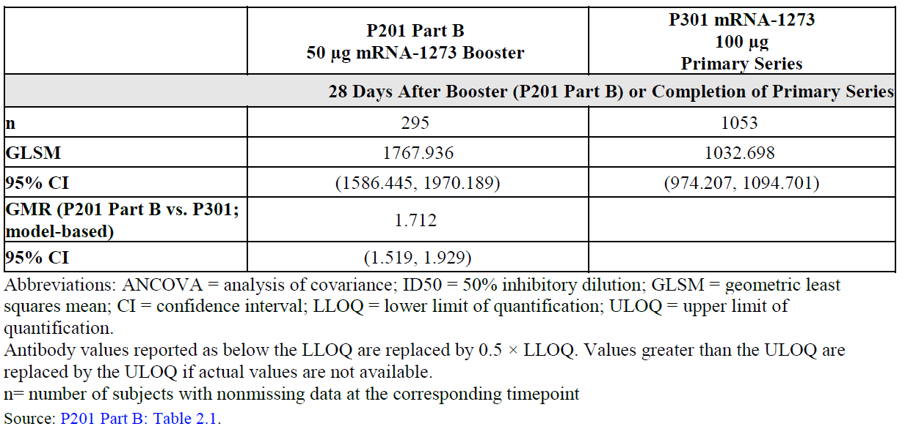
Table 16: Analysis of pseudovirus neutralising antibody 50% inhibitory concentration: mRNA-1273 post-booster compared with the Study P301 Primary series peak titres, by primary series groups (per-protocol (PP) immunogenicity set)
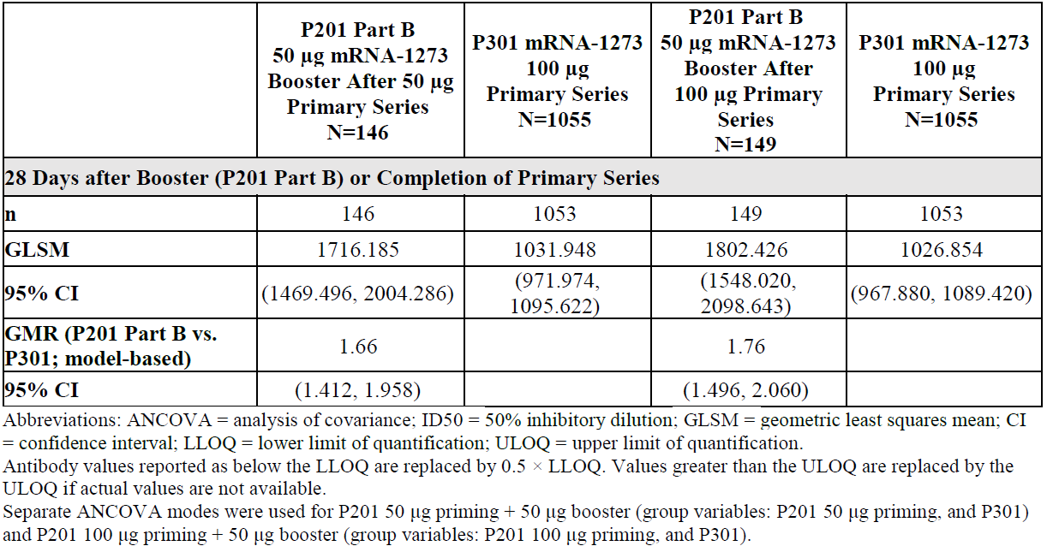

Seroresponse rates as assessed by pseudovirus neutralising antibody 50% inhibitory concentration titres
The calculated seroresponse rates (SRR) difference (for PsVNA ID₅₀ titres) between Study P201 Part B Day 29 post booster and Study P301 Part A Day 57 was assessed. This analysis was performed using 2 definitions of SRR: (i) an assay-specific definition (3.3 fold rise) proposed by the sponsor, and (ii) a 4 fold rise definition as a more conservative approach. The primary analysis used the 4 fold definition (ii).
Using the assay-specific definition (3.3 fold rise), the calculated difference in SRR between Study P201 Part B Day 29 post-boost and Study P301 Part A Day 57 is -5.3% (95% CI: -8.8%, -2.9%) (Table 17). The lower bound of the 95% CI is -8.8%, meeting the prespecified success criterion of a NIM of 10%.
Using the 4 fold rise definition, the calculated difference in SRR between Study P201 Part B Day 29 post-boost and Study P301 Part A Day 57 is -8.2% (95% CI: -12.2%, -5.2%) (Table 17). The lower bound of the 95% CI is less than -10% (the prespecified NIM of 10%).
In general, the subgroup analysis (by prime series) and the SAP specified sensitivity analysis yielded similar results in confirming that the NIM of -10% was not met.
Table 17: Analysis of seroresponse rates by pseudovirus neutralising antibody 50% inhibitory concentration assay: mRNA-1273 post-booster compared with the Study P301 Primary series peak titres, by prime series groups (per-protocol (PP) immunogenicity set)
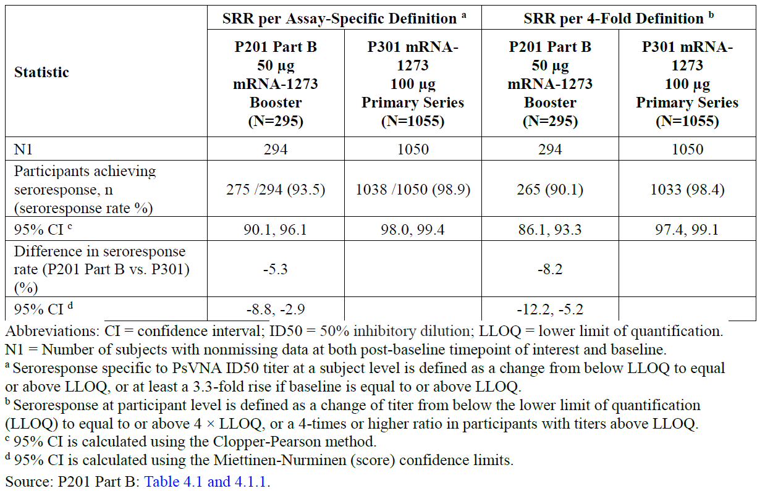
Table 18: Analysis of seroresponse based on pseudovirus neutralising antibody titres by priming groups and 4 fold definition of the seroresponse (per-protocol immunogenicity subset) antibody: pseudovirus neutralising antibody 50% inhibitory titres
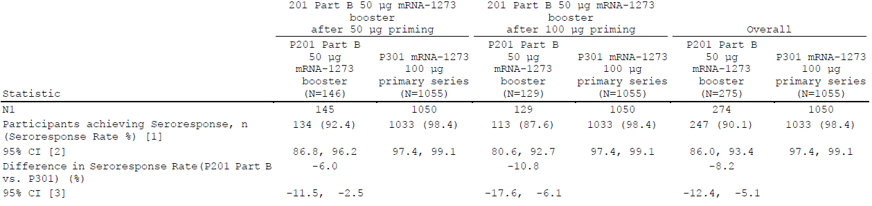
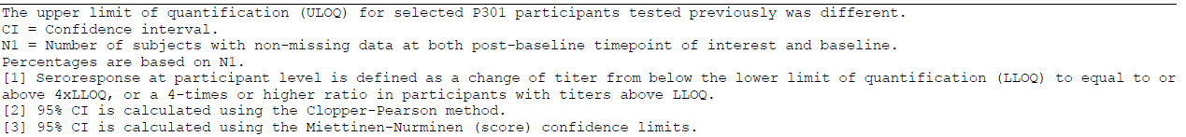
In summary, effectiveness of the booster dose against the WT SARS-CoV-2 is being inferred based on immunobridging to the 2 dose primary series, as assessed by SARS-CoV-2 neutralising antibody titres elicited by the vaccine. Immunobridging analyses against the WT SARS-CoV-2 met the pre-specified success criteria for the GMT ratio (Study P201 Part B/Study P301). The pre-specified success criterion for the difference in seroresponse rates after the booster dose compared to after Dose 2, was not met. The lower limit of the 95% CI for the difference in seroresponse rate (Study P201 Part B booster dose – Study P301 primary series) was <-10% (-16.7%). In post-hoc analyses, participants with lower pre-booster neutralising antibody titres were more likely to achieve a 4 fold rise in neutralising antibody titres after booster vaccination compared to participants with higher pre-booster neutralising antibody titres.
According to the SAP, both criteria on GMR and seroresponse needed to be demonstrated to conclude on non-inferiority of the booster dose in comparison to the primary vaccination series. No sequence of immunogenicity endpoints was defined in the SAP and the protocol considered the assessment of bAb levels as primary objective followed by the assessment of nAb levels. Non-inferiority was met for all assays based on the GMR. Non-inferiority was not formally met for the enzyme-linked immunosorbent (ELISA) assay and PsVNA ID₅₀ in the 100 μg prime cohort, which is of primary interest. As especially the nAbs and the increase in antibody titres is considered of primary relevance for the assessment of the immunogenicity of the booster dose, the failure to prove non-inferiority in seroresponse after the booster dose in comparison to the primary vaccination series is not considered of critical importance. Possible explanation of lower SRR following a third dose can be explained by residual higher levels of nAbs pre booster in Study P201 and by the fact that the response rates following a booster dose were compared to peak levels after the primary series in Study P301. It should be noted that two different study populations were compared and the nAb levels reported in these populations post Dose 2 (GMT: Study P201 approximately with 1200 versus Study P301 with approxumately1000) differ.
Additionally, the sponsor proposes to infer effectiveness of the booster dose against the Delta variant from exploratory descriptive analyses of neutralising antibody titres against this variant evaluated among booster dose recipients from Study P201 Part B.
In conclusion, a booster dose of 50 μg dose administered 6 to 8 months after the primary vaccination series was shown to elevate the neutralising antibody responses significantly. The antibody levels determined 28 days post Dose 3 were higher when compared to peak antibody levels 28 days post Dose 2.

Safety
Safety analyses presented in this review are derived from:
- Summary of solicited adverse reactions (AR) and unsolicited AEs up to study Day 29 for Study P201 Part B. For Study P201 Part B, results are provided for recipients of (i) 100 μg Prime + 50 μg Boost and (ii) 50 μg Prime + 50 μg Boost; and (iii) the combined ‘50 + 100 μg’ Prime + 50 μg Boost.
- Solicited ARs (post Dose 2) and unsolicited AEs for 28 days post any dose from Study P201 Part A (100 μg prime series group) and Study P301 Part A;
- Summaries of solicited AR and unsolicited AE (up to study Day 7) for the supportive study, DMID Study 21-0012.
- Updated listings of cumulative unsolicited AEs, SAEs, and medically-attended adverse events (MAAE) from participants who received a single booster dose in Study P201 Part B, generated from a live ongoing database (data subject to further cleaning; data snapshot date 16 August 2021).

Summary of solicited local adverse reactions
The following local ARs were evaluated in each study within 7 days after injection: pain at injection site, erythema (redness) at injection site, swelling (hardness) at injection site, and localised axillary swelling or tenderness ipsilateral to the injection arm.
The most common solicited AR after the 50 μg booster dose was pain (Table 19). Most solicited local ARs were Grade 1 to Grade 2 in severity. Pain was the most commonly reported Grade 3 local AR in Study P201 Part B. No Grade 4 solicited local ARs were reported in either primary series group in Study P201. Local ARs were transient, and most resolved by Day 4. The frequency and severity of solicited local ARs was numerically comparable between age cohorts (18 to < 55; ≥ 55 years of age).
The frequencies of reported solicited local ARs were comparable between booster doses both primarily vaccinated with 50 μg or 100 μg of Spikevax and comparable to the safety profile of primary vaccination schedules in Study P201 Part A as well as to the safety profile of the primary vaccination schedule in the pivotal Study P301. No safety data were provided for children aged 12 to 17 years. The frequencies of reported solicited local reactions were comparable between both age strata (18 to < 55; ≥ 55 years of age).

Summary of solicited systemic adverse reactions
The following systemic ARs were evaluated in each study: headache, fatigue, myalgia (muscle aches all over the body), arthralgia (aching in several joints), nausea/vomiting, fever, and chills.
Rash was a solicited systemic AR in Study P201 only; therefore, no comparison between Study P201 and Study P301 can be made (Table 20).
The frequencies of reported solicited systemic ARs were comparable for booster doses given to subjects after primary vaccination with either 50 μg or 100 μg of Spikevax and comparable to the safety profiles of primary vaccination schedules in Study P201 Part A as well as to the safety profile of the primary vaccination schedule in the pivotal Study P301. Reported frequencies of solicited systemic reactions were comparable between both age strata. The sponsor has applied for a booster indication for adolescents and adults aged 12 years and above. No data of solicited systemic ARs were provided by the sponsor for the age group of adolescents aged 12 to 17 years after a booster dose. Both age strata (18 to < 55; ≥ 55 years of age) took medication in comparable amounts to prevent pain around 8% and to prevent fever around 45%.
Table 19: Studies 201 and 301 Solicited local adverse reactions
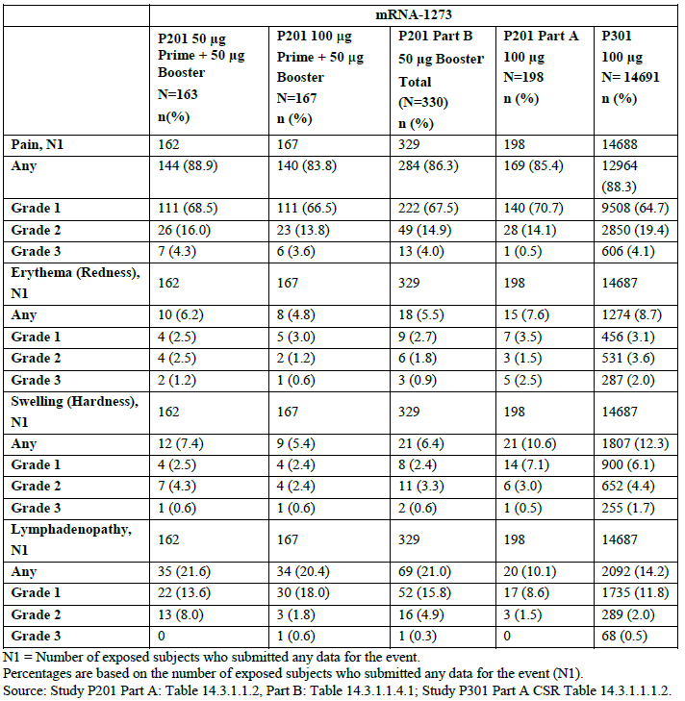
Figure 3: Solicited local adverse reactions within 7 Days
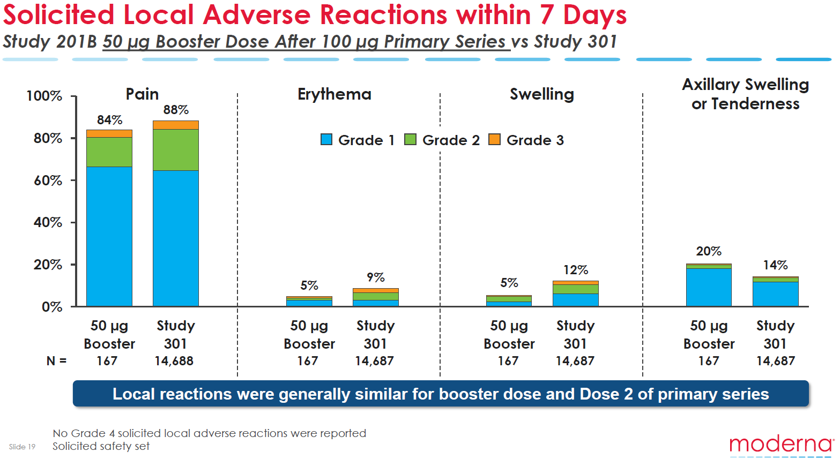
US CDC Advisory Committee on Immunization Practices (ACIP) October 2021.
Table 20: Solicited systemic adverse reactions
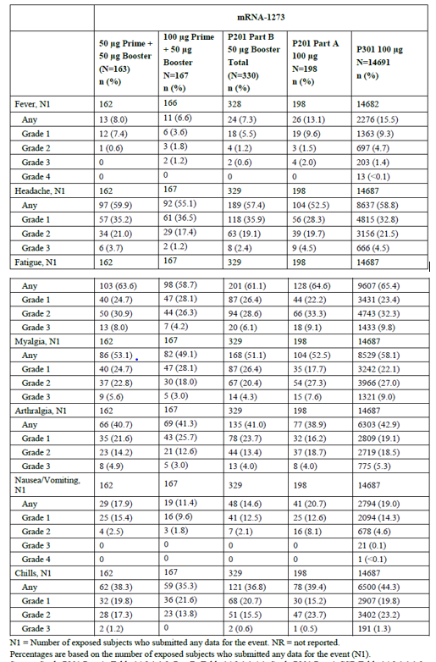
Figure 4: Studies 201B and Study 301 Solicited systemic adverse reactions within 7 Days
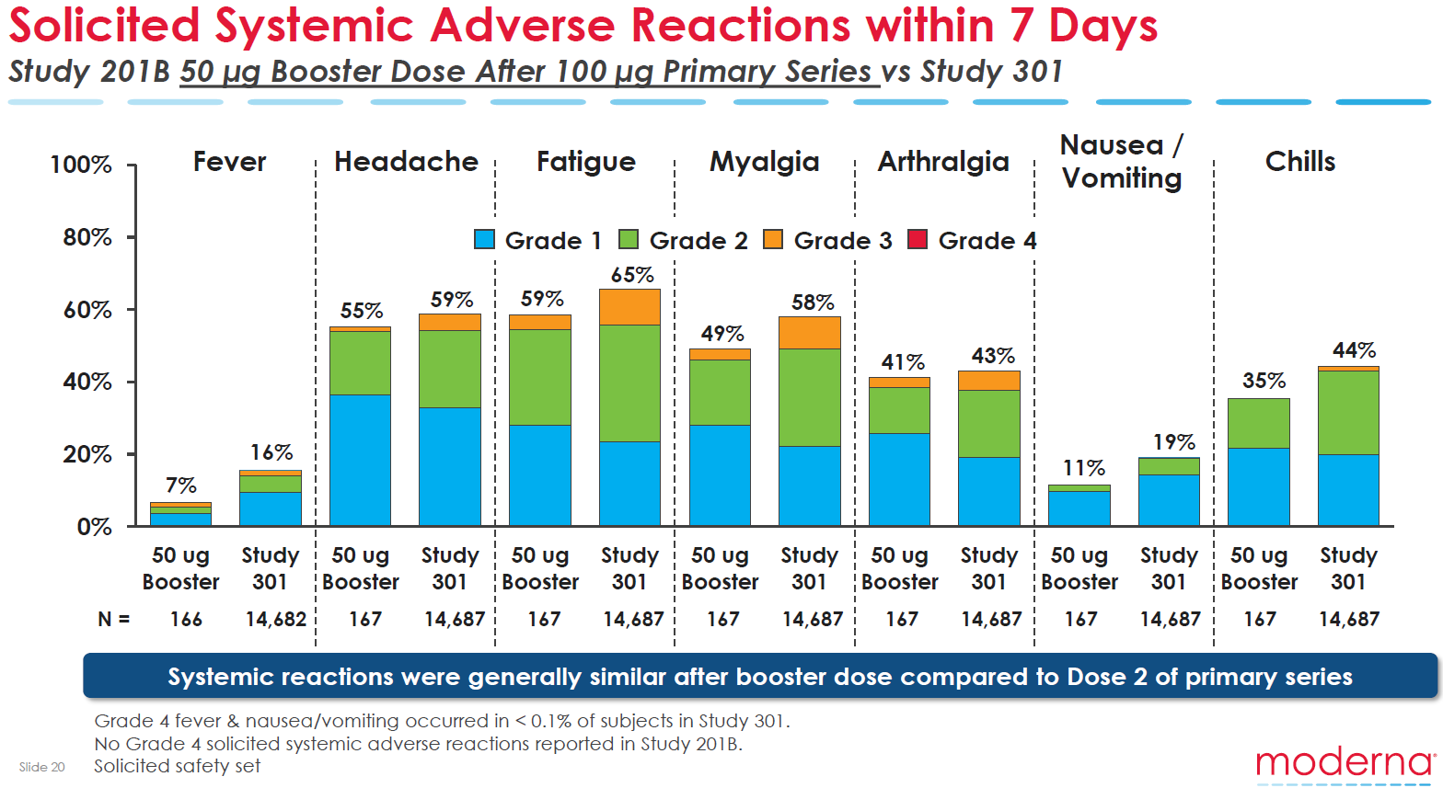
US CDC Advisory Committee on Immunization Practices (ACIP) October 2021

Unsolicited adverse reactions
In Study P201 Part B, unsolicited treatment-emergent adverse events (TEAEs) were systematically collected during the 28 day time window after the booster dose.
Table 21: Studies P201 and P301 Summary of unsolicited treatment-emergent adverse events up to 28 days after the booster in Study P201 Part B or up to 28 days after any injection in Study P201 Part A and Study P301, Safety set
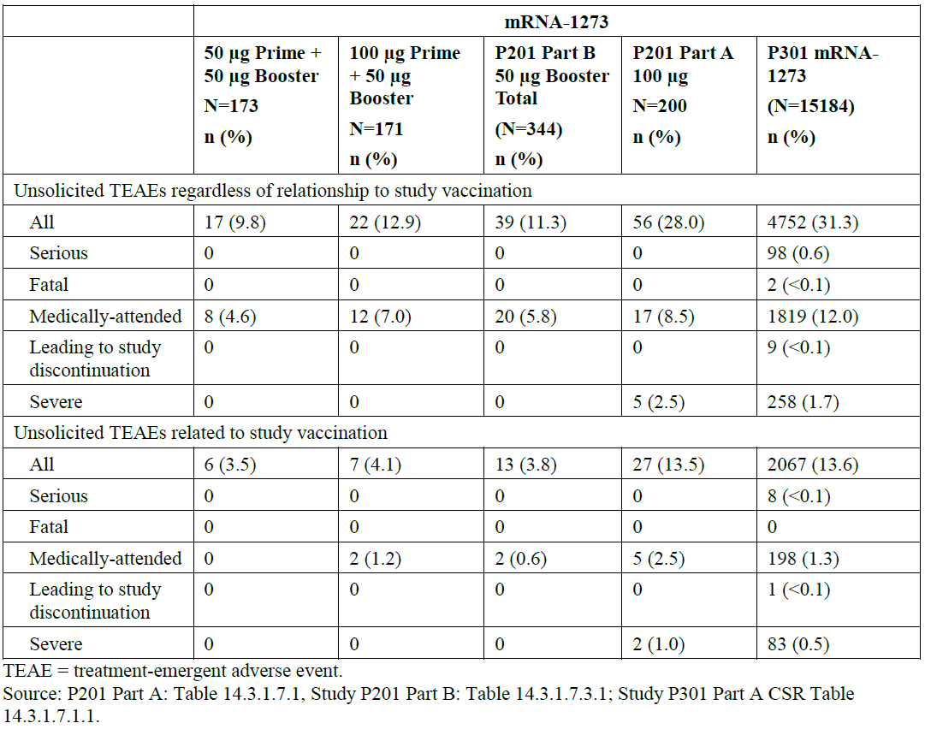
Table 22: Study P201 Part B Incidence of unsolicited treatment emergent adverse events by Preferred Term up to 28 days after booster, Safety set
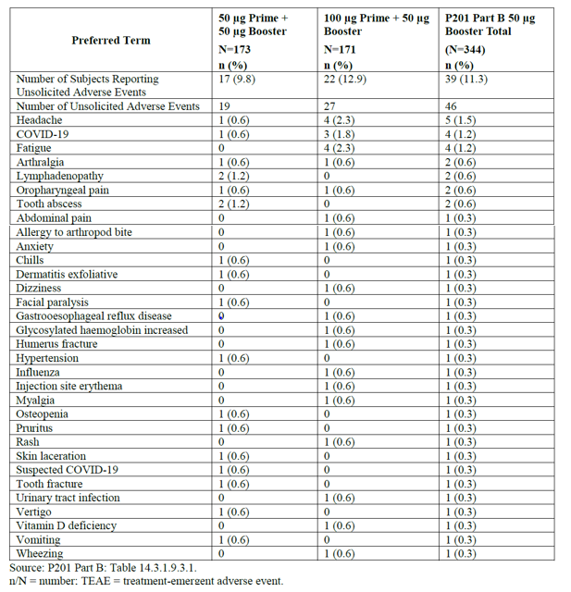
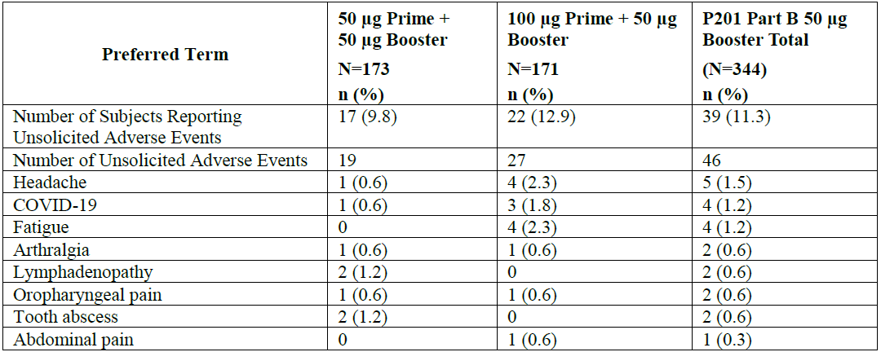
Medically attended TEAEs seem to be slightly more frequent in the 100 μg priming cohort than in 50 μg cohort (n = 12 versus 8). However, since events like influenza, allergy to arthropod bite, vitamin D deficiency and anxiety were counted, this difference seems coincidental and it may be concluded that no difference has been observed between 100 and 50 μg cohorts if medically attended TEAEs are considered in general.
Unsolicited medically attended TEAEs up to 28 days were more frequent in subjects above 55 years old in 100 μg cohort (9 %) than in 50 μg cohort (4.3%). This effect was not observed in subjects younger than 55 years old.

Deaths
No deaths were reported in Study P201 Part A or among Study P201 Part B booster participants.

Serious adverse events
There were no SAEs reported within the 28 day time window post-booster in Study P201 Part B or within the 28 day time window post any injection in Study P201 Part A.
The review of cumulative SAEs among Study P201 Part B participants who received a booster in the live clinical database as of 16 August 2021 shows 5 SAEs, in 4 participants (2 in each of the 50 μg and 100 μg priming groups) were reported, and all were considered by the investigator to be not related to mRNA-1273.

Adverse events leading to discontinuation
There was no study discontinuation due to an adverse event in Study P201 Part B.

Adverse events of clinical interest
Ad hoc analyses of AEs of clinical interest were performed in Study P201 Part B up to Day 29 by searching the database using Standardised Medical Dictionary for Regulatory Activities Queries (SMQs) for the following events of interest: angioedema, arthritis, cardiomyopathy, central nervous system (CNS) vascular disorders, convulsions, demyelination, embolic and thrombotic events, hearing and vestibular disorders, haematopoietic cytopenia, hypersensitivity, peripheral neuropathy, thrombophlebitis, and vasculitis.
In addition, given the newly identified risk of myocarditis/pericarditis, the sponsor searched the live clinical database up to 16 August 2021 for reported cases of myocarditis and pericarditis and individual symptoms or abnormalities that may be associated with these events (that is, TEAEs of angina pectoris, chest pain, dyspnoea, palpitations, and syncope) as well as electrocardiogram (ECG) with ST-elevation or PR-depression, troponin elevation, pericardial rub on examination, and echocardiographic abnormalities.
The results of this analysis showed that no participants had AEs of interest in the SMQs of vasculitis, peripheral neuropathy, demyelination, convulsions, CNS haemorrhage and cerebrovascular conditions, embolic and thrombotic events, thrombophlebitis, haematopoietic cytopenias, or cardiomyopathy (Study P201 Part B).
Within the 28 day time window post-booster in Study P201 Part B, no cases of myocarditis or pericarditis have been reported. No TEAEs were identified for the relevant clinical symptoms and abnormalities: chest pain, palpitations, dyspnoea, syncope, troponin elevation, ECG with ST-elevation or PR-depression, pericardiac rub, or echocardiographic findings.
In the live clinical database up to 16 August 2021 among Study P201 Part B participants who received a booster, review of SAEs and MAAEs as well as reported unsolicited AEs shows no myocarditis events. One SAE of pericarditis and AE of angina pectoris was reported in a person over 85 years old; onset was 89 days after the booster for both events in the 50 μg prime group. The case was assessed as unrelated to mRNA-1273.
Two participants in the 50 μg prime group had adverse events mapping to relevant clinical symptoms for the evaluation of myocarditis or pericarditis; however, in both cases, the events occurred in participants > 65 years old, beyond 7 days following the booster, and were not associated with other reported myocarditis/pericarditis symptoms as described above. The first case is a nonserious Grade 2 dyspnoea on exertion in a person over 65 year of age, 78 days after the booster, which resolved 112 days after the booster dose. The second participant is a person over 70 years of age with nonserious premature ventricular contractions, assessed as unrelated by the investigator to mRNA-1273, which started 92 days after the booster and were ongoing as of 16 August 2021.

Pregnancies
There were no pregnancies reported following on-study testing in Study P201 Part B within the 28 day time window post-booster in Study P201 Part B or within the 28 day time window post any injection in Study P201 Part A.

Study DMID 21-0012 safety results
From the data available within the data snapshot, the number and proportion of participants reporting severe local solicited events/symptoms (out of the total 154 enrolled in all 3 groups) is as follows: 0 (0%) reported severe erythema/redness, 1 (0.6%) severe induration/swelling and 1 (0.6%) severe pain and/or tenderness. Most of the events were mild or moderate. There were no notable clinical differences between groups. Subjects reported with a higher frequency solicited local ARs after priming with Janssen-vaccine and boost with Spikevax compared to both other groups where priming and boost were administered mRNA-vaccines. Only induration was reported with a lower frequency in the Janssen group compared to the Comirnaty and Spikevax groups.
From the data available up to the data snapshot, the number and proportion of participants reporting severe systemic solicited events/symptoms (out of the total 154 participants enrolled in all 3 groups) are as follows: 5 (3.2%) reported chills, 7 (4.5%) malaise and/or fatigue, 3 (1.9%) myalgia, 2 (1.3%) headache, 1 (0.6%) nausea, 1 (0.6%) arthralgia, and 2 (1.3%) fever (Table 5).
No potentially life-threatening systemic solicited events/symptoms have been reported (Study DMID 21-0012 Day 7 Safety Report). Other than fever, participants in the mRNA priming series groups (Dosed Moderna, Boost Moderna and Dosed Pfizer/BioNTech, Boost Moderna) tended to report more solicited systemic AEs post vaccination compared with participants in the Dosed Janssen, Boost Moderna group.
Most participants experienced mild or moderate AEs. The most common AE related to study vaccine was lymphadenopathy.
No deaths, SAEs or pregnancies have been reported.

Use in immunocompromised patients
The sponsor also seeks to extend the patient group and alter the dose regimen for immunocompromised patients, by including a recommendation for administration of a third dose administered at least 28 days following the first two doses of this vaccine in individuals at least 18 years of age who have undergone solid organ transplantation, or who are diagnosed with conditions that are considered to have an equivalent level of immunocompromise.
Primary evidence to support the dose regimen change is derived from independent sub study of the observational cohort study ‘The PREVent-COVID’ study³⁰. It is a randomised, double-blind, placebo-controlled trial of 120 solid organ transplant recipients who were randomised in a 1:1 ratio to receive either a third 100 µg dose of mRNA-1273 (two months after Dose 2) or placebo. The description of statistical analyses in the protocol or SAP remains vague in many places and is not to the standard of pivotal trials usually submitted to the TGA. However, the conducted analyses seem acceptable for this application.
As Elecsys anti-SARS-CoV-2 S enzyme immunoassay was not employed in the clinical evaluation of the pivotal study for approval of Spikevax, the study results do not allow the drawing of any conclusions on the vaccine efficacy of a third dose of Spikevax in patients under immune suppression. However, no internationally recognised immunological surrogate of protection is yet established. Published data by Riester et al, 2021 on independent performance evaluation of the Elecsys anti-SARS-CoV-2 S enzyme immunoassay indicate a high sensitivity (97.92%; 95% CI: 95.21–99.32) and specificity (99.95%; 95% CI: 99.87–99.99) for the detection of anti-spike antibodies. Note that the anti-receptor-binding domain (anti-RBD) assay used for the primary endpoint did not assess neutralising capacity.
The study met its primary immunogenicity endpoint, with the analysis of anti-RBD antibodies one month after Dose 3 showing that the relative risk of being above the 100 U threshold in the mRNA-1273 group as compared with the placebo group was 3.1 (95% CI: 1.7, 5.8; P<0.001). Secondary endpoints were supportive of the immunogenicity of Dose 3 but were not controlled for multiplicity.
The groups were not balanced with respect to time since transplantation. An influence on the outcome cannot be ruled out.
No confirmatory clinical efficacy data were available (there was one case of COVID-19 in a patient in the placebo group). No data are available on persistence of the immune response beyond Month 4.
Note that the third mRNA-1273 dose in this study was administered two months following Dose 2, while the proposed dosing interval in the PI is ‘at least 28 days following the first two doses’. Data were not available with a 28 day dosing interval between Dose 2 and 3.
No new safety signals were identified during the study. Local and systemic reactogenicity events were more frequently reported with Dose 3 than placebo but were mostly Grade 1.
Figure 5: Immune responses in transplant recipients who received third dose mRNA-1273 or placebo
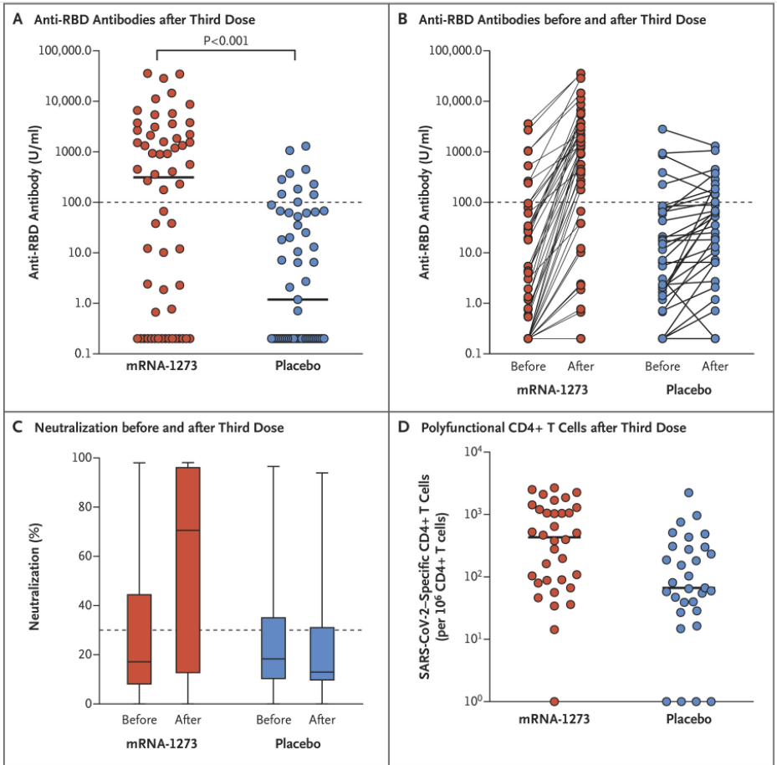
Solid horizontal lines = median values; dotted horizontal lines = pre-specified thresholds
Source: Hall et al., Figure 1³⁰.

Risk management plan
- The most recently evaluated EU-risk management plan (RMP) was version 2.1 (date 15 July 2021; data lock point (DLP) 31 May 2021) and Australia specific annex (ASA) 0.3 (date 5 August 2021). In support of the current submission, the sponsor has provided EU-RMP version 2.3 (date 28 October 2021; DLP 30 June 2021) and ASA version 1.1 (date 5 November 2021).
The summary of safety concerns and their associated risk monitoring and mitigation strategies are summarised in Table 23.Table 23: Summary of safety concerns
Summary of safety concerns |  | Pharmacovigilance |  | Risk Minimisation
 |  | Routine | Additional | Routine | Additional
Important identified risks | Anaphylaxis | * | † |  | –
Important identified risks | Myocarditis | * | † |  | –
Important identified risks | Pericarditis | * | † |  | –
Important potential risks | Vaccine-associated enhanced disease (VAED) including vaccine-associated enhanced respiratory disease (VAERD) | * | † | – | –
Missing information | Use in pregnancy and while breast-feeding |  | † |  | –
Missing information | Long-term safety |  | † | – | –
Missing information | Use in immunocompromised subjects |  | † |  | –
Missing information | Interaction with other vaccines |  | † |  | –
Missing information | Use in frail subjects with unstable health conditions and co-morbidities (e.g. chronic obstructive pulmonary disease (COPD), diabetes, chronic neurological disease, cardiovascular disorders) |  | † |  | –
Missing information | Use in subjects with autoimmune or inflammatory disorders |  | † |  | –
*Follow-up questionnaires. †Clinical studies
- This summary of safety concerns is the same as the summary that was evaluated and considered acceptable for the previous submission for Spikevax (elasomeran). The changes proposed by the current submission do not warrant changes to the summary of safety concerns from an RMP perspective.
- The pharmacovigilance plan was found to be acceptable during the previous evaluation and continues to be acceptable for the current submission. The acceptability of the clinical study plan submitted as part of the provisional approval pathway will be assessed by the clinical evaluator or Delegate.
- Only routine risk minimisation measures are currently in place. This approach was deemed acceptable during the previous evaluation. The changes proposed by the current submission do not warrant additional risk minimisation measures as part of the RMP.

Risk-benefit analysis

Delegate’s considerations
Recent evidence has raised concerns over the declining neutralising antibody titres or reduced effectiveness against symptomatic disease, which may significantly decrease the effectiveness against severe disease. In addition, emergence of the highly transmissible Delta variant of SARS-CoV-2 has resulted in a new wave of COVID-19 cases in many parts of the world, including the recent wave in Australia. It has led to considerations for administration of booster doses to individuals who received primary series of vaccines to enhance immunity, and thus sustain protection from COVID-19.
While currently authorised COVID-19 vaccines in Australia afford protection against severe COVID-19 and death, there are emerging data, primarily from observational studies, that suggest there is a decline in clinical efficacy (or efficacy versus the Delta variant) over time. An independent review of these data has not been conducted by the TGA.
The clinical data submitted in this application come from an ongoing Study P201 (Part A and B) and Study P301, which is also the source of clinical data supporting the original approval of the 2 dose primary series for use in individuals 12 years of age and older. The results for a 50 μg booster dose of Spikevax (mRNA-1273/elasomeran) given at approximately 6 to 8 months after Dose 2 show that higher neutralising titres are obtained after the booster dose compared to the second dose.
For the primary endpoints, there is statistically significant evidence of non-inferiority between geometric mean neutralising titres (as measured by geometric mean ratios) to the WT SARS-CoV-2 at 28 days post-Dose 3 (that is, following the booster) and one month post Dose 2 (that is, following the primary 2 dose vaccination course). While 87.9% (95% CI 81.6, 92.7) of 100 μg primed booster dose participants achieved at least a 4 fold rise in neutralising antibody titres, the difference in seroresponse rates (among 100 μg-primed participants) did not meet the pre-specified immunobridging success criterion. The lower limit of the 95% confidence interval for the difference in seroresponse rate (booster dose – primary series) was <-10% (-16.7% in those primed with 100 µg). Possible explanation of lower SRR following a third dose can be explained by residual higher levels of nAbs pre booster in Study P201 and by the fact that the response rates following a booster dose were compared to peak levels after the primary series in Study P301.
In post hoc analyses, participants with lower pre-booster nAbs titres were more likely to achieve a 4 fold rise in nAbs titres after booster vaccination compared to participants with higher pre-booster nAbs titres. Effectiveness of the booster dose against the Delta variant is inferred from exploratory descriptive analyses of ID₅₀ titres against this variant evaluated among booster dose recipients from Study P201 Part B.
Stratification according to age and primary vaccination dose reveals that lower antibody levels are elicited 28 days after booster in the age group ≥ 55 years compared to 18 to 55 years (GMT 100 μg: 1670 versus 2001) but that the increase in nAb levels from pre Dose 3 to post Dose 3 is higher for the older age cohort (GMR: 16.17 versus 12.85). This demonstrates that the older age group might still benefit from a booster dose due to more pronounced waning and good ability to booster the nAb response. Data on persistence of the antibody response following a third dose of 50 μg are missing to evaluate the durability of the lower booster dose.
There were also no data generated from participants < 18 years of age.
As to the appropriateness of 50 μg booster dose, as part of initial dose ranging of mRNA-1273 (Study P201 Part A), both 50 and 100 μg were evaluated. Both dosages induced substantial neutralising antibody. While the 100 μg dosage was advanced to the pivotal trial (Study P301), it was postulated that a 50 μg booster dose would be effective in briskly activating recall responses. The trend toward lower reactogenicity observed for the 50 μg dose in Study P201 Part A also supported this selection. Finally, there is precedence for a booster dose to be lower than the priming vaccine dose. For example, Tdap (tetanus, diphtheria, pertussis) vaccine, the booster for the diphtheria, tetanus, and acellular pertussis (DTaP) vaccine, has a reduced dose of the diphtheria and pertussis vaccines and is intended to boost the immunity that wanes after primary vaccination. The rationale to recommend the lower 50 μg dose for boosting seems to be supported also by the fact that this dose has had numerically better safety in the elderly compared to 100 μg.
To date, the reactogenicity and safety profile of the booster seems to be consistent with that observed following the primary series in Study P301, which included more than 30,000 study participants, and Study P201 Part A. No new unexpected safety concerns have been identified from a booster dose. Slight imbalances however, in unsolicited AEs have been noted related to the priming dose. The submitted data is also limited in terms of the numbers of vaccinees included in the study and the duration of follow up does therefore not allow any firm conclusions regarding the pattern and incidence of uncommon or rare AEs/SAEs.
Additional results from the ongoing Phase I DMID 21-0012 study, which has enrolled 154 participants who received heterologous prime series and a subsequent booster dose of 100 μg of mRNA-1273 further seem to support a similar reactogenicity and safety profile within the 7 days following the administration of the booster dose.
In the post-authorisation period, a total of 301,035,380 doses have been distributed worldwide. Rare cases of anaphylaxis, myocarditis, and pericarditis events have been reported during the post-authorisation period from healthcare professionals and spontaneously reported from patients. The risk of these events after a booster dose cannot be determined due to the sample size that can be achieved prior to an approval.
The sponsor has committed to the European Medicines Agency to amend Study P301 (known as the COVE trial, the pivotal efficacy and safety study) to administer the booster dose, after which participants will continue to be followed for breakthrough disease. The sponsor would also amend Study P901, the effectiveness study that is currently ongoing to follow effectiveness after the booster dose, which will also contribute extensive information on future protection against variant of concern (VOC).
Immunogenicity of Spikevax in immunocompromised (IC) patients was assessed in a randomised, placebo-controlled trial conducted in Canada and the study results were published by Hall et al., (2021).³¹ In this study, 243 IC patients were enrolled and of those 120 randomised to receive either a third dose of Spikevax or placebo, respectively, within 2 months. No control arm of healthy individuals was included. The trial was not planned with the usual standards of pivotal trials but was conducted and analysed seemingly in an acceptable manner. Although no correlate of protection is yet established, the immunogenicity data reported by Hall et al.,³¹ suggest that a third dose of Spikevax is able to elicit a pronounced antibody response in a substantial number of IC patients at risk for severe COVID-19. IC patients having received a third dose of Spikevax were compared to IC patients treated with placebo. Prior to the third dose, 11.7% in the vaccine group and 8.8% in the placebo group had anti-RBD-antibody titres ≥ 100 U/mL, an antibody response considered by the investigators as seropositive. The median anti-RBD titre reported for both groups was low with 0.37 U/mL (IQR: 0.2-27.64) for the Spikevax group and 0.44 U/mL (IQR: 0.2-18.19) for the placebo group. Following administration of a third dose of Spikevax a significant rise in antibodies was observed with 55% of the IC patients showing at least an antibody titre of 100 U/mL with a calculated absolute mean anti-RBD titre of 3145 U/mL (median: 313.8 U/mL, interquartile range (IQR): 0.2-2191). In the placebo group only 17.5% of IC patients had antibodies ≥100 U/mL and a GMC of 86 U/mL (median: 1.19 U/mL, IQR: 0.2-63.4) was reported.
Overall, the data submitted in this submission has shown that a 50 μg booster dose of Spikevax (mRNA-1273/elasomeran) given 6 months after the primary vaccination series restored waning neutralising titres against WT SARS-CoV-2 to significantly higher levels than seen following the primary vaccination course.
However, as there is no serological correlate of protection, the clinical relevance of restoring the waning titres is unknown. Therefore, while the immunogenicity and reactogenicity of a third dose have been appropriately characterised, the utility of a third dose has not been fully established. In addition, the risk of more rare and serious side effects such as myocarditis remains uncharacterised. Hence, the decision to implement a 50 μg booster dose of Spikevax (mRNA-1273/elasomeran) needs to be taken based on emerging epidemiological vaccine efficacy or effectiveness data in different age groups and given differing comorbidities, including immunosuppression.
The potential benefit in terms of increased duration of protection, and possibly increased protection against variants of concern has not been clearly demonstrated. However, in the view of the waning immune titres observed following the primary vaccination, it is likely that a 50 μg booster dose of Spikevax (mRNA-1273/elasomeran) in individuals aged 18 years and older will provide longer term protection based on experience with other vaccines, and the immunogenicity data available. Duration of the antibody responses following a 50 μg booster dose and the level of long-term protection are currently not known.

Proposed action
In summary, the benefit risk profile of a 50 μg booster dose of Spikevax (mRNA-1273) in individuals aged 18 years and older appears positive, provided its implementation is guided by vaccine effectiveness data and considering limited safety data.

Advisory Committee considerations
The Advisory Committee on Vaccines (ACV), having considered the evaluations and the Delegate’s overview, as well as the sponsor’s response to these documents, advised the following.

Specific advice to the Delegate
- Does the ACV agree that the immunogenicity and safety data support the administration of a 50 μg booster dose for adults aged 18 years and older?
The ACV advised that the current data support the administration of a 50 μg booster dose for adults aged 18 years and older.
The ACV commented that the submitted dataset is relatively limited and relies on immunobridging studies as a surrogate for efficacy.
The safety data provided by the sponsor were reassuring. The ACV noted higher reactogenicity observed with Spikevax compared to Comirnaty in US surveillance data. A higher rate of lymphadenopathy was observed in clinical trials of Spikevax than in the corresponding trials with Comirnaty. While an independent study suggested higher rates of reactogenicity with Spikevax boosters compared with Comirnaty boosters, particularly following Comirnaty primary courses, this study did not use the selected (half) dose and the booster was administered between 12-20 weeks, shorter than the proposed booster interval.
The ACV noted that the observed rate of myocarditis seen with Spikevax primary vaccination is higher in younger males than with Comirnaty in different surveillance systems. In this context, the ACV advised that close monitoring for myocarditis following a Spikevax booster will be important, in particular for young males and when using Spikevax as a booster following a Comirnaty primary course. As these data are rapidly accumulating, communications and guidance will need to be updated accordingly.
The ACV noted that the booster dose (50 μg) is half the dose of the primary doses (100 μg). The ACV strongly emphasised the importance of having clear communication regarding the different doses for the primary course (including third doses in immunocompromised individuals) compared with the booster dose in the labelling, prescribing software, product information and clinical guidance to avoid confusion.
- Advice on the booster dosing wording in the PI.
- Booster Dose
Individuals 18 years of age and older
Spikevax is administered intramuscularly as a single dose (0.25 mL) at least 6 months after completing a primary series.
- Interchangeability
Primary series
The interchangeability of Spikevax with other COVID-19 vaccines to complete the vaccination course has not been established.
Individuals who have received one dose of Spikevax (0.5 mL, 100 micrograms) should receive the second dose of Spikevax (0.5 mL, 100 micrograms) to complete the vaccination course.
Booster dose
A single booster dose of Spikevax (0.25 mL) may be administered as a heterologous booster dose following completion of primary vaccination with another authorised or approved COVID-19 vaccine.
The eligible population(s) and dosing interval for the heterologous booster dose are the same as those authorised for a booster dose of Spikevax.
The ACV recommended the following underlined modifications to the proposed PI wording for clarity and to align with other COVID-19 mRNA vaccines:
Booster Dose
Individuals 18 years of age and older
Spikevax is administered intramuscularly as a single booster dose (0.25 mL; 50 micrograms) at least 6 months after completing a primary series.
The decision when and for whom to implement a booster (third dose) of Spikevax should be made based on available vaccine safety and effectiveness data (see sections 4.4 Special warning and precautions for use and 5.1 Pharmacodynamic properties), in accordance with official recommendations.
Interchangeability
Primary series
The interchangeability of Spikevax with other COVID-19 vaccines to complete the vaccination course has not been established.
Individuals who have received one dose of Spikevax (0.5 mL, 100 micrograms) should receive the second dose of Spikevax (0.5 mL, 100 micrograms) to complete the vaccination course.
Booster dose
A single booster dose of Spikevax (0.25 mL; 50 micrograms) may be administered as a homologous (same brand) booster dose following completion of primary vaccination with Spikevax or as a heterologous booster dose following completion of primary vaccination with another authorised or approved COVID-19 vaccine.
The eligible population(s) and dosing interval for the heterologous booster dose are the same as those authorised for a booster dose of Spikevax.
- Does the ACV agree that data provided support the PI changes in relation to a third dose for immunocompromised patients at least 28 days after the primary series?
Immunocompromised individuals
A third dose of Spikevax (0.5 mL) administered at least 28 days following the first two doses of this vaccine is authorised for administration to individuals who have undergone solid organ transplantation, or who are diagnosed with conditions that are considered to have an equivalent level of immunocompromise.
The ACV advised that the proposed wording in the PI regarding a third primary dose for immunocompromised patients is appropriate and reflects the evidence from the clinical trial in individuals who have undergone solid organ transplant. The ACV noted that the dose interval between the second and third primary doses was 2 months and noted the limited data in younger immunocompromised individuals. The generalisability of this trial to other individuals at a similar level of immunocompromise is felt to be appropriate.
The ACV advised that ‘100 μg’ should be added after ‘0.5 mL’ to clearly highlight the different doses between the booster and the primary series.

Conclusion
The ACV recommended the approval of changes to the Product Information of Spikevax to include a booster (third) dose for persons 18 years and older, and information on dosage for immunocompromised persons over 12 years of age.

Outcome
Based on a review of quality, safety and efficacy, the TGA approved the registration of Spikevax (elasomeran) 0.2 mg/mL, suspension for injection, vial, indicated for the following extension of indications:
The provisionally approved full indication for the new Spikevax medicine, which is unchanged from that for the existing Spikevax medicine is:
Spikevax (elasomeran) COVID-19 Vaccine has provisional approval for the indication below:
Active immunisation to prevent coronavirus disease 2019 (COVID-19) caused by SARS-CoV-2 in individuals 12 years of age and older.
The use of this vaccine should be in accordance with official recommendations.
The decision has been made on the basis of short-term efficacy and safety data. Continued approval depends on the evidence of longer term efficacy and safety from ongoing clinical trials and post-market assessment.

Specific conditions of registration applying to these goods
- Spikevax (elasomeran) COVID-19 vaccine is to be included in the Black Triangle Scheme. The PI and CMI for Spikevax must include the Black triangle symbol and mandatory accompanying text for the entire period of provisional registration.
- The Spikevax European Union (EU)-Risk Management Plan (RMP) (version 2.3, date 28 October 2021; DLP 30 June 2021), with Australian Specific Annex (version 1.1, 5 November 2021), included with submission PM-2021-05131-1-2, and any subsequent revisions, as agreed with the TGA will be implemented in Australia.
An obligatory component of risk management plans is routine pharmacovigilance. Routine pharmacovigilance includes the submission of periodic safety update reports (PSURs).
Reports are to be provided in line with the current published list of EU reference dates and frequency of submission of PSURs until the period covered by such reports is not less than three years from the date of this approval letter, or the entire period of provisional registration, whichever is longer.
The reports are to at least meet the requirements for PSURs as described in the European Medicines Agency’s Guideline on good pharmacovigilance practices (GVP) Module VII-periodic safety update report (Rev 1), Part VII.B Structures and processes. Note that submission of a PSUR does not constitute an application to vary the registration.
Additional to the routine submission of the routine PSURs, expedited monthly, Spikevax safety summary reports (including safety data for patients in Australia) are to be provided for the first 6 months post registration, and thereafter at intervals specified by the TGA.
- Clinical
Existing Conditions for adolescent data
The following reports/data will have to be submitted before a definitive authorisation can be considered:
  - Submit safety data for all adolescents 12 to 17 years of age in Study P203, 6 months post Dose 2, when the data become available.
  - Submit clinical study report of Study P203 (interim and final), including data up to 24 months after Dose 2 in adolescents 12 to17 years of age, when the data become available.
  - Submit safety data in relation to follow-up at 6 months post Dose 2 for all original Spikevax recipients and at 6 months post Dose 4 for original placebo recipients subsequently vaccinated with Spikevax, when the analysis is available.
Existing Conditions for adult data
The following reports/data will have to be submitted before a definitive authorisation can be considered:
  - Submit safety analysis at 6 months post Dose 2 from Study Phase 1 and, 2 Study when the analysis is available.
  - Submit the clinical study report for Study P301 (Phase 3) and Study P201 (Phase 2) when ready. Please also submit the final report for these studies with 24 months follow up duration when it became available.
  - Submit the immunogenicity data for Study 301.
- When available, the sponsor to please provide:
  - Further data relating to vaccine efficacy against asymptomatic disease, efficacy against SARS-CoV-2 transmission, vaccine efficacy in immunocompromised subjects, efficacy in subjects with autoimmune conditions, efficacy against variants of concern, pregnant women, lactating mothers, and information relating to post-market safety and effectiveness studies should be provided to the TGA to update the Product information.
  - Please also provide Real world post market global/local efficacy data, when available.
- Confirmatory trial data (as identified in the sponsor’s plan to submit comprehensive clinical data on the safety and efficacy of the medicine before the end of the 6 years that would start on the day that registration would commence) must be provided.
Further guidance for sponsors is available on the TGA website.
- Quality
Batch release testing and compliance
Batch release testing and compliance with the certified product details conditions of provisional registration for Spikevax
  - It is a condition of registration that all independent batches of Spikevax elasomeran COVID-19 VACCINE 0.2 mg/mL suspension for injection vial imported into Australia are not released for supply by or on behalf of the sponsor until samples and the manufacturer’s release data have been assessed and you have received notification acknowledging release from the Laboratories Branch, TGA.
  - For each independent batch of the product imported into Australia, the sponsor must supply the following:
  - A completed Request for Release Form, available from vaccines@health.gov.au.
  - Complete summary protocols for manufacture and QC, including all steps in production in the agreed format.
  - At least 10 (ten) vials (Samples) of each manufacturing batch of Spikevax elasomeran 0.2 mg/mL suspension for injection vial with the Australian approved labels, PI and packaging (unless an exemption to supply these has been granted) representative of all batches of product seeking distribution in Australia.
  - At least 5 (five) vials (Samples) of any further consignments of a manufacturing batch of Spikevax elasomeran 0.2 mg/mL suspension for injection vial with the Australian approved labels, PI and packaging (unless an exemption to supply these has been granted). Further consignments cover batches previously supplied to TGA for the purposes of batch release testing but are seeking to be supplied again.
  - If the manufacturing batch has been released in Europe or United Kingdom a copy of the EU Official Control Authority Batch Release (OCABR) certificate (or equivalent from the UK) must be provided.
  - Any reagents, reference material and standards required to undertake testing, as requested by Laboratories Branch, TGA.
  - The sponsors must provide all requested samples and data in sufficient time (at least 5 business days) prior to any distribution date to allow the TGA to perform testing and review. Distribution of each batch of vaccine is conditional upon fulfilment of these conditions and receipt of a letter from the Laboratories Branch acknowledging release.
  - Samples and data should be forwarded to the Biotherapeutics Section, Laboratories Branch before release of each batch and with sufficient lead time to allow for Laboratories Branch testing. The address for courier delivery is:
Certified Product Details
An electronic copy of the Certified Product Details (CPD) as described in Guidance 7: Certified Product Details of the Australian Regulatory Guidelines for Prescription Medicines (ARGPM) https://www.tga.gov.au/guidance-7-certified-product-details should be provided upon registration of the therapeutic good. In addition, an updated CPD, for the above products incorporating the approved changes is to be provided within one month of the date of approval letter. A template for preparation of CPD for biological prescription medicines and Vaccines can be obtained from the TGA website https://www.tga.gov.au/form/certified-product-details-cpd-biological-prescriptionmedicines]. The CPD should be sent as a single bookmarked PDF document to Vaccines@health.gov.au as soon as possible after registration/approval of the product or any subsequent changes as indicated above.
- For all injectable products the PI must be included with the product as a package insert.

Attachment 1. Product Information
The PI for Spikevax approved with the submission which is described in this AusPAR is at Attachment 1. For the most recent PI, please refer to the TGA website at <https://www.tga.gov.au/product-information-pi>.

Therapeutic Goods Administration
PO Box 100 Woden ACT 2606 Australia
Email: info@tga.gov.au Phone: 1800 020 653 Fax: 02 6232 8605
https://www.tga.gov.au

The Black Triangle Scheme provides a simple means for practitioners and patients to identify certain types of new prescription medicines, including those being used in new ways and to encourage the reporting of adverse events associated with their use. The Black Triangle does not denote that there are known safety problems, just that the TGA is encouraging adverse event reporting to help us build up the full picture of a medicine's safety profile.
The Product Information (PI) document provides health professionals with a summary of the scientific information relevant to the safe and effective use of a prescription medicine. The information in a product information document has been written by the pharmaceutical company responsible for the medicine and has been approved by the TGA. It provides objective information about the quality, safety and effectiveness of the medicine, as demonstrated in the data provided to the TGA by the pharmaceutical company. This information is intended to assist doctors, pharmacists and other health professionals in prescribing and dispensing medicines. In addition, this information can be used by health professionals in their consultations with patients, so that the patient can be better informed about their medicines.
Zhu, N. et al. A Novel Coronavirus from Patients with Pneumonia in China, 2019, N. Engl. J. Med, 2020; 382(8): 727-733.
CDC, 2020. (last viewed 8 November 2021)
Li, Q., Guan, X, Wu, P., et al. Early Transmissions Dynamics in Wuhan, China, of Novel Coronavirus-Infected Pneumonia. N Engl J Med 2020; 382:1199-1207
Huang, C., Wang, Y., Li, X., et al. Clinical features of patients infected with 2019 novel coronavirus in Wuhan, China, Lancet 2020; 395: 497-506.
WHO dashboard https://covid19.who.int/
Fang X, Li S, Yu H, et al. Epidemiological, comorbidity factors with severity and prognosis of COVID-19: a systematic review and meta-analysis. Aging (Albany NY). 2020; 12 (13): 12493-503.
World Health Organisation (WHO;2020) WHO Director-General Speeches: WHO Director-General’s Opening Remarks at the Media Briefings on COVID-19- 11 March 2020. Accessed 28 October 2021. Available from the WHO website.
World Health Organisation (WHO), Coronavirus Disease (COVID-19) Dashboard. Accessed 8 December 2021. Available from the WHO website.
Australian Government, Department of Health (last updated 7 December 2021) Coronavirus (COVID-19) Case Numbers and Statistics. Accessed 8 December 2021. Available at: Coronavirus (COVID-19) case numbers and statistics | Australian Government Department of Health
As part of the provisional approval pathway, the provisional registration process will allow certain medicines to be provisionally registered in the Australian Register of Therapeutic Goods (ARTG) for a limited duration. These medicines are registered on the basis of preliminary clinical data, where there is the potential for a substantial benefit to Australian patients. The TGA will re-assess risks related to the absence of evidence through data provided at a later stage, as part of the confirmatory data. Confirmatory data should confirm the relationship between outcomes predicted by the surrogate endpoint, or other preliminary data, and the clinical benefit as demonstrated by direct clinical outcomes. The sponsor may apply to transition to full registration at any time up until the provisional registration lapse date, once they have completed the obligations outlined for the provisional registration period and complete confirmatory data on safety and efficacy are available.
Comirnaty was first registered on the ARTG on 25 January 2021 (ARTG number: 346290).
AusPAR for Comirnaty (BNT162b2 (mRNA)) new biological entity, published on 25 January 2021. Available at: https://www.tga.gov.au/auspar/auspar-bnt162b2-mrna-comirnaty
AusPAR for Comirnaty (BNT162b2 (mRNA)) extension of indications, published on 23 July 2021. Available at: https://www.tga.gov.au/auspar/auspar-bnt162b2-mrna.
COVID-19 Vaccine AstraZeneca was first registered on the ARTG on 16 February 2021 (ARTG number: 349072).
AusPAR for COVID-19 Vaccine AstraZeneca (ChAdOx1-S) new biological entity, published on 16 February 2021. Available at: https://www.tga.gov.au/auspar/auspar-chadox1-s.
COVID-19 Vaccine Janssen was first registered on the ARTG on 25 June 2021 (ARTG number: 350150).
7 AusPAR for COVID-19 Vaccine Janssen (Ad26.COV2.S) new biological entity, published on 25 June 2021. Available at: https://www.tga.gov.au/auspar/auspar-ad26cov2s.
Spikevax was first registered on the ARTG on 9 August 2021 (ARTG number: 370599).
AusPAR for Spikevax (elasomeran) new biological entity, adult indication, published on 9 August 2021. Available at: https://www.tga.gov.au/auspar/auspar-elasomeran.
AusPAR for Spikevax (elasomeran) new biological entity, paediatric indication, published on 4 September 2021. Available at: https://www.tga.gov.au/auspar/auspar-elasomeran-0.
Australian Government, Department of Health (last updated 24 November 2021) Coronavirus (COVID-19) Vaccination numbers and statistics. Accessed 24 November 2021. Available at: Vaccination numbers and statistics | Australian Government Department of Health
World Health Organisation (last updated 4 October 2021) Interim statement on booster doses for COVID-19 vaccination. Accessed 25 November 2021. Available at: Interim statement on booster doses for COVID-19 vaccination (who.int)
Therapeutic goods must be entered in the Australian Register of Therapeutic Goods (ARTG) before they can be lawfully supplied in or exported from Australia, unless exempt from being entered in the ARTG, or otherwise authorised by the TGA. For further information visit: Australian Register of Therapeutic Goods | Therapeutic Goods Administration (TGA)
AusPAR for Spikevax (elasomeran) new biological entity, published on 9 August 2021. Available at: Australian public assessment report for Elasomeran (tga.gov.au)
mRNA-1273 refers to the vaccine development name for the Moderna Spikevax (elasomeran) COVID-19 vaccine
Spikevax (elasomeran) AusPAR https://www.tga.gov.au/auspar/auspar-elasomeran
Riester, E ,Majchrzak, M, Mühlbacher A et al (2021). Multicentre Performance Evaluation of the Elecsys Anti-SARS-CoV-2 Immunoassay as an Aid in Determining Previous Exposure to SARS-CoV-2 Infect Dis Ther 2021 Dec;10(4):2381-2397.Epub 2021 Aug 9.
Routine risk minimisation activities may be limited to ensuring that suitable warnings are included in the product information or by careful use of labelling and packaging. Routine pharmacovigilance practices involve the following activities: - All suspected adverse reactions that are reported to the personnel of the company are collected and collated in an accessible manner; - Reporting to regulatory authorities; - Continuous monitoring of the safety profiles of approved products including signal detection and updating of labelling; - Submission of PSURs; - Meeting other local regulatory agency requirements.
AusPAR for Spikevax (elasomeran) new biological entity, published on 4 September 2021. Available at: Australian Public Assessment Report for Elasomeran (tga.gov.au)
The Advisory Committee on Vaccines (ACV) provides independent medical and scientific advice to the Minister for Health and the Therapeutic Goods Administration (TGA) on issues relating to the safety, quality and efficacy of vaccines supplied in Australia including issues relating to pre-market assessment, post-market monitoring and safe use in national immunisation programs. The Committee is established under Regulation 39F of the Therapeutic Goods Regulations 1990 and the members are appointed by the Minister for Health. The ACV was established in January 2017, following consolidation of previous functions of the Advisory Committee on the Safety of Vaccines (ACSOV) and the pre-market functions for vaccines of the Advisory Committee on Prescription Medicines (ACPM). Membership comprises professionals with expertise in specific scientific, medical or clinical fields, or consumer health issues.

