February 2022

Australian Public Assessment Report for Elasomeran
  - Proprietary Product Name: Spikevax
  - Sponsor: Moderna Australia Pty Ltd

About the Therapeutic Goods Administration (TGA)
- The Therapeutic Goods Administration (TGA) is part of the Australian Government Department of Health and is responsible for regulating medicines and medical devices.
- The TGA administers the Therapeutic Goods Act 1989 (the Act), applying a risk management approach designed to ensure therapeutic goods supplied in Australia meet acceptable standards of quality, safety and efficacy (performance) when necessary.
- The work of the TGA is based on applying scientific and clinical expertise to decision-making, to ensure that the benefits to consumers outweigh any risks associated with the use of medicines and medical devices.
- The TGA relies on the public, healthcare professionals and industry to report problems with medicines or medical devices. TGA investigates reports received by it to determine any necessary regulatory action.
- To report a problem with a medicine or medical device, please see the information on the TGA website <https://www.tga.gov.au>.

About AusPARs
- An Australian Public Assessment Report (AusPAR) provides information about the evaluation of a prescription medicine and the considerations that led the TGA to approve or not approve a prescription medicine submission.
- AusPARs are prepared and published by the TGA.
- An AusPAR is prepared for submissions that relate to new chemical entities, generic medicines, major variations and extensions of indications.
- An AusPAR is a static document; it provides information that relates to a submission at a particular point in time.
- A new AusPAR will be developed to reflect changes to indications and/or major variations to a prescription medicine subject to evaluation by the TGA.

Copyright
© Commonwealth of Australia 2022
This work is copyright. You may reproduce the whole or part of this work in unaltered form for your own personal use or, if you are part of an organisation, for internal use within your organisation, but only if you or your organisation do not use the reproduction for any commercial purpose and retain this copyright notice and all disclaimer notices as part of that reproduction. Apart from rights to use as permitted by the Copyright Act 1968 or allowed by this copyright notice, all other rights are reserved and you are not allowed to reproduce the whole or any part of this work in any way (electronic or otherwise) without first being given specific written permission from the Commonwealth to do so. Requests and inquiries concerning reproduction and rights are to be sent to the TGA Copyright Officer, Therapeutic Goods Administration, PO Box 100, Woden ACT 2606 or emailed to <tga.copyright@tga.gov.au>.

Contents
List of abbreviations 4
I. Introduction to product submission 7
Submission details 7
Product background 9
Regulatory status 11
Product Information 11
II. Registration timeline 11
III. Submission overview and risk/benefit assessment 12
Quality 13
Nonclinical 13
Clinical 13
Risk management plan 40
Risk-benefit analysis 42
Outcome 63
Attachment 1. Product Information 64

List of abbreviations
Abbreviation | Meaning
ACIP | Advisory Committee on Immunization Practices (United States of America)
ACV | Advisory Committee on Vaccines
AE | Adverse event
AESI | Adverse event of special interest
AR | Adverse reaction
ARTG | Australian Register of Therapeutic Goods
ASA | Australia specific annex
ATAGI | Australian Technical Advisory Group on Immunisation
bAb | Binding antibody
CBER | Center for Biologics Evaluation and Research (United States of America)
CDC | Centers for Disease Control and Prevention (United States of America)
CHMP | Committee for Medicinal Products for Human Use (European Union)
CI | Confidence interval
CMI | Consumer Medicines Information
COVID-19 | Coronavirus disease 2019
DLP | Data lock point
DSMB | Data safety monitoring board
EMA | European Medicines Agency (European Union)
EMEA | European Medicines Evaluation Agency (European Union)
FDA | Food and Drug Administration (United States of America)
GCP | Good Clinical Practice
GM | Geometric mean
GMFR | Geometric mean fold rise
GMT | Geometric mean titre
GMR | Geometric mean ratio
GVP | Good Pharmacovigilance Practices
ICH | International Council for Harmonisation
ICU | Intensive care unit
ID₅₀ | 50% inhibitory dose
IL-2 | Interleukin 2
IP | Investigational product
LLOQ | Lower limit of quantification
MAAE | Medically attended adverse event
MedDRA | Medical Dictionary for Regulatory Activities
MIS-C | Multisystem inflammatory syndrome in children
mITT1 | Modified intent-to-treat 1
mRNA | Messenger ribonucleic acid
mRNA-1273 | Spikevax (elasomeran) COVID-19 vaccine drug development name
MSD | Meso Scale Discovery
N | N-terminal
nAb | Neutralising antibody
PEG | Polyethylene glycol
PI | Product Information
PIMS-TS | Paediatric multisystem inflammatory syndrome - temporally associated with SARS-CoV-2
PP | Per-protocol
PT | Preferred Term
PSUR | Periodic safety update report
PsVNA | Pseudotyped virus neutralisation assay
PRAC | Pharmacovigilance Risk Assessment Committee (European Union)
RBD | Receptor binding domain
RMP | Risk management plan
RT-PCR | Reverse transcription-polymerase chain reaction
S | Spike
SAE | Serious adverse event
SAP | Statistical analysis plan
SARS-CoV-2 | Severe acute respiratory syndrome coronavirus 2
SFU | Spot-forming units
SMQ | Standardised Medical Dictionary for Regulatory Activities Queries
SOC | System Organ Class
SRR | Seroresponse rate
Study P203 | Study mRNA-1273-P203
Study P204 | Study mRNA-1273-P204
Study P301 | Study mRNA-1273-P301
TEAE | Treatment emergent adverse event
TGA | Therapeutic Goods Administration
US(A) | United States (of America)
VE | Vaccine efficacy
VRBPAC | Vaccines and Related Biological Products Advisory Committee (United States of America)
WHO | World Health Organization

I. Introduction to product submission

Submission details
Type of submission: | Extension of indications
Product name: | Spikevax
Active ingredient: | Elasomeran
Decision: | Approved for provisional registration
Date of decision: | 17 February 2022
Date of entry onto ARTG: | 22 February 2022
ARTG number: | 370599
Black Triangle Scheme: | Yes.  As a provisionally registered product, this medicine will remain in the Black Triangle Scheme for the duration of its provisional registration.
Sponsor’s name and address: | Moderna Australia Pty Ltd  Level 6, 60 Martin Place  Sydney, NSW, 2000
Dose form: | Suspension for injection
Strength: | 0.2 mg/mL
Container: | Vial
Pack size: | 10 x 5 mL-dose vials
Approved therapeutic use: | Spikevax (elasomeran) COVID-19 vaccine has provisional approval for the indication below:  Active immunisation to prevent coronavirus disease 2019 (COVID-19) caused by SARS-CoV-2 in individuals 6 years of age and older.  The use of this vaccine should be in accordance with official recommendations.  The decision has been made on the basis of short-term efficacy and safety data. Continued approval depends on the evidence of longer term efficacy and safety from ongoing clinical trials and post-market assessment.
Route of administration: | Intramuscular
Dosage: | Primary series  Individuals 12 years of age and older  Spikevax is administered as a course of 2 doses (0.5 mL each).  Individuals 6 through 11 years of age  Spikevax is administered as a course of 2 doses (0.25 mL each).  It is recommended to administer the second dose 28 days after the first dose (see Section 4.4 Special warnings and precautions for use and Section 5.1 Pharmacodynamic properties of the Product Information).  Immunocompromised individuals  A third dose of Spikevax (0.5 mL) administered at least 28 days following the first two doses of this vaccine is authorised for administration to individuals who have undergone solid organ transplantation, or who are diagnosed with conditions that are considered to have an equivalent level of immunocompromise.  Booster dose  Individuals 18 years of age and older  Spikevax is administered intramuscularly as a single booster dose (0.25 mL; 50 µg) at least 6 months after completing a primary series.  The decision when and for whom to implement a booster (third dose) of Spikevax should be made based on available vaccine safety and effectiveness data (see Sections 4.4 Special warning and precautions for use and Section 5.1 Pharmacodynamic properties of the Product Information), in accordance with official recommendations.  For further information regarding dosage (including the interchangeability of Spikevax with other COVID-19 vaccines), refer to the Product Information.
Pregnancy category: | B1  Drugs which have been taken by only a limited number of pregnant women and women of childbearing age, without an increase in the frequency of malformation or other direct or indirect harmful effects on the human fetus having been observed.  Studies in animals have not shown evidence of an increased occurrence of fetal damage.  The use of any medicine during pregnancy requires careful consideration of both risks and benefits by the treating health professional. This must not be used as the sole basis of decision making in the use of medicines during pregnancy. The TGA does not provide advice on the use of medicines in pregnancy for specific cases. More information is available from obstetric drug information services in your State or Territory.

Product background
This AusPAR describes the application by Moderna Australia Pty Ltd (the sponsor) to register Spikevax (elasomeran) COVID-19 vaccine, 0.2 mg/mL, suspension for injection for the following proposed extension of indications:
Spikevax (elasomeran) COVID-19 vaccine has provisional approval for the indication below:
Active immunisation to prevent coronavirus disease 2019 (COVID-19) caused by SARS-CoV-2 in individuals 6 years of age and older.
The use of this vaccine should be in accordance with official recommendations.
The decision has been made on the basis of short-term efficacy and safety data. Continued approval depends on the evidence of longer term efficacy and safety from ongoing clinical trials and post-market assessment.
Severe acute respiratory syndrome coronavirus 2 (SARS-CoV-2) is an enveloped, positive sense, single stranded ribonucleic acid beta-coronavirus. SARS-CoV-2 has spread globally since its emergence, causing coronavirus disease 2019 (COVID-19). The World Health Organization (WHO) declared that the outbreak constituted a public health emergency of international concern on 30 January 2020; and declared the outbreak to be a pandemic on 11 March 2020. COVID-19 is predominantly a disease affecting the respiratory system, but can affect other organ systems. People with COVID-19 have reported a wide range of symptoms, ranging from mild symptoms to severe illness. Symptoms may appear between 2 to 14 days after exposure to the virus and may include any combination of the following: fever or chills; cough; shortness of breath; fatigue; muscle or body aches; headache; new loss of taste or smell; sore throat; congestion or runny nose; nausea or vomiting; or diarrhoea.
Severe illness requiring hospitalisation, admission to the intensive care unit (ICU), the need for intubation or mechanical ventilation, or death, can occur in adults of any age with COVID-19. Adults of any age with certain underlying comorbidities such as cancer, chronic kidney disease, chronic obstructive pulmonary disease, obesity, Type 2 diabetes, and immunocompromised states, as well as women who are pregnant, are at increased risk for developing severe illness from the virus that causes COVID-19. Other medical conditions or factors also make certain individuals at high risk for progression to severe disease.
Following suppression of the initial outbreak in early 2020, the situation in Australia has been characterised by periods of zero community transmission, interspersed with sporadic outbreaks caused by escape of the virus from the hotel quarantine system that has been used for returning overseas travellers. In Australia, there have been over 2.6 million cases and 4,913 deaths reported in Australia as of 20 February 2022.
In Australia, as at 16 January 2022, there had been 45,954,013 doses of COVID-19 vaccine administered in Australia. Nationally, 19,597,960 people aged 16 years or over (92.9%) had received at least one dose, including 19,082,286 people aged 16 and over (92.5%) who were fully vaccinated. However, the vaccine rollout for younger individuals have been limited as the vaccine rollout to < 12 years old has only started from January 2022. As at 16 January 2022, among people aged 12 to 15 years, 1,012,626 people (81.4%) had received at least one dose, including 933,566 (75%) who were fully vaccinated. Among people aged 5 to 11 years, 295,106 (12.9%) had received at least one dose.
There are currently four vaccines on the Australian Register of Therapeutic Goods (ARTG), and all are approved under the provisional pathway:
  - Comirnaty (BNT162b2 (mRNA) or tozinameran), the Pfizer/BioNTech messenger ribonucleic acid (mRNA) vaccine, provisionally approved for active immunisation to prevent COVID-19 caused by SARS-CoV-2, in individuals 5 years of age and older.,,,
  - COVID-19 Vaccine AstraZeneca (ChAdOx1-S), an adenoviral vectored vaccine, provisionally approved for active immunisation to prevent COVID-19 caused by SARS-CoV-2, in individuals 18 years of age and older.,
  - COVID-19 Vaccine Janssen (Ad26.COV2.S), an adenoviral vectored vaccine, provisionally approved for active immunisation to prevent COVID-19 caused by SARS-CoV-2, in individuals 18 years of age and older.,
  - Spikevax (elasomeran) COVID-19 vaccine, the Moderna mRNA vaccine, provisionally approved for active immunisation to prevent COVID-19 caused by SARS-CoV-2, in individuals 12 years of age and older.,,
Spikevax (elasomeran) COVID-19 vaccine is comprised of synthetic mRNA encoding the full-length SARS-CoV-2 spike protein modified with two proline substitutions within the heptad repeat 1 domain to stabilise the spike protein into a prefusion conformation. The mRNA is encapsulated in lipid nanoparticles, a delivery system that enables the mRNA to enter into host cells. Once the vaccine is injected, cells at the injection site and the draining lymph nodes take up the lipid nanoparticle containing the mRNA and deliver it into host cells for expression into a protein chain that resembles the virus’ spike protein. This elicits host’s antibody and cellular immune responses, which may contribute to protection against COVID-19.

Regulatory status
The product received initial registration on the Australian Register of Therapeutic Goods (ARTG) on 9 August 2021 for the below indication.
Spikevax (elasomeran) COVID-19 vaccine has provisional approval for the indication below:
Active immunisation to prevent coronavirus disease 2019 (COVID-19) caused by SARS-CoV-2 in individuals 18 years of age and older.
The use of this vaccine should be in accordance with official recommendations.
The decision has been made on the basis of short-term efficacy and safety data. Continued approval depends on the evidence of longer term efficacy and safety from ongoing clinical trials and post-market assessment.
At the time the TGA considered this application, a similar application was under consideration in the European Union (submitted on 8 November 2021).

Product Information
The Product Information (PI) approved with the submission which is described in this AusPAR can be found as Attachment 1. For the most recent PI, please refer to the TGA website at <https://www.tga.gov.au/product-information-pi>.

II. Registration timeline
The following table captures the key steps and dates for this application and which are detailed and discussed in this AusPAR.
Data were provided as part of a rolling submission. Under normal circumstances, the TGA's assessment (for both provisional and general registration) begins once all information to support registration is available. As part of the Department of Health's response to the pandemic, the TGA has agreed to accept rolling data for COVID-19 vaccines and treatments, to enable early evaluation of data as it comes to hand.
In the assessment of the application described in this report, consideration for approval was discussed in two separate meetings of Advisory Committee for Vaccines (ACV).³⁵ As a result of being discussed in these two ACV meetings, two Delegate’s Overviews were prepared, one for each meeting.
Table 1: Timeline for Submission PM-2021-05269-1-2
Description | Date
Determination (Provisional)⁶ | 9 November 2021
Submission dossier accepted and first round evaluation commenced | 25 November 2021
Evaluation completed | 17 December 2021
Delegate’s Overall benefit-risk assessment and request for Advisory Committee advice | 17 December 2021  28 January 2022
Sponsor’s pre-Advisory Committee response | 20 December 2021  3 February 2022
Advisory Committee meeting | 22 December 2021  8 February 2022
Registration decision (Outcome) | 17 February 2022
Completion of administrative activities and registration on the ARTG | 22 February 2022
Number of working days from submission dossier acceptance to registration decision* | 54
*Statutory timeframe for standard applications is 255 working days

III. Submission overview and risk/benefit assessment
The submission was summarised in the following Delegate’s overview and recommendations.
Relevant guidelines or guidance documents referred to by the Delegate are listed below:
- European Medicines Evaluation Agency (EMEA), Committee for Medicinal Products for Human Use (CHMP), Guideline on Clinical Evaluation of New Vaccines, EMEA/CHMP/VMP/164653/2005, 18 October 2006.
- Therapeutic Goods Administration (TGA) (2021) Access Consortium Statement on COVID-19 Vaccines Evidence. Available at: https://www.tga.gov.au/access-consortium-statement-covid-19-vaccines-evidence (accessed 21 December 2021).
- Food and Drug Administration (FDA), Center for Biologics Evaluation and Research (CBER), Emergency Use Authorization for Vaccines to Prevent COVID-19, Guidance for Industry, February 2021. Available from the FDA website.
- Food and Drug Administration (FDA), Center for Biologics Evaluation and Research (CBER), Development and Licensure of Vaccines to Prevent COVID-19, Guidance for Industry, June 2020. Available from the FDA website.
- European Medicines Agency (EMA), Committee for human medicinal products (CHMP), EMA considerations on COVID-19 vaccine approval, EMA/592928/2020, 16 November 2020.

Quality
There was no requirement for a quality evaluation in a submission of this type.
A full quality evaluation was conducted at the time this product received initial registration.

Nonclinical
There was no requirement for a nonclinical evaluation in a submission of this type.
A full nonclinical evaluation was conducted at the time this product received initial registration.

Clinical
The current application is to extend the current indication to include children between the ages of 6 through 11 years. To support this extended population, the sponsor submitted a clinical overview, the study protocol with a number of amendments, a statistical analysis plan, tables and figures from Study mRNA-1273-P204 with the data snapshot date of 6 October 2021. The data package submitted to the TGA is identical to that submitted to the EMA on 9 November 2021.
The sponsor stated in the clinical overview that the clinical protocol and study design elements of Study mRNA 1273-P204 were developed in collaboration with the United States (US) National Institutes of Health and conducted in accordance with consensus ethical principles derived from international guidelines including principles provided by the World Medical Association Declaration of Helsinki, as well as guidelines described in the Council for International Organizations of Medical Sciences International Ethical Guidelines and applicable International Council for Harmonisation (ICH); Good Clinical Practice (GCP); Guidelines.
Contrary to the Comirnaty (Pfizer/BioNTech) vaccine,⁸ Spikevax has the same formulation for adults and children between 6 to < 12 years old. The dose chosen for those aged between 6 to < 12 years is the same as the booster dose with no dilution required. Using half of the regular adult dose with the same formulation means that 20 doses (instead of 10) can be pulled out of one vial.

Study mRNA 1273-P204

Overall study design
Study mRNA 1273-P204 (hereafter referred to as Study P204) is a Phase II/III, two-part, open label, dose escalation, age de-escalation, randomised, observer blind, placebo controlled, expansion study intended to infer the effectiveness of mRNA-1273 (the Spikevax (elasomeran) COVID-19 vaccine drug development name) in children aged from 6 months to < 12 years. The study population is divided into 3 age groups (6 to < 12 years; 2 to < 6 years; and 6 months to < 2 years of age). For the current submission, the available data on the 6 to < 12 years of age cohort is submitted.
Study P204 is being conducted in two parts. In Part 1, participants received mRNA-1273 in an open label and dose escalation fashion. Safety and immunogenicity data from Part 1 for each age group are reviewed to select the preferred dose for each age group (50 μg and 100 μg dose levels were explored in children 6 to < 12 years of age). Part 2 of the study is a placebo controlled, observer blind, randomised (in a 3:1, mRNA-1273 to placebo ratio) evaluation of the selected dose in up to 4000 participants in each of the three age groups (for a total of up to 12,000 children in Study P204). No participants in Part 1 will participate in Part 2 of the study.
The study begins with the oldest age group (6 to < 12 years) and the age groups subsequently de-escalate. Each age group will begin with Part 1 and advance to Part 2 after dose selection in Part 1 is done. The mRNA-1273 vaccine or placebo will be given as two intramuscular injections approximately 28 days apart.
The mRNA-1273 dose levels that will be evaluated in each age group in Part 1 and Part 2 are given in Table 2 below. Both the 2 to <6 year and 6 months to < 2 year age group will receive the 25 μg dose.
Table 2: Study P204 Part 1 and Part 2 Planned age groups and mRNA-1273 dose levels
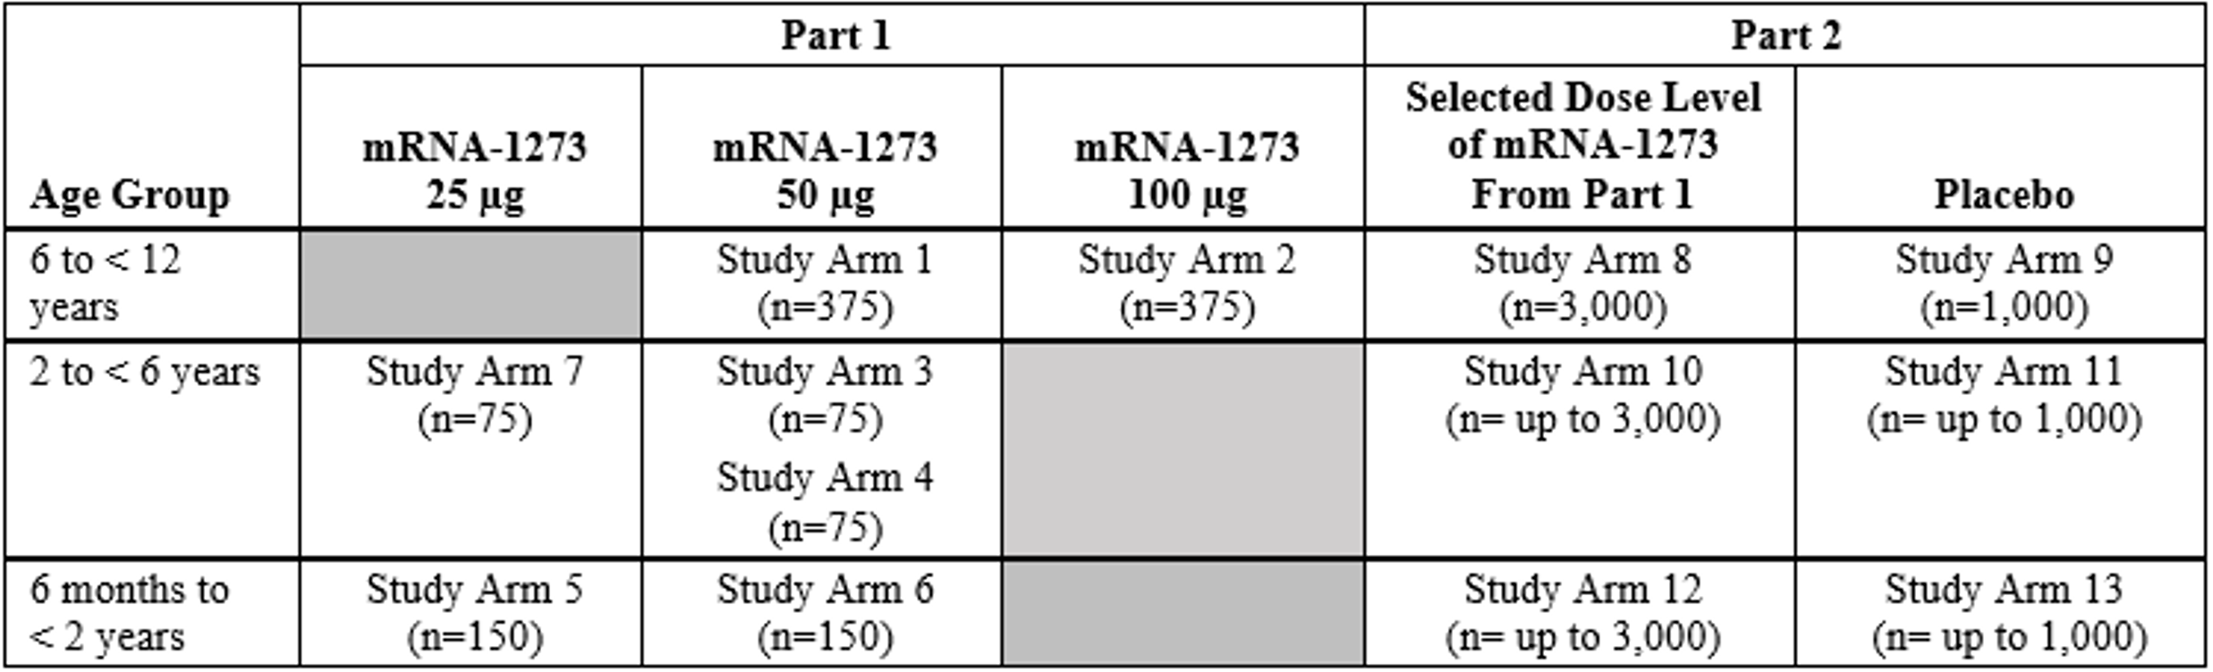
mRNA-1273 = Spikevax COVID-19 vaccine; n = sample size.
Investigational product (IP) refers to mRNA-1273 (25, 50, and 100 μg) vaccine (the study vaccine) or placebo (0.9% sodium chloride) in this study. Each participant will receive two doses of the study vaccine by intramuscular injection approximately 28 days apart (Day 1 and Day 29) into the deltoid muscle or anterolateral thigh (per investigator’s discretion).
The original protocol is dated 24 February 2021. There have been five study amendments. These amendments were considered not of a nature to impact the study results. Main changes included additional data safety monitoring board (DSMB) requirements for children under 6 years of age and an increase in sample sizes to detect adverse events (AEs) that are less frequent.

Study objectives
The primary objectives of Study P204 are:
- to evaluate the safety and reactogenicity of 2 doses of mRNA-1273, 28 days apart in each age group; and
- to infer the effectiveness of the selected dose level in each age group based on noninferiority of neutralising antibody (nAb) responses compared with those of young adults (18 to 25 years in the pivotal efficacy Study mRNA-1273-P301 (referred to as Study P301 hereafter)).
Secondary objectives are to evaluate the persistence of immune response, the incidence of SARS-CoV-2 infection regardless of symptoms, the incidence of asymptomatic SARS-CoV-2 infection and the incidence of COVID-19 (defined as clinical symptoms consistent with COVID-19 and positive reverse transcription polymerase chain reaction (RT-PCR) for SARS-CoV-2) after receipt of mRNA-1273 or placebo.

Inclusion and exclusion criteria
The detailed inclusion and exclusion criteria are not included in this AusPAR.²¹

Analysis sets
The analysis sets defined in the study protocol are as follows:
Table 3: Study P204 Analysis sets
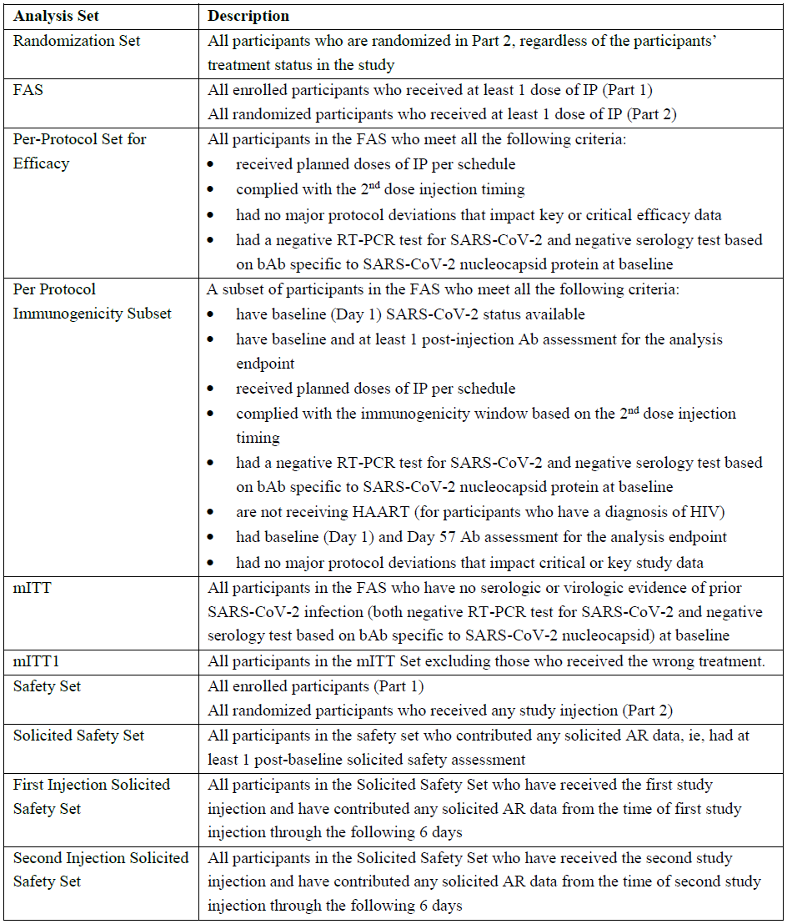
Ab = antibody; AR = adverse reaction; bAb = binding antibody; FAS = full analysis set; HAART = highly active anti-retroviral therapy; HIV = human immunodeficiency virus; IP = investigational product; mITT = modified intent-to-treat; RT-PCR = reverse transcription polymerase chain reaction; SARS-CoV-2 = severe acute respiratory syndrome coronavirus 2.

Statistical methods
The statistical methods are provided in the statistical analysis plan (SAP, version 2.0, 22 September 2021). In the study protocol, it is stated that the primary immunogenicity objective is to infer the effectiveness of mRNA-1273 based on the primary endpoint of either:
- the proportion of participants with a serum antibody level at Day 57 greater than or equal to antibody threshold of protection if an acceptable threshold of protection has been established.
- if an acceptable threshold of protection has not been established, the geometric mean (GM) value of serum antibody level and seroresponse rate from Study P204 vaccine recipients at Day 57 compared with those from young adult (18 to 25 years of age) vaccine recipients (Day 57) in the clinical endpoint efficacy trial (Study P301).
At the time of this submission, a serum antibody threshold of protection against COVID-19 had not been established. Therefore, the primary objective to infer the effectiveness of mRNA-1273 was evaluated by comparing the GM value of serum antibody level and seroresponse rates (two coprimary endpoints) from Study P204 vaccine recipients at Day 57 to those obtained from young adult (18 to 25 years of age) vaccine recipients (Day 57) in the pivotal study (Study P301), which established the efficacy of mRNA-1273.
The noninferiority of geometric mean titre (GMT) in 6 to < 12-year age group is considered demonstrated if the lower bound of the 95% confidence interval (CI) of the geometric mean ratio (GMR) is ≥ 0.67 based on the noninferiority margin of 1.5. In addition, the GMR point estimate > 0.8 (minimum threshold) is required for the success criteria of the immunogenicity objective based on GMT. In addition, the GMR with 95% CIs calculated using t-distribution was provided to assess if the two methods are consistent in the analysis results.
The noninferiority of seroresponse rate in the 6 to < 12-years of age group is considered demonstrated if the lower bound of the 95% CI of the seroresponse rate difference is > -10% based on the noninferiority margin of 10% and the seroresponse rate difference point estimate > -5% (minimum threshold).
Secondary objectives include evaluation of the incidence of SARS-CoV-2 infection, the incidence of asymptomatic SARS-CoV-2 infection, and the incidence of COVID-19 after vaccination with mRNA-1273 or placebo. The incidence rate was calculated as the number of cases divided by the total person-time. The 95% CIs of the incidence rate was calculated using the exact method (Poisson distribution) and adjusted by person-time. Participants in Part 1 and Part 2 of the study and in different age groups who receive the same mRNA-1273 dose level (if applicable) is combined in the analysis. For serologically confirmed SARS-CoV-2 infection or COVID-19, regardless of symptomatology or severity, infection rate is provided by vaccination group, dose level, and age group. The same analysis is conducted for asymptomatic SARS-CoV-2 infection.
The COVID-19 case definitions used in Study P204 is presented in Table 4 below.
Table 4: Study P204 COVID-19 case definitions
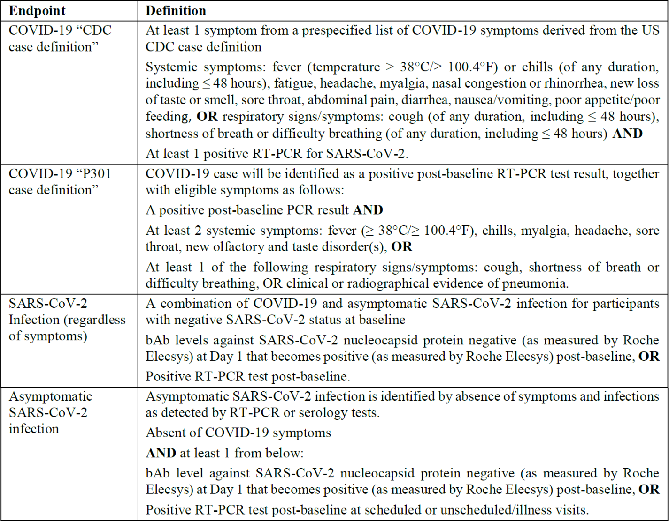
bAb = binding antibody; CDC = Centers for Disease Control and Prevention; COVID-19 = coronavirus disease 19; PCR = polymerase chain reaction; RT-PCR = reverse-transcriptase polymerase chain reaction; SARS-CoV-2 = severe acute respiratory syndrome coronavirus 2.
The planned interim and final analyses stated in the SAP are as follows:

Study P204 Part 1
Interim analyses may be performed after all or a subset of participants (with immunogenicity samples collected for Day 1 and Day 57) have completed Day 57 within an age group in Part 1 (one optional interim analysis for each age group, three interim analyses total for the three age groups in Part 1). Analyses of safety and immunogenicity may be conducted at each interim analysis.

Study P204 Part 2
An interim analysis of immunogenicity and safety will be performed after all or a subset of participants have completed Day 57 (one month after the second dose) in Part 1 or Part 2 within an age group. This interim analysis will be considered the primary analysis of immunogenicity for a given age group. Another interim analysis on safety may be performed after a different subset or all participants have completed Day 57 in an age group.
The final analysis of all endpoints will be performed after participants have completed all planned study procedures. Results of this analysis will be presented in a final clinical study report, including individual listings.
It is noted that the safety analysis on the cut-off date of 6 October 2021 is not a pre-specified and planned analysis. The study plan for interim and final immunogenicity analyses is very vaguely stated in the SAP.

Immunogenicity and efficacy

Dose selection
The study started with dosing the 6 years to < 12-years age group in Part 1 with 50 μg of mRNA-1273. After at least 75 participants had completed Day 8, an internal safety team reviewed the available safety data and agreed with the pre-specified protocol plans to proceed with the 100 μg arm in Part 1 in the 6 years to < 12-year age group. Review of the reactogenicity profile of the 50 μg dose was comparable to what had been observed young adults (18 to 25 years of age) who had received 100 μg in Study P301. The 100 μg dose was more reactogenic in the 6 to < 12-years age group than in older populations as evidenced by an increased fever rate. A pre-planned immunogenicity data review compared the geometric mean (GM) neutralising antibodies and seroresponse rate of the 6 to < 12 years of age dose selection per-protocol (PP) immunogenicity subset 50 μg group in Study P204 with those from the results of the immunogenicity subset of 18- to 25-year-old participants in Study P301. In children (6 to < 12 years of age) in the immunogenicity subset, the nAb GMT (measured by pseudotyped virus neutralisation assay (PsVNA) 50% inhibitory dose (ID₅₀)) was 1204.647 at Day 57 (28 days post-Dose 2). All children achieved seroresponse (Table 5). The immunogenicity from the dose selection PP immunogenicity subset 50 μg group of Study P204 were similar to those of Study P301 immunogenicity subset.
Table 5: Study P204 Part 1 dose finding analysis of pseudovirus neutralising antibody level and seroresponse rate at Day 57 by pseudovirus neutralising antibody assay (50% inhibitory dose) (dose selection per-protocol immunogenicity subset 50 μg group)
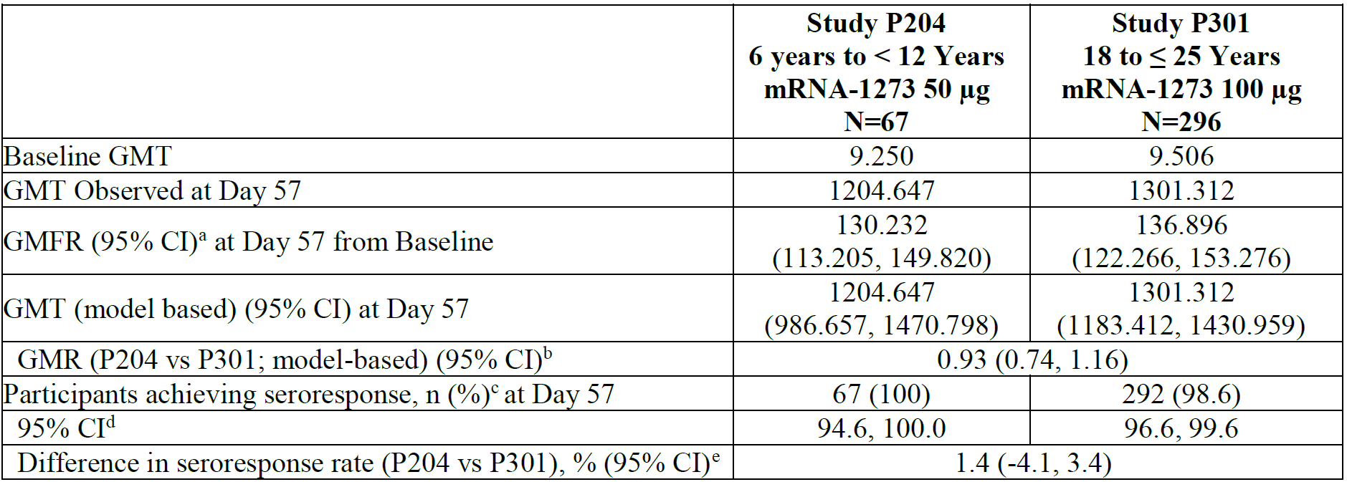
ANCOVA = analysis of covariance; CI = confidence interval; GMFR = geometric mean fold rise; GMR = geometric mean ratio; GMT = geometric mean titre (noted as observed or model based, which is stimated by geometric least squares mean); ID₅₀ = 50% inhibitory dose; LLOQ = lower limit of quantification; LS = least squares; mRNA-1273 = Spikevax COVID-19 vaccine; N = population size; P204 = Study P204; P301 = Study P301; PP = per-protocol; ULOQ = upper limit of quantification.
Antibody values reported as below the LLOQ are replaced by 0.5 × LLOQ. Values greater than ULOQ are replaced by the ULOQ if actual values are not available.
Study P301 mRNA-1273 group includes young adults (18 to 25 years of age).
The ULOQ for selected Study P301 participants tested previously was different.
Of note, one Study P301 participant had human immunodeficiency virus (HIV) and was included in the Study P301 young adults PP immunogenicity subset (n = 296). High apparent Baseline and post-immunisations values in the pseudotyped virus neutralisation assay (PsVNA) ID₅₀ are uninterpretable, likely due to highly active antiretroviral therapy. For this reason, HIV+ individuals were excluded from immunogenicity analysis by PsVNA in Study P301 and will be excluded in future analyses.
a. 95% CI is calculated based on the t-distribution of the log transformed values or the difference in the log transformed values for GMT and GMFR, respectively, then back transformed to the original scale for presentation.
b. The log transformed antibody levels are analysed using an ANCOVA model with the group variable (children in Study P204 and young adults in Study P301) as fixed effect. The resulted LS means, difference of LS means, and 95% CI are back transformed to the original scale for presentation.
c. Seroresponse at a participant level is defined as a change from below the LLOQ to equal or above 4 × LLOQ, or at least a 4-fold rise if Baseline is equal to or above the LLOQ. Percentages are based on the number of participants with non-missing data at Baseline and the corresponding timepoint.
d. 95% CI is calculated using the Clopper-Pearson method.
e. 95% CI is calculated using the Miettinen-Nurminen (score) confidence limits.
Based on the assessments of safety and immunogenicity, the 50 μg dose was selected for evaluation in Part 2 of Study P204 in the 6 years to < 12-year age group.
In the submitted clinical overview, the sponsor states that the immunoassays for Study P204 were validated for use in the assessment of clinical samples, and in Study P204 as well as Study P301 and Study mRNA-1273-P203 (Study P203). Two assays were employed:
- the pseudotyped virus neutralisation assay (PsVNA) for measure of functional nAb; and
- Meso Scale Discovery (MSD) Multiplex (spike (S), N-terminal (N), receptor binding domain (RBD)) for measure of binding antibody (bAb).
Both assays were validated and considered acceptable for use in the assessment of clinical samples. In response to questions raised by the TGA, the sponsor confirms that the immunoassays used in Study P204 are the same as those used for the Study P301 (young adults, from 18 to 25 years of age) comparator used for immunobridging.

Noninferiority immunogenicity analysis
The number of participants in each analysis set for Part 1 and reasons for exclusions from the PP immunogenicity subset are presented in Table 6 below. Of note, the PP immunogenicity subset used for immunogenicity analyses to assess noninferiority in this submission excludes participants whose data were used for dose selection.
Table 6: Study P204 Part 1 Number of participants in each analysis set by dose level (full analysis set)
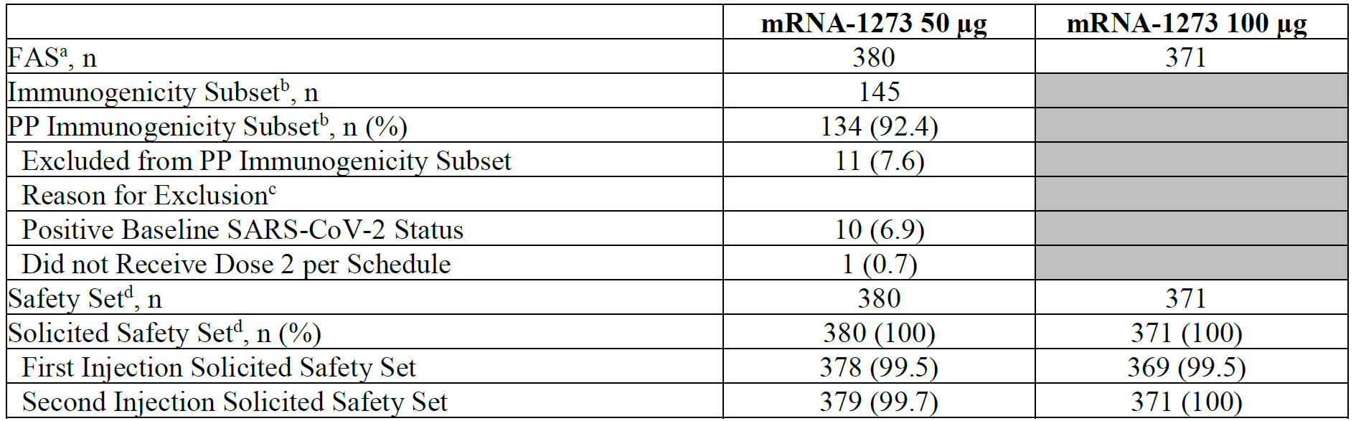
FAS = full analysis set; mRNA-1273 = Spikevax COVID-19 vaccine; n = sample size; PP = per-protocol; SARS-CoV-2 = severe acute respiratory syndrome coronavirus 2.
a. Numbers are based on planned treatment group.
b. Numbers are based on planned treatment group, and percentages are based on the number of participants in the immunogenicity subset, which includes participants in Part 1 whose data were not used in dose selection.
c. A participant who has multiple reasons for exclusion is listed under the reason that appears earliest.
d. Numbers are based on actual treatment group, and percentages are based on the number of safety participants.
Table 7: Study P204 Part 1 Participant disposition by dose level (full analysis set)
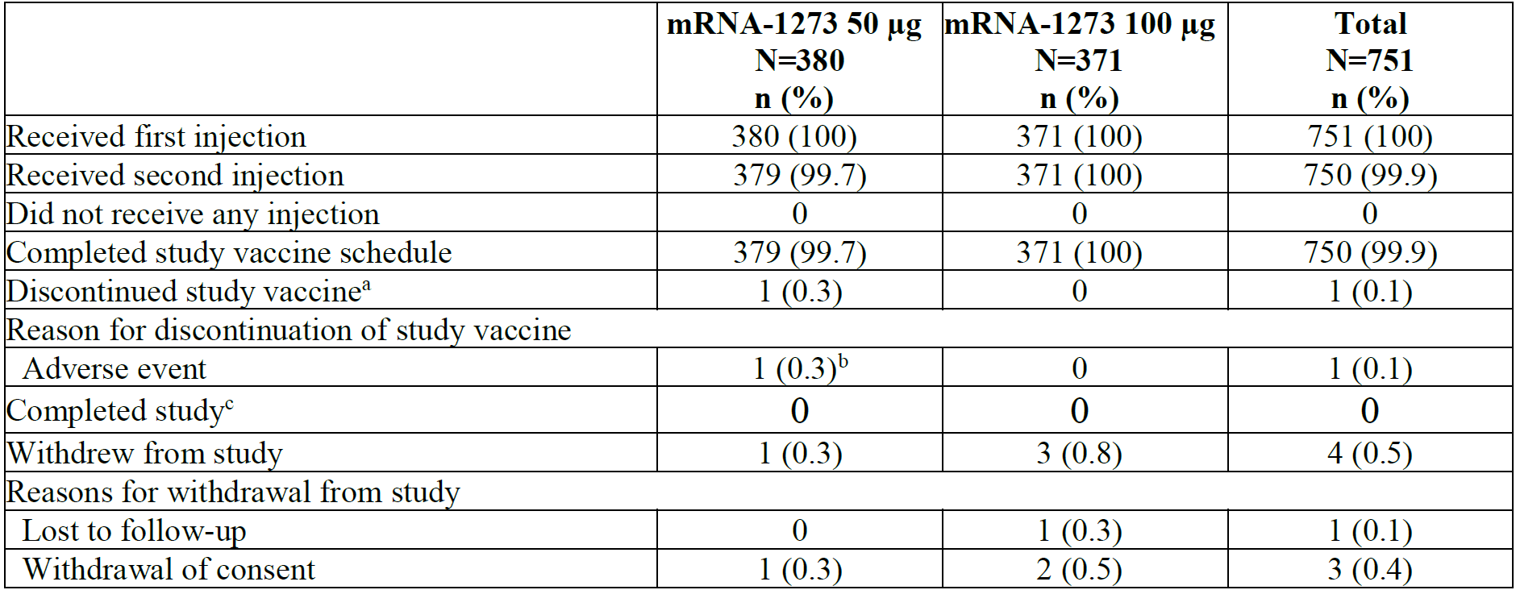
FAS = full analysis set; mRNA-1273 = Spikevax COVID-19 vaccine; N = population size; n = sample size; n = sample size.
Percentages are based on the number of participants enrolled in Part 1 who receive at least one injection of study investigational product.
a. Study vaccine discontinuation is defined as a participant who received the first injection but did not receive the second injection.
b. One participant had an adverse event of urticaria papular (verbatim term: delayed skin reaction, urticaric and papular rash; left arm, elbows, feet and hands) on Day 9 following Dose 1.
c. Study completion is defined as a participant who completed 12 months of follow-up after the last injection received, included participants who complete the first injection but not second injection. The study is ongoing; no participants have completed 12 months of follow-up.
Immunogenicity analysis results are provided for the PP immunogenicity subset for the 50 μg group from Part 1 using the validated PsVNA. Table 8 below summarises the analysis of serum nAb levels (PsVNA ID₅₀) at Day 57 for children of 6 years to < 12 years of age in Study P204 compared with those at Day 57 for young adults (18 to 25 years of age) in Study P301. The data from Study P204 consist of available data from the 50 μg group (Part 1) up until data snapshot (6 October 2021), excluding data from the dose finding immunogenicity subset (n = 67) used to determine dose selection.
Table 8: Study P204 Immunogenicity analysis (pseudovirus neutralising antibody level by pseudovirus neutralising assay)
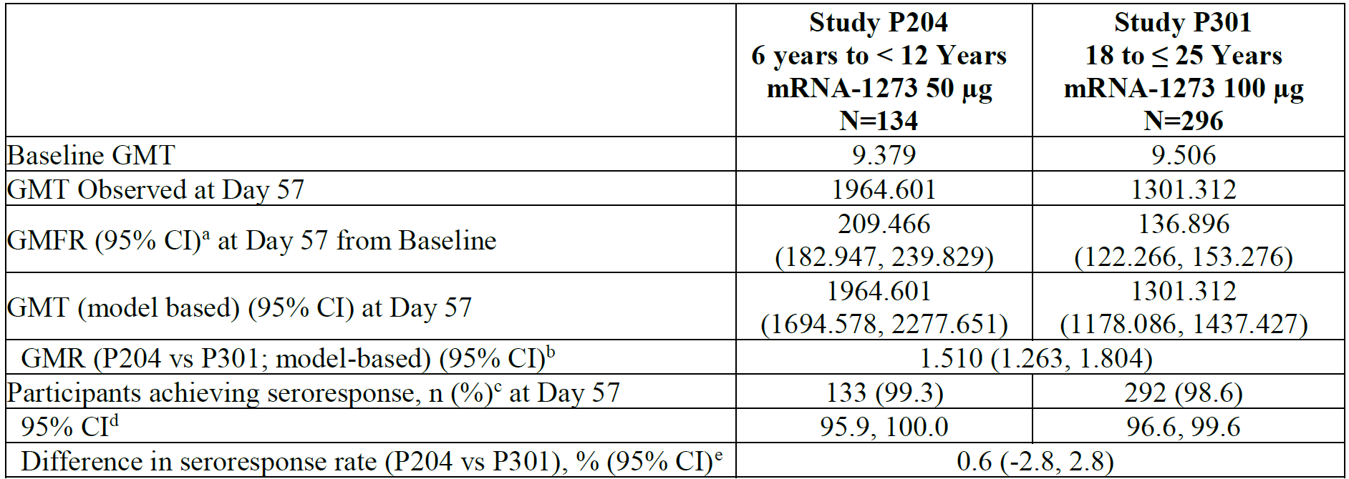
ANCOVA = analysis of covariance; CI = confidence interval; GMFR = geometric mean fold rise; GMR = geometric mean ratio; GMT = geometric mean titre (noted as observed or model based, which is estimated by geometric least squares mean); ID₅₀ = 50% inhibitory dose; LLOQ = lower limit of quantification; LS = least squares; mRNA-1273 = Spikevax COVID-19 vaccine; N = population size; P204 = Study P204; P301 = Study P301; PP = per-protocol; ULOQ = upper limit of quantification.
Antibody values reported as below the LLOQ are replaced by 0.5 × LLOQ. Values greater than ULOQ are replaced by the ULOQ if actual values are not available.
Study P301 mRNA-1273 group includes young adults (18 to 25 years of age).
The ULOQ for selected Study P301 participants tested previously was different.
Of note, one Study P301 participant had human immunodeficiency virus (HIV) and was included in the Study P301 young adults PP immunogenicity subset (n = 296). High apparent Baseline and post-immunisations values in the pseudotyped virus neutralisation assay (PsVNA) ID₅₀ are uninterpretable, likely due to highly active antiretroviral therapy. For this reason, HIV+ individuals were excluded from immunogenicity analysis by PsVNA in Study P301 and will be excluded in future analyses.
a. 95% CI is calculated based on the t-distribution of the log-transformed values or the difference in the log transformed values for GMT and GMFR, respectively, then back transformed to the original scale for presentation.
b. The log transformed antibody levels are analysed using an ANCOVA model with the group variable (children in Study P204 and young adults in Study P301) as fixed effect. The resulted LS means, difference of LS means, and 95% CI are back transformed to the original scale for presentation.
c. Seroresponse at a participant level is defined as a change from below the LLOQ to equal or above 4 × LLOQ, or at least a 4-fold rise if Baseline is equal to or above the LLOQ. Percentages are based on the number of participants with non-missing data at Baseline and the corresponding timepoint.
d. 95% CI is calculated using the Clopper-Pearson method.
e. 95% CI is calculated using the Miettinen-Nurminen (score) confidence limits.
In the PP immunogenicity subset (n = 134), the baseline nAb GMT (measured by PsVNA ID₅₀) in children of 6 to 12 years of age was below the lower limit of quantification (LLOQ) and the GMT was 1964.601 (95% CI 1722.357, 2240.915) at Day 57 (28 days after Dose 2), with 99.3% of children achieving seroresponse. The geometric mean fold rise (GMFR) from Baseline at Day 57 was 209.466 (95% CI: 182.947, 239.829). These results demonstrate strong immune response of 50 μg of mRNA-1273 in this cohort of children one month after the second dose. The pre-specified success criteria for the primary immunogenicity objective are met based on the co-primary immunogenicity endpoints of GMR and seroresponse rate. The SARS-CoV-2 nAb GMR at Day 57 of children of 6 to < 12 years of age (Study P204) compared with young adults (Study P301) was 1.510 (95% CI: 1.263, 1.804), meeting the noninferiority success criterion (that is, lower bound of the 95% CI for GMR ≥ 0.67). The criterion on the point estimator of GMR > 0.8 was also met. The difference in seroresponse rates between children and young adults at Day 57 was 0.6% (95% CI: -2.8%, 2.8%), meeting the noninferiority success criterion (lower bound of the 95% CI of the seroresponse rate difference is > -10%). The immunobridging in children 6 years to < 12 years old in Study P204 is demonstrated as compared with young adults in Study P301.
A large difference in the Day 57 nAb GMT values is noted between the dose selection subset (n = 67) and the PP immunogenicity subset (n = 134). The sponsor is requested by the TGA to explain the reason for this difference. The sponsor stated that the variability in nAb titres (PsVNA ID₅₀) evident in the two study subsets is not uncommon for functional assays (for example, virus neutralising assays) which are subject to the variability inherent in biological assays which rely on elements including in vitro growth of cells and virus inoculum. While variability (within assay validation parameters) was observed for nAb GMT, results of the MSD assay show highly consistent bAb results between the dose selection subset. Although fluctuation in nAb results were observed, immunobridging of children 6 to < 12 years, to young adults in Study P301, was achieved with the primary immunogenicity analysis and the nAb assay performed within expected parameters. In addition, the sponsor provided Part 2 immunogenicity data collected and processed as PP. The Part 2 PP immunogenicity subset Day 57 GMT was 1604.6 (95% CI 1449.5, 1775.9) with 99.0% of children achieving seroresponse. The GMFR from Baseline at Day 57 was 173.4 (95% CI: 156.5, 192.1). The GMR of PsVNA ID₅₀ titres at Day 57 of children of 6 years to < 12 years of age (Study P204) compared with young adults (Study P301) was 1.234 (95% CI: 1.067, 1.428). The GMT measured from Part 2 (1604.6) falls between that observed for the dose selection subset (1204.7, 95% CI: 986.7, 1470.8) and for the Part 1 PP immunogenicity subset (1964.6, 95% CI: 1694.6, 2277.7). Results of the MSD assay show highly consistent bAb results for each of the study subsets, including the Part 2 PP immunogenicity subset. bAb results for Study P204 Part 2 PP immunogenicity subset (295,106 (95% CI 265,273, 328,295)) agree with those observed for the dose selection subset (333,103, 95% CI: 273,638, 405,492) and for the Part 1 PP immunogenicity subset (322,158, 95% CI: 279,605, 371,187).
The Delegate accepts that while fluctuations in nAb results were observed, immunobridging of children aged 6 to < 12 years to young adults in Study P301 was achieved with the primary PP immunogenicity analysis from Part 1 and are supported by the analysis in the Part 2 PP immunogenicity subset. Ideally, the non-inferiority comparison should have been done in one study instead of cross study comparison.
The Delegate acknowledges the above rationale for the dose selection decision made by the sponsor, but in view of the relative higher reactogenicity of the sponsor’s mRNA-1273 vaccine versus the Comirnaty vaccine (Pfizer/BioNTech), it would have been very informative and useful if the assessment of lower dose in this age group had been conducted. It is not known if a lower dose (such as 25 µg) in children could have also shown non-inferiority of the immune response. The Advisory Committee on Vaccines (ACV)³⁵ advice is sought on this issue.

Immunogenicity subgroup analysis
The sponsor later provided a subset comparison of nAb responses (PsVNA ID₅₀) for children with and without obesity following a TGA request (to provide immunogenicity analysis in children with or without underlying medical conditions). The representation of obesity in the study population was sufficient to allow subset comparison of nAb responses (PsVNA ID₅₀) within the PP immunogenicity subset. Each group (obese and non-obese) achieved higher titres of nAb (GMT) than did young adults in Study P301, with a GMR of 1.788 for children with obesity and 1.441 for children without obesity. Children with obesity had slightly higher nAb GMT (2327.137) compared to those of children without obesity (1874.827).

Efficacy (Study P204 Part 1 and Part 2)
Secondary objectives of Study P204 include evaluation of the incidence of SARS-CoV-2 infection, the incidence of asymptomatic SARS-CoV-2 infection, and the incidence of COVID-19 after vaccination with mRNA-1273 or placebo.
The COVID-19 case definition for efficacy endpoints requires the following:
- positive RT-PCR (central or local laboratory); and
- eligible symptoms reported on the SARS-CoV-2 or COVID-19 Symptom Assessment Page electronic case report form.
Routine assessment for SARS-CoV-2 infection (regardless of symptoms) was performed by performing RT-PCR testing on pre-planned nasal swab samples collected on Day 1 and Day 29 (day of injection) and on Day 43 (if visit is applicable), Day 57 (one month after Dose 2), Day 209 (six months after Dose 2), and Day 394 (12 months after Dose 2).
Part 2 of the study randomised around 4000 participants (6 to < 12 years of age), 3005 in the vaccine group and 997 in the placebo group. Table 9 below summarised the subject disposition for this age group.
Table 9: Study P204 Subject disposition by age group (randomisation set)
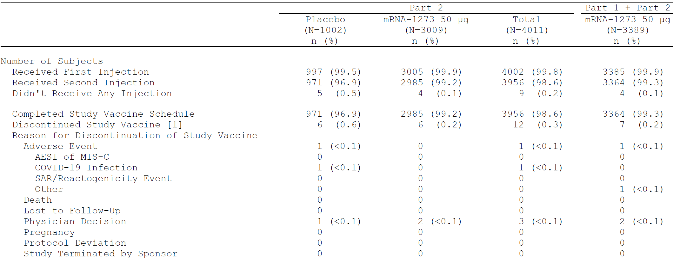
AESI = adverse event of special interest; COVID-19 = coronavirus disease 2019; MIS-C = multisystem inflammatory syndrome in children; mRNA-1273 = Spikevax COVID-19 vaccine; N = population size, n = sample size.
Age group: ≥ 6 and < 12 years.
Part 1 includes subjects who are in full analysis set in Part 1.
For Part 2, percentages are based on the number of subjects in randomization set in Part 2.
For Part 1 + Part 2, percentages are based on the number of subjects in full analysis set in Part 1 and subjects in randomization set in Part 2.
1. Study vaccine discontinuation is defined as a subject who received the first injection but didn't receive the second injection.
2. Study completion is defined as a subject who completed 12 months of follow-up after the last injection received, included subjects who complete the first injection but not second injection.
The number of participants in each analysis set for Part 2 and reasons for exclusion from the PP set for efficacy are provided in Table 10 below.
Table 10: Study P204 Part 2 Number of participants in each analysis set by dose level
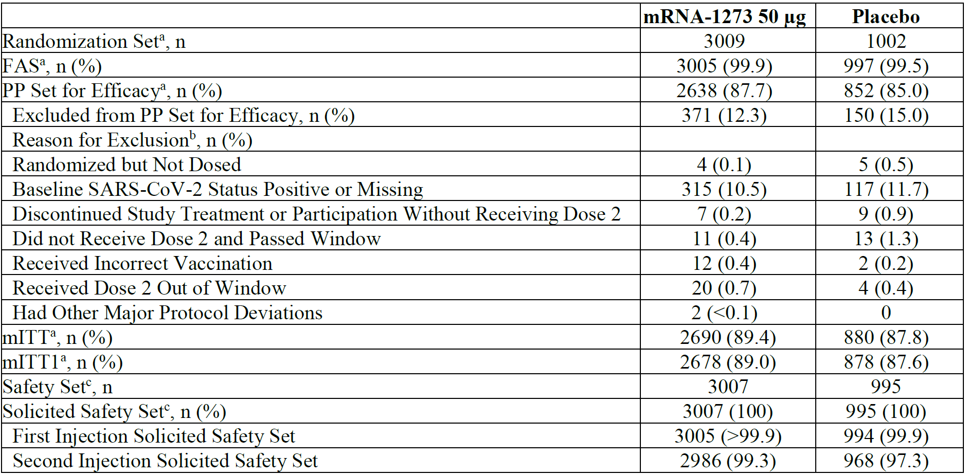
FAS = full analysis set; mITT = modified intent-to-treat; mRNA-1273 = Spikevax COVID-19 vaccine; n = sample size; PP = per-protocol; SARS-CoV-2 = severe acute respiratory syndrome coronavirus 2.
Percentages are based on the number of participants in the randomisation set in Part 2.
a. Numbers are based on planned treatment group, and percentages are based on the number of randomised participants.
b. A participant who has multiple reasons for exclusion is listed under the reason that appears earliest.
c. Numbers are based on actual treatment group, and percentages are based on the number of safety participants.

Secondary efficacy endpoint analysis starting 14 days after Dose 2
In the Part 1 50 μg group starting 14 days after Dose 2 in the PP set for efficacy, there was one case of asymptomatic SARS-CoV-2 infection (occurring at 28 days after Dose 2 in a 7-year-old male), which was detected at the Day 57 pre-specified study visit.
In Part 2 starting 14 days after Dose 2 in the PP set for efficacy, there was one case (0.1%) of COVID-19 in the placebo group (incidence rate 8.58 per 1000 person-years) and none in the mRNA-1273 group. The case in the placebo group met both the Centers for Disease Control and Prevention (CDC) case definition of COVID-19 and the Study P301 case definition of COVID-19. There were no cases of asymptomatic SARS-CoV-2 infection in either treatment group starting 14 days after Dose 2 in the PP set for efficacy.
Table 11: Study P204 Efficacy endpoint analysis starting 14 days post-Dose 2 (per-protocol set for efficacy)
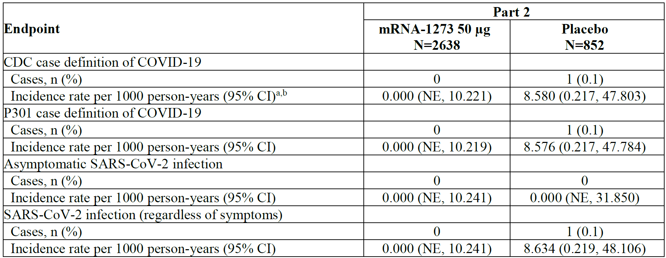
CDC = Centers for Disease Control and Prevention; CI = confidence interval; COVID-19 = coronavirus disease 2019; mRNA-1273 = Spikevax COVID-19 vaccine; N = population size; n = sample size; NE = not estimable; P301 = Study P301; PP = per-protocol; SARS-CoV-2 = severe acute respiratory syndrome coronavirus 2.
a. Person-years is defined as the total years from the first injection date for Part 1 and the randomisation date for Part 2 to the date of event (CDC case definition of COVID-19, Study P301 case definition of COVID-19, asymptomatic SARS-CoV-2 infection, or SARS-CoV-2 infection, depending upon endpoint), last date of study participation, or efficacy data cut-off date, whichever is the earliest.
b. Incidence rate is defined as the number of participants with an event divided by the number of participants at risk and adjusted by person-years (total time at risk) in each treatment group. The 95% CI is calculated using the exact method (Poisson distribution) and adjusted by person-years.
c. Vaccine efficacy is defined as 1 - ratio of incidence rate (mRNA-1273 versus placebo). The 95% CI of the ratio is calculated using the exact method conditional upon the total number of cases, adjusting for person-years.

Secondary efficacy endpoint analyses starting 14 days after Dose 1 in the modified intent-to-treat 1 population
In the Part 1 50 μg group in the modified intent to-treat 1 (mITT1) population, there was one case of asymptomatic SARS-CoV-2 infection. There were no cases of COVID-19.
In Part 2 in the mITT1 population, vaccine efficacy (VE) analyses were conducted using the COVID-19 CDC case definition, requiring only one symptom and reflecting the less severe disease (which is more common in paediatric patients) and a positive RT-PCR. The VE against cases occurring 14 days or more after Dose 1 was based on 3 cases in the mRNA-1273 group and 14 cases in the placebo group. Vaccine efficacy was 93.0% (95% CI: 75.1%, 98.7%).
In Part 2, in the mITT1 population for the analysis of COVID-19 meeting the Study P301 case definition for cases occurring 14 days or more after Dose 1, there were zero cases in the mRNA-1273 group and 13 cases in the placebo group. Vaccine efficacy was 100% (95% CI: 89.3%, not estimable).
In Part 2 in the mITT1 population for the analysis of SARS-CoV-2 infection (regardless of symptoms) occurring 14 days or more after Dose 1, VE was based on 16 cases in the mRNA-1273 group and 26 cases (3.0%) in the placebo group. Vaccine efficacy was 80.1% (95% CI: 61.5%, 90.0%).
In Part 2 in the mITT1 population for asymptomatic SARS-CoV-2 infection, VE against cases occurring 14 days or more after Dose 1 was based on 13 cases in the mRNA-1273 group and 12 cases in the placebo group. Vaccine efficacy was 65.0% (95% CI: 16.1%, 85.3%).
Table 12: Study P204 Secondary efficacy endpoint analysis starting 14 days after Dose 1 (modified intent-to-treat 1 population)
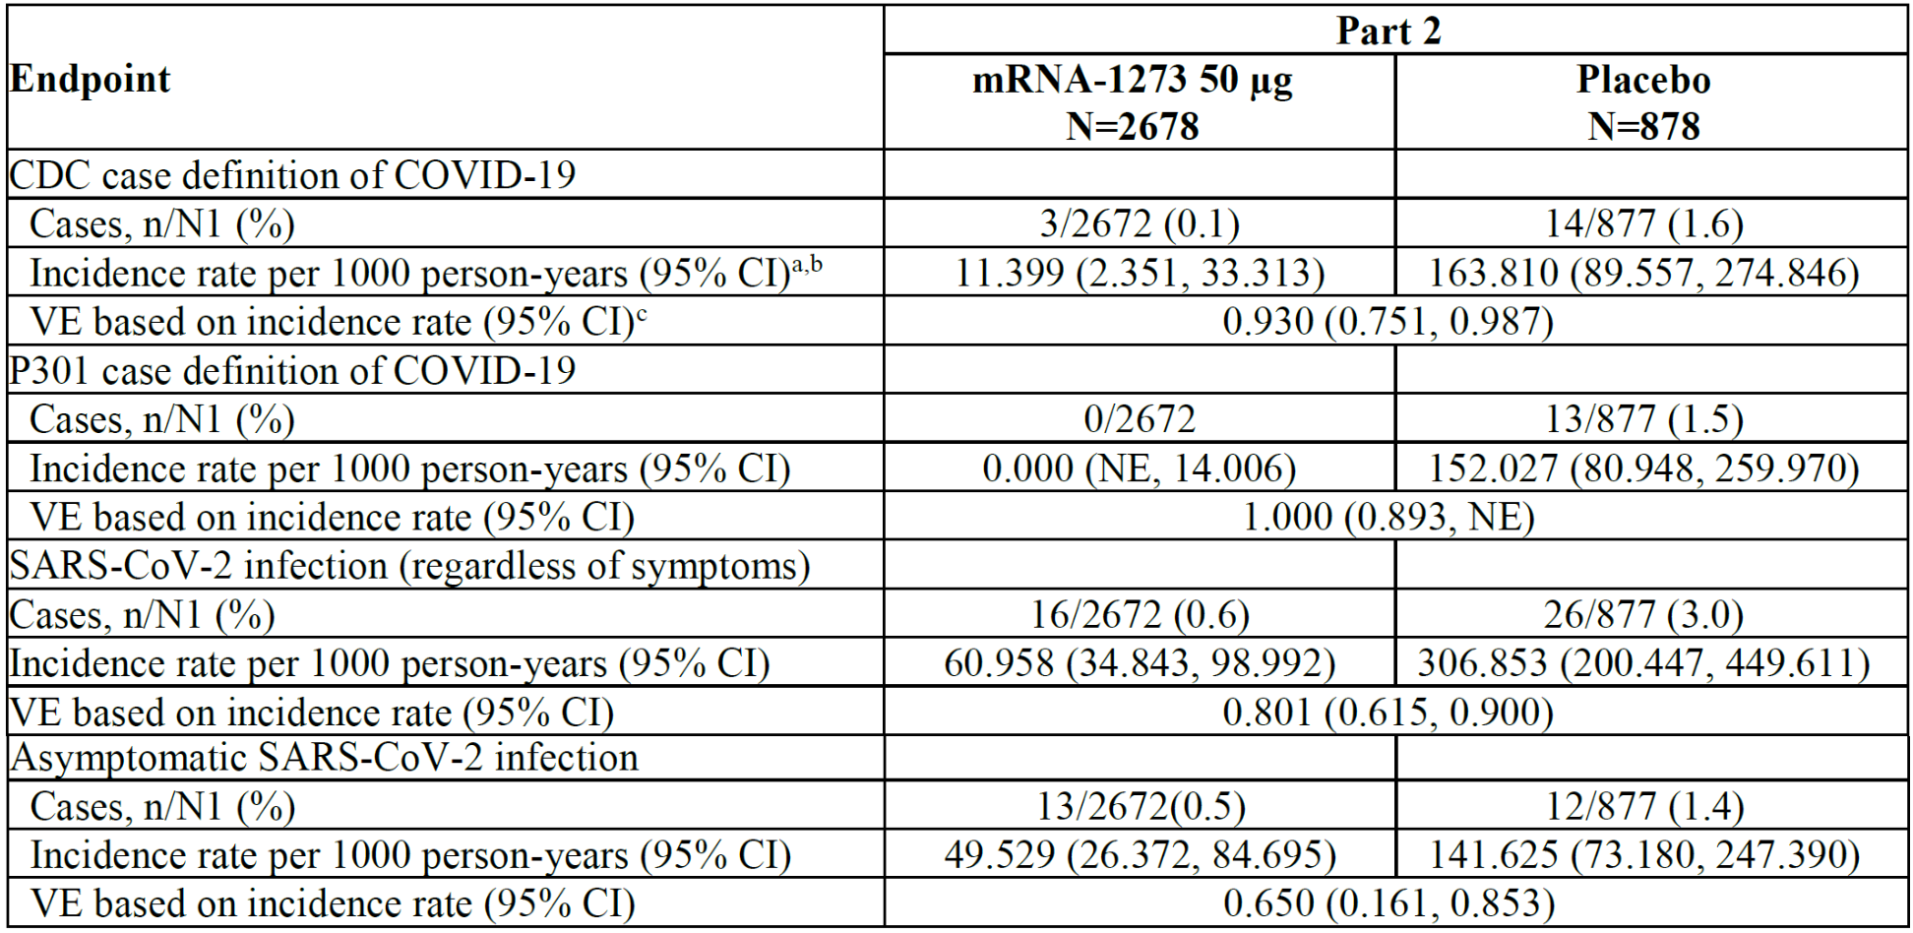
CDC = Centers for Disease Control and Prevention; CI = confidence interval; COVID 19 = coronavirus disease 2019; mITT = modified intent-to-treat; mRNA-1273 = Spikevax COVID-19 vaccine; N= population size; N1= number of participants at risk at 14 days after Dose 1 for specific efficacy endpoint; n = sample size; NE = not estimable; P301 = Study P301; SARS-CoV-2 = severe acute respiratory syndrome coronavirus 2; VE = vaccine efficacy.
a. Person-years is defined as the total years from the first injection date for Part 1 and the randomisation date for Part 2 to the date of event (CDC case definition of COVID-19, Study P301 case definition of COVID-19, asymptomatic SARS-CoV-2 infection, or SARS-CoV-2 infection, depending upon endpoint), last date of study participation, or efficacy data cut-off date, whichever is the earliest.
b. Incidence rate is defined as the number of participants with an event divided by the number of participants at risk and adjusted by person-years (total time at risk) in each treatment group. The 95% CI is calculated using the exact method (Poisson distribution) and adjusted by person-years.
c. Vaccine efficacy is defined as 1 - ratio of incidence rate (mRNA-1273 versus placebo). The 95% CI of the ratio is calculated using the exact method conditional upon the total number of cases, adjusting for person-years.
The Delegate noted that Study P204 was not designed to assess clinical efficacy of mRNA-1273 but rather assess the endpoints of COVID-19 and SARS-CoV-2 infection as secondary endpoints. As the study was not sized to demonstrate efficacy and employed a 3:1 vaccine to placebo randomisation ratio, these endpoints can only be assessed in a secondary fashion. Due to very short duration of follow-up post-Dose 2, there were not many COVID cases in the two study arms after the second dose. The sponsor therefore choses to present the efficacy result post-Dose 1. The median follow-up for Part 2 was 50 days post-Dose 1 and 20 days post-Dose 2. With the results starting 14 days post-Dose 1, there seems to be some protection against the symptomatic forms of the disease, but there was very wide confidence interval for the VE against asymptomatic disease. Overall, with the short follow-up duration and lower case numbers, the VE analysis is not considered reliable.

Safety
Study P204 collected solicited adverse reactions (ARs) for 7 days after each injection (Parts 1 and 2), unsolicited AEs for 28 days after each injection, serious adverse events (SAEs), medically attended adverse events (MAAEs), adverse events of special interest (AESIs), and AEs leading to withdrawals through the last day of study participation.
As of the snapshot date of 6 October 2021, for the 6 to < 12-years of age group, a total of 3387 participants received at least one dose of 50 μg of mRNA-1273 (380 in Part 1 dose selection and 3007 in Part 2) and 995 participants who received placebo in Part 2. There were 371 participants who received at least one dose of 100 μg mRNA-1273 in Part 1.
Table 13 below summarised the duration and the number of subjects who received the 50 μg of the mRNA-1273 in both Part 1 and Part 2 of the study.
Table 13: Study P204 Summary of study duration by age group
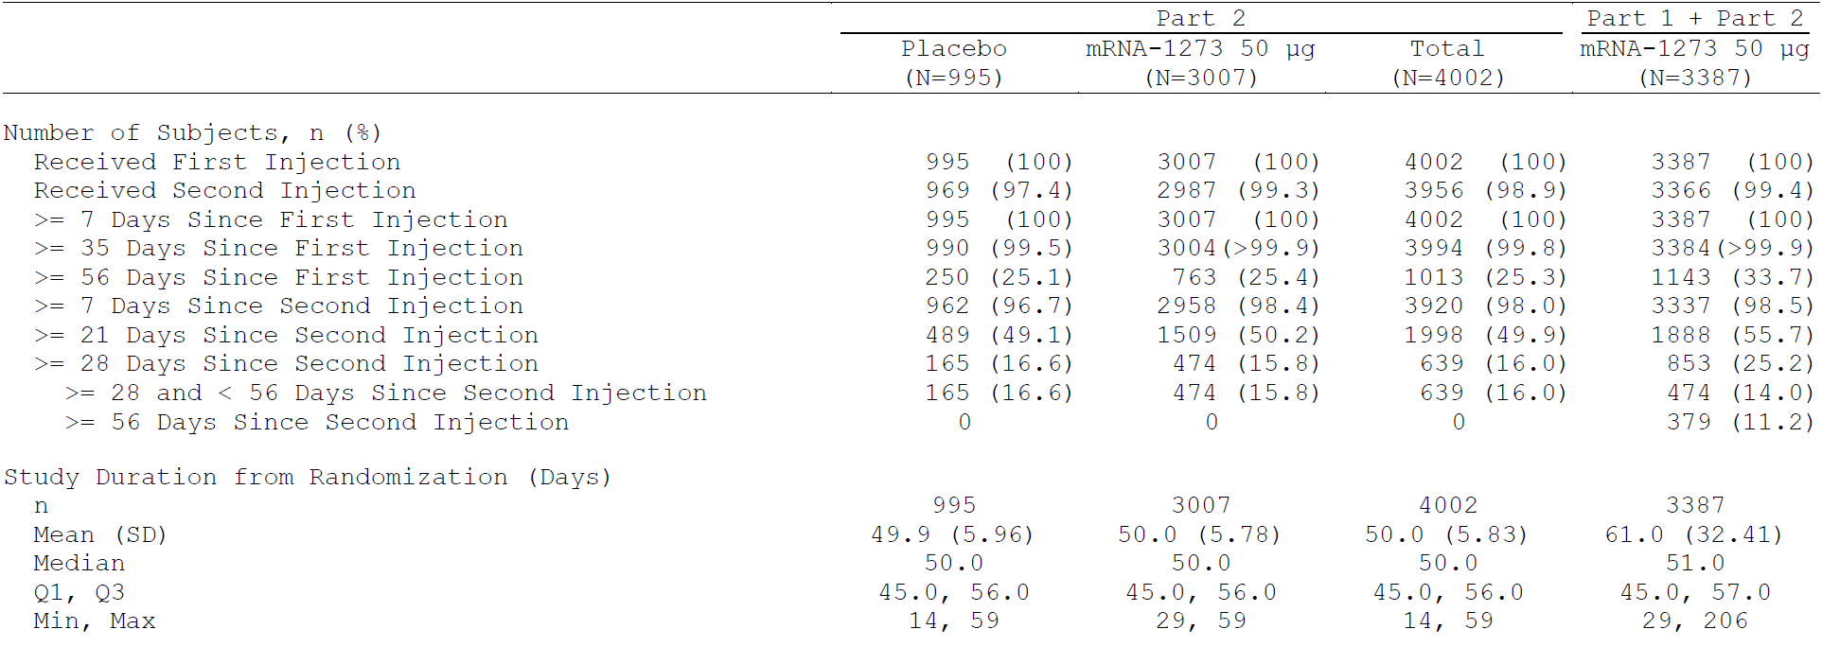
mRNA-1273 = Spikevax COVID-19 vaccine; N = population size; n = sample size; Q1 = the first quarter; Q3 = the third quarter; SD = standard deviation.
Age group: ≥ 6 and < 12 years
Percentages are based on the number of subjects in safety subjects.
Study duration from randomisation (days): calculated from randomisation date for Part 2 subjects and from first dose date for Part 1 subjects.
1. Person-years is defined as the total years from the first dose date to the earlier date of study discontinuation or data cut-off.
2. Study duration from second injection is zero day for subjects who did not receive second injection.
In Part 1, 380 participants in the 50 μg group and 371 participants in the 100 μg group received Dose 1 and 379 participants in the 50 μg group and 371 participants in the 100 μg group received Dose 2. A total of 379 children in the 50 μg group and 370 children in the 100 μg group have been followed for 2 months (56 days) or more after Dose 2.
Table 14: Study P204 Part 1 Summary of study duration by dose level (safety set)
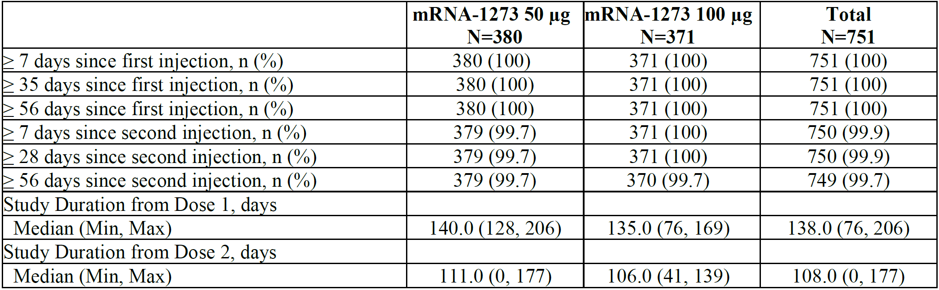
Max = maximum; min = minimum; mRNA-1273 = Spikevax COVID-19 vaccine; N = population size; n = sample size.
Percentages are based on the number of participants in the safety set for Part 1.
In Part 2, the median follow-up duration was 50 days after Dose 1 and 20 days after Dose 2. A total of 2958 subjects in the mRNA-1273 group and 962 (96.7%) in the placebo group have been followed for 7 days or more after Dose 2. A total of 474 (15.8%) subjects in the mRNA-1273 group and 165 (16.6%) in the placebo group have been followed for 28 days or more after Dose 2. At the time of data snapshot, no subjects had been followed for ≥ 56 days post-Dose 2.
Table 15: Study P204 Part 2 Summary of study duration (safety set)
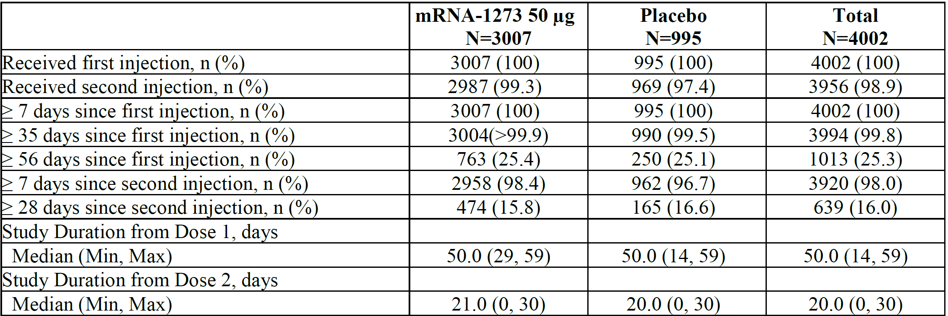
Max = maximum; min = minimum; mRNA-1273 = Spikevax COVID-19 vaccine; N = population size; n = sample size.
Percentages are based on the number of participants in the safety set for Part 2.

Demographics and baseline characteristics
In Part 1, 40.9% of participants were from community of colour and around 7.7% participants were seropositive. In Part 2, the participants in the vaccine and placebo group are similar in demographic characteristics (details see Table 16 and Table 17 below).
Table 16: Study P204 Part 1 Participants and baseline characteristics by dose level (safety set)
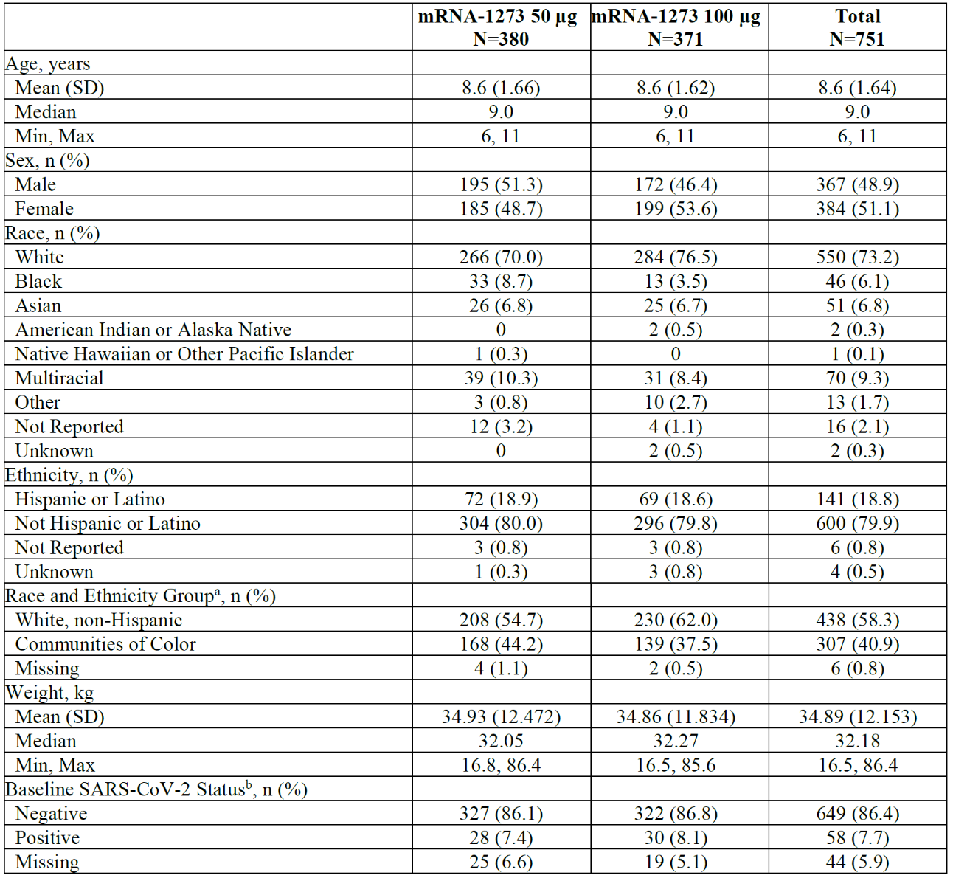
COVID-19 = coronavirus disease 2019; max = maximum; min = minimum; mRNA-1273 = Spikevax COVID-19 vaccine; N = population size; n = sample size; RT-PCR = reverse transcription polymerase chain reaction; SARS-CoV-2 = severe acute respiratory syndrome coronavirus 2; SD = standard deviation.
Percentages are based on the number of participants in the safety set for Part 1.
a. White non-Hispanic is defined as White and non-Hispanic, and Communities of Colour includes all the others whose race or ethnicity is not unknown, unreported, or missing.
b. Baseline SARS-CoV-2 Status: positive if there is immunologic or virologic evidence of prior COVID-19, defined as positive RT-PCR test or positive Elecsys result at Day 1. Negative is defined as negative RT-PCR test and negative Elecsys result at Day 1.
Table 17: Study P204 Part 2 Participants and baseline characteristics (safety set)
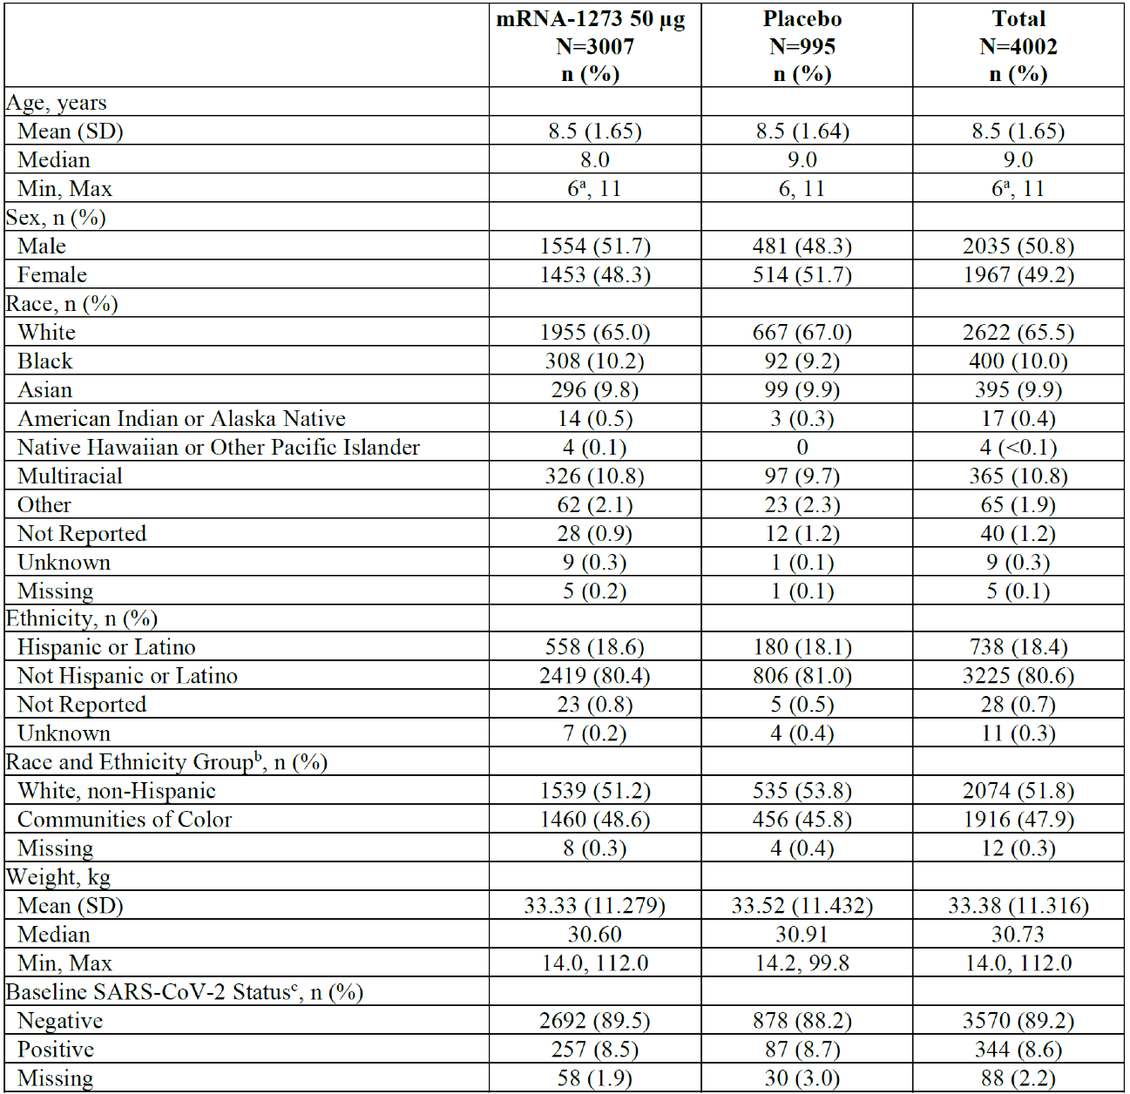
COVID-19 = coronavirus disease 2019; max = maximum; min = minimum; mRNA-1273 = Spikevax COVID-19 vaccine; N = population size; n = sample size; RT-PCR = reverse transcription polymerase chain reaction; SARS-CoV-2 = severe acute respiratory syndrome coronavirus 2; SD = standard deviation.
Percentages are based on the number of participants in the safety set for Part 2.
a. One participant’s age was incorrectly entered in the database as 5 years of age. The site has confirmed that the participant was indeed 6 years of age at the time of informed consent.
b. White non-Hispanic is defined as White and non-Hispanic, and Communities of Colour includes all the others whose race or ethnicity is not unknown, unreported, or missing.
c. Baseline SARS-CoV-2 status: positive if there is immunologic or virologic evidence of prior COVID-19, defined as positive RT-PCR test or positive Elecsys result at Day 1. Negative is defined as negative RT-PCR test and negative Elecsys result at Day 1.
The sponsor provided further detail following the TGA’s question regarding the proportion of children with underlying conditions: the study groups were balanced for having a history of (at least one) underlying or chronic medical condition: rates in Part 1 were 67.9% in the 50 µg group, 60.6% of the 100 µg group; in Part 2, rates were 53.5% of the mRNA-1273 group and 54.2% of the placebo group. The most commonly reported underlying medical condition across all groups was seasonal allergies reported for approximately 30% of all participants in Part 1 and approximately 20% of all participants in Part 2. Additionally, obesity which has been associated with more severe or complicated COVID-19 was similarly balanced between groups: rates in Part 1 were 23.4% in the 50 µg group, 21.6% of the 100 µg group; in Part 2, rates were 19.4% for the mRNA-1273 group and 20.2% of the placebo group.
Table 18: Study P204 Chronic conditions of interest in 6 to less than 12 years of age
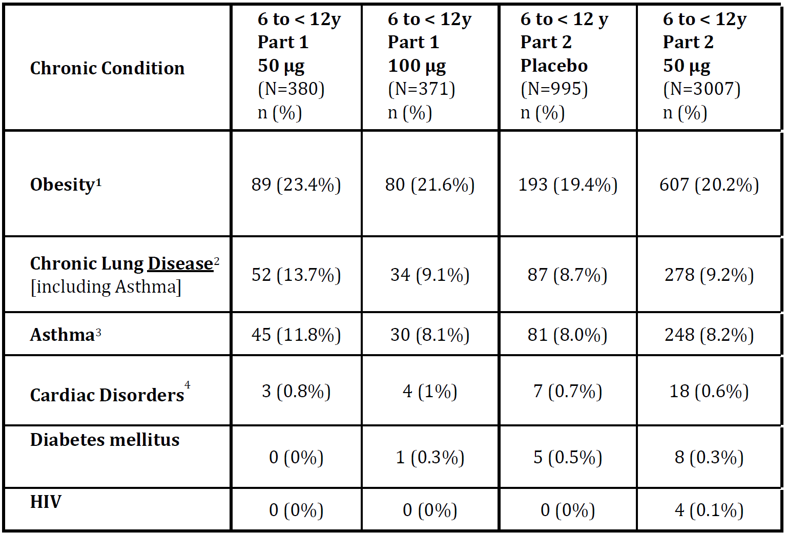
N = population size; n = sample size.
1. Body mass index is greater than or equal to ninety fifth percentile for age and gender (Centers for Disease Control and Prevention definition)
2. Includes sleep apnoea, wheezing, bronchospasm, bronchopulmonary dysplasia, pulmonary fibrosis, asthma, cystic fibrosis
3. Includes verbatim ‘bronchial hyperreactivity’
4. Clinically significant disease only

Safety overview for Study P204 Part 1
As of 6 October 2021, the median participant duration in Part 1 was 138 days. A total of 379 participants had been followed for ≥ 56 days after the second dose in the 50 μg group. One participant in Part 1 did not receive the second dose of vaccine.
In the 50 μg group, the majority of solicited ARs were Grade 1 or Grade 2. Unsolicited AEs were reported in 30.5% of participants in the 50 μg group. There were no unsolicited severe treatment emergent adverse events (TEAEs) in the 50 μg group. Two (0.5%) participants experienced unrelated SAEs in the 28 days after any dose.
In the 28-day window following any dose, 2 unrelated SAEs (with the Preferred Terms (PTs) of foreign body ingestion; and palpitations) were reported. The event of palpitations occurred in a participant with a previous history of palpitations; subsequent to the data snapshot, this event of palpitations was downgraded to nonserious (as investigator did not find the event met SAE criteria) and the onset date was clarified following parent/caregiver inquiry, to greater than 28 days after Dose 2.
In the 100 μg group, a total of 371 participants were followed for ≥ 28 days after Dose 2 and 370 participants were followed for ≥ 56 days after Dose 2. The incidence of Grade 3 solicited local and systemic ARs was higher in the 100 μg group compared with the 50 μg group. There were no SAEs assessed by the Investigator as related to study vaccine, no deaths, no cases of multisystem inflammatory syndrome in children (MIS-C), and no cases of myocarditis or pericarditis reported during the entire study period. A severe AE of injection site erythema was assessed as related and started on Study Day 8 and ended on Study Day 15.
Table 19: Study P204 Part 1 Safety overview
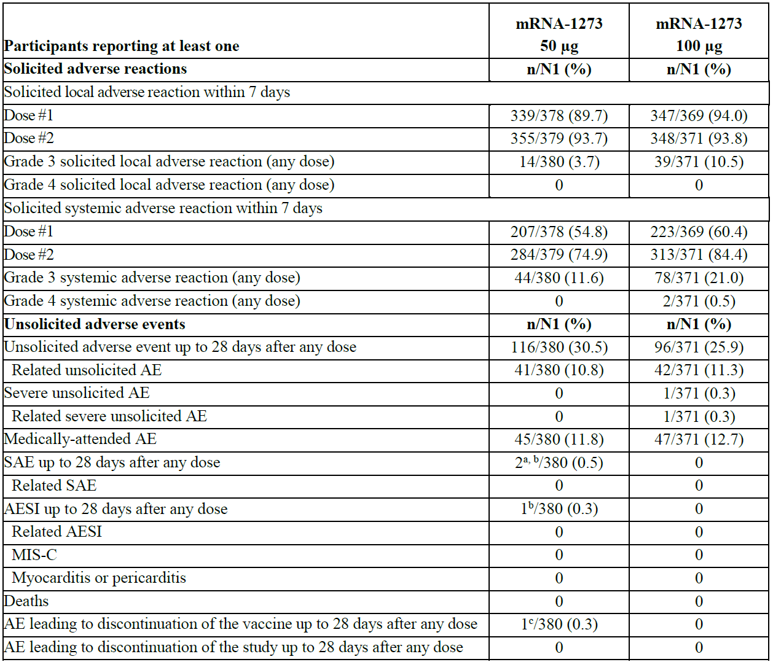
AE = adverse event; AESI = adverse event of special interest; MIS-C = multiorgan inflammatory syndrome in children; mRNA-1273 = Spikevax COVID-19 vaccine; N = population size; n = sample size; SAE = serious adverse event.
a. One participant experienced the SAE of foreign body ingestion.
b. One participant in the 50 μg group of Part 1 experienced an event of palpitations that was reported as an AESI and also as an SAE (note: subsequent to the data snapshot, the event of palpitations was downgraded to nonserious and the onset date was changed to > 28 days after Dose 2).
c. Adverse event of urticaria papular.

Safety overview for Study P204 Part 2
In Part 2, both solicited local and systemic ARs were more frequently reported by participants in the mRNA-1273 group compared with the placebo group after each dose. The majority of solicited ARs were Grade 1 or 2. The frequency of Grade 3 solicited reactions in the mRNA-1273 group was higher than in the placebo group after each dose. The incidence of unsolicited TEAEs up to 28 days after any dose was higher in the mRNA-1273 group compared with the placebo group. Imbalances in unsolicited TEAEs up to 28 days after any dose were mainly attributable to events related to reactogenicity which continued beyond 7 days. Unsolicited TEAEs up to 28 days after any dose assessed as related to study vaccine were more frequently reported in the mRNA-1273 group than in the placebo group. The incidence of severe unsolicited TEAEs up to 28 days in the mRNA-1273 group was low. No participants in the placebo group experienced severe unsolicited TEAEs. The percentage of participants in the mRNA-1273 group reporting MAAEs was lower than that in the placebo group (8.6% versus 10.1%). There were 2 unrelated SAEs in the mRNA-1273 group in the 28 days after any dose: one was an event of orbital cellulitis, and the other one was an event of appendicitis that was also reported as an AESI. Two participants had AEs that led to discontinuation in the mRNA-1273 group. One had a mild event of rash, and the other one had moderate event of urticaria that started on Day 24 and a mild event of wheezing that on Day 29 that was considered unrelated. The causality for the urticaria and the rash were not reported at data snapshot. There were no SAEs assessed as related to study vaccine, no deaths, no cases of MIS-C, and no cases of myocarditis or pericarditis reported during the entire study period.
Table 20: Study P204 Part 2 Safety overview
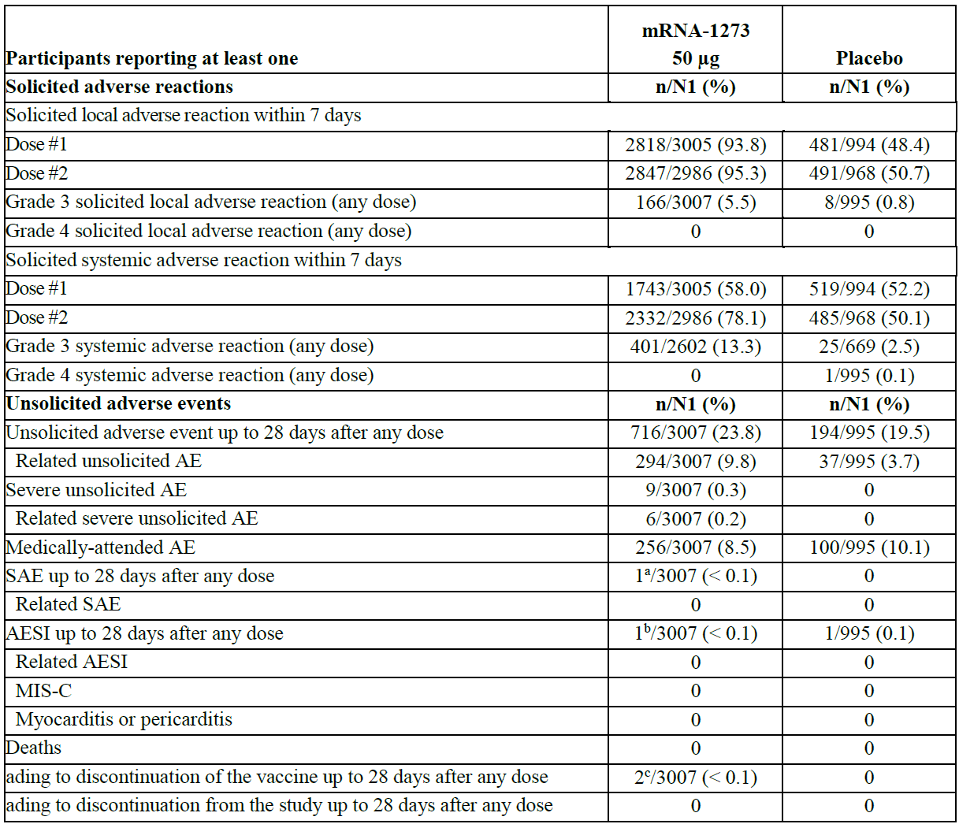
AE = adverse event; AESI = adverse event of special interest; MIS-C = multiorgan inflammatory syndrome in children; mRNA-1273 = Spikevax COVID-19 vaccine; N = population size; n = sample size; PT = Preferred Term; SAE = serious adverse event
a. One participant experienced an SAE with the PT cellulitis orbital.
b. One participant experienced an AESI with the PT appendicitis.
c. Two participants were discontinued from study vaccine due to AEs with the PTs rash and urticaria and wheezing.

Solicited local adverse reactions

Study P204 Part 1
In the 50 μg group, solicited local ARs were similar in frequency after Dose 1 and 2. After any dose, the most common solicited local AR was injection site pain (368 (96.8%) participants). The majority of solicited local ARs were Grade 1 to 2. The most frequent Grade 3 solicited local ARs included injection site pain (10 (2.6%)) and erythema (4 (1.1%)). There were no Grade 4 solicited local ARs. The majority of the solicited local ARs in the 50 μg group occurred within the first one to two days after each dose in both groups and generally persisted for a median of three days. There were 15 (3.9%) participants reported 17 solicited local ARs with an onset after 7 days after Dose 1. The ARs reported were erythema (15 (3.9%)) and injection site swelling (hardness) (2 (0.5%)). No participants in this group reported solicited local ARs with an onset after 7 days after Dose 2.

Study P204 Part 2
The incidence of solicited local ARs were more common in the mRNA-1273 group than in the placebo group. The incidence of participants experiencing Grade 3 solicited local ARs was higher (121 (4.1%)) after Dose 2 than after Dose 1 (54 (1.8%)) in the mRNA-1273 group. After any dose, the most common solicited local AR was injection site pain. The majority of solicited local ARs were Grade 1 to 2. The most common Grade 3 solicited local AR occurring after any dose in the mRNA-1273 group was injection site pain (100 (3.3%)). No Grade 4 solicited local ARs were reported in Part 2. The majority of the solicited local ARs in the mRNA-1273 group occurred within the first one to two days after any dose and persisted for a median of three days.
In the mRNA-1273 group, 81 (2.7%) participants reported solicited local ARs with onset after 7 days after Dose 1. Only 3 (< 0.1%) participants reported solicited local ARs with onset after 7 days after Dose 2. The ARs reported after any dose were injection site swelling (22 (0.7%)), injection site pain (16 (0.5%)), erythema (63 (2.1%)), and axillary (or groin) swelling or tenderness (3 (< 0.1%)).

Solicited systemic adverse reactions

Study P204 Part 1
In the 50 μg group, solicited systemic ARs were more common after Dose 2 than Dose 1. After any dose, the most common solicited systemic ARs were fatigue (262 (68.9%)) and headache (228 (60.0%)). The majority of solicited systemic ARs were Grade 1 to 2. The most common Grade 3 systemic ARs after any dose were fatigue (30 (7.9%)), headache (14 (3.7%)), and fever (11 (2.9%)). No Grade 4 solicited systemic ARs were reported in the 50 μg group of Part 1. The majority of the solicited systemic ARs in the 50 μg group of Part 1 occurred within the first one to two days after each dose and generally persisted for a median of two days. No participants reported solicited systemic ARs with onset after 7 days after Dose 1. One (0.3%) participant reported the solicited systemic AR of a fever with an onset after 7 days post-Dose 2.
Fever, headache, and myalgia were reported more frequently in the 100 μg group after both doses than in the 50 μg group. Fatigue was reported at roughly similar frequencies in both dose groups, but the reported severity of fatigue was higher in the 100 μg group.

Study P204 Part 2
Solicited systemic ARs were more common in the mRNA-1273 group than in the placebo group and were more common after Dose 2 of mRNA-1273. After any dose, the most common solicited systemic ARs were fatigue (2194 (73.0%)) and headache (1862 (62.0%)). The majority of solicited systemic ARs were Grade 1 or 2; however, there was a higher occurrence of Grade 3 solicited systemic reactions in the mRNA-1273 group than in the placebo group. The most common Grade 3 solicited systemic ARs in the mRNA-1273 group after any dose were fatigue (214 (7.1%)), headache (133 (4.4%)), and fever ≥ 39.0°C to 39.9°C (127 (4.2%)). In the placebo group, a Grade 4 systemic AR of fever was erroneously reported in one participant (data entry error). The participant’s actual temperature was 100.0°F (Grade 0). There were no Grade 4 solicited systemic ARs in the mRNA-1273 group. The majority of the solicited systemic ARs in the mRNA-1273 group occurred within the first one to two days after each dose and persisted for a median of two days.
Fever occurred more frequently after any dose in the mRNA-1273 group (778 (25.9%)) than in placebo group (36 (3.6%)). No Grade 4 fevers were reported in the mRNA-1273 group.
The median onset for fever in the mRNA-1273 group after any dose was two days with a median duration of one day. Fevers persisting after 7 days post any dose were reported in 4 (0.1%) participants in the mRNA-1273 group. There were no reports of fever persisting after 7 days in the placebo group.

Comparisons of reactogenicity in children with or without underlying medical conditions
Following a TGA request, the sponsor has generated comparisons of reactogenicity for the chronic medical conditions of obesity and chronic lung disease (predominantly represented by asthma) for children aged 6 to < 12 years in Part 2 of Study P204. Chronic medical conditions represented in fewer than 1% of all study participants were not included as no meaningful comparisons could be conducted. The presence of chronic conditions was identified from medical history recorded for each participant.
Comparisons in reactogenicity rates were made for children with or without obesity and then with or without chronic lung disease. Rates of overall solicited ARs after any injection of mRNA-1273 50 μg, as well as for local or systemic solicited AR were generally similar in both groups. Differences were observed in review of Grade 3 or higher pain after any injection of mRNA-1273 50 μg: rates were lower among participants with obesity than those without obesity (1.8% versus 3.7%). In contrast, obese children reported higher rates of Grade 3 or higher erythema than non-obese children (3% versus 1.3%).
Rates of systemic solicited AR were generally balanced between the two groups with the exception of fever: obese children had lower rates (15.7%) than non-obese children (28.5%). This carried over to rates of Grade 3 or higher fever (2.6% for obese versus 4.6% for non-obese).
For children with chronic lung disease rates of reported solicited ARs (any, local or systemic) were largely comparable to rates in children without chronic lung disease. Differences were observed for rates of Grade 3 or higher myalgia or chills, which were more common in children with chronic lung diseases (4.3% and 1.4 %, respectively) than in those without chronic lung disease (2.6% and 0.7%, respectively).
Analysis of solicited ARs occurring post-Dose 1 and post-Dose 2 did not reveal any additional notable rate differences when children with and without obesity or chronic lung disease were compared.

Comparison of solicited adverse reactions in participants aged 6 to < 12 years old versus 18 to 25 years old
Solicited ARs from participants aged 6 to < 12 years in the mRNA-1273 group (50 μg) in Part 2 of Study P204 (referred to as Study P204 participants) were compared with solicited ARs reported from participants aged 18 to 25 years in the mRNA-1273 group (100 μg) in Part A of Study P301 (referred to as Study P301 participants in the following analyses of solicited ARs).

Comparison to participants aged 18 to 25 years old for solicited local adverse reactions
Solicited local ARs within seven days of any vaccine dose were reported at a similar frequency in Study P204 participants (98.6%) as in Study P301 participants (94.1%). In participants in both studies the majority of solicited local ARs were Grade 1 or 2. Grade 3 solicited local ARs were reported in 5.5% of Study P204 participants and no Grade 4 ARs were reported in this group. In contrast, Grade 3 ARs were more frequent in Study P301 participants (11.4%). The most common solicited local AR was pain in both the Study P204 (98.4%) and Study P301 (89.4% after both Dose 1 and Dose 2) participants.

Comparison to participants aged 18 to 25 years old for solicited systemic adverse reactions
Solicited systemic ARs within seven days of any dose of mRNA-1273 were reported at consistent rates in Study P204 participants (86.5%) and in Study P301 participants (89.1%). The majority of solicited systemic ARs after any dose were Grade 1 or 2 for both Study P204 participants and Study P301 participants. Grade 3 solicited systemic ARs were less frequent in Study P204 participants (13.3%) than in Study P301 participants (23.5%). The most common solicited systemic ARs in Study P204 participants were fatigue (43.4% after Dose 1 and 64.4% after Dose 2) and headache (31.2% after Dose 1 and 54.2% after Dose 2). The most common solicited systemic ARs in Study P301 participants were also fatigue (45.9% after Dose 1 and 69.2% after Dose 2) and headache (42.8% after Dose 1 and 70.1% after Dose 2). Fever was more common in Study P204 participants (3.4% after Dose 1 and 24.1% after Dose 2) than in Study P301 participants (1.7% after Dose 1 and 18.2% after Dose 2). Grade 3 fever was also more frequent in Study P204 participants (0.6% after Dose 1 and 3.8% after Dose 2) than in Study P301 participants (zero after Dose 1 and 1.2% after Dose 2).

Unsolicited adverse events

Study P204 Part 1
A total of 116 (30.5%) participants in the 50 μg group reported at least one unsolicited TEAE. Serious unsolicited TEAEs within 28 days of any dose were reported for 2 participants in this group. These SAEs included an event of palpitations and an event of foreign body ingestion. Medically attended adverse events were experienced by 45 (11.8%) participants in the 50 μg group. One participant in the 50 μg group was discontinued due to a TEAE of urticaria papular and no participants were discontinued as a result of TEAEs. No participants in the 50 μg group reported severe TEAEs.
In the 50 μg group, 41 (10.8%) participants reported at least one TEAE determined by the investigator to be related to the study vaccine. Of these participants, none reported serious TEAEs considered by the investigator to be related to the study vaccine; 4 participants (1.1%) reported MAAEs, none were discontinued from the study, and none experienced severe TEAEs. The incidence of participants experiencing unsolicited AEs in the 50 μg and the 100 μg groups were not notably different. No participants in either dose group reported the TEAEs of MIS-C, myocarditis, or pericarditis.
Treatment emergent adverse events reported in greater than 1% of participants in the 50 μg group of Part 1 had the PTs of injection site erythema (4.5%), upper respiratory infection (3.2%), oropharyngeal pain (3.4%), nasal congestion (2.9%), cough (2.1%), headache (1.6%), nasopharyngitis (1.3%), urinary tract infection (1.3%), rhinorrhoea (1.3%), otitis externa (1.3%), injection site lymphadenopathy (1.3%), fatigue (1.3%), and vomiting (1.1%). While the overall percentage of participants in the 50 μg group reporting unsolicited AEs is slightly higher than the percentage in the 100 μg group, the percentages of participants reporting TEAEs were not notably different between the two groups.
There were no severe TEAEs reported in the 50 μg group. A single severe TEAE was reported within the 28 days following any dose in the 100 μg group with the PT injection site erythema. The event had an onset eight days after the first dose. The participant continued on the study and the TEAE resolved in six days.

Study P204 Part 2
In the mRNA-1273 group, 716 (23.8%) participants reported at least one unsolicited TEAE versus 194 (19.5%) in the placebo group. These events fall mainly under the System Organ Classes (SOC) of ‘General disorders’ and ‘Administration site conditions’. Serious unsolicited TEAEs within 28 days of any dose were reported for two (< 0.1%) participants in the mRNA-1273 group. These SAEs had the PTs appendicitis, and cellulitis orbital. Medically attended adverse events were reported in 256 (8.5%) of participants in the mRNA-1273 group.
Of the participants reporting TEAEs, 294 (9.8%) participants in the mRNA-1273 group of Part 2 reported TEAEs that were determined by the investigator to be related to the study vaccine. Of these participants, none reported serious TEAEs, 31 (1.0%) reported MAAEs, and none were discontinued from study vaccine or the study.
While no participants in the placebo group experienced severe TEAEs, nine (0.3%) of participants in the mRNA-1273 group experienced a severe TEAE; of the 9 participants, 6 (0.2%) experienced severe TEAEs that were considered related to study vaccine.
Treatment emergent adverse events from Part 2 reported greater than 1% of participants in the mRNA-1273 group included the PTs of injection site erythema (2.8%), upper respiratory tract infection (2.3%), headache (2.3%), oropharyngeal pain (2.0%), cough (1.8%), rhinorrhoea (1.7%), nasal congestion (1.6%), injection site lymphadenopathy (1.4%), injection site pain (1.2%), and fatigue (1.1%). In comparison, TEAEs reported in greater than 1% of the placebo group by PT were oropharyngeal pain (2.2%), nasal congestion (2.2%), COVID-19 (2.1%), upper respiratory tract infection (1.9%), headache (1.8%), rhinorrhoea (1.8%), cough (2.1%), and fatigue (1.2%). Treatment emergent adverse events experienced in the mRNA-1273 group are similar in nature and incidence as those in the placebo group with the exception of an increase in the incidence of injection site conditions in the mRNA-1273 group.
A total of ten severe TEAEs were reported in nine (0.3%) participants. Unsolicited severe TEAEs reported in the mRNA-1273 group of Part 2 had the PTs of fatigue (< 0.1%), injection site pain (< 0.1%), cellulitis orbital (< 0.1%), nasal congestion (< 0.1%), rhinorrhoea (< 0.1%), oropharyngeal pain (< 0.1%), vomiting (< 0.1%), urticaria (< 0.1%), and foot fracture (<0.1%). All of these severe TEAEs were reported in one participant except for fatigue and injection site pain, which were each reported in two participants. The events of fatigue (two events), injection site pain (two events), vomiting, and urticaria were considered related to study vaccine. There were no severe TEAEs reported in the placebo group.

Deaths
No deaths have been reported in the study as of the data snapshot.

Serious adverse events

Study P204 Part 1
In the 50 μg group within the 28-day period post any dose, one participant had an SAE of Grade 1 palpitations after Dose 2, and one participant had an SAE of foreign body ingestion that led to hospitalisation. Both events were also considered MAAEs, and neither was considered related to mRNA-1273. The event of palpitations occurred in a child with a history of palpitations. Electrocardiogram and echocardiogram results were normal. While the event was initially reported as an SAE, it was subsequently downgraded to nonserious and the onset was changed to > 28 days after Dose 2. No SAEs were reported in the 100 μg group within the 28-day window post dose. For SAEs with onset after 28 days, in the 50 μg group, one participant had an SAE of Grade 2 optic disc drusen, which occurred 151 days after Dose 2. The event was considered not related to mRNA-1273. In addition, 2 other participants experienced the SAE of Grade 3 appendicitis, at 97 and 72 days, respectively, after Dose 2. Both were considered not related to mRNA-1273. In the 100 μg group, one participant had an SAE of Grade 2 systemic viral infection of unknown aetiology that required hospitalisation 101 days after Dose 2. The event was also an MAAE and was considered not related to mRNA-1273. The event resolved after 6 days.

Study P204 Part 2
In Part 2, one participant had an SAE that occurred within the 28-day window after Dose 1 (Grade 2 appendicitis), and one participant had an SAE that occurred within the 28-day window after Dose 2 (Grade 3 cellulitis orbital), both in the mRNA-1273 50 μg group. Both of the events led to hospitalisation and were also considered MAAEs. Both events resolved, and neither of the events was considered related to mRNA-1273 by the investigator. No participants in the placebo group experienced SAEs during the study.

Discontinuation

Study P204 Part 1
One participant in the 50 μg group, an 11-year-old female with history of seasonal allergies and facial maculopapular rash, had a nonserious urticaria papular leading to discontinuation. The event started on Day 9 following Dose 1 and was reported as related to study vaccine. The participant recovered within 6 days of the onset of the event.

Study P204 Part 2
Two participants in the 50 μg group had AEs leading to discontinuation. One participant, a 9-year-old male with history of seasonal allergies, was discontinued due to nonserious urticaria and mild wheezing. The urticaria started on Day 24 following Dose 1 and the wheezing on Day 29 following Dose 1. The relationship of study vaccine to the event of urticaria was unknown at the time of data snapshot, while the event of wheezing was reported as unrelated to study vaccine. The other participant, a 10-year-old male with a history of chronic kidney disease, experienced mild rash on Day 10 following Dose 1, which led to discontinuation
No participants in the placebo group had an AE leading to discontinuation from study vaccine.

Adverse events of special interest
Adverse events of special interest were assessed as those occurring within 28 days of any injection, and across the study duration. A priority list of AESIs relevant to the development of COVID-19 vaccines, formulated by the Brighton Collaboration, was included in the Study P204 protocol. The investigator was asked to report a list of events;²¹ if the event occurred in the setting of a SARS-CoV-2 infection.

Adverse events of special interest reported in Study P204 Part 1

50 μg group
Appendicitis was reported in two (0.5%) participants, both occurring beyond the 28 day period after any injection. Neither event was considered related to study vaccine. An event of non-cardiac mild chest pain was reported as an AESI in one participant, occurring 72 days after Dose 2. This event does not meet AESI criteria as PP, but the event was marked as an AESI by the investigator. All AESIs were not considered related to study vaccine, except the event of non-cardiac chest pain.

100 μg group
No reports of AESIs occurring within 28 days of any dose. Beyond the 28 day period after any dose, two (0.5%) participants were reported with AESIs, neither were considered related to study vaccine; these AESIs were:
- one event of mild bullous impetigo reported in a 6-year-old male on study Day 79; and
- one event of ageusia reported in a 11-year-old female 28 days after the most recent dose, with contemporaneous nasal congestion.

Adverse events of special interest reported in Study P204 Part 2

mRNA-1273 group
Only one AESI was reported in one (< 0.1%) participant and it occurred within 28 days of any dose: the event of appendicitis was reported in a 7-year-old female. The event occurred on Day 26 following the first dose of study vaccine; the child underwent appendectomy and subsequently recovered. The event was not considered related to study vaccine. The participant went on to receive the second dose of mRNA-1273 without any subsequent events being reported.

Placebo group
Only two AESIs were reported: ageusia and anosmia were reported in a single (0.1%) 8-year-old male participant, occurring 11 days after Dose 1. This event met the CDC case definition and Study P301 case definition of COVID-19. The event was not considered related to study IP by the investigator.

Additional analysis of myocarditis and pericarditis
Enhanced surveillance for potential cases of myocarditis and pericarditis was implemented in this study following protocol amendment. This was done through additional questions added to the safety call script as well as review of the cardiomyopathy Standardised Medical Dictionary for Regulatory Activities (MedDRA) Queries (SMQ); along with specific medical evaluations for potential cases of myocarditis or pericarditis. This analysis did not identify any cases fulfilling the CDC working case definition for cases of acute myocarditis or acute pericarditis. The details are presented below.

Study P204 Part 1
In Part 1, this analysis identified two participants with relevant PTs, one in the 50 μg group and one in the 100 μg group. One report of chest discomfort was reported in a 9-year-old male in the 100 μg group two days post-Dose 2; and one event of musculoskeletal chest pain was reported in a 10-year-old male in the 50 μg group, occurring 90 days post-Dose 2. This participant was evaluated at the emergency department the following day where myocarditis was ruled out based on a normal electrocardiogram and a diagnosis of non-cardiac chest pressure related to worsening anxiety was made. The event was considered not related to study vaccine. The event resolved and was considered mild and nonserious.
Study P204 Part 2
This analysis identified five children with relevant PTs, all in the mRNA-1273 group, one with angina pectoris, two with chest discomfort and two with musculoskeletal chest pain. The one report of angina pectoris was in a 10-year-old male, the event occurred on the day of Dose 1 and resolved on the same day. His troponin, electrocardiogram and echocardiogram were all within normal limits and myocarditis was excluded. The two reports of chest discomfort were as follows:
- A 9-year-old male with a history of anxiety reported chest discomfort on the day of Dose 1 which lasted for two days. He had a normal electrocardiogram two days post-Dose 1. A diagnosis of non-cardiac chest pressure related to worsening anxiety was made. The event was considered not related to study vaccine.
- A 10-years-old female reported chest discomfort occurring five days post-Dose 2, resolving within 24 hours and was considered not related to study vaccine.
The two reports of musculoskeletal chest pain were as follows:
- An 8-year-old boy with concurrent history of upper respiratory tract infections, fever and concomitant medications of azithromycin, Benadryl (diphenhydramine) and Mucinex (guaifenesin), reported musculoskeletal chest pain occurring 13 days post-Dose 2 which resolved the following day. The boy was evaluated by his paediatrician who determined that the event was unlikely to be due to cardiac origin.
- A second report was in a 7-year-old boy with history of chronic lung disease, retinopathy of prematurity, asthma and autism, who reported the event 22 days post-Dose 2.

Risk management plan
The most recently evaluated EU-risk management plan (RMP) was version 2.3 (dated 28 October 2021; data lock point (DLP) 30 June 2021) and Australia specific annex (ASA) version 1.1 (dated 5 November 2021) in relation to Submission PM-2021-05131-1-2. In support of the extended indications, the sponsor has submitted EU-RMP version 1.3 (dated 17 January 2022; DLP 6 October 2021), which included information on 6 to < 12 years old population. However, a corresponding ASA was not provided. The sponsor committed to updating and submitting the ASA in line with the revised EU-RMP at the earliest opportunity. For this submission, EU-RMP version 2.3 and ASA version 1.2 have been considered as these documents contain the key information regarding the safety concerns required by the TGA.
As soon as the consolidated EU-RMP version 3.0 is finalised the sponsor should provide it to the TGA with an accompanying ASA.
The summary of safety concerns and their associated risk monitoring and mitigation strategies are summarised in Table 21.
Table 21: Summary of safety concerns
Summary of safety concerns |  | Pharmacovigilance |  | Risk minimisation
 |  | Routine | Additional | Routine | Additional
Important identified risks | Anaphylaxis | * | † |  | –
Important identified risks | Myocarditis | * | † |  | –
Important identified risks | Pericarditis | * | † |  | –
Important potential risks | Vaccine-associated enhanced disease (VAED) including vaccine-associated enhanced respiratory disease (VAERD) | * | † | – | –
Missing information | Use in pregnancy and while breast-feeding |  | ^{µ} |  | –
Missing information | Long-term safety |  | † | – | –
Missing information | Use in immunocompromised subjects |  | † |  | –
Missing information | Interaction with other vaccines |  | † |  | –
Missing information | Use in frail subjects with unstable health conditions and co-morbidities (for example, chronic obstructive pulmonary disease (COPD), diabetes, chronic neurological disease, cardiovascular disorders) |  | † |  | –
Missing information | Use in subjects with autoimmune or inflammatory disorders |  | † |  | –
* Follow-up questionnaires
† Clinical studies
µ Observational pregnancy outcome study
- This summary of safety concerns is the same as the summary that was evaluated and considered acceptable for the previous Submission PM-2021-05131-1-2. The changes proposed by the current submission are not expected to change the summary of safety concerns from an RMP perspective.
- The pharmacovigilance plan was deemed acceptable during the previous evaluations and continues to be acceptable for the current submission. The acceptability of the clinical study plan will be assessed by the clinical evaluator/Delegate.
- Only routine risk minimisation measures are currently in place. This approach was deemed acceptable during the previous evaluations. Routine risk minimisation measures are acceptable to address the changes proposed by the current submission.
- There are no outstanding or new RMP recommendations. The sponsor is requested to:
  - provide the consolidated EU-RMP version 3.0 and an accompanying ASA as a post-approval RMP update as soon as it is finalised.
  - The Consumer Medicines Information (CMI) should be revised in line with any changes made to the PI.

Risk-benefit analysis

Delegate’s considerations

Coronavirus disease 2019 epidemiology in children
In Australia, the COVID-19 epidemiology in children aged 5 to 11 years can be found in the communicable diseases intelligence report.
The COVID-19 epidemiology in children in the US is summarised in the Advisory Committee on Immunization Practices (ACIP) presentation.
Multisystem inflammatory syndrome in children (MIS-C) associated with SARS-CoV-2 infection is rare but can be fatal. Long-term COVID-19 is also another risk for children globally. COVID-19 continues to be a serious and potentially fatal or life threatening infection for children and there is a significant unmet need in the 5 to < 12 years of age population.

Immunobridging to infer vaccine efficacy
The available data from Study P204 with the data snapshot of 6 October 2021 was provided to support the provisional registration of Spikevax (elasomeran) COVID-19 vaccine for children aged 6 to < 12 years old. The data include dose finding, immunobridging, reactogenicity and safety analysis information. The study objective and endpoints are considered acceptable and the nAb titre is accepted as clinically relevant for immunobridging to infer effectiveness of COVID-19 vaccines in paediatric age groups. As no specific nAb titre has been established to predict disease protection, two immunogenicity endpoints (GMT and seroresponse rate) are considered appropriate for comparing the range of vaccine elicited nAb responses in paediatric versus young adult populations.
The non-inferiority was determined based on comparison of immunogenicity data from participants from different studies. A direct comparison of immunogenicity data within Study P204 would have been preferred. In the response to questions raised by the TGA, the sponsor confirms that the immunoassays used in Study P204 are the same as those used for the Study P301 (young adults, 18 to 25 years of age) comparator used for immunobridging.
Study P204 demonstrated the noninferiority of both GMR nAb and the seroresponse rate in children aged 6 to < 12 years when compared to those in young adults (aged 18 to 25 years) in the pivotal Study P301 (in which efficacy was demonstrated). There are discrepancies in the nAb GMT readouts among different subsets of children (due to assay variability according to the sponsor), but non-inferiority criteria have all been met and immunobridging is considered achieved.
No dose lower than 50 µg is assessed in this age group. It is not known if lower doses may also be sufficiently immunogenic for this age group with less frequent ARs. 50 µg led to similar rates of local ARs and lower rates of systemic ARs, except for fever, compared to young adults(18 to < 25 years old Study P301) participants having received the 100 μg dose.
The VE estimate is not considered reliable as the median follow-up was only 20 days post-Dose 2.

Short-term safety data for provisional registration
With the 6 October 2021 data snapshot, safety data are available for 3387 children (aged 6 to < 12 years old) who received at least one dose of 50 μg of mRNA-1273 (380 in Part 1 and 3007 in Part 2) and 995 children who received placebo in Part 2, and 371 children who received at least one dose of 100 μg mRNA‑1273 in Part 1. In Part 1, a total of 749 children (379 in the 50 μg group and 370 in the 100 μg group) had safety follow-up data for 2 months (56 days) or more after Dose 2. From both Part 1 and 2, a total of 3708 children (50 µg and 100 µg) had safety follow-up for 7 days or more after Dose 2, but no children in Part 2 had more than 2 months follow-up data after Dose 2.
Table 22: Study P204 Part 1 and Part 2 Participants study duration (safety set)
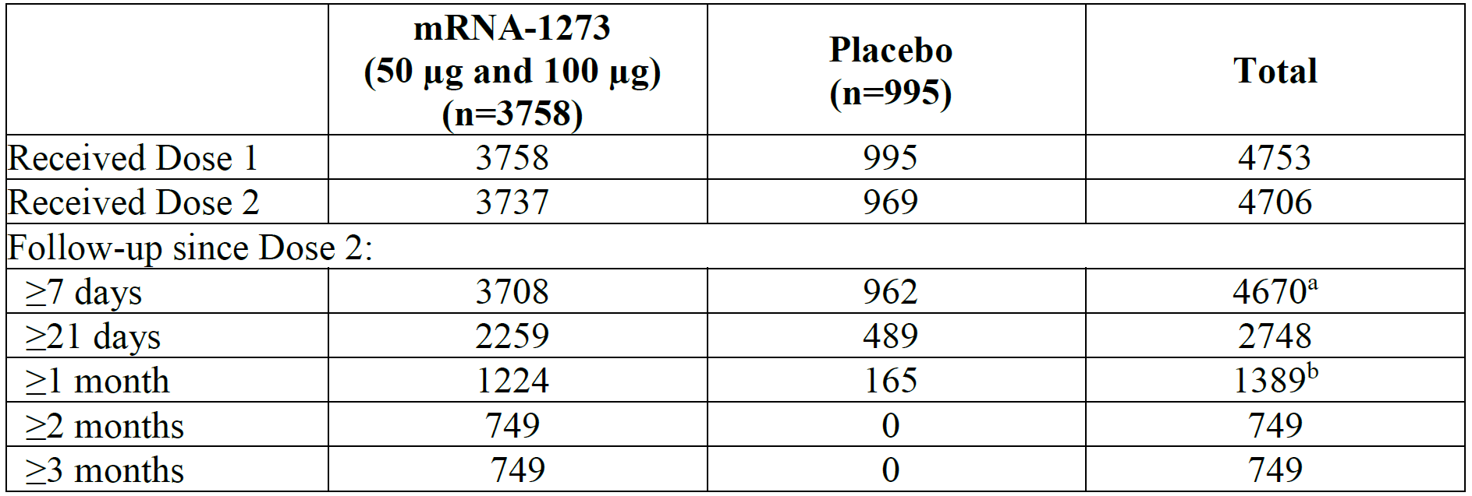
mRNA-1273 = Spikevax COVID-19 vaccine; n = sample size.
a. Median follow-up of > 21 days after Dose 2.
b. Median follow-up of > 2 months after Dose 2.
The Spikevax (elasomeran/mRNA-1273) vaccine is reactogenic with frequent mild to moderate local and systemic ARs, but Grade 3 reactions were rare, and the reactions were short-lived. Reactogenicity events were higher after the second dose. There were no vaccine related SAEs, no deaths, no cases of myocarditis or pericarditis, and no new safety concerns identified from these children who were followed for the short period of time. Obviously, this size of the safety database is not be able to detect very rare AEs such as myocarditis, pericarditis, or any immune mediated diseases.
The sponsor has been requested by the TGA to justify the short safety follow-up with the data cut-off date of 6 October 2021. The sponsor stated in their response that the data snapshot criteria for children aged between 6 to < 12 years was based on the following:
- prior discussions (including the recommendations made at the 10 June 21 US FDA Vaccines and Related Biological Products Advisory Committee (VRBPAC));
- the ongoing public health emergency, the increased occurrence of COVID-19 in children;
- clear indications that myocarditis and pericarditis predominantly occurs within one week post-vaccination.
The sponsor stated in their response that based on the above, a data snapshot was triggered when the following criteria were met to allow assessment of benefit/risk for this age group:
- availability of immunogenicity data from Part 1 participants in the 6 to < 12-years of age group who received the selected dose of mRNA-1273 (two 50 µg doses, 28 days apart);
- a median follow-up of 2 months for at least 1000 mRNA-1273 exposed subjects;
- at least 7 days and a median of 21 days follow-up for at least 3000 mRNA-1273 exposed subjects.
Safety and efficacy data (assessed as secondary endpoint) are considered immature at this stage. The median follow-up duration is 20 days post-Dose 2 for the randomised placebo controlled part of the study (cut-off of 6 October 2021). The sponsor is asked when the data with the median follow-up duration of 2 months post-Dose 2 (for Part 2) will be available. Advice from the ACV is sought as to whether conclusions on the benefit risks balance can be concluded with the currently submitted data , taking into consideration of the available experience of this vaccine in adults and adolescents from clinical trials and the real world use, and with the sponsor’s commitment to submit the timely update on the safety analysis of the ongoing Study P204.

Potential risk of myocarditis and pericarditis
Myocarditis is recognised as a known but very rare side effect of mRNA COVID-19 vaccines. Reports received by the TGA of suspected myocarditis and pericarditis for mRNA vaccines can be found on the TGA website. As the TGA has received limited AE reports for Spikevax, the analysis of likely myocarditis cases focuses on data for the Comirnaty (Pfizer/BioNTech) vaccine. The estimated reporting rates in Australia appear similar to overseas rates. Up to 14 November 2021, the TGA has received 315 reports which have been assessed as likely to be myocarditis from about 23.4 million doses of Comirnaty vaccine.
It is noted that in early December 2021, the EMA’s Pharmacovigilance Risk Assessment Committee (PRAC) assessed recent data on the known risk of myocarditis and pericarditis following vaccination with COVID-19 vaccines Comirnaty and Spikevax. This review included two large European epidemiological studies. One study was conducted using data from the French national health system and the other one was based on Nordic registry data. The outcome of the review confirms the risk of myocarditis and pericarditis, which is already reflected in the PI for these two vaccines,, and provides further details on these two conditions. Based on the reviewed data, the PRAC has determined that the risk for both of these conditions is overall ‘very rare’, meaning that up to one in 10,000 vaccinated people may be affected. Additionally, the data show that the increased risk of myocarditis after vaccination is highest in younger males. The French and Nordic data provide estimates of the number of extra cases of myocarditis in younger males following the second dose, compared to unexposed persons of the same age and gender. In the case of Spikevax, the French data showed that in a period of seven days after the second dose there were about 1.3 extra cases of myocarditis in 12 to 29-year-old males per 10,000 treated population compared to unexposed persons. The Nordic data show that in a period of 28 days after the second dose of Spikevax there were around 1.9 extra cases of myocarditis in 16 to 24-year-old males per 10,000 treated population compared to unexposed persons. Available data suggest that the course of myocarditis and pericarditis following vaccination is not different from myocarditis or pericarditis in general. The EMA confirms that the benefits of all authorised COVID-19 vaccines continue to outweigh their risks, given the risk of COVID-19 illness and related complications, and as scientific evidence shows that they reduce deaths and hospitalisations due to COVID-19.
The PRAC has recommended updating the PI with stronger wording. The stronger wording has now been incorporated into the Australian PI with the Spikevax booster dose application (PM-2021-05131-1-2). The current PI statements are as follows:
‘Myocarditis and pericarditis
There is an increased risk for myocarditis and pericarditis following vaccination with Spikevax.
These conditions can develop within just a few days after vaccination, and have primarily occurred within 14 days. They have been observed more often after the second dose, and more often in adolescent and young adult males.
Available data suggest that the course of myocarditis and pericarditis following vaccination is not different from myocarditis or pericarditis in general. Available short-term follow-up data suggest that the symptoms resolve in most individuals, but information on long-term sequelae is lacking.
Healthcare professionals should be alert to the signs and symptoms of myocarditis and pericarditis.
Vaccine recipients should be instructed to seek immediate medical attention if they develop symptoms indicative of myocarditis or pericarditis such as (acute and persisting) chest pain, shortness of breath, or palpitations following vaccination. Healthcare professionals should consult guidance and/or specialists to diagnose and treat this condition.
For further details, please refer to the relevant clinical guidelines developed by the Australian Technical Advisory Group on Immunisation.’
The risks of myocarditis and pericarditis cannot be assessed on the basis of the submitted data in the 6 to < 12-years of age group. There were no cases of myocarditis detected during the clinical trials with this age group up to the cut-off date (6 October 2021), but the size of the study is certainly not sufficient to detect very rare events and the duration of follow-up is very short. It is also difficult to estimate the risk potential of myocarditis and pericarditis in the 6 to < 12-years of age group, as the proposed dose for this age group is half the dose used in adults and adolescents. Active surveillance is important to timely detect any potential risk in this age group.

Proposed action
The submitted immunobridging data from Study P204 demonstrated that vaccination of children 6 to < 12 years of age with 50 µg mRNA-1273 primary series is associated with non-inferior anti-SARS-CoV-2 nAb responses when compared to that in individuals 18 to 25 years old from Study P301. There are discrepancies in the nAB GMT readouts among different subsets of children (due to assay variability according to the sponsor), but non-inferiority criteria have all been met and immunobridging is considered as having been successfully shown. Questions were raised with regards to the dose finding exercise, and whether a lower dose (< 50 μg) might result in better tolerability and provide an adequate immune response.
For the safety analysis, it is noted that the safety analysis on the cut-off date of 6 October 2021 is not a pre-specified analysis. The planned interim safety analysis was to be done when a subset or all participants have completed Day 57 (2 months post-Dose 2). With the cut-off on 6 October 2021, the median duration is only 20 days post-Dose 2. Based on the submitted data, the reactogenicity profile in children 6 to < 12 years of age (Study P204 participants) were similar to that observed in individuals 18 to 25 years of age in Study P301, but fever was more common in children 6 to < 12 years of age (Study P204 participants) than in Study P301 participants. Grade 3 fever was also more frequent in Study P204 participants than in Study P301 participants. There were no new safety concerns identified in Study P204 participants with the short duration of follow-up, noting that the size of the study is not sufficient to detect very rare events. Post-market active surveillance is important in monitoring rare AEs.
Children with stable chronic underlying disease were allowed to be enrolled into the trial and the children enrolled in Study P204 were those who were in a reasonably good state of health. No conclusion on the safety profile in individuals with severe comorbidities or who are immunocompromised can be drawn from the study. It is currently unknown with regards to duration of vaccine protection in children and, whether the current vaccine can provide protection against newly emerging variants.
It is acknowledged that there are multiple uncertainties at the current time, including the non-optimal dose finding exercise, unavailable longer term safety and effectiveness data; the uncertainty around the risk of myocarditis and pericarditis post-vaccination in this age group; and the future progression of the pandemic, including the emergence of variants of concern. The balance of benefits and risks would change with the changing incidence of COVID-19, and the largest benefits can be anticipated when there is a higher incidence of infection. Children at higher risk of severe disease (for example, obese and/or with certain comorbidities) are more likely to realise benefits than general population of eligible children in this age group. While most children infected with SARS-CoV-2 have a mild illness, some become severely ill and require hospitalisation. Multisystem inflammatory syndrome in children associated with SARS-CoV-2 is rare but may be fatal. The direct benefits of vaccinating children of this age group include prevention of COVID-19 cases, the likely prevention of hospitalisations, ICU visits, MIS-C and deaths and potential long-term sequelae of COVID-19 illness. It is acknowledged that there are indirect benefits associated with vaccinating children, such as contributing to schools remaining open and contributing to herd immunity.
The Delegate acknowledges the challenge in weighing up the benefits and risks for this age group, but is inclined toward thinking that the known and potential benefits are likely to outweigh the known and potential risks for the general population of eligible children aged 6 to < 12 years old.
The Delegate is seeking the advice from the ACV on the issues of dose selection, the short post-Dose 2 follow-up duration, the potential risk of myocarditis and pericarditis, and the consideration of benefits and risks balance at this timepoint. The final decision will be made following the ACV meeting discussion.

Questions for the sponsor
The sponsor provided the following response to questions from the Delegate.
- When will the Day 57 (two months) post-Dose 2 safety analysis be available for all participants (of 6 to < 12 years of age) from Study P204 Part 2?
The sponsor confirms that the study Day 57 safety analysis for all participants (of 6 to < 12 years of age) from Study P204 Part 2 will be available for submission in mid-January 2022 and this will be submitted to the TGA at the earliest opportunity. On 10 November 2021 a data cut-off was triggered as a protocol-specified interim analysis for Part 2 of this study, covering all participants of 6 to < 12 years of age, either reaching Day 57 or having discontinued the study. This interim analysis data cut-off will provide a median follow-up duration of approximately 2 months post-Dose 2 for the Part 2 participants. On 29 October 2021 the US FDA granted an Emergency Use Authorization to a COVID-19 vaccine for children aged 5 to 11 years, an event which triggered the protocol specified unblinding and cross-over of Study P204 placebo participants aged 6 to < 12 years, per their request. The vast majority of participants had requested unblinding by 10 November 2021, thus ending the blinded phase of the trial for this cohort and marking the final date for accumulation of placebo-controlled efficacy data from this study cohort.

Advisory Committee considerations
The Advisory Committee on Vaccines (ACV), having considered the evaluations and the Delegate’s overview, as well as the sponsor’s response to these documents, advised the following.

Specific advice to the Delegate
- Does the ACV consider that the selected 50 μg dose is appropriate for individuals 6 to < 12 years of age?
The ACV noted that a dose lower than 50 µg was not included in dose-ranging study for children 6 to < 12 years of age. In the absence of data it is not possible to confirm that 50 µg is the optimum dose.
Any data on the 2 to < 6 years population at the 25 µg dose would assist to understand the relationship between dose, immunogenicity and reactogenicity.
The ACV noted the reduction to one-third of the 12+ dose for children in the 5 to < 12 years group for Comirnaty, another mRNA vaccine.
The ACV noted that GMRs are increased compared with young adults by approximately 1.5-fold, suggesting that the proposed dose could be in excess of that needed to achieve comparable (high) protection in young adults (using immunobridging to efficacy/effectiveness).
- The median follow-up for the placebo controlled part of the study was 20 days post-Dose 2. Does the ACV consider this follow up duration is appropriate to allow benefits risks assessment for this age group in the pandemic setting?
The ACV noted that more recent data should now be available, as evident from various press releases from the sponsor. The TGA was encouraged to review such data.
Follow-up time would ideally be longer, but the observation period is adequate with respect of myocarditis, given onset of this event is generally within the first days after vaccination.
However, Study P204 is underpowered to detect the expected rates of myocarditis and other rare but significant adverse events.
- What is the ACV view with regards to potential risk of myocarditis/pericarditis in this age group following mRNA-1273 vaccination?
The ACV expressed uncertainty on the potential risk of myocarditis/pericarditis in this age group due to the limited data.
The ACV noted that within older age groups the data suggests rates are higher with Spikevax than with Comirnaty. The ACV noted:
- a UK study that suggests excess rates of myocarditis/pericarditis following second doses of Spikevax compared to Comirnaty and similar rates to following SARS-CoV-2 infection.
- [European Medicines Agency] EMA PRAC notes two studies suggesting rates of myocarditis and pericarditis following second dose of Spikevax were higher than following Comirnaty: in France 13 versus 2.6 per 100,000; in Nordic countries 5.7 versus 1.9 per 100,000.
- 8 cases of myocarditis have been confirmed in the 6 to < 12 age group following administration of Comirnaty in the USA, as at 9 December 2021.
However, myocarditis rates following vaccination in children appear to follow the pattern of the background rate (with milder clinical phenotype), that is, higher rates in infants and in 16 to 18 year olds, compared to 6 to 12-year olds.
- Based on the available data at this point in time, can the ACV advise whether the benefits-risks balance is considered favourable for the provisional registration of Spikevax (elasomeran) as 2 doses of 50 μg primary series in individuals 6 to < 12 years of age?
The ACV advised that the available data are currently insufficient to provide confidence of a favourable benefit-risk profile at the 50 µg dose level, as described in the advice to the Delegate below.
The ACV noted the likely availability of other data, including responses to other regulators:
- longer follow up data from part 2; Day 57 immunogenicity; COVID-19 events from Part 2 to support immunobridging
- outcome data on clinical severity of myocarditis in older age groups
- other post-marketing surveillance.
- dose ranging study of 50 µg dose in teenagers.
- Other
The ACV commented that the vaccine is highly reactogenic and so febrile convulsions may be an issue in younger children but not generally the 6 to 11 year age group. This needed to be balanced against symptoms/consequences of COVID-19. The sponsor has reported no case of febrile convulsion in Study P204.
The ACV commented on administration concerns due to using the same formulation (vial) to administer different injection volumes for adults and children. The ACV noted that given the range of COVID-19 vaccines now available within Australia there continues to be a need for provider education on each vaccine and its usage.
The ACV commented that from the public health perspective there may be advantages of having a second approved vaccine for this age group, especially if there becomes a need for vaccine for variant strains of SARS-CoV-2. Against this, COVID-19 disease is mild in this age group and the program rollout of the other mRNA vaccine is imminent.

ACV advice to the Delegate
The ACV was of the view that there are currently insufficient data to make a recommendation on the overall benefit-risk balance of elasomeran at the 50 μg dose for use in the 6 to < 12-year old population.
The ACV was uncertain whether the selected 50 μg dose is the most appropriate for individuals 6 to < 12 years of age. They expressed the need for a lower dose (25 μg) to be tested in dose ranging studies, particularly considering that GMRs following 50 μg primary doses are increased compared to young adults following 100 μg primary doses by approximately 1.5-fold indicating that dose may be in excess of that needed to achieve comparable high protection in young adults.
The ACV expressed interest in viewing the data on the 2 to < 6 years population at the 25 μg dose to further understand the relationship between dose, immunogenicity and reactogenicity. They noted this may provide guidance to the Delegate in assessing the appropriate dose for the 6 to < 12 years old group.
In providing this advice, the ACV recommended that the Delegate request the longer term follow up data from Study P204 Part 2 including Day 57 immunogenicity, safety and COVID-19 events, as also requested by the EMA.
The ACV noted uncertainty in relation to the risk of myocarditis and pericarditis after Spikevax in this age group, particularly in light of emerging data on the differential risk of these events compared to the other mRNA vaccine registered for older age groups.
In addition, the ACV was of the view that the following information would be informative in assessing benefit over risk:
- comparison of troponin levels (as biomarker for myocardial inflammation early post-Dose 2) in vaccine/placebo arms of young adult, adolescent and child vaccine trial participants
- outcome data on clinical severity of myocarditis in older age groups
- post-marketing data in this age group and dose if available.
The ACV recommended deferral of a decision by the Delegate, pending review of additional information.

Risk/benefit assessment (post-Advisory Committee Meeting)
The extension of indication to children between 6 to < 12 years old for Spikevax 50 μg was discussed at the ACV meeting on 22 December 2021. The ACV considers that the submitted data is not sufficient to assess the benefit-risk balance for Spikevax 50 μg in individuals 6 to < 12 years of age. Following the ACV discussion, the Delegate raised further questions and requested further data from the sponsor. The sponsor’s response was provided to the TGA on 17 and 19 January 2022. The following is a brief summary of the data submitted by the sponsor, the Delegate’s analysis, and additional questions that the Delegate requested for the ACV’s advice.

Data for children aged 6 to < 12 years old with the cut-off date of 10 November 2021
The data provided at the initial submission was at the cut-off date of 6 October 2021. The sponsor has now provided summaries of immunogenicity (Day 57), efficacy (COVID-19 events recently obtained), and safety data with the cut-off on 10 November 2021 (interim analysis).

Immunogenicity
This larger PP immunogenicity subset (n = 319) derives from the blinded, placebo controlled phase (Part 2) of Study P204. The Day 57 nAb GMT measured by PsVNA ID₅₀ from this subset was 1610.2 (95% CI: 1456.6, 1780.0; n = 319) with 99.1% of children achieving seroresponse. The GMFR in nAb from Baseline to Day 57 was 174.0 (95% CI: 157.2, 192.5). The GMT of 1610.2 from this larger Part 2 PP immunogenicity subset falls between that observed for the dose selection subset (1204.6: 95% CI: 1047.2, 1385.8; n = 67) and for the Part 1 PP immunogenicity subset (1964.6, 95% CI: 1722.4, 2240.9; n = 134). Results from this subset (with the 10 November 2021 interim analysis) successfully met non-inferiority criteria for both GMR and seroresponse rate (SRR) difference compared to young adults (18 to 25 years) in the pivotal Study P301. Comparison of GMT between the Part 2 PP immunogenicity subset in Study P204, and the PP immunogenicity subset of young adults in Study P301 shows a GMR of 1.239 (95% CI: 1.072, 1.432) and a SRR difference of 0.1 (95% CI: -1.9, 2.1).
Table 23: Study P204 Part 2 Co-primary immunobridging at Day 57 (pseudovirus Neutralising antibody level by pseudovirus neutralising assay; 50% inhibitory dose) (per-protocol immunogenicity subset)
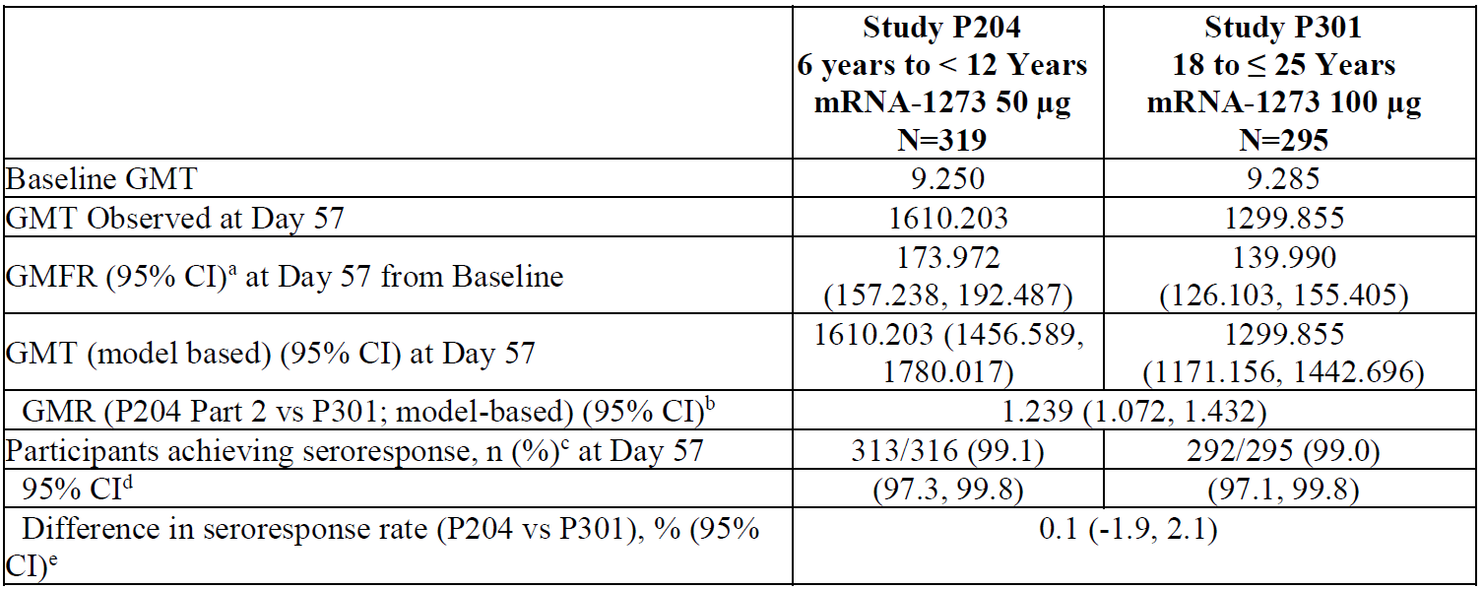
CI = confidence interval; GMFR = geometric mean fold ratio; GMR = geometric mean ratio; GMT = geometric mean titre (noted as observed or model based, which is estimated by geometric least squares mean); mRNA-1273 = Spikevax COVID-19 vaccine; N = population size; vs = versus.
Antibody values reported as below the lower limit of quantification (LLOQ) are replaced by 0.5 x LLOQ. Values greater than upper limit of quantification (ULOQ) are replaced by the ULOQ if actual values are not available.
Study P301 mRNA-1273 group includes young adults (18 to 25 years of age).
The ULOQ for selected Study P301 participants tested previously was different.
a. 95% CI is calculated based on the t-distribution of the log-transformed values or the difference in the log-transformed values for GMT and GMFR, respectively, then back transformed to the original scale for presentation.
b. The log-transformed antibody levels are analysed using an analysis of covariance (ANCOVA) model with the group variable (children in P204 Part 2 and young adults in P301) as fixed effect. The resulted least squares (LS) means, difference of LS means, and 95% CI are back transformed to the original scale for presentation.
c. Seroresponse at a participant level is defined as a change from below the LLOQ to equal or above 4 x LLOQ, or at least a 4-fold rise if baseline is equal to or above the LLOQ. Percentages are based on the number of participants with non-missing data at baseline and the corresponding timepoint.
d. 95% CI is calculated using the Clopper-Pearson method.
e. 95% CI is calculated using the Miettinen-Nurminen (score) confidence limits.
The GMR and SRR both successfully meet non-inferiority criteria of the 50 µg mRNA-1273 in children 6 to < 12 years of age compared to young adults receiving 100 µg of mRNA-1273.

Efficacy
The median follow-up duration is 82 days after Dose 1 and 51 days after Dose 2 in Part 2 blinded phase. Efficacy endpoints accumulated after the first dose (that is, occurring starting 14 days post-Dose 1 and measured in the mITT1 population) outnumber the efficacy endpoints accumulated after the two-dose regimen (that is, starting 14 days post-Dose 2). Limiting endpoint analysis to endpoints occurring 14 days post-Dose 2 yield a total of only 7 cases, which are too few to perform meaningful analysis. Nonetheless, using either of two COVID-19 case definitions (the CDC definition or the Study P301 case definition), the incidence of cases among placebo participants exceeds that of the vaccine recipients.
Table 24: Study P204 Summary of secondary efficacy analysis results starting 14 days after Dose 2 (per-protocol set for efficacy)
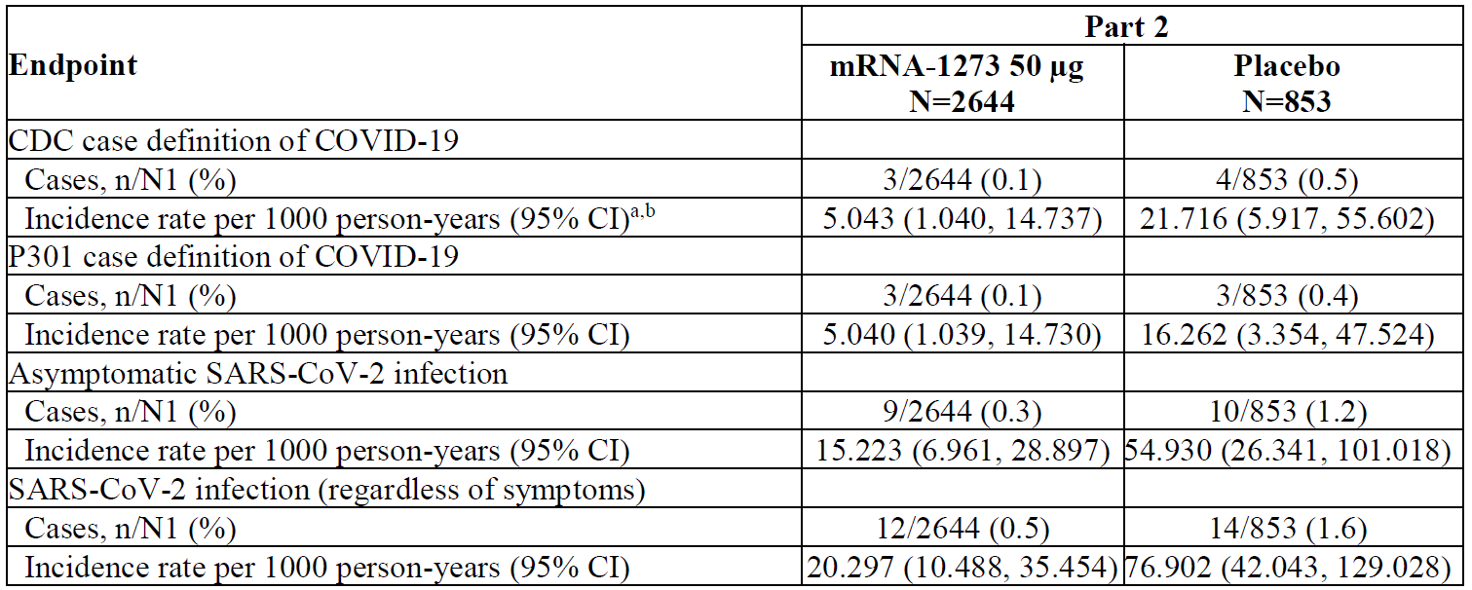
CDC = Centers for Disease Control and Prevention; CI = confidence interval; COVID-19 = coronavirus disease 2019; mRNA-1273 = Spikevax COVID-19 vaccine; N = population size; N1= number of participants at risk at 14 days after Dose 2 for specific efficacy endpoint; NE = not estimable; SARS-CoV-2 = severe acute respiratory syndrome coronavirus 2.
a. Person-years is defined as the total years from the first injection date for Part 1 and the randomisation date for Part 2 to the date of event (CDC case definition of COVID-19, Study P301 case definition of COVID-19, asymptomatic SARS-CoV-2 infection, or SARS-CoV-2 infection, depending upon endpoint), last date of study participation, or efficacy data cut-off date, whichever is the earliest.
b. Incidence rate is defined as the number of participants with an event divided by the number of participants at risk and adjusted by person-years (total time at risk) in each treatment group. The 95% CI is calculated using the exact method (Poisson distribution) and adjusted by person-years.
Where more cases (a total of 25 cases) were accrued (that is, when endpoints are counted starting earlier, 14 days post-Dose 1; mITT1 population) (see Table 26 below), this allowed a calculation of VE in which the lower border of the 95% CI was 70%, providing confidence in the estimate of efficacy. In the mITT1 population starting 14 days after the first dose, the incidence of COVID-19 using the CDC case definition was 117 per 1000 person-years in the placebo group compared to 14 per 1000 person-years in the vaccine group, yielding a VE of 88% (95% CI: 70.0%, 95.8%). Using Study P301 case definition (definition employed in the pivotal adult efficacy trial of mRNA-1273), a VE of 91.8% was observed (95% CI: 74.2, 98.0%).
Table 25: Study P204 Part 2 Summary of secondary efficacy endpoint analysis results starting 14 days after Dose 1 (modified intent-to-treat 1 population)
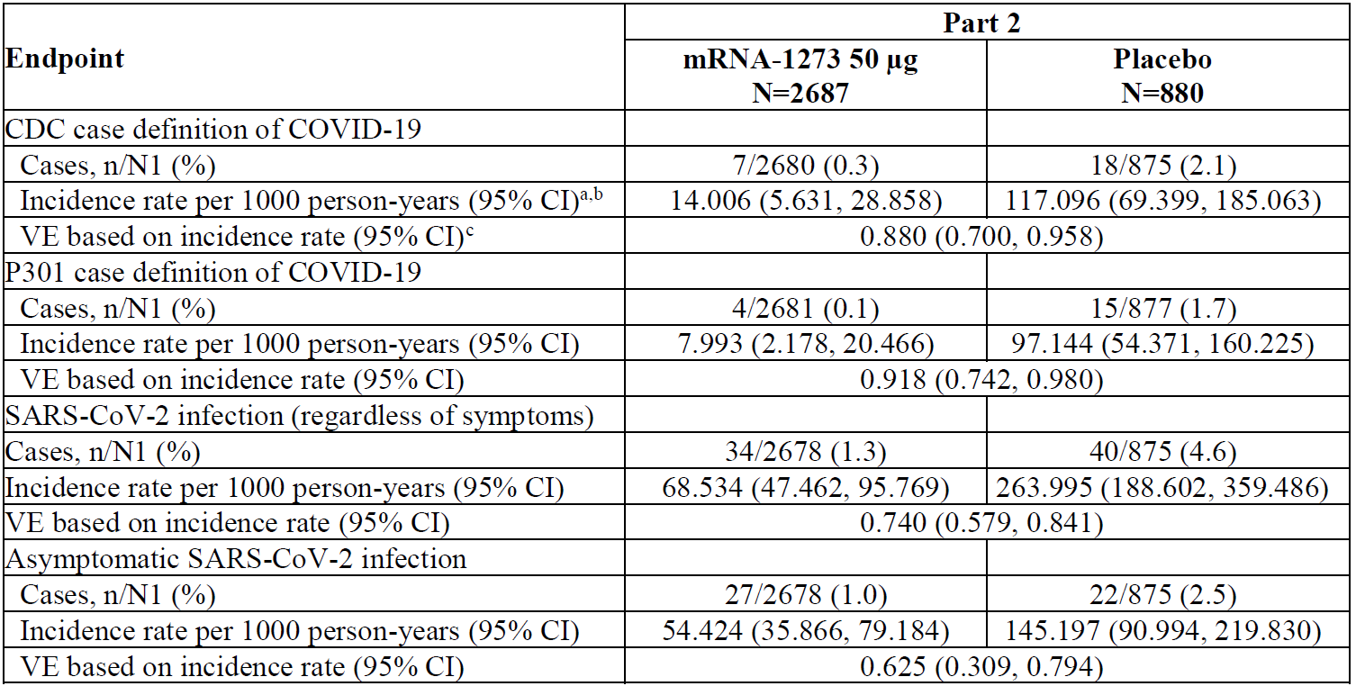
CDC = Centers for Disease Control and Prevention; CI = confidence interval; COVID 19 = coronavirus disease 2019; mRNA-1273 = Spikevax COVID-19 vaccine; N1= number of participants at risk at 14 days after Dose 1 for specific efficacy endpoint; NE = not estimable; SARS-CoV-2 = severe acute respiratory syndrome coronavirus 2; VE = vaccine efficacy.
a. Person-years is defined as the total years from the first injection date for Part 1 and the randomisation date for Part 2 to the date of event (CDC case definition of COVID-19, P301 case definition of COVID-19, asymptomatic SARS-CoV-2 infection, or SARS-CoV-2 infection, depending upon endpoint), last date of study participation, or efficacy data cut-off date, whichever is the earliest.
b. Incidence rate is defined as the number of participants with an event divided by the number of participants at risk and adjusted by person-years (total time at risk) in each treatment group. The 95% CI is calculated using the exact method (Poisson distribution) and adjusted by person-years.
c. Vaccine efficacy defined as 1 - ratio of incidence rate (mRNA-1273 versus placebo). The 95% CI of the ratio is calculated using the exact method conditional upon the total number of cases, adjusting for person-years.

Safety
In the 10 November 2021 interim safety analysis, a median follow-up of 56 days post Dose 2 is provided for a total of 3387 exposed (50 µg) participants across Parts 1 and Part 2 from the blinded and open label phases. From Part 2, a median follow-up of 55 days post-Dose 2 is provided for 4002 participants (3007 exposed to 50 µg, and 995 placebo). Analysis of the clinical safety database showed no clinically meaningful changes in the mRNA-1273 safety profile in this age group. Rates of SAEs, AESIs, MAAEs, and predefined SMQs in either Part 1 or Part 2 of Study P204 were similar to the earlier data snapshot of 6 October 2021 (which provided a median follow-up of 20 days post-Dose 2 for 2987 mRNA-1273 recipients). This 10 November 2021 interim analysis reported no SAEs considered related to study vaccine, no deaths, no cases of MIS-C and no cases of myocarditis or pericarditis.

Dose selection data for children aged between 2 to < 6 years old
Data is provided for children aged 2 to < 6 years old who received either 25 or 50 µg in Part 1 (open label) of Study P204. Review of the reactogenicity and immunogenicity between the two dose groups does suggests a dose relationship for each measure:
- higher dose was associated with higher rates of reactogenicity (particularly post-Dose 2 and for ARs of Grade 3 or higher);
- higher dose was associated with higher levels of Day 57 serum nAb and bAb.
Differences in reactogenicity between the two dose groups were most evident for post-Dose 2 and for events of Grade 3 or higher. This was most pronounced for fever post-Dose 2. In the 25 µg group, 1/75 participants (1.3 %) reported a Grade 3 fever or higher (none reported Grade 4 fever). In contrast, post-Dose 2 in the 50 µg group, 11/149 participants (7.3%) reported a Grade 3 or higher grade fever, including one participant with Grade 4 fever.
Differences in immunogenicity results for the dose selection subset between the two dose groups were similarly evident. Binding and neutralising antibody levels in the 50 µg group were higher than those in the 25 µg group.
The bAb GMR compared to the 18 to 25 years old from Study P301 is 1.563 for the 50 μg and is 1.019 for the 25 μg given to the 2 to < 6 years old. The nAb GMR compared to the 18 to 25 years old from Study P301 is 1.419 for the 50 μg and is 0.779 for the 25 μg used for the 2 to < 6 years old.
Table 26: Study P204 Part 1 SARS-CoV-2 specific binding antibody (Meso Scale Discovery assay) and neutralising antibody (pseudovirus neutralisation assay, 50% inhibitory dose) analysis at Day 57 (dose selection subset age 2 to < 6 years old, by dosage level)
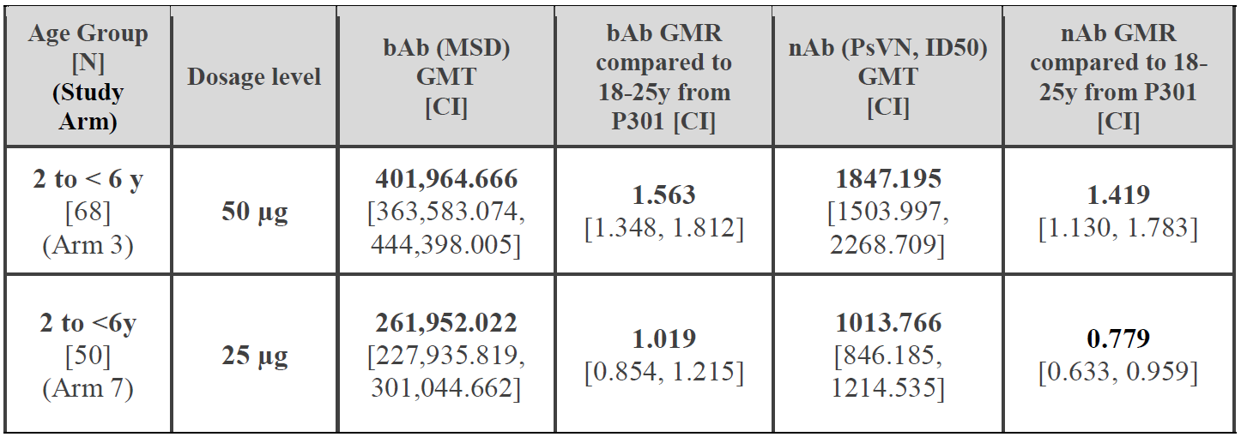
bAb = binding antibody; MSD = Mesoscale Discovery; GMT = geometric mean titre; GMR = geometric mean ratio; ID₅₀ = 50% inhibitory dose; N = population size; nAb = neutralising antibody; PsVN = pseudovirus neutralisation assay; SARS-CoV-2 = severe acute respiratory syndrome coronavirus 2; y = years.
All dose-selection cohort participants met per-protocol immunogenicity criteria.
The 25 µg dose was advanced to Part 2 in this age group (2 to < 6 years old). This is the dose that results in less reactogenicity while still inducing immune responses anticipated to achieve immunobridging to adults in the pivotal Study P301.
The sponsor reaffirmed their view that the 50 µg is considered more appropriate to swiftly provide protection to children and their families in the setting of the ongoing pandemic and considering the current outbreak caused by the Omicron variant and potential future variants of concern.

Data on troponin levels
Following the request by the FDA, the sponsor included an additional blood collection (within four day post-Dose 2) in the paediatric Study P204 (Protocol Amendment 4) with the provision that collected samples were to be stored and not proactively tested. Clinical trials of ≥ 12 years of age were completed prior to these considerations; such collections are planned for the booster portion of mRNA-1273 in adolescents. The decision to store, and not actively test, collected serum was made in agreement with the FDA that screening otherwise healthy children for serum troponin is of limited value. Post-Dose 2 blood from a subset of Study P204 participants in each age group (phlebotomy sub-cohort D, lacking any other post-Baseline blood draws before Amendment 4) was collected and stored at the central lab for potential future biomarker analysis (including cardiac biomarkers).
Although storage of collected blood was indicated in the protocol, the sponsor discovered that between 15 September and 26 October 2021, 50 serum samples collected in Part 2 of Study P204 (6 to < 12 years old) were nonetheless tested for troponin levels (troponin I and/or troponin T, high sensitivity). This testing occurred without sponsor request or authorisation. It was discovered by chance by sponsor’s medical monitor review of Study P204 laboratory test results in the central laboratory portal. While results of these 50 participants were not requested, given their availability, the sponsor proactively provides these troponin results to the TGA, together with basic demographics. They included both groups (9 out of 50 received placebo, 41 out of 50 received mRNA-1273). All results were within normal limits for the 50 participants.

Outcome data on clinical severity of myocarditis
The sponsor provided four published articles relating to observational studies that describe outcome data on patients that had received COVID-19 mRNA vaccines and had experienced myocarditis or pericarditis. For these articles, clinical presentation seems to be consistent with the majority of patients having normal ventricular systolic function on echocardiogram, as well as many having abnormal findings suggestive of myocarditis on cardiac magnetic resonance imaging in the setting of elevated troponin and electrocardiographic changes; the presentation of the myocarditis is usually characterised by a mild illness with rapid resolution of symptoms within few days in the vast majority of affected individuals. Fatal cases were very rare.

Post-marketing adverse events data
There are limited surveillance data for children aged 6 to < 12 years old, as the indication for this age group is not yet authorised. The spontaneous reporting is of limited value for 6 to < 12 years old.
The sponsor provides a summary as of 31 December 2021, an estimated 827,274,740 doses had been distributed; an estimated 466,804,529 doses have been administered.
Cumulatively, the sponsor has received 349 cases (842 events, of which 190 events were serious) for children (< 12 years old). Of the cumulative reported cases, 147 cases were medically confirmed, 80 cases were serious, and 5 cases had fatal outcomes. The proportion of cases reported in females (37.8%, 132) was similar to males (39.3%, 137), while the remaining cases (n = 80) did not have gender reported. The mean age was 1.8 years (standard deviation = 3.0; median = 0.6 years).
Cumulatively, the sponsor has received 5,808 cases (9,981 events, of which 1,081 events were serious) for adolescents (12 to 17 years old). Of the cumulative reported cases, 4,936 cases were medically confirmed, 443 cases were serious, and seven cases had fatal outcomes. The majority of cases were reported in females (54.3%, 3,153) compared to males (41.6%, 2,415) with the mean age of 15.9 years (standard deviation = 1.5; median = 16.0 years).

New information from the sponsor
On 25 January 2022, the sponsor shared the following information to the TGA.

Clinical and neutralising effectiveness data from the KIDCOVE trial (Study P204) in children between 6 to < 12 years of age
Efficacy starting as soon as 14 days after Dose 1 of mRNA-1273 (mITT1 population) in children between 6 and < 12 years was 91.2% against COVID-19 (Study P301 case definition; 95% CI: 74.2%, 98.0%; total 19 cases) with an incidence of 97/1000 person-years in the placebo group compared to an incidence of 8/1000 person-years in the vaccine group. Of note, this efficacy was observed at a time when the major circulating variant in the US and Canada was the Delta variant. This clinical efficacy is, in part, associated with the observed magnitude of nAb responses that cross neutralise a pseudovirus expressing the Delta variant spike protein. Among children 6 to < 12 years in Study P204, robust nAb GMFR against the Delta variant (81.77) and that measured against the original strain (209.466) were both evident.
The Delegate commented the efficacy analysis of 10 /11/2021 cut-off, includes case definitions for 1) CDC, 25 cases accrued, VE 88.0% (95% CI: 70.0%, 95.8%) and 2) P301, 19 cases accrued, VE 91.8% (95% CI: 74.2%, 98.0%).

New preliminary data from both the TEENCOVE trial (Study P203) and the KIDCOVE trial (Study P204) clinical studies on the Omicron variant neutralising capacity of a two dose primary series in adolescent and children
Adolescent and children volunteers received a primary vaccination series of two doses of mRNA-1273 at 100 µg or 50 µg, respectively. Data is provided for a sub-sample (20 participants) that includes pseudovirus ID₅₀ neutralising titres against the archetype virus (the D614G strain) that matches the mRNA-1273 antigen, and the Omicron variants of concern. This data was been generated in research-grade pseudovirus neutralisation assay.
Recently released data indicate that a two-dose primary vaccination regimen of Spikevax elicits higher D614G and Omicron variant neutralising titres in both adolescent (100 µg dose, 12 to 17 years old) and children (50 µg dose, 6 to < 12 years old) than in adults (100 µg dose, ≥ 18 years old) (Figure 1).
All (100%) adolescents and children showed detectable neutralisation titres versus the Omicron variant. Compared to adult’s primary series, GMT titres in adolescents and children were 3.8 and 2.5-fold higher for the Omicron variant, respectively. The effectiveness and the durability of protection against the Omicron variant in adolescents and children remains to be determined.
Figure 1: Study P204 Neutralisation of D614G and Omicron variants SARS-CoV-2 pseudoviruses by sera from mRNA-1273 primary vaccination recipients
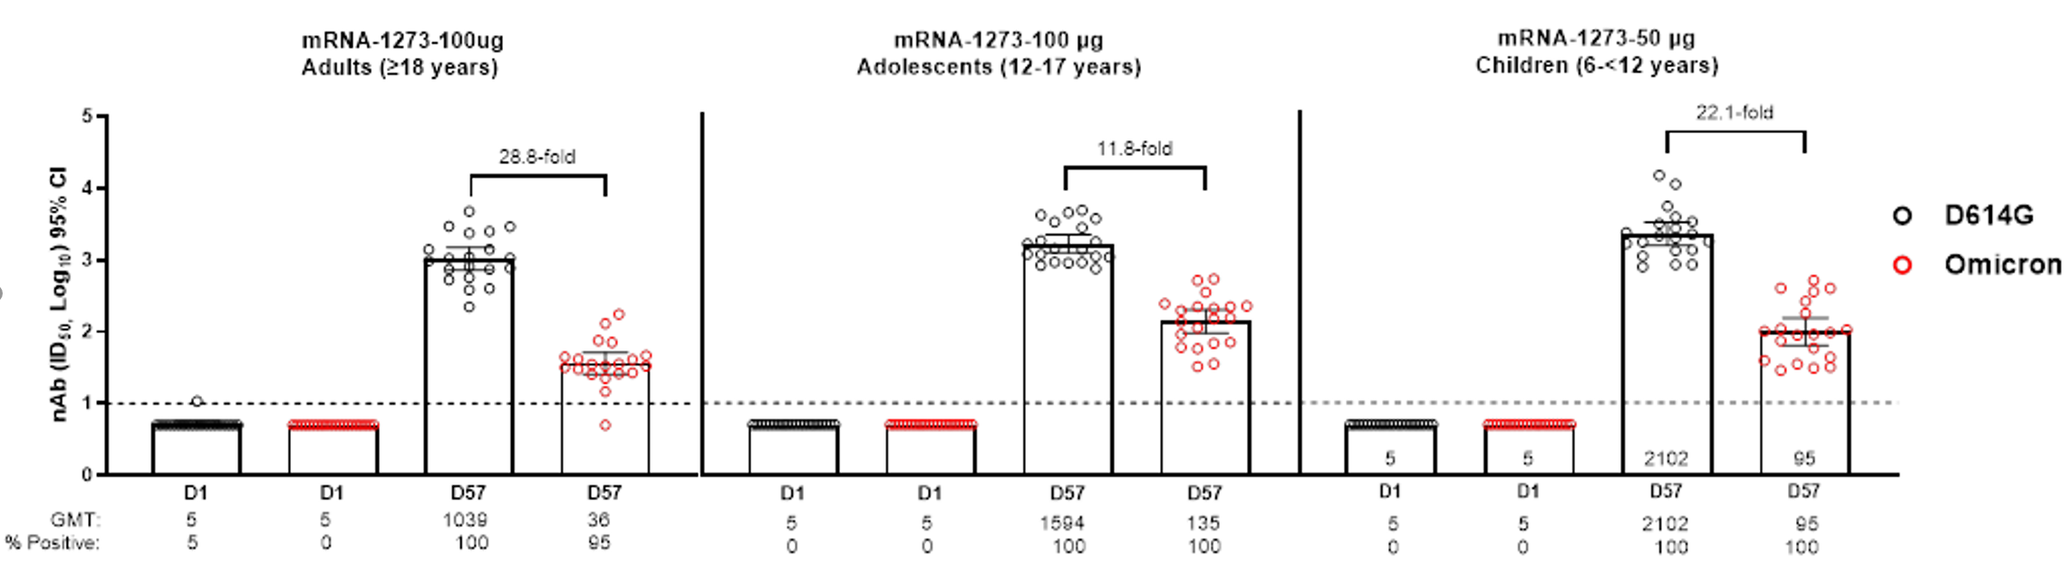
CI = confidence interval; D = Day; GMT = geometric mean titre; ID₅₀ = 50% inhibitory dose; mRNA-1273 = Spikevax COVID-19 vaccine; nAb = neutralising antibody; SARS-CoV-2 = severe acute respiratory syndrome coronavirus 2.
Pseudovirus neutralising assay (PsVNA) titres against wildtype (D614G) and Omicron variant pseudoviruses in adults ≥18 years of age (Panel A), adolescents 12 to 17 years of age (Panel B) and children 6 to ≤ 12 years (Panel C) who received a 2-dose primary regimen of mRNA-1273 in clinical trials. PsVNA titres against wildtype (D614G) and Omicron pseudovirus were measured prior to Dose 1 at Day 1 and 4 weeks after the second dose (Day 57) of mRNA-1273. Included in each group were 20 participants in clinical trials of adults (≥ 18 years) and adolescents (12 to 17 years) who received 100 µg mRNA-1273 and children (6 to ≤ 12 years) who received 50 µg mRNA-1273. Neutralising antibody titres ID₅₀ were assayed against pseudoviruses containing the spike protein of D614G and the Omicron variant (supplementary methods). The assay lower limit of detection (LOD) was 10, indicated by the dotted line. Values below the LOD are assigned a value of 5.
The Delegate commented that the preliminary data are from very limited number of (n = 20) participants.

Early data on antibody profiling including cell-mediated immunity exploratory assessment in children in the KIDCOVE trial (Study P204).
In a separate study, comprehensive antibody profiling of mRNA vaccination in children from Study P204, observed comparable SARS-CoV-2 titres and neutralising activity across variants of concern, higher Fcγ-receptor binding and phagocytic antibodies in children compared to vaccinated adults. This data indicates that mRNA vaccination elicits robust antibody responses and drives antibody functionality in children.
In a further study, looking at the T-cell responses to the Omicron variant comparing cell-mediated immune responses between mRNA vaccines against the Omicron variant, higher interleukin 2 (IL-2) plus spot-forming units (SFU) were detected in vaccinees who received Spikevax as compared to Comirnaty vaccinated individuals.
The Delegate commented that the two articles have not been formally peer-reviewed.

Delegate’s discussion

Immunogenicity of Spikevax 25 μg and 50 μg
As discussed at the ACV meeting on 22 December 2021, the ACV was uncertain whether the selected 50 μg dose is the most appropriate for individuals 6 to < 12 years of age. As the GMRs following 50 μg primary doses are increased compared to young adults following 100 µg primary doses by approximately 1.2-fold indicating that dose may be in excess of that needed to achieve comparable high protection in young adults.
Further data for the 2 to < 6 years of age population showed that the 50 μg dose induced GMR of 1.419 (1.130, 1.783) and the 25 μg dose induced GMR of 0.779 (0.633, 0.959) when compared to the neutralising antibodies in young adults (Study P301). The 50 μg dose was associated with higher rate of reactogenicity. The 25 μg dose is therefore to be advanced for further assessment in Part 2 of Study P204 for the 2 to < 6 years of age population.
Even with the available dose selection information for 2 to 5 year olds, it remains difficult to estimate the most appropriate dose for those aged 6 to < 12 years old without a trial to assess this dose. In view of the GMR of 0.779 (0.633, 0.959) achieved with the 25 μg dose in the 2 to < 6 years old population, it is uncertain whether the 25 µg dose, if given to the 6 to < 12 years old, can achieve non-inferior immune response compare to young adults.
The sponsor has a plan to assess the 25 µg dose for the 6 to < 12 age group, but the results is not expected until the second half of 2022.
The higher level of antibody induced by 50 μg dose in the 6 to < 12 years old would be considered advantageous form COVID-19 prevention point of view, so the questions relating to the higher rates of reactogenicity are as follows:
- Are the higher rates of reactogenicity associated with the 50 μg dose in the 6 to < 12 years old considered unacceptable and preclude provisional registration?
- Does the risk of the higher rate of reactogenicity outweigh the potential benefit of better protection associated with the higher immunogenicity?

Reactogenicity of Spikevax in adults, adolescents and children
The comparison is made by the Delegate for the rate of solicited AEs (reactogenicity following the second dose of Spikevax) between adults, adolescent, and children (6 to < 12 years old) (see Table 27 below).
It appears that the rates of most solicited AEs in children 6 to < 12 years of age group (Study P204) are lower than the rates in adolescents (Study P203), with the exception of fever rate which was higher in children 6 to < 12 years of age.
The rates of most solicited AEs appear to be lower in adults (> 18 years of age, Study P301) when compared to adolescents (12 to 17 years of age, Study P203) and children (6 to < 12 years of age, Study P204).
Table 27: Study P301, Study P203 and Study P204 Rate of solicited reactions for Spikevax in adults, adolescents and children of 6 to < 12 years of age
Rate of SR within 7 days (%)  AG/(G3 or mod) | 50 μg (D2)  6-11 YOA  AG/G3 | 100 μg (D2)  12-18 YOA  AG/G3 | 100 μg (D2)  Adults >18 YOA  AG/>G3
Data source | Sponsor’s clinical overview | Delegate’s overview | Delegate’s  overview
Fever | 24.1  G3: 39.0-40.0ºC  (3.8) | 12.2  (1.9) | 15.5  (1.5)
Fatigue | 64.4  (6.3) | 67.8  (7.6) | 23.4  (0.7)
Headache | 54.2  (4.0) | 70.2  (4.5) | 23.4  (1.1)
Myalgia | 28.2  (2.4) | 46.6  (5.2) | 12.4  (0.4)
Arthralgia | 16.1  (0.8) | 28.9  (2.3) | 10.8  (0.3)
Chills | 30.3  (0.6) | 43.0  (0.4) | 44.2  (1.3)
Nausea and vomiting | 23.9  (0.6) | 23.9  (< 0.1) | 19.0  (0.1)
Injection site pain | 94.8  (2.7) | 92.4  (5.1) | 88.2  (4.1)
Redness | 18.8  (1.1) | 19.5  (2.9) | 8.6  (2.0)
Swelling | 17.1  (0.7) | 20.5  (2.3) | 12.2  (1.7)
Axillary swelling | 18  (0.1) | 21.0  (0.3) | 14.2  (0.5)
AG = any grade; D2 = Dose 2; G3 = Grade 3; mod = moderate; SR = solicited reactions; YOA = years of age.

Reactogenicity of Spikevax in 6 to < 12 years old versus 18 to 25 years old
The following was documented in the clinical overview submitted by the sponsor:
‘Solicited local ARs within 7 days of any dose of mRNA-1273 were reported at a similar frequency in Study P204 participants (98.6%) as in Study P301 participants (94.1%). In participants in both studies the majority of solicited local ARs were grade 1 or 2. Grade 3 solicited local ARs were reported in 5.5% of Study P204 participants and no grade 4 ARs were reported in this group. In contrast, grade 3 ARs were more frequent in Study P301 participants (11.4%). The most common solicited local AR was pain in both the Study P204 (98.4%) and Study P301 (89.4% after both Dose 1 and Dose 2) participants.
Solicited systemic ARs within 7 days of any dose of mRNA-1273 were reported at consistent rates in Study P204 participants (86.5%) and in Study P301 participants (89.1%). The majority of solicited systemic ARs after any dose were Grade 1 or 2 for both Study P204 participants and Study P301 participants. Grade 3 solicited systemic ARs were less frequent in Study P204 participants (13.3%) than in Study P301 participants (23.5%). The most common solicited systemic ARs in Study P204 participants were fatigue (43.4% after Dose 1 and 64.4% after Dose 2) and headache (31.2% after Dose 1 and 54.2% after Dose 2). The most common solicited systemic ARs in Study P301 participants were also fatigue (45.9% after Dose 1 and 69.2% after Dose 2) and headache (42.8% after Dose 1 and 70.1% after Dose 2).
The solicited systemic AR of fever was more common in Study P204 participants (3.4% after Dose 1 and 24.1% after Dose 2) than in Study P301 participants (1.7% after Dose 1 and 18.2% after Dose 2). Grade 3 fever was also more frequent in Study P204 participants (0.6% after Dose 1 and 3.8% after Dose 2) than in Study P301 participants (0 after Dose 1 and 1.2% after Dose 2).’
The overall reactogenicity profile of the 50 μg dose in the 6 to < 12 years old population (Study P204 Part 2) was comparable to young adults (Study P301), with the exception that the observed fever rates in the 6 to < 12 years old population were higher than those in the young adult population.

Spikevax versus other vaccines
The data relating to the rates of solicited adverse events (reactogenicity) are extracted for a number of vaccines from Australian PIs or the US PIs (depend on which documents the data can be located). These data are summarised in Table 28 below.
Table 28: Study P204 Comparison of the percentage of participants who experienced solicited adverse reactions within 7 days post-vaccination for a number of vaccines
Rate of SR  within 7 days (%)  AG/(G3 or mod) | Spikevax  (D2)  6-11 YOA  AG/G3 | Comirnaty  (D2)  5-11 YOA  AG/mod | Afluria quad  5-9 YOA  AG/G3 | Bexsero  (D2)  10-25 YOA  AG/mod | Prevanar 13  5-9 YOA  AG/mod | Imojev  2-5 YOA  No info
Data source | Clinical Overview | US  Fact sheet | Australian PI | US PI | US PI | Australian  PI
Fever | 24.1  G3: 39.0-40.0ºC  (3.8) | 6.5  M: > 38.9-40.0 ºC:  (0.5) | 4.5  (1.2) | 5  M: 39.0-39.9 ºC  (1) | 6.1  (2.4) | 20.7
Fatigue | 64.4  (6.3) | 39.4  (11.1) | 8.8  (0.4) | 35  (10) |  | 33.0
Headache | 54.2  (4.0) | 28  (9.1) | 12.3  (0.1) | 34  (6) |  | 21.0
Myalgia | 28.2  (2.4) | 11.7  (3.9) | 9.8  (0.1) | 48  (19) |  | 24.0
Arthralgia | 16.1  (0.8) | 5.2  (1.4) |  | 16  (6)
Chills | 30.3  (0.6) | 9.8  (2.7)
Nausea and  vomiting | 23.9  (0.6) | 1.9  (0.1) |  | 18  (5) |  | 19.2 (vomiting)
Injection site pain | 94.8  (2.7) | 71.0  (17.8) | 51.3  (0.8) | 83  (37) | 86.8  (19.5) | 23.6
Redness | 18.8  (1.1) | 18.5  (8.8) | 18.6  (3.5) | 45  (5) | 42.9  (22.0) | 23.4
Swelling | 17.1  (0.7) | 15.3  (7.5) | 15.3  (3.4) | 28  (2) | 37.6  (21.9) | 7.2
Axillary swelling | 18  (0.1)
AG = any grade; D2 = Dose 2; G3 = Grade 3; info = information; mod = moderate; PI = Product Information; SR = solicited reactions; US = United states; YOA = years of age.
When compared to other vaccines, Spikevax 50 μg appears to have the highest rate for most of the solicited reactions of any grade, but does not appear to have the highest rate of Grade 3 reactions (or reactions with moderate intensity). The caveat is that the intensity classification may not be identical in the different studies. No Grade 4 AEs were recorded with Spikevax 50 µg in 6 to < 12 years old in Study P204. As documented in the sponsor’s clinical overview, most solicited ARs associated with Spikevax 50 μg were short-lived and usually resolved within a few days. No events of febrile seizure were reported in Study P204. The 10 November 2021 interim analysis reported no SAEs considered related to Spikevax. There were no deaths, no cases of MIS-C and no cases of myocarditis or pericarditis.

Risk of myocarditis and pericarditis
The risks of myocarditis and pericarditis post-vaccination with Spikevax cannot be assessed on the basis of submitted data in the 6 to < 12 years old age group. There were no cases of myocarditis identified with the median 2-months post-Dose 2 follow up, but the size of the study is certainly not sufficient to detect very rare events.
Information from the CDC review; and ACIP discussion; about post-market safety for the Pfizer COVID-19 vaccine may help in estimating the risk of myocarditis post-mRNA vaccines in this age group.
The ACIP discussion stated that since authorisation of the Pfizer COVID-19 vaccine, 8.7 million doses of this vaccine were administered to children between 5 to 11 years old, and 18.7 million doses to children and adolescents between 12 to 15 years old in the US, and the reported myocarditis among male children between 5 to 11 years old are substantially lower than for males between 12 to 15 and 16 to 17 years old (see Table 29 below for the information presented).
Table 29: Reporting rates of myocarditis (per one million doses administered) after Pfizer-BioNTech COVID-19 vaccination, 7-day risk interval;⁴²
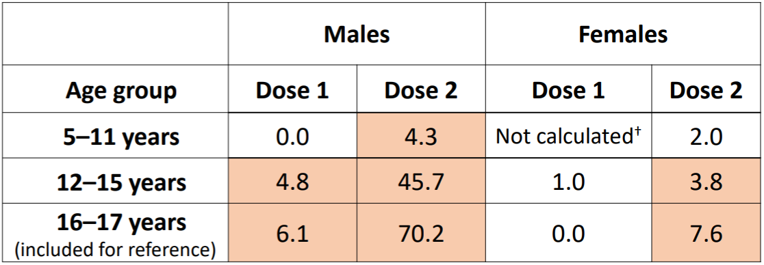
COVID-19 = coronavirus 2019
37,810,998 total Doses 1 and 2 of vaccine administered.
Reporting rates exceed background incidence (peach shaded cells).
-Males: after Dose 1 (ages 12 to 15 and 16 to 17 years) and after Dose 2 (ages 5 to 11, 12 to 15, and 16 to 17 years)
-Females: after Dose 2 (ages 12 to 15 and 16 to 17 years)
-Reporting rates among males substantially lower among ages 5 to 11 versus 12 to 15 and 16 to 17 years.
Reports of myocarditis after Doses 1 and 2 of Pfizer-BioNTech COVID-19 vaccine during a 7-day risk interval after vaccination (as of 19 December 2021); reports verified to meet case definition by healthcare provider interview and/or medical record review.
It may be estimated that a similar age pattern may be seen with the sponsor’s mRNA COVID-19 vaccines, and the rate of myocarditis post-vaccination in 6 to < 12 years old is likely to be lower than the rate in those > 12 years old.

Advisory Committee considerations (on additional questions)
Based on the above information and analysis, the ACV has been requested to provide advice on additional questions. The ACV have considered the evaluations and the Delegate’s second overview, as well as the sponsor’s response to these documents, and provided advice given below.

Specific advice to the Delegate
- With the available data on 25 μg for the 2 to 5 years old, what is the ACV’s estimate with regards to the likelihood of 25 μg dose achieving non-inferior immune response in the 6 to < 12 years old?
The ACV commented that based on the preliminary data available the 25 µg dose in the 2 to < 6 year old age group appears to be not non-inferior to the reference 18 to 25 year old population in terms of immune response by neutralising antibody geometric mean ratio (GMR) (0.779 (95% CI: 0.633, 0.959)) and therefore it is likely that this dose would also not be non-inferior in the 6 to < 12 year old population.
However, the ACV was of the view that further dose exploration within the 6 to < 12 year old age range would still be helpful to ascertain the best balance of immunogenicity and reactogenicity. This should be considered within the future development of variant specific vaccines.
- Whether or not the ACV consider that safety and reactogenicity profile of Spikevax 50 μg unacceptable, outweigh the potential benefit associated with higher immunogenicity, and preclude the provisional registration of this dose for individuals 6 to < 12 years of age?
The ACV considered the updated data from Part 2 Immunogenicity Subset of Study P204 using the pseudovirus neutralising assay (cut-off 10 November 2021) and noted the lower GMR in the 6 to 11 versus 18 to < 25 year age group (1.239) compared to the GMR (approximate 1.5) from Part 1 immunogenicity subset of Study P204. This provided some reassurance that the selected 50 µg dose is probably appropriately immunogenic in this age group.
The ACV commented that the safety data indicate this vaccine is highly reactogenic, noting the rates of systemic and local reactions.
Given the increased rates of rare myocarditis events seen in the older age groups post vaccination, the ACV discussed the risk of myocarditis in the 6 to < 12 year age group. The ACV noted that no cases of myocarditis or pericarditis have been reported in Study P204. The ACV was of the view that there are currently insufficient data regarding the rate of myocarditis and risk relative to other vaccines for the 6 to < 12 year age group. The ACV also noted that cases of myocarditis in older age groups have mostly followed a benign course and data from mRNA vaccines suggests that the risk could be mitigated by a longer interval between primary doses.
While progression to severe COVID-19 is uncommon in children, the ACV noted that the consequences of multisystem inflammatory syndrome in children (MIS-C)/paediatric multisystem inflammatory syndrome - temporally associated with SARS-CoV-2 (PIMS-TS) following COVID-19 infection in children, including mild or asymptomatic disease, can be significant. While the benefits of vaccination are mostly in reducing mild infection, it is likely that vaccination will also reduce cases of severe disease (including MIS-C/PIMS-TS), as well as having indirect benefits (for example, decreased school absence).
On balance the ACV was of the view that the benefits outweigh the risks, however noted higher reactogenicity, including the fever rate in the 6 to < 12 years age range when compared to other age groups with this vaccine and the same age group with the other mRNA COVID-19 vaccine. The ACV advised that the PI and CMI should be clear when conveying information about the reactogenicity of this vaccine. Given the reactogenicity, clinical guidance (for example, ATAGI [Australian Technical Advisory Group on Immunisation]) should consider its place in the COVID-19 vaccination program.
- Whether or not the ACV consider that the result of the 25 μg dose in the 6 to < 12 years old should be waited (at around second half of 2022) prior to considering the provisional registration of Spikevax for individuals 6 to < 12 years of age?
The ACV was supportive of the sponsor’s planned study being conducted using the 25 µg dose in the 6 to < 12 year old age group and noted that data would not be available until the second half of 2022.
The ACV was of the view that the provision of this further data should not preclude provisional registration of the 50 µg dose.
- The committee is also requested to provide advice on any other issues that it thinks may be relevant to a decision on whether or not to approve this application.
The ACV noted that the European Medicines Agency (EMA) evaluation is underway and indicated that the Committee for Medicinal Products for Human Use (CHMP) opinion may provide some additional clarity.
The ACV emphasised the importance of measured messaging to clinicians and consumers regarding the knowns and unknowns within this age group at the proposed dose.
The ACV also emphasised the importance of clear information for carers/parents about what symptoms to look out for in children post-vaccination.
The ACV commented that some flexibility in dose spacing will be necessary in delivering vaccine programs, but it is noted that the 28-day interval in the trials was adhered to strictly.

Conclusion
The ACV considered this product to have an overall positive benefit-risk profile for the indication:
Spikevax (elasomeran) COVID-19 vaccine has provisional approval for the indication below:
Active immunisation to prevent coronavirus disease 2019 (COVID-19) caused by SARS-CoV-2 in individuals 6 years of age and older.
The use of this vaccine should be in accordance with official recommendations.
The decision has been made on the basis of short-term efficacy and safety data. Continued approval depends on the evidence of longer term efficacy and safety from ongoing clinical trials and post-market assessment.

Outcome
Based on a review of quality, safety and efficacy, the TGA approved the registration of Spikevax (elasomeran) COVID-19 vaccine, 0.2 mg/mL, suspension for injection, vial, indicated for the following extension of indications/full indications at the time:
Spikevax (elasomeran) COVID-19 vaccine has provisional approval for the indication below:
Active immunisation to prevent coronavirus disease 2019 (COVID-19) caused by SARS-CoV-2 in individuals 6 years of age and older.
The use of this vaccine should be in accordance with official recommendations.
The decision has been made on the basis of short-term efficacy and safety data. Continued approval depends on the evidence of longer term efficacy and safety from ongoing clinical trials and post-market assessment.

Specific conditions of registration applying to these goods
[The Delegate of the Secretary of the Department of Health imposed the following conditions in relation to the new Spikevax medicine:]
- conditions applicable to all registered therapeutic goods as specified in the document Standard Conditions Applying to Registered or Listed Therapeutic Goods under Section 28 of the Therapeutic Goods Act 1989 effective 1 July 1995, with the exception of Condition 11;
- conditions applicable to specific classes of registered therapeutic goods as specified in the Standard Conditions Applying to Registered or Listed Therapeutic Goods under Section 28 of the Therapeutic Goods Act 1989 effective 1 July 1995;
- subject to [the paragraph below], all conditions that have previously been imposed on the provisional registration of the existing Spikevax medicine, as in force at the date of this decision;
- the RMP condition at [page 44] of the notice of the provisional registration decision relating to the existing Spikevax medicine, varied as underlined below:
The Spikevax EU-risk management plan (RMP) (version 2.3, date 11 January 2022; DLP 30 June 2021), with Australian specific annex (version 1.2, 20 January 2022), and any subsequent revisions, as agreed with the TGA will be implemented in Australia.
An obligatory component of risk management plans is routine pharmacovigilance. Routine pharmacovigilance includes the submission of periodic safety update reports (PSURs).
Reports are to be provided in line with the current published list of EU reference dates and frequency of submission of PSURs until the period covered by such reports is not less than three years from the date of the approval letter, or the entire period of provisional registration, whichever is longer.
The reports are to at least meet the requirements for PSURs as described in the European Medicines Agency’s Guideline on Good Pharmacovigilance Practices (GVP) Module VII-periodic safety update report (Rev 1), Part VII.B Structures and processes. Note that submission of a PSUR does not constitute an application to vary the registration.
Additional to the routine submission of the routine PSURs, expedited safety summary reports (including safety data for patients in Australia) are to be provided in line with the frequency that these reports are submitted to the EMA, until otherwise specified by the TGA.
Spikevax (elasomeran) is to be included in the Black Triangle Scheme. The PI and CMI for Spikevax must include the black triangle symbol and mandatory accompanying text for the products entire period of provisional registration.
- the following additional condition:
For individuals 6 to < 12 years old
    - Submit the interim and final analysis of Study mRNA-1273 P204 [Study P204] and the CSR (clinical study report) for Study P204 when available
As part of the standard conditions of registration applying to all registered therapeutic goods, it should be noted that no changes can be made to the goods without the prior approval of the Secretary.
Under paragraph 30(2) (c) of the Act [Therapeutic Goods Act], refusal or failure to comply with a condition of registration to which inclusion of the medicine in the ARTG is subject may result in the suspension or cancellation of registration.

Attachment 1. Product Information
The PI for Spikevax approved with the submission which is described in this AusPAR is at Attachment 1. For the most recent PI, please refer to the TGA website at <https://www.tga.gov.au/product-information-pi>.

Therapeutic Goods Administration
PO Box 100 Woden ACT 2606 Australia
Email: info@tga.gov.au Phone: 1800 020 653 Fax: 02 6232 8605
https://www.tga.gov.au

The Black Triangle Scheme provides a simple means for practitioners and patients to identify certain types of new prescription medicines, including those being used in new ways and to encourage the reporting of adverse events associated with their use. The Black Triangle does not denote that there are known safety problems, just that the TGA is encouraging adverse event reporting to help us build up the full picture of a medicine's safety profile.
World Health Organization (WHO) Statement on the Second Meeting of the International Health Regulations (2005) Emergency Committee Regarding the Outbreak of Novel Coronavirus (2019-nCoV). 30 January 2020. Available at: https://www.who.int/news/item/30-01-2020-statement-on-the-second-meeting-of-the-international-health-regulations-(2005)-emergency-committee-regarding-the-outbreak-of-novel-coronavirus-(2019-ncov).
World Health Organization (WHO) Director-General's Opening Remarks at the Media Briefing on COVID-19. 11 March 2020. Available at: https://www.who.int/director-general/speeches/detail/who-director-general-s-opening-remarks-at-the-media-briefing-on-covid-19---11-march-2020.
Australian Government Department of Health (2022) Coronavirus (COVID-19) Case Numbers and Statistics. Available at: https://www.health.gov.au/news/health-alerts/novel-coronavirus-2019-ncov-health-alert/coronavirus-covid-19-case-numbers-and-statistics (accessed 21 February 2022).
COVID-19 National Incident Room Surveillance Team, COVID-19 Australia: Epidemiology Report 57 Reporting period ending 16 January 2022, Commun Dis Intell, 2022; 46. Available at: https://www1.health.gov.au/internet/main/publishing.nsf/Content/C50CAE02452A48A7CA2587320081F7BF/$File/covid_19_australia_epidemiology_report_57_reporting_period_ending_16_january_2022.pdf.
As part of the provisional approval pathway, the provisional registration process will allow certain medicines to be provisionally registered in the Australian Register of Therapeutic Goods (ARTG) for a limited duration. These medicines are registered on the basis of preliminary clinical data, where there is the potential for a substantial benefit to Australian patients. The TGA will re-assess risks related to the absence of evidence through data provided at a later stage, as part of the confirmatory data. Confirmatory data should confirm the relationship between outcomes predicted by the surrogate endpoint, or other preliminary data, and the clinical benefit as demonstrated by direct clinical outcomes. The sponsor may apply to transition to full registration at any time up until the provisional registration lapse date, once they have completed the obligations outlined for the provisional registration period and complete confirmatory data on safety and efficacy are available.
Tozinameran, the active ingredient in the Comirnaty COVID-19 Vaccine was previously registered in Australia and overseas by the provisional drug name BNT162b2. Both the International non-proprietary name (INN) and the Australian Approved Name (AAN) is accepted as being tozinameran, and it is therefore referred to as Comirnaty (tozinameran) COVID-19 vaccine throughout this AusPAR. This is in contrast to the use of BNT162b2 as the name of the active ingredient in earlier AusPARs. The change is in name only; the composition of the active ingredient is unchanged in any way.
Comirnaty was first registered on the ARTG on 25 January 2021 (ARTG number: 346290).
AusPAR for Comirnaty (BNT162b2 (mRNA)) new biological entity, published on 25 January 2021. Available at: https://www.tga.gov.au/auspar/auspar-bnt162b2-mrna-comirnaty.
AusPAR for Comirnaty (BNT162b2 (mRNA)) extension of indications, published on 23 July 2021. Available at: https://www.tga.gov.au/auspar/auspar-bnt162b2-mrna.
AusPAR for Comirnaty (tozinameran) extension of indications; change to formulation (excipients), published on 13 December 2021. Available at: https://www.tga.gov.au/auspar/auspar-tozinameran-mrna-covid-19-vaccine.
COVID-19 Vaccine AstraZeneca was first registered on the ARTG on 16 February 2021 (ARTG number: 349072).
AusPAR for COVID-19 Vaccine AstraZeneca (ChAdOx1-S) new biological entity, published on 16 February 2021. Available at: https://www.tga.gov.au/auspar/auspar-chadox1-s.
COVID-19 Vaccine Janssen was first registered on the ARTG on 25 June 2021 (ARTG number: 350150).
AusPAR for COVID-19 Vaccine Janssen (Ad26.COV2.S) new biological entity, published on 25 June 2021. Available at: https://www.tga.gov.au/auspar/auspar-ad26cov2s.
Spikevax was first registered on the ARTG on 9 August 2021 (ARTG number: 370599).
AusPAR for Spikevax (elasomeran) new biological entity, adult indication, published on 9 August 2021. Available at: https://www.tga.gov.au/auspar/auspar-elasomeran.
AusPAR for Spikevax (elasomeran) new biological entity, paediatric indication, published on 4 September 2021. Available at: https://www.tga.gov.au/auspar/auspar-elasomeran-0.
The International Council for Harmonisation of Technical Requirements for Registration of Pharmaceuticals for Human Use (ICH) brings together regulatory authorities and the pharmaceutical industry. It makes recommendations towards achieving greater harmonisation in the interpretation and application of technical guidelines and requirements for pharmaceutical product registration.
Good Clinical Practice (GCP) is a code of international standards and guidance following the International Council on Harmonisation (ICH) concerning the design, conduct, performance, monitoring, auditing, recording, analysis and reporting of clinical trials. Good Clinical Practice provides assurance that a study’s results are credible and accurate and that the rights and confidentiality of the study subjects are protected.
Inclusion of this information is beyond the scope of the AusPAR.
The per-protocol (PP) analysis is restricted to the participants who strictly adhered to the protocol. Also known as ‘on-treatment’ analysis.
The randomised clinical trials analysed by the intention-to-treat (ITT) approach provide unbiased comparisons among the treatment groups. In the ITT population, none of the subjects are excluded, regardless of treatment compliance or attrition due to dropout or crossover, and the subjects are analysed according to the randomisation scheme. A modified intention-to-treat analysis (mITT) may sometimes be conducted excluding subjects post-randomisation.
100°F converts to 37.8°C.
The Medical Dictionary for Regulatory Activities (MedDRA) is a single standardised international medical terminology, developped as a project of the International Council for Harmonisation of Technical Requirements for Pharmaceuticals for Human Use (ICH) which can be used for regulatory communication and evaluation of data pertaining to medicinal products for human use. As a result, MedDRA is designed for use in the registration, documentation and safety monitoring of medicinal products through all phases of the development cycle (that is,, from clinical trials to post-marketing surveillance). Furthermore, MedDRA supports ICH electronic communication within the ICH’s Electronic Common Technical Document (eCTD) and the E2B Individual Case Safety Report.
Standardised MedDRA Queries (SMQs) are groupings of terms from one or more MedDRA System Organ Classes (SOCs) that relate to a defined medical condition or area of interest. They are intended to aid in case identification.
Routine risk minimisation activities may be limited to ensuring that suitable warnings are included in the product information or by careful use of labelling and packaging. Routine pharmacovigilance practices involve the following activities: - All suspected adverse reactions that are reported to the personnel of the company are collected and collated in an accessible manner; - Reporting to regulatory authorities; - Continuous monitoring of the safety profiles of approved products including signal detection and updating of labelling; - Submission of PSURs; - Meeting other local regulatory agency requirements.
COVID-19 National Incident Room Surveillance Team, COVID-19 Australia: Epidemiology Report 55 Reporting period ending 21 November 2021, Commun Dis Intell (2018), 2021; 45 (refer to Table 4 on page 8).
Centers for Disease Control and Prevention (CDC) Epidemiology of COVID-19 in Children Aged 5 - 11 years, ACIP Meeting, 2 November 2021 (refer to page 28: Summary: COVID-19 Epidemiology in Children Aged 5-11 years). Available at: https://www.cdc.gov/vaccines/acip/meetings/downloads/slides-2021-11-2-3/03-COVID-Jefferson-508.pdf.
Therapeutic Goods administration (TGA) COVID-19 Vaccine Weekly Safety Report - 18-11-2021, 18 November 2021. Available at: https://www.tga.gov.au/periodic/covid-19-vaccine-weekly-safety-report-18-11-2021.
European Medicines Agency (EMA) Meeting Highlights from the Pharmacovigilance Risk Assessment Committee (PRAC) 29 November - 2 December 2021, 3 December 2021. Available at: https://www.ema.europa.eu/en/news/meeting-highlights-pharmacovigilance-risk-assessment-committee-prac-29-november-2-december-2021.
European Medicines Agency (EMA) Summary of Product Characteristics for Comirnaty, first published on 12 January 2021, last updated on 13 December 2021. Available at: https://www.ema.europa.eu/en/documents/product-information/comirnaty-epar-product-information_en.pdf.
European Medicines Agency (EMA) Summary of Product Characteristics for Spikevax, first published on 20 January 2021, last updated on 9 December 2021. Available at: https://www.ema.europa.eu/en/medicines/human/EPAR/spikevax#product-information-section.
Australian Product Information for Spikevax (elasomeran). Available at: https://www.ebs.tga.gov.au/ebs/picmi/picmirepository.nsf/pdf?OpenAgent&id=CP-2021-PI-01968-1&d=20220104172310101.
The Advisory Committee on Vaccines (ACV) provides independent medical and scientific advice to the Minister for Health and the Therapeutic Goods Administration (TGA) on issues relating to the safety, quality and efficacy of vaccines supplied in Australia including issues relating to pre-market assessment, post-market monitoring and safe use in national immunisation programs. The Committee is established under Regulation 39F of the Therapeutic Goods Regulations 1990 and the members are appointed by the Minister for Health. The ACV was established in January 2017, following consolidation of previous functions of the Advisory Committee on the Safety of Vaccines (ACSOV) and the pre-market functions for vaccines of the Advisory Committee on Prescription Medicines (ACPM). Membership comprises professionals with expertise in specific scientific, medical or clinical fields, or consumer health issues.
Patone, M. Risks of Myocarditis, Pericarditis, and Cardiac Arrhythmias Associated with COVID-19 Vaccination or SARS-CoV-2 Infection, Nat Med, 2021.
Su, J. R. Vaccine Safety Team, Centers for Disease Control and Prevention (CDC) COVID-19 Vaccine Task Force, Adverse Events among Children Ages 5-11 Years after COVID-19 Vaccination: Updates from v-safe and the Vaccine Adverse Event Reporting System (VAERS), 13 December 2021. Available at: https://www.cdc.gov/vaccines/acip/meetings/downloads/slides-2021-12-16/05-COVID-Su-508.pdf.
The intent here is for teenagers and not 6 to < 12 years old population.
The AusPAR was updated on 17 May 2022 to reflect updated data provided by the sponsor to the TGA.
Bartsch, Y. C. Comprehensive Antibody Profiling of mRNA Vaccination in Children, bioRxiv, 2021.10.07.463592.
Jergovic, M. Resilient T Cell Responses to B.1.1.529 (Omicron) SARS-CoV-2 Variant, medRxiv, 2022.01.16.22269361.
Hause, A. M. et al. COVID-19 Vaccine Safety in Children Aged 5-11 Years - United States, November 3-December 19, 2021, Weekly, 2021; 70 (5152): 1755-1760.
Su, J. R. Vaccine Safety Team, Centers for Disease Control and Prevention (CDC) COVID-19 Vaccine Task Force, COVID-19 Vaccine Safety Updates: Primary Series in Children and Adolescents Ages 5-11 and 12-15 Years, and Booster Doses in Adolescents Ages 16-24 Years, Advisory Committee on Immunization Practices, 5 January 2022. Available at: https://www.cdc.gov/vaccines/acip/meetings/downloads/slides-2022-01-05/02-covid-su-508.pdf.

