September 2021

Australian Public Assessment Report for Elasomeran
  - Proprietary Product Name: Spikevax
  - Sponsor: Moderna Australia Pty Ltd

About the Therapeutic Goods Administration (TGA)
- The Therapeutic Goods Administration (TGA) is part of the Australian Government Department of Health and is responsible for regulating medicines and medical devices.
- The TGA administers the Therapeutic Goods Act 1989 (the Act), applying a risk management approach designed to ensure therapeutic goods supplied in Australia meet acceptable standards of quality, safety and efficacy (performance) when necessary.
- The work of the TGA is based on applying scientific and clinical expertise to decision-making, to ensure that the benefits to consumers outweigh any risks associated with the use of medicines and medical devices.
- The TGA relies on the public, healthcare professionals and industry to report problems with medicines or medical devices. TGA investigates reports received by it to determine any necessary regulatory action.
- To report a problem with a medicine or medical device, please see the information on the TGA website <https://www.tga.gov.au>.

About AusPARs
- An Australian Public Assessment Report (AusPAR) provides information about the evaluation of a prescription medicine and the considerations that led the TGA to approve or not approve a prescription medicine submission.
- AusPARs are prepared and published by the TGA.
- An AusPAR is prepared for submissions that relate to new chemical entities, generic medicines, major variations and extensions of indications.
- An AusPAR is a static document; it provides information that relates to a submission at a particular point in time.
- A new AusPAR will be developed to reflect changes to indications and/or major variations to a prescription medicine subject to evaluation by the TGA.

Copyright
© Commonwealth of Australia 2021
This work is copyright. You may reproduce the whole or part of this work in unaltered form for your own personal use or, if you are part of an organisation, for internal use within your organisation, but only if you or your organisation do not use the reproduction for any commercial purpose and retain this copyright notice and all disclaimer notices as part of that reproduction. Apart from rights to use as permitted by the Copyright Act 1968 or allowed by this copyright notice, all other rights are reserved and you are not allowed to reproduce the whole or any part of this work in any way (electronic or otherwise) without first being given specific written permission from the Commonwealth to do so. Requests and inquiries concerning reproduction and rights are to be sent to the TGA Copyright Officer, Therapeutic Goods Administration, PO Box 100, Woden ACT 2606 or emailed to <tga.copyright@tga.gov.au>.

Contents
List of abbreviations 4
I. Introduction to product submission 7
Submission details 7
Product background 8
Regulatory status 10
Product Information 12
II. Registration timeline 12
III. Submission overview and risk/benefit assessment 12
Quality 13
Nonclinical 13
Clinical 13
Risk management plan 46
Risk-benefit analysis 48
Outcome 54
Attachment 1. Product Information 57

List of abbreviations
Abbreviation | Meaning
ACIP | Advisory Committee on Immunization Practices (United States of America)
ACV | Advisory Committee on Vaccines
AE | Adverse event
AESI | Adverse event of special interest
ARTG | Australian Register of Therapeutic Goods
ASA | Australian specific annex
BMI | Body mass index
CDC | Centers for Disease Control and Prevention (United States of America)
CHMP | Committee for Medicinal Products for Human Use (European Union)
CI | Confidence interval
CMI | Consumer Medicines Information
COVID-19 | Coronavirus disease 2019
CPD | Certified Product Details
DLP | Data lock point
ELISA | Enzyme linked immunosorbent assay
EMA | European Medicines Agency (European Union)
EU | European Union
EUA | Emergency Use Authorization (United States of America)
FDA | Food and Drug Administration (United States of America)
GM | Geometric mean
GMT | Geometric mean titre
GMR | Geometric mean ratio
GVP | Good Pharmacovigilance Practices
HIV | Human immunodeficiency virus
ICU | Intensive care unit
ID₅₀ | 50% inhibitory dose
ID₈₀ | 80% inhibitory dose
IgG | Immunoglobulin G
LLOQ | Lower limit of quantification
MAAE | Medically attended adverse event
MedDRA | Medical Dictionary for Regulatory Activities
MERS-CoV | Middle east respiratory syndrome coronavirus
MIS-C | Multisystem inflammatory syndrome in children
mITT | Modified intent-to-treat
mRNA | Messenger ribonucleic acid
mRNA-1273 | Spikevax (elasomeran) COVID-19 vaccine drug development name
MSD | Meso Scale Discovery
MSSR | Monthly safety summary report
NE | Not estimable
NIM | Non inferiority margin
PI | Product Information
PICU | Paediatric intensive care unit
PP | Per-protocol
PT | Preferred Term
PSUR | Periodic safety update report
PsVNA | Pseudotyped virus neutralisation assay
RMP | Risk management plan
RT-PCR | Reverse transcription polymerase chain reaction
SAE | Serious adverse event
SARS-CoV | Severe acute respiratory syndrome coronavirus
SARS-CoV-2 | Severe acute respiratory syndrome coronavirus 2
SOC | System Organ Class
S protein | Spike glycoprotein
Study P203 | Study mRNA-1273-P203
Study P301 | Study mRNA-1273-P301
TEAE | Treatment emergent adverse event
UK | United Kingdom
US(A) | United States (of America)
WHO | World Health Organization

I. Introduction to product submission

Submission details
Type of submission: | New biological entity
Product name: | Spikevax
Active ingredient: | Elasomeran
Decision: | Approved for provisional registration
Date of decision: | 3 September 2021
Date of entry onto ARTG: | 4 September 2021
ARTG number: | 370599
Black Triangle Scheme: | Yes  As a provisionally registered product, this medicine will remain in the Black Triangle Scheme for the duration of its provisional registration
Sponsor’s name and address: | Moderna Australia Pty Ltd  Level 6, 60 Martin Place  Sydney, NSW, 2000
Dose form: | Suspension for injection
Strength: | 0.2 mg/mL
Container: | Vial
Pack size: | 10
Approved therapeutic use: | Spikevax (elasomeran) COVID-19 vaccine has provisional approval for the indication below:  Active immunisation to prevent coronavirus disease 2019 (COVID-19) caused by SARS-CoV-2 in individuals 12 years of age and older.  The use of this vaccine should be in accordance with official recommendations.  The decision has been made on the basis of short-term efficacy and safety data. Continued approval depends on the evidence of longer term efficacy and safety from ongoing clinical trials and post-market assessment.
Route of administration: | Intramuscular
Dosage: | Spikevax is a vaccine intended to be administered as a course of 2 doses (0.5 mL each).  It is recommended to administer the second dose 28 days after the first dose (see Section 4.4 Special warnings and precautions for use; and Section 5.1 Pharmacodynamic properties in the Product Information).  There are no data available on the interchangeability of the Spikevax vaccine with other COVID-19 vaccines to complete the vaccination course. Individuals who have received the first dose of the Spikevax vaccine should receive the second dose of the Spikevax vaccine to complete the vaccination course.  For further information regarding dosage, refer to the Product Information.
Pregnancy category: | B1  Drugs which have been taken by only a limited number of pregnant women and women of childbearing age, without an increase in the frequency of malformation or other direct or indirect harmful effects on the human fetus having been observed.  Studies in animals have not shown evidence of an increased occurrence of fetal damage.  The use of any medicine during pregnancy requires careful consideration of both risks and benefits by the treating health professional. This must not be used as the sole basis of decision making in the use of medicines during pregnancy. The TGA does not provide advice on the use of medicines in pregnancy for specific cases. More information is available from obstetric drug information services in your State or Territory.

Product background
This AusPAR describes the application by Moderna Australia Pty Ltd (the sponsor) to register Spikevax (elasomeran) COVID-19 vaccine (0.2 mg/mL), suspension for injection for the following proposed indication:
Spikevax is indicated for active immunisation to prevent COVID-19 caused by SARS-CoV-2, in individuals 12-17 years of age and older.
Coronavirus disease 2019 (COVID-19) is an infectious disease caused by the novel coronavirus, severe acute respiratory syndrome coronavirus 2 (SARS-CoV-2), that appeared in late 2019. It is predominantly a respiratory illness, which can affect other organs. Children are just as likely as adults to be infected with SARS-CoV-2. Most children are asymptomatic and when symptoms occur, they are usually mild. The common laboratory findings in hospitalised patient include leukopenia, lymphopenia, and increased levels of inflammatory markers. Chest X-ray findings are variable and computed tomography scans of the chest may show ground glass opacities similar to adults or non-specific findings. There is limited data in children on the use of antivirals, hydroxychloroquine, azithromycin, monoclonal antibodies, and convalescent plasma.
A new entity associated with COVID-19 called multisystem inflammatory syndrome in children (MIS-C) has emerged. Clinical, laboratory, and epidemiological criteria are the basis for this diagnosis. Management options include intensive care unit (ICU) admission, steroids, intravenous gamma globulin, aspirin, anakinra, and anticoagulants. The Vasoactive Inotropic Score is used to guide the need for cardiovascular vasopressor support.
Children account for 9% to 12% of patients diagnosed with COVID-19. In general, 90% of children testing positive for SARS-CoV-2 infection are asymptomatic or have mild to moderate symptoms. In a review of 2,572 paediatric cases, only 15 children needed intensive care with 3 reported deaths. Another study of children needing admission to a paediatric intensive care units (PICU) in either the United States of America (USA) or Canada showed that 18 (38%) of the 48 children hospitalised required invasive ventilation.
As of August 2021, the ongoing pandemic remains a challenge to public health and economic stability worldwide. Although COVID-19 in adolescents is usually mild, severe disease and death can occur, especially in those with underlying medical conditions. The preventive vaccine available for this age group is an important aspect of our fight against this pandemic.
In Australia, there are currently 4 vaccines provisionally registered; to prevent COVID-19; these include COVID-19 Vaccine Comirnaty;,, COVID-19 Vaccine AstraZeneca;, COVID-19 Vaccine Janssen;, and Spikevax., Of these, Comirnaty, more commonly known as the Pfizer vaccine, is the only vaccine indicated for use in the adolescent group at this stage.⁸
Spikevax COVID-19 vaccine (elasomeran) comprises a synthetic messenger ribonucleic acid (mRNA) encoding the pre-fusion stabilised spike glycoprotein (also known as the S protein) of SARS-CoV-2 virus. The RNA is encapsulated in lipid nanoparticles, which enables entry into host cells, expression of the S protein, and elicitation of both antibody and cellular immune responses.
This AusPAR describes the application of provisional registration of Spikevax (elasomeran) to prevent COVID-19 disease caused by SARS-CoV-2 virus in individuals between 12 and 17 years of age. At the time of submission, a concurrent evaluation/submission of Spikevax elasomeran for indication in adults (aged 18 and older) was underway. The indication for individuals 18 years of age and older was given provision registration approval on 9 August 2021.

Regulatory status
The product received initial registration on the Australian Register of Therapeutic Goods (ARTG) on 9 August 2021 for the below indication.
Spikevax (elasomeran) COVID-19 vaccine has provisional approval for the indication below:
Active immunisation to prevent coronavirus disease 2019 (COVID-19) caused by SARS-CoV-2 in individuals 18 years of age and older.
The use of this vaccine should be in accordance with official recommendations.
The decision has been made on the basis of short-term efficacy and safety data. Continued approval depends on the evidence of longer term efficacy and safety from ongoing clinical trials and post-market assessment.
At the time the TGA considered this application, similar applications had been granted various authorisations internationally, including an Emergency Use Authorization (EUA) in the USA on 18 December 2020; an Interim Order of Authorisation granted in Canada on 23 December 2020; a Conditional Marketing Authorisation granted in the European Union (EU) on 6 January 2021; a Conditional Marketing Authorisation granted in the United Kingdom (UK) on 31 March 2021, a Temporary Authorisation granted in Switzerland on 12 January 2021, and a Pandemic Special Access Route granted in Singapore on 3 February 2021.
Table 1, shown below, summarises these applications and provides the indications where approved.
Table 1: International regulatory status
Region | Status | Approved indications
United States of America | Emergency Use Authorisation granted on 18 December 2020 | Moderna COVID-19 Vaccine is authorized for use under an Emergency Use Authorization (EUA) for active immunization to prevent coronavirus disease 2019 (COVID-19) caused by severe acute respiratory syndrome coronavirus 2 (SARS-CoV-2) in individuals 18 years of age and older.
Canada | Interim Order of Authorisation granted on 23 December 2020 | COVID-19 Vaccine Moderna (mRNA-1273 SARS-CoV-2 vaccine) is indicated for active immunization against coronavirus disease 2019 (COVID-19) caused by the severe acute respiratory syndrome coronavirus 2 (SARS-CoV-2) virus in individuals 18 years of age and older.
European Union | Conditional Marketing Authorisation granted on 6 January 2021 | Spikevax is indicated for active immunisation to prevent COVID-19 caused by SARS-CoV-2 in individuals 12 years of age and older.  The use of this vaccine should be in accordance with official recommendations.
United Kingdom | Conditional Marketing Authorisation granted on 31 March 2021 | COVID-19 Vaccine Moderna is indicated for active immunisation to prevent COVID-19 caused by SARS-CoV-2 in individuals 18 years of age and older.  The use of this vaccine should be in accordance with official recommendations.
Switzerland | Temporary Marketing Approval granted on 12 January 2021 | Spikevax is indicated for active immunisation to prevent COVID-19 caused by SARS-CoV-2 in individuals 18 years of age and older.  The use of this vaccine should be in accordance with official recommendations.
Singapore | Pandemic Special Access Route granted on 3 February 2021 | COVID-19 Vaccine Moderna is indicated for active immunisation to prevent COVID-19 disease caused by SARS-CoV-2 in individuals 18 years of age and older.  The use of this vaccine should be in accordance with official recommendations.
COVID-19 = coronavirus disease 2019; EUA = Emergency Use Authorization; SARS CoV-2 = severe acute respiratory syndrome coronavirus 2.

Product Information
The Product Information (PI) approved with the submission which is described in this AusPAR can be found as Attachment 1. For the most recent PI, please refer to the TGA website at <https://www.tga.gov.au/product-information-pi>.

II. Registration timeline
The following table captures the key steps and dates for this application and which are detailed and discussed in this AusPAR.
Data were provided as a rolling submission. Under normal circumstances, TGA's assessment (for both provisional and general registration) begins once all information to support registration is available. As part of the Department of Health's response to the pandemic, the TGA has agreed to accept rolling data for COVID-19 vaccines, to enable early evaluation of data as it comes to hand.
Table 2: Timeline for Submission PM-2021-02994-1-2
Description | Date
Designation (Provisional;⁵) | 24 June 2021
Submission dossier accepted | 8 July 2021
Evaluation completed | 9 August 2021
Delegate’s Overall benefit-risk assessment and request for Advisory Committee advice | 13 August 2021
Sponsor’s pre-Advisory Committee response | 20 August 2021
Advisory Committee meeting | 26 August 2021
Registration decision (Outcome) | 3 September 2021
Completion of administrative activities and registration on the ARTG | 4 September 2021
Number of working days from submission dossier acceptance to registration decision* | 42
*Statutory timeframe for standard applications is 255 working days

III. Submission overview and risk/benefit assessment
The submission was summarised in the following Delegate’s overview and recommendations.
The relevant guidelines or guidance documents referred to by the Delegate is listed below:
- European Medicines Evaluation Agency (EMEA), Committee for Medicinal Products for Human Use (CHMP), Guideline on Clinical Evaluation of New Vaccines, EMEA/CHMP/VWP/164653/2005, 18 October 2006.
- European Medicines Agency (EMA), CHMP, EMA Considerations on COVID-19 Vaccine Approval, EMA/592928/2020, 16 November 2020.
- United States (US) Food and Drug Administration (FDA), Development and Licensure of Vaccines to Prevent COVID-19 Guidance for Industry, June 2020.
- US FDA, Emergency Use Authorization for Vaccines to Prevent COVID-19 Guidance for Industry, 25 May 2021.

Quality
There was no requirement for a quality evaluation in a submission of this type.
A full quality evaluation for Spikevax (elasomeran) was conducted for a concurrent submission.^{15,14}

Nonclinical
There was no requirement for a nonclinical evaluation in a submission of this type.
A full nonclinical evaluation for Spikevax (elasomeran) was conducted for a concurrent submission.^{15,14}

Clinical
The clinical dossier consisted of the following studies:
- A Phase II/III safety, reactogenicity, and efficacy analysis for adolescents aged 12 to 17 years old from Study mRNA-1273-P203 (abbreviated as Study P203).
- A Phase III immunogenicity, efficacy and safety analysis for adolescents 12 to 17 years old from Study mRNA-1273-P301 (abbreviated as Study P301) in blinded follow-up to a data cut-off date of 8 May 2021. The sponsor also submitted the 5 months post Dose 2 safety data as part of the post approval commitment to the original provisional approval for individual older than 18 years of age.

Immunogenicity analysis for adolescents between 12 and 17 years of age

Study P203 (the TEENCOVE trial)
Study mRNA-1273-P203 (ClinicalTrials.gov Identifier: NCT04649151) is an ongoing, two-part (Part A and B), Phase II/III, randomised, observer-blind, placebo-controlled study that evaluates the safety, reactogenicity, and effectiveness of the Spikevax COVID-19 mRNA-1273; vaccine in healthy adolescents aged between 12 and 17 years.
Participants in Part A, (blinded phase of the study) were blinded to their treatment assignment. Part B, the open-label observational phase of this study, is designed to offer participants who received placebo in Part A of this study and who meet the Emergency Use Authorization eligibility criteria an option to receive Spikevax COVID-19 mRNA-1273 vaccine in an open-label fashion.
Vaccine efficacy is inferred based on demonstrating non-inferiority of both the geometric mean (GM) value of serum antibody, and the seroresponse rate from adolescent participants, with both measures compared with those obtained from young adults (≥ 18 to ≤ 25 years of age) enrolled in the ongoing adult Study P301 (lock date of 4 May 2021). Additionally, secondary study endpoints assessed the effect of Spikevax on COVID-19 and asymptomatic infection as measured by reverse transcription polymerase chain reaction (RT-PCR) testing of mucosal samples and serologic assessment of SARS-CoV-2 infection. For this study, baseline SARS-CoV-2 status was determined by using virologic and serologic evidence of SARS-CoV-2 infection on or before Day 1.

Objectives/endpoints co-primary objectives and endpoints
To evaluate the safety and reactogenicity of 100 µg of Spikevax COVID-19 mRNA-1273 vaccine administered in 2 doses 28 days apart.

Endpoints to the above objective
- solicited local and systemic adverse reactions through 7 days after each injection
- unsolicited adverse events (AEs) through 28 days after each injection
- medically attended adverse events (MAAEs) through the entire study period
- serious adverse events (SAEs) through the entire study period
- adverse event of special interest (AESI) of MIS-C through the entire study period
- vital sign measurements
- physical examination findings
To infer efficacy of Spikevax COVID-19 mRNA-1273 vaccine (100 μg, 2 doses 28 days apart), serum antibody response obtained 28 days after the second injection of Spikevax COVID-19 mRNA-1273 vaccine (Day 57) will be either:
- evaluated against an accepted antibody threshold of protection against COVID-19 (if established in Study P301)
- compared in primary vaccine response as measured by GM values of serum antibody and seroresponse rate in Study P203 with those obtained from young adult recipients (18 to 25 years of age) of Spikevax COVID-19 mRNA-1273 vaccine in the clinical endpoint efficacy trial (Study P301).
Endpoints to the above objective
- The proportion of participants with a serum antibody level at Day 57 ≥ an antibody threshold of protection.
- The primary vaccine response as measured by GM value of serum antibody level and seroresponse rate from Study P203 vaccine recipients at Day 57 compared with those obtained from young adult recipients (18 to 25 years of age) at Day 57 in the clinical endpoint efficacy trial (Study P301).
- If an accepted serum antibody threshold of vaccine protection against COVID-19 is available, this analysis will form the basis to infer efficacy.
- If a threshold is not available, efficacy will be inferred based on establishing non-inferiority of adolescent (12 to < 18 years; this clinical study) to adult GM values of serum antibody and seroresponse rate obtained in Study P301 (GM value 12 to < 18 years/GM value 18 to 25 years)

Secondary objectives/endpoints
- To evaluate the persistence of the immune response of Spikevax COVID-19 mRNA-1273 vaccine (100 µg) administered in 2 doses 28 days apart, as assessed by the level of SARS-CoV-2 spike glycoprotein - specific binding antibody through one year after Dose 2 (Day 1, Day 57, Day 209 and Day 394).
- To evaluate the persistence of the immune response of Spikevax COVID-19 mRNA-1273 vaccine (100 µg) administered in 2 doses 28 days apart, as assessed by the level of neutralising antibody through one year after Dose 2 (Day 1, Day 57 , Day 209 and Day 394).
- To evaluate the effect of Spikevax COVID-19 mRNA-1273 vaccine on the incidence of SARS-CoV-2 infection (symptomatic or asymptomatic ) compared with the incidence among placebo recipients, defined as: binding antibody level against SARS-CoV-2 nucleocapsid protein negative at Day 1 that becomes positive (as measured by Roche Elecsys) at Day 57 or later; or positive RT-PCR counted starting 14 days after the second dose of vaccine.
- To evaluate the incidence of asymptomatic SARS-CoV-2 infection after vaccination with Spikevax COVID-19 mRNA-1273 vaccine or placebo, measured by RT-PCR and/or binding antibody levels against SARS-CoV-2 nucleocapsid protein (by Roche Elecsys) counted starting 14 days after the second dose of investigational product in participants with negative SARS-CoV-2 at Baseline.
- To evaluate the incidence of COVID-19 after vaccination with Spikevax COVID-19 mRNA-1273 vaccine or placebo. COVID-19 is defined as clinical symptoms consistent with SARS-CoV-2 infection and positive RT-PCR for SARS-CoV-2.

Exploratory objectives
- To evaluate the genetic and/or phenotypic relationships of isolated SARS-CoV-2 strains to the vaccine sequence.
- To describe the ratio or profile of specific binding antibody relative to neutralising antibody in serum.
- To characterise the clinical profile and immune responses of participants with COVID-19 or with SARS-CoV-2 infection.
- To evaluate the incidence of asymptomatic SARS-CoV-2 infection after vaccination with Spikevax COVID-19 mRNA-1273 vaccine or placebo in participants with serologic evidence of infection at Baseline.

Main inclusion criteria
The main inclusion criteria were:
- Male or female, 12 to < 18 years of age at the time of consent (screening visit, Day 0) who, in the opinion of the investigator, is in good general health.
- Body mass index (BMI) at or above the third percentile according to World Health Organization (WHO) Child Growth Standards at the screening visit (Day 0).

Main exclusion criteria
Participants who met any of the following criteria at the screening visit (Day 0) or at Day 1, unless noted otherwise, were to be excluded from the study:
- Travel outside of the US in the 28 days prior to the screening visit (Day 0).
- Pregnant or breastfeeding.
- Is acutely ill or febrile 24 hours prior to or at the screening visit (Day 0).
- Prior administration of an investigational coronavirus (for example, SARS-CoV-2, severe acute respiratory syndrome coronavirus (SARS-CoV), middle east respiratory syndrome coronavirus (MERS-CoV)) vaccine.
- Current treatment with investigational agents for prophylaxis against COVID-19.
- Medical, psychiatric, or occupational condition that may pose additional risk as a result of participation, or that could interfere with safety assessments or interpretation of results according to the investigator’s judgment.
- Current use of any inhaled substance (for example, tobacco or cannabis smoke, nicotine vapours).
- History of chronic smoking.
- History of illegal substance use or alcohol abuse within the past 2 years.
- History of a diagnosis or condition that, may affect study endpoint assessment or compromise participant safety, specifically:
  - congenital or acquired immunodeficiency, including human immunodeficiency virus (HIV) infection, suspected active hepatitis, bleeding disorder that is considered a contraindication to intramuscular injection or phlebotomy, dermatologic conditions that could affect local solicited adverse reaction assessments;
  - history of anaphylaxis, urticaria, or other significant adverse reaction requiring medical intervention after receipt of a vaccine;
  - diagnosis of malignancy within the previous 10 years (excluding non-melanoma skin cancer);
  - febrile seizures.
- Receipt of:
  - Any licensed vaccine within 28 days before the first dose or plans for receipt of any licensed vaccine through 28 days following the last dose of investigational product.
  - Systemic immunosuppressants or immune-modifying drugs for > 14 days in total within 6 months prior to the day of enrolment (for corticosteroids, ≥ 20 mg/day prednisone equivalent).

Treatments
Spikevax COVID-19 mRNA-1273 vaccine (100 µg) or placebo (0.9% sodium chloride) by intramuscular injection 28 days apart (that is Day 1 and Day 29). The protocol specified a window of +7 days for administration of the second dose.
In part B the open-label phase of the study, participants who received placebo in Part A will receive 2 doses of Spikevax COVID-19 mRNA-1273 vaccine (100 μg) on open-label Day 1 and open-label Day 29 of Part B.

Sample size
The overall sample size of the study was driven by safety. Approximately 3,000 participants were to be randomly assigned in a 2:1 ratio to receive Spikevax COVID-19 mRNA-1273 vaccine and placebo. With 2,000 participants exposed to Spikevax COVID-19 mRNA-1273 vaccine, the study was planned to have at least 90% probability to observe at least one participant with an AE at a true 0.25% AE rate.

Sample size for immunogenicity subset
Serum samples from all participants were to be collected, a subset of participants was to be selected, and their samples were to be processed for immunogenicity testing (the immunogenicity subset). Approximately 362 participants who receive Spikevax COVID-19 mRNA-1273 vaccine were to be selected for the immunogenicity subset, with a target of 289 participants in the per-protocol (PP) immunogenicity subset (adjusting for approximately 20% of participants who may be excluded from the PP immunogenicity subset, as they may not have immunogenicity results due to any reason). The sample size is sufficient for the immunogenicity analysis.
Figure 1: Study P203 Randomisation and analysis populations;
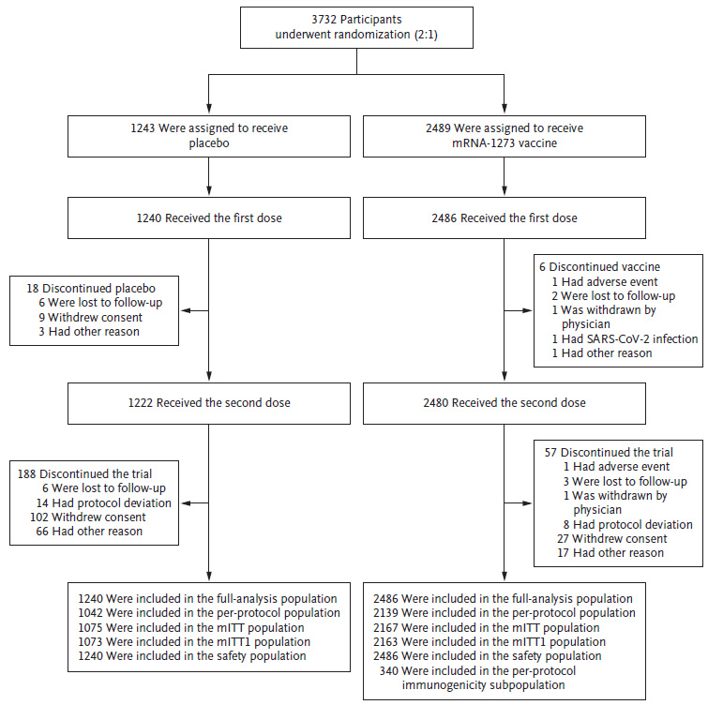
mRNA-1273 = Spikevax COVID-19 mRNA-1273 vaccine; mITT = modified intent-to-treat.
With approximately 289 participants in the PP immunogenicity subset in Study P203 and 289 participants in the PP immunogenicity subset in young adults (18 to 25 years of age) from Study P301, there was to be 90% power to demonstrate non-inferiority of the immune response as measured by antibody GM in adolescents in Study P203 at a 2-sided alpha of 0.05, compared with that in young adults (18 to 25 years of age) from Study P301, assuming an underlying geometric mean ratio (GMR) value of one, a non-inferiority margin of 1.5, and a point estimate minimum threshold of 0.8. The standard deviation of the log transformed levels was assumed to be 1.5.
With approximately 289 participants in the PP immunogenicity subset in Study P203 and 289 participants in the PP immunogenicity subset in young adults (18 to 25 years of age) from Study P301, there was to be at least 90% power to demonstrate non-inferiority of the immune response as measured by seroresponse rate in adolescents in Study P203 at a 2-sided alpha of 0.05, compared with that in young adults (18 to 25 years of age) from Study P301 receiving Spikevax COVID-19 mRNA-1273 vaccine, assuming a true seroresponse rate of 85% in young adults (18 to 25 years of age) from Study P301, and a true seroresponse rate of 85% in adolescents in Study P203 (that is, true rate difference is zero compared to young adults from Study P301), a non-inferiority margin of 10%, and a point estimate minimum threshold of -5% in seroresponse rate difference.

Statistical methods
In total there are 9 analysis sets (Table 3). The most relevant analysis set for immunogenicity was to be the PP immunogenicity set (a subset of subjects selected for immunogenicity testing who were observed and treated according to protocol). For efficacy, the PP efficacy set was planned to be used as primary analysis set, with supplementary analyses in the full analysis set, modified intent-to-treat (mITT) set, and mITT1 set. For safety analyses, the safety set was to be used.
Table 3: Study P203 Analysis sets
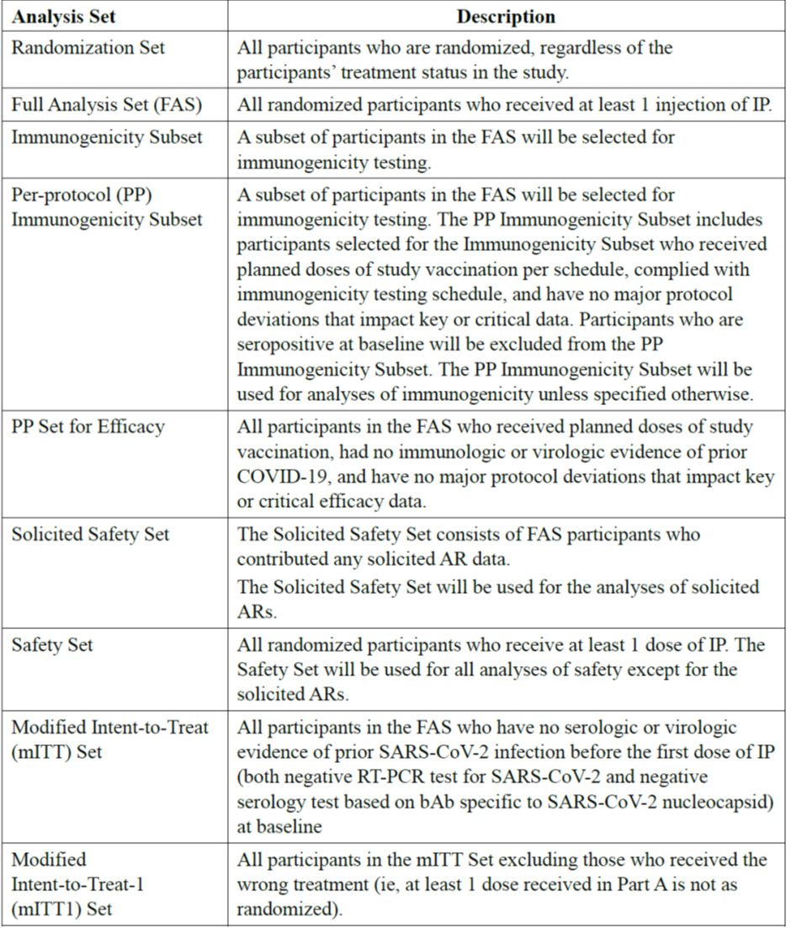
FAS = full analysis set; IP = investigational product; PP = per-protocol; COVID-19 = coronavirus disease 2019; AR = adverse reaction; mITT = modified intent-to-treat; SARS-CoV-2 = severe acute respiratory syndrome coronavirus 2; RT-PCR = reverse transcription polymerase chain reaction; bAb = binding antibody.

Immunogenicity statistical methods
Currently an immunogenicity correlate of protection is not established.
The primary objective to infer efficacy of Spikevax COVID-19 mRNA-1273 vaccine in adolescents was evaluated by comparing the immune response to Spikevax COVID-19 mRNA-1273 vaccine as measured by GM values/titres of serum antibody and seroresponse rate in Study P203 with those obtained from young adults (≥ 18 to ≤ 25 years of age) in Study P301 using the PP immunogenicity subset. This approach is considered acceptable at this stage. The Advisory Committee on Vaccines (ACV) is requested to comment on this.
The study is considered to meet the primary immunogenicity objective if non-inferiority based on both geometric mean titre (GMT) and seroresponse rate at Day 57 is demonstrated at a 2-sided alpha of 0.05, in Study P203 participants receiving Spikevax COVID-19 mRNA-1273 vaccine compared with young adults in Study P301 receiving Spikevax COVID-19 mRNA-1273 vaccine. The null hypotheses were based on GMT and seroresponse. The critera for study success were: non-inferiority based on the ratio of GMT (Study P203 versus Study P301 young adults) with a non-inferiority margin (NIM) of 1.5 and a point estimate of GMT > 0.8; and non-inferiority based on difference of seroresponse rate (Study P203 versus Study P301 young adults), with a NIM of 10% and a point estimate for difference in seroresponse rate > -5.0% (described in Table 4 below).
Table 4: Studies P203 and P301 Co-primary endpoints to demonstrate immunogenicity non-inferiority
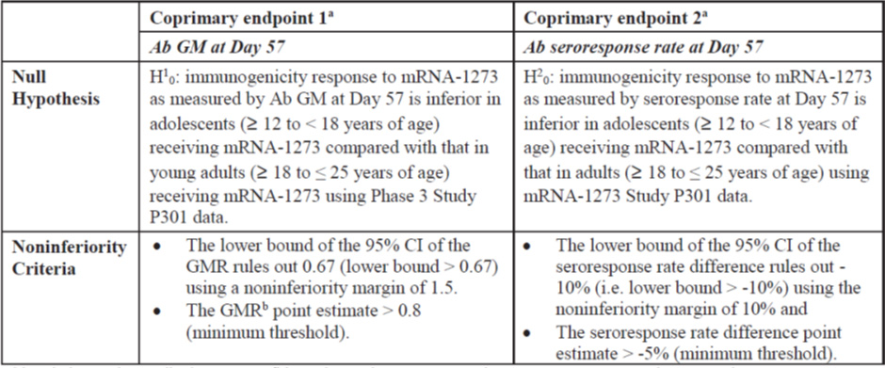
Ab = antibody; GM = geometric mean; mRNA-1273 = Spikevax COVID-19 mRNA-1273 vaccine; P301 = Study mRNA-1273-P301; CI = confidence interval; GMR = geometric mean ratio; i.e. = id est.
a The primary immunogenicity objective was considered met if non-inferiority was demonstrated based on both co-primary endpoints.
b The GMR is the ratio of the GM value of adolescents on Spikevax COVID-19 mRNA-1273 vaccine in this study, Study P203, at Day 57 compared with the GM value of the young adults (≥ 18 to ≤ 25 years of age) on Spikevax COVID-19 mRNA-1273 vaccine in Study P301
Immunogenicity to Spikevax COVID-19 mRNA-1273 vaccine was assessed using 3 immunogenicity assays. The definition of seroresponse was based on assay specific performance characteristics, as described in Table 5. The primary study endpoint was based on results obtained from a pseudotyped virus neutralisation assay (PsVNA) 50% inhibitory dose (ID₅₀), and was used as the basis for the primary immunogenicity objective (to infer efficacy in adolescents). Seroresponse was defined as a change from below the lower limit of quantification (LLOQ) at Baseline to ≥ the LLOQ, or a 3.3-fold rise for those with ≥ LLOQ at Baseline.
Table 5: Study P203 Assay specific definitions of seroresponse for assays of interest
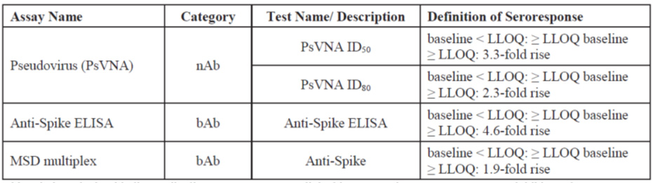
PsVNA = pseudotyped virus neutralisation assay; nAb = neutralising antibody; ID₅₀ = 50% inhibitory dose; LLOQ = lower limit of quantification; ELISA = enzyme linked immunosorbent assay; bAb = binding antibody; MSD = Meso Scale Discovery.
PsVNA ID₅₀ is used as the basis to establish non-inferiority.

Efficacy analyses
Vaccine efficacy was assessed against COVID-19 cases and SARS-CoV-2 infections (asymptomatic and with or without symptoms) in adolescents. For vaccine efficacy analyses, SARS-CoV-2 infection, asymptomatic SARS-CoV-2 infection, COVID-19 and COVID-19 per secondary case definition were to be analysed. For these analyses, vaccine efficacy was to be defined as 1 minus the ratio of incidence rate (Spikevax COVID-19 mRNA-1273 vaccine versus placebo). The 95% confidence interval (CI) of the ratio is calculated using the exact method conditional upon the total number of cases, adjusting for person-years. Person-time was to be defined as the total time from randomisation date to the date of event, last date of study participation, censoring time, or efficacy data cut-off date, whichever was earlier.

Interim analyses
- The first interim analysis for safety and efficacy was to be performed after at least 1,500 participants (1,000 participants receiving Spikevax COVID-19 mRNA-1273 vaccine) completed Day 57 (one month after Dose 2, Part A).
- The second interim analysis for immunogenicity, safety and efficacy was to be performed after Day 57 immunogenicity data were available for the immunogenicity subset. This interim analysis was to be considered as the primary analysis of immunogenicity.
- The final analysis of all applicable endpoints is planned to be performed after all participants have completed all planned study procedures. Results of this analysis are planned to be presented in an end of study clinical study report, including individual listings.

Results

Participant flow
In Study P203 subjects ≥ 12 to < 18 years of age were enrolled. The disposition of subjects enrolled is detailed in Table 6 below.
Table 6: Study P203 Participant disposition
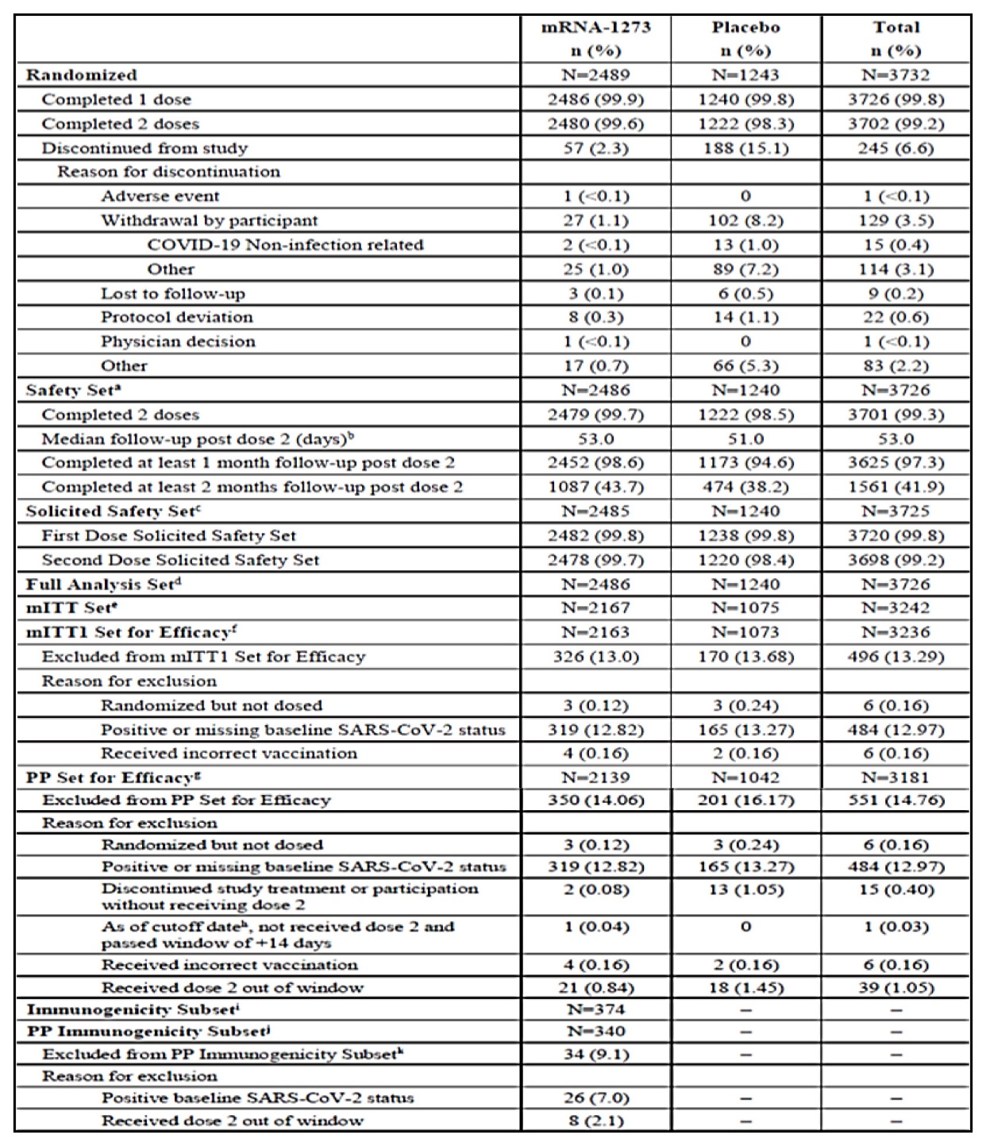
mRNA-1273 = Spikevax COVID-19 mRNA-1273 vaccine; N = number of participants; n (%) = number (percentage) of subjects that meet the criteria at least once; COVID-19 = coronavirus disease 2019; mITT = modified intent-to-treat; SARS-CoV-2 = severe acute respiratory syndrome coronavirus 2; PP = per-protocol.
Table 6: Percentages are based on the number of participants (N) for each analysis set, except for exclusions from mITTI Set for efficacy and PP set for efficacy where N is based on the randomised set.
a the safety set consists of all randomised participants who received any study injection.
b Study duration from second injection is zero day for participants who did not receive Dose 2.
c The solicited safety set consists of all participants who were randomised and received any study injection and contributed any solicited adverse reaction (AR) data (that is, had at least one post Baseline solicited safety assessment). Numbers are based on actual treatment group and percentages are based on the number of safety participants.
d The full analysis set (FAS) consists of all randomised participants who received at least one dose of investigational product (IP). Numbers are based on planned treatment group.
e The mITT set consists of all participants in the FAS who had no serologic or virologic evidence of prior SARS-CoV-2 infection (both negative reverse transcription polymerase chain reaction (RT-PCR) test for SARS-CoV-2 and negative serology test based on binding antibody (bAb) specific to SARS-CoV-2 nucleocapsid) before the first dose of IP, that is, all FAS participants excluding those with positive or missing RT-PCR test or serology test at Baseline. Numbers are based on planned treatment group.
f The mITTI Set consist of all participants in the mITT set excluding those who received the wrong treatment (ie, at least 1 dose received in Part A was not as randomised). Numbers are based on planning treatment group.
g The PP set for efficacy consists of all participants in the FAS who meet all the following criteria: received planned doses of study vaccination; complied with the timing of Dose 2; had a negative RT-PCR test for SARS-CoV-2 and a negative serology test based on bAb specific to SARS-CoV-2 nucleocapsid (as measured by Roche Elecsys anti-SARS-CoV-2 assay) at Baseline; and had no major protocol deviations that impacted key or critical efficacy data. Numbers are based on planned treatment group.
h For Study P203, data cut-off refers to the data snapshot date (8 May 2021).
i The immunogenicity subset consists of participants in the FAS who had baseline SARS-CoV-2 status available and had baseline and at least one post injection antibody assessment for the analysis endpoint.
j The PP immunogenicity subset consists of all participants in the immunogenicity subset who meet all the following criteria: received planned doses of study vaccination per schedule; complied with the timing of Dose 2; had a negative RT-PCR test for SARS-CoV-2 and a negative serology test based on bAb specific to SARS-CoV-2 nucleocapsid (as measured by Roche Elecsys anti-SARS-CoV-2 assay) at Baseline; had Baseline (Day 1) and Day 57 Ab assessment for the analysis endpoint; and had no major protocol deviations that impact key or critical data.
k A participant who has multiple reasons for exclusion is listed under the reason that appears earliest. Percentages are based on the number of participants in the immunogenicity subset.

Immunogenicity
In the PP immunogenicity subset including Study P203 and Study P301 participants, proportions of males and females were comparable (see Table 7). The mean and median ages were 14.4 years and 14.0 years, respectively, for Study P203 participants and 22.3 years and 23.0 years, respectively, for Study P301 young adults. A higher proportion of white non-Hispanic participants and a higher number of participants with a BMI of < 30 kg/m² in the PP immunogenicity subset in Study P203 is noted. No subjects with comorbidities such as diabetes or other risk factors were randomised in the immunogenicity subsets.
Table 7: Studies P203 and P301 Demographic and baseline characteristics in Study P203 participants aged ≥ 12 to < 18 years and Study P301 participants aged ≥ 18 to ≤ 25 years (per-protocol immunogenicity subset)
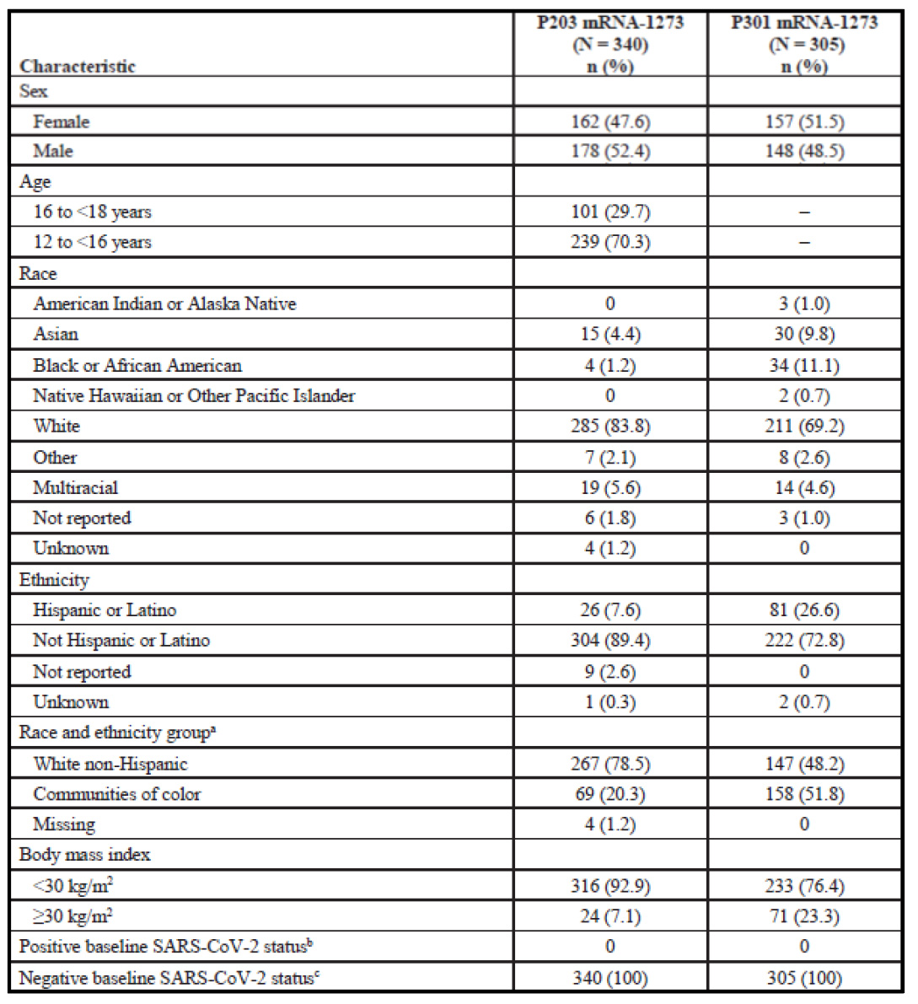
P203 = Study mRNA-1273-P203; mRNA-1273 = Spikevax COVID-19 mRNA-1273 vaccine; N = number of subjects in each group; n (%) = number (percentage) of subjects that meet the criteria at least once; SARS-CoV-2 = severe acute respiratory syndrome coronavirus 2.
Percentages are based on the number of participants in the immunogenicity subset (N).
a White non-Hispanic is defined as White and non-Hispanic, and Communities of Colours includes all the other whose rare or ethnicity is not unknown, unreported , or missing.
b Positive if there is immunologic or virologic evidence of prior COVID-19, defined as positive RT-PCR test or positive Elecsys result at Day 1.
c Negative is defined as negative RT-PCR test and negative Elecsys result at Day 1.

Co-primary endpoints

Non-inferiority of the immune response (neutralising antibody levels and seroresponse rates)
At the time of the immunogenicity/efficacy analyses, no correlate of protection has been established. Therefore, the primary efficacy objective to infer efficacy of Spikevax COVID-19 mRNA-1273 vaccine in adolescents (≥ 12 to < 18 years of age; Study P203) was evaluated by comparing the immune response to Spikevax COVID-19 mRNA-1273 vaccine, as measured by GM values/titres of serum antibody and seroresponse rates 28 days after Dose 2 (Day 57) with those obtained from young adults (≥ 18 to ≤ 25 years of age; Study P301) and establishing non-inferiority. The seroresponse criteria were:
- the number of subjects with Baseline < LLOQ and ≥ LLOQ at Day 57; and
- the number of subjects with Baseline ≥ LLOQ and ≥ 3.3-fold rise at Day 57.
The GMR of adolescent (Study P203) to young adult (Study P301) neutralising antibody titres at Day 57 was 1.077 (95% CI: 0.939, 1.236), meeting the 1.5-fold non-inferiority criterion (that is, lower bound of the 95% CI for GMR is > 0.67). The difference in adolescent to young adult neutralising antibody seroresponse rates at Day 57 was 0.2 (95% CI: -1.8, 2.4), meeting the 10% non-inferiority criterion (lower bound of the 95% of the seroresponse rate difference is > -10%). Both co-primary endpoints met the pre-specified success criteria for non-inferiority and the primary immunogenicity objective is considered to have been met.
Table 8: Studies P203 and P301 Analysis of serum antibody level and seroresponse at Day 57 by pseudovirus neutralisation assay (50% inhibitory dose), analysis of covariance model (per-protocol immunogenicity subset for SARS-CoV-2-specific neutralising antibody)
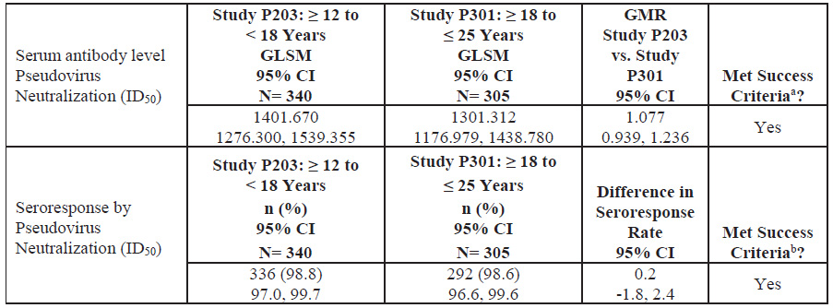
ID₅₀ = 50% inhibitory dose; P203 = Study mRNA-1273-P203; GLSM = geometric least squares mean; CI = confidence interval; N = number of subjects in each group; n (%) = number (percentage) of subjects that meet the criteria at least once; P301 = Study mRNA-1273-P301; GMR = geometric mean ratio.
a The lower bound of the 95% CI of the GMR rules out 0.67 (lower bound > 0.67) using a non-inferiority margin of 1.5, and the GMR point estimate > 0.8 (minimum threshold).
b The lower bound of the 95% CI of the seroresponse rate difference rules out -10% (lower bound > -10%) using the non-inferiority margin of 10% and the seroresponse rate difference point estimate > -5% (minimum threshold)
The upper limit of quantification (ULOQ) for selected Study P301 participants tested previously was different.
Antibody values reported as below the lower limit of quantification (LLOQ) are replaced by 0.5 x LLOQ. Values greater than the ULOQ are replaced by the ULOQ if actual values are not available.
The log-transformed antibody levels are analysed using an analysis of covariance (ANCOVA) model with the group variable (adolescents in Study P203 and young adults in Study P301) as fixed effect. The resulted least squares (LS) means, difference of LS means, and 95% CI are back transformed to the original scale for presentation.
Table 9: Studies P203 and P301 Analysis of pseudovirus neutralising antibody 50% and 80% inhibitory dose titres (serum antibody level, per-protocol immunogenicity subset); pseudovirus neutralising antibody 50% inhibitory dose titres (lower limit of quantification: 18.5, upper limit of quantification: 45118)
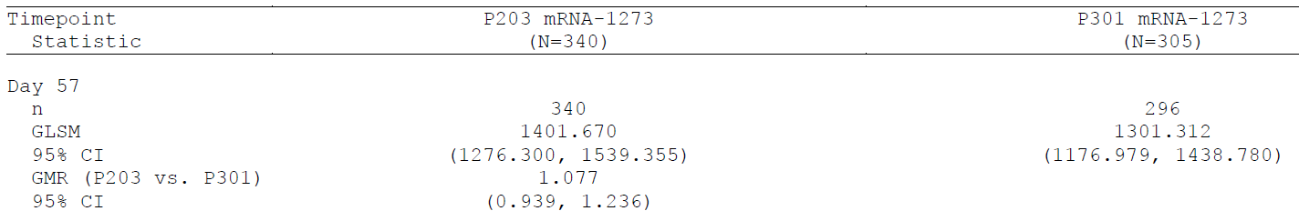
P203 = Study mRNA-1273-P203; mRNA-1273 = Spikevax COVID-19 mRNA-1273 vaccine; N = number of subjects in each group; n = number of subjects with non-missing data at the corresponding timepoint; ; GLSM = geometric least squares mean; CI = confidence interval; GMR = geometric mean ratio; vs = versus.
The upper limit of quantification (ULOQ) for selected Study P301 participants tested previously was different.
Antibody values reported as below the lower limit of quantification (LLOQ) are replaced by 0.5 x LLOQ. Values greater than the upper limit of quantification (ULOQ) are replaced by the ULOQ if actual values are not available.
The log-transformed antibody levels are analysed using an analysis of covariance (ANCOVA) model with the group variable (adolescents in Study P203 and young adults in Study P301) as fixed effect. The resulted least squares (LS) means, difference of LS means, and 95% CI are back transformed to the original scale for presentation.
Table 10: Studies P203 and P301 Pseudovirus neutralising antibody 50% and 80% inhibitory dose titres (seroresponse rate, per-protocol immunogenicity subset) - pseudovirus neutralising antibody 50% inhibitory dose titres (lower limit of quantification: 18.5, upper limit of quantification: 45118)
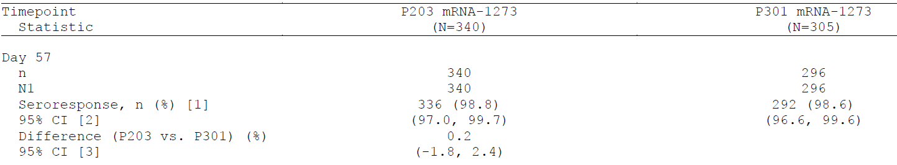
P203 = Study mRNA-1273-P203; mRNA-1273 = Spikevax COVID-19 mRNA-1273 vaccine; N = number of subjects in each group; n = number of subjects with non-missing data at the corresponding timepoint. N1 = number of subjects with non-missing data at Baseline and the corresponding timepoint.; CI = confidence interval; P301 = Study mRNA-1273-P301; vs = versus.
The upper limit of quantification (ULOQ) for selected Study P301 participants tested previously was different.
[1] Seroresponse due to vaccination specific to pseudovirus neutralising antibody 50% inhibitory dose (ID₅₀) titre at a subject level is defined as a change from below lower limit of quantification (LLOQ) to equal or above LLOQ, or at least a 3.3-fold rise if Baseline is equal to or above LLOQ. Seroresponse due to vaccination specific to pseudovirus neutralising antibody 80% inhibitory dose (ID₈₀) titre at a subject level is defined as a change from below LLOQ to equal or above LLOQ, or at least a 2.3-fold rise if baseline is equal to or above LLOQ. Percentages are based on N1.
[2] 95% CI is calculated using the Clopper-Pearson method.
[3] 95% CI is calculated using the Miettinen-Nurminen (score) confidence limits.
Employing the PsVNA and the read out of a 80% inhibitory dose (ID₈₀) a GMR (Study P203 versus Study P301) of 1.117 (95% CI: 0.991, 1.260) and a difference of the seroresponse rate of 0.2 (95% CI: -1.8, 2.4) were obtained meeting the non-inferiority criterion.

Subgroup immunogenicity
In general, comparable antibody levels and response rates were found across different subgroups except for some ethnicities (for example, Hispanic).

Neutralising antibody responses by age stratification:
Geometric mean ratio of the neutralising antibody response at Day 57 as measured by PsVNA (ID₅₀), was comparable between Study P203 stratified age group of ≥ 12 to < 16 years and ≥ 16 to < 18 years, and the young adults in Study P301.
Table 11: Studies P203 and P301 Analysis of pseudovirus neutralising antibody 50% and 80% inhibitory dose titres by age group, analysis of covariance model (per-protocol immunogenicity subset) - pseudovirus neutralising antibody 50% inhibitory dose titres (lower limit of quantification: 18.5, upper limit of quantification: 45118)
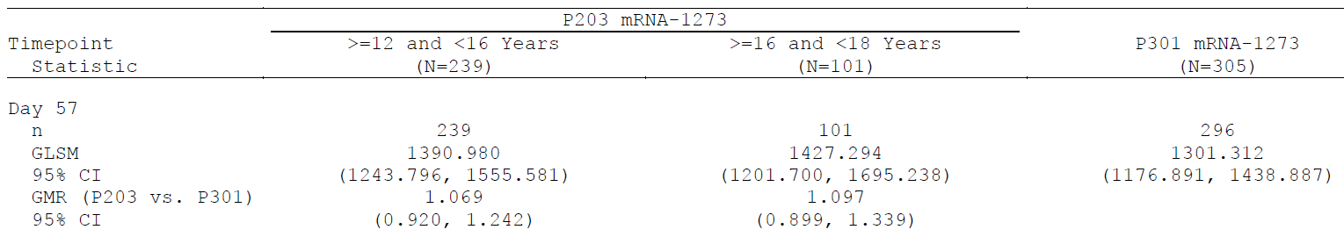
P203 = Study mRNA-1273-P203; mRNA-1273 = Spikevax COVID-19 mRNA-1273 vaccine; N = number of subjects in each group; P301 = Study mRNA-1273-P301; n = number of subjects with non-missing data at the corresponding timepoint; GLSM = geometric least squares mean; GMR = geometric mean ratio; CI = confidence interval; vs = versus.
The upper limit of quantification (ULOQ) for selected Study P301 participants tested previously was different.
Antibody values reported as below the lower limit of quantification (LLOQ) are replaced by 0.5 x LLOQ. Values greater than the ULOQ are replaced by the ULOQ if actual values are not available.
The log-transformed antibody levels are analysed using an analysis of covariance (ANCOVA) model with the group variable (adolescents in Study P203 and young adults in Study P301) as fixed effect. The resulted least squares (LS) means, difference of LS means, and 95% CI are back transformed to the original scale for presentation.
The seroresponse rates are slightly lower in younger participants (≥ 12 to < 16 years) than in young adults.
Table 12: Studies P203 and P301 Analysis of pseudovirus neutralising antibody 50% inhibitory dose titres by age group - seroresponse rate (per-protocol immunogenicity subset): pseudovirus neutralising antibody 50% inhibitory dose titres (lower limit of quantification: 18.5, upper limit of quantification: 45118)
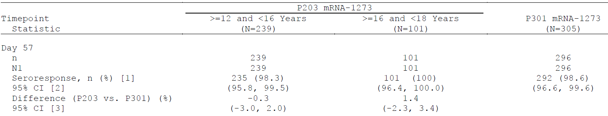
P203 = Study mRNA-1273-P203; mRNA-1273 = Spikevax COVID-19 mRNA-1273 vaccine; N = number of subjects in each group; P301 = Study mRNA-1273-P301; n = number of subjects with non-missing data at the corresponding timepoint; N1 = number of subjects with non-missing data at baseline and the corresponding timepoint.; CI = confidence interval; vs = versus.
The upper limit of quantification (ULOQ) for selected Study P301 participants tested previously was different.
[1] Seroresponse due to vaccination specific to pseudovirus neutralising antibody antibody 50% inhibitory dose (ID₅₀) titre at a subject level is defined as a change from below lower limit of quantification (LLOQ) to equal or above LLOQ, or at least a 3.3-fold rise if Baseline is equal to or above LLOQ. Seroresponse due to vaccination specific to pseudovirus neutralising antibody antibody 80% inhibitory dose (ID₈₀) titre at a subject level is defined as a change from below LLOQ to equal or above LLOQ, or at least a 2.3-fold rise if baseline is equal to or above LLOQ. Percentages are based on N1.
[2] 95% CI is calculated using the Clopper-Pearson method.
[3] 95% CI is calculated using the Miettinen-Nurminen (score) confidence limits.
Following box plot analyses for neutralising antibody responses among different age groups at Day 1 and Day 57 shows that very few participants without evidence of prior SARS-CoV-2 infection in Study P203 and in Study P301 had neutralising antibody titres at Day 1, and almost all participants developed neutralising antibodies by Day 57.
Figure 2: Studies P203 and P301 Box plot of pseudovirus neutralising antibody 50% inhibitory dose (per-protocol immunogenicity set)
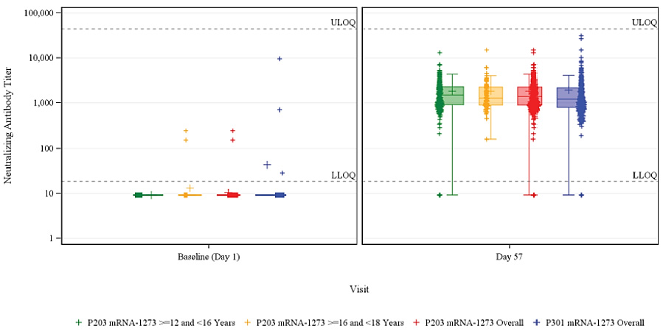
ULOQ = upper limit of quantification; LLOQ = lower limit of quantification; P203 = Study mRNA-1273-P203; mRNA-1273 = Spikevax COVID-19 mRNA-1273 vaccine; P301 = Study mRNA-1273-P301.
Antibody values reported as below the LLOQ (18.5) are replaced by 0.5 x LLOQ. Values greater than the ULOQ (45118) are replaced by the ULOQ if actual values are not available.

Reverse cumulative distribution curves
The distribution of neutralising antibody titres as well as the distribution of binding antibody titres (figures not shown) between the study population across different age groups of both Studies P203 and P301 are comparable. No difference in the neutralising antibody distribution between the two age strata in Study P201 is observed. There is however a slightly broader distribution of antibody titres in Study P301 particularly with a higher proportion of subjects having lower neutralising antibody titres.
Figure 3: Studies P203 and P301 Reverse cumulative distribution function of pseudovirus neutralising antibody titres (50% inhibitory dose) at Day 57 by age group (per-protocol immunogenicity subset) - pseudovirus neutralising antibody 50% inhibitory dose titres (lower limit of quantification: 18.5, upper limit of quantification: 45118)
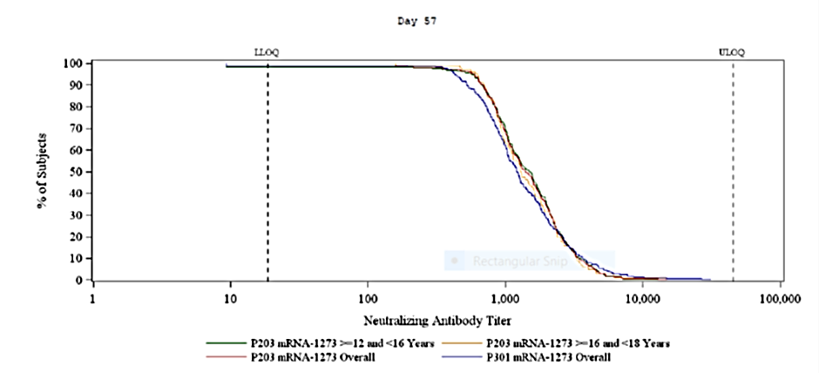
LLOQ = lower limit of quantification; ULOQ = upper limit of quantification; P203 = Study mRNA-1273-P203; mRNA-1273 = Spikevax COVID-19 mRNA-1273 vaccine; P301 = Study mRNA-1273-P301.

The analyses by baseline SARS-CoV-2 status
The analyses by baseline SARS-CoV-2 status based on the immunogenicity subset showed that higher antibody levels were elicited in baseline seropositive subjects in the adolescents than in young adults and that the GMR and seroresponse rates are in the same range as for the non-inferiority analyses on the PP immunogenicity subset.
Table 13: Studies P203 and P301 Analysis of pseudovirus neutralising antibody 50% inhibitory dose titres by baseline SARS-CoV-2 status, analysis of covariance model (immunogenicity subset) (lower limit of quantification: 18.5, upper limit of quantification: 45118)
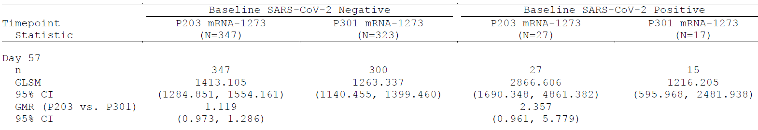
SARS-CoV-2 = severe acute respiratory syndrome coronavirus 2; P203 = Study mRNA-1273-P203; mRNA-1273 = Spikevax COVID-19 mRNA-1273 vaccine; N = number of subjects in each group; P301 = Study mRNA-1273-P301; n = number of subjects with non-missing data at the corresponding timepoint; GLSM = geometric least squares mean; GMR = geometric mean ratio; CI = confidence interval; vs = versus.
The upper limit of quantification (ULOQ) for selected Study P301 participants tested previously was different.
Antibody values reported as below the lower limit of quantification (LLOQ) are replaced by 0.5 x LLOQ. Values greater than the ULOQ are replaced by the ULOQ if actual values are not available.
The log-transformed antibody levels are analysed using an analysis of covariance (ANCOVA) model with the group variable (adolescents in Study P203 and young adults in Study P301) as fixed effect and adjusted for baseline log-transformed value. The resulted least squares (LS) means, difference of LS means, and 95% CI are back transformed to the original scale for presentation.

Non-inferiority of the immune response (binding antibody levels and seroresponse rates as measured by spike immunoglobulin G antibody enzyme linked immunosorbent assay and Meso Scale Discovery multiplex assay)
Non-inferiority of the binding antibody response was demonstrated by employing the Spike immunoglobulin G (IgG) antibody enzyme linked immunosorbent assay (ELISA) and the Meso Scale Discovery (MSD) multiplex assay.
Table 14: Studies P203 and P301 Analysis of binding antibody specific to SARS-CoV-2 spike protein measured by enzyme linked immunosorbent assay, analysis of covariance model (per-protocol immunogenicity subset)
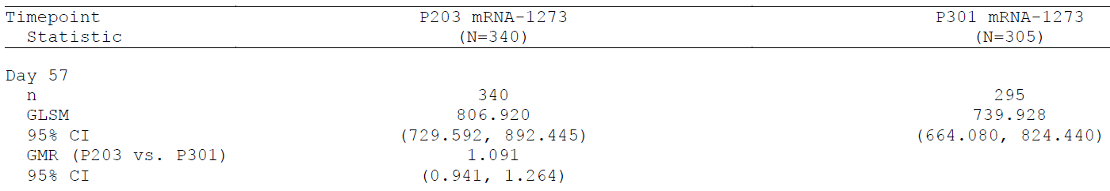
P203 = Study mRNA-1273-P203; mRNA-1273 = Spikevax COVID-19 mRNA-1273 vaccine; N = number of subjects in each group; P301 = Study mRNA-1273-P301; n = number of subjects with non-missing data at the corresponding timepoint ; GLSM = geometric least squares mean; GMR = geometric mean ratio; CI = confidence interval; vs = versus.
Antibody values reported as below the lower limit of quantification (LLOQ) are replaced by 0.5 x LLOQ. Values greater than the upper limit of quantification (ULOQ) are replaced by the ULOQ if actual values are not available.
The log-transformed antibody levels are analysed using an analysis of covariance (ANCOVA) model with the group variable (adolescents in Study P203 and young adults in Study P301) as fixed effect. The resulted least squares (LS) means, difference of LS means, and 95% CI are back transformed to the original scale for presentation.
Table 15: Studies P203 and P301 Analysis of binding antibody specific to SARS-CoV-2 spike protein by enzyme linked immunosorbent assay, seroresponse rate (per-protocol immunogenicity subset) (lower limit of quantification: 1, upper limit of quantification: 2052)
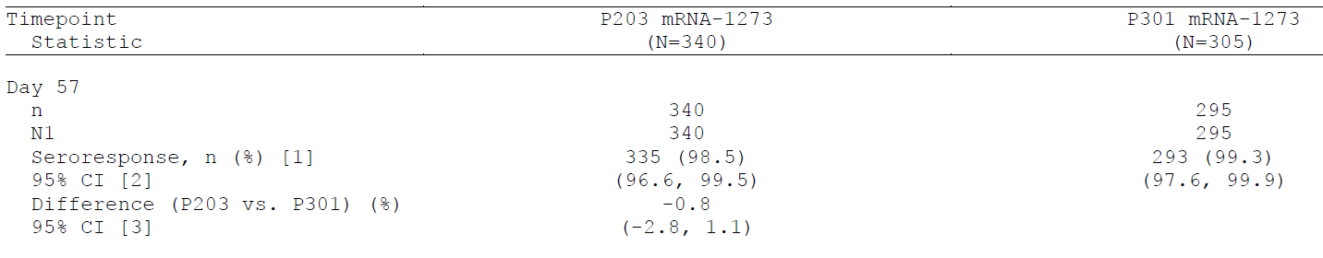
P203 = Study mRNA-1273-P203; mRNA-1273 = Spikevax COVID-19 mRNA-1273 vaccine; N = number of subjects in each group; P301 = Study mRNA-1273-P301; n = number of subjects with non-missing data at the corresponding timepoint; N1 = number of subjects with non-missing data at baseline and the corresponding timepoint; CI = confidence interval; vs = versus.
[1] Seroresponse due to vaccination specific to severe acute respiratory syndrome coronavirus 2 (SARS-CoV-2) spike protein measured by enzyme linked immunosorbent assay (ELISA) at a subject level is defined as a change from below lower limit of quantification (LLOQ) to equal or above LLOQ, or at least a 4.6-fold rise if baseline is equal to or above LLOQ. Percentages are based on N1.
[2] 95% CI is calculated using the Clopper-Pearson method.
[3] 95% CI is calculated using the Miettinen-Nurminen (score) confidence limits.

Vaccine efficacy (secondary endpoints)
Vaccine efficacy was assessed against COVID-19 and SARS-CoV-2 infections (asymptomatic and with or without symptoms) and the methods used were the same as for the Study P301. The secondary endpoint analysis results for vaccine efficacy are summarised in Table 16.
Vaccine efficacy was assessed against COVID-19 meeting the Study P301 (adults) case definition, which was based on either at least two prespecified systemic symptoms or at least one respiratory symptom and a positive RT-PCR and the Centers for Disease Control and Prevention (CDC) case definition (at least one prespecified clinical symptom and a positive RT-PCR). Cases were assessed in both the PP efficacy set (received both planned doses) and the mITT1 set (received at least one dose as randomised), both of which excluded subjects with evidence of previous SARS-CoV-2 infection at Baseline.
For the analysis of vaccine efficacy in Study P203 employing the COVID-19 ‘P301 case definition’ used in the pivotal adult efficacy Study P301, the observed vaccine efficacy against confirmed cases occurring 14 days or more after Dose 2 was 100.0% (95% CI: 28.9%, upper limit not estimable (NE)). There were no cases in the Spikevax COVID-19 mRNA-1273 vaccine group and 4 cases in the placebo group (Table 16). These results are consistent with results obtained in the pivotal efficacy study.
Using the COVID-19 CDC case definition requiring only one symptom and reflecting the symptoms more common in adolescents, vaccine efficacy against COVID-19 occurring 14 days or more after Dose 2 was 93.3% (95% CI: 47.9%, 99.9%). Vaccine efficacy in the mITT1 analysis set (14 days after Dose 1) was 92.7% (95% CI: 67.8, 99.2).
Vaccine efficacy against asymptomatic SARS-CoV-2 infection occurring at least 14 days after Dose 2 (PP set for efficacy) was 39.2% (95% CI, -0.247, 0.697). Vaccine efficacy against asymptomatic SARS-CoV-2 infection based on testing starting 14 days after Dose 1 (mITT1 set) was 59.5% (95% CI: 28.4, 77.3%).
As expected in the younger age group of the subjects, no severe cases occurred in the study.
Table 16: Study P203 Summary of key secondary efficacy endpoint analysis results
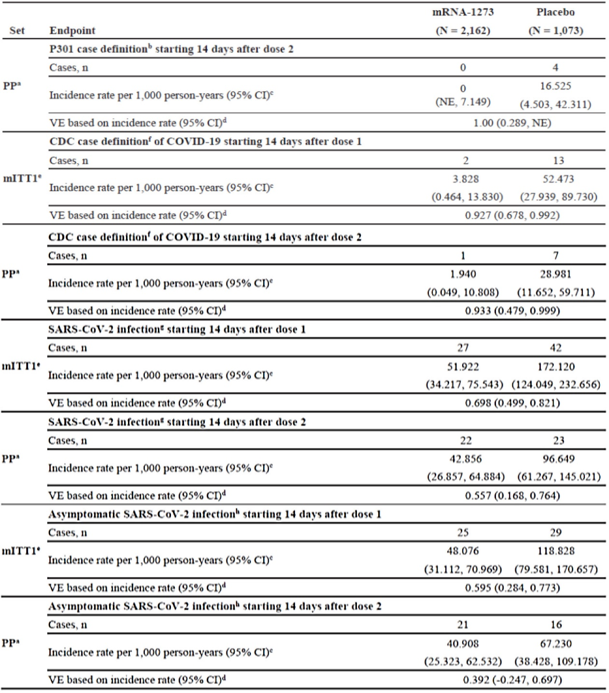
mRNA-1273 = Spikevax COVID-19 mRNA-1273 vaccine; N = number of subjects in each group; P301 = Study mRNA-1273-P301; n = number of subjects that meet the criteria; PP = per-protocol; CI = confidence interval; NE = not estimable; VE = vaccine efficacy; CDC = Centers for Disease Control and Prevention; COVID-19 = coronavirus disease 2019; mITT = modified intent-to-treat; SARS-CoV-2 = severe acute respiratory syndrome coronavirus 2.
a The PP set for efficacy is defined as all participants in the full analysis set (FAS) who meet all the following criteria: received planned doses of study vaccination; had a negative reverse transcription polymerase chain reaction (RT-PCR) test for SARS-CoV-2 and a negative serology test based on bAb specific to SARS-CoV-2 nucleocapsid (as measured by Roche Elecsys anti-SARS-CoV-2 assay) at Baseline, and had no major protocol deviations that impact key or critical efficacy data.
b Defined as symptomatic disease and positive RT-PCR results.
c. Incidence rate is defined as the number of subjects with an event divided by the number of subjects at risk and adjusted by person years (total time at risk) in each treatment group. The 95% CI is calculated using the exact method (Poisson distribution) and adjusted by person years.
d Vaccine efficacy defined as 1 - ratio of incidence rate (Spikevax COVID-19 mRNA-1273 vaccine versus placebo). The 95% CI of the ratio is calculated using the exact method conditional upon the total number of cases, adjusting for person years.
e mITTI Set for efficacy defined all participants in the mITT set (defined as all FAS participants excluding those with positive or missing RT-PCR test or serology test at Baseline), excluding those who received the wrong treatment.
f Defined as the presence of at least one symptom from a list of COVID-19 symptoms using the CDC Case Definition), and a positive nasopharyngeal swab or saliva sample for SARS-CoV-2 RT-PCR, in Baseline negative SARS-CoV-2 participants.
g SARS-CoV-2 injection defined in participants with negative SARS-CoV-2 at Baseline as bAb levels against SARS-CoV-2 nucleocapsid protein negative (as measured by Roche Elecsys) at Day 1 that becomes positive (as measured by Roche Elecsys) counted starting at Day 57 or later; or positive RT-PCR counted starting 14 days after the second dose of investigational product.
h Asymptomatic SARS-CoV-2 infection is identified by absence of symptoms and as bAb levels against SARS-CoV-2 nucleocapsid protein negative (as measured by Roche Elecsys) at Day 1 that becomes positive (as measured by Roche Elecsys) counted starting Day 57 or later; or positive RT-PCR.
Figure 4: Study P203 Cumulative incidence curve of secondary definition of COVID-19 starting 14 days after first injection (modified intent-to-treat 1 set)
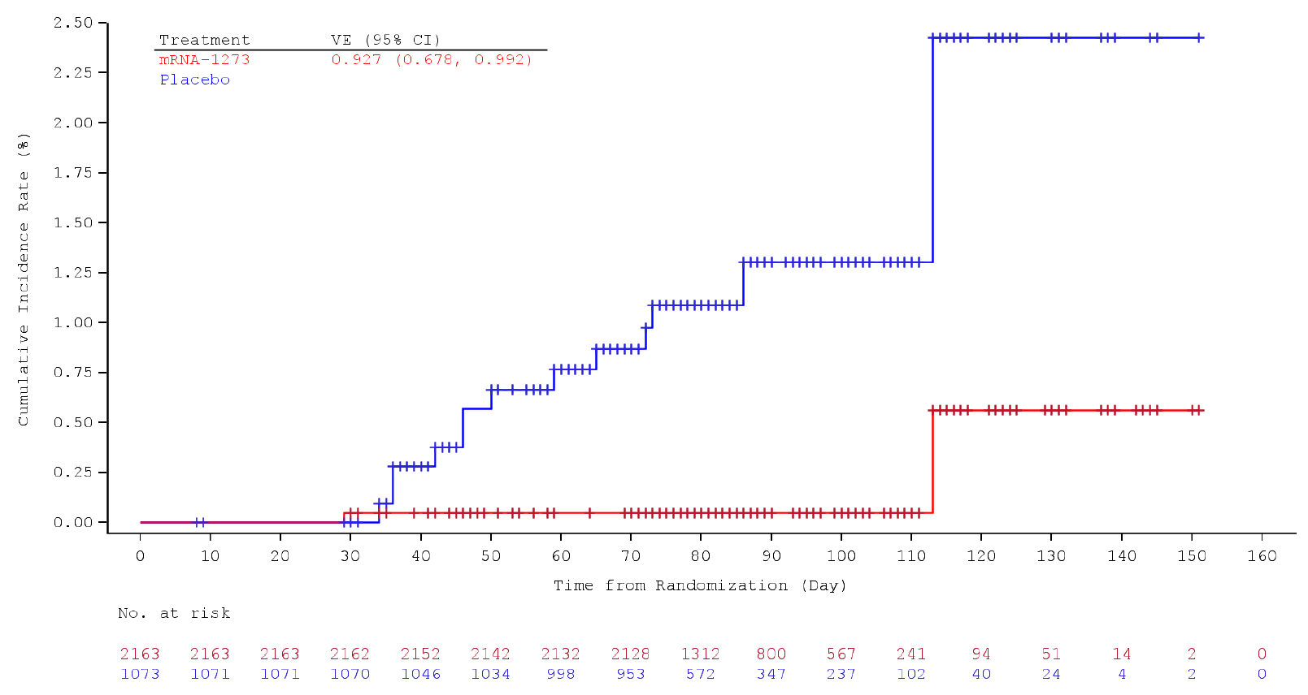
VE = vaccine efficacy; CI = confidence interval; mRNA-1273 = Spikevax COVID-19 mRNA-1273 vaccine.
Vaccine efficacy defined as 1 – ratio of incidence rate (Spikevax COVID-19 mRNA-1273 vaccine versus placebo). The 95% CI of the ratio is calculated using the exact method conditional upon the total number of cases, adjusting for person years.

Safety analysis for adolescents 12 to 17 years of age

Adverse events
On data cut date 8 May 2021 (data snapshot date), median study follow-up duration was 53 days after Dose 2 and 83.5 days after Dose 1. Follow-up period in the safety set of the Spikevax COVID-19 mRNA-1273 vaccine group was comparable between the 2 age cohorts ≥ 12 and < 16 years and ≥ 16 and < 18 years.
2,486 of 2,489 randomised participants (99.9%) in the Spikevax COVID-19 mRNA-1273 vaccine group and 1,240 of 1,243 randomised participants (99.8%) in the placebo group had received Dose 1 and 2,480 (99.6%) and 1,222 (98.3%) received Dose 2 in the Spikevax COVID-19 mRNA-1273 vaccine and placebo group, respectively.
The safety set consists of 1,838 subjects ≥ 12 and < 16 years of age and of 648 subjects ≥ 16 and < 18 years of age who received at least one dose of in the Spikevax COVID-19 mRNA-1273 vaccine, and of 929 and 311 subjects in the two age cohorts who received placebo, respectively. The overall sample size of the safety set included 3,726 subjects, 2,486 who received Spikevax COVID-19 mRNA-1273 vaccine and 1,240 who received placebo.
Overall 6.6% of subjects (245) of the 3,732 randomised subjects discontinued from the study. 2.3% (57) of 2,489 randomised subjects randomised to the Spikevax COVID-19 mRNA-1273 vaccine group, and 15.1% (188) of 1,243 subjects randomised to the placebo group. Three subjects in the Spikevax COVID-19 mRNA-1273 vaccine group discontinued due to an AE.
Table 17: Study P203 Participant disposition
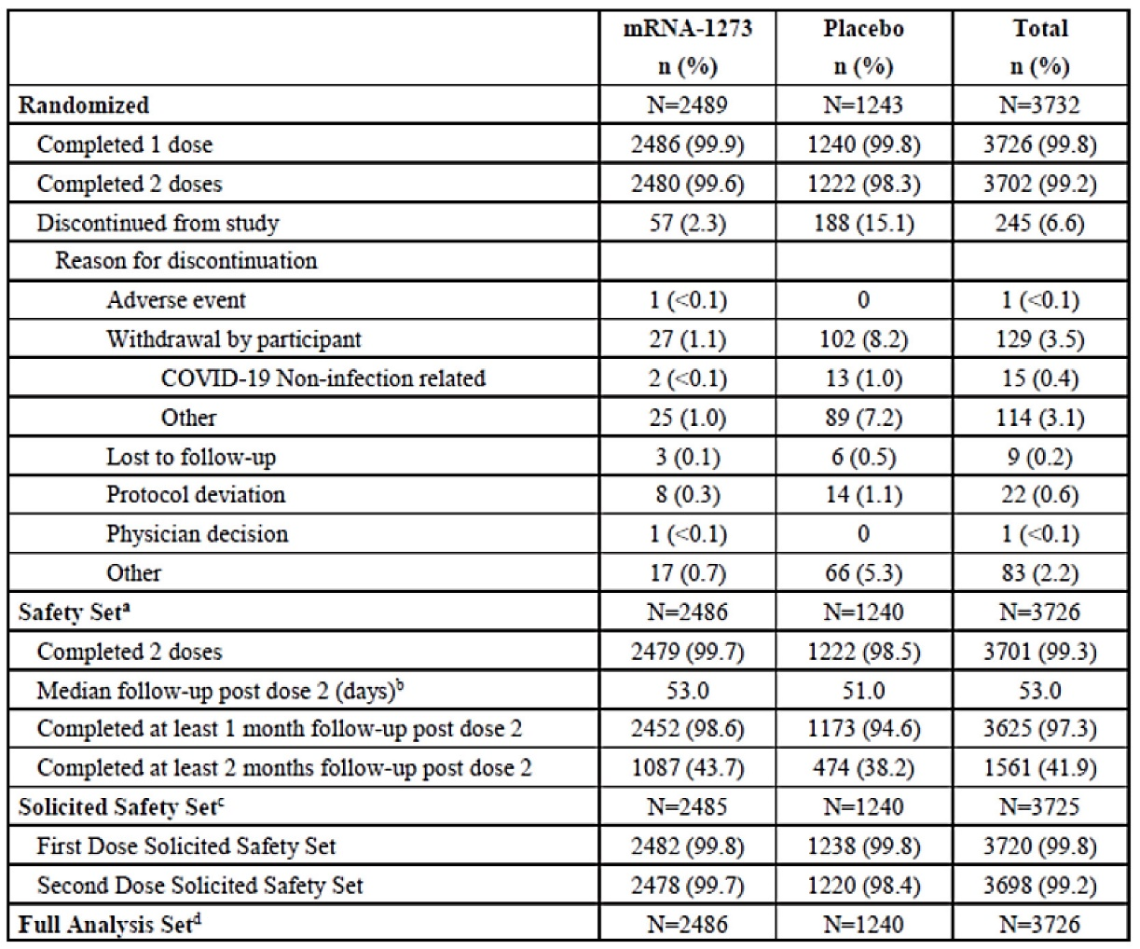
mRNA-1273 = Spikevax COVID-19 mRNA-1273 vaccine; n (%) = number (percentage) of subjects that meet the criteria at least once; N = number of participants; COVID-19 = coronavirus disease 2019.
Percentages are based on the number of participants (N) for each analysis set, except for exclusions from modified intent-to-treat (mITT)I set for efficacy and PP set for efficacy where N is based on the randomised set.
The safety set consists of all randomised participants who received any study injection.
Study duration from second injection is zero day for participants who did not receive Dose 2.
The solicited safety set consists of all participants who were randomised and received any study injection and contributed any solicited adverse reaction (AR) data (that is, had at least one post Baseline solicited safety assessment). Numbers are based on actual treatment group and percentages are based on the number of safety participants.
The full analysis set (FAS) consists of all randomised participants who received at least one dose of investigational product (IP). Numbers are based on planned treatment group.
The mITT set consists of all participants in the FAS who had no serologic or virologic evidence of prior severe acute respiratory syndrome coronavirus 2 (SARS-CoV-2) injection (both negative reverse transcription polymerase chain reaction (RT-PCR) test for SAR-CoV-2 and negative serology test based on binding antibody (bAb) specific to SARS-CoV-2 nucleocapsid) before the first dose of IP, that is, all FAS participants excluding those with positive or missing RT-PCR test or serology test at Baseline. Numbers are based on planned treatment group.
The mITTI set consists of all participants in the mITT set excluding those who received the wrong treatment (that is, at least one dose received in Part A was not as randomised). Numbers are based on planned treatment group.
The per-protocol (PP) set for efficacy consists of all participants in the FAS who meet all the following criteria: received planned doses of study vaccination; complied with the timing of Dose 2; had a negative RT-PCR test for SARS-CoV-2 and a negative serology test based on bAb specific to SARS-CoV-2 nucleocapsid (as measured by Roche Elecsys anti-SARS-CoV-2 assay) at baseline; and had no major protocol deviations that impacted key or critical efficacy data. Numbers are based on planned treatment group.
For Study P203, data cut-off refers to the data snapshot date (8 May 2021).
Demographic and baseline characteristics of the safety set are balanced between the Spikevax COVID-19 mRNA-1273 vaccine group and the placebo group in the older and the younger age cohort. The majority of subjects was enrolled in the younger age cohort ≥ 12 to 16 years of age (74.3% of subjects).
48.6% of subjects were female and 51.4% were male. The majority of subjects was seronegative for SARS-CoV-2 at Baseline (87.0%).

Solicited adverse reactions
The solicited safety set included almost the same sample size like the safety set, that is, overall 2,485 subjects in the Spikevax COVID-19 mRNA-1273 vaccine group (1,838 in the age cohort ≥ 12 to < 16 years of age and 647 ≥ 16 to < 18 years of age), and 1,240 in the placebo group (929 subjects in the younger and 311 in the older age cohort).

Solicited local adverse reactions
Any solicited local adverse reaction after any dose was recorded for 97.8% of subjects in the Spikevax COVID-19 mRNA-1273 vaccine group (2,431/2,485) and for 48.5% of subjects (602/1,240) in the placebo group. The most frequently reported local solicited adverse reaction in the Spikevax COVID-19 mRNA-1273 vaccine and the placebo group after any dose was injection site pain reported by 97.2% of subjects in the Spikevax COVID-19 mRNA-1273 vaccine group and by 45.9% of subjects in the placebo group. This was followed by axillary swelling or tenderness (34.6% versus 10.7%), swelling (27.7% versus 1.9%), and erythema/redness (25.8% versus 1.5%). The events of erythema and swelling tended to be more often reported after Dose 2, whereas the incidence of pain and axillary swelling or tenderness were comparable after Dose 1 and Dose 2.
Table 18: Study P203 Frequency of solicited local adverse reactions within 7 days after each dose, by maximum severity, participants aged ≥ 12 to < 18 years (solicited safety set)
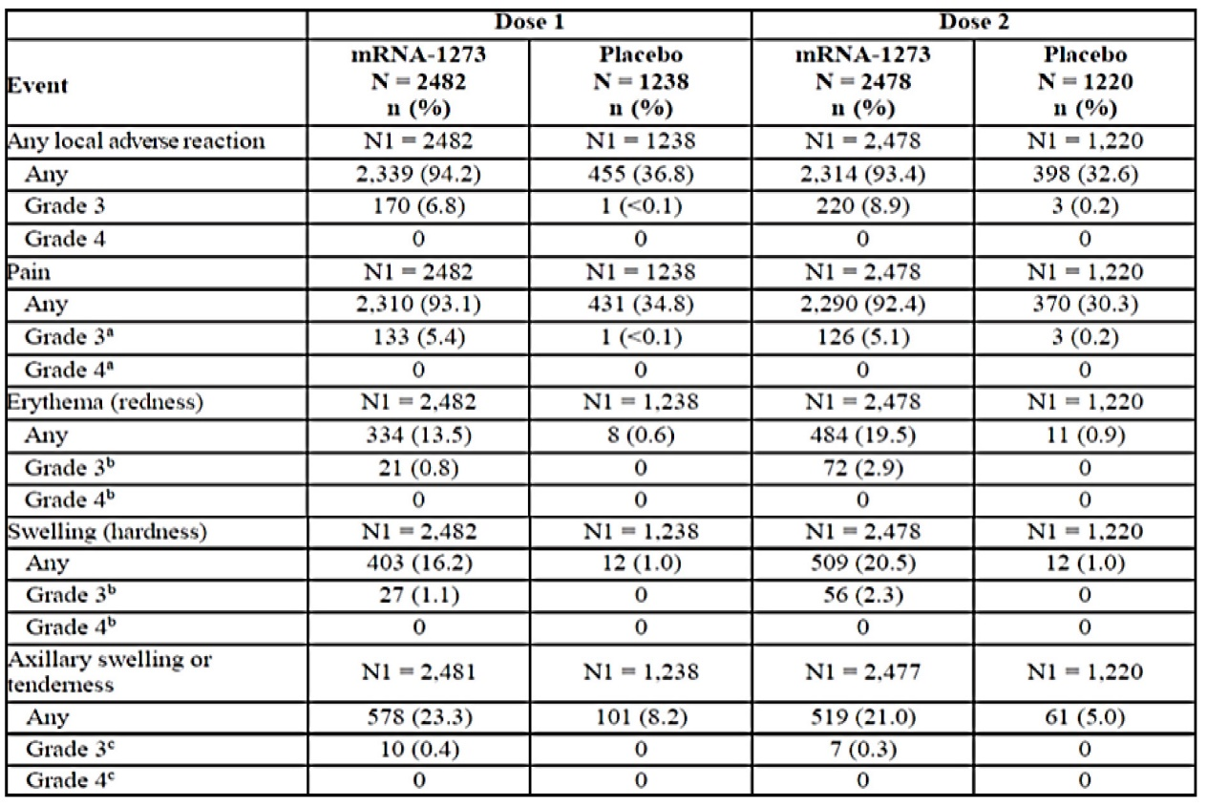
mRNA-1273 = Spikevax COVID-19 mRNA-1273 vaccine; N = number of subjects in each group; n (%) = number (percentage) of subjects that meet the criteria at least once.
Any = Grade 1 or higher. Percentages are based on the number of exposed participants who submitted any data for the event (N1). The solicited safety set consists of all participants who were randomised and received any study injection and contributed any solicited adverse reaction (AR) data (that is, had at least one post Baseline solicited safety assessment). The first (second) injection solicited safety set consists of all participants in the solicited safety set who received the first (second) study infection and contributed any solicited adverse reaction data from the time of the first (second) study injection through the following 6 days.
a Pain Grade 3: any use of prescription pain reliver or prevents daily activity; Grade 4: requires emergency room visit or hospitalisation.
b Erythema (redness) and swelling (hardness) Grade 3: > 100 mm/>10 cm; Grade 4; necrosis/exfoliative dermatitis.
c Axillary swelling or tenderness Grade 3: any use of prescription pain reliver or prevents daily activity; Grade 4: requires emergency room visit or hospitalisation.
The majority of the solicited local adverse reactions were mild to moderate. Grade 3 solicited local adverse reactions after any dose was recorded for 13.8% of subjects in the Spikevax COVID-19 mRNA-1273 vaccine group and for 0.3% in the placebo group. The severity slightly increased from Dose 1 to Dose 2 and 6.8% of subjects reported any Grade 3 local solicited adverse reactions post Dose 1 versus 8.9% post Dose 2. No Grade 4 solicited local adverse reaction was recorded. Pain (9.1% in vaccine group after any dose), followed by erythema (3.5%), swelling (3.2%), and axillary swelling or tenderness (0.6%) were common Grade 3 local solicited adverse reactions. The majority of solicited local adverse reactions occurred within the first one to two days after any dose (97.4% of subjects). 1.3% of subjects in the vaccine group reported solicited local adverse reactions with onset after Day 7. Solicited local adverse reactions usually persisted for a median of 3 days. 6.4% of subjects in the vaccine group reported solicited local adverse reactions beyond Day 7 after Dose 1, and 1.6% after Dose 2.

Solicited systemic adverse reactions
As expected, the vaccine group had higher incidence of systemic adverse reactions as compared with the placebo group after any and after each dose. Any solicited systemic adverse reaction after any dose was recorded for 91.9% of subjects in the Spikevax COVID-19 mRNA-1273 vaccine group (2,284/2,485) and for 66.9% of subjects (830/1,240) in the placebo group. The most frequently reported systemic solicited adverse reaction in the Spikevax COVID-19 mRNA-1273 vaccine group after any dose was headache, reported by 78.4% of subjects in the Spikevax COVID-19 mRNA-1273 vaccine group and by 50.3% of subjects in the placebo group. This was followed by fatigue (75.2% versus 47.5%), myalgia (54.3% versus 23.5%), chills (49.1% versus 16.2%), arthralgia (34.6 versus 16.9%), and nausea (29.3% versus 15.2%). Fever of any grade was reported in 13.7% versus 1.9% of subjects. The incidence of solicited systemic adverse reactions was notably higher after Dose 2 compared with Dose 1. Any solicited systemic adverse reaction was reported by 68.5% of subjects in the Spikevax COVID-19 mRNA-1273 vaccine group after Dose 1 and by 86.1% after Dose 2. Majority of systemic solicited adverse reactions were mild to moderate and any Grade 3 solicited systemic adverse reaction after any dose was recorded for 16.5% of subjects in the Spikevax COVID-19 mRNA-1273 vaccine group (versus 4.6% in the placebo group). Severity of systemic AEs increased from Dose 1 to Dose 2. Grade 3 AEs were reported by 4.4% versus 13.7% of subjects after each dose. Grade 4 solicited systemic adverse reactions were recorded for 3 subjects in the Spikevax COVID-19 mRNA-1273 vaccine group (fever, headache, nausea or vomiting). Grade 3 systemic solicited adverse reactions were mostly recorded for fatigue (8.5% of subjects in the Spikevax COVID-19 mRNA-1273 vaccine group after any dose), followed by headache (6.4%), myalgia (5.8%), arthralgia (2.7%), fever (2.2%), chills (0.5%), and nausea (0.2%). The majority of solicited systemic adverse reactions in the Spikevax COVID-19 mRNA-1273 vaccine group occurred within the first one to two days after any dose (89.1% of subjects). 0.7% of subjects in the Spikevax COVID-19 mRNA-1273 vaccine group reported solicited systemic adverse reactions with onset after Day 7. Solicited systemic adverse reactions usually persisted for a median of 2 days. 4.7% of subjects in the Spikevax COVID-19 mRNA-1273 vaccine group reported solicited systemic adverse reactions that persisted beyond Day 7 after Dose 1 and 3.1% after Dose 2. The use of antipyretic or pain medication was notably higher in the Spikevax COVID-19 mRNA-1273 vaccine group secondary to the higher systemic reactogenicity in the vaccine group (30.1% after Dose 1 and 50.1% after dose 2 versus 9.5% and 8.9% in the placebo group).
Table 19: Study P203 Frequency of solicited systemic adverse reactions within 7 days after each does, by maximum severity, participants ≥ 12 to < 18 years (solicited safety set)
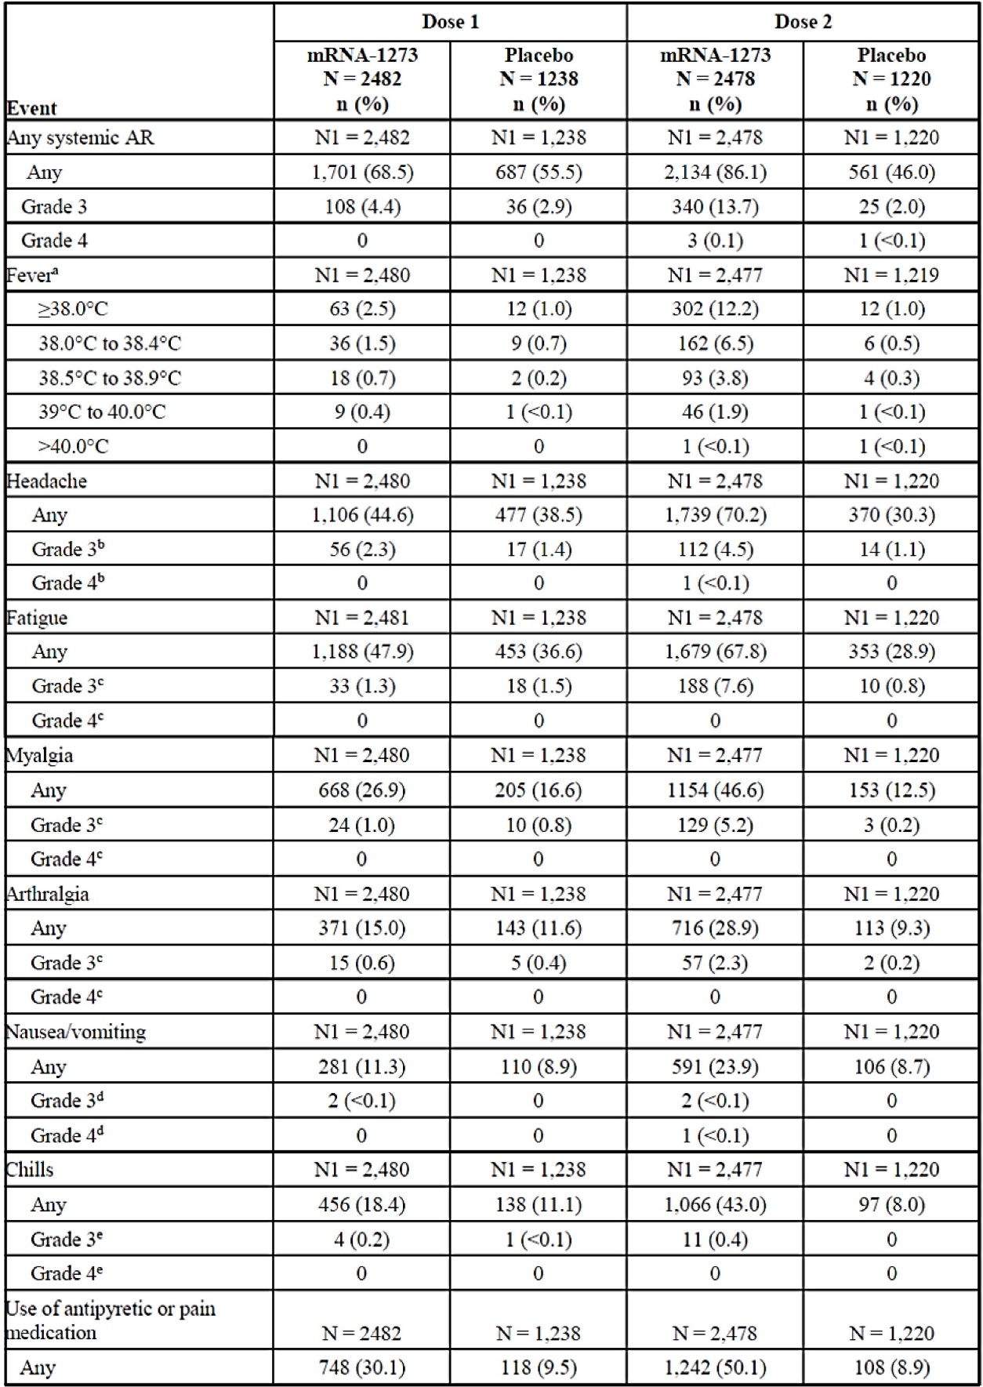
mRNA-1273 = Spikevax COVID-19 mRNA-1273 vaccine; N = number of subjects in each group; n (%) = number (percentage) of subjects that meet the criteria at least once; AR = adverse reaction.
Any = Grade 1 or higher. Percentages are based on the number of exposed participants who submitted any data for the event (N1). The solicited safety set consists of all participants who were randomised and received at least one dose of investigational product (IP) and contributed any solicited adverse reaction (AR) data (that is, had at least one post Baseline solicited safety assessment). The first (second) injection solicited safety set consists of all participants in the solicited safety set who received the first (second) study injection and contributed any solicited adverse reaction data from the time of the first (second) study injection through the following 6 days. Medications were collected on the eDiary.
a Fever is defined as: Grade 1 = 38 to 38.4ºC; Grade 2 = 38.5 to 38.9ºC; Grade 3 = 39 to 40ºC; Grade 4 = greater than 40ºC.
b Headache: Grade 3 significant, any use of prescription pain reliver or prevents daily activity; Grade 4: requires emergency room visit or hospitalisation.
c Fatigue, myalgia., arthralgia: Grade 3 significant, prevents daily activity; Grade 4: requires emergency room visit or hospitalisation.
d Nausea/vomiting: Grade 3 prevents daily activity, requires outpatient intravenous hydration; Grade 4: requires emergency room visit or hospitalisation for hypertensive shock.
e Chills: Grade 3 precents daily activity and requires medical intervention; Grade 4 requires emergency room visit or hospitalization.
Figure 5: Study P203 Percentage of participants who had a solicited local or systemic adverse reaction within 7 days after the first or second injection (Dose 1 or 2) of either Spikevax COVID-19 mRNA-1273 vaccine or placebo;¹⁸
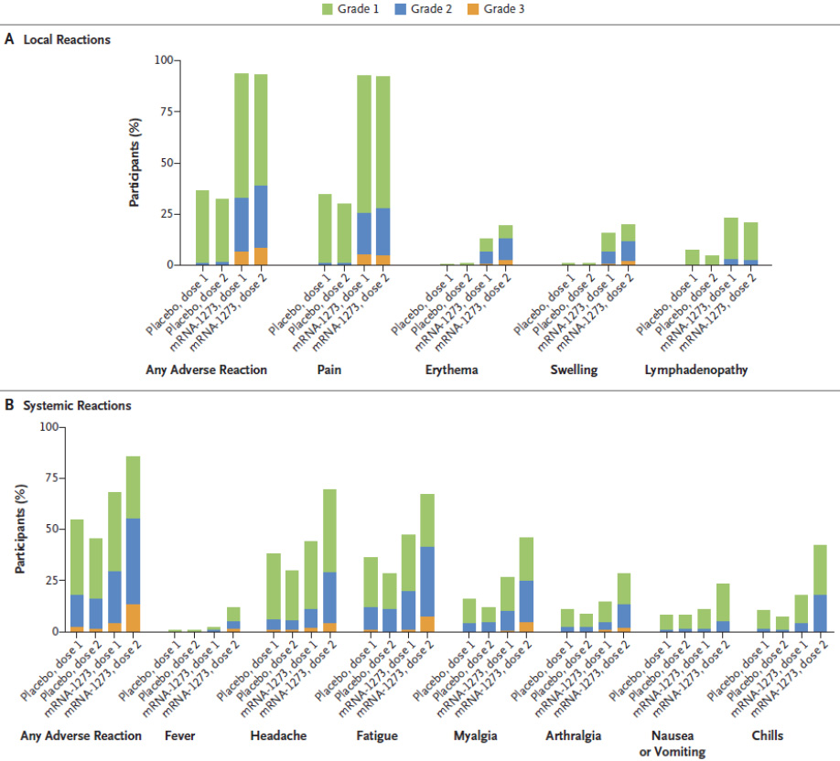
mRNA-1273 = Spikevax COVID-19 mRNA-1273 vaccine.
A local reactions
B systemic reactions

Solicited adverse reactions by age group
In the Spikevax COVID-19 mRNA-1273 vaccine group, any solicited adverse reaction after any dose was recorded by 99.1% of participants ≥ 12 to < 16 years of age and by 99.5% of participants ≥ 16 to < 18 years of age. Any solicited local adverse reaction in the Spikevax COVID-19 mRNA-1273 vaccine group was recorded by 97.9% versus 97.5% of subjects in the 2 age cohorts, and any solicited systemic adverse reaction by 91.6% versus 92.7% respectively.
The most often recorded solicited local adverse reaction in both age cohorts was pain, recorded by 97.4% of subjects ≥ 12 to <16 years of age and by 96.6% of subjects ≥ 16 to < 18 years of age, followed by axillary swelling or tenderness (33.9% and 36.5%), and swelling/hardness (28.9% and 24.3%). Erythema was recorded by 26.7% and 23.3% of participants in the 2 age cohorts, respectively. Any solicited systemic adverse reaction after any dose was recorded by 91.6% of subjects ≥ 12 to < 16 years of age and by 92.7% of subjects ≥ 16 to < 18 years of age in the Spikevax COVID-19 mRNA-1273 vaccine group. The most frequent solicited systemic adverse reaction in both age groups was headache (77.6% and 80.4%), followed by fatigue (74.8% and 76.4%), myalgia (52.8% and 58.6%), and arthralgia (32.9% and 39.3%). Any solicited adverse reaction of Grade 3 or more was recorded by 25.6% of subjects in the younger compared to 24.4% of subjects in the older age group. Any local solicited adverse reaction of Grade 3 or more was recorded by 14.6% versus 11.7%, and any systemic solicited adverse reaction of Grade 3 or more by 16.6% versus 16.8% of subjects in the 2 age cohorts.
Local and systemic reactogenicity was generally comparable in the 2 age cohorts with regard to frequency and severity.
Data on the solicited systemic and local adverse reactions by dose in the age cohort 18 to 25 years of age from Study P301 suggested a higher local reactogenicity for all solicited local adverse reactions except for pain in the age cohort 12 to < 18 years compared with the age cohort 18 to 25 years of age. The incidence of solicited systemic adverse reactions were comparable or slightly higher in the age cohort 18 to 25 years of age. Comparing the incidence of severe (Grade 3) systemic adverse reactions shows a clear difference between adolescents (4.4% Dose 1, 13.7% Dose 2) and young adults (5.2% Dose 1, 21.6% Dose 2), especially after Dose 2. It should be taken into account, that the sample size in the age cohort 12 to < 18 years was 3-fold higher than in the age cohort 18 to 25 years of age and the control group is a historical one.

Solicited adverse reactions by baseline SARS-CoV-2 status
The solicited safety set of the Spikevax COVID-19 mRNA-1273 vaccine group includes 2,167 subjects seronegative for SARS-CoV- 2 at Baseline and 147 subjects seropositive. The placebo group had 1,075 and 69 subjects seronegative and seropositive respectively.
In the Spikevax COVID-19 mRNA-1273 vaccine group, any solicited adverse reaction after any dose was recorded by 99.4% of participants seronegative at Baseline, and by 98.6% of participants seropositive at Baseline. Any solicited local adverse reaction in the Spikevax COVID-19 mRNA-1273 vaccine group was recorded by 98.1% versus 94.6% of subjects, respectively. Any solicited systemic adverse reaction was reported by 91.7% versus 93.9% of seronegative and seropositive subjects. The most often recorded solicited local adverse reaction in seronegative and seropositive subjects of the Spikevax COVID-19 mRNA-1273 vaccine group was pain recorded by 97.5% versus 92.5% of subjects, followed by axillary swelling or tenderness (34.3% and 44.2%), and swelling/hardness (28.3% and 22.4%). Erythema was recorded by 26.5% and 21.1% of participants, respectively. Any solicited systemic adverse reaction after any dose was recorded by 91.7% of seronegative subjects and by 93.9% of seropositive subjects in the Spikevax COVID-19 mRNA-1273 vaccine group.
The most frequent solicited systemic adverse reaction in both age groups was headache (78.3% and 80.3%), followed by fatigue (74.9% and 80.3%), myalgia (54.0% and 59.2%), chills (48.7% and 61.2%) and arthralgia (34.6% and 38.1%). Any fever was recorded by 13.0% of seronegative and 25.9% of seropositive subjects. Any solicited adverse reaction of Grade 3 or more was recorded by 25.4% of seronegative subjects compared to 24.5% of seropositive subjects. Any local solicited adverse reaction of Grade 3 or more was recorded for 13.8% versus 15.0%, and any systemic solicited adverse reaction of Grade 3 or more by 16.5% versus 20.4% of seronegative and seropositive subjects.
These results however, cannot be interpreted as conclusive due to the small size of seropositive subjects in the vaccine group (only 147 subjects). Generally the incidence of solicited local and systemic adverse reactions after any dose was nonetheless comparable in the two groups, except for fever (13.0% versus 25.9% of seronegative and seropositive subjects). No notable difference with regard to severity of adverse reactions could be observed.

Unsolicited adverse events
Adverse events leading to discontinuation from vaccination and/or study participation, MAAEs, SAEs, AESIs (in this study an AESI is the event of MIS-C), and pregnancies are being collected from Day 1 through the entire study period or until last day of study participation.

Summary of unsolicited adverse events (irrespective of causality)
The incidence of unsolicited treatment emergent adverse events (TEAEs) was higher in the Spikevax COVID-19 mRNA-1273 vaccine group compared with the placebo group. Unsolicited TEAEs irrespective of causality up to 28 days after any dose were reported by 20.5% of subjects in the Spikevax COVID-19 mRNA-1273 vaccine group (510/2,486 subjects) compared to 15.9% of participants in the placebo group (197/1,240 subjects).
Table 20: Study P203 Summary of unsolicited treatment emergent adverse event up to 28 days after any injection in participants aged ≥ 12 to < 18 years (safety set)
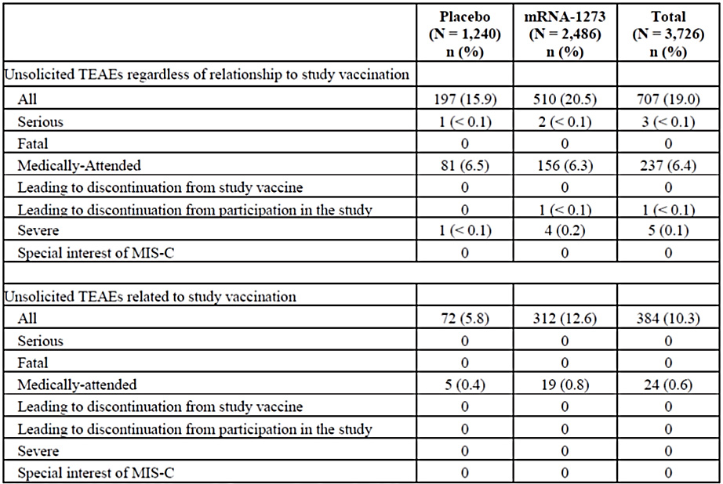
mRNA-1273 = Spikevax COVID-19 mRNA-1273 vaccine; N = number of subjects in each group or in total included in the considered cohort; n (%) = number (percentage) of subjects that meet the criteria at least once; TEAE = treatment emergent adverse event; MIS-C = multisystem inflammatory syndrome in children.
Percentages are based on the number of safety subjects. A treatment emergent adverse event (TEAE) is defined as any event not present before exposure to study vaccination or any event already present that worsens in intensity or frequency after exposure.

Most common unsolicited adverse events
Overall, the most commonly reported (≥2%) unsolicited TEAEs in all participants in the 28 days after any dose by Preferred Term (PT) were injection site lymphadenopathy (3.0%) and headache (2.4%). Imbalances in unsolicited TEAEs up to 28 days after any dose observed in the Spikevax COVID-19 mRNA-1273 vaccine group were primarily attributable to events related to local injection site reactions in the general disorders and administration site conditions System Organ Class (SOC), which included events of injection site lymphadenopathy (4.3%), injection site erythema (1.9%), injection site induration (1.1%), injection site pain (1.1%), injection site pruritis (0.5%), injection site hypersensitivity (0.3%), and urticaria (0.2%).
The most commonly recorded unsolicited TEAEs with a frequency of more than 1% occurred in the SOC general disorders and administration site conditions, reported by 10.1% of subjects in the Spikevax COVID-19 mRNA-1273 vaccine group and by 4.0% of subjects in the placebo group. This included events of injection site lymphadenopathy (4.3% versus 0.4%), injection site erythema (1.9% versus 0.2%), fatigue (1.9% each), injection site induration (1.1% versus 0.2%), and injection site pain (1.1 versus 0.6%). All of the reports of injection site lymphadenopathy were identified as axillary (underarm) swelling or tenderness, ipsilateral to the side of the injection. The incidence of lymphadenopathy within 28 days after any dose was 0.7% in the Spikevax COVID-19 mRNA-1273 vaccine group (18 subjects) and < 0.1% in the placebo group (one subject). Within the SOC skin and subcutaneous tissue disorders 1.1% of subjects in the Spikevax COVID-19 mRNA-1273 vaccine group and 0.6% in the placebo group reported any unsolicited AE. This imbalance is mostly attributable to the events of urticaria (6 subjects/0.2% versus 1 subject/<0.1%), pityriasis rosea (3 subjects/0.1% versus 0 subjects), and rash. Rash included any rash (3 subjects/0,1% versus 1 subject/<0.1%), rash pruritic (1 subject/0.1% versus 0 subjects) and rash vascular (1 subject/<0.1 versus 0 subjects).
Following are the numerical imbalances observed in the SOC of:
- immune system disorders: Type IV hypersensitivity reaction (3 subjects (0.1%) in the Spikevax COVID-19 mRNA-1273 vaccine group and no subjects in the placebo group).
- psychiatric disorders (ADHD, anxiety): attention deficit hyperactivity disorder: 6 subjects in the Spikevax COVID-19 mRNA-1273 vaccine group (0.2%) versus no subject in the placebo group. Anxiety and anxiety disorder together was reported in 8 subjects in the Spikevax COVID-19 mRNA-1273 vaccine group and 2 subjects in the placebo group. None of the events of psychiatric disorders in the vaccine group except of tic (worsening of pre-existing motor tic) was assessed as vaccine related by the investigator.
- endocrine disorders: hypothyroidism (2 subjects in the Spikevax COVID-19 mRNA-1273 vaccine group (< 0.1%) and no subject in the placebo group. Both cases were assessed as not related to the Spikevax COVID-19 mRNA-1273 vaccine.
- nervous system disorders: dizziness in 4 subjects in the Spikevax COVID-19 mRNA-1273 vaccine group and no subject in the placebo group. Three cases of dizziness are considered being vaccine related by the investigator.
- eye disorders: 5 subjects in the Spikevax COVID-19 mRNA-1273 vaccine group versus one subject in the placebo group. The individual events in the Spikevax COVID-19 mRNA-1273 vaccine group included (eye pain, eye swelling, eyelid oedema, periorbital inflammation, and transient blindness).
Severe unsolicited AEs were reported by 0.2% of subjects (4/2,486) in the Spikevax COVID-19 mRNA-1273 vaccine group and by < 0.1% (one subject) in the placebo group. The severe unsolicited AEs in the Spikevax COVID-19 mRNA-1273 vaccine group were one event each of appendicitis, diarrhoea, vomiting, drug-induced liver injury, testicular torsion, and concussion in a total of 4 participants.
Overall incidence of unsolicited AEs irrespective of causality was higher in the Spikevax COVID-19 mRNA-1273 vaccine group compared with the placebo group. None of the severe unsolicited AEs that occurred in the Spikevax COVID-19 mRNA-1273 vaccine group were considered vaccine related.

Hypersensitivity
The most frequently reported events considered being vaccine related (narrow and broad hypersensitivity Standardised Medical Dictionary for Regulatory Activities (MedDRA) Queries) in the Spikevax COVID-19 mRNA-1273 vaccine group were injection site hypersensitivity (8 subjects, 0.3%), injection site urticaria (0.2%, 4 subjects), rash (0.2%, 4 subjects) and urticaria (0.2%, 6 subjects). 3 subjects (0.1%) reported a Type IV hypersensitivity reaction. This included a non-urticarial rash at the upper arm, and a pruritic rash of lower legs.

Type IV hypersensitivity reactions
The three unsolicited AEs of Type IV hypersensitivity reactions in the 3 subjects were all events of delayed cutaneous hypersensitivity reactions with onset on Day 8 to 11 after the first dose of Spikevax COVID-19 mRNA-1273 vaccine. Because of the timing being consistent with reports of delayed cutaneous hypersensitivity reactions, the events of Type IV hypersensitivity reactions are considered most probably vaccine associated.

Anaphylaxis
One case of anaphylactic reaction not assessed as vaccine related was reported (anaphylactic reaction to tree nut). No cases of anaphylactic reaction considered being vaccine related were reported in the Spikevax COVID-19 mRNA-1273 vaccine group.
Table 21: Study P203 Incidence of unsolicited treatment emergent adverse events with occurrence in ≥ 1% of participants in any treatment group up to 28 days after any dose classified by medical dictionary for regulatory activities primary System Organ Class and Preferred Term, all participants aged ≥ 12 to < 18 years (safety set)
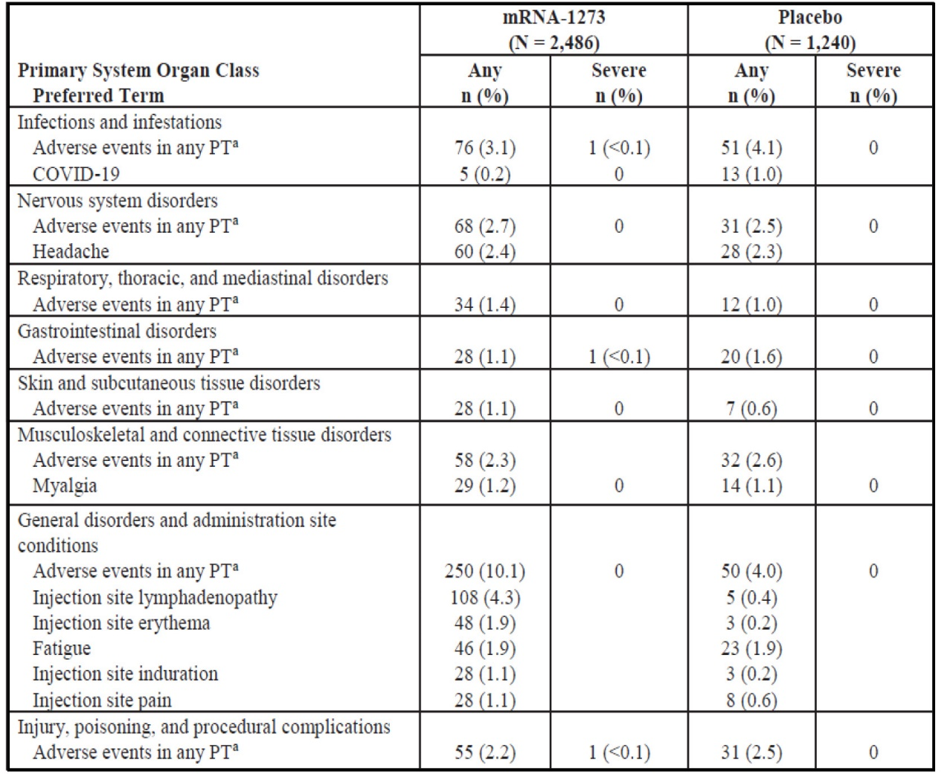
mRNA-1273 = Spikevax COVID-19 mRNA-1273 vaccine; N = number of subjects in each group; n (%) = number (percentage) of subjects that meet the criteria at least once; PT = Preferred Term; COVID-19 = coronavirus disease 2019.
Percentages are based on the number of safety participants. The safety set consists of all randomised participants who received any study injection. A treatment emergent adverse event (TEAE) is defined as any event not present before exposure to study vaccination or any event already present that worsens in intensity or frequency after exposure.
a Participant experienced at least one TEAE within the System Organ class regardless of the Medical Dictionary for Regulatory Activities (MedDRA) PT.

Serious adverse events, deaths and other significant events

Serious adverse events
The incidence of unsolicited severe TEAEs in the 28 days after any dose was reported in 4 subjects in the Spikevax COVID-19 mRNA-1273 vaccine group (0.2%) compared with a single subject in the placebo group (< 0.1%). No unsolicited severe TEAEs within 28 days of any dose were assessed by the investigator as related to the vaccine.

Deaths
At the time of the data snapshot (8 May 2021), no SAEs with fatal outcome or deaths were reported.

Adverse events of special interest
Multisystem inflammatory syndrome in children was defined as an AESI in this trial. No cases were reported at the time of data snapshot.

Myocarditis
No cases of myocarditis have been reported at the time of data snapshot. However, three subjects in the Spikevax COVID-19 mRNA-1273 vaccine group reported symptoms that could be consistent with myocarditis or pericarditis. Details of these cases follow:
- The first case is a study participant who, on the day after the second dose of Spikevax COVID-19 mRNA-1273 vaccine at 07:00, experienced a Grade 2 non-serious MAAE of palpitations (verbatim: intermittent tachy-palpitations).
- Another study participant without any medication and medical history, reported an event of Grade 2 non serious MAAE of painful respiration (chest pain with painful respirations) and a Grade 2 non-serious MAAE of dyspnoea, one day after Dose 2.
- Third study participant reported pain to the left side of the chest with deep inspiration and position changes 4 days after Dose 2 of Spikevax COVID-19 mRNA-1273 vaccine. The event was ongoing at the time of data snapshot.
The AE of myocardits has already been discussed with the adult part of this submission and at the time of the clinical evaluation completion, no additional data has been made available since.

Laboratory findings
Laboratory safety analyses were not carried out.

Safety in special populations
The population of the trial included healthy adolescents 12 to 18 years of age. Individuals with a HIV infection or individuals receiving immunosuppressants or immune-modifying medication for more than 14 days in total within 6 months prior to the day of enrolment were not allowed to participate.

Safety related to drug-drug interactions and other interactions
No interaction study has been performed.

Discontinuations due to adverse events
Until data lock point (DLP), three subjects discontinued due to AEs, all of them were from the Spikevax COVID-19 mRNA-1273 vaccine group. None of the AEs leading to discontinuation is considered vaccine related. No subject in the placebo group discontinued due to an AE.

Post-marketing experience
No further data has been provided by the sponsor since the Advisory Committee on Vaccines (ACV) meeting for advice considering the Spikevax COVID-19 mRNA-1273 vaccine for the indication in adults;¹⁴.

Risk management plan
The initial submission included EU-risk management plan (RMP) version 1.1 (dated 1 March 2021; data lock point (DLP) 21 December 2020), tracked version 1.2 (dated 31 May 2021; DLP 21 December 2020) and tracked version 2.0 (dated 8 June 2021; DLP 8 May 2021) and Australian specific annex (ASA) version 0.1 (dated 3 July 2021). With this initial submission the sponsor was seeking approval for the use this vaccine for individuals 12 years and older. However, following discussions with the TGA, the sponsor is currently seeking approval for the target population of adults 18 years and older in the first instance.
On 16 July 2021, the sponsor provided EU-RMP version 2.1 (dated 15 July 2021; DLP 31 May 2021), in which the summary of safety concerns has been updated to include myocarditis (including myopericarditis) and pericarditis as important potential risks.
On 23 July 2021, the sponsor provided an updated ASA version 0.2 (dated 22 July 2021), which referenced the EU-RMP version 2.1.
The summary of safety concerns and their associated risk monitoring and mitigation strategies are summarised in Table 22.
Table 22: Summary of safety concerns
Summary of safety concerns |  | Pharmacovigilance |  | Risk minimisation
 |  | Routine | Additional | Routine | Additional
Important identified risks | Anaphylaxis | * | † |  | –
Important identified risks | Myocarditis (including myopericarditis) | * | † |  | –
Important identified risks | Pericarditis | * | † |  | –
Important potential risks | Vaccine-associated enhanced disease (VAED) including vaccine-associated enhanced respiratory disease (VAERD) | * | † | – | –
Missing information | Use in pregnancy and while breast-feeding |  | † |  | –
Missing information | Long-term safety |  | † | – | –
Missing information | Use in immunocompromised subjects |  | † |  | –
Missing information | Interaction with other vaccines |  | † |  | –
Missing information | Use in frail subjects with unstable health conditions and co-morbidities (e.g. chronic obstructive pulmonary disease (COPD), diabetes, chronic neurological disease, cardiovascular disorders) |  | † |  | –
Missing information | Use in subjects with autoimmune or inflammatory disorders |  | † |  | –
*Follow-up questionnaires
†Clinical studies
- At this stage, the summary of safety concerns is considered acceptable from an RMP perspective.
- The proposed pharmacovigilance plan is acceptable from an RMP perspective. The clinical evaluator/TGA delegate will assess the acceptability of the clinical study plan that is proposed to fulfil the requirement of the provisional registration.
- Only routine risk minimisation measures are proposed. This is in line with the other COVID-19 vaccines currently approved for use in Australia. At this stage, routine risk minimisation measures, together with the risk minimisation activities launched by the Department of Health, are considered acceptable to minimise the risks associated with Spikevax COVID-19 mRNA-1273 vaccine.

Risk-benefit analysis

Delegate’s considerations
Spikevax COVID-19 mRNA-1273 vaccine has been provisionally approved by TGA on 9 August 2021 for active immunisation to prevent COVID-19 disease in individuals 18 years of age and older on the basis of short-term efficacy and safety data. The sponsor simultaneously provided the data to support the indication extension to include the adolescent group 12 to 17 years of age. The submitted data include immunogenicity, safety and efficacy analysis for adolescents 12 to 17 years old from Study P203 in blinded follow-up to a data cut-off date of 8 May 2021.
Immunogenicity
The immunogenicity analysis demonstrated that the immune response to Spikevax COVID-19 mRNA-1273 vaccine in adolescents 12 to 17 years of age was non-inferior to young adults 18 to 25 years of age. It is to be acknowledged that the neutralising antibody responses were chosen here as an immune biomarker for inferring effectiveness through immunobridging, but a specific level of neutralising antibodies has not yet been established to correlate with protection, and other aspects of the immune response, such as cellular immunity, were not analysed. No data were presented on cellular immunity, however, this is not considered critical in the presence of available secondary efficacy data.
A non-inferiority analysis evaluating SARS-CoV-2 50% neutralising titres and seroresponse rates 28 days after Dose 2 was conducted in the per protocol (PP)¹⁷ immunogenicity subsets of adolescents aged 12 through 17 (n = 340) in the adolescent study and in participants aged 18 through 25 (n = 296) in the adult study. Subjects had no immunologic or virologic evidence of prior SARS-CoV-2 infection at Baseline. The geometric mean ratio (GMR) of the neutralising antibody titres in adolescents of 12 to 17 years of age compared to the 18 to 25 year olds was 1.08 (95% CI: 0.94, 1.24). The difference in seroresponse rate was 0.2% (95% CI: -1.8, 2.4). Non-inferiority criteria (lower bound of the 95% CI for GMR > 0.67 and lower bound of the 95% of the seroresponse rate difference > -10%) were met.

Efficacy
Vaccine efficacy for adolescents was not a pre-specified primary endpoint and the data cut-off date (8 May 2021) was based on the immunogenicity and safety assessment, not based on the number of COVID-19 cases accrued for the adolescent group. The efficacy analysis therefore cannot be considered as hypothesis testing. The efficacy endpoints for adolescents are consistent with the endpoints assessed for adult population. The efficacy study in adolescents 12 through 17 years of age is still ongoing. Participants will be followed for efficacy and safety until one year after the second dose.
Using the same COVID-19 case definition as in the pivotal adult Study P301 or a less stringent US Centers of Disease and Control (CDC) case definition, a vaccine efficacy of 100% (95% CI: 28.9, NE; 0/4 cases) and 93.3% (95% CI: 47.9, 99.9; 1/7 cases), respectively, was estimated. Vaccine efficacy against SARS-CoV-2 infection was estimated to be 55.7% (95%CI: 16.8, 76.4 using the COVID-19 CDC case definition requiring only one symptom and reflecting the symptoms more common in adolescence, vaccine efficacy against COVID-19 occurring 14 days or more after Dose 2 was 93.3% (95% CI: 47.9%, 99.9%). Vaccine efficacy in the modified intent to treat 1 (mITT1) analysis set (14 days after Dose1) was 92.7% (95% CI: 67.8, 99.2).

Safety
At the data cut date of 8 May 2021 (data snapshot date), the median study follow-up duration was 53 days after Dose 2 and 83.5 days after Dose 1. The safety set consists of 1,838 subjects ≥ 12 and < 16 years of age and of 648 subjects ≥ 16 and < 18 years of age who received at least one dose of the Spikevax COVID-19 mRNA-1273 vaccine, and of 929 and 311 subjects in the two age cohorts who received placebo, respectively. The overall sample size of the safety set included 3,726 subjects, 2,486 who received Spikevax COVID-19 mRNA-1273 vaccine and 1,240 who received placebo.
The most frequent adverse reactions (reactogenicity) in participants of 12 through 17 years of age were pain at the injection site (97.2%), headache (78.4%), fatigue (75.2%), myalgia (54.3%), chills (49.1%), arthralgia (34.6%), axillary swelling/tenderness (34.6%), nausea/vomiting (29.3%), swelling at the injection site (27.7%), erythema at the injection site (25.8%), and fever (13.7%).
The most commonly reported unsolicited treatment emergent adverse event (TEAE) in all participants in the 28 days after dose by Preferred Term (PT) was injection site lymphadenopathy. There was an imbalance regarding the number of subjects reporting unsolicited adverse events (AE) up to 28 days after any vaccination. The difference was primarily driven by injections site reactions (for example, injection site lymphadenopathy, injection site erythema) persisting beyond Day 7 after vaccination. Overall, imbalances in events of lymphadenopathy and injection site reactions were comparable to the TEAEs observed in adults (participants aged ≥ 18 years in Study P301). There was no difference regarding the incidence of medically attended adverse events (MAAE) between the vaccine and the placebo group.
The study was restricted to healthy paediatric individuals. No conclusion on the safety profile in individuals with comorbidities or under immunosuppression who have a higher risk for severe COVID-19 can be drawn. Only 2 serious adverse events (SAE) were reported in the Spikevax COVID-19 mRNA-1273 vaccine group, neither of them considered vaccine related. No confirmed cases of myocarditis or pericarditis and no case of multisystem inflammatory syndrome in children or immune thrombocytopenia was reported.
The reactogenicity profile in adolescents in the trial is considered acceptable. The overall frequency of reported AEs and SAEs in adolescents were low.
The safety set size is relatively small and is not sufficient for the detection of rare adverse reactions. The safety database for adults in the real world setting is extensive now, which provides some reassurance for the use of this vaccine in the adolescent population.

Data limitations and uncertainties
The submitted data have the following limitations:
- the long-term efficacy and safety is not known;
- clinical efficacy analyses are limited by very low case counts;
- the vaccine efficacy against viral transmission is not accurately known;
- the small number of adolescents in the study are not sufficient to detect vary rare AEs as multisystem inflammatory syndrome in children, autoimmune disorders or rare vaccine related events like myocarditis or pericarditis;
- no data available on the co-administration with other vaccines, especially with quadrivalent seasonal influenza vaccine;
- adolescents with immunocompromised status/high health risks/chronic medical conditions are not specifically assessed;
- the vaccine efficacy against variants of concern has not been assessed;
- no dose finding trial in this population has been conducted, so it is not possible to conclude whether a lower dose could have resulted in a lower reactogenicity with comparable immune response and efficacy.
These limitations are similar to those identified for individuals 18 years and above, with the previous evaluation;¹⁴. The submitted efficacy and safety data is short-term at this stage, but the data have fulfilled the requirement as set out in the Access Consortium Statement On COVID-19 Vaccines Evidence published on TGA website on 4 December 2020;. The statement specified the minimum requirement that trial participants must be followed for a median of at least 2 months after receiving their final vaccine dose. The EMA has stated that conditional marketing authorisation for a COVID-19 vaccine could be based on review of at least 6 weeks post-vaccination safety data.
The benefit of this vaccine in the adolescent population has been shown with the results of Study P203, demonstrating the protection against symptomatic COVID 19 and the higher neutralising antibody levels. The safety profile in this age group is considered acceptable. Even though the course of COVID-19 in adolescents is generally milder compared to the older population, there are individuals that suffer from direct consequences of the infection. The favourable effects of preventing COVID-19 with potential irreversible and long-lasting consequences outweigh the identified risks of vaccination. The limitations regarding the short-term data can be addressed by planned post-market studies.

Proposed action
Based on the evaluation of the submitted data and taking into consideration the current pandemic and public health need, the delegate is of the view that there is a favourable benefit-risk balance for the use of this vaccine in the adolescent population. The submitted data has satisfied the regulatory requirement for the extension of provisional registration to individuals 12 to 17 years of age.
Pending the advice from the Advisory Committee on Vaccines (ACV) and further review of the PI, the delegate proposes the provisional approval of this vaccine for the indication below:
Spikevax (elasomeran) COVID-19 vaccine has provisional approval for the indication below:
Active immunisation to prevent coronavirus disease 2019 (COVID-19) caused by SARS-CoV-2, in individuals 12 years of age and older.
The use of this vaccine should be in accordance with official recommendations.
The decision has been made on the basis of short-term efficacy and safety data. Continued approval depends on the evidence of longer term efficacy and safety from ongoing clinical trials and post-market assessment.
The proposed conditions of the provisional registration (clinical and RMP) are specified as following.

Clinical conditions
- Submit safety data for all adolescents 12 to17 years of age in Study P203, 6-months post Dose 2, when the data become available.
- Submit clinical study report of Study P203(interim and final), including data up to 24 months after Dose 2 in adolescents 12 to17 years of age, when the data become available.
- Submit safety data in relation to follow-up at 6 months post-Dose 2 for all original Spikevax recipients and at 6 months post-Dose 4 for original placebo recipients subsequently vaccinated with Spikevax , when the analysis is available.

Risk management plan conditions

Conditions of registration
Any changes to which the sponsor has agreed should be included in a revised RMP and ASA. However, irrespective of whether or not they are included in the currently available version of the RMP document, the agreed changes become part of the risk management system.
The Spikevax EU-Risk Management Plan (RMP) (version 2.1, dated 15 July 2021; DLP 31 May 2021), with Australian specific annex (version 0.3, dated 5 August 2021), included with submission PM-2021-02994-1-2, and any subsequent revisions, as agreed with the TGA will be implemented in Australia.
An obligatory component of risk management plans is routine pharmacovigilance. Routine pharmacovigilance includes the submission of periodic safety update reports (PSURs).
Unless agreed separately between the supplier who is the recipient of the approval and the TGA, the first report must be submitted to TGA no later than 15 calendar months after the date of this approval letter. The subsequent reports must be submitted no less frequently than annually from the date of the first submitted report until the period covered by such reports is not less than three years from the date of this approval letter, or the entire period of provisional registration, whichever is longer.
The reports are to at least meet the requirements for PSURs as described in the European Medicines Agency’s Guideline on Good Pharmacovigilance Practices (GVP) Module VII-periodic safety update report (Rev 1), Part VII.B Structures and processes. Note that submission of a PSUR does not constitute an application to vary the registration. Each report must have been prepared within ninety calendar days of the data lock point for that report.
Additional to the routine submission of the routine PSURs, expedited monthly, Spikevax safety summary reports (including safety data for patients in Australia) are to be provided for the first 6 months post registration, and thereafter at intervals specified by the TGA.
Spikevax (elasomeran) is to be included in the Black Triangle Scheme. The PI and CMI [Consumer Medicines Information] for Spikevax must include the black triangle symbol and mandatory accompanying text for the products entire period of provisional registration.
- Confirmatory trial data (as identified in the sponsor’s plan to submit comprehensive clinical data on the safety and efficacy of the medicine before the end of the 6 years that would start on the day that registration would commence) must be provided.
The final decision will be made following the ACV discussion and the satisfactory negotiation of the PI and the conditions of provisional registration.

Questions for the sponsor
The sponsor provided the following response to questions from the Delegate.
- Could the sponsor provide any additional data on the adverse event of myocarditis and pericarditis?
The sponsor has provided additional data on the adverse event (AE) of myocarditis and pericarditis in the Monthly Safety Summary Report (MSSR) 7 for the reporting period of 1 to 31 July 2021.
- Why is the modified intent to treat group used for the efficacy description instead of the per protocol set (as per study protocol)?
Both the per protocol (PP) set and the modified intent to treat (mITT1) set were used for the efficacy analysis description in Study P203.
In the Study P203 PP set there were only 4 COVID-19 cases (Study P301 primary case definition) in the placebo arm and zero case in the Spikevax COVID 19 mRNA-1273 vaccine arm starting 14 days after Dose 2. Assessments using the mITT1 set (including subjects with negative SARS-CoV-2 status at Baseline who received at least one dose without a dosing error) in Study P203 allowed a longer observation period for case occurrence (starting 14 days after the first dose), allowing expanded assessment of cases at the time of the data snapshot. The analyses presented in this submission thus maintain the stringent assessment used in the pivotal adult efficacy study (Study P301 case definition in the PP set) but also employ assessments more aligned with the epidemiology and pathophysiology of COVID-19 in adolescents (CDC case definition in the mITT1 set).
- Could the sponsor provide any data on vaccine overdose, especially in younger population?
The sponsor has provided data on vaccine overdose, including by age group, in MSSR 7 for the reporting period 1 to 31 July 2021.

Advisory Committee considerations²⁰
The Advisory Committee on Vaccines (ACV), having considered the evaluations and the Delegate’s overview, as well as the sponsor’s response to these documents, advised the following.

Specific advice to the Delegate
- Does ACV consider that there is a favourable benefit-risk balance for the use of this vaccine in the adolescent population and the submitted data has satisfied the regulatory requirement for the extension of provisional registration to individuals 12 to 17 years of age, especially in view of the absence of a confirmed immunogenicity correlate of protection?
The ACV advised that immunogenicity was similar in individuals 12 to 17 years of age to that in young adults. Efficacy was supported by both the non-inferiority of the immunogenicity results for the vaccine and the preliminary estimate of vaccine efficacy. Reactogenicity was similar between adolescents and young adults. The safety profile was acceptable.
The ACV was of the view that overall there is a favourable benefit-risk profile for the use of this vaccine in the adolescent population.
- There are rare cases of myocarditis and pericarditis reported following vaccination with Spikevax in young people in the global post-market setting, could ACV please advise: Whether these rare events would change the benefit-risk balance for the use of this vaccine in the adolescent population of 12 to 17 years? This in view of low severity of COVID-19 in this age group and comparing the adverse reactions/adverse events.
The ACV noted that myocarditis and pericarditis are now considered as class effects for the mRNA COVID-19 vaccines, particularly in males under 30 years of age, after the second dose and within 14 days following vaccination. The mechanism for the development of myocarditis is not clear.
The current vaccine with provisional registration for Australians 12 to 17 years is another mRNA vaccine.
Information from US Advisory Committee on Immunization Practices (ACIP) up to 18 August 2021; showed the reporting rate of myopericarditis in the 7 day risk window following Dose 1 or 2 in adults 18 to 39 years was lower following the Pfizer vaccine than following the Moderna vaccine. Data on the Moderna vaccine in the 12 to 17 year population are limited, as the vaccine is newly approved in Canada and still under evaluation in the USA.
The ACV noted the wide confidence intervals previously reported in the 5 June data from ACIP. The ACV noted that the rates of myocarditis/pericarditis may require different descriptive terms, ‘rare’ and ‘very rare’, for this adverse event following immunisation for the Moderna and Pfizer vaccines. The ACV again noted, as discussed at ACV Meeting 23, that the risk of myocarditis following vaccination is substantially less than following COVID-19.
- Advice on any other issues relevant to the decision on whether or not to approve this application.
The ACV advised that the Product Information (PI) should a precaution regarding higher risk of myocarditis/pericarditis in males under 30 years of age after the second dose. The PI should describe the rate and severity of this adverse event following immunisation, which currently appears to be relatively mild in most people.
The ACV advised that the sponsor, via the risk management plan, should provide a specific case reporting form with categorical variables (for example, troponin levels, electrocardiogram results, echocardiogram results) to prompt and collect sufficient information to allow classification of the event using Brighton Collaboration or CDC criteria. This should also facilitate comparisons to Australian background rates.
Subsequent to the ACV meeting, the ACIP reported US data on the incidence and severity of cases of myocarditis in post-marketing surveillance on Monday 30 August 2021 (US time). It was reported that the majority of reported cases of myocarditis were hospitalised, but that short term follow-up suggested that symptoms had resolved in most patients. The incidence of myocarditis was higher after Dose 2 in younger males, but in the 18 to 24 year old age group there was a similar rate reported following Spikevax and Comirnaty (Pfizer) vaccines.

Conclusion
The ACV considered Spikevax to have an overall positive benefit-risk profile, and therefore support provisional approval for the following:
Spikevax (elasomeran) COVID-19 vaccine has provisional approval for the indication below:
Active immunisation to prevent coronavirus disease 2019 (COVID‐19) caused by SARS‐CoV‐2 in individuals 12 years of age and older.
The use of this vaccine should be in accordance with official recommendations.
The decision has been made on the basis of short-term efficacy and safety data. Continued approval depends on the evidence of longer term efficacy and safety from ongoing clinical trials and post-market assessment.

Outcome
Based on a review of quality, safety and efficacy, the TGA approved the registration of Spikevax (elasomeran) 0.2 mg/mL, suspension for injection, vial, indicated for:
Spikevax (elasomeran) COVID-19 vaccine has provisional approval for the indication below:
Active immunisation to prevent coronavirus disease 2019 (COVID-19) caused by SARS-CoV-2 in individuals 12 years of age and older.
The use of this vaccine should be in accordance with official recommendations.
The decision has been made on the basis of short-term efficacy and safety data. Continued approval depends on the evidence of longer term efficacy and safety from ongoing clinical trials and post-market assessment.

Specific conditions of registration applying to these goods
- Risk management plan
Spikevax (elasomeran) COVID-19 vaccine is to be included in the Black Triangle Scheme. The PI and CMI for Spikevax must include the black triangle symbol and mandatory accompanying text for the period of provisional registration.
- The Spikevax EU-RMP (version 2.1, dated 15 July 2021; DLP 31 May 2021), with Australian specific annex (version 0.2, dated 22 July 2021), included with submission PM-2021-02994-1-2, and any subsequent revisions, as agreed with the TGA will be implemented in Australia.
An obligatory component of risk management plans is routine pharmacovigilance. Routine pharmacovigilance includes the submission of periodic safety update reports (PSURs).
Unless agreed separately between the supplier who is the recipient of the approval and the TGA, the first report must be submitted to TGA no later than 15 calendar months after the date of the approval letter. The subsequent reports must be submitted no less frequently than annually from the date of the first submitted report until the period covered by such reports is not less than three years from the date of the approval letter, or the entire period of provisional registration, whichever is longer.
The reports are to at least meet the requirements for PSURs as described in the European Medicines Agency’s Guideline on Good Pharmacovigilance Practices (GVP) Module VII-Periodic Safety update Report (Rev 1), Part VII.B Structures and Processes. Note that submission of a PSUR does not constitute an application to vary the registration. Each report must have been prepared within ninety calendar days of the data lock point for that report.
Additional to the routine submission of the routine PSURs, expedited monthly, Spikevax safety summary reports (including safety data for patients in Australia) are to be provided for the first 6 months post registration, and thereafter at intervals specified by the TGA.
- Clinical
Conditions for adolescent data
The following reports/data will have to be submitted before a definitive authorisation can be considered:
  - Submit safety data for all adolescents 12 to17 years of age in Study P203, 6 months post Dose 2, when the data become available.
  - Submit clinical study report of Study P203 (interim and final), including data up to 24 months after Dose 2 in adolescents 12 to17 years of age, when the data become available.
  - Submit safety data in relation to follow-up at 6 months post-Dose 2 for all original Spikevax recipients and at 6 months post-Dose 4 for original placebo recipients subsequently vaccinated with Spikevax, when the analysis is available.
Existing Conditions for adult data
The following reports/data will have to be submitted before a definitive authorisation can be considered:
  - Submit safety analysis at 6 months post Dose 2 from Phase I, II study when the analysis is available
  - Submit the clinical study report for Study P301 (Phase III) and Study P201 (Phase II) when ready. Please also submit the final report for these studies with 24 months follow up duration when it became available.
  - Submit the immunogenicity data for Study P301
  - When available, please provide:
Further data relating to vaccine efficacy against asymptomatic disease, efficacy against SARS-CoV-2 transmission, vaccine efficacy in immunocompromised subjects, efficacy in subjects with autoimmune conditions, efficacy against variants of concern, pregnant women, lactating mothers, and information relating to post-market safety and effectiveness studies should be provided to the TGA to update the PI.
  - Please also provide real world post market global/local efficacy data, when available.
- Confirmatory trial data (as identified in the sponsor’s plan to submit comprehensive clinical data on the safety and efficacy of the medicine before the end of the 6 years that would start on the day that registration would commence) must be provided.
Further guidance for sponsors is available on the TGA website.
- Quality
Batch Release Testing and Compliance
Batch release testing and compliance with the certified product details conditions of provisional registration for Spikevax.
It is a condition of registration that all independent batches of Spikevax elasomeran COVID-19 vaccine 0.2 mg/mL suspension for injection vial imported into Australia are not released for supply by or on behalf of the sponsor until samples and the manufacturer’s release data have been assessed and you have received notification acknowledging release from the Laboratories Branch, TGA.
For each independent batch of the product imported into Australia, the Sponsor must supply the following:
  - A completed request for release form, available from vaccines@health.gov.au.
  - Complete summary protocols for manufacture and QC, including all steps in production in the agreed format.
  - At least 10 (ten) vials (Samples) of each manufacturing batch of Spikevax elasomeran 0.2 mg/mL suspension for injection vial with the Australian approved labels, PI and packaging (unless an exemption to supply these has been granted) representative of all batches of product seeking distribution in Australia.
  - At least 5 (five) vials (samples) of any further consignments of a manufacturing batch of Spikevax elasomeran 0.2 mg/mL suspension for injection vial with the Australian approved labels, PI and packaging (unless an exemption to supply these has been granted). Further consignments cover batches previously supplied to TGA for the purposes of batch release testing but are seeking to be supplied again.
  - If the manufacturing batch has been released in Europe or the UK a copy of the EU Official Control Authority Batch Release (OCABR) certificate (or equivalent from the UK) must be provided.
  - Any reagents, reference material and standards required to undertake testing, as requested by Laboratories Branch, TGA.
Sponsors must provide all requested samples and data in sufficient time (at least 5 business days) prior to any distribution date to allow the TGA to perform testing and review. Distribution of each batch of vaccine is conditional upon fulfilment of these conditions and receipt of a letter from the Laboratories Branch acknowledging release.
Samples and data should be forwarded to the Biotherapeutics Section, Laboratories Branch before release of each batch and with sufficient lead time to allow for Laboratories Branch testing.
The shipments (including reagents) to TGA are the responsibility of the Australian sponsor/agent who will be required to facilitate the import and customs clearance process.
Certified Product Details
An electronic copy of the Certified Product Details (CPD) as described in Guidance 7: Certified Product Details of the Australian Regulatory Guidelines for Prescription Medicines https://www.tga.gov.au/guidance-7-certified-product-details should be provided upon registration of the therapeutic good. In addition, an updated CPD, for the above products incorporating the approved changes is to be provided within one month of the date of approval letter. A template for preparation of CPD for biological prescription medicines and Vaccines can be obtained from the TGA website https://www.tga.gov.au/form/certified-product-details-cpd-biological-prescriptionmedicines. The CPD should be sent as a single bookmarked PDF document to vaccines@health.gov.au as soon as possible after registration/approval of the product or any subsequent changes as indicated above.

Attachment 1. Product Information
The PI for Spikevax approved with the submission which is described in this AusPAR is at Attachment 1. For the most recent PI, please refer to the TGA website at <https://www.tga.gov.au/product-information-pi>.

Therapeutic Goods Administration
PO Box 100 Woden ACT 2606 Australia
Email: info@tga.gov.au Phone: 1800 020 653 Fax: 02 6232 8605
https://www.tga.gov.au

The Black Triangle Scheme provides a simple means for practitioners and patients to identify certain types of new prescription medicines, including those being used in new ways and to encourage the reporting of adverse events associated with their use. The Black Triangle does not denote that there are known safety problems, just that the TGA is encouraging adverse event reporting to help us build up the full picture of a medicine's safety profile.
Adeyinka, A. et al. COVID 19 Infection: Pediatric Perspectives, JACEP Open, 2021; 2: e12375. DOI: 10.1002/emp2.12375.
Centers for Disease Control and Prevention (CDC) (2021) Demographic Trends of COVID-19 cases and deaths in the US reported to CDC. Available at: https://covid.cdc.gov/covid-data-tracker/#demographics (Accessed on 13 August 2021).
Centers for Disease Control and Prevention (CDC) Coronavirus Disease 2019 in Children - United States, February 12–April 2, 2020, Morb Mortal Wkly Rep, 2020; 69(14): 422-426
As part of the provisional approval pathway, the provisional registration process will allow certain medicines to be provisionally registered in the Australian Register of Therapeutic Goods (ARTG) for a limited duration. These medicines are registered on the basis of preliminary clinical data, where there is the potential for a substantial benefit to Australian patients. The TGA will re-assess risks related to the absence of evidence through data provided at a later stage, as part of the confirmatory data. Confirmatory data should confirm the relationship between outcomes predicted by the surrogate endpoint, or other preliminary data, and the clinical benefit as demonstrated by direct clinical outcomes. The sponsor may apply to transition to full registration at any time up until the provisional registration lapse date, once they have completed the obligations outlined for the provisional registration period and complete confirmatory data on safety and efficacy are available.
Comirnaty was first registered on the ARTG on 25 January 2021 (ARTG number: 346290).
AusPAR for Comirnaty (BNT162b2 (mRNA)) new biological entity, published on 25 January 2021. Available at: https://www.tga.gov.au/auspar/auspar-bnt162b2-mrna-comirnaty
AusPAR for Comirnaty (BNT162b2 (mRNA)) extension of indications, published on 23 July 2021. Available at: https://www.tga.gov.au/auspar/auspar-bnt162b2-mrna
COVID-19 Vaccine AstraZeneca was first registered on the ARTG on 16 February 2021 (ARTG number: 349072).
AusPAR for COVID-19 Vaccine AstraZeneca (ChAdOx1-S) new biological entity, published on 16 February 2021. Available at: https://www.tga.gov.au/auspar/auspar-chadox1-s
COVID-19 Vaccine Janssen was first registered on the ARTG on 25 June 2021 (ARTG number: 350150).
AusPAR for COVID-19 Vaccine Janssen (Ad26.COV2.S) new biological entity, published on 25 June 2021. Available at: https://www.tga.gov.au/auspar/auspar-ad26cov2s
Spikevax was first registered on the ARTG on 9 August 2021 (ARTG number: 370599).
AusPAR for Spikevax (elasomeran) new biological entity, published on 9 August 2021. Available at: https://www.tga.gov.au/auspar/auspar-elasomeran
Therapeutic Goods Administration (TGA) (2021) TGA Grants Provisional Determination for the Moderna COVID-19 Vaccine, Elasomeran. Available at: https://www.tga.gov.au/media-release/tga-grants-provisional-determination-moderna-covid-19-vaccine-elasomeran
mRNA-1273 refers to the vaccine development name for the Moderna Spikevax (elasomeran) COVID-19 vaccine.
The per-protocol (PP) analysis is restricted to the participants who strictly adhered to the protocol. Also known as ‘on-treatment’ analysis.
Adapated from: Ali, K et al. Evaluation of mRNA-1273 SARS-CoV-2 Vaccine in Adolescents, N Engl J Med, 2021 August 11.
Randomised clinical trials analysed by the intent-to-treat (ITT) approach provide the unbiased comparisons among the treatment groups. In the ITT population, none of the patients are excluded and the patients are analysed according to the randomisation scheme.
The Advisory Committee on Vaccines (ACV) provides independent medical and scientific advice to the Minister for Health and the Therapeutic Goods Administration (TGA) on issues relating to the safety, quality and efficacy of vaccines supplied in Australia including issues relating to pre-market assessment, post-market monitoring and safe use in national immunisation programs. The Committee is established under Regulation 39F of the Therapeutic Goods Regulations 1990 and the members are appointed by the Minister for Health. The ACV was established in January 2017, following consolidation of previous functions of the Advisory Committee on the Safety of Vaccines (ACSOV) and the pre-market functions for vaccines of the Advisory Committee on Prescription Medicines (ACPM). Membership comprises professionals with expertise in specific scientific, medical or clinical fields, or consumer health issues.
The Medical Dictionary for Regulatory Activities (MedDRA) is a single standardised international medical terminology, developped as a project of the International Council for Harmonisation of Technical Requirements for Pharmaceuticals for Human Use (ICH) which can be used for regulatory communication and evaluation of data pertaining to medicinal products for human use. As a result, MedDRA is designed for use in the registration, documentation and safety monitoring of medicinal products through all phases of the development cycle (that is,, from clinical trials to post-marketing surveillance) supports ICH electronic communication within the ICH’s Electronic Common Technical Document (eCTD) and the E2B Individual Case Safety Report.
Routine risk minimisation activities may be limited to ensuring that suitable warnings are included in the product information or by careful use of labelling and packaging. Routine pharmacovigilance practices involve the following activities: - All suspected adverse reactions that are reported to the personnel of the company are collected and collated in an accessible manner; - Reporting to regulatory authorities; - Continuous monitoring of the safety profiles of approved products including signal detection and updating of labelling; - Submission of PSURs; - Meeting other local regulatory agency requirements.
Therapeutic Goods Administration (TGA) (4 December 2020) Access Consortium Statement on COVID-19 Vaccines Evidence, Australia, Canada, Singapore, Switzerland, United Kingdom. Available at: https://www.tga.gov.au/access-consortium-statement-covid-19-vaccines-evidence
European Medicines Agency (EMA), Committee for Medicinal Products for Human Use (CHMP), EMA Considerations on COVID-19 Vaccine Approval, EMA/592928/2020, 16 November 2020.
Centers for Disease Control and Prevention (CDC) (2021) Myopericarditis Following COVID-19 Vaccination: Updates from the Vaccine Adverse Event Reporting System (VAERS). Available at: https://www.cdc.gov/vaccines/acip/meetings/downloads/slides-2021-08-30/03-COVID-Su-508.pdf
Centers for Disease Control and Prevention (CDC) (2021) ACIP Presentation Slides: August 30, 2021 Meeting. Available at: https://www.cdc.gov/vaccines/acip/meetings/slides-2021-08-30.html (Accessed on 31 August 2021)

