Date of CER: 29 September 2013

AusPAR Attachment 2

Extract from the Clinical Evaluation Report for eftrenonacog alfa
  - Proprietary Product Name: Alprolix
  - Sponsor: Biogen Idec Australia Pty Ltd
About the Therapeutic Goods Administration (TGA)
- The Therapeutic Goods Administration (TGA) is part of the Australian Government Department of Health, and is responsible for regulating medicines and medical devices.
- The TGA administers the Therapeutic Goods Act 1989 (the Act), applying a risk management approach designed to ensure therapeutic goods supplied in Australia meet acceptable standards of quality, safety and efficacy (performance), when necessary.
- The work of the TGA is based on applying scientific and clinical expertise to decision-making, to ensure that the benefits to consumers outweigh any risks associated with the use of medicines and medical devices.
- The TGA relies on the public, healthcare professionals and industry to report problems with medicines or medical devices. TGA investigates reports received by it to determine any necessary regulatory action.
- To report a problem with a medicine or medical device, please see the information on the TGA website <http://www.tga.gov.au>.
About the Extract from the Clinical Evaluation Report
- This document provides a more detailed evaluation of the clinical findings, extracted from the Clinical Evaluation Report (CER) prepared by the TGA. This extract does not include sections from the CER regarding product documentation or post market activities.
- The words [Information redacted] indicate confidential information has been deleted.
- For the most recent Product Information (PI), please refer to the TGA website <http://www.tga.gov.au/hp/information-medicines-pi.htm>.
Copyright
© Commonwealth of Australia 2013
This work is copyright. You may reproduce the whole or part of this work in unaltered form for your own personal use or, if you are part of an organisation, for internal use within your organisation, but only if you or your organisation do not use the reproduction for any commercial purpose and retain this copyright notice and all disclaimer notices as part of that reproduction. Apart from rights to use as permitted by the Copyright Act 1968 or allowed by this copyright notice, all other rights are reserved and you are not allowed to reproduce the whole or any part of this work in any way (electronic or otherwise) without first being given specific written permission from the Commonwealth to do so. Requests and inquiries concerning reproduction and rights are to be sent to the TGA Copyright Officer, Therapeutic Goods Administration, PO Box 100, Woden ACT 2606 or emailed to <tga.copyright@tga.gov.au>.

Contents
List of abbreviations 5
1. Introduction 6
1.1. Orphan drug designation 6
2. Clinical rationale 7
2.1. Guidance 7
3. Contents of the clinical dossier 8
3.1. Scope of the clinical dossier 8
3.2. Paediatric data 8
3.3. Good clinical practice 8
4. Pharmacokinetics 9
4.1. Studies providing pharmacokinetic data 9
4.2. Summary of pharmacokinetics 9
4.3. Evaluator’s overall conclusions on pharmacokinetics 12
5. Pharmacodynamics 12
6. Dosage selection for the pivotal studies 13
7. Clinical efficacy 13
7.1. Pivotal efficacy study 13
7.2. Analyses performed across trials (pooled analyses and meta-analyses) 29
7.3. Evaluator’s conclusions on clinical efficacy 29
8. Clinical safety 30
8.1. Studies providing evaluable safety data 30
8.2. Pivotal studies that assessed safety as a primary outcome 33
8.3. Patient exposure 33
8.4. Adverse events 35
8.5. Laboratory tests 38
8.6. Post-marketing experience 42
8.7. Safety issues with the potential for major regulatory impact 42
8.8. Evaluator’s overall conclusions on clinical safety 42
9. First round benefit-risk assessment 42
9.1. First round assessment of benefits 42
9.2. First round assessment of risks 43
9.3. First round assessment of benefit-risk balance 43
10. First round recommendation regarding authorisation 43
11. Clinical questions 43
11.1. General 43
11.2. Safety 43
12. Second round evaluation of clinical data submitted in response to questions 44
13. Second round benefit-risk assessment 44
14. Second round recommendation regarding authorisation 44
15. References 44

List of abbreviations
Abbreviation | Meaning
AE | Adverse Event
ALT | Alanine Transaminase
aPPT | Activated Partial Thromboplastin Time
AST | Aspartate Transaminase
ARTG | Australian Register of Therapeutic Goods
AUC | Area Under the Concentration vs. Time Curve
BP | Blood Pressure
BUN | Blood Urea Nitrogen
Cmax | Maximum Concentration
ECG | Electrocardiogram
ECLA | Electrochemiluminescence-based bridging ELISA
ELISA | Enzyme-linked immunosorbent assay
EDs | Exposure Days
EMA | European Medicines Agency
FIX | Factor IX
FIXFc | Eftrenonacog alfa
FDA | Food and Drug Administration
ICH | International Conference on Harmonisation of Technical Requirements for Registration of Pharmaceuticals for Human Use
LDH | Lactate Dehydrogenase
LFTs | Liver Function Tests
PI | Product Information
PK | Pharmacokinetics
PT | Prothrombin Time
PTP | Previously Treated Patient
PUP | Previously Untreated Patient
RBC | Red blood cell
rFIXFc | Eftrenonacog alfa
SAE | Serious Adverse Event
TAT | Thrombin-Antithrombin Complex
TGA | Therapeutic Goods Administration
V_{ss} | Volume of distribution at steady state
WBC | White Blood Cell

Introduction
This is a full submission to register the product as a new chemical entity.
Eftrenonacog alfa is a fusion protein in which a recombinant factor IX (rFIX) molecule is covalently linked to the Fc fragment of an immunoglobulin G1 (IgG1) molecule.
The proposed indication is:
ALPROLIX is a long-acting anti-haemophilic factor (recombinant) indicated in adults and children (≥ 12 years) with haemophilia B (congenital factor IX deficiency) for:
- Control and prevention of bleeding episodes;
- Routine prophylaxis to prevent or reduce the frequency of bleeding episodes;
- Perioperative management (surgical prophylaxis).
In the submitted documentation, eftrenonacog alfa is referred to by the abbreviations ‘rFIXFc’ or ‘FIXFc’. The abbreviation FIXFc will be used in this report.

Orphan drug designation
The product was granted orphan drug status by the TGA on 20 September 2012. The orphan indication granted was:
‘... the control and prevention of haemorrhagic episodes in patients with haemophilia B (congenital factor IX deficiency or Christmas disease), including the control and prevention of bleeding in surgical settings.’
The indication proposed for registration is narrower than that granted in the orphan designation, in that children aged less than 12 years have been excluded.
The Haemophilia Foundation of Australia estimates that there are approximately 2,800 subjects with haemophilia in Australia (4). Approximately 15-20% of haemophilia subjects have haemophilia B (5) and therefore the prevalence of the condition in Australia would be approximately 420 – 560 subjects.

Clinical rationale
The current standard treatment of congenital factor IX (FIX) deficiency is based on the use of replacement FIX therapy. Two replacement therapy products are currently registered in Australia:
- Plasma derived FIX (MonoFIX-VF, CSL Ltd) which is manufactured from blood donated to the Australian Red Cross Blood Service.
- Recombinant FIX (nonacog alfa; BeneFIX; Pfizer Australia Pty Ltd).
The FIX contained in these products has a half-life of approximately 24 h (1,2). For the treatment of bleeding episodes and for surgical prophylaxis it is recommended that dosing be repeated every 12 to 24 h. For routine prophylaxis, dosing is recommended twice per week.
The rationale for the development of eftrenonacog alfa (Alprolix) is that combining the FIX molecule with the Fc fragment of the IgG1 molecule will result in a prolonged half-life, with less frequent dosing required. The draft PI states that eftrenonacog alfa has an elimination half-life of 82 h and the recommended dosage interval for the treatment of bleeding episodes and surgical prophylaxis is up to 48 h. The recommended initial dosage interval for routine prophylaxis is up to 14 days.
The prolonged half life of the molecule occurs because of binding of the Fc fragment with the neonatal Fc receptor for IgG (FcRn). FcRn derives its name through its role in the transfer of IgG from mother to foetus. However, it is also expressed in several adult human tissues and is believed to bind with the Fc fragment of IgG and prevent IgG degradation. FcRn is therefore believed to be responsible for the prolonged half-life of IgG compared to other endogenous proteins (3).
Currently registered products that are fusion proteins combining the Fc fragment of an IgG1 molecule with another active molecule include romiplostim and etanercept.

Guidance
The following EMA guidelines, which have been adopted by the TGA, are considered relevant to the current application.
- Guideline on the Clinical Investigation of the Pharmacokinetics of Therapeutic Proteins (CHMP/EWP/89249/2004); 2007 (6).
- Points to Consider on Application with 1. Meta-Analyses; 2. One Pivotal Study (CPMP/EWP/2330/99); 2001. (7)
- Note for Guidance on the Clinical Investigation of Recombinant Factor VIII and IX Products (CPMP/BPWG/1561/99); 2000 (8).
In Europe, the 2000 guideline on recombinant Factor VIII and IX products has been superseded by a new guideline specific for Factor IX products:
- Guideline on clinical investigation of recombinant and human plasma-derived factor IX products (EMA/CHMP/BPWP/144552/2009); 2011 (9).
This later guideline came into effect in Europe in February 2012, but has not yet been formally adopted in Australia.
Compliance with these guidelines will be considered in the relevant sections of this report.

Contents of the clinical dossier

Scope of the clinical dossier
The submission contained the following clinical information:
- Module 2
  - Clinical overview, summary of biopharmaceutic studies and analytical methods, summary of clinical pharmacology, summary of clinical efficacy and summary of clinical safety.
- Module 5
  - A full study report of one open-label, Phase I/IIa study (SYN-FIXFc-07-001) that examined the safety and pharmacokinetics (PK) of escalating single doses of FIXFc in a total of 14 subjects with haemophilia B.
  - A full study report of one open-label, Phase III pivotal efficacy and safety study (998HB102) that examined the PK, efficacy and safety of FIXFc in a total of 123 subjects with haemophilia B.
  - One population pharmacokinetic analysis of PK data collected in the above two studies.
  - Brief safety reports from two ongoing studies (9HB02PED and 9HB01EXT). These reports included limited information regarding serious adverse events and adverse events of special interest.
  - Literature references.

Paediatric data
The pivotal study in the submission included previously treated patients (PTPs) aged 12 years and over and the indication sought by the sponsor is restricted to this group. One of the ongoing studies (9HB02PED) is a trial of the product in PTPs aged less than 12 years. It is planned to enrol at least 20 subjects and completion is expected by June 2015. Another study is planned in previously untreated patients (PUPs) aged less than 18 years, with completion expected in June 2019.
Comment: The European Medicines Agency (EMA) guideline on recombinant Factor VIII and IX products (8), which has been adopted by the TGA, indicates that the submission of paediatric data can be delayed until after initial marketing approval. The absence of data on children aged less than 12 years of age in this submission is therefore not considered a deficiency in the application.

Good clinical practice
The study reports for the completed studies included assurances that they had been conducted in accordance with applicable guidelines including the International Conference on Harmonisation (ICH) Guideline on Good Clinical Practice and the ethical principles outlined in the Declaration of Helsinki.

Pharmacokinetics

Studies providing pharmacokinetic data
Pharmacokinetic data were collected in both SYN-FIXFc-07-001 and 998HB102, and a population PK analysis was also conducted on these data. Summaries of the PK studies are presented below.
None of these PK studies had deficiencies that excluded their results from consideration. Both studies were conducted in subjects with FIX deficiency (haemophilia B) and hence there were no studies in healthy volunteers.

Summary of pharmacokinetics
The information in the following summary is derived from conventional PK studies unless otherwise stated.

Physicochemical characteristics of the active substance
The following information is derived from the Sponsor’s summaries in Module 2. FIXFc is a fusion protein combining human coagulation factor IX and the Fc domain of a human IgG1 antibody. It contains 867 amino acids and has a molecular weight of approximately 98 kilodaltons. It is produced by recombinant DNA technology in a human embryonic kidney (HEK) cell line.

Pharmacokinetics in haemophilia B subjects

Absorption/bioavailability
FIXFc is only administered intravenously (IV) and by definition has 100% absorption and bioavailability. T_{max} occurred immediately after the completion of the infusion.

Incremental recovery
The incremental recovery of FIXFc was 0.92 IU/dL for every 1.0 IU/kg administered (Table 1). In the same study, the incremental recovery of BeneFIX was 0.95.
Table 1: Study 998HB102 – Comparison of PK (FIX activity) after single doses of 50 IU/kg of BeneFIX and FIXFc (2-compartmental analysis)
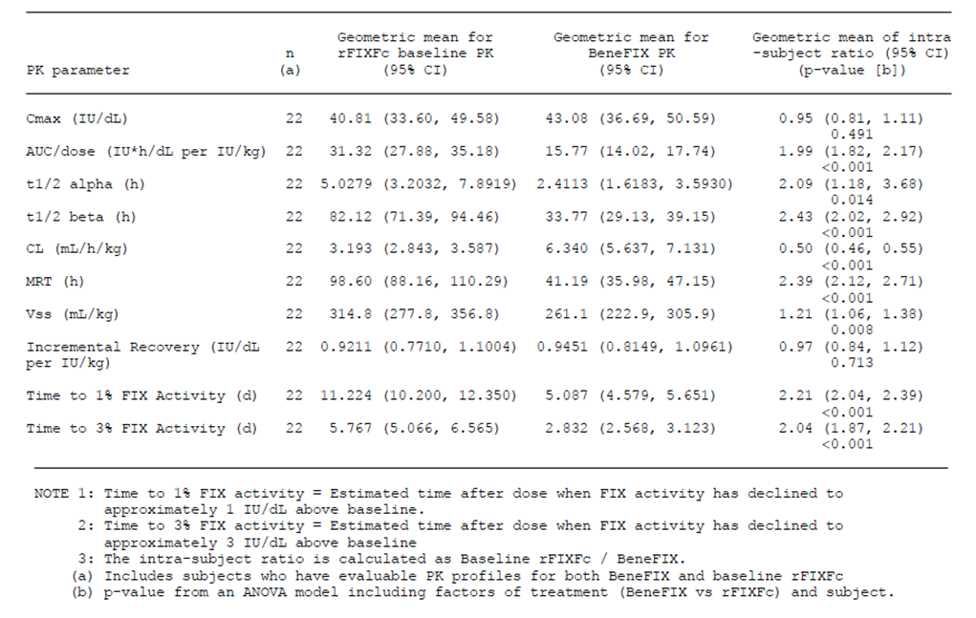
Comment: Factor IX replacement products generally have an incremental recovery of approximately 1.00 IU/dL for every 1.0 IU/kg administered (5). The value of 0.92 for FIXFc is consistent with this. However, BeneFIX is considered to have a lower recovery than plasma-derived FIX (10). The value for incremental recovery in adults quoted in the Australian PI for BeneFIX is 0.72 IU/dL for every 1.0 IU/kg administered. As the recovery values for FIXFc and BeneFIX in this study were comparable, FIXFc may also have a lower recovery than plasma-derived FIX.

Dose proportionality
Mean C_{max} and AUC increased in an approximately dose proportional manner for both FIX activity and FIXFc antigen, over the dose range of 25 to 100 IU/kg.
Table 2: Phase I/IIa Study (SYN-FIXFc-07-001) – FIX activity PK Parameters (Mean ± SD)
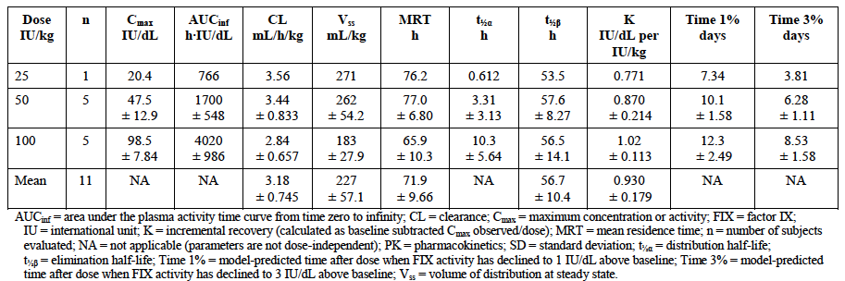
Table 3: Phase I/IIa Study (SYN-FIXFc-07-001) – rFIXFc anitgen PK Parameters (Mean ± SD)
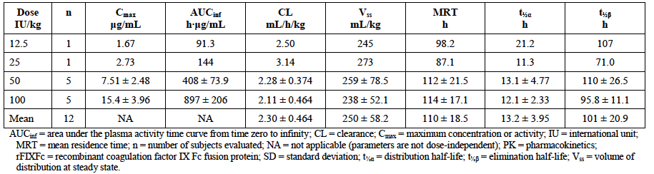

PK during multiple-dosing
There was no alteration in the PK of FIXFc after 26 weeks of dosing using a prophylaxis regimen (Table 4).
Table 4: Study 998HB102 – Comparison of PK (FIX activity) after single doses of 50 IU/kg of FIXFc at baseline and 26 weeks (2-compartmental analysis)
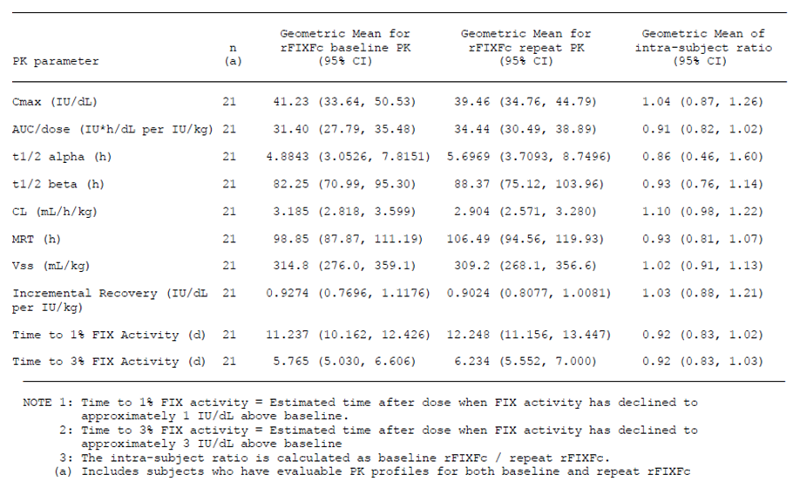

Distribution

Volume of distribution
In the conventional PK studies, the volume of distribution at steady state (V_{ss}) varied between 227 and 314 mL/kg (16 to 22 L for a 70 kg individual). In the population PK analysis the estimated V_{ss} was 271 mL/kg.

Other distribution parameters
There were no clinical data submitted on plasma protein binding, erythrocyte distribution or tissue distribution.
Comment: The guideline on PK of therapeutic proteins adopted by the TGA (6) states that “... binding capacity to plasma proteins should be studied when considered relevant”. It contains no recommendations regarding the need to measure distribution to tissues. The absence of data on other distribution parameters is not considered a deficiency in the submission.

Metabolism and excretion

Routes of metabolism and excretion
There were no clinical data in the submission regarding the routes of metabolism and excretion of FIXFc.
Comment: According to the guideline on PK of therapeutic proteins, the elimination of large proteins can be predicted to occur through catabolism by proteolysis.

Clearance
Following a single intravenous dose of FIXFc, clearance was measured as 3.19 mL/hr/kg (Table 1 above). This equates to 3.72 mL/min for a 70 kg individual.

Half-life
In the same study, half-life (of FIX activity) was measured as 82.1 h (Table 1 above). The half-life of FIXFc antigen was longer (up to 145 hours), probably due to the greater sensitivity of the FIXFc antigen assay compared to the FIX activity assay.

Intra- and inter-individual variability of pharmacokinetics
Both inter-individual and intra-individual variability in PK parameters appeared modest. In the population PK analysis, weight was the only covariate that demonstrated an effect on the PK of FIXFc. All the dosage regimens proposed by the sponsor are weight adjusted.

Pharmacokinetics in other special populations

Pharmacokinetics in subjects with impaired hepatic function
There were no clinical data on the effect of impaired hepatic function on the PK of FIXFc.

Pharmacokinetics in subjects with impaired renal function
There were no clinical data on the effect of impaired renal function on the PK of FIXFc.
Comment: Renal clearance is unlikely to be significant for large proteins such as FIXFc. Hence the absence of PK data in subjects with renal impairment is not considered to be a deficiency in the submission.

Pharmacokinetics according to age
In the population PK analysis, age did not affect the PK of FIXFc.

Pharmacokinetics related to genetic factors
In the population PK analysis, race, blood type or FIX genotype did not affect the PK of FIXFc.

Pharmacokinetic interactions
The submission contained no clinical data on interactions.

Evaluator’s overall conclusions on pharmacokinetics
The PK of FIXFc have been adequately characterised, given the rarity of haemophilia B and the fact that FIXFc is a large protein. In addition, the data generated meet the requirements for PK data laid down in the 2012 EMA haemophilia B guideline.

Pharmacodynamics
FIX activity was measured in both the submitted studies. In haemophilia studies this is generally considered to be a pharmacokinetic endpoint and results have therefore been described in section 4 of this report.
In Study 998HB102, global haemostasis assays were performed, including an exploratory thrombin generation assay and, in some sites, whole blood rotation thromboelastometry (ROTEM). The results were not included in the submitted study report.
No other pharmacodynamic data were submitted.

Dosage selection for the pivotal studies
The doses chosen for prophylaxis and episodic treatment arms of the pivotal study (see section 7.1.1.3 below) were based on the results of the phase I/IIa study (SYN-FIXFc-07-001). The target threshold of the prophylaxis and episodic treatment arms was to maintain FIX activity above 1% for at least 7 days. Based on the results from the Phase I/IIa study, the mean and median FIX activity on Day 7 with 50 IU/kg would be 2.55% and 1.89% above baseline, respectively. Also, over 70% of the population would have FIX activity of 1% above baseline on Day 7.
Doses selected for treatment for bleeding episodes in all arms and for use during surgery were based on clinical practice guidelines for patients with severe haemophilia (5, 11, 12).

Clinical efficacy

Pivotal efficacy study
Only one of the submitted studies (998HB102, also known as the B-LONG study) contained efficacy data.

Study 998HB102 (B-LONG)

Study design, objectives, locations and dates
This study was an open-label, Phase III trial, with 4 arms. The design is summarised in Figure 1. It was conducted in previously treated patients (PTPs) aged 12 years and older.
Figure 1: Design of Study 998HB102
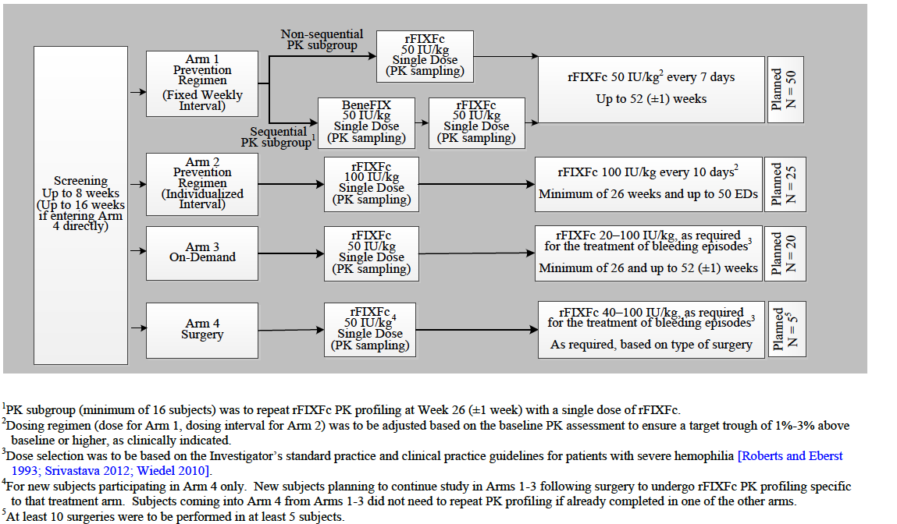
- In Arm 1 of the study, subjects underwent an initial PK assessment after a dose of 50 IU/kg of FIXFc. They were then treated with a prophylaxis regimen, with a dose of FIXFc given at a fixed interval of once every 7 days at a dose indicated by the subject’s baseline PK assessment that ensured a target trough of 1% to 3% above baseline or higher, as clinically indicated.
  - A subgroup of patients in Arm 1 (referred to as the ‘sequential PK subgroup’) also underwent a PK comparison of FIXFc versus BeneFIX, and a PK comparison of initial FIXFc PK versus FIXFc PK after 26 weeks.
- In Arm 2, subjects underwent an initial PK assessment after a dose of 100 IU/kg of FIXFc. They were then treated with a prophylaxis regimen, with a fixed dose of 100 IU/kg FIXFc given at a dose interval indicated by the subject’s baseline PK assessment that ensured a target trough of 1% to 3% above baseline or higher, as clinically indicated.
- In Arm 3, subjects underwent an initial PK assessment after a dose of 50 IU/kg of FIXFc. They were then treated with an on demand regimen, at a dose of 20 to 100 IU/kg rFIXFc, or the dose indicated by the subject’s baseline PK to target a plasma FIX activity level of 20% to 100%, as needed for the treatment of episodes of mild to severe bleeding.
- Arm 4 enrolled subjects scheduled for surgery. Subjects underwent an initial PK assessment prior to surgery following a dose of 50 IU/kg of FIXFc. They were then treated with doses of 40 to 100 IU/kg rFIXFc, as needed for surgical prophylaxis (perioperative management) and the treatment of bleeding episodes.
The PK results for the study are summarised in Table 1 above; Tables 5 to 7 below.
Table 5: Study 998HB102 – Comparison of PK (FIXFc Antigen) after single doses of 50 IU/kg of FIXFc at baseline and 26 weeks (compartmental analysis)
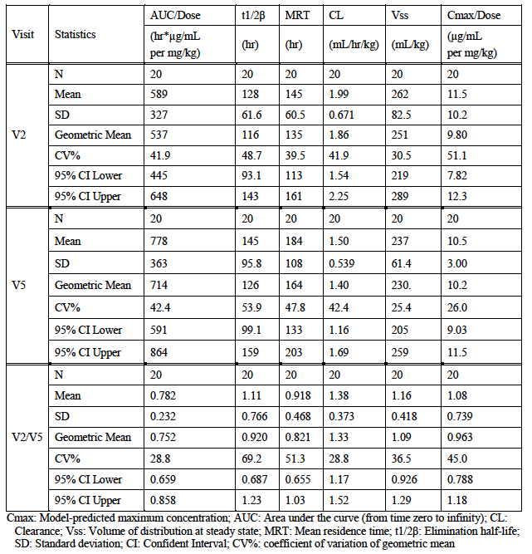
Table 6: Study 998HB102 – PK results (FIX activity) for other arms (2-compartmental analysis)
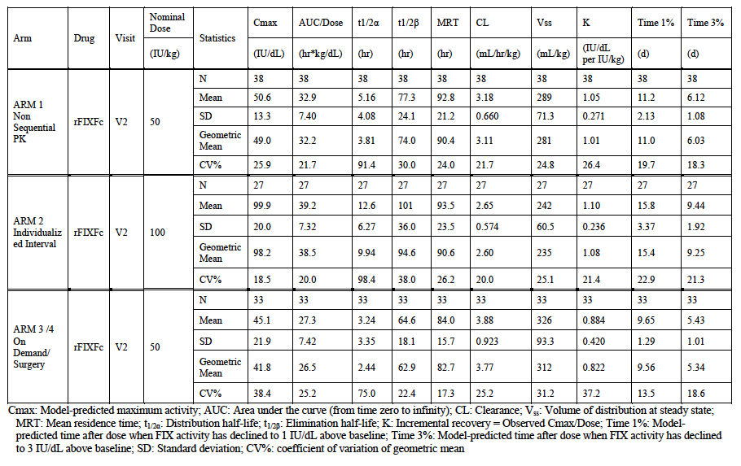
Table 7: Study 998HB102 – PK results (FIXFc Antigen) for other arms (compartmental analysis)
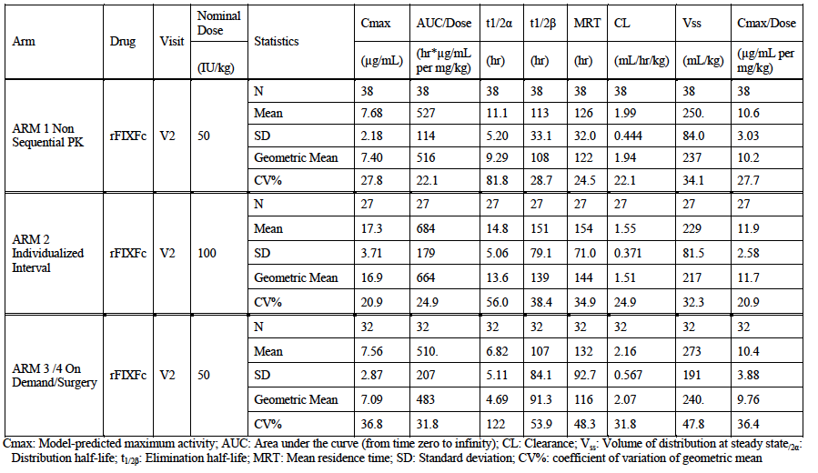
The primary objectives of the study were as follows:
- To evaluate the safety and tolerability of FIXFc.
- To evaluate the efficacy of FIXFc in all treatment arms.
- To evaluate the effectiveness of prophylaxis over on demand (episodic) therapy by comparing the annualised number of bleeding episodes between subjects receiving FIXFc on each prevention (prophylaxis) regimen (Arm 1 and Arm 2) and subjects receiving FIXFc on an episodic regimen (Arm 3).
The secondary objectives of the study were as follows:
- To evaluate and assess the PK parameter estimates of FIXFc and BeneFIX at baseline in the sequential PK subgroup as well as FIXFc at Week 26.
- To evaluate subjects’ response to treatment.
- To evaluate FIXFc consumption.
The study was a multinational trial that enrolled subjects from 50 centres in 17 countries (Australia, Belgium, Brazil, Canada, China, France, Germany, Hong Kong, India, Italy, Japan, New Zealand, Russia, South Africa, Sweden, the United Kingdom, and the United States). The study commenced in January 2010 and ended in July 2012. The study report was dated 14 December 2012. The study does not appear to have been published other than in conference abstract form.

Inclusion and exclusion criteria
Inclusion criteria are as follows:
- Able to understand the purpose and risks of the study and to provide signed and dated informed consent and authorization to use protected health information in accordance with national and local subject privacy regulations. If the subject was younger than 18 years of age, then a parent or guardian was to have signed the ICF and the subject was to have signed the assent form as consistent with local authorities.
- Male, 12 years of age or older, and weighing at least 40 kg.
- Severe hemophilia B, defined as ≤ 2 IU/dL (≤ 2%) endogenous FIX activity, as determined from the central laboratory at the time of screening. If the screening result was > 2%, then the severity of hemophilia B was to have been confirmed by documented historical evidence from a certified clinical laboratory demonstrating ≤ 2% factor IX coagulant activity, by the medical record, or by a documented genotype known to produce severe hemophilia B.
- A PTP, defined as having at least 100 prior EDs to any recombinant or plasma derived FIX product (fresh frozen plasma treatment was not to be considered in the count of the documented EDs).
- Bleeding events and/or treatment with FIX during the prior 12 weeks, as documented in the subject’s medical records.
- Greater than or equal to 8 bleeding episodes in the 52 weeks prior to enrolment in the study, if treating with an on-demand (episodic) regimen.
- A platelet count ≥ 100,000 cells/µL.
- Immunocompetent, as determined by the Investigator’s review of the subject’s medical history.
- Viral load of < 400 copies/mL, if HIV antibody positive.
- An international normalized ratio < 1.40, as defined by the testing laboratory’s normal range.
- Subjects entering directly into Arm 4 (Surgery) were to have met all other eligibility criteria AND required major elective surgery.
Exclusion criteria are as follows:
- Prior history of, or currently detectable inhibitor, as defined by the reporting laboratory (family history of inhibitors was not to be used to exclude the subject) with a positive inhibitor value ≥ 0.6 BU/mL (≥ 1.0 BU/mL only for laboratories with a historical lower sensitivity cut-off for inhibitor detection of 1.0 BU/mL).
- Presence of any other coagulation disorder in addition to hemophilia B.
- Prior history of anaphylaxis associated with any FIX or IV immunoglobulin administration.
- Abnormal renal function, defined as serum creatinine > 2.0 mg/dL.
- Active hepatic disease defined as an aspartate aminotransferase (AST) or alanine aminotransferase (ALT) greater than 5 times the upper limit of normal.
- For Sequential PK subgroup receiving BeneFIX, an allergy to Chinese hamster proteins.
- Any concurrent clinically significant major disease that, in the opinion of the Investigator, made the subject unsuitable for enrolment.
- Inability or unwillingness to refrain from taking additional prophylactic doses of FIX prior to sports activity or increased physical activity.
- Concurrent systemic treatment with immunosuppressant drugs within the last 12 weeks prior to the study entry (exceptions: ribavirin, treatment of HCV and HIV and/or systemic steroids [a total of 2 pulse treatments within 7 days ≤1 mg/kg] and/or inhaled steroids).
- Current enrolment (within the past 30 days) in any other clinical study involving investigational drugs.
- Inability to enter accurate and timely information regarding injections and bleeding episodes into an eDiary and inadequate parental/caregiver support to manage this (per the Investigator’s judgment)
Comment: The inclusion and exclusion criteria are generally consistent with those required by the relevant EMA guidelines for an initial study in PTPs. The EMA guidelines define a PTP as a subject who has had more than 150 exposure days (EDs) whereas the inclusion criteria specified only more than 100 EDs.

Study treatments
In Arm 1, subjects received a prophylaxis regimen involving an infusion of FIXFc at a fixed dosing interval of once every 7 days. The dose was 50 IU/kg initially but this dose was adjusted (based on each subject’s baseline PK assessment) to ensure a target trough level of 1 to 3% above baseline (or higher if clinically indicated). Subjects were to be treated for up to 52 weeks.
In Arm 2, subjects received a prophylaxis regimen involving an infusion of FIXFc at a fixed dose of 100 IU/kg. The dose interval was every 10 days initially, but this interval was adjusted (based on each subject’s baseline PK assessment) to ensure a target trough level of 1 to 3% above baseline (or higher if clinically indicated). Subjects in Arm 2 were to have up to 50 rFIXFc exposure days before completing the study.
In Arm 3, subjects received episodic treatment with FIXFc (that is, only at the time of bleeding episodes) involving an infusion of 20 to 100 IU/kg FIXFc, or the dose required (based on each subject’s baseline PK assessment) to ensure a target level of 20 to 100% FIX activity. Subjects were to be treated for up to 52 weeks.
For all treatment arms, the following served as a guide for treating bleeding episodes with rFIXFc:
- Minor bleeding episodes (superficial, early haemorrhages, early haemorrhages into joints, haematuria, mucous membrane, epistaxis): 20 to 30 IU/kg (20% to 30% FIX level), to be repeated at 48 hours if needed.
- Moderate to major bleeding episodes (haemorrhages into muscles, haemorrhages into the oral cavity, definite haemarthroses, known trauma, minor surgical procedures, epistaxis): 25 to 50 IU/kg (25% to 50% FIX level), or (haemarthroses, with limited motion) 40 to 80 IU/kg (40% to 80% FIX level), to be repeated at 48 hours if needed.
- Major to life threatening bleeding episodes (epistaxis, pharyngeal, retropharyngeal, intrathoracic, gastrointestinal, central nervous system [CNS], intra-abdominal, or retroperitoneal bleeding, or iliopsoas sheath): 50 to 100 IU/kg (50% to 100% FIX level) (80 to 100 IU/kg, or 80% to 100% FIX level, for CNS bleeding episodes), to be repeated at 24 to 48 hours as needed.
In Arm 4, subjects received surgical prophylaxis with FIXFc involving an infusion of 20 to 100 IU/kg FIXFc, as required.
All subjects (except those participating exclusively in Arm 4) who completed the study or were still enrolled when the sponsor ended the study were to be offered the option of entering an extension study (under a separate protocol, Study 9HB01EXT).
All infusions of FIXFc were administered over approximately 10 minutes.
Medications that were prohibited during the trial were:
- Blood products, such as red blood cells, platelets, and fresh frozen plasma, except as required during a surgery or acute clinical care.
- Aspirin or ibuprofen (other non-steroidal anti-inflammatory drugs were permitted).
- Any other FIX product (excluding BeneFIX during the sequential PK portion of Arm 1).

Efficacy variables and outcomes
Subjects used an electronic patient diary (eDiary) during the study to record details of FIXFc administration, bleeding episodes and responses to rFIXFc treatment. Scheduled clinic visits for Arms 1, 2 and 3 were at screening (Visit 1), baseline (Visit 2), Week 4 (Visit 3), Week 16 (Visit 4), Week 26 (Visit 5), Week 39 (Visit 6) and Week 52 (Visit 7). Scheduled visits for Arm 4 were at screening (Visit 1), baseline (Visit 2), the day of surgery (Visit 3), 1 week post-operative (Visit 4), and 1 week post recovery (Visit 5).
The main efficacy variables were:
- The number of bleeding episodes.
- The response to treatment with FIXFc for bleeding episodes.
- The number and frequency of FIXFc infusions for the treatment of bleeding episodes.
- Quality of Life (QoL).
The primary efficacy outcome was the annualised bleeding rate during ‘the efficacy period’. Further explanation of this endpoint is given below. The rates observed in the two prophylaxis arms (Arms 1 and 2) were to be compared with the rate observed in the episodic treatment arm (Arm 3).

Annualised bleeding rate (Primary endpoint):
The number of bleeding episodes was annualised for each subject using the following formula:
Annualised bleeding rate = [(Number of bleeding episodes during the efficacy period) / (Total number of days during the efficacy period)] x 365.25

Efficacy period
In Arms 1 and 2, the efficacy period started with the date and time of first prophylactic dose following a completed PK sampling period and ended with the last dose administered (for prophylaxis or a bleeding episode) as recorded in the eCRF or eDiary. The efficacy period was interrupted for the repeat PK period in Arm 1 (sequential PK subgroup) and for all surgical/rehabilitation periods (for both major and minor surgeries) in Arms 1 and 2. The efficacy period continued up to the last dose (for prophylaxis or treatment of a bleeding episode) before the repeat PK dose or up to the last dose (for prophylaxis or treatment of a bleeding episode) before the start of a surgical/rehabilitation period, and then resumed at the next prophylactic dose following the end of the PK or surgical/rehabilitation period.
In Arm 3, the efficacy period started 1 minute following the last PK sampling timepoint and ended with either the date of last contact or the date of the last entry into the eDiary, whichever was later. The efficacy period was interrupted 1 minute before the start of a surgical/rehabilitation period and restarted at 00:01 the day following the end of the surgical/rehabilitation period.

Exploratory sensitivity analyses of the primary efficacy endpoint
Sensitivity analyses were performed for annualised bleeding rate:
- based on all bleeds as recorded by the subject.
- excluding subjects with major protocol deviations potentially impacting the primary efficacy endpoint.
- for the last 6 months on study for subjects with at least 9 months on study, and for the last 3 months on study for subjects with at least 6 months on study.
- by the prophylactic dose compliance rate (< 80%, ≥ 80%, Arms 1 and 2), by the prophylactic dosing interval compliance rate (< 80%, ≤ 80%, Arms 1 and 2), and by the overall prophylactic dose and dosing interval compliance rate (< 80%, ≥ 80%, Arms 1 and 2).

Exploratory subgroup analyses of the primary efficacy endpoint
Subgroup analyses were performed for annualised bleeding rate:
- by prestudy treatment
- by severity of hemophilia at baseline (estimated bleeds in the prior 12 months; 0, 1 to 11, 12 to 23, 24 to 35, ≥ 36).
- by the number of target joints (none present, ≤ median of the number present, >median of the number present).
- by age (12 to 17 years, 18 to 64 years, 65 years and older).

Secondary efficacy outcomes included:
- Subject’s assessment of response to FIXFc injection using a 4 point bleeding response scale
- Physician’s global assessment of response to FIXFc injection using a 4 point bleeding response scale
- Total annualised FIXFc consumption per subject
- Annualised bleeding rate by type (traumatic versus spontaneous) and location of bleeding episode.
- Time from last injection of FIXFc to the bleeding episode.
- Number of injections and dose of FIXFc to resolve a bleeding episode.
- Quality of life (in adult subjects) using a haemophilia specific instrument (Haem-A-QoL) was also used. It was also intended to use a paediatric haemophilia specific QoL instrument (Haemo-QoL) in adolescents, however, too few responses were obtained, and this endpoint will not be discussed further.
- Information was provided on the endpoints used to assess efficacy in the surgical prophylaxis setting (Arm 4).
Comment: The efficacy endpoints were appropriate for establishing efficacy in haemophilia B, and were generally consistent with those recommended in the EMA guidelines.

Randomisation and blinding methods
Subjects were not randomised to the four treatment arms. They were to be assigned to treatment arms ‘according to the standard of care and investigator decision, following discussion with each subject’.
Subjects receiving a prophylaxis treatment regimen prior to study start were to join Arms 1 or 2 only. Subjects receiving on-demand (episodic) treatment prior to study start were to be allowed to enrol in Arm 1, 2, or 3. Subjects could enrol into Arm 4 either from any of the other treatment arms or as new subjects scheduled for major surgery that required surgical prophylaxis.
All treatment arms were open label. There was no blinding.
Comment: The use of an open-label design without blinding and without a comparator is consistent with the recommendations of the EMA haemophilia guidelines.

Analysis populations
The ‘All-Enrolled Analysis Set’ was defined as subjects who were registered as enrolled and assigned a unique subject identification number. The ‘Full Analysis Set’ (FAS) was defined as subjects who received at least 1 dose of rFIXFc. The analysis of efficacy was performed in this population. Subjects in Arm 1 who received a dose of BeneFIX, but did not receive any rFIXFc were not included in this population.
The ‘Safety Analysis Set’ was defined as subjects who received at least 1 dose of BeneFIX or at least 1 dose of rFIXFc. The analysis of safety was performed in this population.

Sample size
Sample size was based mainly on clinical considerations rather than statistical ones. The 2000 EMA guideline (8) recommended that the initial study in PTPs should include 20 subjects and 5 subjects undergoing surgery. According to the sponsor the FDA requires that the incidence of inhibitor development should be no more than one in 50 subjects treated for 50 exposure days.
The sponsor also calculated the sample size necessary to demonstrate superiority of prophylaxis (Arm 1) over episodic treatment (Arm 3). Assuming that:
- the minimum of follow-up time for subjects is 48 weeks in Arm 1 and 26 weeks in Arm 3;
- the true annualised bleeding rate for subjects in Arm 3 is at least 8 bleeds per subject per year, and a 50% reduction in this rate with prophylaxis would be clinically important;
- the retention rate would be 80%;
then a sample size of 40 subjects in Arm 1 and 16 subjects in Arm 3 would give the study a 95% power at the 2 sided 0.05 level of significance.
The sponsor chose to enrol a total of 100 subjects, with 50 subjects in Arm 1, 25 subjects in Arm 2, 20 subjects in Arm 3 and 5 subjects in Arm 4.

Statistical methods
For the primary endpoint of annualised bleeding rate, the statistical analysis plan described the planned statistical methods as follows:
‘The comparison of annualised bleeding rates between the 2 prevention regimens (Arms 1 and 2) and the on-demand regimen (Arm 3) will be performed in a hierarchical, step-down fashion as follows:
  - The analysis will proceed by comparing annualised bleeding rates between Arm 1 (Prevention Regimen, Fixed-Weekly Interval) and Arm 3 (On-demand Regimen). A Poisson regression model will fit treatment arm as a covariate (Arm 1 or Arm 3). If the treatment factor in the Poisson regression model fails to show statistical significance at the 2-sided 5% level, then testing will stop and the study will have failed to demonstrate a difference between any prevention regimen and the on-demand regimen. If the estimated ratio of annualised bleeding episodes is less than 0.5 for Arm 1:Arm 3, then clinical importance of the fixed weekly interval prevention regimen will have been demonstrated. If the treatment factor in the model is significant at the 2-sided 5% level testing will proceed to the comparison of Arm 2 (Prevention Regimen, Individualized Interval) with Arm 3 (On-demand Regimen) in the same fashion. If the treatment factor in the model for Arm 2 versus Arm 3 is significant at the 2-sided 5% level and the estimated ratio of annualised bleeding episodes is less than 0.5 for Arm 2:Arm 3, then clinical importance of the individualised-interval prevention regimen will have been demonstrated.
  - A dispersion test will be conducted to check the model fit. If no over-dispersion can be detected at the 2-sided 5% level of significance, results of the Poisson regression will be used to interpret the comparison between regimens. Otherwise, a negative binomial regression model will be applied to the data.
Test results will be tabulated by treatment arm along with the annualised bleeding rate ratios and their 95% confidence intervals”.
Descriptive statistics were used to summarise data on the secondary endpoints.

Participant flow
A total of 123 unique subjects were enrolled in the study: 63 in Arm1, 29 in Arm 2, 27 in Arm 3 and 4 in Arm 4. There were 8 subjects who participated in both Arm 4 and one of the other arms, giving a total of 12 subjects who participated in Arm 4. A total of 115 subjects (93.5%) completed the study.

Major protocol violations/deviations
Four subjects had major protocol deviations that could possibly impact on the analysis of the primary endpoint. Two subjects were non-compliant with dosing; one subject administered excessive doses of FIXFc and one subject received a non-study FIX product. A sensitivity analysis of the primary endpoint, which excluded these subjects, was conducted.
Other major protocol deviations were considered unlikely to affect the analysis and included consent issues (28 subjects), incorrect dosing (3 subjects) and use of excluded medications (11 subjects).

Baseline data
Baseline demographics are shown in Table 8. All subjects were male. Baseline disease characteristics are shown in Table 9. All subjects had severe haemophilia B, with baseline FIX levels < 2%, and the majority having levels < 1%. Prior to enrolment, 60% of subjects had been on an episodic dosage regimen and 40% on a prophylaxis regimen. The median number of bleeding episodes in the previous 12 months was 12.0.
Table 8: Study 998HB102 – Baseline Demographics
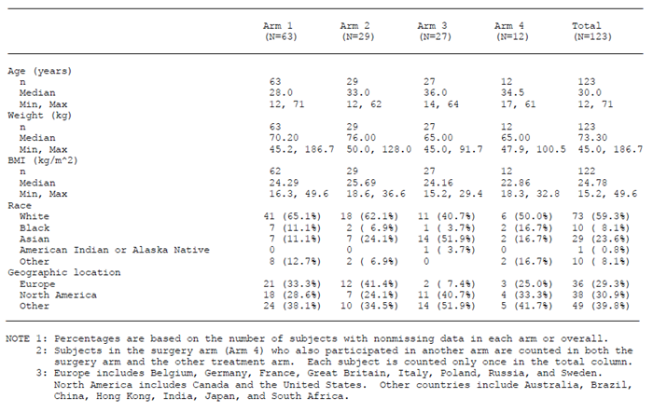
Table 9: Study 998HB102 – Baseline Disease characteristics
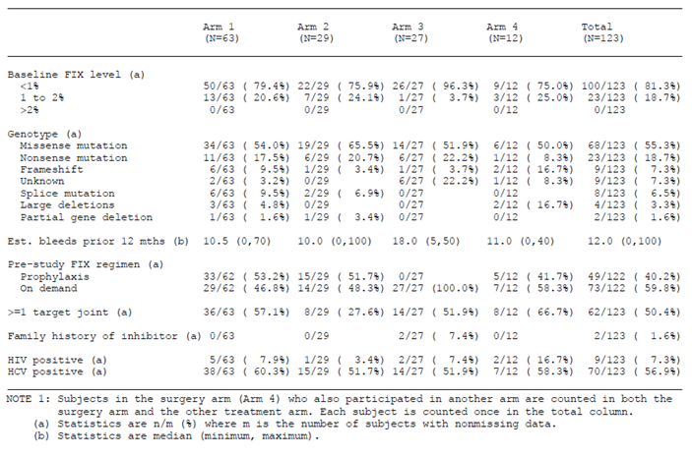

Results for the primary efficacy outcome
Results for the annualised bleeding rate in Arms 1, 2 and 3 are summarised in Table 10. The rate was analysed using negative binomial regression, as the test for overdispersion in the Poisson model had indicated greater variability than would be expected from a Poisson distribution.
The annual bleeding rate was 3.12 in Arm 1, 2.40 in Arm 2 and 18.67 in Arm 3. The bleeding rate was statistically significantly lower (p < 0.001) in both prophylaxis arms when compared to Arm 3.
The various sensitivity analyses conducted on annualised bleeding rate gave comparable results to the primary efficacy analysis. The lower bleeding rates with prophylaxis were also observed in all the pre-specified subgroup analyses. Figure 2 illustrates the results of the subgroup analyses for subjects in Arm 1.
Table 10: Study 998HB102 – Results for annualised bleeding rate (Primary endpoint)
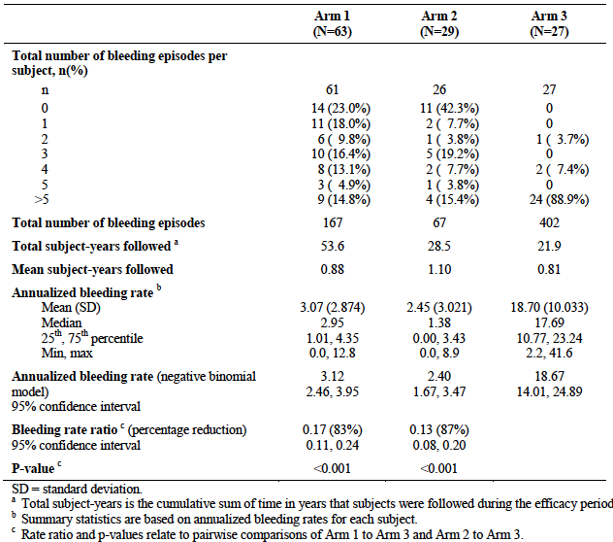
Figure 2 - Study 998HB102 – Subgroup analyses for annualized bleeding rate (Arm 1)
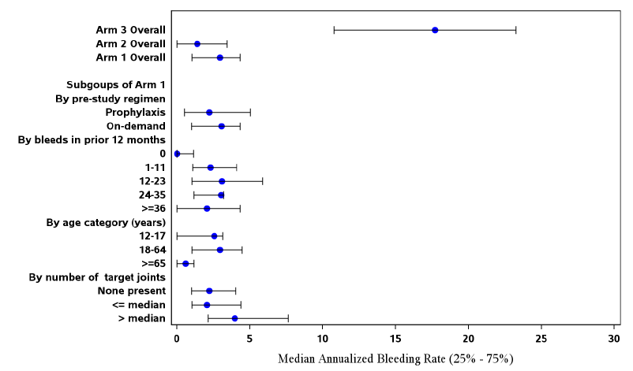
Table 11 compares the on-study bleeding rate with the number of bleeds experienced in the preceding 12 months prior to study entry. It shows that subjects that switched from an episodic regimen of FIX to a prophylaxis regimen of FIXFc had a marked reduction in bleeding rate. Those that continued with a prophylaxis or episodic regimen had no notable change in bleeding rate.
Table 11 - Study 998HB102 – Number of bleeding episodes in the prior 12 months compared with the on-study annualised bleeding rate by pre-study FIX regimen
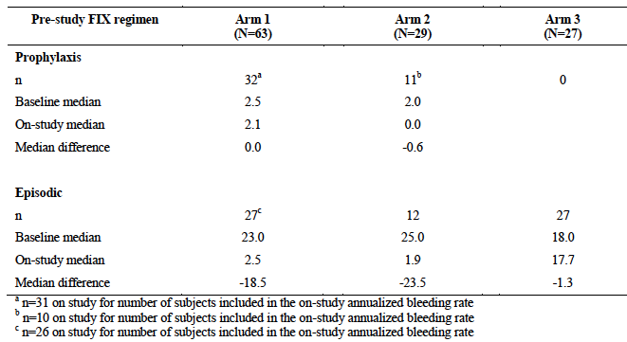

Results for secondary efficacy outcomes (Arms 1, 2 and 3)

Subject’s assessment of response
The results for the subjects’ assessment of response following a bleeding episode showed Response was rated as ‘excellent’ or ‘good’ on 82.0% of occasions.

Physician’s global assessment of response
The results for the physicians’ assessment of response following a bleeding episode showed Responses were rated excellent or effective on 98.8% of occasions.
Comment: The above two endpoints are subjectively assessed and the trial design did not include a comparator for efficacy. The MonoFIX-VF PI states that in a trial of 11 subjects, “the product was considered to be effective by the patient or his guardian in 98% of administrations”. The BeneFIX PI states that, in a trial of 20 patients: “Response was rated excellent or good for 85% of infusions”. It is not clear whether this statement relates to subject or physician assessment.

Total annualised FIXFc consumption per subject
Results for total annualised FIXFc consumption are shown in Table 12. Consumption was greater in the prophylaxis arms.
Table 12: Study 998HB102 – Results for total annualised FIXFc consumption – IU/kg (Secondary endpoint)
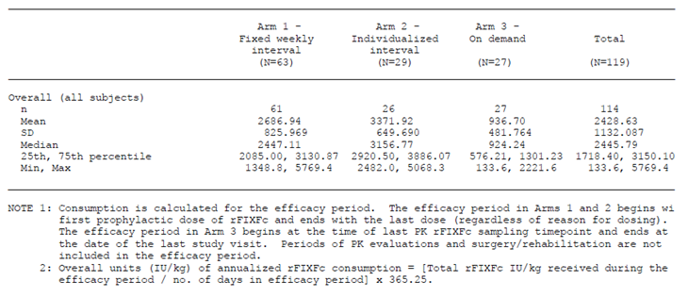

Annualised bleeding rate by type and location of bleeding episode
Results are shown in Table 13. In all three Arms, haemorrhages most commonly occurred into joints. Spontaneous haemorrhages were more common than those due to trauma.
Table 13: Study 998HB102 – Results for annualised bleeding rate by type and location of bleeding episode (Secondary endpoint)
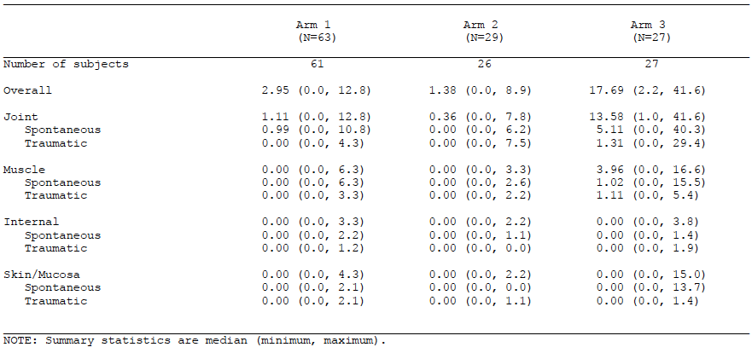

Time from last injection of FIXFc to the next bleeding episode
Results are shown in Table 14. The number of days between the last dose of FIXFc (to treat a bleeding episode) and the next bleeding episode was greater in the prophylaxis arms, as might be expected.
Table 14: Study 998HB102 – Results for number of days from last injection of FIXFc to the next bleeding episode (Secondary endpoint)
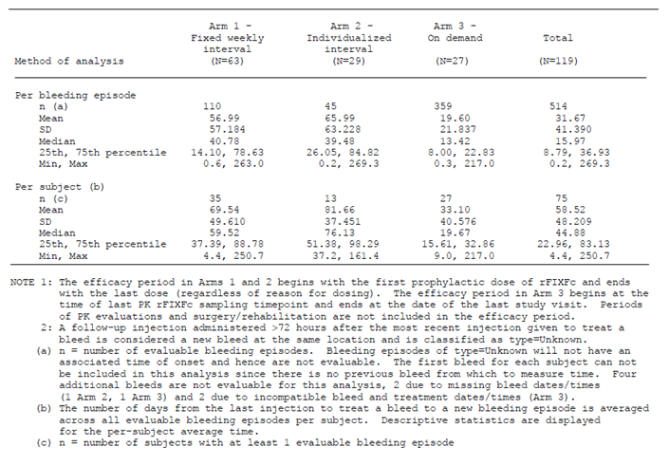

Number of injections and dose of FIXFc to resolve a bleeding episode
A total of 636 bleeding episodes occurred in Arms 1, 2 and 3; 575 (90.4%) of these episodes resolved after a single injection of FIXFc. The median total dose of FIXFc required to resolve bleeds was 46.99 IU/kg, with a range of 7.9 to 263.9 IU/kg.

Quality of life
Adults participating in Arms 1 and 2 completed the Haem-A-QoL instrument. This was administered at baseline, 26 weeks and 52 weeks. A total of 58 subjects aged 18 or older completed the questionnaire at baseline, Week 26, and/or Week 52. There were 38 from Arm 1 and 20 from Arm 2.
The Week 26 results are shown in Table 15, with results presented by subjects’ pre-study regimen (prophylaxis or on-demand). There were small decreases in scores (implying improved quality of life) in total score and in various domains. Results at 52 weeks were similar.
Table 15: Study 998HB102 – Results for Haem-A-QoL – Arms 1 and 2 pooled (Secondary endpoint)
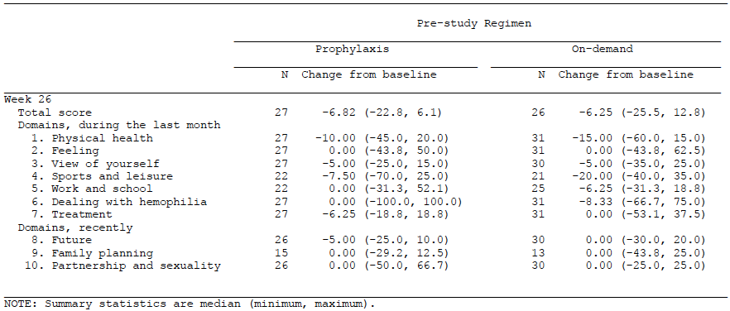
Comment: The submission did not contain any information on what is considered a clinically significant change in score for this instrument. Most of the changes were small (less than 10 points on a scale of 0 to100) and may not have been clinically meaningful. Furthermore, in the absence of a control group it is not possible to conclude that any improvements in QoL were due to FIXFc administration.

Dosing in prophylaxis arms (Arms 1 and 2)
In Arm 1, subjects were treated on a once weekly prophylaxis regimen. The initial dose was 50 IU/kg and subsequent doses were adjusted based on PK data or clinical need, with the once weekly dosing interval being maintained. The actual dosages used over the duration of the study are summarised in the dossier. The mean (± SD) weekly dose over the course of the study was 46.26 (±11.30) IU/kg. The median weekly dose was 45.17 IU/kg and the range of values was 25.0 to 74.3 IU/kg. The median number of dose changes made was 1.0 (range 0 to 5).
Comment: These data support the proposed once weekly dosage regimen, with a starting dose of 50 IU/kg and subsequent adjustment of dose as required.
In Arm 2, subjects were treated with a fixed dose of 100IU/kg and an initial dosage interval of 10 days, with subsequent adjustment of the dosage interval based on PK data or clinical need. The actual dosage intervals used in the study are summarised in the dossier. Over the whole study, the mean dosage interval was 12.17 (± 2.02) days. The median dosage interval was 12.53 days with a range of 7.8 to 15.9 days. The median number of dose changes made was 2.0 (range 0 to 5).
If the analysis of dosing intervals used in Arm 2 is restricted to the last 3 months of the study (and to only those subjects that had at least 6 months on study), the mean dosing interval was increased to 12.99 days (median 14.00) and a range of 7.7 to 20.8 days.
For proportion of patients who achieved an average dosing interval of at least 14 days: Only a small proportion of patients (11.5%) achieved an average dosing interval of at least 14 days over the whole period of the study. However, if the analysis is restricted to the last 3 months of the study (and to only those subjects that had at least 6 months on study), a total of 53.8% of subjects achieved a dosing interval of at least 14 days. This suggests that the dosing interval can be increased over time in some patients, based on PK data or clinical experience.
Comment: The draft PI states that one of the recommended prophylaxis regimens is 100 IU/kg given every 10 to 14 days, with subsequent adjustment as required. This implies that patients can be commenced on a 14 day dosage interval, which was not the strategy used in the pivotal study. It would be prudent for the PI to recommend that patients be commenced on 100 IU/kg every 10 days, with subsequent titration of the dosage interval based on experience. The number of patients who were managed with a dosage interval greater than 14 days was very small (n = 5). Until further experience with longer intervals is available it would be prudent to restrict the maximum dosage interval to 14 days.

Results for secondary efficacy outcomes (Arm 4 - surgery)
A total of 14 major surgical procedures were performed in the total of 12 subjects who participated in Arm 4. Using the 4 point assessment scale the patient’s response was assessed as ‘excellent’ for 13 procedures and ‘good’ for 1 procedure. The mean estimated blood loss was 80.4 mL during surgery and 58.1 mL postoperatively.
Two subjects required blood products. A 43 year old who underwent repair of a large abdominal fistula had diffuse oozing from the wound and received packed cells and fresh frozen plasma. A 30 year old who had a total knee replacement was found to be anaemic postoperatively, despite an intraoperative blood loss of only 250 mL. He received packed cells on day 3.
A total of 15 minor surgeries were performed in 13 subjects. Haemostasis was rated as excellent or good for 11 and as fair for 1. Response was not recorded for the other 3 subjects.
Comment: The EMA guidelines (8, 9) require that efficacy be assessed in a least 5 subjects undergoing at least 10 major surgical procedures. The data generated by the sponsor meets this requirement.

Analyses performed across trials (pooled analyses and meta-analyses)
Not applicable.

Evaluator’s conclusions on clinical efficacy
The PK data generated in the Phase III study demonstrate that the administration of FIXFc restores plasma FIX activity levels in subjects with FIX deficiency. The degree to which FIX activity is restored (as measured by Cmax and incremental recovery) is comparable to that achieved with the registered recombinant FIX product BeneFIX when the two products are administered at the same dose. The half-life and AUC of FIXFc were approximately double those observed with BeneFIX. It would therefore be reasonable to expect that FIXFc should have comparable clinical efficacy to BeneFIX and that a longer dosage interval should be possible.
The data from the pivotal study establish that FIXFc is effective in the treatment of bleeding episodes. Subjects rated the response to FIXFc treatment as ‘excellent’ or ‘good’ on 82.0% of occasions. Physicians rated responses as ‘excellent’ or ‘effective’ on 98.8% of occasions. A total of 90.4% of bleeding episodes resolved after a single injection of FIXFc. The dosages used for the treatment of bleeding episodes in the study (see section 7.1.1.3) are considered appropriate.
The study also established that use of a prophylaxis regimen was superior to use of an on-demand/episodic regimen. The two prophylaxis regimens tested resulted in reductions in annual bleeding rate of 83% and 87% respectively. The two dosage regimens supported by the study are:
- A regimen using a fixed once weekly interval with a starting dose of 50 IU/kg and subsequent adjustment of the dose; or
- A regimen using a fixed dose of 100 IU/kg with an initial dosing interval of 10 days and subsequent adjustment of the dosing interval. The maximum dosing interval should be no more than 14 days.
The study also established efficacy of the product when used in the surgical prophylaxis setting, with response rated as ‘excellent’ or ‘good’ in 100% of major surgeries, and modest blood loss.
The submitted data generally meet the requirements laid down by the EMA guidelines (7, 8, 9).
Overall it is concluded that the efficacy of product has been satisfactorily established for use in PTPs aged 12 years or older.

Clinical safety

Studies providing evaluable safety data
The following studies provided evaluable safety data:

Pivotal (Phase III) efficacy study (998HB102)
In the pivotal (Phase III) study, the following safety data were collected:
- General adverse events (AEs) were assessed at each study visit and again at 30 days after completion of the study (by telephone) for Arms 1, 2 and 3. For Arm 4 AEs were assessed at each study visit.
- Vital signs were measured at every study visit in early versions of the protocol but were only measured at screening and baseline in later versions.
- The following laboratory tests were performed:
  - Haematology: white blood cell (WBC) count with differential, red blood cell (RBC), haemoglobin, haematocrit, and platelet count; (at screening, baseline, Week 26 and Week 52 in Arms 1 to 3 and at screening, baseline, the day of surgery and 1 week post recovery in Arm 4).
  - Biochemistry: sodium, potassium, chloride, carbon dioxide, glucose, total protein, albumin, direct bilirubin, indirect bilirubin, AST, ALT, alkaline phosphatase, blood urea nitrogen (BUN), and serum creatinine (at screening, baseline, Week 26 and Week 52 in Arms 1 to 3 and at screening, baseline, the day of surgery and 1 week post recovery in Arm 4).
  - Total IgG and IgG1, IgG2 IgG3, IgG4 were measured at each study visit in all arms.
  - Coagulation parameters: fibrin degradation products (F1+2), thrombin-antithrombin complexes (TAT), and D-dimer were assessed in subjects in the Arm 1 Sequential PK subgroup at screening, at predosing and at 1, 6, and 24 h following the BeneFIX injection; at pre-dosing and at 1, 6 and 24 h following rFIXFc injection on Day 1 and Week 26; and at predosing for the Week 52 rFIXFc injection. Prothrombin time (PT) was assessed in subjects in the Arm 1 Sequential PK subgroup at screening, and at predosing and 6 and 24 h following the BeneFIX injection and the first rFIXFc injection on Day 1.
  - Nijmegen modified Bethesda assay for inhibitors, and an assay for anti-FIXFc antibodies were taken at each study visit for all Arms;
Urinalysis and ECG monitoring were not performed.
The schedule for safety monitoring in Arms 1, 2 and 3 is summarised in Table 16.
Table 16: Safety monitoring for Study 998HB102 (B-LONG)
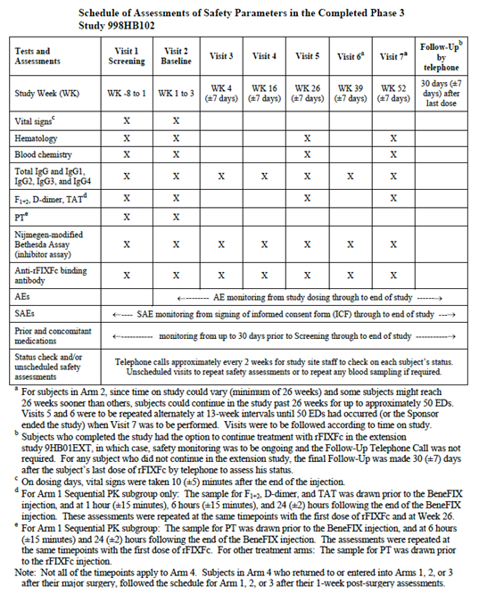

Clinical pharmacology study (SYN-FIXFc-07-001)
Study SYN-FIXFc-07-001 was the first-in-man dose escalation study, which examined safety and PK of FIXFc. The PK data have been summarised in section 4. Subjects only received single doses of FIXFc, over the dose range 1 IU/kg to 100 IU/kg and were monitored daily after the infusion up to Day 11 and had a final study visit on Day 30.
In this study, the following safety data were collected:
- General adverse events (AEs) were assessed at each visit.
- For the two initial dosing regimens (1.0 and 5.0 IU/kg), vital signs (blood pressure [BP], pulse, respiratory rate, oral temperature [⁰C], height, and weight) and electrocardiograms (ECGs) were monitored at each visit. For the higher doses, vital signs and ECGs were monitored on the day of the infusion and at Day 30.
- The following laboratory tests were performed:
  - Haematology (at screening and Day 30): WBC count with differential, RBC, haemoglobin, haematocrit, and platelet count.
  - Biochemistry (at screening and Day 30): sodium, potassium, chloride, carbon dioxide, glucose, total protein, albumin, direct bilirubin, indirect bilirubin, AST, ALT, alkaline phosphatase, BUN, and serum creatinine.
  - Urinalysis (at screening and Day 30): pH, appearance, color, specific gravity, protein, and glucose.
  - Coagulation studies (at screening, Day 1 and on Day 30): prothrombin time (PT), activated partial thromboplastin time (aPPT), d-dimer, thrombin-antithrombin (TAT) complex.
  - Bethesda assay for inhibitors and anti-FIXFc antibodies - taken at screening, just prior to FIXFc administration on Day 1, at 1 time point within 7 to 10 days after FIXFc, and at Day 30.
Information was provided on the schedule for safety monitoring.

Other studies
The submission included brief reports from two ongoing studies:
- Study 9HB02PED. This is an open label multicentre study of the PK, efficacy and safety of FIXFc in paediatric (age < 12) PTPs. The study planned to enrol at least 20 subjects with severe haemophilia B, and at least 50 previous exposure days, to receive a weekly prophylaxis regimen for approximately 50 weeks. Safety assessments included monitoring of AEs including AEs of special interest (inhibitor development, allergic reactions, thrombotic events), and laboratory testing (haematology, biochemistry, Nijmegen modified Bethesda assay for inhibitors, and an assay for anti-FIXFc antibodies).
The first patient was enrolled in June 2012. The cut off date for data to be included in the report was 15 October 2012 and the report itself was dated 12 December 2012. By the cut off date 12 subjects had been enrolled but only 4 subjects had received at least one dose of FIXFc. The submitted report was brief (11 pages) and provided information on serious AEs (SAEs) and AEs of special interest only.
- Study 9HB01EXT. This is an open label extension study for subjects previously enrolled in either the pivotal phase III study (998HB102) or the paediatric study (9HB02PED). It is an open label multicentre study of the long term efficacy and safety of FIXFc. The study expected to enrol approximately 120 subjects from the Phase III study and approximately 20 subjects from the paediatric study. Treatment could be either an episodic or a prophylaxis regimen. Treatment would continue for up to 4 years or until the product became commercially available. Safety assessments included monitoring of AEs including AEs of special interest (inhibitor development, allergic reactions, thrombotic events), and laboratory testing (haematology, biochemistry, Nijmegen modified Bethesda assay for inhibitors).
The first patient was enrolled in December 2011. The cut-off date for data to be included in the report was 9 October 2012 and the report itself was dated 12 December 2012. By the cut off date 87 subjects from the phase III study had been enrolled and all had received at least one dose of FIXFc. No subjects from the paediatric study had been enrolled. The submitted report was brief (12 pages) and provided information on serious AEs (SAEs) and AEs of special interest only.
The studies contributing to the safety database are summarised in Figure 3.
Figure 3: Summary of studies contributing to the safety database
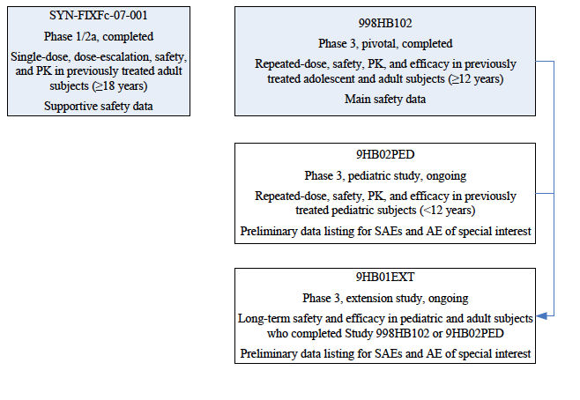

Pivotal studies that assessed safety as a primary outcome
There were no pivotal studies that assessed safety as a primary outcome.

Patient exposure
In the studies included in the submission, a total of 141 separate subjects received at least one dose of FIXFc as summarised in the following table.
Table 17: Exposure to FIXFc in clinical studies.
Study | Number of Subjects
Study 998HB102 | 123
Study SYN-FIXFc-07-001 | 14
Study 9HB02PED | 4
Total | 141⁴
Comment: A total of 87 subjects from 998HB102 continued into the extension study 9HB01EXT and are not included in the table as they are not separate individuals. Subjects in SYN-FIXFc-07-001 received only one dose of FIXFc and the only data provided for the 4 subjects from 9HB02PED related to SAEs and AEs of special interest. Therefore assessment of the safety of FIXFc relies almost entirely on the data generated in study 998HB102.
The most recent EMA guideline on FIX products (9) states that: “The number of patients typically needed to be enrolled into the preauthorisation clinical trials is 40.
The extent of exposure in Study 998HB102 in terms of the number of weeks on FIXFc is summarised in Table 18. A total of 115 subjects were on FIXFc for at least 26 weeks, and 56 subjects for at least 52 weeks. The extent of exposure in terms of exposure days and number of injections is summarised in Table 19. The median number of exposure days was 49.0 and the median number of injections was 50.0.
Table 18: Study 998HB102 - Extent of exposure by number of weeks on FIXFc
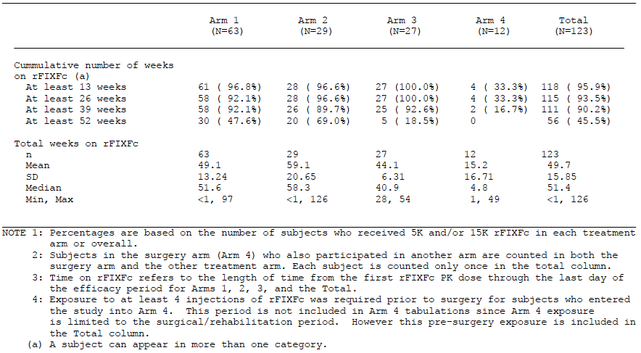
Table 19: Study 998HB102 - Extent of exposure by number of exposure days and number of injections
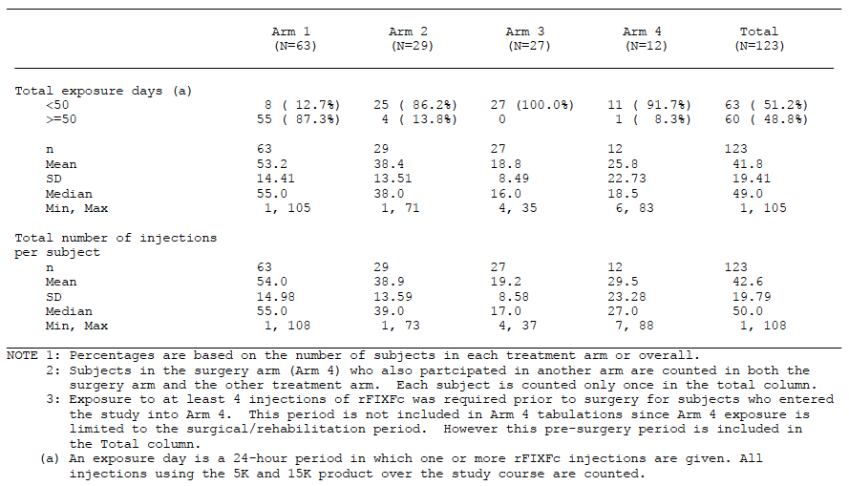

Adverse events
The overall incidence of AEs, SAEs etc. in the phase III study is summarised in Table 20.
Table 20: Study 998HB102 – overall incidence of AEs / SAEs etc.
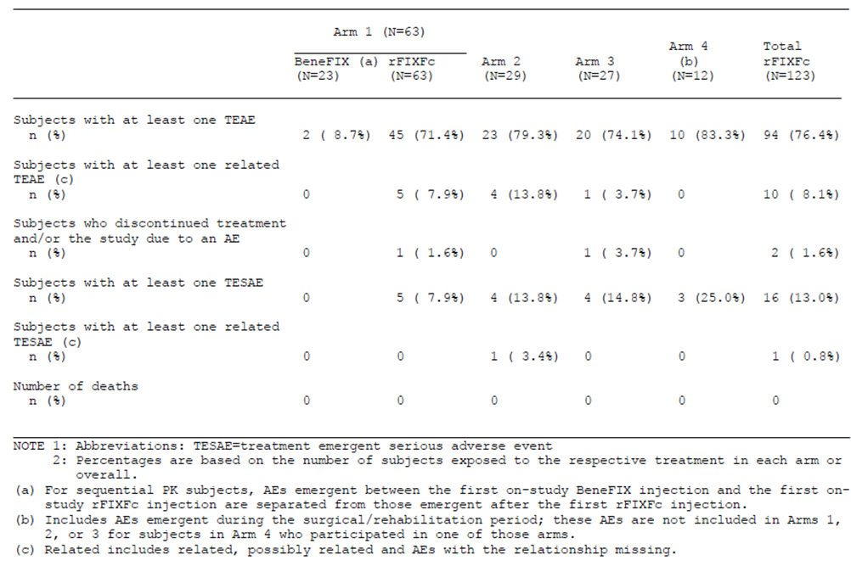

All adverse events (irrespective of relationship to study treatment)

Study 998HB102
Over the whole study period AEs occurred in 76.4% of subjects. Common AEs that occurred in Arms 1, 2 and 3 are shown in Table 21.
Table 21: Study 998HB102 – Common AEs (incidence > 3%) in Arms 1, 2 and 3
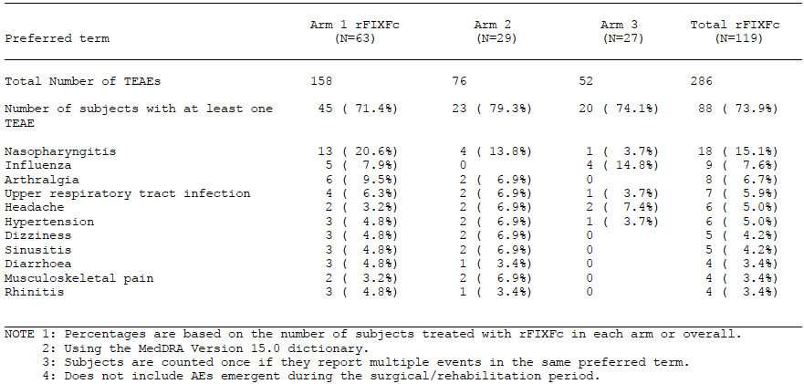
Comment: As the study was designed without a comparator arm, it is difficult to implicate FIXFc in the causality of any of these AEs. Most of the common AEs would be expected to occur in a population of subjects followed for any length of time (infections, headache). Others (arthralgia, musculoskeletal pain) would be expected in a haemophilia population.
Hypertension was reported in 6 subjects (5.0%). Only 2 of these subjects had a prior history of hypertension. Investigators rated severity as mild or moderate in all cases, however treatment was required in 3 of the subjects. The investigators considered that the hypertension was unrelated or unlikely to be related to FIXFc treatment.
Of the 12 subjects who underwent major surgery (Arm 4), 10 (83.3%) reported AEs. A wide variety of AEs were reported, consistent with a population of patients that had undergone major surgery.

Study SYN-FIXFc-07-001
AEs experienced in the phase I/IIa study: A total of 16 AEs were experienced by a total of 7 patients. Two AEs were considered moderate in severity (1 subject with abdominal adhesions and 1 subject with gastroenteritis). The remaining AEs were reported as mild in severity. The only adverse events that occurred in more than 1 subject were sinusitis (n = 2) and increased TAT complex (n = 2). The elevated TAT complex levels are discussed below in section 8.5.5.

Treatment related adverse events (adverse drug reactions)

Study 998HB102
Treatment related AEs occurred in 8.1% of subjects. Those occurring in Arms 1, 2 and 3 are shown in Table 22. The only events that occurred in more than one subject were headache and oral paraesthesia. None of the AEs that occurred in Arm 4 were considered treatment related.
Table 22: Study 998HB102 – Treatment-related adverse events (in Arms 1, 2 and 3)
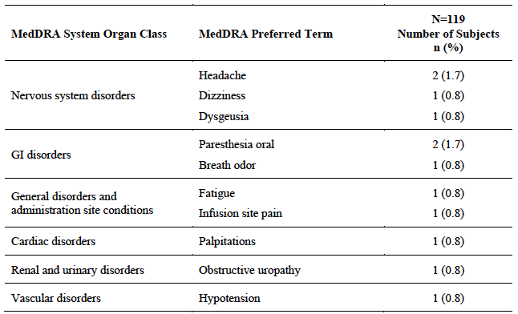

Study SYN-FIXFc-07-001
One of the 14 subjects experienced altered taste and headache considered related to the FIXFc infusion. Both were rated as mild. None of the other AEs were considered related to FIXFc.

Deaths and other serious adverse events

Study 998HB102
There were no deaths in this study.
Serious AEs (SAEs) occurring in Arms 1, 2 and 3. There were two SAEs of cellulitis. Otherwise there were single reports of various event terms. Only one of the SAEs was assessed as being related to FIXFc (a case of renal colic due to clot in the setting of haematuria).
For serious AEs occurring in Arm 4: None of these were assessed as being related to FIXFc.

Study SYN-FIXFc-07-001
There were no deaths in this study. Two SAEs were reported.
- An 18 year old male developed abdominal pain 1 day after infusion of 50 IU/kg. He had a past history of laparotomy and excision of an intra-abdominal mass. CT scan revealed a small bowel obstruction that settled with conservative management. The SAE was considered not related to FIXFc.
- A 20 year old male with a history of bipolar disorder was hospitalised for increasing depression two weeks after infusion of 100 µg/kg. The event was considered unrelated to FIXFc.

Study 9HB02PED
There were no deaths or serious adverse events reported in the 4 subjects enrolled to date in the paediatric study.

Study 9HB01EXT
There were no deaths reported in the open extension study. A total of 4 SAEs in 4 subjects had been reported by the time of data cut off. None of the events were considered related to FIXFc.

Discontinuation due to adverse events

Study 998HB102
Two subjects were discontinued from FIXFc following an AE.
- A 50 year old male developed an infected knee replacement prosthesis while travelling overseas. He was hospitalised and underwent a surgical procedure to treat the infection. It was not possible to conduct the surgery using FIXFc, as the drug could not be imported. The drug was therefore discontinued.
- A 19 year old male sustained renal and head injuries following a motorbike accident while travelling in another country. He was hospitalised and underwent surgery. It was not possible to conduct the surgery using FIXFc, as the drug could not be imported. The drug was therefore discontinued.
Neither of these AEs was considered related to FIXFc.
Comment: Neither of these subjects was truly discontinued due to an AE. In both cases discontinuation was due to inability to access FIXFc while overseas.

Study SYN-FIXFc-07-001
No patients were discontinued due to AEs in this study.

Adverse events of special interest
Three adverse events of special interest were inhibitor development (discussed in Section 7.5.7), allergic reactions and thrombotic adverse events.
There were no AEs suggestive of serious allergic reactions or thrombotic adverse events in any of the four studies.

Laboratory tests

Liver function

Study 998HB102
There were six subjects who experienced clinically significant elevations of LFTs (transaminases > 3 times upper limit of normal or bilirubin ≥ 34.2 µmol/L). The individual patient data on these six patients have been reviewed. Four of the six patients had hepatitis C infection at baseline (one of whom also had hepatitis B infection). All these four subjects had abnormal transaminases at screening and/or baseline. None had significant elevations of bilirubin during the study.
One of the other 2 subjects also had abnormal transaminases at screening and/or baseline and developed a clinically significant elevation of AST at Week 26, which returned to normal at Week 52. He had no significant elevations of bilirubin. The other subject had minor elevation of bilirubin at screening and baseline and a clinically significant reading (44 µmol/L) at Week 52. He had no abnormalities of AST or ALT at any stage.
Comment: The pattern of elevated LFTs observed in this study is not consistent with drug induced hepatotoxicity. A large proportion of patients enrolled in the study (56.9%) were hepatitis C positive at baseline.

Study SYN-FIXFc-07-001
No clinically significant changes from baseline were recorded.

Kidney function

Study 998HB102
For incidence of clinically significant elevations in urea and creatinine: One subject (a 46 year old white male) developed clinically significant elevations of creatinine and urea. His urea was elevated at screening (10.7 mmol/L), normal at baseline and elevated at Week 26 (15.7) and Week 52 (16.1). His creatinine was borderline at screening (118 µmol/L), normal at baseline and elevated at Week 26 (255) and week 52 (158). The subject had a number of medical conditions at baseline: morbid obesity (187 kgs), type II diabetes, hypertension, high cholesterol and bipedal oedema.
Comment: The development of renal impairment in this subject does not appear to have been reported as an adverse event and the study report does not comment on the case. The sponsor should be asked if any further information exists on this subject to exclude a nephrotoxic effect of FIXFc.

Study SYN-FIXFc-07-001
No clinically significant changes from baseline were recorded for urea or creatinine.

Other clinical chemistry

Study 998HB102
For incidence of clinically significant elevations in other biochemistry parameters: Clinically significant elevations in glucose (> 9.71 mmol/L) occurred in five patients. The sponsor argues that only random blood glucose levels were measured and these do not allow for adequate assessment and interpretation of results. Clinically significant abnormalities in other biochemistry parameters were infrequent.

Study SYN-FIXFc-07-001
No clinically significant changes from baseline were recorded on other biochemistry tests.

Haematology

Study 998HB102
Clinically significant changes in haematology parameters: Clinically significant changes in white cells (total WBC, neutrophils or lymphocytes) occurred in 8 subjects. In these subjects abnormalities were often present at baseline or were abnormal at one time point only. Six had pre-existing medical conditions (such as HIV, hepatitis, or advanced hepatic disease) and/or were on concomitant medications (for example, sulfamethoxazole and trimethoprim, lamivudine, and famotidine) that may have affected WBC counts.
One subject developed a clinically significant low platelet count (75 x 10⁹/L) at Week 26. He had low counts at screening and baseline (105 and 110) and the count recovered to 140 at Week 52.
Comment: The pattern of reduced white cells and platelets in these subjects did not suggest a myelotoxic effect of FIXFc. There were no cases of agranulocytosis.

Study SYN-FIXFc-07-001
No clinically significant changes from baseline were recorded on haematology testing.

Coagulation parameters

Study 998HB102
Fibrinogen fragments (F1+F2), TAT complex and d-dimer were measured in subjects in the Arm 1 sequential PK subgroup, before and after BeneFIX and before and after FIXFc at baseline and Week 26. Prothrombin time was measured before and after BeneFIX and before and after FIXFc at baseline. Three subjects had elevations of d-dimer, but these were also elevated prior to dosing. No other trends were apparent.

Study SYN-FIXFc-07-001
No clinically significant changes from baseline were recorded for PT, aPPT or d-dimer.
In this study, levels of TAT complex were also measured. TAT levels are an indicator of activation of the blood clotting system, and the normal value for the assay used was < 5.1 ng/mL. Two subjects developed elevated TAT levels post infusion of FIXFc.
- Subject 200007 was a 27 year old black male who developed elevated levels (up to 22.1 ng/mL) on days 1 and 2, after infusion of 50 IU/kg.
- Subject 200011 was a 32 year old white male who developed elevated levels on day 1 (up to 43.1 ng/mL) and again on day 4 (15.4 ng/mL) after infusion of 100 IU/kg.
The sponsor concluded that these elevations were not due to in vivo activation of the clotting system caused by the infusion of FIXFc. Neither patient developed elevated d-dimer levels or had clinical evidence of thrombosis. The two patients came from the same centre (and were the only patients treated at this centre) and elevated TAT levels were not observed at any other centre. The sponsor states that elevated TAT levels may be caused by prolonged use of tourniquets (for example, ≥ 3 minutes or even earlier), difficult venepuncture, an inadequately mixed sample, a sample containing clot or by strenuous exercise. There was also no clear correlation between FIX activity levels and TAT levels in these patients.
Comment: The sponsor’s explanation for the elevated TAT levels in these two patients is considered acceptable.

Serum Immunoglobulin concentrations

Study 998HB102
No clinically significant changes were observed on testing for total immunoglobulin G or IgG subclasses.

Inhibitor development / antigenicity.

Study 998HB102
Plasma samples were tested for FIX inhibitors at a central laboratory using the Nijmegen modified Bethesda assay. Formation of an inhibitor was defined as a value of ≥ 0.6 Bethesda Units/mL. Samples were collected at screening, baseline and at each study visit. No subject developed an inhibitor during the study. For subjects who received at least 1 dose of the 15,000 L bioreactor scale FIXFc product and who had a valid inhibitor test (n = 121) the estimated inhibitor development rate was 0% (95% confidence interval 0% to 3.00%). If the analysis was restricted to subjects who had at least 50 exposure days to FIXFc (n=55), the estimated inhibitor development rate was 0% (95% confidence interval 0% to 6.49%).
Samples were also tested for anti-FIXFc antibodies using a validated electrochemiluminescence based bridging ELISA (ECLA). Three subjects had a weakly positive test at baseline (prior to any FIXFc administration) but reverted to negative during the study.
One other subject had borderline negative tests at screening, baseline and every study visit until Day 338, when he had a borderline positive result. His FIX activity level at Day 338 was 15.4%, which was consistent with that predicted by his baseline PK profile (13.5%), suggesting that the antibody did not alter the PK of FIXFc. The patient did not experience any adverse events suggestive of loss of efficacy or allergic reactions.

Study SYN-FIXFc-07-001
In this study, plasma samples were tested for FIX inhibitors at a central laboratory using the Nijmegen modified Bethesda assay. Samples were collected at screening, just prior to FIXFc administration on Day 1, at 1 time point within 7 to 10 days after FIXFc, and at Day 30. All inhibitor tests were negative (< 0.7 BU/mL).
Samples were also tested for anti-FIXFc antibodies using a validated ECLA. No patient tested positive.

Study 9HB02PED
There were no inhibitors detected in the 4 subjects enrolled to date in the paediatric study.

Study 9HB01EXT
There were no inhibitors detected in the extension study.
Comment: The major safety issue associated with FIX replacement products is the development of inhibitors. These develop in less than 5% of haemophilia B patients overall, but in 9 to 23% of patients with severe FIX deficiency (13). They usually occur early in treatment. In an international registry of haemophilia B subjects with inhibitors, development of inhibitors occurred after a median of 11 exposure days (range 2 to 180 EDs) (14). As FIXFc is a novel molecule, it is possible that it may be more antigenic than plasma derived or recombinant FIX and be associated with a higher rate of inhibitor development. The results of the inhibitor testing in the phase III study are reassuring. However, this study only enrolled subjects who had already had at least 100 prior EDs and it excluded subjects with a history of inhibitors. This population would have a low risk of inhibitor development.
The sponsor is conducting a study in previously treated children. However, enrolment is restricted to subjects with at least 50 EDs and no history of inhibitor. In order to reliably document the rate of inhibitor development associated with FIXFc it would be necessary to conduct a study in PUPs. The new EMA guideline on FIX products (9) requires that a study in PUPs be conducted for novel proteins, but suggests that it can be submitted after initial marketing approval. The sponsor has indicated in Module 1 of the submission that it plans to undertake such a study, which will not be completed until 2019.

Electrocardiograph

Study 998HB102
ECGs were not monitored during the pivotal study.

Study SYN-FIXFc-07-001
There were no clinically significant ECG changes observed in this study.

Vital signs

Study 998HB102
There was no consistent pattern in the incidence of alterations of pulse, BP and temperature during the trial.

Study SYN-FIXFc-07-001
No clinically significant changes from baseline were observed.

Post-marketing experience
As the product had not been approved for marketing in any jurisdiction at the time of submission, the submission did not include any post-marketing data.

Safety issues with the potential for major regulatory impact

Liver toxicity
As described in section 8.5.1 liver function testing did not suggest any evidence of drug induced hepatotoxicity.

Haematological toxicity
As described in section 8.5.4 haematology testing did not suggest any evidence of drug induced haematological toxicity.

Serious skin reactions
There were no serious AEs involving the skin reported.

Cardiovascular safety
One subject developed an SAE of worsening of angina pectoris during the trial. He had a prior history of ischaemic heart disease including angina pectoris and myocardial infarction. There were no other notable cardiovascular events.

Unwanted immunological events
There were no SAEs related to the immune system. Inhibitor development/antigenicity has been discussed.

Evaluator’s overall conclusions on clinical safety
The overall safety database included a total of 141 subjects, which is well in excess of the number required by the most recent EMA guideline. The extent of safety testing is therefore considered acceptable.
Known safety issues associated with FIX replacement therapy products include inhibitor formation and allergic/anaphylactic reactions. The submitted data were essentially limited to previously treated patients aged 12 or over, with no prior history of inhibitors. There were no reports of inhibitors or allergic reactions suggesting that the incidence of these adverse effects is acceptably low, in this population. The submitted data also suggest that the product is not associated with significant thrombotic adverse events.
The only treatment related adverse events that occurred in more than one patient were oral paraesthesia and headache. Neither of these was considered serious. Monitoring of biochemistry, haematology and coagulation parameters and vital signs did not suggest any unexpected toxicities.

First round benefit-risk assessment

First round assessment of benefits
The benefits of FIXFc in the proposed indication are:
- Efficacy in the control of bleeding episodes.
- Efficacy in the prevention of bleeding episodes when administered as routine prophylaxis.
- Efficacy in the management of bleeding associated with surgical procedures.
- A reduced frequency of dosing when compared to currently available FIX replacement products.
- A decreased risk of viral transmission compared to plasma derived FIX.

First round assessment of risks
The risks of FIXFc in the proposed indication are:
- A possible risk of inhibitor development, vascular thrombotic events and allergic reactions. The available data suggest that the incidence of these effects in the proposed population is acceptably low.

First round assessment of benefit-risk balance
The benefit-risk balance of FIXFc, in previously treated subjects aged 12 years or over, is considered favourable. The submitted data support use for episodic (on demand) therapy, routine prophylaxis and surgical prophylaxis when the product is given by bolus infusion.
The current data do not support use of the product:
- in children aged less 12 years.
- in previously untreated patients.
- by continuous infusion in surgery.
- for immune tolerance induction (ITI) in patients with FIX inhibitors.
The sponsor is not seeking approval for use in these situations at the current time.

First round recommendation regarding authorisation
It is recommended that the application for registration be approved.

Clinical questions

General
Question 1.
Please provide an assurance that the lyophilised product proposed for registration in Australia is identical to that used in the pivotal phase III study (with respect to formulation and manufacturing processes).

Safety
Question 2.
One subject in Study 998HB102 developed clinically significant elevations of creatinine and urea. His urea was elevated at screening (10.7 mmol/L), normal at baseline and elevated at Week 26 (15.7) and Week 52 (16.1). His creatinine was at a borderline level at screening (118 µmol/L), normal at baseline and elevated at Week 26 (255) and Week 52 (158). It is noted that the subject had a number of medical conditions at baseline including morbid obesity (187 kg), type II diabetes, hypertension, high cholesterol and bipedal oedema. The development of renal impairment in this subject does not appear to have been reported as an adverse event and the study report does not comment on the case. Is the sponsor able to provide any further information or comment in relation to this subject to exclude a nephrotoxic effect of FIXFc?

Second round evaluation of clinical data submitted in response to questions
Not applicable.

Second round benefit-risk assessment
Not applicable.

Second round recommendation regarding authorisation
Not applicable.

References
- Therapeutic Goods Administration. MonoFIX-VF Product Information [online]. December 2010 [viewed 3 September 2013].
- Therapeutic Goods Administration. Benefix Product Information [online]. 15 August 2013 [viewed 3 September 2013].
- Roopenian DC, Akilesh S (2007). FcRn: the neonatal Fc receptor comes of age. Nat Rev Immunol. 7(9):715-25.
- Haemophilia Foundation Australia (2013). Haemophilia [online]. July 2013 [viewed 21 September 2013].
- Srivastava A, Brewer AK, Mauser-Bunschoten EP et al. (2013). Treatment Guidelines Working Group The World Federation Of Hemophilia. Guidelines for the management of hemophilia. Haemophilia. 2013 Jan; 19(1): e1-e47
- European Medicines Agency (2007). Guideline On The Clinical Investigation Of The Pharmacokinetics Of Therapeutic Proteins (CHMP/EWP/89249/2004).
- European Medicines Agency (2001). Points to Consider on Application with 1. Meta-Analyses; 2. One Pivotal Study (CPMP/EWP/2330/99).
- European Medicines Agency (2000). Note for Guidance on the Clinical Investigation of Recombinant Factor VIII and IX Products (CPMP/BPWG/1561/99).
- European Medicines Agency (2011). Guideline on clinical investigation of recombinant and human plasma-derived factor IX products (EMA/CHMP/BPWP/144552/2009).
- Franchini M, Frattini F, Crestani S et al. (2013). Treatment of hemophilia B: focus on recombinant factor IX. Biologics: Targets and Therapy. (7) 33–38.
- Roberts HR, Eberst ME (1993). Current management of hemophilia B. Hematol Oncol Clin North Am. 7(6): 1269-80.
- Wiedel J, Stabler S, Geraghty S, et al. (2010). Joint replacement surgery in hemophilia. Treatment of Hemophilia [Internet]. No. 50.
- DiMichele D. Inhibitor development in haemophilia B (2007): an orphan disease in need of attention. Br J Haem. 138 (3), 305–315.
- M. Chitlur M, Warrier I, Rajpurkar M et al. (2009). Inhibitors in factor IX deficiency a report of the ISTH-SSC international FIX inhibitor registry (1997–2006). Haemophilia. 15 (5) 1027–1031.
- Shapiro AD, Ragni MV, Valentino LA, et al. (2012). Recombinant factor IX-Fc fusion protein (rFIXFc) demonstrates safety and prolonged activity in a Phase 1/2a study in hemophilia B patients. Blood. 119(3): 666-672.

Sponsor clarification: Pivotal study 998HB102 allowed a 14 day or longer interval.
See approved PI for finally approved dosage regimen, which recommends starting regimens of either 50 IU/kg once weekly or 100 IU/kg once every 10 days. Either regimen may be adjusted based on patient response.
Sponsor clarification: A primary objective of Study 998HB102 was “To evaluate the safety and tolerability of rFIXFc”
Sponsor clarification: These subjects were not necessarily unique as there is a possibility of overlap of subjects from Phase I/IIa to Phase III. The sponsor suggested the total included more than 130 unique subjects exposed to rFIXFc.
The sponsor provided information about this subject in the response to a TGA request for further information, and concluded that a nephrotoxic effect of rFIXFc treatment is unlikely based on chemistry data from non-clinical toxicology studies and the Phase III study, and further review of data for this subject demonstrating multiple factors potentially contributing to his renal insufficiency.
Sponsor clarification: These subjects were not necessarily unique as there is a possibility of overlap of subjects from Phase I/IIa to Phase III. The sponsor suggested the total included more than 130 unique subjects exposed to rFIXFc.
The sponsor provided information about this subject in the response to a TGA request for further information, and concluded that a nephrotoxic effect of rFIXFc treatment is unlikely based on chemistry data from non-clinical toxicology studies and the Phase III study, and further review of data for this subject demonstrating multiple factors potentially contributing to his renal insufficiency.

