Date of CER: 31 March 2014

AusPAR Attachment 2

Extract from the Clinical Evaluation Report for dulaglutide
  - Proprietary Product Name: Trulicity
  - Sponsor: Eli Lilly Pty Ltd

About the Therapeutic Goods Administration (TGA)
- The Therapeutic Goods Administration (TGA) is part of the Australian Government Department of Health, and is responsible for regulating medicines and medical devices.
- The TGA administers the Therapeutic Goods Act 1989 (the Act), applying a risk management approach designed to ensure therapeutic goods supplied in Australia meet acceptable standards of quality, safety and efficacy (performance), when necessary.
- The work of the TGA is based on applying scientific and clinical expertise to decision-making, to ensure that the benefits to consumers outweigh any risks associated with the use of medicines and medical devices.
- The TGA relies on the public, healthcare professionals and industry to report problems with medicines or medical devices. TGA investigates reports received by it to determine any necessary regulatory action.
- To report a problem with a medicine or medical device, please see the information on the TGA website <https://www.tga.gov.au>.
About the Extract from the Clinical Evaluation Report
- This document provides a more detailed evaluation of clinical findings extracted from the Clinical Evaluation Report (CER) prepared by TGA. This extract does not include sections from the CER regarding product documentation or post market activities.
- The words [Information redacted], where they appear in this document, indicate that confidential information has been deleted.
- For the most recent Product Information (PI), please refer to the TGA website <https://www.tga.gov.au/product-information-pi>.
Copyright
© Commonwealth of Australia 2014
This work is copyright. You may reproduce the whole or part of this work in unaltered form for your own personal use or, if you are part of an organisation, for internal use within your organisation, but only if you or your organisation do not use the reproduction for any commercial purpose and retain this copyright notice and all disclaimer notices as part of that reproduction. Apart from rights to use as permitted by the Copyright Act 1968 or allowed by this copyright notice, all other rights are reserved and you are not allowed to reproduce the whole or any part of this work in any way (electronic or otherwise) without first being given specific written permission from the Commonwealth to do so. Requests and inquiries concerning reproduction and rights are to be sent to the TGA Copyright Officer, Therapeutic Goods Administration, PO Box 100, Woden ACT 2606 or emailed to <tga.copyright@tga.gov.au>.

Contents
List of abbreviations 5
1. Background 10
1.1. Submission type 10
1.2. Drug class and therapeutic indication 10
1.3. Dosage forms and strengths 10
1.4. Dosage and administration 10
2. Clinical rationale 11
3. Contents of the clinical dossier 11
3.1. Scope of the clinical dossier 11
3.2. Paediatric data 12
3.1. Good clinical practice 12
4. Pharmacokinetics 12
4.1. Studies providing pharmacokinetic data 12
4.2. Summary of pharmacokinetics 13
4.3. Physicochemical characteristics of the active substance 13
4.4. Pharmacokinetics in healthy subjects 14
4.5. Pharmacokinetics in the target population 15
4.6. Pharmacokinetics in other special populations 15
4.7. Pharmacokinetic interactions 16
4.8. Evaluator’s overall conclusions on pharmacokinetics 17
5. Pharmacodynamics 18
5.1. Studies providing pharmacodynamic data 18
5.2. Summary of pharmacodynamics 18
5.3. Evaluator’s overall conclusions on pharmacodynamics 22
6. Dosage selection for the pivotal studies 22
7. Clinical efficacy 23
7.1. Treatment of diabetes mellitus 23
8. Clinical safety 94
8.1. Studies providing evaluable safety data 94
8.2. Studies that assessed safety as a primary outcome 95
8.3. Patient exposure 100
8.4. Adverse events 102
8.5. Laboratory tests 106
8.6. Post-marketing experience 110
8.7. Safety issues with the potential for major regulatory impact 110
8.8. Evaluator’s overall conclusions on clinical safety 112
9. First round benefit-risk assessment 113
9.1. First round assessment of benefits 113
9.2. First round assessment of risks 114
9.3. First round assessment of benefit-risk balance 114
10. First round recommendation regarding authorisation 114
11. Clinical questions 114
11.1. Pharmacokinetics 114
11.2. Pharmacodynamics 114
11.3. Efficacy 114
11.4. Safety 114
12. References 114

List of abbreviations
Abbreviation | Meaning
ABPM | Ambulatory blood pressure monitoring
ADA | Anti-drug antibody
AE | Adverse event
ALT | Alanine transaminase
AI | Auto-injector
AST | Aspartate transaminase
AUC | Area under the concentration versus time curve
AUC₍₀₋₁₆₈₎ | AUC from time zero to 168 hours
AUC₍₀₋₁₂₎ | AUC from time zero to 12 hours
AUC_{(0-Tlast)} | AUC from time zero to time T where T is the last timepoint with a measureable concentration
AUC_{(0-∞)} | AUC from zero to infinity
AUC_{T} | AUC during one dosing interval
%AUC_{(Tlast-∞)} | Fraction of AUC_{(0-∞)} extrapolated
AUEC | Area under the effect curve
AVB | Atrioventricular block
AS1 | Analysis Set 1
AS3 | Analysis Set 3
BID | Twice daily injection
BMI | Body mass index
Bpm | Beats per minute

Abbreviation | Meaning
CEC | Clinical endpoint committee
CHMP | Committee for Medicinal Products for Human Use
CI | Confidence interval
CIOMS | The Council for International Organizations of Medical Sciences
CKD-EPI | Chronic Kidney Disease Epidemiology Collaboration
CL | Total body clearance (calculated after IV administration)
CL/F | Apparent clearance
C_{max} | Maximum observed drug concentration
CSR | Clinical study report
CUI | Clinical Utility Index
CV | Cardiovascular
CYP | Cytochrome P450
DBP | Diastolic blood pressure
DPP-4 | Dipeptidyl peptidase-4
DTSQ | Diabetes Treatment Satisfaction Questionnaire
DTSQc | Diabetes Treatment Satisfaction Questionnaire change
DTSQs | Diabetes Treatment Satisfaction Questionnaire status
DSCr | Diabetes Symptoms Checklist - revised
Dulaglutide ADA | Dulaglutide anti-drug antibodies
ECG | Electrocardiogram
EE | Ethynilestradiol
eGFR | Estimated glomerular filtration rate
EQ-5D | EuroQoL 5 Dimension QOL scale
Abbreviation | Meaning
ESRD | End stage renal disease
F_{absolute} | Absolute bioavailability
FBG | Fasting blood glucose
FDA | Food and Drug Administration (USA)
FPG | Fasting plasma glucose
F_{relative} | Relative bioavailability
FSG | Fasting serum glucose
GERD | Gastrooesphageal reflux disease
GI | Gastrointestinal
GLP-1 | Glucagon-like peptide 1
HbA1c | Glycosylated haemoglobin A1c
HOMA2-%B | Homeostasis Model Assessment of beta cell function
HOMA1-%S | Homeostasis Model Assessment of insulin sensitivity
HR | Hazard ratio
IFU | Instructions for use
IgG4 | Immunoglobulin G4
INR_{max} | Maximum international normalized ratio response
IW-SP | Impact of weight on self-perception QOL scale
IW-ADL | Impact of weight on activities of daily living QOL scale
TINR_{max} | Time of maximum observed INR response
ITT | Intent to treat
IVRS | Interactive voice response system
LBSS | The Low Blood Sugar Survey
Abbreviation | Meaning
LLOQ | Lower limit of quantification
LS | Least squares
LY2189265 | Dulaglutide
MACE | Major adverse cardiovascular events
MET | Metformin
MI | Myocardial infarction
MMRM | Mixed-effects model for repeated measures
MTC | Medullary thyroid carcinoma
NGMN | Norelgestromin
NI | Non-inferiority
nsGLP-1 | Native sequence glucagon-like peptide 1
OC | Oral contraceptive
OAM | Oral antihyperglycaemic medication
PD | Pharmacodynamic
PK | Pharmacokinetic
PPG | Post prandial plasma glucose
PRO | Patient-reported outcome questionnaire
PT | Preferred term
QT | Standard cardiovascular ECG interval between Q and T waves
QTc | Corrected QT interval
QW | Once weekly injection
REMS | Risk Evaluation and Mitigation Strategy
RMP | Risk management plan
Abbreviation | Meaning
SAE | Serious adverse event
SAP | Statistical analysis plan
SBP | Systolic blood pressure
SC | Subcutaneous
SMPG | Self-monitored plasma glucose
SOC | System Organ Class
SU | Sulfonylurea
T½ | Terminal half-life
T2DM | Type 2 diabetes mellitus
TEAE | Treatment-emergent adverse event
T_{max} | Time of maximum observed drug concentration
TQT | Thorough QT
TZD | Thiazolidinedione
UACR | Urine albumin to creatinine ratio
ULN | Upper limit of normal
UTI | Urinary tract infection
VAS | Visual analogue scale
V_{z} | Volume of distribution
V_{z}/F | Apparent volume of distribution

Background

Submission type
This is a full submission to register a new biological agent dulaglutide (trade name Trulicity, originally Apleavo).

Drug class and therapeutic indication
Dulaglutide is a long acting human glucagon–like peptide-1 (GLP-1) receptor agonist.
The proposed indication is:
Apleavo is indicated as an adjunct to diet and exercise to improve glycaemic control in adults with type 2 diabetes mellitus:
    - As monotherapy
    - In combination with the following oral glucose lowering medications (metformin, metformin and sulfonylurea, metformin and thiazolidinedione)
    - In combination with prandial insulin, with or without metformin

Dosage forms and strengths
The submission proposes registration of the following dosage forms and strengths:
- 1.5 mg/0.5 mL solution for injection in single use pen injector
- 1.5 mg/0.5 mL solution for injection in pre-filled syringe

Dosage and administration
The proposed Product Information (PI) contains the following Dosage and Administration instructions.

General
Apleavo should be administered once weekly. The dose can be administered at any time of the day, with or without meals, and can be injected subcutaneously in the abdomen, thigh or upper arm. Apleavo should not be administered intravenously or intramuscularly.

Use in adults (≥ 18 years)
The recommended dose of Apleavo is 1.5 mg per week. Administer Apleavo once weekly, at any time of day, independently of meals.

Use in elderly ( ≥ 65 years)
No dose adjustment is required based on age.

Use in children and adolescents
The safety and effectiveness of Apleavo have not been established in children and adolescents under 18 years of age.

Use in renal impairment
No dose adjustment is required based on renal impairment.

Use in hepatic impairment
No dose adjustment is required based on hepatic impairment.
Missed Dose – If a dose is missed, it should be administered as soon as possible if there are at least 3 days (72 hours) until the next scheduled dose. If less than 3 days remain before the next scheduled dose, the missed dose should be skipped and the next dose should be administered on the regularly scheduled day. In each case, patients can then resume their regular once weekly dosing schedule.
Changing Weekly Dosing Schedule – The day of weekly administration can be changed, if necessary, as long as the last dose was administered 3 or more days before.

Clinical rationale
Type 2 diabetes mellitus (T2DM) is one of the most common non-communicable diseases and is a global health problem. In 2011, the estimated number of people with T2DM was 366 million (8.3% of the world population), with an estimated increase to 552 million (9.9% of total world population) by 2030. There are 183 million people with undiagnosed diabetes.
T2DM has a complex pathophysiology that is characterised by deficient insulin activity arising from decreased insulin secretion secondary to β-cell failure, compromised insulin action in peripheral target tissues (insulin resistance), or a combination of the two abnormalities. This abnormal metabolic state is exacerbated by excess glucagon secretion, excess hepatic glucose production, altered metabolism of protein and lipids, and abnormalities within the incretin system. All of these factors contribute to chronic hyperglycaemia which, if left untreated, can increase the risk of microvascular and macrovascular complications.
For many years, there have been several classes of antihyperglycaemic agents available that target one or more of the pathophysiologic deficiencies associated with T2DM, including metformin (MET), sulfonylureas (SU), thiazolidinediones (TZD), and insulins. These drugs can have undesirable side effects and/or limited usefulness in certain populations. For example, MET is contraindicated in patients with renal insufficiency, while TZDs are known to exacerbate congestive heart failure in some patients. Insulin and insulin analogues as well as SUs are often associated with hypoglycaemia and weight gain. More recently, incretin-based therapies, including dipeptidyl peptidase-4 (DPP-4) inhibitors and GLP-1 receptor agonists, have become available and are being prescribed for patients with T2DM. Compared with the DPP-4 inhibitors, GLP-1 receptor agonists are injected and commonly associated with gastrointestinal (GI) side effects; however, in head-to-head trials they have demonstrated more robust glycosylated haemoglobin A1c (HbA1c) lowering and the added advantage of weight loss. Compared to the other commonly used injectable, insulin, the mechanism of action of GLP-1 receptor agonists, with glucose dependent insulin secretion, has the potential to decrease the risk of hypoglycaemia while providing reduction in HbA1c and weight loss. Among the available GLP-1 receptor agonists, there are differences in duration of action; frequency, timing of dosing, and ease of administration, effectiveness, tolerability, and immunogenicity.
Despite the currently available agents, a substantial proportion of patients with T2DM remain under poor glycaemic control. This suggests there continues to be a medical need, necessitating continued development of additional treatment options for patients with T2DM. There is still the opportunity to optimise the benefit-risk profile within the GLP-1 receptor agonist class.

Contents of the clinical dossier

Scope of the clinical dossier
The clinical dossier documented a full clinical development program of pharmacology, efficacy and safety studies.
The submission contained the following clinical information:
- 20 clinical pharmacology studies, including 16 that provided pharmacokinetic data and 8 that provided pharmacodynamic data (some studies included both PK and PD)
- 5 studies that provided information on use, injection site location and different delivery devices
- 2 population pharmacokinetic analyses
- 5 pivotal efficacy/safety studies
- 3 other efficacy/safety studies
- 1 meta-analysis on cardiovascular risk

Paediatric data
The submission did not include paediatric data.
A Paediatric Investigation Plan (PIP) was agreed in Europe. A waiver of the requirement to conduct studies in paediatric patients younger than 10 years of age was granted in the EU in January 2011 (PIP decision P/37/2011). Study of dulaglutide in paediatric patients aged from 10 to 18 years was deferred. In October 2013 Lilly requested a modification to the PIP in Europe which included the request that the PIP include a juvenile toxicology study which would delay the initiation of the clinical study in paediatric patients.
The FDA has agreed that clinical studies in paediatric patients could be delayed until completion of the juvenile toxicology study and until FDA agrees that there is sufficient evidence of efficacy and safety in adults. A waiver has also been requested in children aged 0 to < 10 years.

Good clinical practice
The clinical study reports state that all clinical trials in the dulaglutide clinical development program were conducted in accordance with:
- consensus ethics principles derived from international ethics guidelines, including the Declaration of Helsinki and The Council for International Organizations of Medical Sciences (CIOMS) International Ethical Guidelines,
- the International Conference on Harmonisation (ICH) Good Clinical Practice (GCP) Guideline [E6], and
- applicable laws and regulations
Clinical trials conducted outside of the EU meet the ethical requirements of Directive 2001/20/EC.

Pharmacokinetics

Studies providing pharmacokinetic data
Table 1 shows submitted pharmacokinetic studies.
Table 1: Submitted pharmacokinetic studies.
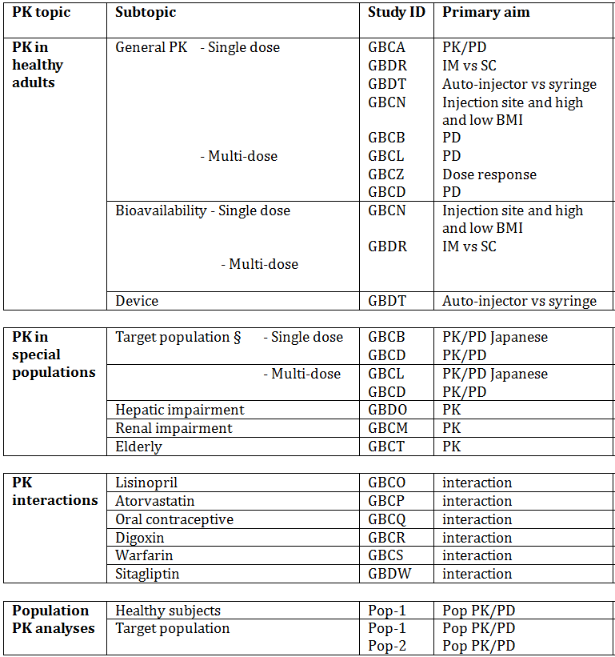
§ Subjects who would be eligible to receive the drug if approved for the proposed indication.
None of the pharmacokinetic studies had deficiencies that excluded their results from consideration.

Summary of pharmacokinetics
The information in the following summary is derived from conventional pharmacokinetic studies and population PK/PD analyses unless otherwise stated. The Summary of Clinical Pharmacology makes reference to a PK meta-analysis. A full report of the meta-analysis was not included in the submission but the tables of results were included as an appendix to the Summary. The 8 clinical pharmacology studies included in the meta-analysis were: GBCL, GBCT, GBCN, GBCM, GBDR, GBDO, GBDW and GBDT.

Physicochemical characteristics of the active substance
Dulaglutide is a long acting human glucagon–like peptide-1 (GLP-1) receptor agonist. The molecule consists of 2 identical, disulphide-linked chains, each containing a human heavy chain fragment (Fc) by a small peptide linker. The GLP-1 analogue portion of dulaglutide is approximately 90% homologous to native human GLP-1 and contains amino acids substitutions designed to optimise its clinical profile, including protection from dipeptiyl peptidase-4 (DPP-4) inactivation and reduction of immunogenicity. The molecular weight is 62, 561 (glycosylated, all Cys residues disulphide bonded). It is described as a clear to slightly opalescent, colourless to slightly yellow to slightly brown solution.
The GLP-1 analogue, linker region, and IgG4 Fc CH2 and CH3 domains are depicted (Figure 1). The 12 Cys residues that are involved in the inter-chain and intra-chain disulphide bonding are also shown. The hexagonal symbol represents the N-linked glycosylation at Asn126 in each polypeptide chain.
Figure 1: A Schematic Diagram of Dulaglutide.

Pharmacokinetics in healthy subjects

Absorption

Sites and mechanisms of absorption
Study GBCN was a phase I, open label study conducted in 45 healthy subjects to determine the bioavailability of dulaglutide injections into the upper arm and thigh relative to the abdominal wall. The results found that the site of administration had no statistically significant effect on the exposure to 1.5 mg dulaglutide or on the rates of dulaglutide absorption and elimination.

Bioavailability

Absolute bioavailability
Study GBDR was a phase I, open label study conducted in 30 healthy volunteers to evaluate dulaglutide’s absolute bioavailability. This study also assessed the relative bioavailability of IM and SC injection as during self-injection, patients may accidentally self-administer dulaglutide IM instead of the intended SC route. The absolute bioavailability of a 1.5 mg SC dose of dulaglutide relative to a 0.1 mg IV dose was approximately 44% based on AUC(0-∞) with a 90% CI of 39.5 - 49.7%. The mean absolute bioavailability based on AUC(0-168) was lower (approximately 37.1%).
The mean relative bioavailability of an IM dose of dulaglutide compared to a SC dose (based on AUC(0-∞) was 95.8% (90%CI: 85.8 - 108%) which showed that systemic exposure to dulaglutide was similar via both administration routes. The median Tmax and mean T½ values were also similar. The population PK model also confirmed there was no differences in bioavailability or rate of absorption between the SC and IM administration routes.

Dose proportionality
Study GBCA investigated dose proportionality in 18 healthy subjects given single doses of dulaglutide over the dose range 0.1 mg to 12 mg. Cmax and AUC(0-∞) increased less than proportionally for each doubling of the dose. Ratios and 90% CI for Cmax and AUC(0-∞) were 1.88 (1.76 - 2.01) and 1.84 (1.76 - 1.93) respectively. A reduced single dose range (0.5 mg to 1.5 mg) was examined in the PK meta-analysis. Consistent with the individual study results, the increase in dulaglutide exposure with a doubling of the dose was approximately 20% less than double which, given that it is within the PK variability of dulaglutide, is not considered clinically relevant.

Bioavailability during multiple dosing
Steady state was reached between the 2nd and 4th doses of dulaglutide. Accumulation after 1.5 mg multiple dose administration was approximately 1.56 fold, and was predictable from the single dose data (PK meta-analysis).

Distribution

Volume of distribution
Mean apparent volumes of distribution (Vz/F) after single and multiple 1.5 mg SC dosing were 19.5 L (40.5% CV) and 17.4 L (range 9.3 to 33), respectively. After a single 0.75 mg dose, mean Vz/F was 11.3 L (PK meta-analysis). After a single 0.75 mg dose, mean Vz/F was 11.3 L.
After 0.1 mg IV administration, mean volume of distribution (Vz) was 5.32 L (17%CV) (Study GBDR) indicating that dulaglutide distributes primarily in the blood volume.

Metabolism
Dulaglutide is a protein and is presumed to be degraded into component amino acids by general protein catabolism pathways.

Excretion
Apparent clearance (CL/F) in patients with T2DM after multiple 1.5 mg dosing was 0.107 L/hr. Mean T½ after multiple 1.5 mg dosing was 4.7 days. After a single 0.75 mg dose, CL/F was 0.0734 L/hr and T½ was 4.5 days (PK meta-analysis). Following single doses of dulaglutide 1 mg and higher, mean plasma concentrations were quantifiable up to 336 hours (Study GBCB).

Inter-individual variability of pharmacokinetics
The inter-subject variability estimates for dulaglutide AUC(0-168) and Cmax after a single 1.5 mg dose were 11.9% and 16.1% respectively (PK meta-analysis).

Pharmacokinetics in the target population
The PK of dulaglutide in patients with T2DM were generally similar to the PK in healthy subjects.

Pharmacokinetics in other special populations

Pharmacokinetics in subjects with impaired hepatic function
Study GBDO investigated the PK of dulaglutide in 26 subjects with a wide range of hepatic impairment, from normal (11 subjects) to mild to moderate (6) to severe (2). The results found no clinically relevant effect of hepatic impairment on dulaglutide PK. The observed individual plasma dulaglutide concentrations from Study GBDO were compared to model-estimated dulaglutide concentrations using a population PK model developed with data from 6 previous dulaglutide studies. The PK profiles from the control or hepatic impairment groups were largely contained within the band of 90% CI from the simulation, confirming there is no effect or hepatic status on PK of dulaglutide.

Pharmacokinetics in subjects with impaired renal function
Study GBCM investigated the PK in 48 subjects with a wide range of renal impairment, from normal to mild to end stage renal disease (ESRD) on dialysis. No clinically relevant effect of renal impairment on dulaglutide PK was observed. The observed individual plasma dulaglutide concentrations from Study GBCM were compared to model-estimated dulaglutide concentrations using a population PK model developed with data from 6 previous dulaglutide studies. The PK profiles from the control or renal impairment groups were largely contained within the band of 90% CI from the simulation, confirming there is no effect on renal status on PK of dulaglutide.

Pharmacokinetics according to age
The effect of age on dulaglutide PK was investigated in Study GBCT which included 39 patients aged ≤ 65 years receiving dulaglutide doses from 0.5 to 1.5 mg weekly for 6 weeks. Dulaglutide PK were generally consistent between elderly patients (≥ 65 years) with T2DM and younger patients (< 65 years). In addition, the combined population PK analysis demonstrated that age did not affect dulaglutide PK or any of the PD measures to any clinically relevant degree.

Pharmacokinetics according to race/ethnicity
The ethnicities/races that were tested in the population PK/PD analyses were: Caucasian (52%), African (7%), Asian (6%), Hispanic (23%), Native American (10%) and other (2%). Race had no clinically relevant effect on dulaglutide PK or PD in the combined Phase 3 analysis (Pop-2 Report,). The only effects of race and ethnicity were observed at baseline, with Caucasians having higher fasting plasma glucose (FPG) values at baseline (FPG-HbA1c model) and higher baseline weight (weight model) compared to the rest of the population. After accounting for body weight, no PK difference was detected between the Japanese and non-Japanese patients included in the analysis of Study GBCZ data.

Pharmacokinetics according to gender
Gender did not have a statistically significant effect on dulaglutide PK in the phase 3 analysis (Pop-2 Report) or in the combined Phase 2 analysis (Pop-1 Report,).

Pharmacokinetic interactions

Effect of dulaglutide on the pharmacokinetics of other drugs
Elimination of dulaglutide is presumed to be by proteolytic degradation into its amino acid components and is not anticipated to be eliminated intact in the urine or to be metabolised by the CYP enzymes. Therefore, PK interactions with drugs primarily renally eliminated or metabolised by CYP enzymes are not expected. However, dulaglutide causes a delay in gastric emptying in healthy subjects (Study GBCH) and patients with T2DM (Study GBDM,), which may alter the PK of orally co-administered drugs. Consequently, the clinical pharmacology program included drug-drug interaction studies for the following drugs relevant to the T2DM population of interest: acetaminophen (Study GBCH,), Lisinopril (Study GBCO), metoprolol (Study GBCO), warfarin (Study GBCS), metformin (Study GBDM), digoxin (Study GBCR), atorvastatin (Study GBCP), oral contraceptives (Study GBCQ), and sitagliptin (Study GBDW).
In all cases, ratios of PK parameters were either close to 1 or within the variability for each of the co-administered drugs (lisinopril, atorvastatin, sitagliptin, metformin, acetaminophen and oral contraceptives), or within the therapeutic window for the drug (digoxin, warfarin, metoprolol). Observations were generally consistent with those of other GLP-1 receptor agonists. Therefore, dulaglutide did not affect the exposure of co-administered acetaminophen, lisinopril, metoprolol, digoxin, oral contraceptives, atorvastatin, sitagliptin, metformin, or warfarin to any clinically relevant degree. No dose adjustment is recommended for these drugs when co-administered with dulaglutide.
Figure 2: Potential for dulaglutide to influence the exposure (AUC or C_{max}) of co-administered drugs.
Note: reference group is administration of co-administered medication alone.

Effect of co-administered drugs on the PK or dulaglutide
Given the anticipated metabolic pathways of dulaglutide, CYP-P450 enzyme mediated PK interactions are not expected. Since dulaglutide contains a GLP-1 analogue, one plausible interaction would be with a DPP-IV inhibitor. The activity of incretin hormones, including GLP-1, is limited by the DPP-4 enzyme, which rapidly hydrolyses GLP-1 to produce inactive products. Dulaglutide was designed to have enhanced stability against DPP-4 inactivation, thereby increasing its duration of pharmacological activity.
Study GBDW tested the interaction between dulaglutide and sitagliptin, a DPP-4 inhibitor thought to improve glycaemic control by preventing the hydrolysis of incretin hormones, such as GLP-1, therefore increasing plasma concentrations of the active forms. A single dose of dulaglutide (1.5 mg) co-administered with steady state sitagliptin (100 mg) resulted in an increase in dulaglutide AUC and Cmax of approximately 38% and 27%, which is comparable to the PK variability for dulaglutide and therefore not considered clinically relevant. These increases, compared with dulaglutide administered alone, suggests that although dulaglutide is not completely protected against DPP-4 inactivation, it does have a high degree of protection.

Evaluator’s overall conclusions on pharmacokinetics
An extensive pharmacokinetic programme was conducted and the studies were all appropriately designed and conducted. After a single SC 1.5 mg dose, PK results were generally similar between healthy subjects and patients with T2DM. The main PK parameters were: Cmax = 114 ng/mL, Tmax = 48 hours (range 24 to 72 hours), mean AUC(0-168) = 1400 ng•hr/mL, T½ = 4.7 days. Steady state was reached between the 2nd and 4th doses of dulaglutide. The exposure to dulaglutide increased less than proportionally with increasing dose in the 0.5 mg to 1.5 mg dose range. Accumulation after 1.5 mg multiple dose administration was approximately 1.56 fold and was predictable from single dose data.
No dose adjustment of dulaglutide is needed based on body weight, age, sex, race, ethnicity, or renal or hepatic impairment. The mean effects of intrinsic factors on PK parameters (AUC and Cmax) were generally within the intersubject PK variability of dulaglutide.
Dulaglutide did not have any significant drug interactions with the drugs studied. Therefore no dose adjustment is recommended for any of the commonly used drugs when co-administered with dulaglutide.

Pharmacodynamics

Studies providing pharmacodynamic data
Table 2 shows the studies relating to each pharmacodynamic topic and the location of each study summary.
Table 2: Submitted pharmacodynamic studies.
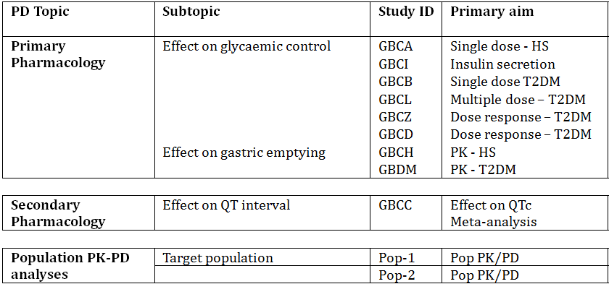
HS = healthy subjects; T2DM = type 2 diabetes mellitus.
None of the pharmacodynamic studies had deficiencies that excluded their results from consideration.

Summary of pharmacodynamics
The information in the following summary is derived from conventional pharmacodynamic studies in humans unless otherwise stated.

Mechanism of action
Dulaglutide activates the GLP-1 receptor, a membrane-bound cell-surface receptor coupled to adenylyl cyclase by the stimulatory G-protein in pancreatic beta cells. Dulaglutide increases intracellular cyclic adenosine monophosphate (AMP) in β cells leading to insulin release in the presence of elevated glucose concentrations. This insulin secretion subsides as blood glucose concentrations decrease and approach euglycaemia. Dulaglutide also decreases glucagon secretion and slows gastric emptying.

Pharmacodynamic effects

Effect on fasting and postprandial plasma glucose
Dulaglutide improves glycaemic control by lowering fasting and postprandial glucose concentrations. In Study GBCB in patients with T2DM, statistically significant and clinically relevant reductions of fasting and postprandial glucose (LS mean differences of up to -38 mg/dL and -95 mg/dL, respectively) compared to placebo were observed for 7 days after single 1 to 6 mg dulaglutide doses. The rapid onset of action was demonstrated after the first dose, with statistically significant reductions of fasting glucose compared to placebo (-22 to -38 mg/dL) observed on Day 3 at all doses. The effect was sustained through the dosing interval, with statistically significant reductions observed on Day 8 at doses of 1 mg or more (-23 to -36 mg/dL). Improvement in glycaemic control starts after the first dose and is sustained throughout the once weekly dosing interval; most of the effect on FPG concentrations occurs by 2 weeks.
These effects were also observed in Study GBCD in patients with T2DM after once weekly dosing of 1 to 8 mg for 5 weeks. In Study GBCT patients with T2DM received once weekly 1.5 mg doses for 6 weeks, fasting glucose concentrations, 2-hour post prandial plasma glucose (PPG) concentrations, and post-prandial serum gAUC were significantly reduced compared to placebo (-25.6 mg/dL, -59.5 mg/dL, and -197 mg•h/dL, respectively). These effects were sustained throughout the entire 6-week period.
Similarly, in Study GBDM patients with T2DM who received once weekly doses of 1.5 mg doses for 4 weeks, general glucose reductions were sustained throughout the 4-week period. These results were confirmed in the Phase 3, 52-week, controlled efficacy study of dulaglutide 1.5 mg once weekly compared to 1500-2000 mg/day metformin (Study GBDC), where PPG levels were measured following a standardised test meal in a subset of patients with T2DM (dulaglutide 1.5 mg: baseline HbA1c 7.6%, average PPG [average of plasma glucose values from 15 minutes through 180 minutes post-meal] 216 mg/dL; metformin: baseline HbA1c 7.6%; average PPG 214 mg/dL). Following 26 weeks of treatment, the LS mean change from baseline in average PPG (average of values from 15 minutes through 180 minutes post meal) was -51 mg/dL for dulaglutide 1.5 mg and -42 mg/dL for metformin (p = 0.89). After treatment for 52 weeks, the LS mean change from baseline in avg. PPG was significantly greater for dulaglutide 1.5 mg (-48 mg/dL) than metformin (-35 mg/dL), p = 0.029.

Effect on HbA1c
Significant reductions in HbA1c of up to -1.38% (mean baseline HbA1c 5.6% to 10.2%) were observed after once weekly dulaglutide dosing for 5 weeks compared to placebo in Study GBCD (0.05, 1, 3, 5, and 8 mg doses) and Study GBCL (1.0, 1.5 mg doses). Similarly, significant reductions in HbA1c of up to -0.55% (mean baseline HbA1c 6.7% to 7.3%) compared to placebo occurred after once weekly 0.5, 0.75 and 1.5 mg dulaglutide dosing for 6 weeks (Study GBCT),
The PK/PD model estimated reductions from baseline for the efficacy population for the 1.5 mg dose and the 0.75 mg dose at 52 weeks were -1.1% and -0.98%, respectively.

Effect on first and second phase insulin secretion
In Study GBCI 10 healthy subjects and 22 patients with T2DM demonstrated a restoration of first phase insulin secretion. The first phase insulin response in patients with T2DM receiving dulaglutide 1.5 mg exceeded the response observed in healthy subjects receiving placebo. Dulaglutide also improved second phase insulin secretion in response to a single IV bolus of glucose in both populations.
Figure 3: Study GBCI: Mean plasma insulin concentrations after dulaglutide or placebo administration to healthy subjects (left panel) and patients with T2DM.
Patients received an IV infusion of insulin for 6 hrs (discontinued 30 min before the glucose bolus, to normalise plasma glucose levels prior to an IV glucose bolus (0.3 g/kg/2 min) at t = 0min.
In the same study, a single 1.5 mg dose of dulaglutide appeared to increase maximal insulin secretion from the β-cells, based on the response to a 1 mg glucagon bolus, and to enhance β-cell function in subjects with T2DM as compared with placebo. For subjects receiving dulaglutide, the areas under the curve of insulin and C-peptide following administration of a glucagon bolus had statistically significant increases of 75% and 48%, respectively, relative to placebo. Statistically significant increases of 1.30 (ratio of LS mean) for the Homeostasis Model Assessment of β-Cell Function (HOMA-B) assessment in patients with T2DM further supported the hypothesis that dulaglutide enhances β-cell function. Additional evidence of the effect of dulaglutide on insulin included the higher mean plasma insulin and C-peptide concentrations compared to placebo in both healthy subjects and patients with T2DM in this study.

Effect on glucose dependent insulin secretion
The effect of steady state dosing of 1.5 mg dulaglutide on glucose-dependent insulin secretion rates (ISR) was further demonstrated in a test meal sub-study in patients with T2DM in the Phase 3 Study GBDC In these patients, the ISR response increased in a glucose-dependent manner at the 26-week time point.
Consistent with these results, increases in insulin AUC (211 pmol•h/L [90% CI - 129, 551]) and -peptide AUC (540 pmol•h/L [ - 804,1883]), fasting insulin (16.7 pmol/L [ - 12.3, 45.7]) and Cpeptide concentrations (188 pmol/L [39.6, 336]), and 2-hour postprandial insulin (98.1 pmol/L [ - 39.8, 236]) and C-peptide concentrations (72.3 pmol/L [ - 483, 628]) compared to placebo were observed after once weekly 1.5 mg dulaglutide doses for 6 weeks in patients with T2DM (Study GBCT). Marked increases from baseline in mean plasma insulin levels of up to 60.63 pmol/L were also observed after once weekly 1.5 mg doses in patients with T2DM (Study GBDM).

Effect on glucagon secretion
Dulaglutide lowers blood glucose by stimulating insulin secretion and decreasing glucagon secretion. In the Phase 3 Study GBDC, LS mean decreases from baseline in fasting glucagon saw reductions of -2.05 pmol/L at the 26-week time point after once weekly dulaglutide 1.5 mg dosing. In addition, decreases in postprandial glucagon AUC (0-3 hours post-meal) were observed following a standardised test meal in this study. After 26 and 52 weeks of treatment with dulaglutide 1.5 mg, LS mean decreases from baseline were -5.91 pmol•h/L and -8.04 pmol•h/L, respectively.

Delay in gastric emptying rate
In Study GBDM scintigraphy was done in 38 patients with T2DM to evaluate the effect of dulaglutide on gastric emptying. Each patient received placebo on Day 1 and a 1.5 mg SC dose of dulaglutide or placebo on Days 8, 15, 22, and 29. Scintigraphy assessments occurred on Days 3, 10, 17, 24, and 31 to coincide with dulaglutide Tmax. Statistically significant delays in gastric emptying rate compared to baseline were observed following each of four successive 1.5 mg dulaglutide doses. The effect was most pronounced after the first dose of dulaglutide, with a mean increase in the primary endpoint of time required for 50% of radioactivity to empty from the stomach (T50) of approximately 2 hours (Day 3, placebo) to Day 10 (2 days after first dulaglutide dose) and a corresponding 2.4-fold increase in AUC (residual activity). These delays were not seen in the placebo group. The gastric emptying delay decreased after the first dose with the mean T50 values following the second, third, and fourth doses of 1.5 mg dulaglutide being 88%, 87%, and 84%, respectively, of that after the first dose. In summary, results showed that dulaglutide delays gastric emptying by approximately 2 hours. The effect is largest after the first dose and diminishes with subsequent doses.

Effect on body weight
Changes in body weight after administration of multiple doses of dulaglutide to patients with T2DM were evaluated as a secondary measure in 4 clinical pharmacology studies:
- Study GBCD – significant reductions of up to 3 kg occurred after 5 weeks of once weekly 5 and 8 mg dulaglutide dosing compared to placebo
- Study GBCL – no statistically significant differences were observed relative to placebo after 5 weeks of once weekly 1.0 and 1.5 mg dulaglutide dosing (-0.64 to 0.36 kg and -0.86 to -0.07 kg, respectively)
- Study GBCT - a decrease from baseline of up to 3 kg at all dulaglutide dose levels after once weekly 0.5, 1.0 and 1.5 mg dosing for 6 weeks, although the change was not statistically significantly different from placebo
- Study GBDM - no significant trends in body weight up to 4 weeks
The PK/PD model estimated change from baseline in body weight at 52 weeks was -1.7 kg for the 1.5 mg dose (phase III population, Pop-2 report) and -1.4 kg for the 0.75 mg dose (Phase II population, Pop-1 Report), consistent with Phase III observed data.

Exposure-response relationship
Long-term responses for both efficacy (HbA1c, FPG, and weight) and safety (heart rate) were estimated by exposure-response models, using data from Phase II and Phase III studies for the 1.5 mg and 0.75 mg doses.
Model-estimated reductions from baseline in FPG and HbA1c for the 1.5 mg dose of dulaglutide at 26, 52 and 104 weeks for Phase III data were -2.2 mM (-40 mg/dL) and -1.2%, -1.9 mM (-35 mg/dL) and -1.1% and -1.3 mM (-23 mg/dL) and -0.77%, respectively, supporting the durability of dulaglutide’s effect throughout the observation period. For the 0.75 mg dose, the values were -1.9 mM (-35 mg/dL) and -1.1%, -1.6 mM (-29 mg/dL) and - 0.98%, and -0.95 mM (-17 mg/dL) and -0.59%, respectively, at 26, 52 and 104 weeks. Consistent with its extended PK profile, the FPG lowering effect of dulaglutide was sustained throughout the once weekly dosing interval, supporting once weekly administration. The improvement in glycaemic control was observed immediately after the first dose of dulaglutide. By the second week of dosing, approximately 75% of the steady state effect on change from baseline FPG was achieved.
The exposure-response relationships for BP, amylase (pancreatic and total), lipase, and calcitonin at the 1.5 mg dose level were not considered clinically relevant. There was no significant relationship between heart rate and weight (absolute and change from baseline) for the 1.5 mg and 0.75 mg doses.
Exposure-response models for nausea and vomiting were developed to evaluate the effect of dose titration on incidence of these events. There was no significant improvement in the model estimated overall incidence of nausea and vomiting when comparing different titration regimens that started with 0.75 mg doses for 1, 2, 3 or 4 weeks before dosing with 1.5 mg dulaglutide. Administration of dulaglutide 1.5 mg without titration resulted in an increased incidence of nausea (11%) and vomiting (7%) over the week after the first dose only. There was a tolerance to this response that led to a marked decrease in the incidence of nausea and vomiting after the second dose. Based on the model estimated probabilities of different dose titration regimens, dulaglutide does not require dose titration.

QT interval evaluation
Study GBCC evaluated the effect of supratherapeutic doses of dulaglutide (4 and 7 mg) on the QTc intervals in 147 healthy subjects. Dulaglutide did not prolong at the QTc interval. The upper limit of the 2-sided 90% CI for the mean difference in change from baseline between dulaglutide and placebo was < 10 milliseconds (ms) at all post dose time points. No individual subject in the study had an absolute QTc interval > 480 ms or an increase of > 30 ms from baseline in QTc following administration of 4 mg or 7 mg dulaglutide, or placebo. No positive correlation was detected between dulaglutide plasma concentrations and changes from baseline in QTc interval.

Evaluator’s overall conclusions on pharmacodynamics
The PD clinical studies documented the expected GLP - 1 mediated effects, including glucose dependent increases in insulin secretion, inhibition of glucagon secretion, delay in gastric emptying and modest weight loss. These mechanisms work in concert to reduce fasting and post prandial plasma glucose concentrations by modulating both glucose appearance (slowing of gastric emptying, inhibition of glucagon secretion) and glucose disposal (β-cell effects), thereby leading to reduction in HbA1c and overall glycaemic benefit.

Dosage selection for the pivotal studies
Dosing for the efficacy studies was based on the results of the clinical pharmacology studies in healthy subjects and patients with T2DM, PK modelling and simulation and dulaglutide dose concentration response relations of PD and safety measures. The initial clinical PK studies studied dulaglutide in the 0.05 to 12 mg dose range and established that the maximum tolerated dose was 3 mg dulaglutide once weekly. The selection of the doses used in the Phase III studies was determined by data from Study GBCF and confirmed by the population PK/PD dose-response analyses of the data.
The first efficacy study (GBCF) was a 104 week, adaptive, inferentially seamless, placebo controlled study comparing the efficacy of dulaglutide to sitagliptin in patients with T2DM on metformin. The purpose of the first, dose-finding stage of Study GBCF was to identify an optimal or maximal utility dose based on a clinical utility index (CUI), using pre-specified measures of efficacy (HbA1c and weight) and safety (DBP and HR). A second dose was also selected, to mitigate the potential risk if a safety signal was subsequently observed with the maximal utility dose. The second dose level was required to have a CUI ≥ 0.6 and be ≤ 50% of the maximal utility dose, to ensure minimum overlap of dulaglutide exposure. The study’s initial dose-finding portion assessed seven doses of dulaglutide (0.25, 0.5, 0.75, 1.0, 1.5, 2.0, and 3.0 mg).
Dulaglutide 1.5 mg was selected as the dose with the optimal benefit: risk profile, and dulaglutide 0.75 mg was selected as the lower dose to be continued for the purposes of confirmation of long-term safety and efficacy in Study GBCF and subsequent Phase III studies.
The once weekly dosing regimen was supported by the PK data: maximum concentrations of dulaglutide are reached at approximately 48 hours and the half-life is approximately 4.7 days; apparent clearance is 0.107 L/hr. This extended PK profile makes dulaglutide suitable for once weekly administration. Steady-state plasma dulaglutide concentrations were achieved between 2 and 4 weeks of once weekly administration. Consistent with its PK profile, dulaglutide has a PD profile suitable for once weekly administration.

Clinical efficacy

Treatment of diabetes mellitus

Pivotal efficacy studies

Study H9X-MC-GBCF
A Phase 2/3 Placebo Controlled, Efficacy and Safety Study of Once Weekly, Subcutaneous LY2189265 [Dulaglutide] Compared to Sitagliptin in Patients with Type 2 Diabetes Mellitus.

Study design, objectives, locations and dates
An adaptive, inferentially seamless, phase 2/3, outpatient, multicentre, randomised, placebo controlled, 24 month, double blind trial conducted at 111 centres in 12 countries (USA, Canada, India, Russia, Mexico, Poland, Romania, Germany, France, Spain, Taiwan and South Korea) from October 2008 to July 2012.

Objectives
Primary: To demonstrate that the glycaemic control of the high dose of dulaglutide selected at the decision point is non-inferior to that of sitagliptin at 12 months as measured by HBA1c change from baseline in patients with T2DM on metformin.
Secondary:
- To assess the glycaemic control of the selected dulaglutide doses as measured by HbA1c change from baseline by HBA1c:
  - High dose:
    - Superior to placebo at 6 months
    - Superior to sitagliptin at 12 months
  - Low dose:
    - Superior to placebo at 6 months
    - Non-inferior to sitagliptin at 12 months
    - Superior to sitagliptin at 12 month
- To compare the efficacy and safety versus sitagliptin at 12 and 24 months with respect to:
  - Fasting plasma glucose (FPG) change from baseline
  - Fasting insulin change from baseline
  - Body weight (kg) and waist circumference (cm) change from baseline
  - Proportion of patients who achieved HBA1c < 7% or ≤ 6.5%
  - Incidence of hypoglycaemic episodes
  - Beta cell function and insulin sensitivity (HOMA2)
  - Impact of weight loss as measured on weight related quality of life questionnaires
  - Health status as measured by EuroQoL questionnaire
  - Resource utilisation
- To compare the efficacy and safety versus placebo at 6 months with respect to:
  - HbA1c change from baseline
  - FBG change from baseline
  - Body weight (kg) change from baseline
  - Incidence of hypoglycaemic episodes
- To assess the durability of glycaemic control of the selected dulaglutide doses, compared to sitagliptin, as measured by HbA1c change from baseline
- To assess the durability of change in body weight of the selected dulaglutide doses compared to sitagliptin
- To characterise the PK of dulaglutide and the relationship between dulaglutide exposure and safety and efficacy measures
- To assess the development of antibodies to dulaglutide
The first 6 months of the trial included a placebo arm to enable a placebo comparison for dulaglutide doses.

Figure 4: Study GBCF: Study design.
Met = metformin, mg = milligram
1. All patients followed the same visit schedule regardless of which stage the trial was in when they were randomised, only the method of randomisation (adaptive versus fixed) and the number of dulaglutide treatment arms differed
2. Patients randomised before the Decision Point were randomised during Stage 1 and patients randomised after the Decision Point were randomised during Stage 2 of the study. The Decision Point did not occur at a defined period of time after study start, but when sufficient data had accumulated to support dose selection or stopping of the study. When dulaglutide doses were selected, the selected dulaglutide, sitagliptin and placebo/sitagliptin arms in Stage 1 continued and Stage 2 began.
3. Patients randomised during Stage 1 to dulaglutide doses that were not selected at the Decision Point were discontinued from the study.
4. The primary analysis of HBA1c included data through Visit 11 from patients assigned to the selected dulaglutide, sitagliptin, and placebo/sitagliptin arms.

Inclusion and exclusion criteria
Male and female patients 18 to 74 years of age (inclusive) who had had T2DM for ≥ 6 months; had an HbA1c ≥ 8.0% to ≤ 9.5% at screening for diet/exercise treated patients and ≥ 7.0% to ≤ 9.5% for all others; on a qualifying diabetes therapy of diet and exercise, oral monotherapy or oral combination therapy; had a BMI of 25 - 40 kg/m2 (inclusive); had stable weight for ≥ 3 months prior to entry; did not have a clinically significant gastric emptying abnormality or history of bariatric surgery or use drugs that affect gastrointestinal motility; did not have poorly controlled hypertension; did not have serum creatinine ≥ 1.5 mg/dL or creatinine clearance < 60 mL/min and did not have liver disease.

Study treatments
During the last 2 weeks of the lead-in period, all patients injected themselves with 0.75 mL of placebo injection solution for training purposes. All patients were also required to take metformin ≤ 1500 mg per day, preferably at a stable dose not to exceed the maximum daily dose allowed per local labelling.

Dulaglutide
Dulaglutide was administered via SC injection in the left or right abdominal wall, once weekly.
Stage 1 randomisation (from the first randomised patient to Decision Point): patients were assigned to 1 of 7 doses of dulaglutide (0.25, 0.5, 0.75, 1.0, 1.5, 2.0 and 3.0 mg).
At the Decision Point, 2 dulaglutide doses were chosen: 1.5 mg and 0.75 mg.
Stage 2 randomisation (after Decision Point to completion of randomisation), patients in the dulaglutide arms were assigned to either the 1.5 mg dose or 0.75 mg dose.
Patients in all dulaglutide arms took a placebo tablet once daily to match sitagliptin administration.

Sitagliptin
Patients in the sitagliptin group received a 100 mg dose administered orally as a single, once daily tablet. They also administered placebo injection once weekly to match dulaglutide administration.

Placebo/Sitagliptin Sequence Group
Patients in the placebo group administered once-weekly injections and once-daily tablets to match the administration routes of dulaglutide and sitagliptin, respectively. At the 6-month endpoint, the placebo tablet was replaced with a blinded 100 mg sitagliptin tablet.

Efficacy variables and outcomes
The primary efficacy outcome was mean change in HbA1c from baseline to 12 months (52 weeks).
Other efficacy outcomes included:
- change from baseline in HbA1c
- proportion of patients with HbA1c < 7% and ≤ 6.5%
- fasting glucose
- fasting insulin
- beta cell function and insulin sensitivity by HOMA2
- European Quality of Life - 5 dimensions (EQ - 5D) questionnaire
- Impact of Weight on Quality of Life (IWQoL-Lite questionnaire).

Randomisation and blinding methods
An interactive voice response system (IVRS) was used to randomise patients to the study treatment arms and assign vials and blister packs of double-blind study drug to each patient. All patients in the study were assigned to both an injectable and an oral study agent to maintain treatment blinding.

Stage 1 Randomisation
Patients were randomised initially in Stage 1 to placebo/sitagliptin sequence, sitagliptin, or 1 of 7 dulaglutide doses until at least 5 patients had been assigned to each of the treatment arms, for a total of 47 patients enrolled before the adaptive algorithm began. After this initial period, patients were adaptively randomised to 1 of 7 doses of dulaglutide with a 60% overall probability, and were assigned to either the sitagliptin or the placebo/sitagliptin treatment arms with a fixed probability of 20% each, using dynamic allocation.
The Decision Point was reached on 29 April 2009 and 2 dulaglutide doses were chosen: 1.5 mg as the maximal utility dose (MUD), and 0.75 mg as the lower dose.

Stage 2 Randomisation
After the Decision Point was reached, the randomisation scheme switched to a block randomisation scheme such that patients were assigned 2:2:2:1 to dulaglutide 1.5 mg, dulaglutide 0.75 mg, sitagliptin, and placebo/sitagliptin.

Analysis populations
Intent-to-Treat (ITT): All randomised patients.
12-month Per Protocol (PP): All patients who completed the 12-month visit, were at least 75% compliant, and had no important protocol violations.
24-month PP: All patients who completed the 24-month visit, were at least 75% compliant, had no important protocol violations, and were not excluded from the 12- month per protocol population.
Safety: All patients in the intent-to-treat population.

Sample size
The final sample size was dependent on the outcome of the dose finding phase. The sample sizes used in this design were based on 2 considerations: 1) sufficient number of patients to power the study and 2) sufficient number of patients to achieve 300 patients exposed to dulaglutide for 24 months (assuming a 25% dropout rate). The power was estimated at approximately 89%, based on a simulation study using the “most likely” PD model, assuming a 20% drop out rate (missing completely at random) at 12 months and an enrolment of 5 patients per week. A predictive power calculation was planned to select either 263 or 333 as the minimum total sample size needed (sum of Stage 1 and Stage 2) per dulaglutide arms and the sitagliptin arm. If the predictive power of the higher dulaglutide dose based on 263 patients in total exceeded 85%, then 263 would be used, else 333 would be used. For comparative purposes, in a traditional fixed design, 263 patients per treatment arm would provide approximately 93% power for a 1-sided 0.025 alpha level test based on a two-sample t-statistic, assuming no true difference, a 20% drop-out rate, a SD of 1.2%, and a non-inferiority margin of 0.25% for HbA1c.
The algorithm selected the 1.5 mg dose as the maximum utility dose (MUD). Based on other pre-specified rules, the 0.75 mg was also chosen for continued study at the Decision Point. The predictive power of superiority based on a future total of 263 patients in the 1.5 mg dose was 0.99; hence 263 patients was selected as the minimum total sample size for the active arms. No augmentation was needed to ensure that 70% of the patients came from Stage 2. At the Decision Point, the 0.75 mg arm had the smallest number of patients, 20 patients, out of the 4 primary arms. Consequently, 243 patients were added to each of the active arms and 122 patients were added to the placebo/sitagliptin sequence arm to ensure a total of at least 263 patients in each of the active arms and 131 patients in the placebo/sitagliptin sequence arm.

Statistical methods
The analysis examined the 6 ordered hypotheses (the primary and key secondary objectives) using a tree-gatekeeping testing strategy to control the family-wise Type 1 error rate. Non-inferiority of the dulaglutide higher dose (1.5 mg) relative to sitagliptin for HbA1c was demonstrated if the hypothesis of inferiority at a margin of 0.25% was rejected with a nominal alpha of 0.02, 1-sided, based on Stage 1 and Stage 2 data or a nominal alpha of 0.025, 1-sided, based on Stage 2 data alone.
The primary statistical analysis was based on an ANCOVA of the endpoint (using LOCF imputation) HbA1c change from baseline values with fixed effects for treatment, country, and baseline HbA1c as a covariate. Two separate analyses were performed using this model. One analysis used the 6-month data and the other used the 12-month data, separately. The 6-month data were used to compare the selected dulaglutide and sitagliptin treatment arms to placebo and the 12-month data were used to compare the selected dulaglutide arms to sitagliptin. The Type III sums of squares were used for treatment comparisons. The second analysis model used a restricted maximum likelihood (REML)-based MMRM approach. This model included the fixed effects of treatment, country, visit, treatment by visit interaction, as well as the covariate of baseline HbA1c. The percent of patients achieving HbA1c goals of ≤6.5% and 7% was summarised by treatment group and analysed by logistic regression and the Cochran-Mantel-Haenszel test. Sustainability was defined as achieving the goal at some visit during the study and at the last visit. This was also analysed using logistic regression to assess significance of an overall effect and Cochran-Mantel-Haenszel test for pairwise treatment differences. An adjusted, nominal family-wise 1-sided alpha of 0.02 was used for the analysis of the primary objective and key secondary objectives, to account for potential selection bias (alpha level of .025, 1-sided). Select analyses were conducted for Stage 1 alone, summarising the dose response across all 9 doses.

Participant flow
Figure 5: Study GBCF: Participant flow.
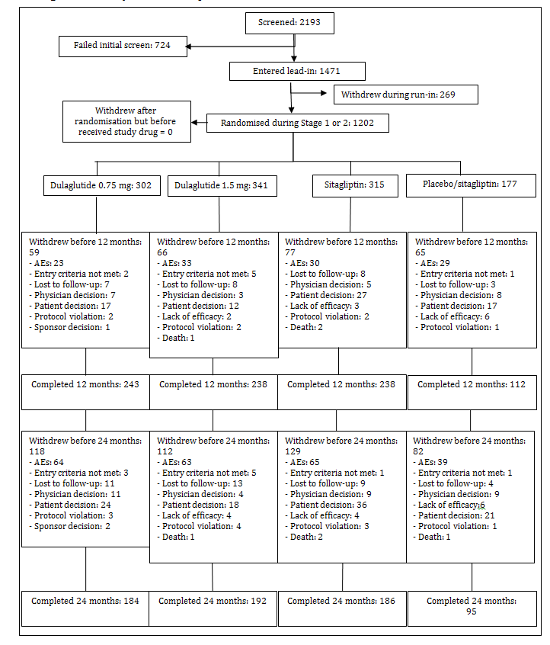

Major protocol violations/deviations
One site was terminated early due to concerns raised regarding high turnover of site personnel which contributed to training issues, quality concerns, and good clinical practice (GCP) noncompliance. The site randomised 3 patients in this study. The 3 patients remained in the study ITT analysis but were excluded from the PP analysis.
A total of 520 (47.4%) ITT patients assigned to the primary treatment were excluded from the PP population at the 24-month endpoint. The protocol violations were evenly spread between the treatment groups and consisted of missing HbA1c values at 12 months due to early study discontinuation up to 12 months followed by the use of excluded concomitant medications, and overall treatment compliance below the required threshold of 75%.

Baseline data
Baseline demographic and clinical characteristics of patients in the primary treatment arms randomised during Stage 1 or 2 and included in the ITT population were balanced across the groups. The mean age was 54.08 years, 52.6% were female, the majority of the patients were Caucasian (51.7%), followed by Hispanic (19.1%), East Asian (16.1%), West Asian [Indian Sub-continent] (8.0%), African (4.0%), and Native American or Aboriginal /Torres Strait Islander (0.1%); the mean duration of diabetes was 7.12 years; the mean body weight was 86.41 kg; the mean BMI was 31.22 kg/m²; mean baseline HbA1c (8.13%) was similar across treatment groups; vital signs and CV risk characteristics were also similar across the groups. Baseline demographic and clinical characteristics of patients in the ITT population randomised in Stage 1 were similarly balanced across treatment groups.

Results for the primary efficacy outcome

Dose Finding – 9 arm adaptive randomisation Stage 1
230 patients were randomised to the 9 treatment groups (from 0.25 to 3 mg). The 3.0 mg dose was stopped prior to the Decision Point due to observed safety risks, increased mean pulse rate and potential safety concerns related to the pancreas (high incidence of GI events and/or pancreatic hyperenzymaemia). The results supported the selection of the 1.5 mg dose at Decision Point as it provided the best benefit:risk ratio with regard to efficacy and safety over the other doses tested.
Figure 6: Study GBCF: CUI and change from baseline in CUI components, Bayesian posterior predicted means and 95% credible intervals at 6 Months (DBP, pulse, and weight) and 12 Months (HbA1c) – ITT (data available up to Decision Point).
bpm = beats per minute; DBP = diastolic blood pressure; Dula = dulaglutide dose delivered once weekly; HbA1c = glycosylated haemoglobin A1c; Pulse = pulse rate, Weight = body weight.

Effect on HbA1c change from baseline
The primary efficacy measure was change in HbA1c from baseline to 12 months (least squares mean SE) to assess non-inferiority of dulaglutide 1.5 mg once weekly to sitagliptin 100 mg once daily (non-inferiority margin 0.25%).
The dulaglutide 1.5 mg arm was non-inferior to sitagliptin at 12 months (adjusted one-sided p-value < 0.001), meeting the primary objective of the study. It was also superior to sitagliptin at 12 months (adjusted one-sided p-value < 0.001). The 0.75 mg arm was non-inferior to sitagliptin (adjusted one-sided p-value < 0.001) at 12 months, and was superior to sitagliptin (adjusted one-sided p-value < 0.001) at 12 months.
The results of the analysis with ANCOVA (LOCF) were supported by analysis with mixed-effects model for repeated measures (MMRM) and when analyses were conducted with the PP population.
The results were also consistent with primary and secondary analyses in the ITT and PP population that included only patients randomised during Stage 2.

Table 3: Study GBCF: Summary and analysis of HBA1c (%) – ANCOVA using LOCF at 6 months and 12 months -ITT.

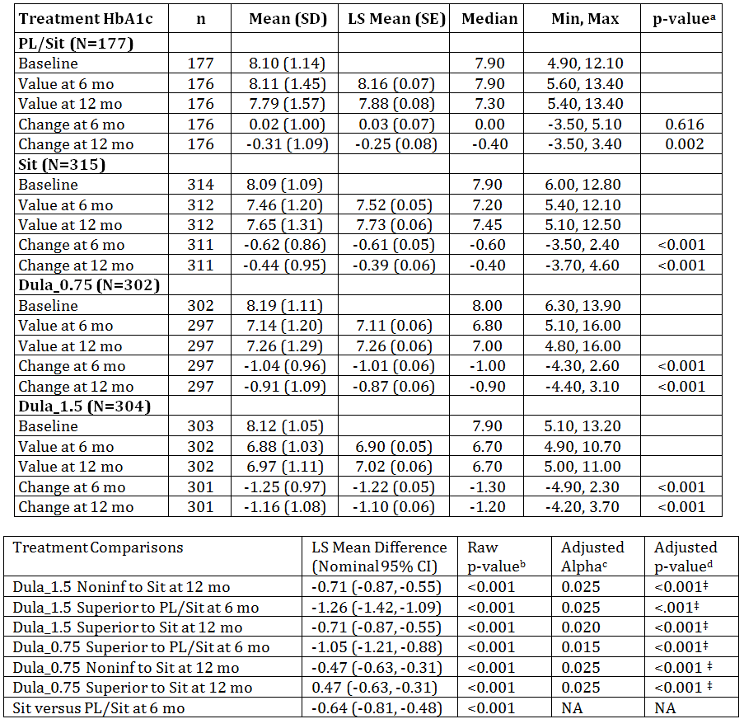
ANCOVA = analysis of covariance; CI = confidence interval; HbA1c = Haemoglobin A1c; LOCF = last observation carried forward; LS Mean = least-squares mean; Max = maximum; Min = minimum; mo = months; N = total number of patients in specified treatment arm; n = number of patients in specified category; NA = not applicable; Noninf = non-inferior; SD = standard deviation; SE = standard error.
Note: Dula x.x refers to x.x milligrams dulaglutide once weekly; PL/Sit = placebo for the first 6 months and Sitagliptin after 6 months; Sit = Sitagliptin.
Confidence intervals, p-values based on ANCOVA model:
Dependent Variable = Country + Baseline + Treatment (Type III sums of squares)
a - Within group 2-sided p-values are from t-tests on LS Mean change from baseline
b – 1-sided raw p-value (no multiplicity adjustment)
c, d – alpha level and 1-sided p-value adjusted for multiplicity, based on tree-gatekeeping strategy
‡ - significant at family-wise 1-sided Type I error of 0.025 level
Figure 7: Study GBCF: Plot of mean (SE) HbA1c (%) change from baseline versus time – ITT patients.
HBA1c = haemoglobin A1c; SE = standard error; Sit = Sitagliptin
Note: Dula x.x refers to x.x milligrams dulaglutide once weekly; PL/Sit = placebo for the first 6 months and Sitagliptin after 6 months.
Figure 8: Study GBCF: Forest plot of HbA1c (%) differences in change from Baseline relative to comparator, 95% confidence intervals based on ANCOVA (LOCF) and MMRM – ITT population.
ΔHbA1c = 95% confident interval of glycosylated haemoglobin A1c for differences in change from baseline relative to active comparator; AC = active comparator; Dula = dulaglutide; PL = placebo; vs = versus.
Notes: Dula_x.xx refers to x.xx milligrams dulaglutide once weekly.
Reference lines – the 2 vertical, dashed red reference lines are at 0.3% and 0.4%.

Results for other efficacy outcomes

HbA1c at 24 months
Significant (p < 0.001) changes from baseline to 24 months (LS mean [SE]) in HbA1c were observed in each active treatment group as follows. In the treatment comparison of change from baseline in HbA1c (LS mean difference [95% CI]), superiority to sitagliptin at 24 months was observed with the dulaglutide 1.5 mg treatment as well as the dulaglutide 0.75 mg treatment. These data are consistent with the data observed after 12 months of treatment.
Table 4: Study GBCF: Summary and analysis of HBA1c (%) – ANCOVA using LOCF at 24 months - ITT.
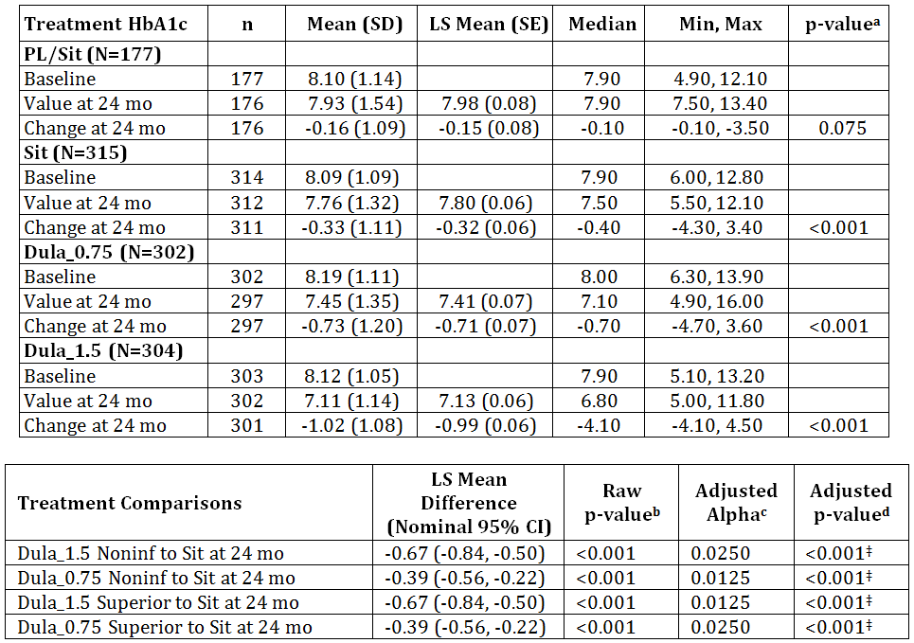
ANCOVA = analysis of covariance; CI = confidence interval; HbA1c = Haemoglobin A1c; LOCF = last observation carried forward; LS Mean = least-squares mean; Max = maximum; Min = minimum; mo = months; N = total number of intent-to-treat patients in specified treatment arm; n = number of patients in specified category; NA = not applicable; Noninf = non-inferior; SD = standard deviation; SE = standard error.
Note: Dula_x.x refers to x.x milligrams dulaglutide once weekly; PL/Sit = placebo for the first 6 months and Sitagliptin after 6 months; Sit = Sitagliptin.
Confidence intervals, p-values based on ANCOVA model:
Dependent Variable = Country + Baseline + Treatment (Type III sums of squares).
a - within group 2-sided p-values are from t-tests on LS Mean change from baseline.
b – 1-sided raw p-value (no multiplicity adjustment).
c, d – alpha level and 1-sided p-value adjusted for multiplicity, based on tree-gatekeeping strategy.
‡ - significant at family-wise 1-sided Type I error of 0.025 level

Proportion of patients with HbA1c < 7.0% or ≤ 6.5%
Significantly greater proportions of patients in the dulaglutide 1.5 mg group and the dulaglutide 0.75 mg group than in the sitagliptin group achieved HbA1c < 7% or ≤ 6.5%.
Table 5: Study GBCF: Summary and analysis of patients achieving HbA1c ≤ 6.5 % and < 7.0 % - LOCF at 24 months.
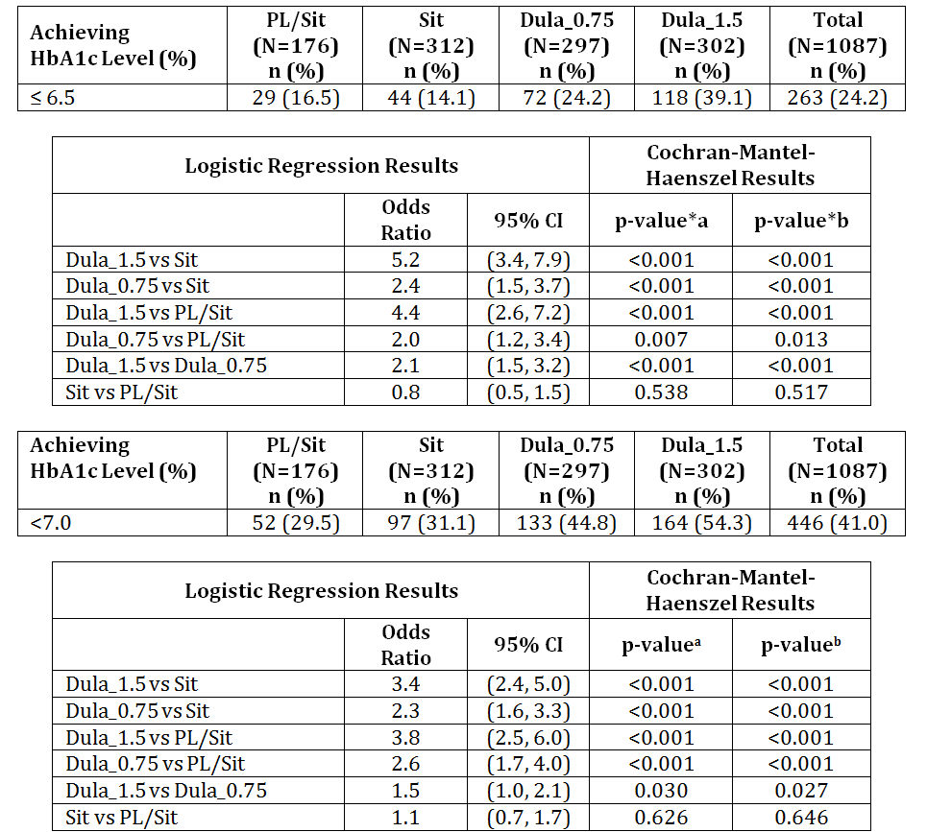
CI = confidence Interval; HbA1c = Haemoglobin A1c; LOCF = Last Observation Carried Forward; N = number of patients with HbA1c 24 months LOCF endpoint value in specified treatment arm; n = number of patients in the specified category; vs = versus.
Note: Dula_x.x refers to x.x milligrams dulaglutide once weekly; PL/Sit = placebo for the first 6 months and Sitagliptin after 6 months; Sit = Sitagliptin.
a – pairwise comparison p-values from logistic regression model: Achieving a specified HbA1c level = Baseline + Country + Treatment;
b – pairwise comparison p-values are from Cochran-Mantel-Haenszel test adjusted for country.
Figure 9: Study GBCF: Percent of patients achieving HbA1c ≤ 6.5% at 6, 12, and 24 months.
HBA1c = haemoglobin A1c; LOCF = last observation carried forward; N = number of patients in specific treatment arm with non-missing HbA1c at baseline or at LOCF endpoints; n = number of patients in specified treatment arm with HbA1c achieving target of ≤ 6.5%.
Percentage has been calculated as (n/N) = 100

Durability and sustainability of glycaemic control
The line plot, Figure 7, and forest plot of treatment differences over time, Figure 8, illustrate the durable effect of both dulaglutide doses on mean change from baseline in HbA1c. This was supported by the statistical analyses of the durability of the mean reduction in HbA1c over time.

HbA1c by subgroups
Subgroup analyses of HbA1c were conducted based on sex, baseline age ( < 65 years, ≥ 65 years), median duration of diabetes at baseline ( < 6 years, ≥ 6 years), baseline BMI ( < 30 kg/m2, ≥ 30 kg/m2), race (Caucasian, Non-Caucasian), and country for ITT patients assigned to the primary treatment arms during Stage 1 or Stage 2 randomisation. Significant interactions (p≤0.10) at the time points assessed were not observed in any of the subgroups.

Fasting Plasma Glucose Change from Baseline
Mean baseline fasting plasma glucose values were similar between each treatment arm. A near maximum reduction in mean FPG was observed after 2 weeks of treatment for dulaglutide 1.5 mg and dulaglutide 0.75 mg treatment arms with an LS mean [SE] change from baseline of -2.37 mmol/L [0.10] and -1.65 mmol/L [0.10], respectively, with only modest changes thereafter.
The maximum reduction in mean FPG in the sitagliptin arm was demonstrated after 1 month (-1.18 mmol/L [0.10]) and in the placebo arm after 6 months (-0.49 mmol/L [0.16]).
Significant differences (p < 0.001) were observed between both dulaglutide groups (1.5 mg and 0.75 mg doses) and sitagliptin.
Figure 9: Study GBCF: Fasting plasma glucose change from baseline versus time - ITT population.
LS mean = least square mean; MMRM = mixed effects model for repeated measures; REML = restricted maximum likelihood; SE = standard error.
Note: Dula_x.x refers to x.x milligrams dulaglutide once weekly; PL/Sit = placebo for the first 6 months and Sitagliptin after 6 months.
Point estimates and CI are from REML based MMRM model; Dependent variable = treatment + baseline + country + visit + treatment*visit where patient treated as a random effect. Covariance structure = unstructured.

Effect on insulin sensitivity (HOMA2-S[%]) and beta cell function (HOMA2-B[%])
Beta cell function, as estimated by HOMA2-B(%) at 12 months, was increased numerically in all treatment groups. The largest LS mean (SE) change from baseline was observed in the dulaglutide 1.5 mg treatment arm (33.57% [2.51]); dulaglutide 0.75 mg (22.30% [2.47]); sitagliptin (6.66% [2.53]). In the LS mean difference pairwise comparisons, the differences observed at 12 months between dulaglutide 1.5 mg and 0.75 mg treatment arms and sitagliptin were significant (p < 0.001).
At 12 months, insulin sensitivity estimated by HOMA2-S(%) numerically increased in all treatment groups, with the dulaglutide 1.5 mg treatment arm experiencing the greatest mean increase. The LS mean [SE] changes observed were dulaglutide 1.5 mg (4.25% [2.35]); dulaglutide 0.75 mg (2.28% [2.32]); sitagliptin (4.69% [2.35]). No statistically significant differences were observed among the treatment groups in the pairwise comparison analyses.
The changes in HOMA2-S(%) and HOMA2-B(%) observed at 6 months and 24 month endpoints were consistent with the results observed at 12 and 24 months. Both dulaglutide arms were associated with significantly greater effect on HOMA2-B(%) versus placebo at the end of the placebo-controlled period at 6 months (p < 0.001, for both). Change in HOMA2-S(%) was similar in dulaglutide 1.5 mg and placebo arms, and significantly greater for placebo versus dulaglutide 0.75 mg arm (p = 0.026).

Body weight
Change from baseline in body weight in patients treated with dulaglutide 1.5 mg were consistently greater compared to sitagliptin up to 24 months (LS Mean difference range -1.14 kg to -1.72 kg) and compared to placebo at 6 months; dulaglutide 0.75 mg treatment was associated with a greater decrease in body weight than placebo and sitagliptin, but the magnitude of the between treatment difference was smaller than with dulaglutide 1.5 mg treatment.

PK/PD - Efficacy
Clear dose-exposure-response relationships were well characterised for HbA1c and weight using PK/PD models developed. The model predicted robust HbA1c response to dulaglutide following 0.75 mg dose with an additional ~0.2% reduction following 1.5 mg dose. The model predicted maximum weight loss was achieved following dulaglutide dose at ≥ 1 mg. Body weight and dose had significant influence on the PK of dulaglutide.

Study H9X-MC-GBDA
A Randomised, Placebo-Controlled Comparison of the Effects of Two Doses of LY2189265 or Exenatide on Glycaemic Control in Patients with Type 2 Diabetes on Stable Doses of Metformin and Pioglitazone
(AWARD-1: Assessment of Weekly Administration of LY2189265 in Diabetes-1)

Study design, objectives, locations and dates
A 12 month, phase III, outpatient, parallel group, placebo controlled, active comparator study conducted at 99 centres in 3 countries (USA, Mexico and Argentina) from February 2010 and May 2012.
The study consisted of 4 periods: a 12 week lead in period during which all patients were required to take metformin and pioglitazone in maximally tolerated doses; a 26 week initial (dulaglutide vs placebo) treatment period followed by a 26 week safety treatment period; and a 4 week safety follow up period.
Primary Objective: To demonstrate the superiority of once-weekly dulaglutide 1.5 mg injected SC versus placebo on HbA1c change from baseline at 26 weeks in patients with T2DM who were taking maximally tolerated doses of metformin and pioglitazone.
Secondary Objectives:
- To compare glycaemic control (as measured by change in HbA1c from baseline) between dulaglutide (1.5 mg and 0.75 mg), exenatide, and placebo to demonstrate that:
  - Dulaglutide 1.5 mg is non-inferior to exenatide at 26 and 52 weeks
  - Dulaglutide 0.75 is superior to placebo at 26 and 52 weeks
  - Dulaglutide 1.5 mg is superior to exenatide at 26 and 52 weeks
  - Dulaglutide 0.75 mg is non-inferior to exenatide at 26 and 52 weeks
  - Dulaglutide 0.75 mg is superior to exenatide at 26 and 52 weeks
- To compare the effect of dulaglutide 0.75 and 1.5 mg, exenatide at 26 and 52 weeks and placebo at 26 weeks
  - Change in body weight and BMI from baseline
  - Blood glucose using self-monitored plasma glucose(SMPG) (actual values and change from baseline)
  - Patient reported outcomes at 26 weeks and 52 using QOL questionnaires
- To characterise the safety of dulaglutide 0.75 and 1.5 mg, exenatide, and placebo with respect to N Terminal pro Brain Natriuretic Peptide (NT-proBNP)
- To characterise the PK of dulaglutide and the relationship between dulaglutide exposure and safety and efficacy measures

Inclusion and exclusion criteria
Male and female (non-pregnant) patients aged ≥ 18 years with T2DM treated with maximally tolerated concomitant OAMS, metformin and pioglitazone; patients on monotherapy with HbA1c ≥ 7.0% and ≤ 11% at baseline, and patients on combination OAM therapy (2 or 3 agents) with HbA1c ≥ 7.0% and ≤ 10%; stable weight for ≥ 3 months prior to screening and a BMI of 23-45 kg/m2, inclusive.

Study treatments
Patients were randomised to either dulaglutide 0.75 mg or 1.5 mg or placebo given as weekly SC injection or exenatide 5µg twice daily for 4 weeks and then 10 µg twice daily for 48 weeks. In all treatment arms, patients also took metformin (up to 2550 mg/day or the highest tolerated local allowed dose) and pioglitazone (up to 45 mg/day or highest tolerated local allowed dose) throughout the lead in and treatment periods.
After the 26 week double blind treatment period, patients allocated to placebo were randomised to dulaglutide 0.75 or 1.5 mg for the remainder of the study.

Efficacy variables and outcomes
- The primary efficacy outcome was the change in HbA1c from baseline at 26 weeks.
- The non-inferiority (NI) margin was set at 0.4%.
- Other efficacy outcomes included:
- Change in HbA1c, body weight, fasting blood glucose (FBG), SMPG profile at 26 and 52 weeks
- Proportion of patients achieving HbA1c < 7% and ≤ 6.5%
- Indices of insulin sensitivity and beta cell function, HOMA2-S and HOMA2-B (calculated using FSG and fasting insulin concentrations

Randomisation and blinding methods
Patients were randomised to 1 of the 4 treatment arms, following a 2:2:2:1 ratio (dulaglutide 1.5 mg:dulaglutide 0.75 mg:exenatide:placebo) according to a computer-generated random sequence using an IVRS. Patients were also stratified by country (to achieve between group comparability within countries) and by baseline HbA1c ( ≤ 8.5, > 8.5) to achieve between-group comparability within countries and to mitigate against confounding the effects of treatments with severity of disease.
This study included an initial treatment period which was open-label to comparator and double blind to dulaglutide dose assignment and placebo (26 weeks), followed by a safety treatment period with 1:1 dulaglutide dose re-assignment of patients on placebo (26 weeks).

Analysis populations
ITT population: Defined as all randomised patients who have taken at least 1 dose of study medication. Patients who received rescue medication were included in the ITT population, but only measurements obtained prior to the beginning of rescue therapy were included in efficacy analyses, including the primary analysis.
PP population: Defined as all randomised patients who completed the study through 26 weeks, had an overall compliance with study treatment across visits of at least 75%, and had no other significant protocol violations.
Safety population: same as ITT population.

Sample size
With a sample size of 140 patients per treatment group (dulaglutide or placebo), a 0.54% mean change in HbA1c value was expected to be detected between any dulaglutide treatment group and the placebo treatment group with a power of 90% when the SD = 1.3%. This assumed an 11% dropout rate at 26 weeks, and was based on a 2-sided test with 0.05 alpha level. The required number of completers was 124 per arm (dulaglutide or placebo). To show non-inferiority of the dulaglutide arm to exenatide with 93% power, 280 patients per arm (dulaglutide or exenatide) were required. This calculation assumed a zero difference in HbA1c between the dulaglutide 1.5 mg arm and exenatide, 0.40% margin of non-inferiority, common SD = 1.3%, 0.05 two-sided significance level, and an 11% dropout rate at 26 weeks. The required number of completers at 26 weeks was 249 per arm (dulaglutide or exenatide).

Statistical methods
The primary statistical analysis for the primary objectives was based on an ANCOVA of the change from baseline in HbA1c with fixed effects for treatment, country, and baseline HbA1c as a covariate. Last-observation-carried-forward (LOCF) was used to impute missing post baseline values. Superiority of dulaglutide 1.5 mg relative to placebo for HbA1c was to be demonstrated if the upper limit of the 95% confidence interval for the difference between dulaglutide 1.5 mg and placebo was below 0.
The analyses for the primary efficacy measure of HbA1c change from baseline at 26 weeks examined the following 6 ordered null hypotheses of no treatment effect (the primary and key secondary objectives), using a gatekeeping strategy to control the family-wise Type I error rate:
- H1: 1.5 mg dose of dulaglutide is not superior to placebo.
- H2: 1.5 mg dose of dulaglutide is inferior to exenatide.
- H3: 1.5 mg dose of dulaglutide is not superior to exenatide.
- H4: 0.75 mg dose of dulaglutide is not superior to placebo.
- H5: 0.75 mg dose of dulaglutide is inferior to exenatide.
- H6: 0.75 mg dose of dulaglutide is not superior to exenatide
The 5 families were tested sequentially beginning with F1. Hypothesis H2 in Family F2 was tested only if Hypothesis H1 in Family F1 was rejected. All p-values in this strategy were 1-sided p-values. The gatekeeping procedure controlled the family-wise Type I error rate at a 1-sided 0.025 level.
The actual measurement and change from baseline for FSG, SMPG, fasting insulin concentrations, and beta cell function, as measured by HOMA2, of which estimates of steady-state beta cell function (HOMA2-B), insulin resistance (HOMA2-IR), and insulin sensitivity (HOMA2-S) were summarised at each visit. Change from baseline at 26 weeks was analysed using a repeated-measures model similar to that used for the primary efficacy variable with the covariate being the corresponding baseline value. For the categorical variables measured, frequency and percents by treatment group were presented and the treatment arms were compared using a Cochrane Mantel Haenszel (CMH) test. For HbA1c at 26 weeks, the proportion of patients who had an HbA1c of < 7.0% and ≤ 6.5% were analysed with a logistic regression model. The model included country, treatment, and baseline HbA1c.

Participant flow
Figure 10: Study GBDA: Participant flow.
Dula = dulaglutide; ITT = intent-to-treat; N = number of patients; Wks = weeks.

Major protocol violations/deviations
Overall, there was no significant difference between treatment groups (p = 0.068) in the number of patients who had at least 1 protocol violation. The only protocol violation for which there was a significant treatment group difference was use of excluded anti-diabetic medication during the study which was highest in the placebo group. The most frequent protocol violation was a time between Visit 3 and Visit 5 that was < 8 weeks ± 7 days.

Baseline data
The treatment groups were similar with respect to demographic characteristics at baseline, with no statistically significant differences observed for any characteristic. The mean patient age was 55.7 years; 41.6% were female and 58.4% male; 74.4% were white; and 33.9% were Hispanic or Latino. The mean weight was 96.0 kg and mean BMI was 33.2 kg/m2. The mean duration of diabetes was 8.8 years; 52.2% were in the category median duration of diabetes ≥8 years; and mean HbA1c at baseline (Visit 5) was 8.07%. The majority (80.7%) of patients were enrolled in the US.

Results for the primary efficacy outcome
The primary efficacy measure of this study was HbA1c change from baseline at 26 weeks; the primary comparison was once-weekly dulaglutide 1.5 mg, injected subcutaneously, versus placebo in patients with T2DM who were taking metformin and pioglitazone.
Treatment with dulaglutide 1.5 mg resulted in an LS mean (SE) reduction of -1.51% (0.06) compared to -0.46% (0.08) for placebo and -0.99% (0.06) for exenatide, and dulaglutide 0.75 mg resulted in a reduction of -1.30% (0.06); each of these reductions was statistically significant (p < 0.001).

Table 6: Study GBDA: HbA1c (%) for primary and gated secondary objectives ANCOVA using LOCF at 26 Weeks and 52 Weeks.
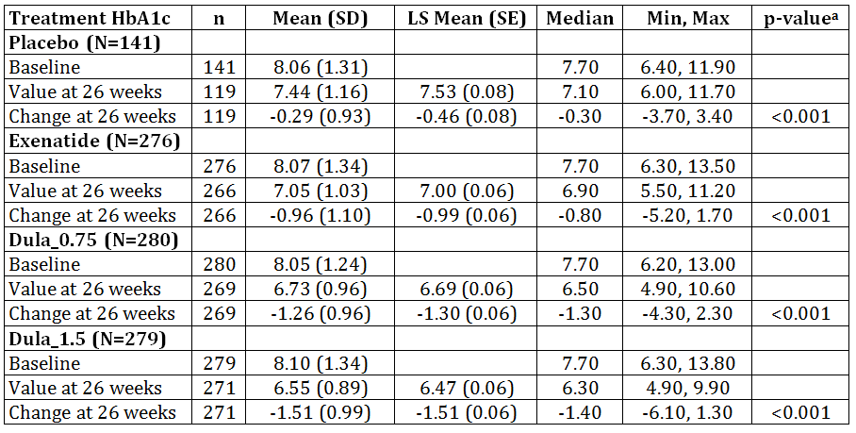
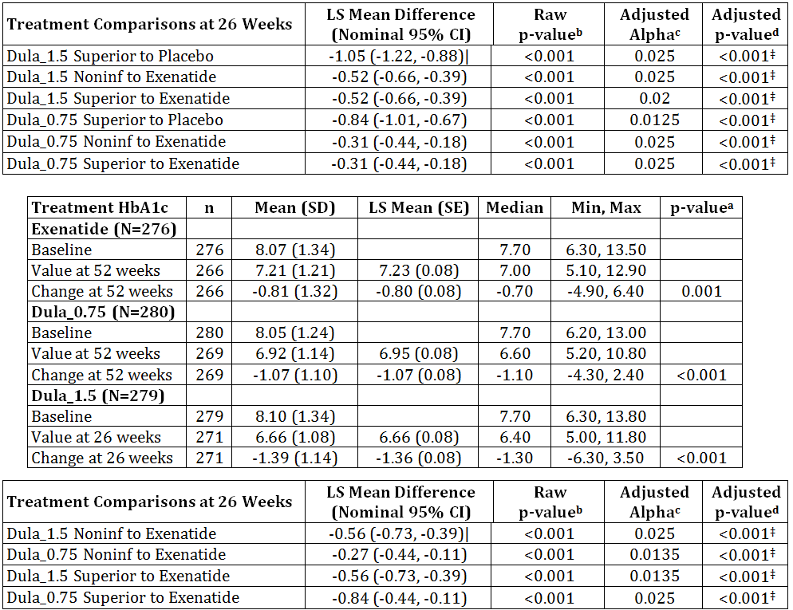
ANCOVA = analysis of covariance; CI = confidence interval;HbA1c = Hemoglobin A1c; LOCF = last observation carried forward; LS Mean = least-squares mean; Max = maximum; Min = minimum; N = total number of patients in specified treatment group; n = number of patients in specified category; NA = not applicable; Noninf = noninferior; SD = standard deviation; SE = standard error.
Note: Dula_x.x refers to x.x milligrams dulaglutide once weekly.
Confidence intervals, p-values based on ANCOVA model:
Dependent Variable = Country + Baseline + Treatment (Type III sums of squares).
a - Within group 2-sided p-values are from t-tests on LS Mean change from baseline.
b – 1-sided raw p-value (no multiplicity adjustment).
c, d – alpha level and 1-sided p-value adjusted for multiplicity, based on tree-gatekeeping strategy.
‡ - significant at family-wise 1-sided Type I error of 0.025 level
Figure 11: Study GBDA: Plot of HbA1c (%) change from baseline to 52 weeks without post-rescue visits, MMRM LS mean ± SE by treatment group, ITT population.
LS mean = least square mean; MMRM = mixed effect model for repeated measures; REML = restricted maximum likelihood; HbA1c = Haemoglobin A1c; SE = standard error.
Note: Dul_x.x refers to x.x milligrams dulaglutide once weekly
REML based MMRM model: change from baseline = baseline + country + visit + treatment*treatment where patient treated as a random effect. Covariance structure = unstructured.
Using the pre-specified tree-gatekeeping strategy with family-wise 1-sided alpha of 0.025, the primary and all key secondary objectives were met based on the primary analysis, leading to the conclusion that dulaglutide 1.5 mg is superior to placebo and superior to exenatide; and that dulaglutide 0.75 mg is superior to placebo and superior to exenatide.

Results for other efficacy outcomes

HbA1c at 52 weeks
At Week 52, patients in the dulaglutide 1.5-mg and dulaglutide 0.75-mg treatment groups had a significantly greater LS mean reduction from baseline in HbA1c of -1.39% (SE: 0.08) and -1.07% (SE: 0.08), respectively, compared to -0.80% (SE: 0.08) for exenatide.

Percent of patients achieving HbA1c of < 7 and ≤ 6.5%
The percentage of patients achieving a target HbA1c < 7% and ≤ 6.5% at Weeks 26 and 52 was greater in the dulaglutide 1.5-mg group, followed by the dulaglutide 0.75-mg group, compared with exenatide and placebo.
Table 7: Study GBDA: Summary of patients achieving HbA1c Levels < 7 and ≤ 6.5% at 26 and 52 weeks by treatment group and visit without post-rescue visits - ITT population.

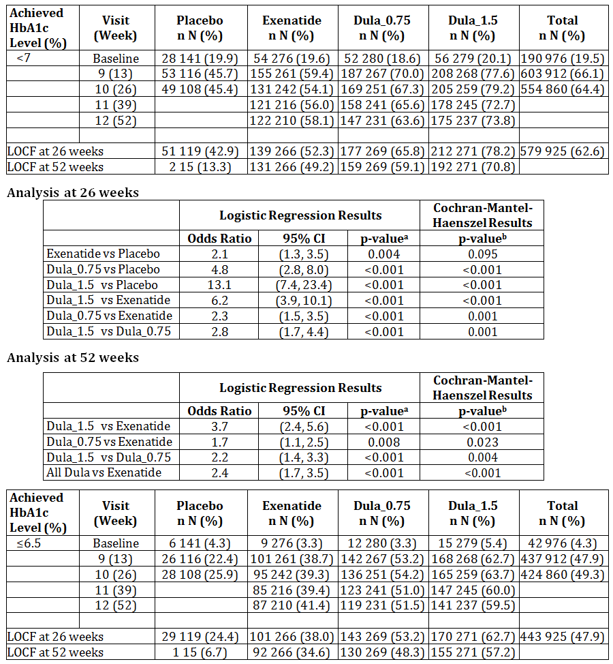
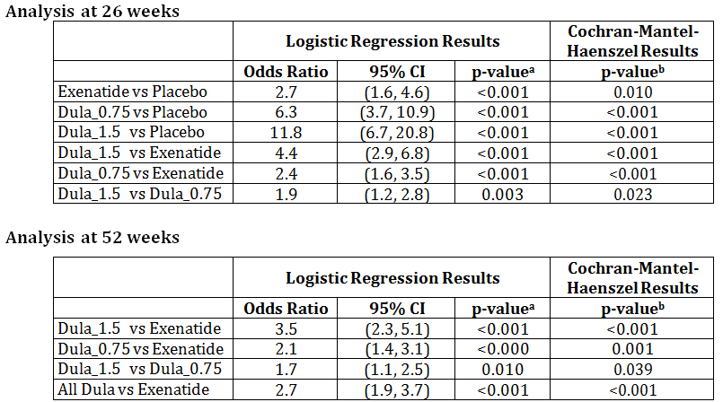
HbA1c = haemoglobin A1c; N = number of patients with non-missing HbA1c value in specified visit and treatment group; n = number of patients in the specified category.
Note: Dula_x.x refers to x.x milligrams dulaglutide once weekly.
a – pairwise comparison p-values from logistic regression model. Achieving a specified HbA1c level = Baseline + Country + Treatment.
b – pairwise comparison p-values are from Cochran-Mantel-Haenszel test.

Fasting serum glucose (FSG)
Significant LS mean decreases from baseline in FSG were observed in both dulaglutide treatment groups and the exenatide group compared to placebo beginning at Week 2, which increased through Week 26 (p < 0.001, all), with the largest reduction in the dulaglutide 1.5-mg group. At Week 52, the largest LS mean decreases from baseline were also observed in the 2 dulaglutide groups, and they were statistically significant when compared to exenatide (p ≤ 0.005, both).
Figure 12: Study GBDA: Plot of fasting blood glucose change from baseline to 52 weeks without post-rescue visits, MMRM LS means ± SE by treatment group, ITT population.

8-Point Self-Monitored Plasma Glucose Profiles (SMPG)
Similar to HbA1c, in comparison with exenatide, significant changes were observed for both dulaglutide groups at 26 weeks (p ≤ 0.038, both) and for dulaglutide 1.5 mg at 52 weeks (p = 0.004) in the mean of all 8-point SMPG values, and for dulaglutide 1.5 mg at 26 weeks (p = 0.047) in the mean of all postprandial plasma glucose values from the 8-point profile. The decreases observed in the mean fasting SMPG values were similar to those observed with FSG.

Beta Cell Function and Insulin Sensitivity (HOMA2)
The analyses of fasting insulin concentration showed increases from baseline in LS mean insulin concentration observed at 26 and 52 weeks in both dulaglutide treatment groups and the exenatide group, with the largest increases at both endpoints in the dulaglutide 1.5-mg group. However these changes were not significant for either dulaglutide group when compared to placebo or exenatide.
No statistically significant changes from baseline were observed in the dulaglutide or exenatide treatment groups from baseline to 26 or 52 weeks for either HOMA2 –S or HOMA2-IR.

Body weight
At 26 weeks both dulaglutide groups and exenatide were significantly different from placebo (p ≤ 0.010). At 26 and 52 weeks dulaglutide 1.5 was not significantly different to exenatide but was significantly different to dulagluide 0.75 (p < 0.001).

Figure 13: Study GBDA: Plot of weight change from baseline to 52 weeks without post-rescue visits, ANCOVA (LOCF) LS mean ± SE by treatment group, ITT population.
ANCOVA = analysis of Covariance; kg = kilogram; LS mean = least squares mean; LOCF = last observation carried forward; SE = standard error.
Note: Dula_x.x refers to x.x milligrams of dulaglutide once weekly.
ANCOVA model: change = baseline+country+treatment

Quality of life assessments
Statistically significant improvements from baseline in LS mean scores were observed in IW-SP (26 and 52 weeks, all groups) and total DTSQ scores (26 weeks, all active treatment groups; 52 weeks, both dulaglutide groups). A statistically significant decrease in frequency of perceived hyperglycaemia (all groups) was observed at 26 and 52 weeks, but an increase in perceived hypoglycaemia was observed with exenatide at 26 and 52 weeks. Improvement in total DTSQ and perceived hyperglycaemia scores were greater in both dulaglutide groups versus exenatide. The EQ-5D visual analogue scale (VAS) score showed significant improvements for all active treatment groups at 26 and 52 weeks. No significant changes were observed in IW-ADL and EQ-5D index scores for any group.

Study H9X-MC-GBDB
A Randomised, Open-Label, Parallel-Arm, Non-inferiority comparison of the effects of two doses of LY2189265 and insulin Glargine on Glycaemic Control in Patients with Type 2 Diabetes on Stable Doses of Metformin and Glimepiride.
(AWARD-2: Assessment of Weekly AdministRation of LY2189265 in Diabetes-2)

Study design, objectives, locations and dates
A multicentre, parallel arm, randomised, 78 week study conducted at 87 study sites in 20 countries (Mexico, Canada, Argentina, Brazil, India, Belgium, France, Czech Republic, Hungary, Slovakia, Romania, Spain, Croatia, Poland, Italy, Sweden, Greece, Australia, Korea and Taiwan) from May 2010 to November 2012. The study consisted of a 10 week lead in period, a 52 week treatment period, a 26 week extended treatment period and a 4 week safety follow up period.

Figure 13: Study GBDB: Study design.
* All patients start metformin and glimepiride during the lead in period and continue for duration of trial.
T1, T2, T3: on weeks 1, 3 and 6, study sites will contact patients by phone per Study Schedule of Events
** The period between Visit 3 and 4 may be decreased to 1 week for patients already on stable, maximum doses of metformin and glimepiride.
Primary objective: to compare the effect of once weekly dulaglutide 1.5 mg injected SC to that of insulin glargine (titrated to target) on HbA1c at 52 weeks (change form baseline) in patients with T2DM who are taking metformin and glimepiride.
Secondary objectives:
- to demonstrate that for HbA1c (change from baseline):
  - dulaglutide 0.75 mg was non-inferior to insulin glargine at 26, 52 and 78 weeks
  - dulaglutide 1.5 mg was superior to insulin glargine at 26, 52 and 78 weeks
  - dulaglutide 0.75 mg was superior to insulin glargine at 26, 52 and 78 weeks
  - dulaglutide 1.5 mg was non-inferior to insulin glargine at 26 and 78 weeks
- to compare the efficacy of dulaglutide 1.5 mg and 0.75 mg and insulin glargine with respect to the following at 26, 52 and 78 weeks:
  - FSG, SMPG, percent of patients attaining HbA1c < 7% and ≤ 6.5%, QOL outcomes
- to compare the efficacy of dulaglutide 1.5 mg and 0.75 mg and insulin glargine with respect to the following at 52 and 78 weeks:
  - glucagon, HOMA2-%B, HOMA2-%S
- safety assessment

Inclusion and exclusion criteria
Inclusion:
Patients enrolled in this study were male and non-pregnant female patients aged ≥ 18 years that were diagnosed with T2DM not optimally controlled with 1, 2, or 3 OAMs (at least 1 of which must have been metformin or a sulfonylurea). Their Visit 1 HbA1c was to be:
- ≥ 7% and 11% if on OAM monotherapy for 3 months before screening AND on the minimal monotherapy required dose or higher at Visit 1 (metformin 1500 mg; glimepiride 4 mg; for other sulfonylureas, the minimal required dose must have been at least 50% of the recommended maximum daily dose) OR
- ≥ 7 and ≤ 10% if on 2 or 3 OAMs for 3 months before screening; other allowed OAMs were dipeptidyl peptidase-4 (DPP-IV) inhibitors, thiazolidinediones, glinides and alpha-glucosidase inhibitors.
They must also have accepted treatment with metformin and glimepiride throughout the trial, as required per protocol, had stable weight (±5%) for at least 3 months, and had a BMI between 23 kg/m2 and 45 kg/m2, inclusive.
Exclusion:
Visit 4 HbA1c ≤ 6.5%; Type 1 diabetes mellitus; Chronic insulin therapy at any time in the past or therapy with any GLP-1 receptor agonist in the 3 months prior to Visit 1; serious diabetes-related or other health concerns or risks, including cardiovascular disease, significant gastric-emptying abnormality, acute or chronic liver disease, acute or chronic pancreatitis and significant renal impairment.

Study treatments
This study involved a comparison of 2 doses of dulaglutide (1.5 mg and 0.75 mg), given as a once-weekly subcutaneous injection, with insulin glargine titrated-to-target given as a once-daily SC injection in patients with T2DM on metformin and glimepiride (metformin: at least 1500 mg/day, but not higher than the maximum approved dose in the local label in participating countries; glimepiride: at least 4 mg/day, but not higher than the maximum approved dose in the local label in participating countries.
Patients started insulin glargine treatment with a single subcutaneous injection of 10 IU at the time of day agreed upon between the patient and the investigator, typically before bedtime. The dose was adjusted every 3 to 4 days during the first 4 weeks after randomisation, and then weekly if required, according to the dosing algorithm and targeting an FPG <5.6 mmol/L through the treatment period (78 weeks).

Efficacy variables and outcomes
The primary efficacy outcome was change from baseline at 52 weeks.
Non-inferiority of dulaglutide 1.5 mg relative to insulin glargine for HbA1c was demonstrated if the upper bound of the 2-sided 95% confidence interval (CI) for the difference between dulaglutide and insulin glargine was below the margin of non-inferiority of 0.4%.
Other efficacy outcomes included:
- Change in HbA1c at other times
- Percentage of patients achieving HbA1c of < 7% or ≤ 6.5%
- FSG and 8 point SMPG
- body weight
- beta cell function and insulin sensitivity as estimated by HOMA2-%B and HOMA1-%S and glucagon

Randomisation and blinding methods
Patients were randomised to 1 of the 3 treatment arms at Visit 5 following a 1:1:1 ratio according to a computer-generated random sequence using an interactive voice response system (IVRS). Randomisation was stratified by country and baseline HbA1c ( ≤ 8.5%, > 8.5%) to achieve between-group comparability and to mitigate against confounding the effects of treatments with severity of disease.
This was an open-label study for insulin glargine, but it was double-blind with respect to dulaglutide dose assignment.

Analysis populations
Intent-to-treat (ITT) population: defined as all randomised patients who took at least 1 dose of study medication. Patients who received rescue medication were included in the ITT population, but only measurements obtained prior to the beginning of rescue therapy were included in all efficacy analyses, including the primary analysis. N = 807 patients.
Per-protocol (PP) population: defined as all randomized patients who completed the study through 52 weeks (78 weeks for the secondary efficacy analysis) of active treatment, have an overall compliance with study treatment across visits (for assessment of between visit compliance) of at least 75%, and have no other significant protocol violations. N = 651 patients.
Safety Population: same as ITT population. N = 807 patients.

Sample size
To show non-inferiority of the dulaglutide 1.5 mg arm to insulin glargine with 90% power, 279 patients per arm were required. This calculation assumed a zero difference in HbA1c between the dulaglutide 1.5 mg arm and insulin glargine, 0.40% margin of non-inferiority, common SD = 1.3% for HbA1c, 0.05 2-sided significance level, and 20% dropout rate at 52 weeks. The required number of completers was 223 per arm.

Statistical methods
The primary statistical analysis model was an analysis of covariance (ANCOVA) of the HbA1c change from baseline to primary endpoint at Week 52 with fixed effects of treatment, country, and baseline HbA1c as covariates. Last-observation-carried-forward (LOCF) was used to impute missing post baseline values. The analysis for the primary efficacy measure of HbA1c change from baseline was based upon the ITT population. Measurements taken after initiation of rescue therapy were excluded.
Non-inferiority of dulaglutide 1.5 mg relative to insulin glargine for HbA1c was demonstrated if the hypothesis of inferiority at a margin of 0.4% was rejected with a nominal alpha of 0.025, 1 sided. The primary and key secondary objectives of HbA1c change from baseline at 52 weeks (Visit 14) were examined using a gatekeeping strategy to control the family-wise Type 1 error rate at a 1-sided 0.025 level. All p-values used in this testing strategy were 1-sided.
Secondary (sensitivity) analyses of the primary and gated key secondary objectives were conducted in the ITT population with a mixed-model repeated measures (MMRM) model, and in the Week 52 per protocol (PP) population with an ANCOVA on LOCF and with an MMRM model. The MMRM model included fixed effects of treatment, time, treatment-by-time, country, and baseline HbA1c as covariates, and a covariance structure for the measurements within each patient. The same gatekeeping strategy was used.

Participant flow
Figure 14: Study GBDB: Participant flow.
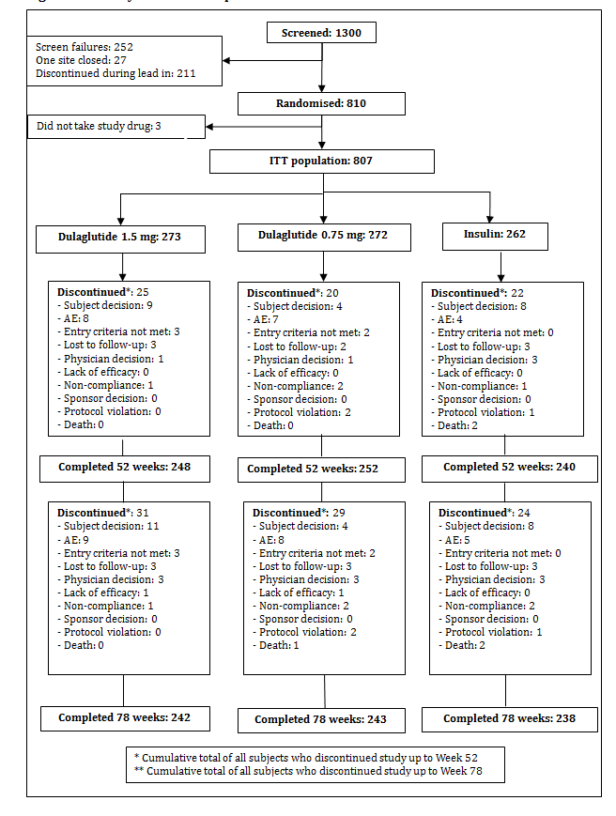

Major protocol violations/deviations
One site was terminated early due to significant violations in GCP compliance. The violations were noted during routine review of safety data and were confirmed at a quality audit. The patients enrolled were discontinued and excluded from any analysis.
The frequencies of patients with significant protocol deviations were balanced among the 3 arms. At 52 weeks, a total of 156 (19.3%) patients had at least 1 significant protocol deviation. At Week 52, the most frequent reasons for deviation were missing plasma HbA1c values at 52 weeks due to early termination and < 75% overall treatment compliance through 52 weeks. At Week 78, the most frequent reasons for deviation were: missing plasma HbA1c values at 52 weeks and < 75% overall treatment compliance.

Baseline data
Overall demographic and baseline characteristics in the ITT population were comparable between arms. The mean age for patients in the 3 arms was 57 years. In all groups, most patients were white (70.6%) and 51.3% were male. The mean HbA1c at baseline was 8.14% (SD = 0.99%), and the mean duration of T2DM was 9.10 years (SD = 6.04). Mean body weight (86.3 kg), BMI (31.6 kg/m2), sitting DBP (78.5 mm Hg), sitting SBP (131.1 mm Hg), and sitting HR (76.6 bpm) were similar for each arm. The majority (84.1%) of patients were previously treated with ≥ 2 OAMs.

Results for the primary efficacy outcome
The primary efficacy measure of this study was HbA1c change from baseline at 52 weeks; the primary comparison was once-weekly dulaglutide 1.5 mg, injected subcutaneously, versus insulin glargine (titrated-to-target) with a non-inferiority margin of 0.4% in patients with T2DM who were taking maximal and stable doses of metformin and glimepiride.
Treatment with dulaglutide 1.5 mg resulted in an LS mean (SE) HbA1c (%) change from baseline of - 1.08% (0.06) compared to -0.63% (0.06) for insulin glargine, and dulaglutide 0.75 mg resulted in a reduction of -0.76% (0.06); each of these reductions was significant (p < 0.001 for all). The LS means and nominal 95% CIs for the difference of dulaglutide 1.5 mg and 0.75 mg relative to insulin glargine at 52 weeks were: -0.45% (0.60, -0.29) and -0.13% (-0.29, 0.02), respectively. Dulaglutide 1.5 mg was non-inferior to insulin glargine at 52 weeks (adjusted 1-sided p-value < 0.001), meeting the primary objective of the study.

Table 8: Study GBDB: HbA1c (%) for primary and gated secondary objectives, ANCOVA Using LOCF at 26, 52, and 78 Weeks, intent-to-treat population without post-rescue values.

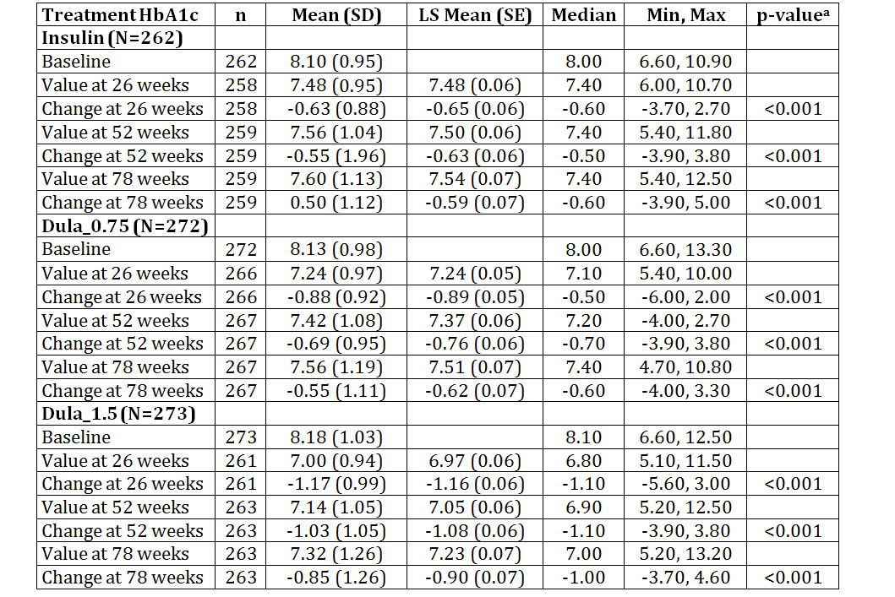
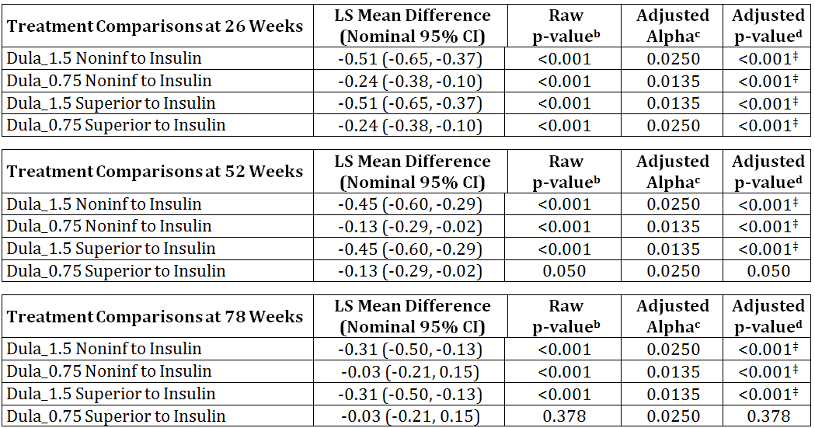
ANCOVA = analysis of covariance; CI = confidence interval; HbA1c = Haemoglobin A1c; LOCF = last observation carried forward; LS Mean = least-squares mean; Max = maximum; Min = minimum; N = total number of patients in specified treatment group; n = number of patients in specified category; NA = not applicable; Noninf = non-inferior; SD = standard deviation; SE = standard error.
Confidence intervals, p-values based on ANCOVA model:
Dependent Variable = Pooled Country + Baseline + Treatment (Type III sums of squares).
a - Within group 2-sided p-values are from t-tests on LS Mean change from baseline.
b – 1-sided raw p-value (no multiplicity adjustment).
c, d – alpha level and 1-sided p-value adjusted for multiplicity, based on tree-gatekeeping strategy.
‡ - significant at family-wise 1-sided Type I error of 0.025 level
Figure 15: Study GBDB: HbA1c change from baseline up to Week 78 (MMRM LS means ± SE).
LS mean = least squares mean; MMRM = mixed effect model for repeated measures; REML = restricted maximum likelihood; SE = standard error
Note: Dula_x.x refers to x.x milligrams of dulaglutide once weekly.
REML based MMRM model: change from baseline = baseline+pooled country+treatment+visit+visit*treatment where patient treated as a random effect, Covariance structure = unstructured.

Results for other efficacy outcomes
At 78 weeks, two of the three secondary objectives were met: dulaglutide 1.5 mg was superior to insulin glargine (adjusted p-value < 0.001 for superiority). Dulaglutide 0.75 was non-inferior to insulin glargine. Dulaglutide 0.75 mg was not superior to insulin (adjusted p-value = 0.050 for superiority). Sensitivity analysis supported these results.

Patients achieving HbA1c of < 7% and ≤ 6.5%
At Weeks 52 and 78, significantly greater percentages of patients in the dulaglutide 1.5 mg arm had HbA1c decreased to < 7% and ≤ 6.5% compared to insulin glargine. The comparisons for dulaglutide 0.75 mg to insulin glargine were generally not significant.
Table 9: Study GBDB: Patients achieving HbA1c of <7% and ≤6.5% at 26, 52 and 78 weeks
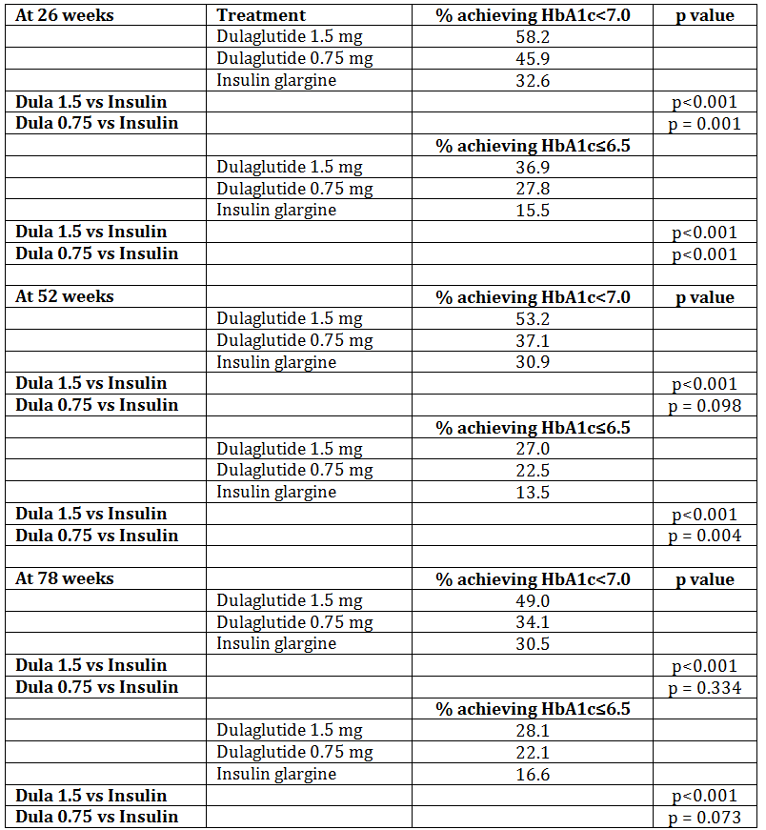
Dula = dulaglutide

Fasting serum glucose
In all arms, there was a reduction in FSG compared to baseline over the entire study treatment period. From Week 14 onward, insulin glargine and dulaglutide 1.5 mg each showed a similar decrease in FSG, and at Weeks 65 and 78, the decrease was significantly greater with insulin glargine than with dulaglutide 1.5 mg. From Week 20 through the end of the study, dulaglutide 0.75 mg showed a significantly smaller decrease than the other 2 arms.
Figure 16: Study GBDB: Fasting serum glucose from baseline up to Week 78 (LS mean [SE]).

Eight-Point Self-Monitored Plasma Glucose Profiles (SMPG)
At Weeks 52 and 78, SMPG measures at all time points decreased from baseline in all 3 arms. At Weeks 52 and 78, significantly greater decreases in SMPG were shown at the fasting time point (morning pre-meal) with insulin glargine compared to both dulaglutide doses, while in general, the evening time points showed greater decreases with dulaglutide 1.5 mg compared to insulin glargine.
Figure 17: Study GBDB: Eight-point SMPG profiles at baseline (Week 0) and Week 52; ITT population.

Βeta-Cell Function, Insulin Sensitivity, and Glucagon
Beta-cell function (HOMA2-%B and HOMA2-%S) at 52 and 78 weeks were evaluated for dulaglutide 1.5 mg and 0.75 mg only and not for insulin glargine patients, as the use of this model has not been validated in patients treated with insulin.
At 52 weeks, both insulin-based and C-peptide-based HOMA2-%B increased in both dulaglutide arms. When comparing the dulaglutide doses (1.5 mg and 0.75 mg), no significant differences in LS mean changes from baseline were observed for either. At 78 weeks, a significant difference in LS mean increases was observed for dulaglutide 1.5 mg compared to dulaglutide 0.75 mg for both insulin-based and C-peptide-based HOMA2-%B.
At 52 weeks, both insulin-based and C-peptide-based HOMA2-%S decreased from baseline. When comparing the dulaglutide doses (1.5 mg and 0.75 mg), no significant differences in LS mean changes from baseline were observed for either of them. At 78 weeks, no significant differences were observed for either insulin-based or C-peptide-based HOMA2-%S.
Table 10: Study GBDB: Summary of HOMA2-%B and HOMA2-%S Using MMRM at Baseline to Week 52 and Week 78; ITT Population

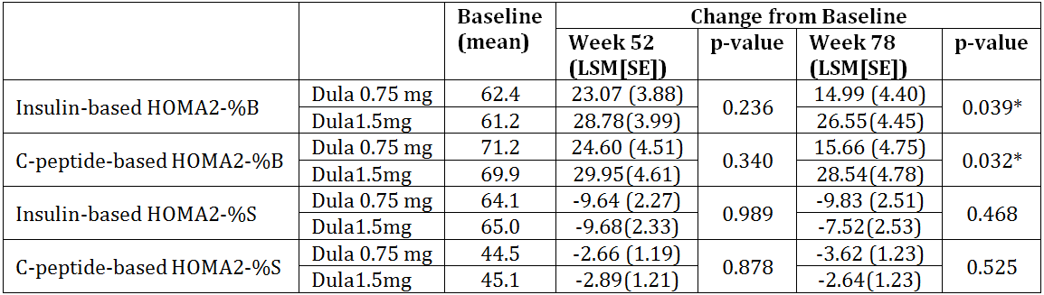
Dula = dulaglutide; HOMA2-%B = updated Homeostasis Model Assessment of beta-cell function;HOMA2-%S = updated Homeostasis Model Assessment of insulin sensitivity; LSM = least squares mean; SE = standard error.
*Significant at p < .050.

Fasting insulin
At 52 weeks, LS mean (SE) changes in fasting insulin were dulaglutide 1.5 mg, 18.11 (6.52) pmol/L and dulaglutide 0.75 mg, 17.14 (6.24) pmol/L. The comparison between arms was not significant (p = .896). At 78 weeks, LS mean (SE) changes in fasting insulin were dulaglutide 1.5 mg, 11.19 (6.53) pmol/L and dulaglutide 0.75 mg, 14.89 (6.34) pmol/L. The comparison between arms was not significant (p = .624).

Fasting glucagon
At 52 and 78 weeks there was no significant difference in fasting glucagon levels between either dulaglutide arm and the insulin glargine arm.

Body weight
Patients in the insulin glargine arm showed an increase in mean body weight and those in the dulaglutide arms showed a decrease, resulting in a mean difference between dulaglutide 1.5 mg and insulin of 3.3 kg at 52 weeks. The difference was less pronounced when comparing dulaglutide 0.75 mg to insulin glargine.
Figure 18: Study GBDB: Plot of body weight change from baseline versus time, MMRM LS Mean ± SE by treatment and visit from baseline to 78 weeks, ITT population without post-rescue values.
LS mean= least square mean; MMRM = mixed effects model for repeated measures; REML= restricted maximum likelihood; SE = standard error.
Dula_x.x refers to x.x mg dulaglutide once weekly.

Subgroup analyses
None of the subgroup analyses indicated a lack of dulaglutide effect in a particular subgroup. The subgroup analyses supported dulaglutide’s effect on HbA1c change and weight change in the subgroups considered.

QOL analyses
Consistent with the clinical data, during the treatment period, patients in the dulaglutide 1.5 mg arm experienced significant improvements from baseline in patient related outcomes. Mean improvement from baseline was greater with dulaglutide 1.5 mg compared to insulin glargine at Week 78 for the IW-SP, IW-ADL, LBSS worry and behaviour scores, and LBSS total score.

Study M9X-MC-GBDC
The Impact of Weekly Administration of LY2189265 versus Metformin on Glycaemic Control in Early Type 2 Diabetes Mellitus
(AWARD-3: Assessment of Weekly AdministRation of LY189265 in Diabetes-3)

Study design, objectives, locations and dates
A phase 3, multicentre, randomised, parallel arm, double blind, active comparator, non-inferiority monotherapy study conducted in 101 centres in 29 countries (Argentina, Brazil, Canada, Croatia, Czech Republic, Finland, France, Germany, India, Mexico, Poland, Puerto Rico, Romania, Slovakia, South Africa, South Korea, Spain, UK and USA) from May 2010 to June 2012.
Primary Objective: To demonstrate the effect of once weekly LY2189265 (dulaglutide) 1.5 mg injected SC, compared to metformin, on glycosylated HbA1c change from baseline at 26 weeks in patients with T2DM.
Secondary Objectives:
- To analyse using a sequential tree gate-keeping strategy to control the familywise Type 1 error, the change from baseline in HbA1c, to demonstrate that:
  - Dulaglutide 1.5 mg was superior to metformin at 26 weeks
  - Dulaglutide 0.75 mg was non-inferior to metformin at 26 weeks
  - Dulaglutide 075 mg was superior to metformin at 26 weeks
- To compare the effect of dulaglutide 1.5 and 0.75 mg and metformin with respect to the following at 26 and 52 weeks:
  - HbA1c change (52 weeks) and FSG
  - Percentage of patients achieving an HbA1<7% or ≤6.5%
  - 8 point SMPG profiles
  - Beta cell function and insulin sensitivity as estimated by HOMA2-B and HOMA2-S
  - Patient reported outcomes using range of QOL scales (IW-ADL, IW-SP, DTSQs and SDC-r)
  - Safety assessments
Figure 18: Study GBDC: Study design.
BID = twice weekly, LV = last visit.
*At the completion of Visit 1, patients who were previously treated with an oral antihyperglycaemic medication and were eligible were discontinued from their previous therapy, received diet and exercise training and blood glucose training, and were scheduled to return in 2 weeks to be randomised (Visit 2). All patients who were treatment naïve and were eligible were to receive diet and exercise training and blood glucose training and were scheduled to return in 2 weeks to be randomised (Visit 2).

Inclusion and exclusion criteria

Inclusion
Male and (non-pregnant) female patients ≥ 18 years who were diagnosed with T2DM for at least 3 months and ≤ 5 years, with a screening HbA1c ≥ 6.5 to ≤ 9.5%, who entered the study not optimally controlled by diet and exercise and either treatment naïve or on 1 oral antihyperglycaemic medication (OAM) (excluding thiazolidinediones) and had stable weight (± 5%) ≥ 3 months prior to screening (Visit 1) and a BMI between 23 kg/m2 and 45 kg/m2, inclusive. Patients on OAM monotherapy were on a dose ≤ 50% of the recommended maximum daily dose (per local label) at Visit 1 for ≥ 3 months.

Exclusion
Type 1 diabetes mellitus; 1 or more episodes of ketoacidosis or hyperosmolar state/coma requiring hospitalisation in the 6 months prior to Visit 1; chronic insulin therapy at any time in the past or therapy with any GLP-1 receptor agonist in the 3 months prior to Visit 1; chronic ( ≥ 14 days) systemic glucocorticoid therapy; serious diabetes-related or other health concerns or risks, including cardiovascular disease, significant gastric-emptying abnormality, acute or chronic liver disease, acute or chronic pancreatitis and significant renal impairment.

Study treatments
Patients were randomised to one of the following treatments:
- Dulaglutide 1.5 mg injected SC once weekly and placebo tablets
- Dulaglutide 0.5 mg injected SC once weekly and placebo tablets
- Metformin 2 x 500 mg tablets 2 times daily by mouth (total dose 2,000 mg/day) or 3 x 500 mg tablets (1,500mg/day) as tolerated by the patient and placebo injections

Efficacy variables and outcomes
The primary efficacy outcome was change from baseline in HbA1c at 26 weeks.
Non-inferiority of dulaglutide (1.5 mg) relative to metformin for HbA1c change was demonstrated if the upper bound of the two-sided 95% CI for dulaglutide minus metformin was below the non-inferiority margin of 0.4%.
Other efficacy outcomes included:
- change in HbA1c from baseline
- 8-point SMPG profile (actual values and changes from baseline)
- FSG (actual values and changes from baseline)
- percentage of patients achieving a target HbA1c < 7.0% or ≤ 6.5%
- indices of beta-cell function and insulin sensitivity using HOMA2-%B and HOMA2-%S
- fasting insulin, fasting C-peptide, fasting pro-insulin, fasting pro-insulin/insulin ratio, and fasting pro-insulin/C-peptide ratio
- changes from baseline in body weight and BMI

Randomisation and blinding methods
All eligible patients were enrolled at Visit 2 according to a computer-generated random sequence (1:1:1) utilising the IVRS to one of the 3 treatment groups. All patients in the study received both an injectable and an oral study agent to maintain treatment blinding: Patients could have received either 1 active injectable and 1 oral placebo agent or 1 placebo injectable and 1 oral active agent.

Analysis populations
ITT population: defined as all randomised patients who had taken at least 1 dose of study medication. For patients in the ITT population who received rescue medication, only measurements obtained prior to the beginning of rescue therapy were included in the efficacy analyses
Per Protocol (PP) population: defined as all randomised patients who completed the study through 26 weeks, had an overall compliance with study treatment across visits of at least 75% up to Visit 6, and had no other significant protocol violations.
Safety population: same as ITT population but all measurements, including those obtained after taking rescue medications, were included.

Sample size
To show non-inferiority of dulaglutide 1.5 mg to metformin with 90% power, 251 randomised patients per group were required. This calculation assumed a 0 difference in HbA1c change at 26 weeks between the dulaglutide 1.5 mg group and the metformin group, a non-inferiority margin of 0.4%, a common SD of 1.3%, a two-sided significance level of 0.05, and an 11% dropout rate at 26 weeks. The rationale to choose an SD of 1.3% was based on historical data and an effort to retain consistency throughout this study program. The required number of completers was 223 per group at 26 weeks; in total, 753 randomized patients were required. If the upper limit of the CI was below 0.4%, the dulaglutide 1.5 mg dose was declared non-inferior to metformin.

Statistical methods
A non-inferiority margin of 0.4% was selected based on clinical and statistical factors. In general, the difference between 2 glucose-lowering treatment strategies, that is <0.4% change in HbA1c, was considered acceptable because of the reported effect on long-term outcomes of diabetes, especially in the HbA1c range that was expected during the treatment period. Patients were stratified by country and prior OAM (not on OAM and on OAM prior to study entry). The primary analysis model was analysis of covariance (ANCOVA) for the change from baseline to endpoint, with treatment, country, and prior medication group (not on OAM versus on OAM) as fixed effects, and baseline value as a covariate. Missing endpoints were imputed with the last observation carried forward (LOCF) (for post baseline values only). The baseline data were not used as an endpoint. The analyses for the primary efficacy measure of HbA1c change from baseline at 26 weeks examined the 4 hypotheses (non-inferiority of both dulaglutide groups to metformin, and superiority of both dulaglutide groups to metformin) using a sequential tree gatekeeping strategy to control the familywise Type 1 error rate. The two-sided 95% CI for the least-squares mean (LS mean) difference between dulaglutide 1.5 mg and metformin in HbA1c at Week 26 (dulaglutide minus metformin) was computed from the model. The secondary analysis for the primary endpoint was a mixed-effects model for repeated measures (MMRM) analysis using restricted maximum likelihood, with treatment, country, prior medication group (not on OAM versus on OAM), visit, treatment by visit interaction as fixed effects, and baseline as a covariate. The Type III sums of squares was used to make the treatment comparisons.
The actual measurement and change from baseline for FSG, SMPG, fasting insulin concentrations, and beta-cell function as measured by HOMA2-%B and HOMA2-%S were summarised by treatment group and by visit. Changes from baseline for FSG, fasting insulin concentrations, and beta-cell function were analysed using a repeated-measures model, and changes from baseline for SMPG were analysed using an ANCOVA model. Both models were similar to that used for the primary efficacy variable, with the covariate being the corresponding baseline value. For continuous measures, summary statistics included sample size, mean, SD, median, minimum, and maximum for both the actual and the change from baseline measurements. Least-squares means and SEs derived from the model were displayed for the change from baseline. Treatment comparisons were displayed showing the treatment difference (dulaglutide minus metformin) LS mean and the 95% CIs of the treatment differences along with the p-value for the treatment comparison.
For categorical measures, summary statistics included sample size, frequency, and percentages. Unless otherwise noted, a chi-square test was used if at least 80% of cells had an expected number of events no less than 5; otherwise a Fisher's exact test was used. The proportions of patients who had an HbA1c of <7.0% or ≤6.5% were analysed with a logistic regression model that included country, treatment, and baseline HbA1c.

Participant flow
Figure 19: Study GBDC participant flow.
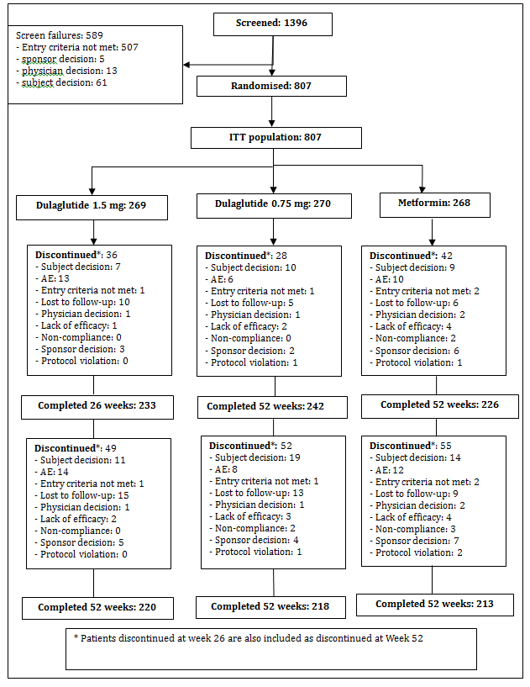

Major protocol violations/deviations
Two sites were discontinued during the study. One site in the USA was discontinued due to GCP concerns in a study of another Lilly compound. The sponsor discontinued all studies at this site. No concerns were raised about this trial and the patients from this site were included in the efficacy and safety analysis. The other site was in Argentina and was closed following concerns about patient eligibility that were detected and subsequently confirmed during a quality audit performed by the sponsor.
The main protocol violations related to compliance with medication and meeting entry criteria particularly details of OAM medication.

Baseline data
Overall, demographic and baseline characteristics in the ITT population were comparable between the treatment groups. The mean age overall was approximately 56 years. The majority of patients overall were white (74.3%) and female (56.3%). The mean (SD) HbA1c overall was 7.60% (0.87) and the mean (SD) duration of T2DM was 2.63 (1.83) years. Mean body weight was 92.3 kg, and mean BMI was 33.3 kg/m2. Mean seated DBP and SBP were 79.6 mm Hg and 129.6 mm Hg, respectively. The majority (75.1%) of patients were previously treated with an OAM.

Results for the primary efficacy outcome
The primary objective of the study was met: dulaglutide 1.5 mg was non-inferior to metformin. Least squares mean difference (95% CI) for dulaglutide minus metformin was -0.22% (-0.36%, -0.08%) adjusted p-value < 0.001 for non-inferiority.
Table 11: Study GBDC: HbA1c (%) for primary and gated secondary objectives, ANCOVA using LOCF at 26 weeks, ITT population without post rescue values
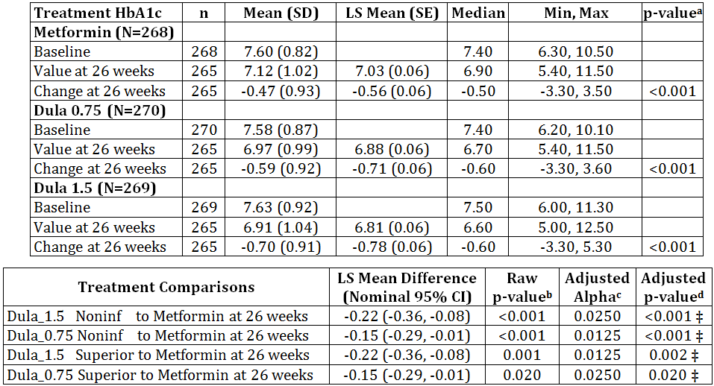
ANCOVA = analysis of covariance; CI = confidence interval; HbA1c = haemoglobin A1c; LOCF = last observation carried forward; LS Mean = least-squares mean; Max = maximum; Min = minimum; N = total number of patients in specified treatment group; n = number of patients in specified category; Noninf = non-inferior; OAM = oral antihyperglycaemic medication; SD = standard deviation; SE = standard error.
Note: Dula_x.x refers to x.x milligrams dulaglutide once weekly.
Confidence intervals, p-values based on ANCOVA model: Dependent Variable = Pooled Country + Baseline + Prior Medication group (previous OAM vs. no previous OAM) + Treatment (Type III sum of squares).
a - Within group 2-sided p-values are from t-tests on LS Mean change from baseline.
b – 1-sided raw p-value (no multiplicity adjustment).
c, *d – alpha level and 1-sided p-value adjusted for multiplicity, based on tree-gatekeeping strategy.
‡ - significant at familywise 1-sided Type I error of 0.025 level
Figure 20: Study GBDC: Plot of HbA1c (%) change from baseline versus time, MMRM LS means ± SE by treatment and visit from baseline to 52 weeks, ITT without post-rescue values.
HbA1c= haemoglobin A1c; LS mean = least squares mean, MMRM = mixed effects model for repeated measures; OAM = oral antihyperglycaemic medication; REML = restricted maximum likelihood; SE - standard error
Note: Dula_x.x refers t x.x milligrams dulaglutide once weekly
REML based MMRM model: change form Baseline = baseline +pooled country+prior medication group (previous OAM vs no previous OAM)+treatment+visit+treatment*visit (Type III sum of squares), where patient enters the model as a random effect. Covariance structure = unstructured.

Results for other efficacy outcomes
Key secondary objectives were met:
- Dulaglutide 1.5 mg was superior to metformin (adjusted p-value = 0.002 for superiority)
- Dulaglutide 0.75 mg was non-inferior to metformin (adjusted p-value < 0.001 for non-inferiority)
- Dulaglutide 0.75 mg was superior to metformin (adjusted p-value = 0.020 for superiority)
Similar results were observed in the PP population (ANCOVA) with the exception that dulaglutide 0.75 mg did not achieve superiority to metformin. Similarly, in the MMRM (ITT analysis), dulaglutide 0.75 mg did not achieve superiority to metformin.

HbA1c at 52 weeks
At 52 weeks, (ITT) using ANCOVA with LOCF, dulaglutide 1.5 mg was superior to metformin, and dulaglutide 0.75 mg was non-inferior to metformin in reduction from baseline of HbA1c.
Table 12: Study GBDC: HbA1c (%) for final gated secondary objectives, ANCOVA using LOCF at 52 weeks, ITT population without post rescue values.
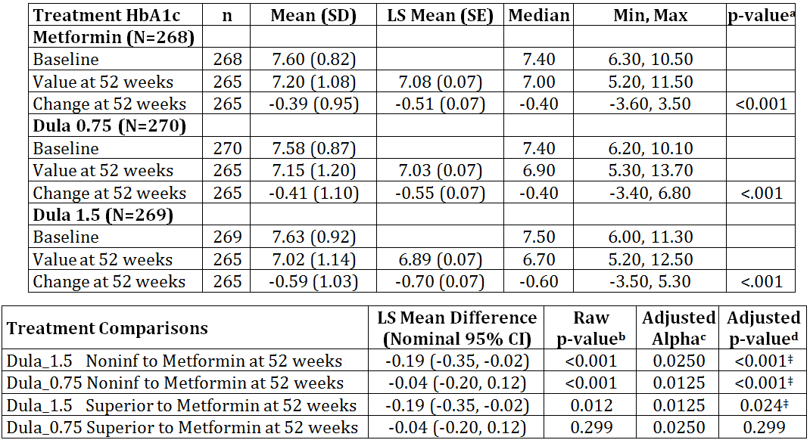
ANCOVA = analysis of covariance; CI = confidence interval; HbA1c = haemoglobin A1c; LOCF = last observation carried forward; LS Mean = least-squares mean; Max = maximum; Min = minimum; N = total number of patients in specified treatment group; n = number of patients in specified category; Noninf = non-inferior; OAM = oral antihyperglycaemic medication; SD = standard deviation; SE = standard error.
Note: Dula_x.x refers to x.x milligrams dulaglutide once weekly.
Confidence intervals, p-values based on ANCOVA model: Dependent Variable = Pooled Country + Baseline + Prior Medication group (previous OAM vs. no previous OAM) + Treatment (Type III sum of squares).
a - Within group 2-sided p-values are from t-tests on LS Mean change from baseline.
b – 1-sided raw p-value (no multiplicity adjustment).
c *d – alpha level and 1-sided p-value adjusted for multiplicity, based on tree-gatekeeping strategy.
‡ - significant at familywise 1-sided Type I error of 0.025 level

Percent of patients achieving HbA1c < 7.0% or ≤ 6.5%
At 26 weeks (ITT, LOCF), the percentages of patients achieving a target HbA1c < 7% or ≤ 6.5% were significantly greater in both dulaglutide groups compared to metformin. At 52 weeks (ITT, LOCF), significantly greater percentages of patients had HbA1c decreased to < 7% or ≤ 6.5% with dulaglutide 1.5 mg compared to metformin.

Table 13: Study GBDC: HbA1c (%) for final gated secondary objectives, ANCOVA using LOCF at 52 weeks, ITT population without post rescue values.
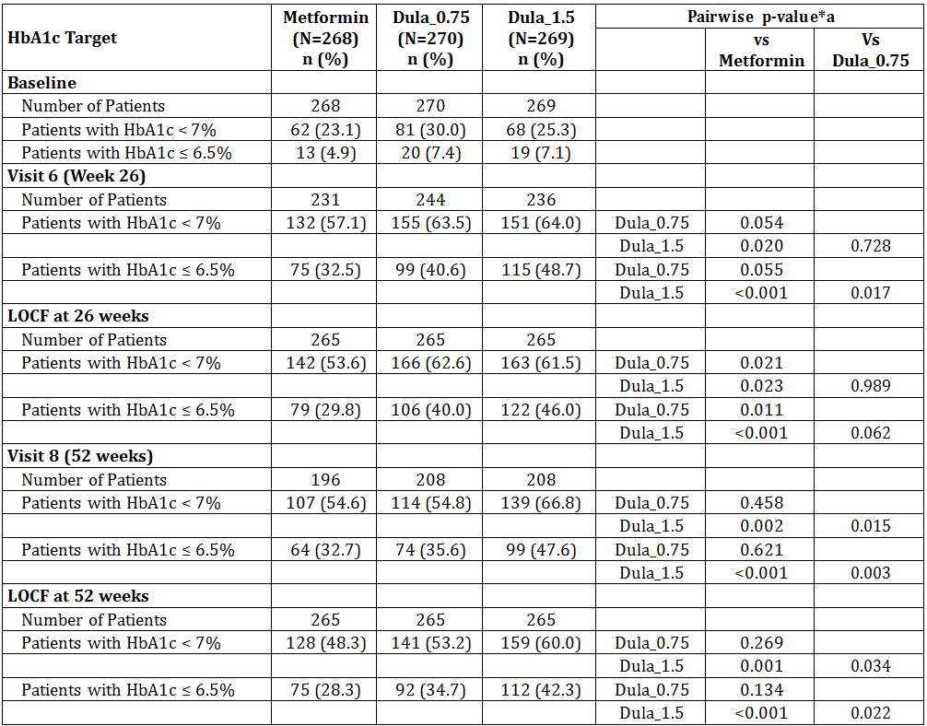
Abbreviations: HbA1c = haemoglobin A1c; N = number of patients with non-missing HbA1c value in specified visit and treatment group; n = number of patients in the specified category; OAM = oral antihyperglycaemic medication; vs = versus.
Note: Dula_x.x refers to x.x milligrams dulaglutide once weekly.
a Pairwise p-values are analysed from repeated logistic regression model(GEE model) Dependent variable = Baseline + Prior Medication group(previous OAM vs. no previous OAM) + Treatment + Visit + Visit* Treatment. For LOCF, Dependent variable =Baseline + Prior Medication group(previous OAM vs. no previous OAM) + Treatment.

Fasting serum glucose
At 26 weeks, no significant differences between dulaglutide and metformin in LS mean decreases from baseline in FSG were observed. At 52 weeks, dulaglutide 1.5 mg demonstrated a significant LS mean decrease from baseline in FSG compared to metformin.
Table 14: Study GBDC: Fasting Blood Glucose to 52 weeks, ITT population.
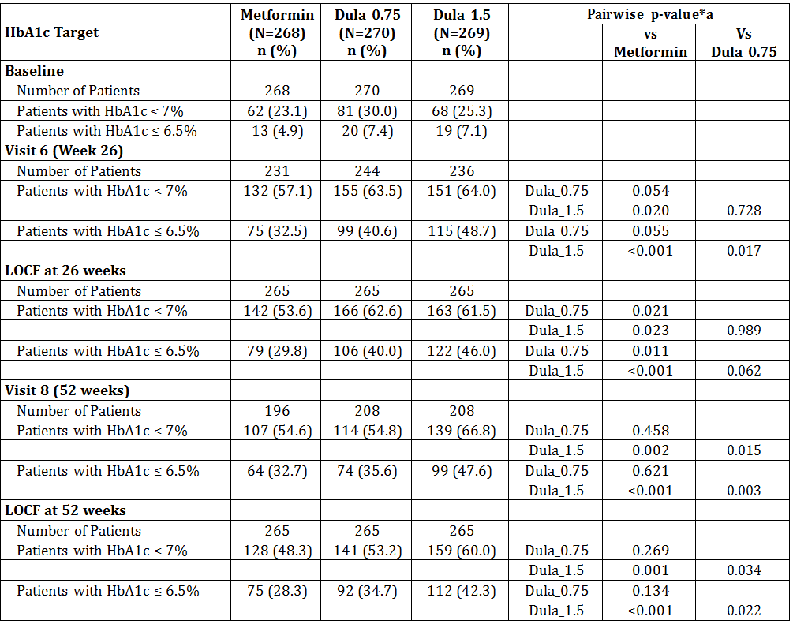
Analysis by MMRM by treatment group and visit from baseline, ITT population without post rescue values.
CI = confidence interval; LS Mean = least-squares mean; Max = maximum; Min = minimum; MMRM = mixed-effects model for repeated measures; N = total number of patients in specified treatment group; OAM = oral antihyperglycaemic medication; REML = restricted maximum likelihood; SD = standard deviation; SE = standard error; VS= versus.
Note: Dula_x.x refers to x.x milligrams dulaglutide once weekly.
*a – p-value and 95% CI of pairwise difference of LS Means of change from baseline are from REML based MMRM model: Change from Baseline = Baseline + Pooled Country + Prior Medication group(previous OAM vs. no previous OAM)+ Treatment + Visit + Treatment*Visit (Type III sum of squares), where patient enters the model as a random effect. Covariance structure = Unstructured.

8-Point Self-Monitored Plasma Glucose Profiles (SMPG)
At 26 weeks, LS mean decreases from baseline in 8-point SMPG parameters were similar in all treatment groups; the exception was a significant LS mean decrease observed for dulaglutide 1.5 mg compared to metformin in the pre-morning meal PG. At 52 weeks, the mean of all 8-point, mean of all preprandial, and mean of all postprandial measurements as well as each preprandial measurement and the post morning meal measurement were significantly decreased with dulaglutide 1.5 mg compared to metformin. No significant differences were observed in comparisons of dulaglutide 0.75 mg and metformin. No significant differences in decreases from baseline in PPG excursions (for individual meals or the overall mean) were observed between dulaglutide and metformin.

Body Weight and Body Mass Index
The differences in LS mean changes from baseline in mean body weight at 26 and 52 weeks for dulaglutide 1.5 mg compared to metformin were not significant. Results for BMI were consistent with the results for body weight.
Figure 21: Study GBDC: Analysis of body weight at 26 and 52 weeks, ITT population.

Fasting insulin
At 26 weeks, LS mean changes from baseline in fasting insulin were dulaglutide 1.5 mg, 17.5 pmol/L; dulaglutide 0.75 mg, 35.4 pmol/L; and metformin, -20.5 pmol/L. Comparisons were significant for both doses of dulaglutide versus metformin (p ≤ 0.002).
At 52 weeks, LS mean changes from baseline in fasting insulin were dulaglutide 1.5 mg, 6.13 pmol/L; dulaglutide 0.75 mg, 31.5 pmol/L; and metformin, -23.0 pmol/L. Comparisons were significant for dulaglutide 1.5 mg (p = 0.016) and dulaglutide 0.75 mg (p < 0.001) versus metformin.

Βeta-Cell Function and Insulin Sensitivity
For HOMA2-%B (insulin) and HOMA2-%B (C-peptide), significant LS mean increases from baseline were observed for both doses of dulaglutide compared to metformin at 26 and 52 weeks, with the greatest increases observed in the dulaglutide 1.5 mg group. For HOMA2-%S (insulin), at 26 and 52 weeks, the LS mean increases for metformin were significantly greater compared with both doses of dulaglutide.
Fasting glucagon decreased significantly from baseline in both dulaglutide groups compared with metformin at 26 weeks; no significant difference between the groups was noted at 52 weeks.

Patient reported outcomes (QOL)
As measured by patient-reported outcomes instruments, there was a significant improvement from baseline in the average impact of weight on self-perception, treatment satisfaction, and perceived hyperglycaemia at 26 and 52 weeks in all treatment groups. Additionally, a significant improvement in patient-perceived hyperglycaemia was observed with both doses of dulaglutide compared to metformin.

Study M9X-MC-GBDD
The Impact of LY2189265 versus Insulin Glargine both in combination with insulin Lispro for the treatment to target of type 2 Diabetes Mellitus
(AWARD-4: Assessment of weekly administration of LY2189265 in Diabetes - 4)

Study design, objectives, locations and dates
A phase III, multicentre, parallel group, randomised, partially blinded, active comparator trial conducted at 105 centre in 15 countries (Argentina, Australia, Belgium, Brazil, Canada, Denmark, Greece, Hungary, Mexico, Poland, Russia, Spain, Sweden, Taiwan, and USA) from October 2010 to September 2012.
Primary objective: To compare the effect of once-weekly 1.5-mg dulaglutide, injected SC, to that of insulin glargine (treated-to-target) on HbA1c at 26 weeks (change from baseline) in patients with T2DM who were treated in combination with prandial insulin lispro.
Secondary objective:
- To compare change in HbA1c from baseline between dulaglutide (1.5 mg and 0.75 mg) and insulin glargine using a tree-gatekeeping method to demonstrate that:
  - 0.75-mg dulaglutide is non-inferior to insulin glargine at 26 weeks
  - 1.5-mg dulaglutide is superior to insulin glargine at 26 weeks
  - 0.75-mg dulaglutide is superior to insulin glargine at 26 weeks
- To compare efficacy of dulaglutide (1.5 mg and 0.75 mg) and insulin glargine using a tree-gatekeeping method to demonstrate that:
  - 1.5-mg dulaglutide is non-inferior to insulin glargine at 52 weeks
  - 0.75-mg dulaglutide is non-inferior to insulin glargine at 52 weeks
  - 1.5-mg dulaglutide is superior to insulin glargine at 52 weeks
  - 0.75-mg dulaglutide is superior to insulin glargine at 52 weeks
- to compare the efficacy of dulaglutide (1.5 mg and 0.75 mg) and insulin glargine for:
  - Fasting serum glucose (FSG) and plasma glucose (PG) values from the 8-point self-monitored PG (SMPG) profiles (actual values and change from baseline) and percent of patients attaining HbA1c < 7% and ≤ 6.5%
  - Total daily insulin lispro dose
  - Percentage of patients achieving HbA1c < 7.0% without a single instance of symptomatic nocturnal hypoglycaemia, confirmed by plasma-referenced glucose ≤ 70 mg/dL (3.9 mmol/L), or meeting the criteria for severe hypoglycaemia
  - patient-reported outcomes (PRO): using EQ-5D, IW-ADL, IW-SP and LBSS
  - safety assessments

Inclusion and exclusion criteria

Inclusion
Male and female patients aged ≥ 18 years who were diagnosed with T2DM with a screening HbA1c ≥ 7% and ≤ 11%, after being treated for ≥ 3 months with a conventional insulin regimen (≤ 2 doses of insulin per day including any combination of basal, basal with prandial, or premixed insulin [excluding any prandial only regimen]), alone or in combination with oral antihyperglycaemic medications (OAMs). If the most commonly administered total daily dose during the prior 3 months was ≥ 40 units, then all total daily doses were to be within ±10% of that dose to confirm that intensification of therapy was needed. If the most commonly administered total daily dose during the prior 3 months was <40 units, then all total daily doses were to be within ±4 units of that dose. Patients had to have stable body weight (±5%) and a BMI of 23 to 45 kg/m2 for ≥ 3 months prior to screening.

Exclusion
Diagnosis of type 1 diabetes mellitus; MDI insulin regimen (≥ 3 insulin doses/day); serious diabetes-related or other health concerns; GLP-1 receptor agonist treatment (for example, exenatide or liraglutide) within 3 months prior to Visit 1; treatment with weight loss medications within 3 months of Visit 1 or chronic (> 2 weeks) systemic glucocorticoid therapy (excluding topical, intra-ocular, intranasal, or inhaled preparations) or such treatment within 1 month of Visit 1.

Study treatments
The patients were randomised to the following treatment regimens:
Randomised Therapy | Insulin Glargine Dose | Insulin Lispro Doseª
Dulaglutide 0.75 mg | -- | 50% of pre-randomisation total daily insulin dose
Dulaglutide 1.5 mg | -- | 50% of pre-randomisation total daily insulin dose
Insulin glargine 100 IU/mL | 50% of pre-randomisation total daily insulin dose | 50% of pre-randomisation total daily insulin dose
a The initial insulin lispro dose could be decreased from 50% to 25% of the pre-randomisation total daily insulin dose if deemed appropriate by the investigator.
All patients randomised to treatment with insulin glargine initiated insulin glargine at 50% of the pre-randomisation total daily insulin dose. The remaining 50% of the pre-randomisation total daily insulin dose applied to the initial insulin lispro dose further divided equally across the 3 largest meals of the day. Insulin dose adjustments to achieve HbA1c targets were based upon SMPG values obtained while fasting or pre-morning meal for insulin glargine, and at pre-midday meal, pre-evening meal, and bedtime for insulin lispro. Patients were instructed to administer the insulin glargine dose daily at bedtime. The dose decision for insulin glargine dose adjustment was based upon the median of the previous 3 fasting PG values according to a specified dosing schedule.
All patients taking metformin at the start of the study remained on the same dose for the duration of the study.

Efficacy variables and outcomes
The primary efficacy outcome was change from baseline in HbA1c at 26 weeks.
Other efficacy outcomes included:
- Change in HbA1c from baseline to other prespecified time points
- 8-point SMPG profile (actual values and change from baseline to prespecified time points)
- Fasting PG (actual values and change from baseline to predefined time points)
- Proportion of patients achieving a target HbA1c < 7% and ≤ 6.5% at prespecified time points, and proportion of patients achieving HbA1c < 7.0% without a single instance of symptomatic nocturnal hypoglycaemia (confirmed by plasma-referenced glucose ≤ 3.9 mmol/L) or meeting the criteria for severe hypoglycaemia.
- Daily insulin glargine (for within insulin glargine treatment group assessment) and insulin lispro dose.

Randomisation and blinding methods
Patients were randomised to 1 of 3 treatment groups, following a 1:1:1 ratio (1.5-mg dulaglutide: 0.75-mg dulaglutide:insulin glargine) according to a computer generated random sequence using an interactive voice response system (IVRS). Randomisation was stratified by country to achieve between-group comparability within countries and by metformin use to achieve between group comparability and to mitigate against confounding the effects of treatments with severity of disease and treatment with antihyperglycaemic medication during the study.
Dulaglutide dose assignment (1.5 mg or 0.75 mg) was double-blinded but the study was open label for the insulin glargine. The open-label study design (that is, whether a patient was assigned to receive insulin glargine or dulaglutide) was based on fact that the insulin doses had to be titrated for patient safety, and hence this treatment could not be blinded compared to a fixed dose treatment.

Analysis populations
Intent to treat (ITT) population: All patients randomised who have taken at least 1 dose of study drug for assigned treatment group.
Per-Protocol (PP): All patients in ITT and also met the following criteria: no significant protocol violations and completed the treatment phase (ie, 26 weeks for primary endpoint or 52 weeks for final endpoint).
Safety Population: same as ITT population.

Sample size
Approximately 837 randomised patients (279 per treatment group) were planned to participate in this study. To show non-inferiority of the 1.5-mg dulaglutide group to insulin glargine with 90% power, 744 total completers (248 per arm) at 26 weeks were required. This calculation assumed a zero difference in HbA1c between the 1.5-mg dulaglutide and insulin glargine groups, 0.4% margin of non-inferiority, common SD of 1.3% for change from baseline in HbA1c, 0.05 2-sided significance level, and 11% drop out rate at 26 weeks. Assuming a 20% dropout rate at 52 weeks, 669 total completers (223 patients per arm) were anticipated at 52 weeks.

Statistical methods
Two analysis models were used for the primary efficacy measurement. The primary analysis model was an analysis of covariance (ANCOVA) for the change from baseline to endpoint with baseline as a covariate. Missing endpoints were imputed with the last post baseline observation carried forward (LOCF). The model included treatment, country, and metformin as fixed effects and baseline HbA1c as a covariate. The primary analysis model was used to examine both non-inferiority and superiority of 1.5-mg dulaglutide to insulin glargine and 0.75-mg dulaglutide to insulin glargine using a gatekeeping strategy to control the family-wise Type 1 error rate.
The secondary analysis for the primary endpoint was a mixed-effects model repeated-measures (MMRM) approach using restricted maximum likelihood (REML) with baseline as a covariate, which implicitly adjusts for missing data through a variance-covariance structure. The Type III sum of squares was used to make treatment comparisons.
The non-inferiority margin was defined as 0.4%. If the upper limit of the 95% CI of 1.5-mg dulaglutide versus insulin glargine did not exceed 0.4%, then 1.5-mg dulaglutide could be declared non-inferior to insulin glargine. If the upper limit of the CI was below zero, then 1.5-mg dulaglutide could be declared superior to insulin glargine. The primary analysis for the primary endpoint was conducted based upon the intent-to-treat (ITT) population prior to taking rescue therapy.
For other continuous measures, treatment comparisons were performed for the LS means and 95% CI of the treatment differences, along with the p-value for the comparison. For categorical measures, unless otherwise noted, a Chi-square test was used for the treatment comparisons. If the total measure count was < 10, then Fisher’s exact test was used.

Participant flow
Figure 22: Study GBDD: Participant flow.
Dula=dulaglutide, ITT=intent to treat; mg=milligrams.
a Two of the 4 patients died before randomisation.
b Nineteen patients from Site 100 were excluded from analysis due to data integrity issues; 8 of these 19 patients were randomised (dulaglutide 1.5 mg: 4; dulaglutide 0.75 mg: 2; insulin glargine: 2) and 6 of these 8 received at least 1 dose of treatment.
Note: The term “protocol violation” in this figure is intended to mean only a change, divergence, or departure from the study requirements, whether by the subject or investigator, that resulted in a subject’s withdrawal from study participation.

Major protocol violations/deviations
One site in Argentina was terminated early due to significant deficiencies in GCP compliance that were observed during monitoring visits. The patients enrolled at this site were excluded from the efficacy analyses.
The frequencies of patients with at least 1 significant protocol violation were balanced among the 3 treatment groups. At 26 weeks, a total of 206 (23.3%) patients had at least 1 significant protocol violation. The most frequent reasons for violation were (a) missing plasma HbA1c values (including early discontinued patients) and (b) < 75% overall treatment compliance.

Baseline data
The 3 treatment groups were similar with respect to demographic and other patient characteristics at baseline, except for BMI (dulaglutide 1.5 mg: 31.99 kg/m2; dulaglutide 0.75 mg: 33.08 kg/m2; insulin glargine: 32.41 kg/m2; p = .013). The majority of patients were < 65 years old (72.5%), male (53.5%), and White (78.8%); 34.3% patients were Hispanic or Latino. The mean age of the patients was 59.4 years. The United States (33.3%), Brazil (10.7%), and Argentina (9.2%) were the 3 highest enrolling countries. The patients had a long history of diabetes (mean duration: 12.7 years) and the mean HbA1c concentration was 8.5%. The mean total daily insulin dose at baseline was 56 units and was similar across the 3 treatment groups. The majority were obese (65.5% of patients had a BMI ≥ 30 kg/m2). The sitting systolic BP and diastolic BP were similar for the treatment groups (mean: 133.5/77.4 mm Hg). The 3 groups were similar with respect to CV risk at baseline.

Results for the primary efficacy outcome
The dulaglutide 1.5 mg arm met criteria for both non-inferiority (primary objective) and superiority to insulin glargine at 26 weeks (adjusted one-sided p-value < 0.001) on HbA1c change from baseline. The LS mean and nominal 95% CI for the difference of the dulaglutide 1.5 mg arm relative to insulin glargine at 26 weeks was: - 0.22% (-0.38, -0.07). Results of the sensitivity analyses using the MMRM model for the ITT population and ANCOVA model for the PP population were similar to the primary analysis. The dulaglutide 0.75 mg group also met criteria for both non-inferiority and superiority to insulin glargine at 26 weeks. The LS mean and nominal 95% CI for the difference between dulaglutide 0.75 mg and insulin glargine at 26 weeks was: -0.17% (-0.33, -0.02).
Table 15: Study GBDD: HbA1c for primary and secondary objectives – ANCOVA using LOCF at 26 weeks – ITT population.
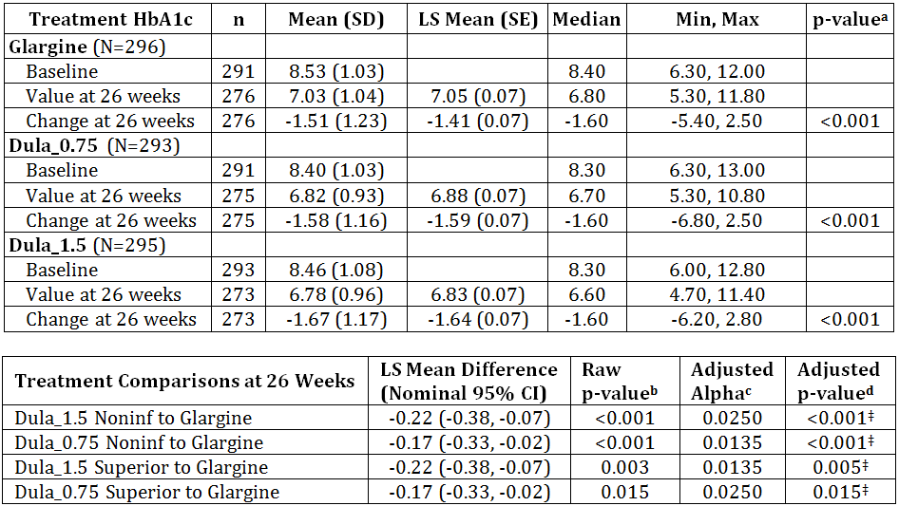
ANCOVA = analysis of covariance; CI = confidence interval; HbA1c = Hemoglobin A1c; LOCF = last observation carried forward; LS Mean = least-squares mean; Max = maximum; Min = minimum; N = total number of patients in specified treatment group; n = number of patients in specified category; NA = not applicable; Noninf = non-inferior; SD = standard deviation; SE = standard error.
Note: Dula_x.x refers to x.x milligrams dulaglutide once weekly.
Confidence intervals, p-values based on ANCOVA model: Dependent Variable = Country + Baseline + Baseline Metformin +Treatment (Type III sums of squares).
a - Within group 2-sided p-values are from t-tests on LS Mean change from baseline.
b – 1-sided raw p-value (no multiplicity adjustment).
c, d – alpha level and 1-sided p-value adjusted for multiplicity, based on tree-gatekeeping strategy.
‡ - significant at family-wise 1-sided Type I error of 0.025 level
Figure 23: Study GBDD: LS mean (SE) HBA1c values at baseline, 26 weeks and 52 weeks by treatment.
Results of the sensitivity analyses using the MMRM model for the ITT population and ANCOVA model for the PP population were similar to the primary analysis.
The dulaglutide 0.75 mg group also met criteria for both non-inferiority and superiority to insulin glargine at 26 weeks. The LS mean and nominal 95% CI for the difference between dulaglutide 0.75 mg and insulin glargine at 26 weeks was: -0.17% (-0.33, -0.02).

Results for other efficacy outcomes

Non-inferiority/Superiority Comparison at 52 Weeks
The dulaglutide 1.5 mg and dulaglutide 0.75 mg groups were superior to insulin glargine at 52 weeks on HbA1c change from baseline. The LS mean and nominal 95% CI for the difference of the dulaglutide 1.5 mg arm relative to insulin glargine at 52 weeks was: -0.25% (-0.42, -0.07). The LS mean and nominal 95% CI for the difference of the dulaglutide 0.75 mg arm relative to insulin glargine at 52 weeks was: -0.19% (-0.37, -0.02).
Table 16: Study GBDD: HbA1c for primary and gated secondary objectives – ANCOVA using LOCF at 52 weeks – ITT population.
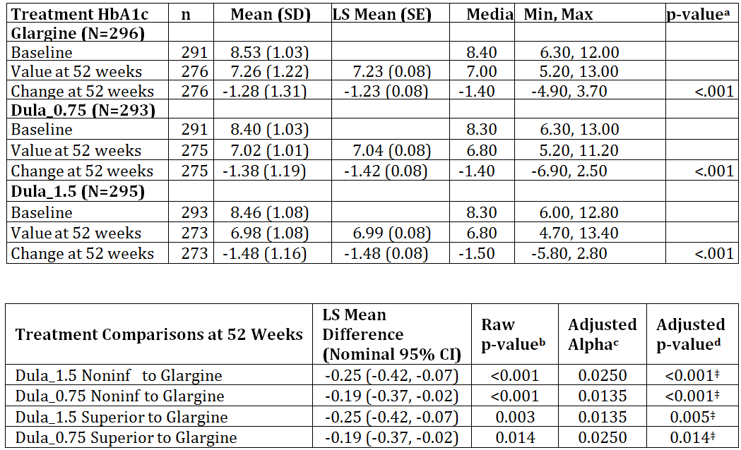
ANCOVA = analysis of covariance; CI = confidence interval; HbA1c = Hemoglobin A1c; LOCF = last observation carried forward; LS Mean = least-squares mean; Max = maximum; Min = minimum; N = total number of patients in specified treatment group; n = number of patients in specified category; NA = not applicable; Noninf = non-inferior; SD = standard deviation; SE = standard error.
Note: Dula_x.x refers to x.x milligrams dulaglutide once weekly.
Confidence intervals, p-values based on ANCOVA model: Dependent Variable = Country + Baseline + Baseline Metformin +Treatment (Type III sums of squares).
a - Within group 2-sided p-values are from t-tests on LS Mean change from baseline.
b – 1-sided raw p-value (no multiplicity adjustment).
c, d – alpha level and 1-sided p-value adjusted for multiplicity, based on tree-gatekeeping strategy.
‡ - significant at family-wise 1-sided Type I error of 0.025 level

Percentage of Patients Attaining Target Thresholds of HbA1c < 7% or ≤ 6.5%
At 26 weeks, significantly higher proportions of patients in the dulaglutide treatment groups had HbA1c levels < 7% compared with insulin glargine. The proportion of patients with HbA1c levels ≤ 6.5% was higher in the dulaglutide 1.5 mg group compared with insulin glargine. At 52 weeks, a significant difference between the dulaglutide 1.5 mg and insulin glargine groups was noted for patients with HbA1c levels < 7%. There was no significant difference between the dulaglutide and insulin glargine groups for patients attaining HbA1c levels ≤ 6.5% at 52 weeks.
Table 17: Study GBDD: HbA1c for primary and gated secondary objectives – ANCOVA using LOCF at 52 weeks – ITT population.
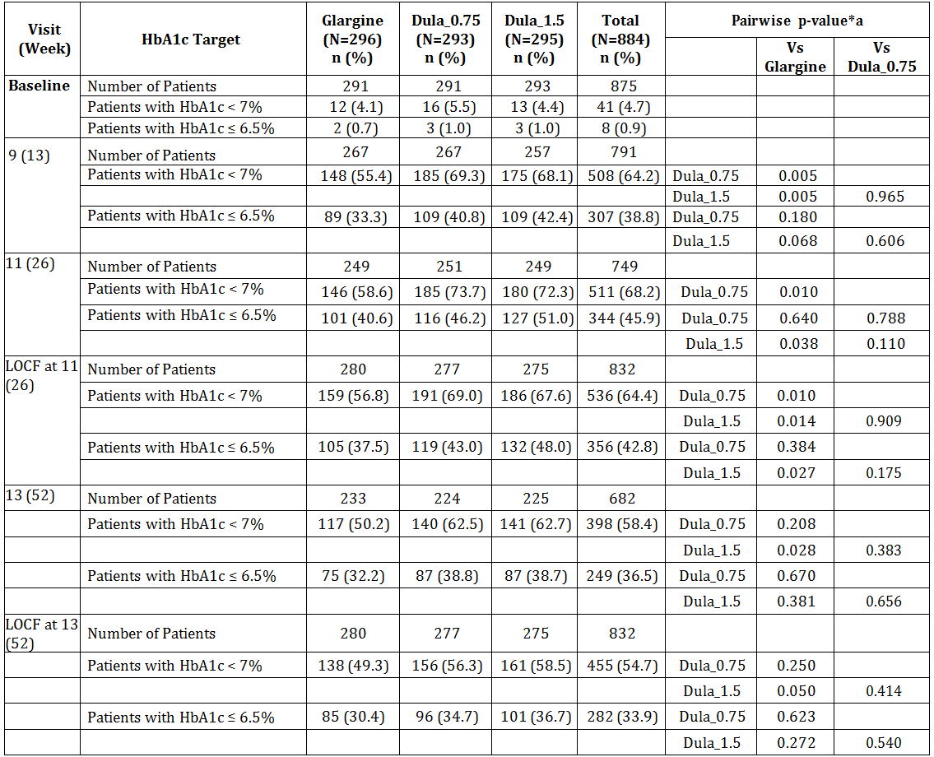
GEE = Generalized estimating equation; HbA1c = Hemoglobin A1c; LOCF = Last observation carried forward; N = total number of patients in specified treatment group; n= number of patients with non-missing HbA1c value in specified visit and treatment arm.
Note: Dula_x.x refers to x.x milligrams dulaglutide once weekly.
*a - Pairwise p-values are analyzed from repeated logistic regression model (GEE model) Dependent variable = Baseline + Metformin
Use at Baseline + Country + Treatment + Visit + Visit * Treatment (Variance-Covariance structure = Unstructured).

Self-monitored Glucose Profiles and Fasting Serum Glucose
At 26 weeks, the mean SMPG values (8-point daily profile) were lower at all-time points compared with the corresponding baseline values for all treatment groups. The decrease from baseline was significantly greater with glargine compared to dulaglutide at 3AM (or 5 hours after bedtime), pre-morning meal, and 2-hour post-morning meal measurements. On the other hand, the changes were generally significantly greater (decreased) with dulaglutide compared to glargine at the 2-hour post midday meal, pre-evening meal, 2 hour post-evening meal, and at bedtime. The results were similar at 52 weeks.
For LOCF, Dependent variable = Baseline + Metformin Use at Baseline + Country + Treatment.
At 26 weeks and 52 weeks, the change from baseline in FSG was significantly greater with glargine compared to the dulaglutide groups.
Figure 24: Study GBDD: 8-point SMPG profile (mmol/L) at baseline and 26 weeks (LSM) MMRM by treatment group Intent-to-Treat Population.
MMRM = mixed effects model for repeated measures
Note: Dula_x.x refers to x.x milligrams dulaglutide once weekly

Daily insulin doses
At 26 weeks, the mean TDI dose was approximately 30% lower in the dulaglutide groups compared with glargine. The mean daily dose of insulin lispro dose was approximately 30% higher in the dulaglutide groups compared with insulin glargine. Assessment of insulin lispro doses by visit indicate that the groups reached stable mean doses (> 90%% the highest mean visit dose) between Week 8 and Week 13. Insulin doses were stable between Week 26 and Week 52 of the treatment period.
Figure 24: Study GBDD: Summary and analysis of insulin lispro algorithm assessment by treatment and visit, ITT Population.
* Statistically significant difference compared with insulin glargine.

Continuous Glucose Monitoring (CGMS) Sub-study Results
A sub-study was conducted on 144 patients included in the study who agreed to perform CGMS assessments over 3-day periods prior to main study visits, on 4 occasions (week 3, 8, 10 and 12). The primary objective of the CGMS sub-study was to compare dulaglutide 1.5 mg weekly versus insulin glargine when either is used in combination with insulin lispro prior to meals (±metformin) for percentage of times blood glucose remains in the optimum target range (71 to 140 mg/dL) during the 24-hour glucose profile captured with CGMS at 26 weeks.
Overall, aspects of glucose control as assessed by CGMS were similar in the 3 treatment groups. The CGMS findings were consistent with findings of the SMPG analyses for most of the outcomes.
At 26 weeks (but not at 52 weeks), the change from baseline in percent of time points (LSM) with glucose values (LOCF) within the 71 to 180 mg/dL range was significantly greater in the dulaglutide 1.5 mg group compared with the corresponding increase in the glargine group (p = 0.014). The overall incidence of total hypoglycemia (LOCF) was similar in the 3 treatment groups at baseline and at post baseline assessments. The overall incidence of nocturnal hypoglycemia at 26 weeks (LOCF) was significantly higher with glargine compared to dulaglutide 0.75 mg. At 52 weeks, the percent of time points with glucose values in this range was significantly fewer in the dulaglutide groups compared with glargine.

Change in Body Weight and BMI
At 26 weeks, there was a significant difference in LSM for change from baseline in body weight between dulaglutide 1.5 mg and glargine groups (-3.20 kg) and between dulaglutide 0.75 mg and glargine groups (-2.15 kg).
At 26 weeks, the BMI was significantly lower in the dulaglutide groups compared with glargine; the LSM difference between the dulaglutide 1.5 mg and glargine groups was -1.20 kg/ m2; and between dulaglutide 0.75 mg and glargine: -0.79 kg/ m2. At 52 weeks, the body weight and BMI results for between-group differences were similar.

Subgroup analysis for HbA1c
No significant sex, age (< 65 or ≥ 65 years) or country by treatment interaction was seen at 26 or 52 weeks. Significant treatment by factor interactions for the effect on HbA1c was observed for race at 52 weeks; for duration of diabetes at 26 and 52 weeks; for BMI at 26 and 52 weeks. The results of body weight by subgroup analysis did not reveal interaction between any of the factors analysed.
For the American Indian or Alaska Native and Black or African American subgroups, the HbA1c change from baseline (LSM) was significantly greater in both dulaglutide treatment groups compared with insulin glargine. For the multiple racial background subgroup, the change from baseline was significant only in the dulaglutide 1.5 mg treatment group and not in the dulaglutide 0.75 mg group compared with insulin glargine. No significant treatment differences were observed for the other 2 racial subgroups (Asian or White).
The observed differences related to duration of diabetes between dulaglutide and insulin glargine were not consistent and did not indicate a clear pattern in the subgroup comparisons by duration of diabetes.
At both 26 and 52 weeks, in the BMI <median subgroup, the HbA1c change from baseline (LSM) was significantly greater in both dulaglutide treatment groups compared with insulin glargine. No significant treatment difference was observed for the BMI ≥ median subgroup at either time point.

Patient reported outcomes
Patients’ health status and ability to perform physical activities of daily living on average decreased in the study, and patients indicated more worries about hypoglycaemia and increased their hypoglycaemia-avoidance behaviors. However, dulaglutide 1.5-mg groups demonstrated a reduced impact of weight on self-perception.

Other efficacy studies

Study M9X-MC-GBCJ
The Effect of Dose Titration of LY2189265 (GLP-1 analog IV-Fc) in overweight and obese patients with Type 2 Diabetes Mellitus (The EGO Study)

Study design, objectives, locations and dates
A multicentre, multiple titrated and non-titrated dose, placebo controlled, parallel group, double blind study conducted in 39 centres in the USA and Puerto Rico from April 2008 to January 2009.
Primary objective: to evaluate once weekly injections of LY2189265 (titrated and non-titrated dosages) compared to placebo on glycaemic control as measured by HbA1c change from baseline at 16 weeks in overweight and obese patients with T2DM.
Secondary objectives:
- To evaluate the changes from baseline to 16 weeks between placebo and once weekly titrated and non-titrated injected doses of LY2189265 for the following: FBG, meal test glucose excursion, 8 point SMPG, body weight and waist circumference, β-cell function and insulin sensitivity (HOMA2) and percentage of patients achieving HbA1c of < 7 and ≤ 6.5%
- Safety and tolerability
- PK and the relationship between LY2189265 exposure and safety measures
- Patient perception of medication effectiveness using Perceptions about Medications –Diabetes, short version (PAM-D-S) questionnaire

Study Population
Overweight and obese (BMI > 27 and < 40 kg/m2) men and women 18 years and older with T2DM on stable doses (no change in previous 3 months) of any FDA approved combination of any 2 of 4 classes of oral antihyperglycaemic agents (sulfonylureas, biquanides, thiazolidinediones, DPP-IV inhibitors) prior to study entry (patients continued on these agents throughout the study). Exclusion criteria were the same as for other efficacy studies.

Study treatments
Three LY2189265 treatment arms were evaluated and compared to a placebo arm during a 16-week treatment period. All treatment arms were injections to be administered subcutaneously in the left or right abdominal area. The treatment regimens were:
- LY2189265 0.5 mg/week for 4 weeks, then LY2189265 1.0 mg/week for 12 weeks, given via subcutaneous (SC) injection
- LY2189265 1.0 mg/week for 16 weeks, given via SC injection
- LY2189265 1.0 mg/week for 4 weeks, then LY2189265 2.0 mg/week for 12 weeks, given via SC injection
- Matching placebo for 16 weeks, given via SC injection

Efficacy outcomes
The primary efficacy outcome was HbA1c change from baseline at 16 weeks.
The other efficacy outcomes were: FBG, 8 point SMPG, body weight and waist circumference, β-cell function and insulin sensitivity as estimated by HOMA2, gastrointestinal symptom evaluation (SGE) and VAS.

Statistical methods
Efficacy analyses were conducted on ITT population defined as all randomised patients who received at least 1 dose of study medication. The primary analysis for the primary efficacy measure of HbA1c was conducted using the analysis of covariance (ANCOVA) to model the change from baseline to endpoint using the last-observation-carried forward (LOCF) approach. Change from baseline was calculated as the LOCF endpoint value minus the baseline value. Patients who did not have both a baseline and a post baseline measurement were excluded from the LOCF analysis.
To detect a -0.9% change from baseline in HbA1c between the active LY2189265 1.0/2.0-mg arm and placebo, it was estimated that approximately 60 patients must have been randomised into each of the 4 treatment arms, or a total of 240 patients randomized into the study, to achieve a 90% power at a 2-sided alpha level of 0.05.

Participant flow
Figure 25: Study GBCJ: Participant flow.

Baseline data
There were no statistically significant differences between treatment groups for any of the demographic variables. Patients’ mean age at baseline was 56.7 years; all 3 LY2189265 and placebo treatment groups were comparable with respect to age. Overall, 50.8% of patients were male and 49.2% of patients were female. The majority of patients identified themselves as either Caucasian (57.6%) or Hispanic (33.6%); all treatment groups were similarly comprised with respect to race. Patient BMI (mean = 33.92 kg/m2), weight, and height were similar for all treatment groups. The mean duration of diabetes reported was 8.30 years. Baseline HbA1c was similar across all treatment groups; overall, the mean baseline HbA1c was 8.24%. The majority of patients reported hypertension (66.0%).

Results for the primary efficacy outcome
For each LY2189265 treatment arm, statistically significant decreases in HbA1c were observed at each post baseline visit (p<0.001). The placebo group had a small but statistically (though not clinically) significant decrease in HbA1c during the first 2 months of the study, which after 4 months of study did not reach statistical significance. Statistically significantly greater decreases were observed in all LY2189265 treatment groups compared to placebo (p<.001), with the largest numerical decrease in the LY2189265 1.0/2.0 mg treatment group (least-squares mean [LS mean] change from baseline [last-observation-carried-forward (LOCF)], -1.52%).
Table 18: Study GBCJ: HbA1c change from baseline by visit – ITT population.
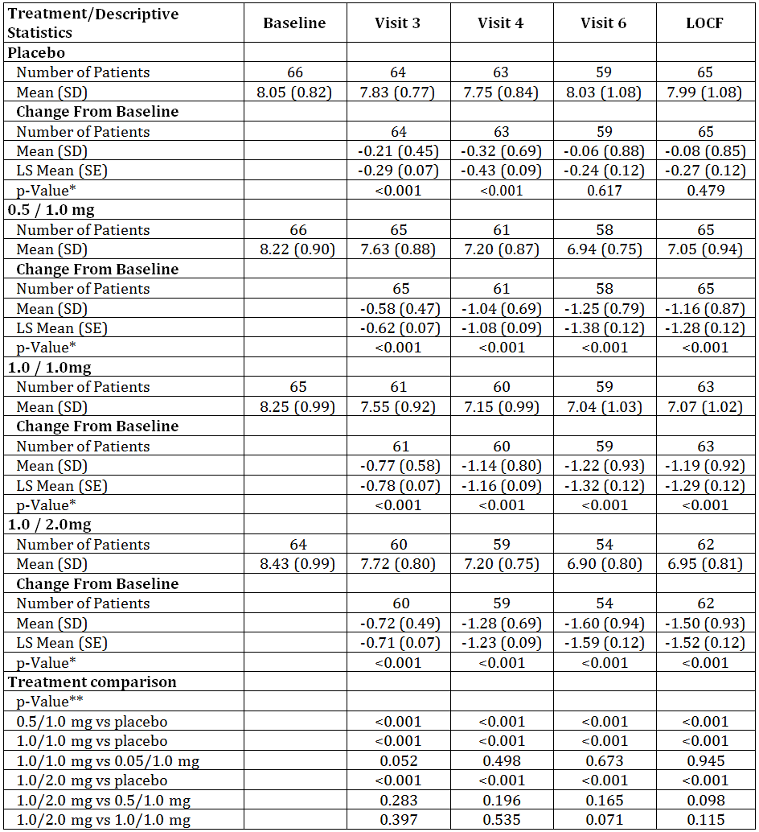
ITT = intent-to-treat; LOCF = last observation carried forward; mg = milligram; N = number of ITT patients; SD = standard deviation; SE = standard error.
*P-values are from t-test.
**Analysis of covariance (ANCOVA) model: Change = Treatment + Oral Combination + Baseline (Type III sums of squares).

Results for other efficacy outcomes

Fasting Blood Glucose (FBG)
Statistically significant decreases were observed in all LY2189265 treatment groups from baseline to endpoint (p < 0.001), and also when compared to placebo (p <.001). The largest decrease was in the LY2189265 1.0/2.0 mg group (LS mean change from baseline [LOCF], -2.64 mmol/L).

Meal Test Glucose AUC and AUC Excursion
Glucose response was evaluated after ingesting a solid mixed meal at baseline and endpoint. All LY2189265 treatment arms demonstrated statistically significant reductions from baseline to endpoint in mean glucose area under the curve (AUC) (0 to 3 hours) (p < 0.001), with the lowest AUC (0 to 3 hours) for test meal at endpoint observed in the LY2189265 1.0/2.0 mg group (28.24). Individually, each of the 3 LY2189265 treatment groups were statistically significantly reduced compared with placebo (p < 0.001); additionally, the LY2189265 1.0/2.0 mg group AUC was statistically significantly reduced compared with the 0.5/1.0 mg group (p = .018) and the 1.0/1.0 mg group (p = 0.011).

Self-Monitoring Blood Glucose 8-Point Profile
Patients were asked to conduct 8-point self-monitoring blood glucose (SMBG) measurements on 2 separate days in the week preceding Visits 2, 3, 4, and 6. Statistically significantly greater decreases were observed in all LY2189265 treatment groups compared with the placebo group (p < 0.001), with the largest decrease in the LY2189265 1.0/1.0 mg treatment group (LS mean change from baseline [LOCF], -41.79 mg/dL); however, there were no statistically significant differences between any LY2189265 treatment groups.

Body Weight and Waist Circumference
Statistically significant decreases in body weight from baseline to endpoint were observed in all LY2189265 treatment groups at each post baseline visit (p < .001), with the largest decrease in the LY2189265 1.0/2.0 mg treatment group (LS mean change from baseline to endpoint [LOCF], -2.51 kg). The weight change in the placebo group was not statistically significantly different from baseline. Statistically significantly greater weight reductions were observed between all LY2189265 treatment groups compared to placebo. Statistical significance was also observed in comparisons between LY2189265 1.0/2.0 mg and 0.5/1.0 mg and between LY2189265 1.0/2.0 mg and 1.0/1.0 mg.
Statistically significant decreases in waist circumference from baseline to endpoint were observed in all LY2189265 treatment groups, with the largest decrease in the LY2189265 1.0/2.0 mg treatment group (LS mean change from baseline [LOCF], -1.92 cm). Statistically significant differences were also observed between all LY2189265 treatment groups as compared to placebo, but not between LY2189265 treatment groups.

β-cell function and insulin sensitivity
The updated Homeostasis Model Assessment (HOMA2) was assessed at baseline and following 4 months administration of study medication (endpoint). A fasting blood glucose, c-peptide and serum insulin level were drawn for purposes of this determination just prior to the mixed meal test.
The change from baseline in β-cell function, (HOMA2-%B), was determined using c-peptide concentrations. Statistically significant changes were observed in all LY2189265 treatment groups from baseline to endpoint and when compared to placebo, with the greatest change observed in the LY2189265 1.0/2.0 mg treatment group (LS mean change from baseline [LOCF], 45.61). These results are corroborated by the HOMA2-%B analyses using insulin.
The change from baseline in insulin sensitivity (HOMA2-%S) and (HOMA2-IR), were determined using c peptide concentrations. No statistically significant changes were observed in any LY2189265 treatment group from baseline to endpoint or when compared to placebo for either HOMA2-%S or HOMA2-IR. These results are corroborated by the HOMA2-%S and HOMA2-IR analyses using insulin.

Percentage of Patients Achieving HbA1c ≤ 7.0%, < 7.0%, and ≤ 6.5%
At endpoint (LOCF), statistical significance was observed in the proportion of patients (p < .001) that had achieved HbA1c ≤ 7.0%, < 7.0%, and ≤ 6.5% among the 4 groups. The percentage of subjects achieving these HbA1c targets was similar across LY2189265 treatment groups at endpoint.
Table 19: Study GBCJ: Patients with HbA1c ≤ 7%, < 7% and ≤ 6.5% - ITT population.
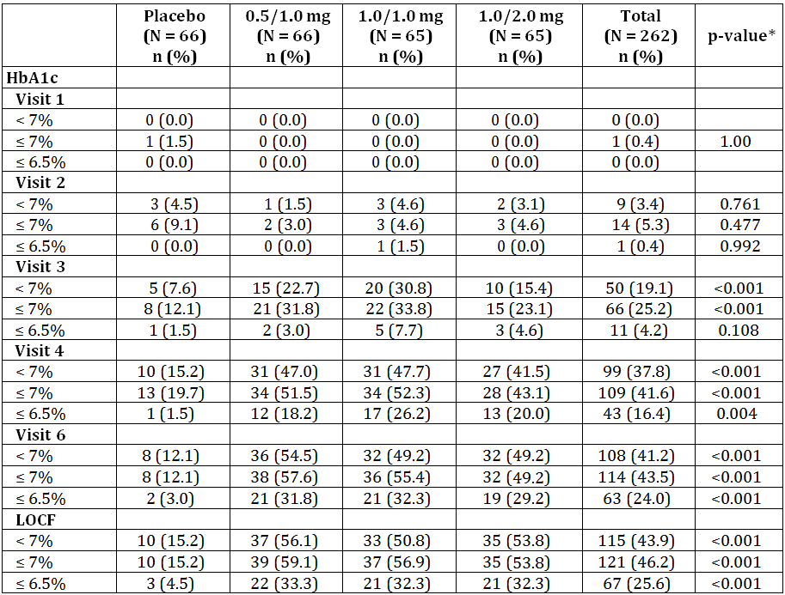
ITT = intent-to-treat; LOCF = last observation carried forward; mg = milligram; N = number of ITT patients.
*P-values are from logistic regression model as:
Actual Measurement (1, 0) for baseline = treatment + Oral Combinations
Actual Measurement (1, 0) for post-baseline = treatment + Oral Combinations + baseline

Overall Effect of Dose Titration
LY2189265 concentration increased as expected with dose titration, from 0.5 to 1 mg and from 1 to 2 mg. In the treatment group without titration, steady-state concentration was reached prior to the fourth dose. The PK of LY2189265 in patients with type 2 diabetes in this study is consistent with previous Phase 1 studies in patients with diabetes. The concentration of LY2189265 was correlated with BMI; that is, concentration decreased with increasing BMI.

Study M9X-MC-GBCK
Assessment of dose-dependent effects of LY2189265 on glycaemic control in patients with Type 2 Diabetes treated only with lifestyle interventions

Study design, objectives, locations and dates
A multicentre, parallel group, randomised, double blind, placebo controlled study conducted at 44 centres in 8 countries (Croatia, India, Mexico, Poland, Puerto Rico, Russia, Spain and USA).
The study consisted of 4 periods: a 2-week screening period, a lead-in period (approximately 4 to 8 weeks depending on entry therapy), a 12-week treatment period, and 4-week post study drug safety follow-up period.
Primary objective: To demonstrate a dose-dependent effect of once weekly LY2189265 injected SC on HbA1c at 12 weeks (change from baseline) in patients with T2DM who had discontinued metformin monotherapy or were antihyperglycaemic medication naïve.
Secondary objectives:
- To evaluate the dose-dependent effect of LY2189265 (0.1, 0.5, 1.0, and 1.5 mg) on fasting blood glucose and mean daily self-monitored blood glucose (SMBG) at 12 weeks
- To compare the LY2189265 (0.1, 0.5, 1.0, and 1.5 mg) and placebo treatment groups at 12 weeks with respect to: HbA1c and mean daily blood glucose values from the 7-point SMBG profiles
- Beta-cell function (HOMA2-B) and insulin sensitivity (HOMA2-S) using the updated Homeostasis Model Assessment (HOMA2)
- To compare the safety and tolerability and to characterise the PK and the relationship between LY2189265 concentration and safety and efficacy measures

Study Population
Male and non-pregnant female patients aged between 18 and 75 years previously diagnosed with T2DM with an elevated BMI (23 - 40 kg/m2 in SE Asia and 25 - 40 kg/m2 in rest of world); who were antihyperglycaemic medication naïve (diet and exercise alone) or were taking prestudy metformin monotherapy and willing to discontinue it; had an HbA1c at screening of ≥ 7.0 to 9.5% (treatment naïve) or > 6.5 to 9.0% (metformin) and remained between ≥ 6.5 and 9.5% following a stabilisation/washout period at randomisation.
Patients were excluded from the study if they were taking specific medications (glucagon-like peptide-1 [GLP-1] analogue, incretin mimetic, chronic glucocorticoid therapy, or central nervous system stimulants); had certain known conditions or abnormalities (gastric emptying, cardiovascular conditions, abnormal ECG, poorly controlled hypertension, liver disease, pancreatitis, kidney disease, autoimmune abnormality, active or untreated malignancy, drug or alcohol abuse, or a transplanted organ).

Study treatments
Patients were randomised to 1 of the 5 double-blind treatment arms (4 doses of LY2189265 and placebo) in a 1:1:1:1:1 in ratio for 12 weeks:
- 0.1 mg LY2189265 0.1 mg LY2189265 once weekly injection
- 0.5 mg LY2189265 0.5 mg LY2189265 once weekly injection
- 1.0 mg LY2189265 1.0 mg LY2189265 once weekly injection
- 1.5 mg LY2189265 1.5 mg LY2189265 once weekly injection
- Placebo once weekly injection of placebo
Three different injection volumes (0.1, 0.5, and 1.0 mL) of LY2189265 were used in this study. To maintain blinding, volumes corresponding to specific doses were not specified.

Efficacy outcomes
The primary efficacy outcome was HbA1c change from baseline at 12 weeks.
Secondary efficacy outcomes included HbA1c at 4 weeks and 8 weeks; fasting blood glucose (FBG); 24-hour, 7-point SMBG profiles (preprandial, 2-hour postprandial, and 2-hour postprandial excursions [the difference between the preprandial and the 2-hour postprandial blood glucose values] from the morning, midday, and evening meals; and FBG obtained the following morning); proportion of patients who achieve HbA1c < 7% or ≤ 6.5%, and HOMA2-B and HOMA2-S.

Statistical methods
Two analysis models were used for the primary efficacy measurement of HbA1c change from baseline. The primary analysis used a mixed-effects model for repeated measures (MMRM) with restricted maximum likelihood (REML). The second analysis was an analysis of covariance (ANCOVA) on the change from baseline to endpoint at Visit 8 with last-observation-carried-forward (LOCF). The MMRM, which implicitly adjusts for missing data through a variance-covariance structure, included country, dose, prestudy therapy (metformin yes/no), baseline BMI, visit, and dose-by-visit interaction as the fixed effects, baseline HbA1c as a covariate, and patient as a random effect. For categorical measures, a Fisher’s exact test comparing all the treatment groups was used for the treatment comparisons, unless otherwise noted. In addition, a Cochran-Armitage exact trend test for dose response was used. For continuous measures, treatment arms were compared using an analysis of variance (ANOVA) model with treatment as a fixed effect. Patients from the discontinued 3-mg LY2189265 treatment group (N = 3) were included in the MMRM analyses to increase the accuracy of the variance estimate, but the dose was not included in the dose response contrast nor in the summary tables due to the small sample size. Data from this group were also excluded from other statistical analyses and summaries but included in safety listings.
A sample size of 180 randomised patients was planned. Excluding the placebo arm, a planned sample size of 144 completers was determined to achieve a 90% power to detect a linear dose response with 0.60 slope in change from baseline HbA1c for each 1-mg change in dose. With a sample size of 36 patients per treatment group (LY2189265 or placebo), a 0.9% change in HbA1c value could be detected between any LY2189265 treatment group and the placebo treatment group with a power of 80% when standard deviation (SD) equalled 1.2%.

Participant flow
Figure 25: Study GBCK: Participant flow.

Baseline data
The study population was evenly balanced across treatment groups with respect to demographic and clinical characteristics at entry. The ITT population was comprised of 45.1% male and 54.9% female patients that were 80.5% White, 14.0% Asian, and 2.4% Black or African American, with a mean age of 56.6 years. The majority of patients were in the US (43.9%). There were no statistically significant differences between the LY2189265 and placebo treatment groups with respect to age, age group, gender, race, or pooled country collected at study entry.

Results for the primary efficacy outcome
The primary analysis demonstrated a statistically significant dose-effect of LY2189265 on HbA1c after 12 weeks of treatment in the ITT population, and similar results were observed in all secondary confirmatory analyses (in the per protocol and BMI 25-40 kg/m² populations). Numerically, the greatest changes in HbA1c change from baseline were at Visit 8.
Table 20: Study GBCK: HbA1c change from baseline, MMRM at all visits – ITT population.
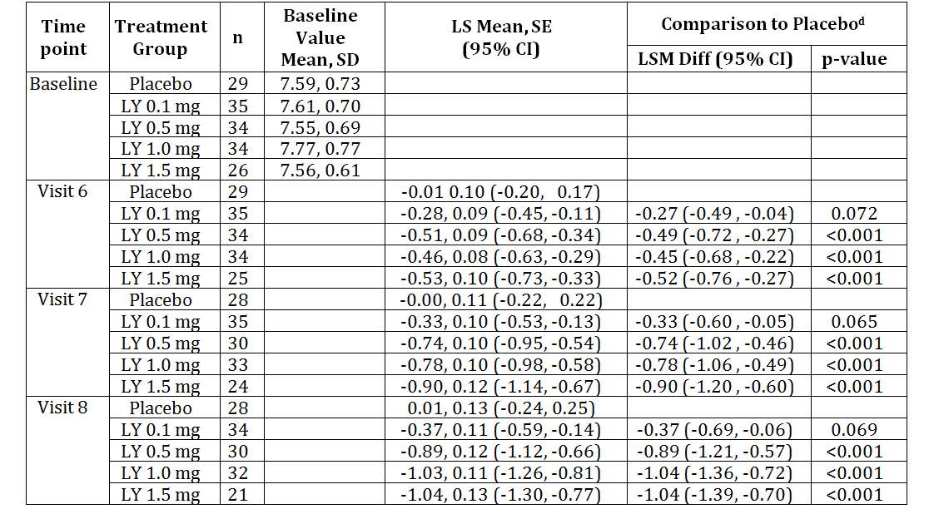
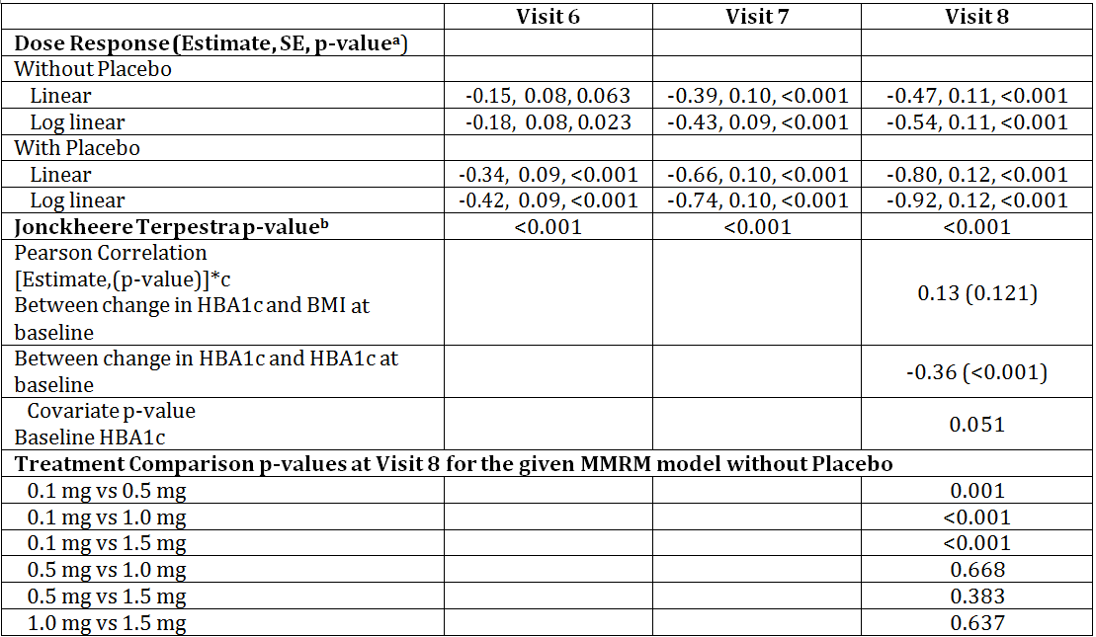
BMI = body mass index; CI = confidence interval; HBA1c = haemoglobin a1c; LS Mean = least-squares mean; LSM Diff = least-squares difference of means; LY = LY2189265; mg = milligram; n = number of patients in the specified category; SD = standard deviation; SE = standard error.
a – p-values from Mixed Models Repeated Measurements (MMRM): Change = Dose + Pre-study Therapy + Pooled Country + Baseline HBA1c + Visit + Dose*Visit; Where patient is treated as a random effect. Type III sums of squares and Kenward-Roger approximation as denominator degrees of freedom will be used.
Covariance structure with placebo = Unstructured.
Covariance structure without placebo = Unstructured.
b – p-values from Jonckheere - Terpestra non-parametric trend test.
c – estimate and p-values from Pearson correlation coefficients test.
d – The LSM Diff, 95% confidence interval and adjusted p-values (Dunnet's p–value) are from above mentioned mixed models repeated measurements (MMRM).
e - The ITT population (N = 167) is defined as all randomized patients who took at least one dose of study drug, including patients from the 3-mg LY2189265 arm that was discontinued (N = 3). The full ITT data set (N = 167) is included in MMRM analyses, ANCOVA, and efficacy listings. The data set included in summaries, MMRM subgroup and all other analyses (N = 164) is the full ITT data set excluding data from the discontinued 3-mg LY2189265 arm.

Results for other efficacy outcomes

Fasting Blood Glucose
At 12 weeks, differences in LS mean decrease in FBG were statistically significant in the 3 highest treatment groups of LY2189265 (all, p < .001) versus the placebo group, which was consistent with analyses of changes in HbA1c at endpoint.

Self-Monitored Blood Glucose at 12 Weeks
The dose response curves of LY2189265 based on mean premeal, mean 2-hour postprandial, and mean daily blood glucose values from the 7-point SMBG profiles without placebo were statistically significant at endpoint (all p < .001).

HbA1c Change from Baseline at Endpoint
All LY2189265 doses showed statistically significant separation (0.1 mg LY: p = 0.039; and 1.5, 1.0, and 0.5 mg LY: p < 0.001) from placebo based on the ANCOVA. Least squares mean changes at Visit 8 ranged from - 0.41 in the 0.1-mg LY2189265 treatment arm to - 1.09 in the 1.0-mg LY2189265 treatment arm, compared to the placebo treatment arm. Least squares mean change from baseline in the placebo treatment arm was 0.01% (CI: - 0.24, 0.25). Treatment comparison between the 4 doses of LY2189265 showed statistically significant separation (0.5 mg LY: p = 0.001; 1.0 and 1.5 mg LY: p < 0.001) of the higher 3 doses from the lowest dose, but the higher doses did not separate from each other. The second analysis using ANCOVA (LOCF) resulted in similar mean changes from baseline at endpoint.

Percent patients achieving HbA1c of < 7% and ≤ 6.5%
At Visit 8, 71.4% of patients in the 1.5-mg LY2189265 arm and 75.0% in the 1.0-mg LY2189265 arm compared to 21.4% in the placebo arm reached the HbA1c target of < 7.0%. At Visit 8, 52.4% of patients in the 1.5-mg LY2189265 arm compared to 7.1% of patients in the placebo arm reached the HbA1c target of ≤ 6.5%.

Beta Cell Function and Insulin Sensitivity
Beta cell function and Insulin sensitivity were calculated using the updated Homeostasis Model Assessment (HOMA2, Version 2.2). A statistically significant increase in HOMA2-B (%) compared to placebo was observed in all except for the 0.1-mg LY2189265 treatment group, at all post randomisation visits. At endpoint, the increase was statistically significant in the 0.5-mg (p = 0.003), 1.0-mg (p < 0.001), and 1.5-mg (p = 0.013) LY2189265 treatment groups. For insulin sensitivity no statistically significant improvement in HOMA2-S was observed in any of the LY2189265 treatment groups at any post randomisation visit.

Study M9X-MC-GBDN
The effect of LY2189265 on blood pressure and heart rate, as assessed by ambulatory blood pressure monitoring, in patients with Type 2 Diabetes Mellitus
Study GBDN was a multicentre, randomised, double blind, parallel group, placebo controlled study that evaluated the effects of dulaglutide 0.75 and 1.5 mg on blood pressure and heart rate using ABPM in a total of 755 patients with T2DM on at least 1 OAM for 26 weeks.
The primary objective of the study was safety – to demonstrate that the change from baseline in mean 24 hour systolic blood pressure (SBP) of the dulaglutide doses was non-inferior (by a margin of 3 mmHg) to placebo at 16 weeks.

HbA1c
There was an overall statistically significant difference in the percentage of patients achieving HbA1c values < 7% and ≤ 6.5% for all 3 treatment groups at both 16 and 26 weeks (p < 0.001 for all comparisons).
Table 21: Study GBDN: HbA1c MMRM by treatment group and visit intent-to treat population.
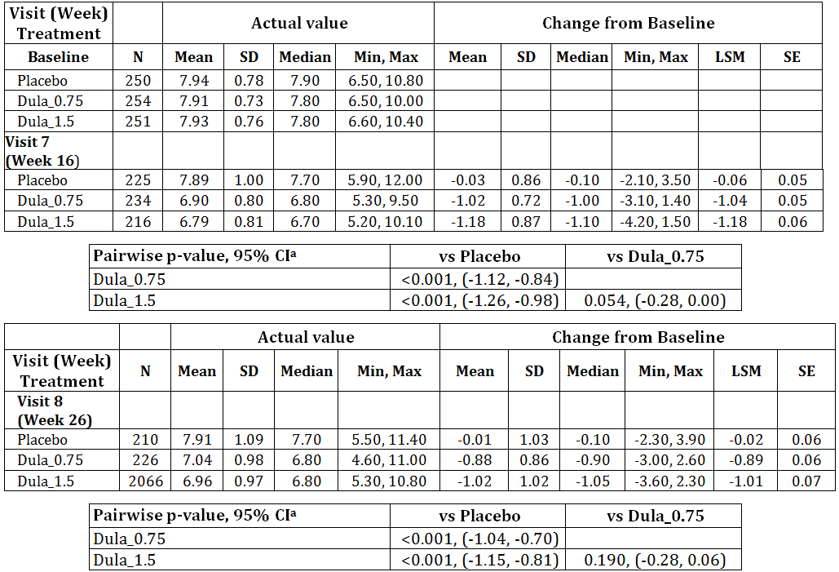
CI = confidence interval; HbA1c = haemoglobin A1c; LSM = least square mean; Max= maximum; Min = minimum; MMRM = mixed-effects model for repeated measures; N = total number of patients with non-missing value at baseline and specified visit in specified treatment arm; REML = restricted maximum likelihood; SD = standard deviation; SE = standard error; vs = versus.
Note: Dula_x.x refers to x.x milligrams dulaglutide once weekly.
a – p-value and 95% CI of pairwise difference of LS Means of change from baseline are from REML based MMRM model: Change from Baseline = Baseline + Pooled Sites + Diagnosis of Hypertension at Baseline + Treatment + Visit + Treatment*Visit (Type III sums of squares), where patient enters the model as a random effect. Covariance structure = Unstructured.
The percentage of patients achieving a target HbA1c < 7% and ≤ 6.5% at Week 16 was greater in the dulaglutide treatment groups compared with placebo. Pairwise comparison showed that the proportion of patients who achieved an HbA1c < 7% and ≤ 6.5% was significantly greater in each dulaglutide group compared with placebo. There were no significant differences between the 2 dulaglutide groups for patients achieving a target HbA1c < 7%. For patients achieving a target HbA1c ≤ 6.5% the differences between the 2 dulaglutide groups just achieved statistical significance (p = 0.05).
Table 22: Study GBDN: Patients achieving HbA1c Values ≤ 6.5% and < 7% by treatment group and visit - ITT population.
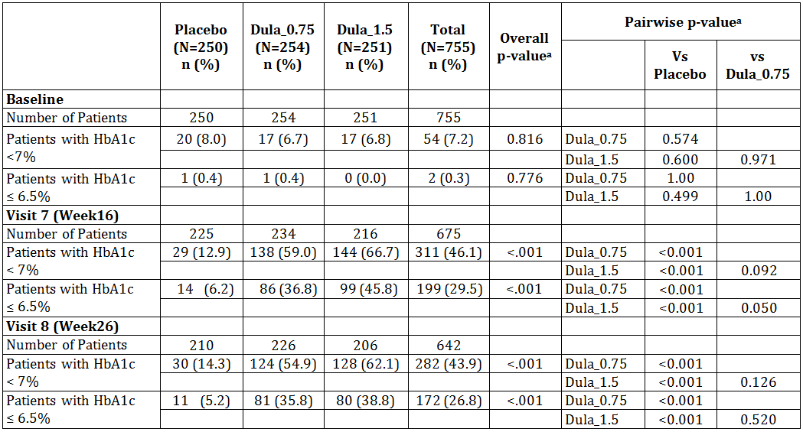
HbA1c = haemoglobin A1c; N = total number of patients in specified treatment arm; n = number of patients in the specified category; vs = versus.
Note: Dula_x.x refers to x.x milligrams dulaglutide once weekly.
a - Overall and pairwise p-values are from Chi-squared test if 80% of cells have an expected value > = 5, otherwise Fisher's exact test will be used.

Fasting Blood Glucose (FBG)
A decrease from baseline in mean FBG was observed in both dulaglutide treatment groups beginning at 4 weeks, that remained fairly unchanged through Week 16; but by Week 26 slightly smaller reductions in FBG were observed. Reductions ranged from -1.58 to -1.93 mmol/L for the dulaglutide 0.75 mg group and -1.85 to -2.22 mmol/L for the dulaglutide 1.5 mg group. Within the placebo group, changes in mean FBG were small (0.13 to -0.24 mmol/L).
Pairwise comparison of the LSM FBG differences showed that both dulaglutide groups significantly reduced FBG at all post randomisation visits compared with placebo (p < 0.001 for each). There were no significant differences between the 2 dulaglutide groups, except at Week 12.

Body Weight
In general, decreases in mean body weight were observed in both dulaglutide groups (dulaglutide 1.5 mg > dulaglutide 0.75 mg) at Week 4 and continued reductions were observed through Week 16. The reduction in mean body weight in both dulaglutide groups from baseline to Week 26 was similar to the change observed at Week 16. Small increases and decreases in mean body weight were observed in the placebo group over the course of the study.
Pairwise comparison showed that both dulaglutide groups were associated with a statistically significant reduction in LSM body weight from baseline compared with placebo at Weeks 4, 8, 12, 16 and 26. There was a statistically significantly greater decrease in LSM body weight in the dulaglutide 1.5 mg group compared with the dulaglutide 0.75 mg group at all time points.

Analyses performed across trials (pooled analyses and meta-analyses)
No meta-analysis or pooled analyses of efficacy were conducted; however the sponsor has provided a summary analysis for comparison of the results of the efficacy studies.

HbA1c
Across the 5 Phase 3 studies, which spanned the T2DM treatment spectrum with multiple background combinations and comparators evaluated, both dulaglutide doses led to a consistent improvement in HbA1c from 26 to 104 weeks. The LS mean difference at 26 and 52 weeks were -0.19% and -0.24%. At 104 weeks only Study GBCF had data at this time point and the LS mean difference was -0.30%.
Figure 26: Differences in HbA1c mean change from baseline (%) relative to comparator at 26, 52, 78 and 104 weeks, Pivotal studies.
AC = active comparator; BID = twice daily; CI = confidence interval; FPG = fasting plasma glucose; HbA1c = glycosylated haemoglobin A1c; ITT = intent-to-treat; LS = least square; PL = placebo; QD = once daily.
Note: Dula_x.x refers to dulaglutide x.x mg once weekly.
Note: Reference lines – dashed red reference lines are at 0.3% and 0.4%.
Note: Active comparator doses: metformin, 1500 to 2000 mg QD, sitagliptin, 100 mg QD; exenatide, 10 mcg BID, insulin glargine, adjusted based on treat-to-target algorithm to maintain FPG < 100 mg/dL ( < 5.6 mmol/L).

Percent of patients achieving HbA1c < 7% and ≤ 6.5%
At the primary time point, treatment with dulaglutide 1.5 mg resulted in significantly greater percentages of patients who achieved HbA1c < 7.0% or ≤ 6.5% compared to placebo, and/or active comparator in all 5 Phase 3 studies (p < 0.01). At the primary time point, treatment with dulaglutide 0.75 mg resulted in significantly greater percentages of patients who achieved HbA1c < 7.0% compared to placebo and/or active comparator in 4 of the 5 Phase III studies.
At 26 weeks, 65.3% of dulaglutide 1.5 mg and 59.7% of dulaglutide 0.75 mg treated patients achieved HbA1c < 7%. At 52 weeks, 60.0% of dulaglutide 1.5 mg and 50.9% of dulaglutide 0.75 mg achieved HbA1c < 7%.
Figure 27: Cumulative distribution functions and bar plots of % patients achieving HbA1c targets of < 7% and ≤ 6.5% at primary time point, ITT, pivotal studies.
AC = active comparator; eCDF = Empirical Cumulative Distribution Function; HbA1c = glycosylated haemoglobin A1c; PL = placebo.
Note: Dula_x.x refers to dulaglutide x.x mg once weekly. Primary time point is 26 weeks for Studies GBDA, GBDC, and GBDD; and 52 weeks for Studies GBDB and GBCF.
* p < .05, ** p < .001 dulaglutide treatment group compared to placebo.
# p < .05, ## p < .001 dulaglutide treatment group compared to active comparator.
+ p < .05, ++ p < .001 dulaglutide 1.5-mg treatment group compared to dulaglutide 0.75-mg treatment group using Log Rank test.

Fasting Blood Glucose
Figure 28: Fasting blood glucose LS mean (SE) change from baseline at the primary time point (26 or 52 weeks), ITT, pivotal studies.
BID = twice daily; FPG = fasting plasma glucose; FSG = fasting serum glucose (central laboratory); ITT = intent-to treat; LS = least-squares; QD = once daily. Note: Dula_x.x refers to dulaglutide x.x mg once weekly.
Note: Active comparator doses: GBDC metformin, 1500 to 2000 mg QD; GBCF sitagliptin, 100 mg QD; GBDA exenatide, 10 mcg
BID, GBDB/GBDD insulin glargine, adjusted based on treat-to-target algorithm to maintain FPG < 100 mg/dL ( < 5.6 mmol/L).

Body weight
In 3 of the 5 Phase III studies, dulaglutide 0.75 mg was associated with weight reduction from baseline over the duration of the studies. Due to concomitant antihyperglycaemic therapies, TZD and prandial insulin in particular, the range of weight changes varied between individual studies.
Figure 29: Least square mean (SE) changes from baseline in body weight (kg) at the primary and final time point, ITT pivotal studies.

Summary of efficacy results at primary time point
Table 23: Summary of efficacy results at primary time point – pivotal trials ITT population.
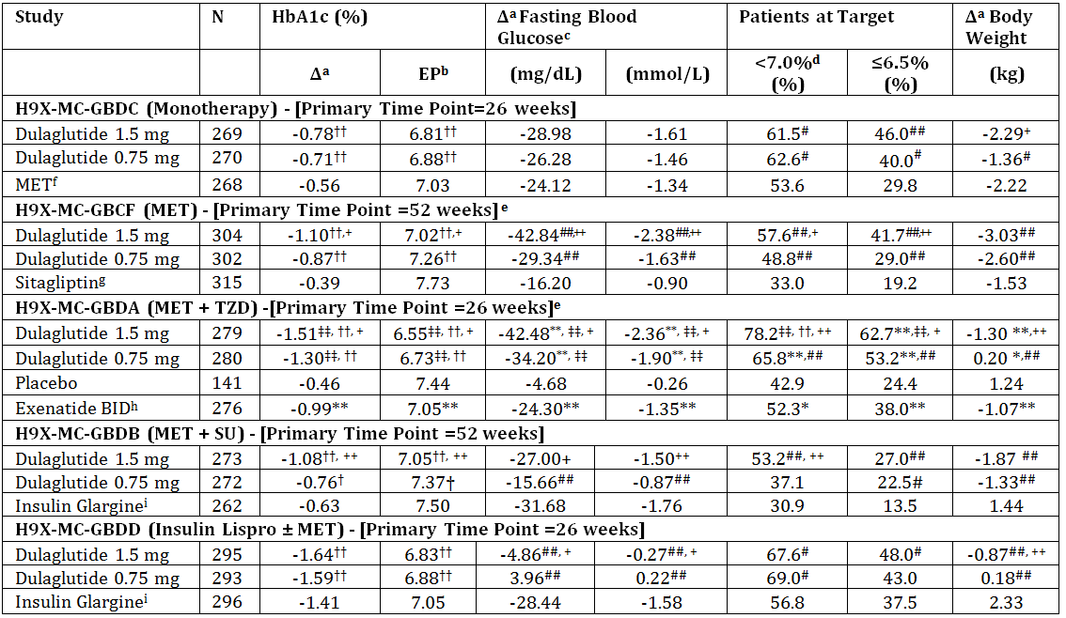
BID = twice daily injection; EP = HbA1c primary endpoint; HbA1c = glycosylated haemoglobin A1c; MET = metformin; SU = Sulfonylurea; TZD = thiazolidinedione; Total controlled duration for Studies GBDC = 52 weeks; GBCF = 104 weeks; GBDA = 52 weeks; GBDB = 78 weeks; GBDD = 52 weeks. Analyses for change in HbA1c and weight (ANCOVA [LOCF]), percentages of patients achieving HbA1c targets (Logistic regression [LOCF]), and change in FBG (MMRM)
a Δ = Change from baseline presented at primary time point of each study. Data presented as Least Squares Mean.
b EP = HbA1c primary endpoint. Data presented as least squares mean
c Fasting glucose concentrations are from central laboratory draw. Study GBCF used plasma, while Studies GBDA, GBDB, GBDC, and GBDD used serum for measuring fasting glucose.
d Number of evaluable patients (that is, patients with LOCF data for the endpoint) was used as denominator for percent to goal analyses of HbA1c.
e In Studies GBCF and GBDA, placebo comparisons were planned at 6 months (after which patients remained blinded and were switched to sitagliptin and dulaglutide (1.5 mg or 0.75 mg), respectively.
f Metformin dose was 1500 to 2000 mg QD.
g Sitagliptin dose was 100 mg QD.
h Exenatide dose was 10 mcg BID.
Insulin glargine dose was adjusted based on treat-to-target algorithm to maintain fasting plasma glucose < 100 mg/dL ( < 5.6 mmol/L).
† Multiplicity adjusted 1-sided p-value < .025, for non-inferiority ††multiplicity adjusted 1-sided p-value < .025, for superiority of dulaglutide compared to comparator, assessed only for HbA1c.
‡‡ Multiplicity adjusted 1-sided p-value <.001 for superiority of dulaglutide compared to placebo, assessed only for HbA1c.
* p < .05, ** p < .001 dulaglutide or exenatide BID treatment group compared to placebo.
# p < .05, ## p < .001 dulaglutide treatment group compared to active comparator.
+ p < .05, ++ p < .001 dulaglutide 1.5 compared to dulaglutide 0.75.

Summary of efficacy results at final time point
Table 24: Summary of efficacy results at the final time point – active comparator trials, ITT population.
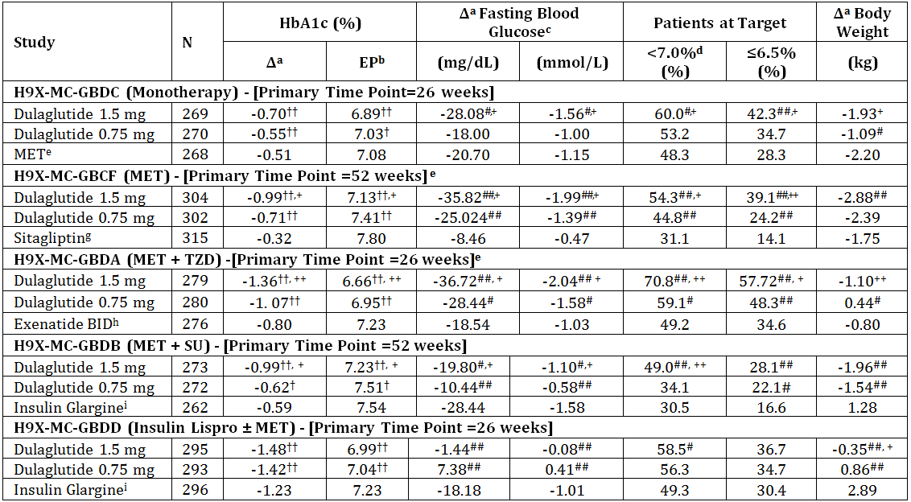
ANCOVA = analysis of covariance; BID = twice daily; FBG = fasting blood glucose; FT=final time point; HbA1c = glycosylated haemoglobin A1c; LOCF = last observation carried forward; MET = metformin; QD = once daily; SU = sulfonylurea; TZD = thiazolidinedione.
Total controlled duration for Studies GBDC = 52 weeks; GBCF = 104 weeks; GBDA = 52 weeks; GBDB = 78 weeks; GBDD = 52 weeks.
Analyses for change in HbA1c and weight (ANCOVA [LOCF]), percentages of patients achieving HbA1c targets (Logistic regression [LOCF]), and change in FBG (MMRM)
a Δ = Change from baseline presented at final time point of each study. Data presented as least squares mean.
b FT HbA1c at final time point. Data presented as least squares mean.
c Fasting blood glucose includes fasting serum glucose (Study GBDC, GBDA, GBDB, and GBDD) and fasting plasma glucose (Study GBCF), as measured by central laboratory.
d Number of evaluable patients (that is, patients with LOCF data for the endpoint) was used as denominator for percent to goal analyses of HbA1c.
e Metformin dose was 1500 to 2000 mg QD.
f Sitagliptin dose was 100 mg QD.
g Exenatide dose was 10 mcg BID.
h Insulin glargine dose was adjusted based on treat-to-target algorithm to maintain fasting plasma glucose < 100 mg/dL ( < 5.6 mmol/L).
† Multiplicity adjusted 1-sided p-value, .025, for non-inferiority, ††multiplicity adjusted 1-sided p-value, .025, for superiority of dulaglutide compared to active comparator, assessed only for HbA1c.
# p < .05, ## p < .001 dulaglutide treatment group compared to active comparator.
+p < .05, ++ p < .001 dulaglutide 1.5 compared to dulaglutide 0.75.

Evaluator’s conclusions on clinical efficacy for treatment of T2DM
An extensive clinical program was conducted to support the indication being requested. There is strong consistency across the studies. The studies were conducted such that they covered the different stages in the continuum of treatment and included: monotherapy in treatment naïve patients (Study GBDC), combination therapy as add on to metformin (Study GBCF), metformin and exenatide (Study GBDA), metformin and glimepride (Study GBDB) and metformin and insulin (Study GBDD).
At all primary time points in the 5 pivotal studies, once weekly dulaglutide 1.5 mg was superior to the active comparator with a corresponding greater proportion of patients reaching an HbA1c of < 7% and < 6.5%. Once weekly dulaglutide 0.75 mg was superior to active comparator in 4 of the 5 pivotal studies and non-inferior to insulin glargine in 1 study. The observed reductions in HbA1c, resulting in superior HbA1c control for all studied comparators for dulaglutide 1.5 mg (in all 5 Phase III studies) and dulaglutide 0.75 mg (in 4 of 5 Phase 3 studies [non-inferior in Study GBDB]), represent a dose-dependent clinical benefit of improved glycaemic control with dulaglutide 1.5 mg once weekly across different stages in the clinical progression of T2DM.
The observed HbA1c reductions are consistent with that seen with the other marketed GLP-1 receptor agonists exenatide and liraglutide.
Reductions in fasting blood glucose are consistent with the HbA1c changes. The reduction in body weight is modest.

Clinical safety

Studies providing evaluable safety data
The following studies provided evaluable safety data:

Efficacy studies
In the efficacy studies, the following safety data were collected:
- General adverse events (AEs) were assessed by collection of treatment-emergent adverse events (TEAEs) at each visit regardless of relationship to study drug
- AEs of particular interest, including acute pancreatitis, hyperglycaemia, hypoglycaemia, thyroid neoplasms, cardiovascular events were evaluated by review of the TEAEs and further investigation for definitive diagnosis if necessary
- Laboratory tests, including chemistry panel, complete blood cell count (CBC), urinalysis, albumin/creatinine ratio, amylase, lipase, calcitonin, and lipids, were performed at each study visit
- Body weight, BMI, waist circumference
- Vital signs (blood pressure and pulse rate
- ECGs according to study schedule
- Immunogenicity was assessed by collection of blood at specified times during the studies and assessed by testing for antibody formation. Positive anti-LY2189265 antibody samples were evaluated for their ability to neutralise the activity of LY2189265. Any anti-LY2189265 antibody samples found to be neutralising to the activity of LY2189265 were also tested for cross-reactivity with native GLP-1.

Studies that assessed safety as a primary outcome
Study GBDN was a study that assessed safety as a primary outcome.

Dose-response and non-pivotal efficacy studies
The dose-response and non-pivotal efficacy studies provided safety data similar to the pivotal studies.

Other studies evaluable for safety only
Not applicable.

Clinical pharmacology studies
The safety of the clinical pharmacology studies is included in the individual study summaries.

Studies that assessed safety as a primary outcome

Study M9X-MC-GBDN
The Effect of LY2189265 on blood pressure and heart rate, as assessed by ambulatory blood pressure monitoring, in patients with type 2 diabetes mellitus.

Study design, objectives, locations and dates
A multicentre, randomised, double blind, parallel group, placebo controlled study conducted in 76 centres in 7 countries (USA, Canada, Argentina, Brazil, India, Czech Republic, and Denmark) from June 2010 to January 2012.
Primary objective: To demonstrate that the change from baseline in mean 24 hour systolic blood pressure (SBP) of the 1.5 and 0.75 mg doses of dulaglutide were non-inferior to placebo at week 16, as measured by ambulatory blood pressure monitoring (ABPM), in patients with T2DM.
Secondary objectives:
- To assess of the effects of the 1.5 and 0.75 mg doses of dulaglutide compared to placebo (change from baseline) at 16 and 26 weeks, as measured by ABPM, on:
- daytime and night time SBP,
- mean 24-hour, daytime, and night time diastolic blood pressure (DBP)
- mean 24-hour, daytime, and night time heart rate (HR)
- mean 24-hour, daytime, and night time pulse pressure
- mean 24-hour, daytime, and night time mean arterial pressure (MAP)
- To demonstrate that the change from baseline in mean 24 hour SBP of the 1.5-and 0.75-mg doses of dulaglutide are non-inferior to placebo at 26 weeks, as measured by ABPM
- To assess the effects of the 1.5 and 0.75 mg doses of dulaglutide compared to placebo on vital signs (HR, SBP, and DBP)
- To assess the effects of the 1.5 and 0.75mg doses of dulaglutide compared to placebo on glycaemic control (haemoglobin A1c [HbA1c], fasting blood glucose [FBG], proportion of patients achieving a HbA1c < 7% and ≤ 6.5%).
- Safety assessment

Study Population
Patients included men and non-pregnant women aged ≥ 18 years with T2DM, treated with a stable regimen of 1 or more OAMs, and an HbA1c ≥ 7.0% and ≤ 9.5%. All patients had to have a mean seated clinic BP > 90/60 mmHg and < 140/90 mmHg, and if the patient was being treated for hypertension, had to be taking ≤ 3 antihypertensive medications (same regimen for at least 1 month). Weight had to be stable for at least 3 months, and patients had to have a body mass index ≥ 23 kg/m2.
Exclusion criteria included: myocardial infarction (MI), stroke, or hospital admission for heart failure (HF) within the prior 3 months; an ongoing or history of frequent intermittent tachyarrhythmias; a mean resting HR < 60 bpm or > 100 bpm; worked a rotating shift; worked during the hours of 2200 to 0700; had a non-dominant arm circumference > 42 cm; were currently taking insulin, a GLP-1 analogue (within the prior 3 months), or a DPP-IV inhibitor (within prior 2 weeks), or had an estimated glomerular filtration rate (eGFR; Cockroft-Gault method) ≤ 30 mL/min/1.73 m2.

Study treatments
Patients were randomised to 1 of 2 treatment arms (dulaglutide 0.75 and 1.5 mg) and placebo in a 1:1:1 ratio. Dulaglutide 1.5 mg, dulaglutide 0.75 mg or matching placebo was administered by subcutaneous injection once weekly for 26 weeks. Dulaglutide 1.5 mg was administered as a 0.5-mL injection of a 3.00-mg/mL solution. Dulaglutide 0.75 mg was administered as a 0.5-mL injection of a 1.50-mg/mL solution. Placebo was administered as a 0.5-mL injection.

Safety outcomes
The primary outcome was change from baseline at 16 weeks in mean 24-hour SBP, as measured by ABPM.
Other safety outcomes were: Mean 24-hour ABPM, daytime and night time SBP, DBP, HR, pulse pressure, and MAP; vital signs (seated clinic-measured SBP, DBP, HR); hypoglycaemic events; laboratory analytes; exploratory CV analytes; ECGs; TEAEs; dulaglutide ADAs; and CV, pancreatic, and thyroid adverse events (AEs) of interest.
HBA1c and FBG at each visit were also measured.

Statistical methods
Two analysis models were used for the primary efficacy measurement. The primary analysis for the primary endpoint was a mixed-model repeated-measure (MMRM) analysis. The secondary analysis model was analysis of covariance (ANCOVA). The primary comparison of ABPM mean 24-hour SBP change from baseline at 16 weeks (Visit 7) was the comparison of both dulaglutide 1.5 and 0.75mg doses versus placebo for non-inferiority with a margin of 3 mmHg. If the upper limit of the 95% CI (adjusted for multiplicity, ie, a 2-sided 97.3% CI) of the difference between dulaglutide 1.5 or 0.75 mg dose and placebo was below 3 mmHg, the respective dulaglutide dose was declared non-inferior to placebo. If the upper limit of the CI was below zero, the dulaglutide dose was declared superior to placebo. All tests of treatment effects were conducted at a 2-sided alpha level of 0.05 and 2-sided 95% confidence intervals (CI) were calculated.
Both MMRM and ANCOVA models were used to analyse the change from baseline for the ABPM summary measurements of mean 24-hour mean SBP, DBP, and HR. Only MMRM was used for the analyses of the other ABPM-derived parameters, the daytime and night time ABPM parameters, as well as the other safety measurements, unless otherwise noted.
For continuous measures, summary statistics included sample size, mean, standard deviation, median, minimum, and maximum for both the actual and the change from baseline measurements. Least-squares mean (LSM) and standard error (SE) derived from the model were displayed for the change from baseline. Treatment comparisons were displayed showing the treatment difference LSM and the 95% CIs of the treatment differences along with the p-value for the treatment comparison. For continuous laboratory measurements, an ANOVA on ranks was used and p-values for the difference between the dulaglutide doses and the placebo were reported. For categorical measures, summary statistics included sample size, frequency, and percentages. Unless otherwise noted, a chi-squared test was used if at least 80% of cells had an expected number of events no less than 5, otherwise a Fisher's exact test was used.

Sample size
Approximately 693 randomised patients were planned to participate in this study. The assumption of a 10% dropout rate after randomisation would have 624 completers (208 per arm) to achieve 80% power for a 1-sided adjusted 0.025 alpha level test (adjustment 0.0135 based on multiple comparisons) based on a 2-sample t-statistic, assuming no true difference, an SD of 10 mm Hg, and a non-inferiority margin of 3 mm Hg for ABPM mean 24-hour SBP change from baseline. The same sample size also provided approximately an 80% power for a non-inferiority margin of 2.5 mm Hg for ABPM mean 24-hour DBP change from baseline, assuming a SD of 8 mm Hg. The same sample size also would provide approximately an 80% power and a non-inferiority margin of 3 bpm for ABPM 24-hour mean HR change from baseline assuming a SD of 9 bpm.

Analysis populations
Intent to treat (ITT) population: (N = 755): All randomised patients who have received at least 1 dose of study medication.
Per Protocol (PP) population: Patients in the ITT population who had no significant protocol violations and completed the study up to Week 16 and had an overall compliance of at least 75% with study treatment across visits up to Week 16.

Participant flow
Figure 30: Study GBDN: Participant flow.
AE = adverse event; N = number of patients randomized; n = number of patients; Wks = weeks.

Major protocol violations/deviations
A total of 157 (20.8%) patients in the study had at least 1 significant protocol violation. Overall, there was a significant difference in the incidence of protocol violations across the 3 treatment groups (p = 0.004). The incidence of protocol violations was highest in the dulaglutide 1.5 mg group (26.7%) followed by the placebo group (21.2%) and the dulaglutide 0.75 mg group (14.6%).
The most frequent protocol violations were:
- patients not completing the study through 16 weeks (13.1% overall; p = .037); greatest in the dulaglutide 1.5 mg group (16.7%) compared with the placebo group (13.6%) or dulaglutide 0.75 mg group (9.1%)
- overall treatment compliance was < 75% up to 16 weeks (3.7% overall; p = .099); greatest in the dulaglutide 1.5 mg group (5.6%) compared with the other 2 groups
- starting a new antihypertensive medication or increasing the dose of an existing antihypertensive drug after randomisation (3.6% overall; p = .037); greatest in the placebo group (6%) compared with the 2 dulaglutide groups (dulaglutide 0.75 mg: 2.8% and dulaglutide 1.5 mg: 2%)
One site in Canada was inspected by Health Canada and issued a “non-compliant” rating from the agency due to the identification of multiple GCP compliance issues. The site was terminated and as per agreement with Health Canada. The site was included in the ITT population of the study, and separate sensitivity analyses conducted to determine whether or not the study findings were affected by inclusion or exclusion of the site data.

Baseline data
The mean age of the patients was 56.5 years, 48% were female and 52% male, 80.5% were white, and 38% Hispanic. The mean BMI was 33.0 kg/m2, mean HbA1c 7.9%, and the mean duration of diabetes was 8.3 years (median 7.0 years). The duration of diabetes was significantly different among the treatment groups (slightly lower in dulaglutide 1.5 mg group, p = 0.029). The majority (54%) of patients were enrolled in the USA.

Results for the primary safety outcome
The primary objective of the study was met. Statistically significant reductions from baseline in LSM 24-hour SBP were observed for the dulaglutide 0.75 mg and dulaglutide 1.5 mg groups at 4, 16, and 26 weeks. No statistically significant difference in LSM 24-hour SBP was observed for the placebo group at any time point. Both doses of dulaglutide were non-inferior to placebo for mean 24-hour SBP at 16 weeks, using a non-inferiority margin of 3 mmHg The dulaglutide 1.5 mg dose was shown to significantly reduce mean 24-hour SBP compared with placebo at 16 weeks (-2.8 mmHg; p<0.001) and at 26 weeks (-2.7 mmHg; p = 0.002).
Figure 31: Study GBDN: Mean plot of change of ABPM mean 24-Hour SBP by treatment and visit, ITT population.
ABPM = ambulatory blood pressure monitoring; mm Hg = millimetres of mercury; SBP = systolic blood pressure.
Notes: Dula_x.x refers to x.x mill1 grams dulaglutide once weekly; the plots are plotted with mean ± standard error.

Results for other safety outcomes

Daytime and Night time SBP
Reductions in day and night-time SBP were observed in both dulaglutide groups at 4, 16, and 26 weeks. Dulaglutide 0.75 mg significantly reduced daytime SBP at 4 and 26 weeks but did not significantly reduce night-time SBP compared with placebo. Dulaglutide 1.5 mg significantly reduced daytime SBP compared with placebo (-2.87 to -3.69 mm Hg) and to a similar extent as that observed in the mean 24-hour analyses. Reductions in night time SBP were significant only at 4 and 26 weeks (-1.24 to -2.35 mm Hg).
The 24-hour SBP profiles at 16 and 26 weeks showed the typical circadian variation in BP in each treatment group. At 16 and 26 weeks, the 24-hour profile for dulaglutide 1.5 mg was shifted downward compared with the other treatment groups.

Mean 24-Hour Diastolic Blood Pressure
Both doses of dulaglutide were shown to be non-inferior to placebo for mean 24-hour DBP at 16 and 26 weeks, using a non-inferiority margin of 2.5 mmHg.
Figure 32: Study GBDN: Mean plot of change of ABPM mean 24-Hour DBP by treatment and visit, ITT population.
ABPM = ambulatory blood pressure monitoring; mmHg = millimetres of mercury; DBP = diastolic blood pressure.
Notes: Dula_x.x refers to x.x mill1 grams dulaglutide once weekly; the plots are plotted with mean ± standard error.

Daytime and Night time DBP
There were no significant effects of dulaglutide on day or night-time DBP compared with placebo.

Mean 24-Hour Heart Rate
Statistically significant increases from baseline LSM 24-hour HR were observed at 4, 16, and 26 weeks for both dulaglutide treatment groups. No statistically significant difference in mean 24-hour HR was observed for the placebo group at any time point.
Using a non-inferiority margin of 3 bpm, treatment comparison for non-inferiority showed that the dulaglutide 0.75 mg group was non-inferior to placebo at 16 and 26 weeks; however, dulaglutide 1.5 mg was not non-inferior to placebo at 16 or 26 weeks. Small increases in LSM HR were observed in the dulaglutide 1.5 mg group compared to placebo at 16 (2.84 bpm) and 26 (3.50 bpm) weeks. Dulaglutide 0.75 mg group was not superior to placebo at any time point.
Figure 33: Study GBDN: Mean plot of ABPM mean 24-hour HR by treatment and visit, intent-to-treat population.
ABPM = ambulatory blood pressure monitoring; bpm = beats per minute; HR = heart rate.
Notes: Dula_x.x refers to x.x mill1 grams dulaglutide once weekly; the plots are plotted with mean ± standard error.

Sensitivity Analyses of ABPM Measurements
The findings for mean 24-hour SBP, DBP, and HR at Weeks 16 and 26 for the ITT and PP populations excluding the 12 patients from the terminated site in Canada were similar to the overall mean 24-hour findings as reported above.

Clinic measured BP
Dulaglutide was associated with reductions in clinic-measured SBP; however, treatment comparisons with placebo were often not statistically significant. Dulaglutide was not observed to have any effect on least square mean (LSM) seated clinic DBP. Therefore, the effects of dulaglutide on LSM seated clinic BP measurements were consistent with the ambulatory BP findings. The effect of dulaglutide on LSM seated clinic-measured HR was similar to the ambulatory HR findings, and a dose-dependent increase in HR was observed with dulaglutide.

Subgroup analysis
The effect of dulaglutide on the mean 24-hour SBP or mean 24-hour DBP was the same regardless of gender, age, race, ethnicity, region, median duration of diabetes, median BMI, hypertension, baseline BP ( ≤ 130/80 versus > 130/80 mm Hg), or history of CVD at baseline.
The remaining safety results in included in the following relevant sections.

Patient exposure
The sponsor has evaluated the safety by integrating the data from the efficacy studies into 2 datasets that allowed a detailed analysis of the potential safety concerns.
- Analysis set 1 (AS1): comparison to placebo using trials with placebo duration of 26 weeks
- Analysis set 3 (AS3): long term safety (overall dulaglutide) and differential dose (1.5 mg vs 0.75 mg) for up to 104 weeks
The trials included in each analysis set are shown in the table below and it is noted that there is overlap between the datasets.
The full safety dataset comprises 6,005 patients included in the efficacy studies, of whom 4,006 received at least 1 dose of dulaglutide.
Table 25: Summary of total treatment duration categories and analysis sets used.
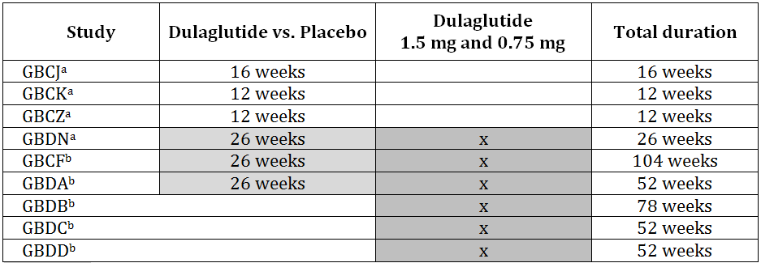
Light shading (AS1): Integrated assessment of Dula_1.5 and Dula_0.75 (combined and separately) vs. placebo for placebo-controlled studies of planned duration ≥ 26 weeks.
Dark shading (AS3): Integrated assessment of Dula_1.5 vs. Dula_0.75 at full duration (26 - 104 weeks).
a Phase II Studies
b Phase III Studies
Table 26: Summary of total treatment duration categories and analysis sets used.
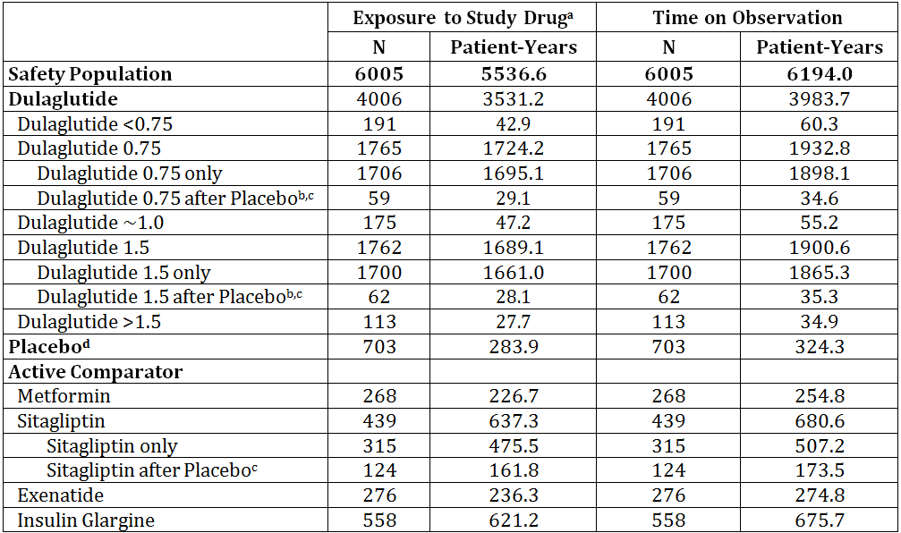
N = Number of patients in the specified treatment group.
a - For some studies (GBDA, GBDB, GBDC, GBDD), if a patient ceased study drug during the study, the patient was requested to remain in the study. "Treatment exposure" does not include any time after cessation of study drug.
b - This group excludes patients in GBDA Placebo/Dula who discontinued study treatment while on Placebo, yet continued in study into the Dula portion of the study (n = 3 Dula_0.75, n = 0 Dula_1.5).
c - This group includes patients who received Placebo prior to receiving Dulaglutide or Sitagliptin.
d - This group includes patients who received Placebo only, and those who subsequently received Dulaglutide or Sitagliptin.
Table 27: Exposure to dulaglutide in clinical studies according to dose and duration.
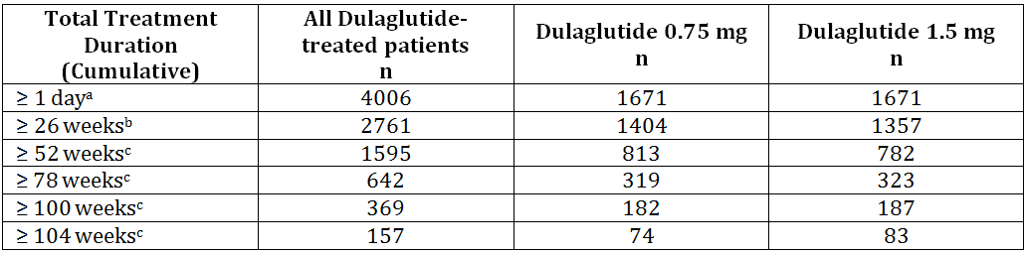
a Exposure for primary safety population based on the Phase 2 and Phase 3 studies (GBCJ, GBCK, GBCZ, GBDN, GBCF, GBDA, GBDB, GBDC, GBDD).
b Phase 2 and Phase 3 studies with 0.75 mg and 1.5 mg Dulaglutide Groups Safety Population, Studies GBCF, GBDA, GBDB, GBDC, GBDD, GBDN
c All exposures beyond 26 weeks are from Phase 3 trials.
Note: Due to nature of 104 week treatment duration GBCF study visit schedule and visit windows, patients may have completed the treatment period in slightly less than 104 weeks therefore reporting ≥100 weeks gives a greater reflection of the number of patients completing the studies.

Adverse events

All adverse events (irrespective of relationship to study treatment)

Placebo controlled studies
The proportion of patients reporting at least 1 TEAE was similar in the all dulaglutide group (69.8%) compared with placebo (66.7%). Gastrointestinal adverse events, including nausea (16.8% vs 5.3%), diarrhoea (10.7% vs. 6.7%), and vomiting (9.3% vs. 2.3%) were the most common adverse events reported with dulaglutide and were reported more frequently than with placebo treated patients.
Table 28: Summary of TEAE with at least 5% of patients occurring through 26 weeks in placebo controlled studies.
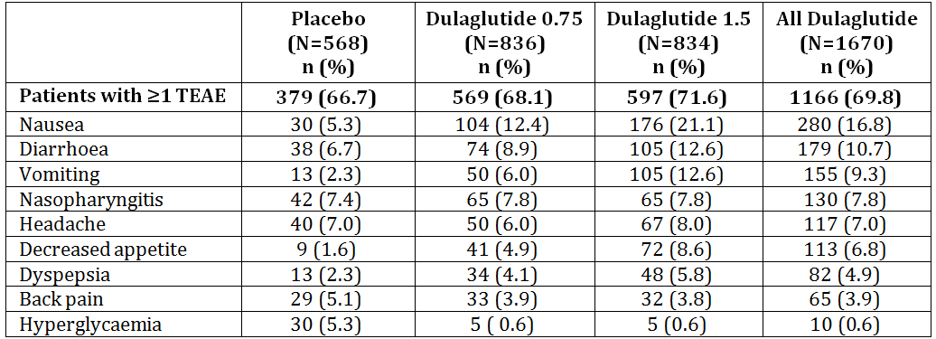
Studies included: GBCR, GBDA, GBDN
Dula = dulaglutide; N = total number of patients in specified treatment group; TEAE = treatment emergent adverse event.
a Events reported during the planned treatment period are events that occurred while the patient was enrolled whether or not that patient was receiving study drug.
All Dulaglutide refers to Dula 0.75 and Dula 1.5 treatment groups combined.

Long term studies
In the integrated dataset comparing dulaglutide 1.5 mg and dulaglutide 0.75 mg doses through the full treatment duration (26 to 104 weeks) (AS3), there were no significant differences in reporting of overall TEAEs between the 2 dulaglutide treatment groups. Similar to the placebo controlled database, GI events continued to be the most common TEAEs reported. These TEAEs were reported more commonly with dulaglutide 1.5 mg (43.9%) than dulaglutide 0.75 mg (34.5%).

Comparison of dulaglutide and all comparators
The analysis set comprised all studies of dulaglutide versus all comparators combined that had a planned duration of at least 26 weeks. Events occurring in ≥ 5% of dulaglutide patients where all dulaglutide has higher incidence than all comparators are predominantly GI tolerability adverse events: nausea, diarrhoea, vomiting, decreased appetite, and dyspepsia. The results should be viewed with caution as the comparator range was diverse in the comparator agents and background regimens employed.
Table 29: All dulaglutide versus all comparator analysis of TEAEs in at least 5% of dulaglutide patients to 26 weeks.
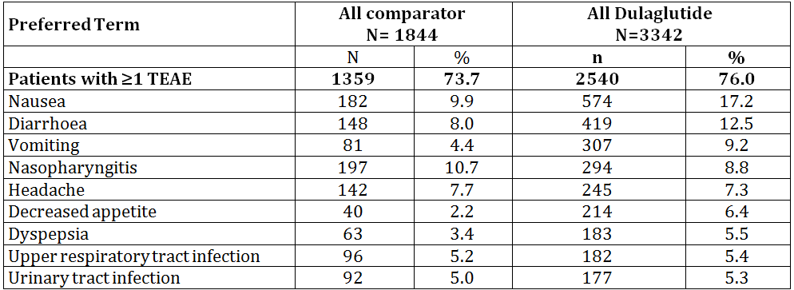
Studies included: GBCF, GBDA, GBDB, GBDC, GBDD, and GBDN
N = total number of patients in specified treatment arm; n = number of patients with at least one treatment-emergent adverse event; TEAE = treatment-emergent adverse event.
Note: All dulaglutide refers to 0.75 milligrams dulaglutide once weekly and 1.5 milligrams dulaglutide once weekly treatment groups combined. All Comparator = metformin for Study GBDC, placebo/sitagliptin or sitagliptin for Study GBCF, exenatide for Study GBDA, insulin glargine for Studies GBDB and GBDD, placebo for study GBDN. Patients randomized to the Placebo/Dulaglutide switch arms of Study GBDA are excluded from this analysis.

Treatment-related adverse events (adverse drug reactions)

Placebo controlled studies
Overall, more patients in the all dulaglutide (32.6%) than placebo (19.7%) group reported adverse events considered possibly related to study drug. The events most frequently reported were within the GI disorders system order class (SOC) (placebo: 3.3%, all dulaglutide: 7.2%). The pattern of events and their frequencies correspond closely to that of the overall adverse event profile. The most frequently reported were nausea, vomiting, decreased appetite, diarrhoea, dyspepsia, constipation, abdominal distension, and upper abdominal pain.
Table 30: Summary of AE considered related to study drug > 1% – placebo controlled trials.
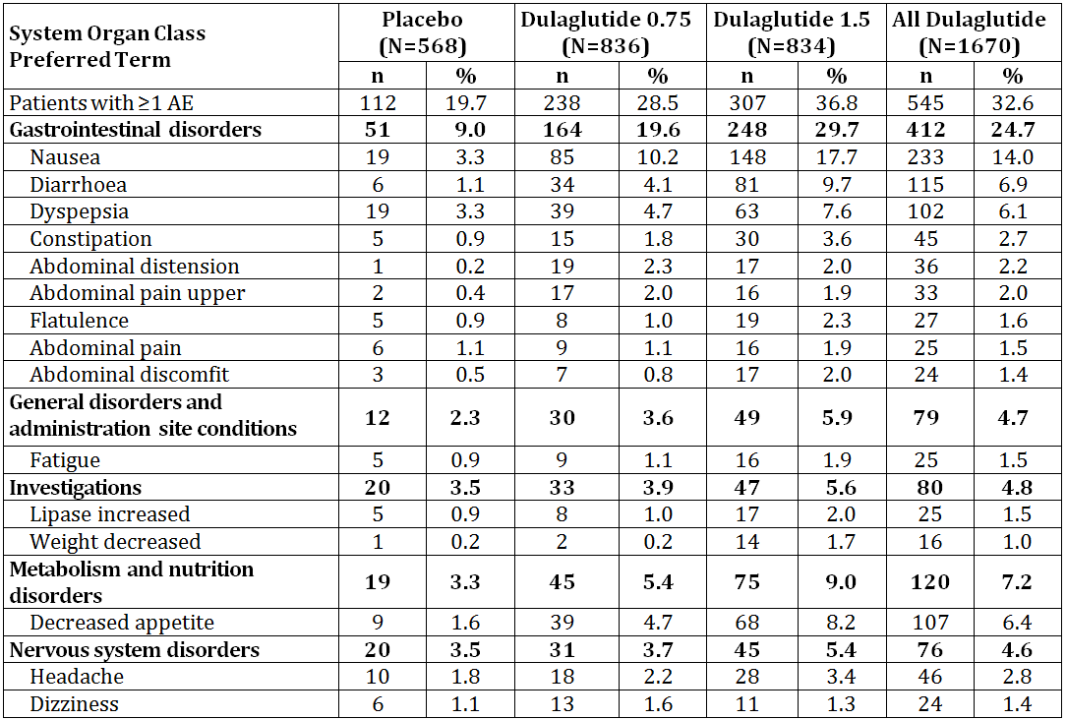
N = total number of patients in specified treatment arm; n = number of patients with at least one Adverse Event; AE = adverse event;
Note: All dulaglutide refers to dulaglutide 0.75 mg and dulaglutide 1.5 mg treatment groups combined.

Comparison of dulaglutide doses
The most frequently reported TEAEs overall were GI disorders. Dulaglutide 1.5 mg had a higher incidence than dulaglutide 0.75 mg for the following GI events.
Table 31: Treatment related AEs by dulaglutide dose.
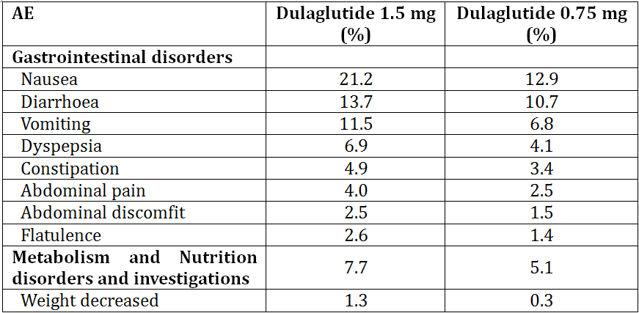
No other notable differences were observed.

Deaths and other serious adverse events

Deaths
17 deaths occurred during the efficacy and safety clinical trial program: 9 on dulaglutide (5 on dulaglutide 1.5 mg and 4 on dulaglutide 0.75 mg) and 8 on comparators (3 on sitagliptin and 5 on insulin glargine). The details of the patients who died while on dulaglutide are:
- Study GBDO: A [information redacted] patient with severe hepatic impairment and was enrolled in the clinical pharmacology study which was examining varying degrees of hepatic impairment. The patient received only 1 dose of dulaglutide 0.75 mg. The death was due to acute renal failure and hepatic failure which were attributed to worsening extant alcoholic liver cirrhosis.
- Study GBCF: A [information redacted] patient on 1.5 mg dulaglutide for 176 days died of a cardiovascular accident while still on therapy (6 days after last dose).
- Study GBDA: A [information redacted] patient died of pancreatic cancer 14 months after randomisation to dulaglutide 1.5 mg. She had received 169 days of treatment. She was also taking metformin, pioglitazone, glimepiride, topical oestradiol, atorvastatin, aspirin and olmesartan.
- Study GBDA: A [information redacted] patient died of a myocardial infarction 34 days after last dose of 1.5 mg dulaglutide which he had been on for 56 days.
- Study GBDA: A [information redacted] patient died of natural causes 13 days after last dose of 0.75 mg dulaglutide which he had been on for 89 days.
- Study GBDB: A [information redacted] patient died of cardiac failure 48 days after last dose of 0.75 mg dulaglutide which he had been on for 456 days.
- Study GBDD: A [information redacted] patient died of pneumonia after 3 days of last dose of 0.75 mg dulaglutide which he had been on for 78 days.
- Study GBDD: A [information redacted] patient who died of staphylococcus 213 days after being randomised to dulaglutide 1.5 mg.
- Study GBCZ: A [information redacted] patient randomized to dulaglutide 0.75 mg. The day following their first and only dose of study drug, baseline laboratory test results drawn one day earlier showed elevations in amylase (269 U/L [ULN = 112]) and lipase (589 U/L [ULN = 60]). These analytes were normal approximately 6 weeks earlier during screening evaluations. One week after randomisation, an MRI scan was performed and demonstrated a 5-cm tumour consistent with pancreatic carcinoma. The patient received chemotherapy but died 5 months later of the cancer.
The deaths appear to be balanced across the treatments and were primarily cardiac in nature (sudden death, cardio-respiratory arrest, MI, CVA, cardiogenic shock, cardiac failure, ventricular fibrillation) which are not unexpected in this population. The events did not appear to cluster with respect to a specific event type and thus do not suggest clinical concern.

Serious Adverse events

Comparison to placebo
Patients in the placebo (4.4%) and all dulaglutide (4.2%) groups reported a similar incidence of SAEs. The most frequently reported SAEs for placebo and all dulaglutide were: appendicitis, cholelithiasis, atrial fibrillation and coronary artery disease. No SAE occurred at > 1% of patients.

Comparison of dulaglutide doses
The incidence of SAEs was consistent with 0.75 mg dulaglutide (8.0%) and 1.5 mg dulaglutide (8.7%). No SAE occurred at >1% of patients. The most frequently reported SAEs were: hypoglycaemia, pneumonia, appendicitis, and cholelithiasis.

Discontinuation due to adverse events

Placebo controlled studies
More patients on placebo (7.0%) than on dulaglutide (4.7%) were withdrawn from studies. Hyperglycaemia was the reason most frequently reported among placebo treated patients (3.2%). These withdrawal rates for hyperglycaemia were largely driven by Study GBCF, which mandated the discontinuation of patients with severe persistent hyperglycaemia with hyperglycaemia reported as an adverse event. Additional analysis of the withdrawals excluding AEs specific to hyperglycaemia and other efficacy related terms, the incidence of discontinuation due to AEs was 6.1% for dulaglutide 1.5 mg versus 3.7% for placebo.
Gastrointestinal TEAEs as a reason for early withdrawal from study or study drug were more common in dulaglutide (2.4%) than placebo-(0.2%) treated patients. Within the GI System Organ Class (SOC), nausea and vomiting were the most commonly reported events leading to study drug or study withdrawal. However, the withdrawal rates due to these events were low, 1.1% and 0.5%, respectively, in dulaglutide-treated patients as compared to 0% for both events with placebo.

Long term studies
Significantly more patients in dulaglutide 1.5 mg (10.4%) withdrew early from study drug and/or study compared with dulaglutide 0.75 mg (7.7%). The most frequent adverse events leading to discontinuation were nausea (1.9%), diarrhoea (0.6%), and vomiting (0.6%), and were generally reported within the first 4 - 6 week.

Laboratory tests

Liver function
Across the clinical development program, dulaglutide was not shown to increase hepatic analytes, including transaminases, bilirubin, or markers of cholestasis. The clinical database was assessed for potential cases of drug induced liver injury (alanine aminotransferase [ALT] and/or aspartate aminotransferase [AST] ≥ 3x ULN, total bilirubin ≥ 2x ULN [not necessarily concurrently]) and cases with transaminases >10x ULN. Two cases were identified in these analyses; each patient had another reason for their laboratory perturbations (alcoholic binge drinking and acute hepatitis E).
Overall, dulaglutide does not appear to be associated with negative effects on the liver analytes or adverse events. These data, together with the PK data, suggest dulaglutide can be used in patients with hepatic impairment without need for dose adjustment.

Kidney function
Overall in patients with T2DM, without regard to renal dysfunction, dulaglutide did not have any detrimental effect on serum creatinine or eGFR, and a trend toward decrease in urinary albumin excretion compared with placebo. Analyses performed to evaluate long-term effects of treatment with dulaglutide 1.5 mg and 0.75 mg (up to 104 weeks) on renal function did not indicate any difference between the 2 dulaglutide doses on any of these renal function parameters.
In addition, when comparing effects of dulaglutide to all active comparators combined throughout the treatment period (ranging from 52 weeks to 104 weeks), no significant differences were observed in serum creatinine or eGFR between the all dulaglutide group and the active comparators group, indicating that dulaglutide does not alter renal function compared to active comparators used in these studies. A small but significant decrease in urinary albumin excretion was observed in the dulaglutide group compared to all comparators throughout the treatment period.
No significant differences were observed in serum creatinine or eGFR between the all dulaglutide group and the insulin glargine group (not expected to alter kidney function).
Analysis based on renal dysfunction found no detrimental effect of dulaglutide treatment on serum creatinine or eGFR. Small decreases in albumin excretion were noted with dulaglutide treatment in the renal impairment subpopulation (defined as having macroalbuminuria and/or eGFR < 60 ml/min/1.73 m² at baseline); and these decreases were greater with dulaglutide 1.5 mg compared to dulaglutide 0.75 mg.
A thorough assessment of all safety parameters revealed a similar safety profile in the renal impairment group compared with the overall T2DM population. This evidence, together with the PK data, suggests dulaglutide can be used safely in patients with renal impairment without need for dose adjustment.

Special safety topics

Gastrointestinal tolerability
The most common adverse events with dulaglutide treatment were GI in nature, namely nausea, vomiting, and diarrhoea, and to a lesser extent constipation and abdominal pain. These GI disorder events reported were typically mild or moderate in severity and led to discontinuation from study drug and/or study in a small proportion of patients. A dose relationship was observed with a higher incidence of these events and discontinuation due to these events with dulaglutide 1.5 mg as compared to dulaglutide 0.75 mg.
In the placebo controlled studies, the onset of nausea and vomiting was observed to peak during the first 2 weeks of treatment and then declined quickly, such that by approximately 6 weeks the levels approximated the incidence reported for placebo.
Dose titration has been shown to mitigate GI tolerability concerns with some short acting GLP-1 receptor agonists (exenatide). Dulaglutide has a half-life of approximately 4.7 days. Steady state plasma dulaglutide concentrations were achieved between 2 and 4 weeks of once weekly administration. Gradual accumulation of dulaglutide concentration with once-weekly dosing suggests that titrating doses would offer little additional benefit with respect to tolerability.

Exocrine pancreatic safety
Acute pancreatitis has been associated with the use of GLP-1 receptor agonists and DPP-4 inhibitors. Based on this and guidance documents from the FDA the sponsor implemented measures to assess and minimise the risk in the clinical development program. Patients identified as having suspected pancreatitis by the investigator, or who had serious or severe abdominal pain, or who had confirmed enzyme elevations were submitted to the clinical endpoint committee (CEC) for adjudication.

Pancreatitis
Of the 151 adjudicated cases, 19 cases were identified by investigators as suspected or definite acute or chronic pancreatitis and 9 cases were identified by the CEC. The exposure-adjusted incidence rates for acute pancreatitis as reported by investigators and the CEC (patients/1000 patient-years) were as shown in the following table. There is no evidence of increased risk of pancreatitis with dulaglutide as demonstrated by the lack of difference between dulaglutide and placebo. However, the number of events is low. Evaluation of individual cases showed no clear clinical pattern with respect to the pancreatic enzyme status as baseline, clinical presentation and course, common presence of major risk factors or exposure duration (1 day to 65 weeks) before the occurrence of the event.
Table 32: Analysis of pancreatitis events by treatment.
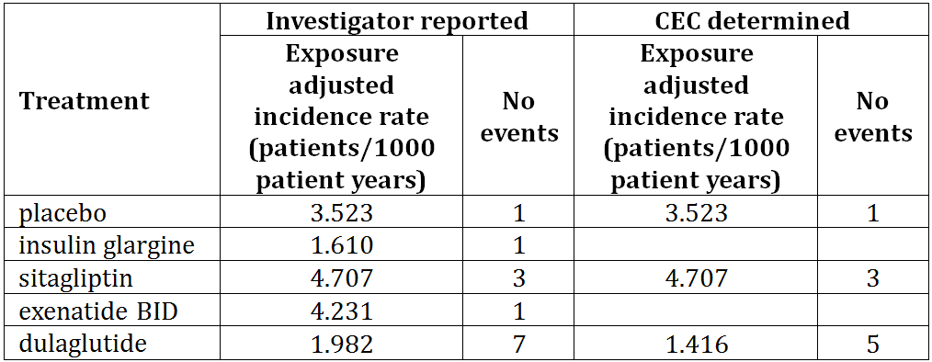
Adverse events of chronic pancreatitis were reported by investigators only with insulin glargine (1 patient) and dulaglutide (5 patients); exposure adjusted incidence rates (patients/1000 patient-years) were 1.610 for insulin glargine and 1.416 for dulaglutide. No events of acute or chronic pancreatitis were reported with metformin comparator.

Pancreatic enzymes
In the placebo-controlled studies, dulaglutide-treated patients had significant increases from baseline in pancreatic enzymes, including lipase (up to 20%), p-amylase (up to 20%), and to a lesser extent total amylase (up to 12%) compared with minimal change in placebo. The maximum increases in enzymes were evident by 4 to 8 weeks, and these levels persisted for the duration of exposure and resulted in more dulaglutide-treated patients with enzyme values above the upper limit of normal (ULN) post baseline (treatment emergent) compared with placebo. However, the median changes for dulaglutide still remained well under the ULN in the central tendency evaluations. Categorical analyses demonstrated that the increases in enzymes primarily involved small changes in the > 1 X ULN to < 5 X ULN categories. Few patients (dulaglutide: 1.8% and placebo: 1.6%) had shifts in maximum post baseline to extreme values ( ≥ 5 X ULN) for any of the enzymes, and these patients were balanced between placebo and dulaglutide.
In the long term studies (up to 104 weeks) comparing dulaglutide doses, dulaglutide 1.5 mg was associated with significantly increased enzymes from baseline compared with dulaglutide 0.75 mg. However, the differences in mean changes between the two doses were small – generally in the order of magnitude of ≤ 5% difference. The two doses were otherwise similar in terms of proportion greater than ULN post baseline (treatment emergent high) and outlier assessments. These changes in enzymes persisted for the entire duration of dulaglutide exposure and returned towards baseline after discontinuation.
Comparison of dulaglutide and active comparators across the efficacy studies demonstrated a similar observed pattern of increase in pancreatic enzymes with sitagliptin, exenatide BID, and metformin treatment. Increases in pancreatic enzymes have been reported with marketed GLP-1 receptor agonists.

Thyroid safety
Nonclinical data have shown thyroid C-cell hyperplasia and neoplasia at clinically relevant exposures in rat and mouse carcinogenicity studies with other long-acting GLP-1 receptor agonists. The impact of the thyroid C-cell carcinogenicity findings on the safety of human subjects participating in dulaglutide clinical trials remains unclear. This effect, which has been observed with liraglutide, exenatide BID, exenatide QW, and lixisenatide, appears to be mediated through a non-genotoxic mode of action.
Dulaglutide did not increase mean serum calcitonin over time compared with placebo. There was no evidence of increased calcitonin with dulaglutide 1.5 mg compared to dulaglutide 0.75 mg. The proportion of patients with calcitonin values meeting thresholds of interest in efficacy studies was similar across the dulaglutide, placebo and active comparator treatment groups (except there were no patients meeting the criteria in the metformin group).
There has been one report of medullary thyroid cancer in a patient who received dulaglutide 2 mg for approximately 6 months in the dose-finding stage of Study GBCF. This cancer was assessed and determined to be pre existing by the sponsor. The limited data from this patient also suggests no increased stimulation of calcitonin following 6 months of exposure to dulaglutide. Two papillary thyroid carcinomas have also been reported in the completed clinical program (one in Study GBCF and one in Study GBDB), both in patients who received dulaglutide 1.5 mg. Neither of these patients had any abnormal measurements of serum calcitonin. The details of these cases were:
- Study GBCF: A [information redacted] patient with no family history of endocrine neoplasms. The patient received 2.0 mg dulaglutide during the dose finding stage which was discontinued according to the protocol after 6 months treatment. At the time of discontinuation the patient’s calcitonin was 61.7 pg/mL. No baseline calcitonin value had been taken. Within 3 months the calcitonin level was 82.8 pg/mL and ultrasound revealed multiple bilateral cystic nodules which biopsy confirmed as a follicular neoplasm. The patient was treated with surgery. Given the baseline value for calcitonin was unknown and the first value obtained was 8x ULN, the sponsor considers this cancer in a patient positive for RET proto-oncogene germline mutation to be pre existing cancer.
- Study GBCF: A [information redacted] patient with a family history of thyroid cancer (2 elder sisters). Concomitant medications included metformin, atorvastatin, amlodipine and valsartan. 104 weeks after starting 1.5 mg dulaglutide a thyroid nodule was found during a regular check-up. Study drug was stopped and the patient had a total thyroidectomy. Pathology confirmed multifocal papillary thyroid cancer. There was no evidence of metastases. At no time during the study did the patient’s calcitonin levels exceed 1.0 pg/mL.
- Study GBDB: A [information redacted] patient with history of factor V Leiden deficiency and T2DM for 10 years. Concomitant medications included glimepiride, metformin, ergocalciferol, ramipril, and rosuvastatin. Approximately 3 months after starting dulaglutide 0.75 mg she was confirmed to have multiple thyroid nodules which on CT were consistent with multinodular goiter. Approximately 5 months after discovering the nodules, the patient discontinued study drug and one week later she underwent thyroidectomy, and follicular variant papillary carcinoma was found on pathology. The patient was treated with I131 therapy and withdrawn from the study. During the study, the patient’s calcitonin values never exceeded 4.9 pg/mL.

Hypoglycaemia
Treatment with dulaglutide was associated with hypoglycaemia rates (plasma glucose ≤3.9 mmol/l, symptomatic and asymptomatic) that were low, but numerically higher than those of placebo-treated patients.
In studies with non-secretagogue concomitant antihyperglycaemia therapies, the rates of total hypoglycaemia for dulaglutide and active comparator-treated patients were low and are shown in the table below.
The observed differences in risk between the dulaglutide treatment groups and the active comparators of metformin, sitagliptin and exenatide BID were small and deemed not clinically relevant.
Hypoglycaemia rates in dulaglutide 1.5 mg arms and in dulaglutide 0.75 mg arms across these studies were similar indicating no significant effect of dulaglutide on the risk of hypoglycaemia when used as a monotherapy or in combination with one or more non-secretagogues.
Table 33: Comparison of hypoglycaemia events in comparative studies.
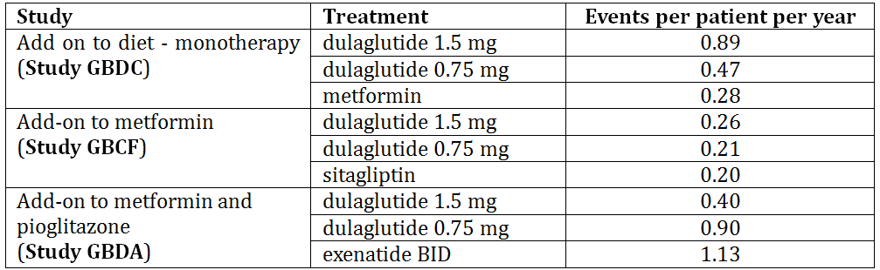
The addition of dulaglutide to a regimen that included SU or insulin was associated with higher rates of total hypoglycaemia compared to studies with non-secretagogues as background therapy. In Study GBDB in which patients received dulaglutide in combination with metformin and glimepiride the rate of total hypoglycaemia for dulaglutide 1.5 mg treated patients was 4.27 and for dulaglutide 0.75 mg treated patients was 4.18 events/patient/year. The rates observed in both dulaglutide groups were lower than that observed with the active comparator, insulin glargine (6.90 events/patient/year). The highest rate of total hypoglycaemia occurred when dulaglutide was used in combination with insulin lispro (with or without metformin) (Study GBDD). The rate of total hypoglycaemia for dulaglutide 1.5 mg treated patients was 41.74 and for dulaglutide 0.75 mg treated patients was 48.38 events/patient/year; the hypoglycaemia rate with the dulaglutide 1.5 mg dose in this study was lower compared to that observed in the active comparator insulin glargine treatment arm (57.17 events/patient/year).
There were no episodes of severe hypoglycaemia in dulaglutide patients treated with concomitant non-secretagogues or with dulaglutide monotherapy.
An integrated analysis across all efficacy studies indicates a comparable overall hypoglycaemia profile for dulaglutide 1.5 mg (total hypoglycaemia, incidence: 23.7%, rate: 1.42 events/patient/year) and dulaglutide 0.75 mg (total hypoglycaemia, incidence: 22.5%, rate: 1.40 events/patient/year). In summary, the risk of hypoglycaemia attributable to dulaglutide is low and similar to the risk observed with active comparators metformin, sitagliptin and exenatide BID, despite greater glycaemic effect with dulaglutide.

Injection site reactions
Across dulaglutide treatment groups from the placebo controlled efficacy studies, numerically more injection site adverse events were reported in the dulaglutide versus placebo treated patients (1.7% versus 0.9%); however the difference was not statistically significant.

Post-marketing experience
Not applicable.

Safety issues with the potential for major regulatory impact

Cardiovascular safety
Studies have shown that GLP-1 receptor agonists may be associated with increased heart rate and stable or reduced SBP.
Study GBCC studied the effect of dulaglutide on QT interval. Results from this study confirmed that dulaglutide did not cause a prolongation in QTc at supratherapeutic doses of 4 mg or 7 mg in healthy male and female subjects.
The overall effects of dulaglutide on SBP, DBP, and heart rate have varied across the clinical pharmacology and early efficacy studies. To address this, a large (N = 755), randomised, placebo-controlled prospective study using 24-hour ABPM was conducted (Study GBDN) to evaluate the effects of dulaglutide on BP and heart rate. The results showed that dulaglutide 1.5 mg demonstrated a statistically significant 2.8 mm Hg reduction in mean 24-hour SBP compared to placebo, and a neutral effect on mean 24 hour DBP. Small increases in heart rate were observed in the dulaglutide 1.5 mg group compared to placebo at 16 weeks (2.84 bpm) and 26 weeks (3.50 bpm).
The integrated analyses confirmed the results reported in Study GBDN. Dulaglutide was associated with dose-dependent mean increases in heart rate from baseline of 2 to 4 bpm. These increases in heart rate from baseline were evident at the earliest time points of measurement, were maximal by 8 weeks, and declined after 26 weeks. Associated with this waning of the increase in heart rate, the dulaglutide 1.5 mg and dulaglutide 0.75 mg doses were no longer significantly different by 39 weeks of therapy. The small mean increases in heart rate were not associated with increased reporting of specific tachyarrhythmia adverse events.
In the integrated analyses, dulaglutide 1.5 mg is associated with a small decrease in mean SBP of approximately 2 mm Hg at 26 weeks. There is no clinically meaningful difference between dulaglutide 1.5 mg and 0.75 mg in reducing SBP. No other effects were observed with dulaglutide 1.5 mg on other CV parameters except small increases in PR interval (2 to 3 msec) with 2.4% incidence of first degree, but not higher degrees, of atrioventricular block (AVB).
In accordance with FDA and EU guidelines, the sponsor conducted a meta-analysis of CV data (Meta-analysis Report) from the completed dulaglutide clinical studies to assess the cardiovascular risk of dulaglutide. The primary objective of the meta-analysis was to compare the time from randomisation to the first occurrence of any independently adjudicated event of the 4 composite CV endpoints: death due to CV causes, nonfatal myocardial infarction (MI), nonfatal stroke, or hospitalisation for unstable angina (ie, 4 component major adverse cardiovascular event [MACE]). Patients treated with dulaglutide in the 9 completed clinical efficacy studies were compared with patients who were administered comparators(placebo and active comparators combined) to demonstrate that the upper bound of the (adjusted) 95% CI for the HR was <1.8. A total of 51 patients (dulaglutide: 26 [N = 3885]; all comparators: 25 [N = 2125]) experienced at least one adjudicated 4 component MACE-endpoint in the 9 studies. Based on the pre-specified alpha spending function, and the number of unique events included in this meta-analysis, the alpha spent is 0.0198 and the corresponding significance level is 98.02%. The meta-analysis results demonstrated an estimated hazard ratio [HR]: 0.57; adjusted [98.02%] CI: 0.30, 1.10; p=0.046) for dulaglutide versus all comparators (active and placebo) indicating that treatment with dulaglutide is not associated with an increase in the risk of experiencing a 4 component MACE endpoint compared with control therapies. The 1.10 value for the upper bound of the CI for the HR satisfies the FDA stipulated limit of 1.8 and, thus, meets the criterion set forth for submission of a new diabetes drug. Various sensitivity analyses using different populations, analysis methodologies, and additional types of CV events (for example, coronary revascularisation procedures or hospitalisation for heart failure) showed similar conclusions, that dulaglutide is not associated with an increased risk of experiencing a CV event.

Immunogenicity

Anti-drug antibodies (ADA)
All patients in all the clinical pharmacology and efficacy and safety studies had blood collected at specified times to test for antibodies to dulaglutide.
The overall incidence of treatment-emergent dulaglutide ADA was low - 1.6% as compared to 0.7% observed in patients treated with placebo or non-GLP-1 comparators. In Study GBDA, the incidence of treatment-emergent exenatide ADA in exenatide BID-treated patients was 44.6%.
In the majority of dulaglutide-exposed patients who developed treatment-emergent dulaglutide ADA, the intensity of immune response, as measured by absolute antibody titre and/or change in titre, was mild. Four patients had a high (≥1:128) treatment-emergent dulaglutide ADA titre. One patient had progressive increases in antibody titre over time, but the titre remained in the low range (<128) until the completion of the trial. No dose effect was observed with respect to the incidence of treatment-emergent dulaglutide ADA across the range of dulaglutide doses included in efficacy dulaglutide studies.
Among the 64 patients with treatment-emergent dulaglutide ADA, approximately half (34; 0.9% of the overall population) had dulaglutide neutralising ADA. There were also 4 patients with treatment-emergent dulaglutide ADA with neutralising activity against native sequence (ns)GLP-1 (0.1% of the overall population).
Overall, no obvious pattern was detected in the relationship between the presence of dulaglutide ADA and change in HbA1c from baseline.
The GLP-1 analogue portion of dulaglutide is approximately 90% homologous to native human GLP-1 (7-37) and contains amino acid substitutions designed to optimize its clinical profile, including protection from DPP-4 inactivation and reduction of immunogenicity. The IgG4-Fc portion of the molecule was also modified to prevent half-antibody formation and to reduce the potential for interaction with high-affinity Fc receptors that may result in activation of immunologic cytotoxicity. The results for dulaglutide indicate that the structural modifications in the GLP-1 and Fc parts of the dulaglutide molecule together with high homology with native GLP-1 and native Fc resulted in low immunogenicity and low risk of immune-mediated adverse events.

Hypersensitivity reactions
The incidence of systemic hypersensitivity adverse events was low in dulaglutide-treated patients and was similar to the incidence with placebo (dulaglutide 7 patients [0.3%]; placebo 5 patients [0.7%]). In the long term studies, the incidence of systemic hypersensitivity adverse events was greater in the dulaglutide 0.75 mg treated patients (13, 0.8%) than dulaglutide 1.5 mg treated patient (3, 0.2%). There were no systemic hypersensitivity adverse events in any of the 64 dulaglutide-treated patients with treatment-emergent dulaglutide ADA, including patients with high or progressive treatment-emergent dulaglutide titres. Overall, these data do not indicate an increased risk of systemic hypersensitivity adverse events with dulaglutide treatment.

Malignancy
In the dulaglutide clinical program, there was no increased reporting of malignancy in general, nor any specific type of malignancy, associated with dulaglutide compared with placebo or active comparators.
Two categories of special interest with dulaglutide, and other GLP-1 receptor agonists, are thyroid and pancreatic malignancies.
- One case of medullary thyroid cancer occurred but the cancer appeared to have been pre-existing prior to dulaglutide treatment
- Two cases of pancreatic cancer were reported. One patient was diagnosed within 1 week of his first and only dose of dulaglutide, strongly suggesting a pre-existing condition. The second case was diagnosed 5 months after randomisation to dulaglutide. Assessment of this tumour determined it to be large, locally advanced, and unresectable. Given the patient’s abbreviated time on study drug, the sponsor determined that this tumour was likely to be pre-existing.

Evaluator’s overall conclusions on clinical safety
The safety assessment of dulaglutide included a large number of patients (over 4,000) in a large number of independent studies. The duration of most trials was relatively short but sufficient patients were treated over 1-2 years.
Overall the safety profile with dulaglutide is consistent with those of marketed GLP-1 receptor agonists. The most commonly reported adverse events are GI related, including nausea, vomiting, and diarrhoea. The onset of nausea and vomiting usually occurs early after drug initiation and attenuates quickly. These GI-related adverse events are, for dulaglutide fixed dose 1.5 mg, similar to dose titrated exenatide BID in a head-to-head comparison.
There was convincing evidence presented that dose titration was not necessary and the fixed dose of 1.5 mg was appropriate.
Dulaglutide demonstrated a dose-dependent effect for increase in pancreatic enzymes. These increases were observed shortly after initiation of therapy, persisted for the duration of exposure and declined towards baseline with dulaglutide cessation. In the absence of other signs and symptoms of acute pancreatitis, elevations in pancreatic enzymes alone, noted in routine serial assessment, were not predictive of acute pancreatitis.
Dulaglutide did not increase mean serum calcitonin levels over time compared with placebo and there was no increased reporting of potential C-cell hyperplasia defined by unstimulated calcitonin measurements in dulaglutide-treated patients compared with placebo- or active comparator-treated patients. There was one report of MTC in a patient who received dulaglutide 2 mg for approximately 6 months in the dose-finding stage of Study GBCF, but this cancer appeared to be pre-existing.
Differences in the hypoglycaemia risk for dulaglutide (either 1.5 mg or 0.75 mg) are mostly attributable to the known difference in the risk between concomitant insulin secretagogues versus concomitant non-secretagogues, and are consistent with the differences in the mechanism of action on glucose metabolism.
High homology with native GLP-1 and native Fc was preserved whilst implementing structural modifications in these components of the dulaglutide molecule appear to minimise immunogenicity against dulaglutide. This was confirmed by the finding of only 1.6% of dulaglutide-treated patients developing treatment-emergent dulaglutide ADA. Incidences of treatment-emergent dulaglutide ADA were lower in dulaglutide-treated patients compared to treatment-emergent exenatide ADA in exenatide BID-treated patients (Study GBDA: 1.6% vs. 44.6%). Few dulaglutide treated patients had dulaglutide neutralizing ADA (0.9%) and/or developed neutralising ADA for nsGLP (0.1%). The incidence of systemic hypersensitivity adverse events was low in dulaglutide-treated patients and was similar to the incidence with placebo.
Dulaglutide had no detrimental or dose-dependent effects on renal or hepatic function. There was no increased reporting of malignancy but the studies were insufficient in size and duration to fully assess the effects of dulaglutide to induce or promote these types of cancers.

First round benefit-risk assessment

First round assessment of benefits
The benefits of dulaglutide in the proposed usage are:
- Robust improvements in glycaemic control as measured by significant decreases in HbA1c and the percentage of patients achieving a HbA1c target of < 7%.
- Modest weight loss
- Sustained efficacy through 104 weeks
- Low risk of hypoglycaemia
- Low immunogenicity
- No dose adjustments for elderly patients or those with renal or hepatic impairment
- Convenient once weekly injection using easy to use single use pen or prefilled syringe

First round assessment of risks
The risks of dulaglutide in the proposed usage are:
- Risk consistent with other drugs in the GLP-1 receptor agonist class
- Hypoglycaemic episodes particularly in combination with insulin secretagogues or an insulin regimen
- Increases in pancreatic enzymes of similar magnitude to those observed with active comparators
- Systemic hypersensitivity reactions and immune mediated injection site adverse events but incidence low

First round assessment of benefit-risk balance
The benefit-risk balance of dulaglutide, given the proposed usage, is favourable.

First round recommendation regarding authorisation
Based on the clinical data included, it is recommended the application is approved.

Clinical questions

Pharmacokinetics
No questions submitted.

Pharmacodynamics
No questions submitted.

Efficacy
No questions submitted.

Safety
No questions submitted.

References
Note for Guidance on Clinical Investigation of Medicinal Products in the Treatment of Diabetes Mellitus CPMP/EWP/1080/00 30 May 2002, adopted by TGA 23 October 2002
Diabetes Mellitus – Evaluating Cardiovascular Risk in New Antidiabetic Therapies to Treat Type 2 Diabetes, FDA 2008.
Hauschke D, Steinijans VW, Diletti E. A distribution-free procedure for the statistical analysis of bioequivalence studies. Int J Clin Pharmacol Ther Toxicol. 1990; 28(2):72-78.

Therapeutic Goods Administration
PO Box 100 Woden ACT 2606 Australia
Email: info@tga.gov.au Phone: 1800 020 653 Fax: 02 6232 8605
https://www.tga.gov.au

Study report only provides results in mg/dL.
FDA notification to sponsors developing GLP-1 receptor agonist of the potential risks of acute pancreatitis and non-clinical thyroid c-cell tumours that had been observed in the class, FDA 2009.

