Date of CER: January 2014

AusPAR Attachment 2

Extract from the Clinical Evaluation Report for Diphtheria, Tetanus, Pertussis (acellular component), Hepatitis B (rDNA), Poliomyelitis (inactivated) and Haemophilus influenzae type b conjugate vaccine (adsorbed)
  - Proprietary Product Name: Hexaxim
  - Sponsor: Sanofi Aventis Australia Pty Ltd

About the Therapeutic Goods Administration (TGA)
- The Therapeutic Goods Administration (TGA) is part of the Australian Government Department of Health, and is responsible for regulating medicines and medical devices.
- The TGA administers the Therapeutic Goods Act 1989 (the Act), applying a risk management approach designed to ensure therapeutic goods supplied in Australia meet acceptable standards of quality, safety and efficacy (performance), when necessary.
- The work of the TGA is based on applying scientific and clinical expertise to decision-making, to ensure that the benefits to consumers outweigh any risks associated with the use of medicines and medical devices.
- The TGA relies on the public, healthcare professionals and industry to report problems with medicines or medical devices. TGA investigates reports received by it to determine any necessary regulatory action.
- To report a problem with a medicine or medical device, please see the information on the TGA website <http://www.tga.gov.au>.
About the Extract from the Clinical Evaluation Report
- This document provides a more detailed evaluation of the clinical findings, extracted from the Clinical Evaluation Report (CER) prepared by the TGA. This extract does not include sections from the CER regarding product documentation or post market activities.
- The words [Information redacted], where they appear in this document, indicate that confidential information has been deleted.
- For the most recent Product Information (PI), please refer to the TGA website <https://www.tga.gov.au/product-information-pi>.
Copyright
© Commonwealth of Australia 2015
This work is copyright. You may reproduce the whole or part of this work in unaltered form for your own personal use or, if you are part of an organisation, for internal use within your organisation, but only if you or your organisation do not use the reproduction for any commercial purpose and retain this copyright notice and all disclaimer notices as part of that reproduction. Apart from rights to use as permitted by the Copyright Act 1968 or allowed by this copyright notice, all other rights are reserved and you are not allowed to reproduce the whole or any part of this work in any way (electronic or otherwise) without first being given specific written permission from the Commonwealth to do so. Requests and inquiries concerning reproduction and rights are to be sent to the TGA Copyright Officer, Therapeutic Goods Administration, PO Box 100, Woden ACT 2606 or emailed to <tga.copyright@tga.gov.au>.

Contents
List of abbreviations 5
1. Introduction 8
1.1. Proposed dosage 8
1.2. Overseas regulatory history 9
2. Clinical rationale 9
3. Contents of the clinical dossier 10
3.1. Scope of the clinical dossier 10
3.2. Paediatric data 13
3.3. Good clinical practice 13
4. Pharmacokinetics 13
4.1. Studies providing pharmacokinetic (PK) data 13
4.2. Summary of pharmacokinetics 14
4.3. Evaluator’s overall conclusions on pharmacokinetics 14
5. Pharmacodynamics: Immunogenicity 14
5.1. Studies providing immunogenicity data 14
5.2. Summary of Immunogenicity 18
6. Dosage selection for the pivotal studies 18
7. Clinical efficacy 18
7.1. Pivotal clinical efficacy (immunogenicity) 18
7.2. Other efficacy studies 50
7.3. Analyses of immunogenicity performed across trials (pooled analyses) 52
7.4. Evaluator’s conclusions on immunogenicity for primary vaccination in the first year of life and boosting and protective efficacy 54
8. Clinical safety 56
8.1. Studies providing evaluable safety data 56
8.2. Pivotal studies that assessed safety as a primary outcome 60
8.3. Patient exposure 61
8.4. Adverse events 63
8.5. Laboratory tests 70
8.6. Post-marketing experience 70
8.7. Safety issues with the potential for major regulatory impact 70
8.8. Other safety issues 70
8.9. Evaluator’s overall conclusions on clinical safety 72
9. First round benefit-risk assessment 73
9.1. First round assessment of benefits 73
9.2. First round assessment of risks 73
9.3. First round assessment of benefit-risk balance 73
10. First round recommendation regarding authorisation 74
11. Clinical questions 74
11.1. Pharmacodynamics (immunogenicity) 74
11.2. Product Information: Indication 74
12. Second round evaluation of clinical data submitted in response to questions 74
13. References 74

List of abbreviations
Abbreviation | Meaning
Ab | antibody
ADEM | acute demyelinating encephalomyelitis
AE | adverse event
AESI | adverse event of special interest
Ag | Antigen
aP | acellular pertussis vaccine
AR | Adverse Reaction
BCG | Bacille Calmette-Guerin
CHMP (CPMP) | Committee for Medicinal Products for Human Use
CI | Confidence Interval
CRF | Case Report Form
CRO | Contract Research Organisation
D | diphtheria
eCRF | electronic Case Report Form
ELS | extensive limb swelling
EMA | European Medicines Agency
EPI | Expanded Program on Immunisation
EU | European Union
FDA | Food and Drug Administration USA
FHA | filamentous hemagglutinin
GCP | Good Clinical Practice
GMC | Geometric mean concentrations
GMTR | geometric mean of individual antibody titre ratio
GMTs | Geometric Mean Titres
GSK | GlaxoSmithKline
Hb | haemoglobin
HBsAg | Hep B Surface Ag
HCV | hepatitis C virus
HepB | hep B
HHE | Hypotonic Hyporesponsive Episode
Hib | Haemophilus influenzae type b
HIV | human immunodeficiency virus
HPA | Health Protection Agency
ICH | International Conference on Harmonization
IM | Intramuscular
IPV | Inactivated Poliomyelitis Virus
ISR | injection Site Reaction
ITT | Intention to treat
LB | lower bound
LL | lower limit
MAA | Marketing Authorisation Application
MedDRA | Medical Dictionary for Regulatory Activities
ml | milliliters
MMR | measles, mumps, rubella
NIP | National Immunisation Program
NR | normal range
OPV | oral polio vaccine
PI | Prescribing Information
PK | pharmacokinetics
PP | per protocol
PPF | Pre-submission Planning Form
RCDCs | Reverse Cumulative Distribution Curves
RF | Russian Federation
rHBsAg | recombinant hep B surface Ag
SafAS | safety analysis set
SAP | statistical analysis plan
SIDS | Sudden infant death syndrome
SUD | sudden unexplained death
TT | tetanus toxoid
URTI | upper respiratory tract infection
UTI | urinary tract infection
V | varicella
vax | vaccine
WBC | white blood cell count
wP | whole pertussis vaccine
WHO | World Health Organisation

Introduction
This is a Category 1 submission to obtain registration for Hexaxim, a preservative free liquid formulation hexavalent vaccine for intramuscular (IM) administration; the 6 Antigen components are diphtheria, tetanus, pertussis (acellular, component), hep B (recombinant), poliomyelitis (inactivated) and Haemophilus influenzae type b (Hib) conjugate vaccine (adsorbed).
The proposed indication is
primary and booster vaccination of infants from six weeks of age against diphtheria, tetanus, pertussis, hepatitis B, poliomyelitis, and invasive infections caused by Haemophilus influenzae type b.
This hexavalent vaccine offers a potential alternative to the already registered, Infanrix Hexa.
Hexaxim 0.5mL is a fully liquid ready-to-use, preservative free vaccine, presented as a suspension for IM injection adjuvanted onto aluminium hydroxide in a single monodose prefilled syringe.
Table 1: Antigenic components of Hexaxim
Active substance | Quantity (per 0.5 mL dose)
Diphtheria Toxoid | ≥ 20 IU
Tetanus Toxoid | ≥ 40 IU
Bordetella Pertussis  - Pertussis Toxoid  - Pertussis Filamentous Haemagglutinin (FHA) | 25 microgram  25 microgram
Hep B surface Ag (new recombinant formulation) | 10 microgram
Poliovirus (Inactivated)  - Type 1 (Mahoney)  - Type 2 (MEF-1)  - Type 3 (Saukett) | 40 D Ag Units  8 D Ag Units  32 D Ag Units
Hib polysaccharide conjugated to Tetanus protein | 12 microgram (T - 22 – 36 microgram)

Proposed dosage
Primary vaccination: three doses of 0.5 mL to be administered at intervals of ≥ four weeks, in accordance with official recommendations. Table 2 shows the childhood vaccination schedule up to 4 years of age for Australia.
Booster vaccination: After vaccination with three doses of Hexaxim, a booster dose should be given in accordance with official recommendations (see Table 2).The proposed indication reflects the indication approved in the European Union (EU) but the upper age limit of 24 months is not proposed for Australia as the National immunisation Program (NIP) differs from country to country.
Table 2: Australian NIP Schedule for Children ≤4 years from 01 July 2013
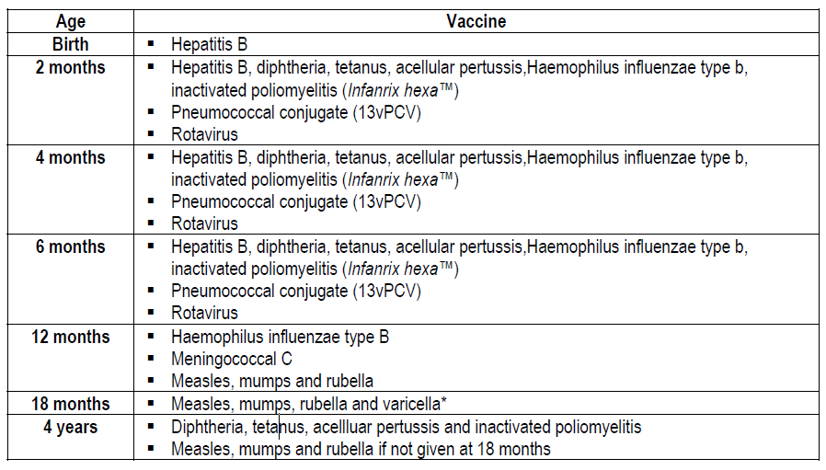

Overseas regulatory history
Hexaxim was approved in the European Union (EU) via the Centralised Procedure on 17-Apr-13. The approved EU trade names are Hexacima (Sanofi Pasteur, Marketing Authorisation Holder (MAA)) and Hexyon (Sanofi Pasteur MSD as the MAA Holder). The approved EU indication is for primary and booster vaccination of infants and toddlers from six weeks to 24 months of age against diphtheria, tetanus, pertussis, hep B, poliomyelitis and invasive diseases caused by Hib. The vaccine is also approved for the same indication as in the EU in the following countries: 1) in Latin America: Chile, Guatemala, Mexico, Peru, Argentina, Paraguay; 2) in Asia: Malaysia, Philippines; 3) in Africa: South Africa. Review is ongoing in several other countries including New Zealand.
It is noteworthy that the Russian Federation (RF) refused approval of Hexaxim on the following grounds: 1) The diphtheria toxoid content (20IU) for primary vaccination does not comply with conventional standards (30 IU) set by the WHO, specified by the European Pharmacopoeia (E Ph 6.0, article 2067); 2) The provided hep B and polio vaccination scheme does not comply with the RF National preventive vaccination calendar schedule. Overall, their reviewers felt that data support high reactivity but insufficient efficiency of Hexaxim for diphtheria and tetanus components.

Clinical rationale
In Australia, the current NIP from birth to 4 years is summarised in Table 2. The vaccine preventable diseases in which killed (non-live) vaccines – antigen or toxoid are: 1) hep B; 2) tetanus (T); 3) diphtheria (D); 4) pertussis; 5) Hib; 6) polio; 7) pneumococcus; 8) meningococcus C. The vaccine preventable diseases in which live-attenuated vaccines are used are: 1) measles; 2) mumps; 3) rubella; 4) varicella (V); 5) rotavirus.
In Australia, several combination vaccines are licensed and at present, Infanrix Hexa (DTPa-hepB-IPV/Hib; sponsor GSK) is the only hexavalent paediatric vaccine used in the NIP. This hexavalent vaccine was approved by TGA in 2006. The Ag components of Infanrix Hexa are shown in Table 3.
Table 3: Antigen components of Infanrix Hexa Powder and suspension
Active substance | Quantity (per 0.5 mL dose)
Diphtheria Toxoid | ≥ 30 IU*
Tetanus Toxoid | ≥ 40 IU
Bordetella Pertussis  - Pertussis Toxoid  - Pertussis Filamentous Haemagglutinin  - Pertactin | 25 microgram  25 microgram  8 microgram*
Hep B surface Ag | 10 microgram
Poliovirus (Inactivated, produced in Vero cells)  - Type 1 (Mahoney)  - Type 2 (MEF-1)  - Type 3 (Saukett) | 40 D Ag Units  8 D Ag Units  32 D Ag Units
Haemophilus type B polysaccharide polyribosylribitol phosphate conjugated to Tetanus protein | 10 microgram*/20 – 40 microgram*
*composition differences from Hexaxim
In regards to combination vaccines for childhood use, Sanofi Pasteur’s pentavalent acellular Pertussis (aP) combination vaccine, Pentavac/Pentaxim (DTPa-IPV/Hib) was first licensed in Sweden in 1997 and is used currently in >100 countries including 26 in the EU; to date, 142 million doses having been distributed worldwide, there is an excellent safety record. Sanofi-Pasteur has effectively extended the pentavalent vaccine with the addition of hep B Ag to make their hexavalent vaccine, Hexaxim. For the Australian NIP, Hexaxim will represent an alternative to the already approved and in use, Infanrix Hexa. The main difference aside from some component differences (Tables 1 and 3) is Infanrix Hexa requires reconstitution prior to vaccination, whereas Hexaxim is presented as a fully liquid ready-to-use vaccine. The latter could add efficiency for clinicians/nurses when complying with the NIP schedule for children.

Contents of the clinical dossier

Scope of the clinical dossier
The submission contains 13 clinical study reports consisting of 14 clinical trials evaluating the most common vaccination schedules for a primary series paediatric combination vaccine, which varied according to the targeted country from the most condensed (6, 10, 14 weeks) (Expanded Program on Immunisation [EPI]) to the least condensed (2, 4, 6 months), and covered booster vaccination during the 2nd year of life as well as long-term immunity persistence.
Control vaccines were as per standard-of-care used in the countries where the studies were conducted. Co-administration of Hexaxim with other childhood vaccines (measles, mumps rubella, varicella, rotavirus, pneumococcal conjugated), and the effect of the presence or the absence of hep B vaccination at birth, were evaluated.
The results have global applicability as the studies were conducted in a wide range of countries and include all major ethnicities (Hispanic, Asian, African, Caucasian). Hispanic ethnicity is predominantly represented in the current CTD as the majority of studies were conducted in Latin America.
Immunogenicity: Hexaxim has been compared to currently licensed vaccines (Infanrix Hexa, Pentaxim, Hexavac, CombAct-Hib, Tritanrix-HepB/Hib and Engerix B, OPV) using non-inferiority study designs. Infanrix Hexa was the comparator vaccine in four studies (A3L11, A3L12, A3L17 and A3L24) and Engerix B (licensed in Australia since 2006) was the comparator hep B vaccine in three studies (A3L02, A3L10 and A3L15).
Non-inferiority of the Ab responses to Hexaxim Ags were tested in all the primary series studies (except the A3L04 large scale safety study). Clinical non-inferiority margins (i.e., maximum delta accepted for the differences between Hexaxim-control groups) were the same for all clinical trials and were established according to acceptable margins already used for combined vaccines. Accepted correlates of protection were used to assess non-inferiority of the Ab responses. These parameters (specific immunoresponse cut-offs) are well established for diphtheria, tetanus, poliovirus types, hep B and Hib Ags. A surrogate of protection is the level of an immunological marker in the immunised population that substitutes for the true (unknown or not established) clinical correlate. Surrogates of protection are used for pertussis Ags.
Safety: The assessment of the safety for Hexaxim comprises source data from 12 completed clinical trials. Clinical trial data demonstrated that Hexaxim has a safety profile similar to or more favourable than other pertussis-containing combination vaccines administered for primary series and booster vaccination in infants and toddlers. The co-administration with other childhood vaccines was assessed in primary series (Prenavar 7 in A3L12 and A3L24; Rotarix in A3L24) and 1 booster (MMR and varicella in A3L15), following local recommend local schedules.
No study directly compared the co-administered vaccines with and without Hexaxim since all Ags contained in the vaccine except hep B have been extensively studied in the past and are currently utilised in different vaccination schedule while co-administered with all common childhood vaccines. In the studies, responses to co-administered vaccines were primarily assess on the basis of achieving accepted seroprotection rates (where available), or satisfactory immune responses.
Table 4: Summary of the immunogenicity and safety studies of Hexaxim
Primary vaccination studies (Phase/Comparator/Schedule) | Booster studies (Phase/Comparator/Schedule)
A3L02 – Argentina  (Phase II /Pentaxim + Engerix B / 2, 4, 6 months) | A3L16 – booster of A3L02 (Phase III / Pentaxim as a booster in both Hexaxim and Pentaxim primed infants and no comparator / 18 months
A3L04 – Mexico/Peru
(Phase III / Tritanrix-Hep B/Hib + OPV / 2, 4, 6 months
A3L10 – Turkey  (Phase III safety study / Pentaxim + Engerix B / 2, 3, 4 months) | A3L22 – booster of A3L10 (Phase III / no comparator / 15-18 months)
A3L11 – Mexico  (Phase III/ Infanrix Hexa / 2, 4, 6 months) | A3L21 – booster of A3L11 (Phase III / no comparator / 15-18 months)
A3L12 – Thailand
(Phase III / Infanrix Hexa / 2, 4, 6 months) concomitant vaccination with Prevenar
A3L15ps* - South Africa  (Phase III / CombAct-Hib+Engerix B+OPV / 6, 10, 14 weeks of age) | A3L15bo* (Phase III / CombAct-Hib+OPV / 15-18 months) concomitant use of Mumps, Measles and Rubella and Varicella vaccine
A3L26- South Africa
(Phase III / no comparator / no vaccine) Long term following up of A3L15
A3L17 – Peru
(Phase III / Infanrix Hexa / 2, 4, 6 months)
A3L24 – Columbia/Costa Rica
(Phase III / Infanrix Hexa / 2, 4, 6 months) concomitant vaccination with Prevenar and Rotarix
A3L01-Argentina
(Phase I / Hexavac / 16-19 months)
*A3L15ps and A3L15bo are included in one study report
Six immunogenicity (prime and boost) & safety studies were presented:
- A3L01: Phase-I Safety of a Booster Dose of Either the Investigational DTaP-IPV-HB-PRP-T Combined Vaccine or HEXAVAC in Healthy Argentinean 16- to 19-Month-Old Toddlers;
- A3L02: Phase II Immunogenicity Study of a DTaP-IPV-HB-PRP-T Combined Vaccine Compared with PENTAXIM and Engerix B PEDIATRICO at 2, 4, and 6 Months of Age in Healthy Argentinean Infants;
- A3L16 (booster study of A3L02): Immunogenicity Study of the Antibody Persistence and Booster Effect of PENTAXIM at 18 Months of Age Following a Primary Series of DTacP-IPV-HepB-PRP-T Combined Vaccine or of PENTAXIM and ENGERIX B PEDIATRICO at 2, 4, and 6 Months of Age in Healthy Argentinean Infants;
- A3L04: Large Scale Safety Study of a DTaP-IPV-Hep B-PRP-T Combined Vaccine, in Comparison to Tritanrix-Hep B/Hib and OPV Administered at 2, 4, and 6 Months of Age in Latin American Infants;
- A3L10: Immunogenicity of DTaP-IPV-Hep B-PRP-T Combined Vaccine Compared with PENTAXIM and ENGERIX B at 2-3-4 Months Primary Schedule in Healthy Turkish Infants;
- A3L22 (booster study of A3L10): Immunogenicity and Safety Study of a Booster Dose of DTaP-IPV-Hep B-PRP-T Combined Vaccine at 15 to 18 Months of Age Following a Primary Series at 2, 3 and 4 Months of Age in Healthy Turkish Infants.
Section 7 (below) summarises 8 pivotal immunogenicity/safety studies of prime and/or boosting, in which the comparator vaccine is Infanrix Hexa. Study A3L15 is included here, although the comparator vaccine was not Infanrix Hexa as it is a large Phase III study with DTaP-IPV-Hep B-PRP-T Combined Vaccine given as part of the primary series and booster; moreover, there is long term immunogenicity data (Study A3L026) arising from this study. Seven of these included immunogenicity as the primary objective:
- A3L11: Lot-to-Lot Consistency Study of DTaP-IPV-Hep B-PRP-T Vaccine Administered at 2-4-6 Months of Age in Healthy Mexican Infants;
- A3L21 (Booster of A3L11): Immunogenicity Study of the Antibody Persistence and Booster Effect of the DTaP-IPV-Hep B-PRP-T Combined Vaccine at 15 to 18 Months of Age Following a Primary Series of DTaP-IPV-Hep B-PRP-T or Infanrix Hexa Administered at 2, 4, and 6 Months of Age in Healthy Mexican Infants;
- A3L12: Immunogenicity Study of a DTaP-IPV-Hep B-PRP-T Combined Vaccine in Comparison to Infanrix Hexa, Both Concomitantly Administered with Prevenar at 2, 4, and 6 Months of Age in Thai Infants;
- A3L15 primary series and A3L15 booster; Immunogenicity Study of a DTaP-IPV-Hep B-PRP-T Combined Vaccine in Comparison to CombAct Hib Concomitantly Administered with Engerix B Pediatric and OPV at 6, 10, and 14 Weeks of Age in South African Infants;
- A3L17: Immunogenicity Study of DTaP-IPV-Hep B-PRP-T Combined Vaccine in Comparison to Infanrix Hexa, at 2-4-6 Months of Age in Healthy Peruvian Infants;
- A3L24: Lot-to-Lot Consistency Study of DTaP-IPV-Hep B-PRP-T Vaccine Administered at 2-4-6 Months of Age in Healthy Latin American Infants Concomitantly with Prevenar and Rotarix;
- A3L26: Antibody Persistence in Healthy South African Children After Primary Series and Booster Vaccination with an Investigational (DTaP-IPV-Hep B-PRP-T) or Control Vaccines.
The dossier included an Integrated Summary of immunogenicity and Integrated Summary of Safety. The integrated analysis plan applied for immunogenicity (IAP-I) focused on comparisons of individual studies (studies A3L01, A3L02, A3L04, A3L10, A3L11, A3L12, A3L17, A3L15 primary series and booster, A3L21, and A3L22).
Also included in the dossier:
- Module 1: Application letter, application form, draft Australian PI and CMI, European Summary of Product Characteristics.
- Module 2: Clinical Overview, Summary of Clinical Efficacy, Summary of Clinical Safety and literature references.

Paediatric data
The submission only included paediatric immunogenicity, efficacy and safety data.

Good clinical practice
The trials were conducted in accordance with the recommendations of the Declaration of Helsinki (revisions, valid at the time of the study) and International Conference on Harmonisation (ICH) Good Clinical Practice (GCP), and with applicable national and local requirements. Clinical trials were designed in accordance with EMA and WHO guidelines on clinical evaluation of new vaccines.

Pharmacokinetics

Studies providing pharmacokinetic (PK) data
As per the Section 2 of Appendix 15 Biopharmaceutic Studies of the Australian Regulatory Guidelines for Prescription Medicines, a justification for not providing biopharmaceutic data is not provided. In addition, as stated in the EMA Note for Guidance on “The Clinical Evaluation of New Vaccines”, PK studies are usually not required for vaccines. PK studies if new delivery systems are employed or when the vaccine contains novel adjuvants or excipients and may include evaluation of the Ags and the excipients. No new adjuvant, toxoid, live/live attenuated virus/bacteria are part of Hexaxim. Hexaxim contains inactivated or purified active ingredients administered by the IM route in a ready-to-use, single dose pre-filled syringe.

Summary of pharmacokinetics
Not applicable.

Evaluator’s overall conclusions on pharmacokinetics
Not applicable.

Pharmacodynamics: Immunogenicity

Studies providing immunogenicity data
The pharmacological profile of Hexaxim is represented by its immunogenicity profile, and as with many vaccines, efficacy is inferred from immunogenicity data. No dose-response effect study has been performed as dosing of almost all the Ags within Hexaxim is well established through clinical and post-marketing experiences with Pentavac/Pentaxim. No dose-finding study was performed for the new Hep B Ag. Hep B containing vaccines are usually formulated to contain 3-40 μg of rHBsAg per mL, and for the infant/toddler targeted vaccines their content ranges from 1.5-10 μg per dose (Mast et al 2004). Dose response studies (Andre and Zuckerman 1994) and randomised comparative trials between 2 yeast-derived rHBsAg vaccines (Rustgi et al 1995; Duval 2000; Tichmann 2005) have shown repeatedly that 10 μg of rHBsAg is the optimal Ag content to use for infant and toddler vaccines. In addition, for all Hep B valence containing combination vaccines evaluated in humans, the HBsAg, when used at the same content as with Hep B stand-alone vaccines, remains sufficiently immunogenic to elicit protective Ab levels (Diez-Delgado et al 1997; West 1997).
Serological assays used to document the immune responses induced by the vaccines in the clinical trials were performed by the GCI Department at Sanofi Pasteur Inc. (Swiftwater, USA) or at qualified contract laboratories under the responsibility of GCI i.e. HPA at Porton Down, UK, Focus Diagnostics, Inc. in Cypress, Ca., and at Columbia University in New York, NY. Whenever changes were applied to the serological assays (replacement by a different or new method), concordance analyses were performed for these assays to justify the change and to assess the relationship between the 2 methods and the laboratories. The concordance was demonstrated for diphtheria, hep B and Hib assays, but not for poliovirus assays. Diphtheria, hep B and Hib results are then comparable between all studies.
Regarding poliovirus results, all the studies have comparable poliovirus results between them except A3L10 (results generated with the MIT-Sa in study A3L10 are, on average, greater than 2-fold dilution lower than results generated with the MIT-WT assay in other studies). Considering high anti-poliovirus seroprotection rates as well as the high magnitude of anti-poliovirus responses, revealed by GMTs in Hexaxim and the control group (study A3L10), any potential differences may have no clinical significance. Moreover, any critical comparisons should be made within the confines of a controlled trial where pre-determined endpoints (shared among randomised treatment groups) can be objectively evaluated using the same analysis criteria.

Table 5: Immunoassays used in Clinical Trials included in the CTD for Antigens contained in Hexaxim
Assays* Study | Diphtheria | Tetanus | Hep B | PRP | PT | FHA | Polio
A3L01 | MIT-pH | ELISA | AUSAB RIA | RIA | ELISA | ELISA | MIT-WT
A3L02 | MIT-pH | ELISA | AUSAB RIA | RIA | ELISA | ELISA | MIT-WT
A3L04 |  |  | Vitros anti-HBs
A3L16 | MIT-CV | ELISA | Vitros anti-HBs | ELISA | ELISA | ELISA | MIT-WT
A3L10 | MIT-CV | ELISA | Vitros anti-HBs | ELISA | ELISA | ELISA | MIT-Sa
A3L11 | MIT-CV | ELISA | Vitros anti-HBs | RIA | ELISA | ELISA | MIT-WT
A3L22 | MIT-CV | ELISA | Vitros anti-HBs | RIA | ELISA | ELISA | MIT-WT
A3L21 | MIT-CV | ELISA | Vitros anti-HBs | RIA | ELISA | ELISA | MIT-WT
A3L12 | MIT-CV | ELISA | Vitros anti-HBs | RIA | ELISA | ELISA | MIT-WT
A3L15 | MIT-CV | ELISA | Vitros anti-HBs | RIA | ELISA | ELISA | MIT-WT
A3L15B | MIT-CV | ELISA | Vitros anti-HBs | RIA | ELISA | ELISA | MIT-WT
A3L17 | MIT-CV |  | Vitros anti-HBs | RIA
*Diphtheria: MIT-pH: seroneutralization assay with using pH development indicator on Vero cells at GCI; MITCV: seroneutralization with assay using Crystal Violet staining at GCI; Tetanus: ELISA at GCI; Hep B: AUSAB RIA – Abbott AUSAB RIA at GCI; Vitros anti-HBs: Ortho Clinical Diagnostic’s VITROS ECi anti-HBs assay at GCI; PRP: RIA: Radioimmunoassay at GCI; ELISA at HPA in Porton Down, UK; PT and FHA: PT-ELISA and FHA-ELISA at GCI; Polio: MIT-WT: Wild type polio seroneutralization on Vero cells at GCI; MIT-Sa: Sabin virus polio seroneutralization on Hep2 cells, at Focus Diagnostics, Inc
Table 6: Immunoassays used in Clinical Trials included in the CTD for Ags contained in Tritanrix and Varilrix concomitant vaccines
Assays Study* | Mumps | Measles | Rubella |  | Varicella
A3L15 (booster phase) | ELISA/PRNT | ELISA/PRNT |  | ELISA |  | ELISA/FAMA
*:Co-administrated vaccine in A3L15 booster phase study: Mumps, Measles: ELISA (Dade Behring Enzygnost kits) and PRNT (functional test) performed at GCI; Rubella: ELISA (Dade Behring Enzygnost kits)at GCI; Varicella: ELISA (Dade Behring Enzygnost kits) at GCI and FAMA (functional test) performed at Columbia University, US

Margins for Non-inferiority and Equivalence Endpoints
The immunogenicity margins (differences between test and control vaccines) were classical boundaries for this type of experimental vaccine. The margins were set at a non-inferiority delta limit of 10% for all Ag except poliovirus, which was set at 5%, as requested by the US FDA for other Sanofi Pasteur combined vaccines, and in order to harmonize comparisons with internal studies. The delta limit for equivalence between 2 paired lots was: a) 10% for Hep B, D, T, PRP, PT and FHA, and b) 5% for poliovirus (same limits used for non-inferiority immunogenicity margins between the Hexaxim and marketed controls).
Table 7: Primary Immunogenicity Endpoints by Ag for Primary Series Studies
Ag | Primary Immunogenicity Endpoints | A3L02 | A3L10 | A3L11 | A3L12 | A3L15 | A3L17
Diphtheria | Ab titre ≥0.01 IU/mL* | X |  | X |  | X
Tetanus | Ab titre ≥0.01 IU/mL * | X |  | X |  | X
PT, FHA | ≥4-fold titre increase -baseline to post dose 3 vax† | X |  | X
Poliovirus types 1, 2, 3 | Ab titre ≥8 (1/dil)* | X |  | X |  | X
Hep B | Ab titre≥10mIU/mL* | X | X | X | X | X | X
PRP | Ab titre ≥0.15 μg/mL* | X |  | X | X | X
*: Seroprotection level; †: Seroconversion
Table 8: Secondary Immunogenicity Ag Endpoints in Primary Series Studies
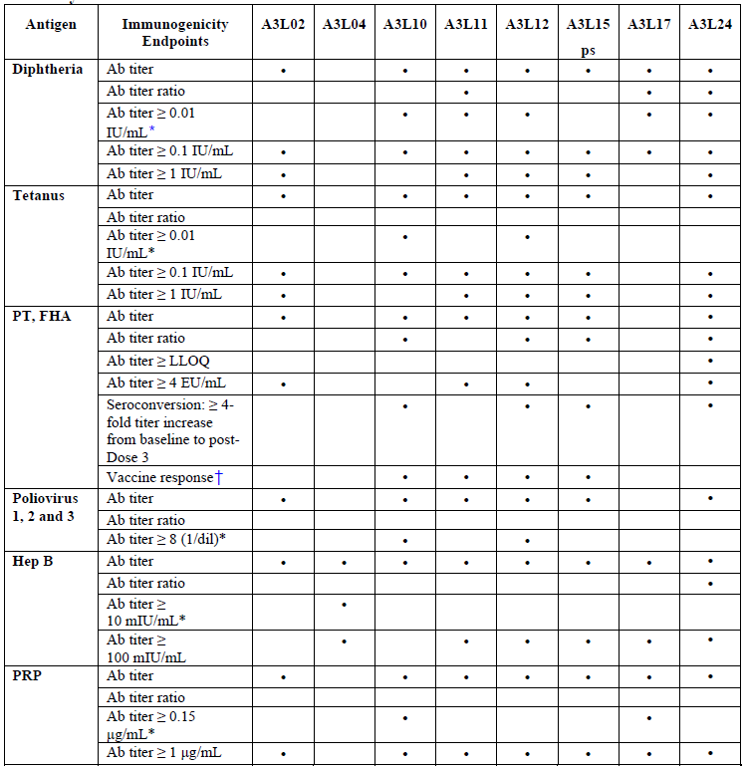
The Hexaxim immunogenicity for booster studies was assessed using the following parameters:
- For Ab persistence at pre-booster injection for all Ags:
- Geometric mean of Ab titres (GM of titres),
- % of subjects with titres above predefined thresholds (including those of defined seroprotection);
- For immune response at one month post-booster injection for all Ags:
- Geometric mean of Ab titres (GM of titres),
- Geometric mean of individual Ab titres ratio post/pre-booster injection (GM of titre ratio)
- % of subjects with titres above predefined thresholds (including those of defined seroprotection).
- For PT and FHA Ags only:
- Seroconversion rates defined as the percentage of subjects with ≥ 4-fold titre increase from baseline to one month post-booster injection;
- Booster response rate was defined as follow:
- Subjects whose pre-vax Ab concentrations are <LLOQ, will demonstrate the booster response if they have post-vax levels ≥4 x LLOQ;
- Subjects whose pre-vaccination Ab concentrations are ≥LLOQ but <4 x LLOQ, will demonstrate the booster response if they have a 4-fold response (i.e. post-/pre-vax ≥4);
- Subjects whose pre-vax Ab concentrations are ≥4 x LLOQ, will demonstrate the booster response if they have a 2-fold response (i.e. post-/prevax ≥2).
See Table 4 for the submitted immunogenicity studies.
None of the immunogenicity studies had deficiencies that excluded their results from consideration.

Summary of Immunogenicity
Please see Section 7.3 and 7.4, as the summary on immunogenicity, as a surrogate for efficacy, pertains to all [efficacy] studies described.

Dosage selection for the pivotal studies
The Hexaxim vaccine in the immunogenicity studies is the same formulation as that used in the studies summarised in Section 7 but used as per the primary vaccination schedule (n=3 vaccines separated by 4 or 8 weeks) in various different countries. Boosting data – when the booster vaccine was Hexaxim (= 4 doses of Hexaxim in an 18 month period) and longevity of the immune response is provided in Studies A3L22, A3L15 and A3L26 respectively.

Clinical efficacy

Pivotal clinical efficacy (immunogenicity)
Comment: It is noteworthy of comment that the distinction between “immunogenicity” studies and clinical efficacy studies in this review is somewhat arbitrary. The reason is that all the studies presented in this submission are immunogenicity studies. This dossier of studies provides only immunological response data (and safety) induced by Hexaxim and the comparator vaccine(s), i.e. these are surrogate markers of clinical protection. No actual clinical efficacy data is provided in this submission. All immunological assays were carried out at the Sponsor’s laboratory in Swiftwater, Pennsylvania, USA, or at qualified contract laboratories – details of the actual assays used and thresholds for primary and booster responses are detailed in Section 5.1.

Primary Vaccination (at 2, 4, and 6 months of age) in infants: Study A3L11
A Lot-to-Lot Consistency Study of DTaP-IPV-Hep B-PRP-T Vaccine Administered at 2-4-6 Months of Age in Healthy Mexican Infants.

Study design, objectives, locations and dates

Design
Phase III, randomised, blind-observer, multicentre, controlled, four-arm study. All subjects received three doses (at 2, 4, 6 months of age: V01, V03, V05, respectively) of either one of the three batches of the DTaP-IPV-Hep B-PRP-T vaccine, (Groups 1, 2, and 3) or the Infanrix Hexa vaccine (Group 4). All infants were followed up for a total of 10 months.

Objectives

Primary:
To demonstrate equivalence of three batches of DTaP-IPV-Hep B-PRP-T vaccine second Drug Product Generation in terms of seroprotection rates for D, T, Hep B, PRP, and polio and seroconversion rates for anti-PT and anti-FHA, 1 month after a three-dose primary series (at 2, 4, 6 months of age).

Secondary:
Immunogenicity: To describe in each group, including the Infanrix Hexa group, the immunogenicity parameters for all antigens, 1 month after the third dose of the primary series; to demonstrate that the immune response of the DTaP-IPV-Hep B-PRP-T vaccine does not induce a lower immune response than the Infanrix Hexa vaccine in terms of seroprotection to D (defined by a titre ≥0.01 IU/mL), 1 month after a 3rd dose of the primary series.
Safety: To assess the overall safety in each group 1 month after the third dose of the primary series in terms of the incidence rates of: any unsolicited systemic AEs in the first 30 minutes after each injection; any solicited ARs in the first 7 days after each injection; any AEs in the first 30 days after each injection; any SAEs during the trial (including the 6-month follow-up period)

Protocol amendments
The study protocol was amended four times; current version at study end was Version 10.0, dated 15 November 2007). Highlighted changes:
- Amendment 1 (Protocol Version 7.0, dated 02 August 2006) to accommodate the routine practice of immunising pregnant women with vaccines containing T and D during pregnancy. As transmission of maternal anti-D Abs to the infant may influence the infants’ immune response to the vaccination. Consequently, non-inferiority of anti-D seroprotection was added as a secondary objective, and anti-D Ab titres above cut-off were added as secondary endpoints. Maternal vaccination history was also to be collected;
- Amendment 4 (current Protocol Version 10.0, dated 15 November 2007) extended the time intervals between vaccinations and between vaccination and blood samples to be used for the primary series. During a blind review of data held on 06 October 2007 it was noted that for a large number of subjects, visit dates were slightly outside the time intervals defined in the protocol. In order to maintain an attrition rate of 15%, the PP Analysis Set criteria for the time intervals were modified slightly. The slight change in the immunisation windows applied only to the definition criteria for the PP Analysis Set, and was not thought to bear any effect on the immunogenicity outcomes of the study.

Trial location and dates
Mexico, 6 sites. Initiation Date: 14 November 2006. Trial Completion Date: 13 June 2008.

Inclusion and exclusion criteria
Inclusion: Two months old infants (50-71 days old) on the day of inclusion; Born at full term of pregnancy (≥37 weeks) with a birth weight ≥2.5 kg; Informed Consent Form signed by one or both parents or by the guardian and two independent witnesses; Able to attend all scheduled visits and to comply with all trial procedures; Received BCG vaccine between birth and 1 month of life in agreement with the national immunisation calendar.
Exclusion: Participation in another clinical trial in the four weeks preceding the (first) trial vaccination; Planned participation in another clinical trial during present trial; Congenital/acquired immunodeficiency; Systemic hypersensitivity to any of the vaccine components or history of a life-threatening reaction to the trial vaccine or a vaccine containing the same substances; Chronic illness; Blood or blood-derived products received since birth; Any vaccination in the 4 weeks preceding the first trial visit; Any planned vaccination (except BCG, rotavirus, and pneumococcal conjugated vaccines) during the study; Documented history of pertussis, tetanus, diphtheria, poliomyelitis, Hib or hep B infection; Previous vaccination against hep B, pertussis, tetanus, diphtheria, poliovirus, or Hib infection; Known personal or maternal history of HIV, HBsAg or hepatitis C (HCV) seropositivity; Thrombocytopaenia/bleeding disorder contraindicating IM vaccination; History of seizures; Febrile (rectal equivalent temperature ≥38.0°C) or acute illness on the day of inclusion.
There were other temporary exclusions which are not detailed here.

Study treatments
All subjects in Groups 1, 2, 3 to receive three IM (into thigh) doses of one of three batches (Batch Number: S4009-F01 or Batch Number: S4106-F01 or Batch Number: S4107-F01 (expiry dates for all 3 batches: November 2007) of the investigational vaccine; all subjects in Group 4 received 3 doses of Infanrix Hexa at 2, 4, 6 months of age. 4 mL blood sample collected at baseline (BL1-V01); a 5 mL blood sample at 7 months of age (BL2-V06) i.e. one month after 3rd vaccine received. SAE information collected for 6 months after last vaccine administration. Total study participation = 10 months for each subject.
Antigen composition of the investigational vaccine (= to Hexaxim) and Infanrix Hexa are detailed in Tables 1 and 3 respectively, above.

Efficacy variables and outcomes
The main efficacy variables were serological endpoints as defined in Table 7 Section 5.1 at one month (V06, D150) after the third vaccine in the primary series was received.
Other efficacy outcomes included are summarised in Table 8, Section 5.1.
Safety:
- Occurrence, nature (MedDRA), preferred term (Pref T), intensity, relationship to vaccination for any unsolicited systemic AEs reported in the 30 minutes after vax;
- Occurrence, time to onset, nos of days of occurrence, intensity for solicited (prelisted in the subject diary and CRF) ISR and systemic reactions occurring up to 7 days after each vax;
- Occurrence, nature (MedDRA Pref T), time to onset, duration, intensity, relationship to vaccination (systemic AEs only) for unsolicited (spontaneously reported) AEs up to 30 days after each vax;
- Occurrence of any SAEs during the trial (including the 6-month follow-up after last vax dose).

Randomisation and blinding methods
Randomisation list prepared under the responsibility of the Biostatistics Platform of the Sponsor and created using the permuted block method, which guaranteed, at any time, an approximately similar ratio of subjects between groups. The investigational vaccine group was composed of three subgroups (Groups 1, 2, 3), to be equally divided per batch. A scratch-off list matching the subject’s inclusion number with the vaccine group was to be used by the nurse/vaccinator to find out the group assignment of each subject. Once the group had been identified, the nurse/vaccinator took one dose corresponding to the group. Each dose had a specific number. Each subject was vaccinated with the vaccine labelled with a dose number (without any link with the subject’s inclusion number).
A blind-observer procedure was to be followed. Neither Investigator (blind-observer) – who assessed safety, nor the subjects' parents knew which vaccine was given. Only the nurse/vaccinator at the site had access to the randomisation list which was stored securely.

Analysis populations
Four study populations were defined:
- The PP Analysis Set i.e. subjects without any protocol deviation that may have interfered with primary criteria evaluation, i.e. All inclusion criteria met, no exclusions; no randomisation errors; received the 3 vaccine injections; had BL2-V06 drawn and with any measurement available; no concomitant vaccines during primary series other than those for the trial (except Rotarix or pneumococcal conjugated vax if included in the NIP); protocol adherence;
- The ITT Analysis Set i.e. subjects receiving ≥1 dose of vaccine on study. Subjects analysed according to the randomisation group regardless of the vaccine actually received;
- The Safety Analysis Set (SafAS) i.e. subjects receiving ≥1 dose of investigational or control vax. SafAS was defined for each dose as the subset of subjects having received this dose. If the vaccine administered differed to the one assigned by randomisation, then the safety analysis was conducted according to the vaccine administered;
- “Subjects present at V01” Analysis Set i.e. subjects with a visit date at V01. This population analysed without taking into account the treatment group.

Sample size
Planned sample size =1190 subjects randomly allocated to one of 4 groups:
- Group 1: 340 infants, 3 doses of the DTaP-IPV-Hep B-PRP-T (Batch 1);
- Group 2: 340 infants, 3 doses of the DTaP-IPV-Hep B-PRP-T (Batch 2);
- Group 3: 340 infants, 3 doses of DTaP-IPV-Hep B-PRP-T (Batch 3);
- Group 4: 170 infants, 3 doses of Infanrix Hexa vaccine.
The sample size for the investigational vaccine group calculated by using simulation to obtain an overall power of 90%; 288 subjects per group of the investigational vaccine was considered necessary to test the global null hypothesis at an alpha level of 5%. Assuming only 85% of subjects would be evaluable, 340 subjects per group of the investigational vaccine were to be enrolled.

Statistical methods
Three paired equivalence tests on seroprotection/seroconversion rates according to the valence, 1 month after the third dose of the DTaP-IPV-Hep B-PRP-T vaccine, to demonstrate the consistency. The statistical methodology was based on the use of the two-sided 90% CI of the differences between pairs of batches of the seroprotection/seroconversion rates. Lot-to-lot consistency was also assessed using 95% CIs of the difference in seroprotection/seroconversion rates between batches, 1 month after the third dose of the primary series as per described in the SAP.
Immunogenicity: Immunogenicity endpoints were summarized by vaccine group. Immune responses described via: Geometric mean of Ab titres; Geometric mean of individual Ab titres ratio, for anti-PT and anti-FHA Ab titres; % of subjects with titres according to predefined thresholds. In addition, Reverse Cumulative Distribution Curves (RCDCs) were plotted on the ITT analysis set for each parameter.
Safety: Safety endpoints were summarised by vaccine group using the number and % of subjects presenting the studied events among the subjects assessable for the safety. The 95% CI was calculated for main parameters using the exact binomial distribution for proportions (Copper-Pearson method). The statistical analyses were performed by a CRO under the responsibility of the Biostatistics Department of Sanofi Pasteur, Marcy l’Etoile, France, using the SAS software, Version 9.1. The IDMC safety analyses were performed by an independent statistician. A detailed SAP was written before database lock.

Participant flow
See also Figure 1: this Figure is presented, as this study, of all the studies presented in this application, was the most problematical in regards to attrition and/or non protocol compliance of participants.
Figure 1: Participant flow in Study A3L11
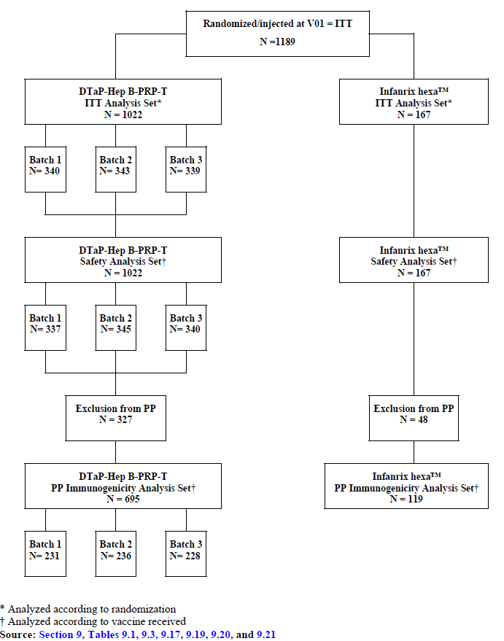
In summary: 1189 subjects were randomised and received a vaccine injection at V01 and are included in the ITT analysis. Of these, 1022 subjects received the DTaP-IPV-Hep B-PRP-T vaccine (batch 1: n=340 subjects, batch 2: n=343, batch 3: n=339), and a total of 167 subjects were randomised to receive the control product Infanrix Hexa. 1056 (88.8%) subjects completed the study up to V06, with similar % completing in each treatment group.
Of the patients who received at least one dose of study vaccine, 11.2% discontinued before V06 i.e. 2 subjects (0.6%) in the DTaP-IPV-Hep B-PRP-T batch 3 group withdrew due to SAEs; 34 subjects (2.9%) withdrew due to non-compliance with the protocol, with similar % in each treatment group; 49 subjects (4.1%) were lost to follow-up, with similar % in each treatment group (3.2% to 4.4% for the individual DTaP-IPV-Hep B-PRP-T batches, and 6.0% for Infanrix Hexa); Overall, 48 subjects (4.0%) withdrew voluntarily for reasons other than an AE, with similar % in each treatment group.
Of the 1056 subjects who completed to V06, a total of 1018 (96.4%) subjects were successfully contacted at the 6-month follow-up visit. Of the 133 (11.2%) subjects who discontinued before V06, 80 subjects (60.2%), were successfully contacted for the 6-month follow-up; a further 13 (9.8%) subjects had contact after V06. The % who received all 3 vaccine injections in accordance with the randomisation schedule was similar in each treatment group: ≥88.2% for the individual DTaP-IPV-Hep B-PRP-T batches, 88.0% for the Infanrix Hexa group. A further 18 subjects received 3 doses of the same vaccine, but were incorrectly allocated to treatment group. The % of these subjects were similarly low (≤2.1%) in each treatment group. The remaining subjects received an incomplete and/or mixed schedule of vaccinations. The % was similar in each treatment group: ≤9.7% for the individual DTaP-IPV-Hep B-PRP-T batches and 10.2% for the Infanrix Hexa group.
Despite protocol Amendment 4, numerous subjects in all groups were still outside the specified vaccination windows.

Major protocol violations/deviations
Subjects with at least one protocol deviation were excluded from the PP Immunogenicity Analysis Set (Table 9). In addition, routine monitoring of study site 002 detected that the first 22 subjects had been allocated using the emergency code-break list rather than the randomisation list. As a result, 15 had received vaccine other than that specified by randomisation; despite this major error, the Principal/Sub-Investigators remained blinded to the vaccine received. The subjects were retained in the study and the site staff re-trained. This incorrect allocation impacted on the PP Analysis Set, but these 15 subjects were evaluable for the ITT and Safety Analyses.
Table 9: A3L11 Subject disposition
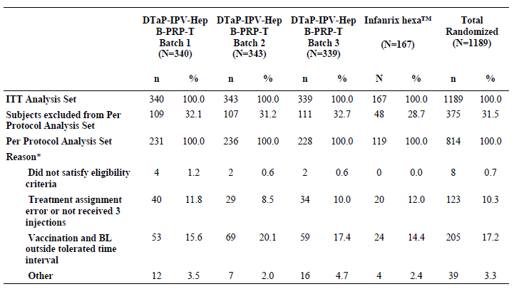

Baseline data
Table 10: Demography data for the ITT analysis set of A3L11
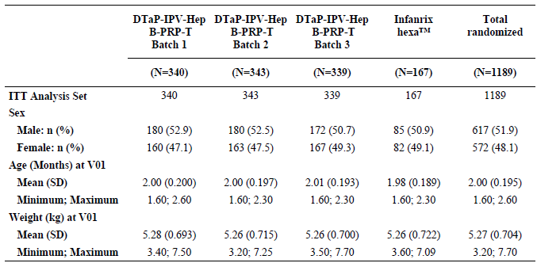

Results for the primary efficacy outcome
The primary objective of the study was met i.e.
- Individual batches were consistent using both PP and ITT Analysis Sets (see Table below). The 90% CIs for the difference in seroprotection/seroconversion rates between DTaP-IPV-Hep B-PRP-T batches lay within (–5; 5) for polio types 1, 2 3, and within (–10; 10) for all other valences. Therefore, the individual null hypotheses were rejected and equivalence between DTaP-IPV-Hep B-PRP-T batches was concluded for all individual valences;
- The three individual batches showed broadly similar seroprotection/seroconversion rates at protocol-specified thresholds, however some differences were observed at higher thresholds i.e. for anti-Hep B batch 2 showed similar seroprotection rates to batch 3, but higher seroprotection rates than batch 1 at the ≥100 mIU/mL threshold (ITT Analysis), and for Anti-D, batch 2 showed greater observed seroprotection rates than the other two batches at the ≥1.0 IU/mL threshold (PP Analysis Set only; this difference was not seen in the ITT Analysis Set and the GMTs were similar).
Table 11: A3L11 equivalence of seroprotection between the three DTaP-IPV-Hep B-PRP-T batches
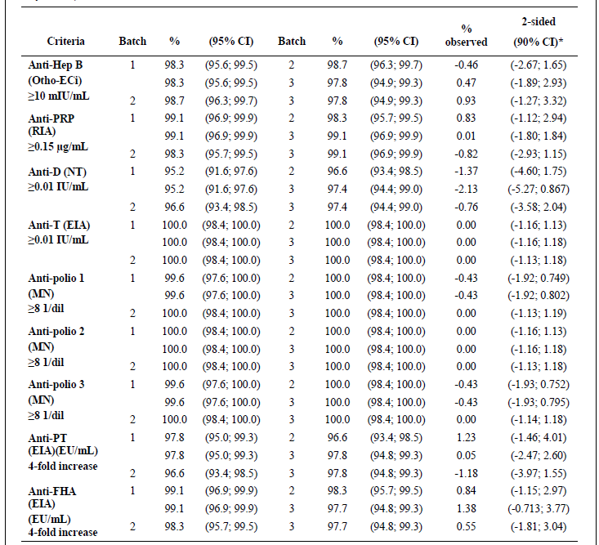

Results for other efficacy outcomes
The % of subjects reaching protocol-defined thresholds for seroprotection/seroconversion were similar (based on overlapping 95% CIs) in the DTaP-IPV-Hep B-PRP-T pooled batches group vs. Infanrix Hexa group and non-inferiority with Infanrix Hexa was demonstrated. For the individual valences, ≥95% of subjects in the individual DTaP-IPV-Hep B-PRP-T batches and in the Infanrix Hexa group met protocol-defined surrogate thresholds for seroprotection/seroconversion.
Some differences were observed at higher thresholds: 91.7% in the pooled batch group met the ≥100 mIU/mL threshold for anti-Hep B vs. 99.2% in Infanrix Hexa group (non-overlapping 95% CIs). Some differences in GMTs were observed between treatment groups: GMT values for anti-PRP and anti-FHA (V06 [D150] and V06/V01 ratio) were higher for the DTaP-IPV-Hep B-PRP-T pooled batches than for Infanrix Hexa, based on non-overlapping 95% CIs. For polio types 1, 2, 3, the pooled batches gave lower GMT values than Infanrix Hexa. For all other valences, observed GMTs were similar across the pooled batches and Infanrix Hexa groups.
Importantly, especially as the amount of diphtheria antigen is less in DTaP-IPV-Hep B-PRP-T than in Infanrix Hexa, the pooled batches elicited a non-inferior anti-D seroprotection rate (at the ≥0.01 IU/mL threshold) compared to Infanrix Hexa. Descriptively, seroprotection/seroconversion rates and GMTs were generally in a similar range for pooled DTaP-IPV-Hep B-PRP-T batches and Infanrix Hexa, demonstrating that both vaccines are protective against the six targeted diseases.
Overall, the safety profile of the pooled DTaP-IPV-Hep B-PRP-T batches was acceptable and similar to Infanrix Hexa. The incidence of solicited injection site or systemic reactions was generally similar between both products. See Section 8 for a summary of safety.

Immunogenicity persistence of Hexaxim when three doses given as the primary vaccine schedule and boosting effects of Hexaxim in infants: Study A3L21
Study A3L21 (Booster of A3L11): Immunogenicity Study of the Antibody Persistence and Booster Effect of the DTaP-IPV-Hep B-PRP-T Combined Vaccine at 15 to 18 Months of Age Following a Primary Series of DTaP-IPV-Hep B-PRP-T or Infanrix Hexa Administered at 2, 4, and 6 Months of Age in Healthy Mexican Infants.

Study design, objectives, locations and dates

Design
Phase III, open-label, multicenter booster vaccination study in toddlers who had completed a three-dose primary series of either the investigational DTaP-IPV-Hep B-PRP-T vaccine or Infanrix Hexa in Study A3L11.

Objectives
Immunogenicity: To describe Ab persistence at 15 to 18 months of age for all valences following a three-dose primary series vaccination of either DTaP-IPV-Hep B-PRP-T or Infanrix Hexa at 2, 4, 6 months of age in a subset of subjects; to describe the immunogenicity of a booster dose of DTaP-IPV-Hep B-PRP-T given at 15 to 18 months of age in a subset of subjects.
Safety: safety profile after DTaP-IPV-Hep B-PRP-T booster given at 15 to 18 months of age.

Trial location and dates
Mexico, 6 sites. Initiation Date to Trial Completion Date: 26 March 2008 to 28 May 2009.

Inclusion and exclusion criteria
Inclusion: Toddlers previously included in Study A3L11 who completed the three-dose primary series vaccination of either DTaP-IPV-Hep B-PRP-T or Infanrix Hexa at 2, 4, 6 months of age; Toddlers of 15-18 months of age, inclusive; Informed Consent Form signed by at least one parent or legal representative and two mandatory witnesses; Able to attend all scheduled visits and to comply with all trial procedures.
Exclusion: Participation in another clinical trial in the 4 weeks preceding the booster vaccination; Planned participation in another clinical trial during present trial; Congenital/acquired immunodeficiency, immunosuppressive therapy; Systemic hypersensitivity to any of the vaccine components or history of a life-threatening reaction to a vaccine containing the same substances; Chronic illness; Blood or blood-derived products received in the last 3 months; Any vax in the 4 weeks preceding the booster vaccination; Any vaccination planned until the next visit; History of documented pertussis, tetanus, diphtheria, poliomyelitis, Hib or hep B infection; Administration of a vaccine against pertussis, tetanus, diphtheria, poliomyelitis, Hib, and/or hep B infection since end of participation in Study A3L11; Coagulopathy, thrombocytopaenia or bleeding disorder contraindicating IM vaccination; Known maternal history of HIV, HBsAg or HCV seropositivity; Subjects with any related SAE that occurred following the three-dose primary series administration of the investigational vaccine or of the reference vaccine in Study A3L11; History of seizures; Febrile (temperature ≥38.0°C) or acute illness on the day of inclusion; Known contraindication to further vaccination with a pertussis vaccine.
Other temporary exclusions applied, details not provided here.

Study treatments
All subjects were to receive a booster dose of the DTaP-IPV-Hep B-PRP-T vaccine at Visit 1.

Efficacy variables and outcomes
The main efficacy variables were:
Pre-booster Immune Response i.e. Ab titres for each valence; Ab titres above a cut-off: Anti-T and anti-D Ab titres ≥0.01 IU/mL and ≥0.1 IU/mL; Anti-Hep B Ab titres ≥10 mIU/mL and ≥100 mIU/mL; Anti-PRP Ab titres ≥0.15 μg/mL and ≥1.0 μg/mL; Anti-polio titres ≥8 (1/dil).
Post-booster Immune Response (one month after the booster dose). The following endpoints as detailed in Table 7 Section 5.1 and in Section 5.1 itself were used to assess the immune response 1 month after the booster dose with DTaP-IPV-Hep B-PRP-T at Day 30 (V02). In addition, Anti-Hep B Ab ≥100 mIU/mL was also tabulated.

Randomisation and blinding methods
Open-label. For the immunogenicity analysis: planned to include approximately 300 subjects in this subset: about 68 subjects from each of the batches in the DTaP-IPV-Hep B-PRP-T group of A3L11 and about 100 subjects from Infanrix Hexa group of A3L11. The selection was to be divided among 3 centres, with a target of 100 subjects each. In order to replace subjects withdrawn from A3L11 or those not satisfying A3L21 inclusion/exclusion criteria, a randomisation list was prepared for 90 subjects per A3L11 DTaP-IPV-Hep B-PRP-T group and 120 subjects in the A3L11 Infanrix Hexa group. Only the first 100 subjects in each of the 3 centres used for the selection (Centres 1, 2, 3) were included in the immunogenicity subset.

Analysis populations
PP Analysis Set; ITT Analysis Set–defined in 3 ways i.e. The ITT Analysis Set= all subjects receiving the booster; ITT Analysis Set for Ab Persistence =all subjects included in the subset for immunogenicity assessment with at least one measurement available on BL1-V01 (Day 0); The ITT for Immunogenicity Analysis Set=all subjects receiving the booster and in whom immunogenicity analyses were planned. Subjects analysed according to vaccine group attributed in the primary series and overall. Descriptive safety analyses were performed on the SafAS.

Sample size
No formal sample size calculation as no statistical hypothesis was being tested.

Statistical methods
Descriptive statistics were produced.

Participant flow
The ITT Analysis Set = 881 subjects who received a DTaP-IPV-Hep B-PRP-T booster injection at V01. Of these, 768 were primed with DTaP-IPV-Hep B-PRP-T vaccine (batch A: 254, batch B: 262, batch C: 252), 113 with Infanrix Hexa. 99.3% completed the study to V02. Six subjects (0.7%) discontinued prior to V02, all were in the DTaP-IPV-Hep B-PRP-T primary vax group: two subjects lost to follow-up and 4 voluntary withdrawals. For the 875 subjects completing to V02, 856 (97.2%) subjects were successfully contacted 6 months post boosting. Of the 6 subjects (0.7%) discontinuing pre V02, 3 were successfully contacted at 6 months after booster vaccination, and a further 2 subjects had contact after V02.
Table 12: subjects assessable for the ITT analysis set and SafAS in A3L21
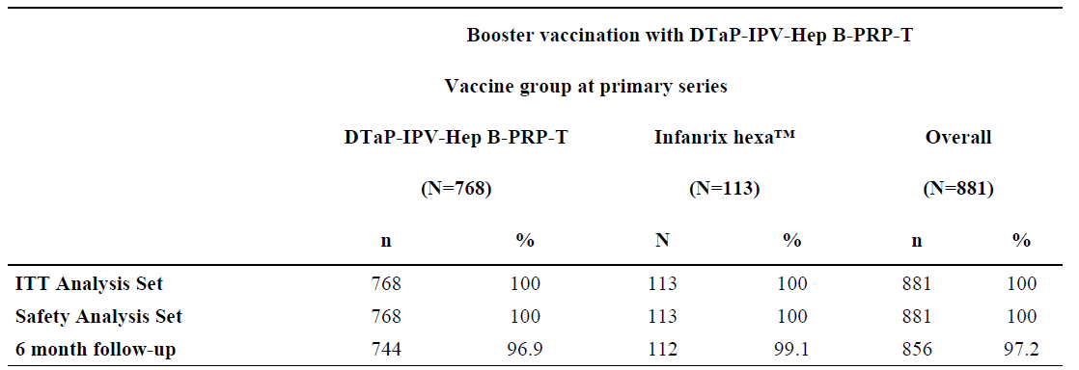

Major protocol violations/deviations
68 subjects were excluded from PP Analysis i.e. 2 subjects (0.6%) did not meet eligibility; 46 subjects (14.8%) - time interval between vax and V02 sample outside the window. The % of these subjects was similar for both groups; in 22 subjects (7.1%), sample or measurement not available.

Baseline data
All the vaccine groups were similar in terms of gender distribution, age, weight. This was also the case for the PP Analysis Set and the ITT for Ab persistence Analysis Set.

Results for the primary efficacy outcome

Pre-Booster Immunogenicity of individual DTaP-IPV-Hep B-PRP-T priming batches
The three individual DTaP-IPV-Hep B-PRP-T batches provided similar Ab persistence (at the thresholds for seroprotection), for all valences studied.

Ab persistence at V01
In the PP Analysis Set, DTaP-IPV-Hep B-PRP-T provided similar Ab persistence to Infanrix Hexa, for all valences studied. For PRP and Hep B ≥86.9% and ≥89.8%, respectively, of subjects primed with DTaP-IPV-Hep B-PRP-T met protocol-defined seroprotection thresholds at V01, vs. ≥92.3% and ≥95.4% of subjects primed with Infanrix Hexa. For all other valences, ≥92% of subjects attained seroprotection thresholds.
Similar results obtained for the ITT and ITT for Ab Persistence Analysis Sets. For almost all valences i.e. Hep B, PRP, D, T, polio type 1, subjects primed with DTaP-IPV-Hep B-PRP-T showed similar pre-booster GMTs to subjects primed with Infanrix Hexa. Differences in GMT noted for seroprotection specific anti-polio Ab persistence.
In the PP, anti-polio 3 GMTs were lower in those primed with DTaP-IPV-Hep B-PRP-T (339) vs. Infanrix Hexa (896). For anti-polio 2, GMTs similar in subjects primed with DTaP-IPV-Hep B-PRP-T (751) compared to subjects primed with Infanrix Hexa (1267), based on overlap of 95% CIs. Similar results in the ITT Analysis Set for Ab persistence, and ITT Immunogenicity Analysis Set. Despite differences in the magnitude of GMT, proportion maintaining protective Ab levels similar.

Booster Response after DTaP-IPV-Hep B-PRP-T Booster Vaccination (V02)
Overall (PP Analysis Set) ≥ 99.2% had protective Ab levels 1 month after booster vaccination for all valences studied. For anti-PT and FHA titres, ≥87.3% of subjects showed a four-fold increase. DTaP-IPV-Hep B-PRP-T primed subjects showed similar seroprotection/seroconversion rate (all valences) after boosting to those primed with Infanrix Hexa. Similar seroconversion rates were observed for FHA regardless of primary vaccination group (86.7% vs 89.1%). Seroconversion rates for PT were numerically higher in those primed with DTaP-IPV-Hep B-PRP-T vs. Infanrix Hexa (91.8% vs. 81.0%) although the difference was non-significant. Booster responses for PT and FHA were similarly high in both primed groups. For the PP Analysis Set, anti-polio 3 GMTs were lower in DTaP-IPV-Hep B-PRP-T primed (6971) than Infanrix Hexa primed (13,337); anti-FHA GMTs were higher for DTaP-IPV-Hep B-PRP-T primed (402) than Infanrix Hexa primed (291). For anti-Hep B, anti-PRP, and anti-polio 2, GMTs were similar for DTaP-IPV-Hep B-PRP-T pooled group (2553, 67.5, 10,046, respectively) vs. Infanrix Hexa (4757, 102, 13,482, respectively) based on overlap of 95% CIs. Although the magnitude of Ab responses varied post-booster for specific valences, seroprotection rates achieved suggest these quantitative differences were not clinically significance.
Table 13: ITT for immunogenicity analysis set (anti hep B) in AL3021
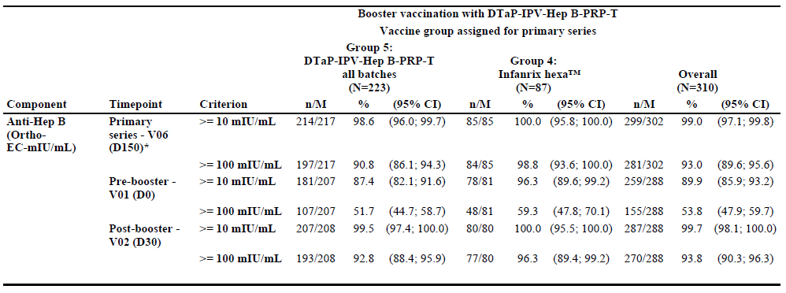
Table 14: ITT for immunogenicity analysis set (anti-D) in AL3021
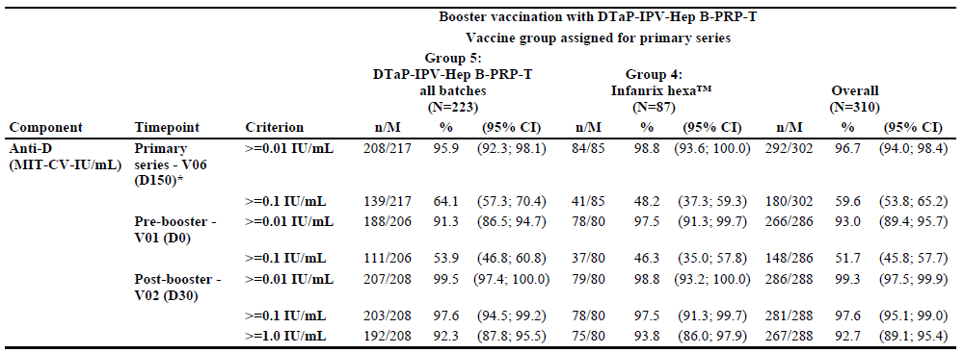

Results for other efficacy outcomes
See also Section 8, but in summary, DTaP-IPV-Hep B-PRP-T boosting of toddlers (age 15-18 months) was well tolerated and immunogenic regardless of the primary vaccine series used.

Primary Vaccination (at 2, 4, and 6 months of age) in infants: Study A3L12
Study A3L12: Immunogenicity Study of a DTaP-IPV-Hep B-PRP-T Combined Vaccine in Comparison to Infanrix Hexa, Both Concomitantly Administered with Prevenar at 2, 4, and 6 Months of Age in Thai Infants

Study design, objectives, locations and dates

Design
Phase III, multicentre, blind-observer, randomised, controlled trial conducted in 412 infants in Thailand. Subjects were to receive a three-dose primary vaccination series (at 2, 4, 6 months of age: V01, V03, and V05, respectively) of either the investigational vaccine (DTaP-IPV-Hep B-PRP-T) co-administered with Prevenar (Group 1, tested group) or the reference vaccine (Infanrix Hexa) co-administered with Prevenar (Group 2, reference group). All subjects must also have received Hep B vax at birth to comply with the Thai Standard Vaccination Schedule.

Objectives
To demonstrate that the hexavalent DTaP-IPV-Hep B-PRP-T combined vaccine induces an immune response at least as good as the response following Infanrix Hexa in terms of Hep B and PRP seroprotection 1 month after a three-dose primary series (at 2, 4, 6 months), when co-administered with Prevenar.
Immunogenicity: Describe immunogenicity of each vaccine component at V06.
Safety: Overall safety after each injection

Trial location and dates
Thailand, 4 sites. Initiation: 22-Oct-06; Trial Completion Date: 19-Nov-07 (LVLS including 6-month follow-up).

Inclusion and exclusion criteria
Inclusion: Two-month-old infant (50 to 71 days old) on the day of inclusion, of either gender; Born at full term of pregnancy (≥37 weeks) and with a birth weight ≥2.5 kg; Hep B vaccination since birth; Informed consent form signed by one parent/legally acceptable representative and an independent witness if the parent/legally acceptable representative is illiterate; Able to attend all scheduled visits and to comply with all trial procedures.
Exclusion: Participation in another clinical trial in the 4 weeks preceding the first trial vaccination; Planned participation in another clinical trial during the present trial period; Systemic hypersensitivity to any of the vaccine components or history of a life-threatening reaction to the trial vaccine or a vaccine containing the same substances; Congenital or acquired immunodeficiency, or immunosuppressive therapy such as long-term systemic corticosteroid therapy; Chronic illness at a stage that could interfere with trial conduct or completion; Blood or blood-derived products received since birth; Any vaccination in the 4 weeks preceding the first trial vaccination; Any planned vaccination (except trial vaccinations) during the trial; Documented history of pertussis, T, D, polio, Hib, hep B or Streptococcus pneumoniae infection(s) confirmed either clinically, serologically, or microbiologically; Previous vaccination against pertussis, T, D, poliomyelitis, Hib infection or Streptococcus pneumonia; Known personal or maternal history of HIV, HBsAg, or HCV seropositivity; Known thrombocytopaenia or bleeding disorder contraindicating IM vaccination; History of seizures; Febrile (rectal equivalent temperature ≥38.0°C) or acute illness on the day of inclusion.
Other temporary exclusions applied, details not provided here.

Study treatments
Subjects to receive a three-dose primary vaccination series (at 2, 4, 6 months of age: V01, V03, and V05, respectively) of either DTaP-IPV-Hep B-PRP-T) co-administered with Prevenar (Group 1) or the reference vaccine, Infanrix Hexa, co-administered with Prevenar (Group 2). All subjects must have received Hep B vaccination at birth to comply with the Thai Standard Vaccination Schedule. Subjects followed up for a total of 300 days (including a 6-month safety follow-up for SAEs) after the last dose. Blood samples for immunogenicity testing were collected at Day 0 and Day 150.
A phone call or visit was arranged to collect information on any SAE occurring during the 6 months after the last vaccine administration.
DTaP-IPV-Hep B-PRP-T vaccine, manufactured by Sanofi Pasteur (ref. Table 1); Infanrix Hexa (ref. Table 3) and Prevenar, 7-valent pneumococcal vaccine, Wyeth Ltd). Each 0.5 mL dose contains: pneumococcal polysaccharide serotypes: 4* - 2 μg; 6B* - 4 μg; 9V* -2 μg; 14*- 2 μg; oligosaccharide serotype 18C* - 2 μg; 19F*- 2 μg; 23F* - 2 μg.
* conjugated to CRM197 carrier protein & adsorbed on aluminium phosphate (0.5 mg).

Efficacy variables and outcomes
The main efficacy variables were seroprotection at one month post 3rd vaccination defined as: Anti-Hep B Ab titres ≥10 mIU/mL and Anti-PRP Ab titres ≥0.15 μg/mL. Other efficacy (immunogenicity) outcomes included titres of the other antigens in the investigational and control vaccine as described in Section 5.1. Standard Safety outcomes assessed as above.

Randomisation and blinding methods
The Sponsor’s Biostatistics Platform provided a scratchable randomisation list. A blind-observer procedure followed so neither investigator (in charge of safety assessment) nor the subject’s parent(s)/guardian(s) knew which vaccine was administered. The product preparation and administration, and assessment of safety were performed by two different individuals (a nurse and Investigator, respectively). The randomisation list and product accountability form were kept in a secure place to which only the nurse in charge of vaccination had access.

Analysis populations
Four study populations were defined for the statistical analysis:
- PP Analysis Set;
- ITT Analysis Set i.e. defined as all subjects who received at least one dose of vaccine (either the DTaP-IPV-Hep B-PRP-T vaccine or Infanrix Hexa, concomitantly administered with Prevenar). Subjects were to be analysed according to the randomisation group regardless of the vaccine actually received;
- SafAS;
- Subjects Present at V0.

Sample size
Calculated using Farrington and Manning formula and based on a type 1 error of 2.5% (one-sided hypothesis) to obtain an overall power of 90%. A total of 412 subjects to be enrolled to obtain 350 evaluable subjects (15% attrition rate). Subjects randomly allocated to one of the two groups. Main safety and immunogenicity parameters described with 95% CI.

Statistical methods
The differences in seroprotection rates for the Hep B and PRP antigens between the two groups (Test – Control) were calculated. The clinically relevant limit for non-inferiority was -10% for Hep B and PRP Ags. The statistical method based on the lower bound of the two-sided 95% CI of the difference of the seroprotection rates.
Individual Hypotheses: for each valence the null hypothesis was the difference in terms of % of seroprotected subjects, between test and control Group less than or equal to the clinically relevant limit for non-inferiority (-10%). Non-inferiority demonstrated if null hypothesis was rejected at significance level of 2.5% (type 1 error).
The global null hypothesis: For at least one valence i.e. the difference in % of seroprotected subjects, between tested Group and control Group was less than or equal to the clinically relevant limit for non-inferiority (-10%). Non-inferiority of investigational vaccine demonstrated if the global null hypothesis was rejected, that is, individual null hypotheses for Hep B & PRP were rejected. The hypothesis was tested on the PP Analysis Set and then the ITT set to confirm the findings. Descriptive statistics for safety and various other immunogenicity parameters (see Table 8).

Participant flow
Table 15: Number of participants included in the analysis sets in A3L12
Number of Subjects | Group 1: Hexaxim + Prevenar | Group 2: Infanrix Hexa + Prevenar | Total randomised
Enrolled | 206 | 206 | 412
Completed | 197 | 196 | 393
Discontinued before V06 | 9 | 10 | 19
Safety Analysis Set | 206 | 206 | 412
PP Immunogenicity Analysis | 189 | 190 | 379
ITT Immunogenicity Analysis | 206 | 206 | 412

Major protocol violations/deviations
Number with protocol deviations was similar in both groups. Protocol deviations observed (V01 to V06) included: Inclusion/exclusion criteria not satisfied at V01 (D0): one subject (0.5%) in the Infanrix Hexa + Prevenar group was outside the age limit of 50 to 71 days of age; Subjects did not receive all three doses of vaccination: 8 (3.9%) in the DTaP-IPV-Hep B-PRP-T + Prevenar group and 9 (4.4%) in the Infanrix Hexa + Prevenar group missed at least one injection; Blood sample at V06 (D150) not taken or no data available: 4.4% and 4.9% in the DTaP-IPV-Hep B-PRP-T + Prevenar group and control group respectively; Time interval between injection 2 and 1 outside 60 and 67 days: 1 subject in DTaP-IPV-Hep B-PRP-T + Prevenar group received a 2nd injection outside window. Time interval between injection 3 and 2 outside 60 and 67 days: 4 subjects (1.9%) in DTaP-IPV-Hep B-PRP-T + Prevenar group and 2 subjects (1.0%) in the Infanrix Hexa + Prevenar group received their 3rd injection outside the window.

Baseline data
Table 16: Demographic data for the ITT Analysis Set in Study A3L12
 | Group 1:  DTaP-IPV-Hep B-PRPT + Prevenar (N=206) | Group 2:  Infanrix Hexa+ Prevenar (N=206) | Total randomised  (N=412)
Male: n (%) | 112 (54.4) | 95 (46.1) | 207 (50.2)
Female: n(%) | 94 (45.6) | 111 (53.9) | 205 (49.8)
Age (Months) at V01 Mean (SD) | 1.88 (0.170) | 1.90 (0.187) | 1.89 (0.179)
Weight (kg) at V01 Mean (SD) | 5.21 (0.586) | 5.08 (0.566) | 5.15 (0.579)
In the ITT Analysis Set, demographic and baseline characteristics (mean age, weight, height) of the treatment groups were similar. In the DTaP-IPV-Hep B-PRP-T + Prevenar group, slightly more males than females, whereas this was the opposite in the Infanrix Hexa + Prevenar group.

Results for the primary efficacy outcome
Data for the primary immunogenicity endpoint (anti-Hep B Ab ≥10 mIU/mL seroprotection rates and anti-PRP Ab titres ≥0.15 μg/mL observed at 1 month post 3rd Vax dose) are presented for the PP Analysis Set in the table below:
Table 17: Anti hep B Ab protection rates in A3L12
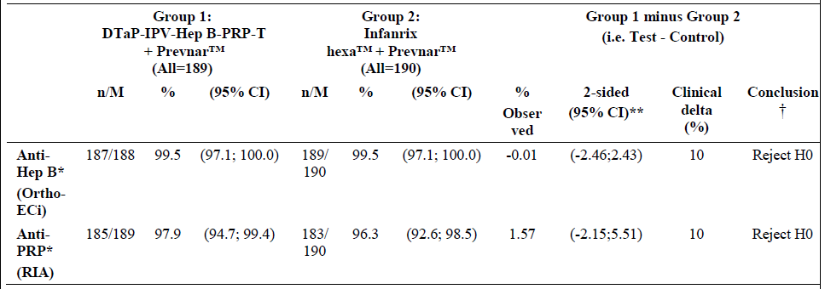
As the lower limit of the 95% CI was greater than –10, non-inferiority criterion was met. Similar results were obtained for the ITT Analysis Set.

Secondary objectives
See Table below.
Table 18: Immunogenicity summary for A3L12
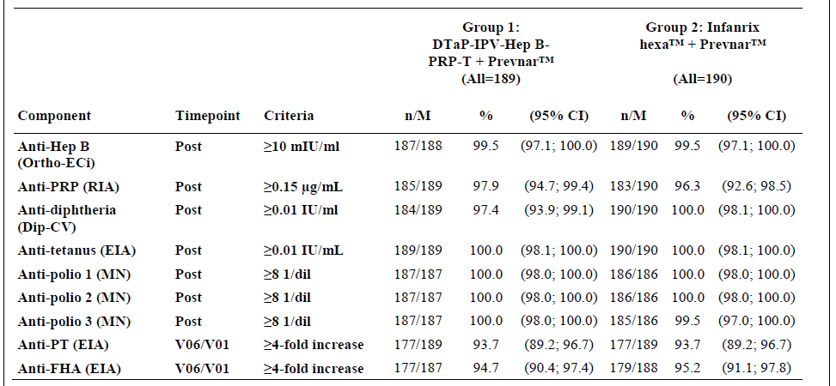
In the PP Analysis Set, the proportions of subjects meeting seroprotection thresholds were similar in the two groups. In addition, descriptive immunogenicity of DTaP-IPV-Hep B-PRP- T + Prevenar vs. Infanrix Hexa + Prevenar showed the following:
- Similar % of subjects in each group reached protocol-defined thresholds for seroprotection for each Ab type. The only two exceptions were the % of subjects reaching the higher threshold of ≥1 IU/mL for ant-T Ab seroprotection (lower in the DTaP-IPV-Hep B-PRP-T + Prevenar group than Infanrix Hexa + Prevenar group, based on non-overlapping 95% CIs [70.9% and 87.9%, respectively] ) and the % of subjects reaching anti-PRP Ab seroprotection thresholds of ≥1 µg/mL (higher in the DTaP-IPV-Hep B-PRP-T + Prevenar group than Infanrix Hexa + Prevenar group, based on non-overlapping 95% CIs [85.2% and 71.1%, respectively]);
- The groups were broadly similar in terms of both the GM of individual titre ratios (V06/V01) and the proportions of subjects achieving a 4-fold increase in anti-pertussis antigens;
- The two groups produced similar results in terms of GMTs for anti-Hep B and anti-D. The GMT was lower in the DTaP-IPV-Hep B-PRP- T + Prevenar group vs. Infanrix Hexa + Prevenar group for anti-T, anti-polio 1, 2, and 3, and anti-PT at V06, based on non-overlapping 95% CIs. For anti-PRP and anti-FHA, the GMT was higher in the DTaP-IPV-Hep B-PRP-T + Prevenar group based on non-overlapping 95% CIs.

Results for other efficacy outcomes
Overall, the safety profile of the DTaP-IPV-Hep B-PRP-T + Prevenar vaccine in this study population was good. Further details are summarised in Section 8.

Primary Vaccination (at 2, 4, and 6 months of age) in infants: Study A3L15
Study A3L15 primary series and A3L15 booster; Immunogenicity Study of a DTaP-IPV-Hep B-PRP-T Combined Vaccine in Comparison to CombAct Hib Concomitantly Administered with Engerix B Paediatric and OPV at 6, 10, and 14 Weeks of Age in South African Infants.

Study design, objectives, locations and dates

Design
Randomised, open, controlled, multicentre, Phase III trial in 635 infants who will receive DTaP-IPV-Hep B-PRP-T (Group 1, N=286), CombAct-Hib and Engerix B Pediatric with OPV (Group 2, N=286), or DTaP-IPV-Hep B-PRP-T with Engerix B Paediatric at birth (Group 3, N=143). A booster dose of DTaP-IPV-Hep B-PRP-T (Groups 1 and 3) or CombAct-Hib and OPV (Group 2), with Trimovax and Varilrix, administered at 15-18 months of age.

Objectives
To demonstrate that the hexavalent DTaP-IPV-HB-PRP-T combined vaccine does not induce a lower immune response than CombAct-HIB with Engerix B Paediatric and OPV in terms of seroprotection rates to D, T, polio, HB, and PRP, one month after a 3-dose primary series (6, 10 and 14 weeks) with no Hep B vaccination at birth.

Protocol amendments
The protocol versions edited and used throughout the course of the study were as follows: Original protocol: version 8.0 dated 22 June 2006; Protocol amendment 1: version 9.0 dated 29 November 2006; Protocol amendment 2: version 10.0, dated 21 June 2007; Protocol amendment 3: version 11.0 dated 20 December 2007. During A3L15 CSR writing and audit, the discrepancies/inconsistencies listed below were identified between protocol and SAP. No amendment was issued because the study was finished. The information in the CSR is correct. Details are not provided here.

Trial location and dates
South Africa, 2 sites. Trial Initiation Date: 28 August 2006; Trial Completion Date: Primary Series: 27 November 2007; Booster Phase: 28 January 2008 to 04 February 2009.

Inclusion and exclusion criteria
Inclusion: 0 to 3 day old infants; Mother seronegative for HIV after 24 weeks gestation; Born at full term of pregnancy (≥37 weeks, assessed by a physician at the time of birth) with a birth weight ≥2.5 kg; Apgar score >7 at 5 or 10 minutes of life; Informed consent form signed by a parent or other legal guardian and by an independent witness if the parent or other legal guardian is illiterate; Able to attend all scheduled visits and to comply with all trial procedures.
Exclusions: Current or planned participation in another clinical trial during the entire duration of the present trial; Suspected congenital or acquired immunodeficiency; Suspected maternal acute seroconversion syndrome to HIV after 24 weeks gestation based on clinical history; Chronic illness at a stage that could interfere with trial conduct or completion; Blood or blood-derived products received since birth; Any planned vaccination (except BCG and trial vaccinations) from birth to V05 (18 weeks of age); OPV administration at birth; Known maternal history of HIV, HB (HbsAg) or Hepatitis C seropositivity; Thrombocytopaenia or a bleeding disorder contraindicating IM vaccination; History of seizures; Febrile (axillary temperature ≥37.4°C) or acute illness on the day of inclusion.
Other temporary exclusions applied, details not provided here.

Study treatments
All subjects in Groups 1, 2 and 3 to receive one dose of investigational or reference vaccines at 6, 10, 14 weeks of age. In addition, Group 3 subjects will receive one dose of Engerix B Paediatric vaccine at birth. Groups 1 and 3 to receive a booster of the investigational vaccine at 18 months of age; subjects in Group 2 to receive a CombAct-HIB and OPV booster at 18 months of age. (As per national childhood immunisation recommendation, children will also receive a dose of measles vaccine at 19 months of age, at completion of booster phase). A 3 mL blood sample taken at six weeks of age (BL1-V02 [D42]) and a 5 mL sample at 18 weeks of age (BL2-V05 [D126]), 18 months of age (BL3-V07) and 19 months of age (BL4-V08). Total study duration, 24 months, for each subject.
In addition, as per the national childhood immunisation recommendation in South Africa, all children also received a measles vaccination at 40 weeks of age) and receive Trimovax (measles, mumps, rubella vaccination=MMR) at 15 to 18 months of age, and where the parents gave consent also to receive Varilrix (varicella vaccine).
- DTaP-IPV-HB-PRP-T manufactured by Sanofi Pasteur S.A. (investigational product and also booster product for Groups 1 and 3). See Table 1 Section 5.1 for Ag components.
- Control vaccines: CombAct-HIB (control product and booster product for Group 2), Engerix B, OPV (control product and also booster product for Group 2).
- CombAct-HIB manufactured by Sanofi Pasteur S.A: Form Freeze-dried PRP-T reconstituted with the injectable suspension of DTwP (0.5 mL). Hib polysaccharide conjugated to tetanus protein: 10 µg (expressed as polysaccharide). Suspension: Purified D toxoid ≥30 IU; Purified T toxoid ≥60 IU; PT inactivated suspension ≥4 IU.
- ENGERIX B manufactured by GSK: 0.5 mL IM dose (for left thigh) contains: Purified recombinant HBs antigen - 10 µg.
- OPV manufactured by Sanofi Pasteur S.A: Each 0.1 mL oral dose=Type 1 poliovirus* (LS- c2ab strain) ≥10(6.0) CCID50**; Type 2 poliovirus* (P712, Ch, 2ab strain) ≥10(5.0) CCID50**; Type 3 poliovirus* (Leon 12a1b strain) ≥10(5.8) CCID50**.
*Produced on VERO cells. **CCID50: 50% cell culture infective doses (viral infectious units).

Efficacy variables and outcomes
The primary efficacy outcome was seroprotection (As defined in Table 7 Section 5.1) to all the valences in the test and control vaccines one month after the third dose.
Other efficacy outcomes included: Immunogenicity i.e. and Safety. The immunogenicity parameters pre and post boosting at 18 months of age i.e. persistence and post boost responses to each vaccine component described in Section 5.1.

Randomisation and blinding methods
Open-label. Randomisation list prepared under the responsibility of the Sponsor. A two-step randomisation used i.e. Step 1: randomise, within first three days after birth, infants who will receive the hep B vax at birth (one fifth of the infants [N=127] will be allocated to the group who will receive Hep B vax at birth [Group 3]). Step 2: randomise subjects who did not receive Hep B vax at birth at 6 weeks of age (subjects in Groups 1 and 2). The lists created using the permuted block method, to guarantee similar proportion of subjects in each group at any time.

Analysis populations
Three study populations are defined for the statistical analysis: 1) PP population; 2) the ITT analysis set; 3) SafAS population.

Sample size
A total of 635 subjects (Groups 1, 2, 3) to be included in the study. Of 635 subjects, 508 subjects (Groups 1 and 2) to be included in the primary immunogenicity analysis to obtain 458 evaluable subjects (attrition rate approximately 10%). Sample size for immunogenicity analysis calculated using Farrington and Manning formula and based on a type 1 error of 2.5% (one sided hypothesis) to obtain an overall power of 90%. The sample size of Group 3 is arbitrary (approximately 50% of Groups 1 and 2) since the data for Group 3 are used for descriptive purposes only.

Statistical methods
The differences in seroprotection rates between subjects who received DTaP-IPV-HB-PRP-T.
(without hep B vax at birth) (Group 1) and subjects who received CombAct-HIB with Engerix B and OPV (without Hep B vax at birth) (Group 2) will be calculated. The clinically relevant limit for non-inferiority is −10% for the D, T, HB, and PRP antigens and 5% for polio antigens. The statistical method will be based on the lower bound of the two-sided 95% CI of the difference of the seroprotection rates between groups. Immunogenicity parameters for the primary series, pre-booster and post booster levels for all valences described in Section 5.1.

Participant flow
715 subjects were present at V01 (Day 0). Of these, 7subjects in the "Engerix B at birth" group withdrew prior to the second step of the randomisation process at V02 and did not receive their final assignment to Group 3. 86 subjects in the "No Engerix B at birth" group withdrew prior to the second randomisation at V02 and were not assigned to Groups 1 or 2. The primary series ITT Analysis Set =622 subjects present at V01 and V02, and who received ≥1 dose of the primary series vaccinations. Of these, 243, 242 and 137 subjects were randomised to Group 1, 2 and 3 respectively. 602 (96.8%) completed to V05 with similar % completers in each group. 20 subjects (present at V01 and V02 and receiving at least one dose of study vax) discontinued before V05. Of these: 2 subjects died (see Section 8); 1 subject withdrawn prior to V03 due to protocol non-compliance; 10 subjects lost to follow-up; 7 subjects withdrew voluntarily for non-AE reasons. Overall, 96.7% of DTaP-IPV-Hep B-PRP-T group, 97.1% of subjects in the CombAct-Hib + Engerix B + OPV group, and 97.8% of subjects in the DTaP-IPV-Hep B-PRP-T + Engerix B at birth group received the scheduled doses of vaccines as per randomisation schedule. In the remaining subjects one or more vaccinations were not received.
Booster Phase (V07 to V08): ITT Analysis Set for the booster phase consisted of 567 subjects who had participated in the primary series, were present at V07 and received a booster.
Table 19: Disposition of subjects for primary series – ITT analysis set in A3L15
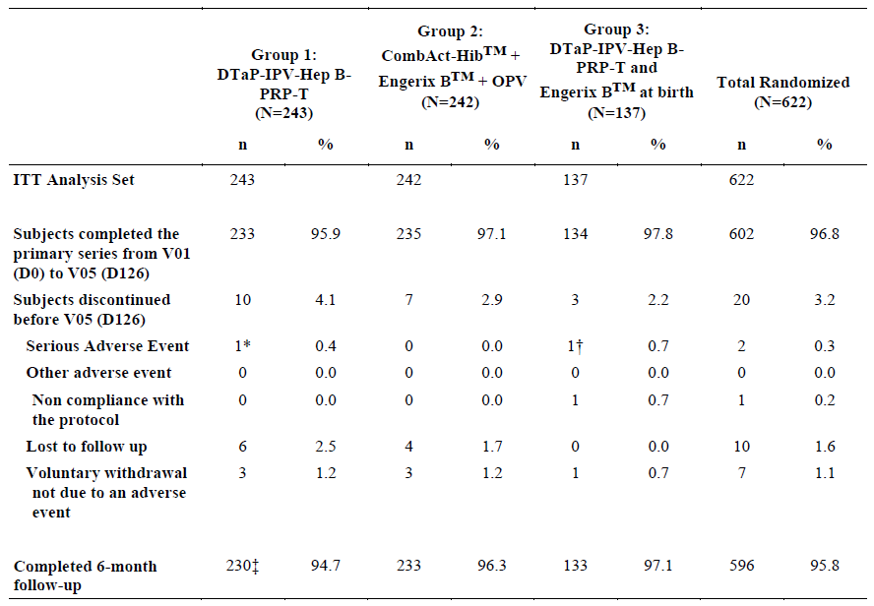
Table 20: Disposition of Subjects During Booster Phase - ITT Analysis Set in A3L15
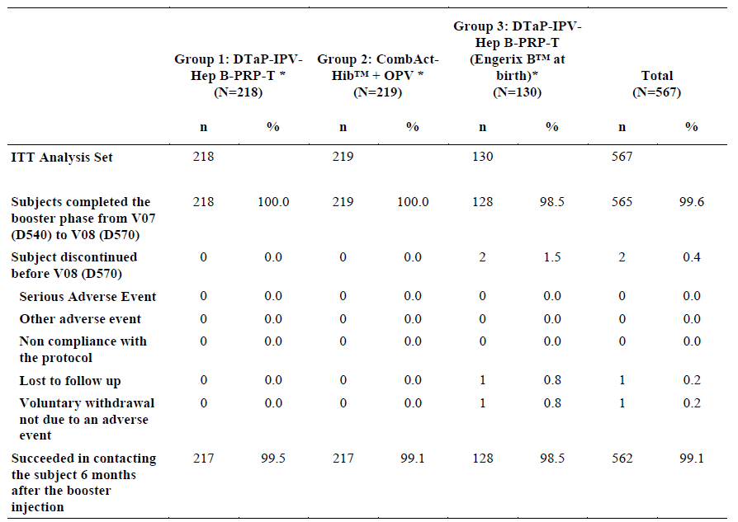

Major protocol violations/deviations
Primary Series: No cases of incorrect vaccine allocation in any of the groups. Deviations from the planned schedule included: Four subjects (0.6%) with definite contraindications at the time of at least one vaccine - in DTaP-IPV-Hep B-PRP-T group: One Subject had HIV infection and respiratory tract infection; another Subject had congenital heart disease; In the CombAct-Hib+Engerix B+ OPV group, another Subject had HIV infection, bronchiolitis, and TB; In the DTaP-IPV-Hep B-PRP-T+Engerix B at birth group, one other Subject received non-trial vaccines at a local clinic; 17 subjects (2.7%) fell outside the age range at V02 of 42 to 49 days old; 4 subjects (0.6%) had a time interval between 1st and 2nd injections outside window. 16 subjects (2.6%) had a time interval between 2nd and 3rd injections outside window; 7 subjects (1.1%) had a time interval between BL2-V05 and the third injection outside window; 1 subject (0.2%) received another vaccine; 18 subjects (2.9%) did not receive all three injections in the primary series. For the ITT Analysis Set, no major differences in type or number of deviations in the 3 groups; Subjects with ≥1 major protocol deviation excluded from PP Immunogenicity Analysis Set.

Baseline data
Table 21: Study A3L15 primary series – subject characteristics – ITT analysis set
 | Hexaxim  (N = 243) | CombAct-Hib + Engerix B + OPV (N = 242 | Hexaxim with Engerix B at birth (N = 137)
ITT Analysis set | 243 | 242 | 137
Male: n (%) | 112 (46.1) | 124 (51.2) | 69 (50.4)
Female: n (%) | 131 (53.9) | 118 (48.8) | 68 (49.6)
Ethnic origin
Asian: n (%) | 1 (0.412) | 2 (0.826) | 1 (0.730)
Black: n (%) | 239 (98.4) | 238 (98.3) | 136 (99.3)
Caucasian: n (%) | 1 (0.412) | 1 (0.413) | 0 (0)
Hispanic: n (%) | 0 (0) | 0 (0) | 0 (0)
Other: n (%) | 2 (0.823) | 1 (0.413) | 0 (0)
Age (weeks) at first dose
Mean (SD) | 6.26 (0.231) | 6.27 (0.243) | 6.27 (0.235)
Minimum; Maximum | 5.5.7; 7.14 | 5.43; 7.14 | 5.71; 7.14

Results for the primary efficacy outcome
See Tables below.
- The % of subjects having anti-D responses ≥ 0.1 IU/mL higher in DTaP-IPV-Hep B-PRP-T vaccine group than in CombAct-Hib + Engerix B + OPV group (39.8 vs. 13.6). All subjects tested showed anti-T responses ≥ 0.1 IU/mL (100% in both groups);
- For anti-D responses ≥1 IU/mL similar between the experimental and control groups. Anti-T responses at ≥1 IU/mL threshold tended to be lower in the experimental group;
- % of subjects presenting anti-Hep B responses ≥ 100 mIU/mL were higher in DTaP-IPV-Hep B-PRP-T group than CombAct-Hib+Engerix B+OPV group (78.8 vs. 65.5);
- % of subjects with anti-PRP responses ≥1 μg/mL lower in DTaP-IPV-Hep B-PRP-T vaccine group than in CombAct-Hib + Engerix B + OPV group (79.5 vs. 92.5);
- Anti-PT and anti-FHA response analysis showed % with a 4-fold rise increase tended to be higher or was higher in DTaP-IPV-Hep B-PRP-T group than in CombAct-Hib + Engerix B + OPV group (93.6 vs. 83.2 for PT and 93.1 vs. 57.7 for FHA, respectively);
- % of subjects with sera levels ≥100 mIU/mL were higher in DTaP-IPV-Hep B-PRP-T receiving Hep B vax at birth vs. those not vaccinated at birth (96.9 vs. 78.8);
- Similar results obtained with the ITT Analysis Set at V05, GMTs were higher for DTaP-IPV-Hep B-PRP-T primed subjects than for CombAct-Hib + Engerix B + OPV primed subjects: for anti-Hep B (330 vs. 148), anti-D (0.074 vs. 0.040), anti-polio 1 (579 vs. 198), and anti-polio 3 (975 vs. 228). Antipolio 2 GMTs tended to be numerically higher in DTaP-IPV-Hep B-PRP-T primed subjects than for CombAct-Hib+Engerix B+OPV primed subjects (620 vs. 446), although the 95% CIs overlapped;
- Anti-PT GMTs at V05 were 332 vs. 191 respectively for DTaP-IPV-Hep B-PRP-T primed subjects and for CombAct-Hib + Engerix B + OPV primed subjects. Anti-FHA GMTs at V05 were 207 vs. 37.4, respectively for DTaP-IPV-Hep B-PRP-T primed and for CombAct-Hib + Engerix B + OPV primed;
- Anti-PRP and anti-T GMTs were lower in DTaP-IPV-Hep B-PRP-T primed than in CombAct-Hib + Engerix B + OPV primed (3.31 and 1.51 vs. 5.18 and 1.88, respectively).
Table 22: Summary of Seroprotection Rates Post-dose 3 (V05-D126) - PP Analysis Set in A3L15
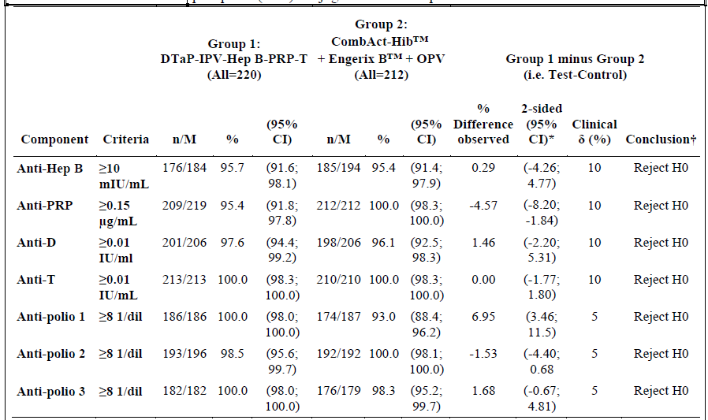

Ab persistence (V07)
See also the Table below:
- Anti-Hep B and anti-PRP Ab persistence lower in subjects primed with DTaP-IPV-Hep B-PRP-T (78.9% and 81.4%, respectively) than with CombAct-Hib + Engerix B + OPV (92.0% and 92.5%, respectively), based on surrogate thresholds for seroprotection;
- For anti-PT and anti-FHA, % of subjects who met the threshold of ≥4 EU/mL was 92.1% and 98.3%, respectively, in subjects primed with DTaP-IPV-Hep B-PRP-T, and 70.9% and 66.9%, respectively, in subjects primed with CombAct-Hib + Engerix B + OPV;
- Anti-D Ab persistence was higher in subjects primed with DTaP-IPV-Hep B-PRP-T (93.4%) than with CombAct-Hib + Engerix B + OPV (86.1%), although 95% CIs overlapped;
- The two primary vax groups showed similar pre-booster Ab persistence for the other valences tested (anti-T, anti-polio subtypes 1, 2, and 3).
Similar results were obtained for the ITT Analysis Set.

Booster responses (V08)
- Anti-Hep B seroprotection rate was 98.5% in subjects boosted with DTaP-IPV-Hep B-PRP-T;
- A four-fold increase in anti-PT titres in 94.8% of those boosted with DTaP-IPV-Hep B-PRP-T, and 83.5% of those boosted with CombAct-Hib + OPV;
- Proportion with a four-fold increase in anti-FHA titres was 91.2% in the DTaP-IPV-Hep B-PRP-T booster group and 96.5% in the CombAct-Hib + OPV booster group;
- Post-booster seroprotection rates were similar and high for all other valences studied (anti-PRP, anti-D, anti-T, anti-polio subtypes 1, 2, and 3), for the DTaP-IPV-Hep B-PRP-T and CombAct-Hib + OPV booster groups.
Similar results were obtained with the ITT Analysis Set.
Table 23: Ab Persistence and Post-Booster Response – PP Analysis Set – A3L15
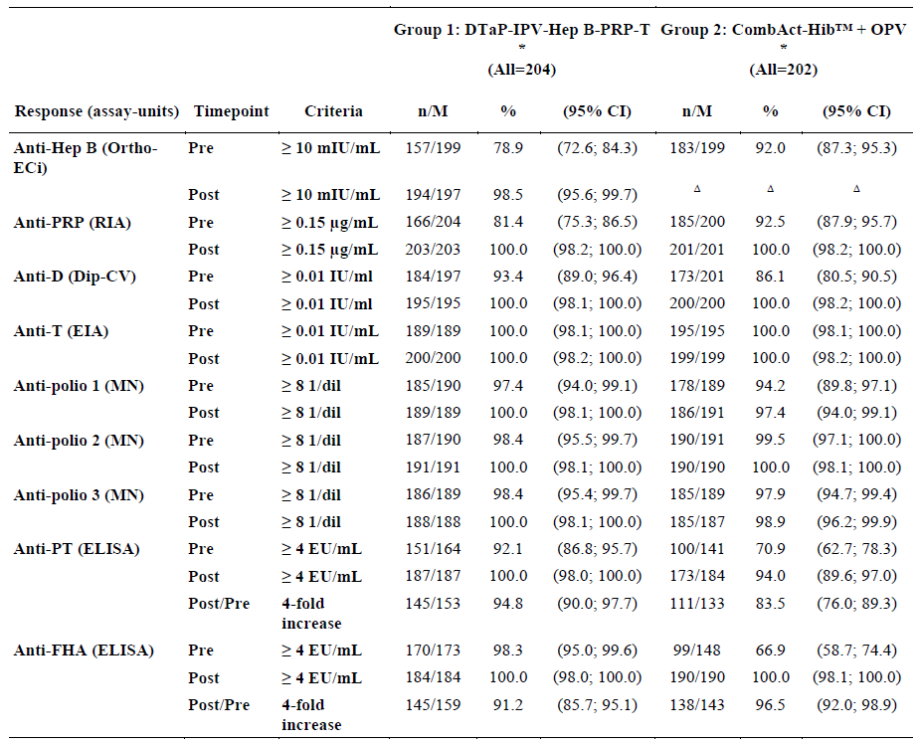

Results for other efficacy outcomes
Booster Hexaxim at 15 to 18 months with MMR and V co-administration induced a similar or better response for all antigens assessed (D, T, IPV and PRP) vs. CombAct-Hib+OPV. The % of subjects responding to protective MMR and ELISA levels was similar between the three vaccine groups. Safety profile of DTaP-IPV-Hep B-PRP-T similar to CombAct-Hib + Engerix B + OPV. The safety profile of DTaP-IPV-Hep B-PRP-T was also similar in those Engerix B vaccinated at birth.

Primary vaccination (at 2, 4, and 6 months of age) in infants: Study A3L17
Study A3L17: Immunogenicity Study of DTaP-IPV-Hep B-PRP-T Combined Vaccine in Comparison to Infanrix Hexa, at 2-4-6 Months of Age in Healthy Peruvian Infants.

Study design, objectives, locations and dates

Design
Randomised, blind-observer, controlled, single-centre, Phase III trial in healthy Peruvian infants born from HBsAg negative mothers. The study was preceded by a screening phase, in which expectant mothers (who had agreed to undergo the screening procedures and who had agreed that no dose of Hep B vaccine would be administered to their baby at birth) were assessed for their HBsAg status. Included infants were randomised to receive a three-dose primary series (at 2, 4, 6 months) of either the investigational vaccine (DTaP-IPV-Hep B-PRP-T – Group 1) or the control vaccine (Infanrix Hexa – Group 2). Subjects followed up for a total of 10 months.

Objectives
To demonstrate DTaP-IPV-Hep B-PRP-T induces an immune response that is at least as good as Infanrix Hexa in terms of seroprotection rates to Hep B, 1 month after a three-dose primary series (2, 4, 6 months); immunogenicity of other valences; safety.

Protocol amendments
The final trial protocol used for the trial (vn 3.0, dated 28 March 2007) was amended five times. There were no changes in the conduct of the trial that were considered to have had an effect on the quality of the trial data or the overall conclusions of the trial.

Trial location and dates
Peru, 1 site. Initiation Date: 23 May 2008; Trial Completion Date: 12 May 2009.

Inclusion and exclusion criteria
Inclusion: Two months old infant on the day of inclusion, of either gender; Born at full term of pregnancy (≥37 weeks) and with a birth weight ≥2.5 kg; Mother negative for HBsAg in approximately the last 30 days of pregnancy (≥36 weeks of amenorrhoea) or in the 30 days post-partum; Informed consent form signed by both parents. If one or both parent(s) are under 18 years of age, the subject’s grandparent(s) should also sign. An independent witness should also sign if the parent(s)/grandparent(s) are illiterate; able to attend all scheduled visits and to comply with all trial procedures; Received BCG vaccine between birth and 1 month of life in agreement with the national immunisation calendar.
Exclusion: Participation in another clinical trial in the 4 weeks preceding the first trial vaccination; Planned participation in another clinical trial during present trial period; Known systemic hypersensitivity to any of the vaccine components or history of a life-threatening reaction to the trial vaccine or a vaccine containing the same substances; Congenital/acquired immunodeficiency, or immunosuppressive therapy; Chronic illness; Blood or blood-derived products received since birth; Any vaccination in the 4 weeks preceding the first trial vaccination; Any planned vaccination during the trial (until V06), except the study vaccines, rotavirus vaccine, and pneumococcal conjugate vaccines; Documented history of pertussis, tetanus, diphtheria, polio, hep B, or Hib infection; Previous vax against pertussis, tetanus, diphtheria, polio, hep B or Hib infection; Known personal or maternal history of HIV, hep B or HCV seropositivity; Known thrombocytopaenia or bleeding disorder contraindicating IM vaccination; History of seizures; Febrile (temperature ≥38.0°C) or acute illness on the day of inclusion. Other temporary exclusions applied, details not provided here.

Study treatments
Subjects received one dose of either the investigational or control vaccine at 2, 4, 6 months of age (at V01, V03, and V05, respectively). A 4 mL blood sample was to be taken at 2 months of age (BL1 - V01) and a 5 mL sample at 7 months of age (BL2 - V06). Total study participation, including safety follow-up conducted 6 months after last vax was 10 months for each subject.
- DTaP-IPV-Hep B-PRP-T manufactured by Sanofi Pasteur SA (see Table 1);
- Infanrix Hexa manufactured by GlaxoSmithKline Biologicals, SA (See Table 3).

Efficacy variables and outcomes
Main efficacy variables: anti-Hep Bs Ab titres assessed 1 month after the 3rd dose of the primary series; seroprotection= Hep B SAb ≥10 mIU/mL. Other efficacy outcomes were immunogenicity to the other valences 1 month post 3rd vax dose (see Section 5.1) and Safety.

Randomisation and blinding methods
Randomisation list prepared under the responsibility of the Sponsor’s Biostatistics Platform using the permuted block method, to guarantee a similar ratio of subjects between groups. After eligibility verification, the nurse/vaccinator used IVRS to assign the vaccine groups. A blind-observer procedure followed, so neither the Investigator (in charge of safety assessment), nor subject (or his/her parent[s]/guardian[s]) would know which vaccine had been given.

Analysis populations
PP; ITT and SafAS.

Sample size
Calculated using the Farrington and Manning formula & based on a type 1 error of 2.5% (one-sided hypothesis) to obtain 90%power. Assuming a seroprotection rate of 96%, 266 subjects to be enrolled to obtain 226 evaluable subjects (15% attrition rate). Subjects randomly allocated to one of the two groups.

Statistical methods
Differences in seroprotection rates for Hep B between the two groups (Investigational – Control) were calculated; clinically relevant limit for non-inferiority was -10%. Statistical method based on the lower bound of the two-sided 95% CI of the difference of the seroprotection rates.

Participant flow
Table 24: Analysis populations in A3L17
Number of subjects: | DTaP-IPV-Hep B-PRP-T | Infanrix Hexa
Subjects present at V01 | 133** | 133***
Completed primary series | 132 (100.0%) | 131 (100.0%)
Discontinued prior to V06 | 0 (0%) | 0 (0%)
Included in PP* Analysis Set | 132 (100.0%) | 130 (99.2%)
Included in ITT* Analysis Set | 132 (100.0%) | 131 (100.0%)
Included in SafAS* | 132 (100.0%) | 131 (100.0%)

Major protocol violations/deviations
One subject in the Infanrix Hexa group excluded from the PP Immunogenicity Analysis Set due to a major protocol deviation: i.e. lack of a blood draw.

Baseline data
Male (%): 131 (49.8); mean age (SD) 1.74 (0.128) months; Mean(SD); weight in Kg; 5.21 (0.601). For the PP, ITT, and SafAS Populations, demographics comparable although more males in the DTaP-IPV-Hep B-PRP-T group and more females in the Infanrix Hexa group. All subjects Hispanic.

Results for the primary efficacy outcome
The primary objective was met: DTaP-IPV-Hep B-PRP-T was non-inferior to Infanrix Hexa in terms of anti-Hep B seroprotection rates (≥10 mIU/mL) at 1 month after the third vaccine. Similar results were obtained for the ITT Analysis Set.
Table 25: Immunogenicity results for anti-Hep B seroprotection rates in A3L17
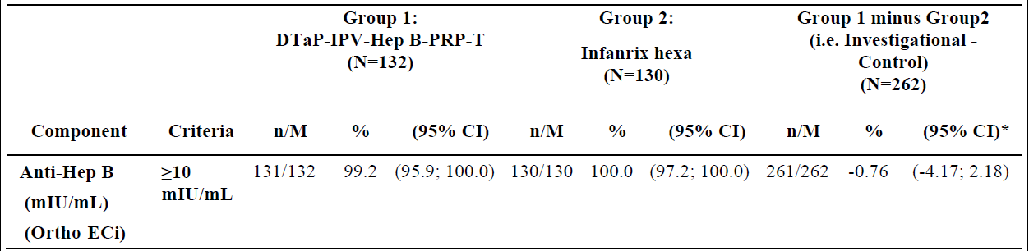

Results for other efficacy outcomes
Table 26: Seroprotection rates in A3L17 for the PP Analysis Set
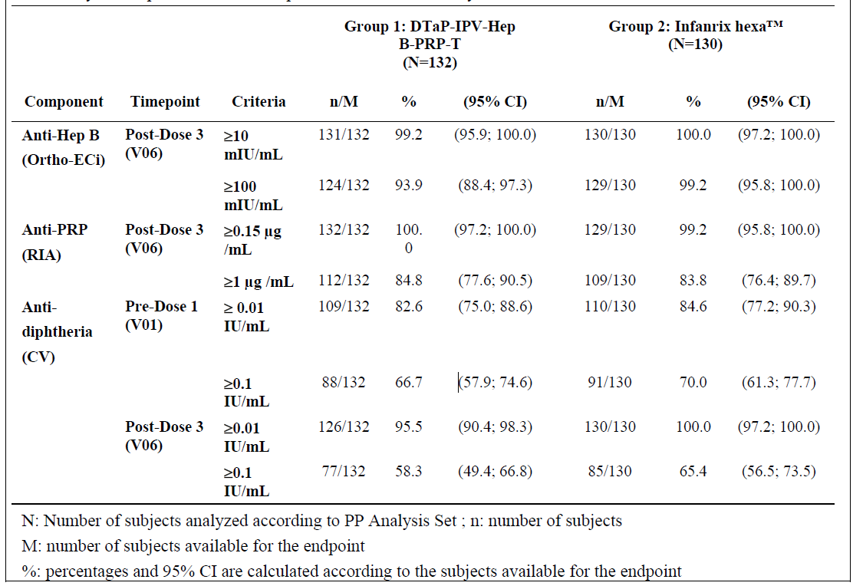
- For each valence at V06, the % of subjects reaching the seroprotection thresholds was similar (>95.5%) for the DTaP-IPV-Hep B-PRP-T and Infanrix Hexa groups;
- Although some numeric differences in seroprotection rates were observed between the vaccine groups at higher thresholds, the vaccine groups were still considered comparable;
- Despite a trend towards lower V01 and V06 GMTs in the DTaP-IPV-Hep B-PRP-T group versus Infanrix Hexa, the values for the two groups were considered comparable. It was noted that, for each vaccine group, there was a decrease in GMTs at V06 compared to V01, although the values at the two timepoints were still comparable;
- Anti-diphtheria GMTs at V01 were higher than V06 in both groups which correlated to maternal transfer of Ab during pregnancy and clearance during the first six months of infants life;
- DTaP-IPV-Hep B-PRP-T and Infanrix Hexa demonstrated comparable safety profiles.

Primary vaccination (at 2, 4, and 6 months of age) in infants: Study A3L24
Study A3L24: Lot-to-Lot Consistency Study of DTaP-IPV-Hep B-PRP-T Vaccine Administered at 2-4-6 Months of Age in Healthy Latin American Infants Concomitantly with Prevenar and Rotarix.

Study design, objectives, locations and dates

Design
Multi-centre, randomised, observer blinded, Phase III trial in 1376 Latin American infants. Four-arm trial with subjects randomly allocated to receive 1 of 3 lots of DTaP-IPV-Hep B-PRP-T vaccine (consistency testing), or the control vaccine Infanrix Hexa (non-inferiority testing). All doses of the investigational or control vaccine were co-administered with Prevenar at 2, 4, and 6 months of age and Rotarix at 2 and 4 months of age.

Objectives
To demonstrate immunogenicity equivalence of 3 lots of DTaP-IPV-Hep B-PRP-T vaccine (final bulk product) one month after a 3- dose primary series (2, 4, 6 months) when co-administered with Prevenar (PCV7) and Rotarix, in terms of immunoresponses evaluated by: GMTs for Hep B; seroprotection rates for D, T, Hep B, PRP, poliovirus and seroresponse rates for anti-PT and anti-FHA; to demonstrate non-inferiority of DTaP-IPV-Hep B-PRP-T vaccine to Infanrix Hexa vaccine in terms of seroprotection/seroresponse rates to all Ags, one month after a 3-dose primary series when co-administered with PCV7 and Rotarix.
Observational Objective: effect of prophylactic antipyretics on immunogenicity (DTaP-IPV-Hep B-PRP-T group only.
Safety.

Trial location and dates
Colombia and Costa Rica, 1 site in each country. Initiation Date: 03-Aug-10; Trial Completion Date: 28-Sep-11.

Inclusion and exclusion criteria
Inclusion: Two-month old infants on the day of inclusion; Born at full term of pregnancy (≥ 37 weeks) with a birth weight ≥ 2.5 kg; Informed consent form signed by one or both parents or by the legally acceptable representative as per local requirements; Able to attend all scheduled visits and comply with all trial procedures; Received Hep B and BCG vaccines between birth and one month of life in agreement with the national immunisation calendar.
Exclusion: Participation in another clinical trial in the 4 weeks preceding the first trial vaccination; Planned participation in another clinical trial during the present trial period; Known or suspected congenital/acquired immunodeficiency, immunosuppressive therapy within the preceding 3 months, or long-term systemic corticosteroid therapy; Known systemic hypersensitivity to any of the vaccine components or history of a life-threatening reaction to the trial vaccine or a vaccine containing the same substances; Chronic illness; Blood or blood-derived products received since birth that might interfere with the assessment of the immune response; Any vaccination before trial vaccination (except Hep B and BCG given at birth); Any planned vaccination until one month after the last trial vaccination (except the study vaccines, rotavirus and pneumococcal conjugated vaccines and for pandemic influenza vaccination, which may be received at least two weeks before each study vaccine dose); Documented history of pertussis, tetanus, diphtheria, poliomyelitis, Hib or Hep B infection; Previous vaccination against pertussis, tetanus, diphtheria, poliomyelitis, Hib; Known personal or maternal history of HIV, hep B or HCV seropositivity; Laboratory-confirmed or clinical suspicion of coagulopathy, thrombocytopenia or a bleeding disorder preceding inclusion contraindicating IM vaccination; History of seizures or encephalopathy; Febrile illness (temperature ≥ 38.0°C), or moderate or severe acute illness/infection on the day of inclusion, according to the Investigator judgment.
Other temporary exclusions applied, details not provided here.

Study treatments
All subjects in Groups 1, 2, 3 to receive 3 doses of 1 of the 3 batches of the DTaP-IPVHep B-PRP-T vaccine and all subjects in Group 4 were to receive 3 doses of Infanrix Hexa at 2, 4, 6 months of age. All subjects were to receive Prevenar (PCV7) at 2, 4, and 6 months of age and Rotarix at 2 and 4 months of age, co-administered with the DTaP-IPV-Hep B-PRP-T vaccine or Infanrix Hexa.
Prevenar (PCV7)(Wyeth Ltd); Rotarix (GSK) (containing Human rotavirus RIX4414 strain (live, attenuated) no less than 106.0 CCID50, sucrose 9 mg, sorbitol 13.5 mg, Sterile water ≤1 mL). A blood sample of approximately 4 mL taken at 2 months of age (BL1 - V01), prior to vaccination, a 4-mL blood sample at 5 months of age, 1 month after dose 2 (BL2 - V04) in a subset of subjects (for anti-RV IgA), and a 5-mL blood sample at 7 months of age, 1 month after dose 3 (BL3 - V06). Each subject participated in the study for approximately10 months (including a 6-month safety follow-up after last vax).

Efficacy variables and outcomes
The main efficacy variables were: serological endpoints 1 month after the 3rd dose of the for the lot-to-lot consistency and non-inferiority analyses i.e. Hep B Ab titres; seroprotection rates for D, T, Hep B, PRP, poliovirus with the levels as described in Table 7 Section 5.1.
Other efficacy outcomes: non-inferiority of responses to all valences (including Rotavirus) vs. Infanrix Hexa; Safety when co-administered with PCV7and Rotarix.

Randomisation and blinding methods
Randomisation list prepared under the responsibility of Sponsor’s Biostatistics Platform and prepared using the permuted block method, to guarantee approximately similar nos of subjects per group. Double randomisation performed. Each dose had both a code letter and a dose number. The code letter was used by the IVRS for vaccine allocation. The 2 subgroups of 544 and 272 subjects respectively tested for PCV7 and Rotarix were also selected using the block permuted method. At the inclusion visit (V01, D0), the nurse/vaccinator, both different from the investigator in charge of safety assessment, called/connected the IVRS to: Assign an inclusion number & assign each subject to 1 of the 2 treatment groups (DTaP-IPV-Hep B-PRP-T [3 lots] or Infanrix Hexa). Observer blinded procedure was followed for the DTaP-IPV-Hep B-PRPT/Infanrix Hexa comparison, so that neither Investigator, subject (or his/her parent[s]/guardian[s]), Sponsor knew which vaccine was administered.

Analysis populations
As above, ITT, PP and SafAS.

Sample size
1376 subjects were to be included and randomly allocated to 1 of the 4 groups (Groups 1, 2, 3, 4). 344 subjects per investigational vaccine lot and 344 subjects in the Infanrix Hexa group were to give the following power for the different tests (based on simulation): Equivalence between the 3 lots in terms of immunogenicity: with an alpha level of 2.5% and under the assumption that only 85% of subjects were evaluable, the overall power was >94%; Non inferiority of the pooled investigational vaccine group versus Infanrix Hexa group in terms of immunogenicity: with an alpha level of 2.5% (one-sided hypotheses), and under the assumption of 85 % of subjects were evaluable, the overall power was over 96.7%. A subset of 544 subjects (136 subjects in each group) was to be tested for the immune response against each of the 7 antigens contained in the PCV7 vaccine. The choice for the number of subjects participating in this secondary analysis was extrapolated such as one formal analysis would have been done. The sample size of the subset was calculated to obtain 90% power (using a 15% attrition rate) to demonstrate non-inferiority of PCV7 immunoresponses between the pooled DTaP-IPVHep B-PRP-T batch group (Groups 1, 2, 3) vs. the Infanrix Hexa group (Group 4), both co-administered with PCV7 and Rotarix. A separate random subset of 272 subjects (68 subjects in each of the 4 groups) was planned to test for immune response against the Ags in the Rotarix vaccine.

Statistical methods
Lot-to-lot consistency analysis: Three paired equivalence tests on GMTs for Hep B, 1 month after the 3rd dose of DTaP-IPV-Hep B-PRP-T vaccine co-administered with PCV7 and Rotarix. The statistical methodology was based on the use of the 2-sided 95% CI of the ratio of GMTs between the pairs of lots; 3 paired equivalence tests on seroprotection/seroresponse rates according to the valence, 1 month after dose #3 of DTaP-IPV-Hep B-PRP-T co-administered with PCV7 and Rotarix. The statistical methodology was based on the use of the 2-sided 95% CI of the differences of the seroprotection/seroresponse rates between the pairs of lots.
Non-inferiority analysis: The differences in seroprotection/seroresponse rates according to the valence between DTaP-IPV-Hep B-PRP-T pooled lots and Infanrix Hexa [Test 3 pooled lots –Reference] was to be calculated if lot-to-lot consistency was demonstrated. The relevant limit for non-inferiority was −10% for D, T, Hep B, PRP, PT, FHA Ags and –5% for polio Ags. The statistical method was based on the lower bound of the 2-sided 95% CI of the difference of the seroprotection/seroresponse rates. The primary objective was met if both lot-to-lot consistency and non-inferiority of the immune responses were demonstrated.

Participant flow
The numbers of subjects in the ITT, PP), SAS and, as well as nos. of subjects evaluated for anti-pneumococcal and anti-rotavirus immune responses are presented in the table below:
Table 27: Analysis sets in Study A3L24
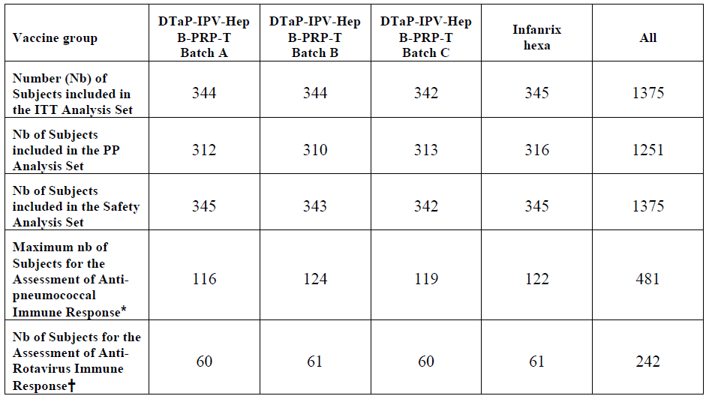

Major protocol violations/deviations
Subjects with at least one protocol deviation excluded from the PP Immunogenicity Analysis Set.
Table 28: Subject Disposition for the Immunogenicity Analyses Showing Primary Reason for Exclusion from PP Analysis Set - ITT Analysis Set – A3L24
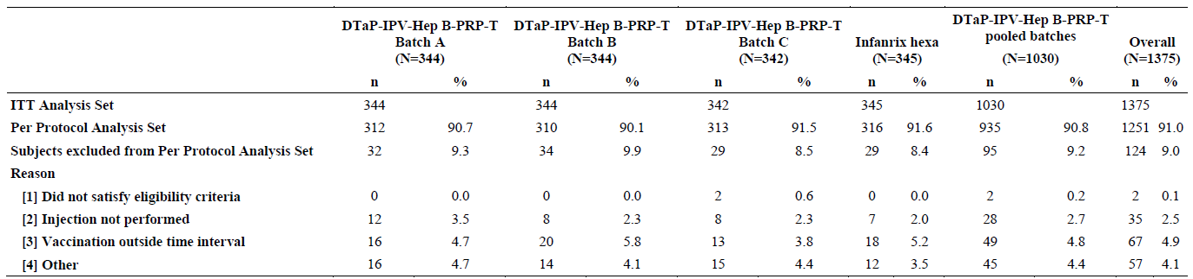
In the ITT Analysis Set, 9.0% (n=124) were excluded from the PP analysis set because ≥1 protocol deviation. The PP Immunogenicity Analysis Set consisted of 935 subjects in the DTaP-IPV-Hep B-PRP-T group (312 batch A, 310 batch B, 313 batch C), and 316 subjects in the control group. No major differences in the % or types of exclusions between individual DTaP-IPV-Hep B-PRP-T batches or vs. the control group. Overall: 2 (0.1%) did not meet eligibility; 35 (2.5%) received incomplete vaccination series - similar % in each group; 67 (4.9%) received a vaccination outside the allowed time interval; 57 (4.1%) excluded for other reasons, with similar % in each group (4.1% to 4.7% for the individual DTaP-IPV-Hep B-PRP-T batches, and 3.5% for control.

Baseline data
For the ITT Analysis Set, all groups were similar in terms of age, gender distribution, ethnic origin, and weight. This was also the case for the PP and the SafAS sets. Overall, mean age was 58.7 days ± 3.30 (SD); 53.9% male; most subjects (88.9%) were of Hispanic origin.
Table 29: Demography data from the ITT Analysis Set – A3L24
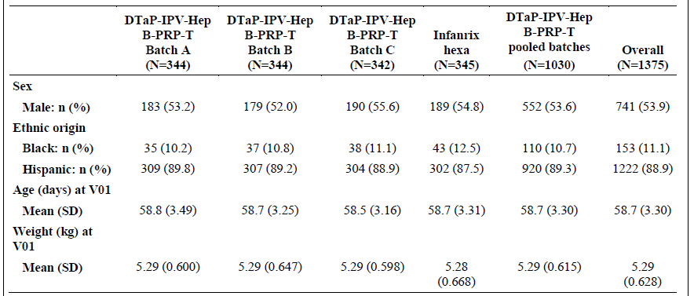

Results for the primary efficacy outcome
Table 30: GM of Hep B Titres Between Batches One month post 3rd Vax PP Analysis Set – A3L24
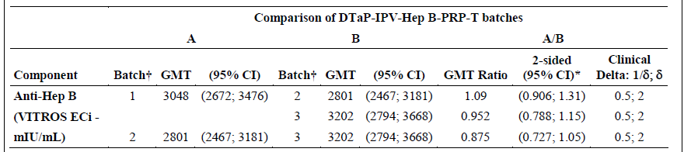
The 95% CIs of the ratio of GMTs for Hep B valence between each pair of DTaP-IPV-Hep B-PRP-T batches lay within (0.5; 2). Therefore, the null hypothesis was rejected and equivalence between DTaP-IPV-Hep B-PRP-T batches was concluded based on GMTs for Hep B valence.

Results for other efficacy outcomes
Table 31: Vaccine Response Rates Between Batches One month post 3rd Vax- PP Analysis Set – A3L24
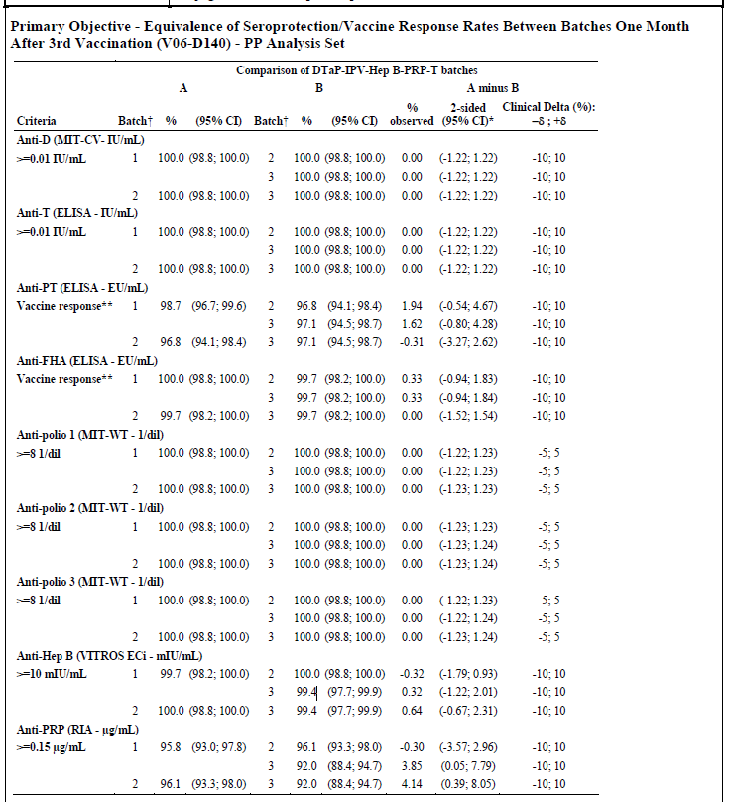
The 95% CIs for the difference in seroprotection/vaccine response rates between each pair of DTaP-IPV-Hep B-PRP-T batches lay within (–5; 5) for poliovirus types 1, 2, 3, and within (–10; 10) for all other valences. Therefore, the individual null hypotheses were rejected. The global null hypothesis was therefore also rejected and equivalence, based on seroprotection/vaccine response rates, between DTaP-IPV-Hep B-PRP-T batches was concluded.
Non-inferiority vs. Infanrix Hexa, was demonstrated for all valences. See Table below.
The pooled DTaP-IPV-Hep B-PRP-T batches were shown to be non inferior to Infanrix Hexa in terms of seroprotection/vaccine response rates to all valences, 1 month after dose #3. A high Ab response in terms of seroprotection/vaccine response rates and GMTs was elicited by the pooled DTaP-IPV-Hep B-PRP-T batches and Infanrix Hexa, demonstrating both vaccines are protective against the six targeted diseases. A high Ab response in terms of seroprotection/vaccine response rate elicited by PCV7 and Rotarix in the DTaP-IPV-Hep B-PRP-T vaccine group. No clinically relevant differences were observed in PCV7 as well as in Rotarix immunogenicity responses when co-administered with either vaccine.
Observational Immunogenicity Objective: Overall, in the DTaP-IPV-Hep B-PRP-T pooled batches group, no major differences in terms of seroprotection/vaccine response rates, observed in the subset of subjects who did not receive antipyretics and in the one who did use antipyretics before/after any vaccine injection, whatever the time of intake. Seroprotection/vaccine response rates were similarly high for all the 9 investigational vaccine antigens in all subjects, independent of the use or not of antipyretics (≥ 99.1% for D, T, FHA, poliovirus 1, 2, 3, and Hep B; ≥ 95.9% for PT; ≥ 94.1% for PRP, PP Analysis Set); GMTs were of the same magnitude. Similar results were observed when considering the intake of antipyretics before or after only one, two, or each vaccine injection(s). Similar results also obtained for the ITT Analysis Set.
Table 32: Vaccine Response Rate One month After 3rd Vax) - PP Analysis Set in A3L24
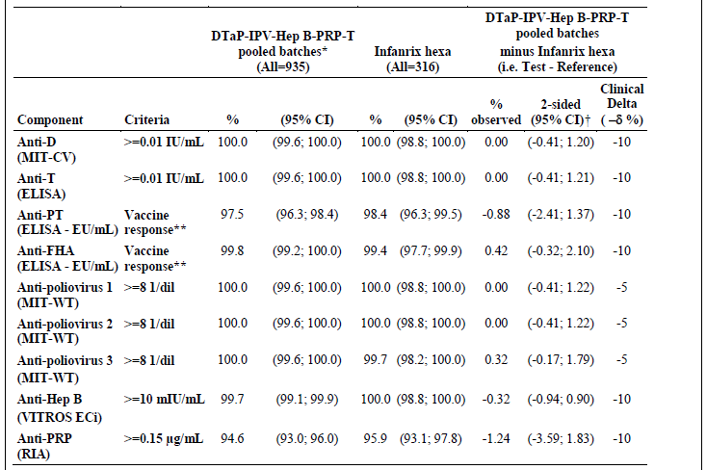
Safety: The safety profile of the 3 individual DTaP-IPV-Hep B-PRP-T batches was similar and revealed no safety concerns. Overall, the safety profile of the pooled DTaP-IPV-Hep B-PRP-T batches was good and similar to that of Infanrix Hexa.

Other efficacy studies

Study A3L26
Study A3L26: Antibody Persistence in Healthy South African Children After Primary Series and Booster Vaccination with an Investigational (DTaP-IPV-Hep B-PRP-T) or Control Vaccines.
Date of first visit of the first subject: 29-Apr-10; Date of last visit of the last subject: 07-Sep-11; Date of interim analysis: 16-Feb-11; Date of interim report (3.5 years of age): 25- Jul-11. Date of final report (4.5 years of age): 22-Nov-12.

Design
Phase III, multi-centre study to describe the Ab long-term persistence at 3.5 and 4.5 years of age in children who had completed a 3-dose primary series (DTaP-IPV-Hep B-PRP-T, ±Hep B vax at birth, or CombAct-Hib+ OPV+Engerix B) and the booster phase (DTaP-IPV-Hep B-PRP-T or CombAct-Hib+OPV*) in study A3L15. Subjects followed for 1 year.
Group 1: 218 children who received 3 doses of DTaP-IPV-Hep B-PRP-T vaccine at 6, 10, 14 weeks of age, and a booster of the same investigational vaccine at 15 to 18 months of age.
Group 2: 219 children who received 3 doses of CombAct-Hib+Engerix B+OPV at 6, 10, 14 weeks of age, and a booster of CombAct-Hib+OPV at 15 to 18 months of age.
Group 3: 130 children who received 3 doses of DTaP-IPV-Hep B- PRP-T vaccine at 6, 10, 14 weeks of age and one dose of Engerix B vax at birth and a booster of the investigational vaccine at 15 to 18 months of age.
*No dose of Hep B received at the booster phase in Group 2.

Endpoints
Serological endpoints were assessed at V01 (3.5 years of age = month [M] 24 to M27 post-booster dose) and at V02 (4.5 years of age = M36 to M39 post-booster dose): Ab titres for each valence (except poliovirus) were defined as: Anti-D Ab titres ≥ 0.01 IU/mL, ≥ 0.1 IU/mL and ≥ 1.0 IU/mL; Anti-T Ab titres ≥ 0.01 IU/mL, ≥ 0.1 IU/mL and ≥ 1.0 IU/mL; Anti-PT and anti-FHA Ab titres ≥ LLOQ, ≥ 2x LLOQ, and ≥ 4x LLOQ*; Anti-Hep B Ab titres ≥ 10 mIU/mL and ≥ 100 mIU/mL; Anti-PRP Ab titres ≥ 0.15 μg/mL and ≥ 1.0 μg/mL.

Statistical methods
Statistical method was descriptive. No hypothesis was tested.

Results
Table 33: Summary of descriptive Ab levels at 3.5 years of age (V01) in A3L26
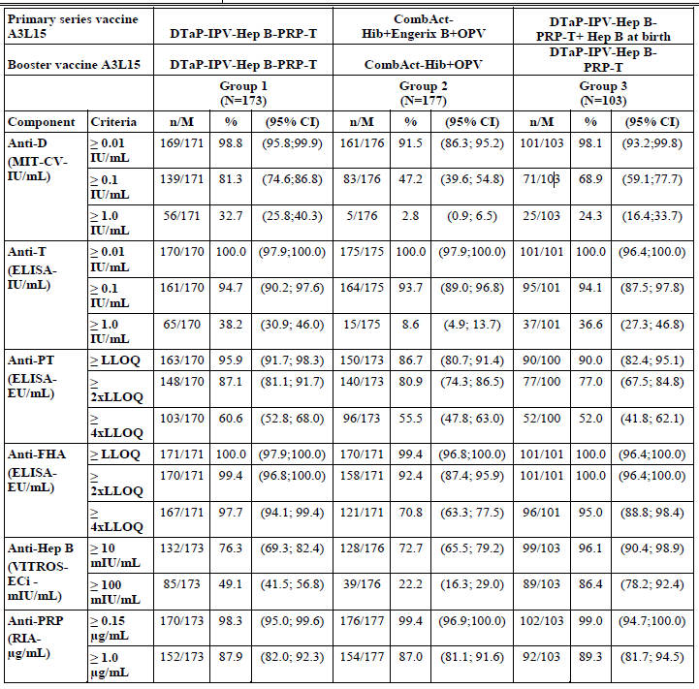
Table 34: Summary of descriptive Ab levels at 4.5 years of age (V01) in A3L26
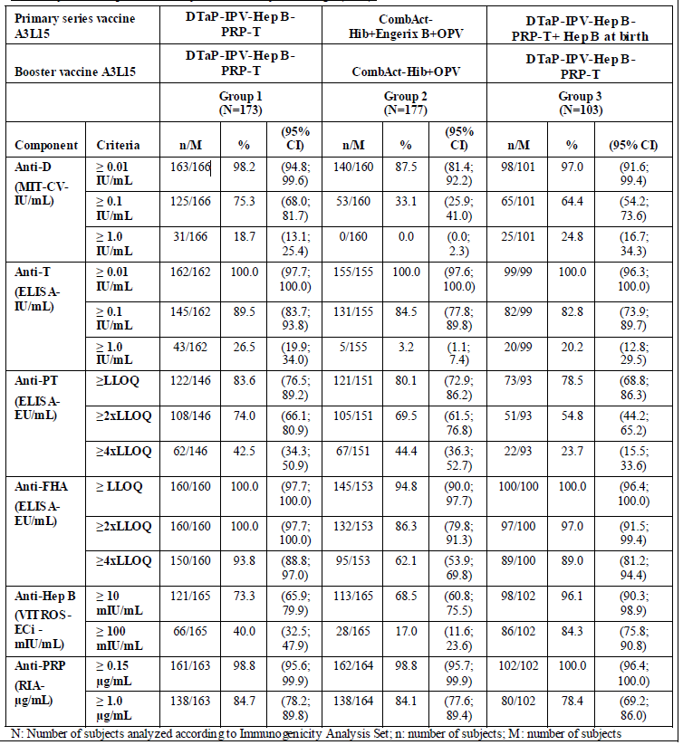

Conclusions
The long-term humoral immunity towards Ags included in the investigational DTaP-IPV-Hep B-PRP-T vaccine showed completion of a 3-dose primary series and a booster in the toddler age (± hep B vax at birth) induced strong Ab responses which were persistent in a significant % of study participants at the time points tested i.e. approximately 2 and 3 years after the toddler dose. Moreover, levels were at or above the established protective levels or protocol-defined Ab thresholds for the vaccine antigens of interest. DTaP-IPV-Hep B-PRP-T long-term Ab persistence does not differ from that observed with the control vaccines.

Analyses of immunogenicity performed across trials (pooled analyses)
All studies i.e. primary series with various immunisation schedules (from 6, 10, 14 weeks to 2, 4, 6 months); various immunisation backgrounds (wP and aP, OPV and IPV) for booster studies; various populations; various use of concomitant vaccines; ± use of hepatitis B vax at birth, that evaluated immunogenicity as a primary objective were conclusive in showing non-inferiority of Hexaxim vs. the corresponding control vaccine(s). Therefore, no meta-analysis performed.
However, 4 studies (all in Latin America) using a 2, 4, 6 months schedule i.e. A3L02, A3L04, A3L11, A3L17 were pooled to provide further estimates of Ag immunogenicity (excluded A3L24, for chronological reasons). Efficacy of Hexaxim vs. control vaccines has been assessed through the statistical analysis of noninferiority between the immunogenicity responses of the 2 vaccines and by descriptive comparisons (no formal statistical testing performed).

Immunogenicity analysis for the integrated analysis plan
There are three critically important Ag responses that this analysis provides additional data for i.e.
- Diphtheria – ref. the lower concentration of D Ag in Hexaxim (see also section 1.1), Hepatitis B– as the rHbSAg represents a novel antigen, and PRP, as there have been concerns about a negative impact of concurrent hepatitis B and Hib vaccination.

Immunoresponses to Diphtheria Ag.
Non-inferiority analysis of immunoresponses against D of Hexaxim vs. controls was assessed in studies A3L15 and A3L02. Hypothesis testing was performed on the difference in post-vax seroprotection rates between the Hexaxim and the control groups, using the PP Analysis Set. The acceptable noninferiority margin for D was 10%. The estimated difference in the rates of D seroprotection (≥ 0.01 IU/mL) was equal to 1.46% (-2.20; 5.31) in study A3L15 (control=CombAct-Hib+Engerix B+ OPV), and 0.369% (-1.12; 2.06) in study A3L02 (control=Pentaxim+Engerix B). The lower bound (LB) of the 95% 2-sided CI of the difference was >-10% for both studies, demonstrating non-inferiority of Hexaxim with respect to D Ag.

Efficacy against hepatitis B.
As a new Ag, the immunogenicity of the Hep B component was tested in a large panel of studies: A3L15, A3L10, A3L02, A3L12 and A3L17 (Table 35). Hypothesis testing was performed for the difference in post-vaccination seroprotection rates between the Hexaxim and the control groups, using the PP Analysis Set. The acceptable noninferiority margin for hepatitis B was 10%.
The estimated difference in rates of hepatitis B seroprotection (≥10 mIU/mL) was equal to 0.291% (-4.26; 4.77) for study A3L15, - 2.06% (-7.88; 3.65) for study A3L10, -0.775% (-2.78; 0.731) for study A3L02, -0.006 % (-2.46; 2.43) for study A3L12 and -0.758% (-4.17; 2.18) for study A3L17. As the LB of the 95% 2-sided CI of the difference was >-10% for all studies, indicating that following the primary vax series and as measured one month later, Hexaxim was non-inferior to all comparator vaccines.
Across studies (A3L15 [±hepatitis B vax at birth], A3L10, A3L02, A3L04, A3L11, A3L12 and A3L17), 1 month after the 3rd vaccination, Hexaxim seroprotection rates for hepatitis B (≥10 mIU/mL) were high (≥94.0%) and similar to those in all the control groups whatever the immunisation schedule assessed.
In terms of GMTs, variability was observed across studies, for example, in studies A3L10 and A3L04, Hexaxim GMTs were lower than control. However, Hexaxim seroprotection rates were respectively ≥94.0% and 100% in these 2 studies -given these high rates, the GMT differences are unlikely to be clinically significant.
Table 35: Anti-Hep B Ag response after Primary Series Vax - PP Analysis Set
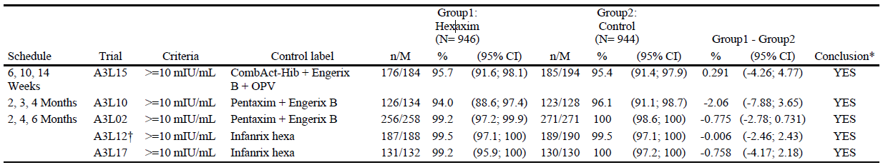
n: number of subjects; M: number of subjects available for the endpoint

Booster
The booster studies are: A3L01, A3L16, A3L22 (booster of A3L10 – booster vax was Hexaxim), A3L21 (booster of A3L11 - booster vax was Hexaxim) and A3L15 booster (booster of A3L15 - booster was either Hexaxim or CombAct-Hib+OPV (no hepatitis B boosting)). A Post hoc analysis of Hexaxim anti-hepatitis B (focused on studies A3L15 and A3L22) responses was performed to evaluate the immunogenicity of a Hexaxim booster dose on subjects with Ab titres <10 mIU/mL pre-Dose 4. In A3L15 and A3L22, pre-booster Hep B responses ≥10 mIU/mL (=protective) in 80.7% and 78.9%, respectively. Among those with pre-Dose 4 Hep B titres <10 mIU/mL, 92.3% (A3L15 bo) and 95% (A3L22) of the subjects responded with Hep B titres ≥10 mIU/mL post-Dose 4. This observation indicates that the majority of toddlers, even if with pre-Dose 4 Hep B titres <10 mIU/mL have good immunological memory elicited by the primary series priming. Presumably then, if exposed to a wild type Hep B virus challenge, they would be able to mount a protective immune response.

Immunoresponses against PRP (represents Hib protection)
No differences in anti-PRP responses in terms of seroprotection rate (≥0.15 μg/mL) were observed between the Hexaxim and control groups, except for study A3L15. At the ≥1.0 μg/mL level, protection rates ranged from 84.8% to 93.1%, except for studies A3L15 ps and A3L10 in which they were 79.5% and 72.9%, respectively. GMTs ranged from 2.12 to 5.22, except for study A3L11 in which they were 12.2. For PRP, the global intra group estimate based on the raw pool of data is 98.0% at the ≥0.15 μg/mL level and 90.2% at the ≥1 μg/mL level. Across studies (A3L15 bo, A3L22, A3L16 and A3L21), pre-booster rates (≥0.15 μg/mL level) decreased but remained high, ranged from 76.3% to 86.9%. At the ≥ 1.0 μg/mL level, protection rates decreased markedly, ranging from 24.6-50.3%. GMTs ranged from 0.399 to 1.09. Post-booster results (studies A3L15 bo, A3L22 and A3L21), showed protection rates about 2 times greater than pre-booster at the ≥1.0 μg/mL level. The protection rates were consistently high (≥98.2% at the ≥1.0 μg/mL level). In terms of GMTs, variability was observed across studies. However, given the high seroprotection rates, these differences are unlikely to be clinically significant.
Table 36: PRP Ag response following Hexaxim 2, 4, 6 Months Schedule - Pooled - PP Analysis Set
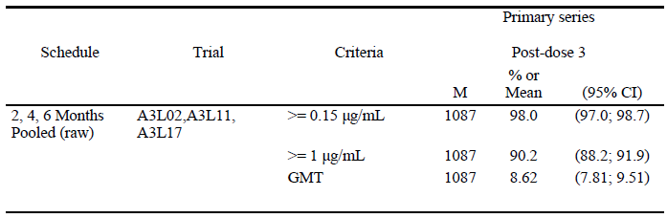
M: number of subjects available for the endpoint from the per protocol analysis set; %: percentages and 95% CI are calculated according to the subjects available for the endpoint; *: studies performed in Latin America

Evaluator’s conclusions on immunogenicity for primary vaccination in the first year of life and boosting and protective efficacy
This application provides a comprehensive and appropriately powered swathe of immunogenicity studies of the hexavalent vaccine, Hexaxim. Immunogenicity is used as surrogate of clinical efficacy, the rationale for this approach is discussed above. However, this is not so clearly established for pertussis and discussed further below.
- Measures of effectiveness of pertussis vaccines
A correlation between the serological response to Ags and protection against pertussis is currently not well established. Stanley Plotkin et al, 2011 reviewed the 16 year clinical data for Pentaxim with the following caveats - it is virtually impossible to detect minor differences between vaccines in efficacy trials and more difficult still, to detect differences in effectiveness by surveillance. The reason for the latter:
i) the same vaccine is not exclusively used over a long period of time in exactly the same way (schedule, nos of boosters) in a country;
ii) population demographics and density change over time;
iii) the natural epidemiology of the infection changes, with cycles of more/less activity;
iv) vaccine coverage changes;
v) the surveillance method used is not usually uniform over time;
vi) sampling techniques and laboratory methods change and tests used to define the infection change in their sensitivity and specificity.
- What is the surveillance data for pertussis
Despite all the caveats above, it appears that the PT and FHA antigens contained in Hexaxim to control diseases caused by B. pertussis have been ‘demonstrated’ in a 10 year National surveillance on pertussis in Sweden with the Pentavac/Pentaxim vaccine which corresponds to the D, T, P, IPV and Hib portion of Hexaxim (Carlsson and Trollfors 2009; Hallander and Gustafsson 2009; Tindberg 1999); national surveillance for pertussis in France (Bonmarin 2007) and Austria (Rendi-Wagner 2006) also provide similar ‘efficacy’ data. In regards to the Swedish surveillance data, vaccines containing aP were included in the Swedish vaccination program in 1996 (note that wP vaccine was withdrawn in 1977). Vaccine coverage for the three-dose pertussis vaccination at 3, 5, 12 months of age reached 98–99% within a few month of wP withdrawal. Reporting of cases changed from a voluntary to mandatory reporting in October 1997 meaning that all pertussis reports confirmed by culture or polymerase chain reaction (PCR) in Swedish children born in 1996 and onwards have been identified through the computer-linked reporting system; clinical outcomes and detailed vaccination status were obtained by structured telephone interviews. Moreover, since 1996, only two pertussis vaccines have been used in Sweden, the two-component vaccine from Sanofi Pasteur and the three-component vaccines from GSK.
Three years after the introduction of aP vaccines, the reported incidence of pertussis had dropped by 80–90% to levels similar to the lowest rates observed in the 1960s when the Swedish wP program was still effective. Moreover, overall incidence of laboratory-confirmed pertussis dropped from 113–150 per 100,000 person years in 1993–1995 to 11–16 per 100,000 in 2001–2004 and 6–16 per 100,000 in 2001–2007.
A pure cohort of Pentaxim recipients was analysed separately. Over 10 years of vaccine use, the incidence of pertussis was 26 per 100,000 and 12 per 100,000 person-years after the second and third doses, respectively, compared with 232 per 100,000 person-years before the first dose and 209 per 100,000 person-years before the second dose. Additional data document the long-term Ab persistence in the years following booster vaccination. In Sweden, Ab persistence was measured at 5.5 years of age (Carlsson 2002). The study found that 89.0–97.0% of children remained seroprotected for diphtheria, tetanus, polio types 1, 2, 3 and PRP antigens, while 91.0–94.0% of children had anti-PT and anti-FHA antibody levels ≥4 EU/ml (defined at the time of the study) at 5.5 years after receiving the booster dose. Anti-PT GMTs were at 12.8 EU/ml (using seroneutralization) and anti-FHA GMTs at 24.8 EU/ml (using ELISA). Following a slight increase in incidence of pertussis that was observed among 7–8-year-old children - suggesting waning of vaccine-induced protection from pertussis, the Swedish vaccine programme now adopts a booster dose at aged 5-7 years (Note the Australian NIP recommends a booster at Age 4 years of age).

- Randomised data
Further data on the protective efficacy of PT against the most severe WHO-defined typical pertussis (primary endpoint was ≥21 days of paroxysmal cough) was provided in a study conducted in Senegal between1990-1994 (Simondon, 1997). This was a prospective, double-blind (randomisation was DTaP vs. European DTP vaccine at 2, 4, 6 months of age) vaccine study, with estimates of absolute efficacy derived from a nested Case-contact study that compared rates of pertussis (after exposure to an index case), among study subjects and non-study subjects, the latter had not received any pertussis vaccination. It is important to note that, case detection bias may have occurred as the non-randomised group (no pertussis vaccination) was unblinded to parents and field surveillance workers. The risk of pertussis was 2.42 in the DTaP vs. DTP group. When cases (meeting primary case definition) were stratified by age, the relative risk was 1.16 for children younger than 18 months vs. 1.76 for older children in the DTaP vs. DTP arms respectively, suggesting that protection waned more quickly among DTaP than DTP recipients. Absolute efficacy estimates were, 74% for DTaP vs. 92% for DTP, but there were very small nos of cases, and CI for these estimates are very wide i.e. 51-86% (DTaP) and 81-97% (DTP).
Not all the Hexaxim studies evaluated all 9 antigens for non-inferiority, largely because of the very large experience with the majority of the active components through predecessor vaccines. The focus was on responses to Hep B antigen, the only new antigen contained in Hexaxim and all the studies (except the large-scale safety study A3L04) focused on a non-inferiority analysis for this component. In all studies, Ags that were not tested for non-inferiority were evaluated descriptively. Studies were conducted in healthy subjects, in different countries with different ethnicities, with different vaccination schedules (6, 10, 14 weeks; 2, 3, 4 months; 2, 4, 6 months), and with a variety of comparison groups, different immunisation backgrounds for booster studies, and different co-administered vaccines.
Taken collectively, Hexaxim results in high levels of protective immunity to all its Ag components; these levels are equivalent to those produced by comparator vaccines e.g. Infanrix Hexa, already used in the Australia NIP, at least for the primary vaccine series in infants.
- Ongoing and planned studies
2 studies are still ongoing: A3L26 (4.5 year-old cohort) and A3L27 (A3L24 booster study). A3L28, long-term persistence study of A3L24/A3L27 cohort is a planned clinical trial. Three studies are planned in the EU to provide additional data on use of Hexaxim in varied immunisation schedules e.g. 2+1 and 3+1 primary- boost combinations.

Clinical safety

Studies providing evaluable safety data
This application includes 13 completed clinical studies – 8 primary series and 5 booster studies, in which safety data has been collected. These 13 clinical studies were conducted in Latin America, Africa and Eastern Europe (Turkey) and provide key information on safety by gender, ethnicity, in very young infants with the earliest administration at 6 weeks of age, boosting of toddlers, in those with hep B vax at birth, coadministration with other childhood vaccines i.e. PCV7 & rotavirus (in primary series), MMR and varicella vaccines in booster.
Clinical safety data obtained from 11 of the 13 studies were pooled in an integrated analysis for Hexaxim. The objective of the pooling was to improve:
- precision of estimation of rate of AEs;
- probability of detection of any safety signal;
- safety assessment in larger subgroups of the population.
The following studies were included in the safety integrated analysis (IAP-S) – see below for more details:
- 7 primary series studies: A3L02, A3L04, A3L10, A3L11, A3L12, A3L15 ps, and A3L17
- 4 of the 5 booster studies: A3L01, A3L15 bo, A3L21, and A3L22
The booster study A3L16 (using Pentaxim) is included with this application, but does not contain safety data on Hexaxim and is therefore not included in the IAP-S. Study A3L24 is a confirmatory study evaluating co-administration of Hexaxim with PCV7 and rotavirus vaccines and not part of the integrated analysis for chronological reasons. In addition in the IAP-S, 3 Hexaxim sub-pools are presented based on which control vaccine was used. Studies A3L04 and A3L15 used the wP combined D, T, pertussis, Hib vaccine Tritanrix-HepB/Hib+OPV and CombAct-Hib+OPV respectively; studies A3L02 and A3L10 used the pentavalent aP combined DTP vaccine Pentaxim; and studies A3L11, A3L12, and A3L17 used the hexavalent aP combined DTP vaccine Infanrix Hexa.
For the purpose of the safety summary safety data for the 13 studies referenced above are included; these will be referred to as “Hexaxim immunogenicity” studies.

Hexaxim Immunogenicity studies: definitions and objectives
In the immunogenicity studies, the terms used to describe safety events are defined below:
- AE: include immediate, solicited, and unsolicited non-serious or serious events;
- AR: corresponds to a related AE (solicited reaction or unsolicited AE considered as related to the vaccination by the Investigator);
- Immediate AE: Any unsolicited systemic AEs (non-serious or serious) reported by the study staff in the 30 minute observation period after vaccination. Immediate AEs can be related or unrelated as determined by the Investigator and/or Sponsor;
- Solicited reaction: Event pre-listed in the CRF/eCRF which occurred during the solicited period, considered by definition as ARs;
- Unsolicited AE: AE recorded in the CRF unsolicited form; excludes solicited reactions. Therefore, includes immediate AEs/ARs and serious & non-serious AEs/ARs;
- SAE: Unsolicited AE meeting the standard criteria for SAE as per GCP considered serious by the Investigator and/or Sponsor Safety data were also reviewed by an IDMC during the Phase III trials;
- Unsolicited AEs occurring during a follow-up period of 30 days after the first vaccination;
Table 37: Measurable Solicited ISR Collected by Study: Terminology, Definitions, and Intensity Scales
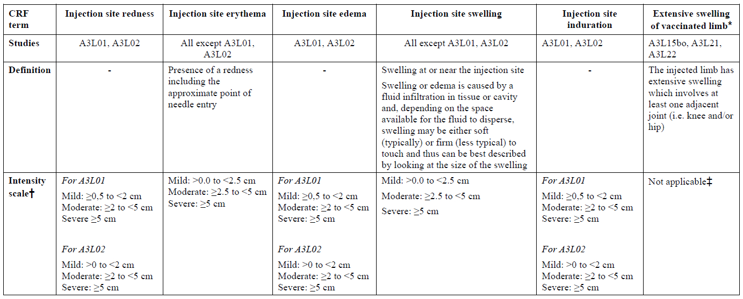
Table 38: Measurable Solicited Systemic Reactions (Pyrexia / Fever) Collected by Study: Definition, Assessment Method and Intensity Scale
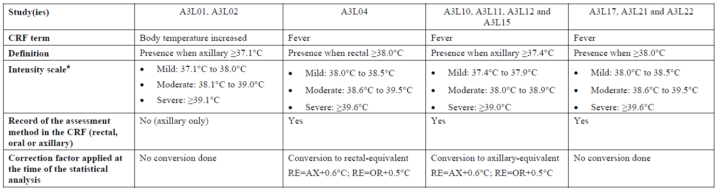
For fever, parents/legal representatives recorded temperature, and the classification as Grade 1, 2, or 3 was assigned at the time of the statistical analysis.
Table 39: Non-Measurable Solicited Systemic Reactions: Terminology, Definitions, Intensity Scales
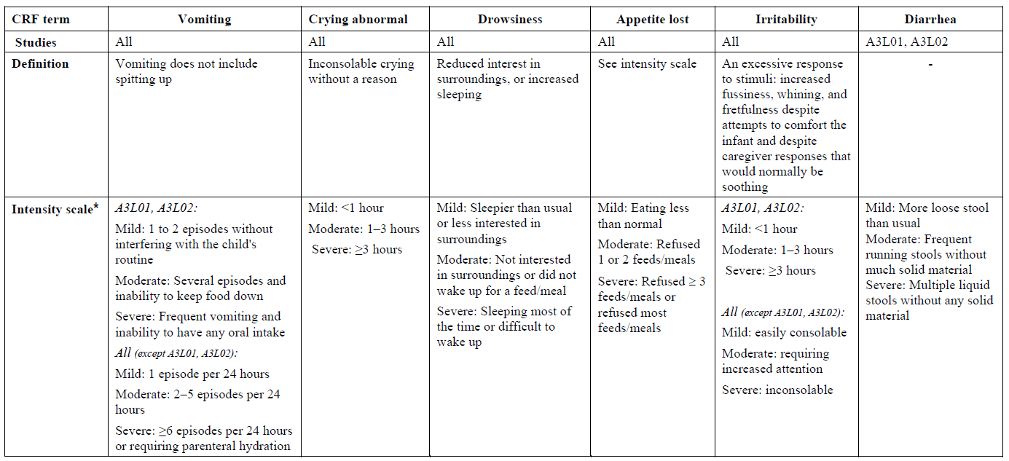
For all non measurable reactions, parents/legal representatives recorded the intensity level (mild, moderate, or severe) in the DC. Note: For all studies, except A3L01, A3L02, A3L04 and A3L10, information on intensity collected as mild, moderate or severe in the CRF was then coded as Grade 1, Grade 2, or Grade 3, by the data management department at the time of the statistical analysis, due to a change in the Sponsor’s safety standards.

Adverse events
AEs were Graded and coded as per standard methods i.e. MedDRA Primary System. However, specific standard methodology was used to describe AEs associated with ISR and systemic upset post vaccination, see Tables below. These data were documented on standard diary cards for the studies by the parent/guardian on a daily for the 7 days post each vaccine and then transcribed by the site onto the CRF/eCRF.

Analysis and objectives
The safety integrated analysis was performed on the SafAS. The SafAS is defined for each vaccination as the subset of subjects who received this dose. Subjects are analysed according to the treatment received at this vaccination. For the analysis at “any vaccination”, subjects were analysed according to the first vaccine received. This safety population is similar to the one defined for each individual study. Differences may be observed in the analysis after any injection, for subjects who wrongly received different products during the primary series. While those subjects have been excluded from the analysis at “any injection” in the individual studies, for this integrated analysis they are included in the SafAS and are analysed according to the vaccine received after the first injection.
Objective 1: Hexaxim safety profile - to assess the global safety profile of Hexaxim after each and after any vaccination.
Objective 2: Hexaxim in subgroups of subjects - to provide a description of Hexaxim safety profile after each and any injection in subgroups of subjects according to: Gender; Ethnicity; cumulative number of Hep B doses received (3, 4 or 5) during the 1st and 2nd year after birth; inclusion or not of a concomitant vaccination PCV7, MMR and V vaccines.
Objective 3: Hexaxim versus control - to present a descriptive comparison of Hexaxim safety profile with that of the control vaccines. Objective 3 analyses are presented for overall safety, unsolicited immediate events (including reactions), non-serious unsolicited and solicited reactions, AEs leading to discontinuation, adverse events of special interest (AESI), and deaths. The 95% CIs were calculated for the each of the safety parameters; the “%” are expressed in percentage of subjects vaccinated (not percentage of doses administered); no statistical testing performed between groups.

Adverse events of special interest (AESI)
AESI in this setting are: Extensive Limb Swelling (ELS), Hypotonic Hyporesponsive Episode (HHE), febrile convulsions, convulsions, anaphylactic reactions, apnoea, encephalopathy or similar severe neurological conditions, encephalitis or acute demyelinating encephalomyelitis (ADEM), Sudden Infant Death syndrome (SIDS) / Sudden Unexplained Death (SUD).

Endpoints
The safety endpoints for the integrated analysis are:
- Occurrence of immediate unsolicited systemic AE reported in the 30 minutes after each/any vaccine injection;
- Occurrence of solicited (prelisted in the subject DC and CRF/eCRF) injection site and systemic reactions within 7 days following each/any vaccine injection;
- Occurrence of unsolicited (spontaneously reported) AEs within 7 days and within 30 days (28 days for study A3L15) following each/any vaccine injection;
- Occurrence of unsolicited non-serious AEs within 7 and within 30 days (28 days for study A3L15) following each/any vaccine injection; v) Occurrence of SAEs throughout the trials; vi) Occurrence of AESIs throughout the trials.

Solicited reactions
For the integrated analysis, the following solicited reactions (all considered AR) are considered similar and are combined:
- Injection site pain (in A3L01 and A3L02) and injection site tenderness (all other studies): the MedDRA preferred term (Pref T) used in the integrated analysis is injection site pain;
- Injection site redness (in A3L01 and A3L02) and injection site erythema (all other studies): the MedDRA Pref T in the IAP-S is injection site erythema;
- Injection site edema (in A3L01 and A3L02) and injection site swelling (all other studies): the MedDRA Pref T in the IAP-S is injection site swelling;
- Drowsiness and somnolence: the MedDRA PT in the IAP-S is somnolence;
- Anorexia and appetite lost: the MedDRA PT in the IAP-S is anorexia;
- Crying and crying abnormal: the MedDRA PT in the IAP-S is crying.
In terms of intensity scales, the terminology Mild/Moderate/Severe was replaced by Grade 1/Grade 2/Grade 3, respectively, the following scale was used:
- For measurable solicited reactions (except pyrexia): Grade 1: 0.1 to <2.5 cm; Grade 2: 2.5 to <5 cm; Grade 3: ≥5 cm. It is important to note that in study A3L01, only reactions ≥0.5 cm collected. Therefore, occurrences were under-estimated in this particular study.
- For pyrexia, whether measured by rectal, oral, or axillary means: Grade 1: 38.0°C to 38.5°C; Grade 2: 38.6°C to 39.5°C; Grade 3: ≥39.6°C.No correction factor was applied, in line with the Brighton collaboration guideline (US Department of Health and Human Services,) and regulatory authority recommendations e.g. FDA.
Note than temperature <38.0°C, whatever the assessment method used in the individual studies, was not considered as pyrexia in the IAP-S. For non-measurable solicited reactions, a harmonisation of the intensity scales was not possible. Therefore, intensity scales of individual studies are considered.

Serious adverse events
For trials A3L01, A3L02, and A3L04, the SAE data collection was different than for the other Hexaxim studies. SAEs were reported with diagnosis and symptoms. For the IAP-S, the original A3L01, A3L02, and A3L04 databases were reformatted by the data management department in collaboration with the Pharmacovigilance representative, and a new database created with the current Sanofi Pasteur standard, the latter was used in the analysis.

Hexaxim studies that assessed safety as a primary outcome
Study A3L04 was a pivotal study that assessed safety as a primary outcome.

Dose-response and non-pivotal efficacy studies
There were no dose-response studies in this application.

Other studies evaluable for safety only
None: all had an immunogenicity component as well.

Pivotal studies that assessed safety as a primary outcome

Study A3L04
Study A3L04: Large Scale Safety Study of a DTaP-IPV-Hep B-PRP-T Combined Vaccine, in Comparison to Tritanrix-Hep B/Hib and OPV Administered at 2, 4, and 6 Months of Age in Latin American Infants.
While safety is a primary outcome, immunogenicity with respect to hep S Ab responses are a secondary outcome measure of this study.

Patient exposure
Overall, in the IAP-S, 3631 infants received ≥1 dose of Hexaxim as part of the primary series, and 3434 received the complete 3 doses. 1 subject received Hexaxim at Dose 2 by mistake, was not included in the SafAS (3630 subjects). Of the 3435 subjects who received all doses, 1 subject discontinued after Dose 3. In addition, in A3L24, 1030 subjects received ≥1 dose of Hexaxim. During the booster, 1511 toddlers received Hexaxim booster. Total exposed population=4927 subjects, who received at least one Hexaxim dose during primary series/booster.
Table 40: Clinical Trial Exposure to Hexaxim: Subjects Who Received Each Dose
Dose of exposure | Study participants (n)
Primary series in integrated safety analysis
At least one primary vaccine injection received | 3631
Safety Analysis Set (SafAS)* | 3630
Received Dose 1: | 3630
Received Dose 2: | 3481
Received Dose 3: | 3435
Received complete 3-dose primary series | 3434
Booster in integrated safety analysis
Received Booster: | 1511†
Received at least one dose in primary or booster | 3897
Not in the integrated safety analysis (A3L24)
Safety Analysis Set | 1030
Received Dose 1: | 1030
Received Dose 2: | 1013
Received Dose 3: | 1002
Total population exposure
Received at least one dose in primary or booster | 4927
N is the number of subjects who received a dose. *SafAS population does not include the subject who received by mistake the second primary dose with Hexaxim instead of control. † Due to an error of administration or due to subjects not received completed series, 3 subjects have not received the same vaccine for the 3 injections performed during the primary series (these subjects are counted on the total but are not on the sub-totals
Table 41: Doses for Hexaxim and Control Vaccines - Safety Analysis Set, IAP-S
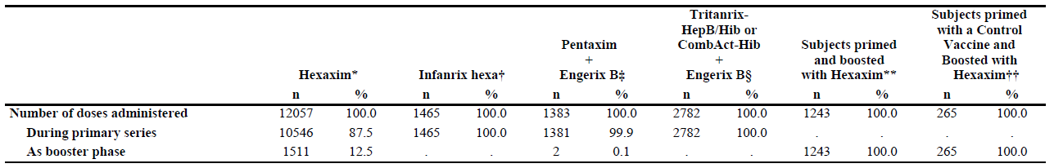
n: number of doses; %: percentages are calculated according to the total number of doses of Hexaxim or control vaccine administered; * Primary series: A3L02, A3L04, A3L10, A3L11, A3L12, A3L15, A3L17, Booster phase: A3L01, A3L15, A3L21, A3L22; † A3L11, A3L12, A3L17; ‡ A3L02, A3L10, A3L22; § A3L04, A3L15; ** A3L15, A3L21, A3L22; †† A3L01, A3L21, A3L22
In the integrated analysis:
- 10,546 doses administered to 3631 infants in the 7 primary series trials; 3434 received a complete 3 doses Hexaxim primary series.
- 1511 doses were administered to toddlers in 4 booster studies; Of the 1511 subjects who received a booster dose, 1243 primed with Hexaxim and 265 primed with a control vaccine.
- A total of 12,057 doses of Hexaxim were administered. In addition, in study A3L24, 3045 doses were administered. Overall, 15102 doses administered in the 12 studies. Of these, 13591 doses were administered to 4661 subjects in the 8 primary series, and 1511 doses were administered to toddlers in 4 booster studies.

Demographics of subjects
These are summarised in the Table below. Of the 3630 subjects who received Hexaxim, 1868 (51.5%) were male. In the control groups, 490 (51.5%) males and 462 (48.5%) females received Tritanrix-HepB/Hib+OPV or CombAct-Hib+Engerix B+OPV, 248 (53.1%) males and 219 (46.9%) females received Pentaxim+Engerix B, and 237 (47.0%) males and 267 (53.0%) females received Infanrix Hexa.
The mean ages of the subjects enrolled in the Hexaxim, Tritanrix-HepB/Hib+OPV or CombAct-Hib+Engerix B+OPV, Pentaxim+Engerix B, and Infanrix Hexa groups were similar: 1.87, 1.77,1.88, and 1.88 months, respectively. Ethnicity data was collected for 3318 subjects - majority of those receiving Hexaxim were Hispanic (2576 subjects [77.6%]), followed by Black, Asian, and Caucasian (375 subject [11.3%], 207 subjects [6.2%], and 157 subjects [4.7%], respectively). The majority in control groups were also Hispanic.
Table 42: Subject Characteristics; Hexaxim and Control Vax, Primary Series - Safety Analysis Set
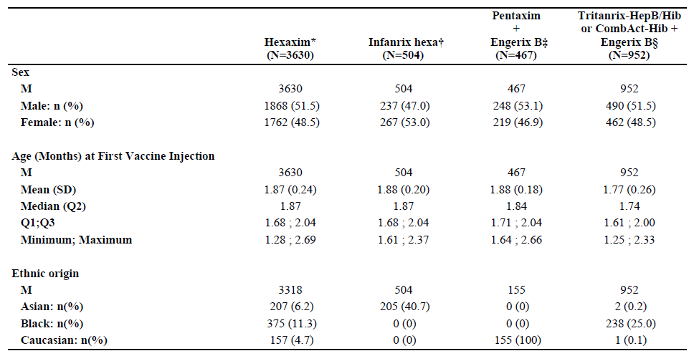

Adverse events

All adverse events (irrespective of relationship to study treatment)
Table 43. Summary of Most Frequently Reported AEs After Any Hexaxim Primary and Booster Vaccine Injection, IAP-S
 | Solicited AEs* | % | Unsolicted AEs* | % | SAEs** | %
1 | Injection site pain | 82.6 | Nasopharyngitis (Infections and infestations) | 26.1 | Gastroenteritis (Infections and infestations) | 1.3
2 | Irritability | 79.5 | Pharyngitis (Infections and infestations) | 14.1 | Bronchiolitis (Infections and infestations) | 0.7
3 | Crying | 72.2 | Diarrhoea (gastrointestinal disorders) | 10.1 | Bronchopneumonia (Infections and infestations) | 0.6
4 | Injection site induration (A3L01 and A3L02 only) | 63.6 | Upper respiratory tract infection (Infections and infestations) | 7.3 | Pneumonia (Infections and infestations) | 0.5
5 | Injection site erythema | 62.7 | Cough (Respiratory, thoracic and mediastinal disorders) | 7.2 | Febrile convulsion (Nervous system disorder) | 0.3
6 | Somnolence | 54.9 | Pyrexia (General disorders and administration site conditions | 6.3 | Bronchila obstruction (Respiratory, thoracic and mediastinal disorders) | 0.3
7 | Anorexia | 49.1 | Rhinitis (Infections and infestations) | 5.9 | Pneumonia viral (Infections and infestations) | 0.2
8 | Injection site swelling | 46.2 | Abdominal pain (gastrointestinal disorders) | 5.6
9 | Pyrexia | 42.6 | Dermatitis diaper (Skin and subcutaneous tissue disorders) | 5.2
10 | Vomiting | 35.2 | Gastroenteritis (Infections and infestations) | 4.6
*AE MedDRA Preferred term, regardless of seriousness; *AE MedDRA Preferred term.
The most frequently reported AE are summarised in the table above.

Treatment-related adverse events (adverse drug reactions)

Hexaxim immunogenicity studies

Adverse events of special interest
AESIs and events possibly related to AESIs occurring within 3 days after any primary or booster vaccination are described below:
- 56 (3.1%) and 26 (2.7%) subjects experienced at least one AESI and events possibly related to AESIs in the Hexaxim (N=1803) or Tritanrix-HepB/Hib+OPV or CombAct-Hib+Engerix B+OPV (N=952) groups, respectively. Most AESIs were in the SOCs of “Skin and subcutaneous disorders” (1.6% and 1.4% of subjects in the Hexaxim and control vaccine groups, respectively) and “respiratory, thoracic and mediastinal disorders” (1.2% and 1.2%, respectively). Five (0.3%) subjects in the Hexaxim group and 5 (0.5%) in the control group experienced at least one related AESI. These included rash generalised, injection site rash, injection site dermatitis, and hypotonic hyporesponsive episode in the Hexaxim group; and rash, rash generalised, swelling face, and injection site rash in control vaccine group;
- A total of 3 (0.6%) and 1 (0.2%) subjects experienced at least one AESI and events possibly related to AESIs in the Hexaxim (n=467) or Pentaxim+Engerix B groups (N=467), respectively. Of these, subjects experienced AESIs occurring in the SOCs of “General disorders and administration site conditions and Skin and subcutaneous disorders” (0.4% and 0.4 % of subjects in the Hexaxim group, respectively) and the one subject from the control vaccine group (0.2%) experienced rash (“Skin and subcutaneous disorders”). Of these 2 (0.4%) subjects experienced at least one related AESI and events possibly related to AESIs in the Hexaxim group (injection site urticaria and oedema peripheral). No AESIs and events possibly related to AESIs in the control vaccine group were considered as related;
- A total of 18 (1.3%) and 5 (1.0%) subjects experienced at least one AESI and events possibly related to AESIs in the Hexaxim (N=1360) or Infanrix Hexa groups (N=504), respectively. Of these, most subjects experienced AESIs occurring in the SOCs of “Skin and subcutaneous disorders” in the Hexaxim group (1.1%) and “Respiratory, thoracic and mediastinal disorders” in the control group (0.8%). A Subject in A3L11 presented with erythema multiforme on the day of Dose 2, post-injection. This was considered not serious and not related. The time to onset (about 3 hrs post-injection) is not suggestive of a relationship with vaccine administration. Most frequent cause of erythema multiforme is infectious. Of these 5 (0.4%) and 1 (0.2%) subjects experienced at least one related AESI and events possibly related to AESIs in the Hexaxim or Infanrix Hexa groups, respectively. These included the Pref Ts rash, rash maculo-papular, and injection site vesicles in the Hexaxim group, and rash generalised in the control vaccine group.
Table 44: AESIs Within 3 Days After Booster of Hexaxim, by SOC and PT per Type of Vaccine Received for Primary Series - Safety Analysis Set, IAP-S
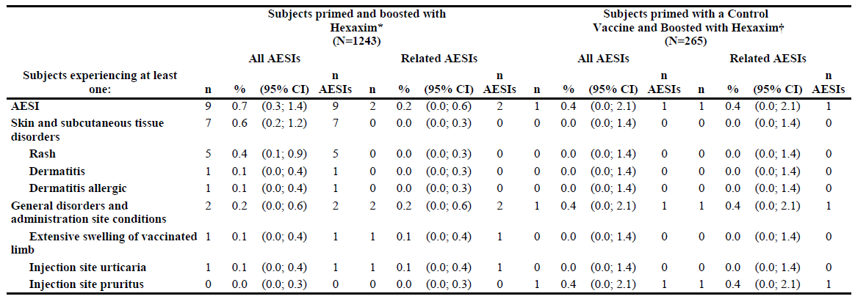
Hexaxim prime series and boost: A total of 9 (0.7%) and 1 (0.4%) subjects experienced at least one AESI and events possibly related to AESIs after receiving a Hexaxim booster when primed with either Hexaxim or control vaccine, respectively. Of these, most subjects experienced AESIs and events possibly related to AESIs occurring in the SOCs of “Skin and subcutaneous disorders” in the group primed with Hexaxim (0.6%). There were 2 (0.2%) and 1 (0.4%) subjects experienced at least one related AESI and events possibly related to AESIs in the group primed with Hexaxim or control vaccine, respectively. These included ELS, injection site urticaria and injection site pruritus.
Related AESIs With Onset >3 Days: 3 related AEs were reported more than 3 days post vaccination: 2 were injection site rash occurring for subjects in the Hexaxim group, at D11 post-injection 1 and D5 post-booster, and 1 was injection site dermatitis at D5 post-injection 3, occurring in a subject who received Tritanrix-HepB/Hib+OPV or CombAct-Hib+Engerix B+OPV.
Integrated Analysis: No differences in frequency of AESIs were observed between Hexaxim and control vaccines (Subject exposure in control groups: Infanrix Hexa (primary) n=504; Pentaxim+Engerix B (primary) n=467; Tritanrix-HepB/Hib+OPV or CombAct-Hib+Engerix B+OPV(primary) n=962; CombAct-Hib (booster) n=254).

Extensive limb swelling
2 subjects had potential ELS following administration of Hexaxim: One subject (from study A3L02) experienced severe oedema of the whole thigh associated with severe erythema on the day of the first primary dose. The episode resolved in one day, and did not recur after subsequent administrations of the vaccine. A second subject (from study A3L21) experienced severe swelling reported as ELS, associated with severe injection site erythema (max. 8 cm) on the day of the booster. The event lasted 8 days, and the patient recovered. It should be noted that this event was reported by the parents and not assessed by the Investigator.

Hyporesponsive Hypotonic Episode (HHE)
One related case of HHE was reported in a subject 7 hours after administration of the first dose of Hexaxim. This case was assessed as level 1 of diagnostic certainty (highest level), using the Brighton collaboration case definition.

Convulsions
Integrated Analysis: 14 subjects experienced 2 episodes of convulsions and 13 episodes of febrile convulsions in the Hexaxim or Hexaxim+OPV placebo groups. All cases but 1 were considered serious; none considered by the Investigator to be related to the vaccination. None occurred within 3 days of vaccination. The time to onset ranged from Day 8 to Day 184 post-vaccination. Of these 14 subjects: a subject from A3L11 presented with 2 episodes of febrile convulsions; a subject from A3L12 had a history of microencephaly and experienced a first episode of convulsion, and was later diagnosed with epilepsy and craniosynostosis; a subject from A3L04 developed mild convulsive disorder considered not serious, 8 days post-injection 3. Two additional subjects were diagnosed with epilepsy and West syndrome (infantile spasms), respectively 17 days and 59 days after vaccination. Convulsive disorders reported in a total of 9 patients in control groups. None considered related.
Studies not Included in the IAP-S: In study A3L24, a total of 3 episodes of non-febrile convulsion and 4 episodes of febrile convulsions were reported. Up to 1 month after the 3rd dose of the primary vaccination series, 2 subjects experienced an episode of non-febrile convulsion, respectively 16 days and 30 days post Hexaxim administration: The first subject had +ve family history of seizure, the second one was started on phenobarbital due to abnormal EEG; both considered not related by the Investigator.
During the 6-month safety follow-up of study A3L24, there were 4 episodes of febrile convulsions in 3 subjects and one episode of non-febrile convulsion reported in the Hexaxim groups. Time to onset ranged from about 2 to 6 months post-vaccination. All events considered not related to study vax; all the subjects recovered.

Apnoea
Two subjects presented with apnoea episodes in Hexaxim arms. Of these, 1 subject had not yet received Hexaxim. The second patient developed life-threatening apnoea episodes 19 days after first dose of Hexaxim, in a context of cough and rhinitis. One subject presented with breath holding one day after the second dose of Hexaxim, and was diagnosed with breath holding spells. No cases of apnoea considered related to Hexaxim.

Severe neurological conditions
No cases of encephalopathy were reported after vaccination with Hexaxim. No cases of ADEM were reported after administration of Hexaxim or control vaccine. But, 2 subjects developed encephalitis after vaccination with Hexaxim: 1 subject developed encephalitis 53 days post-vaccination, and the 2nd subject developed meningoencephalitis 29 days-post vaccination. No encephalitis/encephalopathy reported in Infanrix Hexa, Pentaxim+Engerix B groups and CombAct-Hib+Engerix B+OPV. In Tritanrix-HepB/Hib+OPV, one subject (study A3L04) developed meningo-encephalitis 154 days after first dose. CSF and blood cultures were positive for pneumococcus. The subject recovered 32 days later. Event not considered related by the Investigator.

SIDS
Studies not Included in the IAP-S. In study A3L24, one case of SIDS was reported, 24 days after having received the second dose of Hexaxim. Three SIDS risk factors were identified; The death was not considered to related to the study vaccine.

Anaphylaxis
No cases reported.

Allergic non-anaphylactic reactions
Although no anaphylactic reaction was identified, in the whole pool of Hexaxim, 14 subjects presented with 15 related allergic type reactions, 12 within 3 days post immunisation and 2 at 5 and 11 days post immunisation respectively. All events were not serious and reversible. Nine subjects presented with localised allergic reaction, after vaccination with Hexaxim: injection site dermatitis (n=1), injection site pruritus (n=1), injection site rash (n=4), injection site urticaria (n=2), and injection site vesicle (n=1). Five subjects experienced systemic allergic reaction: rash (n=1), rash generalised (n=1), and rash maculo-papular (n=3; 1 subject had 2 episodes).
In the whole pool of Hexaxim, no difference observed between males and females. Intensity assessed as mild for 10 events, moderate for 2 events, severe for 2 events, and missing for the last event. Duration of events varied from 1 to 8 days, and 10 of 15 (66%) episodes recovered within 4 days. The frequency of allergic non-anaphylactic reaction was 3.6 per 1000 subjects, and 12.4 per 10,000 doses. In the control groups, a total of 6 subjects who received wP vaccines presented 6 related allergic type events, and 1 subject who received Infanrix Hexa presented 1 related allergic type. No allergic type reactions with Pentaxim.

Solicited injection site reactions
Solicited ISR reported at a higher frequency for those who received Hexaxim (83.4%) than those who received Pentaxim+Engerix B (75.4%). Between groups, the frequency was similar post-injection 2 and 3, but higher for post-injection 1 in the Hexaxim group (69.0% and 56.0%, post-injection 1; 60.2% and 53.6%, post-injection 2; 57.5% and 52.1%, post-injection 3, for Hexaxim and Pentaxim+Engerix B, respectively). Grade 3 solicited injection site reactions were reported at a higher frequency for those who received Hexaxim (28.0%) than those who received Pentaxim+Engerix B (15.1%). Between groups, the frequency was similar post-injection 2 and 3, but not for post-injection 1 (the frequency for those who received Hexaxim was higher [21.3%] than Pentaxim+Engerix B [9.3%]). Within each group, the frequency of reported solicited injection site reactions at each post-injection decreased from the previous injection.

Solicited systemic reactions
Solicited systemic reactions reported at a similar frequency for those receiving Hexaxim (85.1%) vs. Pentaxim+Engerix B (83.0%). Between groups, the frequency of reported solicited systemic reactions at each post-injection was similar to the previous injection (74.8% and 67.5%, post-injection 1; 63.1% and 58.4%, post-injection 2; 58.2% and 53.4%, post-injection 3, for Hexaxim and Pentaxim+Engerix B, respectively). Grade 3 solicited systemic reactions were reported at a higher frequency for those who received Hexaxim (39.2%) than those who received Pentaxim+Engerix B (29.3%). Between groups, the frequency was similar post-injection 1, 2 and 3. Within each group, the frequency of reported solicited systemic reactions was highest post-injection 1, and similar post-injection 2 and 3. In the primary series pooled data for Hexaxim, crying and irritability were the most frequently concomitantly reported solicited systemic reactions, reported at a frequency of 9.8%, 9.2% and 6.7% post-injection 1, 2, 3, respectively. Following a booster of Hexaxim, crying, somnolence, anorexia, and irritability were the most frequently concomitantly reported solicited systemic reactions, for 5.7% of subjects.

Pyrexia
Reported in 41.1% subjects who received Hexaxim at any injection. Of these, 898 (25.1%), 515 (14.4%), and 54 (1.5%) of subjects reported a max of Grade 1, Grade 2, or Grade 3 pyrexia after any injection. Post-injection 1 the frequency of pyrexia reported was lower (18.1%) compared to post-injection 2 and 3 (24.0% and 22.1%, respectively). Frequency of pyrexia reported post-dose 2 and 3 were comparable. Grade 1 pyrexia was more frequently reported (than Grade 2 or 3), reported for 13.5%, 17.2% and 14.3% of subjects post-injection 1, 2, and 3, respectively. Grade 3 pyrexia frequency tended to increase after each consecutive post-injection but was low, reported for 5 (0.1%), 17 (0.5%) and 32 (0.9%) of subjects post-injection 1, 2 and 3, respectively. Overall, the frequency of pyrexia was lower following a booster (15.1%) compared to after any primary vaccination (41.1%).
Table 45: Solicited Systemic Pyrexia After Each and Any Primary Hexaxim Vaccine Injection, by Maximum Intensity during the Solicited Period - Safety Analysis Set, IAP-S
Subjects experiencing at least one: |  | Hexaxim (N = 3435)
Subjects experiencing at least one: | Maximum intensity | n/M | % | (95% CI)
Pyrexia (any injection)  (N = 3630) |  | 1467/3573 | 41.1 | (39.4; 42.7)
Pyrexia (any injection)  (N = 3630) | Grade 1 | 898/3573 | 25.1 | (23.7; 26.6)
Pyrexia (any injection)  (N = 3630) | Grade 2 | 515/3573 | 14.4 | (13.3; 15.6)
Pyrexia (any injection)  (N = 3630) | Grade 3 | 54/3573 | 1.5 | (1.1; 2.0)
Post-injection 1  (N = 3630) |  | 646/3562 | 18.1 | (16.9; 19.4)
Post-injection 1  (N = 3630) | Grade 1 | 481/3562 | 13.5 | (12.4; 14.7)
Post-injection 1  (N = 3630) | Grade 2 | 160/3562 | 4.5 | (3.8; 5.2)
Post-injection 1  (N = 3630) | Grade 3 | 5/3562 | 0.1 | (0.0; 0.3)
Post-injection 2  (N = 3481) |  | 827/3451 | 24.0 | (22.5; 25.4)
Post-injection 2  (N = 3481) | Grade 1 | 593/3451 | 17.2 | (15.9; 18.5)
Post-injection 2  (N = 3481) | Grade 2 | 217/3451 | 6.3 | (5.5; 7.2)
Post-injection 2  (N = 3481) | Grade 3 | 17/3451 | 0.5 | (0.3; 0.8)
Post-injection 3  (N = 3436) |  | 753/3409 | 22.1 | (20.7; 23.5)
Post-injection 3  (N = 3436) | Grade 1 | 488/3409 | 14.3 | (13.2; 15.5)
Post-injection 3  (N = 3436) | Grade 2 | 233/3409 | 6.8 | (6.0; 7.7)
Post-injection 3  (N = 3436) | Grade 3 | 32/3409 | 0.9 | (0.6; 1.3)
n: number of subjects experiencing the endpoint listed in the first two columns; M: number of subjects with available data for the relevant endpoint

Solicited systemic reactions - Time to onset and duration
Integrated Analysis: Overall, the time to onset for the majority of solicited systemic reactions for those who received Hexaxim during the primary series occurred during D0 to D3. The same trend was observed for the Hexaxim booster. Each reaction tended to last 1 to 3 days maximum following any Hexaxim injection in the primary series and also following the Hexaxim booster. The majority of Grade 3 systemic reactions (primary series and booster) had ≤7 days (82%) of occurrence, were reported with a mean of 4.51%, and were reversible.

Unsolicited AEs that were considered ARs
Unsolicited AEs were reported at a similar frequency for those who received Hexaxim (34.7%) than those who received Pentaxim+Engerix B (40.5%). Between groups, the frequency was similar post-injection 1, 2, and 3. Within each group, the frequency of reported AEs at each post-injection was similar from the previous injection. Of these, the frequencies of unsolicited ARs were similar: 2.6% and 3.0% of subjects had unsolicited ARs for those who received Hexaxim and Pentaxim+Engerix B, respectively.

Deaths and other serious adverse events

Hexaxim immunogenicity studies

SAEs
Overall, in the IAP-S, 205 of 3896 subjects (5.3%) who received Hexaxim reported ≥1 SAE. Within 7 days of receiving Hexaxim, 22 (0.6%) subjects had at least 1 SAE. The most common were in the SOC of “Infections and infestations”, experienced by 14 (0.4%), specifically bronchiolitis and gastroenteritis. There was 1 SAE following a primary vaccination with Hexaxim (see below) and 1 SAE following a primary vaccination with Infanrix Hexa that was considered related. The frequency of SAEs following a booster dose of Hexaxim was lower than that following any primary vaccination, both during the 6-month follow-up period (1.2%) and 30 days following vaccination (0.2%).
Of the SAEs listed below, 175 (4.5%) of subjects required prolonged hospital stays, of which none were for related SAEs. The frequency of SAEs occurring within 30 days of a primary vaccination similar among the control groups (2.5%, 4.1%, and 2.6% for subjects who received Tritanrix-HepB/Hib+OPV or CombAct-Hib+Engerix B+OPV, Pentaxim+Engerix B, and Infanrix Hexa, respectively), but tended to be lower for the Hexaxim group (1.9%).
Outcome: All subjects with SAEs who had received Pentaxim+Engerix B, Infanrix Hexa, or Hexaxim in these studies (A3L02, A3L10, A3L11, A3L12, and A3L17) recovered without sequelae. One SAE was considered by the Investigator to be related to the vaccine: A Subject from study A3L04, presented with pallor, hypotonia, hyporesponsiveness and dyspnoea 7 hours after the first dose of Hexaxim, and was diagnosed with HHE. The event lasted 3 hours. The subject spontaneously recovered and was discontinued from the study. One SAE was considered as related by the Sponsor (but not the Investigator). A Subject from study A3L11 was diagnosed with partial epilepsy one month after third dose of Infanrix Hexa. Retrospectively the mother, who was epileptic, informed the Investigator that the infant had presented a short episode of convulsions 1 day after administration of the 2nd dose, which relapsed in the following month. This event was considered not related by the Investigator, but related by the Sponsor.

Deaths
13 deaths in the completed studies; 11 subjects who received Hexaxim, 1 subject who received Tritanrix-HepB/Hib+OPV, and 1 subject who was randomised to the Hexaxim arm but never received any vaccine. None of the deaths were considered related to vaccination.
Table 46: All and Related SAEs Throughout all the Trials, by Seriousness Criterion - IAP-S
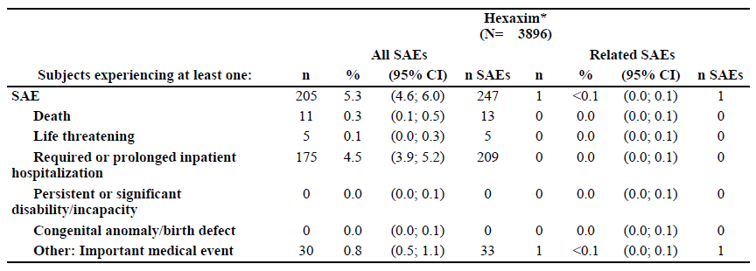

Discontinuation due to adverse events

Hexaxim immunogenicity studies
The % of discontinued subjects who received Hexaxim in any individual primary series study was between 0.0% and 6.6%, except for study A3L11, where it was between 8.2 and 13.3%. For all but 2 subjects, the reasons for withdrawal in study A3L11 were voluntary withdrawals not due to an AE, lost to follow-up, or non-compliance with the protocol (e.g., treatment out-of window). The % of discontinued subjects from any individual booster study was between 0.0% and 1.6%, except study A3L22, where it was 6.2% for subjects who had been primed with Hexaxim and 8.1% for subjects who had been primed with a control vaccine. All of these discontinuations were due to lost to follow-up. Discontinuations due to AE in Hexaxim and comparator vaccine groups (overall rates) were very low indeed.

Laboratory tests

Liver function
Hexaxim immunogenicity studies: Safety labs consisting of full blood count, liver function (AST and ALT) and renal function measured with creatinine, assessed at baseline and Days 30-37 post vaccination only in the Phase 1 study A3L01. There were no findings considered to be of clinical relevance.

Kidney function
Hexaxim immunogenicity studies: There were no findings considered to be of clinical relevance. See under 8.5.1.

Haematology
Hexaxim immunogenicity studies: There were no findings considered to be of clinical relevance. See under 8.5.1.

Electrocardiograph
Hexaxim immunogenicity studies: Not assessed.

Vital signs
Hexaxim immunogenicity studies: Only temperature was assessed – see under Solicited systemic AEs above.

Post-marketing experience
No post marketing data is available.

Safety issues with the potential for major regulatory impact

Liver toxicity
Not assessed and none expected from this vaccine.

Haematological toxicity
Not assessed and none expected from this vaccine.

Serious skin reactions
None identified.

Cardiovascular safety
Not assessed and none expected from this vaccine.

Unwanted immunological events
None identified.

Other safety issues

Safety in special populations
The only population this vaccine was tested in was infants and toddlers. No gender difference in terms of safety in primary series or as a booster - regardless of the vaccine received in the primary series. Results for each safety parameter were reported at similar observed frequencies. The effect of ethnicity on safety was analysed as a potential covariate in the integrated analysis of Hexaxim. While differences are observed among ethnicities, these did not have an overall effect on the safety profile.

Safety related to drug-drug interactions and other interactions

Safety and number if hepatitis B doses received
The safety of Hexaxim was analysed according to the numbers of hep B vaccine doses received (3, 4, or 5 doses), which depended on whether subjects had been Hep B vaccinated with at birth, and/or received a booster with a Hep B-containing vaccine.
Integrated Analysis: Overall, the safety profile after any primary dose of Hexaxim when a subject has received 3 or 4 doses of Hep B vaccine are similar in frequency of reported solicited reactions, but the frequency of unsolicited non-serious AEs (including unsolicited non-serious ARs) reported was lower when the subject has received 3 doses of Hep B vaccine compared to 4 doses (58.4% and 83.6%, respectively). This appears to be driven by much lower frequency of several AES several of which are unlikely to be related to vaccine receipt i.e. nasopharyngitis (23.0% and 40.0%), diarrhoea (4.4% and 24.6%), abdominal pain (2.9% and 12.0%), nasal congestion (1.4% and 6.9%), bronchospasm (0.6% and 15.8%), rhinitis allergic (0.1% and 7.4%), injection site haemorrhage (0.6% and 3.3%), and dermatitis diaper (2.3% and 14.4%) when subjects received 3 doses of Hep B vaccine compared to 4 doses of Hep B vaccine, respectively. Grade 3 unsolicited AEs, have a similar frequency when the subject received 3 doses of Hep B vaccine vs. 4 doses of Hep B vaccine (2.3% and 1.0%, respectively).
The difference in unsolicited non-serious ARs when the subject received only 3 doses of Hep B vaccine vs. 4 doses (3.5% and 12.8%) is mostly driven by injection site ARs, specifically injection site nodules (0% and 7.9%, respectively) and injection site haemorrhage (0.6% and 3.3%, respectively). No differences in the frequency of SAEs and deaths were observed between subjects who received 3 or 4 doses of Hep B.
Studies not Included in the IAP-S: In study A3L24 (4 doses of Hep B), the safety profile of Hexaxim was comparable to the safety profile of Hexaxim obtained in the studies in the IAP-S with 3 doses of Hep B vax. The safety profiles in the subpopulations were similar, except unsolicited non-serious AEs, were reported at a lower frequency by subjects who received 4 doses of Hep B vaccine (20.4%) than by those who received 5 doses (34.6%). This was mostly driven by URTI (4.0% and 10.0%, respectively) and cough (4.0% and 8.5%, respectively). Again, it is unlikely that the differences observed are related to one additional dose of Hep B vaccine. Frequency of unsolicited non-serious ARs were similar and low, 1.3% in the 4 dose and 0.8% in the 5 dose groups. Unsolicited non-serious ARs reported when the subject received 4 doses of Hep B vaccine or 5 doses of Hep B vaccine was mostly driven by injection site haematoma (0.7% and 0.8%, respectively).
Overall, the frequency of unsolicited non-serious AEs, and unsolicited non-serious ARs were lower when subjects received 4 or 5 doses as a booster than 3 or 4 doses in the primary series. A higher percentage of SAEs, not related to the vaccine, was observed in the subjects receiving 5 doses of Hep B than in subjects receiving 4 doses (4.6% [6/130 subjects] vs. 0.9% [10/1113 subjects]); the majority occurred during the 6 months follow-up period. No deaths were observed in the groups of subjects receiving 4 or 5 doses of Hep B.

Prevenar concomitant vaccinations
A3L12 Study: Overall, the safety profile of Hexaxim+PCV7 vs. Hexaxim was similar i.e. rates of solicited reactions and unsolicited AEs similar in both groups. Unsolicited ARs were reported for 2.4% of subjects who received Hexaxim+Prevenar compared to 6.3% of those who received Hexaxim alone; this was mostly driven by a difference in rates of unsolicited nonserious injection site ARs (1.0% and 5.9%, respectively). The data show that these unsolicited ARs mostly occurred in the SOC of “General disorder and administration site conditions”, and were mostly injection site nodule (0% and 2.4%, respectively) and injection site haematoma (0.5% and 1.8%, respectively). The observed differences are not clinically relevant and do not alter the safety profile of Hexaxim co-administered with Prevenar when compared to Hexaxim alone.

PCV7 and Rotarix concomitant vaccinations
Study A3L24: Hexaxim and Infanrix Hexa were similar in terms of safety profile, when co-administered with PCV7 and Rotarix: they showed comparable incidences of solicited reactions (ISR and systemic reactions), unsolicited events, and unsolicited reactions (ISR and systemic reactions), as previously described in Section 2. In conclusion, when co-administered with PCV7 and Rotarix, the safety profile of Hexaxim was good and similar to Infanrix Hexa. No unexpected safety issues were identified with co-administration of these vaccines.

Safety of Hexaxim booster with MMR and V vaccines vs. Hexaxim alone
Overall, the safety profiles for Hexaxim+MMRV vs. Hexaxim were similar, with the exception of rates of unsolicited AEs, which were reported for 31.7% of subjects who received Hexaxim+MMRV compared to 18.2% of subjects who received Hexaxim alone. The data show that these unsolicited AEs were mostly driven by a difference in the frequency of AEs in the SOC of “Infections and infestations” (URTI, with rates of 8.4% and 2.8% of subjects who received Hexaxim+MMRV or Hexaxim, respectively), respiratory, thoracic and mediastinal disorders (cough, with rates of 7.5% and 3.2%, respectively), and gastrointestinal disorders (diarrhoea, with rates of 4.6% and 1.4%; and vomiting, with rates of 2.6% and 0.9%, respectively). The observed differences are not clinically relevant and do not alter the safety profile of Hexaxim co-administered with MMRV when compared to Hexaxim alone.

Evaluator’s overall conclusions on clinical safety
Thirteen clinical studies conducted in Latin America, Africa and Eastern Europe (Turkey) provide key information on safety of Hexaxim by gender, different ethnicities, in very young infants, with the earliest administration at 6 weeks of age, boosting of toddlers, in those with hep B vaccination at birth, coadministration with other childhood vaccines i.e. PCV7 & rotavirus (in primary series), MMR and varicella vaccines in booster. In total, 4927 subjects have received at least one Hexaxim dose during primary series or as a booster.
The data presented in Section 8 clearly demonstrate Hexaxim, as a safe (and effective) hexavalent vaccine for primary series use in infants and/or boosting in toddlers. Overall the vaccine was very tolerated, with very few SAEs and no SUSARs.
Injection site reactions were almost universal (83%) in recipients and rates were slightly higher than those with Pentaxim+Engerix B (75%); the reactions were generally mild-moderate, occurred soon after vaccination and were short lived. However, Grade 3 solicited injection site reactions were reported at a higher frequency for those who received Hexaxim (28.0%) than those who received Pentaxim+Engerix B (15.1%). The frequency of reported solicited injection site reactions at each post-injection decreased from the previous injection in other words there was no incremental increase in solicited local reactions with each successive dose.
Solicited systemic reactions also occurred in the majority, around 85%, as expected, and although these were mostly mild-moderate a higher percentage of Hexaxim recipients had Grade 3 solicited systemic reactions (39%) than those who received Pentaxim+Engerix B (29%). Pyrexia was the most common solicited systemic reaction, again the majority were mild-moderate in intensity and short-lived post vaccination.
There were no safety concerns when infants previously given hepatitis B vaccine were exposed to a primary series of Hexaxim plus a subsequent Hexaxim boost, representing 5 doses of hepatitis B vaccine exposure within an approximate 18 month period. This is an important finding as the current Australian NIP recommends 4 hepatitis B vaccines in year 1. The co-administration of the other vaccines that are part of the Australian NIP in year 1 and 2 of life i.e. pneumococcal conjugate (note only the 7-valent form was assessed here, whereas the 13-valent conjugate is recommended as part of the NIP) and Rotarix in year 1 and MMRV in year 2 were not associated with any safety concerns or negative impact on immunogenicity of vaccine components.

First round benefit-risk assessment

First round assessment of benefits
The benefits of Hexaxim in the proposed usage are:
- Single use, ready-to use vaccine that is immunogenic and safe for all the antigens it contains;
- The antigens contained within Hexaxim represent 6 of the primary series antigens that children are recommended to receive (Australian NIP, 2013) as part of their year 1 vaccines.

First round assessment of risks
The risks of Hexaxim in the proposed usage are:
- This dossier of studies provides only immunological response data (and safety) induced by Hexaxim and the comparator vaccine(s), i.e. these are surrogate markers of clinical protection. No actual clinical efficacy data is provided in this submission. The correlates of protection have not been established for pertussis antigens (see Section 7.4 for a discussion on the data that exist with all of the caveats). This submission provided limited published support for efficacy of the acellular pertussis (PT, FHA) component of Hexaxim to control disease caused by B. pertussis;
- No data provided for the use of Hexaxim with the currently recommended pneumococcal conjugate vaccines which is the 13-valent form;
- The Australia NIP does not recommend boosting at 18 months with all the antigens contained in Hexaxim. It only recommends a Hib booster at month 12 and a DTPa-IPV booster at 4 years of age. No hepatitis B booster is recommended after the “at birth” followed by 3 vaccinations as part of the primary series in year 1 (total n=4). Therefore, Hexaxim as a booster at 18 months does not align with the present Australian NIP. There are reasonable arguments too, that 3 hepatitis B vaccinations are protective in the majority of infants so as a 4th vaccination is already part of the Australian NIP it seems hard to justify giving a 5th dose as a matter of course. Moreover, it could be argued as to whether a 4th dose is even needed as the very high rates of response to even a 4th vaccination attest to the fact that there appears to be protective immunity following 3 hep B vax doses even in those with surface antibody levels <10 mIU/mL;
Whilst the booster studies in this application do not appear associated with harm in the just over 1500 subjects tested in these studies, nevertheless, it is an important discussion point as to the appropriateness of toddlers receiving a booster vaccine with all 6 of these antigens when they don’t “need” two of them i.e. hepatitis B and Hib (already received the booster at month 12 as per the Australia NIP) for protective immunity;
- There is no data provided in premature infants of low birth weight <2.5Kg as these were exclusions for participation;
- There is no data on the immunogenicity or safety of Hexaxim in immunocompromised infants and toddlers, as again these subjects were specifically excluded from the studies.

First round assessment of benefit-risk balance
The benefit-risk balance of Hexaxim, given the proposed usage, is favourable.

First round recommendation regarding authorisation
Hexaxim is a reasonable alternative to Infanrix Hexa for first series vaccinations, but its role in boosting is unclear. While this hexavalent vaccine is clearly safe and immunogenic as a booster, its use in this way would not be in alignment with the current recommendations in the Australian NIP.
The issue regarding pertussis protection is not considered to be unique to Hexaxim: it applies equally to other already registered combination vaccines that contain aP and as such it does not alter the recommendation regarding authorisation of this product.

Clinical questions

Pharmacodynamics (immunogenicity)
What are the Sponsor’s plans to assess safety and immunogenicity of Hexaxim when co-administered with PCV13? Are there any plans to look at immunogenicity and safety when co-administered with meningococcal vaccines?

Product Information: Indication
The Australian PI should not state that Hexaxim is indicated for boosting. This would definitely not align with the current Australia NIP. The PI should be amended to reflect that while boosting with Hexaxim appears safe and effective, the use of a hexavalent vaccine such as Hexaxim is not recommended for boosting at 18 months or even 4 years of age (no data in this age group, plus not recommended that a hexavalent boost is received here) in the current Australian NIP guidelines.
[AusPAR note: other recommendations and comments regarding the PI are not included in this Extract from the Clinical Evaluation Report]

Second round evaluation of clinical data submitted in response to questions
Not required

References
- Andre FE, Zuckerman AJ. Review: protective efficacy of hep B vaccines in neonates. J Med Virol. 1994; 44:144-51;
- Bonmarin I, Levy-Bruhl D, Baron S, Guiso N, Njamkepo E, Caro V, et al. Pertussis surveillance in French hospitals: results from a 10 year period. Euro Surveill 2007;12 (1– 3):34–38;
- Carlsson RM, Trollfors B. Control of pertussis-lessons learnt from a 10-year surveillance programme in Sweden. Vaccine. 2009;27(42):5709-18;
- Carlsson RM, Claesson BA, Fagerlund E, Knutsson N, Lundin C. Antibody persistence in five-year-old children who received a pentavalent combination vaccine in infancy. Pediatr. Infect. Dis. J. 21(6), 535–541 (2002).
- Chong H, Brady K, Metze D, Calonje E. Persistent nodules at injection sites (aluminium granuloma)-clinicopathological study of 14 cases with a diverse range of histological reaction patterns. Histopathology 2006;48(2):182-88;
- Clements CJ, Griffiths E. The global impact of vaccines containing aluminium adjuvants. Vaccine 2002;20(Suppl 3):S24-33;
- Diez-Delgado J, Dal-Re R, Llorente M, Gonzalez A, Lopez J. Hep B component does not interfere with the immune response to diphtheria, tetanus, and whole-cell Bordetella pertussis components of a quadrivalent (DTwP-HB) vaccine: a controlled trial in healthy infants. Vaccine 1997; 15:1418-1422;
- Duval B, Boulianne N, De Serres G, Laflamme N, De Wals P, Massé R, et al. Comparative immunogenicity under field conditions of two recombinant hep B vaccines in 8-10-yearold children. Vaccine. 2000;18:1467-72;
- Hallander HO, Gustafsson L. Efficacy and effectiveness of acellular pertussis vaccines: a 20-year Swedish experience. Expert Rev Vaccines. 2009 Oct;8(10):1303-7;
- Mast E, Mahoney F, Kane M,et al. Hep B Vaccine. In: Plotkin SA, Orenstein WA, with assistance of PA Offit, Elsevier Inc. Vaccines. 4th Edition. USA. 2004;p. 299-337;
- Plotkin SA, Orenstein WA and Offit PA, eds. Vaccine 6th ed. Philadelphia, PA, Saunder Elsevier, 2008;
- Rendi-Wagner P, Kundi M, Mikolasek A, Vécsei A, Frühwirth M, Kollaritsch H. Hospitalbased active surveillance of childhood pertussis in Austria from 1996 to 2003: estimates of incidence and vaccine effectiveness of whole-cell and acellular vaccine. Vaccine. 2006 Aug 14;24(33-34):5960-5;
- Rustgi VK, Schleupner CJ, Krause DS. Comparative study of the immunogenicity and safety of Engerix-B administered at 0, 1, 2 and 12 months and Recombivax HB administered at 0, 1, and 6 months in healthy adults. Vaccine. 1995;13(17):1665-68;
- Simondon F, Preziosi MP, Yam A, Kane CT, Chabirand L, Iteman I, et al. A randomised double-blind trial comparing a two-component acellular to a whole-cell pertussis vaccine in Senegal. Vaccine. 1997 Oct;15(15):1606-12;
- Stanley A Plotkin, Johannes Liese, Shabir A Madhi and Esteban Ortiz. A DTaP–IPV//PRP-T vaccine (Pentaxim): a review of 16 years’ clinical experience. Expert Review of Vaccines. July 2011, Vol. 10, No. 7, Pages 981-1005;
- The European Medicines Agency. Committee for Proprietary Medicinal Products. Note for guidance on preclinical pharmacological and toxicological testing of vaccines. CPMP/SWP/465/95. London, 17 December 1997;
- Tichmann I, Preidel H, Grunert D, Habash S, Schult R, Maier R, et al. Comparison of the immunogenicity and reactogenicity of two commercially available hexavalent vaccines administered as a primary vaccination course at 2, 4, and 6 months of age. Vaccine. 2005;23: 3272-79;
- Tindberg Y, Blennow M, Granström M. A ten year follow-up after immunisation with a two component acellular pertussis vaccine. Pediatr Infect Dis J. 1999 Apr;18(4):361-5; US Department of Health and Human Services, Food and Drug Administration. Guidance for Industry: Toxicity Grading Scale for Healthy Adult and Adolescent Volunteers Enrolled in Preventive Vaccine Clinical Trials. September 2007;
- U.S. Food and Drug Administration - Approved Products - Letter - Study-097-Hiberix;
- Verdier F, Burnett R, Michelet-Habchi C, Moretto P, Fievet-Groyne F, Sauzeat E. Aluminium assay and evaluation of the local reaction at several time points after intramuscular administration of aluminium containing vaccines in the Cynomolgus monkey. Vaccine 2005;23(11):1359-67;
- West DJ, Hesley TM, Jonas LC, Feeley LK, Bird SR, Burke P, et al. Safety and immunogenicity of a bivalent Haemophilus influenzae type b/hep B vaccine in healthy infants. Pediatr Infect Dis J. 1997;16:593-9;
- World Health Organization. Guidelines on Nonclinical Evaluation of Vaccines. WHO Technical Report Series No. 927: Annex 1, 2005. p31-63;

Therapeutic Goods Administration
PO Box 100 Woden ACT 2606 Australia
Email: info@tga.gov.au Phone: 1800 020 653 Fax: 02 6232 8605
http://www.tga.gov.au

From The Australian Immunisation Handbook 10th Edition 2013

