March 2020

Australian Public Assessment Report for Doravirine and doravirine/lamivudine/tenofovir disoproxil fumarate
  - Proprietary Product Name: Pifeltro and Delstrigo
  - Sponsor: Merck Sharp & Dohme (Australia) Pty Ltd

About the Therapeutic Goods Administration (TGA)
- The Therapeutic Goods Administration (TGA) is part of the Australian Government Department of Health and is responsible for regulating medicines and medical devices.
- The TGA administers the Therapeutic Goods Act 1989 (the Act), applying a risk management approach designed to ensure therapeutic goods supplied in Australia meet acceptable standards of quality, safety and efficacy (performance) when necessary.
- The work of the TGA is based on applying scientific and clinical expertise to decision-making, to ensure that the benefits to consumers outweigh any risks associated with the use of medicines and medical devices.
- The TGA relies on the public, healthcare professionals and industry to report problems with medicines or medical devices. TGA investigates reports received by it to determine any necessary regulatory action.
- To report a problem with a medicine or medical device, please see the information on the TGA website <https://www.tga.gov.au>.

About AusPARs
- An Australian Public Assessment Report (AusPAR) provides information about the evaluation of a prescription medicine and the considerations that led the TGA to approve or not approve a prescription medicine submission.
- AusPARs are prepared and published by the TGA.
- An AusPAR is prepared for submissions that relate to new chemical entities, generic medicines, major variations and extensions of indications.
- An AusPAR is a static document; it provides information that relates to a submission at a particular point in time.
- A new AusPAR will be developed to reflect changes to indications and/or major variations to a prescription medicine subject to evaluation by the TGA.

Copyright
© Commonwealth of Australia 2020
This work is copyright. You may reproduce the whole or part of this work in unaltered form for your own personal use or, if you are part of an organisation, for internal use within your organisation, but only if you or your organisation do not use the reproduction for any commercial purpose and retain this copyright notice and all disclaimer notices as part of that reproduction. Apart from rights to use as permitted by the Copyright Act 1968 or allowed by this copyright notice, all other rights are reserved and you are not allowed to reproduce the whole or any part of this work in any way (electronic or otherwise) without first being given specific written permission from the Commonwealth to do so. Requests and inquiries concerning reproduction and rights are to be sent to the TGA Copyright Officer, Therapeutic Goods Administration, PO Box 100, Woden ACT 2606 or emailed to <tga.copyright@tga.gov.au>.

Contents
Common abbreviations 4
I. Introduction to product submission 8
Submission details 8
Product background 10
Regulatory status 11
Product Information 13
II. Registration timeline 13
III. Submission overview and risk/benefit assessment 14
Quality 14
Nonclinical 15
Clinical 16
Risk management plan 36
Risk-benefit analysis 38
Outcome 42
Attachments 1 and 2. Product Information 43

Common abbreviations
Abbreviation | Meaning
3TC | Lamivudine
ABC | Abacavir
ACM | Advisory Committee on Medicines
AE | Adverse event
AIDS | Acquired immune deficiency syndrome
ALT | Alanine aminotransferase
ART | Antiretroviral therapy
ARTG | Australian Register of Therapeutic Goods
ASA | Australian Specific Annex
AST | Aspartate aminotransferase
AUC | Area under to concentration time curve
BCRP | Breast cancer resistance protein
BE | Bioequivalence
BMD | Bone mineral density
C₂₄ | Plasma concentration at 24 hours
cART | Combination antiretroviral therapy
CHMP | Committee for Medicinal Products for Human Use (EU)
CI | Confidence interval
C_{max} | Maximum plasma concentration
CMI | Consumer Medicine Information
CYP | Cytochrome P450
DDI | Drug drug interaction
DHHS | Department of Health and Human Services (USA)
DILI | Drug-induced liver injury
DLP | Data lock point
DOR | Doravirine (drug development name; MK-1439)
DRV | Darunavir
DRV/r | Darunavir boosted with ritonavir
EC₅₀ | Half maximal effective concentration
EE | Ethinylestradiol
EFV | Efavirenz
eGFR | Estimated glomerular filtration rate
ELB | Elbasvir
EMA | European Medicines Agency (EU)
E-R | Exposure-Response
ESRD | End stage renal disease
EU | European Union
EU-RMP | European Union-risk management plan
EVR | Efavirenz
FDA | Food and Drug Administration (USA)
FDC | Fixed dose combination
FMI | Final market image
FTC | Emtricitabine
GM | Geometric mean
GMP | Good Manufacturing Practice
GMR | Geometric mean ratio
GRZ | Grazoprevir
GVP | Good Pharmacovigilance Practices
HDL-C | High-density lipoprotein cholesterol
HIV | Human immunodeficiency virus
HIV-1 | Human immunodeficiency virus type 1
IC₅₀ | Half maximal inhibitory concentration
IM | Intramuscular
INSTI | Integrase strand transfer inhibitors
IV | Intravenous
LDL-C | Low-density lipoprotein cholesterol
LDP | Ledipasvir
LNG | Levonorgestrel
M9 | Doravirine metabolite 9
MK-1439 | Doravirine drug development name
MSP | Main Safety Pool
N/A | Not applicable
NNRTI | Non-nucleoside reverse transcriptase inhibitor
NRTI | Nucleoside reverse transcriptase inhibitor
OAT3 | Organic anion transporter 3
OATP | Organic-anion-transporting polypeptide
OF | Observed failure
PD | Pharmacodynamic
PDVF | Protocol defined virologic failure
PI | Product Information
PK | Pharmacokinetic
PSUR | Periodic safety update report
QD | Once daily (Latin: quaque die)
RMP | Risk management plan
rMSE | Root mean square error
RNA | Ribonucleic acid
SAE | Serious adverse event
SAP | Statistical analysis plan
SSP | Special Safety Pool
t_{1/2} | Biological half life
TDF | Tenofovir disoproxil fumarate
T_{max} | Time of maximum plasma concentration
ULN | Upper limit of normal
US(A) | United States (of America)
Vz/F | Terminal elimination
WT | Wild type

I. Introduction to product submission

Submission details

Pifeltro (SubmissionPM-2017-04580-1-2)
Type of submission: | New chemical entity
Decision: | Approved
Date of decision: | 18 January 2019
Date of entry onto ARTG: | 4 February 2019
ARTG number: | 297701
Black Triangle Scheme | Yes  This product will remain in the scheme for 5 years, starting on the date the product is first supplied in Australia.
Active ingredient: | Doravirine
Product name: | Pifeltro
Sponsor’s name and address: | Merck Sharp & Dohme (Australia) Pty Limited  Level 1, Building A, 26 Talavera Road,  Macquarie Park NSW 2113
Dose form: | Film coated tablet
Strength: | 100 mg
Container: | Bottle
Pack size: | 30
Approved therapeutic use: | Pifeltro is indicated, in combination with other antiretroviral medicinal products, for the treatment of HIV-1 infection in adults who are antiretroviral therapy (ART) naïve with no known substitutions associated with resistance to doravirine.
Route of administration: | Oral
Dosage: | Adult patients  The recommended dosage regimen of Pifeltro in adults is one 100 mg tablet taken orally once daily with or without food.  For further information refer to the Product Information.

Delstrigo (Submission PM-2017-04581-1-2)
Type of submission: | New fixed dose combination
Decision: | Approved
Date of decision: | 18 January 2019
Date of entry onto ARTG: | 4 February 2019
ARTG number: | 297702
Black Triangle Scheme | Yes  This product will remain in the scheme for 5 years, starting on the date the product is first supplied in Australia.
Active ingredients: | Doravirine/lamivudine/tenofovir disoproxil fumarate
Product name: | Delstrigo
Sponsor’s name and address: | Merck Sharp & Dohme (Australia) Pty Limited  Level 1, Building A, 26 Talavera Road,  Macquarie Park NSW 2113
Dose form: | Film coated tablet
Strengths: | Fixed dose combination doravirine 100 mg, lamivudine 300 mg and tenofovir disoproxil fumarate 300 mg
Container: | Bottle
Pack size: | 30
Approved therapeutic use: | Delstrigo is indicated for the treatment of HIV-1 infection in adults who are antiretroviral therapy (ART)-naïve with no known substitutions associated with resistance to doravirine, lamivudine, or tenofovir.
Route of administration: | Oral
Dosage: | Adult patients  The recommended dosage regimen of Delstrigo in adults is one tablet taken orally once daily with or without food.  For further information refer to the Product Information.

Product background
This AusPAR describes the application by Merck Sharp & Dohme (Australia) Pty Ltd (the sponsor) to register the new chemical entity Pifeltro (doravirine) 100 mg film coated tablets for the following proposed indication:
Pifeltro is indicated, in combination with other antiretroviral medicinal products, for the treatment of adults infected with HIV-1 without past or present evidence of viral resistance to doravirine.
The sponsor also sought to register Delstrigo (doravirine/lamivudine/tenofovir disoproxil fumarate) 100/300/300 mg fixed dose combination (FDC) film coated tablets for the following proposed indication:
Delstrigo is indicated for the treatment of adults infected with HIV-1 without past or present evidence of viral resistance to doravirine, lamivudine, or tenofovir.
In 2016, an estimated 26,444 people were living with human immunodeficiency virus (HIV) in Australia, with the number of new HIV diagnoses in Australia remaining stable over the past five years. There were 1013 new diagnoses in 2016. HIV prevalence was 0.13% in Australia in 2016. HIV infection is predominately concentrated among gay and bisexual men.
The prevention of HIV in Australia is primarily focused on a ‘test, treat and prevent’ model. Transmission in people who inject drugs, sex workers and from mother-to-child has already been virtually eliminated. Central features of this strategy include ensuring people with newly diagnosed HIV are treated within 6 weeks of diagnosis and that the treatment of all people with HIV infection is sustained. The New South Wales HIV strategy 2016 to 2020 has set a target to have 95% of those diagnosed with HIV taking antiretroviral treatment by 2020.
If HIV is left untreated, the continuing damage to the immune system can result in a symptomatic chronic phase or acquired immune deficiency syndrome (AIDS), and opportunistic infections occur. AIDS is severe and life-threatening. Due to advances in treatment, HIV infection in Australia is a manageable, chronic condition and there are very few AIDS-related deaths in Australia. While HIV may be controlled with antiretroviral treatment (ART), studies have shown that people are at a higher risk of non-AIDS related illnesses.
Globally, there are more than 30 antiretroviral drugs currently available for the treatment of human immunodeficiency virus type 1(HIV-1) infection for use in combination antiretroviral therapy (cART). Treatment with cART, generally consisting of a combination of 3 antiretroviral drugs, has been shown to be effective in both reducing plasma HIV-1 ribonucleic acid (RNA) below the level of detection and restoring immune system function. The mechanism of action of these drugs involves the inhibition of specific stages of the HIV-1 lifecycle and they are characterised into six classes: nucleoside reverse transcriptase inhibitors (NRTIs), non-nucleoside reverse transcriptase inhibitors (NNRTIs), protease inhibitors, integrase strand-transfer inhibitors (INSTIs), fusion inhibitors, and co-receptor antagonists.
For antiretroviral-naïve patients, treatment generally consists of two NRTIs and a third antiretroviral drug from either of the following classes: INSTI, NNRTI or a protease inhibitor (with pharmacokinetic booster). The United States (US) Department of Health and Human Services (DHHS) Guidelines, with Australian commentary; is intended to guide antiretroviral treatment in Australia. The recommended regimens for antiretroviral-naïve patients, which are currently reimbursed in Australia, are INSTI or boosted protease inhibitor based regimens. For non antiretroviral-naïve patients, the Guidelines have a large section on what drugs not to use. Single, double or triple NNRTIs, with exceptions, are specifically mentioned. Overall, it suggests selection should consider virologic efficacy, toxicity, pill burden, dosing frequency, drug-drug interaction potential, resistance testing results, comorbid conditions and cost.
Submission PM-2017-04580-1-2 was seeking marketing approval for new chemical entity doravirine. Doravirine is a (non-competitive) NNRTI of HIV-1. Doravirine will be supplied as a single agent tablet (100 mg) for use in combination with other antiretroviral agents.
Submission PM-2017-04581-1-2 was seeking marketing approval for doravirine in FDC with a (competitive) NRTI backbone comprising lamivudine and tenofovir disoproxil fumarate.
Both submissions have common data and are considered together in this AusPAR.

Regulatory status
Pifeltro (doravirine) is considered a new chemical entity for Australian regulatory purposes.
At the time the TGA considered the Pifeltro application, a similar application had been approved the United States of America (USA) and Canada and was under consideration in the European Union (EU; positive opinion received 20 September 2018) and Switzerland, see Table 1.
Table 1: International regulatory status of Pifeltro as of November 2018
Region | Submission date | Status | Approved indications
USA (FDA) | 23 October 2017 | Approved 30 August 2018 | Pifeltro, a non-nucleoside reverse transcriptase inhibitor (NNRTI), is indicated in combination with other antiretroviral agents for the treatment of HIV-1 infection in adult patients with no prior antiretroviral treatment history.
Canada (Health Canada) | 15 November 2017 | Approved 11 October 2018 | Pifeltro (doravirine) is indicated, in combination with other antiretroviral medicinal products, for the treatment of adults infected with HIV-1 without past or present evidence of viral resistance to doravirine.
EU (EMA; Centralised Procedure) Rapporteur: Sweden; Co-Rapporteur: Netherlands | 3 November 2017 | Under consideration. Positive CHMP opinion received 20 September 2018 | Under consideration
Switzerland (Swissmedic) | 1 March 2018 | Under consideration | Under consideration
USA = United States of America; FDA = Food And Drug Administation; EU = European Union; EMA = European Medicines Agency; CHMP = Committee for Medicinal Products for Human Use
Delstrigo (doravirine/lamivudine/tenofovir disoproxil fumarate) is considered a new fixed dose combination for Australian regulatory purposes.
At the time the TGA considered the Delstrigo application, a similar application had been approved the USA and Canada and was under consideration in the EU (positive opinion received 20 September 2018) and Switzerland, see Table 2.
Table 2: International regulatory status of Delstrigo as of November 2018
Region | Submission date | Status | Approved indications
USA (FDA) | 23 October 2017 | Approved 30 August 2018 | Delstrigo is a three-drug combination of doravirine (a nonnucleoside reverse transcriptase inhibitor (NNRTI)), lamivudine, and tenofovir disoproxil fumarate (both nucleoside analogue reverse transcriptase inhibitors) and is indicated as a complete regimen for the treatment of HIV-1 infection in adult patients with no antiretroviral treatment history.
Canada (Health Canada) | 29 November 2017 | Approved 9 November 2018 | Delstrigo (doravirine/lamivudine/tenofovir disoproxil fumarate) is indicated as a complete regimen for the treatment of human immunodeficiency virus-1 (HIV-1) infection in adults without past or present evidence of viral resistance to doravirine, lamivudine, or tenofovir.
EU (EMA, Centralised Procedure); Rapporteur: Sweden; Co-Rapporteur: Netherlands | 3 November 2017 | Under consideration. Positive CHMP opinion received 20 September 2018. | Under consideration
Switzerland (Swissmedic) | 28 February 2018 | Under consideration | Under consideration
USA = United States of America; FDA = Food And Drug Administation; EU = European Union; EMA = European Medicines Agency; CHMP = Committee for Medicinal Products for Human Use

Product Information
The Product Information (PI) documents approved with the submissions described in this AusPAR can be found as Attachments 1 and 2. For the most recent PI documents, please refer to the TGA website at <https://www.tga.gov.au/product-information-pi>.

II. Registration timeline
The following tables capture the key steps and dates for the applications and which are detailed and discussed in this AusPAR.
Table 3: Timeline for Submission PM-2017-04580-1-2 (Pifeltro)
Description | Date
Submission dossier accepted and first round evaluation commenced | 31 January 2018
First round evaluation completed | 15 August 2018
Sponsor provides responses on questions raised in first round evaluation | 17 October 2018
Second round evaluation completed | 31 October 2018
Delegate’s Overall benefit-risk assessment and request for Advisory Committee advice | 6 November 2018
Sponsor’s pre-Advisory Committee response | 22 October 2018
Advisory Committee meeting | 6 December 2018
Registration decision (Outcome) | 18 January 2019
Completion of administrative activities and registration on the ARTG | 4 February 2019
Number of working days from submission dossier acceptance to registration decision* | 198
*Statutory timeframe for standard applications is 255 working days
Table 4: Timeline for Submission PM-2017-04581-1-2 (Delstrigo)
Description | Date
Submission dossier accepted and first round evaluation commenced | 31 January 2018
First round evaluation completed | 15 August 2018
Sponsor provides responses on questions raised in first round evaluation | 25 October 2018
Second round evaluation completed | 6 November 2018
Delegate’s Overall benefit-risk assessment and request for Advisory Committee advice | 6 November 2018
Sponsor’s pre-Advisory Committee response | 20 November 2018
Advisory Committee meeting | 6 December 2018
Registration decision (Outcome) | 18 January 2019
Completion of administrative activities and registration on the ARTG | 4 February 2019
Number of working days from submission dossier acceptance to registration decision* | 192
*Statutory timeframe for standard applications is 255 working days

III. Submission overview and risk/benefit assessment
The submission was summarised in the following Delegate’s overview and recommendations.

Quality
Doravirine is a low solubility, high permeability molecule (Biopharmaceutical Classification System Class II). The structure of doravirine is shown in Figure 1.
Figure 1: Structure of doravirine
The bioequivalence data are considered acceptable by the quality area. Drug substance/finished product specifications and Good Manufacturing Practice (GMP) clearances were satisfactorily resolved. There are no objections to the approval from a quality aspect.
Attention has been drawn to the dimensions of the proposed doravirine film-coated tablet (slightly over 1 g and 19 x 9.5 mm, oval shaped) and the doravirine/lamivudine/tenofovir disoproxil fumarate film-coated tablet (1.6 g and 21.59 x 11.30 mm, oval shaped) which are considered large for an oral tablet.

Nonclinical
The following points were summarised by the Delegate from the nonclinical evaluation:
- Doravirine is a highly specific, non-competitive, inhibitor of HIV-1 reverse transcriptase. It has no significant activity against other molecular targets at clinically relevant concentrations.
- In vitro, doravirine is metabolised by cytochrome P450 (CYP)3A. Incubation of doravirine with different recombinant human CYPs showed that only CYP3A4 and CYP3A5 were capable of catalysing the formation of the main doravirine metabolite 9 (M9) metabolite. CYP3A4 was approximately 20 fold more efficient in this reaction than CYP3A5 and as CYP3A4 is more abundant in human liver, doravirine can be considered to be primarily metabolised by CYP3A4 in humans. Doravirine is not expected to alter the exposure of co-administered drugs that are CYP450 substrates.
- Doravirine is a substrate, but not an inhibitor of P-glycoprotein. Doravirine is an inhibitor of breast cancer resistance protein (BCRP, efflux transporter), organic-anion-transporting polypeptide (OATP)1B1/OATP1B3 (hepatic uptake transporters) and organic anion transporter 3 (OAT3; renal uptake transporter). Doravirine is not a substrate of BCRP, OATP1B1, or OATP1B3.
- Doravirine inhibited wild type (WT) and some common mutants of HIV-1 reverse transcriptase with half maximal inhibitory concentration (IC₅₀) values of around 10 nM. Doravirine showed in vitro inhibition of HIV-1 isolates of all HIV-1 subtypes at clinically relevant concentrations, and showed no antagonism towards a variety of anti-HIV drugs including lamivudine and tenofovir.
- Doravirine and the currently available NNRTIs were evaluated for antiviral activity against a panel of 96 NNRTI-resistant clinical isolates of HIV-1. The overall pattern of isolates showing resistance or sensitivity was similar for doravirine, etravirine and rilpivirine but different for efavirenz. Nearly 65% isolates showed resistance (half maximal effective concentration (EC₅₀) > 10 x WT response) to efavirenz compared to 16 to 19% isolates that were resistant to doravirine, etravirine, or rilpivirine.
- The nonclinical dossier was high quality and compliant with the relevant regulatory guidelines. Nonclinical studies did not identify clinically relevant hazards, including general toxicity, carcinogenicity or reproductive toxicity. The highest systemic exposures to doravirine obtained in the toxicity studies were 5 to 7 times the human exposure at the recommended clinical dose.
- Lactating rats, given a daily oral dose of doravirine at 5 or 450 mg/kg, showed a high level of transfer (approximately 147% at low dose and 132% at high dose) of doravirine into milk at 2 hours after dosing.
- Doravirine is described by the sponsor as showing slight photosensitivity.
- No studies were submitted for the FDC. However, double or triple combinations of lamivudine or tenofovir with other anti-HIV agents of various classes including NNRTI and NRTI, but not lamivudine in combination with tenofovir, are already approved for similar indications in Australia. Since no target organ of toxicity was observed for doravirine in toxicity studies, toxicological interactions between doravirine and lamivudine/tenofovir disoproxil fumarate are not expected and the lack of toxicity studies for the triple combination is acceptable.
- Pregnancy classification B1; for doravirine and B3; for doravirine/lamivudine/tenofovir disoproxil fumarate is supported. Comments and recommendations for the PI have been provided by the toxicology area.
- There are no nonclinical objections to registration of doravirine or doravirine/lamivudine/tenofovir disoproxil fumarate.

Clinical
The clinical dossier consisted of 39 studies (see Table 5), of which 34 were Phase I studies including drug-drug interaction (DDI) studies (N = 678); one pharmacodynamic (PD) study (N = 18); one QT study (N = approximately 45); one Phase II study (N = 340); and 2 pivotal Phase III studies (N = 855).
Table 5: List of clinical studies
Study name | Study type | Study name | Study type
P001 | PK; DDI (midazolam); food effect | P029 | Food effect (FDC)
P002 | DDI (ritonavir) | P031 | PK (IM doravirine)
P003 | DDI (tenofovir disoproxil fumarate) | P034 | BE (nano formulation)
P005 | PD; proof-of-concept | P035 | DDI (rifabutin)
P006 | PK (high dose doravirine) | P036 | DDI (atorvastatin)
P007 | Phase II | P037 | Food effect (doravirine)
P008 | ¹⁴C-doravirine study | P038 | FDC components interaction
P009 | Gender and age effect | P039 | BE (doravirine film coated versus plain)
P010 | DDI (ketoconazole) | P042 | DDI (gastric acid modifiers)
P011 | DDI (rifampin) | P043 | BE (paeds formulation)
P012 | DDI (EE and LNG) | P044 | PK (IV doravirine)
P014 | BE (FDC formulations) | P045 | DDI (methadone)
P015 | BE (FDC formulation) | P046 | BE (nano formulations)
P016 | DDI (dolutegravir) | P048 | DDI (metformin)
P017 | QT study | P049 | BE (paediatric formulation)
P018 | Phase III | P050 | DDI (ELB/GRZ)
P019 | Hepatic (moderate) impairment | P051 | Renal (severe) impairment
P020 | EVR to doravirine switch | P052 | BE (paeds formulations)
P021 | Phase III | P053 | DDI (LDP/SOF)
P026 | BE (FDC) | P024,028,030 | Ongoing; not considered in this dossier.
BE = bioequivalence, DDI = drug drug interaction, FDC = fixed dose combinationEE = ethinylestradiol, ELB = elbasvir, EVR = efavirenz, GRZ = grazoprevir, IM = intramuscular, LDP = ledipasvir, LNG = levonorgestrel, PK = pharmacokinetics, SOF = sofosbuvir.
A summary of salient data is presented in this section.

Pharmacokinetics
Based on the radiolabelled oral doravirine study (Study P008), M9 was the major metabolite in human plasma from metabolism by CYP3A corresponding to 13% of the total radioactivity. The parent doravirine accounted for 75% of the radioactivity. The M9 metabolite is inactive. Doravirine is about 76% plasma protein bound. Based on Study P001, the increase in doravirine exposure was proportional in the 6 mg to 100 mg dose range and less than proportional in 100 to 240 mg dose range after single oral dose. The accumulation ratio was 1.2 to 1.4 after multiple dosing for 10 days at 30 to 240 mg dose range.
The absolute bioavailability of doravirine was estimated at 64% for the 100 mg final market image doravirine tablet based on separate data from Studies P039 and P044 using population PK analysis. The time of maximum plasma concentration (T_{max}) is 2 hours. Steady state is reached in 2 days. Terminal half-life is 15 days. The volume of distribution is 60.5 L based on intravenous (IV) dose (100 µg) study. The bioavailability is thought to be limited mainly due to solubility of doravirine.
The plasma clearance of doravirine in healthy volunteers was 3.73 L/h following the 100 µg IV dose. Doravirine is a low hepatic clearance drug. Based on the population PK analysis, apparent clearance is estimated at 6.34 L/h, consistent with the IV data after adjusting for oral bioavailability. The food effect (fed/fasted ratio; 90% confidence interval (CI)) with doravirine and doravirine/lamivudine/tenofovir disoproxil fumarate was as follows in Table 6.
Table 6: Food effect of doravirine and doravirine/lamivudine/tenofovir disoproxil fumarate
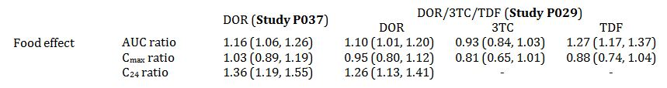
90% confidence intervals in brackets; 3TC = lamivudine, AUC = area under the drug-plasma concentration time curve, C₂₄ = plasma concentration at 24 hours, C_{max} = maximum plasma concentration, DOR = doravirine, TDF = tenofovir disoproxil fumarate.
Film coated tablet doravirine 100 mg is the intended marketing formulation but was not used in any clinical study including the pivotal Phase III efficacy trial Study P018. Bioequivalence of the film coated tablet version with the clinical trial uncoated oral compressed tablet version was demonstrated in Study P039. FMI (final market image) doravirine/lamivudine/tenofovir disoproxil fumarate (100/300/300 mg) is the intended marketing formulation and was also used in the pivotal Phase III efficacy Study P021 but not in any other study.
Pharmacokinetic (PK) parameters of doravirine, lamivudine and tenofovir disoproxil fumarate, on administration of the FDC doravirine/lamivudine/tenofovir disoproxil fumarate are similar to PK on administration of single entities (Study P026). In addition, clinically significant interactions of the 3 components have been ruled out in the component interaction Study P038. Hence, the established clinical profiles of tenofovir disoproxil fumarate and lamivudine are considered applicable to their use with doravirine as free agents or as fixed dose combination doravirine/lamivudine/tenofovir disoproxil fumarate. The 300 mg daily doses of lamivudine and tenofovir disoproxil fumarate in doravirine/lamivudine/tenofovir disoproxil fumarate are the currently recommended clinical doses of lamivudine and tenofovir disoproxil fumarate and were not specifically investigated further in association with doravirine.
Hepatic impairment: the sponsor reasons in favour of lack of clinically meaningful effect on PK of doravirine based on Study P019 in moderate hepatic impairment. No dose adjustment is proposed in mild to moderate hepatic impairment.
Table 7: Statistical comparison of plasma pharmacokinetics of doravirine following a single oral dose of 100 mg doravirine administered to subjects with moderate hepatic insufficiency and healthy matched control subjects
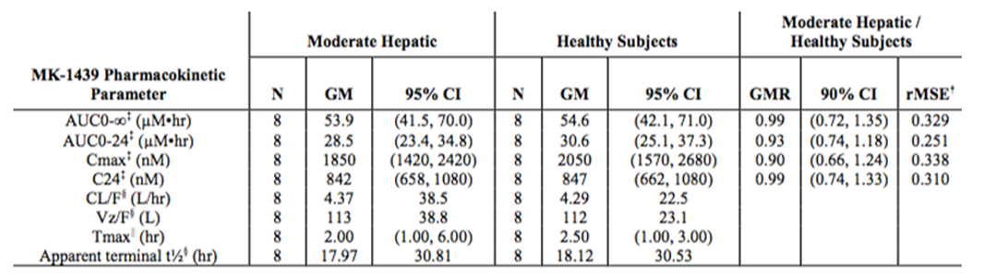
MK-1439 = doravirine (drug development name); CL/F = apparent clearance, GM = geometric mean, GMR = geometric mean ratio, rMSE = root mean square error, AUC_{0-∞} = area under the drug-plasma concentration time curve from time 0 (dosing) extrapolated to infinity; AUC₀₋₂₄ = area under the drug-plasma concentration time curve from time 0 (dosing) to 24 hours; C24 = plasma concentration at 24 hours, C_{max} = maximum plasma concentration; Tmax = time to maximum plasma concentration; t1/2 = biological half life, Vz/F = terminal elimination.
Renal impairment: the sponsor reasons in favour of lack of clinically meaningful effect on PK of doravirine in severe renal impairment based on Study P051. No dose adjustment is proposed in renal impairment.
Table 8: Statistical comparison and summary statistics of plasma doravirine pharmacokinetics following the administration of a single oral dose of 100 mg doravirine to subjects with severe renal impairment and healthy mean matched control subjects
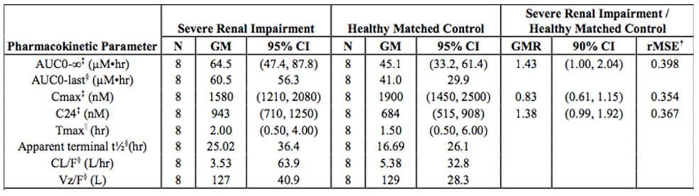
CL/F = apparent clearance, GM = geometric mean, GMR = geometric mean ratio, rMSE = root mean square error, AUC_{0-∞} = area under the drug-plasma concentration time curve from time 0 (dosing) extrapolated to infinity; AUC_{0-last} = area under the drug-plasma concentration time curve from time 0 (dosing) to last measurable concentration; C24 = plasma concentration at 24 hours, C_{max} = maximum plasma concentration; Tmax = time to maximum plasma concentration; t1/2 = biological half life, Vz/F = terminal elimination.
Doravirine has not been studied in end stage renal disease (ESRD) or patients on dialysis. In population PK analysis, increased doravirine exposures (> 20% for AUC₀₋₂₄ and > 60% for C₂₄) were estimated in elderly and in the presence of moderate renal impairment. As a precaution it was noted that data was limited and caution should be exercised when dosing these subpopulations.
The effect of various drugs on doravirine exposure in drug-drug interaction (DDI) studies is shown in Figure 2, below. Note the shaded area represents 0.6 to 3 fold interval compared to control, that is, 40% lower exposure than control to 3 times higher exposure than control. The 0.6 x lower bound represents doravirine steady-state level (560 nM) with 100 mg doravirine daily dose at the lowest decile below which decreased efficacy was observed in population PK analyses (exposure-response (E-R)modelling).
Figure 2: Effect of co-administered compounds on the pharmacokinetics of doravirine
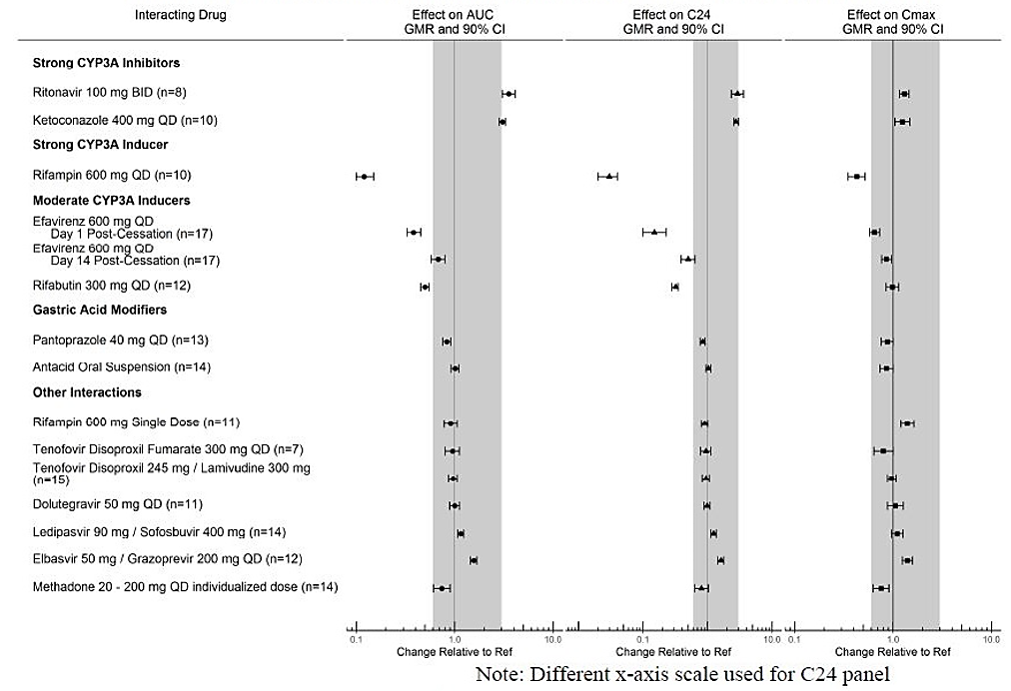
AUC GMR = Area under the drug-plasma concentration time curve geometric mean ratio; CI = confidence interval; C24 GMR = concentration at 24 hours geometric mean ratio; BID = twice daily; QD = once daily; CYP3A = cytochrome p450 enzyme 3A.
Doravirine is not expected to have clinically meaningful effect on the PK of drugs co-administered with it as demonstrated in a number of drug interaction studies as follows in Figure 3.
Figure 3: Effect of doravirine on the pharmacokinetics of co-administered drugs
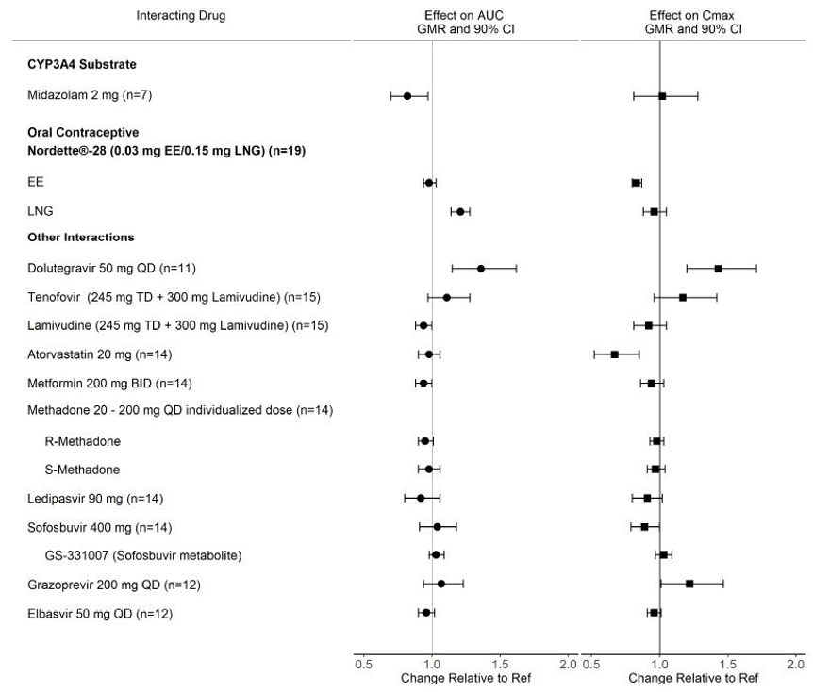
CYP3A = cytochrome p450 enzyme 3A; AUC GMR = Area under the drug-plasma concentration time curve geometric mean ratio; CI = confidence interval; C24 GMR = concentration at 24 hours geometric mean ratio; BID = twice daily; TD = three times daily; QD = once daily; EE = ethinylestradiol; LNG = levonorgestrel.
In population PK analyses, gender, race and ethnicity did not have a significant impact on the PK of doravirine. Concomitant administration of strong CYP3A inhibitors had a statistically significant effect on doravirine exposure in healthy subjects. However, the data were not adequate to detect a possible drug-drug interaction in HIV-1 infected subjects and evaluation of effect of moderate/strong CYP3A inhibitors on doravirine PK parameters were deemed inconclusive.

Pharmacodynamics
Study P005 examined 25 mg and 200 mg once daily doravirine versus placebo for 7 days in treatment naïve HIV-1 patients. The 25 mg dose was projected to achieve plasma trough levels (C₂₄) exceeding the target of > 6 fold the in vitro inhibition of WT virus (approximately 10 nM). The 200 mg dose was selected for safety and tolerability. The viral response after 7 days of treatment was as follows in Table 9.
Table 9: Summary of change from baseline in log₁₀ plasma HIV RNA (log₁₀ copies/mL) on Day 7 following the administration of once daily multiple doses of doravirine 25 mg, 200 mg and placebo for 7 days in HIV-1 infected subjects
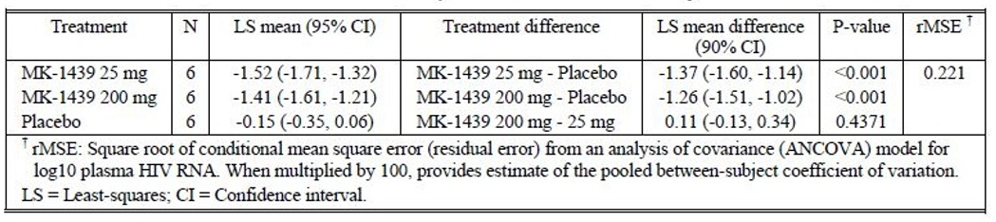
MK-1439 = doravirine (drug development name)
Post-Study P005, one serious adverse event (SAE) of increased alanine aminotransferase (ALT; approximately 20 x upper limit of normal (ULN)) and aspartate aminotransferase (AST; approximately 15 x ULN) was reported beginning 24 days after the first dose of doravirine (25 mg) in a patient with normal baseline enzymes. The patient recovered 29 days after the last dose.
QT study: A supra-therapeutic dose of doravirine did not have a clinically meaningful effect on cardiac conduction in the QT Study P017.⁵

Dose selection
The preceding Phase I PD Study P005 led to the dose ranging Phase II Study P007 in which 4 dose levels of doravirine (25, 50, 100 and 200 mg) versus efavirenz (600 mg), administered in combination with emtricitabine/tenofovir disoproxil fumarate, were examined in treatment naïve HIV-1 patients. The doravirine dose selection was at 24 weeks of treatment followed by continuation of treatment on the selected dose in all doravirine groups versus efavirenz, see Figure 4.
Figure 4: Study P007 design
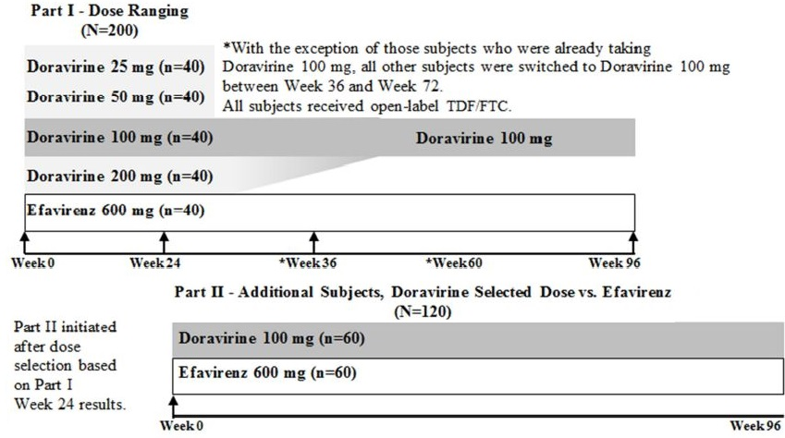
TDF = tenofovir disoproxil fumarate; FTC = emtricitabine;
The efficacy results (viral load < 50 copies per mL) at 24 weeks were as follows in Table 10.
Table 10: Study P007 proportion of subjects with HIV-1 RNA < 50 copies/mL at Week 24 (Full analysis set)
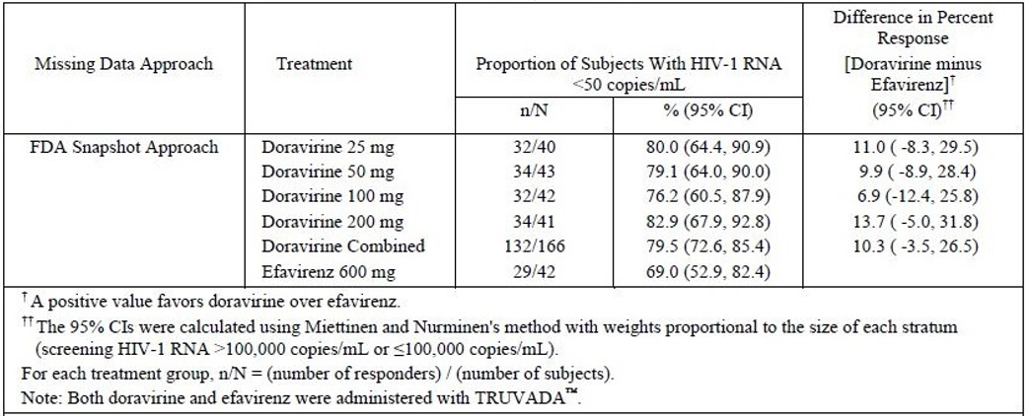
Note: Truvada = fixed dose combination of emtricitabine and tenofovir disoproxil fumarate
Numerically, the treatment differences (doravirine/emtricitabine/tenofovir disoproxil fumarate versus efavirenz/emtricitabine/tenofovir disoproxil fumarate) were indicative of a U-shaped response. Statistically, the dose-response was flat.
The decision was made to take forward the 100 mg daily doravirine dose for further treatment based on risk-benefit argument that it will provide adequate C₂₄ (trough) levels in the setting of common NNRTI resistance mutations against which doravirine was active in vitro. In addition, 100 mg dose was projected to provide adequate margins both on the up side and on the low side for CYP3A-related drug interactions without requiring dose adjustments.
Consequently, all doravirine groups were switched to doravirine 100 mg daily at 24 weeks in this trial and continued the treatment for a total of 96 weeks in comparison with efavirenz as follows in Figure 5.
Figure 5: Proportion of subjects with HIV-1 RNA < 50 copies/mL over time, non-completer = failure approach Part I/II combined (doravirine 4 doses versus efavirenz) (Full analysis set)
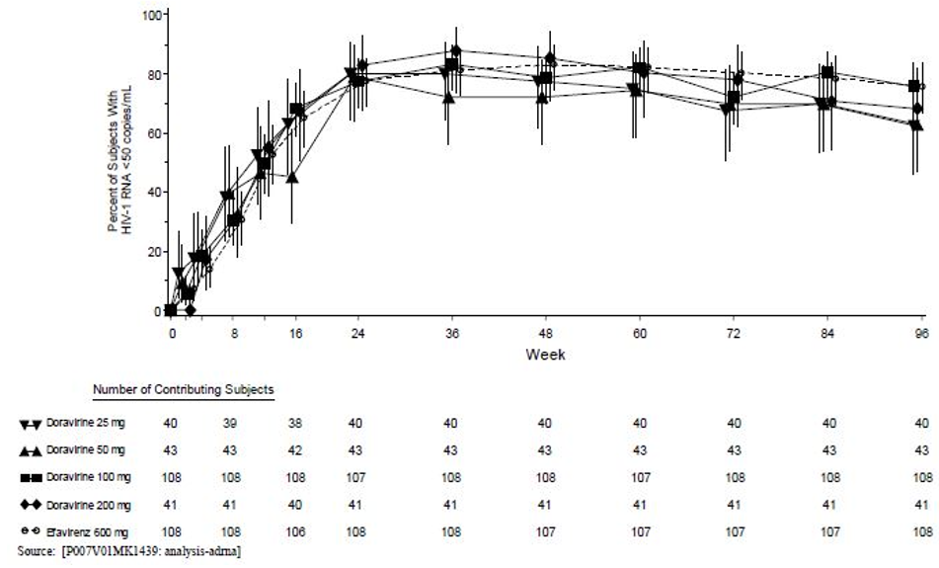
As a result, the 100 mg daily doravirine dose was also the only dose examined in the subsequent two confirmatory Phase III trials (Studies P081 and P021).

Clinical efficacy
Two, Phase III, pivotal clinical trials support the proposed use of doravirine and doravirine/lamivudine/tenofovir disoproxil fumarate (Studies P018 and P021). Thestudy design for both studies is shown in Table 11.
Table 11: Study design of Studies P018 and P021
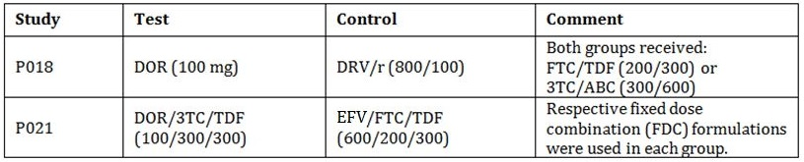
3TC = lamivudine, ABC = abacavir, DOR = doravirine, DRV/r = ritonavir boosted darunavir, EFV = efavirenz, FTC = emtricitabine, TDF = tenofovir disoproxil fumarate.
All study drugs required once daily dosing. Patient population was treatment-naïve adult HIV-1 patients in which the antiretroviral treatment was initiated for the first time. Both trials were randomised, double blind (matching placebos), active controlled, non-inferiority designs. The registration dossiers comprise 48 weeks data (ongoing to 96 weeks). Approaches to missing data were ‘snapshot’ (primary analysis) or observed failure (OF) as follows in Table 12.
Table 12: Summary of the approaches to missing data
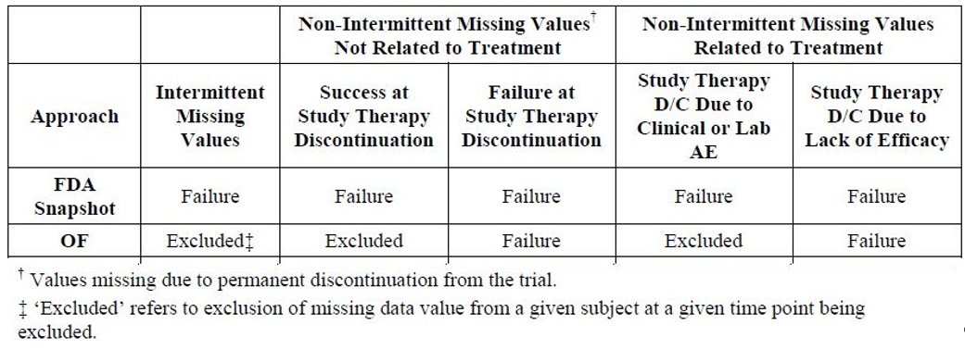
D/C = discontinued; AE = adverse event; FDA = Food and Drug Administration (USA).
Overall, the comparator groups were balanced at Baseline. The Week 48 results demonstrated non-inferiority of doravirine versus the respective controls in each trial with respect to viral load as follows in Table 13.
Table 13: Studies P018 and P021 efficacy analysis at Week 48
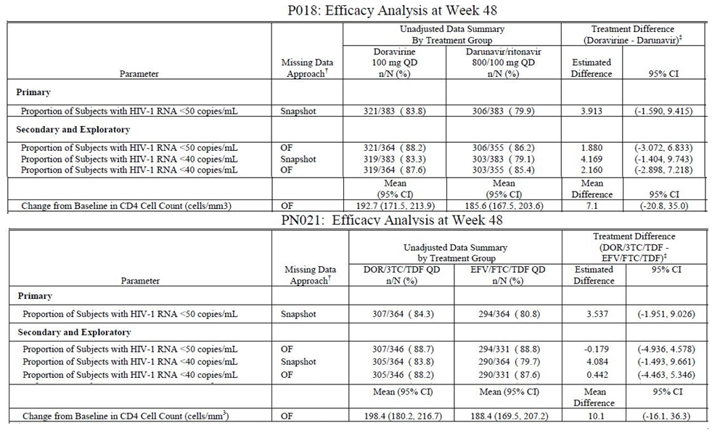
CI = confidence interval; QD = once daily; OF = observed failure; 3TC = lamivudine; DOR = doravirine;, EFV = efavirenz; FTC = emtricitabine; TDF = tenofovir disoproxil fumarate.
The viral response was generally homogenous across demographic and prognostic subgroups. Trends for lower efficacy were seen in patients with high baseline HIV-1 RNA (> 100,000) and low baseline CD4 cell count in all treatment groups. These trends were less pronounced in the doravirine group (pooled data) than the comparators as shown in below Table 14 (OF approach).
Table 14: Proportion of subjects with plasma HIV-1 RNA < 50 copies/mL at Week 48 by prognostic and demographic factors efficacy pool (Studies P018 and P012 combined); observed failure approach
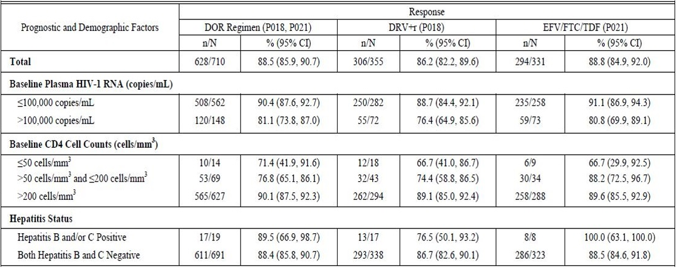
CI = confidence interval; DOR = doravirine; DRV/r = ritonavir boosted darunavir; EFV = efavirenz, FTC = emtricitabine, TDF = tenofovir disoproxil fumarate.
Virological Failures: In the Study P018, the protocol defined virologic failure (PDVF) rates were as follows in Table 15.
Table 15: Study P018 number of subjects with protocol defined virologic failure (Weeks 0 to 48)
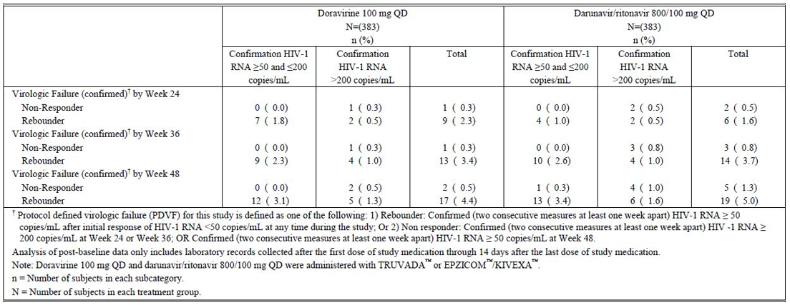
QD = once daily; Note: Truvada = emtricitabine + tenofovir disoprixil fumarate fixed dose combination; Epzicom/Kivexa are abacavir + lamivudine fixed dose combinations.
Virological Failures: In Study P021, the PDVF rates were as follows in Table 16.
Table 16: Study P021 number of subjects with protocol defined virologic failure (Weeks 0 to 48)
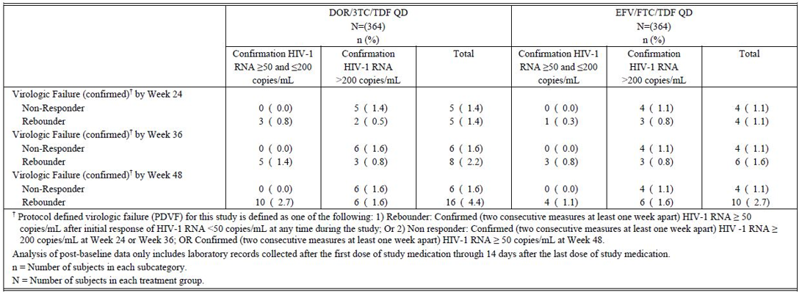
QD = once daily; 3TC = lamivudine, DOR = doravirine, EFV = efavirenz, FTC = emtricitabine, TDF = tenofovir disoproxil fumarate.
Post-hoc E-R analysis of data from Studies P018 and P021, concluded as follows:
- In exploratory E-R analyses for efficacy, relationships were generally flat over the range of exposures achieved at the 100 mg daily doravirine dose with a decrease in efficacy in subjects in the lowest tenth percentile of exposures. A lower, less distinct response was evident in subjects with higher screening viral load.
- In exploratory E-R analyses for safety, there was no association between doravirine exposures and occurrence of neuropsychiatric adverse events through Week 48 or with low-density lipoprotein cholesterol (LDL-C) at Week 48. The small predicted increase in non-high-density lipoprotein (HDL-C) with increasing doravirine exposures was deemed not clinically meaningful.

Resistance development
Among doravirine-treated patients in the 2 pivotal trials (n = 747), 11 subjects showed doravirine-associated treatment emergent resistance substitutions among the 28 subjects included in the resistance analysis (HIV-1 RNA > 400 copies/mL at virologic failure or early discontinuation and having resistance data). Seven of these 11 subjects had doravirine phenotypic resistance. The remaining 4 subjects had amino acid mixtures of NNRTI resistance substitutions. Of the 28 subjects in the resistance analysis, 8 subjects developed genotypic and/or phenotypic resistance to other antiretroviral drugs: abacavir, lamivudine, emtricitabine or tenofovir disoproxil fumarate.
In the darunavir boosted with ritonavir arm of Study P018 (n = 383), no subjects showed emergence of darunavir-associated resistance substitutions among the 9 subjects with resistance data and none had emergent resistance to lamivudine or tenofovir disoproxil fumarate.
In the efavirenz arm of Study P021 (n = 364), 12 subjects showed emergence of efavirenz-associated resistance substitutions among the 20 subjects in the resistance analysis and genotypic resistance to emtricitabine or tenofovir disoproxil fumarate developed in 5 evaluable subjects.
Treatment emergent doravirine-resistance associated substitutions may confer cross resistance to NNRTIs efavirenz, rilpivirine, nevirapine, and etravirine.
The sponsor is requested to provide updated summary of resistance development in its pre-ACM response.

Clinical safety
A total of 678 subjects received at least one dose of doravirine in Phase I studies, and 979 subjects received doravirine in Phase II and III studies: 232 patients in Phase II Study P007 (108 received 100 mg daily doravirine for up to 96 weeks), 383 patients in Phase III Study P018 (all received 100 mg doravirine daily for up to 48 weeks) and 364 patients in Phase III Study P021 (all received doravirine/lamivudine/tenofovir disoproxil fumarate for up to 48 weeks).
The Main Safety Pool (MSP) comprised of patients from Studies P018 and P021, and the doravirine 100 mg patients from Study P007. In the MSP, a total of 82.0%, 78.3% and 90.5% patients experienced at least one adverse event (AE) in the combined doravirine group, darunavir boosted with ritonavir group and efavirenz group respectively. An overall summary of adverse outcomes was as follows in Table 17.
Table 17: Main safety pool, Study P007 (doravirine 100 mg once daily group) and Studies P018 and P021 combined, Weeks 0 to 48
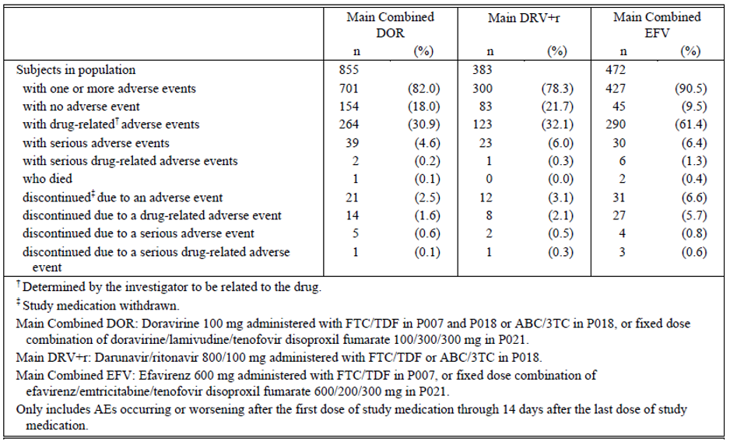
3TC = lamivudine, ABC = abacavir, DOR = doravirine, DRV+r = ritonavir boosted darunavir, EFV = efavirenz, FTC = emtricitabine, TDF = tenofovir disoproxil fumarate.
Three deaths (one in doravirine group in Study P018 and 2 in efavirenz group in Study P021) were reported in the MSP by Week 48. These were not considered study drug-related by the investigators. Two more deaths (both in Study P021; one each in doravirine and efavirenz groups) were reported post-study and were also not considered study drug-related.
In the MSP, the incidence of neuropsychiatric AEs was similar for doravirine and darunavir boosted with ritonavir groups but higher in efavirenz group. The incidence of rash was 3.0%, 1.6% and 11% in doravirine combined, darunavir boosted with ritonavir and efavirenz groups respectively. In the MSP, the commonly occurring AEs with incidence of at least 5% in any treatment were as follows in Table 18.
Table 18: Subjects with adverse events (incidence ≥ 5% in one or more treatment groups, Main Safety Pool, Study P007 (doravirine 100 mg once daily group) and Studies P018 and P021 combined, Weeks 0 to 48
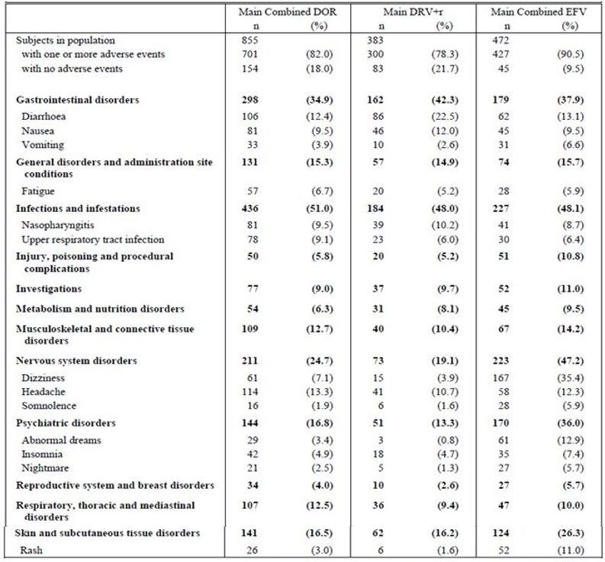
DOR = doravirine, DRV+r = ritonavir boosted darunavir, EFV = efavirenz.
Neuropsychiatric disorders were of special interest particularly in comparison with efavirenz. The incidence by Week 48 was also assessed in the Special Safety Pool (SSP) comprised of the doravirine 100 mg patients from Study P007 and doravirine patients from Study P021 as follows in Table 19.
Table 19: Analysis of subjects with neuropsychiatric adverse events by Week 48, Special Safety Population, Study P007 (doravirine 100 mg once daily group) and Studies P018 and P021 combined
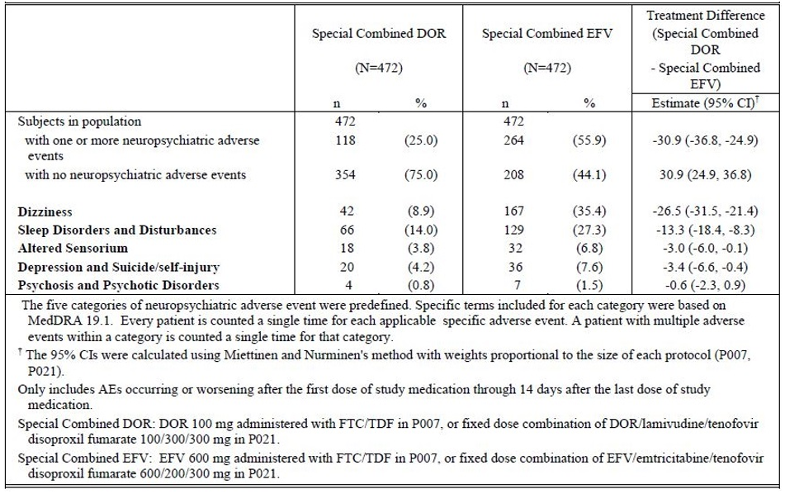
DOR = doravirine, DRV+r = ritonavir boosted darunavir, EFV = efavirenz, FTC = emtricitabine, TDF = tenofovir disoproxil fumarate.
The neuropsychiatric outcomes at Week 8 were similar to the outcomes at Week 48 in the SSP. Three subjects in the doravirine/lamivudine/tenofovir disoproxil fumarate group compared with 6 subjects in efavirenz/emtricitabine/tenofovir disoproxil fumarate group discontinued study drug due to neuropsychiatric events.
In the MSP, a total of 4.6%, 6.0% and 6.4% patients experienced SAE in the doravirine combined, darunavir boosted with ritonavir and efavirenz groups respectively. A summary of serious adverse events (SAEs) was as follows in Table 20.
Table 20: Serious adverse events by System Organ Class and selection serious adverse events (0 to 48 weeks), Main Safety Pool (Studies P018, P021, doravirine 100 mg Study P007)
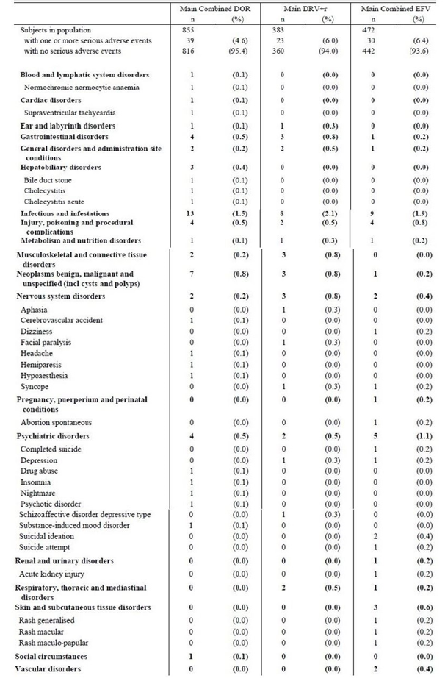
In the MSP, analysis of all Preferred Terms related to ‘Rash’ was as follows in Table 21.
Table 21: Subjects with Preferred Term adverse events of ‘Rash’; Weeks 0 to 48 (incidence > 0% in one or more treatment groups), Main Safety Pool, Study P007 (doravirine 100 mg once daily group) and Studies P018 and P021 combined
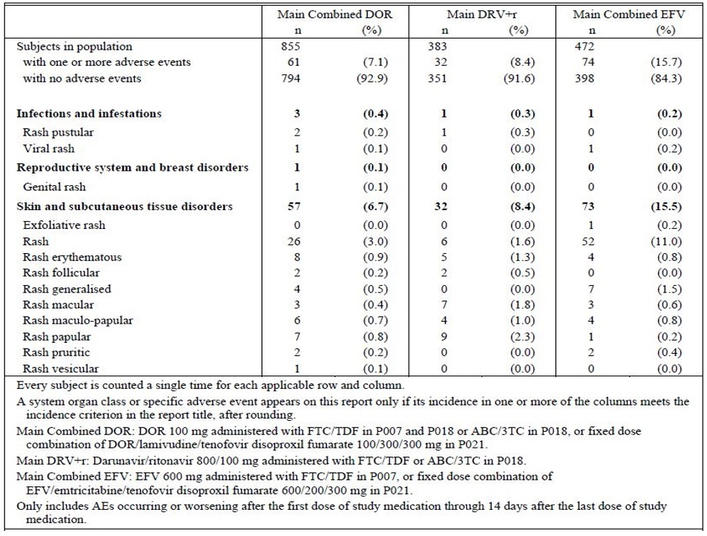
3TC = lamivudine, ABC = abacavir, DOR = doravirine, DRV+r = ritonavir boosted darunavir, EFV = efavirenz, FTC = emtricitabine, TDF = tenofovir disoproxil fumarate.
In the MSP, the incidence of AEs identified by the investigator as probably related to immune reconstitution syndrome was as follows in Table 22.
Table 22: Subjects with immune reconstitution syndrome, Studies P018 and P021 combined (incidence > 0% in one or more treatment groups), Weeks 0 to 48
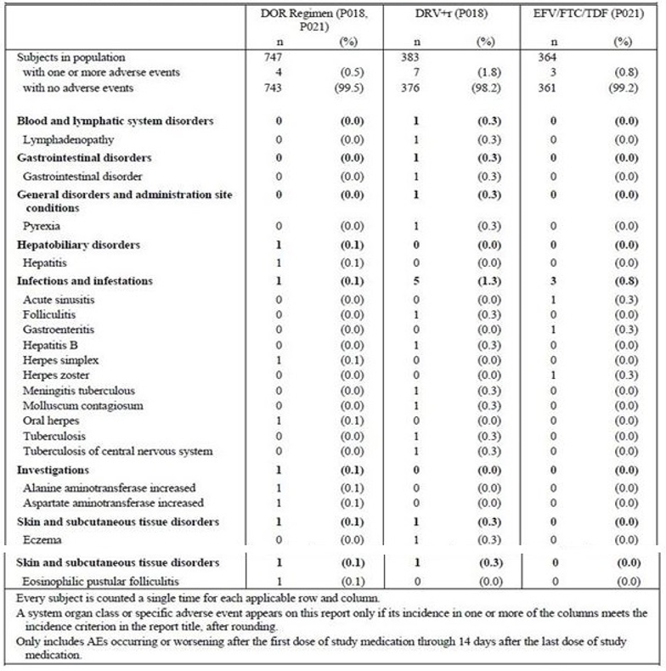
In the MSP, the incidence of pancreatitis was as follows in Table 23.
Table 23: Subjects with adverse events (incidence > 0% in one or more treatment groups), Main Safety Pool, Studies P007 (doravirine 100 mg once daily group) and Studies P018 and P021 combined
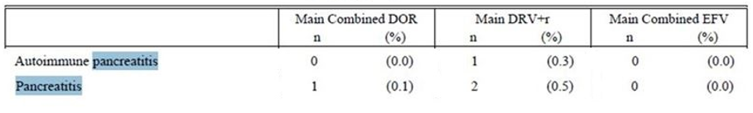
Another case of pancreatitis has been reported in the Study P024 (switching study in virologically suppressed patients, clinical study report not included in this dossier).
In the MSP, mean changes in laboratory parameters at 48 weeks of treatment were as follows in Table 24.
Table 24: Summary of laboratory tests, Main Safety Pool, Study P007 (doravirine 100 mg once daily group) and Studies P018 and P021 combined, Weeks 0 to 48
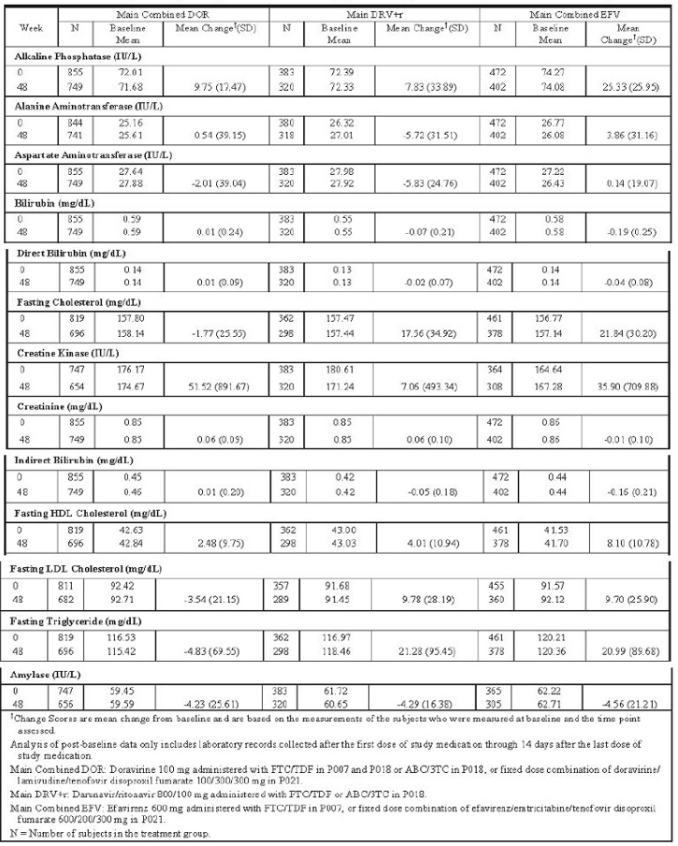
3TC = lamivudine, ABC = abacavir, DOR = doravirine, DRV+r = ritonavir boosted darunavir, EFV = efavirenz, FTC = emtricitabine, TDF = tenofovir disoproxil fumarate.
More Grade 1 bilirubin elevations were observed in the combined doravirine group compared with efavirenz group (6.1% versus 2.8% respectively). This pattern was not observed for bilirubin values greater than Grade 1 nor for AST, ALT or alkaline phosphatase. No patient fulfilling drug-induced liver injury (DILI) criteria was reported in Studies P007, P018 and P021.
Grade 2 to 4 level changes in laboratory parameters in the 2 pivotal clinical trials were as follows in Table 25.
Table 25: Selected Grade 2 to 4 laboratory abnormalities reported in the DRIVE-FORWARD (Study P018) and DRIVE-AHEAD (Study P021) clinical trials, Week 48
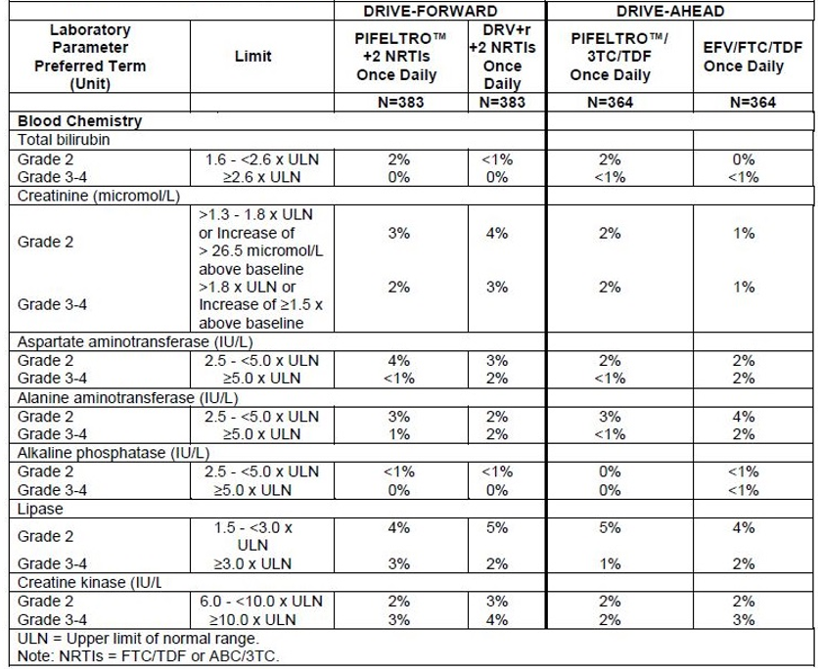
3TC = lamivudine, ABC = abacavir, DOR = doravirine, DRV+r = ritonavir boosted darunavir, EFV = efavirenz, FTC = emtricitabine, TDF = tenofovir disoproxil fumarate; NRTI = nucleoside reverse transcriptase inhibitor.
Mean changes in plasma lipids in the 2 pivotal clinical trials were as follows in Table 26.
Table 26: Mean change from Baseline in fasting lipids in the DRIVE-FORWARD (Study P018) and DRIVE-AHEAD (Study P021) clinical trials, Week 48
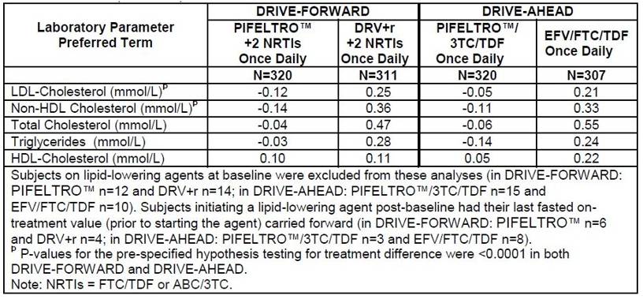
3TC = lamivudine, ABC = abacavir, DOR = doravirine, DRV+r = ritonavir boosted darunavir, EFV = efavirenz, FTC = emtricitabine, TDF = tenofovir disoproxil fumarate; NRTI = nucleoside reverse transcriptase inhibitor
Overall, the adverse effects profile of doravirine and doravirine/lamivudine/tenofovir disoproxil fumarate was comparable with darunavir boosted with ritonavir and efavirenz and advantageous to efavirenz with respect to the neuropsychiatric outcomes.
Early results have been provided of the ongoing Study P024 (early and late switch to doravirine/lamivudine/tenofovir disoproxil fumarate in virologically suppressed HIV-1 patients). This was not considered as part of the clinical evaluation as the full report was not available in the dossier.

Risk management plan
The sponsor has submitted European Union-Risk management plan (EU-RMP) version 1.0 (19 September 2017; data lock point (DLP) 26 April 2017) and Australian Specific Annex (ASA) version 0.1 (December 2017) in support of the doravirine application, and a separate EU-RMP version 1.0 (19 September 2017; DLP 26 April 2017) and ASA version 0.1 (December 2017) in support of the doravirine/lamivudine/tenofovir disoproxil fumarate application. At the second round evaluation, the EU-RMP documents were each updated to version 1.2 (26 July 2018; DLP 29 June 2018). After the second round evaluation the EU-RMP documents were each updated to version 2.0 (26 October 2018; DLP 29 June 2018) and the ASA documents each updated to version 0.2 (November 2018).
The proposed summary of safety concerns and their associated risk monitoring and mitigation strategies are summarised in the tables below.
Table 27: Summary of safety concerns for doravirine
Summary of safety concerns |  | Pharmacovigilance |  | Risk minimisation
 |  | Routine | Additional | Routine | Additional
Important identified risks | None* | – | – | – | –
Important potential risks | None | – | – | – | –
Missing information | Safety during pregnancy |  | † |  | –
Missing information | Safety during lactation |  | – |  | –
Missing information | Safety in elderly patients |  | –
Missing information | Long-term safety |  | – |  | –
* The sponsor removed the important identified risk of immune reconstitution inflammatory syndrome at the second round evaluation on advice from the European Medicines Agency (EMA). † Antiretroviral Pregnancy Registry.
Table 28: Summary of safety concerns for doravirine/lamivudine/tenofovir disoproxil fumarate
Summary of safety concerns |  |  | Pharmacovigilance |  | Risk Minimisation
 |  |  | Routine | Additional | Routine | Additional
Important identified risks* | lamivudine, tenofovir disoproxil fumarate | Severe acute exacerbations of hepatitis B |  | – |  | –
Important identified risks* | tenofovir disoproxil fumarate | New onset or worsening renal impairment/ renal toxicity |  | – |  | –
Important identified risks* | tenofovir disoproxil fumarate | Decreases in bone mineral density (BMD)/bone events due to proximal renal tubulopathy |  | – |  | –
Important potential risks | N/A | None |  | – |  | –
Missing information | doravirine, lamivudine, tenofovir disoproxil fumarate | Safety during pregnancy |  | † |  | –
Missing information | doravirine, lamivudine, tenofovir disoproxil fumarate | Safety during lactation |  | – |  | –
Missing information | doravirine, lamivudine, tenofovir disoproxil fumarate | Safety in elderly patients |  | – |  | –
Missing information | doravirine | Long-term safety |  | – |  | –
N/A = not applicable.* The sponsor removed the important identified risk of immune reconstitution inflammatory syndrome at the second round evaluation on advice from the EMA. † Antiretroviral Pregnancy Registry.
The summary of safety concerns is considered acceptable.
Routine pharmacovigilance activities are proposed for all existing safety concerns for doravirine and doravirine/lamivudine/tenofovir disoproxil fumarate, with inclusion in an Antiretroviral Pregnancy Registry as a pharmacovigilance activity to monitor exposure during pregnancy for doravirine and doravirine/lamivudine/tenofovir disoproxil fumarate. This is acceptable for the nature of the safety concerns.
Routine risk minimisation activities are proposed for all safety concerns for doravirine and doravirine/lamivudine/tenofovir disoproxil fumarate. This is acceptable for the nature of the safety concerns.

Risk-benefit analysis

Delegate’s considerations
- Doravirine (100 mg) and doravirine/lamivudine/tenofovir disoproxil fumarate (100/300/300 mg) are acceptable from a quality and nonclinical point of view.
- Bioequivalence between the clinical trials formulation of doravirine and the commercial formulation has been satisfactorily established, whereas commercial formulation of doravirine/lamivudine/tenofovir disoproxil fumarate was used in the pivotal Study P021.
- Selection of the 100 mg doravirine was based on overall efficacy/safety considerations given that the dose response was flat with 25, 50, 100 and 200 mg daily doravirine dosing.
- Efficacy (patients with HIV-1 RNA < 50 copies/mL) of doravirine (83.8%) in combination with emtricitabine /tenofovir disoproxil fumarate or lamivudine/abacavir was shown to be non-inferior to rarunavir boosted with ritonavir (79.9%) in combination with emtricitabine/tenofovir disoproxil fumarate or lamivudine/abacavir after 48 weeks of treatment in Study P018 in treatment naïve adult HIV-1 patients (treatment difference 3.9%; 95% CI: -1.59, 9.41).
- Efficacy (patients with HIV-1 RNA < 50 copies/mL) of doravirine as FDC of doravirine/lamivudine/tenofovir disoproxil fumarate (84.3%) was shown to be non-inferior to efavirenz/emtricitabine /tenofovir disoproxil fumarate (80.8%) after 48 weeks of treatment in Study P021 in treatment naïve adult HIV-1 patients (treatment difference 3.54%; 95% CI: -1.95, 9.02).
- Important missing information on efficacy and clinical utility of doravirine is the lack of comparative data with an INSTI agent.
  - It is also noted that the second generation tenofovir (alafenamide) has generally not yet replaced tenofovir (disoproxil fumarate) in ART.
- Food effect was modest (doravirine AUC up to 26% higher and doravirine C₂₄ up to 55% higher based on upper limit of 90% CI) and is considered clinically acceptable so that administration without regard to food is supported. Advice from the Advisory Committee on Medicines (ACM) is requested.
- Hepatic impairment: about two thirds of orally administered doravirine is absorbed, of which about 85% undergoes hepatic metabolism by CYP3A. Doravirine is a low metabolism drug with a clearance of around 6 L/h.
  - The sponsor rationalises in favour of lack of a clinically meaningful effect of hepatic impairment on the pharmacokinetics of doravirine, based on moderate (n = 8) versus healthy (n = 8) hepatic impairment Study P019 (doravirine AUC ratio 0.99; 90% CI: 0.72, 1.35). No dose adjustment is proposed in mild to moderate hepatic impairment. The PI notes that doravirine has not been studied in severe hepatic impairment. This is considered acceptable. Advice from the ACM is requested.
- Renal impairment: about 15% of the absorbed drug is excreted unchanged through kidneys.
  - The sponsor rationalises in favour of lack of a clinically meaningful effect of renal impairment on pharmacokinetics of doravirine, based on severe renal impairment (n = 8) versus healthy (n = 8) Study P051 (doravirine AUC 1.43; 90% CI 1.00, 2.04). No dose adjustment is proposed in mild to severe renal impairment. The PI notes that doravirine has not been adequately studied in ESRD and has not been studied in patients on dialysis. This is considered acceptable. Advice from the ACM is requested.
- Drug-drug interactions: coadministration of doravirine with strong CYP3A inhibitors (such as ketoconazole or ritonavir) can result in approximately 3 fold higher doravirine exposures (AUC), whereas coadministration with strong CYPP34 inducers (such as rifampicin or rifabutin) can result in nearly negligible plasma levels of doravirine. Interaction of doravirine with efavirenz, a moderate CYP3A inducer, is of interest in a switching situation and was examined following cessation of efavirenz therapy:
  - The proposed PI includes a contraindication of use of doravirine with strong CYP3A inducers (anticonvulsants, rifampicin and St John’s wort). However, use with rifabutin is recommended with higher dose of doravirine (100 mg twice daily). Coadministration with strong inhibitors (potentially 3 fold higher doravirine plasma levels) is allowed without dose adjustment. The population PK analyses were supportive of the recommendations in the proposed Australian PI. This are considered acceptable, as is the sponsor’s argument against routine therapeutic drug monitoring. Advice from the ACM is requested.
  - Tenofovir disoproxil fumarate and lamivudine components of doravirine/lamivudine/tenofovir disoproxil fumarate are eliminated by renal tubular secretion and may be subject to interactions with inhibitors of renal tubular transporters.
- The 48 weeks data did not uncover any unexpected NNRTI class adverse effects for doravirine in combination with other ART agents, or unacceptable adverse effects relative to its expected efficacy. Overall, the adverse effects profile of doravirine, including laboratory changes, is considered acceptable. Doravirine appeared to have improved neuropsychiatric adverse effects profile compared to efavirenz. The safety dataset is too small to capture rare, serious adverse effects. At present, post-market data are not available.
- TGA has reviewed the risk management plan (RMP), which will be a condition of registration along with the ASA.
- Pending consideration by the ACM, the Delegate is of the view that the supplied dossiers support marketing approval of doravirine (‘in combination with other antiretroviral medicinal products, for the treatment of adults infected with HIV-1 without past or present evidence of viral resistance to doravirine’) and doravirine/lamivudine/tenofovir disoproxil fumarate (‘for the treatment of adults infected with HIV-1 without past or present evidence of viral resistance to doravirine, lamivudine or tenofovir’) as requested.
  - The clinical dataset is restricted to treatment naïve patients. The ACM is requested advice on the need to specify this patient population in the therapeutic indication as has been the practiced in the past.
  - Advice is also requested for the implied use of FDC doravirine / lamivudine / tenofovir disoproxil fumarate for initiation of therapy, rather than switching of therapy in patients who are stable on ART therapy as has been the case in most registration dossiers seen previously.

Proposed action
The Delegate has no reason to say, at this time, that the application for doravirine (100 mg) should not be approved for registration.
The Delegate has no reason to say, at this time, that the application for doravirine / lamivudine / tenofovir disoproxil fumarate (100/300/300 mg) should not be approved for registration.

Request for ACM advice
The Advisory Committee on Medicines (ACM) is requested to provide advice on the following specific issues:
- The ACM is requested advice on appropriate text for the therapeutic indication, and usage instructions for coadministration with CYP3A4 inhibitors/inducers and in the presence of hepatic or renal impairment.
The Committee is also requested to provide advice on any other issues that it thinks may be relevant to a decision on whether or not to approve this application.

Advisory Committee Considerations
The ACM, having considered the evaluations and the Delegate’s overview, as well as the sponsor’s response to these documents, advised the following.
The ACM taking into account the submitted evidence of efficacy, safety and quality, agreed with the Delegate and considered Pifeltro, tablet containing 100 mg of doravirine, to have an overall positive benefit-risk profile for the amended indication:
Pifeltro is indicated, in combination with other antiviral medicinal products, for the treatment of HIV-1 infection in adults who are treatment naïve. Patients must not have had a history of known mutations associated with resistance to doravirine.
The ACM taking into account the submitted evidence of efficacy, safety and quality, agreed with the Delegate and considered Delstrigo, FDC tablet containing 100 mg of doravirine, 300 mg of lamivudine, and 300 mg of tenofovir disoproxil fumarate, to have an overall positive benefit-risk profile for the amended indication:
Delstrigo is indicated for the treatment of HIV-1 infection in adults who are treatment naïve. Patients must not have had a history of known mutations associated with resistance to tenofovir, lamivudine or doravirine.
In providing this advice, the ACM noted the following:
- Pivotal Study P018 was a Phase III trial evaluating the safety, efficacy and PK of doravirine compared with ritonavir-boosted darunavir, each given in combination with emtricitabine plus tenofovir disoproxil fumarate or abacavir plus lamivudine in HIV-1 infected treatment-naïve adults. Non-inferiority of doravirine to ritonavir-boosted darunavir was demonstrated.
- Pivotal Study P021 was a Phase III trial evaluating the safety and efficacy of doravirine/lamivudine/tenofovir disoproxil fumarate FDC compared with efavirenz/emtricitabine/tenofovir disoproxil fumarate FDC in HIV-1 infected treatment-naïve adults. Non-inferiority of doravirine/lamivudine/tenofovir disoproxil fumarate to efavirenz/emtricitabine/tenofovir disoproxil fumarate was demonstrated.
- The safety profiles of doravirine and doravirine/lamivudine/tenofovir disoproxil fumarate FDC were considered acceptable, with similar rates of SAEs to the comparators.
- Preferred first-line treatments in HIV are based on regimens including INSTI therapy. No studies comparing doravirine with INSTI were presented.
- Data from an ongoing trial (Study P024) in virologically suppressed patients switching to doravirine/lamivudine/tenofovir disoproxil fumarate may provide support in future for patients who are not treatment-naïve, however the full report from this study was not included in the dossier and has not been evaluated by the TGA.
- Doravirine FDC is included as a recommended regimen in specific situations in the US Department of Health and Human Services Guidelines for the use of Antiretroviral Agents.
- Both Pifeltro and Delstrigo have been approved in the USA and EU.

Proposed conditions of registration
The ACM agreed with the Delegate on the proposed conditions of registration.

Proposed Product Information/Consumer Medicine Information amendments
The ACM agreed with the Delegate to the proposed amendments to the PI and Consumer Medicine information (CMI) and specifically advised on the inclusion of the following:
- Definition of the term ‘severe renal impairment’ in the PI to specify the estimated glomerular filtration rate (eGFR) range to which the term relates.

Specific advice
The ACM advised the following in response to the Delegate’s specific questions on the submission:
- The ACM is requested advice on appropriate text for the therapeutic indication, and usage instructions for coadministration with CYP3A4 inhibitors/inducers and in the presence of hepatic or renal impairment.
The ACM noted that the pivotal studies provided to support registration were conducted in treatment-naïve patients. Therefore, the ACM advised that the indication wording should reflect the clinical data provided, and specify that use should be in treatment-naïve patients. The ACM was aware that studies supporting an indication to switch in virologically suppressed patients were in progress but had not yet been formally evaluated.
The ACM considered that the contraindication for co-administration of doravirine with strong CYP3A4 inducers (for example, rifampicin), and including a requirement for dose increase (to 100 mg twice daily) for coadminstration with rifabutin, were reasonable. The Committee considered that a caution should be included regarding toxicity when administered with CYP3A4 inhibitors (for example, ketoconazole). The Committee was of the view that an interaction between doravirine and efavirenz in a switching situation was not likely to be clinically relevant.
The ACM considered that the wording regarding dosage in hepatic impairment was appropriate. With respect to renal impairment, the Committee noted that ‘severe renal impairment’ should be defined by specifying the relevant eGFR range.
The ACM advised that implementation by the sponsor of the recommendations outlined above to the satisfaction of the TGA, in addition to the evidence of efficacy and safety provided would support the safe and effective use of these products.

Outcome

Pifeltro
Based on a review of quality, safety and efficacy, the TGA approved the registration of Pifeltro (doravirine) 100 mg film coated tablets, indicated for:
Pifeltro is indicated, in combination with other antiretroviral medicinal products, for the treatment of HIV-1 infection in adults who are antiretroviral therapy (ART) naïve with no known substitutions associated with resistance to doravirine.

Delstrigo
Based on a review of quality, safety and efficacy, the TGA approved the registration of Delstrigo (doravirine/lamivudine/tenofovir disoproxil fumarate) 100/300/300 mg FDC film coated tablets, indicated for:
Delstrigo is indicated for the treatment of HIV-1 infection in adults who are antiretroviral therapy (ART)-naïve with no known substitutions associated with resistance to doravirine, lamivudine, or tenofovir.

Specific conditions of registration applying to these goods

Pifeltro
- Pifeltro (doravirine) is to be included in the Black Triangle Scheme. The PI and CMI for Pifeltro must include the black triangle symbol and mandatory accompanying text for five years, which starts from the date that the sponsor notifies the TGA of supply of the product.
- The Pifeltro EU-RMP (version 2.0, dated 26 October 2018, DLP 29 June 2018), with ASA (version 0.2, dated November 2018), included with submission PM-2017-04580-1-2, and any subsequent revisions, as agreed with the TGA will be implemented in Australia.
An obligatory component of risk management plans is routine pharmacovigilance. Routine pharmacovigilance includes the submission of Periodic Safety Update Reports (PSURs).
Unless agreed separately between the supplier who is the recipient of the approval and the TGA, the first report must be submitted to TGA no later than 15 calendar months after the date of this approval letter. The subsequent reports must be submitted no less frequently than annually from the date of the first submitted report until the period covered by such reports is not less than three years from the date of this approval letter. The annual submission may be made up of two PSURs each covering six months. If the sponsor wishes, the six monthly reports may be submitted separately as they become available.
The reports are to at least meet the requirements for PSURs as described in the European Medicines Agency’s Guideline on Good Pharmacovigilance Practices (GVP) Module VII-Periodic Safety Update Report (Rev 1), Part VII.B Structures and processes. Note that submission of a PSUR does not constitute an application to vary the registration. Each report must have been prepared within ninety calendar days of the data lock point for that report.

Delstrigo
- Delstrigo (doravirine, lamivudine and tenofovir disoproxil fumarate) is to be included in the Black Triangle Scheme. The PI and CMI for Delstrigo must include the black triangle symbol and mandatory accompanying text for five years, which starts from the date that the sponsor notifies the TGA of supply of the product.
- The Delstrigo EU-RMP (version 2.0, dated 26 October 2018, DLP 29 June 2018), with ASA (version 0.2, dated November 2018), included with submission PM-2017-04581-1-2, and any subsequent revisions, as agreed with the TGA will be implemented in Australia.
An obligatory component of risk management plans is routine pharmacovigilance. Routine pharmacovigilance includes the submission of PSURs.
Unless agreed separately between the supplier who is the recipient of the approval and the TGA, the first report must be submitted to TGA no later than 15 calendar months after the date of this approval letter. The subsequent reports must be submitted no less frequently than annually from the date of the first submitted report until the period covered by such reports is not less than three years from the date of this approval letter. The annual submission may be made up of two PSURs each covering six months. If the sponsor wishes, the six monthly reports may be submitted separately as they become available.
The reports are to at least meet the requirements for PSURs as described in the European Medicines Agency’s Guideline on GVP Module VII-Periodic Safety Update Report (Rev 1), Part VII.B Structures and processes. Note that submission of a PSUR does not constitute an application to vary the registration. Each report must have been prepared within ninety calendar days of the data lock point for that report.

Attachments 1 and 2. Product Information
The PIs for Pifeltro and Delstrigo approved with the submission which is described in this AusPAR is at Attachment 1 and 2. For the most recent PIs, please refer to the TGA website at <https://www.tga.gov.au/product-information-pi>.

Therapeutic Goods Administration
PO Box 100 Woden ACT 2606 Australia
Email: info@tga.gov.au Phone: 1800 020 653 Fax: 02 6232 8605
https://www.tga.gov.au

UNSW Sydney, Kirby Institute (2017), HIV, viral hepatitis and sexually transmissible infections in Australia: Annual Surveillance Report 2017
NSW government Ministry of Health (2015), NSW HIV Strategy 2016-2020.
Australasian Society for HIV, Viral Hepatitis and Sexual Health Medicine (ASHM), Sub-Committee for Guidance on HIV Management, US DHHS Guidelines with Australian commentary. Available from the ASHM website.
Australian pregnancy category B1: Drugs which have been taken by only a limited number of pregnant women and women of childbearing age, without an increase in the frequency of malformation or other direct or indirect harmful effects on the human fetus having been observed. Studies in animals have not shown evidence of an increased occurrence of fetal damage.
Australian pregnancy category B3: Drugs which have been taken by only a limited number of pregnant women and women of childbearing age, without an increase in the frequency of malformation or other direct or indirect harmful effects on the human fetus having been observed. Studies in animals have shown evidence of an increased occurrence of fetal damage, the significance of which is considered uncertain in humans.
QT studies are studies conducted to clinically evaluate the QT/QTc interval prolongation and proarrhythmic potential for non-antiarrhythmic drugs. The QT interval is the time taken from the start of the QRS wave complex to the end of the corresponding T wave on an electrocardiograph and approximates from the start of cardiac ventricular contraction to the end of cardiac ventricular relaxation. The QTc is the QT interval corrected for heart rate.
The sponsor’s response to this query is beyond the scope of this AusPAR.
Routine risk minimisation activities may be limited to ensuring that suitable warnings are included in the product information or by careful use of labelling and packaging. Routine pharmacovigilance practices involve the following activities: - All suspected adverse reactions that are reported to the personnel of the company are collected and collated in an accessible manner; - Reporting to regulatory authorities; - Continuous monitoring of the safety profiles of approved products including signal detection and updating of labelling; - Submission of PSURs; - Meeting other local regulatory agency requirements.
The ACM provides independent medical and scientific advice to the Minister for Health and the Therapeutic Goods Administration (TGA) on issues relating to the safety, quality and efficacy of medicines supplied in Australia including issues relating to pre-market and post-market functions for medicines. The Committee is established under Regulation 35 of the Therapeutic Goods Regulations 1990. Members are appointed by the Minister. The ACM was established in January 2017 replacing Advisory Committee on Prescription Medicines (ACPM) which was formed in January 2010. ACM encompass pre and post-market advice for medicines, following the consolidation of the previous functions of the Advisory Committee on Prescription Medicines (ACPM), the Advisory Committee on the Safety of Medicines (ACSOM) and the Advisory Committee on Non-Prescription Medicines (ACNM). Membership comprises of professionals with specific scientific, medical or clinical expertise, as well as appropriate consumer health issues relating to medicines.
Panel on Antiretroviral Guidelines for Adults and Adolescents. Guidelines for the Use of Antiretroviral Agents in Adults and Adolescents with HIV. Department of Health and Human Services. Available at http://aidsinfo.nih.gov/contentfiles/lvguidelines/AdultandAdolescentGL.pdf.

