May 2014

Australian Public Assessment Report for Dolutegravir (as sodium)
  - Proprietary Product Name: Tivicay
  - Sponsor: ViiV Healthcare Pty Ltd

About the Therapeutic Goods Administration (TGA)
- The Therapeutic Goods Administration (TGA) is part of the Australian Government Department of Health and is responsible for regulating medicines and medical devices.
- The TGA administers the Therapeutic Goods Act 1989 (the Act), applying a risk management approach designed to ensure therapeutic goods supplied in Australia meet acceptable standards of quality, safety and efficacy (performance), when necessary.
- The work of the TGA is based on applying scientific and clinical expertise to decision-making, to ensure that the benefits to consumers outweigh any risks associated with the use of medicines and medical devices.
- The TGA relies on the public, healthcare professionals and industry to report problems with medicines or medical devices. TGA investigates reports received by it to determine any necessary regulatory action.
- To report a problem with a medicine or medical device, please see the information on the TGA website <http://www.tga.gov.au>.
About AusPARs
- An Australian Public Assessment Record (AusPAR) provides information about the evaluation of a prescription medicine and the considerations that led the TGA to approve or not approve a prescription medicine submission.
- AusPARs are prepared and published by the TGA.
- An AusPAR is prepared for submissions that relate to new chemical entities, generic medicines, major variations, and extensions of indications.
- An AusPAR is a static document, in that it will provide information that relates to a submission at a particular point in time.
- A new AusPAR will be developed to reflect changes to indications and/or major variations to a prescription medicine subject to evaluation by the TGA.
Copyright
© Commonwealth of Australia 2014
This work is copyright. You may reproduce the whole or part of this work in unaltered form for your own personal use or, if you are part of an organisation, for internal use within your organisation, but only if you or your organisation do not use the reproduction for any commercial purpose and retain this copyright notice and all disclaimer notices as part of that reproduction. Apart from rights to use as permitted by the Copyright Act 1968 or allowed by this copyright notice, all other rights are reserved and you are not allowed to reproduce the whole or any part of this work in any way (electronic or otherwise) without first being given specific written permission from the Commonwealth to do so. Requests and inquiries concerning reproduction and rights are to be sent to the TGA Copyright Officer, Therapeutic Goods Administration, PO Box 100, Woden ACT 2606 or emailed to <tga.copyright@tga.gov.au>.

Contents
List of the most common abbreviations used in this AusPAR 5
I. Introduction to product submission 9
Submission details 9
Product background 9
Regulatory status 10
Product Information 10
II. Quality findings 11
Drug substance (active ingredient) 11
Drug product 11
Biopharmaceutics 11
Quality summary and conclusions 12
III. Nonclinical findings 12
Introduction 12
Pharmacology 12
Pharmacokinetics 15
Toxicology 17
Nonclinical summary and conclusions 24
IV. Clinical findings 28
Introduction 28
Pharmacokinetics 28
Pharmacodynamics 33
Efficacy 34
Safety 35
Clinical summary and conclusions: first round 36
List of questions 37
Second round evaluation in response to questions 38
Clinical summary and conclusions: second round 55
V. Pharmacovigilance findings 56
Risk management plan 56
VI. Overall conclusion and risk/benefit assessment 63
Quality 63
Nonclinical 64
Clinical 64
Risk management plan 76
Risk-benefit analysis 76
Outcome 87
Attachment 1. Product Information 88
Attachment 2. Extract from the Clinical Evaluation Report 88

List of the most common abbreviations used in this AusPAR
Abbreviation | Meaning
3TC | lamivudine
ABC | abacavir
ADME | absorption, distribution, metabolism, and excretion
AE | adverse event
AIDS | acquired immunodeficiency syndrome
ALP | alkaline phosphatase
ALT | alanine aminotransferase
ART | antiretroviral therapy
ASA | Australian Specific Annex
AST | aspartate aminotransferase
ATV | atazanavir
AUC | area under the plasma concentration-time curve
AUC_{0-∞} | area under the plasma concentration-time curve from time zero to time infinity
BCRP | Breast Cancer Resistance protein
BCV | boceprevir
BID | bis in die (twice daily)
BMCs | blood mononuclear cells
Cmax | maximum plasma drug concentration
Cτ | pre dose (trough) concentration at the end of the dosing interval
CDC | Centres for Disease Control
CI | confidence interval
CL/F | apparent clearance
CMI | Consumer Medicines Information
CNS | central nervous system
CSR | Clinical Study Report
DILI | drug induced liver injury
DRV | darunavir
DTG | dolutegravir
Emax | maximum response achievable from a drug
ECG | electrocardiogram
EFV | efavirenz
EMA | European Medicines Agency
ET | etravirine
EVG | elvitegravir
FDA | Food and Drug Administration (US)
FPV | fosamprenavir
FTC | emtricitabine
GD | gestational day
GI | gastrointestinal
GLP | Good Laboratory Practice
HBV | hepatitis B virus
HCV | hepatitis C virus
HIV | human immunodeficiency virus
IC₅₀ | inhibitory concentration 50%
IC₉₀ | inhibitory concentration 90%
ICH | International Conference on Harmonisation
IM | intramuscular
IN | integrase
INI | integrase inhibitor
IV | intravenous
LC-MS | liquid chromatography-mass spectrometry
LOEL | lowest observed effect level
LPV | lopinavir
mITT-E | Modified Intent to Treat Exposed
MRHD | maximum recommended human dose
MS | mass spectrometry
MSDF | Missing, Switch or Discontinuation = Failure
NMR | nuclear magnetic resonance
NNRTI | non nucleoside reverse transcriptase inhibitor
NOAEL | no observed adverse effect level
NOEL | no observed effect level
NRTI | nucleoside reverse transcriptase inhibitor
OMP | omeprazole
PBMCs | peripheral blood mononuclear cells
PD | postnatal day
PI | Product Information
PO | per os (oral administration)
PP | Per Protocol
PRO | protease
PSUR | Periodic Safety Update Report
QD | quaque die (once daily)
RAL | raltegravir
RBT | rifabutin
RMP | Risk Management Plan
RPV | rilpivirine
RTI | reverse transcriptase inhibitor
RTV | ritonavir
SAE | serious adverse events
SC | subcutaneous
SOC | System Organ Class
t1/2 | terminal half-life
Tmax | time to reach maximum plasma concentration following drug administration
TDF | tenofovir disoproxil fumarate
TLOVR | time to loss of virologic response
TTC | threshold of toxicological concern
TVR | telaprevir
UGT | UDP-glucuronosyltransferase
V/F | apparent volume of distribution
XRPD | X-ray powder diffraction

I. Introduction to product submission

Submission details
Type of Submission | New Chemical Entity
Decision: | Approved
Date of Decision: | 17 January 2014

Active ingredient: | Dolutegravir (as sodium)
Product Name: | Tivicay
Sponsor’s Name and Address: | ViiV Healthcare Pty Ltd  Level 4, 436 Johnston Street  Abbotsford VIC 3067
Dose form: | Film coated tablets
Strength: | 50 mg
Container: | High density polyethylene (HDPE) bottle
Pack size: | 30 tablets
Approved Therapeutic use: | Tivicay is indicated for the treatment of human immunodeficiency virus (HIV) infection in combination with other antiretroviral agents in adults and children over 12 years of age and weighing 40 kg or more.
Route of administration: | Oral
Dosage: | 50 mg once daily (patients infected with HIV-1 without resistance to the integrase class) or 50 mg twice daily (patients infected with HIV-1 with resistance to the integrase class)
ARTG Number | 205212

Product background
This AusPAR describes a submission by the sponsor, ViiV Healthcare Pty Ltd, to register a new chemical entity, dolutegravir (DTG), with the trade name Tivicay. DTG is a 2-metal binding integrase inhibitor (INI) developed as a treatment for HIV-1 infection. DTG is a potent, low nanomolar inhibitor of both HIV integrase recombinant enzyme and of HIV replication in cell culture assays, retaining activity against major integrase resistance mutations. The proposed indication is:
For the treatment of human immunodeficiency virus (HIV) infection in combination with other antiretroviral agents in adults and children over 12 years of age.
Each Tivicay 50 mg film coated tablet contains 52.6 mg DTG sodium, which is equivalent to 50 mg DTG free acid.
In 2011 there were an estimated 34.2 million adults and children with HIV infection, with 2.5 million new infections and 1.7 million deaths annually. The epidemic has stabilised in most developed countries but the prevalence continues to rise in Central Europe, Asia and Sub-Saharan Africa. Progression to acquired immunodeficiency syndrome (AIDS) has been significantly reduced by combination therapy with protease (PRO) and reverse transcriptase inhibitors (RTI). More recently, INIs have been introduced. As a new class of antiretroviral therapy (ART), INIs block the action of the integrase (IN) viral enzyme required for HIV replication. Two INIs, raltegravir (RAL) and elvitegravir (EVG), have proved effective and have been approved for use in combination with other ART. However, new therapies continue to be required because of long term drug toxicities and the emergence of drug resistant HIV strains.
RAL was the first approved INI. RAL has shown good antiviral activity as first line therapy in treatment naïve and treatment experienced patients. It has been shown to be non inferior to widely used regimens containing efavirenz (EFV). It is also well tolerated with fewer side effects than EFV regimens. However, virologic failure due to RAL resistant mutations emerge in a significant proportion of patients and new INIs are required. DTG is a potent novel INI with a good barrier to resistance and efficacy against RAL and EVG resistant HIV isolates. It offers further options in treatment naïve and treatment experienced patients with clinical failure due to multiclass drug resistance.

Regulatory status
The international regulatory status for Tivicay at the time of the Australian submission to the TGA is shown in Table 1.
Table 1: International regulatory status for Tivicay.
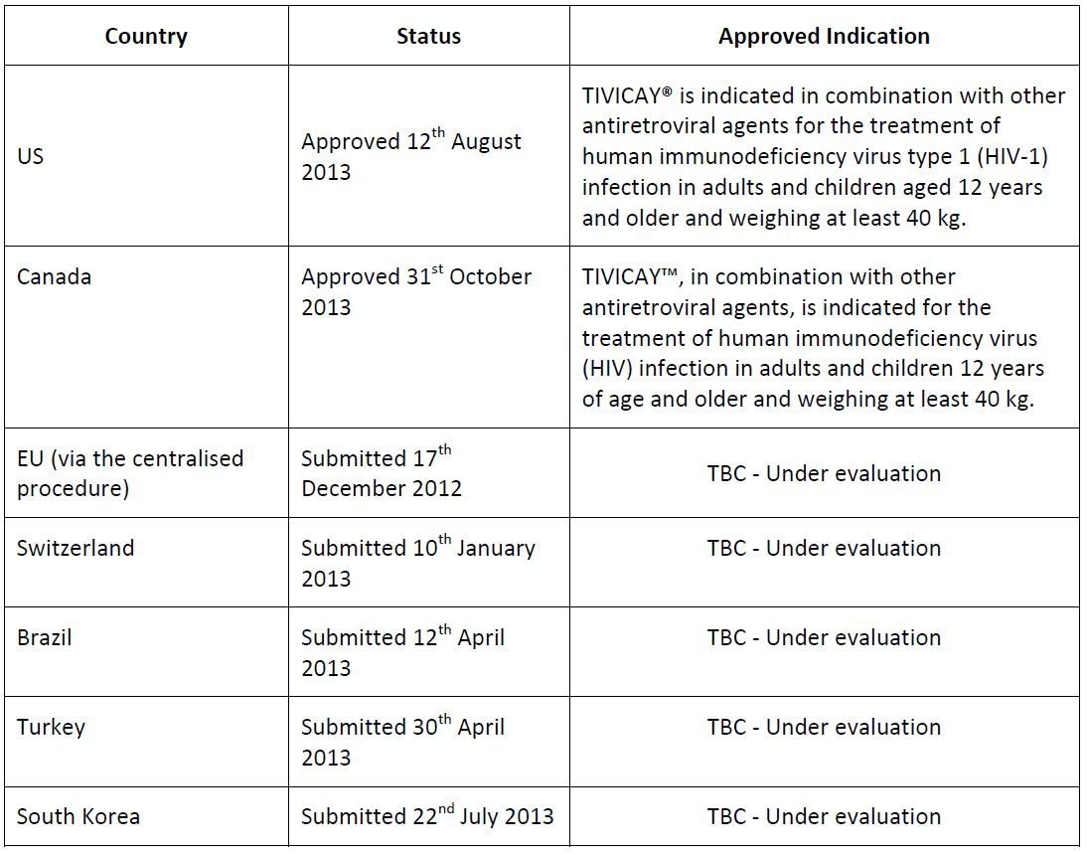

Product Information
The approved Product Information (PI) current at the time this AusPAR was prepared can be found as Attachment 1.

II. Quality findings

Drug substance (active ingredient)
The structure of DTG is depicted in Figure 1.
Figure 1. Structure of DTG.
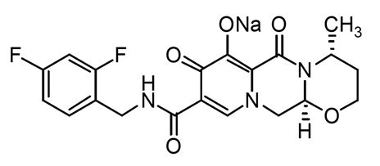
It is manufactured as anhydrous crystalline Form 1. Several pseudo polymorphs are known (hydrates and other solvates) but the desired form is assured by an X-ray powder diffraction (XRPD) test in the drug substance specification.
DTG is a weak acid with a pKa of 8.2. DTG sodium is very slightly soluble at pH 6.5 and 5.0, but practically insoluble at pH 1.2 in aqueous media. It is micronised to a particle size specification of X90 ≤ 10 μm and X10 ≥ 0.3 μm.
The drug substance specifications include a limit of 0.15% for each of five specified impurities and a limit of 0.10% for individual unspecified impurities. In addition, there is a limit of 0.15% for the enantiomer of DTG and for its diastereoisomer.

Drug product
The drug product is an immediate release oral tablet, containing DTG sodium (GSK1349572A) equivalent to 50 mg of DTG (GSK1349572B).
DTG 50 mg tablets are yellow, round, biconvex tablets debossed with ‘SV 572’ on one side and ‘50’ on the other side. DTG tablets are manufactured by a conventional wet granulation process and are packed in opaque, white, round, HDPE bottles with a polypropylene child resistant closure that includes a polyethylene faced induction seal liner.
The finished product specifications include a limit of 0.2% for any individual impurity. A dissolution limit of Q = 80% in 30 minutes is applied, using a paddle apparatus at 50 rpm in 900 mL of 0.01 M phosphate buffer, pH 6.8, containing 0.25% sodium dodecyl sulfate (SDS). The method has been shown to be discriminatory.
The tablets show very good stability, and a shelf life of 2 years below 30°C has been assigned.

Biopharmaceutics
Bioavailability data have been presented comparing two potential Phase III 25 mg tablet formulations with the Phase II formulation, followed by effect of food on the chosen phase III formulation (Study ING113674). The 50 mg tablet proposed for registration is a direct scale of the chosen Phase III 25 mg tablet. Food increased the bioavailability of the tablet, with area under the plasma concentration-time curve from time zero to time infinity (AUC_{0-∞}) increased by 33%, 41% and 66%, and Cmax increased by 46%, 52% and 67% when the tablet was administered with a low, moderate or high fat meal, respectively. The company considers these differences to be clinically insignificant, and recommends that the tablet be taken without regard to meals.
Study ING113068 assessed the effect of particle size on the bioavailability of DTG. Tablets manufactured from unmicronised drug substance showed no significant difference in bioavailability to tablets manufactured from micronised drug substance. Tablets manufactured from drug substance of intermediate particle size showed an ~20% increase in bioavailability. Despite the lack of significant effect on bioavailability, unmicronised tablets dissolved significantly more slowly than the other tablets in the routine in vitro dissolution test. Therefore, micronisation of the drug substance has been retained.
Study 111322 showed that a Phase II 10 mg tablet had a 30% lower AUC and a 42% lower Cmax compared to an oral suspension of DTG.
A justification has been provided for not conducting an absolute bioavailability study on DTG, based in part on the low solubility of the drug substance. The justification has been referred to the clinical evaluator.

Quality summary and conclusions
A number of relatively minor issues were raised with the sponsor following the initial evaluation of this application. The company satisfactorily addressed all issues, and there are no objections in respect of Chemistry, Manufacturing and Controls to registration of this product.

III. Nonclinical findings

Introduction
The sponsor has applied to register the integrase inhibitor DTG for the treatment of HIV infection (in combination with other antiretroviral agents) in adults and children aged 12-18 years and weighing ≥ 40 kg. The proposed dosing regimen involves oral administration of one tablet (50 mg) once daily. For patients with INI resistance, the proposed dose is 50 mg BID. The nonclinical data submitted to support the application were comprehensive and of high quality, with all safety pharmacology and pivotal repeat dose toxicity studies carried out in compliance with Good Laboratory Practice (GLP) requirements. Repeat dose studies were performed in mice (up to 13 weeks), rats (up to six months) and monkeys (up to nine months), and juvenile toxicity was assessed in rats. It is noted that phototoxicity was not investigated in vitro, as recommended in the relevant EU guideline. A nonclinical virology summary was also provided.

Pharmacology

Primary pharmacology
The antiviral activity of DTG is mediated by inhibition of the enzyme HIV integrase. This enzyme processes the 3'-ends of viral cDNA prior to their integration into the cytoplasm and translocation to the nucleus as an enzyme cDNA complex, and catalyses the transfer of viral DNA strand into the host chromosomes. In common with the currently approved HIV integrase inhibitors (RAL and EVG), DTG binds to the integrase active site and blocks the strand transfer step of retroviral DNA integration.
DTG inhibited biochemically purified HIV integrase in two different assays with IC₅₀ values of 2.7 nM and 12.6 nM, respectively. Antiretroviral activity was demonstrated using a range of laboratory strains (Ba-L and NL432 and pseudotyped HIV) in peripheral blood mononuclear cells (PBMCs), MT-4 cells and CIP4 cells, with mean IC₅₀ values ranging from 0.51-2.1nM. Efficacy against clinical isolates of HIV was of a similar order. The mean IC₅₀ against the integrase coding region of 13 clade B isolates in PBMCs was 0.52 nM; in another study of antiretroviral activity in PBMCs infected with 24 HIV-1 clinical isolates (including 3 in each group of M clades A, B, C, D, E, F, and G, and 3 in group O) the in vitro efficacy (IC₅₀) ranged from 0.02 nM to 2.14 nM, while the IC₅₀ values against 3 HIV-2 clinical isolates ranged from 0.09 nM to 0.61 nM. Antiviral efficacy was shown to be well above cytotoxic concentrations, and there was little antiviral activity exhibited against non HIV viruses.
DTG is highly bound to proteins in plasma (>99% in all species; 99.3% bound to human plasma in vitro). If it is assumed that only unbound DTG is able to inhibit integrase activity to inhibit HIV replication then the in vitro IC₅₀ values of 0.51 to 2.1 nM would correspond to total human plasma DTG concentrations of 73 to 300 nM. Evidence from experiments investigating the effects of human serum on the antiviral potency of DTG in vitro indicated that the effect of plasma proteins on DTG is more complex. By extrapolation, the DTG IC₅₀ is estimated to be increased by a mean of ~77 fold in the presence of 100% human serum, compared with the 140 fold increase predicted based on the assumption that DTG activity is reduced directly in proportion to the magnitude of binding to plasma proteins in vitro. Allowing for a 77 fold shift in potency in the presence of human serum, the mean IC₉₀ value for DTG in PBMCs of 1.28 nM (0.54 ng/mL) would correspond to a protein adjusted IC₉₀ value of 42 ng/mL. The DTG trough concentration following administration of a single 50 mg dose to integrase inhibitor naïve subjects is reported to be 1.20 μg/mL, which is ~30 fold the estimated protein adjusted IC₉₀.
In combination studies the in vitro efficacy of DTG was additive to synergistic with maraviroc, adefovir, RAL, stavudine, abacavir, EFV, nevirapine, lopinavir, amprenavir and enfuvirtide. The anti HIV-1 activity of DTG was additive with the anti hepatitis B agent adefovir and unaffected by ribavirin. Thus none of the combinations tested would be expected to reduce the potency of DTG.
The potential for development of resistance to DTG was investigated in vitro by passage of HIV-1 infected cells in the presence of DTG. A T124A substitution was the first mutation to be detected in HIV strain IIB infected MT-2 cells. Additional mutations detected with continued passage included the single mutation S153Y and multiple mutants T124A/S153F, T124A/S153Y and L101I/T124A/S153F, which were associated with resistance to DTG (maximum 4.1-fold increase in IC₅₀ with T124A on Day 112 and T124A/S153Y on Day 98; a single S153Y mutation on Day 84 was associated with a 3.7 fold increase in IC₅₀). The sponsor considers that the integrase substitutions T124A and L101I are polymorphic substitutions with no effect on DTG activity based on site direct mutant HIV-1 resistance testing and evaluation of evaluation of fold changes for a set of 36 clinical isolates with L101 and T124 substitutions. This is accepted.
Passage of wild type HIV-1 NL432 in the presence of DTG selected for E92Q and G193E (associated with approximately 3-fold increase in IC₅₀ values). Passage of umbilical cord blood mononuclear cells (BMCs) infected with HIV-1 subtypes B and A/G in the presence of DTG selected for the highly resistant mutant R263K (associated with an 11-fold increase in IC₅₀), as well as substitutions G118R, S153Y and S153T.
Starting with the single RAL resistance mutants Q148H, Q148K or Q148R, additional mutations detected during passage with DTG included E138K/Q148K, E138K/Q148R, Q140S/Q148R and G140S/Q148R. All of these exhibited greater than 10 fold increases in DTG IC₅₀. In contrast, passage of HIV-1 NL432 with the RAL resistance mutants E92Q, Y143C, Y143R, L101I, L101I/T124A or N155H did not lead to additional substitutions.
The sensitivity to DTG of a range of antiretroviral resistant strains was investigated. HIV-1 mutants with resistance to non nucleoside, nucleoside and protein inhibitor antiretroviral agents showed comparable in vitro susceptibility to DTG compared with wild type virus. DTG showed activity (fold change in IC₅₀ <5 compared with wild type virus) against 27/28 INI mutant strains with single substitutions, while its activity against G118R mutants was reduced 10 fold. DTG showed activity against 23/32 mutant viruses with two or more substitutions in the integrase coding region. Overall, against the 60 site directed mutant viruses tested, DTG showed a fold change in IC50 of <2 for 39/60, compared with 16/60 for RAL. Mutants showing reduced susceptibility to DTG included E138K/Q148R, G140S/Q148R, Q148R/N155H, G140S/Q148H, E92Q/N155N or H, G140G or S/Q148Q or R and E138K/Q148K.
DTG showed mildly reduced activity against HIV-2 mutants with substitutions A153G/N155H/S163G and E92Q/T97A/N155H/S163D (3.8 and 3.9 fold change, respectively), while IC₅₀ values against E92Q/N155H and G140S/Q148R were increased 8.5 and 17 fold, respectively.
Comparative susceptibilities to DTG and RAL were also investigated in 705 RAL clinical isolate samples. Of these, 662/705 (93.9%) exhibited a fold change increase in IC₅₀ for DTG of less than ten. Mutants of amino acid position Q148 with one or more additional substitutions in the integrase coding region exhibited an ~5-6 fold mean increase in IC₅₀, with fold resistance increases of over 25 observed for 13 isolates in this category (1.8%).
Virological failure with DTG treatment in a clinical study of 45 subjects who had commenced treatment following the development of resistance to RAL was also associated with the existence of 1 or more additional substitutions accompanying a Q148 substitution. Forty one of forty three isolates with a fold change to DTG > 10 had Q148 substitutions with one or more additional substitutions.

Secondary PD and safety pharmacology
DTG showed negligible activity against a panel of enzymes, receptors, ion channels and in functional assays in isolated tissues.
Specialised safety pharmacology studies covered the central nervous system (CNS), cardiovascular and respiratory systems. No CNS effects were observed in a functional observation battery in male rats dosed orally with DTG at up to 500 mg/kg (approximately 24 and 21 times the human Cmax with doses of 50 mg QD and BID, respectively, using day 1 toxicokinetic data from the 14 day repeat dose study in this species). DTG showed only weak (16%) inhibition of the hERG channel at a concentration of 20 μM, equivalent to ~300 times the clinical Cmax corrected for a protein binding level of 99.3%. Conscious male cynomolgus monkeys given oral DTG doses of up to 1000 mg/kg exhibited no clinical signs and no effect on cardiovascular or electrocardiogram (ECG) parameters (including QT or QTc intervals), although systemic exposure based on Cmax was only approximately five times the Cmax observed in clinical studies. Similarly, there were no notable effects on respiratory parameters up to six hours following oral administration of DTG to male rats at doses of up to 500 mg/kg. Using Day 1 toxicokinetic data from the 14 day rat repeat dose study, this corresponds to a systemic exposure level (based on AUC) ~18 times the maximum clinical exposure.

Pharmacokinetics
The PK and toxicokinetics of DTG were determined in mice, rats, rabbits, dogs and monkeys using suitably validated chiral or achiral high performance liquid chromatography (HPLC) methods with detection by tandem mass spectrometry. Radioactivity levels in plasma or biological samples were determined following administration of [14C]-DTG by liquid scintillation counting. Metabolites were profiled and identified using liquid chromatography-mass spectrometry (LC-MS), and structures not confirmed by mass spectrometry (MS) were identified using nuclear magnetic resonance (NMR).
Absorption of orally administered DTG was relatively rapid in all species, with Tmax values of 1-6 h in mice and rats, 0.5 h in dogs, 1-4 h in monkeys and 2-3 h in humans. Absorption was delayed in rats when DTG was administered with food, but this has not been reported in humans. DTG was absorbed more rapidly when administered to rats as an oral solution compared with its rate of absorption from suspension formulations. The extent of absorption from oral solutions was also shown to be increased in comparison with that from suspension formulations in both rats and monkeys. Oral bioavailability values reported in these species were 76% and 87%, respectively, for the oral solution, compared with 52% and 25%, respectively, for the suspension formulation. The oral bioavailability in the dog was 39%. As suggested by the sponsor, this indicates that absorption may be limited by solubility or dissolution rate.
The plasma clearance of DTG following intravenous (IV) administration to rats, dogs, and monkeys was very low compared to published values for liver blood flow. The steady state volume of distribution in these species was low, and terminal half life was 5-6 h, significantly shorter than the apparent oral half life in humans of about 14 h.
In repeat dose toxicity studies, increases in exposure based on Cmax and AUC were less than dose proportional, and in some instances this imposed a limit on the maximum exposure levels that could be achieved. There were no notable differences in exposure due to gender or pregnancy status, and there was no evidence of accumulation with repeated dosing. Systemic exposure in unweaned rat pups (postnatal day [PD] 13) was higher than in juvenile rats (PD 32). This reflects the ontogeny of uridine glucuronosyl transferase (UGT) in the rat.
As mentioned previously, DTG binding to proteins in the plasma of rat, dog, money and human in vitro was greater than 99%, with the extent of binding to proteins in human plasma reported to be 99.3%. Tissue distribution studies in pigmented rats showed that DTG associated radioactivity was rapidly and extensively distributed. The highest ratio of tissue:blood radioactivity concentrations were observed in the gastrointestinal (GI) tract, while the lowest ratios were found in brain and skeletal muscle. Elimination of DTG associated radioactivity generally mirrored the rate of disappearance from blood in all tissues with the notable exception of pigmented skin and bone, with the latter tissue exhibiting similar radioactivity levels at 7 and 28 days after dosing.
The major pathway for DTG metabolism in vivo in all species, including man, was ether glucuronidation, with hexose conjugation, N-dealkylation and (most notably in rats) oxidation being lesser pathways. UGT1A1 was the predominant metabolising enzyme responsible for glucuronidation, with UGT1A3 and UGT1A9 playing a minor role. CYP3A4 appeared to be the only CYP isoform involved in DTG metabolism. The products of oxidative defluorination in combination with addition of glutathione or cysteine were detected in the bile of mice, rats and monkeys, comprising 11.7% to 26.3% of the drug related material detected in this matrix. The formation of these metabolites is likely to involve formation of an electrophilic arene oxide intermediate. This was confirmed in vitro using rat and human pooled liver microsomes, where glutathione adducts were detected in the presence of a glutathione regeneration system. This is a potential concern as reactive metabolites may be mutagenic or carcinogenic, and have been associated with renal or hepatic toxicity of some drugs. In this respect, the lack of genotoxicity and carcinogenicity with DTG is reassuring. It is noted that there was no evidence of hepatotoxicity in repeat dose toxicity studies with DTG in rats at relative exposure levels in excess of 20. However, hepatic toxicity was observed in repeat dose studies in monkeys, and also in clinical trials.
DTG has two chiral centres, but there was no notable stereoisomerism in vitro following incubation of DTG with cryopreserved rat, dog, monkey and human hepatocytes.
Unchanged DTG was the predominant species circulating in plasma of mice, rats, monkeys and humans. Very small quantities of a defluorinated cysteine conjugate and the N-dealkylated metabolite were also detected in plasma in humans, while the ether glucuronide was reported to be present in the plasma of monkeys. Neither of the metabolites detected in human plasma are expected to be pharmacologically active. The percentage of administered dose excreted unchanged in urine was undetectable or very low (<1% of administered dose in humans), indicating that metabolism is the major route of elimination. Unchanged drug was the predominant species detected in faeces. All of the human metabolites were formed in one or more of the animal species used in repeat dose toxicity studies to an adequate extent.
Mass balance studies in mice, rats and monkeys indicated that the major route of excretion of DTG associated radioactivity was via the faeces (>90% in rodents and 70-80% in monkeys), which is slightly greater than the faecal excretion reported in humans of 64%. Biliary excretion was demonstrated in all three animal species, and based on the amount of drug related material excreted in urine and bile the mean absorption of DTG was ≥4.3%, 9.5% and 19% in mouse, rat and monkey, respectively. The biliary metabolites are presumably deconjugated in the intestine, since they were not detected in faeces.
In conclusion, the nonclinical PK data submitted confirm the suitability of the animal species used in the toxicity studies.

Pharmacokinetic drug interactions
Studies were conducted in vitro in order to ascertain potential PK drug interactions.
DTG is a substrate for the efflux transporters P-glycoprotein (P-gp) and the human Breast Cancer Resistance protein (BCRP), and its PK could potentially be affected by co administration with other agents which inhibit these proteins. In clinical studies, co administration of DTG with the P-gp inhibitors lopinavir/RTV was reported to negate etravirine mediated reductions in its plasma concentration, suggesting that P-gp inhibitors can affect DTG PK. Based on the metabolic enzymes involved in DTG elimination, plasma concentrations may be influenced by inducers or inhibitors of UGT1A1 and CYP3A4. It is noted that in clinical studies co-administration of DTG with the UGT1A1/CYP3A4 inhibitor atazanavir (ATV) was associated with increases in plasma AUC, Cmax and Cτ of 91%, 50% and 180%, respectively (Study ING111854).
DTG showed little or no relevant potential to inhibit the CYP isozymes CYP1A2, 2A6, 2B6, 2C8, 2C9, 2C19, 2D6 or 3A4 (metabolism dependent inhibition of CYP3A4 was observed, but is unlikely to be clinically significant since the IC₅₀ was >54 μM). A moderate potential for induction of CYP3A4 during therapeutic use of DTG was suggested based on in vitro studies on activation of the human pregnane X receptor, but this was not confirmed in a study of CYP1A2, CYP2B6 and CYP3A4 mRNA expression in cultures of primary human hepatocytes. DTG produced a modest inhibition of UGT1A1 at a concentration of 10 μM, and may have the potential to increase total or unconjugated bilirubin concentrations with prolonged use, although this was only observed in the mouse in nonclinical studies.
DTG did not have any notable inhibitory effects on P-gp, MRP2, BRCP, OCT-1 or OATP1B1 and OATP1B3. The renal OCT2 transporter was inhibited with an IC₅₀ of 1.93 μM, and hence DTG may be expected to decrease the clearance of OCT2 substrates (amantadine, amiloride, cimetidine, dofetilide, dopamine, famotidine, memantine, metformin, pindolol, procainamide, ranitidine, varenicline, oxaliplatin). Of these, coadministration with dofetilide is considered to pose a potential risk for adverse effects due to OCT2 inhibition owing to its narrow therapeutic window. Inhibition of OCT2 may also account for a mild increase in creatinine concentrations observed in clinical studies (and also seen in the two week monkey study for males dosed at 1000 mg/kg/day).

Toxicology

Acute toxicity
Single dose toxicity studies in rats, dogs and monkeys were submitted examined the tolerability and toxicokinetics of a range of intramuscular (IM) and subcutaneous (SC) formulations as well as oral (PO) doses, and did not explore the acute toxicity of DTG by the proposed clinical route, since this was addressed in the repeat dose studies. Oral dosing in dogs was associated with vomiting. There were no notable acute toxic effects in mice dosed orally at 1500 mg/kg/day in a 14 day study or in a 4 week study in rats dosed at 1000 mg/kg PO. In the 14 day study in monkeys, severe GI toxicity was observed in animals dosed at 1000 mg/kg/day resulting in one mortality, and body weight gain was reduced at a dose of 300 mg/kg/day.

Repeat dose toxicity
Studies of up to 13 weeks were conducted in mice, 26 weeks in rats and 38 weeks in monkeys, with four week recovery periods for the latter two species. The route of administration was the same as that proposed clinically, and animals were dosed once a day. The proposed therapeutic dose is to be taken QD or BID depending on the patient group being treated. The monkey was selected as being the most suitable non rodent species owing to the poor oral tolerance observed in dogs, and the low oral bioavailability in this species. However, the levels of systemic exposure achieved in the monkey studies (based on AUC) were at or below the anticipated clinical exposure level, and would probably have been higher if the animals had been dosed BID (see relative exposure table below). In other respects the design of the repeat dose studies was consistent with International Conference on Harmonisation (ICH) guidelines.
In the following table, exposure ratios have been calculated based on animal:human plasma AUC_{0-24h}, and also based on the ratio of the animal to human dose normalised to estimated body surface area. (The latter exposure ratio may be more appropriate for GI toxicity; for full discussion see explanation under that heading). Human reference values are from the population PK data for HIV infected subjects at the maximum recommended human dose (MRHD) of 100 mg. The relative exposure levels in the repeat dose toxicity studies were generally adequate. However, as discussed, the levels of systemic exposure achieved in the 38 week monkey study were below those anticipated in clinical use at the MRHD, even at the highest dose level, and a BID dosing regime would have been preferable

Relative toxicity
Relative exposure is shown in Table 2.
Table 2: Relative exposure (combined sexes) in repeat dose toxicity and carcinogenicity studies.
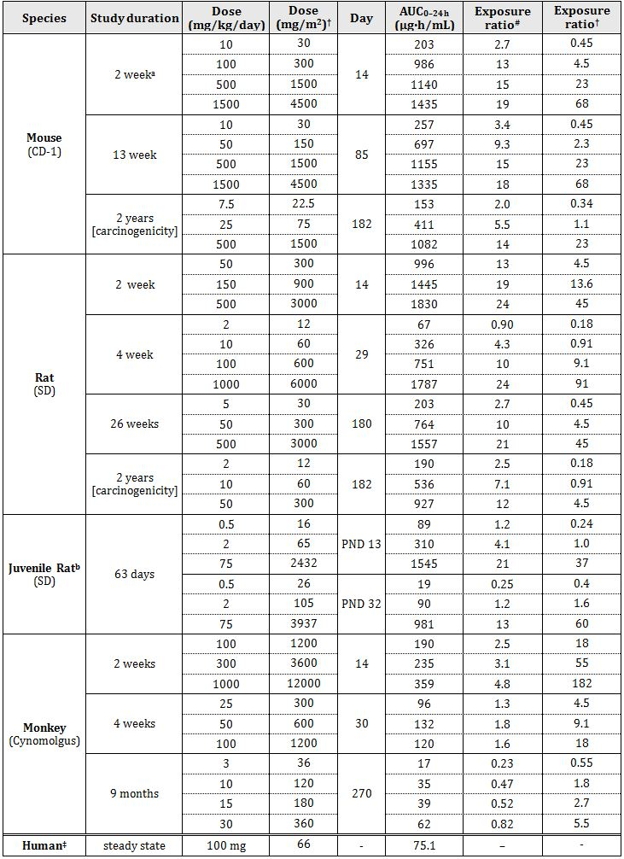
a. animals received the sodium salt (correction factor = 1.07)
# = animal:human plasma AUC_{0-24h}
† animal to human mg/m² dose ratio, based on conversion factors (from mg/kg) of 3, 6, 12 and 33 for mouse, rat, monkey and human, respectively
b. or using A = KW2/3 for juvenile rats, based on mean body weight data from the study
‡ 50 kg body weight; dose 50 mg BID, treatment-experienced HIV adult subjects in combination antiretroviral therapy

Major toxicities
The major target organs for DTG were the GI tract, with some effects also observed on the liver, kidney, and bone marrow and lymph nodes.

Gastrointestinal effects
Gastrointestinal toxicity (also seen with RAL) was observed in all species, and was dose limiting. The incidence and severity of the findings tended to increase with longer duration of treatment. The sponsor claims that the GI toxicity is a local effect at the mucosal surface of the GI tract rather than due to systemic toxicity. This claim is supported by observations that GI toxicity increased with dose despite the absence of any notable increase in systemic exposure. Exposure comparisons based on dose per unit of body surface area (mg/m²) are likely to be more meaningful than comparisons based on AUC, and so both values have been provided.
In the 13 week study in mice, adverse gastric findings consisted of occasional glandular mucosal and submucosal eosinophilic and lymphocytic infiltration at a dose of 1500 mg/kg/day. The no observed adverse effect level (NOAEL) of 500 mg/kg/day corresponds to relative exposures of 15 based on AUC, or 23 based on mg/m².
Similar gastric findings were reported in the rat, with additional observations of oedema and eosinophilic infiltration of the glandular submucosa, acanthosis with cellular oedema of the limiting ridge epithelium of the forestomach, and focal haemorrhage or pigment deposition in the gastric mucosa. In the 26 week study, the no observed effect level (NOEL) for gastric toxicity was 5 mg/kg/day and the lowest observed effect level (LOEL) was 50 mg/kg/day. The effects observed at this dose were relatively mild and the sponsor argued that they were not of toxicological significance. This view is supported by the lack of any treatment related gastric changes in the carcinogenicity study in rats dosed with DTG at 50 mg/kg/day for two years. Thus it is accepted that the NOAEL was 50 mg/kg/day in this species, which corresponds to systemic exposure levels 10-12 times the clinical exposure level based on AUC, or 4.5 times the exposure based on dose per unit of body surface area.
The monkey was the most sensitive species with respect to GI toxicity. Mortalities were attributed to severe GI toxicity in the 14 day study at 1000 mg/kg/day, and in the nine month study at 50 mg/kg/day, associated with emesis, diarrhoea and ulcerated colon and changes in blood electrolyte concentrations. Monkeys in the nine month study dosed at 50 mg/kg/day (which was reduced to 30 mg/kg/day from day 70) exhibited histopathological changes in the stomach including multifocal mononuclear cell infiltration, slight haemorrhage in the lamina propria, very slight multifocal erosions and multifocal epithelial regeneration. Treatment with DTG at doses ≥100 mg/kg/day for four weeks or longer was associated with atrophy of mucosal epithelium, inflammatory cell infiltration in the lamina propria and cell debris from crypts in the caecum, colon and rectum, with mucosal haemorrhage evident at doses ≥ 300 mg/kg/day in the 14 day study. The NOAEL of 15 mg/kg/day corresponds to a relative exposure of only 0.52 based on AUC, and 2.7 based on mg/m². Adverse GI effects are potentially of clinical significance.

Liver
Elevated liver enzymes (aspartate aminotransferase [AST], alanine aminotransferase [ALT], alkaline phosphatase (ALP]) were seen in mice at a dose of 1500 mg/kg/day in the 13 week study (NOEL 500 mg/kg/day, corresponding to a relative exposure level of 15 times the clinical exposure level). Hepatic toxicity was also evident in the 14 day monkey study, consisting of transient increases in ALT at doses ≥ 300 mg/kg/day, increases in AST and triglycerides and decreases in cholesterol at 1000 mg/kg/day. Histological changes seen in monkeys dosed at 1000 mg/kg/day for 14 days included single cell necrosis, hypertrophy and vacuolation of hepatocytes. The NOEL for hepatic toxicity in the monkey of 100 mg/kg/day was associated with systemic exposure levels 2.5 times the maximum clinical exposure level. There was no evidence of hepatic toxicity in repeat dose studies in rats at relative exposure levels (based on AUC) of up to 24 in the two week study, and relative exposure of up to 21 in the 26 week study.

Kidney
Renal toxicity was reported in repeat dose studies in rats and monkeys. Adverse renal effects included increased urinary specific gravity, sodium and chloride excretion and protein concentration, and decreased urinary volume and potassium excretion. The renal LOEL of 50 mg/kg/day in the two week rat study is based on an increase in urinary specific gravity. Since there were no serum chemistry or histopathological changes in this study indicative of renal toxicity this is unlikely to be of toxicological significance. This is supported by the lack of any evidence of renal toxicity in the 26 week study in rats at relative systemic exposure levels up to 21. Serum chemistry findings in monkeys included increases in blood urea nitrogen and serum creatinine, and dilated kidney tubules at a dose of 1000 mg/kg/day in the two week study (relative systemic exposure 4.8), with similar clinical chemistry findings in a single male exposed at near clinical levels for four weeks. There was no evidence of renal toxicity in the nine month study. The mean systemic exposure level in the highest dosage group at the end of this study was approximately 0.8 times the clinical exposure at the maximum recommended human dose.

Bone marrow and lymph node
In a tissue distribution study in pigmented rats the elimination of radioactivity from bone was notably slow, with similar levels of radioactivity present at 7 and 28 days post dosing. Evidence of bone marrow and lymph node toxicity in monkeys included observations of hypocellular or gelatinous bone marrow (with one male exhibiting a decrease in nucleated cell count), atrophy of the thymic cortex and white pulp in the spleen and reduced lymphocyte numbers in paracortical lymph nodes. These effects were accompanied by reductions in numbers of reticulocytes, erythrocytes and platelets and increased activated partial thromboplastin time, which are likely to be secondary to the bone marrow toxicity. The NOAEL for bone marrow effects was 100 mg/kg/day, which corresponded to systemic exposure levels 2.5 times higher than the clinical exposure at the maximum recommended human dose. No evidence of bone marrow toxicity was reported in mice treated with DTG for up to 13 weeks or rats treated for up to 26 weeks with relative systemic exposures of 18 and 21, respectively. It is noted that neutropaenia was reported in clinical trials with DTG.

Genotoxicity
DTG was tested in a standard battery of genotoxicity tests which were conducted in accordance with the relevant European Union (EU) guidelines and were GLP compliant (with the exception of a preliminary mouse lymphoma assay). The in vitro studies used appropriate concentrations of DTG. There was no evidence of genotoxicity in the reverse mutation assay in bacteria. Although there was evidence of genotoxicity in a preliminary forward mutation assay at the thymidine kinase locus in mouse lymphoma cells this study was not GLP compliant and only three concentrations were tested. A positive result was not confirmed in the main, GLP compliant assay, and on a weight of evidence basis it is concluded that DTG was not genotoxic in mammalian cells in vitro. DTG was negative in the mouse in vivo micronucleus assay. Although there was no evidence of systemic or bone marrow toxicity, the highest practical dose was used (higher doses would not have been expected to produce notable increases in systemic exposure owing to the saturation shown in toxicokinetic studies). In addition, DTG associated radioactivity was detected in the bone marrow of pigmented rats in the tissue distribution study, which is evidence of bone marrow exposure to DTG or its metabolites. Thus, it is concluded that the assay was adequately validated, and the overall genotoxicity assessment for DTG is negative.

Carcinogenicity
In support of the application to register DTG, lifetime carcinogenicity studies were conducted in mice and rats. These studies complied with regulatory requirements for carcinogenicity studies with respect to choice of species, route and duration. There was no increase in tumour incidence associated with DTG treatment in either study. The maximum dose administered was based on the results of shorter duration repeat dose studies in which higher doses were associated with GI toxicity likely to reduce life expectancy (and hence compromise the validity of the study). A higher dose would not have been expected to produce a proportionate increase in systemic exposure owing to saturation observed in the supporting toxicokinetic study. A higher level of systemic exposure could have been achieved with BID dosing, and would probably have increased the maximum tolerable dose, since the adverse GI effects are probably due to local irritation. The systemic exposure levels achieved in the carcinogenicity studies in mice and rats were 14 and 12 times greater, respectively, than the clinical exposure level at the maximum recommended human dose, which is modest but adequate from a regulatory standpoint. In conclusion, the carcinogenicity studies were adequate and provided no evidence of carcinogenic potential.

Reproductive toxicity
Reproductive toxicity studies included a study of fertility and early embryonic development in male and female rats, teratology studies in rats and rabbits and a pre and post natal development study in rats. All studies complied with GLP guidelines, and were adequate with respect to species, numbers of animals and study design.

Relative exposure
Relative exposure is shown in Table 3.
Table 3: Relative exposure (combined sexes) in repeat dose toxicity and carcinogenicity studies.
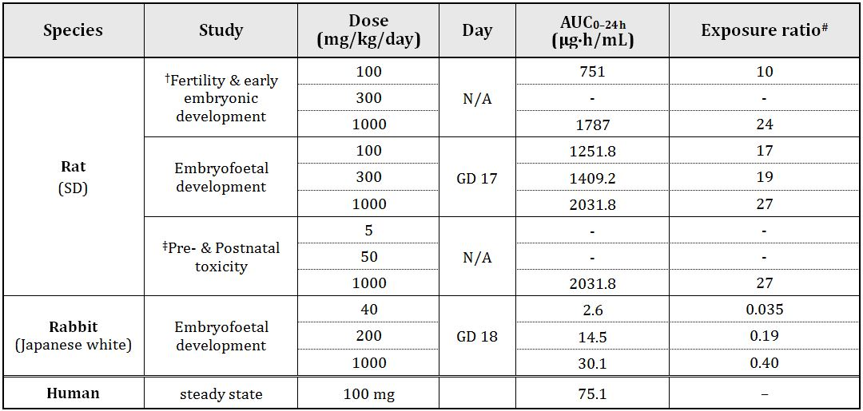
# = animal:human plasma AUC_{0-24h}
† Toxicokinetic data taken from 4-week repeat dose study in rats
‡ Toxicokinetic data from the high dose (HD) level in the embryofoetal development study in this species
Relative exposure levels in the embryofoetal development studies in rats were adequate multiples of the human clinical exposure level (up to 27 fold), but maternal toxicity in the rabbit was dose limiting and systemic exposure in this species was less than half the clinical exposure at the maximum recommended human dose. The fertility and pre/postnatal toxicity studies in rats were not supported by toxicokinetic data, but relative exposure levels can be estimated using toxicokinetic data from the 4 week repeat dose and embryofoetal toxicity studies, respectively. These data indicate that systemic exposure was adequate in the fertility and pre and post natal studies.
DTG associated radioactivity was able to cross the placenta of pregnant rats when administered on gestational day (GD) 18, with foetal blood concentrations of radioactivity approximately one tenth that of maternal blood over 24 h. Distribution of radioactivity throughout foetal tissues was widespread, with the highest levels of radioactivity found in bone marrow, blood and muscle. Transfer of DTG associated radioactivity into the milk of lactating rats was high, appearing as early as 1 h after dosing and reaching a maximum at eight hours, when the milk to plasma ratio reached a maximum of 1.24.
DTG had no effects on fertility in male or female rats at systemic exposure levels up to 24 times greater than the maximum clinical exposure. There was no evidence of foetal malformations or variations in the offspring of pregnant rats exposed to DTG during the period of organogenesis at levels 27 times the maximum clinical systemic exposure level. DTG exposure during the period of organogenesis in rabbits was also not associated with any foetal malformations or variations, although maternal toxicity (reduced body weight gain or loss of body weight and reduced food consumption) limited the maximum dose that could be administered, and the levels of systemic exposure achieved in this study were less than half the maximum clinical exposure.
There were no adverse reproductive or developmental effects observed in the pre and post natal development study in rats, although evidence of maternal toxicity for dams dosed at 1000 mg/kg/day included reduced body weight gain or body weight loss post partum, associated with reduced food consumption. A corresponding decrease in body weight for the female offspring resulted in a NOAEL for pre and post natal toxicity of 50 mg/kg/day. Based on systemic exposure levels at this dose in the 14 day repeat dose study in rats, this corresponds to a relative systemic exposure level of 13.

Pregnancy classification
The sponsor’s has proposed Pregnancy Category of D, which is likely to be a typographical error. Based on the data evaluated, a Pregnancy Category of B2 is recommended, since, due to the lack of an adequate systemic exposure margin in the rabbit developmental toxicity study, there are only adequate teratology data from one species. The US Pregnancy category according to the Food and Drug Administration (FDA) is B.

Local tolerance and skin sensitisation potential
DTG was a low to mild skin irritant and its ocular irritancy was slight. There was no evidence of sensitising potential in a mouse local lymph node assay.

Immunotoxicity
The sponsor submitted a study of the potential for DTG administration to compromise T cell mediated antibody responses, as recommended for a pharmaceutical intended for use in immunocompromised patients. There was no evidence that DTG treatment in six week old rats (up to 1000 mg/kg/day for four weeks) impaired T cell dependent antibody responses. The relative level of systemic exposure associated with this dose is uncertain owing to the lack of toxicokinetic data. The relative exposure level for adult rats in the four week repeat dose study at 1000 mg/kg/day was 24, but for two week old rats the relative exposure was only 4.8, reflecting developmental changes in DTG metabolism. Nevertheless, the data do provide evidence for a lack of immunotoxic potential. The potential for DTG treatment to adversely affect T cell mediated antibody responses was also examined in a juvenile rat toxicity study (see below, ‘Paediatric use’). Data were provided showing no effect of treatment on T cell dependent IgM or IgG mediated immune responses, no effects on lymphocyte subsets (CD4 and CD8 T cells and B cells), and no effect on CD4 or CD8 T cell receptor Vβ usage in peripheral blood. Supporting toxicokinetic data for this study provided a systemic exposure level at the NOEL (with respect to immunotoxicity) of 75 mg/kg/day that was 21 times the clinical exposure level at the maximum recommended human dose.

Impurities
Potential genotoxic impurities in DTG drug substance are controlled to below threshold of toxicological concern (TTC) levels. The proposed specifications for impurities in the drug product are below the ICH qualification thresholds.

Phototoxicity
The absence of any data on the potential phototoxicity of DTG is considered to be a deficiency in this submission. The absorption spectrum for DTG includes minor peaks that are within the range 290-700 nm. In the tissue distribution study in pigmented rats, DTG associated radioactivity was widely distributed throughout tissues, including the pigmented tissues of the skin and uveal tract, and there was evidence of retention in the former tissue. These two properties are sufficient to warrant investigation of the phototoxic potential of DTG. The sponsor did not provide any justification for the absence of any dedicated phototoxicity studies, although noted in the nonclinical overview that no drug related toxicity has been identified in the eye or skin during repeat dose oral toxicity studies in rats and monkeys. In these studies, potential toxic effects on the eye and skin were assessed by ophthalmoscopy, macroscopic and microscopic examination. Phototoxicity is not considered to have been adequately addressed, since the magnitude of exposure to UV radiation in these studies is unknown, and may have been very low. In addition, the laboratory strain used in the repeat dose studies in the rat lacks melanin containing tissues. While the lack of adverse ocular findings in the repeat dose studies in rats and monkeys is reassuring, it is not considered adequate from a regulatory perspective.

Paediatric use
The proposed indications include the treatment of HIV infection of INI naive children aged 12-18 years and weighing ≥ 40 kg at a dose of one tablet (50 mg) once daily. The sponsor submitted a 63 day juvenile toxicity study in pre weanling (PND 4) to adolescent rats (PND 66) to support the paediatric indication. There were two deaths among males dosed at 75 mg/kg/day, one each occurring on PNDs 12 and 17, associated with reduced body weight gain at this dose level. These deaths are considered to be treatment related. Growth of female rats, as assessed by femur length, was very slightly (≤ 4%) but significantly reduced at all dose levels, but this is unlikely to be of biological significance. Treatment with DTG had no adverse effects on the attainment of sexual maturity or on stage dependent evaluation of spermatogenesis. As discussed above, this study also investigated the effects of DTG treatment on T cell dependent antibody responses. There were no adverse effects on T-cell mediated responses in any of the treatment groups. The NOAEL for juvenile toxicity in this study was 2 mg/kg/day. As discussed under “PK”, owing to the ontogeny of UDP-glucuronosyltransferase (UGT) in the rat the glucuronidation of DTG is relatively undeveloped in the unweaned rats (PND 13) compared with adolescents (PND 32). Thus, the systemic exposure to the parent molecule decreases over this time course. The relative exposure at the NOAEL of 2 mg/kg/day decreased from 4.1 on PND 13 to 1.2 on PND 32. It is of note that the mortalities were observed in unweaned rats, corresponding to the higher concentrations of DTG circulating in plasma at this time.

Comments on the safety specification of the Risk Management Plan (RMP)
Results and conclusions drawn from the nonclinical program for DTG detailed in the sponsor’s draft RMP are in general concordance with those of the nonclinical evaluator. The lack of a dedicated phototoxicity study is considered a deficiency, and monitoring for potential phototoxicity could be included in the RMP.

Nonclinical summary and conclusions

Summary
- The sponsor has applied to register the integrase inhibitor DTG (in combination with other antiretroviral agents) for the treatment of HIV infection in adults and children aged 12-18 years weighing ≥ 40 kg. The proposed dose is one 50 mg tablet QD, or BID in the case of patients with integrase resistance (that is, MRHD = 100 mg/day).
- The nonclinical data submitted to support the application were comprehensive and of high quality, with all safety pharmacology and pivotal repeat dose toxicity studies carried out in compliance with GLP requirements, although no phototoxicity study was submitted.
- DTG inhibited HIV-1 integrase in strand transfer assays with IC₅₀ values of 2.7 and 12.6 nM. Antiretroviral activity was demonstrated against laboratory strains of wild type HIV-1 in PBMCs and MT4 cells, with mean IC₅₀ values of 0.51 to 2.1 nM. DTG had similar efficacy at the integrase coding region of 13 clade B isolates grown in PBMCs (IC₅₀ = 0.52 nM). The in vitro efficacy (IC₅₀) against a panel of HIV-1 clinical isolates (including 3 in each group of M clades A, B, C, D, E, F, and G, and 3 in group O) ranged from 0.02 nM to 2.14 nM, while the IC₅₀ values against 3 HIV-2 clinical isolates in PBMC assays ranged from 0.09 nM to 0.61 nM. The DTG trough concentration following administration of a single 50 mg dose to integrase inhibitor naïve subjects of 1.20 μg/mL is estimated to be ~30 times the in vitro IC₉₀ value after correcting for the effects of human serum protein binding.
- Combination studies conducted in vitro with a wide range of antiretroviral agents as well as adefovir and ribavirin found no evidence of reduced potency for DTG.
- DTG resistant viruses were selected in studies of potential resistance using different wild type strains and clades of HIV-1. Emergent amino acid substitutions included E92Q, G193E, G118R, T124A, S153F or Y, L101I and R263K, and were associated with minimal to 11 fold reductions in susceptibility to DTG. In resistance development studies starting with the single RAL resistance mutants Q148H, Q148K or Q148R, additional mutations detected during passage with DTG included E138K/Q148K, E138K/Q148R, Q140S/Q148R and G140S/Q148R. Mutations in the integrase coding region showing reduced susceptibility to DTG included Q148 substitution in addition to E138K, G140S or N155H, or Q148 and G140S substitutions in addition to M154I, V201I, T97A or E138K. Similarly, most RAL resistant clinical isolates showing reduced sensitivity to DTG in vitro possessed a Q148 substitution with one or more additional substitutions in the integrase coding region, and these mutations were also associated with virologic failure with DTG treatment.
- DTG showed mildly reduced activity against HIV-2 mutants with substitutions A153G/N155H/S163G and E92Q/T97A/N155H/S163D, and viruses possessing E92Q/N155H and G140S/Q148R mutations had moderate to high resistance to DTG in vitro.
- Safety pharmacology studies with DTG covering the CNS, cardiovascular system and respiratory systems were adequate, although systemic exposure (based on Cmax) in the cardiovascular study in conscious monkeys was only about five times that observed in clinical studies at the maximum recommended human dose (MRHD).
- The PK of DTG were determined in mice, rats, rabbits, dogs and monkeys, and was characterised by low plasma clearance and volume of distribution. The oral bioavailability appeared to be limited by solubility, and was 76%, 39% and 87% in rats, dogs and monkeys, respectively. Increases in exposure based on Cmax or AUC were less than dose proportional, and this limited the maximum exposure that could be achieved in repeat dose studies. Binding to plasma proteins in vitro was greater than 99% in all species (99.3% in humans). DTG associated radioactivity was extensively distributed in pigmented rats, but radioactivity was eliminated very slowly from bone.
- The major pathway for metabolism in all species was glucuronidation (mediated in humans by UGT1A1, with UGT1A3 and UGT1A9 playing a minor role). CYP3A4 appeared to be the only CYP isoform involved in DTG metabolism, and this was a minor pathway. Oxidative defluorination followed by glutathione or cysteine conjugation is likely to involve formation of an electrophilic arene oxide intermediate. All of the human metabolites were formed in one or more of the animal species used in repeat dose toxicity studies to an adequate extent. Unchanged DTG was the predominant form circulating in plasma, with low levels of circulating metabolites that are not expected to be pharmacologically active. Excretion was predominantly via the faeces in all species, although renal excretion was relatively more important in humans. Biliary metabolites in the mouse, rat and monkey are likely to be deconjugated in the intestine. Overall, the PK data confirmed the suitability of the animal species used in the toxicity studies.
- Therapeutic concentrations of DTG may be influenced by inducers or inhibitors of UGT1A1 and CYP3A4, and also by inhibitors of P-glycoprotein and the human BCRP. DTG showed little or no potential to affect CYP dependent metabolism of other drugs. A modest inhibition of UGT1A1 indicates a potential to increase total or unconjugated bilirubin concentrations with prolonged use, although this was not observed in the nonclinical studies. DTG may decrease the clearance of OCT2 substrates such as dofetilide, and this may also account for a mild increase in creatinine concentrations observed in clinical studies.
- Acute toxicity was addressed in the repeat dose studies. There were no notable acute toxicities in mice or rats. In dogs and monkeys GI effects were dose limiting (see below).
- Studies of up to 13 weeks were conducted in mice, 26 weeks in rats and 38 weeks in monkeys. Levels of systemic exposure achieved in mice and rats were generally adequate, in the monkey studies they were at or below the anticipated clinical exposure level.
- Gastrointestinal toxicity was observed in all species and was dose limiting. In rodents these effects were limited to the stomach, and included oedema and glandular mucosal and submucosal eosinophilic and lymphocytic infiltration (with focal haemorrhage or pigment deposition at higher doses), and acanthosis with cellular oedema of the limiting ridge epithelium of the forestomach. This is considered to be a local rather than systemic toxicity. The NOAELs in mice and rats corresponded to relative exposures of 15 and 10-12, respectively, based on AUC, or 23 and 4.5, respectively, based on mg/m².
- The monkey was more sensitive with respect to GI toxicity, with mortalities in the nine month study at 50 mg/kg/day associated with emesis, diarrhoea and ulcerated colon and changes in blood electrolyte concentrations. Histopathological findings in the stomach at this dose (which was reduced to 30 mg/kg/day from day 70) including multifocal mononuclear cell infiltration, slight haemorrhage in the lamina propria, very slight multifocal erosions and multifocal epithelial regeneration. Atrophy of mucosal epithelium, inflammatory cell infiltration in the lamina propria and cell debris from crypts in the caecum, colon and rectum were observed in the four week study at doses ≥ 100 mg/kg/day, while mucosal haemorrhage was evident in the two week study at doses ≥ 300 mg/kg/day. The NOAEL of 15 mg/kg/day corresponds to a relative exposure of only 0.52 based on AUC, and 2.7 based on mg/m². Adverse GI effects are potentially of clinical significance.
- Elevated liver enzymes (ALP, ALT and AST) were seen in mice at a dose of 1500 mg/kg/day in the 13 week study (NOEL 500 mg/kg/day, corresponding to a relative exposure level of 15 times the clinical exposure level). Hepatic toxicity was also evident in the 14 day monkey study, consisting of transient increases in ALT at doses ≥ 300 mg/kg/day, increases in AST and triglycerides and decreases in cholesterol at 1000 mg/kg/day. Histological changes seen in monkeys dosed at 1000 mg/kg/day for 14 days included single cell necrosis, hypertrophy and vacuolation of hepatocytes. The NOEL for hepatic toxicity in the monkey of 100 mg/kg/day was associated with systemic exposure levels 2.5 times the maximum clinical exposure level. There was no evidence of hepatic toxicity in repeat dose studies in rats at relative exposure levels (based on AUC) of up to 24 in the two week study, and relative exposure of up to 21 in the 26 week study.
- Evidence of renal toxicity in monkeys included increases in blood urea nitrogen and serum creatinine, and dilated kidney tubules. The NOEL for renal toxicity was associated with systemic exposure level similar to clinical levels at the MRHD. There was no evidence of renal toxicity in the nine month study at systemic exposure levels approximately 0.8 times the clinical exposure at the MRHD. Limited evidence of renal toxicity in a two week study in rats was not confirmed in the pivotal study at relative exposures of 21 for 26 weeks.
- Haematological and histopathological abnormalities in monkeys consistent with bone marrow toxicity included observations of hypocellular or gelatinous bone marrow (with one male exhibiting a decrease in nucleated cell count), atrophy of the thymic cortex and white pulp in the spleen and reduced lymphocyte numbers in paracortical lymph nodes. Reticulocyte, erythrocyte and platelet numbers were reduced, and activated partial thromboplastin time increased. The NOAEL for bone marrow toxicity corresponded to systemic exposure levels 2.5 times higher than the clinical exposure at the maximum recommended human dose. Despite the very slow elimination of DTG associated radioactivity from bone in the pigmented rat tissue distribution study there was no evidence of bone marrow toxicity in mice or rats at relative systemic exposures of 18 and 21, respectively.
- DTG is considered to be non genotoxic based on negative results in a bacterial mutation assay, a forward mutation assay in mammalian cells and an in vivo mouse micronucleus assay.
- There was no evidence of carcinogenic potential in two year bioassays in mice and rats at DTG systemic exposure levels 12-14 times greater than the clinical exposure level at the MRHD.
- DTG associated radioactivity was able to cross the placenta of pregnant rats and distribute widely throughout foetal tissues. Lactational transfer appeared to be high in this species, with radioactivity concentrations in milk being similar to the maternal plasma levels. There was no effect on the fertility of male or female rats at systemic exposure levels of DTG up to 24 times greater than the clinical exposure level. No adverse foetal developmental effects were observed in rats and rabbits whose dams were treated with DTG during the period of organogenesis. The maternal systemic exposure to DTG in the rat teratology study was 27 times the clinical exposure level at the MRHD. In the rabbit teratology study maternal exposure levels were subclinical, as maternal toxicity was dose limiting.
- No adverse reproductive or developmental toxicity was seen in rats whose dams were treated with DTG throughout pregnancy and lactation at doses associated with systemic exposures 13 times the clinical AUC level at the MRHD.
- DTG showed low to mild potential for skin and ocular irritancy, and there was no evidence of sensitising potential in a mouse local lymph node assay.
- Evidence for a lack of potential to compromise T cell mediated antibody responses was provided in the form of a four week immunotoxicity study in six week old rats (systemic exposures up to 24 times the maximum clinical AUC level). Immunotoxicity endpoints in a juvenile rat toxicity study (T cell dependent IgM or IgG mediated immune responses, lymphocyte subsets, and CD4 or CD8 T cell receptor Vβ usage in peripheral blood) also confirmed a lack of immunotoxic potential at systemic exposure levels 21 times higher than those anticipated with therapeutic use.
- Potential genotoxic impurities in DTG drug substance are controlled to below TTC levels. The proposed specifications for impurities in the drug product are below the ICH qualification thresholds.
- The absence of a dedicated phototoxicity study is considered to be a deficiency in this submission. While the lack of adverse ocular findings in the repeat dose studies in rats and monkeys is reassuring, it is not considered adequate from a regulatory perspective, since the magnitude of UV exposure in these studies is unknown, and the laboratory strain used in the repeat dose studies in rats lacks melanin containing tissues.
- Support for the paediatric use of DTG was provided by a 63 day juvenile rat toxicity study, which showed no effects on growth and development (including attainment of sexual maturity or on stage dependent evaluation of spermatogenesis) at systemic exposure levels up to four times higher than the maximum clinical exposure. Higher exposures were associated with reduced body weight gain.

Conclusions and recommendation
- The nonclinical data submitted to support the proposed registration were comprehensive and of high quality, although the absence of phototoxicity testing is considered to be a deficiency.
- The virology data demonstrated inhibition of HIV-1 replication in vitro at nanomolar concentrations through inhibition of HIV-1 integrase and supported its use as in combination therapy with a broad range of other antiretroviral agents.
- No relevant hazards were identified in adequate secondary PD and safety pharmacology studies.
- Therapeutic concentrations of DTG may be influenced by inducers or inhibitors of UGT1A1 and CYP3A4, and also by inhibitors of P-glycoprotein and the human BCRP. DTG showed little or no potential to affect CYP dependent metabolism of other drugs.
- The repeat dose toxicity studies were adequate, although no toxicity studies were conducted with DTG in combination with other anti HIV drugs. Also, relative exposure levels in the monkey studies were low. Target organs included the GI tract, liver, kidney and bone marrow, and effects on these are potentially relevant for patients.
- DTG is not considered to pose a genotoxic or carcinogenic hazard.
- There was no evidence of reproductive toxicity, although systemic exposure in the rabbit teratology study was subclinical due to dose limiting maternal toxicity. The proposed pregnancy category of D is likely to be a typographical error. A B2 category is recommended owing to the lack of adequate teratology data in the rabbit.
- There are no nonclinical objections to the proposed registration of DTG.
- The RMP should be amended to include monitoring of potential phototoxicity.

IV. Clinical findings
A summary of the clinical findings is presented in this section. Further details of these clinical findings can be found in Attachment 2.

Introduction
The submission contained the following clinical information:
- 31 clinical pharmacology studies, including 27 that provided PK data and 4 that provided PD data;
- Two population PK analyses;
- 5 pivotal efficacy/safety studies: SPRING-2 (ING113086), SAILING (ING111762), VIKING-3 (ING112574), SINGLE (ING114467), and P1093 (ING112578). The VIKING-3 and P1093 studies do not meet all the criteria for pivotal studies. However, they should be considered as such because they support two important proposed indications (use in paediatric patients and patients with INI resistance);
- One dose-finding study: ING112276;
- One other efficacy/safety study: VIKING (ING112961).

Pharmacokinetics

Studies providing PK data
Table 4 shows the studies relating to each PK topic and the location of each study summary.
Table 4: Submitted PK studies.
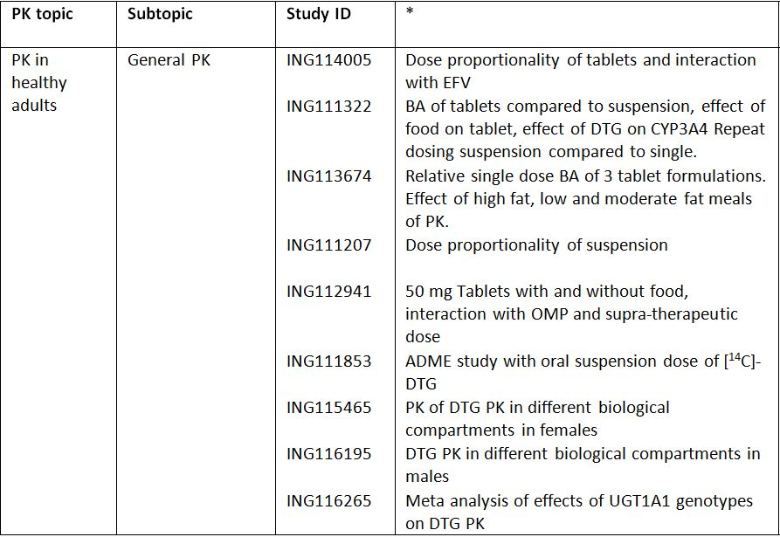
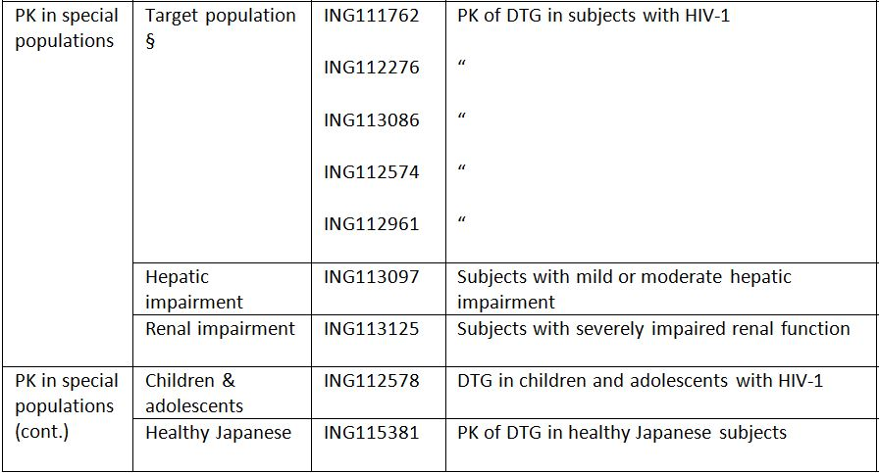

Table 4 (continued): Submitted PK studies.
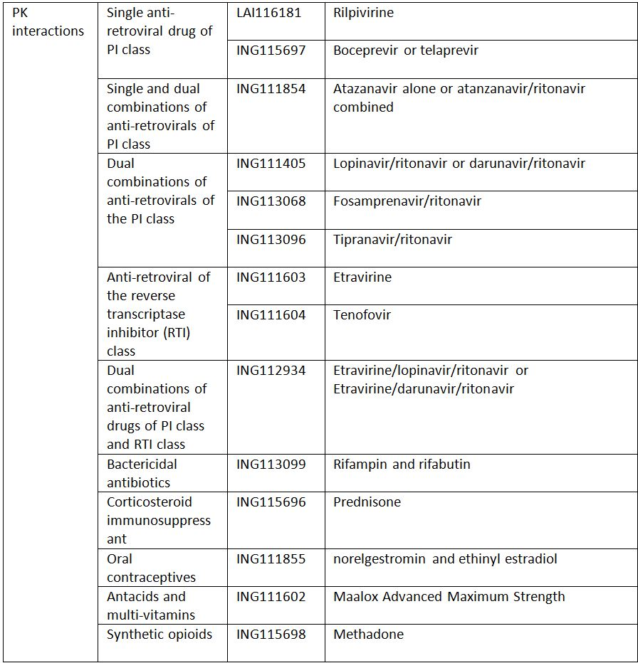
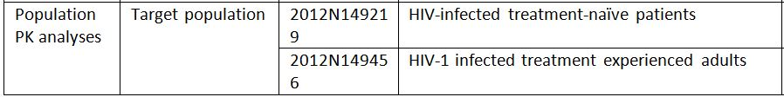
* Indicates the primary aim of the study.
† Bioequivalence of different formulations.
§ Subjects who would be eligible to receive the drug if approved for the proposed indication.
None of the PK studies had deficiencies that excluded their results from consideration.

Evaluator’s overall conclusions on PK

ADME (absorption, distribution, metabolism, and excretion)
- DTG is rapidly absorbed following oral administration of the tablet formulation, with Tmax observed at 2-4 h post dose, and a t1/2 of ~14 h; the estimated CL/F and V/F are 0.56L/h and 12.5 L for suspension formulations and 0.90 L/h and 17.4 L for tablet formulations.
- The absolute bioavailability of DTG has not been determined due to the low solubility of DTG in buffered solutions.
- Following a single dose administration under fasted conditions, a 20 mg dose of the DTG oral tablet formulation delivered 30% lower geometric mean plasma DTG AUC_{0-∞} and 42% lower geometric mean Cmax than an oral suspension 20 mg dose of DTG.
- DTG is highly bound to plasma protein with estimated percentage bound in human plasma of 98.9-99.7% in healthy subjects and 99.5% in HIV-1 infected subjects;
- DTG is present in the female and male genital tract; AUC in cervicovaginal fluid, cervical tissue, and vaginal tissue were 6 to 10% of that in corresponding plasma at steady state; AUC was 7% in semen and 17% in rectal tissue of the plasma AUC at steady state;
- DTG is primarily metabolised via UGT1A1 with a minor CYP3A component (9.7% of total dose administered in a human mass balance study).
- Following a 20 mg dose of ¹⁴C DTG suspension, 64% of the recovered radioactivity was in the faeces and a further 31.6% was recovered in urine.

Effect of food
- For the DTG 25 mg tablet used in Phase II studies, a high fat meal increased the plasma DTG AUC_{0-∞} and Cmax by 94% and 84%, respectively compared with the fasted condition.
- A further study identified that plasma DTG AUC_{0-∞} increased by 33% and 41% when AW (Phase III) tablets were administered with low fat and moderate fat meal, respectively, and Cmax increased by 46% and 52% under the two conditions, respectively. A high fat meal increased the AUC_{0-∞} and Cmax by 66% and 67%, respectively.

Dose escalation
- DTG PK exposure from the tablet formulation increased less than proportionally for doses from 2 mg to 100 mg.
- Following repeat dosing of the suspension formulation in healthy subjects, steady-state was achieved after approximately 5 days of dosing, and DTG showed time-invariant PK; accumulation ratios after 50 mg once daily dosing were 1.43, 1.36, and 1.42 for AUC_{0-τ}, Cmax, and Cτ, respectively.
- Following repeat dose administration of the tablet formulation in HIV infected patients, plasma concentrations of DTG reached steady state by 7 days of dosing and the accumulation ratios were estimated to be 1.25-1.43 for AUC, 1.23-1.40 for Cmax, and 1.27-1.42 for Cτ across the range of doses studied
- In HIV-1 infected patients, subjects who had protocol defined virological failure while being treated with DTG had 58% lower pre dose plasma DTG concentrations than subjects who were non-PDVF.

Metabolites of DTG
- M3 was the major biotransformation product observed in the urine, accounting for 62.5% of the radiocarbon (18.9% of the dose). Two other notable metabolites were also observed in human urine; these resulted from oxidation at the benzylic carbon (M7), representing 10.1% of the urinary radiocarbon (3.0% of the dose), and N-dealkylation (M1), representing 11.8% of the urinary radiocarbon (3.6% of the dose). Renal elimination of unchanged DTG was low (≤2.6% of the sample radiocarbon or ≤0.8% of the dose).
- No dose adjustment for DTG is needed in subjects with genotypes conferring poor metaboliser status of UGT1A1 (*28/*28; *28/*37; *37/*37);

Between subject variability
- DTG has low to moderate between subject and within subject PK variability, and variability is higher in HIV infected subjects than healthy subjects: the between subject variability in HIV infected subjects was estimated at 30-50% for AUC and Cmax, and at 55-140% for trough concentration.

Special populations
- No dose adjustment for DTG is needed in subjects with mild to moderate hepatic impairment (Child-Pugh grade A or B);
- Plasma exposures (AUC and Cmax) of DTG in subjects with severe renal impairment were lower than those in healthy subjects by 23-40%.
- Following a supratherapeutic dose of 250 mg DTG there was a trend for higher exposure in female than in male subjects. Geometric mean ratios comparing the male and female data sets have not been provided by the sponsor and this has been raised elsewhere in this report.

Drug-drug interaction studies
- In vitro studies indicate that DTG demonstrates minimal or no direct inhibition of CYP isozymes, UGT1A1, UGT2B7, and many transporters (Pgp, BCRP, OATP1B1, OATP1B3, MRP2, and OCT1), and it is not an inducer of CYP1A2, CYP2B6, or CYP3A4.
- No clinically significant drug interactions were observed between DTG and midazolam, oral contraceptives containing norgestimate and ethinyl estradiol, methadone, multivitamins, omeprazole (OMP), prednisone, rifabutin (RBT), tenofovir disoproxil fumarate (TDF), rilpivirine (RPV), darunavir/ritonavir (DRV/RTV), lopinavir (LPV)/RTV, etravirine (ET)/LPV/RTV, ET/DRV/RTV, fosamprenavir (FPV)/RTV, boceprevir (BCV), and telaprevir (TVR);
- DTG should be administered at least 2 h before or 6 h after polyvalent metal cation containing antacids; plasma DTG exposure was reduced 74% when co-administered with the antacid Maalox (aluminium hydroxide/magnesium hydroxide/simethicone);
- ET reduced DTG AUC and Cτ by > 70% and increased DTG CL/F by 3.4 fold. Therefore, DTG should not be co-administered with ET alone.
- Co-administration of DTG 50 mg twice daily with RIF 600 mg once daily significantly reduced plasma DTG concentrations relative to DTG 50 mg twice daily alone with AUC_{0-τ}, Cmax and Cτ reduced from 46.3 to 21.3 µg.h/mL, 5.55 to 3.13 µg/mL and 2.41 to 0.67 µg/mL, respectively.
- Co-administration with ATV resulted in an increase in plasma DTG exposures with plasma DTG AUC_{0-τ}, Cmax, and Cτ increasing by 91%, 50%, and 180%, respectively. Therefore, co-administration of DTG and ATV is not recommended.

Population PK studies
- Population PK modelling studies indicated that the PK of DTG following oral administration can be adequately described by a linear one compartment model with first order absorption and absorption lag time and first order elimination. In treatment naive HIV infected patients weight, smoking status, age and total bilirubin were predictors of clearance and gender was a predictor of relative bioavailability (F). Whereas, in treatment experienced HIV infected patients, weight, smoking status, use of metabolic inducers as part of background ART classified by their level of induction, use of ATV or ATV-RTV as part of background ART, and albumin level were predictors of CL/F; weight and albumin level were predictors of V/F; and gender and concomitant use of metal cation containing products were predictors of F.

Limitations of PK studies
- It is not known whether any of metabolites of DTG are active.
- Effect of severe hepatic impairment on DTG PKs was not evaluated.
- The effect of administration timing on DTG PKs was not evaluated.
- PK data on subjects of >65 years of age are limited.
- No studies examined the comparative PK of DTG following 100 mg DTC once daily and 50 mg DTG twice daily.

Pharmacodynamics

Studies providing PD data
Table 5 shows the studies relating to each PD topic and the location of each study summary.
Table 5: Submitted PD studies.
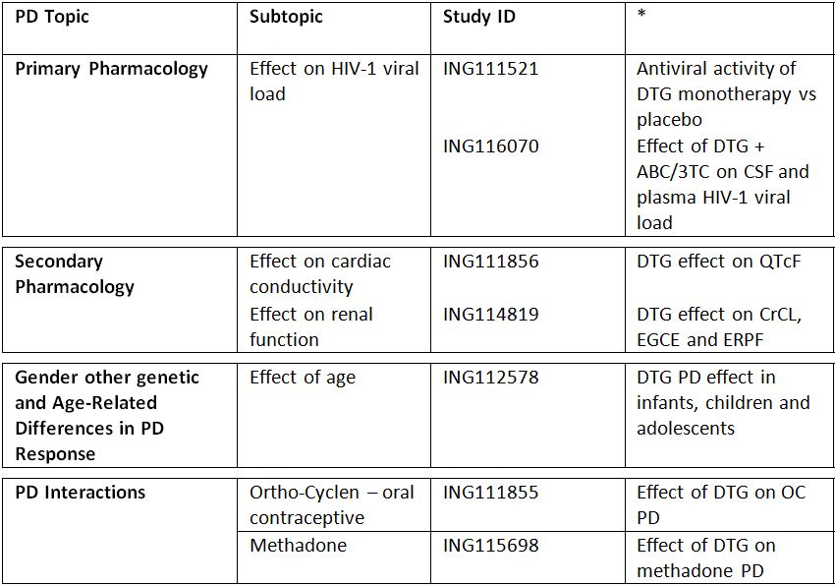
* Indicates the primary aim of the study.
§ Subjects who would be eligible to receive the drug if approved for the proposed indication.
‡ And adolescents if applicable.
None of the PD studies had deficiencies that excluded their results from consideration.

Evaluator’s overall conclusions on PD

MOA
- DTG inhibits HIV integrase by binding to the integrase active site and blocking the strand transfer step of retroviral DNA integration, which is essential for the HIV replication cycle.

Primary PDs
- In HIV-1 infected patients, 10 days of DTG monotherapy at doses of 2, 10 and 50 mg resulted in a statistically significant reduction in plasma HIV-1 RNA log₁₀ copies/mL from Baseline to Day 11 compared with placebo (p≤0.001) for all doses.
- In HIV-1 infected subjects, 31% and 62% of subjects had plasma HIV-1 RNA <50 c/mL and <400 c/mL, respectively, following 2 weeks of treatment with DTG 50 mg once daily in combination with a background nucleoside reverse transcriptase inhibitor (NRTI) regimen of ABC/3TC 600/300 mg once daily. Following 4 weeks of treatment, these percentages increased to 46% and 92%, respectively. The median change from baseline in plasma HIV-1 RNA at Week 2 was -2.53 log₁₀ c/mL and at Week 4 was -3.04 log₁₀ c/mL.

Secondary PDs
- In healthy subjects, DTG has no effect on cardiac repolarisation at a supratherapeutic dose of 250 mg (suspension).
- In healthy subjects, DTG decreased creatinine clearance by 10% at 50 mg every 24 h (q24h) and 14% at 50 mg every 12 h (q12h), whereas it had no effect on glomerular filtration rate and effective renal plasma flow.

Dose response
- Greater antiviral activity was associated with higher DTG plasma exposure. The exposure antiviral activity relationship was best described by an Emax model with Emax fixed to 2.6, Hill factor fixed to 1 and PK parameter on the linear scale. Cτ (concentration at end of dosing interval) was the PK parameter that best predicted Day 11 plasma viral load reduction from baseline or maximum plasma viral load reduction from baseline.
- There was no statistically significant correlation between CSF DTG concentration and absolute CSF HIV-1 RNA levels or between CSF DTG concentration and change from Baseline in CSF HIV-1 RNA.

Special populations
- In infants, children and adolescents infected with HIV-1, once daily dosing with DTG, with target dose of ~1 mg/kg according to weight, resulted in a rapid and sustained antiviral response with 80% of subjects achieving HIV-1 RNA <400 c/mL and 70% achieving HIV-1 RNA <50 c/mL by Week 24.

Interactions
- Co-administration of DTG did not affect the PDs of either the oral contraceptive Ortho-Cyclen or the synthetic opioid methadone.

Efficacy

Evaluator’s conclusions on clinical efficacy for the treatment of HIV-1 infection
The submitted studies are compatible with European Medicines Agency (EMA) guidelines of November 2008 adopted by the TGA. Studies VIKING-3 and P1093 are open label and non randomised, but overall the study designs are adequate and the comparators and outcome measures are appropriate. Viral load reduction to <50 c/mL and changes in CD4+ counts are both accepted as surrogate measures of efficacy, and the HIV-1 RNA assay employed had the appropriate sensitivity to detect the endpoint. Efficacy in subgroups was assessed appropriately, including patients with HBV/HCV co-infection, women, patients with renal impairment, patients with high and low viral loads and patients with varying severities of HIV/AIDS. Treatment naïve populations were studied ensuring that patients with transmitted viral resistance were excluded. Treatment experienced patients were also studied, including those with multiclass and INI resistance. Effective and sustained viral suppression was observed with the combination of DTG and two NRTIs in two randomised, active controlled Phase III studies in ART naïve adults. In ING113086 (SPRING-2), the non inferiority of the DTG combination compared with RAL + NRTI background therapy was convincingly demonstrated after 48 weeks of treatment. In ING114467 (SINGLE), the combination of DTG + ABC/3TC was statistically superior to Atripla although the superiority was driven partly by early withdrawals due to AEs in the Atripla arm. The results were consistent within subgroups defined by age, gender, race, baseline HIV RNA and CD4+ counts. Overall, the results of both studies strongly support a non inferiority claim. ING112574 (VIKING-3) assessed the antiviral activity of DTG in ART experienced patients with INI resistance. An encouraging 63% of patients achieved a virological response at 24 weeks but it was it was an open label study of DTG 50 mg BID with no comparator arm. ING111762 (SAILING) is the only pivotal, controlled Phase III study comparing DTG and RAL regimens in treatment experienced adult patients. There was a statistically significant 9.7% (95% CI: 3.4, 15.9, p = 0.003) difference in viral response rates in favour of DTG 50 mg QD at Week 24. The incidence of treatment emergent INI resistance was also less in DTG patients compared with RAL. However, the primary endpoint of the study is viral response at Week 48 as recommended in the EU guideline. As a minimum, the primary endpoint should be confirmed before DTG efficacy in treatment experienced, INI naive patients is accepted.
The PK profile of DTG in INI naïve adolescents with long standing disease was similar to that observed in adults and 70% achieved the HIV RNA target of 50 c/mL after 24 weeks. However, efficacy data is available for only 10 patients. Data from larger patient numbers are required to justify an indication in this patient group.
The efficacy summary provided by the sponsor in the clinical overview is balanced and the conclusions are acceptable.

Safety

Studies providing evaluable safety data
A summary of the safety population by study for pivotal and supportive studies is shown in Table 6.
Table 6: Submitted safety studies.
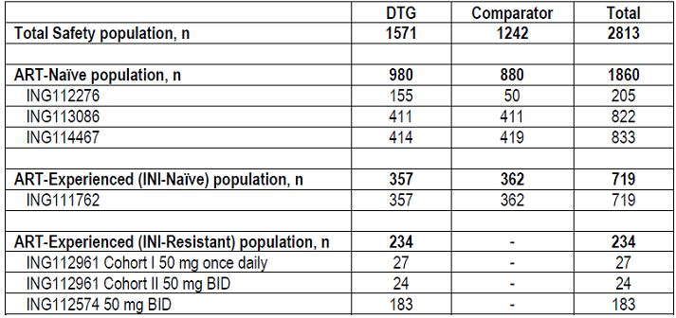

Evaluator’s overall conclusions on clinical safety
The safety profile of DTG 50 mg QD in ART naïve and experienced patients was similar to RAL after 24 and 48 weeks treatment. In combination with ABC/3TC, DTG was better tolerated than Atripla which was associated with higher withdrawal rates due to AEs. DTG 50 mg BID had a similar safety to DTG 50 mg OD. Adverse events (AEs) were more common in ART experienced patients than in ART naïve patients but the increased incidence was attributable mainly to differences in the severity of the underlying disease in the treatment experienced group. The most frequently reported AEs in DTG and comparator groups were diarrhoea, nausea and headache but most were mild to moderate and did not require drug discontinuation. There were few hypersensitivity reactions and skin rashes were generally mild and self limiting. In ING113086 and ING111762, the incidence of hepatic toxicity was similar in the DTG and RAL treatment groups with few cases suggestive of drug induced liver injury (DILI). As might be predicted, hepatic events were more common in treatment experienced patients exposed to multiple concomitant medications, and in patients with HBV and/or HCV co-infection. However, hepatic abnormalities in patients with co-infection appeared lower in DTG patients compare with RAL or EFV. There is a small but consistent rise in serum creatinine following DTG due to inhibition of the renal OCT2 receptor. However, the incidence of renal impairment with DTG treatment is very low. The frequency of GI events was similar in DTG patients compared with RAL and Atripla. The frequency of haematological toxicity was low in DTG patients and there were no cases of torsades de pointes. The neuropsychiatric profile of DTG was similar to that of RAL and Atripla and there was no increased suicide risk. The risk of myositis, lipid and lipase abnormalities also appeared similar in DTG patients compared with comparator treatments. The DTG safety profile was similar in subgroups defined by gender, race, and age. The rapid antiviral response to DTG highlights the need for caution in patients with HBV co-infection risk of IRIS.
DTG has been shown to be well tolerated in treatment naïve HIV patients. DTG also appears to be well tolerated in treatment experienced patients. However, as discussed in the conclusions on efficacy, Week 48 safety data should be reviewed before the conclusions of ING11762 (SAILING) can be accepted. The same caveat applies to the adolescent study in which exposure in only ten patients has been reported to date.

Clinical summary and conclusions: first round

First round benefit-risk assessment

First round assessment of benefits
The benefits of DTG in the proposed usage are:
- There is a continuing need for new ARTs such as DTG for the treatment of multidrug resistance;
- DTG is effective with similar or superior efficacy to RAL and EFV;
- DTG is effective in both ART naïve and experienced populations;
- DTG is effective in subgroups defined by race, age, gender and HBV/HCV co-infection;
- DTG has a high barrier to viral resistance;
- Once daily dosing enhances compliance;
- DTG is well tolerated;
- DTG may be used in patients with renal impairment of any severity, or in patients with mild to moderate hepatic impairment;
- There are no major drug or food interactions;
- DTG 50 mg BID is effective and well tolerated in patients with INI resistance.

First round assessment of risks
The risks of DTG in the proposed usage are:
- The most common AEs are diarrhoea, nausea and headache, mostly mild and self limiting;
- A limited incidence of mild to moderate hypersensitivity reactions including rash, constitutional symptoms and organ dysfunction including DILI;
- A limited incidence of hepatitis flare and IRIS in patients with HBV and/or HCV co-infection;
- A benign but potentially confusing rise in serum creatinine and fall in calculated creatinine clearance rate;
- Data in paediatric populations are limited.

First round assessment of benefit-risk balance
The benefit-risk balance of DTG, given the proposed usage, is favourable. DTG is an effective INI in treatment naïve and experienced patients and non inferior to RAL. It is well tolerated and the tendency to viral resistance is low.

First round recommendation regarding authorisation
Authorisation is recommended for the treatment of adults with HIV-1 infection but subject to:
- Confirmation of the primary endpoint at Week 48 in study ING111762 (SAILING);
- Satisfactory Week 48 tolerability data in the same study.
Authorisation for adolescents is not recommended because of borderline PK data and limited safety and efficacy data in this age group. Further PK data would be of value but they are not required if more efficacy and safety data are provided.

List of questions

Additional expert input
Not required.

Clinical questions

Pharmacokinetics
Question 1: For patients with multidrug resistance, why was the DTG 50 mg BID dose selected instead of 100 mg QD?
Question 2: No information has been provided by the sponsor regarding the pharmacological activity of DTG metabolites. This should be provided.
Question 3: Little to no information is provided in the evaluation materials regarding the PK of the DTG metabolites, although they appear at relatively low levels the evaluator requests that the sponsor provides all information regarding the PK/PD of the DTG metabolites they have at their disposal.
Question 4: In Study ING115697, the BCV PK parameters were not available and it was stated that they will be included in a subsequent amended report. Is this subsequent report now available? Is any further information or data regarding the subject who fell pregnant during the trial available?
Question 5: Is there any data on the effect of administration timing on DTG PKs?
Question 6: In Study ING111856, following a supratherapeutic dose of 250 mg DTG there was a trend for higher exposure in female than in male subjects. Geometric mean ratios comparing the male and female data sets have not been provided by the sponsor, could these be provided?

Pharmacodynamics
Question 7: No information has been provided by the sponsor regarding the pharmacological activity of DTG metabolites. This should be provided.

Efficacy
Question 8: There appears to be no justification provided for the selection of the 50 mg dose for Phase III studies. Could the sponsors please clarify this.
Question 9: Statistical analyses have been or will be performed in ongoing studies at 24, 48 and 96 week intervals. Please provide additional justification for not adjusting the analyses for multiplicity.
Question 10: Median compliance data were not provided in the appropriate section of the SPRING-2 study report. Please provide.
Question 11: The distribution of study sites listed in the VIKING-3 synopsis does not add up to 65. Please clarify.
Question 12: The clinical evaluator sought confirmation of the primary endpoint and satisfactory Week 48 tolerability data for Study ING111762 (SAILING).
Question 13: For Study P1093, the clinical evaluator noted that PK variability is similar to that observed in adults but efficacy and safety data are available for only 10 patients. The clinical evaluator stated that it would be prudent to report the full Cohort 1 with an additional 12 patients at 24 weeks before the positive findings are acceptable.

Safety
Question 14: Why were ECGs not recorded in Study ING112578?

Second round evaluation in response to questions
The sponsors’ response to the clinical questions has been reviewed. The original TGA question is mentioned followed by the sponsor’s response and then the evaluator’s comments on the sponsor’s response.

Pharmacokinetics
Question 1: For patients with multidrug resistance, why was the DTG 50 mg BID dose selected instead of 100 mg QD?

Sponsor’s response:
DTG showed less than dose proportional increase in exposure from 50 mg to 100 mg using tablet formulation based on results from Study ING114005 (presented in original submission). This study evaluated single dose DTG PK from 100 mg dose compared to 50 mg dose under fasted conditions in 12 healthy subjects. DTG PK parameters from this evaluation are provided in Table 7.
Table 7: Summary of selected plasma DTG PK parameters following single dose administration.ª
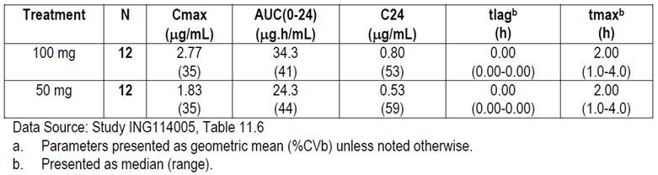
DTG exposure increased by only ~40% when dose was doubled from 50 mg to 100 mg. The relative oral bioavailability of 100 mg is estimated at 70.5% (90% CI: 59.7%, 83.3%) to that of 50 mg based on AUC. The reduced oral bioavailability at 100 mg dose versus 50 mg dose is likely a result from limited absorption due to low water solubility of this compound. While some subjects did achieve near linear increases in exposure between 50 mg and 100 mg, four subjects demonstrated only a minimal increase or no increase as the dose was doubled. Although this evaluation was performed for single dose DTG PK, such nonlinearity from 50 mg to 100 mg using tablet formulation is expected to be carried over upon repeat doses. Therefore, DTG 100 mg once daily dose is expected to have only 40% higher exposure (on average) than DTG 50 mg once daily dose due to nonlinear PK. As a result, 50 mg twice daily dose, rather than a 100 mg once daily dose, was chosen for the evaluation in Cohort 2 in the Phase IIb Study ING112961 in INI resistant subjects (VIKING) as this dosing regimen was expected to deliver predictable higher DTG exposure compared 50 mg once daily and much higher Cτ as opposed to 100 mg once daily to maximise the antiviral effect of this drug. Cτ was determined to be a better predictor of antiviral analysis of INI compared to AUC and Cmax in a meta analysis using pooled data and was expected to be one of the drivers for improved antiviral activity in the resistant population. As demonstrated in Study ING112961, DTG Cτ from 50 mg twice daily cohort was about 4-6 times of those observed from 50 mg once daily cohort and contributed partially to the better antiviral response rate for the twice daily dose. Therefore, DTG 50 mg twice daily dose was subsequently evaluated in the confirmatory Phase III study ING112574 (VIKING-3).

Evaluator’s comments on sponsor’s response:
The evaluator is satisfied with the explanation provided by the sponsor.
Question 2: No information has been provided by the sponsor regarding the pharmacological activity of DTG metabolites. This should be provided.

Sponsor’s response:
In the mass balance study using radiolabeled compound (ING111853), the parent drug DTG accounted for greater than 97% of the total plasma radioactivity. Thus, metabolites are present in plasma at very low concentrations. The primary metabolite, the glucuronide (M3), was a minor component corresponding to 2.4% of the 6 h, and 1.5% of the 24 h plasma pool radiochromatograms and was not quantifiable in the 48 h plasma pool radiochromatogram. Combined, DTG and M3 accounted for ~99% of the total radioactivity DTG and the primary DTG glucuronide metabolite (M3) are shown in Figure 2. The red oval encircles the oxygen atoms on the DTG scaffold which bind the Mg²⁺ ions in the catalytic pocket. All integrase strand transfer inhibitors including DTG bind to the two essential Mg²⁺ ions in the catalytic pocket of the HIV-1 intasome (integrase:HIV-1 cDNA). Of note, crystal structure of the PFV intasome in complex with strand transfer inhibitors including DTG and modelling data demonstrate that RAL, EVG, and DTGs Mg²⁺ binding activity is dependent on three oxygens (Figure 2) positioned at specific constrained distances and angles. Formation of the glucuronide blocks the central oxygen, and in addition adds a bulky ring structure which based on the tight fit in the catalytic pocket will not allow normal binding in the pocket, nor the other two oxygens (carbonyls within red circle in Figure 2) to achieve the close proximity required for Mg²⁺ binding. This molecule was not synthesised during DTG design as the structure precluded binding and it would not be active as a two metal binder of the essential Mg²⁺ ions.
Figure 2. Two dimensional structures of DTG and the DTG glucuronide primary metabolite (M3).
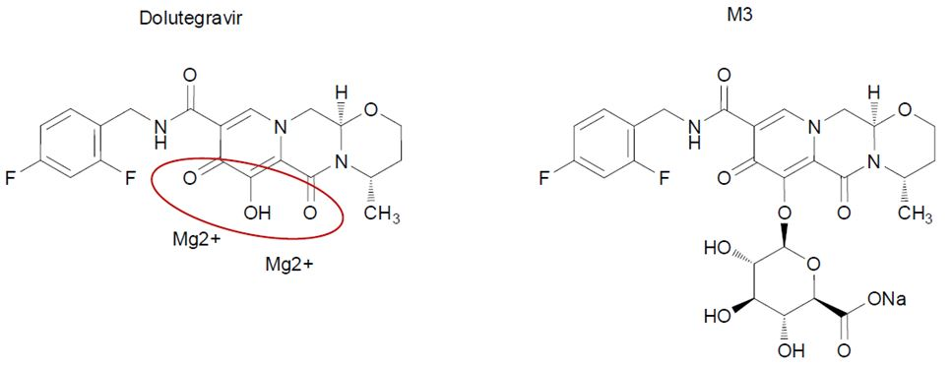

Evaluator’s comments on sponsor’s response:
Although crystal structure and modelling studies can be very powerful tools for predicting the activity of unknown molecules at receptors, they require a large number of assumption to be made concerning the confirmation (shape) and energy states taken by both the molecule and the receptor.
This is can be a highly dynamic process and often several different confirmations are equally feasible and are dependent upon a range of factors such as water binding to receptor etc.
Therefore, biological activity studies, such as radio ligand binding experiments, remain the gold standard for assessing the activity of a molecule at a receptor and this is not possible if the molecule in question has not be synthesized.
However, given that M3 and the other metabolites appear at such low concentrations and that M3 contains an additional bulky ring structure, the evaluator is satisfied with the sponsor’s explanation.
Question 3: Little to no information is provided in the evaluation materials regarding the PK of the DTG metabolites, although they appear at relatively low levels the evaluator requests that the sponsor provides all information regarding the PK/PD of the DTG metabolites they have at their disposal.

Sponsor’s response:
As described above in Question 2, unchanged DTG accounted for >97% of the drug related components in the systemic circulation (RM2009/00293). The similar terminal phase t1/2 values of radioactivity and of DTG indicated that the primary metabolite, the glucuronide (M3) metabolite (<3% of the drug related material), and other minor products that were present in the systemic circulation were formation rate limited and did not persist.
The glucuronide metabolite was not administered directly to determine its own PK. As noted above in Question 2, the glucuronide does not possess integrase inhibition activity. Thus there is no contribution of the metabolites to the PK/PD relationship of DTG.

Evaluator’s comments on sponsor’s response:
Please see the evaluator's response to question 2.
Question 4: In Study ING115697, the BCV PK parameters were not available and it was stated that they will be included in a subsequent amended report. Is this subsequent report now available? Is any further information or data regarding the subject who fell pregnant during the trial available?

Sponsor’s response:
PK data for BCV are not available. There continue to be significant problems with the assay at the contract research organisation that is performing the analysis such that the accuracy of the data cannot be confirmed. Specifically, there are significant issues with the purity of the reference standards. The sponsor is pursuing other avenues to complete the analysis and evaluating the long term stability of the samples.
In regard to the subject who became pregnant during the trial, the baby was born in January 2013. Gestation was 41 weeks. The birth was listed as normal. The baby was female with a length of 58.4 cm and weight of 3487 grams. APGAR (Appearance, Pulse, Grimace, Activity, Respiration) scores were 9 at first assessment and 10 at second assessment. The following details were provided:
Child birth went well. The child had no complications and was healthy at birth. About a week and a half later, the subject was hospitalised for 5 days due to an infection but recovered fully.

Evaluator’s comments on sponsor’s response:
The evaluator accepts that the sponsor has had difficulty in determining whether the co-administration of DTG affects the PKs of BCV. However, until this information becomes available, the evaluator believes that the PI should include a statement, such as: “the effects of DTG on the PKs of BCV have not been determined.”
Question 5: Is there any data on the effect of administration timing on DTG PKs?

Sponsor’s response:
The effect of administration timing on DTG PK has not been evaluated; however, no significant impact of administration timing is expected as DTG demonstrates low to moderate PK variability.
In general, diurnal variations affect drug disposition or PK through the following physiological processes: gastric emptying time, gastric and urinary pH, and blood flow to the GI tract, liver and kidneys. DTG is primarily eliminated through hepatic metabolism and renal excretion is minimal; therefore, diurnal changes in urinary pH and blood flow to the kidney are not expected to affect DTG PK. Changes in gastric pH does not affect DTG absorption and this is supported by the results from Study ING112941 which showed that omeprazole did not affect DTG PK. The oral clearance of DTG is low at approximately 1 L/h therefore is not sensitive to changes in liver blood flow. DTG has high permeability therefore changes in GI perfusion may affect DTG absorption. Variation in gastric emptying/transit time may also affect DTG absorption as DTG is probably mainly absorbed from the upper GI track. In Phase I studies, DTG PK data were mostly collected after morning doses. In Phase II/III studies, although there was not a requirement to collect DTG PK post morning dose, this was probably performed at most sites due to scheduling and working hours of site staff. Gastric emptying is slower at night time than day time therefore DTG may have better absorption at night. However, GI perfusion is expected to be lower at night time than day time therefore reduced DTG absorption may occur at night. Effects of diurnal variations in gastric emptying and GI perfusion between day and night on DTG PK are opposite and therefore the net effect is expected to be small.
In summary, the effect of administration time on DTG PK is expected to be low and not of a magnitude that would affect clinical significance.

Evaluator’s comments on sponsor’s response:
The evaluator is satisfied with the explanation provided by the sponsor.
Question 6: In Study ING111856, following a supratherapeutic dose of 250 mg DTG there was a trend for higher exposure in female than in male subjects. Geometric mean ratios comparing the male and female data sets have not been provided by the sponsor, could these be provided?

Sponsor’s response:
Geometric mean ratios comparing DTG PK parameters between males and females are provided in Table 8. Comparisons were performed for PK parameter estimates with or without weight adjustment to take into account of contribution of weight difference by gender. Weight adjusted AUC and Cmax were calculated as the multiplication of PK parameter and weight; Weight adjusted CL/F is calculated as CL/F divided by weight. Based on comparison results, females has 18% higher AUC, 24% higher Cmax, and 16% lower CL/F than male. When adjusted by weight, the difference between males and females diminished.
Table 8: ING111856 – summary of comparison of DTG PK parameters by gender.
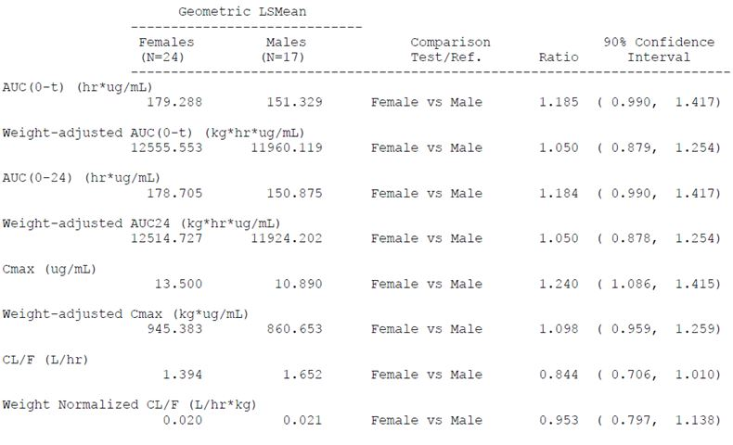

Evaluator’s comments on sponsor’s response:
The evaluator is satisfied with the explanation provided by the sponsor.

Pharmacodynamics
Question 7: No information has been provided by the sponsor regarding the pharmacological activity of DTG metabolites. This should be provided.

Sponsor’s response:
Please refer to response to Question 2.

Evaluator’s comments on sponsor’s response:
Please see the evaluator's response to Question 2.

Efficacy
Question 8: There appears to be no justification provided for the selection of the 50 mg dose for Phase III studies. Could the sponsors please clarify this?

Sponsor’s response:
As noted in the original submission, the 50 mg once daily dose for DTG in ART naïve/experienced (INI naïve) subjects was selected based on the following:
- Results from ING111521, 10 day monotherapy study in treatment naive or treatment experienced and INI naive subjects demonstrating that once daily dosing of DTG achieved viral load declines for 2 mg, 10 mg and 50 mg of 1.54, 2.04, and 2.48 log₁₀ c/mL, respectively. The 50 mg once daily dose achieved an inhibitory quotient (observed DTG concentration at the end of the dosing interval [Cτ]/fold above protein adjusted 90% inhibitory concentration [PA-IC90]) of 19, demonstrating considerable coverage above the in vitro protein adjusted target concentration of 0.064 ng/ml.
- A PK/PD analysis from ING111521 evaluated the relationship between Cτ and change in HIV RNA from Baseline. The data were fit to a maximum effect model and demonstrated that the 50 mg dose was on the plateau of the concentration response curve after monotherapy.
- ING112276, a Phase IIb dose ranging study in treatment naive subjects that evaluated DTG at doses of 10 mg, 25 mg and 50 mg once daily with 2 NRTIs compared to EFV plus 2 NRTIs. DTG was well tolerated across all doses studied.
- A good safety and tolerability profile with a low discontinuation rate due to AEs was observed in all three arms with no significant dose-dependent trends in safety parameters. All three doses showed similar robust antiviral responses and no apparent dose-response relationship was observed, suggesting DTG doses from 10 mg to 50 mg once daily in combination with 2 NRTIs achieved maximum virologic suppression. Therefore, the maximal tolerated and highest dose, DTG 50mg once daily, was selected as the dose for the Phase III studies in INI naïve population. Selection of 50 mg once daily dose was also to accommodate decreases in DTG in light of drug interactions, poor absorption, imperfect adherence, or other causes.
- The metabolic inducers darunavir/ritonavir (DRV/RTV), etravirine (ETR)/DRV/RTV, EFV, fosamprenavir (FPV)/RTV, and tipranavir (TPV)/RTV decreased DTG exposure to various degrees; however, DTG exposures in the face of these interactions are still comparable to or higher than those demonstrated with 10 mg once daily dosing in ING112276.
In summary, a dose of 50 mg once daily demonstrated safety and efficacy while providing a significant coverage in plasma exposure to account for reductions due to drug interactions or other events that could decrease concentrations. This dose was selected for Phase III studies in ART naive/experienced, INI naive adult subjects. More detailed information regarding dose selection for INI naive subjects is outlined in the Week 96 clinical study report for the dose ranging study, ING112276. A summary of the rationale for dose selection from this study is provided below.
The primary objective of ING112276 was to select a DTG once daily dose for further evaluation in Phase III based on a comparison of the Week 16 antiviral activity and tolerability of a range of oral doses of DTG in HIV-1 infected therapy naive adult subjects. All doses of DTG that were assessed were anticipated to provide desirable long term efficacy in combination therapy and were based on a PK and PD analysis from the Phase IIa monotherapy data (ING111521) in INI naive subjects. Because it was intended that one dose be selected for patients naive to INI, to compensate for moderate drug-drug interactions with other antiretrovirals and other situations that decrease DTG exposures (for example, renal insufficiency), an a priori dose selection strategy was adopted to select the highest maximum tolerated dose of DTG from ING112276. Therefore, if comparable efficacy, safety and tolerability were observed across all 3 DTG doses at 16 and 24 Weeks in ING112276, the DTG 50 mg dose was to be selected for further investigation in Phase III. Stopping rules which were agreed a priori are outlined in Protocol ING112276.
Based on comparison of virological markers of HIV infection, the proportion of subjects who achieved HIV-1 RNA <50 c/mL (TLOVR) by Week 16 (and confirmed at Week 24) were substantially higher at Week 16 in the DTG treatment arms (≥90%) across all three doses, compared to the EFV treatment arm (60%). The proportion of subjects across the DTG treatment arms achieving HIV-1 RNA <50 c/mL (TLOVR) continued to be higher than in the EFV treatment arm (≥90% versus 78%) at Week 24. No dose of DTG met the a priori criteria of having 4 fewer responders than the next highest dose at either timepoint.
DTG was well tolerated across all doses studied. At the Week 16 analysis, a greater percentage of subjects receiving EFV reported Grade 2 or higher AEs (50%) versus subjects receiving DTG (26%). At that time, the incidence of GI AEs was 5% overall for the DTG treatment arms and 8% for EFV. DTG continued to be well tolerated at the Week 24 analysis, with 50% of subjects receiving EFV reporting Grade 2 or higher AEs versus 30% of subjects receiving DTG. The incidence of GI AEs remained low overall (6% for the DTG treatment arms, 10% for EFV). No dose of DTG met the a priori criteria of having 7 or more subjects with Grade 2 or higher GI AEs than the EFV control group at the Week 16 timepoint, and this was confirmed at Week 24.
At the time of the Week 16 analysis (and confirmed at Week 24), no apparent dose response relationships were observed with specific treatment emergent laboratory abnormalities within DTG treatment arms, including those chemistries specified in the a prior stopping rule. There were no Grade 3 ALT elevations in any of the DTG treatment arms or the EFV group at either timepoint. The overall frequency of lipase elevations was higher on DTG doses (18%) than EFV (12%) at both the Week 16 and 24 timepoints; in DTG subjects these elevations were transient and asymptomatic. There were only three Grade 3 lipase elevations in the DTG arms (25 mg, 2 subjects; 50 mg, 1 subject). The only lab parameter with consistent, mild (Grade 1) abnormalities was a creatinine increase in the DTG 25 mg dose, along with an approximate 10% increase in mean creatinine values. These changes were observed at Week 1 and remained constant to Week 16 after which the values appear to begin to trend back toward baseline. Additional investigations indicate that the creatinine changes are likely related to a benign condition of blocking creatinine secretion.
After review of the efficacy, safety and tolerability across all doses at Week 16 (and confirmed at Week 24) from ING112276, the 50 mg dose was selected for further investigation in Phase III studies of INI-naive subjects.
A discussion of dose confirmation from the Phase III studies of INI naive subjects is included in the original submission.

Evaluator’s comments on sponsor’s response:
The selected dose of 50 mg has been justified adequately and it did prove safe and effective in the clinical trials submitted.
Question 9: Statistical analyses have been or will be performed in ongoing studies at 24, 48 and 96 week intervals. Please provide additional justification for not adjusting the analyses for multiplicity.

Sponsor’s response:
The primary analysis was performed at Week 48 for studies ING113086, ING114467, and ING111762. No adjustment was made for analyses at other timepoints as those analyses were considered to be secondary. Since analyses at other timepoints were considered to be merely supportive of the analyses at the primary timepoint, no multiplicity adjustment was considered to be necessary.
The primary analysis for the study ING112574 was performed at Day 8 and Week 24.
Given that this is a single treatment arm study, no adjustments for multiplicity regarding treatment effect were made.

Evaluator’s comments on sponsor’s response:
The sponsor argues that only the 48 week analysis was required to confirm the primary endpoint and that the additional analyses at other time points were only supportive. This is not unreasonable.
Question 10: Median compliance data were not provided in the appropriate section of the SPRING-2 study report. Please provide.

Sponsor’s response:
When assessing adherence, issues with unreliable/missing information, sensitivity to assumptions, and lack of clear reporting standards have been described previously by Farmer and colleagues and recently by Baisley and colleagues. Given such limitations for obtaining meaningful data, particularly when based on pill counts, a quantitative calculation of compliance was not defined for the SPRING-2 study.
Pill count data was collected in this study primarily to drive conversations between the subject and investigator to ensure adherence during the study. Adherence was assessed quantitatively in the SAILING study as that was felt to be the study that could obtain the most potential from the pill count information.
For the SAILING study overall imputed adherence rates were well balanced across the DTG and RAL groups, with median adherence in the category of ≥95% to <100% in both groups. Findings are further described the 24 week SAILING clinical study report (CSR) (original submission).

Evaluator’s comments on sponsor’s response:
Compliance data were not provided for the SPRING-2 study because the sponsors consider pill counts to be unreliable index of compliance and they were not performed. This may be correct but pill counts were included in the other Phase 3 studies. Whatever the merits of the argument, the omission does not invalidate the conclusions of the SPRING-2 study.
Question 11: The distribution of study sites listed in the VIKING-3 synopsis does not add up to 65. Please clarify.

Sponsor’s response:
Unfortunately, there is a typographical error in the synopsis of the clinical study report for ING112574, the number of sites in the EU is 27 and not 23 as cited. Together with the 35 sites in the US and 3 in Canada, the total number of sites at 65 is correct as cited. Details of the 65 sites are provided in Modular Appendix F of the report (original submission, ING112754 [VIKING-3], List of Investigators and Sites).

Evaluator’s comments on sponsor’s response:
The sponsors have clarified a typographical error and the number of sites is confirmed to be 65.
Question 12: The clinical evaluator sought confirmation of the primary endpoint and satisfactory Week 48 tolerability data for Study ING111762 (SAILING).

Sponsor’s response:
The 48 week SAILING data extend and confirm the safety and efficacy results observed at Week 24. At Week 48, the proportion of subjects who achieved HIV-1 RNA <50 c/mL (Snapshot/MSDF algorithm) was statistically superior in favour of the DTG treatment group (71%) compared to the RAL treatment group (64%) (adjusted treatment difference [DTG-RAL]: 7.4%; 95% CI: [0.7, 14.2], p = 0.030). These results are consistent and confirmatory with the superiority demonstrated in the Week 24 interim analyses (DTG: 79%; RAL: 70%; [adjusted treatment difference (DTG-RAL): 9.7%; 95% CI: (3.4, 15.9), p = 0.003]). The Week 48 safety/tolerability profile was also consistent with that seen at Week 24, with no newly identified signals in either treatment arm.
The Week 48 synopsis and manuscript recently published in Lancet are provided with this response.

Primary endpoint
The primary endpoint of the study was the proportion of subjects in the Modified Intent to Treat Exposed (mITT-E) population with plasma HIV-1 RNA <50 c/mL at Week 48 based on the outcomes of the FDA “Snapshot (MSDF)” algorithm.
At Week 48, 71% of subjects receiving DTG and 64% of subjects receiving RAL achieved the primary endpoint (Table 9). This difference in response was statistically significant with a 95% CI for the adjusted difference of 0.7% to 14.2% (p = 0.030). This result is supported by the PP analysis where 73% and 66% of DTG and RAL subjects, respectively, achieved plasma HIV-1 RNA <50 c/mL at Week 48 (adjusted treatment difference and 95% CI: 7.5 [0.6, 14.3], Table 10).
Table 9: Proportion of patients with plasma HIV-1 RNA <50 c/mL at Week 48 (mITT-E population).
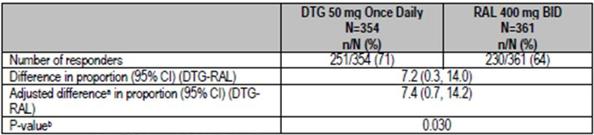

Table 10: Proportion of patients with plasma HIV-1 RNA <50 c/mL at Week 48 (PP Population).
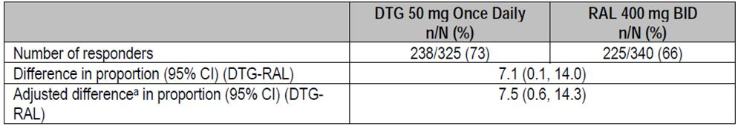
a. Based on Cochran-Mantel Haenszel stratified analysis adjusting for the following baseline stratification factors: baseline HIV-1 RNA, DRV/r use without primary PI mutations, and baseline PSS.

Study outcomes based on plasma HIV-1 RNA <50 c/mL at week 48
The study was designed to demonstrate non inferiority of DTG versus RAL and the analysis met this criterion; statistical superiority was concluded as part of a prespecified testing procedure. This finding was primarily driven by virologic outcomes (Table 11): more subjects on RAL had ‘data within the window not <50 c/mL’ (DTG: 10%; RAL: 13%) and discontinuations due to lack of efficacy (DTG: 5%; RAL: 10%). Superiority of DTG was also achieved in supportive analyses using a treatment related discontinuation imputation approach to address missing HIV-1 RNA data at Week 48, and analyses of time to Protocol Defined Virologic Failure or treatment/efficacy related discontinuation.
Table 11: SAILING trial outcomes (plasma HIV-1 RNA <50c/mL) at Week 48.
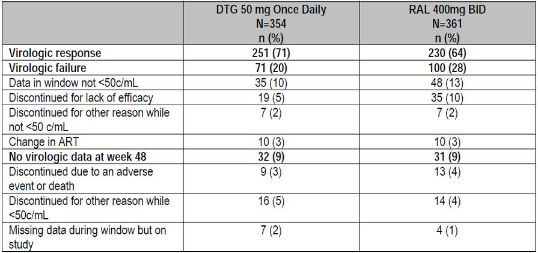

Plasma HIV-1 RNA <50 c/mL over time
The proportion of subjects with plasma HIV-1 RNA <50 c/mL using MSDF analysis for the mITT-E Population increased steeply in both treatment groups from Baseline to Week 4, then tended to plateau starting at Week 8 onward (Figure 3). Both treatment groups followed a similar pattern, but higher values were noted for DTG compared to RAL at all the time points assessed.

Figure 3. Proportion (95% CI) of subjects with plasma HIV-1 RNA <50 c/mL by visit – snapshot (MSDF) analysis (mITT-E population).
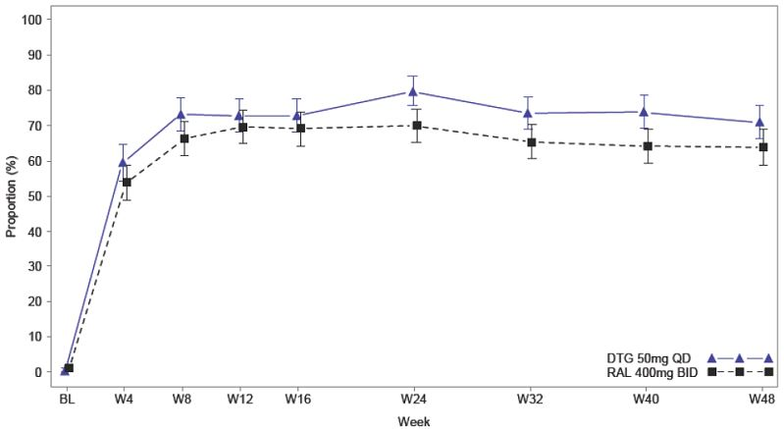

Subgroup analysis of SAILING trial primary outcomes

Plasma HIV-1 RNA <50 c/mL at week 48 by strata related to randomisation
Results were summarised by Baseline HIV-1 RNA (≤ and ≥50 000 c/mL), DRV/r use in the presence of primary PI mutations or no DRV/r use versus DRV/r use in the absence of primary mutations, and by the number of fully active background agents as measured by PSS at baseline (2 and <2) (Table 12).
Table 12: Proportion of subjects responding based on plasma HIV-1 RNA <50 c/mL at Week 48 by strata – snapshot (MSDF) analysis (mITT-E Population).
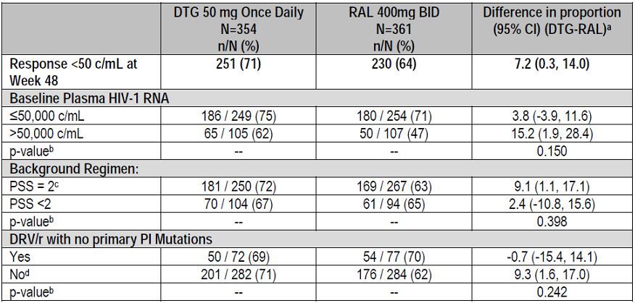
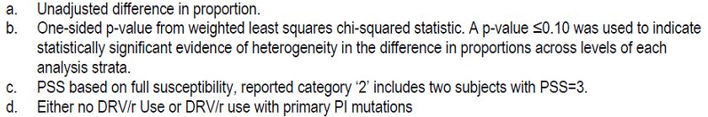
In terms of covariate main effects, baseline plasma HIV-1 RNA >50,000 c/mL was associated with lower response rates for both DTG and RAL. DTG treated subjects had a numerically better response when added to a regimen containing 2 fully active agents compared to <2 (PSS = 2: 72% versus PSS = <2: 67%); whereas RAL response rates were similar regardless of the number of fully active background agents (PSS = 2: 63% versus PSS = <2: 65%). DTG response rates were similar within the dichotomous subgroup for background regimen ‘use of DRV/r without Primary PI mutations’ (yes = 69%; no = 71%), in contrast to RAL, which had varying response rates (yes = 70%; no = 62%).
The hypothesis of a common treatment effect within each randomisation subgroup could not be ruled out statistically; p values for evidence of heterogeneity were all greater than 15%. However, point estimates suggest smaller increased benefit of DTG in subjects with PSS <2 or Baseline plasma HIV-1 RNA ≤50,000 c/mL, and no difference between DTG and RAL in subjects whose background regimen included the use of DRV/r in the absence of primary PI mutations.

Plasma HIV-1 RNA <50 c/mL at week 48 by demographic and baseline

Characteristic subgroups
Antiviral response rates within demographic and baseline characteristic were generally higher for subjects receiving DTG compared to subjects receiving RAL, with the exception of subjects older than 50 years (DTG: 65%; RAL: 69%) or subjects with Centres for Disease Control (CDC) category B (DTG: 56%; RAL: 70%) (Table 13).
Table 13: Proportion of subjects with plasma HIV-1 RNA <50 c/mL at Week 48 across demographic subgroups.
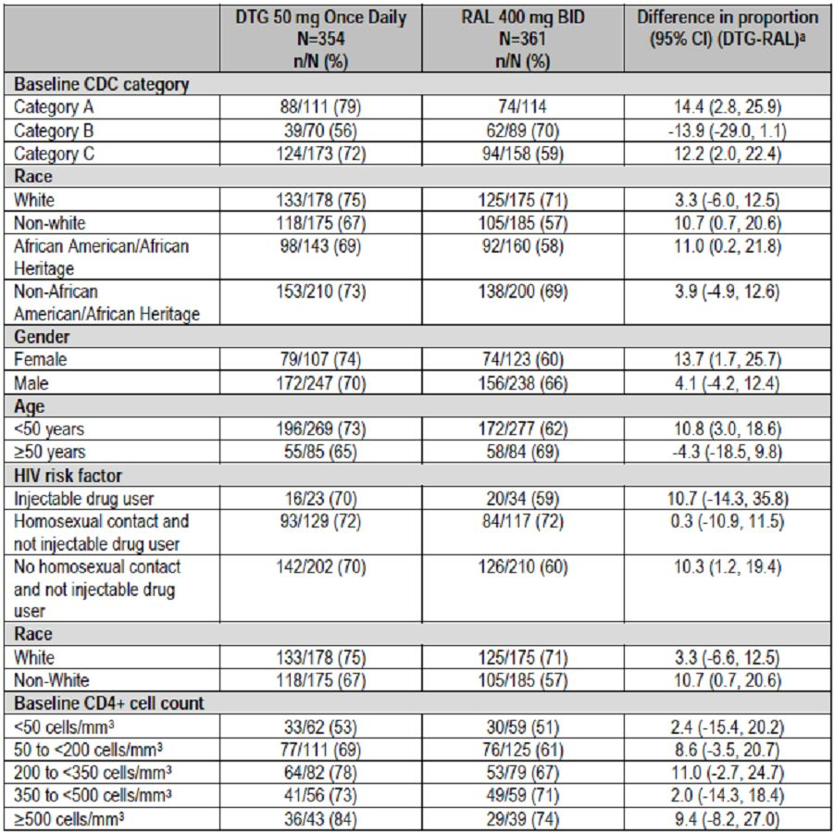
Heterogeneity of the treatment effect within the age subgroup (< 50 years versus ≥ 50 years) and the CDC category subgroup, respectively, was assessed by fitting a logistic-regression model that included factors for treatment group, baseline randomization strata, the relevant subgroup, and the interaction between treatment and subgroup. The test for treatment by age interaction was marginally significant (p = 0.062, although above the pre specified 5% Type I error cut off) and the test for treatment by CDC category was statistically significant (p = 0.004).
The lower response rate on DTG compared to RAL observed in subjects older than 50 years of age was the result of more subjects on DTG being classified as non responders due to having no virologic data at Week 48 (DTG: 13% versus RAL: 5%) and not for reasons related to virologic failure (DTG: 22% versus RAL: 26%).
Treatment with DTG is associated with higher response rates across all baseline CD4+ cell count subgroups than treatment with RAL (Table 13).

Safety and tolerability
Details on the safety at Week 48 are provided in the ING111762 Week 48 CSR synopsis. Over the duration of this analysis, the overall safety profile for DTG was comparable to RAL, with similar rates of AEs in both treatment groups and low rates of discontinuation due to AEs in both groups (DTG 2%, RAL 4%). Similar rates of occurrence in both arms for diarrhoea, nausea, vomiting, and fatigue (most common drug related AEs) were observed. There were similar rates for serious adverse events (SAEs), overall and by System Organ Class (SOC), and similar rates for Grade 2 to 4 AEs. There were similar incidence rates for graded laboratory toxicities. As noted in the Week 24 report and confirmed again in this Week 48 analysis, across the entire study population, a similar hepatic profile was observed for DTG and RAL. No additional significant cases of hepatitis were noted in the Week 48 analysis in the DTG treatment arm, and differences noted at Week 24 in subjects with co-infection were similar at Week 48.

Conclusions

Efficacy
- These results demonstrate that a DTG 50 mg once daily containing regimen is more efficacious than a standard of care regimen for treatment experienced subjects and therefore is an appropriate dose for the treatment experienced, integrase naïve population.
- DTG is superior to RAL using the Snapshot (MSDF) algorithm for the proportion of subjects with plasma HIV-1 RNA <50 c/mL at Week 48. Superiority was also achieved in the pre specified sensitivity analyses (PP and TRDF/ERDF analyses).
- Within subgroups defined by the baseline randomisation strata treatment differences were generally supportive of the overall treatment difference; however, DTG and RAL response rates were similar for subjects receiving DRV/r without primary PRO inhibitor mutations.

Safety
- The safety profile for DTG was similar to RAL, with similar rates of occurrence in both arms for the most common AEs and low rates of discontinuation due to AEs for both DTG and RAL.
- No serious hypersensitivity events were observed, and there was no increased risk for DTG compared to RAL for hypersensitivity events.
- Other serious conditions that are labelled for RAL, such as serious rash (for example, Stevens Johnson syndrome, toxic epidermal necrolysis, or erythema multiforme) were not observed in this study.
- Across the entire study population, a similar hepatic profile was observed for DTG and RAL.
  - Subjects with hepatitis B co-infection receiving DTG were noted to have significant liver chemistry elevations in the setting of HIV virologic and immunologic responses to DTG and withdrawal or lack of HBV active therapy.
  - The pattern of injury is likely consistent with IRIS and/or HBV flare in the setting of inadequate HBV therapy rather than direct liver injury due to DTG.
  - Subjects with hepatitis C co-infection may be at greater risk of HCV IRIS with DTG due to improved HIV virologic responses versus RAL.
- Based on Week 48 data, there appears to be no increased risk of renal toxicity for DTG compared to RAL.
- Mild to moderate general GI intolerance (mainly diarrhoea and nausea) is associated with DTG treatment in a small proportion of subjects; however nonclinical findings for GI erosions did not translate into significant clinical findings.
- There was no increased risk for psychiatric disorders for DTG over RAL.
- Based on Week 48 data, there appears to be no increased risk of musculoskeletal disorders with DTG compared to RAL.
- There is no evidence from this study for increased risk of torsades de pointes with DTG.
- There was no untoward effect on the overall lipid profile in either treatment group.

Evaluator’s comments on sponsor’s response:
As requested, the sponsor has provided a synopsis of the Week 48 data with a CSR available on request. The study has also been published in Lancet.
The SAILING study was designed as a non inferiority study and the primary efficacy endpoint was the proportion of patients who achieved HIV-1 RNA <50 c/mL at Week 48 in the Intention to Treat set. The outcomes observed at Week 24 were confirmed at Week 48. At Week 24, 79% of DTG patients achieved a response compared with 70% of RAL patients with an adjusted treatment difference of 9.7% (95% CI: 3.4, 15.9, p = 0.003). At Week 48, there was still a statistically significant benefit in favour of DTG (71% response) compared with RAL (64%). The adjusted treatment difference at Week 48 was 7.4% (95% CI: 0.7, 14.2, p = 0.03). The finding was confirmed in the PP set with Week 48 response rates of 73% and 66% in the DTG and RAL groups, respectively. The adjusted treatment difference was 7.5% (95% CI: 0.6, 14.3). At Week 48, virologic failure had occurred in 20% of DTG patients compared with 28% in the RAL group. The antiviral response rates within demographic and baseline characteristics were generally higher in DTG patients compared with RAL. Exceptions were patients aged >50 years (DTG 65%, RAL 69%) and patients with CDC category B disease (DTG 56%, RAL 70%).
No new safety signals were detected at Week 48. The overall safety profile was similar in the DTG compared with RAL with low rates of withdrawal due to AEs (DTG 2%, RAL 4%). The most common drug related AES were diarrhoea, nausea, vomiting and fatigue but the incidence was similar in both treatment groups. The rates, SOC and grading of SAEs were similar in both treatment groups. No significant cases of hepatitis or serious hypersensitivity events were recorded after Week 24 in either treatment group.
Overall, the significant benefits in favour of DTG observed at Week 24 were sustained until Week 48 and no new safety issues were identified.
Question 13: For Study P1093, the clinical evaluator noted that PK variability is similar to that observed in adults but efficacy and safety data are available for only 10 patients. The clinical evaluator stated that it would be prudent to report the full Cohort 1 with an additional 12 patients at 24 weeks before the positive findings are acceptable.

Sponsor’s response:
At this time, P1093 is ongoing; results presented here include Cohort I, Stage 1 and Stage II through Week 24 (n = 23 subjects) with a data cut off date of 17 December 2012.
By the time of the 17 December 2012 data freeze date, all 23 subjects in Cohort I, Stages I and II had completed the Week 24 visit and 17 had reached the Week 48 visit.
The P1093, Cohort I, Week 24 CSR is provided with this response.
The treatment dosing regimen assignments used were based on DTG tablet QD doses with target dose of ~1 mg/kg across two weight bands, and maximum dose of 50 mg.
The treatment dosing regimen assignments specifically used for Cohort I were:
- DTG 35 mg QD + OBR for subjects weighing 30- <40kg (n = 4)
- DTG 50 mg QD + OBR for subjects weighing ≥ 40kg (n = 19)
(One subject started on DTG 35mg, then based on body surface area (BSA)/weight change the DTG dose was later increased to 50 mg.)
The 23 subjects included here had extensive prior antiretroviral exposure, with a median of 13 years of treatment. Of these, 100%, 52% and 78% had prior exposure NRTI, NNRTI, and PRO inhibitor experience, respectively.

Summary of cohort I, stage I and stage II
Subject accountability is shown in Tables 14-16.
Table 14: Subject accountability.
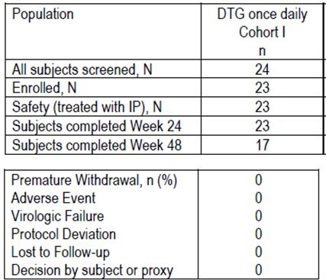
Table 15: Summary of demographic characteristics (AT Population).
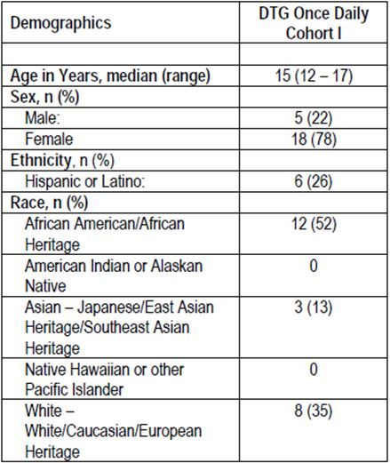
Table 16: Summary of baseline characteristics (AT Population).
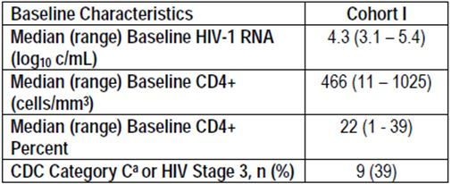

Safety
There were no new safety issues identified in this cohort of subjects beyond those observed in the adult population. Overall, in this population of adolescent subjects, DTG dosed at 35 mg and/or 50 mg once daily was well tolerated when administered with OBT. There were no Grade 3 or greater AEs, no discontinuations due to an AE, no SAEs and no AEs reported as related to DTG (Table 17).
Table 17: Summary of all clinical AEs for Cohort I worst grade for each subject (incidence >1 subject) (AT Population).
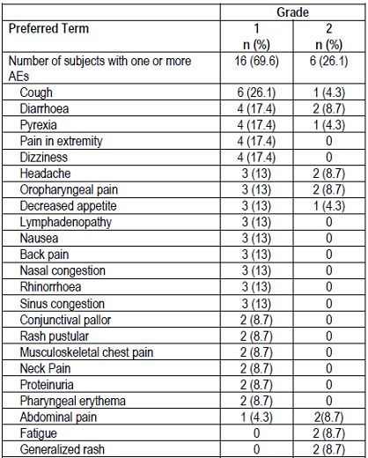

Safety

Laboratory
Laboratory events were reported by 21 (91.3%) subjects; none were serious or clinically significant by the investigator. There were no trends in treatment emergent laboratory abnormalities. As observed in adults, small mean and/or median non progressive increases in creatinine and bilirubin were observed. As previously noted in adult subjects receiving DTG, small mean increases in total bilirubin were observed, likely related to the metabolism of DTG and competitive use of UGT 1A1 enzyme. No subjects experienced significant elevations in liver enzymes in conjunction with bilirubin increases, and importantly, no subjects met liver stopping criteria. Overall, the hepatic safety profile for DTG appears favourable in 12-18 year old paediatric subjects.
Two subjects reported Grade 3 laboratory events. One subject reported an asymptomatic elevated lipase at Day 344 (Week 48). Along with DTG, the subject is being treated with Darunavir 800 mg, abacavir/lamivudine 600/300 mg, and RTV 100 mg daily. On Day 347, the subject returned for repeat chemistry/ lipase levels. The lipase level remained at Grade 3 (268 U/L). The AST (30 U/L), ALT (38 U/L), and ALP (244 U/L) values all remained normal. The subject offered no complaints and remained asymptomatic.
Treatment medications were withheld approximately 2 weeks and the subject was retested on Day 373; at that time the lipase had decreased to Grade 2 (104 U/L) and medications were restarted. A Grade 3 blood bilirubin increase (2.6 mg/dL) was also reported in another subject at Day 2 and was considered related to ATV; neither of the laboratory events were considered related to DTG.
Overall, no clinically significant changes from baseline in laboratory parameters were observed No clinically significant trends in change from baseline in liver chemistries were observed. Small increases in mean and median total bilirubin were noted. There were no clinically significant findings in the summary of urinalysis.

Pharmacokinetics
Intensive PK and safety from Cohort I, Stage I subjects supported enrolment of Stage II in Cohort I and supported further DTG initiation and evaluation in the next younger paediatric cohort, that is, 6-12 year olds. Sparse PK data is not available at this time.

Efficacy
The efficacy data analysis results presented here was designed to use the MSDF Snapshot approach, but there was no missing data at the key time points of baseline and Week 24. All subjects were able to include at least one active drug in their Optimised Background Therapy.
A sustained antiviral response was observed as shown in Table 18.
Table 18: Proportion of subjects with plasma HIV-1 RNA <400 c/mL (AT Population).
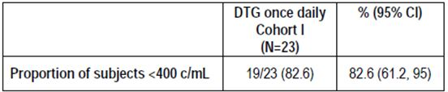
The 4 subjects who failed to achieve HIV-1 RNA <400 c/ml had documented adherence problems. Sixteen (70 %) of the subjects had plasma HIV-1 RNA <50 c/mL at Week 24 .and 20 out of 23 subjects (87%) had > 1 log₁₀ c/m: decrease from Baseline in HIV-1 RNA or HIV-1 RNA < 400 c/mL at Week 24. There was a median gain of 63 cells/mm³ in CD4 count and a median absolute gain of 4.9 in CD4 percent.

Evaluator’s comments on sponsor’s response:
At the time of the 17 December 2012 interim data lock date, all 23 patients in Cohort 1, Stages 1 and 2, had completed the Week 24 visit. At Week 24, 19/23 patients (82.6%, 95% CI: 61.2, 95.0) had achieved a reduction in HIV-1 RNA <400 c/mL. The four patients who did not achieve a virologic response had a documented history of poor compliance. Sixteen (70%) patients had plasma HIV-1 RNA <50 c/mL at week 24 and 20 patients (87%) had >1 log₁₀ c/mL decrease from baseline. There was a median gain in CD4 count of 63 cells/mm³.
No new safety issues were identified and the safety profile in adolescents was similar to the adult population. There were no AEs Grade 3 or greater, no discontinuations due to an AE, no SAEs and no drug related AEs. No significant hepatic events were recorded.
The additional data to Week 24 confirms a sustained antiviral response in adolescents which matches the response rates achieved in adults. The safety profile of DTG also appears similar to that of the adult population.

Safety
Question 14: Why were ECGs not recorded in Study ING112578?

Sponsor’s response:
As per ICH E14 guidance, when a thorough QT/QTc study (TQTS) is interpreted as negative:
“...the collection of baseline and periodic on-therapy ECGs in accordance with the current investigational practices in each therapeutic field is almost always sufficient evaluation during subsequent stages of drug development.”
The cardiovascular assessments of DTG indicated no increased risk for cardiac repolarisation or other cardiac conduction abnormalities. For the DTG development program, the nonclinical (that is, hERG and monkey CV study) and early clinical (Phase I/IIa ECG data) indicated that DTG did not carry an increased risk for QT prolongation and/or torsades de pointes. Further, a thorough QT/QTC study (ING111856) with DTG, designed and executed in accordance with ICH E14 guidance, showed that DTG had no effect on cardiac repolarisation at a supratherapeutic dose of 250 mg suspension. The study was sensitive enough to detect the effect of moxifloxacin, the positive control, on QTcF, which confirms that this study is valid for assessing the effects of DTG on cardiac repolarisation.
Without evidence for an increased risk of cardiac repolarisation or other conduction abnormalities, the assessments in ING112578 followed standard of care for paediatric HIV practice with respect to cardiac assessments. As such, ECG assessments would not typically be performed in this patient population and were not included in ING112578. Further, ECG assessments from adult Phase III studies and AEs from the adult and paediatric studies indicate that DTG does not have an increased risk for cardiac repolarization or other conduction abnormalities.

Evaluator’s comments on sponsor’s response:
The sponsors argue that ECGs will not provide useful information when a negative thorough QTc study has already been conducted. They also argue that ECGs are not routinely performed in paediatric practice. Neither argument is sound. Conduction abnormalities are not the only potential cardiac toxicity and clinical trials rarely follow routine adult or paediatric practice. While not accepting the argument, the omission is not sufficient to invalidate the study conclusions.

Clinical summary and conclusions: second round

Second round benefit-risk assessment

Second round assessment of benefits
After consideration of responses to clinical questions, the benefits of DTG in the proposed usage are unchanged from the first round assessment.

Second round assessment of risks
After consideration of responses to clinical questions, the risks of DTG in the proposed usage are unchanged from the first round assessment.

Second round assessment of benefit-risk balance
All questions have been addressed and no additional clarification is sought. The positive safety and efficacy Week 48 findings reported in the SAILING study synopsis and Lancet publication are sufficient to expedite approval for the use of DTG in adults. The additional Week 24 safety and efficacy data in the adolescent study ING112578 are sufficient to support approval in this age group.
After consideration of responses to clinical questions, the benefit-risk balance of DTG in the proposed usage is unchanged from the first round assessment.

Second round recommendation regarding authorisation
The issues identified in the first round have been addressed. Authorisation is recommended for the following indication:
For the treatment of human immunodeficiency virus (HIV) infection in combination with other antiretroviral agents in adults and children over 12 years of age.

V. Pharmacovigilance findings

Risk management plan
The sponsor submitted a RMP which was reviewed by the TGA’s Office of Product Review (OPR).

Safety specification
The sponsor provided a summary of ongoing safety concerns which are shown at Table 19.
Table 19: Ongoing safety concerns for Tivicay.
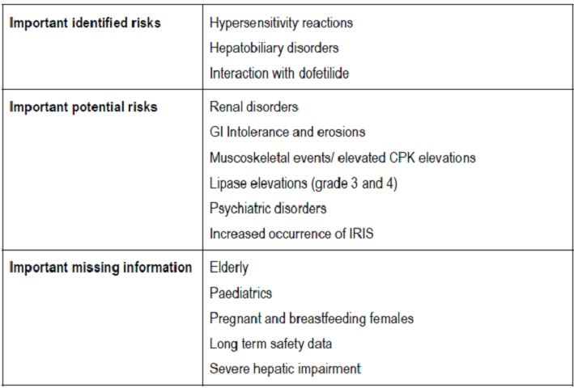

OPR reviewer comment:
Notwithstanding the evaluation of the nonclinical and clinical aspects of the Safety Specification, the above summary of the ongoing safety concerns is considered acceptable.

Pharmacovigilance plan
The Australian Specific Annex (ASA) states that GlaxoSmithKline (GSK) Australia provides full Medical Information and Pharmacovigilance services to ViiV Healthcare Pty Ltd Australia (ViiV). GSK has a dedicated Medical Information and Pharmacovigilance department, which is responsible for compliance with the appropriate regulatory guidelines in order to monitor all the specified ongoing safety concerns. The ASA identifies the appropriate regulatory guidelines as:
- Australian Guideline for Pharmacovigilance Responsibilities of Sponsors of Registered Medicines Regulated by Drug Safety and Evaluation Branch;
- The TGA adopted EU guideline, Note for Guidance on Clinical Safety Data Management: Definitions and standards for expedited reporting - Annotated with TGA Comments.
The ASA provides a tabular summary of the ongoing clinical trials that are proposed to further characterise and monitor the specified ongoing safety concerns (Table 20).

Table 20: Summary of ongoing clinical trials proposed to further characterise and monitor the specified ongoing safety concerns.
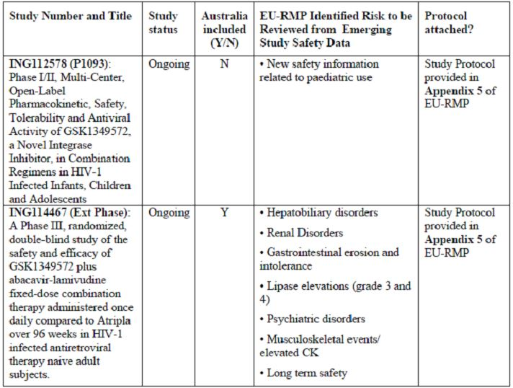
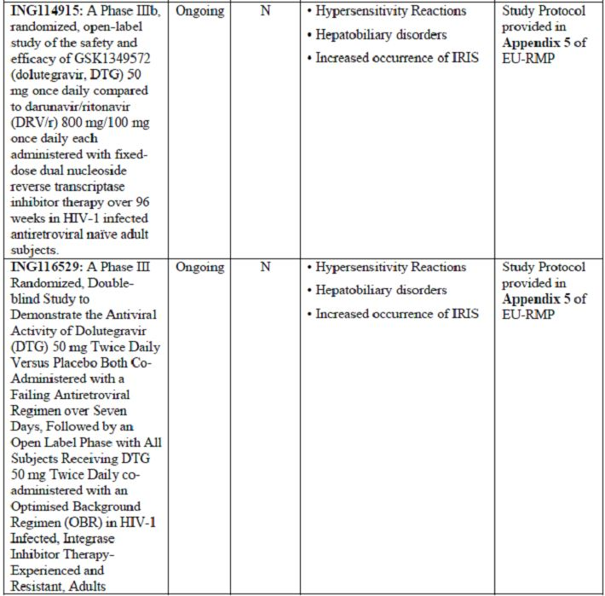
For these studies, the EU-RMP provides the following milestones (Table 21).
Table 21: Study milestones as identified in the EU-RMP.
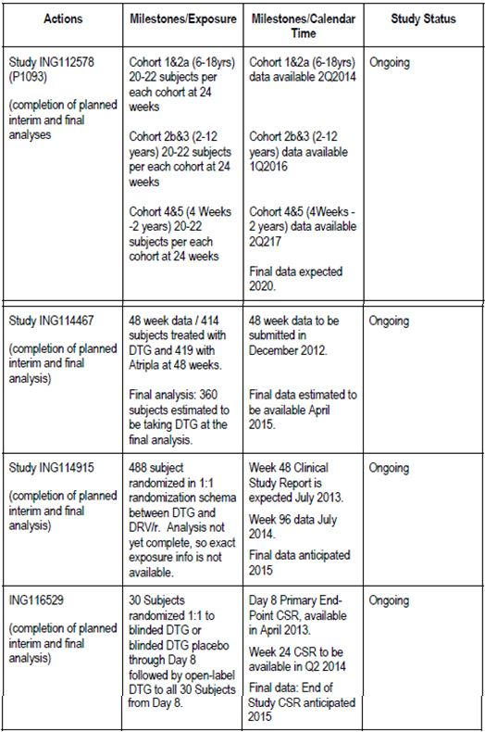
For the important missing information: ‘Pregnant and breastfeeding females’, the sponsor proposes to review the data from the Antiviral Pregnancy Registry on a six monthly basis. Any significant findings related to use in pregnancy will be presented in the Periodic Safety Update Report (PSUR) as required.

OPR reviewer’s comments in regard to the pharmacovigilance plan and the appropriateness of milestones
In principle, there is no objection to the sponsor implementing additional pharmacovigilance activities to further monitor the specified ongoing safety concerns. However, the ongoing studies are not considered to be part of the planned clinical studies in the pharmacovigilance plan. Therefore the related study protocols have not been reviewed. Nevertheless an update on the progress/results/analysis of these studies as outlined in the EU-RMP, will be expected in future PSURs and RMP updates.
In regard to routine pharmacovigilance the ASA should be revised to include the appropriate regulatory guideline: Australian requirements and recommendations for pharmacovigilance responsibilities of sponsors of medicines (Version 1.1, dated December 2012) when this document is next updated.

Risk minimisation activities
The sponsor has provided justification and concluded that routine risk minimisation activities are sufficient for all the specified ongoing safety concerns, although no such activity is proposed for the important potential risks: ‘Musculoskeletal events/elevated CPK elevations’ & ‘Lipase elevations (grade 3 and 4)’ and the important missing information: ‘Long term safety data’.

OPR reviewer comment:
The sponsor’s justification and conclusion that no additional risk minimisation activities are needed appears reasonable and it is agreed the specified ongoing safety concerns would not appear to warrant additional risk minimisation activities. Therefore at this time the sponsor’s conclusion is considered acceptable. Nevertheless, it is recommended that routine risk minimisation should also be applied to the important missing information: ‘Long-term safety data’ - particularly in relation to the use of DTG in children over 12 years of age.
In addition, the nonclinical and clinical aspects of the Safety Specification remain subject to the evaluation by the Office of Scientific Evaluation (OSE) and the Office of Medicines Authorisation (OMA), respectively.

Summary of recommendations
The OPR provides these recommendations in the context that the submitted RMP is supportive to the application; the implementation of a RMP satisfactory to the TGA is imposed as a condition of registration; the submitted EU-RMP is applicable without modification in Australia unless so qualified; and the draft PI and Consumer Medicine Information (CMI) documents should not be revised until the Delegate’s Overview has been received:
- Safety considerations may be raised by the nonclinical and clinical evaluators through the consolidated section 31 request and/or the nonclinical and clinical evaluation reports, respectively. It is important to ensure that the information provided in response to these includes a consideration of the relevance for the RMP, and any specific information needed to address this issue in the RMP. For any safety considerations so raised, the sponsor should provide information that is relevant and necessary to address the issue in the RMP.
- In principle, there is no objection to the sponsor implementing additional pharmacovigilance activities to further monitor the specified ongoing safety concerns. However, the ongoing studies are not considered to be part of the planned clinical studies in the pharmacovigilance plan. Therefore, the related study protocols have not been reviewed. Nevertheless an update on the progress/results/analysis of these studies as outlined in the EU-RMP, will be expected in future PSURs and RMP updates.
- In regard to routine pharmacovigilance, the ASA should be revised to include the appropriate regulatory guideline: Australian requirements and recommendations for pharmacovigilance responsibilities of sponsors of medicines (Version 1.1, dated December 2012) when this document is next updated.
- The sponsor’s justification and conclusion that no additional risk minimisation activities are needed appears reasonable and it is agreed the specified ongoing safety concerns would not appear to warrant additional risk minimisation activities. Therefore, at this time the sponsor’s conclusion is considered acceptable. Nevertheless, it is recommended that routine risk minimisation should also be applied to the important missing information: ‘Long-term safety data’ - particularly in relation to the use of DTG in children over 12 years of age (see below). In addition the nonclinical and clinical aspects of the Safety Specification remain subject to the evaluation by the OSE and the OMA, respectively.
- In regard to the proposed routine risk minimisation activities, it is recommended to the Delegate that the draft PI document be revised as follows:
  - For the important missing information: ‘Long-term safety data’, the statement: “There are no safety data beyond 48 weeks of treatment”, or words to that effect, should be included under the ‘Adverse Effects’ section of the PI.
- In regard to the proposed routine risk minimisation activities, it is recommended to the Delegate that the draft CMI document be revised to adequately reflect any changes made to the Australian PI as a result of the above recommendations.

Reconciliation of issues outlined in the RMP report
Reconciliation of issues outlined in the RMP report is as follows.

Recommendation in RMP evaluation report:
Safety considerations may be raised by the nonclinical and clinical evaluators through the consolidated section 31 request and/or the nonclinical and clinical evaluation reports, respectively. It is important to ensure that the information provided in response to these include a consideration of the relevance for the RMP, and any specific information needed to address this issue in the RMP. For any safety considerations so raised, the sponsor should provide information that is relevant and necessary to address the issue in the RMP.

Sponsor’s response:
Information provided in responses to safety considerations raised by the nonclinical and clinical evaluators include a consideration of the relevance for the RMP. No changes to the RMP are proposed on the basis of these responses.

OPR evaluator’s comment:
This response is not entirely acceptable as the nonclinical evaluator has stated that the lack of a dedicated phototoxicity study is considered a deficiency, and monitoring for potential phototoxicity could be included in the RMP. Consequently, the sponsor should include the important potential risk: ‘Phototoxicity’ as a new ongoing safety concern and assign appropriate pharmacovigilance and risk minimisation activities. The EU-RMP and/or the ASA should be revised accordingly.

Recommendation in RMP evaluation report:
The sponsor was advised that the ongoing studies are not considered to be part of the planned clinical studies in the pharmacovigilance plan. Therefore the related study protocols have not been reviewed. Nevertheless an update on the progress/results/analysis of these studies, as outlined in the EU-RMP, will be expected in future PSURs and RMP updates.

Sponsor’s response:
The sponsor has provided an assurance that an update on the progress/results/analysis of ongoing studies outlined in the EU-RMP will be presented in future PSURs and RMP updates.

OPR evaluator’s comment:
This is acceptable.

Recommendation in RMP evaluation report:
The sponsor was advised that in regard to routine pharmacovigilance the ASA should be revised to include the appropriate regulatory guideline: Australian requirements and recommendations for pharmacovigilance responsibilities of sponsors of medicines (Version 1.1, dated December 2012) when this document is next updated.

Sponsor’s response:
The sponsor has provided an assurance that the ASA will be revised accordingly at the next update.

OPR evaluator’s comment:
This is acceptable.

Recommendation in RMP evaluation report:
The sponsor was advised that routine risk minimisation should also be applied to the important missing information: ‘Long-term safety data’ - particularly in relation to the use of DTG in children over 12 years of age. Consequently, in regard to the proposed routine risk minimisation activities, it was recommended to the Delegate that the draft PI document be revised as follows.
For the important missing information: ‘Long-term safety data’, the statement: “There are no safety data beyond 48 weeks of treatment”, or words to that effect, should be included under the ‘Adverse Effects’ section of the PI.

Sponsor’s response:
The sponsor objects to this recommendation, as it maintains the duration of treatment is constantly changing and “increasing in size”. The sponsor provides an assurance that “Safety information for DTG will be monitored going forward and information added to the PI as part of routine risk minimisation as required.”

OPR evaluator’s comment:
While this is factually correct that the duration of treatment is constantly changing, the information provided in the PI is by nature a snap shot in time. The sponsor’s assurance is acceptable, although it should be acknowledged that there is usually a time lag between such data being generated, analysed and then routine risk minimisation being updated. The objective of this recommendation is to alert healthcare professionals that long-term exposure is an ongoing safety concern. Consequently, this remains an outstanding recommendation to the Delegate.

Outstanding issues

Issues in relation to the RMP
In regard to the proposed routine risk minimisation activities, it was recommended to the Delegate that the draft PI document be revised as follows:
For the important missing information: ‘Long-term safety data’, the statement: “There are no safety data beyond 48 weeks of treatment”, or words to that effect, should be included under the ‘Adverse Effects’ section of the PI.
The sponsor objects to this recommendation as it maintains the duration of treatment is constantly changing and “increasing in size”. While this is factually correct, the information provided in the PI is by nature a snap shot in time. The sponsor provides an assurance that “Safety information for DTG will be monitored going forward and information added to the PI as part of routine risk minimisation as required”. This is acceptable, although it should be acknowledged that there is usually a time lag between such data being generated, analysed and then routine risk minimisation being updated. The objective of this recommendation is to alert healthcare professionals that long-term exposure is an ongoing safety concern. Consequently, this remains an outstanding recommendation to the Delegate.
In addition the nonclinical evaluator has stated that the lack of a dedicated phototoxicity study is considered a deficiency, and monitoring for potential phototoxicity could be included in the RMP (see below). Consequently, the sponsor should include the important potential risk: ‘Phototoxicity’ as a new ongoing safety concern and assign appropriate pharmacovigilance and risk minimisation activities. The EU-RMP and/or the ASA should be revised accordingly.
In regard to the proposed routine risk minimisation activities, it is recommended to the Delegate that the draft consumer medicine information document be revised to adequately reflect any changes made to the Australian PI as a result of the above recommendations.

Advice from the Advisory Committee on the Safety of Medicines (ACSOM)
ACSOM advice was not sought for this submission.

Comments on the safety specification of the RMP

Clinical evaluation report
The Safety Specification in the draft RMP is satisfactory. The EU RMP will be implemented in Australia under the supervision of GSK Australia.

Nonclinical evaluation report
Results and conclusions drawn from the nonclinical program for DTG detailed in the sponsor’s draft RMP are in general concordance with those of the nonclinical evaluator. The lack of a dedicated phototoxicity study is considered a deficiency, and monitoring for potential phototoxicity could be included in the RMP.

Suggested wording for conditions of registration

RMP
The EU-RMP Version: 01 dated 30 November 2012 with an ASA Version: 1.0 (undated), to be revised as specified in the sponsor’s correspondence dated 26 August 2013, must be implemented.

PSUR
The Office of Medicines Authorisation (OMA) is to provide wording.

VI. Overall conclusion and risk/benefit assessment
The submission was summarised in the following Delegate’s overview and recommendations:

Quality
The submitted Chemistry data have been evaluated by the TGA’s Pharmaceutical Chemistry Evaluation section of the OSE. The submission was not presented to the Pharmaceutical Subcommittee (PSC) as there was no issue requiring PSC advice. The drug product is an immediate release oral tablet, containing DTG sodium equivalent to 50 mg of DTG. A number of relatively minor issues were raised with the sponsor following the initial evaluation of this application. The company satisfactorily addressed all issues. It is noted that there is no absolute bioavailability study for DTG. Rate and extent of absorption from the tablet formulation were reduced compared to the suspension formulation: study ING111322 showed that a Phase II 10 mg tablet had a 30% lower AUC and a 42% lower Cmax compared to an oral suspension of DTG. Although lack of estimation of absolute bioavailability is considered a deficiency, this does not preclude this drug being considered for registration based on the available clinical development programme. The Chemistry evaluator has no objections in respect of Chemistry, Manufacturing and Controls to registration of this product.

Nonclinical
- The nonclinical data submitted to support the proposed registration were comprehensive and of high quality, although the absence of phototoxicity testing is considered to be a deficiency.
- The virology data demonstrated inhibition of HIV-1 replication in vitro at nanomolar concentrations through inhibition of HIV-1 integrase and supported its use as in combination therapy with a broad range of other antiretroviral agents.
- No relevant hazards were identified in adequate secondary PD and safety pharmacology studies.
- Therapeutic concentrations of DTG may be influenced by inducers or inhibitors of UGT1A1 and CYP3A4, and also by inhibitors of P-glycoprotein and the human BCRP. DTG showed little or no potential to affect CYP dependent metabolism of other drugs.
- The repeat dose toxicity studies were adequate, although no toxicity studies were conducted with DTG in combination with other anti HIV drugs. Also, relative exposure levels in the monkey studies were low. Target organs included the GI tract, liver, kidney and bone marrow, and effects on these are potentially relevant for patients.
- DTG is not considered to pose a genotoxic or carcinogenic hazard.
- There was no evidence of reproductive toxicity, although systemic exposure in the rabbit teratology study was subclinical due to dose limiting maternal toxicity. The proposed pregnancy category of D has been confirmed as a typographical error by the sponsor. A B2 category is recommended owing to the lack of adequate teratology data in the rabbit.
- There are no nonclinical objections to the proposed registration of DTG.
- The sponsor provided comments on the nonclinical evaluation report by e-mail (14 October 2013) which were addressed by the TGA nonclinical evaluator as a file note dated 15 October 2013 and an amended report. It was recommended that the draft PI should be amended as directed; however, none of the nonclinical evaluator’s proposed changes to the PI have been incorporated at this stage.
- The RMP should be amended to include monitoring of potential phototoxicity.

Clinical

Pharmacology
The clinical data included 34 PK studies (including one dose finding study and two population PK analyses) and five pivotal efficacy/safety studies, of which the P1093 and VIKING-3 studies supported use in paediatric patients and patients with INI resistance, respectively (Table 22).
Table 22: Clinical data and study type.
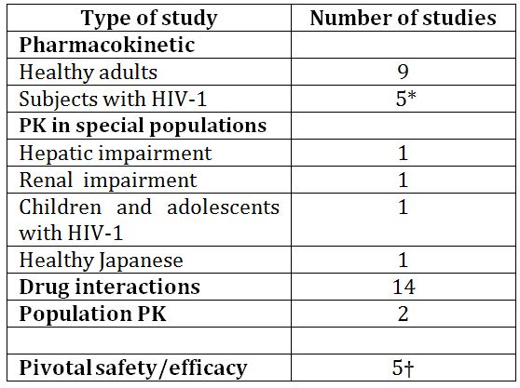
* Includes one dose-finding study: ING112276 and a Phase IIb safety/efficacy study: VIKING (ING112961)
† SPRING-2 (ING113086), SAILING (ING111762), SINGLE (ING114467), VIKING-3 (ING112574), P1093 (ING112578).

Pharmacokinetics
- DTG is rapidly absorbed following oral administration of the tablet formulation, with Tmax observed at 2-4 h post dose, and a t1/2 of ~14 h; the estimated CL/F and V/F are 0.56 L/h and 12.5 L/h for suspension formulations and 0.90 L/h and 17.4/L h for tablet formulations.
- The absolute bioavailability of DTG has not been determined due to the low solubility of DTG in buffered solutions.
- DTG is highly bound to plasma protein with estimated percentage bound in human plasma of 98.9-99.7% in healthy subjects and 99.5% in HIV-1 infected subjects.
- DTG is present in the female and male genital tract: AUC in cervicovaginal fluid, cervical tissue, and vaginal tissue were 6 to 10% of that in corresponding plasma at steady state in 8 healthy HIV-1 negative women (Study ING115465). AUC was 7% in semen and 17% in rectal tissue of the plasma AUC at steady state in 12 healthy HIV-1 negative men (Study ING 116195).
- DTG is primarily metabolised via UGT1A1 with a minor CYP3A component (9.7% of total dose administered in a human mass balance study).
- Following a 20 mg dose of ¹⁴C DTG suspension, 64% of the recovered radioactivity was in the faeces and a further 31.6% was recovered in urine in a study of six healthy male subjects (Study ING 111853).
- For the DTG 25 mg tablet used in Phase II studies, a high fat meal increased the plasma DTG AUC_{0-∞} and Cmax by 94% and 84%, respectively compared with the fasted condition.
- A further study identified that plasma DTG AUC_{0-∞} increased by 33% and 41% when AW (Phase III) tablets were administered with low fat and moderate fat meals, respectively, and Cmax increased by 46% and 52% under the two conditions, respectively. A high fat meal increased the AUC_{0-∞} and Cmax by 66% and 67%, respectively. The sponsor considers the increased exposure with food is not clinically significant based on safety data from Phase IIb and III studies which permitted DTG dosing without restriction to food or food content.
- DTG PK exposure from the tablet formulation increased less than proportionally for doses from 2 mg to 100 mg; however, increase in DTG exposure appears dose proportional from 25 mg to 50 mg.
- Following repeat dose administration of the tablet formulation in HIV infected patients, plasma concentrations of DTG reached steady state by 7 days of dosing and the accumulation ratios were estimated to be 1.25-1.43 for AUC, 1.23-1.40 for Cmax, and 1.27-1.42 for Cτ across the range of doses studied.
- In HIV-1 infected patients, subjects who had protocol defined virological failure while being treated with DTG had 58% lower pre dose plasma DTG concentrations than subjects with non protocol defined virological failure.
- M3 was the major biotransformation product observed in the urine, accounting for 62.5% of the radiocarbon (18.9% of the dose). Two other notable metabolites were also observed in human urine; these resulted from oxidation at the benzylic carbon (M7), representing 10.1% of the urinary radiocarbon (3.0% of the dose), and N-dealkylation (M1), representing 11.8% of the urinary radiocarbon (3.6% of the dose). Renal elimination of unchanged DTG was low (≤2.6% of the sample radiocarbon or ≤0.8% of the dose).
- No dose adjustment for DTG is needed in subjects with genotypes conferring poor metaboliser status of UGT1A1 (*28/*28; *28/*37; *37/*37).
- DTG has low to moderate between-subject and within subject PK variability, and variability is higher in HIV infected subjects than healthy subjects: the between subject variability in HIV infected subjects was estimated at 30-50% for AUC and Cmax, and at 55-140% for trough concentration.

Special populations

Hepatic impairment
- Following a study of 8 subjects with mild to moderate hepatic impairment (Child-Pugh grade A or B) and 8 matched healthy controls, plasma total exposures of DTG were similar, whereas, the fraction unbound (%) of DTG in moderate hepatic impaired subjects was ~76%-120% higher than those in healthy subjects.
- It was concluded and stated in the product information that no dosage adjustment is necessary for patients with mild to moderate hepatic impairment and that ‘the effect of severe hepatic impairment on the PK of DTG has not been studied’, although advice re dosage adjustment is on very few patients. The PI includes the number of patients studied.

Renal impairment
- Plasma exposures (AUC and Cmax) of DTG in 8 subjects with severe renal impairment were lower than those in healthy subjects by 23-40%. The sponsor did not consider this to be clinically significant as the moderate reduction in DTG exposure was within the ‘no effect boundaries’. Furthermore, the reduction in plasma exposure due to severe renal impairment was similar to that observed with co-administration with DRV/r in the SAILING study where virologic response was equivalent, despite lower exposure.

Drug-drug interaction studies
- Overall, a total of 14 drug-drug interaction studies were submitted, of which nine were studies with single and dual combinations therapies for the treatment of HIV and five were studies with drugs for the treatment of concomitant conditions.
- In vitro studies indicate that DTG demonstrates minimal or no direct inhibition of CYP isozymes, UGT1A1, UGT2B7, and many transporters (Pgp, BCRP, OATP1B1, OATP1B3, MRP2, and OCT1), and it is not an inducer of CYP1A2, CYP2B6, or CYP3A4.
- No clinically significant drug interactions were observed between DTG and the following agents: midazolam (CYP3A4 substrate), oral contraceptives containing norgestimate and ethinyl estradiol, methadone, multivitamins, omeprazole, prednisone, tenofovir (TDF), rilpivirine (RPV), darunavir/ritonavir (DRV/RTV), lopinavir (LPV)/RTV, etravirine (ET)/LPV/RTV, ET/DRV/RTV, fosamprenavir (FPV)/RTV, boceprevir (BCV), and telaprevir (TVR)
Clinically significant drug interactions were observed with the following drugs:
- Etravirine reduced DTG AUC and Cτ (trough concentrations) by >70% and increased DTG clearance by 3.4 fold. Therefore, DTG should not be co-administered with etravirine alone. The reduction in DTG exposure is likely to be attributable to the combined inductive effect on UGT1A1 and CYP3A4 activity by etravirine.
- Co-administration of DTG 50 mg twice daily with rifampin 600 mg once daily significantly reduced plasma DTG concentrations relative to DTG 50 mg twice daily alone (with AUC_{0-τ}, Cmax and Cτ reduced from 46.3 to 21.3 µg.h/mL, 5.55 to 3.13 µg/mL and 2.41 to 0.67 µg/Ml, respectively), but resulted in 18-33% higher plasma DTG Cmax, AUC_{0-24h} and trough concentrations than DTG 50 mg once daily alone. The recommendations in the product information concur with this.
- DTG should be administered at least 2 h before or 6 h after polyvalent metal cation containing antacids. Plasma DTG exposure was reduced 74% when co-administered with the antacid Maalox (aluminium hydroxide/magnesium hydroxide/simethicone);
- Co-administration with ATV resulted in an increase in plasma DTG exposures with plasma DTG AUC_{0-τ}, Cmax, and Cτ increasing by 91%, 50%, and 180%, respectively. The clinical evaluator suggested co-administration of DTG and ATV is not recommended, however the sponsor suggested this was not clinically significant.

Population PK studies
- The clinical evaluator concluded that population PK modelling studies indicated that the PK of DTG following oral administration can be adequately described by a linear one compartment model with first order absorption and absorption lag time and first order elimination.

Limitations of PK studies
- It is not known whether any of metabolites of DTG are active.
- Effect of severe hepatic impairment on DTG PKs was not evaluated.
- The effect of administration timing on DTG PKs was not evaluated, although this is probably of limited relevance.
- PK data on subjects of >65 years of age are limited.
- No studies examined the comparative PK of DTG following 100 mg DTC once daily and 50 mg DTG twice daily.

Pharmacodynamics

Mechanism of action
- DTG inhibits HIV integrase by binding to the integrase active site and blocking the strand transfer step of retroviral DNA integration, which is essential for the HIV replication cycle.

Primary PDs
- In HIV-1 infected patients, 10 days of DTG monotherapy at doses of 2, 10 and 50 mg resulted in a statistically significant reduction in plasma HIV-1 RNA log10 copies/mL from Baseline to Day 11 compared with placebo (p≤0.001) for all doses.
- In HIV-1 infected subjects, 31% and 62% of subjects had plasma HIV-1 RNA <50 c/mL and <400 c/mL, respectively, following 2 weeks of treatment with DTG 50 mg once daily in combination with a background NRTI regimen of ABC/3TC 600/300 mg once daily. Following 4 weeks of treatment, these percentages increased to 46% and 92%, respectively. The median change from baseline in plasma HIV-1 RNA was -2.53 log₁₀ c/mL (at Week 2) and -3.04 log₁₀ c/mL (at Week 4).

Secondary PDs
- In healthy subjects, DTG has no effect on cardiac repolarisation at a supratherapeutic dose of 250 mg (suspension).
- In healthy subjects, DTG decreased creatinine clearance by 10% at 50 mg q24h and 14% at 50 mg q12h, whereas it had no effect on glomerular filtration rate and effective renal plasma flow.

Dose-response
- Greater antiviral activity was associated with higher DTG plasma exposure. Cτ (concentration at end of dosing interval) was the PK parameter that best predicted Day 11 plasma viral load reduction from baseline or maximum plasma viral load reduction from baseline.
- There was no statistically significant correlation between CSF DTG concentration and absolute CSF HIV-1 RNA levels or between CSF DTG concentration and change from Baseline in CSF HIV-1 RNA. According to the FDA Decisional review for DTG, dated 6 August 2013, the relevance of these findings is unknown.

Infants, children and adolescents
- In infants, children and adolescents infected with HIV-1, once daily dosing with DTG, with target dose of ~1 mg/kg according to weight, resulted in a rapid and sustained antiviral response with 80% of subjects achieving HIV-1 RNA <400 c/mL and 70% achieving HIV-1 RNA <50 c/mL by Week 24.

Pharmacodynamic interactions
Co-administration of DTG did not affect the PD of either the oral contraceptive Ortho-Cyclen or the synthetic opioid methadone.

Dose finding study: ING112276
ING112276 is an ongoing, randomised, single blind, four arm, Phase IIb study to select a once daily oral dose of DTG administered with either abacavir/lamivudine or tenofovir/emtricitabine (FTC) in HIV-1 infected ART naïve patients. The study commenced in July 2009 and the results of the primary efficacy outcome were reported at Week 16 in June 2010. It was a dose ranging study conducted at 34 centres to compare the antiviral activity of a range of oral DTG doses (10 mg, 25 mg and 50 mg) for further evaluation in Phase III. A total of 205 patients were enrolled and received DTG or EFV.
At Week 16, more than 90% of patients on any dose of DTG achieved viral suppression of <50 copies/mL compared with 60% on EFV (Table 23). Response rates were similar across subgroups including background NRTI, baseline CDC category and baseline CD4+ count. The evaluator commented that there was therefore no clear justification for the selection of the 50 mg dose compared with the others tested. A response provided by the sponsor with the second round evaluation of clinical data was deemed satisfactory by the evaluator.
Table 23: Viral suppression (<50 copies/mL) comparing DTG with EFV to Week 16.
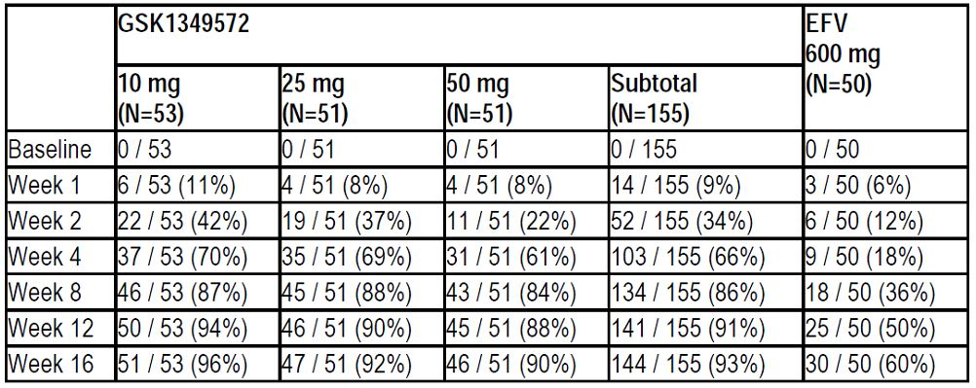

Efficacy
Five pivotal efficacy/safety studies were submitted and included patient populations enrolled in two treatment naive trails (SPRING-2 (ING113086) and SINGLE (ING114467), n=1461), a treatment experienced, INI naive trial(SAILING (ING111762), n = 715), an INI experienced trial (VIKING-3 [ING112574], n = 183), a Phase IIb study (VIKING(ING112961), n = 51) of INI experienced patients and a study in paediatric patients >12 years(P1093 [ING112578], n = 23). The submitted studies were compatible with EMEA guidelines of November 2008 adopted by the TGA. The SPRING-2 and SAILING trials are available as published papers.

SPRING-2 (ING113086): Efficacy in therapy naive patients
SPRING-2 is an ongoing Phase III, randomised, double blind, double dummy, active controlled, multicentre, parallel group, non-inferiority study. The objective was to demonstrate the non inferior antiviral activity of DTG 50 mg once daily compared to RAL 400 mg BID over 48 weeks in therapy naïve patients infected with HIV-1. A total of 822 patients were randomised 1:1 to receive DTG 50 mg QD or RAL 400 mg both in combination with open label fixed dose dual NRTI therapy. HIV-1 infected adults aged ≥18 years; plasma HIV-1 RNA ≥1000 c/mL at screening; and ART naïve were eligible for the study. The primary outcome measure was the proportion of patients with plasma HIV-1 RNA <50 c/mL at Week 48. Secondary outcome measures and further details of the study design are listed in the clinical evaluation report. Efficacy analyses were conducted on the Intent to Treat Exposed (ITT-E) population consisting of all patients who received at least one dose of study medication.

Results for the primary efficacy outcome
At Week 4 in the ITT-E population, the majority of patients in the DTG and RAL groups achieved a viral response. At Week 48, 88% and 85% of patients in the DTG and RAL groups respectively had achieved the primary endpoint of plasma HIV-1 RNA levels <50 c/mL .The non inferiority of DTG to RAL was confirmed because the lower end of the 95% CI for the treatment difference (-2.2%) was greater than -10%. The results of the PP analysis were similar with 90% and 88% of patients treated with DTG and RAL, respectively, achieving plasma HIV-1 RNA <50 c/mL at Week 48. In the ITT-E set, there were more responders in the DTG group compared with RAL. However, superiority of DTG was not confirmed as the lower end of the 95% CI was not above 0%. There were more virologic non responders in the RAL group (8%) than in the DTG group (5%). However, because of missing data at Week 48, 7% of patients in each group were considered to be non-responders. Baseline HIV-1 RNA and backbone NRTI had no influence on the efficacy response. Fourteen patients (8 DTG, 6 RAL) from one site were excluded from the analysis because of poor GCP compliance however this did not affect the overall conclusions. The lower end of the 95% CI for the treatment difference in the adjusted data set was -1.9%. This difference was greater than the non inferiority margin of -10% and similar to the unadjusted difference (-2.2%).

Results for other efficacy outcomes
The secondary endpoint of plasma HIV-1 RNA <400 c/mL at Week 48 was achieved in 90% of DTG patients and 87% of RAL patients. CD4+ cell count changes from baseline were similar in each treatment group. The incidence of HIV associated conditions was low (2% in each treatment group) and HIV disease progression was <1% in both groups. There were no significant differences between DTG and RAL across demographic subgroups.
It was concluded by the evaluator that the study was appropriately designed, controlled and conducted with low numbers of protocol deviations and discontinuation rates. The primary endpoint of plasma HIV-1 RNA <50 c/mL at Week 48 was met by 88% of DTG patients and non-inferiority of DTG compared with RAL was demonstrated with a 2.4% (95% CI: -2.2%, 7.1%) adjusted treatment difference in favour of DTG. The results were within the margins of non inferiority and the findings in the ITT-E set were confirmed by a sensitivity analysis in the PP set. Subgroup analyses were consistent with the main finding with no influence by baseline viral load, baseline demographics, or NRTI background therapy.

ING114467 (SINGLE) Efficacy in therapy naive patients
This was a parallel group, randomised, double blind, active controlled Phase III study of DTG plus abacavir/lamivudine (ABC/3TC) fixed dose combination therapy given once daily compared with Atripla (FTC/TDF/EFV) over 96 weeks in 833 HIV-1 infected ART naïve adult patients. The main efficacy variables were antiviral response, increased CD4+ count and HIV-1 disease related conditions. The primary objective was to compare the antiviral activity of DTG + ABC/3TC once daily with Atripla over 48 weeks, assessed by the proportion of patients with plasma HIV-1 RNA <50 c/mL.
Secondary efficacy objectives included: the antiviral activity of DTG + ABC/3TC compared with Atripla over 96 weeks; the assessment of viral resistance in patients experiencing virologic failure; the incidence of new HIV associated conditions over time; and the impact of race, gender and/or HIV-1 subtype.
At Week 48, 88% of patients in the DTG + ABC/3TC group achieved the primary endpoint of HIV-1 RNA <50 c/mL compared with 81% in the Atripla group. Non inferiority was confirmed as the lower bound of the 95% CI for the treatment difference (+2.5%) was greater than -10%. The adjusted difference in proportions (DTG-Atripla) was 7.4 (95% CI: 2.5-12.3) and the difference was statistically significant (p = 0.003). Virologic failure was similar in both groups and the difference in treatment response was attributable largely to a higher withdrawal rate due to AEs in the Atripla group. A similar result was observed in the PP analysis in which 90% and 81% of patients in the DTG + ABC/3TC and Atripla groups respectively achieved plasma HIV-1 RNA<50 c/mL at Week 48.
The evaluator concluded that this pivotal Phase III study was well conducted with few deviations. There were more early withdrawals in the Atripla arm but this was due to AEs. A total of 88% of patients in the ITT-E group and 90% in the PP group achieved plasma HIV-1 RNA <50 c/mL at Week 48. The rise in CD4+ count was also higher in the DTG + ABC/3TC group and no patients developed INI resistant mutations. The study results were internally consistent with no differences attributable to baseline HIV-1 RNA levels, CD4+ count, or demographics. Notably, the virological response in the DTG + ABC/3TC was significantly faster than in the Atripla group and the response was durable.

SAILING (ING111762), Efficacy in treatment experienced patients
This was a Phase III, randomised, parallel group, double blind, active controlled multicentre study conducted in 156 sites. Patients were required to be INI naïve and have documented resistance to at least one member of each of at least two ART drug classes (NRTI, NNRTI, PRO inhibitor, fusion inhibitor or CCR5 antagonist). The primary efficacy outcome was to demonstrate the antiviral efficacy of DTG QD compared to RAL 400 mg BID both in combination with a background regimen consisting of 1-2 fully active single agents in HIV-1 infected, INI naïve, therapy-experienced patients at 48 weeks. The primary endpoint of the study was the proportion of subjects in the mITT-E population with plasma HIV-1 RNA <50 c/mL at Week 48.
The sponsor provided the week 48 data as a study synopsis with the section 31 response, with a full study clinical report available on request, indicating the publication.

SAILING trial outcomes (plasma HIV-1 RNA <50c/mL) at Week 48
Table 24 shows outcomes from the SAILING trial.
Table 24: Study outcomes from SAILING trial.
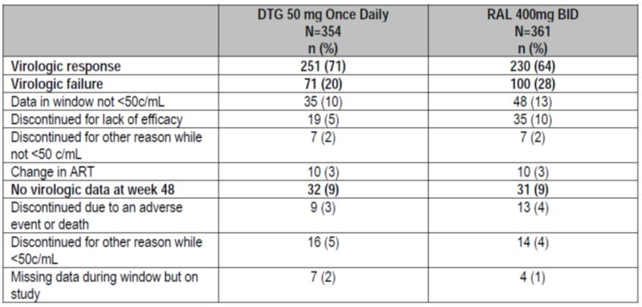

Results for primary outcome
The clinical evaluator concluded that the SAILING study was designed as a non inferiority study and the primary efficacy endpoint was the proportion of patients who achieved HIV-1 RNA <50 c/mL at Week 48 in the ITT set. At Week 24, 79% of DTG patients achieved a response compared with 70% of RAL patients with an adjusted treatment difference of 9.7% (95% CI: 3.4, 15.9, p = 0.003). At Week 48, there was still a statistically significant benefit in favour of DTG (71% response) compared with RAL (64%). The adjusted treatment difference at Week 48 was 7.4% (95% CI: 0.7, 14.2, p = 0.03). The finding was confirmed in the PP set with Week 48 response rates of 73% and 66% in the DTG and RAL groups, respectively (adjusted treatment difference 7.5% [95% CI: 0.6, 14.3]). At Week 48, virologic failure had occurred in 20% of DTG patients compared with 28% in the RAL group. The antiviral response rates within demographic and baseline characteristics were generally higher in DTG patients compared with RAL. Exceptions were patients >50 years (DTG 65%, RAL 69%) and patients with CDC category B disease (DTG 56%, RAL 70%).

VIKING-3 (ING112574) Efficacy in integrase inhibitor experienced patients with RAL or EVG resistance
This was an open label, single arm Phase IIb study conducted in 183 patients with multiple drug resistance including RAL and EVG. The study is ongoing and the current report was completed in September 2012. The patients had advanced disease with a median baseline CD4+ cell count of 140 cells/mm³, median duration of prior antiretroviral treatment of 13 years with more than half classified as CDC Class C (although evidence of Category C disease [AIDS] was noted as an exclusion criteria). A total of 60 patients had INI resistance before or at screening but not at Day 1.
The primary efficacy endpoint was the change from baseline in HIV-1 RNA at Day 8 and the proportion of patients with HIV-1 RNA <50 c/mL at Week 24. The Week 24 ITT-E population was based on analysis of 114 patients, although the reasons for exclusion of 69 patients were not entirely clear from the summary tables and this should be clarified with the sponsor. There was a statistically significant mean reduction of 1.43 log₁₀ c/mL HIV-1 RNA in the ITT-E population at Day 8. A similar mean reduction was observed in the PP population (n = 101 at Week 24). A total of 72/114 (63%) patients achieved plasma HIV-1 RNA <50 c/ml at 24 weeks in the ITT-E population and 66/101 (65%) in the PP population. Lack of virological suppression was the main reason for virological failure. Other factors included non permitted background ART and discontinuation due to AEs.

Study ING112574 (VIKING-3)
Table 25 shows outcomes from the VIKING-3 trial.
Table 25: Summary of Study Outcomes for Plasma HIV-1 RNA <50c/mL at week 24 (MSDF, Week 24 ITT-E).
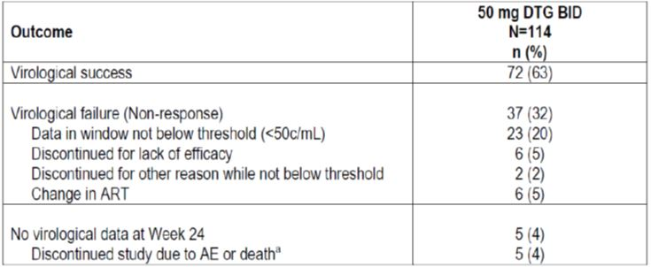

VIKING (Study ING112961). Efficacy in integrase inhibitor experienced patients
This was an open label, single arm Phase IIb study to assess the antiviral activity of a regimen containing DTG in ART-experienced, adults infected with HIV-1 and with RAL resistance. It was conducted at 16 centres in Europe and the US. In Cohort 1, 27 patients with RAL virologic failure substituted therapy based on DTG 50 mg once daily: via a protocol amendment, a second cohort of 24 patients was subsequently recruited and treated with DTG 50 mg BID (Figure 4).
Figure 4. Cumulative distribution of change from baseline to plasma HIV-1 RNA (log₁₀ c/mL) at Day 11.
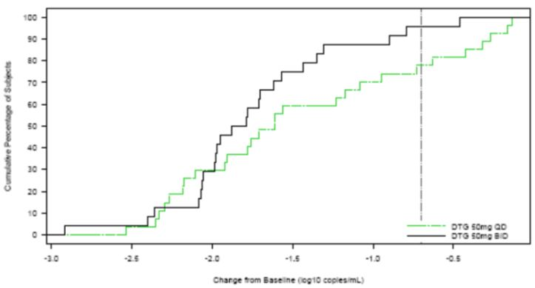
This Phase IIb study was performed in HIV-1 patients with multiple drug resistance including RAL. While the study did not meet the accepted criteria for a pivotal study, it was the main important support for the 50 mg BID dosage in patients with INI resistance. The evaluator commented that the sequential design was not ideal with Cohort 2 (DTG 50 mg BID) added only following suboptimal efficacy in Cohort 1 (DTG 50 mg BID).

P1093 (ING112578): adolescents and children
This study is ongoing and is being conducted in collaboration with the International Maternal Pediatric Adolescent AIDS Clinical Trials Group (IMPAACT). It is a Phase I/II multicentre, open label, non comparative, dose ranging study to examine the efficacy and safety of DTG in combination regimens in infants, children and adolescents with HIV-1 infection. Approximately 160 infants, children and adolescents aged ≥6 weeks to <18 years were treated with DTG prior to starting, and in combination with optimised background therapy.
The treatment dosing regimen assignments used were based on DTG tablet QD doses with target dose of ~1 mg/kg across 2 weight bands, and maximum dose of 50 mg.
The treatment dosing regimen assignments specifically used for Cohort I were:
- DTG 35 mg once daily + OBR for subjects weighing 30 - <40kg (n = 4)
- DTG 50 mg once daily + OBR for subjects weighing ≥ 40kg (n = 19).
Six cohorts of HIV-1 infected children were selected as shown below:
- Cohort I: Adolescents ≥12 to <18 years (Tablet formulation)
- Cohort IIA: Children ≥6 to <12 years (Tablet formulation)
- Cohort IIB: Children ≥6 to <12 years (Paediatric formulation)
- Cohort III: Children ≥2 to <6 years (Paediatric formulation)
- Cohort IV: Children ≥6 months to <2 years (Paediatric formulation)
- Cohort V: Infants ≥6 weeks to <6 months (Paediatric formulation)
Enrolment began with Cohort I and at the time of the report had progressed to Cohort II. Progress through the cohorts will continue after PK and safety data criteria in the preceding cohorts are met. Each age cohort will consist of Stages 1 and 2. Stage 1 consists of ten patients who will have intensive PK sampling and assessment of short term safety and tolerability. Stage 2 will open for the enrolment of additional patients at the selected dose.

Results supporting labelling in adolescents aged 12 to less than 18 years of age
Initial results were provided for 10 patients enrolled in Cohort 1, stage 1 through to Week 24 with further results provided as part of the S31 response from the sponsor for Cohort I, Stages I and II through to Week 24 (n = 23 subjects). By December 17, 2012 (interim data analysis), all 23 subjects had completed the Week 24 visit and 17 had reached the Week 48 visit. Median age was 15 years (range 12-17 years), 18/23 patients (78%) were female.
The evaluator concluded that the study was conducted in a small population of adolescents with long standing disease and intolerance or resistance to multiple drug classes. The PK data showed moderate variability but support the use of 50 mg once daily in adolescents weighing more than 40 kg. At Week 24, 19/23 patients (82.6%, 95% CI: 61.2, 95.0) had achieved a reduction in HIV-1 RNA <400 c/mL. The four patients who did not achieve a virologic response had a documented history of poor compliance. Sixteen (70%) patients had plasma HIV-1 RNA <50 c/mL at Week 24 and 20 patients (87%) had >1 log₁₀ c/mL decrease from baseline. There was a median gain in CD4 count of 63 cells/mm³.
No new safety issues were identified and the safety profile in adolescents was similar to the adult population. There were no AEs Grade 3 or greater, no discontinuations due to an AE, no SAEs and no drug related AEs. No significant hepatic events were recorded.

Safety
A summary of the safety population by study for pivotal and supportive studies is shown in Table 26.
Table 26: Summary of the safety population by study for pivotal and supportive studies.
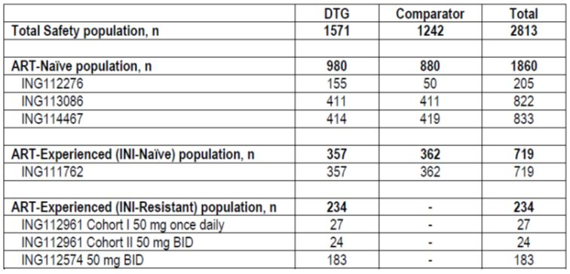

Patient exposure
As of October 2012, a total of 2663 subjects (2026 HIV infected and 637 healthy) have received at least one dose of DTG. A total of 526 healthy subjects and HIV infected patients were exposed in clinical pharmacology studies and a further 139 healthy subjects are exposed in ongoing studies. A total of 1571 HIV infected patients have been exposed in Phase IIb/III studies and 284 patients have received at least one dose of DTG in ongoing studies. A total of 23 adolescents and children have received DTG in the ongoing study ING112578 (P1093). A compassionate use program currently has 110 patients on treatment. In the combined Phase IIb/III studies, exposure to DTG was approximately 1596 patient years, while exposure to RAL, EFV or Atripla ranged from 82.0 to 497.0 days. The mean duration of exposure to DTG was 340 days (range 1 to 943 days).
In the combined database of all DTG studies, a total of 1571 AEs judged by the investigator to be reasonably attributable to DTG were reported. Nausea and diarrhoea were the most commonly reported events (Table 27).
Table 27: Summary of treatment related AEs in at least 1% of subjects – total Phase IIb/III DTG treatment population.
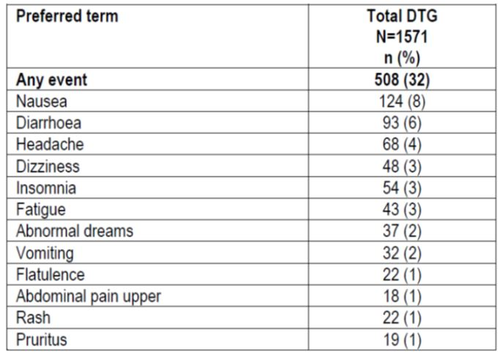

Deaths and other serious adverse events
According to the FDA Decisional review dated 6 August 2013, 15 adults who received DTG died in Phase IIb/III trials and the compassionate use program through the 60 day safety update report cut off date. No deaths were reported in the paediatric trial. Causes of death included progressive multifocal leukoencephalopathy (PML), lymphoma, Kaposi’s sarcoma, non Hodgkin’s lymphoma, myocardial infarction, cardiac death, suicide, homicide, motor vehicle accident, brain mass, pulmonary haemorrhage, fungal pneumonia and haemochromatosis and fibrosis secondary to Hepatitis C virus. The FDA clinical evaluation team concurred with the investigators’ assessments that none of the deaths was thought to be related to DTG.

Safety conclusions
The safety profile of DTG 50 mg QD in ART naïve and experienced patients was similar to RAL after 24 and 48 weeks treatment. In combination with ABC/3TC, DTG was better tolerated than Atripla which was associated with higher withdrawal rates due to AEs. DTG 50 mg BID had a similar safety to DTG 50 mg QD. AEs were more common in ART experienced patients than in ART naïve patients but the increased incidence was attributable mainly to differences in the severity of the underlying disease in the treatment experienced group.
There were few hypersensitivity reactions and skin rashes were generally mild and self limiting. The FDA clinical review described one case of a severe hypersensitivity reaction observed in a subject with no known risk factors which was felt to be most likely attributable to DTG.
In ING113086 and ING111762, the incidence of hepatic toxicity was similar in the DTG and RAL treatment groups. Overall, there were approximately five cases possibly suggestive of drug induced liver disease in the pivotal trials. Hepatic events were more common in treatment experienced patients exposed to multiple concomitant medications, and in patients with HBV and/or HCV co-infection. It was noted in the FDA decisional review that liver chemistry elevations consistent with immune reconstitution were observed in co-infected patients receiving receiving DTG, particularly those in whom anti hepatitis therapy was withdrawn and that it was difficult to determine whether these elevations were a result of hepatic flare secondary to withdrawal of anti hepatitis therapy, immune reconstitution in the setting of a rising CD4 count or hepatoxicity.
There was a small but consistent rise in serum creatinine following DTG due to inhibition of the renal OCT2 receptor. However, the incidence of renal impairment with DTG treatment was low. The frequency of GI events was similar in DTG patients compared with RAL and Atripla. The risk of myositis, lipid and lipase abnormalities also appeared similar in DTG patients compared with comparator treatments. The DTG safety profile was similar in sub-groups defined by gender, race, and age. The rapid antiviral response to DTG highlights the need for caution in patients with HBV co-infection risk of IRIS.
DTG has been shown to be well tolerated in treatment naïve HIV patients. DTG also appears to be well tolerated in treatment experienced patients. As the safety data evaluated patient data as of October 2012, it is suggested that the sponsor provide more recent data, if available.

Risk management plan
The RMP submitted with this application (an EU RMP version 1.0 dated 30 November 2012 with ASA have been evaluated by the OPR evaluator, and the evaluation reports are provided for Advisory Committee on Prescription Medicines (ACPM) information. Advice was not sought from the ACSOM for this submission.
The RMP Round 2 assessment advised that sponsor’s response to the TGA section 31 Request has not adequately addressed all of the issue identified in the RMP evaluation report as follows:
- Under the ‘Adverse Effects’ section, the OPR evaluator suggested the statement “There are no safety data beyond 48 weeks of treatment,” or words to that effect.
The sponsor disagrees with this, citing that exposure to DTG is constantly increasing and changing. The Delegate recommends a statement be included in the PI incorporate both the points of the sponsor and the OPR, such as “At the time of registration there is limited data regarding long term exposure with DTG.”
- The nonclinical evaluator concluded that the lack of a dedicated phototoxicity study was a deficiency and that monitoring for potential phototoxicity should be included in the RMP.
The suggested condition of Registration is as follows:
- The EU RMP Version: dated 30 November 2012 with an ASA Version: 1.0 (undated), to be revised as specified in the sponsor’s correspondence dated 26 August 2013, must be implemented.

Risk-benefit analysis

Delegate considerations
Overall, the sponsor had provided a comprehensive submission supporting the registration of the integrase strand inhibitor DTG for the treatment of HIV infection in combination with other antiretroviral agents in adults and children over 12 years of age. DTG is the third agent within the class, following RAL and EVG, and may be given once daily, as for EVG.
The lack of absolute bioavailability data for DTG is a deficiency; however, justification has been provided based in part on the low solubility of the drug substance. It is noted that the relative bioavailability of the tablet formulation was compared to the suspension formulation (Study ING111322). The evaluator had no objections to the registration of this product and it was not referred to the PSC as there were no outstanding issues.
The data presented for patients with hepatic impairment is limited to a study of 8 subjects with mild to moderate hepatic impairment with matched controls and there is no data available for subjects with severe hepatic impairment. This information is included in the PI; however, the need for post marketing surveillance for patients with hepatic impairment taking DTG should be highlighted.
The Delegate seeks advice from ACPM with respect to the clinical significance of the interaction with the PRO inhibitor ATV. The sponsor has justified the insignificance of this interaction based on the large therapeutic window of DTG and data from phase III studies demonstrating that adverse events including liver chemistry elevations were no different for patients receiving DTG plus ATV or ATV ± RTV. While this differed from evaluator recommendation, the Delegate is inclined to accept the sponsor’s response.
It is also noted that although there is increased exposure with food, the Phase IIb and III data was generated in settings where the drug was taken without regard for food and the interaction was not clinically significant based on safety data from these studies.
The clinical evaluator expressed concern that there was no clear justification for the selection of the 50 mg dose compared with the others tested, as more than 90% of DTG patients at all doses achieved a rapid and sustained virologic response. Justification provided by the sponsor with the second round evaluation of clinical data included similar antiviral responses for all three doses and no apparent dose-response relationship, suggesting DTG doses from 10 mg to 50 mg once daily in combination with 2 NRTIs achieved maximum virologic suppression. The maximal tolerated and highest dose, DTG 50mg once daily, was therefore selected as the dose for the Phase III studies in INI-naïve population. Selection of 50 mg once daily dose was also to accommodate decreases in DTG due to drug interactions, poor absorption and imperfect adherence. It is noted that the FDA agreed with the sponsor’s dose selection at the End of Phase 2 (EOP2) meeting and that dose selection was adequately explored for various patient populations. While the Delegate is inclined to accept the sponsor’s recommendation, it is noted that other doses were not tested as part of the Phase III studies.
Efficacy data support the non inferiority and similar safety profile to the integrase inhibitor RAL. Efficacy studies showed generally consistent effect across subgroups with FDA analysis for the SPRING-2, SINGLE studies and SAILING studies. Limitations of the SPRING-2 study assessing efficacy in therapy naive patients were the predominance of white male patients and the inclusion of few patients with advanced disease suggesting the study was not representative of the global HIV population. The SAILING study compared DTG and RAL in antiretroviral therapy experienced, integrase inhibitor naive patients and demonstrated that DTG reached pre defined criteria for superiority over RAL in the primary analysis at 48 weeks (251 [71%] versus 230 [64%] patients; adjusted difference 7·4%, 95% CI 0·7-14·2; p = 0·03). The study population was more representative of the HIV population, including 32% female, 46% who had previously developed AIDS and a mix of subtypes of HIV. It was also concluded that DTG retains activity against HIV isolates with RAL associated or EVG associated resistance mutations. The VIKING-3 and VIKING trials were uncontrolled trials and used 50 mg BID dosing. FDA analysis demonstrated diminished virological responses in the presence of Q148 substitutions at Week 24 in the VIKING-3 trial. The Delegate requests comments from ACPM with regards to resistance issues and justification for the 50 mg BID dosing, also approved by the FDA.
The data informing labelling in adolescents aged 12-18 years is supported by an ongoing study in INI naïve adolescents and children with longstanding disease. The data set includes an analysis of 23 patients in this age range and while this is very limited, the Delegate supports the extension of indication to this age group, given the study is ongoing, supports the use of 50 mg once daily in adolescents weighing >40 kg and that no SAEs have been recorded. No dosing was proposed for INI experienced paediatric patients as 50 mg twice daily was not evaluated. It is hoped that the sponsor will consider a submission extending the access to younger paediatric HIV patients as more data becomes available.

Summary of issues
Five pivotal efficacy/safety studies were submitted and included patient populations enrolled in two treatment naive trials, a treatment experienced, INI naive trial, an INI experienced trial, a Phase IIb study of INI experienced patients and a study in paediatric patients greater than 12 years old. Efficacy data support the non inferiority and similar safety profile to the integrase inhibitor RAL.
The overview should be read in conjunction with the scientific and RMP evaluation reports.

Delegate’s proposed action pre ACPM
Based on the discussion above, the Delegate proposes to approve Tivicay (dolutegravir) for the treatment of HIV infection in combination with other antiretroviral agents in adults and children over 12 years of age.

Adults
Patients infected with HIV-1 without resistance to the integrase class
The recommended dose of Tivicay is 50 mg once daily.
Patients infected with HIV-1 with resistance to the integrase class (documented or clinically suspected)
The recommended dose of Tivicay is 50 mg twice daily. The decision to use dolutegravir for such patients should be informed by the integrase resistance pattern (see Clinical Trials).

Adolescents
In patients who have not previously been treated with an integrase inhibitor, (12 to less than 18 years of age and weighing greater than or equal to 40 kg) the recommended dose of Tivicay is 50 mg once daily.
The final approval is subject to the finalisation of the PI to the satisfaction of the TGA. The condition of registration is the implementation of the RMP: The EU-RMP Version: 01 dated 30 November 2012 with an ASA Version: 1.0 (undated), to be revised as specified in the sponsor’s correspondence dated 26 August 2013, must be implemented.

Pre ACPM preliminary assessment
The Delegate has no reason to say, at this time, that the application for DTG should not be approved for registration.

Advice sought
- There are no absolute bioavailability data and the Quality evaluator had no objections to the registration of this product. The application was not presented to the PSC as there were no outstanding issues. The Delegate seeks ACPM comment.
- The clinical implications for resistance with the use of DTG, with respect to the results from the VIKING-3 and VIKING trials, both of which were uncontrolled and used 50 mg BID dosing. Is there sufficient justification for this dose regimen which has been recently approved by the FDA?
- The indications and usage section of the FDA PI imply genetic testing for integrase strand transfer inhibitor resistance compared with the proposed Australian PI. There are more details regarding resistance in the Microbiology section of the FDA Prescribing Information.
- Whether the proposed wording for the Renal Impairment section adequately covers patients with severe renal impairment, given the wording of the FDA Prescribing Information.
- The clinical significance of interaction with ATV and the consolidated section 31 response for the PI from the sponsor. The Delegate proposes to accept the sponsor recommendation.
- Adequacy of data in adolescents. Data is available for 23 patients as of December 2012. The sponsor is requested to provide any further information from this study when it is available.
The committee is (also) requested to provide advice on any other issues that it thinks may be relevant to a decision on whether or not to approve this application.

Response from sponsor

Executive summary
- Tivicay (dolutegravir, DTG) is an orally administered, two metal binding INI for the treatment of HIV infection which was approved by the US FDA and Health Canada on 12 August 2013 and 31 October 2013, respectively.
- The sponsor welcomes the Delegate’s proposal to approve the following indication for Tivicay (DTG) 50 mg tablets:
Tivicay is indicated for the treatment of human immunodeficiency virus (HIV) infection in combination with other antiretroviral agents in adults and children over 12 years of age
It is noted that the Delegate’s recommendation is consistent with the clinical evaluator who recommended authorisation “for the treatment of human immunodeficiency virus (HIV) infection in combination with other antiretroviral agents in adults and children over 12 years of age.”
- Tivicay is safe and effective and offers the following improvements over current INIs:
  - activity against highly-resistant HIV,
  - durability and higher barrier to resistance,
  - fewer drug interactions and no boosting requirement, and
  - a convenient once daily dosing schedule in patients without resistance to the integrase class or BID dosing for patients with a history of integrase resistance.
From an HIV clinician’s perspective, the dosing schedule has the “advantage, compared with RAL, of once daily dosing in integrase naive patients and, compared to EVG, without the need for boosting and consequent metabolic and drug-drug interactions.”
- TIVICAY 50 mg BID represents the first new option in the INI class for patients with RAL and/or EVG resistant virus. These patients represent a small but challenging group with limited options and for whom the clinical evaluator has commented that the VIKING-3 “study results support the use of the higher dose of DTG 50 mg BID in patients with multiclass drug resistance”.
- The comprehensive DTG clinical development program was designed to achieve a broad initial indication and the data supports the benefit risk assessment across the treatment spectrum.

Summary of efficacy

Antiretroviral therapy naïve
- DTG 50 mg QD has been studied in two Phase III, double blind, double dummy, non inferiority studies in treatment-naive subjects, SPRING-2 (ING113086) and SINGLE (ING114467).
  - In SPRING-2, DTG, administered with two NRTIs, demonstrated non inferiority to RAL at Week 48; 88% versus 85%, of DTG and RAL subjects, respectively, achieved the primary endpoint of HIV-1 RNA <50 copies/mL (c/mL) (FDA “Snapshot” algorithm).
  - SINGLE compared DTG co-administered with abacavir/lamivudine to ATRIPLA [EFV/FTC/tenofovir disoproxil fumarate (EFV/FTC/TDF)]. The DTG regimen demonstrated superiority compared to ATRIPLA, 88% versus 81% (p = 0.003), based on proportion of subjects achieving the primary endpoint of HIV-1 RNA <50 copies/mL (c/mL).
  - Sensitivity and subgroup analyses were supportive of the primary analyses in each study and did not identify subgroups at risk of diminished benefit on DTG.

Antiretroviral therapy experienced, INI naïve
- In SAILING (ING111762), DTG was administered once daily compared to RAL 400 mg twice daily both in combination with a background regimen consisting of one to two fully active agents in HIV-1 infected, INI naïve, therapy experienced subjects. In the Week 24 interim analyses, the proportion of subjects who achieved HIV-1 RNA <50 c/mL (Snapshot/MSDF algorithm) was statistically superior in favour of the DTG treatment group (79%) compared to the RAL treatment group (70%) (adjusted treatment difference [DTG-RAL]: 9.7%; 95% CI: 3.4, 15.9), p = 0.030). These results were extended and confirmed with superiority demonstrated in the Week 48 primary endpoint analyses (DTG: 71%; RAL: 64%; [adjusted treatment difference (DTG-RAL): 7.4%; 95% CI: (0.7, 14.2), p = 0.003]).

Antiretroviral therapy experienced, INI resistant
- VIKING-3 (ING112574) was a single arm study of DTG in integrase resistant patients with the primary endpoint being the change from baseline in plasma HIV-1 RNA at Day 8 and an assessment of the proportion of subjects with <50 c/mL HIV-1 RNA at Week 24. In subjects who had the opportunity to reach Week 24 before the data cut-off, 63% of this Week 24 ITT-E population (n = 114) achieved viral suppression to <50 c/mL based on the Snapshot algorithm. Analysis of the initial ~100 subjects enrolled was a pre-specified analysis for ING112474, agreed with the FDA and EMA, to allow inclusion in the initial regulatory submissions. This was not a censored population (as suggested on clinical evaluation report).

Adolescents (≥ 12 to < 18 years of age)
- P1093 (ING112578) is an ongoing Phase I/II multicentre, open label, non comparative, dose ranging study of approximately 160 HIV-1 infected infants, children, and adolescents. As of 17 December 2012 data freeze date, all 23 subjects in Cohort I (Adolescents ≥ 12 to < 18 years of age), had completed the Week 24 visit and 17 had reached Week 48. Sixteen (70 %) of the subjects had plasma HIV-1 RNA <50 c/mL at Week 24 and 20 out of 23 subjects (87%) had > 1 log₁₀ c/m decrease from baseline in HIV-1 RNA or HIV-1 RNA < 400 c/mL at Week 24.

Summary of pharmacokinetics
- DTG can be taken with or without food based on results from a food effect study and the accumulated safety data in Phase IIb and III studies which permitted DTG dosing without regard to food. The Delegate has agreed to the proposed absorption and dosing text in the Tivicay PI, which is consistent with the US and Canada labels which state that DTG can be taken with or without food.
- DTG has been evaluated in a series of drug interaction studies and does not require dose adjustment for most co-administered drugs. Dose adjustment of DTG to 50 mg twice daily is required when co-administered with strong inducers of UGT1A1 and/or CYP3A4, with the exception of etravirine where the interaction is mitigated by co-administration of lopinavir/RTV, ATV/RTV and DRV/RTV.

Summary of safety
Both the clinical evaluator and Delegate have concluded that “DTG has been shown to be well tolerated in treatment naïve HIV patients” and “also appears to be well tolerated in treatment experienced patients”. The safety profile for DTG including AEs, drug related discontinuations, SAEs and deaths is favourable when compared across all treatment populations and comparator antiretroviral agents and at higher (that is, 50 mg twice daily) doses.

Sponsor’s comments on Delegate’s request for ACPM advice

1. There are no absolute bioavailability data and the Quality evaluator had no objections to the registration of this product. The application was not presented to the PSC as there were no outstanding issues.
The sponsor acknowledges that the absolute bioavailability of DTG has not been determined. The low solubility of DTG in buffered solutions and its non specific binding presents significant challenges to an IV formulation for DTG even at very low doses. The majority of the information for which absolute bioavailability is assessed is available through studies that demonstrate that the tablet formulation is well characterised through linear predictable PK and that the clinical trials can serve as a benchmark for product quality and performance. Studies have shown that DTG exhibits high absorptive permeability, low systemic and pre systemic clearance, unlikely pre systemic drug interactions with efflux transporters, and linear PK over the clinical dose range with low to moderate variability.
In agreement with the Quality evaluator, the sponsor believes that the lack of absolute bioavailability does not preclude registration of DTG.

2. The clinical implications for resistance with the use of DTG, with respect to the results from the VIKING-3 and VIKING trials, both of which were uncontrolled and used 50 mg BID dosing. Is there sufficient justification for this dose regimen which has been recently approved by the FDA?
During the Tivicay TGA pre submission meeting on 26 September 2012, the TGA evaluator commended the decision to select BID dosing for this group of patients noting the current trend towards QD dosing and the associated risks with suboptimal dosing. This is a view also shared in a supporting statement by an HIV clinician who states that the VIKING and VIKING-3 studies “involved a particularly difficult patient group who had a history of integrase exposure and resistance” and “illustrate the superiority of twice daily DTG dosing over 50 mg once daily in this population.”
An open-label, single-arm study design with a short functional monotherapy phase was adopted for VIKING-3 in view of the challenges of a controlled design for this patient population. Key issues included the risk of further resistance evolution in a placebo control arm and lack of availability of a single comparator drug appropriate for participants with multiclass (including INI) resistance. VIKING-3 was therefore an open label, single arm non comparative study with a 7 day period of functional monotherapy specifically included to demonstrate antiviral activity that could predominantly be attributed to DTG with durability of response assessed at Week 24 after re-optimisation of the background regimen.
Despite the limitations of a single arm study, the VIKING-3 results clearly demonstrate the benefit of DTG for this population with limited treatment options. For the Day 8 virologic response, mean change from Baseline of HIV-1 RNA of -1.43 log₁₀ c/mL was observed (95%CI: -1.52,-1.34, p <0.001). In the subgroup analyses, the mean change from Baseline in plasma HIV-1 RNA at Day 8 was > -1 log₁₀ c/mL for most subgroups except for subjects with virus with a DTG FC > 10 or a genotype of Q148 + ≥ 2 associated mutations for whom Day 8 antiviral response was -0.7 log₁₀ c/mL and -0.9 log₁₀ c/mL respectively. Multivariate linear regression analyses showed that the most important factor associated with Day 8 antiviral response was baseline genotypic or phenotypic resistance to DTG, with the presence of the Q148+ ≥ 2 mutations having the most impact. Background drugs did not contribute to response in this analysis. The virologic response (HIV-1 RNA < 50 c/mL) at Week 24 was 63% (72/114). Similar to the response at Day 8, logistic regression analyses showed that background drug activity did not impact virologic response. The factors with greatest influence on response were baseline resistance (integrase genotype and DTG phenotype), baseline viral load and baseline CD4+ cells. The significant impact of integrase resistance/DTG susceptibility on virologic response suggests that DTG was a key driver of Day 8 and Week 24 response.
Recognising the limitations of cross study comparisons, previous studies of new, within class antiretrovirals in ART experienced subjects had Week 24 response rates in the range of 25% to 62%, although the study populations were generally less treatment experienced than that of VIKING-3. The DUET populations were most similar to that of VIKING-3, and although patients received 2 new within-class antiretrovirals (etravirine [ETR] and DRV + RTV [DRV/r]), the Week 24 virologic response in DUET (59%) was comparable to that seen in VIKING-3. Even in the combined BENCHMRK studies, where a new class of drug was included, approximately 60% of patients achieved HIV-1 RNA <50 c/mL at Week 24. The demonstrated efficacy of DTG 50 mg BID at Week 24 in VIKING-3 despite the advanced disease and limited treatment options of the study population compares favourably with previously tested antiretrovirals in similar patient populations and supports the indication of DTG 50 mg BID in patients with INI resistance. In addition, as RAL and EVG, the only two approved INI, are highly cross resistant, DTG 50 mg BID would represent the first new option in the INI class for patients with RAL and/or EVG resistant virus.
In terms of clinical implication of baseline integrase resistance, as per regulatory guidance, specific analyses were also performed to identify genotypic and phenotypic determinants of virologic response. Three distinct baseline genotypic resistance groups were identified based on their differential impact on antiviral response:
No Q148 mutations: includes Y143, N155H, T66, E92Q mutations, or historical evidence of resistance:
- Q148 + 1 secondary mutation: Q148H/K/R with one mutation of G140A/C/S, L74I, E138A/K/T.
- Q148 + ≥ 2 secondary mutations: Q148H/K/R with two or more mutations of G140A/C/S, L74I, E138A/K/T.
The best antiviral responses (at both Day 8 and Week 24) were seen in the ‘No Q148’ group. Specifically, robust antiviral responses were seen with the following primary integrase mutations present at baseline: N155H, Y143, T66, and E92Q. In subjects harbouring virus of Q148, a decreased response was observed with increasing numbers of secondary mutations amongst G140A/C/S, L74I or E138A/K/T. Multivariate analysis at Week 24 showed these three mutation groups to be highly predictive of response. Based on these analyses, these three integrase mutation groups were used to describe the Week 24 response in Table 5 of the Australian PI. The data in Table 5 shows that only 1/9 subjects with Q148 + ≥ 2 secondary mutation had a virologic response (<50 c/mL) to DTG, which sets expectation for therapeutic response with DTG 50 mg BID in patients with this mutation pattern. Importantly, the vast majority of subjects had robust antiviral responses.
In summary, this highly treatment experienced population with advanced HIV disease and limited treatment options achieved clear benefit from the DTG 50 mg BID based regimen. Multivariate analyses demonstrated the independent activity of DTG as the main driver of response and the significant impact of baseline integrase resistance on virologic reponse. Therefore, the derived integrase genotypic groups are important predictors of response to DTG 50 mg BID and set expectations for clinicians for therapeutic response.

3. The indications and usage section of the FDA PI imply genetic testing for integrase strand transfer inhibitor resistance compared with the proposed Australian PI. There are more details regarding resistance in the Microbiology section of the FDA Prescribing Information.
The US Prescribing Information does not require genotypic testing prior to administration of Tivicay, but rather it outlines appropriate patients for the Tivicay 50 mg twice daily dose.
The usage statement in the Tivicay US PI refers to the advanced patient population of VIKING-3 (ING112574). In VIKING-3, all patients experienced virological failure on a RAL or EVG containing regimen and either had evidence at screening of genotypic and/or phenotypic resistance to those INIs or documented evidence of resistance from prior resistance testing.
The Dosing and Administration section of the proposed Australian Tivicay PI has been updated to describe the patient populations based on resistance profiles according to EMA proposed amendments which do not include the terms “treatment experienced” or “treatment naïve.” The proposed Australian twice daily dosing recommendation relevant to the VIKING-3 population states “Patients Infected with HIV-1 with resistance to the integrase class (documented or clinically suspected)”. The sponsor believes that the use of this dosing terminology adequately ensures appropriate use of DTG in the treatment experienced in the INI resistant patient population described in the US PI and therefore mitigates the risks controlled in the US by inclusion of a usage statement.
The sponsor also considers the proposed PI to be consistent with the views of HIV clinician who states
genetic testing for resistance testing should be encouraged but not a prerequisite for prescribing: results need to be interpreted with caution (as with results for reverse transcriptase and PRO mutations, which may not be apparent if there has not been recent drug selection pressure to keep the mutations predominant in the viral population).

4. Whether the proposed wording for the Renal Impairment section adequately covers patients with severe renal impairment, given the wording of the FDA Prescribing Information.
The sponsor considers that the proposed wording in the Tivicay PI is adequate to address dosing recommendations (that is, no dose adjustment) in patients with several renal impairment.
The US Prescribing Information provides an additional cautionary statement for the population (patients with severe renal impairment and documented or clinically suspected INI resistance) that could theoretically be at greater risk for treatment failure with the reduction in DTG exposure seen in severe renal impairment (~40%). The risk of reduced treatment response due to reduced DTG exposure is only theoretical as this was not shown based on the PK/PD analysis in the VIKING-3 study as well as the observation that subjects with reduced DTG exposure (for example, on strong inducers in Optimised Background Therapy) showed similar antiviral response rate to the overall population, and thus the sponsor feels that the relevant information is provided to the prescriber in the current proposed Australian PI. Further discussion is provided in Attachment 3Ad (sponsor’s comments on PI).

5. The clinical significance of interaction with ATV and the consolidated s31 response for the PI from the sponsor. The Delegate proposes to accept the sponsor recommendation.
The sponsor welcomes the Delegate’s proposal to accept the proposed PI statements regarding interaction with ATV.
DTG has a large therapeutic window and no exposure has been identified that is associated with an increase in AEs. Higher DTG exposures were observed when co-administered with ATV (± RTV) compared to those not on ATV, but there was no statistically significant (p >0.05) correlation between DTG average pre dose concentrations and the occurrence of the most common AEs across the clinical studies. In SAILING, no differences in liver enzymes were noted in subjects receiving ATV and DTG compared to those who were not. In summary, there are no data to suggest that higher DTG plasma concentrations from concomitant use of ATV or ATV/RTV are likely to cause higher incidence of AEs.

6. Adequacy of data in adolescents. Data is available for 23 patients as of December 2012. The sponsor is requested to provide any further information from this study when it is available.
Study P1093 (ING112578) is an ongoing study designed to assess the PK, safety, tolerability and antiviral activity of DTG in HIV-1 infected infants, children and adolescents (6 weeks to <18 years). Cohort I (12 to <18 years, tablet formulation) has completed enrolment; 24 week data from Cohort I (n = 23) have already been submitted to the TGA. Cohort II (6 to <12yr tablet formulation) has enrolled 15 of ~20 subjects to date. Data from this cohort to support the DTG 10 mg and 25 mg tablet formulations and an indication in this age group is anticipated to be available in the first half of 2015. At that time longer term safety from Cohort I will also be available. Study assessments for all cohorts continue to 48 weeks; then subjects deriving benefit from the study drug continue as part of long term safety follow-up for a minimum of 3 years.

Proposed changes to PI
All changes to the Tivicay PI noted by the Delegate as being accepted are included in the annotated and non annotated version of the PI.
With regards to the nonclinical evaluation report pregnancy category recommendation of B2, the sponsor believes that Category B1 is more appropriate for DTG because reproductive and developmental toxicity has been adequately characterised in nonclinical studies, and has revealed no specific hazards. The sponsor asserts that the possible embryotoxicity of DTG in rabbit has been fully assessed in the embryofoetal development study. A detailed justification is provided.

Conclusion
Tivicay is a significant new treatment option which is safe and effective and has the potential to address unmet medical needs among patients infected with HIV. Areas for improvement over current regimens afforded by DTG include:
- activity against highly resistant HIV
- durability and higher barrier to resistance
- fewer drug interactions and no boosting requirement, and
- a convenient once daily dosing schedule in patients without resistance to the integrase class.
In addition, Tivicay BID dosing is a valuable option for patients with a history of integrase exposure and resistance and for whom there may be limited treatment options available.
Reflecting the benefits of Tivicay, on 30 October 2013, the Health and Human Services (HHS) Guidelines for the Use of Antiretroviral Agents in HIV-1 Infected Adults and Adolescents were updated with Panel recommendations to include the following DTG based regimens as preferred INI regimens for antiretroviral naive patients:
- DTG 50 mg once daily plus abacavir 600 mg/lamivudine 300 mg once daily in patients who are HLA B*5701 negative
- DTG 50 mg once daily plus tenofovir 300 mg/FTC 200 mg once daily.
Consistent with the Delegate and clinical evaluator, the sponsor believes that the benefit-risk assessment for Tivicay (DTG) 50 mg tablets justifies approval for the following indication:
Tivicay is indicated for the treatment of human immunodeficiency virus (HIV) infection in combination with other antiretroviral agents in adults and children over 12 years of age.

Advisory committee considerations
The submission seeks to register a new chemical entity.
The ACPM, taking into account the submitted evidence of efficacy, safety and quality, agreed with the Delegate and considered Tivicay film coated tablet containing 50 mg of DTG (as sodium) to have an overall positive benefit-risk profile for the modified indication;
For the treatment of human immunodeficiency virus (HIV) infection in combination with other antiretroviral agents in adults and children over 12 years of age and weighing 40 kg or more

Specific advice
The ACPM provided the following specifically requested advice:
- There are no absolute bioavailability data and the Quality evaluator had no objections to the registration of this product. The application was not presented to the PSC as there were no outstanding issues. The Delegate sought ACPM comment.
The lack of absolute bioavailability study was justified on the grounds of poor solubility. The clinical data set compensated for lack of absolute bioavailability data.
- The clinical implications for resistance with the use of DTG, with respect to the results from the VIKING-3 and VIKING trials, both of which were uncontrolled and used 50 mg BID dosing. Is there sufficient justification for this dose regimen which has been recently approved by the FDA?
There were insufficient data from these studies to confirm efficacy in integrase inhibitor experienced patients. However, there appeared to be benefit in the VIKING study when dosing was changed to 50 mg BID. A summary of the total safety experience in patients receiving BID dosing in the clinical trials would be useful.
In the VIKING-3 study, the number of treatment experienced patients achieving virological suppression was considerable; however, it is unclear how this product will perform with regards to resistance in the context of current mutations.
- The indications and usage section of the FDA PI imply genetic testing for integrase strand transfer inhibitor resistance compared with the proposed Australian PI. There are more details regarding resistance in the Microbiology section of the FDA Prescribing Information.
Resistance testing appears to be advisable to predict a possible lack of response in most situations where combination ARV regimens are being chosen including a low likelihood of a DTG response, for example, with Q148 substitutions. The ACPM would support inclusion of the more comprehensive information available in the US PI, with the caveat that the mutation list be prefaced by “...including but not limited to...”
- Whether the proposed wording for the Renal Impairment section adequately covers patients with severe renal impairment, given the wording of the FDA Prescribing Information.
The PI advises that dose adjustment in mild to moderate is not required and this is appropriate. While modest increases in creatinine and falls in creatinine clearance occur in patients receiving DTG these are not associated with changes in GFR and are not likely to be clinically significant. Nonetheless, regular monitoring should occur. The PI should provide guidance regarding the use of DTG in patients receiving potentially nephrotoxic drugs, for example, tenofovir. ACPM advises adding a statement in the Precautions section such as “...when TIVICAY is co-administered with tenofovir, renal toxicity should be monitored.” The RMP should also reflect the potential nephrotoxicity when co-administered with tenofovir.
- The clinical significance of interaction with ATV and the consolidated section 31 response for the PI from the sponsor. The Delegate proposes to accept the sponsor recommendation.
The ACPM agreed with the sponsor’s response. DTG is well tolerated and the increases in exposure associated with ATV are unlikely to be associated with unacceptable adverse effects.
- Adequacy of data in adolescents. Data is available for 23 patients as of December 2012. The sponsor is requested to provide any further information from this study when it is available.
The ACPM agreed with the delegate and was of the view that no signals were forthcoming from the data available to cause concern.

Further advice
- The ACPM noted the treatment experienced, INI experienced trial population, while a genuine patient group, were not representative of all treatment experienced patients. There should be a clearer description of the trial population emphasising the limited data available for INI experienced groups. The word “highly” is not considered appropriate to describe the INI experienced population.

Proposed conditions of registration
The ACPM agreed with the Delegate on the proposed conditions of registration.

Proposed Product Information (PI)/Consumer Medicine Information (CMI) amendments:
The ACPM agreed with the delegate to the proposed amendments to the PI and CMI and specifically advised on the inclusion of the following:
- A statement in the Precautions section of the PI and relevant sections of the CMI to warn of the risks of withdrawal in HBV co-infected, immune reconstitution inflammatory syndrome (IRIS) hepatitis patients.
- The statements in the PI and relevant section of the CMI on control of viral load should include a statement to the effect that HIV viral load suppression substantially reduces but does not entirely prevent HIV transmission.
- The CMI side-effects section has a heading for Allergic Reactions but no other headings, thus all other side-effects may be interpreted as “Allergic Reactions” or not fully read. It was suggested the heading “Allergic Reactions” should be a third level heading.
- The statement “See your doctor immediately” needs to be better placed and perhaps expanded.
The ACPM advised that the implementation by the sponsor of the recommendations outlined above to the satisfaction of the TGA, in addition to the evidence of efficacy and safety provided would support the safe and effective use of these products.

Outcome
Based on a review of quality, safety and efficacy, TGA approved the registration of Tivicay tablets containing 50 mg dolutegravir as sodium indicated for:
Tivicay is indicated for the treatment of human immunodeficiency virus (HIV) infection in combination with other antiretroviral agents in adults and children over 12 years of age and weighing 40 kg or more.

Specific conditions of registration applying to these therapeutic goods
- RMP: for Tivicay (dolutegravir as sodium) 50 mg tablets, the EU-RMP Version: dated 30 November 2012 with an ASA Version: 1.0 (undated), to be revised as specified in the sponsor’s correspondence dated 26 August 2013, must be implemented in Australia.

Attachment 1. Product Information
The Product Information approved for Tivicay at the time this AusPAR was published is at Attachment 1. For the most recent Product Information please refer to the TGA website at <http://www.tga.gov.au/hp/information-medicines-pi.htm>.

Attachment 2. Extract from the Clinical Evaluation Report

Therapeutic Goods Administration
PO Box 100 Woden ACT 2606 Australia
Email: info@tga.gov.au Phone: 1800 020 653 Fax: 02 6232 8605
http://www.tga.gov.au

European Medicines Agency, “Committee for Proprietary Medicinal Products (CPMP): Note for Guidance on Photosafety Testing (CPMP/SWP/398/01)”, 27 June 2002.
Vavro, C. et al (2010) Polymorphisms at position 101 and 124 in the HIV-1 integrase (IN) gene: Lack of effects on in vitro susceptibility to S/GSK1349572. Interscience Conference on Antimicrobial Agents and Chemotherapy (ICAAC) Abstract H-935.
Min, S. et al (2011) Antiviral activity, safety, and pharmacokinetics/pharmacodynamics of dolutegravir as 10-day monotherapy in HIV-1-infected adults. AIDS 25: 1737-1745.
In cardiology, the QT interval is a measure of the time between the start of the Q wave and the end of the T wave in the heart’s electrical cycle.
Davies B, Morris T. (1993) Physiological parameters in laboratory animals and humans. Pharmaceutical Research 10: 1093-1095.
Kishi, M. (2008) Ontogenic isoform switching of UDP-glucuronosyltransferase family 1 in rat liver. Biochemical and Biophysical Research Communications 377: 815-819; Saghir SA, et al. (2012) Ontogeny of mammalian metabolising enzymes in humans and animals used in toxicological studies. Critical Reviews in Toxicology 42: 323-357; De Zwart L, et al. (2008) The ontogeny of drug metabolising enzymes and transporters in the rat. Reproductive Toxicology 26: 220-230.
Mascolini M. (2012) Drug interactions with integrase inhibitor dolutegravir identified. 13th International Workshop on Clinical Pharmacology of HIV therapy. Conference reports for NATAP.
TGA Pregnancy Category D: Drugs which have caused, are suspected to have caused or may be expected to cause, an increased incidence of human foetal malformations or irreversible damage. These drugs may also have adverse pharmacological effects. Accompanying texts should be consulted for further details.
TGA Pregnancy Category B2: Drugs which have been taken by only a limited number of pregnant women and women of childbearing age, without an increase in the frequency of malformation or other direct or indirect harmful effects on the human foetus having been observed. Studies in animals are inadequate or may be lacking, but available data show no evidence of an increased occurrence of foetal damage.
FDA Pregnancy Category B: Animal reproduction studies have failed to demonstrate a risk to the foetus and there are no adequate and well-controlled studies in pregnant women.
European Medicines Agency, “ICH Topic S 8 Immunotoxicity Studies for Human Pharmaceuticals, Step 5: Note for Guidance on Immunotoxicity Studies for Human Pharmaceuticals (CHMP/167235/2004)”, May 2006.
European Medicines Agency, “Committee for Proprietary Medicinal Products (CPMP): Note for Guidance on Photosafety Testing (CPMP/SWP/398/01)”, 27 June 2002.
European Medicines Agency, “Committee for Medicinal Products for Human Use (CHMP): Guideline on the Clinical Development of Medicinal Products for the Treatment of HIV Infection (EMEA/CPMP/EWP/633/02)”, 20 November 2008.
Hare S, et al. (2010) Molecular mechanisms of retroviral integrase inhibition and the evolution of viral resistance. Proc Natl Acad Sci USA. 107: 20057-20062; Hare S, et al. (2011) Structural and functional analyses of the second-generation integrase strand transfer inhibitor dolutegravir (S/GSK1349572). Mol Pharmacol. 80: 565-572.
DeAnda F, et al. (2010) Structural models of HIV-1 integrase and DNA in complex with S/GSK1349572, raltegravir, or elvitegravir: structure-based rationale for INI resistance profiles. Antiviral Ther. 15(Suppl. 2): A73.
Farmer KC. (1999) Methods for measuring and monitoring medication regimen adherence in clinical trials and clinical practice. Clin Ther. 21: 1074-1090.
Baisley K, et al. (2013) Summary measures of adherence using pill counts in two HIV prevention trials: the need for standardisation in reporting. AIDS Behav. 17: 3108-3119.
Cahn P, et al. (2013) Dolutegravir versus raltegravir in antiretroviral-experienced, integrase-inhibitor-naive adults with HIV: week 48 results from the randomised, double-blind, non-inferiority SAILING study. Lancet 382: 700-708.
Cahn P, et al. (2013) Dolutegravir versus raltegravir in antiretroviral-experienced, integrase-inhibitor-naive adults with HIV: week 48 results from the randomised, double-blind, non-inferiority SAILING study. Lancet 382: 700-708.
US Food and Drug Administration, “Guidance for Industry: E14 Clinical Evaluation of QT/QTc Interval Prolongation and Proarrhythmic Potential for Non-Antiarrhythmic Drugs”, October 2005.
Cahn P, et al. (2013) Dolutegravir versus raltegravir in antiretroviral-experienced, integrase-inhibitor-naive adults with HIV: week 48 results from the randomised, double-blind, non-inferiority SAILING study. Lancet 382: 700-708.
Therapeutic Goods Administration, “Note for Guidance on Clinical Safety Data Management: Definitions and Standards for Expedited Reporting - Annotated with TGA Comments (CPMP/ICH/377/95)”, July 2000.
European Medicines Agency, “Committee for Medicinal Products for Human Use (CHMP): Guideline on the Clinical Development of Medicinal Products for the Treatment of HIV Infection (EMEA/CPMP/EWP/633/02)”, 20 November 2008.
Raffi F, et al. (2013) Once-daily dolutegravir versus raltegravir in antiretroviral-naive adults with HIV-1 infection: 48 week results from the randomised, double-blind, non-inferiority SPRING-2 study. Lancet 381: 735-743; Cahn P, et al. (2013) Dolutegravir versus raltegravir in antiretroviral-experienced, integrase-inhibitor-naive adults with HIV: week 48 results from the randomised, double-blind, non-inferiority SAILING study. Lancet 382: 700-708.
Boyd MA, Donovan B (2013) Antiretroviral therapy: dolutegravir sets SAIL(ING). Lancet 382: 664-666.
Chan-Tack KM, et al. (2008) HIV clinical trial design for antiretroviral development: moving forward. AIDS 22: 2419-2427; European Medicines Agency, “Committee for Medicinal Products for Human Use (CHMP): Guideline on the Clinical Development of Medicinal Products for the Treatment of HIV Infection (EMEA/CPMP/EWP/633/02)”, 20 November 2008.
Cahn P, et al. (2007) Pooled 24-week results of DUET-1 and DUET-2: TMC125 (etravirine; ETR) versus placebo in treatment-experienced HIV-1-infected patients. Interscience Conference on Antimicrobial Agents and Chemotherapy (ICAAC) Abstract H-717; Clotet B, et al. (2007) Efficacy and safety of darunavir-ritonavir at week 48 in treatment-experienced patients with HIV-1 infection in Power 1 and 2: a pooled sub-group analysis of data from two randomised trials. Lancet 369: 1169-1178; Molina J-M, et al. (2012) Efficacy and safety of once daily elvitegravir versus twice daily raltegravir in treatment-experienced patients with HIV receiving a ritonavir boosted protease inhibitor: randomised, double-blind, phase 3, non-inferiority study. Lancet Infect Dis. 12: 27-35; Steigbigel RT, et al. (2008) Raltegravir with optimised background therapy for resistant HIV-1 infection. N Eng J Med. 359: 339-354.
Cahn P, et al. (2007) Pooled 24-week results of DUET-1 and DUET-2: TMC125 (etravirine; ETR) versus placebo in treatment-experienced HIV-1-infected patients. Interscience Conference on Antimicrobial Agents and Chemotherapy (ICAAC) Abstract H-717.
TGA pregnancy category B1: Drugs which have been taken by only a limited number of pregnant women and women of childbearing age, without an increase in the frequency of malformation or other direct or indirect harmful effects on the human foetus having been observed. Studies in animals have not shown evidence of an increased occurrence of foetal damage.

