Date of first round CER: May 2013
Date of second round CER: September 2013

AusPAR Attachment 2

Extract from the Clinical Evaluation Report for dolutegravir (as sodium)
  - Proprietary Product Name: Tivicay
  - Sponsor: ViiV Healthcare Pty Ltd
About the Therapeutic Goods Administration (TGA)
- The Therapeutic Goods Administration (TGA) is part of the Australian Government Department of Health, and is responsible for regulating medicines and medical devices.
- The TGA administers the Therapeutic Goods Act 1989 (the Act), applying a risk management approach designed to ensure therapeutic goods supplied in Australia meet acceptable standards of quality, safety and efficacy (performance), when necessary.
- The work of the TGA is based on applying scientific and clinical expertise to decision-making, to ensure that the benefits to consumers outweigh any risks associated with the use of medicines and medical devices.
- The TGA relies on the public, healthcare professionals and industry to report problems with medicines or medical devices. TGA investigates reports received by it to determine any necessary regulatory action.
- To report a problem with a medicine or medical device, please see the information on the TGA website <http://www.tga.gov.au>.
About the Extract from the Clinical Evaluation Report
- This document provides a more detailed evaluation of the clinical findings, extracted from the Clinical Evaluation Report (CER) prepared by the TGA. This extract does not include sections from the CER regarding product documentation or post market activities.
- The words [Information redacted] indicate confidential information has been deleted.
- For the most recent Product Information (PI), please refer to the TGA website <http://www.tga.gov.au/hp/information-medicines-pi.htm>.
Copyright
© Commonwealth of Australia 2014
This work is copyright. You may reproduce the whole or part of this work in unaltered form for your own personal use or, if you are part of an organisation, for internal use within your organisation, but only if you or your organisation do not use the reproduction for any commercial purpose and retain this copyright notice and all disclaimer notices as part of that reproduction. Apart from rights to use as permitted by the Copyright Act 1968 or allowed by this copyright notice, all other rights are reserved and you are not allowed to reproduce the whole or any part of this work in any way (electronic or otherwise) without first being given specific written permission from the Commonwealth to do so. Requests and inquiries concerning reproduction and rights are to be sent to the TGA Copyright Officer, Therapeutic Goods Administration, PO Box 100, Woden ACT 2606 or emailed to <tga.copyright@tga.gov.au>.

Contents
List of abbreviations 5
1. Clinical rationale 11
2. Contents of the clinical dossier 11
2.1. Scope of the clinical dossier 11
2.2. Paediatric data 11
2.3. Good clinical practice 11
3. Pharmacokinetics 12
3.1. Studies providing pharmacokinetic data 12
3.2. Summary of pharmacokinetics 13
3.3. Evaluator’s overall conclusions on pharmacokinetics 27
4. Pharmacodynamics 29
4.1. Studies providing pharmacodynamic data 29
4.2. Summary of pharmacodynamics 30
4.3. Evaluator’s overall conclusions on pharmacodynamics 32
5. Dosage selection for the pivotal studies 33
5.1. Study ING112276 33
6. Clinical efficacy 35
6.1. The treatment of HIV infection in combination with other ART 35
6.2. Analyses performed across trials (pooled & meta analyses) 53
6.3. Evaluator’s conclusions on clinical efficacy 53
7. Clinical safety 54
7.1. Studies providing evaluable safety data 54
7.2. Pivotal studies that assessed safety as a primary outcome 55
7.3. Patient exposure 55
7.4. Adverse events 55
7.5. Laboratory tests 61
7.6. Post-marketing experience 64
7.7. Safety issues with the potential for major regulatory impact 64
7.8. Other safety issues 65
7.9. Evaluator’s overall conclusions on clinical safety 65
8. First round benefit-risk assessment 66
8.1. First round assessment of benefits 66
8.2. First round assessment of risks 66
8.3. First round assessment of benefit-risk balance 67
9. First round recommendation regarding authorisation 67
10. Clinical questions 67
10.1. Additional expert input 67
10.2. Pharmacokinetics 67
10.3. Pharmacodynamics 68
10.4. Efficacy 68
10.5. Safety 68
11. Second round evaluation of clinical data 68
11.1. Pharmacokinetics 68
11.2. Pharmacodynamics 72
11.3. Efficacy 73
11.4. Safety 85
12. Second round benefit-risk assessment 86
12.1. Second round assessment of benefits 86
12.2. Second round assessment of risks 86
12.3. Second round assessment of benefit-risk balance 86
13. Second round recommendation regarding authorisation 87
14. References 87

List of abbreviations
Abbreviation | Meaning
3TC | lamivudine, Epivir
ABC | abacavir, Ziagen
ABC/3TC | lamivudine
AE | adverse event
AESI | adverse event of special interest
AIDS | acquired immunodeficiency syndrome
ALT | alanine aminotransferase (SGPT)
ANA | antinuclear antibody
ANCOVA | analysis of covariance
API | active pharmaceutical ingredient
APV | amprenavir
ART | antiretroviral therapy
AST | aspartate aminotransferase (SGOT)
ATV | atazanavir
ATV/RTV | atazanavir/ritonavir
AZT | zidovudine
BCV | boceprevir
BID | twice daily
BMI | body mass index
Cτ | pre-dose (trough) concentration at the end of the dosing interval
c/mL | copies/millilitre
C0 | pre-dose concentration
C24 | concentration at 24hr post dose
CART | combination antiretroviral therapy
CCR5 | chemokine receptor 5
CI | confidence interval
CL/F | apparent clearance
C_{max} | maximum plasma drug combination
CMH | Cochran-Mantel-Haenszel
CMV | cytomegalovirus
CPK | creatine phosphokinase
CrCL | creatinine clearance
CRO | contract research organisation
CS | clinically significant
CSF | cerebrospinal fluid
CT | cervical tissue
CVb | inter-subject variability
CVF | cervicovaginal fluid
DILI | drug induced liver injury
DRV | darunavir
DRV/RTV | darunavir/ritonavir
DTG | dolutegravir
EBV | Epstein-Barr virus
ECG | electrocardiogram
eCRF | electronic case report form
EE | ethinyl estradiol
EFV | efavirenz
EGCE | extraglomerular creatinine excretion
EMA | European Medicines Agency
ERPF | effective renal plasma flow
ETR | etavirine
ETV | etravirine
EVG | elvitegravir
F | relative bioavailability
FDA | Food and Drug Administration (US)
FI | Fusion inhibitor (enfuvirtide)
FPV | fosamprenavir, Lexiva, Telzir
FSH | follicle stimulating hormone
FTC | emtricitabine
GCP | Good Clinical Practice
GERD | gastro-oesophageal reflux disease
GFR | glomerular filtration rate
GGT | gamma-glutamyltransferase
GI | gastrointestinal
GSK | GlaxoSmithKline
GSK1349572 | Tivicay/Dolutegravir
HBsAg | Hepatitis B surface antigen
HBV | Hepatitis B virus
HCV | Hepatitis C virus
HDL | high density lipoprotein
HIV | human immunodeficiency virus
HIV-1 | human immunodeficiency virus Type 1
HR | heart rate
ICH | International Conference on Harmonisation
IDMC | Independent Data Monitoring Committee
IEC | Institutional Ethics Committee
IgM | immunoglobulin M
IIV | inter-individual variability
IMPAACT | International Maternal Pediatric Adolescent AIDS Clinical Trials Group
IN | integrase
INI | integrase inhibitor
INR | international normalised ratio
IOV | inter-occasion variability
IP | investigational product
IRIS | immune reconstitution inflammatory syndrome
ITT | intent-to-treat
IVRS | Interactive Voice Response System
LDH | lactate dehydrogenase
LDL | low density lipoprotein
LH | luteinizing hormone
LPV | lopinavir
LPV/RTV | lopinavir/ritonavir, Kaletra
LVH | left ventricular hypertrophy
MedDRA | Medical Dictionary of Regulatory Activities
MHRA | Medicines and Healthcare products Regulatory Agency
MSDF | Missing, Switch or Discontinuation = Failure
MVC | maraviroc
NAG | N-acetyl-β-d-glucosaminidase
NCS | not clinically significant
NGMN | norelgestromin
NNRTI | non-nucleotide reverse transcriptase inhibitor
NR | normal range
NRTI | nucleoside reverse transcriptase inhibitor
OBR | optimised background regime
OCT2 | organic cation transporter 2
OD | once daily
OMP | omeprazole
PA | protein-adjusted
PAH | para-aminohippurate
PA-IC90 | protein-adjusted concentration of drug that inhibits 90% of viral growth
PCB | placebo
PCR | polymerase chain reaction
PD | pharmacodynamic
PDVF | protocol defined virologic failure
PI | protease inhibitor
PIQ | phenotypic inhibitory quotient
PK | pharmacokinetic
Pop PK | population pharmacokinetic
PP | per protocol population
PRO | protease
PSS | phenotypic susceptibility score
PT | prothrombin time
q12h | every 12 hours
q24h | every 24 hours
q8h | every 8 hours
QOL | quality of life
QT_{c}F | corrected QT interval Fridericia’s formula
RAL | raltegravir, Isentress
RF | rectal mucosal fluid
RIF | rifampin
RNA | ribonucleic acid
RPV | rilpivirine
RT | rectal mucosal tissue
RTV | ritonavir
SAE | serious adverse event
SD | standard deviation
SF | seminal fluid
SOC | system organ class
SOP | standard operating procedure
t_{1/2} | terminal half-life
TDF | tenofovir
TLOVR | time to loss of virologic response
TPV | tipranavir
TPV/RTV | tipranavir/ritonavir
TVR | telaprevir
ULN | upper limit of normal
V/F | apparent volume of distribution
VT | vaginal tissue

Clinical rationale
In 2011 there were an estimated 34.2 million adults and children with HIV infection, with 2.5 million new infections and 1.7 million deaths annually. The epidemic has stabilised in most developed countries but the prevalence continues to rise in Central Europe, Asia and Sub-Saharan Africa. Progression to acquired immunodeficiency syndrome (AIDS) has been significantly reduced by combination therapy with protease (PRO) and reverse transcriptase inhibitors (RTI). More recently, INIs have been introduced. As a new class of antiretroviral therapy (ART), INIs block the action of the integrase (IN) viral enzyme required for HIV replication. Two INIs, raltegravir (RAL) and elvitegravir (EVG), have proved effective and have been approved for use in combination with other ART. However, new therapies continue to be required because of long term drug toxicities and the emergence of drug resistant HIV strains.
RAL was the first approved INI. RAL has shown good antiviral activity as first line therapy in treatment naïve and treatment experienced patients. It has been shown to be non inferior to widely used regimens containing efavirenz (EFV). It is also well tolerated with fewer side effects than EFV regimens. However, virologic failure due to RAL resistant mutations emerge in a significant proportion of patients and new INIs are required. DTG is a potent novel INI with a good barrier to resistance and efficacy against RAL and EVG resistant HIV isolates. It offers further options in treatment naïve and treatment experienced patients with clinical failure due to multiclass drug resistance.

Contents of the clinical dossier

Scope of the clinical dossier
The submission contained the following clinical information:
- 31 clinical pharmacology studies, including 27 that provided PK data and 4 that provided PD data;
- Two population PK analyses;
- 5 pivotal efficacy/safety studies: SPRING-2 (ING113086), SAILING (ING111762), VIKING-3 (ING112574), SINGLE (ING114467), and P1093 (ING112578). The VIKING-3 and P1093 studies do not meet all the criteria for pivotal studies. However, they should be considered as such because they support two important proposed indications (use in paediatric patients and patients with INI resistance);
- One dose-finding study: ING112276;
- One other efficacy/safety study: VIKING (ING112961).

Paediatric data
The submission included paediatric (adolescents aged ≥12 to <18 years) pharmacokinetic, efficacy and safety data.

Good clinical practice
All studies complied with the principles of GCP and were conducted and monitored under GSK SOPs. All studies had IEC approvals and informed consent was obtained from all subjects.

Pharmacokinetics
The bioanalytical method for the measurement of dolutegravir (DTG) concentrations in plasma was based on extraction by protein precipitation using acetonitrile containing an isotopically labelled internal standard ([2H7 15N ]-DTG) followed by HPLC-MS/MS analysis with a TurboIonSpray interface and multiple reaction monitoring. The method was first validated over a range of 5 to 5000 ng/mL, then validated at a range of 20 to 20,000 ng/mL, to accommodate the higher concentrations of dolutegravir being seen at the clinical dose of 50 mg.
The bioanalytical methods used to measure concentrations of DTG in human plasma were sensitive, selective, accurate and reproducible. Stability of the analyte was demonstrated during sample processing and long-term storage.

Studies providing pharmacokinetic data
Table 1 shows the studies relating to each pharmacokinetic topic and the location of each study summary.
Table 1: Submitted PK studies.
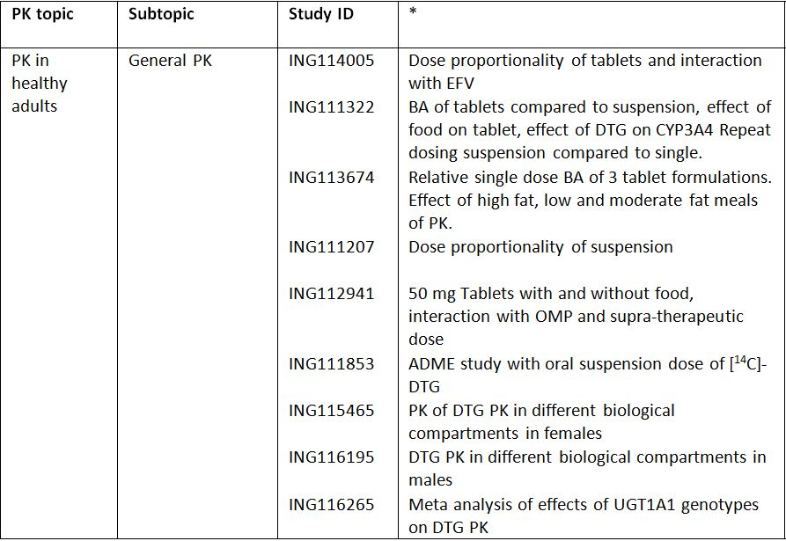
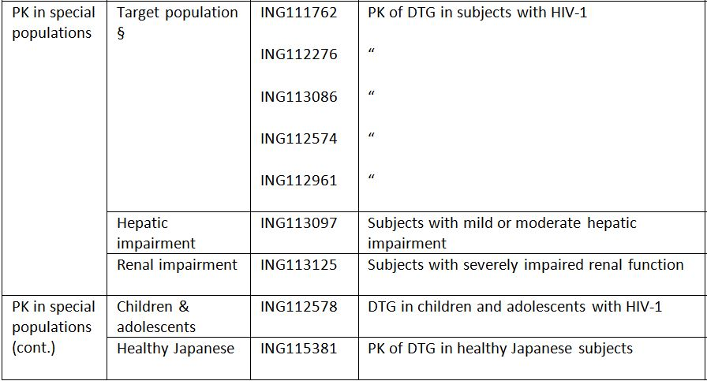

Table 1 (continued): Submitted PK studies.
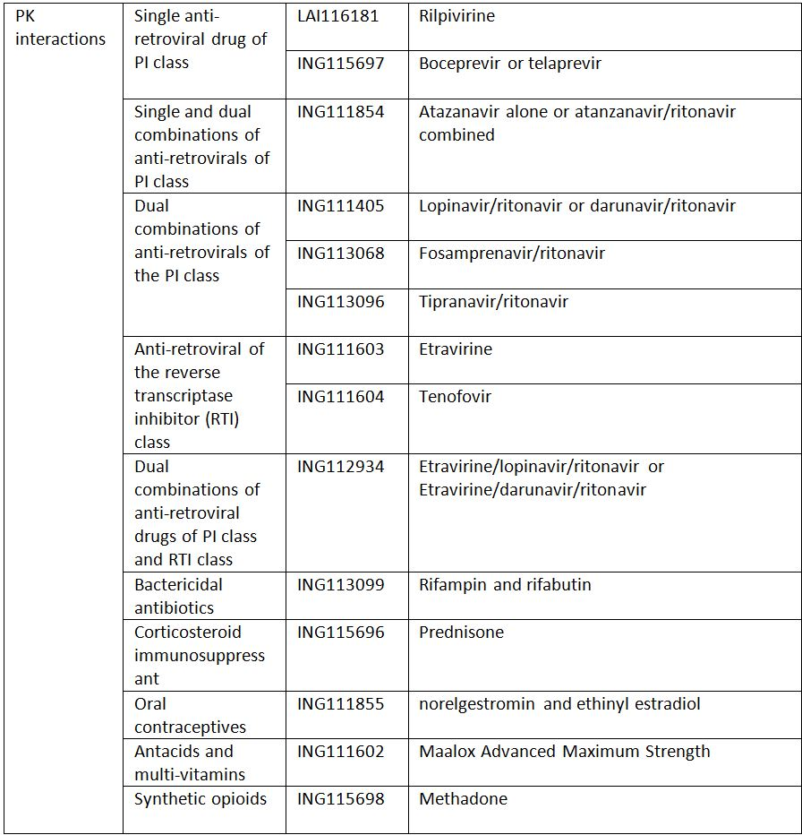
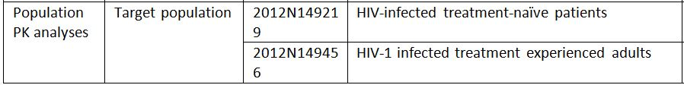
* Indicates the primary aim of the study.
† Bioequivalence of different formulations.
§ Subjects who would be eligible to receive the drug if approved for the proposed indication.
None of the PK studies had deficiencies that excluded their results from consideration.

Summary of pharmacokinetics
The information in the following summary is derived from conventional pharmacokinetic studies unless otherwise stated.

Physicochemical characteristics of the active substance
TIVICAY film-coated tablets contain dolutegravir (as dolutegravir sodium) which is an integrase inhibitor active against Human Immunodeficiency Virus (HIV).
The chemical (IUPAC) name for dolutegravir sodium is sodium (4R,12aS)-9-{[(2,4-difluorophenyl)methyl]carbamoyl}-4-methyl-6,8-dioxo-3,4,6,8,12,12a-hexahydro-2H-pyrido[1',2':4,5]pyrazino[2,1-b][1,3]oxazin-7-olate.
The structural formula is given in Figure 1.
Figure 1. Structure of DTG.
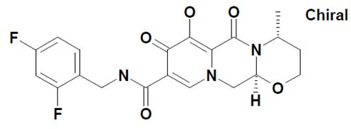
Molecular formula: C₂₀H₁₈F₂N₃NaO₅
Molecular weight of 441.36 g/mol
CAS Registry Number: 1051375-19-9

Pharmacokinetics in healthy subjects
A Phase I, open-label, single-sequence, three period study (ING114005) evaluated the single dose pharmacokinetics (PK) of dolutegravir (DTG) 100 mg versus 50 mg in 12 healthy adults. The Cmax and AUC₍₀₋₂₄₎ following a single dose of 50 mg DTG was 1.83 µg/mL and 24.3 µg.h/mL, respectively, and following a single dose of 100 mg DTG was 2.77 µg/mL and 34.3 µg.h/mL, respectively. The Tmax occurred 2.0 hours after dosing for both tablet strengths.

Absorption

Sites and mechanisms of absorption
DTG is rapidly absorbed following oral administration, with median Tmax (range) occurring 2
(1–4) hours post dose for both the 50 and 100 mg tablet formulations. DTG concentration declines mono-exponentially with an average terminal half life of approximately 13.5 hours for both the tablet and solution formulations (Study ING111322).

Bioavailability

Absolute bioavailability
The absolute bioavailability of DTG has not been determined due to the low solubility of dolutegravir in buffered solutions.

Bioavailability relative to an oral solution or micronised suspension
A single dose, randomised, 3-period, balanced, crossover study (Study ING111322) assessed the relative bioavailability of DTG tablets (2 x 10 mg) compared with an oral suspension of DTG (20 mg). Following single dose administration under fasted conditions, the DTG 10 mg oral tablet formulation delivered 30% lower geometric mean plasma DTG AUC_{(0-inf)} and 42% lower geometric mean Cmax. Plasma DTG concentrations were quantifiable within 0.25 hours after oral tablet and suspension dosing, but median Tmax was delayed from 0.75 hours with the oral suspension to 2.5 hours for the tablet, suggesting a prolonged absorption time for the tablet. Geometric mean plasma DTG half-life (t_{1/2}) was similar between treatments, 13.3 hours for tablet and 13.5 hours for oral suspension.

Bioequivalence of clinical trial and market formulations
Study ING113674 assessed the bioavailability of two new tablet formulations (Formulation Codes AW and AX) relative to the bioavailability of the 25 mg tablet administered in Phase II studies (Formulation Code AP) using a single-centre, randomised, two part, open-label, crossover methodology in healthy adults. The results of the analysis indicated that the 2 test tablet formulations were bioequivalent to the reference (Phase IIb) tablet formulation when given as a 50 mg dose (i.e. 2 x 25 mg). New tablet formulation AW was selected to be used in future clinical trials due to its smaller tablet size and lower inter-subject variability.
It should be noted that no further bioequivalence studies were conducted as there were no changes in formulation during the conduct of the Phase III studies.

Bioequivalence of different dosage forms and strengths
Results from Study ING114005 indicated that the relative oral bioavailability of the 100 mg tablet was 70.5% compared to the 50 mg tablet. For the 100 mg tablet AUC₍₀₋₂₄₎ and Cmax were 34.3 µg.h/mL and 2.77 µg/mL.
In addition, two studies (Study ING111207 and Study ING111322) examined the PKs of various strengths of an oral suspension/solution formulation.
Study ING111207 was a double-blind, randomised, placebo-controlled, single dose escalation (2, 5, 10, 25, 50 and 100 mg) study conducted in healthy subjects under fasted conditions. Following a single oral dose administration of suspension, DTG was readily absorbed (Tlag=0) with the maximum concentration achieved between 0.50 to 1.25 hours post dose across the 2 to 100 mg dose levels. The AUC_{(0-inf)} and Cmax for the 50 mg dose of suspension was 73.2 µg.h/mL and 4.56 µg/mL, respectively and for the 100 mg suspension was 136 µg.h/mL and 8.14 µg/mL, respectively.
Study ING111322, a double-blind, randomised, placebo-controlled, repeat dose escalation study, examined the PK of DTG following single and repeat-dosing of 10, 25 and 50 mg of a suspension formulation. The AUC_{(0-inf)} and Cmax of the 50 mg suspension dose was 75.8 µg.h/mL and 4.52 µg/mL, respectively, which was similar to that results obtained in the previous study.
A randomised, double-blind Study ING112941, in healthy adults, examined the PK of a supratherapeutic dose of DTG 250 mg suspension. In this study the single 250 mg dose as suspension achieved exposure that was at least 4-fold of that observed for the 50 mg tablet, whereas the t_{1/2} was similar for both the 50 mg tablet and 250 mg suspension formulations.

Bioequivalence to relevant registered products
Not applicable.

Influence of food
The second part of Study ING111322 examined the effect of a moderate fat meal (30% fat / 669 calories) on pharmacokinetics of DTG investigational tablet in eligible healthy subjects, using an open-label, randomised, single dose, three-period, balanced crossover methodology. Administration of the DTG 10 mg oral tablet formulation with a moderate-fat meal delivered equivalent plasma DTG AUC_{(0-inf)} and Cmax compared to administration fasted. Median plasma DTG Tmax was similar between fed (3.0 hours) and fasted (2.50 hours) treatments. Geometric mean plasma DTG t_{1/2} was similar between treatments, 13.6 hours for tablet fed and 13.3 hours for tablet fasted.
Study ING112941 also evaluated the effects of a high fat meal on the PK of DTG 25 mg tablet used in Phase II studies. Plasma DTG AUC_{(0-inf)} and Cmax increased by 94% and 84%, respectively, following a high fat meal compared with the fasted condition, whereas, the median plasma DTG Tmax were similar between fed (4.5 hours) and fasted (4.0 hours) treatments. Geometric mean plasma DTG t_{1/2} was also similar between treatments, 13.9 hours for tablet fed and 14.4 hours for tablet fasted.
Study ING113674 examined the effect of meals containing low-fat, moderate-fat, and high-fat on the PKs of 25 mg tablet formulation selected for Phase III studies using an open-label, randomised, single dose, three-period, six-sequence, balanced crossover design in healthy subjects. The low-fat meal comprised approximately 300 kcal and 7% fat, the moderate fat meal comprised approximately 600 kcal and 30% fat, and the high-fat meal comprised approximately 870 kcal and 53% fat. A meal at the time of dosing with the Phase III DTG tablet formulation resulted in increased plasma DTG exposures. Plasma DTG AUC_{(0-inf)} increased by 33%, 41%, and 66% when AW tablets were administered with low fat, moderate fat and high fat food, respectively. Plasma DTG Cmax increased by 46%, 52%, and 67% when the tablets were administered with low fat, moderate fat and high fat food, respectively. Tmax increased with increasing fat content and median values were 2.0, 3.0, 4.0, and 5.0 hours for fasting, low fat, moderate fat, and high fat meals, respectively. Half-life was similar between treatment groups ranging from 13.4 to 14.1 hours.

Dose proportionality
Study ING114005 evaluated the dose proportionality of kinetics following single doses of DTG, 50 mg and 100 mg, oral tablets under fasted conditions. Plasma exposures of DTG increased less than dose proportionally as dose increased from 50 mg to 100 mg and the relative oral bioavailability of 100 mg was 70.5% compared to the 50 mg tablet. Therefore for the tablet formulation at least, the PKs of DTG cannot be assumed to be dose proportional.
By contrast, two earlier studies, which examined the single-dose proportionality of the suspension formulation, indicated that the AUCs of DTG were in general dose proportional for the suspension formulation. Study ING111207 examined the PKs of DTG suspension following a single dose escalation (2, 5, 10, 25, 50 and 100 mg) in healthy subjects under fasted conditions. In this study plasma exposures (AUC₍₀₋₂₄₎, AUC_{(0-inf)}, AUC_{(0-t)}, Cmax, and C24) of DTG increased proportionally as doses increased from 2 mg to 100 mg. By contrast, the t_{1/2} for all doses was similar and was estimated to be approximately 13 to 15 hours. Study ING111322, a repeat dose escalation study, also examined the PK of DTG following single dosing of 10, 25 and 50 mg of a suspension formulation. The results indicated that following single doses the DTG AUC and Cτ increased proportionally with dose, whereas, the increase in DTG Cmax was slightly less than dose-proportional.

Bioavailability during multiple-dosing
Study ING111322 also examined the PK of DTG following the repeat-dose escalation of 10, 25 and 50 mg doses of the suspension formulation. Following repeat dose administration of the DTG suspension, plasma concentrations of DTG reached steady-state following approximately 5 days of dosing and the accumulation ratios were estimated to be 1.24-1.42 for AUC, 1.16-1.36 for Cmax, and 1.29-1.53 for Cτ across the range of doses studied. Analysis of time invariance demonstrated that DTG PK did not change over time. Steady-state DTG exposure, AUC and Cτ increased proportionally as dose increased from 10 to 50mg once daily while the increase in Cmax was slightly less than dose-proportional.

Effect of administration timing
No studies in the submitted dossier examined the effect of administration timing.

Distribution
ING111853, which was an open label, non-randomised, single dose, mass balance study that investigated the recovery, excretion, and PKs of [¹⁴C]-DTG 20 mg, administered as a single oral suspension dose to healthy males. It was the primary ADME study described in the evaluation materials and the following results are taken from this trial unless otherwise noted.

Volume of distribution
The apparent volume of distribution for DTG in healthy males was 12.5 L.

Plasma protein binding
Plasma DTG exposure was similar to that of plasma radiocarbon and the individual ratio of plasma DTG AUC_{(0-inf)}/total plasma radiocarbon AUC_{(0-inf)} had a mean of 0.97 with range of 0.95-0.99, indicating that the plasma DTG AUC_{(0-inf)} accounted for an average of 97% of the total plasma radiocarbon AUC_{(0-inf)}.

Erythrocyte distribution
The mean blood: plasma concentration ratios between 0.5 hour to 72 hours post dose ranged from 0.441 to 0.535, indicating minimal association of radioactivity with the cellular components of the blood.

Tissue distribution
Studies ING115465 and ING116195 examined the PKs of DTG in various biological compartments in healthy females and males, respectively.
Study ING115465 examined DTG PKs in cervicovaginal fluid (CVF), blood plasma (BP) and cervical and vaginal biopsies (CT and VT) following administration of one 50 mg tablet of DTG orally each day for 5-7 days. DTG exposure in CVF was 6% of plasma exposure at steady-state. There was no accumulation after repeat dosing. Delayed Tmax was observed in CVF (Tmax=6hr) compared to plasma (Tmax =2hr). DTG exposure in CT was 10% of plasma exposure at steady state. There was higher accumulation in CT after repeat dosing than in plasma (R=1.9 in CT vs 1.4 in plasma). DTG exposure in VT was similar to CT and representing 9% of plasma exposure. The accumulation in VT after repeat dosing is higher than in plasma (R=1.7 in VT vs 1.4 in plasma). CT and VT exposures were highly correlated, and had concentrations above the protein binding-adjusted IC90 at steady state in CT in all women and in VT in 7/8 women.
Study ING116195 examined DTG PKs following single doses (50 mg) and at steady-state in blood plasma, seminal fluid (SF), rectal mucosal fluid (RF) and rectal mucosal tissue (RT). Penetration of DTG into SF was ≤7% BP, with SF C24h below the PA-IC90 (0.064 µg/mL) of DTG for wild-type HIV-1 virus. Although the AUC of DTG in RT was <20% BP, RT C24h was approximately 2-fold higher than the PA IC90. RF was not a strong surrogate for RT concentrations, and demonstrated high intra- and between-subject variability.

Metabolism

Interconversion between enantiomers
Not applicable.

Sites of metabolism and mechanisms / enzyme systems involved
Dolutegravir is primarily metabolised via UGT1A1 with a minor CYP3A component (9.7% of total dose administered in a human mass balance study).
The enzymes responsible for the formation of M3 metabolite are UDP glucuronosyl transferase (UGT) 1A1 (major), and UGT1A3 and UGT1A9 (minor). The enzyme responsible for forming M7 is CYP3A4, while the enzyme responsible for forming for M13 is unknown. M1 is formed by hydrolysis of M7.

Non-renal clearance
Following a 20 mg dose of [¹⁴C]-DTG suspension, 64% of the recovered radioactivity was in the faeces.

Metabolites identified in humans
Analyses of metabolite profiles using plasma, urine, and faecal samples in Study ING111853 revealed that M3 was the major biotransformation product observed in the urine, accounting for 62.5% of the radiocarbon (18.9% of the dose). Two other notable metabolites were also observed in human urine; these resulted from oxidation at the benzylic carbon (M7), representing 10.1% of the urinary radiocarbon (3.0% of the dose), and N-dealkylation (M1), representing 11.8% of the urinary radiocarbon (3.6% of the dose). Renal elimination of unchanged DTG was low (≤2.6% of the sample radiocarbon or ≤0.8% of the dose).
An average of 89.1% of the faecal radiocarbon (53.1% of the dose) was recovered as DTG. Other notable components in faeces included a metabolite resulting from the loss of fluorine and the addition of cysteine and oxygen (M13), representing 3.1% of the faecal radiocarbon (1.8% of the dose), and M1 accounting for 2.2% of the faecal radiocarbon (1.3% of the dose). It was unclear how much of the unchanged DTG recovered in faeces was due to unabsorbed dose and how much was due to biliary secretion of M3 with subsequent conversion of the conjugate to the parent drug in faeces. However based on such data, the oral bioavailability of DTG (from suspension formulation) is at least 47% assuming unchanged DTG recovered in faeces was completely due to unabsorbed dose and no metabolite(s) observed in faeces were generated from degradation of DTG by gut lumen bacteria.
The total radioactivity of the glucuronide conjugate metabolite, M3, recovered in urine and faeces represented at least 18.9% of total dose administered (possibly higher if accounting for M3 converted to parent drug in faeces). The total radioactivity of metabolites formed through oxidation (M1, M7, and M13) that were recovered in urine and faeces accounted for approximately 9.7% (mean) of the total dose administered.
The proposed metabolic scheme for DTG in human as well as in various animal species is provided in Figure 2.
Figure 2. Metabolic scheme of DTG in human compared to nonclinical species.
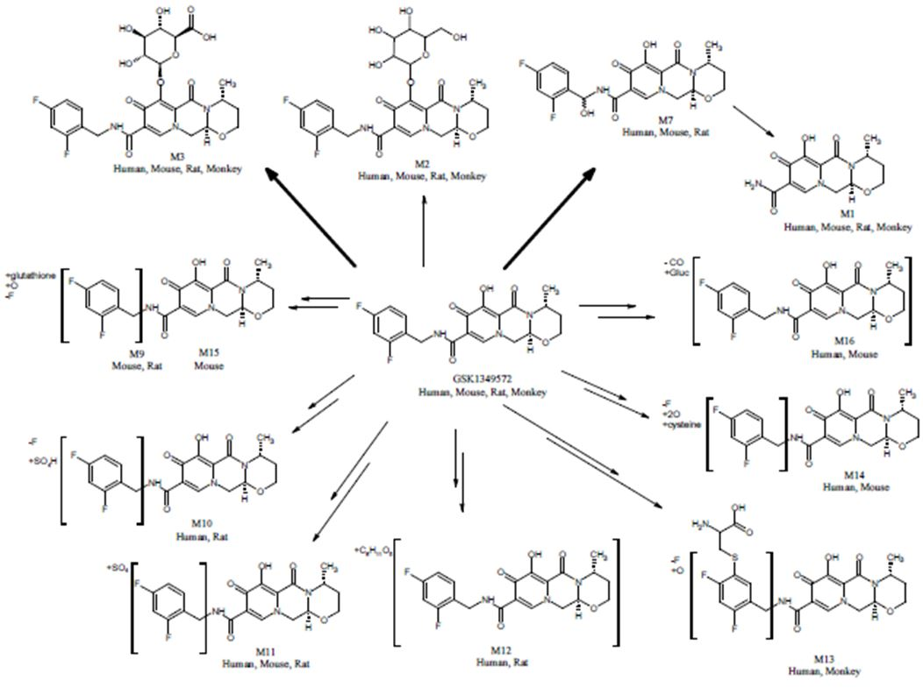
Bolded arrows indicate the primary metabolic products in humans (M3 is the predominant product; M7 is a notable metabolite).

Active metabolites
No information is provided concerning the activity of DTG metabolites.
Comment: Information on the pharmacological activity of the DTG metabolites should be provided.

Other metabolites
See above.

Pharmacokinetics of metabolites
Little to no information is provided in the evaluation materials regarding the PK of the DTG metabolites in Study ING111853. However, in a sub-report, Study 09DMR014, although individual pharmacokinetic parameters such as Cmax and AUC are not provided, the results in Table 2 indicates that the M3 metabolite represents only 2.4% of total radioactivity in plasma 6 hours after dosing and by 48 hours post-dose it could no longer be detected in plasma. Therefore, even if the M3 metabolite is active, due to its low plasma levels it is unlikely to figure significantly in the clinical effects of the parent. However for the sake of completion, the evaluator requests that the Sponsor provides all information regarding the PK/PD of the DTG metabolites they have at their disposal.
Table 2: Study 09DMR014: Summary of the radiochromatographic analyses of plasma following a single oral administration of [¹⁴C]GSK1349572 to healthy male human subjects at a target dose of 20 mg (80 µCi).
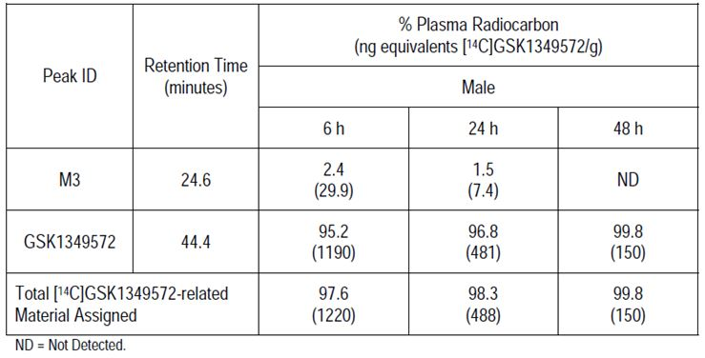

Consequences of genetic polymorphism
A pharmacogenetics (PGx) meta-analysis (Study ING116265) evaluated the effect of UGT1A1 polymorphisms on DTG PK, using pooled DTG PK data from 8 Phase I studies and single Phase IIa study. This analysis identified that CL/F decreased 23%, while AUC_{(0-τ)} and Cmax increased 31% and 22%, respectively, in subjects with low and reduced UGT1A1 activity compared to subjects with normal UGT1A1 activity. CL/F decreased 32%, while AUC_{(0-τ)} and Cmax increased 46% and 32%, respectively, in subjects with low UGT1A1 activity (*28/*28; *28/*37; *37/*37) compared to subjects with normal UGT1A1 activity(*1/*1, *1/*36). DTG PK parameters were similar between CYP3A4 and CYP3A5 functional groups (low, reduced, and normal metabolisers). There were no statistically significant differences in PK parameters (CL/F, AUC, and Cmax) among the number of low activity or risk allele markers for UGT1A1, CYP3A4/5, and NR1I2. It was also found that gender was a significant covariate in the analysis, with female subjects demonstrating ~30% lower CL/F than male subjects.

Excretion

Routes and mechanisms of excretion
By 144 hours post-administration of a 20 mg dose of [¹⁴C]-DTG suspension, 64% of recovered dose was identified in faeces and a further 31.6% was recovered in urine. DTG solution had a terminal plasma half-life of 15.6 hours and an apparent clearance (CL/F) of 0.56 L/hr.

Mass balance studies
Following a 20 mg dose of [¹⁴C]-DTG suspension, the mean total recovery of the administered radioactivity was 95.6% by 144 hours post-dose.

Renal clearance
By 144 hours post-administration of a 20 mg dose of [¹⁴C]-DTG suspension, 31.6% of recovered radioactivity was identified in urine. Renal elimination of unchanged DTG comprised less than 1% of the total dose administered.

Intra- and inter-individual variability of pharmacokinetics
Tablets: The within-subject variations in Study ING111322 for the tablet formulation were 14%, 16% and 17%, for the DTG PK parameters AUC₍₀₋₂₄₎, Cmax and C24, respectively.
DTG suspension: Low to moderate between-subject variability was observed in single dose DTG PK parameters with inter-subject variability (%CVb) ranging from 9% to 41% (Study ING111207).

Pharmacokinetics in the target population
Three controlled Phase II and Phase III studies (ING111762, ING112276 and ING113086) and two uncontrolled Phase II and Phase III studies (ING112574 and ING112961) examined the PK of DTG in patients with HIV-1. It must be noted that in almost all of these trials DTG was given in combination with background ART therapy. In addition, in the following studies the phenotypic inhibitory quotient (PIQ) represents the DTG PK parameter divided by fold-change in IC50 relative to wild-type virus for DTG at Baseline.

Controlled studies in patients with HIV-1
Study ING111762 was a Phase III randomised, double-blind, active controlled, multi-centre, parallel-group, fully-powered non-inferiority study, which examined the pre-dose concentrations of DTG (C0) following 4, 24 and 48 weeks of dosing with 50 mg DTG once daily. The C0, were similar across visits. C0_avg was calculated for each subject as the average of the Week4 and Week 24 C0 for the purpose of this report. The overall geometric mean C0_avg was 0.856 µg/mL with a between-subject coefficient of variation [CVb%] of 140%.
Based on the subgroup analysis, plasma DTG C0_avg was approximately 25% lower in non-responders than responders (<50 c/mL at Week 24 based on Snapshot [MSDF]); it was approximately 58% lower in subjects with protocol defined virologic failure (PDVF) than non-PDVF subjects; was similar by Baseline HIV-1 RNA category (>50,000 vs ≤50,000 c/mL); and was similar between HCV co-infected subjects and subjects with no HBV or HCV co-infection; but was somewhat higher in HBV co-infected subjects.
Study ING112276 was a Phase IIb study to select a once daily oral dose of DTG administered with either abacavir/lamivudine or tenofovir/emtricitabine in HIV-1 infected antiretroviral therapy naïve adult subjects, which examined the DTG PK at 2, 12 and 24 weeks. Pre-dose and post-dose DTG concentrations were similar at Weeks 2, 12, and 24. Following 2 weeks of dosing the AUC_{(0-τ)} was 16, 23 and 48 µg.h/mL for the 10, 25 and 50 mg doses, respectively and the Cmax was 1.1, 1.7 and 3.4 µg/mL, respectively. Assessments using the power model showed that Week 2 DTG PK parameters, AUC_{(0-τ)}, Cmax, and Cτ, increased less than proportionally as dose increased from 10 mg to 50 mg. Whereas, a dose proportionality assessment using pairwise ANOVA based on dose-normalized PK parameters showed that DTG PK exposure increased in a dose proportional manner between 25 mg and 50 mg, and less than proportionally from 10 mg to 25 mg and from 10 mg to 50 mg.
Study ING113086 was a Phase III, randomised, double blind study of the safety and efficacy of DTG 50mg once daily compared to raltegravir 400mg twice daily both administered with fixed-dose dual nucleoside reverse transcriptase inhibitor therapy over 96 weeks in HIV-1 infected antiretroviral naive adult subjects. 48 week results, which examined the DTG C0 following 4, 24 and 48 weeks of dosing. DTG C0 were similar among visits (Week 4, Week 24, and Week 48) with C0_avg estimated at 1.18 µg/mL (geometric mean), representing ~18 fold of in vitro PA-IC90 (0.064 µg/mL). There was no apparent difference in C0_avg by subgroups of virologic response based on FDA “snapshot” at Week 48, background therapy, baseline viral load (≤100,000 c/mL vs. >100,000 c/mL), and HBV-HCV co-infection.

Uncontrolled studies in patients with HIV-1
Study ING112574 was a Phase III study to demonstrate the antiviral activity and safety of dolutegravir in HIV-1 infected adult subjects with treatment failure on an integrase inhibitor containing regimen, which examined the DTG C0 and PIQ_C0 following 8 days and 4 and 24 weeks of dosing with 50 mg DTG twice daily. In this study plasma DTG C0 and PIQ_C0 were consistent across visits. The overall geometric mean plasma DTG pre-dose concentration (C0_avg) was 2.35 µg/mL, with high variability (between-subject coefficient of variation [CVb%] of 70%). The geometric mean PIQ_C0_avg was 19.7 and PIQs ranged from 0 to 204. Plasma DTG C0_avg was similar between virology responders and non-responders (where response is defined as <50 c/mL at Week 24), Baseline HIV-1 RNA categories (>100,000 vs ≤100,000 c/mL), hepatitis infected and non-infected subjects, and subjects who did and did not receive concomitant moderate to strong metabolic (CYP3A4/UGT) inducers (TPV/RTV and EFV) in OBR in the Week 24 ITT-E population (n=114). A small number of subjects (n=3) received atazanavir/ritonavir, a UGT1A1 inhibitor, and showed higher DTG exposure.
Study ING112961 was a Phase IIb pilot study to assess the antiviral activity of DTG containing regimen in ART-experienced, HIV-1-infected adult subjects with raltegravir resistance who were administered either 50 mg DTG daily or twice daily. The results indicated that DTG PK exposures and PIQ values were similar at Day 10, Week 4, and Week 24 within each cohort but were higher in the twice-daily cohort compared with the once-daily dosing group.
A further 2 pharmacodynamic studies, ING111521 and ING116070, also examined the DTG PKs.
Study ING111521 characterised the PK of DTG following single and multiple oral tablet doses of 2, 10 and 50 mg DTG in antiretroviral therapy-naïve and experienced (integrase inhibitor-naïve) HIV-1 infected adults who were not currently receiving antiretroviral therapy. The results of the dose proportionality assessment showed a less than dose proportional increase in DTG exposures (AUC and Cmax) as dose increased from 2 to 50 mg following administration of DTG on Day 1. Following repeat dose administration, plasma concentrations of DTG reached steady-state by 7 days of dosing and the accumulation ratios were estimated to be 1.25-1.43 for AUC, 1.23-1.40 for Cmax, and 1.27-1.42 for Cτ across the range of doses studied . Analysis of time invariance demonstrated that DTG PK did not change over time. Steady state DTG exposure (AUC and Cmax) increased less than dose proportionally as dose increased from 2 to 50mg once daily.
Study ING116070 evaluated the relationship between DTG concentration in plasma and cerebrospinal fluid (CSF) in HIV-1 infected antiretroviral therapy-naïve subjects who received DTG 50 mg once daily in combination with ABC/3TC for 96 weeks. At Week 2, there was no significant correlation between CSF and total plasma DTG concentrations (Pearson Correlation Coefficient [P-value] = 0.267 [0.427]) or between CSF and unbound plasma DTG concentrations (Pearson Correlation Coefficient [P-value] = 0.434 [0.183]).

Pharmacokinetics in other special populations

Pharmacokinetics in subjects with impaired hepatic function
A Phase I, open-label, parallel-group, two-part, adaptive study (Study ING113097) evaluated the PK of DTG in subjects with hepatic impairment and healthy matched control subjects. The results indicated that plasma total exposures of DTG in moderate hepatic impaired subjects were similar to those in healthy subjects with ratios of the GLS means (90% CIs)for AUC_{(0-inf)} and Cmax of 1.05 (0.75, 1.50) and 1.02 (0.75, 1.40). By contrast, the fraction unbound (%) of DTG in moderate hepatic impaired subjects was ~76%-120% higher than those in healthy subjects. Overall, these results indicate that the PKs of DTG are not affected by moderate hepatic impairment.

Pharmacokinetics in subjects with impaired renal function
A Phase I, open-label, parallel-group study (Study ING113125) compared the PK of DTG in eight subjects with severe renal impairment (creatinine clearance [CrCL] <30 mL/min, not on dialysis) and 8 healthy controls (matched for gender, age, and body mass index) who received a single dose of DTG 50 mg under fasted conditions. In subjects with renal impairment and healthy subjects the DTG AUC_{(0-inf)} was 23.5 and 37.1 µg.h/mL, respectively, and DTG Cmax was 1.50 and 1.86 µg/mL, respectively. In subjects with renal impairment and healthy subjects the DTG glucuronide AUC_{(0-inf)} was 2.48 and 0.54 µg.h/mL, respectively, and DTG glucuronide Cmax was 0.12 and 0.04 µg/mL, respectively. The results of the statistical comparisons showed that plasma exposures (AUC and Cmax) of DTG in subjects with severe renal impairment were lower than those in healthy subjects by 23-40%. There was a small decrease in terminal phase half-life and no change in fraction unbound (to plasma protein). There was overlap in the plasma DTG PK parameters and in the direction of the change between renally-impaired and healthy subjects. When compared to their matched controls, 6/8 healthy subjects had a higher AUC while 2/8 renally-impaired subjects had a higher AUC.

Pharmacokinetics (in other special population / according to other population characteristic)
Study ING112276, which examined the PK of DTG in HIV-1 infected patients co-administered DTG and background ART therapy, identified that, in general, significant correlation (p<0.05) was found between DTG PK parameters and age, gender, body size, baseline total bilirubin, and baseline albumin, but not race or smoking status.

Age
Study ING112578 (P1093) evaluated the steady-state PK of DTG in combination with other antiretrovirals (optimised background therapy) in treatment experienced HIV-1 infected infants, children and adolescents. The geometric mean AUC24 for the full Cohort I was 46 μg*h/mL and the C24h was 0.902 μg/mL, meeting the pre-defined targeted PK exposure with 1mg/kg dosing for AUC₀₋₂₄ and C24h (37-67 μg.h/ml and 0.77 – 2.26 μg/ml) supporting DTG 50 mg once daily in 12-18 years of age weighing at least 40kg.

Race
Study ING115381 assessed the PKs of DTG following a single 50 mg oral tablet dose administered to healthy Japanese subjects. The mean AUC_{(0-inf)} and Cmax of DTG in healthy subjects following a single 50 mg tablet dose was 47.7 µg.h/mL and 2.37 µg/mL, respectively, and the Tmax and t_{1/2/} were 2.9 hours and 14.7 hours, respectively. PK data for clinical studies conducted in Western (non-Japanese) subjects following a single 50mg dose indicated that the PK parameters of DTG in these subjects are similar to that observed in the healthy Japanese volunteers in this study.

Gender
Part of pharmacodynamic Study ING111856 compared DTG PKs in male and female subjects following a single supratherapeutic (250 mg) oral dose of DTG suspension in healthy subjects. Although Tmax and C24 were similar in both females and male subjects following a single 250 mg oral dose exposure appeared to be higher in females than males and AUC_{(0-τ)} and Cmax were 1.24-fold and 1.19-fold in higher in healthy females compared with healthy males. These results suggest that there may be a trend for higher DTG exposure in females compared with male subjects.

Pharmacokinetic interactions

Pharmacokinetic interactions demonstrated in human studies

Single anti-retroviral drug of protease inhibitor (PI) class
Study LAI116181 compared the steady-state plasma DTG PKs following administration of DTG 50 q24h with and without rilpivirine (RPV) 25 mg q24h in healthy subjects. Co-administration of DTG with RPV resulted in no change in DTG AUC_{(0-τ)}, and Cmax, and a 22% increase in Cτ. Co-administration of DTG with RPV resulted in no change in RPV AUC_{(0-τ)} and Cmax, and a 21% increase in Cτ.
Study ING115697 compared plasma DTG PK following administration of DTG 50 mg with and without boceprevir (BCV) 800 mg every 8 hours (q8h) or telaprevir (TVR) 750 mg q8h in healthy subjects. Co-administration with BCV had no effect on plasma exposure of DTG. Co-administration with TVR resulted in increased DTG plasma exposures: AUC_{(0-τ)}, Cmax, Cτ, increased by 25%, 19%, 37%, respectively. TVR PK parameters when co-administered with DTG were similar to historical data. BCV PK parameters were not available at this time and will be included in a subsequent amended report.
Comment: Is the subsequent report mentioned in the study and the information regarding the subject who fell pregnant during the course of the study available? These questions have been forwarded to the sponsor for clarification as part of Section 12 of this evaluation (p67).

Single and dual combinations of anti-retrovirals of PI class
Study ING111854 compared the steady-state plasma DTG PK following administration of DTG 30mg every q24h with and without atazanavir (ATV)/ritonavir (RTV) 300/100mg q24h or ATV 400 mg q24h in healthy subjects. Co-administration with ATV/RTV resulted in an increase in plasma DTG exposures; plasma DTG AUC_{(0-τ)}, Cmax, and Cτ increased by 62%, 34%, and 121%, respectively. Co-administration with ATV resulted in an increase in plasma DTG exposures; plasma DTG AUC_{(0-τ)}, Cmax, and Cτ increased by 91%, 50%, and 180%, respectively. Therefore, co-administration of DTG and ATV is not recommended.

Dual combinations of anti-retrovirals of the PI class
Study ING111405 compared the steady-state plasma DTG PK following administration of DTG 30mg every 24 hours (q24h) with and without lopinavir (LPV)/(RTV) 400/100mg every 12 hours (q12h) or darunavir (DRV)/RTV 600/100mg q12h. Co-administration of LPV/RTV had no effect on steady state PKs of DTG. Co-administration of DRV/RTV decreased plasma DTG exposures: plasma DTG AUC_{(0-τ)}, Cmax, Cτ and t_{1/2} were decreased by 22%, 11%, 38% and 20%, respectively, whereas, the CL/F of DTG was increased by 28%. The effect of DRV/RTV on DTG was not considered to be clinically significant and the disparate effects of DRV/RTV and LPV/RTV on DTG PK were considered not to be due to RTV (as the RTV daily dose was the same, and a similar RTV exposure was observed between the treatment groups; rather, this was likely due to the differential effects of LPV and DRV on UGT1A1, the enzyme governing the primary metabolism of DTG.
Study ING113068 compared the steady-state plasma DTG PK following administration of DTG 50 mg q24h with and without fosamprenavir/(FPV)/RTV 700/100 mg q12h in healthy subjects. APV exposure following co-administration of FPV/RTV and DTG is similar to historical data of APV; therefore, these data suggest that DTG did not affect APV exposure. The results of the statistical comparisons showed that co-administration of FPV/RTV decreased DTG SSAUC_{(0-τ)}, Cmax, and Cτ by 35%, 24%, and 49%, respectively, resulting from increased CL/F and decreased t_{1/2} for DTG.
Study ING113096 compared the steady-state plasma DTG PKs following administration of DTG 50 mg once daily alone and with tipranavir (TPV)/RTV 500/200 mg twice daily in healthy subjects. Co-administration of TPV/RTV resulted in decreased plasma DTG exposures: plasma DTG AUC(0-τ), Cmax, and Cτ, were decreased 59%, 46%, and 76%, respectively, resulting from 144% increase in CL/F and 47% decrease in t_{1/2}.
Comment: As co-administration of RTV is not thought to affect the PK of DTG, these changes in PK are most likely due to TPV and an increase in DTG dose maybe required when it is co-administered with TPV.

Anti-retroviral of the reverse transcriptase inhibitor class
Study ING111603 compared the steady-state plasma DTG PKs following administration of DTG 50mg every 24 hours with and without etravirine (ETV) 200mg every 12 hours in healthy subjects. Co-administration of ETR decreased steady-state plasma DTG exposures. Plasma DTG AUC_{(0-τ)}, Cmax, and Cτ decreased by 71%, 52%, and 88%, respectively. In addition, it resulted in a 3.4-fold increase in CL/F and a 48% reduction in t_{1/2} for DTG; therefore, co-administration of DTG and ETR is not recommended. The reduction in DTG exposure by ETV is likely due to the combined inductive effect on UGT1A1 and CYP3A4 activity by ETV.
Study ING111604 compared the steady-state plasma DTG PKs following administration of DTG 50mg q24h with and without tenofovir (TDF) 300mg q24h in healthy males. Co-administration of TDF 300 mg once daily and DTG 50 mg once daily had no effect on DTG PKs, with GLS mean ratios for PK parameters ranging from 0.920 to 1.01, and confidence intervals within the bounds of 0.8-1.25. Whereas, co-administration of DTG 50 mg once daily and TDF 300 mg once daily resulted in an equivalence in tenofovir AUC_{(0-τ)} and Cmax, and a slight increase (19%) in tenofovir trough plasma exposures; however, this effect is unlikely to be clinically significant.

Dual combinations of anti-retroviral drugs of PI class and RTI
Study ING112934 compared the steady-state plasma DTG PK following administration of DTG 50mg q24h alone and DTG 50mg q24h in combination with ETV/lopinavir (LPV)/RTV 200/400/100mg q12h or ETV/darunavir (DRV)/RTV 200/600/100mg q12h, each for 14 days in healthy subjects. Co-administration with ETR/LPV/RTV had no effect on DTG AUC_{(0-τ)} and Cmax, while increasing Cτ by 28% and t_{1/2} by 36%. Co-administration with ETR/DRV/RTV resulted in decreased plasma DTG exposures, plasma DTG AUC_{(0-τ)}, Cmax, and Cτ were on average 25%, 12%, and 37% lower when co-administered with ETR/DRV/RTV compared to DTG given alone. Such effects of ETR/LPV/RTV and ETR/DRV/RTV on DTG exposures were not considered clinically relevant. ETR PK parameters values obtained in this study were consistent with historical data in healthy subjects. Therefore, DTG may be co-administered with ETR without a dosage adjustment if the subject is receiving concomitant LPV/RTV or DRV/RTV.

Bactericidal antibiotics
Study ING113099 compared the steady state PK of DTG 50 mg twice daily when co-administered with rifampin (RIF) 600 mg once daily to those of DTG 50 mg once daily and DTG 50 mg twice daily administered alone in healthy subjects. Co-administration of DTG 50 mg twice daily with RIF 600 mg once daily significantly reduced plasma DTG concentrations relative to DTG 50 mg twice daily alone, but resulted in 18 to 33% higher plasma DTG Cmax, AUC₍₀₋₂₄₎, and Cτ than DTG 50 mg once daily alone. Co-administration of DTG 50 mg once daily with RBT 300 mg once daily resulted in a 16% increase in DTG Cmax, no change in AUC_{(0-τ)}, and a 30% reduction in Cτ compared DTG 50 mg once daily alone. DTG 50 mg twice daily is recommended when co-administered with RIF. No dose adjustment is needed when DTG is co-administered with RBT.

Corticosteroid immunosuppressant
Study ING115696 compared the steady-state plasma DTG PK following administration of DTG 50 mg every 24 hours with and without prednisone 60 mg q24h for 5 days followed by a 5 day dosage taper in healthy subjects. DTG PK parameters were similar between Day 5 and Day 10 in Period 2. Co-administration of prednisone 60 mg once daily x 5 days + 5 days of taper with DTG (Day 10 in Period 2) resulted in an increase in the mean DTG AUC, Cmax and Cτ by 11%, 6%, and 17%, respectively. Steady state was reached for DTG following 5 days co-administration of DTG with prednisone.

Oral contraceptives
Study ING111855 examined the effect of DTG on the exposure of norelgestromin (NGMN) and ethinyl estradiol (EE) in healthy female subjects. NGMN and EE PK parameters, AUC, Cmax, and Cmin were similar between the treatment of Ortho-Cyclen with DTG and the treatment of Ortho-Cyclen with placebo. Exposure of DTG when administered with Ortho-Cyclen was similar to historical data, suggesting Ortho-Cyclen had no effect on DTG PK. Ortho-Cyclen is an example of a combination estrogen-progestin OC. While it was selected in this study for its widespread use and fixed dose throughout the cycle, there are a wide variety of similar products. Most combination OCs use EE for the estrogen component while the progestin component may include norethindrone, drospirenone, desogestrel, or norgestimate. While there are some differences in metabolism of these drugs, the lack of an effect by DTG on either the estrogen or progestin component in this study support the use of DTG with OC brands other than Ortho-Cyclen.

CYP3A4 substrates
In Part 1 of Study ING111322 the potential of DTG to inhibit or induce CYP3A activity was examined using midazolam (MDZ), a CYP3A4 substrate, in a cohort of healthy subjects. Subjects received DTG 25 mg or placebo once daily on Day 1 through Day 10 and a single oral dose of MDZ 3 mg alone on Day -1 and co-administered with the DTG/placebo dose on Day 10. The results indicated that MDZ PK was not changed when co-administered with DTG; therefore, DTG does not affect CYP3A enzyme activity and should not affect exposure of CYP3A substrates following co-administration.

Antacids and proton pump inhibitors
Part 1 of Study ING112941 compared the plasma DTG PK following administration of a single 50 mg tablet dose of DTG under fasting conditions with and without omeprazole (OMP) 40 mg q24h in healthy subjects. The results indicated that co-administration of 50 mg DTG with omeprazole had no statistically significant effect on plasma DTG PK.
Study ING111602 compared the single dose plasma DTG PK following co-administration of DTG 50mg and Maalox Advanced Maximum Strength to DTG 50mg alone and following co-administration of DTG 50mg and One A Day Maximum multivitamin in healthy males. Concurrent administration of a multivitamin decreased DTG AUC, Cmax, and C24 by 33%, 35%, and 32%, respectively, on average these changes were not considered clinically significant. By contrast, concurrent administration of Maalox decreased DTG AUC, Cmax, and C24 by 74%, 72%, and 74%, respectively, on average, whereas, administration of Maalox 2 hr after DTG decreased DTG AUC, Cmax, and C24 by 26%, 18%, and 30%, respectively, on average, indicating that separation by 2 hours attenuated the effect of Maalox. Therefore, concomitant administration of DTG and antacids should be avoided and it is recommended that DTG should be administered 2 hours before or 6 hours after antacids.

Synthetic opioids
Study ING115698 compared the steady-state plasma total and R-methadone PK following administration of an individualized methadone dose with and without DTG 50 mg twice daily in healthy subjects on stable methadone therapy. Plasma exposures of total, R-, and S-methadone were similar between methadone alone and when co-administered with 50 mg DTG twice daily. Therefore, no dose adjustment for methadone is required when given in combination with DTG.

Clinical implications of in vitro findings
DTG is primarily metabolized by UGT1A1 with a notable contribution from CYP3A4. UGT1A3 and 1A9 were minor pathways. Therefore, drugs that are strong inducers of UGT1A1 or CYP3A4 may decrease DTG plasma concentrations and reduce the therapeutic effect of DTG. Drugs that inhibit UGT1A1 and CYP3A4 may increase DTG plasma concentrations. In vitro, DTG was a substrate for the human efflux transporters P-glycoprotein (Pgp) and human breast cancer resistance protein (BCRP).
DTG was determined to have high passive and absorptive membrane permeability (3 x 10-4 cm/s) across the absorptive pH range of 5.5 to 7.4 and provided support for classification as a BCS Class II drug. High permeability and rapid absorption has the potential to attenuate any impact of efflux inhibitors. In clinical studies, no notable effect on DTG pharmacokinetics was observed following co-administration with the efflux transport inhibitors LPV/RTV and TVR.
In vitro, DTG was noted to have little or no inductive effects on the human Pregnane X Receptor (PXR), on CYP1A2, 2B6 or 3A4 mRNA. DTG demonstrated little or no direct inhibition (IC50 values >50 µM) in vitro on the transporters BCRP, multi-drug resistance protein (MRP) 2, organic anion transporting polypeptide (OATP) 1B1, 1B3, organic cation transporter (OCT) 1, and Pgp, or the enzymes CYP1A2, 2A6, 2B6, 2C8, 2C9, 2C19, 2D6, 3A4, UGT1A1 or 2B7. Therefore DTG has a low propensity to cause drug interaction. DTG glucuronide, GSK2832500, did not inhibit MRP2, thus inhibition of biliary clearance of bilirubin glucuronides or glucuronide conjugates of co-administered drugs is not expected.
In vitro, DTG was an inhibitor of the renal organic cation transporter 2 (OCT2). In vitro incubation with DTG concentrations that were observed in vivo after a 50 mg oral dose produced a 90% inhibition of OCT2. These in vitro results indicate the potential for a drug interaction in vivo with cationic compounds that are renally cleared by this transporter, such as the endogenous substrate, creatinine, and the anti-arrhythmic drug, dofetilide. Caution should be used when considering co-administration of narrow therapeutic index drugs in which a significant part of their clearance is by renal proximal tubule secretion by OCT2.

Population pharmacokinetic modelling
Two studies used, population PK modelling of DTG plasma data in HIV-infected treatment-naïve patients (Study 2012N149219) and in HIV-infected treatment-experienced patients (Study 2012N149456), in an attempt to identify co-factors that contribute to inter-individual variability and to explore the PK/PD relationship between DTG exposure and efficacy. In both studies the pop PK model was developed using a non-linear mixed-effect modelling approach using the NONMEM VII software with the first order conditional estimation method with interaction (FOCEI).
In Study 2012N149219, the population PK analysis included data from 563 subjects taken from 3 studies, ING111521, ING112276 and ING113086. In this study, the PK of DTG following oral administration was adequately described by a linear one-compartment model with first-order absorption and absorption lag-time and first-order elimination, with inter-individual variability (IIV) in apparent clearance (CL/F), apparent volume of distribution (V/F) and first-order absorption (KA) and inter-occasion variability (IOV) in CL/F.
Weight, smoking status, age and total bilirubin were predictors of CL/F and gender was a predictor of F. Following the same dosing regimen, females would have 21% (95% CI: 13-29%) higher F compared to males and current smokers would have 16% (95% CI: 10-22%) higher CL/F compared to non-current smokers. CL/F and V/F increased with body weight. For the range of weights in the analysis (39-135 kg), CL/F ranged from 23% lower to 33% higher and V/F ranged from 36% lower to 66% higher than for 70-kg individuals. CL/F increased with age.
In Study 2012N149456, the population PK analysis included 574 subjects from 3 studies In this study, the PK of DTG following oral administration was adequately described by a linear one-compartment model with first-order absorption, absorption lag-time and first-order elimination, with inter-individual variability (IIV) and inter-occasion variability (IOV) in apparent clearance (CL/F).
Weight, smoking status, use of metabolic inducers as part of background ART classified by their level of induction, use of atazanavir or atazanavir-ritonavir as part of background ART, and albumin level were predictors of CL/F; weight and albumin level were predictors of V/F; and gender and concomitant use of metal-cation containing products were predictors of relative bioavailability (F). CL/F of DTG was, on average, 16% (95% CI: 8-24%) higher in current smokers than non-current smokers. Use of metabolic inducers as part of background ART within two weeks of PK sampling resulted in 26% (95% CI: 18-34%) and 73% (95% CI: 48-98%) increase in CL/F for mild (darunavir-ritonavir or fosamprenavir-ritonavir) and moderate (etravirine without ritonavir-boosted protease inhibitors, efavirenz without ritonavir-boosted protease inhibitors, or tipranavir-ritonavir) inducers, respectively, compared to non-users. On the contrary, use of metabolic inhibitors (atazanavir or atazanavir-ritonavir) as part of background ART on the day of PK sampling resulted in a 42% (95% CI: 37-48%) decrease in CL/F compared to non-users. CL/F and V/F increased with body weight.

Evaluator’s overall conclusions on pharmacokinetics

ADME (absorption, distribution, metabolism, and excretion)
- DTG is rapidly absorbed following oral administration of the tablet formulation, with Tmax observed at 2-4 h post dose, and a t1/2 of ~14 h; the estimated CL/F and V/F are 0.56L/h and 12.5 L for suspension formulations and 0.90 L/h and 17.4 L for tablet formulations.
- The absolute bioavailability of DTG has not been determined due to the low solubility of DTG in buffered solutions.
- Following a single dose administration under fasted conditions, a 20 mg dose of the DTG oral tablet formulation delivered 30% lower geometric mean plasma DTG AUC_{0-∞} and 42% lower geometric mean Cmax than an oral suspension 20 mg dose of DTG.
- DTG is highly bound to plasma protein with estimated percentage bound in human plasma of 98.9-99.7% in healthy subjects and 99.5% in HIV-1 infected subjects;
- DTG is present in the female and male genital tract; AUC in cervicovaginal fluid, cervical tissue, and vaginal tissue were 6 to 10% of that in corresponding plasma at steady state; AUC was 7% in semen and 17% in rectal tissue of the plasma AUC at steady state;
- DTG is primarily metabolised via UGT1A1 with a minor CYP3A component (9.7% of total dose administered in a human mass balance study).
- Following a 20 mg dose of ¹⁴C DTG suspension, 64% of the recovered radioactivity was in the faeces and a further 31.6% was recovered in urine.

Effect of food
- For the DTG 25 mg tablet used in Phase II studies, a high fat meal increased the plasma DTG AUC_{0-∞} and Cmax by 94% and 84%, respectively compared with the fasted condition.
- A further study identified that plasma DTG AUC_{0-∞} increased by 33% and 41% when AW (Phase III) tablets were administered with low fat and moderate fat meal, respectively, and Cmax increased by 46% and 52% under the two conditions, respectively. A high fat meal increased the AUC_{0-∞} and Cmax by 66% and 67%, respectively.

Dose escalation
- DTG PK exposure from the tablet formulation increased less than proportionally for doses from 2 mg to 100 mg.
- Following repeat dosing of the suspension formulation in healthy subjects, steady-state was achieved after approximately 5 days of dosing, and DTG showed time-invariant PK; accumulation ratios after 50 mg once daily dosing were 1.43, 1.36, and 1.42 for AUC_{0-τ}, Cmax, and Cτ, respectively.
- Following repeat dose administration of the tablet formulation in HIV infected patients, plasma concentrations of DTG reached steady state by 7 days of dosing and the accumulation ratios were estimated to be 1.25-1.43 for AUC, 1.23-1.40 for Cmax, and 1.27-1.42 for Cτ across the range of doses studied
- In HIV-1 infected patients, subjects who had protocol defined virological failure while being treated with DTG had 58% lower pre dose plasma DTG concentrations than subjects who were non-PDVF.

Metabolites of DTG
- M3 was the major biotransformation product observed in the urine, accounting for 62.5% of the radiocarbon (18.9% of the dose). Two other notable metabolites were also observed in human urine; these resulted from oxidation at the benzylic carbon (M7), representing 10.1% of the urinary radiocarbon (3.0% of the dose), and N-dealkylation (M1), representing 11.8% of the urinary radiocarbon (3.6% of the dose). Renal elimination of unchanged DTG was low (≤2.6% of the sample radiocarbon or ≤0.8% of the dose).
- No dose adjustment for DTG is needed in subjects with genotypes conferring poor metaboliser status of UGT1A1 (*28/*28; *28/*37; *37/*37);

Between subject variability
- DTG has low to moderate between subject and within subject PK variability, and variability is higher in HIV infected subjects than healthy subjects: the between subject variability in HIV infected subjects was estimated at 30-50% for AUC and Cmax, and at 55-140% for trough concentration.

Special populations
- No dose adjustment for DTG is needed in subjects with mild to moderate hepatic impairment (Child-Pugh grade A or B);
- Plasma exposures (AUC and Cmax) of DTG in subjects with severe renal impairment were lower than those in healthy subjects by 23-40%.
- Following a supratherapeutic dose of 250 mg DTG there was a trend for higher exposure in female than in male subjects. Geometric mean ratios comparing the male and female data sets have not been provided by the sponsor and this has been raised elsewhere in this report.

Drug-drug interaction studies
- In vitro studies indicate that DTG demonstrates minimal or no direct inhibition of CYP isozymes, UGT1A1, UGT2B7, and many transporters (Pgp, BCRP, OATP1B1, OATP1B3, MRP2, and OCT1), and it is not an inducer of CYP1A2, CYP2B6, or CYP3A4.
- No clinically significant drug interactions were observed between DTG and midazolam, oral contraceptives containing norgestimate and ethinyl estradiol, methadone, multivitamins, omeprazole (OMP), prednisone, rifabutin (RBT), tenofovir disoproxil fumarate (TDF), rilpivirine (RPV), darunavir/ritonavir (DRV/RTV), lopinavir (LPV)/RTV, etravirine (ET)/LPV/RTV, ET/DRV/RTV, fosamprenavir (FPV)/RTV, boceprevir (BCV), and telaprevir (TVR);
- DTG should be administered at least 2 h before or 6 h after polyvalent metal cation containing antacids; plasma DTG exposure was reduced 74% when co-administered with the antacid Maalox (aluminium hydroxide/magnesium hydroxide/simethicone);
- ET reduced DTG AUC and Cτ by > 70% and increased DTG CL/F by 3.4 fold. Therefore, DTG should not be co-administered with ET alone.
- Co-administration of DTG 50 mg twice daily with RIF 600 mg once daily significantly reduced plasma DTG concentrations relative to DTG 50 mg twice daily alone with AUC_{0-τ}, Cmax and Cτ reduced from 46.3 to 21.3 µg.h/mL, 5.55 to 3.13 µg/mL and 2.41 to 0.67 µg/mL, respectively.
- Co-administration with ATV resulted in an increase in plasma DTG exposures with plasma DTG AUC_{0-τ}, Cmax, and Cτ increasing by 91%, 50%, and 180%, respectively. Therefore, co-administration of DTG and ATV is not recommended.

Population PK studies
- Population PK modelling studies indicated that the PK of DTG following oral administration can be adequately described by a linear one compartment model with first order absorption and absorption lag time and first order elimination. In treatment naive HIV infected patients weight, smoking status, age and total bilirubin were predictors of clearance and gender was a predictor of relative bioavailability (F). Whereas, in treatment experienced HIV infected patients, weight, smoking status, use of metabolic inducers as part of background ART classified by their level of induction, use of ATV or ATV-RTV as part of background ART, and albumin level were predictors of CL/F; weight and albumin level were predictors of V/F; and gender and concomitant use of metal cation containing products were predictors of F.

Limitations of PK studies
- It is not known whether any of metabolites of DTG are active.
- Effect of severe hepatic impairment on DTG PKs was not evaluated.
- The effect of administration timing on DTG PKs was not evaluated.
- PK data on subjects of >65 years of age are limited.
- No studies examined the comparative PK of DTG following 100 mg DTC once daily and 50 mg DTG twice daily.

Pharmacodynamics

Studies providing pharmacodynamic data
Table 3 shows the studies relating to each PD topic and the location of each study summary.
Table 3: Submitted PD studies.
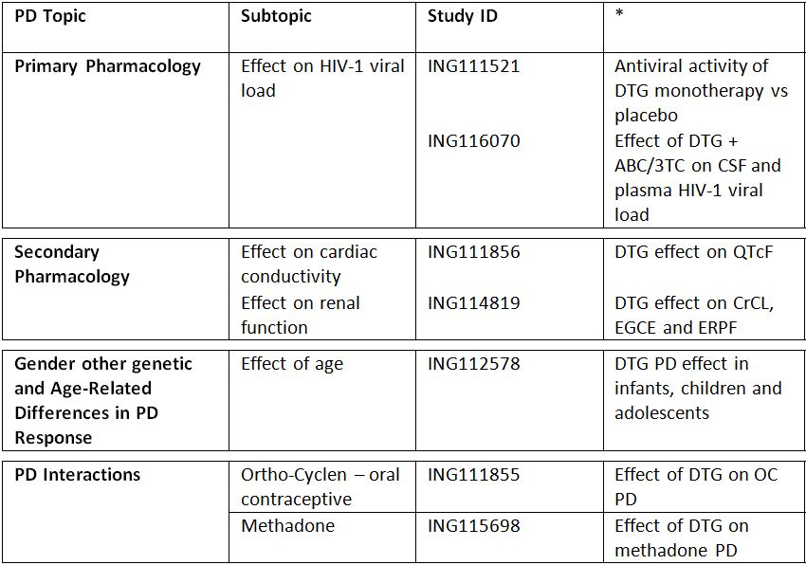
* Indicates the primary aim of the study.
§ Subjects who would be eligible to receive the drug if approved for the proposed indication.
‡ And adolescents if applicable.
None of the PD studies had deficiencies that excluded their results from consideration.

Summary of pharmacodynamics
The information in the following summary is derived from conventional pharmacodynamic studies in humans unless otherwise stated.

Mechanism of action
DTG inhibits HIV integrase by binding to the integrase active site and blocking the strand transfer step of retroviral DNA integration, which is essential for the HIV replication cycle.
Plasma HIV-1 RNA (viral load) is an accepted surrogate marker for efficacy in clinical trials for antiretroviral agents [EMA, 2008; FDA, 2002], and this efficacy variable has been measured in all clinical studies of DTG in HIV-infected subjects.

Pharmacodynamic effects

Primary pharmacodynamic effects
Study ING111521 evaluated the antiviral activity of DTG vs placebo in HIV-1 infected patients during 10 days of monotherapy in which patients received daily either placebo or oral tablet doses of 2, 10 or 50 mg DTG. The primary efficacy endpoint of the study was the mean change from baseline in plasma HIV-1 RNA at Day 11 based on the analysis for the ITT(E) Population. All DTG treatments demonstrated a statistically significant reduction in plasma HIV-1 RNA log10 copies/mL from Baseline to Day 11 compared with placebo (p≤0.001).
Study ING116070 examined the effect of DTG + abacavir/lamivudine (ABC/3TC) on CSF and plasma HIV-1 viral load in 13 HIV-1 infected adults. All subjects initially received DTG 50 mg once daily in combination with a background NRTI regimen of ABC/3TC 600/300 mg once daily. At Week 2, 4/13 (31%) and 8/13 (62%) of subjects had plasma HIV-1 RNA <50 c/mL and <400 c/mL, respectively, using the FDA snapshot MSDF algorithm. This increased to 46% and 92%, respectively, by Week 4. The median change from Baseline in plasma HIV-1 RNA at Week 2 was -2.53 log10 c/mL and at Week 4 was -3.04 log10 c/mL. At Week 2, 7/12 (58%) and11/12 (92%) of subjects had CSF HIV-1 RNA <50 c/mL and <400 c/mL, respectively, using an Observed Dataset. The median change from Baseline to Week 2 in CSF HIV-1 RNA was -2.18 log10 c/mL. At Week 4, there was a median increase in CD4+ cell count of 162.0 cells/mm³ (IQR: 118 to 217.5 cells/mm³). No subjects reported new or recurrent CDC Class B or Class C conditions through the cut-off date for this interim analysis.

Secondary pharmacodynamic effects

Cardiac conductivity
Study ING111856 examined the effect of a single supratherapeutic oral dose of DTG (250 mg) on cardiac conduction as assessed by 12-lead ECG compared to placebo in 42 healthy subjects. For the primary endpoint, QTcF, all time-matched values and their corresponding upper bounds of the 90% CI were below 10 msec for DTG. The maximum observed time-matched change from Baseline for DTG 250 mg was at 4h (1.99 msec, 90% CI: -0.55, 4.53 msec). The maximum observed time-matched change from Baseline for moxifloxacin was at 4h (9.58 msec, 90% CI: 7.05, 12.11 msec). Therefore, it was concluded that DTG did not significantly affect cardiac repolarisation.

Renal function
Study ING114819 examined the effect of DTG on renal function as assessed by changes in creatinine clearance (CrCL), extraglomerular creatinine excretion (EGCE) and effective renal plasma flow (ERPF) from baseline following DTG 50mg q24h and 50mg q12h dosing in 38 healthy subjects. The results indicated that DTG decreased creatinine clearance by 10% at 50mg q24h and 14% at 50mg q12h, respectively after 14 days of dosing, after being adjusted for placebo but had no effect on GFR (as measured by iohexol plasma clearance) nor effective renal plasma flow, as measured by para-aminohippurate plasma clearances.

Time course of pharmacodynamic effects
Study ING116070, which examined the effect of DTG + ABC/3TC on CSF and plasma HIV-1 viral load identified that 4/13 (31%) and 8/13 (62%) of subjects had plasma HIV-1 RNA <50 c/mL and <400 c/mL, respectively at Week 2, using the FDA snapshot MSDF algorithm. This increased to 46% and 92%, respectively, by Week 4. The median change from Baseline in plasma HIV-1 RNA at Week 2 was -2.53 log10 c/mL and at Week 4 was -3.04 log10 c/mL.

Relationship between drug concentration and pharmacodynamic effects

Primary PD effects
Study ING111521 identified a clear dose-response relationship between viral load and DTG dose in HIV-1 infected subjects. The adjusted mean difference (active vs placebo) for plasma HIV-1 RNA for the 2, 5 and 10 mg doses equalling -1.54, -2.04 and -2.46 log10 copies/mL, respectively. Additional efficacy analyses assessed whether or not subjects experienced at least a 1.7 log10 copies/mL decrease in plasma HIV-1 RNA or achieved plasma HIV-1 RNA levels <400 or <50 copies/mL through Day 11. A dose-dependent antiviral response was observed for the proportion of subjects with a >1.7 log10 reduction in plasma HIV-1 RNA from baseline to Day 11. More subjects receiving DTG 50mg once daily had plasma HIV-1 RNA <400 or <50 copies/mL on Day 11 compared with those receiving 2mg or 10mg. Additionally, 70% of subjects (7/10) who received DTG 50mg once daily achieved plasma HIV-1 RNA <50 copies/mL at one or more time-points during the study.
Greater antiviral activity was associated with higher DTG plasma exposure. The exposure-antiviral activity relationship was best described by an Emax model with Emax fixed to 2.6, Hill factor fixed to 1 and PK parameter on the linear scale. Cτ (concentration at end of dosing interval) was the PK parameter that best predicted Day 11 plasma viral load reduction from baseline or maximum plasma viral load reduction from baseline.
By contrast, Study ING116070 indicated that after 2 weeks of once daily DTG 50 mg in combination with ABC/3TC 600/300 mg to HIV-1 infected adults, there was no statistically significant correlation between CSF DTG concentration and absolute CSF HIV-1 RNA levels (Pearson Correlation Coefficient value] = 0.567 [0.069]) or between CSF DTG concentration and change from Baseline in CSF HIV-1 RNA (Pearson Correlation Coefficient [P-value] = 0.007 [0.983]).

Secondary PD effects
Study ING111856 indicated that following a supratherapeutic dose (250 mg) of DTG that there was no relationship between DTG plasma concentration and ddQTcF.

Genetic-, gender- and age-related differences in pharmacodynamic response
Study ING112578 identified that once a day dosing with DTG, with target dose of ~1 mg/kg according to weight, in HIV-1 infected infants, children and adolescents resulted in a rapid and sustained antiviral response, with 80% of subjects achieving HIV-1 RNA <400 c/mL and 70% achieving HIV-1 RNA <50 c/mL by Week 24.

Pharmacodynamic interactions
Two PK studies, ING111855 and ING115698 examined the effect of DTG on the PDs of the oral contraceptive Ortho-Cyclen and the synthetic opioid methadone, respectively.
Study ING111855 identified that there were no apparent differences in leutinizing hormone, follicle stimulating hormone, or progesterone concentrations between OC co-administered with DTG and OC with placebo following administration of DTG 50 mg every q12h when given in combination with Ortho-Cyclen.
Study ING115698 indicated that here were no differences in any of the PD markers of methadone i.e., opioid overall opiate agonist score and withdrawal score, change from baseline in minimum pupil diameter, and PAOE following administration of an individualized methadone dose with and without DTG 50 mg twice daily in subjects on stable methadone therapy. In addition, no statistically significant difference was noted between subjects receiving methadone only and subjects receiving DTG 50 mg BID + methadone for overall opiate agonist and withdrawal scores. No significant difference was noted between the methadone and DTG 50 mg BID + methadone for pupillometry scores. No significant difference in change from baseline in PAOE values was noted between subjects receiving methadone compared to DTG 50 mg BID + methadone.

Evaluator’s overall conclusions on pharmacodynamics

MOA
- DTG inhibits HIV integrase by binding to the integrase active site and blocking the strand transfer step of retroviral DNA integration, which is essential for the HIV replication cycle.

Primary PDs
- In HIV-1 infected patients, 10 days of DTG monotherapy at doses of 2, 10 and 50 mg resulted in a statistically significant reduction in plasma HIV-1 RNA log₁₀ copies/mL from Baseline to Day 11 compared with placebo (p≤0.001) for all doses.
- In HIV-1 infected subjects, 31% and 62% of subjects had plasma HIV-1 RNA <50 c/mL and <400 c/mL, respectively, following 2 weeks of treatment with DTG 50 mg once daily in combination with a background nucleoside reverse transcriptase inhibitor (NRTI) regimen of ABC/3TC 600/300 mg once daily. Following 4 weeks of treatment, these percentages increased to 46% and 92%, respectively. The median change from baseline in plasma HIV-1 RNA at Week 2 was -2.53 log₁₀ c/mL and at Week 4 was -3.04 log₁₀ c/mL.

Secondary PDs
- In healthy subjects, DTG has no effect on cardiac repolarisation at a supratherapeutic dose of 250 mg (suspension).
- In healthy subjects, DTG decreased creatinine clearance by 10% at 50 mg every 24 h (q24h) and 14% at 50 mg every 12 h (q12h), whereas it had no effect on glomerular filtration rate and effective renal plasma flow.

Dose response
- Greater antiviral activity was associated with higher DTG plasma exposure. The exposure antiviral activity relationship was best described by an Emax model with Emax fixed to 2.6, Hill factor fixed to 1 and PK parameter on the linear scale. Cτ (concentration at end of dosing interval) was the PK parameter that best predicted Day 11 plasma viral load reduction from baseline or maximum plasma viral load reduction from baseline.
- There was no statistically significant correlation between CSF DTG concentration and absolute CSF HIV-1 RNA levels or between CSF DTG concentration and change from Baseline in CSF HIV-1 RNA.

Special populations
- In infants, children and adolescents infected with HIV-1, once daily dosing with DTG, with target dose of ~1 mg/kg according to weight, resulted in a rapid and sustained antiviral response with 80% of subjects achieving HIV-1 RNA <400 c/mL and 70% achieving HIV-1 RNA <50 c/mL by Week 24.

Interactions
- Co-administration of DTG did not affect the PDs of either the oral contraceptive Ortho-Cyclen or the synthetic opioid methadone.

Dosage selection for the pivotal studies

Study ING112276
This is an ongoing, randomised, single-blind, 4-arm, Phase 2B study to select a once daily oral dose of DTG administered with either abacavir/lamivudine or tenofovir/emtricitabine in HIV-1 infected ART naïve patients. It was started in July 2009 and the results of the primary efficacy outcome were reported at Week 16 in June 2010. It was a dose ranging study conducted at 34 centres to compare the antiviral activity of a range of oral DTG doses for further evaluation in Phase 3. A total of 205 patients were enrolled and received DTG or EFV. The study schematic is shown in Figure 3.
Figure 3. Schematic for Study ING112276.
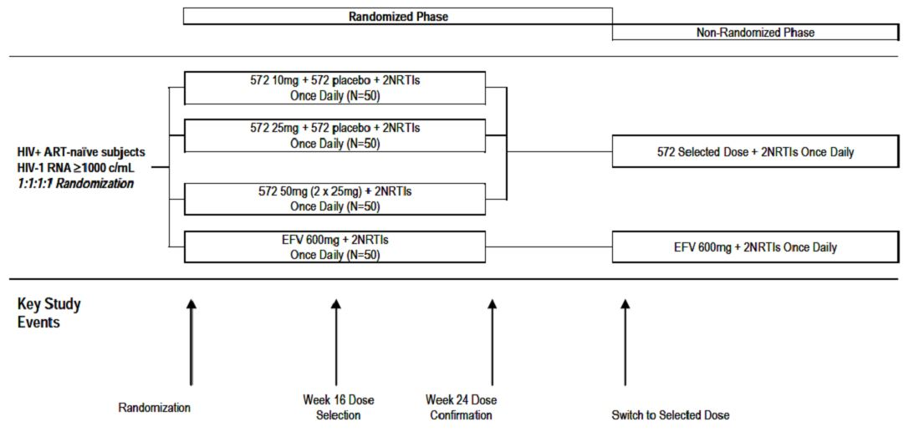
The main inclusion criteria were; HIV-1-infected adults ≥18 years of age without Category C disease; plasma HIV-1 RNA ≥1000 copies/mL; CD4+ count ≥200 cells/mm³; ART naïve with no evidence of viral resistance. Patients randomised to the DTG arms were given doses of 10 mg, 25 mg or 50 mg once daily, with matching placebo to ensure the patients were blind to the treatment. At Week 16, 195 patients were available for analysis. The majority of patients were White (80%) and male (86%) with a mean age of 37 years. Most patients (87%) had Category A disease.
At Week 16, more than 90% of patients on any dose of DTG achieved viral suppression of <50 copies/mL compared with 60% on EFV as shown in Table 4. Response rates were similar across subgroups including background NRTI, baseline CDC category and baseline CD4+ count.
Table 4: Viral suppression (<50 copies/mL) comparing DTG with EFV to Week 16.
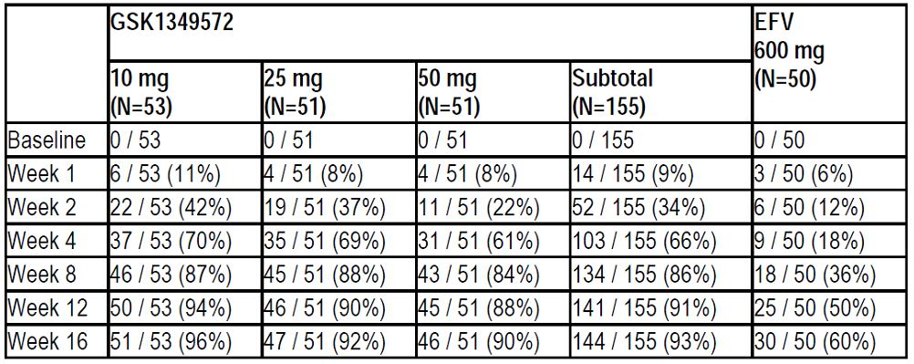
Comment: The study was a dose ranging Phase 2b PK/PD study which was well controlled and conducted. More than 90% of DTG patients at all doses achieved a rapid and sustained virologic response. There is no clear justification for the selection of the 50mg dose compared with the others tested.

Clinical efficacy

The treatment of HIV infection in combination with other ART

Pivotal efficacy studies

Study ING113086 (SPRING-2)

Study design, objectives, locations and dates
This is an ongoing, multicentre study being conducted at 100 sites: 59 centres in Europe (France, Germany, Italy, Spain, and UK), 19 in the US, 11 in Russia, 7 in Canada and 4 in Australia. It was started in October 2010 and the present interim report was prepared in July 2012. The study was administered by GSK.
The objective is to demonstrate the antiviral activity of dolutegravir (DTG) 50mg once daily compared to RAL 400mg BID over 48 weeks in therapy naïve patients infected with HIV-1. RAL was selected as the active comparator because it has proven efficacy and safety and is approved for use in treatment naïve patients. It is a Phase 3 randomised, double-blind, double-dummy, active-controlled, multicentre, parallel group, fully-powered non-inferiority study. Patients were randomised 1:1 to receive DTG 50 mg OD or RAL 400 mg BID, both in combination with open-label fixed-dose dual NRTI therapy. The open-label NRTI therapy was either ABC/3TC or TDF/FTC tablets selected by the investigator. To ensure balanced treatment groups, randomisation was stratified by screening viral load (HIV-1 RNA ≤100,000 c/mL or >100,000 c/mL) and background NRTI therapy (ABC/3TC or TDF/FTC). Analyses were performed using the Abbott Real Time HIV-1 assay with a lower limit of detection of 40 c/mL. After randomisation, patients attended the clinic at Day 1, Weeks 2, 4, 8, 12, 16, 24, 32, 40, 48 and every 12 weeks thereafter. At Week 96, patients randomised to RAL will be withdrawn from the study, while patients randomised to DTG will be offered continued open-label therapy. The study flow is shown in Figure 4.
Figure 4. Schematic for Study ING112276 (SPRING-2).
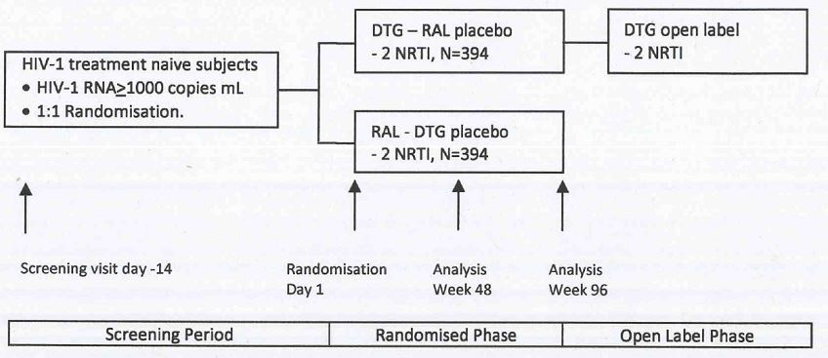

Inclusion and exclusion criteria
The main inclusion criteria were HIV-1 infected adults aged ≥18 years; plasma HIV-1 RNA ≥1000 c/mL at Screening; and ART-naïve (≤10 day’s prior therapy with any ART agent). The main exclusion criteria were CDC Category C HIV disease (AIDS); moderate to severe hepatic impairment; history of malignancy within 5 years, excluding skin cancers and Kaposi’s sarcoma; recent treatment with cytotoxic therapy or immune modulators; any evidence of viral resistance at screening; any Grade 4 laboratory abnormality; estimated creatinine clearance < 50 mL/min using the Cockcroft-Gault method; and recent GI bleeding

Study treatments
Study treatments are shown in Table 5. Fixed dose dual NRTI therapies were either ABC/3TC 600 mg/300 mg, or TDF/FTC 300 mg/200 mg, both as one tablet) taken once daily in the morning or evening. Compliance was assessed by tablet count at each clinic visit.
Table 5: Study treatments for Study ING112276 (SPRING-2).
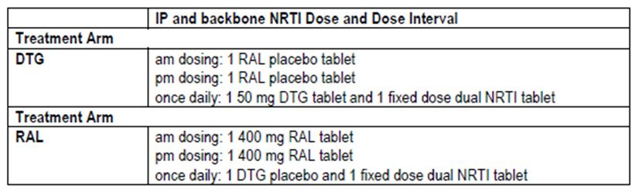

Efficacy variables and outcomes
The main efficacy variable was the proportion of patients with plasma HIV-1 RNA <50 c/mL at Week 48. The primary efficacy outcome was to demonstrate the antiviral activity of DTG 50 mg administered once daily compared to RAL 400 mg twice daily over 48 weeks in HIV-1 infected therapy naïve patients.
Other efficacy outcomes included the antiviral activity of DTG compared to RAL over 96 weeks; assessment of viral resistance in patients experiencing virologic failure; changes in CD4+ lymphocyte counts; a comparison of HIV-associated conditions; sparse PK sampling and population PK modelling; and the effects of demographic factors such as weight, age, gender and race.

Randomisation and blinding methods
Patients were assigned to a study treatment via a validated central randomisation procedure which included stratification (RANDALL, GSK). During the randomised phase of the study (to Week 96), patients received double-blinded DTG or RAL plus matching placebo. At the primary endpoint, GSK study personnel were implicitly un-blinded during the Week 48 analysis. However, the investigators and patients will remain blind until the open-label phase after Week 96.

Analysis populations
Efficacy analyses were conducted based on the Intent-to-Treat Exposed (ITT-E) population consisting of all patients who received at least one dose of study medication. The numbers in each analysis population are shown in Table 6.
Table 6: Numbers in each analysis population for Study ING112276 (SPRING-2).
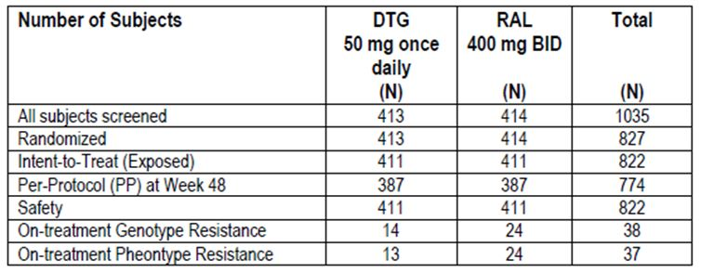

Sample size
Previous studies of RAL in treatment-naïve HIV-1 patients showed response rates of 86% at Week 48, and 81-83% at Week 96. Assuming a 75% response rate in the RAL group, the present study required 394 evaluable patients in each treatment arm to have 90% power with an arbitrarily selected 10% non-inferiority margin and a one-sided 2.5% significance level.

Statistical methods
At the Week 48 analysis, the primary efficacy variable was the proportion of patients with plasma HIV-1 RNA <50 c/mL as determined using the FDA ‘snapshot’ algorithm to allow for Missing, Switch or Discontinuation = Failure (MSDF). The adjusted difference in the proportions in each treatment group was analysed using the Cochran-Mantel-Haenszel method. Data from four published studies of dual NRTI compared with dual NRTI plus a third therapy demonstrated a pooled difference in response rates of 39% (95% CI: 33%, 45%). A conservative non-inferiority margin of -10% was considered small enough compared to the additional effect of a third agent because the non-inferiority margin is significantly lower than the lower bound of the 95% CI for the pooled difference. Non-inferiority of DTG was assumed if the lower bound of the two-sided 95% CI of the difference was greater than -10%. The analysis was repeated for consistency using a per protocol (PP) population. The superiority of DTG was be assumed if both analyses showed non-inferiority and the lower end of the 95% CI from the ITT-E analysis was above 0%.

Participant flow
Participant flow is shown in Table 7. Premature withdrawals at 48 weeks were low and balanced between the two treatment groups. Virologic failure occurred in 4% of the DTG group compared with 6% in the RAL group.
Table 7: Participant flow for Study ING112276 (SPRING-2).
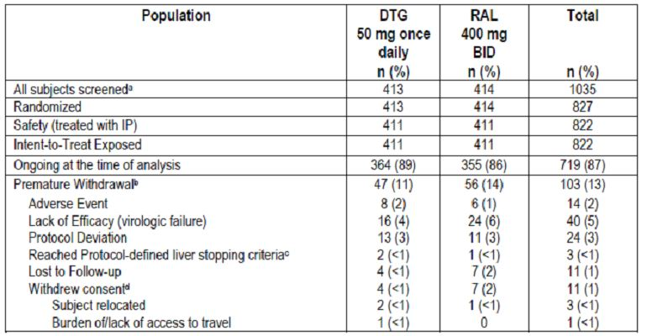

Major protocol violations/deviations
A total of 48 patients had protocol deviations excluding them from the PP population (24 patients in each group). The most common deviations were related to inclusion/exclusion criteria, primary viral resistance detected at screening, and use of prohibited medications. A total of 22 patients (12 DTG, 10 RAL) discontinued IP permanently because of protocol deviations. These were due to pregnancy (n=8), use of prohibited medications (n=5), non-compliance (n=4) and missing genotype at entry (n=5).

Baseline data
Most patients were White (85%) and male (86%) with a median age of 36 years. Only six patients were aged ≥65 years (1 DTG, 5 RAL). Other baseline characteristics were evenly balanced. The leading HIV risk factor was homosexual behaviour; most HIV RNA levels were ≤100,000 c/mL; most CD4+ counts were >200 cells/mm³; most had CDC Category A disease; and most were free of concomitant hepatitis B or C infection. Approximately 60% of patients were given TDF/FTC as backbone NRTI and the remainder received ABC/3TC. Median exposure to DTG was 347 days with 80% of patients treated for more than 48 weeks. Median exposure to RAL was 340 days with 77% of patients receiving therapy for more than 48 weeks. Four patients were withdrawn from the PP analysis because of poor compliance. Median compliance rates were not documented in the study report.

Results for the primary efficacy outcome
At Week 4 in the ITT-E population, the majority of patients in the DTG and RAL groups achieved a viral response. At Week 48, 88% and 85% of patients in the DTG and RAL groups respectively had achieved the primary endpoint of plasma HIV-1 RNA levels <50 c/mL. The non-inferiority of DTG to RAL was confirmed because the lower end of the 95% CI for the treatment difference (-2.2%) was greater than -10%. The results of the PP analysis were similar with 90% and 88% of patients treated with DTG and RAL, respectively, achieving plasma HIV-1 RNA <50 c/mL at Week 48. In the ITT-E set, there were more responders in the DTG group compared with RAL. However, superiority of DTG was not confirmed as the lower end of the 95% CI was not above 0%. There were more virologic non-responders in the RAL group (8%) than in the DTG group (5%). However, because of missing data at Week 48, 7% of patients in each group were considered to be non-responders. Baseline HIV-1 RNA and backbone NRTI had no influence on the efficacy response. Fourteen patients (8 DTG, 6 RAL) from one site were excluded from the analysis because of poor GCP compliance but this did not affect the overall conclusions. The lower end of the 95% CI for the treatment difference in the adjusted data set was -1.9%. This difference is greater than the non-inferiority margin of -10% and similar to the unadjusted difference (-2.2%).

Results for other efficacy outcomes
The secondary endpoint of plasma HIV-1 RNA <400 c/mL at Week 48 was achieved in 90% of DTG patients and 87% of RAL patients. CD4+ cell count changes from baseline were similar in each treatment group. The median increase in CD4+ cell count at Week 48 was +229.5 cells/mm³ in the DTG group compared with +230.0 cells/mm³ in the RAL group. The incidence of HIV associated conditions was low (2% in each treatment group) and HIV disease progression was <1% in both groups. There were no significant differences between DTG and RAL across demographic subgroups.
Comment: This Phase 3 pivotal study was appropriately designed, controlled and conducted with low numbers of protocol deviations and discontinuation rates. The virologic gold standard endpoint of HIV RNA <50 c/mL was met by 88% of DTG patients, and non-inferiority of DTG compared with RAL was convincingly demonstrated with a 2.4% (95% CI: -2.2%, 7.1%) adjusted treatment difference in favour of DTG. The results were well within the margins of non-inferiority and the findings in the ITT-E set were confirmed by a sensitivity analysis in the PP set. Subgroup analyses were consistent with the main finding with no influence by baseline viral load, baseline demographics, or NRTI background therapy. Recovery of CD4+ counts was equal in the DTG and RAL treatment groups and the incidence of emergent or progressive HIV disease was low in both groups.

Study ING111762 (SAILING)

Study design, objectives, locations and dates
The study is multicentre with 156 sites: 68 centres in N. America (US, Canada and Mexico); 46 in Europe (Belgium, France, Greece, Hungary, Italy, the Netherlands, Spain, Romania, and the UK); and 42 in the rest of the world (Argentina, Australia, Brazil, Chile, Russia, South Africa and Taiwan). It was started in October 2010; it is still ongoing and the present report is a 24 week interim analysis prepared in November 2012. The study was administered by GSK.
The study objective was to demonstrate non-inferiority of DTG compared to RAL in the treatment of HIV-1 infected, ART experienced, INI naïve patients after 48 weeks treatment. RAL was selected as the active comparator because it has proven efficacy and safety and is approved for use in treatment-experienced patients. It is a Phase 3, randomised, parallel-group, double-blind, active-controlled study. Patients were randomised 1:1 to receive DTG 50 mg OD or RAL 400 mg BID, added to an investigator selected background regimen consisting of one fully active single agent, plus no more than one second single agent which may or may not have been active. Recruitment of patients with highly potent regimens including DRV/r was capped. Patients were required to be INI naïve and have documented resistance to at least one member of each of at least two ART drug classes (NRTI, NNRTI, PI, fusion inhibitor or CCR5 antagonist). Randomisation was stratified by screening plasma HIV-1 RNA ≤50,000 c/mL or >50,000 c/mL and DRV/r use without primary PI resistance. Randomised patients attend clinic visits on Day1, Weeks 2, 4, 8, 12, 16, 20, 24, 32, 40, and 48 and every 12 weeks thereafter. Patients who remain on therapy at the Week 48 visit are unblinded and offered open-label DTG at the discretion of the investigator. The study flow is illustrated in Figure 5.
Figure 5. Schematic for Study ING111762 (SAILING).
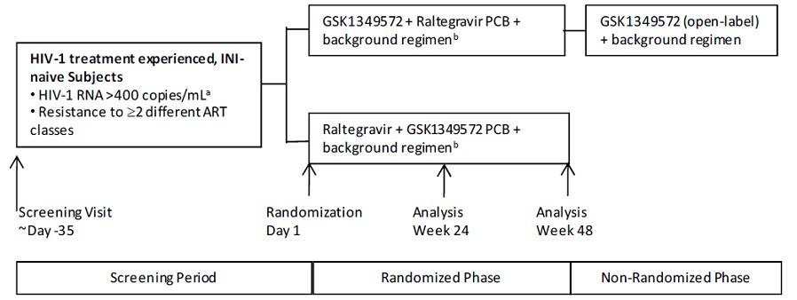

Inclusion and exclusion criteria
Key inclusion criteria were: ART-experienced, HIV-1 infected patients aged ≥18 years of age; documented HIV-1 RNA >400 c/mL at screening; documented resistance to two or more different classes of ART; INI naïve. Key exclusion criteria were: resistance indicating no fully active background ART available; evidence of Category C (AIDS) disease; moderate to severe hepatic disease; recent GI bleeding; malignancy within the previous 5 years; recent treatment with immunotherapeutic vaccines, cytotoxic agents or immunomodulators; any Grade 4 laboratory abnormality; ALT >5 times ULN.

Study treatments
Randomised patients took one tablet of DTG or DTG placebo OD, and one tablet of RAL or RAL placebo BID taken with investigator selected background therapy as shown in Table 8.
Table 8: Study treatments for Study ING111762 (SAILING).
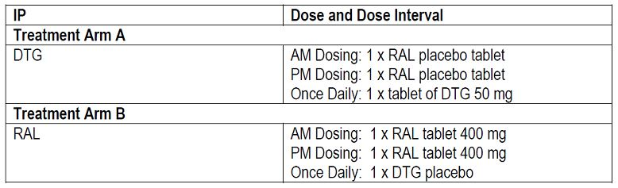

Efficacy variables and outcomes
The main efficacy variables were the proportion of patients achieving HIV-1 RNA <400 c/mL and <50 c/mL at Weeks 24 and 48; viral resistance; changes in CD4+ counts over time; and the incidence of disease progression. The primary efficacy outcome was to demonstrate the antiviral efficacy of DTG OD compared to RAL 400 mg BID both in combination with a background regimen consisting of 1-2 fully active single agents in HIV-1 infected, INI naïve, therapy-experienced patients at 48 weeks.
Other efficacy outcomes included the antiviral activity of DTG compared with RAL at 24 weeks; assessment of viral resistance in patients experiencing virological failure; sparse PK sampling and population modelling; the effects of demographic factors; and comparison of the development of HIV-associated conditions with each treatment.

Randomisation and blinding methods
Randomisation was conducted via a validated, centralised randomisation procedure using RANDALL (GSK). Patients received double-blinded DTG or RAL plus matching placebo tablets through the Week 48 visit. Patients and investigators will remain blind until Week 48 but GSK data management staff were unblinded for the 24 week interim analysis. IP treatment after Week 48 will be open-label.

Analysis populations
Efficacy analyses were conducted on the ITT-E population consisting of all patients who received at least one dose of study medication. The PP population was used for sensitivity analyses for the main secondary efficacy endpoint (viral response at 24 weeks). The numbers in each analysis population are shown in Table 9.
Table 9: Analysis populations for Study ING111762 (SAILING).
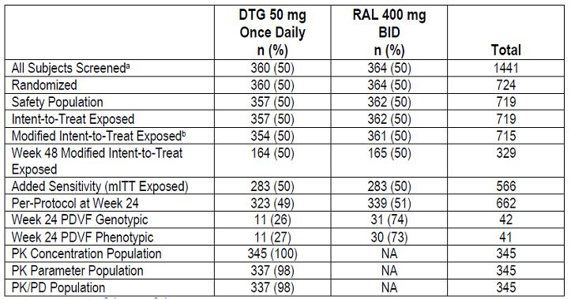

Sample size
The sample size was determined to detect non-inferiority of DTG versus RAL for the primary endpoint of patients with plasma HIV-1 RNA <50 c/mL at Week 48 using the FDA Snapshot algorithm. Assuming a 65% response rate in the RAL arm, a sample size of at least 333 per treatment arm provided 90% power with a 12% non-inferiority margin and a one-sided 2.5% significance level. The non-inferiority margin of 12% was based on clinical judgement and applicable HIV-1 guidelines (CHMP, 2007) and statistical guidelines (ICH Guidance for Industry, 2001).

Statistical methods
The primary comparison for the Week 24 interim analysis was the comparison of viral response in the DTG and RAL arms. Treatment with DTG would be considered non-inferior to treatment with RAL at Week 24 if the lower end of a two-sided 95% CI for the treatment difference was above -12%. If the lower end of the 95% CI for the treatment difference was above 0%, a statistically significant treatment difference in favour of DTG would be demonstrated. To assess consistency, the analyses were also performed in the PP population. No adjustment for multiplicity was made as the Week 48 data are considered primary. Adjusted estimates of the difference in response rates between the DTG and RAL arms were presented with CIs based on a stratified analysis using Cochran-Mantel-Haenszel weights. All CIs were two-sided. For the statistical analysis, eight subgroup strata were formed to allow for categorical variables.

Participant flow
Participant flow is shown in Figure 6. A total of 1441 patients were screened and 724 were randomised (360 DTG and 364 RAL). Discontinuation rates were similar in each treatment group (14% DTG and 17% RAL).
Figure 6. Participant flow for Study ING111762 (SAILING).
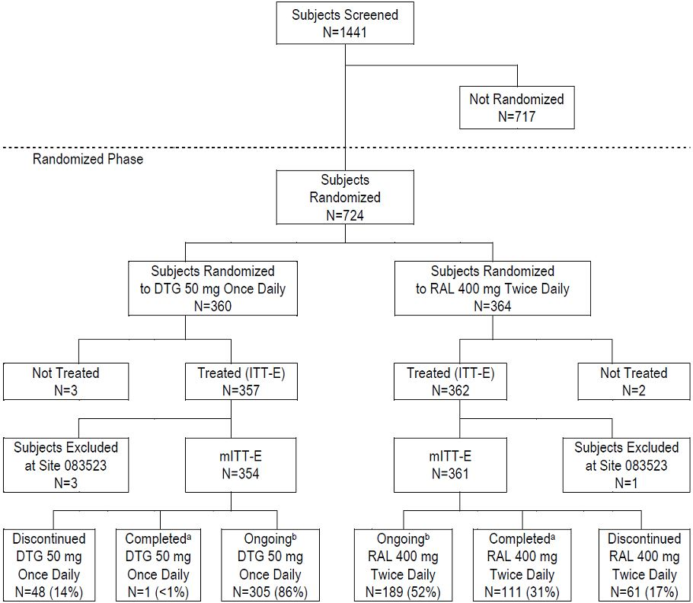

Major protocol violations/deviations
Criteria leading to exclusion from the PP population were pre-defined in the protocol. A total of 53 (7%) patients (31 DTG, 22 RAL) were excluded from the PP analysis.

Baseline data
Most patients were male (68%) with a mean age of 43 years and it was racially diverse (White 49%, African American 42%). Twelve patients were aged ≥65 years. Disease activity was relatively advanced but balanced between treatment groups. Median CD4+ count was 200 c/mL and overall 46% of patients had Category C disease (AIDS). All but one patient in the ITT-E group had received prior ART therapy. Overall, the median prior exposure to any ART was >6 years. Most patients had received five or more ART with >99% having received one or more NRTI, 84% having received one or more NNRTI and 60% having received one or more PI. All patients had resistance to at least two ART classes, 51% had 2-class resistance and 49% had 3-class or more resistance . More than 60 different individual regimens were used as background therapy. In North America and Europe, DRV/r was the most commonly prescribed ART (74% and 60%, respectively). Exposure was the same in the DTG and RAL groups (median 281 days, with 67% receiving treatment for at least 32 weeks). Median compliance rates assessed by tablet count at each visit were ≥95 - 100% in both groups.

Results for the primary efficacy outcome
The primary efficacy endpoint is the antiviral activity of DTG at 48 weeks but this interim analysis presents only the 24 week data.

Results for other efficacy outcomes
In the ITT-E set at Week 24, 79% of DTG patients and 70% of RAL patients achieved the principal secondary endpoint of plasma HIV-1 RNA <50 c/mL. There was a statistically significant adjusted difference in favour of DTG of 9.7% (95% CI: 3.4, 15.9, p=0.003). In the PP analysis, 81% of DTG patients and 72% of RAL patients achieved the same endpoint (adjusted difference 9.3% with 95% CI: 3.0, 15.7). Similar results were achieved for the proportion of patients with plasma HIV-1 RNA <400 c/mL (86% DTG, 79% RAL): the unadjusted treatment difference in favour of DTG was 7.2% (95% CI: 1.7, 12.7). There were fewer virologic non-responders in the DTG patients (15% DTG, 24% RAL). In both groups, 6% of patients were deemed virologic non-responders because of lack of virologic data at Week 24.
Subgroup analyses supported the overall conclusions. Results were compared by baseline HIV-1 RNA (≤ and > 50,000 c/mL), DRV/r use in the presence or absence of primary mutations, and by the number of fully active background agents as measured by PSS. Virologic response rates were lower in patients with baseline HIV-1 RNA >50,000 c/mL than in those with baseline ≤50,000 c/mL. There were no differences in treatment response between patients given DTG and RAL with DRV/r included as background therapy. At Week 24, 79% of DTG and 67% of RAL patients achieved HIV-1 RNA <50 c/mL in the subgroup which excluded patients receiving DRV/r within the background regimen without evidence of primary PI mutations at baseline (adjusted difference 12.2% with 95% CI: 5.0, 19.3). Virologic suppression was comparable in subgroups defined by gender, race and HIV-1 subtype. Response rates in DTG patients were similar in those aged <50 years compared with those aged > 50 years.The response rate in RAL patients appeared greater in patients aged >50 years than in patients aged <50 years and other subgroups, possibly a statistical artefact due to small patient numbers. Treatment differences in favour of DTG were consistent with the overall findings when adjusted for compliance (with the exception of <70%, the most poorly compliant group).
The proportion of patients with plasma HIV-1 RNA <50 c/mL increased sharply from baseline to Week 4 and the response was sustained to Week 24. The response was similar in both treatment groups but marginally higher values were noted throughout in the DTG group. The proportion of patients with plasma HIV-1 RNA <400 c/mL also increased in both treatment groups with a benefit in favour of DTG at all time points. For patients achieving plasma HIV-1 RNA <400 c/mL, virologic non-responders were more common in the RAL group (7% DTG, 13% RAL). Plasma HIV-1 RNA fell rapidly in both treatment groups with a difference in favour of DTG at all time points.
Mean and median CD4+ counts increased from baseline to Week 24 in the DTG (mean +113.9 cells/mm³) and RAL groups (mean +105.8 cells/mm³). The incidence of HIV-associated conditions (3% DTG, 5% RAL) and disease progression (2% DTG, 2% RAL) was low in both treatment groups. In patients with HIV disease progression, 2% progressed from CDC Class C to death.
Comment: This Phase 3 non-inferiority study in treatment experienced patients was well conducted with low numbers of protocol deviations and non-treatment related discontinuation rates. The study was well designed to allow for the absence of placebo control and the effects of extremely potent background therapy such as DRV/r. For the main secondary endpoint of HIV-1 RNA <50 c/mL, there was a statistically significant benefit in favour of DTG compared with RAL with an adjusted difference of 9.7% (95% CI: 3.4, 15.9), p=0.003). The proportion of patients who failed therapy with evidence of INI resistance was also significantly lower. The benefit in favour of DTG was shown in subgroup analyses including gender, race and HIV disease category, although there were no detectable differences between DTG and RAL in patients receiving the boosted PI DRV/r as background. CD4+ counts rose equally in both treatment groups with few cases of emergent HIV-associated conditions or disease progression.
Only Week 24 data are provided in the present interim analysis but the EU guideline adopted by the TGA requires Week 48 efficacy data. Moreover, the study has not met its primary endpoint which is viral response at Week 48. The Week 24 efficacy data are positive. However, the treatment difference was driven largely by virologic non-response, with fewer non-responders in the DTG group at Week 24 compared with RAL. Increasing non-response rates leading to loss of non-inferiority at Week 48 is unlikely but this cannot be assumed. As a minimum, confirmation of the primary endpoint at Week 48 should be provided by the sponsor before accepting the overall efficacy findings as pivotal rather than supportive.

Study ING112574 (VIKING-3)

Study design, objectives, locations and dates
This is a multicentre, Phase 3 study conducted at 65 sites, in Europe, Canada and the US. The study was initiated in May 2011 and is still ongoing. The present report was completed in September 2012. The study was administered by GSK. The single arm, open-label study objective was designed to assess the antiviral activity of DTG in HIV-infected patients with virological failure on a prior INI containing regimen, and genotypic or phenotypic resistance to RAL or EVG. The study schema is shown in Figure 7.
Figure 7. Schema for Study ING112574 (VIKING-3).
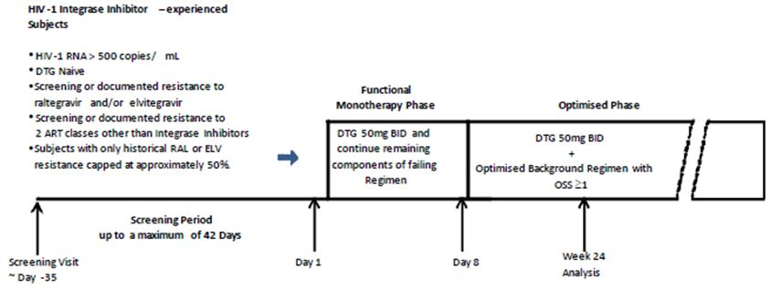
A minimum of 100 patients were enrolled to receive DTG 50 mg BID with the current failing regimen (without RAL or EVG) for 7 days but with OBR from Day 8. The first interim analysis was planned on this patient set at Week 24 while enrolment continued to allow a further 50-100 patients to be recruited for subsequent analyses. Patients were required to have documented genotypic and/or phenotypic resistance to at least one compound in two or more classes of ART (NRTIs, NNRTIs, PIs, CCR5 antagonists and fusion inhibitors). However, they were also able to include at least one active drug in the OBR to be commenced on Day 8. After Day 8, patients attended the clinic at 4 week intervals until Week 24 after which access to DTG was continued at investigator discretion. Patients were reviewed every 8 weeks until Week 48 and every 12 weeks thereafter.

Inclusion and exclusion criteria
Key inclusion criteria were: plasma HIV-1 RNA ≥500 c/mL at screening; ART experienced for at least 1 month before screening; naïve to DTG but experiencing or having experienced failure to RAL or EVG; current or historical genotypic or phenotypic resistance to RAL or EVG; resistance to at least one drug from each of two or more of all other approved classes of ART; patients able to receive at least one fully active drug in the OBR from Day 8 onwards. Key exclusion criteria included: evidence of Category C disease (AIDS); moderate to severe hepatic disease; anticipated need for HCV therapy; recent GI bleed; recent malignancy with the exception of Kaposi’s sarcoma; recent treatment with HIV vaccines, immunomodulators, radiation or cytotoxic therapy; recent treatment with un-licenced ARTs; recent treatment with ETR, EFV, NVP, TPV/RTV, FPV or FPV/RTV; any Grade 4 laboratory abnormality; ALT >5 times ULN.

Study treatments
Functional monotherapy phase (Day1 – Day 7): DTG 50 mg BID and the remaining components of the failing background therapy were continued as shown in Table 10.
Table 10: Study treatments for Study ING112574 (VIKING-3).
Optimised phase (Day 8 to at least Week 24): DTG was continued but background therapy was re-optimised to include at least one active drug in the OBR.

Efficacy variables and outcomes
The main efficacy variables were antiviral activity; disease progression; compliance; PK; and phenotypic and genotypic resistance. The primary efficacy outcome was the change from baseline in plasma HIV-1 RNA at Day 8, and the proportion of patients with HIV-1 RNA <50 c/mL at Week 24.
Other efficacy outcomes included DTG antiviral and immunologic activity over time, including CD4+ counts; the impact of different baseline INI resistance patterns on the treatment response to DTG; characterisation of treatment emergent viral resistance in patients with virologic failure; HIV-associated conditions and clinical disease progression; sparse PK and population modelling; and the effects of demographic factors.

Randomisation and blinding methods
The study was single arm and all study medication was administered open-label.

Analysis populations
Efficacy analyses were conducted based on the Intent-to-Treat Exposed (ITT-E) population consisting of all patients who received at least one dose of study medication. The PP population was used for sensitivity analyses at Day 8 and Week 24.

Sample size
Assuming a standard deviation of 0.5 log₁₀ c/ml, a sample size of 20 patients had 90% power to detect a change from baseline in HIV-1 RNA at Day 8. However, the number was expanded to permit a more detailed assessment of safety, antiviral activity and DTG PK. A single arm study with 100 patients provided a 4% standard error, translating to a 95% CI of 72% to 88% for an assumed response rate of 80% (percentage of patients HIV RNA <50 c/mL at week 24).

Statistical methods
The primary efficacy objective was to assess the antiviral activity of DTG over 8 days in functional mono-therapy and over 24 weeks in combination with at least one active agent. The Day 8 analysis assessed the activity of DTG alone while the Week 24 assessment measured the response to DTG as part of an OBR. Thus the primary endpoint was the change in plasma HIV-1 RNA from baseline to day 8. The null hypothesis was no change from baseline to Day 8 in HIV-1 RNA: the alternative hypothesis was a change in mean HIV-1 RNA at Day 8 of at least 0.7 log₁₀ c/mL. The hypothesis was to be tested at the 2-sided 5% significance level. In the event of a statistically significant outcome, the second primary endpoint was to be assessed (the response to DTG as part of an OBR at 24 weeks).

Participant flow
There were 183 patients in the ITT-E at baseline and 114 patients had the opportunity to reach the data cut-off point at Week 24. In the PP population, there were 173 patients at Day 8, and 101 patients at Week 24. In the Week 24 ITT-E population, 90 patients (79%) were still ongoing. A total of 21% of patients were withdrawn, the main reason being lack of efficacy (13%).

Major protocol violations/deviations
A total of 10 (5%) and 13 (11%) of patients were excluded from the PP analysis at Day 8 and Week 24, respectively. The most common violation was the use of prohibited medication.

Baseline data
Demographics were similar in the Day 8 and Week 24 ITT-E populations. Median age was 48 years, approximately 75% were White, 25% were African American and 77% were male. More than half the population had advanced CDC Category C disease. Approximately 70% had INI resistance detected at screening and the remainder had documented historical resistance. Median CD4+ count were low (<150 cells/mm³), and median HIV-1 RNA was high (~4.4 log₁₀ c/mL). Median duration of prior ART treatment was 13 years and the median number of previous ARTs used was fourteen. The study design mandated virological failure with previous INI treatment. In the ITT-E group, all but 4 patients had failed on RAL, 4 had failed on EVG and one patient had failed on both INIs. Most patients had used ≥3 NRTIs, ≥2 PIs or ≥2 NNRTIs. At the data cut-off point, median duration of exposure was 169 days and 181 patients had at least 4 weeks of exposure to DTG.

Results for the primary efficacy outcome
The primary efficacy endpoint was the change from baseline in HIV-1 RNA at Day 8 and the proportion of patients with HIV-1 RNA <50 c/mL at Week 24. There was a statistically significant mean reduction of 1.43 log₁₀ c/mL HIV-1 RNA in the ITT-E population at Day 8 as shown in Table 11. A similar mean reduction was observed in the PP population (-1.427 log₁₀ c/mL, 95% CI: -1.517, -1.337).
Table 11: Change from baseline in HIV-1 RNA at Day 8 (Study ING112574, VIKING-3).
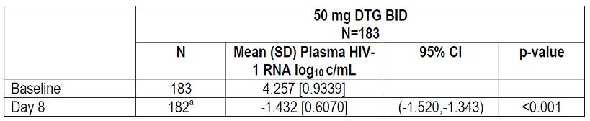
A total of 72/114 (63%) patients achieved plasma HIV-1 RNA <50 c/ml at 24 weeks in the ITT-E population and 66/101 (65%) in the PP population. Lack of virological suppression was the main reason for virological failure. Other factors included non-permitted background ART and discontinuation due to AEs. Of the 29 patients who had plasma HIV-1 RNA ≥50 c/mL at Week 24, or who were discontinued because of lack of efficacy, 20/29 (69%) never achieved <50 c/mL at any point during the study. The baseline parameters having most impact on Day 8 response were viral load, degree of change in IC₅₀ to DTG, and IN mutation category.

Results for other efficacy outcomes
A secondary objective was assessment of the efficacy of DTG over time. There was a 1.4 log₁₀ c/mL reduction of HIV-1 RNA after 7 days, increasing to >2 log₁₀ after Week 4 and sustained to Week 24 when DTG was administered with OBR. By Week 4, 75% and 52% of patients achieved <400 c/mL and <50 c/mL respectively. The proportion of those achieving <50 c/mL rose to 63% by Week 24. By Week 24, there was a median increase of 65 CD4+ cells/mm³ from baseline. In the ITT-E group, 10/183 (5%) patients experienced new HIV-associated conditions (including one death due to CML), and 23 (13%) experienced recurrent conditions. Only two patients had progression of CDC Class during the study.
Comment: This was a single arm study of DTG in patients at high risk of disease progression with advanced HIV disease and low CD4+ counts. Most had limited treatment options with multi-class viral resistance following extensive previous ART treatment. The dose of DTG 50 mg BID was selected because of superior efficacy compared with DTG 50 mg OD in RAL resistant patients shown in study ING112961 (reviewed below). At Day 8, there was a mean reduction of -1.43 log10 c/mL (95% CI: -1.520, -1.343), and 63% of patients had achieved HIV RNA <50 c/mL at Week 24. There was a 65 cells/mm3 increase in CD4+ count and a low incidence of new HIV-associated conditions or disease progression. The influence of background drug activity was examined and was not shown to significantly impact the Week 24 response. Overall, the study results support the use of the higher dose of DTG 50 mg BID in patients with multi-class drug resistance.

Study ING112578 (P1093)

Study design, objectives, locations and dates
This study is being conducted in collaboration with the International Maternal Paediatric Adolescent AIDS Clinical Trials Group (IMPAACT) who have assigned it the protocol number P1093. Consistent with ICH E11 guidance and most paediatric HIV trials, it does not have a comparator arm. The study was started in April 2011 and it is still on-going. The data cut-off point of this interim analysis is June 2012, and the PK data presented are those of the first 10 patients to complete Stage 1 in adolescents aged ≥12 to <18 years.
Comment: This is not a pivotal study using accepted criteria but it is the only data set supporting the claim for DTG in adolescents. This is an important indication so it is evaluated in some detail.
It is a Phase I/II multicentre, open label, non-comparative, dose ranging study to examine the efficacy and safety of DTG in combination regimens in infants, children and adolescents with HIV-1 infection. Approximately 160 infants, children and adolescents aged ≥6 weeks to <18 years were treated with DTG prior to starting, and in combination with OBT. As HIV integrase is a viral rather than a host target, it was assumed that the relationship between drug exposure and antiviral activity is similar in adults and paediatric populations. DTG was administered orally as tablets of 10 mg, 25 mg and 50 mg but a paediatric formulation was developed for younger children unable to swallow tablets. Six cohorts of HIV-1 infected children were selected as shown below:
Cohort I: Adolescents ≥12 to <18 years (Tablet formulation)
Cohort IIA: Children ≥6 to <12 years (Tablet formulation)
Cohort IIB: Children ≥6 to <12 years (Paediatric formulation)
Cohort III: Children ≥2 to <6 years (Paediatric formulation)
Cohort IV: Children ≥6 months to <2 years (Paediatric formulation)
Cohort V: Infants ≥6 weeks to <6 months (Paediatric formulation)
Enrolment began with Cohort I and at the time of the report had progressed to Cohort II. Progress through the cohorts will continue after PK and safety data criteria in the preceding cohorts are met. Each age cohort will consist of Stages 1 and 2. Stage 1 consists of ten patients who will have intensive PK sampling and assessment of short term safety and tolerability. Patients enrolled in Stage 1 while Stage 2 will open for the enrolment of additional patients at the selected dose.

Inclusion and exclusion criteria
Key inclusion criteria were ART experienced INI naïve infants, children and adolescents aged ≥6 weeks to <18 years; confirmed HIV-1 infection; and an optimised OBR containing at least one fully active drug. Key exclusion criteria included known resistance to an INI; presence of any active AIDS defining opportunistic infections; Grade 3 or 4 laboratory toxicities; evidence of pancreatitis; liver toxicity; and known exposure to an INI.

Study treatments
The study was open-label with no active comparator. Patients enrolled in Stage 1 received DTG added to a stable, failing ART regimen or started DTG as monotherapy if they were not receiving ART. Intensive PK was performed between Days 5-10, following which the ART was optimised. In addition to DTG, all ART regimens were required to have at least one fully active drug and one additional drug in the OBR. Patients were fasted for six hours before PK visits but otherwise were instructed to take DTG with or without food. The initial DTG dose was approximately 1 mg/kg once daily with a maximum daily dose of 50 mg as shown in Table 12.
Table 12: Study treatments for Study ING112578 (P1093).
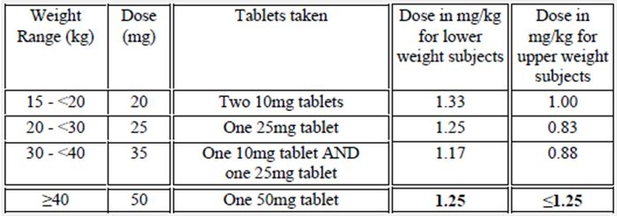
At the report cut-off date of June 2012, the median exposure to DTG was 294 days. The first 10 patients have completed Week 24 and 4 patients have completed Week 48.

Efficacy variables and outcomes
The main efficacy variables were steady state PK of DTG in combination with OBT; and the DTG dose achieving a targeted AUC24 and C24hr. The primary efficacy outcome was to select a DTG dose for chronic dosing in infants, children and adolescents. The dose will achieve similar exposure to the DTG adult dose selected in ART-naïve adult patients. The PK targets to be met are shown in Table 13.
Table 13: PK targets for Study ING112578 (P1093).
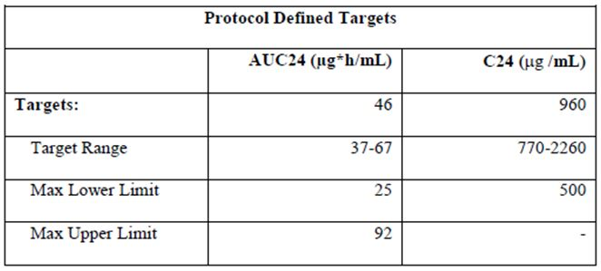
Other efficacy outcomes included virologic response including the relationship between DTG exposure and antiviral activity; immunologic response; genotypic and phenotypic resistance to DTG; and the effects on PK of variables such as age and weight.

Randomisation and blinding methods
This was a single-arm, open-label study with no comparator.

Analysis populations
All adolescents received DTG so the analysis population is All Treated (AT). All 10 adolescents are included in the PK analyses.

Sample size
A sample size of 160 was selected to ensure at least 100 patients. A sample size of 10 patients in Stage 1 of each cohort was based on feasibility and previous recruitment experience generated by IMPAACT and GSK.

Statistical methods
Data were analysed in aggregate and stratified by age cohort with estimates bounded by 95% CI. Due to the limited sample size, the analysis was largely descriptive with interpretation based on clinical rather than statistical significance.

Participant flow
All 10 patients received at least one dose of study medication and have reached Week 24 as shown in Table 14.
Table 14: Participant flow for Study ING112578 (P1093).
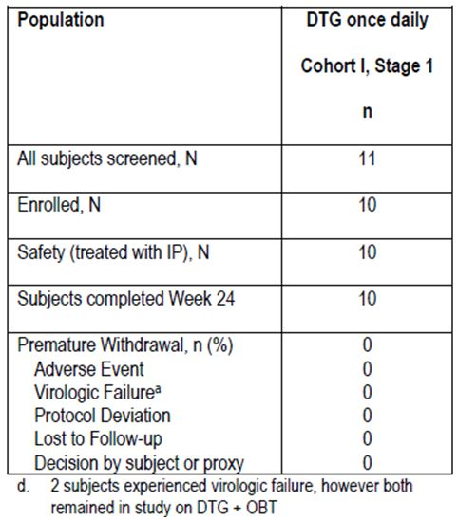

Major protocol violations/deviations
There were no significant protocol deviations.

Baseline data
Median age was 13.5 years, 7 (70%) were female, 6 (60%) were African American and the remainder were White. Median baseline plasma HIV-1 RNA was 4.5 log₁₀ c/mL, median baseline CD4+ count was 543 cells/mm³, and 4 (40%) patients had Category C disease. All patients were treatment experienced (median time 12.8 years) but no patient was receiving non-permitted therapy at enrollment.

Results for the primary efficacy outcome
Similar exposure with moderate PK variability was obtained in adolescents compared with adults in previous studies. A DTG dose of approximately 1 mg/kg (50mg for children >40kg and 35 mg for children >30 - 40 kg) achieved exposure within the pre-defined AUC (0-24) and C24 targets. The results support the use of the adult dose of DTG 50mg once daily in children ≥12 to 18 years of age who weigh >40kg. In the full Cohort I, the geometric mean AUC24 was 46µg*h/mL and the C24 was 902 ng/mL, both well within the pre-determined target limits. Exposure was notably low in one patient.

Results for other efficacy outcomes
Most patients achieved plasma HIV RNA <400 c/mL at Week 24 as shown in Table 15.
Table 15: Plasma HIV RNA <400 c/mL at Week 24 (Study ING112578, P1093).
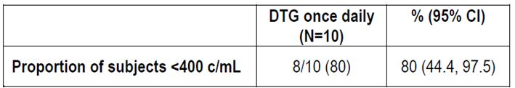
Seven (70%) patients achieved HIV RNA <50 c/mL at Week 24 and nine (90%) had >1 log10 drop from baseline, or achieved HIV RNA <400 c/ml at Week 24. Two patients had protocol defined virologic failure, both due to poor compliance and neither had INI resistant mutations. There was an increase in median CD4+ count from baseline of 118 cells/mm3 (95% CI: -97, 389) at 24 weeks. There were no new cases of Category C disease. Cohort 1, Stage 2 (including an additional 12 patients) is proceeding based on the dose ranging PK data outlined in this first analysis. They will include in a further report when 24 Week data are available.
Comment: This study was conducted in a small population of adolescents with long-standing disease and intolerance or resistance to multiple drug classes. The PK data showed moderate variability but support the use of 50 mg OD in adolescents weighing more than 40 kg. Virologic success was high and 70% of patients achieved HIV RNA <50 c/mL at 24 weeks. The PK data support the use of DTG in this population but the patient numbers are small. The EMEA guideline accepts extrapolation of adult PK data to paediatric patients if the data are ‘robust’. However, the PK data in this study were at least moderately variable and exposure was notably low in one patient. Overall, the PK variability is similar to that observed in adults but efficacy and safety data are available for only the same ten patients. It would be prudent to report the full Cohort 1 with an additional 12 patients at 24 weeks before the positive findings are accepted.

Study ING114467 (SINGLE)

Study design, objectives, locations and dates
This is a multinational study conducted at 136 sites in Europe (71), USA (51), Canada (10) and Australia (4). It was started in February 2011 and is still ongoing. This Week 48 analysis had a last observation period dated May 2012. It is a fully-powered, parallel group, randomised, double-blind, active-controlled Phase 3 study of DTG plus abacavir-lamivudine (ABC/3TC) fixed-dose combination therapy given once daily compared with Atripla (emtricitabine/tenofovir/efavirenz) over 96 weeks in HIV-1 infected ART naïve adult patients. It is a non-inferiority study conducted in approximately 800 patients randomised 1:1 to receive DTG plus ABC/3TC once daily or Atripla once daily. Randomisation was stratified by screening HIV-1 RNA status (≤100,000 or >100,000 c/mL) and CD4+ count (≤200 or >200 cells/mm³). After enrolment, patients attend the clinic at Day 1, Weeks, 2, 4, 8, 12, 16, 24, 32, 40 and 48 and the every 12 weeks thereafter. The study schematic is shown in Figure 8.
Figure 8. Schema for Study ING114467 (SINGLE).
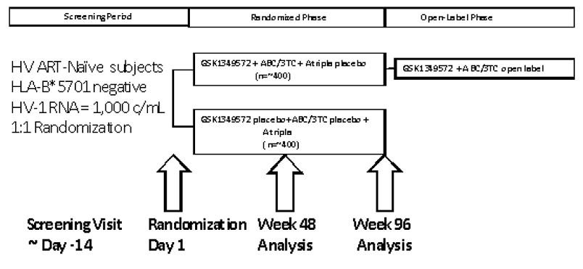

Inclusion and exclusion criteria
Key inclusion criteria were: HIV-1 infected, ART naïve adults aged ≥18 years; plasma HIV-1 RNA ≥1000 c/mL; and negative HLA-B*5701 allele. Key exclusion criteria were: Category C disease; hepatic impairment; history of malignancy; recent treatment with HIV-1 vaccines, immunomodulators, cytotoxic agents or radiation; evidence of viral resistance; any Grade 4 laboratory abnormality; significant renal impairment; and recent GI bleeding.

Study treatments
The randomised treatments including matched placebo tablets are summarised in Table 16.
Table 16: Treatments for Study ING114467 (SINGLE).
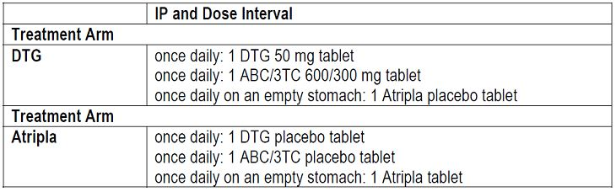

Efficacy variables and outcomes
The main efficacy variables were antiviral response, increased CD4+ count and HIV-1 disease related conditions. The primary objective was to compare the antiviral activity of DTG + ABC/3TC once daily with Atripla over 48 weeks, assessed by the proportion of patients with plasma HIV-1 RNA <50 c/mL.
Secondary efficacy objectives included: the antiviral activity of DTG + ABC/3TC compared with Atripla over 96 weeks; the assessment of viral resistance in patients experiencing virologic failure; the incidence of new HIV-associated conditions over time; and the impact of race, gender and/or HIV-1 subtype.

Randomisation and blinding methods
Patients were randomised 1:1 using a validated central randomisation procedure (RANDALL, GSK). Patients received double-blind IP or matched placebo. Emergency un-blinding by the investigator was available by IVRS.

Analysis populations
A total of 1090 patients were screened and 844 randomised as shown below. The primary efficacy analyses were performed on the ITT-E population (all randomised patients who received at least one dose of study drug) at Week 48. The PP population was used for sensitivity analyses.
Table 17: Analysis populations for Study ING114467 (SINGLE).
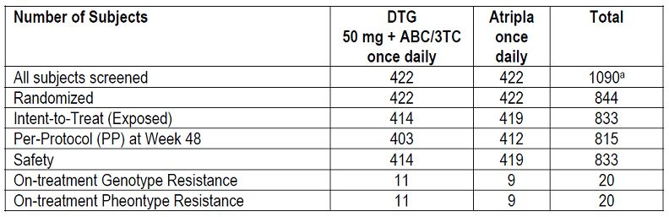

Sample size
Based on recent large clinical studies, a response rate of 75% was assumed in the EFV arm. Assuming a 75% response in the Atripla arm, the study required 394 evaluable patients in each arm to have 90% power with a 10% non-inferiority margin and a one-sided 2.5% significance level.

Statistical methods
For the primary endpoint, adjusted estimates of the difference in the rate of responders between the two arms were used with CIs based on a stratified analysis using Cochran-Mantel-Haenszel weights. Four subgroup strata were formed based on baseline plasma HIV-1 RNA (≤100,000 and >100,000 c/mL) and baseline CD4+ cell count (<200 and ≥200 cells/mm³). Strata specific tests of homogeneity were assessed at the one-sided 10% significance level. If the primary comparison demonstrated non-inferiority of DTG + ABC/3TC compared to Atripla, further testing for the superiority of DTG + ABC/3TC with respect to viral suppression was to be used using a Wilcoxon test based on the ITT-E population.

Participant flow
A total of 844 patients were randomised and 833 patients received at least one dose of study medication. More patients in the Atripla group withdrew prematurely, mainly due to an excess of AEs. Virologic failure occurred in 3% of patients in each treatment arm.

Major protocol violations/deviations
A total of 18 patients (3% DTG and 2% Atripla) had protocol deviations which excluded them from the PP analysis.

Baseline data
Most patients were White (68%) and male (84%) with a median age of 35 years. One patient in the DTG group and six patients in the Atripla group were 65 years of age or older. Most patients were in CDC Category C and 93% were negative for HCV infection at screening. Overall, 68% of patients had plasma HIV-1 RNA ≤100,000 c/mL at baseline. Overall, the median CD4+ count was 338.0 cells/mm³ and only 3% of patients in each group had CD4+ counts <50 cells/mm³. Median exposure to DTG + ABC/3TC was 347 days with 82% receiving therapy for more than 48 weeks. Median exposure in the Atripla group was 339 days with 75% receiving therapy for more than 48 weeks.

Results for the primary efficacy outcome
There was a rapid and sustained viral response in both groups. At Week 48, 88% of patients in the DTG + ABC/3TC group achieved the primary endpoint of HIV-1 RNA <50 c/mL compared with 81% in the Atripla group. Non-inferiority was confirmed as the lower bound of the 95% CI for the treatment difference (+2.5%) was greater than -10%. The adjusted difference in proportions (DTG-Atripla) was 7.4 (95% CI: 2.5-12.3) and the difference was statistically significant (p=0.003). Virologic failure was similar in both groups and the difference in treatment response was attributable largely to a higher withdrawal rate due to AEs in the Atripla group. A similar result was observed in the PP analysis in which 90% and 81% of patients in the DTG + ABC/3TC and Atripla groups respectively achieved plasma HIV-1 RNA<50 c/mL at Week 48. The lower bound of the 95% CI was +3.9% which matched that of the ITT-E analysis.

Results for other efficacy outcomes
Treatment differences supported the non-inferiority of DTG + ABC/3TC compared with Atripla when the results were adjusted for baseline HIV-1 RNA and baseline CD4+ counts. Treatment differences in demographic subgroups (including race, gender and age) also supported the non-inferiority of DTG + ABC/3TC. The median time to viral suppression was 28 days in the DTG + ABC/3TC group compared with 84 days in the Atripla group (p<0.0001). The change from baseline HIV-1 RNA was consistently greater in the DTG +ABC/3TC group until Week 24, and the change from baseline in CD4+ counts consistently favoured the DTG + ABC/3TC group. The incidence of HIV disease progression was low (3% in both treatment groups). As noted above, overall differences in virologic response rates were driven largely by an excess of discontinuations due to AEs in the Atripla group (2% DTG + ABC/3TC vs. 10% Atripla). However, virologic non-response rates were similar in both treatment groups (5% DTG +ABC/3TC vs. 6% Atripla).
Comment: This pivotal Phase 3 study was well conducted with few deviations. There were more early withdrawals in the Atripla arm but this was due to AEs. Atripla is a widely recommended first line treatment for HIV and this study demonstrated that the DTG + ABC/3TC combination was superior to Atripla in treatment naïve HIV patients. A total of 88% of patients in the ITT-E group and 90% in the PP group achieved plasma HIV-1 RNA <50 c/mL at Week 48. The rise in CD4+ count was also higher in the DTG + ABC/3TC group and no patients developed INI resistant mutations. The study results were internally consistent with no differences attributable to baseline HIV-1 RNA levels, CD4+ count, or demographics including gender, race and age. Notably, the virological response in the DTG + ABC/3TC was significantly faster than in the Atripla group and the response was durable.

Other efficacy studies

Study ING112961 (VIKING)
This was an open-label, single arm Phase 2b study to assess the antiviral activity of a regimen containing DTG in ART-experienced, adults infected with HIV-1 and with RAL resistance. It was conducted at 16 centres in Europe and the USA. In Cohort 1, patients with RAL virologic failure substituted therapy based on DTG 50 mg OD: via a protocol amendment, a second cohort of patients was subsequently recruited and treated with DTG 50 mg BID.
In Cohort 1, 27 patients with plasma HIV-1 RNA ≥1000 c/mL with RAL virologic or treatment failure substituted DTG 50 mg for RAL in addition to their background therapy. Antiviral activity was assessed at Day 11 when they continued DTG but optimised their background therapy until Week 24. The primary endpoint was the proportion of patients with Day 11 plasma HIV-1 RNA /mL or at least log₁₀ c/mL below their baseline value. There were 27 patients in the ITT-E population. In the PP population there were 21 patients at Day 11 and 19 patients at Week 24 (8 patients were withdrawn for protocol violations). In the ITT-E group, most patients were male (93%) and White (89%) with CDC Category C disease (59%). Median age was 48 years. Median plasma HIV-1 RNA was 4.48 (range 2.64-6.06) log₁₀ c/mL and median CD4+ count was 114 (range 19-729) cells/mm³. In Cohort 2, patients received DTG 50 mg BID but otherwise shared the same protocol design and objectives as Cohort 1. There were 24 patients in the ITT-E population, 22 patients were ongoing at the time of the analysis, and 21 patients were in the PP population at 24 weeks. Most patients were male (75%) and White (75%) with a median age of 47 years. In Cohort 2, 42% had Category A disease and 33% were in Category C. Median baseline HIV-1 RNA was 4.26 (range 3.32-5.84) and median baseline CD4+ count was 202 cells/mm³ (range 19-528).
The proportion of patients meeting the primary endpoint (Day 11 plasma HIV-1 RNA <400 c/mL or at least 0.7 log₁₀ c/mL below baseline) was higher in Cohort 2 than in Cohort 1 as shown in Table 17.
Table 17: Day 11 plasma HIV-1 RNA <400 c/mL or at least 0.7 log₁₀ c/mL below baseline (Study ING112961, VIKING).
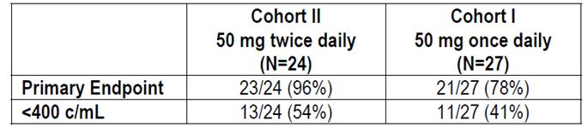
Comment: This Phase 2b study was performed in HIV-1 patients with multiple drug resistance including RAL. The study does not meet the accepted criteria for a pivotal study. However, the study is the main important support for the higher BID dosage in patients with INI resistance. The sequential design was not ideal with Cohort 2 (DTG 50 mg BID) added only following suboptimal efficacy in Cohort 1 (DTG 50 mg BID). Nonetheless, the study results justified the use of the higher daily dose of DTG in studies of treatment experienced patients with RAL resistance.

Analyses performed across trials (pooled & meta analyses)
No pooled efficacy analyses were performed due to significant differences in study designs, patient populations, background therapies and comparator arms.

Evaluator’s conclusions on clinical efficacy
The submitted studies are compatible with European Medicines Agency (EMA) guidelines of November 2008 adopted by the TGA. Studies VIKING-3 and P1093 are open label and non randomised, but overall the study designs are adequate and the comparators and outcome measures are appropriate. Viral load reduction to <50 c/mL and changes in CD4+ counts are both accepted as surrogate measures of efficacy, and the HIV-1 RNA assay employed had the appropriate sensitivity to detect the endpoint. Efficacy in subgroups was assessed appropriately, including patients with HBV/HCV co-infection, women, patients with renal impairment, patients with high and low viral loads and patients with varying severities of HIV/AIDS. Treatment naïve populations were studied ensuring that patients with transmitted viral resistance were excluded. Treatment experienced patients were also studied, including those with multiclass and INI resistance. Effective and sustained viral suppression was observed with the combination of DTG and two NRTIs in two randomised, active controlled Phase III studies in ART naïve adults. In ING113086 (SPRING-2), the non inferiority of the DTG combination compared with RAL + NRTI background therapy was convincingly demonstrated after 48 weeks of treatment. In ING114467 (SINGLE), the combination of DTG + ABC/3TC was statistically superior to Atripla although the superiority was driven partly by early withdrawals due to AEs in the Atripla arm. The results were consistent within subgroups defined by age, gender, race, baseline HIV RNA and CD4+ counts. Overall, the results of both studies strongly support a non inferiority claim. ING112574 (VIKING-3) assessed the antiviral activity of DTG in ART experienced patients with INI resistance. An encouraging 63% of patients achieved a virological response at 24 weeks but it was it was an open label study of DTG 50 mg BID with no comparator arm. ING111762 (SAILING) is the only pivotal, controlled Phase III study comparing DTG and RAL regimens in treatment experienced adult patients. There was a statistically significant 9.7% (95% CI: 3.4, 15.9, p = 0.003) difference in viral response rates in favour of DTG 50 mg QD at Week 24. The incidence of treatment emergent INI resistance was also less in DTG patients compared with RAL. However, the primary endpoint of the study is viral response at Week 48 as recommended in the EU guideline. As a minimum, the primary endpoint should be confirmed before DTG efficacy in treatment experienced, INI naive patients is accepted.
The PK profile of DTG in INI naïve adolescents with long standing disease was similar to that observed in adults and 70% achieved the HIV RNA target of 50 c/mL after 24 weeks. However, efficacy data is available for only 10 patients. Data from larger patient numbers are required to justify an indication in this patient group.
The efficacy summary provided by the sponsor in the clinical overview is balanced and the conclusions are acceptable.

Clinical safety

Studies providing evaluable safety data
A summary of the safety population by study for pivotal and supportive studies is shown in Table 18.
Table 18: Submitted safety studies.
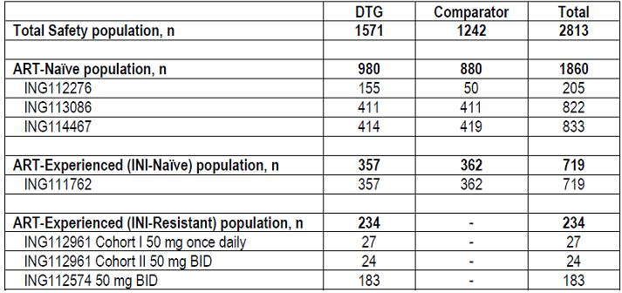

Pivotal efficacy studies
In the pivotal efficacy studies, the following safety data were collected:
- General adverse events (AEs) were classified summarised by SOC, severity grading, causality determined by the investigator, AEs causing withdrawal, and frequency (occurring at 1% and 5% levels). GSK study personnel remained blind but IDMCs evaluated unblinded data at pre-specified points during the pivotal Phase 3 studies.
- AEs of particular interest included GI disturbances and gastric erosions (based on pre-clinical data); rash with and without systemic involvement (based on RAL PI); hepatobiliary disorders and DILI; renal impairment (based on previous DTG studies); Torsades de Pointes (despite no demonstrable effect on QTc by DTG); nervous system disorders including headache and dizziness (from the RAL PI and previous DTG studies); psychiatric disturbance and suicide (common in HIV-1 patients and identified in the RAL PI); myositis and rhabdomyolysis (from the RAL PI); IRIS (based on rapid anti-viral response to DTG and rise in CD4+ count); neoplasms; myocardial infarction (increased risk in HIV patients on long-term ART).
- Laboratory tests, including haematology, fasting lipids, blood chemistry and urinalysis were performed at central laboratory facilities (Quest Diagnostics, Valencia, CA, USA and Monogram Biosciences, San Francisco, CA, USA).

Pivotal studies that assessed safety as a primary outcome
None presented.

Pivotal studies that assessed safety as a primary outcome
None presented.

Patient exposure
As of October 2012, a total of 2663 subjects (2026 HIV-infected and 637 healthy) have received at least one dose of DTG. A total of 526 healthy subjects and HIV-infected patients were exposed in clinical pharmacology studies and a further 139 healthy subjects are exposed in ongoing studies. A total of 1571 HIV-infected patients have been exposed in Phase 2b/3 studies and 284 patients have received at least one dose of DTG in ongoing studies. A total of 33 adolescents and children have received DTG in the ongoing Study ING112578 (P1093). A compassionate use program currently has 110 patients on treatment. In the combined Phase 2b/3 studies, exposure to DTG was approximately 1596 patient years, while exposure to RAL, EFV or Atripla ranged from 82.0 to 497.0 days. The mean duration of exposure to DTG was 340 days (range 1 to 943 days).

Adverse events

All adverse events (irrespective of relationship to study treatment)

Pivotal studies
In Study ING113086, the safety profile of DTG 50 mg OD in treatment-naïve, HIV infected patients was similar to RAL over 48 weeks. There were similar rates of AEs and discontinuations (2% in each arm). The most commonly reported clinical AEs in patients receiving DTG or RAL were nausea, headache, nasopharyngitis and diarrhoea with no significant differences between groups. In Study ING111762, the safety profile of DTG 50 mg OD in treatment-experienced, INI-naïve patients was similar to RAL over 24 weeks. There were similar rates of AEs and low rates of discontinuation (2% DTG, 4% RAL). The most common AEs in both groups were diarrhoea, nausea, vomiting, and fatigue (Table 19). In Study ING112574, the safety profile of DTG 50 mg BID was assessed in 105 INI-experienced patients with background ART treated for at least 24 weeks. Median exposure was 169 days (range 14-341 days). There was no comparator arm but DTG 50 mg BID was well tolerated with an AE profile similar to those observed with DTG 50 mg OD in other Phase 2b/3 studies (Table 20). The most commonly reported AEs were diarrhoea, nausea and headache. In the paediatric study ING112578 (P1093), all 10 patients completed 24 weeks therapy. AEs were reported in 9/10 patients but all but one were Grade 1 (Table 21). In Study ING114467, the tolerability of DTG + ABC/3TC was compared to Atripla in the treatment of ART naïve, HIV infected patients. Over 48 Weeks, the safety profile of the DTG combination was acceptable. Patients in the DTG + ABC/3TC group were more likely to develop insomnia whereas patients in the Atripla group were more likely to develop dizziness, abnormal dreams, rash, anxiety and somnolence (Table 22). Other commonly reported AEs included diarrhoea, nasopharyngitis, nausea, headache and fatigue.
Table 19: Most common AEs in Study ING111762.
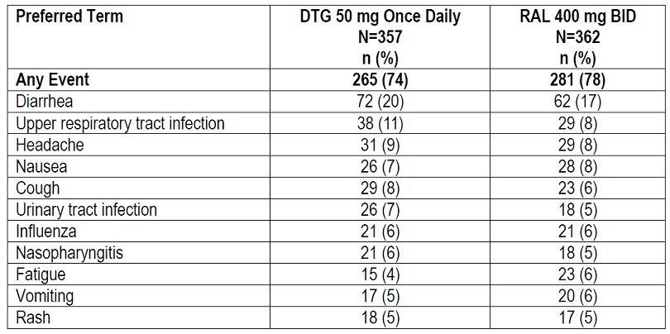
Table 20: Most common AEs in Study ING112574 (reported for greater than or equal to 5% incidence).
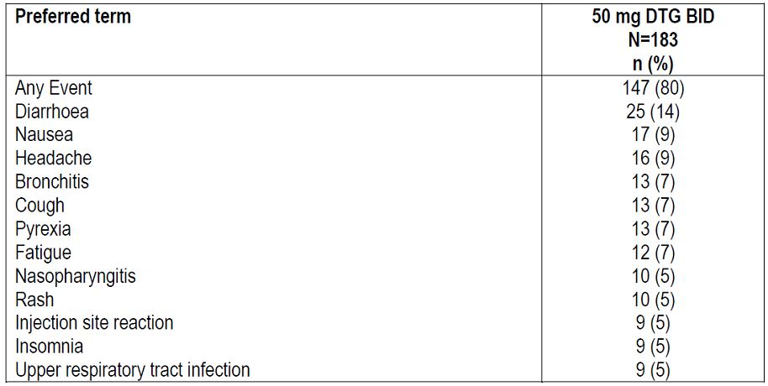
Table 21: Summary of all AEs for Cohort I, Stage 1 Worst Grade for each subject (incidence ≥1 subject) AT population (Study ING112578).
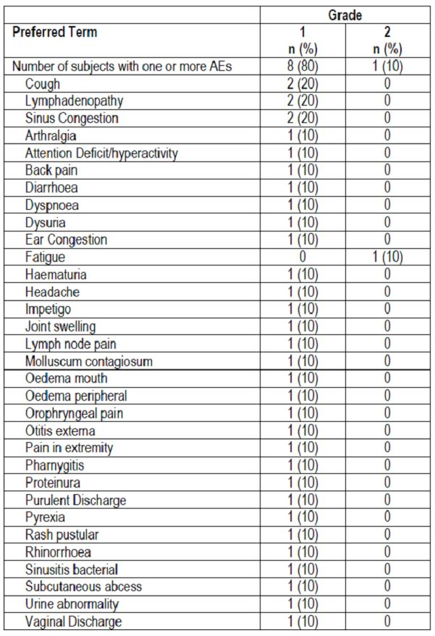
Table 22: Most common AEs (reported for ≥5% incidence in either treatment group) (Study ING114467).
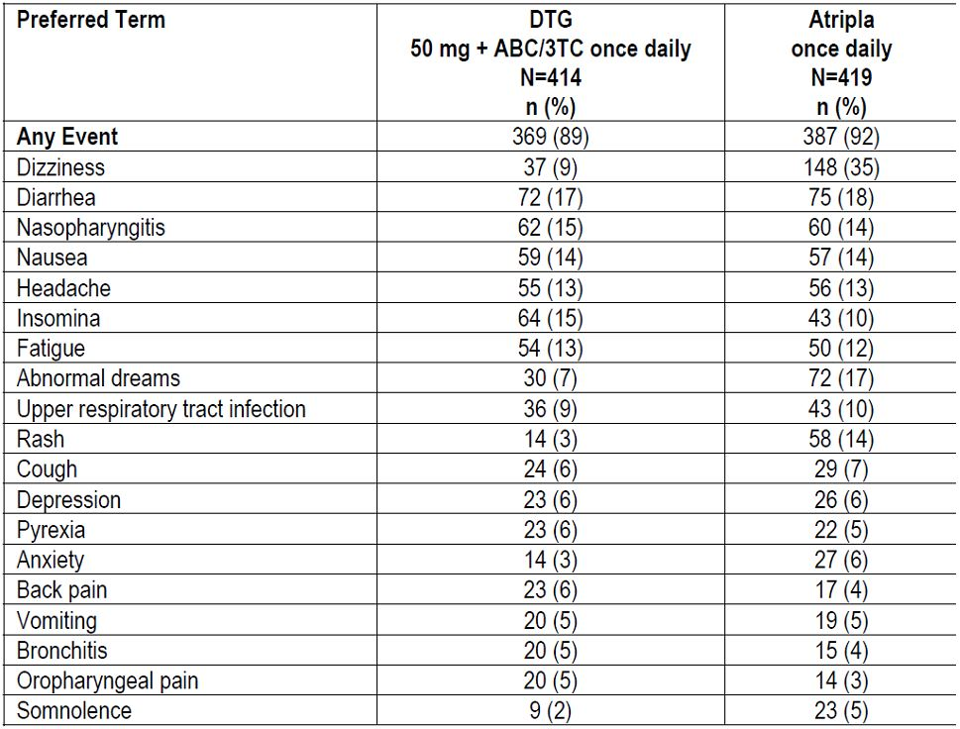

Other studies
In the dose ranging Study ING112276, more AEs were observed in the EFV treatment arm (86%) than in the DTG treatment arms (77% overall). The most common AEs in the DTG group were mild and included nausea, diarrhoea, headache and nasopharyngitis (Table 23). There appeared to be no relationship between DTG dose and the incidence of AEs. In the Phase 2b Study ING112961 in HIV patients with RAL resistance, 85% of patients in Cohort 1 (DTG 50 mg OD), developed at least one AE during the 24 week treatment period compared with 88% in Cohort 2 (DTG 50 mg BID). Most were mild as shown in Table 24.
Table 23: Common adverse events (Study ING112276).
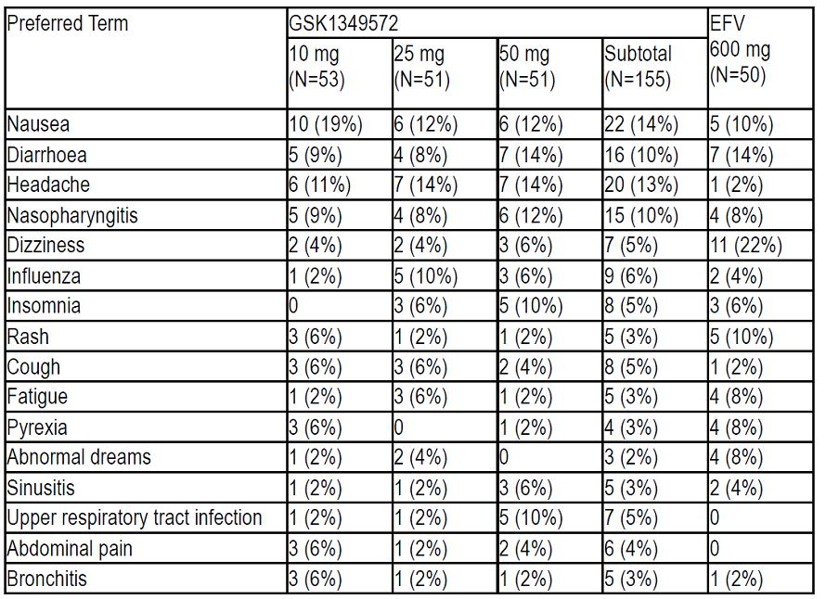
Table 24: Summary of common AEs (all grades, occurring in more than 1 subject) through Week 24 interim analysis (Safety Population) (Study ING112961).
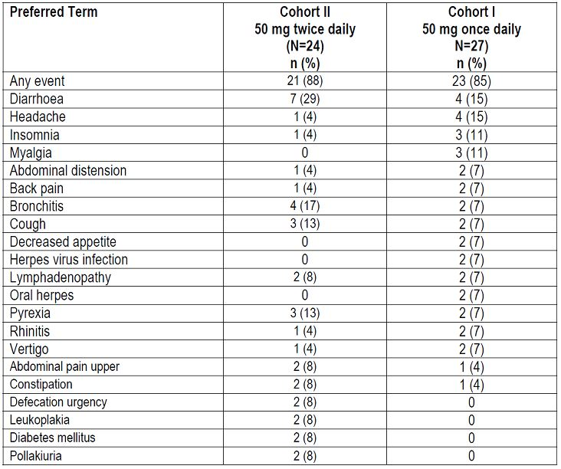

Treatment-related adverse events (adverse drug reactions)

Pivotal studies
In the pivotal Study ING113086 (Spring-2), the incidence of the most common AEs were similar in the DTG and RAL treatment groups as shown in Table 25.
Table 25: Treatment-related adverse events in Study ING113086 (Spring-2).
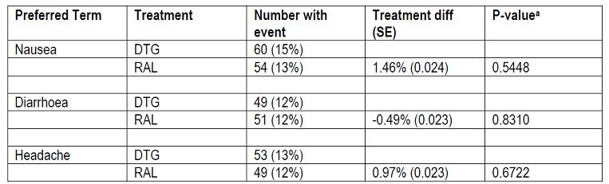
In the combined database of all DTG studies, a total of 1571 AEs judged by the investigator to be reasonably attributable to DTG were reported. Nausea and diarrhoea were the most commonly reported events as shown in Table 26.
Table 26: Summary of treatment-related AEs in at least 1% of subjects – total phase IIb/III DTG treatment population (pooled data).
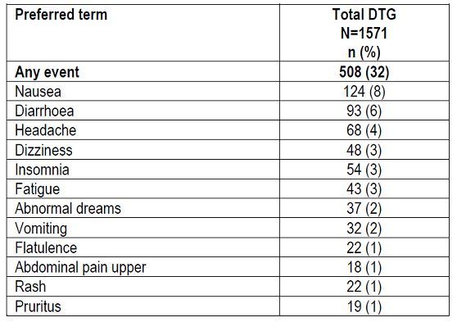

Other studies
Included in pooled data above.

Deaths and other serious adverse events

Pivotal studies
In Study ING113086, there were two deaths (one homicide DTG, one suicide RAL), neither considered to be drug related by the investigator. The incidence of SAEs was low and similar in both treatment groups (DTG 7%, RAL 8%) with no pattern of events. Eight patients had SAEs considered by the investigator to be drug related (3 DTG, 5 RAL). In the DTG group, one patient had non-sustained ventricular tachycardia, one developed a hypersensitivity syndrome with rash and severe hepatic impairment, and one had hepatic insufficiency related to gallstones but DILI could not be excluded.
In Study ING111762, there were two deaths (both in the RAL group), neither considered drug related. The incidence of SAEs was low and similar in both groups (DTG 8%, RAL 11%) with no discernable pattern. In the DTG group, only two patients had an SAE considered by the investigator to be drug related. One patient developed myositis and renal failure and the other developed a rash and mucositis. There was one death in the single-arm Study ING112574 considered unrelated to treatment. The patient died of PML 10 weeks after her last dose of DTG. SAEs were reported in 27 (15%) patients most commonly related to infections (7%) and hepatobiliary disorders (3%). Two events were considered drug related by the investigator. One patient developed rash and pruritus and the other developed a drug eruption with hyperbilirubinaemia. In ING114467 at Week 48, there were two deaths, both in the Atripla group. The incidence of SAEs was similar in both treatment groups (9% DTG + ABC/3TC, 8% Atripla) and all individually reported SAE preferred terms had an incidence <1% in either treatment group. There were 9 SAEs considered to be drug related by the investigator but only one in the DTG group, a drug hypersensitivity reaction thought to be related to abacavir. There were no deaths or SAEs reported in ING112578 (P1093).

Other studies
In study 112276 there were no deaths. The incidence of SAEs was similar in the EFV (6%) and DTG groups (4%) with no evidence of a dose relationship. None of the SAEs in the DTG groups were considered to be drug related by the investigator. In ING112961, there were two deaths (both lymphoma), both considered AIDS-related and not attributable to DTG. Both deaths occurred in Cohort 1 (DTG 50 mg OD). Five patients in Cohort 1 and 3 patients in Cohort 2 (DTG 50 mg BID) reported SAEs but none were considered drug related by the investigator.

Discontinuation due to adverse events

Pivotal studies
Overall, few patients were withdrawn from DTG treatment in the pivotal studies. In study ING113086 withdrawals due to AE were few and similar in both treatment groups (DTG 2%, RAL 2%). Withdrawal rates were also similar in study ING111762 (DTG 2%, RAL 4%). In study
ING112574 (DTG 50 mg BID), 5/183 (3%) patients were withdrawn. None of the 10 patients in the paediatric study ING112578 (P1093) were withdrawn. In study ING114467, withdrawals due to AEs were low in the DTG + ABC/3TC group (2%) but significantly higher in the Atripla group (10%).

Other studies
In study ING112276, there was one withdrawal (<1%) in a patient receiving DTG 25 mg OD compared with 4 (8%) in the EFV arm. At week 24 in study ING112961, there were two withdrawals due to fatal SAEs in Cohort 1 (DTG 50 mg OD) but none in Cohort 2 (DTG 50 mg BID).

Laboratory tests

Liver function

Pivotal studies
Overall, the incidence of suspected DILI was low and liver function abnormalities occurred most commonly in the setting of HCV and HBV infection flares, or by IRIS. In study ING113086, the incidence of hepatic abnormalities was low and similar in each treatment group (DTG 3%, RAL 4%). Seven patients (5 DTG, 2 RAL) had maximum treatment emergent ALT values >10xULN, two of whom (I DTG, 1 RAL) were considered to have possible DILI. A further 11 patients [7 (2%) DTG, 4 (<1%)] had ALT elevations >5xULN but <10xULN. None of this group were considered likely to have DILI. AEs related to abnormal liver chemistry were few and comparable between treatment groups (1% DTG, 1% RAL). In study ING111762, there was a similar proportion of patients in each treatment group with ALT ≥3xULN (6% DTG, 4% RAL) and ALT ≥5xULN (3% DTG, 2% RAL). Five patients (4 DTG, 1 RAL) had treatment emergent ALT ≥10xULN but none were considered to be DILI. Eleven patients [5 (1%) DTG, 6 (2%) RAL] had ALT elevations >5xULN but <10xULN but DILI was considered possible in only one DTG patient. In study ING112574 (DTG 50 mg BID), ALT elevations >3xULN were more common (8%) than in the DTG 50 mg OD study ING113086 (3%). However, DILI was considered possible (but unlikely) in only 3/15 patients. ALT elevations 10xULN occurred in two patients and DILI due to DTG was considered unlikely. Five patients had ALT increases >5xULN but < 10xULN but only one had possible DILI. In study ING112578 (P1093), 2/10 adolescent patients had Grade 1 ALT elevations of no clinical significance. In study ING114467, more patients in the Atripla group developed ALT elevations >3xULN (DTG 1%, Atripla 4%). Two patients (one in each group) had ALT elevations >10xULN, both in the setting of HCV disease. Only one patient (Atripla) had an ALT elevation >5xULN but <10xULN and only one patient (Atripla) had possible DILI. No patients in the DTG group had liver dysfunction reported as an AE and only three patients in the Atripla group.

Other studies
In study ING112276, emergent ALT elevations occurred in 6%-10% of DTG patients compared with 16% in the EFV group. All abnormalities were Grade 1 or 2 with no relationship to DTG dose. In study ING112961, 1/27 patient had an ALT elevation (Grade 2) in Cohort 1 (DTG 50 mg OD). In Cohort 2 (50 mg BID), 5/24 patients had ALT elevations (4 Grade 1 and 1 Grade 3). The single Grade 3 abnormality occurred in the setting of an HCV infection flare.

Kidney function

Pivotal studies
Patients who received DTG in study ING113086 had a small mean increase in serum creatinine and small decreases in estimated creatinine clearance by Week 4 which remained stable until Week 48. There were similar but smaller changes in the RAL group. Only one event (in the DTG group) was considered a Grade 2 toxicity, ascribed to vancomycin therapy by the investigator. There were no consistent changes in albumin/creatinine ratios or dipstick protein urinalysis in the DTG or RAL groups. Clinically significant proteinuria of 2+ or above was recorded in 6 DTG patients and 9 RAL patients. In study ING111762, patients receiving DTG also had small increases in serum creatinine with decreases in calculated creatinine clearance evident by Week 4 and remaining stable through Week 24. Patients in the RAL group showed similar but smaller changes. There were similar decreases in albumin/creatinine ratios (DTG 58%, RAL 57%). There were few changes in dipstick protein urinalysis. At Week 24, treatment emergent proteinuria ≥2+ was observed in 3% and 7% of patients receiving DTG and RAL respectively. Three patients (2 DTG, 1 RAL) developed acute renal failure but none was considered related to IP. In study ING112574, a similar pattern of raised creatinine and reduced estimated creatinine clearance was observed following DTG 50 mg BID. The changes were observed at Week 4 and remained stable through Week 24. Six patients had treatment emergent creatinine elevations ≥Grade 2 but a possible relationship to DTG was proposed in only one patient. No consistent changes in albumin/creatinine ratios or proteinuria were observed. The ten adolescent patients in ING112578 (P1093) had small stable increases in serum creatinine (creatinine clearance not reported) over the 24 week treatment period. There were no clinically significant changes in urinary protein. In study ING114467, patients receiving DTG had small increases in serum creatinine with decreases in estimated creatinine clearance evident by Week 2 and remaining stable through Week 48. However, there were no significant changes in the Atripla group. There were only 3 (<1%) Grade 2 toxicities in the DTG group, all transient, and changes in albumin/creatinine ratios were inconsistent. Few patients had treatment emergent dipstick proteinuria ≥2+ (13/396 DTG, 4/397 Atripla).

Other studies
In the dose-ranging study ING112276, there were four Grade 1 creatinine toxicities, all in the DTG 25 mg arm. For all DTG doses but not in the EFV arm, there were small increases in mean serum creatinine (range +7.0 to +12.4 µmol/L) evident at Week 1 and maintained until Week 16. There were reciprocal small changes in estimated creatinine clearance but there were no significant changes in urinary protein. In Cohorts 1 and 2 of study ING112961, there were immediate small increases in serum creatinine reaching a plateau at Week 4 and remaining stable until Week 24. The increases were modest (range +6 to +15 µmol/L) with no evidence of a dose relationship.

Other clinical chemistry

Pivotal studies
Overall, in studies ING113086 and ING111762, there were no clinically relevant differences between the DTG and RAL treatment groups and individual chemistry parameters were also similar. In study ING112574, 83% of patients receiving DTG 50 mg BID had treatment emergent changes in clinical chemistry. However, the majority were Grade 1 and 2 and only six (3%) patients had Grade 4 events. In study ING112578 (P1093), laboratory events were reported in 9/10 patients but none was considered significant or related to DTG by the investigator. In study ING114467, the distribution and number of treatment emergent clinical chemistry toxicities was similar in the DTG + ABC/3TC and Atripla groups.

Other studies
In the dose ranging study ING112276, the number and pattern of laboratory abnormalities was similar the DTG and EFV groups with no evidence of a relationship to DTG dose. In study ING112961, there were no important differences in the number and pattern of laboratory abnormalities after 24 weeks. In Cohort 1, 6/27 (21%) patients had a Grade 3 abnormality compared with 5/24 (21%) patients in Cohort2. There were no Grade 4 abnormalities in either group.

Haematology

Pivotal studies
In the DTG and RAL comparator studies, there were no clinically significant treatment emergent haematology abnormalities in either group. The incidence of haematological toxicities ≥ Grade 2 in ING113086 was 7% in the DTG group and 5% in the RAL group, and 11% in both treatment groups in ING111762. In study ING112574, few patients had haematological abnormalities. Two patients had Grade 2 abnormalities and one patient had a Grade 4 abnormality (two cases of transient neutrophilia and one case of transient thrombocytopaenia). In the adolescent study ING112578 (P1093), no haematological toxicities were reported. In study ING114467, haematological toxicities were infrequent and similar in both treatment groups. Events ≥ Grade 2 (most commonly neutropaenia) occurred in 5% of the DTG + ABC/3TC group and 8% in the Atripla group.

Other studies
In study ING112276, there were no clinically significant trends in treatment emergent haematological abnormalities. The incidence of events ≥ Grade 2 was 8% in both the DTG and EFV arms. At Week 72 in Cohort 1 of study ING112961, all toxicities (7/27, 26%) were Grade 1. At Week 24 in Cohort 2, toxicities were reported in 4/24 (17%) patients (2 Grade).

Electrocardiograph

Pivotal studies
ECGs were conducted on Day 1 and at Week 96 in study ING113086 and there were no significant differences between the DTG and RAL groups. Only one patient in the DTG had significantly abnormal ECG findings (coronary artery disease). Most patients in the DTG arm had QTcF values <450 msec throughout the study and no patient had a QTcF interval >500 msec. Most patients had a change from baseline QTcF of ≤30 msec. In study ING111762, the pattern of changes in QTcF was similar with no meaningful differences between the DTG and RAL groups. One DTG patient and two RAL patients recorded QTcF values >500msec. In study ING112574, ECGs were recorded at baseline and Week 24. Thirteen patients recorded significantly abnormal ECG finding although there was no meaningful pattern of diagnoses. Most patients had QTCF ≤450msec and none had QTcF >500msec. Few had QTcF values >60msec compared with baseline. In study ING114467, ECGs were performed at baseline, withdrawal and Week 96. Clinically significant abnormal ECG findings were reported in three DTG patients (two arrhythmias and one ST elevation) and three Atripla patients. Most patients in the DTG arm had QTcF values ≤450 msec, no patient had QTcF >500msec and most DTG patients had a change in QTcF from baseline ≤30 msec.
Comment: No safety ECGs were performed in the adolescent study ING112578 (P1093). This omission should be justified, with particular reference to QTc changes.

Other studies
In study ING112276, there were no clinically significant ECG abnormalities at baseline or at Week 24 in the DTG or EFV groups. The incidence of non-significant abnormalities was similar in all treatment groups. In study ING112961, there were no clinically significant ECG abnormalities in either cohort at Week 24. Most patients had changes from baseline QTcF ≤30 msec. Three patients in Cohort 1 had QTcF values >450msec (one patient >500 msec) and three patients in Cohort 2 had QTcF values >450 msec.

Vital signs

Pivotal studies
In studies ING113086 and ING111762, vital signs were measured at Day 1, Week 24 and Week 48. No clinically significant patterns of change were noted in the DTG or RAL groups. There were no significant changes in vital signs in studies ING112574 and ING112578 (P1093). In study ING114467, vital signs were measured at Day 1, Week 24 and Week 48 but there were no significant differences from baseline in the DTG or Atripla groups.

Other studies
No vital sign changes were reported in studies ING112276 or ING112961.

Post-marketing experience
Not applicable.

Safety issues with the potential for major regulatory impact

Liver toxicity
Overall, the incidence of clinically significant LFT abnormalities was low in DTG patients and similar to the comparator treatment groups. In 980 ART naïve DTG patients, 65 (7%) met at least one criterion of liver abnormality compared with 9% - 20% in comparator groups. Only one DTG patient had suspected DILI which occurred in the setting of a hypersensitivity reaction. LFT abnormalities were more common in ART experienced INI naïve subjects. There were 71/357 (20%) DTG patients who met at least one criterion of liver abnormality compared with 65/362 (18%) patients in the RAL group. Most abnormalities were mild to moderate in severity and only one event was considered possibly related to DTG. Patients with HBV and/or HCV co-infection had at least twice the incidence of treatment emergent LFT abnormalities compared with in patients without co-infection. Most events were mild to moderate and the incidence of severe events was low.
Comment: Identification of potential hepatic toxicity is difficult because most abnormalities occurred in patients in the setting of one or more of HBV/HCV infection, alcohol abuse, fatty liver, and concomitant medications. Continuing scrutiny is required but there is no evidence of significant hepatic toxicity in the current data set.

Haematological toxicity
No clinically significant treatment emergent toxicology was identified. Neutropaenia was observed in approximately 14% of DTG patients but it was mostly Grade 1 and occurred with similar frequency in comparator treatment groups. The incidence of abnormalities of haemoglobin, WBC and platelets was also low and similar in comparator groups.

Serious skin reactions
Rash occurred in 57/980 (6%) DTG patients and considered drug related in 13/57 (23%) patients. In 50 (88%) patients the rash was considered mild or Grade 1 and none was considered severe or ≥Grade 3. There have been no cases of Stevens-Johnson syndrome, toxic epidermal necrolysis or erythema multiforme reported to date.

Cardiovascular safety
Overall, there were few clinically significant treatment emergent abnormalities in DTG patients. Post-baseline ECGs were conducted in 232 DTG patients. The ECGs were normal in 146 (63%) patients, abnormal NCS in 81 (35%) patients, and CS in 5 (2%) patients. QTc intervals remained ≤450 msec in 220 (95%) of patients, >450 msec to ≤500 msec in 11 (5%) patients and >500 msec in only 1 (<1%) patient. There have been no cases of Torsades de Pointes or sustained ventricular tachycardia in the DTG development program.

Unwanted immunological events
The incidence of IRIS was low in DTG patients despite the rapid decline in plasma HIV RNA and recovery of immune function observed in all studies. Rates in DTG patients were similar to those observed in the RAL and EFV treatment groups. However, patients with HBV/HIV co-infection were more likely to have HBV disease flares.

Other safety issues

Safety in special populations
There are limited safety data in 10 adolescent patients aged 12 to <18 years treated for 24 weeks. DTG appears to be well tolerated in this group and no drug related adverse events have been reported to date. Only 27 INI treatment naïve patients aged ≥65 years have been treated to date but no specific safety issues related to age, gender or race were identified.

Safety related to drug-drug interactions and other interactions
DTG is metabolised mainly by UGT1A1. Only strong inhibitors of UGT1A1 (such as atazanavir or atazanavir/ritonavir) have been shown to significantly increase DTG exposure.

Safety related to other adverse events of interest
- There were no cases of rhabdomyolysis in the study program and only one case of myositis (in the Atripla group).
- Cases of attempted and completed suicide are described in the RAL PI. In the DTG group, two patients developed suicidal ideation and two patients attempted suicide. In the RAL group, there were four cases of attempted suicide and one completed suicide. Three of the DTG patients and four of the RAL patients had a previous history of depression.
- There were immediate and consistent elevations from baseline in serum creatinine with parallel reductions in calculated creatinine clearance (Cockcroft-Gault) in the ART naïve and treatment experienced DRT treatment groups. The rise in serum creatinine is attributed to decreased renal tubular clearance of creatinine and there were few cases of renal failure or adverse events. The change in calculated creatinine clearance at 24 weeks was approximately -15 mL/min in both treatment groups.
- Gastrointestinal intolerance, mainly diarrhoea (16%) and nausea (12%), was common in DTG patients. However, most were mild to moderate and the frequency was similar in RAL and EFV treatment groups. There were no cases of upper GI haemorrhage in DTG patients.
- Overall, headache and dizziness occurred in 13% and 7% of DTG patients. The incidence of these events was similar in comparator groups, with the exception of dizziness which was much more common in the EFV treatment groups. Insomnia was more common in DTG patients.

Evaluator’s overall conclusions on clinical safety
The safety profile of DTG 50 mg OD in ART naïve and experienced patients was similar to RAL after 24 and 48 weeks treatment. In combination with ABC/3TC, DTG was better tolerated than Atripla which was associated with higher withdrawal rates due to AEs. DTG 50 mg BID had a similar safety to DTG 50 mg OD. AEs were more common in ART experienced patients than in ART naïve patients but the increased incidence was attributable mainly to differences in the severity of the underlying disease in the treatment experienced group. The most frequently reported AEs in DTG and comparator groups were diarrhoea, nausea and headache but most were mild to moderate and did not require drug discontinuation. There were few hypersensitivity reactions and skin rashes were generally mild and self limiting. In ING113086 and ING111762, the incidence of hepatic toxicity was similar in the DTG and RAL treatment groups with few cases suggestive of drug induced liver injury (DILI). As might be predicted, hepatic events were more common in treatment experienced patients exposed to multiple concomitant medications, and in patients with HBV and/or HCV co-infection. However, hepatic abnormalities in patients with co-infection appeared lower in DTG patients compare with RAL or EFV. There is a small but consistent rise in serum creatinine following DTG due to inhibition of the renal OCT2 receptor. However, the incidence of renal impairment with DTG treatment is very low. The frequency of GI events was similar in DTG patients compared with RAL and Atripla. The frequency of haematological toxicity was low in DTG patients and there were no cases of torsades de pointes. The neuropsychiatric profile of DTG was similar to that of RAL and Atripla and there was no increased suicide risk. The risk of myositis, lipid and lipase abnormalities also appeared similar in DTG patients compared with comparator treatments. The DTG safety profile was similar in subgroups defined by gender, race, and age. The rapid antiviral response to DTG highlights the need for caution in patients with HBV co-infection risk of IRIS.
DTG has been shown to be well tolerated in treatment naïve HIV patients. DTG also appears to be well tolerated in treatment experienced patients. However, as discussed in the conclusions on efficacy, Week 48 safety data should be reviewed before the conclusions of ING11762 (SAILING) can be accepted. The same caveat applies to the adolescent study in which exposure in only ten patients has been reported to date.

First round benefit-risk assessment

First round assessment of benefits
The benefits of DTG in the proposed usage are:
- There is a continuing need for new ARTs such as DTG for the treatment of multidrug resistance;
- DTG is effective with similar or superior efficacy to RAL and EFV;
- DTG is effective in both ART naïve and experienced populations;
- DTG is effective in subgroups defined by race, age, gender and HBV/HCV co-infection;
- DTG has a high barrier to viral resistance;
- Once daily dosing enhances compliance;
- DTG is well tolerated;
- DTG may be used in patients with renal impairment of any severity, or in patients with mild to moderate hepatic impairment;
- There are no major drug or food interactions;
- DTG 50 mg BID is effective and well tolerated in patients with INI resistance.

First round assessment of risks
The risks of DTG in the proposed usage are:
- The most common AEs are diarrhoea, nausea and headache, mostly mild and self limiting;
- A limited incidence of mild to moderate hypersensitivity reactions including rash, constitutional symptoms and organ dysfunction including DILI;
- A limited incidence of hepatitis flare and IRIS in patients with HBV and/or HCV co-infection;
- A benign but potentially confusing rise in serum creatinine and fall in calculated creatinine clearance rate;
- Data in paediatric populations are limited.

First round assessment of benefit-risk balance
The benefit-risk balance of DTG, given the proposed usage, is favourable. DTG is an effective INI in treatment naïve and experienced patients and non inferior to RAL. It is well tolerated and the tendency to viral resistance is low.

First round recommendation regarding authorisation
Authorisation is recommended for the treatment of adults with HIV-1 infection but subject to:
- Confirmation of the primary endpoint at Week 48 in study ING111762 (SAILING);
- Satisfactory Week 48 tolerability data in the same study.
Authorisation for adolescents is not recommended because of borderline PK data and limited safety and efficacy data in this age group. Further PK data would be of value but they are not required if more efficacy and safety data are provided.

Clinical questions

Additional expert input
Not required.

Pharmacokinetics
Question 1: For patients with multidrug resistance, why was the DTG 50 mg BID dose selected instead of 100 mg QD?
Question 2: No information has been provided by the sponsor regarding the pharmacological activity of DTG metabolites. This should be provided.
Question 3: Little to no information is provided in the evaluation materials regarding the PK of the DTG metabolites, although they appear at relatively low levels the evaluator requests that the sponsor provides all information regarding the PK/PD of the DTG metabolites they have at their disposal.
Question 4: In Study ING115697, the BCV PK parameters were not available and it was stated that they will be included in a subsequent amended report. Is this subsequent report now available? Is any further information or data regarding the subject who fell pregnant during the trial available?
Question 5: Is there any data on the effect of administration timing on DTG PKs?
Question 6: In Study ING111856, following a supratherapeutic dose of 250 mg DTG there was a trend for higher exposure in female than in male subjects. Geometric mean ratios comparing the male and female data sets have not been provided by the sponsor, could these be provided?

Pharmacodynamics
Question 7: No information has been provided by the sponsor regarding the pharmacological activity of DTG metabolites. This should be provided.

Efficacy
Question 8: There appears to be no justification provided for the selection of the 50 mg dose for Phase III studies. Could the sponsors please clarify this.
Question 9: Statistical analyses have been or will be performed in ongoing studies at 24, 48 and 96 week intervals. Please provide additional justification for not adjusting the analyses for multiplicity.
Question 10: Median compliance data were not provided in the appropriate section of the SPRING-2 study report. Please provide.
Question 11: The distribution of study sites listed in the VIKING-3 synopsis does not add up to 65. Please clarify.
Question 12: The clinical evaluator sought confirmation of the primary endpoint and satisfactory Week 48 tolerability data for Study ING111762 (SAILING).
Question 13: For Study P1093, the clinical evaluator noted that PK variability is similar to that observed in adults but efficacy and safety data are available for only 10 patients. The clinical evaluator stated that it would be prudent to report the full Cohort 1 with an additional 12 patients at 24 weeks before the positive findings are acceptable.

Safety
Question 14: Why were ECGs not recorded in Study ING112578?

Second round evaluation of clinical data
The sponsors’ response to the clinical questions has been reviewed. The original TGA question is mentioned followed by the sponsor’s response and then the evaluator’s comments on the sponsor’s response.

Pharmacokinetics

Question 1: For patients with multidrug resistance, why was the DTG 50 mg BID dose selected instead of 100 mg QD?

Sponsor’s response
DTG showed less than dose proportional increase in exposure from 50 mg to 100 mg using tablet formulation based on results from Study ING114005 (presented in original submission). This study evaluated single dose DTG PK from 100 mg dose compared to 50 mg dose under fasted conditions in 12 healthy subjects. DTG PK parameters from this evaluation are provided in Table 27.
Table 27: Summary of selected plasma DTG PK parameters following single dose administration.ª
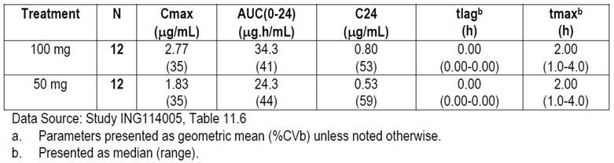
DTG exposure increased by only ~40% when dose was doubled from 50 mg to 100 mg. The relative oral bioavailability of 100 mg is estimated at 70.5% (90% CI: 59.7%, 83.3%) to that of 50 mg based on AUC. The reduced oral bioavailability at 100 mg dose versus 50 mg dose is likely a result from limited absorption due to low water solubility of this compound. While some subjects did achieve near linear increases in exposure between 50 mg and 100 mg, four subjects demonstrated only a minimal increase or no increase as the dose was doubled. Although this evaluation was performed for single dose DTG PK, such nonlinearity from 50 mg to 100 mg using tablet formulation is expected to be carried over upon repeat doses. Therefore, DTG 100 mg once daily dose is expected to have only 40% higher exposure (on average) than DTG 50 mg once daily dose due to nonlinear PK. As a result, 50 mg twice daily dose, rather than a 100 mg once daily dose, was chosen for the evaluation in Cohort 2 in the Phase IIb Study ING112961 in INI resistant subjects (VIKING) as this dosing regimen was expected to deliver predictable higher DTG exposure compared 50 mg once daily and much higher Cτ as opposed to 100 mg once daily to maximise the antiviral effect of this drug. Cτ was determined to be a better predictor of antiviral analysis of INI compared to AUC and Cmax in a meta analysis using pooled data and was expected to be one of the drivers for improved antiviral activity in the resistant population. As demonstrated in Study ING112961, DTG Cτ from 50 mg twice daily cohort was about 4-6 times of those observed from 50 mg once daily cohort and contributed partially to the better antiviral response rate for the twice daily dose. Therefore, DTG 50 mg twice daily dose was subsequently evaluated in the confirmatory Phase III study ING112574 (VIKING-3).

Evaluator’s comments on sponsor’s response
The evaluator is satisfied with the explanation provided by the sponsor.

Question 2: No information has been provided by the sponsor regarding the pharmacological activity of DTG metabolites. This should be provided.

Sponsor’s response
In the mass balance study using radiolabeled compound (ING111853), the parent drug DTG accounted for greater than 97% of the total plasma radioactivity. Thus, metabolites are present in plasma at very low concentrations. The primary metabolite, the glucuronide (M3), was a minor component corresponding to 2.4% of the 6 h, and 1.5% of the 24 h plasma pool radiochromatograms and was not quantifiable in the 48 h plasma pool radiochromatogram. Combined, DTG and M3 accounted for ~99% of the total radioactivity DTG and the primary DTG glucuronide metabolite (M3) are shown in Figure 2. The red oval encircles the oxygen atoms on the DTG scaffold which bind the Mg²⁺ ions in the catalytic pocket. All integrase strand transfer inhibitors including DTG bind to the two essential Mg²⁺ ions in the catalytic pocket of the HIV-1 intasome (integrase:HIV-1 cDNA). Of note, crystal structure of the PFV intasome in complex with strand transfer inhibitors including DTG and modelling data demonstrate that RAL, EVG, and DTGs Mg²⁺ binding activity is dependent on three oxygens (Figure 9) positioned at specific constrained distances and angles. Formation of the glucuronide blocks the central oxygen, and in addition adds a bulky ring structure which based on the tight fit in the catalytic pocket will not allow normal binding in the pocket, nor the other two oxygens (carbonyls within red circle in Figure 2) to achieve the close proximity required for Mg²⁺ binding. This molecule was not synthesised during DTG design as the structure precluded binding and it would not be active as a two metal binder of the essential Mg²⁺ ions.
Figure 9. Two dimensional structures of DTG and the DTG glucuronide primary metabolite (M3).
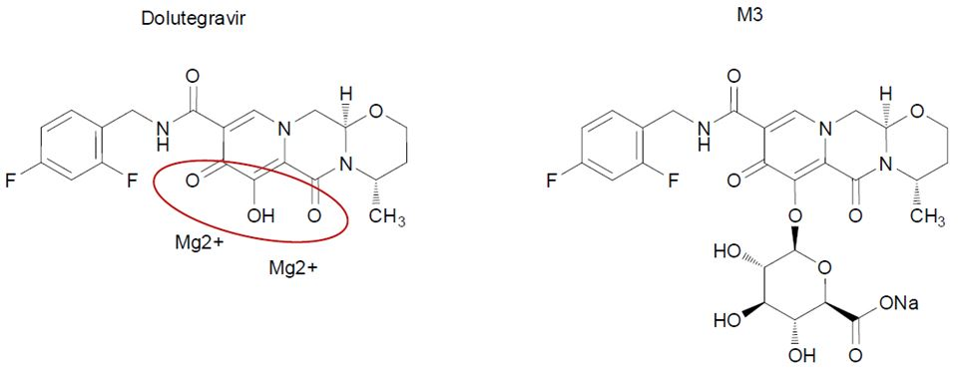

Evaluator’s comments on sponsor’s response
Although crystal structure and modelling studies can be very powerful tools for predicting the activity of unknown molecules at receptors, they require a large number of assumption to be made concerning the confirmation (shape) and energy states taken by both the molecule and the receptor.
This is can be a highly dynamic process and often several different confirmations are equally feasible and are dependent upon a range of factors such as water binding to receptor etc.
Therefore, biological activity studies, such as radio ligand binding experiments, remain the gold standard for assessing the activity of a molecule at a receptor and this is not possible if the molecule in question has not be synthesized.
However, given that M3 and the other metabolites appear at such low concentrations and that M3 contains an additional bulky ring structure, the evaluator is satisfied with the sponsor’s explanation.

Question 3: Little to no information is provided in the evaluation materials regarding the PK of the DTG metabolites, although they appear at relatively low levels the evaluator requests that the sponsor provides all information regarding the PK/PD of the DTG metabolites they have at their disposal.

Sponsor’s response
As described above in Question 2, unchanged DTG accounted for >97% of the drug related components in the systemic circulation (RM2009/00293). The similar terminal phase t1/2 values of radioactivity and of DTG indicated that the primary metabolite, the glucuronide (M3) metabolite (<3% of the drug related material), and other minor products that were present in the systemic circulation were formation rate limited and did not persist.
The glucuronide metabolite was not administered directly to determine its own PK. As noted above in Question 2, the glucuronide does not possess integrase inhibition activity. Thus there is no contribution of the metabolites to the PK/PD relationship of DTG.

Evaluator’s comments on sponsor’s response
Please see the evaluator's response to question 2.

Question 4: In Study ING115697, the BCV PK parameters were not available and it was stated that they will be included in a subsequent amended report. Is this subsequent report now available? Is any further information or data regarding the subject who fell pregnant during the trial available?

Sponsor’s response
PK data for BCV are not available. There continue to be significant problems with the assay at the contract research organisation that is performing the analysis such that the accuracy of the data cannot be confirmed. Specifically, there are significant issues with the purity of the reference standards. The sponsor is pursuing other avenues to complete the analysis and evaluating the long term stability of the samples.
In regard to the subject who became pregnant during the trial, the baby was born in January 2013. Gestation was 41 weeks. The birth was listed as normal. The baby was female with a length of 58.4 cm and weight of 3487 grams. APGAR (Appearance, Pulse, Grimace, Activity, Respiration) scores were 9 at first assessment and 10 at second assessment. The following details were provided:
Child birth went well. The child had no complications and was healthy at birth. About a week and a half later, the subject was hospitalised for 5 days due to an infection but recovered fully.

Evaluator’s comments on sponsor’s response
The evaluator accepts that the sponsor has had difficulty in determining whether the co-administration of DTG affects the PKs of BCV. However, until this information becomes available, the evaluator believes that the PI should include a statement, such as: “the effects of DTG on the PKs of BCV have not been determined.”

Question 5: Is there any data on the effect of administration timing on DTG PKs?

Sponsor’s response
The effect of administration timing on DTG PK has not been evaluated; however, no significant impact of administration timing is expected as DTG demonstrates low to moderate PK variability.
In general, diurnal variations affect drug disposition or PK through the following physiological processes: gastric emptying time, gastric and urinary pH, and blood flow to the GI tract, liver and kidneys. DTG is primarily eliminated through hepatic metabolism and renal excretion is minimal; therefore, diurnal changes in urinary pH and blood flow to the kidney are not expected to affect DTG PK. Changes in gastric pH does not affect DTG absorption and this is supported by the results from Study ING112941 which showed that omeprazole did not affect DTG PK. The oral clearance of DTG is low at approximately 1 L/h therefore is not sensitive to changes in liver blood flow. DTG has high permeability therefore changes in GI perfusion may affect DTG absorption. Variation in gastric emptying/transit time may also affect DTG absorption as DTG is probably mainly absorbed from the upper GI track. In Phase I studies, DTG PK data were mostly collected after morning doses. In Phase II/III studies, although there was not a requirement to collect DTG PK post morning dose, this was probably performed at most sites due to scheduling and working hours of site staff. Gastric emptying is slower at night time than day time therefore DTG may have better absorption at night. However, GI perfusion is expected to be lower at night time than day time therefore reduced DTG absorption may occur at night. Effects of diurnal variations in gastric emptying and GI perfusion between day and night on DTG PK are opposite and therefore the net effect is expected to be small.
In summary, the effect of administration time on DTG PK is expected to be low and not of a magnitude that would affect clinical significance.

Evaluator’s comments on sponsor’s response
The evaluator is satisfied with the explanation provided by the sponsor.

Question 6: In Study ING111856, following a supratherapeutic dose of 250 mg DTG there was a trend for higher exposure in female than in male subjects. Geometric mean ratios comparing the male and female data sets have not been provided by the sponsor, could these be provided?

Sponsor’s response
Geometric mean ratios comparing DTG PK parameters between males and females are provided in Table 28. Comparisons were performed for PK parameter estimates with or without weight adjustment to take into account of contribution of weight difference by gender. Weight adjusted AUC and Cmax were calculated as the multiplication of PK parameter and weight; Weight adjusted CL/F is calculated as CL/F divided by weight. Based on comparison results, females has 18% higher AUC, 24% higher Cmax, and 16% lower CL/F than male. When adjusted by weight, the difference between males and females diminished.
Table 28: ING111856 – summary of comparison of DTG PK parameters by gender.
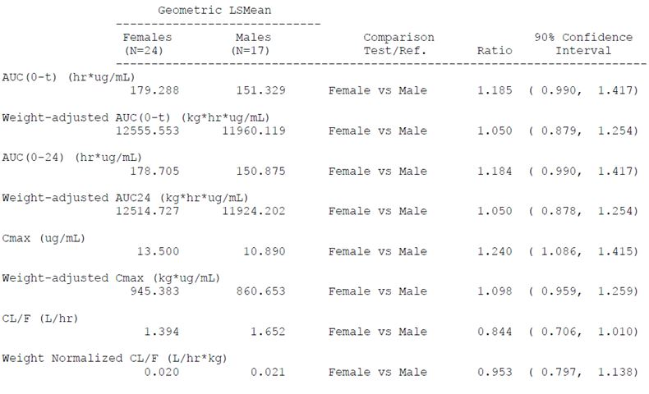

Evaluator’s comments on sponsor’s response
The evaluator is satisfied with the explanation provided by the sponsor.

Pharmacodynamics

Question 7: No information has been provided by the sponsor regarding the pharmacological activity of DTG metabolites. This should be provided.

Sponsor’s response
Please refer to response to Question 2.

Evaluator’s comments on sponsor’s response
Please see the evaluator's response to Question 2.

Efficacy

Question 8: There appears to be no justification provided for the selection of the 50 mg dose for Phase III studies. Could the sponsors please clarify this?

Sponsor’s response
As noted in the original submission, the 50 mg once daily dose for DTG in ART naïve/experienced (INI naïve) subjects was selected based on the following:
- Results from ING111521, 10 day monotherapy study in treatment naive or treatment experienced and INI naive subjects demonstrating that once daily dosing of DTG achieved viral load declines for 2 mg, 10 mg and 50 mg of 1.54, 2.04, and 2.48 log₁₀ c/mL, respectively. The 50 mg once daily dose achieved an inhibitory quotient (observed DTG concentration at the end of the dosing interval [Cτ]/fold above protein adjusted 90% inhibitory concentration [PA-IC90]) of 19, demonstrating considerable coverage above the in vitro protein adjusted target concentration of 0.064 ng/ml.
- A PK/PD analysis from ING111521 evaluated the relationship between Cτ and change in HIV RNA from Baseline. The data were fit to a maximum effect model and demonstrated that the 50 mg dose was on the plateau of the concentration response curve after monotherapy.
- ING112276, a Phase IIb dose ranging study in treatment naive subjects that evaluated DTG at doses of 10 mg, 25 mg and 50 mg once daily with 2 NRTIs compared to EFV plus 2 NRTIs. DTG was well tolerated across all doses studied.
A good safety and tolerability profile with a low discontinuation rate due to AEs was observed in all three arms with no significant dose-dependent trends in safety parameters. All three doses showed similar robust antiviral responses and no apparent dose-response relationship was observed, suggesting DTG doses from 10 mg to 50 mg once daily in combination with 2 NRTIs achieved maximum virologic suppression. Therefore, the maximal tolerated and highest dose, DTG 50mg once daily, was selected as the dose for the Phase III studies in INI naïve population. Selection of 50 mg once daily dose was also to accommodate decreases in DTG in light of drug interactions, poor absorption, imperfect adherence, or other causes.
- The metabolic inducers darunavir/ritonavir (DRV/RTV), etravirine (ETR)/DRV/RTV, EFV, fosamprenavir (FPV)/RTV, and tipranavir (TPV)/RTV decreased DTG exposure to various degrees; however, DTG exposures in the face of these interactions are still comparable to or higher than those demonstrated with 10 mg once daily dosing in ING112276.
In summary, a dose of 50 mg once daily demonstrated safety and efficacy while providing a significant coverage in plasma exposure to account for reductions due to drug interactions or other events that could decrease concentrations. This dose was selected for Phase III studies in ART naive/experienced, INI naive adult subjects. More detailed information regarding dose selection for INI naive subjects is outlined in the Week 96 clinical study report for the dose ranging study, ING112276. A summary of the rationale for dose selection from this study is provided below.
The primary objective of ING112276 was to select a DTG once daily dose for further evaluation in Phase III based on a comparison of the Week 16 antiviral activity and tolerability of a range of oral doses of DTG in HIV-1 infected therapy naive adult subjects. All doses of DTG that were assessed were anticipated to provide desirable long term efficacy in combination therapy and were based on a PK and PD analysis from the Phase IIa monotherapy data (ING111521) in INI naive subjects. Because it was intended that one dose be selected for patients naive to INI, to compensate for moderate drug-drug interactions with other antiretrovirals and other situations that decrease DTG exposures (for example, renal insufficiency), an a priori dose selection strategy was adopted to select the highest maximum tolerated dose of DTG from ING112276. Therefore, if comparable efficacy, safety and tolerability were observed across all 3 DTG doses at 16 and 24 Weeks in ING112276, the DTG 50 mg dose was to be selected for further investigation in Phase III. Stopping rules which were agreed a priori are outlined in Protocol ING112276.
Based on comparison of virological markers of HIV infection, the proportion of subjects who achieved HIV-1 RNA <50 c/mL (TLOVR) by Week 16 (and confirmed at Week 24) were substantially higher at Week 16 in the DTG treatment arms (≥90%) across all three doses, compared to the EFV treatment arm (60%). The proportion of subjects across the DTG treatment arms achieving HIV-1 RNA <50 c/mL (TLOVR) continued to be higher than in the EFV treatment arm (≥90% versus 78%) at Week 24. No dose of DTG met the a priori criteria of having 4 fewer responders than the next highest dose at either timepoint.
DTG was well tolerated across all doses studied. At the Week 16 analysis, a greater percentage of subjects receiving EFV reported Grade 2 or higher AEs (50%) versus subjects receiving DTG (26%). At that time, the incidence of GI AEs was 5% overall for the DTG treatment arms and 8% for EFV. DTG continued to be well tolerated at the Week 24 analysis, with 50% of subjects receiving EFV reporting Grade 2 or higher AEs versus 30% of subjects receiving DTG. The incidence of GI AEs remained low overall (6% for the DTG treatment arms, 10% for EFV). No dose of DTG met the a priori criteria of having 7 or more subjects with Grade 2 or higher GI AEs than the EFV control group at the Week 16 timepoint, and this was confirmed at Week 24.
At the time of the Week 16 analysis (and confirmed at Week 24), no apparent dose response relationships were observed with specific treatment emergent laboratory abnormalities within DTG treatment arms, including those chemistries specified in the a prior stopping rule. There were no Grade 3 ALT elevations in any of the DTG treatment arms or the EFV group at either timepoint. The overall frequency of lipase elevations was higher on DTG doses (18%) than EFV (12%) at both the Week 16 and 24 timepoints; in DTG subjects these elevations were transient and asymptomatic. There were only three Grade 3 lipase elevations in the DTG arms (25 mg, 2 subjects; 50 mg, 1 subject). The only lab parameter with consistent, mild (Grade 1) abnormalities was a creatinine increase in the DTG 25 mg dose, along with an approximate 10% increase in mean creatinine values. These changes were observed at Week 1 and remained constant to Week 16 after which the values appear to begin to trend back toward baseline. Additional investigations indicate that the creatinine changes are likely related to a benign condition of blocking creatinine secretion.
After review of the efficacy, safety and tolerability across all doses at Week 16 (and confirmed at Week 24) from ING112276, the 50 mg dose was selected for further investigation in Phase III studies of INI-naive subjects.
A discussion of dose confirmation from the Phase III studies of INI naive subjects is included in the original submission.

Evaluator’s comments on sponsor’s response
The selected dose of 50 mg has been justified adequately and it did prove safe and effective in the clinical trials submitted.

Question 9: Statistical analyses have been or will be performed in ongoing studies at 24, 48 and 96 week intervals. Please provide additional justification for not adjusting the analyses for multiplicity.

Sponsor’s response
The primary analysis was performed at Week 48 for studies ING113086, ING114467, and ING111762. No adjustment was made for analyses at other timepoints as those analyses were considered to be secondary. Since analyses at other timepoints were considered to be merely supportive of the analyses at the primary timepoint, no multiplicity adjustment was considered to be necessary.
The primary analysis for the study ING112574 was performed at Day 8 and Week 24.
Given that this is a single treatment arm study, no adjustments for multiplicity regarding treatment effect were made.

Evaluator’s comments on sponsor’s response
The sponsor argues that only the 48 week analysis was required to confirm the primary endpoint and that additional analyses at other time points were only supportive. This is not unreasonable.

Question 10: Median compliance data were not provided in the appropriate section of the SPRING-2 study report. Please provide.

Sponsor’s response
When assessing adherence, issues with unreliable/missing information, sensitivity to assumptions, and lack of clear reporting standards have been described previously by Farmer and colleagues and recently by Baisley and colleagues. Given such limitations for obtaining meaningful data, particularly when based on pill counts, a quantitative calculation of compliance was not defined for the SPRING-2 study.
Pill count data was collected in this study primarily to drive conversations between the subject and investigator to ensure adherence during the study. Adherence was assessed quantitatively in the SAILING study as that was felt to be the study that could obtain the most potential from the pill count information.
For the SAILING study overall imputed adherence rates were well balanced across the DTG and RAL groups, with median adherence in the category of ≥95% to <100% in both groups. Findings are further described the 24 week SAILING clinical study report (CSR) (original submission).

Evaluator’s comments on sponsor’s response
Compliance data were not provided for the SPRING-2 study because the sponsors consider pill counts to be unreliable index of compliance and they were not performed. This may be correct but pill counts were included in the other Phase 3 studies. Whatever the merits of the argument, the omission does not invalidate the conclusions of the SPRING-2 study.

Question 11: The distribution of study sites listed in the VIKING-3 synopsis does not add up to 65. Please clarify.

Sponsor’s response
Unfortunately, there is a typographical error in the synopsis of the clinical study report for ING112574, the number of sites in the EU is 27 and not 23 as cited. Together with the 35 sites in the US and 3 in Canada, the total number of sites at 65 is correct as cited. Details of the 65 sites are provided in Modular Appendix F of the report (original submission, ING112754 [VIKING-3], List of Investigators and Sites).

Evaluator’s comments on sponsor’s response
The sponsors have clarified a typographical error and the number of sites is confirmed to be 65.

Question 12: The clinical evaluator sought confirmation of the primary endpoint and satisfactory Week 48 tolerability data for Study ING111762 (SAILING).

Sponsor’s response
The 48 week SAILING data extend and confirm the safety and efficacy results observed at Week 24. At Week 48, the proportion of subjects who achieved HIV-1 RNA <50 c/mL (Snapshot/MSDF algorithm) was statistically superior in favour of the DTG treatment group (71%) compared to the RAL treatment group (64%) (adjusted treatment difference [DTG-RAL]: 7.4%; 95% CI: [0.7, 14.2], p = 0.030). These results are consistent and confirmatory with the superiority demonstrated in the Week 24 interim analyses (DTG: 79%; RAL: 70%; [adjusted treatment difference (DTG-RAL): 9.7%; 95% CI: (3.4, 15.9), p = 0.003]). The Week 48 safety/tolerability profile was also consistent with that seen at Week 24, with no newly identified signals in either treatment arm.
The Week 48 synopsis and manuscript recently published in Lancet are provided with this response.

Primary Endpoint
The primary endpoint of the study was the proportion of subjects in the Modified Intent to Treat Exposed (mITT-E) population with plasma HIV-1 RNA <50 c/mL at Week 48 based on the outcomes of the FDA “Snapshot (MSDF)” algorithm.
At Week 48, 71% of subjects receiving DTG and 64% of subjects receiving RAL achieved the primary endpoint (Table 29). This difference in response was statistically significant with a 95% CI for the adjusted difference of 0.7% to 14.2% (p = 0.030). This result is supported by the PP analysis where 73% and 66% of DTG and RAL subjects, respectively, achieved plasma HIV-1 RNA <50 c/mL at Week 48 (adjusted treatment difference and 95% CI: 7.5 [0.6, 14.3], Table 30).
Table 29: Proportion of patients with plasma HIV-1 RNA <50 c/mL at Week 48 (mITT-E population).
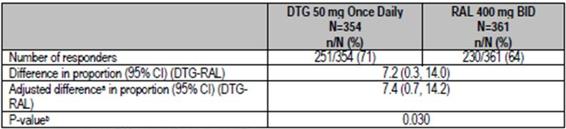
Table 30: Proportion of patients with plasma HIV-1 RNA <50 c/mL at Week 48 (PP Population).
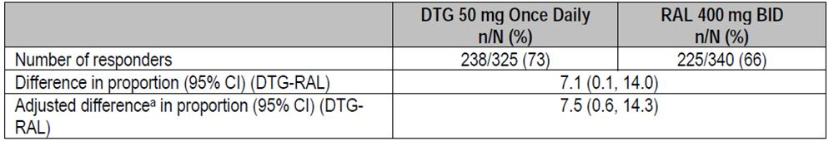
^{a.} Based on Cochran-Mantel Haenszel stratified analysis adjusting for the following baseline stratification factors: baseline HIV-1 RNA, DRV/r use without primary PI mutations, and baseline PSS.

Study Outcomes based on Plasma HIV-1 RNA <50 c/mL at Week 48
The study was designed to demonstrate non inferiority of DTG versus RAL and the analysis met this criterion; statistical superiority was concluded as part of a prespecified testing procedure. This finding was primarily driven by virologic outcomes (Table 31): more subjects on RAL had ‘data within the window not <50 c/mL’ (DTG: 10%; RAL: 13%) and discontinuations due to lack of efficacy (DTG: 5%; RAL: 10%). Superiority of DTG was also achieved in supportive analyses using a treatment related discontinuation imputation approach to address missing HIV-1 RNA data at Week 48, and analyses of time to Protocol Defined Virologic Failure or treatment/efficacy related discontinuation.
Table 31: SAILING trial outcomes (plasma HIV-1 RNA <50c/mL) at Week 48.
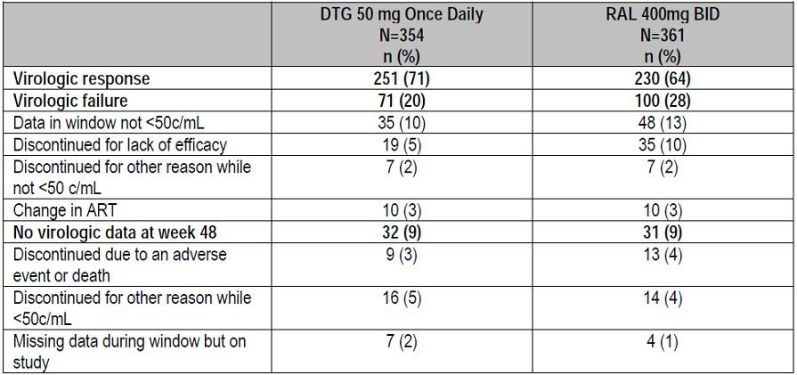

Plasma HIV-1 RNA <50 c/mL Over Time
The proportion of subjects with plasma HIV-1 RNA <50 c/mL using MSDF analysis for the mITT-E Population increased steeply in both treatment groups from Baseline to Week 4, then tended to plateau starting at Week 8 onward (Figure 10). Both treatment groups followed a similar pattern, but higher values were noted for DTG compared to RAL at all timepoints assessed.
Figure 10. Proportion (95% CI) of subjects with plasma HIV-1 RNA <50 c/mL by visit – snapshot (MSDF) analysis (mITT-E population).
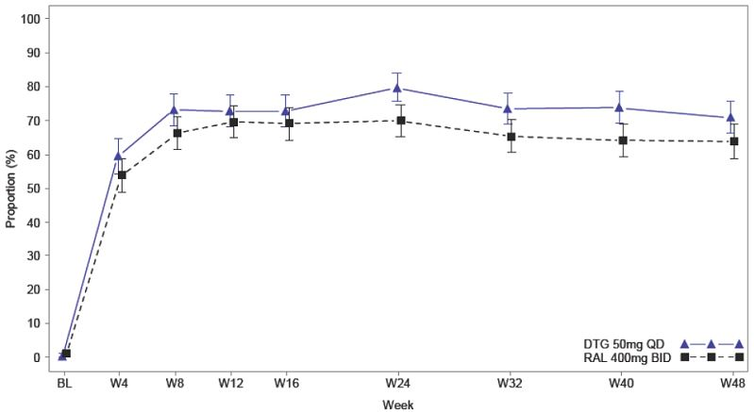

Subgroup analysis of SAILING trial primary outcomes

Plasma HIV-1 RNA <50 c/mL at Week 48 by Strata Related to Randomisation
Results were summarised by Baseline HIV-1 RNA (≤ and ≥50 000 c/mL), DRV/r use in the presence of primary PI mutations or no DRV/r use versus DRV/r use in the absence of primary mutations, and by the number of fully active background agents as measured by PSS at baseline (2 and <2) (Table 32).
Table 32: Proportion of subjects responding based on plasma HIV-1 RNA <50 c/mL at Week 48 by strata – snapshot (MSDF) analysis (mITT-E Population).
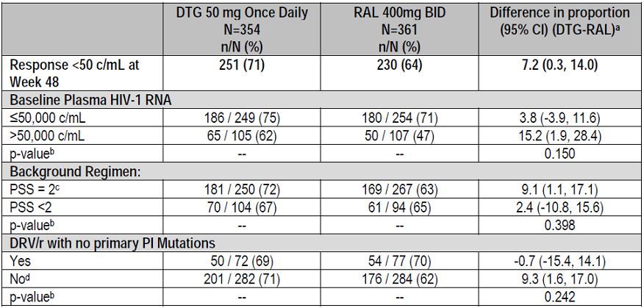
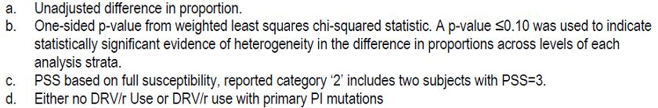
In terms of covariate main effects, baseline plasma HIV-1 RNA >50,000 c/mL was associated with lower response rates for both DTG and RAL. DTG treated subjects had a numerically better response when added to a regimen containing 2 fully active agents compared to <2 (PSS = 2: 72% versus PSS = <2: 67%); whereas RAL response rates were similar regardless of the number of fully active background agents (PSS = 2: 63% versus PSS = <2: 65%). DTG response rates were similar within the dichotomous subgroup for background regimen ‘use of DRV/r without Primary PI mutations’ (yes = 69%; no = 71%), in contrast to RAL, which had varying response rates (yes = 70%; no = 62%).
The hypothesis of a common treatment effect within each randomisation subgroup could not be ruled out statistically; p values for evidence of heterogeneity were all greater than 15%. However, point estimates suggest smaller increased benefit of DTG in subjects with PSS <2 or Baseline plasma HIV-1 RNA ≤50,000 c/mL, and no difference between DTG and RAL in subjects whose background regimen included the use of DRV/r in the absence of primary PI mutations.

Plasma HIV-1 RNA <50 c/mL at week 48 by demographic and baseline

Characteristic subgroups
Antiviral response rates within demographic and baseline characteristic were generally higher for subjects receiving DTG compared to subjects receiving RAL, with the exception of subjects older than 50 years (DTG: 65%; RAL: 69%) or subjects with Centres for Disease Control (CDC) category B (DTG: 56%; RAL: 70%) (Table 33).
Table 33: Proportion of subjects with plasma HIV-1 RNA <50 c/mL at Week 48 across demographic subgroups.
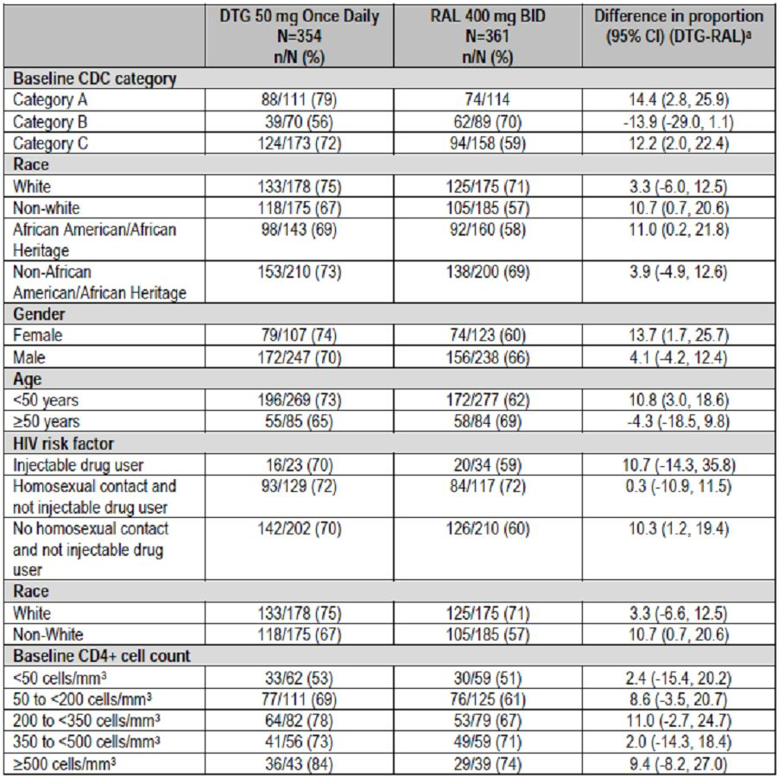
Heterogeneity of the treatment effect within the age subgroup (< 50 years versus ≥ 50 years) and the CDC category subgroup, respectively, was assessed by fitting a logistic-regression model that included factors for treatment group, baseline randomization strata, the relevant subgroup, and the interaction between treatment and subgroup. The test for treatment by age interaction was marginally significant (p = 0.062, although above the pre specified 5% Type I error cut off) and the test for treatment by CDC category was statistically significant (p = 0.004).
The lower response rate on DTG compared to RAL observed in subjects older than 50 years of age was the result of more subjects on DTG being classified as non responders due to having no virologic data at Week 48 (DTG: 13% versus RAL: 5%) and not for reasons related to virologic failure (DTG: 22% versus RAL: 26%).
Treatment with DTG is associated with higher response rates across all baseline CD4+ cell count subgroups than treatment with RAL (Table 13).

Safety and tolerability
Details on the safety at Week 48 are provided in the ING111762 Week 48 CSR synopsis. Over the duration of this analysis, the overall safety profile for DTG was comparable to RAL, with similar rates of AEs in both treatment groups and low rates of discontinuation due to AEs in both groups (DTG 2%, RAL 4%). Similar rates of occurrence in both arms for diarrhoea, nausea, vomiting, and fatigue (most common drug related AEs) were observed. There were similar rates for serious adverse events (SAEs), overall and by System Organ Class (SOC), and similar rates for Grade 2 to 4 AEs. There were similar incidence rates for graded laboratory toxicities. As noted in the Week 24 report and confirmed again in this Week 48 analysis, across the entire study population, a similar hepatic profile was observed for DTG and RAL. No additional significant cases of hepatitis were noted in the Week 48 analysis in the DTG treatment arm, and differences noted at Week 24 in subjects with co-infection were similar at Week 48.

Conclusions

Efficacy
- These results demonstrate that a DTG 50 mg once daily containing regimen is more efficacious than a standard of care regimen for treatment experienced subjects and therefore is an appropriate dose for the treatment experienced, integrase naïve population.
- DTG is superior to RAL using the Snapshot (MSDF) algorithm for the proportion of subjects with plasma HIV-1 RNA <50 c/mL at Week 48. Superiority was also achieved in the pre specified sensitivity analyses (PP and TRDF/ERDF analyses).
- Within subgroups defined by the baseline randomisation strata treatment differences were generally supportive of the overall treatment difference; however, DTG and RAL response rates were similar for subjects receiving DRV/r without primary PRO inhibitor mutations.

Safety
- The safety profile for DTG was similar to RAL, with similar rates of occurrence in both arms for the most common AEs and low rates of discontinuation due to AEs for both DTG and RAL.
- No serious hypersensitivity events were observed, and there was no increased risk for DTG compared to RAL for hypersensitivity events.
- Other serious conditions that are labelled for RAL, such as serious rash (for example, Stevens Johnson syndrome, toxic epidermal necrolysis, or erythema multiforme) were not observed in this study.
- Across the entire study population, a similar hepatic profile was observed for DTG and RAL.
  - Subjects with hepatitis B co-infection receiving DTG were noted to have significant liver chemistry elevations in the setting of HIV virologic and immunologic responses to DTG and withdrawal or lack of HBV active therapy.
  - The pattern of injury is likely consistent with IRIS and/or HBV flare in the setting of inadequate HBV therapy rather than direct liver injury due to DTG.
  - Subjects with hepatitis C co-infection may be at greater risk of HCV IRIS with DTG due to improved HIV virologic responses versus RAL.
- Based on Week 48 data, there appears to be no increased risk of renal toxicity for DTG compared to RAL.
- Mild to moderate general GI intolerance (mainly diarrhoea and nausea) is associated with DTG treatment in a small proportion of subjects; however nonclinical findings for GI erosions did not translate into significant clinical findings.
- There was no increased risk for psychiatric disorders for DTG over RAL.
- Based on Week 48 data, there appears to be no increased risk of musculoskeletal disorders with DTG compared to RAL.
- There is no evidence from this study for increased risk of torsades de pointes with DTG.
- There was no untoward effect on the overall lipid profile in either treatment group.

Evaluator’s comments on sponsor’s response
As requested, the sponsor has provided a synopsis of the Week 48 data with a CSR available on request. The study has also been published in Lancet.
The SAILING study was designed as a non inferiority study and the primary efficacy endpoint was the proportion of patients who achieved HIV-1 RNA <50 c/mL at Week 48 in the Intention to Treat set. The outcomes observed at Week 24 were confirmed at Week 48. At Week 24, 79% of DTG patients achieved a response compared with 70% of RAL patients with an adjusted treatment difference of 9.7% (95% CI: 3.4, 15.9, p = 0.003). At Week 48, there was still a statistically significant benefit in favour of DTG (71% response) compared with RAL (64%). The adjusted treatment difference at Week 48 was 7.4% (95% CI: 0.7, 14.2, p = 0.03). The finding was confirmed in the PP set with Week 48 response rates of 73% and 66% in the DTG and RAL groups, respectively. The adjusted treatment difference was 7.5% (95% CI: 0.6, 14.3). At Week 48, virologic failure had occurred in 20% of DTG patients compared with 28% in the RAL group. The antiviral response rates within demographic and baseline characteristics were generally higher in DTG patients compared with RAL. Exceptions were patients aged >50 years (DTG 65%, RAL 69%) and patients with CDC category B disease (DTG 56%, RAL 70%).
No new safety signals were detected at Week 48. The overall safety profile was similar in the DTG compared with RAL with low rates of withdrawal due to AEs (DTG 2%, RAL 4%). The most common drug related AES were diarrhoea, nausea, vomiting and fatigue but the incidence was similar in both treatment groups. The rates, SOC and grading of SAEs were similar in both treatment groups. No significant cases of hepatitis or serious hypersensitivity events were recorded after Week 24 in either treatment group.
Overall, the significant benefits in favour of DTG observed at Week 24 were sustained until Week 48 and no new safety issues were identified.

Question 13: For Study P1093, the clinical evaluator noted that PK variability is similar to that observed in adults but efficacy and safety data are available for only 10 patients. The clinical evaluator stated that it would be prudent to report the full Cohort 1 with an additional 12 patients at 24 weeks before the positive findings are acceptable.

Sponsor’s response
At this time, P1093 is ongoing; results presented here include Cohort I, Stage 1 and Stage II through Week 24 (n = 23 subjects) with a data cut off date of 17 December 2012.
By the time of the 17 December 2012 data freeze date, all 23 subjects in Cohort I, Stages I and II had completed the Week 24 visit and 17 had reached the Week 48 visit.
The P1093, Cohort I, Week 24 CSR is provided with this response.
The treatment dosing regimen assignments used were based on DTG tablet QD doses with target dose of ~1 mg/kg across two weight bands, and maximum dose of 50 mg.
The treatment dosing regimen assignments specifically used for Cohort I were:
- DTG 35 mg QD + OBR for subjects weighing 30- <40kg (n = 4)
- DTG 50 mg QD + OBR for subjects weighing ≥ 40kg (n = 19)
(One subject started on DTG 35mg, then based on body surface area (BSA)/weight change the DTG dose was later increased to 50 mg.)
The 23 subjects included here had extensive prior antiretroviral exposure, with a median of 13 years of treatment. Of these, 100%, 52% and 78% had prior exposure NRTI, NNRTI, and PRO inhibitor experience, respectively.

Summary of cohort I, stage I and stage II
Subject accountability is shown in Tables 34-36.
Table 34: Subject accountability.
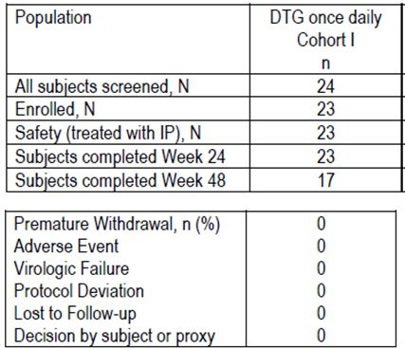
Table 35: Summary of demographic characteristics (AT Population).
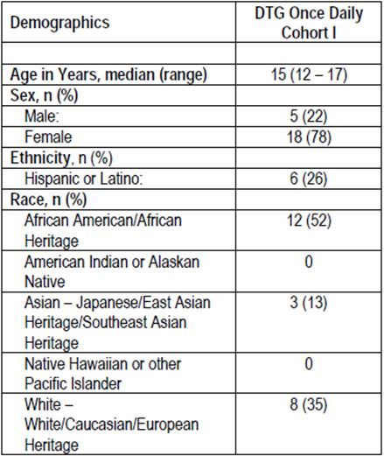
Table 36: Summary of baseline characteristics (AT Population).
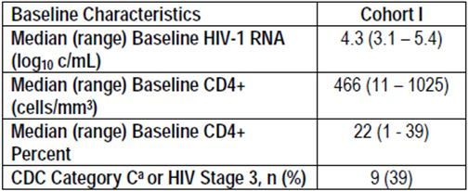

Safety
There were no new safety issues identified in this cohort of subjects beyond those observed in the adult population. Overall, in this population of adolescent subjects, DTG dosed at 35 mg and/or 50 mg once daily was well tolerated when administered with OBT. There were no Grade 3 or greater AEs, no discontinuations due to an AE, no SAEs and no AEs reported as related to DTG (Table 37).
Table 37: Summary of all clinical AEs for Cohort I worst grade for each subject (incidence >1 subject) (AT Population).
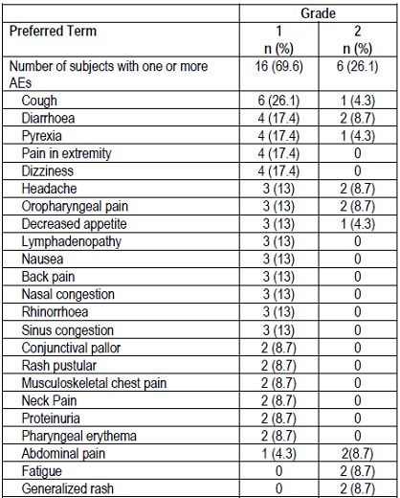

Laboratory
Laboratory events were reported by 21 (91.3%) subjects; none were serious or clinically significant by the investigator. There were no trends in treatment emergent laboratory abnormalities. As observed in adults, small mean and/or median non progressive increases in creatinine and bilirubin were observed. As previously noted in adult subjects receiving DTG, small mean increases in total bilirubin were observed, likely related to the metabolism of DTG and competitive use of UGT 1A1 enzyme. No subjects experienced significant elevations in liver enzymes in conjunction with bilirubin increases, and importantly, no subjects met liver stopping criteria. Overall, the hepatic safety profile for DTG appears favourable in 12-18 year old paediatric subjects.
Two subjects reported Grade 3 laboratory events. One subject reported an asymptomatic elevated lipase at Day 344 (Week 48). Along with DTG, the subject is being treated with Darunavir 800 mg, abacavir/lamivudine 600/300 mg, and RTV 100 mg daily. On Day 347, the subject returned for repeat chemistry/ lipase levels. The lipase level remained at Grade 3 (268 U/L). The AST (30 U/L), ALT (38 U/L), and ALP (244 U/L) values all remained normal. The subject offered no complaints and remained asymptomatic.
Treatment medications were withheld approximately 2 weeks and the subject was retested on Day 373; at that time the lipase had decreased to Grade 2 (104 U/L) and medications were restarted. A Grade 3 blood bilirubin increase (2.6 mg/dL) was also reported in another subject at Day 2 and was considered related to ATV; neither of the laboratory events were considered related to DTG.
Overall, no clinically significant changes from baseline in laboratory parameters were observed No clinically significant trends in change from baseline in liver chemistries were observed. Small increases in mean and median total bilirubin were noted. There were no clinically significant findings in the summary of urinalysis.

Pharmacokinetics
Intensive PK and safety from Cohort I, Stage I subjects supported enrolment of Stage II in Cohort I and supported further DTG initiation and evaluation in the next younger paediatric cohort, that is, 6-12 year olds. Sparse PK data is not available at this time.

Efficacy
The efficacy data analysis results presented here was designed to use the MSDF Snapshot approach, but there was no missing data at the key time points of baseline and Week 24. All subjects were able to include at least one active drug in their Optimised Background Therapy.
A sustained antiviral response was observed as shown in Table 32.
Table 32: Proportion of subjects with plasma HIV-1 RNA <400 c/mL (AT Population).
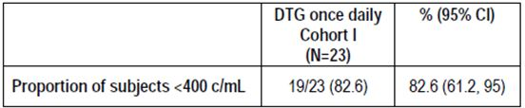
The 4 subjects who failed to achieve HIV-1 RNA <400 c/ml had documented adherence problems. Sixteen (70 %) of the subjects had plasma HIV-1 RNA <50 c/mL at Week 24 .and 20 out of 23 subjects (87%) had > 1 log₁₀ c/m: decrease from Baseline in HIV-1 RNA or HIV-1 RNA < 400 c/mL at Week 24. There was a median gain of 63 cells/mm³ in CD4 count and a median absolute gain of 4.9 in CD4 percent.

Evaluator’s comments on sponsor’s response
At the time of the 17 December 2012 interim data lock date, all 23 patients in Cohort 1, Stages 1 and 2, had completed the Week 24 visit. At Week 24, 19/23 patients (82.6%, 95% CI: 61.2, 95.0) had achieved a reduction in HIV-1 RNA <400 c/mL. The four patients who did not achieve a virologic response had a documented history of poor compliance. Sixteen (70%) patients had plasma HIV-1 RNA <50 c/mL at week 24 and 20 patients (87%) had >1 log₁₀ c/mL decrease from baseline. There was a median gain in CD4 count of 63 cells/mm³.
No new safety issues were identified and the safety profile in adolescents was similar to the adult population. There were no AEs Grade 3 or greater, no discontinuations due to an AE, no SAEs and no drug related AEs. No significant hepatic events were recorded.
The additional data to Week 24 confirms a sustained antiviral response in adolescents which matches the response rates achieved in adults. The safety profile of DTG also appears similar to that of the adult population.

Safety

Question 14: Why were ECGs not recorded in Study ING112578?

Sponsor’s response
As per ICH E14 guidance, when a thorough QT/QTc study (TQTS) is interpreted as negative:
“...the collection of baseline and periodic on-therapy ECGs in accordance with the current investigational practices in each therapeutic field is almost always sufficient evaluation during subsequent stages of drug development.”
The cardiovascular assessments of DTG indicated no increased risk for cardiac repolarisation or other cardiac conduction abnormalities. For the DTG development program, the nonclinical (that is, hERG and monkey CV study) and early clinical (Phase I/IIa ECG data) indicated that DTG did not carry an increased risk for QT prolongation and/or torsades de pointes. Further, a thorough QT/QTC study (ING111856) with DTG, designed and executed in accordance with ICH E14 guidance, showed that DTG had no effect on cardiac repolarisation at a supratherapeutic dose of 250 mg suspension. The study was sensitive enough to detect the effect of moxifloxacin, the positive control, on QTcF, which confirms that this study is valid for assessing the effects of DTG on cardiac repolarisation.
Without evidence for an increased risk of cardiac repolarisation or other conduction abnormalities, the assessments in ING112578 followed standard of care for paediatric HIV practice with respect to cardiac assessments. As such, ECG assessments would not typically be performed in this patient population and were not included in ING112578. Further, ECG assessments from adult Phase III studies and AEs from the adult and paediatric studies indicate that DTG does not have an increased risk for cardiac repolarization or other conduction abnormalities.

Evaluator’s comments on sponsor’s response
The sponsors argue that ECGs will not provide useful information when a negative thorough QTc study has already been conducted. They also argue that ECGs are not routinely performed in paediatric practice. Neither argument is sound. Conduction abnormalities are not the only potential cardiac toxicity and clinical trials rarely follow routine adult or paediatric practice. While not accepting the argument, the omission is not sufficient to invalidate the study conclusions.

Second round benefit-risk assessment

Second round assessment of benefits
After consideration of responses to clinical questions, the benefits of DTG in the proposed usage are unchanged from the first round assessment.

Second round assessment of risks
After consideration of responses to clinical questions, the risks of DTG in the proposed usage are unchanged from the first round assessment.

Second round assessment of benefit-risk balance
All questions have been addressed and no additional clarification is sought. The positive safety and efficacy Week 48 findings reported in the SAILING study synopsis and Lancet publication are sufficient to expedite approval for the use of DTG in adults. The additional Week 24 safety and efficacy data in the adolescent study ING112578 are sufficient to support approval in this age group.
After consideration of responses to clinical questions, the benefit-risk balance of DTG in the proposed usage are unchanged from the first round assessment.

Second round recommendation regarding authorisation
The issues identified in the first round have been addressed. Authorisation is recommended for the following indication:
For the treatment of human immunodeficiency virus (HIV) infection in combination with other antiretroviral agents in adults and children over 12 years of age.

References
Centers for Disease Control and Prevention (CDC) (1992) 1993 revised classification system for HIV infection and expanded surveillance case definition for AIDS among adolescents and adults. MMWR 41(No. RR-17): 1-19.
Hare S, et al. (2010) Molecular mechanisms of retroviral integrase inhibition and the evolution of viral resistance. Proc Natl Acad Sci USA 107: 20057-20062.
Hare S, et al. (2011) Structural and Functional Analyses of the Second-Generation Integrase Strand Transfer Inhibitor Dolutegravir (S/GSK1349572). Molecular Pharmacology 80: 565-572.
DeAnda, F, et al. (2010) Structural models of HIV-1 integrase and DNA in complex with S/GSK1349572, raltegravir, or elvitegravir: structure-based rationale for INI resistance profiles. Antiviral Ther. 15(Suppl. 2):A73.
Farmer KC. (1999) Methods for measuring and monitoring medication regimen adherence in clinical trials and clinical practice. Clin Ther. 21: 1074-90.
Baisley K, et al. (2013) Summary measure of adherence using pill counts in two HIV prevention trials: the need for standardization in reporting. AIDS 17: 3108-3119.

European Medicines Agency, “Committee for Medicinal Products for Human Use (CHMP): Guideline on the Clinical Development of Medicinal Products for the Treatment of HIV Infection (EMEA/CPMP/EWP/633/02)”, 20 November 2008.
Hare S, et al. (2010) Molecular mechanisms of retroviral integrase inhibition and the evolution of viral resistance. Proc Natl Acad Sci USA. 107: 20057-20062; Hare S, et al. (2011) Structural and functional analyses of the second-generation integrase strand transfer inhibitor dolutegravir (S/GSK1349572). Mol Pharmacol. 80: 565-572.
DeAnda F, et al. (2010) Structural models of HIV-1 integrase and DNA in complex with S/GSK1349572, raltegravir, or elvitegravir: structure-based rationale for INI resistance profiles. Antiviral Ther. 15(Suppl. 2): A73.
Farmer KC. (1999) Methods for measuring and monitoring medication regimen adherence in clinical trials and clinical practice. Clin Ther. 21: 1074-1090.
Baisley K, et al. (2013) Summary measures of adherence using pill counts in two HIV prevention trials: the need for standardisation in reporting. AIDS Behav. 17: 3108-3119.
Cahn P, et al. (2013) Dolutegravir versus raltegravir in antiretroviral-experienced, integrase-inhibitor-naive adults with HIV: week 48 results from the randomised, double-blind, non-inferiority SAILING study. Lancet 382: 700-708.
Cahn P, et al. (2013) Dolutegravir versus raltegravir in antiretroviral-experienced, integrase-inhibitor-naive adults with HIV: week 48 results from the randomised, double-blind, non-inferiority SAILING study. Lancet 382: 700-708.
US Food and Drug Administration, “Guidance for Industry: E14 Clinical Evaluation of QT/QTc Interval Prolongation and Proarrhythmic Potential for Non-Antiarrhythmic Drugs”, October 2005.
Cahn P, et al. (2013) Dolutegravir versus raltegravir in antiretroviral-experienced, integrase-inhibitor-naive adults with HIV: week 48 results from the randomised, double-blind, non-inferiority SAILING study. Lancet 382: 700-708.

