June 2020

Australian Public Assessment Report for Dinutuximab beta
  - Proprietary Product Name: Qarziba
  - Sponsor: Emerge Health Pty Ltd

About the Therapeutic Goods Administration (TGA)
- The Therapeutic Goods Administration (TGA) is part of the Australian Government Department of Health and is responsible for regulating medicines and medical devices.
- The TGA administers the Therapeutic Goods Act 1989 (the Act), applying a risk management approach designed to ensure therapeutic goods supplied in Australia meet acceptable standards of quality, safety and efficacy (performance) when necessary.
- The work of the TGA is based on applying scientific and clinical expertise to decision-making, to ensure that the benefits to consumers outweigh any risks associated with the use of medicines and medical devices.
- The TGA relies on the public, healthcare professionals and industry to report problems with medicines or medical devices. TGA investigates reports received by it to determine any necessary regulatory action.
- To report a problem with a medicine or medical device, please see the information on the TGA website <https://www.tga.gov.au>.

About AusPARs
- An Australian Public Assessment Report (AusPAR) provides information about the evaluation of a prescription medicine and the considerations that led the TGA to approve or not approve a prescription medicine submission.
- AusPARs are prepared and published by the TGA.
- An AusPAR is prepared for submissions that relate to new chemical entities, generic medicines, major variations and extensions of indications.
- An AusPAR is a static document; it provides information that relates to a submission at a particular point in time.
- A new AusPAR will be developed to reflect changes to indications and/or major variations to a prescription medicine subject to evaluation by the TGA.

Copyright
© Commonwealth of Australia 2020
This work is copyright. You may reproduce the whole or part of this work in unaltered form for your own personal use or, if you are part of an organisation, for internal use within your organisation, but only if you or your organisation do not use the reproduction for any commercial purpose and retain this copyright notice and all disclaimer notices as part of that reproduction. Apart from rights to use as permitted by the Copyright Act 1968 or allowed by this copyright notice, all other rights are reserved and you are not allowed to reproduce the whole or any part of this work in any way (electronic or otherwise) without first being given specific written permission from the Commonwealth to do so. Requests and inquiries concerning reproduction and rights are to be sent to the TGA Copyright Officer, Therapeutic Goods Administration, PO Box 100, Woden ACT 2606 or emailed to <tga.copyright@tga.gov.au>.

Contents
Common abbreviations 4
I. Introduction to product submission 7
Submission details 7
Product background 8
Regulatory status 10
Product Information 10
II. Registration timeline 10
III. Submission overview and risk/benefit assessment 11
Quality 11
Nonclinical 12
Clinical 12
Risk management plan 26
Risk-benefit analysis 28
Outcome 32
Attachment 1. Product Information 34

Common abbreviations
Abbreviation | Meaning
13-cis-RA | 13-cis-retinoic acid
ACM | Advisory Committee on Medicines
ADA | Anti-drug antibody
ADCC | Antibody-dependent cell-mediated cytotoxicity
AE | Adverse event
ALT | Alanine aminotransferase
AST | Aspartate aminotransferase
BSA | Body surface area
CD | Cluster of differentiation
CDC | Complement-dependent cytotoxicity
ch14.18 | Dinutuximab (antibody name)
ch14.18/CHO | Dinutuximab beta (antibody name)
CHMP | Committee for Medicinal Products for Human Use (EU)
CLS | Capillary leak syndrome
CMI | Consumer Medicines Information
COG | Children’s oncology group
CPD | Certified product details
CR | Complete response
CRS | Cytokine release syndrome
DLP | Data lock point
EFS | Event-free survival
EMA | European Medicines Agency (EU)
EU | European Union
EU-RMP | European Union risk management plan
FAS | Full analysis set
GCP | Good Clinical Practice(s)
GD2 | Ganglioside disialic acid 2
GFR | Glomerular filtration rate
GM2 | Ganglioside monosialic acid 2
GM-CSF | Granulocyte-macrophage colony-stimulating factor
GvHD | Graft versus host disease
GVP | Good Pharmacovigilance Practice(s)
HACA | Human anti-chimeric antibodies
Haplo-SCT | Haploidentical stem cell transplant
Ig | Immunoglobulin
IgG1 | Immunoglobulin G1
IL-2 | Interleukin 2
INRG | International Neuroblastoma Risk Group
INSS | International Neuroblastoma (Risk Group) staging system
IV | Intravenous
NCI CTC | National Cancer Institute common toxicity criteria
NK | Natural killer
NSAID | Nonsteroidal anti-inflammatory drugs
ORR | Overall response rate
OS | Overall survival
PD | Pharmacodynamic(s)
PK | Pharmacokinetic(s)
PR | Partial response
PSUR | Periodic safety update report
R1 | First randomisation cohort in the SIOPEN HR-NBL1 trial
SAE | Serious adverse event
SC | Subcutaneous
SIOPEN | International Society of Paediatric Oncology European Neuroblastoma
T_{1/2} | Half-life
TEAE | Treatment emergent adverse event
USA | United States of America

I. Introduction to product submission

Submission details
Type of submission: | New biological entity
Decision: | Approved
Date of decision: | 17 March 2020
Date of entry onto ARTG: | 2 April 2020
ARTG number: | 321016
Black Triangle Scheme | Yes  This product will remain in the scheme for 5 years, starting on the date the product is first supplied in Australia.
Active ingredient: | Dinutuximab beta
Product name: | Qarziba
Sponsor’s name and address: | Emerge Health Pty Ltd  Suite 3, 22 Gillman Street,  Hawthorn East, VIC 3123
Dose form: | Solution
Strength: | 4.5 mg/mL
Container: | Vial
Pack size: | One
Approved therapeutic use: | Qarziba is indicated for the treatment of high-risk neuroblastoma in patients who have previously received induction chemotherapy and achieved at least a partial response.
Route of administration: | Intravenous infusion
Dosage: | Treatment with Qarziba consists of 5 consecutive courses, each course comprising 35 days.  - For patients weighing > 12 kg, the individual dose is determined based on the body surface area and should be a total of 100 mg/m² per course.  - For patients weighing > 5 kg and ≤ 12 kg, the individual dose is determined based on body weight and should be a total of 3.3 mg/kg per course.  Two modes of administration are possible:  - a continuous infusion over the first 10 days of each course (a total of 240 hours) at the daily dose of 10 mg/m² (for patients weighing > 12 kg) or 0.33 mg/kg (for patients weighing > 5 kg and ≤ 12 kg)  - or five daily infusions of 20 mg/m² (for patients weighing > 12 kg) or 0.66 mg/kg (for patients weighing > 5 kg and ≤ 12 kg) administered over 8 hours, on the first 5 days of each course.  Prior to starting each treatment course, the following clinical parameters should be evaluated and treatment should be delayed until these values are reached:  - pulse oximetry > 94% on room air;  - adequate bone marrow function: absolute neutrophil count ≥ 500/μL, platelet count ≥ 20,000/μL, haemoglobin  > 8.0 g/dL;  - adequate liver function: alanine aminotransferase (ALT)/ aspartate aminotransferase (AST) < 5 times upper limit of normal;  - adequate renal function: creatinine clearance or glomerular filtration rate (GFR) > 60 mL/min/1.73 m².  For further information on dosage, refer to the Product Information.

Product background
This AusPAR describes the application by Emerge Health Pty Ltd (the sponsor) to register Qarziba (dinutuximab beta) 4.5 mg/mL concentrate for solution for infusion for the following proposed indication:
Qarziba is indicated for the treatment of high-risk neuroblastoma in patients aged 12 months and above, who have previously received induction chemotherapy and achieved at least a partial response, followed by myeloablative therapy and stem cell transplantation, as well as patients with history of relapsed or refractory neuroblastoma, with or without residual disease. Prior to the treatment of relapsed neuroblastoma, any actively progressing disease should be stabilised by other suitable measures.
In patients with a history of relapsed/refractory disease and in patients who have not achieved a complete response after first-line therapy, Qarziba should be combined with interleukin 2 (IL-2).
Neuroblastomas are embryonal tumours of the autonomic nervous system. They generally occur in very young children; the median age at diagnosis is 17 months. They are the most common extracranial solid tumour of childhood. The incidence is 10.2 cases per million children under 15 years of age, accounting for approximately 7% of paediatric malignancies in this age category.1 Neuroblastomas arise in tissues of the sympathetic nervous system, typically in the adrenal medulla or paraspinal ganglia, and can present as mass lesions in the abdomen, chest, neck, or pelvis.
Various risk classification systems have been developed to predict outcomes for neuroblastoma. The International Neuroblastoma Risk Group (INRG) classification system; is used to classify tumours into four broad categories (very low risk, low risk, intermediate risk, and high risk) based on the following prognostic factors: age at diagnosis (2 cut-offs, 12 and 18 months), INRG tumour stage (L1, L2, M, MS), histologic category, grade of tumour differentiation, DNA ploidy (hyperploidy/diploidy), MYCN oncogene status (n-myc gene amplified or not) and aberrations at chromosome 11q (presence/absence). In general, younger age at diagnosis is associated with a more favourable prognosis (with the exception of neonates).
Low risk disease may be managed with surgery, with or without chemotherapy, or observation in some cases. Intermediate risk disease is generally managed with chemotherapy plus surgery where feasible. High-risk disease is typically managed with an aggressive multimodality approach, which comprises four main components:
- Induction. Induction regimen involves intensive chemotherapy with a combination of agents (for example, platinum agents, cyclophosphamide, doxorubicin, etoposide) to shrink primary and metastatic tumours; teniposide may be used outside of the United States (US).
- Local control. Local control treatment includes surgical resection and radiation therapy. Resection may be performed after several courses of induction chemotherapy, when the tumour is smaller and less invasive.
- Consolidation. Consolidation therapy involves higher-dose chemotherapy followed by autologous hematopoietic stem cell rescue.
- Maintenance. Maintenance phase of therapy aims for eradication of minimal residual disease. Biological differentiation therapy with 13-cis-retinoic acid (13-cis-RA) has been the backbone of maintenance therapy regimen. Addition of anti-disialoganglioside 2 (GD2) immunotherapy to 13-cis-RA in combination with granulocyte macrophage colony stimulating factor (GM-CSF) and interleukin 2 (IL-2) improved survival rates compared to therapy with 13-cis-RA, GM-CSF and IL-2.
Qarziba (dinutuximab beta) is a mouse-human chimeric monoclonal immunoglobulin G1 (IgG1) antibody that is specifically directed against the carbohydrate moiety of GD2, which is overexpressed on neuroblastoma cells. GD2 is also expressed on the surface of normal tissues, including peripheral nerve fibres. Dinutuximab beta binds to cell surface GD2 and induces cell lysis of GD2-expressing cells via complement-dependent cytotoxicity (CDC) and antibody-dependent cell-mediated cytotoxicity (ADCC). The development of dinutuximab beta was coordinated by the International Society of Paediatric Oncology European Neuroblastoma (SIOPEN) group.

Regulatory status
Qarziba (dinutuximab beta) is considered a new biological entity for Australian regulatory purposes.
At the time the TGA considered this application, a similar application had been approved under centralised marketing authorisation application in the European Union (EU) (approved on 8 May 2017) under ‘exceptional circumstances’; for the following indication:
Qarziba is indicated for the treatment of high-risk neuroblastoma in patients aged 12 months and above, who have previously received induction chemotherapy and achieved at least a partial response, followed by myeloablative therapy and stem cell transplantation, as well as patients with history of relapsed or refractory neuroblastoma, with or without residual disease. Prior to the treatment of relapsed neuroblastoma, any actively progressing disease should be stabilised by other suitable measures.
In patients with a history of relapsed/refractory disease and in patients who have not achieved a complete response after first-line therapy, Qarziba should be combined with interleukin-2 (IL-2).
A similar application was under consideration in Israel (submitted 3 July 2017).

Product Information
The Product Information (PI) approved with the submission which is described in this AusPAR can be found as Attachment 1. For the most recent PI, please refer to the TGA website at <https://www.tga.gov.au/product-information-pi>.

II. Registration timeline
The following table captures the key steps and dates for this application and which are detailed and discussed in this AusPAR.
Table 1: Timeline for Submission PM-2019-03174-1-4
Description | Date
Positive Designation | Orphan: 24 June 2019 Priority: 24 June 2019
Submission dossier accepted and first round evaluation commenced | 28 August 2019
Evaluation completed | 6 January 2020
Delegate’s Overall benefit-risk assessment and request for Advisory Committee advice | 2 January 2020
Sponsor’s pre-Advisory Committee response | Not applicable
Advisory Committee meeting | 7 February 2020
Registration decision (Outcome) | 17 March 2020
Completion of administrative activities and registration on the ARTG | 2 April 2020
Number of working days from submission dossier acceptance to registration decision* | 137
*Target timeframe for priority applications is 150 working days from acceptance for evaluation to the decision.

III. Submission overview and risk/benefit assessment
The submission was summarised in the following Delegate’s overview and recommendations.

Quality
Dinutuximab beta is a mouse-human chimeric monoclonal IgG1 antibody generated using recombinant DNA technology in Chinese hamster ovary (CHO) cells (alternative (antibody) name: ch14.18/CHO, Anatomical Therapeutic Chemical Classification System (ATC) code: L01XC16). This anti-neoplastic antibody has specificity for disialoganglioside GD2 antigen, which is overexpressed on neuroblastoma cells. Dinutuximab beta is presented as a 20 mg concentrate for solution for infusion in a volume of 4.5 mL in glass vial. Figure 1, shown below, presents a schematic diagram of dinutuximab beta with disulphide bridge locations.
Figure 1: Schematic diagram of dinutuximab beta with disulphide bridge locations
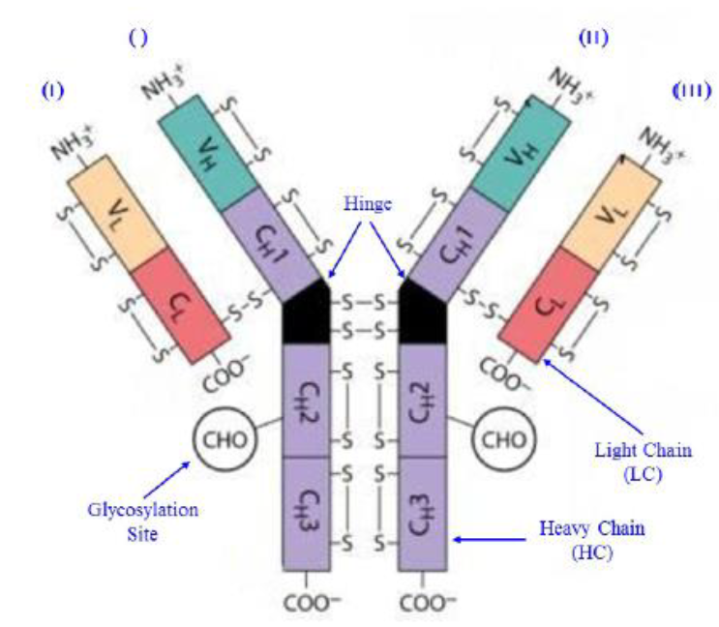
The quality evaluator concluded that there are no objections on quality grounds to the approval of Qarziba (dinutuximab beta).

Nonclinical
The following points were summarised in the nonclinical evaluation:
- The pharmacology studies support the proposed indication for dinutuximab beta to treat patients with neuroblastoma.
- No safety pharmacology studies were conducted with dinutuximab beta. Testing of neurological, cardiovascular and respiratory functions during repeat-dose toxicity studies did not show any treatment related effects. However, behavioural abnormalities were observed in ganglioside monosialic acid 2 (GM2)/ ganglioside disialic acid 2 (GD2) synthase knockout mice (GM2/GD2 synthase is a key enzyme in the synthesis of complex gangliosides including GD2).
- Notable findings of clinical relevance in the toxicity studies with dinutuximab beta include reduced motility, bodyweight and food consumption (possibly due to pain), bone marrow atrophy, and reduction in the size and weight of thymus.
- Based on the mode of action (binding to GD2 and induction of CDC/ADCC after binding) and taking into account GD2 expression on neuronal tissues, bone marrow stem cells and other tissues of neuroectodermal origin, especially during embryo-fetal development, and when immunoglobulin (Ig) crosses the placenta, it is considered likely that dinutuximab beta may cause fetal harm when administered to pregnant women and therefore, Qarziba should not be used during pregnancy.
Pregnancy Category C; is recommended for dinutuximab beta.
- There are no objections on nonclinical grounds to the registration of dinutuximab beta for the proposed indication provided safety and interactions with IL-2 have been adequately addressed by clinical data.
- The nonclinical evaluator recommended amendments to the draft PI.

Clinical
Efficacy and safety were assessed in five clinical studies (see Table 2). The clinical data provide evidence across different disease settings (first-line, relapse, and refractory), different infusion regimens, and as a single agent or in combination with IL-2 and/or 13-cis-RA. The majority of the studies were investigator-initiated studies, conducted primarily for clinical research rather than for the purpose of marketing authorisation, so they did not follow Good Clinical Practice (GCP) standards to the full extent.
Table 2: Overview of the clinical studies
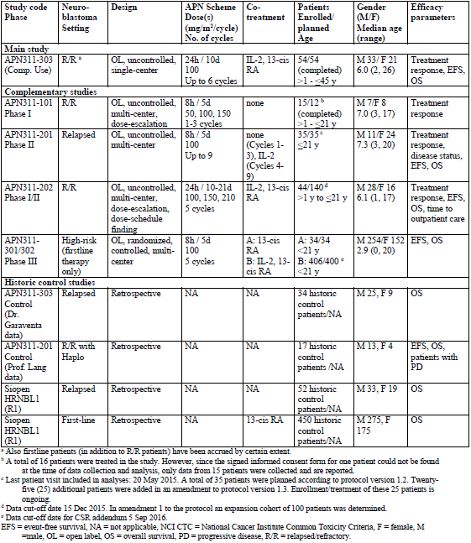
Study APN311-303 is an open-label, uncontrolled, retrospective data collection from the compassionate use of dinutuximab beta in a single centre. Comparative analyses have been performed against historical controls. Supportive studies in the relapsed/refractory setting include investigator-sponsored Phase I/II trials (Studies APN311-101, -201, and -202) evaluating the safety, pharmacokinetics (PK), pharmacodynamics (PD) and anti-tumour activity of dinutuximab beta.
The only randomised, controlled study is the Phase III Study APN311-301/APN311-302 undertaken by the SIOPEN Association, evaluating the treatment of high-risk neuroblastoma in the first-line setting. Study APN311-301 was designed to compare maintenance treatment with 13-cis-RA with or without dinutuximab beta. This study commenced in 2006 but was stopped in 2009 following the publication of the Children’s Oncology Group (COG) trial which demonstrated a survival benefit when dinutuximab plus GM-CSF and IL-2 was added to maintenance 13-cis-RA treatment. The COG study established dinutuximab as a standard of care for maintenance treatment of high-risk neuroblastoma, so it was no longer feasible to continue with Study APN311-301 which was randomising patients to an arm which did not receive anti-GD2 immunotherapy. Protocol amendments were introduced and Study APN311-302 was initiated with the objective of evaluating the effects of adding IL-2 to dinutuximab beta and 13-cis RA in the first-line maintenance treatment of high-risk neuroblastoma.

Pharmacology

Pharmacokinetics
PK data are available from 3 clinical studies in patients with refractory/relapsed neuroblastoma: Studies APN311-101, -202, and -303. There is no study directly comparing the PK of dinutuximab beta (mouse-human chimeric monoclonal IgG1 antibody ch14.18 manufactured on the basis of CHO cell line) to dinutuximab (mouse-human chimeric monoclonal IgG1 antibody ch14.18 manufactured on the basis of SP2/0 cell line).
Study APN311-101 was an investigator initiated Phase I bridging study of dinutuximab beta as a single agent in 15 patients with relapsed/refractory neuroblastoma. The aim was to assess the safety, PK, immunogenicity and activity of dinutuximab beta administered as 8 hour infusions over 5 consecutive days. Three dose levels were evaluated (10, 20, and 30 mg/m²/day). The 20 mg/m²/day dose level (cumulative dose of 100 mg/m² per cycle) was selected for further study based on PK and safety findings.
Study APN311-202 was an investigator initiated, Phase I/II, open-label, uncontrolled, dose escalation, dose schedule finding study in patients with primary refractory or relapsed neuroblastoma. The primary objective was to find a tolerable treatment schedule which reduces the pain-toxicity profile of dinutuximab beta whilst maintaining immunomodulatory efficacy. Dinutuximab beta was given as a 10 day continuous infusion in conjunction with IL-2 and 13-cis-RA. Doses of 100, 150, or 210 mg/m²/cycle were planned, but the dose schedule part of the study was closed after evaluation of data from the first cohort and 100 mg/m²/cycle was selected as the dose schedule for the confirmatory part of the study.
Study APN311-303, a retrospective data collection from the compassionate use of dinutuximab beta in a single centre, involved continuous infusions of dinutuximab beta over 10 days (100 mg/m²/cycle) in conjunction with IL-2 and 13-cis-RA.
Dinutuximab beta is given as an intravenous infusion. In Studies APN311-202 and -303, peak levels were generally reached at the end of the 10 day infusion. There are limited data to assess dose proportionality.
The expected metabolic pathway of a monoclonal antibody is degradation to small peptides and individual amino acids by ubiquitous proteolytic enzymes. No excretion or metabolism studies have been submitted. In Studies APN311-202 and -303, the estimated half-life (T_{1/2}) was around 190 hours.
No PK interaction studies have been performed. Dinutuximab beta is considered to have a low potential for drug-drug interactions given its target and elimination profile.
There are no studies in patients with renal or hepatic impairment.
The collection of further PK, PD and immunogenicity data is a Specific Obligation following the EU Marketing Authorisation under ‘exceptional circumstances’.9

Population pharmacokinetics data
A population PK analysis was conducted on data from Studies APN-311-101, -202, and -303. Covariates investigated included markers of renal and liver function, gender, age, body weight, body surface area (BSA), anti-drug antibody (ADA), infusion length and cycle number. Markers for renal (estimated glomerular filtration rate) and hepatic (bilirubin) function did not show a relationship with exposure. The relationship for weight was consistent with dosing on a mg/m² basis. Gender and age were not found to influence the PK of dinutuximab beta, but data in children less than 2 years of age are very limited.

Pharmacodynamics
PD parameters assessing the proliferation and activation of immune cells and cytolytic effects on tumour cells were investigated as secondary endpoints in the clinical studies. Cytolytic activity was durably elevated following treatment with dinutuximab beta. The studies are limited in their capacity to differentiate the PD effects of dinutuximab beta and IL-2. Exposure data were not sufficiently robust to evaluate the relationship between drug concentration and PD effects. Human anti-chimeric antibodies (HACAs) or ADAs were detected in 62% of patients, but their effect on PK and PD outcomes is uncertain.

Efficacy

Study APN311-303
Study APN311-303 is an open-label, uncontrolled, retrospective data collection from the compassionate use of dinutuximab beta in a single centre in Germany. Patients eligible for compassionate use treatment had to be aged ≥ 1 and ≤ 45 years, and be diagnosed with high-risk neuroblastoma according to International Neuroblastoma Staging System (INSS) criteria, or relapsed or refractory neuroblastoma. Fifty four patients were enrolled and treated between November 2009 and August 2013.
The primary objective of Study APN311-303 was to evaluate retrospectively the safety and pain-toxicity profile of prolonged continuous infusion of dinutuximab beta in combination with subcutaneous IL-2 and oral 13-cis-RA. Secondary objectives included the retrospective evaluation of tumour response through clinical assessment (computed tomography/magnetic resonance imaging; ¹²³iodine-meta-iodobenzylguanidine, bone marrow examination) in patients with measurable disease, overall survival (OS), and event-free survival (EFS), as well as PD and PK endpoints.
The study included patients with relapsed neuroblastoma (N = 30), primary refractory neuroblastoma having had two or more first-line treatments (N = 15), and high-risk neuroblastoma who had received front line therapy only (N = 9). Patients had to have received at least one previous high dose treatment followed by stem cell rescue after conventional therapy to reduce tumour burden.
Patients received dinutuximab beta 10 mg/m²/day given by continuous 10 day infusion in up to six 5 week treatment cycles. Each cycle started with subcutaneous IL-2, followed by dinutuximab beta infusion and oral 13-cis-RA.
Primary endpoint: Safety and tolerability were evaluated by pain intensity/morphine use, and incidence, grade and type of adverse events (AEs), vital signs and changes in clinical laboratory tests.
Secondary endpoints: Response rate in patients with measurable disease, and durability of the response, OS; EFS; PD parameters; correlation between activated natural killer (NK) cells and ch14.18/CHO level with ADCC; and PK parameters.
At the end of treatment, the overall response rate (ORR) in evaluable patients was 32.4% (see Table 3), comprising 3 (8.1%) complete response (CR) and 9 (24.3%) partial response (PR). Median duration of response was 313 days (range 71 to 847). In patients with relapsed/refractory disease, the response rate was 28% (10/36).
Table 3: Study APN311-303; Overall response in patients with evidence of disease at Baseline
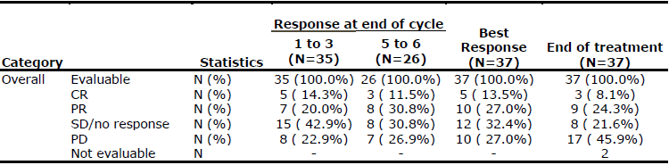
Source: European Public Assessment Report (EPAR) for dinutuximab beta.
Survival outcomes are presented in Table 4. OS outcomes in Study APN311-303 appear favourable when compared against historical controls (see Table 5 and Figure 2) from a retrospective study of children with relapsed neuroblastoma who were not treated with ch.14.18 antibodies (Garaventa et al, 2009; Italian Neuroblastoma Registry 1979 to 2006). The historical cohort included more patients with Stage 4 disease and MYCN (n-myc gene) amplification resulting in less favourable prognosis than the immunotherapy cohort, but analyses of OS after adjusting for prognostic factors (age at diagnosis, gender, MYCN amplification, and INSS stage) still favoured the immunotherapy cohort.
Table 4: Studies APN311-303 and APN311-202; Survival rates in relapsed and refractory patients
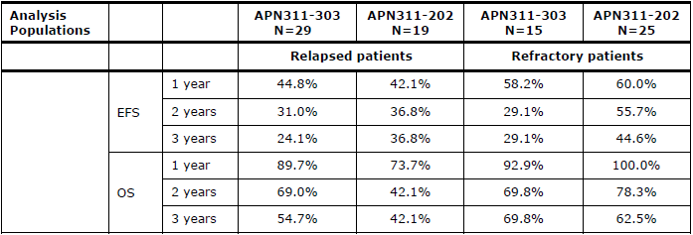
Source: EPAR for dinutuximab beta.12
Table 5: Studies APN311-303; Overall survival, relapsed patients, dinutuximab beta versus historical controls (Garaventa et al.)
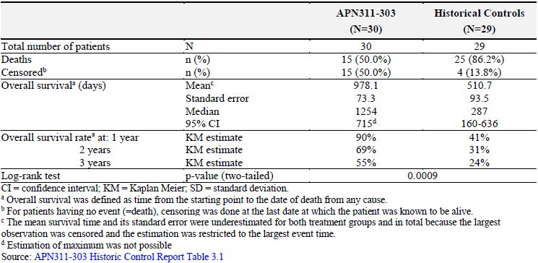
Figure 2: Study APN311-303; Kaplan-Meier estimates of overall survival, dinutuximab beta versus historical controls
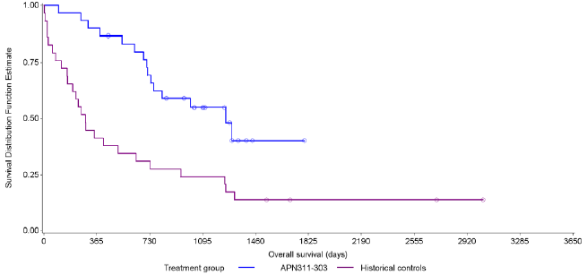

Study APN311-202
Study APN311-202 was a Phase I/II, open-label, uncontrolled, dose escalation, dose schedule finding study in patients aged 1 to 21 years with primary refractory or relapsed neuroblastoma. The primary objective was to find a tolerable treatment schedule which reduces the pain-toxicity profile of dinutuximab beta whilst maintaining immunomodulatory efficacy by using a prolonged continuous infusion in combination with subcutaneous IL-2. Secondary objectives included assessment of pain intensity and relief, pharmacokinetics, pharmacodynamics, immunogenicity, and anti-tumour response in patients with measurable disease. EFS and OS were also assessed, but these were not pre-specified endpoints.
Forty-four patients with refractory or relapsed neuroblastoma were enrolled between January 2012 and February 2015. Dinutuximab beta was given by continuous 10 day infusion at 10 mg/m²/day, in conjunction with IL-2 and 13-cis-RA.
There were two primary endpoints: a pain-toxicity endpoint and an efficacy endpoint relating to cluster of differentiation (CD) 16/CD56 positive activated NK cells. The primary efficacy endpoint is not suitable as a regulatory endpoint due to uncertain correlation with clinical benefit. Tumour response rates were assessed as a secondary endpoint.
At the end of treatment, ORR in patients with measurable disease was 42.4% (6 (18.2%) CR and 8 (24.2%) PR) (Table 6). The median duration of response was approximately 2.3 years (range 5 weeks to 3 years). In a pooled analysis of relapsed/refractory patients with measurable disease in Studies APN311-202 and -303, ORR at the end of treatment was 36.1% (9 (12.5%) CR, 17 (23.6%) PR).
Table 6: Studies APN311-303 and APN311-202; Tumour response rates at end of treatment
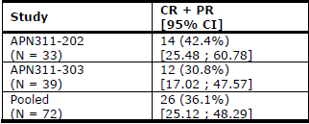
Source: EPAR dinutuximab beta12
Survival outcomes are shown in Table 4. A pooled analyses of OS of relapsed patients in Studies APN311-202 and -303 appeared favourable when compared against two cohorts of historical controls (Italian Neuroblastoma Registry cohort, Garaventa et al,13 Table 7; SIOPEN HR-NBL1 first randomisation (R1) cohort, Table 8).
Table 7: Overall survival, relapsed patients, Studies APN311-202/-303 versus historic controls (Garaventa et al.)
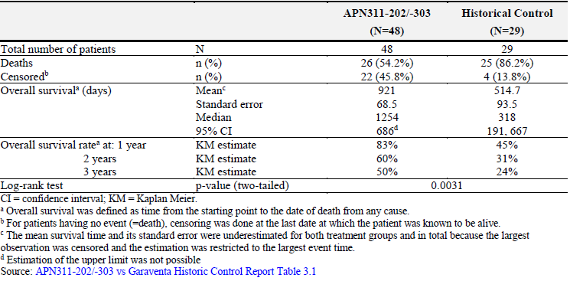
Table 8: Studies APN311-303 and APN311-202; Overall survival, relapsed patients, dinutuximab beta versus historic controls (R1 cohort)
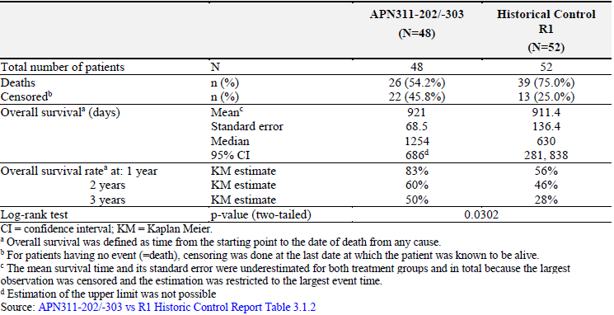

Study APN311-201
Study APN311-201 was an investigator-initiated, Phase II feasibility study evaluating the use of dinutuximab beta (100 mg/m² per cycle, given as 8 hour infusions over 5 consecutive days) following haploidentical stem cell transplant (haplo-SCT) in patients aged up to 21 years with relapsed neuroblastoma (N = 35). The primary objective was to assess the safety and feasibility of dinutuximab beta and IL-2 after haplo-SCT. Secondary objectives included evaluation of anti-tumour responses, PK, and immunological monitoring (NK cells). Dinutuximab beta was given as a single agent for the first 3 cycles, and with IL-2 in Cycles 4 to 9.
Treatment responses are shown in Table 9. Comparative analyses of survival outcomes compared to historic controls with relapsed neuroblastoma treated with haplo-SCT favoured the dinutuximab beta group (Table 10).
Table 9: StudyAPN311-201; Treatment response in patients with evidence of disease after haploidentical stem cell transplant
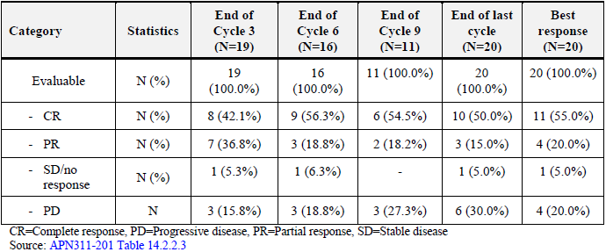
Table 10: Study APN311-201; overall survival, versus historic controls
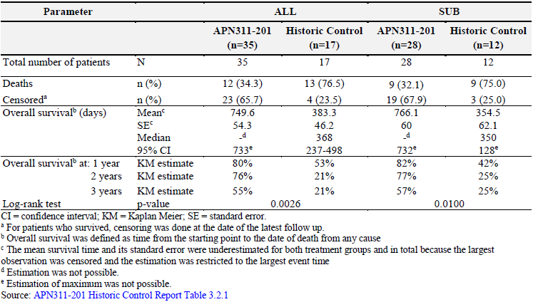
Subgroup analysis (SUB): Some patients underwent a ch14.18 antibody treatment before haploidentical stem cell transplantation. These patients were excluded from analysis set SUB.

Study APN311-302 (HR-NBL-1.5/SIOPEN trial)
Study APN311-302 is a Phase III, investigator initiated, multinational, open-label, randomised, controlled trial in patients with high-risk neuroblastoma (first-line setting). The study is being conducted by the SIOPEN Association.
The primary objective is to assess whether the addition of subcutaneous IL-2 to dinutuxumab beta and 13-cis-RA will improve 3 year survival (EFS). Secondary objectives are to determine the tolerance of the maintenance treatment following myeloablative therapy, and to collect data on validated biological features and determine the effect of these on EFS and OS.
Between November 2009 and August 2013, 406 patients aged < 21 years were enrolled in 10 European countries, Australia and Israel. As at the data cut-off date 5 September 2016, 385 patients were randomised and 370 patients were included in the full analysis set (FAS). The median age of the patients was 3 years (range 0.6 to 20 years). Ten (2.7%) patients were aged < 1 year.
Patients were randomised to receive dinutuximab beta (100 mg/m² per cycle, given as 8 hour infusions over 5 consecutive days) and 13-cis-RA, with or without IL-2. Weight based dosing (dinutuximab beta 0.67 mg/kg/day) was used for children weighing < 12 kg instead of dosing based on BSA. The study is ongoing and a protocol amendment has led to the study recruiting additional patients to be treated with continuous infusions of dinutuxumab beta over 10 days instead of 8 hour infusions over 5 consecutive days.
The primary endpoint was 3 year EFS (events included disease progression, relapse, death from any cause, and second neoplasm). OS was a secondary endpoint.
The Kaplan-Meier estimate of 3 year EFS was 55.4% in those treated with dinutuximab beta and 13-cis-RA, and 61.2% in those treated with IL-2 in addition to dinutuximab beta and 13-cis-RA (Table 11). The difference in EFS between the two arms was not statistically significant. 1 year and 2 year estimates of EFS were similar across the arms (72.3% versus 72.3%, and 63.2 versus 66.3%, respectively). EFS was generally lower for patients with evidence of disease at Baseline.
There was no significant difference in OS outcomes between the two arms (see Table 12). The submission included a comparison of OS in APN311-302 against historical controls from the R1 randomisation phase of the SIOPEN HR-NBL1 trial (N = 450) who received myeloablative therapy and 13-cis-RA, but no immunotherapy. OS in Study APN311-302 appeared favourable compared to the R1 historical control group (see Table 13).
Table 11: Study APN311-302; Three year event-free survival (primary endpoint)
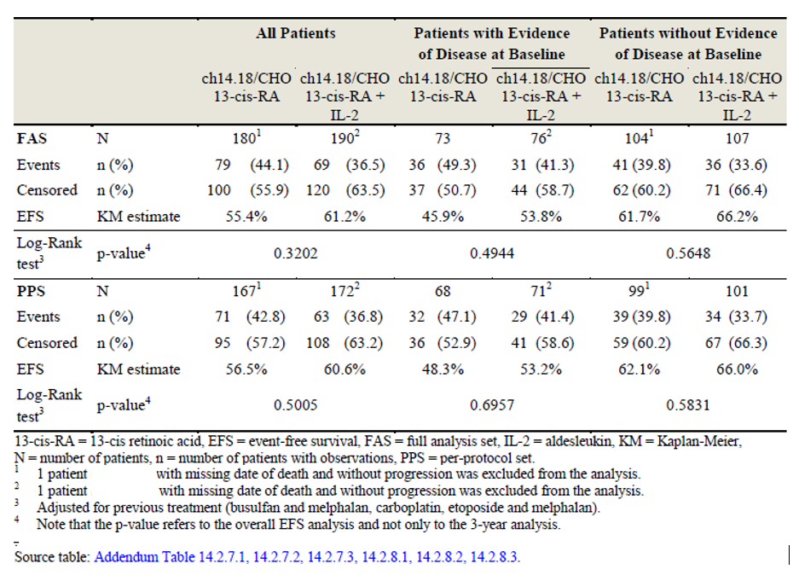
Table 12: Study APN311-302; Overall survival
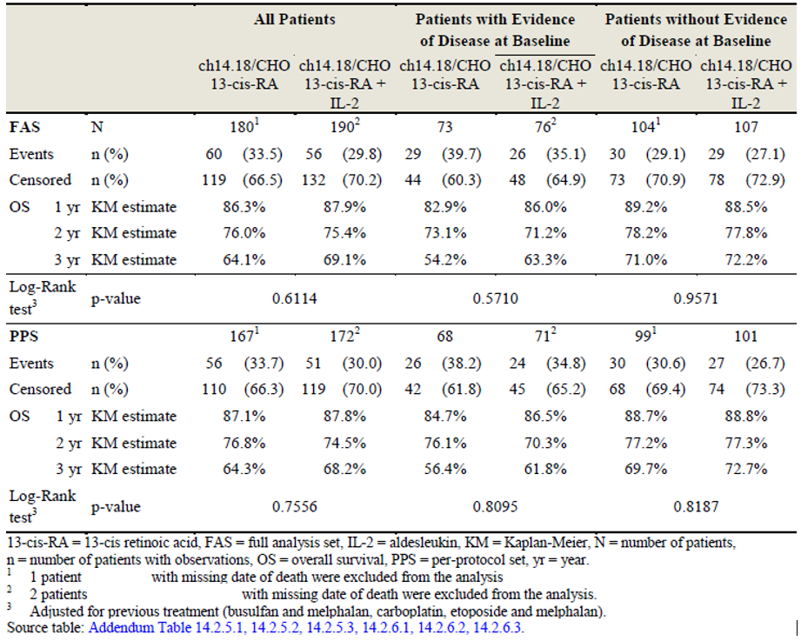
Table 13: Study APN311-302; Overall survival, in study (R2 cohort) versus historic controls (R1 cohort)
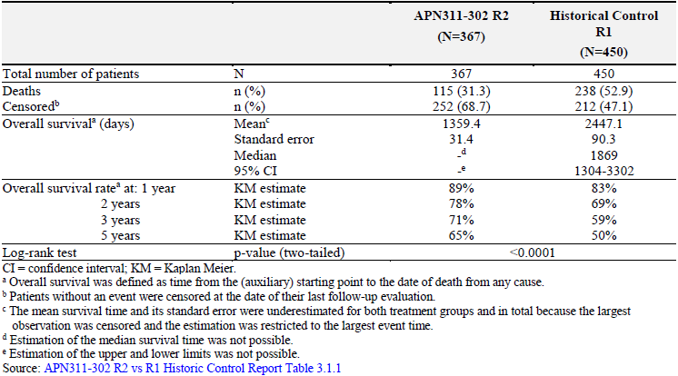
Findings from this study were published in The Lancet Oncology on 12 November 2018, with the authors concluding that:
‘There is no evidence that addition of subcutaneous IL-2 to immunotherapy with dinutuximab beta, given as an 8 h infusion, improved outcomes in patients with high-risk neuroblastoma who had responded to standard induction and consolidation treatment. Subcutaneous IL-2 with dinutuximab beta was associated with greater toxicity than dinutuximab beta alone. Dinutuximab beta and isotretinoin without subcutaneous IL-2 should thus be considered the standard of care until results of ongoing randomised trials using a modified schedule of dinutuximab beta and subcutaneous IL-2 are available.’

Safety
The overall safety database includes 514 patients in 5 studies who received dinutuximab beta. The dosage was largely 100 mg/m²/cycle. Ninety-eight patients received dinutuximab beta as a continuous infusion over 10 days and 416 patients as 8 hour infusions over 5 consecutive days. No studies directly compared the two dosage regimens. There are no randomised data comparing treatment with and without dinutuximab beta. Three hundred and six patients received dinutuximab beta in conjunction with subcutaneous IL-2. Patients did not receive IL-2 in Study APN311-101, the first 3 cycles of Study APN311-201, and one treatment arm of Study APN311-302. Most patients also received oral 13-cis-RA (other than patients in Studies APN311-101 and -201). In the continuous infusion studies (Studies APN311-303 and -202), 68 of 98 (69%) completed 5 or 6 cycles.
The method of AE collection varied substantially across studies. The main study, Study APN311-303, was a retrospective data collection, so safety was assessed retrospectively from AEs recorded from the time of enrolment until 30 days after last study treatment. In Study APN 311-302, only serious adverse events (SAEs) and a pre-defined list of 31 National Cancer Institute common toxicity criteria (NCI CTC) toxicities were reported. AEs, pain and morphine use, acute graft versus host disease (GvHD), and NCI CTC toxicities were reported in Study APN311-201.
Safety data have been presented for each study (see Table 16). Pooled analyses based on dosing regimen and concomitant IL-2 treatment have also been presented (see Tables 14 and 15).
Table 14: Overview of patient numbers by infusion and co-treatment regimens
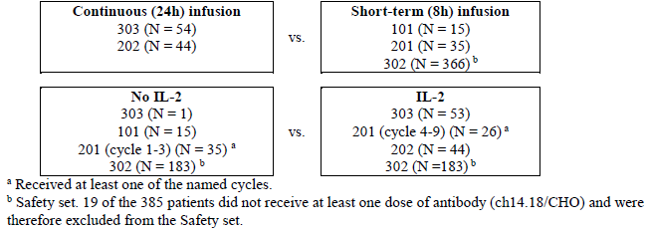
Table 15: Studies APN311 -101, -201, -202, -302 and -303; Summary of dinutuximab beta, IL-2 and 13-cis-RA administration
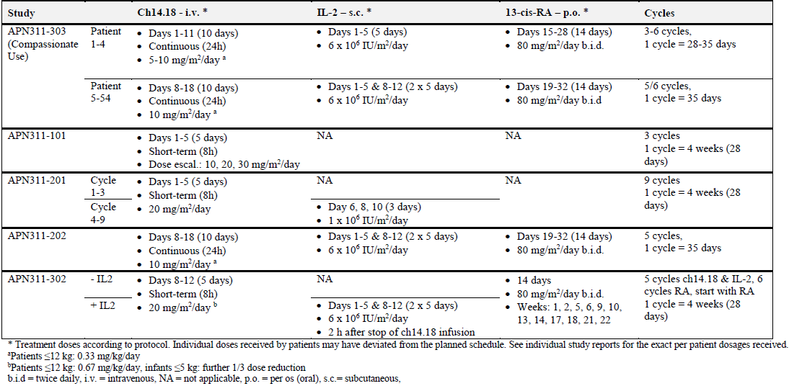
Table 16: Studies APN311 -101, -201, -202, -302 and -303; Overall summary of treatment emergent adverse events
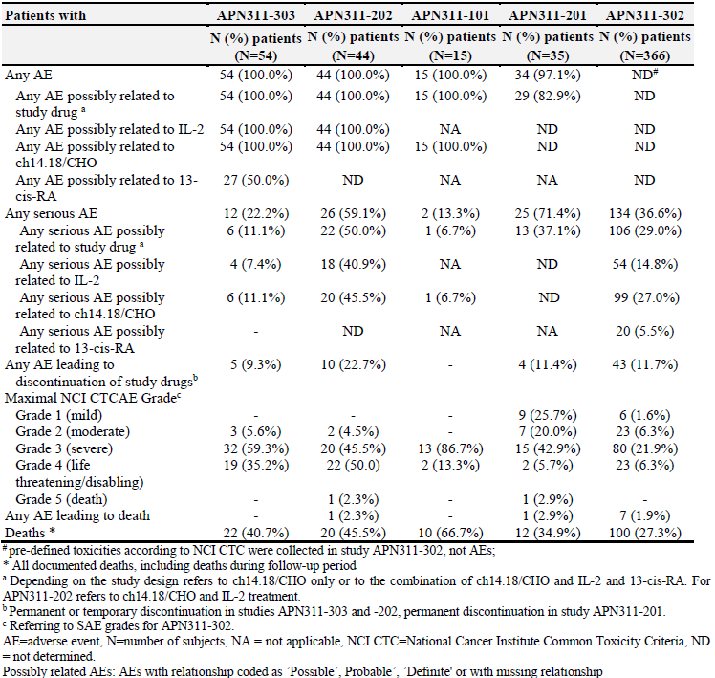
The most frequent treatment emergent adverse events (TEAE) reported in Study APN311-303 were pyrexia (98.1%), pruritus (92.6%), pain in extremity (85.2%), constipation (83.3%), capillary leak syndrome (83.3%), cough (79.6%), dry skin (75.9%), vomiting (74.1%), pain (74.1%), and tachycardia (74.1%). The most frequent Grade 3 TEAEs were neutropaenia (37.0%), anaemia (33.3%), pain (25.9%), pain in extremity (20.4%), thrombocytopaenia (16.7%) and cough (16.7%). The most frequent Grade 4 TEAEs were thrombocytopaenia (13.0%), neutropaenia (11.1%), pain in extremity (7.4%), and abdominal pain upper (5.6%).
In Study APN311-303, SAEs were reported in 22% of patients. The incidence of SAEs decreased over the treatment cycles. Across the studies, 7 patients died for a reason other than disease progression. Four deaths could be considered possibly treatment-related: 2 deaths in Study APN311-302 were due to capillary leak syndrome and acute respiratory distress syndrome, 1 death in Study APN311-201 was due to herpes encephalitis (possibly related to stem cell transplantation) and pneumonia, and 1 death in Study APN311-202 was due to septic shock.
Study APN311-302 compared the safety profile of dinutuximab beta with and without subcutaneous IL-2. SAEs were reported more frequently in patients receiving IL-2 compared to patients not receiving IL-2: 46% versus 27%. More patients who received IL-2 experienced at least one SAE leading to the discontinuation of dinutuximab beta, 13-cis-RA, and/or IL-2, if applicable: 17.5% versus 6.0% of patients (47 versus 16 SAEs).
Pain: Pain was expected based on the known safety profile of anti-GD2 immunotherapy and was treated with morphine. Other treatments were permitted, including gabapentin, acetaminophen, nonsteroidal anti-inflammatory drugs, ketamine and fentanyl patches. Differences in pain treatment protocols limit comparisons of pain outcomes across studies. In the continuous infusion studies, approximately 90% of patients experienced pain in Cycle 1. The percentage of patients with pain decreased in subsequent cycles to approximately 60% in Cycle 5. Morphine use also declined over subsequent cycles.
Hypersensitivity reactions: In the continuous infusion studies, allergic and infusion-related reactions were reported in 72.7% of patients in Study APN311-202 and 88.9% in Study APN311-303. Most were of mild or moderate severity. Grade 3 reactions were reported in 18.2% and 16.7%, respectively. No Grade 4 reaction was reported. Their incidence decreased from Cycle 1 (52% and 74%, respectively) to Cycle 5 (29% and 41%, respectively). Six patients (4.1%) across Studies APN311-101, -201, -202, and -303 had at least 1 serious episode consistent with anaphylaxis.
Cytokine release syndrome (CRS): CRS was reported in 36.4% and 55.6% of patients in studies APN311-202 and -303, respectively. Most cases were mild to moderate severity.
Capillary leak syndrome (CLS): CLS was reported in 36.4% and 83.3% of patients in Studies APN311-202 and -303, respectively. Most cases were mild to moderate severity. In Study APN311-302, the frequency of CLS was about twice as high in patients who were treated with IL-2 (49.7% versus 24.6%).
Neurological disorders: Neurological eye disorders were reported in 22.7% and 27.8% of patients in Studies APN311-202 and -303, respectively. Mydriasis and accommodation defects with blurred vision were the most common events. SAEs were reported in 2.7% across all studies. Neuropathies (motor and sensory) were reported in 9% and 5% of patients in Studies APN311-202 and -303, respectively. Most events were non-serious.
Infection: Infection-related events were reported in 61.4% and 75.9% of patients in Studies APN311-202 and -303, respectively. 63 patients (12%) reported serious infection-related events.

Risk management plan
The sponsor submitted European Union-risk management plan (EU-RMP) version 8.0 (dated 29 March 2017; data lock point (DLP) 11 November 2015) and Australian specific Annex (ASA) version 1.0 (dated 10 July 2019) in support of this application. The proposed pharmacovigilance and risk minimisation activities in the summary of safety concerns are shown in Table 17.
Table 17: Proposed summary of safety concerns
Summary of safety concerns |  | Pharmacovigilance |  | Risk Minimisation
 |  | Routine | Additional | Routine | Additional
Important identified risks | Pain |  | * |  | –
Important identified risks | Serious infusion reactions including hypersensitivity, hypotension, and cytokine release syndrome |  |  |  | –
Important identified risks | Neurological eye disorders |  | * |  | –
Important identified risks | Peripheral neuropathy |  | * |  | –
Important identified risks | Capillary leak syndrome |  |  |  | –
Important identified risks | Hypoxia, respiratory distress and respiratory failure |  |  |  | –
Important identified risks | Haematological toxicities |  |  |  | –
Important potential risks | Cardiotoxicity |  |  |  | –
Important potential risks | Immunogenicity |  |  |  | –
Important potential risks | Medication errors |  |  |  | –
Missing information | Drug-drug interactions |  |  |  | –
Missing information | Use in adolescents, adults, and elderly |  |  |  | –
Missing information | Use in patients with an ethnic origin other than Caucasian |  |  |  | –
Missing information | Use in patients with hepatic and renal impairment |  |  |  | –
Missing information | Potential harm from overdose |  |  |  | –
Missing information | Long-term effects of treatment in childhood |  |  |  | –
Additional pharmacovigilance activities include clinical studies. * Patient registry – not proposed for Australia.
The sponsor will maintain a patient registry in Europe as part of additional pharmacovigilance but does not propose an Australian patient registry.

Question to the sponsor
- Please comment on whether data from Australian patients can be included in the European patient registry.
Sponsor’s response
The sponsor believes that it would not be appropriate to include data from Australian patients in the European patient registry, as this was not part of the European Medicines Agency’s (EMA’s) requirements, as currently agreed for Europe.
The sponsor reiterates, however, that data from Australian patients will still be gathered as consolidated global data within periodic safety update reports (PSURs).
It is the sponsor’s expectation that the Australian Marketing Authorisation for Qarziba will include the standard requirement for PSUR reporting, for three years post-approval.
The first PSUR likely to be applicable following TGA-approval of Qarziba will have a data lock date of 8 November 2020.

Recommended conditions of registration
- The Qarziba EU-RMP (version 8.0, date 29 March 2017; DLP 11 November 2015), with ASA (version 1.0, dated 10 July 2019), included with submission PM-2019-03174-1-4, and any subsequent revisions, as agreed with the TGA will be implemented in Australia.
- An obligatory component of risk management plans is routine pharmacovigilance. Routine pharmacovigilance includes the submission of PSURs.
Reports are to be provided in line with the current published list of EU reference dates and frequency of submission of PSURs until the period covered by such reports is not less than three years from the date of this approval letter.
The reports are to at least meet the requirements for PSURs as described in the European Medicines Agency’s Guideline on Good Pharmacovigilance Practices (GVP) Module VII-periodic safety update report (Rev 1), Part VII.B Structures and processes. Note that submission of a PSUR does not constitute an application to vary the registration.
- Qarziba (dinutuximab beta) is to be included in the Black Triangle Scheme. The PI and Consumer Medicines Information (CMI) for Qarziba must include the black triangle symbol and mandatory accompanying text for five years, which starts from the date that the sponsor notifies the TGA of supply of the product.

Risk-benefit analysis

Delegate’s considerations

Efficacy
Five clinical studies were submitted in support of efficacy in the proposed indication. The main studies are Study APN311-303, a retrospective data collection from a compassionate use program in a single centre in Germany, and the ongoing Phase III Study APN311-302. These are supported by Phase I and II studies designed primarily to assess safety, PK and PD.
The evidence for efficacy of dinutuximab beta is based on tumour response rates, duration of response, and survival outcomes (EFS, OS), with comparative analyses of survival outcomes performed against historical controls. There are no direct comparative data for Qarziba against placebo or active control.
Evidence of efficacy in the relapsed and refractory settings comes primarily from Study APN311-303, supported by Studies APN311 -202 and -201. Study APN311-303 also included a small number of patients in the first-line setting. Evidence of efficacy in the first-line setting comes primarily from Study APN311-302. Most of the clinical studies recruited patients aged ≥ 1 year, but Study APN311-302 included 10 (2.7%) patients aged < 1 year.
In Study APN311-303, the ORR in evaluable patients at the end of treatment was 32.4%, comprising 3 (8.1%) CR and 9 (24.3%) PR. Median duration of response was 313 days (range 71 to 847). In patients with relapsed/refractory disease, the response rate was 28% (10/36). OS at 1 year and 2 years was 90% and 69% respectively, which compared favourably against historical controls not treated with anti-GD2 therapy.
In a pooled analysis of relapsed/refractory patients with measurable disease in Studies APN311 -202 and -303 who were treated with dinutuximab beta (10 mg/m²/day as a continuous infusion over 10 days in each 35 day treatment course) in conjunction with IL-2 and 13-cis RA, the ORR was 36.1% (9 (12.5%) CR, 17 (23.6%) PR). Survival outcomes compared favourably with historical controls. Favourable efficacy outcomes were also observed in Study APN311-201 for patients treated with 8 hour infusions of dinutuximab beta over 5 consecutive days in each treatment cycle following haplo-SCT for refractory neuroblastoma. These studies in the relapsed/refractory setting do not inform the differential treatment effects of dinutuximab beta, IL-2 and 13-cis-RA.
In the first-line setting, Study APN311-302 demonstrated 3 year EFS of 55.4% without IL-2 and 61.2% with IL-2. Three year OS was 64.1% without IL-2 and 69.1% with IL-2. In this study, the addition of IL-2 did not provide a significant benefit in EFS or OS. Survival outcomes in this study compared favourably against historical controls.

Safety
The safety dataset for dinutuximab beta comprises 514 patients across 5 studies. There is no study directly comparing treatment with and without dinutuximab beta. There were substantial differences in the study designs and the extent of safety data collected across the studies. Study APN311-303 was a retrospective data collection. In the largest study, Study APN311-302, SAEs were fully reported but reporting of other AEs was based on a pre-defined list of 31 specific toxicities.
The infusion regimen differed between studies, with 98 patients receiving dinutuximab beta as a continuous infusion over 10 days and 416 patients as 8 hour infusions over 5 consecutive days. None of the studies directly compared the two infusion regimens. Differences in study design, treatment regimen and safety data collection across the studies limit the conclusions that can be drawn regarding comparative safety of the two dosing regimens.
The most common TEAEs included pyrexia, pruritus, pain in extremity, constipation, capillary leak syndrome, cough, dry skin, vomiting, pain, and tachycardia. Grade 3 to 4 TEAEs included laboratory abnormalities (neutropaenia, anaemia, thrombocytopaenia) and pain.
Treatment with dinutuximab beta is associated with considerable neurotoxicity, particularly pain, eye/vision disorders and neuropathy. Allergic and infusion-related reactions are common. Severe hypersensitivity reactions, anaphylaxis, and cytokine release syndrome may occur. Other notable toxicities include capillary leak syndrome and infections.
In Study APN311-302, the safety profile was less favourable when IL-2 was administered with dinutuximab beta.
The toxicities of dinutuximab beta are substantial, but the safety profile is considered acceptable in the context of the disease being treated. This treatment is used only in major hospitals with expertise in the treatment of cancer and the identification and management of treatment-related toxicities.
The PI contains specific precautions regarding pain, hypersensitivity reactions, capillary leak syndrome, neurological disorders of the eye, peripheral neuropathy, systemic infections, and haematologic toxicities. The PI also contains guidance that dinutuximab beta should be administered only in a hospital setting with immediate access to full resuscitation services, under the supervision of a physician experienced in the use of oncological therapies.
Specific Obligations relating to the EU Marketing Authorisation under exceptional circumstances;9 include the provision of annual reports from a registry study in patients with high-risk neuroblastoma (non-interventional post-authorisation safety study).

Dosage
The clinical studies provide efficacy and safety data for the two proposed dosage regimens delivering dinutuximab beta 100 mg/m²/cycle: 10 mg/m²/day by continuous infusion over 10 days, or 8 hour infusions over 5 consecutive days. There are no direct comparative data for the two dosing regimens.
Most of the clinical studies recruited patients aged ≥ 1 year, but Study APN311-302 included 10 (2.7%) patients aged < 1 year. In this study, weight-based dosing (dinutuximab beta 0.67 mg/kg/day) was used for children weighing < 12 kg instead of dosing based on BSA.

Limitations and uncertainties of the data
The lack of direct comparative data demonstrating the efficacy and safety of Qarziba is a limitation of the submitted dataset. Indirect comparisons of EFS and OS for Qarziba have been performed against historical controls. Anti-GD2 therapy became standard of care following the publication of the COG study in 2009;11 after which it was not feasible to conduct a randomised study allocating patients to treatment without anti-GD2 antibodies. There are no studies directly comparing Qarziba to Unituxin (dinutuximab), the only potential active comparator. Unituxin is approved in the United States of America (USA) but not in Australia nor in the EU. During the EMA assessment for marketing authorisation of dinutuximab beta, the Committee for Medicinal Products for Human Use (CHMP) concluded that a comparative trial against Unituxin was not feasible in the context of the withdrawal of the marketing authorisation of Unituxin in 2017.
The investigator-initiated studies were not specifically designed for the purpose of marketing approval, so they did not fully comply with GCP requirements.
Study APN311-303 was a retrospective data collection from a compassionate use program in a single centre, so has potential issues with selection bias, incomplete data, and reporting bias.
Efficacy of dinutuximab beta was not a primary objective of Study APN311-303, or the Phase I/II studies. Study APN311-302 assessed 3 year EFS as the primary endpoint, but all patients received dinutuximab beta, the primary objective being to determine whether the addition of IL-2 improved 3 year EFS.
Differences in the method of collecting safety data in the studies in this submission limit the capacity to compare safety across studies.
Overall, HACAs (ADAs) were detected in 62% patients. There is uncertainty regarding the impact of HACAs on the PK, efficacy and safety of dinutuximab beta.

Conclusion
There are limitations in the efficacy and safety data presented in this submission, particularly with regard to direct comparative data. Based on current treatment practices and the regulatory status of Qarziba (dinutuximab beta) and Unituxin (dinutuximab) internationally, a definitive randomised controlled study evaluating the efficacy and safety of Qarziba is unlikely. A placebo-controlled trial of dinutuximab beta is no longer feasible, as anti-GD2 immunotherapy is now part of the standard of care for high-risk, relapsed and refractory neuroblastoma. An active-controlled trial of Qarziba versus Unituxin is unlikely given the regulatory status of these treatments in the EU and the USA.
Efficacy outcomes presented in this submission, including tumour response rates and comparisons of EFS and OS against historical controls, are favourable for dinutuximab beta. Limitations of comparisons against historical controls mean that there is some uncertainty regarding the extent of survival benefit attributable to dinutuximab beta.
Safety data are limited by the lack of direct comparative data. Differences in study design and safety data collection limit the capacity to compare safety across studies. To address this concern, ongoing safety reporting was required as part of Specific Obligations of the EU Marketing Authorisation under exceptional circumstances.9
Dinutuximab beta is associated with considerable toxicity, but this risk is considered acceptable in the context of the disease being treated. Administration of dinutuximab beta is undertaken only in specialist hospitals with expertise in the treatment of neuroblastoma and the identification and management of treatment-related toxicities.
Although there are limitations in the efficacy and safety datasets, the Delegate is satisfied overall that the efficacy and safety of Qarziba have been satisfactorily established.
Recent evidence from the Phase III study has raised questions regarding the benefit/risk of IL-2 in the maintenance treatment of high-risk neuroblastoma, so expert clinical advice is sought regarding the reference to IL-2 in the proposed indication.
There are limited data on the use of dinutuximab in children aged < 12 months. The proposed indication is restricted to patients aged 12 months and above. In practice, most patients are likely to be older than 12 months by the time they have completed initial intensive treatments and are ready for maintenance treatment with dinutuximab, but there may be exceptions, so expert advice is sought regarding the reference in the indication to ‘aged 12 months and above’.

Proposed conditions of registration
Proposed conditions of registration are outlined in the ‘Risk management plan’ section, above.
Additional conditions may be included when the quality evaluation is finalised (for example, batch release testing).

Proposed action
The Delegate has no reason to say, at this time, that the application for Qarziba should not be approved for registration.

Request for Advisory Committee on Medicines advice
The committee is requested to provide advice on the following specific issues:

- What is your current practice with regard to the use of IL-2 in the treatment of high-risk, relapsed, and refractory neuroblastoma?
- Do you support the removal of the sentence in the proposed indication relating to the use of Qarziba in combination with IL-2?

  - What is your clinical perspective on the reference to ‘aged 12 months and above’ in the indication?
- If the age cut-off were to be removed, what would be your recommendation with regard to dosing?

  - From a clinical perspective, is it important for the indication to specify ‘with or without residual disease’?
- The sentence ‘Prior to the treatment of relapsed neuroblastoma, any actively progressing disease should be stabilised by other suitable measures’ could be viewed as a clinical practice issue. From a clinical perspective, would you support the removal of this sentence from the indication?

Advisory Committee Considerations
The Advisory Committee on Medicines (ACM), having considered the evaluations and the Delegate’s overview, as well as the sponsor’s response to these documents, advised the following.
The ACM considered this product to have an overall positive benefit-risk profile for the indication:
Qarziba is indicated for the treatment of high-risk neuroblastoma in patients who have previously received induction chemotherapy and achieved at least a partial response.

Specific advice
Question 1
  - What is your current practice with regard to the use of IL-2 in the treatment of high-risk, relapsed, and refractory neuroblastoma?
The ACM advised that IL-2 no longer forms part of current regimens used for treating high-risk, relapsed, and refractory neuroblastoma and does not support use of IL-2 in this setting.
- Do you support the removal of the sentence in the proposed indication relating to the use of Qarziba in combination with IL-2?
The ACM agreed with the proposal to remove the sentence in the proposed indication regarding the use of Qarziba in combination with IL-2 as this is no longer standard clinical practice.
Question 2
  - What is your clinical perspective on the reference to ‘aged 12 months and above’ in the indication?
The ACM advised that the use of Qarziba in paediatric patients less than 12 months of age is very uncommon, but Qarziba is appropriate to utilise in this population if required.
- If the age cut-off were to be removed, what would be your recommendation with regard to dosing?
The ACM was of the view that if the age cut-off was removed, weight based dosing (mg/kg) would be preferable in patients weighing less than 12 kg.
Question 3
  - From a clinical perspective, is it important for the indication to specify ‘with or without residual disease’?
The ACM considered that the indication need not specify ‘with or without residual disease’ but that at least partial response must be achieved.
- The sentence ‘Prior to the treatment of relapsed neuroblastoma, any actively progressing disease should be stabilised by other suitable measures’ could be viewed as a clinical practice issue. From a clinical perspective, would you support the removal of this sentence from the indication?
The ACM supports the removal of the sentence ‘prior to the treatment of relapsed neuroblastoma, any actively progressing disease should be stabilised by other suitable measures’ from the indication.

Outcome
Based on a review of quality, safety and efficacy, the TGA approved the registration of Qarziba (dinutuximab beta) 4.5 mg/mL concentrate for solution for infusion for the following indication:
Qarziba is indicated for the treatment of high-risk neuroblastoma in patients who have previously received induction chemotherapy and achieved at least a partial response.

Specific conditions of registration applying to these goods
- Qarziba (dinutuximab beta) is to be included in the Black Triangle Scheme. The PI and CMI for Qarziba must include the black triangle symbol and mandatory accompanying text for five years, which starts from the date that the sponsor notifies the TGA of supply of the product.
- The Qarziba EU-RMP (version 8.0, date 29 March 2017; DLP 11 November 2015), with Australian specific Annex (version 1.0, dated 10 July 2019), included with submission PM-2019-03174-1-4, and any subsequent revisions, as agreed with the TGA will be implemented in Australia.
An obligatory component of risk management plans is routine pharmacovigilance. Routine pharmacovigilance includes the submission of PSURs.
Reports are to be provided in line with the current published list of EU reference dates and frequency of submission of PSURs until the period covered by such reports is not less than three years from the date of this approval letter.
The reports are to at least meet the requirements for PSURs as described in the European Medicines Agency’s Guideline on GVP Module VII-periodic safety update report (Rev 1), Part VII.B Structures and processes. Note that submission of a PSUR does not constitute an application to vary the registration.
- It is a condition of registration that all batches of Qarziba (dinutuximab beta) imported into/manufactured in Australia must comply with the product details and specifications approved during evaluation and detailed in the Certified Product Details (CPD).
- It is a condition of registration that up to 5 initial batches of Qarziba (dinutuximab beta) imported into/manufactured in Australia is not released for sale until samples and/or the manufacturer’s release data have been assessed and endorsed for release by the TGA Laboratories Branch. Outcomes of laboratory testing are published biannually in the TGA Database of Laboratory Testing Results http://www.tga.gov.au/ws-labsindex.
- The sponsor should be prepared to provide product samples, reference materials and documentary evidence as defined by the TGA Laboratories branch. The sponsor must contact Biochemistry.Testing@health.gov.au for specific material requirements related to the batch release testing/assessment of the product. More information on TGA testing of biological medicines is available at https://www.tga.gov.au/publication/testing-biological-medicines. This batch release condition will be reviewed and may be modified on the basis of actual batch quality and consistency. This condition remains in place until the sponsor is notified in writing of any variation.
- The CPD, as described in Guidance 7: Certified Product Details of the Australian Regulatory Guidelines for Prescription Medicines (http://www.tga.gov.au/industry/pm-argpm-guidance-7.htm), in portable document format, for the above products should be provided upon registration of these therapeutic goods. In addition, an updated CPD should be provided when changes to finished product specifications and test methods are approved in a Category 3 application or notified through a self-assessable change.
- For all injectable products the PI must be included with the product as a package insert.

Attachment 1. Product Information
The PI for Qarziba approved with the submission which is described in this AusPAR is at Attachment 1. For the most recent PI, please refer to the TGA website at <https://www.tga.gov.au/product-information-pi>

Therapeutic Goods Administration
PO Box 100 Woden ACT 2606 Australia
Email: info@tga.gov.au Phone: 1800 020 653 Fax: 02 6232 8605
https://www.tga.gov.au

Maris J. M (2010). Recent advances in neuroblastoma. The New England journal of medicine, 362(23), 2202–2211.
Colon, N. C. and Chung, D. H. (2011). Neuroblastoma. Advances In Pediatrics, 58(1): 297-311.
Nour-Eldin et al. (2012). Pediatric primary and metastatic neuroblastoma: MRI findings: Pictorial review. Magnetic Resonance Imaging, 30(7): 893-906.
Sokol, E., and Desai, A. V. (2019). The Evolution of Risk Classification for Neuroblastoma. Children (Basel, Switzerland), 6(2), 27. https://doi.org/10.3390/children6020027.
Cohn SL et al. (2009). The International Neuroblastoma Risk Group (INRG) classification system: an INRG Task Force report. J Clin Oncol, 27(2):289‐297.
INRG staging system constitutes four stages: Stage L1: Locoregional tumor without image defined risk factors; Stage L2: Locoregional tumor with one or more image defined risk factors; Stage M: Distant metastatic disease (except MS); Stage MS: INRG Stage L1 or L2 tumor with metastatic disease confined to skin and/or liver and/or bone marrow.
Whittle SB et.al. (2017). Overview and recent advances in the treatment of neuroblastoma. Expert Review of Anticancer Therapy, 17(4), 369-386.
SIOPEN is a grouping of neuroblastoma clinicians from Europe and other affiliated countries. The stated purpose of the SIOPEN Association is ‘to perform and facilitate clinical, translational and basic research for children and adolescents with neuroblastoma in European countries as well as worldwide in order to improve the outcome of these patients’.
European Medicines Agency (EMA), Marketing authorisation under exceptional circumstances: a type of marketing authorisation granted to medicines where the applicant is unable to provide comprehensive data on the efficacy and safety under normal conditions of use, because the condition to be treated is rare or because collection of full information is not possible or is unethical. For further information, refer to the EMA guidance document: Pre-authorisation procedural advice for users of the centralised procedure: Question 1.10, EMA/821278/2015, 6 February 2020.
Australian Pregnancy Category C: Drugs which, owing to their pharmacological effects, have caused or may be suspected of causing, harmful effects on the human fetus or neonate without causing malformations. These effects may be reversible. Accompanying texts should be consulted for further details.
Yu AL et al. (2010). Anti-GD2 antibody with GM-CSF, interleukin-2, and isotretinoin for neuroblastoma. N Engl J Med, 363:1324–34.
European Medicines Agency (EMA), European Public Assessment Report (EPAR) for dinutuximab beta (Apeiron), EMA/263814/2017, first published 15 May 2017.
Garaventa A et al. (2009). Outcome of children with neuroblastoma after progression or relapse. A retrospective study of the Italian neuroblastoma registry. European Journal of Cancer, 45 (16) 2835-2842
Ladenstein R, et al. (2018). Interleukin 2 with anti-GD2 antibody ch14.18/CHO (dinutuximab beta) in patients with high-risk neuroblastoma (HR-NBL1/SIOPEN): a multicentre, randomised, phase 3 trial. Lancet Oncol, 19: 1617-1629.
Routine risk minimisation activities may be limited to ensuring that suitable warnings are included in the product information or by careful use of labelling and packaging. Routine pharmacovigilance practices involve the following activities: - All suspected adverse reactions that are reported to the personnel of the company are collected and collated in an accessible manner; - Reporting to regulatory authorities; - Continuous monitoring of the safety profiles of approved products including signal detection and updating of labelling; - Submission of PSURs; - Meeting other local regulatory agency requirements.
The ACM provides independent medical and scientific advice to the Minister for Health and the Therapeutic Goods Administration (TGA) on issues relating to the safety, quality and efficacy of medicines supplied in Australia including issues relating to pre-market and post-market functions for medicines. The Committee is established under Regulation 35 of the Therapeutic Goods Regulations 1990. Members are appointed by the Minister. The ACM was established in January 2017 replacing Advisory Committee on Prescription Medicines (ACPM) which was formed in January 2010. ACM encompass pre and post-market advice for medicines, following the consolidation of the previous functions of the Advisory Committee on Prescription Medicines (ACPM), the Advisory Committee on the Safety of Medicines (ACSOM) and the Advisory Committee on Non-Prescription Medicines (ACNM). Membership comprises of professionals with specific scientific, medical or clinical expertise, as well as appropriate consumer health issues relating to medicines.

