30 July 2014

AusPAR Attachment 2

Extract from the Clinical Evaluation Report for dexamethasone
  - Proprietary Product Name: Ozurdex
  - Sponsor: Allergan Australia Pty Ltd

About the Therapeutic Goods Administration (TGA)
- The Therapeutic Goods Administration (TGA) is part of the Australian Government Department of Health, and is responsible for regulating medicines and medical devices.
- The TGA administers the Therapeutic Goods Act 1989 (the Act), applying a risk management approach designed to ensure therapeutic goods supplied in Australia meet acceptable standards of quality, safety and efficacy (performance), when necessary.
- The work of the TGA is based on applying scientific and clinical expertise to decision-making, to ensure that the benefits to consumers outweigh any risks associated with the use of medicines and medical devices.
- The TGA relies on the public, healthcare professionals and industry to report problems with medicines or medical devices. TGA investigates reports received by it to determine any necessary regulatory action.
- To report a problem with a medicine or medical device, please see the information on the TGA website <https://www.tga.gov.au>.
About the Extract from the Clinical Evaluation Report
- This document provides a more detailed evaluation of the clinical findings, extracted from the Clinical Evaluation Report (CER) prepared by the TGA. This extract does not include sections from the CER regarding product documentation or post market activities.
- The words [Information redacted], where they appear in this document, indicate that confidential information has been deleted.
- For the most recent Product Information (PI), please refer to the TGA website <https://www.tga.gov.au/product-information-pi>.
Copyright
© Commonwealth of Australia 2016
This work is copyright. You may reproduce the whole or part of this work in unaltered form for your own personal use or, if you are part of an organisation, for internal use within your organisation, but only if you or your organisation do not use the reproduction for any commercial purpose and retain this copyright notice and all disclaimer notices as part of that reproduction. Apart from rights to use as permitted by the Copyright Act 1968 or allowed by this copyright notice, all other rights are reserved and you are not allowed to reproduce the whole or any part of this work in any way (electronic or otherwise) without first being given specific written permission from the Commonwealth to do so. Requests and inquiries concerning reproduction and rights are to be sent to the TGA Copyright Officer, Therapeutic Goods Administration, PO Box 100, Woden ACT 2606 or emailed to <tga.copyright@tga.gov.au>.

Contents
List of abbreviations 5
1. Introduction 7
2. Clinical rationale 7
3. Contents of the clinical dossier 7
3.1. Scope of the clinical dossier 7
3.2. Paediatric data 8
3.3. Good clinical practice 8
4. Pharmacokinetics 8
4.1. Studies providing pharmacokinetic data 8
4.2. Summary of pharmacokinetics 10
4.3. Evaluator’s overall conclusions on pharmacokinetics 10
5. Pharmacodynamics 10
6. Dosage selection for the pivotal studies 10
7. Clinical efficacy 11
7.1. Pivotal efficacy studies 11
7.2. Other efficacy studies 29
7.3. Evaluator’s conclusions on clinical efficacy 34
8. Clinical safety 35
8.1. Studies providing evaluable safety data 35
8.2. Pivotal studies that assessed safety as a primary outcome 36
8.3. Patient exposure 36
8.4. Adverse events 37
8.5. Laboratory tests 42
8.6. Pooled safety analysis (ISS) 44
8.7. Post-marketing experience 46
8.8. Safety issues with the potential for major regulatory impact 46
8.9. Other safety issues 46
8.10. Evaluator’s overall conclusions on clinical safety 47
9. First round benefit-risk assessment 47
9.1. First round assessment of benefits 47
9.2. First round assessment of risks 47
9.3. First round assessment of benefit-risk balance 48
10. First round recommendation regarding authorisation 48
11. Clinical questions 48
11.1. Pharmacokinetics 48
11.2. Pharmacodynamics 48
11.3. Efficacy 48
11.4. Safety 48
12. Second round evaluation of clinical data submitted in response to questions 49

List of abbreviations
Abbreviation | Meaning
µm | micrometre
ANCOVA | analysis of covariance
ANOVA | analysis of variance
AUC | area under the curve
BCVA | best-corrected visual acuity
BSE | better-seeing eye
CSME | clinically significant macular oedema
DDS | drug delivery system
DEX PS DDS | Dexamethasone Posterior Segment Drug Delivery System
DME | diabetic macular oedema
ETDRS | Early Treatment Diabetic Retinopathy Study
EU | European Union
FDA | Food and Drug Administration
GFR | glomerular filtration rate
HbA1c | glycosylated haemoglobin
IOP | intraocular pressure
ISE | integrated summary of efficacy
ISS | integrated summary of safety
ITT | intention-to-treat
IVRS | interactive voice response system
IWRS | interactive web response system
LC-MS/MS | liquid chromatography-tandem mass spectrometry
LLOQ | lower limit of quantitation
LOCF | last observation carried forward
ME | macular oedema
MedDRA | Medical Dictionary of Regulatory Activities
NPDR | non-proliferative diabetic retinopathy
OCT | optical coherence tomography
PDR | proliferative diabetic retinopathy
PLGA | poly [lactic-glycolic] acid
PP | per protocol
PRP | panretinal photocoagulation
PSC | posterior subcapsular
VAS | visual analogue scale
VEGF | vascular endothelial growth factor

Introduction
This is a Category 1 submission to register Ozurdex dexamethasone 700 µg intravitreal implant.
The proposed indication is:
Ozurdex is indicated for the treatment of diabetic macular oedema (DME).
Ozurdex is presented as a single use device containing dexamethasone 700 µg for injection into the vitreous of each eye. The dose may be repeated at approximately 6 monthly intervals according to the clinical response.

Clinical rationale
Diabetic macular oedema (DME) is the most common cause of moderate vision loss in developed countries. Its onset is usually insidious with loss of central visual acuity. It is caused by a breakdown of the capillary endothelium of the blood retina barrier resulting in leakage into adjacent retinal tissues. Fluid accumulation and macular thickening may be reversible in the short term but it may cause irreversible damage leading to permanent visual loss. Laser photocoagulation has been the treatment of choice for many years. Deterioration is often slowed but normal vision is not usually restored. In recent years, VEGF inhibitors have been developed which are effective but require monthly injections. Corticosteroids have been shown to suppress inflammation by inhibiting inflammatory mediators, oedema, fibrin deposition, capillary leakage and phagocytic migration, at least in part by inhibiting VEGF expression. Systemic corticosteroids are associated with serious side effects, including the exacerbation of diabetes mellitus, and topical formulations are unable to penetrate the posterior segment. Intraocular steroid injections such as triamcinolone acetonide have proved effective but duration of effect has now been extended using biodegradable depot steroid formulations. It is proposed that direct injection of a slow release formulation of dexamethasone will provide a sustained therapeutic response without the risk of systemic side effects in patients with DME.

Contents of the clinical dossier

Scope of the clinical dossier
The submission contained the following clinical information:
Two pivotal Phase III efficacy/safety Studies (206207-010 and 206207-011). Pooled efficacy and safety data from these two studies were analysed in an Integrated Summary of Efficacy (ISE), and an Integrated Summary of Safety (ISS).
Two limited population pharmacokinetic analyses performed in selected patients from the pivotal Phase III studies.
One dose finding study in patients with persistent ME (206207-06).
Two Phase II studies assessing Ozurdex
- as an adjunct to laser photocoagulation in patients with DME in Study 206207-012;
- in patients who had a pars plana vitrectomy in the study eye in Study 206207-018.
Nonclinical Overview, Clinical Overview, Summary of Clinical Efficacy, Summary of Clinical Safety and literature references.

Paediatric data
The submission did not include evaluable paediatric data and usage in children is not proposed.

Good clinical practice
All studies were conducted in accordance with the principles of ICH GCP.

Pharmacokinetics

Studies providing pharmacokinetic data
Serial blood samples for the measurement of plasma dexamethasone concentrations were collected from selected patients in the pivotal Studies 206207-010 (010) and 206207-011 (011). Summaries of these limited population pharmacokinetic studies are provided below.

Study 206207-010 summary

Objectives
The objective of the study was to assess systemic dexamethasone exposure following intraocular injection of DEX PS DDS 700 µg or 350 µg in patients with DME.

Methodology
Design: The study was a limited population PK analysis in patients participating in Study 010, described in Section 7. Blood samples from 19 patients at selected sites were collected to determine systemic dexamethasone exposure. Serial sampling was performed for up to 3 months following the first intraocular injection of study treatment.

Entry criteria
Eligible patients were male or female adults with DME.

Treatments
The study treatments were DEX PS DDS 700 µg, DEX PS DDS 350 µg, or Sham (no treatment).

PK sampling and analysis
10 mL blood samples were drawn prior to dosing at the baseline visit (Day -14 to Day -4), on Days 1, 7, 21, and at Months 1.5 and 3 post-dose. Plasma dexamethasone concentrations were measured using a validated LC-MS/MS method with a LLOQ of 0.05 ng/mL. Descriptive statistics were used for calculation of plasma dexamethasone concentrations by treatment and by visit day using SAS version 9.1.

Study participants
Enrolled: PK samples were collected from 19 patients, six of whom received the Sham treatment. Data from 13 patients (5 DEX 700, 8 DEX 350) were included in the PK analysis. In the DEX 700 group, all patients were Caucasian and most were male with a mean age of 63 (41 to 78) years. In the DEX 350 group, all patients were Caucasian, and 50% were male with a mean age of 66 (61 to 78) years.
Completed: All 13 patients completed the study.
Analysed: All 13 patients had PK samples collected and analysed. Samples not collected or not available for bioanalysis were provided in the tabulated PK data summary.

PK results
Plasma dexamethasone concentrations in the 5 patients who received DEX 700, and the 8 patients who received DEX 350 were provided. Only 3 samples, each in the DEX 700 group had quantifiable concentrations and all were close to the LLOQ.
Comments: The study design, conduct and analysis were satisfactory. Patient numbers included in the PK analysis were low and several values were missing but the data clearly show negligible systemic exposure to dexamethasone following intravitreal injection of DEX 700 or DEX 350.

Study 206207-011 summary

Objectives
The objective of the study was to assess systemic dexamethasone exposure following intraocular injection of DEX PS DDS 700 µg or 350 µg in patients with DME.

Methodology

Design
The study was a limited population PK analysis in patients participating in Study 011. Blood samples from 12 patients at selected sites were collected to determine systemic dexamethasone exposure. Serial sampling was performed for up to 3 months following the first intraocular injection of study treatment.

Entry criteria
Eligible patients were male or female adults with DME.

Treatments
The study treatments were DEX PS DDS 700 µg, DEX PS DDS 350 µg, or Sham (no treatment).

PK sampling and analysis
10 mL blood samples were drawn prior to dosing at the baseline visit (Day -14 to Day -4), on Days 1, 7, 21, and at Months 1.5 and 3 post-dose. Plasma dexamethasone concentrations were measured using a validated LC-MS/MS method with a LLOQ of 0.05 ng/mL. Descriptive statistics were used for calculation of plasma dexamethasone concentrations by treatment and by visit day using SAS version 9.1.

Study participants
Enrolled: PK samples were collected from 12 patients, four of whom received the Sham treatment. Data from 8 patients (5 DEX 700, 3 DEX 350) were included in the PK analysis. In the DEX 700 group, the patients were Black, Caucasian or Hispanic. Most patients were male with a mean age of 61 (52 to 73) years. In the DEX 350 group, the patients were Hispanic or Caucasian, and most were female with a mean age of 59 (56 to 62) years.
Completed: All 8 patients completed the study.
Analysed: All 8 patients had PK samples collected and analysed. Samples not collected or not available for bioanalysis were shown in the tabulated PK data summary.

PK results
Plasma dexamethasone concentrations in the 5 patients who received DEX 700, and the 3 patients who received DEX 350 were provided. Only 2 samples, each in the DEX 700 group had quantifiable dexamethasone concentrations and all were close to the LLOQ.
Comments: The study design, conduct and analysis were satisfactory. Patient numbers included in the PK analysis were low and several values were missing but the data clearly show negligible systemic exposure to dexamethasone following intravitreal injection of DEX 700 or DEX 350.

Summary of pharmacokinetics
Limited plasma PK data were obtained from 13 patients in Study 010 and 8 patients in Study 011 at intervals for up to 3 months. In the DEX 700 group, quantifiable dexamethasone concentrations were detected in only a few samples and most were below the lower limits of detection. Data from the population PK analyses demonstrated that there was minimal systemic exposure to dexamethasone following the intraocular injection of DEX 700 or DEX 350.

Physicochemical characteristics of the active substance
The following information is derived from the Sponsor’s summaries. Dexamethasone Posterior Segment Drug Delivery System (DEX PS DDS) applicator system is a drug device combination product comprising a biodegradable sustained delivery intravitreal implant. The drug substance is dexamethasone USP/Ph Eur, dispersed in a biodegradable polymer matrix formed into an implant. The implant is loaded and retained within the needle of the single use applicator.

Pharmacokinetics in healthy subjects
No data submitted.

Evaluator’s overall conclusions on pharmacokinetics
The dose of dexamethasone in each implant is low and less than a daily physiological replacement dose (approximately 0.75 mg). This already low dose is released for up to 6 months into the eye from where little systemic absorption would be predicted. As expected, the population PK studies demonstrated negligible systemic exposure to dexamethasone at any time point within the first 3 months after administration. No pharmaceutic studies were conducted to assess the drug release characteristics or to support the claim for full biodegradability. Such studies in man would be unacceptably invasive but the performance of the implant has been extensively studied in animal models.

Pharmacodynamics
No new data submitted.

Dosage selection for the pivotal studies
Dose selection was based on multiple preclinical studies, conducted mainly in a rabbit model of VEGF induced vascular retinopathy. No testing in human eyes was conducted because of the invasive nature of these experiments. The final dose selection was based on two studies in rabbits which evaluated two dose forms each at two dose levels (350 µg and 700 µg) with analyses performed at 72 hours or 84 days after implantation. These and other studies showed that the dexamethasone release profiles were similar and the mean intraocular dexamethasone concentrations were consistent with the dose levels administered. Peak dexamethasone concentrations were achieved within the first 24 hours and they remained detectable for 35 days after implantation. Necropsy samples confirmed complete degradation of the biodegradable polymer matrix. Ocular adverse effects including cataract were observed at these doses.
Based on these findings, the same two 700 µg and 350 µg doses were selected for the dose ranging Study 06 in patients with ME of any cause. Only 53.9% of the study population had DME. An analysis of the DME subgroup showed similar efficacy rates compared with the overall population, with a dose response effect in favour of the higher dose. However, there was no analysis of the AE profile reported for the subgroup of patients with DME.

Clinical efficacy
Clinical efficacy for the treatment of diabetic macular oedema (DME).

Pivotal efficacy studies

Study 206207-010 (010)

Study design, objectives, locations and dates
This was a Phase III, multicentre, masked, randomised, sham controlled trial of the Ozurdex Posterior Segment Drug Delivery System (DEX PS DDS) in patients with DME. It was conducted at 59 centres in 10 countries (Australia, Canada, Czech Republic, Germany, Israel, Philippines, Portugal, South Africa, Spain and the USA) between February 2005 and June 2012. The objectives were to evaluate the safety and efficacy of the 700 µg DEX PS DDS (DEX 700) and 350 µg DEX PS DDS (DEX 350) applicators compared with Sham DEX PS DDS. The study was masked using sham injections to minimise investigator and patient bias. At the time the study was designed, there were no approved pharmacological treatments for DME and it was considered unethical to expose patients to intravitreal injections of vehicle (or polymer alone) control.
It was a 3 year study with up to 40 scheduled visits. After the initial treatment visit, visits occurred every 6 weeks during the first year and every 3 months thereafter until the end of the study. At the 6 month visit and every 3 months thereafter, patients were evaluated for retreatment eligibility although repeat treatment was not performed more often than 6 monthly. Post injection safety visits were required at 1, 7 and 21 days after the day of treatment or retreatment. Approximately 510 adult patients were planned, randomised 1:1:1 in three parallel treatment groups. The main efficacy endpoints were BCVA, contrast sensitivity, central retinal thickness measured by OCT, fundus photography and fluorescein angiography. Blood samples were collected in selected patients for up to 3 months following the initial treatment to measure plasma dexamethasone concentrations.

Inclusion and exclusion criteria
The key inclusion criteria were: males or females aged 18 years or older; type 1 or type 2 diabetes; clinically observable DME in patients considered unsuitable by the investigator, or who had refused laser photocoagulation treatment; BCVA score between 34 and 68 letters; retinal thickness ≥ 300 µm by OCT in the central macular subfield; and patients who had received intravitreal triamcinolone acetonide but at low dose, not within the previous 6 months, and without treatment related adverse events.
The key exclusion criteria were: uncontrolled systemic disease or current immunosuppressive diseases; initiation of medical therapy or a change from oral hypoglycaemic agents to insulin within the previous 4 months; HbA1c greater than 10% at baseline; renal failure requiring dialysis; eGFR < 50 mL/min; other ocular conditions with the potential to prevent a 15 letter improvement in BCVA; presence of BRVO, CRVO, uveitis, pseudophakic cystoid macular oedema, or other eye conditions associated with macular oedema; history of IOP elevation in response to steroid treatment; history of glaucoma; uncontrolled ocular hypertension; aphakia or intraocular lens; active optic disc or retinal neovascularisation; active or history of choroidal neovascularisation in the study eye; rubeosis iridis in the study eye at baseline; active ocular infection; history of herpetic infection in the study eye or adnexa; active or inactive toxoplasmosis in either eye at baseline; visible scleral thinning or ectasia in the study eye; media opacity excluding photographic evaluation at baseline; intraocular surgery within the previous 90 days; history of central serous chorioretinopathy in either eye; history of pars plana vitrectomy in the study eye; anticipated need for ocular surgery or laser within 1 year of the baseline visit; history of intravitreal steroids in the study eye with the exception of triamcinolone; history of intravitreal bevacizumab, ranibizumab, or pegaptanib in the study eye in the previous 3 months; use of systemic steroids in the previous 6 months; use of dexamethasone within the previous 1 month; use of immunosuppressants, immunomodulators or antimetabolites within the previous 6 months; use or expected use of anticoagulants; BCVA score < 34 letters in the non-study eye; known allergy or hypersensitivity to study medication, fluorescein or povidone iodine; or contraindication to pupil dilation in either eye.

Study treatments
Patients received the initial DEX 700, DEX 350 or Sham treatment to the study eye on the randomisation day (Day 0) using the DEX PS DDS Applicator. Up to six additional retreatments of the same assigned study medication were permitted during the course of the study.

Efficacy variables and outcomes
The main efficacy variables were:
- BCVA using the ETDRS method in the study eye
- Contrast sensitivity using the Pelli-Robson chart
- OCT capturing the mean retinal thickness in the 1 mm central subfield
- Fundus photography
- Fluorescein angiography.
The primary efficacy outcome was the proportion of patients with a BCVA improvement of ≥ 15 letters in the study eye at Year 3. This was the primary endpoint mandated by the FDA. Subsequent protocol amendments allowed for an alternative primary endpoint, namely, BCVA average change from baseline in the study eye during the study using an AUC approach. This was the primary endpoint mandated by the MHRA as the method accounts for multiple treatments and observations.
Other efficacy outcomes included:
- Percentage of visits with BCVA ≥ 15 letter improvement
- Time to BCVA improvement
- Percent of visits with BCVA ≥ 15 letter improvement
- Average change from baseline in OCT retinal thickness
- Change from baseline in diabetic retinopathy severity based on fundus photography and fluorescein angiography
- Change from baseline in contrast sensitivity.

Randomisation and masking methods
Patients were randomised to receive DEX 700, DEX 350 or Sham in a ratio of 1:1:1 at the treatment visit using IVRS or IWRS. Emergency unmasking by the investigator was permitted. The study medications were supplied in identical packaging.
The study eye of each patient was anaesthetised with topical and subconjunctival anaesthetic and prepared according to a standard protocol. Patients randomised to an active treatment had the study drug placed into the vitreous through the pars plana using the DEX PS DDS Applicator System. Patients randomised to Sham treatment had a needleless applicator pressed against the conjunctiva to preserve masking.
The study treatment procedure and post injection safety evaluations were performed by a treating investigator. The treating investigator also evaluated the quality of the OCT prints, fundus photographs and fluorescein angiograms obtained at the treatment visit. The treating investigator had overall responsibility for patient safety, but did not participate in efficacy procedures and was required to conceal the study treatment except for safety reasons.
The follow-up investigator did not participate in study treatment procedures and any unscheduled visits necessary within 30 days of treatment were performed by the treating investigator. All other unscheduled visits were performed by the follow-up investigator. Individuals collecting BCVA, contrast sensitivity, OCT, fundus photographs, and fluorescein angiograms were masked to the patient treatments. A masked central reading centre was used to evaluate OCT, fundus photographs, and fluorescein angiograms.

Analysis populations
There were three analysis populations: ITT, PP and safety. The ITT population was defined as all randomised patients, the PP population was randomised patients with no pre-defined major protocol violations, and the safety population was defined as all patients who received at least one dose of study medication.

Sample size
The sample size calculation was based on the primary efficacy analysis of the BCVA average change from baseline during the study in the study eye. Based on two 6 month studies in RVO (206207-008 and 206207-009), the BCVA average change from baseline at 6 months was 6.9 and 2.9 letters for the DEX 700 and Sham groups, respectively, with an observed SD of 10 letters. For the DME study, a 4 letter mean difference in the BCVA average change from baseline for the DEX 700 group compared with the Sham group, with a higher SD of 12.0 to allow for multiple injections, was assumed. Based on these assumptions, a planned sample size of 170 patients per arm (510 patients in total) had 86% power with a 2 sided α of 0.05.

Statistical methods
The primary analysis of BCVA average change from baseline was performed using ANCOVA with treatment as a fixed effect and the baseline BCVA as a covariate in the ITT population. The primary comparisons between DEX 700 and Sham, and between DEX 350 and Sham were performed in a pairwise fashion using contrasts from the ANCOVA model. A gate keeping procedure was used to control the overall type 1 error at 5% for the two comparisons. The comparison of DEX 700 versus Sham was significant if the p-value was ≤ 0.05. If the comparison was not statistically significant, the comparison between the DEX 350 and Sham groups could not be considered statistically significant regardless of p-value. In addition, 2 sided 95% CIs were constructed for the between group differences based on the ANCOVA model. Analyses of secondary efficacy endpoints were performed with missing values imputed by LOCF in the ITT population. Analyses were performed using ANCOVA, Pearson’s chi-square test, Wilcoxon rank-sum test, and Kaplan-Meier survival curves as appropriate.

Participant flow
A total of 494 patients were randomised and 295 patients completed the 3 year study (107, 118 and 70 patients in the DEX 700, DEX 350 and Sham groups, respectively). The main reasons for discontinuation were adverse events in the active treatment groups, and lack of efficacy in the Sham group. Additional details are shown below in Figure 1. By Month 12, 21.5% of patients had discontinued: 16.6% in the DEX 700 group, 9.6% in the DEX 350 group, and 38.2% in the Sham group. By Month 24, 32.0% of patients had discontinued: 25.8% in the DEX 700 group, 18.7% in the DEX 350 group, and 51.5% in the Sham group. After 3 years, 40.3% of patients had discontinued: 34.4% in the DEX 700 group, 28.9% in the DEX 350 group, and 57.6% in the Sham group.
Figure 1. Disposition of patients in the ITT population
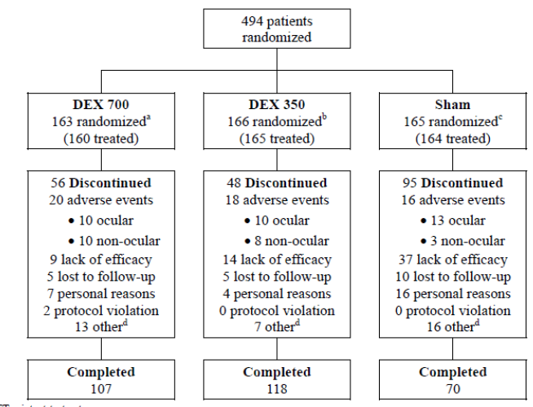
ITT = intent to treat. ª Three patients were randomised to DEX 700 but never received treatment. ^{b} one patient was randomised to DEX 700 but never received treatment ^{c} one patient was randomised to Sham never received treatment ^{d}. other reasons for patient discontinuation included site closure, patient withdrawal of consent, poor compliance from patient, sponsor request, patient participation in other trial etcetera.

Major protocol violations/deviations
Two patients were withdrawn for major protocol violations in the DEX 700 group but none were withdrawn in the DEX 350 and Sham groups. A total of 52 patients were excluded from the PP analysis. The main reasons were inclusion/exclusion errors (26 patients); randomised but did not receive treatment (5 patients); incorrect treatments given (3 patients); and patient missed last retreatment opportunity (22 patients).

Baseline data
Baseline demographics in the ITT population were well balanced among the treatment groups (Table 7.1.2, p42). The mean age was 63.0 years (range 26-84 years), and the majority were male (61.5%) and Caucasian (83.4%). Baseline disease characteristics are shown in Table 1. Most patients (91.1%) had type 2 diabetes present for an average of 16.2 years with a median duration of DME of 15 months. Mean HbA1c was 7.5%. Most patients (71.5%) had a phakic study eye with a mean IOP of 15.5 mm Hg. Mean SBP was 140.6 mm Hg and mean DBP was 78.8 mm Hg. There were no meaningful differences between groups. In the study eye, 96.6% of patients reported a history of ophthalmic conditions other than DME, and 99.8% of patients reported a medical history other than ophthalmic conditions. In the ITT population, 26.9% of patients had received previous treatment for DME, mainly triamcinolone acetonide (10.3%), bevacizumab (9.9%), and triamcinolone (5.9%). A total of 71.5% of patients had retinal laser therapy for DME prior to study entry.

Table 1 Baseline disease characteristics (ITT population) Study 010
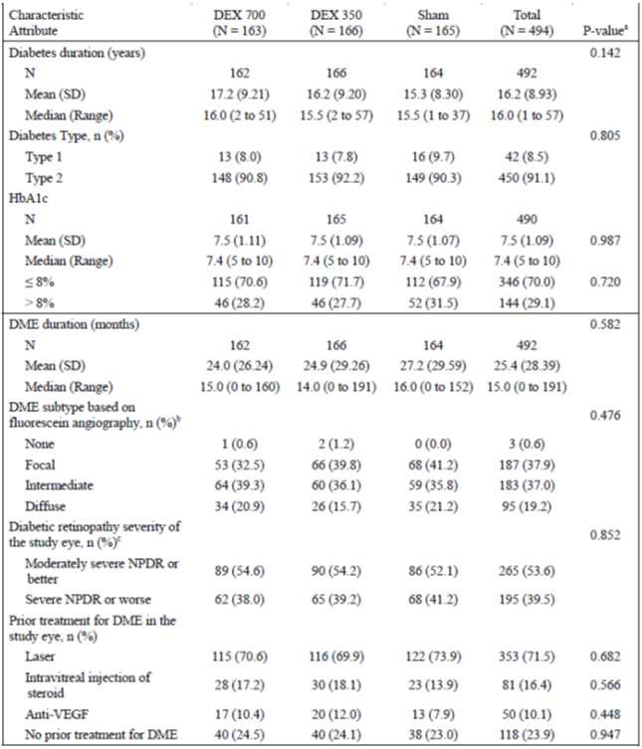

Table 1. (continued) Baseline disease characteristics (ITT population) Study 010
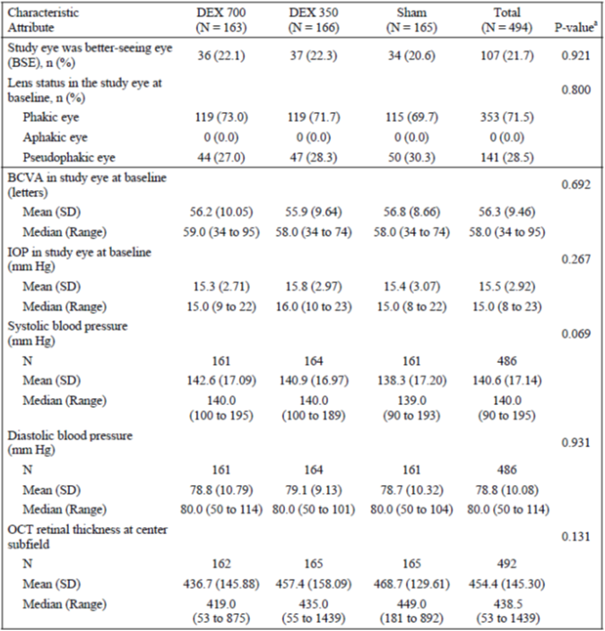
BCVA = best corrected visual acuity; BSE = better seeing eye; DME = diabetic macular edema; HbA1c = haemoglobin A1c; IOP = intraocular pressure; ITT = intent to treat; mmHg = millimetres of mercury; NDPR = non-proliferative diabetic retinopathy; OTC = optical coherence tomography; SD = standard deviation; VEGF = vascular endothelial growth factor; ª P-values were from a 1 way analysis of variance (ANOVA) for continuous variables and Pearson’s chi square for categorical variables. ^{b} based on fluorescein leakage source within grid focal, ≥ 67% from microaneurysms; intermediate 33% to 66% from microaneurysms; diffuse < 33% from microaneurysms. ^{c} Assessed by using the early treatment diabetic retinopathy study (ETDRS) final retinopathy severity scale.

Results for the primary efficacy outcome
In the ITT population, the mean average change from baseline in BCVA (using an AUC approach) was 4.1 letters in the DEX 700 group (range -24.5 to 24.3) and 4.3 letters in the DEX 350 group (range -20.1 to 25.9) compared with 1.9 letters in the Sham group (range -21.1 to 25.6). Compared with the Sham group, the differences were statistically significant for both DEX 700 (p = 0.016) and DEX 350 (p = 0.010) (Table 2).

Table 2. Mean BCVA average change form Baseline during the study (AUC approach) in the Study EYE (ITT population) Study 010
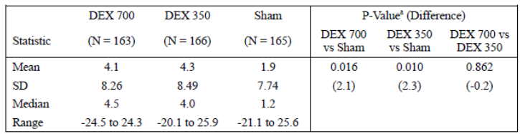
AUC = area under the curve; BCVA = best corrected visual acuity; ITT = intent to treat; SD = standard deviation. Note: average change in letters read calculated using AUC approach on observed data. BCVA assessment s after escape therapy were set to missing; missing values were not imputed. ª P-values based on analysis of v covariance (ANCOVA) with treatment as a factor and baseline value as covariate. Estimated difference was from least-squares mean.
In the PP analysis, the mean BCVA average change from baseline was similar to observed data in the ITT population. The mean average change was significantly greater with DEX 700 (4.7 letters) compared with Sham (2.2 letters) (p = 0.008), and with DEX 350 (4.6 letters) compared with Sham (p = 0.015). In a further sensitivity analysis, the mean BCVA average change from baseline using multiple imputation data in the ITT population was similar to the observed data in the ITT population although the change was statistically significant only with the DEX 350 group. The mean average change was greater with DEX 700 (2.9 letters) compared with Sham (0.2 letters) (p = 0.086), and with DEX 350 (4.0 letters) compared with Sham (p = 0.014).
In an analysis of the primary endpoint mandated by the FDA, the proportions of patients with a ≥ 15 letter improvement from baseline in the study eye at the final visit (with missing values imputed by LOCF) were 22.1% in the DEX 700 group, 18.7% in the DEX 350 group and 13.3% in the Sham group. The difference between the DEX 700 and Sham groups was statistically significant (p = 0.038) but not for the DEX 350 group compared with the Sham group (p = 0.185) (Table 3).

Table 3. Number (%) of patients with BCVA improvement of 15 or more letters from baseline in the study eye at year 3 final (ITT population) Study 010
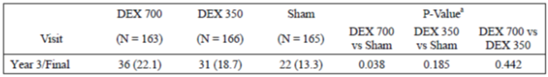
BCVA = best corrected visual acuity; ITT = intent to treat; Note; missing values are imputed by last observation carried forward at the follow up visits. BCVA assessments after escape therapy were set to missing. ª P-values are based on Pearson’s chi squared test.

Results for other efficacy outcomes
Mean changes in BCVA from baseline summarised by visit are shown in Figure 2. The treatment benefits in favour of the DEX groups were sustained and statistically significant at most study visits. At the final visit, the mean BCVA changes from baseline were 4.1 letters in the DEX 700 group, 5.0 letters in the DEX 350 group and 0.8 letters in the Sham group (p < 0.02 and p < 0.003, respectively). At the final visit, 38.7% of patients receiving DEX 700 and 34.3% of patients receiving DEX 350 showed a ≥10 letter improvement compared to 23.0% in the Sham group (p = 0.002 and p = 0.023, respectively).
Figure 2. Mean change from baseline in BCVA (Letters) in the study eye (ITT population Study 010
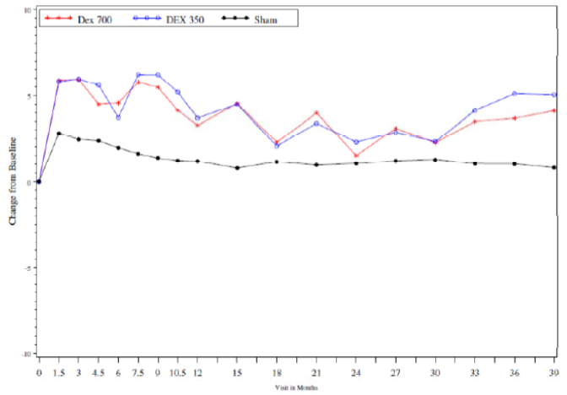
BCVA = best corrected visual acuity; ITT = intent to treat; Note; missing values are imputed by last observation carried forward at the follow up visits.
The mean average decreases from baseline in central subfield retinal thickness using OCT (AUC approach) were significantly greater in the DEX 700 group (101.1 µm) and DEX 350 group (103.9) compared with the Sham group (37.8 µm) (p < 0.001 for both comparisons) (Figure 3). The severity of diabetic retinopathy was assessed using fundus photography. Less than 8% of patients in each group had a 2 step progression in their diabetic retinopathy severity score. There were no statistically significant differences between the groups although there were trends in favour of both DEX groups. Only minor changes in contrast sensitivity were observed throughout the study.
Figure 3. Mean change from baseline in central subfield retinal thickness (µm) in the study eye (ITT population) Study 010
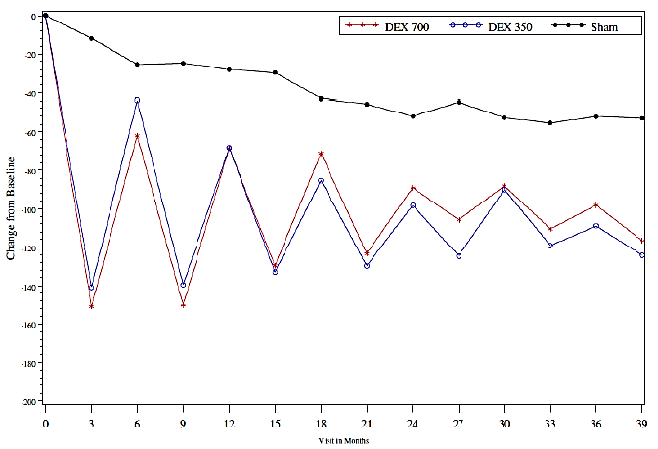
Analyses of efficacy were conducted according to subgroups defined by diabetes duration, DME duration, HbA1c, prior laser treatment, any prior treatment, phakic and pseudophakic study eyes, and severe NPDR (Table 4). In the DEX 700 group, the mean average BCVA was statistically significantly increased in patients with a shorter duration of diabetes, DME duration < 1.5 years, HbA1c < 8.0%, patients with prior laser treatment, patients with any prior treatment, and in patients with severe NPDR at baseline. Improvements in BCVA ≥ 15 letters were also observed in these patient groups. Similar changes were also observed in the DEX 350 group compared with Sham. A statistically significant benefit for DEX 700 was seen in pseudophakic eyes (p < 0.001). In the subgroup of patients with a pseudophakic eye at baseline, the mean BCVA average change from baseline during the study (AUC approach) was significantly greater with DEX 700 and DEX 350 compared with Sham. The differences in favour of DEX 700 and DEX 350 were 5.9 letters and 4.1 letters (p < 0.001 and p = 0.007, respectively). In patients with phakic eyes, the differences in favour of DEX 700 and DEX 350 were 0.7 letters and 1.5 letters. Neither difference was statistically significant. In patients with pseudophakic eyes at baseline, there was an 18.1% difference between DEX 700 and Sham for improvement of ≥ 15 letters from baseline to the last visit (p < 0.042). No benefit was seen in the DEX 350 group with a treatment difference of -1.1% (NS). In patients with phakic eyes at baseline, there was a 5.5% difference between DEX 700 and Sham for improvement of ≥ 15 letters from baseline to the last visit (NS). No benefit was seen in the DEX 350 group with a treatment difference of 8.0% (NS). The average mean decrease from baseline in retinal thickness measured by OCT was significantly greater with both DEX groups compared with Sham (p < 0.001 for both comparisons).

Table 4. Efficacy in the study eye by subgroup (ITT population) Study 010
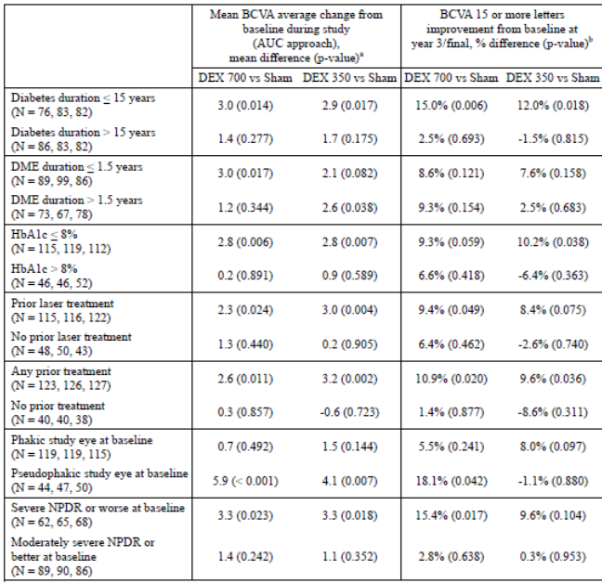
Note: N values correspond to the following order of treatment groups: DEX 700, DEX 350 and Sham. AUC = area under the curve; BCVA = best corrected visual acuity; DME = diabetic macular edema; HbA1c = haemoglobin A1c; ITT = intent to treat; NPDR = non-proliferative retinopathy ª p-values based on analysis of covariance (ANCOVA) with treatment as a factor and baseline value as covariate. Estimated difference was from least-squares mean. ^{b} p-value was from chi square test
Comment: The study was carefully conducted and controlled with adequate masking of patients and investigators using sham injections. Because of ethical considerations, the use of sham administration as a control group is generally accepted in ophthalmic clinical studies. Patient demographics were balanced between groups and they were representative of the type 2 diabetes population. At baseline, 71.5% of patients had a phakic eye. In an analysis of the initial primary endpoint mandated by the FDA, the proportions of patients with a ≥ 15 letter improvement from baseline after 3 years were 22.1% in the DEX 700 group compared with 13.3% in the Sham group. The difference between the DEX 700 and Sham groups was statistically significant (p = 0.038) and clinically meaningful but the overall response rate was low. Using the primary endpoint mandated by the MHRA, the mean average change from baseline in BCVA (using an AUC approach) was 4.1 letters in the DEX 700 group (range -24.5 to 24.3) compared with 1.9 letters in the Sham group (range -21.1 to 25.6). The treatment benefit in favour of DEX 700 was statistically significant (p = 0.06) but the clinical significance of an improvement of < 5 letters is questionable. However, improvements in visual acuity occurred rapidly and, in general they were sustained long-term. Overall, analyses of the secondary endpoints were consistent with the results of the primary analyses. Improved BCVA was associated with decreased central subfield retinal thickness measured by OCT. The mean average decrease from baseline was significantly greater in the DEX 700 group (101.1 µm) compared with the Sham group (37.8 µm) (p < 0.001). At the time the study commenced, there were no other approved medications for DME. Inclusion of a laser alone control group would have been useful but the protocol specifically included only patients considered unsuitable for laser therapy, or who had refused it. The benefits in favour of DEX were largely confined to patients with pseudophakic eyes. Improvements in visual acuity in phakic eyes were largely offset by cataract formation although OCT demonstrated consistent improvement in the underlying macular oedema. The dosing interval was fixed at a minimum of 6 months but, based on OCT, the treatment benefit for DEX was significantly attenuated after 3 months.

Study 206207-011 (011)

Study design, objectives, locations and dates
This was a Phase III, multicentre, masked, randomised, sham controlled trial of the Ozurdex Posterior Segment Drug Delivery System (DEX PS DDS) in patients with DME with the same study design as 206207-010. It was conducted at 72 centres in 14 countries (Brazil, Canada, Colombia, France, Hungary, India, Italy, NZ, Poland, Singapore, South Korea, Taiwan, the UK and the USA) between May 2005 and May 2012. The objectives were to evaluate the safety and efficacy of the 700 µg DEX PS DDS (DEX 700) and 350 µg DEX PS DDS (DEX 350) applicators compared with Sham DEX PS DDS. The study was masked using sham injections to minimise investigator and patient bias.
It was a 3 year study with up to 40 scheduled visits. After the initial treatment visit, visits occurred every 6 weeks during the first year and every 3 months thereafter until the end of the study. At the 6 month visit and every 3 months thereafter, patients were evaluated for retreatment eligibility although repeat treatment was not performed more often than 6 monthly. Post injection safety visits were required at 1, 7 and 21 days after the day of treatment or retreatment. Approximately 510 adult patients were planned, randomised 1:1:1 in three parallel treatment groups. The main efficacy endpoints were BCVA, contrast sensitivity, central retinal thickness measured by OCT, fundus photography and fluorescein angiography. Blood samples from selected patients were collected up to 3 months following the initial treatment to measure plasma dexamethasone concentrations.

Inclusion and exclusion criteria
The key inclusion criteria were: males or females aged 18 years or older; type 1 or type 2 diabetes; clinically observable DME in patients considered unsuitable by the investigator, or who had refused laser photocoagulation treatment; BCVA score between 34 and 68 letters; retinal thickness ≥ 300 µm by OCT in the central macular subfield; and patients who had received intravitreal triamcinolone acetonide but at low dose, not within the previous 6 months, and without treatment related adverse events.
The key exclusion criteria were: uncontrolled systemic disease or current immunosuppressive diseases; initiation of medical therapy or a change from oral hypoglycaemic agents to insulin within the previous 4 months; HbA1c greater than 10% at baseline; renal failure requiring dialysis; eGFR < 50 mL/min; other ocular conditions with the potential to prevent a 15 letter improvement in BCVA; presence of BRVO, CRVO, uveitis, pseudophakic cystoid macular oedema, or other eye conditions associated with macular oedema; history of IOP elevation in response to steroid treatment; history of glaucoma; uncontrolled ocular hypertension; aphakia or intraocular lens; active optic disc or retinal neovascularisation; active or history of choroidal neovascularisation in the study eye; rubeosis iridis in the study eye at baseline; active ocular infection; history of herpetic infection in the study eye or adnexa; active or inactive toxoplasmosis in either eye at baseline; visible scleral thinning or ectasia in the study eye; media opacity excluding photographic evaluation at baseline; intraocular surgery within the previous 90 days; history of central serous chorioretinopathy in either eye; history of pars plana vitrectomy in the study eye; anticipated need for ocular surgery or laser within 1 year of the baseline visit; history of intravitreal steroids in the study eye with the exception of triamcinolone; history of intravitreal bevacizumab, ranibizumab, or pegaptanib in the study eye in the previous 3 months; use of systemic steroids in the previous 6 months; use of dexamethasone within the previous 1 month; use of immunosuppressants, immunomodulators or antimetabolites within the previous 6 months; use or expected use of anticoagulants; BCVA score < 34 letters in the non-study eye; known allergy or hypersensitivity to study medication, fluorescein or povidone iodine; or contraindication to pupil dilation in either eye.

Study treatments
Patients received the initial DEX 700, DEX 350 or Sham treatment to the study eye on the randomisation day (Day 0) using the extruded DEX PS DDS Applicator. Up to six additional retreatments of the same assigned study medication were permitted during the course of the study.

Efficacy variables and outcomes
The main efficacy variables were:
- BCVA using the ETDRS method in the study eye
- Contrast sensitivity using the Pelli-Robson chart
- OCT capturing the mean retinal thickness in the 1 mm central subfield
- Fundus photography
- Fluorescein angiography
The primary efficacy outcome was the proportion of patients with a BCVA improvement of ≥ 15 letters in the study eye at Year 3. This was the primary endpoint mandated by the FDA. Subsequent protocol amendments allowed for an alternative primary endpoint, namely, BCVA average change from baseline in the study eye during the study using an AUC approach. This was the primary endpoint mandated by the MHRA as the method accounts for multiple treatments and observations.
Other efficacy outcomes included:
- Percentage of visits with BCVA ≥ 15 letter improvement
- Time to BCVA improvement
- Percent of visits with BCVA ≥ 15 letter improvement
- Average change from baseline in OCT retinal thickness
- Change from baseline in diabetic retinopathy severity based on fundus photography and fluorescein angiography
- Change from baseline in contrast sensitivity

Randomisation and blinding methods
Patients were randomised to receive DEX 700, DEX 350 or Sham in a ratio of 1:1:1 at the treatment visit using IVRS or IWRS. Emergency unmasking by the investigator was permitted. The study medications were supplied in identical packaging.
The study eye of each patient was anaesthetised with topical and subconjunctival anaesthetic and prepared according to a standard protocol. Patients randomised to an active treatment had the study drug placed into the vitreous through the pars plana using the DEX PS DDS Applicator System. Patients randomised to Sham treatment had a needleless applicator pressed against the conjunctiva to preserve masking.
The study treatment procedure and Post injection safety evaluations were performed by a treating investigator. The treating investigator also evaluated the quality of the OCT prints, fundus photographs and fluorescein angiograms obtained at the treatment visit. The treating investigator had overall responsibility for patient safety, did not participate in efficacy procedures and was required to conceal the study treatment except for safety reasons.
The follow-up investigator did not participate in study treatment procedures and any unscheduled visits necessary within 30 days of treatment were performed by the treating investigator. All other unscheduled visits were performed by the follow-up investigator. Individuals collecting BCVA, contrast sensitivity, OCT, fundus photographs, and fluorescein angiograms were masked to the patient treatments. A masked central reading centre was used to evaluate OCT, fundus photographs, and fluorescein angiograms.

Analysis populations
There were three analysis populations: ITT, PP and safety. The ITT population was defined as all randomised patients, the PP population was randomised patients with no pre-defined major protocol violations, and the safety population was defined as all patients who received at least one dose of study medication.

Sample size
The sample size calculation was based on the primary efficacy analysis of the BCVA average change from baseline during the study in the study eye. Based on two 6 month studies in RVO (206207-008 and 206207-009), the BCVA average change from baseline at 6 months was 6.9 and 2.9 letters for the DEX 700 and Sham groups, respectively, with an observed SD of 10 letters. For the DME study, a 4 letter mean difference in the BCVA average change from baseline for the DEX 700 group compared with the Sham group, with a higher SD of 12.0 to allow for multiple injections, was assumed. Based on these assumptions, a planned sample size of 170 patients per arm (510 patients in total) had 86% power with a 2 sided α of 0.05.

Statistical methods
The primary analysis of BCVA average change from baseline was performed using ANCOVA with treatment as a fixed effect and the baseline BCVA as a covariate in the ITT population. The primary comparisons between DEX 700 and Sham, and between DEX 350 and Sham were performed in a pairwise fashion using contrasts from the ANCOVA model. A gate keeping procedure was used to control the overall type 1 error at 5% for the two comparisons. The comparison of DEX 700 versus Sham was significant if the p-value was ≤ 0.05. If the comparison was not statistically significant, the comparison between the DEX 350 and Sham groups could not be considered statistically significant regardless of p-value. In addition, 2 sided 95% Cis were constructed for the between group differences based on the ANCOVA model. Analyses of secondary efficacy endpoints were performed with missing values imputed by LOCF in the ITT population. Analyses were performed using ANCOVA, Pearson’s chi-square test, Wilcoxon rank-sum test, and Kaplan-Meier survival curves as appropriate.

Participant flow
A total of 554 patients were randomised and 312 patients completed the 3 year study (118, 112 and 82 patients in the DEX 700, DEX 350 and Sham groups, respectively). The main reasons for discontinuation were adverse events in the active and Sham treatment groups, and lack of efficacy in the Sham group. Additional details are shown below in Figure 4. By Month 12, 22.4% of patients had discontinued: 17.0% in the DEX 700 group, 14.4% in the DEX 350 group, and 35.7% in the Sham group. By Month 24, 35.7% of patients had discontinued: 29.3% in the DEX 700 group, 28.7% in the DEX 350 group, and 49.2% in the Sham group. After 3 years, 43.7% of patients had discontinued: 37.2% in the DEX 700 group, 38.1% in the DEX 350 group, and 55.7% in the Sham group.
Figure 4. Disposition of patients in the ITT population Study 011
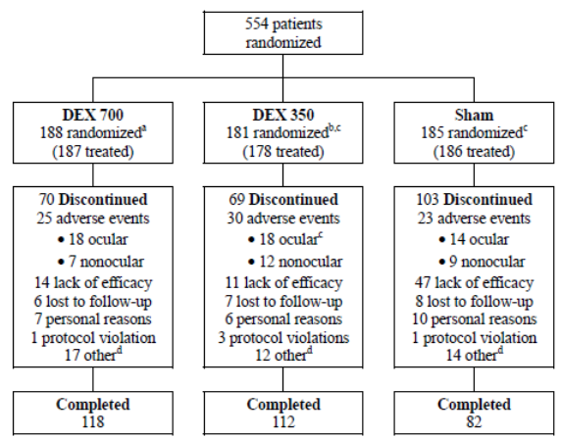
ITT = intent to treat. ª One patient was randomised to DEX 700 but never received treatment. ^{b} Two patients were randomised to DEX 350 but never received treatment ^{c} one patient was randomised to DEX 350 but actually received Sham. This patient discontinued the study due to an serious adverse event of macular fibrosis in the study eye after Sham treatment. The patient is counted in the DEX 350 group for analysis based on the ITT population and in the Sham group for analysis based on the safety population^{d}. other reasons for patient discontinuation included site closure, patient withdrawal of consent, poor compliance from patient, sponsor request, patient participation in other trial etcetera.

Major protocol violations/deviations
Five patients were withdrawn for major protocol violations: three patients in the DEX 350 group and one patient each in the DEX 700 and Sham groups. A total of 63 patients were excluded from the PP analysis. The main reasons were inclusion/exclusion errors (21 patients); randomised but did not receive treatment (3 patients); incorrect treatments given (2 patients); and patients missed their last retreatment opportunity, that is patients should have received their last retreatment based on OCT criteria but did not (38 patients).

Baseline data
Baseline demographics in the ITT population were well balanced among the treatment groups. The mean age was 61.9 years (range 25 to 88 years) and the majority were male (59.9%) and Caucasian (52.2%). Baseline disease characteristics were provided. Most patients (92.2%) had type 2 diabetes present for an average of 15.9 years with a median duration of DME of 17 months. Mean HbA1c was 7.5%. Most patients (75.8%) had a phakic study eye with a mean IOP of 15.4 mm Hg. Mean SBP was 137.4 mm Hg and mean DBP was 79.0 mm Hg. There were no meaningful differences between groups. In the study eye, 96.6% of patients reported a history of ophthalmic conditions other than DME, and all patients reported a medical history other than ophthalmic conditions. In the ITT population, 26.9% of patients had received previous treatment for DME, mainly triamcinolone acetonide (9.7%), triamcinolone (8.7%) and bevacizumab (6.7%). A total of 62.3% of patients had retinal laser therapy for DME prior to study entry.

Results for the primary efficacy outcome
In the ITT population, the mean average change in BCVA (using an AUC approach) was 2.9 letters in the DEX 700 group (range -33.3 to 21.4) and 2.9 letters in the DEX 350 group (range -23.8 to 27.2) compared with 2.0 letters in the Sham group (range -26.5 to 24.1). Compared with the Sham group, the differences were not statistically significant for either DEX 700 (p = 0.366) or DEX 350 (p = 0.396) (Table 5).

Table 5. Mean BCVA average change from baseline during the study (AUC approach) in the study eye (ITT population) Study 011
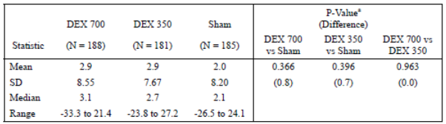
AUC = area under the curve; BCVA = best corrected visual acuity; ITT = intent to treat; SD = standard deviation Note; average change in letters read calculated using AUC approach on observed data; BCVA assessments after escape therapy was set to missing; missing values were not imputed. ª p-values based on analysis of covariance (ANCOVA) with treatment as a factor and baseline value as covariate. Estimated difference was from least-squares mean
In the PP analysis, the mean BCVA average change from baseline using observed data was similar to observed data in the ITT population. The mean average change was not significantly greater with DEX 700 (3.5 letters) compared with Sham (2.2 letters) (p = 0.161), or with DEX 350 (3.0 letters) compared with Sham (p = 0.434). In a further sensitivity analysis, the mean BCVA average change from baseline using multiple imputation data in the ITT population was similar to the observed data in the ITT population. The change was not statistically significant for DEX 700 (-0.1 letters) compared with Sham (0.4 letters) (p = 0.694), or for DEX 350 (1.2 letters) compared with Sham (p = 0.685).
In an analysis of the primary endpoint mandated by the FDA, the proportions of patients with a ≥ 15 letter improvement from baseline in the study eye at the final visit (with missing values imputed by LOCF) were 22.3% in the DEX 700 group, 18.2% in the DEX 350 group and 10.8% in the Sham group. The differences between the DEX 700 and DEX 350 groups and the Sham group were statistically significant (p = 0.003 and p = 0.044, respectively.

Results for other efficacy outcomes
Mean changes in BCVA from baseline summarised by visit are shown in Figure 5. Early treatment benefits in favour of the DEX 700 and DEX 350 groups in the first year of treatment were not sustained long-term. At the final visit, the mean BCVA changes from baseline were 1.3 letters in the DEX 700 group, 1.4 letters in the DEX 350 group and -0.0 letters in the Sham group (p = 0.505 and p = 0.536, respectively). At the final visit, 34.6% of patients receiving DEX 700 and 29.8% of patients receiving DEX 350 showed a ≥ 10 letter improvement compared to 24.9% in the Sham group (p = 0.04 and p = 0.286, respectively).
Figure 5. Mean change from baseline in BCVA (Letters) in the study eye (ITT population) Study 011
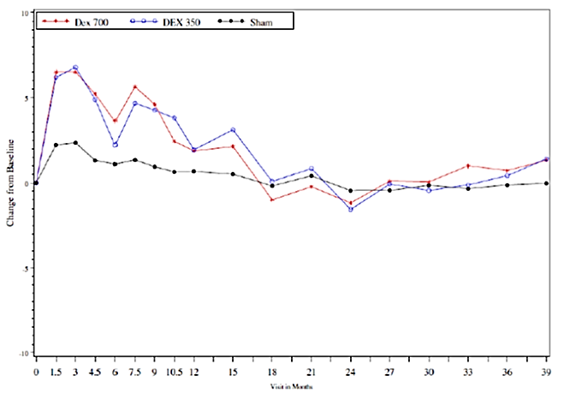
BCVA = best corrected visual acuity; ITT = intent to treat Note: missing values are imputed by last observation carried forward at the follow up visits
The mean average decreases from baseline in central subfield retinal thickness using OCT (AUC approach) were significantly greater in the DEX 700 group (120.7 µm) and DEX 350 group (111.6) compared with the Sham group (45.8 µm) (p < 0.001 for both comparisons) (Figure 6). The severity of diabetic retinopathy was assessed using fundus photography. Less than 10% of patients in each group had a 2 step progression in their diabetic retinopathy severity score. There were no statistically significant differences between the groups although there were trends in favour of both DEX groups. Small mean decreases from baseline in contrast sensitivity were observed in all three treatment groups throughout the study.
Figure 6. Mean change from baseline in central subfield retinal thickness (µm) in the study eye (ITT population) Study 011
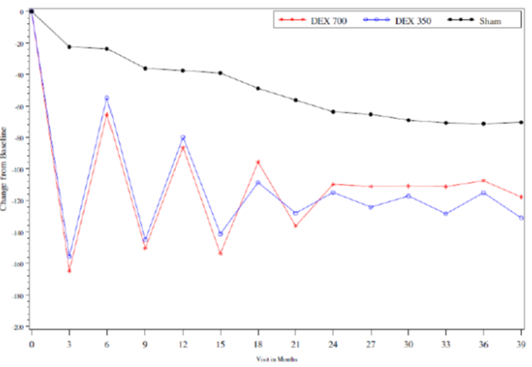
ITT = intent to treat Note: missing values are imputed by last observation carried forward at the follow up visits
Analyses of efficacy were conducted according to subgroups defined by diabetes duration, DME duration, HbA1c, prior laser treatment, any prior treatment, phakic and pseudophakic study eyes, and severe NPDR (Table 6). In the DEX 700 group, the mean average BCVA was not statistically significantly increased in patients with a shorter duration of diabetes, DME duration < 1.5 years, HbA1c < 8.0%, patients with prior laser treatment, patients with any prior treatment. Statistically significant improvements in BCVA ≥ 15 letters were also observed in these patient groups with the exception of prior laser treatment. Similar trends were also observed in the DEX 350 group compared with Sham. Patients with severe NPDR at baseline had significant improvements in the DEX 700 group compared with Sham.

Table 6. Efficacy in the study eye by subgroups ITT population Study 011
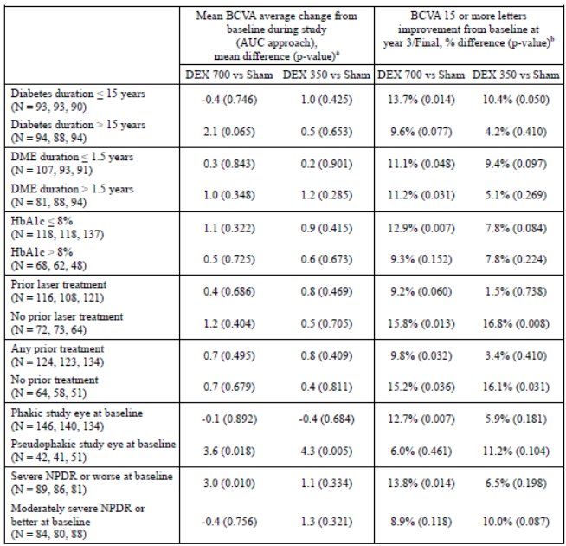
Note: N values correspond to the following order of treatment groups: DEX 700, DEX 350 and Sham. AUC = area under the curve; BCVA = best corrected visual acuity; ITT = intent to treat; NDPR = non-proliferative diabetic retinopathy. ª p-values based on analysis of covariance (ANCOVA) with treatment as a factor and baseline value as covariate. Estimated difference was from least-squares mean. ^{b} p-values from Chi-square test.
In the subgroup of patients with a pseudophakic eye at baseline, the mean BCVA average change from baseline during the study (AUC approach) was significantly greater with DEX 700 and DEX 350 compared with Sham. The differences in favour of DEX 700 and DEX 350 were 3.6 letters and 4.3 letters (p < 0.018 and p = 0.005, respectively). In patients with phakic eyes, the differences in favour of DEX 700 and DEX 350 were -0.1 letters and -0.4 letters. Neither difference was statistically significant. In patients with pseudophakic eyes at baseline, there was a 6% difference between DEX 700 and Sham for improvement of ≥ 15 letters from baseline to the last visit (NS). No benefit was seen in the DEX 350 group with a treatment difference of 11.2% (NS). In patients with phakic eyes at baseline, there was a significant 12.7%% difference (p = 0.007) in favour of DEX 700 and Sham for improvement of ≥ 15 letters from baseline to the last visit. No benefit was seen in the DEX 350 group with a treatment difference of 5.9% (NS). The average mean decrease from baseline in retinal thickness measured by OCT was significantly greater with both DEX groups compared with Sham (p < 0.001 for both comparisons).
Comment: The study was identical in design and methodology to Study 010. In an analysis of the initial primary endpoint mandated by the FDA, the proportions of patients with a ≥ 15 letter improvement from baseline after 3 years were 22.3% in the DEX 700 group compared with 10.8% in the Sham group. The difference between the DEX 700 and Sham groups was statistically significant (p = 0.003) and clinically meaningful. However, using the primary endpoint mandated by the MHRA, the mean average change from baseline in BCVA (using an AUC approach) was 2.9 letters in the DEX 700 group compared with 2.0 letters in the Sham group which was not statistically significant (p = 0.366). There was a sustained decrease in central subfield retinal thickness measured by OCT. The mean average decrease from baseline using an AUC approach was significantly greater in the DEX 700 group (120.7 µm) compared with the Sham group (45.8 µm) (p < 0.001). The 011 study failed one of its primary endpoints but the overall results were consistent with Study 010 and the same comments apply.

Other efficacy studies

Study DC103-06 (06)
This was a Phase II, randomised, multicentre, controlled, parallel group, dose ranging study of DEX PS DDS in the treatment of persistent ME. It was conducted at 29 centres in the US between October 2001 and August 2004. The objective was to compare the efficacy and safety of two doses of DEX PS DDS versus Observation in the treatment of ME persisting at least 90 days after laser treatment or medical management. The Observation group was patients who met all the protocol eligibility criteria but who received no active treatment. The patients were aware if they were randomised to active treatment but they were not aware of which dose of DEX they received. Patients were randomised 1:1:1 to DEX 700, DEX 350 or Observation groups with subgroup stratification based on the underlying cause of ME (diabetic retinopathy, uveitis, Irvine-Gass syndrome, BRVO or CRVO). The study medications used an earlier rather than extruded later formulation of the DEX PS DDS. Eligible patients were male or female aged 12 years or above. Patients were followed for 180 days after treatment for safety evaluation. The primary efficacy endpoint was the 2 line improvement rate in BCVA from baseline to Day 90. Secondary endpoints included changes in contrast sensitivity, OCT, fundus photography and fluorescein angiography.
A total of 285 patients were planned and 315 patients were randomised, 105 patients in each group. Of these, 306 patients received their assigned study medications (101 patients DEX 700, 100 patients DEX 350, and 105 patients Observation). There were 29 study discontinuations, most commonly due to withdrawal of consent. Baseline demographics were similar in each group. Mean age was 62 years, most patients were male (51.3%) and Caucasian (77.8%), and the most common cause of ME was diabetic retinopathy (53.9%). The mean duration of the first onset of macular oedema in the DME stratum was 2.18 years.

Efficacy results
The 2 line improvement rate from baseline in the ITT population at 90 days was significantly higher in the DEX 700 group (36.7%) compared with the Observation group (19.0%) (p = 0.005). The improvement rate was also higher in the DEX 350 group (26.1%) but the difference was not statistically significant (p = 0.238). A significantly higher proportion of patients had an improvement of at least 15 letters on Day 90 in the DEX 700 group (18.1%) compared with the observation group (5.7%) (p = 0.006). A higher proportion of patients had an improvement in the DEX 350 group (9.7%) but the change was not significant (p = 0.280). A total of 165 (53.9%) patients had DME. In patients with DME, the 2 line improvement rates in BCVA from baseline were 18.0%, 34.0%, 39.6% and 30.2% in the DEX 700 group at Days 30, 60, 90, and 180, respectively (p = 0.007 for DEX 700 compared with Sham at Day 90). Improvement rates in the DEX 350 group were 21.3%, 24.5%, 20.0%, and 22.0% at Days 30, 60, 90, and 180, respectively (p = 0.209 for DEX 350 compared with Sham at Day 90). The corresponding rates in the Observation group were 9.4%, 12.7%, 14.5%, and 20.0%, respectively.
Contrast sensitivity was significantly improved in the DEX 700 and DEX 350 groups compared with the Observation group (p < 0.03 for both comparisons). Clinical signs of ME, fundus photography and fluorescein angiographic appearance were also significantly improved in both active treatment groups. Mean changes in retinal thickness measured by OCT from baseline to Day 90 were -147.20 µm in the DEX 700 group, -63.08 µm in the DEX 350 group, and 9.54 µm in the Observation group. The differences were statistically significant in both active treatment groups (p ≤ 0.016).
Comment: This dose ranging study has some limitations. The study population was not representative of the pivotal study population and an earlier formulation was used for both DEX doses. Only 53.9% of patients had DME, although an analysis of the DME subgroup showed similar efficacy rates compared with the overall population.

Study 206207-012 (012)
This was a 52 week, Phase II, masked, multicentre, randomised, controlled trial to assess the efficacy and safety of DEX 700 compared with laser photocoagulation in patients with diffuse DME. It was conducted at 48 centres in Canada and the USA between May 2007 and February 2010. The objective was to compare the efficacy and safety of 700 µg of DEX PS DDS in combination with laser photocoagulation compared with laser photocoagulation alone. Patients were randomised 1:1 to Combination Therapy (DEX + Laser) or Laser Alone (Sham + Laser), stratified according to baseline BCVA (≥ 34 to ≤ 49 letters or ≥ 50 to ≤ 70 letters). Eligible patients were male or female patients with type 1 or type 2 diabetes aged 18 years or above. Patients were followed for 52 weeks with up to 11 scheduled visits. After the initial treatment, patients were allowed an additional three laser treatments at intervals of no less than 13 weeks, and a maximum of one additional treatment with DEX/Sham with a minimum interval of 26 weeks. The primary efficacy endpoint was the proportion of patients with a BCVA improvement of 10 or more letters from baseline to Month 12. Secondary endpoints included the proportion of patients with a BCVA improvement of 15 letters or more, changes in contrast sensitivity, OCT, fundus photography and fluorescein angiography. A total of 248 patients were planned and 253 patients were randomised, 126 patients in the Combination Group and 127 patients in the Laser Alone group. Approximately 75% of patients in each group completed the study. The most common reasons for early discontinuation were AEs and lack of efficacy. Baseline demographics were similar in each group. In the ITT population, mean age was 61.6 years, approximately 50% of patients were male, and over 60% were Caucasian.

Efficacy results
The 10 letter improvement rates from baseline to Month 12 in the ITT population were 27.8% in the Combination Therapy group and 23.6% in the Laser Alone group but the difference was not statistically significant (p = 0.453). For the primary endpoint, the difference in favour of the Combination group was 4.1 letters (95% CI: -6.7, 15.0, p = 0.453)). In the PP population, the improvement rates were 26.1% in the Combination group and 29.4% in the Laser group. The difference was -3.2 letters (95% CI: -16.5, 10.1, p = 0.636). At Month 12, more patients in the Combination group had a ≥ 15 letter improvement compared with the Laser Alone group but the difference was not statistically significant (16.7% and 11.0%, respectively, p = 0.192). There were no significant benefits in favour of Combination Therapy measured by OCT, contrast sensitivity, clinical signs of ME, fundus photography and fluorescein angiographic appearance.
Comment: The study results do not suggest a meaningful benefit in combining DEX 700 and laser therapy compared with laser therapy alone.

Study 206207-018 (018)
This was a 26 week, open label, Phase II study to assess the efficacy and safety of DEX PS DDS in the treatment of vitrectomised patients with DME. The study was conducted at 13 centres in the USA and Australia between January 2009 and December 2009. The objective was to assess the efficacy and safety of 700 µg of DEX PS DDS in patients who had a pars plana vitrectomy in the study eye. The study was open label and all patients received DEX 700. Eligible patients were male or female patients with type 1 or type 2 diabetes aged 18 years or above, with a history of pars plana vitrectomy at least 3 months before the study treatment day. Patients were followed for 26 weeks with up to 9 scheduled visits. The primary efficacy endpoint was the change in central retinal thickness from baseline measured by OCT. Secondary endpoints included the proportion of patients with improved BCVA and fluorescein angiography. A total of 40 patients were planned, 56 patients were randomised, 55 patients received treatment, and 53 (94.6%) patients completed the study. Baseline demographics were provided. In the ITT population, mean age was 62.0 years, and most patients were female (53.6%) and Caucasian (64.3%). Mean duration of DME was 43.04 months.

Efficacy results
There was a statistically significant decrease in central retinal thickness in the study eye at Week 26 compared to baseline (-38.9 µm, 95% CI: -64.8, -12.9, p = 0.004). Compared with baseline, mean BCVA increased after treatment at Week 26 by 3.0 letters (95% CI: 0.1, 6.0, p = 0.046). At baseline, 96.4% of patients had fluorescein leakage in the macula of the study eye compared with 79.2% at Week 26.

Analyses performed across trials
A pooled efficacy analysis of the two Phase III pivotal Studies 010 and 011 was performed. The Phase II studies were not included in the pooled analysis as the study designs, duration and patient populations were different.
The Integrated Summary of Efficacy (ISE) consisted of 1,048 patients (494 patients from 010 and 554 patients from 011). There were 351, 347 and 350 patients in the DEX 700, DEX 350 and Sham groups, respectively. Discontinuation rates were lower in the DEX 700 (35.9%) and DEX 350 groups (33.7%) compared with the Sham group (56.6%). Discontinuations due to AEs were similar in the DEX and Sham groups but discontinuations due to lack of efficacy were 3 times higher in the Sham group. Patient demographics and baseline disease characteristics were similar across the treatment groups. Overall, the mean age was 62.4 years and the majority were male (60.7%) and Caucasian (66.9%). Average diabetes disease duration was 16.1 years, the majority (91.7%) had type 2 diabetes and HbA1c was ≤ 8% in 68.6% of patients. The median duration of DME was 16 months. Previous treatments in the study eye included laser (66.6%), intravitreal steroid injection (17.9%), and anti-VEGF medical therapy. A total of 27.8% of patients were treatment naïve. At baseline, 73.8% of patients had a phakic eye and 26.2% had a pseudophakic study eye. Mean BCVA at baseline was 56.2 letters (range 34 to 94) and mean IOP was 15.4 mm Hg (range 8 to 28).

Efficacy results

Primary endpoints
In the ITT population, mean average changes in BCVA from baseline (AUC approach) are shown in Figure 7. In the pooled analysis, DEX 700 and DEX 350 were statistically superior to Sham (p = 0.023 and 0.019, respectively). In each of the Phase III studies and the pooled analysis, the mean percent of visits with BCVA ≥ 15 letters improvement was significantly greater with DEX700 and DEX 350 compared with Sham (p < 0.001 for both pooled comparisons) (Figure 8). There were rapid BCVA improvements in both DEX groups which were sustained long-term.
Figure 7. Mean BCVA change from baseline (letters) in the study eye (pooled Studies 206207-010 and 206207-011, ITT population)
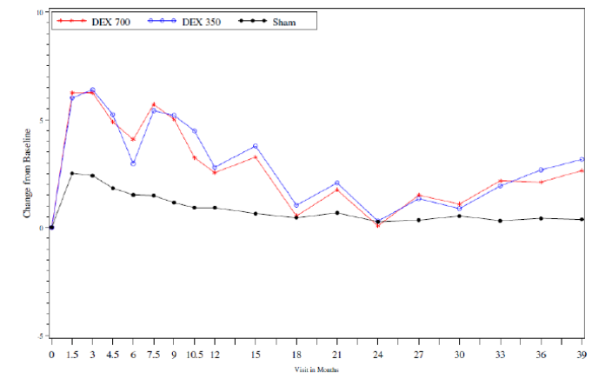
Figure 8. Mean percent of visits with BCVA ≥ 15 letters improvement (Studies 206207-010 and 206207-011, ITT population)
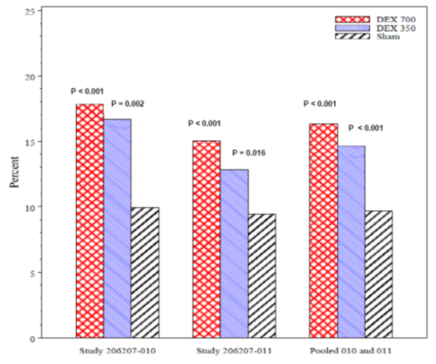
BCVA = best corrected visual acuity; ITT = intent to treat; Note percent calculated based on observed data at visits month 3 through 39, every 3 month interval; missing values were not imputed. Percentages set to 0 for patients without post baseline 3 month or beyond BCVA data. For the by-study and pooled analysis, p-values versus Sham were based on the Wilcoxon rank-sum test. Sample sizes for the DEX 700, DEX 350 and Sham groups are as follows: N = 163, 166 and 165 for Study 206207-010; N = 188, 181 and 185 for Study 206207-011 and N = 351, 347 and 350 for the pooled analysis.

Secondary endpoints
Mean average decreases in retinal thickness from baseline using OCT were provided. In the pooled analysis, the decrease was 111.6 µm in the DEX 700 group, 107.9 µm in the DEX 350 group and 41.9 µm in the Sham group. Mean decreases in contrast sensitivity were seen in all groups and there was no difference between the DEX and Sham groups.

Impact of cataracts on visual impairment
A post hoc analysis was performed to account for the high incidence of cataract formation associated with diabetes and with ocular corticosteroids. The analysis showed that there was loss of vision associated with the development of cataracts but this did not influence the underlying improvements in vision in the DEX treatment groups. In the pooled Phase III studies, 176 DEX 700 patients, 159 DEX 350 patients, and 42 Sham patients with a phakic eye at baseline had cataract AEs reported during the course of the study. As shown in Figure 9, DEX 700 was significantly more effective than Sham for improvements in BCVA. Vision loss was observed following reports of cataract but improvement was re-established after cataract surgery. In patients with a phakic eye at baseline with no cataract AEs reported, visual improvement in the DEX groups was similar to that seen in patients after surgery. Mean average change from baseline was 4.7, 4.4, and 2.2 letters in the DEX 700, DEX 350 and Sham groups, respectively. In patients with a pseudophakic study eye at baseline, vision improvement persisted throughout the study. In patients with a phakic eye at baseline and with cataract AEs reported during the study, reductions in retinal thickness measured by OCT were significantly reduced in both DEX treatment groups throughout the study (Figure 10).
Figure 9. Mean BCVA average change from baseline (AUC approach) in phakic study eyes for time intervals between baseline, cataract adverse event, cataract surgery and last BCVA measurement (pooled Studies 206207-010 and 206207-011, ITT population)
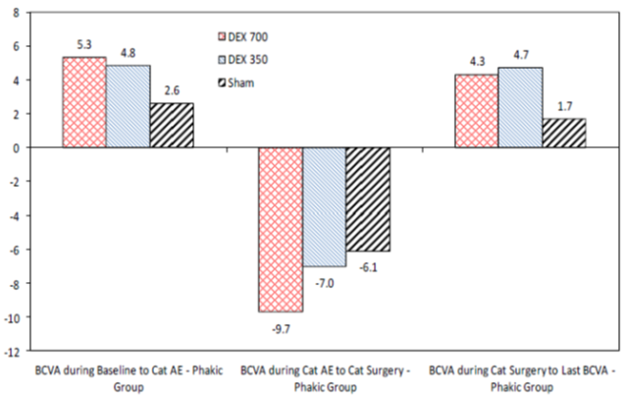
AE = adverse event, AUC = area under the curve, BCVA = best corrected visual acuity; Cat = cataract; ITT = intent to treat. Note: BCVA during baseline to Cat AE is the period from baseline to the study visit prior to reporting of cataract AE. Sample sizes for the DEX 700, DEX 350 and Sham groups are as follows for each time interval: Baseline to cataract AE for baseline phakic study eyes (N = 176, 159 and 42). Cataract AE to cataract surgery + 30 days for baseline phakic study eyes (N = 132, 118 and 14) Day of cataract surgery + 30 days to last BCVA for baseline phakic study eyes (N = 142, 123 and 17).
Figure 10. Mean OCT retinal thickness (RT) central subfield average change from baseline (AUC approach) in phakic study eyes for time intervals between baseline, cataract adverse event, cataract surgery and last OCT RT measurement (pooled Studies 206207-010 and 206207-011, ITT population)
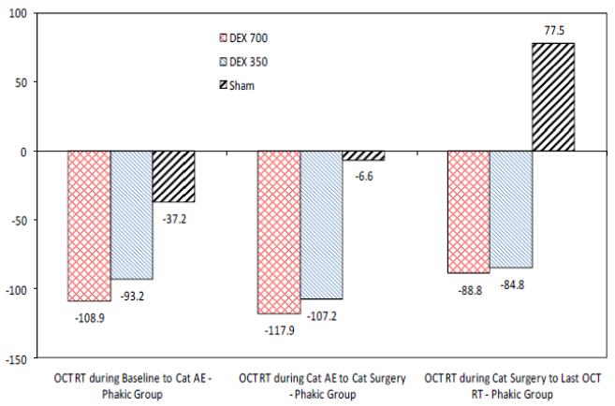
AE = adverse event, AUC = area under the curve, Cat = cataract; ITT = intent to treat; OCT RT = optical coherence tomography retinal thickness at centre subfield (µm). Note: OCT RT during baseline to Cat AE is the period from baseline to the study visit prior to reporting of cataract AE. Sample sizes for the DEX 700, DEX 350 and Sham groups are as follows for each time interval: Baseline to cataract AE for baseline phakic study eyes (N = 172, 149 and 39); Cataract AE to cataract surgery + 30 days for baseline phakic study eyes (N = 120, 108 and 12); cataract surgery + 30 days to last OCT RT for baseline phakic study eyes (N = 140, 119 and 17)
Comment: No comprehensive subgroup analyses have been provided in the ISE. Analysis is largely confined to patients with pseudophakic eyes and patients with severe NPDR. These subgroups have been selectively reported as they have the best outcomes compared with the overall group. The sponsor comments in the Clinical Overview that ‘some differential efficacy effects observed within subgroups were likely caused by the small sample size of that subgroup’. This statement might be valid but the sponsor should provide an analysis of efficacy for all subgroups, in particular patients with phakic eyes. This group represented > 70% of the study population but it appeared to have the least favourable efficacy outcomes.

Evaluator’s conclusions on clinical efficacy
Evaluator’s conclusions on clinical efficacy for the treatment of diabetic macular oedema (DME):
Statistically significant efficacy has been demonstrated for the use of Ozurdex 700 µg and 350 µg in both pivotal studies, although improved BCVA using the AUC approach was not confirmed in Study 011. Improved visual acuity occurred within the first month of treatment and was sustained with repeat dosing over a 3 year observation period. The BCVA clinical endpoints and the 3 year observation period were appropriate using design and methodologies agreed by the EU and US FDA. In both studies the positive BCVA findings were supported by the OCT findings which clearly demonstrated reductions in retinal thickening due to macular oedema. Both DEX doses were effective with a modest benefit in favour of the 700 µg dose. Dose selection was based on preclinical studies in a rabbit model of VEGF induced vasculopathy as the characterisation of intraocular PK is invasive. The studies confirmed the release of effective dexamethasone concentrations. However, the implant has a 35 day release profile (in rabbits) and the rationale for a 6 month dose interval is not clear. The dose ranging clinical Study 06 showed that both doses were effective with an acceptable safety profile.
No active comparator group was included in the pivotal studies. At the time the studies were designed, there were no approved medications for DME although triamcinolone injections have been used off label for some years. VEGF inhibitors are now widely used but laser therapy remains the most widely used intervention. It is not clear why a laser therapy control group was not included, or why the study population was restricted to patients unsuitable for laser therapy. Sham injections are an accepted masking methodology in ocular studies. This is largely due to ethical concerns about potential damage, including infection, in eyes given placebo injections.
In the overall Phase III study population there was a statistically significant treatment benefit in favour of DEX 700 compared with Sham. Approximately 20 to 25% of patients had a meaningful increase in visual acuity with DEX 700 compared with 10 to 15% in the Sham population. However, the average improvements in measures of BCVA were modest and not clinically meaningful. In the ISE, two paragraphs have been devoted to efficacy in subpopulations, with reference only to patients with pseudophakic eyes and/or severe NPDR (in whom efficacy appeared most favourable). Only scant subgroup data have been provided in the CSRs but it appears that efficacy is significantly less or non-existent in other subgroups. A more thorough analysis of efficacy in all subgroups should be provided. BCVA improvement in phakic eyes appears to be ill-sustained due to the almost inevitable development of cataract. The sponsor’s argument that cataract formation masks the positive effects of DEX in patients with phakic eyes is reasonably made. OCT data appear similar in pseudophakic and phakic study eyes and BCVA improvement is restored following cataract surgery in phakic eyes. However, the data suggest that treatment of phakic eyes is largely ineffective, unless or until the patient has a lens replacement.

Clinical safety

Studies providing evaluable safety data
The following studies provided evaluable safety data:
- Two pivotal 3 year Phase III Studies (010 and 011). The data were presented as individual studies and as a pooled Integrated Summary of Safety (ISS).
- Three Phase II Studies. These data could not be pooled due to differences in patient groups, and study design and duration.

Pivotal efficacy studies
In the pivotal efficacy studies, the following safety data were collected:
- Non-ocular adverse events (AEs) were assessed with coding performed using MedDRA.
- Ocular AEs including increased IOP and the development of cataracts were coded in the Eye Disorders SOC. Treatment related ocular AEs were broken down further by relationship to applicator or insertion, or to DEX PS DDS, or both. AEs were tabulated for the study eye and for the non-study eye but patients from the three treatment groups were combined into a single group for the non-study eye.
- Routine laboratory testing was not a protocol requirement in the Phase II or III studies. Measurements of HbA1c and serum creatinine for eGFR were performed at central laboratories.

Pivotal studies that assessed safety as a primary outcome
None presented.

Dose response and non-pivotal efficacy studies
The dose response and non-pivotal efficacy studies provided safety data, as follows:
- Study 06 provided 3 month safety data in patients with any cause of ME.
- Study 012 provided 52 week safety data in patients with DME.
- Study 018 provided 26 week safety data in patients with DME.

Other studies evaluable for safety only
None presented.

Pivotal studies that assessed safety as a primary outcome
None presented.

Patient exposure
In the ISS, 1,040 patients with DME received at least one dose of study drug (347 patients in the DEX 700 group, 343 patients in the DEX 350 group, and 350 patients in the Sham group). Cumulative exposure was 22% less in the Sham group than in the DEX groups due to more patient discontinuations (Table 7). A total of 3,037 retreatments were administered during the 3 year study period. Approximately 80% of them were administered between 5 to 7 months after the initial treatment.
In Study 06, 101 patients received a single DEX 700 dose, 100 patients received a single DEX 350 dose, and 105 patients were followed with Observation only. In Study 012, the mean duration of exposure to DEX 700 was 348.0 days in the Combination Therapy group and 339.1 days in the Laser Alone group.

Table 7. Cumulative number of patients [%] and average study duration of exposure (pooled Studies 206207-010 and 206207-011, ITT population)
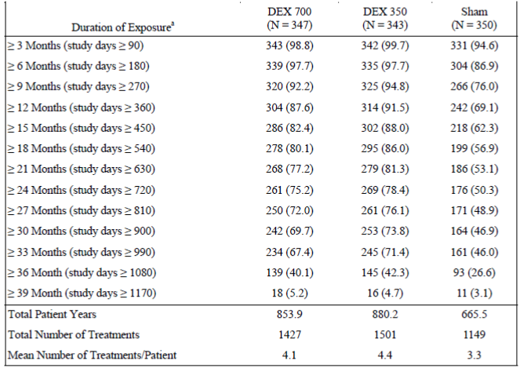
Total patient years = total study days /365.25. Note: the cumulative duration of exposure is based on observed data. ª Treatment exposure = exit date – day 0 visit date.

Adverse events

All adverse events (irrespective of relationship to study treatment)

Pivotal studies
A summary of patients with AEs in Study 010 were provided. AEs were reported in 95.6% and 98.2% of the DEX 700 and DEX 350 groups, respectively, compared with 75.6% in the Sham group (p < 0.001 for both DEX groups compared with Sham). Ocular AEs were reported in 88.8% and 91.5% of the DEX 700 and DEX 350 groups, respectively, compared with 59.1% in the Sham group. Ocular AEs in the study eye and the non-study eye were more commonly reported in the DEX 700 and DEX 350 groups compared with the Sham group. Non-ocular AEs were also reported more frequently in the active treatment groups (66.3%, 67.3% and 54.9% in the DEX 700, DEX 350 and Sham groups, respectively). Non-ocular AEs reported in > 3% of patients in any treatment group were provided. The most common AEs were related to infections (mostly upper respiratory) and GI disorders. Ocular AEs reported in > 2% of patients are shown in Table 8. With the exception of ME, almost all AEs by preferred term were more common in the DEX 700 and DEX 350 groups compared with Sham. The most commonly reported events in the study eye were increased IOP (38.1% DEX 700, 34.5% DEX 350, 3.0% Sham), cataract (36.9% DEX 700, 32.7% DEX 350, 7.9% Sham), conjunctival haemorrhage (22.5% DEX 700, 30.9% DEX 350, 10.4% Sham), subcapsular cataract (11.9% DEX 700, 12.1% DEX 350, 3.7% Sham), and vitreous haemorrhage (7.5% DEX 700, 14.5% DEX 350, 3.0% Sham). Within each treatment group, the overall incidence of ocular AEs in the study eye remained similar with repeated treatments.

Table 8. Number (%) of patients with ocular adverse events in the study eye reported for > 2% in any treatment group – entire study period (safety population)
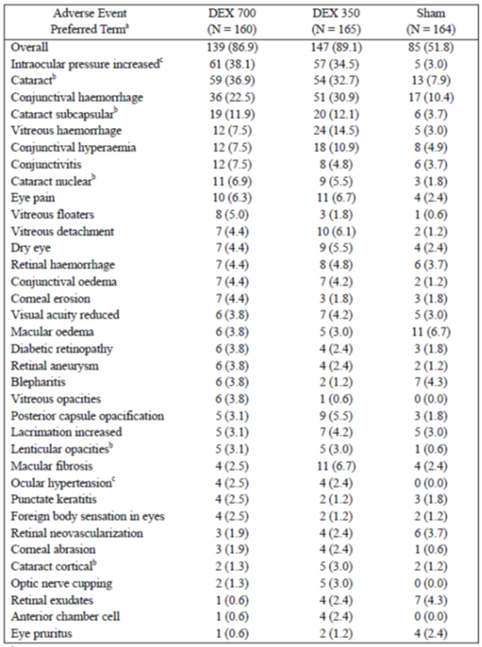
ª system organ classes and preferred terms based on MedRA version 15.0. ^{b} Calculation of the proportion of patients who experienced cataract adverse events did not consider the patients lens status (phakic or pseudophakic study eye). For discussion on cataract adverse events in the study eye in patients who had phakic study eye. ^{C} Events associated with elevated IOP were further discussed.
A summary of patients with all AEs in Study 011 was provided. AEs were reported in 96.3% and 96.6% of the DEX 700 and DEX 350 groups, respectively, compared with 84.4% in the Sham group. Ocular AEs were reported in 92.0% and 90.4% of the DEX 700 and DEX 350 groups, respectively, compared with 70.4% in the Sham group. Ocular AEs in the study eye and the non-study eye were more commonly reported in the DEX 700 and DEX 350 groups compared with the Sham group. Non-ocular AEs were also reported more frequently in the active treatment groups (72.2%, 70.8% and 62.9% in the DEX 700, DEX 350 and Sham groups, respectively). Non-ocular AEs reported in > 3% of patients in any treatment group were provided. The most common AEs were related to infections (mostly upper respiratory), investigations, metabolism and GI disorders. Ocular AEs reported in > 2% of patients were provided. With the exceptions of vitreous haemorrhage, ME, and conjunctival hyperaemia, almost all AEs by preferred term were more common in the DEX 700 and DEX 350 groups compared with Sham. The most commonly reported events in the study eye were cataract (38.5% DEX 700, 32.0% DEX 350, 11.3% Sham), increased IOP (24.6% DEX 700, 25.8% DEX 350, 3.8% Sham), visual acuity reduced (12.3% DEX 700, 11.8% DEX 350, 4.8% Sham), subcapsular cataract (11.8% DEX 700, 11.8% DEX 350, 3.2% Sham), and ocular hypertension (9.1% DEX 700, 7.3% DEX 350, 2.7% Sham). Within each treatment group, the overall incidence of ocular AEs in the study eye remained similar with repeated treatments.

Other studies
In Study 06, there was a higher incidence of AEs in the DEX 700 (98.0%) and DEX 350 (97.0%) groups than in the Observation (80.0%) group (p < 0.001). Most AEs in the study eye were in the eye disorders SOC (87.1%, 89.0% and 55.2% in the DEX 700, DEX 350 and Observation groups, respectively, p < 0.001). The most frequently reported AEs (> 5.0% in any study group) are shown in Table 9). The incidence of AEs which were significantly higher in each DEX group compared with Observation were anterior chamber cell, anterior chamber flare, vitreous haemorrhage, eye pain, vitreous disorder, eye irritation, vitreous floaters, conjunctival haemorrhage and eye redness (p ≤ 0.012). IOP was also significantly raised in both DEX groups compared with the Sham group (p ≤ 0.027). There was no analysis of the AE profile reported for the subgroup of patients with DME.

Table 9. Number % of patients with ocular adverse event in the study eye reported by greater than 5% of patients in any study group.
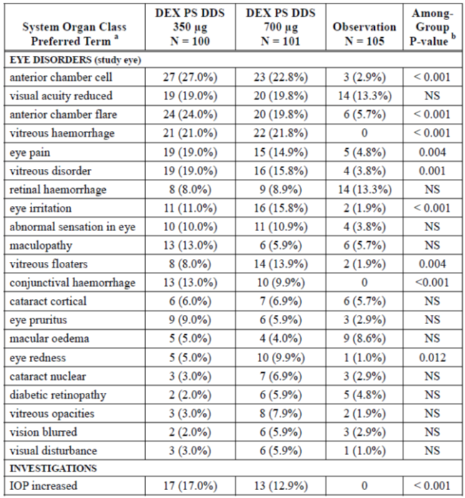
ª preferred terms and system organ class based on MedRA version 6.1. ^{b} among group p-value based on Fisher’s exact test; NS = not statistically significant at the 0.10 level
In Study 012, there was a higher incidence of AEs in the Combination Therapy group (92.8%) compared to Laser Alone (p < 0.014). Most AEs in the study eye were in the eye disorders SOC (73.6% in the Combination Therapy group, 58.3% in the Laser Alone group, p < 0.01). The rate of non-ocular events was similar in both groups. The most frequently reported AEs in the study eye (> 2.0% in any study group) were provided. There were no significant differences in the incidence of any specific ocular AEs between groups. In Study 018, a total of 90.9% of patients experienced AEs and 83.6% experienced ocular AEs. The most common ocular AEs were provided.

Treatment related adverse events (adverse drug reactions)

Pivotal studies
In Study 010, all except three treatment related AEs were ocular. The three non-ocular events were mild headache. In Study 011, all except two events were non-ocular, both mild headache.

Other studies
In Study 06, the great majority of ADRs were ocular. In Study 012and 018, all ADRs were ocular and reported in the study eye.

Deaths and other serious adverse events

Pivotal studies
In Study 010, there were 12 deaths during the study (4 in the DEX 700 group, 5 in the DEX 350 group and 3 in the sham group). None of the deaths was due to an ocular AE and all were considered unrelated to treatment by the investigator. There was a higher incidence of ocular and non-ocular SAEs in the DEX groups compared with the Sham group (Table 10). SAEs were reported in 32.5%, 31.5% and 20.7% of the DEX 700, DEX 350 and Sham groups, respectively. Ocular SAEs in the study eye were reported in 6.9%, 4.8% and 3.0% in the DEX 700, DEX 350 and Sham groups, respectively. The numbers of patients with ocular or non-ocular SAEs were provided.

Table 10. Number (%) of patients who experienced serious adverse events (safety population)
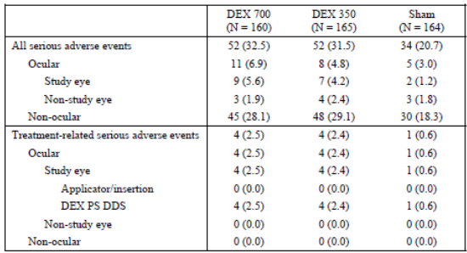
Note: within each type of relationship a patient is counted at most once. However patients who had a serious adverse event in both the study eye and non-study eye and had both ocular and non-ocular serious adverse events were counted again in the other category.
In Study 011, there were 17 deaths during the study (5 in the DEX 700 group, 10 in the DEX 350 group and 2 in the sham group). None of the deaths was due to an ocular AE and all were considered unrelated to treatment by the investigator. There was a higher incidence of ocular and non-ocular SAEs in the DEX groups compared with the Sham group. SAEs were reported in 33.7%, 38.2% and 26.3% of the DEX 700, DEX 350 and Sham groups, respectively. Ocular SAEs in the study eye were reported in 8.0%, 3.9% and 1.1% in the DEX 700, DEX 350 and Sham groups, respectively. The numbers of patients with ocular or non-ocular SAEs were provided.

Other studies
In Study 06, there were 6 deaths, all in the active treatment groups [3 (3%) DEX 700 and 3 (3%) DEX 350]. SAEs (including deaths) were reported in 23.8% of the DEX 700 group, 14.0% in the DEX 350 group and 10.5% in the Observation group. None of the SAEs was considered related to treatment although a single case of vitreous haemorrhage was considered possibly related. There were 6 deaths in Study 012. Five deaths occurred in the DEX 700 group but none was considered related to treatment. SAEs (including death) were reported in 18.4% of patients in the Combination Therapy group compared with 21.3% in the Laser Alone group. None of the SAEs was considered treatment related with the exception of one case of vitreous haemorrhage. In Study 018, there was one death not considered to be treatment related. SAEs were reported in 25.5% of patients but there were no treatment related SAEs or SAEs in the study eye.

Discontinuation due to adverse events

Pivotal studies
In Study 010, discontinuations were reported in 12.5%, 10.9% and 9.8% of the DEX 700, DEX 350 and Sham groups, respectively. Two patients, both in the DEX 700 group discontinued because of treatment related AEs. In Study 011, discontinuations were reported in 13.4%, 16.3% and 12.9% of the DEX 700, DEX 350 and Sham groups, respectively. Ten patients, 6 in the DEX 700 group and 4 in the DEX 350 group discontinued because of treatment related AEs (all ocular).

Other studies
In Study 06, two patients discontinued due to AEs, both unrelated to study treatment. In Study 018, AEs leading to discontinuation were reported in 7.2% of patients in the Combination Therapy group and 9.4% in the Laser Alone group. None of the events were considered related to study treatment.

Laboratory tests

Liver function

Pivotal studies
There were no protocol requirements for routine clinical chemistry measurements in the pivotal studies.

Other studies
There were no protocol requirements for routine clinical chemistry measurements in the Phase II studies.

Kidney function

Pivotal studies
Serum creatinine was measured for the calculation of eGFR in both pivotal studies. There was a modest, similar decline in eGFR from baseline in all treatment groups during both studies.

Other studies
There were no measurements of eGFR in Study 06 or Study 018. In Study 012, there were modest similar decreases in eGFR in both the Combination Therapy group and the Laser Alone group.

Other clinical chemistry

Pivotal studies
There were no protocol requirements for routine clinical chemistry measurements in the pivotal studies.

Other studies
There were no protocol requirements for routine clinical chemistry measurements in the Phase II studies.

Haematology

Pivotal studies
There were no protocol requirements for routine haematology measurements in the pivotal studies.

Other studies
There were no protocol requirements for routine haematology measurements in the Phase II studies.

Glycosylated haemoglobin

Pivotal studies
There were modest and similar increases in HbA1c from baseline in both pivotal studies over the 3 year treatment period.

Other studies
In Studies 06 and 012, there were no meaningful within or between group differences from baseline in HbA1c. HbA1c was not measured in Study 018.

Electrocardiograph

Pivotal studies
There was no protocol requirement for ECG monitoring in the pivotal studies.

Other studies
There was no protocol requirement for ECG monitoring in the Phase II studies.

Vital signs

Pivotal studies
There were no meaningful changes from baseline in SBP, DBP or pulse rate during the course of the pivotal studies.

Other studies
There were no meaningful changes from baseline in SBP, DBP or pulse rate during the course of the Phase II studies.

Raised intraocular pressure

Pivotal studies
In Study 010, elevated IOP AEs during the whole study period were reported in 40.6%, 36.4% and 3.0% of the DEX 700, DEX 350 and Sham groups, respectively. Mean IOP in the study eye increased following each injection of DEX 700 by -3.0 to 4.5 mm Hg across all visits from baseline. However, the magnitude of change in mean IOP did not increase with repeated injections. Similar changes in mean IOP were recorded in the DEX 350 group. Mean changes from baseline ranged from -2.0 to 5.0 mm Hg across all visits. During the course of the study, 43.8%, 39.4% and 6.7% of patients required IOP lowering medications in the DEX 700, DEX 350 and Sham groups, respectively. In Study 011, elevated IOP AEs during the whole study period were reported in 32.1%, 32.0% and 7.0% of the DEX 700, DEX 350 and Sham groups, respectively. Mean IOP in the study eye increased following each injection of DEX 700 by -4.0 to 3.0 mm Hg across all visits from baseline. However, the magnitude of change in mean IOP did not increase with repeated injections. Similar changes in mean IOP were recorded in the DEX 350 group. Mean changes from baseline ranged from -3.0 to 6.0 mm Hg across all visits. During the course of the study, 39.6%, 36.0% and 11.3% of patients required IOP lowering medications in the DEX 700, DEX 350 and Sham groups, respectively.

Other studies
In Study 06, mean changes in IOP from baseline ranged from 0.92 to 2.40 mm Hg in the DEX 700 group; from 0.52 to 1.34 mmHg in the DEX 350 group; and from -0.28 to 0.20 mm Hg in the Observation group. In Study 012, there were no meaningful differences in mean IOP between the treatment groups. However, more patients in the Combination Therapy group (16.8%) experienced raised IOP ≥ 25 mm Hg at any scheduled visit compared with the Laser Alone group (1.6%, p < 0.001. In Study 018, statistically significant changes in IOP from baseline were seen at Weeks 1, 4, 8, and 13 (p < 0.005) before returning to near baseline at Week 26.

Cataract

Pivotal studies
In Study 010, patients with a phakic study eye numbered 117, 118 and 115 in the DEX 700, DEX 350 and Sham groups, respectively. In this subgroup, the incidence of cataract AEs was 68.4%, 69.5% and 14.8% in the DEX 700, DEX 350 and Sham groups, respectively. Most cataracts became apparent during Years 2 and 3. In this subgroup of patients with phakic eyes at baseline, 61.5%, 61.0% and 7.0% of patients had cataract surgery during the study period. In Study 011, patients with a phakic study eye numbered 145, 138 and 135 in the DEX 700, DEX 350 and Sham groups, respectively. In this subgroup, the incidence of cataract AEs was 67.6%, 59.4% and 25.2% in the DEX 700, DEX 350 and Sham groups, respectively. Most cataracts became apparent during Years 2 and 3. In this subgroup of patients with phakic eyes at baseline, 57.2%, 44.9% and 7.4% of patients had cataract surgery during the study period.

Other studies
The Phase II studies were of short duration which did not permit meaningful analysis of cataract AEs.

Pooled safety analysis (ISS)
A pooled safety analysis of the two pivotal studies was performed. A total of 1,040 patients received at least one dose of study treatment and were included in the ISS (347 patients in the DEX 700 group, 343 patients in the DEX 350 group, and 343 patients in the Sham group). Overall, the average cumulative exposure was 22% less in the Sham group compared with the DEX groups because there were more discontinuations due to lack of efficacy in the Sham group. The mean number of treatments per patient was 4.1, 4.4, and 3.3 in the DEX 700, DEX 350 and Sham groups, respectively. A total of 3,037 retreatments were administered.
An overall summary of AEs is shown in Table 11. More AEs were reported in the DEX groups compared with Sham but there were no notable differences between the DEX 700 and DEX 350 groups. The incidence of ocular AEs in the study eye was higher in the DEX 700 group (85.3%), and DEX 350 group (88.3%), compared to Sham (58.0%). However the rates per 100 patient-years were only modestly higher in the DEX groups (34.7, 34.4, and 30.5 in the DEX 700, DEX 350, and Sham groups, respectively). The most common ocular AEs were cataract, raised IOP, conjunctival haemorrhage, subcapsular cataract, visual acuity reduced, vitreous haemorrhage, macular fibrosis, and conjunctival hyperaemia. The incidence of cataract and raised IOP were notably higher in the DEX groups compared with Sham. In the ISS, there were two reports of endophthalmitis following 2928 DEX injections.

Table 11. Overall summary of number (%) of patients with adverse events (pooled studies 20607-010 and 20607-011 safety population)
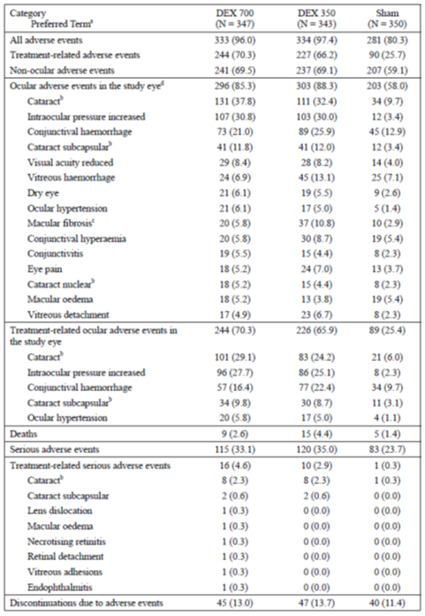
Note: ocular adverse events include those noted by the investigator as right or left eye or coded in the eye system organ class. Within each type of relationship a patient is counted at most once. All adverse events include all reported events, regardless of relationship to treatment. Treatment related adverse events include those that in the investigator’s opinion may have been caused by the study medication (DEX PS DDS or application/insertion) with reasonable possibility. ª system organ classes and preferred terms based on MedRA version 15.0. ^{b} Calculation of the proportion of patients who experienced cataract adverse events did not consider the patient’s lens status at baseline (phakic or pseudophakic study eye). ^{c} Macular fibrosis included the investigator terms macular fibrosis, macular puckering, epritinal membrane premacular gliosis, preretinal fibrosis etc. d Ocular adverse events in the study eye reported by > 5% of patients in any treatment group.
There were 29 deaths in the pooled Phase III studies (9 in the DEX 700 group, 15 in the DEX 350 group, and 5 in the Sham group). None of the deaths was ocular, and none was considered related to study treatment. The incidence of SAEs in the ISS was higher in the DEX 700 group (33.1%), and DEX 350 group (35.0%), compared with Sham group (23.7%). However, the exposure adjusted data were similar across all treatment groups (13.5, 13.6, and 12.5 in the DEX 700, DEX 350 and Sham groups, respectively). Ocular SAEs, in the study eye were reported in 6.9%, 4.1%, and 1.1% in the respective treatment groups. All treatment related ocular SAEs occurred in the study eye, mainly cataract and subcapsular cataract. There were no notable among-group differences in AEs leading to discontinuation (13.0%, 13.7%, and 11.4% in the respective treatment groups).
The overall incidence of elevated IOP AEs across the entire study period was 36.0%, 34.1%, and 5.1% in the DEX 700, DEX 350, and Sham groups, respectively. Rates of elevated IOP AEs were similar between the DEX 700 and DEX 350 groups. The exposure related rates per 100 patient-years were 14.6, 13.3, and 2.7 in the DEX 700, DEX 350, and Sham groups, respectively. Cataract AEs were analysed in the subgroup of patients who had a phakic study eye (145 DEX 700, 138 DEX 350, 135 Sham). In this subgroup, the total incidence of cataract AEs in the DEX 700, DEX 350, and Sham groups was 67.6%, 59.4%, and 25.2%, respectively. Cataract AEs were observed mainly in Years 2 and 3.

Post-marketing experience
Since the initial marketing approval in the US in 2009, there have been an estimated 45,018 patient-years of exposure to Ozurdex. The safety profile in the DME study program are consistent with the overall experience when used in patients with other causes of ME, and consistent with events typically associated with the use of injected ophthalmic steroids. However, there is no post-marketing experience in patients with DME.

Safety issues with the potential for major regulatory impact

Liver toxicity
No issues identified.

Haematological toxicity
No issues identified.

Serious skin reactions
No issues identified.

Cardiovascular safety
No issues identified.

Unwanted immunological events
No issues identified.

Other safety issues

Safety in special populations
No unexpected issues were identified. The overall incidence of AEs in the ISS was similar for subgroups defined by age, gender, race, baseline HbA1c, duration of diabetes, duration of DME, and previous laser treatment in the study eye. The overall incidence of all AEs in the ISS was similar in patients with phakic or pseudophakic study eyes at baseline. In the DEX groups, there was a higher incidence of ocular AEs in the study eye compared with the Sham group, related in part to a higher incidence of cataract.

Safety related to drug-drug interactions and other interactions
Not applicable.

Evaluator’s overall conclusions on clinical safety
The incidence of non-ocular AEs and SAEs was higher in the DEX groups compared with Sham. However, the rates were similar when the data were adjusted for exposure, and the pattern was consistent with the diabetic study population. Ocular AEs and ADRs in the study eye were similar in the DEX 700 and DEX 350 groups and higher compared with the Sham group. However, with the exception of cataract, the incidence of AEs remained stable throughout the 3 year study. Most AEs related to cataract, IOP increased, conjunctival haemorrhage, reduced visual acuity, and vitreous haemorrhage. In phakic eyes, approximately 2 out of 3 of patients had cataract AEs and 57% required cataract surgery within the study period. IOP was consistently increased in the DEX groups. The elevations were generally reversible with time but approximately 40% of patients in the DEX groups required medical intervention to lower IOP. Only eight patients required surgical intervention for raised IOP and endophthalmitis was reported in only two patients. In the pooled studies, 37 patients had severe visual loss of which approximately 90% were due to cataract. The pattern of AEs was consistent with the known effects of ocular steroids. The incidence of AEs in phakic eyes was unacceptable due to the risk of cataract and/or raised IOP.

First round benefit-risk assessment

First round assessment of benefits
The benefits of Ozurdex in the proposed usage are:
- Improved visual acuity
- Rapid onset of action
- Long duration of effect with sustained benefits for up to 3 years following repeated doses
- Low frequency of injections and risk of procedure related AEs
- Proven reduction of macular oedema measured by OCT.

First round assessment of risks
The risks of Ozurdex in the proposed usage are:
- A high risk of steroid related ocular AEs in the treated eye
- A high risk of cataract formation in phakic eyes
- A high risk of raised IOP
- A low risk of ocular infection
- A low risk of complications following surgery for cataract or raised IOP

First round assessment of benefit-risk balance
The benefit-risk balance of Ozurdex is unfavourable given the proposed usage, but would become favourable if the changes recommended in the first round recommendation reageding authorisation are adopted.

First round recommendation regarding authorisation
Approval is not recommended for the proposed indication:
‘Ozurdex is indicated for the treatment of diabetic macular oedema (DME)’.
Approval is recommended for the indication:
Ozurdex is indicated for adults with diabetic macular oedema who have an artificial lens implant or who are scheduled for cataract surgery.
This recommendation is in line with the indication approved by the FDA but it is subject to satisfactory responses from the sponsor to the clinical questions.

Clinical questions

Pharmacokinetics
- In preclinical studies, the in situ release characteristics from the implant suggest that peak intravitreal dexamethasone concentrations are achieved within 24 hours and remain detectable for 35 days. Based on OCT measurements, efficacy benefits are significantly attenuated from Months 3 to 6. Please confirm the release characteristics of the implant and explain why 6 monthly repeat injections were recommended in the clinical trial program.

Pharmacodynamics
No questions.

Efficacy
- In Studies 010 and 011, analyses of efficacy in the study eye by subgroups are summarised as shown in Table 4 and Table 6. Please provide an analysis of the pooled data to identify subgroups with the best and least responses to treatment. For example, is there a rationale for treating diabetics with poor glycaemic control?
- Please explain why a triamcinolone or laser alone control arm was not used in the pivotal studies.
- A key inclusion criterion for the pivotal study was patients unsuitable for laser therapy, or patients who had refused it. It could be argued that the indication for Ozurdex should be restricted to second line therapy for this patient population. Please discuss.

Safety
- Please provide a brief summary of ocular AEs in the study eye based on subgroups in the ISS. The analysis should be combined with the subgroup analysis of efficacy to permit a risk/benefit assessment in each subgroup.

Second round evaluation of clinical data submitted in response to questions
The analysis of the response to the questions was presented in the Delegates overview (please see the AusPAR)

Therapeutic Goods Administration
PO Box 100 Woden ACT 2606 Australia
Email: info@tga.gov.au Phone: 1800 020 653 Fax: 02 6232 8605
https://www.tga.gov.au

Clarification: The inclusion criteria associated with diabetic macular edema for Studies 010 and 011 were as follows: Diabetic macular edema in the study eye defined as clinically observable macular edema involving the center of the macula (fovea) associated with diabetic retinopathy with any of the following characteristics: a) prior medical therapy for diabetic macular edema; b) prior macular laser(s) for diabetic macular edema with the most recent laser at least 3 months prior to Baseline/ Qualification where, in the opinion of the investigator, the patient will be able improve 15 or more letters in BCVA from baseline with the resolution of the macular edema despite the presence of macular laser scars; c) in the investigator’s opinion the patient would not benefit from macular laser treatment; d) the patient refuses laser treatment.

