NAME OF THE MEDICINE
NOCDURNA® sublingual wafers
Desmopressin

Synonyms of desmopressin: DDAVP
1-Desamino-8-D-Arginine vasopressin. Desamino-cys-1-D-Arginine-8-vasopressin.

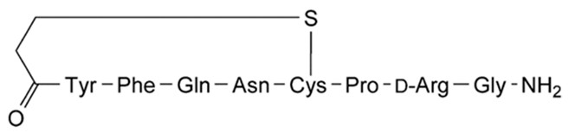

CAS Nos.:
Desmopressin base | 16679-58-6
Desmopressin acetate | 62288-83-9

Molecular formula and molecular mass: C48H74N14O17S2 (acetate trihydrate)
MW = 1183.2
C46H64N14O12S2 (free base) MW = 1069.2

Physical and chemical characteristics:
A white, fluffy powder, soluble in water, in alcohol and in glacial acetic acid.

DESCRIPTION
NOCDURNA, a sublingual wafer, contains the active substance, desmopressin (present as the hydrated acetate), a synthetic structural analogue of the natural pituitary hormone, arginine vasopressin. The difference lies in the desamination of cysteine and substitution of L-arginine by D-arginine. NOCDURNA also contains gelatin, mannitol and citric acid.

PHARMACOLOGY
Pharmacodynamics
Pharmacotherapeutic group: Vasopressin and analogues. ATC code: H01B A02

Mechanism of action
NOCDURNA contains desmopressin, a synthetic analogue of naturally occurring anti-diuretic hormone arginine vasopressin (AVP). Desmopressin mimics vasopressin’s anti-diuretic effect, binding to the V2 receptors in the renal collecting tubules of the kidneys, causing reabsorption of water into the body. This reabsorption in turn decreases night-time urine production. Due to the proposed low gender-specific doses (25 micrograms for females and 50 micrograms for males), and the limited duration of action of NOCDURNA, the antidiuretic activity is limited to the night time sleep period.
Pharmacodynamic effects
In study CS29, the weight-corrected NOCDURNA dose that induced 50% maximum achievable drug effect on nocturnal urine volume differed significantly between females and males. The estimated exposure value for males was 2.7-fold (95% CI: 1.3-8.1) higher than the value for females to obtain an identical dynamic effect, corresponding to higher desmopressin sensitivity among females. The development of hyponatraemia is dose dependent. Females are at higher risk of developing hyponatraemia than males. The incidence of hyponatraemia rises with increasing dose and with increasing age (see sections DOSAGE AND ADMINISTRATION and PRECAUTIONS).

Pharmacokinetics
Absorption
The overall mean absolute bioavailability of desmopressin administered sublingually in doses of 200, 400 and 800 micrograms is 0.25%, with a 95% confidence interval (95% CI) of 0.21 –
0.31%.

Desmopressin exhibits a moderate to high variability in bioavailability, both within and between subjects.

Desmopressin shows dose linearity regarding AUC and Cmax in the range of 60 to 240 micrograms. Bioavailability at doses below 60 micrograms has not been evaluated.

Distribution
The distribution of desmopressin is best described by a two-compartment distribution model with a volume of distribution during the elimination phase of 0.3-0.5 L/kg.

Metabolism
The in vivo metabolism of desmopressin has not been studied. The presence of the D-amino acid isomer in position eight of the molecule is thought to protect desmopressin from degradation by the enzyme that inactivates natural arginine vasopressin. In vitro human liver microsome metabolism studies of desmopressin have shown that no significant amount is metabolised in the liver by the cytochrome P450 system. Thus, human liver metabolism in vivo by the cytochrome P450 system is unlikely to occur.

Excretion
The total clearance of desmopressin has been calculated to 7.6 L/hr. The terminal half-life of desmopressin is estimated to 2.8 hours. In healthy subjects the fraction excreted unchanged was 52% (44% - 60%).

Linearity/non-linearity
There are no indications of non-linearities in any of the pharmacokinetic parameters of desmopressin.

Special populations:
Renal impairment
The AUC and half-life increased with the severity of the renal impairment. Desmopressin is contraindicated in patients with moderate and severe renal impairment (creatinine clearance below 50 mL/min or an eGFR below 45 mL/min/1.73 m2).
Table 1: Pharmacokinetic parameters for different degrees of renal impairment. Data from CS001.

 | Creatinine Clearance | Renal Function | AUC (Hrs*pg/mL) | T½ (Hrs)
Healthy | >80 mL/min | Normal | 186 | 2.8
Mild | 50-80 mL/min | Mildly impaired | 281 | 4.0
Moderate | 30-49 mL/min | Moderately impaired | 453 | 6.7
Severe | 5-29 mL/min | Severely impaired | 682 | 8.7

Hepatic impairment
No studies have been performed in this population.

Paediatric population
The population pharmacokinetics of desmopressin tablets have been studied in children with primary nocturnal enuresis (PNE) and no significant difference from adults were detected.

CLINICAL TRIALS
The studies CS40 (conducted in females) and CS41 (conducted in males) had similar overall designs using the same co-primary and secondary clinical endpoints, investigating change from baseline over 3 months of treatment.

The studies included patients ≥ 18 years of age with at least 2 nocturnal voids every night in a consecutive 3-day period during the screening period. Patients with evidence of severe daytime voiding dysfunction were excluded, as were those with interstitial cystitis, chronic prostatitis/chronic pelvic pain syndrome, suspicion of bladder outlet obstruction (BOO) or urine flow < 5 mL/sec, surgical treatment, including transurethral resection, for BOO or benign prostatic hyperplasia within the past 6 months, urinary retention or a post-void residual volume in excess of 250 mL, habitual or psychogenic polydipsia, central or nephrogenic diabetes insipidus, syndrome of inappropriate anti-diuretic hormone, current or a history of urologic malignancies, genitourinary tract pathology, detrusor overactivity, suspicion or evidence of cardiac failure, uncontrolled hypertension, uncontrolled diabetes mellitus, hyponatraemia, renal insufficiency, hepatic and/or biliary diseases, a history of obstructive sleep apnoea, previously treated with desmopressin for nocturia, and on concomitant treatment with any prohibited medication (e.g. loop diuretics).

Randomisations for studies CS40 and CS41 were stratified by equal split according to patients under 65 years of age and patients 65 years of age and over; the median ages were 63 and 64 years, respectively. The adjusted mean changes in nocturnal voids from baseline during 3 months of treatment in CS40 and CS41 are presented in Figure 1 and Figure 2, respectively.

CS40 study (Females):
- A 3-month, randomised, double-blind study comparing NOCDURNA 25 micrograms versus placebo in women with nocturia, defined as an average of ≥ 2 nocturnal voids per night
- Two hundred and sixty eight (268) subjects were randomised, with the majority having 2- 3 voids/night and 90% of the subjects had nocturnal polyuria
- The study met the co-primary endpoints with statistically significant differences favouring NOCDURNA compared with placebo over the 3-month period:
  - There was a statistically significant (p=0.028) decrease in the adjusted mean number of nocturnal voids from baseline on NOCDURNA 25 micrograms (-1.46) compared to placebo (-1.24), with a treatment contrast of 0.22 voids/night (Figure 1)
  - The proportion of subjects with > 33% decrease in the mean number of nocturnal voids was significantly increased (p=0.006). The risk ratio of NOCDURNA 25 micrograms compared to placebo was 1.20 (95% CI: 1.04-1.36).
- There was consistent differentiation between NOCDURNA 25 micrograms and placebo for the secondary endpoints, including an increase from baseline to 3 months in the first undisturbed sleep period (FUSP)/time to first void (TTFV) of 155 minutes for NOCDURNA compared to 106 minutes for placebo, with a treatment contrast of 49 minutes
- There was a strong association (p<0.0001) between treatment response, measured by reduction in number of nocturnal voids and increase in FUSP, and improvements in patients' quality of life
- There was a statistically significant (p=0.0226) improvement in quality of life for NOCDURNA 25 micrograms (N-QoL total score 27.24) compared to placebo (21.90).

Figure 1. Co-Primary Endpoint: Adjusted mean change from baseline in nocturnal voids during 3 months of treatment – (Females, CS40 Full Analysis Set).

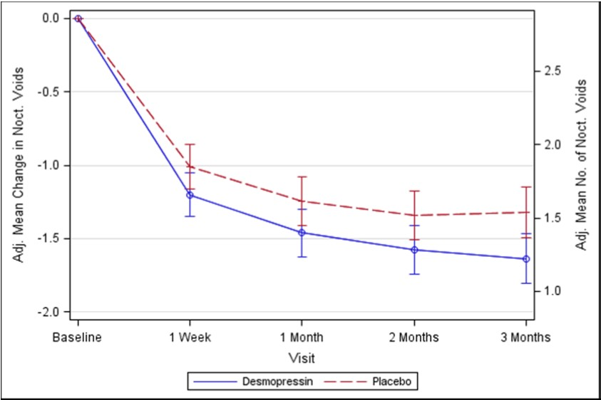

CS41 study (Males):
- A 3-month, randomised, double-blind study comparing NOCDURNA 50 micrograms and
75 micrograms versus placebo in men with nocturia, defined as an average of ≥ 2 nocturnal voids per night
- Three hundred and ninety five (395) subjects were randomised, with the majority having 2-3 voids/night and 87% of the subjects had nocturnal polyuria
- The study met the co-primary endpoints with statistically significant differences favouring NOCDURNA compared with placebo over the 3-month period:
  - There was a statistically significant (p=0.0003) decrease in the adjusted mean number of nocturnal voids on NOCDURNA 50 micrograms (-1.25) compared to placebo
(-0.88), with a treatment contrast of 0.37 voids/night (Figure 2)
  - The proportion of subjects with > 33% decrease in the mean number of nocturnal voids was significantly increased (p=0.0009). The risk ratio of NOCDURNA 50 micrograms compared to placebo was 1.32 (95% CI:1.11-1.54).
- There was consistent differentiation between NOCDURNA 50 micrograms and placebo for the secondary endpoints, including an increase from baseline to 3 months on the FUSP/TTFV of 112 minutes for NOCDURNA compared to 73 minutes for placebo, with a treatment contrast of 39 minutes
- There was a strong association (p<0.0001) between treatment response, measured by reduction in number of nocturnal voids and increase in FUSP, and improvements in patients' quality of life
- There was a statistically significant (p=0.0385) improvement in quality of life for NOCDURNA 50 micrograms (N-QoL total score 18.37) compared to placebo (13.88).

Figure 2. Co-Primary Endpoint: Adjusted mean change from baseline in nocturnal voids during 3 months of treatment – (Males, CS41 Full Analysis Set).

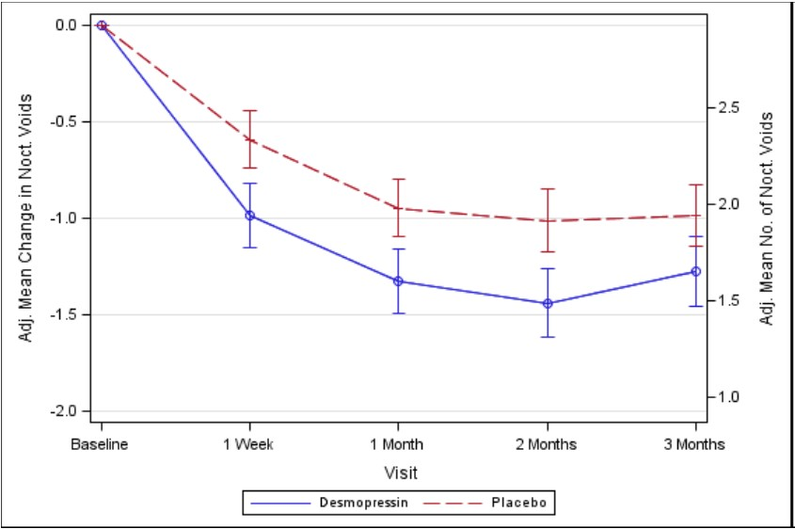

Gender differences in clinical safety and efficacy
Clinical study [FE992026 CS029] analysed the dose-response to NOCDURNA in females and males at doses ranging from 10 to 100 micrograms: In females, there was no further gain in pharmacodynamic effect above the dose of 25 micrograms, indicating that the dose response plateau was reached at 25 micrograms in females. In males, reduction in urine volume was greater at 50 micrograms, but not substantially higher at 100 micrograms. Increasing doses to the 50 microgram dose level in females did not yield further efficacy, but was associated with a 5-fold increase in the risk of hyponatraemia compared with males in the age group above 50 years (p=0.015).

INDICATIONS
NOCDURNA is indicated for the treatment of nocturia due to idiopathic nocturnal polyuria in adults who awaken two or more times each night to void and have not responded to lifestyle measures.

Nocturnal polyuria should be confirmed on the basis of a 24 hour urine frequency-volume diary. It is defined as > 33% of urine passed overnight. Secondary causes of nocturia should be excluded (see CONTRAINDICATIONS and PRECAUTIONS).

CONTRAINDICATIONS
- Hypersensitivity to the active substances or to any of the excipients listed in the DESCRIPTION section
- Habitual or psychogenic polydipsia (resulting in a urine production exceeding 40 mL/kg/24 hours)
- A history of known or suspected cardiac insufficiency and other conditions requiring treatment with diuretics
- Moderate and severe renal insufficiency (creatinine clearance below 50 mL/min or an eGFR below 45 mL/min/1.73 m²)
- Known history of hyponatraemia
- Patients with cognitive impairment who may not be expected to comply with the fluid intake restriction recommendations when taking NOCDURNA (see PRECAUTIONS)
- Syndrome of inappropriate anti-diuretic hormone secretion (SIADH) and conditions that predispose the patient to SIADH
- Conditions associated with abnormal electrolyte such as nausea, eating disorders, chronic vomiting or diarrhoea, adrenal insufficiency, nephropathy.

PRECAUTIONS
NOCDURNA can cause hyponatraemia due to fluid overload.

Risk factors include
- Age ≥ 65 years
- Underlying medical problems such as heart failure, renal impairment, peripheral oedema, SIADH
- History of hyponatraemia
- Cognitive impairment
- Psychogenic or habitual polydipsia

NOCDURNA must only be used when contraindications, co-morbidities and secondary causes of nocturnal polyuria have been excluded.

Monitoring of serum sodium is recommended (see PRECAUTIONS).

NOCDURNA treatment should only be considered when nocturnal polyuria has been established as the primary cause of nocturia. Nocturnal polyuria should be diagnosed on the basis of a bladder diary and 24 hour urine output. Comprehensive assessment for causes and co-morbidities prior to prescribing should also occur. Investigations may include blood examination (sodium, renal function, liver function, blood glucose, calcium, osmolality), cardiac examination, urine microscopy and culture.

Polyuria due to diabetes mellitus, diabetes insipidus, hypercalcaemia and renal disease should be excluded. Polyuria needs to be differentiated from urinary frequency with low volume urine output, such as due to bladder disorders, as NOCDURNA will not be effective in these disorders. Severe bladder dysfunction and outlet obstruction should be considered before starting treatment.

Lifestyle modifications which may contribute to nocturia should be addressed before NOCDURNA treatment and continued during treatment (e.g. before bedtime drink only enough to satisfy thirst; and avoid alcohol and caffeine-containing beverages).

The risk of hyponatraemia increases with age and increasing dose of desmopressin. It is important that conditions such as cardiac failure, renal impairment and use of medications that may decrease serum sodium are screened for prior to commencing NOCDURNA.

Fluid intake must be limited to a minimum from 1 hour before administration until the next morning (at least 8 hours) after administration. Treatment without a concomitant reduction of fluid intake may lead to prolonged fluid retention and/or hyponatraemia with or without accompanying warning signs and symptoms (headache, nausea/vomiting, weight gain, and, in severe cases, convulsions).

Sodium Monitoring
All patients should receive a single baseline sodium determination before starting NOCDURNA and additional monitoring of sodium during the first week of treatment (4-8 days) and again at one month.

Sodium should be measured every 3 to 6 months and/or when medications are altered or the patient’s clinical condition changes.

Treatment is not recommended if serum sodium is less than 135 mmol/L at baseline and should be discontinued if at any time the serum sodium level falls below this value. Treatment with NOCDURNA should be interrupted and reassessed during acute intercurrent illnesses characterised by fluid and/or electrolyte imbalance (such as systemic infections, fever, and gastroenteritis) or during any hospitalisation.

Caution is required in cases of cystic fibrosis, coronary heart disease, hypertension, chronic renal disease and pre-eclampsia.

Extreme caution is required with concomitant use of the following medications: diuretics, ACE inhibitors, NSAID and lithium.

Effects on fertility
A study with desmopressin in rats showed no impairment of fertility in male or female animals at subcutaneous doses up to 200 µg/kg/day. In vitro analysis of human cotyledon models have shown that there is no transplacental transport of desmopressin when administered at therapeutic concentrations corresponding to the recommended dose.

Use in Pregnancy (Category B1)
Caution should be exercised when prescribing to pregnant women.

Data on a limited number (n=53) of exposed pregnancies in women with diabetes insipidus as well as data on a limited number of exposed pregnancies in women with bleeding complications (n=216) indicate no adverse effects of desmopressin on pregnancy or on the health of the fetus/newborn child. To date, no other relevant epidemiological data are available. Animal studies do not indicate direct or indirect harmful effects with respect to pregnancy, embryonic/fetal development, parturition or postnatal development.

Embryofetal development studies performed with desmopressin in rats and rabbits given subcutaneous doses up to 50 ng/kg/day and 200 μg/kg/day, respectively, and in rats given intravenous doses up to 241 µg/kg/day, revealed no evidence for a harmful effect on the fetus.

Use in lactation
Results from analyses of milk from nursing mothers receiving high dose desmopressin acetate (300 micrograms intranasal) indicate that the amounts of desmopressin that may be transferred to the child are considerably less than the amounts required to influence diuresis.

Paediatric use
NOCDURNA is only indicated in adults.

Use in the elderly
The risk of hyponatraemia increases with age - the risk/benefit balance of treatment beyond the age of 65 years should be carefully considered. Particular care with selecting appropriate patients and sodium level monitoring should be exercised when considering NOCDURNA for patients aged greater than 75 years. Treatment of frail elderly patients is not be recommended.

Genotoxicity
In vitro studies in bacterial and mammalian cells revealed no mutagenic activity for desmopressin.

Carcinogenicity
Carcinogenicity studies have not been performed with desmopressin.

Effect on laboratory tests
Prior to treatment with NOCDURNA, all patients should have serum sodium within the normal range.

INTERACTIONS WITH OTHER MEDICINES

Pharmacodynamic interactions

Drug | Potential effect | Sodium monitoring
Tricyclic anti-depressants, selective serotonin re-uptake inhibitor, chlorpromazine, diuretics, carbamazepine, sulphonylurea antidiabetics (e.g. chlorpropamide) | Additive antidiuretic effect can increase risk of water retention and hyponatraemia – use with caution. | Baseline, 4-8 days,  1 month, every 3 months and if dose is adjusted
ACE inhibitors and angiotensin receptor blockers | Increase renal sodium loss and potassium retention
Thiazide and loop diuretics |  | Treatment with NOCDURNA is not recommended
Non-steroidal anti- inflammatories and oxytocin | May potentiate the antidiuretic effect of desmopressin and increase risk of water retention and hyponatraemia | Baseline, 4-8 days,  1 month, every 3 months and if dose is adjusted
Lithium | Can decrease antidiuretic  effect. In addition NOCDURNA could mask lithium- induced nephrogenic diabetes and should not be used if suspected.

Pharmacokinetic interactions
Concomitant treatment with loperamide may result in a 3-fold increase of desmopressin plasma concentrations, which may lead to an increased risk of water retention/hyponatraemia. Although not investigated, other drugs slowing intestinal transport might have the same effect. Should concomitant treatment with loperamide be initiated, sodium monitoring should be undertaken at baseline, 4-8 days, 1 month, every 3 to 6 months, depending on clinical need and if dose of loperamide is adjusted.

It is unlikely that desmopressin will interact with drugs affecting hepatic metabolism, since desmopressin has been shown not to undergo significant metabolism following incubation with human liver microsomes and not to inhibit CYP450 isozymes in in vitro studies. However, formal in vivo interaction studies with co-administered drugs that interact with CYP450 enzymes have not been performed with NOCDURNA.

In a double-blind randomised clinical study, the efficacy and safety of combination therapy with NOCDURNA and tolterodine extended release capsules, was investigated for the treatment of overactive bladder with nocturia in women, for a period of 3 months. Forty-nine (49) subjects were exposed to a combination of NOCDURNA 25 micrograms and tolterodine 4 milligrams. No serious adverse events were observed in this study and the safety profile of the combination treatment was similar to the safety profile of NOCDURNA 25 micrograms. The efficacy in terms of reduction from baseline in mean number of nocturnal voids during 3 months treatment was numerically greater in the combination therapy group versus tolterodine monotherapy group (treatment contrast, -0.34 voids) in full analysis set, and the difference reached statistical significance (p=0.049) with a treatment contrast of -0.41 voids in the per protocol analysis set.

A standardised 27% fat meal significantly decreased absorption (rate and extent) of desmopressin tablets. No significant effect was observed with respect to pharmacodynamics (urine production or osmolality). Food intake may reduce the intensity and duration of the antidiuretic effect at low oral doses of desmopressin tablet.

ADVERSE EFFECTS
Summary of the safety profile:
The incidences of treatment-emergent adverse events (≥ 2%) recorded in each arm of the Phase III NOCDURNA clinical trials are reported in Table 2.

Table 2: Incidence of treatment-emergent adverse events (TEAEs) from Phase III NOCDURNA clinical trials.
 | CS40 (female) Incidence of common (≥ 2%)  TEAEs |  | CS41 (male) Incidence of common (≥ 2%)  TEAEs
System Organ Class MedDRA Preferred Term | Placebo (N=126) n (%) | Desmopressin 25 μg  (N=135) n (%) | Placebo (N=143) n (%) | Desmopressin 50 μg  (N=119) n (%)
Any adverse event | 36 (29%) | 42 (31%) | 30 (21%) | 24 (20%)
Gastrointestinal disorders
Dry mouth | 4 (3%) | 6 (4%) | 7 (5%) | 4 (3%)
Nausea | 2 (2%) | 3 (2%) | 1 (<1%) | 1 (<1%)
Diarrhoea | 4 (3%) | 5 (4%) | 4 (3%) | 0
Constipation | 1 (<1%) | 4 (3%) | 3 (2%) | 1 (<1%)
General Disorders and Administration Site Conditions
Oedema peripheral |  |  | 3 (2%) | 5 (4%)
Infections and Infestations
Nasopharyngitis | 5 (4%) | 5 (4%) | 4 (3%) | 1 (<1%)
Upper respiratory tract infection | 6 (5%) | 4 (3%) | 3 (2%) | 1 (<1%)
Urinary tract infection | 10 (8%) | 5 (4%) | 0 | 5 (4%)
Injury, Poisoning and Procedural Complications
Incorrect dose administered | 3 (2%) | 3 (2%)
Medication error | 1 (<1%) | 3 (2%) | 3 (2%) | 0
Metabolism and Nutrition Disorders
Hyponatraemia |  |  | 0 | 3 (3%)
Musculoskeletal and Connective Tissue Disorders
Back pain | 2 (2%) | 4 (3%)
Arthralgia | 4 (3%) | 3 (2%)
Nervous System Disorders
Headache | 4 (3%) | 7 (5%) | 5 (3%) | 6 (5%)
Psychiatric Disorders
Insomnia |  |  | 0 | 3 (3%)
Reproductive System and Breast Disorders
Erectile dysfunction |  |  | 3 (2%) | 0

Description of selected adverse reactions:
The most serious adverse reaction that could result from the antidiuretic effects of desmopressin is hyponatraemia. The clinical manifestations of hyponatraemia include headache, nausea, vomiting, weight increase, malaise, abdominal pain, muscle cramps, dizziness, confusion, decreased consciousness and in severe cases convulsions and coma. The hyponatraemia is an antidiuretic effect, arising from increased water re-absorption by the renal tubules and osmotic dilution of plasma. In studies of adult subjects with nocturia treated with desmopressin, those who developed low serum sodium did so usually within the first month of commencing treatment. Special attention should be paid to the precautions raised in the PRECAUTIONS section.

Females have a higher risk of hyponatraemia which may be due to increased sensitivity of the kidney tubules to vasopressin and its analogues in women compared with men. The risk of this is minimised by recommendation of a lower dose in women. The risk of hyponatraemia in the over 65 years age group is further reduced by monitoring of serum sodium in this age group (see sections DOSAGE AND ADMINISTRATION and PRECAUTIONS).

Tabulated list of adverse reactions:
Table 3 shows the frequencies of adverse reactions reported. The frequencies are defined as follows: very common (≥ 1/10), common (≥ 1/100 to < 1/10) and uncommon (≥ 1/1,000 to
< 1/100).

Table 3: Frequency of adverse drug reactions reported (Phase III studies and Post-marketing reports).
MeDRA System Organ Class (SOC) | Very common (≥ 1/10) | Common  (≥ 1/100 and < 1/10) | Uncommon  (≥ 1/1000 and < 1/100)
Metabolism and nutrition disorders |  | Hyponatraemia
Nervous system disorders |  | Headache, Dizziness
Gastrointestinal disorders | Dry mouth* | Nausea, Diarrhoea | Constipation, Abdominal discomfort
General disorders and administration site conditions |  |  | Fatigue,  Oedema peripheral
* It is to be noted that subjects were specifically queried about dry mouth in some of the clinical studies.

Post marketing experience
The following adverse reactions have been identified during post approval use of desmopressin. Because these reactions are reported voluntarily from a population of uncertain size, it is not always possible to reliably estimate their frequency or establish a causal relationship to drug exposure. Desmopressin has been marketed worldwide since 1972 in several formulations, including intranasal, intravenous, and oral formulations for the treatment of diabetes insipidus and primary nocturnal enuresis. These oral formulations are available at much higher doses than NOCDURNA.

The most frequently reported adverse reactions for oral formulations of desmopressin are as follows:

Electrolytes
Hyponatraemia

Gastrointestinal Disorders
Abdominal pain, vomiting, nausea

Nervous System
Headache, convulsions

Skin
Rash/urticaria

Sensitivity/Resistance
Lack of effect
Reporting of suspected adverse reactions
Reporting suspected adverse reactions after authorisation of the medicinal product is important. It allows continued monitoring of the benefit/risk balance of the medicinal product. Healthcare professionals are asked to report any suspected adverse reactions via the Australian Adverse Drug Reaction Reporting System.

DOSAGE AND ADMINISTRATION
Women: 25 micrograms daily, one hour before bedtime, administered sublingually
without water.
Men: 50 micrograms daily, one hour before bedtime, administered sublingually without
water.
Method of administration
NOCDURNA is placed under the tongue where it dissolves without the need for water.

NOCDURNA should be discontinued if the serum sodium level falls below the lower limit of normal range (135 mmol/L) (see PRECAUTIONS).

In the event of signs or symptoms of water retention and/or hyponatraemia (e.g. headache, nausea/vomiting, weight gain, and, in severe cases, convulsions) treatment should be interrupted and reassessed (see PRECAUTIONS).

Food intake may reduce the intensity and duration of the antidiuretic effect at low doses of desmopressin (see INTERACTIONS WITH OTHER MEDICINES).

NOCDURNA should be used under the guidance of physicians familiar with the diagnosis and management of nocturia and the use of desmopressin. Treatment should only be initiated after contraindications, secondary causes of polyuria and bladder outlet obstruction has been considered. Monitoring of serum sodium is recommended (see PRECAUTIONS). If treatment with NOCDURNA does not result in evidence of a therapeutic benefit after 1 month, treatment should be discontinued.

Special Populations
Use in the elderly
The risk of hyponatraemia increases with age - the risk/benefit balance of treatment beyond the age of 65 years should be carefully considered.

Elderly patients are at increased risk of developing hyponatraemia with desmopressin treatment and may also have impaired renal function. Caution should therefore be exercised in this age group and daily doses above 25 micrograms for females and 50 micrograms for males should not be used.

Renal impairment
NOCDURNA is contraindicated in patients with moderate and severe renal insufficiency (see

CONTRAINDICATIONS).

Hepatic impairment
No dose adjustment is needed for patients with hepatic impairment (see INTERACTIONS WITH OTHER MEDICINES).

Paediatric population
NOCDURNA is only indicated in adults.

OVERDOSAGE
Overdose of NOCDURNA leads to a prolonged duration of action with an increased risk of water retention and hyponatraemia.

Treatment:
Treatment of hyponatraemia should be individualised. Treatment should include discontinuing desmopressin and instigating fluid restriction and symptomatic treatment, if needed.

PRESENTATION AND STORAGE CONDITIONS
NOCDURNA 25 micrograms desmopressin (as desmopressin acetate). White, round, sublingual wafer marked with 25 on one side.

NOCDURNA 50 micrograms desmopressin (as desmopressin acetate). White, round, sublingual wafer marked with 50 on one side.

Desmopressin free base represents approximately 89% of the desmopressin acetate content. This is due to the presence of acetic acid/acetate, water and impurities.

NOCDURNA is packed in Aluminium/Aluminium blister trays containing 10 sublingual wafers and are available in cartons of 10s and 30s.

Not all strengths/pack sizes may be distributed in Australia.

Storage
Store below 25ºC. Keep in original container in order to protect from moisture and light. Use immediately upon opening individual wafer blister.

Any unused medicinal product or waste material should be disposed in accordance with local requirements.

NAME AND ADDRESS OF SPONSOR
Ferring Pharmaceuticals Pty Ltd Suite 2, Level 1, Building 1
20 Bridge Street
Pymble NSW 2073 Australia

POISON SCHEDULE OF THE MEDICINE
Prescription Only Medicine (S4)

DATE OF FIRST INCLUSION IN THE AUSTRALIAN REGISTER OF THERAPEUTIC GOODS (the ARTG)
TBA

DATE OF MOST RECENT AMENDMENT
N/A

NOCDURNA® is a registered trademark of Ferring B.V.

