February 2019

Australian Public Assessment Report for Denosumab
  - Proprietary Product Name: Prolia
  - Sponsor: Amgen Australia Pty Ltd

About the Therapeutic Goods Administration (TGA)
- The Therapeutic Goods Administration (TGA) is part of the Australian Government Department of Health and is responsible for regulating medicines and medical devices.
- The TGA administers the Therapeutic Goods Act 1989 (the Act), applying a risk management approach designed to ensure therapeutic goods supplied in Australia meet acceptable standards of quality, safety and efficacy (performance) when necessary.
- The work of the TGA is based on applying scientific and clinical expertise to decision-making, to ensure that the benefits to consumers outweigh any risks associated with the use of medicines and medical devices.
- The TGA relies on the public, healthcare professionals and industry to report problems with medicines or medical devices. TGA investigates reports received by it to determine any necessary regulatory action.
- To report a problem with a medicine or medical device, please see the information on the TGA website <https://www.tga.gov.au>.
About AusPARs
- An Australian Public Assessment Report (AusPAR) provides information about the evaluation of a prescription medicine and the considerations that led the TGA to approve or not approve a prescription medicine submission.
- AusPARs are prepared and published by the TGA.
- An AusPAR is prepared for submissions that relate to new chemical entities, generic medicines, major variations and extensions of indications.
- An AusPAR is a static document; it provides information that relates to a submission at a particular point in time.
- A new AusPAR will be developed to reflect changes to indications and/or major variations to a prescription medicine subject to evaluation by the TGA.
Copyright
© Commonwealth of Australia 2019
This work is copyright. You may reproduce the whole or part of this work in unaltered form for your own personal use or, if you are part of an organisation, for internal use within your organisation, but only if you or your organisation do not use the reproduction for any commercial purpose and retain this copyright notice and all disclaimer notices as part of that reproduction. Apart from rights to use as permitted by the Copyright Act 1968 or allowed by this copyright notice, all other rights are reserved and you are not allowed to reproduce the whole or any part of this work in any way (electronic or otherwise) without first being given specific written permission from the Commonwealth to do so. Requests and inquiries concerning reproduction and rights are to be sent to the TGA Copyright Officer, Therapeutic Goods Administration, PO Box 100, Woden ACT 2606 or emailed to <tga.copyright@tga.gov.au>.

Contents
Common abbreviations 4
I. Introduction to product submission 6
Submission details 6
Product background 6
Regulatory status 7
Product Information 8
II. Registration time line 8
III. Quality findings 9
IV. Nonclinical findings 9
V. Clinical findings 9
Introduction 9
Clinical rationale 12
Pharmacokinetics 13
Pharmacodynamics 14
Dosage selection for the pivotal studies 15
Efficacy 15
Safety 20
First round benefit-risk assessment 28
First round recommendation regarding authorisation 30
Clinical questions and second round evaluation 30
Second round benefit-risk assessment 48
VI. Pharmacovigilance findings 51
Risk management plan 51
VII. Overall conclusion and risk/benefit assessment 53
Background 53
Quality 55
Nonclinical 55
Clinical 55
Risk management plan 61
Risk-benefit analysis 62
Outcome 74
Attachment 1. Product Information 74

Common abbreviations
Abbreviation | Meaning
ADT | Androgen deprivation therapy
ARTG | Australian Register of Therapeutic Goods
AUC | Area under the plasma/serum concentration versus time curve
AUC_{last} | Area under the plasma/serum concentration versus time curve from time zero to the last quantifiable concentration
BMD | Bone mineral density
CHMP | Committee for Medicinal Products for Human Use
CI | Confidence interval
CMI | Consumer Medicines Information
DXA | Dual X-ray absorptiometry
eCRF | Electronic case report form
GIOP | Glucocorticoid induced osteoporosis
GC | Glucocorticoid
GC-C | Glucocorticoid-continuing (population)
GC-I | Glucocorticoid-initiating (population)
GCTB | Giant cell tumour of bone
GREES | Group for the Respect of Ethics and Excellence in Science
HALT | Hormone ablation therapy; includes men with prostate cancer receiving androgen deprivation therapy and women with breast cancer receiving aromatase inhibitors
IOF | International Osteoporosis Foundation
ONJ | Osteonecrosis of the jaw
Q6M | Given every 6 months
PI | Product information
PK | Pharmacokinetics
PMO | Postmenopausal osteoporosis
RANK | Receptor activator of nuclear factor-kappa B
RANKL | Receptor activator of nuclear factor-kappa B ligand
RSI | Request for Supplementary Information
SAE | Serious adverse event
SAG | Scientific Advisory Group
SC | Subcutaneous(ly)
SLE | Systemic lupus erythematosus
TGA | Therapeutic Goods Administration
TIA | Transient ischemic attack
T-score | The results of a bone density test

I. Introduction to product submission

Submission details
Type of submission: | Major variation; extension of indications
Decision: | Approved
Date of decision: | 15 June 2018
Date of entry onto ARTG: | 22 June 2018
ARTG numbers: | 159322, 159323
Black Triangle Scheme | No

Active ingredient: | Denosumab
Product name: | Prolia
Sponsor’s name and address: | Amgen Australia Pty Ltd  Mezzanine Level 1  115 Cotham Road  Kew VIC 3101
Dose form: | Solution for injection
Strength: | 60 mg in 1 mL
Container: | Prefilled syringe
Pack size: | 1
Approved therapeutic use: | Treatment to increase bone mass in women and men at increased risk of fracture due to long-term systemic glucocorticoid therapy.
Route of administration: | Subcutaneous
Dosage: | The recommended dose of Prolia is a single subcutaneous (SC) injection of 60 mg, once every 6 months. If Prolia treatment is discontinued, consider transitioning to an alternative anti-resorptive therapy.

Product background
This AusPAR describes the application by Amgen Australia Pty Ltd (the sponsor) to register Prolia denosumab for the following new indication:
Treatment of osteoporosis associated with sustained systemic glucocorticoid therapy in women and men at increased risk of fracture.
Prevention of osteoporosis in women and men at increased risk of fracture who are starting or have recently started long-term glucocorticoid therapy.
Denosumab is a monoclonal antibody with specificity for receptor activator of nuclear factor-kappa B ligand (RANKL). RANKL normally activates the receptor activator of nuclear factor-kappa B (RANK), which is present on osteoclasts (and their precursor cells). Osteoclasts are responsible for resorption of bone.
Osteoporosis is characterised by low bone mass and the deterioration in bone microarchitecture; people with osteoporosis are at increased risk of bone fractures. There are many causes or risk factors for osteoporosis, genetics plays a major role, other risk factors include age, low muscle mass, glucocorticoid use, systemic disease, nutritional deficiency, oestrogen or androgen deficiency.
The use of glucocorticoids is associated with bone loss due to increased bone resorption and reduced bone formation, mediated through osteoprotegerin suppression (an osteoclastogenesis inhibitor) and production of RANK. Initial accelerated bone resorption results in early and rapid bone loss. With chronic corticosteroid use, reduction of bone formation predominates. Glucocorticoids also have indirect effects on bone by decreasing secretion of androgens and oestrogens, interfering with parathyroid hormone excretion and actions, decreasing production of insulin-like growth factor and testosterone, decreasing intestinal calcium absorption and decreasing renal calcium reabsorption.
The risk of fracture associated with corticosteroids has been shown to increase within 3 to 6 months of starting oral corticosteroid therapy and reduces upon cessation of therapy Fractures are thought to occur in 30 to 50% of patients receiving long-term glucocorticoids and prevalence increases with age. Vertebral fractures are the most common.
Currently available medicines on the Australian Register of Therapeutic Goods (ARTG) to treat glucocorticoid induced osteoporosis include aledronate, risedronate, zoledronic acid and teriparatide.

Regulatory status
The product received initial registration on the Australian Register of Therapeutic Goods (ARTG) on June 2010.
The current approved indications for Prolia (denosumab) are:
- The treatment of osteoporosis in postmenopausal women. Prolia significantly reduces the risk of vertebral, non-vertebral and hip fractures.
- Treatment to increase bone mass in men with osteopaenia receiving androgen deprivation therapy for non-metastatic prostate cancer.
- Treatment to increase bone mass in men with osteoporosis at increased risk of fracture.
At the time the TGA considered this application; a similar application had been approved or was under consideration in other countries as shown in Table 1.
Table 1: International regulatory status
Country | Submission date status | Indications
EU (Centralised procedure) | 8 March 2017 Under evaluation | Treatment of bone loss associated with long-term systemic glucocorticoid therapy in adult patients at increased risk of fracture.
USA | 28 July 2017 Under evaluation | Treatment of osteoporosis associated with newly initiating or sustained systemic glucocorticoid therapy in men and women at high risk for fracture
Canada | 14 February 2018 Approved | Treatment to increase bone mass for the treatment and prevention of glucocorticoid-induced osteoporosis in women and men at high risk for fracture.  Prolia is indicated as a treatment to increase bone mass in women and men at high risk for fracture due to sustained systemic glucocorticoid therapy (see clinical trials).  Prolia is indicated as a treatment to increase bone mass in women and men at high risk for fracture who are starting or have recently started long term glucocorticoid therapy (see clinical trials).
Switzerland | 31 May 2017 Under evaluation | Treatment of osteoporosis associated with sustained systemic glucocorticoid therapy in women and men at increased risk of fracture.  Prevention of osteoporosis in women and men at increased risk of fracture who are starting or have recently started long-term glucocorticoid therapy.

Product Information
The Product Information (PI) approved with the submission which is described in this AusPAR can be found as Attachment 1. For the most recent PI, please refer to the TGA website at <https://www.tga.gov.au/product-information-pi>.

II. Registration time line
The following table captures the key steps and dates for this application and which are detailed and discussed in this AusPAR.
Table 2: Timeline for Submission PM-2017-01353-1-5
Description | Date
Submission dossier accepted and first round evaluation commenced | 1 June 2017
First round evaluation completed | 1 November 2017
Sponsor provides responses on questions raised in first round evaluation | 22 December 2017
Second round evaluation completed | 14 February 2018
Delegate’s Overall benefit-risk assessment and request for Advisory Committee advice | 16 February 2018
Sponsor’s pre-Advisory Committee response | 13 March 2018
Advisory Committee meeting | 5-6 April 2018
Registration decision (Outcome) | 15 June 2018
Completion of administrative activities and registration on ARTG | 22 June 2018
Number of working days from submission dossier acceptance to registration decision* | 221
*Statutory timeframe for standard applications is 255 working days

III. Quality findings
There was no requirement for a quality evaluation in a submission of this type.

IV. Nonclinical findings
There was no requirement for a nonclinical evaluation in a submission of this type.

V. Clinical findings
A summary of the clinical findings is presented in this section.

Introduction
Denosumab is a human monoclonal antibody which targets the receptor activator of nuclear factor-kappa B ligand (RANKL). It is an antiresorptive drug.
This submission is an application to extend the indications of Prolia.
The registered dosage form and strength is a 1 mL single-use pre-filled syringe containing 60 mg of denosumab in 1 mL (60 mg/mL). Prefilled syringes with automatic needle guard and without the needle guard are registered (Australian Register of Therapeutic Goods (ARTG) numbers 159323 and 159322 respectively) however the syringe without the automatic needle guard is not available in Australia.

Information on the condition being treated
Osteoporosis is characterised by low bone mass and the deterioration in bone microarchitecture; people with osteoporosis are at increased risk of bone fractures. Bone mineral density (BMD) is a measurement of bone mass and determines a patient’s T-score. A T-score of -2.5 or lower is defined as osteoporosis and a T-score of between -1 and -2.5 is defined as osteopaenia.
The use of glucocorticoids is associated with bone loss due to increased bone resorption and reduced bone formation, mediated through osteoprotegerin suppression (an osteoclastogenesis inhibitor) and production of the receptor activator of nuclear factor kappa-B (RANK). Initial accelerated bone resorption results in early and rapid bone loss. With chronic corticosteroid use, reduction of bone formation predominates. Glucocorticoids also have indirect effects on bone by decreasing secretion of androgens and oestrogens, interfering with parathyroid hormone excretion and actions, decreasing production of insulin-like growth factor and testosterone, decreasing intestinal calcium absorption and decreasing renal calcium reabsorption.³
The risk of fracture associated with corticosteroids has been shown to increase within 3 to 6 months of starting oral corticosteroid therapy and reduces upon cessation of therapy. The fracture risk associated with corticosteroid use is not only related to bone mineral density but also an alteration of bone quality and an increased risk of falls; fractures occur at a higher BMD value than those that occur in post-menopausal osteoporosis. In addition, the specific disease for which the corticosteroids are being administered may in itself also lead to bone loss and fracture; for example, rheumatoid arthritis and inflammatory bowel disease.³
Fractures are thought to occur in 30 to 50% of patients receiving long-term glucocorticoids and prevalence increases with age. Vertebral fractures are the most common.³

Current treatment options
Patients starting long term glucocorticoid treatment should have their BMD measured before starting therapy and BMD should be regularly monitored.
According to the Endocrinology Therapeutic Guidelines, bisphosphonates (alendronate, risedronate or zoledronic acid) given prophylactically to prevent further bone loss should be considered in patients with either osteopaenia or osteoporosis (defined as T-score < -1.0); and planned to receive either more than 5 mg oral prednisolone (or equivalent) daily or high doses of inhaled glucocorticoids for three months or more. Oestrogen/progestin therapy may be considered in postmenopausal women and teriparatide is a second line therapy in this setting. Preventive treatment is only required whilst the patient is taking glucocorticoids.
Recommendations from Osteoporosis Australia are slightly different to the Therapeutic Guidelines; this organisation recommends that all people over the age of 50 receiving corticosteroid therapy (oral or inhaled) of ‘7.5 mg daily’(drug name is not explicitly stated) for at least 3 months and a T score of -1.5 or less should receive treatment to prevent osteoporosis.
However, the nomenclature is confusing. Neither the Therapeutic Guidelines nor the recommendations from Osteoporosis Australia clearly distinguish between prevention and treatment of osteoporosis, given that both recommendations include people with existing osteoporosis. True preventative treatment is not discussed; that is, prevention of BMD loss in patients with normal BMD.

Treatment currently available
The following drugs are approved for use in Australia with regards to glucocorticoid induced osteoporosis. As shown in Table 3.
Table 3: Drugs approved for use in the treatment of glucocorticoid induced osteoporosis in Australia
Drug | Approved indication(s) | Population enrolled  (based on information in the PI)
Fosamax (alendronate) | - Treatment of osteoporosis, including glucocorticoid induced osteoporosis  - Prevention of glucocorticoid induced osteoporosis in those patients on long term corticosteroids. | Patients were receiving at least 7.5 mg/day of prednisolone or equivalent. 57% of patients had osteopenia/osteoporosis at study commencement.
Actonel (risedronate) | Treatment of glucocorticoid induced osteoporosis. | 1. Initiated corticosteroid therapy (> 7.5 mg/day of prednisolone or equivalent) within the previous 3 months and normal BMD lumbar spine  2. Continuing, long-term use (> 6 months) of corticosteroids and low BMD lumbar spine.
Aclasta (zoledronic acid) | To prevent glucocorticoid induced bone mineral density loss.  - To increase Bone mineral density in patients associated with long term glucocorticoid use. | 1. Patients in the prevention subpopulation were treated with glucocorticoids ≤ 3 months prior to randomisation  2. Treatment subpopulation was treated with glucocorticoids ≥ 3 months prior to randomisation.
Forteo (teriparatide) | Treatment of osteoporosis associated with sustained systemic glucocorticoid therapy in women and men at high risk for fracture. | Patients had received sustained systemic glucocorticoid therapy (equivalent to 5 mg or greater of prednisolone for at least 3 months), had low BMD and a proportion of population had fractures.

Other important steps for management of glucocorticoid induced osteoporosis are ensuring that other risk factors are minimised and the administration of Vitamin D supplementation. Calcium supplementation is recommended only if there is insufficient dietary intake.

Clinical rationale
Long term use of glucocorticoids is associated with increased fracture risk.
Glucocorticoids increase bone resorption and reduce bone formation. At a cellular level, the effects are via the glucocorticoid type 2 receptors which are found on pre-osteoblasts/stromal cells and osteoblasts.
Glucocorticoids stimulate the production of the receptor activator of nuclear factor kappa-B (RANK), which is required for osteoclastogenesis. High glucocorticoid levels also stimulate RANKL synthesis which supports osteoclast differentiation and resulting in increased bone resorption.³ As denosumab directly acts on RANKL, there may be some specific pathophysiological rationale for its use in this disease.
In addition, glucocorticoids decrease androgens and estrogens by inhibiting gonadotropin secretion, decrease intestinal calcium absorption and increase urinary calcium excretion.
The clinical rationale for the submission, as stated by the sponsor, is that denosumab has the potential to fulfil an unmet need in patients with glucocorticoid induced osteoporosis, which is the most common form of secondary osteoporosis. However the evaluator notes that teriparatide and some bisphosphonates are available for the treatment of glucocorticoid induced osteoporosis. The sponsor states that patient compliance is variable with bisphosphonates, however has not provided specific evidence to support this.

Evaluator’s commentary on the background information
The sponsor’s stated clinical rationale is noted although the nature of the ‘unmet clinical need’ in patients with glucocorticoid induced osteoporosis is unclear to the evaluator since there are several drugs already approved for patients with glucocorticoid induced osteoporosis, including zoledronic acid which is administered once a year and may mitigate compliance issues associated with daily oral medications.

Guidance
No pre-submission meeting was held between the sponsor and the TGA. The sponsor has noted that there is no official regulatory guidance for secondary osteoporosis in North America or Europe although the sponsor also noted that a Concept paper on the need for an addendum on the clinical investigation of medicinal products intended for treatment of glucocorticoid induced osteoporosis has been published by the European Medicines Agency (EMA) in 2010 (EMA/CHMP/EWP/15912/2010).
The evaluator further notes that a concept paper on the need for the revision of the guideline on the evaluation of medicinal products in the treatment of primary osteoporosis (EMA/CHMP/520786/2012) is also available on the EMA website; and was released for public consultation in 2012. However, no final guidance has been issued from the EMA.
Sponsor also references recommendations made by the Group for the Respect of Ethics and Excellence in Science (GREES) regarding the registration of agents for the prevention and treatment of glucocorticoid induced osteoporosis. GREES consists of a relatively large number of industry representatives and a more limited number of non-industry representatives (including two from European regulatory agencies).

Contents of the clinical dossier
The clinical module includes data from the following studies:
- One pivotal study: Study 201001217 (12 month primary analysis)
- Four supportive studies: Studies 20030216, 20080098, 20040135 and 20040138.
- Although not described in the cover letter, it is noted that one additional study is included: Study 20040144.
Integrated summary of safety, integrated summary of efficacy and literature references are also included.

Paediatric data
No paediatric data is included.

Good clinical practice
The sponsor has stated that clinical studies were conducted under Good Clinical Practice principles.

Pharmacokinetics

Studies providing pharmacokinetic data
The pivotal Study 20101217 provided pharmacokinetic data for glucocorticoid treated subjects. This study was not, however, a specific pharmacokinetic study. No other new pharmacokinetic data were presented.
Pharmacokinetic data has been previously evaluated for denosumab. The only new pharmacokinetic data in this submission was relating to the target population.

Evaluator’s conclusions on pharmacokinetics
The main single dose pharmacokinetic outcomes of the Glucocorticoid-initiating (GC-I) and Glucocorticoid-continuing (GC-C) populations were generally comparable to each other in terms of T_{max} and C_{max}. The values for AUC_{last} of the GC-I and GC-C population were within an approximate 10% range of each other (mean and median). Mean half-life was similar between the two arms; however there was a difference of just less than 3 days in median half-life. However, comprehensive pharmacokinetic (PK) measurements were not done for the second dose, so it is unknown whether the PK changes with additional doses. The 24 month measurements are pending.
Some information was lacking regarding the pharmacokinetic study such as how subjects were chosen for inclusion and the baseline characteristics of the population included. There was also a discrepancy between the stated population number of the PK/bone turnover marker subset on the denosumab arm in a specified section [not included here] of the study report; stated as 140; however only 118 were included in the PK analysis. The reason for this discrepancy was not stated.
When compared to other population types (glucocorticoid induced osteoporosis (GIOP), primary osteoporosis and hormone ablation therapy (HALT)), the PK of denosumab did not appear to be significantly impacted by the population type. Some variation was seen in a direct comparison with healthy subjects’ outcome however, overall, the PK outcomes in the GIOP population were relatively consistent with what has been noted previously.
It is noted that the current denosumab PI states the denosumab half-life to be 26 days; however the mean half-life across the combined GIOP subpopulations was 17.5 days. The reason for this difference is unclear.

Pharmacodynamics

Studies providing pharmacodynamic data
Bone turnover markers were an exploratory endpoint of Study 20101217.

Evaluator’s conclusions on pharmacodynamics
The outcomes from the bone turnover marker exploratory endpoint in Study 20101217 showed reductions in the markers in both arms, consistent with reduced bone turnover.
Trends in Study 20101217 (GIOP) for the two bone turnover markers were generally consistent with studies in other indications, although the percentage reduction from baseline was less in population receiving corticosteroids compared to some of the other populations, especially at 12 months. The reason for this is not clear however it was seen for both bone turnover markers measured. The sponsor has hypothesised that this may be due to the lower baseline bone turnover rate in subjects receiving corticosteroids. The evaluator also notes that the half-life in the GIOP was slightly reduced compared to other populations, which may potentially impact the duration of action of denosumab. The clinical implications of this difference are not clear.

Dosage selection for the pivotal studies
No new information regarding dosage selection was presented; the proposed dosing regimen for denosumab in glucocorticoid induced osteoporosis (GIOP) is consistent with the currently approved dosage for denosumab.

Efficacy

Studies providing efficacy data
The sponsor has provided one new pivotal study; Study 20101217; four previously evaluated studies are considered to be supportive: Study 20030216 (women with postmenopausal osteoporosis), Study 20080098 (men with osteoporosis), Study 20040138 (men with bone loss due to androgen deprivation therapy for prostate cancer) and Study 20040135 (women undergoing aromatase inhibitor therapy for non-metastatic breast cancer).

Evaluator commentary on Study 20101217
The Study 20101217 was a Phase III, double blinded trial which continued two sub-populations:
- Glucocorticoid-continuing (GC-C) subpopulation (≥ 7.5 mg daily prednisolone or its equivalent for ≥ 3 months and planning to continue treatment for a total of at least 6 months)
- Glucocorticoid-initiating (GC-I) subpopulation (≥ 7.5 mg daily prednisolone or its equivalent for < 3 months and planning to continue treatment for a total of at least 6 months).
The primary objective for both subpopulations was to demonstrate that treatment with denosumab is not inferior to risedronate treatment with respect to the percent change from baseline in lumbar spine BMD by dual X-ray absorptiometry (DXA) at 12 months. Although fracture incidence is a more clinically relevant endpoint, the sponsor has stated that there is precedent for the use of this primary endpoint in the assessment of other therapies to prevent and treat glucocorticoid induced osteoporosis (GIOP) (for example zoledronic acid compared to risedronate; and teriparatide compared to alendronate); and has indicated that this study is considered to be a bridging study. Nevertheless, appropriateness of BMD as a surrogate in this setting is still an important consideration. It is noted that fractures occur at a higher BMD in women who are taking glucocorticoids compared to those with postmenopausal osteoporosis;³ and that it has been suggested that BMD may not adequately indicate fracture risk in patients receiving glucocorticoids due to the alteration of bone quality associated with glucocorticoids.⁵ The number of fractures occurring on this study may reflect, at least in part, the trial population size and follow up time.
In this study, subjects were expected to be treated with oral glucocorticoids for a total of at least 6 months however the measurement of the primary endpoint occurred at 12 months. This is notable since upon the cessation of glucocorticoid therapy, BMD generally increases. In other words, an increase in BMD measured at 12 months in this trial may be due to the study treatment; or in the case of subjects who have ceased their corticosteroid treatment, due to ‘normalisation’ (relative to age and other factors) of BMD. This would be particularly important if there was a difference between the two arms of corticosteroid use duration however as the average duration of corticosteroid use during the study was not reported, the impact on the outcomes cannot be assessed.
The comparator was 5 mg risedronate orally daily and appears to have been associated with significant compliance issues during the trial, which likely reflects the ‘real world’ situation. Given that denosumab is administered every 6 months, a more suitable comparator may have been zoledronic acid, which is administered intravenously once a year and indicated in Australia to prevent glucocorticoid induced bone mineral density loss; potentially reducing confounding that may have occurred due to patient compliance on the risedronate arm.
The inclusion criteria for this study are not consistent with treatment guidelines in Australia, although it is also acknowledged that there are also discrepancies in guidance referred to:
- The dose of corticosteroid for eligibility for this study was 7.5 mg prednisolone (or equivalent) which is inconsistent with the Therapeutic Guidelines (which suggest a minimum dose of 5 mg prednisolone), but may be consistent with the Osteoporosis Australia guidance.
- Both the Therapeutic Guidelines and Osteoporosis Australia include inhaled steroids; this study did not.
- Neither the Therapeutic Guidelines nor Osteoporosis Australia clearly delineate prevention and treatment of corticosteroid induced steroids.
- Both the Therapeutic Guidelines and Osteoporosis Australia suggest treatment for patients with pre-existing osteoporosis or osteopenia; that is disease with a T-score of ≤-1. This study’s inclusion criteria enrolled a diverse group of patients with respect to BMD and pre-existing osteoporotic fracture:
Table 4: Comparison of inclusion criteria for Study 20101217 and the recommended treatment guidelines
Subpopulation (as defined by Study 20101217) | Age | Inclusion criteria of Study 20101217 | Consistent with Therapeutic Guidelines? | Consistent with Osteoporosis Australia recommendations?
Glucocorticoid-continuing | ≥ 50 years of age | BMD value equivalent to a T-score ≤ -2.0 at the lumbar spine, total hip, or femoral neck  OR  a BMD value equivalent to a T-score ≤ -1.0 at the lumbar spine, total hip, or femoral neck and a history of osteoporotic fracture. | Yes. These guidelines recommend treatment for patients with either osteopenia or osteoporosis (defined as T score < -1). Note: there are no specific criteria relating to fractures. | Somewhat. These guidelines recommend treatment for patients with a T score < -1.5. There are no specific criteria relating to fractures.
Glucocorticoid-continuing | < 50 years old | History of osteoporotic fracture | No; patient population requiring therapy in this guideline is defined by T-score only | No; these guidelines only recommend treatment for patients > 50 years old
Glucocorticoid-initiating | ≥ 50 years of age | No requirements for BMD or fracture history | No; only patients with osteopenia or osteoporosis are recommended to receive treatment | No; these guidelines recommend treatment for patients with a T-score < -1.5
Glucocorticoid-initiating | < 50 years old | History of osteoporotic fracture | No; patient population requiring therapy in this guideline is defined by T-score only | No; these guidelines only recommends treatment for patients > 50 years old
Therefore it is not clear how well the population recruited to this study represents the actual target population in clinical practice. Other potential discrepancies with the ‘real-world’ population noted:
- The majority of the subjects recruited in both subpopulations were women, and of these, only a small minority were pre-menopausal. However, it is also noted that denosumab is categorised as Pregnancy Category D; and therefore contraindicated for use during pregnancy and in women trying to get pregnant. This may reduce the number of pre-menopausal women who are suitable for treatment with denosumab.
- The mean ages for all arms in both sub populations were in the sixties. Of particular note, the mean age for those on the denosumab arm in the GC-I subpopulation was 67.5 years.
- The follow up time was for 12 months, however many of the conditions for which the patients were taking corticosteroids are chronic conditions (for example, rheumatoid arthritis, polymyalgia rheumatica, asthma and systemic lupus erythema) which may require long term (years) or repeated courses of oral corticosteroid treatment and therefore 12 months may be considered relatively short in this context.
Specific details of the characteristics and the primary endpoint outcomes of the two subpopulations will be discussed separately.

Glucocorticoid-initiating sub-population
In this population, the difference in percent change from baseline in lumbar spine BMD at Month 12 between the two arms was 2.9 % (95% confidence interval (CI) 2.0, 3.9) in favour of denosumab (p < 0.001) therefore demonstrating not only non-inferiority but also superiority.
However, a number of uncertainties regarding the reliability of the efficacy outcomes remain:
- This subpopulation contained a number of baseline discrepancies between the two arms which may affect the outcomes of the study. Notable discrepancies:
- Differences between the two arms in terms of age (older population on denosumab arm), current smokers (more prevalent on risedronate arm) and ≥ 3 alcoholic beverages a day (double the number of subjects on the risedronate arm). Advancing age, excessive alcohol intake and cigarette smoking are all risk factors for fracture incidence.³
- Enrolment of a number of subjects who had been treated for 3 or more months with corticosteroids; 11% of risedronate subjects and 6.9% of denosumab subjects; 5.5% on the risedronate arm had received glucocorticoid for more than 12 months. Duration of glucocorticoid therapy is a risk factor for fracture incidence³ and therefore this imbalance is a potential confounding factor. Importantly, it is also a threat to the external validity of this subpopulation given that these subjects do not meet the fundamental pre-determined definition of Glucocorticoid-initiating subjects.
- Disproportionately more subjects on the risedronate arm compared to denosumab (risedronate arm 13.8%; denosumab 6.2%) with pre-existing secondary osteoporosis.
The risk of confounding in this subpopulation due to these baseline differences is important given that they may impact fracture risk. Although the primary and secondary objectives for this study relate to BMD outcomes and not fracture outcomes, it is relevant from a clinical point of view to note these differences.
- A discrepancy in the number of subjects who discontinued the study prior to the first 12 months was also seen between the two arms; 15.9% on the denosumab arm and 9.7% on the risedronate arm. The largest discrepancy was seen for the reason of withdrawn consent (5.5% risedronate compared to 9.0% on the denosumab arm).
- There were a relatively high number of subjects reporting at least one important deviation with a higher number on the denosumab arm; 22.1% compared to 15.2%; impacting the internal validity of the study.
- The ‘projected denosumab advantage’ at study start was 1.56%. The clinical significance of the ‘denosumab advantage’ chosen by the sponsor is not clearly stated.
- The primary endpoint was BMD, which is only a surrogate endpoint for a more clinically relevant endpoint of fractures. As it is known that fractures associated with glucocorticoid treatment tend to occur within 3 to 6 months of initiating treatment;³ the reduction of fracture incidence would be particular interest in this population.
- This report includes data from only 12 months of follow up; 24 month data is still pending.
- The proposed indication relating to this subpopulation is ‘prevention of osteoporosis’ however it is noted that many subjects showed characteristics consistent with current or previous osteoporosis at baseline (percentage of full analysis set):
- 13.8% of subjects on the risedronate arm and 6.2% on the denosumab arm were described as having secondary osteoporosis at baseline.
- 17.9% of subjects on the denosumab arm and 18.6% on the risedronate arm had a lumbar spine BMD T-score of ≤ -2.5 and 6.9% on the denosumab arm and 8.3% on the risedronate arm had a total hip BMD T-score of ≤ -2.5.
- Approximately a third of subjects had a prior osteoporotic fracture (risedronate 35.2%; denosumab 33.8%).
- All subjects less than 50 years old were required to have a history of an osteoporotic fracture (7.8% on the risedronate arm and 8.8% of those on the denosumab arm).

Glucocorticoid-continuing subpopulation
In this population, the difference in percent change from baseline in lumbar spine BMD at Month 12 between the two arms was 2.2 % (95% confidence interval 1.4, 3.0) in favour of denosumab (p < 0.001) demonstrating superiority. As would be expected, this subpopulation of subjects had more indicators of bone loss compared to the GC-I; such as higher rates of existing osteoporotic fractures, lower T-scores and higher calculated probability of fractures.
However, a number of uncertainties regarding the reliability of the efficacy outcomes remain:
- Baseline characteristics were generally well balanced for both arms although there were some notable discrepancies (although fewer compared to the GC-I subpopulation). On the risedronate arm, rheumatoid arthritis was more prevalent (this is of note as rheumatoid arthritis is associated with risk of fracture independent of corticosteroid use⁵) and more subjects had prior usage of a glucocorticoid for ≥ 12 months; on the denosumab arm, more subjects took a dose equivalent to ≥ 10 mg prednisolone.
- Important deviations were also a relatively common occurrence across both arms (21.8% of subjects on the risedronate arm and 18.6% on the denosumab arm) which may impact the study internal validity.
- The projected denosumab advantage at study start was 1.06% however the clinical significance of the ‘denosumab advantage’ chosen by the sponsor is not clearly stated by the sponsor.
- The primary endpoint was BMD, which is only a surrogate endpoint for a more clinically relevant endpoint of fractures.
- This report includes data from only 12 months of follow up; 24 month data is still pending.

Evaluator’s conclusions on efficacy
Denosumab is already approved for a number of indications; for the treatment of osteoporosis in postmenopausal women, treatment to increase bone mass in men with osteopenia receiving androgen deprivation therapy for non-metastatic prostate cancer and treatment to increase bone mass in men with osteoporosis at increased risk of fracture.
The sponsor has indicated that efficacy in GIOP is established based on data from the Study 20101217 in combination with efficacy data from Study 20030216 in post-menopausal women. However, it is noted that the existing data (from Study 20030216 and other supporting studies) do not address the prevention of osteoporosis, as is the indication being sought for the GI-I subpopulation.
As discussed above, there are a number of uncertainties that are present for both subpopulations. Therefore, even though the clinical trial met its primary endpoint, questions remain.

Safety

Studies providing safety data

Pivotal and/or main efficacy studies
The pivotal study for this submission is Study 20101217. The study was a Phase III multicentre, randomised double blinded, double dummy, active controlled, parallel group study for which results from the 12 month primary analysis are available.
The subpopulations of GC-I and GC-C have been combined to provide safety data from this study.

Other studies
A number of other studies were presented as supporting studies: Study 20030216 (women with postmenopausal osteoporosis), Study 20080098 (men with osteoporosis), Study 20040138 (men with bone loss due to androgen deprivation therapy for prostate cancer) and Study 20040135 (women undergoing aromatase inhibitor therapy for non-metastatic breast cancer). As these are considered to be supportive studies only and data from each of these studies up to at least 12 months have been evaluated by the TGA, evaluation of their study reports is not included as part of this report.

Patient exposure
The following patient exposure table (Table 5) includes data from Study 20101217; please note that exposure data is only available for the combined subpopulations.
Table 5: Summary of investigational product administration, combined subpopulations (Safety analysis set, 12 month primary analysis)
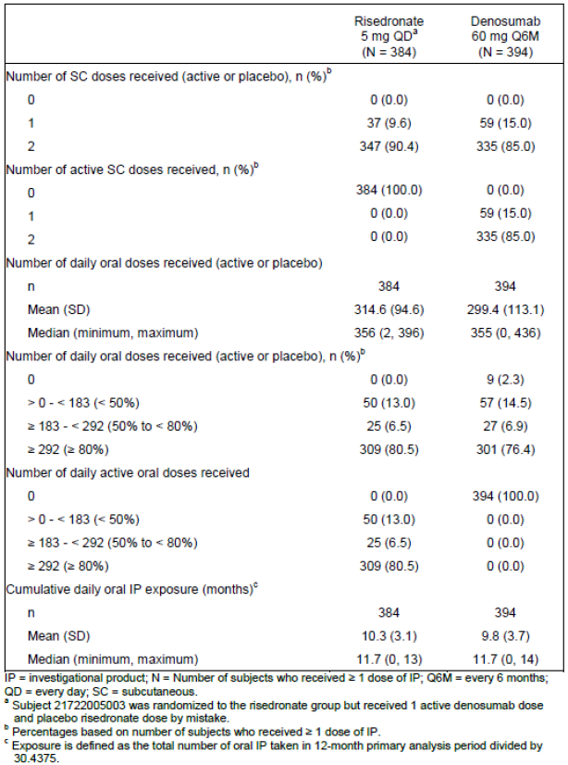
With regards to the subcutaneous drug (active or placebo), only 85% of subjects received the full course of two doses in the first 12 months.
With regards to the oral investigational product, the data is consistent with the known compliance issue. Of particular relevance, 13% of subjects on the active risedronate arm in the safety analysis set received less than half of their planned medication.

Safety issues with the potential for major regulatory impact

Events of interest
A number of events have been designated as events of interest by the sponsor due to their possible association with anti-resorptive activity or RANKL inhibition, association with monoclonal antibodies or based on results from previous denosumab studies. These include:
- Hypocalcaemia
- Positively adjudicated osteonecrosis of the jaw (ONJ)
- Adverse events potentially related to hypersensitivity
- Serious infection
- Serious bacterial cellulitis (skin infections)
- Malignancy
- Cardiac disorders
- Vascular disorders
- Adjudicated positive atypical femoral fracture
- Eczema
- Acute pancreatitis
- Musculoskeletal pain
Compared with the primary osteoporosis studies (Studies 20030216 and 20080098) and hormone ablation therapy (HALT) studies (Studies 20040135 and 20040138; includes men with prostate cancer receiving androgen deprivation therapy and women with breast cancer receiving aromatase inhibitors), the incidence for the events of interest were generally somewhat similar or lower on the GIOP study for the denosumab arm. The main exception was the incidence of infections:
- The incidence of adverse events on the denosumab arm was higher on the GIOP study (Study 20101217) compared to the HALT studies but lower than the primary osteoporosis studies. However, compared to the risedronate arm on Study 20101217, the incidence on the denosumab was slightly lower.
- The incidence of serious infections was higher in Study 20101217 compared to the other indications, but the incidence on the denosumab arm was similar to the risedronate arm within this study (4.3% compared to 3.9% respectively).
These differences compared to other indications may reflect the different features of the study population enrolled. In particular, increased susceptibility to infection is also a potential complication of corticosteroid use.
Table 6: Summary of treatment emergent adverse events of interest (safety subjects, Integrated Analysis of Safety)
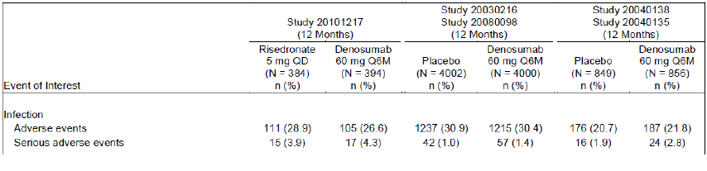
Interestingly, the incidence of musculoskeletal pain was much lower in the GIOP study compared to the others (13.7% on denosumab and 14.6% on risedronate compared to ranges of 32.9 to 33.5% in the osteoporotic cohorts and 21.0 to 22.9% in the HALT cohorts). This is somewhat surprising given the underlying diseases in this study (for example, polymyalgia rheumatica was the most common underlying disease in the GC-I group) but may also reflect the use of corticosteroids.

Pivotal and/or main efficacy studies; Study 20101217

Hypocalcaemia
Denosumab decreases the rate of bone resorption and therefore may lower serum calcium levels. As part of the protocol, all subjects were to receive calcium and vitamin D supplements.
Table 7: Hypocalcaemia at 12 month analysis (combined subpopulations), safety analysis set
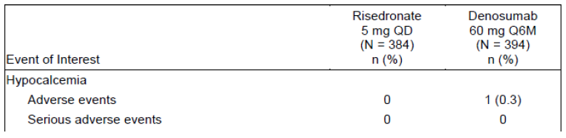
One subject on the denosumab arm had a reported adverse event related to hypocalcaemia.

Adjudicated positive osteonecrosis of the jaw (ONJ)
Osteonecrosis of the jaw has been reported in subjects receiving treatment with denosumab.
No events were reported in the 12 month primary analysis period in this study.

Hypersensitivity
Monoclonal antibodies may theoretically be associated with hypersensitivity reactions; hypersensitivity is recognised as an adverse reaction with denosumab use.
Table 8: Hypersensitivity at 12 month analysis (combined subpopulations), safety analysis set
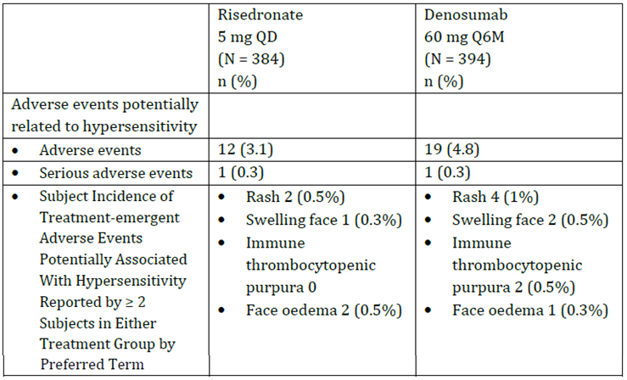
Hypersensitivity events occurred in 4.8% of subjects on the denosumab arm and 3.1% on the risedronate arm. Of the two events of Immune thrombocytopenic purpura that occurred on the denosumab arm, one was in a subject with a history of autoimmune thrombocytopenia and not considered to be study drug related by the investigator; the other was considered to be related to study drug by the investigator and the subject discontinued the study due to it.

Serious infection
RANKL is expressed on activated T and B cells and in the lymph nodes and infection has been identified as an event of interest. Nonclinical studies suggest that a normal immune response to infectious pathogens is not dependent on RANKL.
Table 9: Serious infection at 12 month analysis (combined subpopulations), safety analysis set
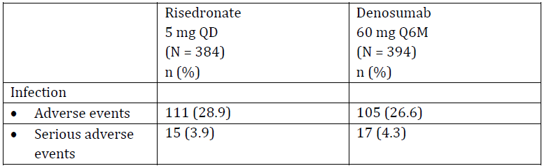
Infections (defined as all adverse events and serious adverse events mapped to the infections and infestations System Organ Class in MedDRA) occurred in 26.6% of subjects on the denosumab arm and 28.9% on the risedronate arm. 4.3% of subjects on the denosumab arm and 3.9% on the risedronate arm had serious adverse events of infection.
In terms of serious adverse events, the most common event of infection was pneumonia on both arms (denosumab 5 subjects, 1.3%; and risedronate 6 subjects, 1.6%) although it is noted that ‘pneumonia bacterial’ and ‘lower respiratory tract infection’ were also reported once each as separate preferred terms on the denosumab arm). All other preferred terms for serious events on the denosumab arm were reported only once. Two subjects in the denosumab group (0.5%) had serious adverse event infections considered to be related to treatment; lung abscess and bacterial pneumonia.
The median daily dose of glucocorticoid was 10 mg for both treatment groups regardless of infection status (no infection, non-serious infections or serious infections) with the exception of subjects with serious infection in the denosumab group (15 mg median daily dose of glucocorticoid). Cultures were only obtained at the investigators discretion. The study report indicates that a serious opportunistic infection was reported for 1 subject (0.3%) in each treatment group: denosumab; lymph node tuberculosis and risedronate; Clostridium colitis. The denosumab subject with lymph node tuberculosis had multiple lung lesions prior to study initiation. It is noted by the evaluator that a Serratia marcescens infection was also reported on the denosumab arm. Very little additional information regarding this infection is available in narrative however it is noted that Serratia marcescens is considered to be an opportunistic pathogen in published literature.
227 subjects on the risedronate arm and 208 on the denosumab arm received a concomitant immunosuppressant agent or biologic. The incidence of treatment emergent serious infections in subjects with use of a concomitant immunosuppressant agent or biologic by preferred term was 6 (2.9%) on the denosumab arm and 9 (4.0%) subjects on the risedronate arm. In contrast, serious infection was reported for 11 subjects (5.9%) in the denosumab group and 4 subjects (2.5%) in the risedronate group in those not receiving a biologic/immunosuppressant medication.

Serious bacterial cellulitis (Skin Infections)
Table 10: Serious bacterial cellulitis at 12 month analysis (combined subpopulations), safety analysis set
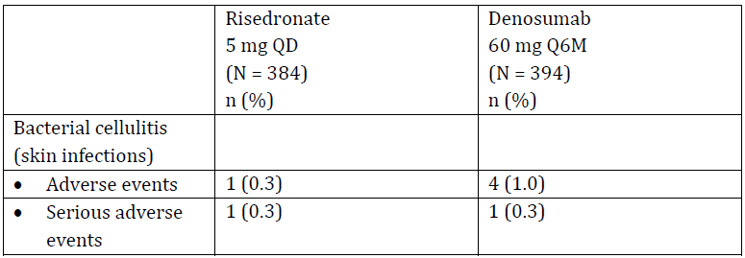
Adverse events of bacterial cellulitis reported in the denosumab group included erysipelas (3 subjects, 0.8%), cellulitis (1 subject, 0.3%), and pustular rash (1 subject, 0.3%). One of the erysipelas events (denosumab arm) was considered to be serious but not related to the investigational product. The only bacterial cellulitis event reported on the risedronate arm was cellulitis and was considered to be serious.

Malignancy
Table 11: Malignancy at 12 month analysis (combined subpopulations), safety analysis set
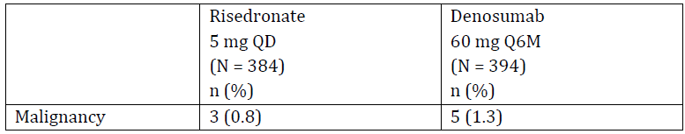
Malignancy was reported in 1.3% of denosumab subjects and 0.8% of risedronate subjects. Each preferred term reported was reported only once.

Cardiac and vascular disorders
Table 12: Cardiac disorders at 12 month analysis (combined subpopulations), safety analysis set
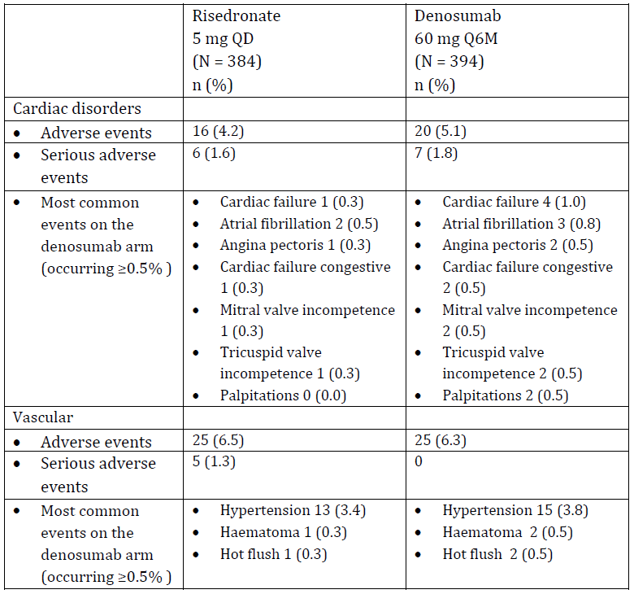
Cardiac disorders occurred in 5.1% of subjects on the denosumab arm and 4.2% on the risedronate arm. ‘Cardiac failure’ was the most commonly reported preferred term on the denosumab arm in 4 subjects (1.0%) compared to 1 (0.3%) on the risedronate arm and an additional 2 subjects (0.5%) on the denosumab arm reported the related preferred term of ‘cardiac failure congestive’ compared to 1 (0.3%) on the risedronate arm. Of the four subjects who reported an event of ‘cardiac failure’, two had a history of cardiac failure and one had other cardiovascular risk factors at baseline. Of the two subjects who reported ‘cardiac failure congestive’ on the denosumab arm, both had a history of cardiac failure.
Vascular disorders occurred in 6.3% of subjects on the denosumab arm and 6.5% on the risedronate arm and hypertension was the most commonly reported event on both arms.

Adjudicated positive atypical femoral fracture
One subject in the denosumab group had a positively adjudicated atypical femoral fracture; none occurred in the risedronate arm. The event occurred in a subject with a long history of receiving glucocorticoid therapy, one previous fracture and no history of bisphosphonate or proton pump inhibitor use. It occurred approximately 2 months after the second dose of denosumab and resolved after the database lock point for the 12 month primary analysis following closed reduction and osteosynthesis.

Eczema
Two subjects on the denosumab arm had non-serious adverse events of eczema (Preferred Terms ‘atopic dermatitis’ and ‘eczema’); none occurred on the risedronate arm.

Acute pancreatitis
No subject on the denosumab arm had an adverse event of acute pancreatitis; one subject on the risedronate arm reported a serious event.

Musculoskeletal pain
Table 13: Subject incidence of treatment-emergent adverse events of musculoskeletal pain reported in ≥ 1% of subjects in either treatment group by preferred term, combined subpopulations; safety analysis set, 12 month primary analysis)
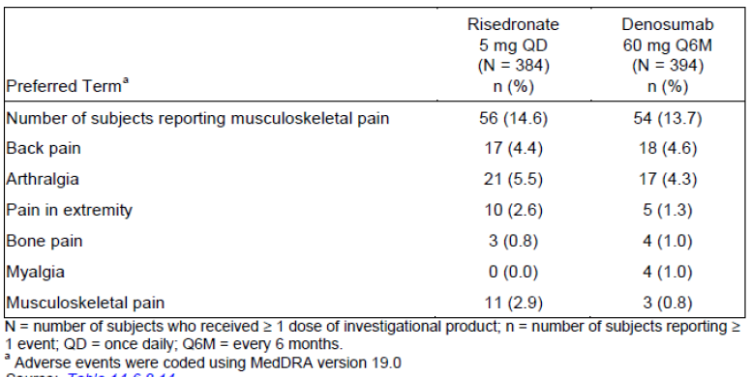
Musculoskeletal pain occurred in 13.7% of subjects on the denosumab arm and 14.6% on the risedronate arm. Back pain was the most commonly reported event followed by arthralgia on the denosumab arm. Serious adverse events relating to musculoskeletal pain occurred in 2 (0.5%) of subjects on the denosumab arm and 4 (1%) of subjects on the risedronate arm.

Post-marketing data
Very limited post-marketing data was presented in the Summary of clinical safety regarding overall numbers of adverse drug reactions (serious and non-serious) but no details of the types of reactions were provided.

Evaluator’s conclusions on safety
The new safety data presented by the sponsor was from the Study 20101217 and no new, significant safety signals were detected in this study. However, as the use of corticosteroids is associated with a number of significant side effects there is potential for additive toxicities of corticosteroids and denosumab (for example, those listed as events of interest) such as hypertension, pancreatitis, heightened risk of infections and opportunistic infections. This trial did not show any clear indication of potential additive effects of corticosteroids and denosumab compared to risedronate/corticosteroids (however all conclusions from this study are limited by a relatively short follow up of 12 months, especially in the context of potential long term corticosteroid use/ recurrent courses of corticosteroids with chronic disease), relatively small numbers of subjects enrolled (compared to other denosumab studies and considering the rarity of some events) and the heterogeneous corticosteroid use in the baseline population.
Safety information was provided only for the combined subpopulations; that is, data was not shown for the two individual subpopulations. From the point of view of rare adverse event detection, this may be reasonable as there is a larger data set available for comparison to the risedronate arm. However, based on the data presented, no conclusions can be made about potential any differences in the safety profile between the two subpopulations.

First round benefit-risk assessment

First round assessment of benefits
Table 14: First round benefits and strengths and uncertainties
Benefits | Strengths and Uncertainties
Denosumab was non-inferior to risedronate for the primary endpoint of lumbar spine BMD at 12 months in the glucocorticoid-initiating subpopulation (primary endpoint). | Although this study met its primary endpoint in both the GC-I and GC-C subpopulations, a number of key uncertainties remain:  - How well do the differences in BMD reflect the more clinically relevant endpoint of fractures  - Longer term data is still pending (24 month follow up)  - Imbalances in baseline characteristics between the two arms may result in bias of the results  - Whether the population enrolled into this study is a true reflection of the subpopulations seen in clinical practice  With particular reference to the GC-I subpopulation, a number of subjects had baseline characteristics consistent with pre-existing osteoporotic fractures and/or had received long-term corticosteroids already, compromising the validity of the baseline population and the applicability of the ‘prevention’ wording in the proposed indication.
Denosumab non-inferior to risedronate for the primary endpoint lumbar spine BMD at 12 months in the glucocorticoid-continuing subpopulation (primary endpoint). | This study demonstrated statistical superiority for the two secondary endpoints reporting at the 12 month mark (others are due to report at 24 month follow up), however the clinical significance of the difference detected was not addressed by the sponsor.
6 monthly injections of denosumab are associated with better compliance compared with daily oral risedronate. | Poor compliance with risedronate may have biased the results toward denosumab. The comparison with another parenteral comparator given at infrequent intervals may have been more appropriate.

First round assessment of risks
Table 15: First round assessment of risks
Risks | Strengths and Uncertainties
The safety profile of denosumab is well documented across a number of studies in different indications; no new safety signals were detected in this new population of patients. | Uncertainties remain for this population due to limited duration of follow up (12 months; 24 month follow up is planned).  Data for the individual subpopulations was not provided therefore any differences in safety profile between the two subpopulations is not known.
Rare adverse events, such as osteonecrosis of the jaw, have been documented with the use of denosumab. | Relatively small total number of patients (N = 778) exposed to denosumab for 12 months in the corticosteroid initiated/continuing subpopulations (compared to combined HALT approximately 1,600 and primary osteoporosis populations approximately 8,000) which may not adequately determine the risk of these rarer events in this population.

First round assessment of benefit-risk balance
There are some issues associated with the glucocorticoid treated population seen in this clinical trial.
Ideally, an osteoporosis prevention patient population would not have osteoporosis at baseline (or other baseline risk of osteoporosis) and have only recently started on glucocorticoids. A glucocorticoid induced osteoporosis indication would ideally include patients with established osteoporosis, long term use of glucocorticoids and no other risk factors for osteoporosis (for example, family history or age).
It is also difficult to determine whether osteoporosis is due to glucocorticoids alone, as other contributing factors such as underlying inflammation, poor nutrition, poor mobility, age, and other factors may also play a role. Defining osteoporosis also has challenges (for example based on fracture risk or fracture).
Two indications are proposed, therefore each will be considered separately:
Prevention of osteoporosis in women and men at increased risk of fracture who are starting or have recently started long-term glucocorticoid therapy.
With regards to this indication, the study met its primary endpoint and denosumab appears to be non-inferior to risedronate. Indeed denosumab also demonstrated statistical superiority to risedronate. No significant, new safety risks were detected. However, as outlined previously, there are a number of uncertainties remaining. Of these, the following are of particular note:
- Despite the proposed indication being ‘prevention of osteoporosis’, there is evidence to suggest that a significant minority of denosumab receiving subjects in this sub study already had osteoporosis either currently or in the past. Of the subjects on the denosumab arm, 6.2% on the denosumab arm (and 13.8% on the risedronate arm) were determined to have secondary osteoporosis at baseline. Additionally at baseline on the denosumab arm:
  - 17.9% of subjects had a lumbar spine BMD T-score of ≤-2.5
  - 7.6% of subjects on the denosumab arm had a femoral neck BMD T-score of ≤-2.5
  - 33.8% of subjects on the denosumab arm had a prior osteoporotic fracture.
- Despite the proposed indication relating to patients ‘who are starting or have recently started long-term glucocorticoid therapy’, 11% on the risedronate arm and 6.9% on denosumab arm had received prior oral glucocorticoids for more than 3 months (consistent with the GC-C population definition rather than the GC-I).
- Whether the population enrolled into this study is a true reflection of the subpopulation seen in clinical practice; for example, more than 50% of subjects enrolled were post-menopausal women and the mean age was mid-sixties.
The sponsor has stated that this is considered to be a bridging study from the studies which relate to the treatment of osteoporosis. However, prevention implies that osteoporosis is not present at the time of treatment initiation. Thus, bridging from a treatment study is not relevant.
Treatment of osteoporosis associated with sustained systemic glucocorticoid therapy in women and men at increased risk of fracture.
As outlined above, some uncertainties remain; however some of these will be mitigated with longer term efficacy and safety data due for this study after 24 months follow up.
The primary endpoint was met showing that denosumab is non-inferior to risedronate and no significant, new safety risks were detected.
The wording of the indication is for the ‘treatment’ of osteoporosis, however not all subjects enrolled had a BMD consistent with the diagnosis of osteoporosis.
Further information has been requested from the sponsor.

First round recommendation regarding authorisation
Further information is sought from the sponsor prior to a recommendation being made.

Clinical questions and second round evaluation

Administrative questions

Question 1
According to the submitted dossier, a similar application has not been submitted to the US FDA and the date of submission to be determined. Please explain why a submission to the US FDA has not been made; or if this status has changed, please provide updated information.

Sponsor’s response
A similar application was submitted to the US FDA on 28 July 2017; the expected approval date is 28 May 2018. The proposed US prescribing information was submitted with the sponsor’s response.

Evaluator comment
No further comments.

Question 2
According to the submitted dossier, at the time of the current submission, the outcomes of the related EMA and Health Canada applications were still pending. Please provide updated information regarding the status of these applications including relevant product documentation (for example Summary of Product Characteristics) if applicable.

Sponsor’s response
- Health Canada: Approval is expected mid-February 2018 and at the time of response to TGA, the sponsor had not received requests for additional information.
- EMA: a Committee for Medicinal Products for Human Use (CHMP) Request for Supplementary Information (RSI) was received on 22 June 2017; the sponsor responded on 07 September 2017
  - An EMA ad hoc expert Scientific Advisory Group (SAG) was convened by the EMA CHMP in the context of this extension of indication procedure (23 October 2017), and final minutes were issued 1 November 2017. On 10 November 2017, Amgen received an additional CHMP RSI and an annotated, redlined SmPC
  - The originally proposed indications (which were consistent with those proposed to the TGA) have not been endorsed by the EMA. The CHMP is currently proposing the following indication: Treatment of osteoporosis associated with long-term systemic glucocorticoid therapy in patients at increased risk of fracture and the sponsor intends to propose the following indication in response: Treatment of bone loss associated with long-term systemic glucocorticoid therapy in adult patients at increased risk of fracture.
  - The sponsor has provided additional documentation relating to the EMA submission; the sponsor’s response to the CHMP’s RSI (22 June 2017) and the additional CHMP RSI and annotated, redlined SmPC (10 November 2017) is provided.
- Other regulatory authorities: the sponsor has also indicated that a similar application was also filed with SwissMedic on 31 May 2017. The draft Physicians information was submitted with the sponsor’s response.

Evaluator comment
An updated SmPC (Europe) was not submitted and is presumed to be an error A similar issue is found for the proposed Canadian product monograph. However, an SmPC was included as part of the EMA correspondence and this version also contains comments from the EMA.

Pharmacokinetics

Question 3
Please provide an updated version of Figure 3 which includes data from healthy subjects as indicated was intended to be included in the original figure in sponsor’s submission.

Sponsor’s response
Data for healthy volunteers beyond Month 4 are not available for Study 20050146 and the reference to ‘Healthy Volunteers’ title of the original figure is an error and has been amended. Given the similarity in denosumab exposures between healthy volunteers and subjects with GIOP at other time-points (Day 10, and Months 3 and 4), these results suggest there is no difference in denosumab exposure between the two populations.

Evaluator comment
The lack of comparative data for healthy volunteers beyond 4 months (despite availability of this in diseased populations) is noted.

Question 4
Please explain how the difference in the mean post dose concentrations between healthy subjects and subjects with GIOP at Months 3 and 4 of < 9% and < 36% were derived (as stated in the Summary of Clinical Efficacy); the difference at Month 3 does not seem to reflect the difference between the GC-C subjects and healthy subjects (see Table 16).
Table 16: Serum concentrations after SC administration of 60 mg denosumab to healthy subjects (Study 20050146) and subjects with glucocorticoid-induced osteoporosis (Study 20101217)
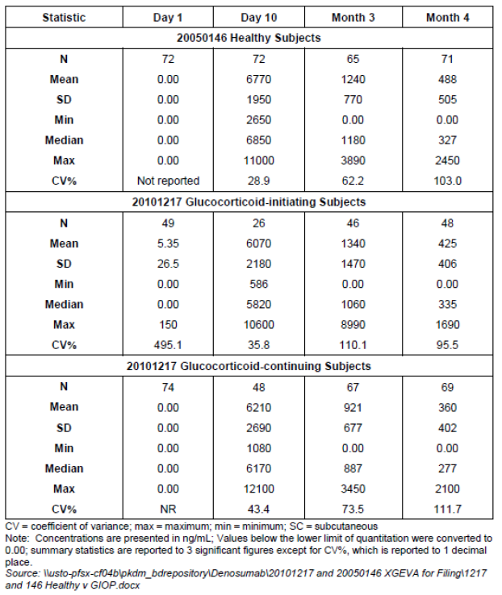

Sponsor’s response
The previously stated calculated exposure difference between heathy volunteers and subjects with GIOP at Month 3 in the Summary Clinical Efficacy has been amended to ‘< 35%’.

Evaluator comment
Updated wording is noted; no further comment.

Question 5
The current denosumab PI states that the denosumab half-life is 26 days, however the mean half-life across the combined GIOP subpopulations was 17.5 days. Please provide an explanation for the difference seen.

Sponsor’s response
The mean denosumab half-life of 26 days, as described in the Prolia PI, was derived from data which included time-points immediately following the C_{max} primarily representing the beta-phase half-life (or elimination phase).
The mean half-life value of 17.4 to 17.6 days for the GC-C and GC-I subjects, respectively, was based on PK concentrations measured at Months 3, 4 and 6 (representing the beta-phase as well as, in part, the gamma-phase (terminal) half-life profile) and did not include time-points immediately following C_{max}.
Denosumab has nonlinear PK properties; it is cleared faster at lower concentrations, due to target-mediated drug disposition. The differences in the PK time-points used for the half-life calculation is the reason for the noted discrepancy.

Evaluator comment
No further comment.

Pharmacodynamics
No questions.

Efficacy

Question 6
Provide information regarding the duration of use and dose of corticosteroids during the trial for the two subpopulations and by arm.

Sponsor’s response
The pattern of glucocorticoids usage in Study 20101217 was similar between the denosumab and risedronate treatment groups for both subpopulations; see Table 17, Table 18, Table 19 and Table 20.
The sponsor noted that the average duration of glucocorticoid (GC) therapy was nearly 1 year, a substantial proportion of study subjects remained on GC therapy through Month 12, a majority of study subjects remained on a daily glucocorticoid (prednisone equivalent) dose ≥ 7.5 mg and the percentage of subjects on a daily glucocorticoid (prednisone equivalent) dose of at least 7.5 mg at Month 12 was similar between the denosumab and risedronate treatment groups in both the GC-C and GC-I subpopulations.
Glucocorticoid-initiating (GC-I) subpopulation
Table 17: Glucocorticoid-initiating (GC-I) subpopulation: duration of glucocorticoid medications use between Baseline and 12 months (full analysis set; Study 20101217, 12 month primary Analysis)
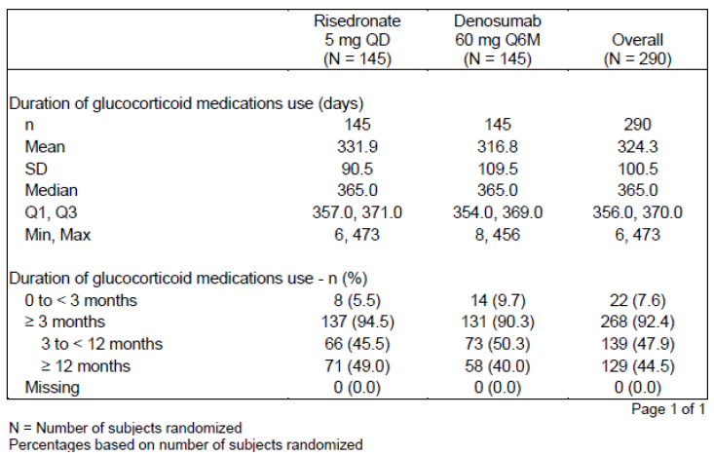
Table 17: Glucocorticoid-initiating (GC-I) subpopulation: use of glucocorticoid medications at Baseline at 12 Months (Full Analysis Set; 20101217 12 month Primary analysis)
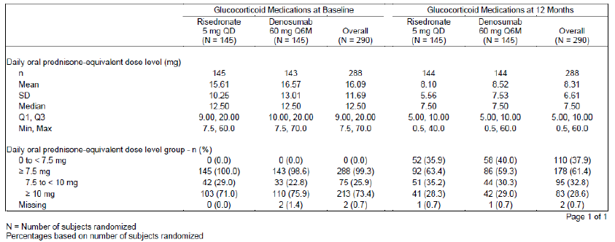
Glucocorticoid-continuing (GC-C) subpopulation
Table 19: Glucocorticoid-continuing (GC-C) subpopulation: duration of glucocorticoid medications use between Baseline and 12 months (full analysis set; Study 20101217, 12 month primary analysis)
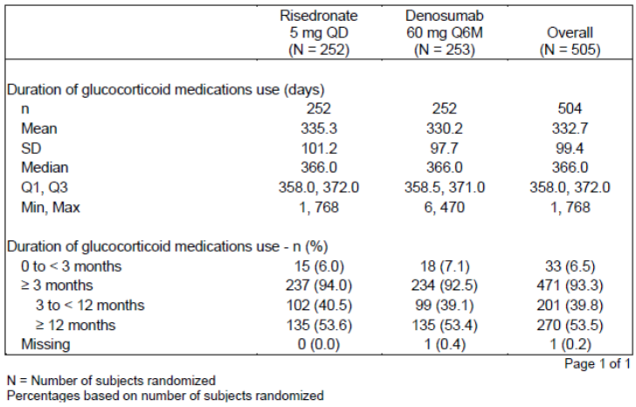
Table 20: Glucocorticoid-continuing (GC-C) Subpopulation: use of glucocorticoid medications at Baseline and at 12 months (full analysis set; Study 20101217, 12 month primary analysis)
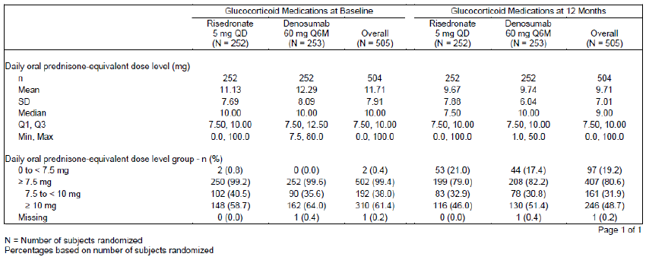

Evaluator comment
The evaluator notes some differences between the two arms in terms of glucocorticoid therapy during the study in both subpopulations, especially in the GC-I subpopulation.
For example, with respect to the GC-I subpopulation, more subjects on the denosumab (9.7%) arm treated for 3 or fewer months compared to risedronate arm (5.5%). At baseline, more subjects on the risedronate arm were on a lower dose (7.5 to < 10 mg prednisolone equivalent) compared to the denosumab arm (29.0% compared to 22.8% respectively); at 12 months, more subjects on the denosumab were on a lower dose overall (0 to < 7.5 mg; 40.0% and 35.9% respectively). It is also noted that 49% of subjects on the risedronate arm and 40% on the denosumab arm in the GC-I subpopulation were treated for 12 months or more between baseline and 12 months, however it is unclear what the true difference is given that this is a 12 month analysis. These differences contribute further to the uncertainty with regards to the outcomes in the GC-I subpopulation.
Overall, it is noted that the average duration of GC treatment during the study was relatively long (mean ranged from 316.8 to 335.3 days across the four arms) and at 12 months, although the average dose of GC (prednisolone equivalent) had decreased from baseline, the mean dose remained greater than 7.5 mg on all arms (range 8.10 to 9.74 mg across the four arms). This data helps to address issues regarding the potential for early cessation of glucocorticoids to contribute to BMD recovery.

Question 7
Please provide explanation as to why there are discrepancies in the number of subjects in the ‘primary efficacy analysis set’ between the primary, secondary and exploratory endpoint analyses. Please also confirm which analysis subset the exploratory analyses were carried out on.

Sponsor’s response
‘The reason for the discrepancies in the number of subjects in the primary efficacy analysis set between the primary, secondary, and exploratory endpoint analyses is that the primary efficacy analysis set definition was applied to each bone mineral density (BMD) endpoint. The primary efficacy analysis was to only include subjects with observed BMD data. Both lumbar spine and total hip BMDs were assessed at baseline, but post-baseline assessments were conducted at Months 6 and 12 for the former and Month 12 only for the latter. Therefore, the number of subjects in the primary efficacy analysis set may differ across endpoints, based on the number of missing data by skeletal sites and time point (which is expected to be different among subject.
The exploratory analyses were based on the primary efficacy analysis set.’

Evaluator comment
No further comments

Question 8
Please provide explanation regarding rationale for the definition of clinical fracture and in particular:
- explain why fractures associated with high trauma severity and pathologic fractures were excluded?
- why the definition was changed and the potential impact on the collection of data relating to this outcome?

Sponsor’s response
The definition of ‘clinical fracture’ (which includes clinical vertebral and non-vertebral fractures) in the Study 20101217 is consistent with the definition used throughout the denosumab clinical development program, including the Phase III pivotal fracture study.
- (Regarding part (a); verbatim excerpt of sponsor’s response): ‘Fractures associated with high trauma severity or pathologic fractures are excluded from the fragility or osteoporosis-related fracture category, as they are not directly related to bone loss, but to high force trauma. This approach used in Study 20101217 is consistent with the approach used throughout the denosumab clinical development program. Importantly, however, high trauma severity and pathologic fractures were reported in the adverse event summary tables.’
- (Regarding part (b); verbatim excerpt of sponsor’s response): ‘The revision of the definition of clinical fracture in the Statistical Analysis Plan (SAP) amendment was not a change to the definition, but only a clarification, as clinical vertebral fractures, by definition, are a subset of vertebral fractures that are associated with signs and/or symptoms indicative of a fracture. Both clinical vertebral fractures and non-vertebral fractures were captured on the Clinical Fracture Summary electronic case report form (eCRF) from the beginning of the study. Removing the clause, ‘that are associated with signs and/or symptoms indicative of a fracture’, from the definition in the SAP did not alter fracture collection, which remained consistent throughout the duration of the study.’

Evaluator comment
- Regarding the answer to part (a); the sponsor has referred the evaluator to the adverse event summary tables for a more fulsome picture of the fractures that occurred on study. Upon review of the safety adverse event data (note: manually calculated by the evaluator), the following is noted with regards to the preferred term of ‘fracture’ (note that tooth fracture has been excluded from this list since bone fractures are of specific interest) and back/spinal/bone pain (included as may be a clinical sign of fracture, especially vertebral):
Table 21: Treatment emergent adverse events; fractures and other potentially fracture related events (safety analysis set; Study 20101217, 12 month primary analysis)
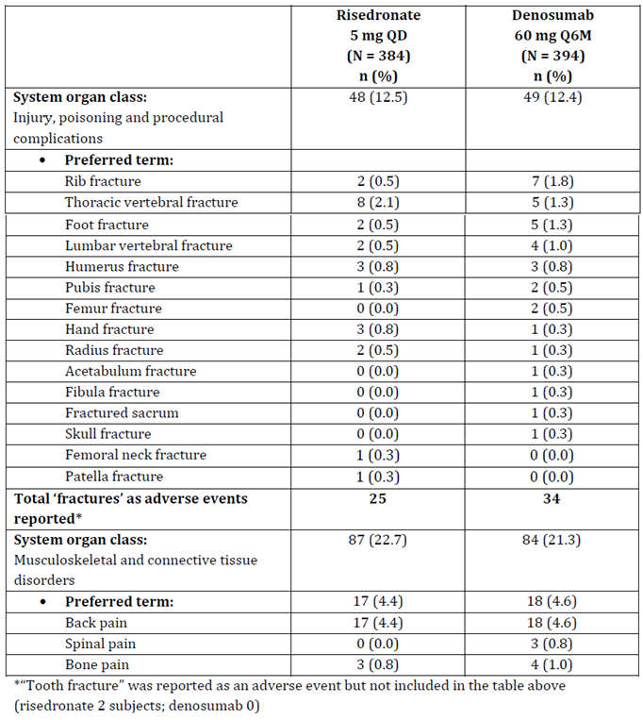
N = Number of subjects who received ≥ 1 dose of investigational product, n = Number of subjects reporting ≥ 1 event; coded using MedDRA version 19.0.
Based on the evaluator’s manual calculation, in terms of bone ‘fractures’ reported as adverse events, there were more subjects reporting events on the denosumab arm; 34 (8.6%) subjects on the denosumab arm and 25 (6.5%) subjects on the risedronate arm.
- Regarding the answer to part (b); the evaluator has no further comments.

Question 9
Provide fracture incidence data at 12 months for the individual subpopulations (that is, not combined data)

Sponsor’s response
The sponsor has stated that the results in each subpopulation are overall consistent with those in the two subpopulations combined; new data submitted is shown in Table 75, Table 76, Table 77 and Table 78 (not included in AusPAR due to size of tables). Results for non-vertebral fractures are presented by location and population (for example post-menopausal, premenopausal woman etcetera); vertebral fractures are presented by type and population. Selected data points are shown in Table 22.
Table 22: Selected data points relating to fractures in the two separate subpopulations (full analysis set)
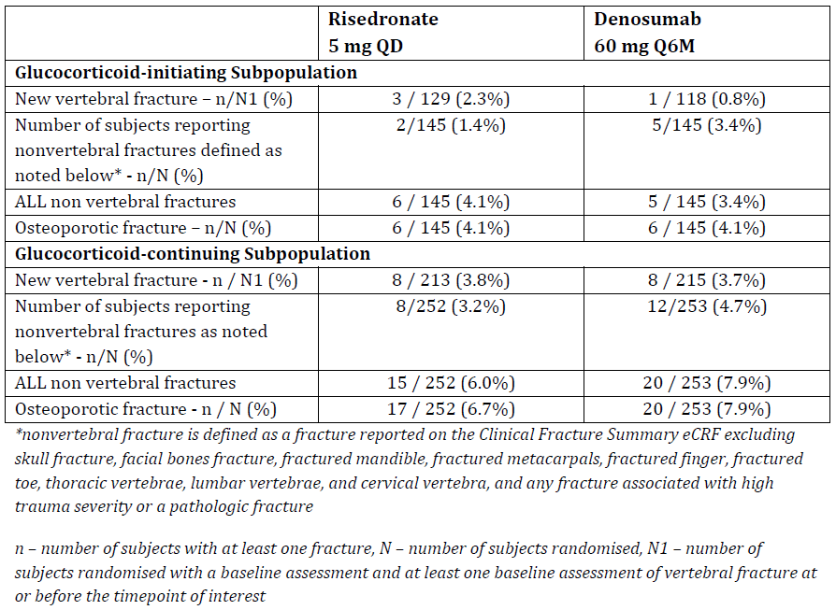

Evaluator comment
The additional data (that is Table 75, Table 76, Table 77 and Table 78) regarding fractures contains much more detail than that which was originally submitted with a number of new subcategories of fractures were reported. However, there is little explanation provided by the sponsor with regards to this new data and it is not clear how all of the subcategories relate to each other. Thus, the new data is difficult to interpret and conclusions are limited by the relatively small subcategories/population subgroups within each subpopulation.
Some general observations:
- Glucocorticoid-initiating subpopulation:
  - More subjects had non-vertebral fractures as defined by the protocol on the denosumab arm (3.4% compared to 1.4%), however the risedronate arm had more non-vertebral fractures when definitions were removed (‘all’; 4.1% compared to 3.4%). However, the absolute difference in terms of numbers of subjects is relatively low (≤ 3) and the smaller subpopulation limits firm conclusions.
  - Vertebral fractures were presented in a number of subcategories/population subgroups. Risedronate had a higher percentage of vertebral fractures for all subcategories (not including demographic subgroups) compared to denosumab however the absolute difference was mostly low, the largest being 3 for ‘new and worsening fracture’.
- Glucocorticoid-continuing subpopulation
  - More subjects had non-vertebral fractures on the denosumab arm (4.7% compared to 3.2% as defined by the protocol; not those specified as ‘all’). Rib and pelvic fractures were the most common types of non-vertebral fractures on the denosumab arm.
  - For all subgroups of vertebral fractures, risedronate had a higher percentage of fractures except for morphometric vertebral fractures (denosumab 2.8% (6) compared to risedronate 0.9% (2)); the largest difference was for ‘clinical vertebral fracture’ (denosumab 0.9% (2) compared to risedronate 2.8%(6)).
However, the sponsor’s statement that ‘the results in each subpopulation are overall consistent with those in the 2 subpopulations combined’ cannot be confirmed since the data submitted for the two subpopulations is different to that which was originally presented for the overall population in the study report. The originally submitted fracture data for the combined subpopulations in the study report reported outcomes for ‘new vertebral fractures’ and ‘clinical fractures’. In terms of ‘new vertebral fractures’, the new data shows that 2.3% of subjects on the risedronate arm compared to 0.8% on the denosumab arm developed new vertebral fractures in the GC-I subpopulation and this accounts for the numerical difference seen in the combined populations. In terms of ‘clinical fractures’, these are not specifically reported in Tables 75, to 78) and it is not clear what are the corresponding measures (if present).
Potentially of relevance, the evaluator notes that data has been provided to the EMA (provided in the response) for ‘new vertebral fractures’ and ‘clinical fractures’ by subpopulation which could potentially be more useful for comparison purposes. However the combined population data submitted to the EMA (Table 23) does not appear to be consistent with that which was reported in the original study report (Table 24), nor does it appear to be consistent with what has been submitted to the TGA in the current response (Table 76 and Table 78 ‘new vertebral fractures’).
Table 23: Number of New Vertebral Fractures and Clinical Fractures at Month 12 (full analysis set; Study 20101217 12 month primary analysis) as contained in the EMA extension of indication variation assessment report (9 November 2017)
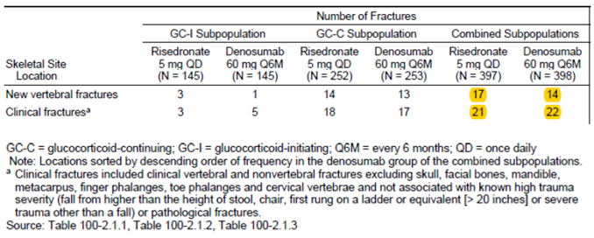
Table 24: Subject incidence of new vertebral fractures and clinical fractures at Month 12 (full analysis set; combined subpopulations; Study 20101217 12 month primary analysis) as reported in Study 20101217 report
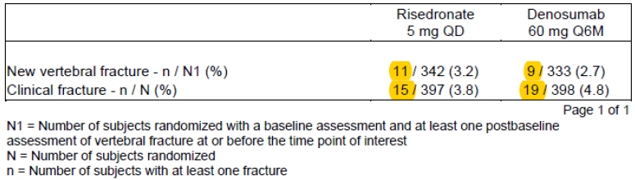
The reason for this discrepancy is unclear and thus the EMA data does not contribute further insight after all. Furthermore, it is unclear why the TGA has been provided with different data to that which was provided to the EMA. It is also noted that the EMA has made specific comment about the fracture data and in particular, clinical fractures and non-vertebral fractures. However, the data for non-vertebral fractures quoted by the EMA assessor (‘Specifically, an imbalance in non-vertebral fractures is noted with a total of 20 fractures in the denosumab group compared to 10 non-vertebral fractures in the risedronate group’) is not consistent with data provided to the TGA; again the reason for this discrepancy is unclear. The data provided to the TGA (Table 22) shows that the number of non-vertebral fractures (as defined by the study; see * in same table) in the combined population was 10 on the risedronate arm and 17 on the denosumab arm (for ‘all’ non-vertebral fractures, the difference was 21 on the risedronate arm compared to 25 on the denosumab arm).
With regards to fractures, the EMA assessor has concluded that ‘Fracture data in Study 20101217 needs to be evaluated at Month 24. Meanwhile, fracture data from 12 month analyses needs to be included in the SmPC’. Furthermore, it is noted that the EMA assessor has raised a Major Objection that in part relates to this fracture data; the following is stated ‘A numerical imbalance in non-vertebral fractures in favour of comparator was noted at Month 12. Therefore, the final 24 month analysis results of the Study 20101217 are required before a potential approval to provide additional information concerning this imbalance.’ As a result of the ongoing Major Objection, it is stated in the EMA report that ‘the application is not approvable since a major objections has been identified…’.
Overall, conclusions relating to denosumab and fractures, a particularly clinically relevant endpoint, remain limited in this study for the following reasons:
- the study was not adequately powered to compared fracture rate between risedronate and denosumab
- the additional data for fractures provided was not clearly defined in the sponsor’s response and is difficult to interpret
- data provided to the TGA appears to conflict with data provided to the EMA.
As mentioned in the first round report, the sponsor has postulated that data from other patient populations which show that denosumab both increases BMD and decreases fracture incidence can be extrapolated to this population. The Study 20030216 in women with postmenopausal osteoporosis demonstrated significant increases in BMD at all skeletal sites measured (lumbar spine, proximal femur (total hip, femoral neck, trochanter), and 1/3 radius) and the primary efficacy analysis showed that denosumab decreased fracture risk compared with placebo, with relative risk reductions at Month 36 for new vertebral, non vertebral, and hip fractures of 68% (absolute risk reduction 4.8%), 20%, and 40%, respectively. The Study 20040138 in men with bone loss from androgen-deprivation therapy for non-metastatic prostate cancer also showed demonstrated significant increases in BMD at all skeletal sites measured and a 62% decrease in the incidence of new vertebral fractures in the denosumab group relative to the placebo group at Month 36 (2.4% absolute risk reduction). However, little supporting evidence was provided for the extrapolation; the sponsor has stated the following in the Summary of Clinical Efficacy: ‘In denosumab treated subjects, mean increases in BMD in Study 20101217 were overall similar to the mean increases in BMD in Studies 20030216 and 20040138 at Month 12. Since BMD increases were associated with fracture risk reduction in Studies 20030216 and 20040138, and BMD increases within the same range of the above were observed in Study 20101217, it is reasonable to extrapolate the anti-fracture efficacy of denosumab 60 mg given every 6 months (Q6M) to patients with GIOP.’ Of the two studies for which extrapolation are proposed, the postmenopausal group study included 7,808 women and incidence of new vertebral fractures was also the primary endpoint of that study. However, the evaluator notes that fractures tend to occur at a higher BMD in patients receiving glucocorticoid therapy than in postmenopausal osteoporosis; and there are differences in the underlying pathogenesis; therefore extrapolation should be interpreted with caution. In addition, only 12 month data is available for the glucocorticoid study, whereas the two referenced studies both have data for up to 36 months.

Question 10
Provide further justification regarding why the population enrolled in the GC-I sub-population is representative of the treatment population that would be treated in clinical practice – that is, those at high risk of osteoporosis and without established osteoporosis.

Sponsor’s response
The sponsor referred to a number of guidelines:
- International Osteoporosis Foundation (IOF); recommends that pharmacologic treatment should be considered for
  - postmenopausal women and men ≥ 50 years committed to high dose GC therapy (that is, ≥ 7.5 mg/day prednisone equivalent) for ≥ 3 months
  - premenopausal women, and men < 50 years of age if they have a history of fracture or, in the absence of it, based on clinical judgment of the treating physician.
GC-I subjects from Study 20101217 fulfilled the IOF criteria for pharmacologic treatment of osteoporosis as they were all committed to receiving high dose GC therapy (that is, ≥ 7.5 mg/day prednisone-equivalent) for ≥ 6 months and those < 50 years of age were required to have a history of fragility fracture.
- There are inconsistencies amongst local Australian guidelines:
  - Endocrinology Therapeutic Guideline on ‘Osteoporosis’ recommends BMD monitoring and prophylactic treatment for patients with osteopenia or osteoporosis (T score < -1) taking glucocorticoids (prednisolone equivalent of 5 mg daily or more), with no mention of age.
  - Osteoporosis Australia recommends preventative therapy for patients older than 50 years on corticosteroid therapy of ≥ 7.5 mg per day (prednisolone equivalent) for at least 3 months and with a T-score of < -1.5.
  - The Royal Australian College of General Practitioners (RACGP) guideline on ‘Osteoporosis prevention, diagnosis, and management in postmenopausal women and men over 50 years of age’ recognises the use of glucocorticoid 7.5 mg or more daily for more than 3 months as a major osteoporosis risk factor and recommends anti-osteoporosis medication.
A significant proportion of GC-I subjects from Study 20101217, especially those 50 years of age or more, also fulfilled local guidelines’ criteria for GIOP intervention.

Evaluator comment
It is agreed that the study population is consistent with some elements of the international IOF/European Calcified Tissue Society Framework. It is also noted that the international IOF/European Calcified Tissue Society Framework highlighted that there are other patient groups who may be considered for pharmacological intervention however this is dependent on their risk factors and for some populations, there is limited evidence available to inform this.¹⁹ This is consistent with the Study 20101217 which mostly recruited postmenopausal women and/or an older population (> 95% of subjects were ≥ 50 years old in the GC-I) however, there is limited data in this trial to support treatment of other patient subgroups (most notably, younger patients).
As noted by the evaluator previously and the sponsor above, local guidelines offer differing advice regarding the treatment of glucocorticoid associated osteoporosis. This lack of clear local guidance may lead to variation in clinical practice in the local setting. Although reference to T-score is a consistent theme in guidelines at a local level, there was no specific reference to T-score for the GC-I subpopulation in the Study 20101217.

Question 11
Please provide a subset analysis for the following populations which are more specific to the subpopulations of interest:
- The glucocorticoid-continuing subpopulation which excludes post-menopausal women
- The glucocorticoid-initiating subpopulation which excludes subjects with pre-existing osteoporosis (either a history of osteoporotic fracture, current osteoporotic fracture or T score ≤-2.5) and those who had initiated their glucocorticoid treatment ≥ 3 months ago
For these subsets, please provide primary and secondary efficacy outcomes.

Sponsor’s response (first subpopulation)
- The glucocorticoid-continuing subpopulation which excludes post-menopausal women
The following two tables were provided.
Table 25: Lumbar spine bone mineral density percent change from Baseline at Month 12 by subgroup (men/premenopausal women versus postmenopausal women) (ANCOVA) (primary efficacy set, observed data) (glucocorticoid-continuing subpopulation; Study 20101217 12 month primary analysis)
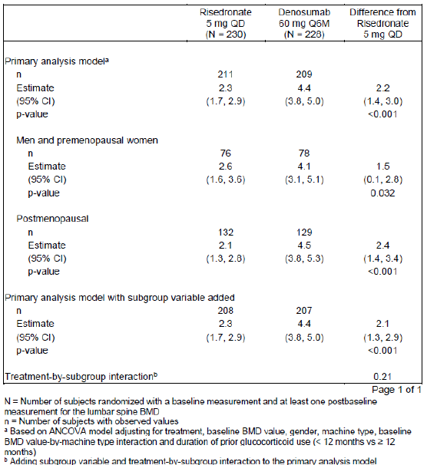
Table 26: Total hip bone mineral density percent change from Baseline at Month 12 by subgroup (men/premenopausal women versus postmenopausal women) (ANCOVA) (primary efficacy set, observed data) (glucocorticoid-continuing subpopulation; Study 20101217 12 month primary analysis)
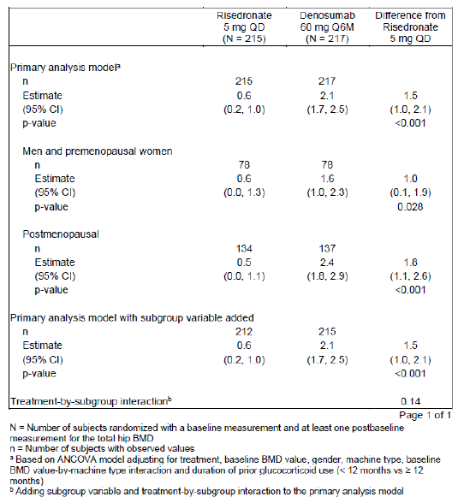

Evaluator comment
The subset of pre-menopausal women and men only was smaller than that of post-menopausal women and although the magnitude of difference in BMD percent change from baseline at Month 12 was smaller for both lumbar spine and total hip compared to both the total population and the post-menopausal subset, it remained statistically significant for both measures - lumbar spine 1.5% (95% CI 0.1, 2.8) and total hip 1.0% (95% CI 0.1, 1.9).

Sponsor’s response (second subpopulation)
- The glucocorticoid-initiating subpopulation which excludes subjects with pre-existing osteoporosis (either a history of osteoporotic fracture, current osteoporotic fracture or T-score ≤ -2.5) and those who had initiated their glucocorticoid treatment ≥ 3 months ago.
The following two tables were provided:
Table 27: Lumbar spine bone mineral density percent change from Baseline at Month 12 by subgroup (low risk versus others) (ANCOVA) (primary efficacy set, observed data) (glucocorticoid-initiating subpopulation; Study 20101217 12 month primary analysis)
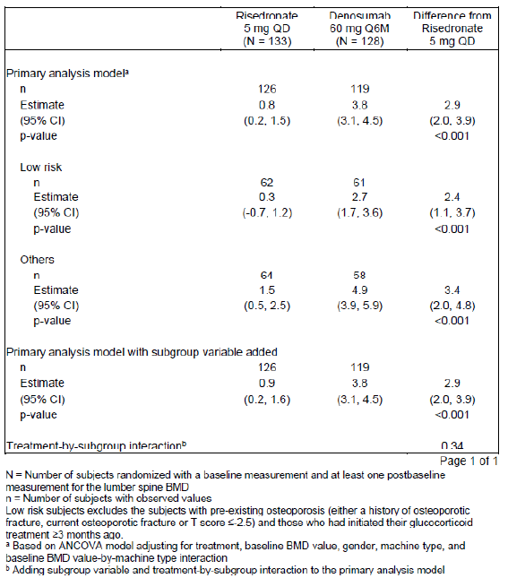
Table 28: Total hip bone mineral density percent change from Baseline at Month 12 by subgroup (low risk versus others) (ANCOVA) (primary efficacy set, observed data) (glucocorticoid-initiating subpopulation; Study 20101217 12 month primary analysis)
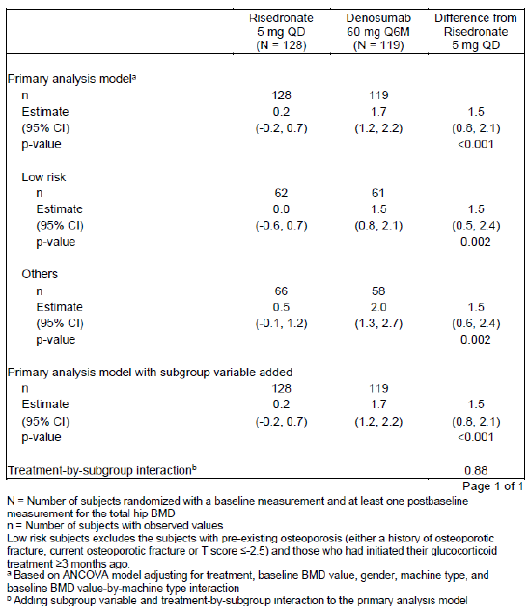

Evaluator comment
In the subgroup which excluded subjects with pre-existing osteoporosis and those who had initiated their glucocorticoid treatment 3 or more months ago (named ‘low risk’ by the sponsor), with respect to the lumbar spine BMD percentage change from baseline at Month 12 the subgroup showed a similar, but smaller magnitude change, compared to the overall population and the alternate ‘others’ subset: 2.4 (95% confidence interval 1.1, 3.7). For the total hip analysis, the percent change from baseline at 12 months was the same as the overall population and ‘others’ subset with similar 95% confidence interval: 1.5 (0.5, 2.4).

Safety

Question 12
The study report notes that one serious opportunistic infection occurred on the denosumab arm however it is noted that in addition a serious adverse event of ‘Serratia infection’ was also reported. Serratia marcescens is a known opportunistic pathogen; please comment on this case and the significance of this infection.

Sponsor’s response
This 56 year old male patient had history of:
- Vasculitis for which he had received methylprednisolone 6 mg daily for vasculitis (duration 13 months prior to study initiation) with 6 instances of boluses of 1,500 mg daily x 2 days.
- Raynaud’s phenomenon
- Infection of the right foot fifth toe with subsequent amputation and post-operative infection 3 months prior to study initiation.
At baseline, the subject had an elevated white cell count 12.53 x 10³/µL. Approximately 5 months after the first dose of study medication, the subject developed a bacterial infection of a purulent necrotic toe (unspecified); the toe wound culture found Serratia marcescens bacteria. Treatment included antibiotic treatment (ciprofloxacin and fluconazole) and subsequent amputation of the second toe of the right foot. The event resolved approximately after 1 month from the onset and the investigator did not consider the event to be related to investigational product.
The sponsor stated that ‘These pre-existing medical conditions and complications, in conjunction with the prednisone therapy, make this subject more susceptible to infection including an opportunistic infection such as Serratia marcescens’.

Evaluator comment
No further comments.
An event of ‘drug induced liver injury’ was reported on the denosumab arm. Please provide additional details about this case.

Sponsor’s comment
This 44 year old female subject [information redacted] had a history of:
- diabetes mellitus type 2
- hypertension
- rheumatoid arthritis
- knee osteoarthritis
- concomitant medication of methotrexate 15 mg subcutaneous every 2 weeks.
Approximately 6 months after the first dose of blinded investigational product, the subject developed a non-serious adverse event of drug induced liver injury (verbatim: methotrexate hepatoxicity). Routine study liver function tests remained < 3 x within normal limits (WNL) throughout the duration of the adverse event. Treatment included Silymarin and the investigational product was continued. The event resolved and the investigator did not consider the event to be related to investigational product.
Table 29: Liver function for subject [information redacted]
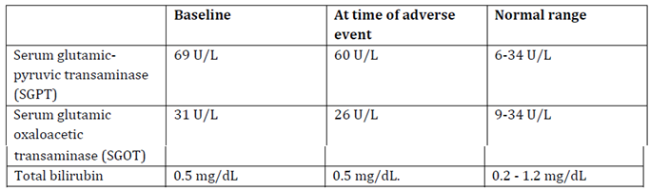
The sponsor has stated that ‘The investigator reported this non-serious event as ‘methotrexate hepatoxicity’ and liver functions test did not support liver injury as the liver function tests were < 3 x within normal limits. This event did not meet Hy’s Law laboratory criteria. Methofill (injectable methotrexate) (Summary of Product Characteristics (SMPc) Section 4.8 (Hepatobiliary disorders)) is known to cause elevated transaminases (very common) and hepatic failure (very rare)’.

Evaluator comment
No further comments.

Second round benefit-risk assessment
The sponsor has withdrawn the proposed indications relating to the submitted data and is now proposing a new indication as follows:
Treatment of bone loss associated with long-term systemic glucocorticoid therapy in adult patients at increased risk of fracture.
The second round benefit-risk assessment has been updated from the first round and also made in the context of the revised indication.

Second round assessment of benefits
Table 30: Second round assessment of benefits
Benefits | Strengths and Uncertainties
Denosumab was non-inferior to risedronate for the primary endpoint lumbar spine BMD at 12 months in the glucocorticoid-initiating subpopulation (primary endpoint) | Although this study met its primary endpoint in both the GC-I and GC-C subpopulations, a number of key uncertainties remain:  - How well do the differences in BMD reflect the more clinically relevant endpoint of fractures (see risks below)  - Longer term data is still pending (24 month follow up) therefore longer term efficacy  - Imbalances in baseline characteristics between the two arms may result in bias of the results  - Whether the population enrolled into this study is a true reflection of the population likely to be considered for treatment in clinical practice  - the optimal duration of treatment is not known.
Denosumab was non-inferior to risedronate for the primary endpoint lumbar spine BMD at 12 months in the glucocorticoid-continuing subpopulation (primary endpoint).
Denosumab demonstrated superiority to risedronate for the lumbar spine and total hip BMD at 12 months in both glucocorticoid-continuing and glucocorticoid-initiating subpopulations (secondary endpoint). | This study demonstrated statistical superiority for the two secondary endpoints reporting at the 12 month mark (others are due to report at 24 month follow up), however the clinical significance of the difference detected was not addressed by the sponsor.
6 monthly injections of denosumab are associated with better compliance compared with daily oral risedronate. | Poor compliance with risedronate may have biased the results toward denosumab. The comparison with another parenteral comparator given at infrequent intervals may have been more appropriate.
The safety profile of denosumab is well documented across a number of studies in different indications; no new safety signals were detected in this new population of patients. | Uncertainties remain for this population due to limited duration of follow up (12 months; 24 month follow up is planned).  Data for the individual subpopulations was not provided therefore any differences in safety profile between the two subpopulations is not known.

Second round assessment of risks
Table 31: Second round assessment of risks
Risks | Strengths and Uncertainties
The fracture risk for this population has not been not clearly determined based on the Study 20101217: BMD was the primary endpoint however may not reflect fracture tendency accurately in a population receiving corticosteroids. In terms of fractures reported as adverse events (not an efficacy endpoint reported by the sponsor; manual calculation by evaluator), 34 subjects on the denosumab arm reported a fracture compared to 25 subjects on the risedronate arm. | It remains unclear to the evaluator whether BMD increase will correlate with a decrease in fracture incidence; the most clinically relevant outcome. Unfortunately, interpretation of fracture outcomes for this study is limited (for example, this trial was not powered for fracture outcomes and has only 12 month follow up). Extrapolation is proposed by the sponsor however the robustness of this approach is questioned. The various definitions of ‘fracture’ are also somewhat confusing and the supplied EMA report highlighted a numerical difference in the number of non-vertebral fractures between the risedronate and denosumab arms however this data does not appear to have been submitted to the TGA.
There is potential for additive toxicities of corticosteroids and denosumab due to overlap in the safety profile of these two drugs. | This study may not be adequate to determine the longer term risk of this combination (that is > 12 months) or rare risks.
Rare adverse events, such as osteonecrosis of the jaw, have been documented with the use of denosumab. | Relatively small total number of patients (N=778) exposed to denosumab for 12 months in the corticosteroid initiated/continuing subpopulations (compared to combined HALT approximately 1600 and primary osteoporosis populations approximately 8000) which may not adequately determine the risk of these rarer events in this population.

Second round assessment of benefit-risk balance
The benefit-risk balance of denosumab is currently considered unfavourable for the proposed indication. Although the Study 20101217 met its primary endpoint and no new safety signals have been detected, uncertainties remain. In particular, the clinical relevance of BMD has not been clearly shown in this population and there is a lack of corresponding evidence with respect to the most clinically relevant endpoint; fractures. Fractures have been reported to occur in as many as 30 to 50% of patients receiving long-term glucocorticoids.⁷ A Bayesian meta-regression of data from 22 randomised controlled trials found an annual incidence of vertebral and non-vertebral fracture of 5.1 % (95 % credible interval = 2.8 to 8.2) and 2.5 % (95 % credible interval = 1.2 to 4.2) respectively among glucocorticoid initiators (≤ 6 months), and 3.2 % (95 % credible interval = 1.8 to 5.0) and 3.0 % (95 % credible interval = 0.8 to 5.9) respectively among chronic glucocorticoid (> 6 months) users.
In the Study 20101217, the various definitions of ‘fracture’ adds another level of complication to the interpretation of this data. When considering all fractures (as reported as adverse events), there appears to be a higher number of subjects who reported fractures on the denosumab arm compared to the risedronate arm.

Second round recommendation regarding authorisation
The proposed indication is as follows:
‘Treatment of bone loss associated with long-term systemic glucocorticoid therapy in adult patients at increased risk of fracture’.
Approval of denosumab is not recommended for this indication for the following reasons:
- Strong evidence regarding the efficacy of denosumab for preventing fracture, the most clinically relevant endpoint, is lacking.
- Possible increased risk of fracture with denosumab in safety data.
- It is unclear whether the population recruited to this study adequately represents the range of patients who may be considered for treatment. Overall, more than 90% of subjects were older than 50 years old and many were post-menopausal women. Although patients are likely to be treated according to risk and increasing age is an important risk factor, other populations such as younger patients are still of relevance.
- This study has 12 months of follow up data, providing limited data from both a safety and efficacy point of view, especially considering that
- patients may receive corticosteroids to treat chronic diseases and treatment beyond 12 months is feasible
- there is overlap in the safety profiles of denosumab and corticosteroids
- there are some rare but important adverse events associated with the use of denosumab.
Twenty-four month follow-up data are still pending.

VI. Pharmacovigilance findings

Risk management plan

Summary of RMP evaluation
- The most recently evaluated AU-RMP for denosumab was version 2.0 (dated 29 August 2012; DLP 26 May 2012) as part of submission PM-2012-02302-3-5. In support of the extended indications, the sponsor has submitted EU-RMP version 19 (dated 13 February 2017; DLP 26 September 2016) and ASA version 2.0 (dated 12 April 2017). In its Section 31 response, the sponsor submitted EU-RMP version 20 (dated 14 March 2017; DLP 26 September 2015) and ASA version 3.0 (dated 30 June 2017).
- The proposed Summary of Safety Concerns and their associated risk monitoring and mitigation strategies are summarised in Table 32 with bold text the safety concern applicable to the ASA only.
Table 32: Summary of safety concerns and pharmacovigilance and risk minimisation measures
Summary of safety concerns |  | Pharmacovigilance |  | Risk Minimisation
 |  | Routine | Additional | Routine | Additional
Important identified risks | Hypocalcaemia |  |  |  | *
Important identified risks | Skin infection leading to hospitalisation |  | - |  | -
Important identified risks | Osteonecrosis of the jaw |  |  |  | *
Important identified risks | Hypersensitivity reactions |  | - |  | -
Important identified risks | Atypical femoral fracture |  |  |  | *
Important identified risks | Musculoskeletal pain |  | - |  | -
Important identified risks | Multiple vertebral fractures following discontinuation of Prolia treatments# |  | - |  | -
Important potential risks | Fracture healing complications |  | - | - | -
Important potential risks | Infection |  | - | - | -
Important potential risks | Cataracts in men with prostate cancer receiving androgen deprivation therapy |  |  |  | -
Important potential risks | Cardiovascular events |  | - | - | -
Important potential risks | Malignancy |  |  |  | -
Important potential risks | Immunogenicity |  |  |  | -
Important potential risks | Osteonecrosis outside the jaw including external auditory canal |  | - | - | -
Important potential risks | Hypercalcaemia following treatment discontinuation in patients with growing skeletons |  |  | - | -
Missing information | Risks with pregnancy/lactation |  | - |  | -
Missing information | Use in paediatric patients |  |  |  | -
Missing information | Use in patients with hepatic impairment |  | - |  | -
Missing information | Potential adult off-label use |  | - | - | -
#Australia-specific risk *Additional risk minimisation measures only in the EU (Dear HCP letter and for ‘Osteonecrosis of the jaw’- Dear HCP letter and Patient Reminder Card)
- Routine pharmacovigilance has been proposed to monitor all the safety concerns. All additional pharmacovigilance studies are ongoing, four of which involve Australian patients.
- Routine risk minimisation activities are proposed for all important identified risks and most important potential risks and missing information except: Fracture healing complications, Infection, Cardiovascular events, Osteonecrosis outside of the jaw including external auditory canal, Hypercalcaemia following treatment discontinuation in patients with growing skeletons, and Potential adult off-label use. No additional risk minimisation activities are proposed for Australia. As there are no new safety concerns relating to this submission, this is considered appropriate.

New and outstanding recommendations from second round evaluation
There is one minor issue at the Round 2 evaluation that should not impede registration:
Recommendation 4: The data lock points for versions 19 and 20 of the EU RMP are 26 September 2016 and 26 September 2015 respectively. The sponsor should clarify the correct data lock point date.
In addition, the sponsor should note the proposed wording for the condition of registration relating to PSUR submission, which requires PSURs to be provided in line with the EU reporting schedule.

Other advice to the Delegate
The Delegate should note that the sponsor has removed ‘cataracts in men with prostate cancer receiving androgen deprivation therapy’ as an important identified risk from the EU RMP (version 20.0) and the ASA (version 3.0), following the completion of Study 20080560 (see section 3.1).

VII. Overall conclusion and risk/benefit assessment
The submission was summarised in the following Delegate’s overview and recommendations:

Background
Denosumab is a monoclonal antibody with specificity for RANK ligand. RANK ligand normally activates the receptor RANK, which is present on osteoclasts (and their precursor cells). Osteoclasts are responsible for resorption of bone.
Osteoporosis is characterised by low bone mass and the deterioration in bone microarchitecture; people with osteoporosis are at increased risk of bone fractures. There are many causes or risk factors for osteoporosis, genetics plays a major role, other risk factors include age, low muscle mass, glucocorticoid use, systemic disease, nutritional deficiency, oestrogen or androgen deficiency.
The use of glucocorticoids is associated with bone loss due to increased bone resorption and reduced bone formation, mediated through osteoprotegerin suppression (an osteoclastogenesis inhibitor) and production of the receptor activator of nuclear factor kappa-B (RANK). Initial accelerated bone resorption results in early and rapid bone loss. With chronic corticosteroid use, reduction of bone formation predominates. Glucocorticoids also have indirect effects on bone by decreasing secretion of androgens and oestrogens, interfering with parathyroid hormone excretion and actions, decreasing production of insulin-like growth factor and testosterone, decreasing intestinal calcium absorption and decreasing renal calcium reabsorption. High dose glucocorticoids may cause muscle wasting.
The risk of fracture associated with corticosteroids has been shown to increase within 3 to 6 months of starting oral corticosteroid therapy and reduces upon cessation of therapy. The fracture risk associated with corticosteroid use is not only related to bone mineral density but also an alteration of bone quality and an increased risk of falls; fractures occur at a higher BMD value than those that occur in post-menopausal osteoporosis. In addition, the specific disease for which the corticosteroids are being administered may in itself also lead to bone loss and fracture; for example, rheumatoid arthritis and inflammatory bowel disease.
Fractures are thought to occur in 30 to 50% of patients receiving long-term glucocorticoids and prevalence increases with age. Vertebral fractures are the most common.
The future risk of fracture can be estimated with the FRAX tool (see Table 33 and Figure 1). However, this tool may not be accurate in patients aged < 40years, those on glucocorticoids (as it does not take into consideration dose or duration of use). Fracture risk also depends on racial origin. In analysis of trials of anti-resorptive agents, logistic regression analysis has demonstrated that an improvement in BMD contributes to only about 16% of the improvement in fracture risk.
Currently available medicines on the ARTG to treat glucocorticoid induced osteoporosis include aledronate, risedronate, zoledronic acid and teriparatide.
There was no paediatric data submitted. However, children may also be treated with long term glucocorticoids.
Table 33: Clinical risk factors for FRAX
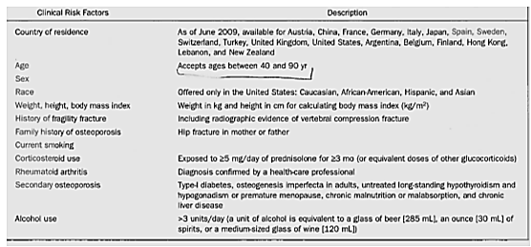
Figure 1: The American College of Rheumatology (ACR) 2010 recommendations for the treatment of pre-menopausal women and men < 50 years receiving glucocorticoids
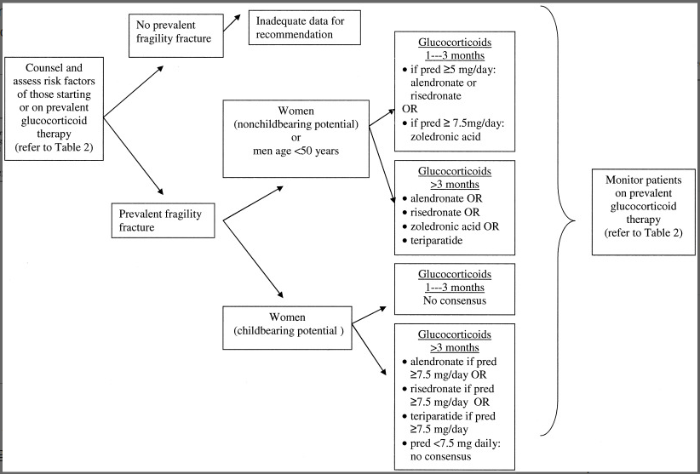

Quality
There was no requirement for a quality evaluation in a submission of this type.

Nonclinical
There was no requirement for a nonclinical evaluation in a submission of this type.

Clinical

Pharmacology
The PK characteristics of denosumab in the clinical studies were described. These were similar to the known PK characteristics of denosumab.
Following a 60 mg dose of denosumab, maximum serum concentrations occurred in 10 days. The half-life was 26 days (range 6 to 52 days). However the pharmacodynamic effects (changes in bone turnover) were observed as early as 6 hours after dosing and remain partially suppressed after 6 months.

Efficacy

Study 20101217
One clinical study was submitted, Study 20101217.
Study 20101217 was a Phase III multicentre, randomised, 24 month, double blinded, double dummy, active controlled, parallel group study, however only the 12 month data were available.

Endpoints
Primary: Non inferiority to treatment with oral risedronate 5 mg every day with respect to the percent change from baseline in lumbar spine BMD by dual X-ray absorptiometry (DXA) at 12 months.
Secondary: These included:
- Percent change from baseline in lumbar spine BMD by DXA at 12 months
- Percent change from baseline in total hip BMD by DXA at 12 months
- Percent change from baseline in lumbar spine BMD by DXA at 24 months
- Percent change from baseline in total hip BMD by DXA at 24 months
- Fracture was exploratory; only lumbar and clinical fractures described. Traumatic and pathological fractures were excluded (This is not consistent with guidelines and potentially under-reports fracture rates as it is not always possible to determine the cause of a fracture).

Key inclusion criteria
- Glucocorticoid-initiating subpopulation: Men and women ≥ 18 years of age who have initiated prednisolone ≥ 7.5 mg daily or its equivalent within 3 months prior to screening and are expected to be treated with oral glucocorticoids for a total of at least 6 months
OR
- Glucocorticoid-continuing subpopulation: Men and women ≥ 18 years of age who are taking prednisolone ≥ 7.5 mg daily or its equivalent for ≥ 3 months preceding screening and are expected to be treated with oral glucocorticoids for a total of at least 6 months.
Glucocorticoid continuing subjects who are ≥ 50 years of age will be required to have a BMD value equivalent to a T-score ≤ -2.0 at the lumbar spine, total hip, or femoral neck; or a BMD value equivalent to a T-score ≤ -1.0 at the lumbar spine, total hip, or femoral neck and with a history of osteoporotic fracture.
Subjects who were < 50 years old at the time of screening were required to have a history of osteoporotic fracture in both glucocorticoid continuing and glucocorticoid initiating subpopulations.
Note: By definition, those who have already had an osteoporotic fracture already have osteoporosis. It is likely that many patients in the study would have qualified for treatment under the current indications. Previous or current use of bisphosphonates or teriparatide were exclusion criteria. The study design does not help determine if young people with no history of fracture but who may have low or normal BMD and are treated with glucocorticoids benefit from treatment. Overall, the inclusion criteria were not consistent with clinical guidelines.
All patients were treated with 1000 mg calcium and at least 800 IU vitamin D during the study.

Baseline populations
Table 34: Description of baseline populations
 | Glucocorticoid Continuing | Glucocorticoid Initiating
n | 505 | 290
Women | 73% | 93%
Age  < 50  50-65  65-75  >75years | 59  244  135  67 | 7  55  50  38
Pre-menopause | 49 (10%) | 17 (6%)
Daily oral prednisone dose equivalent | About 11 mg | About 16 mg
Duration or oral glucorticoid use > 7.5 mg prior to study | 481 > 3 months  125 > 12 months | 26 > 3 months  11 > 12 months
Secondary osteoporosis | 188 (37%) | 29 (10%)
Previous vertebral fracture | 147 (29%) | 47 (16%)
Lumbar spine BMD T-score  Less than -2.5 | 194 (38%) | 53 (18%)
Prior medical condition  Polymyalgia rheumatica  Rheumatoid arthritis  Asthma  Systemic lupus erythematosus (SLE) | 38  226  33  31 | 102  91  5  6
There was clearly a lot of cross over between these two populations. Most patients were > 50 years. There was little data in men and pre-menopausal women < 50 years.

Primary efficacy outcome
The duration of glucocorticoid use during the study was similar in both groups, mean 324 days, mean dose was 10.3 mg in the risedronate group and 9.8 mg in the denosumab group.
Table 35: Percent change from Baseline in lumbar BMD at Month 12
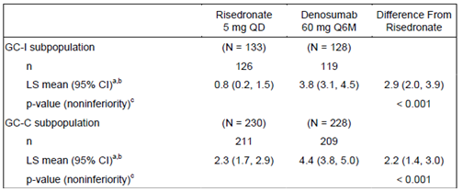
There was a greater improvement in lumbar BMD in the denosumab treatment group compared to the risedronate treatment group. Non inferiority to risedronate was demonstrated. The secondary analysis of BMD was supportive.

Other efficacy outcomes
For the GC-I population, these are shown in Table 36.
Table 36: 12 month endpoint results for GC-I population
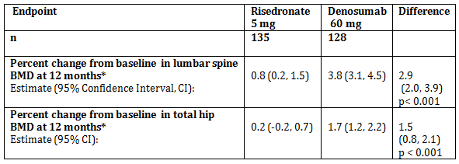
For the glucocorticoid-continuing (GC-C) population, these are shown in Table 37.
Table 37: 12 month endpoint results for GC-C population
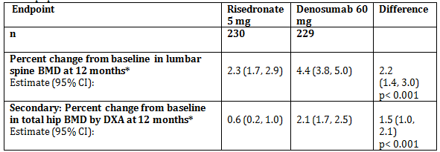
Table 38: Fracture data for the combined analysis set
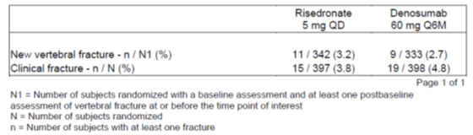
There were numerically less vertebral fracture and more non vertebral fracture in the denosumab group. However it is important to note that clinical fracture did not include traumatic or pathological fractures.
6 subjects on the denosumab arm and 11 subjects on the risedronate arm had bone biopsies. All collected bone biopsies showed normal bone histology with normal lamellar bone, normal mineralisation and normal osteoid. Osteomalacia, marrow fibrosis, woven bone and clinically significant marrow abnormalities were not detected. Tetracycline labelling showed more double labelling in the risedronate arm than the denosumab arm, consistent with other studies and the mechanism of action.
Bone markers indicated reduced bone resorption and formation.
Patients preferred injections than a daily tablet. Compliance with the oral tablets was unclear.
Subgroup analysis shows a numerical improvement in lumbar BMD in pre-menopausal women, the numbers are too small for valid statistical analysis. Treatment was efficacious in those with and without pre-existing osteoporosis, but with a numerically greater improvement in percent increase in lumbar BMD with those with lower baseline BMD.
Table 39: Lumbar spine bone mineral density percent change from Baseline at Month 12 for female subjects by menopausal status (ANCOVA); primary efficacy set, observed data (glucocorticoid-initiating subpopulation) (Study 20101217 12 month primary analysis)
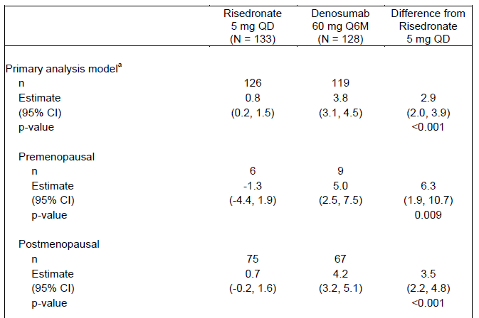

Table 40: Lumbar spine bone mineral density percent change from Baseline at Month 12 for female subjects by menopausal status (ANCOVA); primary efficacy set, observed data (glucocorticoid-initiating subpopulation) (Study 20101217 12 month primary analysis)
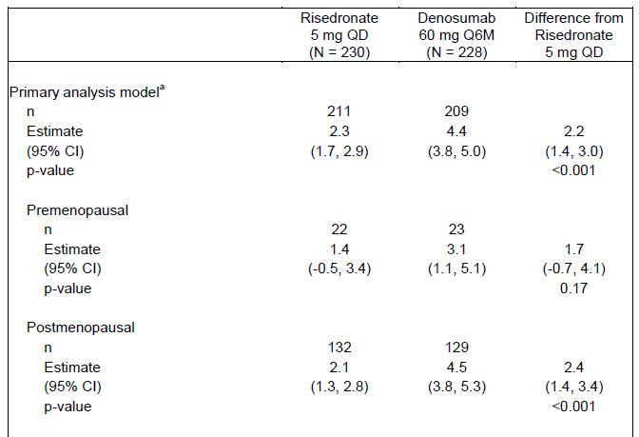

Evidence to support bridging
Previous studies for denosumab from PI are shown in Table 41, below.
Table 41: Previous studies for denosumab from the Prolia PI
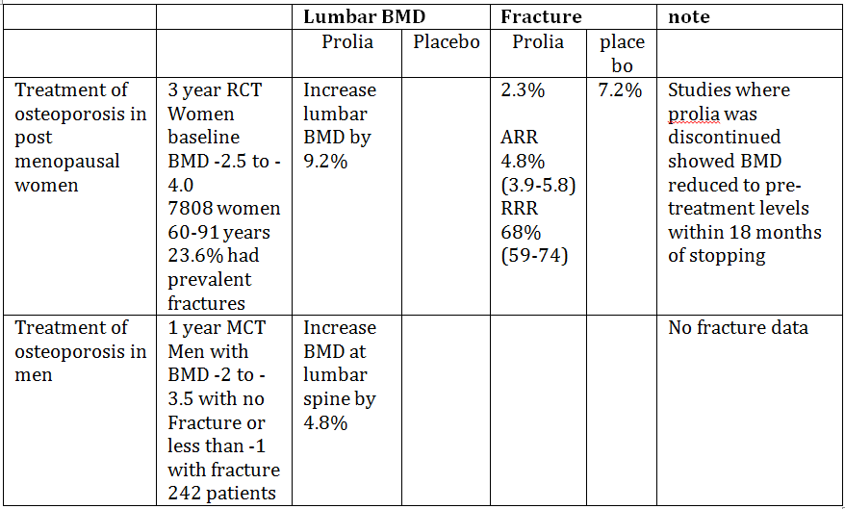

Safety
Incidence of adverse events was 72.3% on the denosumab arm and 69% on the risedronate arm. Overall, both drugs were well tolerated.
Treatment related and serious AEs occurred in a similar proportion of patients in the risedronate and denosumab treatment groups. It is notable that cardiac failure, transient ischemic attack (TIA) and stroke were more common with denosumab. Cardiovascular events are in the RMP as a potential risk.
Hypocalcaemia was seen in one patient who received denosumab, and no patient who received risedronate. There were no cases of osteonecrosis of the jaw. Hypersensitivity occurred in 19 patients treated with denosumab and 12 who received risedronate. One patient in the denosumab group had an atypical femoral fracture.
Table 42: Treatment emergent AEs related to fractures in the safety set
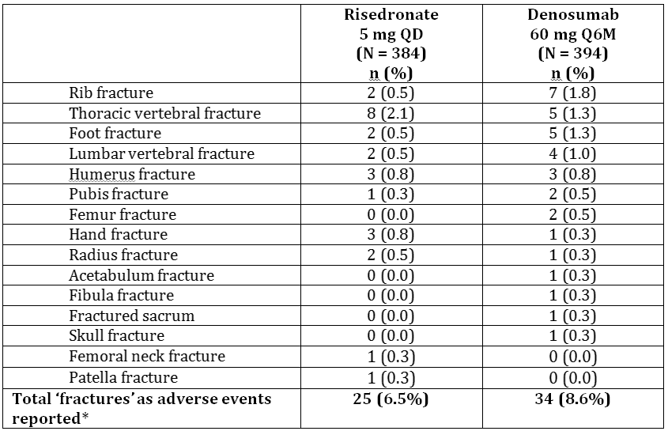
It appears that there was an increased rate of non vertebral fracture in the denosumab group compared to the risedronate group.

Risk management plan
The risk management plan (RMP) provided was Version 19 of the EU-RMP and version 3.0 of the ASA.
Table 43: Summary of safety concerns
Summary of safety concerns
Important identified risks | Hypocalcaemia  Skin infection leading to hospitalisation  Osteonecrosis of the jaw  Hypersensitivity reactions  Atypical femoral fracture  Musculoskeletal pain
Important potential risk | Fracture healing complications  Infection  Cardiovascular events  Malignancy  Immunogenicity  Osteonecrosis outside the jaw including external auditory canal  Hypercalcaemia following discontinuation with growing skeleton
Missing information | Risks with pregnancy/lactation  Use in paediatric patients  Use in patients with hepatic impairment  Potential off label use
Routine risk mitigation and pharmacovigilance is proposed for all safety concerns.
There are a number of ongoing studies:
- Study 20050209: A randomised, double blind, placebo controlled, multicentre Phase III study to determine the treatment effect of denosumab in subjects with non-metastatic breast cancer receiving aromatase inhibitor therapy.
- Study 20060359: A randomised, double blind, placebo controlled, multi-centre Phase III study of denosumab as adjuvant treatment for women with early-stage breast cancer at high risk of recurrence (D-CARE study).
- Study 20080560: A double blind, placebo controlled; study to evaluate new or worsening lens opacification in subjects with non-metastatic prostate cancer receiving denosumab for bone loss due to androgen-deprivation therapy.
- Study 20062004: An open-label, multi-centre, Phase II study of denosumab in subjects with giant cell tumour of bone (GCTB).
- Study 20130173: A prospective, multicentre, single arm study to evaluate the efficacy, safety, and pharmacokinetics of denosumab in children with osteogenesis imperfecta (OI).
- Study 20090522: A post marketing observational Study; denosumab global safety assessment among women with postmenopausal osteoporosis (PMO) and men with osteoporosis using multiple observational databases.

Risk-benefit analysis

Delegate’s considerations
The sponsor proposed a new indication with response to questions:
Treatment of bone loss associated with long-term systemic glucocorticoid therapy in adults at increased risk of fracture.
The treatment of osteoporosis in postmenopausal women and men is already covered in the current indication; regardless of whether this was associated with glucocorticoid use or not. The proposed new indication would support treatment in men or post-menopausal women treated with glucocorticoids with an increased risk of fracture but who do not have established osteoporosis and would support use in pre-menopausal women treated with glucocorticoids with and without osteoporosis.
The proposed indication specifies that patients would include those on glucocorticoids and that have an increased risk of fracture. However, fracture risk is not well defined and may be subjective. The 10 year fracture risk in the clinical study varied from 1.7 to 89 % with a median of around 11% in the glucocorticoid initiating group and 14% in the glucocorticoid continuing group. This was calculated using BMD.

Extrapolation of efficacy
The clinical study submitted demonstrated efficacy in terms of improvement in lumbar BMD which was non-inferior to risedronate. However, fractures occur at a higher BMD in women who are taking glucocorticoids compared to those with postmenopausal osteoporosis³ and that it has been suggested that BMD may not adequately indicate fracture risk in patients receiving glucocorticoids due to the alteration of bone quality associated with glucocorticoids.⁵ Thus, the Delegate is unsure if bridging results for a fracture risk reduction in women with osteoporosis based on similar reduction in BMD is appropriate. The sponsor has not submitted data to show a reduction in fracture risk with denosumab in pre-menopausal women or men for any osteoporosis indication. There is data to support improved BMD and fracture in patients with glucocorticoid induced osteoporosis treated with risedronate; however, this drug has a different mechanism of action thus extrapolation to denosumab is uncertain.
It is noted that the indications for osteoporosis in men includes is to improve BMD in those at increased risk of fracture. Although a similar indication could be claimed for pre-menopausal women for glucocorticoid induced osteoporosis, the main aim of treatment for osteoporosis is to reduce fracture risk. A surrogate endpoint used in a regulatory setting needs to be valid marker of clinically significant events.

Risedronate as comparator
Risedronate has been studied in a placebo controlled trial in 224 men and women with glucocorticoid induced osteoporosis in 1999. After 12 months of treatment, mean lumbar spine BMD did not change significantly from baseline in those who received risedronate 5 mg (0.6% +/1 0.5%), but decreased in the placebo group (-2.8% +/1 0.5%). A decrease in fracture risk was observed in the Risedronate group (5.7% compared to 17.3%). In this study, the patient population was younger, were on a higher dose of glucocorticoids, had better baseline BMD than in Study 20101217.

Other studies for drugs used in glucocorticoid induced osteoporosis
Studies using risedronate, teriparatide and zoledronic acid all included fracture data as a secondary endpoint.

Use in pregnancy
Denosumab has a Pregnancy Category D.¹⁵ It is known to cross the placenta. In a study in monkeys who received a higher dose/kg than that recommended in humans, there was an increased rate of stillbirths, abnormal bone growth, obliteration of marrow spaces, tooth malalignment, dental dysplasia, altered appearance of the eyes, and absence of lymph nodes.
If the indications were to extend to pre-menopausal women, there needs to be clear instructions about the need for contraception and planning of pregnancy.

Limitations of the data
Lack of fracture data is in important limitation in this submission. Based on the data submitted; the duration of treatment, long term effects and risk of fracture after discontinuation is unknown.

Proposed action
The Delegate did not consider that the revised indication:
‘Treatment of bone loss associated with long-term systemic glucocorticoid therapy in adults at increased risk of fracture.’
was acceptable for the following reasons:
- a treatment for osteoporosis should have good evidence that is effective at reducing fracture. Improved BMD may not equate with reduced risk of fracture due to a number of other variables.
- there was an imbalance in non-vertebral fractures, with more in the denosumab group.
In addition:
- ‘Increased risk of fracture ‘is not well defined. It was not an entry criteria in the clinical studies. FRAX assessment is not valid for patients less than 40 years and is not accurate for patients on glucocorticoids. From a regulatory perspective, it is difficult to assess the efficacy and safety (or risk/benefit) of a medicine under Section 25 of the Therapeutic Goods Act if the purpose of use (patient population and disease to be treated) are poorly defined.
There is no unmet clinical need as there are other treatments on the ARTG for this indication. This decision could be reconsidered with the results of the 24 months study and/or other long term studies and further consideration for the wording of the indication.

Request for ACM advice
In relation to the sponsor’s proposed indication:
Treatment of bone loss associated with long-term systemic glucocorticoid therapy in adults at increased risk of fracture.
- Is it appropriate to improve an indication for treatment of bone loss (surrogate measure) when there is no data on fractures?
- Is it appropriate to extrapolate the reduced fracture rate with denosumab in post-menopausal women with osteoporosis to men and pre-menopausal women on long term glucocorticoids?
- Is it appropriate to extrapolate the reduced fracture rate that has been observed with risedronate to denosumab based on the common feature of reduced rate of bone loss?
- There are no valid tools for the assessment of fracture risk in pre-menopausal women and those on glucocorticoids; please comment on whether ‘increased risk of fracture’ should be included in the indication, and if/how it should be defined?

Response from Sponsor
The indication proposed with the initial application was:
‘Treatment of osteoporosis associated with sustained systemic glucocorticoid therapy in women and men at increased risk of fracture’ and ‘Prevention of osteoporosis in women and men at increased risk of fracture who are starting or have recently started long-term glucocorticoid therapy.’
With the subsequent response to questions this indication was amended to:
‘Treatment of bone loss associated with long-term systemic glucocorticoid therapy in adult patients at increased risk of fracture’
In response to comments in the clinical evaluation report and the Delegate’s overview, the sponsor proposes to amend the indication to:
‘Treatment to increase bone mass in women and men at increased risk of fracture due to long-term, systemic glucocorticoid therapy.’
The Delegate posed 4 questions to the ACM. The sponsor’s responses to these questions are provided below.
- Is it appropriate to approve an indication for treatment of bone loss (surrogate measure) when there is no data on fractures?
There is no official guideline from any regulatory authority for the evaluation of medicinal products for the treatment or prevention of secondary osteoporosis, the most common form of which is glucocorticoid (GC)-induced osteoporosis (GIOP). Recommendations for the registration of agents for the prevention and treatment of GIOP have been produced by the Group for the Respect of Ethics and Excellence in Science (GREES);,, though these recommendations have not been formally endorsed by any regulatory authority. For GIOP, the GREES recommends a bridging study based on bone mineral density (BMD) for agents that have been granted marketing authorisation for the treatment of postmenopausal osteoporosis (PMO) in women at increased risk of fracture. The design should be a non inferiority study with lumbar spine BMD at 1 year as the primary endpoint. Approved and established drug therapies for GIOP should be used as the active comparator.³⁷ The pivotal trial for Prolia in GIOP (Study 20101217) was a non inferiority, active (risedronate) controlled study that enrolled 795 GC-treated subjects for a treatment duration of 2 years, thus fulfilling the above GREES recommendations for GIOP. This design is aligned with the clinical studies used to support registration of all agents currently approved in Australia for GIOP, which have been granted approval based on non inferiority, active controlled studies (zoledronic acid and teriparatide) or even placebo controlled studies (alendronate and risedronate), with BMD as the primary endpoint.
To provide support for fracture risk reduction in the current application, the sponsor has evaluated the consistency of the effects of denosumab across the following 4 populations with different aetiologies for bone loss:
- PMO (FREEDOM, Study 20030216), which represents the basis for bridging to other indications.
- Hormone ablation therapy (androgen deprivation therapy (ADT) Study 20040138; adjuvant aromatase inhibitor therapy for nonmetastatic breast cancer, Study 20040135), which has supportive information regarding fracture outcomes.
- Male osteoporosis (ADAMO, Study 20080098).
- GIOP (Study 20101217).
Results from the primary analysis of Study 20101217, together with results from Studies 20030216, 20080098, 20040138, and 20040135, demonstrate the following:
- The distribution of baseline 10 year probability of major osteoporosis-related fracture (FRAX) in subjects who received GC therapy in Study 20101217 showed considerable overlap with that in the population of women with PMO from Study 20030216. This was true for both the GC-C and GC-I subpopulations
- The magnitude of the BMD increases observed in Study 20101217 was similar to that observed in Study 20030216 and the 3 other supportive studies after 12 months of denosumab treatment, demonstrating the consistency of the effects of denosumab across primary and secondary osteoporosis patient populations
- The safety profile observed in Study 20101217 was consistent with that observed in the pivotal clinical studies in primary osteoporosis and bone loss due to hormone ablation therapy. No new safety risks associated with denosumab treatment were identified in Study 20101217.
The mean increases in BMD with denosumab treatment in both subpopulations in Study 20101217 were similar to mean increases in BMD in Studies 20030216, 20080098, 20040138, and 20040135 at 12 months. Because Study 20030216 demonstrated that increases in BMD were associated with fracture risk reduction, it is reasonable to extrapolate the anti-fracture efficacy of denosumab 60 mg Q6M to subjects with GIOP.
Finally, when data were pooled from studies of risedronate, etidronate, and alendronate in GIOP, the combined effects of all bisphosphonates on vertebral and non vertebral fracture incidence were comparable to those observed in PMO; thus supporting the notion that anti-fracture efficacy of anti-resorptive medications is likely to be similar between PMO and GIOP.
- Is it appropriate to extrapolate the reduced fracture rate with denosumab in post-menopausal women with osteoporosis to men and premenopausal women on long term glucocorticoids?
The sponsor acknowledges that extrapolation of anti-fracture benefits established in PMO to men and premenopausal women on long-term glucocorticoids may not be straightforward. In fact, most GIOP management guidelines are focused on postmenopausal women and men ≥ 50 years old, and evidence for the treatment of premenopausal women and of men < 50 years old is weak.
It is the sponsor’s position, however, that it is reasonable to extrapolate anti-fracture benefit established in women with PMO to men and premenopausal women on long-term glucocorticoids, based on the following considerations:
- Approval of therapies with a GIOP indication in Australia was based on bridging studies with BMD as a primary endpoint and extrapolation of anti-fracture benefits, previously established in post-menopausal women with osteoporosis, to GC-treated subjects, without the exclusion of premenopausal women and men.
- There was a considerable overlap in the distribution of 10 year probabilities of major osteoporotic (Figure 2) and hip (Figure 3) fractures across postmenopausal women with osteoporosis (Study 20030216) and GC treated pre-menopausal women and men (Study 20101217), thus indicating a similar level of fracture risk.
- The least squares mean (95% confidence interval) percent changes from baseline in lumbar spine BMD at 12 months in denosumab treated subjects were similar across postmenopausal women with osteoporosis (Study 20030216) and GC-treated men and premenopausal women (Study 20101217) (Table 44), thus indicating consistent BMD benefits from denosumab treatment.
- When data were pooled from studies of risedronate, etidronate, and alendronate in GIOP that also included men and premenopausal women, the combined effects of all bisphosphonates on vertebral and nonvertebral fracture incidence were comparable to those observed in PMO.⁴⁰
- According to International Osteoporosis Foundation, European Calcified Tissue Society (IOF–ECTS) GIOP guidelines, in premenopausal women and in men aged < 50 years committed to or exposed to ≥ 3 months of oral GC, treatment should be considered in patients with a history of previous fracture and should be based on clinical judgment in patients with no history of fracture. For both the GC-C and GC-I subpopulations of Study 20101217, men and women < 50 years of age had to have a history of fragility fracture and be expected to continue receiving GC for at least 6 months. Therefore, according to international guidelines, these subjects would be considered for GIOP treatment.
Based on the above considerations, it is reasonable to extrapolate anti-fracture benefit established in women with PMO to men and premenopausal women on long-term glucocorticoids.
Figure 2: Distribution of 10 year major osteoporotic fracture risk with BMD for Studies 20101217 (pre-menopausal women, and Men) and 20030216; randomised analysis set, Integrated Analysis of Efficacy
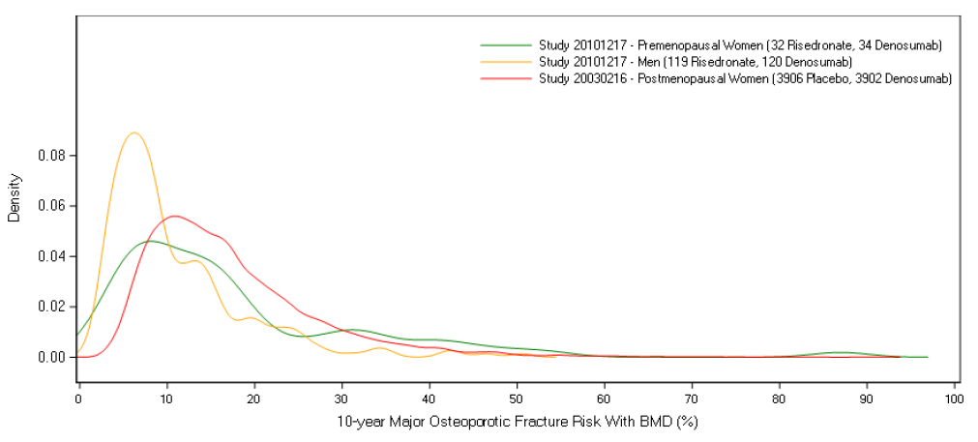
Figure 3: Distribution of 10 year hip fracture risk with BMD for Studies 20101217 (pre-menopausal women, and men) and 20030216; randomised analysis set, Integrated Analysis of Efficacy
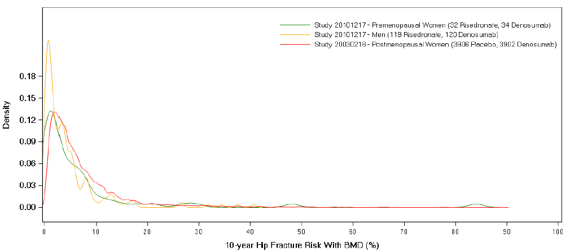
Table 44: Lumbar spine bone mineral density by DXA percent change from Baseline at Month 12 for Studies 20101217 (pre-menopausal women, and men) and 20030216 (ANCOVA Model); efficacy analysis set, Integrated Analysis of Efficacy
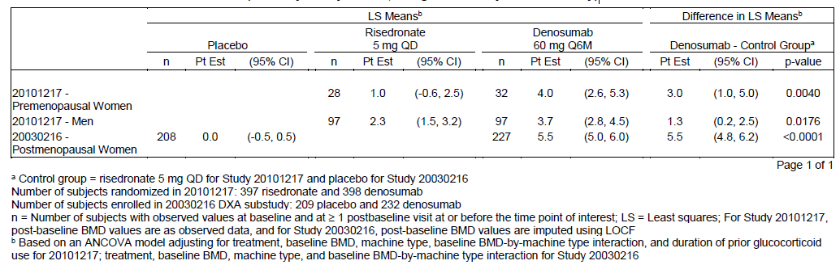
- Is it appropriate to extrapolate the reduced fracture rate in glucocorticoid induced osteoporosis that has been observed with risedronate to denosumab based on the common feature of reduced rate of bone loss?
The sponsor acknowledges that anti-fracture efficacy may not be directly extrapolated between osteoporosis medications with different mechanisms of action (for example, denosumab and risedronate). Instead, extrapolation of anti-fracture efficacy of denosumab to the GIOP population is based on multiple considerations:
- The magnitude of lumbar spine BMD increases at 12 months across 4 osteoporosis settings, including GIOP, PMO, male osteoporosis, and androgen deprivation therapy (ADT), demonstrated the consistency of effects of denosumab. Similar increases in lumbar spine BMD with denosumab 60 mg every 6 months were associated with decreases in the risk of fracture in both PMO and ADT. This suggests that the BMD increases observed in the GIOP population are clinically meaningful and support extrapolation of anti-fracture benefit from PMO to GIOP.
- Denosumab demonstrated anti-fracture efficacy in both men on ADT for prostate cancer; and women with breast cancer receiving treatment with aromatase inhibitors; (that is, 2 secondary osteoporosis settings in which, like GIOP, fractures occur at a higher BMD threshold than in PMO).
- A systematic review of interventions in GIOP and PMO demonstrated that the combined effects of bisphosphonates on vertebral and non vertebral fracture incidence in GIOP were comparable to those observed in PMO;⁴¹ thus suggesting that the anti-fracture efficacy of anti-resorptive medications is similar between these 2 osteoporosis settings.
- A meta-analysis of two placebo controlled clinical studies of risedronate 5 and 2.5 mg in men and women receiving GCs, albeit not designed with adequate statistical power to show differences in fracture rates, demonstrated a significant reduction in new vertebral fracture risk in the risedronate 5 mg group compared with the placebo group. Denosumab met the secondary endpoints of superiority over risedronate with respect to the percent change from baseline in lumbar spine and total hip BMD at 12 and 24 months in GC treated subjects from Study 20101217. Furthermore, both denosumab and risedronate reduced the incidence of new vertebral fracture at 3 years by 68% and 41 to 49%, respectively, in PMO. In addition, as indicated above, denosumab also decreases fracture incidence in 2 secondary osteoporosis settings; that is, men on ADT for prostate cancer;⁴³ and women with breast cancer receiving treatment with aromatase inhibitors.⁴⁴
In conclusion, while denosumab and risedronate have different mechanisms of action, they are both anti-resorptive treatments, and there is no plausible reason to believe that a greater increase in BMD with denosumab, compared with risedronate, would be associated with no anti-fracture efficacy only in GIOP.
- There are no valid tools for the assessment of fracture risk in premenopausal women and those on glucocorticoids - please comment on whether ‘increased risk of fracture’ should be included in the indication, and if/how it should be defined?
The European Medicines Agency (EMA) guideline; recommends indication language that includes an ‘increased risk of fracture’ clause. The ‘increased risk of fracture’ clause allows bone related independent risk factors for fractures to be considered when a physician ‘provides a global assessment of future fracture risk, allowing the identification of women who should benefit from a treatment’ to prevent the occurrence of fractures.³⁴ As stated in the EMA 2007 guidelines, several independent factors for fracture, in addition to low bone mass, contribute towards a patient being at ‘increased risk of fracture.’ Of these factors, age, prior fracture, a family history of hip fractures, high bone turnover, low body mass index, tobacco, use, and alcohol abuse are the most important to be considered. Genetic and nutritional factors (for example, calcium intake and vitamin D repletion) play significant roles. The sponsor supports this approach for PMO and for other bone loss indications including secondary osteoporosis, a category that includes premenopausal women with GIOP.
In addition, IOF-ECTS GIOP guidelines recommend that premenopausal women should be considered for treatment if they have a history of fracture or, in the absence of it, based on clinical judgment of the treating physician.²⁹ Fracture risk in GC-treated individuals is also affected by other factors, such as the underlying disease for which GC therapy is given, smoking habit, alcohol intake, family history, concomitant medications, et cetera. Therefore, the treating physician is in the best position to determine which patients, in the absence of a history of fragility fracture, are at increased risk of fracture and, as such, warrant GIOP intervention based on the above mentioned risk factors for fracture.
A consistent theme in Australian guidelines is that systemic GC therapy is an independent risk factor for fracture, with rapid bone loss and increased fracture risk occurring early (within 3 to 6 months on GC therapy) before T-scores reach levels conventionally considered diagnostic of osteoporosis. Fractures occur at a higher BMD in patients on GC therapy compared to non GC users, contributing to patients not being treated early enough. It is recommended that, from a clinical perspective, the optimal approach is to treat patients who have not yet lost bone.
Considering the above, the sponsor believes that the proposed clause ‘increased risk of fracture’ should be included in the indication statement.

Sponsor responses to other clinical comments raised by the Delegate or the evaluator
- Imbalance in non vertebral fractures
In the Delegate’s Overview, the Delegate commented, ‘there was an imbalance of non vertebral fractures, with more in the denosumab group.’ This statement is based on manual calculations that inaccurately describe the incidence of fracture adverse events for the 2 treatment groups. The sponsor provided a response to the Delegate regarding fracture adverse events across subject populations from the final, 24 month analysis of Study 20101217 that further support that denosumab treatment is not associated with an increased risk of fracture in GC-treated individuals (Appendix 2; not included in the AusPAR).
- Study 20101217 24 month final analysis
Both the clinical evaluator and Delegate raised uncertainties based on limited data (12 months) but commented that 24 month data will provide clarification. Results of the final 24 month analysis (dated 20 January 2018) for Study 20101217 are now available and confirm the primary (12 month) analysis. The percent change from baseline in lumbar spine and total hip BMD through Month 24 (secondary and exploratory endpoints) was significantly greater in the denosumab group compared with the risedronate group in both the GC-C and GC-I subpopulations. Safety findings were similar to those presented in the 12 month primary analysis submitted with the initial application. No new safety risks related to denosumab treatment have been identified. The synopsis of the 24 month final analysis clinical study report is provided in Appendix 3 (not included in the AusPAR).

Conclusion
The sponsor believes that the benefit: risk established in GC-treated individuals in Study 20101217 supports approval of Prolia for the GIOP indication. Study 20101217 is based on the same principles used to support other therapies currently approved in Australia for similar GIOP indications, including use of BMD as a primary endpoint and extrapolation of anti-fracture benefits established in post-menopausal women with osteoporosis.
To address the Delegate’s key concerns, the sponsor has proposed to modify the indication statement to:
‘Treatment to increase bone mass in women and men at increased risk of fracture due to long-term, systemic glucocorticoid therapy.’
The amended indication further aligns with the primary endpoint of Study 20101217 and better reflects the treatment population.

Advisory committee considerations
The Advisory Committee on Medicines (ACM), having considered the evaluations and the Delegate’s overview, as well as the sponsor’s response to these documents, advised the following:
The ACM taking into account the submitted evidence of efficacy, safety and quality, agreed with the delegate and considered Prolia pre-filled syringe containing 60 mg/mL of Denosumab to have an overall positive benefit-risk profile for this submission. It was recommended the proposed indication be amended to [the following] indication:
Treatment to preserve bone mass in women and men at increased risk of fracture due to long-term systemic glucocorticoid therapy
In making this recommendation, the ACM:
- noted that fracture prevention is the most important measure of efficacy in patient with osteoporosis. However in patients with glucocorticoid induced osteoporosis (GIOP), it is difficult to adequately power studies with this as the primary endpoint due to the relatively low fracture event rate and the heterogeneity of fracture type. ACM also noted that there are limitations with using the surrogate measure of bone mineral density (BMD) as an indicator for fracture risk in post-menopausal osteoporosis (PMO) due to glucocorticoid induced osteoporosis.
- noted that the current tools available to determine ‘risk of fracture’ in GIOP are limited.
- expressed concern regarding the use of denosumab in young patients and the possible increase risk of fracture at the time of discontinuation due to the potential in rebound bone turnover which may lead to a reduction in bone density.
- expressed concern that there had been no studies in patients on immunosuppressant therapy or post-transplant.
- that there was an unmet need for the management of GIOP in patients with renal impairment where bisphosphonates are contraindicated.

Proposed Product Information (PI)/ Consumer Medicine Information (CMI) amendments
The ACM agreed with the delegate to the proposed amendments to the PI and CMI and specifically advised on the inclusion of the following:
- A statement in the Precautions sections of the PI and relevant sections of the CMI to ensure a clear and strong warning regarding contraception use and denosumab.
- A statement in the Precautions sections of the PI to more accurately reflect the limitations of the data , optimal duration of therapy, risk of rebound increases in bone turnover upon discontinuation of denosumab and possible higher fracture risk.
- Amendment of the CMI to include reference to the availability of patient support program, which include reminders for patient for their next scheduled denosumab doses.

Specific advice
The ACM advised the following in response to the delegate’s specific questions on the submission:
- Is it appropriate to approve an indication for treatment of bone loss (surrogate measure) when there is no data on fractures?
The ACM noted the limitations of extrapolating BMD data as the surrogate measure of the risk of fracture in GIOP patients. BMD is only one of the many factors that contribute to fracture risk. However, for a clinical trial to be powered to demonstrate a reduction of fractures, an impractically large sample size would be required. The extrapolation from bone loss to fracture risk has been made previously in the clinical trials with bisphosphonates. The ACM was of the view that it was appropriate to approve the indication for the treatment of bone loss (surrogate measure) without evidence of fracture reductions.
- Is it appropriate to extrapolate the reduced fracture rate with denosumab in post-menopausal women with osteoporosis to men and pre-menopausal women on long term glucocorticoids?
The ACM agreed that PMO and GIOP are two different conditions with different pathophysiology, with one primarily having an effect on osteoclasts and one on osteoblasts. The committee noted that the same extrapolation of reduced fracture rate in PMO to GIOP had been made for bisphosphates. The ACM was of the view that it was acceptable to use the same extrapolation in denosumab.
- Is it appropriate to extrapolate the reduced fracture rate in glucocorticoid induced osteoporosis that has been observed with risedronate to denosumab based on the common feature of reduced rate of bone loss?
Both risedronate and denosumab inhibit the reabsorption of bones, but with different mechanism and both medicines have demonstrated a reduction in the incidence of fractures in post-menopausal women. The committee was of the view that it is acceptable to extrapolate the reduced fracture rate in GIOP observed in risedronate group to denosumab.
- There are no valid tools for the assessment of fracture risk in pre-menopausal women and those on glucocorticoids - please comment on whether ‘increased risk of fracture’ should be included in the indication, and if/how it should be defined.
The committee noted that there are multiple factors which can affect fracture risk in GIOP, including steroid dose, age and individual patient’s susceptibility to glucocosteriod therapy. In addition, the current tools available for assessing fracture risk, such as the Fracture Risk Assessment tool/calculator (FRAX), are not well validated for men or pre-menopausal women. The committee was of the view that clinician will consider clinical experiences, international guidelines and risk assessment calculators to determine fracture risk in patients. The ACM advises ‘increase risk of fracture’ should be included in the indication.
The ACM advised that implementation by the sponsor of the recommendations outlined above to the satisfaction of the TGA, in addition to the evidence of efficacy and safety provided would support the safe and effective use of these/this products.

Post ACM negotiations

Delegate’s correspondence with sponsor
On 20 April 2018 the Delegate provided the sponsor with the following correspondence:
The Delegate has reviewed your pre-ACM response and considered the recommendations of the ACM. The Delegate has decided to approve the submission conditional to addressing the changes made to the attached clean version of the PI provided with your pre-ACM response and the following:
- An amendment to the indication to:
‘Preservation of bone mass associated with long term systemic glucocorticoid therapy in adults at risk of fracture’.
The rationale being not all patients may increase bone mass.

Sponsor’s response
On 4 May 2018 the sponsor provided a response which provided information and justification supporting the sponsor’s proposed indication:
‘Treatment to increase bone mass in women and men at increased risk of fracture due to long-term systemic glucocorticoid therapy’
It is the sponsor’s opinion that the indication language proposed by TGA does not accurately capture the disease condition being treated and the effect of Prolia in this setting and, as such, may be unclear to healthcare professionals, based on the following considerations:
- The rationale provided for replacing ‘Treatment to increase bone mass’ with ‘Preservation of bone mass’ is that not all patients may experience an increase in bone mass. This is true of any medications in any disease condition, whereby not all patients respond to treatment.
- The vast majority of denosumab-treated subjects in Study 20101217 experienced an increase in bone mineral density (BMD) from baseline to 12 months (defined as a percent change from baseline in BMD > 0). Specifically, 85.7% and 89.0% of denosumab-treated subjects experienced an increase in lumbar spine BMD in the glucocorticoid-initiating (GC-I) and glucocorticoid continuing (GC-C) sub-populations, respectively, and 77.3% and 80.6% of denosumab-treated subjects experienced an increase in total hip BMD in the GC-I and GC-C sub-populations, respectively. By comparison, 55.6% and 67.8% of risedronate-treated subjects experienced an increase in lumbar spine BMD in the GC-I and GC-C sub-populations, respectively, and 50.0% and 60.0% of risedronate-treated subjects experienced an increase in total hip BMD in the GC-I and GC-C sub-populations, respectively.
- ‘Bone mass associated with long term systemic glucocorticoid therapy’ is not a well-recognised nosological entity, as glucocorticoid therapy is associated with bone loss.
- The following similar language has been adopted by the Committee for Medicinal Products for Human Use (CHMP) ‘Treatment of bone loss associated with long-term systemic glucocorticoid therapy in adult patients at increased risk of fracture’.
- ‘Preservation of bone mass’ is not used in the glucocorticoid-induced osteoporosis indication statement for any other medications approved in Australia for this disease condition, including risedronate, to which Prolia is superior with respect to BMD effects, as demonstrated in Study 20101217.
Therefore, it is the sponsor’s position that the indication statement, ‘Treatment to increase bone mass in women and men at increased risk of fracture due to long-term systemic glucocorticoid therapy’ more accurately reflects the disease condition being treated and the effect of Prolia in this setting, as well as provides better clarity to healthcare professionals.

Outcome
Based on a review of quality, safety and efficacy, TGA approved the registration of Prolia denosumab, indicated for:
Treatment to increase bone mass in women and men at increased risk of fracture due to long-term systemic glucocorticoid therapy.
The full indications are now:
The treatment of osteoporosis in postmenopausal women. Prolia significantly reduces the risk of vertebral, non-vertebral and hip fractures.
Treatment to increase bone mass in men with osteopaenia receiving androgen deprivation therapy for non-metastatic prostate cancer (see Clinical Trials).
Treatment to increase bone mass in men with osteoporosis at increased risk of fracture.
Treatment to increase bone mass in women and men at increased risk of fracture due to long-term systemic glucocorticoid therapy.

Attachment 1. Product Information
The PI for Prolia approved with the submission which is described in this AusPAR is at Attachment 1. For the most recent PI, please refer to the TGA website at <https://www.tga.gov.au/product-information-pi>.

Therapeutic Goods Administration
PO Box 100 Woden ACT 2606 Australia
Email: info@tga.gov.au Phone: 1800 020 653 Fax: 02 6232 8605
https://www.tga.gov.au

Rosen H. Pathogenesis, clinical features and evaluation of glucocorticoid induced osteoporosis (topic updated 8 July 2016) at www.uptodate.com. Accessed 11 August 2017.
A T-score shows how much your bone density is higher or lower than the bone density of a healthy 30-year old adult. A T-score of -1.0 or above is normal bone density. A T-score between -1.0 and -2.5 means low bone density or osteopenia. A T-score of -2.5 or below is a diagnosis of osteoporosis
Osteoporosis” in Endocrinology Therapeutic guideline (revised March 2014; amended June 2014) In eTG complete (Internet). Melbourne: Therapeutic Guidelines limited; July 2017
Rosen H. Pathogenesis, clinical features and evaluation of glucocorticoid induced osteoporosis (topic updated 8 July 2016) at www.uptodate.com. Accessed 11 August 2017
Staa T, et al. The epidemiology of corticosteroid induced osteoporosis: a meta-ana;ysis. Osteoporos Int 2002; 13: 777-787.
Briot K and Roux C Glucocorticoid induced osteoporosis. RMD Open 2015; 1: e00014
Rosen H and Saag K Prevention and treatment of glucocorticoid induced osteoporosis (topic last updated June 2015) at www.UpToDate.com accessed on 11 August 2017.
Briot K and Roux C Glucocorticoid induced osteoporosis RMD Open 2015; 1: e00014
Osteoporosis” in Endocrinology Therapeutic guideline (revised March 2014; amended June 2014) In eTG complete (Internet). Melbourne: Therapeutic Guidelines limited; July 2017
Therapeutic Management on Osteoporosis Australia website last updated 14 July 2017; reviewed at https://www.osteoporosis.org.au/therapeutic-management
‘Concept paper on the need for the revision of the guideline on the evaluation of medicinal products in the treatment of primary osteoporosis’ available at http://www.ema.europa.eu/docs/en_GB/document_library/Scientific_guideline/2012/10/WC500134467.pdf
Compston, J, et al. Recommendations for the registration of agents for prevention and treatment of glucocorticoid-induced osteoporosis: an update from the Group for the Respect of Ethics and Excellence in Science Osteoporos Int. 2008; 19: 1247-1250
AUC_{last}: area under the plasma/serum concentration versus time curve from time zero to the last quantifiable concentration
Reid D, et al (2009) Zoledronic acid and risedronate in the prevention and treatment of glucocorticoid-induced osteoporosis (HORIZON): a multicentre, double-blind, double-dummy, randomised controlled trial Lancet 2009; 373: 1253-1263
Saag K, et al (2007) Teriparatide or Alendronate in Glucocorticoid-Induced Osteoporosis N Engl J Med 2007; 357: 2028-2039.
Rosen H and Saag K, Prevention and treatment of glucocorticoid-induced osteoporosis (last updated 5 June 2015) at www.uptodate.com, accessed 11/9/2017
Pregnancy Category D is defined as: Drugs which have caused are suspected to have caused or may be expected to cause, an increased incidence of human fetal malformations or irreversible damage. These drugs may also have adverse pharmacological effects. Accompanying texts should be consulted for further details.
Mahlen SD (2011) Serratia infections: from military experiments to current practice. Clinical Microbiology reviews 2011; 24: 755-791
Rosen H “Clinical features and evaluation of glucocorticoid induced osteoporosis” UpToDate 30 October 2017; accessed at www.uptodate.com
Manolagas S “Pathogenesis of osteoporosis” UpToDate 20 July 2017, accessed at www.uptodate.com
Lekamwasam et al (2012) A framework for the development of guidelines for the management of glucocorticoid-induced osteoporosis Osteoporos Int. 2012; 23: 2257-2276.
Amiche M, et al (2016) Fracture risk in oral glucocorticoid users: a Bayesian meta-regression leveraging control arms of osteoporosis clinical trials Osteoporos Int 2016; 27: 1709–1718
Routine risk minimisation activities may be limited to ensuring that suitable warnings are included in the product information or by careful use of labelling and packaging. Routine pharmacovigilance practices involve the following activities: - All suspected adverse reactions that are reported to the personnel of the company are collected and collated in an accessible manner; - Reporting to regulatory authorities; - Continuous monitoring of the safety profiles of approved products including signal detection and updating of labelling; - Submission of PSURs; - Meeting other local regulatory agency requirements.
Rosen H. Pathogenesis, clinical features and evaluation of glucocorticoid induced osteoporosis (topic updated 8 July 2016) at www.uptodate.com. Accessed 11 August 2017.
Cohen S et al (1999) Risedronate therapy prevents corticosteroid-induced bone loss. Arthritis & rheumatism 1999; 42: 2309–2318
CompstonJ et al, (2008) Recommendations for the registration of agents for prevention and treatment of glucocorticoid induced osteoporosis: an update from the Group for the Respect of Ethics and Excellence in Science. Osteoporos Int. 2008; 19: 1247-1250
Abadie EC et al, (2005) Recommendations for the registration of agents to be used in the prevention and treatment of glucocorticoid induced osteoporosis: updated recommendations from the Group for the Respect of Ethics and Excellence in Science. Sem Arthritis Rheum. 2005; 35: 1-4
Compston J E et al, (1996) Recommendations for the registration of agents used in the prevention and treatment of glucocorticoid induced osteoporosis. Calcif Tissue Int 1996; 59: 323-327
Kanis JA et al, (2007) Glucocorticoidinduced osteoporosis: a systematic review and cost-utility analysis. Health Technol Assess. 2007;11:iii-iv, ix xi,1-231
Rizzoli R and Biver E (2015) Glucocorticoid-induced osteoporosis: who to treat with what agent? Nat Rev Rheumatol. 2015; 11: 98-109
Lekamwasam S et al, (2012) A framework for the development of guidelines for the management of glucocorticoid induced osteoporosis. Osteoporos Int. 2012; 23: 2257-2276
Smith MR et al, (2009) Denosumab in men receiving androgen-deprivation therapy for prostate cancer. N Engl J Med. 2009; 361: 745-755
Gnant M et al, (2015) Adjuvant denosumab in breast cancer (ABCSG-18): a multicenter, randomized, double-blind, placebo-controlled trial. Lancet. 2015; 386: 433-443
Wallach S et al, (2000) Effects of risedronate treatment on bone density and vertebral fracture in patients on corticosteroid therapy. Calcif Tissue Int. 2000; 67: 277-280
Reginster J et al, (2000) Randomized trial of the effects of risedronate on vertebral fractures in women with established postmenopausal osteoporosis. Vertebral Efficacy with Risedronate Therapy (VERT) Study Group. Osteoporos Int. 2000; 11: 83-91
European Medicines Agency (EMA), Committee for Medicinal Products for Human Use (CHMP). Guideline on the Evaluation of Medicinal Products in the Treatment of Primary Osteoporosis. Effective 31 May 2007
Sambrook, PN (2005) How to prevent steroid induced osteoporosis. Ann Rheum Dis 2005; 64: 176–178
The ACM provides independent medical and scientific advice to the Minister for Health and the Therapeutic Goods Administration (TGA) on issues relating to the safety, quality and efficacy of medicines supplied in Australia including issues relating to pre-market and post-market functions for medicines. The Committee is established under Regulation 35 of the Therapeutic Goods Regulations 1990. Members are appointed by the Minister. The ACM was established in January 2017 replacing Advisory Committee on Prescription Medicines (ACPM) which was formed in January 2010. ACM encompass pre and post-market advice for medicines, following the consolidation of the previous functions of the Advisory Committee on Prescription Medicines (ACPM), the Advisory Committee on the Safety of Medicines (ACSOM) and the Advisory Committee on Non-Prescription Medicines (ACNM). Membership comprises of professionals with specific scientific, medical or clinical expertise, as well as appropriate consumer health issues relating to medicines.

