Date of CER: January 2013

AusPAR Attachment 2

Extract from the Clinical Evaluation Report for denosumab
  - Proprietary Product Name: Prolia
  - Sponsor: Amgen Australia Pty Ltd
About the Therapeutic Goods Administration (TGA)
- The Therapeutic Goods Administration (TGA) is part of the Australian Government Department of Health, and is responsible for regulating medicines and medical devices.
- The TGA administers the Therapeutic Goods Act 1989 (the Act), applying a risk management approach designed to ensure therapeutic goods supplied in Australia meet acceptable standards of quality, safety and efficacy (performance), when necessary.
- The work of the TGA is based on applying scientific and clinical expertise to decision-making, to ensure that the benefits to consumers outweigh any risks associated with the use of medicines and medical devices.
- The TGA relies on the public, healthcare professionals and industry to report problems with medicines or medical devices. TGA investigates reports received by it to determine any necessary regulatory action.
- To report a problem with a medicine or medical device, please see the information on the TGA website <http://www.tga.gov.au>.
About the Extract from the Clinical Evaluation Report
- This document provides a more detailed evaluation of the clinical findings, extracted from the Clinical Evaluation Report (CER) prepared by the TGA. This extract does not include sections from the CER regarding product documentation or post market activities.
- The words [Information redacted] indicate confidential information has been deleted.
- For the most recent Product Information (PI), please refer to the TGA website <http://www.tga.gov.au/hp/information-medicines-pi.htm>.
Copyright
© Commonwealth of Australia 2013
This work is copyright. You may reproduce the whole or part of this work in unaltered form for your own personal use or, if you are part of an organisation, for internal use within your organisation, but only if you or your organisation do not use the reproduction for any commercial purpose and retain this copyright notice and all disclaimer notices as part of that reproduction. Apart from rights to use as permitted by the Copyright Act 1968 or allowed by this copyright notice, all other rights are reserved and you are not allowed to reproduce the whole or any part of this work in any way (electronic or otherwise) without first being given specific written permission from the Commonwealth to do so. Requests and inquiries concerning reproduction and rights are to be sent to the TGA Copyright Officer, Therapeutic Goods Administration, PO Box 100, Woden ACT 2606 or emailed to <tga.copyright@tga.gov.au>.

Contents
List of abbreviations 5
1. Clinical rationale 8
2. Contents of the clinical dossier 8
2.1. Scope of the clinical dossier 8
2.2. Paediatric data 9
2.3. Good clinical practice 9
3. Pharmacokinetics 9
3.1. Studies providing pharmacokinetic data 9
3.2. Summary of pharmacokinetics 9
3.3. Evaluator’s overall conclusions on pharmacokinetics 9
4. Pharmacodynamics 10
4.1. Studies providing pharmacodynamic data 10
4.2. Summary of pharmacodynamics 10
4.3. Evaluator’s overall conclusions on pharmacodynamics 10
5. Dosage selection for the pivotal studies 10
6. Clinical efficacy 11
6.1. Pivotal efficacy studies – Osteoporosis in men 11
6.2. Other efficacy studies – Postmenopausal women with osteoporosis 23
6.3. Analyses performed across trials (pooled & meta-analyses) 46
6.4. Evaluator’s conclusions on clinical efficacy for osteoporosis in men 50
7. Clinical safety 51
7.1. Studies providing evaluable safety data 52
7.2. Studies that assessed safety as a primary outcome 52
7.3. Patient exposure 52
7.4. Adverse events 53
7.5. Laboratory tests 64
7.6. Post-marketing experience 65
7.7. Safety issues with the potential for major regulatory impact 66
7.8. Evaluator’s overall conclusions on clinical safety 75
8. First round benefit-risk assessment 75
8.1. First round assessment of benefits 75
8.2. First round assessment of risks 75
8.3. First round assessment of benefit-risk balance 75
9. First round recommendation regarding authorisation 75
10. Clinical questions 76
11. References 76

List of abbreviations
Abbreviation | Meaning
ACTH | adrenocorticotrophic hormone
ADT | androgen deprivation therapy
ALT | alanine aminotransferase
ANCOVA | analysis of covariance
AST | aspartate aminotransferase
AUC | area under the curve
BCC | basal cell carcinoma
BMD | bone mineral density
BMD T score | the standardised score for BMD which is the number of standard deviations above or below the mean for a healthy 30 year old adult of the same sex and ethnicity as the patient
BSAP | Bone specific alkaline phosphatase, also referred to as BALP
CFR | Code of Federal Regulations (USA)
CHMP | Committee for Medicinal Products for Human Use
CI | confidence interval
C_{max} | maximum serum concentration
CSR | clinical study report
CTX1 | type-1 collagen C-telopeptide
DXA | dual X-ray absorptiometry
FDA | Food and Drug Administration (USA)
GCP | Good Clinical Practice
GFR | glomerular filtration rate
HALT | hormone ablation therapy
Hep B | hepatitis B
Hep C | hepatitis C
HIV | human immunodeficiency virus
HR-pQCT | high resolution peripheral quantitative computed tomography
ICH | International Conference on Harmonisation
iPTH | intact parathyroid hormone
IU | international units
IVDS | Interactive Voice Response System
K_{d} | dissociation equilibrium constant
LLOQ | lower limit of quantification
LOCF | last observation carried forward
Medra-14 | MedDRA Medical Dictionary for Regulatory Activities- 14th edition
NCE | new chemical entity
ONJ | osteonecrosis of the jaw
OPG | osteoprotegrin
PFS | pre-filled syringe
P1NP | procollagen type-1 N-telopeptide
PI | Product Information
PMO | post menopausal osteoporosis
PTH | parathyroid hormone
PTHrP | parathyroid hormone related peptide
Q6M | once every 6 months
Q4W | once every 4 weeks
RANKL | RANK ligand
SC | subcutaneous
SCC | squamous cell carcinoma
SD | standard deviation
SERMS | selective oestrogen receptor modulators
TSH | thyroid stimulating hormone
ULN | upper limit of normal

Clinical rationale
Osteoporosis is a systemic skeletal disorder characterised by low bone mass greater than expected for an individual’s sex, age and race. Age related osteoporosis causes loss of both trabecular and cortical bone and microarchitectural deterioration of bone tissue, with a consequent increase in bone fragility and susceptibility to fracture. With the aging of the overall population and the increasing longevity of men, fractures (the primary consequence of osteoporosis) and the ensuing health care burdens are expected to greatly increase in coming years.
Bone remodelling is the continuous turnover of bone matrix and mineral that ensures the mechanical integrity of the skeleton throughout life. The process is controlled by a complex signalling network and is characterised by resorption of bone by osteoclasts and formation of new bone by osteoblasts. The imbalance between bone resorption and formation results in bone diseases such as osteoporosis.
Bone resorption and formation are coupled temporally and spatially by recruitment of teams of osteoclasts and osteoblasts (basic multicellular units) that work in concert to remove and replace packets of bone. Bone remodelling is measured using the bone turnover rate and depends on the activation frequency, level of activity of osteoclasts and osteoblasts, and termination rate of basic multicellular units. The initiation of osteoclastic bone resorption on a bone surface signals the birth of a new basic multicellular unit. The regulation of this process appears to be mainly through osteoblasts, which have receptors for calciotropic hormones (e.g. parathyroid hormone) and cytokines (e.g. tumour necrosis factor, interleukin 1) and appear to orchestrate the local recruitment and activity of osteoclasts. Bone resorption can be inhibited by preventing the recruitment or activation of osteoclasts or by decreasing their life span.
Current treatments for male osteoporosis include bisphosphonates (alendronate, risedronate, zoledronic acid), teriparatide, vitamin D analogues and calcium. While these have shown efficacy and safety in clinical studies there are practical concerns related to side effects and ease of dosing in their use in the community setting which have limited their acceptability.

Contents of the clinical dossier

Scope of the clinical dossier
The clinical dossier documented a development program of pivotal and other clinical trials relating to the proposed extension of indications.
The submission contained the following clinical information:
- No clinical pharmacology studies
- 1 pivotal efficacy/safety study in the indication osteoporosis in men (Study 20080098)
- 5 other efficacy/safety studies in the indication osteoporosis in women (Studies 20060289, 20050233, 20080287 and 20080747); one study (20040132) had been previously evaluated and was not evaluated again
- Two documents titled Integrated Summary of Efficacy, Integrated Summary of Safety, were included, but no report is included; only tabulations of data including data from the pivotal study and 2 studies not included in the application (Studies 20030216 and 20040138) and the 120 day US safety update for Studies 20080098, 20060289, 20050233 and 20080537 (not included in application)
Comment: The Clinical Overview and Summary of Clinical Efficacy only discuss the pivotal study (20080098) and the Summary of Clinical Safety discusses the pivotal trial (20080098) in relation to Studies 20030216 and 20040138, which were not included in the submission (included in previous submissions). The additional studies in postmenopausal women (20060289, 20050233) are summarised in the US 120 day safety update, but no explanation is provided as to why they and Studies 20080287 and 20080747 are included in the submission.

Paediatric data
The submission did not include paediatric data. The indication is not relevant to children.

Good clinical practice
All studies were conducted under Good Clinical Practice as described in the ICH GCP Guideline, under the principles of the Declaration of Helsinki and in accordance with local and regional regulations.
The pivotal study was conducted in the USA in accordance with applicable Food and Drug Administration (FDA) regulations set forth in 21 Code of Federal Regulations (CFR) Parts 11, 50, 54, 56, and 312, as well as International Conference on Harmonisation (ICH) Good Clinical Practice (GCP) guidelines.
All patients gave written informed consent prior to screening and the protocol and informed consent documents were approved by the appropriate institutional ethics committee.

Pharmacokinetics

Studies providing pharmacokinetic data
No pharmacokinetic studies were included in the submission.

Summary of pharmacokinetics
Previously submitted and evaluated studies have demonstrated that the pharmacokinetics of denosumab are not significantly affected by age, weight, body mass index, sex, race or disease state. In particular, no relationship between age and pharmacokinetics was apparent. Exposure (based on maximum serum concentration (Cmax) and area under the curve (AUC)) was similar between men 50 to 64 years of age and men ≥65 years of age. In addition, following administration of a 60 mg dose of denosumab, median AUC and Cmax values between healthy adult men and women were <7% and <1% different, respectively, and overlap was observed in both AUC and Cmax interquartile ranges , indicating no notable differences in exposure by sex following a dose of 60 mg denosumab SC.

Evaluator’s overall conclusions on pharmacokinetics
No new pharmacokinetic studies were submitted. As the drug is currently approved for use in men it is accepted that no new data was required.

Pharmacodynamics

Studies providing pharmacodynamic data
No pharmacodynamic studies were included in the submission.

Summary of pharmacodynamics

Mechanism of action
Denosumab is a fully human monoclonal antibody that binds with high affinity (dissociation equilibrium [K_{d}] = 3 x 10⁻¹² M) and specifically to RANKL and neutralises the activity of human RANKL (Figure 1). In blocking RANKL, denosumab inhibits osteoclast formation, function, and survival, thereby decreasing bone resorption and increasing bone mass and strength in both cortical and trabecular bone.
Figure 1: Mechanism of action of denosumab.
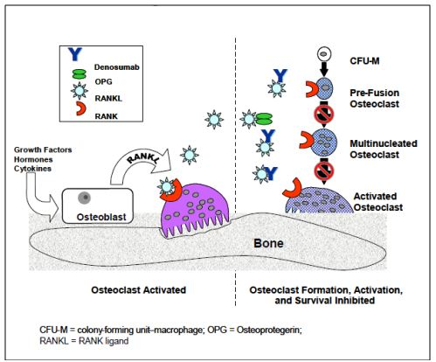

Evaluator’s overall conclusions on pharmacodynamics
No new pharmacodynamic studies were submitted. Given the new indication is related to that already approved it is accepted that new data was not required.

Dosage selection for the pivotal studies
The dose used in the clinical studies was based on the approved dose for treatment of osteoporosis in post menopausal women which is the same as the approved dose for treatment of men with prostate cancer receiving androgen deprivation therapy (ADT).

Clinical efficacy

Pivotal efficacy studies – Osteoporosis in men

Study 20080098: A Multicentre, Randomised, Double Blind, Placebo Controlled Study to Compare the Efficacy and Safety of Denosumab versus Placebo in Males with Low Bone Mineral Density (BMD)
Comment: The clinical study report (CSR) is dated 1 November 2011 but presents only the reports of the first 12 months. Secondary endpoints at greater than 12 months are not presented as the study report states the study is ongoing.

Study design, objectives, locations and dates
Multicentre, randomised, double blind, placebo controlled trial conducted at 27 centres in US (8 centres), Denmark (5), Belgium (4), France (3), Poland (3), Sweden (3) and Canada (1) from September 2009 to June 2011.
The study comprised two treatment periods: 12 month double blind phase and 12 month open label phase (all patients treated with denosumab) (Figure 2). The study duration was therefore 24 months.
Figure 2: Study 20080098 design.
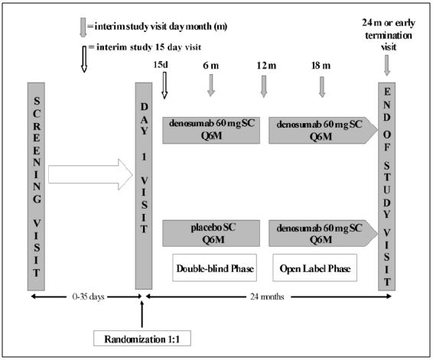

Primary objective
To evaluate the effect of denosumab 60 mg once every 6 months (Q6M) compared to placebo on lumbar spine BMD at 12 months in men with low BMD.

Secondary objectives
To evaluate the effects of denosumab in men with low BMD compared to placebo on:
- BMD at proximal femur (total hip, hip trochanter, femoral neck) and distal radius at 12 months
- Type-1 collagen C-telopeptide (CTX1) at day 15

Other objectives (termed “exploratory”)
- CTX1 at 6 and 12 months compared to placebo
- CTX1 change from baseline to 18 and 24 months
- BMD for all skeletal sites at 6 months compared to placebo
- BMD change from baseline for all skeletal sites at 24 months
- Bone histology and histomorphometry in a subset of subjects at 12 months

Inclusion and exclusion criteria

Inclusion
All of the following:
- Bone mineral density values (g/cm²) assessed by the local site at either the lumbar spine OR the femoral neck that occurred within the following ranges, based on the particular scanner used:
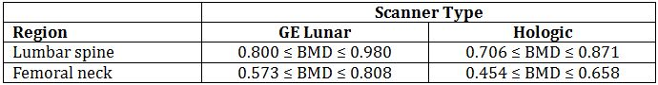
OR
- Subjects with a history of a major osteoporotic fracture (e.g. clinical vertebral, hip, humerus, and distal radius fractures) that occurred ≥ 6 months prior to screening were required to have BMD values within the following ranges:
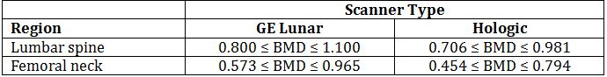
- At least 2 lumbar vertebrae and at least 1 hip and 1 forearm be evaluable by DXA
- Ambulatory men aged 30 to 85 inclusive at start of the screening
- Capable of providing written informed consent

Exclusion
- BMD values (g/cm²) in subjects with or without a history of major osteoporotic fractures, based on the particular scanner that is used:
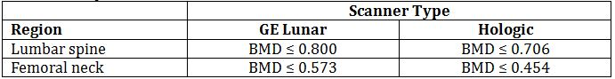
- Any disorder that compromised the ability of the subject to give written informed consent
- Any severe or ≥1 moderate vertebral fractures on screening spinal X-ray
- Any clinical fracture within the last 6 months prior to screening
- For males with partner who was pregnant or of childbearing potential – refusal to use condom (pregnant partner) or 2 highly effective methods of contraception for the duration of the study and for 10 months after the last dose of study medication
- Vitamin D deficiency - 25[OH] vitamin D <20 ng/mL (49.9 nmol/L); Vitamin D supplements were permitted and subject could be re-screened
- Hyper or hypo-thyroidism, however stable subjects (in the investigator’s opinion) on thyroid replacement therapy were allowed
- Hyper or hypo-parathyroidism – determined by range of central laboratory
- Elevated transaminases: Serum aspartate aminotransferase (AST) or serum alanine aminotransferase (ALT) >2.5 x the upper limit of normal (ULN)
- Significantly impaired renal function (GFR <30 mL/min/1.73 m²) calculated by central laboratory
- Hypo or hypercalcaemia based on the central laboratory ranges for albumin adjusted serum calcium
- Known positivity for HIV, Hep C, Hep B surface antigen or cirrhosis of the liver
- Malignancy (except fully resected cutaneous BCC or SCC) within the last 5 years
- Any metabolic bone disease (eg osteomalacia, osteogenesis imperfect, rheumatoid arthritis, Paget’s disease, Cushing’s disease or hyperprolactinaemia) that had the potential to interfere with the interpretation of findings or evidence of malabsorption syndromes that had the potential to interfere with absorption of vitamin D
- Received any solid organ or bone marrow transplant or was on chronic immunosuppression for any reason
- Any laboratory abnormality which might prevent the subject from completing the study or would interfere with the interpretation of the results
- Previous use of denosumab
- Administration of IV bisphosphonate, fluoride (except for dental treatment), or strontium ranelate
- Oral bisphosphonate treatment
  - ≥3 months cumulatively in the part 2 years, or
  - ≥1 month in the past year, or
  - Any use during the 3 month period prior to randomisation
- Administration of any of the following treatments within the 3 months prior to screening:
  - Anabolic steroid or testosterone
  - Glucocorticosteroids (≥5 mg prednisolone equivalent per day for more than 10 days or a total cumulative dose of ≥50 mg)
  - Calcitonin
  - Calcitriol or vitamin D derivatives (Vitamin D contained in supplements or multivitamins were permitted)
  - Other bone active drugs including anti-convulsives (except benzodiazepines) and heparin
  - Chronic systemic ketoconazole, ACTH, cinacalcet, aluminium, lithium, protease inhibitors, methotrexate, gonadotropin-releasing hormone agonists
  - Androgen deprivation therapy
- Known sensitivity to mammalian cell derived drug products
- Known intolerance to calcium or vitamin D supplements
- Height, weight or girth that had a potential to preclude accurate DXA measurements
- Bilateral hip replacements
- Any physical or psychiatric disorder that, in the opinion of the investigator or sponsor would prevent the subject from completing the study or interfere with the interpretation of the results
- Any evidence of alcohol or substance abuse within the last 12 months which the investigator believed would interfere with understanding or completing of the study

Study treatments
Study comprised two treatment periods:
- A 12 month double blind phase during which patients were randomised 1:1 to receive single 60 mg SC administration of denosumab or matching placebo Q6M (ie one dose on Day 1 and the second dose at month 6), and
- A 12 month open label phase during which all patients (independent of randomisation) received 60 mg SC denosumab Q6M (ie single doses at month 12 and month 18).
SC injections were administered at the study site after all other study visit procedures were conducted.
Denosumab was supplied as a sterile, clear, colourless to slightly yellow, preservative free liquid in a pre-filled syringe (PFS) containing 60 mg denosumab per mL of 10 mM sodium acetate at pH 5.2 containing 5% sorbitol in water for injection. A single syringe was used for each SC dose; no special preparation was required prior to denosumab administration.
Matching placebo was provided in containers identical to denosumab – the formulation was identical except for the active ingredient. All investigational product was to be stored at the study site at 2°C to 8°C.
All subjects were required to take daily supplements of ≥ 1000 mg elemental calcium and ≥ 800 IU vitamin D during the study.
All other medications, except those specified in the exclusion criteria were allowed as required.

Efficacy variables and outcomes
The primary efficacy outcome was the percent change from baseline in lumbar spine BMD at 12 months.
Other efficacy outcomes included:
- Percent change from baseline in BMD of the total hip, femoral neck, hip trochanter, and distal radius at month 12
- Percent change from baseline in CTX1 at day 15
- Percent change in BMD for all sites at 6 and 24 months
- Percent change in CTX1 at 6, 12, 18 and 24 months
- Bone histology and histomorphometry in a subset of 20 patients at 12 months
The CTX1 was analysed at the central laboratory using the Serum CrossLaps enzyme-linked immunosorbent assay from Nordic Bioscience Diagnostics.

Randomisation and blinding methods
Subjects were randomised in a 1:1 ratio. The randomisation schedule was stratified by the minimum BMD T Score (<-2.5 vs >-2.5) at either the lumbar spine or femoral neck (whichever was lower). The randomisation schedule used randomly permuted blocks. Subjects were randomised using an Interactive Voice Response System (IVDS).
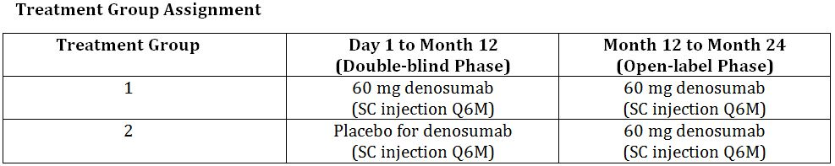
The first 12 months of the study were conducted in double blind fashion.
Each site was supplied with blinded investigational product, with each denosumab or matching placebo dose being supplied in boxes containing a prefilled syringe (PFS) or 60 mg denosumab/mL or placebo solution. Each box was identified by a separate box identification number. The identity of investigational product assigned to subject number or to individual packages was contained in the IVRS.
In order to maintain the integrity of the study blind, the local DXA technician performed the DXA scans but did not use local DXA instrument software to analyse any of the study densitometry measurements. All DXA scans were submitted electronically to the central imaging vendor for final blinded analysis. Similarly, lateral spine x-ray films (or assessment of incident vertebral fracture) were scored at the central imaging vendor, with the radiologist being blinded to treatment.
In addition, all post baseline results of the following parameters were also concealed from investigators and sponsor personnel involved in the study: serum calcium, albumin-adjusted calcium, phosphorus, alkaline phosphatase, CTX1, BMD, bone histology and histomorphology, and antidenosumab antibodies.

Analysis populations
Primary Analysis Set was all randomised patients who had a non missing baseline and at least 1 non missing post baseline evaluation at (or prior to) the time point under consideration. Subjects in this subset were analysed according to their original randomised treatment assignment, regardless of treatment received. This analysis set was used for the primary analysis of efficacy endpoints where percent change or change from baseline was required.
Full Analysis Set was used for the baseline and disposition tables and included all randomised subjects. As above, subjects in this set were analysed according to their original randomised treatment assignment, regardless of treatment received = 242 patients.
Per Protocol Set was defined for the double-blind period and included subjects who were in the primary analysis set and who were compliant with the protocol (ie. received 2 doses of investigational product during the double-blind period, and satisfied all eligibility criteria). For subjects who received proscribed therapy or who received investigational product that did not match the subject’s randomised treatment group, all data collected after the first occurrence of either event were excluded from the per protocol analysis.
Safety Analysis Set was all randomised subjects who received at least 1 dose of investigational product. These subjects were analysed according to their actual treatment received, where subjects who received at least 1 dose of denosumab were analysed in the denosumab treatment group regardless of the randomised treatment = 240 patients (120 denosumab, 120 placebo).
The Bone Biopsy Subset comprised subjects who elected to participate in the bone biopsy substudy (at any time from screening through prior to month 12), and who had received 1 dose of investigational product, and had 1 evaluable bone biopsy at 12 months.

Sample size
The primary clinical hypothesis was that in men with low BMD, the mean percent change in lumbar spine BMD at 12 months would be greater among subjects receiving denosumab than that among subjects receiving placebo. It was further hypothesised that in men with low BMD, the mean percent change of BMD at 12 months in total hip, femoral neck, hip trochanter, and distal radius would be greater in subjects receiving denosumab than that in subjects receiving placebo.
The sample size supported a 2-step sequential testing strategy in order to maintain the overall type-1 error rate at 0.05: in the event that the primary efficacy null hypothesis was rejected (Step 1), then all secondary hypotheses were simultaneously tested (Step 2). The Hochberg procedure was used to control the type-1 error for multiple testing among the secondary hypotheses. The sample size is driven by the distal radius BMD which has the least power among all primary and secondary endpoints. A sample size of 232 subjects in total provides an 80% power to detect a 1.99% difference between the treatment groups at the distal radius, assuming a standard deviation (SD) of 4.2% and a two-sided type-1 error rate of 0.01 (a Bonferroni type-1 error allocation was applied). A 10% dropout rate for the 12-month double-blind treatment duration was assumed.
The sample size of 232 provided a minimum of 99% power to detect a 5.1% difference at lumbar spine between the treatment groups at month 12 assuming a SD of 3.8% and a 2-sided type-1 error rate of 0.05.
For the secondary objectives 116 subjects per arm (232 subjects in total) provided 80% power for distal radius and 99% power for other anatomical sites; assumptions of treatment differences were based on a previously conducted meta-analysis of BMD results — both the point estimate and the lower limit of 95% confidence interval (CI) of treatment difference were used in the power estimation. While the Hochberg procedure was used in the actual analysis, a Bonferroni type-1 error allocation was applied for the sample size calculation, being the more conservative method.

Statistical methods
All primary endpoints were summarised using the number and percentage of patients having the response of interest by treatment group. All ordinal endpoints were summarised using the number and percent of subjects in each category by treatment group. All continuous endpoints were summaries using descriptive statistics including mean, standard deviation (SD), minimum, 25th percentile, median (50th percentile), 75th percentile, maximum, and number of non missing observations (n).
The primary analysis of efficacy endpoints were completed on the Primary Analysis Set. The primary inference was to test for a treatment difference in the percent change in lumbar spine after 12 months of treatment. If statistical significance was declared for the primary endpoint, then further formal inferential testing for secondary endpoints was performed. The secondary inferences included tests for treatment differences in BMD at the total hip, femoral neck, hip trochanter and distal radius after 12 months of treatment and CTX1 after 15 days of treatment. The Hochberg step-up procedure was used to adjust for multiple testing for secondary endpoints at the level of 0.05.
Analysis of covariance (ANCOVA) models were used for the primary analysis of the primary and secondary BMD efficacy endpoints (treatment as the main effect and the minimum baseline BMD T score (stratification factor) as covariate) with a last observation carried forward (LOCF) imputation. Percent change in CTX1 was analysed using the van Elteren stratified rank test.

Participant flow
Planned enrolment = 232
Enrolled = 242
- Denosumab = 121
- Placebo = 121
Two patients (1 in each treatment group) were withdrawn prior to receiving treatment due to violations of eligibility criteria.
13 subjects (9 denosumab treated and 4 placebo treated) discontinued within the first 12 months of the study.
Completed study = 227
- Denosumab = 111
- Placebo = 116

Major protocol violations/deviations
The overall incidence of important protocol deviations during the 12-month double-blind phase of the study was 10% (n = 12 [10%] denosumab; n = 13 [11%] placebo) The most common deviations were characterised as ICH GCP compliance issues (4% denosumab, 6% placebo) - generally consisting of on-study DXA scans being analysed locally (which could compromise the study blind) rather than being sent to the central imaging vendor for blinded analysis (3 denosumab, 4 placebo); failure to promptly obtain informed consent subsequent to the issuance of the protocol addendum (3 subjects [2 placebo, 1 denosumab]) and the use of temperature-compromised investigational product (all 9 subjects at one centre [5 placebo, 4 denosumab]).
None of the deviations were considered to have the potential to affect the conclusions of the study.

Baseline data
All subjects were men, with a mean age of 65 (SD 9.8) years (64.9 [10.5] years in the denosumab group and 65.0 [9.1] years in the placebo group); the majority of enrolled subjects were between the ages of 50 and 79 years. The overall mean body mass index (BMI) was 25.8 (SD 3.6) kg/m² (25.6 [3.6] in the denosumab group and 26.0 [3.6] in the placebo group)). All subjects in the denosumab group were White and 88.4% of subjects in the placebo group were White (Table 1).
Table 1: Study 20080098 baseline demographics, body composition and geographic region.
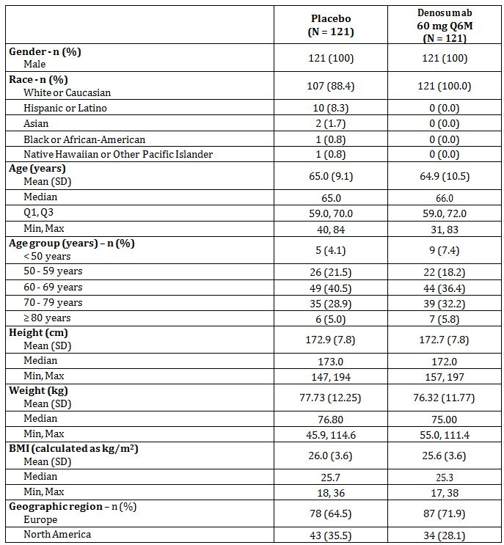
The randomisation schedule was stratified by the minimum baseline BMD T-score (lumbar spine or femoral neck) to obtain at least 116 subjects with a minimum T-score of ≤-2.5. A total of 117 subjects (as confirmed by central reading) were randomised that met this criterion; approximately half the subjects in each treatment group had BMD T-scores ≤-2.5. With the exception of baseline mean distal radius BMD T-scores being higher among subjects randomised to denosumab (-1.37) than to placebo (-1.66), baseline mean BMD T-scores were similar between treatment groups. The proportion of subjects with a prevalent vertebral fracture at baseline based on spine radiographs was 24.8% in the denosumab group and 20.7% in the placebo group.

Results for the primary efficacy outcome
The primary efficacy outcome was the percent change from baseline in lumbar spine BMD at 12 months.
Subjects treated with denosumab, as compared with placebo, showed significantly greater gains in mean percent change from baseline at month 12 in lumbar spine BMD, 5.7% vs 0.9%, with a mean difference of 4.8% (p < 0.0001; 95% CI: 4.0 - 5.6) between the treatment groups.
Results of sensitivity analyses of the BMD efficacy endpoints were consistent with the primary analysis, demonstrating that the results of the primary analyses were robust. Results of subgroup analyses, including by age, geographic region, baseline serum CTX1, minimum baseline BMD T-score, baseline testosterone, and baseline 10-year major osteoporotic fracture risk (with BMD), demonstrated that denosumab increased lumbar spine BMD at the primary assessment time point compared with placebo in all subgroups (Table 2, Figures 3-4).
Table 2: Study 20080098 Lumbar Spine Bone Mineral Density by DXA Percent Change From Baseline by Visit (ANCOVA Model) (Primary Efficacy Subset, LOCF) (First 12 Months Analysis).
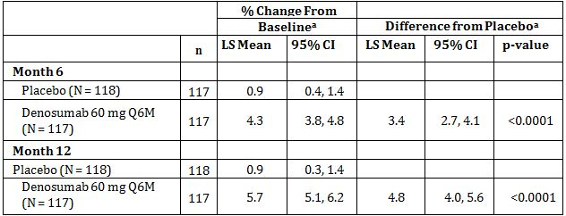
N = Number of subjects with values at baseline and ≥ 1 post baseline visit
n = Number of subjects with values at baseline and ≥ 1 post baseline visit at or prior to the time point of interest
a. Based on an ANCOVA model with treatment as main effect and level of baseline BMD T-score as covariate
P-value is not adjusted for multiple comparisons.
Figure 3: Study 20080098 Lumbar Spine Bone Mineral Density Percent Change From Baseline by Visit: Least Squares Means and 95% CIs from ANCOVA (Primary Efficacy Analysis Set, LOCF) (First 12 Months Analysis).
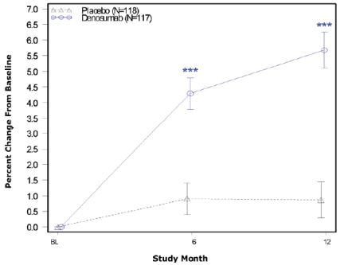
N = Number of subjects with values at baseline and at ≥ 1 post baseline visit. Point estimates and nominal 95% CIs are based on an ANCOVA model with treatment as the main effect and level of baseline BMD T-score as the covariate
*** p-value ≤ 0.01
Figure 4: Study 20080098 Bone Mineral Density Percent Change From Baseline at Month 12 by Anatomical Site Least Squares Means and 95% CIs from ANCOVA (Primary Efficacy Analysis Set, LOCF) (First 12 Months Analysis).
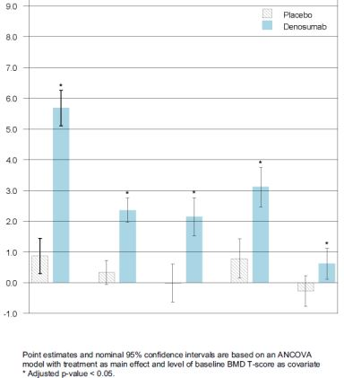

Results for other efficacy outcomes

Percent change from baseline in BMD of the total hip, femoral neck, hip trochanter, and distal radius at month 12
Subjects treated with denosumab showed greater gains at month 12 in BMD, as compared with placebo-treated subjects, at the total hip (2.4% vs 0.3%), femoral neck (2.1% vs 0%), trochanter (3.1% vs 0.8%), and distal radius (0.6% vs -0.3%); mean differences between the treatment groups ranged from 0.9% to 2.3% (Table 3, Figures 5-6).
Table 3: Study 20080098 Results of Secondary Endpoints – Primary Efficacy Subset, LOCF, 12 months analysis.
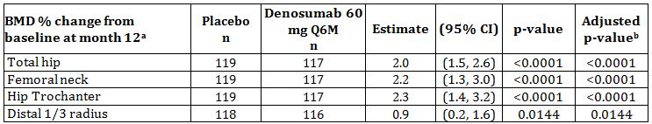
n = Number of subjects with values at baseline and at ≥ 1 post baseline visit for BMD endpoints and at baseline and at day-15 visit for serum CTX1
a. Difference from placebo and p-value based on an ANCOVA model with treatment as main effect and level of baseline BMD T-score as covariate
b. Based on the Hochberg procedure for multiple comparisons
Figure 5: Study 20080098 Bone Mineral Density Percent Change From Baseline at Month 12 by Anatomical Site: Least Squares Means and 95% CIs from ANCOVA (Primary Efficacy Analysis Set, LOCF) (First 12 Months Analysis).
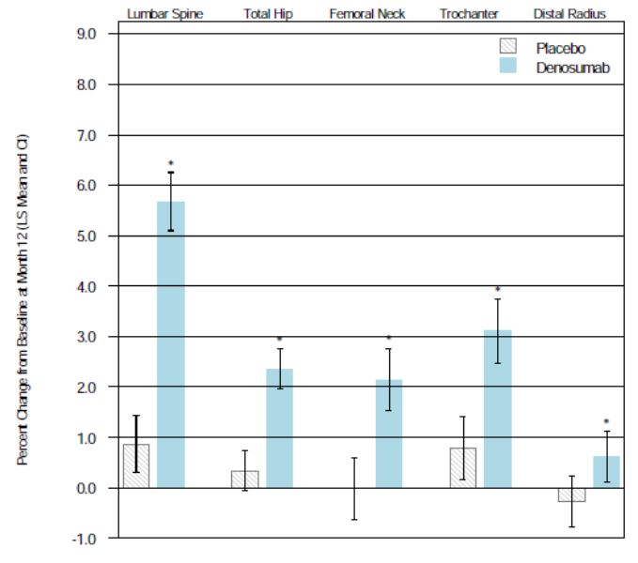
Point estimates and nominal 95% CI are based on an ANCOVA model with treatment as main effect and level of baseline BMD T-score as covariate
* Adjusted p-value < 0.05.
Figure 6: Study 20080098 Percent Change from Baseline in BMD for Secondary Endpoints: Least Squares Means and 95% CIs from ANCOVA (Primary Efficacy Analysis Set, LOCF) (First 12 Months Analysis).
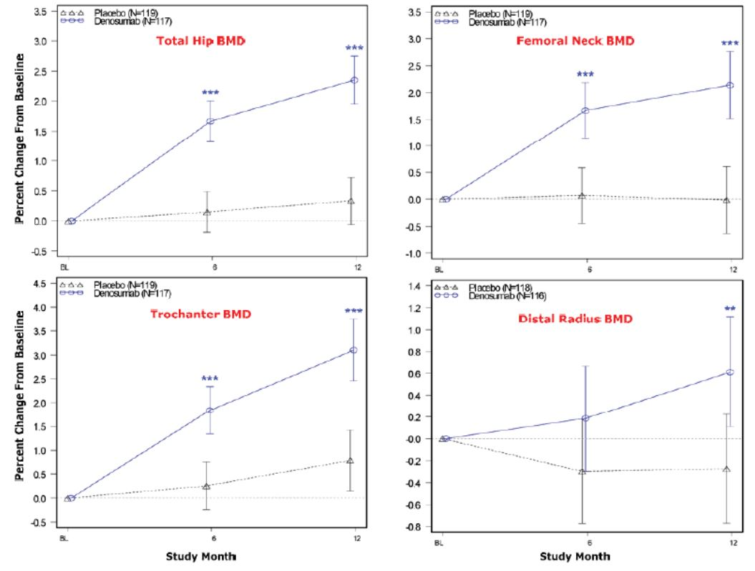

Percent change from baseline in CTX1 at day 15 and Percent change in CTX1 at 6, and 12 months
Treatment with denosumab significantly decreased mean serum CTX1 concentration, a marker of bone resorption, compared with placebo at day 15 (adjusted p <0.0001). Median percent changes from baseline in serum CTX1 concentration at day 15 were -45% in the denosumab group and -2% in the placebo group.
It is noted by the sponsor that the decreases in CTX1 were less than those observed in previous denosumab studies. This is explained as due to the CTX1 LLOQ defined by the central laboratory (0.2 ng/mL) being higher than the LLOQ defined in previous denosumab clinical studies (0.05 ng/mL). After treatment with denosumab, most subjects had a serum CTX1 concentration at or below the 0.2 ng/mL LLOQ. The same serum CTX1 assay has been used in the denosumab clinical trial program.
To reconcile the differences in CTX1 results between the current study and previous denosumab clinical studies, raw data were obtained from central laboratory for subjects who had values below the LLOQ to recalculate median percent change. Results of the supplemental analysis indicate that, without applying the LLOQ, the median percent changes from baseline to day 15 in CTX1 are -81% in the denosumab group and -7% in the placebo group (Table 4).
Table 4: Study 20080098 Serum CTX1 Percent Change from Baseline by Visit: Primary Efficacy Subset, Observed Data, First 12 Months Analysis.
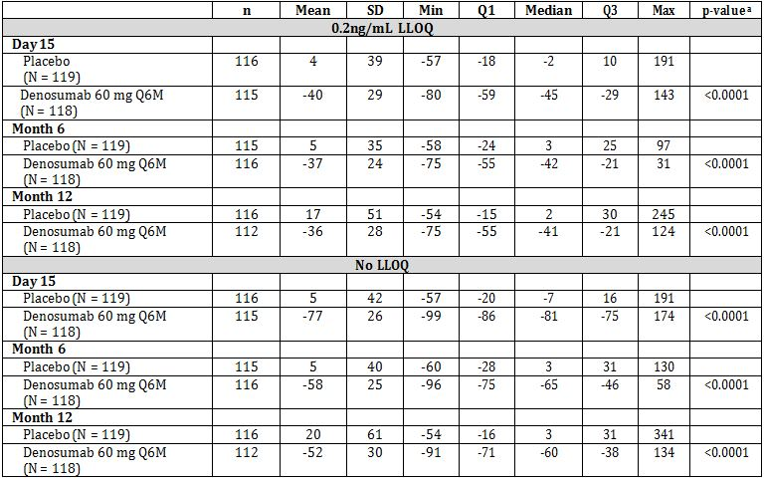
N = Number of subjects with values at baseline and at ≥ 1 post baseline visit
n = Number of subjects with values at baseline and at the time point of interest
ª P-value is based on the van Elteren stratified rank test adjusting for level of baseline BMD T-score and not adjusted for multiple comparisons.

Bone histology and histomorphometry in a subset of 20 patients at 12 months
A total of 29 subjects (17 denosumab, 12 placebo) were enrolled at selected study sites to undergo a transiliac bone biopsy within 30 days prior to the month 12 visit. All subjects scheduled for the biopsy were to follow a double tetracycline/demeclocycline labelling procedure prior to undergoing the biopsy.
Overall, bone biopsy results showed normal bone histology. After 12 months of denosumab treatment, there was evidence of normal lamellar bone, normal mineralisation, and normal osteoid in both treatment groups. There was no evidence of osteomalacia, marrow fibrosis, woven bone, or abnormal osteoid. Denosumab did not impair matrix mineralization.
Consistent with denosumab’s mechanism of action, evaluation of histomorphometric parameters showed changes consistent with decreased bone remodelling in subjects treated with denosumab compared with placebo. Decreased bone remodelling led to reductions in tetracycline uptake and therefore labelling. As a consequence, a reduction in single and double labels was observed in a number of biopsies in the denosumab group. Evaluation of dynamic bone histomorphometry in the subset of samples in which double or single labels were present showed changes consistent with decreased remodelling in subjects treated with denosumab.

Antidenosumab antibody assays
All subjects treated with denosumab (n = 120) for up to 12 months were negative for antidenosumab binding antibodies at all tested time points. No neutralising antibodies were reported.

Conclusions
- The duration of the treatment period, 12 months, is commensurate with EU guidance in male osteoporosis populations, once anti-fracture efficacy has been demonstrated in women with postmenopausal osteoporosis.
- This study used an inclusion criterion of BMD equivalent to a T-score of ≤-2 at the lumbar spine or femoral neck, OR ≤-1 at the lumbar spine or femoral neck in subjects with a history of major osteoporotic fracture.
- The T-score criteria are consistent with prior published clinical trials for the pharmacologic treatment of male osteoporosis and this approach is also consistent with that proposed in the EU guideline.
- All subjects received daily supplementary calcium and vitamin D.
- The study was intended as a 2 year study and includes secondary efficacy outcomes at time points greater than 12 months. The primary efficacy analysis was pre-defined for 12 months and has been reported at 12 months.
- The primary analyses of efficacy endpoints were completed on the Primary Analysis Set, comprising all randomised subjects who had a non missing baseline and ≥ 1 non missing post baseline evaluation at (or prior to) the time point under consideration.
- Denosumab significantly increased mean BMD at the lumbar spine compared with placebo, with a mean difference of 4.8% between the treatment groups from baseline to month 12.
- Denosumab significantly increased mean BMD at all other skeletal sites measured (proximal femur [total hip, femoral neck, trochanter] and distal radius) compared with placebo at month 12.
- Treatment with denosumab significantly decreased the serum concentration of bone resorption marker C-telopeptide of type 1 collagen (CTX1) compared with placebo at day 15.
- Bone biopsy specimens at month 12 showed normal histology in all specimens; histomorphometry showed that there was decreased bone remodelling in patients treated with denosumab, consistent with the mechanism of action.

Other efficacy studies – Postmenopausal women with osteoporosis
Comment: no explanation for the inclusion of these studies is included in the submission. It is assumed that they are included to provide additional long term safety data and to meet the requirement in the EU guideline:
“The magnitude of the changes in BMD versus placebo is similar to that observed in postmenopausal osteoporotic women treated with the same compound and is globally proportional to the decreased incidence of fractures in treated women.”

Study 20050233 (Extension study for Study 20010223): An Open Label, Single Arm Extension Study to Evaluate the Long Term Safety of Denosumab Administration in Postmenopausal Women with Low Bone Mineral Density.

Study design, objectives, locations and dates
This was a multicentre, open label, single arm, 5 year extension study conducted at 23 centres in the USA from May 2006 to March 2011.
The primary objective was to evaluate the long term safety outcomes of denosumab administration in postmenopausal women with low bone mineral density (BMD) who completed in study 20010223 (original study).
The secondary objectives were to describe the treatment effect of long term denosumab administration on BMD and bone turnover markers (BTM) in postmenopausal women with low BMD.
In study 20050233, the subjects had received 60 mg denosumab by SC injection every 6 months (Q6M), with the last dose administered at month 42.
Subjects enrolled into study 20050233 were organised into the following cohorts, based on treatment regimens received during the 4 year original study (20010233):
- Continuous treatment cohort: in the original study the ‘continuous treatment cohort’ received denosumab SC for 4 years. During the first 2 years, the doses were 6 mg every 3 months (Q3M), 14 mg Q3M, 60 mg Q6M, or 100 mg Q6M. During the last 2 years, all subjects received 60 mg Q6M. Treatment for 4 years in the current study represents 8 years of continuous exposure to denosumab for this cohort
- Placebo cohort: in the original study, the ‘placebo cohort’ received placebo SC for 4 years
- Re-treatment cohort: in the original study, the ‘re-treatment cohort’ received denosumab 30 mg SC Q3M for 2 years, placebo Q6M for 1 year, followed by denosumab 60 mg Q6M for 1 year. This cohort is referred to as the ’30 mg Q3M’
- Off-treatment cohort: in the original study, the ‘off-treatment cohort’ received denosumab 210 mg SC Q6M for 2 years and placebo Q6M for 2 years. This cohort is referred to as the ‘210 mg Q6M’ group
- Alendronate cohort: in the original study, the ‘alendronate cohort’ received alendronate 70 mg orally (PO) QW for 2 years, treatment was discontinued for the remaining 2 years of the original study. Treatment for 4 years in the current study represents initial exposure to denosumab in subjects previously treated with alendronate.

Inclusion and exclusion criteria

Inclusion criteria
Subject must have been ambulatory, and must have participated in and attended the 20010223 end-of-study visit and completed all tests and procedures during the visit.

Exclusion criteria
- Discontinued investigational product (i.e. denosumab or placebo SC injection) before the scheduled month 48 end-of-study visit in the 20010223 study
- Missed 2 or more scheduled SC investigational product administrations during year 3 and year 4 of the 20010223 study (e.g., more than one of the following scheduled dosing: months 24, 30, 36, 42)
- Experienced severe and/or serious adverse events that were thought to be related to denosumab administration during the 20010223 study
- Developed grade 3 or 4 laboratory abnormalities based on Common Terminology Criteria for Adverse Event v3.0 (CTCAE 3.0) during the 20010223 study that did not normalise upon follow up or did not have a diagnosis and treatment (based on available laboratory results collected prior to the 20010223 end-of-study visit)
- Use of any of the following therapies while participating in the 20010223 study:
  - Any oral bisphosphonate use (other than the alendronate provided by investigators to subjects assigned to the alendronate treatment group during the 20010223 study)
  - Subjects who were assigned to the alendronate group during the 20010223 study but did not discontinue alendronate use during the second 2 years of the study per protocol
  - Administration of intravenous bisphosphonate, fluoride or strontium
  - PTH or PTH derivatives, e.g., teriparatide, PTHrP
  - Calcitonin
  - Calcitriol or vitamin D derivatives (vitamin D contained in supplements or multivitamins is allowed)
  - Oral strontium
  - Selective oestrogen receptor modulators (SERMS), e.g., raloxifene
  - Systemic hormone replacement therapy
  - Tibolone
  - Anabolic steroids or testosterone
  - Systemic glucocorticosteroids (≥2 courses of steroid treatment within 1 year, each course encompasses ≥5 mg prednisone equivalent per day for > 10 days)
  - Chronic systemic ketoconazole, androgens, adrenocorticotrophic hormone (ACTH), cinacalcet, aluminum, lithium, protease inhibitors, methotrexate, gonadotropin releasing hormone agonists, aromatase inhibitors, chemotherapeutics
  - Other bone active drugs including anticonvulsants (except gabapentin for neuropathic pain and benzodiazepines) and chronic heparin (> 7 days)
  - Any biologic agents other than denosumab
- Subjects newly diagnosed with any of the following conditions prior to the 20010223 end-of-study visit:
  - Hyperthyroidism (stable on antithyroid therapy or post ablation is allowed, if the thyroid stimulating hormone (TSH) is within the normal range)
  - Hypothyroidism (stable on thyroid replacement therapy is allowed, if the TSH is within the normal range)
  - Hyper- or hypoparathyroidism
  - Rheumatoid arthritis, Paget’s disease, Cushing’s disease, hyperprolactinaemia, or cirrhosis of the liver
  - Other bone diseases which affect bone metabolism (e.g., osteopetrosis, osteogenesis imperfecta)
  - Renal disease (creatinine clearance ≤35 mL/min)
  - Malignancy within the last 5 years prior to enrolment (except cervical carcinoma in situ or basal cell carcinoma)
- Known sensitivity to mammalian-derived drug preparations (e.g., Herceptin®)
- Any organic or psychiatric disorder, serum chemistry or haematology values, which, in the opinion of the investigator, may have prevented the subject from completing the study or interfering with the interpretation of the study results
- Self-reported alcohol or drug abuse within the previous 12 months or any disorder that compromises ability to give truly informed consent for participation in this study

Study treatments
All subjects received denosumab 60 mg SC every 6 months for 48 months with the last dose administered at month 42.
No details of the formulation are provided in the study report.
All subjects were required to take supplemental calcium (at least 500 mg daily) and vitamin D (at least 400 IU daily) as provided by the sponsor.

Efficacy and safety variables and outcomes
The primary safety outcome was the incidence of serious adverse events, adverse events and abnormal safety laboratory values.
The secondary safety outcomes were:
- Incidence of neutralising and non-neutralising antibodies against denosumab
- Periodic serum denosumab concentrations
- Clinical laboratory assessments (including toxicity grade) at each visit
The secondary efficacy outcomes included:
- Markers of bone turnover (serum C-telopeptide 1 (CTX-1) and bone specific alkaline phosphatase (BSAP)
- Percent change from baseline in BMD for lumbar spine, total hip, femoral neck, trochanter, and 1/3 distal radius, every 12 months

Randomisation and blinding methods
This was an unblinded, open-label study in which all subjects received 60 mg denosumab.

Analysis populations
Analyses are presented by 5 pooled treatment groups from Study 20010223, including:
- continuous treatment cohort (denosumab 6 and 14 mg Q3M and 14, 60, and 100 mg Q6M for the first 2 years of Study 20010223 and denosumab 60 mg Q6M for the last 2 years of Study 20010223)
- retreatment cohort (denosumab 30 mg SC Q3M for 2 years, placebo SC Q6M for 1 year, followed by denosumab 60 mg SC Q6M for 1 year)
- off-treatment cohort (denosumab 210 mg SC Q6M for 2 years and placebo SC Q6M for 2 years)
- placebo cohort (placebo SC for 4 years)
- alendronate cohort (alendronate 70 mg PO QW for 2 years; treatment discontinued for the remaining 2 years)
The safety analysis set included all subjects who received at least 1 dose of denosumab during this extension study. Subjects with missing values for a particular visit were excluded from the analysis of that endpoint at that visit.

Sample size
The number of subjects who entered this study was determined by the number of subjects who completed the 20010223 study and were willing to participate in the 20050233 study. Approximately 250 subjects were expected to enrol.

Statistical methods
No formal hypothesis testing was performed for this open-label, uncontrolled study. All analyses were descriptive in nature. Summary statistics were presented, where applicable, with continuous endpoints summarised descriptively using the mean, standard deviation, minimum, median, maximum, and the number of non-missing observations. Frequencies and percentages were presented for binary or categorical endpoints.

Participant flow
A total of 262 subjects completed the parent study 20010223. 200 subjects enrolled in the extension study (20050233). Of these 200 enrolled subjects, 138 (69%) completed the 48 month treatment phase (Table 5).
Table 5: Study 2005233 Subject Disposition by Pooled Group.
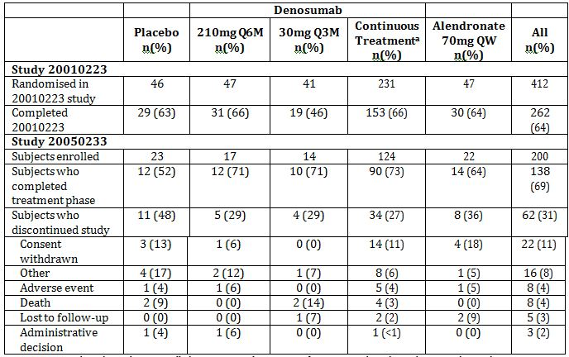
Note: Percentages based on subjects enrolled in 20050233 (percentages for 20010223 based on subjects randomised in 20010223) Treatment groups are the original assignments in the 20010223 study; all subjects in 20050233 were to receive denosumab 60mg Q6M
a. Includes denosumab 6 mg Q3M, 14 mg Q3M, 14 mg Q6M, 60 mg Q6M, and 100 mg Q6M dose groups

Major protocol violations/deviations
Overall, 39 (19.5%) subjects had one or more important protocol deviations related to eligibility criteria, receiving prohibited or improperly stored medications, or other GCP violations. 12 (6%) subjects had taken exclusionary medications during the study, mainly extended use of systemic glucocorticoids and use of chemotherapeutics. Twelve (6%) subjects received study medication stored at improper temperatures.
There were 3 (1.5%) subjects who had important protocol deviations related to exclusion criteria during screening for Study 20010223; 2 subjects had taken prohibited medications and 1 subject had an exclusionary medical condition. The remaining protocol deviations were related to other GCP violations (7%), which included a delay in signing an updated consent form at 1 site.
All subjects with important protocol deviations continued in Study 20050233 as it was concluded that these deviations would neither compromise any study objective of this long-term safety evaluation nor place the subjects at risk. The small numbers of subjects with important protocol deviations were judged by the sponsor as unlikely to have affected the interpretation of study results.

Baseline data (at entry to extension study)
All subjects were postmenopausal women. The mean age was 66.1 years with 54.5% of subjects ≥65 years of age. Mean age was similar across pooled treatment groups. The majority of subjects were white (89%) with 8.5% Hispanic or Latino, 1.5% Black or African American and 1% Asian. Subjects were postmenopausal for an average of 19.3 years. Approximately a quarter of the subjects (27.0%) had undergone a hysterectomy and 11.0% had undergone bilateral oophorectomy prior to entering the parent study.

Results for efficacy outcomes: Pharmacokinetics
The mean and median serum denosumab concentrations at months 1 and 25 (i.e. 1 month post dose) differed by <4% and mean serum denosumab trough concentrations from months 24 to 48 were similar, ranging from approximately 90 to 116 ng/mL. Combined with the PK results from study 20010223, these data suggest that the pharmacokinetics of denosumab did not change over the time period of the study (Table 6).
Table 6: Study 20050233 Summary Statistics for Serum Denosumab Concentrations for Postmenopausal Women with Low Bone Mineral Density Receiving SC Administration of 60 mg Denosumab Every Six Months.
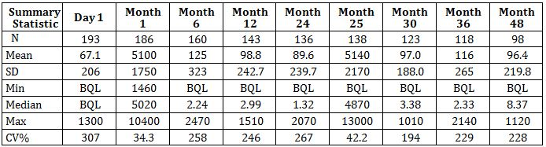
Summary statistics are presented to 3 significant figures, except for SD which is presented to the same precision as its respective mean value.
BQL values (Below the lower limit of quantification (0.8 ng/mL)) were changed to zero for the calculation of summary statistics.

Results for efficacy outcomes: Bone mineral density
For subjects in the continuous treatment cohort, 4 additional years of denosumab treatment during Study 20050233 led to further gains in BMD.
At month 48, BMD showed increases from the extension baseline by a least-square means (LSM) of 5.7% at the lumbar spine, 1.8% at the total hip, 2.3% at the femoral neck, 3.5% at the trochanter, and 0.8% at the distal radius.
After 8 years of denosumab treatment, the LSM BMD percent change from the parent Study 20010223 baseline was 16.5% at the lumbar spine, 6.8% at total hip, 6.8% at the femoral neck, 11.2% at the trochanter, and 1.3% at the distal radius (Table 7).
Table 7: Study 20050233 Percent Change from Parent Study 20010223 Baseline in BMD Measures at Month 48 by Pooled Group (ANCOVA).
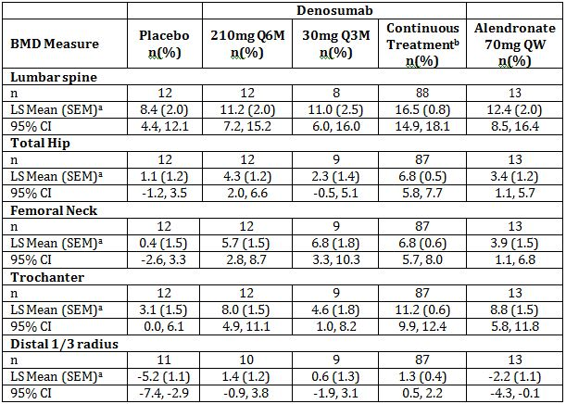
Treatment groups are the original assignments in the 20010223 study; all subjects in 20050233 were to receive denosumab 60mg Q6M
N = Number of subjects enrolled in 20050233
n = Number of subjects with nonmissing data at 20010223 baseline and month 48 during 20050233
a. Based on ANCOVA model adjusting for treatment, geographical location, and baseline value
b. Includes denosumab 6 mg Q3M, 14 mg Q3M, 14 mg Q6M, 60 mg Q6M, and 100 mg Q6M dose groups
1 subject who had new vertebra deletion during 20050233 are excluded from the analysis of lumbar spine at month 48 during 20050233
For subjects in the placebo cohort, 4 years of 60 mg Q6M denosumab treatment during Study 20050233 resulted in gains in BMD from baseline of Study 20050233 comparable to those observed during 60 mg Q6M denosumab treatment in parent Study 20010223.
In the other cohorts (retreatment, off-treatment, and alendronate), magnitudes of gains in BMD were variable, likely reflecting the small number of subjects within these cohorts.

Results for efficacy outcomes: Bone turnover markers
For subjects in the continuous treatment cohort, reductions in biochemical markers of bone resorption and formation (serum CTX-1 and BSAP) were sustained over the course of continuous treatment. After 8 years of continuous denosumab treatment, median percent reduction in CTX-1 was 64.6% as compared with parent study 20010223 baseline. From baseline of parent Study 20010223, median reduction of BSAP was 44.4% after 8 years of treatment.
For subjects in the off-treatment, placebo, and alendronate cohorts who were not receiving therapy at the end of parent Study 20010223, reductions in serum CTX-1 occurred rapidly after the first dose in Study 20050233 and reductions in bone specific alkaline phosphatase (BSAP) temporally followed those in serum CTX-1.

Study 20060289 (Extension study for Study 20030216): An Open Label, Single Arm, Extension Study to Evaluate the Long Term Safety and Sustained Efficacy of Denosumab (AMG 162) in the Treatment of Postmenopausal Osteoporosis.
Comment: This study is ongoing and is only presented as an extended synopsis with tabulations for the interim analysis up to 36 months.

Design
This is an ongoing, multinational, multicentre, open label, single arm, extension study enrolling subjects who completed Study 20030216, a placebo controlled study in postmenopausal women with osteoporosis. All subjects in the current study, regardless of the treatment assigned in Study 20030216 received denosumab 60mg SC every 6 months (Q6M). The last scheduled dose of denosumab is at month 78 and subjects will be followed until month 84.
Study 20030216 was a three year placebo controlled study in postmenopausal women with osteoporosis with BMD T-scores at the lumbar spine or total hip <-2.5 and ≥-4.0.
Results for the extension study are reported for 2 groups depending on whether the subjects were randomised to receive denosumab in Study 20030216 (called ‘the long term’ group) or if they were randomised to receive placebo in Study 20030216 (called the ‘cross over’ group). Subjects in the long term group have received denosumab for a total of 6 years at the time of the interim report and those in the cross over group have received denosumab for up to a total of 3 years in the interim report.

Objectives
The primary objective is to study the long term safety, tolerability and efficacy for all subjects from baseline through completion of the study up to 10 years of treatment (3 years in original study and 7 years in extension study). There was a planned interim analysis at 36 months.
Long term safety is being assessed by adverse event monitoring, immunogenicity and safety laboratory parameters.
Secondary objectives:
- The effect of denosumab administration on changes in lumbar spine, total hip and radius BMD
- The effect of denosumab administration on the incidence of vertebral and non-vertebral fractures
- The effect of denosumab administration on markers of bone turnover
- The change in serum calcium values between the baseline and day 10 visits in subjects who previously received denosumab or placebo
- The effect of denosumab administration on bone histology at 5 and 10 years in subjects who previously received denosumab. The 5 year data (3 years in 20030216 and 2 years in extension study 20060289) are included in this report.

Location and dates
The study was conducted in 180 centres in USA (24 centres), Canada (9), Europe [Austria (5), Belgium (5), Denmark (4), Finland (1), France (6), Germany (4), Italy (8), Norway (5), Spain (9), Sweden (6), Switzerland (3), UK (13) Hungary (10), Czech Republic (10), Slovakia (6), Greece (2), Estonia (3), Latvia (3), Lithuania (2), Poland (17), Romania (1), Bulgaria (2), Serbia (3),Malta (1)], Latin America [Argentina (3), Brazil (5), Mexico (5)] and Australasia [Australia (3), New Zealand (2)]. The study began in August 2007 and the last patient completed their 36 month visit in June 2011. The synopsis is dated February 2012.

Inclusion and exclusion criteria
Subjects who completed Study 20030216 and who missed no more than 1 dose of investigational product in the original study and completed all study visits were eligible to enrol in the extension study (20060289). Subjects are postmenopausal women with osteoporosis, ambulatory and not receiving any other medications that affect bone metabolism (other than denosumab in Study 20030216).

Study treatments
This is an open study and all subjects received denosumab 60mg SC every 6 months (Q6M). All subjects were also instructed to take daily calcium (≥1 g) and vitamin D (≥400 IU) supplementation.
No formulation of the product is provided. It is described as a sterile, clear, colourless, preservative-free liquid in glass vials or prefilled syringes. The formulation for denosumab vial is 60 mg denosumab per mL formulated with 10 mM sodium acetate and 5% sorbitol in water for injection, with a pH of 5.2. The formulation for denosumab prefilled syringe is identical to that of the vial, with the addition of 0.01% polysorbate 20.

Efficacy and safety variables and outcomes
The primary endpoint is safety monitoring, including adverse event incidence, serious adverse event incidence, changes in safety laboratory analytes (serum chemistry, haematology) and subject incidence of anti-denosumab antibody formation.
The secondary endpoints:
- Actual values, changes, and percent changes in BMD of the lumbar spine, total hip and radius from baseline at all time points where BMD is collected
- Actual values, changes, and percent changes in BMD of the lumbar spine, total hip, and radius from Study 20030216 baseline at all time points where BMD is collected
- Subject incidence of vertebral fractures at months 24, 36, 60, and 84
- Subject incidence of non-vertebral fractures during the study
- Actual values, changes, and percent changes in bone turnover markers (C-telopeptide 1 [CTX-1], intact parathyroid hormone [iPTH], osteoprotegrin [OPG], bone-specific alkaline phosphatase [BSAP, also referred to as BALP], procollagen type-1 N-telopeptide [P1NP]) from baseline at all time points
- Actual values, changes, and percent changes in bone turnover markers (CTX-1, iPTH, OPG, BSAP, P1NP) from Study 20030216 baseline at all time points
- Actual value, change and percent change from baseline in albumin-adjusted serum calcium at Day 10
- Actual values of bone biopsy measurements (including bone histomorphometric parameters and bone histology) at months 24 and 84. Results of the month 24 data are presented in this report.

Randomisation and blinding methods
This is an open label single arm study.

Analysis populations
Not stated.

Sample size
It was planned to enrol 4900 to 5600 subjects but only 4550 were enrolled.

Statistical methods
The results are summarised and analysed using descriptive statistics. The analysis is done according to the Study 20030216 randomised treatment groups. Results of statistical tests (p values) and confidence intervals are presented in an exploratory and descriptive manner.
The statistical powering for BMD at 24 months for subjects randomised to denosumab during the 20030216 study is given below. It was assumed that 2,600 subjects from 20030216 denosumab arm would enrol in the extension study, and that 93% of these subjects would have at least one post-baseline BMD measurement.
- Lumbar Spine: Assuming a standard deviation of 3.5, there is at least 99% power to detect a 1.5 percent change increase from the 20060289 extension study baseline at 24 months, using a one-sample t-test at the two-sided 0.05 level of significance.
- Total Hip: Assuming a standard deviation of 4.0, there is at least 99% power to detect a 0.75 percent change increase from the 20060289 extension study baseline at 24 months, using a one-sample t-test at the two-sided 0.05 level of significance.
Assuming a standard deviation of 3.5, with approximately 140 subjects at the end of the extension study within each of the prior treatment groups (Study 20030216), there will be at least 90% power to detect a 1.0 percent change increase in BMD lumbar spine for yearly comparisons, using a one-sample t-test at the two-sided 0.05 level of significance.

Participant flow
A total of 6478 subjects completed Study 20030216 and 5928 were eligible for the extension study.
A total of 4550 subjects were enrolled in the extension study: 2207 in the cross over arm (placebo in original study) and 2343 in the long term arm (denosumab in the original study).
At the time of the 36 month interim analysis: 1003 (22%) had discontinued the extension study. The most common reasons for discontinuation were:
- Consent withdrawn (368 subjects – 8.5%)
- Other reasons - not specified (321 – 7.1%)
- Adverse event (116 – 2.5%)
- Death (82 – 1.8%)
- Lost to follow up (64 1.4%)
The proportion and reasons for discontinuation from the study were similar between the cross over and long- term groups.
A total of 3473 subjects were continuing in the study at 36 months.

Major protocol violations/deviations
Not discussed in synopsis. According to tabulation 173 (3.8%) of subjects had protocol violations. The most common were taking prohibited medications while on study (1.3%), missing doses (0.5%), problems with test product – out of stability when taken, expired product or received incorrect Box ID (0.7%) and serious GCP non-compliance (not explained) (1.3%).

Baseline data (at entry to extension study)
All subjects were women (100%) and the mean age was 74.8 ± 5.0 (SD) years with a range of 63 to 93 years.
A total of 4232 (93%) subjects were White or Caucasian, 266 (5.8%) were Hispanic or Latino, 35 (0.8%) Black or African American, 8 (0.2%) Japanese, 5 (0.1%) Asian, 1 (0.1%) Native Hawaiian or other Pacific Islander, and 3 (0.01%) other.
The mean age since menopause was 26.7 years (± 7.3). Baseline demographics were similar between the cross over group and the long term group. Approximately a quarter of the subjects had prevalent vertebral fracture at entry to the extension study. As expected lower BMD T-scores and higher level of bone turnover markers were seen in the cross over group, compared to the long term group (Table 8).
Table 8: Study 20060289 Bone Mineral Density T-score at Study Entry: (All Enrolled Subjects) (Month 36 Interim Analysis).
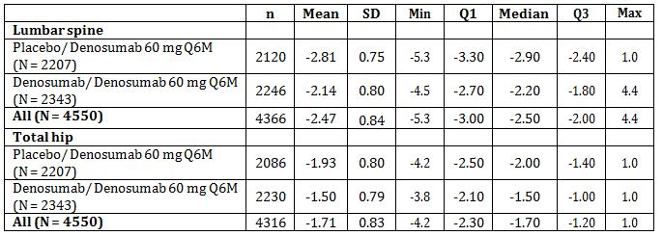
Treatment groups are the original randomized assignments in the 20030216 study; All subjects in the 20060289 study are to receive denosumab 60 mg Q6M.N = Number of subjects enrolled

Results for efficacy outcomes: Bone Mineral Density
BMD was assessed in all subjects at the lumbar spine and hip, and in a smaller subset of subject at the radius.
At 36 months the long term group experienced further statistically significant gains in BMD. The LS mean percent increase in BMD from the end of Study 20030216 (extension Study 20060289 baseline) was 4.9% at the lumbar spine, 1.8% at the total hip, 1.7% at the femoral neck, and 2.8% at the trochanter and 0.6% at the radius.
At month 36, the crossover group experienced further statistically significant increases in BMD; the LS mean percent increase in BMD from the end of Study 20030216 (extension Study 20060289 baseline) was 9.4% at the lumbar spine, 4.8% total hip, 4.0% at the femoral neck, 6.6% at the trochanter, and 1.2% at the radius (Figure 7).
Figure 7: Study 20060289 Bone Mineral Density Percent Change From Study 20030216 Baseline by Visit (Mean + 95% CI) (Long-term & Cross-over BMD Subsets, Observed Data) (Month 36 Interim Analysis).
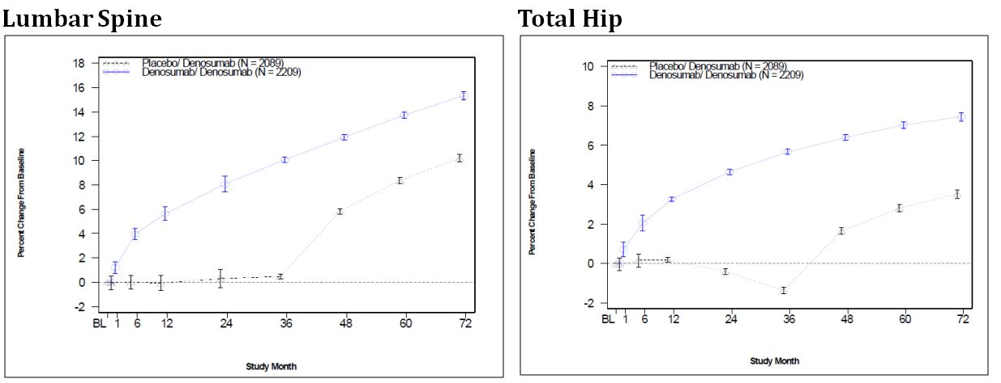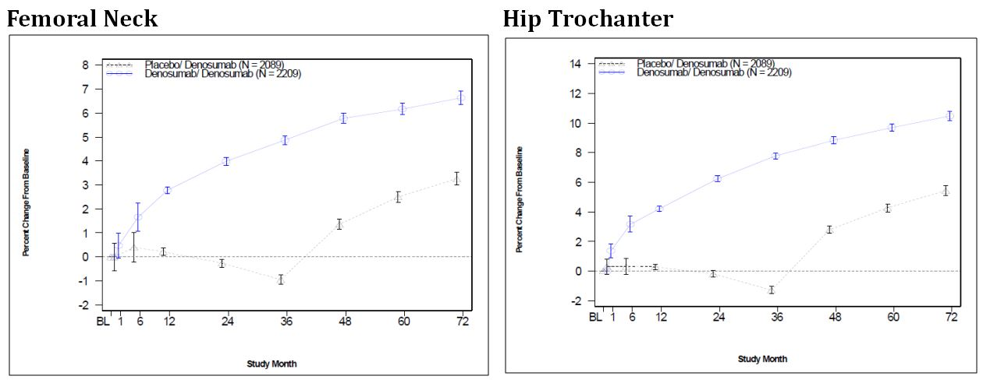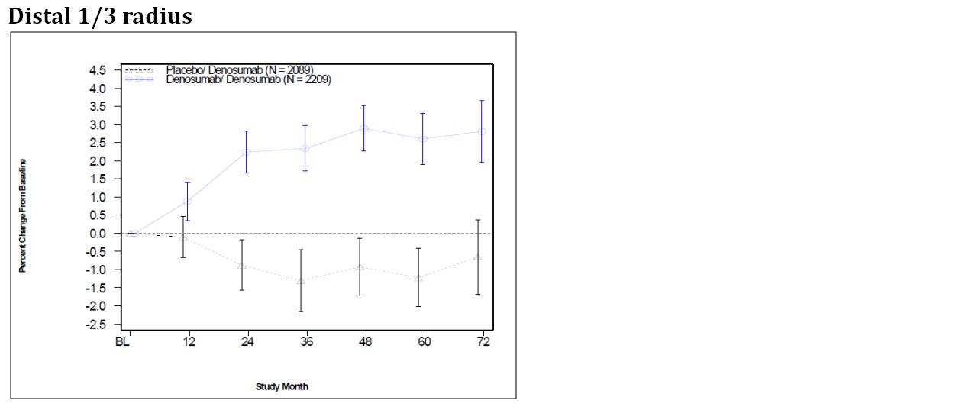
Data from study 20030216 start through 20060289 Month 36 Treatment groups are the original randomized assignments in the 20030216 study; all subjects in the 20060289 study receive denosumab 60 mg Q6M.
N = Number of subjects in the long-term & cross-over bone mineral density subsets
Study 20060289 baseline DXA BMD values were imputed when missing.
For each BMD location, subjects were required to have a study 20060289 baseline and at least one post-baseline DXA BMD measurement during study 20060289 to be included in the analysis.

Results for efficacy outcomes: Bone turnover markers
Denosumab administration in the long-term group resulted in rapid and marked reduction in serum CTX with a characteristic attenuation at the end of the dosing interval. The bone turnover markers CTX-1 and P1NP remained at reduced levels over 72 months of denosumab treatment (from the beginning of Study 20030216 to month 36 of the extension Study 20060289).
Denosumab administration in the crossover group resulted in rapid and marked reduction in serum CTX to levels similar to that observed in the long-term group. Reductions in serum P1NP and BSAP followed the reductions in serum CTX. The reductions in CTX and P1NP were similar to what was observed in the long-term group during the first 6 months of Study 20030216 (Figure 8).
Figure 8: Study 20060289 Percent Change in Serum P1NP and Serum CTX-1 from Study 20030216 Baseline by Visit (Median + IQR) (Long-term & Cross-over Bone Turnover Marker Subsets, Observed Data) (Month 36 Interim Analysis).
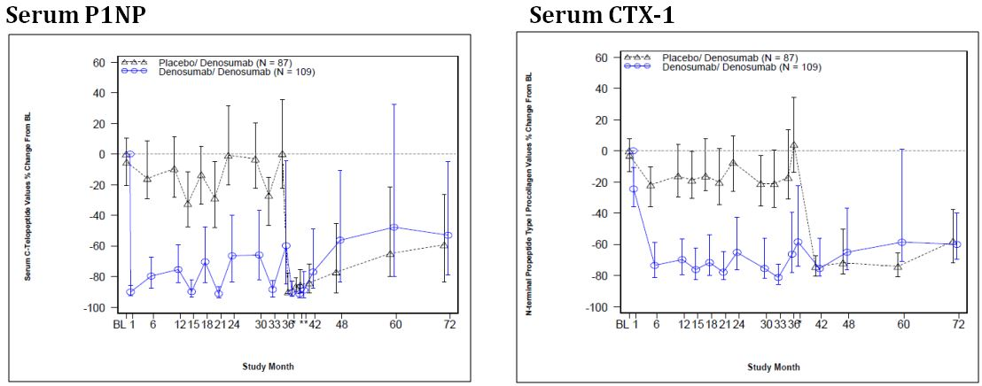
Treatment groups are the original randomized assignments in the 20030216 study;
All subjects in the 20060289 study are to receive denosumab 60 mg Q6M
N = Number of subjects in long-term & cross-over bone turnover marker subsets
* = Day 10
For each bone turnover marker, subjects were required to have a baseline and at least one post-baseline bone marker measurement to be included in the analysis.
Note: Interquartile range (IQR) is the difference between the third and first quartiles

Results for efficacy outcomes: Fractures (confirmed by X-ray)
Overall, 3.5% of subjects in the long term group had at least one new vertebral fracture by month 36 of the extension study compared to 2.8% in the cross over group.
The cumulative incidence of new vertebral fractures in Studies 20030216 and 20060289 for subjects in the long term group was 4.5%. This was lower than the incidence in the cross over group (7.3%).
The cumulative incidence of non-vertebral fractures in Studies 20030216 and 20060289 for subjects in the long term group was 9.9%. This was lower than the incidence in the cross over group (13.1%) (Table 9).
Table 9: Study 20060289: Incidence of Fracture at Month 36.
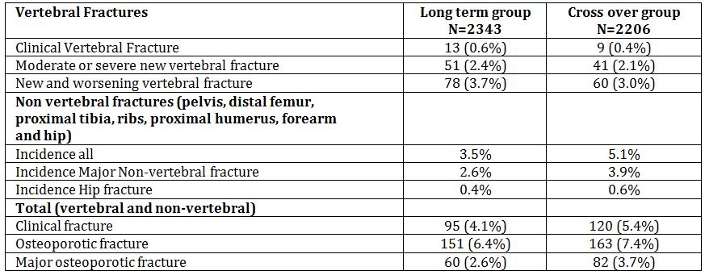

Results for efficacy outcomes: Bone biopsy sub-study at month 24
A total of 41 subjects (13 in crossover group and 28 in long term group) participated in the bone biopsy sub-study and had a transiliac crest bone biopsy at 24 months. All biopsies were evaluable for histology and 38/41 were evaluable for histomorphology. Demographics for this subset were comparable to that of the overall study population.
After 5 years (long-term subjects) or 2 years (crossover subjects) of treatment with denosumab, there was evidence of normal histology as evidenced by normal bone architecture, lamellar appearance, and mineralisation. There was no evidence of pathologic findings, including osteomalacia, woven bone, or marrow fibrosis. Five subjects in the long-term group did not have osteoid that could be visualised; samples for all 5 of these subjects were intact.
The antiresorptive mechanism of action of denosumab was associated with lower osteoclasts cell counts compared with placebo, as indicated by significantly decreased surface- and length-based osteoclast numbers. Since bone resorption and formation are coupled, indicators associated with bone formation also showed significant decreases with denosumab compared with placebo with lower osteoblast-osteoid interface, osteoid surface, and osteoid width. Structural indices, including cancellous bone volume, trabecular number, and surface were similar between the crossover and long-term groups.
Significant reductions in bone turnover observed during denosumab treatment were associated with a reduction in double and single tetracycline labels in the bone biopsy samples. Ten crossover subjects and 13 long-term subjects had specimens with double tetracycline label for histomorphometry (trabecular or cortical).
Of the 10 subjects with bone biopsies that showed no cortical or trabecular tetracycline label, there were no notable differences observed in the adverse event profile, including serious adverse events or incidence of fractures (no fractures reported), compared with those subjects with cortical and/or trabecular labelling.

Conclusions
- After up to 6 years of denosumab administration, the safety and tolerability profile of the subjects who participated in the extension study remains similar to that observed in the original 20030216 study
- Up to 36 months bone turnover markers are reduced in both groups
- BMD increased in the cross over group and continued to increase in the long term group
- The denosumab-treated group, experienced fewer vertebral and non vertebral fractures over 6 years (cumulative incidence) than the crossover group due to a lower incidence of fractures in the denosumab group compared with the placebo group in Study 20030216
- In the crossover group there was a prompt decrease in the incidence of vertebral fractures through 36 months of the extension study, which is consistent with what was observed in the denosumab-treated group of Study 20030216
- The incidence of non-vertebral fractures in the long-term group remains low through 36 months of the extension study, indicating a progressive and continued effect of denosumab. In the crossover group, the incidence of non-vertebral fractures through 36 months of the extension study was consistent with what was observed in the denosumab-treated group of Study 20030216
- Bone biopsies at month 24 showed normal bone histology (architecture, lamellar appearance, and mineralization) and anticipated decreases in bone remodelling due to the mechanism of action of denosumab

Study 20080747: A HR-pQCT Study in Postmenopausal Women Previously Treated with Denosumab.

Objectives

Primary objective
To evaluate the combined effect of denosumab treatment and discontinuation on cortical thickness at the distal radius by high resolution peripheral quantitative computed tomography (HR-pQCT).

Secondary objective
To evaluate the combined effect of denosumab treatment and discontinuation on the following:
- Select HR-pQCT parameters at the distal radius (total BMD, cortical BMD, trabecular BMD) and tibia (cortical thickness, total BMD, cortical BMD, trabecular BMD)
- BMD parameters assessed by DXA at the distal radius, ultradistal radius and total radius
- Changes in bone turnover markers from baseline.

Design
This was a cohort study enrolling approximately 75 subjects from the two centres (1 in Argentina and 1 in Canada) who were the major contributors to study 20050179. The subjects had received denosumab or placebo in study 20050179 and at least 12 months had elapsed from their end of study visit in the 20050179 study. Subjects in this study may also participate in the bone biopsy study 20080287. Subjects who signed the informed consent had HR-pQCT and DXA measurements. The study consisted of one visit for screening, enrolment and completion of study procedures (DXA, HR-pQCT and BTM). No study drug was administered during the course of the study. Study 20080747 was conducted from July 2009 to June 2010.
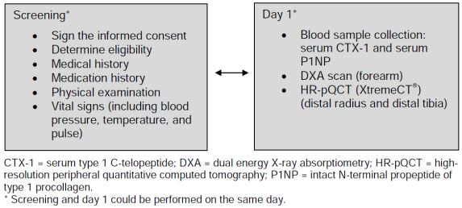
Comment: No details of study 20050179 are provided in the study report and so it is unclear from the study report how long the subjects were treated in study 20050179 but from the published AusPAR it was a multicentre, randomised, double-blind, double-dummy, placebo controlled study designed to estimate the effect of treatment with denosumab in postmenopausal women with low bone mass using in vivo microcomputed tomography in women with a lumbar spine or total hip BMD T-score of between minus 2.0 and minus 3.0. Subjects were randomised in a blinded 1:1:1 fashion to receive denosumab (83 patients), alendronate (82 patients) or placebo (82 patients). Treatment was continued for 12 months.

Inclusion and exclusion criteria

Inclusion criteria
- Ambulatory, postmenopausal women
- Randomised to either denosumab or placebo in the 20050179 study and completed that study (i.e. the subject attended an end-of-study visit)
- At least 12 months elapsed since their end of 20050179 study visit
- Provided signed informed consent

Exclusion criteria
- Subjects who failed to receive both doses of denosumab (or subcutaneous placebo) during the 20050179 study
- Subjects who were randomised to the alendronate arm during the 20050179 study
- Subjects diagnosed with any of the following conditions following completion of the 20050179 study:
  - Hyperthyroidism
  - Hyperparathyroidism
  - Malignancy within the last 5 years (except cervical carcinoma in situ or basal cell carcinoma)
  - Any condition that required chronic (greater than 3 months cumulative and greater than 5 mg/day) glucocorticoid therapy
  - Other diseases which affect bone metabolism
- Self-reported alcohol or drug abuse within the previous 12 months
- Any disorder that, in the opinion of the investigator, may compromise the ability of the subject to give written informed consent and/or comply with study procedures
- Received any investigational product other than denosumab in 2 years before the screening visit
- Received > 3 months (or equivalent) of osteoporosis treatment since having completed the 20050179 study
- Current use of the following osteoporosis agents: bisphosphonates, calcitonin, fluoride, parathyroid hormone analogue, selective oestrogen receptor modulators, systemic oral or transdermal oestrogen (except vaginal preparations and oestrogen creams which are acceptable), strontium, or tibolone
- Currently enrolled in or has not yet completed at least 1 month since ending other investigational device or drug trial(s), (except the bone biopsy study 20080287) or subject is receiving other investigational agent(s)

Treatments
No investigational drug was administered during the study. After subjects signed the informed consent before they underwent laboratory and imaging procedures.

Study endpoints

Primary endpoint
The percent change in cortical thickness at the distal radius as determined by the HR-pQCT from baseline (the baseline is as established in protocol 20050179).

Secondary endpoints
- Total, cortical and trabecular BMD as measured by HR-pQCT at the distal radius
- Cortical thickness and total, cortical and trabecular BMD as measured by HR-pQCT at the distal tibia
- 1/3 distal radius, ultradistal radius, and total radius BMD as determined by DTX
- Actual bone turnover marker (CTX-1 and P1NP) levels

Statistical methods
Efficacy analyses were performed on all enrolled subjects with available data for the parameter of interest. No adjustments were made for multiplicity. Because subjects self-selected to participate in this study, the Study 20050179 demographic and baseline characteristics were compared between those subjects from Study 20050179 who elected to participate in this study and those who did not. In addition, the baseline and demographic characteristics of subjects receiving bone loss medications after the end of Study 20050179 were compared between the subjects originally randomised to denosumab and placebo.
For the primary endpoint, summary statistics for the actual value, change, and percent change from 20050179 baseline are presented. An analysis of covariance model was fit with main effects for randomised treatment in Study 20050179, baseline value, time since last subcutaneous dose of denosumab or placebo in Study 20050179 as a continuous variable, and the age stratification from Study 20050179. Adjusted means and the corresponding 95% confidence intervals (CIs) at month 30, 32 and 34 since last subcutaneous dose in Study 20050179 are presented for the denosumab and placebo groups individually. Adjusted means, 95% CIs, and p-values for the comparison of denosumab to placebo (denosumab – placebo) are also provided.
Following the a priori proposed analyses, the assumption of linearity between time since last subcutaneous dose in Study 20050179 and response was assessed using a cubic term to represent the relationship. Additionally, the interaction between time since last subcutaneous dose in Study 20050179 and treatment group was investigated. These assessments led to 4 possible configurations of the time component in the model:
- Cubic time term with treatment-by-time interaction
- Cubic time term without treatment-by-time interaction
- Linear time term with treatment-by-time interaction
- Linear time term without treatment-by-time interaction
The model with the lowest corrected Akaike’s information criterion (AICc) was used as the primary model.
For the secondary endpoints, summary statistics for actual values, change, and percent change from baseline for the parameters derived by HR-pQCT and DXA are presented. These summaries were based on all enrolled subjects with available data. The same methodology as the primary analysis for the primary endpoint was used for analysing percent change of parameters derived by HR-pQCT and DXA.
Actual values of bone turnover markers (CTX-1 and P1NP) are summarised descriptively. An analysis of covariance model with the log transformed actual value for the bone turnover marker was fit with main effects for treatment, baseline value, time since last dose of denosumab or placebo in Study 20050179 as a continuous variable, and the age stratification from Study 20050179. The same methodology as the primary analysis for the primary endpoint was used.

Study participants
Enrolled: 79 (40 denosumab, 39 placebo)
Completed: 79
Analysed: 79

Demographics
A total of 75 (94.9%) subjects were enrolled at the site in Argentina and 4 (5.1%) subjects were enrolled at the site in Canada. Baseline demographics were balanced across both treatment groups. All subjects were women with median age of 64 years (range 53 to 73 years). 100% were white/Caucasian. The mean (SD) years since menopause was 17.0 (6.9) years. The mean (SD) months since last subcutaneous dose of denosumab in Study 20050179 was 32.1 (2.6) months. The mean (SD) height, weight, and BMI were 156.5 (6.0) cm, 67.84 (10.86) kg, and 27.7 (4.5) kg/m², respectively

Results: Primary endpoint
Cortical thickness of the distal radius assessed by HR-pQCT was 1.8% below pretreatment values at month 32 in subjects who received and discontinued denosumab. In comparison, cortical thickness at the distal radius was 5.5% below pretreatment values at month 32 in subjects who received placebo. The difference between the denosumab and placebo groups was 3.7% (95% CI: [-0.4, 7.8]; p = 0.0766).
Eighty percent of the subjects had evaluations between 29.5 and 34.9 months after their last dose of investigational product in Study 20050179. Two subjects had evaluations considerably earlier than the rest of the subjects, approximately 22 months since their last dose of investigational product in Study 20050179. To assess whether data from these 2 subjects exerted high influence on the prespecified models, outcomes were evaluated using Cook’s distance. A sensitivity analysis was conducted by removing subjects who had statistically-assessed high leverage or influence on the model fit (Cook’s distance ≥ 1). The sensitivity analysis showed similar results, with a treatment difference between denosumab and placebo or 1.9% (95%CI: -0.8, 4.6; p=0.1637).

Results: Secondary endpoints

Distal radius
Similar results were observed for cortical bone density and total bone density of the distal radius assessed by HR-pQCT. Cortical bone density was significantly higher (denosumab – placebo 0.9%; [95% CI: 0.1, 1.7; p = 0.0228]) and total bone density was numerically higher (denosumab – placebo 1.5%; [95% CI: -0.6, 3.5; p = 0.1648]) in subjects who received and discontinued denosumab compared with subjects who received placebo.

Distal tibia
HR-pQCT results at the distal tibia were consistent with results at the distal radius, with significantly higher total bone density (denosumab – placebo 2.6%; [95% CI: 0.9, 4.3; p = 0.0032]), and numerically higher cortical thickness (denosumab – placebo 1.8%; [95% CI: -0.1, 3.7; p = 0.0594]) and cortical bone density (denosumab – placebo 0.4%; [95% CI: -0.4, 1.2; p = 0.2897]) in subjects who received and discontinued denosumab compared with subjects who received placebo (Table 10).
Table 10: Study 20080747Month 32 Results of Primary and Secondary Percent Change Endpoints (ANCOVA Model) (Final Analysis).
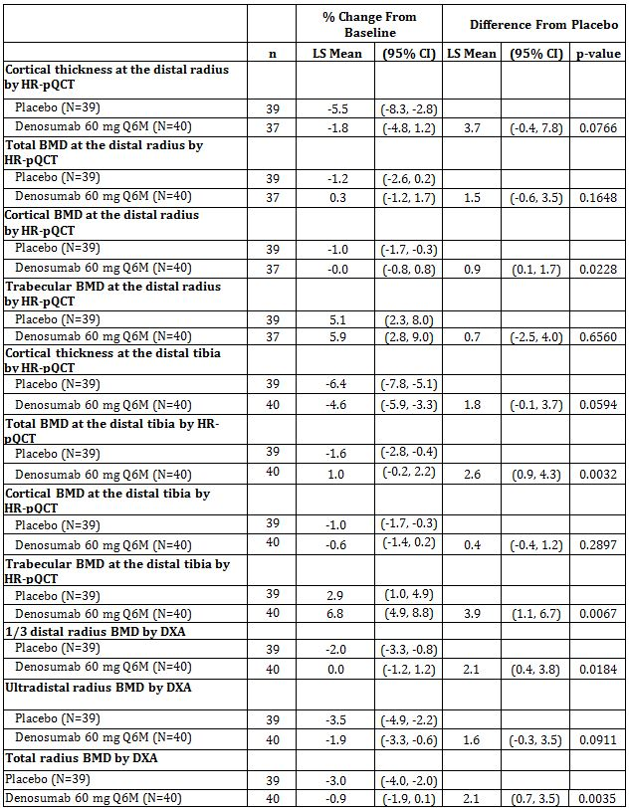
N = Number of subjects enrolled
n = Number of subjects with observed data and baseline
LS = Least squares

Results for efficacy outcomes: Trabecular BMD
Trabecular bone density assessed by HR-pQCT was also higher in the denosumab group compared with the placebo group at the distal radius (denosumab – placebo 0.7%; [95% CI: -2.5, 4.0; p = 0.6560]) and the distal tibia (denosumab – placebo 3.9%; [95% CI: 1.1, 6.7; p = 0.0067]). However, the trabecular bone densities at the distal radius and distal tibia for both the denosumab and placebo groups were higher than their respective Study 20050179 baseline values. This unexpected finding (i.e., that trabecular bone density did not decrease over time) could not be explained by shifts in machine calibration, and no other technological explanation could be identified to date to account for this observation.
DXA assessments of BMD had similar results. BMD was significantly higher at the 1/3 distal radius (denosumab – placebo 2.1%; [95% CI: 0.4, 3.8; p = 0.0184]) and the total radius (denosumab – placebo 2.1%; [95% CI: 0.7, 3.5; p = 0.0035]), and numerically higher at the ultradistal radius (denosumab – placebo 1.6%; [95% CI: -0.3, 3.5; p = 0.0911]) in subjects who received and discontinued denosumab compared with subjects who received placebo.

Results for efficacy outcomes: Bone turnover markers
Serum CTX-1, a marker of bone resorption, was 10% higher (densoumab/placebo 1.1; [95% CI: 1.0, 1.3; p = 0.0591]) and serum P1NP, a marker of bone formation, was 20% higher (denosumab/placebo 1.2; [95% CI: 1.0, 1.3; p = 0.0079]) in subjects who received and discontinued denosumab compared with subjects who received placebo.

Safety results
No SAEs (the only safety data collected) were reported during the study.

Conclusions
- Overall, the bone parameter gains (i.e., density, cortical thickness) and bone turnover marker reductions associated with denosumab administration are reversible upon denosumab discontinuation
- Bone parameters assessed by HR-pQCT and DXA at the distal radius and distal tibia generally returned to pretreatment levels, but remained above levels in the placebo group, following discontinuation of denosumab treatment in postmenopausal women with low BMD

Study 20080287: A Transiliac Crest Bone Histology and Histomorphology Study in Postmenopausal Women with Low Bone Mass or Osteoporosis Previously Treated with Denosumab.

Objectives
Primary objective was to characterise the effects of discontinuation of denosumab therapy on variables of bone histology in postmenopausal women with low bone mass or osteoporosis.
Secondary objectives were to characterise the effects of discontinuation of denosumab therapy on:
- Variables of bone histomorphometry in postmenopausal women with low bone mass or osteoporosis
- Level of the biochemical markers of bone turnover C-telopeptide (CTX-1) and procollagen type 1 amino-terminal porpeptide (P1NP)

Design
A randomised, double-blind, placebo controlled study conducted at 2 two sites – one in Canada and one in Argentina from June 2009 to June 2010.
This was a cohort study that enrolled subjects who had previously received denosumab in a completed study in post menopausal women. The study comprised a screening visit, 2 cycles of tetracycline (or tetracycline derivative) dosing, and a transiliac crest bone biopsy procedure, with a follow-up visit 7 days after the biopsy procedure. No study drug was administered. The duration of the study for each subject was between 32 and 41 days.
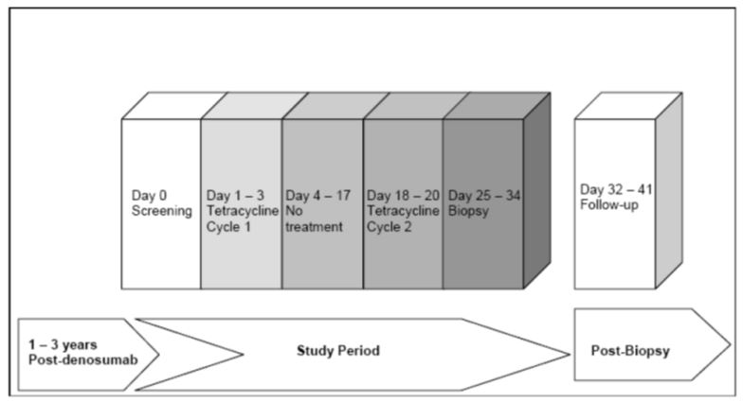

Inclusion and exclusion criteria

Inclusion criteria
Post menopausal women who had previously received denosumab and completed one of the following studies: 20050179, 20050141, 20060237 or study 20030216 (but not enrolled in the extension study 20060289). Subjects had to have completed participation in the eligible studies ≥ 12 and ≤ 36 months prior to screening.

Exclusion criteria
- received > 1 month osteoporosis treatment since having completed studies 20050141, 20060237, 20030216, or 20050179
- received zoledronic acid at any time after ending study participation in original studies
- subjects newly diagnosed with any of the following conditions during the intervening period since completing studies 20050141, 20060237, 20030216, or 20050179
  - hyperthyroidism (stable on anti-thyroid therapy or post-ablation is allowed if thyroid stimulating hormone is within the normal range)
  - hypothyroidism (stable on thyroid replacement therapy is allowed, if thyroid stimulating hormone is within the normal range)
  - hyper- or hypoparathyroidism
  - osteomalacia
  - Paget’s disease of bone
- other bone diseases that affect bone metabolism (e.g., osteopetrosis, osteogenesis imperfecta)
- malignancy within the last 5 years (except cervical carcinoma in situ or basal cell carcinoma)
- self-reported alcohol or drug abuse within the previous 12 months
- permanently non-ambulatory subjects (use of assistive device, e.g., cane, walker, is permitted)
- known or suspected sensitivity or contraindication to tetracycline derivatives
- received any investigational product other than denosumab
- current use of the following osteoporosis agents: bisphosphonates, calcitonin, fluoride, parathyroid hormone analogue, selective oestrogen receptor modulators, systemic oral or transdermal oestrogen (except vaginal preparations and oestrogen creams, which are acceptable), strontium, or tibolone
- has undergone bilateral transiliac crest bone biopsy in the past
- current use of medications that, in the opinion of the investigator, cannot be discontinued and may compromise the safety of the subject when undergoing the bone biopsy procedure (e.g., aspirin, warfarin, high-dose heparin)
- current use of systemic glucocorticoid therapy (topical or nasal steroids are permitted)
- evidence of coagulopathy that, in the opinion of the investigator, may compromise patient safety when subjected to the bone biopsy procedure

Treatments
No investigational drug was given in this study. Subjects had received denosumab 60 mg Q6M for periods from 1 to 3 years and had stopped therapy for at least 1 year and up to 3 years prior to entry to this study.

Data collection and analysis

Primary endpoint
- Bone histology as part to the qualitative assessment of bone

Secondary endpoints
- Bone histomorphology variables including cancellous bone volume, trabecular number, separation and thickness, cortical width, surface density, osteoblast-osteoid interface, osteoid surface, width and volume, mineralising surface, mineral apposition rate, adjusted apposition rate, bone formation rate, formation period, activation frequency and mineralisation lag time
- Biochemical markers of bone turnover, CTX-1 and P1NP

Study participants
Enrolled: 15 subjects were screened and all 15 were enrolled.
Completed: 15 subjects
Analysed: 5 of the enrolled subjects had originally participated in study 20050141, and 10 subjects had participated in study 20050179. Mean time since denosumab discontinuation (defined as 6 months after last denosumab injection to first tetracycline labelling cycle) was 25.1 months and ranged from 21 to 29 months. All subjects had previously received 1 year of denosumab treatment in the original studies.

Statistical methods
No formal hypothesis was tested in this study. All analyses were descriptive in nature. The sample size of 15 was based on what was considered common for studies involving bone biopsies to evaluate bone histology and histomorphometry variables.

Baseline Data
All subjects were women and white/Caucasian. Mean (SD) age was 62.1 (5.9) years and 5 subjects (33.3%) were ≥ 65 years of age. Mean (SD) years since menopause was 15.8 (7.9) years. Mean (SD) weight and BMI were 63.66 (10.24) kg and 26.7 (3.6) kg/m², respectively.

Results
All subjects’ biopsies were evaluable for histology and showed normal histology, defined as normal lamellar bone and mineralisation, without evidence of osteomalacia, woven bone, or marrow fibrosis.
14/15 subjects had biopsies that were evaluable for histomorphology, one specimen had crush artefact and was not evaluable. Thirteen specimens had double label in trabecular and cortical bone, and 1 specimen had single label in trabecular bone and double label in the cortical compartment. The specimen with crush artefact had evidence of single label in trabecular bone and no label in cortical bone.
Values for static and dynamic histomorphology variable were generally within the range as compared with the placebo treated postmenopausal women in Study 20030216.
The biochemical markers of bone turnover CTX-1 and P1NP had returned to levels similar to those seen at baseline in the original studies 20050141 and 20050179. Approximately 2 years after discontinuing treatment with denosumab and without starting new treatment for osteoporosis, the median value (Q1, Q3) for CTX-1 was 0.646 mg/mL (0.494, 0.789), compared with the original study baseline of 0.573 ng/mL (0.471, 0.646) and the median (Q1, Q3) for P1NP was 50.70 μg/L (40.80, 58.90) compared with the original study baseline of 43.08 μg/L (37.60, 50.34) (Figure 9-10).
Figure 9: Study 20080287 Actual Value of Serum CTX-1 During Parent Studies and Off-treatment Biopsy Study, Median and Interquartile Range, (Primary Analysis Subset) (Final Analysis).
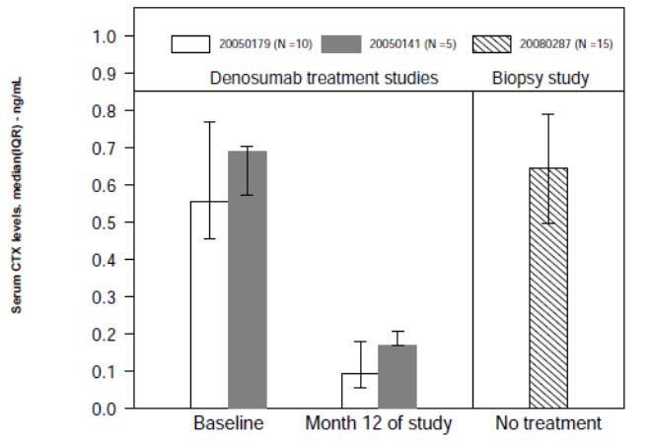
Figure 10: Study 20080287 Actual Value of P1NP During Parent Studies and Off-treatment Biopsy Study Median and Interquartile Range (Primary Analysis Subset) (Final Analysis).
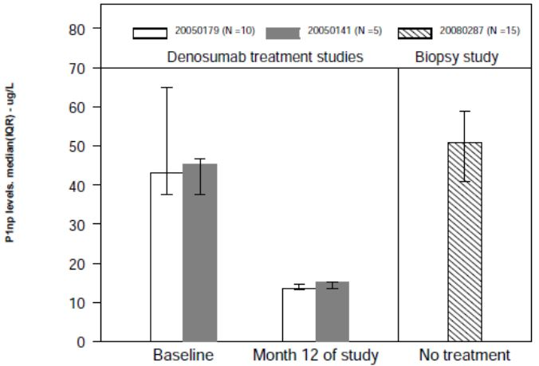

Conclusion
The effects of denosumab on bone remodelling, as assessed by biochemical markers on bone turnover and histomorphology, are reversible. The data suggest that subjects who discontinue denosumab return to pretreatment levels of bone remodelling. Bone histology does not show evidence of pathology with treatment discontinuation.

Analyses performed across trials (pooled & meta-analyses)
The applicant has compared the results of study 20080098 with those from two studies previously submitted and evaluated but not submitted in this dossier: Studies 20030216 and 20040138.

Study 20030216
Study 20030216 was an international, multicentre randomised, double blind, placebo controlled study in women with postmenopausal osteoporosis. Effects on fracture incidence and BMD were evaluated. A substudy examined the effect of denosumab, compared with placebo, on BMD measured at the lumbar spine, proximal femur (total hip, femoral neck, trochanter), distal radius, and total body (without head) in 441 subjects (232 denosumab, 209 placebo) at different time points, including at 12 months of therapy. Subjects were randomised (1:1) to receive either placebo or denosumab 60 mg SC Q6M for a total of 6 doses over the 36-month treatment period, followed by a separate 7-year open-label extension study (Study 20060289). All subjects were instructed to take daily supplemental calcium (≥ 1 g) and vitamin D (≥ 400 IU).

Study 20040138
Study 20040138 was an, international, multicenter, randomised, double-blind, placebo-controlled study in men with non metastatic prostate cancer who were undergoing androgen deprivation therapy (ADT). Effects on fracture incidence and BMD were evaluated. Subjects were randomised (1:1) to receive either placebo or denosumab 60 mg SC Q6M for a total of 6 doses over the 36-month treatment period, followed by a 24-month safety follow-up period or enrolment in a separate 2-year open-label extension study (Study 20080537). All subjects were instructed to take daily supplemental calcium (≥ 1 g) and vitamin D (≥ 400 IU).

Baseline Bone Mineral Density (BMD)
Baseline BMD T-scores for lumbar spine, total hip, femoral neck, trochanter, and distal radius were generally similar between treatment groups within each study.
The distal radius BMD T-score was slightly lower in the placebo group than in the denosumab group in Study 20080098.
Consistent with the eligibility criteria for these studies, the mean baseline BMD T-scores in Study 20030216 were lower than those in Study 20080098, which were generally lower than those in Study 20040138.
- For Study 20030216, BMD T-score at the lumbar spine or total hip had to be < -2.5 at either site and ≥ 4.0 at both sites
- For Study 20040138, subjects had to be ≥ 70 years of age or < 70 years of age with either a history of osteoporotic fracture or a BMD T-score < -1.0 at the lumbar spine, total hip, or femoral neck
- To be included in Study 20080098, subjects had to have BMD equivalent to a T-score of ≤ -2 and ≥ -3.5 at the lumbar spine or femoral neck or ≤ -1 and ≥ -3.5 at the lumbar spine or femoral neck with a history of major osteoporotic fracture (Figure 11).
Figure 11: Distribution of Baseline Lumbar Spine BMD T-scores for Studies 20080098, 20030216 and 20040138.
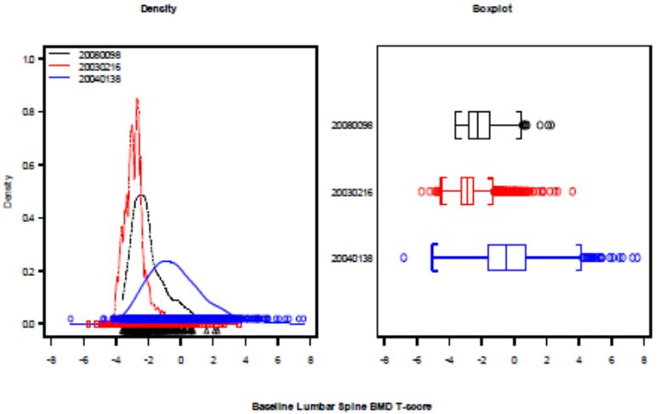

Baseline prevalent fracture risk
Since prevalent vertebral fractures predict the risk of future fractures to a similar extent in both men and women, the presence of prevalent vertebral fractures was examined at baseline in each of the 3 studies. The proportion of subjects with prevalent vertebral fractures was numerically higher in the denosumab group than in the placebo group in Study 20080098 and similar between treatment groups in the other 2 studies. The difference in Study 20080098 is likely due to the sample size being much smaller than in Studies 20030216 and 20040138. Overall, among the 3 studies, the proportion of subjects having prevalent vertebral fractures at baseline ranged from 20.7% to 24.8%.

Baseline 10 year fracture risk
Ten-year fracture probability was assessed with the FRAX tool (version 3.3) in all subjects in Study 20080098 before study unblinding. FRAX is a computer-based algorithm that provides country/ethnicity-specific models for the assessment of fracture probability in men and women.
The estimate of probability can be calculated with clinical risk factors alone, or additionally with baseline femoral neck BMD. The clinical risk factors used for the calculation include sex, age, BMI, a prior fragility fracture, parental history of hip fracture, current tobacco smoking, ever long-term use of oral glucocorticoids, rheumatoid arthritis, other causes of secondary osteoporosis, and daily alcohol consumption of 3 or more units daily.
The 10-year fracture risk for both major osteoporotic and hip fractures was similar between treatment groups in each of the 3 studies. Including femoral neck BMD in the calculation, the median (interquartile range) 10-year risks of major osteoporotic fracture and hip fracture were:
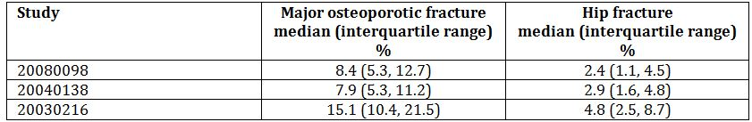
The distribution of fracture risk in Study 20080098 shows a considerable overlap with the distributions seen in 2 previous studies where reduction of fracture rate was shown with denosumab treatment (Figure 12).
Figure 12: Distribution of 10 Year Major Osteoporotic Fracture Risk (with femoral neck BMD included in the FRAX Calculation) for studies 20080098, 20030216 and 20040138.
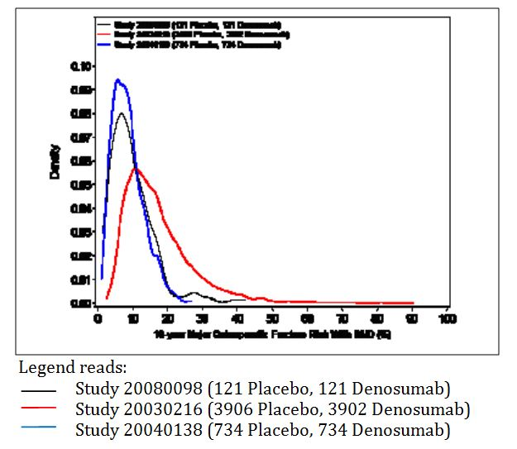

Comparison of Bone Mineral Density results
The difference in mean percent change in BMD at the lumbar spine between the denosumab and placebo treatment groups in Study 20080098 (4.8 %) was similar to the increases observed in Studies 20030216 (5.5 %) and Study 20040138 (4.9 %), and the absolute changes from baseline were similar at all anatomical sites examined. These results indicate a similar treatment effect of denosumab across all 3 studies (Table 11).
Table 11: Summary of Bone Mineral Density by DXA Percent Change From Baseline at Month 12 by Site (ANCOVA Model with LOCF).
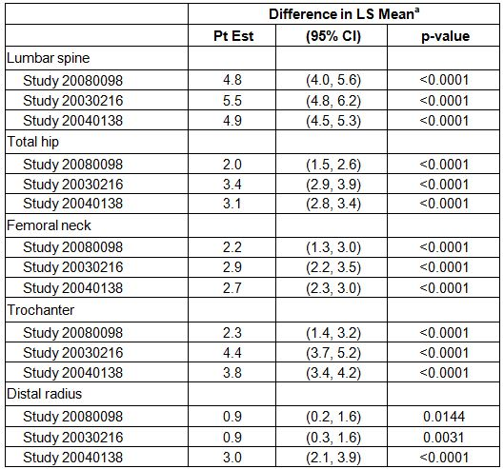
Number of subjects randomised in Study 20080098: 121 placebo and 121 denosumab
Number of subjects enrolled in Study 20030216 DXA substudy: 209 placebo and 232 denosumab
Number of subjects randomised in Study 20040138: 734 placebo and 734 denosumab
Number of subjects enrolled in DXA substudy: 148 placebo and 161 denosumab
LS = Least squares; Pt Est = Point estimate; Difference = Denosumab – Placebo
a. Based on an ANCOVA model adjusting for treatment and baseline BMD T-score level for Study 20080098; treatment, baseline BMD, machine type, and baseline BMD-by-machine type interaction for Study 20030216; and treatment, age group, ADT duration at study entry, baseline BMD, machine type, and baseline BMD-by-machine type interaction for Study 20040138

Serum CTX1
Denosumab significantly reduced bone resorption, as assessed by decreases in serum CTX1 concentrations, in Studies 20080098, 20030216, and 20040138. When adjusted for the LLOQ of the assays median percent changes from baseline in serum CTX1 concentrations were similar in all 3 studies.

Conclusion
In Studies 20030216 and 20040138, significant increases in BMD were observed at all skeletal sites measured (lumbar spine, proximal femur [total hip, femoral neck, trochanter], and distal radius). In Study 20030216, the primary efficacy analysis demonstrated the efficacy of denosumab at decreasing fracture risk, with relative risk reductions at month 36 for new vertebral, non vertebral, and hip fractures of 68%, 20%, and 40%, respectively. A decrease in fracture risk was also observed in Study 20040138, with a 62% decrease in the incidence of new vertebral fractures in the denosumab group relative to the placebo group at month 36.
Studies 20030216 and 20040138 demonstrated that increases in BMD with denosumab 60 mg Q6M are associated with decreases in the risk of fracture. Mean increases in BMD in Study 20080098 were similar to the mean increases in BMD in Studies 20030216 and 20040138 at month 12. Since increases in BMD were associated with fracture risk reduction in Studies 20030216 and 20040138, it is reasonable to extrapolate the anti-fracture efficacy of denosumab 60 mg Q6M to men with osteoporosis.

Evaluator’s conclusions on clinical efficacy for osteoporosis in men
Overall, while Study 20080098 was only for 12 months (only 2 injections of denosumab) and the analysis was a modified Intent To Treat (ITT), the results did show increases in bone mineral density (BMD) that were comparable to that seen in postmenopausal women.
The European Union (EU) guideline for the treatment of osteoporosis in men where an indication for osteoporosis in postmenopausal women has been approved requires the following conditions to be met:
- The duration of the study is at least one year.
The study duration was 12 months.
- The dosage is justified.
The dose was the same as that used in women and men with prostate cancer receiving androgen deprivation therapy.
- The applicant justifies the cut off of BMD, age and any other risk factor open for the inclusion of men in the pivotal study will generate a fracture risk of a similar magnitude compared with postmenopausal women that were recruited in the studies used to obtain the indication ‘treatment of postmenopausal osteoporosis in women at high risk of fractures’.
Eligible subjects in the pivotal study (20080098) were men 30 to 85 years of age, inclusive, with BMD values that corresponded to a T-score ≤ -2 and ≥ -3.5 at the lumbar spine or femoral neck or ≤ -1 and ≥ -3.5 in subjects with a history of major osteoporotic fracture, no vertebral or clinical fracture in the 6 months prior to screening, and no recent exposure to bisphosphonates or other medications known to affect bone metabolism. The proportion of subjects with a prevalent vertebral fracture at baseline based on spine radiographs was 24.8% in the denosumab group and 20.7% in the placebo group.
The details of the pivotal study in postmenopausal women (20030216) are not provided in the submission; however, according to the current PI, the entry criteria for the trial was postmenopausal women aged 60 to 91 years of age with BMD T-scores at the lumbar spine or total hip between -2.5 and -4.0, of which 23.6% has prevalent vertebral fractures.
- The magnitude of the changes in BMD versus placebo is similar to that observed in postmenopausal osteoporotic women treated with the same compound and is globally proportional to the decreased incidence of fractures in treated women.
Denosumab effectively increased BMD, as assessed by dual energy X ray absorptiometry (DXA) at the lumbar spine, total hip, femoral neck, trochanter, and distal radius in men with low BMD. The mean change in lumbar spine BMD after 12 months of treatment was large (5.7% in the denosumab group as compared with 0.9% in the placebo group [p < 0.0001]).
The magnitudes of the mean BMD increases observed in Study 20080098 were similar to those observed in Studies 20030216 and 20040138 at 12 months.
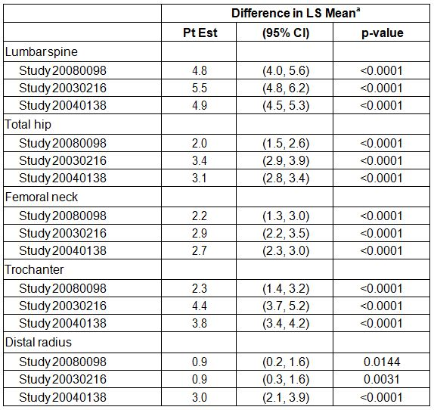
In Study 20030216, the primary efficacy analysis demonstrated the efficacy of denosumab at decreasing fracture risk, with relative risk reductions at month 36 for new vertebral, non vertebral, and hip fractures of 68%, 20%, and 40%, respectively. A decrease in fracture risk was also observed in Study 20040138, with a 62% decrease in the incidence of new vertebral fractures in the denosumab group relative to the placebo group at Month 36.
Decrease in fracture risk was not an efficacy outcome in Study 20080098 but clinical fractures were reported by the investigators and confirmed by the central imaging vendor for 1 subject in the denosumab group (0.8%) and 2 subjects in the placebo group (1.7%). New (morphometric) vertebral fractures were reported for no subjects in the denosumab group and 1 subject in the placebo group (0.8%).
Overall, it is considered that the EU criteria have been met.
It is noted that according to the EU guideline the indication should be “treatment of osteoporosis in men at high risk of fracture”.
Whether the indication should be limited by qualification of the BMD and/or BMD is uncertain – this does not appear to have been the practice with the indication for post menopausal women. If deemed necessary, then it should match the criteria for entry to the study.

Clinical safety
Comment: The Summary of Clinical Safety presents the data from the pivotal study in men with osteoporosis (20080098) and compares it to two other studies not included in the submission: Study 20030216 a 3 year randomised, double blind, placebo controlled study of 7808 women with postmenopausal osteoporosis and Study 20040138 a 3 year randomised, double-blind study in men receiving androgen deprivation therapy for prostate cancer.
No information is provided in the summary on the 2 safety studies presented in the submission: Study 20050233 which is a report of the first 3 years of the open label, single arm extension study of Study 20010223 and Study 20060289 which is a report of the first 3 years of the open label, single arm extension study of Study 20030216.
As the original studies 20030216 and 20040138 have been previously evaluated they were not available to the evaluator. The results presented below are for the studies presented in the submission with reference to the summary where relevant.

Studies providing evaluable safety data
The following studies provided evaluable safety data:

Pivotal efficacy study – men with osteoporosis
In the pivotal efficacy study, the following safety data were collected:
- General adverse events (AEs) whether or not considered to be related to the investigational product, were collected in the case record forms (CRF). Monitoring by the sponsor included daily review of serious adverse events (SAEs); monthly review of aggregate safety data; quarterly review of pooled safety data, including adverse events and laboratory results; and ad hoc review of other safety data, as determined by the sponsor’s Global Development Team or Global Safety Team
- AEs of particular interest, including hypoglycaemia, osteonecrosis of jaw and avascular necrosis at other sites, infections, hypersensitivity, malignancy and incidence and healing of fractures were assessed by review of the adverse events reported
- Laboratory tests, including albumin corrected calcium and phosphorus, were performed at baseline, Day 15 and at 6 and 12 months

Pivotal studies that assessed safety as a primary outcome
No pivotal studies assessed safety as a primary outcome.

Non-pivotal efficacy studies – women with postmenopausal osteoporosis
The non-pivotal efficacy studies provided safety data, as follows:
- Study 20060289 provided data on adverse events, immunogenicity and safety laboratory parameters.
- Study 20050233 provided data on incidence of serious adverse events, adverse events and safety laboratory parameters.
- Studies 20080747 and 20080287 did not provide safety data as they did not involve further treatment with denosumab.

Studies that assessed safety as a primary outcome
No studies were provided that assessed safety as a primary outcome in men with osteoporosis.
The studies 20050233 (extension study of 20010223) and 20060289 (extension study of 20030216) that assessed safety as a primary outcome in women with osteoporosis are described in the efficacy section. The safety data from these studies is presented in the next section.

Patient exposure
Summaries are shown in Table 12.
Table 12: Exposure to Denosumab and comparators in clinical studies.
Pivotal Study 20080098
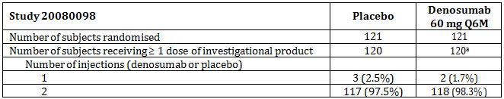
a. Number of subjects receiving ≥ 1 dose of denosumab regardless of randomised treatment group
Postmenopausal women with osteoporosis
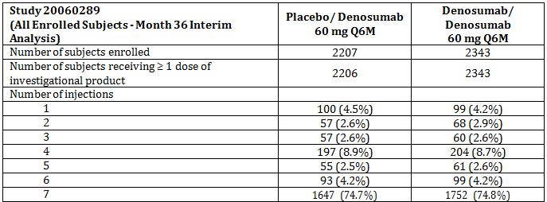
Treatment groups are the original randomized assignments in the 20030216 study; all subjects in the 20060289 study are to receive denosumab 60 mg Q6M.
Study 20050233 enrolled subjects
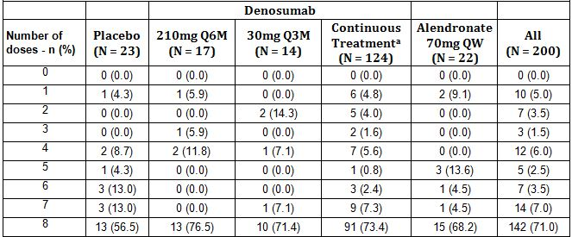
Treatment groups are the original assignments in the 20010223 study; All subjects in 20050233 were to receive denosumab 60mg Q6M
N = Number of subjects enrolled in 20050233
a. Includes denosumab 6 mg Q3M, 14 mg Q3M, 14 mg Q6M, 60 mg Q6M, and 100 mg Q6M dose groups

Adverse events

All adverse events (irrespective of relationship to study treatment)

Pivotal study 20080098
Most subjects in each treatment group (72% denosumab, 70% placebo) experienced ≥ 1 adverse event during the 12-month double-blind phase, with the most common events being categorised within the system organ classes of musculoskeletal and connective tissue disorders (28% denosumab, 26% placebo) and infections and infestations (20% each group). By preferred term, the most frequently experienced adverse events (≥ 5% in either treatment group) were back pain (8% denosumab, 7% placebo), arthralgia (7% denosumab, 6% placebo), nasopharyngitis (7% denosumab, 6% placebo), and constipation (0 denosumab, 6% placebo) (Table 13).
Table 13: Study 20080098 Adverse Events by System Organ Class and Preferred Term in Descending Order of Frequency (Safety Analysis Set) (First 12 Months Analysis).
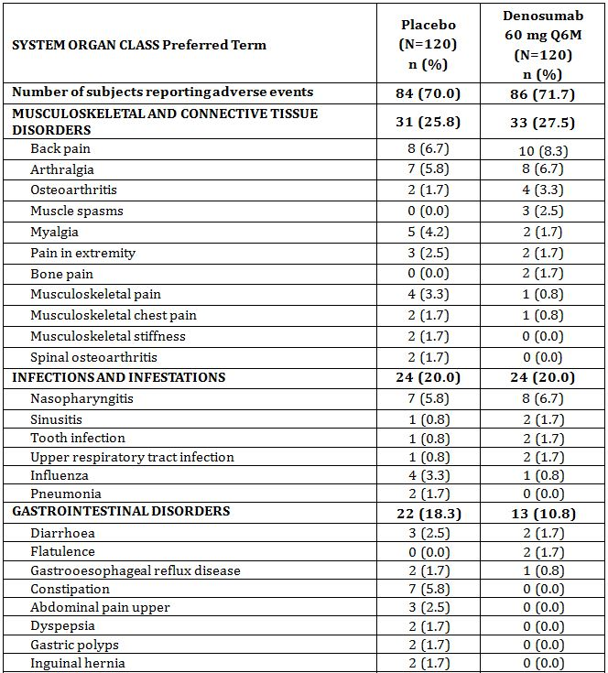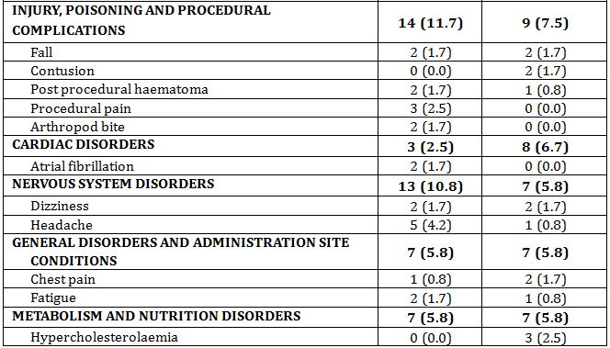
Table 13 (continued): Study 20080098 Adverse Events by System Organ Class and Preferred Term in Descending Order of Frequency (Safety Analysis Set) (First 12 Months Analysis).
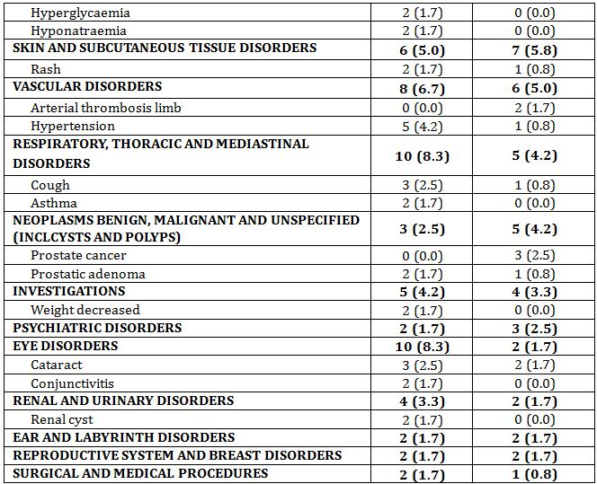
N = Number of subjects who received ≥ 1 dose of investigational product
n = Number of subjects reporting ≥ 1 event
System organ classes and preferred terms are sorted by descending order of frequency in the denosumab group and coded using MedDRA version 14.0.

Other studies

Study 20050233 (Extension of Study 20010223)
The majority of subjects (92.0%) reported adverse events over the course of the 4-year treatment period. The most frequently reported AEs were upper respiratory tract infection (22.5%), Arthralgia (18.5%), back pain (12.5%) and hypertension (12.5%). Overall, the types and incidence of adverse events were not unexpected over a 4-year period in this subject population (Table 14).
Table 14: Study 20050233 Related Adverse Events Reported in 2 or More Subjects During the 48-month Treatment Period by Descending Order and Preferred Term for Pooled Groups, Safety Analysis Set.
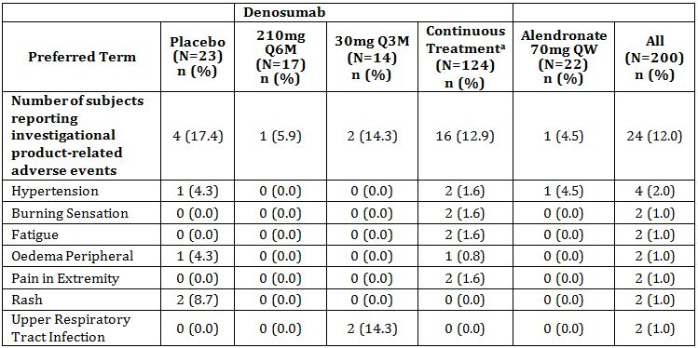
Treatment groups are the original assignments in the 20010223 study; all subjects in 20050233 were to receive denosumab 60mg Q6M
N = Number of subjects who received ≥1 dose of denosumab during study;
n = Number of subjects reporting ≥1 event
Includes only treatment-emergent adverse events
Preferred terms are sorted by descending order of frequency in all dose groups combined Coded using MedDRA version 14.0
a. Includes denosumab 6 mg Q3M, 14 mg Q3M, 14 mg Q6M, 60 mg Q6M, and 100 mg Q6M dose groups

Study 20060289 (Extension of Study 20060289)
During the initial 36 months of extension Study 20060289, 181.6 adverse events per 100 subject years were reported among all subjects enrolled into the study; 179.0 adverse events per 100 subject years were reported in the long-term group and 184.3 adverse events per 100 subject years were reported in the crossover group). This was lower than in the original study (235.1 per 100 subject years in the denosumab and 237.3 per 100 subject years in the placebo arm).
The most commonly reported subject-year-adjusted AEs (> 4 events per 100 subject years) from all subjects in the extension study were arthralgia (6.9 events per 100 subject years), back pain (6.6 events per 100 subject years), hypertension (5.6 events per 100 subject years), nasopharyngitis (4.9 events per 100 subject years), and osteoarthritis (4.6 events per 100 subject years) (Table 15).
Table 15: Study 20060289 Investigational Product-related Adverse Events Leading to Study Discontinuation by System Organ Class and Preferred Term in Descending Order of Frequency (Safety Analysis Set) (Month 36 Interim Analysis).
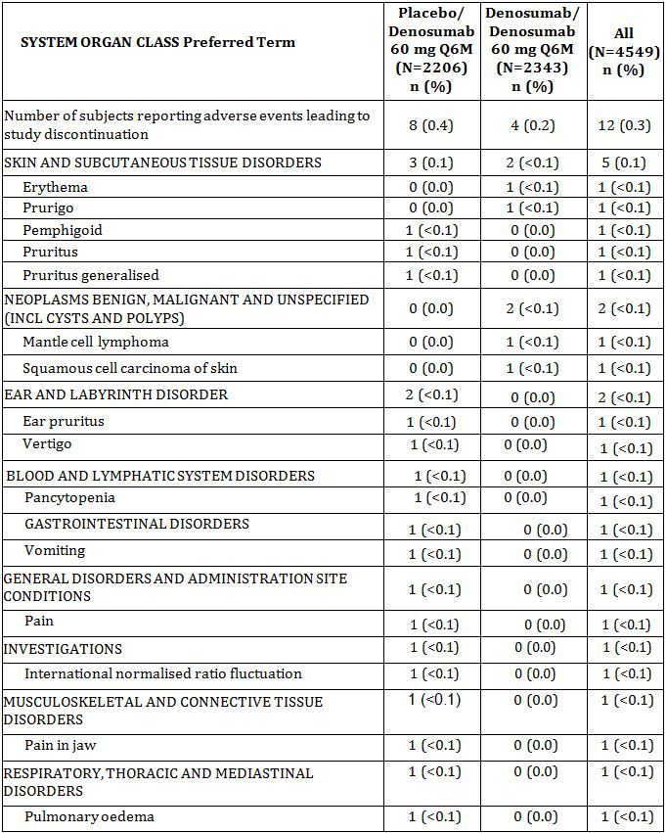
Treatment groups are the original randomized assignments in the 20030216 study; All subjects in the 20060289 study are to receive denosumab 60 mg Q6M.
N = Number of subjects who received ≥ 1 dose of investigational product n = Number of subjects reporting ≥ 1 event
Includes only treatment-emergent adverse events for which the investigator indicated there was a reasonable possibility they may have been caused by investigational product
System organ classes and preferred terms are sorted by descending order of frequency in the 'All' column and coded using MedDRA version 14.0.

Treatment-related adverse events (adverse drug reactions)

Pivotal study 20080098
The incidence of adverse events considered by the investigator to be related to investigational product was 1.7% (2 subjects) in the denosumab group and 5.0% (6 subjects) in the placebo group. No single treatment-related adverse event was experienced by > 1 subject within either treatment group, although treatment-related arthralgia was noted in 1 subject in each treatment group. No treatment-related adverse event satisfied the criteria of a serious adverse event.

Other studies

Study 20050233 (Extension of Study 20010223)
Adverse events that were considered by the investigators to be related to denosumab therapy were reported for 12.0% of subjects during the 48-month treatment period. The most frequently reported related adverse event was hypertension (4 [2.0%]). Few related adverse events were reported in more than 1 (0.5%) subject. The most common categories of related adverse events were general disorders and administration site conditions (3.5%) and nervous system disorders (3.0%).

Study 20060289 (Extension of Study 20030216)
A total of 278 (6.1%) subjects (136 [5.8%] subjects in the long-term group and 142 [6.4%] subjects in the crossover group) experienced adverse events that were considered by the investigator to be related to denosumab. The most common adverse events that were considered by the investigator to be related to denosumab were pain in extremity (0.4%), nasopharyngitis (0.3%), headache (0.3%), arthralgia (0.3%), and nausea (0.3%).

Deaths and other serious adverse events

Pivotal study 20080098

Deaths
Two subjects died during the first 12 months of study 20080098 (1 subject in each treatment group):
- One subject experienced a myocardial infarction 110 days after receiving his first dose of denosumab and died 44 days after the onset of this serious adverse event
- One subject received 1 dose of placebo and experienced a SAE of basilar artery thrombosis 59 days later; and died 3 days after the onset of the thrombosis
Neither death was reported by the investigator as being related to investigational product.

Serious Adverse Events (SAEs)
In total, 11 denosumab-treated subjects (9%) and 10 placebo-treated subjects (8%) experienced SAEs during the first 12 months of the study.
None of the SAEs was considered by the investigator to be related to blinded investigational product. The only SAEs reported for > 1 subject within either treatment group were prostate cancer and arterial thrombosis limb, respectively reported for 3 subjects (3%) and 2 subjects (2%) in the denosumab group, and no subjects in the placebo group.
With respect to the cases of prostate cancer, 2 of the 3 cases were likely present at baseline, based on subject medical histories. Additionally, both subjects who experienced arterial thrombosis had medical histories remarkable for arterial insufficiency and prior vascular surgical intervention (Table 16).
Table 16: Study 20080098 Serious Adverse Events by Preferred Term in Descending Order of Frequency (Safety Analysis Set) (First 12 Months Analysis).
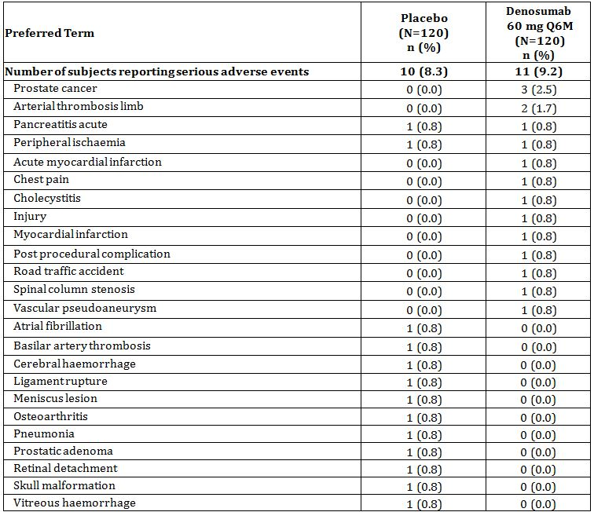
N = Number of subjects who received ≥ 1 dose of investigational product.
n = Number of subjects reporting ≥ 1 event
Includes only treatment-emergent adverse events
Preferred terms are sorted by descending order of frequency in the denosumab group and coded using MedDRA version 14.0.

Other studies

Study 20050233 (Extension of Study 20010223)

Deaths
A total of 9 subjects died during the study, 8 of whom died during the study period and one who died after study discontinuation due to a reported adverse event. One of the nine subjects died after withdrawing from the study due to non-small cell lung cancer stage IIIB. Most of the deaths were due to cardiac disorders or neoplasms, which were not unexpected in this subject population, and are summarised in Table 17. None of the deaths were considered related to denosumab treatment by the investigators.
Table 17: Fatal Adverse Events During the 48-month Treatment Period of Study 20050233 by Preferred Term and Pooled Group, Safety Analysis Set.
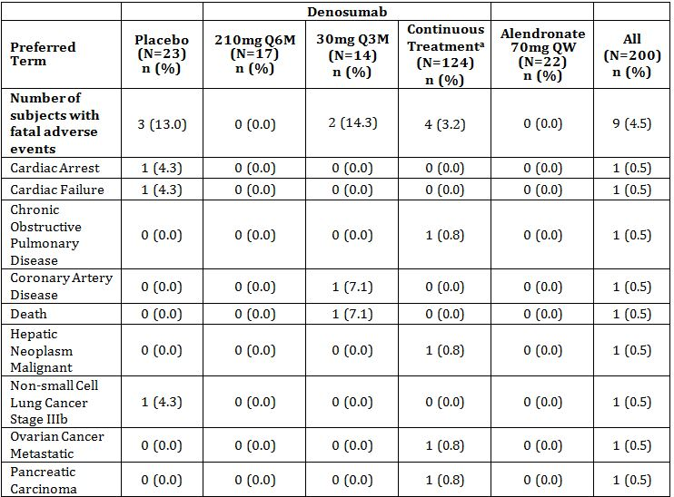
Treatment groups are the original assignments in the 20010223 study; all subjects in 20050233 were to receive denosumab 60mg Q6M
N = Number of subjects who received ≥1 dose of denosumab during study;
n = Number of subjects reporting ≥1 event
Includes only treatment-emergent adverse events
Preferred terms are sorted by descending order of frequency in all dose groups combined and coded using MedDRA version 14.0
a. Includes denosumab 6 mg Q3M, 14 mg Q3M, 14 mg Q6M, 60 mg Q6M, and 100 mg Q6M dose groups
One (0.5%) subject died during the first year of Study 20050233 due to unknown causes (event listed as “death”). This subject had a history of hypertension and had been randomised to the retreatment group (denosumab 30 mg Q3M) in parent Study 20010223. The subject received 2 doses of denosumab during the extension Study (20050233) and died unexpectedly 3 weeks after the last dose. The fatal event was considered unrelated to denosumab therapy. Attempts to collect further information regarding the death were unsuccessful.

Serious Adverse Events
SAEs were reported in 22.5% of subjects although only 2.0% were considered related to denosumab therapy and only 1 (0.5%) occurred in more than 1 subject. Osteoarthritis (4 [2.0%]), non-cardiac chest pain (3 [1.5%]), and pneumonia (3 [1.5%]) were the most frequently occurring serious adverse events (Table 18).
Table 18: Serious Adverse Events During 48-month Treatment Period of 20050233 in Descending Order of Frequency by Preferred Term and Pooled Group, Safety Analysis Set.
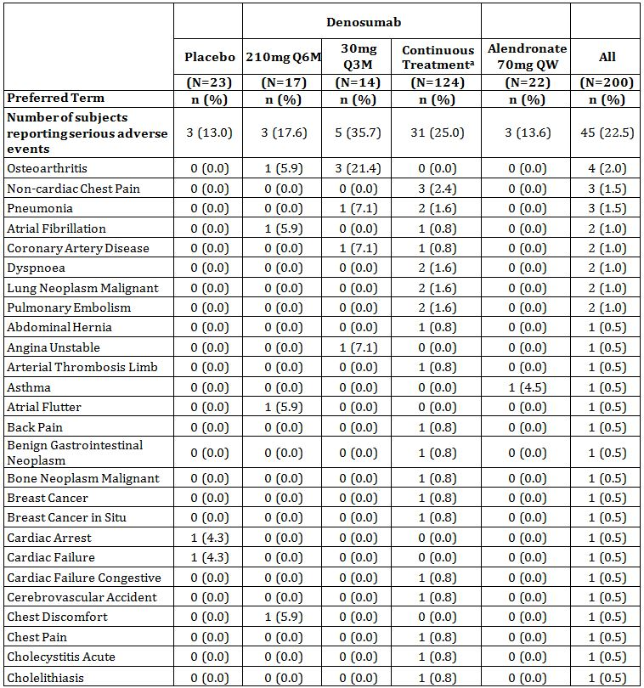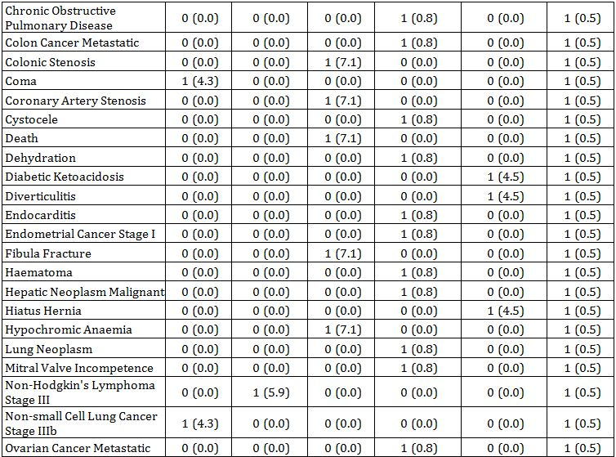
Table 18 (continued): Serious Adverse Events During 48-month Treatment Period of 20050233 in Descending Order of Frequency by Preferred Term and Pooled Group, Safety Analysis Set.
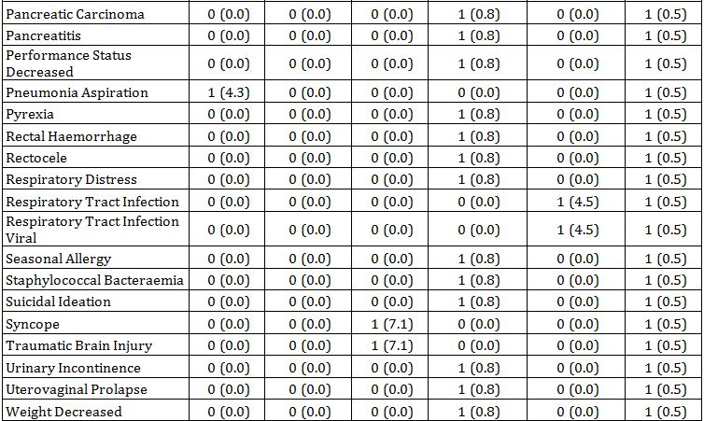
Treatment groups are the original assignments in the 20010223 study; all subjects in 20050233 were to receive denosumab 60mg Q6M
N = Number of subjects who received ≥1 dose of denosumab during study;
n = Number of subjects reporting ≥1 event
Includes only treatment-emergent adverse events
Preferred terms are sorted by descending order of frequency in all dose groups combined and coded using MedDRA version 14.0
a. Includes denosumab 6 mg Q3M, 14 mg Q3M, 14 mg Q6M, 60 mg Q6M, and 100 mg Q6M dose groups
A total of 4 subjects experienced serious adverse events that were considered, by the local investigator, related to study medication, 2 of which were previously reported in the month 12 report for Study 20050233:
- One subject experienced 2 occurrences of atrial fibrillation at approximately month 26 (39 days post-dose) and month 39 (71 days post-dose)
- One subject was diagnosed with a pulmonary embolism at approximately month 37 of treatment, 19 days following a scheduled dose of denosumab
- One subject was diagnosed with breast cancer in situ 5 months after receiving the first dose of denosumab in the extension study; she had been randomised to the 60 mg Q6M denosumab group during parent Study 20010223 (previously reported)
- One subject developed staphylococcal bacteraemia approximately 7.5 months after entering the extension study, and 42 days after receiving the second dose of denosumab.

Study 20060289 (Extension of Study 20030216)

Deaths
During the 36 months of the extension study there were 86 deaths (1.9%) reported: 45 in the long term group and 41 in the cross-over group. None of the deaths were considered by the investigator to be related to denosumab. The most commonly occurring fatal events were: cardiac disorders, general disorders (multi system failure and sudden death) and malignancy. This was similar to that seen in the original study.
The rate of fatal events is 0.7 per 100 subject years which is similar to that reported in the original Study 20060216 (0.7 per 100 subject years in the denosumab group and 0.9 per 100 subject years in the placebo group).

Serious Adverse Events
16.4 SAEs per 100 subject years were reported during the 36 months – 15.9 per 100 subject years in the long term group and 17.0 per 100 subject years in the cross over group. The most commonly reported subject-year-adjusted SAEs (>0.2 events per 100 subject years) were: osteoarthritis (0.7 events per 100 subject years), atrial fibrillation (0.4 events per 100 subject years) and pneumonia (0.3 events per 100 subject years).
A total of 31 (0.7%) subjects (18 (0.8%) subjects in the long term group and 13 (0.6%) subjects in the cross over group) experienced SAEs that were considered by the investigator to be related to denosumab. Each related SAE was experienced by <0.1% of subjects.
The SAE rate in the first 36 months of the extension study was comparable to the rate in the original Study 20030216: 17.3 per 100 subject years in the denosumab group and 16.4 per 100 subject years in the placebo group (Table 19).
Table 19: Study 20060289 Investigational Product-related Serious Adverse Events by Preferred Term in Descending Order of Frequency (Safety Analysis Set) (Month 36 Interim Analysis).
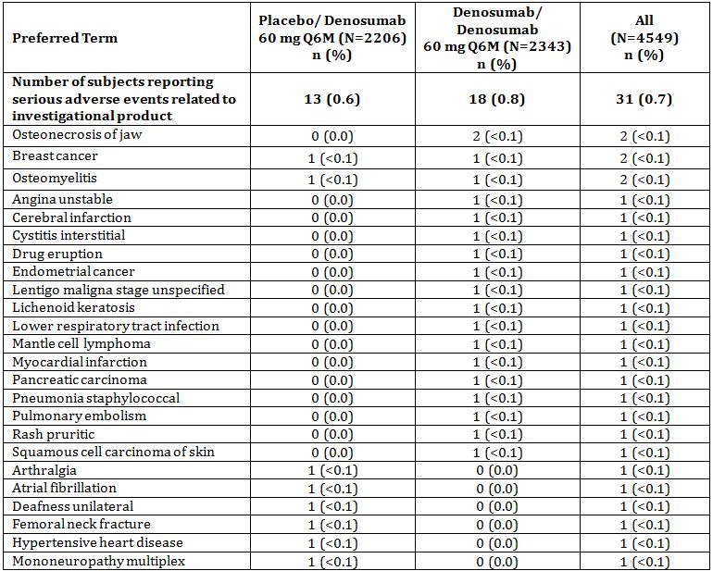
Treatment groups are the original randomized assignments in the 20030216 study; All subjects in the 20060289 study are to receive denosumab 60 mg Q6M.
N = Number of subjects who received ≥ 1 dose of investigational product
n = Number of subjects reporting ≥ 1 event
Includes only treatment-emergent adverse events for which the investigator indicated there was a reasonable possibility they may have been caused by investigational product
Preferred terms are sorted by descending order of frequency in the 'All' column and coded using MedDRA version 14.0

Discontinuation due to adverse events

Pivotal study 20080098
No subject in the placebo group experienced an adverse event that led to either the discontinuation of investigational product or withdrawal from the study.
Three subjects (3%) in the denosumab group experienced a total of 5 adverse events that resulted in withdrawal from the study. The events included prostate cancer, a traffic accident and resultant traumatic injuries, and an increased frequency of upper respiratory tract infections along with a feeling of being cold. None of the adverse events leading to withdrawal from the study was considered by the investigator to be related to investigational product.
In addition to the adverse events noted above, 1 additional subject in the denosumab group experienced an adverse event of myocardial infarction that resulted in discontinuation of investigational product; this event is noted above in deaths and was not considered by the investigator to have a causal relationship with investigational product.

Other studies

Study 20050233 (Extension of Study 20010223)
Ten (5.0%) subjects were withdrawn from the study due to adverse events. Nine (4.5%) subjects discontinued denosumab therapy due to adverse events during the 48-month treatment period of the extension study. No single event was reported in more than 1 (0.5%) subject. Three subjects had adverse events that were considered related to denosumab therapy by the investigator (one subject with breast cancer in situ; one subject with muscle spasms; and one subject with paraesthesia).

Study 20060289 (Extension of Study 20030216)
There were a total of 225 (4.9%) subjects (116 [5.0%] in the long-term group and 109 [4.9%] in the crossover group) who experienced an adverse event that led to discontinuation of denosumab. The most common adverse events (≥ 0.1%) leading to discontinuation were death (9 [0.2%]), breast cancer (8 [0.2%]), cerebrovascular accident (6 [0.1%]), pancreatic carcinoma (6 [0.1%]), and colon cancer (5 [0.1%]). There were a total of 115 (2.5%) subjects (58 [2.5%] in the long-term group and 57 [2.6%] in the crossover group) who experienced an adverse event that led to withdrawal from the study. The most common adverse events (≥ 0.1%) for all subjects enrolled leading to withdrawal from the study were breast cancer (0.1%) and dementia (0.1%).

Laboratory tests

Liver function
Not done.

Kidney function
Not done.

Other clinical chemistry

Pivotal study 20080098

Albumin-corrected calcium
Consistent with previous studies, denosumab administration was associated with transient decreases in serum calcium. At day 15, median change from baseline in albumin-adjusted serum calcium was -1.1% in the denosumab group and 0.0% in the placebo group.
No decrease in serum calcium was observed at months 6 and 12 (median change of denosumab, placebo 0.0%, 0.0% at month 6, and 2.1%, 2.1% at month 12).

Serum phosphorus
Denosumab administration also was associated with decreases in serum phosphorus. Median change from baseline in phosphorus was (denosumab, placebo) -6.0%, 2.9% at day 15; -4.7%, 0.0% at month 6; and 0.0%, 0.0% at month 12.

Other studies

Study 20050233 (Extension of Study 20010223)

Calcium
Overall, median serum calcium levels and albumin-adjusted calcium levels remained similar to baseline over time; median albumin-adjusted calcium was 2.4 mmol/L at baseline and 2.5 mmol/L at month 48 of the extension study.
Subjects in the off-treatment cohort (210 mg Q6M group), who were reinitiated with denosumab therapy at the beginning of this extension study, showed a median decrease of 6.3% in albumin-adjusted serum calcium at month 1 of the extension.

Serum phosphorus
Median levels of phosphorus ranged from 1.1 to 1.3 mmol/L throughout the treatment period (all subjects). Minor reductions in serum phosphorus were observed for all treatments within the first month of treatment in the extension study, with a median percent change from 20010223 baseline of -7.7% overall. Median percent change from 20010223 baseline in serum phosphorus was 5.1% at month 48 (all subjects).

Alkaline phosphatase
As expected, modest reductions in alkaline phosphatase were observed with denosumab therapy. Overall, median percent change from 20010223 baseline in alkaline phosphatase ranged from -19.7% to -22.0% from month 6 through month 48 of the extension study.

Study 20062289 (Extension of Study 20030216)

Serum calcium
Serum calcium was measured in the extension study in all subjects at approximately day 10 (±5 days), the time when the nadir in serum calcium is known to occur. Reductions in serum calcium at day 10 in both the long term and cross over groups were small (2-3%) and considered not clinically significant.
Shifts in serum calcium, phosphorus and/or alkaline phosphatase were small and not considered clinically significant.

Vital signs, physical findings

Pivotal study 20080098
No patterns or trends over time in vital signs were apparent during the first 12 months of the study, and none of the results appeared to be clinically significant.

Other studies

Study 20050233 (Extension of Study 20010223)
There were no clinically significant changes from baseline in blood pressure, pulse, or temperature over the 48-month treatment period. Mean changes from baseline in systolic and diastolic blood pressure were -0.5 mm Hg and -2.7 mmHg at month 48, respectively.

Study 20060289 (Extension of Study 20030216)
Not reported in synopsis.

Post-marketing experience
Post-marketing information is very sparse in the both the Summary of Clinical Safety and the more recent US 120 day safety update. Since denosumab was approved, an estimated 153,224 patient years of exposure to Prolia has occurred (date of report unknown).
The applicant states that since its approval they have conducted 2 safety analyses of Prolia in the postmarketing setting: 1) an assessment of hypersensitivity and 2) an assessment of hypocalcaemia and muscle spasms in association with the use of densoumab.
The review of hypersensitivity suggested that a relationship could not be excluded between Prolia administration and events such as rash, urticaria, facial oedema and erythema. It is stated that these are planned to be added to the national product labelling.
The review of hypocalcaemia showed that hypocalcaemia events were observed infrequently in the postmarketing setting and that, when they did occur, underlying conditions often contributed to the event. It was considered that the current labelling was sufficient to address this issue.

Safety issues with the potential for major regulatory impact

Hypocalcaemia
Due to the potential for denosumab therapy to lower serum calcium levels as a result of lower rates of bone resorption, hypocalcaemia was considered to be a clinically significant adverse event. It is noted in the Summary that the incidence of hypocalcaemia in studies 20030216 and 2004138 was ≤0.1% in each treatment group and balanced between treatment groups.

Pivotal study 20080098
No subject experienced an AE of hypocalcaemia during the first 12 months of the study.

Other studies

Study 20050233 (extension of Study 20010223)
No adverse events of hypocalcaemia were reported during the 48-month treatment period of the study.

Study 20060289 (Extension of Study 20030216)
There was 1 (<0.1%) subject in the long term group and 6 (0.3%) subjects in the cross over group who reported hypocalcaemia as an AE. None of these events were considered serious, all were mild to moderate in severity and all events were transient. Four of the 6 events in the cross over subjects occurred around the day 10 visit when serum calcium was measured for all subjects following the first dose of denosumab. 6 of the 7 events were asymptomatic. One subject in the cross over group reported an event potentially associated with hypocalcaemia (muscle spasms) on day 10, one day following the occurrence of the AE of hypocalcaemia. The muscle spasm was mild and considered unrelated to study medication.

Osteonecrosis of the jaw (ONJ)
ONJ has been reported in subjects receiving treatment with bisphosphonates and in subjects with advanced cancer receiving denosumab. There were 4 cases, all in study 20060289, reported in women with postmenopausal osteoporosis. All four cases had oral risk factors and one subject reported prior bisphosphonate usage.

Pivotal study 20080098
There were no cases of positively adjudicated ONJ reported during the first 12 months of the study.

Other studies

Study 20050233 (Extension of Study 20010223)
There were no subjects who had adverse events associated with osteonecrosis of the jaw based on adjudication of oral adverse events. There were also no cases of osteonecrosis excluding the jaw (avascular necrosis) reported during the study.

Study 20060289 (Extension of Study 20030216)

Cross over group
- One subject reported osteonecrosis of the jaw observed following a tooth extraction due to a previous fracture in the tooth. The osteonecrosis was observed on day 397 after receiving 3 doses of denosumab in the study. The subject developed dry socket and was treated with penicillin and medicated dressings. The healing was abnormally slow and she was referred to an oral surgeon for biopsy and treatment. The biopsy showed necrotic/non-viable bone with chronic inflammation and some healing. After 137 days the event was reported as resolved as the necrotic bone had healed and there was complete coverage of bone by mucosa. The subject remained on denosumab and received an additional 4 doses during the extension study. The investigator considered the event unrelated to the study medication.
- One subject was diagnosed with ondontogenic osteomyelitis of the left inferior mandibulae in the area of teeth 34 and 35. The event started approximately 1.5 years after enrolling in extension study and after receiving 4 doses of denosumab. Teeth 34 and 35 had been extracted approximately 4 months prior to the event; alveoli were reported as failing to heal after the extraction. A dental examination showed that the bone was gradually covering the mucous membrane; however, a follow-up examination revealed that the wound had failed to heal and was covered with granulate tissue with bare bone and blood odour noted. The area was cleaned and the subject underwent a partial alveoli resection and sequestration. The subject was also treated with amoxicillin, and an antiseptic mouthwash with nitrofuralum solution and gentian violet. The event was reported as resolved on day 610 and denosumab was discontinued. The mandible pain reoccurred one month later and the subject was admitted to the hospital. Orthopantomographic imaging showed sequestral case formed in the left-side lower maxilla. Incision surgery was performed in the left-side lower maxilla, mucous membrane periostium patch was lifted, excision of the inflammatory granulations was made, and necrotised lower maxilla bone was removed. A follow-up examination showed that the wound was completely healed. The investigator considered the event to be related to study medication

Long-term group
- One subject was diagnosed with osteonecrosis of the jaw on day 954, 49 days after receiving the last dose of denosumab; (day 906). The subject had received 6 doses of denosumab during the extension study and 6 doses during Study 20030216. The subject had no previous history of periodontal disease. The subject had 2 teeth extractions 3 months (lower right first molar) and 4 months later (upper right tooth). Three months following the last tooth extraction, the subject complained of exposed bone area, which was confirmed by the oral surgeon. Seven months later (day 906), the subject was referred to a maxillofacial surgeon due to a socket that had not healed since the extraction (lower right molar); on examination, the right molar had not healed and suppuration from the socket was evident. The subject was treated with clindamycin and a debridement was performed; study treatment was discontinued at this time. Subsequently, the subject was seen by another physician and was diagnosed with osteonecrosis of the jaw, which was associated with minimal pain. The bone was completely covered by mucosa and the event was reported as resolved 2 months later. The subject was last seen by an oral surgeon 9 months later for a follow-up visit; the area of the osteonecrosis of the jaw was reported as not completely healed, but continued to improve. The investigator considered the osteonecrosis of the jaw to be related to denosumab therapy.
- One subject was diagnosed with osteonecrosis of the jaw and on day 757, after receiving 5 doses of denosumab in the extension study; the subject had no previous history of periodontal disease. On day 757, the subject presented with swelling in the molar region of the lower right mandible and she was referred to an oral surgeon. Upon examination, a dehiscence was noted on the right side (lower molar region), with pus evident upon compression. The subject was diagnosed with osteomyelitis of the jaw and purulent osteonecrosis of the jaw. No exposed bone was noted and the lesion was covered with mucosa. The subject underwent exchochleation rinsing with hydrogen peroxide, saline, and povidone iodine; and underwent Chlumsky stripping. She also was treated with amoxicillin/clavulanic acid, clindamycin, niflumic acid and mouth wash with chlorohexidine. Three weeks later, 2 teeth were extracted in the same area as the initial lesion, and resulted in additional inflammation; no exposed bone was observed. On day 868 the subject developed parodontopathy and was hospitalised to undergo surgical extraction of teeth 21, 12, 11, and 33, which showed significant periodontal disease. The subject continued in the study, with the final dose of denosumab administered on day 918. During a check-up 2 months later (day 993), the doctor found evidence of osteomyelitis and osteonecrosis of the jaw. The subject was treated with antibiotics and the osteomyelitis of the jaw resolved 7 days later; osteonecrosis of the jaw was ongoing. The subject was again diagnosed with osteomyelitis of the jaw 2 months later (day 1063) and was hospitalised; she was treated with antibiotics (Augmentin) and a sequestrectomy was performed. Osteonecrosis of the jaw was reported to have resolved by day 1063 and the subject was discharged. Approximately 6 weeks later, purulent secretion was present with incomplete coverage of the bone; antibiotic treatment continued. Osteomyelitis of the jaw was reported as resolved on day 1160. The subject continued in the study and received a total of 6 doses of denosumab in (last dose administered on day 918). The investigator considered the osteonecrosis of the jaw to be related to denosumab therapy.

Oral events
Subjects were asked at the 36 month visit to recall the number and nature of oral adverse events that had occurred during the original study (20030216), as well as those that occurred during the extension study. The retrospective overall rate of oral events, such as dental implants, tooth extraction, natural tooth loss, or scaling or root planning was comparable between treatments groups in Study 20030216.
During the first 30 months of the extension study, 2.0% of subjects had dental implants, 10.5% had tooth extraction, 1.3% had natural tooth loss, and 18.6% of subjects had scaling or root planning. Although there are limitations to this data given the retrospective nature, the rates of reported oral events during Study 20030216 were similar to those reported through the first 30 months of the extension study.

Osteonecrosis outside the jaw (avascular necrosis)
At the request of regulatory authorities, cases were reviewed in which the term “osteonecrosis” was used in connection with anatomical sites other than the jaw. These events do not collectively represent a syndrome, but a variety of conditions that are discussed together because they share a common radiologic feature of avascular necrosis or osteonecrosis (often associated with osteoarthritis, steroid use, and/or surgical procedures) and were observed at sites other than the jaw.
Osteonecrosis was reported in 7 (0.2%) subjects (4 [0.2%] cross over; 3 [0.1%] long-term) during the first 36 months of the extension study. Generally, subjects had either steroid exposure as a risk factor or the term was used in connection with radiographic findings of osteoarthritis. Two subjects in the crossover group and 1 subject in the long-term group had serious adverse events of osteonecrosis. None of the events of osteonecrosis were considered related to denosumab treatment.

Cross over group
A total of 2 subjects had SAEs of avascular necrosis: one of the hip following surgical repair for a fracture of the left femur neck; and one of the internal femoral condyle of the knee following a knee injury. Both were treated with surgical repair (total prosthesis of the hip and arthroplasty of the knee) and made full recovery. Both subjects remained on denosumab.
There were 2 additional subjects with non serious AEs: one with moderate avascular necrosis of the femoral head with femoral head collapse following extensive inhaled and oral steroid therapy; and one with moderate osteonecrosis of the knee reported on day 470 with no risk factors identified, however the investigator indicated that the condition was likely related to the subject’s gonarthosis. No treatment was provided and both subjects remained on denosumab.

Long term group
There was one subject that had an SAE of moderate avascular necrosis of the hip on study day 560. This subject had previously been treated for 4 months with glucocorticoid injections for trochanter bursitis and for synovitis bursitis for an additional 2 months. This subject was treated with total hip replacement and fully recovered. She remained on denosumab.
There were 2 additional subjects who had non serious AEs: one subject was diagnosed with moderate morbus ahibeck (Ahibeck’s disease – osteonecrosis of the knee) with no known risk factors; one subject reported mild caput necrosis pain in the hip on study day 996 and aseptic arthritis of the hip that resolved on day 995, this subject had been treated with oral prednisone for 30 years for polymyalgia rheumatic. Both subjects remained on denosumab.

Fractures and fracture healing

Pivotal study 20080098
Clinical fractures were reported by the investigators and confirmed by the central imaging vendor for 1 subject in the denosumab group (0.8%) and 2 subjects in the placebo group (1.7%). New (morphometric) vertebral fractures were reported for no subjects in the denosumab group and 1 subject in the placebo group (0.8%).
No atypical femur fractures or fracture healing complications were reported during the first 12 months of the study.

Other studies

Study 20050233 (Extension of Study 20010223)
All AEs involving fractures were examined to assess the likelihood of causality due to osteoporosis. Fractures were reported in 18 (9.0%) subjects during the 48-month treatment period, of which 9 (4.5%) subjects had fractures that were considered to be osteoporotic. Two (1.0%) subjects had humerus fractures and 2 subjects had rib fractures thought to be associated with osteoporosis. The remaining osteoporotic fractures included foot, hand, patella, pubis, and thoracic vertebral fracture (1 [0.5%] each). There were no reports of delayed healing time or non-union of non-vertebral fractures at 6 months post-fracture.

Study 20060289 (Extension of Study 20030216)
Overall, 3.5% of subjects in the long term group had at least one new vertebral fracture by month 36 of the extension study compared to 2.8% in the cross over group.
The cumulative incidence of new vertebral fractures in Studies 20030216 and 20060289 for subjects in the long term group was 4.5%. This was lower than the incidence in the cross over group (7.3%).
The cumulative incidence of non-vertebral fractures in Studies 20030216 and 20060289 for subjects in the long term group was 9.9%. This was lower than the incidence in the cross over group (13.1%) (Table 9).
One subject (<0.1%) in the long term group and 2 (<0.1%) subjects in the crossover group reported femur fractures in the first 36 months of the extension study but none were considered atypical.
One subject in the crossover group, aged 73, reported a non-serious AE of delayed fracture union in the right finger on study day 343. The event was reported to have resolved on study day 657. The exposure-adjusted incidence of adverse events of delayed fracture healing was <0.1% during the extension study; this rate was comparable to that observed in Study 20030216 (<0. 1%).

Hypersensitivity
All monoclonal antibodies can theoretically be associated with hypersensitivity reactions, including anaphylactic events. Results from studies 20030216 and 20040138 demonstrated no evidence of an increased risk of hypersensitivity reactions to denosumab.

Pivotal study 20080098
The incidence of AEs potentially associated with hypersensitivity was the same for both treatment groups (3 subjects [2.5%]) during the first 12 months of the study.
Events in the denosumab group consisted of rash, allergic dermatitis, and eczema (1 subject each); events in the placebo group consisted of rash (2 subjects) and eyelid oedema and allergic rhinitis (1 subject each). None of the adverse events potentially associated with hypersensitivity was considered by the investigator to be treatment related, none met the criteria of a serious adverse event, and all events of hypersensitivity were of mild or moderate severity.

Other studies

Study 20050233 (Extension of Study 20010223)
AEs that were potentially associated with hypersensitivity reactions were reported for 22 (11.0%) subjects during the 48-month treatment period. Rash (3.0%) and contact dermatitis (2.0%) were the most frequently occurring of these events. Most events were considered unrelated to study therapy and were mild to moderate in severity. There were no serious hypersensitivity reactions.
Few of the events occurred within 30 days of the previous dose of study medication. Both reports of rash that were considered related to study medication as well as the injection site rash, occurred 1 day following denosumab administration.

Study 20060289 (Extension of Study 20030216)
A total of 175 (7.5%) subjects in the long-term group and 159 (7.2%) subjects in the crossover group who reported AEs that were potentially associated with hypersensitivity. The most common (≥0.5%) AEs reported were rash (42 [1.8%] long-term; 38 [1.7%] crossover), eczema (35 [1.5%] long-term; 35 [1.6] crossover), hypersensitivity (12 [0.5%] long-term; 13 [0.6%] crossover), urticaria (12 [0.5%] long-term; 13 [0.6%] crossover), dermatitis allergic (14 [0.6%] long-term; 10 [0.5%] crossover), rhinitis allergic (9 [0.4%] long-term; 15 [0.7%] crossover), and dermatitis (11 [0.5%] long-term; 6 [0.3%] crossover).
The rate of hypersensitivity was similar to that seen in the original study.

Infections
RANKL is expressed on activated T and B cells and in the lymph nodes. However, nonclinical studies suggest that the RANKL/RANK pathway does not play an essential role in the adult immune system and have shown that the ability to mount a normal immune response to infectious pathogen challenges is not dependent on RANKL.

Pivotal study 20080098
Infection AEs were reported by 24 (20%) subjects in each treatment group; the adverse event of nasopharyngitis was the most frequently reported infection among subjects in either the denosumab (8 [7%] subjects) or placebo (7 [6%] subjects) treatment groups.
One placebo-treated subject experienced an infection that met the criteria of a serious adverse event (pneumonia). Among denosumab-treated subjects, none of the events of infection met the criteria of a SAE, none was considered by the investigator to be related to investigational product, and all but one event of infection was of mild or moderate severity (one event, influenza, was severe). One non serious event of skin infection (impetigo) was reported for a subject receiving placebo. There were no events of skin infection in the denosumab group.

Other studies

Study 20050233 (Extension of Study 20010223)
Infections and infestations were reported for 121 (60.5%) subjects during the 4-year treatment period. Upper respiratory tract infection (22.5%), sinusitis (11.5%), urinary tract infection (10.0%), bronchitis (8.5%), nasopharyngitis (7.5%), and influenza (5.0%) were the most frequently reported infections. There did not appear to be an increased risk for infection based on length of denosumab treatment, as the incidence of infections was similar over time, and the proportion of subjects with infections was comparable across pooled treatment groups.
Seven subjects (3.5%) had infections that were serious (diverticulitis, endocarditis, pneumonia [3 subjects], respiratory tract infection, respiratory tract infection viral, and staphylococcal bacteraemia).
The infection AE which was considered related to denosumab was:
- One subject, who had been randomised to the continuous treatment cohort in parent Study 20010223, had 2 separate SAEs of staphylococcal bacteraemia and endocarditis, the latter of which occurred 1 month after the first event. The staphylococcal bacteraemia was considered by the investigator to be related to investigational product. The subject previously had an event of dental caries, which occurred approximately 2.5 years before the event of staphylococcal bacteremia and resolved on the same day as onset. She initially presented with shaking, chills, fatigue, fever, urinary incontinence, confusion, and pain in the lower neck. The subject was hospitalised with methicillin-susceptible Staphylococcus aureus (MSSA) bacteraemia/sepsis (based on blood culture) approximately 8 months after enrolling into Study 20050233 (approximately 4.5 years after initiating continuous treatment with denosumab in parent Study 20010223). She was treated with intravenous ceftriaxone and discharged from the hospital after 12 days, at which time it was reported that the event was resolving. The investigator reported that there was a reasonable possibility that the staphylococcal bacteremia may have been caused by study drug. The subject withdrew consent to continue study participation approximately 12 months after enrolling in Study 20050233 (approximately 4 months after this event occurred).

Study 20060289 (Extension of 20030216)
In the first 36 months of the extension study, 33.5 adverse events of infection per 100 subject years were reported among all subjects enrolled into the study (33.3 AEs per 100 subject years in the long-term group and 33.8 AEs per 100 subject years were reported in the crossover group. The most commonly reported (>3.0 events per 100 subject years) adverse events of infection were nasopharyngitis (4.9 events per 100 subject years) and cystitis (3.2 events per 100 subject years).
The rates of adverse events of infections during the extension study were slightly lower than the rates in the original 20030216 study (39.7 events per 100 subject years in the denosumab arm and 40.1 events per 100 subject years in the placebo arm).
There were 1.6 serious adverse events of infection per 100 subject years among all subjects enrolled into the study (1.6 SAEs per 100 subject years in the long-term group and 1.7 SAEs per 100 subject years in the crossover group). The most commonly reported (≥ 0.1 event per 100 subject years) SAE of infection was pneumonia (0.3 events per 100 subject years for long-term and crossover). This incidence was similar to that in Study 20030216.
There were 6 cases of serious skin infections in the study (5 in the long term and 1 in the cross over group). One case was cellulitis and the remaining were erysipelas. None were serious and all patients continued on denosumab. The rate of serious skin infections was similar to that seen in the original study.

Malignancies

Pivotal study 20080098
Malignancy AEs, were reported for 4 subjects (3.3%) in the denosumab group and no subjects in the placebo group.
The events consisted of prostate cancer in 3 subjects (2.5%) and basal cell carcinoma in 1 subject (0.8%). None of the events was considered to be related to the investigational product. Two of the 3 prostate cancer cases were likely present at baseline, based on subject medical histories.

Other studies

Study 20050233 (extension of Study 20010223)
A total of 24 (12.0%) subjects had adverse events associated with malignancy during the treatment period. Basal cell carcinoma (11 [5.5%]) and lung neoplasm malignant (2 [1.0%]) were the only adverse events reported in more than 1 subject during the study. Of the subjects who had basal cell carcinoma, 1 subject from the original placebo cohort and 1 subject from the continuous cohort (14 mg Q6M) each had 4 separate adverse events of basal cell carcinoma.
Two subjects had events that were considered related to denosumab therapy (breast cancer in situ and thyroid neoplasm [right thyroid nodule]); both subjects had been receiving continuous denosumab treatment.

Study 20060289 (Extension of Study 20030216)
In the first 36 months of the extension study 2.0 malignancy adverse events per 100 subject years were reported among all subjects enrolled into the study; 2.1 events per 100 subject years were reported in the long-term group and 2.0 events per 100 subject years were reported in the crossover group. The most commonly reported (≥ 0.1 events per 100 subject years) malignancy AEs were basal cell carcinoma (0.5 events per 100 subject years), breast cancer (0.2 events per 100 subject years), and colon cancer (0.1 events per 100 subject years).
The rate of malignancy was similar to that seen in the original study.

Cardiovascular AEs

Pivotal study 20080098
Cardiovascular AEs were reported for 6 subjects (5.0%) in the denosumab group and 3 subjects (2.5%) in the placebo group during the first 12 months of the study. The most common event was angina pectoris, which was initially reported for 2 subjects (1.7%) in the denosumab group and no subjects in the placebo group. The subjects who reported the 2 cases of angina pectoris had a history of cardiovascular disease, and neither case of angina pectoris was reported as serious or was considered by the investigator to be related to the investigational product.
SAEs in the system organ class of cardiac disorders were reported for 2 subjects (1.7%) in the denosumab group (acute myocardial infarction and myocardial infarction) and 1 subject (0.8%) in the placebo group (atrial fibrillation). None of the events was considered by the investigator to be related to the investigational product. Both denosumab-treated subjects had a history of coronary artery disease.
Vascular disorders AEs were reported for 6 subjects in the denosumab group (5.0%) and 8 subjects in the placebo group (6.7%) during the first 12 months of the study. The most common event was hypertension, which was reported for 1 subject in the denosumab group (0.8%) and 5 subjects in the placebo group (4.2%).
SAEs in the vascular disorders system organ class were reported for 2 subjects in the denosumab group (1.7%) and 1 subject in the placebo group (0.8%). These events included arterial thrombosis limb (2 [1.7%] denosumab, 0 placebo) and peripheral ischemia (1 [0.8%] denosumab, 1 [0. 8%] placebo). (One subject receiving denosumab had both arterial thrombosis limb and peripheral ischemia).

Other studies

Study 20050233 (Extension of Study 20010223)
Cardiac disorders were reported for 18 (9.0%) subjects during the 48-month treatment period. Palpitations (2.5%) and atrial fibrillation (1.5%) were the most frequently occurring cardiac disorders. Myocardial infarction, cardiac failure congestive, and coronary artery disease were reported in 1% of subjects. All other cardiac disorders, such as cardiac arrest and cardiac failure, were reported in 1 (0.5%) subject each. The incidence and types of cardiac disorders were not unexpected over a 4-year period in this subject population.

Study 20060289 (Extension of Study 20030216)
There were 6.9 cardiac disorders per 100 subject years reported among all enrolled subjects; 7.3 events per 100 subject years in the long-term group and 6.5 events per 100 subject years in the crossover group. The most commonly reported (≥ 0.4 events per 100 subject years) cardiac disorders were atrial fibrillation (1.1 events per 100 subject years), angina pectoris (0.7 events per 100 subject years), cardiac failure (0.4 events per 100 subject years), and arrhythmia (0.4 events per 100 subjects years). The rate of cardiac events was similar to that seen in the original study.
There were 9.5 vascular disorders per 100 subject years reported among all enrolled subjects (9.5 events per 100 subject years for long term; 9.6 events per 100 subject years for crossover group). The most commonly reported vascular disorders during the extension were hypertension (5.6 events per 100 subject years) and varicose veins (0.5 events per 100 subject years). The rate of vascular events was similar to that seen in the original study.

Eczema

Pivotal study 20080098
Eczema was reported for 2 subjects in the denosumab group (1.7%) and no subjects in the placebo group. The events were mild-to-moderate in severity and resolved within 7 weeks of onset. Both subjects continued denosumab administration without evidence of recurrence.

Other studies

Study 20050233 (Extension of Study 20010223)
AEs associated with symptoms of eczema included dermatitis contact (4 [2.0%]) and eczema (3 [1.5%]) and are described in section 8.7.1.4.2 Hypersensitivity. All of these events were considered unrelated to study medication and were mild to moderate in severity.

Study 20060289 (Extension of Study 20030216)
In the first 36 months of this study, 1.1 adverse events of eczema per 100 subject years were reported among all subjects enrolled into the study, as well as the long-term and crossover groups. These rates were comparable with those observed in Study 20030216: 0.7 events per 100 subject years in the placebo group and 1.3 events per 100 subject years in the denosumab group.

Acute pancreatitis

Pivotal study 20080098
One event of serious acute pancreatitis was reported in each treatment group (0.8%) during the first 12 months of the study. The subject receiving denosumab had a history of cholelithiasis and was receiving ursodeoxycholic acid. Acute pancreatitis in the subject receiving placebo was reported as possibly due to hydrochlorothiazide administration.

Other studies

Study 20050233 (Extension of Study 20010223)
One subject had an adverse event associated with acute pancreatitis during the 48-month treatment period. The subject was hospitalised with severe pancreatitis (gall stone pancreatitis) on day 683 after presenting with acute abdominal pain. She was treated with intravenous hydration, sultamicillin, and hydromorphone and underwent a laparoscopic cholecystectomy the following day. She developed post operative aspiration pneumonia which required oxygen therapy and prolonged her hospitalisation. The event resolved and was not considered to be drug related.

Study 20060289 (Extension of Study 20030216)
There were 6 subjects with SAEs of pancreatitis (4 [0.2%] in the long term group and 2 [<0.1%] in the crossover group). All subjects with pancreatitis had a history of concurrent biliary tract disease (cholelithiasis, cholecystitis or cholangiosarcoma), a predisposing factor for pancreatitis.
One patient died 23 days after hospitalisation for abdominal pain with a diagnosis of pancreatitis but had a long history or cholestectomy, uraemia and smoking. No hospital records were available and so no information is available as to investigations or treatment but the investigator attributed her death to her complicated medical history.
The remaining 4 subjects had isolated episodes of pancreatitis, were treated with cholecystectomy or supporting measures (if previous cholecystectomy) and remained on denosumab with no recurrence of the pancreatitis.
One subject was diagnosed with cholangiosarcoma on day 57 of the study following an episode of pancreatitis classed as non serious. The subject had only received one dose of denosumab as she was in the cross over group. She was withdrawn from the study.

Anti-denosumab antibodies

Pivotal study 20080098
All subjects treated with denosumab (n = 120) for up to 12 months were negative for anti-denosumab binding antibodies at all tested time points. No neutralising antibodies were reported.

Other studies

Study 20050233 (Extension of Study 20010223)
All subjects tested negative for anti-denosumab binding antibodies at baseline (month 48 of parent Study 20010223), including 1 subject who had tested positive for transient non-neutralising binding antibodies at month 12 of the parent study. All subjects tested post-baseline (199 of 200 subjects) were negative at all time points during the extension study.

Study 20060289 (Extension of Study 20030216)
Two subjects (1 in each group) tested positive for binding anti-denosumab antibodies. No further information is provided.

Evaluator’s overall conclusions on clinical safety
The safety data seen in the pivotal study in men with osteoporosis was similar to that seen previously in studies in postmenopausal women with osteoporosis. The long term studies in postmenopausal women with osteoporosis did not identify any additional risks with the exception of the cases of osteonecrosis of the jaw. While the patients who developed these events also had local risk factors the incidence is significant and should be better reflected in the Product Information.
The post-marketing review of adverse events states that there is sufficient evidence to add drug sensitivity as a post marketing adverse drug reactions to the national product labelling. This is not reflected in the proposed Product Information included in the submission.

First round benefit-risk assessment

First round assessment of benefits
The benefits of Prolia in the proposed usage are:
- Increase in BMD at all skeletal sites measured: lumbar spine, proximal femur (total hip, femoral neck, trochanter), and distal radius compared with placebo at 12 months.
- The magnitudes of the mean BMD increases observed in males with osteoporosis were similar to those observed in studies in postmenopausal women.
- Increases in BMD were associated with a decrease in new vertebral, non vertebral, and hip fractures in studies in previously evaluated studies (20030216 and 20040138). It is reasonable to extrapolate the same in men with osteoporosis.
- Safety in men with osteoporosis was similar to that seen in postmenopausal women.

First round assessment of risks
The risks of Prolia in the proposed usage are:
- AEs which are similar to those previously documented for denosumab.
- Osteonecrosis of the jaw is likely in a small number of subjects with long term use of denosumab.

First round assessment of benefit-risk balance
The benefit-risk balance of Prolia, given the proposed usage, is favourable.

First round recommendation regarding authorisation
Based on the clinical data submitted, it is recommended that the application be approved.

Clinical questions
No clinical questions.

References
- CHMP, Guideline on the Evaluation of New Medicinal Products in the Treatment of Primary Osteoporosis. CPMP/EWP/552/95 Rev 2, Adopted in EU May 2007, Adopted in Australia August 2008.
- Kaufman JM, Compston J, Audran MA, Avouac B, Devogelaer, JP, Lemmel EM, Vanhaelst L and Reginster JY. Recommendations for the registration of drugs intended for use in the treatment of male osteoporosis. Calcif Tissue Int. 1999; 65:4-7.

