January 2021

Australian Public Assessment Report for Decitabine and cedazuridine
  - Proprietary Product Name: Inqovi 35/100
  - Sponsor: Otsuka Australia Pharmaceutical Pty Ltd

About the Therapeutic Goods Administration (TGA)
- The Therapeutic Goods Administration (TGA) is part of the Australian Government Department of Health and is responsible for regulating medicines and medical devices.
- The TGA administers the Therapeutic Goods Act 1989 (the Act), applying a risk management approach designed to ensure therapeutic goods supplied in Australia meet acceptable standards of quality, safety and efficacy (performance) when necessary.
- The work of the TGA is based on applying scientific and clinical expertise to decision-making, to ensure that the benefits to consumers outweigh any risks associated with the use of medicines and medical devices.
- The TGA relies on the public, healthcare professionals and industry to report problems with medicines or medical devices. TGA investigates reports received by it to determine any necessary regulatory action.
- To report a problem with a medicine or medical device, please see the information on the TGA website <https://www.tga.gov.au>.

About AusPARs
- An Australian Public Assessment Report (AusPAR) provides information about the evaluation of a prescription medicine and the considerations that led the TGA to approve or not approve a prescription medicine submission.
- AusPARs are prepared and published by the TGA.
- An AusPAR is prepared for submissions that relate to new chemical entities, generic medicines, major variations and extensions of indications.
- An AusPAR is a static document; it provides information that relates to a submission at a particular point in time.
- A new AusPAR will be developed to reflect changes to indications and/or major variations to a prescription medicine subject to evaluation by the TGA.

Copyright
© Commonwealth of Australia 2021
This work is copyright. You may reproduce the whole or part of this work in unaltered form for your own personal use or, if you are part of an organisation, for internal use within your organisation, but only if you or your organisation do not use the reproduction for any commercial purpose and retain this copyright notice and all disclaimer notices as part of that reproduction. Apart from rights to use as permitted by the Copyright Act 1968 or allowed by this copyright notice, all other rights are reserved and you are not allowed to reproduce the whole or any part of this work in any way (electronic or otherwise) without first being given specific written permission from the Commonwealth to do so. Requests and inquiries concerning reproduction and rights are to be sent to the TGA Copyright Officer, Therapeutic Goods Administration, PO Box 100, Woden ACT 2606 or emailed to <tga.copyright@tga.gov.au>.

Contents
Common abbreviations 4
I. Introduction to product submission 7
Submission details 7
Product background 8
Regulatory status 9
Product Information 9
II. Registration timeline 9
III. Submission overview and risk/benefit assessment 10
Quality 10
Nonclinical 11
Clinical 13
Risk management plan 25
Risk-benefit analysis 28
Outcome 29
Attachment 1. Product Information 30

Common abbreviations
Abbreviation | Meaning
%CV | Geometric mean
¹⁴C | Carbon -14
ACM | Advisory Committee on Medicines
ADME | Absorption, distribution, metabolism, and excretion
AE | Adverse event
AML | Acute myeloid leukaemia
ARTG | Australian Register of Therapeutic Goods
ASA | Australia specific annex
ASTX727 | Drug development code for Inqovi
AUC | Area under the plasma concentration time curve
AUC₀₋₂₄ | Area under the plasma concentration time curve from time zero to 24 hours
AUC_{tau} | Area under the plasma concentration time curve during the dosing interval
AusPAR | Australian public assessment report
C1D1 | Course 1 assessments at Baseline
C2D1 | Course 2 assessments at Baseline
CDA | Cytidine deaminase
CI | Confidence interval
CL/F | Oral clearance
C_{max} | Maximum plasma concentration
CMI | Consumer medicine information
CMML | Chronic myelomonocytic leukaemia
CNS | Central nervous system
CR | Complete response
CSR | Clinical study report
CYP | Cytochrome enzyme
DAC | Intravenous decitabine
DLP | Data lock point
DNA | Deoxyribonucleic acid
ECOG-PS | Eastern Cooperative Oncology Group performance status
EU | European Union
FDA | Food and Drug Administration (United States)
FDC | Fixed dose combination
GI | Gastrointestinal
GVP | Good pharmacovigilance practice
HI | Haematologic improvement
IC₅₀ | Concentration giving half maximum inhibition
ILD | Interstitial lung disease
IPSS | International Prognostic Scoring System
IV | Intravenous
IWG | International Working Group
LSM | Least squares mean
mCR | Marrow complete response
MDS | Myelodysplastic syndromes
NA | Not applicable
NYHA | New York Heart Association
OCE | Oncology Center of Excellence (of Food and Drug Administration, United States)
PD | Pharmacodynamics
PI | Product Information
PK | Pharmacokinetic
PO | Orally
PR | Partial response
PSURs | Periodic safety update reports
RBC | Red blood cell
RMP | Risk management plan
SEM | Standard error of the mean
t_{1/2} | Elimination half-time
TDS | Thrice daily; Latin: ter die sumendum
TEAE | Treatment emergent adverse event
TGA | Therapeutic Goods Administration
TI | Transfusion independence
T_{max} | Time of maximum plasma concentration
US(A) | United States (of America)
V/F | Apparent volume of distribution

I. Introduction to product submission

Submission details
Type of submission: | New chemical entity in a new combination of active ingredients
Product name: | Inqovi 35/100
Active ingredients: | Decitabine and cedazuridine
Decision: | Approved
Date of decision: | 29 October 2020
Date of entry onto ARTG: | 2 November 2020
ARTG number: | 328904
Black Triangle Scheme: | Yes  This product will remain in the scheme for 5 years, starting on the date the product is first supplied in Australia.
Sponsor’s name and address: | Otsuka Australia Pharmaceutical Pty Ltd  Suite 2.03, Level 2, 9 Help Street  Chatswood NSW 2067
Dose form: | Tablet, film coated
Strength: | 35 mg of decitabine and 100 mg of cedazuridine
Container: | Bottle
Pack size: | 5
Approved therapeutic use: | Inqovi 35/100 is indicated for the treatment of adult patients with myelodysplastic syndromes (MDS) intermediate-1, intermediate-2, and high-risk International Prognostic Scoring System groups, and patients with chronic myelomonocytic leukaemia (CMML)
Route of administration: | Oral
Dosage: | The recommended dose of Inqovi 35/100 is 1 tablet containing 35 mg of decitabine and 100 mg of cedazuridine taken orally once daily on Days 1 through 5 of each 28 days cycle for a minimum of 4 cycles.Best response may take longer than 4 cycles. Continue treatment as long as the patient continues to benefit. Repeat cycles every 28 days in the absence of haematologic toxicities not attributed to active disease and blood counts show absolute neutrophil count at least 1,000/µL and platelets at least 50,000/µL, or at least return to pretreatment levels. Delay or reduce the dose per cycle for haematologic toxicity (see the Product Information (PI), sections: dosage adjustment, and haematological toxicity for more information).  Prior to initiation of Inqovi 35/100, conduct baseline laboratory testing including complete blood cell counts with platelets, serum hepatic panel, and serum creatinine. Obtain complete blood cell counts prior to initiation of Inqovi 35/100 and prior to each cycle (see dosage adjustment, and haematological toxicity).  For further information regarding dosage, refer to the Product Information (PI).
Pregnancy category: | X  Drugs which have such a high risk of causing permanent damage to the fetus that they should not be used in pregnancy or when there is a possibility of pregnancy.  The use of any medicine during pregnancy requires careful consideration of both risks and benefits by the treating health professional. This must not be used as the sole basis of decision making in the use of medicines during pregnancy. The TGA does not provide advice on the use of medicines in pregnancy for specific cases. More information is available from obstetric drug information services in your State or Territory.

Product background
This AusPAR describes the application by Otsuka Australia Pharmaceutical Pty Ltd (the sponsor) to register Inqovi 35/100 (35 mg decitabine and 100 mg cedazuridine) tablets for the following proposed indication:
Treatment of adult patients with myelodysplastic syndromes (MDS) intermediate-1, intermediate-2, and high-risk International Prognostic Scoring System groups, and patients with chronic myelomonocytic leukaemia (CMML).
Inqovi 35/100 is an oral fixed dose combination product comprising two components; decitabine and cedazuridine. Decitabine is a deoxyribonucleic acid (DNA) methyl-transferase inhibitor agent which has been used for several decades in the treatment of myelodysplastic syndrome and chronic myelomonocytic leukaemia (CMML). However, when administered orally, decitabine is metabolised by cytidine deaminase (CDA) in the gut. This lowers oral bioavailability and necessitates the administration of decitabine via the intravenous (IV) route in order to obtain therapeutic levels.
Cedazuridine is an inhibitor of CDA with no inherent anti-neoplastic activity. When administered orally with decitabine, cedazuridine reduces first-pass metabolism of decitabine sufficiently to allow therapeutic levels of decitabine to be obtained from oral administration. This has potential advantages in terms of convenience and safety for patients who do not require IV administration of their chemotherapy.
Decitabine was first registered by the United States of America (USA) Food and Drug Administration (FDA) in 2006. This combination product is the first application to register decitabine in Australia.
This evaluation was facilitated through Project Orbis, an initiative of the US FDA Oncology Center of Excellence (OCE). Under this project, the FDA and the TGA collaboratively reviewed the application. This innovative evaluation process provided a framework for process alignment and management of evaluation issues in real-time across jurisdictions.
Each regulator agency maintained its regulatory process to make independent decisions about the approval (market authorisation).

Regulatory status
This product is considered a new chemical entity in a new combination of active ingredients for Australian regulatory purposes.
At the time the TGA considered this application, a similar application was under consideration in USA (12 December 2019) and in Canada (19 December 2019).

Product Information
The Product Information (PI) approved with the submission which is described in this AusPAR can be found as Attachment 1. For the most recent PI, please refer to the TGA website at <https://www.tga.gov.au/product-information-pi>.

II. Registration timeline
The following table captures the key steps and dates for this application and which are detailed and discussed in this AusPAR.
Table 1: Timeline for Submission PM-2020-00088-1-6
Description | Date
Designation: Orphan | 9 January 2020
Submission dossier accepted and first round evaluation commenced | 2 March 2020
First round evaluation completed | 31 July 2020
Sponsor provides responses on questions raised in first round evaluation | 30 September 2020
Second round evaluation completed | 28 October 2020
Delegate’s Overall benefit-risk assessment | 19 October 2020
Sponsor’s pre-Advisory Committee response | Nil
Advisory Committee meeting | Nil
Registration decision (Outcome) | 29 October 2020
Completion of administrative activities and registration on the ARTG | 2 November 2020
Number of working days from submission dossier acceptance to registration decision* | 123
*Statutory timeframe for standard applications is 255 working days

III. Submission overview and risk/benefit assessment
This section is a TGA summary of wording used in TGA’s evaluation report, which discussed numerous aspects of overseas evaluation reports and included some information that was commercial-in-confidence.

Quality
A tablet of Inqovi 35/100 consists of 35 mg of decitabine and 100 mg of cedazuridine. The chemical structures of decitabine and cedazuridine are displayed in Figures 1 and 2 respectively. Its proposed container is high-density polyethylene bottle with child resistant closure.
Figure 1: Chemical structure of decitabine
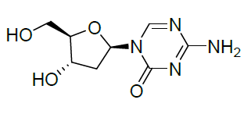
Figure 2: Chemical structure of cedazuridine
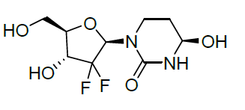
Both components are synthetic chemicals that were evaluated by the pharmaceutical chemistry section. The quality evaluator has raised no objections to registration of the product.

Nonclinical
The nonclinical evaluator has raised no objections to registration and has noted that the sponsor has applied to register a new fixed-dose combination product, Inqovi 35/100, containing cedazuridine and decitabine as the active ingredients. Both cedazuridine and decitabine are new chemical entities in Australia. Inqovi 35/100 is proposed to be used for the treatment of adult patients with MDS intermediate-1, intermediate-2, and high-risk International Prognostic Scoring System (IPSS) groups, and patients with CMML. The proposed dosing regimen involves oral administration of 100 mg cedazuridine and 35 mg decitabine (one tablet) once daily on Day 1 through Day 5 of each 28 days cycle for a minimum of 4 cycles. The draft PI document states that treatment should continue as long as the patient continues to benefit.
The submitted nonclinical dossier was of high overall quality. The scope of the nonclinical program was consistent with the relevant TGA adopted guideline on the nonclinical evaluation of anticancer pharmaceuticals.
Decitabine is a nucleoside metabolic inhibitor that exerts its anti-neoplastic effects after phosphorylation and direct incorporation into DNA. Anti-tumour activity has been demonstrated with decitabine in vitro and in vivo, with the most pronounced effects observed in leukaemic cell lines. Cedazuridine is an inhibitor of cytidine deaminase, the enzyme chiefly responsible for the degradation of decitabine (and other nucleosides). By inhibiting first-pass metabolism, co-administration of cedazuridine improves the otherwise limited oral bioavailability of decitabine.
Competitive inhibition of cytidine deaminase by cedazuridine was demonstrated in vitro, associated with an extension of the in vitro half-life of gemcitabine (another nucleoside analogue) by more than two orders of magnitude. In vivo, cedazuridine was shown to significantly enhance the anti-tumour activity of oral decitabine in mouse models of acute myeloid leukaemia and acute lymphocytic leukaemia.
The primary pharmacology studies offer support for the rationale for the combination and its utility for the proposed indications. Screening assays revealed no significant secondary pharmacological targets for cedazuridine, and none were apparent for decitabine. Specialised safety pharmacology and other studies with cedazuridine and decitabine revealed no clinically relevant effects on central nervous, cardiovascular or respiratory function.
A generally similar pharmacokinetic profile in laboratory animal species and humans was seen for both cedazuridine and decitabine. For cedazuridine, this was characterised by rapid absorption after oral administration, but with low bioavailability, and short plasma half-life. The oral bioavailability of decitabine was low or moderate in laboratory animal species and low in humans. Oral absorption of decitabine was rapid and plasma half-life was short. Oral co-administration with cedazuridine was shown to produce large increases in systemic exposure to decitabine (5.6 to 69 fold in laboratory animal species and 7.6 fold in patients).
Plasma protein binding was low for cedazuridine and very low for decitabine, and similar across laboratory animal species and humans. Tissue distribution of carbon-14 (¹⁴C) cedazuridine derived radioactivity was limited in mice, with penetration of the blood-brain barrier not seen. For decitabine, though, tissue distribution in mice was extensive and included significant entry into the central nervous system (CNS).
The epimer of cedazuridine was identified as the only significant circulating metabolite in laboratory animal species and humans. It is formed non-enzymatically, and possesses much weaker pharmacological activity compare to its parent. Decitabine is mainly metabolised via deamination by cytidine deaminase, and is also subject to chemical degradation, involving oxidation, ring opening and deformylation. Excretion of orally administered cedazuridine was predominantly via the faeces in laboratory animal species and humans; urine was the major route of excretion for decitabine.
In vitro studies indicate limited potential for pharmacokinetic drug interactions by cedazuridine and decitabine involving cytochrome enzymes (CYP); and transporters. Of note, though, the potential for interactions caused by the epimer of cedazuridine — a major metabolite for which exposure is only slightly less than half that of the parent drug in patients has not been explored. The primary pharmacological activity of cedazuridine means that Inqovi 35/100 has the potential to increase exposure of additional drugs besides decitabine that are substrates of cytidine deaminase.
Cedazuridine showed a low to moderate order of acute toxicity in mice and monkeys after oral administration. A moderate to high order of acute toxicity was evident for decitabine after IV administration in mice, dogs and monkeys. Pivotal repeat-dose toxicity studies involved oral administration once daily for five or seven days on a 28 days cycle (the same or similar to the clinical regimen) for three months in mice and cynomolgus monkeys for cedazuridine, and in rats for decitabine. The major targets for toxicity were largely shared for the two drugs, comprising the bone marrow, haematopoietic system, lymphoid tissues, gastrointestinal (GI) tract and male and female reproductive tract. A single cycle study with cedazuridine and decitabine in combination in monkeys did not identify novel toxicity (although examination was limited).
Leukopaenia was observed in animals treated with cedazuridine and decitabine. An increased risk for infections is expected in patients.
Cedazuridine and decitabine are both genotoxic. Positive results were obtained for cedazuridine in the bacterial reverse mutation assay (Ames test); and in the in vitro chromosomal aberration assay in human lymphocytes; and with decitabine in assays for mutagenicity in L5178Y mouse lymphoma cells and in mice in vivo, and for chromosomal rearrangements in Drosophila melanogaster larvae. No carcinogenicity studies have been conducted with either cedazuridine or decitabine. This is acceptable given the proposed indication.
The decitabine component of Inqovi 35/100 is expected to impair male fertility. Decitabine reduced fertility in male mice at dose levels well below the clinical dose. This was accompanied by reduced testes weights, abnormal histology and marked decreases in sperm count. Pre implantation loss was significantly increased in females that were mated with treated males. Decitabine is teratogenic, with malformations and embryofetal lethality observed in mice and rats at subclinical doses. Multiple fetal malformations have also been reported in a pregnant woman treated with IV decitabine. Assignment to Pregnancy Category X; as the sponsor proposes, is appropriate.

Clinical
The clinical dossier consisted of:
- one Phase I study;
- one Phase II study (Study ASTX727-01);
- one Phase III study (Study ASTX727-02);
- one study on food effect with ASTX727; and
- one study on absorption, distribution, metabolism, and excretion of ASTX727.

Pharmacology
The main focus of the assessment of pharmacology was demonstrating the equivalence of decitabine levels when given IV and orally in combination with cedazuridine.
Decitabine area under the plasma concentration time curve (AUC) was demonstrated to be similar between IV administration and administration in oral ASTX727 (see Table 2).
Table 2: Study ASTX727-02 Comparative area under the plasma concentration time curve of intravenous decitabine and ASTX727
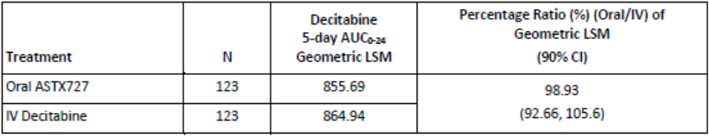
Study ASTX727-02, a Phase III study. AUC₀₋₂₄ = area under the plasma concentration time curve from time zero to 24 hours; CI = confidence interval; CSR = clinical study report; LSM = least square mean, N = number of subjects.
Following oral administration of ASTX727;⁸ cedazuridine was rapidly absorbed with a median time after administration of a drug when the maximum plasma concentration is reached (T_{max}) of 3 hours and an oral bioavailability of 20%. Decitabine was also rapidly absorbed with a median T_{max} of 1 hour. Cedazuridine 40 mg, 60 mg and 100 mg increased the oral availability of decitabine by 3.68 to 12 fold compared to oral decitabine alone. Administration of a high fat meal had little effect on cedazuridine absorption, but reduced the decitabine AUC by 40 to 54%. Cedazuridine and decitabine were mainly renally excreted.
Age, sex and weight did not affect the pharmacokinetics of either component of ASTX727.8 Cedazuridine levels were increased in mild to moderate renal impairment, but this was of small magnitude and not considered clinically relevant. The effect of severe renal or moderate to severe hepatic impairment was not adequately studied.
In vitro studies suggest that cedazuridine is not a substrate or modulator of CYP;5 enzymes or major transporters and, as such, specific advice to avoid concomitant drugs is recommended.
The Delegate notes that advice regarding use of ASTX727;8 in renal and hepatic impairment has been included in the draft PI.
The Delegate notes that advice to avoid agents which increase gastric pH within four hours of administration of ASTX727;8 and food within two hours of administration of ASTX727;8 has been included in the draft PI on the basis of the food effect-study.
A summary of the pharmacokinetic (PK) characteristics of ASTX727;8 is listed in Table 3.
Table 3: Summary of pharmacology and pharmacokinetic characteristics of ASTX727
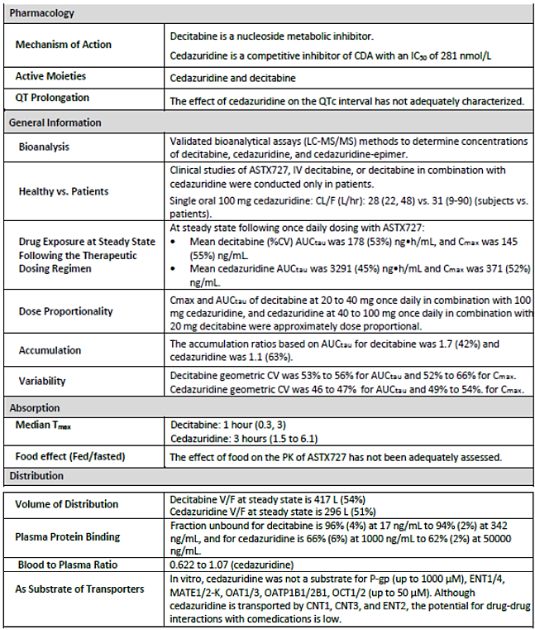
Table 3 (continued): Summary of pharmacology and pharmacokinetic characteristics of ASTX727
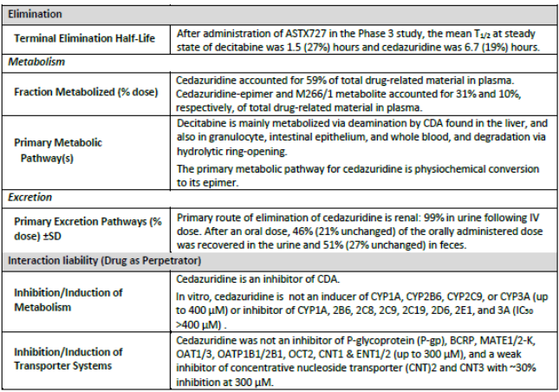
AUC_{tau} = area under concentration time curve during the dosing interval; CDA = cytidine deaminase; C_{max} = maximum plasma concentration; IC₅₀ = concentration giving half maximum inhibition; t_{1/2} = elimination half-time; T_{max} = time to maximum plasma concentration; CL/F = clearance; V/F = apparent volume of distribution. Note: PK paramaters are presented as geometric mean (%CV) or median (minimum, maximum) unless otherwise noted.

Efficacy
A summary listing of studies considered in this application is Table 4.
Table 4: Summary of clinical trials relevant to Inqovi 35/100
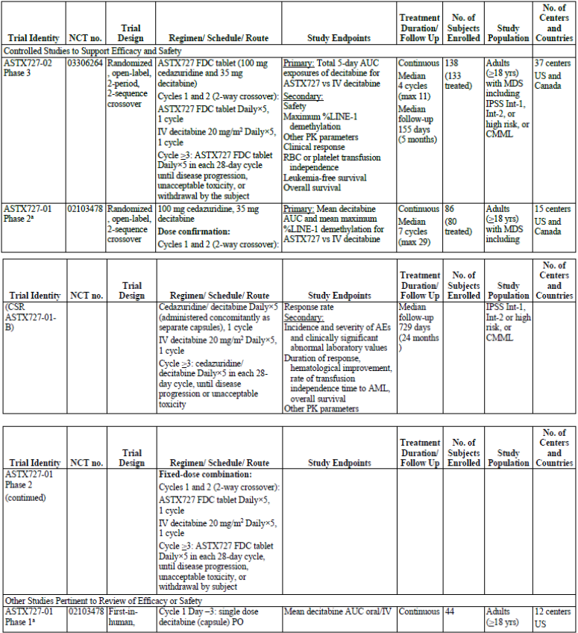
Table 4 (continued): Summary of clinical trials relevant to Inqovi 35/100
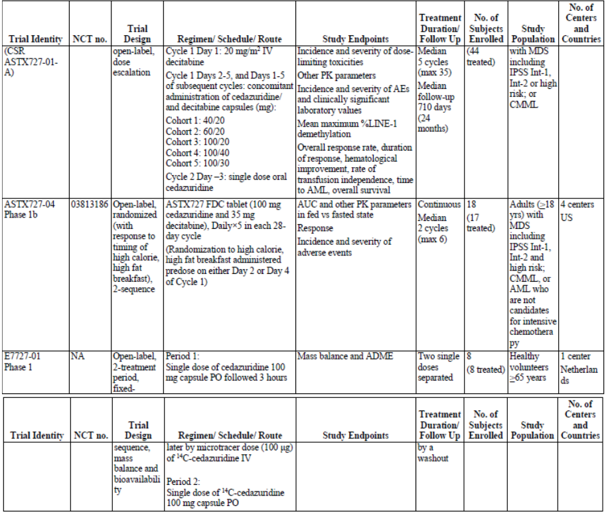
NCT no. = US National Library of Medicine clinical trial number. ADME = absorption, distribution, metabolism, and excretion; AML = acute myeloid leukemia; CMML = chronic myelomonocytic leukaemia; CSR = clinical study report; FDC = fixed dose combination; IPSS = International Prognostic Scoring System; Int-1 = IPSS intermediate 1 risk; Int-2 = IPSS intermediate 2 risk; IV = intravenous; MDS = myelodysplastic syndrome; PK = pharamcokinetic(s); PO = orally.
Study ASTX727-01 was a two part Phase I and II study conducted under a single protocol. The result of this study have been reported in two separate CSRs (Study ASTX727-01-A and Study ASTX727-01-B).

Pivotal study

Study ASTX727-02
Study ASTX727-02 was a Phase III, open label, randomised two arm cross-over trial between IV decitabine and ASTX727 followed by a single arm continuation of ASTX727 treatment. It was designed to assess the PK, pharmacodynamics (PD), safety and efficacy of ASTX727 compared to IV decitabine 20 mg/m² daily. Figure 3 is a schema of the Study ASTX727-02 trial design.
Figure 3: Study ASTX727-02 trial design
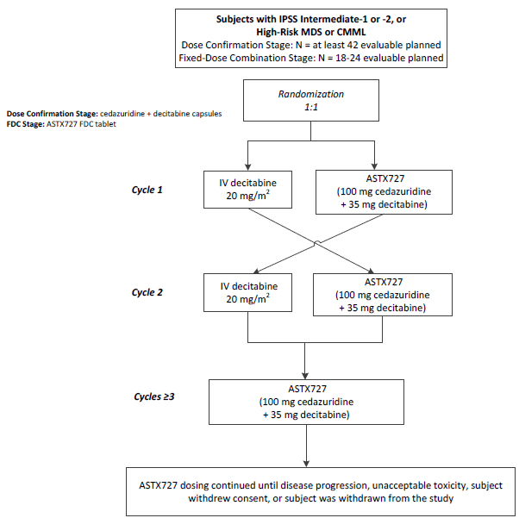
Included in the trial were adults with new or previously treated MDS or CMML consistent with the proposed indications, but who had not previously received more than 1 cycle of azacitidine or decitabine (Figure 3).
The primary endpoint was a pharmacokinetic comparison of 5 days AUC of decitabine after IV or ASTX727 administration in the cross-over arm of the trial. The secondary endpoints were clinical and included:
- Safety as assessed by adverse events (AE), concomitant medications, physical examination, clinical laboratory tests (haematology, serum chemistry, and urinalysis), vital signs, Eastern Cooperative Oncology Group performance status (ECOG-PS), and electrocardiogram.
- Maximum %LINE-1 demethylation.
- Additional secondary PK parameters.
- Clinical response (complete response (CR), marrow CR, partial response (PR), and haematologic improvement (HI)) based on International Working Group (IWG) 2006 MDS response criteria.
- Red blood cell (RBC) or platelet transfusion independence (TI).
- Leukaemia free survival, defined as the number of days from the date of randomisation to the date when bone marrow or peripheral blood blasts reach ≥ 20%, or death from any cause.
- Overall survival, defined as the number of days from the date of randomisation to the date of death from any cause.
Table 5, below, gives the results for the clinical endpoints of Study ASTX727-02.
Table 5: Study ASTX727-02 Clinical endpoints, interim analysis
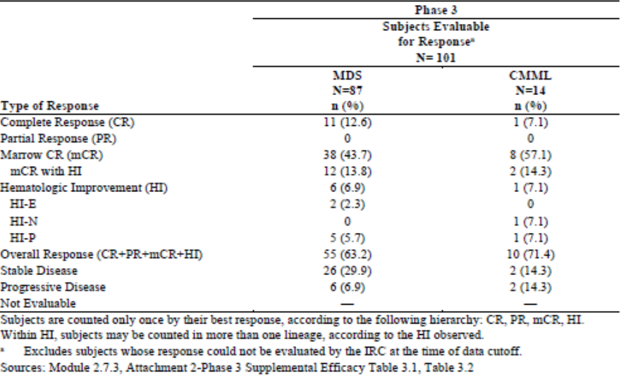
The median duration on therapy in this analysis was 5.1 months. A subsequent 120 day update provided data with a median duration of follow-up of 12.6 months and time on therapy of 8.1 months. This was generally confirmatory of the response rate (see Table 5).

Study ASTX727-01
Study ASTX727-01, a Phase II study, has the same design as the Study ASTX727-02, Phase III trial and is mainly of significance in that it presented data from a longer duration of follow-up, including overall survival.
Figure 4: Study ASTX727-01 Overall survival of patients (Phase II trial)
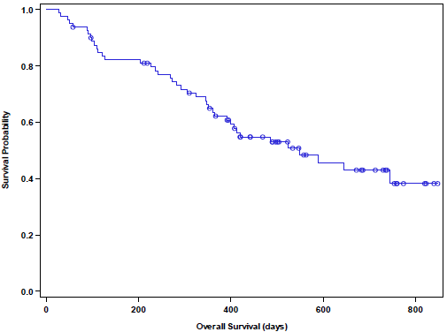
Of 80 treated patients, the median survival was 18.3 months (Figure 4).
Figure 5: Study ASTX727-02 Comparative LINE-1 methylation in cross over period
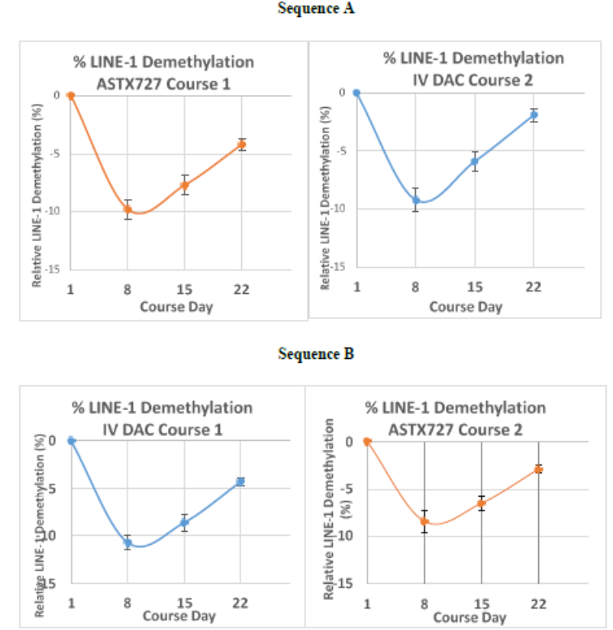
N = 78. Sequence A = ASTX727 in course 1; IV decitabine in course 2. Dosing was Day 1 to 5 of each 28 days course. DAC = IV decitabine. Error bars are standard error of the mean (SEM).
Note: Course 1 assessments at Baseline (for example latest available value on or before C1D1) and on Days 8, 15,22. Course 2 assessments at Baseline (C2D1) and on Days 8, 15, 22.
Methylation of LINE-1 gene sequences was compared between oral and IV products in the cross-over part of the trial as a proxy for pharmacodynamics effect. This was equivalent between ASTX727 and IV decitabine, indicating a similar target effect of the two products (Figure 5).

Safety
The safety analysis was based on the single arm portions of Studies ASTX727-01 and ASTX727-02.
Table 6: Studies contributing to safety analysis
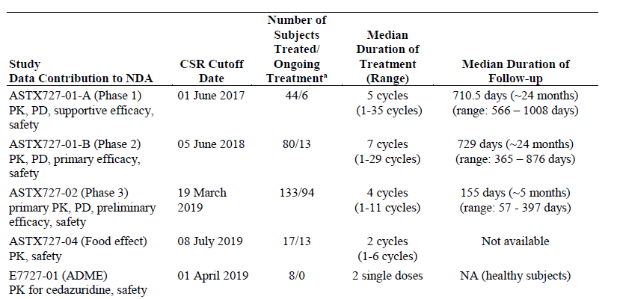
NDA = United States Food and Drug Administration (FDA) New Drug Application; CSR = clinical study report; ADME = absorption, distribution, metabolism, and excretion; NA = not applicable; PK = pharmacokinetics; PD = pharmacodynamics.
ª As of the data cutoff date for respective CSRs.
The safety analysis was based on the single arm portions of Studies ASTX727-01 and -02.
A total of 208 patients were exposed to ASTX727 and available for safety review, representing 1342 cycles of therapy with a mean of 5 cycles per patient. The duration of follow-up in the Phase II study was longer, 12 to 24 months, than in the Phase III study, in which it was a median of 5 months. 81% of the pooled patients had MDS and 19% had CMML (Table 7).
Table 7: Exposure of patients in safety analysis to ASTX727
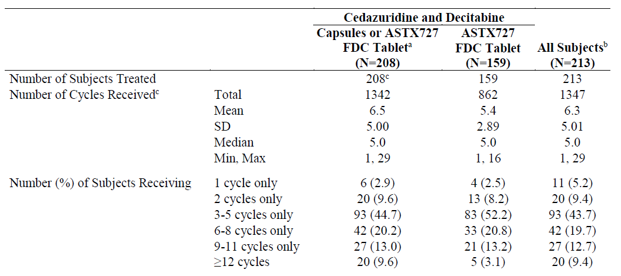
FDC = fixed dose combination; SD = standard deviation.
Note: Exposure data are included through the data cut-off dates for the respective CSRs.
ª Includes all subjects who received 100 mg cedazuridine and 35 mg decitabine, either administered concomitantly as separate capsule or as the AST727 FDC tablet.
^{b} Includes all subjects who received any treatment in Study ASTX727-01 (Phase II part) or Study ASTX727-02 (Phase III), including 5 subjects who only received IV decitabine.
^{c} Completed or partially completed cycles.
A total of 17 patients in the safety population suffered a treatment emergency cause of death, 3 in the IV decitabine and 14 in the ASTX727 population respectively (Table 8).
Table 8: Treatment emergent adverse events with death as an outcome (ASTX727 integrated population)
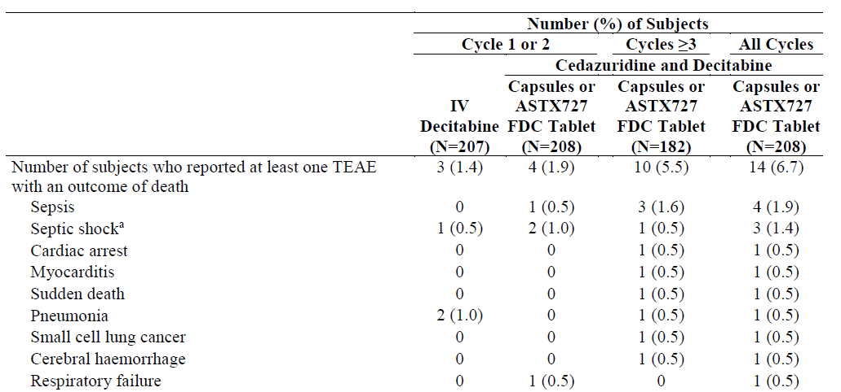
Treatment emergent adverse events (TEAE) included those occurring up to 30 days after the last dose and events that occurred more than 30 days after the last dose that were both serious and related to study treatment.
ª One event of septic shock reported with ASTX727 in Cycle 2 was considered by the investigator to be related to IV decitabnine received in Cycle 1.
The sponsor has noted that overall these were primarily infections and are consistent with prolonged neutropaenia typical of the diseases being treated. The most common non-fatal serious adverse events were febrile neutropaenia, pneumonia and sepsis, as shown in Table 9.
Table 9: Serious adverse events occurring in > 1% of subjects by System Organ Class and Preferred Term (integrated safety population)
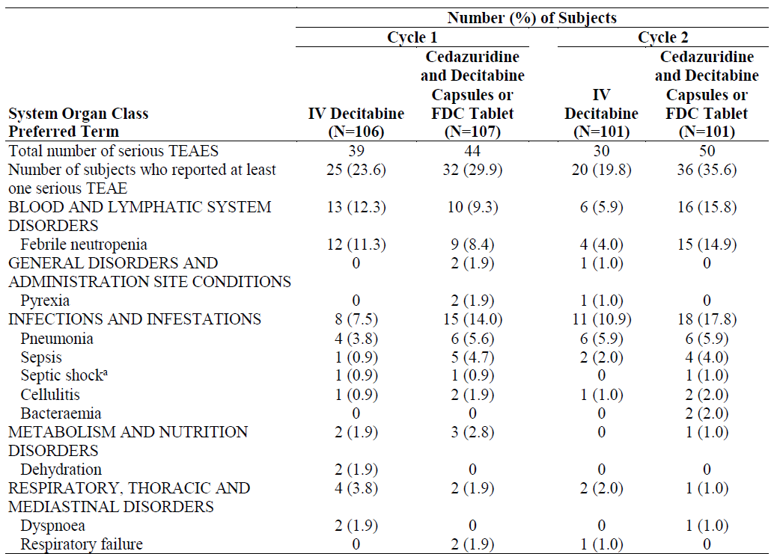
ª Septic shock is included despite occurring at an incidence below the cut off for this table because of its medical relatedness to sepsis.
The most common adverse events resulting in interruption to therapy were related to neutropaenia, which occurred in less than 10% of cases, as shown in Table 10.
Table 10: Adverse events leading to interruption of treatment in > 1% of subjects by System Organ Class and Preferred Term(integrated safety population)
As noted, the most common adverse events were related to haematological endpoints or infections consistent with both the underlying conditions and expected potential adverse effects of cytotoxic therapy, (see Table 11, below).
Table 11: All grade adverse events occurring in > 10% of patients in integrated safety population
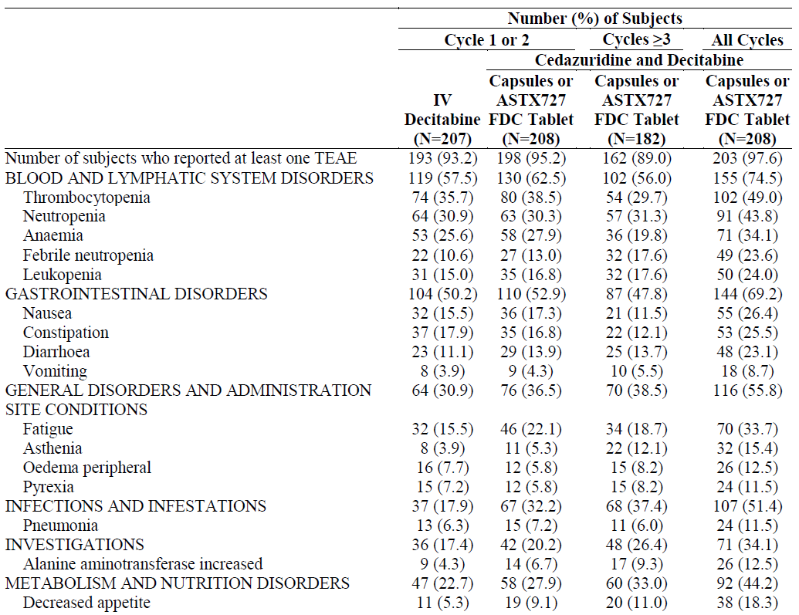
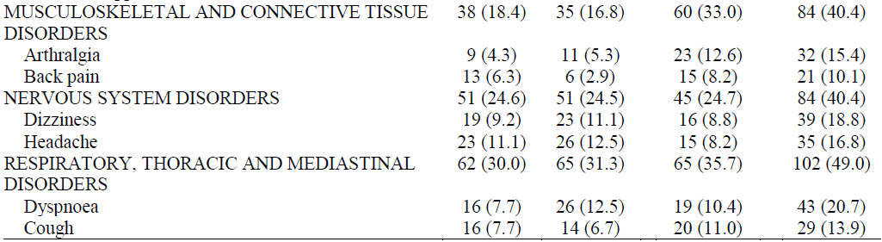

Risk management plan
The sponsor has submitted a core-risk management plan (RMP) version 1.0 (16 December 2019; data lock point (DLP) 19 March 2019) and Australia specific annex (ASA) version 1.0 (09 January 2020) in support of this application. In response to questions raised by TGA, the sponsor provided an updated core-RMP version 1.1 (25 August 2020; DLP 19 March 2019) and an ASA version 1.1 (September 2020).
Later in the evaluation phase, the product name was changed to Inqovi 35/100 to depict 35 mg of decitabine and 100 mg of cedazuridine.
The summary of safety concerns and their associated risk monitoring and mitigation strategies are summarised in Table 12.
Table 12: Summary of safety concerns and their associated risk monitoring and mitigation strategies
Summary of safety concerns |  | Pharmacovigilance |  | Risk Minimisation
 |  | Routine | Additional | Routine | Additional
Important identified risks | None
Important potential risks | Interstitial lung disease (ILD) |  | – |  | –
Missing information | Use in severe renal impairment |  | – | * | –
Missing information | Use in hepatic impairment |  | – | * | –
Missing information | Use in severe cardiac disease (for example uncontrolled angina or severe congestive heart failure, New York Heart Association Grades III-IV (NYHA III-IV)) |  | – | * | –
* Clinical trials
The summary of safety concerns is acceptable from an RMP perspective.
The sponsor has proposed routine pharmacovigilance activities for all safety concern. Additional pharmacovigilance activities are planned for all of the missing information. The pharmacovigilance plan is acceptable from an RMP perspective.
The sponsor has proposed routine risk minimisation activities for all safety concerns. The Consumer Medicine Information (CMI) will be included in the pack. No additional risk minimisation activities have been proposed. Routine risk minimisation measures are considered acceptable to address the risk associated with this product.

Wording for conditions of registration
Any changes to which the sponsor has agreed should be included in a revised RMP and ASA. However, irrespective of whether or not they are included in the currently available version of the RMP document, the agreed changes become part of the risk management system.
The suggested wording is:
‘The Inqovi 35/100 Core Management Plan (RMP) (version 1.1, dated 25 August 2020, data lock point 19 March 2019), with Australian Specific Annex (version 1.1, dated September 2020), included with submission PM-2020-00088-1-6, and any subsequent revisions, as agreed with the TGA will be implemented in Australia.
An obligatory component of risk management plans is routine pharmacovigilance. Routine pharmacovigilance includes the submission of periodic safety update reports (PSUR).
Unless agreed separately between the supplier who is the recipient of the approval and the TGA, the first report must be submitted to TGA no later than 15 calendar months after the date of this approval letter. The subsequent reports must be submitted no less frequently than annually from the date of the first submitted report until the period covered by such reports is not less than three years from the date of this approval letter. The annual submission may be made up of two PSURs each covering six months. If the sponsor wishes, the six monthly reports may be submitted separately as they become available.
If the product is approved in the European Union (EU) during the three years period, reports can be provided in line with the published list of EU reference dates no less frequently than annually from the date of the first submitted report until the period covered by such reports is not less than three years from the date of this approval letter.
The reports are to at least meet the requirements for PSURs as described in the European Medicines Agency’s Guideline on good pharmacovigilance practices (GVP) Module VII-periodic safety update report (Rev 1), Part VII.B Structures and processes. Note that submission of a PSUR does not constitute an application to vary the registration. Each report must have been prepared within ninety calendar days of the data lock point for that report.’
As Inqovi 35/100 contains a new chemical entity, it should be included in the Black Triangle Scheme as a condition of registration. The following wording is recommended for the condition of registration:
‘Inqovi 35/100 (decitabine/ cedazuridine) is to be included in the Black Triangle Scheme. The PI and CMI for Inqovi 35/100 must include the black triangle symbol and mandatory accompanying text for five years, which starts from the date that the sponsor notifies the TGA of supply of the product.’

Risk-benefit analysis

Delegate’s considerations
The Delegate notes that the US FDA assessment of this submission was grounded largely in PK-bridging to a well-established agent, where as in Australia decitabine was a new chemical entity for which there is no existing regulatory foundation as a sole agent. In Australia the place of decitabine has been taken by azacitidine, which has a similar mechanism of action but can be administered daily rather than three times a day (TDS).
The Delegate notes, however, that the sponsor has provided a substantial body of data that supports for comparative efficacy of ASTX727 and decitabine IV, including clinical endpoint and PD data. The PD data suggests that the demethylation effect (on LINE-1) is equivalent between the two dosage forms, and exposure to decitabine is bioequivalent. The single arm clinical endpoint data would, in the Delegate’s view, be considered immature for a standard new chemical entity. However, the Delegate accepts that in the context of an agent with a long history of regulatory approval by a comparable regulator, these studies are sufficiently supportive of efficacy to warrant registration of ASTX727.
The safety analysis is consistent with the known cytotoxic effects of decitabine as well as the underlying manifestations of CMML and MDS. It does not suggest any additional toxicities as a result of the combination of decitabine and cedazuridine and the Delegate again refers to the long post-market history of decitabine in foreign markets.
The Delegate notes, however, that while there is a long clinical history of using decitabine, the only safety data regarding cedazuridine is provided from the clinical trials submitted in this application. Although the safety data does not suggest new cytotoxic effects from the combination of the two components of ASTX727, the Delegate notes that cedazuridine is not a cytotoxic agent itself. The potential long term effects of inhibiting the endogenous effect of CDA in humans is not characterised in this data. Against this concern, the Delegate notes that the likely duration of use of ASTX727 in the indications proposed is 5 to 10 years in an older population. Therefore, it is considered that the unknown potential long term toxicity of cedazuridine is not a barrier to registration in these indications. The Delegate also notes that there were no concerns raised in this regard by the pre-clinical toxicology assessment.

Proposed action
The Delegate proposes to register Inqovi 35/100 for the indication:
Treatment of adult patients with myelodysplastic syndromes (MDS) intermediate-1, intermediate-2, and high-risk International Prognostic Scoring System groups, and patients with chronic myelomonocytic leukaemia (CMML).
With the product information as provided to TGA amended in line with the quality and non-clinical evaluations by Health Canada and the US FDA.

Advisory Committee considerations
The Delegate did not refer this application to the Advisory Committee on Medicines (ACM) for advice.

Outcome
Based on a review of quality, safety and efficacy, the TGA approved the registration of Inqovi 35/100, 35 mg decitabine and 100 mg cedazuridine tablet, indicated for:
Inqovi 35/100 is indicated for the treatment of adult patients with myelodysplastic syndromes (MDS) intermediate-1, intermediate-2, and high-risk International Prognostic Scoring System groups, and patients with chronic myelomonocytic leukaemia (CMML).

Specific conditions of registration applying to these goods
- Inqovi 35/100 (decitabine 35 mg and cedazuridine 100 mg) is to be included in the Black Triangle Scheme. The PI and CMI for Inqovi 35/100 must include the black triangle symbol and mandatory accompanying text for five years, which starts from the date that the sponsor notifies the TGA of supply of the product.
- The Inqovi 35/100 Core Management Plan (RMP) (version 1.1, dated 25 August 2020, DLP 19 March 2019), with ASA (version 1.1, dated September 2020), included with submission PM-2020-00088-1-6, and any subsequent revisions, as agreed with the TGA will be implemented in Australia.
An obligatory component of risk management plans is routine pharmacovigilance. Routine pharmacovigilance includes the submission of PSURs.
Unless agreed separately between the supplier who is the recipient of the approval and the TGA, the first report must be submitted to TGA no later than 15 calendar months after the date of this approval letter. The subsequent reports must be submitted no less frequently than annually from the date of the first submitted report until the period covered by such reports is not less than three years from the date of this approval letter. The annual submission may be made up of two PSURs each covering six months. If the sponsor wishes, the six monthly reports may be submitted separately as they become available.
If the product is approved in the EU during the three years period, reports can be provided in line with the published list of EU reference dates no less frequently than annually from the date of the first submitted report until the period covered by such reports is not less than three years from the date of this approval letter.
The reports are to at least meet the requirements for PSURs as described in the European Medicines Agency’s Guideline on good pharmacovigilance practices (GVP) Module VII-periodic safety update report (Rev 1), Part VII.B Structures and processes. Note that submission of a PSUR does not constitute an application to vary the registration. Each report must have been prepared within ninety calendar days of the data lock point for that report.

Attachment 1. Product Information
The PI for Inqovi 35/100 approved with the submission which is described in this AusPAR is at Attachment 1. For the most recent PI, please refer to the TGA website at <https://www.tga.gov.au/product-information-pi>.

Therapeutic Goods Administration
PO Box 100 Woden ACT 2606 Australia
Email: info@tga.gov.au Phone: 1800 020 653 Fax: 02 6232 8605
https://www.tga.gov.au

The Black Triangle Scheme provides a simple means for practitioners and patients to identify certain types of new prescription medicines, including those being used in new ways and to encourage the reporting of adverse events associated with their use. The Black Triangle does not denote that there are known safety problems, just that the TGA is encouraging adverse event reporting to help us build up the full picture of a medicine's safety profile.
Project Orbis seeks to increase collaboration among international regulators, which may in turn allow patients with cancer to receive earlier access to products in other countries where there may be significant delays in regulatory submissions, regardless of whether the product has received approval. Pivotal clinical trials in oncology are commonly conducted internationally and these global trials are increasingly important for investigating the safety and effectiveness of cancer drugs for approval across jurisdictions. Future drug development may benefit by establishing a greater uniformity of new global standards of treatment, leading to the optimal design of these important trials.
'Orphan drugs' are often developed to treat small and very specific patient populations who suffer from rare diseases and conditions. In order to facilitate orphan drug access to the Australian marketplace and help offset orphan drug development costs the TGA waives application and evaluation fees for prescription medicine registration applications if a related orphan designation is in force. A medicine may be eligible for orphan drug designation if all orphan criteria set by the TGA are met. The orphan designation application precedes the registration application and the designation is specific to the sponsor, orphan indication for which designation was granted and dosage form of the medicine.
The International Council for Harmonisation of Technical Requirements for Registration of Pharmaceuticals for Human Use (ICH) S9: Non-clinical evaluation for anticancer pharmaceuticals. This guidance aims to assist in the design of non-clinical studies for the development of anticancer pharmaceuticals. It provides recommendations for non-clinical evaluations to support the development of anticancer pharmaceuticals in clinical trials for the treatment of patients with advanced disease and limited therapeutic option.
Cytochrome P450 (CYP) enzymes: CYPs are the major enzymes involved in drug metabolism, accounting for large part of the total metabolism. Most drugs undergo deactivation by CYPs, either directly or by facilitated excretion from the body. Also, many substances are bioactivated by CYPs to form their active compounds. Many drugs may increase or decrease the activity of various CYP isozymes either by inducing the biosynthesis of an isozyme (enzyme induction) or by directly inhibiting the activity of the CYP (enzyme inhibition). This is a major source of adverse drug interactions, since changes in CYP enzyme activity may affect the metabolism and clearance of various drugs. Such drug interactions are especially important to take into account when using drugs of vital importance to the patient, drugs with important side-effects and drugs with small therapeutic windows, but any drug may be subject to an altered plasma concentration due to altered drug metabolism
An Ames test is a biological assay to assess the mutagenic potential of chemical compounds.
Pregnancy Category X: Drugs which have such a high risk of causing permanent damage to the fetus that they should not be used in pregnancy or when there is a possibility of pregnancy.
ASTX727 is the development code used by sponsor for Inqovi 35/100
ECOG Performance Status: The Eastern Cooperative Oncology Group (ECOG) has developed criteria used by doctors and researchers to assess how a patient's disease is progressing, assess how the disease affects the daily living abilities of the patient, and determine appropriate treatment and prognosis. The following are used: 0 - Fully active, able to carry on all pre-disease performance without restriction 1- Restricted in physically strenuous activity but ambulatory and able to carry out work of a light or sedentary nature, for example., light house work, office work 2 - Ambulatory and capable of all selfcare but unable to carry out any work activities. Up and about more than 50% of waking hours3 - Capable of only limited selfcare, confined to bed or chair more than 50% of waking hours 4 - Completely disabled. Cannot carry on any selfcare. Totally confined to bed or chair 5 – Dead
Routine risk minimisation activities may be limited to ensuring that suitable warnings are included in the product information or by careful use of labelling and packaging. Routine pharmacovigilance practices involve the following activities: - All suspected adverse reactions that are reported to the personnel of the company are collected and collated in an accessible manner; - Reporting to regulatory authorities; - Continuous monitoring of the safety profiles of approved products including signal detection and updating of labelling; - Submission of PSURs; - Meeting other local regulatory agency requirements.
The New York Heart Association (NYHA) Classification classifies patients based on limitations of physical activity and presence and severity of symptoms. Class I: No limitation of physical activity. Ordinary physical activity does not cause undue fatigue, palpitation, dyspnoea (shortness of breath). Class II: Slight limitation of physical activity. Comfortable at rest. Ordinary physical activity results in fatigue, palpitation, dyspnoea (shortness of breath). Class III: Marked limitation of physical activity. Comfortable at rest. Less than ordinary activity causes fatigue, palpitation, or dyspnoea. Class IV: Unable to carry on any physical activity without discomfort. Symptoms of heart failure at rest. If any physical activity is undertaken, discomfort increases.
The ACM provides independent medical and scientific advice to the Minister for Health and the Therapeutic Goods Administration (TGA) on issues relating to the safety, quality and efficacy of medicines supplied in Australia including issues relating to pre-market and post-market functions for medicines. The Committee is established under Regulation 35 of the Therapeutic Goods Regulations 1990. Members are appointed by the Minister. The ACM was established in January 2017 replacing Advisory Committee on Prescription Medicines (ACPM) which was formed in January 2010. ACM encompass pre and post-market advice for medicines, following the consolidation of the previous functions of the Advisory Committee on Prescription Medicines (ACPM), the Advisory Committee on the Safety of Medicines (ACSOM) and the Advisory Committee on Non-Prescription Medicines (ACNM). Membership comprises of professionals with specific scientific, medical or clinical expertise, as well as appropriate consumer health issues relating to medicines.

