First round evaluation: 12 June 2015
Second round evaluation: 20 October 2015

AusPAR Attachment 2

Extract from the Clinical Evaluation Report for Daclizumab
  - Proprietary Product Name: Zinbryta
  - Sponsor: Biogen Australia Pty Ltd

About the Therapeutic Goods Administration (TGA)
- The Therapeutic Goods Administration (TGA) is part of the Australian Government Department of Health, and is responsible for regulating medicines and medical devices.
- The TGA administers the Therapeutic Goods Act 1989 (the Act), applying a risk management approach designed to ensure therapeutic goods supplied in Australia meet acceptable standards of quality, safety and efficacy (performance), when necessary.
- The work of the TGA is based on applying scientific and clinical expertise to decision-making, to ensure that the benefits to consumers outweigh any risks associated with the use of medicines and medical devices.
- The TGA relies on the public, healthcare professionals and industry to report problems with medicines or medical devices. TGA investigates reports received by it to determine any necessary regulatory action.
- To report a problem with a medicine or medical device, please see the information on the TGA website <https://www.tga.gov.au>.
About the Extract from the Clinical Evaluation Report
- This document provides a more detailed evaluation of the clinical findings, extracted from the Clinical Evaluation Report (CER) prepared by the TGA. This extract does not include sections from the CER regarding product documentation or post market activities.
- The words [Information redacted], where they appear in this document, indicate that confidential information has been deleted.
- For the most recent Product Information (PI), please refer to the TGA website <https://www.tga.gov.au/product-information-pi>.
Copyright
© Commonwealth of Australia 2017
This work is copyright. You may reproduce the whole or part of this work in unaltered form for your own personal use or, if you are part of an organisation, for internal use within your organisation, but only if you or your organisation do not use the reproduction for any commercial purpose and retain this copyright notice and all disclaimer notices as part of that reproduction. Apart from rights to use as permitted by the Copyright Act 1968 or allowed by this copyright notice, all other rights are reserved and you are not allowed to reproduce the whole or any part of this work in any way (electronic or otherwise) without first being given specific written permission from the Commonwealth to do so. Requests and inquiries concerning reproduction and rights are to be sent to the TGA Copyright Officer, Therapeutic Goods Administration, PO Box 100, Woden ACT 2606 or emailed to <tga.copyright@tga.gov.au>.

Contents
List of common abbreviations 5
1. Introduction 8
2. Clinical rationale 8
2.1. Regulatory background 9
3. Contents of the clinical dossier 10
3.1. Scope of the clinical dossier 10
3.2. Paediatric data 10
3.3. Good clinical practice 10
4. Pharmacokinetics 11
4.1. Studies providing pharmacokinetic data 11
4.2. Summary of pharmacokinetics 12
4.3. Evaluator’s overall conclusions on pharmacokinetics 17
5. Pharmacodynamics 18
5.1. Studies providing pharmacodynamic data 18
5.2. Summary of pharmacodynamics 18
5.3. Evaluator’s overall conclusions on pharmacodynamics 19
6. Dosage selection for the pivotal studies 19
6.1. Evaluator’s overall conclusions on dosage selection for the pivotal studies 19
7. Clinical efficacy 20
7.1. Pivotal efficacy studies 20
7.2. Other efficacy studies 39
7.3. Analyses performed across trials (pooled analyses and meta-analyses) 43
7.4. Evaluator’s conclusions on clinical efficacy 43
8. Clinical safety 44
8.1. Studies providing evaluable safety data 44
8.2. Patient exposure 48
8.3. Adverse events 50
8.4. Laboratory tests 58
8.5. Post-marketing experience 62
8.6. Safety issues with the potential for major regulatory impact 62
8.7. Evaluator’s overall conclusions on clinical safety 67
9. First round benefit-risk assessment 68
10. First round recommendation regarding authorisation 69
11. Clinical questions 70
11.1. Additional expert input 70
11.2. Clinical questions 70
12. Second round evaluation of clinical data submitted in response to questions 70
13. Second round benefit-risk assessment 70
14. Second round recommendation regarding authorisation 70
15. References 70

List of common abbreviations
Abbreviation | Meaning
A/H1N1 | Influenza A virus subtype H1N1
A/H3N2 | Influenza A virus subtype H3N2
ADA | Anti-drug antibody
ADCC | Antibody dependent cellular cytotoxicity
AE | Adverse event
ALT | Alanine transaminase
ARR | Absolute risk ratio
AST | Aspartate transaminase
B-strains | Influenza B virus strains
BBB | Blood-brain barrier
CD56^{bright} | A natural killer (NK) cell subset
CDC | Complement dependent cytotoxicity
CI | Confidence interval
CNS | Central nervous system
CRF | Clinical record file
CYP | Cytochrome p450
DAC-HYP | Daclizumab high-yield process
DAE | Discontinuation due to adverse event
DMT | Disease modifying therapy
DMT | Disease modifying therapy
ECG | Electrocardiogram/graph
EDSS | Expanded Disability Status Scale
EU | European Union
FLAIR | Fluid-attenuated inversion recovery
FOXP3 | FOXP3 (scurfin) protein
GCP | Good Clinical Practice
Gd | Gadolinium
GGT | Gamma-glutamyl transpeptidase
GI | Gastrointestinal
ICH | International Conference on Harmonisation
IFN-β | Interferon-beta
IL | Interleukin
IL-2R | Interleukin-2 receptor
ISE | Integrated Summary of Efficacy
ISS | Integrated Summary of Safety
ITT | Intention-to-treat
IVRS | Interactive voice randomisation system
kDa | Kilodalton
LTi | Lymphoid tissue inducer (cell)
MAb | Monoclonal antibody
MRI | Magnetic resonance imaging
MS | Multiple sclerosis
MSIS-29 | Multiple Sclerosis Impact Scale-29
NAb | Neutralising antibody
NCI | National Cancer Institute (US)
NCI-CTCAE | National Cancer Institute, Common Terminology Criteria for Adverse Events
NK | Natural killer (cell)
PD | Pharmacodynamic(s)
PFP | Pre-filled pen
PFS | Pre-filled syringe
PML | Progressive multifocal leukoencephalopathy
popPK | Population pharmacokinetics
RBC | Red blood cell
RRMS | Relapsing remitting multiple sclerosis
SAE | Serious adverse event
SC | Subcutaneous(ly)
SCAR | Serious cutaneous events
SD | Standard deviation
SJS | Steven’s Johnson Syndrome
SOC | System organ class
TEN | Toxic epidermal necrolysis
TP-DI | Therapeutic Protein-Drug Interaction
T_{reg} | Regulatory T-cell
ULN | Upper limit of normal
US | United States
WBC | White blood cell

Introduction
This submission proposes to register the new active substance daclizumab (Zinbryta). Daclizumab is a human monoclonal antibody with the ATC code L01XC.
The proposed indication is:
‘Zinbryta is indicated for the treatment of relapsing forms of multiple sclerosis (MS).’
This submission proposes registration of the following dosage forms and strengths:
- Zinbryta daclizumab 150 mg/ml solution for injection pre-filled pen (PFP);
- Zinbryta daclizumab 150 mg/ml solution for injection pre-filled syringe (PFS).
The proposed dosage is: 150 mg administered as a subcutaneous (SC) injection once a month.

Clinical rationale
Multiple sclerosis (MS) is an autoimmune inflammatory demyelinating disease of the central nervous system (CNS). There are a number of clinical sub-types of MS:
- Clinically isolated syndromes: first episode of a condition compatible with MS such as optic neuritis.
- Relapsing-remitting MS (RRMS): distinct episodes of disease separated by clear periods of relapse with full recovery or with ongoing deficit upon recovery. The disease does not progress during periods of relapse.
- Secondary progressive MS (SPMS): Initial RRMS disease followed by ongoing deterioration, there may be occasional relapses or minor remissions.
- Primary progressive MS (PPMS): Progressive disability from the onset of the disease.
Most commonly patients have RRMS at onset and progress to develop secondary progressive MS. The level of activity of MS is determined by the frequency of relapses or MRI evidence of lesions.
The main magnetic resonance imaging (MRI) markers of MS disease activity are lesion load and atrophy. Lesion load is assessed on conventional T2-weighted, fluid-attenuated inversion recovery (FLAIR) and post-contrast T1-weighted MRIS sequences.
The prevention of clinical relapses and disability progression as well as the subclinical brain injuries that occur during the relapsing phase of MS are recognized as important therapeutic benefits for MS patients.
MS pathology in the cerebral white matter is characterized by focal areas of demyelination and axonal injury and, in acute lesions, by activated T-lymphocytes in the adjacent perivascular spaces and migration of inflammatory cells through a compromised blood-brain barrier (BBB). Autoreactive T-cells directed against myelin antigens in the CNS play a role in the initiation and propagation of MS lesions, contributing to the destruction of myelin, axons, and oligodendrocytes through both direct and indirect effects of inflammation.
Daclizumab high-yield process (DAC HYP) works through a novel, reversible modulation of interleukin (IL)-2 signalling, inhibiting CD25-dependent, high-affinity IL-2 receptor signalling but leaving intermediate-affinity IL-2 receptor signalling intact. This signalling modulation results in several well-characterised immunologic changes that were hypothesized to result in selective targeting of both white and grey matter MS pathology while also preserving key protective functions of the immune system, as follows:
- Since activated but not resting T-cells express CD25 and depend on the high-affinity receptor to respond efficiently to IL-2, DAC HYP selectively inhibits activated T-cells without causing a nonspecific immune-depletion of lymphocytes.
- DAC HYP treatment results in an expansion of immune-regulatory NK cells, the CD56 bright natural killer (NK) cell. CD56^{bright} NK cells have been shown to selectively target activated but not resting T-cells in MS, and the magnitude of their expansion post-treatment has correlated with the therapeutic response to DAC HYP.
- Regulatory T-cells (T_{reg}) express CD25 and play an important role in immune system homeostasis and regulation. While there is a reversible decrease in the number of circulating T_{reg} cells during DAC HYP treatment, T_{reg} cells express high levels of the intermediate affinity IL-2 receptor, thereby enabling continued response to IL-2 signals. The cellular proliferation status, cytokine production profile, and epigenetic markers of the FOXP3 promoter indicate that a stable and functionally competent population of T-reg cells is maintained in the presence of long-term DAC HYP treatment despite CD25 antagonism. Compared to other forms of daclizumab, DAC HYP has a decreased amount of antibody-dependent cellular cytotoxicity, and this was believed to be advantageous for maintaining T-reg cell populations during long-term use.
In summary, the novel IL-2 signalling modulation of DAC HYP represents a targeted and reversible therapeutic approach to MS treatment that can selectively impact both grey and white matter MS pathology without causing nonspecific immune-depletion. DAC HYP’s mechanism of action is distinct and differentiated from other therapies available to treat RMS. The impact of DAC HYP on T-reg cells was an area of potential concern but the demonstration of functional adaptation by T-reg cells during DAC HYP use as well as the expansion of other immune-regulatory cell populations provided a basis for managing any potential impact on T-regs; therefore, DAC HYP was systematically evaluated in clinical studies to define its risks and benefits in relapsing MS.
Comment: The sponsor presents an acceptable rationale for the development of the product.

Regulatory background
This product is a new version of daclizumab, a monoclonal antibody product previously registered for the prophylaxis of acute organ rejection in patients receiving renal transplants. Daclizumab was discontinued by the sponsor for commercial reasons in 2005.
This marketing application is being submitted to support the approval of daclizumab (DAC HYP), a new structurally and functionally distinct form of daclizumab, as a disease modifying therapy (DMT) for the treatment of patients with relapsing forms of MS.
DAC HYP differs from a previously authorised form of daclizumab through structural and biologic differences, and through differences in the production cell line and manufacturing process. DAC HYP has a unique product profile that is distinct from the previously approved drug through its different indication, formulation, its route of administration, dosing schedule, and treatment duration.
Comment: The data package is independent of previous data supporting registration of the earlier version of this monoclonal antibody (MAb).

Contents of the clinical dossier

Scope of the clinical dossier
The clinical dosser documented a full clinical development program of pharmacology, efficacy and safety studies.
The submission contained the following clinical information:
- 5 clinical pharmacology studies, including 5 that provided pharmacokinetic data and 3 that provided pharmacodynamic data.
- 1 population pharmacokinetic (popPK) analysis.
- 2 pivotal efficacy/safety studies.
- 1 dose-finding study.
- 3 other efficacy/safety studies, 2 of which are ongoing.
- An Integrated Summary of Efficacy (ISE) and an Integrated Summary of Safety (ISS).
In addition, the submission contained a clinical overview, Summary of Clinical Efficacy (SCE), Summary of Clinical Safety (SC) and literature references.

Paediatric data
The submission did not include paediatric data. MS is a condition that most commonly has an onset in adults (usually aged over 20) resulting in very limited clinical value in the paediatric population. The sponsor has submitted paediatric investigation plans in the EU (European Union) and the US (United States). The applicant proposes to investigate the DAC HYP in children and adolescents aged between 10 and 18 years.

Good clinical practice
The studies used as a basis for clinical data presented in this dossier were conducted in compliance with Good Clinical Practice (GCP), as required by the ICH E6 “Guideline for Good Clinical Practice.” The studies also meet with the requirements of the Declaration of Helsinki.

Pharmacokinetics

Studies providing pharmacokinetic data
Table 1 shows the studies relating to each pharmacokinetic (PK) topic.

Table 1. Submitted pharmacokinetic studies
PK topic | Subtopic | Study ID | Study aims¹
PK in healthy adults | General PK (Multiple dosing)  DAC HYP 200 mg every 2 weeks x 9 doses DAC HYP; 200 mg loading dose pus 100 mg every 2-weeks x 8 doses; placebo  Subcutaneous administration | DAC-1014 | To determine the safety, tolerability, pharmacokinetics, pharmacodynamics and immunogenicity of multiple doses of DAC HYP administered by SC injection
PK in healthy adults | General PK (Single dosing)  DAC HYP: 50 mg; 150 mg; 300 mg; placebo  Subcutaneous administration | DAC-1015 | To determine the safety, tolerability, pharmacokinetics, pharmacodynamics and immunogenicity of SC DAC HYP
PK in healthy adults | General PK (Single dosing)  DAC HYP 200 mg; 400 mg; placebo  Subcutaneous administration | DAC-1018 | To determine the safety, tolerability, pharmacokinetics, pharmacodynamics and immunogenicity of IV DAC HYP
Genetic/ gender-related PK | PK Profile in Japanese and Caucasian healthy volunteers  Single dose PK | 205HV102 | To evaluate the PK, safety, and tolerability of DAC HYP administered as a single SC dose in Japanese and Caucasian adult healthy volunteers
PK in target population | Auto-injector sub-study.  DAC HYP 150 mg SC from a PFS by either manual injection or by auto-injector every 4 weeks for 4 doses-16-weeks | 205MS203 | To compare the systemic exposure of daclizumab following SC administration of 150 mg DAC HYP using the single use auto-injector (PFP) to the systemic exposure following manual PFS injection
PK in target population | Intensive PK sub-study DAC HYP 150 mg SC by PFS every 4 weeks for 6 doses-24-weeks | 205MS302 | To characterize the PK of DAC HYP following single and multiple doses of SC DAC HYP administered by the PFS in a subset of subjects with RRMS
PK in target population | DAC HYP 150 mg SC by PFS every 4 weeks for 3 Doses 12-weeks | 205MS302 | To evaluate the effect of DAC HYP on the PK of probe substrates for CYP isoenzymes (CYP1A2, CYP2C9, CYP2C19, CYP2D6, and CYP3A) in MS subjects
Population PK analyses | Derived from DAC-1014, DAC1015 DAC-1018 and 205MS301
(1) Indicates the primary aim of the study. Note PK = pharmacokinetics; PD = pharmacodynamics; SC = subcutaneous
None of the pharmacokinetic studies had deficiencies that excluded their results from consideration.

Summary of pharmacokinetics
The information in the following summary is derived from conventional pharmacokinetic studies unless otherwise stated.

Physicochemical characteristics of the active substance
The following information is derived from the sponsor’s summaries provided for this submission. The key physicochemical properties of DAC HYP are summarized as follows:
- The molecular weight of DAC HYP without N-glycans is approximately 144 kilo daltons (kDa).
- The molecular weights of the heavy chain without N-glycans and the light chain of DAC HYP are approximately 49 kDa and 23 kDa, respectively.
- DAC HYP is a basic protein
- The composition of the DAC HYP heavy chain is heterogeneous. The peptide sequence of approximately 70% of the heavy chain subunits in DAC HYP starts with the predicted N-terminal glutamine residue (or pyroglutamate); the other 30% start at N minus 3, with valine due to incomplete processing of the signal peptide. The composition of the DAC HYP heavy chain is also heterogeneous at the C-terminus with approximately 80% of the subunits free of the terminal lysine residue due to post-translational processing. The N- and C-terminal heterogeneities of the DAC HYP heavy chain are the major contributors to the DAC HYP charge heterogeneity.
- DAC HYP is glycosylated in its Fc domain on asparagine N296. DAC HYP glycans are almost entirely fucosylated asialobiantennary complex glycans, mostly non-galactosylated (G0F and G0F lacking one GlcNAc). High mannose glycan content is very low (< 3%), with only the Man5 species present at measurable levels.
DAC HYP binds specifically to CD25, the alpha subunit of the human high-affinity interleukin-2 receptor (IL-2R). DAC HYP binding of CD25 prevents IL-2 binding to CD25, thereby blocking IL-2 signalling by those cells that require high-affinity IL-2 receptors to mediate IL-2 signalling. DAC HYP binds with high affinity to CD25 and blocks IL-2 driven, CD25-dependent, T cell proliferation and activated T cell responses. DAC HYP does not show measurable complement-dependent cytotoxicity (CDC) activity and has low potency in antibody dependent cellular cytotoxicity (ADCC) activity. DAC HYP-induced inhibition of proliferation and cytokine production by activated pro-inflammatory T cells is expected to convey therapeutic benefit in MS and is consistent with the expected mechanism of action of this antibody.

Pharmacokinetics in healthy subjects

Absorption

Sites and mechanisms of absorption
DAC HYP is administered SC. Following SC administration DAC HYP achieves maximum concentration at approximately seven days.

Bioavailability

Absolute bioavailability
The absolute bioavailability of DAC HYP for the 100 mg to 300 mg dose group is estimated at approximately 90%. The elimination half-life was approximately 15-days.

Bioavailability relative to an oral solution or micronised suspension
Not applicable.

Bioequivalence of clinical trial and market formulations
The sponsor states that the formulation of DAC HYP used for clinical development is identical to that proposed for marketing.

Bioequivalence of different dosage forms and strengths
A sub-study in Study 205MS302 evaluated the pharmacokinetic parameters for DAC HYP 150 mg when administered subcutaneously by pre-filled syringe or an auto-injector pen. The formulation used in the two presentations was identical and as may be expected in such a case the two presentations were bioequivalent.

Bioequivalence to relevant registered products
Not applicable.

Influence of food
Not applicable.

Dose proportionality
Single dose PK studies following SC administration of doses ranging from 50 mg to 300 mg. DAC HYP was more than dose proportional in the 50 mg to 100 mg SC dose range and dose proportional form 100mg to 300 mg SC. Single-dose pharmacokinetics is summarised in Table 2 below.

Table 2. Summary of single-dose pharmacokinetics of DAC HYP following SC administration

Bioavailability during multiple-dosing
Consistent with the long elimination half-life steady state is achieved after about 16-weeks with dosing of 150 mg SC every 4-weeks. At steady state the DAC HYP accumulation ratio is approximately 2.5.

Effect of administration timing
Not applicable

Distribution

Volume of distribution
The estimated volume of distribution is small and ranges from 8.8 to 13.4 litres.

Metabolism

Sites of metabolism and mechanisms/enzyme systems involved
DAC HYP is a humanised MAb and the primary routes of elimination are likely to be proteolytic degradation, similar to that of physiological antibodies, and receptor mediated clearance.

Excretion

Routes and mechanisms of excretion
DAC HYP is a humanised MAb and the primary routes of elimination are likely to be proteolytic degradation, similar to that of physiological antibodies, and receptor mediated clearance.

Immunogenicity
Subjects evaluated for immunogenicity had to have at least 1 post-baseline immunogenicity test.
Serum samples were analysed for the presence of anti-drug antibodies (ADA) using the validated bridging ADA assays. The confirmed samples were also evaluated in the neutralising antibody (NAb) assay to detect the presence of NAb.
ADA-negative samples required no additional testing.
The immunogenicity of DAC HYP was evaluated in 4 Phase I clinical studies of healthy volunteers. The rate of initial ADA response to single-dose DAC HYP treatment was higher in these Phase I studies as compared with that following multiple-dose treatment in Phase 2 and 3 studies. In the Phase I studies, the incidence of immunogenicity responses appeared to be inversely correlated with the DAC HYP dose and was further elevated as the drug washed out.
Population PK analysis showed that time-varying NAb-positive status increased DAC HYP clearance by 19% on average.

Pharmacokinetics in the target population
Most of the pharmacokinetics was evaluated in healthy volunteers. Pharmacokinetics in patients with RRMS was evaluated in Studies 205MS201, 205MS202, 205MS301 and 205MS302.
The PK parameters was similar between healthy volunteers and subjects with RRMS.

Absorption

Sites and mechanisms of absorption
DAC HYP is administered SC. Following SC administration DAC HYP achieves maximum concentration at approximately seven days.

Bioavailability

Absolute bioavailability
The absolute bioavailability of DAC HYP for the 100 mg to 300 mg dose group is estimated at approximately 90%. The elimination half-life was approximately 15 days.

Bioavailability relative to an oral solution or micronised suspension
Not applicable.

Bioequivalence of clinical trial and market formulations
The sponsor states that the formulation of DAC HYP used for clinical development is identical to that proposed for marketing.

Bioequivalence of different dosage forms and strengths
A sub-study in Study 205MS302 evaluated the pharmacokinetic parameters for DAC HYP 150 mg when administered subcutaneously by pre-filled syringe or an auto-injector pen. The formulation used in the two presentations was identical and as may be expected in such a case the two presentations were bioequivalent.

Bioequivalence to relevant registered products
Not applicable.

Influence of food
Not applicable.

Dose proportionality
Single dose PK studies following SC administration of doses ranging from 50 mg to 300 mg. DAC HYP was more than dose proportional in the 50 mg to 100 mg SC dose range and dose proportional form 100mg to 300 mg SC.

Bioavailability during multiple-dosing
Consistent with the long elimination half-life steady state is achieved after about 16-weeks with dosing of 150 mg SC every 4-weeks. At steady state the DAC HYP accumulation ratio is approximately 2.5.

Effect of administration timing
Not applicable.

Distribution

Volume of distribution
The estimated volume of distribution is small and ranges from 8.8 to 13.4 litres.

Metabolism

Sites of metabolism and mechanisms/enzyme systems involved
DAC HYP is a humanised MAb and the primary routes of elimination are likely to be proteolytic degradation, similar to that of physiological antibodies, and receptor mediated clearance.

Excretion

Routes and mechanisms of excretion
DAC HYP is a humanised Mab and the primary routes of elimination are likely to be proteolytic degradation, similar to that of physiological antibodies and receptor mediated clearance.

Immunogenicity
Subjects evaluated for immunogenicity had to have at least 1 post-baseline immunogenicity test.
Serum samples were analysed for the presence of ADAs using the validated bridging ADA assays. The confirmed samples were also evaluated in the NAb assay to detect the presence of NAb.
ADA-negative samples required no additional testing.
Treatment-emergent ADAs to DAC HYP 150 mg were observed in 4% and 19% of evaluable subjects in Study 205MS201 and Study 205MS301, respectively. Treatment-emergent NAbs to DAC HYP 150 mg were observed in 3% and 8% of evaluable subjects in Study 205MS201 and Study 205MS301, respectively. The differences in the incidences of immunogenicity between the 2 studies appeared to be due primarily to more frequent immunogenicity testing at early time-points and more sensitive assay used in Study 205MS301 as compared with Study 205MS201.
Time-varying NAb status increased DAC HYP clearance by 19% on average. However, the impact does not appear to be clinically relevant since there was no discernible impact of immunogenicity status on the efficacy, safety, or PD profile of DAC HYP.

Pharmacokinetics in other special populations

Pharmacokinetics in subjects with impaired hepatic function
Not applicable.

Pharmacokinetics in subjects with impaired renal function
Not applicable.

Pharmacokinetics according to age
DAC HYP was only studied in patients aged 18 to 66 inclusive, it is therefore not known the impact extremes of age may have on the PK. 20 year old, and drug metabolism declines slowly with age.

Pharmacokinetics related to genetic factors
No apparent PK differences were observed between Japanese and Caucasian subjects following a single-dose administration of DAC HYP 75 mg or 150 mg SC.

Pharmacokinetics related to body weight
Population PK analysis showed that body weight was a significant covariate for DAC HYP clearance and central volume of distribution, explaining 37% and 27%, respectively, of the estimated inter individual variability for these two parameters.
Comment: Given the small volume of distribution and the slow clearance this is unlikely to be clinically significant at the proposed dosing interval and no adjustment is necessary.

Pharmacokinetic interactions

Pharmacokinetic interactions demonstrated in human studies
DAC HYP is a humanised MAb and the primary routes of elimination are likely to be proteolytic degradation, similar to that of physiological antibodies, and receptor mediated clearance. As such the relevant data has not been submitted.
Therapeutic monoclonal antibodies that modulate cytokine activities can indirectly influence the expression of CYP isoenzymes. The sponsor did undertake a sub-study to investigate the effect of multiple dosing of DAC HYP 150 on cytochrome P450 (CYP) substrates.
Concomitant administration of oral midazolam 5 mg (CYP3A), warfarin 10 mg/vitamin K 10 mg (CYP2C9), omeprazole 40 mg (CYP2C19), caffeine 200 mg (CYP1A2), and dextromethorphan 30 mg (CYP2D6) following 12-week dosing of DAC HYP 150 mg SC every 4 weeks in 20 MS subjects did not alter the exposure of these probe substrates.
Multiple dosing of DAC HYP 150 mg SC every 4 weeks in MS patients had no effect on CYP1A2, CYP2C9, CYP2C19, CYP2D6, and CYP3A. No dosage adjustments are needed for drugs that are substrates of these CYP enzymes when given concomitantly with DAC HYP.

Evaluator’s overall conclusions on pharmacokinetics
Since the expected consequence of metabolism of DAC HYP is degradation to small peptides and single amino acid, no studies were performed to assess the route of excretion of DAC HYP; this is in line with ICH S6(R1) guideline and accepted by the evaluator. As a high molecular weight protein, the contribution of renal clearance is considered to be negligible.
At the proposed dosing interval accumulation is anticipated and has been estimated to be about 2.5 fold.
No data were submitted regarding hepatic impairment. The clearance of DAC-HYP is dependent on proteolysis which in turn dependent on the production of proteolytic enzymes the effect of basal albumin levels should be investigated (which is altered in hepatic impairment) as this is known to have an influence on other humanised MAb therapies.
The development of ADAs/NAbs has no clinically significant effect on clearance of DAC HYP.
The PK of DAC HYP is similar in subjects with RRMS and healthy volunteers.
The findings for the population PK analysis show that body weight has an influence on clearance; higher body weight increases the clearance.
Multiple dosing of DAC HYP 150 mg SC every 4 weeks in MS patients had no effect on CYP1A2, CYP2C9, CYP2C19, CYP2D6, and CYP3A.

Pharmacodynamics

Studies providing pharmacodynamic data
Table 3 shows the studies relating to each pharmacodynamic topic.

Table 3. Submitted pharmacodynamic studies.
PD Topic | Subtopic | Study ID
Primary Pharmacology | Effect on relative peripheral levels of CD25+ T-cells and absolute CD4+  T-cell counts by flow cytometry analysis. | DAC 1014
Primary Pharmacology |  | DAC 1015
Primary Pharmacology |  | DAC 1018
Secondary Pharmacology | Levels of circulating anti-Daclizumab antibodies (ADA) were assessed. (Immunogenicity) | DAC1014
Secondary Pharmacology |  | DAC 1015
Secondary Pharmacology |  | DAC 1018
None of the pharmacodynamic studies had deficiencies that excluded their results from consideration.

Summary of pharmacodynamics
The information in the following summary is derived from conventional pharmacodynamic (PD) studies in humans unless otherwise stated.

Mechanism of action
DAC HYP works through a novel, reversible modulation of IL-2 signalling, inhibiting CD25 dependent, high-affinity IL-2 receptor signalling but leaving intermediate-affinity IL-2 receptor signalling intact. This signalling modulation results in several immunologic changes that were hypothesized to result in selective targeting of both white and grey matter MS pathology while also preserving key protective functions of the immune system, as follows:
- Since activated but not resting T-cells express CD25 and depend on the high-affinity receptor to respond efficiently to IL-2, DAC HYP selectively inhibits activated T-cells without causing a nonspecific immune-depletion of lymphocytes.
- DAC HYP treatment results in an expansion of immunoregulatory NK cells, the CD56^{bright} NK cell. CD56^{bright} NK cells have been shown to selectively target activated but not resting T-cells in MS, and the magnitude of their expansion post-treatment has correlated with the therapeutic response to DAC HYP.
- Regulatory Treg cells express CD25 and play an important role in immune system homeostasis and regulation. While there is a reversible decrease in the number of circulating Treg cells during DAC HYP treatment, Treg cells express high levels of the intermediate affinity IL-2 receptor, thereby enabling continued response to IL-2 signals. The cellular proliferation status, cytokine production profile, and epigenetic markers of the FOXP3 promoter indicate that a stable and functionally competent population of Treg cells is maintained in the presence of long-term DAC HYP treatment.
Evaluator’s comment: As DAC HYP is an immune-modulator it may be anticipated that there is an increased susceptibility to infection with DAC HYP treatment.

Pharmacodynamic effects

Primary pharmacodynamic effects
Saturation of CD25 peripheral T-cells was observed in all PD studies. Saturation of CD25 peripheral T cells was maintained when DAC HYP serum concentration was at least 5 micrograms per millilitre. This saturation was seen consistently across the PD studies.
Evaluator’s comment: The primary pharmacodynamics effect observed in the PD studies is consistent with the proposed mechanism of action.

Secondary pharmacodynamic effects
As may be anticipated for a MAb immunogenicity in terms of the development of ADAs and NAbs was seen in the PD studies. This is discussed under Section Pharmacokinetics: Immunogenicity.

Time course of pharmacodynamic effects
Saturation of CD25 T-cell receptors was seen within 4 hours of the first administration of DAC HYP. CD25 saturation was maintained throughout the dose period of the PD studies. The effect was observed to be reversible between 8 to 12-weeks after discontinuation of treatment.

Relationship between drug concentration and pharmacodynamic effects
CD25 saturation was maintained when individual DAC HYP serum concentrations were > 5 μg/ml. The mean DAC HYP serum concentrations in the 150 and 300 mg single-dose groups were maintained at > 5 μg/ml for approximately 7 and 10 weeks, respectively. The mean DAC HYP serum concentration in healthy volunteers that received DAC HYP 50 mg was < 5 μg/ml at all times. Desaturation of CD25 occurred when DAC HYP concentration decreased to < 1 μg/ml

Evaluator’s overall conclusions on pharmacodynamics
A pharmacodynamic effect was observed that supported the proposed mechanism of action with a serum level of at least 5 μg/ml is required to maintain the PD effect.

Dosage selection for the pivotal studies
The dose selection for the pivotal efficacy studies was made based on an investigational form of daclizumab manufactured using a different process and cell line (DAC Penzberg) and was undertaken in subjects with RRMS based on the results of this study 150 mg SC and 300 mg SC were selected as the doses to carry forward. No difference in efficacy was seen in Study 205MS201 between the 150 mg SC and 300 mg SC dose, this may mean that 150 mg is in the maximum efficacious dose range. That the use of a lower dose, which may still achieve efficacy but minimise adverse events has not been explored is a deficiency.

Evaluator’s overall conclusions on dosage selection for the pivotal studies
It has not been made clear how the dose selection was made. There was no statistically significant difference seen between the 150 mg dose and 300 mg dose. This may mean that the 150 mg dose is in the maximum effective dose range and the lowest effective dose has not been established.

Clinical efficacy

Pivotal efficacy studies
The sponsor has submitted two studies that are considered pivotal:
- Study 205MS201 investigated DAC HYP 150 mg every 4-weeks and DAC-HYP 300 mg every 4-weeks versus placebo. This study had a double-blind extension phase (Study 205MS202) that continued for 52-weeks.
- Study 205MS301 that investigated DAC HYP 150 mg every 4-weeks versus interferon beta-1 once weekly for up to 3-years.

Study 205MS201

Study design, objectives, locations and dates
Study 205MS201 was a multicentre, double-blind, placebo controlled, dose ranging study that included a 52-week treatment phase in subjects with RRMS. Subjects who completed the 52-week treatment phase without a major change in their medical status were eligible to enrol in the blinded extension Study 205MS202 to continue dosing with DAC HYP. For subjects who enrolled in Study 205MS202, the Week 52 visit in Study 205MS201 was the End-of-study visit. Subjects who did not enrol in the blinded extension study remained in a 20-week blinded, post-dosing safety follow-up period (Weeks 52 to 72).
The date of first treatment was 15 February 2008 and the end of study date was 30 August 2011. The subjects were recruited at 78 sites in 9 countries (Czech Republic, Germany, Hungary, India, Poland, Russia, Turkey, Ukraine, United Kingdom). The study investigated the efficacy of DAC HYP versus placebo at reducing the rate of relapses between baseline and week-52.

Main Inclusion Criteria
- Aged 18 to 55-years inclusive.
- Diagnosis of RRMS according to McDonald criteria.
- Have a baseline Expanded Disability Status Scale (EDSS) between 0.0 and 5.0 inclusive.
- Must have met either of the following 2 criteria:
  - had experienced at least 1 relapse within the 12 months prior to randomisation, with a cranial MRI demonstrating lesion(s) consistent with MS (it was not necessary to obtain a current scan if a scan performed previously was available from the subject’s history; if a scan was not available from the subject’s history, then the baseline scan could be used);
  - were shown to have evidence of gadolinium (Gd)-enhancing lesions of the brain on an MRI performed within the 6 weeks prior to randomisation (if scan was not available from the subject’s history, then baseline scan was used).

Main exclusion criteria
- Diagnosis of primary progressive, secondary progressive or progressive relapsing MS.
- Any previous treatment with DAC HYP or Zenapax.
- MS relapse within the 50 days prior to randomisation and/or the subject had not stabilised from a previous relapse prior to randomisation.
Comment: The inclusion criteria are representative of a population of patients with RRMS. The exclusion criteria by and large exclude subjects who are at risk of infection, this is appropriate for a biological product that is intended to cause immunosuppression. Screening for occult or adventitial infection is usual prior to commencing such products in a clinical setting. Other exclusion criteria were for other safety purposes and importantly subjects should have had no evidence of renal or hepatic dysfunction. The subjects were recruited from neurology outpatient clinics and this can be considered reflective of where MS disease modifying agents are usually initiated.

Study treatments
Two DAC HYP dose regimens were studied: DAC HYP 150 mg and 300 mg administered by SC injection once every 4 weeks or placebo. There was no dose titration as subjects were randomised in a 1:1:1 ratio. The planned duration of treatment was 52-weeks with an opportunity to enter a blinded extension study. This is summarised in Figure 1 as follows:
Figure 1. Study pathway, Study 205MS201

Efficacy variables and outcomes

Primary/main efficacy outcomes
The main efficacy variables were:
- Annualised relapse rate of MS:
  - suspected relapses were reported by the subject to their treating neurologist within 48 hours of onset, The subject then underwent a detailed neurological examination by an independent examining neurologist who was not otherwise involved in the subject’s management and was blinded to adverse events (AE), concomitant medications, laboratory and MRI data.
- Number of new Gd-enhancing lesions over 5 brain MRI scans in a subset of subjects
  - Gd-enhancing lesions are detected when gadolinium contrast medium leaks into a perivascular space as a result of local breakdown of the blood brain barrier, indicating the presence of active inflammation in lesions centred round blood vessels. The appearance of new Gd-enhancing lesions on MRI scan is associated with greater relapse frequency and disability progression.
- Number of new or newly enlarging T2 hyper-intense lesions at Week 52:
  - lesions detected on T2-weighted MRI scan sequences correspond to a range of histopathological processes related to MS, including oedema, inflammation, demyelination, gliosis, and axon loss. Longitudinal studies have shown that greater T2 hyper-intense lesion burden predicts long-term disability.
- Proportion of relapsing subjects between baseline and Week 52.
- Change in MSIS-29 physical score at Week 52 compared to baseline:
  - the Multiple Sclerosis Impact Scale-29 (MSIS-29) is a validated instrument that measures the impact of MS from a patient perspective. The response (score) for each item ranges from 1 to 5, with higher scores indicating a greater impact of MS on the physical and psychological well-being. A total score for each subscale is derived by summing items and transforming them into a score out of 100. Increased scores on these scales represent worsening from baseline, and decreased scores represent improvement; a worsening of ≥ 7.5 points is considered clinically meaningful;
  - the efficacy of DAC HYP in slowing the progression of disability as measured by at least a 1.0 point increase on the EDSS from baseline EDSS ≥ 1.0 that was sustained for 12 weeks, or at least a 1.5 point increase on the EDSS from baseline EDSS = 0 that was sustained for 12 weeks was a tertiary objective.
- Expanded Disability Status Scale (EDSS)
  - The EDSS is a scale used to measure neurological impairment and disability. The EDSS score is based on 7 functional systems: Visual, Brainstem, Pyramidal, Cerebellar, Sensory, Bowel/Bladder, and Cerebral, as well as ambulation. EDSS scores range from 0.0 (normal exam) to 10.0 (death).
Comments: The efficacy variables selected are standard methods of assessing MS disease severity and are consistent with the EMA guideline on clinical investigation of Medicinal Products for the Treatment of MS adopted by the TGA. The MSIS-29 is a validated tool for assessing the impact of MS on patients.
The primary objective of this study was to determine whether DAC HYP, when compared to placebo, is effective in reducing the rate of relapses between baseline and Week 52. The primary endpoint was the change in annualised relapse rate between baseline and Week 52.
Relapses were defined as new or recurrent neurologic symptoms not associated with fever or infection, lasting at least 24 hours, and accompanied by new objective neurological findings upon examination by the examining neurologist. New or recurrent neurologic symptoms that evolved gradually over months were considered disease progression, not an acute relapse. New or recurrent neurologic symptoms that occurred less than 30 days following the onset of a protocol-defined relapse were considered part of the same relapse. A flow diagram for relapse evaluation is given below (Figure 2).
Overall, the primary efficacy variable is a standard, clinically relevant, direct method of assessing MS disease severity and is consistent with the EMA guideline on clinical investigation of Medicinal Products for the Treatment of MS adopted by the TGA.
Figure 2. Flow diagram for relapse evaluation

Other efficacy outcomes
These included:
- Reducing the number of Gd-enhanced lesions over 5 brain magnetic resonance imaging (MRI) scans at Weeks 8, 12, 16, 20, and 24 (calculated as the sum of these 5 MRIs) in a subset of subjects.
- Reducing the number of new or newly-enlarging T2 hyper-intense lesions at Week 52.
- Reducing the proportion of relapsing subjects between baseline and Week 52.
- Improving quality of life as measured by the MSIS-29 physical score at Week 52 compared to baseline.
- Slowing the progression of disability as measured by the EDSS scale.

Randomisation and blinding methods
Randomisation took place across all study sites using a centralised interactive voice randomisation system (IVRS). At randomisation, the IVRS assigned a unique 6-digit subject identification number to each subject. The subject’s identification number was used on all of that subject’s clinical record files (CRF). Screen failures were not captured in the CRF. There was no breaking of the blind during the study.
Comment: Randomisation and blinding were adequate.

Analysis populations
The main analysis population was the ITT population defined as all randomised subjects who received at least one dose of study treatment. Subjects from a single site were prospectively excluded from the ITT population due to study treatment administration error.
The efficacy-evaluable population includes subjects in the ITT population with no missing MRI data from Weeks 8, 12, 16, 20, and 24 who did not take prohibited alternative MS medications during the treatment period and who had their baseline MRI scan prior to their first dose of study treatment. Subjects must have had their MRI scans carried out within 14 days of the target study day.
All efficacy endpoints were evaluated for the ITT population. The number of new Gd-enhancing lesions endpoint was evaluated in both the ITT and efficacy-evaluable populations. The analyses performed on the ITT population are considered the primary analyses, while the analyses in the efficacy-evaluable population are considered supportive.
Comment: One site was closed for study misconduct after it was discovered that the pharmacist dosed all 21 subjects at that site with DAC HYP rather that the appropriate treatment assignments. The sponsor carried out sensitivity analysis to assess any effects that this may have add. Whereas not ideal the handling of the patients data from this site was undertaken prospectively and is acceptable.

Sample size
The annualised relapse rate in the placebo group was estimated to be 0.50. Because subjects may add IFN-β as rescue; however, the annualized relapse rate in the placebo group will be reduced to 0.476 while the rate in the DAC HYP group will stay the same. A sample size of 198 subjects per treatment group will have approximately 90% power to detect a 50% reduction in the annualised relapse rate between a DAC HYP treatment group and placebo. Power was estimated from simulations assuming a negative binomial distribution, a 10% drop out rate, and a 5% type 1 error rate. A total of 594 subjects were required for this study.
Comment: The assumptions for sample size calculation are adequate a clinically appropriate treatment effect was identified.

Statistical methods
Statistical testing for efficacy endpoints was made between the DAC HYP 300 mg group and placebo and the DAC HYP 150 mg group and placebo separately. A sequential closed testing procedure was used to control the overall Type I error rate due to multiple comparisons. If the first comparison (300 mg versus placebo) is statistically significant (p ≤ 0.05) then the second comparison (150 mg versus placebo) will be tested at the 0.05 significance level; however, if the first comparison was not statistically significant, then the second comparison was not considered statistically significant.
The primary analysis of relapse rate is based on relapses that met the protocol-defined definition of relapses between the day of first dose and Week 52 (or early withdrawal) and were confirmed by the Independent Neurology Evaluation committee (INEC). New or recurrent neurological symptoms that occurred < 30 days following the onset of a protocol-defined relapse were considered part of the same relapse (that is, if 2 relapses had onset days within 29 days of one another, they were counted as 1 relapse). Relapses that occurred after subjects received alternative MS medications were excluded from the analyses of relapse rate, and the subject’s time on study was censored at the time the alternative MS medication was added. Interferon-beta (IFN-β) was not considered an alternative MS medication if it was given as a protocol-defined concomitant treatment for relapse after Week 24.
The unadjusted relapse rate for each treatment group was calculated as the total number of relapses experienced in the group divided by the total number of days the group accrued at 1 year multiplied by 365.
The primary analysis of the annualised relapse rate was analysed using a negative binomial regression model adjusted for the number of relapses in the 1-year interval prior to study entry, baseline EDSS (EDSS 2.5 versus EDSS > 2.5), and baseline age (age 35 versus age > 35 years). The likelihood ratio statistic from the adjusted negative binomial regression model was used to compare treatment groups. The logarithmic transformation of the variable time on study was included in the model as the ‘offset’ parameter.
It was planned that if the data were under dispersed or if the negative binomial regression model did not converge, a Poisson regression model could be used in place of the negative binomial regression. The degree of data dispersion was evaluated based on the Pearson Chi Square statistic. If the ratio of the Pearson Chi Square statistic to the degrees of freedom was < 1, then a Poisson regression model would be used.
Comment: The statistical analysis plan contained adequate detail and appropriately defined the pre-specified endpoints.

Participant flow
A total of 621 subjects were randomised and all received study treatment.
Closure of Site 93 (see Section: Major protocol violations for this study, below) meant 21 subjects were excluded from the intention-to-treat (ITT) analysis leaving an ITT population of 196 subjects in the placebo group, 201 in the DAC HYP 150 mg SC group and 203 in the DAC HYP 300mg SC group.
A total of 186 completed placebo treatment; 189 completed DAC HYP 150 mg SC treatment and a total of 192 completed DAC HYP 300 mg SC treatment. Figure 3 below gives a visual representation of participant flow in this study.
Figure 3. Patient disposition and participant flow, Study 205MS201
The major reason for early discontinuation was withdrawal of consent.
Comment: Withdrawal was balanced across treatment groups. The number of withdrawals meant that 565 subjects completed the study. The ITT population included a total of 600 subjects with at least 198 subjects in each treatment group. Power was therefore adequate.

Major protocol violations
One site was closed for study misconduct after it was discovered that the pharmacist dosed all 21 subjects at that site with DAC HYP rather that the appropriate treatment assignments. The sponsor carried out sensitivity analysis to assess any effects that this may have add.
Comment: Whereas not ideal the handling of the patients data from this site was undertaken prospectively; a sensitivity analysis was prospectively defined to analyse the impact.

Baseline data
Subjects in the study ranged from 18 to 55 years. Mean age, standard deviation (SD) was 36.6 years (9.02) in the placebo group; 35.3 years (8.94) in the DAC HYP 150 mg group; and 35.2 years (8.67) in the DAC HYP 300 mg group.
Approximately two-thirds of the study population was female (placebo: 63% female to 37% male; DAC HYP 150 mg: 67% female to 33% male; and DAC HYP 300 mg: 64% female to 36% male).
The study population was predominantly Caucasian (96%); the only other race represented was Indian at 3% to 4% of the total population.
Other baseline characteristics are summarised in Tables 4 and 5 below and are taken from the final study report.

Table 4. Baseline characteristics: medical history and McDonald criteria evaluation, Study 205MS201
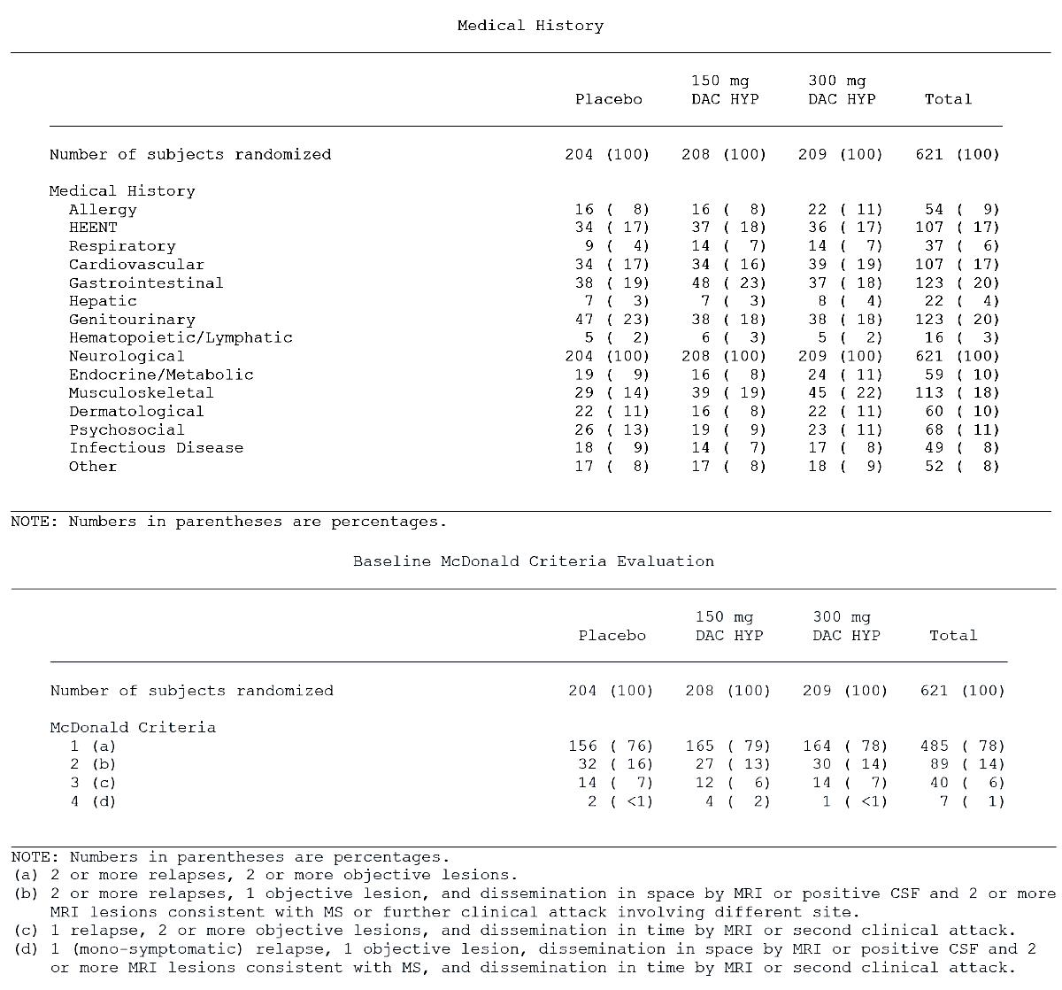

Table 5. Baseline characteristics (relapse history), Study 205MS201
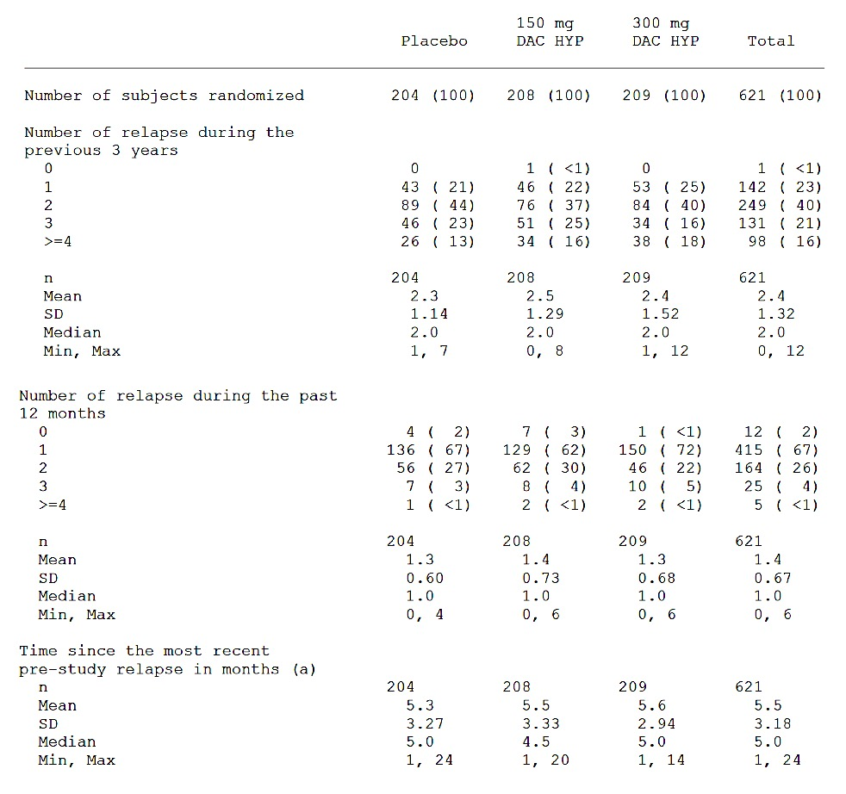
Note: numbers in brackets are percentages; (a) time since most recent relapse prior to study randomisation.
Comment: The baseline characteristics of the subjects can be considered representative of a population of patients with MS and are generalisable to the general population. Importantly the subjects are broadly balanced across treatment groups with regard to medical history, disease severity and pre-study relapse rate.

Results for the primary efficacy outcome
The data are summarised (see Figure 4 and Table 6 below) and are obtained from the final study report.

Table 6. Results for the primary analysis, annualised relapse rate between baseline and Week 52 (negative binomial regression); Study 205MS201
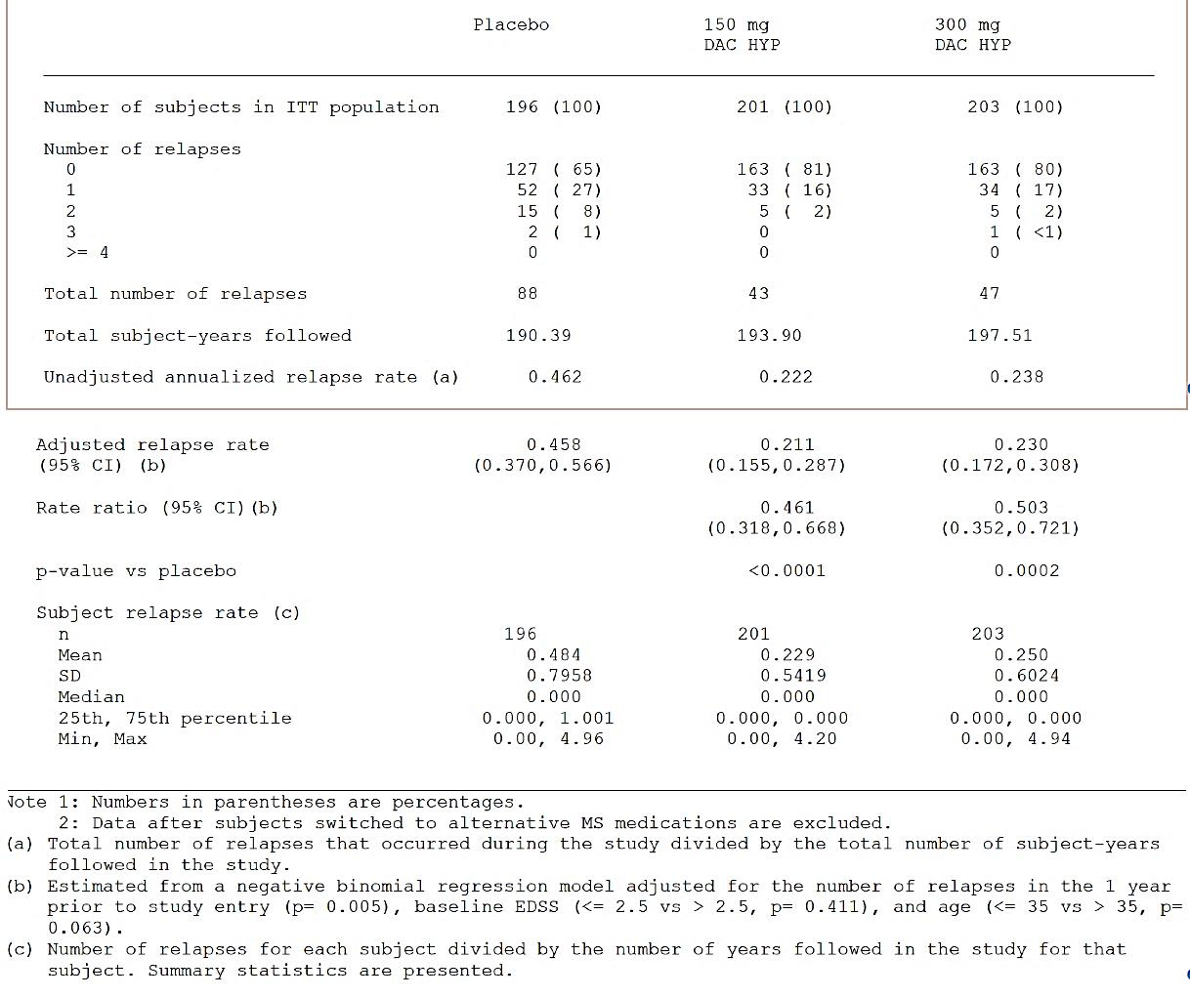
Figure 4. Annualised relapse rate; summary of primary and sensitivity analysis; Study 205MS201
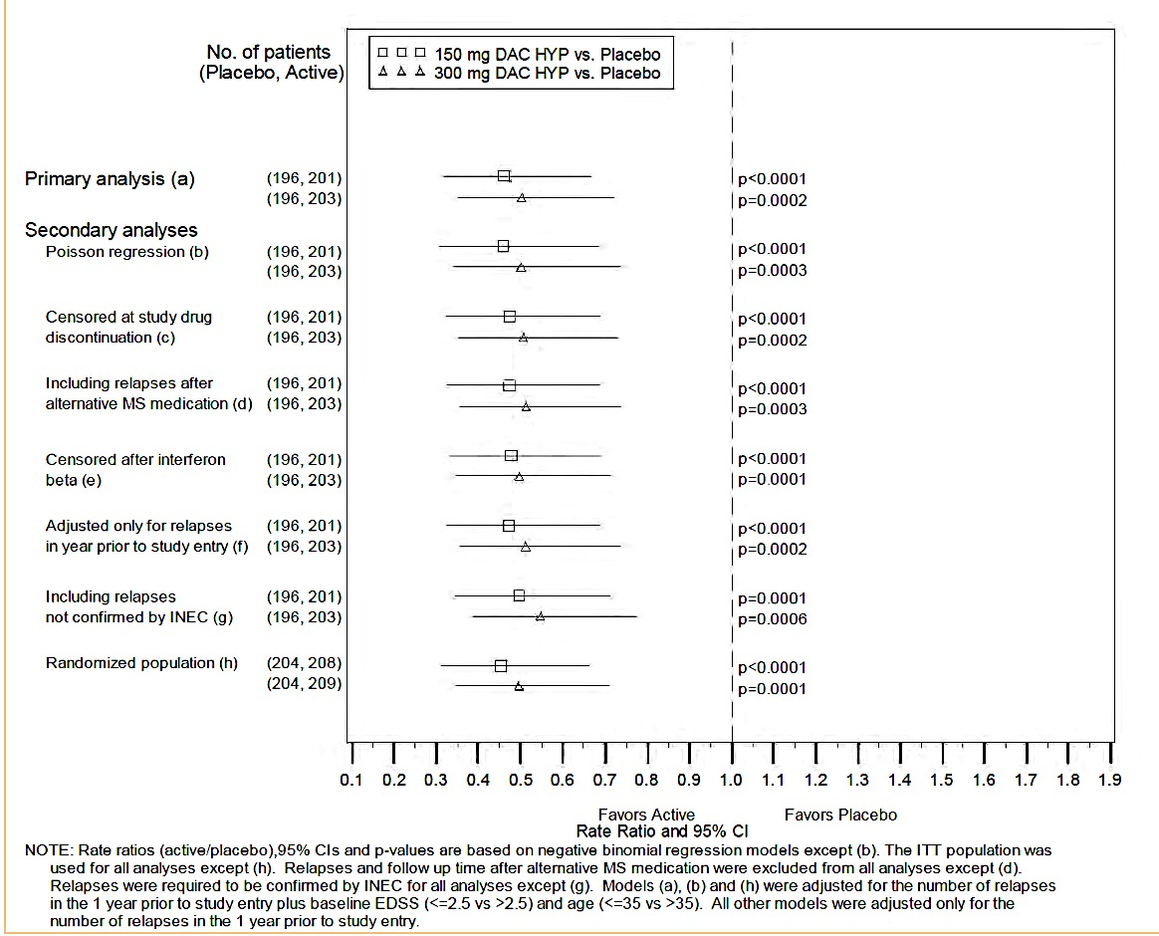
Comment: Compared to placebo DAC HYP reduced the absolute risk ratio (ARR) by 54% for the 150 mg group and 50% for the 300 mg group. Multiple sensitivity analyses were undertaken and were supportive of the primary analysis. Exclusion of the results of subjects from one site had no statistically relevant impact on the outcome of the primary efficacy endpoint.
The magnitude of the observed effect (approximately a 50% ARR reduction) versus placebo is considered clinically meaningful.
There were no clinically or statistically relevant differences between the 300mg and 150 mg DAC HYP groups.

Results for other efficacy outcomes

Number of new Gd-enhancing lesions over 5 brain MRI scans
The number of new Gd-enhancing lesions over 5 brain MRI scans at Weeks 8, 12, 16, 20, and 24 (calculated as the sum of these 5 MRIs) in a subset of subjects was reduced versus placebo at Week 4 through to Week 52. DAC HYP 150 mg and 300 mg reduced the number of new Gd-enhancing lesions between Weeks 8 and 24 by 69% (p < 0.0001) and 78% (p < 0.0001), respectively, compared to placebo. The Forest plot below in Figure 5 summarises the results.

Figure 5. New Gd-enhancing lesions between Weeks 8 and 24; summary of primary and sensitivity results; Study 205MS201
The adjusted mean number of new or newly enlarging T2 hyper-intense lesions at Week 52 was 8.13 (95% confidence interval (CI): 6.65, 9.94) in the placebo group, 2.42 (95% CI: 1.96, 2.99; p < 0.0001) in the DAC HYP 150 mg group, and 1.73 (95% CI: 1.39, 2.15; p < 0.0001) in the DAC HYP 300 mg group. This result indicated that DAC HYP 150 mg reduced the number of new or newly enlarging T2 lesions by 70% (p < 0.0001) and DAC HYP 300 mg reduced it by 79% (p < 0.0001), respectively compared to placebo.

Reduced proportion of relapsing subjects between baseline and Week 52
The Kaplan-Meier estimate for the proportion of subjects who relapsed at Week 52 was 36% in the placebo group compared to 19% in the DAC HYP 150 mg and 20% in the DAC HYP 300 mg group. The hazard ratio was 0.45 (95% CI: 0.30, 0.67) in the DAC 150 mg group compared to placebo and 0.49 (95% CI: 0.33, 0.72) in the DAC 300 mg group compared to placebo. These results indicate that the proportion of relapsing subjects was reduced by 55% in the DAC HYP 150 mg group (p < 0.0001) and 51% (p = 0.0003) in the DAC HYP 300 mg group, compared to placebo.

Improving quality of life as measured by MSIS-29, physical score at Week 52 compared to baseline
The analysis of this endpoint demonstrated a nominally statistically significant benefit in the DAC HYP 150 mg group compared to placebo but not in the DAC HYP 300 mg group. The mean ± SD change in the MSIS-29 physical score from baseline to Week 52 was 3.0 ± 13.52 in the placebo group, –1.0 ± 11.80 in the DAC HYP 150 mg group (p = 0.0008 versus placebo), and 1.4 ± 13.53% in the DAC HYP 300 mg group (p = 0.1284 versus placebo). The difference for DAC HYP 150 mg versus placebo was not considered statistically significant per the sequential closed testing procedure because the procedure required that the 300 mg dose group be tested first and achieve statistical significance before the 150 mg dose group could be tested.

Slowing progression of disability measured by EDSS
The proportion of subjects with 12-week confirmed disability progression was 13.3% in the placebo group, 5.9% in the DAC HYP 150 mg group, and 7.8% in the DAC HYP 300 mg group. Compared to placebo, the hazard ratio for disability progression was 0.43 (95% CI: 0.21, 0.88) in the DAC HYP 150 mg group and 0.57 (95% CI: 0.30, 1.09) in the DAC HYP 300 mg group.
This result indicated that the risk of disability progression was reduced by 57% in the DAC HYP 150 mg group (p = 0.0211) and by 43% in the DAC HYP 300 mg group (p = 0.0905) compared with placebo.
Comments: With the exception of the quality of life measurements, the secondary endpoints are supportive and consistent with the primary endpoints. This should be expected as MRI indicators are a measure of CNS neuronal inflammation and have been related to clinical activity with regard to relapses. This study only provides 52-weeks of data for ARR in general 2 years follow-up is the accepted duration for measuring this endpoint. Patients in this study were therefore given the opportunity to enter a double-blind extension study (205MS202) that is discussed further in the relevant section for this study. Treatment with DAC HYP reduced the risk of progression of disability as measured by EDSS by 57% compared to placebo. This is a clinically relevant difference.

Study 205MS301

Study design, objectives, locations and dates
Study 205MS301 was a multicentre, double-blind, parallel group, monotherapy active-control study to determine the efficacy and safety of DAC HYP versus IFN β-1a (trade name: Avonex) in patients with RRMS by measuring the effects on relapse rate. The study had a 4-week randomisation period followed by a 144-week treatment period. Study enrolment began in November 2009 and the study completed in March 2014.
The subjects were recruited at 246 sites in 28 countries (Argentina, Australia, Brazil, Canada, Czech Republic, Denmark, Finland, France, Georgia, Germany, Greece, Hungary, India, Ireland, Israel, Italy, Mexico, Moldova, Poland, Romania, Russia, Serbia, Slovenia, Spain, Sweden, Switzerland, Ukraine, United Kingdom, and United States of America).

Inclusion criteria
The main inclusion criteria were:
- Confirmed diagnosis of RRMS according to McDonald criteria numbers 1 through 4
- Either:
  - 2 or more clinical relapses within the previous 3 years with at least 1 clinical relapse in the 12 months prior to randomisation; or
  - 1 or more clinical relapses and 1 or more new MRI lesions (Gd-enhancing and/or T2 hyper-intense lesion) within the previous 2 years, with at least one of these events in the 12 months prior to randomisation.

Exclusion Criteria
The main exclusion criteria were:
- Diagnosis of primary progressive, secondary progressive, or progressive relapsing MS
- Any previous treatment with DAC HYP or Zenapax
- MS relapse within the 50 days prior to randomisation and/or the subject had not stabilised from a previous relapse prior to randomisation
Comments: The inclusion criteria are representative of a population of patients with RRMS.
The exclusion criteria, by and large, exclude subjects who are at risk of infection. This is appropriate for a biological product that is intended to cause immunosuppression. Screening for occult or adventitial infection is usual prior to commencing such products in a clinical setting. Other exclusion criteria were for other safety purposes and importantly subjects should have had no evidence of renal or hepatic dysfunction. The subjects were recruited from neurology outpatient clinics and this can be considered reflective of where MS disease modifying agents are usually initiated.

Study treatments
Figure 6. Study timeline, Study 205MS301
All subjects received study treatment (either DAC HYP or Avonex or their respective matching placebos) starting at Week 0 (Baseline Visit) and ending at Week 144 or when the last subject enrolled had completed the Week 96 Visit, whichever was sooner.
Subjects randomised to Group 1 received an injection of DAC HYP 150 mg SC once every 4 weeks plus placebo IFN β-1a IM once weekly for 96 to 144 weeks.
Subjects randomised to Group 2 received IFN β-1a 30 μg IM once weekly plus placebo DAC HYP SC once every 4 weeks for 96 to 144 weeks.
DAC HYP and matching placebo were administered in the clinic, and Avonex and matching placebo were self-administered.

Efficacy variables and outcomes

Main efficacy outcome
The primary endpoint was the ARR.

Other efficacy outcomes
Other efficacy outcomes included:
- The number of new or newly enlarging T2 hyper-intense lesions on brain MRI over 96 weeks
- The proportion of subjects with confirmed disability progression defined by at least a 1.0-point increase on the EDSS from a baseline EDSS ≥ 1.0 that was sustained for 12 weeks or at least a 1.5-point increase on the EDSS from a baseline EDSS = 0 that was sustained for 12 weeks.
- The proportion of subjects who were relapse free
- The proportion of subjects with a ≥ 7.5-point worsening from baseline in the MSIS-29 Physical Impact score at 96 weeks
- EDSS
  - The EDSS is a scale used to measure neurological impairment and disability. The EDSS score is based on 7 functional systems: Visual, Brainstem, Pyramidal, Cerebellar, Sensory, Bowel/Bladder, and Cerebral, as well as ambulation. EDSS scores range from 0.0 (normal exam) to 10.0 (death).
Comments: The efficacy variables selected are standard methods of assessing MS disease severity and are consistent with the EMA guideline on clinical investigation of Medicinal Products for the Treatment of MS adopted by the TGA. The MSIS-29 is a validated tool for assessing the impact of MS on patients. The EDSS is a standard and validated scale for measuring disability in clinical studies of MS.

Randomisation and blinding methods
This was a double-blind, rater-blind study. All subjects and study staff were blinded to the study treatment assignment.
Treatment assignments were assigned through an IVRS. No code-breaking tools were provided to the study sites. All subjects were required to take prophylactic treatment for flu-like symptoms for the first 24 weeks of therapy to minimise any potential unblinding that could occur due to the presence or absence of this known side-effect of IFN-β treatment.
To ensure treatment blinding, each subject received 1 injection of DAC HYP 150 mg or DAC HYP placebo SC once every 4 weeks and 1 injection of IFN β-1a 30 μg or IFN β-1a placebo IM once weekly. Matched active and placebo drug supplies were prepared for each treatment group to ensure that the appropriate treatment was provided to each subject. Drug supplies were identified by kit numbers supplied from IVRS so that the appropriate supplies were dispensed to a subject throughout the study.
Unblinding was only permitted in the case of medical emergency and if it were to occur was undertaken through the IVRS. The sponsor had a prospective unblinding plan. In 26 instances, subjects were unblinded by the investigator; 14 of these 26 subjects were randomised to DAC HYP and 12 subjects were randomised to IFN β-1a. Investigators unblinded subjects for safety reasons, to aid future treatment assignments, and in 1 instance, due to a pregnancy.
Comment: Randomisation and blinding were adequate. The study was of a so-called ‘double-dummy’ design, importantly steps were taken to attempt to mask the known early onset adverse events related to the initiation of IFN-β treatment.

Analysis populations
The ITT population included all randomised subjects who received at least 1 dose of any study treatment. Subjects were analysed in the group to which they were randomised.
In general, efficacy endpoints were analysed using the ITT population as the primary analysis, although subjects with missing data for baseline covariates were excluded.
The primary analysis of the number of new or newly enlarging T2 lesions at Week 96 was evaluated in the subset of subjects with non-missing post baseline scan data; sensitivity analyses of this endpoint included all subjects.
The per-protocol population was defined as subjects from the ITT population who satisfied the following conditions:
- Met both inclusion criteria related to MS-specific disease activity:
  - had a confirmed diagnosis of RRMS according to McDonald criteria 1-4 and a cranial MRI demonstrating lesion(s) consistent with MS;
  - had a baseline EDSS between 0.0 and 5.0, inclusive.
- Compliant with study treatment for ≥ 90% of DAC HYP or IFN-β doses up to Week 96.
- Did not permanently discontinue study treatment prior to Week 96.
The primary and secondary endpoints were evaluated on the per-protocol population.
Comment: The analyses were carried out in both the ITT and the per-protocol population. The ITT population was the primary analysis and this is appropriate.

Sample size
Subjects were randomised to IFN β-1a or DAC HYP 150 mg in a 1:1 ratio. A sample size of 900 subjects per treatment group would have approximately 90% power to detect a 24% reduction in the ARR between the IFN β-1a treatment group and the DAC HYP treatment group based on a negative binomial regression model with a 5% type 1 error rate. Power was estimated from simulations assuming a 21% drop-out rate, an average of 2.4 years of follow-up, and an ARR of 0.27 in the IFN β-1a group. Approximately 1800 subjects were required for this study.
Evaluator’s comment: The assumptions for sample size calculation are adequate. A clinically relevant difference was identified to calculate the sample size.

Statistical methods
Statistical testing for efficacy endpoints was made between the DAC HYP group and IFN β-1a group.
The secondary endpoints are listed in the order of importance. In order to control for a type I error for the secondary endpoints, a sequential closed testing procedure was employed with the sequence of endpoints defined. If the first secondary is statistically significant then the second comparison was tested at the 0.05 significance level; however, if the first comparison was not statistically significant, then all endpoint(s) of a lower rank for that comparison were not considered statistically significant. All statistical tests were 2-sided with an overall type I error rate of 0.05.
Differences between the DAC HYP group and the IFN β-1a group in the ARR were tested using a negative binomial regression model.
The primary analysis included all INEC approved relapses and follow up time between the first dosing date and either the end of treatment period visit or time of censoring. The likelihood ratio statistic from the negative binomial regression model adjusted for the baseline relapse rate (number of relapses in the 3-years prior to study entry divided by 3), history of prior IFN-β use (either yes or no, collected as a stratification variable in IVRS), baseline EDSS (EDSS score of 2.5 versus EDSS ≥ 2.5) and baseline age (age < 35 versus age ≥ 35 years) was used to compare treatment groups. The logarithmic transformation of the number of days in the study was included in the model as the ‘offset’ parameter.
Analysis methods for secondary endpoints included negative binomial regression (number of T2 hyper-intense lesions), Cox proportional hazards, Kaplan-Meier product limit estimator (disability progression as measured by an increase in EDSS score, proportions of subjects who were relapse free) and logistic regression (proportion of subjects with a ≥ 7.5-point worsening in the MSIS-29 Physical Impact score). Primary analyses excluded data after subjects switched to alternative MS medications. Sensitivity analyses were performed on all endpoints.
Comment: The statistical analysis plan contained adequate detail and appropriately defined the pre-specified endpoints.

Participant flow
A total of 1841 subjects were randomised. A similar percentage of subjects in the IFN β-1a and DAC HYP groups completed their assigned study treatment (70% and 71%, respectively) and completed the study (75% and 79%, respectively). The most common reasons for early treatment discontinuation in the IFN β-1a and DAC HYP groups, respectively, were AEs (9% and 14%), withdrawal of consent (10% and 7%), and lack of efficacy (7% and 3%). The incidences of the other reasons for treatment discontinuation were ≤ 1% and were generally similar between the IFN β-1a and DAC HYP groups. The rates of treatment discontinuation were 17% in the IFN β-1a group and 12% in the DAC HYP group in Year 1 of the study and 11% and 13%, respectively, in Year 2.
The ITT and safety populations included 1841 subjects (922 in the IFN β-1a group and 919 in the DAC HYP group) who received at least 1 dose of study treatment.
Additional details are shown in Figure 7 below.
Figure 7. Subject disposition and participant flow; Study MS205301
Comment: Withdrawal was balanced across treatment groups. The most common reason for withdrawal was due to an AE. There were proportionally more AEs in the DAC HYP group compared to the IFN β-1a group. The number of withdrawals meant that 724 subjects completed the study. The ITT population included a total of 1841 subjects with at least 900 subjects in each treatment group; power was therefore adequate.

Major protocol violations/deviations
No major protocol violations/deviations were reported by the clinical evaluator for this study.

Baseline data
The mean (SD) age was 36.2 years (9.32) in the IFN β-1a treatment group and 36.4 years (9.36) in the DAC HYP treatment group. The ratio of males to females was the same in both treatment groups (68% female to 32% male). The study population was predominantly White (90%). Asian subjects comprised 3%, Black or African Americans comprised 1%, and American Indian or Alaska natives comprised < 1% of the total population. The race was not reported for 3% of subjects, and was reported as “other” for 3% of subjects.
Three regions were defined, based on geography, type of health care system, and access to health care in each country. Overall, 13% of subjects were from Region 1 (US and Canada), 23% were from Region 2 (Western European countries, Australia, and Israel) and 65% were from Region 3 (Eastern European countries, Argentina, Brazil, India, and Mexico).
MS disease history was balanced between the IFN β-1a and the DAC HYP treatment groups.
Across all subjects, the mean (median) time since first MS symptoms was 6.9 (5.0) years and the time since diagnosis was 4.2 (2.0) years; 95% of subjects were right handed
Relapse history at was balanced between the 2 treatment groups. During the 12 months prior to the study, the majority of subjects (99%) had experienced at least 1 relapse, 46% had experienced at least 2 relapses and 9% had experienced 3 or more relapses. Subjects had a mean (median) of 1.6 (1.0) relapses in the 12 months prior to the study and 2.7 (2.0) relapses in the 3 years prior to the study. The mean (median) duration between the most recent relapse and the Baseline Visit was 5.3 (4.0) months.
Baseline EDSS scores (mean; median) were similar in the IFN β-1a (2.54, 2.25) and DAC HYP (2.48; 2.00) treatment groups; individual scores ranged from 0.0 to 6.0. A majority of subjects (70%) had baseline scores that were < 3.5 and 30% had scores ≥ 3.5.
Comment: The baseline characteristics of the subjects can be considered representative of a population of patients with MS and are generalisable to the general population. Importantly the subjects are broadly balanced across treatment groups with regard to medical history, disease severity and pre-study relapse rate.

Results for the primary efficacy outcome
In the primary analysis, the adjusted ARRs were 0.393 (95% CI: 0.353 to 0.438) in the IFN β-1a treatment group and 0.216 (95% CI: 0.191 to 0.244) in the DAC HYP treatment group.
Figure 8. Summary of annualised relapse rate between DAC HYP versus IFN β-1a treated groups; Study 205MS301
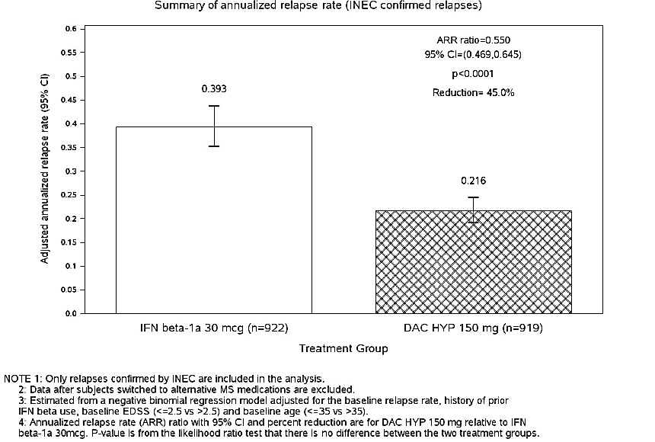
The adjusted ARR ratio (DAC HYP/IFN β-1a) was 0.550 (95% CI: 0.469 to 0.645) indicating that DAC HYP reduced the ARR by 45% (95% CI: 35 to 53%) compared with IFN β-1a (p < 0.0001). A total of 392 subjects (43%) in the IFN β-1a group had 643 INEC-confirmed relapses and 260 subjects (28%) in the DAC HYP group had 402 INEC-confirmed relapses during the study. The mean (SD) subject relapse rate was 0.50 (1.110) in the IFN β-1a group and 0.32 (2.467) in the DAC HYP group.
Comment: Compared to IFN β-1a, after 144-weeks of treatment, DAC HYP reduced the ARR by about 45%. Ideally the study should have had a placebo arm for assay sensitivity, however the magnitude of treatment effect against a recognised treatment for MS is clinically meaningful.

Results for other efficacy outcomes

Number of new or newly enlarging T2 hyper-intense lesions on brain MRI over 96 weeks
The adjusted mean number of new or newly enlarging T2 hyper-intense lesions at Week 96 was 9.44 (95% CI: 8.46 to 10.54) in the IFN β-1a treatment group and 4.31 (95% CI: 3.85 to 4.81) in the DAC HYP treatment group. Relative to IFN β-1a, DAC HYP reduced the number of new or newly enlarging T2 lesions by 54.4% (95% CI: 46.9% to 60.8%; p < 0.0001) at Week 96.

12-week confirmed disability progression
Confirmed disability progression was defined as a ≥ 1.0-point increase on the EDSS from a baseline EDSS ≥ 1.0 that was sustained for 12 weeks, or a ≥ 1.5-point increase on the EDSS from a baseline EDSS of 0 that was sustained for 12 weeks. The difference between treatment groups in confirmed disability progression was assessed using a Cox proportional hazards model; adjusted for baseline EDSS (EDSS ≤ 2.5 vs. EDSS > 2.5), history of prior IFN β use, and baseline age (age ≤ 35 versus age > 35 years).
Figure 9. Time to sustained progression (3 month) of disability (increased EDSS)
In the primary analysis, the hazard ratio for DAC HYP/IFN β-1a was 0.84 (95% CI: 0.66 to 1.07), indicating DAC HYP reduced the risk of disability progression by 16% (p = 0.1575) compared with IFN β-1a. Kaplan-Meier analysis estimated that 20.3% of subjects in the IFN β-1a group and 16.2% in the DAC HYP group had 12-week confirmed disability progression over 144 weeks.

Proportion of subjects free from relapse
Figure 10. Time to first relapse (in weeks) and proportion of relapse-free subjects
Across the treatment period, 392 subjects (43%) in the IFN β-1a group and 260 subjects (28%) in the DAC HYP group had an INEC-confirmed relapse. The Kaplan-Meier estimate for relapse-free subjects in the IFN β-1a and DAC HYP groups was 71.2% and 81.2%, respectively, at 48 weeks; 58.5% and 72.9% at 96 weeks; and 50.8% and 67.3% at 144 weeks. The hazard ratio (DAC HYP/IFN β-1a) for the risk of relapse was 0.59 (95% CI: 0.50 to 0.69; p < 0.0001), indicating that the risk of relapse was reduced by 41% in the DAC HYP group compared to IFN β-1a.

Proportion of subjects with a ≥ 7.5-point worsening from baseline in the MSIS-29 Physical Impact score at Week 96

Table 7. Analysis of proportions of subjects with a ≥ 7.5-point worsening from baseline (MSIS-29)
At 96 weeks, 213 subjects (23%) in the IFN β-1a group had a ≥ 7.5-point worsening from baseline compared with 171 subjects (19%) in the DAC HYP treatment group. The odds ratio (DAC HYP/IFN-β 1a) was 0.76 (95% CI: 0.60 to 0.95; p = 0.0176), indicating that the risk of a clinically meaningful worsening on the subject-reported physical impact of MS was reduced by 24% in the DAC HYP group compared with the IFN β-1a group.
The proportion of subjects with a ≥ 7.5-point worsening on the MSIS-29 Physical Impact score was lower in the DAC HYP group than in the IFN β-1a group at each visit up to and including Week 96. Throughout the study, 14% to 19% of subjects in the DAC HYP group and 19% to 23% of subjects in the IFN β-1a group had a ≥ 7.5-point worsening on MSIS-29 Physical Impact score.
Comments: With the exception of the EDSS measurement, the secondary endpoints are supportive and consistent with the primary endpoints. The results from the patient reported MSIS-29 were reported in terms of a clinically meaningful deterioration of physical impact and achieved statistical significance in favour of DAC HYP. The magnitude of the difference is about 5% which appears small but may be of clinical relevance in a population of patients where one of the goals of impact is to limit the physical effects of MS on the patient. The results for risk of relapse are supportive of the results seen for the primary endpoint.

Other efficacy studies

Study 205MS202

Study design
This was a double-blind, multicentre, extension study to evaluate the safety and efficacy of DAC HYP in subjects with multiple sclerosis who completed treatment in Study 205MS201. The primary objective was to assess the safety and immunogenicity of extended treatment with DAC HYP. The components of this objective included:
- An assessment of safety and immunogenicity of extended treatment with DAC HYP when administered to MS subjects who completed 52 weeks of active therapy with DAC HYP in Study 205MS201.
- An assessment of safety and immunogenicity during a 6-month washout period from DAC HYP.
- An assessment of safety and immunogenicity during re-initiation of therapy with DAC HYP after a 6-month washout period.
- An assessment of safety and immunogenicity of DAC HYP when administered to MS subjects who previously received placebo during Study 205MS201.
The number of subjects in this study was determined by the number of subjects who completed Study 205MS201. Treatment groups were determined by their original treatment allocation during Study 205MS201.

Study treatments
Subjects previously randomised to placebo in Study 205MS201 were randomised in a 1:1 ratio to:
- DAC HYP 150 mg SC every 4 weeks for a total of 13 doses (PBO/DAC150); or
- DAC HYP 300 mg SC every 4 weeks for a total of 13 doses (PBO/DAC300).
Subjects previously randomised to DAC HYP 150 mg SC every 4 weeks in Study 205MS201 were randomised in a 1:1 ratio to:
- Placebo SC every 4 weeks for a total of 5 doses followed by DAC HYP 150 mg SC every 4 weeks for a total of 8 doses (DAC150/WO/150); or
- DAC HYP 150 mg SC every 4 weeks for a total of 13 doses (DAC150/150).
Subjects previously randomised to DAC HYP 300 mg SC every 4 weeks in Study 201 were randomised in a 1:1 ratio to:
- Placebo SC every 4 weeks for a total of 5 doses followed by DAC HYP 300 mg SC every 4 weeks for a total of 8 doses (DAC300/WO/300)
- DAC HYP 300 mg SC every 4 weeks for a total of 13 doses (DAC300/300).
Summary statistics for safety, efficacy, PK and PD endpoints were presented by treatment group and by combined dose groups (that is, continuing exposure to DAC HYP in Study 205MS202, washout followed by re-initiation of DAC HYP in Study 205MS202, first time exposure to DAC HYP in Study 205MS202). Subjects previously randomised to placebo in Study 205MS201 were randomised in a 1:1 ratio to DAC HYP 150 mg.

Analysis populations
The Week 52 Visit from Study 205MS201 served as the Study Entry Visit (or the Baseline Visit) for this Study205MS202. A total of 577 subjects completed Study 205MS201; of these, 517 subjects (90%) were randomised to treatment in Study 205MS202. The ITT population comprised of 499 subjects; per protocol population had 424 subjects; and the safety population had 517 subjects.

Efficacy outcomes and statistical methods
Clinical endpoint: the ARR (for INEC-confirmed relapses) after 1 year (Study 205MS201) and after 2 years (Study 205MS202) were calculated using a negative binomial regression model adjusted for the number of relapses in the previous year. These analyses were used to assess the reduction in ARR during Study 205MS202 for each treatment group and combined dose groups. The proportion of subjects who relapsed and the proportion of subjects with 3-month confirmed disability progression were estimated from the Kaplan-Meier survival curve distribution for Year 1 (from Study 205MS201), Year 2 (from Study 205MS202) and over 2 years combined.
Radiological endpoint: descriptive statistics presented for MRI endpoints (number of new Gd-enhancing lesions during Study 205MS201 and Study 205MS202, number of new or newly enlarging T2 hyper-intense lesions during Study 205MS202, change in volume of T2 hyper-intense lesions and change in volume of T1 hypo-intense lesions from Study 205MS202 baseline). The percentage change and rate of percentage chance in whole brain volume were calculated for Year 1 using Study 205MS201 baseline and for Year 2 using Study 205MS202 baseline. Adjusted rates and 95% confidence intervals (CIs) were estimated for each year using an analysis of covariance model adjusted for the normalized brain volume at the relevant baseline. The rate of percentage change in Year 1 was compared to Year 2 using a repeated measures mixed model adjusted for normalised brain volume at Study 205MS201 baseline.
Quality of life endpoint: Changes that occurred during Study 205MS202 from baseline of Study 201 were summarised using descriptive statistics for MSIS 29, EQ-5D and SF 12.

Participant flow
A total of 517 subjects were randomised at 73 investigational sites in the Czech Republic, Germany, Hungary, India, Poland, Russia, Ukraine, and the United Kingdom.
The mean, SD time on study treatment was similar across the 6 treatment groups (44.4 weeks for PBO/DAC150, 45.3 weeks for PBO/DAC300, 43.5 weeks for DAC150/WO/150, 44.4 weeks for DAC300/WO/300, 43.6 weeks for DAC150/150, and 43.3 weeks for DAC300/300). The overall mean follow-up time in the study was also similar across the 6 treatment groups and ranged from 52.5 weeks (9.42) to 55.3 weeks (8.94). Among subjects randomised to washout followed by re-initiation, the mean duration (SD) of washout was 27.7 weeks (6.29) in the DAC150/WO/150 group and 26.3 weeks (4.60) in the DAC300/WO/300 group.
The incidence of subjects who completed treatment was similar across 6 treatment groups: 88% (72/82) and 84% (70/83) in the DAC150/150 and DAC300/300 groups, respectively; 86% (73/85) and 88% (76/86) in the DAC150/WO/150 and DAC300/WO/300 groups, respectively; and 89% (75/84) and 95% (75/79) in the PBO/DAC150 and PBO/DAC300 groups, respectively. Overall, the most frequent common reasons for treatment discontinuation in the 6 treatment groups were consent withdrawn and AEs.

Results for the efficacy outcomes
For subjects who continued DAC HYP treatment from Study 205MS201 through Study 205MS202:
- The ARR was similar in the second year of DAC HYP treatment compared to the first year of treatment. The Year 2 ARR (CI 95%) for Study 205MS202 was 0.165 (0.105 to 0.259) and the Year 1 ARR (CI 95%) for Study 205MS201 was 0.148 (0.096 to 0.229).
- The proportion of subjects who relapsed was similar during Year 2 of DAC HYP treatment in Study 205MS202 compared to Year 1 of DAC HYP treatment in Study 201 (0.136 and 0.147 for Year 2 and Year 1, respectively).
- The proportion of subjects with 3-month confirmed disability progression during Year 2 of DAC HYP treatment in Study 205MS202 was similar to Year 1 of DAC HYP treatment in Study 205MS201 (6% each).
- The mean (SD) number of new Gd-enhancing lesions was similar at the end of the second year of DAC HYP treatment compared to the end of the first year of treatment (0.2 (1.21) and 0.2 (0.66) for Week 52 visit in Year 2 and Year 1, respectively).
- The mean (SD) number of new or newly enlarging T2 hyper-intense lesions was similar in the second year of DAC HYP treatment compared to the first year of treatment (1.2 (4.33) and 1.9 (3.83) for new or enlarging T2 lesions at Week 52 compared to baseline in Year 2 and Year 1, respectively).
Among subjects who were randomised to DAC HYP washout followed by re-initiation of DAC HYP treatment in Study 205MS202:
- At the completion of the 24-week washout period (Week 20 of Study 205MS202), the mean (SD) number of new Gd-enhancing lesions was similar to the baseline MRI in Study 205MS201 (1.1 (2.34) at the end of washout period in Study 205MS202 and 1.6 (3.47) at the baseline for Study 205MS201).
- After re-initiation of treatment, the number (SD) of new Gd-enhancing lesions at Week 52 was similar to that of subjects who had remained on continuous treatment of DAC HYP (0.2 (0.64) for subjects in the washout/re-initiation cohorts and 0.2 (1.21) in cohorts of subjects with continued exposure to DAC HYP in Study 205MS202).
Among subjects who received placebo in Study 205MS201 and initiated DAC HYP treatment in Study 202:
- The ARR decreased from 0.434 (0.347 to 0.544) during 1-year of placebo treatment in Study 205MS201 to 0.179 (0.123 to 0.261) during 1 year of DAC HYP treatment in Study 205MS202.
- The proportion of subjects who relapsed was lower with DAC HYP treatment in Study 205MS202 than with placebo treatment in Study 205MS201 (0.362 and 0.176 for Year 1 and Year 2, respectively).
- The proportion of subjects with 3-month confirmed disability progression was lower with DAC HYP treatment in Study 205MS202 than with placebo treatment in Study 201 (11% and 5% for Year 1 and Year 2, respectively).
- The mean (SD) number of new Gd-enhancing lesions was lower at the end of 1 year of DAC HYP treatment compared to the end of 1-year of placebo treatment in Study 205MS201 (1.4 (2.41) and 0.2 (0.80) for Week 52 visit in Year 1 and Year 2, respectively).
- The mean (SD) number of new or newly enlarging T2 hyper-intense lesions was lower during 1 year of DAC HYP treatment compared to 1-year of placebo treatment in Study 205MS201 (8.0 (9.48) and 2.1 (3.68) new or newly enlarging T2 lesions at Week 52 compared to baseline for Year 1 and Year 2, respectively).
Comments: This was a somewhat complex extension study that provides evidence that DAC HYP has a sustained effect; furthermore, it provides supporting evidence that de novo treatment with DAC HYP reduces the ARR when crossed over from prior placebo treatment. The magnitude of the treatment effect was about the same as that seen in 205MS201. The effects on radiological endpoints were similar to those for the pivotal study 205MS201.

Study 205MS203
This was a multicentre, single-arm, open label, extension study to evaluate the long-term safety and efficacy of DAC HYP in subjects with RRMS who have completed study treatment in 205MS202.
Comment: This study is ongoing and an interim report has been provided. As it is an ongoing uncontrolled single arm study it provides little useful efficacy data and is not considered further.

Study 205MS303
This is an extension to Study 205MS301. It is a single-arm open-label study and is ongoing. It is designed to assess the safety and efficacy of long-term treatment with DAC-HYP and will provide data for up to six years of treatment. No efficacy data were provided in the interim report. An influenza vaccine sub-study was part of the protocol for this study.

2013-2014 Influenza vaccine sub-study
The objective of the optional administration of the 2013-2014 trivalent seasonal influenza vaccine was to assess the effect of DAC HYP treatment on the immune response to licensed trivalent seasonal influenza vaccine, as defined by haemagglutination inhibition (HI) titre.
The 2013-2014 trivalent seasonal influenza vaccine was offered to all eligible subjects in Study 205MS203 as an optional sub-study to assess the effect of DAC HYP treatment on the immune response to vaccination, as defined by HI titre. HI assays were performed on samples obtained prior to vaccination with the trivalent seasonal influenza vaccine and 28 (± 3) days after vaccination.
Geometric mean titres pre- and post-vaccination were calculated and compared.
For the A/California/7/2009 (H1N1), A/Texas/50/2012 (H3N2), and B/Massachusetts/2/2012 (referred to as the A/H1N1, A/H3N2, and B strains, respectively) in the 2013-2014 trivalent seasonal influenza vaccine, a 7.7, 9.0, and 4.3 fold increase, respectively, was observed in geometric mean HI titres from pre-vaccination compared to 28 days post-vaccination. Overall sero-conversion (percentage (95% CI)), defined as the percentage of subjects with a pre-vaccination HI titre < 10 and post-vaccination HI titre ≥ 40 or a pre-vaccination HI titre ≥ 10 and a 4-fold increase in HI titre post-vaccination, was observed for 69% (58% to 78%), 69% (58% to 78%), and 44% (34% to 55%) for the A/H1N1, A/H3N2, and B strains, respectively. Sero-protection, defined as a post-vaccination HI titre ≥ 40, was observed for 92% (85% to 97%), 91% (83% to 96%), and 67% (56% to 76%) of subjects for the A/H1N1, A/H3N2, and B strains, respectively.

Analyses performed across trials (pooled analyses and meta-analyses)
Pooled analyses was not performed due to the differences in comparator groups, treatment duration and sample sizes.

Evaluator’s conclusions on clinical efficacy
The sponsor has complied with the relevant TGA adopted guidelines in the development of DAC HYP for the submitted indication.
The evidence of efficacy is dependent on two double-blind controlled studies one of which was placebo-controlled, the other active controlled. The studies were of adequate design and evaluated appropriate endpoints for the proposed indication.
The placebo controlled study (205MS201) was of 52-weeks duration the accepted duration of studies that utilise ARR as a primary endpoint is 2-years however it is recognised that there are ethical considerations regarding the use of placebo for such a period of time when effective treatments are available. Patients in the placebo controlled study were therefore given the opportunity to continue in a further dose blinded extension phase where patients who previously had not received treatment could cross-over onto active treatment and patients already on active treatment continued on such, this is considered acceptable.
Study 205MS301 was of a satisfactory duration to measure treatment effect in patients with MS that is a chronic, relapsing and remitting disease in its earlier phase. The studies were both randomised and adequate measures were in place to preserve the blind.
The studies utilised accepted and standard endpoints for clinical studies in MS that are recognised in the adopted guidelines. The primary endpoint for both clinical studies was the ARR. This is a clinical relevant endpoint for patients with RRMS in that the goal of treatment with disease modifying drugs for RRMS is to reduce the number of relapses (and to reduce disability).
Although there was no placebo arm in the active controlled pivotal study, which would have been desirable for assay sensitivity, the magnitude of the treatment effect observed for DAC HYP was similar to that seen in the placebo controlled study that had a similar study population. This study also demonstrates reproducibility of results seen in the placebo study.
Further evidence to support reproducibility is derived from study 205MS202 that is a blinded, extension to Study 201. In this study, subjects that were previously on placebo were commenced on DAC HYP the result for the ARR for this patient group is similar to that seen in both the original study and those who received DAC HYP in the active controlled study. Sustained response rates in terms of reduction in ARR were demonstrated in this study.
The magnitude of the reduction of ARR versus placebo was about 54% and about 45% versus the active comparator IFN β-1a.
A clinically meaningful reduction in risk of disability progression as measured by EDSS of 57% versus placebo was seen in Study 205MS201. This result was also reported as statistically significant however as a tertiary endpoint no adjustment was made for multiple comparisons or endpoints.
In the active controlled study DAC HYP reduced the risk of disability progression by 16% (p = 0.1575) compared with IFN β-1a. Kaplan-Meier analysis estimated that 20.3% of subjects in the IFN β-1a group and 16.2% in the DAC HYP group had 12-week confirmed disability progression over 144 weeks.
In the placebo controlled study the results from the patient reported MSIS-29 was not considered statistically significant per the sequential closed testing procedure because the procedure required that the 300 mg dose group be tested first and achieve statistical significance before the 150 mg dose group could be tested.
In the active controlled study the results from the patient reported MSIS-29 were reported in terms of a clinically meaningful deterioration of physical impact and achieved statistical significance in favour of DAC HYP. The magnitude of the difference is about 5%, which appears small but may be of clinical relevance in a population of patients where one of the goals of impact is to limit the physical effects of MS on the patient and may represent a very modest incremental benefit overt an established active treatment.
Given that there was no difference in efficacy between the 150 mg SC dose and the 300 mg SC dose it may be the case that the 150 mg dose in the maximum effective dose range and the Sponsor has not adequately explored the efficacy of lower doses.
The efficacy of DAC HYP in special populations has not been investigated and this should be reflected in the PI.

Clinical safety

Studies providing evaluable safety data
Figure 11 (below) details the studies available for evaluation of safety of DAC HYP and the relationship and differences between those studies.
Figure 11. Studies providing data for the evaluation of safety

Pivotal efficacy studies
In the pivotal efficacy studies, (Study 205MS201 and Study 205MS301) the following safety data were collected:
- General AEs were assessed by open questioning at each study visit.
- AEs of particular interest were determined based on the mechanism of action, therapeutic class and prior experience with DAC HYP. The categories were based on system organ class (SOC) and included cutaneous events, autoimmune disorders, hepatic events, injection site reactions, and allergic conditions. These were assessed by direct questioning, appropriate questionnaires, clinical examination and laboratory tests obtained at study visits.
- Laboratory tests, including haematology and clinical chemistry (including liver function tests (LFT)) were performed at each study visit.
- Immunogenicity was evaluated in healthy volunteers in Studies DAC-1015, 1014, 1017 and 205HV102. Immunogenicity in MS patients was evaluated in Studies 205MS201 and 205MS301.

Pivotal studies that assessed safety as a primary outcome
Not applicable.

Dose-response and non-pivotal efficacy studies
The dose-response and non-pivotal efficacy studies provided safety data as follows: Studies 205MS202, 205MS203, 205MS302 and 205MS303 were extension studies and provided data on AEs, laboratory tests and immunogenicity.

Other studies evaluable for safety only

Study 205MS203
An extension to Study 205MS202, this is an open-label single arm study in patients with RRMS that is currently ongoing. Subjects were recruited from Study 205MS202 and when completed will provide a total of 6.5 years of safety data in subjects with RRMS. It includes an influenza vaccine sub-study that evaluates the safety and efficacy of influenza vaccine when administered concurrently with DAC HYP.
Eligible subjects had clinic visits scheduled every 4 weeks for the first 12 weeks in this study, followed by clinic visits scheduled every 12 weeks for up to 6 years of continuous treatment with a 6-month safety follow-up phase.
An interim report dated 20 January 2014 was provided. Study participants received 150mg DAC HYP SC either via a PFS or auto-injector. At the cut-off date for analysis a total of 318 subjects of an enrolled 410 were still participating in the study. Mean age (SD) in the overall study was 38.4 years (8.74), approximately two-thirds of subjects were female, and 97% of subjects were White. At Study 205MS203 baseline, the mean (SD) EDSS score was 2.7 (1.28) with scores ranging from 0 to 6, 72 (18%) subjects had ≥ 1 relapses in the 12 months prior to the Baseline Visit of Study 203, and the mean (SD) number of Gd-enhancing lesions was 0.2 (0.99).
For A/H1N1, A/H3N2, and B (influenza) strains respectively, in the 2013-2014 trivalent seasonal influenza vaccine, a 7.7-fold, 9.0-fold, and 4.3-fold increase, respectively, was observed in geometric mean HI antibody titres from pre-vaccination compared to 28 days post-vaccination. Overall, sero-conversion given as a percentage (95% CI), defined as the percentage of subjects with a pre-vaccination HI titre < 10 and post-vaccination HI titre ≥ 40 or a pre-vaccination HI titre ≥ 10 and a 4-fold increase in HI titre post-vaccination, was observed for 69% (58% to 78%), 69% (58% to 78%), and 44% (34% to 55%) for the A/H1N1, A/H3N2, and B strains, respectively. Sero-protection, defined as a post-vaccination HI titre ≥ 40, was observed for 92% (85% to 97%), 91% (83% to 96%), and 67% (56% to 76%) of subjects for the A/H1N1, A/H3N2, and B strains, respectively.
Comment: This study was not included in the efficacy evaluation as it is uncontrolled and open label.

Study 205MS302
This is an ongoing 3-year study. It was a multicentre, single-arm, open-label study to assess the immunogenicity, PK, PD, and tolerability of DAC HYP when administered SC using a PFS in subjects with RRMS. In addition to the main study, 2 sub-studies (an intensive PK sub-study and Therapeutic Protein-Drug Interaction (TP-DI) sub-study) were performed.
The study period consisted of screening, an initial 24 weeks of open-label treatment, 20 weeks of washout, re-initiation of open-label treatment for up to 3 years (optional), and then 6 months of post-dosing safety follow-up.
A study population of approximately 100 DAC HYP-naïve subjects with RRMS at approximately 35 sites was planned for the main study. Of these, a minimum of 25 subjects were to enrol in the intensive PK sub-study. If necessary to achieve the inclusion of approximately 20 subjects in the TP-DI sub-study, activated sites were allowed to recruit up to 20 new subjects who had not participated in the main study. Therefore, the total number of planned subjects was approximately 120. A total of 113 subjects were actually enrolled in the main study at 20 sites in 4 countries worldwide, of which, 26 subjects enrolled in the Intensive PK sub-study. An interim study report with a data cut-off date of 3 February 2014 is included in the application.
A study population of approximately 100 DAC HYP-naïve subjects with RRMS at approximately 35 sites was planned for the main study, of which, a minimum of 25 subjects were to enrol in the PK sub-study. If necessary to achieve the inclusion of approximately 20 subjects in the TP-DI sub-study, activated sites were allowed to recruit up to 20 new subjects who had not participated in the main study.
The total number of planned subjects was approximately 120. For the first interim analysis (Week 0 to Week 44), 113 subjects were enrolled at 20 sites in 4 countries worldwide, of which 26 subjects enrolled in the intensive PK sub-study. This first interim analysis was based on all data collected through the Week 44 visit date. AEs were assessed by questioning at each study visit. LFTs were obtained at 4-weekly intervals for the duration of the study, full clinical chemistry and haematology were assessed at Week 24, Week 44 and Week 68, Week 92, Week 116, Week 140 and Week 188.
All subjects received DAC HYP 150 mg injections using the PFS at the clinic every 4 weeks over an initial 24-week treatment period (for a total of 6 injections) followed by a 20-week washout period. After completion of the washout period, eligible subjects had the option to resume monthly open-label treatment with DAC HYP 150 mg in the extension phase of the study for up to 3 additional years (or subjects could elect to complete the study through Week 44 only). Subjects were allowed to choose at-home administration after Week 56. All subjects had to undergo post-dosing safety follow-up evaluations for 6 months after their last dose of DAC HYP.
A total of 115 subjects enrolled in the extension phase which included 95 subjects from the main study (Week 0 to Week 44) and 20 planned and newly enrolled subjects for the TP-DI sub-study. The second interim analysis (extension phase analysis) was based on all data collected from the start of the extension phase through 03 February 2014. The TP-DI sub-study analysis was based on the 20 subjects in the TP-DI sub-study. Overall, 133 subjects enrolled in the study with 113 enrolled from the main study and 20 newly enrolled from the TP-DI sub-study.
Comment: This study was not included in the efficacy evaluation as efficacy is not the primary endpoint and it is ongoing.

Study 205MS303
Study 205MS303 is a multicentre, open-label, extension study to evaluate the long-term safety and efficacy of DAC HYP 150 mg in subjects with RRMS who had completed the parent study, 205MS301. The parent study was a multicentre, double-blind, randomized, parallel-group, active-controlled study designed to evaluate the efficacy and safety of DAC HYP versus IFN β-1a in subjects with RRMS. In this extension study up to 1841 subjects were allowed to participate for up to 144 weeks. All subjects in the extension study received DAC HYP 150 mg by an SC injection every 4 weeks.
The study period consists of baseline assessments, treatment (for up to 144 weeks) and post-treatment safety follow-up visits (from approximately 4 to 24 weeks after the last dose of DAC HYP).
The safety population consisted of all subjects who received at least 1 dose of DAC HYP during Study 205MS303 and who had any post-baseline safety follow-up in that study, defined as any AE or any laboratory, vital signs, immunogenicity, or physical examination assessment occurring after the day of the first DAC HYP dose in Study 205MS303.
A total of 1000 subjects provided informed consent and received at least 1 dose of DAC HYP by the cut-off date (ITT population) and 308 subjects received at least 1 dose of DAC HYP and had any post-baseline safety follow-up during Study 205MS303 (safety population). Of the 1000 subjects in the study ITT population, 506 subjects received DAC HYP in Study 205MS301, and 494 subjects received IFN β-1a in Study 205MS301. Of the 308 subjects in the Study 205MS303 safety population, 162 subjects received DAC HYP in Study 205MS301 and 146 subjects received IFN β-1a in Study 205MS301. In the ITT population, a total of 24 subjects discontinued treatment (15 continuing subjects and 9 newly exposed subjects) and 2 subjects withdrew from the study (1 subject from each group).
An interim report with a data cut-off date of 28 February 2014 was submitted in this application.
Comment: No efficacy data were provided in the interim report, therefore these were not evaluated in the efficacy section.

Clinical pharmacology studies
AEs, vital signs, haematology and clinical chemistry were recorded in the clinical pharmacology studies. All of these studies enrolled participants who were not in the target population and who received DAC HYP for periods of 16 weeks or as a single dose.

Patient exposure
In Study 205MS201, a total of 417 subjects were exposed to at least 1 dose of DAC HYP; 208 subjects received DAC HYP 150 mg and 209 received DAC HYP 300 mg with 204 subjects receiving at least 1 dose of placebo. The percentage of subjects receiving all planned doses was similar across treatment groups (placebo, 87%; DAC HYP 150 mg, 84%; and DAC HYP 300 mg, 81%). The mean time on study treatment was similar across the treatment groups: 323.0, 320.5, and 321.9 days in the placebo group, DAC HYP 150 mg group and DAC HYP 300 mg group respectively. The overall mean follow-up time in the study was 53.3 ± 10.12 weeks with 635 subject-years accrued. Follow-up time was similar across the 3 treatment groups; placebo, 209 subject years; DAC HYP 150 mg, 212 subject years; and DAC HYP 300 mg, 214 subject years.
In Study 205MS301, the mean (median) time on treatment was 100.54 (111.43) weeks for the IFN β-1a group and 102.04 (108.71) weeks for the DAC HYP group. The total number of subject-years on treatment was 1776.56 years in the IFN β-1a and 1797.17 years in the DAC HYP group.

Table 8. Exposure to DAC HYP and comparators in clinical studies (subjects with RRMS)

Table 8. Exposure to DAC HYP and comparators in clinical studies (subjects with RRMS) (continued)
Not listed on this table: 127 subjects in healthy volunteer studies (Studies DAC-1014, DAC-1015, DAC-1918 and 205HV102) received DAC HYP at least once. DAC-1015, DAC01918 and 205HV102 were all single-dose studies with subjects receiving between 50 mg and 400 mg of DAC HYP SC once only. Study DAC-1014 was a multi-dose study with DAC HYP-exposed subjects (n = 24) receiving either DAC HYP 200 mg SC once every 2 weeks for 9 doses or DAC HYP 200 mg SC once followed by DAC HYP 100 mg once every 2 weeks for 8 follow-up doses.

Table 9. Overall Exposure to DAC HYP in the pooled safety population.
Comment: The overall exposure to DAC HYP reflects a sufficient number of patients, for a satisfactory duration of treatment, for a medicine that is used for long-term treatment of a chronic condition as outlined in ICH E1. Further safety data have been provided for 358 patients treated with DAC HYP (any dose) for at least 24 months; this is considered an adequate number for this period of time and is compliant with the relevant adopted guideline. The extent of exposure is sufficient to pick up AEs that occur at a frequency of about 1:1000 but is not sufficient to pick up cases of progressive multifocal leukoencephalopathy (PML) that have been associated with the use of immunomodulatory MAb.

Adverse events
The sponsor has provided summary data for AEs split into the placebo controlled group and the active controlled group. These studies were not pooled because of the difference in treatment duration. The pooling strategy for the analysis of AEs is summarised in Table 10 below.
Comment: The pooling strategy is appropriate as the studies are of different duration and some are ongoing.

All adverse events (irrespective of relationship to study treatment)
The overall incidence of adverse events for all subjects who received DAC HYP was 88%.

Table 10. Treatment groups and sponsor’s pooling strategy

Table 11. Overall Summary of AEs by severity (pooled safety population)

Pivotal studies
Overall, no differences in the incidence of any AEs were observed between the two DAC HYP dose groups; however, potential dose-related effects in the DAC HYP 150 mg and 300 mg groups were noted for the AE of pyrexia (< 1% placebo, 3% DAC HYP 150 mg, 7% DAC HYP 300 mg). In addition, potential dose-related effects were also noted for the infections and infestations SOC (44% placebo, 50% DAC HYP 150 mg, 54% DAC HYP 300 mg) and the skin and subcutaneous tissue disorders SOC (13% placebo, 18% DAC HYP 150 mg, 2% DAC HYP 300 mg. The DAC HYP 300 mg group was not carried forward into further development as no significant incremental gain in efficacy was observed. There was no difference in the incidence of adverse events over time.

Table 12. Incidence of adverse events by preferred term with an incidence of 3% or more in either DAC HYP group
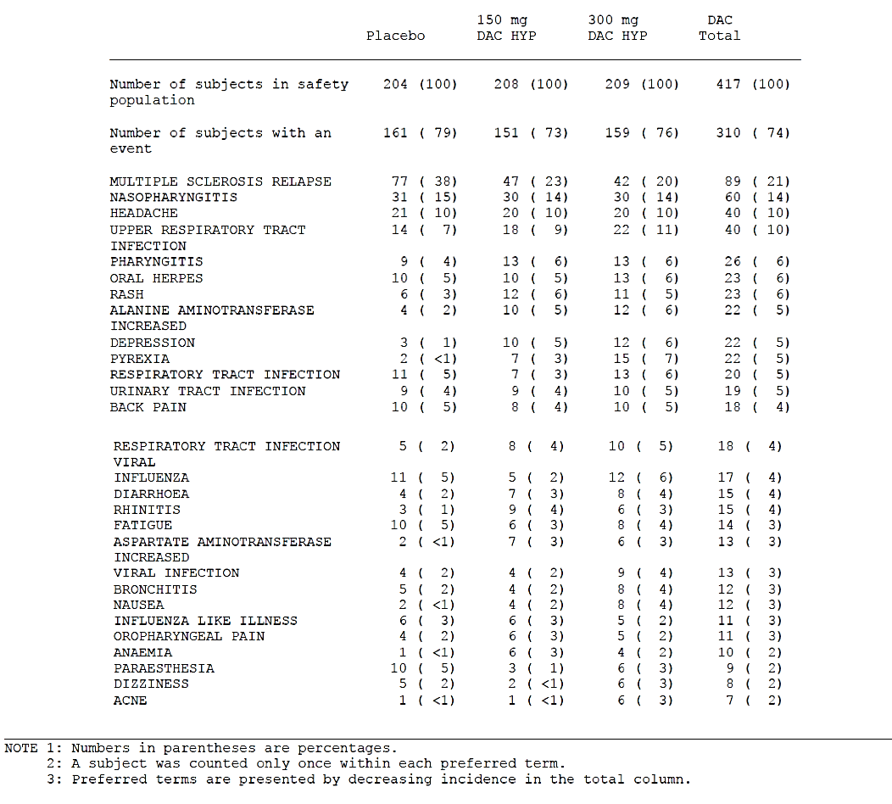

Table 13. Incidence of treatment-emergent adverse events occurring in 5% or more of subjects in any one treatment
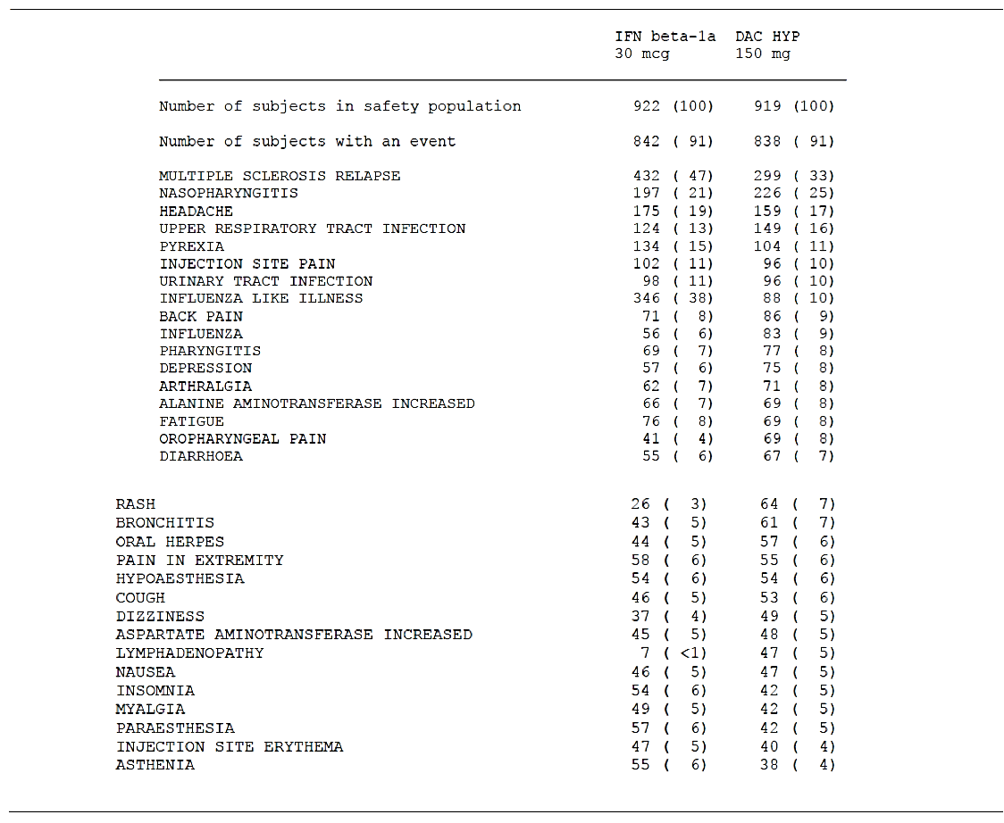
In the DAC HYP group compared with the IFN β-1a group, there was a higher incidence of events in the infections and infestations SOC (57% IFN β-1a, 65% DAC HYP) and skin and subcutaneous tissue disorders SOC (19% versus 37%). Comparison of the IFN β-1a group with the DAC HYP group showed a higher incidence of AEs in the nervous system disorders SOC (63% IFN β-1a, 54% DAC HYP) and in the general disorders and administration site conditions SOC (59% IFN β-1a, 39% DAC HYP) (see Table 13 above). There was no difference in the incidence of AEs over time.

All studies (Total DAC HYP safety dataset)
Across the total DAC HYP group the most common AEs (≥ 20%) by SOC were infections and infestations (62%), nervous systems disorders (50%), skin and subcutaneous tissue disorders (35%), general disorders and administration site conditions (31%), gastrointestinal disorders (26%), musculoskeletal and connective tissue disorders (26%), and investigations (24%).

Table 14. Adverse events with an incidence of 5% or more
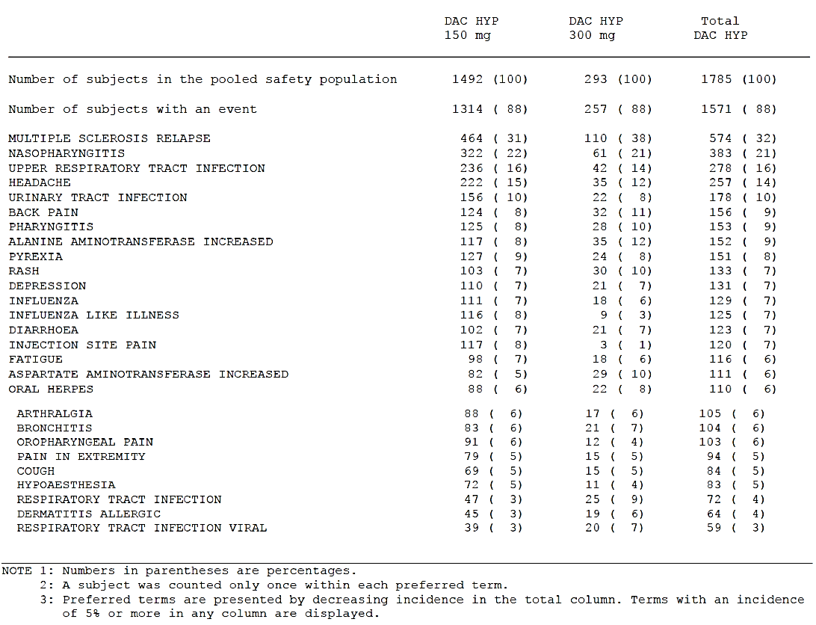
The most common AEs (incidence ≥ 10%) in total DAC HYP group are MS relapse, nasopharyngitis, upper respiratory tract infection, headache, and urinary tract infection.

Treatment-related adverse events (adverse drug reactions)

Pivotal studies
In Study 205MS201, the incidence of AEs related to study treatment was higher in the DAC HYP groups (29% for DAC HYP 150 mg; 35% for DAC HYP 300 mg) compared with the placebo group (22%). The SOCs with the highest incidence of AEs considered related to study treatment were infections and infestations (8% for placebo; 13% for DAC HYP 150 mg; 16% for DAC HYP 300 mg) and skin and subcutaneous tissue disorders (6% for placebo, 7% for DAC HYP 150 mg; 12% for DAC HYP 300 mg). In the hepatobiliary disorders SOC, the incidence of AEs considered related to study treatment was ≤ 1% in all treatment groups (1% for placebo; ≤ 1% for DAC HYP 150 mg; ≤ for 1% DAC HYP 300 mg). The most common AEs related to study treatment (≥ 2%) in any DAC HYP group were MS relapse, nasopharyngitis, upper respiratory tract infections, and respiratory tract infection.
The overall incidence of treatment related AEs was higher in the IFN β-1a group compared with DAC HYP group (65% IFN β-1a versus 52% DAC HYP). In the IFN β-1a group, there was a higher incidence than in the DAC HYP group of treatment related AEs in the general disorders and administration site conditions SOC (51% IFN β-1a versus 25% DAC HYP). In the DAC HYP group there was a higher incidence of treatment-related AEs in the skin and subcutaneous tissue disorders SOC (7% IFN β-1a versus 15% DAC HYP) and infections and infestations (10% versus 14%).
In the DAC HYP group, the SOCs with an incidence of AEs ≥ 5% that were considered related to study treatment were general disorders and administration site conditions (25%); skin and subcutaneous disorders (15%); infections and infestations, investigations (14% each); nervous system disorders (9%); gastrointestinal (GI) disorders (6%); and blood and lymphatic system disorders (5%). The most common treatment-related AEs by preferred term (≥ 2%) in the DAC HYP group were injection site pain, influenza-like illness, headache, alanine transaminase (ALT) increased, aspartate transaminase (AST) increased, LFT abnormal, gamma-glutamyl transpeptidase (GGT) increased, nasopharyngitis, pyrexia, injection site erythema, injection site bruising, upper respiratory tract infection, pharyngitis, MS relapse, fatigue, rash, eczema, nausea, lymphadenopathy, and lymphopenia.
In the IFN β-1a group, the SOCs with an incidence of AEs ≥ 5% that were considered related to study treatment were general disorders and administration site conditions (51%), investigations (14%), nervous system disorders (13%), infections and infestations (10%), musculoskeletal and connective tissue disorders (8%), skin and subcutaneous disorders (7%).
The most common treatment-related AEs by preferred term (≥ 2%) in the IFN β-1a group were influenza-like illness, pyrexia, injection site pain, headache, injection site erythema, ALT increased, AST increased, liver function test abnormal, myalgia, chills, asthenia, body temperature increased, injection site bruising, fatigue, nausea, arthralgia, MS relapse, lymphopenia, and nasopharyngitis. The incidence of all other treatment-related AEs in each treatment group was ≤ 1%.

Total DAC HYP dataset
In the total DAC HYP experience, the incidence of AEs that were considered related to study treatment was 44%. The SOCs with the highest incidence of AEs (> 10%) that were related to study treatment were general disorders and administration site conditions (17%), skin and subcutaneous disorders (15%), infections and infestations (14%), and investigations (13%).
The AEs related to study treatment with an incidence of ≥ 5% in either the DAC HYP 150 mg or 300 mg dose groups, respectively, were injection site pain (7% and 1%), ALT increased (5% and 6%), AST (4% and 5%), and rash (2% and 5%).

Deaths and other serious adverse events
As of the data cut-off point for this application, a total of 10 deaths were reported in the clinical development program. A summary with reported relationship to treatment is given in Table 15, below.
Table 15. Deaths in the DAC HYP program (all studies)
Study | Treatment group | Days into Study | Cause | Relationship | Medical history/relevant history
205MS201 | 150 mg DAC | 402 | Colitis, ischaemic; psoas abscess | Related | Complex clinical cause. Initial hospitalisation for macular rash
205MS202 | 300 mg/WO/ 300 mg DAC | 692 (315 of 202) | Autoimmune hepatitis; liver failure; multiple organ failure | Not related | None
205MS301 | IFN | 145 | Acute myocardial infarction | Not related | Hypertensive disease, acute myocardial infarction history; coronary artery disease; atherosclerosis of aorta; coronary stenting
205MS301 | IFN | 148 | Peritonitis | Not related | Post surgical peritonitis; emergency laparotomy for abdominal pain
205MS301 | IFN | 446 | Suicide | Not related | None
205MS301 | IFN | 924 | Pancreatic cancer, metastatic | Not related | Hospitalised with neuropathic pain; tumorous process left lung (CT imaging); tumorous enlargement of pancreas; metastatic process liver
205MS301 | IFN | 284 | Progressive relapsing MS | Not related | None
205MS301 | 150 mg | 202 | MS; aspiration pneumonia; decubitus ulcer; sepsis; cardio-respiratory arrest | Not related | Acute exacerbation of MS; MS involvement of brainstem
Study 205MS303 | 150 mg | 193 | Subdural haematoma; brain oedema; brain compression; traumatic intracranial haemorrhage | Not related | Subject fall; compression of brain ventricular system; traumatic subarachnoid haemorrhage; brain oedema; brain dislocation

Pivotal studies
One possibly related death occurred during Study 205MS201. This subject initially developed a maculopapular rash that 40-days after onset began to worsen and is described as having mucosal involvement and was desquamating in nature. A punch biopsy was undertaken and the appearance of the biopsy was consistent with a drug reaction though no vasculitis was seen. The patient had a positive blood culture for Staphylococcus aureus. The subject went on to develop a psoas abscess resulting in death. Autopsy revealed a psoas abscess that had caused infarction of the sigmoid colon due to compromise of an adjacent mesenteric artery. The patient was recovering from the rash at the time of the subject’s death. The subject had discontinued study medication 94 days prior to her death.
Comment: This death, in the opinion of the evaluator, is probably related to the development of a serious cutaneous reaction (SCAR) that was possibly contributory to the development of bacteraemia (due to desquamation) and subsequent death due to events related to the development of a psoas abscess due to secondary seeding as a result of Staphylococcus aureus bacteraemia. The sponsor has not commented on the possible contribution of the SCAR to this subject’s death, though the investigator considered this to be related to study drug. Two dermatologists have reviewed the case, one local to the patients, the other affiliated with the sponsor who conducted a post event case review. Neither considered the SCAR to be Steven’s Johnson Syndrome (SJS) or toxic epidermal necrolysis (TEN).
In Study 205MS201 the incidence of serious adverse events (SAE) was 26% for the DAC HYP 150 mg group, 15% for the DAC HYP 300 mg group and 17% for the placebo group. The most common SAE was MS relapse, all others occurred in less than 1% of subjects across the groups.
In Study 205MS301 SAEs were observed more frequently in the DAC HYP group than the IFNβ 1a group at 24% versus 21% respectively. The most common SAE was MS relapse, when this is excluded the incidence of SAEs was 10% versus 15% in the IFN β-1a group versus the DAC HYP group respectively. SAEs are summarised in Table 16 below.
Comment: Excluding MS relapse the commonest SAEs observed for DAC HYP in the placebo-controlled study were infections, skin and subcutaneous disorders (mainly rash) and gastrointestinal disorders (notably colitis). These occurred in less than 1% of patients. The pattern of SAEs was similar in the active controlled study.

Other studies
One subject in Study 205MS202 died from autoimmune related hepatitis (see Table 15 above). This was judged by the investigator as not related to DAC HYP however the sponsor has judged this as possibly related. (This case is discussed in the safety Section: Liver toxicity, later in this document).

Table 16. Incidence of treatment-emergent serious adverse events occurring in 3 or more subjects by system organ class and preferred term (Study 205MS301)
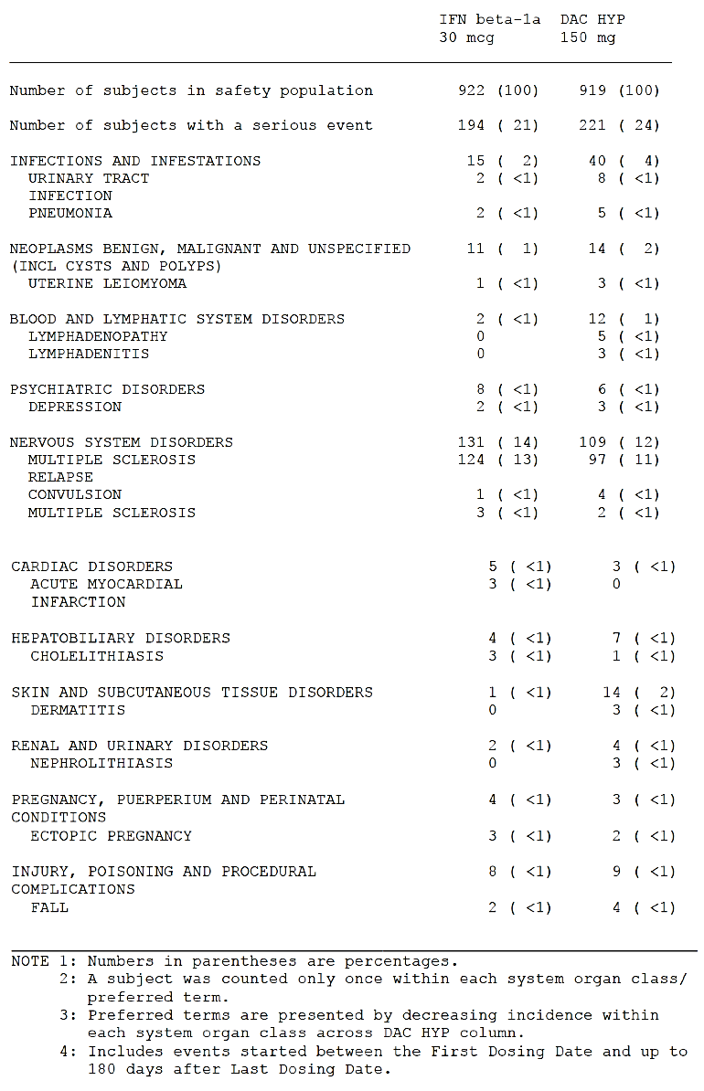

Discontinuation due to adverse events

Pivotal studies
In Study 205MS201, the incidence of AEs leading to study treatment discontinuation (or discontinuation due to adverse events (DAE)) was < 1%, 3%, and 4% in the placebo, DAC HYP 150 mg, and DAC HYP 300 mg group, respectively. In the DAC HYP groups, the most common (≥ 1%) events leading to treatment discontinuation by SOC were skin and subcutaneous disorders (1%). None of the individual events by preferred term leading to treatment discontinuation occurred in ≥ 1% of subjects.
In Study 205MS301, the incidence of DAEs (excluding MS relapse) was 14% for DAC HYP subjects and 9% for IFN β-1a subjects. SOCs with an incidence ≥ 1% of AEs that led to study treatment discontinuation in the DAC HYP group were skin and subcutaneous disorders, and investigations (5% each); and nervous system disorders (2%).

Total DAC HYP safety population
In the pooled safety population of those exposed to DAC HYP, the incidence of DAEs was 9%. In general, the pattern of AEs leading to withdrawal from the study was similar to that observed for AEs leading to discontinuation of study treatment. The most common AEs by SOC leading to study withdrawal are investigations (3%) and skin and subcutaneous tissue disorders (2%). AEs by preferred term that led to withdrawal from study in ≥ 1% of subjects was ALT increased (1%).

Laboratory tests

Liver function

Pivotal studies
Pivotal study summary data for changes in clinical chemistry are available in Tables 17 and 18, below.

Table 17. Summary of changes in clinical chemistry, Study 205MS201
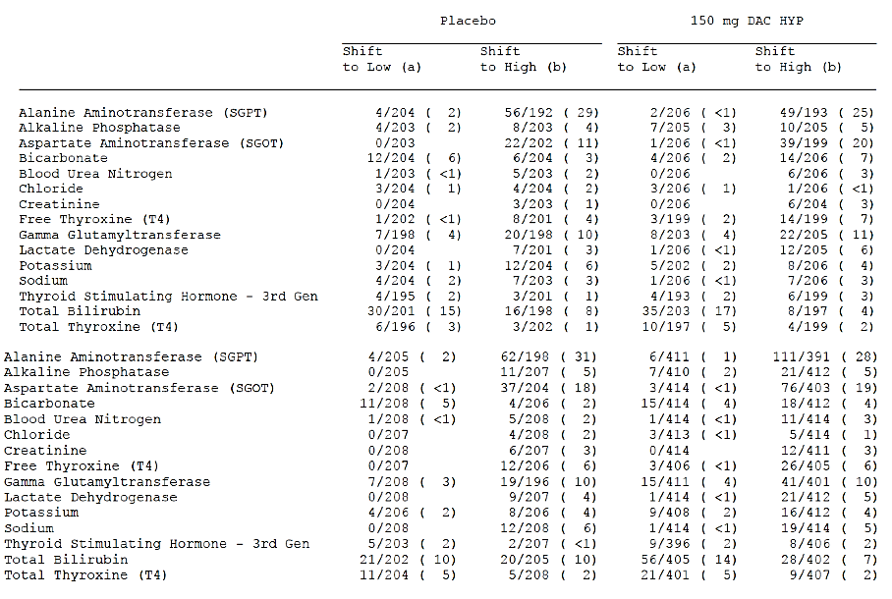
In the placebo-controlled study (205MS201) changes in baseline liver function tests were similar across the groups with the exception of AST in which there were more shifts towards high for DAC HYP compared to the placebo group. There was no apparent dose effect when comparing the 150 mg DAC HYP SC group with the 300 mg DAC HYP SC group. The change in LFTs was similar between the treatment groups and there was no clinically relevant increase in LFT. Increases in LFTs were similar between the active control IFN β-1a and the DAC HYP group.

Table 18: Summary of changes in clinical chemistry (Study 205MS301)
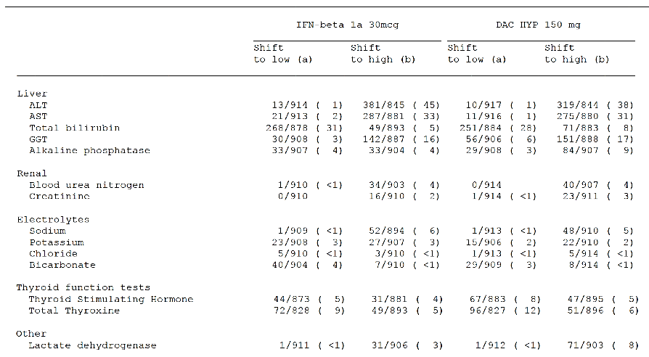
Figure 12. Concurrent maximum post-baseline ALT or AST and total bilirubin, excluding subjects that had prior bilirubin abnormalities
The maximum change in baseline LFTs were spread evenly between the two treatment groups.

Other studies

Total DAC HYP dataset
The mean and median values for ALT, AST, total bilirubin, GGT and ALP showed little change from baseline over time. These are summarised in Table 19, below.

Table 19. Summary of maximum liver function test values total DAC HYP safety population
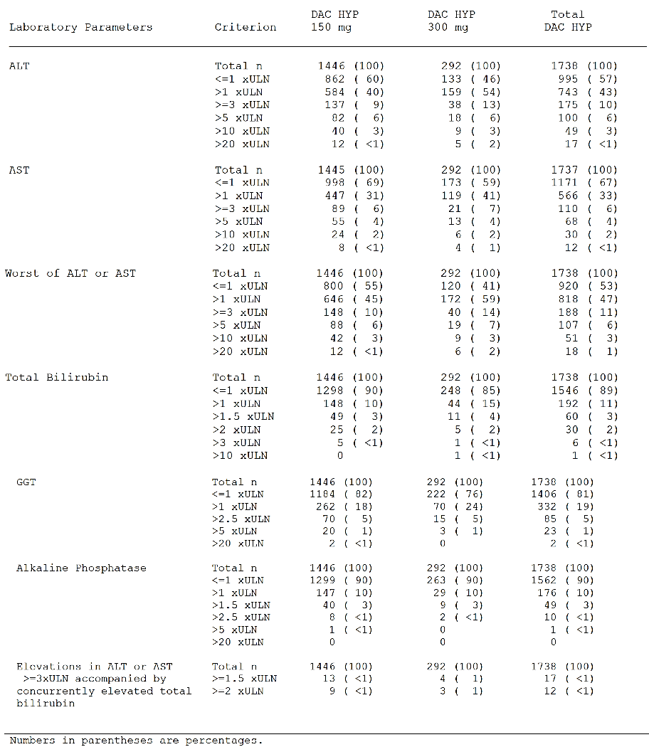
Elevations of ALT or AST above the ULN were observed in 47% of DAC HYP-treated subjects and were similar to levels observed in the placebo and IFN β-1a control groups. The majority of DAC HYP treated subjects who experienced elevated transaminases had maximum values of < 3 x the upper limit of normal (ULN). ALT or AST elevations ≥ 3 x ULN and > 5 x ULN occurred in 11% and 6% of DAC HYP-treated subjects and elevations > 10 x ULN occurred in 3% of subjects. The majority of these elevations were asymptomatic. The incidence of ALT or AST elevations was consistent over time when measured by 6-month intervals.
Comment: There was an increase in the number of subjects with LFTs (transaminase elevations > 5 ULN for the DAC HYP group compared to placebo or IFN β-1a groups).

Kidney function

Pivotal studies
There were no clinically meaningful changes in standard measures of kidney function.

Haematology
In summary, mean lymphocyte, neutrophil, monocyte and eosinophil counts varied by small amounts over time, the changes were not clinically significant. Table 20 below summarises abnormalities in white cell count for the total DAC HYP pooled population.

Table 20. Summary of abnormalities in white cell counts
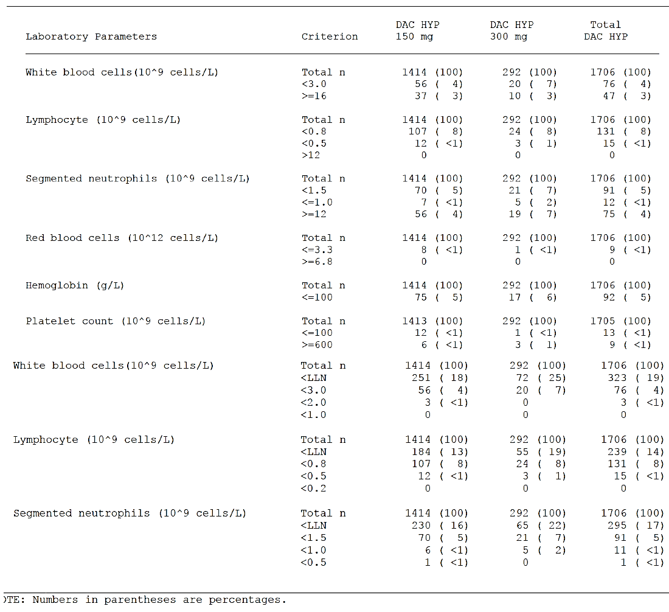
Potentially significant abnormalities in white cell count were seen in about 4% if subjects. For all DAC HYP-treated subjects, the majority of abnormalities in white blood cell (WBC), lymphocyte, and neutrophil counts were Grade 1 or Grade 2 according to the National Cancer Institute (US) Common Terminology Criteria for Adverse Events (NCI-CTCAE) criteria. For WBC counts, 3 out of 1706 subjects (< 1%) had Grade 3 abnormalities and 0 subjects had Grade 4 abnormalities. For lymphocyte counts, 15 subjects (< 1%) had Grade 3 abnormalities and 0 subjects had Grade 4 abnormalities. For neutrophil counts, 11 subjects (< 1%) had Grade 3 abnormalities. One subject (Study 205MS301) had a Grade 4 neutropenia this subject developed reactive arthritis with agranulocytosis and lymphopenia and thrombocytopenia. These were attributed to concomitant medications that included: omeprazole, sulfasalazine and triamcinolone. The investigator did not consider this to be related to study medication.
In terms of red blood cell (RBC) parameters and platelet counts there was little change of baseline over time. Mean haemoglobin was decreased by 1.6% from baseline after 48-weeks of treatment and 1.7% after 96-weeks. There were no clinically significant changes.
Comment: Overall the extent of clinically significant changes in WBC parameters was comparable between the placebo, active controlled and DAC HYP groups. NCI CTCAE Grade 1-3 abnormalities were observed in less than 1% of DAC HYP treated subjects.

Immunogenicity
The effect of ADAs and Nabs was analysed for both the DAC HYP 150 mg and DAC HYP 300 mg groups. The effect of immunogenicity on the safety profile was also evaluated after a 6-month interval. There were no clinically appreciable effects on the safety profile of DAC HYP. Of note no changes in potentially immune medicated adverse events such as hypersensitivity, anaphylaxis or angioedema were seen.
Comment: The development of ADAs or Nabs did not have a clinically apparent effect on the safety profile of DAC HYP.

Electrocardiograph
There were no clinically significant changes in the absolute values and changes from baseline in terms of quantitative electrocardiograph (ECG) parameters (heart rate, PR interval, QRS interval, QT interval, QTcF interval, QTcB interval). The mean and median changes for QTcB at Week 144 were +0.9 (20.97 SD) and +1.0 seconds respectively for the DAC HYP 150 mg group.

Vital signs
There were no clinically significant differences in the observed vital signs between the DAC HYP groups and placebo groups (Systolic and diastolic blood pressure, heart rate, body temperature and weight). The changes from baseline to end of treatment were similar for both groups.

Post-marketing experience
Not applicable.

Safety issues with the potential for major regulatory impact

Liver toxicity
In the placebo-controlled studies elevations in LFTs was seen more frequently in the DAC HYP groups compared to placebo, however there were no cases that satisfied the criteria for a ‘Hy’s Law’ case. In the extension phase to this study (Study 205MS202) there was one patient who experienced what was described as autoimmune hepatitis and died. This patient had received DAC HYP 300 mg for one year prior to entering the washout period for the study. The patient had been off DAC HYP for 24-weeks. Following the third dose of DAC HYP at Week 28 elevations in ALT and AST were noted. The patient continued to receive DAC HYP and LFTs continued to deteriorate including ALP and bilirubin. Post-mortem findings revealed fulminant hepatitis consistent with autoimmune hepatitis. The death resulted in protocol amendments across the study program such that monthly LFTs occurred monthly for all subjects to temporarily suspend dosing for ALT or AST elevations > 3 x ULN (dosing could be resumed once serum ALT and AST were ≤ 2 x ULN), and to permanently discontinue treatment for confirmed elevations of serum ALT or AST > 5 x ULN, or for elevations of ALT or AST > 3 x ULN that lasted longer than 1 week.
Comment: Given that there is no alternative explanation for the hepatitis and death it is likely related to DAC HYP treatment. The death resulted in more intensive monitoring of LFTs and more stringent discontinuation and withdrawal criteria. Further measures were included to limit concomitant treatment with specific medications associated with potential hepatotoxic risks (for example, drugs such as carbamazepine, valproate, lamotrigine, phenytoin, isoniazid, propylthiouracil or nimesulide) and to require testing of LFTs within a 7-day window prior to dosing. No further cases of hepatitis related deaths were observed. Although an appropriate step from a patient safety perspective introducing these changes would have meant that the chances of seeing further Hy’s Law cases were reduced. This would also serve to demonstrate whether monthly monitoring of LFTs would mitigate against the risk of drug induced liver injury.
In the active controlled study two Hy’s Law cases were observed one was a subject receiving IFN β -1a the other receiving DAC HYP. The DAC HYP case was a female who was on carbamazepine and sodium valproate for the treatment of epilepsy. The subject experienced an increase in LFTs. Liver biopsy was performed and histology was consistent with drug induced hepatic injury. There was no evidence of autoimmune injury.
Comment: This case is confounded by concomitant use of sodium valproate and carbamazepine. Liver toxicity with carbamazepine is uncommon but well described. Elevation in LFTs with valproate is common. Acute hepatocellular injury resulting in jaundice is associated with valproate use.
As discussed in above (see Section: Laboratory tests; liver function) DAC HYP is associated with an increased incidence of serum aminotransferase elevations. The majority of these elevations have been asymptomatic, not associated with elevations of serum bilirubin, and have resolved with discontinuation of dosing or resolved spontaneously while treatment was DAC HYP was continued.

Serious skin reactions
The data from the clinical study program demonstrate the DAC HYP is associated with a higher rate of cutaneous adverse events than placebo or IFN β-1a. The main adverse events were a rash and either exacerbation of pre-existing eczema or psoriasis. However there were a number of cases that represent delayed-type hypersensitivity reaction. The most common AEs (≥1%) were rash (7%); eczema, dermatitis allergic (4% each); dermatitis, dermatitis contact, urticaria, rash maculopapular (2% each); and dermatitis atopic (1%). All other AEs in the hypersensitivity group had an incidence of ≤ 1% in both treatment groups.
Notably one subject (discussed above in Section: Deaths and other serious adverse events) developed a desquamating rash and subsequently developed bacteraemia possibly due to skin breakdown. This case was reviewed by a consulting dermatologist who does not view this as a possible case of SJS, however sufficient clinical information was not available to this dermatologist who conducted a review of documents.
Comment: The case of death as previously discussed was a severe rash and was described by the investigator involved in the treatment of the patient exfoliative in nature at the peak of severity. The nature of this AE has been down-played in the opinion of the evaluator and represented a severe exfoliative reaction that although not full thickness was sufficient in extent to allow significant bacteraemia. While not the primary cause of the death DAC HYP played a secondary contributing factor by causing a rash that allowed entry of bacteria. The sponsor has recognised that there is a possibility of delayed hypersensitivity reaction that, in the majority of cases, were mild to moderate in nature. The overall incidence of hypersensitivity was low.

Unwanted immunological events
There was 1 case of possible anaphylaxis in a subject after the first dose of DAC HYP 300 mg SC. A male who experienced a serious event of circulatory collapse after his first dose of study treatment, which consisted of 3 injections. The patient felt dizzy 10 minutes after his first injection and his blood pressure was 90/40 mm Hg. After lying down, the patient felt better and received the second and third injections. Following the third injection, he fainted, and his blood pressure was 70/10 mm Hg. The patient was transferred to the emergency room, where he was treated with IV saline solution and IV prednisolone. After 30 minutes, the patient stabilised with a blood pressure of 120/70 mm Hg. Airway compromise, angioedema, or urticaria was not reported for this event. After approximately 4 hours in the emergency room, the subject was discharged. The subject completed the study with no further incidents. Delayed type hypersensitivity reactions are further described in the preceding section.
Comment: The event described does not have features typical for anaphylaxis and may equally be a vasovagal episode, particularly as the subject continued in the study with no further events.

Other safety issues

Safety in special populations
There was no clinically evident difference in the safety profile when analysed by age, race, gender, region or previous use of disease modifying agents.

Safety related to drug-drug interactions and other interactions
The sponsor has carried out analyses based on the concomitant use of corticosteroids and effects on influenza vaccine protection.

Safety with use of systemic corticosteroids
Corticosteroids are commonly used for the treatment of relapse of MS and cutaneous reactions such as those observed in the development of DAC HYP. The sponsor therefore analysed the safety of profile of DAC HYP based on use of systemic corticosteroids.
The incidence of AEs in subjects who used systemic corticosteroids was higher than in subjects who did not use steroids for DAC HYP and IFN β-1a groups (Used corticosteroids: 100% IFN β-1a and DAC HYP; Did not use corticosteroids: 84% IFN β-1a, 86% DAC HYP). The incidence of serious AEs was greater in the SOC infections and infestations for DAC HYP patients who used systemic corticosteroids versus those who did not (6% versus 3% respectively). The most frequent AE was urinary tract infection. However, the sponsor states that in most cases the infection preceded the steroid use or the difference in time between the onset of steroid use and onset of infection made the relationship unlikely.
Comment: Concurrent use of corticosteroids theoretically may increase the susceptibility to infection however no evidence for this was seen in the safety data provided by the sponsor.

Effects on influenza vaccine
The effects of long-term treatment with DAC HYP on the protection afforded by the seasonal inactivated influenza vaccine were evaluated in a sub-study of 90 subjects in Study 205MS203. The immune response to influenza vaccine was appropriate and consistent with that which may be expected for the general population.

Gastrointestinal disorders
The incidence of potential inflammatory GI events was < 1% (7 subjects) in the DAC HYP group and no subjects in the IFN β-1a group (see Table 21 below). 2 subjects had serious events: 1 subject with colitis, microscopic; and 1 subject with colitis, ulcerative. These SAEs were considered moderate in severity and related to study treatment. Both events resolved after discontinuation of study treatment.

Table 21. Incidence of potential immune-mediated gastrointestinal events (Study 205MS301)
The incidence of treatment emergent gastrointestinal disorders is summarised in Table 22 below.

Table 22: Treatment emergent adverse events in SOC:GI disorders
21 cases with potentially inflammatory colitis or IBD‐like events were identified as reported in over 2200 patients in all DAC HYP trials. Severity ranged from mild diarrhoea through to severe with dehydration. The cases responded to medical therapy. The cases did not appear to be immune mediated as the onset of the event was after a prolonged course of DAC HYP and there were no extra-intestinal manifestations of inflammatory bowel disease such as uveitis. It is hypothesised that the colitis is related to changes in IL-2 signalling rather than immune-mediated.
Comment: An excess of cases of colitis and diarrhoea was seen in subjects treated with DAC HYP. The cases generally developed late in treatment most occurred after about 40-weeks. The mechanism for the development of colitis is not clear. There was an increased incidence of sustained diarrhoea in subjects who received DAC HYP compared to subjects treated with IFN β-1a. It is not known whether patients who develop colitis related to DAC HYP will need ongoing treatment for colitis or whether these subjects will continue to experience flares of colitis in the future despite the discontinuation of DAC HYP. Over the entire DAC HYP group approximately 0.95% of patients experienced colitis, which represents a number needed to harm of about 105.

Lymphadenopathy
An excess of cases of lymphadenopathy was observed for subjects who received DAC HYP 150 mg versus IFN β-1a or placebo. Similarly an excess of lymphadenitis was seen for subjects who received DAC HYP 150 mg versus IFN β-1a. No cases of malignancy were seen. The cases were by and large mild to moderate in nature. Discontinuation due to lymphadenopathy occurred in 5 subjects, discontinuation due to lymphadenitis occurred in 2 subjects. Where biopsy was undertaken reactive or inflammatory processes were seen. A summary of lymphadenopathy events is given in Table 23, below,

Table 23. Incidence of lymphadenopathy in the pivotal studies
 | Placebo  N (%) | DAC HYP  150 mg (205MS201)  N (%) | DAC HYP 300 mg  (205MS201)  N (%) | IFN β-1a (205MS301)  N (%) | DAC HYP 150 mg  (205MS301)  N (%)
Lymphadenopathy | 3 (1) | 4 (2) | 2 (< 1) | 7 (< 1) | 47 (5)
Lymphadenitis |  |  |  | 1 (< 1) | 22 (2)
Note: A subject was only counted once within each preferred term
Comment: Administration of DAC HYP is associated with the development of lymphadenopathy the cases were generally observed late in treatment mostly after at least 12 doses (48-weeks) of treatment.

Depression and suicidal ideation
An excess of depression was seen for the DAC HYP 150 mg group in the placebo-controlled study, a summary of which is available in Table 24 below.
Patients with a history of severe depression 3-months prior to screening were excluded from the subsequent active control study. Additionally the Beck depression inventory was undertaken in the active control study. There was no difference between the two groups in terms of the Beck depression inventory scores. The sponsor states that the frequency of depression is no higher than the background rate in an MS population.
Comment: Depression was one of the more common treatment emergent adverse events in patients who received DAC HYP in the placebo controlled pivotal study. There were no reports of suicidal ideation or completed suicide in this study. Patients with a recent history of severe depression were excluded from the active controlled study and this may explain the lower incidence of depression seen in this study. Although no difference was seen between the IFN β-1a group and DAC HYP group it should be noted that depression is a common adverse event seen with IFN β-1a treatment. The Australian PI for Avonex (IFN β-1a) contains a precaution for depression. Based on the results of the placebo-controlled study it seems likely that there is an association between depression and DAC HYP treatment, the estimated number needed to harm is 25.

Table 24. Incidence of depression and suicidal ideation in pivotal studies
 | Placebo  N (%)  (205MS201) | DAC HYP 150 mg (205MS201)  N (%) | DAC HYP  300 mg  (205ms201)  N (%) | IFN β -1a  N (%)  (205MS301) | DAC HYP 150 mg  (205MS301)  N (%)
Depression | 3 (1) | 10 (5) | 12 (6) | 2 (<1) | 2(< 1)
Depressed mood | 1 (< 1) | 5 (2) | 2 (1) | 0 | 0
Depression suicidal |  |  |  | 3 (< 1) | 1(< 1)
Substance abuse |  |  |  | 0 | 1 (< 1)
Suicidal ideation |  |  |  | 1 (< 1) | 1 (< 1)
Completed suicide |  |  |  | 1 (< 1) | 0
Mood swings |  |  |  | 1 (< 1) | 0
Suicide attempt |  |  |  | 1 (< 1) | 0

Injection site reactions
The rate of injection site reactions was similar for placebo and DAC HYP groups and IFN β-1a and DAC HYP groups. There were no clinically significant differences between the two groups.

Evaluator’s overall conclusions on clinical safety
Adverse events were common in subjects treated with DAC HYP. Treatment related AEs occurred in about 22% of subjects treated with DAC HYP the most common being were injection site pain, influenza-like illness, headache, ALT increased, AST increased, LFT abnormal, GGT increased, nasopharyngitis, pyrexia, injection site erythema, injection site bruising, upper respiratory tract infection, pharyngitis, MS relapse, fatigue, rash, eczema, nausea, lymphadenopathy, and lymphopenia. The majority were mild to moderate and were manageable with standard treatment or interruption or discontinuation of DAC HYP.
There were two deaths attributed DAC HYP, one was a case of autoimmune hepatitis following planned washout and re-initiation of DAC HYP, the second a case of bacteraemia following an exfoliative rash leading to the development of a psoas abscess, emboli and bowel ischemia. The case of hepatitis lead to more intensive monitoring in the clinical study programs, though derangements in LFTs remained common in the DAC HYP studies these were managed by interruption or discontinuation of treatment. No further Hy’s Law cases were seen and there were no further episodes of hepatitis. It is considered that the risk can be adequately managed in the post-market environment with a program that frequently monitors LFTs and the provision of adequate advice with regard to managing derangements. The second death was related to DAC HYP but appears to have been as a secondary consequence of the adverse event of skin rash. It is unclear whether this case was true SJS and, at the very least, was a case of a severe skin hypersensitivity reaction.
Skin reactions were common treatment emergent AEs and occurred in about 37% of subjects in the active control study, 2% of cutaneous adverse events met the criteria for serious. Typically the cutaneous adverse events were mild to moderate in nature and resolved with treatment. The serious cases were treated with systemic corticosteroids; this should be reflected in the PI.
A low incidence of colitis was seen in patients treated with DAC HYP this largely resolved after DAC HYP was discontinued, the mechanism, optimal treatment and long-term management remains unknown.
An excess of mild to moderate depression in subjects treated with DAC HYP was seen in the placebo-controlled study. The incidence of depression appears to be no worse than that for IFN β-1a a standard treatment for MS. DAC HYP should be contra-indicated in patients with a recent history of severe depression.
With regard to laboratory evaluation the most common finding was an increase in liver transaminases. DAC HYP treatment was discontinued in subjects with ALT or AST > 5 x ULN, or for elevations of ALT or AST > 3 x ULN that lasted longer than 1 week. LFTs returned to normal values with temporary cessation of treatment or discontinuation of treatment.
Overall the safety profile would indicate that with appropriate monitoring and physician and patient education patients may be expected to be managed on DAC HYP and that the safety profile is by and large in line with that seen for other disease modifying treatments of MS.

First round benefit-risk assessment

First round assessment of benefits
The benefits of DAC HYP in the proposed usage are:
- A reduction in the ARR for subjects with RRMS with superiority demonstrated against placebo and standard IFN β-1a therapy.
- DAC HYP does delay disability progression as measured by the EDSS and appears to be equivalent to IFN β-1a in its ability to do this.
- A reduction in CNS lesion load as measured by standard MRI techniques for CNS imaging in MS patients.
- Maintenance of efficacy for at least 2-years (and up to 144-weeks) has been demonstrated.
- DAC HYP provides another treatment option for patients who have RRMS this expands the range of treatment such that it increases the chance that a patient can find a tolerable treatment for them.
- DAC HYP is more conveniently administered than other injectable treatments for MS such as IFN β-1a or natalizumab. It is a subcutaneous injection administered every four-weeks versus daily injection or intravenous infusion.
- Based on the total number of relapses seen for the DAC HYP 150 mg group versus the placebo group the number needed to treat is approximately 4 over 52 weeks.

First round assessment of risks
The risks of DAC HYP in the proposed usage are:
- There are few safety data and no efficacy data for adults older than 65 years.
- The use of DAC HYP is associated with skin hypersensitivity reactions, which in rare cases, has resulted in exfoliation.
- Rarely subjects treated with DAC HYP developed colitis the number needed to harm is estimated at 105 based on the frequency observed in the active controlled study.
- The risk for the development of PML, which has been observed with other therapeutic agents that have an immunomodulatory action, is unknown.
- DAC HYP treatment appears to have an association with the development of mild to moderate depression the number needed to harm based on the placebo controlled study is 25. The incidence of depression compared to IFN β-1a is the same.
- Based on the frequency of any observed treatment related adverse event for DAC HYP 150 mg or placebo in study 205MS201 the number need to harm is approximately 14 over 52 weeks.

First round assessment of benefit-risk balance
The benefit-risk balance of daclizumab high yield production (Zinbryta), given the proposed usage, is favourable.
In clinical practice one of the goals of treatment of RRMS as patients with a high rate of relapse and active lesions are likely to progress and experience sustained disability. The data presented in this submission support the efficacy of daclizumab in reducing the risk of relapse and the lesion load as measured by MRI techniques. This should be balanced with the risk of side effects that include changes in LFTs, skin hypersensitivity reactions, colitis and mood disorder. Overall the safety profile (with regard to risks) is in line with that of other disease modifying treatments for MS.
It is considered that the risk can be managed in the post-market environment which may include measures such as appropriate monitoring or alertness to the possibility of these events and early institution of treatment. It is therefore essential that the prescribing information and information is clear and concise. Consideration should also be given to a physician education program and a monitoring program for liver function tests. A satisfactory risk minimisation plan is considered critical for a positive benefit-risk balance for this product.
Finally it is noted that there are ongoing studies of daclizumab and the applicant should commit to providing these data for evaluation upon completion of the final study reports as the results of these studies may have an impact on the benefit risk balance.

First round recommendation regarding authorisation
Approval of daclizumab high yield production (Zinbryta) is recommended subject to:
- Amendment of the indication so that is narrower and more consistent with the population studied in the clinical trials. The indication, treatment of relapsing forms of MS, is considered too broad and should be amended to reflect the target patient population and the primary endpoint investigated in the clinical studies. For example:
‘DAC HYP is indicated in patients aged 18-years or over who have RRMS who have had two or more clinical relapses within the previous 3 years with at least 1 clinical relapse in the 12 months prior to treatment’; or
‘One or more clinical relapses and 1 or more new MRI lesions (Gd-enhancing and/or T2 hyper-intense lesion) within the previous 2 years, with at least one of these events in the 12 months prior to treatment.’
- That the risk minimisation plan is evaluated as satisfactory.
- That the sponsor commits to supplying the final study reports for ongoing clinical studies upon completion of the reports.

Clinical questions

Additional expert input
The clinical evaluator had no recommendation on the need for additional expert input.

Clinical questions

Pharmacokinetics
The clinical evaluator had no questions relating to pharmacokinetics.

Pharmacodynamics
The clinical evaluator had no questions relating to pharmacodynamics.

Efficacy
The clinical evaluator had no questions relating to clinical efficacy.

Safety
The clinical evaluator had no questions relating to clinical safety.

Second round evaluation of clinical data submitted in response to questions
Not applicable.

Second round benefit-risk assessment
Please see Attachment 3, extract of the Supplementary Clinical Evaluation Report, for details of the second round evaluation.

Second round recommendation regarding authorisation
Please see Attachment 3, extract of the Supplementary Clinical Evaluation Report, for details of the second round evaluation.

References
Nil.

Therapeutic Goods Administration
PO Box 100 Woden ACT 2606 Australia
Email: info@tga.gov.au Phone: 1800 020 653 Fax: 02 6232 8605
https://www.tga.gov.au

ICH E6 (R1): The tripartite harmonised ICH Guideline was finalised under Step 4 in May 1996. This Good Clinical Practices document describes the responsibilities and expectations of all participants in the conduct of clinical trials, including investigators, monitors, sponsors and institution review boards (or ethics committees). GCPs cover aspects of monitoring, reporting and archiving of clinical trials and incorporating addenda on the Essential Documents and on the Investigator's Brochure which had been agreed earlier through the ICH process.
ICH S6 (R1) Preclinical safety evaluation of biotechnology-derived pharmaceuticals: a basic framework for the preclinical safety evaluation of biotechnology-derived pharmaceuticals. It applies to products derived from characterised cells through the use of a variety of expression systems including bacteria, yeast, insect, plant, and mammalian cells. Published 30 September 1997; Effective 01 March 1998.
McDonald diagnostic criteria for multiple sclerosis: MRI criteria used in the diagnosis of MS; introduced in 2001, revised in 2005 and again in 2010. Polman CH, Reingold SC, Banwell B et-al. Diagnostic criteria for multiple sclerosis: 2010 revisions to the McDonald criteria. Ann. Neurol. 2011;69 (2): 292-302.
ICH E1: The tripartite harmonised ICH Guideline was finalised under Step 4 in October 1994. This document gives recommendations on the numbers of patients and duration of exposure for the safety evaluation of drugs intended for the long-term treatment of non-life-threatening conditions

