December 2015

Australian Public Assessment Report for daclatasvir dihydrochloride
  - Proprietary Product Name: Daklinza
  - Sponsor: Bristol-Myers Squibb Australia Pty Ltd

About the Therapeutic Goods Administration (TGA)
- The Therapeutic Goods Administration (TGA) is part of the Australian Government Department of Health and is responsible for regulating medicines and medical devices.
- The TGA administers the Therapeutic Goods Act 1989, applying a risk management approach designed to ensure therapeutic goods supplied in Australia meet acceptable standards of quality, safety and efficacy (performance) when necessary.
- The work of the TGA is based on applying scientific and clinical expertise to decision-making, to ensure that the benefits to consumers outweigh any risks associated with the use of medicines and medical devices.
- The TGA relies on the public, healthcare professionals and industry to report problems with medicines or medical devices. TGA investigates reports received by it to determine any necessary regulatory action.
- To report a problem with a medicine or medical device, please see the information on the TGA website <www.tga.gov.au>.
About AusPARs
- An Australian Public Assessment Report (AusPAR) provides information about the evaluation of a prescription medicine and the considerations that led the TGA to approve or not approve a prescription medicine submission.
- AusPARs are prepared and published by the TGA.
- An AusPAR is prepared for submissions that relate to new chemical entities, generic medicines, major variations, and extensions of indications.
- An AusPAR is a static document, in that it will provide information that relates to a submission at a particular point in time.
- A new AusPAR will be developed to reflect changes to indications and/or major variations to a prescription medicine subject to evaluation by the TGA.
Copyright
© Commonwealth of Australia 2015
This work is copyright. You may reproduce the whole or part of this work in unaltered form for your own personal use or, if you are part of an organisation, for internal use within your organisation, but only if you or your organisation do not use the reproduction for any commercial purpose and retain this copyright notice and all disclaimer notices as part of that reproduction. Apart from rights to use as permitted by the Copyright Act 1968 or allowed by this copyright notice, all other rights are reserved and you are not allowed to reproduce the whole or any part of this work in any way (electronic or otherwise) without first being given specific written permission from the Commonwealth to do so. Requests and inquiries concerning reproduction and rights are to be sent to the TGA Copyright Officer, Therapeutic Goods Administration, PO Box 100, Woden ACT 2606 or emailed to <tga.copyright@tga.gov.au>.

Contents
List of abbreviations 5
I. Introduction to product submission 7
Submission details 7
Product background 7
Regulatory status 8
Product information 9
II. Quality findings 10
Drug substance (active ingredient) 10
Drug product 10
Biopharmaceutics 11
Quality summary and conclusions 12
III. Nonclinical findings 13
Introduction 13
Pharmacology 13
Pharmacokinetics 18
Toxicology 20
Nonclinical summary and conclusions 27
IV. Clinical findings 29
Introduction 29
Pharmacokinetics 32
Pharmacodynamics 34
Dosage selection for the pivotal studies 34
Efficacy 35
Safety 39
First round benefit-risk assessment 47
First round recommendation regarding authorisation 47
Clinical questions 48
Second round evaluation of clinical data 48
Second round recommendation regarding authorisation 52
V. Pharmacovigilance findings 52
Risk management plan 52
VI. Overall conclusion and risk/benefit assessment 63
Quality 64
Nonclinical 64
Clinical 64
Risk management plan 71
Clinical recommendation 71
Risk-benefit analysis 73
Outcome 83
Attachment 1. Product Information 84
Attachment 2. Extract from the Clinical Evaluation Report 84

List of abbreviations
Abbreviation | Meaning
ACPM | Advisory Committee on Prescription Medicines
ACSOM | Advisory Committee on the Safety of Medicines
AE | adverse event
ASA | Australian Specific Annex
AUC | area under the plasma drug concentration-time curve
BID | twice daily
BMS | Bristol-Myers Squibb
BOC | boceprevir
C_{max} | maximum drug serum concentration
C_{min} | minimum drug serum concentration
CHC | chronic hepatitis C
DAA | direct acting antiviral
DCV | daclatasvir
EC50 | effective concentration 50%
EMA | European Medicines Agency
FDA | US Food and Drug Administration
GT | genotype
HCC | hepatocellular carcinoma
HCV | hepatitis C virus
IC50 | inhibitory concentration 50%
IFN | interferon
NS5A | selective non-structural protein 5A
pegIFNα | peginterferon alpha
PD | pharmacodynamics
PI | Product Information
PK | pharmacokinetics
QD | once daily
RBV | ribavirin
RMP | Risk Management Plan
SMV | simeprevir
SOF | sofosbuvir
SVR | sustained virologic response
VR | telaprevir

I. Introduction to product submission

Submission details
Type of submission: | New chemical entity
Decision: | Approved
Date of decision: | 22 June 2015
Date of ARTG entry: | 25 June 2015
Active ingredient(s): | Daclatasvir dihydrochloride
Product name(s): | Daklinza
Sponsor’s name and address: | Bristol-Myers Squibb Australia Pty Ltd  4 Nexus Court, Level 2  Mulgrave VIC 3170
Dose form(s): | Tablets, film coated
Strength(s): | 30 mg, 60 mg
Container(s): | PVC/PCTFE/aluminium blisters
Pack size(s): | 7 tablets (sample pack) or 28 tablets
Approved therapeutic use: | Daklinza is indicated in combination with other medicinal products for the treatment of chronic hepatitis C virus (HCV) infection in adults with compensated liver disease (including cirrhosis) [see CLINICAL TRIALS and DOSAGE AND ADMINISTRATION].
Route(s) of administration: | Oral
Dosage: | The proposed dose is 60 mg daily, administered with or without food, in combination with other antiviral agents (sofosbuvir or asunaprevir or a combination of asunaprevir, peginterferon alfa, and ribavirin, depending on viral genotype).
ARTG number (s): | 222743 (30 mg), 222742 (60 mg)

Product background
This AusPAR describes the application by Bristol-Myers Squibb Australia Pty Ltd to register daclatasvir (DCV, trade name: Daklinza) as a new chemical entity. DCV is a novel, antiviral agent proposed for use as part of combination therapies against hepatitis C virus (HCV) infection. The drug product is a film coated tablet in dose strengths of 30 mg and 60 mg of DCV (as DCV dihydrochloride).
DCV is a first in class new antiviral agent. It is a highly selective non-structural protein 5A (NS5A) replication complex inhibitor of HCV with broad genotypic coverage. The proposed indication is:
Daklinza is indicated in combination with other medicinal products for the treatment of chronic hepatitis C virus (HCV) infection in adults with compensated liver disease (including cirrhosis) [see CLINICAL TRIALS and DOSAGE AND ADMINISTRATION].
The proposed Product Information (PI) contains the following section on Dosage and Administration:
Daklinza is for oral administration and may be taken with or without food.
The recommended dose of Daklinza is 60 mg once daily. Daklinza must be administered in combination with other agents (see Table 1). For specific dose recommendations for other agents in the regimen, refer to the respective prescribing information.
Table 1: Recommended regimens with Daklinza 60 mg once daily combination therapy.
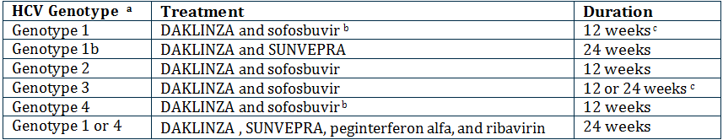
(a) Treatment naïve or failed prior treatment with peginterferon alfa and ribavirin.
(b) The DCV/sofosbuvir (SOF) regimen is also recommended for HCV genotype 1 and 4 patients who failed prior protease inhibitor treatment.
(c) Treatment duration of 24 weeks can be considered for HCV genotype 3 treatment experienced patients with cirrhosis.
At the time of this submission, asunaprevir (Sunvepra) 100 mg soft gelatin capsules were the subject of a current parallel submission for registration.

Regulatory status
The regulatory status for DCV worldwide as of March 2015 is listed in Table 2.
Table 2: Worldwide regulatory status for DCV.
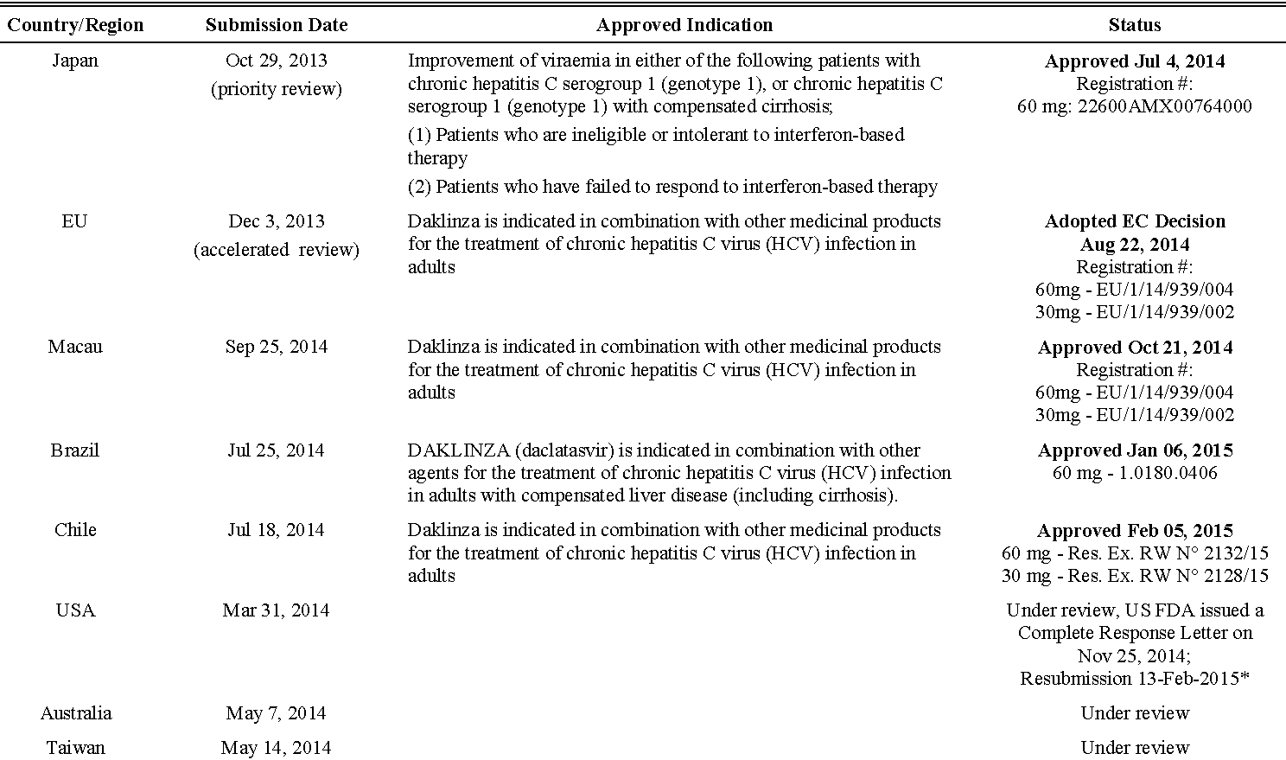
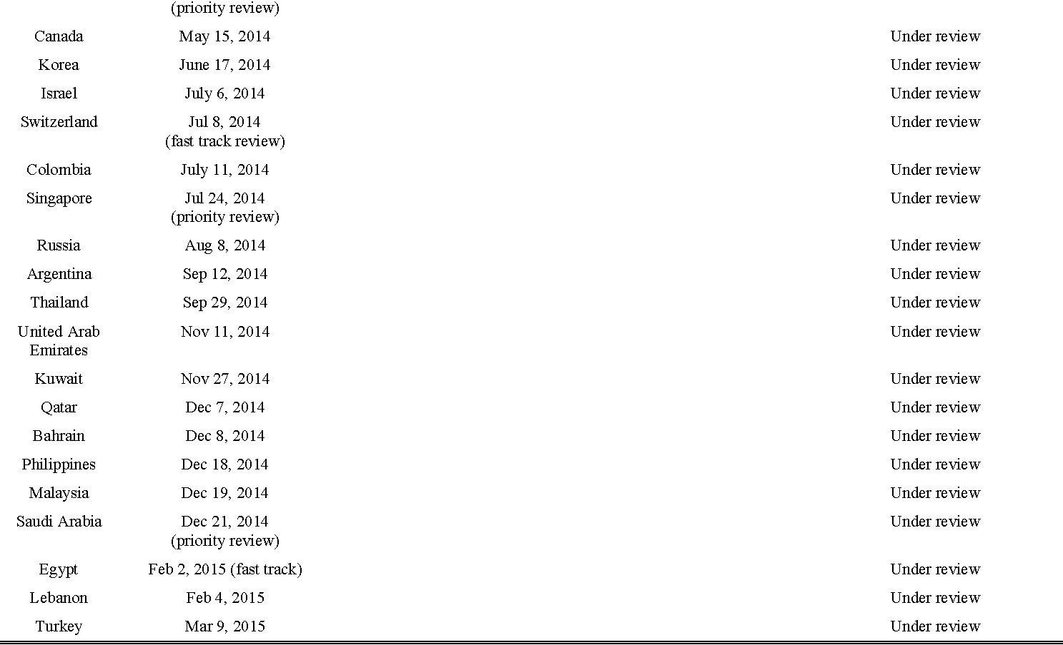
* Given the change in direction with regard to the withdrawal of the asunaprevir NDA in the United States, on 25 November 2014 the US Food and Drug Administration (FDA) issued a Complete Response Letter requesting additional data showing the safety and efficacy of DCV in combination with other antiviral agents for the treatment of HCV. The sponsor aligned with FDA on additional data requirements for the revised New Drug Application (NDA) for DCV and resubmission took place on 13 February 2015.

Product information
The approved PI current at the time this AusPAR was prepared can be found as Attachment 1. For the most recent PI, please refer to the TGA website at <www.tga.gov.au/product-information-pi>.

II. Quality findings

Drug substance (active ingredient)
DCV (Figure 1) is a novel, highly selective NS5A replication inhibitor of HCV infection with broad genotypic coverage. HCV NS5A is a multifunctional protein with key roles in HCV replication, virus assembly and the modulation of cellular signalling pathways. DCV inhibits virion assembly as well as viral RNA replication. DCV is stated to offer the potential for either reduced or interferon free treatment when used with other direct acting antiviral agents. Combination studies demonstrate additive to synergistic interaction when DCV is administered with other anti HCV agents such as inhibitors of NS3 protease and NS5B polymerase (asunaprevir or sofosbuvir [SOF]).
Figure 1: Chemical structure of daclatasvir dihydrochloride.
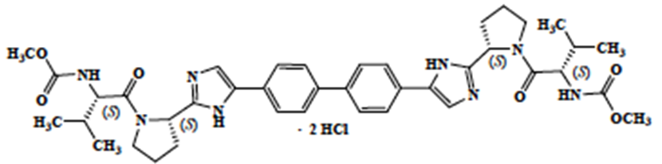
DCV dihydrochloride (anhydrous) is a white to yellow, non hygroscopic powder which is highly soluble in water (>700mg/mL). Solubility is higher at low pH. In aqueous buffers over the physiological pH range (pH 1.2-6.8) solubility is very low (4mg/mL to 0.004 mg/mL) due to the slow formation of the less soluble hydrated form. Water content in the drug substance is adequately controlled by in process tests. The desired anhydrous crystalline form of DCV dihydrochloride (N-2) is consistently produced and has been shown to not change on storage.
DCV dihydrochloride has four chiral centres, and is chirally pure.
The proposed drug substance specifications include adequate control of particle size, and comply with TGA requirements. They are considered adequate to ensure the quality and consistency of manufacture of the finished product.
The drug substance shows good solid state stability and adequate stability data have been provided to support a retest period for the drug substance of 24 months stored below 25°C.

Drug product
The proposed products are immediate release, unscored, film coated tablets containing 30 mg and 60 mg of DCV (as DCV dihydrochloride). The two strengths are direct scales and are distinguished by colour and debossing:
- 30 mg tablets are “green, biconvex pentagonal, film coated tablets, debossed with ‘BMS’ on one side and ‘213’ on the other”, and
- 60 mg tablets are “light green, biconvex pentagonal, film coated tablets debossed with ‘BMS’ on one side and ‘215’ on the other”.
The excipients used in the drug products are all substances with well known properties and functions and which are used in many registered tablet formulation. The manufacturing method is a conventional dry granulation process and is adequately controlled.
Product performance was tested during development and for routine Quality Control testing using a dissolution test (75 rpm paddles, 1000 mL pH 6.8 phosphate buffer with 0.75% Brij surfactant) whose parameters have been adequately justified and shown to be acceptably discriminating. The tablets dissolved reasonably rapidly (64% to 88% dissolved in 15 minutes and ≥ 87% dissolved in 30 minutes).
The product is to be marketed with 7 tablets (sample pack) or 28 tablets packed into PVC/Aclar blisters with aluminium foil lidding.
A limit at release and expiry limit for individual degradants of NMT (Not More Than) 0.2% is proposed, which is within the applicable International Conference on Harmonisation (ICH) qualification threshold. Batches of tablets typically have low levels of total impurities at release (<0.34%) and no significant increase was observed on storage.
The proposed finished product specifications have been adequately justified and comply with TGA requirements. They are considered adequate to ensure the quality of the finished product at release and throughout the shelf life.
The tablets show good stability and a shelf life of 24 months when stored below 30°C, in the original packaging, has been established.

Formulation development
Phase I clinical studies used drug in bottle and drug in capsule (1 mg, 10 mg and 100 mg) formulations and for Phase II trials film coated immediate release tablets (drug load 1% for the 3 mg strength and 10% for the 10 mg and 100 mg strengths) were used. For Phase III clinical trials, the formulation of the film coated tablets was refined such that drug load was increased to 22% w/w with a corresponding decrease in the amounts of anhydrous lactose and microcrystalline cellulose. The amount of lubricant (magnesium stearate) was also increased and the coating changed from a white poly vinyl alcohol polymer based system to a green hypromellose polymer based system.
The Phase III and commercial tablet formulations differ only with respect to colour and debossing. All tablets were manufactured by dry granulation techniques.

Biopharmaceutics
DCV administered as a tablet was readily absorbed following multiple oral doses with peak plasma concentrations occurring between 1-2 h. DCV C_{max}, AUC, and C_{min} increased in a dose-proportional manner. Steady state was achieved after 4 days of once daily administration.
In vitro studies with human Caco-2 cells indicated that DCV is a substrate of P-gp. The absolute bioavailability of the tablet formulation is 67%.
In vitro studies demonstrate that DCV is a substrate of CYP3A, with CYP3A4 the major CYP isoform responsible for the metabolism.
Following single dose oral administration of ¹⁴C-DCV in healthy subjects, 88% of total radioactivity was recovered in faeces (53% as unchanged drug) and 6.6% was excreted in the urine (primarily as unchanged drug). Following multiple dose administration of DCV in HCV infected subjects, the terminal elimination half life of DCV ranged from 12 to 15 h.

Bioequivalence and food effect
Study AI444039 was a 4 sequence, 4 period, crossover study intended to determine the relative bioavailability of 2 x 30 mg DCV Phase II tablets versus 1 x 60 mg Phase III tablets in healthy subjects under fasting conditions. A secondary objective was to estimate the effect of high fat and low fat meal on the bioavailability of the Phase 3 tablets. The following was concluded from the study:
- The Phase II (2 x 30 mg) and Phase III (1 x 60mg) tablets were bioequivalent under fasting conditions, using the normal criteria.
- No effect was observed on bioavailability between administration of the Phase III 60 mg DCV tablet with a light meal versus under fasting conditions with respect to total (AUC) or peak exposure (C_{max}).
- Administration of the Phase III tablet with a high fat meal decreased C_{max} and AUC_{(0-∞)} by 28% and 23%, respectively, compared to the fasted state.
- Administration of the Phase III tablet with a high fat meal decreased C_{max} and AUC_{(0-∞)} by 23% to 25%, respectively, compared to administration with a light meal.
- The bioavailability of the Phase III tablet following a high fat meal was lower than that of the Phase III tablet following a light meal. The geometric mean values of DCV C_{max} and AUC∞ with a high fat meal were 23% and 25% lower than the corresponding values with a light meal.
- The median T_{max} for DCV was delayed by approximately 0.5 h when DCV Phase III 60 mg tablets were administered after a high fat meal compared with administration under fasted conditions.
- The median T_{max} for DCV was delayed by approximately 1 h when DCV Phase III 60 mg tablets were administered after a light fat meal compared with administration under fasted conditions.
The modest (~23-25%) decrease in DCV exposure, when the capsules are given with a high fat meal or under fasting conditions versus administration with a high fat meal, is argued by the company to not be clinically relevant, and in the PI it is stated that the capsules can administered without regard for food.

Absolute bioavailability
Absolute bioavailability was determined in an open label study in 8 healthy fasted subjects, each receiving a 60 mg oral dose of DCV as a tablet first followed an hour later (approximate oral T_{max}) by a 100 µg micro tracer dose of [¹³C-¹⁵N]-DCV infused intravenously over 1 minute. The results indicate that DCV has an absolute oral bioavailability of ~67% (90% CIs: 56.2, 79.8).

Quality summary and conclusions
Registration of the proposed DCV 30 mg and 60 mg film coated tablets in PVC/PCTFE/aluminium blisters in packs of 7 tablets (sample pack) or 28 tablets, is recommended with respect to quality and biopharmaceutic aspects. All issues raised during the initial evaluation of this application have been satisfactorily resolved.
As no significant pharmaceutical chemistry issues were identified, the submission was not referred to the Pharmaceutical Subcommittee (PSC) of the Advisory Committee on Prescription Medicines (ACPM).

III. Nonclinical findings

Introduction
The general quality of the submitted studies was reasonable and consistent with ICH guidelines. Pivotal studies examining repeat dose toxicity and reproduction/development were conducted under Good Laboratory Practice (GLP) conditions. The exposure ratios are adequate to address the clinical relevance of the observed toxicities.
Two combination repeat dose studies which are not the subject of the current application (Study DM08018 and Study DS08147) were included in the application.

Pharmacology

Mechanism of action
DCV is an inhibitor of the HCV NS5A replication complex. NS5A is a multifunctional protein with key functions in both HCV replication and modulation of cellular signalling pathways. DCV is proposed to be used in combination with other drugs (asunaprevir, SOF, PEGIFNα/ribavirin) in chronic HCV infected patients.

Primary pharmacology
In vitro studies were conducted using a human Huh-7 cell line expressing subgenomic HCV. In this replicon assay, DCV exhibited a high potency against all HCV genotypes from infected patients, including the most common GT-1a and GT-1b, with EC50 values between 0.001-0.019 nM, which are well below the clinical exposure (based on C_{max} of 1.73 μg/mL or 2.3 μM). Similar potency for DCV was noted in replicon assay conducted in other cell lines, namely, HeLa and HEK 293T. The potency of DCV metabolites was 1-3 orders of magnitude lower than the potency of DCV. DCV was inactive against 10 other RNA or DNA viruses. Inhibition by DCV was also reversible over various time periods. Human hybrid replicons GT-1a, GT-1b and GT-4a had EC50 values of 0.0059, 0.002 and 0.007 nM, respectively. Similar EC50 values were obtained in the separate infectious virus assay for HCV inhibition. Selectivity of DCV binding was demonstrated with biotin tagged active (S-stereoisomer) and inactive (R-stereoisomer) enantiomers of DCV, by direct binding with radiolabelled DCV, and with mapping of the binding site on NS5A.

Resistance and cross resistance
Mutations in NS5A that conferred some resistance to DCV were identified from in vitro studies (treatment emergent mutations in HCV replicon assays) and from subjects treated with DCV monotherapy in the clinic (Table 3).
Table 3: Resistance profile of DCV in the in vitro replicon system.
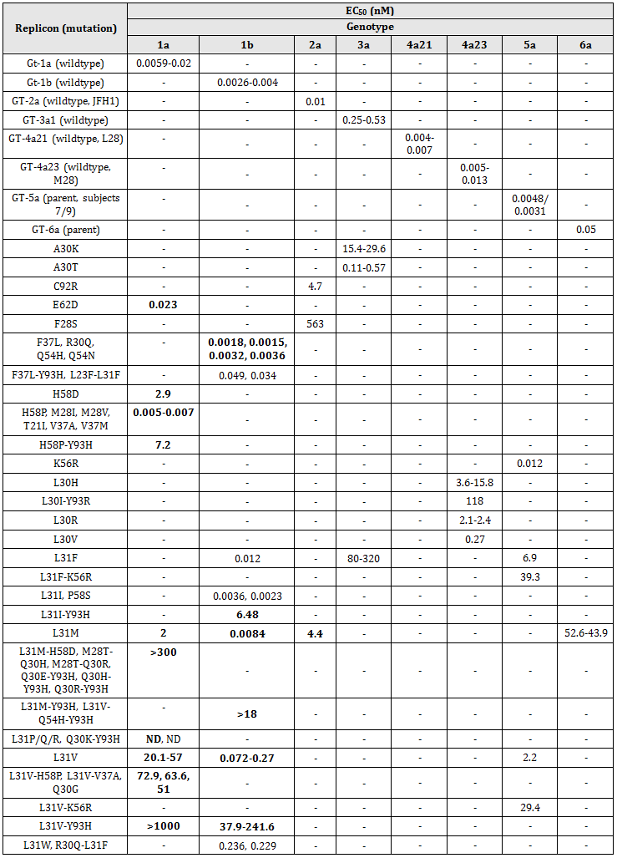
Table 3 (continued): Resistance profile of DCV in the in vitro replicon system.
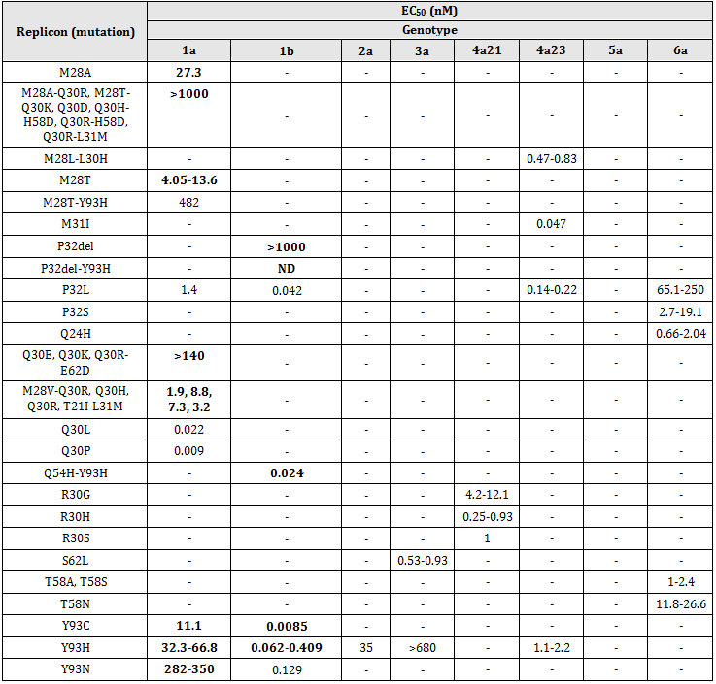
Bold values represent variants identified in the clinic; ND or - = not determined; the majority of wild-type HCV genotype 2a contain a pre-existing resistance substitution (L31M).
Resistance to DCV has been shown to occur in all HCV genotypes and has been mapped to the first 100 amino acids of NSA5. The highest level of resistance was conferred by GT-1a variants. Mutations at L31 (1a, 1b, 3a, 5a, 6a), M28 (1a), Q30 (1a), Y93 (1a, 2a, 3a), P32 (1b, 6a), F28S (2a), L30 (4a), and R30 (4a), or their combinations, conferred increases of >800 fold in DCV EC50 (Table 4). Genotype 1a and 1b mutations were present in replicons found in the clinic.
Table 4: Extent of resistance to DCV conferred by mutations in NS5A, in HCV replicon assays.
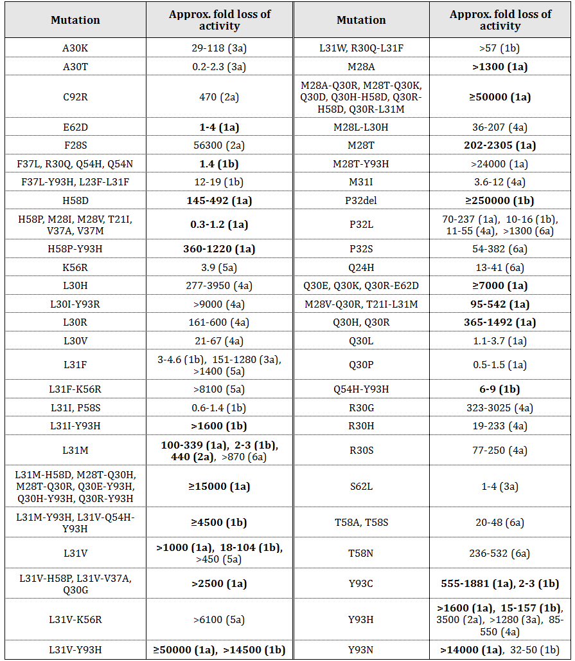
Bold values represent variants identified in the clinic.
The potency of DCV in replicon cells has been shown to correlate with the anti-HCV effect observed in patients. Inhibitors of other HCV targets, namely the NSA3 protease inhibitor and the NS5B polymerase inhibitor, are as active against hybrid replicons resistant to DCV as they are against wild type sequences, suggesting DCV combination therapy with other HCV agents will be effective for the treatment of HCV.
Table 5: Extent of resistance to DCV conferred by mutations in NS5A , in HCV replicon assays.
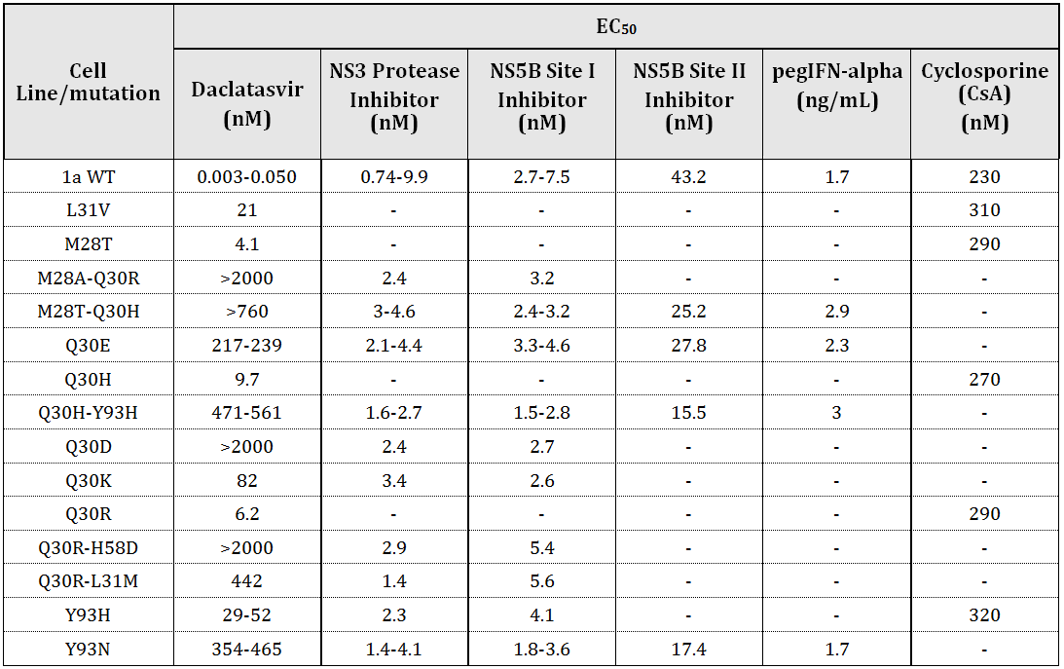
- = not detected
Combination studies in replicon cells with IFNα, asunaprevir, NS5B polymerase inhibitor, pegIFNλ showed additive or synergistic antiviral effects.

Secondary pharmacodynamics
DCV has no known mechanistic or metabolically relevant human target.

Safety pharmacology
Cardiovascular, CNS and respiratory endpoints were evaluated as part of the single and repeat dose toxicity studies. Specialised studies were conducted to examine ion channel currents and receptor binding, as well as general cardiovascular parameters. In relation to potential CNS effects, animal studies did not reveal any evidence of neurological clinical signs on behaviour, movement, or peripheral and cranial nerve function, or histopathological findings indicative of a DCV induced effect. Repeat dose combination studies with other HCV drugs did not result in any enhanced effects on CNS endpoints. The highest dose in the dog and monkey studies was 100 (reduced to 50) and 300 mg/kg/day, respectively (equivalent to 10 and 3 times the AUC clinical exposure, respectively). The CNS endpoints have been adequately examined in the nonclinical studies and the observed effects are not considered clinically relevant.
In relation to potential respiratory effects, animal studies did not reveal any evidence of changes in respiratory rate or function indicative of a DCV induced effect. Repeat dose combination studies with other HCV drugs did not result in any enhanced effects on respiratory endpoints. The highest dose in the dog and monkey studies was 100 (reduced to 50) and 300 mg/kg/day, respectively (equivalent to 10 and 3 times the AUC clinical exposure, respectively). The respiratory endpoints have been adequately examined in the nonclinical studies and the observed effects are not considered clinically relevant.
In relation to potential cardiovascular effects using in vitro binding assays, DCV (but not metabolite BMS-805215) inhibited binding to the sodium ion channel, but did not inhibit ligand binding to 37 other targets. In cell based in vitro assays, DCV produced moderate inhibition of K, Na and Ca ion channel currents, but no significant effect on Purkinje action potential parameters at 10 µM (>200x unbound Cmax clinical exposure). In a similar study, metabolite BMS-795853 inhibited K and Na ion channel currents at 10 µM. In an in vivo study in rabbits up to 30 mg/kg IV, there were no DCV related effects on ECG parameters at 10 mg/kg, but there was a moderate increase in QRS duration at 30 mg/kg. There was no evidence of cardiac arrhythmia at any dose level. Exposure at the 10 mg/kg NOAEL (72.9 µg/mL) was 42x the Cmax clinical exposure. In an in vivo study in dogs up to 100 mg/kg PO, there were no DCV-related effects on ECG parameters, but there was a reversible increase in blood pressure at 100 mg/kg. Exposure at the 15mg/kg NOAEL (3.87 µg/mL) was 2.2x the Cmax clinical exposure. In repeat dose studies in dogs and monkeys, there were no DCV related changes to heart rate or electrocardiograph (ECG) parameters at 100 mg/kg/day in dogs (equivalent to 10 times the AUC clinical exposure) or at 300 mg/kg/day in monkeys (equivalent to 3 times the AUC clinical exposure). Repeat dose combination studies with other HCV drugs did not result in any enhanced effects on cardiovascular endpoints. The cardiovascular endpoints have been adequately examined in nonclinical studies and the observed effects are not considered clinically relevant other than a low potential for increased blood pressure.

Pharmacokinetics
Nonclinical pharmacokinetics studies with DCV were conducted in mice, rats, dogs and monkeys.

Absorption
Absorption of DCV from the gastrointestinal tract was moderately rapid (Tmax 2-3h) in mice, rats, dogs and monkeys. Bioavailability was high in mice and dogs (>100%), but lower in rats and monkeys (≤50%). Tissue distribution was extensive in all species. Clearance after IV administration was low in mice (10% hepatic blood flow), but higher in other species (>25% hepatic blood flow). An intraportal infusion study in rats indicated high hepatic bioavailability, suggesting bioavailability was not limited by first pass hepatic clearance. A study in dogs suggested that gastric absorption may be pH dependent (inverse relationship). Elimination half life was short in mice (1.1h), but longer in other species (~4h). In repeat dose studies in mice, rats, dogs and monkeys, exposure was dose-proportional, but generally did not increase with the period of exposure. There was no gender difference in exposure.

Distribution
Plasma protein binding by DCV was high in laboratory animals and humans. Blood-to-plasma concentration ratios were high in all species, including humans, indicting no significant red blood cell partitioning by DCV. Tissue distribution of radioactivity following single dose oral 14C-DCV treatment was rapid (Cmax 4 h) and wide in rats, with highest concentrations in cecum, small intestine, stomach, adrenal gland and liver. Some radioactivity was associated with melanin containing tissues (pigmented skin and eye uveal tract in pigmented rats) but levels slowly decreased with time, suggesting no irreversible binding. There was no evidence of transfer across the blood-brain barrier or high distribution to reproductive tissues. After repeated exposure, there was no indication of tissue accumulation.

Metabolism
DCV metabolism was qualitatively similar in all species, including humans, involving pyrrolidine ring opening followed by intramolecular cyclization to form the major metabolite BMS-805215, carbamate cleavage to form BMS-795853, and other oxidation reactions to form minor metabolites. Metabolism in vitro with microsomes or hepatocytes was limited (73-84% DCV unchanged). Metabolism in vitro was mediated by CYP3A4.
In CYP450 inhibition studies, DCV was a weak time dependent and NADPH dependent inhibitor of CYP3A4 (IC50 13.5µM). There was no inhibition of other CYP450 enzymes. DCV was not an inducer of CYP3A4 mRNA formation in Fa2N-4 cells, but did induce an increase in CYP3A4/5 enzyme activity and mRNA formation in human hepatocytes (EC50 2-7 µg/mL).
Metabolism in vivo was similar across all species, with DCV the major plasma component. Metabolite BNS-805215 was the only metabolite detected in human plasma. It was also a major metabolite in monkey but not in other species. BMS-805215 was a major faecal component in humans and monkeys.

Excretion
The major excretion route for DCV was via the faeces in all species. Bile duct cannulation experiments in rats, dogs and monkeys suggest that bile may also be a route of excretion in humans. In humans, 77% of dose was excreted within 72 h, with 52% as unchanged DCV. Renal excretion was a minor pathway.

Conclusion
The pharmacokinetic profiles in dogs and monkeys are sufficiently similar to humans for these species to be used as models for the assessment of the toxicity of DCV and its metabolites in humans.

Pharmacokinetic drug interactions

Transporter and CYP450 enzyme interactions
DCV was shown to be a substrate for efflux transporter P-gp in Caco-2 cells. DCV was able to inhibit the permeability of 3H-digoxin via P-gp with an IC50 of 4.4µM (twice clinical Cmax exposure). Similarly, in MDCK cells, DCV inhibited P-gp with an IC50 of >7µM). DCV was not a substrate for BCRP, OATP1B1, OATP1B3, or OATP2B, but was an inhibitor of BCRP, OATP1B1, PATP1B3, OATP2B1, MRP2, OAT1, OAT3, OCT1, OCT2 and BSEP (IC50 range 1.4-41.8µM). There is therefore potential for DCV to increase the plasma concentration of drugs which use these transporters. Clinical studies suggest that DCV at clinically relevant exposures may have potential to affect the pharmacokinetics of drugs which are substrates of P-gp, BCRP or OATPs, but that potential to interact with the other transporters is low. The potential for DCV to influence exposure to other drugs should be examined further in clinical studies.
In relation to a potential effect on CYP3A4, model based analysis indicated induction of CYP3A4 by DCV would not be clinically relevant. There is potential, however, for inhibitors of CYP3A4 to increase the plasma concentration of DCV.

Other HCV drug interactions
Co-administration with asunaprevir slightly lowered exposure to DCV in rats (1 month), but not in monkeys (1 and 3 months). Co-administration with NS5B polymerase inhibitor alone or in combination with asunaprevir in dogs (1 month) slightly lowered exposure to DCV. The potential for DCV to change the exposure to asunaprevir and/or NS5B2 polymerase inhibitor was not evaluated in this report. Co-administration with pegIFNα2B + ribavirin in monkeys did not lower exposure to DCV (1 month), nor was there any evidence that DCV reduced exposure to pegIFNα2B or ribavirin.

Toxicology

Acute toxicity
In single dose oral studies in mice, rats, dogs and monkeys, DCV demonstrated low toxicity with minimal clinical signs and no evidence of organ toxicity. The maximum non lethal oral dose in mice was 1000 mg/kg, in rats was 1000 mg/kg, in dogs was 150 mg/kg, and in monkeys was 150 mg/kg. Clinically, DCV is expected to have a low order of acute toxicity.

Repeat dose toxicity
Appropriately designed repeat dose toxicity studies were conducted in mice, rats, dogs and monkeys, with DCV administered once daily by oral gavage in the pivotal studies in rats (6 months) and monkeys (9 months), consistent with ICH guidelines. The recommended clinical dose is DCV 60 mg orally by capsule once daily.

Relative exposure
The exposure ratios for DCV and metabolite BMS-805215 have been calculated based on animal:human AUC at steady state. Human reference values for DCV are derived from Clinical Study AI444004 (930040110). The NOAEL is shown in bold type. Human reference values for BMS-805215 are derived from Clinical Study AI447009 (930068309).
Table 6: Relative exposure for DCV in oral repeat-dose toxicity and carcinogenicity studies.
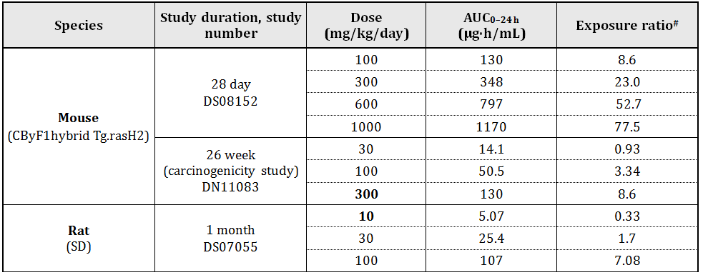
Table 6 (continued): Relative exposure for DCV in oral repeat-dose toxicity and carcinogenicity studies.
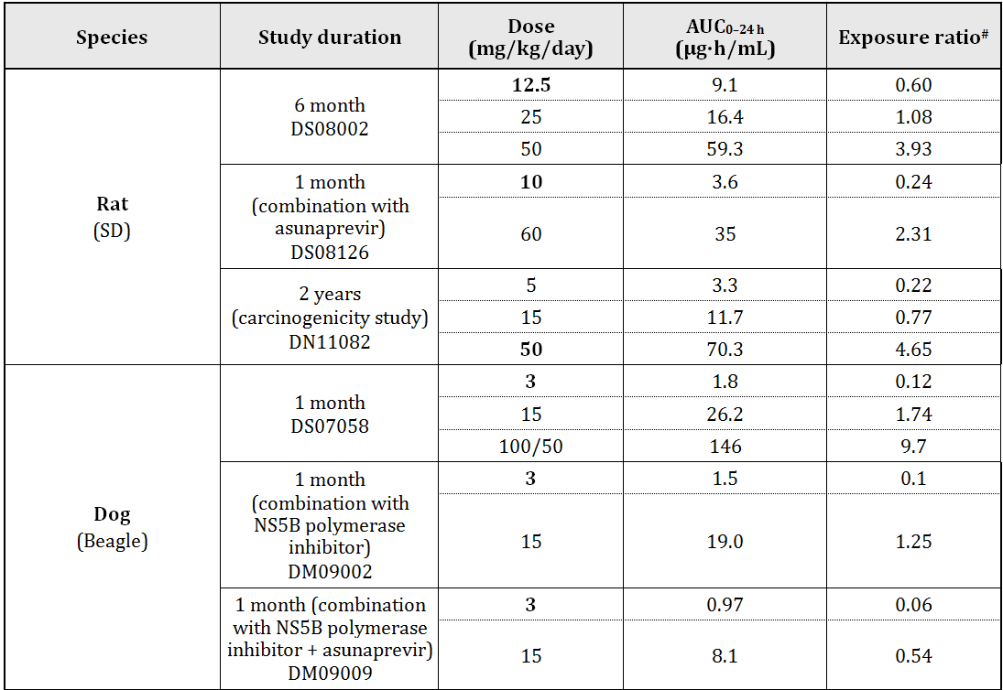
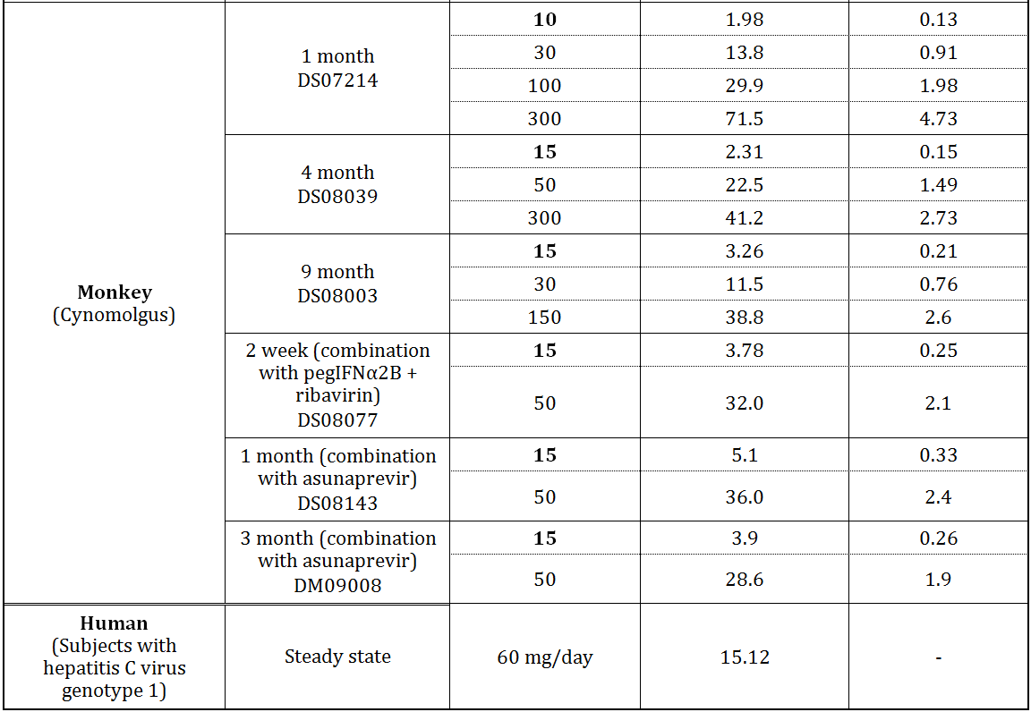
# = animal:human plasma AUC_{0–24 h}
Table 7: Relative exposure for BMS-805215 in repeat-dose toxicity studies.
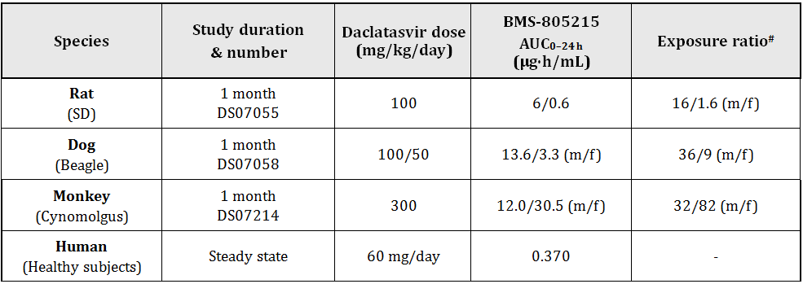
# = animal:human plasma AUC_{0–24 h}
The exposure ratios in all repeat dose toxicity studies and in the carcinogenicity study were adequate to address the clinical relevance of the observed effects.

Major toxicities
The treatment related toxicity observed in the mouse, rat, dog and monkey studies was generally of a low order and reversible. Changes were noted in the liver, adrenal gland, and bone marrow, but generally only at high dose levels. In most cases, the observed changed were fully or partially resolved during the recovery period.
In the mouse studies, evidence of mild toxicity was observed in the liver (increased vacuolation and increased weight), spleen (increased weight) and stomach (inflammation) only at ≥600 mg/kg/day (equivalent to 53 times the AUC clinical exposure).
In the rat studies, evidence of toxicity in a 2 week study included increases in liver, adrenal and kidney weights, with accompanying histopathological changes only in the adrenal (increased vacuolation and inflammation) at 60 mg/kg/day. Urine volume was increased at ≥60 mg/kg/day. Longer term studies (1 and 6 month) confirmed the treatment-related changes in the adrenal gland (weight increases with histopathological evidence of hypertrophy/hyperplasia together with cytoplasmic vacuolation) at ≥25 mg/kg/day (approximately equivalent to the AUC clinical exposure), which reversed during the recovery period. Urine volume increases were noted at ≥25 mg/kg/day, in line with increased water consumption. Although occurring at the clinical exposure level, the observed changes were mild and reversible, and not considered clinically relevant.
In the 1 month dog study, evidence of toxicity in the liver and bone marrow was associated mainly with the high dose (100, reduced to 50 mg/kg/day, 10 times the AUC clinical exposure), and confirmed by histopathological evidence of inflammation, degeneration and hypertrophy/hyperplasia in the liver, and decreased erythroid and granulocyte components in the bone marrow. These changes were reversible at 15 mg/kg/day (twice the AUC clinical exposure).
In the monkey studies, a high incidence of soft/liquid faeces was associated with vehicle treatment which was exacerbated by DCV treatment, particularly in the 4 and 9 month studies. DCV related gross toxicity was observed in the adrenal gland and liver, and confirmed by histopathological evidence of bile duct and Kupffer cell hyperplasia in the liver and decreased cytoplasmic vacuolation in the adrenal gland, at 1-3 times the AUC clinical exposure. The adrenal gland changes in monkeys may be related to stress. The adrenal gland changes were resolved during the recovery period and the liver changes reduced.

Combination studies
Combination toxicity studies were conducted in rats, dogs and monkeys with other potential HCV drugs (asunaprevir and NS5B polymerase inhibitor) as well as with currently used HCV drugs (pegIFNα-2b and ribavirin). In all of these combination studies, there was no evidence that the toxicity profile of DCV was altered by co-administration with other HCV drugs. The available combination studies in animals were adequate to assess the potential effect of other HCV drugs on the toxicity profile of DCV.

Metabolite toxicity
Repeat dose toxicity associated with metabolite BMS‐805215 was adequately evaluated in studies in dogs and monkeys where the exposure to BMS‐805215 was greater than the exposure in humans. Metabolite BMS‐795853 was not detected in humans. Monkeys were selected for chronic toxicologic evaluations as their in vivo metabolism was more representative of humans.

Genotoxicity
The genotoxic potential of DCV was examined in a bacterial reverse mutation assay, in an in vitro micronucleus assay and in a cytogenetics study in Chinese hamster ovary cells. The genotoxic potential of DCV was also examined in vivo in a rat micronucleus assay at dose levels up to 2000 mg/kg/day (equivalent to 5 times the clinical AUC exposure). All assays were negative and no further testing was considered necessary. DCV is not considered to have genotoxic potential.

Carcinogenicity
The carcinogenic potential of DCV was examined in a 26 week study in transgenic mice and in a 2 year study in rats. Dose selection in mice and rats was appropriate and based on 28 day and 26 week studies, respectively. Studies were conducted in compliance with ICH guidelines.
In mice, there was only minimal evidence of toxicity and no evidence of an increase in tumour incidence in either sex compared to the water and vehicle control groups. In the positive control group (N-nitroso-N-methylurea [NMU] treated animals), there was a significant decrease in survival and a significant increase in the incidence of lymphoma in both sexes compared to controls. Lymphoma was observed across a wide range of tissues. There was no evidence of an increase in DCV related tumour incidence in mice at 300 mg/kg/day (equivalent to 8.6 times the AUC clinical exposure).
In the rat study, survival was reduced and the study terminated at 92/94 (m/f) weeks, however, the number of study animals was still considered adequate to assess carcinogenicity. There was minimal evidence of toxicity and no evidence of an increase in tumour incidence in either sex compared to water and vehicle control groups. Trend test analysis (Poly-3 test) revealed significance at P ≤ 0.05 for (i) keratoacanthoma + squamous cell papilloma; (ii) benign granular cell tumours of the cervix; and (iii) combined fibroma/fibrosarcoma of the skin/subcutis, however, all of these tumour types are considered common tumours and showed no significant difference between control and high dose based on pairwise comparison (Fisher exact test). All of the tumour incidences in this study were low based on historical control data. There was no evidence of an increase in DCV related tumour incidence in rats at 50 mg/kg/day (equivalent to 5 times the AUC clinical exposure).

Reproductive toxicity
The reproductive and developmental toxicity of DCV was examined in rats and rabbits. Embryonic development was examined in rats and rabbits. Fertility and male reproductive toxicity, as well as postnatal development, were examined in rats. Toxicity and fertility were also examined in juvenile rats. All of these studies were appropriately designed.

Relative exposure
Relative exposure in reproduction and development studies are shown in Tables 8 and 9.
Table 8: Relative exposure for DCV in reproduction and development studies.
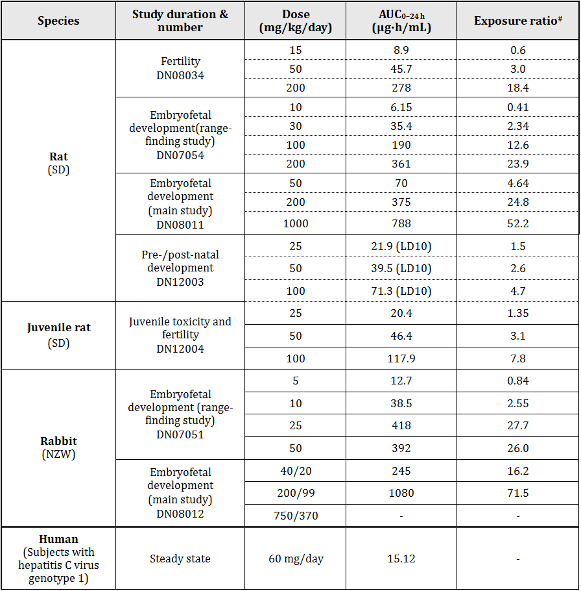
# = animal:human plasma AUC_{0–24 h}
Table 9: Relative exposure for BMS-805215 in reproduction and development studies.
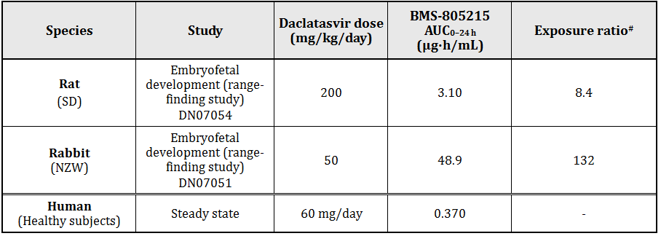
# = animal:human plasma AUC_{0–24 h}
The exposure ratios in all reproductive and development studies were adequate to address the clinical relevance of the observed effects.
Placental transfer of DCV and its metabolites was shown to occur in pregnant rats given 14C-DCV, but distribution in the foetus was minimal, with radioactivity only detected in the liver. The potential for milk transfer of DCV and its metabolites was demonstrated in rats on lactation day (LD) 8-10 where the milk:plasma ratio was 1.55 (based on AUC_{0-72h}). Milk transfer of DCV was also demonstrated in the pre and postnatal development study with derived milk:plasma ratios of 1.7-2.0 at LD10.
The fertility study with DCV did not demonstrate any evidence any adverse effects on mating or fertility. There was no evidence of reproductive toxicity in females, either on the oestrus cycle or on pregnancy outcomes at 200 mg/kg/day (equivalent to 18 times the AUC clinical exposure). In males, there was a small increase in abnormal sperm morphology (misshapen head) at 200 mg/kg/day, which was not considered clinically relevant. No treatment related effects were observed at 50 mg/kg /day (equivalent to 3 times the AUC clinical exposure).
In the embryofoetal toxicity study in rats, there was evidence of maternal toxicity and teratogenicity at 200 mg/kg/day, and an increase in early resorptions at 1000 mg/kg/day. Teratogenicity was also evident at 1000 mg/kg/day. Foetal malformations affected the brain, skull, eyes, ears, nose, lip, palate and limbs. It was unclear whether the increase in foetal malformations at 1000 mg/kg/day was the result of maternal toxicity. There were no treatment related effects on the dams or foetuses at 50 mg/kg/day (equivalent to 4.6 times the AUC clinical exposure).
In the embryofoetal toxicity study in rabbits, the high dose level (750/375 mg/kg/day) was above the maximum tolerated dose for this species. At the 200/99 mg/kg/day dose level, both maternal and foetal toxicity was evident, with increased abortions and resorptions. Foetal variations were increased at this dose and to a lesser extent at 40/20 mg/kg/day. The overall incidence of malformations was not increased, but a non-significant increase in rib malformations was evident at 40 mg/kg/day (equivalent to 16 times the clinical AUC exposure). There were no treatment-related effects on the does or foetuses at 40/20 mg/kg/day (equivalent to 16 times the AUC clinical exposure).
There are no data on DCV use in human pregnancy. Since embryotoxic and teratogenic effects were only seen in rats and rabbits at multiples of the human exposure (AUC), the risk for humans is unclear, but as a precautionary measure it is recommended that DCV not be used in pregnant women or women of childbearing potential not using highly effective contraception. The proposal (Risk Management System document) that effective contraception be continued for 5 weeks (five half lives and one thirty day ovulatory cycle) after completion of treatment is acceptable. These recommendations are consistent with the EU Summary of Product Characteristics (SmPC) for DCV.
In the pre/postnatal development study in rats, there was clear evidence of toxicity in the F0 generation at 100 mg/kg/day, with decreased pup survival at postnatal day (PND) 4. There was no treatment related effect on pup survival at LD21, although pup bodyweight was reduced during lactation and post weaning at 100 mg/kg/day, but not at 50 mg/kg/day (equivalent to 2.6 times the AUC clinical exposure). There was no treatment related effect on pup development, mating performance or reproductive parameters.
In a juvenile toxicity and fertility study, there was evidence of mild toxicity at 100 mg/kg/day, which was accompanied by reversible changes in gross and histopathology, but no treatment related effects at 50 mg/kg/day (equivalent to 3 times the AUC clinical exposure). The pathology changes were similar to those observed previously in adult animals. There were no treatment related effects on the oestrus cycle, on sperm, on mating and fertility, or on pregnancy outcomes.

Metabolite toxicity
Reproduction and developmental toxicity associated with metabolite BMS-805215 was adequately evaluated in studies in rats and rabbits where the exposure to BMS-805215 was greater than the exposure in humans (8.4 and 132 times, respectively, the AUC clinical exposure). Metabolite BMS-795853 was not detected in humans.

Pregnancy classification
The sponsor initially proposed a Pregnancy Category C, possibly based on the US classification. There are no data on DCV use in human pregnancy. There are no human data on DCV use in pregnancy. Given the findings of embryotoxicity and foetal malformations in both rats and rabbits, with exposure multiples of 4x (rats) and 16x (rabbits) at the respective NOAELs, an Australian pregnancy B3 category is recommended.
When used in combination with other antiviral drugs such as ribavirin (category X), the most restrictive pregnancy category is applicable.

Local tolerance
The potential for DCV to cause skin sensitisation, dermal irritation and eye irritation was assessed. DCV was considered a skin sensitiser under the condition of an in vitro local lymph node assay. DCV was considered a non irritant in a dermal irritation study in rabbits. DCV is a moderate eye irritant.

Other toxicity studies

Mechanistic studies
A study to examine the potential mechanism of liver and bone marrow toxicity in DCV treated dogs noted clinical pathology changes which defined the early onset of both toxicities, namely, decreased blood cell counts, increased liver enzyme levels, increased C-reactive protein and increased fibrinogen. Mechanistic information for the observed toxicities was not identified.

Phototoxicity studies
An in vitro phototoxicity assay with DCV in mouse fibroblast produced some evidence of phototoxic potential; however, this was not confirmed in an in vivo study in Long-Evans rats treated with a single oral dose of DCV up to 100 mg/kg (equivalent to 7 times the clinical AUC exposure).

Nonclinical summary and conclusions

Summary
- The sponsor has conducted adequate studies on the pharmacodynamics, pharmacokinetics and toxicity of DCV according to the relevant guidelines. All definitive toxicity studies were conducted under GLP conditions.
- Primary pharmacology in vitro studies using a cell based HCV replicon assay demonstrated the ability of DCV to inhibit the HCV NS5A replication complex at concentrations well below the clinical exposure. The only metabolite detected in human plasma, BMS-805215, has 1 order of magnitude less antiviral potency than DCV. The selectivity of DCV towards HCV was adequately demonstrated, as was its specificity to NS5A.
- Resistance to DCV was demonstrated in all HCV genotypes using hybrid replicons from genotypes 1-6, with the highest level of resistance conferred by GT-1a variants. Mutations at L31 (genotypes 1a, 1b, 3a, 5a, 6a), M28 (1a), Q30 (1a), Y93 (1a, 2a, 3a), P32 (1b, 6a), F28S (2a), L30 (4a), and R30 (4a), or their combinations, conferred significant levels of resistance to DCV. Hybrid DCV resistant replicons were still sensitive to other HCV inhibitors. Combination studies in replicon cells with IFNα, asunaprevir, NS5B polymerase inhibitor, and pegIFNλ showed additive or synergistic antiviral effects with DCV.
- Based on findings in the combined set of safety pharmacology studies, daclatasvir (alone or in combination with other HCV drugs) is not expected to have any adverse effects on CNS or respiratory function during clinical use. The potential for DCV to exert cardiovascular effects exists, since it caused hypertension in dogs, and moderately inhibited K, Na, and Ca ion channel currents.
- Pharmacokinetic studies showed that DCV was absorbed moderately rapidly from the gastrointestinal tract in all species. Bioavailability was high in mice and dogs but lower in rats and monkeys and tissue distribution was wide. Liver concentrations of DCV were higher than plasma levels. Clearance varied between species (10-66% of hepatic blood flow) and elimination was ~4h. In repeat dose studies, exposure was dose-proportional, with no evidence of accumulation. There was high plasma protein binding and no significant red blood cell partitioning. Metabolism of DCV was mediated by CYP3A4. Metabolism was similar across all species, with unchanged DCV the major plasma component. BMS-805215, the only metabolite detected in human plasma, was also a major metabolite in monkeys. Excretion of DCV and/or its metabolites was predominantly via the biliary/faecal route in animals and humans. Unchanged DCV was the major faeces component. Dogs and monkeys were appropriate models to assess the toxicity of DCV in humans.
- Inducers/inhibitors of P glycoprotein (P-gp) or CYP3A4 may alter the systemic exposure to DCV. In vitro studies indicate DCV has the potential to affect the oral absorption of co-administered drugs that are substrates for BCRP and P-gp, and affect the disposition of co-administered drugs that are substrates for OATPs. There was some potential for asunaprevir to reduce exposure to DCV in animals.
- Single dose studies demonstrated that DCV has low acute toxicity, with minimal clinical signs and no evidence of organ toxicity.
- The treatment-related toxicity observed in mouse, rat, dog and monkey studies was generally of a low order and reversible. Notable changes were observed at high dose levels in the liver, adrenal gland and bone marrow. In the liver, there was an increase in organ weight, accompanied by evidence of inflammation and hypertrophy/hyperplasia in all species. In the adrenal gland, there was increased vacuolation and inflammation observed in the dog, but decreased cytoplasmic vacuolation in the monkey, which may be related to an increased level of stress. In the bone marrow, there were decreased erythroid and granulocyte components observed in the dog. All of the observed changes were fully or partially reversible and not considered clinically relevant. There was also no evidence that the toxicity profile of DCV was altered by combination studies with other HCV drugs. Potential toxicity associated with the human metabolite BMS-805215 was adequately assessed and not considered clinically relevant.
- In adequate genotoxicity studies, DCV did not produce any evidence of genotoxicity.
- In adequate carcinogenicity studies in mice and rats, DCV did not produce treatment-related tumours at exposure levels 5-9 fold the clinical exposure.
- In a rat reproduction and fertility study, DCV did not impair fertility at exposures well in excess of the clinical exposure. Embryofoetal development studies in rats and rabbits showed embryotoxicity, reduced foetal bodyweights and teratogenicity at maternotoxic doses. Malformations in rats affected the brain, skull, eyes, ears, nose, lip, palate and limbs, and the ribs were affected in rabbits. Exposure margins based on AUC at the respective NOAELs for both maternotoxicity and teratogenicity were 4x and 16x. There are no data on use in human pregnancy. An Australian pregnancy category of B3 is recommended for DCV alone, while category X is applicable to the combination with ribavirin.
- The pre/postnatal development study in rats showed a decrease in pup bodyweight during lactation as well as during post-weaning. There were no treatment related effects on pup development, mating performance or reproductive parameters at exposure levels well in excess of the clinical exposure. In a study in juvenile rats, there were no treatment related effects on reproductive organs or fertility at dose levels higher than the clinical exposure. DCV was shown to be excreted in the milk of lactating rats at levels around 2 fold those shown in maternal plasma at anticipated therapeutic concentrations. The potential reproduction and developmental toxicity of human metabolite BMS-805215 was adequately evaluated at exposure levels higher than the clinical exposure.
- DCV was considered to have potential for skin sensitisation and to be a moderate eye irritant. It did not cause dermal irritation. DCV was not considered to have phototoxic potential in an adequate in vivo rat study.

Conclusions
- There were no major deficiencies in the nonclinical studies.
- The primary pharmacology studies on DCV support its use for the proposed indications.
- The safety pharmacology studies did not reveal any cardiovascular, CNS or respiratory effects that are clinically relevant apart from possibly increased blood pressure.
- The pharmacokinetic data indicate that DCV inhibition of P-glycoprotein, BCRP and OATPs transporters may be clinically relevant. Inhibitors of CYP3A4 may also increase exposure to DCV. Co-administration of asunaprevir may reduce exposure to DCV.
- The repeat dose toxicity studies in mice, rats, dogs and monkeys, alone or in combination with other HCV drugs (asunaprevir, BMS-791325, PEGIFNα/ribavirin), did not reveal any significant treatment-related effects at clinically relevant exposure levels. Main target organs were the liver, adrenal gland, and bone marrow.
- DCV is not considered to have genotoxic or carcinogenic potential.
- Embryofoetal development studies in rats and rabbits showed embryotoxicity and foetal malformations at maternotoxic doses. Foetal malformations in rats affected the brain, skull, eyes, ears, nose, lip, palate and limbs. Foetal malformations affected the ribs in rabbits. Exposure margins based on AUCs at the respective NOAELs for maternotoxicity and teratogenicity were 4x (rats) and 16x (rabbits). There were no data on use in human pregnancy. Although teratogenicity was only observed at multiples of the clinical exposure in animals, it is recommended as a precautionary measure that DCV not be used in pregnant women or women of child bearing potential not using highly effective contraception. An Australian pregnancy category of B3 is recommended for DCV alone. A pregnancy category X is applicable to the combination with ribavirin.

Recommendation
- Based on the nonclinical data evaluated herein, there are no nonclinical objections to the registration of DCV for the proposed indications.

IV. Clinical findings

Introduction
This is a full submission to register a new chemical entity for the treatment of chronic HCV infection.

Clinical rationale
Approximately 150-160 million people worldwide are chronically infected with HCV. The majority of individuals infected progress to chronic hepatitis, which can lead to cirrhosis, liver failure and hepatocellular carcinoma (HCC).
Chronic hepatitis C (CHC) infection is associated with variable degrees of hepatic inflammation and progression of fibrosis. Liver disease progression takes place over several decades, and is accelerated in the presence of co-factors such as alcohol consumption, diabetes mellitus, old age, HIV co-infection, or hepatotropic virus co-infection. Between 10-40% of patients with CHC will develop cirrhosis depending on the presence of these co-factors. Deaths, related to the complications of cirrhosis, occur at an incidence of approximately 4% per year, and HCC occurs in this population at an estimated incidence of 1-5% per year. Given that HCC often goes undiagnosed until late into the disease, once diagnosed with HCC, patients have an approximate 33% probability of death during the first year.
Various HCV genotypes (GT) have been described that respond differently to current treatment regimens. HCV GT-1 (subtypes 1a and 1b) is the most prevalent worldwide with a higher prevalence of GT-1a in the United States and GT-1b in Europe. GT-3 is the second most prevalent GT in some European countries and India, and is associated with an increased likelihood of developing hepatic complications, from steatosis to HCC. Due to the migration from North-East and Sub-Saharan Africa, HCV GT-4 accounts for up to 19% of cases in Mediterranean countries and in 5-8% in Central and Western European countries. GT-2 is found in clusters in the Mediterranean region, while GT-5 and GT-6 are more rarely found in Europe.
Comment: There is no discussion of the prevalence of GT in Australia in submitted modules but in a reference quoted in the Risk Management Plan (RMP) and supported by a publication not provided in the submission it is estimated that in Australia, approximately: 32-35% of people with hepatitis C have subtype GT-3 (mostly being GT-3a), 15 - 35% have GT-1a, 15 - 23% have GT-1b and 7-9.3%, have GT-2, 5.5% have GT-4 and 1.7% have GT-6.
Peginterferon alfa in combination with ribavirin (pegIFNα/RBV) was the traditional well accepted standard of care for the treatment of CHC until 2011. This treatment regimen is administered for either 48 weeks (GT-1, -4, -5, -6) or for 24 weeks (GT-2 and -3), inducing sustained virologic response rates at 24 weeks (SVR24) of 42% to 46% in patients with HCV GT-1 and GT-4, and 76% and 82% in patients with GT-2 and GT-3 infections.
In 2011, two direct acting antiviral (DAA) agents, the HCV NS3/4A protease inhibitors telaprevir (TVR) and boceprevir (BOC), added on to pegIFNα/RBV were approved in the US and EU. These DAA/ pegIFNα/RBV regimens were then considered the standard of care for treating CHC patients in the EU, US, Japan and other regions.
Comment: TVR and BOC were approved in Australia in July 2014.
Recently, other agents including SOF (Sovaldi), a nucleoside NS5B polymerase inhibitor, and simeprevir (SMV), an NS3/4A protease inhibitor, have been approved in the USA offering new treatment options to patients with CHC.
Comment: SOF was approved in Australia in June 2014 and SMV was approved in July 2014.
Introduction of these newer options has provided an improvement over the use of IFN-based therapies alone for patients with GT-1. However, there is still a need for improved efficacy in HCV GT-1 patients, particularly in patients with limited response to pegIFNα/RBV or in patients who are intolerant or ineligible for IFN based therapy, and for patients who have failed current protease inhibitor therapies.
Treatment duration with pegIFNα/RBV can be long (24 to 48 weeks) depending on the GT, and because pegIFNα requires parenteral administration, treatment adherence, compliance, and complications arising from injections can be a challenge.
Side effects associated with pegIFNα/RBV include flu-like symptoms (chills, pyrexia, myalgia, fatigue), psychiatric disorders (depression, irritability, anxiety), and haematologic abnormalities (anaemia and neutropenia). TVR and BOC are associated with serious dermatologic side effects (rash and/or pruritus) and additional decreases in haemoglobin and absolute neutrophils when combined with pegIFNα/RBV, compared to IFN-based therapy alone. SMV treatment is associated with increased rates of hyperbilirubinaemia and photosensitivity.
Despite the treatment advancement with the first generation DAAs and recently approved DAAs, there is still an unmet medical need for new therapeutic agents that are more effective, pangenotypic, less toxic than INF and RBV based therapies and less complex with simpler administration, monitoring and management of adverse events (AEs) to ensure the most optimal combination of DAAs are available to patients. Currently, there is a need for improved therapies in subjects who have failed TVR and BOC regimens as well as INF ineligible/intolerant patients and non responders to pegIFNα/RBV. DCV was developed to address the shortcomings of current standard of care therapy.

Guidance
The following European Medicines Agency (EMA) guidelines, which have been adopted by the TGA, are considered relevant to the current evaluation:
- Guideline on pharmacokinetic studies in man
- Note for guidance on the evaluation of the pharmacokinetics of medicinal products in patients with impaired renal function
- Concept paper on the need for revision of the note for guidance on the evaluation of the pharmacokinetics of medicinal products in patients with impaired renal function
- Guideline on the evaluation of the pharmacokinetics of medicinal products in patients with impaired hepatic function
- Guideline on the investigation of drug interactions
- Guideline on the clinical evaluation of QT/QTc interval prolongation and proarrhythmic potential for non-antiarrhythmic drugs
- Guideline on the clinical evaluation of direct acting antiviral agents intended for treatment of chronic hepatitis C
It is also relevant to note the recently revised US FDA guidance:
- Guidance for Industry Chronic Hepatitis C Virus Infection: Developing Direct-Acting Antiviral Drugs for Treatment
The EU guidelines require that the SVR24 is used as the primary efficacy outcome. However, as stated in the FDA guideline, the primary endpoint is now accepted to be SVR12 based on the high concordance between SRV12 and SVR 24. This was discussed with and accepted by the TGA at the pre submission meeting.

Contents of the clinical dossier
The dossier contained:
- 2 bioavailability studies that examined bioequivalence between various formulations and the effect of food
- 1 absolute bioavailability study
- 5 ascending dose studies examining pharmacokinetics (PK) and initial tolerability. Three were conducted in healthy subjects and two in subjects with chronic HCV infection
- 1 mass balance study
- 2 studies in special populations (1 in hepatic impairment and 1 in renal impairment)
- 18 interaction studies
- 4 studies examining population PK and population PK/exposure response
- 1 pharmacodynamic (PD) study examining effects on QT interval
- 4 pivotal efficacy/safety studies
- 9 other efficacy/safety studies
- 2 other pooled analyses of the resistance profile and hepatoxicity

Paediatric data
The submission did not include paediatric data.
The sponsor has stated that they have an agreed paediatric plan in both the US and EU but no date has been confirmed for data submission. A waiver appears to have been granted in both US and EU for children under the age of 3 years on the basis that they will not benefit significantly from this treatment since there is a higher spontaneous resolution of HCV infection in children than in adults and the HCV infection is milder within this age group (milder liver inflammation, less frequent cirrhosis, lower viral load and shorter duration of infection).
There was no discussion of the potential role of the drug in older children.

Good clinical practice
The study reports all included assurances that the studies had been conducted in accordance with Good Clinical Practice (GCP) guidelines, and in accordance with the principles of the Declaration of Helsinki.

Pharmacokinetics

Studies providing pharmacokinetic data
Table 10 shows the studies relating to each PK topic and the location of each study summary.
Table 10: Submitted pharmacokinetic studies.
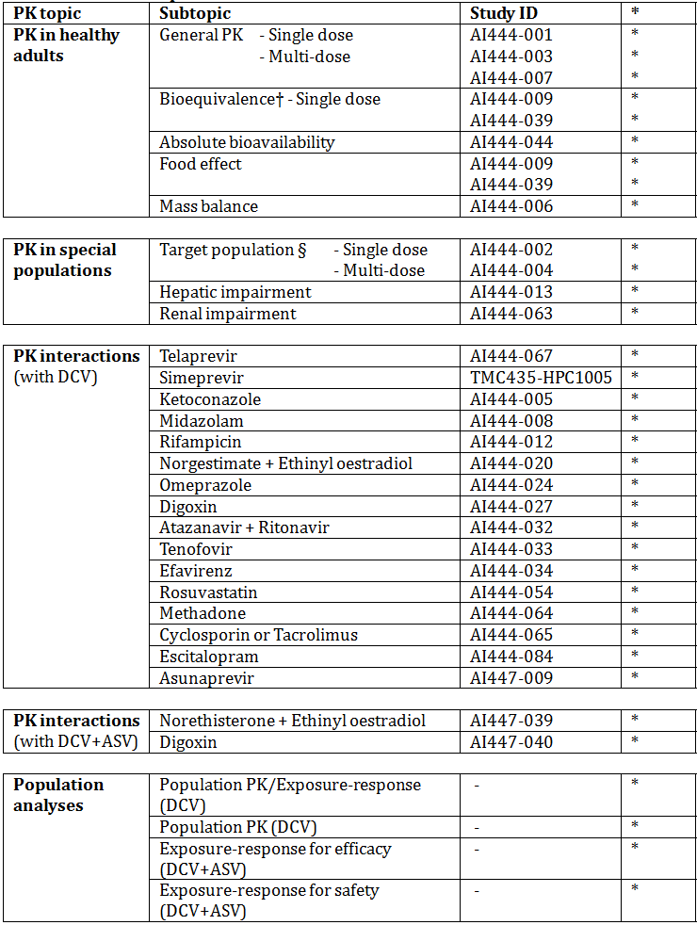
* Indicates the primary aim of the study.
† Bioequivalence of different formulations.
§ Subjects who would be eligible to receive the drug if approved for the proposed indication.
None of these PK studies had deficiencies that excluded their results from consideration. The submission included one other early phase study, which is not reviewed in this report. Study AI447-003 examined the PK of ASV after multiple doses in healthy subjects and has been reviewed in the evaluation report for this medicine.

Evaluator’s conclusions on pharmacokinetics
The early phase clinical studies have provided sufficient data to adequately describe the PK of DCV. The requirements outlined in the relevant EMA guidelines adopted by the TGA have generally been met. In particular, an extensive program of interaction studies has been conducted, as required by the guideline on DAAs for HCV infection.

Pharmacodynamics

Studies providing pharmacodynamic data
Table 11 shows the studies relating to each PD topic and the location of each study summary.
Table 11: Submitted pharmacodynamic studies.
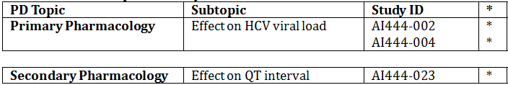
* Indicates the primary aim of the study.
None of the PD studies had deficiencies that excluded their results from consideration.

Evaluator’s conclusions on pharmacodynamics
The PD data provided were acceptable.

Dosage selection for the pivotal studies
Based on the data from AI444014, DCV 60 mg QD was selected as the highest dose for the subsequent study in treatment naïve HCV infected subjects (AI444010). In addition, DCV 20 mg QD was also selected to minimise exposure overlap with DCV 60 mg, which provided an acceptable alternative should dose related toxicity be observed with the higher dose. The overall SVR24 rates were 37.5%, 59.2%, and 59.6% for subjects treated with placebo/pegIFNα-2a/RBV, 20 mg DCV/pegIFNα-2a/RBV, and 60 mg DCV pegIFNα-2a/RBV, respectively. In addition, the safety profile was similar in all 3 treatment groups suggesting that at doses of 20 mg and 60 mg QD, DCV demonstrates a flat exposure-response and exposure safety profile.
To supplement the empirical data, multiple analyses were conducted including a PPK analysis, an exposure response analysis, and a pharmacokinetic viral kinetic analysis (PKVC) to select the dose for Phase III studies of DCV combined with pegIFNα-2a/RBV and DCV combined with asunaprevir (ASV). The exposure-response analysis evaluated the relationship between model predicted exposures of DCV and antiviral response endpoints using data generated from 4 studies in HCV infected subjects: AI444010; AI444002; AI444004; and AI444014.
In general, the goal of the analysis was to determine a DCV dose that would maximise efficacy in HCV GT-1 infected subjects while minimising exposure related AEs. In GT-1 naïve subjects, exposure-response and PKVK modelling predicted that the 20-mg dose was expected to have comparable efficacy to the 60 mg dose. A flat dose-response in both GT-1 naïve subjects and in a difficult-to-treat high baseline viral load, GT-1a population was expected for doses of 20 mg and above.
No unique safety signals and no exposure-response relationships were identified across the 20 mg to 60 mg QD DCV dose groups. In order to evaluate the exposure-response relationship in difficult-to-treat patients, a full logistic regression analysis of antiviral response as a function of DCV exposures (using Cavgss) was conducted. This model accounted for factors like virus GT, baseline viral load, cirrhosis status, and host GT, and was used to predict antiviral efficacy for a group of subjects with specific combination of patient-specific factors that are historically considered more difficult to treat: GT-1a viral infection, high baseline viral load, cirrhosis and non-CC host GT. The model predicted that the DCV 60 mg QD dose may result in an increase of 2% to 5% in efficacy relative to the 20-mg dose.
Based on the results of the integrated analysis, a 60 mg QD dose of DCV was selected for further development in Phase III studies. This dose was expected to provide simplicity of therapeutic use and allow maximal antiviral response with DCV/ASV, DCV/SOF, DCV QUAD, and DCV/pegIFN/RBV combinations while maintaining an acceptable safety profile. The 60 mg QD dose was also expected to compensate for factors that can reduce DCV exposure, such as food, pH modifiers, poor compliance, and CYP3A4 inducers.

Efficacy

Studies providing efficacy data
The efficacy analysis is presented as follows:
- DCV in combination with ASV: Studies AI447028, AI447026, AI447017, AI447011, AI444046
- DCV in combination with SOF: Studies AI444040, AI444046
- DCV in combination with ASV plus pegIFNα/RBV (QUAD): Studies AI447029, AI447011, AI444046
- DCV in combination with pegIFN/RBV: this comprises tables showing efficacy for studies which are summarised as they do not include proposed treatment regimens.
- Analyses performed across trials (pooled analyses and meta-analyses) for DCV + ASV, DCV + SOF and QUAD.

Evaluator’s conclusions on efficacy
This is a large and complex application. The new product DCV is only recommended in combination with other agents. One of these agents is ASV which is also a new chemical entity and the subject of a parallel evaluation. All the data for ASV is included in this submission (with the exception of 1 supportive study) as it is also only recommended for use in combination with DCV.
This submission comprises mostly early phase studies that include a range of dose regimens (doses and durations) and various patient populations (treatment naïve, prior treatment failure and IFN/RBV intolerant or ineligible). The sponsor has chosen to present the data as amalgamations of dosing and treatment under the 3 dose regimens requested. This has led to great difficulty in dissecting out the actual numbers of subjects treated with the regimens requested.
There is a problem with the indication as requested as the dose regimen requested does not reflect the patients included in the clinical studies. The company have addressed this issue by providing a “Position Pater on Proposed Dosage and Administration” in which they argue on the basis of a series of assumptions for extrapolations from the dose regimens submitted to the proposed dose regimens proposed for approval. The rationale for these extrapolations were discussed in the TGA Pre-Submission Meeting Briefing Document provided by the Sponsor, however there is no mention of this in the minutes of the meeting (included in the submission).
In the Position Statement, the sponsor provides the following table which describes the range of doses, duration and patient populations actually in the clinical trials in the submission.
Table 12: DCV (60 mg once daily) combination therapies: populations, regimens and durations of treatment studied in submitted clinical trials.
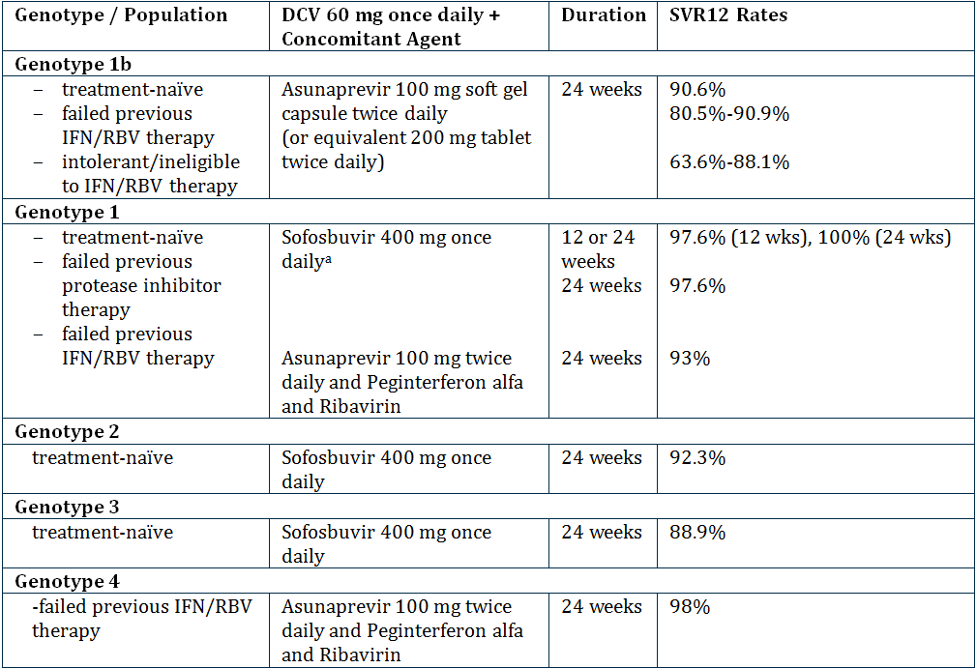
a. Since comparable results were observed for DCV/SOF regimens with or without RBV, the data from both groups are pooled. The addition of RBV to DCV/SOF does not improve efficacy, while resulting in higher anaemia rates. Thus the Sponsor recommends the use of DCV/SOF alone (without RBV).
The sponsor then proposed the following extrapolations; this is presented in detail and exactly as provided by the sponsor in the Position Paper:
- DAA+pegIFNα/RBV treatment failure to pegIFNα/RBV treatment failure: Since current standard-of-care for HCV GT-1 consists of a DAA in combination with pegIFNα/RBV, failure to these regimens containing pegIFNα/RBV means that these patients also failed the individual components of the treatment regimen, including pegIFNα/RBV alone. Thus, if an investigational regimen yields high SVR rates in patients who failed prior therapy with telaprevir (TVR) or boceprevir (BOC) in combination to pegIFNα/RBV, this same regimen would also be effective in patients who failed pegIFNα/RBV treatment alone.
- Treatment-naïve to prior IFN/RBV failures: Multiple studies with pegIFNα/RBV have shown that approximately 50% of subjects with genotype 1 and 20-30% with genotype 2 or 3 do not respond to pegIFNα/RBV therapy. Therefore, if an investigational DAA regimen yields 90-100% sustained virologic response (SVR) in treatment-naïve subjects, many patients who would have failed treatment with pegIFNα/RBV would also be expected to respond to this investigational DAA regimen. Extrapolation to prior IFN/RBV failures for HCV regimens is important since the future of HCV therapy will most likely include all oral regimens, and thus patients currently categorised as partial or null responders to pegIFNα/RBV (based on failure to prior treatment with pegIFNα/RBV) will be fewer in number and harder to enrol in clinical trials.
This rationale was used by FDA, and supported by the Antiviral Drug Advisory Committee, for SOF/pegIFNα/RBV, in which the strength of the data with this regimen in GT-1 treatment naïve warranted its consideration for use in GT-1 prior IFN/RBV failures (a group not studied with that regimen). Extrapolation enables a broader patient population (i.e. pegIFNα/RBV non responders) to receive a regimen that is of shorter duration and better tolerated.
- Prior IFN/RBV failures to IFN/RBV treatment-naïve subjects: A regimen that has proven to be effective in a harder-to-treat patient population (such as IFN/RBV non responders, which are generally associated with higher treatment outcome risk factors) should be effective also in a treatment naïve patient group. As has been shown with multiple therapeutic combinations, the SVR rates in subjects who are prior non responders are often lower than that of subjects who are treatment naïve using the same regimen. Therefore, extrapolation from the prior IFN/RBV failures to treatment-naïve subjects is reasonable.
- General populations studied to populations that are more difficult-to-treat: A subgroup analysis of the overall patient populations studied can be used to identify characteristics common to a population that is more difficult-to-treat. This could be used to expand the use of a highly effective investigational regimen to patients in need of treatment.
The sponsor then provided the following table with the extrapolations.
Table 13: DCV (60 mg Once Daily) Combination Therapies: Extrapolation.
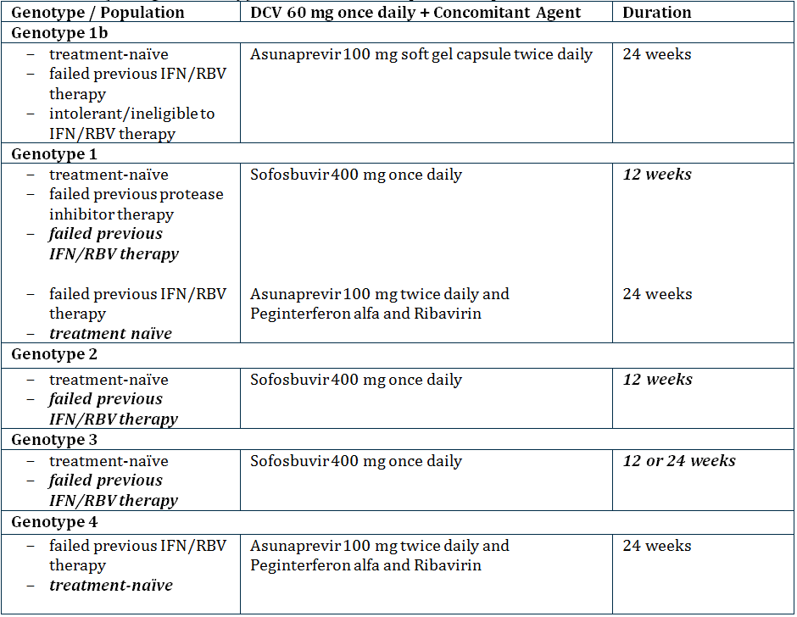
Note: Proposed extrapolation shown in bold, italicised font
Overall the data appears efficacious with consistent findings of high SVR rates. This is well documented for GT-1 (and GT-1a and GT-1b). However, the sponsor did not include patient numbers in the table of submitted studies. When this is done the following table is produced.
Table 14: Subjects treated with 60 mg DCV + various combinations by HCV GT.
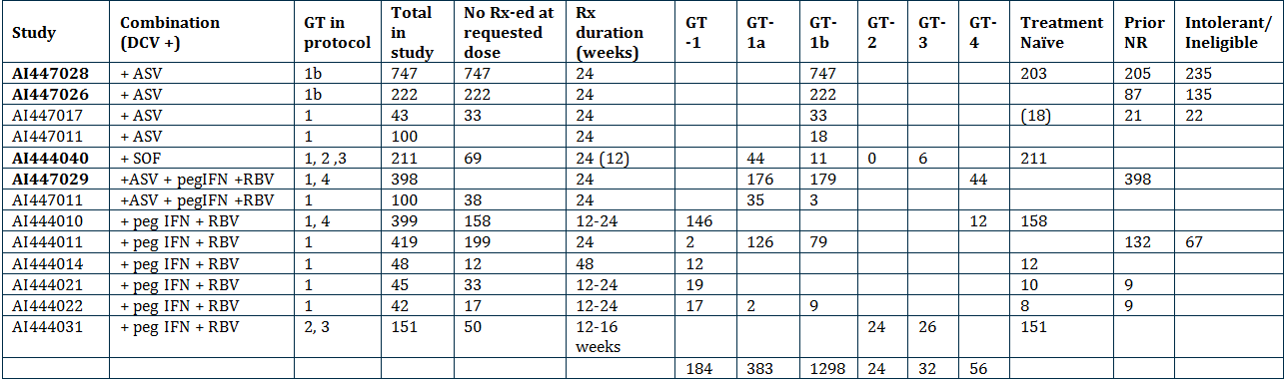
NR = non responder
Pivotal studies in bold
AI444040 – Group C & D & G – Group C & D treated for 24 weeks and Group G for 12 weeks
AI447011 – Group A1 (DCV & ASV) and Group B1 (= DCV 60 mg + ASV 200 mg tab BID + IFN + RBV
AI444021/22 - patients treated for 12 weeks and then if responded treated for another 12 weeks.
The key problem is with the GT of HCV other than GT-1. This submission was the same as that submitted in the USA but not the EU as the sponsor states that the submission was delayed in EU due to lack of data on GT-4. It is also noted that the companion product ASV has not been submitted in Europe and so the approved treatment regimens in Europe are necessarily different to Australia and the US where ASV has been submitted.
The key issue relevant to Australia is the patient group with GT-3. The data from Australian sources suggest that the epidemiology of HCV is not the same as in the US with a greater proportion of patients with GT-3 in Australia. Throughout the submission the sponsor has pooled data for each treatment regimen. Thus, for GT-2 and 3 they have pooled together the data for all treatment doses and regimens to suggest greater number of patients treated than is actually the case. Treatment of patients with GT-3 is represented by only one study (AI444040) and by only 3 groups within that study (groups B, D and F). These groups each included patients with both GT-2 and GT-3 and had slightly different treatments. All groups were treated for 24 weeks. This is summarised below.
Table 15: Study A1444040: Treatment Regimens: Groups B, D and F.
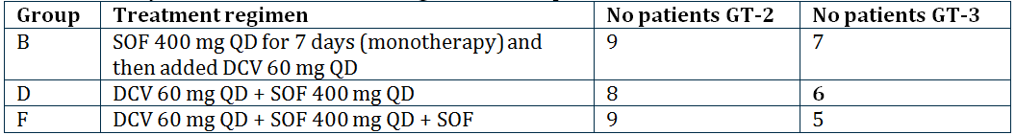
Therefore only 6 patients were actually treated with the proposed dose and for 24 weeks rather than the proposed 12 weeks. The justification for the proposal of an option of 12 weeks or 24 weeks is based on a selected literature review mostly of studies in patients with GT-1. The results quoted for GT-3 patients who were treated for 12 (ineligible for IFN) to 16 weeks (prior IFN treatment) were SVR 30%-61%. The sponsor also claims that there is no difference when RBV is added to the regimen but with so few patients treated with each specific regimen there is insufficient evidence for such a claim.
These data are tenuous at best and insufficient to warrant approval for the combination of DCV + SOF for 12 weeks for GT-3. A larger study should be performed in this patient group to clarify that DCV +SOF is appropriate and to clarify the optimal duration of treatment. If it is to be approved than the recommended duration should be 24 weeks. There is insufficient data to justify the extrapolation from 24 weeks to 12 weeks.
The extrapolations appear to be suggestive of a hasty submission of early phase studies in place of appropriately conducted clinical trials. The extrapolation to 12 weeks for GT-3 should not be accepted as a reason for not conducting the required trials to prove the efficacy and safety of the product. The extrapolation of the use of DCV/SOF in GT-1 to include prior treatment failures who have failed pegIFNα/RBV is appropriate given there is evidence of good response in the group who have failed prior TVR and BOC plus pegIFNα/RBV. The patient numbers treated with the proposed treatment regimens are not sufficient to support the extrapolations requested for GT-2 and GT-3.
Lack of comparative data to other newer agents is also lacking in the submission. While most of the newer agents have only been approved in Australia while this submission was being evaluated the range of products which will soon be available make it difficult for clinicians to decide the optimum therapy. It appears there is a move towards all oral therapy (replacing IFN) but the optimum therapy is not clear and is unlikely to be until some direct comparative studies are conducted. The sponsor has chosen not to seek approval for the combination of DCV + pegIFNα +RBV despite having conducted a large number of trials for this combination. No explanation is provided as to why this was not requested and it is assumed it is to move to combinations of oral therapy.
The use of SVR12 in place of SVR24 as required by the adopted EU guideline is acceptable based on the high and consistent responses and concordance of SVR12 and SVR24.
Overall, the data support the following indications:
- used in combination as DCV/ASV therapy for the treatment of GT-1b HCV infected subjects who are treatment naïve, ineligible/intolerant to interferon (IFN) based therapy or who are prior non responders (null or partial responders) to IFN (peginterferon α [pegIFNα]/ribavirin (RBV) therapy – treatment for 24 weeks
- used in combination with SOF for the treatment of GT-1 infected subjects who are treatment naïve, ineligible/intolerant to interferon (IFN) based therapy or who are prior non responders (null or partial responders) to IFN (pegIFNα]/ribavirin (RBV) therapy – treated for 12 weeks
- DCV and ASV combined with pegIFNα/RBV (DCV Quad for the treatment of GT-1 or -4 HCV infected subjects who are treatment-naïve or prior non responders (null or partial responders) to IFN/RBV therapy – treated for 24 weeks

Safety

Studies providing safety data
Safety data from the pharmacology studies are summarised. There were no pivotal studies that assessed safety as a primary outcome.
In the efficacy (pivotal and supportive) studies, the following safety data were collected:
- General AEs were collected at each study visit either from spontaneous reports by the subject or elicited during open ended questioning, examination, or evaluation of a subject.
- AEs of particular interest, including haematological events (especially pancytopenia and Grade 3/4 neutropenia), liver function tests (especially ALT and AST), gastrointestinal (GIT) events (especially anorectal events), rash and hypersensitivity were assessed by conducting specific searches of the AE database.
- Laboratory tests, including standard haematology and clinical chemistry testing, were performed at each study visit.
- ECG, vital signs and physical examination were conducted at pre and post treatment and at specified study visits.

Patient exposure
The patient exposure is presented as provided by DCV combination regimens.
Table 16: Subjects treated with DCV combination regimens at recommended dose: 60 mg QD.
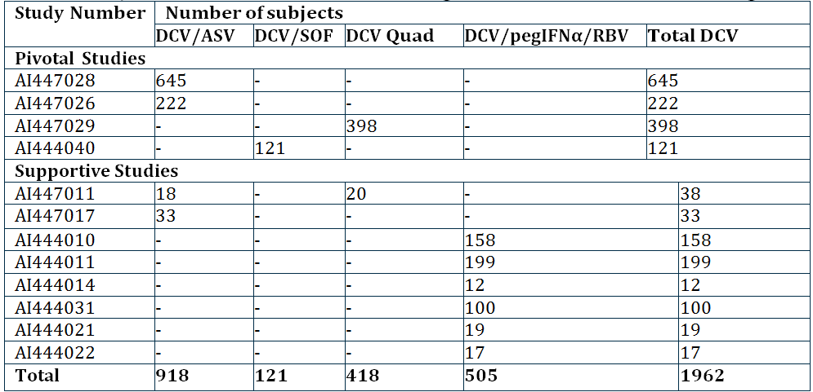
a. Amended to include only subjects treated with recommended combination and dose of DCV and the combination agents.
Table 17: Exposure to DCV in clinical studies according to dose and duration: DCV/ASV, DCV/SOF, DCV QUAD and DCV/IFN/RBV Regimens.
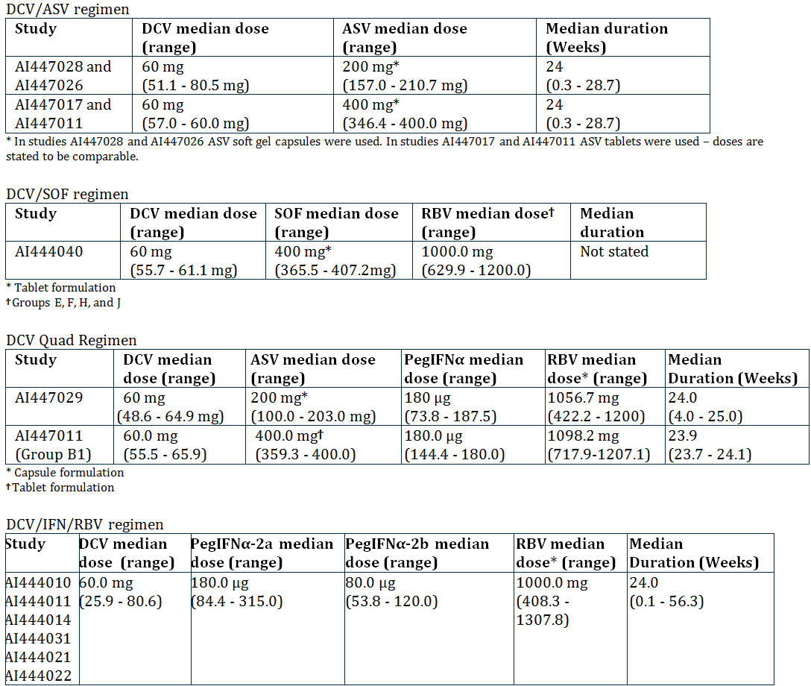

Safety issues with the potential for major regulatory impact

Liver toxicity

DCV/ASV
Subjects with baseline compensated cirrhosis were included in studies AI447028 and AI447026 but were excluded from Studies AI447017 and AI447011. In the integrated analysis evaluating DCV 60 mg QD plus ASV 100 mg BID, 229 of 918 (24.9%) subjects had baseline cirrhosis. There was no clinically meaningful difference in subgroups by cirrhosis. The frequency of SAEs (regardless of relationship to study therapy) were low (< 10%) and were consistent among subjects with (15 [6.6%] subjects) and without cirrhosis (41 [6.0%] subjects). SAEs of hepatocellular carcinoma (in 5 [2.2%] subjects with, and 2 [0.3%] subjects without cirrhosis), liver transplant (in 1 [0.4%] subject with, and 0 subjects without cirrhosis), ascites (in 1 [0.4%] subject with, and 0 subjects without cirrhosis), oesophageal varices haemorrhage (in 1 [0.4%] subject with, and 0 subjects without cirrhosis) were reported.
The frequency of AEs (regardless of relationship to study therapy) among subjects with cirrhosis (83.4% [191/229] of subjects) was consistent with the frequency of AEs among subjects without baseline cirrhosis (86.4% [595/689] subjects).
Table 18: AEs reported in ≥5% of DCV/ASV treated subjects by baseline cirrhosis status.
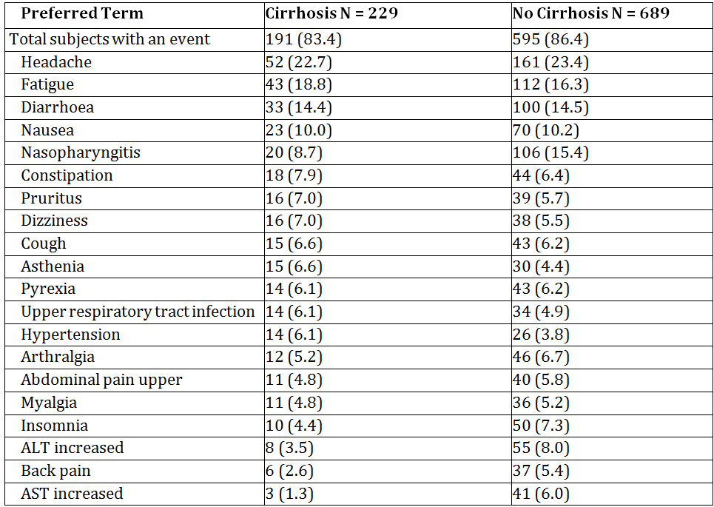
a. Does not include AEs that may have occurred during rescue therapy.
The frequency of LFT laboratory abnormalities (ALT, AST) was lower among subjects with baseline cirrhosis compared to subjects without baseline cirrhosis. Grade 3/4 ALT was reported in 4 (1.8%) subjects with and 32 (4.7%) without cirrhosis. Grade 3/4 AST was reported in 4 (1.8%) subjects with and 24 (3.5%) subjects without cirrhosis. Grade 3/4 total bilirubin was reported in 3 (1.3%) subjects with and 3 (0.4%) subjects without cirrhosis. The rate of concurrent (within ± 4 weeks of each other) Grade 3/4 ALT and AST was lower among subjects with baseline cirrhosis (4 [1.8%] subjects) compared to subjects without baseline cirrhosis (23 [3.3%] subjects). No cirrhotic subject treated with DCV/ASV during the first 12 weeks of treatment in the treatment-naïve cohort of AI447028 developed Grade 3/4 LFT laboratory abnormalities.
Table 19: Liver function test laboratory abnormalities reported for DCV/ASV treated subjects by baseline cirrhosis status.
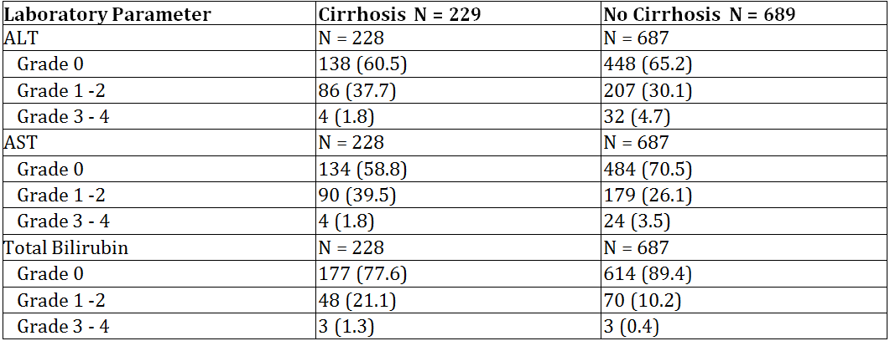
a. Does not include assessments that may have occurred during rescue therapy.
b. Percentage relative to the number of subjects with laboratory test results.

DCV/SOF
In Study AI444040, subjects with cirrhosis were excluded from enrolment.

QUAD: DCV/ASV/IFN/RBV
In the pivotal study AI447029, 93 of 398 (23.4%) DCV QUAD-treated subjects had baseline cirrhosis. There was no clinically meaningful difference in subgroups by cirrhosis, among subjects exposed to DCV 60 mg QD in combination with ASV + pegIFNα/RBV. The frequency of SAEs (regardless of relationship to study therapy) were low (< 10%) and were consistent among subjects with (4 [4.3%] subjects) and without cirrhosis (18 [5.9%] subjects).
SAEs reported in more than 1 subject in either group (with baseline or without baseline cirrhosis) included pneumonia (in 1 [1.1%] subjects with, and 2 [0.7%] subjects without cirrhosis), and anaemia (in 2 [2.2%] subjects with, and 0 subjects without cirrhosis). The frequency of AEs (regardless of relationship to study therapy) among subjects with cirrhosis (98.9% [92/93] subjects) was consistent with the frequency of AEs among subjects without baseline cirrhosis (98.7% [301/305] subjects).
Table 20: AEs reported in ≥5% of DCV QUAD treated subjects by baseline cirrhosis status.
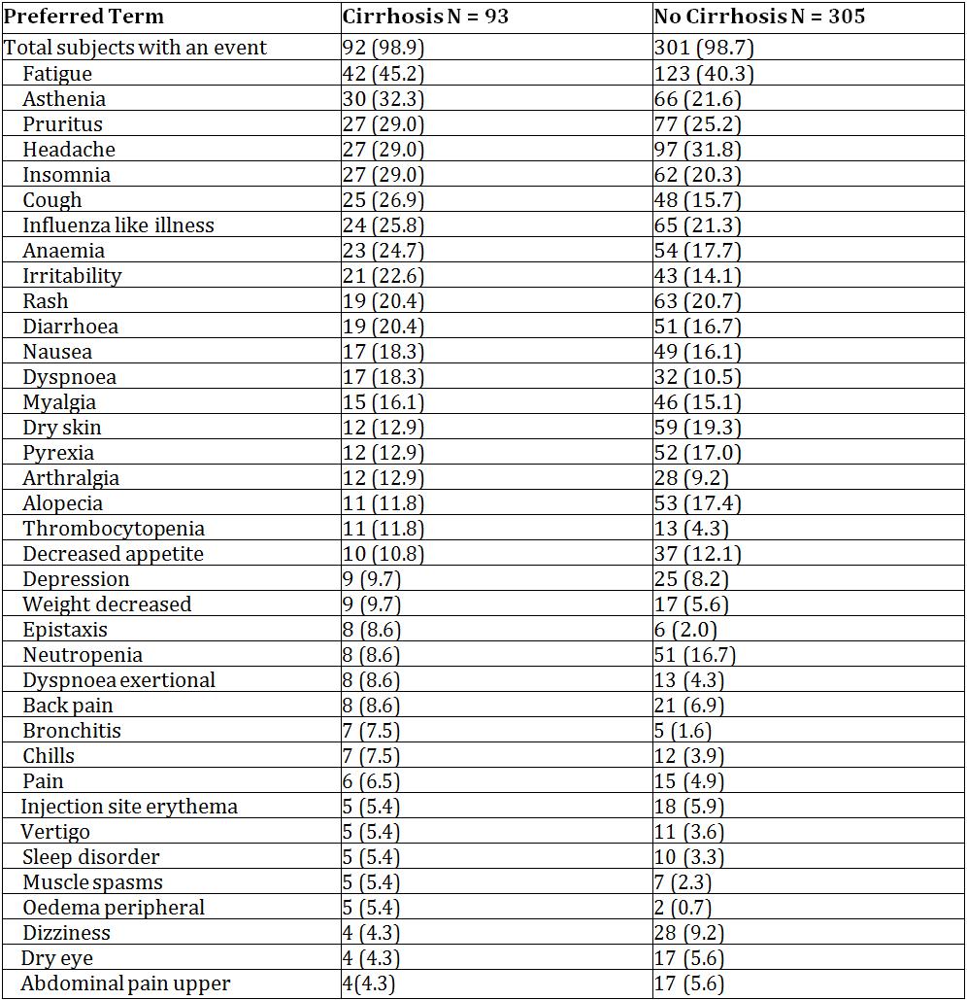
Table 21: Liver function test abnormalities reported on treatment with DCV/QUAD in Study AI447029 by baseline cirrhosis status.
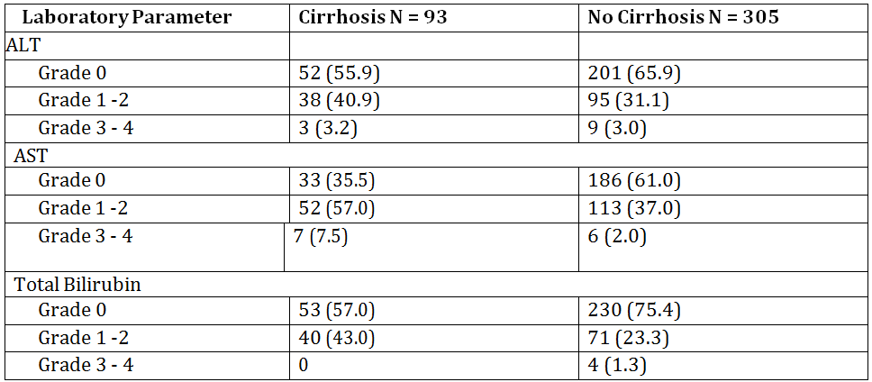
Does not include assessments that may have occurred during rescue therapy.
Percentage relative to the number of subjects with laboratory test results.
Study AI447011 excluded subjects with cirrhosis.

DCV/IFN/RBV
Subjects with baseline compensated cirrhosis were included in Studies AI444010, AI444011 and AI444031. In these, 53/505 (10.5%) DCV/pegIFNα/RBV subjects had baseline cirrhosis, including 19 (6.6%) treatment naïve and 34 (15.7%) prior non responders. Rates of SAEs (regardless of treatment relatedness) with cirrhosis in DCV/pegIFNα/RBV treated subjects (9/53 [17.0%]) were similar to subjects treated with placebo/pegIFNα/RBV (2/19 [10.5%]). Rates of AEs (regardless of treatment relatedness) with cirrhosis in DCV/pegIFNα/RBV treated subjects (98.1% [52/53]) were similar to placebo/pegIFNα/RBV-treated subjects (94.7% [18/19]).
Table 22: Summary of AEs regardless of relationship to study therapy reported in at least 20% of DCV/pegIFNα/RBV or placebo/pegIFN/RBV treated subjects with baseline cirrhosis.
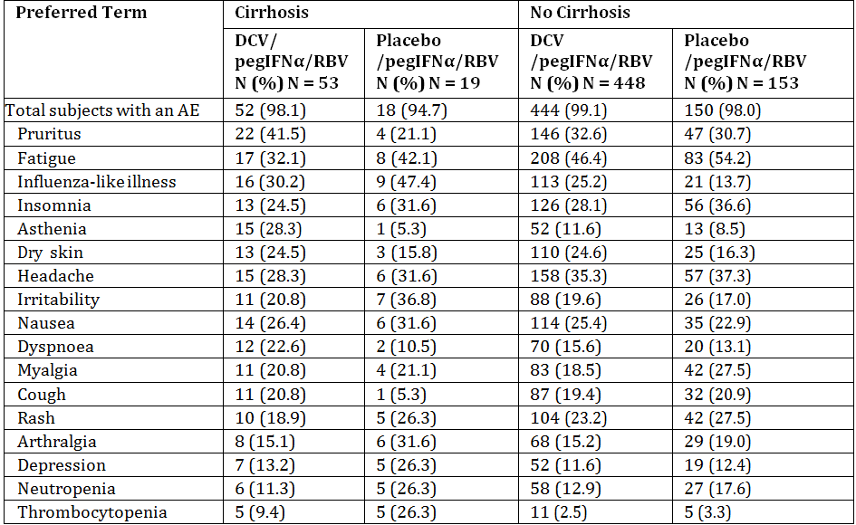
Does not include AEs that may have occurred during rescue therapy.

Resistance
The sponsor has provided a summary report on the resistance profiles seen with the recommended dose of DCV (60 mg QD) in the following combination therapies:
- DCV/ASV (recommended dose of 100 mg BID [soft gel capsule] or 200 mg BID [tablet]) in HCV GT-1b treatment naïve, prior non responders or intolerant/ineligible subjects to pegIFNα/RBV participating in 4 Phase II/III studies (AI447028, AI447026, AI447017, and AI447011)
- DCV/SOF (recommended dose of 400 mg QD) with or without RBV in treatment naïve subjects infected with GT-1, GT-2, or GT-3, or prior NS3 PI failures infected with GT-1 participating in the Phase II study (AI444040)
- DCV Quad therapy in 2 Phase II/III studies (AI447029 in prior non responders infected with GT-1 or GT-4 and AI447011 in prior non responders infected with GT-1)
- DCV/pegIFNα/RBV (6 Phase 2 studies, AI444010 in GT-1 and GT-4 treatment naive, AI444011 in GT-1 prior non responders to pegIFNα/RBV, AI444014 in GT-1 treatment-naïve , AI444031 in GT-2 and GT-3 treatment naive, AI444021 and AI444022 in GT-1b treatment naive and prior non responders to pegIFNα/RBV) and ASV/pegIFNα/RBV (AI447016 in GT-1 and GT-4 treatment naïve)
The summary of results was:
- DCV/ASV therapy was generally effective at suppressing the emergence of NS5A and NS3 RAVs in GT-1b treatment naïve, prior non responders and IFN intolerant/ineligible subjects. Drug resistant variants to both DCV and ASV were generally detected together.
- Baseline NS5A polymorphism at L31 and Y93H appeared to be associated with virologic failure in the DCV/ASV therapy in subjects infected with GT-1b, while baseline NS3-D168E appeared to be associated with virologic failure to a lesser extent.
- DCV/SOF therapy was effective at suppressing the emergence of NS5A and NS5B RAVs, respectively, in treatment naïve subjects infected with HCV GT-1, GT-2, and GT-3 and prior TVR/BOC failures infected with GT-1
- DCV Quad therapy was effective at suppressing the emergence of NS5A and NS3 RAVs in prior non responders to pegIFNα/RBV treatment infected with GT-1 and GT-4. Drug resistant variants to both DCV and ASV were generally detected together in GT-1a virologic failures and the single GT-1b virologic failure. There were no GT-4 virologic failures.
- DCV/pegIFNα/RBV therapy was generally effective at suppressing the emergence of NS5A RAVs in treatment naive subjects infected with GT-1a, GT-1b, GT-2, GT-3, and GT-4.
- The NS5A-Y93H polymorphism appeared to be associated with virologic failure in GT-3 subjects receiving DCV/pegIFNα/RBV therapy.
- DCV-resistant variants were similar whether failure occurred during treatment or post treatment and irrespective of study population
- The association of baseline NS5A RAPs and IL-28B (RS12979860) genotype on virologic outcome appeared to be treatment-specific and HCV GT-specific

Postmarketing data
Not applicable as drug is not yet marketed in any country.

Evaluator’s conclusions on safety
DCV 60 mg QD plus ASV 100 mg soft gel capsule BID (or equivalent 200 mg tablet BID) appears generally well tolerated and no unique AEs or laboratory abnormalities attributable to DCV were identified. The most frequently reported AEs were fatigue, diarrhoea, nasopharyngitis, headache and nausea. The most significant AEs were transaminase elevations (ALT/AST). Grade 3/4 elevations were observed in less than 4% of DCV/ASV treated subjects. The median time to the onset of treatment emergent elevations was approximately 13 weeks.
There were 4 cases that met the criteria for potential DILI and 1 subject who did not meet the clinical criteria due to baseline Gilbert’s syndrome.
The DCV/ASV combination had a better safety profile than that reported with pegIFNα/RBV or TVR or BOC + pegIFNα/RBV with respect to anaemia, neutropenia, thrombocytopenia, rash, anorectal disorders, flu like symptoms and depression.
In the one study submitted for the combination of DCV and SOF most subjects reported an AE (89.2%). The most frequently reported treatment related AEs (≥10%) were fatigue, headache, and nausea. The frequency of these was consistent across treatments (± RBV) and duration of treatment (12 versus 24 weeks). AEs commonly associated with RBV (that is, anaemia, cough, rash, dyspnoea, insomnia and anxiety) were higher with DCV/SOF/RBV. No Grade 3/4 AEs were reported in this study.
The safety profile seen in the DCV QUAD regimen was consistent with that seen in the other studies.
In the placebo controlled trials where placebo included pegIFNα/RBV no clinically relevant laboratory abnormalities were observed on treatment or during follow-up other than those anticipated for pegIFNα/RBV.

First round benefit-risk assessment

First round assessment of benefits
The benefits of DCV in the proposed usage are:
- High rates of SVR12 (and SVR24) in patients infected with HCV GT-1b treated with DCV in combination with ASV treated for 24 weeks:
  - Treatment naïve: 90.6% (184/205)
  - Prior non responders to pegIFNα or IFNβ/RBV: 80.5-90.9%
  - PegIFNα/RBV intolerant/ineligible subjects: 63.6-82.6%
- High rates of SVR12 (and SVR24) in patients infected with HCV GT1 treated with HCV in combination with SOF, who failed prior TVR or BOC plus pegIFNα/RBV and failed prior IFNα/RBV treated for 24 weeks:
  - With RBV: 100% (20/20)
  - Without RBV: 100% (21/21)
- High rates of SVR12 in prior non responders (partial and null responders) with:
  - GT-1: 93% (330/354) and 95% (19/20)
  - GT-4: 100% (44/44)
- Similar rates were seen across various baseline factors including males and females, patients ≥65 and <65 years, with and without cirrhosis and HCV RNA ≥ 800,000 IU/mL and < 800,000 IU/mL and subjects with IL-28B and non CC genotypes
- There were no deaths attributable to DCV and low rates of serious (SAEs) and AEs of increased hepatic transaminases were generally reversible on discontinuation and most patients with increases achieved SVR12.

First round assessment of risks
The risks of DCV in the proposed usage are:
- Small numbers of patients with HVC GT-2 and GT-3 treated with requested regimens
- Increases in hepatic transaminases were reported across all treatment groups
- Increased risk of Grade 3/4 transaminase elevations in combination with ASV

First round assessment of benefit-risk balance
The benefit-risk balance of DCV, given the proposed usage, is favourable.

First round recommendation regarding authorisation
Based on the clinical efficacy and safety data submitted, it is recommended that DCV be approved with modification of the indication as outlined.

Clinical questions
None

Second round evaluation of clinical data
No clinical questions were asked, however the sponsor provided a response to the initial clinical evaluation report. No major errors were identified by the sponsor but additional clarification of a number of issues raised in the first round report was provided.
Summary information for a number of new studies and a large number of new references was provided. These have not been evaluated in line with the TGA requirements for responses to Section 31 letters. The issues addressed by the sponsor are summarised below.

Overseas regulatory status
The sponsor provided the following comment in relation to the US:
Based on the large number of patients with GT-1a in the US and the emerging availability of all oral regimens that are expected to have broader genotype coverage with a 12 week treatment duration, the Sponsor has concluded that the DSV/ASV regimen would not be competitive in the United States marketplace. For that reason, BMS withdrew its new drug application (NDA) for ASV in the United States on 06 October 2014. The decision to withdraw the ASV NDA was not based on any new safety data from the DCV/ASV studies. Given the change in direction with regard to the withdrawal of the ASV NDA in the US, on 25-Nov-2014, the US FDA issued a Complete Response Letter requesting additional data showing the safety and efficacy of DCV in combination with other antiviral agents for the treatment of HCV. BMS continues to work closely with the FDA to determine the additional data requirements of the revised NDA submission for DCV.
The sponsor has stated the DCV/ASV combination has been approved in Japan for the treatment of patients with GT-1b CHC, with or without compensated cirrhosis, who have failed or are ineligible/intolerant to interferon based therapy. A supplemental application is under review for use in treatment naïve patients. The combination has been submitted in Canada, Taiwan, Korea, Colombia, Chile, Singapore, Russia, Thailand, and Israel but with the decision to not seek registration of ASV in the USA or Europe there may be doubts on the future availability of ASV.

Efficacy of DCV in combination with SOF
The sponsor concurred with the clinical evaluator’s observation that the prevalence of GT-3 in Australia is a significant proportion of the HCV infected population in Australia and is relatively high and different compared to other geographical regions, such as the USA. The sponsor provided a useful table of the currently available treatment regimens in Australia by HCV genotype.
Table 23: Currently approved treatment regimens in Australia by HCV genotype.
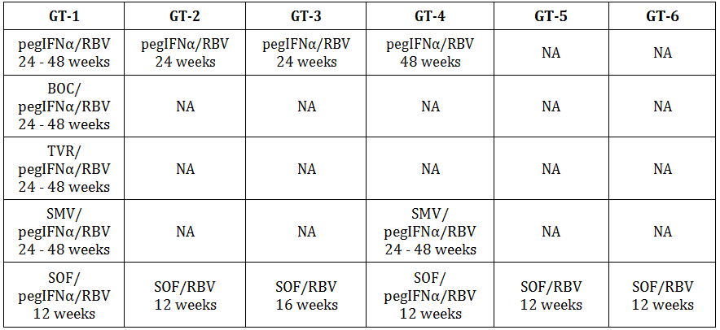
BOC: boceprevir; pegIFNα: peginterferon alpha; RBV: ribavirin; SMV: simeprevir; SOF: sofosbuvir; VR: telaprevir
The sponsor also concurred with the clinical evaluator on the low numbers of patients with GT-2, GT-3 and GT-4 in the submission.
While not disputing the data (subjects treated with 60 mg DCV + various combinations by HCV GT), the sponsor provided an updated and “corrected” table which again pooled data for GT-2 and GT-3. They stated they took their data from the summary data. The evaluator used the data in the individual study reports and provided the data on the GT types only for the patients in each GT type who received the requested dose and duration of treatment (Group D). The revised table provided by the sponsor continues to pool all the patients who received DCV +SOF in different regimens. It is also noted that the trial (AI444040) treated patients for 24 weeks when 12 weeks is the requested duration of treatment (24 weeks only for prior treated patients who had cirrhosis).
The sponsor provided some summary new data taken from ongoing or recently completed clinical trials which were not available at the time of the original submission
- Study AI444215 (ALLY-1) in GT-1-6 subjects with cirrhosis or post liver transplant who received DCV+SOF +RBV for 12 weeks (N=113)
- Study AI444216 (ALLY-2) in GT-1-6 subjects with HCV/HIV co-infection who received DCV+SOF for either 8 weeks (HCV treatment naïve) or 12 weeks(HCV treatment naïve and experienced) (N=203)
- Study AI444218 (ALLY-3) in GT-3 treatment naïve and experienced subjects who received DCV+SOF for 12 weeks (N=152)
- Study AI444042 in GT-4 subjects – treatment details not provided
- Study AI443014 in GT-4 treatment naïve subjects treated with 30 mg DCV + 200 mg ASV and 75 or 150 ng of beclabuvir (BCV) BD or 12 weeks
The sponsor also presented summary data for the combination of ledipasvir + SOF with the claim that
based on in vitro comparison …., as well as clinical experience with regimens that included each of these drugs, it is reasonable to assume replacing LDV with DCV will result in improved (GT-2/3 HCV) or similar (non-GT-2/3 HCV response.
The sponsor further states:
In conclusion, although DCV/SOF has not been studied in subjects with GT-4 infection, the regimen is expected to yield similar activity as that observed for GT-1, based on in vitro antiviral activity and available clinical data with DCV in combination with pegIFNα/RBV.
The sponsor notes that the EU approved DCV+SOF for GT-4 based on this argument.
The company clearly now has data based on clinical studies for the use of DCV+SOF in GT-2, 3 and 4. The new data needs to be evaluated from the study reports and not from summary data and should be the subject of a separate submission.
The sponsor concurred that the data in the submission was limited and no errors were made in the evaluation of the data in the original submission. Based on this data, there is no reason to change the recommendation to not approve the combination of DCV +SOF in patients with HCV GT-2, 3 and4 due to insufficient efficacy data in these patient populations at the doses and duration requested. It is not appropriate to grant approval based on unevaluated summary data or on data from a different compound.

Renal safety
The initial evaluation report recommended a dosage reduction (to 30 mg QD) for subjects with moderate or severe renal impairment based on a PK study (AI444063) in normal subjects with varying degrees of renal impairment. The sponsor notes that in this study there were wide overlapping 90% CI and an apparent absence of a trend with worsening renal function. The sponsor provided an analysis of the data from this trial using primary regression analysis as the best estimation of the correlation between renal function and DCV exposure for subjects with renal impairment (excluding ESRD subjects on dialysis). ESRD subjects were excluded from the regression because DCV AUC was only 26.9% higher in these subjects receiving haemodialysis, suggesting there is no accumulation of uremic factors in renal impairment that affect DCV metabolism/disposition which are removed by haemodialysis. As the unbound DCV is the pharmacologically active component the regression analysis was done using the unbound DCV AUC versus GRF rate. From the estimated slopes derived from regression analysis with creatinine clearance (CrCL) geometric mean ratios with corresponding 90% CI relative to normal renal function (90 ml/min) for unbound DCV AUC∞ were projected for subjects with CrCL values of 60, 30 and 15 mL/min, each representative of the midpoint of the mild, moderate and severe renal impairment without haemodialysis categories, respectively.
Table 24: Estimated total and unbound DCV AUC∞ comparisons for different degrees of renal impairment.
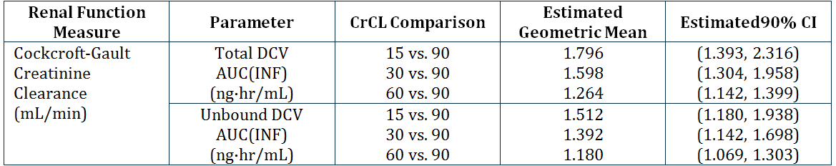
The sponsor concluded:
Based on the estimated higher unbound concentration of ~51% among subjects with severe renal impairment, a dose reduction to 30 mg QD would result in a systemic exposure comparable to a 45 mg DCV QD dose, which may not be optimal as part of some potential treatment regimens, including dosing with ASV. As noted by the evaluator, although there was a small benefit in efficacy for increases in dose from 20 mg QD to 60 mg QD, modelling of viral load data suggested that a 60 mg QD dose of DCV would be beneficial in a group of subjects with a combination of patient specific factors that is historically more difficult to treat. Additionally, the 60 mg QD dose would be expected to compensate for potential factors such as dosing with food or gastric pH modifiers, and poor compliance, which may further reduce DCV exposures. In conclusion, despite the systemic exposures at the higher end of normal range for DCV 60 mg QD, due to an absence of a relationship between exposure and safety events, the 60 mg QD dose offers the best balance of benefit:risk in patients with moderate and severe renal impairment.
In light of the overall safety profile of DCV in the efficacy and safety studies the reduction in dosage for moderate to severe renal impairment is not recommended.

Hepatic safety
The sponsor has provided a review of the hepatic safety of DCV to assert that the increased liver enzymes are due solely to the ASV component of the combination therapy and there is no contribution from DCV. They have based this primarily on the results of the Phase II studies where:
a numerically higher rate of on-treatment and treatment-emergent (that is, abnormalities with a higher toxicity grade than the baseline grade) transaminase elevations, particularly ALT, were reported among subjects receiving ASV-containing regimens (that is, DCV/ASV and ASV/pegIFNα/RBV) as compared with subjects receiving DCV/pegIFNα/RBV therapy. The rate of transaminase elevations reported with DCV/pegIFNα/RBV was generally comparable to that reported with placebo/pegIFNα/RBV. Together, these data provide a subset of the available information that has indicated that ALT elevations are associated with ASV, rather than with DCV.
Table 25: Summary of treatment emergent transaminase evaluations in Phase II studies of ASV and DCV.
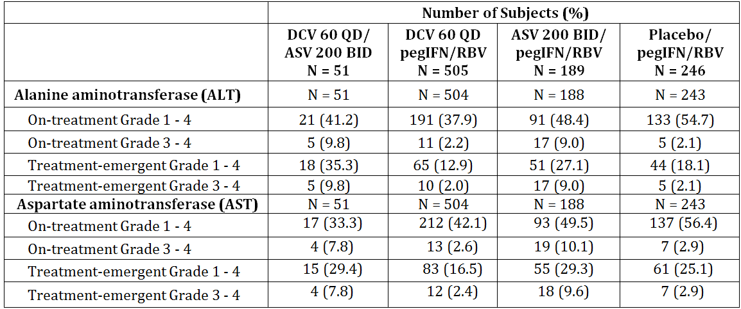
Laboratory results based on SI units
Treatment-emergent abnormalities are those with a higher toxicity grade than the baseline toxicity grade (including missing baseline).
ASV recommended dose: 200 mg tablet or 100 mg soft gel capsule, BID
Given that there is so much pooling of data in the study reports it is difficult to confirm this emphatic conclusion. It is certainly true that ASV is the major contributor of the increased liver enzymes and that regular monitoring of liver function (as recommended by the sponsor’s expert) is now recommended in the revised ASV product information (see ASV clinical evaluation report) but it is not yet clear to the evaluator that there is no contribution from DCV.

Second round assessment of benefits
After consideration of the response to the first round evaluation report, the benefits of DCV in the proposed usage are unchanged from those identified in the first round.

Second round assessment of risks
After consideration of the response to the first round evaluation report, the risks of DCV in the proposed usage are unchanged from those identified in the first round.

Second round benefit-risk assessment
The benefit-risk balance of DCV, given the proposed usage, is favourable.

Second round recommendation regarding authorisation
The recommendation regarding authorisation is slightly changed from the first round evaluation. DCV is recommended for approval but not for all the indications requested by the sponsor. The recommendation for approval is for the following indications.
Table 26: Recommended regimens with Daklinza 60 mg once daily combination therapy.
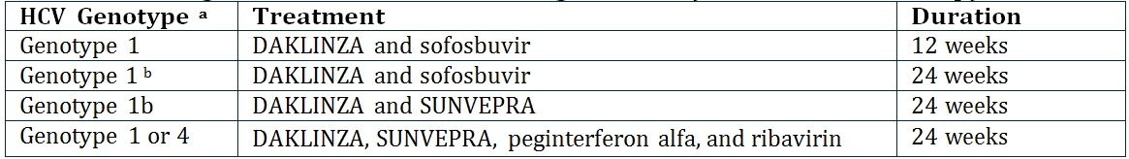
a. Treatment-naïve or failed prior treatment with peginterferon alfa and ribavirin or interferon intolerant.
b. HCV genotype 1 patients who failed prior protease inhibitor treatment
In Study AI444040, Groups A-F were treated for 12 weeks but Group I and J who were the group of patients who had failed prior therapy (TVP/BOC) were treated for 24 weeks not 12 weeks. There is no evidence that shortening the treatment to 12 weeks will be effective in this group. Concordance of SVR12 and SVR24 was only demonstrated for treatment naïve patients. The study report states that
concordance was not evaluated for the TVR/BOC failure groups (Groups I and J) because these groups did not have SVR24 results at the time of database lock for this CSR.
Also, Study AI444040 was only conducted in patients without cirrhosis and therefore no recommendation for use of this combination of DCV+SOF can be made in patients with cirrhosis. The 12 week duration of therapy is only recommended for patients without cirrhosis.

V. Pharmacovigilance findings

Risk management plan
The sponsor submitted a DCV EU-Risk Management Plan (RMP) version 1.2 dated 24 June 2014 (data lock point 13 March 2014), Australian Specific Annex (ASA) version 1 dated 31 March 2014, and an updated ASA version 2 dated 19 December 2014.

Safety specification
The sponsor provided a summary of ongoing safety concerns which are shown at Table 27.
Table 27: Ongoing safety concerns.
Important identified risks
None
Important identified drug-drug interactions
Important identified drug-drug interactions | CYP3A inhibitors and inducers; P-gp substrates; OATP1B1 and BCRP substrates
Important potential risks
Hepatic toxicity | Relevance to humans is unknown.  No clinically relevant trends in liver function test are observed in long-term clinical studies when DCV is administered with SOF or with pegIFNα/RBV.
Hematologic toxicity | Relevance to humans is unknown.  No unique clinically relevant changes in hematologic parameters are observed in clinical studies to date.
Development of drug resistance | Relevance to humans is unknown.
Embryofoetal development toxicity | Relevance to humans is unknown.
Paediatric off-label use | The safety of efficacy of Daklinza in children and adolescents aged below 18 years has not yet been established. No data are available.
Missing information
Pregnancy and lactation | The use of DCV in pregnancy and lactation has not been studied. Safety conclusions cannot be established in this patient population. Use of DCV is not recommended during pregnancy. Mothers who are taking DCV should be instructed not to breastfeed.
Children and adolescents (<18 years of age) | The use of DCV in children and adolescents has not been studied. Therefore, safety and efficacy have not been established in the paediatric population.
HIV/HCV | The safe and effective use of DCV in HIV/HCV co-infected individuals has not been established. Studies AI444043 and AI444216 to assess safety and efficacy of DCV in co-infected population are ongoing.
HBV/HCV | The safe and effective use of DCV in HBC/HCV co-infected individuals has not been established.
Hepatic impairment and decompensated liver disease | The safe and effective use of DCV in patients with hepatic impairment and decompensated liver disease has not been established.
Liver transplant | The safe and effective use of DCV in this population has not been established. Study AI444215 is ongoing.
African origin | The safety and efficacy in this subgroup has not been established and may pose specific issues in terms of development of resistance. Study AI444038 is ongoing and will provide further information regarding safety and efficacy in this population.
Elderly age >65 years | This important target population has been under-represented. Although a different safety profile may not be expected, specific monitoring is indicated.
Subjects in whom drugs with potential for clinically significant DDI may be expected to decrease systemic exposure to DCV | The recommendation for dose adjustment have been made without regard to the dynamics of the interaction with CYP3A and P-gp in the long-term. The impact of the dose-adjustment recommendation should be monitored. In ongoing and planned studied, the potential for drug interaction between DCV and dolutegravir and the involvement of transporters, including OCT1, in the hepato-bilary excretion of DCV will be assessed.

Evaluator comment
The sponsor stated that DCV was shown to inhibit digoxin transport. This safety risk should be included under ‘important identified drug-drug interactions’.
The sponsor addressed the issue of ‘use in patients with renal impairment’ and concluded that no dose adjustment is necessary for patients with any degree of renal impairment. The sponsor acknowledges that creatinine clearance is a statistically significant covariate but considers that the magnitude of the effect is unlikely to influence the pharmacokinetic parameters of DCV in a clinically meaningful way (see ‘Pharmacology’, proposed PI).
Subject to the evaluation outcomes of the nonclinical and clinical aspects of the Safety Specification, the sponsor should add the following safety concerns to the safety concern list in the ASA or provide justification as to why they should not be included:
- Mitochondrial toxicity;
- Cardiotoxicity;
- Use in post solid organ transplant;
- Off label use: outside of the recommended treatment regimens;
- Increased risk of psychiatric disorders including depression and anxiety in combination therapy with interferon.

Pharmacovigilance plan
Table 28 shows a summary of pharmacovigilance activities proposed in the EU-RMP and ASA.
Table 28: Summary of pharmacovigilance activities proposed.
Important identified risks | Pharmacovigilance activities
None | n/a
Important identified drug-drug interactions
CYP3A inhibitors and inducers; P-gp substrates; OATP1B1 and BCRP substrates | Routine pharmacovigilance;
Important potential risks
Hepatic toxicity | Routine pharmacovigilance;
Hematologic toxicity | Routine pharmacovigilance;
Development of drug resistance | Routine pharmacovigilance;  Additional pharmacovigilance: conducting long-term follow-up (up to three years following the completion of parent studies), observational study (AI444046): durability of efficacy, resistance, and characterisation of progression of liver disease in subjects with chronic hepatitis C previously treated with DCV and/or ASV (1000 subjects).
Embryo-foetal development toxicity | Routine pharmacovigilance;  Additional pharmacovigilance: use of surveillance form for pregnancy and supplemental case report form for clinical trials
Paediatric off-label use | Routine pharmacovigilance;  Additional pharmacovigilance: a paediatric investigational plan (PIP number EMEA-001191-PIP01-11) including studies in children infected with HCV has been proposed and agreed by the EMA in 2012 (Decision number P/0166/2012), which should address safety and efficacy of DCV in paediatric population.
Missing information
Pregnancy and lactation | Routine pharmacovigilance;  Additional pharmacovigilance: surveillance form for pregnancy and supplemental case report form for clinical trials
Children and adolescents (<18 years of age) | Routine pharmacovigilance;  Additional pharmacovigilance: a paediatric investigational plan (PIP number EMEA-001191-PIP01-11) including studies in children infected with HCV has been proposed and agreed by the EMA in 2012 (Decision number P/0166/2012), which should address safety and efficacy of DCV in paediatric population.
HIV/HCV | Routine pharmacovigilance;  Additional pharmacovigilance: study AI444216: a phase III evaluation of daclatasvir plus sofosbuvir in treatment-naïve and treatment experienced chronic hepatitis subjects co-infected with HIV; AI444043: a phase III, open-label study of safety and efficiacy with daclatasvir plus pegIFNα and ribavirin in previously untreated HCV patients co-infected with HIV
HBV/HCV | Routine pharmacovigilance;
Hepatic impairment and decompensated liver disease | Routine pharmacovigilance;  Additional pharmacovigilance: AI444215: a phase III evaluation of daclatasvir, sofosbuvir, and ribavirin in genotype 1-6 chronic hepatitis C infection subjects with cirrhosis who may require future liver transplant and subjects post-liver transplant;
Liver transplant | Routine pharmacovigilance;  Additional pharmacovigilance: AI444215 (phase III study)
African origin | Routine pharmacovigilance;  Additional pharmacovigilance: AI444038: an open-label, single arm evaluation of daclatasvir in combination with pegIFNα and ribavirin in black-African Americans, Latinos, and white-Caucasians with chronic hepatitis C genotype 1 infection;
Elderly age >65 years | Routine pharmacovigilance;
Subjects in whom drug with potential for clinically significant DDI may be expected to decrease systemic exposure to DCV | Routine pharmacovigilance;  Additional pharmacovigilance: AI444093, AI444273: a phase I, open-label, crossover study to evaluate the drug interaction between dlutegravir and daclatasvir in healthy adults; in vitro study using a human hepatocyte model.

Evaluator comment
Reporting and follow-up of pregnancy events are part of routine practice for clinical trials.
Protocols of ongoing studies are not reviewed as part of this evaluation. The only planned study in the proposed pharmacovigilance plan is Study AI444093. This is a Phase I, open label, nonrandomised, two group, single sequence, one way study to assess the effects of darunavir/ritonavir or lopinavir/ritonavir on the pharmacokinetics of DCV in healthy subjects.

Risk minimisation activities
The sponsor states:
No additional risk minimisation activities outside those described in the CCRMP are planned for Australia.

Evaluator comment
The sponsor has addressed the potential issues of overdose, transmission of infectious disease, misuse for illegal purposes, and has included off-label paediatric use as an ongoing safety concern.
The sponsor’s response is acceptable.

Reconciliation of issues outlined in the RMP report

Recommendation #1 in RMP evaluation report
Safety considerations may be raised by the nonclinical and clinical evaluators through the consolidated Section 31 request and/or the nonclinical and clinical evaluation reports respectively. It is important to ensure that the information provided in response to these includes a consideration of the relevance for the RMP, and any specific information needed to address this issue in the RMP. For any safety considerations so raised, the sponsor should provide information that is relevant and necessary to address the issue in the RMP.

Sponsor response
The sponsor confirms that safety considerations raised by the nonclinical and clinical evaluators through the nonclinical and clinical evaluation reports respectively have been assessed, and no additions/amendments to the RMP have been made as result of these TGA evaluations.

Evaluator’s comment
The sponsor’s response is satisfactory.

Recommendation #2 in RMP evaluation report
The ASA submitted is an annex to the core company RMP. As the EU-RMP is under the evaluation for the purpose of the submission, the sponsor should update the content of the ASA to refer to the EU-RMP.

Sponsor response
The sponsor will update the ASA to refer to the EU-RMP.

Evaluator’s comment
The sponsor’s response is satisfactory. The evaluator has noted the submission of an updated ASA version 2 dated 19 December 2014.

Recommendation #3 in RMP evaluation report
The sponsor stated that DCV was shown to inhibit digoxin transport. This safety risk should be included under ‘important identified drug-drug interactions’.

Sponsor response
The EU RMP v1.2 already includes digoxin in the Important Identified Drug Interactions (see Risk Minimisation Measures by Safety Concerns).
Thus no further amendments to the EU RMP v1.2 are required.

Evaluator’s comment
The evaluator has noted the advice on the interaction with digoxin provided in the Australian PI. However, this safety risk is not listed in the summary of the safety concerns. Additional advice has been provided by the ACSOM in regard to risk minimisation measures for drug interactions.

Recommendation #4 in RMP evaluation report
The sponsor should add the following safety concerns to the safety concern list in the ASA. Otherwise, justification should be provided as to why they are irrelevant to the use of DCV:
- Mitochondrial toxicity
- Cardiotoxicity
- Use in post solid organ transplant
- Off label use: outside of the recommended treatment regimens
- Increased risk of psychiatric disorders including depression and anxiety in combination therapy with interferon

Sponsor response
The sponsor has reviewed the requests of the RMP evaluator, and does not agree with including any of the requested risks to the summary of ongoing safety concerns. Please find below justifications for each of the risks raised by the RMP evaluator.

a. Mitochondrial toxicity
Mitochondrial toxicity was not identified as a risk for DCV in preclinical studies, nor has evidence emerged in clinical or post marketing data that such a risk is applicable to DCV. Review of the BMS global safety database (CARES) as of 20 November 2014, revealed only 4 reports of muscle weakness, and 1 report of lactic acidosis, all with alternate plausible explanations unrelated to DCV. Although mitochondrial toxicity has been associated with RBV therapy, the RMP reflects the safety profile of the medicinal product for which the marketing authorisation is requested, in this case DCV; therefore, assessment of the risks associated with RBV (or any other compound which may be co-administered with DCV) is beyond the scope of the DCV RMP.

b. Cardiotoxicity
Reports of cardiac related adverse events are routinely monitored, and discussed in aggregate in the PSUR. BMS is currently investigating reports of bradycardia when DCV was administered in combination with SOF and concomitant amiodarone and propranolol, as a potential safety signal. As of this date, cardiotoxicity has not been identified as a risk for DCV; if the cumulative review or the investigation of possible drug-drug interaction (DDI) with amiodarone suggests a causal relationship of cardiac events with DCV, the EU RMP will be updated accordingly.

c. Use in post solid organ transplant
Use of DCV in peri and post liver transplant patients has been studied in an ongoing Phase III study (AI444-215); of DCV, SOF and ribavirin in GT 1-6 chronic hepatitis C infection subjects with cirrhosis who may require future liver transplant, and subjects post liver transplant; all patients have completed treatment, and follow up is continuing. Additionally, DCV has been used in combination with SOF +/- RBV in post liver transplant patients in an Expanded Access Program. Of 3239 patients available for interim analysis in the French ATU Cohort study (AI444-258), approximately 7% had prior liver transplants. The safety profile in patients enrolled in these studies has been comparable to that in patients without liver transplant; no safety signal has been identified that would suggest a particular risk in these patients. Additionally, no clinically meaningful effect was observed in pharmacokinetic studies when DCV was co-administered with tacrolimus or cyclosporine. There is no evidence to warrant listing use in post transplant patients as a particular risk.

d. Off label use outside of the recommended treatment regimens
BMS abides by its Global Policies, as well as the Medicines Australia’s Code of Conduct (Edition 17). As such, BMS does not engage in the promotion of unregistered products or unapproved indications. BMS collects spontaneously reported off-label use associated with adverse events, and off label use with no associated adverse events, from all countries where the medicine is marketed. There is currently no data to suggest specific safety risks that may be associated with off label use.
The knowledge of the safety of the medicinal product derived from off label use data is reflected in the benefit-risk evaluation sections of PBRERs/PSURs where relevant, and appropriate. BMS complies with the European Medicines Agency Guideline on Good pharmacovigilance practices (GVP) Module VI1 and Module VII2, with respect to off label use.
Based on the above, BMS does not believe there is a need to undertake a drug utilisation study specifically to monitor off label use in Australia.

e. Increased risk of psychiatric disorders including depression and anxiety in combination therapy with interferon
In clinical trials in which DCV was used in combination with ASV, the incidence of depression and anxiety ranged from 0 to 5% (lower than published rates of depression and anxiety in untreated patients with chronic hepatitis C infection), whereas when PEG-IFN and RBV were added to the regimen, the incidence increased up to 8.5% for depression and 16% for anxiety. Psychiatric AEs are delineated in the PI for PEG-IFN and RBV. As marketing authorisation is requested for DCV, assessment of the risks associated with PEG-IFN and/or RBV (or any other compound which may be co-administered with DCV) is beyond the scope of the DCV RMP. These risks should be discussed in the respective RMPs for these products, which is the responsibility of their respective Marketing Authorisation Holders. For this reason, identified risks of PEG-IFN and/or RBV, which are not attributable to DCV, are not listed as important identified risks or important potential risks in the DCV RMP.

Evaluator’s comment
Refer to ratified ACSOM advice.

Recommendation #5 in RMP evaluation report
The sponsor has addressed the issue of off label use in the EU-RMP. Due to the significant unmet clinical demand and the complexity of HCV infection, there is a possibility for DCV to be used outside of the regimens proposed by the sponsor. This type of off label use could have potential safety implications. Therefore, it is recommended that the sponsor conducts a drug utilisation study to monitor the pattern of use.

Sponsor response
The RMP evaluator has acknowledged that the sponsor has addressed the issue of off label use in the EU-RMP appropriately. In the EU, the approved SmPC will guide healthcare professionals clearly on the approved indications and dosage regimens for DCV. Similarly, in Australia, the approved Product Information will provide clarity on the approved indications and dosage regimens. Additionally, it must be acknowledged that in view of the reimbursed market in Australia, the potential for off-label use outside of the approved indications is minimal.
BMS abides by its Global Policies, as well as the Medicines Australia’s Code of Conduct (Edition 17). As such, BMS does not engage in the promotion of unregistered products or unapproved indications. BMS collects spontaneously reported off label use associated with adverse events, and off label use with no associated AEs, from all countries where the medicine is marketed. There is currently no data to suggest specific safety risks that may be associated with off label use.
The knowledge of the safety of the medicinal product derived from off-label use data is reflected in the benefit-risk evaluation sections of PBRERs/PSURs where relevant, and appropriate. BMS complies with the EMA Guideline on good pharmacovigilance practices (GVP) Module VI (Management and reporting of adverse reactions to medicinal products) and Module VII (Periodic safety update report), with respect to off label use.
Based on the above, BMS does not believe there is a need to undertake a drug utilisation study specifically to monitor off label use in Australia.

Evaluator’s comment
The sponsor’s response is satisfactory.

Recommendation #6 in RMP evaluation report
In regard to the proposed routine risk minimisation activities, it is recommended to the Delegate that the draft product information document be revised as follows:
- Indication: the proposed indication allows combination therapy using DCV with other medical products. This includes, but is not limited to DAAs or RBV. It is recommended that the Delegate considers the potential use of DCV in combination therapies that are not supported by clinical evidence.
- Contraindication: ‘hypersensitivity to the active substance or to any of the excipients’ should be listed.
- Recommended regimens: as Sunvepra is still under evaluation by the TGA, the Delegate should consider the appropriateness of inclusion of a combination therapy with an unregistered product in the PI.
- Dosage and administration: the currently approved SmPC contains the following dosage table and treatment stopping rules. The proposed Australian PI does not appear to contain such detail in modifying treatment duration or rules on treatment discontinuation. It is recommended that the Delegate considers inclusion of the similar information in the Australian PI.
- Hepatic impairment: Patients with decompensated liver disease have been excluded from clinical trials (EU-RMP). However, the sponsor claims that no dose adjustment is required for patients with any level of hepatic impairment (Special Populations, Australian PI). It is recommended that the following wording for clarification is included in the Australian PI:
Daklinza has not been studied in patients with decompensated cirrhosis (refer to the approved SmPC).

Sponsor response
a: In view of the rapidly evolving HCV therapeutic landscape and emerging therapeutic goods that may potentially be used in combination with Daklinza, the proposed indication with references to the sections CLINICAL TRIALS and DOSAGE AND ADMINISTRATION is appropriate. The sponsor also notes that this is consistent with recently approved DAA indications in Australia.
b: The statement
Daklinza is contraindicated in patients with previously demonstrated hypersensitivity to DCV or any component of the product
has been added to the CONTRAINDICATIONS section of the proposed PI.
c: The sponsor acknowledges the RMP evaluator’s comments regarding the ongoing TGA evaluation for Sunvepra. An assurance is provided that the Product Information documents for DCV and Sunvepra will be checked for consistency.
d: The detailed stopping rules in the EU SmPC apply to the DCV, PEG-IFN, and RBV regimen. BMS is not seeking approval of this regimen in Australia. As stated in the EU SmPC, there are no virologic treatment stopping rules that apply to the combination of DCV with SOF. For the two Sunvepra containing regimens, BMS proposes to add a recommendation that therapy be discontinued for patients experiencing confirmed virologic breakthrough (greater than 1 log₁₀ increase in HCV RNA from nadir) to both the DCV and Sunvepra PIs.
e: The Special Populations, Hepatic Impairment section of the PI has a cross reference to the PRECAUTIONS, Hepatic Impairment and Cirrhosis section, which has a statement about patients with decompensated cirrhosis. BMS has revised the wording of that statement to be the same as in the EU SmPC:
Daklinza combination therapy has not been studied in patients with decompensated cirrhosis.

Evaluator’s comment
The sponsor’s response is acceptable. It is recommended that the Delegate considers the recommendations and the sponsor’s response on the product information document.

Summary of recommendations
It is considered that the sponsor’s response to the Section 31 Request has adequately addressed most of the issues identified in the RMP evaluation report.

Outstanding issues

Issues in relation to the RMP
Details on the following outstanding recommendations are above.
Recommendation 6: The sponsor’s response is acceptable. It is recommended that the Delegate considers the recommendations and the sponsor’s response on the product information document.

RMP evaluator comment
The evaluator supports the recommendations made by the ACSOM.
It is noted that an updated Australian PI has been provided with the Section 31 response. As a result, the table on established and other potentially significant drug interactions now aligns with that in the European SmPC. A statement on missing information – use of DCV post liver transplant – has been included. A list of advice on potential drug interactions has been added to the consumer medicines information.
As recommended by the ACSOM, the sponsor should update the ASA as follows:
Safety concerns
  - Important Identified Drug-Drug Interactions should include pharmacokinetic details for ketoconazole, rifampicin, digoxin and rosuvastatin;
  - Important Potential Drug Interactions should include food, dietary supplements and herbal supplements (for example, grapefruit, St John’s Wort, ginseng);
  - Important Potential Risks should include:
    - Off label use in any patient, in addition to Paediatric off label use;
    - cardiotoxicity;
    - mitochondrial toxicity; and
    - neuropsychiatric reactions.
  - Missing Information should include:
    - Aboriginal and Torres Strait Islander peoples;
    - persons at the extremes of body mass index (BMI);
    - extended treatment durations (as only 55 subjects had exceeded 28 weeks of treatment);
    - patients with transplants of any organ (not just liver transplant), bone marrow transplant, and other immunosuppressed conditions; and
    - use with combinations of medicinal products other than those used in clinical trials.

Pharmacovigilance plan
The ACSOM recommended that the sponsor should provide an undertaking to contribute ongoing utilisation and pharmacovigilance data to Australian surveillance and regulatory systems, such as the National Centre in HIV Epidemiology and Clinical Research (NCHECR), especially of patients with co-morbidities or complex conditions.

Risk minimisation plan
It is recommended that the Delegate considers the following advice from the ACSOM on the Australian PI:
…Safety concerns associated with other direct acting antiviral agents against HCV were not mentioned in the summary of ongoing safety concerns; these included mitochondrial toxicity, cardiotoxicity, use in post solid organ transplant, and off label use. Reference to these risks in the PI was considered to be necessary/recommended.
…The sponsor should be requested to clarify the advice to patients (male and female) regarding contraception when DCV is used in combination therapy.

Comments on the safety specification of the RMP

Clinical evaluation report
The Medicines Authorisation Branch (MAB) of the TGA has provided the following comments in the clinical evaluation report:
The Safety Specification in the draft RMP is satisfactory.

Nonclinical evaluation report
The Scientific Evaluation and Special Access Branch (SESPAB) of the TGA has provided the following comments in the nonclinical evaluation report:
Results and conclusions drawn from the nonclinical program for DCV detailed in the sponsor’s draft RMP are in general concordance with those of the Nonclinical Evaluator.

Key changes to the updated RMP
In their response to the Section 31 Requests, the sponsor provided an updated ASA version 2 dated 19 December 2014. Key changes from the version evaluated at Round 1 are summarised in Table 29.
Table 29: Key changes between ASA Round 1 and 2.
Section of ASA | Summary of changes
General editorial changes | ASA version number and date
Introduction | Updated to include the EU-RMP version 1.2
Product registration history | Updated to include the ARTG entry details
Epidemiology | Updated Australian epidemiology data
Studies in the EU-RMP | Updated clinical studies
Risk minimisation plan | Updated to list differences between the Australian and European labelling documents
References | Updated references
Contact details | Updated contact details

RMP evaluator comment
The evaluator has no objection to the above changes.

Suggested wording for conditions of registration

RMP
Any changes to which the sponsor agreed become part of the risk management system, whether they are included in the currently available version of the RMP document, or not included, inadvertently or otherwise.
The suggested wording is:
The European Risk Management Plan EU-RMP version 1.2 dated 24 June 2014 (data lock point 13 March 2014), with the ASA version 2 dated 19 December 2014 to be revised to the satisfaction of the TGA, should be implemented.

VI. Overall conclusion and risk/benefit assessment
The submission was summarised in the following Delegate’s overview and recommendations:

Quality
The evaluation of chemistry, quality control and bioequivalence data has been completed and no further issues remain. Registration of DCV (as DCV dihydrochloride) 30 mg and 60 mg film coated tablet in PVC/PCTFE (Aclar) blisters is recommended with respect to quality and biopharmaceutical aspects.

Nonclinical
There were no major deficiencies in the nonclinical studies. There are no nonclinical objections to the registration of DCV as proposed.
The primary pharmacology studies on DCV support its use for the proposed indications. In vitro studies were conducted using a human Huh-7 cell line expressing subgenomic HCV. In this replicon assay, DCV exhibited a high potency against all HCV genotypes from infected patients, including the most common GT-1a and GT-1b, with EC50 values between 0.001-0.019 nM, which are well below the clinical exposure (based on Cmax of 1.73 μg/mL or 2.3 μM).
Resistance to DCV was demonstrated in all HCV genotypes using hybrid replicons from genotypes 1-6, with the highest level of resistance conferred by GT-1a variants. Mutations at L31 (genotypes 1a, 1b, 3a, 5a, 6a), M28 (1a), Q30 (1a), Y93 (1a, 2a, 3a), P32 (1b, 6a), F28S (2a), L30 (4a), and R30 (4a), or their combinations, conferred significant levels of resistance to DCV. Hybrid DCV-resistant replicons were still sensitive to other HCV inhibitors. Combination studies in replicon cells with IFNα, asunaprevir, NS5B polymerase inhibitor, and pegIFN showed additive or synergistic effects with DCV.
The pharmacokinetic data indicate that DCV inhibition of P-glycoprotein, BCRP and OATPs transporters may be clinically relevant. Inhibitors of CYP3A4 may also increase exposure to DCV. Co-administration of asunaprevir may reduce exposure to DCV.
The safety pharmacology studies did not reveal any cardiovascular, CNS or respiratory effects that are clinically relevant apart from possibly increased blood pressure.
The repeat dose toxicity studies in mice, rats, dogs and monkeys, alone or in combination with other HCV drugs (asunaprevir, BMS-791325, PEGIFNα/ribavirin), did not reveal any significant treatment related effects at clinically relevant exposure levels. Main target organs were the liver, adrenal gland, and bone marrow.
DCV is not considered to have genotoxic or carcinogenic potential.
An Australian pregnancy category of B3 is recommended for DCV alone. A pregnancy category X is applicable to the combination with ribavirin.

Clinical

Pharmacology
A summary of DCV pharmacokinetics is presented. The sponsor is not proposing dosage adjustment in patients with impaired hepatic function. The sponsor does not propose dosage adjustment in subjects with moderate or severe impairment of renal function, although systemic exposure to DCV was increased approximately 2 fold.
The sponsor’s Section 31 response included a regression analysis of DCV exposure and CrCl values of 60, 30 and 15 mL/min. The second round clinical evaluation report accepts the sponsor’s conclusion that, due to an absence of relationship between exposure and safety events, the 60 mg QD dose in patients with moderate and severe renal impairment offers the best balance of benefit-risk.
Preclinical data suggested that CYP3A4 was the major enzyme responsible for any metabolism of DCV. In clinical interaction studies, co-administration of DCV with agents that inhibited CYP3A4 resulted in increased DCV systemic exposure, for example, ketoconazole (increased AUC for plasma DCV 3.00 fold, and increased the Cmax of DCV 1.57-fold ), atazanavir + ritonavir (1.35 fold increase in DCV Cmax, and a 2.10 fold increase in DCV AUC), simeprevir (increased AUC for plasma DCV 1.96 fold, and increased the Cmax of DCV 1.50 fold), telaprevir (increased AUC for plasma DCV 2.15 fold, and increased the Cmax of DCV 1.22 fold) and cyclosporin (40% increase in DCV AUC but had no effect on DCV Cmax).
Co-administration of DCV with agents that induce CYP3A4 resulted in decreased DCV systemic exposure: efavirenz (32% reduction in AUC and a 17% reduction in Cmax). Rifampicin, a strong CYP3A4 and P-gp inducer, caused a marked (79%) reduction in DCV AUC. The second round clinical evaluation report includes a PK substudy in patients receiving DCV and simeprevir. The Delegate accepts that the initial results indicate that the dose reduction of DCV in combination with simeprevir may not be required.
Co-administration with asunaprevir (ASV) had no clinically significant effect on DCV PK. The effects of DCV on ASV PK are difficult to interpret.
In 2 early phase clinical studies in subjects with chronic HCV infection (AI444002 and AI444004), treatment with DCV monotherapy (1 mg, 10 mg, 30 mg, 60 mg , and 100 mg daily) resulted in significant reductions in HCV RNA loads. Maximum decline in log₁₀ HCV RNA generally increased with increasing dose up to 60 mg QD in subjects infected with HCV GT-1a. Many subjects experienced viral rebound on or before Day 7 of dosing.
Dose selection for pivotal studies was based mainly on activity of DCV in combination with pegIFNα/RBV (Study A1444014 ) in HCV GT-1 infected subjects with primary efficacy outcome of extended rapid virologic response (eRVR: undetectable HCV RNA at Weeks 4 and 12).

Efficacy
The efficacy analysis is presented as follows:
- DCV in combination with ASV: Studies AI447028, AI447026, AI447017, AI447011, AI444046.
- DCV in combination with SOF: Studies AI444040, AI444046.
- DCV in combination with ASV plus pegIFNα/RBV (QUAD): Studies AI447029, AI447011, AI444046.
- DCV in combination with pegIFN/RBV: this comprises tables showing efficacy for studies which are summarised as they do not include proposed treatment regimens.
- Analyses performed across trials (pooled analyses and meta-analyses) for DCV + ASV, DCV + SOF and QUAD.
The clinical evaluation report presents Studies A1447028 (DCV+ASV), A1447026 (DCV+ASV), A1444040 (DCV +SOF +/- RBV), and A1447029 (DCV+ASV+ pegIFNα/ RBV) as pivotal studies.
There were some differences in efficacy endpoints used in the efficacy studies. The CER presents a summary of efficacy endpoints across studies and criteria for virological failure.
The pivotal studies are discussed below.

DCV in combination with ASV
Study A1447028 is a Phase III study of DCV and ASV for 24 weeks in adult chronic HCV GT-1b infected subjects. The study was conducted at 116 sites in 18 countries from May 2012 to October 2013. The study planned enrolment in 3 populations:
- Cohort 1: null or partial responders to pegIFNα/RBV (n = 200)
- Cohort 2: subjects who were intolerant or ineligible for pegIFNα/RBV (n = 200)
- Cohort 3: treatment naive subjects with chronic HCV GT1b infection
The treatment naïve group were randomised to receive DCV+ASV (n = 200) or placebo (n = 100) for 12 weeks after which the placebo group received DCV+ASV. The primary efficacy outcome was proportion with SVR12, defined as HCV ribonucleic acid (RNA) < limit of quantitation (LOQ) at post treatment Week 12. For the treatment naïve cohort SVR12 rate was compared to the historical TVR in combination with pegIFNα/RBV in previously untreated, GT-1b, HCV patients. Study treatments DCV 60 mg tablet QD and ASV 100 mg capsule BID for 24 weeks or DCV/ASV placebo for 12 weeks. Investigator site, subject and sponsor blinding was maintained until the week 12 visit.
In the prior non or partial responder cohort 86.3% of 205 subjects completed the treatment period, in the intolerant/ineligible cohort 88.5% of 235 subjects completed the treatment period. In the treatment naïve cohort randomised to DCV/ASV 92% of 205 completed the treatment period and 100% of 102 treatment naïve randomised to placebo completed the treatment period.
Cirrhosis was present in ~16% of treatment naïve subjects, 30% of null responders and 47% of intolerant/ineligible subjects. Results for the primary efficacy outcome are shown. In Null/Partial responders SVR12 was achieved in 168/205 subjects (82.0%; 95% CI: 76.7, 87.2%). In intolerant/ineligible subjects SVR12 was achieved in 192/235 subjects 81.7%; 95% CI: 76.8, 86.6%). In treatment naïve subjects the SVR12 rate in the DCV/ASV arm was 89.7% (95% CI: 85.5%, 93.8%) (182/203 subjects), which was shown to be similar to the historical SVR rate observed in TVR/pegIFNα/RBV because the lower bound of the 95% CI exceeded 68%. Results for other efficacy outcomes are also summarised. DCV/ASV therapy demonstrated rapid and persistent antiviral activity as demonstrated by high rates of RVR, eRVR, cRVR, and EOTR. There was high concordance between SVR12 and SVR24 (99.8%). SVR12 rates were comparable with respect to gender, age, race, cirrhosis status, and IL-28B, and SVR rates were consistently high across all categories of baseline viral load.
Virologic breakthrough was experienced by 26 (12.7%) non/partial responders, 20 (8.5%) intolerant/ineligible subjects, and 9 (4.4%) treatment naïve subjects in the active arm of the treatment naive cohort. Treatment futility was recorded in 1 (0.4%) intolerant/ineligible subject who had confirmed HCV RNA ≥ LLOQ at Week 8. Confirmed relapse was experienced in 7 (4.0%) null/partial responders, 12 (5.9%) intolerant/ineligible subjects, and 5 (2.6%) treatment naïve subjects in the active arm relapsed during the follow up period.
Of the 101 non SVR12 subjects (37 prior non responders, 43 intolerant/ineligible, and 21 treatment naïve) who met the criteria for resistance testing (HCV RNA ≥1000 IU/mL), resistance associated substitutions to both DCV and ASV were generally detected together (78.2% [79/101] of subjects). The most prevalent combination for subjects with resistance associated substitutions to both DCV and ASV was NS5A-L31-Y93 plus NS3-D168 variants (77.2% [61/79] of subjects).
The most common GT-1b signature resistance associated variant detected in available subject-derived baseline NS5A sequences was NS5A-Y93H (7.8% [47/599] of subjects); 61.7% (29/47) of subjects with this polymorphism subsequently failed treatment
GT-1b signature resistance associated variants at NS5A-L31 (L31F/I/M/V) were less prevalent than NS5A-Y93H (4.5% [27/599] of subjects); 59.3% (16/27) of subjects with L31 polymorphisms subsequently failed treatment.
Study A1447026 is an open label Phase II study of DCV and ASV for 24 weeks in adult chronic HCV GT-1b infected subjects who are nonresponders to IFN/RBV or INF Ineligible/Intolerant. The study was conducted at 24 sites in Japan from January 2012 to April 2013.
Subjects were administered 60 mg tablet of DCV QD and 100 mg capsule of ASV BID in combination for 24 weeks and followed for 24 weeks after the last dose of study drug. The primary efficacy outcome was SVR24.
A total of 73 of 87 (83.9%) of non responders completed the treatment period and 121 of 135 (89.6%) of IFN ineligible/intolerant completed the treatment period. 65% were females Median age was 62.5 years. All subjects were Japanese. Baseline disease characteristics are shown. The primary endpoint was SVR24 was reported in prior non responders in 80.5% (95% CI: 72.1, 88.8%) and INF ineligible/intolerant in 87.4% (95% CI: 81.8, 93%). In general, SVR24 rates were high across the different subgroups. Baseline factors (gender, age, baseline viral load, cirrhotic or IL-28B, etcetera) did not appear to affect response to the dual therapy with DCV/ASV. The percentage of cirrhotic patients was low in this study (at around 10%). Other efficacy outcomes are shown. DCV/ASV demonstrated rapid early antiviral activity as suggested by high rates of RVR, cEVR, and eRVR. The antiviral activity persisted through the end of treatment (EOTR rates). There was high concordance between SVR12 and SVR24 (99.3% to 100.0%). 11.5% prior non responder and 3.0% IFN ineligible/intolerant subjects experienced virological breakthrough 1.1% prior non responder and 1.5% IFN ineligible/intolerant subjects had detectable HCV RNA at EOT on therapy. 7.9% prior non responders and 8.5% IFN ineligible/intolerant subjects relapsed during the follow up period.

DCV in combination with SOF
Study A1444040 is an parallel, open label randomised study to evaluate safety, PK, PD of DCV in combination with SOF with or without RBV in treatment naïve subjects chronically infected with HCV GTs 1, 2, or 3. The study involved 211 HCV infected adults without cirrhosis and the subjects were separated into 10 groups. Subjects with prior documented cirrhosis defining equivalent histopathology on liver biopsy are excluded. Among the 211 subjects, the median age was 54 years; 83% were white, 12% were black, 2% were Asian; and 20% were Hispanic or Latino. The mean score on the FibroTest for all subjects was 0.460 (range: 0.03 to 0.89). Most subjects had IL-28B rs12979860 non-CC genotypes. Among the 167 subjects with HCV genotype 1 infection, 126 were treatment naive and 41 had failed prior therapy with a protease inhibitor (PI) regimen (boceprevir or telaprevir). All 44 subjects with HCV genotype 2 or 3 infection were treatment naive. The dose of DCV was 60 mg once daily and the dose of SOF was 400 mg once daily. Treatment duration was 12 weeks for 82 treatment naive HCV genotype 1 subjects, and 24 weeks for the other 129 subjects (treatment naive HCV genotype 1, 2, or 3 and genotype 1 subjects who had failed prior PI therapy). All subjects were followed for 48 weeks post-treatment.
The primary endpoint is SVR12. SVR12 was achieved by 99% GT-1 treatment naive subjects 100% in GT-1 prior PI failure group, 96% of those with genotype 2, and 89% of those with genotype 3. The number of GT2 and GT3 subjects is small and this will be discussed later. Response was rapid and was not influenced by HCV subtype (1a/1b), IL-28B genotype, or use of ribavirin. Treatment naive subjects with HCV GT-1 who received 12 weeks of treatment had a similar response as those treated for 24 weeks.

Table 30: Summary of Study AI 444040 (DCV + SOF regimen).
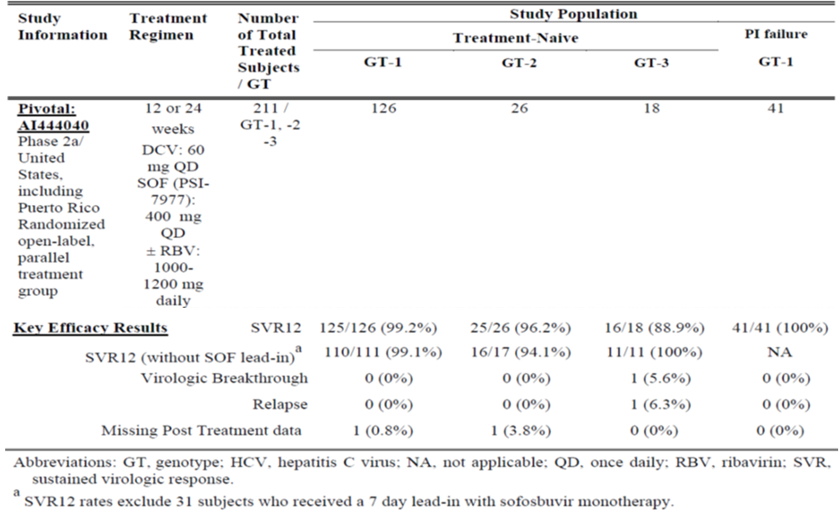
While the addition of ribavirin to the regimen did not result in an increase in efficacy, the frequencies of adverse reactions commonly associated with ribavirin therapy were higher for subjects in this study who received ribavirin than for subjects who did not.

DCV in combination with ASV plus pegIFNα/RBV (QUAD)
Study A1447029 is presented at CER pp 65-72. This was a Phase III, open label, single arm study with ASV and DCV plus pegIFNα/RBV (QUAD) in adults with chronic HCV GT-1 or GT-4 infection who were partial or null responders to treatment with peginterferon alfa 2a or 2b and ribavirin. The primary efficacy endpoint was the SVR12. There were 354 subjects with HCV GT-1 (89%) and 44 subjects with GT-4(11%). The 398 treated subjects had a median age of 53 years; 69% were male; 76% were white, 12% were Asian, 9% were black; 9% were Hispanic/Latino. The mean baseline HCV RNA level was 6.46 log10 IU/mL; 23% of subjects had compensated cirrhosis (Child-Pugh A); 91% of subjects had non-CC IL-28B genotype.
Subjects received DCV 60 mg once daily, ASV100 mg twice daily, peginterferon alfa 2a or 2b weekly injection, and ribavirin 1000 mg per day (body weight less than 75 kg) or 1200 mg per day (at least 75 kg) in two divided doses for 24 weeks followed by 24 weeks of follow-up after completion of treatment or early discontinuation.
Results for the primary efficacy outcome are presented.

Table 31: Key efficacy results for Study A1447029.
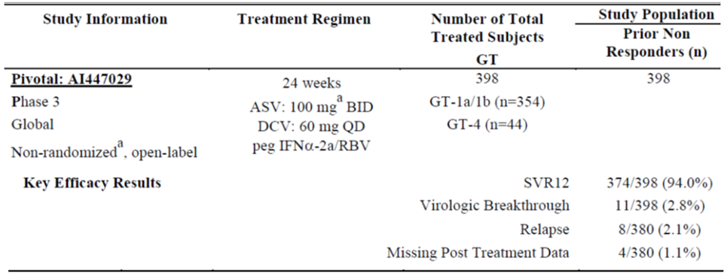
The efficacy of QUAD regimen (DCV/ASV/peginterferon alfa/RBV) in HCV genotype 1 and 4 null responders indicates that this regimen is expected to be effective in HCV genotype 1 and 4 subjects who are treatment naive.

Safety
The clinical evaluation reveals that DCV 60 mg QD plus ASV 100 mg appears generally well tolerated and no unique AEs or laboratory abnormalities attributable to DCV were identified. The most frequently reported AEs were fatigue, diarrhoea, nasopharyngitis, headache and nausea. The most significant AEs were transaminase elevations (ALT/AST). Grade 3/4 elevations were observed in less than 4% of DCV/ASV treated subjects. The median time to the onset of treatment emergent elevations was approximately 13 weeks. There were 4 cases that met the criteria for potential DILI and 1 subject who did not meet the clinical criteria due to baseline Gilbert’s syndrome.
The DCV/ASV combination had a better safety profile than that reported with pegIFNα/RBV or TVR or BOC + pegIFNα/RBV with respect to anaemia, neutropenia, thrombocytopenia, rash, anorectal disorders, flu like symptoms and depression.
In the one study submitted for the combination of DCV and SOF most subjects reported an AE (89.2%). The most frequently reported treatment related AEs (≥10%) were fatigue, headache, and nausea. The frequency of these was consistent across treatments (± RBV) and duration of treatment (12 versus 24 weeks). AEs commonly associated with RBV (that is, anaemia, cough, rash, dyspnoea, insomnia and anxiety) were higher with DCV/SOF/RBV. No Grade 3/4 AEs were reported in this study.
The safety profile seen in the DCV QUAD regimen was consistent with that seen in the other studies.
In the placebo controlled trials where placebo included pegIFNα/RBV no clinically relevant laboratory abnormalities were observed on treatment or during follow-up other than those anticipated for pegIFNα/RBV.
The second round clinical evaluation report comments on a review of hepatic safety. When ASV was combined with DCV ± pegIFNα/RBV), ALT elevations were observed, which were asserted to be associated with ASV use. In general, these ALT elevations to date have been reversible after study drug has been discontinued. Infrequently, these ALT elevations are associated with increased bilirubin (subjects meeting biochemical criteria for Hy’s law or pDILI criteria) without clinical evidence of hepatic decompensation. One case of a subject with severe liver injury, who exhibited evidence of hepatic encephalopathy, has been reported in a subjects receiving HCV 3DAA (DCV/ASV/BCV). The draft PI now recommends patients receiving DCV/ASV or DCV/ASV/pegIFNα/RBV, should have close monitoring of liver enzymes.
The sponsor has recently informed the TGA of post marketing adverse events reports from the European Union of clinically significant bradyarrhythmias from patients receiving amiodarone who were co-administered with DCV and SOF. The sponsor is unable to determine whether this potential drug interaction with amiodarone is from interaction of amiodarone with DCV, SOF, or both. The sponsor plans to update the draft Australian PI with a precaution regarding the use of amiodarone in combination with DCV and SOF.

Population PK analysis and the PSC discussions
The submitted population PK analysis has been evaluated by the external evaluator and the evaluation has been discussed at the 159th PSC meeting. The population pharmacokinetics of DCV was described using data from 11 clinical studies (9 Phase II studies and 2 Phase III studies). It is considered that a two compartment model with first order elimination from the central compartment, and an absorption model of zero-order release followed by first order absorption adequately described the PK of DCV after oral administration. The PSC requested that the sponsor address the following issues:
- Explain why the null responders or poor responders in study AI447029 were not included in the final population analysis.
- Investigate whether Japanese participants have different clearance, as Japanese participants were included in ‘other populations’ and this may mask any difference.
Regarding the PI:
- Ascertain from where data for AUC, C_{max}, C_{min} were derived.
- Include the magnitude (numerical value) of the impact of covariates reported in the population PK analysis.
At the 160th meeting, the PSC considered the company’s responses to the recommendations of PSC 159th meeting, and made the following comments:
- The PSC advised that the sponsor should provide further information from study AI447029 regarding the pharmacokinetics in null or poor responders to interferon if the eleven other studies did not report on these populations.
- The PSC advised that the numerical value of the impact of co-variates reported in the population PK analysis should be reported in the PI sections concerning renal impairment, elderly patients, gender, ethnicity (currently headed ‘Race’).
In response to the above PSC comments, the sponsor states that the population PK analysis for both DCV and ASV was subsequently updated after availability of data from study AI447029 and other Studies AI447031 and AI444042. In addition, as part of the updated analysis, sensitivity analyses were also conducted to evaluate the applicability of the model to data from Japanese HCV subjects. The population PK report addenda describing the results of the updated population PK analyses are provided.
For both DCV and ASV, the results of the updated population PK model were comparable to the results of the original model (without data from AI447029). From the updated model the CL/F of DCV was 5.58 L/h (1.67% RSE), and Vc/F was 56.8 L (1.94% RSE). Elimination half life was 15.8 h. The duration of the zero-order release of the drug was 0.918 hr-1 (3.73% RSE) and the first order absorption rate constant was 3.29 h⁻¹ (5.05% RSE). The univariate impact of covariates on the steady state AUC is similar to the prior model. The impact of WT on Vc/F, female subjects on CL/F and Vc/F, and race on CL/F and Vc/F overlapped with the 80-125% boundary and the resulting impact of DCV exposure is not considered clinically relevant. All other covariates effects were within the 80-125% range.
The updated model was also used to conduct additional sensitivity analyses to evaluate the impact of Japanese ethnicity independent of the Asian race. This was achieved by separating non Japanese Asians and Japanese subjects into separate race categories in the sensitivity analyses. The CL/F value estimated for Japanese ethnicity alone was very similar to the value estimated for Asian subjects including Japanese (5.89 L/h versus 5.94 L/hr). The CL/F value estimated using the five Japanese studies was 5.58 L/h, which is also similar to the CL/F of the updated model. Inter individual variability and intra individual variability are also similar between the updated model and the model using Japanese studies alone. The updated population PK analysis showed that the impact of Japanese ethnicity, GT-4 and non responders on the PK is small, and steady state AUC is similar across patient types. Overall, the magnitude of the covariate effects on DCV exposure is not considered clinically important.
The sponsor’s response also states that the updated DCV and ASV PI documents addressing all the requests from all the TGA evaluation sections will be provided as part of the Pre-ACPM responses to TGA.

Risk management plan
The RMP evaluation report is included for ACPM information. This submission was discussed at the ACSOV meeting and a number of recommendations were made. Of note, the sponsor was requested to include the potential interactions with food and herbal supplements (such as grapefruit, St John’s Wort) as safety concerns, and the sponsor was requested to provide an undertaking to contribute ongoing utilisation and pharmacovigilance data to Australian surveillance and regulatory systems, such as the National Centre in HIV Epidemiology and Clinical Research (NCHECR), especially of patients with co-morbidities or complex conditions.
The RMP evaluator has proposed the following wording as the conditions of registration:
The European Risk Management Plan EU-RMP version 1.2 dated 24 June 2014 (data lock point 13 March 2014), with the ASA version 2 dated 19 December 2014 to be revised to the satisfaction of the TGA, should be implemented.
The sponsor has not accepted Recommendation 4 in Section 5 in the second round RMP evaluation report. The RMP evaluator maintains the recommendations to add the following safety concerns to the safety concern list in the ASA. Otherwise, justification should be provided as to why they are irrelevant to the use of DCV:
- Mitochondrial toxicity
- Cardiotoxicity
- Use in post-solid organ transplant
- Off-label use - outside of the recommended treatment regimens
- Increased risk of psychiatric disorders including depression and anxiety in combination therapy with interferon.

Clinical recommendation
The clinical evaluator recommends the approval of DCV for the treatment of adult patients infected with chronic hepatitis C genotypes 1 and 4. The approval is recommended for the following treatment regimens:
Table 32: Evaluator recommended regimens with DCV 60 mg once daily combination therapy.
HCV Genotype ª | Treatment | Duration
Genotype 1 | DAKLINZA and sofosbuvir | 12 weeks
Genotype 1 ^{b} | DAKLINZA and sofosbuvir | 24 weeks
Genotype 1b | DAKLINZA and SUNVEPRA | 24 weeks
Genotype 1 or 4 | DAKLINZA, SUNVEPRA, peginterferon alfa, and ribavirin | 24 weeks
a. Treatment naïve or failed prior treatment with peginterferon alfa and ribavirin or interferon intolerant.
b. HCV genotype 1 patients who failed prior protease inhibitor treatment
The evaluator noted that in Study AI444040, Groups A-F were treated for 12 weeks but Group I and J who were the group of patients who had failed prior PI therapy (TVP/BOC) were treated for 24 weeks not 12 weeks. There is no evidence that shortening the treatment to 12 weeks will be effective in this group (Concordance of SVR12 and SVR24 was only demonstrated for treatment naïve patients. The study report states that
concordance was not evaluated for the TVR/BOC failure groups (Groups I and J) because these groups did not have SVR24 results at the time of database lock for this CSR.
The evaluator also noted that Study AI444040 was only conducted in patients without cirrhosis and therefore no recommendation for use of DCV+SOF can be made in patients with cirrhosis. The 12 week duration of therapy is only recommended for patients without cirrhosis.
The evaluator considers that the key deficiency is the data in subjects infected with HCV genotype 2 and 3 infection. Throughout the submission the sponsor has pooled data form different treatment regimens. For example, treatment of patients with GT-3 is represented by only one study (AI444040) and by only 3 groups within that study (groups B, D and F). These groups each included patients with both GT-2 and GT-3 and had slightly different treatments. All groups were treated for 24 weeks. This is summarised below.
Table 33: Study A1444040: Treatment Regimens: Groups B, D and F.
Group | Treatment regimen | Number of patients with GT-2 | Number of patients with GT-3
B | SOF 400 mg QD for 7 days (monotherapy) and then added DCV 60 mg QD | 9 | 7
D | DCV 60 mg QD + SOF 400 mg QD | 8 | 6
F | DCV 60 mg QD + SOF 400 mg QD + SOF | 9 | 5
It can be seen that very small number of GT-2 and 3 HCV subjects were actually treated with the proposed dose and for 24 weeks rather than the proposed 12 weeks. The justification for the proposal of an option of 12 weeks or 24 weeks is based on a selected literature review mostly of studies in patients with GT-1. The results quoted for GT-3 patients who were treated for 12 (ineligible for IFN) to 16 weeks (prior IFN treatment) were SVR 30%-61%. The sponsor also claims that there is no difference when RBV is added to the regimen but with so few patients treated with each specific regimen there is insufficient evidence for such a claim.
Overall, the evaluator considers that the data is insufficient to warrant approval for the use of 12 weeks of DCV+SOF for HCV subjects with genotype 2 or 3. There is no data provided for the use of DCV+SOF for genotype 4 patients.
The extrapolation of the use of DCV+SOF in GT-1 to include prior treatment failures who have failed pegIFNα/RBV is considered appropriate given there is evidence of good response in the group who have failed prior TVR and BOC plus pegIFNα/RBV.
This submission contains substantial clinical data on DCV in combination with asunaprevir which is a new chemical entity and the subject of a parallel submission. Asunaprevir at the time of the Section 31 response was registered only in Japan and in USA the asunaprevir submission was withdrawn in October 2014.

Risk-benefit analysis

Delegate’s considerations
The Delegate agrees that the actual data on the use of DCV+SOF in HCV patients with GT-2, -3 or -4 are limited; the sponsor-proposed treatment regimens for these patients are based on extrapolation. There is no data submitted on the use of DCV+SOF in HCV subjects with cirrhosis.

Proposed action
The Delegate proposes the registration approval for DCV for use in combination with other medicinal products for the treatment of chronic HCV infection in adults with compensated liver disease. The treatment regimens (various combination and treatment durations) warrant further discussion at the ACPM meeting.

Request for ACPM advice
The committee is requested to provide advice on the following specific issues:
- With the combination use of DCV and SOF, what is the view of the ACPM with regards to the sponsor-proposed indication/ treatment regimen for patients infected with HCV genotype 2, 3, or 4?
- With the combination use of DCV and SOF, what is the view of the ACPM with regards to the sponsor proposed treatment duration for genotype 1 patients, including the statements in the footnote of a, b and c ?
- For HCV genotype 1 patients who failed prior protease inhibitor treatment, the evaluator recommended 24 weeks treatment with DCV/SOF. What is the view of the ACPM with the 12 weeks treatment duration proposed by the sponsor?
Table 34: Sponsor proposed regimens with DCV 60 mg once daily combination therapy.
HCV Genotype | Treatment | Duration
Genotype 1 | DAKLINZA and sofosbuvir ^{a,b,c} | 12 weeks
Genotype 1b | DAKLINZA and SUNVEPRA ª | 24 weeks
Genotype 2 | DAKLINZA and sofosbuvir ^{a,c} | 12 weeks
Genotype 3 | DAKLINZA and sofosbuvir ^{a,c} | 12 weeks
Genotype 4 | DAKLINZA and sofosbuvir ^{a,b,c} | 12 weeks
Genotype 1 or 4 | DAKLINZA, SUNVEPRA, peginterferon alfa, and ribavirin ª | 24 weeks
a. Treatment naive or failed prior treatment with peginterferon alfa and ribavirin.
b. The DCV/SOF regimen is also recommended for HCV genotype 1 and 4 patients who failed prior protease inhibitor treatment.
c. Consider adding ribavirin to the DCV/SOF 12-week regimen or prolonging treatment duration to 24 weeks for patients with cirrhosis or with other negative prognostic factors such as prior treatment experience (for example, protease inhibitor, peginterferon alfa and ribavirin).
The committee is (also) requested to provide advice on any other issues that it thinks may be relevant to a decision on whether or not to approve this application.

Summary of issues
DCV is only recommended in combination with other agents. One of these agents is asunaprevir (ASV) which is also a new chemical entity and the subject of a parallel submission. Asunaprevir is currently registered only in Japan.
The clinical evaluation report comments that this is a complex and seemingly hasty submission of early phase studies in place of appropriately conducted clinical trials. The clinical evaluation report considers patient numbers treated with the proposed treatment regimens in submitted clinical studies are not sufficient to support the extrapolations requested for GT-2 and GT-3. The CER does not support DCV+SOF in subjects with GT-4, with no clinical study data. The second round clinical evaluation report comments:
The company clearly now has data based on clinical studies for the use of DCV+SOF in GT-2, 3 and 4. The new data needs to be evaluated from the study reports and not from summary data and should be the subject of a separate submission.
The clinical evaluation report noted that in study AI444040, Groups A-F were treated for 12 weeks but Group I and J who were the group of patients who had failed prior PI therapy (TVP/BOC) were treated for 24 weeks not 12 weeks. There is no evidence that shortening the treatment to 12 weeks will be effective in this group. Study AI444040 was only conducted in patients without cirrhosis and therefore no recommendation for use of DCV+SOF can be made in patients with cirrhosis. The 12 week duration of therapy is only recommended for patients without cirrhosis.
Other agents including SOF, a nucleoside NS5B polymerase inhibitor, and simeprevir (SMV), an NS3/4A protease inhibitor, have recently been approved in the USA and Australia. Comparative data to other newer agents is also lacking in the submission. While most of the newer agents have only been approved in Australia while this submission was being evaluated, the range of products which will soon be available make it difficult for clinicians to decide the optimum therapy.
The sponsor has chosen not the seek approval for the combination of DCV + pegIFNα +RBV despite having conducted a large number of trials for this combination.
Regarding its safety, DCV was well tolerated and the side effects were similar to those experienced by patients taking placebo. When ASV was combined with DCV ± pegIFNα/RBV), ALT and AST elevations were observed, with close monitoring of liver enzymes now recommended in draft PI.

Response from sponsor
The sponsor acknowledges the Delegate’s proposal to approve the registration of DCV for use in combination with other medicinal products for the treatment of chronic HCV infection in adults with compensated liver disease. The sponsor welcomes the opportunity to comment on the questions asked of the ACPM in the Delegate’s request for ACPM advice.

Advise sought and sponsor’s comments

QUESTION 1: With the combination use of DCV/SOF, what is the view of the ACPM with regards to the sponsor-proposed indication/treatment regimen for patients infected with HCV GT 2, 3, or 4?
The combination use of DCV and SOF to treat patients infected with HCV genotypes (GT) 1 to 4 is supported by data from Study AI444040, which demonstrated exceptional efficacy in HCV GT-1, -2 and -3 infected treatment naive patients without cirrhosis, as well as GT-1 infected patients, without cirrhosis, who failed prior treatment with a protease inhibitor (PI) plus pegylated interferon alfa and ribavirin (pegIFNα/RBV). SVR12 rates in the GT-1 infected treatment groups (n = 126 for treatment naive; n = 41 for prior PI failure) were 99.2% and 100% respectively, and the sponsor welcomes the Delegate’s recommendation for approval for the combination use of DCV/SOF for 12 weeks in these patient populations.
The efficacy demonstrated in Study AI444040 was so well received by Health Authorities and physicians worldwide that the sponsor, upon initial advice from regulators in the EU, made a decision to include Study AI444040 as a pivotal study in the DCV applications for registration in many countries globally. In the EU, efficacy data from Study AI444040, along with the accepted extrapolation of efficacy of DCV across genotypes, including GT-4, was the basis upon which an indication across genotypes was granted in August 2014.
The sponsor acknowledges that Study AI444040 had smaller sample sizes of HCV GT-2 and -3 infected patients, however believes an indication for DCV/SOF is warranted in Australia for these patients to address a significant unmet medical need, and is supported by both data extrapolation and recent confirmatory Phase III data. The evidence and unmet medical need for GT-2, -3 and -4 patients is detailed below, presenting the sponsor’s position that registration of the DCV/SOF treatment regimen should include these genotypes.

Genotype 3
The prevalence of HCV GT-3 infected patients in Australia is estimated to be between 30-40%. GT-3 is the second highest HCV genotype present in Australia, behind GT-1 which has a prevalence estimate of 55%. The prevalence of GT-3 infection in Australia is relatively high compared to other geographical regions, for example GT-3 comprises just 12% of HCV infection in the US. Unfortunately, there remains a particular unmet medical need for GT-3 infected patients, because these patients tend to have lower response rates (especially patients with cirrhosis) and a faster progression of liver disease than patients with other HCV genotypes.
Study AI444040 included 18 GT-3 infected patients, 16 of whom achieved SVR12 (88.9%) with the DCV/SOF combination after 24 weeks treatment. Given the prevalence of HCV GT-3 infection in Australia, and the specific problems associated with this genotype, the sponsor deemed it was important to include data from Study AI444040 to seek an indication for DCV/SOF in this specific patient population.
The sponsor appreciates that the GT-3 infection data in Study AI444040 are limited by the sample size, however, since the application for DCV in Australia was submitted (May 2014), the sponsor has completed a Phase III study (AI444218; ALLY-3) in which GT-3 infected treatment naive and experienced subjects with or without cirrhosis (n = 152) were treated with DCV/SOF for 12 weeks. The topline data from this study, which were presented by the Sponsor in the section 31 response, confirms the efficacy in this patient population first seen in AI444040 (see Table 35). Overall, the SVR12 rate in HCV GT-3 infection after 12 weeks of DCV/SOF was 88.8%, consistent with 88.9% seen in Study AI444040 in HCV GT-3 infected patients after 24 weeks of DCV/SOF ± RBV.
Table 35: SVR12 Rates for GT-3 Subjects Treated with DCV-containing Regimens (AI444040, AI444218).
Study | Regimen | Subject Population (n) with GT3 | SVR12
AI444040 | DCV/SOF ± RBV x 24 weeks | All (n = 18; treatment-naïve)  ≥ F3^{b,c} | 88.9% (16/18)  100% (5/5)
ALLY-3 (AI444218) | DCV/SOF x 12 weeks | All (n = 152)  Treatment-naïve  Treatment-experienced  No cirrhosis  Cirrhosisª | 88.8% (135/152)  90.1% (91/101)  86.3% (44/51)  96.3% (105/109)  62.5% (20/32)
a. Cirrhosis determined by liver biopsy (METAVIR F4; N = 14), FibroScan (> 14.6 kPa, N = 11), or FibroTest score ≥ 0.75 and APRI (aspartate aminotransferase to platelet ratio index) > 2 (N = 7).
b. Derived from FibroTest score and classified according to information on the FibroTest manufacturer’s website (www.biopredictive.com).
c. Subjects with a score of F4 were required to have no evidence of cirrhosis on the basis of a liver biopsy.
ALLY-3 data confirms the conclusions of Study AI444040 that the combination of DCV/SOF in HCV GT-3 infected patients will be, and in some countries already is, the preferred treatment regimen of choice. The European Association for the Study of the Liver (EASL) published “EASL Recommendations on Treatment of Hepatitis C” in April 2014, which already includes the combination of DCV/SOF as a treatment option for GT-3 infection, based on Phase II data alone. These recommendations also predated the regulatory approval of this regimen in the EU (August 2014).
The only approved regimens for HCV GT-3 infected patients in Australia currently are limited to pegIFNα/RBV for 24 weeks and SOF/RBV for 16 weeks. DCV is more potent than RBV against GT-3 infection. As confirmed by ALLY-3, the regimen of DCV/SOF in GT-3 infected treatment naive patients for 12 weeks can achieve a similar SVR12 to that with 24 weeks of SOF/RBV (93% in VALENCE study). At 16 weeks, which is the approved treatment duration for SOF/RBV in GT-3 infected patients in Australia, SVR12 rates are 62% (FUSION study). A notable difference is also observed in GT-3 infected treatment-experienced subjects, whereby higher SVR12 rates are achieved with DCV/SOF (86.3% in ALLY-3) compared with SOF/RBV (77% in VALENCE).
In addition, the anticipated newer therapies for the treatment of HCV in Australia, specifically the regimen of SOF/ledipasvir (LED) ± RBV, has not been studied in GT-3 infected patients in Phase III trials. The only available data for this combination in this patient population are from a small phase 2 open-label study (ELECTRON-2) which evaluated efficacy of SOF/LED + RBV (n = 26) or SOF/LED (n = 25) in treatment naive patients. The SVR12 rates were 64% and 100% respectively, yet these rates have not yet been confirmed with phase 3 data.
The sponsor is committed to updating the Daklinza PI to include the full data from ALLY-3. The regulatory mechanism by which the sponsor can do this is a Category 1 Application (12 to 14 month submission to approval), which can only be submitted once the initial registration of Daklinza is complete. Therefore, the updated PI will only be available mid-2016, representing a delay of over one year from the initial approval. This, in the context of the known disease progression for HCV GT-3 infected patients, is of concern and unduly disadvantages Australian patients infected with GT-3 in terms of access to a highly efficacious, all-oral treatment regimen.
In light of the compelling efficacy demonstrated in Study AI444040, the sponsor concludes that DCV/SOF is the treatment regimen of choice in GT-3 infected patients. This patient population represents a significant unmet medical need of particular concern in Australia, especially given emerging data showing increased rates of liver cancer and liver decompensation in patients with GT-3 infection compared to other genotypes. In Australia, given the high prevalence of this difficult to treat genotype, the unmet medical need for an efficacious RBV-free regimen is even more urgent.
The critical role of DCV/SOF in the treatment of GT-3 infected patients is reinforced by the Australian medical community. The sponsor sought opinions on the place of DCV/SOF in the treatment of HCV GT-3 infection from two professors. An extract is provided below:
Chronic HCV genotype 3 infection is an enormous clinical and public health challenge in Australia at present. ... Current interferon-based therapies are sub-optimal, particularly in those with cirrhosis in whom the cure rate is around 50% and the treatment duration 48 weeks. In contrast, an all oral combination of SOF and DCV can provide a cure in the vast majority of patients with genotype 3, with minimal toxicity, and only requiring 12-24 weeks duration. The combination of these two direct acting antiviral therapies has the potential to markedly reduce the escalating burden of advanced liver disease in Australia.

Genotype 2
Although representing a small proportion of HCV infection in Australia (5%), the sponsor maintains that there is sufficient data presented in Study AI444040 (n = 26, SVR12 = 96.2%) to support an indication for the use of DCV/SOF in this patient population. In addition to the high cure rates seen in Study AI444040, Phase III data now available confirms the efficacy in GT-2 patients (AI444216, ALLY-2; AI444215, ALLY-1). ALLY-2 investigated the use of DCV/SOF in GT-1 to -6 treatment naive and treatment experienced HCV/HIV coinfected patients, and ALLY-1 investigated DCV/SOF + RBV in HCV GT-1 to -6 patients with cirrhosis who may require future liver transplant and patients post-liver transplant.
The SVR12 rates achieved in GT-2 patients with 12 weeks of treatment with DCV/SOF±RBV were 100% (13/13 HIV/HCV co-infected patients; study ALLY-2) and 80% (4/5 HCV advanced cirrhotic patients; study ALLY-1).
ALLY-2 and ALLY-1 data support the conclusions of Study AI444040 for the combination of DCV/SOF in the treatment of HCV GT-2 infected patients. The only approved regimens for HCV GT-2 infected patients in Australia currently are limited to pegIFNα/RBV for 24 weeks and SOF/RBV for 12 weeks.

Genotype 4
It has long been considered that demonstration of efficacy against GT-1 infection can be extrapolated to GT-4 infection. Similar efficacy rates are achieved clinically for both GTs 1 and 4 with many HCV treatment regimens. Although, HCV GT-4 infected patients were not studied in Study AI444040, an indication is sought for this patient population in Australia by extrapolation.
The DCV/SOF regimen is expected to yield similar activity as that observed for GT-1 infection, based on in vitro antiviral activity of both agents against GT-1 and GT-4. This cross genotypic extrapolation is reflected in current (January 2011) draft EMA/CHMP guideline and the indication granted in the European Union for HCV GT-4 infected patients on the basis of Study AI444040 data.
As described in the Section 31 response, DCV containing regimens have yielded high SVR rates in GT-4 infected patients: 82% (67/82; Study AI444042) to 100% (12/12; Study AI444010) with 24-48 weeks of treatment with DCV+pegIFNα/RBV; and 100% (21/21) with 12 weeks of DCV/asunaprevir/beclabuvir; Study AI443014). Phase III data now available confirms the efficacy of DCV/SOF±RBV in GT-4 infected patients. All 7 (100%) GT-4 patients (3 HIV/HCV noncirrhotic and 4 HCV cirrhotic) patients achieved SVR12 following 12 weeks of treatment with DCV/SOF±RBV (studies ALLY-1 and -2).

QUESTIONS 2 and 3: With the combination use of DCV/SOF, what is the view of the ACPM with regards to the sponsor proposed treatment duration for genotype 1 patients, including the statements in the footnote of a, b and c? For HCV genotype 1 patients who failed prior protease inhibitor treatment, the evaluator recommended 24 weeks treatment with DCV/SOF. What is the view of the ACPM with the 12 weeks treatment duration proposed by the sponsor?
As noted by the Delegate, in the proposed Australian PI for Daklinza, the sponsor recommends DCV/SOF treatment of HCV GT-1, -2, -3 and -4 infections for 12 weeks. Three footnotes to the ‘Dosage and Administration’ table accompany this recommendation (Table 36) and the Delegate seeks ACPM’s view on these footnotes for DCV/SOF for GT-1, as well as the treatment duration of 12 weeks for prior PI-treatment failures. In response to Question 1, the sponsor presents rationale on the use of DCV/SOF in HCV GT-2, GT-3 and GT-4 infection in Australia. As the sponsor proposes that the three footnotes are relevant to HCV GT-1, -2, -3 and -4 infection, comments are provided on each footnote in turn in this section.
Table 36: Recommended Regimens with DAKLINZA 60 mg Once Daily Combination Therapy.
HCV Genotype | Treatment | Duration
Genotype 1 | DAKLINZA and sofosbuvir ^{a,b,c} | 12 weeks
Genotype 1b | DAKLINZA and SUNVEPRA ª | 24 weeks
Genotype 2 | DAKLINZA and sofosbuvir ^{a,c} | 12 weeks
Genotype 3 | DAKLINZA and sofosbuvir ^{a,c} | 12 weeks
Genotype 4 | DAKLINZA and sofosbuvir ^{a,b,c} | 12 weeks
Genotype 1 or 4 | DAKLINZA, SUNVEPRA, peginterferon alfa, and ribavirin ª | 24 weeks
(a) Treatment naive or failed prior treatment with peginterferon alfa and ribavirin.
(b) The DAKLINZA/SOF regimen is also recommended for HCV genotype 1 and 4 patients who failed prior protease inhibitor treatment.
(c) Consider adding ribavirin to the DAKLINZA/SOF 12-week regimen or prolonging treatment duration to 24 weeks for patients with cirrhosis or with other negative prognostic factors such as prior treatment experience (for example, protease inhibitor, peginterferon alfa and ribavirin).

Rationale for footnote (a)
Study AI444040 evaluated GT-1 treatment naive patients (n = 126) and those who failed prior treatment with telaprevir (TVR) or boceprevir (BOC) added-on to pegIFNα/RBV (n = 41). The latter patients failed not only TVR or BOC but also pegIFNα/RBV. In the DRA, the Delegate indicated that extrapolation of pegIFNα/RBV from experience gained from protease inhibitor (PI) treatment failures is considered appropriate.

Genotypes 2, 3 and 4
Footnote a is also applicable for the treatment of patients with HCV GT-2, -3 or -4 infection, as it is appropriate to extrapolate the efficacy data observed in Study AI444040 in GT-2 and -3 treatment naive patients (detailed in the sponsor’s comments on Question 1) to PI treatment failures. The efficacy in these patient populations is confirmed with Phase 3 data from studies ALLY-3, ALLY-2 and ALLY-1.
With regards to the applicability of footnote (a) to the treatment of HCV GT-4, the sponsor has outlined in the response to Question 1 that there is strong justification for extrapolation for efficacy demonstrated in GT-1 to GT-4, supported by in vitro antiviral activity, demonstrated efficacy in clinical trials and regulatory guidelines.

Rationale for footnote (b)

Genotype 1
Study AI444040 demonstrated that DCV/SOF was highly efficacious (SVR12 = 100%) for the 41 GT-1 patients who failed prior protease inhibitor treatment, and thus also failed pegIFNα/RBV.

Genotype 4
The applicability of this footnote in GT-4 patients is as per the accepted extrapolation of efficacy from GT-1, described previously in this response.

Rationale for footnote (c)

Genotype 1
Since Study AI444040 did not enrol cirrhotic patients, this footnote was added to conservatively recommend adding RBV or extending the treatment duration to 24 weeks to optimize efficacy in harder-to-treat patients. Recent data from the Phase III ALLY program indicate that DCV/SOF±RBV is effective in cirrhotic patients with 12 weeks of treatment. In ALLY-2, for patients treated for 12 weeks with DCV/SOF, the SVR12 rates were 98% (122/124) and 92% (22/24) for non-cirrhotic and cirrhotic patients, respectively. In addition, high SVR12 of 80% (48/60) was observed in those cirrhotic/decompensated liver patients treated with DCV/SOF/RBV, with SVR12 rates of 92% (11/12), 94% (30/32), and 56.3% (9/16) in Child-Pugh class A, B, and C patients, respectively.
Also DCV/SOF for 12 weeks was effective in PI treatment failures. In ALLY-2, all 11 HIV/HCV patients who were prior PI treatment failures achieved SVR12 with DCV/SOF, and in ALLY-1, 8/9 of the PI failures (3/4 cirrhosis/decompensated liver patients and 5/5 post-liver transplant patients) achieved SVR12 with DCV/SOF/RBV, all with 12 weeks of treatment. As mentioned above, since PI failures are treatment naive to DCV/SOF, they are expected to respond similarly, as other treatment naive patients in study AI444040, to 12 weeks of DCV/SOF.

Genotype 2
As described previously, 24 weeks of treatment with DCV/SOF in GT-2 treatment naive patients in Study AI444040 yielded SVR12 of 92% (25/26). Similar efficacy in GT-2 patients has been achieved in studies ALLY-2 and ALLY-1. While the overall experience of DCV/SOF±RBV in GT-2 infected patients is promising, it is limited and thus for now, footnote (c) also applies to GT-2.

Genotype 3
Study AI444040 evaluated GT-3 treatment naive patients with 24 weeks of treatment with DCV/SOF, yielding SVR12 of 89% (16/18). The SVR12 achieved in GT-3 patients with 12 weeks of treatment with DCV/SOF±RBV are: 86% (135/156; Study ALLY-3 comprised of 101 treatment naive and 51 treatment experienced patients); 100% (10/10 HIV/HCV co-infected patients; Study ALLY-2); 83% (5/6 HCV cirrhotic patients; study ALLY-1); and 91% (10/11 post-liver transplant patient; Study ALLY-1). Of note, in ALLY-3, the SVR12 rates were 96% (105/109) in non cirrhotic versus 63% (20/32) in cirrhotic patients with 12-wks of DCV/SOF. For HCV all oral regimens, GT-3 is the most challenging genotype to treat. It is evident that DCV/SOF can cure almost all GT-3 treatment naive patients with 12 weeks of therapy, however, longer treatment or the addition of RBV may benefit some GT-3 cirrhotic patients, and thus footnote (c) in the ‘Dosage and Administration’ table.

Genotype 4
The applicability of this footnote in GT-4 patients is as per the accepted extrapolation of efficacy from GT-1, described previously in this response.

Proposed amendment to footnote (c)
In order to provide clarity under which situation a prescriber may want to consider a longer duration of treatment or the addition of RBV, and acknowledging the newly available, confirmatory Phase III data, the sponsor proposes that footnote (c) be amended to:
(c) Consider adding ribavirin to the DCV/SOF 12 week regimen or prolonging treatment duration to 24 weeks for patients with cirrhosis.

Sponsor’s comments on other aspects

Population Pharmacokinetic Analysis and PSC Discussions
The PSC recommended that the numerical value of the impact of co-variates reported in the population pharmacokinetic analysis should be reported in the PI concerning renal impairment, gender and race. The magnitude of all these covariate effects on DCV exposure is not considered clinically relevant, and the sponsor is updating the PI accordingly.

RMP evaluation
The ongoing RMP Evaluation is noted in the Delegate’s report and the sponsor confirms discussions to resolve the outstanding issues with the TGA RMP evaluator are in progress.

Conclusion
The DCV/SOF regimen offers patients an alternative, highly efficacious, all oral regimen with a lower pill burden and an excellent safety profile relative to the currently approved regimens. The sponsor requests that the ACPM recommend an indication for the use of DCV/SOF in HCV genotypes 1, 2, 3 and 4 infection based on the data submitted with this application. On account of all available data, the recommended treatment duration is for 12 weeks, with the exception of a consideration to either add RBV or extend the treatment duration to 24 weeks in the case of cirrhosis.

Advisory committee considerations
The ACPM resolved to recommend to the TGA delegate of the Minister and Secretary that:
The ACPM, taking into account the submitted evidence of pharmaceutical quality, safety and efficacy advised that Daklinza tablet, containing 30 mg and 60 mg of DCV (as dihydrochloride) has an overall positive benefit-risk profile for the following modified indication:
Daklinza is indicated in combination with other active treatments for the treatment of chronic hepatitis C virus (HCV) infection in adults with compensated liver disease (including cirrhosis) [see CLINICAL TRIALS and DOSAGE AND ADMINISTRATION].
In making this recommendation, the ACPM:
- Noted that there was insufficient evidence to support an indication for HCV genotype 2 and 3 due to small patient numbers.
- Noted that a Phase III study for HCV genotype 3 treatment naive and experienced subjects with or without cirrhosis and treated with DCV/SOF for 12 weeks had been completed but that this information had not been evaluated and therefore could not be taken into consideration.
- Noted that the evidence to date did not support an indication in combination with SOF for HCV genotype 4, and that any new data would need evaluation.
- Noted that the proposed treatment duration with DCV and SOF for patients with HCV genotype 1 who had failed protease inhibitors was 12 weeks, was not supported by the evidence presented in the current application.
- Expressed concern regarding the elevations of bilirubin and liver transaminases with asunaprevir containing regimens.

Proposed conditions of registration
The ACPM agreed with the Delegate on the proposed conditions of registration and advised on the inclusion of the following:
- a requirement to monitor and report liver toxicity in patients receiving asunaprevir containing regimens.

Proposed Product Information (PI)/Consumer Medicine Information (CMI) amendments
The ACPM agreed with the delegate to the proposed amendments to the PI and CMI and specifically advised on the inclusion of the following:
- Inclusion of the results of the Phase III Study (AI444218; ALLY-3) in the PI.
- Inclusion of a Black Box warning to highlight the risk of elevated bilirubin levels and liver transaminases when using asunaprevir containing regimens and ensure appropriate monitoring.
- Specify a lower level of ALT elevation of five times the upper limit of normal (ULN) instead of ten times ULN for treatment discontinuation for patients receiving asunaprevir containing regimens.
- Replacement of Table 10 in ‘Dosage and Administration’ section as follows in Table 37.
Table 37: Recommended regimens with Daklinza 60 mg once daily combination therapy.
Genotype | Prior treatment experience | Combination | Duration
1 | None, or failed peginterferon alfa/ribavirin | Daclatasvir and sofosbuvir* | 12 weeks
1 | Failed protease inhibitor and peginterferon / ribavirin | Daclatasvir and sofosbuvir* | 24 weeks
1b | None, or failed peginterferon alfa/ribavirin | Daclatasvir and asunaprevir | 24 weeks
1 or 4 | None, or failed peginterferon alfa/ribavirin | Daclatasvir, asunaprevir, peginterferon alfa, and ribavirin | 24 weeks
* Consider adding ribavirin to the DCV/SOF 12 week regimen or prolonging treatment duration to 24 weeks for patients with cirrhosis or with other negative prognostic factors such as prior treatment experience (for example, protease inhibitor, peginterferon alfa and ribavirin).

Specific advice
The ACPM advised the following in response to the specific Delegate’s questions on this submission:
- With the combination use of DCV and SOF, what is the view of the ACPM with regards to the sponsor proposed indication/treatment regimen for patients infected with HCV genotype 2, 3, or 4?
The ACPM advised that to date there are insufficient data to support an indication for the treatment of chronic HCV genotypes 2 and 3, due to the small number of patients with genotype 2 and 3 in Study AI444040. However, the ACPM noted that the since the application for daclatsavir in Australia was submitted (May 2014), the sponsor has completed a Phase III study (AI444218; ALLY-3) in which genotype 3 infected treatment naive and experienced subjects with or without cirrhosis (n = 152) were treated with DCV/SOF for 12 weeks. The ACPM advised that as this data had not been evaluated in this application, it would be premature to include genotype 3 in the indication for daclatsavir. However, the ACPM advised that, if the evaluation was found to be adequate, the results of the Phase III study should be included in the PI.
The ACPM also noted that there were no clinical data for the use of DCV in combination with SOF in subjects with genotype 4 in this application. However, the ACPM acknowledged that the sponsor now has data available which may support use of DCV in combination with SOF for genotypes 2, 3 and 4 but it is yet to be evaluated.
- With the combination use of DCV and SOF, what is the view of the ACPM with regards to the sponsor proposed treatment duration for genotype 1 patients, including the statements in the footnote of (a), (b) and (c)?
The ACPM noted the sponsor’s revised proposed dosage table in its pre ACPM response but considered that clarity of the table could be improved by including ‘prior treatment experience’ as a heading in the table.
The ACPM agreed that there should be a footnote, as proposed by the sponsor, recommending that a treatment duration of 24 weeks or the addition of ribavirin to the 12 week duration of treatment with DCV and SOF should be considered for patients with HCV genotype 1 with cirrhosis or other negative prognostic factors. The ACPM advised the duration of treatment for patients who have failed prior protease inhibitor therapy should be 24 weeks and not 12 weeks as proposed by the sponsor (see Question 3).
- For HCV genotype 1 patients who failed prior protease inhibitor treatment, the evaluator recommended 24 weeks treatment with DCV/SOF. What is the view of the ACPM with the 12 weeks treatment duration proposed by the sponsor?
The ACPM noted that in Study AI444040, Groups A-F were treated for 12 weeks but Group I and J, who were the group of patients who had failed prior protease inhibitor therapy (TVP/BOC), were treated for 24 weeks not 12 weeks. The ACPM considered that the data did not support the shortened duration of 12 weeks for DCV in combination with SOF in patients who have failed protease inhibitors, as proposed by the sponsor, as no evidence had been presented to support the shortened duration.
The ACPM advised that implementation by the sponsor of the recommendations outlined above to the satisfaction of the TGA, in addition to the evidence of efficacy and safety provided would support the safe and effective use of this product.

Post ACPM
After the ACPM outcomes were received for this application, the sponsor and TGA entered a clock stop during which an additional Phase III study (“ALLY-3”) was accepted for evaluation. The results of ALLY-3 (and corresponding dosing recommendation for GT-3 patients) are included in the Daklinza PI.

Outcome
Based on a review of quality, safety and efficacy, TGA approved the registration of Daklinza (daclatasvir as dihydrochloride) for 30 mg and 60 mg tablet blister, indicated for:
Daklinza is indicated in combination with other medicinal products for the treatment of chronic hepatitis C virus (HCV) infection in adults with compensated liver disease (including cirrhosis) [see CLINICAL TRIALS and DOSAGE AND ADMINISTRATION].

Specific conditions of registration applying to these goods
- Daclatasvir (Daklinza) EU-RMP version 1.2 dated 24 June 2014 (data lock point 13 March 2014), ASA version 1 dated 31 March 2014; and an updated ASA version 2 dated 19 December 2014 provided with the submission, and any subsequent revisions, as agreed with the TGA will be implemented in Australia.

Attachment 1. Product Information
The PI approved for Daklinza at the time this AusPAR was published is at Attachment 1. For the most recent PI, please refer to the TGA website at <www.tga.gov.au/product-information-pi>.

Attachment 2. Extract from the Clinical Evaluation Report

Therapeutic Goods Administration
PO Box 100 Woden ACT 2606 Australia
Email: info@tga.gov.au Phone: 1800 020 653 Fax: 02 6232 8605
https://www.tga.gov.au

Sponsor comment: “These are preliminary studies that supported combination toxicity work.”
Fridell RA, et al. Distinct Functions of NS5A in Hepatitis C Virus RNA Replication Uncovered by Studies with the NS5A Inhibitor BMS-790052. J Virology 85: 7312-20 (2011).
Sun JH, et al. Impact of a baseline polymorphism on the emergence of resistance to the hepatitis C virus nonstructural protein 5A replication complex inhibitor, BMS-790052. Hepatology 55: 1692-9 (2012).
Fridell RA, et al. Resistance analysis of the HCV NS5A inhibitor BMS-790052 in an in vitro replicon system. Antimicrob Agents Chemother 54: 3641-50 (2010). Fridell RA, et al. Distinct Functions of NS5A in Hepatitis C Virus RNA Replication Uncovered by Studies with the NS5A Inhibitor BMS-790052. J Virology 85: 7312-20 (2011); Wang C, et al. Hepatitis C virus RNA elimination and development of resistance in replicon cells treated with BMS-790052. Antimicrob Agents Chemother 56:1350-8 (2012).
Category B3: Drugs which have been taken by only a limited number of pregnant women and women of childbearing age, without an increase in the frequency of malformation or other direct or indirect harmful effects on the human foetus having been observed. Studies in animals have shown evidence of an increased occurrence of foetal damage, the significance of which is considered uncertain in humans.
Category X: Drugs which have such a high risk of causing permanent damage to the foetus that they should not be used in pregnancy or when there is a possibility of pregnancy.
Kaba S, et al. Molecular Epidemiology of Hepatitis C in Australia. Journal of Gastroepidemiology and Hepatology 13: 914-920 (1998); Dore GJ, et al. Epidemiology of Hepatitis C virus infection in Australia. Journal of Clinical Virology 26: 171-84 (2003).
European Medicines Agency, “Guideline on the clinical evaluation of direct acting antiviral agents intended for treatment of chronic hepatitis C (EMEA/CHMP/EWP/30039/2008)”, 24 April 2008.
Dore GJ, et al. Epidemiology of Hepatitis C virus infection in Australia. Journal of Clinical Virology 26: 171-84 (2003).
European Medicines Agency, “Guideline on clinical evaluation of medicinal products for the treatment of chronic hepatitis C (EMEA/CHMP/51240/2011)”, 20 January 2011.

