First Round CER report: 28 October 2014
Second Round CER report: 13 February 2015

AusPAR Attachment 2

Extract from the Clinical Evaluation Report for daclatasvir dihydrochloride
  - Proprietary Product Name: Daklinza
  - Sponsor: Bristol-Myers Squibb Australia Pty Ltd

About the Therapeutic Goods Administration (TGA)
- The Therapeutic Goods Administration (TGA) is part of the Australian Government Department of Health, and is responsible for regulating medicines and medical devices.
- The TGA administers the Therapeutic Goods Act 1989 (the Act), applying a risk management approach designed to ensure therapeutic goods supplied in Australia meet acceptable standards of quality, safety and efficacy (performance), when necessary.
- The work of the TGA is based on applying scientific and clinical expertise to decision-making, to ensure that the benefits to consumers outweigh any risks associated with the use of medicines and medical devices.
- The TGA relies on the public, healthcare professionals and industry to report problems with medicines or medical devices. TGA investigates reports received by it to determine any necessary regulatory action.
- To report a problem with a medicine or medical device, please see the information on the TGA website <https://www.tga.gov.au>.
About the Extract from the Clinical Evaluation Report
- This document provides a more detailed evaluation of the clinical findings, extracted from the Clinical Evaluation Report (CER) prepared by the TGA. This extract does not include sections from the CER regarding product documentation or post market activities.
- The words [Information redacted], where they appear in this document, indicate that confidential information has been deleted.
- For the most recent Product Information (PI), please refer to the TGA website <https://www.tga.gov.au/product-information-pi>.
Copyright
© Commonwealth of Australia 2015
This work is copyright. You may reproduce the whole or part of this work in unaltered form for your own personal use or, if you are part of an organisation, for internal use within your organisation, but only if you or your organisation do not use the reproduction for any commercial purpose and retain this copyright notice and all disclaimer notices as part of that reproduction. Apart from rights to use as permitted by the Copyright Act 1968 or allowed by this copyright notice, all other rights are reserved and you are not allowed to reproduce the whole or any part of this work in any way (electronic or otherwise) without first being given specific written permission from the Commonwealth to do so. Requests and inquiries concerning reproduction and rights are to be sent to the TGA Copyright Officer, Therapeutic Goods Administration, PO Box 100, Woden ACT 2606 or emailed to <tga.copyright@tga.gov.au>.

Contents
List of abbreviations 5
1. Background 9
1.1. Submission type 9
1.2. Drug class and therapeutic indication 9
1.3. Dosage forms and strengths 9
1.4. Dosage and administration 9
2. Clinical rationale 10
3. Contents of the clinical dossier 12
3.1. Scope of the clinical dossier 12
3.2. Paediatric data 12
3.3. Good clinical practice 13
4. Pharmacokinetics 13
4.1. Studies providing pharmacokinetic data 13
4.2. Summary of pharmacokinetics 14
4.3. Evaluator’s overall conclusions on pharmacokinetics 18
5. Pharmacodynamics 18
5.1. Studies providing pharmacodynamic data 18
5.2. Summary of pharmacodynamics 19
5.3. Evaluator’s overall conclusions on pharmacodynamics 19
6. Dosage selection for the pivotal studies 19
6.1. Introduction 19
6.2. Study AI444014 20
6.3. Discussion and conclusion 24
7. Clinical efficacy 25
7.1. Treatment of Hepatitis C infection – Daclatasvir in combination with ASV 29
7.2. Treatment of hepatitis C – Daclatasvir in combination with sofosbuvir 54
7.3. Treatment of hepatitis C – Daclatasvir with asunaprevir plus interferon alfa plus ribavirin (QUAD) 60
7.4. Treatment of Hepatitis C infection – DCV in combination with PegIFN plus ribavirin 69
7.5. Analyses performed across trials 69
7.6. Evaluator’s conclusions on clinical efficacy for treatment of HCV 74
8. Clinical safety 79
8.1. Studies providing evaluable safety data 79
8.2. Patient exposure 79
8.3. Adverse events 81
8.4. Laboratory tests 84
8.5. Post-marketing experience 87
8.6. Safety issues with the potential for major regulatory impact 87
8.7. Other safety issues 90
8.8. Evaluator’s overall conclusions on clinical safety 90
9. First round benefit-risk assessment 90
9.1. First round assessment of benefits 90
9.2. First round assessment of risks 91
9.3. First round assessment of benefit-risk balance 91
10. First round recommendation regarding authorisation 91
11. Second round evaluation of clinical data 91
11.1. Overseas regulatory status 91
11.2. Efficacy of daclatasvir in combination with sofosbuvir 92
11.3. Currently approved treatment regimens in Australia by HCV genotype 92
11.4. Renal safety 93
11.5. Estimated total and unbound DCV AUC(INF) comparisons for different degrees of renal impairment 93
11.6. Hepatic safety 94
11.7. Summary of treatment-emergent transaminase evaluations in phase II studies of ASV and DCV 94
12. Second round benefit-risk assessment 95
12.1. Second round assessment of benefits 95
12.2. Second round assessment of risks 95
12.3. Second round assessment of benefit-risk balance 95
13. Second round recommendation regarding authorisation 95
14. References 96

List of abbreviations
Abbreviation | Meaning
AE(s) | Adverse event(s)
AI | Accumulation index
ALT | Alanine aminotransferase
ANC | Absolute neutrophil count
AST | Aspartate aminotransferase
ASV | Asunaprevir (BMS-650032) NS3 protease inhibitor
AUC | Area under the plasma concentration-time curve
AUC(TAU) | Area under the concentration-time curve in 1 dosing interval
BID/BD | Twice daily
BMI | Body mass index
BMS | Bristol-Myers Squibb
BMS-650032 | Asunaprevir = ASV NS3 protease inhibitor
BMS-790052 | Daclatasvir = DCV NS5A inhibitor
BMS-791325 | NS5B polymerase inhibitor
BOC | Boceprevir
cEVR | Complete early viral response
Cavgss | steady state average concentration
CHC | chronic hepatitis C
CL | Clearance
Cmax | Maximum concentration
Cmin | Minimum concentration
Ctrough | Observed trough plasma concentration at pre AM dose
CSR(s) | Clinical study report(s)
CYP | Cytochrome P450
CYP3A4 | Cytochrome P450 3A4
DAA | Direct acting antiviral agent
DCV | Daclatasvir (BMS-790052) NS5A inhibitor
ECG | Electrocardiogram
eGFR | Estimated glomerular filtration rate
EOT | End of treatment
EOTR | End of treatment response
eRVR | Extended rapid virologic response
EVR | Early virologic response
GT(s) | Genotype(s)
GT-1 | Genotype 1
GT-1a | Genotype-1a
GT-1b | Genotype-1b
GT-2 | Genotype 2
GT-3 | Genotype 3
GT-4 | Genotype-4
HCC | Hepatocellular carcinoma
HCV | Hepatitis C virus
HIV | Human immunodeficiency virus
IFN | Interferon
IFNα | Interferon-alfa
IV | Intravenous
IVRS | Interactive Voice Response System
L | Litre
LC-MS/MS | Liquid chromatography-mass spectrometry/mass spectrometry
LLOQ (LOQ) | Lower limit of quantitation
MedDRA | Medical Dictionary of Regulatory Activities
mg | Milligram
mL | Millilitre
NS3 | Nonstructural protein 3
NS5B | Nonstructural protein 5B
OD | Once daily
pDILI | Potential drug-induced liver injury
PD | Pharmacodynamics
PDR | Protocol defined response
pegIFN | Pegylated interferon
pegIFNα | Pegylated interferon alfa
pegIFNα/RBV | Pegylated interferon alfa plus ribavirin
P-gp | P-glycoprotein
PK | Pharmacokinetics
PT | Preferred term
QD | Once daily
RBV | Ribavirin
RNA | Ribonucleic acid
RVR | Rapid virologic response
SAE(s) | Serious adverse event(s)
sd | Single dose
SNP | Single nucleotide polymorphisms
SmPC | Summary of Product Characteristics
SOC | Standard of care
SOF | Sofosbuvir
SVR | Sustained virologic response
SVR4 | Sustained virologic response at follow up week 4
SVR12 | Sustained virologic response for 12 weeks after the last dose of study drug
SVR24 | Sustained virologic response for 24 weeks after the last dose of study drug
TD | Target detected
Tmax | Time to maximum concentration
TND | Target not detected
TVR | Telaprevir
ULN | Upper limit of normal
VBT | Virologic breakthrough
Vc | Volume of central compartment
Vss | Volume of distribution at steady state

Background

Submission type
This is a full submission to register a new chemical entity.

Drug class and therapeutic indication
Daclatasvir (DCV) is a first in class new antiviral agent. It is a highly selective non-structural protein 5A (NS5A) replication complex inhibitor of hepatitis C virus (HCV) with broad genotypic coverage. The proposed indication is:
DAKLINZA is indicated in combination with other medicinal products for the treatment of chronic hepatitis C virus (HCV) infection in adults with compensated liver disease (including cirrhosis) [see CLINICAL TRIALS and DOSAGE AND ADMINISTRATION].

Dosage forms and strengths
The submission proposes registration of the following dosage forms and strengths:
- 30 mg tablet – a green biconvex, pentagonal film coated tablet with “BMS” debossed on one side and “213” debossed on the other side
- 60 mg tablet – a light green biconvex, pentagonal film coated tablet with “BMS” debossed on one side and “215” debossed on the other side

Dosage and administration
The proposed Product Information (PI) contains the following section on Dosage and Administration:
DAKLINZA is for oral administration and may be taken with or without food.
The recommended dose of DAKLINZA is 60 mg once daily. DAKLINZA must be administered in combination with other agents (Table 1). For specific dose recommendations for other agents in the regimen, refer to the respective prescribing information.

Table 1: Recommended Regimens with DAKLINZA 60 mg Once Daily Combination Therapy.
HCV Genotypeª | Treatment | Duration
Genotype 1 | DAKLINZA and sofosbuvir^{b} | 12 weeks^{c}
Genotype 1b | DAKLINZA and SUNVEPRA | 24 weeks
Genotype 2 | DAKLINZA and sofosbuvir | 12 weeks
Genotype 3 | DAKLINZA and sofosbuvir | 12 or 24 weeks^{c}
Genotype 4 | DAKLINZA and sofosbuvir^{b} | 12 weeks
Genotype 1 or 4 | DAKLINZA , SUNVEPRA, peginterferon alfa, and ribavirin | 24 weeks
a Treatment-naïve or failed prior treatment with peginterferon alfa and ribavirin.
b The DAKLINZA/sofosbuvir regimen is also recommended for HCV genotype 1 and 4 patients who failed prior protease inhibitor treatment.
c Treatment duration of 24 weeks can be considered for HCV genotype 3 treatment-experienced patients with cirrhosis.
Dose modification and interruption
Once therapy is started, dose modification of DAKLINZA is not recommended. Refer to the respective product information for dose modification of other agents in the regimen. Treatment interruption should be avoided: however, if treatment interruption of any agent in the regimen is necessary because of adverse reactions, DAKLINZA should not be given as monotherapy.
Concomitant therapy
Strong inhibitors of cytochrome P450 3A4 (CYP3A4): The dose of DAKLINZA should be reduced to 30 mg once daily when co-administered with strong inhibitors of CYP3A4 (using the 30 mg tablet: DAKLINZA tablets should not be broken). See INTERACTIONS WITH OTHER MEDICINES. Coadministration with strong or moderate CYP3A4 inhibitors is contraindicated with regimens that include SUNVEPRA.
Moderate inducers of CYP3A4: the dose of DAKLINZA should be increased to 90 mg once daily (three 30 tablets or one 60 mg and one 30 mg tablet) when coadministered with moderate inducers of CYP3A4 [see INTERACTIONS WITH OTHER MEDICINES]. Coadministration with moderate CYP3A4 inducers is contraindicated with regimens that include SUNVEPRA.”

Clinical rationale
Approximately 150 - 160 million people worldwide are chronically infected with HCV. The majority of individuals infected progress to chronic hepatitis, which can lead to cirrhosis, liver failure and hepatocellular carcinoma (HCC).
Chronic hepatitis C (CHC) infection is associated with variable degrees of hepatic inflammation and progression of fibrosis. Liver disease progression takes place over several decades, and is accelerated in the presence of co-factors such as alcohol consumption, diabetes mellitus, old age, HIV co-infection, or hepatotropic virus co-infection. Between 10-40% of patients with CHC will develop cirrhosis depending on the presence of these co-factors. Deaths, related to the complications of cirrhosis, occur at an incidence of approximately 4% per year, and HCC occurs in this population at an estimated incidence of 1 - 5% per year. Given that HCC often goes undiagnosed until late into the disease, once diagnosed with HCC, patients have an approximate 33% probability of death during the first year.
Various HCV genotypes (GT) have been described that respond differently to current treatment regimens. HCV GT-1 (subtypes 1a and 1b) is the most prevalent worldwide with a higher prevalence of GT-1a in the United States and GT-1b in Europe. GT-3 is the second most prevalent GT in some European countries and India, and is associated with an increased likelihood of developing hepatic complications, from steatosis to HCC. Due to the migration from North-East and Sub-Saharan Africa, HCV GT-4 accounts for up to 19% of cases in Mediterranean countries and in 5 - 8% in Central and Western European countries. GT-2 is found in clusters in the Mediterranean region, while GT-5 and GT-6 are more rarely found in Europe.
Evaluator’s Comment: There is no discussion of the prevalence of GT in Australia in Module 2 or 5 but in a reference quoted in the risk management plan (RMP) and supported by a publication not provided in the submission it is estimated that in Australia, approximately: 32 - 35% of people with hepatitis C have subtype GT-3 (mostly being GT-3a), 15 - 35% have GT-1a, 15 - 23% have GT-1b and 7 – 9.3%, have GT- 2, 5.5% have GT-4 and 1.7% have GT-6 (Dore et al 20031, Kaba et al 19982).
Peginterferon alfa in combination with ribavirin (pegIFNα/RBV) was the traditional well accepted standard of care for the treatment of CHC until 2011. This treatment regimen is administered for either 48 weeks (GT-1, -4, -5, -6) or for 24 weeks (GT-2 and -3), inducing sustained virologic response rates at 24 weeks (SVR24) of 42% to 46% in patients with HCV GT-1 and GT-4, and 76% and 82% in patients with GT-2 and GT-3 infections.
In 2011, 2 direct acting antiviral (DAA) agents, the HCV NS3/4A protease inhibitors telaprevir (TVR) and boceprevir (BOC), added on to pegIFNα/RBV were approved in the United States (US) and European Union (EU). These DAA/ pegIFNα/RBV regimens were then considered the standard of care for treating CHC patients in the EU, US, Japan and other regions.
Evaluator’s Comment: TVR and BOC were approved in Australia in July 2014.
Recently, other agents including sofosbuvir (Sovaldi) (SOF), a nucleoside NS5B polymerase inhibitor, and simeprevir (SMV), an NS3/4A protease inhibitor, have been approved in the USA offering new treatment options to patients with CHC.
Evaluator’s Comment: SOF was approved in Australia in June 2014 and SMV was approved in July 2014.
Introduction of these newer options has provided an improvement over the use of IFN-based therapies alone for patients with GT-1. However, there is still a need for improved efficacy in HCV GT-1 patients, particularly in patients with limited response to pegIFNα/RBV or in patients who are intolerant or ineligible for IFN based therapy, and for patients who have failed current protease inhibitor therapies.
Treatment duration with pegIFNα/RBV can be long (24 to 48 weeks) depending on the GT, and because pegIFNα requires parenteral administration, treatment adherence, compliance, and complications arising from injections can be a challenge.
Side effects associated with pegIFNα/RBV include flu-like symptoms (chills, pyrexia, myalgia, fatigue), psychiatric disorders (depression, irritability, anxiety), and haematologic abnormalities (anaemia and neutropenia). TVR and BOC are associated with serious dermatologic side effects (rash and/or pruritus) and additional decreases in haemoglobin and absolute neutrophils when combined with pegIFNα/RBV, compared to IFN-based therapy alone. SMV treatment is associated with increased rates of hyperbilirubinaemia and photosensitivity.
Despite the treatment advancement with the first generation DAAs and recently approved DAAs, there is still an unmet medical need for new therapeutic agents that are more effective, pangenotypic, less toxic than INF- and RBV-based therapies and less complex with simpler administration, monitoring and management of adverse events (AEs) to ensure the most optimal combination of DAAs are available to patients. Currently, there is a need for improved therapies in subjects who have failed TVR- and BOC-regimens as well as INF ineligible/intolerant patients and non-responders to pegIFNα/RBV. DCV was developed to address the shortcomings of current standard of care therapy.

Contents of the clinical dossier

Scope of the clinical dossier
The submission contained:
- 2 bioavailability studies that examined bioequivalence between various formulations and the effect of food
- 1 absolute bioavailability study
- 5 ascending dose studies examining pharmacokinetics (PK) and initial tolerability. Three were conducted in healthy subjects and two in subjects with chronic HCV infection
- 1 mass balance study
- 2 studies in special populations (1 in hepatic impairment and 1 in renal impairment)
- 18 interaction studies
- 4 studies examining population PK and population PK/exposure-response
- 1 pharmacodynamic (PD) study examining effects on QT interval
- 4 pivotal efficacy/safety studies
- 9 other efficacy/safety studies
- 2 other pooled analyses of the resistance profile and hepatoxicity
Evaluator’s Comment: The sponsor did not provide the Summary of Clinical Efficacy and Summary of Clinical Safety in Module 2 (hard copy). These were included in Module 5 under the heading of Integrated Summary of Efficacy, and Integrated Summary of Safety in the electronic submission. These documents are titled Module 2.7.3 Summary of Clinical Efficacy and Module 2.7.4 Summary of Clinical Safety.

Paediatric data
The submission did not include paediatric data.
The sponsor has stated that they have an agreed paediatric plan in both the US and EU but no date has been confirmed for data submission. A waiver appears to have been granted in both US and EU for children under the age of 3 years on the basis that they will not benefit significantly from this treatment since there is a higher spontaneous resolution of HCV infection in children than in adults and the HCV infection is milder within this age group (milder liver inflammation, less frequent cirrhosis, lower viral load and shorter duration of infection).
There was no discussion of the potential role of the drug in older children.

Good clinical practice
The study reports all included assurances that the studies had been conducted in accordance with Good Clinical Practice guidelines, and in accordance with the principles of the Declaration of Helsinki.

Pharmacokinetics

Studies providing pharmacokinetic data
Table 2 shows the studies relating to each PK topic and the location of each study summary.
Table 2: Submitted pharmacokinetic studies.
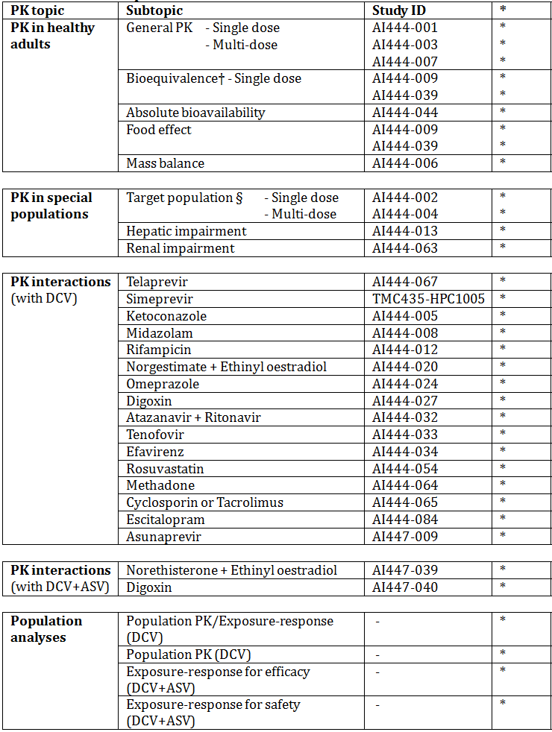
* Indicates the primary aim of the study.
† Bioequivalence of different formulations.
§ Subjects who would be eligible to receive the drug if approved for the proposed indication.
None of these PK studies had deficiencies that excluded their results from consideration. The submission included one other early phase study, which is not reviewed in this report. The study (AI447 - 003) examined the PK of ASV after multiple doses in healthy subjects and has been reviewed in the evaluation report for this medicine.

Summary of pharmacokinetics
The information in the following summary is derived from conventional PK studies unless otherwise stated.

Physicochemical characteristics of the active substance
The following information is derived from the Sponsor’s summaries in Module 2. The drug is formulated as daclatasvir dihydrochloride. It has a molecular weight of 811.80 as the dihydrochloride and 738.88 as the free base. It is a weak base with Pka values of 5.6 and 4.9 for two imidazole groups, and solubility decreases with higher pH. It is a chiral molecule but the product is manufactured as a single enantiomer.

Pharmacokinetics in healthy subjects

Absorption
Absorption of DCV was rapid with maximum concentrations being reached within 1 - 2 hours. After multiple dosing with the proposed regimen of 60 mg OD in healthy subjects, Cmax was 1582 ng/mL, Cmin was 295.8 ng/mL and AUC was 15,666 ng.h/mL. DCV is a substrate for the efflux transporter P-glycoprotein (P-gp). There were no clinical data examining site or mechanism of absorption.

Bioavailability

Absolute bioavailability
Absolute bioavailability was measured at 67%.

Bioequivalence of clinical trial and market formulations
The formulations used in phase II and phase III studies were demonstrated to be bioequivance. The formulation proposed for marketing is identical to the formulation used in the phase III studies.

Influence of food
With the formulation proposed for marketing, co-administration with a high fat meal resulted in a reduction in DCV AUC of approximately 23%, and a reduction in DCV Cmax of approximately 28%. A low fat meal had no significant effect on DCV bioavailability.
Evaluator’s Comment: The sponsor is proposing that DCV can be administered with or without food. Modelling of the relationship between dose and viral loads suggested that doses as low as 20 mg OD would not be associated with any reduction in efficacy. A 23% reduction in AUC is therefore unlikely to result in loss of efficacy. However, the dosage instructions in the PI with respect to co-administration with food should reflect the dosage instructions given to patients in the pivotal efficacy studies.

Dose proportionality
In healthy subjects treated with repeated doses of DCV in the range of 1 – 60 mg daily, increases in Cmax and AUC were proportionally somewhat greater than the increases in dose.
Evaluator’s Comment: The sponsor is proposing a fixed dose of 60 mg OD, without subsequent titration. There are therefore unlikely to be any clinically significant consequences if DCV has non-linear PK.

Bioavailability during multiple-dosing
Repeated daily dosing with DCV 60 mg in healthy subjects resulted in modest accumulation, with the accumulation index for AUC being 1.365. A similar result was obtained with repeated daily doses of 100 mg in Japanese subjects. Steady state (as assessed by trough concentrations) was reached after 4 - 5 days.

Effect of administration timing
There were no clinical data examining the effect of altering time of administration.
Evaluator’s Comment: Instructions in the PI regarding timing of administration should reflect those given to patients in the pivotal studies.

Distribution

Volume of distribution
Following IV administration of [13C, 15N] DCV, volume of distribution at steady state was estimated to be 47.1 litres.

Plasma protein binding
Protein binding was measured at 1 and 4 hours after administration of DCV in otherwise healthy subjects with hepatic impairment and renal impairment. Mean plasma protein binding was > 99% at all time points.

Metabolism
As indicated above, the absolute bioavailability of DCV is 67%. However, only 5% of an orally administered dose is recovered unchanged in the urine. DCV is therefore cleared predominantly by non-renal mechanisms. According to the sponsor’s Summary of Clinical Pharmacology in Module 2, preclinical data indicate that he elimination of DCV involves multiple pathways including metabolic clearance, biliary clearance, and direct intestinal secretion.
In a mass balance study using radiolabelled [14C] DCV, unchanged DCV accounted for 95% of total radioactivity in plasma, suggesting that metabolism is not a major mechanism for the clearance of the drug.

Sites of metabolism and mechanisms / enzyme systems involved
Preclinical data suggested that CYP3A4 was the major enzyme responsible for any metabolism of DCV. In clinical interaction studies, co-administration of DCV with agents that inhibited CYP3A4 resulted in increased DCV systemic exposure - e.g. ketoconazole, ritonavir, simeprevir, telaprevir and cyclosporin.
Co-administration of DCV with agents that induce CYP3A4 resulted in decreased DCV systemic exposure - e.g. rifampicin and efavirenz.

Clearance
Following IV administration of [13C, 15N] DCV, total clearance was estimated to be 4.24 L/hr (70.1 mLs/min).

Half-life
In healthy subjects receiving DCV 1-60 mg daily, half-life after 14 days was 12.7 – 14.9 hours.

Metabolites identified in humans
According to the sponsor’s Summary of Clinical Pharmacology, following administration of a dose of radiolabelled [14C] DCV, 58.9% of the dose was recovered as unchanged drug and 30.1% as metabolites. Preclinical data indicated that 8 metabolites were formed in humans. The only metabolite found in plasma was BMS-805215, which accounted for up to 2% of plasma radioactivity. This metabolite was found to be > 100-fold less potent than DCV. In a clinical study, BMS-805215 had a mean half-life of 6.40 hours and a median Tmax of 1.0 hour.

Excretion

Routes and mechanisms of excretion
Following oral administration of radiolabelled DCV, drug-related material was mainly excreted in faeces (87.7%) with a small amount (6.61%) in urine. There were no clinical data relating to mechanisms of excretion.

Renal clearance
Only 5% of an orally administered dose is recovered unchanged in the urine.

Intra- and inter-individual variability of pharmacokinetics
The sponsor considered intra-subject variability to be low based on Cmax and AUC values in healthy subjects receiving repeated single doses in bioequivalence studies. Inter-subject variability was assessed as moderate among healthy volunteers, with CV values for AUC and Cmax being < 40%. Inter-subject variability was higher among HCV-infected subjects.

Pharmacokinetics in the target population
The PK of DCV in subjects with HCV infection were consistent with the PK observed in healthy subjects, as evidenced by the following:
- After multiple dosing with the proposed regimen of 60 mg OD in subjects with HCV infection, Cmax was 1726 ng/mL, Cmin was 254 ng/mL and AUC was 15,121 ng.h/mL. Median Tmax was 1 - 2 hours.
- In HCV subjects treated with repeated doses of DCV in the range of 1 – 100 mg daily, increases in Cmax and AUC were proportionally greater than the increases in dose, and clearance values generally decreased with increasing dose.
- Repeated daily dosing with DCV 60 mg in subjects with HCV infection resulted in modest accumulation, with an accumulation index of 1.414 for AUC and 1.225 for Cmax.
- Protein binding was measured pre-dose and at 2 hours post-dose in subjects with HCV infection receiving repeated doses of DCV. Mean plasma protein binding was >99% at both time points.
- In HCV patients receiving DCV 1 - 100 mg daily, half-life after 14 days was 11.7 – 15.2 hours.

Pharmacokinetics in other special populations

Pharmacokinetics in subjects with impaired hepatic function
Systemic exposure to DCV was not increased in subjects with hepatic impairment (Child-Pugh stages A, B or C). In the draft PI, no dosage reduction is being proposed for subjects with hepatic impairment.

Pharmacokinetics in subjects with impaired renal function
Systemic exposure to DCV was increased in subjects with renal impairment. In subjects with moderate (eGFR 30 - 59 mL/min/1.73m2) or severe (eGFR 15 - 29 mL/min/1.73m2) renal impairment, AUC was increased approximately 2-fold. Systemic exposure was only increased by 35% in subjects with end stage renal disease who were receiving dialysis. The effect of mild renal impairment was not examined in this study. However, the population PK analysis indicated that a subject with a baseline CrCl of 64 mL/min would have an AUC only 6% higher than a subject with a baseline CrCl of 100 mL/min.
Evaluator’s Comment: Renal clearance is a minor route of elimination for DCV. The increased systemic exposure in subjects with moderate and severe renal impairment may represent alterations in the activity of transporter proteins and metabolising enzymes caused by toxins that accumulate in renal failure (11). The sponsor is not proposing a dose reduction for subjects with moderate or severe renal impairment. The sponsor argues that DCV has been administered in single doses of up to 200 mg and multiple doses (14 days) of up to 100 mg daily without any safety concerns being raised. In the early phase clinical studies, these doses were used in very small numbers of subjects (n = 12 for 200 mg single doses and n = 10 for 100 mg repeat doses). It therefore cannot be reasonably concluded that the safety of doses higher than 60 mg OD has been established. Unless safety data for higher doses are available from later phase studies, it may be prudent to recommend a dosage reduction (e.g. to 30 mg OD) for subjects with moderate or severe renal impairment. As suggested by the sponsor’s modelling of the relationship between dose and viral loads, a dosage reduction of this magnitude is unlikely to be associated with any reduction in efficacy.

Pharmacokinetics according to age
No dedicated studies examining the effect of age on DCV PK were conducted. In 2 population PK analyses, age was not found to be a significant factor affecting DCV PK.

Pharmacokinetics related to gender
No dedicated studies examining the effect of gender on DCV PK were conducted. In a population PK analysis, gender was found to be a significant factor affecting DCV PK, with females having an approximate increase of 30% in AUC compared to males. This effect was considered unlikely to be clinically significant.

Pharmacokinetics according to race
In a population PK analysis, race was found to be a significant factor affecting DCV PK. However, the effects were small and unlikely to be clinically significant.

Pharmacokinetic interactions

Pharmacokinetic interactions demonstrated in human studies

Effect of other drugs on PK of DCV
CYP3A4 and P-gp inhibitors: Preclinical data suggested that DCV is a substrate for both CYP3A4 and the drug efflux pump P-glycoprotein (P-gp). The early phase clinical studies supported these findings with co-administration of drugs that inhibit CYP3A4 and P-gp generally causing increases in DCV AUC and Cmax.
Evaluator’s Comment: Ketoconazole caused a 3-fold increase in DCV AUC. Ritonavir/atazanavir caused a 2 fold increase in DCV AUC. For both, the draft PI recommends a reduction in DCV dose to 30 mg OD. TVR and SMV also caused an approximate 2-fold increase in DCV AUC, however the PI does not recommend reduction in DCV dose when co-administered with these agents. As the safety of a 2-fold increase in DCV AUC has not been established, a DCV dose reduction to 30 mg OD should be recommended for co-administration with these agents.
CYP3A4 and P-gp inducers: Rifampicin, a strong CYP3A4 and P-gp inducer, caused a marked (79%) reduction in DCV AUC. The draft PI states that DCV is contraindicated in subjects receiving strong inducers of CYP3A4. Efavirenz, a moderate inducer of CYP3A4, caused a modest (32%) reduction in DCV AUC. The draft PI recommends that DCV dose should be increased to 90 mg OD when co-administered with moderate inducers of CYP3A4.
Drugs affecting gastric pH: The solubility of DCV decreases with increasing pH. Consistent with this finding, co-administration of DCV with omeprazole or famotidine resulted in small decreases in DCV AUC. No adjustment to DCV dosage would be required.
HCV antiviral agents: It is proposed that DCV be administered in combination with ASV, SOF or pegIFNα/RBV. ASV caused a minor increase in DCV AUC. The effect of SOF or pegIFNα/RBV was not examined in the early phase clinical studies. The Summary of Clinical Pharmacology indicates that data regarding these potential interactions were generated in later phase studies.

Effect of DCV on PK of other drugs
CYP3A4 substrates: Preclinical data suggested that DCV is a weak inhibitor and inducer of CYP3A4. Clinical studies indicated that DCV had no significant effect on the PK of various CYP3A4 substrates, including midazolam.
Pg-p substrates: Preclinical data suggested that DCV inhibited P-gp. This was confirmed in a clinical study where DCV increased digoxin AUC by 27%. The draft PI recommends monitoring of serum digoxin concentrations when co-prescribed with DCV. A 44% increase in the AUC of SMV (a P-gp and CYP3A4 substrate) was also observed.
Efflux transporters: Preclinical data suggested that DCV inhibited OAT1B1, OAT1B3 and BCRP. This was confirmed in a clinical study where DCV increased rosuvastatin AUC by 27%.
HCV antiviral agents: The effect of DCV of the PK of ASV was not clearly established. However, this is not considered a deficiency as ASV is only recommended for use in combination with DCV. The effect of DCV on the PK of SOF or pegIFNα/RBV was not examined in the early phase clinical studies.

Effect of DCV+ASV combination on PK of other drugs
2 early phase clinical studies examined the effect of the combination of DCV and ASV on the PK of other drugs. The effects of the combination were similar to those observed for DCV alone, with no effect on the CYP3A4 substrates ethinyl oestradiol and norethisterone, and a 29% increase in the AUC of digoxin, a P-gp substrate.

Evaluator’s overall conclusions on pharmacokinetics
The early phase clinical studies have provided sufficient data to adequately describe the PK of DCV. The requirements outlined in the relevant EMA guidelines adopted by the TGA have generally been met. In particular, an extensive program of interaction studies has been conducted, as required by the guideline on DAAs for HCV infection.

Pharmacodynamics

Studies providing pharmacodynamic data
Table 3 shows the studies relating to each PD topic and the location of each study summary.

Table 3: Submitted pharmacodynamic studies.
PD Topic | Subtopic | Study ID | *
Primary Pharmacology | Effect on HCV viral load | AI444 - 002 | *
Primary Pharmacology |  | AI444 - 004 | *
Secondary Pharmacology | Effect on QT interval | AI444 - 023 | *
* Indicates the primary aim of the study.
None of the PD studies had deficiencies that excluded their results from consideration.

Summary of pharmacodynamics
The information in the following summary is derived from conventional PD studies in humans unless otherwise stated.

Pharmacodynamic effects

Primary pharmacodynamic effects
In 2 early phase clinical studies in subjects with chronic HCV infection treatment with DCV monotherapy resulted in significant reductions in HCV RNA loads. With repeated dosing, the effect was no longer significant by 14 days, suggesting that resistance develops early if DCV is used as monotherapy.

Secondary pharmacodynamic effects
DCV had no significant effect on QT interval or other ECG parameters.

Evaluator’s overall conclusions on pharmacodynamics
The PD data provided were acceptable.

Dosage selection for the pivotal studies

Introduction
The recommended therapeutic dose of 60 mg QD for DCV is based mainly on the antiviral activity of DCV when coadministered with pegIFNα/RBV. Results of the clinical pharmacology and Phase II studies were considered prior to selecting the Phase III dose and proposed therapeutic dose. No safety issues had arisen with this dose. Modelling of the relationship between dose and viral loads suggested that efficacy would be similar with doses between 20 and 60 mg (Study AI444 - 007). The sponsor stated “the 60 mg dose was expected to compensate for potential factors that can reduce exposure, such as food, pH modifiers, poor compliance and weak CYP3A4 inducers, thus circumventing the need for dose adjustment”.
The phase I study (AI444004) was a double-blind, placebo-controlled, sequential panel, multiple ascending dose (MAD) study. A number of daily doses of DCV (1mg, 10mg, 30mg, 60mg , and 100mg daily) were evaluated in HCV genotype 1 infected subjects. The primary endpoint for antiviral activity was to be the decrease of HCV RNA level from baseline to Day 7. The results showed that the mean HCV RNA level decreases exceeded 1.5 log10 IU/mL after 7 days of oral administration of 1 - 100 mg DCV in subjects infected with HCV, however, this drug effect was not sustained for the entire 14 days of dosing. Many subjects experienced viral rebound on or before Day 7 of dosing. Maximum decline in log10 HCV RNA generally increased with increasing dose up to 60 mg QD in subjects infected with HCV genotype 1a.There did not appear to be a difference in individual subjects’ maximum decline between doses of 60 mg QD, 100 mg QD and 30 mg BID.
In study AI444 – 002, the effect of a single oral dose of 1, 10, 100, and a fourth dose of ≤ 200 mg of DCV on HCV RNA was assessed. The mean maximum decline from baseline in log10 HCV RNA levels (mean time to reach the maximum decline) for 10, 50, 200 and 600 mg are 0.28 (26.00 hr), 0.64 (21.60 hr), 2.26 (21.60 hr) and 2.87 (28.00 hr), respectively. The mean maximum decline increased with increases in dose and exposure. No obvious trend was found between genotype and exposures, and between the hours after dose when maximum decline achieved in HCV RNA and exposures. Due to the small sample size, the sponsor considered that the finding is not conclusive.

Study AI444014
This was a Phase IIa Study of BMS-790052 in Combination with pegIFNα/RBV in Treatment Naïve Subjects with Chronic Hepatitis C (CHC) Genotype (GT) 1 Infection. It was the first study to assess the long-term safety and efficacy of DCV in HCV-infected subjects. It was a randomised double blind, placebo controlled, multicentre study conducted at 14 sites in France and the USA from June 2009 to June 2011.

Objectives
Primary: Safety; antiviral activity as determined by the proportion of subjects with extended rapid virologic response (eRVR) at Week 4 and 12
Secondary: Proportion of subjects with RVR at Weeks 4 and 12; proportion of subjects with EVR at Week 12; proportion of subjects with sustained virologic response (SVR) at Week 12 and 24; resistant variants associated with clinical failure
Exploratory: Relationship between measures of safety or antiviral activity and exposure to BMS-790052 when co-administered with pegIFNα/RBV; the PK of BMS-790052, RBV, and PegIFNα

Study population
Adult men and women 18 to 70 years of age, with chronic HCV genotype 1 infection who had < 4 weeks of total therapy with IFN, pegIFNα, or RBV at any time, and none in the 24 weeks prior to randomisation, and no evidence of HIV or HBV co-infection and, no evidence of advanced liver disease.

Study treatments
Patients were randomised (1:1:1:1) to receive placebo once daily (QD) plus pegIFNα/RBV or DCV 3 mg, 10 mg, or 60 mg QD plus pegIFNα/RBV. Randomisation was stratified by HCV subtype determined at screening (genotype 1a or 1b).
These were taken as follows:
- pegIFNα: 180 μg pegIFNα injection self-administered subcutaneously (SC) once weekly
- RBV: Subjects took either 400 mg (2 tablets for subjects < 75 kg) or 600 mg (3 tablets for subjects > 75 kg) in the morning with food and 600 mg (3 tablets) in the evening with food
- DCV/placebo: DCV/placebo tablets were taken once daily, with a light meal

Statistical methods
The eRVR rate for pegIFNα/RBV was expected to be at most 15%. A target sample size of 12 subjects per treatment regimen provided the following 80% exact binomial confidence intervals (CIs) for observed eRVR rates: eRVR observed rate of 92% (11 of 12) 80% CI: 71, 99 to eRVR observed rate of 8% (1 of 12) 80% CI: 1%, - 29). The analysis sets and statistical methods were similar to other studies.
3 interim analyses were planned:
- An analysis of early safety and antiviral activity by coded treatment regimen after all subjects reached Week 4
- An unblinded analysis of safety and antiviral activity to support Phase IIb study design and dose selection decisions after all subjects reached Week 12, the primary endpoint of the study
- An unblinded analysis of safety and antiviral activity after all subjects had completed 12 weeks of follow-up. A final analysis occurred after all subjects completed 24 weeks of follow-up.

PK sampling and analysis:
Intensive PK sampling for DCV levels was done in all subjects on Day 1 and Week 12. Sampling on Day 1 occurred pre-dose and 1, 2, 4, and 6 hours post dose. Sampling at the Week 12 visit occurred at pre-dose and 1, 2, 4, 8, 12, and 24 hours post-dose. The pre-dose sample was used as the 12-hour or 24-hour sample if either of these were not available. DCV trough samples were collected pre-dose on Weeks 4, 8, 12 and at Weeks 16, and 24. Intensive PK sampling for RBV was performed at the Week 12 visit at pre-dose and 1, 2, 4, 8, and 12 hours post-dose. PegIFNα samples were collected pre-dose on Weeks 12 and 24. Plasma concentrations of DCV were measured using a validated assay using a liquid chromatography tandem mass spectrometry (LC MS/MS) method and for pegIFNα in human serum samples by electrochemiluminescence (ECL) validated assay. The range of the assays was: DCV 0.500 to 500 ng/mL; Ribavirin 5.00 to 5000 ng/mL and PegIFNα 0.0313 to 2.00 ng/mL.

Participant flow
This is shown in Table 4.

Table 4: Study AI444014: subject disposition – treated subjects
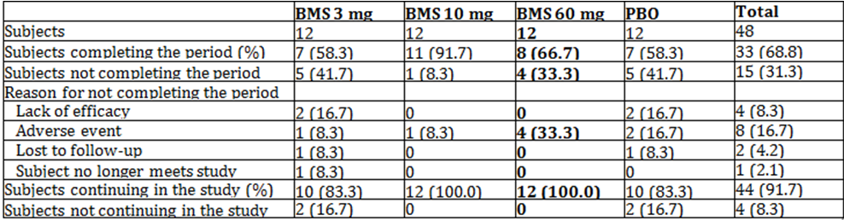
* Highlighted column indicates the dose regimen requested in the application

Baseline data
The majority of subjects were male (66.7%) and 89.6% were < 65 years. Most subjects were white (72.9%). Subjects in the placebo group were slightly younger than those in the DCV dose groups with a mean age of 48.0 as compared with 52.0, 53.2 and 52.0 years in the 3 mg, 10 mg and 60 mg dose groups respectively.

Table 5: Study AI444014: Baseline disease characteristics – treated subjects
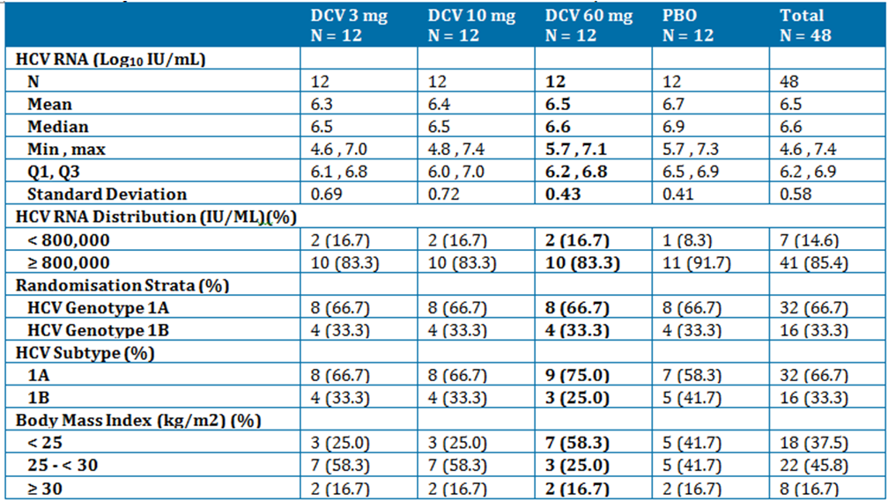
* Highlighted column indicates the dose regimen requested in the application

Results for the primary efficacy outcome
Based on modified intent-to-treat (mITT) analyses, the extended rapid virologic response (eRVR: undetectable HCV RNA at Weeks 4 and 12) rates of 42% (5/12), 83% (10/12) and 75% (9/12) were achieved for the 3, 10 and 60 mg DCV groups compared with 8% (1/12) for placebo.

Table 6: Study AI444014: Results of primary efficacy outcome – modified ITT population
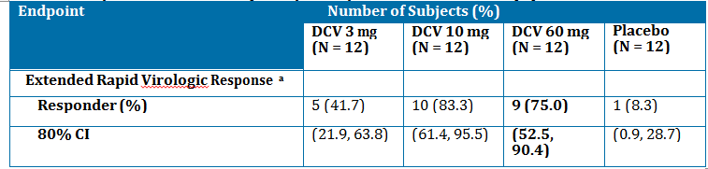a Undetectable HCV RNA at both Weeks 4 and 12.

Results for other efficacy outcomes
Table 7 shows these results.

Table 7: Study AI444014: Results of other efficacy outcomes – modified ITT population
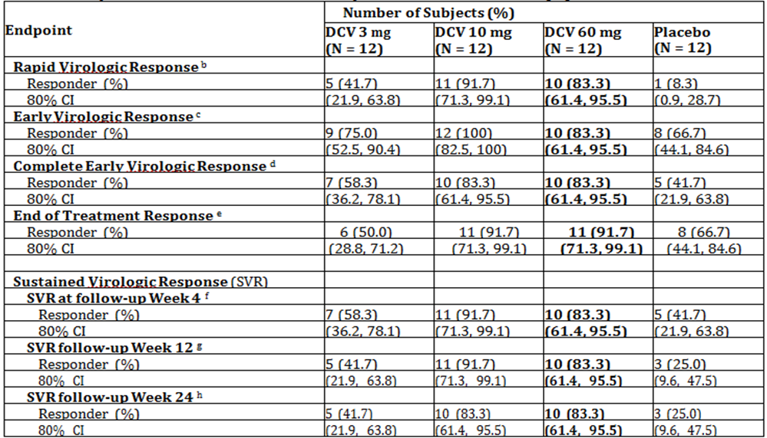
b. Undetectable HCV RNA at Week 4.
c. Defined as ≥ 2 log10 decrease in HCV RNA from baseline at Week 12 or HCV RNA < 10 IU/mL for subjects with baseline HCV RNA < 1000 IU/mL.
d. Undetectable HCV RNA at Week 12.
e. Undetectable HCV RNA at the end of treatment.
f. Undetectable HCV RNA at follow-up Week 4.
g. Undetectable HCV RNA at follow-up Week 12.
h. Undetectable HCV RNA at follow-up Week 24.

Concordance between SVR12 and SVR24
Concordance was evaluated for subjects who had HCV RNA values at both follow-up Weeks 12 and 24, with SVR based on the criteria HCV RNA < LLOQ, TD or TND. There was 100% concordance between SVR12 and SVR24 in all treatment groups except for the 10 mg/pegIFNα/RBV group (91.7%).
Figure 1: Study AI444014: Mean HCV RNA change from baseline through Week 48 – Treated subjects
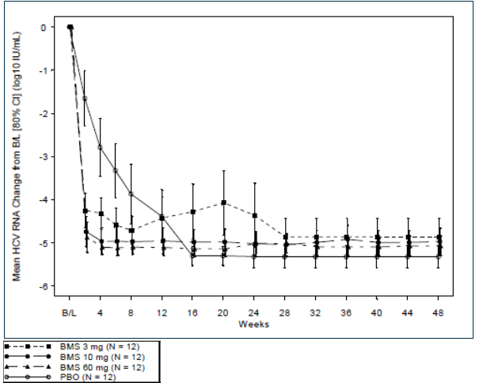

Resistance
A total of 11 subjects treated with DCV met protocol-defined criteria of treatment failure: 3 viral breakthroughs, 1 with detectable HCV RNA at Week 12 and ≥ LOQ at Week 24, 3 with detectable HCV RNA at the EOT, and 4 subjects with relapse post-treatment. Of these subjects, 4 had pre-existing polymorphisms at sites shown to be associated with resistance and did not achieve SVR24.

PK results
DCV Cmax, AUC(0 - 24), and C24 were similar to exposure observed in previous monotherapy studies conducted in HCV-infected subjects. When DCV 3 mg, 10 mg, and 60 mg were coadministered with pegIFNα and RBV, the adjusted geometric mean ratio for RBV Cmax were 0.824, 1.018, and 0.939, respectively; the adjusted geometric mean ratio for AUC(0 - 12) were 0.736, 0.973, and 0.942, respectively. The geometric means of the pegIFNα trough concentrations at Weeks 12 and 24 when co-administered with DCV 3 mg, 10 mg, and 60 mg are similar to the geometric means observed in the placebo group. The geometric means at Weeks 12 and 24 ranged from 12.1 to 15.3 ng/mL and 13.2 to 17.0 ng/mL in the BMS groups compared to 13.5 to 15.3 ng/mL, respectively, in the placebo group
Evaluator’s comments: The study design, conduct and analysis were satisfactory. This study demonstrated that although the 10- and 60-mg dose groups had similar efficacy, exposures in the 10-mg group overlapped with exposures in the sub-therapeutic 3-mg group, suggesting that subjects receiving the 10-mg dose could have exposures resulting in a sub-therapeutic response. The safety results are presented in section and did not show and meaningful relationships between exposure and safety events were identified.

Discussion and conclusion
Based on the data from AI444014, DCV 60 mg QD was selected as the highest dose for the subsequent study in treatment-naïve HCV-infected subjects (AI444010: page 214). In addition, DCV 20 mg QD was also selected to minimise exposure overlap with DCV 60 mg, which provided an acceptable alternative should dose-related toxicity be observed with the higher dose. The overall SVR24 rates were 37.5%, 59.2%, and 59.6% for subjects treated with placebo/pegIFNα-2a/RBV, 20 mg DCV/pegIFNα-2a/RBV, and 60 mg DCV pegIFNα-2a/RBV, respectively. In addition, the safety profile was similar in all 3 treatment groups suggesting that at doses of 20 mg and 60 mg QD, DCV demonstrates a flat exposure-response and exposure-safety profile.
To supplement the empirical data, multiple analyses were conducted including a PPK analysis, an exposure-response analysis, and a pharmacokinetic viral kinetic analysis (PKVC) to select the dose for Phase III studies of DCV combined with pegIFNα-2a/RBV and DCV combined with asunaprevir (ASV). The exposure-response analysis evaluated the relationship between model-predicted exposures of DCV and antiviral response endpoints using data generated from 4 studies in HCV-infected subjects: AI444010, AI444002, AI444004, AI444014.
In general, the goal of the analysis was to determine a DCV dose that would maximise efficacy in HCV GT-1 infected subjects while minimising exposure-related adverse events. In GT-1 naïve subjects, exposure-response and PKVK modelling predicted that the 20-mg dose was expected to have comparable efficacy to the 60-mg dose. A flat dose-response in both GT-1 naïve subjects and in a difficult-to-treat high baseline viral load, GT-1a population was expected for doses of 20 mg and above.
No unique safety signals and no exposure-response relationships were identified across the 20 mg to 60 mg QD DCV dose groups. In order to evaluate the exposure-response relationship in difficult-to-treat patients, a full logistic regression analysis of antiviral response as a function of DCV exposures (using Cavgss) was conducted. This model accounted for factors like virus GT, baseline viral load, cirrhosis status, and host GT, and was used to predict antiviral efficacy for a group of subjects with specific combination of patient-specific factors that are historically considered more difficult to treat: GT-1a viral infection, high baseline viral load, cirrhosis and non-CC host GT. The model predicted that the DCV 60 mg QD dose may result in an increase of 2% to 5% in efficacy relative to the 20-mg dose.
Based on the results of the integrated analysis, a 60 mg QD dose of DCV was selected for further development in Phase III studies. This dose was expected to provide simplicity of therapeutic use and allow maximal antiviral response with DCV/ASV, DCV/SOF, DCV QUAD, and DCV/pegIFN/RBV combinations while maintaining an acceptable safety profile. The 60-mg QD dose was also expected to compensate for factors that can reduce DCV exposure, such as food, pH modifiers, poor compliance, and CYP3A4 inducers.

Clinical efficacy
The efficacy analysis is presented as follows:
- DCV in combination with ASV: studies AI447028, AI447026, AI447017, AI447011, AI444046.
- DCV in combination with SOF: studies AI444040, AI444046.
- DCV in combination with ASV plus pegIFNα/RBV (QUAD): studies AI447029, AI447011, AI444046.
- DCV in combination with pegIFN/RBV: this comprises tables showing efficacy for studies which are summarised as they do not include proposed treatment regimens.
- Analyses performed across trials (pooled analyses and meta-analyses) for DCV + ASV, DCV + SOF and QUAD.
Study AI444046 includes patients from 9 of the efficacy studies for all indications. Summary results are provided in the body of the evaluation report.
HCV RNA Assay: HCV RNA levels in plasma were measured in all subjects at baseline before and during treatment to assess antiviral response, and after treatment to assess the efficacy of the treatment. The COBAS TaqMan HCV Test, v2.0 For Use with the High Pure System was used in all studies and chosen as the assay for quantitation of HCV RNA due to its wide dynamic range, low limit of quantitation/detection of HCV RNA and its accepted use within the HCV community. It is an in vitro nucleic acid amplification test for the quantitation of HCV RNA in human plasma or serum of HCV-infected individuals using the High Pure System Viral Nucleic Acid Kit for manual specimen preparation and the COBAS TaqMan 48 Analyzer for automated amplification and detection. Specimens containing HCV GT-1 through 6 have been validated for quantitation in the assay. Central laboratories were used to perform the analyses of HCV RNA in all the studies.
It is noted that the LLOQ differed slightly in the studies.
- 15 IU/mL was used for Studies AI447026, AI447017, AI444021, and AI444022
- 25 IU/mL was used for Studies AI447028, AI447029, AI444040, AI447011, AI444031, AI444010, AI444014, and AI444011.
HCV Genotype Subtype Assay: The VERSANT HCV Genotype 2.0 Assay (LiPA) is a line probe assay designed to identify HCV GT-1 to 6 in human serum or EDTA plasma samples. Subtype information was available in the majority of cases. LiPA was chosen as the assay to be used for determination of HCV genotype/subtype due to its ability to identify HCV GT-1 through 6, subtypes -1a and -1b and its accepted use within the HCV community.
Efficacy endpoints: There were slight differences in the efficacy endpoints used in the efficacy trials. The following tables are taken from the Summary of Clinical Efficacy as a summary of these differences.

Table 8: Summary of efficacy endpoints
Endpoints | Definition
SVR12 | Proportion of subjects with HCV RNA < LLOQ, TD or TND at follow-up Week 12.  Subjects with missing follow-up Week 12 HCV RNA data had their response imputed using the first available HCV RNA measurement after the follow-up Week 12 visit.
SVR12 (protocol) | Proportion of subjects with HCV RNA < LLOQ, TD or TND at follow-up Week 12  (for AI447028, AI447026, AI447029, AI444040) or  Proportion of subjects with HCV RNA < LLOQ, TND  (for AI447011, AI447017, AI444014, AI444010, AI444021, AI444022, AI444031, AI444011)  No imputation for missing values.
SVR24 | Proportion of subjects with HCV RNA < LLOQ, TD or TND at follow-up Week 24.  No imputation for missing values.
SVR4 | Proportion of subjects with HCV RNA < LLOQ, TD or TND at follow-up Week 4.  No imputation for missing values.
VBT | Any confirmed > 1 log10 on treatment increase in HCV RNA over nadir, or any confirmed HCV RNA ≥ LLOQ if previously declined to HCV RNA < LLOQ, TD or TND during treatment.
IVR | Subjects who did not meet the VBT criteria, but met the protocol defined futility stopping criteria for insufficient response while on treatment (see Table below).
Relapse | HCV RNA < LLOQ, TND at EOT followed by confirmed HCV RNA ≥ LOQ during follow-up. Confirmation is defined as 2 consecutive measurements showing HCV RNA ≥ LOQ or the last available measurement ≥ LOQ.
RVR | Proportion of subjects with HCV RNA < LLOQ, TND at Week 4
cEVR | Proportion of subjects with HCV RNA < LLOQ, TND at Week 12
eRVR | Proportion of subjects with HCV RNA < LLOQ, TND at both Weeks 4 and 12
EOTR | Proportion of subjects with HCV RNA < LLOQ, TND at EOT
PDR | HCV RNA < LLOQ, TD or TND at Week 4 and HCV RNA < LLOQ, TND at Week 10.  For AI444010 and AI444031  HCV RNA < LLOQ, TD or TND at Week 4 and HCV RNA < LLOQ, TND at Week 12  For AI444011, AI444021, and AI444022
cEVR - complete early viral response, EOT - end of treatment, EOTR - end of treatment response, eRVR – extended rapid virologic response, HCV - hepatitis C virus, IVR - insufficient virologic response, LLOQ (15 IU/mL was used for AI447026, AI447017, AI444021, and AI444022; 25 IU/mL was used for AI444040, AI444031, AI447011, AI444010, AI444014, AI444011, AI447028, and AI447029) - lower limit of quantitation, PDR - protocol-defined response, RNA - ribonucleic acid, RVR - rapid virologic response, SVR4, 12, 24 - sustained virologic response at follow-up Weeks 4, 12, and 24, respectively, TD - target detected, TND - target not detected, VBT – virologic breakthrough

Table 9: Protocol-defined criteria for on-treatment virologic failure: virologic breakthrough and treatment futility
Protocol | Criteria
AI447028 | Any confirmed > 1 log₁₀ increase in HCV RNA from nadir  Any confirmed HCV RNA ≥ LOQ after confirmed undetectable HCV RNA while on treatment  Any confirmed HCV RNA ≥ LOQ at Week 8.
AI447026 | Any increase in viral load > 1 log₁₀ from nadir (no confirmation needed) Any confirmed detectable HCV RNA (≥ 15 IU/mL) on or after Week 8  Null response; < 1 log₁₀ decrease in HCV RNA from baseline at Week 4 of treatment
AI447011 | Treatment Group A Sentinel Cohort  Any increase in HCV viral load ≥ 1 log from nadir (not necessarily from a consecutive sampling) Any quantifiable HCV RNA ≥ 25 IU/mL on or after Week 4  Any detectable HCV RNA < 25 IU/mL on or after week 4 confirmed by a subsequent consecutive HCV RNA measurement  Expansion Cohorts A1, A2 and B3  Any increase in viral load ≥ 1 log from nadir  Any confirmed detectable HCV RNA < 25 IU/mL on or after Week 8. Confirmation should occur via an immediate unscheduled return visit  Any quantifiable HCV RNA ≥ 25 IU/mL on or after Week 8 (no confirmation needed)  Expansion Cohorts B1 and B2  Any increase in HCV viral load ≥ 1 log from nadir (not necessarily from a consecutive sampling) Any confirmed quantifiable HCV RNA ≥ 25 IU/mL after confirmed undetectable HCV RNA.
AI447017 | Week 4 futility: HCV RNA ≥ LLOQ (limit of quantification) at Week 4  VBT: confirmed >1 log₁₀ increase in HCV RNA over nadir or confirmed HCV RNA ≥ LOQ after confirmed undetectable HCV RNA
AI444040 | Original Protocol Definition of VBT  Any increase in HCV viral load ≥ 1 log from nadir (not necessarily from a consecutive sampling) Any confirmed HCV RNA, < LLOQ, TD on or after Week 8 (i.e., 2 consecutive results of HCV RNA, < LLOQ, TD)  Any HCV RNA ≥ LLOQ on or after Week 8 (no confirmation needed)  Protocol Amendment 03/05 Definition of VBT  Any confirmed increase in viral load ≥ 1 log from nadir (included in Protocol Amendment 03, but the word confirmed was added in Protocol Amendment 05)  Any confirmed HCV RNA ≥ 25 IU/mL (e.g., HCV RNA > LOQ) on or after Week 8 (included in Protocol Amendment 03)
AI447029 | Treatment Futility: Any confirmed HCV RNA ≥ LOQ at Week 8.  VBT: Any confirmed > 1 log₁₀ increase in HCV RNA over nadir or confirmed HCV RNA ≥ LOQ after confirmed undetectable HCV RNA while on treatment.
AI444010  AI444011  AI444021  AI444022  AI444031 | VBT: confirmed > 1 log₁₀ increase in HCV RNA over nadir or confirmed HCV RNA ≥ LOQ after confirmed undetectable HCV RNA while on treatment.  < 1 log₁₀ decrease in HCV RNA from baseline at Week 4 of treatment  Failure to achieve EVR, defined as < 2 log₁₀ decrease in HCV RNA from baseline and HCV RNA ≥ LOQ at Week 12 of treatment  Detectable HCV RNA at EOT (including early discontinuation)  Detectable HCV RNA at Week 12 and HCV RNA ≥ LOQ (AI444011, AI444021, AI444022) or > 50 IU/mL (AI444010) at Week 24 of treatment
AI444014 | Failure to achieve EVR, defined as ≤ 2 log10 decrease in HCV RNA from baseline at Week 12 (or HCV RNA > 10 IU/mL for subjects with baseline HCV RNA < 1000 IU/mL)  VBT: Any confirmed detectable HCV RNA on treatment after undetectable HCV RNA on treatment  Detectable HCV RNA at EOT after Week 12
EOT - end of treatment, EVR - early virologic response, HCV - hepatitis C virus, LOQ/LLOQ (15 IU/mL was used for AI447026, AI447017, AI444021, and AI444022; 25 IU/mL was used for AI444040, AI444031, AI447011, AI444010, AI444014, AI444011, AI447028, and AI447029) - lower limit of quantitation, pegIFNα/RBV - peginterferon alfa plus ribavirin, RNA - ribonucleic acid, TD - target detected, VBT - virologic breakthrough

Treatment of Hepatitis C infection – Daclatasvir in combination with ASV

Study AI447028: Pivotal

Study design, objectives, locations and dates
This was a Phase III Study with ASV and DCV (DUAL) for Null or Partial Responders to pegIFNα/RBV, Intolerant or Ineligible to pegIFNα/RBV Subjects and Treatment-Naïve Subjects with Chronic HCV GT 1b Infection. It was a randomised, parallel group study conducted at 116 sites in 18 countries (USA, Canada, Australia [12 sites], New Zealand, UK, Ireland, Netherlands, France, Germany, Poland, Spain, Italy, Austria, Russia, Israel, Korea, Taiwan and Argentina) from May 2012 to October 2013.
Figure 2: Study AI447028: Study Design
ASV = asunaprevir; DCV = daclatasvir; P/R = peginterferon/ribavirin; PBO = placebo

Primary objectives
- For the prior null or partial responders to pegIFNα/RBV cohort: To estimate efficacy, as determined by the proportion of subjects with SVR12, defined as HCV ribonucleic acid (RNA) < limit of quantitation (LOQ) at post-treatment Week 12
- For the treatment naïve cohort: To determine whether the SVR12 rate in subjects treated with DCV/ASV therapy is similar to the historical SVR rate for TVR in combination with pegIFNα/RBV in previously untreated, GT-1b, HCV patients

Secondary objectives
- To estimate efficacy, as determined by the proportion of subjects with SVR12, defined as HCV RNA < LOQ at post-treatment Week 12 for subjects who are intolerant or ineligible to pegIFNα/RBV
- To assess safety, as measured by the frequency of SAEs and discontinuations due to AEs and the rate of anaemia and rash
- To estimate the differences in rates of selected Grade 3/4 laboratory abnormalities (haematologic and liver function) during the first 12 weeks between treatments (DCV/ASV vs placebo) for naïve subjects
- To assess the relationship between efficacy and the rs12979860 single nucleotide polymorphisms (SNP) in the IL-28B gene
- To assess the efficacy as determined by HCV RNA undetectable at each of the following time points: Weeks 1, 2, 4, 6, 8, and 12; at both Weeks 4 and 12 (extended rapid virologic response, eRVR); end of treatment (EOT, up to 24 weeks), post-treatment Week 12 (SVR12) or post-treatment Week 24 (SVR24)
- HCV RNA < LOQ at each of the following time points: Weeks 1, 2, 4, 6, 8, and 12; at both Weeks 4 and 12 (eRVR); EOT (up to 24 weeks), post-treatment Week 24

Exploratory objectives:
- To describe ASV and DCV HCV drug resistant variants associated with virologic failure
- To explore the relationship between efficacy and pharmacogenomic biomarkers, such as SNPs in the IL-28B gene other than rs12979860 or ENT1 if deemed necessary
- To explore the relationship between safety and pharmacogenomic biomarkers, such as Human Leukocyte Antigen if deemed necessary
- To describe the relationship between efficacy and baseline levels of Interferon-gamma Inducible Protein-10 (IP-10)
- To describe PK of ASV and DCV

Inclusion and exclusion criteria

Inclusion criteria
Males and females at least 18 years of age, chronically infected with HCV-GT-1b, of 3 parallel populations:
- Null or partial responders to pegIFNα/RBV:
- Null responders were defined as subjects who never attained ≥ 2 log10 decline in HCV RNA level after at least 12 weeks of pegIFNα/RBV therapy, or never attained ≥ 1 log10 decline in HCV RNA level after at least 4 weeks of pegIFNα/RBV therapy
- Partial responders were defined as subjects who received at least 12 weeks of prior pegIFNα/RBV therapy and attained ≥ 2 log10 decline in HCV RNA, but never achieved undetectable HCV RNA; or subjects who became HCV RNA undetectable and subsequently had a detectable HCV RNA result during pegIFNα/RBV treatment
- Intolerant/ineligible to pegIFNα/RBV therapy, defined as meeting protocol-specified criteria for depression, anaemia, neutropenia, and/or compensated advanced fibrosis/cirrhosis (F3/F4) with thrombocytopenia
- Treatment-naïve (defined as no previous exposure to an IFN formulation, RBV, or HCV direct acting antiviral therapy).
Subjects with compensated cirrhosis were permitted (capped at approximately 25% of treated subjects, except in the subgroup of subjects with thrombocytopenia and advanced fibrosis/cirrhosis in which no cap existed). If a subject did not have a documented history of cirrhosis, a liver biopsy within three years prior to enrolment was required to demonstrate the absence of cirrhosis.

Key exclusion criteria
- Prior treatment with HCV DAA
- Evidence of a medical condition contributing to chronic liver disease other than HCV
- Evidence of decompensated liver disease including, but not limited to, a history or presence of ascites, bleeding varices, or hepatic encephalopathy
- Diagnosed or suspected hepatocellular carcinoma or other malignancies
- Uncontrolled diabetes or hypertension
- Total bilirubin ≥ 34 µmol/L (or ≥ 2 mg/dL) except documented history of Gilbert’s disease
- ALT ≥ 5 x ULN
- Albumin < 3.5 g/dL (35 g/L)
- AFP > 100 ng/mL OR ≥ 50 and ≤ 100 ng/mL required a liver ultrasound and subjects with findings suspicious of HCC are excluded
- ANC < 0.5 x 109 cells/L

Study treatments
Null or partial responders to prior pegIFNα/RBV therapy, and subjects intolerant to or ineligible for pegIFNα/RBV therapy, received DCV 60 mg tablet QD and ASV 100 mg capsule BID, self-administered by mouth. Treatment-naïve subjects were randomised 2:1 to receive received either DCV 60 mg QD/ASV 100 mg BID, or placebo.
Subjects in both groups meeting pre-specified rescue criteria were eligible to have therapeutic rescue instituted with QUAD (ASV/DCV/pegIFNα/RBV) for 24 or 48 weeks, at investigator discretion.
Rescue subjects self-administered pegIFNα 180 µg via subcutaneous (SC) injection once weekly and self-administered RBV by mouth twice daily with food. For subjects weighing < 75 kg the total dose was 1000 mg per day and for those weighing ≥ 75 kg the dose was 1200 mg per day.

Efficacy variables and outcomes
The primary efficacy outcome was antiviral activity, as determined by the proportion of subjects with SVR12 for each population. SVR12 defined as HCV RNA < LLOQ target detected or target not detected (TD or TND) at post-treatment Week 12, for subjects who are prior null or partial responders to pegIFNα/RBV or were treatment-naïve (active DCV/ASV).
Other efficacy outcomes included:
- Antiviral activity, as determined by the proportion of treated subjects with SVR12, for subjects who are intolerant or ineligible to pegIFN
- Proportion of subjects with SVR12 by the rs12979860 SNP in the IL-28B gene for each cohort
- Proportion of subjects who achieve HCV RNA < LLOQ, TND at Weeks 1, 2, 4, 6, 8 and 12; at both Weeks 4 and 12 (eRVR); end of treatment (EOT) (up to 24 weeks); post-treatment Week 12; or post-treatment Week 24 for each cohort
Virologic failure was defined as:
- Virologic breakthrough (VBT): confirmed > 1 log10 increase in HCV RNA over nadir or any confirmed HCV RNA ≥ LLOQ after confirmed undetectable HCV RNA
- Relapse: HCV RNA < LLOQ, TND at EOT followed by HCV RNA ≥ LLOQ during follow up
- Treatment futility: defined as confirmed HCV RNA ≥ LLOQ at Week 8
- Other non-responder (EOT detectable, missing SVR, etc). Non-SVR subjects who did not meet the relapse criteria during follow-up, or did not meet the futility or virologic breakthrough criteria during treatment. This category included subjects such as those who were detectable at EOT (without breakthrough), or those with missing data in the follow up Week 12 window.
Resistance testing was done on all variants associated with clinical failure and in all subjects with HCV RNA ≥ 1000 IU/mL who had virologic failure.

Randomisation and blinding methods
Treatment-naïve subjects were randomised 2:1 via an Interactive Voice Response System (IVRS) Randomisation was stratified by cirrhosis status (absent or present). Blinding only applied to naïve subjects for the first 12 weeks. Randomised treatment assignment in the treatment-naïve cohort was placebo-controlled and investigator site, subject, and Sponsor blinded until the Week 12 visit. To maintain blinding of study treatment in this cohort, study drugs and containers were prepared in a double-blind design using placebo that matched the active treatments. HCV RNA was masked to investigator site and subject up to Week 12 (with the exception of screening and baseline HCV RNA) to minimise the possibility that early HCV RNA kinetics could make treatment assignment apparent.

Analysis populations
Analyses were done by cohort:
- Cohort 1: Null or Partial Responders to pegIFNα/RBV treated with DCV/ASV
- Cohort 2: Intolerant or Ineligibles treated with DCV/ASV
- Cohort 3: Treatment-naïve subjects
  - 3a: Treatment-naïve subjects randomised to receive DCV/ASV
  - 3b: Treatment-naïve subjects randomised to receive DCV/ASV matched placebo
The 2 treatment naïve subjects assigned rather than randomised to DCV/ASV (IVRS programming error) were excluded from the treatment-naïve cohort in efficacy tables. However, they were included in tables covering other domains because efficacy analyses were done following the intent-to-treat (ITT) principle (grouping as randomised) while analyses in other domains followed an as-treated approach.

Sample size
The sample sizes for cohorts for the DCV/ASV were driven by ICH/NDS safety guidelines. An event with an incidence rate of 1.2% or greater in the treatment naïve population (or in the null and partial responder population) would have a 90% probability of being observed with a sample size of 200 subjects. An event with an incidence rate of 1.1% would have a 90% probability of being observed in the intolerant or ineligible cohort, with 225 subjects. An event with an incident rate of 0.4% in the combined populations would have a 90% probability of being observed with 625 subjects. Finally, an event with an incidence rate of 2.3% would have a 90% probability of being observed in the placebo arm with a sample size of 100 subjects. The sample sizes of approximately 200 treatment-naïve subjects, 200 null or partial responders, and up to 225 intolerant or ineligible subjects provide 95% confidence that the upper and lower bounds of the confidence interval (CI) for the SVR12 rate are no more than 7% from the observed SVR12 rate.

Statistical methods
The primary objective for the treatment-naïve cohort was to determine whether the SVR12 rate in subjects treated with DCV/ASV therapy was > 68%. The 68% benchmark was determined using the historical SVR rates of TVR in combination with pegIFNα/RBV. The SVR rates for previously untreated GT-1b subjects who received TVR in combination with pegIFNα/RBV and who received pegIFNα/RBV alone, as reported for the ADVANCE trial and defined as the HCV RNA < LOQ at post-treatment Week 24, were 85% and 51%, respectively (FDA Telaprevir NDA, Statistical Review, April, 2011). DCV/ASV therapy would be preserving at least 50% of the historical treatment effect of TVR relative to pegIFNα/RBV alone if the SVR rate exceeded 68%. The hypothesis that the SVR12 rate was 68% would be rejected if the lower bound of the two-sided 95% confidence interval (CI) for the SVR12 rate exceeded 68%. With 200 subjects, it would take an observed SVR rate of 74.5% or higher for the lower bound of the 95% CI to exceed 68%. (The lower bound of a two-sided, 95% CI associated with 149 out of 200 responders, 74.5%, is 68.5%.)
Antiviral activity and safety were assessed for treated subjects using descriptive and exploratory analysis. Binary antiviral activity endpoints were assessed using modified ITT (mITT) and observed values. In both analyses, the numerator was based on subjects meeting the response criteria. For mITT, the denominator was based on all treated subjects. For observed values, the denominator was based on subjects with available measurements at the analysis week(s). Response rates were presented with 2 sided 95% exact binomial CIs.
Resistance testing was performed to 1) assess the prevalence of NS5A and/or NS3 polymorphisms at baseline that may correlate with virologic response and 2) establish that virologic failure was associated with the detection of DCV- and/or ASV-resistant substitutions.

Participant flow
These are shown in Table 10 and 11.

Table 10: Study AI447028: Participant flow at end of DCV/ASV or placebo treatment period
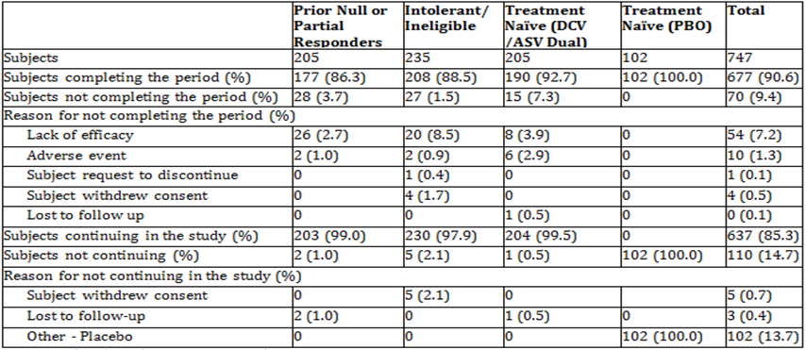
Percentages based on subjects entering period

Table 11: Study AI447028: Participant flow at end of study
 | Prior Null or Partial Responders | Intolerant/ Ineligible | Treatment Naïve  (DCV/ASV Dual) | Total
Subjects | 203 | 230 | 204 | 637
Subjects completing the study (%) | 179 (88.2) | 202 (87.8) | 171 (83.8) | 552 (86.7)
Subjects not completing the study (%) | 1 (0.5) | 1 (0.4) | 0 | 2 (0.3)
Reason for not completing the study (%)
Subject withdrew consent | 1 (0.5) | 1 (0.4) | 0 | 2 (0.3)
Percentages based on subjects entering period
The most common reason for not completing was lack of efficacy which was highest in the prior null/partial responder cohort, and occurred in 12.7% of prior null/prior responders, 8.5% of intolerant/ineligible subjects, and 3.9% of subjects in the active arm of the treatment naïve cohort.

Major protocol violations/deviations
21 (2.8%) subjects had relevant protocol deviations:
- Null/partial responders: 4 (2.0%) subjects
- Intolerant/ineligible subjects: 9 (3.8%) subjects
- Treatment-naïve active arm: 5 (2.4%) subjects
- Treatment-naïve placebo arm: 3 (2.9%) subjects
These did not affect the interpretability of the study results. They included 2 subjects in the null/partial responder cohort who were incorrectly assigned as they were prior relapsers on IFN-based therapy, 2 subjects whose average daily dose of either ASV or DCV was < 80% of the planned daily doses; and 16 subjects who used prohibited concomitant medications for more than 1 day.

Baseline data
Overall, baseline demographics were balanced across cohorts; 48.7% of treated subjects were male and 51.3% were female. In the intolerant/ineligible cohort there was a slightly higher proportion of females (58.3%). The median age was 57.0 years; 20.2% were ≥ 65 years of age. Subjects in the active arm of the treatment-naïve cohort (median 55.0 years) were slightly younger than the other DCV/ASV groups. Most subjects were white or Asian (68.4% and 24.9%, respectively). Mean body mass index (BMI) was 25.9 kg/m2.

Table 12: Study AI447028: Baseline disease characteristics
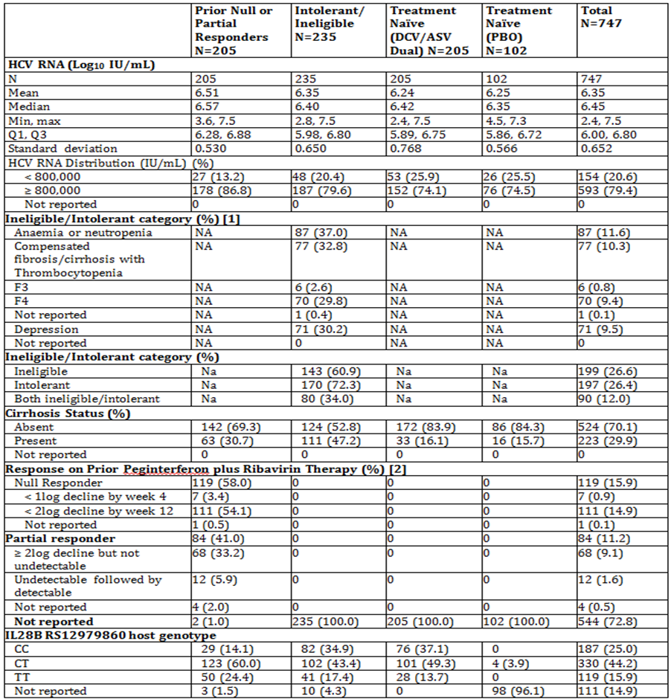
NA = not applicable
1. categories based on the Cohort Assignment CRF
2. the source for criteria for null and partial response in the IVRS database.

Results for the primary efficacy outcome
Primary endpoint: SVR12 (HCV RNA < LLOQ, TND or TD at follow-up Week 12)
- Null/Partial responders: SVR12 was achieved in 168/205 subjects (82.0%; 95% CI: 76.7, 87.2%). When accounting for missing SVR12 data by using the imputation method, SVR12 was achieved in 169/205 subjects (82.4%; 95% CI: 77.2%, 87.6%)
- Treatment-naïve subjects: The SVR12 rate in the DCV/ASV arm of the treatment-naïve cohort was 89.7% (95% CI: 85.5%, 93.8%) (182/203 subjects), which was shown to be similar to the historical SVR rate observed in TVR/pegIFNα/RBV because the lower bound of the 95% CI exceeded 68%. When accounting for subjects with missing SVR12 data by using the imputation method, the SVR12 rate was 90.6% (95% CI: 86.6%, 94.6%) (184/203 subjects).

Results for other efficacy outcomes
Antiviral activity on treatment and post treatment:
- DCV/ASV for 24 weeks was highly efficacious in the intolerant/ineligible cohort, with 81.7% and 82.6% of subjects achieving SVR12 by using the primary and imputed analysis methods, respectively
- DCV/ASV therapy demonstrated rapid and persistent antiviral activity as demonstrated by high rates of RVR, eRVR, cRVR, and EOTR. Using an observed value approach since the study is ongoing, SVR24 was observed in 88.6% of evaluable subjects treated with DCV/ASV
- There was high concordance between SVR12 and SVR24 (99.8%)
- Baseline factors traditionally known to impact outcomes with pegIFNα/RBV treatment did not appear to affect response to DCV/ASV therapy. SVR12 rates were comparable with respect to gender, age, race, cirrhosis status, and IL-28B. SVR rates were consistently high across all categories of baseline viral load
- In all cohorts, DCV/ASV for 24 weeks was highly efficacious in subjects with either CC or non-CC alleles of the rs12979860 SNP in the IL-28B gene, with SVR12 achieved in 83.4% of CC subjects, 83.3% of CT subjects, and 89.1% of TT subjects.
Virologic failures were infrequent in all populations:
- Virologic Breakthrough: VBT was experienced by 26 (12.7%) null/partial responders, 20 (8.5%) intolerant/ineligible subjects, and 9 (4.4%) treatment-naïve subjects in the active arm of the treatment-naive cohort
- Treatment futility: 1 (0.4%) intolerant/ineligible subject had confirmed HCV RNA ≥ LLOQ at Week 8
- Confirmed relapse: 7 (4.0%) null/partial responders, 12 (5.9%) intolerant/ineligible subjects, and 5 (2.6%) treatment-naïve subjects in the active arm relapsed during the follow-up period.
- Other on-treatment failure: 3 (1.5%) null/partial responders, 8 (3.4%) intolerant/ineligible subjects, and 4 (2.0%) treatment-naïve subjects in the active arm had detectable (15 subjects total) or missing (4 subjects total) HCV RNA at EOT

Table 13: Study AI447028: Efficacy results, treated subjects
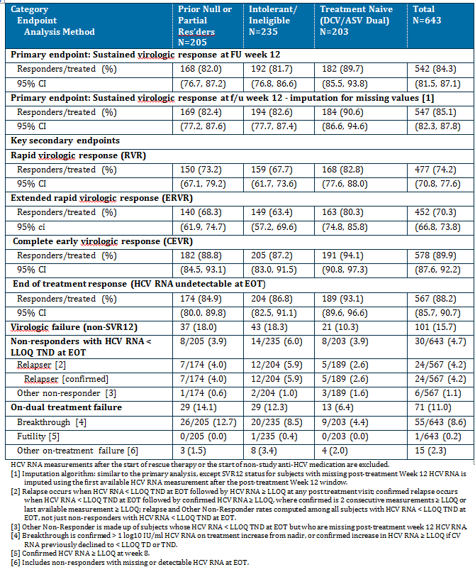

Figure 3: Study AI447208: Mean CV RNA changes from baseline, treated subjects
HCV RNA measurements after the start of rescue therapy or the start of non-study anti-HCV medication are excluded.

Drug resistance
Results of resistance testing showed:
- Of the 101 non-SVR12 subjects (37 prior non-responders, 43 intolerant/ineligible, and 21 treatment-naïve) who met the criteria for resistance testing (HCV RNA ≥1000 IU/mL), resistance-associated substitutions to both DCV and ASV were generally detected together (78.2% [79/101] of subjects). The most prevalent combination for subjects with resistance-associated substitutions to both DCV and ASV was NS5A-L31-Y93 plus NS3-D168 variants (77.2% [61/79] of subjects)
- The most common GT-1b signature resistance-associated variant detected in available subject-derived baseline NS5A sequences was NS5A-Y93H (7.8% [47/599] of subjects); 61.7% (29/47) of subjects with this polymorphism subsequently failed treatment
- GT-1b signature resistance-associated variants at NS5A-L31 (L31F/I/M/V) were less prevalent than NS5A-Y93H (4.5% [27/599] of subjects); 59.3% (16/27) of subjects with L31 polymorphisms subsequently failed treatment
- In general, subjects with baseline NS5A-Y93H plus L31 polymorphisms or baseline NS3-D168E were less likely to achieve a rapid virologic response and respond to treatment; detection of these variants, however, was low (< 0.4% [2/599] of baseline NS5A sequences and 0.6% [4/634] of baseline NS3 sequences);
- IL-28B GT did not appear to predict for virologic failure; 31.6% (31/98) of subjects who failed treatment had the CC allele

Study AI447026: pivotal

Study design, objectives, locations and dates
This was an open label Phase III Study of BMS-790052 plus BMS-650032 Combination Therapy in Chronic Hepatitis C Genotype 1b Infected Subjects who are Non Responders to Interferon plus Ribavirin and Interferon Based Therapy Ineligible Naïve/Intolerant. It was conducted with 2 parallel populations at 24 sites in Japan from January 2012 to April 2013.
Figure 4: Study AI447026: Study design

Primary objective
To assess antiviral activity as determined by the proportion of subjects with SVR24 for each population:
- Prior non-responders to alfa ribavirin (α/RBV) or beta ribavirin (β/RBV) (includes null and partial responders)
- Interferon (IFN)-based therapy ineligible-naïve/intolerant subjects.
SVR24 was defined as HCV RNA < LLOQ (< 15 IU/mL) target detected (TD) or target not detected (TND) at follow-up Week 24.

Secondary objectives
- To assess safety, as measured by the frequency of serious adverse events (SAEs), discontinuation due to adverse events (AEs), AEs, and abnormalities observed from clinical laboratory tests
- To assess antiviral activity for each population, as determined by:
  - The proportion of subjects with HCV RNA < LLOQ, TD or TND, at Weeks: 1, 2, 4, 6, 8, 10 and 12; Weeks: 4 and 12; end of treatment (EOT), or follow-up Week 12
  - The proportion of subjects with HCV RNA < LLOQ, TND at Weeks: 1, 2, 4, 6, 8, 10 and 12; Weeks: 4 and 12; EOT, or follow-up Weeks 12 and 24
- To assess the relationship between efficacy and the rs12979860 SNPs in the interleukin-28B (IL-28B) gene

Exploratory objectives:
- To assess the PK profiles of ASV and DCV
- To assess SVR24 for subjects who receive the rescue treatment
- To assess SNPs in organic anion transporter protein (OATP)1B1, OATP1B3, OATP2B1 and IL-28B (other than rs12979860)
- To describe the relationship between efficacy and baseline (BL) levels of interferon-gamma inducible protein-10 (IP-10)
- To describe DAA-resistant variants at BL, during the study treatment and post-treatment follow up associated with virologic failure for each population
- To explore the relationship between safety and human leukocyte antigen (HLA) if deemed necessary

Inclusion and exclusion criteria

Inclusion:
- Males and females (non-childbearing potential) aged 20-75 years who were chronically infected with HCV GT-1b as documented by:
  - Positive for anti-HCV antibody, HCV RNA, or a positive HCV GT test at least 6 months prior to enrolment, and positive for HCV RNA and Anti-HCV antibody at the time of screening, OR
  - Positive for anti-HCV antibody and HCV RNA at the time of screening with a liver biopsy consistent with chronic HCV infection with HCV RNA viral load of ≥ 105 IU/mL (100,000 IU/mL) at screening:
- Patients with compensated cirrhosis (Child-Pugh A) as documented by a liver biopsy or laparoscopy, but capped at approximately 10% of treatment population (ie, approximately 8 subjects in non-responder, 12 subjects in ineligible/intolerant subject).
- Non-responder (null-responder and partial responder) to alfa/RBV or beta/RBV and IFN-based therapy ineligible/intolerant subjects defined as subjects who have never attained undetectable in HCV RNA levels after a minimum of 12 weeks of alfa/RBV or beta/RBV therapy
- IFN-based therapy ineligible naïve patients - defined as patients who have never been exposed to any HCV therapy with IFN-based therapy, and cannot receive IFN-based therapy and have no plans to use IFN based therapy in next 12 months because of meeting any of the following criteria: advanced age, anaemia, neutropenia, thrombocytopenia, depression, or other complications
- BMI of 16 to 35 kg/m2, inclusive

Exclusion:
- Evidence of hepatocellular carcinoma documented by ultrasound, computed tomography (CT) scan, or magnetic resonance imaging (MRI) within 12 months prior to enrolment
- Evidence of cirrhosis based on the liver biopsy or laparoscopy within 36 months prior to enrolment, imaging studies (ultrasonography, CT or MRI) and laboratory test results or discriminated at the time of screening by the function defined in inclusion criteria
- Co-infection with hepatitis B virus (HBV) or HIV at screening
- Evidence of a medical condition associated with chronic liver disease other than HCV (eg haemochromatosis, autoimmune hepatitis, metabolic liver disease, alcoholic liver disease, toxin exposures)
- History of variceal bleeding, hepatic encephalopathy (except subjects who have cirrhosis), or ascites requiring management with diuretics or paracentesis
- Any severe unstable medical disease requiring new medication
- Meeting specified abnormal lab results as specified in protocol (QTcF, ALT, bilirubin, Cr, INR, Hb, WBC, ANC, platelets)

Study treatments
All subjects were administered 60 mg tablet of DCV QD and 100 mg capsule of ASV BID in combination for 24 weeks and followed for 24 weeks after the last dose of study drug. Prior non-responders who were considered treatment failures to the DAA combination treatment could receive DCV + ASV + pegIFNα/RBV combination regimen (rescue treatment) for 24 additional weeks at the discretion of the investigator. IFN-based therapy ineligible/intolerant subjects were not eligible to receive rescue therapy. Addition of pegIFNα/RBV was offered to all prior non-responders who met the definition of futility criteria defined as:
- Any increase in viral load > 1 log10 from nadir (no confirmation needed)
- Any confirmed detectable HCV RNA (≥ 15 IU/mL) on or after Week 8 (unscheduled HCV RNA was to be obtained within 1 week of receiving the results and pegIFNα/RBV was added within 2 weeks of performance of the confirmation test or at the next scheduled visit, whichever came sooner)

Efficacy variables and outcomes
Primary efficacy outcome: antiviral activity, as determined by the proportion of subjects with SVR24, defined as below LLOQ (< 15 IU/mL) HCV RNA, TD or TND, at follow-up Week 24 for each population.
Other efficacy outcomes included:
- Proportion of subjects who achieve HCV RNA below LLOQ (< 15 IU/mL), TD or TND, at Weeks 1, 2, 4, 6, 8, 10 and 12; Weeks 4 and 12; EOT, or post treatment Week 12 (SVR12: defined as HCV RNA below LLOQ, TD or TND, at follow-up Week 12)
- Proportion of subjects who achieve HCV RNA < LLOQ, TND at Weeks 1, 2, 4 (rapid virologic response [RVR]: defined as HCV RNA < LLOQ, TND at Week 4), 6, 8, 10 and 12 (complete early virologic response [cEVR]: defined as HCV RNA < LLOQ, TND at Week 12); Weeks 4 and 12 (extended rapid virologic response [eRVR]: defined as HCV RNA < LLOQ, TND at both Weeks 4 and 12); EOT, or post-treatment Week 12, post-treatment Week 24
- Proportion of subjects with SVR24 by IL-28B status (CC, CT, or TT genotype at the IL-28B rs12979860 SNP)
- Resistance testing: at baseline and in all subjects with HCV RNA ≥ 1000 IU/mL who had virologic failure
Virologic failure was defined as:
- VBT: confirmed> 1 log10 increase in HCV RNA over nadir or any confirmed HCV RNA ≥ LLOQ after confirmed undetectable HCV RNA
- Relapse: HCV RNA < LLOQ, TND at EOT followed by HCV RNA ≥ LLOQ during follow up
- Null response: < 1 log10 decrease in HCV RNA from baseline at Week 4 of treatment
- EOT detectable: HCV RNA at EOT ≥ LOQ or < LOQ target detected (including early discontinuation).

Randomisation and blinding methods
Not applicable as this was an open label study.

Analysis populations
- Enrolled subject population: those who signed an informed consent form and were assigned a patient identity code; this cohort was used to assess subject status and deaths.
- Treated subject population: enrolled subjects who received at least 1 dose of active study therapy; the numerator was based on subjects meeting the response criteria, i.e., HCV RNA below LLOQ, TD or TND, at follow-up Week 24; the denominator is based on all treated subjects. This cohort was used to assess all data domains.
- Follow-up subject population: treated subjects who continued into the post-treatment or safety follow-up period; the numerator is based on subjects meeting the response criteria, however, the denominator is based on evaluable subjects, ie HCV RNA at follow-up Week 24. this cohort was used to assess safety during follow-up.

Sample size
A target sample size of 120 and 80 subjects provides:
- IFN Ineligible-naïve/Intolerant Subjects: 2-sided 95% CI of 84%, 96% for observed SVR24 rates of 90% (108 of 120) to 95% CI of (21%, 39%) for observed SVR24 rates of 30% (36 of 120)
- Prior non responders: 2-sided 95% CI of 83%, 97% for observed SVR24 rates of 90% (72 of 80) to 95% CI of (29%, 51%) for observed SVR24 rates of 40% (32 of 80)

Statistical methods
Antiviral activity was assessed for treated subjects using descriptive and exploratory analysis. Response rates and 95% CIs based on normal approximation method were presented by population using treated subjects and observed values algorithms. Secondary binary efficacy endpoints were assessed with response rates by population and total using the treated subjects. SVR12 with imputation for missing values was also summarised similarly. A subject with a missing post-treatment Week 12 HCV RNA measurement was imputed as a responder (SVR12) if the HCV RNA measurements at both the scheduled prior visit (post-treatment Week 8) and subsequent visit (post-treatment Week 24) are < LLOQ, TD or TND.
Resistance testing was done on all variants associated with clinical failure – in all subjects with HCV RNA ≥ 1000 IU/mL who had virologic failure.

Participant flow

Table 14: Study AI447026: Participant flow – End of dual treatment period
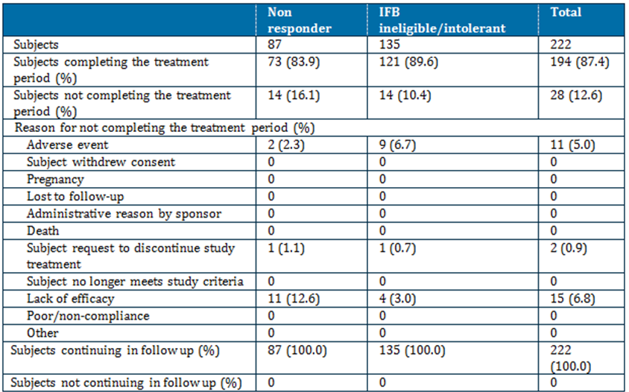
Percentages based on subjects entering period. 9 subjects want to rescue therapy before continued in follow-up.

Table 15: Study AI447026: Participant flow – End of study
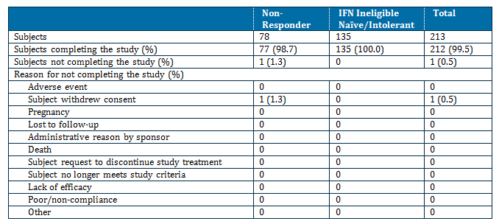

Major protocol violations/deviations
There were no relevant protocol deviations reported in this study

Baseline data
There were 34.7% male and 65.3% female subjects treated. The median age was 62.5 years; 40.1% of subjects were aged ≥ 65 years. All were Japanese. Mean BMI was 22.56 kg/m2.

Results for the primary efficacy outcome
The primary endpoint was SVR24 (TND or TD at follow-up Week 24). DCV in combination with ASV for 24 weeks was highly efficacious SVR24 was achieved in 80.5% in prior non-responders and 87.4% in IFN ineligible-naïve/intolerant subjects.

Table 16: Study AI447026: Primary efficacy outcome – SVR24
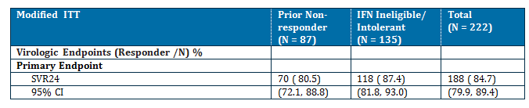

Results for other efficacy outcomes

Table 17: Study AI447026: Secondary efficacy outcomes
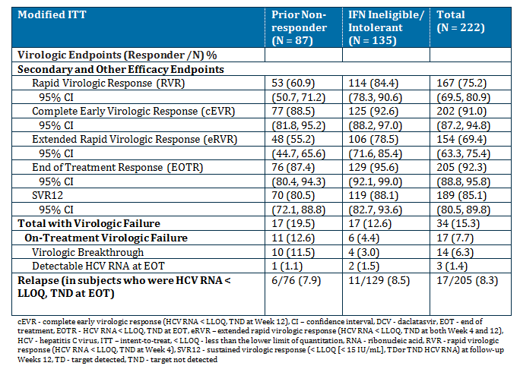

Antiviral activity on- and post- treatment
- Dual therapy demonstrated rapid early antiviral activity as suggested by high rates of RVR, cEVR, and eRVR. The antiviral activity persisted through the end of treatment (EOTR rates).
- There was high concordance between SVR12 and SVR24 (99.3% to 100.0%)
- In a majority of subjects, the on treatment time point with the highest positive predictive value for SVR24 was cEVR
- Baseline factors traditionally known to impact outcomes with pegIFNα/RBV treatment (gender, age, BL HCV RNA, BL cirrhosis, patient populations, and SNP genotype) did not appear to affect response to Dual therapy; SVR rates were high across the different subgroups
- Subjects who were ≥ 95% treatment compliant were more likely to achieve SVR24 than those who were noncompliant (≥ 95%: 179/193 [92.7%] versus <95%: 9/29 [31.0%])
Virologic failures were infrequent in both populations.
- VBT: 10 (11.5%) prior non-responder and 4 (3.0%) IFN ineligible/intolerant subjects experienced VBT
- Detectable at EOT: 1 (1.1%) prior non-responder and 2 (1.5%) IFN ineligible/intolerant subjects had detectable HCV RNA at EOT on Dual therapy
- Relapse: 6 (7.9%) prior non-responders and 11 (8.5%) IFN ineligible/intolerant subjects relapsed during the follow-up period

HCV RNA Changes from baseline
Figure 5: Study AI447026: HCV RNA changes from baseline
HCV RNA measurements are excluded after the start of rescue therapy or non-study anti-HCV medication on treatment or during follow-up.

Study AI447017: supportive

Study design, objectives, locations and dates
This was a Phase IIa open label Study of BMS-790052 and BMS-650032 in Combination Therapy in Subjects with Genotype 1 Chronic HCV Infection. It was conducted at 4 centres in Japan from April 2010 to May 2012. The subjects were non-cirrhotic patients who were prior null responders to pegIFNα/RBV therapy (Cohort 1 & 2) or ineligible/intolerant to IFN (pegylated and non-pegylated forms)/RBV (cohorts 3 & 4), as determined by the investigator. The study was conducted in 2 parts.
Part 1, cohort 1 was a sentinel cohort of 10 prior null responder patients to evaluate the safety of the DUAL therapy. All subjects were treated for 24 weeks. Prior null responders who failed treatment were treated for 48 weeks of quadruple therapy. Subjects who achieved HCV RNA < LLOQ, TND, at the end of treatment, regardless of treatment duration, were followed for 24 weeks of off treatment follow up. All subjects who had virologic breakthrough (VBT) or relapse were followed for 48 weeks post treatment.

Primary objectives
- Part 1: to assess the safety and tolerability of the DUAL (DSV+ASV)
- Part 2: to determine the proportion of subjects who achieved sustained virologic response at follow up Week 12 (SVR12). SVR12 is defined as HCV RNA < LLOQ, TD or TND at follow up Week 12

Secondary objectives
- To evaluate the proportion of subjects who achieve eRVR: HCV RNA < LLOQ, TND at Week 4
- To evaluate the proportion of subjects with eRVR: HCV RNA < LLOQ, TND at both Weeks 4 and 12
- To evaluate the proportion of subjects who achieve SVR24: HCV RNA < LLOQ, TD or TND
- To describe resistant variants associated with virologic failure

Exploratory objectives
- To evaluate the proportion of subjects with undetectable HCV RNA at EOT
- To evaluate the proportion of subjects with alanine aminotransferase (ALT) ≤ 30 IU/L on treatment who have ALT > 30 IU/L at baseline
- To describe the PK properties of DCV and ASV
- To explore the relationship between endpoints of antiviral activity and exposure to DCV and ASV
- To explore the relationship between antiviral activity endpoints and SNPs in genes encoding proteins of the IFNλ family (IL-28B). SNPs for IL-28A and IL-29 were also included in the protocol as exploratory endpoints; however, they were not measured.

Study population
Males and females (non-childbearing potential) aged 20 to 75 years of age with genotype 1 (GT-1) chronic HCV infection who were prior null-responders or IFN/RBV ineligible/intolerant.
Prior null responders to IFN/RBV were defined as subjects who never attained ≥ 2 log10 decline in HCV RNA levels after at least 12 weeks of therapy with IFN/RBV. IFN/RBV ineligible /intolerant were defined as subjects who had never been exposed to any HCV therapy with IFN containing regimens and cannot receive (peg)IFNα ± RBV therapy due to a medical reason or patients who received (peg)IFNα ± RBV for < 12 weeks and discontinued due to intolerance.

Study treatments
Patients in cohort 1 were initially administered DCV 60 mg tablet once daily (QD) and ASV 600 mg (tablets) twice daily (BID). The dose of ASV was reduced to 200 mg BID following review of data from an ASV dose ranging study (Study A447016 presented in the clinical evaluation report for ASV). Following the safety review at 4 weeks, Cohort 2 (additional null responders) and cohort 3 and 4 (IFN/RBV ineligible/intolerant patients) initiated treatment with DCV 60 mg QD plus ASV 200 mg BID. All subjects were administered DUAL therapy for 24 weeks. Prior non-responders in Cohort 1 & 2 who failed treatment, were administered rescue therapy of DCV + ASV + pegINFα/RBV for an additional 48 weeks.

Efficacy outcomes
- The primary antiviral activity outcome was the proportion of patients with SVR12: HCV RNA
- < LLOQ (TD or TND) at follow up Week 12.
- The secondary outcomes were: RVR: HCV RNA < LLOQ (TD or IND) at follow up 24 week and to describe resistant variants association with virologic failure
- Exploratory outcomes were assessment of the proportion of subjects with EOT response (HCV RNA < LLOQ [TND at EOT] and exploring the relationship between antiviral activity and single nucleotide polymorphisms (SNPs) in genes encoding proteins of the IFNλ family (IL-28B)

Statistical methods
The sample size for each stage and cohort was not based on statistical power. Antiviral activity was assessed for treated patients using descriptive analysis. Binary antiviral activity endpoints were assessed using modified ITT and observed values. In both analyses, the numerator was based on subjects meeting the response criteria. For the modified ITT, the denominator was based on all treated subjects. Response rates are presented with 2 sided 80% exact binomial CI.

Participant flow
- Cohort 1 (sentinel/prior null responders): 10 subjects were enrolled and 9 completed the 24 week treatment period. One subject discontinued due to an AE (increased blood bilirubin) at week 2.
- Cohort 2 (expansion/ prior null responders): 11 subjects were enrolled and 9 completed the 24 week treatment period. One subject added on pegIFNα/RBV to DCV+ASV at treatment week 6 due to lack of efficacy. One subject was discontinued due to an AE (increased AST).
- Cohort 3 & 4 (Expansion/IFN/RBV Ineligible/intolerant subjects): 22 subjects enrolled and 18 completed the 24 week treatment period. 4 subjects discontinued: 2 due to withdrawn consent, 1 due to lack of efficacy and 1 due to AE (increased ALT). One subject was lost to follow up and did not complete the follow up period.

Baseline data
All subjects were Japanese. The majority in each cohort were female (60% - 73%). The mean age ranged from 56.1 - 64.4 years. Prior null responders from Cohort 2 were slightly younger than the other cohorts. Most (70.0% - 72.7%) prior null responders were aged < 65 years. In contrast, more than half (54.5%) of IFN/RBV ineligible/intolerant subjects were aged > 65 years. The 2 cohorts of prior null responders tended to be taller (159.0 - 161.8 vs 154.6 cm) and heavier (58.3 - 58.9 vs 51.9 kg) compared with the IFN/RBV ineligible/intolerant subjects. Most subjects (86% overall) had a BMI < 25 kg/m2.
Baseline HCV disease characteristics were similar among prior null responders and IFN/RBV ineligible/intolerant subjects. Mean HCV RNA level ranged from 6.7 to 6.8 log10 IU/mL in prior null responders (Cohorts 1 and 2) and was 6.6 log10 IU/mL in IFN/RBV ineligible/intolerant subjects (Cohorts 3 and 4). Most subjects had a high baseline viral load (> 800,000 IU/mL). All subjects had HCV RNA GT-1b. The IL-28B CC genotype was more common in Cohorts 3 & 4 compared with Cohorts 1 and 2, conversely the IL-28B CT genotype was more common in Cohorts 1 and 2 compared with Cohorts 3 and 4.

Results for the primary efficacy outcome
SVR12 (HCV RNA < LLOQ, TD or TND at follow-up Week 12) was 77% overall: 90% and 91% in prior null responders and 64% in IFN/RBV ineligible/intolerant subjects.

Results for other efficacy outcomes
These data show:
- DUAL (DCV + ASV) therapy demonstrated efficacy across subgroups
- There were no overall differences in antiviral/efficacy endpoints (RVR, cEVR, EOTR, SVR12, and SVR24) by IL-28B GT. However, the initial viral load declines (at Weeks 2 and 3) were more rapid in subjects with IL-28B rs12979860 CC genotype (all cohorts combined) than the CT GT
- Virologic failure occurred in 7 IFN/RBV ineligible/intolerant subjects (3 with VBT, 4 with virologic relapse) compared with 2 prior null responders (1 with HCV RNA > LLOQ at EOT, 1 met the Week 4 futility rule). One additional subject in Cohorts 3 & 4 discontinued before follow-up Week 12 and was lost to follow-up post-treatment
  - Of the 7 subjects (all in Cohorts 3 & 4) with virologic failure who met the criteria for resistance testing:
- All had resistance-associated substitutions to both DCV and ASV at or close to the time of virologic failure
- The most common baseline resistance-associated polymorphism was NS5A-Y93H detected in 23% (10/43) of subjects overall; 50% (5/10) of subjects with this polymorphism subsequently failed treatment
- In all but 1 subject with virologic failure (who had compliance issues), both DSV and ASV exposures were below the median exposure as measured by Ctrough during the study

HCV RNA changes from baseline
Figure 6: Study AI447017: Mean (log10) change from baseline in HCV RNA levels: all treated subjects
NR1 - sentinel cohort (Cohort 1) of prior null responders, NR - expansion cohort (Cohort 2) of prior null responders, SOC NV - expansion cohorts (Cohorts 3& 4) IFN/RBV ineligible/intolerant subjects

Resistance
9 subjects were considered failures to treatment with DCV + ASV (1 in Cohort 1, 1 in Cohort 2, and 7 in Cohorts 3 & 4). Only 7 of these 9 failures met the requirement for resistance testing (HCV RNA ≥ 1000 IU/mL from treatment Week 1 through follow-up Week 48). For the 2 subjects who did not meet the requirement, HCV RNA levels never met the virologic definition of on-treatment or post-treatment failure.
- 1 subject (Cohort 1, sentinel/prior null responder) discontinued treatment after 16 days of treatment due to a SAE, but subsequently achieved SVR24
- 1 subject (Cohort 2, expansion/prior null responder) had HCV RNA < LLOQ, TD at Week 6 of treatment and added pegIFNα/RBV. This subject subsequently achieved SVR24
Resistance analyses of the 7 failures meeting the requirement for resistance testing had resistance-associated substitutions to both investigational agents at or close to the time of virologic failure. The predominant NS5A amino acid substitutions were L31M/V-Y93H (7/7 failures), while NS3 protease amino acid substitutions were NS3-D168A (2/7 failures) and D168V (5/7 failures). All on-treatment failures carried the non-CC IL-28B GT (3/3 VBTs) while most relapsers (3/4) carried the CC IL-28B GT. The NS5A-Y93H resistance-associated polymorphism pre-existed in 23% (10/43) subjects and 50% (5/10) of subjects with this polymorphism subsequently failed treatment. Taking into account drug exposure in subjects who failed treatment versus those who responded, all subjects except 1 with compliance issues had DCV and ASV exposure below the median. Therefore, a loose association with pre-existing NS5A-Y93H variant and virologic outcome was observed when drug exposures were low.

Study AI447011: supportive

Study design, objectives, locations and dates
This was a parallel, open-label, randomised, multi-dose study to evaluate the safety, PK and PD of BMS-790052 and BMS-650032 in combination in null responders to standard of care in patients infected with chronic HCV GT 1. It was conducted at 20 sites in the US (11), France (8) and Puerto Rico (1) from December 2009 to September 2012. The study was undertaken in 2 parts:
- Part 1: sentinel cohort who were treated for up to 72 weeks.
- Part 2: the sentinel cohort was expanded based on the results of pre-planned decision points at week 2 and 4.

Primary objectives
- To determine the proportion of subjects in the sentinel cohort with successful response to treatment at week 2 and rapid virologic response (RVR) at week 4
  - A successful response to treatment was defined at Week 2 as either HCV RNA < LLOQ, TND, < 10 IU/mL or ≥ 2 log10 IU/mL decrease in plasma HCV RNA from baseline without rebound and at Week 4 by a RVR defined as HCV RNA < LLOQ, TND.
- To determine the proportion of subjects with sustained virologic response at follow-up Week 12 (SVR12) in each cohort.
  - SVR12 is defined as HCV RNA < LLOQ, TND at follow-up Week 12.

Secondary objectives
- To assess the safety of co-administration of ASV + DCV ± pegIFNα/RBV or RBV
- To assess the decrease in log10 HCV RNA from baseline to Day 4, Day 7 and Day 14
- To assess the PK profiles of subjects treated with ASV + DCV ± pegIFNα/RBV or RBV
- To evaluate the proportion of subjects with RVR
- To evaluate the proportion of subjects with eRVR defined as HCV RNA < LLOQ, TND at both Weeks 4 and 12
A number of exploratory objectives were also included.

Study population
Adult men and women (non-childbearing potential) aged 18 to 75 years with chronic HCV GT-1 who were prior null-responders defined as subjects who after at least 12 weeks of therapy with pegIFNα and RBV never attained ≥ 2 log10 decline in HCV RNA level, and had no evidence of chronic liver disease.

Study treatments
Part 1: Sentinel cohort received the following treatments for up to 72 weeks:
- Group A: DCV 60 mg QD + ASV 600 mg tablet BID (GT-1a and -1b)
- Group B: DCV 60 mg QD + ASV 600 mg tablet BID + pegIFNα/RBV (GT-1a and -1b)
The dose of ASV was reduced from 600 mg to 200 mg BID following findings of elevated transaminases (mostly at the higher doses of ASV 600 mg QD and BID) noted in the Phase II study of ASV/pegIFNα/RBV (Study AI447016). At the time of the ASV dose modification, all subjects in the sentinel cohort had completed treatment except for subjects with VBT.
Part 2:
- Group A1: ASV 200 mg tablet BID/DCV 60 mg QD (GT-1b only)
- Group A2: ASV 200 mg tablet QD/DCV 60 mg QD (GT-1b only)
- Group B1: ASV 200 mg tablet BID/DCV 60 mg QD/pegIFN/RBV (GT-1a and GT-1b; GT-1b targeted to < 20%)
- Group B2: ASV 200 mg tablet QD/DCV 60 mg QD + pegIFN/RBV (GT-1a and GT-1b, GT-1b targeted to < 20%)
- Group B3: ASV 200 mg tablet BID/DCV 60 mg QD/RBV (GT-1a and GT-1b; GT-1b targeted to < 20%)
PegIFNα-2a 180 µg/0.5 mL SC was self-administered once weekly (QW) and RBV either 400 mg (subjects <75 kg: 2 tablets) or 600 mg (subjects > 75 kg: 3 tablets) in the morning with food and 600 mg (3 tablets) in the evening with food. Patients treated with dual therapy who had VBT could have pegIFNα/RBV as rescue therapy for an additional 48 weeks. The treatment period was 24 weeks for subjects not requiring rescue therapy and up to 72 weeks for subjects receiving rescue therapy. All subjects had 48 weeks of untreated follow-up.

Efficacy outcomes
- Primary: Proportion of subjects with successful response to treatment at week 2 and RVR at week 4; proportion of subjects with SVR12
- Secondary: Decrease in log10 CV RNA from baseline to Day 4, Day 7 and Day 14; PK profiles of subjects treated with DCV + ASV + pegIFNα/RBV or RBV; proportion of subjects with RVR, eRVR, cEVR, and SVR24; to describe the resistant variants associated with virologic failure

Statistical methods
Antiviral activity was assessed for treated subjects using descriptive and exploratory analyses. Binary antiviral activity endpoints were assessed using modified ITT and observed values. In both analyses, the numerator was based on subjects meeting the response criteria. For mITT, the denominator was based on all treated subjects. For observed values, the denominator was based on subjects with available measurements at the analysis week(s). Response rates were presented with 2 sided 80% exact binomial CIs.

Participant flow

Sentinel cohort
21 subjects treated: 11 with DCV/ASV (Group A) and 10 with DCV/ASV/pegIFNα/RBV (Group B).

DCV/ASV expansion cohort
38 subjects treated: 18 with DCV/ASV 200 mg BID (Group A1) and 20 with DCV/ASV 200 mg QD (Group A2). The treatment period was up to 72 weeks for subjects in Groups A1 and A2, who received rescue therapy, and 24 weeks for all other subjects:
 | Completed treatment | Completed follow up
Group A1 | 10 (94.4%) | 10 (55.6%); the remaining 8 subjects were ongoing in follow up; including 2 subjects, who added pegIFN/RBV as rescue treatment.
Group A2 | 18 (90.0%) including 4 subjects who had VBT and pegIFN/RBV added as rescue treatment | 9/19 (47.4%) completed follow up 10 were ongoing in follow up  (including the 4 subjects who had rescue treatment), 1 subject  Did not enter follow up.

DCV/ASV/pegIFNα/RBV expansion cohort
41 subjects treated: 20 with DCV/ASV 200 mg BID + pegIFNα/RBV (Group B1) and 21 with DCV/ASV 200 mg QD + pegIFNα/RBV (Group B2).
 | Completed treatment | Completed follow up
Group B1 | 100.0%) | 19 (95.0%) and 1 subject ongoing in follow up
Group B2 | 100.0%) | 20 (95.2%) and 1 subject ongoing in follow up

Baseline data

Table 18: Study AI447011: Baseline demographics and characteristics.
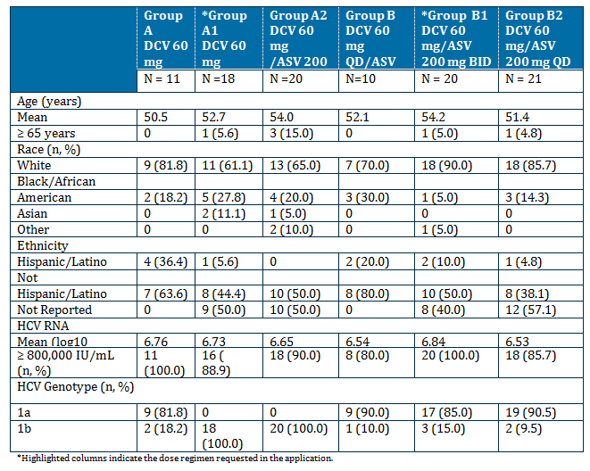

Results
This section includes results for subjects receiving DCV + ASV (part 1: groups A and B; part 2: groups A1 and A2). Results for subjects in groups B1 and B2 receiving DCV+ ASV + pegIFNα/RBV are presented. The CSR indicates that results for group B3 will be provided in an addendum.

Primary efficacy outcome
It is noted that the primary efficacy outcome was for ASV dosed at higher (ASV 600 mg tablet BID) than the requested dose regimen for combination with DCV (ASV 100 mg capsule BID). This study is included as supportive for the results of the requested dose regimen in the secondary outcomes.
Dual therapy with DCV (60 mg QD) and ASV (600 mg BID) demonstrated efficacy in prior null responders with GT-1a and -1b.
- Dual therapy produced a successful virologic response at Week 2 in 81.8% (9/11) of subjects. A successful response to treatment was defined at Week 2 as either HCV RNA < LLOQ, TND or ≥ 2 log10 IU/mL decrease in plasma HCV RNA from baseline without rebound.
- Dual therapy also produced RVR in 63.6% (7/11) of subjects, and an SVR12 and SVR24 response in 36.4% (4/11) of subjects
  - SVR12 and SVR24 responses were achieved in the 2 GT-1b subjects.
  - Among subjects with HCV RNA results at both follow-up Weeks 12 and 24, SVR12/24 concordance (based on the criteria HCV RNA < LLOQ, TND) was 100.0% (10/10).
- In subjects with GT-1a, virologic failure was 77.8% (7/9: 6 experienced VBT on treatment and 1 experienced viral relapse 4 weeks after completing treatment).

Other efficacy outcomes
Efficacy Results (HCV RNA < LLOQ, TND): Prior to Addition of Rescue Therapy: All Treated Subjects

Table 19: StudyAI447011: Efficacy results Prior to Addition of Rescue Therapy: All Treated Subjects
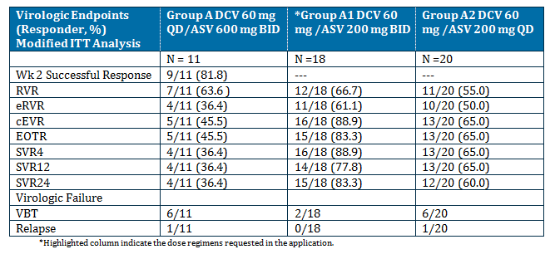

Mean change from baseline in HCV RNA
The mean change from baseline in HCV RNA log10 IU/mL at Days 4, 7 and 14 (all 20 efficacy endpoints for the sentinel cohort) ranged from -4.2 at Day 4 to -5.3 at Day 14 with Dual therapy and -3.6 at Day 4 and -5.0 at Day 14 with Quad therapy.
Figure 7: StudyAI447011: Mean (SE) change from baseline in log10 HCV RNA for first 2 weeks of treatment: all treated subjects in Groups A and B
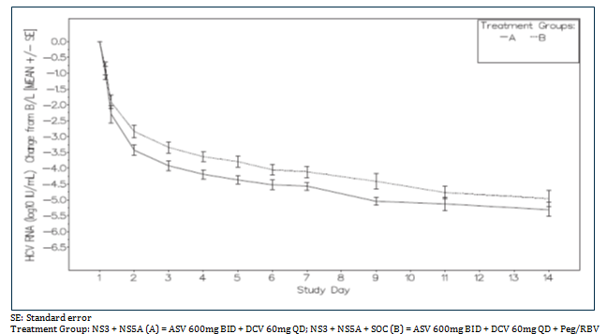

Study AI444046: long term follow up study – interim report
This study includes patients from 9 of the efficacy studies for all indications. Of note, no patients from study AI444028 were included. For this section, efficacy results for DCV in combination with ASV from studies AI447011 (DCV/ASV/ pegIFNα/RBV), AI447026, and AI447017 (both DCV / ASV) are provided. The number of subjects from each study was:
- AI447011 - 22 subjects
- AI447017 - 37 subjects
- AI447026 - 201 subjects

Efficacy results
The median duration of the follow up of the eligible subjects who achieved SVR12 in their respective parent study from the date of SVR12 in the parent study to the last HCV RNA measurement date in the follow up study was 260.0 days (37 weeks) for the subjects receiving DCV + ASV.
There was 1 relapse in the DCV/ASV group reported from 224 subjects (time to loss of response 190.0 days from achievement of SVR12 in the parent study to the relapse event in this study).
The subject had a pre-treatment HCV RNA level of 3,981,072 IU/mL in the parent study. The subject first had an HCV RNA < LLOQ, target not detected (TND) level at Week 4 and achieved SVR12 (26-Nov-2012) and SVR24 (15-Feb-2013) (HCV RNA < LLOQ) during the follow-up period of the parent study. At the Day 1 visit (12-Apr-2013) of this study, the subject was HCV RNA < LLOQ. On 03-Jun-2013 of this study, the subject had an HCV RNA level of 110 IU/mL, and subsequently at the follow-up Week 24 visit (29-Jul-2013) had an HCV RNA level of 343,133 IU/mL. Sequencing to determine if the subject had a possible re-infection of a different strain of HCV was not completed by the date of this report.

Treatment of hepatitis C – Daclatasvir in combination with sofosbuvir

Study AI447040: pivotal

Study design, objectives, locations and dates
This was a parallel, open-label, randomised study to evaluate the safety, PK and PD of SOF (PSI-7977) in combination with DCV (BMS-790052) with or without RBV in treatment naive subjects chronically infected with HCV GTs 1, 2, or 3. The study included 10 treatment groups conducted at 17 sites in the USA and 1 site in Puerto Rico from June 2011 to time of report (primary outcome) of January 2013. The study design is shown below.

Table 20: Study AI1444040: Study design Groups A-H in treatment-naive subjects: 24 weeks of treatment
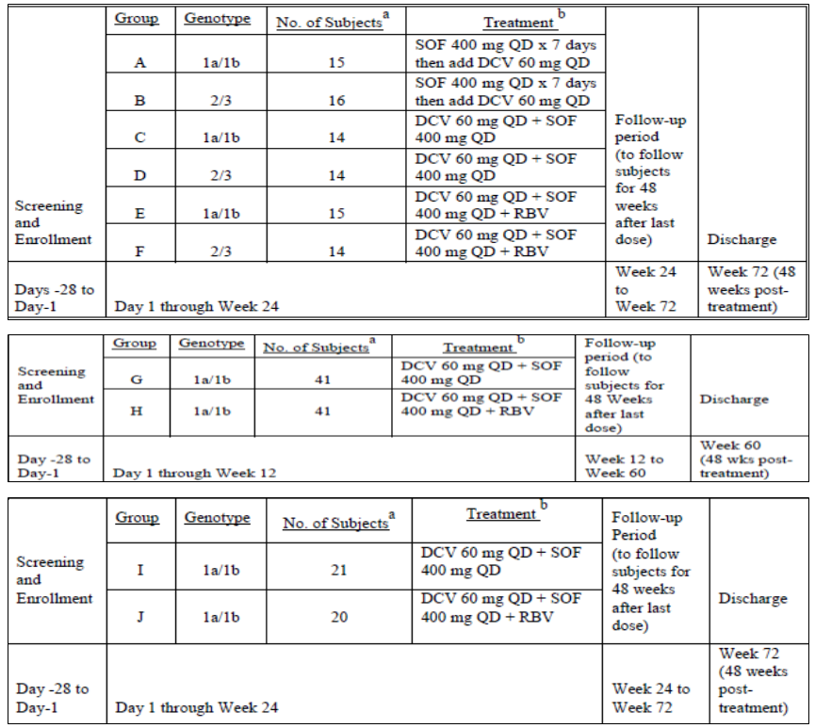
a Actual number of subjects treated
b Study drug was to be taken with a meal. Subjects meeting prespecified criteria could have had therapeutic rescue therapy for up to 48 additional weeks.

Primary objective:
To estimate the rate of SVR12 in each treatment group, where SVR12 was defined as HCV RNA <LLOQ, TD or TND at follow up Week 12.
Secondary objectives:
- To assess the safety and tolerability of SOF and DCV ± RBV when dosed for 12 or 24 weeks
- To characterise the steady state (Day 14) PK profiles of DCV, SOF and the PSI-6206 and PSI-352707 metabolites when the parent compounds are co-administered
- To estimate the effect of DCV on the steady state PK profiles of SOF and the PSI-6206 and PSI-352707 metabolites when the parent compounds are co-administered
- To estimate the rate of subjects who achieve HCV RNA < LLOQ, TD or TND at Weeks: 1, 2, 4, 6, 8, 10, 12, 14, 16, 18, 20, and 22 weeks of therapy; EOT, following 12 or 24 weeks of treatment, by group; and follow-up Weeks 4, 12, 24, 36, and 48
- To estimate the rate of subjects who achieve HCV RNA < LLOQ, TND at Weeks: 1, 2, 4, 6, 8, 10, 12, 14, 16, 18, 20, and 22 weeks of therapy; at EOT (following 12 or 24 weeks of treatment, by group); and follow-up Weeks 4, 12, 24, 36, and 48
- To describe rates of VBT and relapse
- To characterise the development of antiviral resistance through HCV genomic substitutions
- To estimate the rate of SVR24 defined as HCV RNA < LLOQ, TD or TND at follow-up Week 24
There were also a large number of exploratory objectives including describing the PK/PD relationship and exploring the relationship between antiviral activity endpoints and SNPs in the gene encoding a protein of the IFN λ family (IL-28B) and potentially the RBV transporter protein ENT-1.

Inclusion and exclusion criteria
Adult men and women aged 18 to 70 years of age, with HCV, a BMI of 18-35 kg/m2, inclusive and who had the following treatment history:
- Groups A through H: Treatment naïve, defined as no previous exposure to an IFN formulation
- Groups I and J: Failed treatment with a TVR or BOC containing regimen

Study treatments
All subjects received 2 x DCV 30 mg tablet QD and 2 x SOF 200 mg tablet QD with a meal. Subjects in Groups A to F and I & J were treated for 24 weeks and in Groups G & H were treated for 12 weeks. Subjects in Groups E, H, and J also received RBV in following doses:
- For subjects <75 kg, the total dose was 1000 mg/day taken as 2 tablets (400 mg) in the morning and 3 tablets (600 mg) in the evening with a meal
- For subjects >75 kg the total dose was 1200 mg/day taken as 3 tablets (600 mg) BID with meals
Subjects in Group F (GT-2 and 3) received RBV 800 mg/day as 2 tablets (400 mg) BID with meals.
Therapeutic rescue was:
- Subjects in Groups E, F, H, and J continued the prior dosing of RBV with the addition of pegIFN
- Subjects from Groups A, B, C, D, G, and I received the addition of RBV following genotype and weight based guidelines
- All rescued subjects received self-administered 180 μg pegIFNα-2a injection subcutaneously (SC) once weekly (QW) throughout the entire dosing period. Subjects were to continue therapy up to Week 72 (for subjects who received rescue therapy after 24 weeks of standard therapy), and were followed up to 48 weeks post-treatment.

Efficacy variables and outcomes
The primary efficacy outcome was the proportion of subjects in each group with SVR12 (HCV RNA < LLOQ, TD or TND at follow-up Week 12).

Other efficacy outcomes included:
- The proportion of subjects who achieved HCV RNA < LLOQ, TD or TND at Weeks: 1, 2, 4, 6, 8, 10, 12, 14, 16, 18, 20, 22, and 24 weeks of therapy; at EOT (following 12 or 24 weeks or less of treatment, by group); and follow-up Weeks 2 (Groups G, H, I, and J only) 4, 12, 24, 36, and 48
- The proportion of subjects who achieved HCV RNA < LLOQ, TND at Weeks: 1, 2, 4, 6, 8, 10, 12, 14, 16, 18, 20, 22, and 24 weeks of therapy; at EOT (following 12 or 24 weeks or less of treatment, by group); and follow-up Weeks 2 (Groups G, H, I, and J only) 4, 12, 24, 36, and 48
- The proportion of subjects with SVR24, defined as HCV RNA < LLOQ, TD or TND at follow-up Week 24
- The proportion of subjects in each group with VBT during the treatment period
- The proportion of subjects in each group who experienced viral relapse during follow-up
- Absolute values and change from baseline in log10 HCV RNA at scheduled sampling time
- Maximum observed changes from baseline in log10 HCV RNA
- Time points for a subject’s observed maximum changes from baseline in log10 HCV RNA
- Proportion of subjects in each group who have HCV RNA < LLOQ, TND at any time point
- The frequency of HCV genomic substitutions associated with virologic failure for each HCV GT

HCV resistance testing
Resistance testing (viral genotyping and phenotyping) on plasma samples was performed using population sequencing on (1) all baseline samples, and (2) samples in all subjects with VBT who had HCV RNA ≥ 1000 IU/mL. VBT was defined as follows:
- On treatment failure, defined as ≥ 1 log10 increase in HCV RNA over nadir
- Any confirmed HCV RNA ≥ LLOQ on or after Week 8
- Relapse, defined as HCV RNA ≥ LLOQ during follow-up after HCV RNA < LLOQ, TD or TND at EOT

Randomisation and blinding methods
Eligible subjects were randomised to receive DCV, SOF, and RBV according to a computer-generated randomisation scheme. Randomisation in Groups A, C, E, G and H, and Groups B, D, and F were stratified by GT-1a and -1b and GT-2 and -3, respectively, to minimise the risk of genotype imbalance between treatment regimens. The treatments were not blinded.

Analysis populations
- Randomised: enrolled subjects who received a treatment assignment.
- Treated: randomised subjects who received at least 1 dose of active study therapy. Analyses of treated subjects were based on actual treatment received.
- Follow-up: treated subjects who continued in the follow-up period.
The proportions of subjects with antiviral efficacy endpoints were summarised by treatment regimen using mITT and observed values:
- mITT: The numerator was the subjects meeting the response criteria and the denominator was the total number of subjects who received at least one dose of the study drugs. The analysis was based on the actual treatment received. Subjects with VBT or relapse were considered as treatment failures and were not counted in the numerator at the time of VBT or relapse or any subsequent time points. Subjects with missing HCV RNA value for a given time point were considered as a failure for the specific time point only. If a subject had received rescue treatment even without VBT or relapse, this subject was considered as failure from the time of start of the rescue treatment onward. The modified ITT analysis was pre-defined as the primary analysis. The approach modified classic ITT to include subjects who not only were randomised but also received at least one dose of study drug and the analysis was based on actual treatment received.
- Analysis based on observed values: at each time point, the proportion was determined with the numerator as the number subjects meeting the response criteria and the denominator as the number of treated subjects with available HCV RNA. As with the modified ITT analysis, subjects with VBT or relapse are considered treatment failures at the time of VBT or relapse and for all subsequent time points.

Sample size
The sample sizes were selected to maintain the probability of underestimating SVR12 at an acceptable level under various assumptions of true SVR12. With sample size of 14, the probability of underestimating the true population SVR12 by more than 10% when the true population SVR12 was 90% is 0.16. This probability decreased to 0.13 and 0.04 if the sample size was increased to 20 and 40, respectively.
The sample size for Group G and H, 40 per group, provides SVR estimate with 80% CI of width approximately ±10% of the observed value. With a sample size of 40, a 2-sided 80% exact confidence interval for SVR12 was (39%, 61%) or (64%, 84%) if the observed SVR12 was 50% or 75%, respectively.

Statistical methods
Antiviral endpoints were tabulated with exact binomial 2-sided 80% confidence intervals (CIs). In addition, descriptive statistics were used to summarise and plot the HCV RNA (log10) data by treatment group over time. Concordance between SVR12 and SVR24 was assessed by evaluating SVR at follow-up Week 12 versus follow-up Week 24 for subjects with non-missing data at both time points. The proportion of subjects with matched status (responder or non-responder at both time points) was computed and reported as percent agreement.

Major protocol violations/deviations
The most common relevant protocol deviation was receiving prohibited concomitant medications for > 1 day during treatment with DCV/SOF ± RBV (4.7%, 10/211). These medications included ciprofloxacin (2.8%, 6/211) and azithromycin (1.9%, 4/211). 2 subjects were considered to have relevant protocol deviations because they received incorrect study therapy. Both were infected with HCV GT-2/-3. They were randomised to Group D (DCV 60 mg + SOF 400 mg x 24 weeks), but took the Group B regimen (SOF 400 mg QD x 7 days then added DCV 60 mg QD for the remaining 23 weeks). These 2 subjects were analysed as treated (as Group B subjects). These protocol deviations were not major in nature and therefore were not considered to impact the study results or conclusions.

Baseline data
The baseline demographics were generally comparable across the treatment groups. Slightly more than half of the subjects were male (52.6%). Overall, the mean age was 52 years, with 5.7% ≥ 65 years of age. In all groups, most subjects were white (82.9%) and a small proportion were black/African American (12.3%), Asian (2.4%), or ‘other’ race (1.9%). The mean BMI was 26.9 kg/m2. There were some modest differences between groups with respect to baseline demographics, but there were not considered to affect the interpretation of the efficacy or safety data. Baseline HCV disease characteristics were generally comparable across treatment groups. Subjects had a high baseline viral load. The overall mean HCV RNA level was 6.43 log10 IU/mL. Most (80.1%) had an HCV RNA level ≥ 800,000 IU/mL and 15.6% had an HCV RNA level ≥ 10,000,000 IU/mL. Subjects were GT-1a (62.6%), GT-1b (16.6%), GT-2 (12.3%), or GT-3 (8.5%).
The mean Fibrotest score overall was 0.460. 65.9% (139/211) of subjects had a METAVIR score (calculated using the Fibrotest score per manufacturer’s website) ≥ F2. Most had IL-28B rs12979860 non-CC genotypes (71.1%, 150/211). The median baseline ALT level overall was 59.0 U/L.
There were a few notable differences between groups with respect to baseline disease characteristics. By study design, all subjects in Groups A, C, E, G, H, I, and J had HCV RNA GT-1a (79.0%, 132/167) or -1b (21.0%, 35/167), while subjects in Groups B, D, and F had HCV GT-2 (59.1%, 26/44) or GT-3 (40.9%, 18/44). 22 - 57.1% of treatment-naïve subjects in Groups A through H had an IL-28B rs12979860 CC GT. 97.6% of TVR or BOC treatment failures in Groups I and J had non-CC GTs.

Results for the primary efficacy outcome
The proportion of subjects achieving SVR12 (HCV RNA < LLOQ, TD or TND at follow-up Week 12), ranged from 90.9% to 98.4% as follows:
- Treatment-naïve subjects with GT-1 (Groups A, C, E, G, and H combined): 98.4% (124/126)
- Treatment-naïve subjects with GT-2/-3 (Groups B, D and F combined): 90.9% (40/44)
- TVR/BOC failure subjects with GT-1 (Groups I and J combined): 97.6% (40/41)
Overall, 7 subjects did not achieve SVR12. The most common reason for not achieving SVR12 was missing HCV RNA results at follow-up Week 12: 5/7 (71.4%). The analyses based on observed values showed even higher SVR12 rates: 100.0%, 95.4%, and 100% for Groups A, C, E, G, and H combined, Groups B, D and F combined and Groups I and J combined respectively. No treated subjects were excluded from the efficacy analyses.

Results for other efficacy outcomes
DCV 60 mg QD + SOF 400 mg QD (with or without RBV and with or without a SOF lead-in) produced high rates of virologic response on-treatment that were rapid and sustained during the follow-up period in all populations tested: treatment-naïve subjects with GT-1, GT-2, and GT-3 and TVR/BOC failures with GT-1. Key results were:
- Virologic response rates (HCV RNA < LLOQ, TD or TND) at Week 4 with or without RBV ranged from 95.0% to 100.0%
- Among GT-1 and GT-2/3 treatment-naïve subjects with HCV RNA results at both follow-up Weeks 12 and 24, there was 100.0% concordance between SVR12 and SVR24, except in Group A (DCV/SOF without RBV) which had 93.3% concordance
- In treatment-naïve subjects with GT-1, SVR12 rates with DCV/SOF with or without RBV were > 95% in subjects who received 12 or 24 weeks of treatment
- SVR12 rates with DCV/SOF were consistently high across all subgroups, including genotype (1, 2, 3), genotype subtype (1a vs 1b), and IL-28B RS12979860 GT (CC and non-CC)
  - SVR12 rates in treatment-naïve subjects were as follows: 98.0% with GT-1a, 100.0% with GT-1b, 92.3% with GT-2, and 88.9% with GT-3. SVR12 rates in TVR/BOC failures were as follows: 97.0% with GT-1a and 100.0% with GT-1b
  - SVR12 rates for subjects with IL-28B RS12979860 non-CC genotypes ranged from 95.8% to 98.8% across all viral genotypes (1 and 2/3) and populations (naïve and TVR/BOC failures)
  - SVR12 rates for subjects with an IL-28B RS12979860 CC genotype were 85.0% in treatment-naïve subjects with GT-2/-3, 97.5% in treatment-naïve subjects with GT-1 and 100.0% in TVR/BOC failures with GT-1
- Of the 211 subjects treated with DCV/SOF with or without RBV; 3 (1.4%; 2 with GT-3 and 1 with GT-1a) had virologic failure during the study (1 with VBT and 2 relapsers). One relapser (treatment-naïve subject with GT-1a) was a likely re-infection
- There did not appear to be a relationship between NS5A resistance-associated polymorphisms and virologic response. All subjects with baseline NS5A resistance-associated polymorphisms achieved SVR, with the exception of 1 GT-3 subject who relapsed; this subject had an NS5A-alanine (A)30 lysine (K) polymorphism at baseline and at relapse
The key efficacy outcomes are shown in Table 21 on following page.

Table 21: Study AI444040: Key efficacy endpoints with combination DCV + SOF with / without ribavirin: all treated subjects
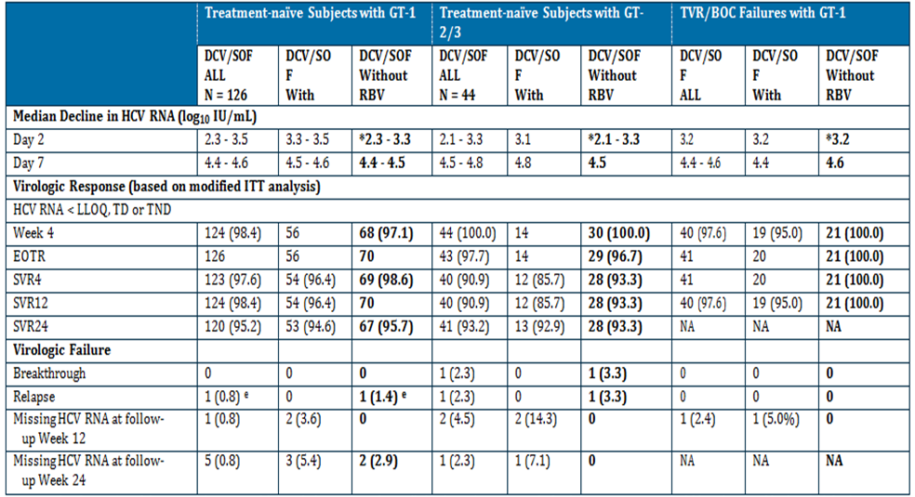
Note that the TVR/BOC failure groups (Groups I and J) were the last groups to be enrolled in the study; SVR24 results for these groups were not available at the time of database lock for the AI444040 CSR.
a With RBV: Groups E and H; Without RBV: Groups A, C, and G
b With RBV: Group F; Without RBV: Groups B and D
c With RBV: Group J; Without RBV: Group I
d One subject (appearing in the DCV/SOF ALL and the DCV/SOF With RBV columns) had missing HCV RNA at follow-up Week 12.
e One subject (GT-1a) in Group A achieved SVR4 and SVR12, then had HCV RNA 670772 IU/mL at follow-up Week 24. This subject is a likely re-infection due to viral sequences at relapse that were different from those at baseline and absence of DCV/SOF resistance detected in the virus at relapse.
* Results highlighted are for requested regimen

Virologic response by treatment duration
In treatment-naïve subjects with GT-1, SVR12 rates with DCV/SOF with or without RBV were similar in subjects who received 12 weeks of treatment compared with subjects who received 24 weeks of treatment.

HCV RNA Changes from baseline
HCV RNA levels declined rapidly in all subjects. During the initial 48 hours, the mean viral decline was faster in the groups receiving DCV/SOF (Groups C through J) compared with those receiving SOF alone (Groups A and B). This difference did not persist; all subjects had HCV RNA < 25 IU/mL by Week 4.

Study AI444046: long term follow up study: interim report
This study includes patients from 9 of the efficacy studies for all indications. The efficacy results are provided here.
There were no patients receiving only DCV + SOF enrolled into the follow up study.
64 patients who received DCV + SOF +/- RBV in study AI444040 were enrolled in the long term follow up study. No relapse was reported from the DCV + SOF + RBV group (N = 28).
The median duration of the follow up of the eligible subjects who achieved SVR12 in their respective parent study from the date of SVR12 in the parent study to the last HCV RNA measurement date in the follow up study was 442.5 days (63 weeks) for the subjects receiving DCV + SOF + RBV.
A large percentage of subjects in AI444046 were censored, particularly after 18 months of follow-up, which makes Kaplan Meier (KM) estimates of the probability of loss of virologic response highly variable after the first year. The KM estimates of the probability of loss of virologic response were 0 for the DCV/SOF + RBV treated subjects as there were no relapses in this cohort.

Treatment of hepatitis C – Daclatasvir with asunaprevir plus interferon alfa plus ribavirin (QUAD)

Study AI447029 Pivotal

Study design, objectives, locations and dates
This was a phase III, open-label study with ASV and DCV Plus pegIFNα/ RBV (QUAD) for subjects who are null or partial responders to pegIFNα (2a or 2b) plus RBV with chronic HCV GT 1 or 4 Infection. It was a multi-site, multinational single arm study with no control group conducted at 79 sites in 15 countries (USA, Canada, Mexico, Argentina, Netherlands, France, Germany, Italy, Spain, Switzerland, Russia, Sweden, Denmark, Taiwan, Korea) from May 2012 to December 2013. The study design is presented below.
Figure 8: Study AI447029: Study Design

Primary objective:
To assess efficacy, as determined by the proportion of subjects with SVR12 defined as HCV RNA < LOQ at post treatment Week 12.

Secondary objectives:
- To assess safety, as measured by the frequency of serious adverse events (SAEs) and discontinuations due to adverse events (AEs)
- To assess the relationship between efficacy endpoints and the rs12979860 single nucleotide polymorphisms (SNPs) in the interleukin (IL)-28B gene
- To assess the efficacy as determined by:
  - HCV RNA undetectable (HCV RNA < LLOQ, TND) at each of the following time points: Weeks 1, 2, 4, 6, 8 and 12; at both Weeks 4 and 12 (extended rapid virologic response [eRVR]); end of treatment (EOT) (up to 24 weeks), post treatment Week 12, or post treatment Week 24
  - HCV RNA < LOQ (HCV RNA < LLOQ, target detected [TD] or TND) at each of the following time points: Weeks 1, 2, 4, 6, 8 and 12; at both Weeks 4 and 12 (virologic response at Weeks 4 and 12 [VR(4&12)]); EOT (up to 24 weeks), post treatment Week 24 (SVR24)
- To evaluate antiviral activity endpoints for HCV GT-4 subjects

Exploratory objectives:
- To describe ASV and DCV HCV-resistant variants associated with virologic failure
- To explore the relationship between efficacy endpoints and pharmacogenomic biomarkers, such as SNPs in the IL-28B gene other than rs12979860 or ENT1 if deemed necessary
- To describe the relationship between efficacy and baseline levels of interferon-gamma inducible protein-10 (IP-10)
- To describe the pharmacokinetics (PK) of DCV and ASV
- To describe Health Related Quality of Life (HRQL) for subjects who received at least 1 dose of ASV and DCV compared to pegIFNα/RBV-based regimens

Inclusion and exclusion criteria
Males and females, ≥ 18 years of age chronically infected with HCV GT-1 (minimum 40% of either GT-1a or non GT-1a) or GT-4 only (capped at 10%) with a HCV RNA viral load of ≥ 104 IU/mL (10,000 IU/mL) at screening, and who had previously failed treatment with pegIFNα/RBV classified as previous null and partial responders as follows:
- Previous null responders:
  - Subjects who, after at least 12 weeks of therapy with pegIFNα/RBV, have never attained ≥ 2 log10 decline in HCV RNA, or
  - Subjects who, after 4 weeks of therapy with pegIFNα/RBV have never attained ≥ 1 log10 decline in HCV RNA (limited to no more than 10% of the total study population)
- Previous partial responders:
  - Subjects who, after at least 12 weeks of therapy with pegIFNα/RBV attained ≥ 2 log10 decline in HCV RNA but never achieved undetectable HCV RNA, or
  - Subject who became HCV RNA undetectable and subsequently had a detectable documented HCV RNA result during prior pegIFNα/RBV (limited to no more than 10% of the total study population)
Subjects with compensated cirrhosis were eligible for enrolment, but were capped at approximately 25% of the treated population.

Study treatments
All enrolled subjects received the following 4 treatments during the 24-week treatment period:
- DCV 60-mg tablet administered once daily
- ASV 100-mg soft gel capsule administered twice daily: total daily dose 200 mg
- pegIFNα-2a (PEGASYS): 180-μg injection administered SC QW
- RBV: 400 mg (2 x 200-mg tablets for subjects weighing < 75 kg) or 600 mg (3 x 200-mg tablets for subjects weighing ≥ 75 kg) administered in the morning with food and 600 mg (3 tablets for subjects weighing ≥ 75 kg) administered in the evening with food (total daily dose 1000 mg or 1200 mg, respectively)

Efficacy variables and outcomes
The primary efficacy outcome was the proportion of GT-1 subjects with SVR12, defined as HCV RNA < LLOQ at follow-up Week 12. SVR12 rate for subjects with GT-1 is also presented using imputed values (HCV RNA was imputed using the first available HCV RNA measurement after the follow-up Week 12 window) and observed values as sensitivity analyses.
The HCV RNA collected at Weeks 1, 2, 4, 6, 8, 12, EOT and follow-up Weeks 12 and 24 was used to assess the following secondary efficacy outcomes:
- Proportion of GT-1 subjects with SVR12 (HCV RNA < LLOQ [(HCV RNA < LLOQ, TD or TND] at follow-up Week 12) by host genotype CC, CT, or TT of the rs12979860 SNP in the IL-28B gene
- Proportion of GT-1 subjects with HCV RNA undetectable (HCV RNA < LLOQ, TND) at each of the following time points: Weeks 1, 2, 4, 6, 8, and 12; at both Weeks 4 and 12 [eRVR]; EOT (up to 24 weeks), follow-up Week 12; or follow-up Week 24
- Proportion of GT-1 subjects with HCV RNA < LLOQ (HCV RNA < LLOQ, TD or TND) at each of the following time points: Weeks 1, 2, 4, 6, 8, and 12; EOT (up to 24 weeks); SVR24.

Randomisation and blinding methods
This was an open-label study.

Analysis populations
- Enrolled subjects: subjects who signed an informed consent form and were assigned a patient identification number; this group was used to assess pre-treatment subject status and deaths.
- Treated subjects: enrolled subjects who received at least 1 dose of any active study therapy (DCV, ASV, pegIFNα-2a, or RBV); this group was used to assess all data domains.
- Follow-up subjects: treated subjects who continued into the follow-up period; this group was used to assess safety during follow-up.
Analyses were done by GT (GT-1 vs -4) and overall unless otherwise stated.
Binary antiviral activity endpoints were assessed using mITT and observed values. In both analyses, the numerator was based on subjects meeting the response criteria. For mITT, the denominator was based on all treated subjects.

Sample size
The sample size was driven by the ICH/NDS safety guidelines. A sample size of approximately 390 subjects (GT-1 and -4) can detect, with 90% probability, a safety event that occurs at an incident rate of 0.6%. For the primary analysis, a sample size of approximately 350 HCV GT-1a and -1b subjects ensures a 95% confidence interval (CI) for the SVR12 rate with a width of less than 11%.

Statistical methods
Categorical variables are summarised with counts and percents. Continuous variables are summarised with univariate statistics (e.g., n, mean, median, minimum, maximum, quartiles, SD). Changes from baseline in continuous variables are summarised with univariate statistics (eg, n, mean, standard error, median, interquartile range). All CIs were 2-sided with 95% confidence level unless otherwise specified. For binary efficacy endpoints, response rates and 2-sided 95% CIs based on the normal approximation to the binomial distribution were presented. Results are presented for treated subjects. The primary analysis for proportions of subjects with efficacy endpoints was summarised for all treated subjects where the numerator is based on subjects meeting the response criteria and the denominator was based on all treated subjects.
For sensitivity analyses:
- imputation for a missing follow-up Week 12 measurement was conducted similar to the primary analysis, except that for subjects with a missing follow-up Week 12 measurement, SVR12 status was imputed using the first available HCV RNA measurement after the follow-up Week 12 window
- for observed values, the denominator was based on subjects with available measurements at the analysis week(s)

Major protocol violations/deviations
19 (4.8%) subjects had relevant protocol deviations. None were considered to affect the interpretability of the study results. The deviations were: 16 (4.0%) subjects who used prohibited concomitant medications for > 1 day and 3 (0.8%) subjects whose average daily dose of either ASV or DCV was reported to be < 80% of the planned daily doses (2 of these subjects were subsequently found to have transcription errors and were confirmed as receiving the correct dosage).

Baseline data
There were 68.6% male and 31.4% female subjects treated in the study. The median age was 53.0 years; 9.3% of subjects were aged ≥ 65 years and 0.8% were aged ≥ 75 years. Most subjects were white (76.4%), Asian (12.1%), or black or African American (9.3%). Demographics were comparable between GT-1 and -4 cohorts, except there were fewer Asian GT-4 subjects. Mean BMI was 26.41 kg/m2.
354 subjects had HCV GT-1 (49.7% GT-1 subtype 1a [GT-1a] and 50.3% GT-1 subtype 1b [GT-1b]). There were 44 subjects with HCV GT-4 (20 subjects with GT-4, 20 subjects with GT 4 subtype 4a/c/d [GT-4a/c/d], 3 subjects with GT 4 subtype 4e [GT-4e], and 1 subject with GT 4 subtype 4h [GT-4h]). Overall, 23.4% of subjects had compensated cirrhosis at baseline (20.6%, GT-1; 45.5%, GT-4).
Null responders comprised 67.3% (66.1% with GT-1 and 77.3% with GT-4) and partial responders comprised 32.7% (33.9% with GT-1 and 22.7% with GT-4) of the treated study population. Most (84.4%) subjects had a high baseline viral load (≥ 800,000 IU/mL): 86.7% of subjects with GT-1 and 65.9% with GT-4. A total of 9.0% of subjects had IL-28B rs12979860 CC genotype, while 65.8% and 25.1% had IL-28B rs12979860 CT and TT genotypes, respectively.

Results for the primary efficacy outcome
The primary efficacy endpoint was the proportion of subjects with SVR12, defined as HCV RNA below LLOQ (< 25 IU/mL) at follow-up Week 12. The proportion of subjects with GT-1 treated with DCV QUAD regimen who achieved SVR12 (responders) was 92.9% (329/354: 95% CI: 90.3%, 95.6%). The SVR12 rate from the imputation value approach was 93.2% (330/354: 95% CI: 90.6%, 95.8%) in subjects with GT-1.

Results for other efficacy outcomes

Antiviral activity on-treatment and post treatment for subjects with GT-1:
- DCV QUAD regimen demonstrated rapid early antiviral activity in subjects with HCV GT-1 as suggested by high rates of HCV RNA < LLOQ, TND (82.5%; rapid virologic response [RVR]) or < LLOQ, TD or TND (97.7%) as early as Week 4. High rates of complete early virologic response (cEVR) and eRVR were also achieved
- The majority of subjects had either the CT or TT (90.7%, 321/354) rs12979860 SNP in the IL-28B gene; SVR12 rates were 92.2% and 94.4% for each of these IL-28B genotype cohorts, respectively, similar to the SVR12 rate for the CC genotype (93.9%)
- There was high concordance (98.8% [326/330]) between SVR12 and SVR24 for subjects who had available data at both time points. Of the 4 subjects (all null responders) who were non-concordant, 3 relapsed at follow-up Week 24, and 1 who relapsed at SVR24 had a repeat HCV RNA measurement < LLOQ, TND 29 days later
- Positive predictive values of HCV RNA suppression was high (ie, ≥ 90%) at all time points through Week 12 for GT-1, regardless if HCV RNA < LLOQ, TD or TND or < LLOQ, TND was evaluated. Early HCV RNA suppression did not appear to lead to higher rates of SVR12. Negative predictive values were low for on-treatment time points, and generally were not helpful for predicting virologic outcome
- Subjects with baseline cirrhosis had comparable SVR12 rates with subjects without baseline cirrhosis (90.4% and 93.6%, respectively)
- High rates of SVR12 were achieved by both GT-1a (87%) and -1b (99%) subjects
- Baseline factors traditionally known to impact outcomes with pegIFNα/RBV treatment (gender, age, and baseline HCV RNA) did not appear to affect response to DCV QUAD regimen; SVR rates were high across the different subgroups
- SVR12 rates of black/African American subjects were 87.9% and comparable with overall SVR12, as well as SVR12 rates of other races

Virologic failures for subjects with GT-1 were infrequent
- VBT: 3.1% subjects
- Confirmed relapse: 2.4% subjects
- Other on-treatment failure: 0.6% subjects had detectable HCV RNA at EOT
- Other non-responder: 1.2% had HCV RNA < LLOQ, TND at EOT but had missing follow-up Week 12 HCV RNA measurements

Antiviral activity on-treatment and post treatment for subjects with GT-4
- SVR12: HCV RNA < LLOQ, TD or TND at follow-up Week 12 was achieved in 97.7% (43/44) (95% CI: 93.3%, 100.0%) of subjects with GT-4 treated with DCV QUAD regimen for 24 weeks (using the mITT approach)
  - Imputation approach: SVR12 was 100.0% (44/44) (95% CI: 100.0%, 100.0%) in subjects with GT-4
- Virologic failure for 1 subject with GT-4 was reported because of missing HCV RNA measurements at SVR12. However, this subject achieved SVR24 and was included in the SVR12 rate using the imputation analysis.

Table 22: Study AI447029: Results for secondary efficacy outcomes
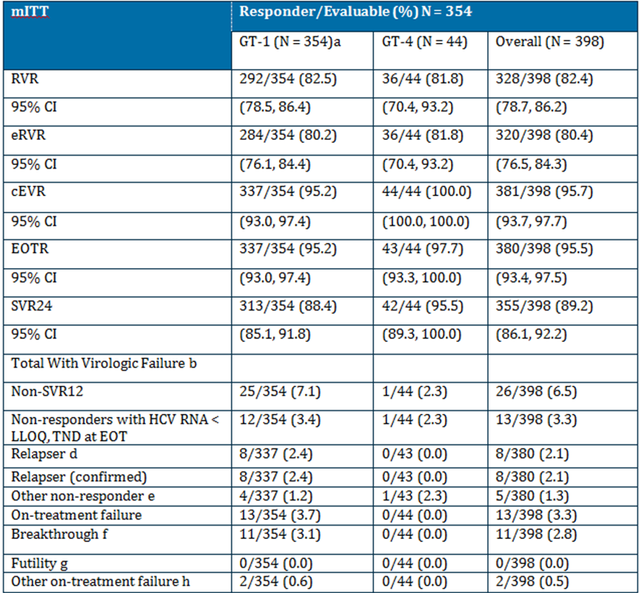
a One subject infected with HCV GT-4 as determined by NS3 and NS5A sequence alignment; however, an indeterminate GT was assigned in the viral GTdataset; subject entered the study as GT-1a (IVRS assignment) and included in the GT-1a cohort for the efficacy and safety analyses; subject was an SVR12 responder.
b HCV RNA measurements are excluded after the start of non-study anti-HCV medication on-treatment or during follow-up.
c SVR12 status for subjects with missing follow-up Week 12 HCV RNA is imputed using the first available HCV RNA measurement after the follow-up Week 12 window.
d Relapse occurs when HCV RNA < LLOQ, TND at EOT followed by HCV RNA ≥ LLOQ at any post-treatment visit; confirmed relapse occurs when HCV RNA < LLOQ, TND at EOT followed by confirmed HCV RNA ≥ LLOQ, where confirmed is 2 consecutive measurements ≥ LLOQ or last available measurement ≥ LLOQ; relapse and Other non-responder rates computed among all subjects with HCV RNA < LLOQ, TND at EOT, not just non-responders with HCV RNA < LLOQ, TND at EOT.
e Other non-responder is made up of subjects whose HCV RNA < LLOQ, TND at EOT but who are missing follow-up Week 12 HCV RNA.
f Breakthrough is confirmed > 1 log10 IU/mL HCV RNA on-treatment increase from nadir, or confirmed increase in HCV RNA ≥ LLOQ if HCV RNA previously declined to < LLOQ, TD or TND.
g Confirmed HCV RNA ≥ LLOQ at Week 8.
h Includes non-responders with missing or detectable HCV RNA at EOT.

Table 23: Study AI447029: Summary of HCV RNA over time - treated subjects with HCV GT-1
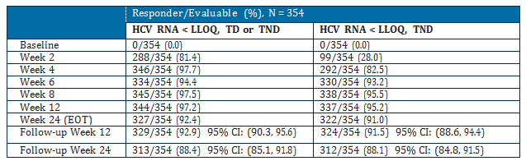

Table 24: Study AI447029: Summary of HCV RNA over time - treated subjects with HCV GT-4
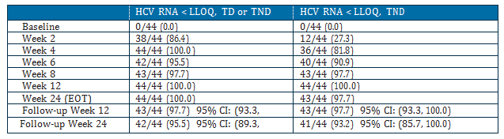

HCV RNA changes from baseline
Figure 9: Study AI447029: Mean HCV RNA Changes from Baseline - Treated Subjects

Resistance
- Overall, baseline resistance associated polymorphisms (RAPs) had little impact on ability of subjects to achieve SVR12. Of the evaluated baseline RAPs, only NS5A-L31M, NS5A-Y93, and NS3-R155 appeared to have potential relevance for GT-1a.
- The proportion of GT-1a subjects with NS5A-L31M, NS5A-Y93, and NS3-R155 baseline RAPs was low: 1.2 %, 1.2%, and 1.8% respectively
- The proportion of GT-1b subjects with NS5A-L31M, NS5A-Y93, and NS3-R155 baseline RAPs was low, 8.2%, 4.7%, and 0% respectively, and there was no clear association with virologic outcome
- There were no associations between baseline RAPs for GT-4 subjects. All subjects achieved SVR12 (imputed). A phylogenetic analysis of the 34 available subject-derived NS5A sequences revealed that the majority ~ 80% were more similar to GT-4a sequences and GT-4d (~18%)
- Non-structural protein 5A and NS3 resistance-associated variants to both DCV and ASV, respectively, were generally detected together at failure. These variants were genotype-specific

IL-28B (rs12979860 SNP analysis
The IL-28B rs 12989860 SNPs were analysed. For the SNP genotype, IL-28B genotype did not impact SVR12 rates for subjects with GT-1 (rs12979860: CC genotype, 93.9%, CT genotype, 92.2%; and TT genotype, 94.4%).
Evaluator comment: The study report states that the PK/PD results were to be reported in an addendum to the study report. No addendum to this study was included in the submission.

Study AI447011: supportive study

Study design, objectives, locations and dates
This was a parallel, open label, randomised, multi dose study to evaluate the safety, PK and PD of DCV and ASV in combination in null responders to standard of care infected with chronic HCV GT 1. It included groups x 2 who received DCV+ASV, groups x 2 who received pegIFNα/RBV with DCV+ASV (QUAD) and 1 group (B3) who received DCV+ASV+RBV. Results for the groups receiving pegIFNα/RBV are presented here.

Population flow
41 subjects were randomised into the QUAD expansion cohort:
- Group B1: 20 to treatment with DCV/ASV 200 mg BID + pegIFNα/RBV
- Group B2: 21 to treatment with DCV/ASV 200 mg QD + pegIFNα/RBV
These 41 randomised subjects were treated, completed the 24 week treatment period and entered the 48 week post treatment follow-up period. All but 2 subjects completed the study and one in Group B1 and one in Group B2 were ongoing in the follow-up period at the time of database lock for the CSR.
1 subject was randomised to Group B1, but took the B2 regimen (DCV/ASV 200 mg QD + pegIFNα/RBV) for the entire treatment period. This subject was analysed as a Group B2 subject.
In Group B1, 5 subjects had a dose reduction of pegIFNα and/or RBV:
- 2 subjects had a dose reduction of both pegIFNα and RBV: one due to neutropenia and one due to anaemia
- 1 subject had a dose reduction of pegIFNα only due to neutropenia
- 2 subjects had a dose reduction of RBV only: one due to rash and one due to anaemia

Baseline demographics
Baseline demographics were comparable in the 2 treatment groups. The mean age in Groups B1 and B2 combined was 52.8 years and 95.1% of subjects were aged < 65 years. Most subjects were white (87.8%) and the remainder (9.8%) were black/African American, or other race (2.4%). The distribution of subjects across the 3 BMI categories (< 25, 25 to < 30, and ≥ 30 kg/m2) was generally similar in the 2 treatment groups.
Baseline HCV disease characteristics were similar in the 2 treatment groups. The mean HCV RNA level overall was 6.68 log10 IU/mL. All, but 3 subjects in Group B2 had a baseline viral load ≥ 800,000 IU/mL and 12 subjects had a baseline viral load > 10,000,000 IU/mL. Most (87.8%) subjects had GT-1a and the remainder (12.2%) had GT-1b. The mean Fibrotest score overall was 0.613. Most subjects (95.1%, 39/41) had a METAVIR score (calculated using the Fibrotest score per manufacturer’s website) of F2 or F3. 10 subjects had a calculated METAVIR score > F3 (Fibrotest 0.82). Subjects with baseline Fibrotest scores > 0.72 were permitted to either repeat the Fibrotest and document a score < 0.72 or document a biopsy consistent with an absence of cirrhosis.
All subjects had IL-28B rs12979860 non-CC GTs. The median baseline ALT level overall was 78.5 U/L.
All prior null responders in the QUAD expansion cohort had an IL-28B rs12979680 non-CC genotype:
- Group B1: 13 CT and 7 TT
- Group B2: 17 CT and 4 TT

Results for efficacy outcomes
QUAD therapy with DCV 60 mg QD + ASV 200 mg BID + pegIFNα/RBV (Group B1) or DCV 60 mg QD + ASV 200 mg QD + pegIFNα/RBV (Group B2) produced high rates of virologic response in prior null responders with GT-1b and -1a.
- SVR12 rates (10 efficacy endpoint) were 95.0% in Group B1 and 95.2% in Group B2.
- Virologic response rates during treatment (RVR, cEVR, EOTR) and SVR12/SVR24 rates during follow-up were consistently high in both Group B1 and B2.
  - Among subjects with HCV RNA results at follow-up Weeks 12 and 24, the concordance of SVR24 with SVR12 (based on the criteria HCV RNA < LLOQ, TND) was 100% in both Group B1 and B2

Mean change from baseline in HCV RNA
Groups B1 and B2 had a similar mean change from baseline in HCV RNA during the first 2 weeks of treatment. The mean change from baseline in HCV RNA log10 IU/mL ranged from -4.2 at Day 4 to -5.5 at Day 14 in Group B1 and -4.2 at Day 4 and -5.2 at Day 14 in Group B2
Figure 10: Study AI447011: Mean (SE) change from baseline in log10 HCV RNA for First 2 Weeks of Treatment: All Treated Subjects in Groups B1 and B2
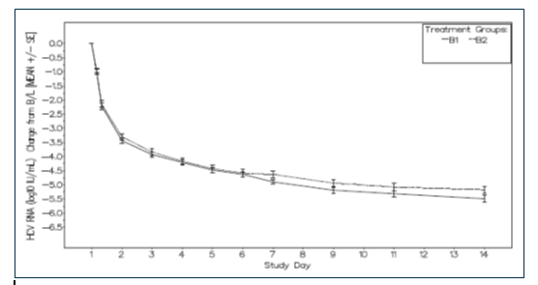

Study AI444046: long term follow up study: interim report
This study includes patients from 9 of the efficacy studies for all indications. The efficacy results are provided here.
The median duration of the follow up of the eligible subjects who achieved SVR12 in their respective parent study from the date of SVR12 in the parent study to the last HCV RNA measurement date in the follow up study was 537.0 days (76 weeks) for the subjects receiving DCV QUAD regimen.
Of the 601 eligible subjects in AI444046 who had achieved SVR12 during their parent studies there were no relapses reported from the DCV QUAD Regimen group (N = 31). Two relapses were reported within 6 months in the group of patients who received DCV/ASV plus pegIFNα/RBV rescue treatment after failing treatment with DCV/ASV.
A large percentage of subjects in AI444046 were censored, particularly after 18 months of follow-up, which makes KM estimates of the probability of loss of virologic response highly variable after the first year. The KM estimates of the probability of loss of virologic response were 0 for the DCV QUAD Regimen as there were no relapses in this cohort.

Treatment of Hepatitis C infection – DCV in combination with PegIFN plus ribavirin
The sponsor submitted 5 studies evaluating the combination of DCV + pegIFN + RBV. This combination as not been requested as part of the indication but the studies have been evaluated as they provide information relevant to the selection of DCV dose and safety.

Analyses performed across trials
No pooled analyses or meta-analyses have been done but the sponsor has provided summaries of the studies in each patient group within each indication.

DCV/ASV combination

Overall efficacy

Table 25: Summary of efficacy of DCV/ASV Therapy by Population
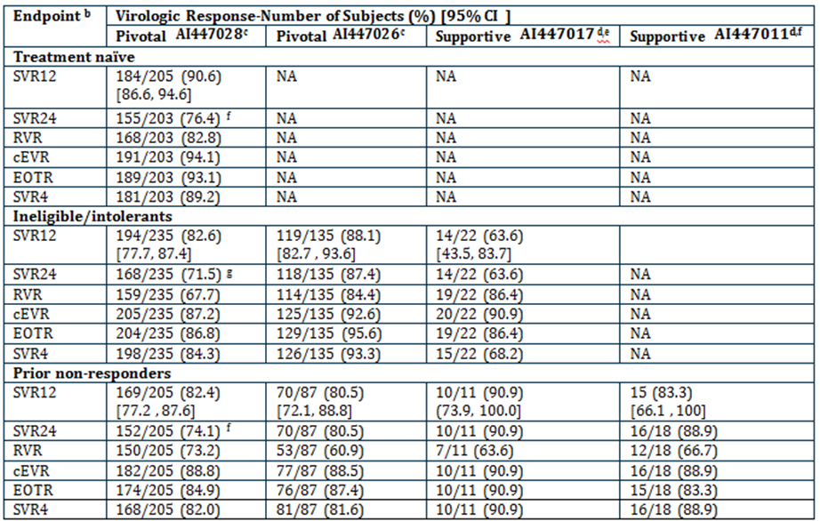
b On-treatment virologic rates based on HCV RNA < LLOQ, TND; SVR12 (imputed), SVR24, and SVR4 based on HCV RNA < LLOQ, TD or TND.
c Included null and partial responders (all subjects infected with GT-1b).
d Includes null responders only.
e Subjects in Cohort 2 (prior null responders; N = 11) and Cohort 3/4 (ineligible-naive/intolerants; N = 22) treated in Expansion Phase of study for 24 weeks at recommended dose.
f Subjects in Cohort 1A (prior null responders, N = 18) treated in Expansion Phase of study for 24 weeks at recommended dose.
g AI447028 study clinical study report completed for primary endpoint (SVR12). SVR24 rates are based on database as of 22-Nov-2013 in which 83 subjects remained in follow-up.

Virologic failure

Table 26: DCV/ASV - Virologic Breakthrough and Relapse
Population | Study | Virologic Breakthrough | Virologic Relapse
Treatment naïve | AI447028 | 4.4% | 2.6%
Non-responders | AI447028, AI447026, AI447017 | 0% - 12.7% | 0 - 7.9%
IFN intolerant/ ineligible | AI447028, AI447026, AI447017 a | 3% - 13.6% | 5.9% - 21.1%
a The VBT and relapse rates were higher among the small number of IFN intolerant/ineligible GT-1b subjects in AI447017; VBT occurred in 13.6% (3/22) of subjects and relapse occurred in 21.1% (4/19) of subjects. This is likely related to the greater proportion of subjects with baseline NS5A-Y93H (an NS5A resistance-associated polymorphism) in this small cohort of subjects.

DSV/ASV long term therapy
Among GT-1b subjects with HCV RNA results at both follow-up Weeks 12 and 24, the concordance between SVR12 and SVR24 rates with DCV 60 mg QD/ASV therapy was high:
- AI447028: 99.8% (529/530)
- AI447026: 99.5% (211/212)
- AI447017: 100.0% (28/28)
- AI447011: 94.1% (16/17)

DCV/SOF combination
Only one study was submitted in support of the DCV/SOF combination.

Table 27: AI44404: Efficacy of DCV/SOF by genotype and population
Endpoint | Virologic Response: Number of subjects with response (%) [95% CIs ]  HCV RNA < LLOQ, TD or TND, or TND as applicable based on endpoint^{b}
Treatment naïve: GT-1 | GT-1a (N = 99) | GT-1b (N = 27) | GT-1 (N = 126)
SVR12 | 98 (99.0) | 27 (100.0) | 125 (99.2) [97.1, 100.0]
SVR24 | 95 (96.0) | 25 (92.6) | 120 (95.2)
EOTR | 99 (100.0) | 27 (100.0) | 126 (100.0)
SVR4 | 98 (99.0) | 25 (92.6) | 123 (97.6)
Treatment naïve: GT-2/3 | GT-2 (N = 26) | GT-3 (N = 18) | GT-2/3 (N = 44)
SVR12 | 25 (96.2) [88.8, 100.0] | 16 (88.9) [74.4, 100.0] | 41 (93.2)
SVR24 | 25 (96.2) | 16 (88.9) | 41 (93.2)
EOTR | 26 (100.0) | 16 (88.9) | 42 (95.5)
SVR4 | 24 (92.3) | 16 (88.9) | 40 (90.9)
TVR/BOC Failures: GT-1 | GT-1a (N = 33) | GT-1b (N = 8) | GT-1 (N = 41)
SVR12 | 33 (100.0) | 8 (100.0) | 41 (100.0)
SVR24 | NA^{c} | NA^{c} | NA^{c}
EOTR | 30 (90.9) | 8 (100.0) | 38 (92.7)
SVR4 | 33 (100.0) | 8 (100.0) | 41 (100.0)
b EOTR: HCV RNA <LLOQ TND; SVR4, SVR12 and SVR24: HCV RNA <LLOQ TD or TND
c Note that the TVR/BOC failure groups (Groups I and J) were the last groups to be enrolled in the study; SVR24 results for these groups were not available at the time of database lock for the Study AI444040 CSR.

Table 28: SVR12 by Treatment Duration: GT-1 Treatment-Naive Subjects in AI444040 Treated with DCV/SOF +/- RBV
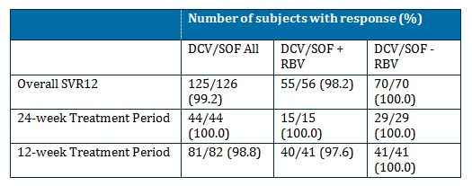

Virologic failure
Virologic failure was infrequent in these study populations with only 2 GT-1 subjects (2/398, 0.5%) experiencing virologic failure in AI447029.
Virologic breakthrough was infrequent with DCV QUAD therapy (11/398 [2.8%] subjects in AI447029, none in AI447011). In AI447029, relapse occurred in 8/380 (2.1%) subjects, all GT-1, and in AI447011, relapse occurred in 0 subjects. No subjects with GT-4 had virologic breakthrough.

Combination with interferon and ribavirin (DCV/pegIFNα/RBV Regimen)

Table 29: SVR12 Response Rates for DCV/pegIFNα/RBV, GT-1 Subtype (-1a and -1b)
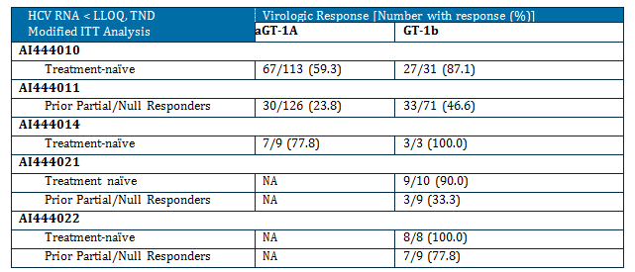

Table 30: SVR12 Response Rates for DCV/pegIFNα/RBV, GT-2/-3/-4
HCV RNA < LLOQ, TD or TND  Modified ITT Analysis | Virologic Response [Number with response (%)]
HCV RNA < LLOQ, TD or TND  Modified ITT Analysis | GT-2 | GT-3
AI444031 Treatment-naïve | 43/47 (91.5) | 41/53 (77.4)

Table 31: SVR12/24 by Baseline Cirrhosis: DCV/pegIFN/RBV Regimen
 | Virologic Response [Number with response (%)]
 | Cirrhotic |  | Non-Cirrhotic
 | DCV/pegIFNα/ RBV | Placebo/pegIFNα/ RBV | DCV/pegIFNα/ RBV | Placebo/pegIFNα/ RBV
Treatment Naive
SVR12: AI444010 (GT-1) | 5/8 (62.5) | 3/8 (37.5) | 91/137 (66.4) | 25/64 (39.1)
SVR24: AI444031 (GT-3)
12 week group | 3/7 (42.9) | - | 15/19 (78.9) | -
16 week group | 2/4 (50.0) | - | 14/20 (70.0) | -
24 week group | - | 3/7 (42.9) | - | 13/20 (65.0)
Prior Non-responders ª
SVR12: AI444011 (GT-1) | 9/34 (26.5) | 0/3 (0.0) | 55/165 (33.3) | 0/14 (0.0)
a DCV/pegIFNα/RBV group included prior null and partial responders; placebo group included partial responders.

Long-term results (DCV/pegIFNα/RBV)
Concordance of SVR12 and SVR24 was high with DCV/pegIFNα/RBV treatment ranging from 96.8 to 100% across the 6 supportive studies. Of the 287 subjects who received DCV/pegIFNα/RBV and enrolled in long-term follow-up study AI444046, 4 relapsed since achieving SVR12 in the parent study after a median duration of follow-up of approximately 22 months.
Of these 4 subjects, only 1 relapsed while in follow up study and the other 3 subjects relapsed during follow-up in the parent study.

Evaluator’s conclusions on clinical efficacy for treatment of HCV
This is a large and complex application. The new product DCV is only recommended in combination with other agents. One of these agents is ASV which is also a new chemical entity and the subject of a parallel evaluation. All the data for ASV is included in this submission (with the exception of 1 supportive study) as it is also only recommended for use in combination with DCV.
This submission comprises mostly early phase studies that include a range of dose regimens (doses and durations) and various patient populations (treatment naïve, prior treatment failure and IFN/RBV intolerant or ineligible). The sponsor has chosen to present the data as amalgamations of dosing and treatment under the 3 dose regimens requested. This has led to great difficulty in dissecting out the actual numbers of subjects treated with the regimens requested.
There is a problem with the indication as requested as the dose regimen requested does not reflect the patients included in the clinical studies. The company have addressed this issue by providing a “Position Pater on Proposed Dosage and Administration” in which they argue on the basis of a series of assumptions for extrapolations from the dose regimens submitted to the proposed dose regimens proposed for approval The rationale for these extrapolations were discussed in the TGA Pre-Submission Meeting Briefing Document provided by the Sponsor, however there is no mention in the minutes of the meeting (included in the submission).
In the Position Statement the sponsor provides the following table which describes the range of doses, duration and patient populations actually in the clinical trials in the submission.

Table 32: DCV (60-mg once daily) combination therapies: populations, regimens and durations of treatment studied in submitted clinical trials
Genotype / Population | DCV 60 mg once daily + Concomitant Agent | Duration | SVR12 Rates
Genotype 1b
treatment-naïve failed previous IFN/RBV therapy  intolerant/ineligible to IFN/RBV therapy | Asunaprevir 100 mg soft gel capsule twice daily  (or equivalent 200 mg tablet twice daily) | 24 weeks | 90.6%  80.5%-90.9%  63.6%-88.1%
Genotype 1
treatment-naïve  failed previous protease inhibitor therapy  failed previous IFN/RBV therapy | Sofosbuvir 400 mg once dailyª  Asunaprevir 100 mg twice daily and Peginterferon alfa and Ribavirin | 12 or 24 weeks  24 weeks  24 weeks | 97.6% (12 wks), 100% (24 wks)  97.6%  93%
Genotype 2
treatment-naïve | Sofosbuvir 400 mg once daily | 24 weeks | 92.3%
Genotype 3
treatment-naïve | Sofosbuvir 400 mg once daily | 24 weeks | 88.9%
Genotype 4
-failed previous IFN/RBV therapy | Asunaprevir 100 mg twice daily and Peginterferon alfa and Ribavirin | 24 weeks | 98%
a Since comparable results were observed for DCV/SOF regimens with or without RBV, the data from both groups are pooled. The addition of RBV to DCV/SOF does not improve efficacy, while resulting in higher anaemia rates. Thus the Sponsor recommends the use of DCV/SOF alone (without RBV).
The sponsor then proposed the following extrapolations – this is presented in detail and exactly as provided by the sponsor in the Position Paper:
- DAA+pegIFNα/RBV treatment failure to pegIFNα/RBV treatment failure: Since current standard-of-care for HCV GT-1 consists of a DAA in combination with pegIFNα/RBV, failure to these regimens containing pegIFNα/RBV means that these patients also failed the individual components of the treatment regimen, including pegIFNα/RBV alone. Thus, if an investigational regimen yields high SVR rates in patients who failed prior therapy with telaprevir (TVR) or boceprevir (BOC) in combination to pegIFNα/RBV, this same regimen would also be effective in patients who failed pegIFNα/RBV treatment alone.
- Treatment-naïve to prior IFN/RBV failures: Multiple studies with pegIFNα/RBV have shown that approximately 50% of subjects with genotype 1 and 20 - 30% with genotype 2 or 3 do not respond to pegIFNα/RBV therapy. Therefore, if an investigational DAA regimen yields 90 - 100% sustained virologic response (SVR) in treatment-naïve subjects, many patients who would have failed treatment with pegIFNα/RBV would also be expected to respond to this investigational DAA regimen. Extrapolation to prior IFN/RBV failures for HCV regimens is important since the future of HCV therapy will most likely include all-oral regimens, and thus patients currently categorised as partial or null responders to pegIFNα/RBV (based on failure to prior treatment with pegIFNα/RBV) will be fewer in number and harder to enrol in clinical trials.
- This rationale was used by FDA, and supported by the Antiviral Drug Advisory Committee, for SOF/pegIFNα/RBV, in which the strength of the data with this regimen in GT-1 treatment-naïve warranted its consideration for use in GT-1 prior IFN/RBV failures (a group not studied with that regimen). Extrapolation enables a broader patient population (ie, pegIFNα/RBV non-responders) to receive a regimen that is of shorter duration and better tolerated.
- Prior IFN/RBV failures to IFN/RBV treatment-naïve subjects: A regimen that has proven to be effective in a harder-to-treat patient population (such as IFN/RBV non-responders, which are generally associated with higher treatment-outcome risk factors) should be effective also in a treatment-naïve patient group. As has been shown with multiple therapeutic combinations, the SVR rates in subjects who are prior non-responders are often lower than that of subjects who are treatment-naïve using the same regimen. Therefore, extrapolation from the prior IFN/RBV failures to treatment-naïve subjects is reasonable.
- General populations studied to populations that are more difficult-to-treat: A subgroup analysis of the overall patient populations studied can be used to identify characteristics common to a population that is more difficult-to-treat. This could be used to expand the use of a highly effective investigational regimen to patients in need of treatment.
The sponsor then provided the following table with the extrapolations.

Table 33: DCV (60-mg Once Daily) Combination Therapies: Extrapolation
Genotype / Population | DCV 60 mg once daily + Concomitant Agent | Duration
Genotype 1b
treatment-naïve failed previous IFN/RBV therapy intolerant/ineligible to IFN/RBV therapy | Asunaprevir 100 mg soft gel capsule twice daily | 24 weeks
Genotype 1
treatment-naïve failed previous protease inhibitor therapy failed previous IFN/RBV therapy failed previous IFN/RBV therapy treatment naïve | Sofosbuvir 400 mg once daily  Asunaprevir 100 mg twice daily and Peginterferon alfa and Ribavirin | 12 weeks  24 weeks
Genotype 2
treatment-naïve failed previous IFN/RBV therapy | Sofosbuvir 400 mg once daily | 12 weeks
Genotype 3
treatment-naïve failed previous IFN/RBV therapy | Sofosbuvir 400 mg once daily | 12 or 24 weeks
Genotype 4
failed previous IFN/RBV therapy treatment-naïve | Asunaprevir 100 mg twice daily and Peginterferon alfa and Ribavirin | 24 weeks
Note: Proposed extrapolation shown in bold, italicized font
Overall the data appears efficacious with consistent findings of high SVR rates. This is well documented for GT-1 (and GT-1a and GT-1b). However, the sponsor did not include patient numbers in the table of submitted studies. When this is done, the following table is produced.

Table 34: Subjects treated with 60 mg DCV + various combinations by HCV GT -
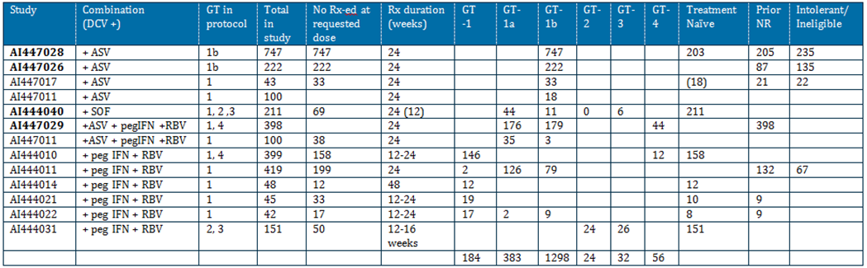
NR = non responder
Pivotal studies in bold
AI444040 – Group C & D & G – Group C & D treated for 24 weeks and Group G for 12 weeks
AI447011 – Group A1 (DCV & ASV) and Group B1 (= DCV 60 mg + ASV 200 mg tab BID + IFN + RBV
AI444021/22 - patients treated for 12 weeks and then if responded treated for another 12 weeks.
The key problem is with the GT of HCV other than GT-1. This submission was the same as that submitted in the USA but not the EU as the sponsor states that the submission was delayed in EU due to lack of data on GT-4. It is also noted that the companion product ASV has not been submitted in Europe and so the approved treatment regimens in Europe are necessarily different to Australia and the US where ASV has been submitted.
The key issue relevant to Australia is the patient group with GT-3. The data from Australian sources (eg Dore et al) suggest that the epidemiology of HCV is not the same as in the US with a greater proportion of patients with GT-3 in Australia. Throughout the submission the sponsor has pooled data for each treatment regimen. Thus, for GT-2 and 3 they have pooled together the data for all treatment doses and regimens to suggest greater number of patients treated than is actually the case. Treatment of patients with GT-3 is represented by only one study (AI444040) and by only 3 groups within that study (groups B, D and F). These groups each included patients with both GT-2 and GT-3 and had slightly different treatments. All groups were treated for 24 weeks. This is summarised below.

Table 35: Study A1444040: Treatment Regimens: Groups B, D and F
Group | Treatment regimen | No patients GT-2 | No patients GT-3
B | SOF 400 mg QD for 7 days (monotherapy) and then added DCV 60 mg QD | 9 | 7
D | DCV 60 mg QD + SOF 400 mg QD | 8 | 6
F | DCV 60 mg QD + SOF 400 mg QD + SOF | 9 | 5
Therefore only 6 patients were actually treated with the proposed dose and for 24 weeks rather than the proposed 12 weeks. The justification for the proposal of an option of 12 weeks or 24 weeks is based on a selected literature review mostly of studies in patients with GT-1. The results quoted for GT-3 patients who were treated for 12 (ineligible for IFN) to 16 weeks (prior IFN treatment) were SVR 30%-61%. The sponsor also claims that there is no difference when RBV is added to the regimen but with so few patients treated with each specific regimen there is insufficient evidence for such a claim.
These data are tenuous at best and insufficient to warrant approval for the combination of DCV + SOF for 12 weeks for GT-3. A larger study should be performed in this patient group to clarify that DCV +SOF is appropriate and to clarify the optimal duration of treatment. If it is to be approved than the recommended duration should be 24 weeks. There is insufficient data to justify the extrapolation from 24 weeks to 12 weeks.
The extrapolations appear to be suggestive of a hasty submission of early phase studies in place of appropriately conducted clinical trials. The extrapolation to 12 weeks for GT-3 should not be accepted as a reason for not conducting the required trials to prove the efficacy and safety of the product. The extrapolation of the use of DCV/SOF in GT-1 to include prior treatment failures who have failed pegIFNα/RBV is appropriate given there is evidence of good response in the group who have failed prior TVR and BOC plus pegIFNα/RBV. The patient numbers treated with the proposed treatment regimens are not sufficient to support the extrapolations requested for GT-2 and GT-3.
Lack of comparative data to other newer agents is also lacking in the submission. While most of the newer agents have only been approved in Australia while this submission was being evaluated the range of products which will soon be available make it difficult for clinicians to decide the optimum therapy. It appears there is a move towards all oral therapy (replacing IFN) but the optimum therapy is not clear and is unlikely to be until some direct comparative studies are conducted. The sponsor has chosen not the seek approval for the combination of DCV + pegIFNα +RBV despite having conducted a large number of trials for this combination. No explanation is provided as to why this was not requested and it is assumed it is to move to combinations of oral therapy.
The use of SVR12 in place of SVR24 as required by the adopted EU guideline is acceptable based on the high and consistent responses and concordance of SVR12 and SVR24.
Overall, the data support the following indications:
- used in combination as DCV/ASV therapy for the treatment of genotype (GT) -1b HCV infected subjects who are treatment-naïve, ineligible/intolerant to interferon (IFN)-based therapy or who are prior non-responders (null or partial responders) to IFN (peginterferon α [pegIFNα]/ribavirin (RBV) therapy – treatment for 24 weeks
- used in combination with SOF for the treatment of GT-1 infected subjects who are treatment-naïve, ineligible/intolerant to interferon (IFN)-based therapy or who are prior non-responders (null or partial responders) to IFN (peginterferon α [pegIFNα]/ribavirin (RBV) therapy – treated for 12 weeks
- DCV and ASV combined with pegIFNα/RBV (DCV Quad for the treatment of GT-1 or -4 HCV infected subjects who are treatment-naïve or prior non-responders (null or partial responders) to IFN/RBV therapy – treated for 24 weeks

Clinical safety

Studies providing evaluable safety data
There were no pivotal studies that assessed safety as a primary outcome.
In the efficacy (pivotal and supportive) studies, the following safety data were collected:
- General AEs were collected at each study visit either from spontaneous reports by the subject or elicited during open-ended questioning, examination, or evaluation of a subject.
- AEs of particular interest, including haematological events (especially pancytopenia and Grade 3/4 neutropenia), liver function tests (especially ALT and AST), gastrointestinal (GIT) events (especially anorectal events), rash and hypersensitivity were assessed by conducting specific searches of the AE database.
- Laboratory tests, including standard haematology and clinical chemistry testing, were performed at each study visit.
- ECG, vital signs and physical examination were conducted at pre and post treatment and at specified study visits.

Patient exposure
The patient exposure is presented as it is provided by DCV combination regimens.

Table 36: Subjects treated with DCV combination regimens at recommended dose: 60 mg QD
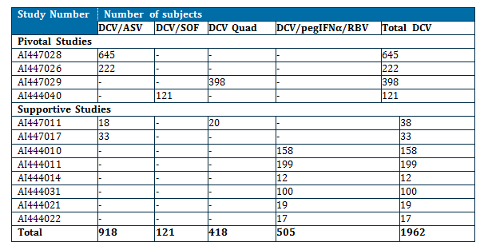

Table 37: Exposure to daclatasvir in clinical studies according to dose and duration: DCV/ASV, DCV/SOF, DCV QUAD and DCV/IFN/RBV Regimens

DCV/ASV regimen
Study | DCV median dose (range) | ASV median dose (range) | Median duration (Weeks)
AI447028 and AI447026 | 60 mg  (51.1 - 80.5 mg) | 200 mg*  (157.0 - 210.7 mg) | 24  (0.3 - 28.7)
AI447017 and AI447011 | 60 mg  (57.0 - 60.0 mg) | 400 mg*  (346.4 - 400.0 mg) | 24  (0.3 - 28.7)
* In studies AI447028 and AI447026 ASV soft gel capsules were used. In studies AI447017 and AI447011 ASV tablets were used – doses are stated to be comparable.

DCV/SOF regimen
Study | DCV median dose (range) | SOF median dose (range) | RBV median dose** (range) | Median duration
AI444040 | 60 mg (55.7 - 61.1 mg) | 400 mg* (365.5 - 407.2mg) | 1000.0 mg (629.9 - 1200.0) | Not stated
* Tablet formulation
** Groups E, F, H, and J

DCV Quad Regimen
Study | DCV median dose (range) | ASV median dose (range) | PegIFNα median dose (range) | RBV median dose* (range) | Median Duration (Weeks)
AI447029 | 60 mg (48.6 - 64.9 mg) | 200 mg* (100.0 - 203.0 mg) | 180 μg (73.8 - 187.5) | 1056.7 mg (422.2 - 1200) | 24.0 (4.0 - 25.0)
AI447011  (Group B1) | 60.0 mg (55.5 - 65.9) | 400.0 mg ** (359.3 - 400.0) | 180.0 μg (144.4 - 180.0) | 1098.2 mg (717.9-1207.1) | 23.9 (23.7 - 24.1)
* Capsule formulation
** Tablet formulation

DCV/IFN/RBV regimen
Study | DCV median dose (range) | PegIFNα-2a median dose (range) | PegIFNα-2b median dose (range) | RBV median dose (range) | Median Duration (Weeks)
AI444010 AI444011 AI444014 AI444031 AI444021 AI444022 | 60.0 mg (25.9 - 80.6) | 180.0 μg (84.4 - 315.0) | 80.0 μg (53.8 - 120.0) | 1000.0 mg (408.3 - 1307.8) | 24.0 (0.1 - 56.3)
All above adapted from Text and individual study CSRs.

Adverse events

All adverse events: irrespective of relationship to study treatment

DCV/ASV combination
The frequency of on-treatment AEs in the treatment-naïve cohort during the first 12 weeks of DCV/ASV or placebo therapy in AI447028 was comparable between the treatment arms. Most on-treatment AEs, regardless of relationship to study therapy, were mild to moderate (Grade 1/2) in intensity. The most frequently reported (≥ 10%) AEs, were fatigue, diarrhoea, nasopharyngitis, headache, and nausea. Grade 3/4 AEs, regardless of relationship to study therapy, were reported in 94 (10.2%) subjects.
Overall, 50 (5.4%) subjects reported Grade 3/4 treatment-related AEs. Grade 3/4 AEs during the first 12 weeks of DCV/ASV or placebo treatment in the treatment-naïve cohort of AI447028 were slightly greater in the DCV/ASV treatment arms (DCV/ASV: 4.4%; placebo: 2.9%).

DCV/SOF
The most frequently reported AEs were fatigue, headache, nausea, arthralgia, and diarrhoea. These were consistent across the treatments (DCV/SOF ± RBV) and the duration of treatment (12 or 24 weeks).

QUAD therapy
The most frequently (≥ 10%) reported AEs were fatigue, headache, pruritus, asthenia, influenza-like illness and insomnia, rash, anaemia, cough, dry skin, diarrhoea, nausea, alopecia, irritability, pyrexia, myalgia, neutropenia, dyspnoea, decreased appetite, and arthralgia. Most AEs were mild to moderate (Grade 1/2) in intensity.

DCV/IFN/RBV
The proportion of subjects reporting AEs was similar between the DCV/pegIFNα/RBV and placebo/ pegIFNα/RBV.

Treatment-related adverse events: adverse drug reactions

DCV/ASV
The most frequently reported (≥ 5%) treatment-related AEs were headache, fatigue, diarrhoea, nausea, and ALT increased. Overall, 15/918 (1.6%) subjects had AEs of both Grade 3/4 ALT increased and Grade 3/4 AST increased, including 2 (0.6%) prior non-responder, and 13 (3.3%) intolerant/ineligible subjects.

DCV/IFN/RBV
The proportion of subjects with treatment-related AEs (any grade) was similar with DCV/pegIFNα/RBV and placebo/pegIFNα/RBV. The most frequently reported (≥ 10%) treatment-related AEs among DCV/pegIFNα/RBV-treated subjects were fatigue, headache, pruritus, insomnia, influenza-like illness, dry skin, nausea, alopecia, decreased appetite, rash, irritability, myalgia, dyspnoea, cough, anaemia, pyrexia, diarrhoea, asthenia, neutropenia, arthralgia, and depression.
The frequency of treatment-related Grade 3/4 AEs was lower with DCV/pegIFNα/RBV than with placebo/pegIFNα/RBV group (15.8% vs 25.3%, respectively). The most frequently reported (>5%) Grade 3/4 treatment-related AE was neutropenia with both DCV/pegIFNα/RBV and placebo/pegIFNα/RBV (5.7% vs 9.2%, respectively).

Deaths and other serious adverse events

DCV/ASV
There were no deaths reported in subjects treated with DCV 60 mg QD/ASV 100 mg capsule BID/200 mg tablet BID in studies AI447028, AI447026, AI447017, and AI447011.
The frequency of treatment related SAEs were low (9 subjects, 1.0%). Pyrexia (3 subjects, 0.3%) and ALT increased (2 subjects, 0.2%) were the only treatment related SAEs reported in more than 1 subject.

DCV/SOF
There were no deaths reported in study AI444040. SAEs were reported in 7.1% of subjects overall. There was a higher proportion of subjects reporting SAEs in the 24 week groups compared to the 12 week group (8.8 - 12.2% vs 2.4%). Only the SAE of overdose (of DCV/SOF) in 4 subjects were judged by the investigator as related to study therapy. These events were generally inadvertent single extra doses of study medications reported as SAEs (as required by the protocol) and did not result in clinical symptoms or require treatment intervention.
Many of the subjects with other SAEs (judged by the investigator as not related to study therapy) had a relevant medical history that may have contributed to the SAE. Study medications were continued and the events resolved without study drug discontinuation in most cases, consistent with a lack of relationship to study therapy.

QUAD therapy
No deaths were reported in the DCV QUAD therapy trials while on treatment. There was 1 death reported during follow up at Week 12. The death was due to an SAE of Grade 4 pneumonia, which was judged by the investigator as not related to study therapy. The frequency of SAEs was low (2.3% in study AI447029, 5% in study AI447011). Anaemia (2 subjects 0.5%) was the only treatment related SAE reported in more than 1 subject.

DCV/IFN/RBV
There were no deaths reported during treatment with DCV/INF/RBV. 2 subjects died during follow up:
- A [information redacted] subject with cirrhosis, was treated with DCV 60 mg/pegIFNα/RBV and died due to liver and kidney failure during follow-up on Day 295. The subject was diagnosed with renal and hepatic failure (both Grade 4), shock haemorrhagic (Grade 3), and sepsis (Grade 4), on Day 248, 83 days after the last dose of DCV (the subject had discontinued RBV and pegIFNα on Days 202 and 203, respectively). The investigator considered the liver and kidney failure events to be related to study therapy.
- A [information redacted] subject with cirrhosis, was treated with DCV 60 mg/pegIFNα/RBV and died as a result of haemoperitoneum due to hepatocellular carcinoma during follow-up on Day 405. The subject was hospitalised due to Grade 3 hepatic neoplasm malignant 232 days after the last dose of DCV. The investigator considered the hepatic neoplasm malignant event as unrelated to study therapy.
The proportion of subjects reporting SAEs was low and similar in both DCV (2.8%) and placebo (2.3%) treatment groups. No event occurred more than once in the DCV/ pegIFNα/RBV group.

Discontinuation due to adverse events

DCV/ASV
23 (2.5%) subjects discontinued study therapy due to an AE. 19 (2.1%) subjects discontinued study therapy due to at least 1 AE that involved LFT elevations (ALT increased, AST increased, blood bilirubin increased, transaminases increased, or hypertransaminasaemia), of whom 16 achieved SVR12.

DCV/SOF
Two (< 1%) subjects had an AE leading to discontinuation of study therapy (Grade 2 cerebrovascular accident and Grade 3 fibromyalgia). These events were not considered related to study therapy.

QUAD therapy
Overall, 18 (4.5%) subjects discontinued study drugs due to an AE. 7 (1.8%) subjects discontinued due to skin and subcutaneous tissue disorders, although none were reported as serious. 1 subject discontinued study drugs due to an AE of increased hepatic enzyme.

DCV/IFN/RBV
The proportion of subjects with AEs leading to discontinuations of study drugs was low in both treatment groups, 6.5% and 8.6% with DCV/pegIFNα/RBV and placebo/ pegIFNα/RBV respectively. Anaemia was the most frequent AE leading to discontinuation (3 subjects).

Laboratory tests

Liver function

DCV/ASV
Based on the integrated DCV/ASV analyses (Studies AI447028, AI447026, AI447017 and AI447011), the majority of LFT abnormalities (AST, ALT, and bilirubin increases) were Grade 1/2. Grade 3/4 ALT abnormalities were reported in 36 (3.9%) DCV/ASV-treated subjects (7 [3.4%] treatment-naïve, 11 [3.4%] prior non-responder, and 18 [4.6%] intolerant/ineligible). The median time to onset of ALT/AST elevations was approximately 13 weeks.
Grade 3 total bilirubin laboratory abnormalities were reported in 6 (0.7%) DCV/ASV-treated subjects (1 [0.5%] treatment-naïve, 2 [0.6%] prior non-responder, and 3 [0.8%] intolerant/ineligible). No subject had Grade 4 bilirubin, or Grade 3/4 alkaline phosphatase (ALP) or albumin abnormal values on-treatment.
There were 3 subjects (1 treatment-naïve, 1 prior non-responder, and 1 intolerant/ineligible) who met the laboratory criteria for potential drug induced liver injury (pDILI). In all 3 cases, LFT elevations were reversible with cessation of study therapy. No hepatic decompensation was associated with these elevations. Two subjects achieved SVR and the other subject was a virologic failure. One subject did not meet the clinical criteria for pDILI due to baseline Gilbert’s syndrome.

Table 38: Summary of worst grade liver function tests in DCV/ASV studies
Parameter | Number (%) of Subjects ^{a,b}
Parameter | Treatment-naïve (N = 205) | Prior Non-responders (Null + Partial) (N = 321) | Intolerant/ Ineligible (N = 392) | Total (N = 918)
ALT | N = 203 | N = 321 | N = 391 | N = 915
Grade 0 | 146 (71.9) | 200 (62.3) | 240 (61.4) | 586 (64.0)
Grade 1 - 2 | 50 (24.6) | 110 (34.3) | 133 (34.0) | 293 (32.0)
Grade 3 - 4 | 7 (3.4) | 11 (3.4) | 18 (4.6) | 36 (3.9)
AST | N = 203 | N = 321 | N = 391 | N = 915
Grade 0 | 151 (74.4) | 218 (67.9) | 249 (63.7) | 618 (67.5)
Grade 1 - 2 | 45 (22.2) | 97 (30.2) | 127 (32.5) | 269 (29.4)
Grade 3 - 4 | 7 (3.4) | 6 (1.9) | 15 (3.8) | 28 (3.1)
Billirubin | N = 203 | N = 321 | N = 391 | N = 915
Grade 0 | 188 (92.6) | 289 (90.0) | 314 (80.3) | 791 (86.4)
Grade 1 - 2 | 14 (6.9) | 30 (9.3) | 74 (18.9) | 118 (12.9) ^{c}
Grade 3 - 4 | 1 (0.5) | 2 (0.6) | 3 (0.8) | 6 (0.7)
a Percentage relative to the number with the test
b Does not include assessments during rescue therapy
c The majority of the Grade 1/2 bilirubin laboratory abnormalities reported on-treatment Grade 1 (83 [9.1%]) subjects.

DCV/SOF
In study AI444040, no Grade 3/4 ALT, AST or total bilirubin values were reported and no cases of pDILI were identified. Overall, most subjects had normal LFT values on treatment. No Grade 3/4 LFT values were reported in the study. Grade 1/2 total bilirubin levels were numerically higher in the groups treated with RBV (DCV/SOF + RBV) compared with subjects not treated with RBV (DCV/SOF): 18.9% vs 5.0%. No cases of pDILI were observed with the combination of DCV/SOF alone.

DCV QUAD
1 (0.3%) subject in study AI447029 met the laboratory criteria for pDILI. This was 61-year-old white male with HCV GT-4 who was a prior partial responder to pegIFNα/RBV therapy without cirrhosis who had hepatic enzyme increased (Grade 3) beginning on Study Day 56.
The patient also had a decrease in haemoglobin within the first 2 weeks of therapy. ASV therapy was interrupted at Week 9, and was resumed after 9 days. The subject was asymptomatic and no clinical hepatic decompensation was noted. The event of increased hepatic enzyme was considered resolved at Week 20 (Study Day 141). The subject continued the study and completed 24 weeks of DCV QUAD regimen. At Week 4 through follow-up Week 24, the subject’s HCV RNA levels were < LLOQ, TND, and he achieved SVR12.
No subject in the DCV Quad group (Group B1) of study AI447011 met the laboratory criteria for pDILI.

DCV/INF/RBV
No cases of pDILI were identified in subjects treated with DCV 60 mg QD/pegIFNα/RBV.

Review of liver toxicity by independent hepatologist
The company provided a review of the liver toxicity conducted by [information redacted]. This review was of the safety data for DCV and ASV in the Summaries of Clinical Safety, the Investigators Brochures for both products and the Exposure-Response Analysis for ASV and DCV in HCV Infected Subjects. His review includes analysis of individual cases of abnormal LFTs and specifically the 4 cases of potential DILI. There is no discussion in the report on use of DCV plus SOF.
The conclusion is:
Given the improved efficacy and tolerability profile of the DCV/ASV and DCV QUAD therapies, as well as the reversibility of observed transaminase elevations, it is my opinion that the DCV/ASV and DCV QUAD therapies can be safely administered in patients with routine monitoring of liver tests. Based upon my review of the available safety data and the fact that treatment with DCV/ASV and DCV QUAD therapies will be limited to 24 weeks, clinicians should monitor liver tests at weeks 2, 4, 8, 10 and 12.
Additional testing and follow-up should be instituted in those patients who demonstrate clinically significant elevations at any of those time points. More specifically, subjects with Grade 4 aminotransferase enzyme elevations or bilirubin elevations > 2 at any time point should be immediately discontinued from therapy. Caution and more frequent monitoring should be instituted in any patient who develops a Grade 3 elevation in ALT or AST during the course of therapy. Clinicians should fractionate bilirubin lab tests prior to deciding to discontinue therapy to ensure that the abnormalities are not related to underlying Gilbert’s disease. Patients should be advised to limit alcohol intake to no more than 20 grams (approximately two drinks) of alcohol per day (and preferably not every day), and take 2 grams or less of acetaminophen per day. Clinicians should also pay special attention to over-the-counter and prescribed medications that are metabolized by CYP3A in order to avoid potential drug induced elevations in exposure levels.

Kidney function

DCV/ASV
Based on the integrated analyses, the majority of DCV/ASV-treated subjects had normal (Grade 0) creatinine on-treatment. Grade 1/2 creatinine values were reported in 69 (7.5%) DCV/ASV-treated subjects, which included 13 (6.4%) treatment-naïve, 16 (5.0%) prior null responders and 40 (10.2%) intolerant/ineligible subjects. Grade 3/4 creatinine values were reported in 2 (0.5%) DCV/ASV-treated subjects of whom 1 subject (treatment naïve) was reported as having a Grade 3 SAE of pyelonephritis at Week 16 on-treatment, and, 1 subject (intolerant/ineligible) was reported as having a Grade 2 SAE of pyelonephritis at Week 2 on-treatment. Both events of pyelonephritis were judged by the investigator as not related to study therapy. No subject with baseline Grade 1/2 creatinine values had worsening on-treatment to Grade 3/4..

DCV/SOF
In study AI444040 no Grade 3/4 creatinine laboratory abnormalities were reported. Grade 1 - 2 creatinine laboratory abnormalities were reported in 18 (8.5%) subjects: 8.9% in the DCV/SOF + RBV groups and 8.3% in the DCV/SOF group.

DCV qUAD
In study AI447029, no subject had a Grade 3/4 creatinine value. Grade 1/2 creatinine values were reported in 12 (3.0%) subjects. No subject with baseline Grade 1/2 creatinine value had worsening on-treatment.

DCV/IFN/RBV
Most (98%) subjects had normal creatinine at baseline and remained normal throughout the study. Grade 3/4 abnormalities of creatinine were reported for 1 subject in each treatment group.

Haematology

DCV/ASV
Based on the integrated DCV/ASV analyses the majority of subjects had normal haematologic laboratory values on-treatment with most abnormalities on-treatment Grade 1 or 2.

DCV/SOF
No Grade 4 laboratory values were reported in this study. A larger mean decrease from baseline in haemoglobin was observed in the groups receiving RBV (DCV/SOF + RBV) compared with the groups without RBV (DCV/SOF). The proportion of subjects with haemoglobin decreases from baseline (Grade 1/2) was 30.0% vs 3.3% in subjects with and without RBV respectively.

Electrocardiograph
No safety signals were identified from ECG data in any of the DCV combination regimens. DCV was not associated with QTc prolongation, or clinically meaningful effects on other ECG intervals, in a QT study AI444023 (see pharmacology evaluation report).

Vital signs
There were no safety signals identified in any of the DCV combination regimes - DCV/ASV, DCV/SOF, DCV Quad, or DCV/pegIFNα/RBV from vital signs or physical findings.

Post-marketing experience
Not applicable as drug is not yet marketed in any country.

Safety issues with the potential for major regulatory impact

Liver toxicity

DCV/ASV
Subjects with baseline compensated cirrhosis were included in studies AI447028 and AI447026 but were excluded from Studies AI447017 and AI447011. In the integrated analysis evaluating DCV 60 mg QD plus ASV 100 mg BID, 229 of 918 (24.9%) subjects had baseline cirrhosis. There was no clinically meaningful difference in subgroups by cirrhosis. The frequency of SAEs (regardless of relationship to study therapy) were low (< 10%) and were consistent among subjects with (15 [6.6%] subjects) and without cirrhosis (41 [6.0%] subjects). SAEs of hepatocellular carcinoma (in 5 [2.2%] subjects with, and 2 [0.3%] subjects without cirrhosis), liver transplant (in 1 [0.4%] subject with, and 0 subjects without cirrhosis), ascites (in 1 [0.4%] subject with, and 0 subjects without cirrhosis), oesophageal varices haemorrhage (in 1 [0.4%] subject with, and 0 subjects without cirrhosis) were reported.
The frequency of AEs (regardless of relationship to study therapy) among subjects with cirrhosis (83.4% [191/229] of subjects) was consistent with the frequency of AEs among subjects without baseline cirrhosis (86.4% [595/689] subjects).

Table 39: AEs reported in ≥5% of DCV/ASV treated subjects by baseline cirrhosis status
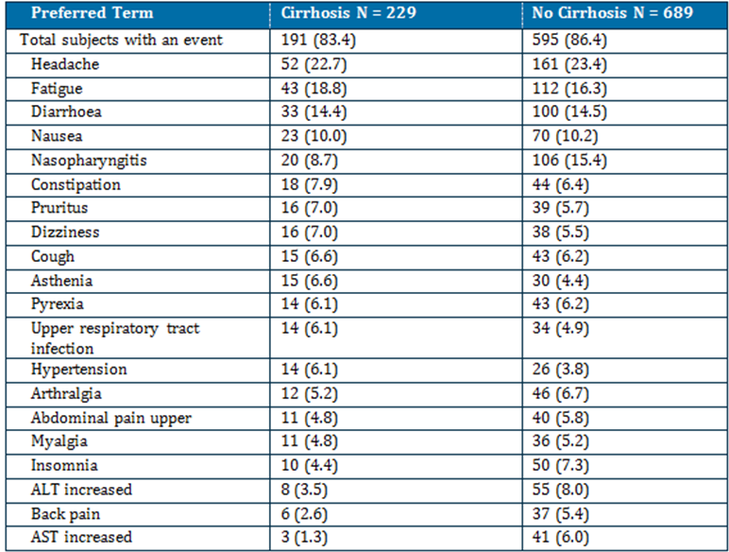
a. Does not include AEs that may have occurred during rescue therapy.
The frequency of LFT laboratory abnormalities (ALT, AST) was lower among subjects with baseline cirrhosis compared to subjects without baseline cirrhosis. Grade 3/4 ALT was reported in 4 (1.8%) subjects with and 32 (4.7%) without cirrhosis. Grade 3/4 AST was reported in 4 (1.8%) subjects with and 24 (3.5%) subjects without cirrhosis. Grade 3/4 total bilirubin was reported in 3 (1.3%) subjects with and 3 (0.4%) subjects without cirrhosis. The rate of concurrent (within ± 4 weeks of each other) Grade 3/4 ALT and AST was lower among subjects with baseline cirrhosis (4 [1.8%] subjects) compared to subjects without baseline cirrhosis (23 [3.3%] subjects). No cirrhotic subject treated with DCV/ASV during the first 12 weeks of treatment in the treatment-naïve cohort of AI447028 developed Grade 3/4 LFT laboratory abnormalities.

DCV/SOF
In Study AI444040 subjects with cirrhosis were excluded from enrolment.

QUAD: DCV/ASV/IFN/RBV
In the pivotal study AI447029, 93 of 398 (23.4%) DCV QUAD-treated subjects had baseline cirrhosis. There was no clinically meaningful difference in subgroups by cirrhosis, among subjects exposed to DCV 60 mg QD in combination with ASV + pegIFNα/RBV. The frequency of SAEs (regardless of relationship to study therapy) were low (< 10%) and were consistent among subjects with (4 [4.3%] subjects) and without cirrhosis (18 [5.9%] subjects).
SAEs reported in more than 1 subject in either group (with baseline or without baseline cirrhosis) included pneumonia (in 1 [1.1%] subjects with, and 2 [0.7%] subjects without cirrhosis), and anaemia (in 2 [2.2%] subjects with, and 0 subjects without cirrhosis). The frequency of AEs (regardless of relationship to study therapy) among subjects with cirrhosis (98.9% [92/93] subjects) was consistent with the frequency of AEs among subjects without baseline cirrhosis (98.7% [301/305] subjects).
Study AI447011 excluded subjects with cirrhosis.

DCV/IFN/RBV
Subjects with baseline compensated cirrhosis were included in studies AI444010, AI444011 and AI444031. In these, 53/505 (10.5%) DCV/pegIFNα/RBV subjects had baseline cirrhosis, including 19 (6.6%) treatment-naïve and 34 (15.7%) prior non-responders. Rates of SAEs (regardless of treatment relatedness) with cirrhosis in DCV/pegIFNα/RBV-treated subjects (9/53 [17.0%]) were similar to subjects treated with placebo/pegIFNα/RBV (2/19 [10.5%]). Rates of AEs (regardless of treatment relatedness) with cirrhosis in DCV/pegIFNα/RBV-treated subjects (98.1% [52/53]) were similar to placebo/pegIFNα//RBV-treated subjects (94.7% [18/19]).

Resistance
The sponsor has provided a summary report on the resistance profiles seen with the recommended dose of DCV (60 mg QD) in the following combination therapies:
- DCV/ASV (recommended dose of 100 mg BID [soft gel capsule] or 200 mg BID [tablet]) in HCV GT-1b treatment-naïve, prior non-responders or intolerant/ineligible subjects to pegIFNα/RBV participating in 4 Phase II/III studies (AI447028, AI447026, AI447017, and AI447011)
- DCV/SOF (recommended dose of 400-mg QD) with or without RBV in treatment-naïve subjects infected with GT-1, GT-2, or GT-3, or prior NS3 PI failures infected with GT-1 participating in the Phase II study (AI444040)
- DCV Quad therapy in 2 Phase II/III studies (AI447029 in prior non-responders infected with GT-1 or GT-4 and AI447011 in prior non-responders infected with GT-1)
- DCV/pegIFNα/RBV (6 Phase II studies, AI444010 in GT-1 and GT-4 treatment-naive, AI444011 in GT-1 prior non-responders to pegIFNα/RBV, AI444014 in GT-1 treatment-naïve , AI444031 in GT-2 and GT-3 treatment-naive, AI444021 and AI444022 in GT-1b treatment-naive and prior non-responders to pegIFNα/RBV) and ASV/pegIFNα/RBV (AI447016 in GT-1 and GT-4 treatment-naïve)
The summary of results was:
- DCV/ASV therapy was generally effective at suppressing the emergence of NS5A and NS3 RAVs in GT-1b treatment-naïve, prior non-responders and IFN intolerant/ineligible subjects. Drug-resistant variants to both DCV and ASV were generally detected together.
- Baseline NS5A polymorphism at L31 and Y93H appeared to be associated with virologic failure in the DCV/ASV therapy in subjects infected with GT-1b, while baseline NS3-D168E appeared to be associated with virologic failure to a lesser extent.
- DCV/SOF therapy was effective at suppressing the emergence of NS5A and NS5B RAVs, respectively, in treatment-naïve subjects infected with HCV GT-1, GT-2, and GT-3 and prior TVR/BOC failures infected with GT-1
- DCV Quad therapy was effective at suppressing the emergence of NS5A and NS3 RAVs in prior non-responders to pegIFNα/RBV treatment infected with GT-1 and GT-4. Drug resistant variants to both DCV and ASV were generally detected together in GT-1a virologic failures and the single GT-1b virologic failure. There were no GT-4 virologic failures.
- DCV/pegIFNα/RBV therapy was generally effective at suppressing the emergence of NS5A RAVs in treatment-naive subjects infected with GT-1a, GT-1b, GT-2, GT-3, and GT-4.
- The NS5A-Y93H polymorphism appeared to be associated with virologic failure in GT-3 subjects receiving DCV/pegIFNα/RBV therapy.
- DCV-resistant variants were similar whether failure occurred during treatment or post treatment and irrespective of study population
- The association of baseline NS5A RAPs and IL-28B (RS12979860) genotype on virologic outcome appeared to be treatment-specific and HCV GT-specific

Other safety issues

Safety in special populations
Across the DCV-containing regimens, there was no clinically meaningful difference in subgroups by baseline cirrhosis status, age, gender, baseline BMI, race or region.

Safety related to drug-drug interactions and other interactions
The results were consistent with those in the efficacy studies.

Evaluator’s overall conclusions on clinical safety
DCV 60 mg QD plus ASV 100 mg soft gel capsule BID (or equivalent 200 mg tablet BID) appears generally well tolerated and no unique AEs or laboratory abnormalities attributable to DCV were identified. The most frequently reported AEs were fatigue, diarrhoea, nasopharyngitis, headache and nausea. The most significant AEs were transaminase elevations (ALT/AST). Grade 3/4 elevations were observed in less than 4% of DCV/ASV treated subjects. The median time to the onset of treatment emergent elevations was approximately 13 weeks.
There were 4 cases that met the criteria for potential DILI and 1 subject who did not meet the clinical criteria due to baseline Gilbert’s syndrome.
The DCV/ASV combination had a better safety profile than that reported with pegIFNα/RBV or TVR or BOC + pegIFNα/RBV with respect to anaemia, neutropenia, thrombocytopenia, rash, anorectal disorders, flu like symptoms and depression.
In the one study submitted for the combination of DCV and SOF most subjects reported an AE (89.2%). The most frequently reported treatment related AEs (≥10%) were fatigue, headache, and nausea. The frequency of these was consistent across treatments (± RBV) and duration of treatment (12 vs 24 weeks). AEs commonly associated with RBV (ie, anaemia, cough, rash, dyspnoea, insomnia and anxiety) were higher with DCV/SOF/RBV. No Grade 3/4 AEs were reported in this study.
The safety profile seen in the DCV QUAD regimen was consistent with that seen in the other studies.
In the placebo controlled trials where placebo included pegIFNα/RBV no clinically relevant laboratory abnormalities were observed on treatment or during follow-up other than those anticipated for pegIFNα/RBV.

First round benefit-risk assessment

First round assessment of benefits
The benefits of daclatasvir in the proposed usage are:
- High rates of SVR12 (and SVR24) in patients infected with HCV GT-1b treated with DCV in combination with ASV treated for 24 weeks:
  - Treatment naïve: 90.6% (184/205)
  - Prior non-responders to pegIFNα or IFNβ/RBV: 80.5% - 90.9%
  - PegIFNα/RBV intolerant/ineligible subjects: 63.6% - 82.6%
- High rates of SVR12 (and SVR24) in patients infected with HCV GT1 treated with HCV in combination with SOF, who failed prior TVR or BOC plus pegIFNα/RBV and failed prior IFNα/RBV treated for 24 weeks:
  - With RBV: 100% (20/20)
  - Without RBV: 100% (21/21)
- High rates of SVR12 in prior non-responders (partial and null responders) with:
  - GT-1: 93% (330/354) and 95% (19/20)
  - GT-4: 100% (44/44)
- Similar rates were seen across various baseline factors including males and females, patients ≥65 and <65 years, with and without cirrhosis and HCV RNA ≥ 800,000 IU/mL and < 800,000 IU/mL and subjects with IL-28B and non-CC genotypes
- There were no deaths attributable to DCV and low rates of SAEs, and AEs of increased hepatic transaminases were generally reversible on discontinuation and most patients with increases achieved SVR12

First round assessment of risks
The risks of daclatasvir in the proposed usage are:
- Small numbers of patients with HVC GT-2 and GT-3 treated with requested regimens
- Increases in hepatic transaminases were reported across all treatment groups
- Increased risk of Grade 3/4 transaminase elevations in combination with ASV

First round assessment of benefit-risk balance
The benefit-risk balance of daclatasvir, given the proposed usage, is favourable.

First round recommendation regarding authorisation
Based on the clinical efficacy and safety data submitted, it is recommended that daclatasvir be approved with modification of the indication as outlined.

Second round evaluation of clinical data
No clinical questions were asked, however the sponsor provided a 66 page response to the initial clinical evaluation report. No major errors were identified by the sponsor but additional clarification of a number of issues raised in the first round report was provided.
Summary information for a number of new studies and a large number of new references were provided. These have not been evaluated in line with the TGA requirements for responses to Section 31 letters. The issues addressed by the sponsor are summarised below.

Overseas regulatory status
The sponsor provided the following comment in relation to the USA.
Based on the large number of patients with GT-1a in the United States and the emerging availability of all oral regimens that are expected to have broader genotype coverage with a 12 week treatment duration, the Sponsor has concluded that the DSV/ASV regimen would not be competitive in the United States marketplace. For that reason, BMS withdrew its new drug application (NDA) for ASV in the United States on 06-Oct-2014. The decision to withdraw the ASV NDA was not based on any new safety data from the DCV/ASV studies. Given the change in direction with regard to the withdrawal of the ASV NDA in the US, on 25-Nov-2014, the US FDA issued a Complete Response Letter requesting additional data showing the safety and efficacy of DCV in combination with other antiviral agents for the treatment of HCV. BMS continues to work closely with the FDA to determine the additional data requirements of the revised NDA submission for DCV.
The sponsor has stated the DCV/ASV combination has been approved in Japan for the treatment of patients with GT-1b CHC, with or without compensated cirrhosis, who have failed or are ineligible/intolerant to interferon based therapy. A supplemental application is under review for use in treatment naïve patients. The combination has been submitted in Canada, Taiwan, Korea, Colombia, Chile, Singapore, Russia, Thailand, and Israel but with the decision to not seek registration of ASV in the USA or Europe there may be doubts on the future availability of ASV.

Efficacy of daclatasvir in combination with sofosbuvir
The sponsor concurred with the clinical evaluator’s observation that the prevalence of GT-3 in Australia is a significant proportion of the HCV infected population in Australia and is relatively high and different compared to other geographical regions, such as the USA. The sponsor provided a useful table of the currently available treatment regimens in Australia by HCV genotype.

Currently approved treatment regimens in Australia by HCV genotype

The sponsor also concurred with the clinical evaluator on the low numbers of patients with GT-2, GT-3 and GT-4 in the submission.
While not disputing the data showing subjects treated with 60 mg DCV +various combinations by HCV GT, the sponsor provided an updated and “corrected” table which again pooled data for GT-2 and GT-3. They stated they took their data from the summary data. The evaluator used the data in the individual study reports and provided the data on the GT types only for the patients in each GT type who received the requested dose and duration of treatment (Group D). The revised table provided by the sponsor continues to pool all the patients who received DCV +SOF in different regimens. It is also noted that the trial (AI444040) treated patients for 24 weeks when 12 weeks is the requested duration of treatment (24 weeks only for prior treated patients who had cirrhosis).
The sponsor provided some summary new data taken from ongoing or recently completed clinical trials which were not available at the time of the original submission
- Study AI444215 (ALLY-1) in GT-1-6 subjects with cirrhosis or post liver transplant who received DCV+SOF +RBV for 12 weeks (N=113)
- Study AI444216 (ALLY-2) in GT-1-6 subjects with HCV/HIV co-infection who received DCV+SOF for either 8 weeks (HCV treatment naïve) or 12 weeks(HCV treatment naïve and experienced) (N=203)
- Study AI444218 (ALLY-3) in GT-3 treatment naïve and experienced subjects who received DCV+SOF for 12 weeks (N=152)
- Study AI444042 in GT-4 subjects – treatment details not provided
- Study AI443014 in GT-4 treatment naïve subjects treated with 30 mg DCV + 200 mg ASV and 75 or 150 ng of beclabuvir (BCV) BD or 12 weeks
The sponsor also presented summary data for the combination of ledipasvir +sofosbuvir with the claim that “based on in vitro comparison …., as well as clinical experience with regimens that included each of these drugs, it is reasonable to assume replacing LDV with DCV will result in improved (GT-2/3 HCV) or similar (non-GT-2/3 HCV response.”
The sponsor further states:
In conclusion, although DCV/SOF has not been studied in subjects with GT-4 infection, the regimen is expected to yield similar activity as that observed for GT-1, based on in vitro antiviral activity and available clinical data with DCV in combination with pegIFNα/RBV.
The sponsor notes that the EU approved DCV+SOF for GT-4 based on this argument.
The company clearly now has data based on clinical studies for the use of DCV+SOF in GT-2, 3 and 4. The new data needs to be evaluated from the study reports and not from summary data and should be the subject of a separate submission.
The sponsor concurred that the data in the submission was limited and no errors were made in the evaluation of the data in the original submission. Based on this data there is no reason to change the recommendation to not approve the combination of DCV +SOF in patients with HCV GT-2, 3 and4 due to insufficient efficacy data in these patient populations at the doses and duration requested. It is not appropriate to grant approval based on unevaluated summary data or on data from a different compound.

Renal safety
The initial evaluation report recommended a dosage reduction (to 30 mg QD) for subjects with moderate or severe renal impairment based on a PK study (AI444063) in normal subjects with varying degrees of renal impairment. The sponsor notes that in this study there were wide overlapping 90% CI and an apparent absence of a trend with worsening renal function. The sponsor provided an analysis of the data from this trial using primary regression analysis as the best estimation of the correlation between renal function and DCV exposure for subjects with renal impairment (excluding ESRD subjects on dialysis). ESRD subjects were excluded from the regression because DCV AUC was only 26.9% higher in these subjects receiving haemodialysis, suggesting there is no accumulation of uremic factors in renal impairment that affect DCV metabolism/disposition which are removed by haemodialysis. As the unbound DCV is the pharmacologically active component the regression analysis was done using the unbound DCV AUC versus GRF rate. From the estimated slopes derived from regression analysis with creatinine clearance (CrCL) geometric mean ratios with corresponding 90% CI relative to normal renal function (90 ml/min) for unbound DCV AUC(INF) were projected for subjects with CrCL values of 60, 30 and 15 mL/min, each representative of the mid-point of the mild, moderate and severe renal impairment without haemodialysis categories, respectively.

Estimated total and unbound DCV AUC(INF) comparisons for different degrees of renal impairment
Renal Function Measure | Parameter | CrCL Comparison | Estimated Geometric Mean | Estimated90% CI
Cockcroft-Gault Creatinine Clearance (mL/min) | Total DCV AUC(INF) (ng·hr/mL) | 15 vs. 90  30 vs. 90  60 vs. 90 | 1.796  1.598  1.264 | (1.393, 2.316)  (1.304, 1.958)  (1.142, 1.399)
Cockcroft-Gault Creatinine Clearance (mL/min) | Unbound DCV AUC(INF) (ng·hr/mL) | 15 vs. 90  30 vs. 90  60 vs. 90 | 1.512  1.392  1.180 | (1.180, 1.938)  (1.142, 1.698)  (1.069, 1.303)
The sponsor concluded:
Based on the estimated higher unbound concentration of ~51% among subjects with severe renal impairment, a dose reduction to 30 mg QD would result in a systemic exposure comparable to a 45 mg DCV QD dose, which may not be optimal as part of some potential treatment regimens, including dosing with ASV. As noted by the evaluator, although there was a small benefit in efficacy for increases in dose from 20 mg QD to 60 mg QD, modelling of viral load data suggested that a 60 mg QD dose of DCV would be beneficial in a group of subjects with a combination of patient specific factors that is historically more difficult to treat. Additionally, the 60 mg QD dose would be expected to compensate for potential factors such as dosing with food or gastric pH modifiers, and poor compliance, which may further reduce DCV exposures. In conclusion, despite the systemic exposures at the higher end of normal range for DCV 60 mg QD, due to an absence of a relationship between exposure and safety events, the 60 mg QD dose offers the best balance of benefit:risk in patients with moderate and severe renal impairment.
In light of the overall safety profile of DCV in the efficacy and safety studies, the reduction in dosage for moderate to severe renal impairment is not recommended.

Hepatic safety
The sponsor has provided a review of the hepatic safety of DCV to assert that the increased liver enzymes are due solely to the ASV component of the combination therapy and there is no contribution from DCV. They have based this primarily on the results of the Phase II studies where:
a numerically higher rate of on-treatment and treatment-emergent (ie, abnormalities with a higher toxicity grade than the baseline grade) transaminase elevations, particularly ALT, were reported among subjects receiving ASV-containing regimens (ie, DCV/ASV and ASV/pegIFNα/RBV) as compared with subjects receiving DCV/pegIFNα/RBV therapy. The rate of transaminase elevations reported with DCV/pegIFNα/RBV was generally comparable to that reported with placebo/pegIFNα/RBV. Together, these data provide a subset of the available information that has indicated that ALT elevations are associated with ASV, rather than with DCV.

Summary of treatment-emergent transaminase evaluations in phase II studies of ASV and DCV
Given that there is so much pooling of data in the study reports it is difficult to confirm this emphatic conclusion. It is certainly true that ASV is the major contributor of the increased liver enzymes and that regular monitoring of liver function (as recommended by the sponsor’s expert) is now recommended in the revised ASV product information (see ASV clinical evaluation report) but it is not yet clear to the evaluator that there is no contribution from DCV.

Second round benefit-risk assessment

Second round assessment of benefits
After consideration of the response to the first round evaluation report, the benefits of daclatasvir in the proposed usage are unchanged from those identified in the first round.

Second round assessment of risks
After consideration of the response to the first round evaluation report, the risks of daclatasvir in the proposed usage are unchanged from those identified in the first round.

Second round assessment of benefit-risk balance
The benefit-risk balance of daclatasvir, given the proposed usage, is favourable.

Second round recommendation regarding authorisation
The recommendation regarding authorisation is slightly changed from the first round evaluation. Daclatasvir is recommended for approval but not for all the indications requested by the sponsor. The recommendation for approval is for the following indications:

Table 40: Recommended Regimens with DAKLINZA 60 mg Once Daily Combination Therapy.
HCV Genotypeª | Treatment | Duration
Genotype 1 | DAKLINZA and sofosbuvir | 12 weeks
Genotype 1^{b} | DAKLINZA and sofosbuvir | 24 weeks
Genotype 1b | DAKLINZA and SUNVEPRA | 24 weeks
Genotype 1 or 4 | DAKLINZA, SUNVEPRA, peginterferon alfa, and ribavirin | 24 weeks
a Treatment-naïve or failed prior treatment with peginterferon alfa and ribavirin or interferon intolerant.
b HCV genotype 1 patients who failed prior protease inhibitor treatment
In study AI444040 Groups A-F were treated for 12 weeks but Group I and J who were the group of patients who had failed prior therapy (TVP/BOC) were treated for 24 weeks not 12 weeks. There is no evidence that shortening the treatment to 12 weeks will be effective in this group. (Concordance of SVR12 and SVR24 was only demonstrated for treatment naïve patients. The study report states that “concordance was not evaluated for the TVR/BOC failure groups (Groups I and J) because these groups did not have SVR24 results at the time of database lock for this CSR.”
Also study AI444040 was only conducted in patients without cirrhosis and therefore no recommendation for use of this combination of DCV+SOF can be made in patients with cirrhosis. The 12 week duration of therapy is only recommended for patients without cirrhosis.

References
- Dore G.J., Law M., MacDonald M. et al. Epidemiology of Hepatitis C virus infection in Australia. Journal of Clinical Virology 2003; 26(2):171 - 84.
- Kaba S., Dutta U, Byth K., Crewe E. B., Khan M, H., Coverdale S. A., Lin R., Liddle C., and Farrell C. Molecular Epidemiology of Hepatitis C in Australia. Journal of Gastroepidemiology and Hepatology 1998; 13: 914 - 920
- European Medicines Agency. Pharmacokinetic studies in man. 1987.
- European Medicines Agency. Note for Guidance on the Evaluation of the Pharmacokinetics of Medicinal Products in Patients with Impaired Renal Function (CHMP/EWP/225/02); 2004.
- European Medicines Agency. Concept paper on the need for revision of the Note for guidance on the evaluation of the pharmacokinetics of medicinal products in patients with impaired renal function (EMA/CHMP/203926/2012); 2012
- European Medicines Agency. Guideline on the evaluation of the pharmacokinetics of medicinal products in patients with impaired hepatic function (CPMP/EWP/2339/02). 2005.
- European Medicines Agency. Guideline on the Investigation of Drug Interactions (CPMP/EWP/560/95/Rev. 1 Corr.) 2012.
- European Medicines Agency. Note for Guidance on Clinical Evaluation of QT/QTc Interval Prolongation and Proarrhythmic Potential for Non-Antiarrhythmic Drugs (CHMP/ICH/2/04); 2005.
- European Medicines Agency. Guideline on the clinical evaluation of direct acting antiviral agents intended for treatment of chronic hepatitis C (EMEA/CHMP/EWP/30039/2008).
- United States Food and Drug Administration. Guidance for Industry Chronic Hepatitis C Virus Infection: Developing Direct-Acting Antiviral Drugs for Treatment. Draft October 2013.

Therapeutic Goods Administration
PO Box 100 Woden ACT 2606 Australia
Email: info@tga.gov.au Phone: 1800 020 653 Fax: 02 6232 8605
https://www.tga.gov.au

