April 2021

Australian Public Assessment Report for Clostridium botulinum type A toxin-haemagglutinin complex
  - Proprietary Product Name: Dysport
  - Sponsor: Ipsen Australia Pty Ltd

About the Therapeutic Goods Administration (TGA)
- The Therapeutic Goods Administration (TGA) is part of the Australian Government Department of Health and is responsible for regulating medicines and medical devices.
- The TGA administers the Therapeutic Goods Act 1989 (the Act), applying a risk management approach designed to ensure therapeutic goods supplied in Australia meet acceptable standards of quality, safety and efficacy (performance) when necessary.
- The work of the TGA is based on applying scientific and clinical expertise to decision-making, to ensure that the benefits to consumers outweigh any risks associated with the use of medicines and medical devices.
- The TGA relies on the public, healthcare professionals and industry to report problems with medicines or medical devices. TGA investigates reports received by it to determine any necessary regulatory action.
- To report a problem with a medicine or medical device, please see the information on the TGA website <https://www.tga.gov.au>.

About AusPARs
- An Australian Public Assessment Report (AusPAR) provides information about the evaluation of a prescription medicine and the considerations that led the TGA to approve or not approve a prescription medicine submission.
- AusPARs are prepared and published by the TGA.
- An AusPAR is prepared for submissions that relate to new chemical entities, generic medicines, major variations and extensions of indications.
- An AusPAR is a static document; it provides information that relates to a submission at a particular point in time.
- A new AusPAR will be developed to reflect changes to indications and/or major variations to a prescription medicine subject to evaluation by the TGA.

Copyright
© Commonwealth of Australia 2021
This work is copyright. You may reproduce the whole or part of this work in unaltered form for your own personal use or, if you are part of an organisation, for internal use within your organisation, but only if you or your organisation do not use the reproduction for any commercial purpose and retain this copyright notice and all disclaimer notices as part of that reproduction. Apart from rights to use as permitted by the Copyright Act 1968 or allowed by this copyright notice, all other rights are reserved and you are not allowed to reproduce the whole or any part of this work in any way (electronic or otherwise) without first being given specific written permission from the Commonwealth to do so. Requests and inquiries concerning reproduction and rights are to be sent to the TGA Copyright Officer, Therapeutic Goods Administration, PO Box 100, Woden ACT 2606 or emailed to <tga.copyright@tga.gov.au>.

Contents
List of abbreviations 4
I. Introduction to product submission 6
Submission details 6
Product background 7
Regulatory status 9
Product Information 10
II. Registration timeline 10
III. Submission overview and risk/benefit assessment 11
Quality 11
Nonclinical 11
Clinical 11
Risk management plan 26
Risk-benefit analysis 26
Outcome 31
Attachment 1. Product Information 32

List of abbreviations
Abbreviation | Meaning
ACM | Advisory Committee on Medicines
AE | Adverse event
AHA | Assisting Hand Assessment
ANCOVA | Analysis of covariance
ARTG | Australian Register of Therapeutic Goods
BTX | Botulinum toxin
CI | Confidence interval
CMAP | Compound muscle action potential
EU | European Union
FPS | Faces Pain Scale
GAS | Goal Attainment Scale
GFL | Glabellar frown line
GL | Glabellar line
IRS | Interactive Response System
LCL | Lateral canthal line
LS | Least squares
MAS | Modified Ashworth Scale
mITT | Modified intent to treat
MRP | Mutual recognition procedure
N | Number of subjects
NNT | Number needed to treat
Non-SUL | Non-study upper limb
PD | Pharmacodynamic(s)
PedsQL | Paediatric Quality of Life Inventory
PGA | Physician Global Assessment
PI | Product Information
PK | Pharmacokinetic(s)
PROM | Passive range of motion
PSUR | Periodic safety update report
PTMG | Primary targeted muscle group
PUL | Paediatric upper limb
ROM | Range of motion
SD | Standard deviation
SE | Standard error
SSQ | Subject Satisfaction Questionnaire
sU | Speywood units
SUL | Study upper limb
TC | Treatment Cycle X (for example, Treatment Cycle 1 = TC1)
U | Ipsen units
UK | United Kingdom
US | United States
VAS | Visual analogue scale
WSP | Work sharing procedure

I. Introduction to product submission

Submission details
Type of submission: | Extension of indications
Product name: | Dysport
Active ingredient: | Clostridium botulinum type A toxin - haemagglutinin complex
Decision: | Approved
Date of decision: | 14 July 2020
Date of entry onto ARTG: | 21 July 2020
ARTG numbers: | 74124, 170651, 235282
Black Triangle Scheme: | No
Sponsor’s name and address: | Ipsen Pty Ltd  Level 2, Building 4, Brandon Office Park  540 Springvale Road  Glen Waverley Victoria 3150
Dose form: | Powder for injection
Strengths: | 125 Ipsen units (U), 300 U, 500 U
Container: | Vial
Pack sizes: | 1 or 2 vials
Approved therapeutic use: | For symptomatic treatment of focal spasticity of upper limbs in children aged 2 years and older.
Route of administration: | Intramuscular injection
Dosage: | Training: Dysport should only be administered by appropriately trained physicians. The product distributor can facilitate training in administration of Dysport injections.  Focal spasticity of upper limbs in children aged 2 years and older  Dosing in initial and sequential treatment sessions should be tailored to the individual based on the size, number and location of muscles involved, severity of spasticity, the presence of local muscle weakness, the patient's response to previous treatment, and/or adverse event history with botulinum toxins.  The maximum dose of Dysport administered per treatment session when injecting unilaterally must not exceed 16 U/kg or 640 U whichever is lower. When injecting bilaterally, the maximum Dysport dose per treatment session must not exceed 21 U/kg or 840 U, whichever is lower.  For further information regarding dosage, refer to the Product Information.
Pregnancy category: | B3  Drugs which have been taken by only a limited number of pregnant women and women of childbearing age, without an increase in the frequency of malformation or other direct or indirect harmful effects on the human fetus having been observed.  Studies in animals have shown evidence of an increased occurrence of fetal damage, the significance of which is considered uncertain in humans.  The use of any medicine during pregnancy requires careful consideration of both risks and benefits by the treating health professional. This must not be used as the sole basis of decision making in the use of medicines during pregnancy. The TGA does not provide advice on the use of medicines in pregnancy for specific cases. More information is available from obstetric drug information services in your State or Territory.

Product background
This AusPAR describes the application by Ipsen Pty Ltd (the sponsor) to register Dysport (Clostridium botulinum type A toxin-haemagglutinin complex) 125 Ipsen units (U), 300 U and 500 U powder for injection, for the following proposed extension of indications:
For symptomatic treatment of focal spasticity of upper limbs in children aged 2 years and older.
Spasticity is characterised by overactivity of simple reflex circuits, particularly the monosynaptic stretch reflexes that are traditionally assessed by clinicians with a tendon hammer. Under normal physiological conditions, these reflexes play an important role in maintaining a desired muscle length.
In the setting of an injury to the central nervous system (the brain or spinal cord), there is often compromise of the descending inhibition that runs with the upper motor neuron pathway, with the result that the reflexes become disinhibited and overactive. This is detected clinically by brisk tendon reflexes; by a sudden increase in muscle tone manifesting as a characteristic ‘catch’ or resistance to passive movement, when a threshold velocity, angle or amplitude is met due to activation of the reflex during passive movement of the limb; and by ‘clonus’, a repetitive activation of the reflex elicited by rapid stretch of an affected muscle.
Excessive activation of the affected muscles leads to increased muscle tone (stiffness), which can interfere with passive and active movement, and typically leads to abnormalities of posture (with flexion in the upper limbs and extension in the lower limbs). The tone abnormalities often show marked velocity dependence, with greater increases in tone and an increased tendency to ‘catch’, during rapid stretch of the muscle, with lesser changes observed during slow stretch of the muscle.
In the upper limb, flexor muscles often have the dominant increase in tone, leading to an upper limb that is flexed at the elbow, wrist and fingers, and often excessively adducted and internally rotated at the shoulder. Muscles that have already been weakened by the original neurological insult may be further compromised by having to work against overactive antagonist muscles.
Spasticity may also be associated with painful discomfort due to chronic overactivity of the affected muscles, and may cause hygiene issues when severe flexion deformities lead to continuously moist flexion creases.
Existing systemic pharmacological treatments of spasticity usually consist of systemic muscle relaxants, which have a broadly inhibitory function on neural activity. These agents include: benzodiazepines, such as diazepam; anticonvulsants, such as valproate; and baclofen. A potential side effect common to all systemic anti-spasticity agents is that they produce dose-dependent sedation, and often the dose required to have a meaningful impact on a patient’s spasticity is sufficiently high that sedative side effects make the drug unacceptable to the patient.
Dysport is derived from a bacterial toxin (Clostridium botulinum toxin, usually abbreviated as ‘botulinum toxin’). The toxin is a complex of proteins with a molecular weight of about 900,000 daltons. The toxin has reversible neurotoxic effects on a range of neuron types, including motor neurons. In controlled doses targeted to specific sites, botulinum toxin has proven useful in the treatment of a range of conditions characterised by local overactivity of neurons or muscles.
Dysport is structurally and functionally similar to the product Botox, which is also derived from Clostridium botulinum toxin. Like Botox, Dysport can be used therapeutically to produce partial, focal, and reversible effects that functionally resemble partial denervation. In particular, when injected into muscle, Dysport can reduce the power and baseline tone of the treated muscle, which may be useful in the treatment of spasticity.
In addition to the proposed extension of indications, the sponsor also proposed the following amendments to the Product Information (PI) for Dysport, including:
- an alternative dilution for reconstitution of the 125 U powder for injection product for the treatment of glabellar frown lines (GFL) and lateral canthal lines (LCL), to make a 10 U/0.1 mL solution for injection;
- changing the listed frequency of the adverse event, ‘abnormal eye movements’, as a complication of treatment of the GFL indication;
- flexibility in choice of needle gauge for the cosmetic indications (changing references from a ’29 to 30 gauge needle’ to a ‘suitable gauge needle’); and
- minor editing or formatting changes.

Regulatory status
The 500 U Dysport product received initial registration on the Australian Register of Therapeutic Goods (ARTG) on 16 June 2000. The 300 U and 125 U products were registered on 10 February 2011 and 28 October 2015, respectively.
At the time of submission, Dysport was registered on the ARTG for the following indications:
Dysport is indicated for symptomatic treatment of focal spasticity of:
- Upper limbs in adults
- Lower limbs in adults
- Lower limbs in children aged 2 years and older
Dysport is indicated in adults for the treatment of:
- Spasmodic torticollis
- Blepharospasm
- Hemifacial spasm
- Moderate to severe glabellar lines and / or lateral canthal lines (crow’s feet)
At the time the TGA considered this application, similar applications had been approved by multiple countries of the European Union (EU); by the United Kingdom (UK), and by the United States (US). A similar application was under consideration in Canada. These applications are summarised in Table 1, shown below.
Table 1: International regulatory status (paediatric upper limb focal spasticity indication) as of May 2020
Region | Submission date | Status | Approved indications
EU/EEA | France: 17 April 2019  Work sharing procedure (WSP),multiple countries (AT, BE, BG, CY, CZ, DE, EE, EL, ES, FI, HU,IE, LU, LT, LV, PL, PT, RO, SI, SK): 15 May 2019  Mutual recognition procedure (MRP) (NO/SE): 17 April 2019  Denmark: 24 April 2019  Netherlands: 27 April 2019  Italy: 30 April 2019 | France: approved on 19 December 2019  WSP: under consideration  MRP (NO/SE):  - NO: approved on 15 April 2020  - SE: approved on 17 April 2020  Denmark: approved on 7 January 2020  Netherlands: under consideration  Italy: under consideration | Symptomatic treatment of focal spasticity of upper limbs in paediatric cerebral palsy patients, two years of age or older.
UK | 18 April 2019 | Approved on 17 December 2019 | Symptomatic treatment of focal spasticity of upper limbs in paediatric cerebral palsy patients, two years of age or older.
USA | 25 March 2019 | Approved on 25 September 2019 | Treatment of upper limb spasticity in pediatric patients 2 years of age and older, excluding spasticity caused by cerebral palsy.
Canada | 11 March 2020 | Under consideration | Under consideration
European Union (EU)/ European Economic Area (EEA) country codes: AT = Austria, BE = Belgium, BG = Bulgaria, CY = Cyprus, CZ = Czechia, DE = Germany, EE = Estonia, EL = Greece, ES = Spain, FI = Finland, HU = Hungary, IE = Ireland, LU = Luxembourg, LT = Lithuania, LV = Latvia, MRP = mutual recognition procedure, NO = Norway, PL = Poland, PT = Portugal, RO = Romania, SE = Sweden, SI = Slovenia, SK = Slovakia, WSP = work sharing procedure, UK = United Kingdom; USA = United States of America.

Product Information
The Product Information (PI) approved with the submission which is described in this AusPAR can be found as Attachment 1. For the most recent PI, please refer to the TGA website at <https://www.tga.gov.au/product-information-pi>.

II. Registration timeline
The following table captures the key steps and dates for this application and which are detailed and discussed in this AusPAR.
Table 2: Timeline for Submission PM-2019-02645-1-1
Description | Date
Submission dossier accepted and first round evaluation commenced | 31 July 2019
First round evaluation completed | 27 November 2019
Sponsor provides responses on questions raised in first round evaluation | 28 January 2020
Second round evaluation completed | 27 February 2020
Delegate’s Overall benefit-risk assessment and request for Advisory Committee advice | 5 May 2020
Sponsor’s pre-Advisory Committee response | 13 May 2020
Advisory Committee meeting | 4 and 5 June 2020
Registration decision (Outcome) | 14 July 2020
Completion of administrative activities and registration on the ARTG | 21 July 2020
Number of working days from submission dossier acceptance to registration decision* | 199
*Statutory timeframe for standard applications is 255 working days

III. Submission overview and risk/benefit assessment
The submission was summarised in the following Delegate’s overview and recommendations.

Quality
There was no requirement for a quality evaluation in a submission of this type.

Nonclinical
There was no requirement for a nonclinical evaluation in a submission of this type.

Clinical
The clinical information in the dossier included the following:
- Clinical study reports for studies performed in focal spasticity:
  - Study Y-52-52120-153;
  - Study Y-55-52120-147;
  - Study Y-97-52120-047.
- Clinical study reports for studies performed in subjects with glabellar frown lines:
  - Study 05PF1311;
  - Study GLI.04.SRE.US1038.
- A pooled analysis of Studies Y-97-52120-717, Y-97-52120-718 and Y-97-52120-719 and an assessment of the long-term safety data for Study Y-97-52120-720, in support of the proposed changes to the description of adverse events (AEs).
- Literature references for the paediatric upper limb (PUL) and dilution components of the submission.
Paediatric data was provided for the proposed new indication of PUL spasticity but not for the GFL and LCL indications, which do not apply to children.

Pharmacology

Pharmacokinetics
Conventional pharmacokinetic (PK) studies are contraindicated for botulinum toxin. Dysport is applied topically, within targeted muscles and, under ideal circumstances, systemic exposure is negligible. If the toxin were to produce significant levels in serum, then this could have adverse consequences including widespread muscle weakness, as experienced in the clinical condition of botulism.
No new PK data were submitted.
The proposed PI includes the following brief comment about the PK of Dysport:
‘Pharmacokinetics have not been formally studied in humans or animals. Following intramuscular injection to man, there is usually a delay of 2 - 3 days with a peak effect between 10 and 21 days after injection. The duration of response varies but on average is 8 - 12 weeks.’
The time course described in the quoted section above is likely to reflect the pharmacodynamic (PD) response as well as the PK response to an intramuscular injection of Dysport.

Pharmacodynamics
No new PD data were submitted.
The proposed PI includes the following a summary, which appears to be accurate and resembles standard descriptions of the mechanism of action of botulinum toxin in the literature:
‘Clostridium botulinum type A toxin-haemagglutinin complex blocks peripheral cholinergic transmission at the neuromuscular junction by a presynaptic action at a site proximal to the release of acetylcholine. The toxin acts within the nerve ending to antagonise those events that are triggered by Ca²⁺ [calcium ions] which culminate in transmitter release. It does not affect postganglionic cholinergic transmission or postganglionic sympathetic transmission.
The action of toxin involves an initial binding step whereby the toxin attaches rapidly and avidly to the presynaptic nerve membrane. Secondly, there is an internalisation step in which toxin crosses the presynaptic membrane, without causing onset of paralysis. Finally the toxin inhibits the release of acetylcholine by disrupting the Ca²⁺ mediated acetylcholine release mechanism, thereby diminishing the endplate potential and causing paralysis.
Recovery of impulse transmission occurs gradually as new nerve terminals sprout and contact is made with the postsynaptic motor endplate, a process which takes 6 - 8 weeks in the experimental animal.’
This summary appears to be accurate, and it reflects the current knowledge of the PD actions of botulinum toxin.

Dosage selection information for the pivotal study
For the proposed paediatric upper limb indication, the doses chosen were broadly based upon:
- previous experience with botulinum toxins in the treatment of spasticity and on the doses used in similar contexts;
- treatment of adult upper limb spasticity with Dysport and other preparations;
- treatment of paediatric lower limb spasticity with Dysport and other preparations;
- the treatment of PUL spasticity with non-Dysport preparations.
While not making overall conclusions on dose finding/dosage selection for the pivotal study (Study Y-52-52120-153) per se, the clinical evaluator did make comments regarding dosing instructions, paediatric and adult, in the proposed PI. In particular, the clinical evaluator stated that that there is a discrepancy between the total session maximum recommended for adults (21.4 U/kg for a 70 kg patient) and the total session maximum recommended for children (30 U/kg);
The sponsor was asked to comment on this discrepancy, and the response can be summarised as:
- For many body weights, the upper limit of 1000 U in total will lead to a dose less than 30 U/kg.
- Total body doses of 30 U/kg have already been approved for the treatment of paediatric lower limb spasticity, so the proposed new indication of PUL spasticity merely involves administration of a previously approved total dose over a larger number of sites.
- For subjects receiving treatment to the PUL only, a lower maximum limit applies, 16 U/kg or 640 U, which is comparable to the adult experience.
- Safety data from the pivotal PUL study did not raise new concerns, and no consistent dose trends were observed.
Against these points, it should be noted that the number of paediatric subjects exposed to 30 U/kg under trial conditions has been very low. In the initial dose cycle of the pivotal study, subjects received a maximum of 16 U/kg, and in subsequent cycles only a very small proportion received additional lower limb treatment (the precise number of subjects exposed to the maximum dose of 30 U/kg is not mentioned in the sponsor’s response).
In general, the clinical evaluator believes that doses with minimal trial experience should not be approved for registration, but the total body dose proposed with the extension of indications to the PUL indication has already been approved with the paediatric lower limb indication. Subjects receiving the maximum proposed total body dose (30 U/kg) would be receiving that dose, in part, for the previously approved paediatric lower limb indication, with only a portion of the dose administered for the new PUL indication. In conjunction with the broadly reassuring post-marketing experience with this total body dose and the acceptable safety data from the pivotal PUL study, which showed no consistent dose-related trends in adverse events, the sponsor’s arguments are considered sufficient to justify approval of the proposed dose range.

Efficacy

Treatment of upper limb spasticity in children

Study Y-52-52120-153 (pivotal study)
Study Y-52-52120-153 was a Phase III, multicentre, double blind, prospective, randomised, controlled, multiple treatment study assessing and comparing, the efficacy and safety of three doses of Dysport (2 U/kg, 8 U/kg and 16 U/kg) in the treatment of upper limb spasticity in children with cerebral palsy.
The primary objective was to assess the efficacy of two doses of Dysport (8 U/kg and 16 U/kg) compared to Dysport 2 U/kg used in the treatment of upper limb spasticity in children with cerebral palsy following a single treatment. The low dose group (2 U/kg) served as a control group because the inclusion of a placebo group was considered unethical.
Study treatments:
Subjects (n = 210) were randomised with equal likelihood (1:1:1) to one of the three study doses: 2 U/kg, 8 U/kg and 16 U/kg. One muscle group was designated the primary targeted muscle group (PTMG, which was either the elbow flexors or wrist flexors) in the study upper limb (SUL). Additional muscles in the same limb could be also treated, but other limbs could not be treated for Treatment Cycle 1 (TC1). The total dose for the SUL could not exceed 320 U in the 8 U/kg group and 640 U in the 16 U/kg group.
Distribution of the dose was complex, and was described in the clinical study report as follows:
‘In TC1, before performing the injection, the investigator selected the study limb and the PTMG (either the elbow flexors or wrist flexors). Subjects received Dysport 2 U/kg, 8 U/kg or 16 U/kg in the study limb in TC1 in a fixed total volume of 1.6 mL (regardless of dose). The dose for each subject was calculated according to the subject’s body weight, up to a maximum body weight of 40 kg (even if the subject weighed more than 40 kg, and therefore, a maximum total dose of 320 U in the 8 U/kg group and 640 U in the 16 U/kg group).
The entire volume for injection (1.6 mL) was injected and divided between the PTMG (elbow flexors or wrist flexors) and a number of additional muscles (non-PTMG muscles) selected by the investigator according to the disease presentation (see Table 3). The total injected volume (1.6 mL) could not exceed, per muscle, that specified in the dosing paradigm.’
Table 3: Study Y-52-52120-153 Maximum injected volumes, dose per muscle and number of injection sites in the study upper limb for Treatment Cycle 1
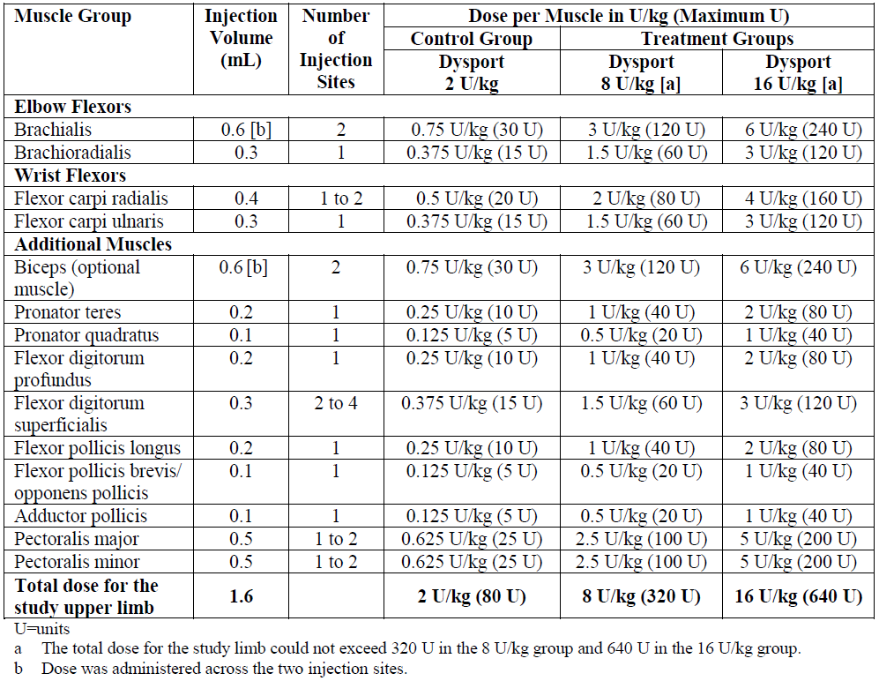
After a minimum treatment interval of 16 weeks from TC1, subjects received treatment at 8 U/kg (maximum = 320 U) or 16 U/kg (maximum = 640 U) for up to 3 subsequent treatment cycles (TC2, TC3 and TC4), over the course of a minimum of one year, and a maximum of one year and 9 months.
For TC2, TC3 and TC4, injection into the lower limbs and the non-study upper limb (non-SUL) were allowed at the same time as the SUL was injected. Investigators could change the PTMG for later cycles, if the Modified Ashworth Scale (MAS) score in those muscles was higher (worse) than the original PTMG. The maximum dose when both upper limbs were injected was 21 U/kg (up to 840 U), and when both upper limbs and lower limbs were injected, the maximum permitted total dose was 30 U/kg (up to 1,000 U). Dosing in the lower limb was as per the approved doses in the PI.
The Delegate requested that the sponsor should provide justification for injecting the lower limbs at TC2, TC3 and TC4 at all, given the proposed indication (see ‘Questions for the sponsor’ section, below)
Randomisation and blinding methods:
Subjects were randomised with equal probability to each of the three treatment groups. Randomisation was stratified by age range (2 to 9 years and 10 to 17 years) and by whether or not subjects had previously been exposed to botulinum toxin.
Blinding was attempted by having the allocated dose made up by a pharmacist not otherwise involved in the study, using different blinded dilutions to achieve the same volumes of available study treatment for each dose.
For TC2, TC3 and TC4, subjects were planned to receive Dysport 8 U/kg or 16 U/kg according to the treatment allocation by the Interactive Response System (IRS) and remained double blind throughout the study. In response to first round evaluation questions, the sponsor confirmed that although there were dose adaptations, that is, reduction or increase in dose based on the investigator’s judgement regarding efficacy/safety of Dysport, blinding was maintained.
Efficacy parameters/endpoints:
The primary endpoint was the mean change by analysis of covariance in MAS score from Baseline to Week 6 of TC1 in the PTMG.
The key secondary endpoint consisted of:
- the mean Physician Global Assessment (PGA) score at Treatment 1, Week 6. The clinical evaluator commented that PGA is a straightforward and appropriate approach that has been widely used in many clinical studies.
The other secondary endpoint was based on:
- Goal Attainment Scale (GAS) score at Treatment 1, Week 6.
Tertiary endpoints:
- Passive range of motion (PROM). In subjects who had shoulder muscle injections, the PROM in flexion and abduction was measured. In subjects who had forearm pronator injections, the PROM in forearm supination was measured.
- Assisting Hand Assessment (AHA).
- Faces Pain Scale (FPS).
- Paediatric Quality of Life Inventory (PedsQL).
- Parents or guardians also completed the condition-specific module of the PedsQL in cerebral palsy (in countries where a translation was available).
Results:
The study was positive for its primary endpoint, change in MAS by Week 6. Across all three-treatment groups, there were improvements in the MAS from Baseline to Weeks 6 and 16 (see Table 4). At the primary time point (Week 6), the magnitude of the improvement was statistically significantly greater, in favour of the Dysport 8 U/kg and 16 U/kg groups, compared with the low-dose control group. A significant benefit for the two higher doses was also observed at the non-primary time point, Week 16.
Table 4: Modified Ashworth Scale score in the primary targeted muscle group at Week 6 and Week 16 (Treatment Cycle 1) by study limb dose – modified intent to treat population
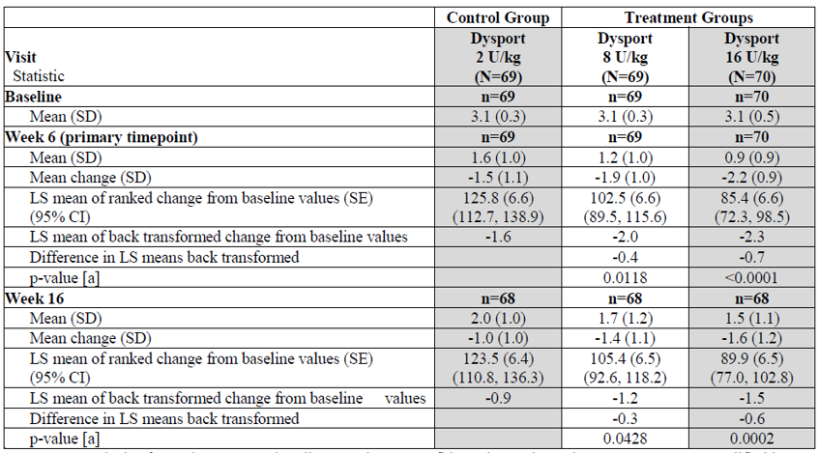
ANCOVA = analysis of covariance, BTX = botulinum toxin, CI = confidence interval, LS = least squares, mITT = modified intent to treat, N = number of subjects, n = number with data, SD = standard deviation, SE = standard error, U = Ipsen units.
The mITT population included all randomised subjects who received at least one injection of the study treatment and had a MAS score in the PTMG assessed both at Baseline and at TC1, Week 6. The mITT population was analysed using the dose group as randomised, regardless of treatment actually received.
Figure 1: Change in Modified Ashworth Scale in the primary targeted muscle group at Treatment Cycle 1, by study limb dose – modified intent to treat population
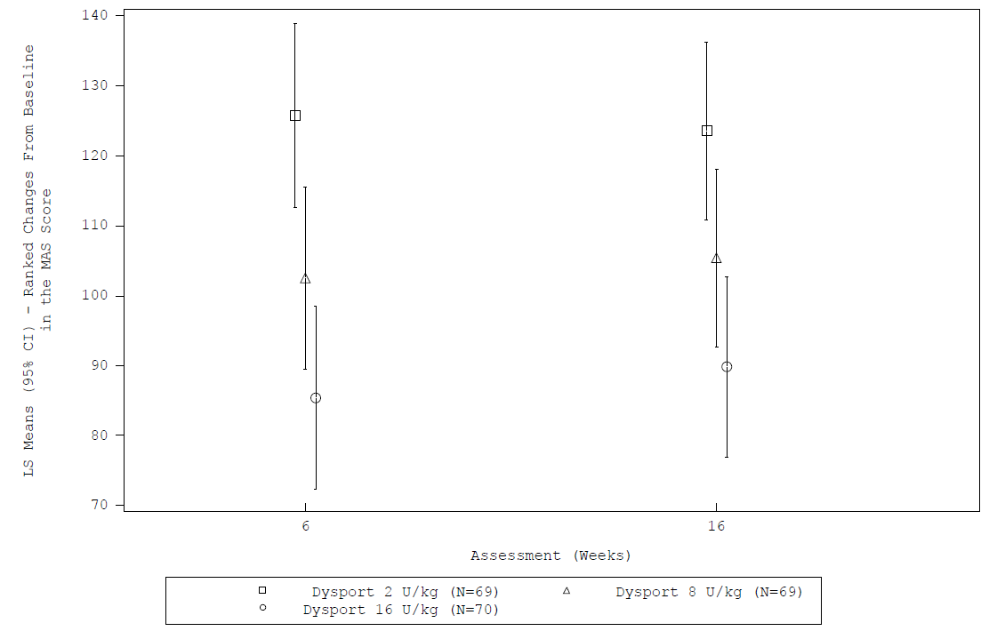
The estimated magnitude of the difference in MAS at Week 6, relative to the low-dose control group, was modest: 0.4 points for the 8 U/kg group and 0.7 points for the 16 U/kg group, from a scale spanning from 0 to 5 (assigning sequential numbers to each possible MAS score). This is a small benefit relative to the improvement that was observed in the low-dose control group (1.6 points), even though the low dose was considered to be sub therapeutic and was used in place of a placebo group.
Improvements in the MAS were generally maintained over subsequent treatment cycles (TC2, TC3 and TC4).
Other analyses of the MAS, including responder analyses, were also favourable. An improvement of one MAS grade in the PTMG was significantly more likely to be achieved with the higher doses than in the low dose control group. At Weeks 6 and 16, the proportion of responders reaching this threshold was higher in the 8 U/kg and 16 U/kg groups, compared with the low dose control group; this difference was significant for the Dysport 16 U/kg group at Week 16, but the model did not converge to allow a significance estimate at Week 6. The attributable response rate for the 16 U/kg dose group was 22% (83.8% to 61.8%), with an odds ratio of 3.3 (p = 0.0052). This is consistent with a number needed to treat (NTT) of about five subjects.
Table 5: Responders based on the Modified Ashworth Scale score in the primary targeted muscle group (Treatment Cycle 1) by study limb dose - modified intent to treat population
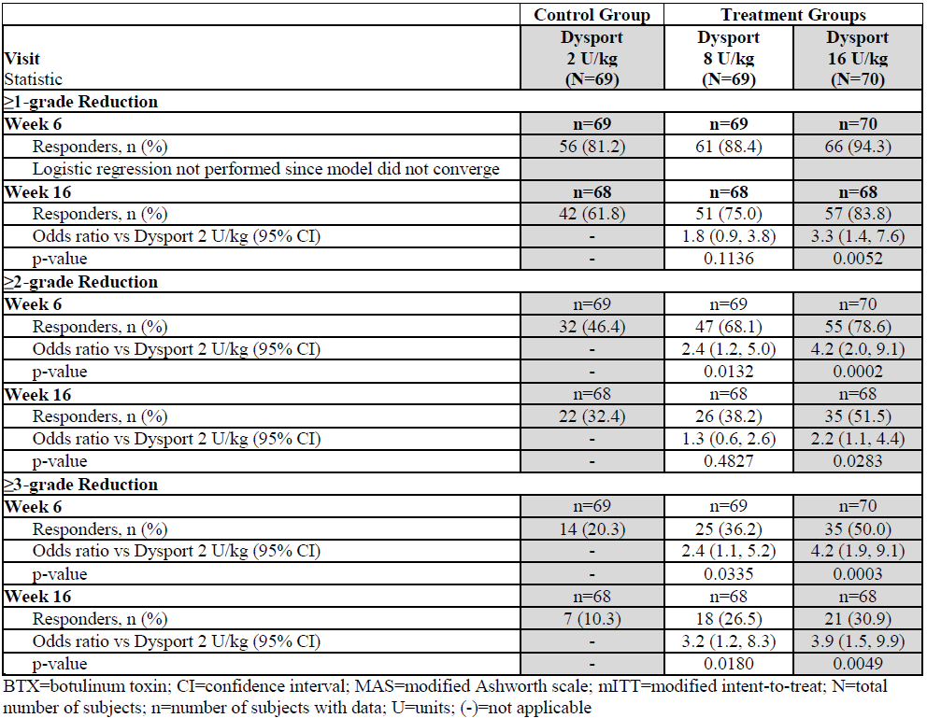
By contrast, the study was negative for most of its secondary endpoints, partly reflecting the fact that even the low dose group was rated as showing substantial improvements. These negative endpoints included the PGA, the GAS, and quality of life measures. Pain was assessed with a visual analogue scale, but there was very little pain at Baseline, and this endpoint showed no benefit.
According to the statistical analysis plan for the European submission, this study should be considered positive, showing benefit for both of the higher doses (8 U/kg and 16 U/kg) in the primary endpoint, MAS. A specific analysis plan for the Australian context was not prospectively specified, but it appears reasonable to accept the study as positive on the basis of the single MAS endpoint.
According to the statistical analysis plan for the US submission, a positive result was required for both the primary endpoint (Week 6 MAS) and the key secondary endpoint (PGA) to consider the whole study positive, and the hierarchy of endpoints mean that the positive MAS result for the 8 U/kg dose could only be considered nominal. The clinical evaluator believes that the PGA was not a particularly useful endpoint, because subjects in the low-dose group were often rated as improved, leaving little room for a superior result to be obtained with higher doses; poor results for this endpoint do not indicate an overall failure of treatment. The negative results of the PGA and other secondary endpoints including the GAS highlight the difficulty in proving an objective functional benefit of botulinum toxin in the treatment of spasticity, but they do not suggest that Dysport failed to reduce spasticity.
In summary, this study was positive for its primary endpoint, showing a modest but statistically significant benefit for the primary endpoint, reduction in MAS by Week 6, for doses of 8 U/kg or 16 U/kg in comparison to 2 U/kg. It was negative for most of its minor endpoints, but overall it supports the sponsor’s claim that Dysport may reduce spasticity in the upper limb of paediatric subjects.

Other studies
Study Y-55-52120-147: a Phase III, prospective, multicentre, open label, extension study assessing the long term safety and efficacy of repeated treatment with Dysport used in the treatment of lower limb spasticity in children with dynamic equinus foot deformity due to cerebral palsy (an open label extension of a previously submitted study, Study Y-55-52120-141).
Study Y-97-52120-047: retrospective, non-comparative study with a focus on lower limb treatment.
Other studies (Studies Y-55-52120-147 and Y-97-52120-047), referring to the lower limbs apart from their being open, retrospective and non-comparative, are considered as providing safety data in the submission and, not relevant to the efficacy of the proposed indication.

New dilution option for the 125 U powder for injection product for treatment of glabellar frown lines and lateral canthal lines
Primary study: Study 05PF1311
Supportive study: Study GLI.04.SRE.US10348

Study 05PF1311 (primary study)
Study 05PF1311 was a randomised, evaluator blinded, comparative study to evaluate the efficacy and safety of different injection volumes of botulinum toxin type A, Azzalure (Dysport), in the glabellar lines (GLs).
The objectives were:
- the assessment of GLs at Baseline and all follow-up visits;
- the assessment of the subject’s satisfaction using the Subject Satisfaction Questionnaire (SSQ);
- evaluation of the onset of effect by asking patients to indicate the day they first noted any effect on their GLs;
- evaluation of the compound muscle action potential (CMAP) using electroneurography;
- evaluation of the safety of two different injection volumes;
- evaluation of the subject’s pain on injection using the VAS.
Study treatments:
Subjects were randomised with equal probability to receiving Dysport:
- either with a standard dilution (Group A, 0.05 mL/injection point, n = 30);
- or a two fold increased dilution (Group B, 0.1 mL/injection point, n = 32).
Both treatment groups received the same drug, botulinum toxin type A, made up from a vial containing 125 Speywood units (sU)/vial, and all patients received 5 injections of 10 sU per injection point, for a total dose of 50 sU, at the sites indicated in the figure below.
Figure 2: Study 05PF1311 Injection sites in corrugator muscle for treatment of glabellar lines
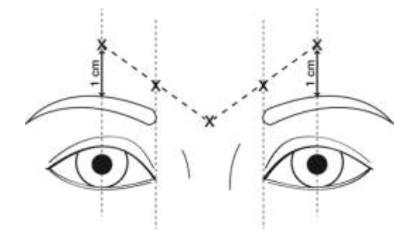
Because the Groups A and B received different volumes, complete blinding was not possible, but the efficacy scores were derived by an evaluator blinded to the volume administered.
Randomisation and blinding methods:
Randomisation was stratified for wrinkle severity, and subjects were assigned with equal probability to either standard or increased injection volumes that is, Group A or B.
Blinding of the treating clinician and subject was not possible, because one group received an injection volume that was twice that of the other. Evaluation of wrinkle severity was performed by the unblinded clinician as well as an offsite blinded evaluator, who used photographs.
The clinical evaluator commented that the sponsor did not clearly rank these two evaluation techniques for wrinkle severity or declare that the blinded evaluation was primary. The unblinded, ‘live’ results were given much greater prominence in the sponsor’s presentation of the wrinkle severity scores, but this could reflect post hoc selection of the more favourable set of results. Most endpoints were based on assessments by the subject or treating clinician, and were therefore unblinded.
The Delegate commented that, given the fact that wrinkle severity scoring was also carried out by a blinded off-site evaluator, the sponsor is requested to elaborate as to why the treating clinician‘s unblinded wrinkle severity scoring was rated higher in the wrinkle severity scores. In addition, what was the sponsor’s rationale for basing most endpoints on assessment by unblinded personnel that is, the treating clinician and the treated subjects? (see ‘Questions for the sponsor’ section, below).
Sixty-two subjects were randomised and treated. No subjects withdrew their participation, which meant that the efficacy results included 6 month data for all 62 subjects. Of these:
- N = 30 (Group A) received the currently labelled standard injection volume (0.05 mL/injection point); or
- N = 32 (Group B) received the two fold larger injection volume (0.1 mL/injection point).
Efficacy parameters/endpoints:
- Assessment of the severity of the subject’s GFLs were conducted by the treating investigator (live )and an independent blinded trained evaluator (photos with the films were taken at all visits under standardised lighting conditions for later evaluation) using the Merz Aesthetics Scale (a 5 point wrinkle severity scale), at rest and at maximum frown (the ‘dynamic’ wrinkle severity score), at Baseline and at all follow-up visits.
- Subject satisfaction (based on a questionnaire) at Baseline, Visit 5 (Month 1), Visit 6 (Month 3) and Visit 8 (Month 6).
- The subject’s estimate of the day of onset of effect on the GFLs.
- CMAPs, measured using electroneurography (in a subgroup of subjects only) at Baseline, Day 1, Day 3, Day 7, Month 1, Month 3, and Month 6. CMAPs were measured separately for each corrugator supercilii muscle in the forehead using electroneurography in subjects at one of the study sites (n = 31). The temporal branch of the facial nerve was stimulated with surface electrodes (4 cm lateral to the eye). Surface recording over the corrugator supercilii muscles examined the amplitude of the resulting CMAP, which indicates the degree of electrical activation of the muscle, measured in millivolts, and it would be expected that this would correlate with contraction. Successful weakening of the muscle with Dysport would be expected to reduce the CMAP amplitude. Measurements were made at Baseline (pre-treatment) and at Day 1, Day 3, Day 7, Month 1, Month 3, and Month 6, and were expressed as percentage changes relative to Baseline.
Results:
The clinical evaluator commented that the study had a large number of methodological flaws. It was a Phase IV study with largely unblinded efficacy assessments and an unclear statistical methodology. No clear statistical hypothesis was advanced, and the study lacked a primary endpoint. Power calculations were not presented, and the sample size (n = 62) seemed small and arbitrary. Most of the statistical tests performed in this study were tests that would have been suitable for a superiority study, but the aim of this study was not to show superiority of the proposed dilution, but to show equivalence between the standard dilution and the proposed dilution;
Most endpoints showed no significant difference between the two treatment groups, but this could reflect its poor statistical power. Only one minor endpoint, changes in CMAP, explicitly addressed the need for a non-inferiority analysis, but details of how this endpoint was analysed were not provided, and the endpoint appeared to be a low-ranking endpoint; it was only assessed in a small subset of patients (n = 31). Furthermore, the threshold for inferring inferiority (a between group difference in CMAP change equal to at least 10% of baseline CMAP) appeared unambitious, exceeding a difference that could be considered clinically relevant.
The only blinded efficacy endpoint (wrinkle severity scores), showed nominal superiority for the proposed dilution at a couple of time points.
Mean changes: nominally significant differences between groups were observed as summarised in Table 6 and Figure 3 shown below, in favour of the new dilution, at Day 1, Day 3 and Day 14, and at Month 1 and Month 3 (p-values: 0.018, 0.050, 0.015, 0.041 and 0.038, respectively).
Table 6: Study 05PF1311 Difference (Group B minus Group A) in mean change from Baseline in dynamic wrinkle severity scores, intent to treat population
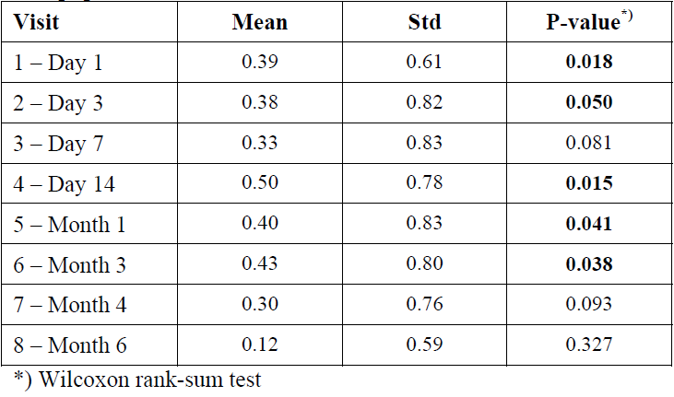
Std = standard deviation
Wrinkle severity ratings scored according to Merz Aesthetics Scale for the upper face.
Figure 3: Study 05PF1311 Post-injection independent mean dynamic wrinkle severity scores at maximum frown expression
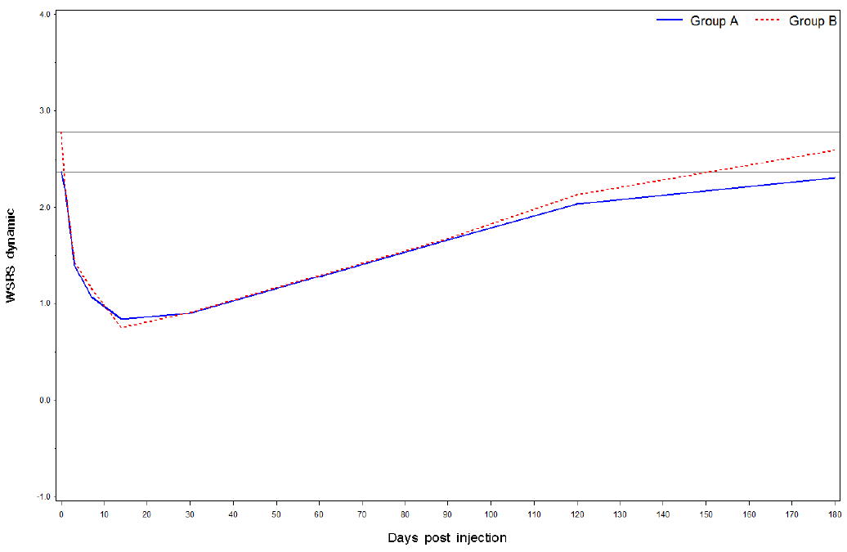
Wrinkle severity ratings scored according to Merz Aesthetics Scale for the upper face.
Despite these very substantial limitations, the two treatments appeared to be broadly equivalent, with several endpoints showing trends in favour of the proposed dilution, a few endpoints and time points showing trends in favour of the standard dilution, and scattered comparisons at isolated time points showing nominal superiority of one treatment or the other.
Overall, the study should be formally rejected because of its inadequate methodology. However, given that the change proposed by the sponsor is fairly minor (changing the recommended dilution while keeping the dose and indication unchanged), and that most of the trends favoured the proposed dilution, and the only non-inferiority analysis achieved a satisfactory outcome, the study can be interpreted as providing some weak support for sponsor’s proposed dilution.
No study directly assessed the proposed dilution in the treatment of LCLs, but the clinical evaluator believes that this omission is acceptable given the relatively minor nature of the proposed change and the broad similarity of the safety and efficacy issues in LCLs and GFLs.
The Delegate commented that their preference is to approve the proposed dilution while keeping the already approved standard dilution. The choice of which dilution to use is then dependent on the treating physician, as agreed to by the consumer patient.

Study GLI.04.SRE.US10348
This was a prospective, randomised, multicentre, subject and evaluator blinded, parallel comparison of Dysport, when reconstituted at 1.5 mL and 2.5 mL, for the treatment of moderate to severe GLs.
The clinical evaluator commented that in principle, this study has limited relevance to the current submission. The study did not assess the proposed dilution and injection volume (0.10 mL/injection site) but instead, assessed a lower injection volume (0.08 mL/injection site).

Safety
The safety of Dysport is acceptable and the proposed extension of indications and new dilution option do not raise any substantial new safety concerns.

Upper limb spasticity in children (paediatric)
AEs occurred with a similar frequency in subjects who received therapeutic dose (8 U/kg or 16 U/kg) or a subtherapeutic control dose (2 U/kg).
When used to treat limb spasticity, Dysport is associated with a risk of weakness in the treated limb, so the decision to inject Dysport should be made by an experienced clinician. This is already a known issue in relation to treatment of lower limb spasticity; the proposed extension to include upper limb spasticity in children carries no extra risk.
Weakness at sites distant from the treated muscle may occasionally be observed, suggesting some systemic spread of toxin. This was not evident in the submitted spasticity studies, but weakness has been noted with post-marketing surveillance, with some reports of dysphagia after treatment of limb spasticity. In the previously evaluated lower limb studies with Dysport, there was also an overall excess of respiratory events. Treatment in the upper limbs, especially very proximal treatment, poses some risks related to local spread that are not present in the lower limbs, because local spread can involve the neck muscles, including those required for adequate airway protection. This did not emerge as an issue in the submitted studies, but the submitted PUL study was small, and extra vigilance might have resulted from the study situation; local spread to the neck could occur when larger numbers of children are treated in a real world environment. This issue is already covered in the PI, as follows:
‘There have been rare spontaneous reports of death sometimes associated with aspiration pneumonia in children with severe cerebral palsy after treatment with botulinum toxin, including following off label use (e.g. neck area). Extreme caution should be exercised when treating paediatric patients who have significant neurologic debility, dysphagia, or have a recent history of aspiration pneumonia or lung disease’.
Doses in the upper limb are generally lower than those used in the lower limb, suggesting that treatment of a single upper limb would carry a lower risk of unwanted systemic exposure, but the addition of an upper limb indication will lead to some children being treated concurrently in the upper and lower limbs; this means that such children will receive a greater total dose.
Although doses up to 16 U/kg were adequately tested in the submitted study, higher total body doses were not adequately tested. The upper range of the proposed paediatric total body doses were not tested at all during the low-dose controlled phase of the pivotal spasticity cycle (TC1), and relatively few children received doses at the upper end of the proposed total dose range in later cycles: only 22 subjects received 30 U/kg (allocated for treatment of both upper and lower limbs) in TC2; 19 subjects in TC3 and 8 subjects in TC4.
In adults, the maximum recommended dose for treatment of spasticity is 1,000 U in a single treatment session involving the upper limb without the lower limb, or 1,500 U when the upper limb and lower limb are both treated. The total body maximum dose for adults is therefore 21.4 U/kg for a 70 kg subject, or 25 U/kg for a 60 kg subject. These calculations suggest that there is a discrepancy between the total session maximum recommended for adults (21.4 U/kg for a 70 kg patient) and the total session maximum recommended for children (30 U/kg). The sponsor was asked to comment on this discrepancy (see ‘Dosage selection information for the pivotal study’ section, above).

Proposed dilution
AEs appeared with a similar incidence with the standard and proposed dilutions in the pivotal GFL study. The proposed dilution for cosmetic indications has only been tested in 32 subjects who received it for GFLs, however, and it has not been tested in any subjects for treatment of LCLs.
The proposed dilution does not affect the total dose administered, so the safety implications of the dilution are expected to be minimal, but the increased dilution could reasonably be expected to:
- increase the risk of local oedema (and this was observed in the pivotal GFL study, with approximately 10% of the larger volume group and none of the standard volume group reporting oedema); and/or
- increase the risk of local spread to non-targeted muscles, such as the levator palpebrae or the muscles involved in eye movements (leading to ptosis or diplopia, respectively).
The small size of the pivotal GFL study, and the complete lack of an LCL study with the proposed dilution, means that this risk has not been fully characterised. Given the reversible nature of the muscle weakness induced by botulinum toxin, and the fact that diplopia and ptosis usually represents an inconvenience rather than a major hazard to health, this risk is considered acceptable.

Other safety issues (general)
- Dysport use may be associated with hypersensitivity reactions, but this was not noted in the submitted studies and the proposed extension of indications does not increase the risk.
- No deaths occurred in any of the newly submitted studies.
- Dysport would be expected to cause synergistic weakness if it were combined with other agents that interfere with neuromuscular transmission, or if it were administered in the presence of myasthenia gravis or other disease affecting neuromuscular transmission.

Change in adverse event frequency of ‘abnormal eye movements’
On the proposal of changing the listed frequency of the AE, ‘abnormal eye movements’, as a complication of treatment of the GFLs indication, the clinical evaluator stated, especially in the light of the proposed diluted volume, that there is an increased risk of local spread to non-targeted muscles, such as the levator palpebrae or the muscles involved in eye movements (leading to ptosis or diplopia, respectively). Given that this risk could increase with the new dilution, the ongoing risk of eye movement disorders, subsequent to that dilution, is unclear.
Furthermore, the sponsor’s proposed change to the PI would lead to eye movement disorders being listed as rare while diplopia was already listed as uncommon. Given that most diplopia is due to an abnormality of eye movement, and therefore represents a subset of eye movement disorders, the sponsor’s proposed change is illogical (see ‘Delegate’s considerations’ section, below for discussion and resolution of this issue).

Clinical evaluator’s recommendation

Upper limb spasticity in children (paediatric)
Dysport should be approved for treatment of upper limb spasticity in children aged 2 years and older, for the doses proposed by the sponsor:
- Upper limb dosing: ‘The maximum dose of Dysport administered per treatment session when injecting unilaterally must not exceed 16 U/kg or 640 U whichever is lower. When injecting bilaterally, the maximum Dysport dose per treatment session must not exceed 21 U/kg or 840 U, whichever is lower.’ (Proposed PI).
- Combined upper and lower limb dosing: ‘The dose of Dysport to be injected for concomitant treatment should not exceed a total dose per treatment session of 30 U/kg or 1000 U, whichever is lower.’ (Proposed PI).
The sponsor should continue to gather evidence, that total body doses of up to 30 U/kg remain safe, and this should be a priority in post-marketing surveillance.

Proposed dilution
The proposed dilution (10 U/0.1 mL) for treatment of GFLs and LCLs should be approved.
Post marketing surveillance should include assessment of the incidence of diplopia and ptosis for this dilution, in comparison to the standard dilution.

Risk management plan
There was no requirement for a risk management plan evaluation for a submission of this type.

Risk-benefit analysis

Delegate’s considerations
The bacterial toxin, Clostridium botulinum toxin, is pharmacologically classified as a neuromuscular blocker and Dysport, like Botox, is a derivative of the toxin (both classified as Botulinum toxin type A). The toxin has reversible neurotoxic effects on a range of neuron types, including motor neurons. Remarkably, food contamination with the Gram positive bacterium Clostridium botulinum (which produces the neurotoxin botulinum) causes foodborne botulism, and general muscle weakness is one of the complications.
Being structurally and pharmacologically similar, both Botox and Dysport are used therapeutically to produce partial, focal and reversible effects that functionally resemble partial denervation of muscle, skeletal in particular.
The major themes of the current submission are:
- Extension of indications to include the treatment of upper limb spasticity in children.
The currently ARTG approved treatment indications for Dysport, as listed in the PI are:
Dysport is indicated for symptomatic treatment of focal spasticity of:
- Upper limbs in adults
- Lower limbs in adults
- Lower limbs in children aged 2 years and older
Dysport is indicated in adults for the treatment of:
- Spasmodic torticollis
- Blepharospasm
- Hemifacial spasm
- Moderate to severe glabellar lines and / or lateral canthal lines (crow’s feet)
- A new dilution option for treatment of GFLs and LCLs.
- Changing the listed frequency of the AE, ‘abnormal eye movements’, as a complication of treatment of the GFLs indication.
The minor themes are:
- Some minor editing or formatting changes.
- Flexibility in choice of needle gauge for the cosmetic indications (changing references from a ’29 to 30 gauge needle’ to a ‘suitable gauge needle’).
Study Y-52-52120-153 for the first major theme, that is, an extension of indications, was positive for its primary endpoint, showing a modest but statistically significant benefit for the primary endpoint, reduction in MAS by Week 6, for doses of 8 U/kg (p-value = 0.0118) or 16 U/kg (p-value = < 0.0001) in comparison to 2 U/kg. The reduction in MAS extended to Week 16, for doses of 8 U/kg (0.0428) or 16 U/kg (p-value = 0.0002) compared to 2 U/kg. It was negative for most of its minor endpoints, but overall it supports the sponsor’s claim that Dysport may reduce spasticity in the upper limb of paediatric subjects.
Study 05PF1311 was designed for the second major theme, that is, a new dilution option for treatment of GFLs and LCLs. Overall as per the clinical evaluator, the study should be formally rejected because of its inadequate methodology. However, given that the change proposed by the sponsor is fairly minor (changing the recommended dilution while keeping the dose and indication unchanged), and that most of the trends favoured the proposed dilution, and the only non-inferiority analysis achieved a satisfactory outcome, the study can be interpreted as providing some weak support for sponsor’s proposed dilution.
The Delegate’s preference is to approve the proposed dilution while keeping the already approved standard dilution. The choice of which dilution to use is then dependent on the treating physician, as agreed to by the consumer patient.
No study directly assessed the proposed dilution in the treatment of LCLs, but the clinical Evaluator believes that this omission is acceptable given the relatively minor nature of the proposed change and the broad similarity of the safety and efficacy issues in LCLs and GFLs.
Regarding the third major theme, changing the listed frequency of the AE, ‘abnormal eye movements’, as a complication of treatment of the GFLs indication, the clinical evaluator was of the opinion, especially in the light of the proposed diluted volume, that:
- There is an increased risk of local spread to non-targeted muscles, such as the levator palpebrae or the muscles involved in eye movements (leading to ptosis or diplopia, respectively). Given that this risk could increase with the new dilution, the ongoing risk of eye movement disorders, subsequent to that dilution, is unclear.
- Furthermore, the sponsor’s proposed change to the PI would lead to eye movement disorders being listed as rare while diplopia was already listed as uncommon. Given that most diplopia is due to an abnormality of eye movement, and therefore represents a subset of eye movement disorders, the sponsor’s proposed change is illogical.
The sponsor’s response to the above, which is now acceptable, is to vary the draft PI to read, under ‘Eye disorders’ for treatment of GFLs:
‘Common: Asthenopia, ptosis, eyelid oedema, lacrimation increased, dry eye, muscle twitching
Uncommon: Visual impairment, vision blurred, diplopia
Rare: eye movement disorders excluding diplopia’
For the first minor theme, some minor editing or formatting changes, the clinical evaluator stated that some minor formatting error has altered the spacing of bullet points in the listing of indications, producing excess vertical spacing between the third and fourth bullet points. It is suggested that the spacing error be corrected prior to the production of the final PI version.
The second minor theme, flexibility in choice of needle gauge for the cosmetic indications (changing references from a ’29 to 30 gauge needle’ to a ‘suitable gauge needle’) was without data. Given that the theme is simply replacing a ’29 to 30 gauge needle’ to a ‘suitable gauge needle’, it is considered as an acceptable minor alteration not requiring data.
While commenting that on balance, the safety profile of Dysport for the proposed extension of indication and dilution paradigm is acceptable, the clinical evaluator’s authorisation recommendation includes the following statements:
- The sponsor should continue to gather evidence, that total body doses of up to 30 U/kg remain safe, and this should be a priority in post-marketing surveillance.
- Post marketing surveillance should include assessment of the incidence of diplopia and ptosis for this dilution, in comparison to the standard dilution.

Proposed indication
The proposed indication (as per the sponsor and accepted by both the clinical evaluator and the Delegate):
Dysport is indicated for the treatment of upper limb spasticity in children, aged 2 years and older.

Proposed additional dilution
The proposed additional dilution (as per the sponsor and accepted by both the clinical evaluator and the Delegate):
‘Dilution (10 U/0.1 mL) for treatment of Glabellar Facial Lines and Lateral Canthal Lines.’

Proposed conditions of registration
- The sponsor should continue to gather evidence, that total body doses of up to 30 U/kg remain safe, and this should be a priority in post-marketing surveillance.
- Post marketing surveillance should include assessment of the incidence of diplopia and ptosis for this dilution, in comparison to the standard dilution.

Proposed action
The Delegate finds the submission to be approvable, with the above stated conditions of registration.
The Delegate sought advice from the Advisory Committee (see ‘Advisory Committee considerations’ section, below).

Questions for the sponsor
The sponsor provided the following response to questions from the Delegate.
Regarding the extension of indications:
- In its pre-Advisory Committee on Medicines (ACM) response, the sponsor should provide justification for injecting the lower limbs at TC2, TC3 and TC4 at all, given the proposed indication.
While Study Y-52-52120-153 was to support the treatment of PUL spasticity with Dysport and was designed with this in mind, it also needed to recognise the importance of treatment of lower limb spasticity in this population. This is particularly relevant for the growing paediatric population where treatment in the lower limb(s), when affected by spasticity, is key for optimisation of their development, including the ability to improve walking. The use of botulinum toxin type A for treating lower limb spasticity of children with cerebral palsy is now well established.,,, It was not considered feasible, nor ethical, to conduct a long-term Dysport repeat treatment study without addressing their lower limb spasticity, if clinically needed.
This approach is supported by the profile of patients that were enrolled in the study. At Baseline, 160 out of 208 (76.9%) and 40 out of 208 (19.2%) of subjects presented with hemiparesis and tetraparesis, respectively, meaning that the children’s cerebral palsy affected lower limbs in 96.2% of the study population, as displayed in the table below.
Table 7: Study Y-52-52120-153 Number (%) of subjects presenting with specified cerebral palsy paralysis
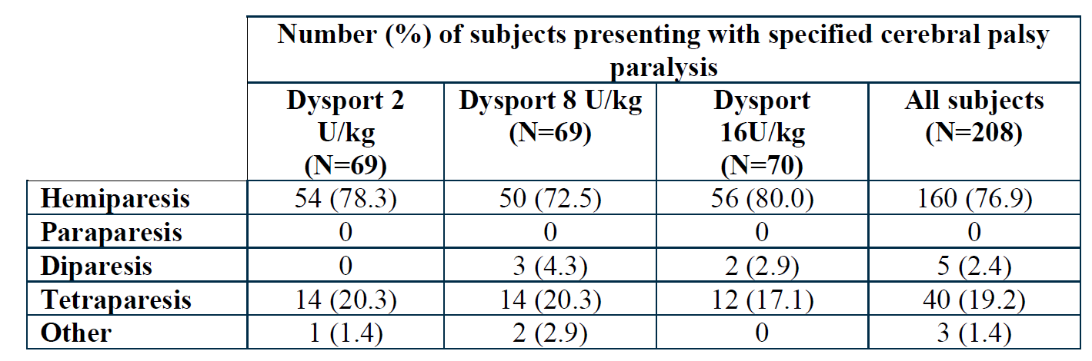
While only the study upper limb could be treated in the initial treatment cycle and a treatment in the study upper limb was maintained in all treatment cycles, it is clear that such a population would require supplementary lower limb treatment in a significant proportion. Permitting such a multilevel treatment paradigm is also consistent with the available guidelines for the treatment of paediatric spasticity.18,19,20,21
Regarding the proposed additional dilution of the 125 U product (for treatment of glabellar lines and lateral canthal lines indications only):
- Given the fact that wrinkle severity was also carried out by a blinded off-site evaluator, the sponsor ought to elaborate in its pre-ACM response as to why the treating clinician’s unblinded wrinkle severity was rated higher in the wrinkle severity scores. In addition, what was the sponsor’s rationale for basing most endpoints on assessment by unblinded personnel that is, the treating clinician and the treated subjects?
Discrepancy between photographic wrinkle severity score and investigator’s live assessment of severity:
The sponsor considers that there are significant challenges in accurately representing in a static two-dimensional photograph the three-dimensional and dynamic nature of facial wrinkles, an appreciation of which is required for an accurate assessment of their severity.
Indeed, the investigator’s live assessments of wrinkle severity were generally higher than the independent blinded wrinkle severity scores performed using photos. After discussions with the investigators at the end of the study it was concluded that the differences seen in the investigator’s live and the independent photographic assessments can be explained by lighting used during photography, which resulted in a highlighting of the facial creases to the extent that wrinkles were more difficult to see on the photographs. The wrinkles would therefore appear shallower on the photo than seen live where greater detail and nuances of the wrinkles could be appreciated.
This, as expected, leads to a bias with photographic evaluation consistently under-appreciating the severity of wrinkles which leads to a discrepancy between the live evaluation and a photographic evaluation.
This is consistent with the sponsor’s position that photographic assessment of three-dimensional and dynamic pathology is inaccurate.
Predominance of endpoints based on live investigator and subject assessment:
As stated above, the use of a live assessment is required to appropriately evaluate three-dimensional dynamic endpoints such as those relating to wrinkles and thus endpoints that involve a direct live evaluation were considered most applicable for this study. Also, since the aim of glabellar line treatment is for the subject to experience a better appearance, endpoints that reflect their own self-assessment seem particularly pertinent for this indication.
The same active dose was administered in both treatment arms, with only the volume/concentration differing, so it could be reasonable to assume that any influence on the assessment post-treatment due to the knowledge of the allocated treatment arm may not be as great as would be the case if unblinding related to whether a subject was administered an active treatment or placebo. Furthermore, the participating subjects were partially blinded regarding treatment since they were prevented to view the syringes during administration of the product and the injector was not permitted to discuss treatments with the subjects, so their assessments were done without the knowledge of the volume injected.
The results comparing the two treatment arms using the live investigator and subject assessments were in line with those obtained from both the photographic assessment and CMAP which further supports the applicability of the live assessments in evaluating the treatment effect between the two different treatment arms.

Advisory committee considerations
The Advisory Committee on Medicines (ACM), having considered the evaluations and the Delegate’s overview, as well as the sponsor’s response to these documents, advised the following.

Specific advice to the delegate
The ACM advised the following in response to the Delegate’s specific request for advice.
- The ACM is requested to consider the approvability or not of the submission, based on the evaluated data and the stated conditions of registration.
The ACM considered that the proposed extension of indication, the proposed 2 fold dilution and the other three minor proposed changes (that is, changing the listed frequency of the adverse event, ‘abnormal eye movements’, as a complication of the GFLs indication as subsequently modified by the sponsor, minor editorial /formatting changes to the PI and flexibility in choice of needle gauge for the cosmetic indications) associated with the submission were approvable.

Conclusion
The ACM considered that this product had an overall positive benefit-risk profile for the indication:
For symptomatic treatment of focal spasticity of upper limbs in children aged 2 years and older.

Outcome
Based on a review of quality, safety and efficacy, the TGA approved the registration of Dysport (Clostridium botulinum type A toxin-haemagglutinin complex) 125 U, 300 U and 500 U powder for injection vials, for the following extension of indications:
For symptomatic treatment of focal spasticity of upper limbs in children aged 2 years and older.
As such, the full indications at this time were:
Dysport is indicated for symptomatic treatment of focal spasticity of:
- Upper limbs in adults
- Lower limbs in adults
- Upper limbs in children aged 2 years and older
- Lower limbs in children aged 2 years and older
Dysport is indicated in adults for the treatment of:
- Spasmodic torticollis
- Blepharospasm
- Hemifacial spasm
- Moderate to severe glabellar lines and / or lateral canthal lines (crow’s feet)
In addition:
- The alternative dilution for reconstitution (resulting in 10 U/0.1 mL solution) of the 125 U powder for injection product for the treatment of GFLs and LCLs was approved.
- In Section 4.8 Adverse effects (undesirable effects) of the PI under ‘Glabellar lines: Eye disorders’, the frequency of adverse events related to eye movement was amended to read: ‘Rare: eye movement disorders excluding diplopia’.
- The recommended needle gauge for GFLs and LCLs was changed to a ‘suitable gauge needle’.
- Minor formatting changes were made to the PI.

Specific conditions of registration applying to these goods
- The sponsor should continue to gather evidence that total body doses of up to 30 U/kg in paediatric patients remain safe, and this should be a priority in postmarketing surveillance; post marketing surveillance should include assessment of the incidence of diplopia and ptosis for the additional dilution of the 125 U product, in comparison to the standard dilution.
- This approval does not impose any requirement for the submission of periodic safety update reports (PSURs). The sponsor should note that it is a requirement that all existing requirements for the submission of PSURs as a consequence of the initial registration or subsequent changes must be completed.
- For all injectable products the PI must be included with the product as a package insert.

Attachment 1. Product Information
The PI for Dysport approved with the submission which is described in this AusPAR is at Attachment 1. For the most recent PI, please refer to the TGA website at <https://www.tga.gov.au/product-information-pi>.

Therapeutic Goods Administration
PO Box 100 Woden ACT 2606 Australia
Email: info@tga.gov.au Phone: 1800 020 653 Fax: 02 6232 8605
https://www.tga.gov.au

The Black Triangle Scheme provides a simple means for practitioners and patients to identify certain types of new prescription medicines, including those being used in new ways and to encourage the reporting of adverse events associated with their use. The Black Triangle does not denote that there are known safety problems, just that the TGA is encouraging adverse event reporting to help us build up the full picture of a medicine's safety profile.
One Ipsen unit is not equivalent to one unit of any other botulinum toxin preparation.
Botox (botulinum toxin type a) powder for injection vial, 50 U (AUST R 195530), 100 U (AUST R 67311), 200 U (AUST R 172264), is registered in Australia and sponsored by Allergan Australia Pty Ltd.
Sponsor clarification: identification of individual patients who received a total body dose of 30 U/kg was previously provided as an appendix to the clinical study report for Study Y-52-52120-153.
Modified Ashworth Scale (MAS): 0 = no increase in muscle tone 1 = slight increase in muscle tone, manifested by a catch or by minimal resistance at the end of the range of motion (ROM) when the affected part(s) is (are) moved in flexion or extension 1+ = Slight increase in muscle tone, manifested by a catch, followed by minimal resistance throughout the remainder (less than half) of the ROM 2 = More marked increase in muscle tone through most of the ROM, but affected part(s) easily moved 3 = considerable increase in muscle tone, passive movement difficult 4 = affected part(s) rigid in flexion or extension
Physician Global Assessment (PGA) was assessed by asking the investigator: ‘How would you rate the response to treatment in the subject’s upper limb since the start of the study?’ Answers were made on a nine point rating scale (-4: markedly worse, -3: much worse, -2: worse, -1: slightly worse, 0: no change, +1: slightly improved, +2: improved, +3: much improved and +4: markedly improved).
Goal Attainment Scale (GAS), originally described by Turner-Stokes (2009), is a functional scale intended to measure progress towards individual therapy goals, which were defined for each subject by the investigator and the child’s caregivers prior to each treatment. Between one and three individual goals were selected for each subject, and each of these was rated by importance and difficulty. For each treatment cycle, one of the selected goals was to be designated as the primary goal. In practice, most subjects had ‘involving the affected arm more in daily activities’ or ‘reaching’ as their primary goal. Following each treatment, the achievement of each of the subject’s goals was rated by the investigator on a five-point scale (+2: much more than expected outcome, +1: somewhat more than expected outcome, 0: expected outcome, -1: somewhat less than expected outcome and -2: much less than expected outcome). A total GAS score was calculated based on the importance, difficulty and level of achievement of all the selected goals. Turner-Stokes L. Goal attainment scaling (GAS) in rehabilitation: a practical guide. Clin Rehabil. 2009 Apr;23 (4): 362-370.
Assisting Hand Assessment (AHA) is a hand function evaluation assessment in children with difficulties using one of their hands, and describes how the child uses in the affected hand in collaboration with the non-affected hand in bimanual play;
The Faces Pain Scale (FPS) is a tool used to assess pain intensity, which utilises a pictorial to allow children to rate pain on a 10 point scale, ranging from ‘no’ pain’ to ‘very much’ pain.
In the Paediatric Quality of Life Inventory (PedsQL), parents or other primary guardians were asked to complete questionnaires on their child’s quality of life, using a standard quality of life tool. The Generic Core Scales of the PedsQL cover four domains including physical, emotional, social and school aspects.
The number needed to treat (NNT) is the number of patients that need to be treated in order to prevent a certain adverse outcome or achieve a benefit in a single patient.
The visual analogue scale (VAS) is a psychometric response scale for characteristics or attitudes that range across a continuum of values and cannot easily be directly measured, such as pain, mood and appetite. The VAS pain scale ranges along a 10 cm line from ‘no pain’ (0 cm) to ‘worst pain’ (10 cm), and patients mark a line at a point along the scale to indicate how they are feeling.
Dysport is marketed under the tradename Azzalure in some countries.
The Merz Aesthetics Scale for the upper face, grades the severity of glabellar lines on a five point scale ranging from 0 to 4: 0 - no glabellar lines 1 - mild glabellar lines 2 - moderate glabellar lines 3 - severe glabellar lines 4 - very severe glabellar lines The rating was based on sample photographs that were provided as part of the definition of the scale.
The Subject Satisfaction Questionnaire (SSQ) consisted of a series of questions to be answered by the subject at each visit, directed at rating how content they were with the treatment and their own appearance.
The subjective Onset of Response was defined as the first day a subject responded ‘yes’ to the question ‘Since being injected, have you noticed any effect on the appearance of your glabellar lines?’
The sponsor must still comply with routine product vigilance and risk minimisation requirements.
Simpson, D.M. et al. Assessment: botulinum neurotoxin for the treatment of spasticity (an evidence-based review): Report of the Therapeutics and Technology Assessment Subcommittee of the American Academy of Neurology. Neurology 2008; 70(19): 1691-1698.
Delgado, M.R. et al. Practice parameter: pharmacologic treatment of spasticity in children and adolescents with cerebral palsy (an evidence-based review): report of the Quality Standards Subcommittee of the American Academy of Neurology and the Practice Committee of the Child Neurology Society. Neurology 2010; 74(4): 336-343.
National Institute for Health and Care Excellence (NICE). Clinical guideline CG145. Spasticity in under 19s: management. Published date: 25 July 2012, last updated: 29 November 2016. Available from the NICE website.
Strobl, W. et al. Best clinical practice in botulinum toxin treatment for children with cerebral palsy. Toxins (Basel) 2015; 7(5): 1629-1648.
The ACM provides independent medical and scientific advice to the Minister for Health and the Therapeutic Goods Administration (TGA) on issues relating to the safety, quality and efficacy of medicines supplied in Australia including issues relating to pre-market and post-market functions for medicines. The Committee is established under Regulation 35 of the Therapeutic Goods Regulations 1990. Members are appointed by the Minister. The ACM was established in January 2017 replacing Advisory Committee on Prescription Medicines (ACPM) which was formed in January 2010. ACM encompass pre and post-market advice for medicines, following the consolidation of the previous functions of the Advisory Committee on Prescription Medicines (ACPM), the Advisory Committee on the Safety of Medicines (ACSOM) and the Advisory Committee on Non-Prescription Medicines (ACNM). Membership comprises of professionals with specific scientific, medical or clinical expertise, as well as appropriate consumer health issues relating to medicines.

