First round report: 30 April 2017
Second round report: 1 October 2017

AusPAR Attachment 2

Extract from the Clinical Evaluation Report for Cladribine
  - Proprietary Product Name: Mavenclad
  - Sponsor: Merck Serono Australia Pty Ltd

About the Therapeutic Goods Administration (TGA)
- The Therapeutic Goods Administration (TGA) is part of the Australian Government Department of Health, and is responsible for regulating medicines and medical devices.
- The TGA administers the Therapeutic Goods Act 1989 (the Act), applying a risk management approach designed to ensure therapeutic goods supplied in Australia meet acceptable standards of quality, safety and efficacy (performance), when necessary.
- The work of the TGA is based on applying scientific and clinical expertise to decision-making, to ensure that the benefits to consumers outweigh any risks associated with the use of medicines and medical devices.
- The TGA relies on the public, healthcare professionals and industry to report problems with medicines or medical devices. TGA investigates reports received by it to determine any necessary regulatory action.
- To report a problem with a medicine or medical device, please see the information on the TGA website <https://www.tga.gov.au>.
About the Extract from the Clinical Evaluation Report
- This document provides a more detailed evaluation of the clinical findings, extracted from the Clinical Evaluation Report (CER) prepared by the TGA. This extract does not include sections from the CER regarding product documentation or post market activities.
- The words [Information redacted], where they appear in this document, indicate that confidential information has been deleted.
- For the most recent Product Information (PI), please refer to the TGA website <https://www.tga.gov.au/product-information-pi>.
Copyright
© Commonwealth of Australia 2018
This work is copyright. You may reproduce the whole or part of this work in unaltered form for your own personal use or, if you are part of an organisation, for internal use within your organisation, but only if you or your organisation do not use the reproduction for any commercial purpose and retain this copyright notice and all disclaimer notices as part of that reproduction. Apart from rights to use as permitted by the Copyright Act 1968 or allowed by this copyright notice, all other rights are reserved and you are not allowed to reproduce the whole or any part of this work in any way (electronic or otherwise) without first being given specific written permission from the Commonwealth to do so. Requests and inquiries concerning reproduction and rights are to be sent to the TGA Copyright Officer, Therapeutic Goods Administration, PO Box 100, Woden ACT 2606 or emailed to <tga.copyright@tga.gov.au>.

Contents
List of common abbreviations 6
1. Submission details 10
1.1. Identifying information 10
1.2. Submission type 10
1.3. Drug class and therapeutic indication 10
1.4. Current dosage forms and strengths 10
1.5. Dosage and administration 11
1.6. Proposed changes to the product documentation 12
2. Background 12
2.1. Information on the condition being treated 12
2.2. Current treatment options 12
2.3. Clinical rationale 15
2.4. Formulation 15
2.5. Guidance 16
2.6. Evaluator’s commentary on the background information 16
3. Contents of the clinical dossier 16
3.1. Scope of the clinical dossier 16
3.2. Paediatric data 17
3.3. Good clinical practice 17
3.4. Evaluator’s commentary on the clinical dossier 17
4. Pharmacokinetics 18
4.1. Studies providing pharmacokinetic information 18
4.2. Summary of pharmacokinetics 18
4.3. Evaluator’s overall conclusions on pharmacokinetics 24
5. Pharmacodynamics 24
5.1. Studies providing pharmacodynamic information 24
5.2. Summary of pharmacodynamics 25
5.3. Evaluator’s overall conclusions on pharmacodynamics 25
6. Dosage selection for the pivotal studies 26
6.1. Pharmacokinetics and pharmacodynamics: dose finding studies 26
6.2. Phase II dose finding studies 26
6.3. Phase III pivotal studies investigating more than one dose regimen 26
6.4. Evaluator’s conclusions on dose finding for the pivotal studies 26
7. Clinical efficacy 26
7.1. Studies providing evaluable efficacy data 26
7.2. Pivotal or main efficacy studies 26
7.3. Other efficacy studies 46
7.4. Analyses performed across trials: pooled and meta analyses 55
7.5. Evaluator’s conclusions on clinical efficacy 55
8. Clinical safety 56
8.1. Studies providing evaluable safety data 56
8.2. Studies that assessed safety as the sole primary outcome 58
8.1. Patient exposure 58
8.2. Adverse events 59
8.3. Evaluation of issues with possible regulatory impact 84
8.4. Other safety issues 89
8.5. Post marketing experience 90
8.6. Evaluator’s overall conclusions on clinical safety 92
9. First round benefit-risk assessment 93
9.1. First round assessment of benefits 93
9.2. First round assessment of risks 93
9.3. First round assessment of benefit-risk balance 94
10. First round recommendation regarding authorisation 94
11. Clinical questions 94
11.1. Pharmacokinetics 94
11.2. Pharmacodynamics 95
11.3. Efficacy 96
11.4. Safety 96
12. First round evaluation errata 96
12.1. Minor editorial changes 96
12.2. Minor errors of fact 96
12.3. Significant errors of fact 96
13. Second round evaluation 96
13.1. Pharmacokinetics 96
13.2. Pharmacodynamics 98
13.3. Efficacy 102
13.4. Safety 102
14. Second round benefit-risk assessment 103
14.1. Second round assessment of benefits 103
14.2. Second round assessment of risks 103
14.3. Second round assessment of benefit-risk balance 103
15. Second round recommendation regarding authorisation 104
16. References 104

List of common abbreviations
Abbreviation | Meaning
AE | Adverse event
ALC | Absolute lymphocyte count
ALT | Alanine aminotransferase
AMC | Absolute monocyte count
AML | Acute myelogenous leukaemia
ANC | Absolute neutrophil count
ANOVA | Analysis of variance
ANCOVA | Analysis of covariance
ARR | Annualised relapse rate
AST | Aspartate aminotransferase
ATC | Anatomic Therapeutic Chemical classification
AUC | Area under the plasma concentration time curve
AUC_{0-inf} | Area under the plasma concentration time curve from time 0 to infinity
BPF | Brain parenchymal fraction
BVMT-R | Brief Visuospacial Memory Test Revised
CBC | Complete blood count
CDMS | Clinically definite multiple sclerosis
CHMP | Committee for Medicinal Products for Human Use
CI | Confidence interval
CIS | Clinical isolated syndrome
CLCR | Creatinine clearance
CLL | Chronic lymphocytic leukaemia
C_{max} | Maximum plasma concentration
CNS | Central nervous system
CTCAE | Common Terminology Criteria for Adverse Events
CU | Combined unique
DAE | Discontinuation due to adverse event
DCK | Deoxycytidine kinase
DER | Drug Event Report
DMD | Disease modifying drug
DNA | Deoxyribonucleic Acid
DSMB | Data Safety Monitoring Board
ECG | Electrocardiogram
EDSS | Expanded Disability Status Score
EQ-5D | EuroQol 5-Dimension questionnaire
EU | European Union
FDA | US Food and Drug Administration
GCP | Good Clinical Practice
Gd | Gadolinium
Gd+ | Gadolinium-enhancing
hCG | Human chorionic gonadotropin
HCL | Hairy cell leukaemia
HDA | High disease activity
HDPE | High density polyethylene
HPβCD | Hydroxypropyl betadex (2-hydroxypropyl-β-cyclodextrin)
HR | Hazard ratio
HRQL | Health Related Quality of Life
HRU | Health Resource Utilisation
ICH | International Conference on Harmonisation
IEC | Independent ethics committee
IFN | Interferon
IMP | Investigational medicinal product
ITP | Initial treatment period
IRB | Institutional Review Board
ITT | Intention to treat
IV | Intravenous
IVIG | Intravenous immunoglobulin
IVRS | Interactive Voice Response System
JCV | John Cunningham virus
KFS | Kurtzke Functional Systems
LC-MS | Liquid chromatography-mass spectrometry
LLN | Lower limit of normal
LTBI | Latent tuberculosis infection
MCDA | Multi criteria decision analysis
MedDRA | Medical Dictionary of Regulatory Activities
MRI | Magnetic resonance imaging
MS | Multiple sclerosis
MSQOL-54 | Multiple Sclerosis Quality of Life-54
MSSS | Multiple sclerosis severity score
NONMEM | Nonlinear Mixed Effects Modelling
OR | Odds ratio
PASAT | Paced Auditory Serial Addition Test
PBVC | Percentage brain volume change
PD | Pharmacodynamic
PGx | Pharmacogenetics of pharmacogenomics
PI | Product information
PK | Pharmacokinetic
PML | Progressive multifocal leukoencephalopathy
PO | By mouth (orally)
PopPK | Population pharmacokinetic
PPMS | Primary progressive multiple sclerosis
PY | Patient years
RD | Risk difference
RI | Renal impairment
RRMS | Relapsing remitting multiple sclerosis
SAE | Serious adverse event
SC | Subcutaneous
SD | Standard deviation
SDMT | Symbol Digit Modalities Test
SIR | Standard incidence ratio
SOC | System Order Class
SPMS | Secondary progressive multiple sclerosis
SUSAR | Suspected Unexpected Serious Adverse Reaction
TB | Tuberculosis
TEAE | Treatment emergent adverse event
t_{max} | Time to maximum plasma concentration
ULN | Upper limit of normal
UTI | Urinary tract infection

Submission details

Identifying information
Submission number | PM-2016-03923-1-1
Sponsor | Merck Serono Australia Pty Ltd
Trade name | Mavenclad
Active substance | Cladribine

Submission type
This is an application seeking to extend the indications of Mavenclad cladribine 10 mg tablets. The sponsor seeks to extend the indication of Mavenclad, by the addition of ‘to reduce the frequency of clinical relapses and to delay the progression of physical disability’ and removal of ‘for a maximum duration of 2 years’ from the approved indication and update the Product Information (PI) per the revised Risk Management Plan (RMP) based on the updated clinical data set.
A change in tradename was also approved by the TGA during the evaluation process. The tradename Movectro has now been replaced with Mavenclad (application date 19 May 2017).

Drug class and therapeutic indication
Cladribine is a nucleoside analogue of deoxyadenosine. It differs from deoxyadenosine by a chlorine substitution in the 2-position in the purine ring. It has the following chemical structure:
Cladribine is an immunomodulatory agent by increasing the rate of lymphocyte cell death, which results in depleted lymphocyte populations. Lymphocytes have high expression of deoxycytidine kinase (resulting in increased activation of cladribine to 2-chlorodeoxyadenosine triphosphate) and low expression of 5`-nucleotidase (resulting in decreased metabolism of 2- chlorodeoxyadenosine triphosphate). 2-chlorodeoxyadenosine triphosphate inhibits adenosine deaminase, and results in abnormal DNA synthesis, accumulation of DNA strand breaks, activation of p53 and apoptosis.
The currently approved indication is:
Movectro is indicated for the treatment of relapsing-remitting multiple sclerosis (MS) for a maximum duration of two years.
The proposed new indication is:
Mavenclad is indicated for the treatment of relapsing-remitting multiple sclerosis (RRMS) to reduce the frequency of clinical relapses and to delay the progression of physical disability.

Current dosage forms and strengths
Movectro (cladribine) 10 mg tablet blister pack (AUST R 166483).

Dosage and administration
The proposed dosing regimen, as described in the Product Information, is shown below.

General treatment schedule
The recommended cumulative dose of Movectro is 3.5 mg/kg body weight over 2 years, administered as 1 treatment course of 1.75 mg/kg per year, followed by observation for another 2 years. Each treatment course consists of 2 treatment weeks, one at the beginning of the first month and one at the beginning of the second month of the respective year. Each treatment week consists of 4 or 5 days on which a patient receives 10 mg or 20 mg (one or two tablets) as a single daily dose, depending on body weight.
Patients should receive no more than 2 treatment courses over two consecutive years. The recommended dose should not be exceeded.

Criteria for starting and continuing therapy
Lymphocyte counts must be:
- normal before initiating Movectro therapy;
- at least 800/mm³ before the second treatment course in Year 2.
If necessary, the treatment course in year 2 can be delayed for up to 6 months to allow for recovery of lymphocytes. If this recovery takes more than 6 months the patient should not receive cladribine anymore.

Distribution of dose
The distribution of the total dose over the 2 years of treatment is provided in Table 3. Note that for some weight ranges the number of tablets may vary from one treatment week to the next.

Table 1: Dose of Movectro per year and treatment (Table 3 from PI)
Table 2 (Table 4 from the PI) shows how the total number of tablets per treatment week is distributed over the individual days. It is recommended that the daily Movectro doses of a course be taken at intervals of 24 hours at approximately the same time each day. If a daily dose consists of two tablets, both tablets are taken together as a single dose.

Table 2: Movectro 10 mg tablets per week day

Proposed changes to the product documentation
The PI and CMI have been extensively revised.

Background

Information on the condition being treated
Relapsing remitting multiple sclerosis (RRMS) is the most common variant of multiple sclerosis and is characterised by recurrent acute exacerbations followed by partial or complete recovery. During the acute exacerbations, inflammation occurs to myelin, the insulating layer on axons, and to the axons themselves in the central nervous system (CNS). The regions of damage are localised, and vary between patients, resulting in a variable neurological presentation. The damage results in plaques or scars which can be detected by magnetic resonance imaging (MRI). The most common symptoms reported in RRMS include episodic bouts of fatigue, numbness, vision problems, spasticity or stiffness, bowel and bladder problems, and problems with cognition (learning and memory or information processing).
Overall, MS affects over 23,000 patients in Australia and more than two million diagnosed worldwide. Most people are diagnosed between the ages of 20 to 40 years, but it can affect younger and older people too (MS Australia). Roughly three times as many women have MS as men. Seventy to seventy-five percent of people with MS initially begin with a relapsingremitting course.
MS reduces life-expectancy by a few months and 15 years from diagnosis 60% of patients will be ambulatory without assistance (some of whom may have little disability); approximately 20% will be bedridden or institutionalised, and 20% may require a wheelchair, crutches or a cane to ambulate (Rolak 2002). Up to a third of patients will not develop persistent disability, and will have only intermittent, transient episodes of symptoms.

Current treatment options
The management of relapsing remitting multiple sclerosis (RRMS) involves rehabilitation, symptomatic treatments and disease modifying treatments. There are no curative treatments. Cladribine is classed as a disease modifying treatment. The alternative currently available disease modifying treatments for RRMS are:
- Injectable therapies:
  - interferon beta-1b
  - interferon beta-1a
  - glatiramer
  - daclizumab
- Infusion therapies:
  - natalizumab
  - alemtuzumab
  - mitoxantrone
- Oral therapies:
  - dimethyl fumarate
  - teriflunomide
  - fingolimod
- Other treatments:
  - azathioprine
  - ccsvi
  - cyclophosphamide
  - dalfampridine
  - glucocorticoids
  - intravenous immunoglobulin
  - laquinimod
  - rituximab
  - ocrelizumab
  - stem cell transplantation
A published comparison of efficacy for the disease modifying treatments for RRMS is extracted from Fogarty 2016 and displayed in Figure 1. Compared to placebo, a 50% reduction in annualised relapse rate can be achieved with alemtuzumab, natalizumab, fingolimod and dimethyl fumarate. Compared to placebo, the HR (95% CI) for 3 month disease progression is 0.32 (0.17 to 0.59) for alemtuzumab, 0.55 (0.42 to 0.73) for natalizumab, 0.62 (0.49 to 0.78) for dimethyl fumarate and 0.62 (0.41 to 0.93) for peg-IFN β-1a 125 μg. Compared to placebo, the HR (95% CI) for 6 month disease progression is 0.31 (0.15 to 0.62) for peg-IFN β-1b 250 μg, 0.41 (0.27 to 0.63) for alemtuzumab, 0.45 (0.26 to 0.75) for peg-IFN β-1a 125 μg, and 0.46 (0.33 to 0.63) for natalizumab.
Figure 1: Comparative efficacy for disease modifying treatments for RRMS (copied from Fogarty 2016)

Table 3: Comparative efficacy of cladribine

Clinical rationale
The stated clinical rationale for developing cladribine for the treatment of MS is:
‘Because of cladribine’s actions on the immune system, a potential clinical utility in the treatment of multiple sclerosis (MS) was postulated. Initial clinical studies on MS were performed by the Scripps Research Institute, using a parenteral formulation and, based on observations from these, Merck developed an oral cladribine formulation for the treatment of MS.’
The rationale for the present application is that additional data are now available that the sponsor considers support the longer term efficacy and safety of cladribine.

Formulation

Formulation development
The following formulation is approved for marketing in Australia:
- Movectro (cladribine) 10 mg tablet blister pack (AUST R 166483)

Regulatory history
Movectro (cladribine) 10 mg tablet have been approved for marketing in Australia in 2010 but are not currently being marketed by the sponsor.

Australian regulatory history
Movectro (cladribine) 10 mg tablets were approved for marketing in 2010. Resolution for Movectro from the ACPM 271 meeting August 2010 is as follows:
Resolution 9450:
- ACPM recommends approval of the submission from Merck Serono Australia Pty Ltd to register the new dose form and new route of administration for cladribine (Movectro) tablet 10 mg for the extended indication:
For the treatment of relapsing-remitting multiple sclerosis for a maximum duration of two years.
In making this recommendation, the ACPM considered the risk benefit profile for this new dose form and route to be positive overall, however were concerned that in the absence of long term safety data there was insufficient evidence to support use for a period greater than two years.
- The specific conditions of registration should include:
  - Increased focus on infection risk in the Risk Management Plan.
- Changes to the Product Information (PI) and Consumer Medicines Information (CMI) which should be made prior to approval include:
  - Detailed information about the uncertainty of safety with long term use in view of the absence of long term safety data, in the Precautions section.
  - Statement that the lowest effective dose has not been determined, in the Clinical trials section.
In the discussion it was noted that ‘Increased incidences of serious, including fatal infections and malignancies were seen in clinical trials which extended for only 96 weeks’.

Orphan drug designation
Orphan Drug Designation does not apply to the present application.

Guidance
The following regulatory guidance applies to the present application:
- Guideline on clinical investigation of medicinal products for the treatment of Multiple Sclerosis. Committee for Medicinal Products for Human Use (CHMP). EMA/CHMP/771815/2011, Rev. 2. 26 March 2015
- Guideline on Reporting the Results of Population Pharmacokinetic Analyses. CHMP/EWP/185990/06

Evaluator’s commentary on the background information
The clinical evaluator has identified the following issues with the background information:
- The Clinical Overview and Clinical Summaries do not fully address the proposed new indication. In these documents the sponsor does not make an argument that supports treatment beyond 2 years.
- The information regarding regulatory status lacked clarity.
- The rationale for altering the RMP was not clearly defined.
- The proposed new dosing regimen is ambiguous. It is not clear whether there is a two-year break between each two-year block of treatment.

Contents of the clinical dossier

Scope of the clinical dossier
The new clinical data are:
- CLARITY EXT, ORACLE MS and ONWARD
- The final report of RECORD MS registry
- Interim data from a prospective long-term follow-up registry set up by the sponsor (PREMIERE)
Previously submitted data included:
- Nine clinical pharmacology studies: Study IXR-102-09-186, Study 25803, Study 26127, Study IXR-101-09-186, Study 6226/6414, Study 93-220, Study JK-6251-1, Study 26486 and Study 27967.
- One population pharmacokinetic study (dated May 2009 and assumed to have been included in the original dossier): Study 700568-013
- Three phase II efficacy studies: Study 2-CdA-MS-SCRIPC, Study 2-CdA-MS-001, and Study 2-CdA-MS-SCRIPP
- One pivotal efficacy study: Study 25643 CLARITY
- Two studies evaluable for safety only: Study 2-CdA-MS-SCRIPB and Study 2-CdA-MS-SCRIPA

Paediatric data
There are no paediatric data in the submission. The sponsor has a waiver for a Paediatric Investigation Plan from the European Medicines Agency. The sponsor provides the following statements:
‘In 2009, a waiver for the condition multiple sclerosis was granted for cladribine (EMEA-000383-PIP01-08, A). The waiver applies to all subsets of the paediatric population from birth to less than 18 years of age for tablet, oral use, on the grounds that the specific medicinal product is likely to be unsafe in the paediatric population.
In an E-mail on 15April 2015, the EMA has confirmed that the Decision P/101/2009 of 19 May 2009 is still valid, and, as the Opinion granted for PIP EMEA-000383- PIP01-08 is a full waiver, no PIP compliance check would be required prior to the Marketing Authorisation Application.’

Good clinical practice
The studies submitted in the clinical dossier are stated to have conformed to Good Clinical Practice, and appear to have conformed to Good Clinical Practice.

Evaluator’s commentary on the clinical dossier
The changes to the indication, Product Information, dosing and Risk Management Plan relate to both the new data and the previously submitted data. Hence, the clinical evaluator has, in addition to evaluating the new data, re-evaluated the previously submitted data.

Pharmacokinetics

Studies providing pharmacokinetic information

Table 4: Submitted pharmacokinetic studies
PK topic | Subtopic | Study ID | *
PK in healthy adults | General PK- Single dose | Study 6226 / Study 6414
PK in healthy adults | - Multi-dose | Study 93-220
PK in healthy adults | - Multi-dose | Study JK-6251-1
PK in healthy adults | Food effect | Study 26127
PK in special populations | Target population §- Single dose | Study IXR-109-09-186
PK in special populations | Target population §- Single dose | Study 25803
PK in special populations | Target population §- Single dose | Study IXR-101-09-186
PK interactions | IFN-β-1a | Study 26486
PK interactions | Pantoprazole | Study 27967
Population PK analyses | Target population | Study 700568-013
* Indicates the primary PK aim of the study. † Bioequivalence of different formulations. § Subjects who would be eligible to receive the drug if approved for the proposed indication.

Summary of pharmacokinetics

Physicochemical characteristics of the active substance
From the Product information document, cladribine differs in structure from the naturally occurring nucleoside, deoxyadenosine, only by the substitution of a chlorine for hydrogen in the 2-position of the purine ring. According to the Biopharmaceutical Classification Scheme, cladribine is highly soluble in water. It is stable at basic and neutral pH and at temperatures up to 85°C. Decomposition increases over time at acidic pH. The ionisation behaviour of the molecule over the pH range 0 to 12 is characterized by a single pKa of approximately 1.21.

Pharmacokinetics in healthy subjects

Absorption

Sites and mechanism of absorption
In Study 25803 using non-compartmental analysis and for the 10 mg oral dose, mean (SD) half-life was 19.7 (4.96) hours, T_{max} was 0.7 (0.27) hours, C_{max} was 29048 (10070) pg/mL and AUC_{inf} was 99169 (28742) pg•h/mL.

Bioavailability

Absolute bioavailability
In Study IXR-109-09-186 the absolute bioavailability, determined using the ratio of AUC_{inf} oral/IV was 34.5% for the 3 mg oral dose and 39.1% for the 10 mg oral dose. Interpatient variability, expressed as CV%, was 43.0% for C_{max}, 29.2% for AUC_{inf}, and 29.8% for AUC_{t}. Interoccasion variability, expressed as CV%, was 37.5% for C_{max}, 18.3% for AUC_{inf}, and 19.1% for AUC_{t}.
In Study 25803 mean (SD) absolute bioavailability was 42.9 (12.1) %.

Bioavailability relative to an oral solution or micronised suspension
In Study 93-220 for an oral solution compared to IV solution, mean (SD) bioavailability was 36.7 (9.0) %.

Bioequivalence of clinical trial and market formulations
Not applicable.

Bioequivalence of different dosage forms and strengths
In Study IXR-101-09-186 T_{max} was greater for the hard gelatin capsule and muco-adhesive tablet formulations than the tablet formulation (Table 5). Bioavailability was similar for the three oral formulations. Geometric mean (90% CI) absolute bioavailability (by AUC_{inf}) was 43.1 (35.7 to 52.1) % for the tablet formulation, 38.4 (31.4 to 46.4) % for the muco-adhesive tablet and 38.9 (32.1 to 47.0) % for the hard gelatin capsule.

Table 5: Summary statistics of pharmacokinetic parameters of 2-CdA for each treatment

Bioequivalence to relevant registered products
Not applicable.

Influence of food
Overall exposure to cladribine was similar in the fed and fasted states for the 10 mg oral dose. In Study 26127 mean (90% CI) C_{max} was 23.32 (19.12 to 28.45) in the fasted state and 16.46 (13.47 to 20.11) in the fed, geometric mean ratio (90% CI) fed / fasted 0.71 (0.58 to 0.86) (Table 6). Mean (90% CI) AUC_{inf} was 75.69 (64.93 to 88.23) ng•hour/mL in the fasted state and 72.77 (64.79 to 88.23) ng•hour/mL in the fed, geometric mean ratio (90% CI) fed / fasted 0.96 (0.87 to 1.06).

Table 6: Summary statistics of the PK parameters of cladribine in the fed and fasted state

Dose proportionality
Cladribine was dose-proportional in the range 3 mg to 10 mg by oral dosing (Study IXR-109-09-186). In Study 6226 the pharmacokinetics of claribine were linear in the dose range 2.5 to 21.5 mg/m²/day (Table 7).

Table 7: Mean (SD) cladribine pharmacokinetic parameter estimates and statistical evaluation for the 2.5, 4, 6, 8, 10, 12.5, 15, 18 and 21.5 mg/m²/day dose groups

Bioavailability during multiple-dosing
Not assessed in the development program.

Effect of administration timing
Not assessed in the development program.

Distribution

Volume of distribution
In Study 25803 the plasma concentration – time profile of cladribine was consistent with multiple compartments (Figure 2).
Figure 2: Mean (SD) Plasma cladribine concentrations (pg/ml) for each treatment versus time (semilogarithmic presentation; 0 to 48 h period)

In Study 93-220 the data were fitted to a three-compartment model and mean (SD) steady state volume of distribution was 7.72 (6.23) L/kg.

Plasma protein binding
The Product Information states that the plasma protein binding is 20%, and independent of plasma concentration.

Erythrocyte distribution
Not stated.

Tissue distribution
Cladribine has a large volume of distribution indicating extensive tissue distribution. The Product Information states: ‘Intracellular concentrations of phosphorylated cladribine were found to be several hundred-folds higher than corresponding plasma concentrations.’

Metabolism

Interconversion between enantiomers
Not applicable.

Sites of metabolism and mechanisms / enzyme systems involved
The enzyme systems involve in degradation of cladribine are intracellular and have not been identified in the submission.

Non-renal clearance
In the population pharmacokinetic model (Study 700568) the estimate of typical value for non-renal clearance was 24 L/hour, with CV% 19.5.

Metabolites identified in humans: active and other
In Study 25803 following IV administration of 3 mg, 59 (21) % of the administered dose was recovered unchanged in the urine over 72 hours, and 3.9 (5.5%) was recovered as 2-chloroadenine. After oral administration, 27 (20) % of the administered dose was recovered unchanged in the urine over 72 hours, and 1.4 (1.7%) was recovered as 2-chloroadenine. Carboxy-2-cladribine was detected in a few of the plasma and urine samples. There were no significant gluconuronide or sulphate metabolites detected.

Pharmacokinetics of metabolites
In Study 25803 for 2-chloroadenine (the major metabolite) mean (SD) half-life was 19.7 (4.96) hours, T_{max} was 1.7 (1.30) hours, C_{max} was 670 (334) pg/mL and AUC_{inf} was 3479 (1750) pg•h/mL.

Consequences of genetic polymorphism
Not applicable.

Excretion

Routes and mechanisms of excretion
In Study 93-220 mean (SD) clearance was 0.839 (0.396) L/h/kg and terminal half-life was 16.4 (7.1) hours.

Mass balance studies
Mass balance data were not included in the submission.

Renal clearance
In Study 6226 the fraction excreted unchanged (Fe) was approximately 20% of the administered dose. Renal clearance was proportional to creatinine clearance.
Study JK-6251-1 the mean (SD) fraction of the dose excreted unchanged over 7 days was 38.43 (11.62) % and the mean (SD) proportion of the total dose excreted as 2-chloroadenine was 2.04 (1.87) %.

Intra- and inter-individual variability of pharmacokinetics
In Study IXR-109-09-186 interpatient variability, expressed as CV%, was 43.0% for C_{max}, 29.2% for AUC_{inf}, and 29.8% for AUC_{t}. Inter-occasion variability, expressed as CV%, was 37.5% for C_{max}, 18.3% for AUC_{inf}, and 19.1% for AUC_{t}.

Pharmacokinetics in the target population
In Study 25803 using non-compartmental analysis and for the 10 mg oral dose, mean (SD) half-life was 19.7 (4.96) hours, T_{max} was 0.7 (0.27) hours, C_{max} was 29048 (10070) pg/mL and AUC_{inf} was 99169 (28742) pg•h/mL. Mean (SD) absolute bioavailability was 42.9 (12.1) %.

Pharmacokinetics in special populations

Pharmacokinetics in subjects with impaired hepatic function
No PK data were submitted from patients with impaired hepatic function.

Pharmacokinetics in subjects with impaired renal function
No PK data were submitted from patients with impaired renal function.

Pharmacokinetics according to age
No PK data were submitted from patients aged > 65 years.

Pharmacokinetics related to genetic factors
No PK data were submitted relating to genetic factors.

Pharmacokinetics in other special populations/with other population characteristic
No PK data were submitted from patients in other special populations.

Population pharmacokinetics

PopPK analysis 700568-013
Study 700568-013 contributed further to understanding of cladribine PK, in particular the estimation of renal and non-renal clearance, and the association of renal clearance with CRCL. Typical renal clearance was 23.1 L/Hour, and related to CRCL by 3.66 x CRCL (L/hour). Typical non-renal clearance was 22.7 L/hour. The population study confirmed the effects of food on bioavailability and IFN-1 on metabolic clearance that were observed in other studies.

Pharmacokinetic interactions

IFN-β-1a
There was no clinically significant PK interaction between cladribine and IFN-β-1a. In Study 26486 for IFN-β-1a the geometric mean ratio (90% CI) combined / monotherapy was 0.99 (0.71 to 1.37) for AUC_{ttrunc}. For cladribine, the estimated geometric mean ratio (90% CI) combined / monotherapy was 0.9965 (0.8627 to 1.1512) for C_{max} and 0.8822 (0.7979 to 0.9754) for AUC₀₋₂₄.

Pantoprazole
In Study 27967 the PK parameters of cladribine were not significantly changed by pantoprazole (Table 8). The LS geometric mean ratio (90% CI) cladribine + pantoprazole / cladribine was 1.006 (0.907 to 1.116) for AUC_{0-inf} and 0.980 (0.804 to 1.194) for C_{max}.

Table 8: Descriptive summary of pharmacokinetic parameters

Clinical implications of in vitro findings
Not applicable.

Evaluator’s overall conclusions on pharmacokinetics
The original data submission did not include PK data for patients with renal impairment, hepatic impairment, age < 18 years or age > 65 years. No new data for these populations has been included in the current application.
In the opinion of the evaluator there are statements in the PI that are not supported by the data these statements are:
- The statement ‘A population pharmacokinetic analysis did not show any effect of age (range 18 to 65 years) or gender on cladribine pharmacokinetics.’ Is included in the pharmacokinetics section relating to special populations. The statement is ambiguous and should be rephrased as: The effects of age < 18 years or > 65 years on cladribine pharmacokinetics have not been studied.
- The following statement also appears in the pharmacokinetics section: ‘Based on a population pharmacokinetic analysis including patients with normal renal function and with mild renal impairment, total clearance in patients with mild renal impairment (CLCR = 65 mL/min) is estimated to decrease by 18%. The predicted decrease in cladribine clearance is 30% in patients with moderate renal impairment (CLCR = 40 mL/min) and 40% in patients with severe renal impairment (CLCR = 20 mL/min).’ In the opinion of the evaluator this statement is not supported by the data in the submission because the model used in the population pharmacokinetic study was not validated sufficiently to support simulations, particularly in populations that were not represented in the covariate data.

Pharmacodynamics

Studies providing pharmacodynamic information
The sponsor provided one modelling and simulation study in support of pharmacodynamics (Table 9).

Table 9: Submitted pharmacodynamic studies
PD Topic | Subtopic | Study ID | *
Population PD and PK-PD analyses | Target population | M&S Population Analysis Report Trial No.: 25643 (CLARITY), 27820 (CLARITY EXT); 28821 (ORACLE-MS): | *
* Indicates the primary PD aim of the study.

Summary of pharmacodynamics

Mechanism of action
No new data were presented in support of mechanism of action.

Pharmacodynamic effects

Primary pharmacodynamic effects
No new data were presented in support of primary pharmacodynamic effects.

Secondary pharmacodynamic effects
No new data were presented in support of secondary pharmacodynamic effects.

Time course of pharmacodynamic effects
No new data were presented in support of time course of pharmacodynamic effects.

Relationship between drug concentration and pharmacodynamic effects
M&S Population Analysis Report Trial No.: 25643 (CLARITY), 27820 (CLARITY EXT); 28821 (ORACLE-MS) was a modelling and simulation study. The study describes an E_{max} dose effect model based on cumulative dose transferred into an effect compartment, but in the opinion of the evaluator there was insufficient precision for the estimate of ED₅₀ to enable reliable simulations of alternative dosing regimens.

Genetic, gender and age related differences in pharmacodynamic response
No new data were presented with regard to genetic, gender and age related differences in pharmacodynamic response.

Pharmacodynamic interactions
No new data were presented with regard to pharmacodynamic interactions.

Evaluator’s overall conclusions on pharmacodynamics
The sponsor has not provided sufficient data to enable reliable conclusions of the dose effect relationship. In the opinion of the evaluator this is because the dose effect relationship cannot be reliably described with only high dose and placebo data. Maximum effect appears to have been achieved at the 3.5 mg/kg dose level. Hence, in order to adequately describe the dose effect relationship, PD outcome data from lower doses are required.

Dosage selection for the pivotal studies

Pharmacokinetics and pharmacodynamics: dose finding studies
No new PK or PD dose finding studies were provided in the dossier.

Phase II dose finding studies
No new Phase II dose finding studies were provided in the dossier.

Phase III pivotal studies investigating more than one dose regimen
Study 27820 CLARITY Extension has examined extended dosing regimens and is discussed in Efficacy section below. The study examined cumulative doses of 7 mg/kg and 8.25 mg/kg.

Evaluator’s conclusions on dose finding for the pivotal studies
The sponsor provided a modelling and simulation report using data from the clinical studies using the 3.5 mg/kg and 5.25 mg/kg dose levels (M&S Population Analysis Report Trial No.: 25643 (CLARITY), 27820 (CLARITY EXT); 28821 (ORACLE-MS)). In the opinion of the evaluator, the population PKPD modelling was not sufficiently robust to simulate lower doses.
The ACPM considered in Resolution 9450 that the lowest effective dose had not been determined (see above). The sponsor has not provided any new data examining lower doses in clinical trials.

Clinical efficacy

Studies providing evaluable efficacy data
There were two pivotal studies conducted in patients with the proposed indication, RRMS: Study 25643 CLARITY and Study 27820 CLARITY Extension.
There were five other efficacy studies:
- Study 2-CdA-MS-SCRIPC, a Phase II study in patients with RRMS.
- Study 2-CdA-MS-001, a Phase III study in patients with PPMS.
- Study 2-CdA-MS-SCRIPP, a Phase II study in patients with chronic progressive MS (CPMS).
- Study 28821 ORACLE, a Phase III study in patients with a first clinical event at high risk of converting to MS.
- Study 26593 ONWARD, a Phase IIb study in patients with active MS.

Pivotal or main efficacy studies

Study 25643 CLARITY

Study design, objectives, locations and dates
Study 25643 CLARITY was a randomised, double blind, placebo controlled, three parallel group Phase III efficacy and safety study of two dose levels of cladribine compared to placebo in patients with RRMS. The study was of 96 weeks duration. The study was conducted from April 2005 to November 2008 at 155 sites in Australia, Austria, Belgium, Brazil, Bulgaria, Canada, Croatia, Czech Republic, Denmark, Estonia, Finland, France, Germany, Greece, Israel, Italy, Lebanon, Latvia, Lithuania, Morocco, Netherlands, Poland, Portugal, Russia, Serbia and Montenegro, Switzerland, Tunisia, Turkey, United Kingdom, Ukraine, Kingdom of Saudi Arabia, and United States.

Inclusion and exclusion criteria
The inclusion criteria included:
- Male or female, between 18 and 65 years of age (inclusive, at time of informed consent)
- Had definite MS according to the McDonald criteria
- Had relapsing-remitting disease with one or more relapses within twelve months prior to Trial Day 1
- Must have been clinically stable and not had a relapse within 28 days prior to Trial Day 1
- Had MRI consistent with MS at the pre-trial evaluation, according to the Fazekas criteria
- Had an EDSS from 0-5.5, inclusive
- Weighed between 40-120 kg, inclusive
- If female, she must have either:
  - been post-menopausal or surgically sterilized; or
  - used a hormonal contraceptive, intra uterine device, diaphragm with spermicide, or condom with spermicide, for the duration of the trial; and
  - been neither pregnant nor breast-feeding
- If male, he must have been willing to use contraception to avoid pregnancies
The exclusion criteria included:
- Had Secondary Progressive MS (SPMS) or Primary Progressive MS (PPMS)
- Had received disease modifying drugs (DMDs) within the last three months prior to Trial Day 1
- Had previously failed treatment with two or more DMDs on the basis of efficacy (could have previously failed treatment based on tolerability and/or convenience)
- Had prior or current history of malignancy
- Had a history of persistent anaemia, leukopaenia, neutropaenia, or thrombocytopaenia after immunosuppressive therapy
- Had platelet and absolute neutrophil counts below the lower limit of normal range within 28 days prior to Trial Day 1
- Had significant leukopaenia (white blood cell count <0.5 times the lower limit of normal of the central laboratory) within 28 days prior to Trial Day 1
- Had received cladribine, mitoxantrone, total lymphoid irradiation, myelosuppressive therapy, campath-1h, cyclophosphamide, azathioprine, methotrexate or natalizumab
- Had received cytokine or anti-cytokine therapy, intravenous immunoglobulin (IVIG) or plasmapheresis within three months prior to Trial Day 1
- Had received oral or systemic corticosteroids or adrenocorticotropic hormone within 28 days prior to Trial Day 1
- Used any investigational drug or experimental procedure within six months prior to Trial Day 1
- Had systemic disease that, in the opinion of the Investigator, might interfere with subject safety, compliance or evaluation of the condition under trial (e.g. insulin-dependent diabetes, Lyme disease, clinically significant cardiac, hepatic, or renal disease, Human Immunodeficiency Virus, or Human T-Cell Lymphotrophic Virus Type-1)
- Had compromised immune function or infection
- Had a psychiatric disorder that, in the opinion of the Investigator, was unstable or would preclude safe participation in the trial
- Had an allergy or hypersensitivity to gadolinium, to cladribine or any of its excipients.

Study treatments
The study treatments were:
- Cladribine 10 mg tablets, at a total dose of 3.5 mg/kg over the study (administered orally as 0.875 mg/kg/course for two courses plus placebo orally for two courses during the first 48 weeks and 0.875 mg/kg/course for two courses during the second 48 weeks)
- Cladribine 10 mg tablets, at a total dose of 5.25 mg/kg over the study (administered orally as 0.875 mg/kg/course for four courses during the first 48 weeks and 0.875 mg/kg/course for two courses during the second 48 weeks)
- Matching placebo (administered orally for four courses during the first 48 weeks and two courses during the second 48 weeks).

Efficacy variables and outcomes
The primary efficacy outcome measure was the qualifying relapse rate at 96 weeks. The secondary efficacy outcome measures were:
- Proportion of subjects qualifying relapse-free at 96 weeks
- Disability progression at 96 weeks (time to sustained change in Expanded Disability Status Score (EDSS) ≥ one point, or ≥ 1.5 points if baseline EDSS was 0, over a period of at least three months)
- Mean number of active T1 gadolinium-enhanced lesions per subject per scan at 96 Weeks
- Mean number of active T2 lesions per subject per scan at 96 weeks
- Mean number of CU lesions defined as 1) new T1 gadolinium-enhancing, or 2) new T2 non-enhancing or enlarging lesions, or 3) both, without double-counting (designated ‘combined unique lesions’) per subject per scan at 96 weeks
Tertiary efficacy outcome measures were:
- Time to first qualifying relapse at 96 weeks
- Proportion of subjects with no active T2 lesions at 96 weeks
- Proportion of subjects with no active T1 gadolinium-enhanced lesions at 96 weeks
- Mean change in T2 lesion volume from baseline to 96 weeks
- Mean number of T1 hypointense lesions per subject per scan at 96 weeks
- Mean change in volume of T1 hypointense lesions from baseline at 96 weeks
- Proportion of subjects rescued at 96 weeks
- Mean changes in brain atrophy, as measured by mean percentage change in Brain Parenchymal Fraction (BPF) on MRI scans, from baseline to Week 48, from baseline to Week 96 and from Week 48 to Week 96.
- Assess the potential impact of treatment with cladribine on patients’ health related quality of life (HRQL).
- Assess the potential impact of treatment with cladribine on health care resource utilization (HRU).
- Change from baseline to 96 weeks in the following MSQOL-54 domains: physical function, role limitations-physical, role limitations-emotional, health perception, mental health and change in health: change from baseline to 96 weeks in the following SF-36 and Health Survey domains: physical functioning, role physical, general health and mental health.
- Mean and Median number of HRU per subject during the follow-up period.
The safety outcome measures were: AEs, symptom and sign-directed physical examinations, clinical laboratory assessments (haematology, lymphocyte surface markers, chemistry and urinalysis), ECGs (subset of subjects) and vital signs.

Randomisation and blinding methods
Patients were randomised 1:1:1 to treatment group. Patients were allocated a treatment identification number using a computer generated code, and according to the patients weight (within weight ranges). Blinding was maintained using identical placebo treatments.

Analysis populations
The ITT population included all subjects who were randomised into the trial. Subjects who completed treatment without a major protocol deviation with 96-week data were included in the Evaluable population. The Safety population included all subjects who received at least one dose of trial medication with follow-up safety data. The ITT and Safety populations were the primary analysis populations for efficacy and safety analyses, respectively.

Sample size
The sample size calculation used the mean relapse rate in a placebo group over 96 weeks of 2.1 with a SD of 2.2 (from the PRISMS-2 study), and in order to have 90% power to detect a 25% reduction in the cladribine group, with a one-sided p-value of 0.025, assuming a 10% non-evaluable rate, 430 patients would be required in each treatment group.

Statistical methods
For the primary efficacy outcome measure, the qualifying relapse rate was analysed using a Poisson regression model with fixed effects for treatment group and region with log of time on study as an offset variable in the model. Continuous outcome measures were tested using ANOVA models. Survival analysis was performed using Cox proportional hazards models. Categorical outcome measures were tested using odds ratios. Hypothesis tests all used 95% CI.

Participant flow
There were 1641 subjects screened, and 1326 were randomised to treatment: 456 patients to cladribine 5.25 mg, 433 to cladribine 3.5 mg and 437 to placebo (Figure 3). There were 406 (89.0%) patients in the 5.25 mg group, 398 (91.9%) in the 3.5 mg and 380 (87.0%) in the placebo who completed the study (Table 10). Overall there were 19 (1.4%) patients who discontinued because of adverse events.
Figure 3: Disposition of subjects for treatment completion and study completion

Table 10: Study termination by treatment group, ITT Population

Major protocol violations/deviations
Major protocol deviations were reported in 27 (5.9%) patients in the 5.25 mg group, 18 (4.2%) in the 3.5 mg and 27 (6.2%) in the placebo.

Baseline data
There were 898 (67.7%) females, 428 (32.3%) males and the age range was 18 to 65 years. The treatment groups were similar in demographic characteristics. The treatment groups were similar in baseline MRI and neurological features (Table 11). The treatment groups were similar in MS history (Table 12). The treatment groups were similar in previous MS treatment (Table 13). The mean compliance rate was 99.7% for the 5.25 mg group, 99.9% for the 3.5 mg group, and 99.8% for the placebo group.

Table 11: Baseline MRI and neurological assessments by treatment group, ITT population
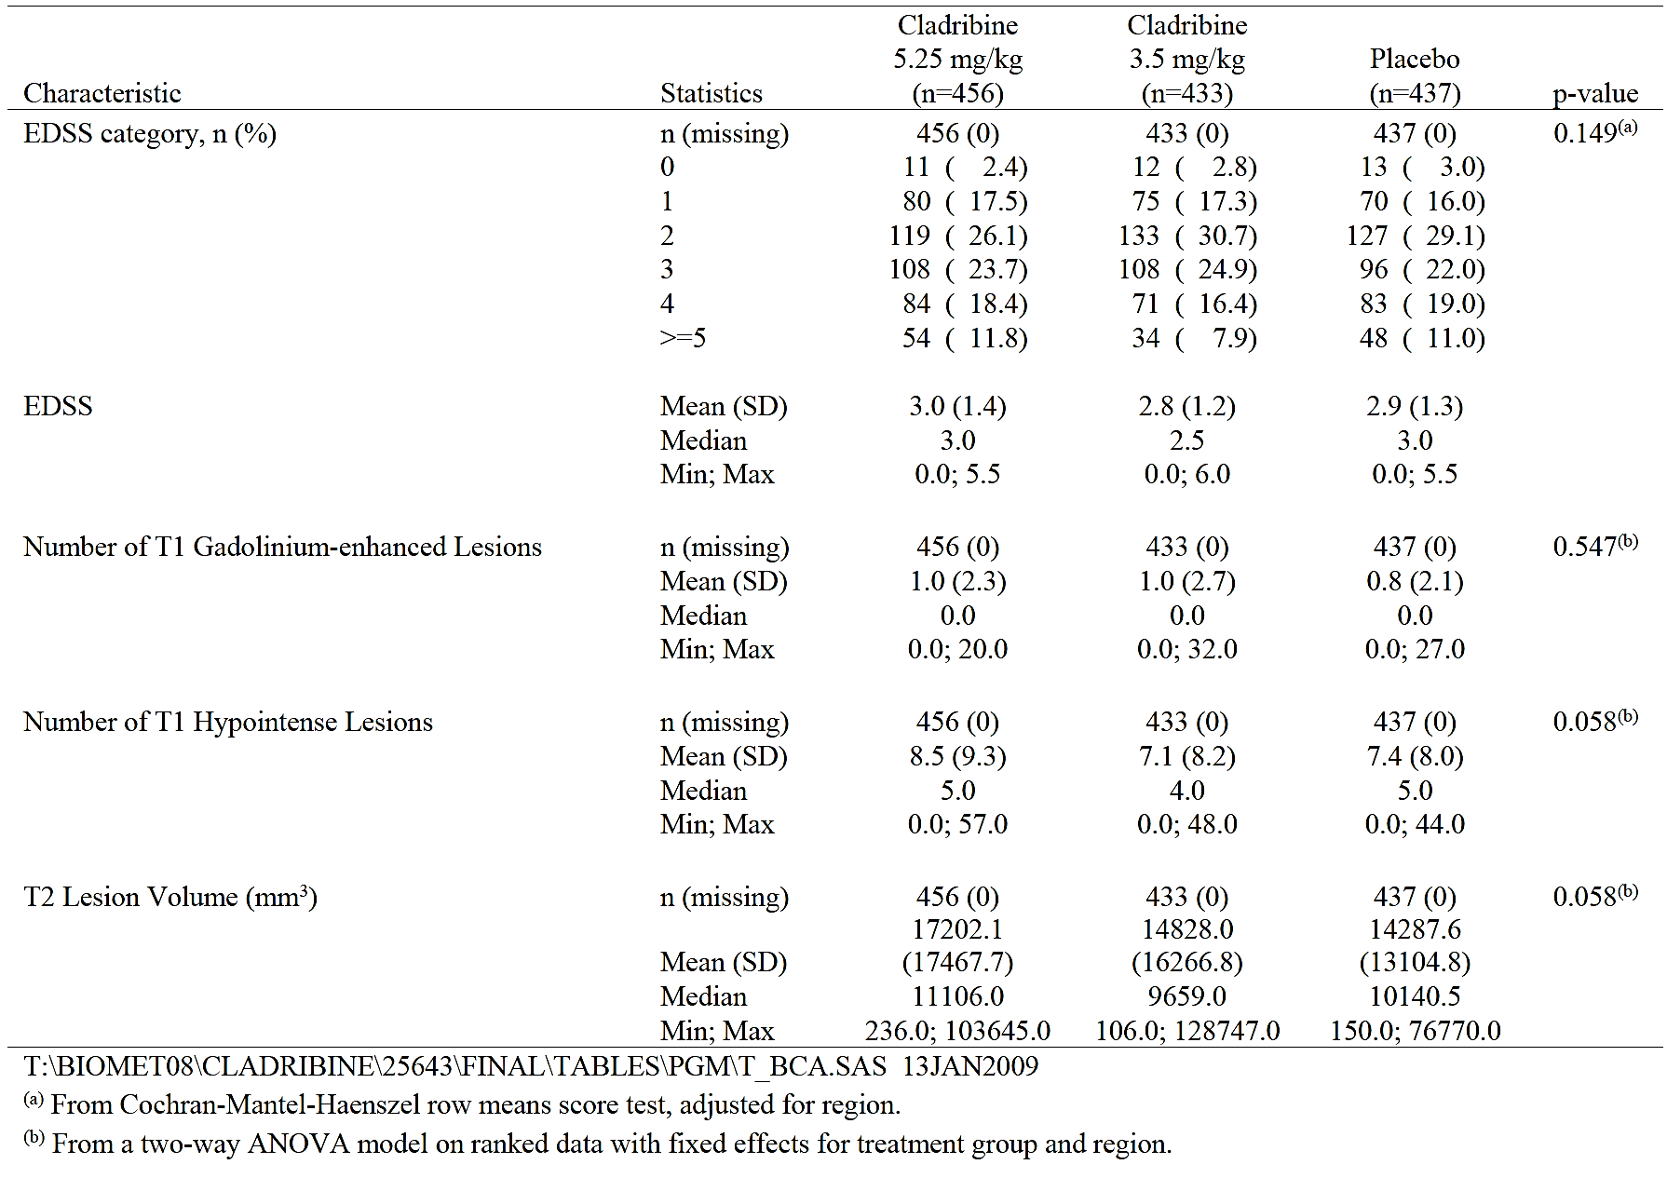

Table 12: Multiple sclerosis history by treatment group, ITT population

Table 13: Multiple sclerosis therapy taken by subjects prior to study Day 1 by treatment group, ITT population

Results for the primary efficacy outcome
There was a statistically and clinically significant reduction in relapse rate in both cladribine groups relative to placebo. The relapse rate was 0.15 per year for cladribine 5.25 mg/kg, 0.14 per year for cladribine 3.5 mg/kg and 0.33 per year for placebo (Table 14). The relative risk (95% CI) cladribine / placebo was 0.43 (0.35 to 0.54) p < 0.001 for 5.25 mg and 0.43 (0.34 to 0.54) p < 0.001 for 3.5 mg. The reduction in annualised relapse rate was 54.5% for cladribine 5.25 mg/kg and 57.6% for cladribine 3.5 mg/kg.

Table 14: Qualifying relapse rate at Week 96 by treatment group, ITT Population

Results for other efficacy outcomes
The results for the secondary efficacy outcome measures were:
- The number (%) of relapse free patients by Week 96 was 360 (78.9%) in the cladribine 5.25 mg/kg group, 345 (79.7%) in the cladribine 3.5 mg/kg group and 266 (60.9%) in the placebo. The odds ratio (95% CI) cladribine / placebo was 2.43 (1.81 to 3.27) p < 0.001 for cladribine 5.25 mg/kg and 2.53 (1.87 to 3.43) p < 0.001 for cladribine 3.5 mg/kg.
- The HR (95% CI) for sustained change in EDSS Score over 3 months was 0.69 (0.49 to 0.96) p = 0.026 for cladribine 5.25 mg/kg and 0.67 (0.48 to 0.93) p = 0.018 for cladribine 3.5 mg.
- The mean (SD) number of active T1 gadolinium enhanced lesions at Week 96 was 0.07 (0.37) for cladribine 5.25 mg, 0.09 (0.30) for cladribine 3.5 mg and 0.86 (1.78) for placebo. The LSM treatment difference (95% CI) cladribine – placebo was -0.80 (-0.94 to -0.66) p < 0.001 for cladribine 5.25 mg/kg and -0.78 (-0.92 to -0.65) p < 0.001 for cladribine 3.5 mg.
- The mean (SD) number of active T2 lesions at Week 96 was 0.29 (0.56) for cladribine 5.25 mg, 0.35 (0.66) for cladribine 3.5 mg and 1.38 (2.11) for placebo. The LSM treatment difference (95% CI) cladribine – placebo was -1.10 (-1.27 to -0.94) p < 0.001 for cladribine 5.25 mg/kg and -1.05 (-1.22 to -0.87) p < 0.001 for cladribine 3.5 mg.
- The mean (SD) number of CU lesions at Week 96 was 0.33 (0.64) for cladribine 5.25 mg, 0.39 (0.71) for cladribine 3.5 mg and 1.65 (2.55) for placebo. The LSM treatment difference (95% CI) cladribine – placebo was -1.34 (-1.54 to -1.14) p < 0.001 for cladribine 5.25 mg/kg and -1.28 (-1.49 to -1.08) p < 0.001 for cladribine 3.5 mg.
For the tertiary efficacy outcome variables:
- The HR (95% CI) for first qualifying response was 0.46 (0.36 to 0.60) p < 0.001 for cladribine 5.25 mg/kg and 0.44 (0.34 to 0.58) p < 0.001 for cladribine 3.5 mg.
- The number (%) of patients with no active T1 gadolinium enhanced lesions at Week 96 was 415 (91.0%) in the cladribine 5.25 mg/kg group, 376 (86.8%) in the cladribine 3.5 mg/kg group and 211 (48.3%) in the placebo. The odds ratio (95% CI) cladribine / placebo was 11.79 (8.07 to 17.24) p < 0.001 for cladribine 5.25 mg/kg and 7.57 (5.37 to 10.67) p < 0.001 for cladribine 3.5 mg/kg.
- The number (%) of patients with no active T2 lesions at Week 96 was 285 (62.5%) in the cladribine 5.25 mg/kg group, 267 (61.7%) in the cladribine 3.5 mg/kg group and 124 (28.4%) in the placebo. The odds ratio (95% CI) cladribine / placebo was 4.35 (3.27 to 5.78) p < 0.001 for cladribine 5.25 mg/kg and 4.17 (3.13 to 5.55) p < 0.001 for cladribine 3.5 mg/kg.
- The mean (SD) change from baseline in T2 lesion volume (mm³) at Week 96 was -3372.26 (8016.94) for cladribine 5.25 mg, -2349.94 (8041.69) for cladribine 3.5 mg and -1745.72 (8860.64) for placebo. The LSM treatment difference (95% CI) cladribine – placebo was -747.71 (-1626.49 to 131.06) p < 0.001 for cladribine 5.25 mg/kg and -434.72 (-1322.11 to 452.68) p < 0.001 for cladribine 3.5 mg. Note: there was a difference between the LSM and arithmetic mean.
- The mean (SD) number of T1 hypointense lesions at Week 96 was 6.94 (7.62) for cladribine 5.25 mg, 6.20 (7.33) for cladribine 3.5 mg and 6.69 (6.81) for placebo. The LSM treatment difference (95% CI) cladribine – placebo was -0.57 (-0.88 to -0.26) p < 0.001 for cladribine 5.25 mg/kg and -0.20 (-0.51 to 0.12) p < 0.001 for cladribine 3.5 mg. Note: there was a difference between the LSM and arithmetic mean.
- The mean (SD) change from baseline in T1 hypointense lesion volume (mm³) at Week 96 was 1817.81 (2976.42) for cladribine 5.25 mg, 1443.87 (2312.72) for cladribine 3.5 mg and -1371.95 (2005.25) for placebo. The LSM treatment difference (95% CI) cladribine – placebo was 457.15 (136.88 to 777.42) p = 0.212 for cladribine 5.25 mg/kg and 68.55 (-255.84 to 392.93) p = 0.356 for cladribine 3.5 mg.
- The number (%) of patients rescued at Week 96 was nine (2.0%) in the cladribine 5.25 mg/kg group, 11 (2.5%) in the cladribine 3.5 mg/kg group and 27 (6.2%) in the placebo. The odds ratio (95% CI) cladribine / placebo was 0.31 (0.14 to 0.66) p = 0.003 for cladribine 5.25 mg/kg and 0.40 (0.19 to 0.81) p = 0.011 for cladribine 3.5 mg/kg.
- Health related quality of life scores were instituted relatively late in the study and there were relatively few baseline measures. The MSQOL-54 physical function score did not demonstrate any significant difference between the groups. An analysis was not performed for the SF-36 score. The mean difference in resource use for the cladribine 3.5 mg/kg group versus placebo was -0.81 (p < 0.01) and the cladribine 5.25 mg/kg group versus placebo was -0.78 (p < 0.01).

Evaluator commentary
Study 25643 CLARITY demonstrated superiority for cladribine in comparison with placebo for relapse rates, MRI findings indicative of disease activity and for progression of disability. There was no significant difference between the 3.5 mg/kg dose and the 5.25 mg dose.
The Guideline on clinical investigation of medicinal products for the treatment of multiple sclerosis (EMA/CHMP/771815/2011, Rev. 2, 26 March 2015) advises that for confirmatory trials superiority must be shown against placebo. Although demonstrating efficacy against first line treatments in non-inferiority trials is preferred, because of the sample size requirements demonstrating efficacy in comparison with placebo only may be acceptable. Hence Study 25643 CLARITY is consistent with CHMP guidance.

Study 27820 CLARITY EXTENSION

Study design, objectives, locations and dates
Study 27820 CLARITY Extension was a double blind, placebo controlled, parallel group extension trial to evaluate the safety and tolerability of oral cladribine in patients with RRMS who had completed Study 25643 CLARITY. The study was conducted from February 2008 to December 2011 at 133 centres in 30 countries: Australia (3 centres), Austria (1), Belgium (2), Brazil (1), Bulgaria (11), Canada (4), Croatia (3), Czech Republic (3), Denmark (1), Estonia (3), Finland (2), France (7), Germany (7), Greece (2), Italy (11), Latvia (1), Lebanon (4), Lithuania (1), Morocco (4), Poland (5), Portugal (1), Russia (20), Saudi Arabia (2), Serbia & Montenegro (1), Switzerland (2), Tunisia (4), Turkey (2), UK (6), Ukraine (4), USA (15).

Inclusion and exclusion criteria
The study included patients who had been enrolled in Study 25643 CLARITY and who had completed, with or without rescue therapy; who had no evidence of latent tuberculosis infection (LTBI) or TB as evidenced by skin test or chest X-ray, and normal haematologic parameters.

Study treatments
- Subjects randomised to placebo during CLARITY were assigned to low-dose oral cladribine in the 96 week extension study (3.5 mg/kg of body weight over 2 years).
- Subjects randomised during CLARITY to either low-dose oral cladribine (3.5 mg/kg of body weight over 2 years) or high-dose oral cladribine (5.25 mg/kg over 2 years) were re-randomised in a 2:1 ratio to receive either low-dose oral cladribine or placebo in the 96 week extension study.
Cladribine (or matching placebo) was administered as two treatment courses (each of two treatment weeks separated by a month) separated by one year.
The treatment groups are summarised as:
- LLPP: cladribine 3.5 mg/kg for CLARITY and placebo for CLARITY Extension: total dose 3.5 mg/kg
- HLPP: cladribine 5.25 mg/kg for CLARITY and placebo for CLARITY Extension: total dose 5.25 mg/kg
- LLLL: cladribine 3.5 mg/kg for CLARITY and 3.5 mg/kg for CLARITY Extension: total dose 7 mg/kg
- HLLL: cladribine 5.25 mg/kg for CLARITY and 3.5 mg/kg for CLARITY Extension: total dose 8.25 mg/kg
- PPLL: placebo for CLARITY and cladribine 3.5 mg/kg for CLARITY Extension: total dose 3.5 mg/kg
Immunomodulatory, immunosuppressant and anti-cytokine therapies were prohibited.

Efficacy variables and outcomes
There was no primary efficacy analysis. The secondary efficacy outcome measures were:
Clinical:
- Proportion of subjects ‘qualifying’ relapse-free.
- Disability progression (defined in the protocol as an increase in the EDSS scale of at least 1.0 point compared to baseline if baseline EDSS score was ≥ 1.0 or ≤ 4.5; ≥ 1.5 points if the baseline EDSS score was zero; and ≥0.5 points if the baseline EDSS score was ≥5.0). The following two progression endpoints were to be used:
  - Time to confirmed EDSS progression, confirmed after 3 months.
  - Time to confirmed EDSS progression, confirmed after 6 months.
- Time to treatment start with rescue medication.
- Annualized ‘qualifying’ relapse rate.
- Time to first ‘qualifying’ relapse.
- Time to second ‘qualifying’ relapse.
MRI:
- Number of new T1 gadolinium-enhancing lesions.
- Number of active T2 lesions.
- Number of combined unique (CU) lesions, defined as 1) new T1 gadolinium-enhancing, or 2) new or enlarging T2 lesions, or 3) both, without double-counting.
- Total T2 lesion volume (the proton density/T2-weighted [T2] burden of disease [BOD]).
- Proportion of T1 gadolinium-enhancing lesions assessed at Baseline of Study 25643 transformed in T1 hypointense lesions (black holes).
- Percent brain volume changes.
- Proportion of subjects with no new T1 gadolinium-enhancing lesions.
- Proportion of subjects with no active T2 lesions.
- Proportion of subjects with no combined unique lesions.
- Number of new T1 hypointense lesions.
- Mean change in volume of T1 hypointense lesions
Other outcome measures were:
Immunological endpoint:
- Characterisation of immune cell subsets.
Pharmacoeconomic and health outcomes endpoints:
- Health-related quality of life (HRQL) assessment.
- Health resource utilisation (HRU) assessment.
Safety outcome measures were:
- Proportion of subjects with at least one Grade 4 CTCAE toxicity on the following parameters of haematologic and hepatic function: absolute lymphocyte count (ALC), haemoglobin level, white blood cell (WBC) count, absolute neutrophil count (ANC), platelets, alanine transaminase (ALT), aspartate transaminase (AST), and bilirubin.
- Proportion of subjects with Grades 3 or 4 adverse events (AEs) for haematologic and hepatic indices.
- Mean change in absolute lymphocyte count, haemoglobin level, WBC, ANC, platelets, ALT, AST, and bilirubin.
- Incidence of all treatment-emergent AEs and SAEs.
- Proportion of subjects developing infections, infection-related AEs, and malignancies.
- Time to first Grade 3 and 4 haematological toxicity or liver toxicity.
- Median and mean time to recovery from haematological and liver toxicity.
- Median and mean time to nadir of absolute lymphocyte count and mean time to recovery to normal values.
- Mean change in corrected QT (QTc) interval from baseline.

Randomisation and blinding methods
Randomisation was performed centrally and blinding was maintained by identical placebo. Only the subjects who had previously received active treatment were randomised, either to placebo or a further 3.5 mg/kg over two years.

Analysis populations
The ITT analysis set included all subjects randomised to treatment. The safety analysis set included all subjects who received at least one dose of study treatment and had at least one safety assessment.

Sample size
The sample size was determined by the number of patients completing Study 25643 CLARITY.

Statistical methods
Hypothesis tests were performed using odds ratios and hazard ratios and their 95% CI.

Participant flow
A total of 883 patients were screened, 867 were enrolled and 806 were randomised: 98 to LLPP, 92 to HLPP, 186 to LLLL, 186 to HLLL and 244 to PPLL (Table 15). There were 89 (11%) patients who discontinued medication during the double blind phase, 89 (11.0%) due to AE. The highest proportion of any group to discontinue because of AE was the HLLL (8.25 mg/kg) group with 30 (16.1%) patients, followed by the LLLL (7 mg/kg) group with 26 (14.0%).

Table 15: Subject disposition and reasons for discontinuation during the double blind phase of CLARITY EXT by treatment group
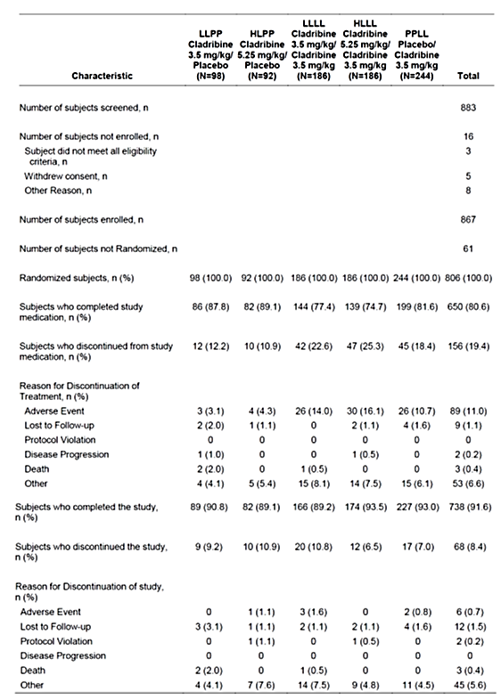

Major protocol violations/deviations
There were 27 major protocol deviations: 12 involved the use of another investigational drug and four involved use of prohibited medications.

Baseline data
There were 531 (65.9%) females, 275 (34.1%) males and the age range was 20 to 67 years. The treatment groups were similar in demographic characteristics. The treatment groups were similar in MS history (Table 16). Patients in the PPLL group had a slightly higher EDSS, a greater number of T1 gadolinium enhanced lesions and a greater volume of T1 gadolinium enhancing lesions (Table 17). These findings may reflect previous treatment from the CLARITY trial. Mean compliance rate was > 94% for all the treatment groups.

Table 16: Multiple sclerosis history at entry into CLARITY EXT by treatment group, ITT Analysis Set

Table 17: Baseline MRI and neurological assessment at entry into CLARITY EXT by treatment group, ITT Analysis Set

Table 17 continued: Baseline MRI and neurological assessment at entry into CLARITY EXT by treatment group, ITT Analysis Set

Results for the primary efficacy outcome
There was no primary efficacy outcome measure.

Results for other efficacy outcomes
- There was no significant difference between the treatment groups in annualised relapse rate (Table 18). The qualifying annualised relapse rate (95% CI) was 0.15 (0.09 to 0.21) for LLPP, 0.13 (0.08 to 0.19) for HLPP, 0.10 (0.06 to 0.13) for LLLL, 0.12 (0.08 to 0.16) for HLLL and 0.10 (0.07 to 0.13) for PPLL.

Table 18: Qualifying relapse rates during CLARITY EXT by treatment group, ITT Analysis Set
- The number (%) of patients qualifying relapse free was 68 (75.6%) for LLPP, 61 (75.3%) for HLPP, 134 (81.2%) for LLLL, 132 (76.7%) for HLLL and 180 (79.6%) for PPLL.
- The time to first qualifying relapse was greatest in the LLLL group (Table 19). However, there was no clear difference in the Kaplan-Meier plots (Figure 4).
- The time to second qualifying relapse was shortest in the PPLL group (Table 20). There was a similar result for time to second ‘strictly qualifying’ relapse.
- The time to 3 month disability progression was longest in the HLPP group (Table 21). There was no significant difference between groups in time to 6 month disability progression.
- The number (%) of patients free of 3 month disability progression was 71 (72.4%) for LLPP, 72 (78.3%) for HLPP, 144 (77.4%) for LLLL, 142 (76.3%) for HLLL and 185 (75.8%) for PPLL.
- There was no significant difference in change in EDSS scores during the study.

Table 19: Time to first qualifying relapse during CLARITY EXT by treatment group, ITT Analysis Set
Figure 4: Time to first qualifying relapse during the 120 week CLARITY EXT, ITT Analysis Set

Table 20: Time to second qualifying relapse during the entire trial (CLARITY + CLARITY Extension) by treatment group, ITT Analysis Set

Table 21: Disability progression, time to confirmed 3 month EDSS progression during the CLARITY Extension by treatment group, ITT Analysis Set
MRI outcomes:
- The mean (SD) number of new TI gadolinium enhancing lesions was 0.28 (0.87) for LLPP, 0.29 (1.14) for HLPP, 0.03 (0.08) for LLLL, 0.17 (1.04) for HLLL and 0.07 (0.38) for PPLL.
- The mean (SD) cumulative number of TI gadolinium enhancing lesions was 1.33 (4.13) for LLPP, 1.14 (4.10) for HLPP, 0.13 (0.41) for LLLL, 0.87 (5.92) for HLLL and 0.36 (2.24) for PPLL.
- The number (%) of patients without new T1 gadolinium enhancing lesions was 65 (73.0%) for LLPP, 65 (80.2%) for HLPP, 144 (88.9%) for LLLL, 152 (89.9%) for HLLL and 188 (85.1%) for PPLL.
- For the mean number of active T2 lesions per scan there was no consistent benefit for prolonged treatment compared to placebo (Table 22).

Table 22: Mean number of active T2 lesions per subject per scan, between treatment group comparisons during the CLARITY Extension, ITT Analysis Set
- The mean (SD) cumulative number of active T2 lesions was 6.35 (15.08) for LLPP, 6.36 (10.15) for HLPP, 4.09 (7.11) for LLLL, 5.69 (14.98) for HLLL and 5.43 (9.30) for PPLL.
- The number (%) of patients with no active T2 lesions at the end of CLARITY Extension was 55 (62.5%) for LLPP, 45 (54.2%) for HLPP, 114 (69.6%) for LLLL, 114 (70.8%) for HLLL and 158 (71.8%) for PPLL.
- The mean (SD) total volume of T2 lesions (10³mm³) was 16.86 (16.06) for LLPP, 15.45 (13.95) for HLPP, 9.26 (10.65) for LLLL, 15.05 (15.51) for HLLL and 11.89 (10.41) for PPLL.
- The mean (SD) cumulative number of CU lesions was 6.66 (15.78) for LLPP, 6.80 (11.63) for HLPP, 4.11 (7.15) for LLLL, 5.98 (16.51) for HLLL and 5.48 (9.39) for PPLL. The relative % reduction (95% CI), active versus placebo was 30.18 (-1.22 to 51.85) p = 0.030.
- The number (%) of patients with no CU lesions at the end of CLARITY Extension was 32 (34.4%) for LLPP, 24 (27.6%) for HLPP, 63 (37.1%) for LLLL, 76 (43.7%) for HLLL and 91 (40.1%) for PPLL.
- The mean (SD) number of new T1 hypointense lesions per scan was 0.67 (1.67) for LLPP, 0.73 (1.33) for HLPP, 0.58 (1.21) for LLLL, 0.64 (1.58) for HLLL and 0.63 (1.18) for PPLL.
- The cumulative mean (SD) number of new T1 hypointense lesions per was 2.97 (6.66) for LLPP, 3.50 (6.71) for HLPP, 2.79 (5.51) for LLLL, 3.31 (8.29) for HLLL and 3.20 (6.19) for PPLL. There was no significant difference between the groups in change in T1 hypointense lesion volumes.
- The number (%) of patients with no new T1 hypointense lesions at the end of CLARITY Extension was 40 (44.0%) for LLPP, 33 (39.3%) for HLPP, 77 (45.6%) for LLLL, 94 (53.4%) for HLLL and 112 (48.9%) for PPLL. There was no significant difference between active and placebo treatments.
- Seven patients required rescue treatment during CLARITY Extension: three (3.1%) in the LLPP group, two (2.2%) in the HLPP, one (0.5%) in the LLLL and one (0.4%) in the PPLL.
The sponsor provided a summary table of the efficacy endpoints that were considered to be ‘key’. This summary indicated benefit for the LLLL group for a reduction in qualifying relapse rate, change from baseline in EDSS score and mean number of new T1 gadolinium enhancing lesions (Table 23).

Table 23: Key clinical and MRI endpoints during CLARITY EXT, descriptive statistics and between treatment group comparisons

Evaluator commentary
Study 27820 CLARITY Extension did not have a primary efficacy outcome measure and was not designed primarily to demonstrate efficacy. The sponsor argues for efficacy based on a post hoc selection of ‘key’ efficacy variables. The overall efficacy results were inconsistent and the statistically significant findings were not clearly of clinical significance. The MRI outcome measures were more convincing of efficacy than the clinical outcome measures.
However, the study is supportive of the LLLL (total dose 7 mg/kg over 4 years) treatment group over the HLLL (8.5 mg/kg over 4 years) and does provide some support for extending the duration of treatment, and total exposure, to 7 mg/kg over 4 years.

Other efficacy studies

Study 2-CdA-MS-SCRIPC
Study 2-CdA-MS-SCRIPC was a Phase II, randomised, placebo controlled, double blind, parallel group efficacy and safety study of 18 months duration in patients with RRMS. The study was conducted from May 1994 to February 1997. The study included patients aged 18 to 50 years, male or female with RRMS for at least 1 year. The study treatments were:
- Cladribine 0.35 mg/kg/course (five daily injections) for 6 course and two placebo courses.
- Placebo, eight courses.
The efficacy measures were relapse rate and MRI findings. The study enrolled and randomised 52 patients and data were available for 49: 26 treated with cladribine and 23 with placebo. There were 35 (71%) females, 14 (29%) males and the age range was 31 to 52 years. Relative to placebo, there was a decrease in relapse rate and improvement in MRI findings, but no clinically significant difference in disability scores (Table 24).

Table 24: Summary of efficacy results at Month 18 (double blind phase)
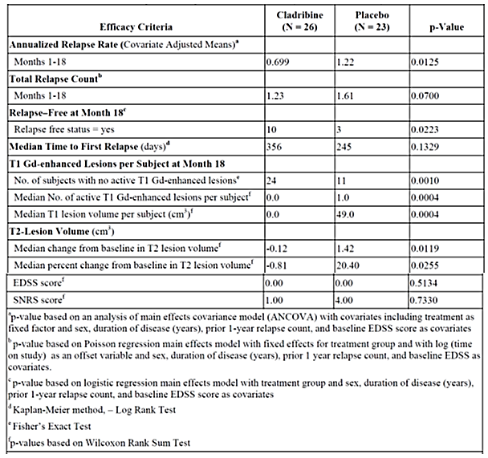

Study 2-CdA-MS-001
Study 2-CdA-MS-001 was a Phase III randomised, double blind, three parallel group, placebo controlled safety and efficacy trial in patients with PPMS. The study was conducted from December 1994 to October 1996. The study included males or females aged 21 to 60 years with PPMS over 1 year. The study treatments were:
- Cladribine 2.1 mg/kg (0.07 mg/kg/day subcutaneously for 5 days per course, for six courses)
- Cladribine 0.7 mg/kg (0.07 mg/kg/day subcutaneously for 5 days per course, for two courses)
- Placebo
The efficacy measures were MRI changes, EDSS score and SNRS score. The study enrolled 159 patients: 52 to cladribine 2.1 mg/kg, 53 to cladribine 0.7 mg/kg and 54 to placebo. There was an improvement in MRI findings in the treated groups relative to placebo but no significant difference in functional scores (Table 25).

Table 25: Summary of efficacy results

Study 2-CdA-MS-SCRIPP
Study 2-CdA-MS-SCRIPP was a Phase II, randomised, double blind, placebo controlled, parallel group crossover study in patients with Chronic Progressive MS (CPMS). The study was conducted from January 1992 to September 1994. The study included male or female patients aged 21 to 55 years, with CPMS and were not severely disabled or wheelchair bound. The study treatments were:
- Cladribine 2.8 mg/kg (0.1 mg/kg/day for 7 days as a continuous infusion per course; four courses); followed the second year by placebo
- Placebo; followed the second year by: Cladribine 1.4 mg/kg (0.1 mg/kg/day for 7 days for the first course, then 0.05 mg/kg/day for 7 days for the next two courses, then placebo for one course, as a continuous infusion)
The outcome measures were MRI findings, EDSS and SNRS. The study randomised 49 patients: 25 to initially cladribine, and 24 to initially placebo. There were 34 (69%) females, 15 (31%) males and the age range was 21 to 54 years. There were improvements in both MRI and functional scores in the cladribine patients compared to placebo (Table 26).

Table 26: Summary of efficacy results

Study 28821 ORACLE
Study 28821 ORACLE was a Phase III, randomised, double-blind, placebo controlled, parallel group efficacy and safety study in patients with a first clinical event at high risk of converting to MS. The study was terminated prior to full follow-up time because the sponsor had decided to cease further development of cladribine. The study was conducted at 160 centres in 34 countries from December 2008 to April 2012. Study design is summarised below (Figure 5).
Figure 5: Study design for Study 28821 ORACLE
The study included male or female patients, aged 18 to 55 years who experienced a single, first clinical event suggestive of MS within 75 days prior to the initial screening visit. The event must have been a new neurological abnormality present for at least 24 hours, either mono- or poly-symptomatic. Subjects must have had at least two clinically silent lesions on the T2-weighted MRI scan at screening, with a size of at least 3 mm, at least 1 of which was ovoid or periventricular or infratentorial on screening MRI, and had an EDSS score of 0 to 5.0. Subjects must not have had a diagnosis of MS (per 2005 McDonald criteria) or used any approved or experimental MS disease-modifying drug or any immunomodulatory or immunosuppressive therapy at any time prior to Study Day 1.
The study treatments were:
- Cladribine 3.5 mg/kg, administered by two treatment courses separated by one year
- Cladribine 5.25 mg/kg, administered by two treatment courses separated by one year
- Placebo
Cladribine was administered orally as the 10 mg tablet formulation.
The primary efficacy outcome measure was time to conversion to Clinically Definite MS (CDMS) according to the Poser Criteria, defined by either a second attack or a sustained increase in the EDSS score during the ITP. The secondary efficacy outcome measures included:
- Proportion of subjects converting to CDMS
- Number of new or persisting Gd-enhanced lesions
- Number of new or enlarging T2 lesions
- Number of combined unique active (CUA) MRI lesions
- Volume of T1 Gd-enhanced lesions
- Volume of T2 lesions
- Number of T1 hypointense lesions
- Proportion of subjects with no new or persisting T1 Gd-enhanced lesions
- Proportion of subjects with no new or enlarging T2 lesions
- Percentage brain volume change (PBVC)
- Number of relapses and annualized relapse rate
- Proportion of subjects relapse-free
- Cognition Endpoints
  - PASAT-3 performance
  - SDMT performance
  - BVMT-R performance
  - Correlation between cognitive tests and MRI
- Patient Reported Outcome Endpoints: EQ-5D, MSQoL-54, Treatment satisfaction scale, health resource utilization
The intended sample size was 600 patients, 200 in each treatment group. The study included 617 patients: 205 in the 5.25 mg/kg group, 206 in the 3.5 mg/kg and 206 in the placebo. Only 209 (33.9%) patients completed the ITP period (Table 27). One patient in the cladribine 5.25 mg group was excluded from the efficacy analysis. There were 400 (64.9%) females, 216 (35.1%) males and the age range was 18 to 55 years. The treatment groups were similar in demographic and baseline characteristics.
Time to conversion to MS was significantly increased in both treatment groups: HR (95% CI) cladribine/placebo was 0.381 (0.248 to 0.584) p < 0.0001 for 5.25 mg/kg and 0,327 (0.210 to 0.509) p < 0.0001 for 3.5 mg/kg. Up to 90 days the survival curve for conversion to MS was similar for all three treatment groups, but improved significantly subsequently for the two cladribine treatment groups (Figure 6). There was a significantly lower number of new or persisting T1 gadolinium enhanced lesions: mean (SD) 1.01 (5.63) for 5.25 mg/kg, 1.35 (5.51) for 3.5 mg/kg, and 4.41 (6.79) for placebo (Table 28). There was a significantly lower number of new or enlarging T2 lesions: mean (SD) 1.96 (4.28) for 5.25 mg/kg, 2.19 (6.45) for 3.5 mg/kg, and 5.08 (6.77) for placebo (Table 29). There was a significantly lower number of combined unique active lesions: mean (SD) 2.91 (7.73) for 5.25 mg/kg, 3.31 (11.03) for 3.5 mg/kg, and 9.34 (12.22) for placebo (Table 30). The mean (SD) change in volume of T1 gadolinium enhanced lesions was -73.97 (204.80) for 5.25 mg/kg, -126.64 (399.39) for 3.5 mg/kg, and 48.63 (239.03) for placebo. The proportion of patients with no new or persisting T1 gadolinium enhanced lesions was 77 (67.0%) for 5.25 mg/kg, 80 (57.1%) for 3.5 mg/kg and 37 (21.6%) for placebo. The mean (SD) change in volume of T2 lesions to Week 48 was -654.20 (2061.85) for 5.25 mg/kg, -828.97 (3513.04) for 3.5 mg/kg, and -29.57 (2581.44) for placebo. The proportion of patients with no new or enlarging T2 lesions was 46 (32.9%) for 5.25 mg/kg, 53 (35.1%) for 3.5 mg/kg and 33 (19.0%) for placebo. The proportion of patients who converted to CDMS was 30 (28.8%) patients for 5.25 mg/kg, 27 (23.1%) for 3.5 mg/kg and 71 (56.3%) for placebo. The annualised relapse rate (95% CI) was 0.24 (0.07 to 0.40) for 5.25 mg/kg, 0.14 (0.00 to 0.27) for 3.5 mg/kg and 0.42 (0.28 to 0.56) for placebo. There were insufficient data to enable analysis of the cognition endpoints. The patient reported outcomes were reported separately.

Table 27: Patient disposition for Study 28821 ORACLE
Figure 6: Time to CDMS conversion during the ITP: Kaplan-Meier cumulative incidence curves, ITT Analysis Set

Table 28: Number of new or persisting T1 Gd-enhanced lesions during the ITP, ITT Analysis Set

Table 29: Number of new or enlarging T2 lesions during the ITP, ITT Analysis Set

Table 30: Number of combined unique active lesions during the ITP, ITT Analysis Set

Study 26593 ONWARD
Study 26593 ONWARD was a Phase IIb multicentre, randomised, double blind, placebo controlled safety and tolerability study of cladribine in combination with IFN-β in patients with active MS. The study was conducted from November 2006 to March 2012 at 50 sites in the US, Russia, Spain and Italy. The study included males and females aged 18 to 65 years, weighing 40 to 120 kg, with active MS. The study treatments were:
- Cladribine 3.5 mg administered as two courses separated by one year
- Placebo
Patients were also treated with IFN-β (either IFN-β-1a or IFN-β-1b). There were 172 patients randomised to treatment: 124 to cladribine 3.5 mg/kg and 48 to placebo. There were 111 (89.5%) patients in the cladribine 3.5 mg/kg group and 27 (77.1%) in the placebo who completed the study. There were 120 (69.8%) females, 52 (30.2%) males and the age range was 18 to 64 years. The annualised qualifying relapse rate (95% CI) was 0.12 (0.08 to 0.17) in the cladribine group and 0.32 (0.20 to 0.45) in the placebo, RR (95% CI) cladribine/placebo 0.37 (0.22 to 0.63) p < 0.001. However, there was no apparent difference in survival between the two groups for the first year of the study (Figure 7). The proportion of patients free of qualifying relapse was 93 (75.0%) in the cladribine group and 25 (52.1%) in the placebo. There was no significant difference between the groups in time to EDSS disability progression. There were no new T1 gadolinium enhancing lesions in 104 (86.0%) patients in the cladribine group and 27 (56.3%) in the placebo. There were no new active T2 lesions in 65 (56.2%) patients in the cladribine group and 14 (19.2%) in the placebo.
Figure 7: Amendment 1 and 2 time to first qualifying relapse: Kaplan-Meier Cumulative incidence curves (ITT Population)

Evaluator commentary: other efficacy studies
The five other efficacy studies were generally supportive of efficacy but did not relate to the proposed amendments to the indications. The sponsor has not referred to these studies in the Product Information document and does not appear to be basing any claims upon them.

Analyses performed across trials: pooled and meta analyses
There were no analyses performed across trials or meta-analyses. The Integrated Summary of Efficacy discussed Study 25643 CLARITY, Study 27820 CLARITY Extension and Study 26593 ONWARD.

Evaluator’s conclusions on clinical efficacy
The sponsor has demonstrated efficacy compared to placebo in Study 25643 CLARITY which has been previously submitted and evaluated.
Efficacy was demonstrated using qualifying relapse rate as the primary efficacy outcome measure. Disability progression was measured using EDSS. There was a statistically and clinically significant benefit for cladribine in comparison with placebo for both of these outcome measures. Hence there are sufficient data to support: ‘to reduce the frequency of clinical relapses and to delay the progression of physical disability’ being included in the indication.
There are limited data in support of removing the 2 year limit on treatment. Although Study 27820 CLARITY Extension is supportive of the LLLL (total dose 7 mg/kg over 4 years) treatment group over the HLLL (8.5 mg/kg over 4 years) and does provide some support for extending the duration of treatment, and total exposure, to 7 mg/kg over 4 years, there are a number of limitations to the study. These limitations are:
- Study 27820 CLARITY Extension did not have a primary efficacy outcome measure and was not designed primarily to demonstrate efficacy.
- The sponsor argues for efficacy based on a post hoc selection of ‘key’ efficacy variables.
- The overall efficacy results were inconsistent and the statistically significant findings were not clearly of clinical significance.
- The MRI outcome measures were more convincing of efficacy than the clinical outcome measures.
The sponsor has not provided any data that explores the lowest effective dose. This was identified as a major issue at the time of initial approval but has not subsequently been addressed by the sponsor.

Clinical safety

Studies providing evaluable safety data

Pivotal studies that assessed safety as the sole primary outcome
There were no pivotal studies that assessed safety as the sole primary outcome.

Pivotal and/or main efficacy studies
There were two pivotal studies conducted in patients with the proposed indication, RRMS; Study 25643 CLARITY and Study 27820 CLARITY Extension.

Other studies

Other efficacy studies
There were five other efficacy studies:
- Study 2-CdA-MS-SCRIPC, a Phase II study in patients with RRMS.
- Study 2-CdA-MS-001, a Phase III study in patients with PPMS.
- Study 2-CdA-MS-SCRIPP, a Phase II study in patients with Chronic Progressive MS (CPMS).
- Study 28821 ORACLE, a Phase III study in patients with a first clinical event at high risk of converting to MS.
- Study 26593 ONWARD, a Phase IIb in patients with active MS.

Studies with evaluable safety data: dose finding and pharmacology
There were nine clinical pharmacology studies: Study IXR-102-09-186, Study 25803, Study 26127, Study IXR-101-09-186, Study 6226/6414, Study 93-220, Study JK-6251-1, Study 26486 and Study 27967.
The safety data from the clinical pharmacology studies are limited by the short duration of drug exposure and follow-up.

Studies evaluable for safety only

Study 2-CdA-MS-SCRIPB
Study 2-CdA-MS-SCRIPB was a Phase II, double blind, placebo controlled, Parallel group crossover study in patients with progressive MS (PPMS). The study was of 12 months duration and was conducted in 11 patients. The study included patients with PPMS, aged between 21 and 55 years age and able to ambulate a minimum of 25 feet. The study treatments were:
- Cladribine 2.1 mg/kg (0.07 mg/kg/day subcutaneously for 5 days per course, for 6 courses)
- Cladribine 0.7 mg/kg (0.07 mg/kg/day subcutaneously for 5 days per course, for 2 courses), followed by an additional four courses in the second phase
- Placebo, followed by cladribine 2.1 mg/kg (0.07 mg/kg/day subcutaneously for 5 days per course, for 6 courses) in the second phase
The efficacy outcome measures were EDSS, SNRS and MRI brain scan at the end of each 6 month phase. The safety outcome measures included AEs, clinical laboratory tests and vital signs. There were 11 patients entered into the study, ten entered the second phase and a further two discontinued during the second phase. There were eight females, three males and the age range was 35 to 55 years.
During the initial phase TEAEs were reported in seven (87.5%) patients treated with cladribine and three (100%) treated with placebo. The commonest TEAE was urinary tract infection in four subjects in the cladribine group. Lymphopaenia occurred in all the cladribine treated patients. TEAEs were reported in all patients in the retreatment phase. One patient developed herpes zoster infection. There were no deaths or SAEs. No hypothesis tests were performed on the efficacy data.

Study 2-CdA-MS-SCRIPA
Study 2-CdA-MS-SCRIPA was an open label, Phase II, ‘proof-of-concept’ study in patients with progressive MS (PPMS). The study was conducted at a single centre in the US from December 1989 to May 1998. The study included male or female patients, aged 21 to 55 years, with PPMS who were not severely disabled or wheelchair bound. The study treatment was: cladribine 3.65 mg/kg (0.87 mg/kg/day over 7 days as a continuous infusion, for six courses, monthly). Three patients received half of this dose. The efficacy outcome measures were neurological symptoms and disability scores: EDSS and SNRS scales. The study included seven patients: five females and two males. Total exposure ranged from 1.21 to 5.10 mg/kg. The most commonly reported TEAE was nausea, in four (57.1%) patients, and insomnia was reported in four (66.7%) of six patients who entered the follow-up phase. There was one death due to cardiac arrest 3 years after last dose of cladribine. SAEs were reported in three patients (pancytopaenia, gastrointestinal haemorrhage, bronchitis, pneumonia, pyelonephritis, sinusitis, haemoglobin decreased, MS, haemangioma, skin lesion). Three patients discontinued study treatment, one because of an AE. Lymphocyte count shifted from normal to low in four (57.1%) patients and Grade 3/4 lymphocyte toxicity was recorded in six (85.7%) patients.

PREMIERE Registry
PREMIERE Registry was a long-term safety monitoring study. The study included patients who had participated in CLARITY, CLARITY Extension, ONWARD, ORACLE and Study 27967. The study is ongoing and the report providing interim data is dated May 2016. The data were collected using telephone contacts every 3 months for 2 years, then yearly. Data from 1153 patients are included in the registry, but patients from Study 27967 and those with non-matching record numbers are excluded from the safety analysis, leaving 1,133 patients in the safety analysis. There were 941 patients who had received at least one dose of cladribine, with a mean (SD) total dose of 4.742 (2.082) mg/kg. There were 192 patients who had received placebo, with no cladribine exposure. In the cladribine group, 319 (33.9%) patients were subsequently exposed to other disease modifying drugs, predominantly IFN-β (Table 31).

Table 31: DMD of special interest, Safety Set
RECORD MS registry
A prospective, observational, post-authorisation study of cladribine tablets in cladribine-naïve patients in the Australian Patient Familiarisation Program and is discussed in the Safety section below.

Studies that assessed safety as the sole primary outcome
There were no pivotal studies that assessed safety as the sole primary outcome.

Patient exposure

Integrated safety analysis
In the integrated safety analysis there were 1976 patients exposed to cladribine, for a total of 8650.16 patient years of follow-up and 802 patients exposed to placebo for a total of 2361.13 patient years follow-up. Cumulative dose was in the range > 0 to 3.5 mg/kg for 439 patients, > 3.5 to 5.25 mg/kg for 759, > 5.25 to 7.0 mg/kg for 418, > 7.0 to 8.75 mg/kg for 213 and > 8.75 mg/kg for 147.

Clinical pharmacology studies
In Study IXR-102-09-186 there were 26 patients with MS exposed to single doses of three treatments: cladribine 3 mg orally, cladribine 10 mg orally and cladribine 3 mg IV.
In Study 25803 there were 16 patients with MS exposed to a single oral 10 mg dose and a single 3 mg IV dose.
In Study 26127 there were 16 subjects exposed to two single 10 mg doses of cladribine, one each in the fed and fasted states.
In Study IXR-101-09-186 there were 12 patients exposed to three oral and one IV single doses of 3 mg cladribine.
In Study 6226 / Study 6414 there were 61 patients with haematological malignancies or solid tumours exposed to intravenous doses in the range of 2.5 to 21.5 mg/m²/day.
In Study 93-220 ten patients with advanced malignancy were exposed to cladribine 1 mg/mL oral solution, 0.28 mg/kg/day for 5 days, followed by a month break, then cladribine 1 mg/mL IV solution (Leustatin), 0.14 mg/kg/day administered intravenously over 2 hours, daily for 5 days.
Study JK-6251-1 there were nine patients with lymphoid malignancies exposed to cladribine 1 mg/mL solution, 0.06 to 0.09 mg/kg/day continuous IV infusion for 7 days, for up to three courses.
In Study 26486 there were 17 patients with MS exposed to the combination of IFN-β-1a 44 μg every second day and cladribine 10 to 20 mg daily for 5 days.
In Study 27967 18 subjects received up to two single doses of cladribine 10 mg orally.

Pivotal studies
In Study 25643 CLARITY there were 454 subjects enrolled to have 5.25 mg/kg, and 390 (85.9%) received the full course of treatment; 430 subjects enrolled to have 3.5 mg/kg, and 395 (91.9%) received the full course of treatment; and 435 enrolled to receive placebo.
In Study 27820 CLARITY Extension there were 98 patients exposed to LLPP (total dose 3.5 mg/kg), 92 to HLPP (total dose 5.25 mg/kg), 186 to LLLL (total dose 7 mg/kg), 186 to HLLL (total dose 8.25 mg/kg) and 244 to PPLL (total dose 3.5 mg/kg).

Other efficacy studies:
In Study 2-CdA-MS-SCRIPC there were 26 patients with RRMS exposed to 2.1 mg/kg over an 8 month period, and 23 exposed to placebo. Twelve patients were entered into an open-label extension study and received a mean dose of 1.38 mg/kg over a mean duration of 22.8 months.

Studies for other indications:
In Study 2-CdA-MS-001 there were 52 patients with PPMS exposed to cladribine 2.1 mg/kg, 53 to cladribine 0.7 mg/kg and 54 to placebo.
In Study 2-CdA-MS-SCRIPP there were 48 patients with CPSS exposed to cladribine: 25 to cladribine 2.8 mg/kg and 23 to cladribine 1.4 mg/kg.
In Study 28821 ORACLE there were 204 patients with a first clinical event at high risk of converting to MS randomised to cladribine 5.25 mg/kg, 206 to 3.5 mg/kg and 206 to placebo. There were 99 (48.5%) who completed the fill course for 5.25 mg/kg and 131 (63.6%) for 3.5 mg/kg.
Study 26593 ONWARD there were 124 patients with active MS exposed to cladribine 3.5 mg in combinations with IFN-β, and 48 exposed to placebo.

Adverse events

All adverse events (irrespective of relationship to study treatment)

Integrated safety analyses
In the integrated analysis of safety the rate of AEs was 122.79 /100PY for cladribine and 111.73/100 PY for placebo. Lymphopaenia and leukopaenia were more common with cladribine, but other than this the profile of common adverse events for cladribine was similar to that for placebo.

Main/pivotal studies that assessed safety as the sole primary outcome
Not applicable.

Pivotal and/or main efficacy studies
In Study 25643 CLARITY there were 2712 TEAEs reported in 381 (83.9%) patients in the cladribine 5.25 mg/kg group, 2514 in 347 (80.7%) of the 3.5 mg/kg group and 1958 in 319 (73.3%) of the placebo (Table 32). Lymphopaenia was reported in 143 (31.5%) patients in the 5.25 mg/kg group, 93 (21.6%) of the 3.5 mg/kg and eight (1.8%) of the placebo.
In Study 27820 CLARITY Extension TEAEs were reported in 74 (75.5%) patients in the LLPP (total dose 3.5 mg/kg) group, 71 (77.2%) in the HLPP (total dose 5.25 mg/kg), 149 (80.1%) in the LLLL (total dose 7 mg/kg), 149 (80.1%) in the HLLL (total dose 8.25 mg/kg) and 194 (79.5%) in the PPLL (total dose 3.5 mg/kg) (Table 33). Blood and lymphatic disorders were more common in the LLLL (total dose 7 mg/kg) and HLLL (total dose 8.25 mg/kg) groups: 17 (17.3%) patients in the LLPP (total dose 3.5 mg/kg) group, 12 (13.0%) in the HLPP (total dose 5.25 mg/kg), 78 (41.9%) in the LLLL (total dose 7 mg/kg), 82 (44.1%) in the HLLL (total dose 8.25 mg/kg) and 81 (33.2%) in the PPLL (total dose 3.5 mg/kg).

Table 32: Overall summary of most common treatment emergent adverse events (reported in ≥ 1% of patients in the cladribine groups) during the study by treatment group, Safety Population
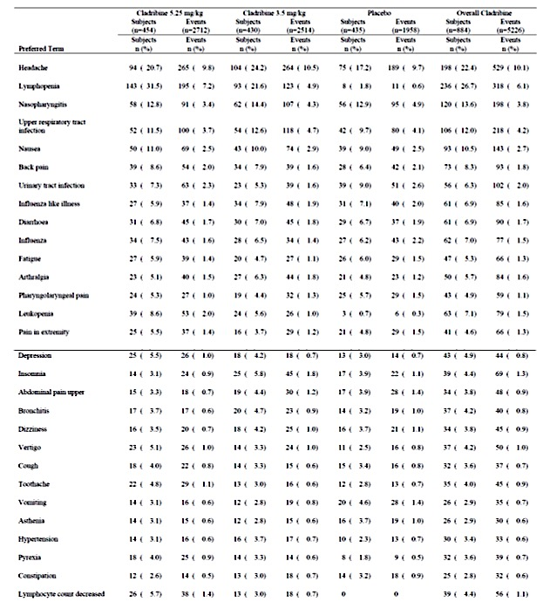

Table 33: Treatment emergent adverse events in ≥5% of subjects in any treatment group during Study CLARITY EXT by treatment group, Safety Analysis Set

Table 33 continued: Treatment-emergent adverse events in ≥5% of subjects in any treatment group during Study CLARITY EXT by treatment group, Safety Analysis Set

Other studies

Other efficacy studies
In Study 2-CdA-MS-SCRIPC TEAEs were reported in all patients: 26 (100%) of the cladribine group and 23 (100%) of the placebo. Injection site reactions were more common with cladribine (Table 34).

Table 34: Most common treatment emergent adverse events during double blind phase

Table 34 continued: Most common treatment emergent adverse events during double blind phase
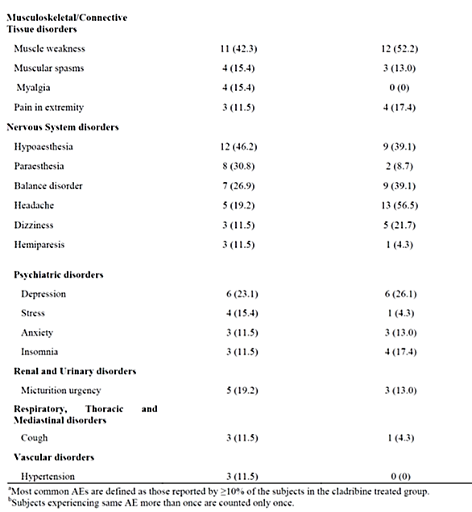

Studies with evaluable safety data: dose finding and pharmacology
In Study IXR-102-09-186 three TEAEs were reported, all with the 3 mg oral dose: headache in two patients and vomiting in one.
In Study 25803 there were two TEAEs reported with the 10 mg oral dose and five with the 3 mg IV dose.
In Study 26127 there were three TEAEs (mild MS, pharyngitis, gastroenteritis).
In Study IXR-101-09-186 there were 12 TEAEs were reported in nine patients. The most frequent TEAE was headache in three patients.

Studies evaluable for safety only
In Study 2-CdA-MS-001 TEAEs were reported in 52 (100%) patients exposed to cladribine 2.1 mg/kg, 53 (100%) to cladribine 0.7 mg/kg and 53 (98%) to placebo.
In Study 2-CdA-MS-SCRIPP TEAEs were reported in 25 (100%) patients in the cladribine 2.8 mg/kg group and 21 (91%) in the cladribine 1.4 mg/kg. The commonest TEAE was injection site inflammation.
In Study 28821 ORACLE TEAEs were reported in 164 (80.4%) patients in the cladribine 5.25 mg/kg group, 168 (81.6%) in the 3.5 mg/kg and 162 (78.6%) in the placebo. Lymphopaenia was reported in 48 (23.5%) patients in the cladribine 5.25 mg/kg group, 23 (11.2%) in the 3.5 mg/kg and none in the placebo (Table 35).
In Study 26593 ONWARD TEAEs were reported in 119 (96.0%) of the cladribine 3.5 mg/kg group and 36 (75.0%) of the placebo.
In the PREMIERE Registry, there were new disease diagnoses in 218 (23.2%) of the cladribine exposed group and 51 (26.6%) of the placebo (Table 35). There were new neoplastic diagnoses in nine (1.0%) of the cladribine exposed group and one (0.5%) of the placebo. There were new herpes zoster infection diagnoses in 26 (2.8%) of the cladribine exposed group and two (1.0%) of the placebo. There were new other severe infection diagnoses in 13 (1.4%) of the cladribine exposed group and three (1.6%) of the placebo. AEs were reported in 332 (35.3%) of the cladribine group and 76 (39.6%) of the placebo. Severe infection was reported in six (0.6%) patients in the cladribine group and two (1.0%) in the non-exposed. Opportunistic infection was reported in 31 (3.3%) patients in the cladribine group and six (3.1%) in the non-exposed. Herpes infection was reported in 29 (3.1%) patients in the cladribine group and five (2.6%) in the non-exposed. Malignant or unspecified tumours were reported in 11 (1.2%) patients in the cladribine group and one (0.5%) in the non-exposed (Table 36).

Table 35: Incidence of most common treatment-emergent adverse events (reported by 5% or more subjects) by MedDRA Preferred Term, Safety Population

Table 36: New disease diagnosis, by diagnosis condition, System Organ Class and Preferred term, Safety Set
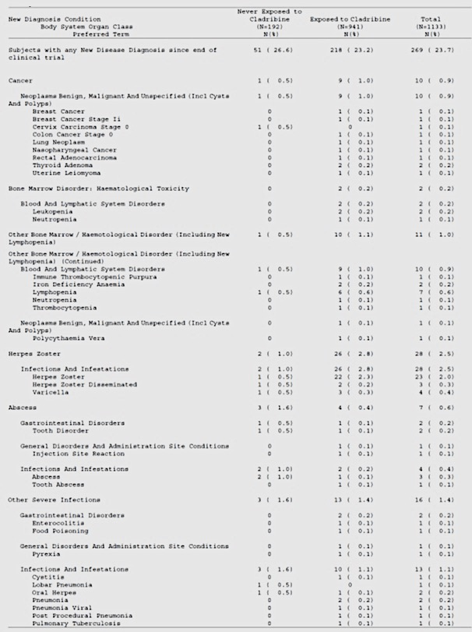

Table 36 continued: New disease diagnosis, by diagnosis condition, System Organ Class and Preferred term, Safety Set
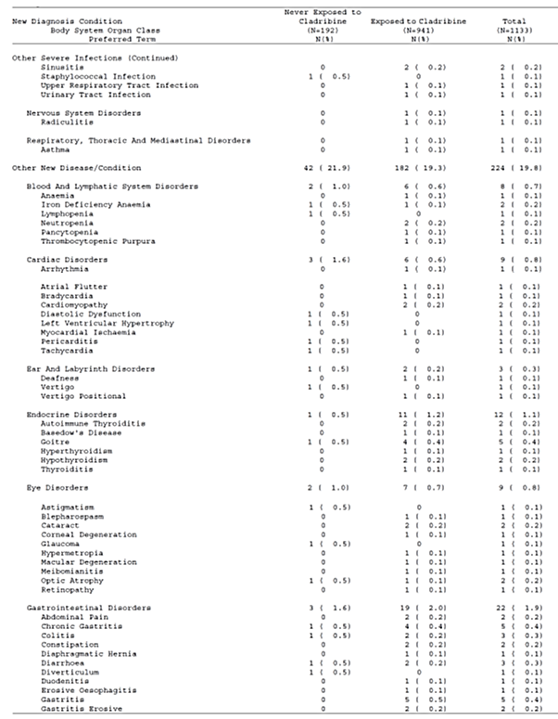

Table 36 continued: New disease diagnosis, by diagnosis condition, System Organ Class and Preferred term, Safety Set
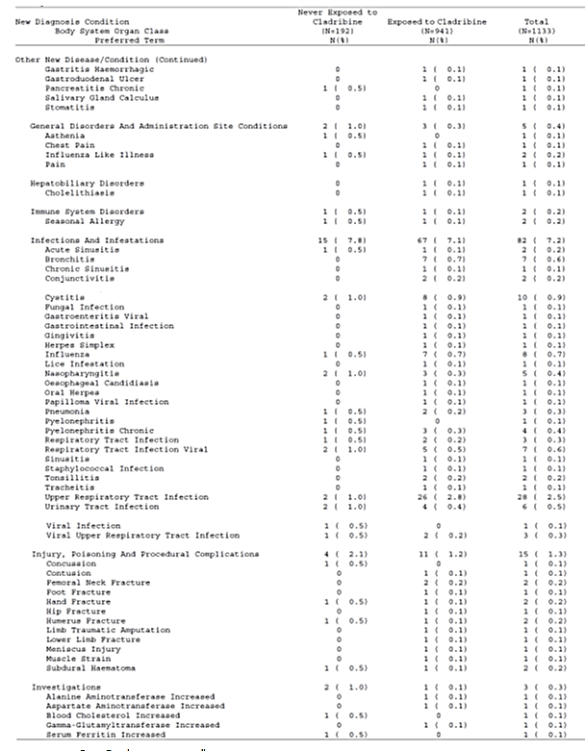

Table 36 continued: New disease diagnosis, by diagnosis condition, System Organ Class and Preferred term, Safety Set
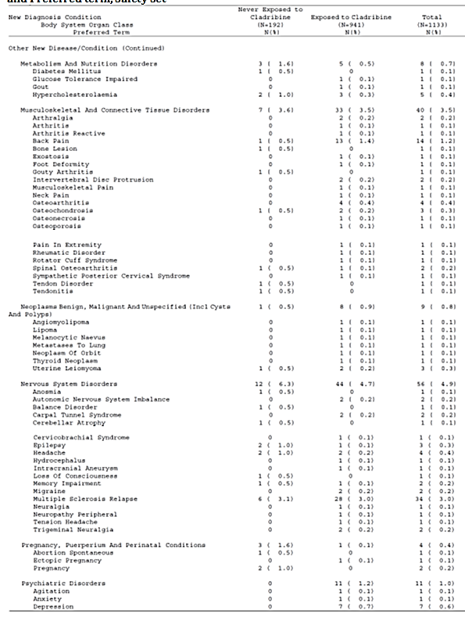

Table 36 continued: New disease diagnosis, by diagnosis condition, System Organ Class and Preferred term, Safety Set
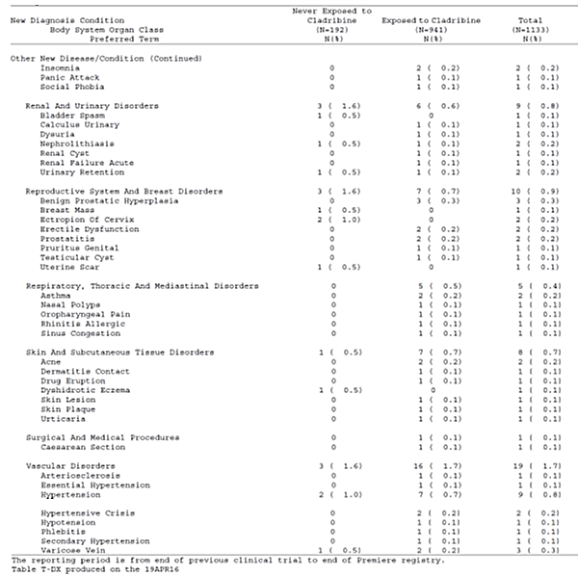

Table 37: AESI: All malignant or unspecified tumors By Preferred Term Safety Set

Treatment related adverse events (adverse drug reactions)

Integrated safety analyses
In the integrated analysis of safety the rate of treatment related AEs was 45.13 /100PY for cladribine and 32.09 /100 PY for placebo. Lymphopaenia and leukopaenia were more common in the cladribine group (Table 38).

Table 38: Most frequently reported related adverse events (Adj-AE per 100 PY of ≥ 1.0 in either group) (All Exposed Cohort)
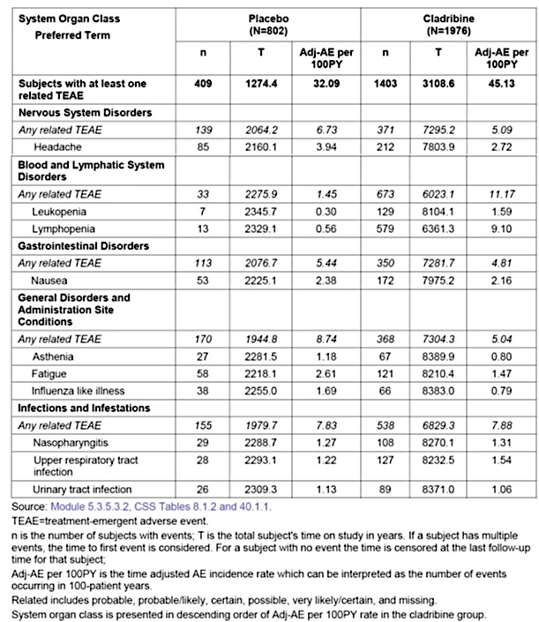

Main/pivotal studies that assessed safety as the sole primary outcome
Not applicable.

Pivotal and/or main efficacy studies
In Study 27820 CLARITY Extension treatment related TEAEs were reported in 42 (42.9%) patients in the LLPP (total dose 3.5 mg/kg) group, 36 (39.1%) in the HLPP (total dose 5.25 mg/kg), 105 (56.5%) in the LLLL (total dose 7 mg/kg), 108 (58.1%) in the HLLL (total dose 8.25 mg/kg) and 124 (50.8%) in the PPLL (total dose 3.5 mg/kg).

Other studies
In Study 28821 ORACLE treatment related TEAEs were reported in 102 (50.0%) patients in the cladribine 5.25 mg/kg group, 92 (44.7%) in the 3.5 mg/kg and 55 (26.7%) in the placebo.
In Study 26593 ONWARD treatment related TEAEs were reported in 94 (75.8%) of the cladribine 3.5 mg/kg group and 21 (43.8%) of the placebo.

Deaths and other serious adverse events

Integrated safety analyses
In the integrated analysis of safety the rate of serious TEAE leading to death was 0.22 /100PY for cladribine and 0.21 /100 PY for placebo. There were four deaths due to Neoplasms Benign, Malignant and Unspecified (including Cysts and Polyps) SOC, all in cladribine-treated subjects: rectal adenocarcinoma (related), pancreatic carcinoma metastatic (unrelated), ovarian cancer (unrelated), bile duct adenocarcinoma and metastases to lymph nodes (same subject, both related). There were two deaths due to Infections and Infestations SOC, both in the cladribine group: Tuberculosis (related) and hepatitis B (unrelated). Another patient in the cladribine group had death coded as due to pyrexia, and the underlying conditions included herpetic encephalopathy and pneumonia.
The rate of SAEs was 4.30 /100PY for cladribine and 4.51 /100 PY for placebo (all exposed cohort). The rate of neoplasia was higher in the cladribine group (0.86 /100 PY) compared to placebo (0.56 /100 PY). The risk ratio (95% CI) for malignancy was 2.1979 (0.7773 to 6.2148) for the ‘All Exposed’ cohort and 3.7884 (0.4738 to 30.2896) for the ‘Placebo-controlled double-blind’ cohort.. The rate of infections / infestations was higher in the cladribine group (0.94 /100 PY) compared to placebo (0.64 /100 PY), including herpes zoster (1.14 versus 0.25 /100PY) which was also more common with cladribine.

Main/pivotal studies that assessed safety as the sole primary outcome
Not applicable.

Pivotal and/or main efficacy studies
In Study 25643 CLARITY there were six deaths, two in each treatment group (tuberculosis reactivation, drowning in the 5.25 mg/kg group; acute myocardial infarction, pancreatic carcinoma in the 3.5 mg group; suicide and cerebrovascular accident in the placebo). There were 80 SAEs reported in 41 (9.0%) patients in the cladribine 5.25 mg/kg group, 61 in 36 (8.4%) of the 3.5 mg/kg group and 44 in 28 (6.4%) of the placebo. The commonest group of SAEs was infections and infestations: 15 in 13 (2.9%) patients in the cladribine 5.25 mg/kg group, 10 in 10 (2.3%) of the 3.5 mg/kg group and eight in seven (1.6%) of the placebo (Table 39).
In Study 27820 CLARITY Extension death was reported for two (2.0%) patients in the LLPP (total dose 3.5 mg/kg) group (unknown, drowning), none in the HLPP (total dose 5.25 mg/kg), one (0.5%) in the LLLL (total dose 7 mg/kg) (traumatic intracranial injury), none in the HLLL (total dose 8.25 mg/kg) and none in the PPLL (total dose 3.5 mg/kg). SAEs were reported in 16 (16.3%) patients in the LLPP (total dose 3.5 mg/kg) group, eight (8.7%) in the HLPP (total dose 5.25 mg/kg), 25 (13.4%) in the LLLL (total dose 7 mg/kg), 23 (12.4%) in the HLLL (total dose 8.25 mg/kg) and 22 (9.0%) in the PPLL (total dose 3.5 mg/kg) (Table 40). A total of 27 patients with neoplastic conditions were reported: three (3.1%) patients in the LLPP (total dose 3.5 mg/kg) group, three (3.3%) in the HLPP (total dose 5.25 mg/kg), nine (4.8%) in the LLLL (total dose 7 mg/kg), seven (3.8%) in the HLLL (total dose 8.25 mg/kg) and five (2.0%) in the PPLL (total dose 3.5 mg/kg). There was a mix of neoplastic conditions with no apparent pattern and none appeared to be haematological malignancies.

Table 39: Summary of serious treatment emergent adverse events during the study by treatment group, Safety Population

Table 40: Serious treatment emergent adverse events by primary System Organ Class (SOC) and Preferred Term (PT) during the Study CLARITY Extension by treatment group

Table 40 continued: Serious treatment emergent adverse events by primary System Organ Class (SOC) and Preferred Term (PT) during the Study CLARITY Extension by treatment group
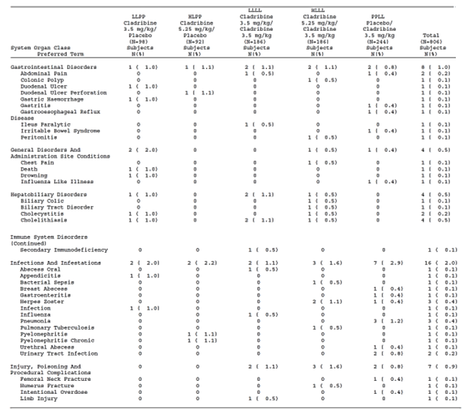

Table 40 continued: Serious treatment emergent adverse events by primary System Organ Class (SOC) and Preferred Term (PT) during the Study CLARITY Extension by treatment group
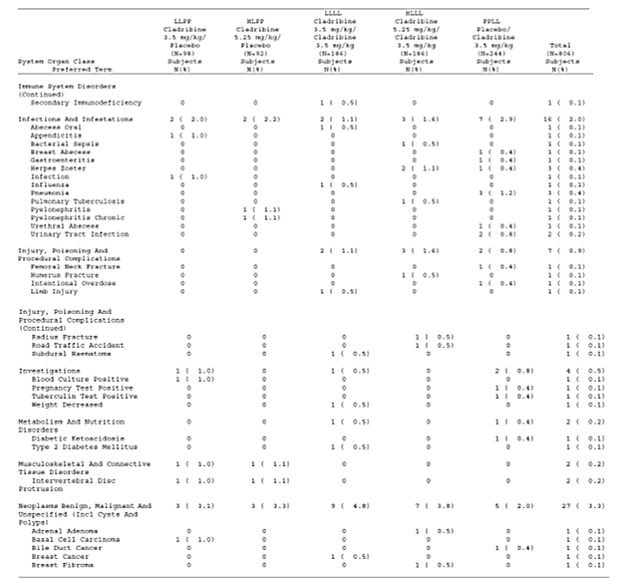

Table 40 continued: Serious treatment emergent adverse events by primary System Organ Class (SOC) and Preferred Term (PT) during the Study CLARITY Extension by treatment group

Other studies

Other efficacy studies
In Study 2-CdA-MS-SCRIPC there were no deaths reported. SAEs were reported five (19.2%) patients in the cladribine group and four (17.4%) in the placebo. There were no neoplasms reported in the cladribine group.

Studies with evaluable safety data: dose finding and pharmacology
In Study IXR-102-09-186, Study 25803, Study 26127 and Study IXR-101-09-186 there were no deaths or SAEs.

Studies evaluable for safety only
In Study 2-CdA-MS-001 there were no deaths. SAEs were reported in eight (15.4%) patients in the cladribine 2.1 mg/kg group, six (11.3%) in the cladribine 0.7 mg/kg and ten (18.5%) in the placebo. The commonest SAEs were aggravated MS and urinary tract infection. There were no neoplasms reported as SAEs.
In Study 2-CdA-MS-SCRIPP one patient in the 2.8 mg/kg group during the treatment phase from Hepatitis B. SAEs were reported in ten (40%) patients in the cladribine 2.8 mg/kg group and five (21.7%) in the cladribine 1.4 mg/kg (Table 41). There was one patient with basal cell carcinoma.
In Study 28821 ORACLE there were no deaths. SAEs were reported in eight (3.9%) patients in the cladribine 5.25 mg/kg group, 21 (10.2%) in the 3.5 mg/kg and 21 (10.2%) in the placebo. Neoplasms were reported in one (0.5%) patients in the cladribine 5.25 mg/kg group, two (1.0%) in the 3.5 mg/kg and six (2.9%) in the placebo (Table 42).
In Study 26593 ONWARD there were no deaths. SAEs were reported in 12 (9.7%) of the cladribine 3.5 mg/kg group and five (10.4%) of the placebo (Table 43).
In the PREMIERE Registry EAs leading to death were reported for three (0.3%) patients in the cladribine group and three (1.6%) in the non-exposed. SAEs were reported in 37 (3.9%) patients in the cladribine group and eight (4.2%) in the non-exposed.

Table 41: Subjects with serious adverse events (All subjects: Protocol 2-CdA-MS-SCRIPP)

Table 42: Serious treatment-emergent adverse events by MedDRA System Organ Class and Preferred Term, Safety Population

Table 42 continued: serious treatment-emergent adverse events by MedDRA System Organ Class and Preferred Term, Safety Population

Table 43: Amendment 1 and 2 DBP serious TEAEs by SOC and Preferred Term (Safety Population)

Discontinuations due to adverse events

Integrated safety analyses
In the integrated analysis of safety the rate of TEAEs leading to treatment discontinuation was 3.27/100PY for cladribine and 1.17 /100 PY for placebo. The higher rate of discontinuation in the cladribine group was due primarily to lymphopaenia (Table 44).

Table 44: Adverse events leading to treatment discontinuation with an Adj-AE per 100 PY of ≥ 0.05 in the cladribine-treated group by SOC (All Exposed Cohort)
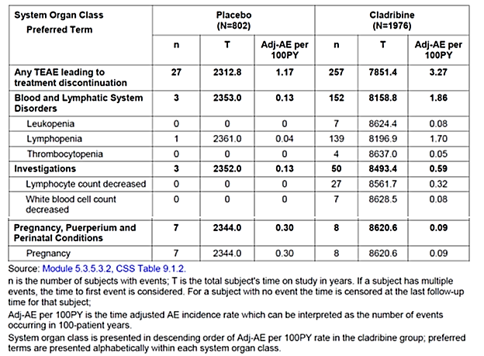

Main/pivotal studies that assessed safety as the sole primary outcome
Not applicable.

Pivotal and/or main efficacy studies
In Study 25643 CLARITY DAE was reported for 36 (7.9%) patients in the cladribine 5.25 mg/kg group, 15 (3.5%) in the 3.5 mg/kg group and nine (2.1%) of the placebo. Discontinuations due to haematological disorders and infections were more common in the cladribine 5.25 mg/kg group (Table 45).
In Study 27820 CLARITY Extension DAE was reported for three (3.1%) patients in the LLPP (total dose 3.5 mg/kg) group, two (2.2%) in the HLPP (total dose 5.25 mg/kg), 26 (14.0%) in the LLLL (total dose 7 mg/kg), 30 (16.1%) in the HLLL (total dose 8.25 mg/kg) and 25 (10.1%) in the PPLL (total dose 3.5 mg/kg) (Table 46). The most common AE leading to discontinuation was lymphopaenia which was dose related.

Table 45: Overall summary of treatment emergent adverse events leading to treatment discontinuation during the study by treatment group, Safety Population
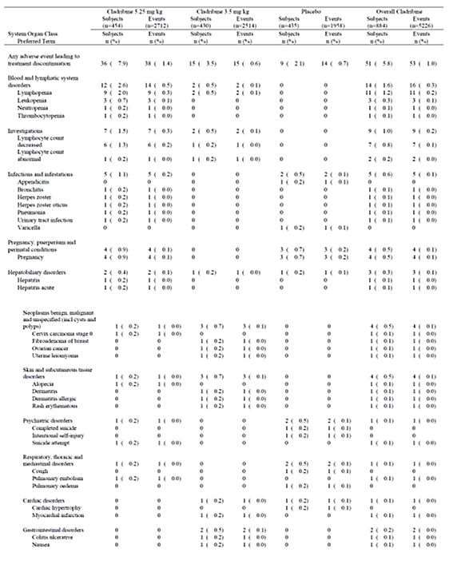

Table 45 continued: Overall summary of treatment emergent adverse events leading to treatment discontinuation during the study by treatment group, Safety Population

Table 46: treatment emergent adverse events leading to treatment discontinuation in 2 or more subjects overall during Study CLARITY EXT by treatment group, Safety Analysis Set

Other studies

Other efficacy studies
In Study SCRIPPSC there were no DAEs reported.

Studies with evaluable safety data: dose finding and pharmacology
In Study IXR-102-09-186, Study 25803, Study 26127 and Study IXR-101-09-186 there were no DAEs.

Studies evaluable for safety only
In Study 2-CdA-MS-001 AE leading to temporary or permanent withdrawal of drug was reported in no patients in the cladribine 2.1 mg/kg group, three (5.7%) in the cladribine 0.7 mg/kg and six (11.1%) in the placebo.
In Study 2-CdA-MS-SCRIPP DAE was reported for four (16%) patients in the cladribine 2.8 mg/kg group (hepatitis B leading to death, injury, aplastic anaemia and thrombocytopaenia).
In Study 28821 ORACLE TEAE leading to treatment discontinuation was reported for 20 (9.8%) patients in the cladribine 5.25 mg/kg group, nine (4.4%) in the 3.5 mg/kg and six (2.9%) in the placebo (Table 47). Lymphopaenia was the commonest AE leading to discontinuation in the cladribine groups: 17 (8.3%) patients in the 5.25 mg/kg group, six (2.9%) in the 3.5 mg/kg and none in the placebo.
In Study 26593 ONWARD TEAE leading to discontinuation of treatment was reported for 37 (29.8%) of the cladribine 3.5 mg/kg group and four (8.3%) of the placebo.

Table 47: Incidence of treatment-emergent adverse events leading to study treatment discontinuation by MedDRA System Organ Class and Preferred Term, Safety Population
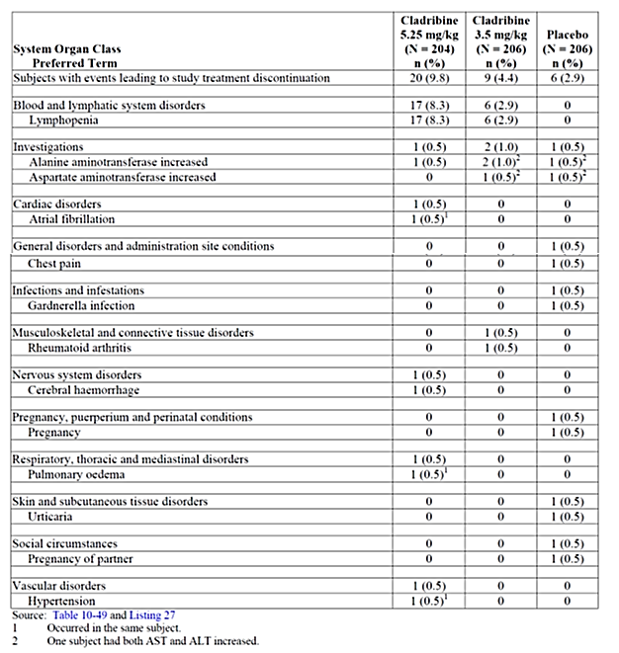

Evaluation of issues with possible regulatory impact

Liver function and liver toxicity

Integrated safety analyses
As per individual study reports.

Main/pivotal studies that assessed safety as the sole primary outcome
Not applicable.

Pivotal and/or main efficacy studies
In Study 25643 CLARITY ALT >5 x ULN was reported for 14 (3.1%) patients in the cladribine 5.25 mg/kg group, 15 (3.5%) in the 3.5 mg/kg and 16 (3.7%) in the placebo. AST > 5 x ULN was reported for 12 (2.6%) patients in the cladribine 5.25 mg/kg group, 13 (3.0%) in the 3.5 mg/kg and 14 (3.2%) in the placebo.
In Study 27820 CLARITY Extension Grade 3 or 4 AST toxicity (> 5 x ULN) was reported for two (2.0%) patients in the LLPP (total dose 3.5 mg/kg) group, none in the HLPP (total dose 5.25 mg/kg), one (0.5%) in the LLLL (total dose 7 mg/kg), one (0.5%) in the HLLL (total dose 8.25 mg/kg) and one (0.4%) in the PPLL (total dose 3.5 mg/kg). Grade 3 or 4 AST toxicity (> 5 x ULN) was reported for two (2.0%) patients in the LLPP (total dose 3.5 mg/kg) group, none in the HLPP (total dose 5.25 mg/kg), none in the LLLL (total dose 7 mg/kg), three (1.6%) in the HLLL (total dose 8.25 mg/kg) and three (1.2%) in the PPLL (total dose 3.5 mg/kg).

Other studies

Other efficacy studies
In Study SCRIPPSC one patient in the cladribine group developed mildly elevated ALT.

Studies with evaluable safety data: dose finding and pharmacology
In Study IXR-102-09-186, Study 25803, Study 26127 and Study IXR-101-09-186 there were no clinically significant laboratory test abnormalities.

Studies evaluable for safety only
In Study 28821 ORACLE Grade 3/4 abnormalities in ALT were reported in six (2.9%) patients in the 5.25 mg/kg group, five (2.4%) in the 3.5 mg/kg and seven (3.4%) in the placebo. Grade 3/4 abnormalities in AST were reported in two (1.0%) patients in the 5.25 mg/kg group, three (1.5%) in the 3.5 mg/kg and three (1.5%) in the placebo.
In Study 26593 ONWARD Grade 3/4 ALT increase was reported in one (0.8%) of the cladribine 3.5 mg/kg group and one (2.1%) of the placebo. Grade 3/4 AST increase was reported in one (0.8%) of the cladribine 3.5 mg/kg group and none of the placebo.

Renal function and renal toxicity

Integrated safety analyses
As per individual study reports.

Main/pivotal studies that assessed safety as the sole primary outcome
Not applicable.

Pivotal and/or main efficacy studies
There were no reports of renal dysfunction in the pivotal efficacy studies.

Other studies
There were no reports of renal dysfunction in the other studies.

Other clinical chemistry
Disorders of other clinical chemistry were not identified as safety issues in the clinical data.

Haematology and haematological toxicity

Integrated safety analyses
As per the individual study reports.

Main/pivotal studies that assessed safety as the sole primary outcome
Not applicable.

Pivotal and/or main efficacy studies
In Study 25643 CLARITY in the cladribine groups the counts for lymphocyte subsets CD3, CD4, CD8, CD19 and CD16/56 were depressed during the study. CD19 counts did not return to normal by Week 96. There were 99 (22%) patients in the 5.25 mg/kg group, 75 (17.4%) in the 3.5 mg/kg group and 13 (2.9%) in the placebo who shifted from normal to low WBC count groups. There were 19 (4.2%) patients in the 5.25 mg/kg group, 13 (3.0%) in the 3.5 mg/kg group and four (0.9%) in the placebo who shifted from normal to low neutrophil count groups. There were seven (1.5%) patients in the 5.25 mg/kg group, ten (2.3%) in the 3.5 mg/kg group and three (0.7%) in the placebo who shifted from normal to low platelet count groups.
In Study 27820 CLARITY Extension lymphocyte toxicity was common, was related to total dose and worsened with ongoing treatment (Table 48). At the end of the treatment phase approximately 40% of patients in the 8.25 mg total dose had Grade 3 or 4 lymphocyte toxicity (< 500/mm³). Mean (SD) time to recovery was 256.7 (239.7) days with 7 mg total dose and 241.8 (216.1) days with 8.25mg total dose. Grade 3 or 4 WBC toxicity (<2000/mm³) was reported for no patients in the LLPP (total dose 3.5 mg/kg) group, one (1.1%) in the HLPP (total dose 5.25 mg/kg), 11 (5.9%) in the LLLL (total dose 7 mg/kg), 11 (5.9%) in the HLLL (total dose 8.25 mg/kg) and five (2.0%) in the PPLL (total dose 3.5 mg/kg). Grade 3 or 4 absolute neutrophil count toxicity (<1000/mm³) was reported for four (4.1) patients in the LLPP (total dose 3.5 mg/kg) group, three (3.3%) in the HLPP (total dose 5.25 mg/kg), 11 (5.9%) in the LLLL (total dose 7 mg/kg), 12 (6.5%) in the HLLL (total dose 8.25 mg/kg) and eight (3.3%) in the PPLL (total dose 3.5 mg/kg). Grade 3 or 4 platelet toxicity (<50,000/mm³) was reported for no patients in the LLPP (total dose 3.5 mg/kg) group and the HLPP (total dose 5.25 mg/kg), one (0.5%) in the LLLL (total dose 7 mg/kg), one (0.5%) in the HLLL (total dose 8.25 mg/kg) and none in the PPLL (total dose 3.5 mg/kg).

Table 48: Proportion of subjects with CTCAE lymphocyte (109/L) toxicity gradings during Study CLARITY EXT by period and treatment group, Safety Analysis Set

Other studies

Other efficacy studies
In Study SCRIPPSC 14 (53.8%) patients in the cladribine group developed a low white cell count and 16 (61.5%) developed a low lymphocyte count.

Studies with evaluable safety data: dose finding and pharmacology
In Study 6226/Study 6414, an open-label, dose-escalation, parallel group PK study of intravenous cladribine in patients with incurable haematological malignancies or solid tumours, doses of 2.5, 4. 6. 8. 10, 12.5, 15, 18 and 21.5 mg/m²/day were used. There were 61 patients included in the study and PK data were available for 51. Fifteen (34.9%) of the patients with haematologic malignancies experienced haematologic toxicity which included thrombocytopaenia. In patients with solid tumours, dose limiting myelosuppression was achieved at a dose of 8 mg/m²/day. Ten patients died during or after the study. Eight deaths occurred in the patients with haematologic malignancy, seven due to infection and one due to the malignancy. Many of the patients had myelosuppression but it was not possible to discriminate between drug toxicity and disease progression. Two deaths in the patients with solid tumours were related to disease progression.

Studies evaluable for safety only
In Study 2-CdA-MS-001 markedly low WCC was reported in 14 (27%) patients in the cladribine 2.1 mg/kg group, seven (13%) in the cladribine 0.7 mg/kg and one (2%) in the placebo. Markedly low platelet count was reported in one patient in the cladribine 2.1 mg/kg group.
In Study 2-CdA-MS-SCRIPP in the cladribine 2.8 mg/kg group one patient was reported with aplastic anaemia and another with thrombocytopaenia both leading to discontinuation. Overall, thrombocytopaenia was reported in four (16%) subjects in the 2.8 mg/kg group. Low WCC was reported in 13 (52%) patients in the 2.8 mg/kg group and four (17%) in the 1.4 mg/kg group.
In Study 28821 ORACLE Grade 3/4 abnormalities in WCC were reported in ten (4.9%) patients in the 5.25 mg/kg group, seven (3.4%) in the 3.5 mg/kg and none in the placebo. Grade 3/4 abnormalities in neutrophil count were reported in seven (3.4%) patients in the 5.25 mg/kg group, nine (4.4%) in the 3.5 mg/kg and none in the placebo. Grade 3/4 abnormalities in lymphocyte were reported in 73 (35.8%) patients in the 5.25 mg/kg group, 41 (19.9%) in the 3.5 mg/kg and one (0.5%) in the placebo. There was one Grade 4 abnormality of platelets in the cladribine 3.5 mg/kg group
In Study 26593 ONWARD Grade 3/4 lymphocyte decrease was reported in 79 (63.7%) of the cladribine 3.5 mg/kg group and one (2.1%) of the placebo. Grade 3/4 CD4+ count decrease was reported in 63 (50.8%) of the cladribine 3.5 mg/kg group and two (4.2%) of the placebo. Grade 3/4 neutrophil count decrease was reported in 15 (12.2%) of the cladribine 3.5 mg/kg group and two (4.2%) of the placebo.

Other laboratory tests
No other laboratory tests were identified as safety issues.

Electrocardiograph findings and cardiovascular safety

Integrated safety analyses
As per individual studies.

Main/pivotal studies that assessed safety as the sole primary outcome
Not applicable.

Pivotal and/or main efficacy studies
In Study 25643 CLARITY ALT increase in QTcF of 30 to 60 ms was reported for one patient in the cladribine 5.25 mg/kg group, one in the 3.5 mg/kg and none in the placebo.
There were no clinically significant changes in ECG parameters in Study 27820 CLARITY Extension.

Other studies

Other efficacy studies
No significant ECG changes were identified.

Studies with evaluable safety data: dose finding and pharmacology
In Study IXR-102-09-186, Study 25803, Study 26127 and Study IXR-101-09-186 there were no clinically significant abnormalities in ECGs.

Studies evaluable for safety only
In Study 28821 ORACLE and Study 26593 ONWARD there were no clinically significant changes in ECGs.

Vital signs and clinical examination findings

Integrated safety analyses
As per individual studies.

Pivotal studies that assessed safety as the sole primary outcome
Not applicable.

Pivotal and/or main efficacy studies
In Study 25643 CLARITY and Study 27820 CLARITY Extension there were no between group differences in vital signs.

Other studies

Other efficacy studies
No clinically significant changes were identified.

Studies with evaluable safety data: dose finding and pharmacology
In Study IXR-102-09-186, Study 25803, Study 26127 and Study IXR-101-09-186 there were no clinically significant abnormalities in vital signs.

Studies evaluable for safety only
In Study 28821 ORACLE and Study 26593 ONWARD there were no clinically significant changes in vital signs.

Immunogenicity and immunological events

Integrated safety analyses
As per individual studies.

Main/pivotal studies that assessed safety as the sole primary outcome
Not applicable.

Pivotal and/or main efficacy studies
In Study 25643 CLARITY in the cladribine groups the counts for lymphocyte subsets CD3, CD4, CD8, CD19 and CD16/56 were depressed during the study. CD19 counts did not return to normal by Week 96.
In Study 27820 CLARITY Extension TEAEs in the infections and infestations SOC were reported in 48 (49.0%) patients in the LLPP (total dose 3.5 mg/kg) group, 44 (47.8%) in the HLPP (total dose 5.25 mg/kg), 91 (48.9%) in the LLLL (total dose 7 mg/kg), 87 (46.8%) in the HLLL (total dose 8.25 mg/kg) and 110 (45.1%) in the PPLL (total dose 3.5 mg/kg). Herpes virus infections were reported in six (6.1%) patients in the LLPP (total dose 3.5 mg/kg) group, four (4.3%) in the HLPP (total dose 5.25 mg/kg), six (3.2%) in the LLLL (total dose 7 mg/kg), 13 (7.0%) in the HLLL (total dose 8.25 mg/kg) and eleven (4.5%) in the PPLL (total dose 3.5 mg/kg). Any viral infection was reported in 20 (20.4%) patients in the LLPP (total dose 3.5 mg/kg) group, 16 (17.4%) in the HLPP (total dose 5.25 mg/kg), 28 (15.1%) in the LLLL (total dose 7 mg/kg), 41 (22.0%) in the HLLL (total dose 8.25 mg/kg) and 39 (16.0%) in the PPLL (total dose 3.5 mg/kg). Any opportunistic infection was reported in eight (8.2%) patients in the LLPP (total dose 3.5 mg/kg) group, four (4.3%) in the HLPP (total dose 5.25 mg/kg), nine (4.8%) in the LLLL (total dose 7 mg/kg), 17 (9.1%) in the HLLL (total dose 8.25 mg/kg) and 15 (6.1%) in the PPLL (total dose 3.5 mg/kg).

Other studies
In Study 26593 ONWARD any TEAE in the infections and infestations SOC was reported in 76 (61.3%) of the cladribine 3.5 mg/kg group and 26 (54.2%) of the placebo.

Serious skin reactions
Serious skin reactions were not identified as a safety concern.

Other safety issues

Safety in special populations
There were no new data regarding safety in special populations.

Safety related to drug-drug interactions and other interactions
In Study 26486 there were patients with MS exposed to the combination of IFN-β-1a 44 μg every second day and cladribine 10 to 20 mg daily for 5 days. There were 22 (9.9%) TEAEs with cladribine monotherapy, 165 (74.0%) TEAEs with IFN monotherapy and 36 (16.1%) TEAEs with combined therapy. The commonest TEAE was pyrexia, which was predominantly reported with IFN treatment. There were no deaths. There was one SAE (thrombocytopaenia) reported during IFN monotherapy that lead to discontinuation. Increased transaminases and decreased white cell counts were predominantly associated with IFN but increased with combined therapy. Lymphocyte and CD4 counts were substantially decreased with combined therapy (Table 49 and Table 50). The sponsor considered a carry-over effect from continuing IFN may have contributed to the lymphopaenia. In the PI the sponsor states: ‘In a clinical study, when beta-interferon was used in combination with cladribine, a more pronounced effect in the reduction of lymphocyte count was observed. This needs to be considered when beta-interferon is used after cladribine.’
In Study 27967 there was no interaction with pantoprazole.

Table 49: Haematology: lymphocytes total, descriptive statistics for measured values and changes from Baseline

Table 50: Haematology: CD4 abs, descriptive statistics for measured values and changes from Baseline

Post marketing experience

Post-marketing data
The sponsor submitted one post-marketing study. Study EMR700568_015 Record MS was a prospective, observational, post-authorisation study of cladribine tablets in cladribine-naïve patients in the Australian Patient Familiarisation Program. The study was conducted at seven centres in Australia from February 2011 to September 2014. The study included patients with relapsing forms of MS. The outcome measures were serious adverse drug reactions and Grade 3/4 lymphopaenia. There were 35 patients included in the study. There were 31 (88.6%) females, four (11.4%) males, the age range was 23 to 69 years, and the time since diagnosis ranged from 1 to 42 years. The majority had previously received disease modifying treatment: 30 (85.7%) patients. Twelve patients received concomitant disease modifying treatment: three (8.6%) with natalizumab, two (5.7%) with fingolimod, two (5.7%) with dimethyl fumarate, two with interferon-β-1a and two (5.7%) with glatiramer acetate. The total dose of cladribine ranged from 0.9 to 2.5 mg/kg (patients only received a maximum of two courses due to withdrawal of cladribine from the Australian market).
Two serious adverse drug reactions were reported, both in the same patient: lymphopaenia and prostatic cancer. The prostate cancer was reported 490 days after the last dose. The patient was a 61 year old male, who was also reported with hip fracture and acute myocardial infarction. There were no deaths. Four patients were reported with Grade 3 lymphopaenia.

Risk Management Plan
The previous version of the RMP stated the following safety specification:
- Important Identified Risks:
  - Severe lymphopaenia
  - Herpes infection, viral infection
  - Activation of latent TB or exacerbation of chronic infections
  - Vertigo and tinnitus
- Important Potential Risks:
  - Serious infections, opportunistic infections
  - Progressive multifocal leukoencephalopathy
  - Malignancies
  - Teratogenicity/adverse pregnancy outcomes
  - Severe cytopaenia
  - Anaemia haemolytic, autoimmune
  - Severe neurological toxicity
  - Nephrotoxicity
  - Hepatotoxicity
  - Aplastic anaemia
  - Myelodysplastic syndrome
  - Hypersensitivity
- Missing Information
  - Long-term studies to evaluate the myelo-suppressive effects of cladribine
  - Developmental defects in offspring
  - Paediatric population
  - Elderly (patients > 65 years)
The sponsor proposes changing the Safety Specification to:
- Important Identified Risks
  - Severe (Grade ≥ 3) lymphopaenia
  - Herpes zoster infection
  - Severe infections
  - Opportunistic infection (including PML and tuberculosis)
  - Malignancies
  - Teratogenicity/adverse pregnancy outcomes
- Missing Information
  - Long-term safety data
The sponsor proposes removing ‘activation of latent TB or exacerbation of chronic infections’ from important identified risks because with pre-screening of patients there has not been observed reactivation of TB. In the opinion of the evaluator including this risk in Important Identified Risks may have resulted in pre-screening and have protected patients. Hence the proposed change should be rejected.
Severe cytopaenia and aplastic anaemia were observed during the development program in patients treated with cladribine. In the opinion of the evaluator there are insufficient data to exclude these conditions as Important Potential Risks.
Elevations in transaminases were reported in patients treated with cladribine during the development program but there were no cases of drug induced liver injury (DILI). However, in the opinion of the evaluator there are insufficient data to exclude this condition as an Important Potential Risk.
The sponsor proposes removing Developmental defects in offspring; Paediatric population; and Elderly (patients >65 years) from missing information. The sponsor has not provided any new data for these patient groups. For developmental defects in offspring the sponsor argues this issue will be addressed by a pregnancy registry. In the opinion of the evaluator the issue should remain until the data are submitted.
The sponsor argues that Paediatric population and Elderly (patients >65 years) are not part of the target population. In the opinion of the evaluator these populations are still important because of off-label use. MS can occur in the paediatric and older populations, and the data are still missing.

Evaluator’s overall conclusions on clinical safety
The safety data confirm a higher rate of adverse events in the cladribine treated population compared with placebo. Lymphopaenia is a very common adverse event, and is dose related. Lymphopaenia is related to the mode of action of cladribine. Infections and infestations are more common with cladribine. Herpes infections are more common with cladribine.
There appears to be a higher rate of malignancy with cladribine but there is an insufficient sample size in the reported data to establish statistical significance. The relationship between total dose/exposure and malignancy remains to be determined.
The sponsor proposes extensive changes to the Risk Management Plan, but as discussed in above, many of the proposed changes are not supported by any new data.
The sponsor has not submitted new clinical data exploring the minimum effective dose, so it is not possible to comment whether the adverse event profile may be improved by dose reduction. There were few patients treated with more than four years of treatment (total dose 7 mg/kg) and long-term treatment (beyond four years) has not been sufficiently investigated.
In the PI document the sponsor has changed the recommendations with regard the waiting time following administration of live vaccines to commencement of cladribine, from 3 months to 4 to 6 weeks. The sponsor has not provided any data in support of this change.

First round benefit-risk assessment

First round assessment of benefits
Indication
Benefits | Strengths and Uncertainties
The sponsor has demonstrated efficacy compared to placebo in Study 25643 CLARITY which has been previously submitted and evaluated.  Efficacy was demonstrated using qualifying relapse rate as the primary efficacy outcome measure. Disability progression was measured using EDSS. There was a statistically and clinically significant benefit for cladribine in comparison with placebo for both of these outcome measures. Hence there are sufficient data to support: ‘to reduce the frequency of clinical relapses and to delay the progression of physical disability’ being included in the indication.  There are limited data in support of removing the 2-year limit on treatment. Study 27820 CLARITY Extension provides some support for extending the duration of treatment, and total exposure, to 7 mg/kg over 4 years. | The data in support of removing the 2-year limit on treatment are limited. Although Study 27820 CLARITY Extension is supportive of the LLLL (total dose 7 mg/kg over 4 years) treatment group over the HLLL (8.5 mg/kg over 4 years) and does provide some support for extending the duration of treatment, and total exposure, to 7 mg/kg over 4 years, there are a number of limitations to the study. These limitations are:  - Study 27820 CLARITY Extension did not have a primary efficacy outcome measure and was not designed primarily to demonstrate efficacy.  - The sponsor argues for efficacy based on a post hoc selection of ‘key’ efficacy variables.  - The overall efficacy results were inconsistent and the statistically significant findings were not clearly of clinical significance.  - The MRI outcome measures were more convincing of efficacy than the clinical outcome measures.  The sponsor has not provided any data that explores the lowest effective dose. This was identified as a major issue at the time of initial approval but has not subsequently been addressed by the sponsor

First round assessment of risks
Risks | Strengths and Uncertainties
The safety data confirm a higher rate of adverse events in the cladribine treated population compared with placebo. Lymphopaenia is a very common adverse event, and is dose related. Lymphopaenia is related to the mode of action of cladribine. Infections and infestations are more common with cladribine. Herpes infections are more common with cladribine.  There appears to be a higher rate of malignancy with cladribine. | The sponsor has not submitted new clinical data exploring the minimum effective dose, so it is not possible to comment whether the adverse event profile may be improved by dose reduction.  There were few patients treated with more than four years of treatment (total dose 7 mg/kg) and long-term treatment (beyond four years) has not been sufficiently investigated.  There is an insufficient sample size in the reported data to establish statistical significance for a higher rate of malignancy with cladribine.  The relationship between total dose/exposure and malignancy remains to be determined.

First round assessment of benefit-risk balance
The risk benefit for cladribine is favourable for the currently approved treatment regimen. The duration of treatment could be extended to four years but there are insufficient data to support a favourable risk-benefit balance for treatment beyond this.

First round recommendation regarding authorisation
The application to amend to indication for Mavelclad to:
Mavenclad is indicated for the treatment of relapsing-remitting multiple sclerosis (RRMS) to reduce the frequency of clinical relapses and to delay the progression of physical disability.
should be rejected.
In the opinion of the evaluator there are sufficient data to support the addition of ‘to reduce the frequency of clinical relapses and to delay the progression of physical disability’ but not the removal of ‘for a maximum duration of 2 years’. The sponsor needs to clarify the proposed dosing regimen before the treatment duration can be determined, but in the opinion of the evaluator it should not exceed four years.

Clinical questions

Pharmacokinetics

Question 1
Does the sponsor have pharmacokinetic data for the following populations:
- Patients with renal impairment
- Patients with hepatic impairment
- Patients aged < 18 years
- Patients aged > 65 years?

Pharmacodynamics

Question 2
With regard to M&S Population Analysis Report Trial No.: 25643 (CLARITY), 27820 (CLARITY EXT); 28821 (ORACLE-MS):
- The sponsor should provide bootstrap 95% CI for the pharmacodynamic parameter estimates.
- The sponsor should provide 95% CI or 5th and 95th percentiles for the two year cumulative risk that was simulated for the two doses used in drug development (see Figure 8).
- The sponsor should provide simulations of alternative dosing strategies for two year cumulative risk, with confidence intervals or 5th and 95th percentiles to indicate the precision of the estimates.
- The sponsor should provide 95% CI or 5th and 95th percentiles for the dose effect relationship (see Figure 9).
Figure 8: Predictions from the model of two-year cumulative risk for experiencing a first relapse for the typical subject with EXNB value of 1 for each of the three regimens
Figure 9: The drug-effect relationship derived by the model of the cladribine effect compartment exposure at the end of year two

Efficacy

Question 3
In Study 25643 CLARITY what were the 95% CI for the reduction in annualised relapse rate of 54.5% for cladribine 5.25 mg/kg and 57.6% for cladribine 3.5 mg/kg?

Safety

Question 4
Does the sponsor have safety data to support treatment beyond four years?

Question 5
Does the sponsor have comparative safety data for a treatment regimen of two years, followed by two years observation then another two years treatment?

Question 6
Does the sponsor have data on interactions with vaccines?

First round evaluation errata

Minor editorial changes
No minor editorial changes have been identified.

Minor errors of fact
No minor errors of fact have been identified.

Significant errors of fact
No significant errors of fact have been identified.

Second round evaluation
The sponsor has clarified the proposed dosing regimen to be:
‘Mavenclad therapy comprises of 2 treatment courses over 2 years (Year 1 and Year 2; cumulative dose of 3.5 mg/kg over 2 years). Patients should receive no more than 2 treatment courses over two consecutive years. The recommended dose should not be exceeded. Following completion of these 2 treatment courses, no additional treatment is needed in the subsequent 2 years (Year 3 and Year 4). Re-initiation of treatment with cladribine after Year 4 has not been studied.’

Pharmacokinetics

Question 1
Does the sponsor have pharmacokinetic data for the following populations:
- Patients with renal impairment
- Patients with hepatic impairment
- Patients aged < 18 years
- Patients aged > 65 years?

Sponsor’s response:
The sponsor states ‘no dedicated pharmacokinetic (PK) studies in typical special populations such as children and elderly, and patients with different degrees of hepatic and renal impairment have been conducted with cladribine tablets’. In the population pharmacokinetic analysis there were 43 (25%) patients with mild renal impairment (defined as ≥ 60 to < 90 mL/min) and one patient with moderate renal impairment (defined as CRCL 30 to < 60 mL/min). Hence there were sufficient patients to determine the effects of mild renal impairment but not to determine the effects of moderate renal impairment. The sponsor extrapolated from the population pharmacokinetic model the following conclusions: ‘the decrease in total clearance calculated in patients with moderate and severe renal impairment, also translates into an increase in exposure, that is, a 45% increase in a patient with a CLCR of 40 mL/min (moderate renal impairment) and a 65% increase in a patient with a CLCR of 20 mL/min (severe renal impairment)’. The sponsor does not recommend cladribine in patients with moderate or severe renal impairment.
The sponsor does not have PK data in patients with hepatic impairment and does not recommend cladribine in patients with moderate or severe hepatic impairment.
The sponsor does not have PK data for patients >65 years of age or <18 years of age.

Evaluator’s comments:
The sponsor’s response is not satisfactory. The sponsor does not have sufficient PK data to address any of the special populations discussed in Section Summary of Pharmacokinetics above. The sponsor also proposes to remove ‘Paediatric population’ and ‘Elderly (patients >65 years)’ from the missing information section of the safety specification but provides no data for these populations. In the opinion of the evaluator the following should be included as missing information in the safety specification: moderate and severe renal impairment, hepatic impairment, paediatric population and elderly (patients >65 years).

Pharmacodynamics

Question 2
With regard to M&S Population Analysis Report Trial No.: 25643 (CLARITY), 27820 (CLARITY EXT); 28821 (ORACLE-MS):
- The sponsor should provide bootstrap 95% CI for the pharmacodynamic parameter estimates.
- The sponsor should provide 95% CI or 5th and 95th percentiles for the two year cumulative risk that was simulated for the two doses used in drug development (see Figure 8).
- The sponsor should provide simulations of alternative dosing strategies for two year cumulative risk, with confidence intervals or 5th and 95th percentiles to indicate the precision of the estimates.
- The sponsor should provide 95% CI or 5th and 95th percentiles for the dose effect relationship (see Figure 9).

Sponsor’s response:
The sponsor has provided bootstrap 95% CIs for the pharmacodynamic parameters (Table 51).
The sponsor has provided 95% CIs for the two year cumulative risk. The simulations indicate no significant difference between the two dosing regimens, and a significant improvement compared to placebo (Figure 10).
The sponsor has simulated six alternative dosing strategies ranging from 1.0 mg/kg to 3.5 mg/kg (Figure 11). In these simulations, the confidence intervals for all of the dosing strategies overlapped, but the 3.5 mg dose regimen appears to have the greatest efficacy.
The sponsor has provided 5th and 95th percentiles for the dose effect relationship. These have been constructed by two methods:
- Using the SIR estimates of precision (Figure 12)
- Using the bootstrap estimates of precision (Figure 13)

Table 51: Parameter estimates and uncertainties of the final PD model for relapse rate, including results from the bootstrap and SIR (copied from Table 2 of the sponsor’s response)
Figure 10: Predictions from the model of 2 year cumulative risk for the typical subject receiving either placebo or cladribine, including uncertainty based on the SIR (overlaid)
Figure 11: Predictions from the model of 2-year cumulative risk for the typical subject according to 6 alternative cladribine dose regimens, including uncertainty based on the SIR
Figure 12: The dose-effect relationship derived by the model of the cladribine effect compartment exposure at the end of Year 2, including uncertainty based on the SIR
Figure 13: The dose-effect relationship derived by the model of the cladribine effect compartment exposure at the end of Year 2, including uncertainty based on the bootstrap

Evaluator’s comments:
The bootstrap estimates indicate that D₅₀ was not estimated with precision because the %RSE for this parameter was 59. This means that the sponsor cannot state with any certainty that the minimum effective dose has been identified. This is because the sponsor does not have data for doses between zero and the dose which is close to that which give maximum effect. The sponsor had difficulty with the bootstrap estimates for covariate effects, which indicate the covariate model is unstable.
The sponsor proposes using Sampling Importance Resampling (SIR) as an alternative method to validate the model. In the references the sponsor provides, the authors conclude SIR may be useful in the following circumstances: small datasets, highly nonlinear models or meta-analysis. These are circumstances when the distribution of the parameters is unknown or not normal. The evaluator does not consider this to be likely with the model presented in the application. Bootstrapping is considered to be an appropriate validation procedure in the Guideline on Reporting the Results of Population Pharmacokinetic Analyses (CHMP/EWP/185990/06). However, SIR is a new technique when applied to population pharmacokinetics, and whilst attractive for validating models that cannot be validated by other methods, is relatively untested. SIR is also influenced by the choice of cut-off points and weighting (Tokdar S). Hence, SIR may be useful for theoretical work but not for drug regulatory decisions. In an academic setting SIR may be useful when there are insufficient data to perform a bootstrap but would be inappropriate as a substitute for a bootstrap when the bootstrap results are unfavourable. In the opinion of the evaluator, the bootstrap %RSE for D₅₀ is large because when there are only data for a dose of 0 and for a dose close to that for E_{max} then D₅₀ cannot be estimated with precision. In other words, the problem is not the distribution it is the lack of data.
The sponsor’s simulations of 2-year cumulative risk are not satisfactory. The sponsor has used the parameter estimates from the final model, and the estimates of precision from the SIR model. Hence the model used for simulation was a hybrid of the two approaches. Normal practice would be to simulate from the final model, and not from a validation step. It is not clear why the sponsor decided on this approach.
The sponsor’s simulations of alternative dosing strategies are not satisfactory. The sponsor has the parameter estimates from the final model, and the estimates of precision from the SIR model. Hence the model used for simulation was a hybrid of the two approaches. Normal practice would be to simulate from the final model, and not from a validation step. It is not clear why the sponsor decided on this approach. However, the sponsor did not demonstrate any significant difference between the dosing strategies.
The sponsor’s simulations of the 5th and 95th percentiles for the dose effect relationship are satisfactory. The Evaluator rejects the simulations performed using the SIR estimates of parameter precision because SIR is not a recognised method in the Guideline on Reporting the Results of Population Pharmacokinetic Analyses (CHMP/EWP/185990/06). In the opinion of the evaluator, SIR is an exploratory technique that may be useful when there is paucity of data or distributions that cannot be identified. However, the simulations using the bootstrap estimates of precision for the estimates indicate that an E_{max} of 50% and an EC₅₀ of 0 mg are within the bounds of the 5th and 95th percentiles. This illustrates that the sponsor is not in a position to estimate the minimal effective dose. In the opinion of the evaluator, the model is not useful in simulating alternative dosing strategies or in predicting the optimal doing strategy.

Efficacy

Question 3
In Study 25643 CLARITY what were the 95% CI for the reduction in annualised relapse rate of 54.5% for cladribine 5.25 mg/kg and 57.6% for cladribine 3.5 mg/kg?

Sponsor’s response:
The relative reduction in annualised relapse rate (95% CI) was 54.5 (46 to 65) % for cladribine 5.25 mg/kg and 57.6 (46 to 66) % for cladribine 3.5 mg/kg.

Evaluator’s comments:
The sponsor’s response is satisfactory. There was no significant difference in relative reduction in annualised relapse rate between the 5.25 mg/kg and 3.5 mg/kg dose levels.

Safety

Question 4
Does the sponsor have safety data to support treatment beyond four years?

Sponsor’s response:
The sponsor states: ‘the sponsor has safety data beyond 4 years regarding subsequent treatment with other DMDs, but not with oral cladribine.’ The sponsor also states that in these data, covering up to 8 years of follow-up: ‘no specific pattern in the reported SAEs and no unexpected safety finding were observed’.

Evaluator’s comments:
The sponsor’s response is satisfactory. The sponsor does not have safety data for treatment duration > 4 years.

Question 5
Does the sponsor have comparative safety data for a treatment regimen of two years, followed by two years observation then another two years treatment?

Sponsor’s response:
The sponsor states: ‘The design mentioned by the evaluator, ie, 2 years of treatment followed by 2 years of observation and then another 2 years treatment, has not been formally studied by the sponsor.’

Evaluator’s comments:
The sponsor’s response is satisfactory. The sponsor has clarified the proposed dosing advice to: ‘Mavenclad therapy comprises of 2 treatment courses over 2 years (Year 1 and Year 2; cumulative dose of 3.5 mg/kg over 2 years). Patients should receive no more than 2 treatment courses over two consecutive years. The recommended dose should not be exceeded. Following completion of these 2 treatment courses, no additional treatment is needed in the subsequent 2 years (Year 3 and Year 4). Re-initiation of treatment with cladribine after Year 4 has not been studied.’

Question 6
Does the sponsor have data on interactions with vaccines?

Sponsor’s response:
The sponsor states: ‘The sponsor has not conducted any formal vaccine-interaction studies and no specific data were identified from literature sources’ and ‘the sponsor recommends a safety margin of 4 to 6 weeks between live vaccination and initiation of cladribine tablet therapy.’

Evaluator’s comments:
The sponsor’s response is satisfactory. The advice in the PI for a safety margin of 4 to 6 weeks between live vaccination and initiation of cladribine and to await recovery of white cell counts before administering live vaccines after claribine treatment is appropriate.

Second round benefit-risk assessment

Second round assessment of benefits
After consideration of the responses to clinical questions, the benefits of cladribine (Mavenclad) in the proposed usage are unchanged from those identified in the first round evaluation.

Second round assessment of risks
After consideration of the responses to clinical questions, the risks of cladribine (Mavenclad) in the proposed usage are unchanged from those identified in the first round evaluation.

Second round assessment of benefit-risk balance
The risk benefit for cladribine is favourable for proposed amended dosing regimen, which is: ‘Mavenclad therapy comprises of 2 treatment courses over 2 years (Year 1 and Year 2; cumulative dose of 3.5 mg/kg over 2 years). Patients should receive no more than 2 treatment courses over two consecutive years. The recommended dose should not be exceeded. Following completion of these 2 treatment courses, no additional treatment is needed in the subsequent 2 years (Year 3 and Year 4). Re-initiation of treatment with cladribine after Year 4 has not been studied.’

Second round recommendation regarding authorisation
The application to amend to indication for Mavenclad to:
Mavenclad is indicated for the treatment of relapsing-remitting multiple sclerosis (RRMS) to reduce the frequency of clinical relapses and to delay the progression of physical disability.
should be rejected.
In the opinion of the evaluator there are sufficient data to support the addition of ‘to reduce the frequency of clinical relapses and to delay the progression of physical disability’ but not the removal of ‘for a maximum duration of 2 years’. The sponsor is proposing a dosing regimen that is for a maximum duration of 2 years, the precise wording being ‘Patients should receive no more than 2 treatment courses over two consecutive years’. Hence, removing the wording ‘for a maximum duration of 2 years’ from the indication is contradictory to the dosing information and would be confusing to prescribers.
The evaluator recommends that the following alternative indication could be considered for authorisation:
Mavenclad is indicated for the treatment of relapsing-remitting multiple sclerosis (RRMS) for a maximum duration of two years, to reduce the frequency of clinical relapses and to delay the progression of physical disability.

References
Fogarty E, Schmitz S, Tubridy N, Walsh C, Barry M. Comparative efficacy of disease-modifying therapies for patients with relapsing remitting multiple sclerosis: Systematic review and network meta-analysis. Multiple Sclerosis and Related Disorders (2016) 9; 23-30
MS Australia. https://www.msaustralia.org.au, accessed 6th April 2017
Rolak LA. Multiple Sclerosis: It’s Not The Disease You Thought It Was. Clinical Medicine and Research (2002) 1; 57-60
Tokdar ST, Kass RE. Importance Sampling: A Review. Wiley Interdisc Rev Comput Stat 2:54–60

Therapeutic Goods Administration
PO Box 100 Woden ACT 2606 Australia
Email: info@tga.gov.au Phone: 1800 020 653 Fax: 02 6232 8605
https://www.tga.gov.au

