April 2020

Australian Public Assessment Report for Ciclosporin
  - Proprietary Product Name: Cequa
  - Sponsor: Sun Pharma ANZ Pty Ltd

About the Therapeutic Goods Administration (TGA)
- The Therapeutic Goods Administration (TGA) is part of the Australian Government Department of Health and is responsible for regulating medicines and medical devices.
- The TGA administers the Therapeutic Goods Act 1989 (the Act), applying a risk management approach designed to ensure therapeutic goods supplied in Australia meet acceptable standards of quality, safety and efficacy (performance) when necessary.
- The work of the TGA is based on applying scientific and clinical expertise to decision-making, to ensure that the benefits to consumers outweigh any risks associated with the use of medicines and medical devices.
- The TGA relies on the public, healthcare professionals and industry to report problems with medicines or medical devices. TGA investigates reports received by it to determine any necessary regulatory action.
- To report a problem with a medicine or medical device, please see the information on the TGA website <https://www.tga.gov.au>.

About AusPARs
- An Australian Public Assessment Report (AusPAR) provides information about the evaluation of a prescription medicine and the considerations that led the TGA to approve or not approve a prescription medicine submission.
- AusPARs are prepared and published by the TGA.
- An AusPAR is prepared for submissions that relate to new chemical entities, generic medicines, major variations and extensions of indications.
- An AusPAR is a static document; it provides information that relates to a submission at a particular point in time.
- A new AusPAR will be developed to reflect changes to indications and/or major variations to a prescription medicine subject to evaluation by the TGA.

Copyright
© Commonwealth of Australia 2020
This work is copyright. You may reproduce the whole or part of this work in unaltered form for your own personal use or, if you are part of an organisation, for internal use within your organisation, but only if you or your organisation do not use the reproduction for any commercial purpose and retain this copyright notice and all disclaimer notices as part of that reproduction. Apart from rights to use as permitted by the Copyright Act 1968 or allowed by this copyright notice, all other rights are reserved and you are not allowed to reproduce the whole or any part of this work in any way (electronic or otherwise) without first being given specific written permission from the Commonwealth to do so. Requests and inquiries concerning reproduction and rights are to be sent to the TGA Copyright Officer, Therapeutic Goods Administration, PO Box 100, Woden ACT 2606 or emailed to <tga.copyright@tga.gov.au>.

Contents
Common abbreviations 4
I. Introduction to product submission 6
Submission details 6
Product background 7
Regulatory status 8
Product Information 8
II. Registration timeline 8
III. Submission overview and risk/benefit assessment 9
Quality 9
Nonclinical 10
Clinical 10
Risk management plan 17
Risk-benefit analysis 18
Outcome 20
Attachment 1. Product Information 21

Common abbreviations
Abbreviation | Meaning
ACM | Advisory Committee on Medicines
AE | Adverse event
ANCOVA | Analysis of co-variance
ARTG | Australian Register of Therapeutic Goods
ASA | Australian specific Annex
CI | Confidence interval
CL | 95% confidence limit
CMI | Consumer Medicines Information
DLP | Data lock point
FDA | Food and Drug Administration (United States)
GMP | Good Manufacturing Practice
ITT | Intent to treat
KCS | Keratoconjunctivitis sicca
LLOQ | Lower limit of quantitation
LOCF | Last Observation Carried Forward
LS | Least squares
LSM | Least square mean
OSDI | Ocular surface disease index
OTX-101 | Drug development name for Cequa, aqueous nanomicellar solution of ciclosporin;
PD | Pharmacodynamics
PI | Product Information
PK | Pharmacokinetic(s)
PSUR | Periodic safety update report
RCT | Randomised controlled trial
RMP | Risk management plan
SAE | Serious adverse event
SANDE | Symptom Assessment iN Dry Eye
SAS | Special Access Scheme
SD | Standard deviation
SE | Standard error
TBUT | Tear break up time
TEAE | Treatment emergent adverse event
TGA | Therapeutic Goods Administration
US | United States
VA | Visual acuity
μg | Microgram

I. Introduction to product submission

Submission details
Type of submission: | Extension of indications
Decision: | Approved
Date of decision: | 28 January 2020
Date of entry onto ARTG: | 31 January 2020
ARTG number: | 313780
Black Triangle Scheme | Yes  This product will remain in the scheme for 5 years, starting on the date the product is first supplied in Australia
Active ingredient: | Ciclosporin
Product name: | Cequa
Sponsor’s name and address: | Sun Pharma ANZ Pty Ltd  12 Waterloo Road  Macquarie Park NSW 2113
Dose form: | Eye drops
Strength: | 900 µg/mL
Containers: | Ampoule
Pack sizes: | 10 (sample pack), 60
Approved therapeutic use: | Cequa is indicated to increase tear production in patients with moderate to severe keratoconjunctivitis sicca (dry eye) where prior use of artificial tears has not been sufficient.
Routes of administration: | Topical ophthalmic
Dosage: | Each Cequa ampoule is for single use in one patient only.  Instil one drop of Cequa twice daily (approximately 12 hours apart) into the affected eye(s).  Response to treatment should be reassessed at least every 6 months.  Cequa can be used concomitantly with artificial tears, allowing a 15 minute interval between products. Discard the ampoule immediately after using in both eyes.  For further information of dosing please refer to the Product Information.

Product background
This AusPAR describes the application by Sun Pharma ANZ Pty Ltd (the sponsor) to register Cequa (ciclosporin) 900 µg/mL eye drops for the following proposed indication:
Cequa is indicated to increase tear production in patients with keratoconjunctivitis sicca (dry eye).
Keratoconjunctivitis sicca (KCS), also referred to as dry eye disease, is a multifactorial disease of the ocular surface. It is characterised by a loss of homeostasis of the tear film and accompanied by ocular symptoms, in which tear film instability and hyperosmolarity, ocular surface inflammation and damage, and neurosensory abnormalities play aetiological roles.
KCS is a complex immune-mediated disease of the lacrimal glands and ocular surface. Although the pathogenesis of KCS is not fully understood, it is recognised that inflammation has a prominent role in its development and propagation. KCS is broadly categorised as aqueous-deficient or evaporative in nature, but these categories are not mutually exclusive and elevated levels of cytokines expressed by T lymphocytes are found in the tear film of patients with either category. KCS is thought to result from a cytokine and receptor mediated inflammatory process that affects the lacrimal gland acini and ducts, leading to abnormalities in the tear film and ultimately disrupting the homeostasis of the ocular surface.
The goal of treatment for KCS is to return the ocular surface and tear film to their normal states in order to reduce ocular discomfort, improve quality of life and prevent further damage to the ocular tissue and cornea. While a wide range of therapies are employed for the treatment of KCS, there are a limited number of approved pharmaceutical treatments. These therapies include: tear replacements, tear conservation approaches, topical secretagogues (including lipid stimulation, oral secretagogues, nasal neurostimulation, and other stimulation methods), lid abnormality treatments, anti-inflammatories, other non-glucocorticoid immunomodulators (for example, cyclosporin; and lifitegrast), macrolides (topical and systemic) as well as surgical and behavioural treatments. The treatments noted above include topical pharmacotherapies approved in the United States (US) including Restasis (cyclosporin ophthalmic emulsion) and Xiidra (lifitegrast ophthalmic solution); these are not approved in Australia for the treatment of KCS. Approved pharmaceutical treatments for KCS are limited in Australia
In KCS patients whose tear production is presumed to be suppressed due to ocular inflammation associated with keratoconjunctivitis sicca, topical administration of cyclosporin is thought to act as a partial immunomodulator. The exact mechanism of action is not known. The effectiveness of cyclosporin in the treatment of KCS is thought to be due to its effects on the pathogenesis of the disease, because cyclosporin impacts cytokine production, T-lymphocyte maturation, and mitochondria-mediated apoptosis. By suppressing cell-mediated inflammatory responses associated with ocular surface disease, treatment with cyclosporin can result in increased tear production, potentiating improvement in ocular surface health.
The beneficial effect of topical cyclosporin administration relative to increased tear production was established by clinical trials in patients with KCS that were conducted to support the US marketing approval of Restasis. Restasis, a 0.05% ophthalmic emulsion of cyclosporin, is indicated for the increase in tear production in patients whose tear production is presumed to be suppressed due to ocular inflammation associated with KCS. This product has been shown to be effective in increasing tear production, but only shows significant improvement from Baseline after 6 months of treatment. Therefore, the sponsor rationalises that there is an unmet medical need for drug therapies for the treatment of KCS that have a more rapid onset of action.
The sponsor hypothesised that a formulation of ciclosporin that produced higher concentrations of ciclosporin than currently available therapy in relevant ocular tissues could be a valuable addition to the armamentarium for the treatment of KCS. Thus, OTX-101; an aqueous nanomicellar solution of ciclosporin, which produces enhanced ocular tissue distribution, was developed with the aim of providing a well-tolerated and more rapidly effective product.

Regulatory status
Various presentations of ciclosporin have been registered on the Australian Register of Therapeutic Goods (ARTG) since the 1990’s. Cequa (ciclosporin) 900 µg/mL eye drops is considered a new strength, new dose form and new route of administration of ciclosporin for Australian regulatory purposes and was evaluated as an extension of indications application.
At the time the TGA considered this application, a similar application had been approved in the United States (US) on 14 August 2018. The approved indication was:
Cequa ophthalmic solution is a calcineurin inhibitor immunosuppressant indicated to increase tear production in patients with keratoconjunctivitis sicca (dry eye).

Product Information
The Product Information (PI) approved with the submission which is described in this AusPAR can be found as Attachment 1. For the most recent PI, please refer to the TGA website at <https://www.tga.gov.au/product-information-pi>.

II. Registration timeline
Table 1 captures the key steps and dates for this application and which are detailed and discussed in this AusPAR.
Table 1: Timeline for Submission PM-2019-00113-1-5
Description | Date
Submission dossier accepted and first round evaluation commenced | 28 February 2019
First round evaluation completed | 9 August 2019
Sponsor provides responses on questions raised in first round evaluation | 9 September 2019
Second round evaluation completed | 14 October 2019
Delegate’s Overall benefit-risk assessment | 28 December 2019
Sponsor’s pre-Advisory Committee response | Not applicable
Advisory Committee meeting | Not applicable
Registration decision (Outcome) | 28 January 2020
Completion of administrative activities and registration on the ARTG | 31 January 2020
Number of working days from submission dossier acceptance to registration decision* | 203
*Statutory timeframe for standard applications is 255 working days

III. Submission overview and risk/benefit assessment
The submission was summarised in the following Delegate’s overview and recommendations.

Quality
The quality evaluator has recommended approval from a pharmaceutical chemistry and biopharmaceutics perspective.
At the time of the evaluation, manufacturing sites have current and valid Good Manufacturing Practice (GMP) clearances.
Outstanding labelling issue: the sponsor has few batches of Cequa with the labels that do not comply with the requirements of TGO 91. The issue is that the ampoule labels do not give the batch number prefix, as required by section 10(12) of TGO 91. The evaluator has indicated that, if the sponsor is planning to market the product with the non-compliant labels, the sponsor should comply with the recommendations of the evaluator that were made following the assessment of the Section 14 exemption application submitted during the evaluation process.
The Delegate agrees with the evaluator’s conclusions and the following will be the conditions for marketing, based on the Section 14 exemption granted.
‘As a Delegate to the Secretary under to Sections 14 and 14A of the Act, I consent to the importation and supply in Australia of the above products that do not conform to the requirements of paragraph 10(12)(d) of Therapeutic Goods Order No 91 Standard for labels of prescription and related medicines (TGO 91), in that the batch number prefix is not included on ampoule label.
The consent is effective from the date of this letter until 5 November 2021, unless, an update to TGO 91 not requiring this information to be on very small containers, precedes this date.
As a Delegate under Section 15 of the Act, I impose under subsection 15(1) the following conditions on that consent:
- The ampoule labels must include the batch number.
- The associated carton and pouch labels must include the batch number prefix and batch number.
- The associated carton and pouch labels must include instructions that unused ampoules must be stored in the associated pouch.
It is an offence under Section 15 of the Act, and a civil penalty under Section 15AA of the Act may be payable, for breach of a condition of this consent.
Sections 14, 14A, 15 and 15AA of the Act can be found online at the following link: https://www.legislation.gov.au/Details/C2014C00410.
This registration approval and consent are based on the evaluation of the information and data provided with the original letter of application and with any subsequent correspondence and submissions relating to the application.’

Nonclinical
The following conclusions and recommendations were summarised in the nonclinical evaluation:
- Repeat-dose studies in rabbits support the local ocular tolerability of Cequa eye drops (with regard to ciclosporin and the excipients used, including octoxinol 40) and an absence of systemic toxicity.
- There are no nonclinical objections to the registration of Cequa for the proposed indication.
- The draft PI document should be amended as directed. Of particular note, this product should be assigned to Pregnancy Category C; rather than B2; as the sponsor proposes.

Clinical
The clinical evaluator has recommended approval of Cequa for the proposed indication.

Pharmacology

Pharmacokinetics
Bioavailability: the pharmacokinetic (PK) information was based on findings of a single study. Following ocular administration, majority of systemic levels of ciclosporin were below the lower limit of quantitation (LLOQ).

Pharmacodynamics
No pharmacodynamic (PD) studies were included in this submission.

Clinical efficacy
The two pivotal efficacy/safety studies in this submission are Studies OTX-101-2014-001 and OTX-101-2016-001.
Study OTX-101-2014-001 is a dose-ranging Phase IIb/III study that compared two concentrations of OTX-101 ciclosporin (0.05% and 0.09%) against vehicle.
Study OTX-101-2016-001 is Phase III study that compared OTX-101 ciclosporin 0.09% against vehicle.

Study OTX-101-2014-001
Study design: multicentre, dose ranging, randomised controlled trial (RCT).
Adult patients with a patient-reported history of KCS for at least 6 months were recruited. They were required to have a clinical diagnosis of bilateral KCS, and a Snellen visual acuity (VA) > 20/200 in both eyes. Lissamine green conjunctival staining; sum score of ≥ 3 to≤ 9 out of a total possible score of 12 in the same eye, and a global Symptom Assessment iN Dry Eye (SANDE); symptom score for symptoms of dryness and/or irritation rated by the subject as ≥ 40mm on a 100 mm scale were other key inclusion criteria.
Eligible patients were administered with twice daily vehicle to both eyes for 14 days. Following run-in, patients who continued to meet the lissamine green conjunctival staining score and global SANDE symptom score inclusion criteria in at least one eye were randomised at Baseline (Day 0) into 1 of 2 treatment groups and received treatment for 12 weeks. 0.09% and 0.05% OTX-101 (ciclosporin) ophthalmic solution, and matching vehicle ophthalmic solution (placebo) were administered topically 1 drop in each eye twice daily for a duration of twelve weeks (84 days).
A total of 455 subjects were randomised: 152 to the OTX-101 ciclosporin 0.09% group, 151 to the OTX-101 ciclosporin 0.05% group, and 152 to the vehicle group.

Results
Co-primary efficacy endpoints:
- A mean change of -0.7 and -0.6 was reported for conjunctival staining score at Day 84 for ciclosporin 0.05% and 0.09% groups, respectively, compared to vehicle. The treatment difference was statistically significant.
- Mean changes from Baseline in global SANDE symptom score was -0.24 and 0.74 for ciclosporin 0.05% and 0.09% groups respectively and did not achieve statistical significance.
The Delegate noted that there was an improvement with symptom score with 0.9% ciclosporin and worsening with 0.5% strength formulation. The improvement with conjunctival scoring was comparable between 0.9% and 0.5% formulations. This highlights the discordance between clinical signs and symptom improvement when used as efficacy outcome measures for the treatment of dry eyes.
Table 2: Mean change from Baseline in total conjunctival staining score at Day 84
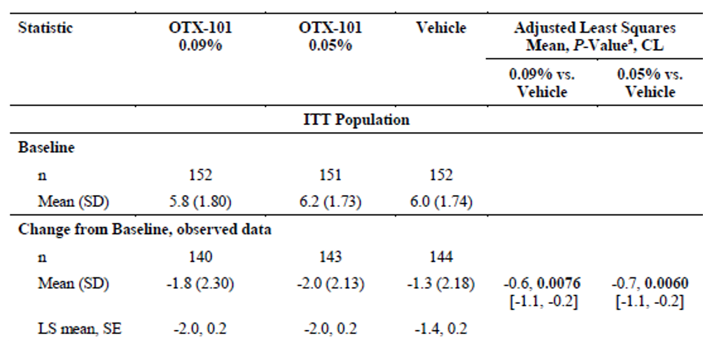
CL = 95% confidence limits, ITT = intent to treat, LS = least squares, SD = standard deviation, SE = standard error. a: analysis of covariance (ANCOVA) with treatment and clinical site as fixed factors and baseline value as a covariate.
Table 3: Mean change from Baseline to Day 84 in global SANDE symptom score
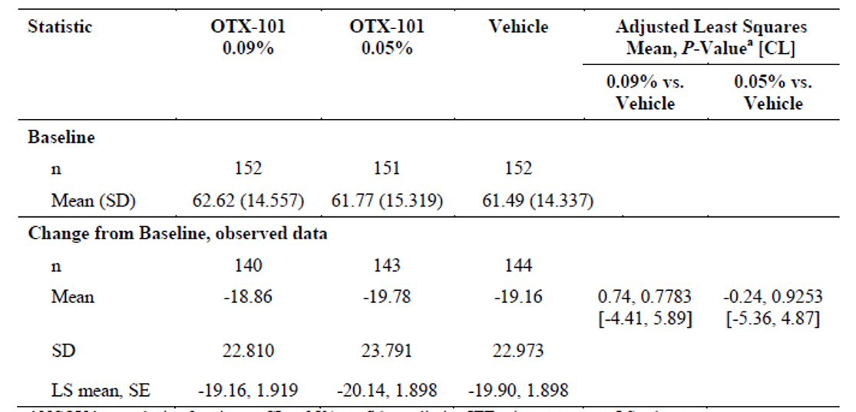
a: analysis of covariance (ANCOVA) with treatment and clinical site as fixed factors and baseline value as a covariate.
Secondary efficacy endpoints: as one of the co-primary endpoints did not achieve statistical significance, secondary endpoints that achieved a p value < 0.05 were considered as nominally significant.
- There was no significant increase in mean tear break up time (TBUT); from Baseline for both 0.09% and 0.05% ciclosporin solutions.
- A nominally significant reduction in total corneal staining score; was reported for both 0.09% and 0.05% ciclosporin solutions, compared to vehicle.
- No significant improvement in mean patient satisfaction with treatment score for both strengths of ciclosporin solutions, compared to vehicle.
The Delegate commented that, overall, from a clinical perspective, there was a positive trend noted with clinical endpoints, which was greater in magnitude for 0.09%, compared to 0.05% formulation.
In a post-hoc responder analysis, a significantly higher proportion of eyes treated with 0.09% ciclosporin solution achieved ≥ 10mm increase in Schirmer’s Test score; from Baseline at Day 84. No similar observations were reported with the 0.05% solution.
As an exploratory end point, a greater proportion of patients treated with 0.09% ciclosporin solution achieved > 30% reduction in conjunctival staining score from Baseline. The treatment difference was nominally significant, compared to placebo. A similar observation was not reported for 0.05% solution.

Study OTX-101-2016-001
Study design: multicentre, double masked vehicle-controlled RCT. Eligible patients were administered with twice daily vehicle to both eyes for 14 days. Study design and inclusion criteria were identical to Study OTX-101-2014-001.
Study treatment: ciclosporin 0.09%.
Study duration: 84 days.
Mean age of study population was 59 years. 84% of patients were females. At Baseline, for the ciclosporin group, the median Schirmer’s Test reading was 10 mm. Mean conjunctival staining was 5.42 and corneal staining was 4.06.

Results
Primary endpoint: a significantly higher proportion of eyes treated with ciclosporin 0.09% achieved an increase of ≥ 10 mm from Baseline in Schirmer’s Test at Day 84, compared to vehicle group (16.6% versus 9.2%).
Table 4: Percentage of eyes with increase from Baseline of ≥ 10 mm in Schirmer’s Test score
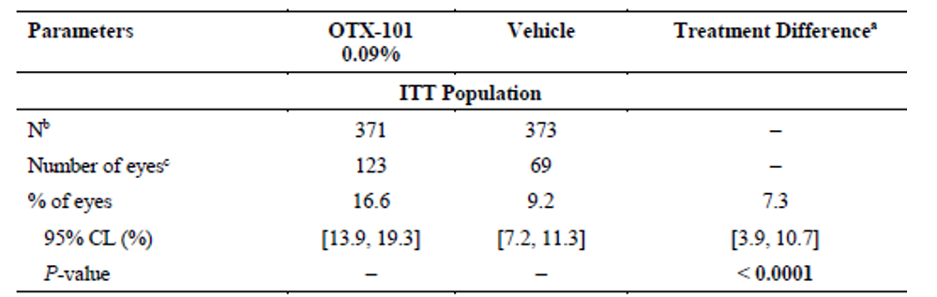
a: Generalised estimating equations model with treatment group as a fixed effect as well as eyes within subject as a repeated measure using a compound symmetric covariance structure. The P value tests the hypothesis the % of eyes in the 2 groups is the same. Positive estimates of the difference favour response in the OTX-101 group. b: Missing data on Day 84 were imputed by baseline carried forward. A total of 25 subjects in the OTX-101 group and 12 subjects in the vehicle group did not provide post-baseline values. c: n = number of subjects with only one eye + 2 times number of subjects with both eyes responding. Denominator is 2 times the number of subjects.
Secondary endpoints: a significant reduction in conjunctival staining and central corneal staining were reported in ciclosporin group, compared to vehicle ((least squares mean (LSM) change from Baseline of -1.54 versus -1.15, p = 0.0007 and LSM change from Baseline of -0.30 versus -0.24, p = 0.0159 for conjunctival and corneal staining, respectively).
A significant increase in tear production (Schirmer’s Test) and a significantly greater proportion of eyes with complete clearing of central corneal fluorescein staining were reported in ciclosporin group, compared to placebo.
Table 5: Mean change from Baseline at Day 84 in Schirmer’s Test score
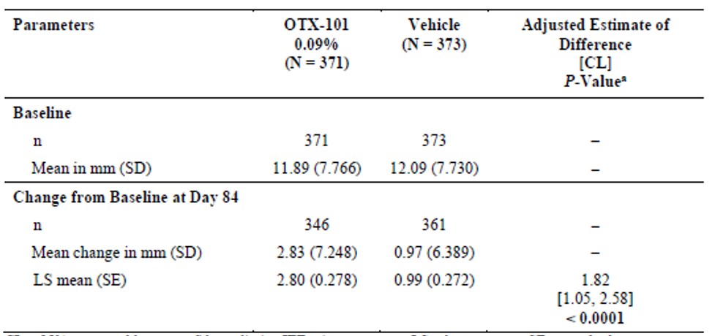
a: Test statistics are from a restricted maximum likelihood measures mixed model on change from baseline values with baseline as a covariate and visit, and its interaction with treatment group as repeated measures on observations from both eyes using an unstructured covariance structure.
Table 6: Percentage of eyes with complete clearing (score = zero) of central corneal staining
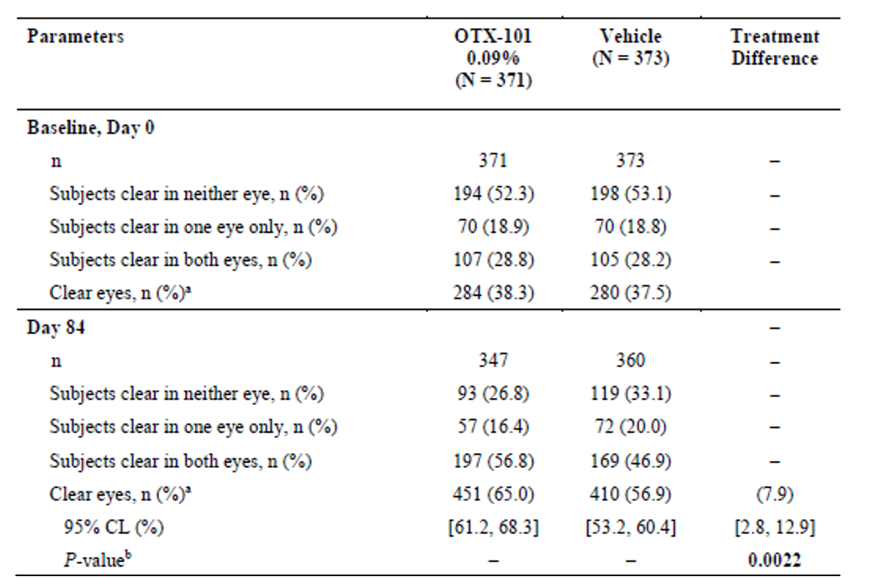
a: n = number of subjects with only one eye + 2 times number of subjects with both eyes responding. Denominator is 2 times the number of subjects. b: Generalised estimating equations model with treatment group, visit and their interaction as fixed effects as well as eyes within subject as a repeated measure using an unstructured covariance structure. The P value tests the hypothesis the response probability in the 2 groups is the same. Positive estimates of the difference favour response in the OTX-101 group.
No significant between-group treatment difference was reported for SANDE global symptom score and visual-related function subscale of the ocular surface disease index (OSDI) questionnaire.

Sub-group analysis
The sponsor has also included pooled and meta-analyses for primary and secondary endpoints. The pooled post-hoc analyses for increased tear production (measured by Schirmer’s Test) and improvement in conjunctival surface signs (as measured by decreased conjunctival staining) favoured ciclosporin 0.09% group, compared to vehicle.
A subgroup analysis of patients when categorised based on baseline Schirmer’s Test values showed that a greater proportion of patients with < 5 mm score at Baseline (severe) and 5 to 9 mm score (moderate) achieved ≥ 10 mm increase in Schirmer’s Test score after treatment period, compared to those having ≥ 10mm score at Baseline. This sub-group analysis was requested by the US Food and Drug Administration (FDA).
Figure 1: Subgroup analysis, proportion of eyes with ≥ 10 mm increase in Schirmer’s Test score from Baseline by baseline Schirmer’s Test score
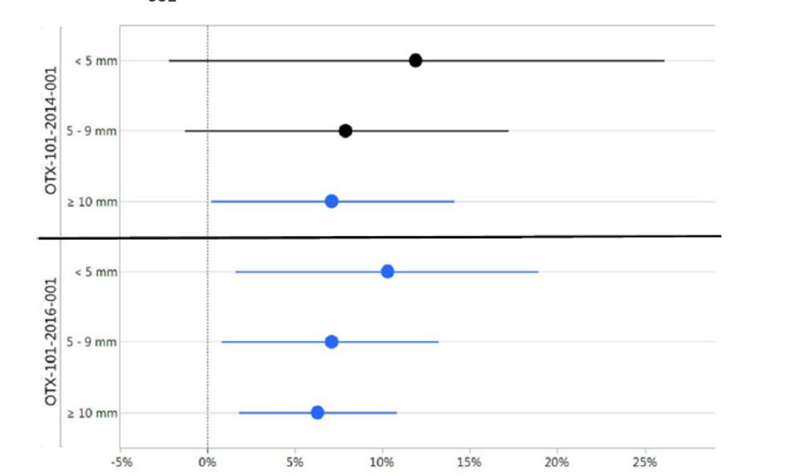
Circles represent the treatment difference (OTX-101 0.09% - vehicle for the proportion of eyes with ≥ 10 mm increase from Baseline) and lines show the lower (left) and upper (right) 95% confidence intervals (CI). If the lower CI is to the right of the 0% line, the P value is < 0.05 and is shown in blue.
The Delegate commented that patients with ≥ 10 mm score at Baseline represents those with milder severity of dry eye disease. They would not have much room for further improvement after treatment with ciclosporin eye drops. All these patients had inadequate response to tear substitutes administered for 14 days prior to study treatment. This observation supports the use of ciclosporin eye drops in moderate and severe dry eyes, with inadequate response to tear substitutes.

Clinical safety

Treatment emergent adverse events
The most common treatment emergent adverse events (TEAE) reported in ciclosporin group was instillation site pain (15.1%, 13.2% and 3.3% in the OTX-101 cyclosporin 0.09%; OTX-101 cyclosporin 0.05%; and vehicle groups, respectively, in Study OTX-101-2014-001 and 24.2% with OTX-101 cyclosporin 0.09% versus 4.3% with vehicle in Study OTX-101-2016-001). The majority of TEAEs were mild to moderate in severity and resolved after the treatment was stopped.

Serious adverse events
No ocular serious adverse events (SAEs) were reported across studies. Incidence of SAEs was low overall and it was lower in ciclosporin group, compared to vehicle.

Discontinuations
TEAEs leading to discontinuation were higher in ciclosporin group, compared to vehicle. The most common TEAE was instillation site pain.
No other major safety signals were reported.

Risk management plan
- The sponsor has submitted a Core risk management plan (RMP) version 0.1 (18 January 2019; no data lock point (DLP) stated) and Australian specific Annex (ASA) version 0.1 (18 January 2019) in support of this application. The sponsor has submitted Core RMP version 0.1 (19 August 2019; DLP 31 October 2017) in their response to TGA questions. There has been no update to the ASA.
- The proposed summary of safety concerns and their associated risk monitoring and mitigation strategies are summarised below in Table 7.
Table 7: Summary of safety concerns
Summary of safety concerns |  | Pharmacovigilance |  | Risk Minimisation
 |  | Routine | Additional | Routine | Additional
Important identified risks | Instillation site pain |  | – |  | –
Important potential risks | Medication errors |  | – |  | –
Important potential risks | Use for non-approved conditions or patient groups (off-label use) |  | – |  | –
Important potential risks | Allergy |  | – | * | –
Important potential risks | Development/worsening of eye infection |  | – | – | –
Important potential risks | Cancer of the eye or skin around the eye |  | – | – | –
Important potential risks | Corneal calcification |  | – | * | –
Missing information | Pregnant or breastfeeding women |  | – |  | –
Missing information | Paediatric use |  | – |  | –
*ASA only
The summary of safety concerns was considered as acceptable by the RMP evaluator. The sponsor has included the Black Triangle to the PI and Consumer Medicines Information (CMI) as suggested by the evaluator.
The evaluator has highlighted that the sponsor has mentioned in the core RMP that ‘Cequa must not be given to patients with known or suspected eye infections’. In relation to the risk of cancer of the eye, the sponsor has also mentioned that ‘risk groups include people with light coloured eyes, older people, patients with dysplastic nevus syndrome or oculodermal melanocytosis’. The sponsor also states that ‘The patient groups above should be warned of a potentially increased risk of developing cancer of the eye or skin around the eye’ as a preventative measure. Based on these statements, the evaluator has suggested the Delegate to consider recommending the sponsor to include wordings in PI related to this risk.
The Delegate has requested the sponsor to provide the basis of those statements in the core RMP. The Delegate agrees with RMP evaluator’s recommendation to include these statements in PI or to provide a reason for why it is not required.

Risk-benefit analysis

Delegate’s considerations
The sponsor has provided clinical data from two Phase III studies to support the proposed indication:
Cequa is indicated to increase tear production in patients with moderate to severe keratoconjunctivitis sicca (dry eye).
An increased treatment benefit was observed for cyclosporine 0.09% in Study OTX-101-2014-001, which is the proposed strength for marketing, compared to 0.05% formulation. No major difference in safety signals were observed between doses.
The clinical relevance of the magnitude of change reported with the efficacy endpoints was uncertain. Conjunctival and corneal staining, as efficacy endpoints used in the clinical studies enabled to provide objective measures of underlying pathology of dry eyes. However, the clinical relevance of the magnitude of change in the outcome measures was unclear. Schirmer’s Test, which was the primary endpoint in Study OTX-101-2016-001 is also used to assess functional improvement after treatment of dry eyes in clinical setting. However, the outcome measure of this test (length of moistening in the filter paper) is variable if repeated and also confounded by the paradoxically increased tear production seen in some patients with dry eyes.
The significant improvement in conjunctival staining in Study OTX-101-2014-001 was not supported by improvements in treatment scores that measures quality of life outcomes. Similarly, in Study OTX-101-2016-001, significant improvements in Schirmer’s Test and conjunctival and corneal staining outcomes were not supported by quality of life measures. The short study duration (84 days) might have contributed to this sub-optimal response in quality of life measures of patients with a chronic condition (dry eyes). It also appears that this dissociation between clinical signs and symptoms in dry eye disease is well recognised. Physiological factors, along with variable sensitivity, specificity and reproducibility of clinical markers (Schirmer’s Test) for treatment benefit are proposed to be contributing factors.
The short duration of study also limits the ability to assess long term efficacy and safety of ciclosporin for the treatment of dry eyes, which is a chronic condition, requiring longer duration of treatment. The improvement in corneal staining is re-assuring that the treatment has modified the pathophysiology of dry eyes, and might be beneficial in the long term. Long term safety data is lacking in this submission.
In terms of clinical endpoints, the improvement in corneal and conjunctival staining was modest (treatment difference of around 10%). It is re-assuring that results of Schirmer’s Test, which is a common test used in clinical settings to assess dry eye severity were statistically significant and clinically relevant (≥ 10 mm improvement) in Study OTX-101-2016-001. However, it was also noted that there was a < 10% difference between Cequa and vehicle group in the proportion of patients with ≥ 10 mm improvement in Schirmer’s Test.
The safety profile of ciclosporin in the patient population indicated was acceptable. Instillation site pain, which was the most common treatment-related TEAE is mentioned in the PI and CMI to inform prescribers and patients.
The Delegate has considered that, in the treatment paradigm of dry eyes, there is a paucity in the availability of TGA-approved treatment options for patients with moderate to severe dry eye disease and with inadequate response to tear substitutes (first line treatment). Prescribers have been accessing ciclosporin eye drops for the treatment of dry eyes through TGA’s Special Access Scheme (SAS) arrangement.
In summary, based on the clinically relevant magnitude of treatment benefit in terms of Schirmer’s Test outcome and the statistically significant outcomes for both corneal and conjunctival staining in Study OTX-101-2016-001 and a positive trend observed for quality of life measures outcomes in both Studies OTX-101-2014-001 and OTX-101-2016-001, the Delegate considers that ciclosporin 0.9% eye drops has a positive benefit-risk profile for the treatment of dry eyes.
Considering the modest evidence of treatment benefit, the Delegate has recommended inclusion of statements to be inserted in the PI that indicate initiation of treatment by an ophthalmologist and treatment response to be reviewed at least every 6 months and treatment to be ceased if there is no adequate response.

Proposed action
This application will be progressed based on sponsor’s response to the recommended changes to PI.16,20

Advisory Committee Considerations
The Delegate did not refer this application to the Advisory Committee on Medicines (ACM) for advice.

Outcome
Based on a review of quality, safety and efficacy, TGA approved the registration of Cequa (ciclosporin) 900 µg/mL eye drops, indicated for:
Cequa is indicated to increase tear production in patients with moderate to severe keratoconjunctivitis sicca (dry eye) where prior use of artificial tears has not been sufficient.

Specific conditions of registration applying to these goods
- Cequa (ciclosporin) is to be included in the Black Triangle Scheme. The PI and CMI for Cequa must include the black triangle symbol and mandatory accompanying text for five years, which starts from the date that the sponsor notifies the TGA of supply of the product.
- Any changes to which the sponsor has agreed should be included in a revised RMP and ASA. However, irrespective of whether or not they are included in the currently available version of the RMP document, the agreed changes become part of the risk management system.
The Cequa Core RMP, version 0.1, dated 19 August 2019 (DLP 31 October 2017), with ASA, version 0.1, dated18 January 2019, included with submission PM-2019-00113-1, and any subsequent revisions, as agreed with the TGA will be implemented in Australia.
An obligatory component of risk management plans is routine pharmacovigilance. Routine pharmacovigilance includes the submission of periodic safety update reports (PSURs).
Unless agreed separately between the supplier who is the recipient of the approval and the TGA, the first report must be submitted to TGA no later than 15 calendar months after the date of this approval letter. The subsequent reports must be submitted no less frequently than annually from the date of the first submitted report until the period covered by such reports is not less than three years from the date of this approval letter. The annual submission may be made up of two PSURs each covering six months. If the sponsor wishes, the six monthly reports may be submitted separately as they become available.
The reports are to at least meet the requirements for PSURs as described in the European Medicines Agency’s Guideline on Good Pharmacovigilance Practices (GVP)
Module VII-periodic safety update report (Rev 1), Part VII.B Structures and processes. Note that submission of a PSUR does not constitute an application to vary the registration. Each report must have been prepared within ninety calendar days of the data lock point for that report.

Attachment 1. Product Information
The PI for Cequa approved with the submission which is described in this AusPAR is at Attachment 1. For the most recent PI, please refer to the TGA website at <https://www.tga.gov.au/product-information-pi>.

Therapeutic Goods Administration
PO Box 100 Woden ACT 2606 Australia
Email: info@tga.gov.au Phone: 1800 020 653 Fax: 02 6232 8605
https://www.tga.gov.au

Cyclosporin and ciclosporin are alternative spellings of the same active ingredient.
OTX-101 is the drug development name for Cequa, aqueous nanomicellar solution of ciclosporin, discussed in this AusPAR
TGO 91: Therapeutic Goods Order 91; Standards required for labels of prescription and related medicines; made under Section 10 of the Therapeutic Goods Act (1989).This Order sets out what kinds of information are required to be included on the label of prescription and other related medicines. For further information, visit the TGA website: https://www.tga.gov.au/therapeutic-goods-orders.
Section 14 consent decisions are listed on the TGA website at https://www.tga.gov.au/ws-s14-index.
Australian Pregnancy Category C: Drugs which, owing to their pharmacological effects, have caused or may be suspected of causing, harmful effects on the human fetus or neonate without causing malformations. These effects may be reversible. Accompanying texts should be consulted for further details.
Australian Pregnancy Category B2: Drugs which have been taken by only a limited number of pregnant women and women of childbearing age, without an increase in the frequency of malformation or other direct or indirect harmful effects on the human fetus having been observed. Studies in animals are inadequate or may be lacking, but available data show no evidence of an increased occurrence of fetal damage.
A vehicle is the equivalent to the active drug formulation, containing the same relatively inert excipients intended to act as a medium for carrying the active drug component, minus the active drug component itself.
20/200 is a visual acuity measurement using the Snellen chart. This notation means that a person needs to be at a distance of 20 feet (6 metres) from the chart, in order to read letters that a person with normal visual acuity could read at 200 feet (60 metres).
Lissamine green conjunctival staining was performed using 1 drop (10 µL) of 1% lissamine green solution by pipette. Between 1 and 4 minutes following instillation, staining was measured in low to moderate intensity white light of the slit-lamp. Six (6) areas of the conjunctiva were evaluated. The investigator recorded a score for each area of each eye. Total conjunctival staining score in the designated study eye was calculated as the sum of scores for zones 1, 3, 5, 6. Staining was scored as Grade 0 (none), 1, 2 or 3 (worst).
Schaumberg, D.A. et al. Development and validation of a short global dry eye symptom index. Ocul Surf. 2007; 5(1): 50-7. A modified SANDE instrument was used to evaluate dry eye symptoms. Subjects were asked two questions: (1) Please indicate how often, over the past week, your eyes felt dry and/or irritated (on a visual analogue scale of 0 (rarely) to 100 (all the time)); (2) Please indicate how severe, on average you felt your symptoms of dryness and/or irritation were over the past week (on a visual analogue scale of 0 (very mild) to 100 (very severe)). The frequency and severity scores were recorded. The global symptom score was the square root of the frequency score times the severity score.
Tear break up time (TBUT): the tear film was observed for approximately 10 to 15 seconds under the slit lamp while the patient avoided blinking until tiny dry spots developed. The TBUT was measured in seconds. The test was repeated 3 times and each value was recorded.
Fluorescein staining of the corneal epithelium was performed. One drop (10 μL) of 0.5% fluorescein solution was instilled by pipette into the conjunctival cul-de-sac followed by adequate blinking. Staining was measured 2 to 2.5 minutes after instillation. The Expanded National Eye Institute (NEI)/Industry Workshop Scale for Corneal Staining Score was used to grade each of the 5 areas of the cornea on a 0 to 4 scale in 0.5 increments. Lemp, M.A. Report of the National Eye Institute/Industry workshop on Clinical Trials in Dry Eyes. Clao J. 1995; 21(4): 221–232.
Schirmer’s Test is a test of tear production. The score represents the length of wetting (in mm) on a paper strip placed on the eye. Strips were placed in both eyes at the same time and timed for 5 minutes. Strips were removed after 5 minutes and the amount of wetting was recorded in millimetres (mm).
The OSDI is a 12-item questionnaire designed to provide a rapid assessment of the symptoms of ocular irritation consistent with dry eye disease and their impact on vision-related functioning.
Routine risk minimisation activities may be limited to ensuring that suitable warnings are included in the product information or by careful use of labelling and packaging. Routine pharmacovigilance practices involve the following activities: - All suspected adverse reactions that are reported to the personnel of the company are collected and collated in an accessible manner; - Reporting to regulatory authorities; - Continuous monitoring of the safety profiles of approved products including signal detection and updating of labelling; - Submission of PSURs; - Meeting other local regulatory agency requirements.
The sponsor subsequently provided the basis for the statements, which is that these are general risk factors and not specifically linked to Cequa use. The Delegate concluded that the warning specified was not warranted in the Product Information.
Baudouin, C. et al. Diagnosing the severity of dry eye: a clear and practical algorithm. Br J Ophthalmol, 2014. 98(9): 1168-1176
Study OTX-101-2016-002 was included in the submission, which evaluated the safety of Cequa treatment for up to 52 weeks. However, there were no studies designed to assess patient outcomes once treatment is ceased. Hence, dependency on treatment to maintain optimal benefits cannot be ruled out.
The Special Access Scheme (SAS) allows certain health practitioners to access therapeutic goods (such as medicines, medical devices or biologicals) that are not included in the Australian Register of Therapeutic Goods (ARTG) for a single patient. Therapeutic goods that are not included in the ARTG (and are not otherwise exempt from being in the ARTG) are described by the TGA as 'unapproved'.
In the response to the Delegate’s Overview, the sponsor provided reasons for not including initiation of treatment by ophthalmologist in the PI, which related to the ability of GPs and optometrists to diagnose the condition and prescribe Cequa, and the impracticalities and cost to patients associated with visiting an ophthalmologist. It was subsequently considered unnecessary by the Delegate to include initiation of treatment by an ophthalmologist in the PI.
The ACM provides independent medical and scientific advice to the Minister for Health and the Therapeutic Goods Administration (TGA) on issues relating to the safety, quality and efficacy of medicines supplied in Australia including issues relating to pre-market and post-market functions for medicines. The Committee is established under Regulation 35 of the Therapeutic Goods Regulations 1990. Members are appointed by the Minister. The ACM was established in January 2017 replacing Advisory Committee on Prescription Medicines (ACPM) which was formed in January 2010. ACM encompass pre and post-market advice for medicines, following the consolidation of the previous functions of the Advisory Committee on Prescription Medicines (ACPM), the Advisory Committee on the Safety of Medicines (ACSOM) and the Advisory Committee on Non-Prescription Medicines (ACNM). Membership comprises of professionals with specific scientific, medical or clinical expertise, as well as appropriate consumer health issues relating to medicines.

