February 2021

Australian Public Assessment Report for ChAdOx1-S
  - Proprietary Product Name: COVID-19 Vaccine AstraZeneca
  - Sponsor: AstraZeneca Pty Ltd

About the Therapeutic Goods Administration (TGA)
- The Therapeutic Goods Administration (TGA) is part of the Australian Government Department of Health and is responsible for regulating medicines and medical devices.
- The TGA administers the Therapeutic Goods Act 1989 (the Act), applying a risk management approach designed to ensure therapeutic goods supplied in Australia meet acceptable standards of quality, safety and efficacy (performance) when necessary.
- The work of the TGA is based on applying scientific and clinical expertise to decision-making, to ensure that the benefits to consumers outweigh any risks associated with the use of medicines and medical devices.
- The TGA relies on the public, healthcare professionals and industry to report problems with medicines or medical devices. TGA investigates reports received by it to determine any necessary regulatory action.
- To report a problem with a medicine or medical device, please see the information on the TGA website <https://www.tga.gov.au>.

About AusPARs
- An Australian Public Assessment Report (AusPAR) provides information about the evaluation of a prescription medicine and the considerations that led the TGA to approve or not approve a prescription medicine submission.
- AusPARs are prepared and published by the TGA.
- An AusPAR is prepared for submissions that relate to new chemical entities, generic medicines, major variations and extensions of indications.
- An AusPAR is a static document; it provides information that relates to a submission at a particular point in time.
- A new AusPAR will be developed to reflect changes to indications and/or major variations to a prescription medicine subject to evaluation by the TGA.

Copyright
© Commonwealth of Australia 2021
This work is copyright. You may reproduce the whole or part of this work in unaltered form for your own personal use or, if you are part of an organisation, for internal use within your organisation, but only if you or your organisation do not use the reproduction for any commercial purpose and retain this copyright notice and all disclaimer notices as part of that reproduction. Apart from rights to use as permitted by the Copyright Act 1968 or allowed by this copyright notice, all other rights are reserved and you are not allowed to reproduce the whole or any part of this work in any way (electronic or otherwise) without first being given specific written permission from the Commonwealth to do so. Requests and inquiries concerning reproduction and rights are to be sent to the TGA Copyright Officer, Therapeutic Goods Administration, PO Box 100, Woden ACT 2606 or emailed to <tga.copyright@tga.gov.au>.

Contents
List of abbreviations 4
I. Introduction to product submission 7
Submission details 7
Product background 8
Regulatory status 10
Product Information 10
II. Registration timeline 10
III. Submission overview and risk/benefit assessment 11
Quality 11
Nonclinical 13
Clinical 15
Risk management plan 28
Risk-benefit analysis 37
Outcome 45
Attachment 1. Product Information 48

List of abbreviations
Abbreviation | Meaning
ABN | Australian Biological Name
ACV | Advisory Committee on Vaccines
AE | Adverse event
AESI | Adverse event of special interest
ARGPM | Australian Regulatory Guidelines for Prescription Medicines
ARTG | Australian Register of Therapeutic Goods
ASA | Australian specific Annex
AusPAR | Australian Public Assessment Report
AZD1222 | Drug development code for COVID-19 Vaccine AstraZeneca (ChAdOx1-S)
BMI | Body mass index
CD4+ | Cluster of differentiation 4 positive
CD8+ | Cluster of differentiation 8 positive
ChAdOx1 | Chimpanzee adenovirus Ox1
CHMP | Committee for Medicinal Products for Human Use (European Union)
CI | Confidence interval
CMI | Consumer Medicines Information
COVID-19 | Coronavirus disease 2019
CPD | Certified Product Details
DIR | Dealing involving an Intentional Release (of genetically modified organisms into the Australian environment)
DLP | Data lock point
EMA | European Medicines Agency (European Union)
EU | European Union
FDA | Food and Drug Administration (United States)
GMO | Genetically modified organism
GMP | Good Manufacturing Practice
GMT | Geometric mean titre
HIV | Human immunodeficiency virus
ICMR | Indian Council on Medical Research
ICU | Intensive care unit
IFNγ | Interferon gamma
IgG | Immunoglobulin G
IM | Intramuscular
ITT | Intent to treat
LD | Low dose of ChAdOx1-S (2.2 to 2.5 x 10¹⁰ viral particles)
LDSD | Low dose for the first dose followed by standard dose for the second dose
MedDRA | Medical Dictionary for Regulatory Activities
MenACWY | Meningococcal group A, C, W-135, and Y conjugate vaccine
MERS | Middle East respiratory syndrome
NA | Not applicable
NE | Not estimable
OCABR | Official Control Authority Batch Release (European Union)
OGTR | Office of the Gene Technology Regulator
PCR | Polymerase chain reaction
PI | Product Information
PSUR | Periodic safety update report
PT | Preferred Term
QC | Quality control
RARMP | Risk Assessment and Risk Management Plan (Office of the Gene Technology Regulator)
RMP | Risk management plan
RT-PCR | Reverse transcription-polymerase chain reaction
S glycoprotein | Severe acute respiratory syndrome coronavirus 2 spike surface glycoprotein
SAE | Serious adverse event
SARS-CoV-2 | Severe acute respiratory syndrome coronavirus 2
SD | Standard dose of ChAdOx1-S (approximately 5 x 10¹⁰ viral particles)
SDSD | Standard dose for both the first and second dose
SII | Serum Institute of India
TGA | Therapeutic Goods Administration
Th1 | T helper type 1
UK | United Kingdom
US(A) | United States of America
VAED | Vaccine associated enhanced disease
VAERD | Vaccine associated enhanced respiratory disease
VE | Vaccine efficacy
vp | Viral particles
WHO | World Health Organization

I. Introduction to product submission

Submission details
Type of submission: | New biological entity
Product name: | COVID-19 Vaccine AstraZeneca
Active ingredient: | ChAdOx1-S
Decision: | Approved for provisional registration
Date of decision: | 15 February 2021
Date of entry onto ARTG: | 16 February 2021
ARTG number: | 349072
Black Triangle Scheme: | Yes  As a provisionally registered product, this medicine will remain in the Black Triangle Scheme for the duration of its provisional registration
Sponsor’s name and address: | AstraZeneca Pty Ltd  66 Talavera Road  Macquarie Park NSW 2113
Dose form: | Solution for injection
Strength: | 1 x 10¹¹ viral particles (vp)/mL
Container: | Multi dose vial
Pack size: | 10 vials
Approved therapeutic use: | COVID-19 Vaccine AstraZeneca has provisional approval for the indication:  Active immunisation of individuals ≥ 18 years old for the prevention of coronavirus disease 2019 (COVID-19) caused by SARS-CoV-2.  The use of this vaccine should be in accordance with official recommendations.  The decision has been made on the basis of short term efficacy and safety data. Continued approval is dependent upon the evidence of longer-term efficacy and safety from ongoing clinical trials and post-market assessment.
Route of administration: | Intramuscular
Dosage: | The COVID-19 Vaccine AstraZeneca vaccination course consists of two separate doses of 0.5 mL each. The second dose should be administered between 4 and 12 weeks after the first dose.  It is recommended that individuals who receive a first dose of COVID-19 Vaccine AstraZeneca complete the vaccination course with COVID-19 Vaccine AstraZeneca.  For further information regarding dosage, refer to the Product Information.
Pregnancy category: | B2  Drugs which have been taken by only a limited number of pregnant women and women of childbearing age, without an increase in the frequency of malformation or other direct or indirect harmful effects on the human fetus having been observed.  Studies in animals are inadequate or may be lacking, but available data show no evidence of an increased occurrence of fetal damage.  The use of any medicine during pregnancy requires careful consideration of both risks and benefits by the treating health professional. This must not be used as the sole basis of decision making in the use of medicines during pregnancy. The TGA does not provide advice on the use of medicines in pregnancy for specific cases. More information is available from obstetric drug information services in your State or Territory.

Product background
This AusPAR describes the application by AstraZeneca Pty Ltd (the sponsor) to register COVID-19 Vaccine AstraZeneca (ChAdOx1-S) 1 x 10¹¹ viral particles (vp)/mL solution for injection for the following proposed indication:
COVID-19 Vaccine AstraZeneca is indicated for active immunisation of individuals (≥ 18 years) for the prevention of Coronavirus disease 2019 (COVID-19).
In December 2019, a cluster of patients with pneumonia of unknown cause was discovered in Wuhan, China. The patients were subsequently confirmed to be infected with the novel coronavirus, now known as severe acute respiratory syndrome coronavirus 2 (SARS-CoV-2). Infections caused by SARS-CoV-2, and the resulting disease, coronavirus disease 2019 (COVID-19), have spread globally. The World Health Organization (WHO) declared the novel coronavirus a pandemic on 11 March 2020. As of the 12 February 2021, there have been more than 106 million confirmed cases of COVID-19, and more than 2.3 million deaths reported worldwide.
Although most cases of COVID-19 are mild or moderate in severity, severe disease can result in respiratory, multi organ failure and death. Vulnerable groups for severe infection include the elderly, and those with co-morbidities including cardiovascular disease, respiratory disease and type 2 diabetes.6
Currently, the management of COVID-19 disease is largely supportive. The only medication approved in Australia for use for the management of COVID-19 is Veklury (remdesivir), for use in patients with pneumonia, requiring supplemental oxygen. Immunisation with a safe and effective COVID-19 vaccine is a critical component of the public health strategy to reduce COVID-19-related illnesses, hospitalisations, and deaths, and to help restore societal functioning. There are currently a number of vaccine candidates in development. The TGA approved the Pfizer-BioNTech COVID-19 vaccine, Comirnaty (BNT162b2 mRNA), in January 2021. Availability of a number of different COVID-19 vaccines will assist in providing sufficient coverage for the global population.
COVID-19 Vaccine AstraZeneca is a new biological entity developed for vaccination against COVID-19. The active ingredient of COVID-19 Vaccine AstraZeneca is ChAdOx1-S,1 previously known during vaccine development as AZD1222, which is a recombinant replication-defective chimpanzee adenovirus ChAdOx1, carrying a gene encoding the SARS-CoV-2 spike (S) surface glycoprotein. Development of AZD1222 was initiated by the University of Oxford, and subsequently, a partnership was formed with the sponsor.
The evaluation of COVID-19 Vaccine AstraZeneca (ChAdOx1-S) was significantly expedited without compromising the TGA’s strict standards of safety, quality and efficacy. This was facilitated through rolling data submission, and through collaboration with international regulators.
The provisional determination for COVID-19 Vaccine AstraZeneca (ChAdOx1-S) was granted by the TGA on 9 October 2020. The provisional approval pathway allows sponsors to apply for provisional registration on the ARTG.
The product contains a genetically modified organism (GMO). A licence application for a Dealing involving an Intentional Release (DIR) of GMOs into the Australian environment under the Gene Technology Act 2000 was submitted by the sponsor to the Office of the Gene Technology Regulator (OGTR) under application DIR 180, and the licence was approved on 8 February 2021.

Regulatory status
This product is considered a new biological entity for Australian regulatory purposes.
At the time the TGA considered this application, similar applications had been approved in the European Union (EU) and United Kingdom (UK) (see Table 1), and were under consideration in multiple regions, including Canada and Switzerland.
Table 1: Major region regulatory approvals as of 1 February 2021
Region | Approval | Approved indications
EU (Centralised Procedure) | Approved for conditional marketing authorisation on 29 January 2021 | COVID-19 Vaccine AstraZeneca is indicated for active immunisation to prevent COVID-19 caused by SARS-CoV-2, in individuals 18 years of age and older.
UK | Approved for emergency supply on 29 December 2020 | COVID-19 Vaccine AstraZeneca is indicated for active immunisation of individuals ≥ 18 years old for the prevention of coronavirus disease 2019 (COVID 19).
Approvals (conditional, emergency use or special import licence) had also been granted to the sponsor or their partners in the following countries (as of 1 February 2021): Argentina, El Salvador, Dominican Republic, India, Mexico, Morocco, Bangladesh, Saudi Arabia, Nepal, Brazil, Myanmar, Pakistan, Thailand, South Africa, Ecuador, Bahrain, Chile and the Philippines.

Product Information
The Product Information (PI) approved with the submission which is described in this AusPAR can be found as Attachment 1. For the most recent PI, please refer to the TGA website at <https://www.tga.gov.au/product-information-pi>.

II. Registration timeline
The following table captures the key steps and dates for this application and which are detailed and discussed in this AusPAR.
Data were provided as a rolling submission.10
Table 2: Timeline for Submission PM-2020-06115-1-2
Description | Date
Positive Designation (Provisional) | 9 October 2020
Submission dossier accepted and first round evaluation commenced | 1 December 2020
Evaluation completed | 28 January 2021
Delegate’s Overall benefit-risk assessment and request for Advisory Committee advice | 28 January 2021
Sponsor’s pre-Advisory Committee response | 1 February 2021
Advisory Committee meeting | 3 February 2021
Registration decision (Outcome) | 15 February 2021
Completion of administrative activities and registration on the ARTG | 16 February 2021
Number of working days from submission dossier acceptance to registration decision* | 48
*Statutory timeframe for standard applications is 255 working days

III. Submission overview and risk/benefit assessment
The submission was summarised in the following Delegate’s overview and recommendations.

Quality
The manufacturing and quality evaluation involved a primary and a number of secondary evaluations, including container safety, infectious disease, endotoxin, and microbiology/sterility.
The following points were summarised from the quality evaluation:
- Initial supply of COVID-19 into Australia will be imported from Europe. In the future, the vaccine will be manufactured in Australia. This will be the subject of a subsequent Category 3 application.
- There are no applicable quality standards for manufacturing. The sponsor will need to ensure Good Manufacturing Practice (GMP) clearance of all of the relevant manufacturing sites prior to supply.
- Manufacturing processes and controls were described. The sponsor utilised a comprehensive strategy to assess the changes in manufacturing processes during the product development. These met the required specifications.
- Multiple methods are used to characterise the physiochemical and biological properties of the drug product. The viral particle concentration was described in comparison to reference standard, however the reference standard was not described.
- There are three different presentations for the drug product; only the 10 dose vial is proposed to be registered as part of the current application.
- The container closure system is composed of primary and secondary packaging components. The primary packaging components consist of a vial and a stopper. The secondary packaging components comprised of a seal, an opaque paperboard carton to protect the drug product from light exposure, an internal partition to secure the drug product during transportation, and a label.
- The in-use times and temperature conditions are intended to be 6 hours at room temperature or 48 hours at 2 to 8 °C, and not to exceed a cumulative in-use time of 48 hours.
- The quality evaluator concluded that there are no significant issues identified from the quality evaluation of the submitted data that would indicate the product should not be provisionally registered on the basis of quality, or safety-related issues arising from the quality of the product. The manufacturing quality information submitted by the sponsor support the provisional registration of COVID-19 Vaccine AstraZeneca (ChAdOx1-S).
- However, it should be noted that there are some issues that need to be fully resolved before it is possible to provide assurances that the product is able to meet all of the requirements of the Therapeutics Goods Act 1989 and its associated instruments. As such, the quality evaluator recommended a number of proposed conditions of registration to ensure the product is fully compliant with all of the previously mentioned instruments before release into the market, see ‘Proposed quality conditions of registration’, below.

Proposed quality conditions of registration
- Batch release testing and compliance
It is a condition of registration that all independent batches of COVID-19 Vaccine AstraZeneca (ChAdOx1-S) vaccine imported into Australia are not supplied for distribution by or on behalf of the sponsor until samples and the manufacturer’s release data have been assessed and the sponsor has received notification acknowledging release from the Laboratories Branch, TGA.
For each independent batch of the product imported into Australia, the sponsor must supply the following:
  - A completed Request for Release Form, available from vaccines@health.gov.au.
  - Complete summary protocols for manufacture and quality control (QC), including all steps in production in the agreed format.
  - At least 10 (ten) vials (samples) of each manufacturing batch of COVID-19 Vaccine AstraZeneca (ChAdOx1-S) with the Australian approved labels, PI and packaging (unless an exemption to supply these has been granted) representative of all batches of product seeking distribution in Australia.
  - At least 5 (five) vials (samples) of any further consignments of a manufacturing batch COVID-19 Vaccine AstraZeneca (ChAdOx1-S) with the Australian approved labels, PI and packaging (unless an exemption to supply these has been granted). Further consignments cover batches previously supplied to TGA for the purposes of batch release testing but are seeking to be supplied again.
  - If the manufacturing batch has been released in Europe or United Kingdom a copy of the EU Official Control Authority Batch Release (OCABR) certificate (or equivalent from the UK) must be provided.
  - Any reagents, reference material and standards required to undertake testing, as requested by Laboratories Branch, TGA.
Sponsors must provide all requested samples and data in sufficient time (at least 5 business days) prior to any distribution date to allow the TGA to perform testing and review. Distribution of each batch of vaccine is conditional upon fulfilment of these conditions and receipt of a letter from the Laboratories Branch acknowledging release.
- Certified Product Details
An electronic copy of the Certified Product Details (CPD) as described in Guidance 7: Certified Product Details of the Australian Regulatory Guidelines for Prescription Medicines (ARGPM) https://www.tga.gov.au/guidance-7-certified-product-details should be provided upon registration of the therapeutic good. In addition, an updated CPD, for the above products incorporating the approved changes is to be provided within one month of the date of approval letter. A template for preparation of CPD for biological prescription medicines and Vaccines can be obtained from the TGA website https://www.tga.gov.au/form/certified-product-details-cpd-biological-prescription-medicines. The CPD should be sent as a single bookmarked PDF document to Vaccines@health.gov.au as soon as possible after registration/approval of the product or any subsequent changes as indicated above.
- As this medicine is being considered for provisional registration, extensive post-approval commitments will be required of the sponsor. The additional requested quality data and notifications to the TGA should be provided as post-approval commitments. This includes the following commitments:
  - Additional data should be provided in relation to drug substance and drug product stability.
  - Additional information should be provided in relation to the test for transgene expression of the spike protein.
  - The requested leachables study data should be provided.
  - The additional data related to validation of analytical procedures for endotoxin testing should be provided.

Nonclinical
There were no nonclinical objections to the provisional registration of the vaccine.
The sponsor has generally conducted adequate pharmacology studies. As part of a rolling submission, limited toxicity studies were provided with AZD1222. A bio-distribution study and a main developmental and reproductive toxicity study in mice are pending.

Pharmacology
COVID-19 AstraZeneca was found to be immunogenic in BALB/c and CD-1 mice; ferrets; non-human primates and pigs. Mice and pigs showed T helper type 1 (Th1) like cluster of differentiation 4 positive (CD4+) and cluster of differentiation 8 positive (CD8+) T cell responses. Pigs and inbred mice showed a response to booster vaccine. The lack of response in outbred mice was attributed to a higher initial dose. When vaccinated rhesus monkeys were exposed to SARS-CoV-2, the clinical disease severity scores in the lungs were reduced, however there was no reduction in viral shedding from the nose. There was no evidence of vaccine associated enhanced disease (VAED) in vaccinated monkeys exposed to COVID-19. The pharmacology studies were designed to assess short term immunogenicity only.

Pharmacokinetics
Three different mouse studies (one using the ChAdOx1 vector, the other two using a similar vector, ChAd63) examined the biodistribution. Two of these studies showed no evidence of the adenovirus vector beyond the site of administration. The third showed that low levels of the ChAdOx1 vector were found in the heart, liver, ovary, testes and lymph nodes. The significance of this is uncertain.

Toxicology
A repeat dose toxicology study was performed in mice. The vaccine (total viral particle dose 3.7 x 10¹⁰) was given over 6 weeks with a 4 week recovery period. Scheduled necroscopies were performed at the end of the 6 week treatment period or 28 day recovery period. Injections were associated with increased temperature, decreased monocyte count, increased globulin and decreased albumin/globulin consistent with an acute phase response. Higher spleen weights were observed.
Another study was performed to investigate the potential toxicity of ChAdOx1 Chikungunya or ChAdOx1 Middle East respiratory syndrome (MERS) vaccines in inbred (Balb/c) mice aged 8 weeks old and weighing 20 g. The doses given were 1 x 10¹⁰ viral particles, in 25 or 35 µL per injection. Vaccines were well tolerated with no adverse effects. Similarly, a further two studies of mice with other vaccines containing the ChAdOx1 vector did not show any toxicity.
No genotoxicity or carcinogenicity studies were performed.
The ChADOx1 vector is expected to have negligible risks of integrating into the human genome or recombination with human adenovirus.

Reproductive and developmental toxicity
A study was performed in outbred CD-1 female mice either before mating and during gestation; or during the littering phase. The dose given was 2.59 x 10¹⁰ viral particles per dose, which is estimated to be approximately 906.5 fold the human dose. Dams produced an anti-spike glycoprotein immune response. The fetuses and pups were seropositive, indicative of placental and lactational anti-spike glycoprotein activity. There were no abnormal effects on female reproduction, fetal or pup survival and no abnormal gross pathology findings in pups or dams in either phase.
A mouse study of embryofetal development is ongoing.

Nonclinical conclusions and recommendation
The following conclusions and recommendations were outlined in the nonclinical evaluation report:
- Primary pharmacology studies indicate the vaccine elicits both neutralising antibody and cellular immune responses to the spike antigen in animal models.
- Antibodies generally declined quickly over 2 weeks after the peak response to the booster dose of AZD1222. Long term immunity was not assessed in nonclinical studies.
- Immunogenicity of AZD1222 might decrease with repeated vaccination due to induction of anti-vector antibodies.
- New variants are continuously emerging and require testing to confirm effective immunity and protection by AZD1222.
- The ChAdOx1 vector is expected to have negligible risks of integrating into the human genome or recombination with human adenoviruses.
- Repeat dose toxicity studies with the proposed vaccine in mice raised no safety issues. Treatment-related findings were limited to (reversible) acute inflammation at the injection sites.
- A reproductive toxicity study is currently ongoing and therefore Pregnancy Category B2 is considered acceptable. Without adequate assessment of effects on embryofetal development, this vaccine is not recommended for use in pregnant women.
- There are no nonclinical objections to the provisional registration of the vaccine, provided efficacy of the prime-boost regimen has been satisfactorily addressed by clinical studies.
- The proposed nonclinical statements in the draft PI are acceptable.

Proposed nonclinical conditions of registration
The following nonclinical post-approval commitments were proposed:
- To provide the AZD1222 tissue distribution study (Study 514559) report.
- To provide the AZD1222 development and reproductive study (Study 490843) report.

Clinical
The clinical development programme investigating the efficacy, safety, and immunogenicity of AZD1222 for the prevention of COVID-19 consists of nine ongoing studies:
- five University of Oxford-sponsored studies (Studies COV001, COV002, COV003, COV004 and COV005);
- three applicant-sponsored studies (Studies D8110C00001, D8111C00001 and D8111C00002); and
- one study sponsored by the Serum Institute of India/Indian Council of Medical Research (Study ICMR/SIICOVISHIELD).
Studies COV001, COV002, COV003 and COV005 contributed data to the submission and are described in this AusPAR.

Pharmacology

Pharmacodynamics
Vaccination with COVID-19 Vaccine AstraZeneca induces a cellular (T cell) and humoral (B cell) immune response.
There is no established immunological correlate of protection against SARS-CoV-2. The neutralising antibody against the spike protein of SARS-CoV-2 is likely to be the best surrogate marker of efficacy. In seropositive patients, antibodies to the receptor binding domain, anti-spike antibodies and neutralising antibodies after a single standard dose were similar to that seen in convalescent plasma. These peaked at Day 28, then remained stable. In seronegative patients, there was a further increase in antibodies after a second dose. The spike-specific antibodies are biased towards immunoglobulin G (IgG) subtype 1 and IgG subtype 3.
Cell mediated immunity was assessed by interferon gamma (IFNγ) enzyme-linked immunospot and pan intracellular cytokine staining assay. IFNγ peaked at Day 14 and remained stable, with no further increase after a second dose.
Anti-vector antibodies increased after the initial vaccination, with no further increase after the second dose. Limited data was available as to how these affect antibodies to the spike protein.

Efficacy
As outlined previously, the clinical development program for AZD1222 consists of nine clinical studies. Four of these studies were used in the interim analysis (4 November 2020). Table 3, shown below, summarises the characteristics of these studies.
Table 3: Studies included in the pooled efficacy analysis
Study | COV001 | COV002 | COV003 | COV005
Trial ID | NCT04324606 | NCT04400838 | ISRCTN89951424 | NCT04444674
Region | UK | UK | Brazil | South Africa
Sponsor | University of Oxford | University of Oxford | University of Oxford | University of Oxford
Start Date / Status | April 2020 / Ongoing | May 2020 / Ongoing | June 2020 / Ongoing | June 2020 / Ongoing
Phase | I/II | II/III | II/III | I/II
Design | Participant blind, randomised, controlled | Participant blind, randomised, controlled | Participant blind, randomised, controlled | Double blind, randomised, controlled
Planned number of participants | Approx. 1077 | Approx. 12390 | Approx. 10300 | Approx. 2070
Characteristics of participants | 18 to 55 years, healthy | ≥18 years, healthy | ≥ 18 years, healthy | ≥18 to 65 years, healthy
Number of doses (IM route) | 1 or 2 (based on study group) | 1 or 2 (based on study group) | 2 | 2
AZD1222 dose levels ª | SD: 5 x 10¹⁰ vp LD: 2.5 x 10¹⁰ vp | SD: 5 x 10¹⁰ vp LD: 2.2 x 10¹⁰ vp | SD: 5 x 10¹⁰ vp | SD: 5 x 10¹⁰ vp LD: 2.2 x 10¹⁰ vp^{b}
Control | MenACWY | MenACWY | MenACWY (first dose);saline placebo (second dose) | Saline; placebo
Planned dose interval | 4 to 8 weeks | 4 to 6 weeks | 4 to 12 weeks | 4 weeks
Case detection | Passive | Passive and active (weekly swabbing, SARS-CoV-2 PCR) | Passive | Passive and active (by-visit nasal swabs and/or saliva collection, SARS CoV-2 PCR)
Planned duration of Follow-up | 364 days after the last dose | 364 days after the last dose | 364 days after the last dose | 364 days after the first dose
a: AstraZeneca assay of reference, b: Estimated administered dose.
Approx. = approximately; HIV = human immunodeficiency virus; IM = intramuscular; LD = low dose; MenACWY = meningococcal group A, C, W-135, and Y conjugate vaccine; PCR = polymerase chain reaction; SD = standard dose; vp = viral particles.
All clinical trials have had a number of protocol changes since commencement; Study COV001 has had twelve, Study COV002 has had fourteen, Study COV003 has had eight and Study COV005 has had four.
Only Studies COV002 and COV003 were used in the interim analysis for efficacy based on the date lock from 4 November 2020. This is because the statistical analysis plan involved excluding studies were there were less than five cases detected, as was the case in Studies COV001 and COV005.
The dosing regimens (that is, number of doses, dose level, and dose schedule) chosen for the four University of Oxford-sponsored efficacy studies were selected on the basis of clinical experience with the ChAdOx1 adenovirus vector expressing different inserts and other similar adenovirus vectored vaccines. Across the four ongoing studies, a single dose and a two dose regimen were being evaluated. Two AZD1222 dose levels were a standard dose (SD) of approximately 5 x 10¹⁰ vp and a low dose (LD) of 2.2 to 2.5 x 10¹⁰ vp.
Due to differences in concentration determination between analytical methods, a subset of participants in Studies COV002 and COV005 who were due to receive the SD actually received the LD.
The initial intent of this programme was to implement a one dose only immunisation schedule. Following review of immunogenicity data from Study COV001, it became apparent that a second dose provided increased immunogenicity. This led to a decision to more extensively evaluate a two dose schedule. In the context of logistical constraints related to the rapid conditions in which this clinical programme and scale-up manufacturing were initiated in parallel, delays occurred in clinical trial material availability for second dose vaccinations, mainly in the UK-based studies, Studies COV001 and COV002. The interval between doses 1 and 2 was originally intended to range from 4 to 12 weeks, however extended to as long as 26 weeks.
Changes to the study protocol such as this are not ideal, however are an accepted phenomenon seen with vaccines developed in the context of a pandemic.

Efficacy endpoint
The primary efficacy endpoint was patients with symptoms (either fever ≥ 37.8 °C, cough, shortness of breath, anosmia or ageusia) and a positive reverse transcription-polymerase chain reaction (RT-PCR) test (or other nucleic acid amplification test) for COVID-19. Definitions of COVID-19 cases for the evaluation of efficacy are given in Table 4, below.
Table 4: Definitions of COVID-19 cases for evaluation of efficacy
Case | Definition
COVID-19 (primary) virologically confirmedª symptomatic cases of COVID-19 | Virologically confirmed SARS-CoV-2 and at least one of the following symptoms: objective fever (defined as ≥ 37.8 °C), cough, shortness of breath, anosmia, or ageusia. Confirmed by adjudication committee.
COVID-19 hospital admission | WHO Grade ≥ 4^{b}
COVID-19 severe disease | WHO Grade ≥ 6^{b}
COVID-19 requiring intensive care unit (ICU) | WHO Grade ≥ 7^{b}
COVID-19 death | WHO Grade = 10^{b}
Asymptomatic SARS-CoV-2 infection | Virologically confirmed SARS-CoV-2 infection and no symptom record in data. Confirmed by adjudication committee.
Asymptomatic and unknown symptoms SARS-CoV-2 infection | Virologically confirmed SARS-CoV-2 infection and no symptom record in data or symptoms unknown. Confirmed by adjudication committee.
a: Virologically confirmed from RT-PCR or other nucleic acid amplification test; b: WHO clinical progression scale.
Secondary analysis included severe disease, death, asymptomatic cases, and subgroup analysis.
Asymptomatic cases were only identified from Study COV002 as this was the only study which included weekly PCR swabs for COVID-19.
These studies were not designed to assess disease transmission.

Statistical methods
The study protocol stated that the interim pooled analysis was to occur when at least 53 cases of SARS-CoV-2 virologically confirmed symptomatic COVID-19 that occurred ≥ 15 days post the second dose had been reported in participants who received SDSD across the AZD1222 and control groups in pooled studies. This was expected to provide approximately 80% power for a 20% threshold for an assumed vaccine efficacy of 70% for the primary population (participants who received standard dose for both the first and second dose (SDSD) and low dose for the first dose followed by standard dose for the second dose (LDSD)). Due to the sudden rise in baseline incidence and rapid accumulation of cases prior to data cut-off, 131 events were included in the analysis, of which 98 were in participants that received the SDSD regimen.
A Poisson regression model with robust variance was used as the primary efficacy analysis model to estimate the relative risk on the incidence of SARS-CoV-2 virologically confirmed primary symptomatic COVID-19 between the AZD1222 and control groups. The model contained the terms of study code, treatment, age group at screening (18 to 55, 56 to 69, and ≥ 70 years of age). The logarithm of the period at risk for the primary endpoint for primary analysis was used as an offset variable in the model to adjust for participants having different follow up times during which the events occurred. Vaccine efficacy (VE), which was the incidence in the vaccine group relative to the incidence in the control group expressed as a percentage, was calculated as VE = 1 - relative risk. The VE, and its corresponding 2 sided (1 - α)% confidence interval (CI), were estimated from the model.

Participant disposition
As of the data cut off point 4 November 2020, 23,745 participants had been randomised to one of the four studies, received at least one dose of study intervention and met the inclusion criteria for inclusion in the pooled analysis. Almost all (99.4%) of these participants are ongoing. The full efficacy population (also referred to as the ‘any dose efficacy’ population, in Figure 1, below) includes 20,014 participants, 10,014 who had received AZD1222 and 10,000 who received control. Approximately half of the participants were included in the primary efficacy analysis population, the most common reason for exclusion was not having received 2 doses of vaccine.
Figure 1: AZD1222 pooled analysis, disposition of participants for the efficacy analysis sets
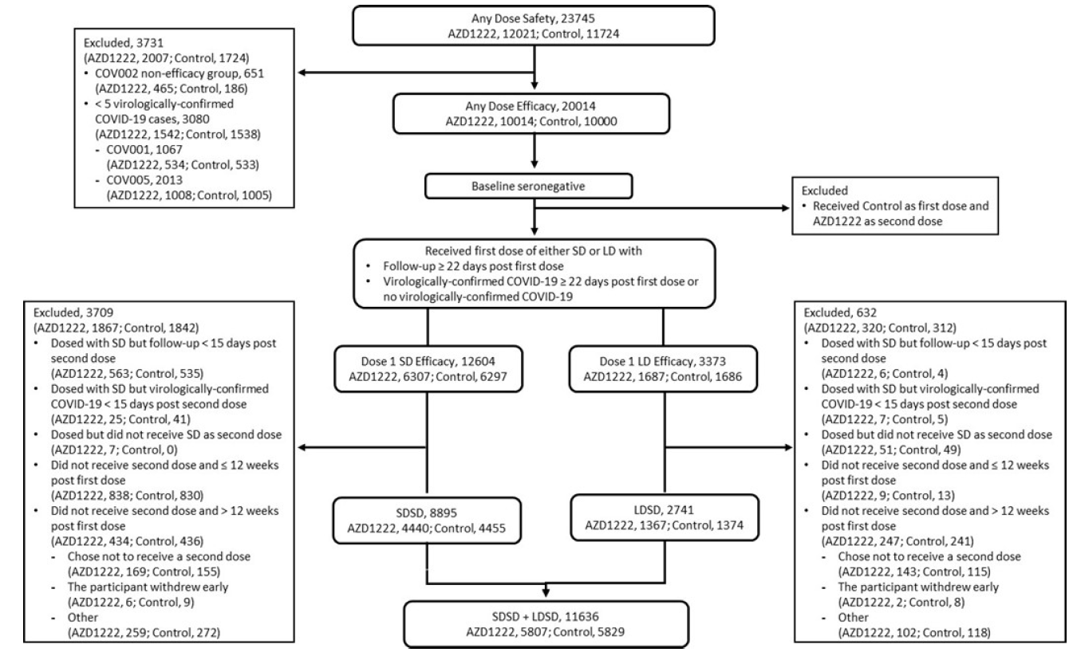
COVID-19 = coronavirus disease 2019; LD = low dose; SD = standard dose.

Demographics
In the primary efficacy population, the mean age of participants was 41.52 years of age. There were in total 660 participants (5.7%) over 65 years of age and 444 (3.8% ) over 70 years of age (see Table 5, below). Approximately 61% of participants were female. In relation to race, 83.4% were White, 4.4% were Asian, 4.1% were Black. There were 20.2% with a body mass index (BMI) of > 30 kg/m². All participants were seronegative (to nucleic acid) at Baseline.
Table 5: AZD1222 efficacy analysis set, baseline characteristics (age)
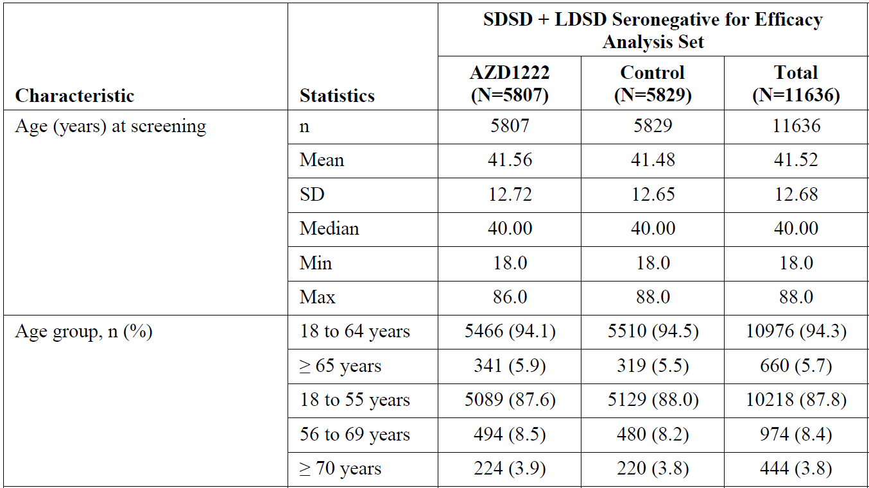
SD = standard deviation (in this table ‘Statistics’ column only, otherwise SD = standard dose).

Efficacy results
The median duration of follow up since the first dose was 132 days (4 months). The median duration of follow up ≥ 15 days after the second dose was 48 days. The duration of follow up ≥ 15 days after the second dose was longer after the LDSD group (59 days) than the SDSD group (39 days).

Primary efficacy endpoint
The interim analysis was planned using the number of cases in the SDSD seronegative group. The sponsor proposed that the combined LDSD and SDSD seronegative population should be used for the primary efficacy population due to the greater power of the numbers, and presumed similar efficacy in the LDSD population based on immunology. Depending on which population is used, the vaccine efficacy is 60 to 70% with a lower 95% confidence interval of over 40%. This meets the European Medicines Agency (EMA) and United States (US) Food and Drug Administration (FDA) criteria for efficacy of a COVID vaccine that states the point estimate should be over 50% with lower 95% CI over 30%., Results for the primary endpoint are shown in Table 6, below.
Table 6: AZD1222 pooled analysis, primary endpoint, vaccine efficacy for incidence of first SARS-CoV-2 virologically confirmed symptomatic COVID-19 occurring ≥ 15 days post second dose
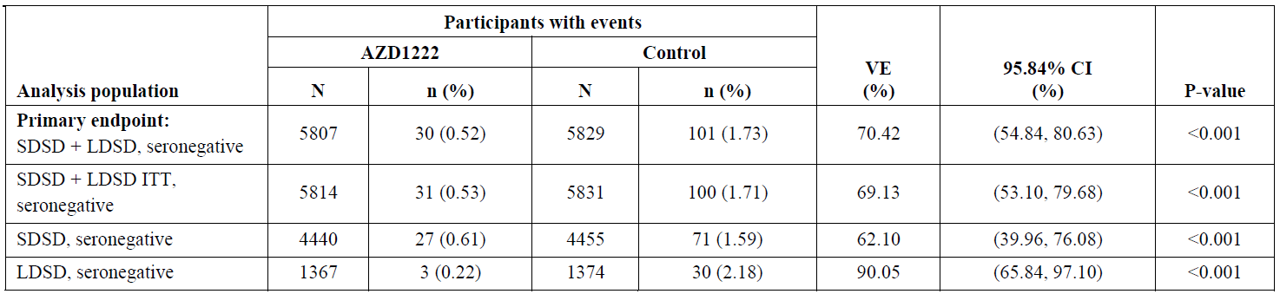
ITT = intent to treat.
VE of AZD1222 versus control, the 95.84% CI and p value were estimated based on Poisson regression with robust variance including the terms of study code, treatment, age group at screening (18 to 55, 56 to 69, and ≥ 70 years of age) as covariates, as well as the log of the follow-up time as an offset.
VE was defined as 1 - (incidence from the AZD1222 arm / incidence from the control arm) expressed as a percentage, where the risk ratio was derived from the Poisson regression model with robust variance. The 95.84% CI for the VE was obtained by taking 1 minus the 95.84% CI of the risk ratio derived from the model.
For the primary endpoint efficacy objective to be met, the lower bound of the CI for the VE must be > 20%.
The observation period for the endpoint was 15 days post second dose up to 1 year in study.
COVID-19 endpoints were based on adjudicated events.
Figure 2 , shown below, is the Kaplan Meier curve (actually a survival curve) for primary efficacy in the combined LDSD and SDSD seronegative population. It is important to note the rapidly decreasing denominator over time. There is survivor bias in this analysis, in that patients who contract COVID-19 are excluded. There is also the bias introduced by duration of follow up, in that the longer the duration of follow up the greater the exposure and the more likely an event is likely to occur.
Figure 2: AZD1222 pooled analysis, cumulative incidence plot for time to first SARS-CoV-2 virologically confirmed symptomatic COVID-19 case occurring ≥ 15 days post second dose (SDSD + LDSD seronegative, efficacy analysis set)
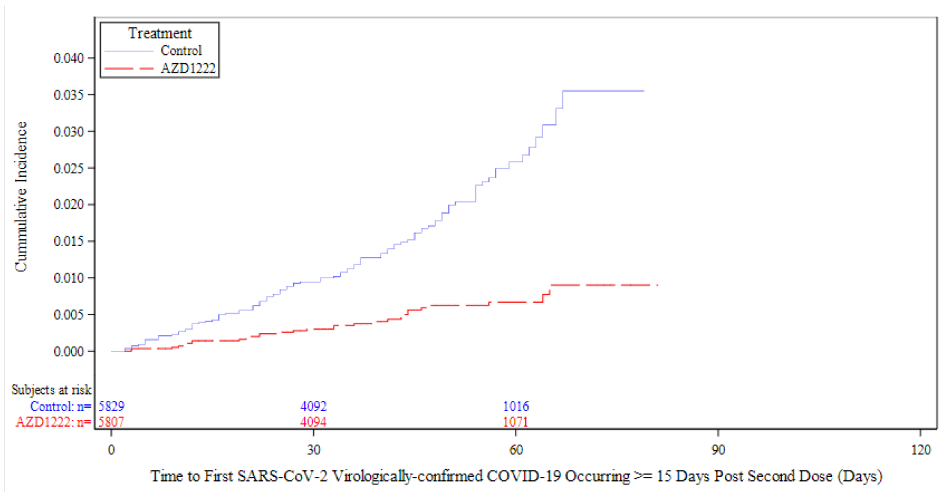
In the full efficacy population (any dose for efficacy analysis set), who received at least one dose with any duration follow up from the first dose, efficacy of the AZD1222 vaccine was 52.69% (95% CI: 40.52%, 62.37%) against COVID-19 in this group of participants. A similar Kaplan Meier (survival) curve is shown for this group in Figure 3. The vaccine appears to be effective from around 21 days after the first dose.
Figure 3: AZD1222 pooled analysis, cumulative incidence plot for time to first SARS-CoV-2 virologically confirmed symptomatic COVID-19 case occurring post first dose (any dose for efficacy analysis set, any serostatus)
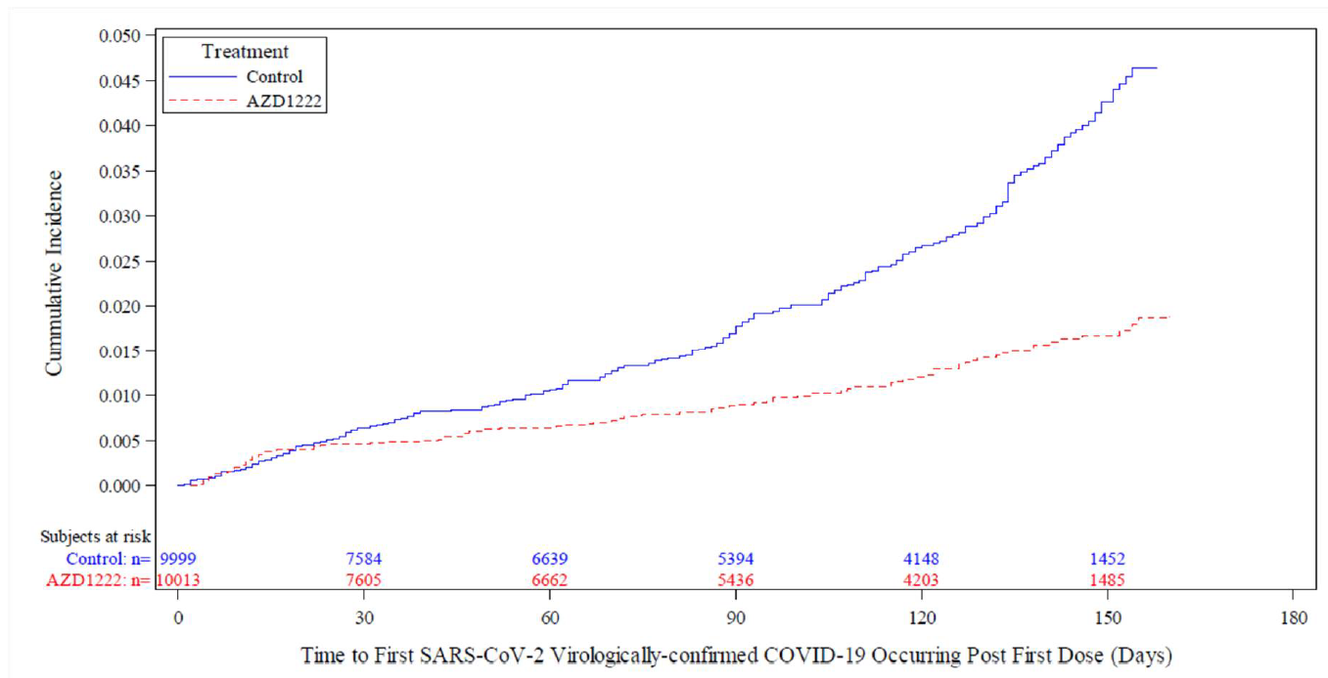
There were very few patients with severe disease and hospitalisation in the interim analysis. In the SDSD population, there were 0 out of 4440 participants who received AZD1222 who were hospitalised, and 4 out of 4455 in the control group. One patient required ICU admission and died in the control group.
Asymptomatic COVID-19 cases were assessed in Study COV002. Code-bar tagged swabs were distributed to participants to support weekly traceable results of self-swabbing for detection of SARS-CoV-2 infection. Swabs were sent for RT-PCR testing at National Health Service (UK) laboratories. Participants were also asked to self-record whether they experienced symptoms or not. Participants who had a virologically confirmed SARS-CoV-2 infection and reported that they had no symptoms are referred to here as ‘asymptomatic’; those participants who did not report whether they had symptoms or not are referred to here as ‘unknown’. It is important to note that not all participants returned their swabs.
There were similar, or numerically lower, number of asymptomatic or unknown cases in the LDLD + SDSD groups, importantly, there was not an increased number of cases like may be expected if there were less symptomatic cases.
Table 7: Study COV002 (only), vaccine efficacy for incidence of asymptomatic SARS-CoV-2 infection occurring ≥ 15 days post second dose
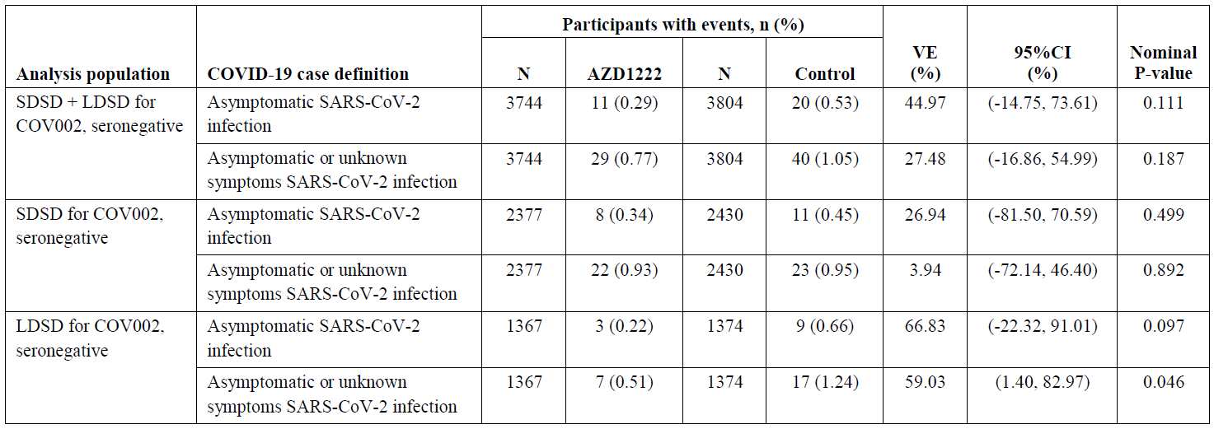
VE of AZD1222 versus control, the 95% CI and p-value were estimated based on Poisson regression with robust variance including the term of treatment, as well as the log of the follow-up time as an offset.
VE was defined as 1-(incidence from the AZD1222 arm / incidence from the control arm) expressed as a percentage, where the risk ratio was derived from the Poisson regression model with robust variance. The 95% CI for the VE was obtained by taking 1 minus the 95% CI of the risk ratio derived from the model.
The observation period for the endpoint was 15 days post second dose up to 1 year in study.
COVID-19 endpoints were based on adjudicated events.

Efficacy in subpopulations
Co-morbidity: although 36% of the patient population had co-morbidities, most of these were mild. The mean age of those with comorbidities was greater than those without comorbidities (44 versus 40 years, respectively), and a greater proportion were over 65 years of age (8.4% versus 4.1%). Also, the duration of follow up was shorter in the AZD1222 group (38 days) than the control group (47 days). In the combined LSSD and SDSD seronegative population, 11 out of 2070 participants in the AZD1222 group and 43 out of 2133 participants in the control group met the primary efficacy endpoint.
Age: as previously mentioned, only 660 adults over 65 years of age were included in the primary efficacy population. There were insufficient data to assess efficacy with age.
Country: efficacy was similar in the UK and Brazil.

Dose and dose interval
The greater efficacy in the LDSD data set was noted, and is described in Table 6. Although this is interesting, this will not be pursued from a regulatory viewpoint due to the multitude of confounding factors (longer duration of follow up, longer dose interval, only UK data set, younger participants) that have the potential to cause misleading results.
Efficacy after a single dose is in the order of 60%. A subsequent analysis of the efficacy of a single dose was performed using those who received either SD or LD as the first dose, and were follow from 22 days after the first dose to 12 weeks after the first dose. In this population there were 12 out of 7998 symptomatic cases in the AZD1222 group and 44 out of 7982 in the control group, VE 73% (95% CI 48.8 to 85.8).
The sponsor performed analysis of efficacy by dose interval and identified a trend for greater efficacy with increasing dose interval. Analysis of efficacy by dose interval data is shown in Table 8, below.
Table 8: Vaccine efficacy for incidence of first SARS-CoV-2 virologically confirmed symptomatic COVID-19 cases occurring ≥ 15 days post second dose by dose interval (SDSD seronegative, efficacy analysis set)
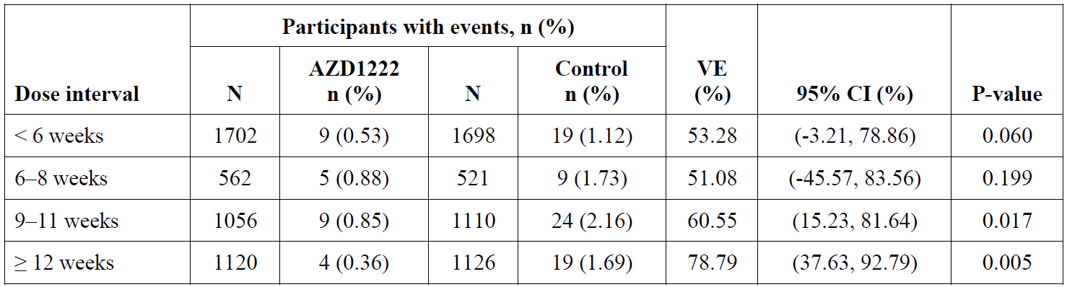
VE of AZD1222 versus control, the 95% CI and p value were estimated based on Poisson regression with robust variance including the term of treatment as well as the log of the follow-up time as an offset.
VE is defined as 1 - (incidence from the AZD1222 arm / incidence from the control arm) expressed as a percentage, where the risk ratio is derived from Poisson regression with robust variance. The 95% CI for the VE is obtained by taking 1 minus the 95% CI of the risk ratio derived from the model.
The observation period for the endpoint was 15 days post second dose up to 1 year in study.
COVID-19 endpoints were based on adjudicated events.
The increasing efficacy with increasing dose interval is supported by the immunology data which demonstrated increased antibody responses with greater dose intervals; data is presented in Table 9, below.
Table 9: Quantification of neutralising antibodies (by pseudoneutralisation assay) levels for different regimens, dose level and interval (seronegative at Baseline)
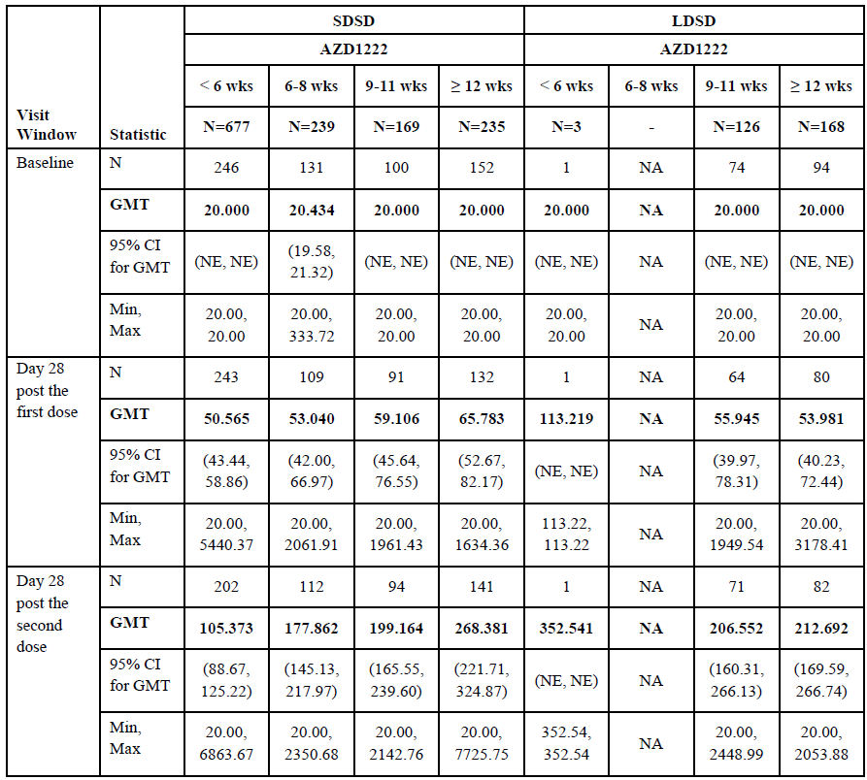
GMT = geometric mean titre; NA = not applicable; NE = not estimable.

Safety

Experience with other ChAdOx1 vaccines
Over 240 healthy adult volunteers have received ChAdOx1-vectored vaccines in previous clinical studies sponsored by the University of Oxford with immunogens from multiple pathogens such as influenza, chikungunya, tuberculosis, and MERS, as well as prostate cancer.
In addition, the ChAdOx1 platform has been developed with immunogens from malaria, meningitis B, Zika, and hepatitis B, with clinical studies ongoing in healthy volunteers, and with an immunogen from HIV to act as a therapeutic vaccine, with 2 studies in HIV patients currently being performed. The vaccines are not associated with safety concerns other than anticipated reactogenicity events.

Meta-analysis
Safety was assessed in all studies by evaluation of solicited adverse events (AEs) commonly associated with vaccinations, unsolicited AEs, serious adverse events (SAEs) (including deaths) and adverse events of special interest (AESIs). Biochemistry and haematology clinical laboratory tests were also evaluated for a subset of participants in Studies COV001, COV002, and COV005.
There were 23745 participants in the any dose for safety analysis set. The median number of days follow up after the first dose was 105 in the AZD1222 group and 104 in the control group. Approximately 2 out of 3 participants received two doses, and 1 out of 3 participants received one dose.
In the safety data set, 8.7% were over 65 years of age (1169 exposed to AZD1222) and 6.8 % were over 70 years (821 exposed to AZD1222). The safety population included around 20% of the population with a BMI > 30 kg/m², 2.5% with diabetes, and 6.1% had hypertension.

Solicited adverse events
Solicited local and systemic AEs occurred in most participants, but were generally mild and short lived.
Table 10: Overall summary of solicited adverse events collected within 7 days after vaccination: pooled analysis (Dose 1 SD, safety analysis set)
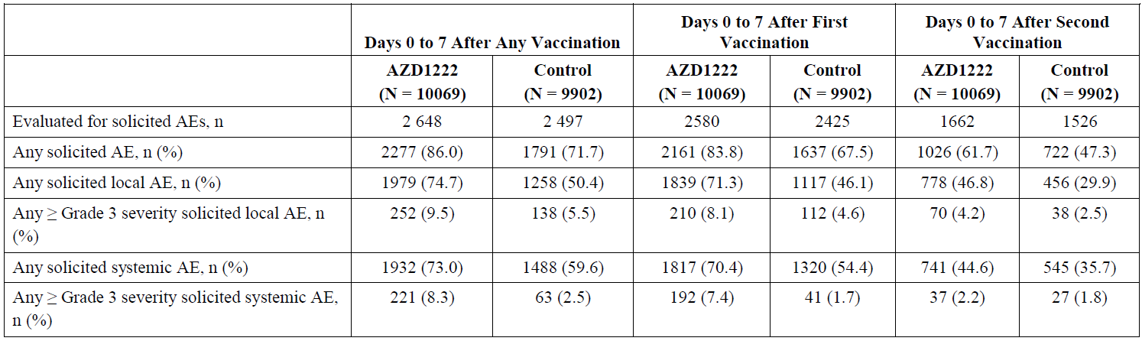
In the Dose 1 SD for safety analysis set, the most frequently reported solicited local injection site AEs within 7 days after either vaccination with AZD1222 were tenderness (63.7% versus 39.5% in control) and pain (54.2% versus 36.7% in control). Other solicited local injection site AEs reported in ≥ 10% of AZD1222 participants were warmth (17.7% versus 14.5% in control), redness (14.0% versus 8.8% in control), itch (12.7% versus 7.5% in control), and swelling (10.0% versus 5.8% in control). Solicited local AEs with ≥ Grade 3 severity after any vaccination of AZD1222 reported in ≥ 2% of participants included swelling (5.3%), redness (4.8%), and induration (4.1%). No Grade 4 events were reported.
In the Dose 1 SD for safety analysis set, the most frequently reported solicited systemic AEs within 7 days after either vaccination with AZD1222 were fatigue (53.1% versus 38.2% in control) and headache (52.6% versus 39.0% in control); other frequently reported systemic solicited AEs were muscle pain (44.0% versus 21.6% in control), malaise (44.2% versus 20.2% in control), feverishness, (33.6% versus 10.7% in control), chills (31.9% versus 8.3% in control), joint pain (26.4% versus 12.4% in control) nausea (21.9% versus 13.1% in control), and fever (7.9% versus 1.2% in control). Solicited systemic AEs with ≥ Grade 3 severity after any vaccination with AZD1222 reported in ≥ 2% of participants included malaise (3.8%), feverishness (3.5%), chills (3.5%), fatigue (3.2%), and headache (2.7%). A single Grade 4 event was reported in the AZD1222 group for fever.
Solicited AEs were less common after the second dose, and less common in the elderly.

Unsolicited adverse events
In the any dose for safety analysis set, 37.8% of participants in the AZD1222 group and 27.9% of participants in the control group reported an unsolicited AE within 28 days following any vaccination. Unsolicited AEs were less common after the second vaccine.
Serious AEs were reported in 0.7% of participants in the AZD1222 group and 0.8% of participants in the control group. Very few, < 0.1% in each treatment group, were considered related to the investigated product. A total of 6 SAEs with a fatal outcome (2 in the AZD1222 group and 4 in the control group) occurred as of the cut-off date. None of these were thought to be due to the vaccine. AESIs occurred in 0.8% of participants in the AZD1222 group and 1.1% of participants in the control group.
All of the unsolicited AEs were typical of those reported for vaccines.
Table 11: Unsolicited adverse events within 28 days following vaccination (≥ 2% in either treatment group) by Preferred Term: pooled analysis (Dose 1 SD, safety analysis set)
 | Number (%) of Participantsª
Preferred Term (MedDRA version 23.1) | AZD1222 (N = 10069) | Control (N = 9902)
Vaccination site pain | 1197 (11.9) | 733 (7.4)
Headache | 1051 (10.4) | 685 (6.9)
Pyrexia | 852 (8.5) | 210 (2.1)
Myalgia | 852 (8.5) | 345 (3.5)
Fatigue | 487 (4.8) | 290 (2.9)
Chills | 392 (3.9) | 100 (1.0)
Asthenia | 262 (2.6) | 123 (1.2)
Malaise | 243 (2.4) | 138 (1.4)
Nausea | 211 (2.1) | 117 (1.2)
a: Number (%) of participants with AEs, sorted in decreasing frequency for PT of AZD1222 group. Participants with multiple events in the same PT were counted only once in each of those PT. Participants with events in more than 1 PT are counted once in each of those PT.
Unsolicited AEs collected from the start of each dose through 28 days, SAE and AESI collected from first dose to 364 days after the last vaccination were summarised.
AE = adverse event; AESI = adverse event of special interest; MedDRA = Medical Dictionary for Regulatory Activities; PT = Preferred Term; SAE = serious adverse event.

Serious adverse events
In the AZD1222 group, there was one case of multiple sclerosis and one case of transverse myelitis, both unlikely to be related to investigational agent.
In the control group there was one case of myelitis and one case or haemolytic anaemia.

Use in pregnancy
Women who were pregnant, lactating, or intended to become pregnant were excluded from the University of Oxford studies, and women of childbearing capacity were required to use continuous birth control.
As of the data cut off of 4 November 2020, there were 17 pregnancies reported in the AZD1222 pooled analysis set, ten participants in the AZD1222 group and seven in the control group. In the AZD1222 group, there was one termination of pregnancy and one spontaneous miscarriage. In the control group, there were two reports of termination of pregnancy and two spontaneous miscarriages. In addition to the above cases, there were four cases of pregnancy in the Study COV005 global safety database. There was one spontaneous miscarriage in the AZD1222 group and one in the control group. No data on the outcome of the pregnancies is noted.

Clinical evaluator’s recommendation
For provisional registration, the role of the TGA is to assess whether the ‘quality, safety and efficacy’ have been adequately established for the purpose for which the goods are to be used. For a vaccination to be rolled out with the aim of protecting the Australian population, the context of this use needs to be considered.
The primary efficacy endpoints for the prevention of symptomatic COVID-19 meets the EMA and FDA requirements for COVID vaccines.18,19 There needs to be consideration as to whether the efficacy demonstrated is sufficient for use in the Australian context where COVID-19 is less prevalent. This will require expert advice. Apart from local and systemic signs of reactogenicity typical of vaccines, there were no significant safety concerns.
Although it is understandable that the clinical development plan needed to evolve in the context of the pandemic and as more knowledge about the vaccine and COVID-19 became available, there are significant concerns about the robustness of the data:
- the study design was not entirely fit for purpose to evaluate efficacy in high risk groups;
- there is insufficient data about dosing; and
- there were a number of patients lost to efficacy analysis.
The clinical evaluator has the following recommendations to the wording of the indication and PI if the vaccine is to be approved:
- The clinical evaluator recommends a change in the wording of the indications to reflect other vaccines registered for COVID-19.
- The limitations of the data in the elderly, immunosuppressed and pregnant women will be made clear in the precautions sections. It is recommended that these patients speak to their general practitioner or a specialist physician about the risks and benefits of the vaccine for them.
- The dosing interval proposed for 4 to 12 weeks is acceptable.
- The clinical trial sections in the PI should be limited to the primary efficacy analysis.

Risk management plan
The sponsor has submitted EU-risk management plan (RMP) Version 1.0 Succession 1.0 (date 21 December 2020; data lock point (DLP) 4 November 2020) and Australian specific annex (ASA) Version 1.0 Succession 1.0 (date 22 December 2020) in support of this application. With the responses to rolling questions sent on 30 December 2020, the sponsor provided an updated ASA Version 1.0 Succession 2 (date 13 January 2021).
On 30 January 2021, the sponsor provided an updated EU RMP Version 1.0 Succession 4 (date 26 January 2021; DLP 4 November 2020) and an updated ASA Version 1.0 Succession 3 (date 30 January 2021). At the completion of the RMP evaluation, the sponsor has submitted EU RMP Version 1.0 Succession 5 (date 2 February 2021; DLP 4 November 2020) and ASA Version 1.0 Succession 4 (date 4 February 2021).
The summary of safety concerns and their associated risk monitoring and mitigation strategies are summarised in Table 12.
Table 12: Summary of safety concerns
Summary of safety concerns |  | Pharmacovigilance |  | Risk minimisation
 |  | Routine | Additional | Routine | Additional
Important identified risks | None | - | - | - | –
Important potential risks | Nervous system disorders, including immune-mediated neurological conditions |  | *‡+ | – | –
Important potential risks | Vaccine-associated enhanced disease(VAED), including vaccine associated enhanced respiratory disease (VAERD) |  | *‡+ | – | –
Important potential risks | Anaphylaxis |  | *‡+ |  | –
Missing information | Use during pregnancy and while breastfeeding |  | ¶‡+ |  | –
Missing information | Use in immunocompromised patients |  | *‡+^φ |  | –
Missing information | Use in frail patients with co-morbidities (for example, chronic obstructive pulmonary disease, diabetes, chronic neurological disease, cardiovascular disorders) |  | ‡+ | – | –
Missing information | Use in patients with autoimmune or inflammatory disorders |  | ‡+ | – | –
Missing information | Interactions with other vaccines |  | ‡+ |  | –
Missing information | Long-term safety |  | *‡+ | – | –
Missing information | Use in elderly (> 65 years of age) § |  | *‡+ |  | –
*Clinical studies, Pregnancy registry, § Australia-specific safety concern, ‡Post-marketing observational study, + Enhanced active surveillance study, ^ Interventional study, φ post marketing safety study
The sponsor revised the summary of safety concerns during the evaluation phase to include the recommendations made by the EMA and the TGA’s RMP evaluator. At this stage, this safety summary is acceptable from an RMP perspective.
Routine and additional pharmacovigilance activities have been proposed, as indicated in the table above. Routine pharmacovigilance measures include targeted follow-up questionnaires to monitor important potential risks, provision of monthly summary safety reports and ensuring traceability of batch/lot numbers. Additional pharmacovigilance measures include enhanced post-market surveillance activities.
Australian participants are not involved in the clinical trials. However, the outcomes of these trials are expected to be applicable to the Australian context. The sponsor has committed to include Australian participants in a pregnancy registry.
Only routine risk minimisation measures are proposed. The PI and the Consumer Medicines Information (CMI) together with the information/training expected to be provided by the Department of Health are anticipated to adequately mitigate the risks associated with this vaccine. If the current understanding of the safety profile of this vaccine changes, the risk minimisation plan will require re-assessment.
Table 13: Ongoing and planned additional pharmacovigilance studies
Study | Objectives | Safety concerns addressed | Milestones
Ongoing
Study COV001  A Phase I/II Study to Determine Efficacy, Safety, and Immunogenicity of the Candidate Coronavirus Disease (COVID-19) Vaccine ChAdOx1 nCoV-19 in UK Healthy Adult Volunteers | Primary objectives:  To assess efficacy of AZD1222 against COVID-19  To assess the safety of AZD1222  Key secondary Objectives:  To assess the reactogenicity profile of AZD1222  To assess cellular and humoral immunogenicity of AZD1222 | Nervous system disorders, including immune-mediated neurological conditions, vaccine-associated enhanced disease (VAED), including vaccine associated enhanced respiratory disease (VAERD), anaphylaxis, long-term safety | Final study report due first quarter 2022
Study COV002  A Phase II/III Study to Determine the Efficacy, Safety, and Immunogenicity of the Candidate Coronavirus Disease (COVID-19) Vaccine ChAdOx1 nCoV-19 | Primary objectives:  To assess efficacy and safety of AZD1222 against COVID-19 in adults aged 18 years and older in the UK  Secondary objectives:  To assess the reactogenicity profile of AZD1222  To assess efficacy of AZD1222 against severe and non-severe COVID-19  To assess humoral immunogenicity of AZD1222  To assess cellular immunity of AZD1222 in older adults  To assess the safety and immunogenicity of a booster dose of AZD1222 in older adults aged 56 years or older (two-dose schedule). | Nervous system disorders, including immune-mediated neurological conditions, vaccine-associated enhanced disease (VAED), including vaccine associated enhanced respiratory disease (VAERD), anaphylaxis, long-term safety, Use in elderly (> 65 years of age) | Final study report due second quarter 2022
Study COV003  A Randomised, Controlled, Phase III Study to Determine the Safety, Efficacy, and Immunogenicity of the Non- Replicating ChAdOx1 nCoV-19 Vaccine | Primary objective:  To evaluate the efficacy of AZD1222 vaccine against COVID-19 disease confirmed with PCR  Secondary objectives:  To evaluate the safety, tolerability and reactogenicity profile of AZD1222  To evaluate the efficacy of AZD1222 against severe and non-severe COVID-19 disease  To evaluate the humoral immunogenicity of AZD1222  To assess the cellular immunogenicity of AZD1222. | Nervous system disorders, including immune-mediated neurological conditions, vaccine-associated enhanced disease (VAED), including vaccine associated enhanced respiratory disease (VAERD), anaphylaxis, long-term safety, Use in elderly (> 65 years of age) | Final study report due second quarter 2022
Study COV004  A Phase IB/II Single- Blinded, Randomised, Controlled Study to Determine Safety, Immunogenicity and Efficacy of the Candidate Coronavirus Disease (COVID-19) Vaccine ChAdOx1 nCoV-19 in Adults in Kenya | Primary objectives:  To assess the safety, tolerability and reactogenicity profile of the candidate vaccine ChAdOx1 nCoV-19  To assess immunogenicity of ChAdOx1 nCoV-19  Secondary objectives:  To assess humoral immunogenicity of ChAdOx1 nCoV-19 at early and late timepoints  To assess cellular immunogenicity of ChAdOx1 nCoV-19  To assess efficacy of ChAdOx1 nCoV-19 against COVID-19 | Nervous system disorders, including immune-mediated neurological conditions, vaccine-associated enhanced disease (VAED), including vaccine associated enhanced respiratory disease (VAERD), anaphylaxis, long-term safety | Final study report due 2022
Study COV005  An Adaptive Phase I/II Randomised Placebo-controlled Trial to Determine Safety, Immunogenicity and Efficacy of Non- Replicating ChAdOx1 SARS-CoV-2 Vaccine in South African Adults Living Without HIV, and Safety and Immunogenicity in Adults living with HIV. | Primary objective:  To assess the safety of AZD1222 in healthy HIV-uninfected adults  To assess efficacy of AZD1222 against COVID-19  To assess the safety of the candidate vaccine AZD1222 in adults living with HIV  To evaluate the immunogenicity of AZD1222 after first and second doses of vaccine in adults living with HIV  Secondary objectives:  To assess the immunogenicity of AZD1222 in healthy HIV uninfected adults. | Nervous system disorders, including immune-mediated neurological conditions, use in immunocompromised patients, vaccine associated enhanced disease (VAED), including vaccine associated enhanced respiratory disease (VAERD), anaphylaxis, long-term safety | Final study report due: second quarter 2022
D8110C00001  A Phase III Randomized, Double blind, Placebo controlled Multicentre Study in Adults to Determine the Safety, Efficacy, and Immunogenicity of AZD1222, a Nonreplicating ChAdOx1 Vector Vaccine, for the Prevention of COVID-19 | Primary objectives:  To estimate the efficacy of 2 IM doses of AZD1222 compared to placebo for the prevention of COVID-19 in adults ≥ 18 years of age  To assess the safety and tolerability of 2 IM doses of AZD1222 compared to placebo in adults ≥ 18 years of age  To assess the reactogenicity of 2 IM doses of AZD1222 compared to placebo in adults ≥ 18 years of age (substudy only)  Key secondary objectives:  To estimate the efficacy of 2 IM doses of AZD1222 compared to placebo for the prevention of SARS-CoV-2 infection  To estimate the efficacy of 2 IM doses of AZD1222 compared to placebo for the prevention of symptomatic COVID-19 using CDC criteria  To estimate the efficacy of 2 IM doses of AZD1222 compared to placebo for the prevention of University of Oxford-defined symptomatic COVID-19  To estimate the efficacy of 2 IM doses of AZD1222 compared to placebo in the prevention of COVID-19 in all study participants, regardless of evidence of prior SARS-CoV-2 infection  To estimate the efficacy of 2 IM doses of AZD1222 compared to placebo for the prevention of severe or critical symptomatic COVID-19  To estimate the efficacy of 2 IM doses of AZD1222 compared to placebo for the prevention of COVID-19-related Emergency Department visits | Nervous system disorders, including immune-mediated neurological conditions, vaccine-associated enhanced disease (VAED), including vaccine associated enhanced respiratory disease (VAERD), anaphylaxis, long-term safety, use in elderly (> 65 years of age) | Interim analysis due: first quarter 2021
D8111C00002  A Phase I/II Randomized, Doubleblind, Placebocontrolled Multicentre Study in Participants Aged 18 Years or Older to Determine the Safety and Immunogenicity of AZD1222, a Nonreplicating ChAdOx1 Vector Vaccine, for the Prevention of COVID-19 | Primary objectives:  To assess antibody responses to AZD1222 Spike antigen following 2 IM doses of AZD1222 or placebo.  To assess the safety, tolerability, and reactogenicity profile of the candidate vaccine AZD1222.  Secondary objectives:  To assess antibody responses to AZD1222 RBD antigen following 2 IM doses of AZD1222 or placebo.  To assess time course of antibody to AZD1222 Spike and RBD antigens of AZD1222 (MSD serology assay)  To assess the function of nAb against SARS-CoV-2 spike protein  To assess the safety of the candidate vaccine AZD1222.  To describe occurrence of symptomatic COVID-19 in recipients of AZD1222 and placebo.  To describe occurrence of severe COVID- 19 and seroresponse to non-Spike SARSCoV-2 antigens. | Nervous system disorders, including immune-mediated neurological conditions, vaccine-associated enhanced disease (VAED), including vaccine associated enhanced respiratory disease (VAERD), anaphylaxis, long-term safety, use in elderly (> 65 years of age) | Interim analysis due first quarter 2021  Primary analysis due second quarter 2021
Planned
Enhanced Active Surveillance Study  A Phase IV Enhanced Active Surveillance Study of People Vaccinated with AZD1222  D8111R00003 (EU)  D8110R00001 (US)  ESR 21-21121 (UK, DSRU sponsored) | Primary objectives:  To assess the safety and tolerability of at least 1 IM dose of AZD1222 in adults ≥ 18 years of age for 3 months after vaccination with the first dose of AZD1222.  Secondary objectives:  To assess the longer-term safety and tolerability of at least 1 IM dose of AZD1222 for 18 months after vaccination.  To assess the safety and tolerability of AZD1222 in participants ≥ 65 year of age and in other key subgroups.  To estimate the frequency of select pregnancy outcomes in women vaccinated with AZD1222 during pregnancy or within 45 days of the estimated conception date.  To estimate the frequency of select outcomes in neonates/infants born to mothers vaccinated with AZD1222 during pregnancy or within 45 days of the estimated date of conception. | Nervous system disorders, including immune-mediated neurological conditions, vaccine-associated enhanced disease (VAED), including vaccine associated enhanced respiratory disease (VAERD), anaphylaxis, use during pregnancy and while breastfeeding, use in immunocompromised patients, use in frail patients with co-morbidities (for example, chronic obstructive pulmonary disease, diabetes, chronic neurological disease, cardiovascular disorders), use in patients with autoimmune or inflammatory disorders, interactions with other vaccines, long-term safety, use in elderly (> 65 years of age) | Final study protocol available: 23 February 2021  Start of study: 18 May 2021  First interim report available: third quarter 2021
AZD1222 Pregnancy Registry:  Pregnancy Registry of Women Exposed to AZD1222  Immediately Before or During Pregnancy as Part of the C-VIPER Registry Consortium ESR-21-21138 (Pregistry-externally sponsored) | Primary objectives:  To estimate the frequency of selected adverse pregnancy outcomes (that is, spontaneous abortions, stillbirths, and preterm births) in women receiving at least 1 dose of the AZD1222 vaccine during pregnancy or up to a predefined period (eg 30 days) before estimated date of last menstrual period (LMP).  To estimate the risk of selected adverse foetal/neonatal outcomes (that is, major congenital malformations and small for gestational age) at birth and up to at least the 12 months of life (to account for diagnosis of major congenital malformations that might be delayed) in infants from pregnancies in which the mothers received the AZD1222 vaccine during pregnancy or up to a predefined period (for example, 30 days) before estimated date of LMP. | Use during pregnancy and while breastfeeding | Study protocol submitted to EMA on 27 January 2021
Post-marketing observational study using existing secondary health data sources  A post-authorisation/ post-marketing observational study using existing secondary health data sources to evaluate the association between exposure to AZD1222 and safety concerns.  D8111R00006 (EU/UK) Study code to be confirmed (US) | Primary objectives:  To estimate the incidence of safety concerns and AESIs in recipients and non-recipients of AZD1222, among all populations targeted for vaccination and in the specific populations considered as missing information  To estimate the relative risk (comparing exposed and unexposed person time) of safety concerns including adverse events of interest among all populations targeted for vaccination and in the specific populations considered as missing information  To characterise the use of AZD1222 among all populations targeted for vaccination and in the specific populations considered as missing information. | Nervous system disorders, including immune-mediated neurological conditions, vaccine-associated enhanced disease (VAED), including vaccine associated enhanced respiratory disease (VAERD), anaphylaxis, use during pregnancy and while breastfeeding, use in immunocompromised patients, use in frail patients with co-morbidities (for example, chronic obstructive pulmonary disease, diabetes, chronic neurological disease, cardiovascular disorders), use in patients with autoimmune or inflammatory disorders, Interactions with other vaccines, long-term safety, use in elderly (> 65 years of age) | Study protocol available by 1 April 2021
Post-marketing safety study in patients receiving immunosuppressant medication or with primary immunodeficiency | To evaluate the safety profile of AZD1222 in patients receiving immunosuppressant medication(s) or with primary immunodeficiency | Use in immunocompromised patients | Study protocol expected 1 November 2021
Interventional study in immunocompromised subjects | Primary objective:  To evaluate the safety profile of AZD1222 in patients receiving immunosuppressant medication(s) or with primary immunodeficiency | Use in immunocompromised patients | Study protocol due 28 February 2021
Post-marketing effectiveness study:  Post-authorisation/ Post-marketing retrospective cohort study to evaluate the effectiveness of the AZD1222 vaccine to prevent serious COVID-19 infection in conditions of usual care through public private partnership with COVIDRIVE utilising primary data collected prospectively through the COVIDRIVE platform.  D8111R00005 (EU/UK)  Study code to be confirmed (US) | To estimate brand specific vaccine effectiveness against laboratory-confirmed SARS-CoV-2 in hospitalised patients, overall and by age group (< 18, 18 to 64 and ≥ 65 years old), after adjusting for potential confounders. | Not applicable | Study protocol expected March 2021 (COVIDRIVE consortium)
The TGA is implementing the COVID-19 vaccine safety monitoring plan. In addition, enhanced active surveillance will be conducted by AusVaxSafety and will enable rapid identification of adverse events and also early identification of potential quality issues. Sponsors of COVID-19 vaccines are expected to conduct batch specific pharmacovigilance measures to ensure timely detection and handling of both batch specific safety signals and batch specific reports or reduced effectiveness or vaccine failure. The Department of Health will implement traceability processes at a national level.

Proposed risk management plan conditions of registration
Any changes to which the sponsor has agreed should be included in a revised RMP and ASA. However, irrespective of whether or not they are included in the currently available version of the RMP document, the agreed changes become part of the risk management system.
The suggested wording is:
- The COVID-19 Vaccine AstraZeneca (ChAdOx1-S) EU-RMP (version 1.0 Succession 5, dated 2 February 2021, data lock point 4 November 2020), with Australian Specific Annex (version 1.0 Succession 4, dated 4 February 2021), included with submission PM-2020-06115-1-2 and any subsequent revisions, as agreed with the TGA will be implemented in Australia.
An obligatory component of risk management plans is routine pharmacovigilance. Routine pharmacovigilance includes the submission of periodic safety update reports (PSURs).
Unless agreed separately between the sponsor and the TGA, the first report must be submitted to TGA no later than six calendar months after the date of the approval letter. The subsequent reports must be submitted no less frequently than six monthly until the period covered by such reports is not less than three years from the date of the approval letter, or the entire period of provisional registration, whichever is longer.
The reports are to at least meet the requirements for PSURs as described in the European Medicines Agency’s Guideline on good pharmacovigilance practices (GVP) Module VII-periodic safety update report (Rev 1), Part VII.B Structures and processes. Note that submission of a PSUR does not constitute an application to vary the registration. Each report must have been prepared within ninety calendar days of the data lock point for that report.
- Additional to the routine submission of the routine PSURs, expedited monthly safety summary reports (including safety data for patients in Australia) are to be provided for the first 6 months post registration, and thereafter at intervals specified by the TGA.
- COVID-19 Vaccine AstraZeneca (ChAdOx1-S) is to be included in the Black Triangle Scheme. The PI and CMI for COVID-19 Vaccine AstraZeneca must include the black triangle symbol and mandatory accompanying text for the products entire period of provisional registration.

Risk-benefit analysis

Delegate’s considerations
The clinical development program for the AZD1222 occurred in the midst of a pandemic. There have been a number of changes to the protocols which make interpretation of the trials challenging.
The sponsor has reported the primary efficacy endpoint using a range of different populations. In all of these populations, the point estimate for vaccine efficacy was over 50% and lower bound of the 95% confidence interval around the point estimate was above 30%, thus meeting the requirement for EMA and FDA in terms of an effective COVID vaccine.18,19 The vaccine efficacy was highest in the SDSD + LDSD seronegative analysis set, but possibly biased due to younger patient population, longer duration of follow up and longer dose interval. It was lowest in the any dose efficacy data set (also referred to as the full efficacy set), as this included both one and two doses, and variable periods of follow up. The Delegate considers the SDSD population as most relevant for the regulatory decision.
The study was not powered for secondary analysis, thus firm conclusions cannot be drawn from this. However, there appeared to be lower number of patients requiring hospitalisation. Study COV002 included active screening for asymptomatic COVID-19. Participants were required to perform and return their own swab. The results are uninterpretable due to low numbers and incomplete compliance. Animal studies have shown reduced viral load in the lower respiratory tract, but persistent spreading in the upper respiratory tract. At this stage, efficacy in preventing asymptomatic disease and transmission is unknown.
Although the AZD1222 vaccine passes the statistical requirement for efficacy, the Advisory Committee on Vaccines (ACV; see ‘Advisory Committee considerations’, below) are asked to comment upon whether the efficacy demonstrated is adequate to meet the objectives of the Australian Vaccination Strategy. It is important that the population understand the facts about the efficacy of the vaccine, and limitations of the data, and the need to continue other public health measures to prevent the spread of disease until more information about vaccine efficacy is available.
One of the major limitations in the study is the short and variable duration of follow up. The duration of follow up, and reasons for missing data in follow up, are important in determining efficacy. Lower duration of follow up may be from drop outs, but may also arise due to censoring of cases. Longer duration of follow up increases the time of exposure and increases the opportunity for true effectiveness (or non-effectiveness) to be demonstrated.
Variable doses and variable dose intervals arose due to procedural issues in the study. Although the AZD1222 and control groups were equally affected, different subgroups within the meta-analysis were unequally affected. For regulatory purposes, the sponsor is proposing the standard dose (SD) of 5 x 10¹⁰ vp and a two dose regime, 4 to 12 weeks apart. This is supported by primary efficacy analysis and will be confirmed by ongoing studies. The post hoc exploratory subgroup analysis suggested greater efficacy (and immunogenicity) with longer dose intervals, such that the best dose regimen may be 12 weeks between doses. This is supported by adequate protection of a single dose for up to 12 weeks, and adequate protection after two doses for after 12 weeks. The optimal dose interval within the 4 to 12 week interval for the vaccine roll out is best left to the Immunisation Task Force for consideration.
Another limitation to the clinical development program was that those at high risk of COVID-19, including the elderly and those with significant co-morbidities, were excluded or under-represented. From a regulatory perspective, under the Therapeutic Goods Act, the Delegate must be satisfied that ‘quality safety and efficacy have been adequately established for the purpose for which they are to be used’. This is a different assessment to a risk/benefit analysis as the potential risks of vaccination are small, and the potential benefits in this population are large. In the Delegate’s opinion, these populations should not be excluded from the indication as it is reasonable to extrapolate efficacy, and the risks of COVID-19 outweigh potential risks of the vaccine. However, there needs to be adequate warning about the limitations of the data in the PI, and a recommendation to prescribers that the potential risks and benefits to an individual be considered prior to proceeding to vaccinate.
Similar limitations apply to the data available for use in pregnancy. However, not only was there insufficient patients in the study but also incomplete nonclinical studies. The proposed Pregnancy Category is B2.16 The ACV will be requested to advise on the adequacy of the warning for use in pregnancy.

Clinical study plan for provisional registration
As part of the provisional registration process, sponsors are required to submit a clinical study plan whereby they demonstrate how any limitations present at the time of interim analysis will be addressed.
The sponsor’s provisional approval clinical study plan included availability of the full study reports of Studies COV001, COV002, COV003 and COV004 for submission, expected in March to May 2022 depending on the study. In addition, the clinical study report from the interim analysis of the ongoing US/Chile/Peru study, Study D8110C00001, is expected to be available for submission in March 2021.
The Delegate was of the view that this clinical study plan will assist in providing further information in relation to long term efficacy, long term safety, and use in the elderly. It should also include further information about use in immunosuppressed individuals (including patients with HIV).
Although not officially part of the clinical study plan, the ongoing post market surveillance, pregnancy register, and post authorisation safety studies will help inform use in pregnancy and in patients with other co-morbidities. It is recommended that the ongoing studies also form part of the clinical study plan.
The sponsor should also provide the TGA with the studies evaluating co-administration of influenza (and any other vaccines).
The main gap in the proposed ongoing studies is in relation to the optimal dose and dosing interval for vaccine efficacy. The sponsor is requested to provide further information about any proposed future studies.
Table 14: Additional studies in the clinical program
Study | COV004 | D8110C00001 | D8111C00001 | D8111C00002 | ICMR/SII- COVISHIELD
Identifier | PACTR20200568189 5696 | NCT04516746 EudraCT number 2020-001228-32 |  | NCT04568031
Region | Kenya | US, Chile, Peru | Russia | Japan | India
Sponsor | University of Oxford | AstraZeneca | AstraZeneca | AstraZeneca | ICMR/SIIPL
Start Date/Status | October 2020 / Ongoing | August 2020 / Ongoing | On Hold | August 2020 / Ongoing | August 2020 / Ongoing
Phase | Ib/II | III | III | I/II | II/III
Design | Participant-blind, randomised, controlled | Double-blind, randomised, controlled | Open label | Double-blind, randomised, controlled | Observer-blind, randomised, controlled
Planned number of participants | Approx. 400 | Approx. 30000 | Approx. 100 | Approx. 256 | Approx. 1600
Participant characteristics | ≥ 18 yr, healthy | ≥ 18 yr, healthy or with medically- stable chronic disease | ≥ 18 yr, healthy | ≥18 yr, healthy | ≥ 18 yr, healthy
Number of doses (IM route) | 1 | 2 | 1 | 2 | 2
AZD1222 dose levels c | SD: 5 x 10¹⁰ vp | SD: 5 x 10¹⁰ vp | SD: 5 x 10¹⁰ vp | SD: 5 x 1010 vp | SD: 5 x 10¹⁰ vp OR COVISHIELD: 5 x 10¹⁰ vp
Control | Rabies vaccine | Saline placebo | None | Saline placebo | Placebo (vaccine vehicle)
Planned dose interval | - | 4 wk | - | 4 wk | 4 wk
Case detection | Passive | Passive and active (weekly contacts) | Not applicable | Passive | Passive
Planned duration of Follow-up | Approx. 365 days after the dose | Approx. 730 days after the first dose | Approx. 180 days after the dose | Approx. 365 days after the first dose | Approx. 180 days after the last dose
a None of these studies contribute data to this application; therefore they are not listed in the clinical study report section of the submitted dossier, b Vaccinations not started; safety data in review by Russian Ministry of Health, c AstraZeneca assay of reference
Approx. = approximately; ICMR = Indian Council on Medical Research; IM = intramuscular; MenACWY meningococcal group A, C, W-135, and Y conjugate vaccine; SII = Serum Institute of India; vp = viral particles; wk = weeks; yr = years.

Proposed action
While a decision is yet to be made, at this stage the Delegate is inclined to approve the registration of the product.
The ACV is requested to assist in the responses to a number of questions and in drafting the wording of some sections of the PI.
There are a number of outstanding studies that will be required to be submitted before full approval to address limitations in the data. It is important that the PI is kept up to date with this information.
There is a Section 14 exemption for the labelling to accommodate the supply of vaccines from Europe.
If registration was approved, the Delegate would propose the following additional conditions of registration.
Quality:
- As outlined in ‘Proposed quality conditions of registration’, above.
- Section 14 exemption is required regarding labelling.23
Nonclinical:
- As outlined in ‘Proposed nonclinical conditions of registration’, above.
Clinical:
- Changes to the PI.
- That the sponsor provides the full study reports of Studies COV001, COV002, COV003 and COV005 when available in 2022.
- That the sponsor provides the interim and full study report for Study D811000001.
- That the studies in the pharmacovigilance plan be included in the clinical study plan and be submitted prior to full registration.
RMP:
- As outlined in ‘Proposed risk management plan conditions of registration’, above.

Questions for the sponsor
The sponsor provided the following response to questions from the Delegate.
- When the studies included in the pharmacovigilance are plan due to be completed? Are they expected to be submitted to the TGA prior to full registration (that is, within 6 years)?
In their overview, the Delegate has provided a preliminary view that, in addition to the agreed confirmatory efficacy and safety studies (Studies COV001, COV002, COV003 and COV005; with support from Study D8110C00001), the studies in the EU-RMP (Version 1, Succession 1) pharmacovigilance plan are also required to be submitted prior to full registration.
It is the sponsor’s understanding that confirmatory safety and efficacy data are required to transition to full registration, and that the confirmatory data requirements would be in line with those expected for a standalone new vaccine registration. The studies described in the pharmacovigilance plan are best described as post-authorisation safety studies (Category 3 studies in the RMP), typical for any new product, irrespective of whether approved via full or provisional registration. They are not confirmatory safety and efficacy studies and consequently the sponsor considers that these should not form part of the data obligations for conversion to a full registration.
As per the clinical study plan provided in the provisional determination request as well as the ASA, the proposed confirmatory safety and efficacy data for full transition consists of the final clinical study reports for Studies COV001, COV002, COV003, and COV005 with support from the interim analysis from Study D8110C00001. The final reports for the Oxford studies are expected late first quarter/early second quarter 2022. Data from the primary analysis of Study D8110C00001 is expected to be available end of first quarter 2021. The sponsor is therefore intending to submit a conversion to full registration in 2022 once all the final COV study reports are available. The primary efficacy analysis for Study D8110C00001 will also be included, together with further safety analyses to ensure we evaluate the risk benefit with longer duration of follow up.
The pharmacovigilance plan studies referred to in Table 13 have not yet been initiated, therefore timelines for completion are subject to change. At this time, it is estimated that final reports and results from these studies can be expected around 2024 to 2026, well after the final reports for the confirmatory safety and efficacy studies have been completed. Therefore, the sponsor proposes to maintain these studies as part of the pharmacovigilance plan, under which the study outcomes will be provided to TGA on completion of these studies, but they will not form part of the data obligations for conversion to full registration.
- Please clarify if there will be ongoing studies in relation to the dosing interval.
With respect to further data on dosing interval, currently the US Phase III study, Study D8110C00001, has a 4 week dosing schedule, with the second dose due to be administered 29 days after the first (within a visit window of - 3 to + 7 days). There will also be additional data from the ongoing studies, Studies COV002, COV003, and COV005.

Advisory Committee considerations
The Advisory Committee on Vaccines (ACV), having considered the evaluations and the Delegate’s overview, as well as the sponsor’s response to these documents, advised the following.

Specific advice to the Delegate
The ACV advised the following in response to the Delegate’s specific request for advice.
- Depending upon which efficacy population is used, vaccine efficacy in 50 to 70%, with the lower 95% confidence interval over 40%, to prevent symptomatic COVID-19 infection. This complied with the EMA guidelines. The initial aims of the Australian immunisation program are to protect the high risk groups of the population. Do you consider this level of efficacy acceptable for the aims of the Australian immunisation program?
The ACV advised that, based on data currently available, the vaccine has acceptable efficacy for the proposed provisional approval.
The ACV advised that, if approved, the COVID-19 Vaccine AstraZeneca can be available to be used within the Australian Government COVID-19 Vaccine and Treatment Strategy, subject to relevant clinical and programmatic guidance.
The ACV noted that program implementation (‘official recommendations’ in the proposed indication) will consider all available vaccines, including preferential use of different vaccines in different groups of Australians such as frail older people, supply issues, et cetera.
The ACV noted the lack of data on the balance of benefits and potential harms in pregnant women, those with autoimmune/inflammatory diseases, immunocompromised, older people (particularly those with frailty) and those with severe or unstable comorbid medical conditions. There was also insufficient data to assess efficacy in individuals over 55 years of age, noting that the vaccine was immunogenic in this age group (discussed further in Question 2).
- Please comment on use in the elderly in view of the limited numbers available in the efficacy and safety analysis, and limited duration of follow up. Please review the wording of the PI in relation to use in the elderly and advise if there is a need for stronger wording.
There was much discussion around use in older people. The ACV agreed with the proposed indication of use in adults 18 years and above with no upper age limit.
Available safety data indicate that local and systemic adverse events are milder and reported less frequently in older adults (> 65 years) compared to younger adults.
It was noted that in frail older people, adverse events may be atypical (for example, falls) and mild disturbances in physiological homeostasis may be clinically significant.
The ACV advised that the limitations of the data in older persons should be clearly expressed in the PI. The ACV generally agreed with the proposed wording in the PI, which describes the limitation of data demonstrating efficacy in the population over 55 years of age, and limited data on safety in this age group, particularly in those over 65 years of age.
Immunogenicity studies demonstrate older participants produce similar or in some cases moderately lower immune responses compared with younger participants. However, there is no immunologic correlate of protection and it is not possible to predict what level of efficacy will be provided for older adults in the absence of further data in this population.
Administration of the vaccine will not negate the need for older people and those around them to follow current precautions and public health guidance to reduce the risk of acquiring COVID-19.
The ACV noted that further interim analysis data from a Phase III study containing higher numbers of older participants, who will also have co-morbidities, is expected to be provided to the TGA in second quarter of 2021.
The ACV noted that the Australian Technical Advisory Group on Immunisation (ATAGI) and the Department of Health will be providing clinical guidance on the use of this vaccine under the Australian Government COVID-19 Vaccine Program which will include information on the available data, risks and benefits of vaccination in subgroups, including in older people.
The ACV discussed the importance of collecting specific post-market data about risks to frail older people, from routine and other sources The ACV advised that post-market data should be stratified by frailty (for example, community-dwelling versus nursing home residents) and should include adverse events specific to this group (for example, falls, delirium).
- In post hoc secondary subgroup analysis, greater immunogenicity and efficacy was observed with longer dose intervals. Is there a scientific rationale for this?
The ACV advised a longer dose interval between the first and second doses allows for affinity maturation of the T cell responses which will improve long term B cell responses. A longer interval, that is, closer to 12 weeks, rather than 4 weeks, will allow the second dose to act as a true booster to increase immunogenicity and was associated in post-hoc analysis with a trend toward higher vaccine efficacy following the second dose (see also Question 4).
- The dosing interval proposed by the sponsor is 4 to 12 weeks. From a regulatory perspective, this is satisfactory. Should information about efficacy of a single dose or efficacy by stratified dosing interval be included in the PI?
The ACV supported the provision of relevant information in a brief statement, noting that there are challenges in interpreting data and varying statistical robustness within the interim dataset.
Information on variation in dose interval should not detract from the key message of the importance of the second dose.
The ACV acknowledged that a longer interval (around 12 weeks) between doses was associated with a trend towards higher levels of antibody post dose 2 and a possible modest increase in efficacy. However, this was based on post hoc secondary subgroup analysis, and confirmatory data may not become available. The ACV also noted that, while again a post-hoc analysis, the short term efficacy following one standard dose (prior to receipt of a second dose) was approximately 60%.
- The Pregnancy Category is B2.16 Only one study has been performed in mice. Another study is ongoing. No abnormal findings were identified in the completed study. There were a small number of pregnant women exposed in the clinical study, but outcomes of pregnancies are not yet known. Currently the use in pregnancy section states ‘use in pregnancy is not recommended’. Is this adequate?
The ACV advised that the PI section on Use in Pregnancy should also state:
- use in pregnancy is not routinely recommended, due to the lack of data and as a precautionary measure
- use of the vaccine is not contraindicated
- as a replication deficient viral vaccine, pregnant women may choose to receive this vaccine in consultation with their antenatal clinician if they are at increased risk of the disease.
The ACV recommended the sponsor give consideration to the inclusion of Australian women in the pregnancy registry.
- The committee is also requested to provide advice on any other issues that it thinks may be relevant to a decision on whether or not to approve this application.
The ACV advised that sufficient and appropriate information should be provided to clinicians and patients to allow decision making on benefit and risks, given current uncertainties.
The risks of vaccination to a breastfeeding women appeared minimal. Breastfeeding women can be offered vaccination if they are at increased risk for example, healthcare workers.
The ACV recommended the sponsor give consideration to a co-administration study with 2021 Southern Hemisphere influenza vaccines.
The ACV advised vaccination errors should be monitored in post-market surveillance.
The PI will be an important source of information. ATAGI and other bodies will also be developing information.

Conclusion
The ACV considered COVID-19 vaccine AstraZeneca to have an overall positive benefit-risk profile, and therefore support provisional approval for the following:
COVID-19 Vaccine AstraZeneca has provisional approval for the indication:
Active immunisation of individuals ≥ 18 years old for the prevention of coronavirus disease 2019 (COVID-19) caused by SARS-CoV-2.
The use of this vaccine should be in accordance with official recommendations.
The decision has been made on the basis of short term efficacy and safety data. Continued approval is dependent upon the evidence of longer-term efficacy and safety from ongoing clinical trials and post-market assessment.

Outcome
Based on a review of quality, safety and efficacy, the TGA approved the registration of COVID-19 Vaccine AstraZeneca (ChAdOx1-S) 1 x 10¹¹ viral particles (vp)/mL solution for injection multi dose vial, indicated for:
COVID-19 Vaccine AstraZeneca has provisional approval for the indication:
Active immunisation of individuals ≥ 18 years old for the prevention of coronavirus disease 2019 (COVID-19) caused by SARS-CoV-2.
The use of this vaccine should be in accordance with official recommendations.
The decision has been made on the basis of short term efficacy and safety data. Continued approval is dependent upon the evidence of longer-term efficacy and safety from ongoing clinical trials and post-market assessment.

Specific conditions of registration applying to these goods
- COVID-19 Vaccine AstraZeneca is to be included in the Black Triangle Scheme. The PI and CMI for COVID-19 Vaccine AstraZeneca must include the black triangle symbol and mandatory accompanying text for the products entire period of provisional registration.
- The COVID-19 Vaccine AstraZeneca EU-RMP (Version 1.0 Succession 5, dated 2 February 2021, data lock point 4 November 2020), with Australian Specific Annex (Version 1.0 Succession 4, dated 4 February 2021), included with submission PM-2020-06115-1-2 and any subsequent revisions, as agreed with the TGA will be implemented in Australia.
An obligatory component of risk management plans is routine pharmacovigilance. Routine pharmacovigilance includes the submission of periodic safety update reports (PSURs).
Unless agreed separately between the sponsor and the TGA, the first report must be submitted to TGA no later than six calendar months after the date of the approval letter. The subsequent reports must be submitted no less frequently than six monthly until the period covered by such reports is not less than three years from the date of the approval letter, or the entire period of provisional registration, whichever is longer.
The reports are to at least meet the requirements for PSURs as described in the European Medicines Agency’s Guideline on Good Pharmacovigilance Practices (GVP) Module VII-periodic safety update report (Rev 1), Part VII.B Structures and processes. Note that submission of a PSUR does not constitute an application to vary the registration. Each report must have been prepared within ninety calendar days of the data lock point for that report.
- Additional to the routine submission of the routine PSURs, expedited monthly, safety summary reports (including safety data for patients in Australia) are to be provided for the first 6 months post registration, and thereafter at intervals specified by the TGA.
- Clinical
  - The sponsor provide the full study reports of Studies COV001, COV002, COV003 and COV005 when available in 2022 as a Category 1 Type J or Type F application.
  - The sponsor should provide the interim data from Study D811C00001 when available to provide further evidence in support of efficacy, safety, use in the elderly, and use with co-morbidities. This would be a Category 1 Type J or Type F application, depending upon the PI changes proposed.
  - The sponsor provide updates to the TGA in relation to additional information relevant to efficacy of COVID-19 Vaccine AstraZeneca against new and emerging variants of COVID-19.
  - The sponsor provide further information to the TGA in relation to use of the COVID-19 vaccine with influenza vaccines when available.
  - The sponsor to provide the TGA with updates of the studies in the pharmacovigilance plan in relation to the safety of the vaccine in pregnancy, the elderly, the immunosuppressed and those with co-morbidities with the PSUR every 6 months.
- Nonclinical
The sponsor should submit the following studies for review by the TGA when they are available. The submission type would be a Category 1 Type H were no update to the PI is required, or Category 1 Type J where an update to the PI is required.
  - Biodistribution study
  - Developmental and reproductive toxicity final report
- Medicine labels
Unless otherwise agreed to by the Secretary following an application under section 9D of the Act, the product must only be supplied with the following labels:
  - the international label, referred to here as the ‘EU labels’ for 10 doses per vial as follows:
    - EU Anangi carton label
    - EU Anangi vial label
    - EU Catalent Stickers
The sponsor will develop Australian-specific labels for the product, that conform with all relevant Australian labelling requirements, and will take all reasonable steps to implement such labelling before the end of the provisional registration period referred to in subsection 29(3) of the Act (being the period of 2 years starting on the day specified in the ARTG certificate of registration) (noting that, consistent with paragraph 28(5)(aaa) of the Act, changes to such matters as labels that have been agreed to as part of an evaluation under section 25 of the Act may only occur following submission under section 9D of a 'variation' application and approval by the TGA).
- Batch release testing and compliance
It is a condition of registration that all independent batches of COVID-19 Vaccine AstraZeneca (ChAdOx1-S) vaccine imported into Australia are not supplied for distribution by or on behalf of the sponsor until samples and the manufacturer’s release data have been assessed and the sponsor has received notification acknowledging release from the Laboratories Branch, TGA.
For each independent batch of the product imported into Australia, the sponsor must supply the following:
  - A completed Request for Release Form, available from vaccines@health.gov.au.
  - Complete summary protocols for manufacture and quality control (QC), including all steps in production in the agreed format.
  - At least 10 (ten) vials (samples) of each manufacturing batch of COVID-19 Vaccine AstraZeneca (ChAdOx1-S) with the Australian approved labels, PI and packaging (unless an exemption to supply these has been granted) representative of all batches of product seeking distribution in Australia.
  - At least 5 (five) vials (samples) of any further consignments of a manufacturing batch COVID-19 Vaccine AstraZeneca (ChAdOx1-S) with the Australian approved labels, PI and packaging (unless an exemption to supply these has been granted). Further consignments cover batches previously supplied to TGA for the purposes of batch release testing but are seeking to be supplied again.
  - If the manufacturing batch has been released in Europe or United Kingdom a copy of the EU Official Control Authority Batch Release (OCABR) certificate (or equivalent from the UK) must be provided.
  - Any reagents, reference material and standards required to undertake testing, as requested by Laboratories Branch, TGA.
Sponsors must provide all requested samples and data in sufficient time (at least 5 business days) prior to any distribution date to allow the TGA to perform testing and review. Distribution of each batch of vaccine is conditional upon fulfilment of these conditions and receipt of a letter from the Laboratories Branch acknowledging release.
- Certified Product Details
An electronic copy of the Certified Product Details (CPD) as described in Guidance 7: Certified Product Details of the Australian Regulatory Guidelines for Prescription Medicines (ARGPM) https://www.tga.gov.au/guidance-7-certified-product-details should be provided upon registration of the therapeutic good. In addition, an updated CPD, for the above products incorporating the approved changes is to be provided within one month of the date of approval letter. A template for preparation of CPD for biological prescription medicines and Vaccines can be obtained from the TGA website https://www.tga.gov.au/form/certified-product-details-cpd-biological-prescription-medicines. The CPD should be sent as a single bookmarked PDF document to Vaccines@health.gov.au as soon as possible after registration/approval of the product or any subsequent changes as indicated above.
- Post approval quality commitments
As a provisionally registered medicine, extensive post-approval commitments will be required of the sponsor. The additional requested quality data and notifications to the TGA should be provided as post-approval commitments. This includes the following commitments:
  - Additional data should be provided in relation to drug substance and drug product stability.
  - Additional information should be provided in relation to the test for transgene expression of the spike protein.
  - The requested leachables study data should be provided.15
  - The additional data related to validation of analytical procedures for endotoxin testing should be provided.

Attachment 1. Product Information
The PI for COVID-19 Vaccine AstraZeneca approved with the submission which is described in this AusPAR is at Attachment 1. For the most recent PI, please refer to the TGA website at <https://www.tga.gov.au/product-information-pi>.

Therapeutic Goods Administration
PO Box 100 Woden ACT 2606 Australia
Email: info@tga.gov.au Phone: 1800 020 653 Fax: 02 6232 8605
https://www.tga.gov.au

Provisional Australian Biological Name (ABN).
The Black Triangle Scheme provides a simple means for practitioners and patients to identify certain types of new prescription medicines, including those being used in new ways and to encourage the reporting of adverse events associated with their use. The Black Triangle does not denote that there are known safety problems, just that the TGA is encouraging adverse event reporting to help us build up the full picture of a medicine's safety profile.
Zhu, N. et al. A Novel Coronavirus from Patients with Pneumonia in China, 2019. The New England journal of medicine. 2020; 382(8): 727-733.
World Health Organization (2020) WHO Director-General speeches: WHO Director-General's opening remarks at the media briefing on COVID-19 - 11 March 2020. Available from the WHO website.
World Health Organization, Coronavirus disease (COVID-19) dashboard. Accessed 12 February 2021. Available from the WHO website at https://covid19.who.int/.
McIntosh, K. Coronavirus disease 2019 (COVID-19): Clinical features, In: UpToDate, Waltham, MA (Accessed on 1 February 2021). Available from the UpToDate website.
AusPAR for Veklury (remdesivir) 100 mg concentrate for injection and 100 mg powder for injection AUST R 338419 and 338420. Published 21 July 2020 at https://www.tga.gov.au/auspar/auspar-remdesivir.
AusPAR for Comirnaty (BNT162b2 mRNA) 30 µg/0.3 mL concentrated suspension for injection AUST R 346290. Published 25 January 2021 at https://www.tga.gov.au/auspar/auspar-bnt162b2-mrna-comirnaty.
ChAdOx1 (chimpanzee adenovirus Ox1) is a adenoviral vaccine vector developed by the Jenner Institute, University of Oxford. The vector is a chimpanzee adenovirus modified to avoid its replication. Previous clinical trials for a ChAdOx1 vectored vaccine have included those for influenza (fusion protein NP + M1), tuberculosis, prostate cancer, malaria, chikungunya, Zika, Middle East respiratory syndrome coronavirus (MERS-CoV) and meningitis. None of these vaccinations are currently registered for clinical use.
Under normal circumstances, the TGA's assessment (for both provisional and general registration) begins once all information to support registration is available. As part of the Department of Health's response to the pandemic, the TGA has agreed to accept rolling data for COVID-19 vaccines, to enable early evaluation of data as it comes to hand.
As part of the provisional approval pathway, the provisional registration process will allow certain medicines to be provisionally registered in the Australian Register of Therapeutic Goods (ARTG) for a limited duration. These medicines are registered on the basis of preliminary clinical data, where there is the potential for a substantial benefit to Australian patients. The TGA will re-assess risks related to the absence of evidence through data provided at a later stage, as part of the confirmatory data. Confirmatory data should confirm the relationship between outcomes predicted by the surrogate endpoint, or other preliminary data, and the clinical benefit as demonstrated by direct clinical outcomes. The sponsor may apply to transition to full registration at any time up until the provisional registration lapse date, once they have completed the obligations outlined for the provisional registration period and complete confirmatory data on safety and efficacy are available.
Documents related to the licence decision for DIR 180 are available on the OGTR website at: http://www.ogtr.gov.au/internet/ogtr/publishing.nsf/Content/dir180.
A Category 3 application relates to updates to the quality data of medicines already included on the Australian Register of Therapeutic Goods (ARTG) which, in the opinion of the TGA, do not need to be supported by clinical, non-clinical or bioequivalence data.
Good Manufacturing Practice (GMP) is the minimum standard that a medicines manufacturer must meet in their production processes. Products must be of consistent high quality; be appropriate to their intended use; and meet the requirements of the marketing authorisation or product specification.
A leachables study examines the migration of mobile chemicals from components using in the manufacture and storage of a pharmaceutical product.
Australian Pregnancy Category B2: Drugs which have been taken by only a limited number of pregnant women and women of childbearing age, without an increase in the frequency of malformation or other direct or indirect harmful effects on the human fetus having been observed. Studies in animals are inadequate or may be lacking, but available data show no evidence of an increased occurrence of fetal damage.
WHO Working Group on the Clinical Characterisation and Management of COVID-19 infection. A minimal common outcome measure set for COVID-19 clinical research. Lancet Infect Dis. 2020; 20(8): e192-e197.
EMA, Committee for Medicinal Products for Human Use (CHMP), EMA considerations on COVID-19 vaccine approval. 16 November 2020, EMA/592928/2020. Published on the EMA website.
FDA, Centers for Biologics Evaluation and Research: Development and Licensure of vaccines to prevent COVID-19. Guidance for Industry. 30 June 2020, FDA-2020-D-1137. Published on the FDA website.
Routine risk minimisation activities include ensuring that suitable warnings are included in the product information and consumer medicines information, and labelling and packaging. Routine pharmacovigilance practices involve the following activities: - All suspected adverse reactions that are reported to the personnel of the company are collected and collated in an accessible manner; - Reporting to regulatory authorities; - Continuous monitoring of the safety profiles of approved products including signal detection and updating of labelling; - Submission of PSURs and monthly safety summaries; - Meeting other local regulatory agency requirements.
https://www.tga.gov.au/resource/covid-19-vaccine-safety-monitoring-plan.
AusVaxSafety, led by the National Centre for Immunisation Research and Surveillance (NCIRS) and funded by the Australian Government Department of Health is a national vaccine safety system, established in 2014 to monitor adverse events following immunisation.
Medicines and other therapeutic goods must comply with applicable standards to be supplied in Australia. Under the Therapeutic Goods Act 1989 prior consent must be given under Sections 14 and 14A of the Act to the import, export or supply of therapeutic goods that do not comply with an applicable standard. The Secretary can impose conditions on the consent under Section 15 of the Act. Section 14 consent decisions are listed on the TGA website at https://www.tga.gov.au/ws-s14-index.
Prior to approval, further information about the efficacy of the vaccine in regards to emerging variants became available. The sponsor was requested to include further information about variants in the PI.
The Advisory Committee on Vaccines (ACV) provides independent medical and scientific advice to the Minister for Health and the Therapeutic Goods Administration (TGA) on issues relating to the safety, quality and efficacy of vaccines supplied in Australia including issues relating to pre-market assessment, post-market monitoring and safe use in national immunisation programs. The Committee is established under Regulation 39F of the Therapeutic Goods Regulations 1990 and the members are appointed by the Minister for Health. The ACV was established in January 2017, following consolidation of previous functions of the Advisory Committee on the Safety of Vaccines (ACSOV) and the pre-market functions for vaccines of the Advisory Committee on Prescription Medicines (ACPM). Membership comprises professionals with expertise in specific scientific, medical or clinical fields, or consumer health issues.
Australian Government Department of Health COVID-19 Vaccine and Treatment Strategy, available at https://www.health.gov.au/initiatives-and-programs/covid-19-vaccines/about-covid-19-vaccines/covid-19-vaccine-and-treatment-strategy, page last updated 27 January 2021.

