February 2022

Australian Public Assessment Report for ChAdOx-1-S
  - Proprietary Product Name: Vaxzevria
  - Sponsor: AstraZeneca Pty Ltd

About the Therapeutic Goods Administration (TGA)
- The Therapeutic Goods Administration (TGA) is part of the Australian Government Department of Health and is responsible for regulating medicines and medical devices.
- The TGA administers the Therapeutic Goods Act 1989 (the Act), applying a risk management approach designed to ensure therapeutic goods supplied in Australia meet acceptable standards of quality, safety and efficacy (performance) when necessary.
- The work of the TGA is based on applying scientific and clinical expertise to decision-making, to ensure that the benefits to consumers outweigh any risks associated with the use of medicines and medical devices.
- The TGA relies on the public, healthcare professionals and industry to report problems with medicines or medical devices. TGA investigates reports received by it to determine any necessary regulatory action.
- To report a problem with a medicine or medical device, please see the information on the TGA website <https://www.tga.gov.au>.

About AusPARs
- An Australian Public Assessment Report (AusPAR) provides information about the evaluation of a prescription medicine and the considerations that led the TGA to approve or not approve a prescription medicine submission.
- AusPARs are prepared and published by the TGA.
- An AusPAR is prepared for submissions that relate to new chemical entities, generic medicines, major variations and extensions of indications.
- An AusPAR is a static document; it provides information that relates to a submission at a particular point in time.
- A new AusPAR will be developed to reflect changes to indications and/or major variations to a prescription medicine subject to evaluation by the TGA.

Copyright
© Commonwealth of Australia 2022
This work is copyright. You may reproduce the whole or part of this work in unaltered form for your own personal use or, if you are part of an organisation, for internal use within your organisation, but only if you or your organisation do not use the reproduction for any commercial purpose and retain this copyright notice and all disclaimer notices as part of that reproduction. Apart from rights to use as permitted by the Copyright Act 1968 or allowed by this copyright notice, all other rights are reserved and you are not allowed to reproduce the whole or any part of this work in any way (electronic or otherwise) without first being given specific written permission from the Commonwealth to do so. Requests and inquiries concerning reproduction and rights are to be sent to the TGA Copyright Officer, Therapeutic Goods Administration, PO Box 100, Woden ACT 2606 or emailed to <tga.copyright@tga.gov.au>.

Contents
List of abbreviations 4
I. Introduction to product submission 6
Submission details 6
Product background 7
Regulatory status 8
Product Information 9
II. Registration timeline 9
III. Submission overview and risk/benefit assessment 10
Quality 10
Nonclinical 11
Clinical 11
Risk management plan 19
Risk-benefit analysis 21
Outcome 24
Attachment 1. Product Information 26

List of abbreviations
Abbreviation | Meaning
Act | Therapeutic Goods Act 1989
ACV | Advisory Committee on Vaccine
ARGPM | Australian Regulatory Guidelines for Prescription Medicines
ARTG | Australian Register of Therapeutic Goods
ASA | Australia specific annex
ATAGI | Australian Technical Advisory Group on Immunisation
AusPAR | Australian Public Assessment Report
Cat. 1 | TGA Category 1
CMI | Consumer Medicine Information
COVID-19 | Coronavirus disease 2019
CPD | Certified Product Details
DLP | Data lock point
ELISA | Enzyme-linked immunosorbent assay
EU | European Union
IgG | Immunoglobin G
mRNA | Messenger ribonucleic acid
OCABR | Official Control Authority Batch Release
PDF | Portable document format
PI | Product Information
QC | Quality control
RMP | Risk management plan
SARS-CoV-2 | Severe acute respiratory syndrome coronavirus 2
SFU | Spot forming unit
TGA | Therapeutic Goods Administration
TTS | Thrombocytopenic thrombotic syndrome
UK | United Kingdom
vp | Viral particles

I. Introduction to product submission

Submission details
Type of submission: | Major variation (change of dose regimen)
Product name: | Vaxzevria
Active ingredient: | ChAdOx-1-S
Decision: | Approved for provisional registration
Date of decision: | 8 February 2022
Date of entry onto ARTG: | 11 February 2022
ARTG number: | 349072
Black Triangle Scheme: | Yes  As a provisionally registered product, this medicine will remain in the Black Triangle Scheme for the duration of its provisional registration
Sponsor’s name and address: | AstraZeneca Pty Ltd  66 Talavera Road  Macquarie Park NSW 2113
Dose form: | Solution for injection
Strength: | 1 x 10¹¹ viral particles (vp)/mL
Container: | Multi-dose vial
Pack size: | 10 vials
Approved therapeutic use: | Vaxzevria has provisional approval for the indication:  Active immunisation of individuals ≥ 18 years old for the prevention of coronavirus disease 2019 (COVID-19) caused by SARS-CoV-2.  The use of this vaccine should be in accordance with official recommendations.  The decision has been made on the basis of short term efficacy and safety data. Continued approval is dependent upon the evidence of longer-term efficacy and safety from ongoing clinical trials and post-market assessment.
Route of administration: | Intramuscular
Dosage: | The Vaxzevria primary vaccination course consists of two separate doses of 0.5 mL each. The second dose should be administered between 4 and 12 weeks after the first dose (see Section 5.1 Pharmacodynamic properties of the Product Information).  It is recommended that individuals who receive a first dose of Vaxzevria receive a second dose of Vaxzevria (see Section 4.4 Special warnings and precautions for use of the Product Information).  A third (booster) dose of 0.5 mL may be given if clinically indicated with reference to official guidance regarding the use of a heterologous third dose (for example, messenger ribonucleic acid (mRNA) vaccines).  A third (booster) dose of Vaxzevria should be administered at least 6 months after a second dose of Vaxzevria.  For further information regarding dosage, refer to the Product Information.
Pregnancy category: | B2  Drugs which have been taken by only a limited number of pregnant women and women of childbearing age, without an increase in the frequency of malformation or other direct or indirect harmful effects on the human fetus having been observed.  Studies in animals are inadequate or may be lacking, but available data show no evidence of an increased occurrence of fetal damage.  The use of any medicine during pregnancy requires careful consideration of both risks and benefits by the treating health professional. This must not be used as the sole basis of decision making in the use of medicines during pregnancy. The TGA does not provide advice on the use of medicines in pregnancy for specific cases. More information is available from obstetric drug information services in your State or Territory.

Product background
This AusPAR describes the application by AstraZeneca Pty Ltd (the sponsor) to register Vaxzevria (ChAdOx-1-S) 1 x 10¹¹ viral particles (vp)/mL solution for injection for the following major variation:
- The inclusion of a third dose booster of AZD1222 in individuals previously vaccinated with a 2-dose primary course of AZD1222.
Coronavirus disease 2019 (COVID-19) is a variable clinical syndrome caused by infection with the severe acute respiratory syndrome coronavirus 2 (SARS-CoV-2) virus that has been circulating as a global pandemic since early 2020. Infection with the SARS-CoV-2 is frequently asymptomatic or mild, particularly individuals who have received an effective vaccine. Age, immunosuppression, and co-morbid chronic conditions (obesity, cardiovascular disease, hypertension) increase the risk of severe COVID-19 in which viral pneumonitis leads to hypoxia, respiratory failure and shock. The management of patients with critical disease is largely supportive and mortality rates are high in this group.

Current vaccine and treatment options
Vaccination has been the cornerstone of preventative efforts to reduce the number and severity of COVID-19 infections in the current pandemic. Vaxzevria was provisionally registered in Australia in February 2021 and was the basis of the primary vaccination program in older adults, peaking at approximately 3 million doses administered in August 2021. Epidemiology and immunology studies worldwide have demonstrated that protective immunity wanes following primary courses (usually two doses) of all current COVID-19 vaccines, with protection against infection being more rapidly lost that mitigation of disease severity. This has led to third dose ‘boosters’ being recommended for many COVID-19 vaccines after the completion of their primary courses. The need for boosters has been increased by the emergence of vaccine escape variants of COVID-19, most lately B.1.1.529 (Omicron), which require higher antibody levels to confer protective immunity.

Regulatory status
Vaxzevria (ChAdOx1-S) was provisionally approved 15 February 2021 for:
Active immunisation of individuals ≥ 18 years old for the prevention of coronavirus disease 2019 (COVID-19) caused by SARS-CoV-2.
The use of this vaccine should be in accordance with official recommendations.
The decision has been made on the basis of short term efficacy and safety data. Continued approval is dependent upon the evidence of longer-term efficacy and safety from ongoing clinical trials and post-market assessment.
At the time the TGA considered this application, similar applications had been approved in Philippines (15 November 2021), Malaysia (17 November 2021), Thailand (16 December 2021) and Vietnam (9 December 2021). Similar applications were under consideration in Canada, European Union (EU) and United Kingdom (UK).
Table 1: International regulatory status of selected countries
Region | Submission date | Status | Approved indications
Canada | 10 December 2021 | Under consideration | Under consideration
European Union | 5 December 2021 | Under consideration | Under consideration
United Kingdom | 10 November 2021 | Under consideration | Under consideration
Philippines | 3 November 2021 | 15 November 2021 | The inclusion of a third dose booster of AZD1222 in individuals previously vaccinated with a 2-dose primary course of AZD1222
Malaysia | 3 November 2021 | 17 November 2021 | The inclusion of a third dose booster of AZD1222 in individuals previously vaccinated with a 2-dose primary course of AZD1222
Thailand | 11 November 2021 | 16 December 2021 | The inclusion of a third dose booster of AZD1222 in individuals previously vaccinated with a 2-dose primary course of AZD1222
Vietnam | 5 November 2021 | 9 December 2021 | The inclusion of a third dose booster of AZD1222 in individuals previously vaccinated with a 2-dose primary course of AZD1222

Product Information
The Product Information (PI) approved with the submission which is described in this AusPAR can be found as Attachment 1. For the most recent PI, please refer to the TGA website at <https://www.tga.gov.au/product-information-pi>.

II. Registration timeline
The following table captures the key steps and dates for this application, and which are detailed and discussed in this AusPAR.
Data was provided as a rolling submission. Under normal circumstances, the TGA's assessment (for both provisional and general registration) begins once all information to support registration is available. As part of the Department of Health's response to the pandemic, the TGA has agreed to accept rolling data for COVID-19 vaccines and treatments, to enable early evaluation of data as it comes to hand.
Table 2: Timeline for Submission PM-2021-05173-1
Description | Date
Determination (Provisional); | Not applicable
Submission dossier accepted and first round evaluation commenced | 11 November 2021
Evaluation completed | 23 December 2021
Delegate’s Overall benefit-risk assessment and request for Advisory Committee advice | 23 December 2021
Sponsor’s pre-Advisory Committee response | 8 January 2022
Advisory Committee meeting | 14 January 2022
Registration decision (Outcome) | 8 February 2022
Completion of administrative activities and registration on the ARTG | 11 February 2022
Number of working days from submission dossier acceptance to registration decision* | 56
*Statutory timeframe for standard applications is 255 working days

III. Submission overview and risk/benefit assessment
The submission was summarised in the following Delegate’s overview and recommendations.

Quality
There was no requirement for a quality evaluation in a submission of this type.
Vaxzevria (ChAdOx-1-S) received a full quality evaluation to the satisfaction of the TGA at the time of initial provisional registration.

Nonclinical
There was no requirement for a nonclinical evaluation in a submission of this type.
Vaxzevria (ChAdOx-1-S) received a full nonclinical evaluation to the satisfaction of the TGA at the time of initial provisional registration.

Clinical

Pivotal efficacy study
Study COV001 was a multi-arm Phase I/II study for which an initial study report was submitted to TGA in the initial registration of Vaxzevria. It included a total of 1067 healthy volunteer subjects 18 to 55 years of age who were randomised to receive Vaxzevria or active control (MenACWY vaccine). Of this cohort, 90 subjects were recruited to investigate a third Vaxzevria dose in a 2:1 ratio of Vaxzevria/MenACWY controls (see Figure 1). Participants in the third dose substudy had received their primary two dose schedule an interval of 8 to 16 weeks. The third dose was administered 28 to 38 weeks after the second dose. Antibody levels were measured against the Alpha variant of SARS-CoV-2 (specifically SARS-CoV-2/Victoria/01/2020).
Figure 1: Study COV001 Sub-study participant disposition;8
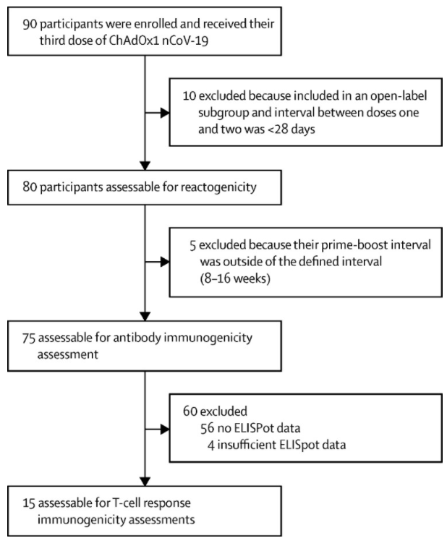
ChAdOx1 nCoV-19 = Vaxzevria (ChAdOx-1-S) COVID-19 vaccine; ELISpot = enzyme-linked immune absorbent spot.
Figure 2: Study COV001 Anti-spike protein immunoglobulin G for 75 evaluable subjects receiving third doses of Vaxzevria;8
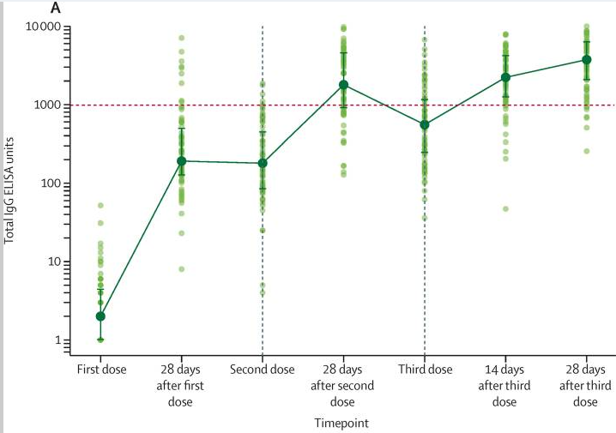
IgG = immunoglobulin G; ELISA = enzyme-linked immunosorbent assay.
Antibody levels to SARS-CoV-2 Alpha strain spike protein measured by total IgG ELISA (n = 75). Datapoints in lighter colours represent individual participants and darker datapoint show median values with error bars showing interquartile range (IQRs) and with solid lines connecting these median values.
Median immunoglobin G (IgG) levels against spike protein were significantly higher after the third dose, 3746 enzyme linked immunosorbent assay (ELISA) unit, than after the second dose, 1792 ELISA units (p = 0.0043) although the Delegate notes considerable overlap in the wide range of results observed (see Figure 2).
Figure 3: Study COV001 Neutralising antibody titres against three variants of concern (Alpha, Beta and Delta) following second and third dose Vaxzevria schedules;8
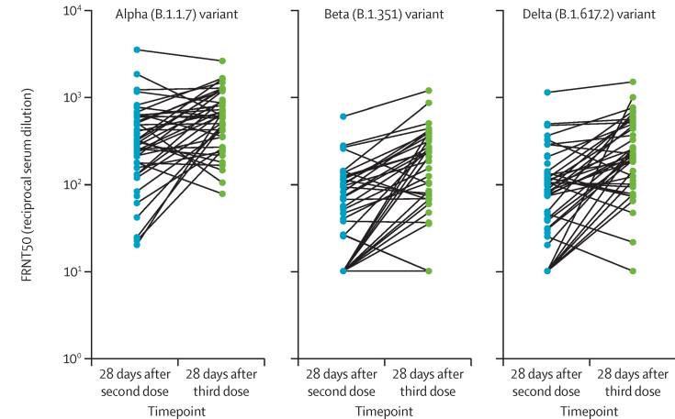
FRNT50 = focus reduction neutralisation titres with 50% neutralisation cut-off.
Neutralisation titres from a randomly selected subset of participants (45 of 75 participants who received a third dose of vaccine and who had an interval of 8 to 16 weeks between their first and second dose). Datapoints represent individual participants for the three variants of concern investigated.
Median neutralising antibody titres against alpha, beta and delta strains of COVID-19 were significantly higher after third doses than after second doses of Vaxzevria. However, the Delegate notes that there was a significant overlap in the range of these two results (see Figure 3 and Table 3).
Table 3: Study COV001 Geometric mean titre for neutralising antibodies to alpha, beta and delta variants of concern following second and third dose Vaxzevria schedules;8
CI = confidence intervals; IQR = interquartile range; n = number of study participants; V = visit.
P-values shown for pairwise comparisons using Wilcoxon sign rank test using second dose + 28 days as the reference time point.
Figure 4: Study COV001 Enzyme linked immune absorbent spot assessment of interferon gamma response stimulated by spike proteins after Vaxzevria vaccination;8
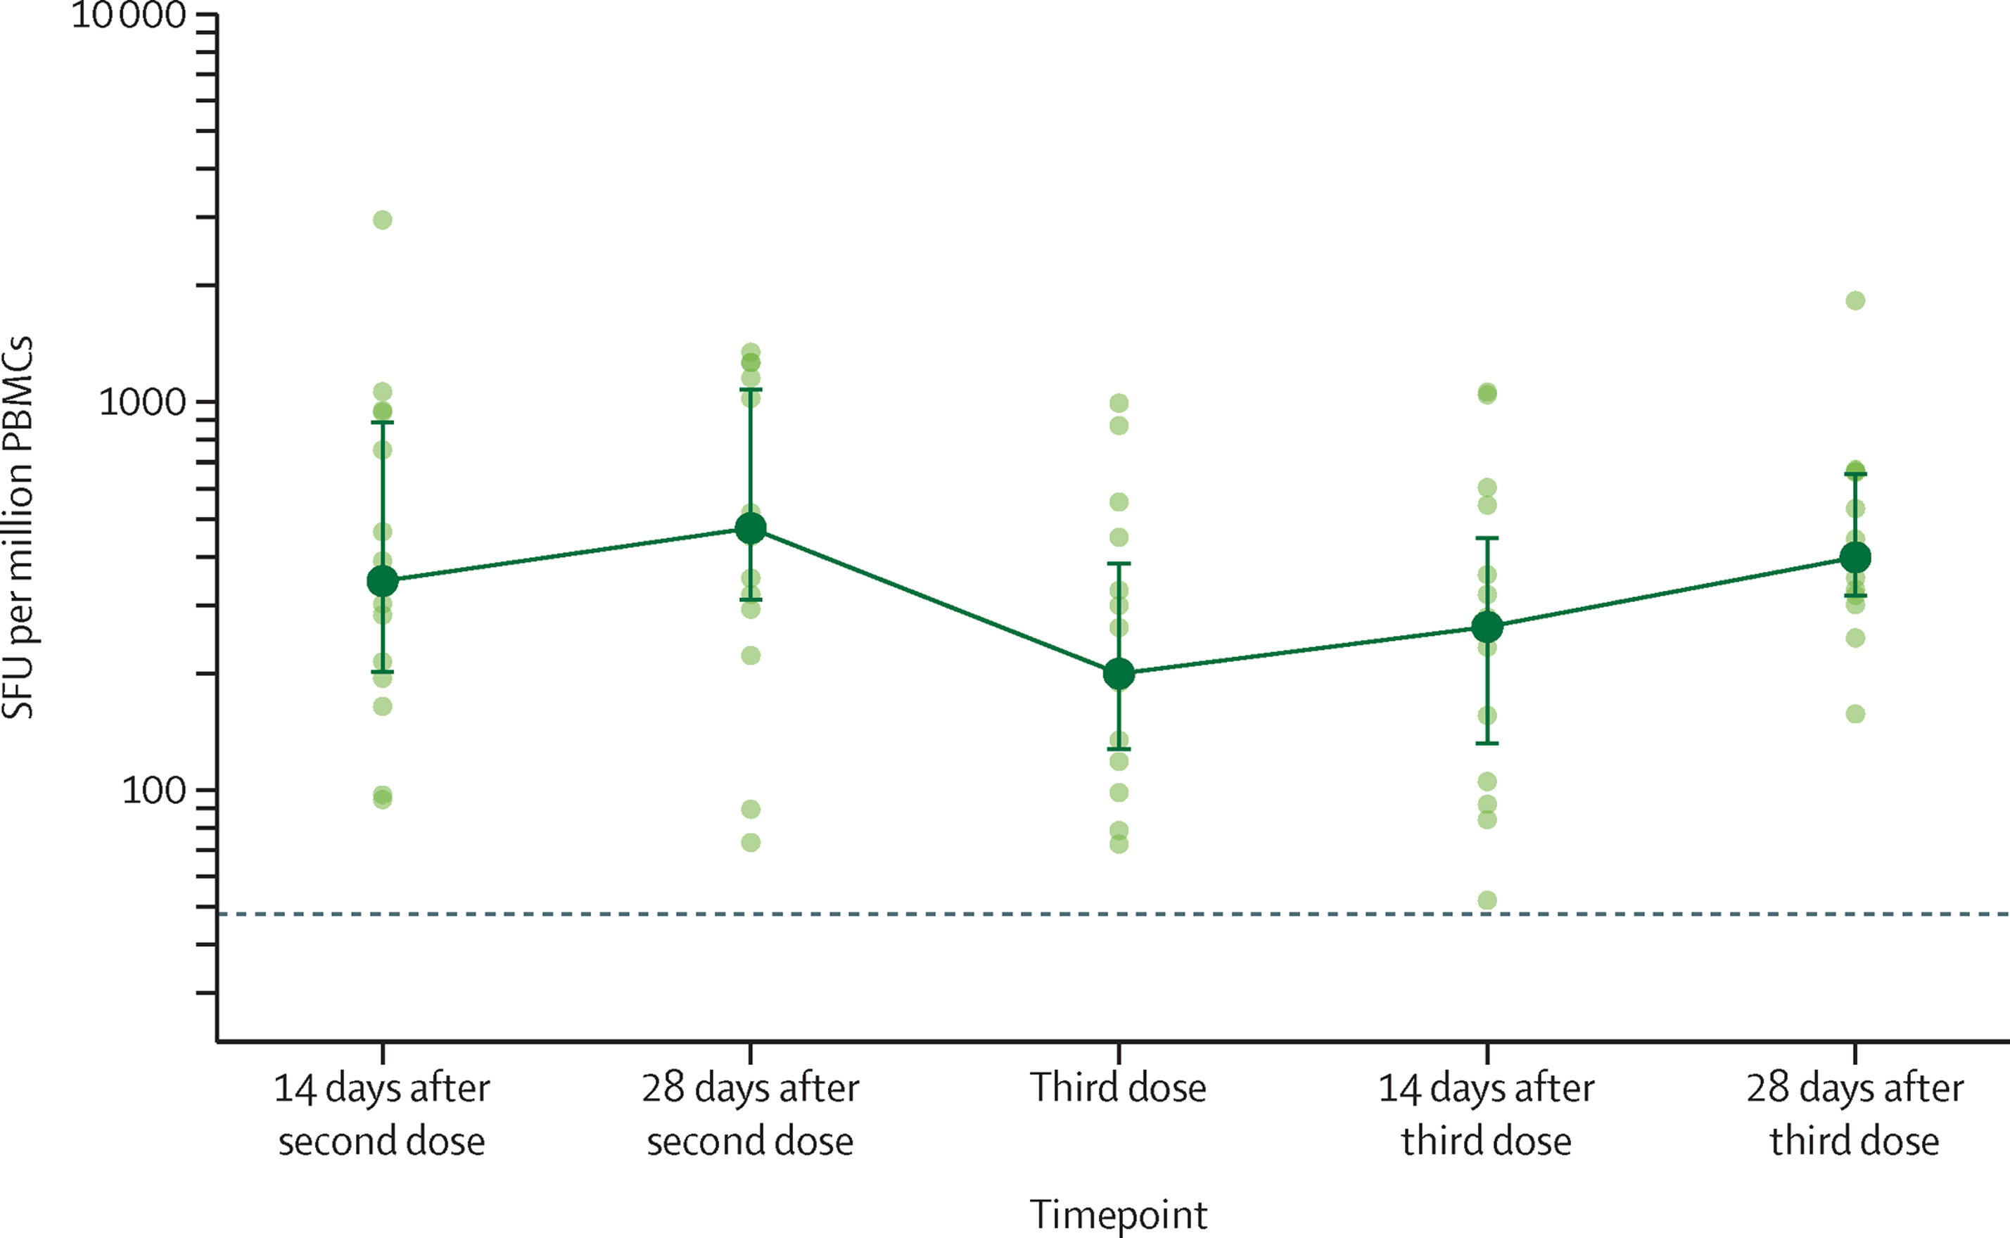
SFU=spot forming unit. PBMC=peripheral blood mononuclear cells.
15 participants with an interval of 8 weeks between their first and second doses were assessed for ELISpot responses. These participants received their third dose 37 to 38 weeks after the second dose (median 38 weeks, interquartile range 38 to 38). Datapoints in lighter colours represent individual participants and darker datapoints show median values with error bars showing the interquartile range and with solid lines connecting these median values. The dotted horizontal line represents the lower limit of detection of the assay (48 SFU per million PBMCs).
A subset of 15 subjects were selected to assess cytokine response (interferon gamma) response to vaccination. The media spot forming unit (SFU) increased from 200 per million peripheral monocytes after two doses of vaccine and at the time of the third dose, to 399 SFU/million peripheral blood mononuclear cells 28 days post the third dose. The peak response after the third dose was not significantly different from the peak response after the second dose of vaccine.

Other efficacy studies
Bar-on, Y et al. (2021); was a study from the New England Journal of Medicine detailing the deployment of BNT162b2 third booster doses; in Israel between July and August 2021. This found a 11.3-fold reduction in rates of infection and a 19.5 fold reduction in rates of severe disease in recipients of the three dose schedule compared to unboosted individuals.
This study was referenced in the sponsor’s submitted clinical overview as support for the concept of boosters but does not directly inform the efficacy of Vaxzevria.
Barrett J et al. (2021); was a Phase I/II study from Nature Medicine that provided an early examination of the immunogenicity of the two dose Vaxzevria schedule. It examined anti-vector that is ChAdOx1-S neutralising immunity. It was found that these antibodies were induced and remained elevated until 84 days after enrolment following a second vaccine dose at Day 56.
This study was referenced in the sponsor submitted clinical overview in the context of anti-vector immunity, noting that the levels of neutralising antibodies did not increase after a second dose compared to post-first dose. However, it is also noted that induced vector immunity after a third dose of Vaxzevria is not known.
Berkwerk et al. (2021); was a study from the New England Journal of Medicine that examined ‘breakthrough’ infections in health care workers vaccinated with BNT162b2;10 (Pfizer vaccine).
This study was referenced in the sponsor submitted clinical overview in the context of supporting the assertion that breakthrough infections occur. It does not directly inform the efficacy of Vaxzevria.
Bhuyan et al. (2021); was a brief description of a study that examined the rate of thrombocytopenic thrombotic syndrome (TTS) in recipients of the two dose Vaxzevria schedule based on post-marketing surveillance by the European Centre for Disease Prevention and Control. It estimated the rate of TTS within 14 days of the second dose of Vaxzevria to be approximately 2.3 per million vaccines.
This study was referenced in the sponsor submitted clinical overview in the context of reporting the rate of TTS. The clinical overview further notes:
‘In line with the reduced reactogenicity of second and third dose of AZD1222;2 compared with first dose, no increased risk of thrombosis with thrombocytopenia is anticipated following a third dose booster of AZD1222.’
Greinacher et al (2021); was a study from the New England Journal of Medicine that provided an early case series of TTS in recipients of Vaxzevria.
This study was referenced in the sponsor submitted clinical overview in support of the assertion that while a number of biological mechanisms have been proposed to explain TTS,14 the exact mechanism remains unknown.
Hall et al. (2021); was a study from the New England Journal of Medicine that examined the immune response of a third dose of mRNA vaccine administered to organ transplant recipients who had previously received two doses of the same product (mRNA-1273). This found the third dose to produce an effective boost in immune markers.
This study was referenced in the sponsor submitted clinical overview in support of the validity of third dose boosting in immunocompromised patients. It does not, however, directly inform the efficacy of Vaxzevria.
Levin et al. (2021); was a study from the New England Journal of Medicine was described waning of IgG levels in the six months following the second dose of BNT162b2;10 in the Israeli national vaccination program.
This study was referenced in the sponsor submitted clinical overview in support of the assertion that evidence suggests waning immunity following two dose vaccination has occurred and this contributes to breakthrough infections. This study does not directly inform the efficacy of Vaxzevria.
Ramasamy et al. (2021); was a Phase II/III study from the Lancet that examined the immunogenicity of a two dose regimen of Vaxzevria in 560 participants. It formed part of the sponsor submitted dossier for the original registration submission and is detailed in the clinical evaluation report.
This study was referenced in the sponsor submitted clinical overview as a general reference to the development of the two dose regimen. It does not directly inform the immunogenicity of the third dose booster regimen under consideration in this application.
Shrotri et al. (2021); was a study from the Lancet that examined the waning of anti-spike IgG levels after the two dose regimen of Vaxzevria or Comirnaty.
Figure 5: Antibody levels against spike glycoprotein of SARS-CoV-2 (S-antibody) following two dose regimen of Vaxzevria or Comirnaty
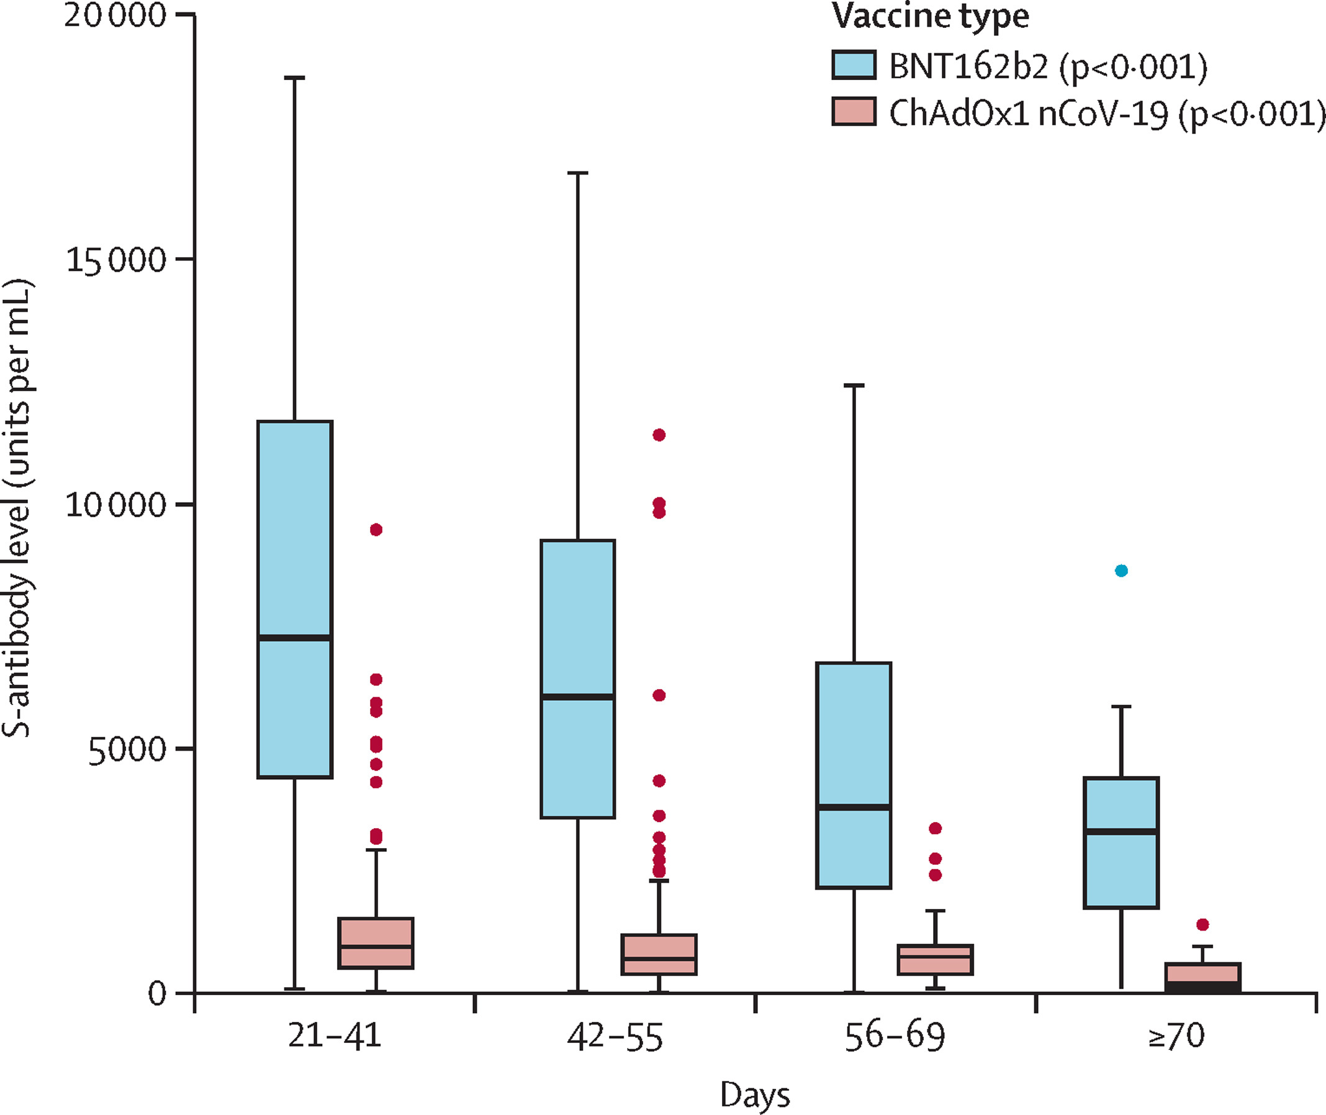
p values derived from non-parametric tests for trend for each vaccine subgroup are given in parenthesis in the key.
BNT162b2 is the product development code for Comirnaty.
ChAdOx1 nCoV-19 is the product development code for Vaxzevria.
The study found that there was a general waning of antibody levels for both vaccines regardless of the initial peak effect of the two dose schedule.
This study was references in the sponsor submitted clinical overview in support of the assertion that immunity wanes after two dose COVID-19 vaccination.
Tré-Hardy et al. (2021); was a letter to the Journal of Infectious Disease noting the waning of immunity over six months following a two dose Spikevax elasomeran (mRNA-1273);16 vaccination schedule in COVID naïve patients, but the persistence of antibodies for longer following natural infection.
This was referenced in this sponsor submitted clinical overview in support of the general assertion that immunity wanes after two doses of COVID-19 vaccine. It does not directly inform the efficacy of Vaxzevria.
Voysey et al. (2021);; were the two main studies which demonstrated the clinical efficacy of Vaxzevria in March 2021, and the additional benefit of a three-month dosing interval respectively. This includes the data from Studies COV001, COV002, COV003 and COV005 considered in the original registration application for Vaxzevria and detailed in the clinical evaluation report.
These studies were referenced in the sponsor submitted clinical overview as a general reference to the development of the two dose regimen. They do not directly inform the immunogenicity of the third dose booster regimen under consideration in this application.

Safety
The Study COV001 third booster study examined reactogenic adverse events for 7 days following administration (see Figure 6)
Figure 6: Study COV001 Solicited adverse events up to seven days following the first, second and third doses of Vaxzevria in 80 subjects with severity indicated by colour
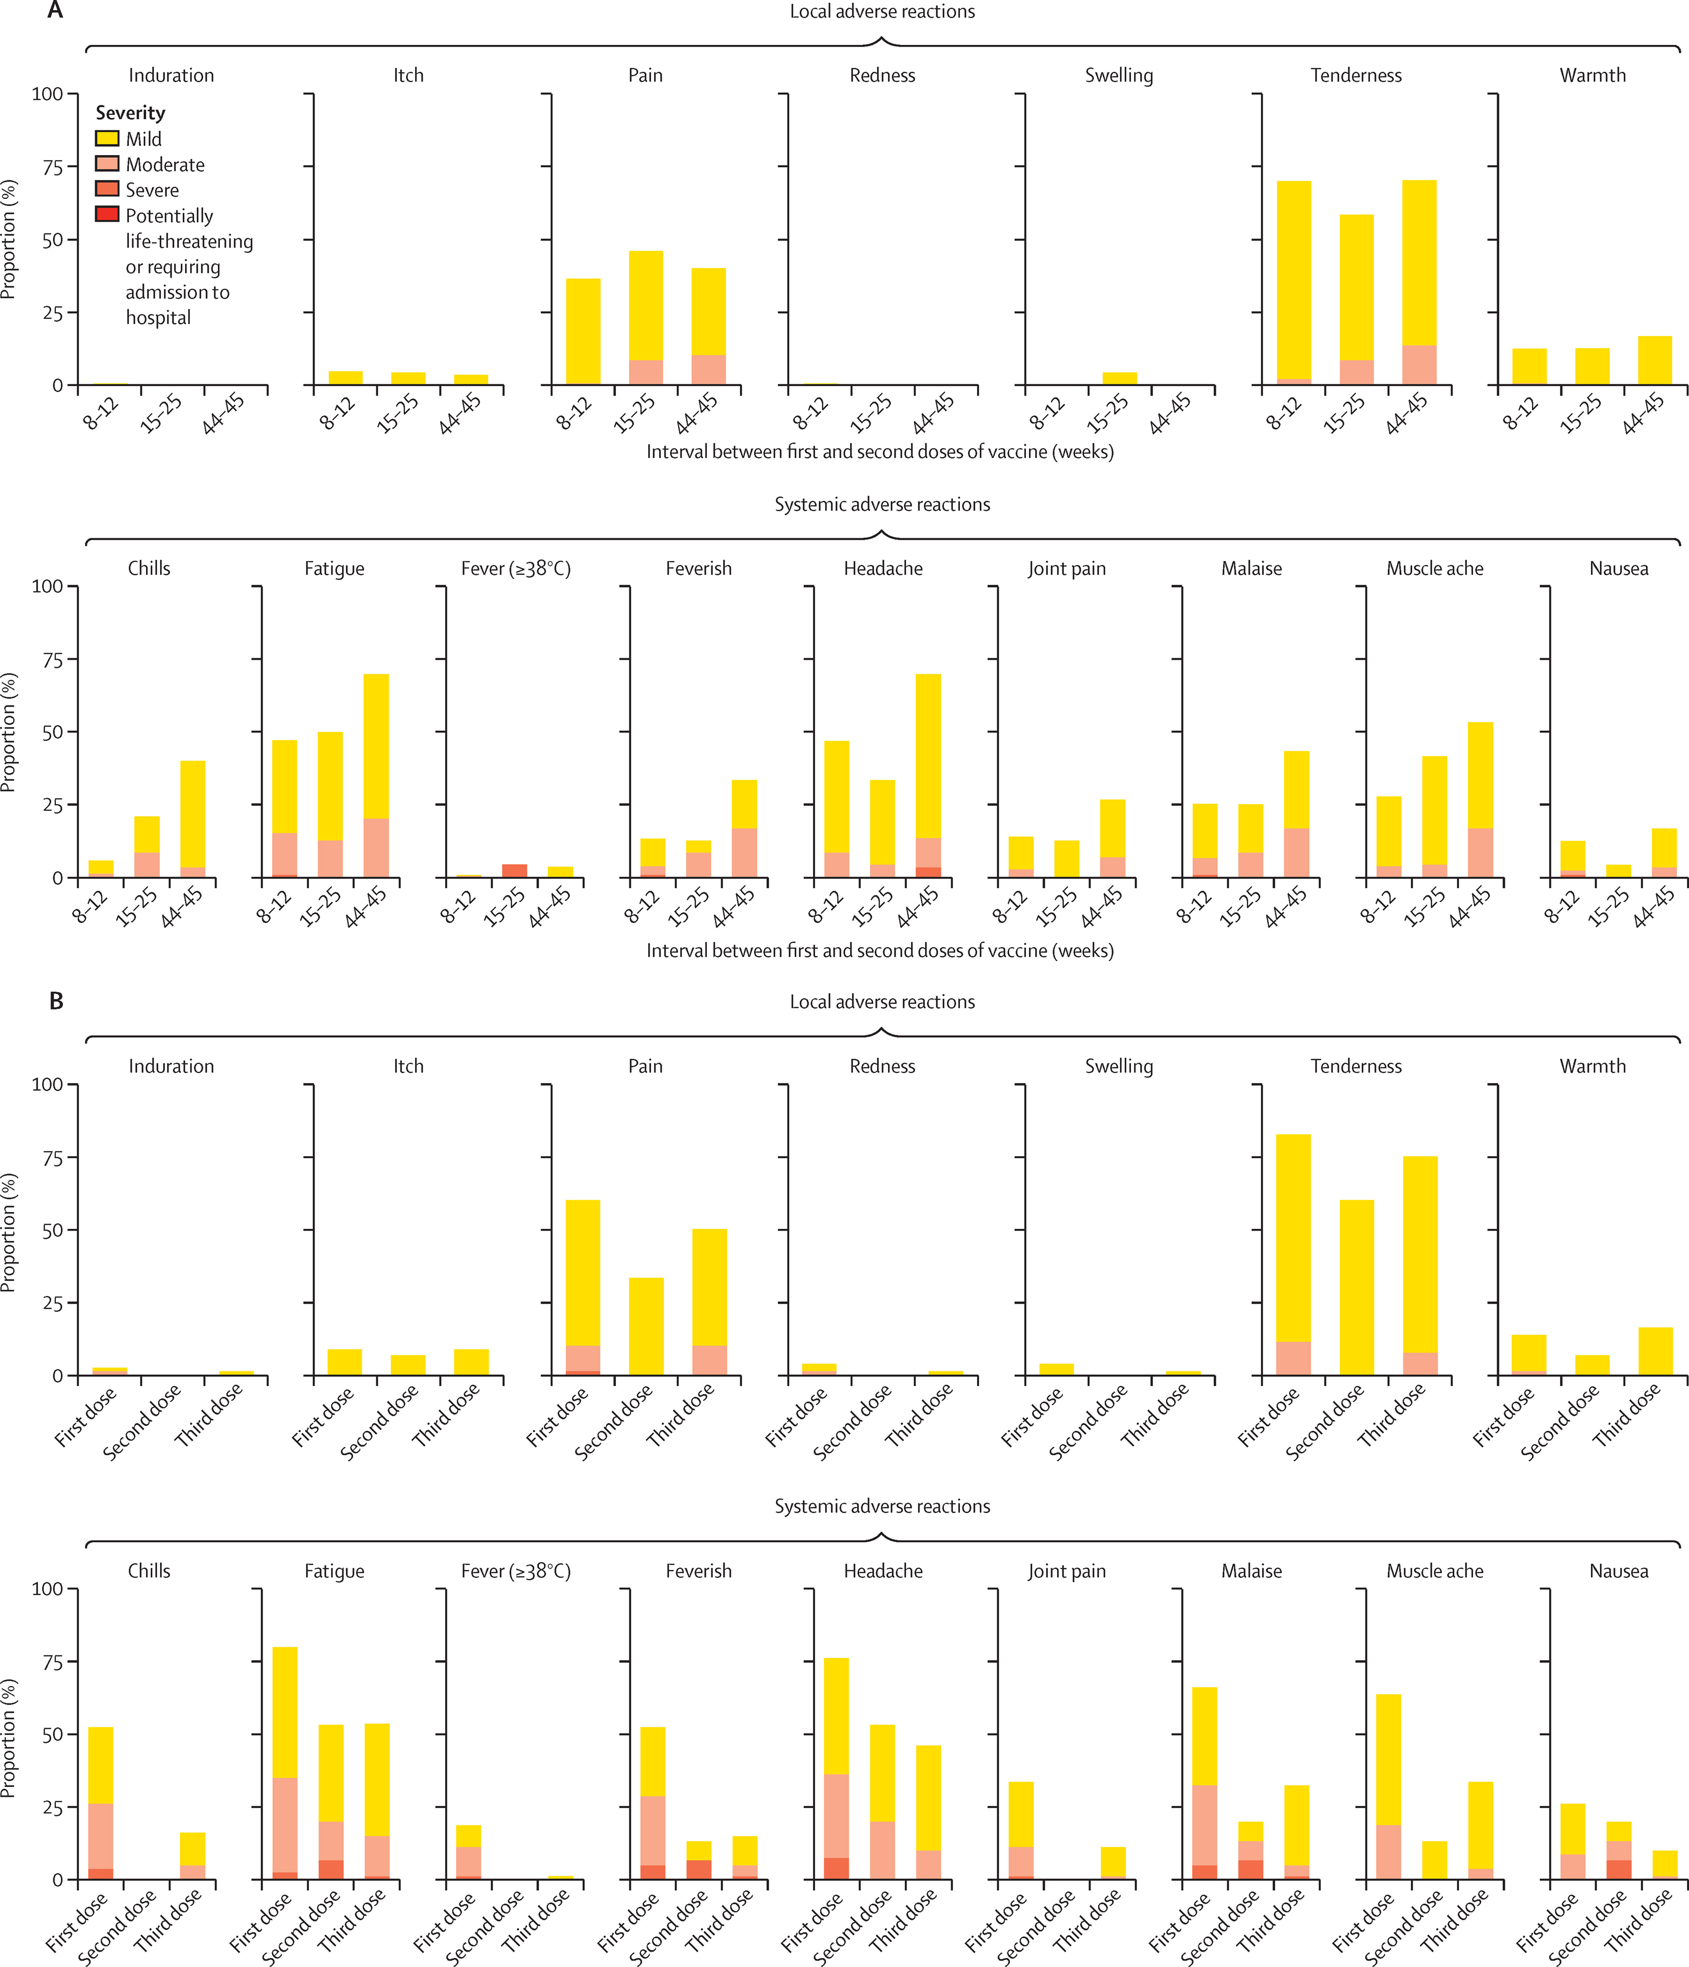

Risk management plan
The most recently evaluated EU-risk management plan (RMP) is version 3.0, Succession 3 (8 July 2021; data lock point (DLP) 25 April 2021) and Australia specific annex (ASA) version 2.0, Succession 3 (30 August 2021). The sponsor did not provide an EU-RMP or ASA specific for this application and stated that the proposed changes ‘will not results in a new or heightened risk’. Previously evaluated EU-RMP version 3.0, Succession 3 and ASA version 2.0, Succession 3 are considered applicable to this submission.
The summary of safety concerns and their associated risk monitoring and mitigation strategies are summarised in Table 4.
Table 4: Summary of safety concerns
Summary of safety concerns |  | Pharmacovigilance |  | Risk minimisation
 |  | Routine | Additional | Routine | Additional
Important identified risks | Thrombosis with thrombocytopenia syndrome | ¹ | ^{3,4,5,6,9} |  | –
Important identified risks | Anaphylaxis | ¹ | ^{4,5,6} |  | –
Important potential risks | Thrombosis | ¹ | ^{4,5,6} |  | –
Important potential risks | Nervous system disorders, including immune-mediated neurological conditions | ² | ^{4,5,6} | – | –
Important potential risks | Vaccine-associated enhanced disease (VAED), including vaccine associated enhanced respiratory disease (VAERD) | ¹ | ^{4,5,6} | – | –
Missing information | Use during pregnancy and while breastfeeding |  | ^{4,7} |  | –
Missing information | Use in immunocompromised patients |  | ^{3,4,6,8} |  | –
Missing information | Use in frail patients with co-morbidities (for example, chronic obstructive pulmonary disease, diabetes, chronic neurological disease, cardiovascular disorders) |  | ⁴ | – | –
Missing information | Use in patients with autoimmune or inflammatory disorders |  | ⁴ | – | –
Missing information | Interactions with other vaccines |  | ⁴ |  | –
Missing information | Long-term safety |  | ^{4,5,6} | – | –
1. Specific adverse reaction follow-up forms
2. Specific adverse reaction follow-up form for immune-mediated neurological conditions only
3. Interventional study - Study D8111C00010
4. Enhanced active surveillance and post-marketing observational study
5. Clinical trials excluding Study COV005
6. Study COV005
7. Pregnancy registry
8. Metanalytic post marketing safety study
9. Biodistribution study; in vitro expression of spike protein; heparin-induced thrombocytopenia (HIT) antibodies in vaccinated sera; In vitro interaction with platelet factor 4 (PF4) and/or platelets
- The summary of safety concerns was evaluated and found acceptable during the previous Submission PM-2021-02612-1-2. The introduction of a booster dose is not expected to warrant changes to the summary of safety concerns from an RMP perspective. However, the acceptability of the summary of safety concerns will be reconsidered when the advice from the clinical evaluator and the Advisory Committee on Vaccine (ACV)²⁵ is received.
- The pharmacovigilance plan was deemed acceptable during the previous evaluations and continues to be acceptable for the current submission.
- Only routine risk minimisation measures are currently in place. COVID-19 vaccines that have been approved for booster doses in Australia have not required additional risk minimisation activities as part of the RMP. Routine risk minimisation measures are considered acceptable to address the changes proposed by the current submission.

Risk-benefit analysis

Delegate’s considerations
Study COV001 trial provides prima facie evidence that a third dose of Vaxzevria:
- induces a level of anti-spike protein antibodies 28 days after the third dose that is comparable to that present 28 days after the two doses; and
- induces a level of anti-spike protein antibodies 28 days after the third dose that is significantly higher than present 28 to 38 weeks after the second dose.
The median geometric mean titre for anti-spike protein antibodies was significantly higher after the third dose of Vaxzevria than after the second. The Delegate notes, however, that the interquartile range of antibody levels showed overlap and that the median geometric mean titre may not be the most appropriate measure of central tendency in this data. Furthermore, given that there is no absolute correlate of protection for COVID-19, the clinical relevance of any difference in antibody levels is not clear. The Delegate concludes therefore that the most appropriate interpretation is that the level of antibodies is likely to provide a comparable level of protection to that clinically demonstrated one month following two doses of Vaxzevria, and this compensates for the recognised waning of this response over approximately six months following the second dose.
The Delegate notes that neutralising antibody levels obtained after three doses of Vaxzevria appear lower than those obtained from heterologous boosting with a two dose Vaxzevria primary schedule for example, ChAdOx-1-S/ChAdOx-1-S/an mRNA vaccine. Optimal treatment is not required for approval under the Therapeutic Goods Act. However, the Delegate considered whether it might be appropriate to limit a three dose Vaxzevria schedule to ‘second-line’ vaccination schedule given that it is not as effective as emerging ‘standard of care’ vaccination schedules. This would be consistent with current Australian Technical Advisory Group on Immunisation (ATAGI) advice regarding the use of third doses for example, mRNA third doses are preferred on a Vaxzevria primary schedule. The Delegate has concluded, however, that this is a matter better left to clinical implementation given that the relative effectiveness of COVID-19 vaccine platforms may change as new strains of the virus become dominant.
The Delegate considers the major methodological concerns with COV001 trial to be that:
- It is not clear from the sponsor’s application or the published account of Study COV001 exactly how the subjects who received three doses were selected from the original larger pool of participants in the two-dose Study COV001. While the trial remained blinded, it is not clear that the selection of subjects was random.
- The issue of potential selection bias is made more significant given the relatively small number of participants in the trial. Given that some millions of people have now received two doses of Vaxzevria, the external validity of the results of Study COV001 when applied to a diverse population would have been better supported by a more robust recruitment methodology.
The Delegate notes, however, that Vaxzevria is provisionally registered, and this allows discretion to consider preliminary data.
The immune response induced by Vaxzevria against three variants of concern has been measured and fits with the generally observed reduction in neutralisation against Delta variant of COVID-19. This application precedes the emergence of the Omicron variant of COVID-19.
Safety data in the dossier is limited to short term reactogenicity, and there is a general trend to lower rates of adverse reactions following the third dose than the second. The Delegate notes the small number of subjects in Study COV001 and the short period of follow up, however, and that rarer adverse events would not be detected in this trial.
The sponsor has not provided any data on anti-vector antibody levels following the third dose, having noted that they did not increase after a second dose of Vaxzevria. The Delegate notes that it is plausible that multiple exposures to ChAdOx-1-S might induce higher levels of anti-vector antibodies and considers this important to examine as a potential source of vaccine resistance in future studies on multi-dose Vaxzevria schedules.

Proposed action
The Delegate is currently minded to approve the proposed major variation of ‘Dosage and Administrations instructions’ to include a third dose of Vaxzevria as proposed by the sponsor, that is at 6 months or more after the completion of a two dose schedule.
The advice of ACV regarding whether there is sufficient data in the pivotal trial to conclude that a third dose of Vaxzevria is effective in boosting immunity against COVID-19 will be considered determinative in the Delegates final decision.

Advisory Committee considerations
The Advisory Committee on Vaccine (ACV), having considered the evaluations and the Delegate’s overview, as well as the sponsor’s response to these documents, advised the following.

Specific advice to the Delegate
- Whether there are sufficient data in the pivotal trial to conclude that a third dose of Vaxzevria is effective in boosting immunity against COVID-19.
The ACV commented that the pivotal data for this application were provided in an updated analysis of Study COV001. The ACV also took into account published clinical and immunogenicity data.
The ACV advised that there are sufficient data to support the use of a third (booster) dose of Vaxzevria. The booster dose has been shown to increase antibody levels and there were no additional safety concerns.
The ACV noted that supportive efficacy/effectiveness data against any clinical outcome were not available, and that the data/publications reflect relatively small patient groups.
The ACV noted that the rise in neutralising antibody with the third (booster) dose was no greater than achieved by delaying the second dose beyond 12 to 14 weeks.
The ACV advised that in vitro data (Dejnirattisai et al) do not suggest that a Vaxzevria booster will provide stronger protection against infection and clinical outcomes with the Omicron variant.
The ACV advised that data from Munro et al; suggest boosted responses are better following an mRNA vaccine rather than following Vaxzevria. The ACV discussed the place of this vaccine as a booster in the current clinical context of available COVID-19 vaccines in Australia and commented that there is a clinical need in the small number of Australians who cannot have mRNA vaccines, but advised that this matter is primarily a consideration for ATAGI.
- Advice on the Product Information
The ACV advised that the following sentence should be added into the PI:
‘The use of COVID-19 boosters should be in line with official recommendations.’
The ACV advised the following sentence should be added into the PI (Section 4.2):
‘The risk of Thrombosis and Thrombocytopenia following a third dose of Vaxzevria has not yet been determined.’
This undetermined risk also applies to persons receiving a Vaxzevria booster dose following vaccination with a primary series with another COVID-19 vaccine.
Published data comparing Vaxzevria to other COVID-19 vaccines could be referenced within the clinical trials section of the PI, for example:
‘The relative efficacy of Vaxzevria as a booster compared to other vaccines as boosters is not known. However, it is noted that the incremental increase in antibody concentrations is lower following a booster with ChAdOx1-S than following mRNA vaccines in published studies. This is likely to translate into lower efficacy against infection (particularly with Omicron variant) and/or a shorter duration of protection’.
Additionally, the ACV commented on the following statement in the Section 4.4 of the PI:
‘Interchangeability: There are no safety, immunogenicity or efficacy data to support interchangeability of Vaxzevria with other COVID-19 vaccines’.
This is not accurate as there is a public-domain, peer-reviewed publication (Munro et al)²⁷ that shows that boosting with an mRNA vaccine after the two dose primary series of Vaxzevria appears to be more immunogenic than boosting with Vaxzevria.
The ACV advised that wording in the PI regarding the booster indication should be modified as needed to avoid confusion for persons who have received a three dose primary series consistent with the current official recommendation (not PI recommendation) for persons who are severely immunocompromised.
The ACV advised that wording in the PI regarding dosage (Section 4.2) could say:
‘It is recommended that individuals who receive a first dose of Vaxzevria receive a second Vaxzevria dose’ rather than ‘complete the vaccination course’.
The ACV supported alignment of terminology used within dosage directions (for example, the use of booster dose or third dose) across all COVID-19 vaccines, and terms like ‘complete vaccination course’ should be avoided as this is now ambiguous.
- Other advice
The ACV commented that anti-vector responses could play a role in attenuating immune responses to the vaccine. There are currently no publicly available data on anti-vector responses after a third dose of Vaxzevria (ChAdOx1-S). The ACV advised that any available data should be reviewed by the TGA.

Conclusion
The ACV recommended the approval of changes to the Product Information of Vaxzevria to include a booster (third) dose for persons aged 18 years and older.
The use and timing of Vaxzevria booster in adults should be in accordance with official recommendations.
The efficacy of Vaxzevria booster against the Omicron variant has not yet been determined.

Outcome
Based on a review of quality, safety and efficacy, the TGA approved the registration of Vaxzevria (ChAdOx-1-S) 1 x 10¹¹ viral particles (vp)/mL, solution for injection, multi-dose vial, change in dose regimen to:
‘The Vaxzevria primary vaccination course consists of two separate doses of 0.5 mL each. The second dose should be administered between 4 and 12 weeks after the first dose (see Section 5.1 Pharmacodynamic properties).
It is recommended that individuals who receive a first dose of Vaxzevria receive a second dose of Vaxzevria (see Section 4.4 Special warnings and precautions for use).
A third (booster) dose of 0.5 mL may be given if clinically indicated with reference to official guidance regarding the use of a heterologous third dose ([for example] e.g. mRNA vaccine).
A third (booster) dose of Vaxzevria should be administered at least 6 months after a second dose of Vaxzevria.’

Specific conditions of registration applying to these goods
- Vaxzevria (ChAdOx1-S) is to be included in the Black Triangle Scheme. The PI and [Consumer Medicine Information] CMI for Vaxzevria must include the black triangle symbol and mandatory accompanying text for the products entire period of provisional registration.
Risk management plan
The Vaxzevria EU-risk management plan (RMP) (version 3 succession 3, dated 8 July 2021, data lock point 25 April 2021), with Australian specific annex (version 2 succession 3, dated 30 August 2021), and any subsequent revisions, as agreed with the TGA will be implemented in Australia.
Existing conditions
Clinical
- The sponsor is to provide the full study reports of Studies COV001, COV002, COV003 and COV005 when available in 2022 as a [TGA Category 1] Cat. 1 Type J or Type F application.
- The sponsor is to provide updates to the TGA in relation to additional information relevant to efficacy of Vaxzevria against new and emerging variants of COVID-19.
- The sponsor is to provide further information to the TGA in relation to use of the COVID-19 vaccine with influenza vaccines when available.
- The sponsor is to provide the TGA with updates of the studies in the pharmacovigilance plan in relation to the safety of the vaccine in pregnancy, the immunosuppressed and those with co-morbidities with the PSUR every6 months
- Unless otherwise agreed to by the secretary following an application under Section 9D of the [Therapeutic Goods Act 1989] Act, the new Vaxzevria medicine must only be supplied with the labels that have been determined to be acceptable in this decision.
Quality
- Batch release testing and compliance
It is a condition of registration that all independent batches of [Vaxzevria] (ChAdOx1-S) vaccine imported into Australia are not supplied for distribution by or on behalf of the sponsor until samples and the manufacturer’s release data have been assessed and [the sponsor has] received notification acknowledging release from the Laboratories Branch, TGA.
For each independent batch of the product imported into Australia, the sponsor must supply the following:
  - A completed request for release form, available from vaccines@health.gov.au.
  - Complete summary protocols for manufacture and [quality control] QC, including all steps in production in the agreed format.
  - At least 10 (ten) vials (samples) of each manufacturing batch of COVID-19 Vaccine AstraZeneca (ChAdOx1-S) with the Australian approved labels, PI and packaging (unless an exemption to supply these has been granted) representative of all batches of product seeking distribution in Australia.
  - At least 5 (five) vials (Samples) of any further consignments of a manufacturing batch COVID-19 Vaccine AstraZeneca (ChAdOx1-S) with the Australian approved labels, PI and packaging (unless an exemption to supply these has been granted). Further consignments cover batches previously supplied to TGA for the purposes of batch release testing but are seeking to be supplied again.
  - If the manufacturing batch has been released in Europe or United Kingdom a copy of the EU Official Control Authority Batch Release (OCABR) certificate (or equivalent from the UK) must be provided.
  - Any reagents, reference material and standards required to undertake testing, as requested by Laboratories Branch, TGA.
Sponsors must provide all requested samples and data in sufficient time (at least 5 business days) prior to any distribution date to allow the TGA to perform testing and review. Distribution of each batch of vaccine is conditional upon fulfilment of these conditions and receipt of a letter from the Laboratories Branch acknowledging release.
Samples and data should be forwarded to the Biotherapeutics Section, Laboratories Branch before release of each batch and with sufficient lead time to allow for Laboratories Branch testing.
The shipments (including reagents) to TGA are the responsibility of the Australian sponsor/agent who will be required to facilitate the import and customs clearance process.
- Certified Product Details
An electronic copy of the Certified Product Details (CPD) as described in Guidance 7: Certified Product Details of the Australian Regulatory Guidelines for Prescription Medicines (ARGPM) https://www.tga.gov.au/guidance-7-certified-product-details should be provided upon registration of the therapeutic good. In addition, an updated CPD, for the above products incorporating the approved changes is to be provided within one month of the date of approval letter. A template for preparation of CPD for biological prescription medicines and vaccines can be obtained from the TGA website (https://www.tga.gov.au/form/certified-product- details-cpd-biological-prescription- medicines). The CPD should be sent as a single bookmarked [portable document format] PDF document to vaccines@health.gov.au as soon as possible after registration/approval of the product or any subsequent changes as indicated above.

Attachment 1. Product Information
The PI for Vaxzevria approved with the submission which is described in this AusPAR is at Attachment 1. For the most recent PI, please refer to the TGA website at <https://www.tga.gov.au/product-information-pi>.

Therapeutic Goods Administration
PO Box 100 Woden ACT 2606 Australia
Email: info@tga.gov.au Phone: 1800 020 653 Fax: 02 6232 8605
https://www.tga.gov.au

The Black Triangle Scheme provides a simple means for practitioners and patients to identify certain types of new prescription medicines, including those being used in new ways and to encourage the reporting of adverse events associated with their use. The Black Triangle does not denote that there are known safety problems, just that the TGA is encouraging adverse event reporting to help us build up the full picture of a medicine's safety profile.
AZD1222 is the product development code for Vaxzevria.
World Health Organization, WHO Director-General Speeches: WHO Director-General's Opening Remarks at the Media Briefing on COVID-19 - 11 March 2020, 11 March 2020. Available at: https://www.who.int/director-general/speeches/detail/who-director-general-s-opening-remarks-at-the-media-briefing-on-covid-19---11-march-2020.
AusPAR for Vaxzevria ChAdOx1-S AstraZeneca Pty Ltd PM 2020 06115 1-2. Available at: https://www.tga.gov.au/auspar/auspar-chadox1-s.
World Health Organization (WHO) Tracking SARS-CoV-2 Variants, updated on 25 January 2022. Available at: https://www.who.int/en/activities/tracking-SARS-CoV-2-variants/ (accessed 27 January 2022).
As part of the provisional approval pathway, the provisional registration process will allow certain medicines to be provisionally registered in the Australian Register of Therapeutic Goods (ARTG) for a limited duration. These medicines are registered on the basis of preliminary clinical data, where there is the potential for a substantial benefit to Australian patients. The TGA will re-assess risks related to the absence of evidence through data provided at a later stage, as part of the confirmatory data. Confirmatory data should confirm the relationship between outcomes predicted by the surrogate endpoint, or other preliminary data, and the clinical benefit as demonstrated by direct clinical outcomes. The sponsor may apply to transition to full registration at any time up until the provisional registration lapse date, once they have completed the obligations outlined for the provisional registration period and complete confirmatory data on safety and efficacy are available.
The MenACWY vaccine is a vaccination conveying protection against meningococcal disease caused by serogroups A, C, W and Y.
Flaxman et al. Reactogenicity and Immunogenicity after a Late Second Dose or a Third Dose of ChAdOx1 nCoV-19 in the UK: a Substudy of two Randomised Controlled Trials (COV001 and COV002), Lancet, 2021; 398(10304): 981-990.
Bar-On, Y. et al. Protection of BNT162b2 Vaccine Booster Against COVID-19 in Israel, N Engl J Med, 2021; 385: 1393-1400.
BNT162b2 is the product development code for Comirnaty.
Barrett, J. et al. Phase 1/2 Trial of SARS-CoV-2 Vaccine ChAdOx1 nCoV-19 with a Booster Dose Induces Multifunctional Antibody Responses, Nat Med, 2021; 279–288.
Bergwerk, M. et al. COVID-19 Breakthrough Infections in Vaccinated Health Care Workers, N Engl J Med, 2021; 385: 1474-1484
Bhuyan, P. et al. Very Rare Thrombosis with Thrombocytopenia after Second AZD1222 Dose: a Global Safety Database Analysis, Lancet, 2021; 398(10300): 577-578.
Greinacher, A. et al. Thrombotic Thrombocytopenia after ChAdOx1 nCov-19 Vaccination, N Engl J Med, 2021; 384: 2092-2101.
Hall, V. G. et al. Randomized Trial of a Third Dose of mRNA-1273 Vaccine in Transplant Recipients, N Engl J Med, 2021; 385: 1244-1246.
mRNA-1273 is the product development code for Spikevax.
Levin, E.G. et al. Waning Immune Humoral Response to BNT162b2 COVID-19 Vaccine over 6 Months, N Engl J Med, 2021; 385: e84.
Ramasamy et al. Safety and Immunogenicity of ChAdOx1 nCoV-19 Vaccine Administered in a Prime-Boost Regimen in Young and Old Adults (COV002): a Single-Blind, Randomised, Controlled, Phase II/III Trial, Lancet, 2020; 396: 1979-1993.
Shrotri, M. et al. Spike-Antibody Waning after Second Dose of BNT162b2 or ChAdOx1, Lancet, 2021; 398: 385-387.
Tré-Hardy, M. et al. Reactogenicity, Safety and Antibody Response, after One and Two Doses of mRNA-1273 in Seronegative and Seropositive Healthcare Workers, J Infect, 2021; 83(2): 237-279.
Voysey, M. et al. Safety and Efficacy of the ChAdOx1 nCoV-19 Vaccine (AZD1222) Against SARS-CoV-2: an Interim Analysis of Four Randomised Controlled Trials in Brazil, South Africa, and the UK, Lancet, 2021; 397: 99-111.
Voysey, M. et al. Single-Dose Administration and the Influence of the Timing of the Booster Dose on Immunogenicity and Efficacy of ChAdOx1 nCoV-19 (AZD1222) Vaccine: a Pooled Analysis of Four Randomised Trials, Lancet, 2021; 397: 881-891.
Routine risk minimisation activities may be limited to ensuring that suitable warnings are included in the product information or by careful use of labelling and packaging. Routine pharmacovigilance practices involve the following activities: - All suspected adverse reactions that are reported to the personnel of the company are collected and collated in an accessible manner; - Reporting to regulatory authorities; - Continuous monitoring of the safety profiles of approved products including signal detection and updating of labelling; - Submission of PSURs; - Meeting other local regulatory agency requirements.
Therapeutic Goods Act 1989: The Therapeutic Goods Act, along with the Therapeutic Goods Regulations, and Orders are key pieces of legislation that sets out the requirements for inclusion of therapeutic goods in the Australian Register of Therapeutic Goods, including advertising, labelling, product appearance and appeal guidelines. Some provisions such as the scheduling of substances and the safe storage of therapeutic goods, are covered by the relevant State or Territory legislation.
The Advisory Committee on Vaccines (ACV) provides independent medical and scientific advice to the Minister for Health and the Therapeutic Goods Administration (TGA) on issues relating to the safety, quality and efficacy of vaccines supplied in Australia including issues relating to pre-market assessment, post-market monitoring and safe use in national immunisation programs. The Committee is established under Regulation 39F of the Therapeutic Goods Regulations 1990 and the members are appointed by the Minister for Health. The ACV was established in January 2017, following consolidation of previous functions of the Advisory Committee on the Safety of Vaccines (ACSOV) and the pre-market functions for vaccines of the Advisory Committee on Prescription Medicines (ACPM). Membership comprises professionals with expertise in specific scientific, medical or clinical fields, or consumer health issues.
Dejnirattisai, W. et al. Omicron-B.1.1.529 Leads to Widespread Escape from Neutralizing Antibody Responses, bioRxiv, 2021; 2021.12.03.471045.
Munro, A. P. S. et al, Safety and Immunogenicity of Seven COVID-19 Vaccines as Third Dose (Booster) Following Two doses of ChAdOx1 nCov-19 or BTN162b2 in the UK (COV-BOOST): a Blinded, Multicentre, Randomised, Controlled Phase II Trial, Lancet, 2021; 398: 2258-2276.
Department of health, ATAGI recommendations on the use of a third primary dose of COVID-19 vaccine in individuals who are severely immunocompromised, published on 8 October 2021, last updated on 19 January 2022. Available at: https://www.health.gov.au/resources/publications/atagi-recommendations-on-the-use-of-a-third-primary-dose-of-covid-19-vaccine-in-individuals-who-are-severely-immunocompromised.

