November 2019

Australian Public Assessment Report for Cenegermin (rbe)
  - Proprietary Product Name: Oxervate
  - Sponsor: JACE Pharma Pty Ltd

About the Therapeutic Goods Administration (TGA)
- The Therapeutic Goods Administration (TGA) is part of the Australian Government Department of Health and is responsible for regulating medicines and medical devices.
- The TGA administers the Therapeutic Goods Act 1989 (the Act), applying a risk management approach designed to ensure therapeutic goods supplied in Australia meet acceptable standards of quality, safety and efficacy (performance) when necessary.
- The work of the TGA is based on applying scientific and clinical expertise to decision-making, to ensure that the benefits to consumers outweigh any risks associated with the use of medicines and medical devices.
- The TGA relies on the public, healthcare professionals and industry to report problems with medicines or medical devices. TGA investigates reports received by it to determine any necessary regulatory action.
- To report a problem with a medicine or medical device, please see the information on the TGA website <https://www.tga.gov.au>.
About AusPARs
- An Australian Public Assessment Report (AusPAR) provides information about the evaluation of a prescription medicine and the considerations that led the TGA to approve or not approve a prescription medicine submission.
- AusPARs are prepared and published by the TGA.
- An AusPAR is prepared for submissions that relate to new chemical entities, generic medicines, major variations and extensions of indications.
- An AusPAR is a static document; it provides information that relates to a submission at a particular point in time.
- A new AusPAR will be developed to reflect changes to indications and/or major variations to a prescription medicine subject to evaluation by the TGA.
Copyright
© Commonwealth of Australia 2019
This work is copyright. You may reproduce the whole or part of this work in unaltered form for your own personal use or, if you are part of an organisation, for internal use within your organisation, but only if you or your organisation do not use the reproduction for any commercial purpose and retain this copyright notice and all disclaimer notices as part of that reproduction. Apart from rights to use as permitted by the Copyright Act 1968 or allowed by this copyright notice, all other rights are reserved and you are not allowed to reproduce the whole or any part of this work in any way (electronic or otherwise) without first being given specific written permission from the Commonwealth to do so. Requests and inquiries concerning reproduction and rights are to be sent to the TGA Copyright Officer, Therapeutic Goods Administration, PO Box 100, Woden ACT 2606 or emailed to <tga.copyright@tga.gov.au>.

Contents
Common abbreviations 4
I. Introduction to product submission 6
Submission details 6
Product background 6
Regulatory status 7
Product Information 8
II. Registration timeline 8
III. Submission overview and risk/benefit assessment 9
Quality 9
Nonclinical 9
Clinical 11
Risk management plan 18
Risk-benefit analysis 20
Outcome 22
Attachment 1. Product Information 23

Common abbreviations
Abbreviation | Meaning
ACM | Advisory Committee on Medicines
ADR | Adverse drug reaction
AE | Adverse event(s)
ARTG | Australian Register of Therapeutic Goods
ASA | Australian-specific annex
BAX | Bcl-2-associated X protein
BCDVA | Best corrected distance visual acuity
BCVA | Best corrected visual acuity
Bcl-2 | B-cell lymphoma 2
CI | Confidence interval
CMI | Consumer Medicines Information
CNS | Central nervous system
EC₅₀ | Half maximal effective concentration
EMA | European Medicines Agency (EU)
EDTRS | Early Treatment Diabetic Retinopathy Study
EU | European Union
EU-RMP | European Union-Risk Management Plan
F0 | Parental strain animals
F1 | First filial generation
FDA | Food and Drug Administration (USA)
GLP | Good Laboratory Practice
IC₅₀ | Half maximal inhibitory concentration
ICH | International Conference on Harmonisation
ITT | Intention-to-treat
Ki | Inhibitory constant
LOCF | Last observation carried forward
LogMAR | Logarithm of the minimum angle of resolution
mNGF | Murine nerve growth factor
NGF | Nerve growth factor
NK | Neurotrophic keratitis
nM | Nanomolar
p75LNGFR | Low-affinity nerve growth factor receptor p75
P7NTR | P75 neurotrophic receptor
PED | Persistent epithelial defect
PI | Product Information
PK | Pharmacokinetic(s)
pM | Picomolar
PSUR | Periodic safety update report
rbe | Recombinant biological entity
rhNGF | Recombinant human nerve growth factor
RMP | Risk management plan
SC | Subcutaneous
SD | Standard deviation
TEAE | Treatment emergent adverse event(s)
TESAE | Treatment emergent serious adverse event
TrkA | Tropomyosin receptor kinase A
µg/mL | Micrograms per millilitre

I. Introduction to product submission

Submission details
Type of submission: | New biological entity
Decision: | Approved
Date of decision: | 16 September 2019
Date of entry onto ARTG: | 1 October 2019
ARTG number: | 310960
Black Triangle Scheme | Yes  This product will remain in the scheme for 5 years, starting on the date the product is first supplied in Australia.
Active ingredient: | Cenegermin (rbe)
Product name: | Oxervate
Sponsor’s name and address: | JACE Pharma Pty Ltd  7 Clunies Ross Court,  Eight Mile Plains QLD 4113
Dose form: | Eye drops, Solution
Strength: | 20 µg/mL
Container: | Vial
Pack size: | 7/carton
Approved therapeutic use: | Treatment of moderate (persistent epithelial defect) or severe (corneal ulcer) neurotrophic keratitis in adults.
Route of administration: | Ophthalmic
Dosage: | Adults  The recommended dose is one drop of Oxervate in the conjunctival sac of the affected eye(s), 6 times a day at 2 hourly intervals, starting from the morning and within 12 hours. Treatment should be continued for eight weeks.  For further information refer to the Product Information (PI).

Product background
This AusPAR describes the application by JACE Pharma Pty Ltd (the sponsor) to register Oxervate (cenegermin rbe) eye drop solution for the following indication:
[…] treatment of moderate (persistent epithelial defect) or severe (corneal ulcer) neurotrophic keratitis in adults.
Neurotrophic keratitis (NK) is a rare, degenerative corneal disease induced by an impairment of trigeminal corneal innervation, leading to a decrease or absence of corneal sensation. Many ocular and systemic diseases can cause lesions at different levels of the fifth cranial nerve and, as a consequence, an impairment of corneal sensorial innervation. The most common factors that lead to NK are herpetic infections of the cornea, surgery for trigeminal neuralgia, and surgery for acoustic neuroma. Disease severity is classified into three stages according to the Mackie classification; and the disease is treated accordingly. The presence of epithelial dystrophy or punctuate keratopathy (Stage 1) requires discontinuation of all topical medications and administration of preservative-free artificial tears. In the majority of patients, this treatment is sufficient to delay the progression of Stage 1 disease. When a persistent epithelial defect (PED) develops (Stage 2), the goal of treatment is to avoid further progression of the disease to a frank corneal ulcer, and the same therapeutic approaches as in Stage 1 are used, though, with a lower rate of success. Therapeutic contact lenses have been used with some efficacy, but may increase the risk of microbial keratitis and corneal ulceration. When a corneal ulcer develops (Stage 3), therapy is aimed at promoting corneal healing, and preventing corneal melting and perforation. Surgical procedures at this stage can preserve or restore ocular integrity but they often sacrifice cosmetic appearance and visual function. There are also no medications available that can improve corneal sensitivity, thus there is no possibility for NK patients to be cured and disease-free.
Nerve growth factor (NGF) is a polypeptide that is naturally present in the eye and is essential for the survival and growth of sympathetic and sensory neurons and for differentiation of neurons in the central nervous system (CNS). NGF binds with two entirely distinct classes of receptors: 1) tropomyosin receptor kinase A (TrkA), a transmembrane tyrosine kinase that is also known as high-affinity NGF receptor; and 2) low-affinity NGF receptor (p75 LNGFR), also called p75 neurotrophin receptor (p75NTR). NGF and TrkA are expressed on structures of the anterior segment of the eye (iris, ciliary body, lens, cornea and conjunctiva), by the lacrimal gland, and by many intraocular tissues. Activation of these receptors by NGF plays a role in the trophism of the cornea. NGF appears to modulate some of the principal functions of epithelial cells and fibroblasts, either directly or via the induction of other cytokines/growth factors. Specifically, NGF induces in vitro corneal epithelial cell proliferation and differentiation and it is involved in maintaining limbal epithelial stem cell potential.
The active drug substance of cenegermin is a recombinant form of human NGF (rhNGF) produced in Escherichia coli. rhNGF production in mammalian cells does not achieve good yields, so a manufacturing process based on the use of recombinant E. coli was developed by Dompé farmaceutici S.p.A so that an ophthalmic formulation of rhNGF could be developed. Clinical development was initially based upon findings of efficacy in more than 100 patients with NK who were treated with murine-derived NGF (mNGF), extracted from submaxillary glands of mice. Nonclinical studies showed that the biological activity of rhNGF was similar or possibly superior to that of mNGF.

Regulatory status
Oxervate (cenegermin rbe) is considered a new biological entity for Australian regulatory purposes.
Oxervate (cenegermin rbe) was granted Orphan Drug designation on 23 May 2018 for the ‘treatment of neurotrophic keratitis’. Designation for priority review was granted on 30 August 2018.
At the time the TGA considered this application, a similar application had been approved in the European Union (EU; approved on 6 July 2017), Canada (approved on 8 February 2019), the United States of America (USA; approved on 22 August 2018), Switzerland (approved on 6 September 2018) and Israel (approved on 23 January 2019).

Product Information
The Product Information (PI) approved with the submission which is described in this AusPAR can be found as Attachment 1. For the most recent PI, please refer to the TGA website at <https://www.tga.gov.au/product-information-pi>.

II. Registration timeline
Table 1 captures the key steps and dates for this application and which are detailed and discussed in this AusPAR.
Table 1: Timeline for Submission PM-2018-04728-1-5
Description | Date
Granted positive Designations for:  Orphan Drug  Priority review | 23 May 2018  30 August 2018
Submission dossier accepted and first round evaluation commenced | 31 October 2018
Evaluation completed | 18 June 2019
Delegate’s Overall benefit-risk assessment and request for Advisory Committee advice | 1 July 2019
Sponsor’s pre-Advisory Committee response | 17 July 2019
Advisory Committee meeting | 1-2 August 2019
Registration decision (Outcome) | 16 September 2019
Completion of administrative activities and registration on ARTG | 1 October 2019
Number of working days from submission dossier acceptance to registration decision* | 181
*Target timeframe for priority applications is 150 working days from acceptance for evaluation to the decision.

III. Submission overview and risk/benefit assessment
The submission was summarised in the following Delegate’s overview and recommendations.

Quality
The drug substance developed by Dompé farmaceutici S.p.A. is expressed in E. coli as pro-protein, from which the pro-sequence is cleaved with trypsin to produce mature NGF. In this process, pro-NGF is produced as inclusion bodies of E. coli, then solubilised in a strong denaturing agent and subsequently refolded to the native conformation. The recombinant human pro-NGF is captured from refolded product using a chromatographic step and, successively, the pro-sequence is cleaved with trypsin to generate rhNGF. Further purification to homogeneity is achieved using two successive chromatographic columns. After buffer exchange and formulation, the drug substance protein solution is filtered and sent to final filling.
Cenegermin is delivered as 20 micrograms per millilitre (µg/mL) preservative-free sterile eye drop solution (ophthalmic solution). It is presented in vials for daily use, with 1 drop being administered 6 times daily, after a 2 hour interval from the previous administration.
Oxervate (cenergermin) is dispensed from the pharmacy as a frozen solution. The patient will receive a weekly kit with seven multi-dose vials and will store them in a refrigerator until use. Each box of drug product is provided in combination with a delivery system which includes 45 pipettes, 8 vial adapters and 45 disinfectant wipes. Each of the vials is for multi-dose use over the course of a single day. The product must be kept refrigerated and the opened vial can be stored in the fridge or below 25°C, but must be used within 12 hours. The biological evaluator considered the accuracy of the pipette in delivering this dose and considered this to be acceptable (8% relative standard deviation). The stability for in use conditions was also acceptable.
The initial formulation contained rhNGF as a concentration of up to 180 µg/mL. The same formulation but with lower concentrations (10 and 20 µg/ml) was used in one of the Phase I/II clinical studies. Due to a trend in the preliminary results of this study, and manufacturing considerations suggesting oxidation may affect the quality and stability of the product, a small amount of an anti-oxidant (L-methionine) was added. Subsequently 3 further clinical studies were performed.
The biological evaluator recommended approval.

Nonclinical
- The submitted nonclinical dossier was in accordance with the relevant International Conference on Harmonisation (ICH) guideline for the nonclinical assessment of biological medicines (ICH S6). The overall quality of the nonclinical dossier was high. Pivotal safety-related (toxicity) studies were Good Laboratory Practice (GLP) compliant.
- Under in vitro conditions, rhNGF exhibited nanomolar (nM) affinity for its major receptor target, TrkA (half maximal inhibitory concentration (IC₅₀) 7.45 nM; inhibitory constant (Ki) 3.73 nM). The other target, the low-affinity nerve growth factor receptor p75 (p75LNGFR) was not assessed. Trophic activity by rhNGF was evident in rat and human cell lines, with increases in neurite projections, neurite length and markers denoting neurite development and differentiation. Potency of the proliferative effects of rhNGF ranged between half maximal effective concentration (EC₅₀) values of 9.2 to 28 picomolar (pM). Under in vivo conditions, rhNGF increased conjunctival goblet cell density and production of mucins to protect the ocular surface. Moreover, rhNGF attenuated retinal cell death and led to increases in pro-mitotic markers (TrkA and B-cell lymphoma 2 (Bcl-2)) but decreases in apoptopic signals (caspases 3 and 9, annexin-V, and Bcl-2-associated X protein (BAX)).
- No dedicated secondary pharmacodynamics studies were conducted. The negligible systemic exposure and selectivity for TrkA and p75 receptors by rhNGF indicate that off-target effects are unlikely. Safety pharmacology assessments of rhNGF were limited to the CNS, where a functional observational battery found no treatment-related effects on behaviour, reflexes, locomotor function and grip strength.
- Repeat dose toxicity studies by the clinical (topical eye drops) and subcutaneous (SC) routes were conducted in rats (up to 26 weeks) and in rabbits (up to 13 weeks). Doses used in the rat were up to 3.8 times as high as the human relative dose, while rabbit doses ranged between 12 and 23 times the human relative dose (as µg/day applied to the eyes). Cenegermin/rhNGF was well tolerated by both species and by either route of administration, with findings being relatively benign and mostly limited to the eye (transient conjunctival redness, minimal grade iris lesions). The inclusion of the antioxidant excipient L-methionine in the formulation used in some rabbit studies was well-tolerated with no distinguishing toxicities observed. Overall, rhNGF administered by the clinical route was well tolerated by both species.
- No genotoxicity were performed. Considering that rhNGF is a recombinant protein not expected to directly interact with DNA or chromosomal material, this is acceptable. Although rhNGF has potential for mitotic growth, carcinogenicity studies are not considered useful because of observed immunogenic responses to rhNGF in laboratory species. Furthermore, due to low systemic exposures and short duration of treatment, rhNGF is not expected to represent a significant risk of carcinogenicity under clinical conditions of use.
- Rat fertility assessments did not reveal any treatment-related impairment to male and female fertility. Embryofetal developmental studies in the rat (but not the rabbit) using the SC route showed increased post-implantation losses and developmental abnormalities in the treated groups at very high relative exposure levels. The high incidence of anti-rhNGF antibodies in rabbits may have attenuated the effects of rhNGF enough to reduce its potential influence on embryofetal development. This may also explain the absence of adverse findings in the rat pre-/postnatal development study where anti-rhNGF antibodies were found in almost all parental strain (F0) and first filial generation (F1) animals. Despite these uncertainties, the negligible systemic exposure to cenegermin observed with clinical use suggest that risk of reproductive toxicity by Oxervate cenegermin (rbe) will be negligible.
There were no nonclinical objections to the registration.
The evaluator recommended the pregnancy category be changed to Category B3.
It was noted that although the systemic exposures of rhNGF is likely to be negligible with the clinical use of Oxervate, the proposed Australian pregnancy Category B1; was not consistent with the observed adverse embryofetal effects in rats.

Clinical
See Table 2 for the clinical studies included in the dossier.
Table 2: Clinical studies included in the dossier
Type | Study number | Description
Clinical pharmacology | NGF0112 | Pharmacokinetics (PK) in healthy population ( single and multiple doses)
Clinical and pharmacology | NGF0212 | Multi-dose PK, dose finding, efficacy and safety in NK
Safety and efficacy | NGF0214 | Efficacy and safety in NK
Safety | NGF0113 | Study in retinitis pigmentosa
Safety | NGF0213 | Study in dry eye
Device usability | NEST-4-127 | Healthy subjects
The submission did not include paediatric data. The sponsor has stated that they had an agreed paediatric investigation plan in Europe for the use of Oxervate in children < 18 years. There was a requirement to perform toxicology studies in rats and rabbits, as well as a qualitative review of toxicology data from animals or humans. However it is unclear to the delegate if these studies have been performed, and if the European Medicines Agency (EMA) have approved use in the paediatric population. The evaluator has stated that the sponsor submitted paediatric data in the USA Food and Drug Administration (FDA) for the 2 to 11 years and 12 to 17 years age group. In the USA, the product is approved for use in paediatric patients over 2 years of age.
The human cornea has reached full growth and maturation by 2 years, and that there is no clinical difference between NK in child or adults.

Pharmacology
PK Study NGF0112 studied the systemic exposure of NGF in healthy adults who received 1 drop of NGF at 1 to 3 times a day. The concentration of formulation varied from 20 to 180 µg/mL. The serum concentrations were found to be not significantly different to baseline, and in many cases below the level of quantification.
No evidence of systemic absorption was also demonstrated in Study NGF0212 when patients received 2 drops of the 20 µg/mL solution 6 times a day for 8 weeks.
Data on pharmacodynamics came from in vitro studies and studies in animals.
In humans, NGF receptors are expressed in the anterior segment of the eye (cornea, conjunctiva, iris, ciliary body, and lens), by the lacrimal gland, and by posterior segment intraocular tissues.

Efficacy

Dose finding studies
The 20 µg/mL formulation was used due to results of pre-clinical studies, a literature review of mNGF and a dose finding study comparing 10 and 20 µg/mL strength formulations. The 20 µg/mL formulation was found to be more efficacious on some parameters than the 10 µg/mL formulation. However, the frequency of dosing was not tested. It is unclear why an 8 week period was chosen.

Pivotal Study NGF0212
Study NGF0212 was an 8 week Phase I/II, multicentre, randomised, double masked, vehicle controlled parallel group study with a 48 or 56 week follow up period to evaluate the safety and efficacy of two doses (10 µg/mL and 20 µg/mL) of rhNGF eye drops solution versus vehicle in patients with Stage 2 and 3 NK.
The primary efficacy endpoint was complete corneal healing, as measured by the central reading centre evaluating clinical pictures of corneal staining.
Secondary endpoints included complete healing as measured by the investigator, duration of complete healing, improvement in visual acuity, improvement in corneal sensitivity, percentage of patients achieving complete corneal clearing.
The inclusion criteria and exclusion were described in detail in the clinical evaluation report, and included:
- Adults with Stage 2 or Stage 3 NK in one eye that had been present for at least 2 weeks and refractory to treatment;
- The defect had to have no evidence of improvement within 2 weeks of enrolment;
- Best corrected distance visual acuity (BCDVA) score was ≤ 75 Early Treatment Diabetic Retinopathy Study (EDTRS) letters (≥ + 0.2 logarithm of the minimum angle of resolution (logMAR) or ≤ 20/32 using the Snellen chart); and
- Evidence of reduced corneal sensitivity.
Patients were not allowed to wear contact lenses. Patients with evidence of corneal ulceration in the posterior one third of the eye, corneal melting or perforation of the eye were excluded.
Subjects were randomised in Phase I to the following treatment arms: rhNGF 10 µg/mL, rhNGF 20 µg/mL or vehicle control. In Phase II, patients previously in the active arm stopped treatment if the defect was healed, or continued the current dose. Patients previously in the control arm were randomised to one of the two treatment groups for 8 weeks. Patients who had a corneal defect which healed with rhNGF but recurred were able to be treated. It is unclear what sort of training patients had to instill the eye drops.
In Phase I, 18 patients were enrolled to evaluate safety; in Phase II, the study was powered to detect a 30% improvement in corneal healing.
The primary endpoint for this study was complete healing evaluated at Week 4. Complete healing was defined by the sponsor (and agreed by the EMA) as the percentage of patients experiencing complete healing, defined as the greatest diameter of the corneal fluorescein staining in the area of the PED or corneal ulcer, as determined by the reading centre, being less than 0.5 mm at the Week 4 visit. This was later amended at the prompting of the FDA to be defined as no corneal fluorescein staining in the area of the PED or corneal ulcer, and non-persistent lesions in the surrounding area of the cornea.

Phase I
There were 7 patients in each of the NGF groups, and 4 in the vehicle control group. 2 patients from the 10 µg/mL and vehicle control group were withdrawn due to adverse events (AE).
10 patients had Stage 2 NK, 8 had Stage 3 NK. The duration of NK before treatment was greater in those who received rhNGF (approximately 12 months) versus those in the placebo group (approximately 5 months).
At Week 4, complete healing of NK was achieved by 3 out of 7 patients in the 10 µg/mL group, 3 out of 7 in the 20 µg/mL group and 1 out of 4 in the placebo group. At Week 8, complete healing was achieved by 4 out of 6 patients in the 10 µg/mL group, 6 out of 7 in the 20 µg/mL group and 1 out of 2 in the vehicle control group. A 15 letter improvement in BCDVA was achieved by 3 out of 7 patients in the 20 µg/mL group by Week 8, but no patient in the vehicle control group. An improvement in corneal sensitivity was achieved by 3 out of 5 patients in the 20 µg/mL group and 2 out of 2 patients in the vehicle control group at Week 8.
Of those patients who were healed at Week 8, most remained healed at Week 56. More patients in the rhNGF group gained visual acuity during this period. Corneal sensitivity also improved during the follow up period.

Phase II
There were 52 patients in each of the NGF groups and control group. The dropout rate was high; 33.3%. AE occurred in 9 patients in each of the NGF groups and 2 in the vehicle control group. 23 of the 52 patients which were initially randomised to the control group were subsequently randomised to rhNGF.
76 patients had Stage 2 NK and 80 patients had Stage 3 NK. The mean time since initial diagnosis was 28 months in the 10 µg group, 30 months in the 20 µg group and 24 months in the placebo group.
Complete healing was achieved by over 50% in each of the rhNGF groups compared to 20% of the control group. The response was numerically greater in the 20 µg/mL group. The improvement in response rate over vehicle control was statistically significant for both groups.
Table 3: Study NGF0212 Summary and primary efficacy analysis of percentage of patients who achieved complete healing at Week 4 (LOCF) as determined by the reading centre, Phase II (ITT population)
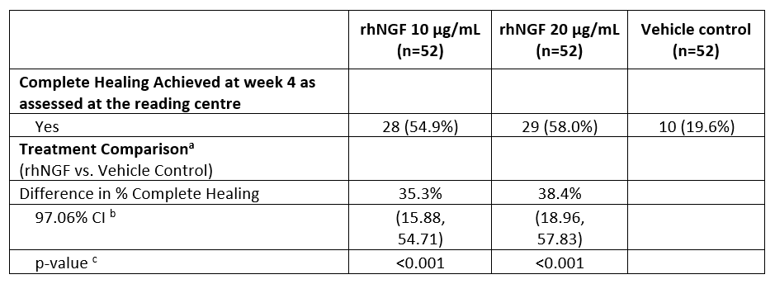

CI = confidence interval; ITT = intent-to-treat; LOCF = last observation carried forward. Top n counts relate to the number of patients randomized to each treatment at Baseline. The significance level for the statistical tests is 0.0294 (adjusted according to Pocock). a = rhNGF 10 μg/mL and rhNGF 20 μg/mL were each compared against the vehicle control group. b = Asymptotic (Wald) CI. c = Asymptotic p-value based on Pearson statistic from Chi-Square test.
At Week 8, there were numerically greater gains in BCDVA in the rhNGF groups than the vehicle control group, these were only statistically significant for the 10 µg/mL group. A 15 letter gain in BCDVA score at Week 8 was achieved by 27.5% (confidence interval (CI): 8.33, 46.67; p = 0.008) more than placebo for rhNGF 10 μg/mL and 19.0% (CI: -0.91, 38.83; p = 0.068) for rhNGF 20 μg/mL). There was no difference in the improvement in corneal sensitivity at Week 4 and Week 8 between rhNGF and vehicle.
Differences in results were observed when described based on endpoint analysis by reading centre or the investigator. There was also a difference in healing noted at week 4, 6 and 8. I suspect this reflected the variable nature of the condition.
Table 4: Study NGF0212 Summary and analysis of percentage of patients who achieved complete healing at Week 8 (LOCF) as determined by the Reading Centre (ITT population)
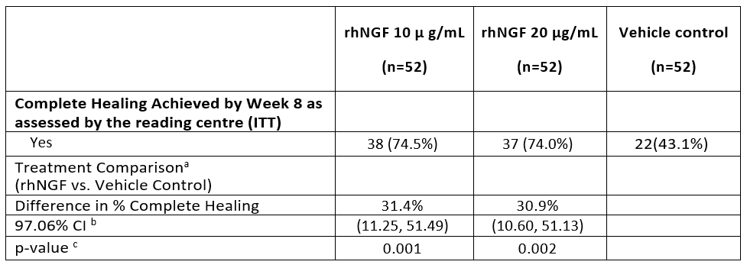
CI = confidence interval; ITT = intent-to-treat; LOCF = last observation carried forward; rhNGF = recombinant human nerve growth factor. Top n counts relate to the number of patients randomized to each treatment at Baseline. The significance level for the statistical tests is 0.0294 (adjusted according to Pocock).a = rhNGF 10 μg/mL and rhNGF 20 μg/mL were each compared against the vehicle control group. b = Asymptotic (Wald) CI. c = Asymptotic p-value based on Pearson statistic from Chi-Square test.
Of the 100 patients who had a response available after 12 weeks of follow up (at Week 20/28), 2 patients (5.1%) in the rhNGF 10 µg/mL group and 4 patients (10.0%) in the rhNGF 20 µg/mL group had a recurrence of PED or corneal ulcer. None of the 21 completely healed patients in the vehicle control group with a response available had a recurrence at this time point during the follow-up period.
The difference in the percentage of patients who achieved complete healing with no residual staining at Week 8 between the rhNGF 20 µg/mL group and the vehicle control group was 38.7% (97.06% CI: 18.72, 58.62), and was statistically significant (p < 0.001).
At 48 weeks, 83.9, 80 and 95% of patients in the 10 µg/mL, 20 µg/mL and placebo groups remained completely healed. An increase in BCDVA of over 15 letters was achieved in 58%, 37% and 28% of these patients. Improved corneal sensitivity was observed almost all of those patients who had healing.

Study NGF0214
Study NGF0214 was an 8 week Phase II, multicentre, randomised, double masked, vehicle controlled, parallel group study with a 24 or 32 week follow up period to evaluate the efficacy of a formulation containing anti-oxidant of rhNGF in 20 µg /mL, eye drops solution versus vehicle containing anti-oxidant in patients with Stage 2 or 3 NK.
Primary efficacy endpoint: To evaluate the efficacy of 20 µg/mL 6 times a day of rhNGF containing anti-oxidant, eye drops solution compared to vehicle (formulation containing anti-oxidant) given 6 times a day in inducing a complete healing of Stage 2 (PED) and 3 (corneal ulcer) NK as measured by the central reading centre, evaluating the clinical pictures of corneal fluorescein staining.
Secondary efficacy endpoint: To assess the duration of complete healing, improvement in visual acuity and improvement in corneal sensitivity, and percentage of patients achieving complete corneal clearing defined as complete absence of staining on the modified Oxford Scale.
The study had an 8 week double blind, randomised, controlled treatment period and a 24 or 32 week, follow up period. The duration of the follow up period of 24 weeks (approximately 6 months) or 32 weeks (approximately 8 months) was determined by the randomised treatment received and the clinical outcome following the completion of the 8 week controlled treatment period. The maximum study duration was 40 weeks (approximately 10 months).
Inclusion and exclusion criteria were similar to Study NGF 0212.
Patients in the initial vehicle control group were allowed to be treated with rhNGF in the next treatment period. Patients were allowed an additional treatment for 8 weeks for recurrence.
Figure 1: Study NGF0214 Patient disposition
Percentages are based on the ITT population. Patients should only have one reason for not completing the study.+ One patient [Information redacted] had been randomized to rhNGF, although not eligible for this study, and discontinued from the study before receiving any study medication. ++ Percentage of screened patients. *In the rhNGF group one patient was worried about her treated eye after she had experienced an adverse event (possible ocular infection) and withdrew from the study; the other [Information redacted] had non-controlled intraocular pressure and glaucoma specialist recommended patient not to participate in the study. ** Six patients of the vehicle group terminated controlled period prematurely and continued directly into uncontrolled treatment period. Therefore, they did not have a reason for discontinuing the controlled period. *** In the vehicle group 7 patients were not completely healed at Week 8 and entered into the uncontrolled treatment phase. One patient as considered as not completely healed at Week 8, but did not enter uncontrolled treatment period upon discretion of the investigator.
As in Study NGF0212, there was a large dropout rate during the study with only 2 out of 3 of patients completing, 2 out of 24 patients in the rhNGF group and 2 out of 24 patients in the vehicle control group withdrew due to AE. 6 patients from the vehicle controlled treatment period entered the uncontrolled treatment period in order to access the study drug.
There was a statistically significant difference in favour of rhNGF between the percentages of patients reaching complete healing at Week 8: 69.6% in the rhNGF treated group versus 29.2% in the vehicle treated group; p = 0.006. Similar results were seen with the sensitivity analyses.
There was a statistically significant difference in favour of rhNGF between the percentages of patients reaching no corneal fluorescein staining at Week 8: 65.2% (15 out of 23) in the rhNGF treated group versus 16.7% (4 out of 24) in the vehicle treated group; p < 0.001.
There was no statistically significant difference in improvement in visual acuity between the two treatments at Week 8. The mean (standard deviation (SD)) change from baseline in BCDVA was 4.48 (9.825) in the rhNGF group and 4.33 (10.399) in the vehicle group.
There was no statistically significant difference for improvement in corneal sensitivity between the two treatments (p = 0.207).

Safety
The evaluator was uncertain if the sponsor had provided the most recent safety analysis.
The sponsor had included two safety pools in the summary of clinical safety. The primary safety pool included data from the two pivotal studies; Studies NGF0212 and NGF0214. The secondary safety pool contained data from all five studies, including one in retinitis pigmentosa and one in dry eye.
In the rhNGF pool, 78 patients had been exposed for 6 to 8 weeks, the longest period of exposure was 12 weeks. In the secondary pool, 315 patients had received rhNGF for > 1 day, 181 had received treatment for 8 weeks and 40 patients had received treatment for 24 weeks.
There were more treatment emergent adverse events (TEAE) in patients receiving rhNGF than those with vehicle control, with some dose effects. There were high number of patients discontinuing treatment during the study, the reason for this is unclear.
Table 5: Overview of treatment emergent adverse events in the secondary safety pool
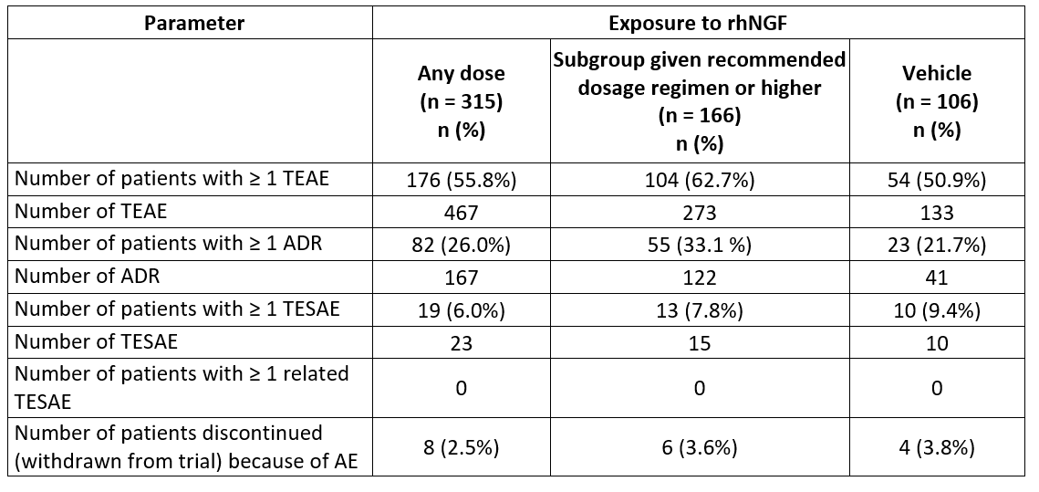
ADR = adverse drug reaction; n = number of subjects/patients; rhNGF = recombinant human nerve growth factor; TEAE = treatment emergent adverse events; TESAE = treatment emergent serious adverse event.
Table 6: Summary of adverse events by System Organ Class or by Preferred Term occurring in ≥ 5% of patients in the primary safety pool
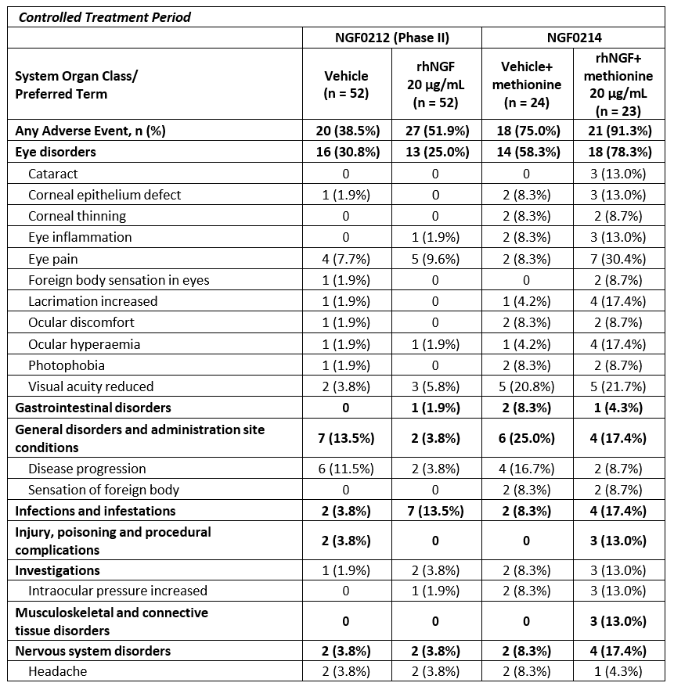
In the secondary safety pool, eye irritation and eye pain occurred more commonly in the rhNGF group.
There were very few serious adverse effects attributable to the study drug.
In the analysis of secondary safety, a total of 12 TEAEs led to discontinuation in 8 patients allocated to any dose of rhNGF. Ten TEAEs in 6 patients led to discontinuation during treatment with the recommended dosage of rhNGF. A total of 4 AE in 4 patients in vehicle groups led to discontinuation. The rates of patients discontinuing study drug because of AEs was slightly lower with rhNGF than with vehicle (2.5 to 3.6% versus 3.8%), mainly due to discontinuation due to disease progression.
In Study NGF0212, 13 patients experienced 20 AEs leading to discontinuation: 9 patients in the rhNGF 20 µg/mL group and 4 (7.7%) patients in the vehicle control group. Disease progression was the most frequently reported AE leading to discontinuation during the controlled treatment period, occurring in 5 patients (3.2%) overall (2 patients in the rhNGF 20 µg/mL group and 3 patients in the vehicle control group). This was followed by reduced visual acuity which occurred in 4 patients (3.8%) overall, (2 patients in the rhNGF 20 µg/mL group and 2 patients in the vehicle control group).
In Study NGF0214: 5 patients (21.7%) in the rhNGF 20 µg/mL group and 7 patients (29.2%) in the vehicle control group discontinued due to AE. Disease progression was the most frequent cause of discontinuation (10.6% patients, 3 patients in the vehicle group and 2 in the rhNGF 20 µg/mL group) followed by corneal thinning (6.4% patients, 2 patients in the vehicle group and one in the rhNGF 20 µg/mL group).
Four patients (2.6%) reported at least 1 AE leading to discontinuation of study drug during the follow up period: 1 patient in the rhNGF 10 µg/mL group (disease progression), 2 patients in the rhNGF 20 μg/mL group (disease progression/lack of efficacy, and keratitis, uveitis and bacterial infection) and 1 patient in the vehicle control group (ophthalmic herpes).

Immunogenicity
Immunogenicity was evaluated in four of the five rhNGF clinical studies: in healthy volunteers (Study NGF0112), in two NK (Studies NGF0212 and NGF0214), and in one in retinitis pigmentosa (Study NGF0113). None of the studies showed that patients developed systemic antibodies to the study drug.

Post marketing experience
The sponsor submitted two periodic safety update reports (PSUR). The cumulative post market exposure is estimated to be 130 patients. It included 4 cases of off label use in children.

Risk management plan
- The sponsor submitted European Union-risk management plan (EU-RMP) version 1.0 (16 May 2017; data lock point 22 February 2017) and Australian-specific annex (ASA) version 1.0 (22 February 2017) in support of the application. In response to rolling questions sent 18 March 2019, the sponsor has submitted updated ASA version 1.1 (21 March 2019).
- The proposed summary of safety concerns and their associated risk monitoring and mitigation strategies are summarised in Table 7, below.
Table 7: Risk management plan for Oxervate
Summary of safety concerns |  | Pharmacovigilance |  | Risk Minimisation
 |  | Routine | Additional | Routine | Additional*
Important identified risks | Nil | – | – | – | –
Important potential risks | Serious corneal disorders | † | – |  | –
Missing information | Use in patients with active ocular cancer |  | – |  | –
Missing information | Use in patients with active eye infections |  | – |  | –
Missing information | Use in patients with corneal melting or impending perforation requiring immediate surgery |  | – |  | –
Missing information | Concomitant use with topical ophthalmic products that impair the healing process including corticosteroids and eye drops containing preservatives such as benzalkonium chloride polyquaternium-1, benzododecinium bromide, cetrimide and other quaternary ammonium derivatives |  | – |  | –
Missing information | Off-label use |  | – |  | –
Missing information | Use with contact lenses |  | – |  | –
Missing information | Use in pregnancy |  | – |  | –
* The sponsor has included a weekly dose recording card as an aide to correct dosing. † Specific adverse drug reaction follow up form
- The sponsor has proposed routine pharmacovigilance and no additional pharmacovigilance activities. This is acceptable in the context of global pharmacovigilance for this product.
- The sponsor has proposed routine risk minimisation for all safety concerns. During evaluation the sponsor agreed to made changes to the Consumer Medicines Information (CMI) for clarity and to include the CMI in the product package. The risk minimisation activities are acceptable.

Risk-benefit analysis

Delegate’s considerations

Discussion
NK is a rare disease with significant morbidity in some cases.
The contents of the dossier reflected the topical nature of the product and rarity of the disease. Statistically significant and clinically important improvements in the healing of corneal defects were noted in the pivotal clinical studies. However, there was limited evidence of improvements in visual acuity or corneal sensitivity. Long term follow up for up to 48 weeks suggested that most eyes remained healed. Patients with contact lenses and corneal perforation were excluded from the study.
The period of treatment in the pivotal studies was 8 weeks. The number of eyes that healed increased from 4 to 8 weeks. Published studies using mNGF have used eye drops until complete corneal healing. Thus optimal duration of therapy may be longer than that proposed.
Most AEs were mild. Oxervate does cause irritation and pain.
In the clinical study using the formulation containing anti-oxidant methionine, there was less improvement in the control arm and a greater number of adverse events. The sponsor has attributed this to a different study population. It is difficult to draw conclusions from one study. However, whether methionine has an impact on the efficacy and safety of the formulation is uncertain.

Overall impression
The Delegate was of the opinion that this treatment offers a significant benefit to a group of patients who risk poor visual outcomes from their condition. The AE profile is acceptable.
However, the Delegate had some questions to the sponsor in relation to educational materials around the storage and administration. Further studies into longer period of treatment, and long term efficacy and safety would be recommended.
The Delegate notes that there are routine risk mitigation and pharmacovigilance activities.

Summary of issues
- This indication was given Orphan Drug designation.
- The submission was accepted as a priority review.
- This medicine is a new biological eye drop solution containing rhNGF.
- There were 2 pivotal studies evaluating an 8 week course of treatment. Both studies showed statistically and clinically significant in healing in corneal defects. However, the impact on visual acuity was limited; less than 60% of those who healed had improved visual outcomes.
- There is limited long-term efficacy data.
- There is limited long-term safety data.

Proposed action
The Delegate has no reason to say, at this time, that the application for Oxervate should not be approved for registration.

Request for ACM advice
- Is an improvement in corneal healing a valid endpoint to assess efficacy? Comment on the limited improvement in visual acuity and corneal sensitivity.
- What is the most appropriate measure to assess improvement in visual acuity; mean change in best corrected visual acuity (BCVA) or improvement over 15 letters?
- Comment on the PI and CMI in relation to instructions for storage, handing and administration. Is this information clear enough? Do you have any further advice on how this may be improved?
- Is it feasible for patients with contact lenses to administer eye drops so frequently? Patients with contact lenses were excluded from the clinical trials, however in the PI it is recommended that patients with contact lenses remove these before eye drops are used then reinsert them 15 minutes later. Could changing contact lenses so frequently risk other complications?

Advisory Committee Considerations
The Advisory Committee on Medicines (ACM), having considered the evaluations and the Delegate’s overview, as well as the sponsor’s response to these documents, advised the following.
The ACM considered the referral for advice from the TGA Delegate in relation to the submission to register Oxervate eye drop solution, containing 20 µg/mL of cenegermin.
The ACM considered this product to have an overall positive benefit-risk profile for the proposed indication:
The treatment of neurotrophic keratitis.

Specific advice
The ACM advised the following in response to the Delegate’s specific request for advice:
- Is an improvement in corneal healing a valid endpoint to assess efficacy? Comment on the limited improvement in visual acuity and corneal sensitivity.
The ACM was of the opinion that for NK, corneal healing is the most appropriate and valid endpoint to assess the efficacy of this product. Corneal healing is important as if unresolved may lead to further complications. The ACM also advised that visual acuity and corneal sensitivity are secondary outcomes and that these may remain impaired despite significant corneal healing.
- What is the most appropriate measure to assess improvement in visual acuity; mean change in BCVA or improvement over 15 letters?
The ACM advised that mean change in BCVA would be an appropriate measure to assess improvement in visual acuity for this product.
- Comment on the PI and CMI in relation to instructions for storage, handing and administration. Is this information clear enough? Do you have any further advice on how this may be improved?
The ACM was of the view that while the PI and CMI were reasonably comprehensive, the language used in the CMI in particular should be simplified to be more user friendly. The ACM considered that while there are instructions on use of the product in the CMI, the accompanying video provides significantly more clarity on the required technique for administration. However, the ACM noted that this is a US video and was not made for Australian conditions, and in particular expressed concern about access to and storage of the medication for patients in regional and remote areas.
- Is it feasible for patients with contact lenses to administer eye drops so frequently? Patients with contact lenses were excluded from the clinical trials, however in the PI it is recommended that patients with contact lenses remove these before eye drops are used then reinsert them 15 minutes later. Could changing contact lenses so frequently risk other complications?
The ACM was of the view that the use of contact lenses in conjunction with this product was absolutely contraindicated, as the repeated removal of contact lenses would directly impair corneal healing.

General advice
The ACM noted that the method of disposal of this product after patients have completed their course of treatment has not been specified in the PI/CMI and recommended that this be included.
The ACM noted that there is currently no commitment from the sponsor to perform long term studies of efficacy and safety. The ACM was of the opinion that this is important for a novel therapy such as this.

Outcome
Based on a review of quality, safety and efficacy, TGA approved the registration of Oxervate cenegermin (rbe) 20 µg/mL eye drops, indicated for:
Treatment of moderate (persistent epithelial defect) or severe (corneal ulcer) neurotrophic keratitis in adults.

Specific conditions of registration applying to these goods
- Oxervate cenegermin (rbe) is to be included in the Black Triangle Scheme. The PI and CMI for Oxervate must include the black triangle symbol and mandatory accompanying text for five years, which starts from the date that the sponsor notifies the TGA of supply of the product.
- The Oxervate cenegermin (rbe) EU-Risk Management Plan (EU-RMP), version 1.0, dated 16 May 2017 (data lock point 22 February 2017), with Australian-specific annex (ASA), version 1.2, dated 30 August 2019, included with submission PM-2018-04728-1-5, to be revised to the satisfaction of the TGA, will be implemented in Australia. An obligatory component of risk management plans is routine pharmacovigilance. Routine pharmacovigilance includes the submission of periodic safety update reports (PSURs).
Reports are to be provided in line with the current published list of EU reference dates and frequency of submission of PSURs until the period covered by such reports is not less than three years from the date of this approval letter.
The reports are to at least meet the requirements for PSURs as described in the European Medicines Agency’s Guideline on Good Pharmacovigilance Practices (GVP) Module VII-Periodic Safety Update Report (Rev 1), Part VII.B Structures and processes. Note that submission of a PSUR does not constitute an application to vary the registration.
- The sponsor is required to provide the TGA with a copy of the proposed educational materials, including instructional video, for approval before the medicine is marketed.
- The sponsor is required to update the ASA with the details of the educational program. This should include how health care providers, pharmacists and patients can access educational materials.
- Batch release testing & compliance with Certified Product Details (CPD)
  - All batches of Oxervate imported into/manufactured in Australia must comply with the product details and specifications approved during evaluation and detailed in the Certified Product Details (CPD).
  - Each batch of Oxervate imported into/manufactured in Australia is not released for sale until samples and/or the manufacturer’s release data have been assessed and endorsed for release by the TGA Laboratories Branch. Outcomes of laboratory testing are published biannually in the TGA Database of Laboratory Testing Results http://www.tga.gov.au/ws-labs-index.
  - The sponsor should be prepared to provide product samples, reference materials and documentary evidence as defined by the TGA Laboratories Branch. The sponsor must contact Biochemistry.Testing@health.gov.au for specific material requirements related to the batch release testing/assessment of the product. More information on TGA testing of biological medicines is available at https://www.tga.gov.au/publication/testing-biological-medicines.
This batch release condition will be reviewed and may be modified on the basis of actual batch quality and consistency.

Attachment 1. Product Information
The PI for Oxervate approved with the submission which is described in this AusPAR is at Attachment 1. For the most recent PI, please refer to the TGA website at <https://www.tga.gov.au/product-information-pi>.

Therapeutic Goods Administration
PO Box 100 Woden ACT 2606 Australia
Email: info@tga.gov.au Phone: 1800 020 653 Fax: 02 6232 8605
https://www.tga.gov.au

Bonini S, et al. (2003), Neurotrophic keratitis. Eye; 17: 989-995.
European Medicines Agency (EMA), Committee for medicinal products for human use (CHMP), ICH guideline S6 (R1); preclinical safety evaluation of biotechnology-derived pharmaceuticals, EMA/CHMP/ICH/731268/1998, June 2011.
Pregnancy category B3: Drugs which have been taken by only a limited number of pregnant women and women of childbearing age, without an increase in the frequency of malformation or other direct or indirect harmful effects on the human fetus having been observed. Studies in animals have shown evidence of an increased occurrence of fetal damage, the significance of which is considered uncertain in humans.
Pregnancy category B1: Drugs which have been taken by only a limited number of pregnant women and women of childbearing age, without an increase in the frequency of malformation or other direct or indirect harmful effects on the human fetus having been observed. Studies in animals have not shown evidence of an increased occurrence of fetal damage.
Routine risk minimisation activities may be limited to ensuring that suitable warnings are included in the product information or by careful use of labelling and packaging. Routine pharmacovigilance practices involve the following activities: - All suspected adverse reactions that are reported to the personnel of the company are collected and collated in an accessible manner; - Reporting to regulatory authorities; - Continuous monitoring of the safety profiles of approved products including signal detection and updating of labelling; - Submission of PSURs; - Meeting other local regulatory agency requirements.
These questions and the sponsor’s response are beyond the scope of this AusPAR.
The ACM provides independent medical and scientific advice to the Minister for Health and the Therapeutic Goods Administration (TGA) on issues relating to the safety, quality and efficacy of medicines supplied in Australia including issues relating to pre-market and post-market functions for medicines. The Committee is established under Regulation 35 of the Therapeutic Goods Regulations 1990. Members are appointed by the Minister. The ACM was established in January 2017 replacing Advisory Committee on Prescription Medicines (ACPM) which was formed in January 2010. ACM encompass pre and post-market advice for medicines, following the consolidation of the previous functions of the Advisory Committee on Prescription Medicines (ACPM), the Advisory Committee on the Safety of Medicines (ACSOM) and the Advisory Committee on Non-Prescription Medicines (ACNM). Membership comprises of professionals with specific scientific, medical or clinical expertise, as well as appropriate consumer health issues relating to medicines.

