January 2016

Australian Public Assessment Report for ceftolozane (as sulfate) / tazobactam (as sodium salt)
  - Proprietary Product Name: Zerbaxa
  - Sponsor: Merck Sharp & Dohme Australia Pty Ltd

About the Therapeutic Goods Administration (TGA)
- The Therapeutic Goods Administration (TGA) is part of the Australian Government Department of Health and is responsible for regulating medicines and medical devices.
- The TGA administers the Therapeutic Goods Act 1989 (the Act), applying a risk management approach designed to ensure therapeutic goods supplied in Australia meet acceptable standards of quality, safety and efficacy (performance) when necessary.
- The work of the TGA is based on applying scientific and clinical expertise to decision-making, to ensure that the benefits to consumers outweigh any risks associated with the use of medicines and medical devices.
- The TGA relies on the public, healthcare professionals and industry to report problems with medicines or medical devices. TGA investigates reports received by it to determine any necessary regulatory action.
- To report a problem with a medicine or medical device, please see the information on the TGA website <https://www.tga.gov.au>.
About AusPARs
- An Australian Public Assessment Report (AusPAR) provides information about the evaluation of a prescription medicine and the considerations that led the TGA to approve or not approve a prescription medicine submission.
- AusPARs are prepared and published by the TGA.
- An AusPAR is prepared for submissions that relate to new chemical entities, generic medicines, major variations and extensions of indications.
- An AusPAR is a static document; it provides information that relates to a submission at a particular point in time.
- A new AusPAR will be developed to reflect changes to indications and/or major variations to a prescription medicine subject to evaluation by the TGA.
Copyright
© Commonwealth of Australia 2015
This work is copyright. You may reproduce the whole or part of this work in unaltered form for your own personal use or, if you are part of an organisation, for internal use within your organisation, but only if you or your organisation do not use the reproduction for any commercial purpose and retain this copyright notice and all disclaimer notices as part of that reproduction. Apart from rights to use as permitted by the Copyright Act 1968 or allowed by this copyright notice, all other rights are reserved and you are not allowed to reproduce the whole or any part of this work in any way (electronic or otherwise) without first being given specific written permission from the Commonwealth to do so. Requests and inquiries concerning reproduction and rights are to be sent to the TGA Copyright Officer, Therapeutic Goods Administration, PO Box 100, Woden ACT 2606 or emailed to <tga.copyright@tga.gov.au>.

Contents
Common abbreviations 5
I. Introduction to product submission 7
Submission details 7
Product background 8
Regulatory status 9
Product Information 9
II. Quality findings 9
Introduction (if applicable) 9
Drug substance (active ingredient) 10
Drug product 11
Biopharmaceutics 12
Advisory committee considerations 12
Quality summary and conclusions 12
III. Nonclinical findings 12
Introduction 12
Pharmacology 13
Pharmacokinetics 14
Toxicology 15
Nonclinical summary and conclusions 20
IV. Clinical findings 23
Introduction 23
Pharmacokinetics 24
Pharmacodynamics 26
Dosage selection for the pivotal studies 27
Efficacy 28
Safety 31
First round benefit-risk assessment 33
First round recommendation regarding authorisation 35
Clinical questions 35
Second round evaluation 36
Second round benefit-risk assessment 36
Second round recommendation regarding authorisation 37
V. Population pharmacokinetics 37
Introduction 37
Pharmacodynamics/pharmacodynamics 37
Dosage selection for the pivotal studies 39
Efficacy 39
Safety 39
First round benefit-risk assessment 39
First round recommendation regarding authorisation 39
Clinical questions 40
Second round evaluation 40
Second round benefit-risk assessment 40
Second round recommendation regarding authorisation 41
VI. Pharmacovigilance findings 41
Risk management plan 41
VII. Overall conclusion and risk/benefit assessment 54
Quality 54
Nonclinical 55
Clinical 56
Risk management plan 63
Risk-benefit analysis 64
Outcome 74
Attachment 1. Product Information 75
Attachment 2. Extract from the Clinical Evaluation Report 75

Common abbreviations
Abbreviation | Meaning
ACPM | Advisory Committee on Prescription Medicines
AE | adverse event
ASA | Australian Specific Annex
AUC_{t1-t2} | area under the plasma concentration time curve (t1 to t2)
BLI | β lactamase inhibitor
BW | body weight
CE | clinically evaluable
CHMP | Committee for Medicinal Products for Human Use
cIAI | complicated intra abdominal infection
cUTI | complicated urinary tract infection
DPI | drug product intermediate
ECG | electrocardiograph
EMA | European Medicines Agency
EOT | end of therapy
ESBL | extended spectrum β lactamase
FDA | (US) Food and Drug Administration
GD | gestation day
GMP | Good Manufacturing Practice
IAI | intra abdominal infection
IV | intravenous
IVI | intravenous infusion
LFU | late follow up
LOAEL | lowest observed adverse effect level
MDR | multi drug resistant
ME | microbiologically evaluable
MIC | minimum inhibitory concentration
MITT | modified intent-to-treat
MFD | maximum feasible dose
mMITT | microbiological modified intent-to-treat
NCE | new chemical entity
NOAEL | no observed adverse effect level
PBP | penicillin binding protein
PD | pharmacodynamics
PI | Product Information
PK | pharmacokinetics
q8h | every 8 h
RMP | Risk Management Plan
SAE | serious adverse event
T_{½} | half life
TEAE | treatment emergent adverse event
TOC | test of cure
UTI | urinary tract infection
UDS | unscheduled DNA synthesis
VD_{SS} | volume of distribution (steady state)

I. Introduction to product submission

Submission details
Type of submission: | New chemical entity
Decision: | Approved
Date of decision: | 29 October 2015
Date of entry onto ARTG | 4 November 2015

Active ingredients: | Ceftolozane (as sulfate) / tazobactam (as sodium salt)
Product name: | Zerbaxa
Sponsor’s name and address: | Merck Sharp & Dohme Australia Pty Ltd  Level 1, 26 Talavera Road  Macquarie Park NSW 2113
Dose form: | Powder for Injection
Strengths: | Ceftolozane (as sulfate) 1000 mg  Tazobactam (as sodium) 500 mg
Container: | Vials
Pack size: | 10 vials
Approved therapeutic use: | Zerbaxa (ceftolozane/tazobactam) is indicated for the treatment of the following infections in adults suspected or proven to be caused by designated susceptible microorganisms:  - Complicated intra-abdominal infections in combination with metronidazole  - Complicated urinary tract infections, including pyelonephritis  Consideration should be given to published therapeutic guidelines on the appropriate use of antibacterial agents.
Route of administration: | Intravenous infusion (IVI)
Dosage: | Ceftolozane/tazobactam 1000 mg/500 mg administered as a 60 minute IVI every 8 h (that is, 3000 mg of ceftolozane and 1500 mg of tazobactam per day). Treatment is continued for 4-14 days depending on disease severity and patient response.
ARTG number: | 229608

Product background
This AusPAR describes the application by Merck Sharp & Dohme Australia Pty Ltd to register a new fixed dose combination Zerbaxa containing ceftolozane sulfate (1000 mg free base), which is a new chemical entity (NCE), and tazobactam sodium (500 mg free base), which is currently registered as fixed dose combination of piperacillin/tazobactam.
Ceftolozane is a cephalosporin antibiotic. Tazobactam is a β-lactamase inhibitor. Tazobactam has no appreciable antibacterial activity and is not approved for use as a single agent.
The proposed product [ceftolozane 1000 mg (as sulfate)/tazobactam 500 mg (as sodium)] is presented as lyophilised powder in vial, intended for IVI over 60 minutes after reconstitution.
The proposed indication for Zerbaxa is:
For the treatment of the following infections in adults:
    - Complicated intra-abdominal infections in combination with metronidazole
    - Complicated urinary tract infections, including pyelonephritis
Consideration should be given to published therapeutic guidelines on the appropriate use of antibacterial agents.
The proposed dosing is as shown in Table 1.
Table 1: Dose of Zerbaxa by type of infection in patients with a creatinine clearance (CrCL) > 50 mL/min.
Type of infection | Dose | Frequency | Infusion time | Duration of treatment
Complicated intra-abdominal infections* | 1 g / 0.5 g | Every 8 h | 1 h | 4-14 days
Complicated urinary tract infections, including pyelonephritis | 1 g / 0.5 g | Every 8 h | 1 h | 7 days
* Used in conjunction with metronidazole 500 mg IV every 8 h
Modified dosing is proposed in the presence of impaired renal function is as shown in Table 2.
Table 2: Dosage of ceftolozane/tazobactam in patients with renal impairment.
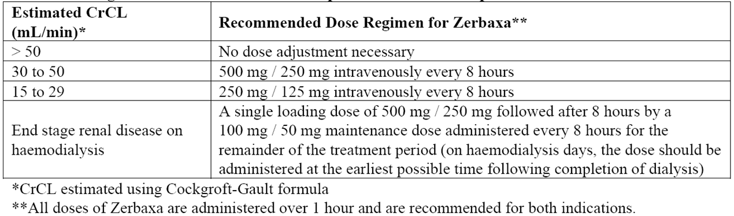

Regulatory status
Zerbaxa was approved by the US Food and Drug Administration (FDA) in December 2014 for the following indication:
Zerbaxa (ceftolozane and tazobactam) is a combination product consisting of a cephalosporin-class antibacterial drug and a beta-lactamase inhibitor indicated for the treatment of the following infections caused by designated susceptible microorganisms:
    - Complicated Intra-abdominal Infections, used in combination with metronidazole
    - Complicated Urinary Tract Infections, including Pyelonephritis
To reduce the development of drug-resistant bacteria and maintain the effectiveness of Zerbaxa and other antibacterial drugs, Zerbaxa should be used only to treat infections that are proven or strongly suspected to be caused by susceptible bacteria.
The dose and recommended duration of treatment (including use in renal impairment) approved by FDA is identical to that being sought in Australia.
The product received positive opinion in July 2015 from the European Medicines Agency’s (EMA’s) Committee for Medicinal Products for Human Use (CHMP). The approval process had not yet been completed at the time of submission to TGA.

Product Information
The approved Product Information (PI) current at the time this AusPAR was prepared can be found as Attachment 1. For the most recent PI, please refer to the TGA website at <https://www.tga.gov.au/product-information-pi>.

II. Quality findings
There was no requirement for a quality evaluation in a submission of this type.

Introduction (if applicable)
Cubist Australia Pty Ltd has applied to register an injectable antibacterial combination product consisting of the cephalosporin antibacterial NCE ceftolozane sulfate and the well-established beta lactamase inhibitor, tazobactam sodium.
The proposed ceftolozane and tazobactam 1000 mg/500 mg powder for injection contains 1147 mg of sterile ceftolozane sulfate (equivalent to 1000 mg ceftolozane free acid) and 537 mg of sterile tazobactam sodium (equivalent to 500 mg tazobactam free acid) in glass vials under the tradename ‘Zerbaxa’. The finished product also contains citric acid (21 mg, chelating agent), sodium chloride (487 mg, stabilising agent) and L-arginine (600 mg, pH adjustment). The trade name is considered clinically acceptable.
Ceftolozane sulfate is a new semi synthetic cephalosporin antiobiotic which exerts bactericidal activity against many Gram-negative and -positive microorganisms by inhibiting essential penicillin binding proteins (PBPs), resulting in inhibition of cell wall synthesis and subsequent cell death.
Tazobactam, a beta lactam (β lactam) structurally related to penicillins, is a potent, irreversible inhibitor of Class A broad spectrum and extended spectrum beta lactamases and Class C cephalosporinases, which commonly cause resistance to penicillins and cephalosporins. Tazobactam extends the antimicrobial spectrum of ceftolozane to include beta lactamase producing bacteria. It is a component, with the antibiotic piperacillin sodium, in other combination powders for injection (‘Tazocin’, sponsored by Pfizer; and other generic versions).
At the time of administration, the contents of the vial are reconstituted using 10 mL sterile Water for Injection or 0.9% Sodium Chloride Injection followed by further dilution in an infusion bag of 0.9% Sodium Chloride Injection or 5% Dextrose (Glucose) Injection, for administration, typically by infusion over 1 hour.
The recommended dose of Zerbaxa is ceftolozane/tazobactam 1000 mg/500mg administered as a 1 h IVI every 8 h (that is, 3000 mg of ceftolozane and 1500 mg of tazobactam per day). Treatment is continued for 4-14 days depending on disease severity and patient response.

Drug substance (active ingredient)

Ceftolozane sulfate
Ceftolozane sulfate (Figure 1) is a semi synthetic antibiotic of the β lactam class and is manufactured in a 4 step convergent synthesis, with the fermentation derived starting material product ‘ACLE.HCl’ providing the required cephalosporin structure.
Figure 1: Structure of ceftolozane sulfate.
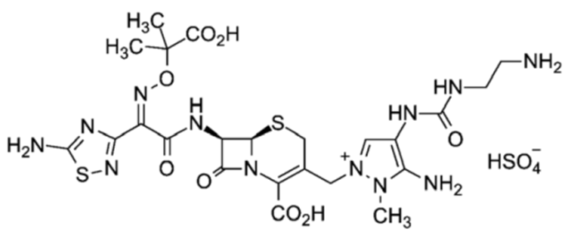
Ceftolozane sulfate is a white to off-white hygroscopic partially crystalline powder which is sparingly soluble in water (~30 mg/mL). It is insoluble in isopropanol, acetonitrile, and dichloromethane. In aqueous solution its pH is about 2 and it has pKa values of 9.3, 3.2 and 1.9.
The manufacturing process is considered adequately described and controlled. A large number of potential related substances were identified, resulting from the fermentation and chemical steps, and 9 of these are controlled as specified impurities in the drug substance. The proposed related impurity levels have been supported by toxicological studies which have been separately assessed as acceptable. An adequate assessment of potential genotoxic impurities has been performed.
Controls applied to the drug substance are considered acceptable, after tightening of the assay limit.
The drug substance shows good stability when stored under the proposed freezer conditions but at 25°C significant degradation is observed. This thermal instability necessitates the use of a stabilising excipient in the finished product.
A retest period of 12 months (stored at -20°C) is applied.

Tazobactam sodium
Tazobactam sodium (Figure 2) is a well established beta lactamase inhibitor. It is a white to off-white hygroscopic powder which is freely soluble in water. The pH of aqueous solution (0.25%) is around 6 and it has a pKa of 2.65.
Figure 2: Structure of tazobactam sodium.
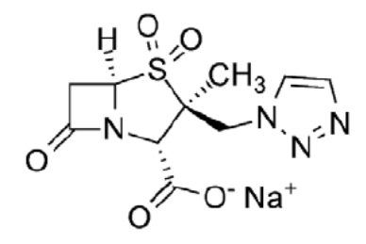
Drug Master Files (DMFs) describing the manufacture and quality control of tazobactam sodium and tazobactam acid have been evaluated and are considered satisfactory.

Drug product
The proposed Zerbaxa ceftolozane and tazobactam 1000 mg/500 mg powder for injection is a combination of two sterile active powders in a glass vial. Each vial contains 1147 mg ceftolozane sulfate, which is equivalent to 1000 mg ceftolozane free base, as well as approximately 537 mg tazobactam sodium, equivalent to 500 mg tazobactam free acid. Each vial also contains 21 mg of citric acid (chelating and buffering agent), 487 mg sodium chloride (stabilising agent for ceftolozane) and ~600 mg of L-arginine for pH adjustment (to pH 6).
Prior to reconstitution, the product appears as a white to yellowish powder, contained in a clear glass vial, metal seal and a grey stopper with a purple flip cap top.
At the time of administration each vial is reconstituted with 10 mL of either water for injection or 0.9% Sodium Chloride Injection, prior to further dilution in an infusion bag of 0.9% Sodium Chloride Injection or 5% Dextrose (AAN Glucose) Injection, for administration. Ceftolozane/tazobactam following reconstitution with normal saline and dilution for infusion also in normal saline (10 mg/mL ceftolozane; 5 mg/mL tazobactam) is slightly hypertonic, with osmolality approximately 500 mOsm/kg.
The product is supplied in single dose clear Type I 20 mL glass vials, each sealed with bromobutyl, siliconized rubber stoppers, aluminium crimp cap with purple, flip off seals and packaged in cartons containing 10 vials.
The product is manufactured in the USA but Good Manufacturing Practice (GMP) certification has yet to be provided for the relevant manufacturing site.
The proposed finished product specifications included controls on appearance, identity of each drug substance, colour, turbidity and pH, of solution, reconstitution time, water content, particulate matter, assay of active drugs, degradation products, bacterial endotoxins and sterility. The safety of the proposed limits for ceftolozane related impurities was supported by submitted toxicological data.
After some revision of limits to water content and assay of the active drugs, the revised finished product specifications are considered adequate to ensure the quality of the finished product at release and throughout the shelf life.
The stability data originally included with the submission support a shelf life of 18 months when stored at 2-8°C, protected from light, and stored in original container.

Labels
The FDA has issued an alert about dose confusion and medication errors relating to the US registered version of Zerbaxa. Several medication errors arose due to confusion with the display of the strength of individual ingredients on Zerbaxa’s labelling. Listing the individual drug strengths led to confusion because it was different from labelling for other drugs in the beta-lactam/beta-lactamase class that express strength as the sum of the two active ingredients. In some cases, this led to administration of 50% more drug than was prescribed. The currently proposed Australian Zerbaxa labels list the individual drug strengths, as is typical for fixed dose combination drugs. Clinical comment is sought on whether Australian pharmacists and prescribers use the ‘combined’ expression for dose of other beta lactam/beta lactamase antibacterial drug products, and whether the expression of drug strength on the vial and carton labels require revision. The labels are otherwise acceptable from a pharmaceutical chemistry perspective.

Biopharmaceutics
None

Advisory committee considerations
None

Quality summary and conclusions
All issues raised during the initial evaluation of this application have been satisfactorily resolved, apart from:
- the provision of evidence of GMP certification for the finished product manufacturing site in the USA.
- resolution of the preferred expression of drug strength on the labels.
Pending provision of such GMP evidence, registration of the proposed Zerbaxa ceftolozane and tazobactam 1000 mg/500 mg powder for injection in vial, from a pharmaceutical chemistry perspective, is recommended with respect to quality and biopharmaceutic aspects.
Microbiological aspects of the submission have been evaluated separately and no objections to registration remain.
As no significant pharmaceutical chemistry issues were identified, the submission was not referred to the Pharmaceutical Subcommittee of the Advisory Committee on Prescription Medicines (ACPM), in keeping with recent branch policy.

III. Nonclinical findings

Introduction
The overall non-clinical strategy was to evaluate the safety properties of the new active ingredient, ceftolozane, in isolation and to supply a combination ceftolozane + tazobactam bridging study (canine 14 day [the maximum anticipated duration of clinical use] repeat dose utilising 2:1 fixed dose combinations of ceftolozane and tazobactam). While scientifically less desirable, this approach is consistent with current international and TGA guidance.
The data package is of mixed quality. Overall, with the exception of teratology evaluation in a non rodent species, submission meets current requirements. All studies were evaluated. Only studies of sufficient data quality have been summarised (other studies listed in the main body of the report).
Lack of teratology testing in a non rodent species is a significant deficit in the submission. Ceftolozane pharmacokinetic studies were carried out in rabbits without incident and the pharmacokinetic properties of IV ceftolozane imply a low risk of haemorrhagic enterocolitis. Teratology testing in rabbits in addition to the submitted rodent studies appears feasible.

Pharmacology

Primary pharmacology
Ceftolozane is a rapidly bactericidal cephalosporin that inhibits essential PBPs (particularly Pseudomonas aeruginosa PBP3) thereby inhibiting bacterial cell wall synthesis and limiting replication and survival. Tazobactam is a catalytic inhibitor of most common class A and some class C β-lactamases, and has little antibacterial activity. In combination with ceftolozane, tazobactam protect ceftolozane from hydrolysis and broadens its effectiveness against most extended spectrum β lactamase (ESBL) positive members of the Enterobacteriaceae.
An Australian antibiotic resistance risk assessment was submitted.
In vitro passage and hollow fibre studies imply a low potential for development of resistance in P. aeruginosa and ESBL positive Escherichia coli. Ceftolozane is resistant to P. aeruginosa AmpC hydrolysis and its efficacy is not affected by active efflux or the loss of outer membrane protein D (OprD) in P. aeruginosa.
The spectrum of activity for ceftolozane/tazobactam includes clinically relevant Gram negative pathogens (including the majority of the Enterobacteriaceae [for example, E. coli, Klebsiella pneumonia]), non fermenters (such as P. aeruginosa [including strains resistant to carbapenems, cephalosporins, fluoroquinolones and/or aminoglycosides and other multi-drug resistant [MDR] isolates]), Gram positive pathogens (such as Streptococcus pneumoniae and S. pyogenes) and anaerobic pathogens (such as B. fragilis). The MIC90 for ceftolozane/tazobactam for P. aeruginosa strains is 0.5/4 μg/mL. The MIC50/90 for E. coli is 0.25/0.5 μg/mL and for ESBL positive E. coli the MIC50/90 is 0.5/4 μg/mL.
Pharmacodynamic, pharmacokinetic and in vivo efficacy studies were conducted with ceftolozane and ceftolozane/tazobactam. Ceftolozane/tazobactam combinations were evaluated in pharmacodynamic time kill studies to characterise in vitro killing kinetics of a range of ceftolozane and tazobactam combinations. In in vitro pharmacodynamic time kill studies ceftolozane displayed concentration dependent activity against one wild type strain and three β lactamase (AmpC, CMY-10, CTX-M-15) expressing E. coli strains. Tazobactam potentiated ceftolozane activity against all β lactamase expressing strains in a concentration dependent manner.
In the neutropenic mouse thigh infection model, time above MIC (T>MIC) was the best PK/PD predictor of efficacy of ceftolozane, %T>MIC was not affected over a range of MIC values and similar PK/PD indices for ceftolozane were observed against Enterobacteriaceae, P. aeruginosa and S. pneumoniae. The average %T>MIC for stasis was ≤ 30% for all species and MIC values.
Ceftolozane/tazobactam and ceftolozane alone have been evaluated in a number of infection models including immunocompetent and neutropaenic mice models, including sepsis, pneumonia, urinary tract infection (UTI), burn wound and thigh infection models. Ceftolozane has also been studied in rabbit models. Ceftolozane was comparable to or better than comparator antibiotics evaluated against all pathogens studied including MDR P. aeruginosa.
The mouse sepsis studies established ceftolozane + tazobactam effectiveness against ESBL positive E. coli, K. pneumoniae and ceftolozane effectiveness against MDR P. aeruginosa. Likewise immunocompetent mouse thigh infection studies established ceftolozane effectiveness against P. aeruginosa and ceftolozane + tazobactam effectiveness against EBSL positive Enterobacteriaceae.
Ceftolozane + tazobactam are unlikely to adversely affect the activity of or be affected by other antimicrobials that may be administered concomitantly. Cephalosporin induced cross resistance may affect the efficacy of ceftolozane; however this issue was not specifically evaluated. The effects of ceftolozane + tazobactam are generally additive or synergistic when combined with other agents likely to be utilized to treat Gram negative infections.

Secondary pharmacodynamics and safety pharmacology
Specialised safety pharmacology studies covered the central nervous system (CNS), cardiac electrical activity, the erythron, respiration and histamine release from peripheral blood leukocytes. Neither ceftolozane nor tazobactam are expected to display adverse secondary pharmacological properties of the types evaluated within the anticipated clinical dose range and use pattern. Transient and reversible tachycardia was observed in 1 out of 4 dogs administered an infusion of ceftolozane at an exposure level of 9.1 X the proposed human clinical exposure (on an mg/m² basis). It is unclear if this effect is test article related.

Pharmacokinetics
IV ceftolozane displays typical 2 compartment saturable 1st order kinetics with a very rapid α-phase (most probably representing rapid redistribution to the kidneys) and a typical β-phase. The ceftolozane VD_{SS} implies distribution beyond the intravascular fluid, but confinement to the extracellular fluid. The T_{½} is short (typically < 1 h in animals and approximately 1-3 h in humans). Plasmatic accumulation was not apparent and unlikely given the 8 h dosing interval. Ceftolozane displays modest plasma protein binding (up to approximately 20%, depending on species; in general, plasma protein binding is lower [and availability for glomerular filtration is higher] in rodents compared with humans, potentially explaining the somewhat lower rodent T_{½} in some of the studies) and low penetrance of erythrocytes. As is typical of the class, IV ceftolozane rapidly redistributes and concentrates in the kidneys. Distribution to other tissues is low. Ceftolozane metabolism is minimal. M3 predominates in urine and plasma. M1 predominates in the kidney. Metabolism in humans appears is lower than in animals (in humans, the mean renal clearance is approximately the same as the mean plasma clearance, implying negligible metabolism/clearance by other mechanisms). Based on the low level of metabolism of ceftolozane, extensive metabolite characterisation is not required based on current guidance. Ceftolozane is almost exclusively, and rapidly, eliminated by glomerular filtration. Some renal proximal tubular epithelial re-uptake is implied by the capacity of ceftolozane to induce phagolysosomal protein associated hyaline droplet nephrosis. While the whole body elimination is nearly complete within 48 h, significant amounts of ceftolozane are retained within the kidney (renal terminal T_{½} ~76 h; likely representing retention within renal tubular epithelial phagolysosomes). Ceftolozane displays similar pharmacokinetic properties in neonatal rats compared with adult animals. Co-administration of tazobactam does not markedly alter the pharmacokinetics of ceftolozane in a clinically relevant manner (and vice versa; the presence of tazobactam reduced the ceftolozane Cmax and AUC_{0-∞} by up to approximately 20% in dogs; the reduced AUC_{0-∞} was not accompanied by a change in ceftolozane T½; tazobactam did not affect the typical 1st order elimination phase kinetics of ceftolozane).

Pharmacokinetic drug interactions
Ceftolozane is unlikely to be associated with clinically relevant drug interactions. Tazobactam has the potential to suffer from pharmacokinetic drug-drug interactions associated with OAT1 and OAT3 transporters. Drugs that inhibit OAT1 or OAT3 (for example, probenecid) may increase tazobactam plasma concentrations.

Toxicology

Acute toxicity
Based on limited evaluation, ceftolozane appears to be not particularly acutely toxic. Transient weight loss was observed in rats administered single IV ceftolozane boluses of ≥1000 mg/kg body weight. Combined ceftolozane + tazobactam exposures were not evaluated.

Repeat dose toxicity
The approach adopted by the sponsor was to test ceftolozane in isolation and then provide a 14 day (the proposed maximum duration of use in humans) combination ceftolozane + tazobactam bridging study. While scientifically less desirable, this approach is consistent with current TGA and international guidance. The maximum duration of repeated-exposure was 28 days, 2X the proposed maximum duration of use in humans. Again, this is consistent with current TGA and international guidance. The package of repeat dose studies utilised the slow IV injection (proposed human clinical) route of exposure primarily in 2 species (rat and dog). IV exposure was typically OID whereas the proposed human clinical pattern of use is to divide the daily dose into 3 separate slow IV infusions due to the short pharmacological T½ of ceftolozane.
Predictably the renal proximal tubular epithelium is the major target tissue for ceftolozane. Ceftolozane induced renal proximal tubular hyaline droplet nephropathy in male rats and renal proximal tubular vacuolar nephropathy in female rats. These effects are considered to be human relevant because renal proximal tubular injuries occurred in both sexes and the target tissue and lesions are consistent with the known effects of other cephalosporins. The renal proximal tubular hyaline droplet nephropathy observed with ceftolozane has also been reproduced in both sexes and in non rodent species (dogs). The renal proximal tubule hyaline droplet nephrosis observed in the males is not analogous to alpha-2U-microglobulin nephropathy (particularly given the observation of this lesion in dogs) despite the presence of clear morphological and dose threshold differences between the sexes in one of the rat studies.
The sponsor convened a pathology working group regarding the nature of the renal proximal tubular hyaline droplet nephropathy observed in all the higher quality repeat exposure studies. The pathology working group provided a case for regarding the renal proximal tubular injuries as being non adverse based upon: (a) the lack of evidence of overt renal decompensation and acute renal insufficiency; (b) the lack of urinalysis evidence of renal tubular injury; and (c) the general lack of other systemic adverse effects.
The evaluator concurs with the pathology working group that there was no overt evidence of decompensated renal failure associated with the observed renal proximal tubular changes. However, the evaluator does not concur that the changes were “not adverse”. Induction of the renal tubular lesions observed in the repeat dose studies is a key adverse event in the path leading to classical cephalosporin induced renal proximal tubular nephropathy. This is in fact fully acknowledged in the expert panel reports: “The droplets do, however, represent part of the known pathogenesis of accumulation leading to degeneration of the renal tubular epithelium.”
In toxicological risk assessment, it is considered usual and good practice to set dose response thresholds on the basis of human relevant key pathophysiological events in adverse outcomes pathways and mode of action frameworks. The critical hypothesis that overt renal dysfunction would have occurred if the duration of dosing had been extended beyond 28 days was not evaluated by the applicant. It is very likely given the chronologically cumulative nature of the types of renal tubular injuries present that overt renal insufficiency would have occurred if the duration of exposure was extended. Notably, there were no 14 day studies conducted in rats.
In terms of the application of the results of these studies, toxicological thresholds and exposure ratios to the practical clinical use of Zerbaxa, it should be noted that the mode of action of the adverse renal tubular epithelial effects observed in this study is dependent upon cumulative re-absorption of ceftolozane from the glomerular filtrate and renal tubular epithelial phagolysosomal accumulation. This mode of action is heavily dependent on the duration of xenobiotic exposure as well as the dose. This is consistent with the results of the 14 day repeat-dose study in dogs (WIL-705004 [CXA201-T-005]) where renal proximal tubular lesions were not observed (where as they were in the 28 day studies).
Critically, while toxicologically adverse key events were noted in the renal proximal tubular epithelia, this was not accompanied by evidence of overt renal insufficiency in any of the studies. Accordingly, these changes are likely not to impact upon the practical clinical use of ceftolozane provided that the duration of exposure is not increased beyond the proposed maximum duration of treatment of 14 days and pre-existing/concurrent renal tubular insults are not present. This conclusion is consistent with the lack of renal tubular injury observed in the canine 14 day repeat dose study (WIL-705004 [CXA201-T-005]). However, the potential risk versus clinical benefit of ceftolozane treatment should be carefully considered given that the effects of ceftolozane on the renal proximal tubular epithelial are likely to be at least additive to other renal proximal tubular epithelial insults. Given the cumulative nature of the renal proximal tubular lesions, treatment with ceftolozane should not be routinely extended beyond the proposed 14-day duration of treatment.

Relative exposure
Adequate relative exposure ratios were accomplished in the non-clinical repeat-dose toxicity studies.

Major toxicities
As expected, the major adverse effect is classical cephalosporin renal proximal tubular phagolysosomal hyaline/vacuolar droplet nephropathy as discussed above.
Table 3: Relative exposure in repeat dose toxicity studies.
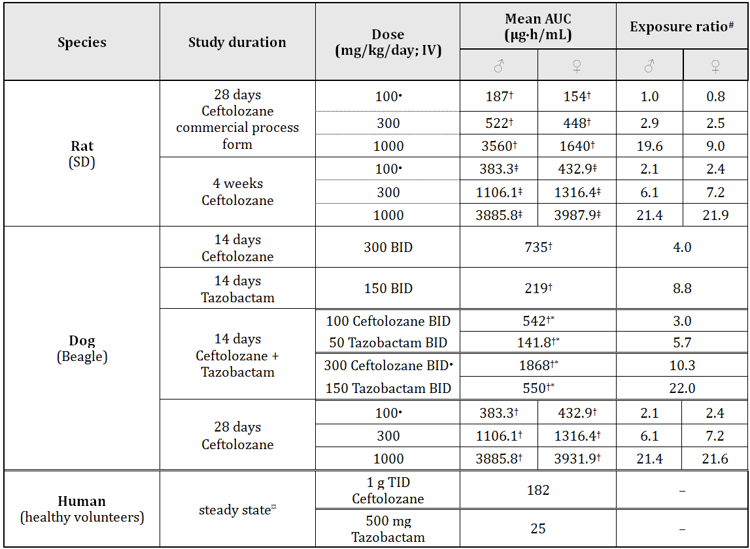
† AUC_{Last}; ‡ AUC_{0-24h} at week 4 of exposure; * total daily exposure expressed as AUC; # animal:human plasma AUC_{0-24h}; ¤ AUCτ SS; • NOAEL

Genotoxicity
The sponsor has submitted an in vitro genotoxicity screening package that included in vivo micronucleus studies and ex vivo hepatocyte unscheduled DNA synthesis (UDS) studies. The overall limitation is the lack of ceftolozane + tazobactam bacterial reverse mutation assays and in vivo/ex vivo assays. Based on limited in vitro data, ceftolozane + tazobactam (concentration ratio of 2:1) induces structural chromosomal aberrations. However this finding was not replicated in the higher tier in vivo studies. Ceftolozane and/or its microsomal metabolites do not cause other forms of direct DNA interactive genotoxicity. Overall ceftolozane and/or its microsomal metabolites do not behave as classical DNA interactive mutagens.

Carcinogenicity
Carcinogenicity was not evaluated by the sponsor, in accordance with current guidance.

Reproductive toxicity
Studies in non rodent species were not performed. Placental transfer was not definitively demonstrated.
Ceftolozane exhibited no evidence of adverse effects on male or female reproductive performance, fertility, or intrauterine survival following once daily IV administration to male and female Sprague Dawley rats from premating to conception and from conception to implantation at dose levels up to 1000 mg/kg body weight (BW)/day, the no observed adverse effect level (NOAEL) and highest dose level assessed.
In mice, no evidence of maternal toxicity, embryofoetal toxicity, or embryo-fetal developmental effects was observed following once daily IV administration of ceftolozane between Gestation Day (GD) 6 through 15 at dose levels up to 2000 mg/kg/day, the Maximum Feasible Dose (MFD) and NOAEL. A dose of 2000 mg/kg/day was associated with Day 15 maternal C0 and AUC₀₋₂₄ systemic exposure values of 9506 μg/mL and 3538 μg•h/mL, respectively.
In rats, no evidence of embryofoetal toxicity or developmental effects were noted up to 1000 mg/kg/day, the highest dose tested, following once daily IV administration of ceftolozane between GD 6 through 17. Administration of ceftolozane at a dose of 1000 mg/kg/day was associated with maternal toxicity as evidenced by a decrease in mean body weight in dams. The NOAEL for embryofoetal developmental toxicity identified in this study was 1000 mg/kg/day with corresponding Day 17 maternal C0 and AUC₀₋₂₄ values of 5015 μg/mL and 2013 μg•h/mL, respectively. The NOAEL for maternal toxicity identified in this study was 300 mg/kg/day with corresponding Day 17 C0 and AUC₀₋₂₄ values of 1759 μg/mL and 678 μg•h/mL, respectively.
Maternal ceftolozane exposure is associated with an auditory sensorimotor processing deficit (without neuropathology correlates) in in utero exposed offspring manifesting on post natal day (PND) 60. It is unknown if this effect is reversible. The NOAEL for this effect is 100 mg/kg BW/day (maternal dose) IV (approximately 1.6X human clinical dose on a mg/kg BW basis assuming human body weight of 50kg; approximately 1.3X on a BAS basis).
In the absence of maternotoxicity, tazobactam does not affect fertility or reproduction. At sub maternotoxic doses, tazaobactam is not teratogenic, does not affect neonatal development and is not detrimental to neurobehavioral development. In an embryofoetal study in rats, tazobactam administered intravenously at doses up to 3000 mg/kg/day (approximately 19 times the recommended human dose based on body surface area comparison) produced maternal toxicity (decreased food consumption and body weight gain) but was not associated with foetal toxicity. In rats, tazobactam was shown to cross the placenta. Concentrations in the foetus were less than or equal to 10% of those found in maternal plasma.
In a pre-postnatal study in rats, tazobactam administered intraperitoneally twice daily at the end of gestation and during lactation (GD 17 through Lactation Day 21) produced decreased maternal food consumption and body weight gain at the end of gestation and significantly more stillbirths with a tazobactam dose of 1280 mg/kg/day (approximately 8 times the recommended human dose based on body surface area comparison). No effects on the development, function, learning or fertility of F1 pups were noted, but postnatal body weights for F1 pups delivered to dams receiving 320 and 1280 mg/kg/day tazobactam were significantly reduced 21 days after delivery. F2 generation foetuses were normal for all doses of tazobactam. The NOAEL for reduced F1 body weights was considered to be 40 mg/kg/day (approximately 0.3 times the recommended human dose based on body surface area comparison).

Pregnancy classification
The sponsor has proposed Pregnancy Category C (presumably a US FDA category which differs from the Australian classification system). The evaluator proposes Australian Category B1 based on: only limited evaluation in pregnant women and women of child-bearing age; and lack evidence of damage to the foetus in animal studies. However, it should be noted that transient neurological toxicity was observed in neonates (without neuropathology correlates) at high maternal exposure levels and an auditory sensorimotor processing deficit (without neuropathology correlates) was observed (it is unknown if this effect is reversible).

Local tolerance
Local intravenous tolerance could not be accurately evaluated because of the method of experimental administration; however it appears to be adequate. Perivascular tolerance was not evaluated. Ceftolozane is not a topical skin irritant.

Antigenicity
Ceftolozane has the potential to induce anaphylactic and other hypersensitivity reactions under strongly sensitising conditions (for example, co-exposure to Freund’s adjuvant).
Repeated daily ceftolozane treatment induced splenic follicular development in mice and stimulated an increase in blood IgM levels. These effects were not replicated in the repeat exposure toxicity studies

Studies on impurities
Repeat daily IV exposure of rats to force degraded ceftolozane over 28 days resulted in effects identical to non degraded ceftolozane. The key effect was renal proximal tubular hyaline droplet nephropathy with a lowest observed adverse effect level (LOAEL) of 300 mg/kg BW/day and a NOAEL of 100 mg/kg BW/day. Forced degradation of ceftolozane does not substantively alter either the spectrum or dose response characteristics of the observed adverse key effects.
Force degraded ceftolozane in the presence or absence of microsomal activation does not induce base-pair, frame shift or cross-linking reverse mutations in bacterial reverse mutation studies. Likewise force degraded ceftolozane in the presence or absence of metabolic activation does not induce chromosomal aberrations in mammalian cells in vitro and does not induce erythrocyte micronuclei in vivo.

Phototoxicity
No skin reactions or ophthalmological observations (confirmed by histopathology) relevant to phototoxicity were observed in rats following four consecutive daily IV exposures to ceftolozane at dose levels up to 1000 mg/kg/day followed within 4 to 10 minutes of the end of the final administration by a single exposure to solar-simulated ultraviolet radiation.

Impurities
The proposed specifications for impurities/degradants in the drug substance are not below the ICH qualification thresholds/have not been adequately qualified. However, this interpretation is based on conservative toxicological thresholds derived from a 28 day repeat dose study. The toxicological key events were not apparent after 14-days of repeated exposure in animals. Accordingly, given the proposed 14-day maximum duration of human exposure, the risk associated with the impurities appears to be negligible.

Paediatric use
Lactational transfer was not definitively demonstrated.
Zerbaxa is not intended for use in patients < 18 years of age. Early post-natal S/C exposure of rats to ceftolozane + tazobactam (2:1 dose combinations) induced transient/reversible depression of motor activity and righting reflexes without neuropathology correlates. The NOAEL for these effects was 50/25 mg/kg BW/day ceftolozane/tazobactam. CNS toxicity is a cephalosporin class effect.
In a preliminary dose ranging toxicity study, once daily SC administration of ceftolozane/tazobactam to PND 4 neonatal Sprague Dawley rats for 14 days was associated with increased liver and kidney weight, as well as microscopic evidence of centrilobular hepatocellular hypertrophy and cytoplasmic vacuolation in the proximal convoluted tubular epithelium of the kidney at a dose of 1000/500 mg/kg/day. As was the case in adult rats, hyaline droplets (males only), and basophilic tubules and fibrosis in the kidney were also noted at this dose level in neonatal rats. A dose of 300/150 mg/kg/day was associated with increased liver and kidney weight with correlating microscopic evidence of centrilobular hepatocellular hypertrophy and cytoplasmic vacuolation in the proximal convoluted tubular epithelium of the kidney. These effects were not replicated in the pivotal study which utilised a similar dose range and an identical batch of test article.

Comments on the Safety Specification of the Risk Management Plan
Results and conclusions drawn from the nonclinical program for Zerbaxa detailed in the sponsor’s draft Risk Management Plan (RMP) are in general concordance with those of the nonclinical evaluator.

Nonclinical summary and conclusions

Summary
- The overall strategy used was evaluation of the safety properties of ceftolozane in isolation and provision of a canine 14 day repeat exposure bridging study utilising 2:1 fixed dose ceftolozane + tazobactam combinations. With the possible exception of evaluation for teratology in a non rodent species, the submission meets current guideline requirements. The dossier is of mixed quality: all studies were evaluated; only quality studies are summarised.
- Adequate non-clinical in vivo and in vitro proof of efficacy was established. Ceftolozane is rapidly bactericidal (notably to Pseudomonas sp.) via inhibition of bacterial PBPs (particularly P. aeruginosa PBP 3). Combination with tazobactam (a β-lactamase inhibitor) extends the efficacy to other Gram -ve and ESBL Gram +ve bacteria. Ceftolozane is efficacious against biofilm-forming bacteria in vitro. Ceftolozane + tazobactam are efficacious against antibiotic resistant and multidrug resistant strains of P. aeruginosa and have a low potential for development of resistance.
- Neither ceftolozane nor tazobactam display adverse secondary pharmacological properties relevant to the proposed pattern of use. Ceftolozane produced transient and reversible tachycardia was in 1/4 dogs at an exposure level of 9.1 X the proposed human clinical exposure. It is unclear if this effect is test article related. As expected, ceftolozane induces hypersensitivity reactions (including the potential for anaphylaxis) under strongly sensitizing conditions. Ceftolozane did not display classical cephalosporin induced immune-mediated blood dyscrazias in animals; however such effects cannot be categorically excluded. Non adverse reductions in the erythron mass were noted in some of the nonclinical studies (mechanism unknown).
- IV ceftolozane displays typical 2 compartment saturable 1st order kinetics with a very rapid α-phase (redistribution and sequestration in kidney). The ceftolozane VD_{SS} implies distribution beyond the intravascular fluid, but confinement to the extracellular fluid. The T½ is short (typically < 1 h in animals and approximately 1-3 h in humans). Plasmatic accumulation did not occur and is unlikely given the proposed dosing interval. Ceftolozane displays modest plasma protein binding (up to approximately 20%, depending on species; in general, plasma protein binding is lower [and availability for glomerular filtration is higher] in rodents compared with humans, potentially explaining the somewhat lower rodent T½). There is low erythrocyte penetrance. As expected IV ceftolozane rapidly re-distributes to, and concentrates in, the kidneys (a major proposed site of action). Distribution to other tissues is low. Ceftolozane metabolism is minimal. Metabolism in humans is lower than in animals (renal clearance ≈ plasma clearance in humans, implying negligible metabolism/non-renal clearance). Based on the low level of metabolism, extensive metabolite characterisation is not required. Ceftolozane is almost exclusively, and rapidly, eliminated by glomerular filtration. Renal proximal tubular epithelial re-uptake is implied by the kidney redistribution, the capacity of ceftolozane to induce phagolysosomal hyaline droplet nephrosis, and the long kidney terminal T½. While the whole body elimination is nearly complete within 48 h, significant amounts of ceftolozane are retained within the kidney (renal terminal T½ ~76 h; most likely due to renal tubular epithelial phagolysosomal retention). Ceftolozane displays similar pharmacokinetic properties in neonatal rats compared with adult animals. Co-administration of tazobactam does not markedly alter the pharmacokinetics of ceftolozane in a clinically relevant manner (and vice versa). Ceftolozane is unlikely to be associated with clinically relevant drug interactions. Drugs that inhibit or compete at OAT1 or OAT3 (for example, penicillin, probenecid) may increase tazobactam plasma concentrations.
- Ceftolozane has relatively low acute toxicity. The single dose toxicology package was mostly of poor quality. However, current guidance does not require these studies.
- The key adverse event in repeat dose studies of > 14 days duration was early-stage classical cephalosporin phagolysosomal hyaline droplet formation in renal proximal tubular epithelial cells. This is a chronologically cumulative toxicological key event eventually leading to cephalosporin induced decompensated acute renal failure (overt decompensated acute renal failure did not occur in the nonclinical studies with exposures ≤ 28 days, the maximum duration of exposure studied; however a low level of early toxicological key events were observed with an exposure duration of 28 days. These effects can be expected to behave at least additively with similar renal proximal tubular epithelial insults. The sponsor’s proposed maximal clinical duration of use of 14 days is appropriate given the lack of renal proximal tubular lesions at exposures < 14 days. However some degree of clinical care should be taken in extending the duration of clinical use beyond 14 days (current maximal duration of treatment recommended by the sponsor) due to the chronologically cumulative nature of the lesions (this conclusion is supported by the long renal terminal T½ of ~76 h, that is, a non treatment period of 4-5 X the renal T½ [56-70 days] would be required to prevent renal ceftolozane accumulation that would presumably eventually lead to renal tubular hyaline droplet nephrosis, assuming 1st order kinetics).
- Ceftolozane and its microsomal metabolites are unlikely to be direct DNA interacting mutagens. Current guidance does not require carcinogenesis studies for ceftolozane.
- Zerbaxa is not intended for use in patients < 18 years of age. Lack of teratololgy testing in a non rodent species is a deficit in the study package. Ceftolozane pharmacokinetic studies were carried out in rabbits without incident and the pharmacokinetic properties of IV ceftolozane (that is, not eliminated in bile or excreted into the gut and administered by IV only) imply a low risk of haemorrhagic enterocolitis. Accordingly, rabbit teratology evaluation appears feasible.
- Maternal ceftolozane exposure is associated with an auditory sensorimotor processing deficit in in utero exposed offspring manifesting on PND 60 (without neuropathology correlates). It is unknown if this effect is reversible (Maternal NOAEL is approximately 1.3X on a body surface area [BSA] basis).
- Early post-natal exposure of rats to ceftolozane + tazobactam (2:1 dose combinations) induced transient/reversible depression of motor activity and righting reflexes without neuropathology correlates. The NOAEL for these effects was 50/25 mg/kg BW/day ceftolozane/tazobactam. CNS toxicity is a known cephalosporin drug class effect.
- In a preliminary dose ranging toxicity study, once daily SC administration of ceftolozane + tazobactam to postnatal day PND 4 neonatal rats for 14 days was associated with increased liver and kidney weight, as well as centrilobular hepatocellular hypertrophy and cytoplasmic vacuolation in the proximal convoluted tubular epithelium of the kidney at dose ≥ of 300/150 mg/kg/day. Hyaline droplets (male only), basophilic tubules and fibrosis in the kidney were also noted at this dose level. These effects were not replicated in the larger pivotal study which utilized a similar dose range and identical batch of test article. No explanation was provided.
- No absolute conclusions regarding the local venous tolerance can be made due to the confounding effects of the experimental dosing method (repeated daily single IV injection versus indwelling catheterisation in human clinical use). However, local venous tolerance appears to be acceptable. Accidental perivascular injection was not evaluated. Ceftolozane is neither a topical irritant nor a photosensitiser.
- The proposed specifications for impurities/degradants in the drug substance are technically unqualified using a highly conservative approach based on toxicological thresholds from the 28 day study. The toxicological key events were not present after 14 days of exposure and given the proposed 14 day maximum duration of human exposure, the risk associated with the impurities appears to be negligible. Further qualification is not required.

Conclusions and recommendation
- From the nonclinical perspective, registration of Zerbaxa is supported provided that its use is restricted to individuals ≥ 18 years of age and the duration of treatment is ≤ 14 days (consistent with the sponsor’s restrictions as stated in the PI). Extension of indication to younger individuals is possible with additional information.
- The main scientific deficiencies in the package are a lack of teratology testing in a non-rodent species and lack of combined ceftolozane + tazobactam testing in the nonclinical toxicology and nonclinical efficacy packages. However, the package generally conforms to current guidance.
- From the nonclinical perspective, the safety properties for Zerbaxa for human patients < 18 years of age have not been fully established. Use during pregnancy requires careful assessment of risk-benefit.
- Based on the nonclinical studies, Zerbaxa appears to be efficacious (particularly against P. aeruginosa infection) within the intended scope and pattern of use. Zerbaxa appears to have a low propensity for induction of antibacterial resistance.
- Ceftolozane, like other members of the cephalosporin class, induces hypersensitivity reactions (potentially including systemic anaphylaxis) under strongly sensitising conditions. Ceftolozane did not produce overt autoimmune blood dyscrasias (a known cephalosporin class effect) in animals; however these endpoints were not conclusively evaluated.
- Drugs that inhibit or compete at OAT1 or OAT3 (for example, probenecid, penicillins) may increase tazobactam plasma concentrations.
- The key adverse event is induction of renal proximal tubular epithelial hyaline droplet lesions with ceftolozane exposures ≥ 28 days (without evidence of overt decompensated renal failure). These lesions are chronologically cumulative, are key adverse events leading to classical cephalosporin renal proximal tubular nephrosis/decompensated renal failure, and can be expected to behave at least additively with similar renal proximal tubular epithelial insults. Based on the results of the nonclinical evaluation, restricting the duration of ceftolozane treatment to ≤ 14 days will completely avoid these effects (this is supported by the long renal terminal T½). Extension of duration of treatment beyond the maximum duration stipulated by the sponsor requires careful clinical evaluation of risk-benefit. The effects of agents that share a common mode of action with ceftolozane (for example, aminoglycosides, other cephalosporin antibiotics) are expected to act at least additively over time, that is, previous or subsequent treatment with such agents will at least additively increase the risk of renal proximal tubular injury.
- Ceftolozane and its microsomal metabolites are not overt DNA interactive mutagens. In accordance with current guidance carcinogenicity has not been assessed.
- Pregnancy category B1 is proposed. Use during pregnancy requires careful assessment of risk-benefit. In utero high dose exposure of rodents to ceftolozane results in a sensory motor processing deficit. It is unknown if this effect is reversible. Exposure of neonatal rats to high dose ceftolozane + tazobactam resulted in transient/reversible CNS toxicity. Ceftolozane teratogenic was evaluated in non-rodent species. In rats, tazobactam only effects on pre-postnatal development at maternotoxic doses In this species tazobactam is not teratogenic and does not affect postnatal growth, or reproductive performance at non maternotoxic doses.
- Local intravenous tolerance could not be accurately evaluated because of the method of experimental administration; however it appears to be adequate. Perivascular tolerance was not evaluated. Ceftolozane is not a topical irritant or photosensitiser.
- The proposed specifications for impurities/degradants in the drug substance are technically unqualified. However, the risk associated with the impurities is negligible.
- Relevant sections of the RMP are adequate.

IV. Clinical findings
A summary of the clinical findings is presented in this section. Further details of these clinical findings can be found in Attachment 2.

Introduction
This is a submission to register a new chemical entity, Zerbaxa, as a fixed combination medicinal product. In this fixed combination product, the component of ceftolozane sulphate is a new chemical entity while the component of tazobactam sodium is currently registered in Australia as a component of Tazocin (piperacillin/tazobactam).

Clinical Rationale
Complicated UTI (cUTI) is a heterogeneous clinical entity that includes UTI in the presence of factors that predispose to persistent or relapsing infection (e.g. indwelling catheters, urinary obstruction, instrumentation of the urinary tract), and pyelonephritis. According to the sponsor, cUTIs are a frequent cause of hospitalisation and a common healthcare associated complication. Gram- negative organisms account for approximately 60% to 80% of complicated and nosocomial UTIs, with the most common uropathogens being Escherichia coli (E. coli), Klebsiella spp, Pseudomonas spp, Proteus spp, Enterobacter spp, and Citrobacter spp.
Complicated intra abdominal infection (IAI) includes a wide variety of infections ranging from appendiceal abscesses to more severe conditions such as intestinal perforation with diffuse faecal peritonitis. These infections are associated with significant morbidity and mortality when inadequately treated or when accompanied by septic shock. According to the sponsor, although the bacteriology of complicated IAI (cIAI) depends on the anatomic origin of the infection, these infections are usually polymicrobial and involve a wide variety of Gram positive and Gram negative aerobic and anaerobic organisms. Pathogens most commonly encountered in cIAI are E. coli, other common Enterobacteriaceae, Pseudomonas aeruginosa (P. aeruginosa), and anaerobes (for example, Bacteroides fragilis).
Although multiple antimicrobial agents are approved for use in cUTI and cIAI, the emergence of resistance to these agents (for example, fluoroquinolone resistant and ESBL producing Enterobacteriaceae) has created an unmet medical need. The sponsor is of the opinion that there is a need for new antimicrobial agents with stability to common resistance mechanisms, especially the ESBLs of E. coli and Klebsiella pneumoniae (K. pneumoniae), and those occurring in P. aeruginosa. Based on this rationale, the sponsor developed Zerbaxa, composed of ceftolozane, a novel cephalosporin with potent anti pseudomonal activity, and tazobactam, an established BLI. The BLI activity of tazobactam is expected to protect ceftolozane from the majority of common ESBL producing Enterobacteriaceae.

Guidance
The sponsor had addressed the issues identified as requiring sponsor action at the pre submission meeting.

Contents of the clinical dossier
The submission contained the following clinical information:
- 13 clinical pharmacology studies, including 12 that provided PK data and 1 that provided PD data
- 4 population PK analyses
- 6 population PK/PD analyses
- 2 pivotal efficacy/safety study reports (CXA-cUTI-10-04-05 [pooled analyses of Studies CXA-cUTI-10-04 and CXA-cUTI-10-05] and CXA-cIAI-10-08-09 [pooled analyses of Studies CXA-cIAI-10-08 and CXA-cIAI-10-09]).

Paediatric data
The submission did not include paediatric data. The sponsor had stated that Zerbaxa is currently proposed only for use in adults. A deferral of paediatric studies has been granted in the US until post-marketing safety data is available in the adult population and paediatric data is not required to be submitted in the US and EU until December 2016.

Good clinical practice
The pivotal clinical studies reviewed in this evaluation were in compliance with CPMP/ICH/135/95 Note for Guidance on Good Clinical Practice.

Pharmacokinetics

Studies providing pharmacokinetic data
Table 4 shows studies relating to each PK topic and the location of each study summary.

Table 4: Submitted pharmacokinetic studies.
PK topic | Subtopic | Study ID
PK in healthy adults | General PK - Single dose | CALI-RAS-001
PK in healthy adults |  | CUBI-RAS-006  CXA-101-01  CXA-201-01  CXA-ELF-10-03
PK in healthy adults | - Multi-dose | CXA-MD-11-07
PK in healthy adults | Bioequivalence† - Single dose | No studies
PK in healthy adults | - Multi-dose | No studies
PK in healthy adults | Food effect | No studies
PK in special populations | Target population § - Single dose | CUBI-RAS-008
PK in special populations | - Multi-dose | CXA-101-03
PK in special populations | Hepatic impairment
PK in special populations | Renal impairment | CXA-201-01  CXA-101-02  CXA-201-02  CXA-REN-11-01
PK in special populations | Neonates/infants/children/adolescents | Not studies
PK in special populations | Elderly | No studies
PK in special populations | Other special population | none
Genetic/gender-related PK | Males vs. females | Population PK
PK interactions | Caffeine, midazolam, furosemide | CXA-DDI-12-10
Population PK analyses | Healthy subjects | CXA-PH-001
Population PK analyses | Target population
Population PK analyses | Volunteers and patients  Impaired and normal renal function  End Stage Renal Disease | CUBI-PCS-100  CXA-PH-002  CXA-POPPK-002
* Indicates the primary aim of the study.
† Bioequivalence of different formulations.
§ Subjects who would be eligible to receive the drug if approved for the proposed indication.
None of the PK studies had deficiencies that excluded their results from consideration.

Evaluator’s conclusions on pharmacokinetics
In general, the PK studies presented by the sponsor were well designed although subject numbers were not based on a priori power calculations. Thus, the studies may have limited power. Dose proportionality of kinetics was demonstrated across doses which included the recommended therapeutic dose. The effects of various degrees of renal impairment on PK were thoroughly investigated in four studies as well as in a population PK analysis. Moderate and severe renal impairment require adjustment of the dose of ceftolozane and tazobactam. There were no studies on the effects of hepatic impairment on the PK. As the drug is almost entirely cleared by the kidneys this is not regarded as a deficiency in the application. The effect of ceftolozane/tazobactam on the PK of hepatically metabolised drugs was investigated using in vitro methods. There was no induction or inhibition of P450 enzymes. This was supported by a single study using a cocktail of model substrates for CYP3A4, and 1A2 as well as the transporters OAT1 and OAT3. There was some exploration of gender differences in PK using a modelling approach and in the PK/QTc study. Both studies suggested no effect of gender, but the sample size in the latter study is too small to be reliable. There were no dedicated studies examining the effect of age but the population PK studies suggest no effect. PK in paediatric cohorts was not investigated.
While the application seeks approval for a combination treatment, there were relatively few studies which defined the PK profile of ceftolozane alone. The sponsor has provided only two studies (CXA-101-01 and CXA-101-02) which investigated the PK of ceftolozane as a single entity. There did not appear to be any PK interaction between ceftolozane and tazobactam on the basis of the studies presented. Thus the PK of ceftolozane can be inferred from the combination PK studies presented and a more thorough investigated of the PK of ceftolozane may not be required. This would appear to be in agreement with the relevant guideline.
One of the active substances is a new chemical substance. This case should be treated as a New Drug Application and the full characterisation of the pharmacokinetic profile (including interaction studies and studies in special populations and patients) is recommended to be made using the combination (and not only with just the new monocomponent).

Pharmacodynamics

Studies providing pharmacodynamic data
Table 5 shows the studies relating to each PD topic and the location of each study summary.

Table 5: Submitted pharmacodynamic studies.
PD Topic | Subtopic | Study ID
Primary Pharmacology | Effect on clinical and microbiological response | CUBI-RAS-008
Secondary Pharmacology | Effect on QTc Interval | CXA-QT-10-02
Gender other genetic and Age-Related Differences in PD Response | Effect of gender | Not conducted
 | Effect of age | Not conducted
PD Interactions |  | Not conducted
Population PD and PK-PD analyses | Healthy subjects | CXA-101-PH-003
Population PD and PK-PD analyses | Target population | CXA-101-PH-003  CUBI-RAS-003  ICPD 00319  ICPD 00319-2
* Indicates the primary aim of the study.
§ Subjects who would be eligible to receive the drug if approved for the proposed indication.
‡ And adolescents if applicable.
None of the pharmacodynamic studies had deficiencies that excluded their results from consideration.

Evaluator’s conclusions on pharmacodynamics
For ceftolozane/tazobactam, the most important PK/PD index correlating with in vivo efficacy is the duration that the plasma concentration remains above the drug’s MIC for target Gram negative pathogens, described as the percentage of the dosing interval (%T>MIC). An extensive series of population PK/PD models, based on the PK data derived from Phase I studies and in vitro and ex vivo antibacterial activity of ceftolozane/tazobactam, were undertaken to derive the doses necessary to achieve these responses. The derived clinically recommended dose of 1000 mg/500 mg every 8 h seems to have been established by these models. Two Phase II studies evaluated either the combination treatment or ceftolozane alone for efficacy in cIAIs or cUTIs. In both studies a 7-10 day treatment gave >90% cure rates against the principal microbiological organisms E. coli and P. aeruginosa.
The evaluation of the combination treatment on the QTc interval was conducted in healthy volunteers. The study was adequately designed, included a positive control (moxifloxacin) and was conducted in a good sample size. The study evaluated single doses whereas the proposed clinical use is for repeated doses. The effect on the ECG in patients treated for therapeutic indications is therefore of further interest in addressing the cardiovascular effects of the combination.

Dosage selection for the pivotal studies
According to the sponsor, the PK/PD rationale for determining the clinical dosing of β lactam antimicrobial/β lactamase inhibitor combination drugs is primarily based on the active β lactam antibiotic component rather than on the combination of the β lactam and β lactamase inhibitor (BLI) components. The dose selection of tazobactam (the BLI component) for the pivotal studies was based on prior experience showing it to be well tolerated and efficacious in combination with piperacillin in Tazocin (piperacillin 4 g/ tazobactam 500 mg). The dose selection of the ceftolozane component (the β lactam antibiotic component) was largely based on its PK, PK/PD and safety profiles. PK studies showed that ceftolozane exhibited linear and time independent PK and was well tolerated over a range of doses (250 mg to 3 g ceftolozane). Co-administration of ceftolozane and tazobactam did not change the PK profiles of ceftolozane or tazobactam.
In vitro and in vivo models of infections suggested that for the cephalosporin class of antibiotics, the PK/PD parameter that is most predictive of in-vivo efficacy is the duration that the drug plasma concentration remains above the drug’s minimum inhibitory concentration (MIC) for target pathogens (that is, percentage of the dosing interval that the total drug concentration exceeds the MIC; %T>MIC). The β lactam antibiotics, including cephalosporins, are time dependent bactericidal agents, and their antibacterial efficacy improves (up to a plateau) as the %T >MIC increases. The sponsor looked at the %T>MIC for various cephalosporin and pathogen combinations, which showed that %T>MIC values of free drug required for bacteriostatic effect with strains of Enterobacteriaceae and Streptococcus pneumoniae (S. pneumoniae) ranged from 35% to 41% with 4 third generation cephalosporins (ceftriaxone, cefotaxime, ceftazidime, cefpirome). In selecting a dosing regimen for ceftolozane/tazobactam in the pivotal clinical studies, a 30%T>MIC was selected as a predictor of efficacy, based on findings that for ceftolozane/tazobactam, %T>MIC values of 26.3% and 31.6% achieved a bacteriostatic and 1-log kill effect, respectively, for 4 wildtype strains of Enterobacteriaceae, including E. coli, in the neutropenic mouse thigh infection model.
Monte Carlo simulations (n = 1000 replicates) were conducted based on PK in subjects with normal and mild or moderate renal impairment and subjects with cUTI (including pyelonephritis) from a Phase 2 cUTI study (Study CXA-101-03). The results showed that based on 30%T>MIC as predictor for efficacy, a 1.5 g dose (1000 mg ceftolozane/500 mg tazobactam) infused over 1 h every 8 h was predicted to produce sufficient drug concentrations to cover target pathogens, including many β lactam resistant Enterobacteriaceae, and to provide adequate systemic drug exposures for the treatment of pyelonephritis or concurrent bacteraemia and for the treatment of cIAI.
Overall, the dose selection for the pivotal studies was in compliance with the TGA adopted EMA guideline on the evaluation of medicinal products indicated for treatment of bacterial infections and the addendum to this guideline.

Efficacy

Studies providing efficacy data
Pivotal data supporting the efficacy of ceftolozane/tazobactam in the treatment of cUTI and of cIAI were each derived from two Phase III studies with identical study design, incorporated into 1 pooled analysis per indication (cUTI: pooled analysis study report CXA-cUTI-10-04-05, derived from Studies CXA-cUTI-10-04 and CXA-cUTI-10-05; cIAI: pooled analysis study report CXA-cIAI-10-08-09, derived from Studies CXA-cIAI-10-08 and CXA-cIAI-10-09). The sponsor had requested scientific advice from the CHMP in December 2012 to discuss the potential to statistically pool the 2 cIAI and 2 cUTI studies into a single study per indication (decision to pool the data across the protocols was made prior to completion of the studies). According to the sponsor, the CHMP had agreed that pooling of the studies was possible and that analysis would have to be conducted at a 99% confidence interval with a 1 sided alpha level of 0.005 in accordance with the EMA guidelines. The US FDA had also agreed with the sponsor’s pooling proposal.
The sponsor had provided the rationale for the pooling of data. As part of the original development programme for ceftolozane/tazobactam for the indications of use in cUTI and cIAI, the sponsor had initiated two identical Phase III cUTI protocols (CXA-cUTI-10-04 and CXA-cUTI-10-05), each with a planned sample size of 776 subjects, and two identical Phase 3 cIAI protocols (CXA-cIAI-10-08 and CXA-cIAI-10-09), each with a planned sample size of 906 subjects. Each study was multi-centre, multi-national, prospective, double blind, active controlled and randomised (stratified by investigational site for the cUTI studies, and by investigational site and primary site of infections for the cIAI studies). In September 2012, the FDA released a new draft Guidance for Industry for cIAI stipulating a single study pathway per indication for sponsors developing a drug for more than 1 indication caused by similar bacterial pathogens. The sponsor then obtained agreement from the CHMP and the FDA to proceed with a single study strategy for the cUTI and cIAI indications, to be achieved by pooling data from the two identical Phase III cUTI protocols and the two identical Phase III cIAI protocols, providing one database per indication with appropriate total sample size and adequate power.
In accordance with statistical consideration in the EMA guideline, the total planned pooled sample size for the single cIAI analysis was revised to 988 subjects (494 subjects per treatment arm). This was projected to achieve the target sample size of 370 clinically evaluable subjects per treatment arm. Similarly, the total planned pooled sample size for the single cUTI analysis was revised to 954 subjects (477 subjects per treatment arm). This was projected to achieve the target sample size of 334 microbiologically evaluable subjects per treatment arm. In addition, for both indications the significance level was changed from 0.05 to 0.01 in accordance with the above mentioned EMA guidance for a single study submission. The data from the individual protocols for each indication were pooled after database lock (prior to unblinding), analysed as one dataset, and are reported in one clinical study report per indication.

Evaluator’s conclusions on efficacy

For the treatment of complicated urinary tract infection, including pyelonephritis
Overall, the study design, study inclusion and exclusion criteria, and study endpoints of the pivotal study were appropriate. The study primary and secondary endpoints allowed evaluations of microbiological and clinical effects after 7 days of treatment at 7 days after the last dose of study drug (test of cure [TOC] visit), at within 24 h after the last dose of study drug (end of therapy [EOT] visit), and at 28 to 35 days after the last dose of study drug (late follow up [LFU] visit). Baseline demographic and disease characteristics were comparable between treatment groups and were consistent with the target patient population.
Efficacy results were generally supportive of the use of ceftolozane/tazobactam in the treatment of cUTI (including pyelonephritis) in terms of microbiological as well as clinical response. Primary and key secondary efficacy analyses showed that ceftolozane/tazobactam was non inferior compared to levofloxacin in the treatment of adult subjects with cUTI (including pyelonephritis) in terms of microbiological success rate at the TOC visit in both the microbiologically evaluable (ME) at TOC population (microbiological success rate of 84.7% with ceftolozane/tazobactam versus 75.4% with levofloxacin; treatment difference of 9.4% [99% CI:1.54, 17.12]) and the mMITT population (microbiological success rate of 78.6% versus 69.9%; treatment difference of 8.7% [99% CI: 0.77, 16.57]).
Analyses of the microbiological response rate at the EOT visit showed that ceftolozane/tazobactam had higher microbiological eradication rates compared to levofloxacin in both the ME at TOC (microbiological success rate of 95.6% with ceftolozane/tazobactam versus 84.4% with levofloxacin; treatment difference of 11.2% [95% CI:6.79, 15.66]) and mMITT analysis populations (microbiological success rate of 94.2% with ceftolozane/tazobactam versus 83.8% with levofloxacin; treatment difference of 10.4% [95% CI:6.12, 14.74]). However, sustained microbiological eradication rate (microbiological response rate at the LFU visit) was lower in the ceftolozane/tazobactam group compared to the levofloxacin group (71.4% versus 81.4%; treatment difference equating to -12.7% [95% CI: -27.84, 4.20]), although the rate of relapses at the LFU visit was low for both study drugs (28.6 % and 15.9% in the ceftolozane/tazobactam and the levofloxacin groups, respectively). It is noted that analyses of microbiological response rate at the LFU visit involved a small sample size. The sponsor had stated that as a urine culture was not required at the LFU visit unless a subject had signs and symptoms suggestive of recurrence of the urinary infection and as subjects were not required to return to the study centre for the LFU visit (which could be performed by phone), only 14% (100/693) of subjects in the ME at TOC population returned to the study centres for the LFU visit, had a urine specimen obtained and were microbiologically evaluable at the LFU visit.
With regards to clinical response rates, analyses showed that clinical cure rates were comparably high in both treatment groups at TOC visit (ME at TOC population: 95.9% with ceftolozane/tazobactam versus 93.2% with levofloxacin; mMITT population: 92.0% versus 88.6%) and at EOT visit (ME at TOC population: 97.4% versus 96.6%; mMITT population: 94.2% versus 92.3%). Sustained clinical response rates at the LFU visit were also comparably high between ceftolozane/tazobactam and levofloxacin groups in the clinically evaluable (CE) at LFU population (96.4% versus 95.4%).
The incidence of emergent infections (superinfections and/or new infections) following 7 days of study therapy was low in both treatment groups (incidence of superinfections: 3.8% with ceftolozane/tazobactam versus 5.7% with levofloxacin; incidence of new infections: 8.8% versus 6.5%).

For the treatment of complicated intra-abdominal infections in combination with metronidazole
Overall, the study design, study inclusion and exclusion criteria, and study endpoints of the pivotal study were appropriate. The study primary and secondary endpoints allowed evaluations of clinical and microbiological effects after 4 to 10 days of treatment, at 26 to 30 days after the first dose of study drug (TOC visit), at within 24 h after the last dose of study drug (EOT visit) and at 38 to 45 days after the first dose of study drug (LFU visit). Baseline demographic and disease characteristics were comparable between treatment groups and were consistent with the target patient population.
Efficacy results were generally supportive of the use of ceftolozane/tazobactam in the treatment of cIAI in terms of clinical as well as microbiological response. Primary and key secondary efficacy analyses showed that ceftolozane/tazobactam + metronidazole was non inferior to meropenem in the treatment of adult subjects with cIAI in terms of clinical cure rate at the TOC visit in the CE population (clinical cure rate of 94.1% with ceftolozane/tazobactam + metronidazole versus 94.0% with meropenem; treatment difference of 0.0% [99% CI:-4.16, 4.30]) and in the ITT population (clinical cure rate of 83.8% versus 85.8%; treatment difference of -2.2% [99% CI:-7.95, 3.44]). Analyses of the clinical cure rate at the TOC visit in other analysis populations (ME, MITT and Expanded ME populations) also showed generally comparable clinical cure rates between the ceftolozane/tazobactam + metronidazole group and the meropenem group (ME population: 94.2% versus 94.7%; MITT population: 83.0% versus 87.3%; Expanded ME population: 93.8% versus 93.6%), as did analyses of the clinical cure rate at the EOT visit in the various analysis populations (CE, ITT, ME, MITT and Expanded ME populations): treatment difference ([ceftolozane/tazobactam + metronidazole] minus meropenem) equating to -3.1% to -0.1%. Sustained clinical cure rates (at the LFU visit) in the CE, ITT, ME, MITT and Expanded ME populations were also comparable between the ceftolozane/tazobactam + metronidazole group and the meropenem group (treatment difference of -4.1% to 0.7%).
Per-subject microbiological success rates at the TOC visit were comparable between the ceftolozane/tazobactam + metronidazole group and the meropenem group in the ME, MITT and Expanded ME populations (treatment difference of -3.4% to 0.9%). In addition, the incidence of emergent infections (superinfections and/or new infections) was low in both treatment groups (incidence of superinfections: 2.6% with ceftolozane/tazobactam + metronidazole versus 3.1% with meropenem; incidence of new infections: 3.1% and 2.2%, respectively).

Safety

Studies providing safety data
The following studies provided evaluable safety data:

Pivotal efficacy studies (study reports CXA-cUTI-10-04-05 and CXA-cIAI-10-08-09)
In the pivotal efficacy studies, the following safety data were collected:
- General adverse events (AEs) were assessed by the investigator obtaining and recording all AEs at each scheduled visit. All AEs were classified by preferred term (PT) according to the Medical Dictionary for Regulatory Activities (MedDRA, version 14.1).
- Laboratory tests performed included serum haematology, coagulation tests (prothrombin time, direct Coomb’s’ test), clinical chemistry, urinalysis and urine microscopy.

Patient exposure
In CXA-cUTI-10-04-05, the mean (SD) length of exposure was 5.78 (1.81) days and 5.81 (1.72) days in the ceftolozane/tazobactam and levofloxacin groups, respectively. Overall, 77.1% of subjects in the ceftolozane/tazobactam group and 76.3% of subjects in the levofloxacin group were exposed to study treatment for at least 7 days.
In CXA-cIAI-10-08-09, the mean (SD) length of exposure was 7.7 (2.43) days and 7.6 (2.48) days in the ceftolozane/tazobactam + metronidazole and the meropenem groups, respectively. Overall, 83.8% of subjects in the ceftolozane/tazobactam + metronidazole group and 87.3% of subjects in the meropenem group were exposed to study treatment for 4 to 10 days.
Comments: Overall, the study drug exposure is adequate to assess the safety profile of ceftolozane/tazobactam.

Safety issues with the potential for major regulatory impact

Liver toxicity
Transaminase elevations are associated with β-lactam antibiotics. Safety results showed that in CXA-cUTI-10-04-05 and CXA-cIAI-10-08-09 the incidence of raised ALT and AST as adverse events was low. In CXA-cUTI-10-04-05, the incidence of raised ALT as all causality AEs was 1.7% with ceftolozane/tazobactam versus 0.9% with levofloxacin, while that for raised AST was also 1.7% versus 0.9%. The incidence of raised ALT as treatment related AEs was 1.1% with ceftolozane/tazobactam versus 0.7% with levofloxacin, while that for raised AST was 1.3% versus 0.7%. In CXA-cIAI-10-08-09, the incidence of raised ALT as all causality AEs was 1.5% with ceftolozane/tazobactam + metronidazole versus 1.0% with meropenem, while that for raised AST was also 1.0% versus 0.6%. The incidence of raised ALT as treatment related AEs was 0.6% with ceftolozane/tazobactam + metronidazole versus 0.6% with meropenem, while that for raised AST was also 0.6% versus 0.6%. None of these transaminase elevations were SAEs or led to study drug discontinuation except for 1 subject (in ceftolozane/tazobactam + metronidazole group in CXA-cIAI-10-08-09) where an SAE was reported for the preferred term of “hepatic enzyme increased”. In both CXA-cUTI-10-04-05 and CXA-cIAI-10-08-09, incidences of significant transaminase elevations (>3x, >5x or >10x ULN) were low in both treatment arms throughout the study period.

Postmarketing data
Not applicable.

Evaluator’s conclusions on safety
Overall, safety results did not raise any major safety concerns. For the indication of treatment of cUTI, safety results showed that the percentages of subjects with any AEs (34.7% with ceftolozane/tazobactam versus and 34.4% with levofloxacin), treatment-related AEs (10.3% versus 12.0%), SAEs (2.8% versus 3.4%), and AEs leading to discontinuation of study drug (1.3% versus 1.7%) were comparable between ceftolozane/tazobactam and levofloxacin. One death was reported in the ceftolozane/tazobactam group (versus no deaths in the levofloxacin group), but the cause of death was considered unrelated to study treatment.
For the indication of treatment of cIAI in combination with metronidazole, safety results showed that the percentages of subjects with any AEs (44.0% with ceftolozane/tazobactam + metronidazole versus and 42.7% with meropenem), treatment-related AEs (8.1% versus 8.9%), SAEs (8.1% versus 7.2%), and AEs leading to discontinuation of study drug (2.7% versus 2.2%) were comparable between ceftolozane/tazobactam + metronidazole and meropenem. Eleven deaths (2.3%) were reported with ceftolozane/tazobactam + metronidazole versus 8 deaths (1.6%) with meropenem, but all TEAEs leading to death were judged to be unrelated to study treatment.
For both indications, most of the treatment emergent AEs (TEAEs) were mild or moderate in intensity. The incidence of TEAEs of severe intensity was low and comparable across treatment groups (cUTI: 3.2% with ceftolozane/tazobactam versus 1.9% with levofloxacin; cIAI: 7.5% with ceftolozane/tazobactam + metronidazole versus 5.6% with meropenem). In CXA-cUTI-10-04-05, the most commonly reported treatment-related AE by preferred term in the ceftolozane/tazobactam group was headache (1.9% with ceftolozane/tazobactam versus 0.9% in the levofloxacin group). In CXA-cIAI-10-08-09, the most commonly reported treatment related AE by preferred term in the ceftolozane/tazobactam + metronidazole group was diarrhoea (2.5% with ceftolozane/tazobactam + metronidazole versus 2.4% in the meropenem group). Overall, across the 2 indications, the most commonly reported treatment related AE by preferred term with ceftolozane/tazobactam were nausea (1.7% versus 0.6% with comparators), diarrhoea (1.6% versus 3.0%), headache (1.4% versus 0.5%) and AST increased (1.0% versus 0.7%).
For both indications, laboratory test results and vital signs did not raise any safety concerns.

First round benefit-risk assessment

First round assessment of benefits
The benefits of ceftolozane/tazobactam in the proposed usage for the treatment of cUTIs (including pyelonephritis) and complicated intra-abdominal infections in combination with metronidazole are:-
Efficacy results supported the use of ceftolozane/tazobactam in the treatment of cUTI, in terms of microbiological as well as clinical response. IV ceftolozane/tazobactam 1.5 g every 8 h was non inferior compared to intravenous levofloxacin 750 mg once daily in the treatment of adult subjects with cUTI (including pyelonephritis) in terms of microbiological success rate at the TOC visit (7 days after the last dose of study drug) (ME at TOC population: microbiological success rate of 84.7% with ceftolozane/tazobactam versus 75.4% with levofloxacin [treatment difference of 9.4%, 99% CI:1.54, 17.12]; mMITT population: microbiological success rate of 78.6% versus 69.9% [treatment difference of 8.7%, 99% CI: 0.77, 16.57]). Ceftolozane/tazobactam showed higher microbiological eradication rates at the EOT visit (within 24 h after the last dose of study drug) compared to levofloxacin (ME at TOC population: microbiological success rate of 95.6% with ceftolozane/tazobactam versus 84.4% with levofloxacin [treatment difference of 11.2%, 95% CI:6.79, 15.66]; mMITT analysis population: microbiological success rate of 94.2% versus 83.8% [treatment difference of 10.4%, 95% CI:6.12, 14.74]). The rate of relapses at the LFU visit (28 to 35 days after the last dose of study drug) was low (28.6 % with ceftolozane/tazobactam versus 15.9% with levofloxacin), although the sustained microbiological eradication rate (microbiological response rate at the LFU visit) was lower in the ceftolozane/tazobactam group compared to the levofloxacin group (71.4% versus 81.4%; treatment difference of -12.7% [95% CI: -27.84, 4.20]). Clinical cure rates were comparably high with both ceftolozane/tazobactam and levofloxacin at TOC visit (ME at TOC population: 95.9% with ceftolozane/tazobactam versus 93.2% with levofloxacin; mMITT population: 92.0% versus 88.6%) and at EOT visit (ME at TOC population: 97.4% versus 96.6%; mMITT population: 94.2% versus 92.3%). Sustained clinical response rates at the LFU visit were also comparably high between ceftolozane/tazobactam and levofloxacin groups (96.4% versus 95.4%).
Efficacy results also supported the use of ceftolozane/tazobactam in combination with metronidazole in the treatment of cIAI, in terms of clinical as well as microbiological response. Intravenous ceftolozane/tazobactam 1.5 g every 8 h in combination with metronidazole 500 mg every 8 h was non inferior to intravenous meropenem 1 g every 8 h in the treatment of adult subjects with cIAI in terms of clinical cure rate at the TOC visit (26 to 30 days after the first dose of study drug) (CE population: clinical cure rate of 94.1% with ceftolozane/tazobactam + metronidazole versus 94.0% with meropenem [treatment difference of 0.0%, 99% CI:-4.16, 4.30]; ITT population: clinical cure rate of 83.8% versus 85.8% [treatment difference of -2.2%, 99% CI:-7.95, 3.44]). These results were supported by clinical cure rates at the TOC visit in other analysis populations showing generally comparable clinical cure rates between the ceftolozane/tazobactam + metronidazole group and the meropenem group (ME population: 94.2% versus 94.7%; MITT population: 83.0% versus 87.3%; Expanded ME population: 93.8% versus 93.6%). Clinical cure rate at the EOT visit (within 24 h after the last dose of study drug) was also comparable between ceftolozane/tazobactam + metronidazole and meropenem (treatment difference [ceftolozane/tazobactam + metronidazole minus meropenem] of -3.1% to -0.1%). Sustained clinical cure rates (at the LFU visit [38 to 45 days after the first dose of study drug]) were also comparable between the ceftolozane/tazobactam + metronidazole group and the meropenem group (treatment difference of -4.1% to 0.7%). In addition, microbiological success rates at the TOC visit were comparable between ceftolozane/tazobactam + metronidazole and meropenem (treatment difference of -3.4% to 0.9%).
Overall, there were no major safety concerns following use of Zerbaxa for proposed indications.

First round assessment of risks
The risks of ceftolozane/tazobactam in the proposed usage are:
- Gastrointestinal symptoms (nausea, diarrhoea)
- Headache
- Transaminases elevations
Overall, there were no major safety concerns following the use of ceftolozane/tazobactam for the proposed indications. The majority of AEs were mild to moderate in severity. For the cUTI indication, the most commonly reported treatment related AE in the ceftolozane/tazobactam group was headache (1.9% with ceftolozane/tazobactam versus 0.9% in the levofloxacin group). For the cIAI indication, the most commonly reported treatment-related AE in the ceftolozane/tazobactam + metronidazole group was diarrhoea (2.5% with ceftolozane/tazobactam + metronidazole versus 2.4% in the meropenem group). Overall, across the 2 indications, the most commonly reported treatment related AE by preferred term with ceftolozane/tazobactam was nausea (1.7% versus 0.6% with comparators), diarrhoea (1.6% versus 3.0%), headache (1.4% versus 0.5%) and AST increased (1.0% versus 0.7%).
Transaminase elevations are associated with β-lactam antibiotics. Safety results showed that the incidence of treatment related ALT and AST elevations was low with ceftolozane/tazobactam. For the cUTI indication, the incidence of treatment related raised ALT was 1.1% with ceftolozane/tazobactam versus 0.7% with levofloxacin, while that of treatment related raised AST of 1.3% versus 0.7%. For the cIAI indication, the incidence of treatment related raised ALT was 0.6% with ceftolozane/tazobactam + metronidazole versus 0.6% with meropenem, while that for treatment related raised AST was also 0.6% versus 0.6%. None of these transaminase elevations were SAEs or led to study drug discontinuation except for 1 subject (in ceftolozane/tazobactam + metronidazole group in CXA-cIAI-10-08-09) where an SAE was reported for the preferred term of “hepatic enzyme increased”. For both indications, incidences of significant transaminase elevations (>3x, >5x or >10x ULN) were low with both ceftolozane/tazobactam and comparators throughout the post-baseline study period (cUTI: ≤2.2% with ceftolozane/tazobactam versus ≤2.6% with levofloxacin; cIAI: ≤1.1% with ceftolozane/tazobactam + metronidazole versus ≤1.6% with meropenem).
For the indication of treatment of cUTI, the dosing regimen of ceftolozane/ tazobactam (1.5 g every 8 h) can be a disadvantage compared to the once a day dosing regimen of levofloxacin (750 mg once daily). In addition the cUTI study was a non inferiority study, which did not allow rigorous statistical conclusion regarding superiority of ceftolozane/tazobactam over levofloxacin, but only that it was non inferior to levofloxacin with regards to the efficacy endpoints. However, it is noted that analyses of per pathogen microbiologic response showed that ceftolozane/tazobactam had greater microbiologic eradication rates compared to levofloxacin for Gram negative aerobes (87.6% versus 75.0%). Consistent with findings in clinical settings, Gram negative aerobes were the most commonly found baseline uropathogens in both treatment groups (94.7% in ceftolozane/tazobactam group and 96.3% in levofloxacin group). In addition, among subjects with ESBL producing pathogens, microbiological response at the TOC visit was higher with ceftolozane/tazobactam compared to levofloxacin (mMITT population: 62.3% with ceftolozane/tazobactam versus 37.0% with levofloxacin; ME population: 70.4% versus 43.5%Among subjects with baseline levofloxacin resistant uropathogen, microbiological response at the TOC visit was also higher with ceftolozane/tazobactam compared to levofloxacin (65.2% versus 42.2%; ME at TOC population).
In the cUTI study, efficacy results showed that although ceftolozane/tazobactam had greater microbiologic eradication rates compared to levofloxacin for Gram negative aerobes (87.6% versus 75.0%), it had lower microbiologic eradication rates compared to levofloxacin for Gram positive aerobes (33.3% versus 80.0%). The sponsor had offered the rationale that the enterococcal isolates (Gram positive aerobes) were known to be inherently resistant to cephalosporins. In addition, it is noted that the majority of cUTI involves gram-negative rather than Gram positive aerobes.

First round assessment of benefit-risk balance
The benefit-risk balance of ceftolozane/tazobactam, given the proposed usage, is favourable.
Efficacy results supported the use of ceftolozane/tazobactam in the treatment of cUTI, and in the treatment of cIAI in combination with metronidazole, in terms of microbiological as well as clinical response. Compared to commonly used and recommended antibiotic regimen for the treatment of cUTI (levofloxacin) and of cIAI (meropenem), ceftolozane/tazobactam (monotherapy for cUTI, and plus metronidazole for cIAI) was found to be non inferior for the respective indications. Safety results did not raise any major safety concerns and were generally comparable between ceftolozane/tazobactam and the comparators.

First round recommendation regarding authorisation
It is recommended that the application to register ceftolozane 1000 mg/tazobactam 500 mg for the treatment of adult patients with cUTIs, including pyelonephritis, and the treatment of cIAIs in combination with metronidazole, be approved. This is contingent upon satisfactory response by the sponsor to the comments and clinical questions.

Clinical questions

Pharmacokinetics
- Does the sponsor have further studies of the PK of ceftolozane as a single agent?

Pharmacodynamics
- Is there an analysis of the cardiovascular effects of the proposed combination after repeated dosing? The study evaluated single doses whereas the proposed clinical use is for repeated doses. The effect on the ECG in patients treated for therapeutic indications is therefore of further interest in addressing the cardiovascular effects of the combination.

Efficacy
- Please provide justification for the choice of inferiority margin of -10% for CXA-cUTI-10-04-05.
Rationale for question:
As described above, justification for the choice of non inferiority margin of -10% for CXA-cUTI-10-04-05 was not described in the clinical study report or the SAP. It is noted by the evaluator that the addendum to the EMA guideline on the evaluation of medicinal products indicated for treatment of bacterial infections states that for cUTI, the “suggested non-inferiority margin is -10%”, and that according to the FDA guidance for industry: complicated urinary tract infections and pyelonephritis developing antimicrobial drugs for treatment, “In most cases, a noninferiority margin of 10 percent will be clinically acceptable and scientifically justified”. However, it is recommended that the sponsor provides explanation for the choice of non inferiority margin as to whether it was based only on these guidelines, or other additional basis.
- Please provide details regarding the issues of GCP non compliance at the 2 study sites in CXA-cIAI-10-08-09, justification for the exclusion of the 23 randomised subjects enrolled at these 2 sites from the ITT population, as well as the timing at which the decision to exclude these subjects were made (for example, before or after unblinding).
Rationale for question:
As described above, the above information was missing from the clinical study report. These details are needed in order to evaluate whether the exclusion of the subjects at these 2 sites from the ITT population is appropriate.

Safety
None

Second round evaluation
Overall, the sponsor has adequately addressed all the questions posed in the first round of evaluation. Further details are provided in Appendix 2.

Second round benefit-risk assessment

Second round assessment of benefits
After consideration of the responses to clinical questions, the benefits of ceftolozane/tazobactam in the proposed usage are unchanged from those identified in the first round.

Second round assessment of risks
After consideration of the responses to clinical questions, the risks of ceftolozane/tazobactam in the proposed usage are unchanged from those identified in the first round.

Second round assessment of benefit-risk balance
The benefit-risk balance of ceftolozane/tazobactam, given the proposed usage, is favourable.

Second round recommendation regarding authorisation
It is recommended that the application to register ceftolozane 1000 mg/tazobactam 500 mg for the treatment of adult patients with cUTIs, including pyelonephritis, and the treatment of cIAIs in combination with metronidazole, be approved.

V. Population pharmacokinetics

Introduction
The population pharmacokinetic evaluation has been undertaken to replicate the key analysis of the population PK Study CUBI-PCS-100 and to perform critical appraisals of the study reports for population PK Study CUBI-PCS-100 and the PK/PD Study CXA-101-PH-003.

Scope of the clinical dossier
The submission contained the following clinical information:
- Four population PK analyses. One was supplied for evaluation and the remaining three were supplied for information.
- One population PK/PD analysis and simulation study for evaluation.

Pharmacodynamics/pharmacodynamics

Studies providing data
Table 6 shows submitted population PK/PD studies.

Table 6: Submitted population PK/PD studies.
Population PKPD Study | Studies contributing Data | Study Population | Number of Subjects
Study CUBI-PCS-100 | CXA-101-01 | Healthy | 48
Study CUBI-PCS-100 | CXA-201-01 | Healthy | 48
Study CUBI-PCS-100 | CXA-QT-10-02 | Healthy | 51
Study CUBI-PCS-100 | CXA-ELF-10-03 | Healthy | 25
Study CUBI-PCS-100 | CXA-MD-11-07 | Healthy | 12
Study CUBI-PCS-100 | CXA-101-02 | Healthy /mild renal impairment | 12
Study CUBI-PCS-100 | CXA-201-02 | Healthy and mild to moderate renal impairment | 24
Study CUBI-PCS-100 | CXA-REN-11-01 | Severe renal impairment | 6
Study CUBI-PCS-100 | CXA-IAI-10-01 | Patients: UTI | 77
Study CUBI-PCS-100 | CXA-101-03 | Patients: intra-abdominal infection | 73

Evaluator’s overall conclusions on the PK/PD analysis
The modelling process was conducted and reported in accordance with published guidelines.
The base structural models were adopted from previous studies. This is an acceptable strategy because the phase 1 data are rich (that is, many observations per subjects) and are well suited to describing the structural model. The error models had been developed in previous population PK studies, using mostly the same data, and were well supported. The residual error models were also adopted from previous population PK models, but were also supported by the model diagnostic plots (from the sponsor’s analysis and also from the evaluator’s analysis).
The covariate models were developed using all the available covariate data. The covariate model building processes were rigorous. The final models were supported by the goodness of fit plots, the bootstrap analyses and the Visual Predictive Checks (VPCs). The covariates that remained in the final model were consistent with the known pharmacokinetic characteristics of ceftolozane and tazobactam.
The modelling process supports the proposed dosing regimen. However, these dosing recommendations were not derived from the population PK models. There were no simulations of dosing regimens provided in the reports.
The PK/PD data support a dose regimen of 1000 mg q8h for the treatment of common streptococcal and gram negative infections, with the exception of Acinetobacter species and Enterobacter cloacae.
The methodology of the PK/PD study was sound. The PK data were simulated from the results of a population PK study that had acceptable predictive ability at the dose level used in the study. The bacteriological data were obtained as a representative population in the US hospital system. This would be comparable to the Australian hospital system. The modelling and simulation was performed using appropriate methods.
However, the data do not support a dose regiment using a lower dose of ceftolozane/tazobactam. Specifically, no data were provided that support a dose regimen of 500 mg q8h.

Dosage selection for the pivotal studies
Not evaluated.

Efficacy
Not evaluated.

Safety
Not evaluated.

First round benefit-risk assessment

First round assessment of benefits
The data were supportive for the efficacy of Zerbaxa (ceftolozane sulfate/tazobactam sodium) at a dose of 1000 mg q8h for the treatment of common streptococcal and gram negative infections, with the exception of Acinetobacter species and Enterobacter cloacae.
The population PK data support dose adjustment in patients with moderate or severe renal impairment, or with ESRD. However, the population PK data were not used to simulate dosing regimens in these populations.
The PK/PD data do not support the sponsor’s recommendation for a dose of ceftolozane 500 mg q8h.

First round assessment of risks
No new risks were identified in the population PK or PK/PD data.

First round assessment of benefit-risk balance
The evaluator is not in a position to comment on the overall benefit-risk balance.

First round recommendation regarding authorisation
The evaluator is not in a position to provide a recommendation regarding authorisation.

Clinical questions
- Does the sponsor have any PK/PD data with regard the proposed 500 mg q8h dosing regimen?

Second round evaluation
The sponsor has provided a report of an additional simulation study (Study ICPD 00319). The objective of the study was to provide support for:
- Recommendations for in vitro susceptibility test interpretive criteria for ceftolozane/tazobactam against Pseudomonas aeruginosa
- Selected ceftolozane/tazobactam dosing regimens by renal function category
The renal function categories were:
- High normal renal function (>150 to ≤200 mL/min)
- Normal renal function (>90 to ≤150 mL/min)
- Mild renal impairment (>50 to ≤ 90 mL/min)
- Moderate renal impairment (≥29 to ≤ 50 mL/min)
- Severe renal impairment (≥15 to <29 mL/min)
The PK model used to generate the PK profiles was derived from Study CUBI-PCS-100. Monte Carlo simulation was used to generate 1000 PK profiles in each renal function group. Renal function was randomly sampled from uniform distributions. BW was randomly sampled from a log-normal distribution. The dose ranges used were 250 mg to 2000 mg, administered every 8 h. The plasma concentration profiles were compared with the profile of MICs for North American strains of P. aeruginosa.
The results support the dose recommendations for patients with renal impairment in the PI document. The following doses were supported by the results:
- In patients with high normal renal function: 1000 mg ceftozolane/500 mg tazobactam q8h
- In patients with normal renal function: 1000 mg ceftozolane/500 mg tazobactam q8h
- In patients with mild renal impairment: 1000 mg ceftozolane/500mg tazobactam q8h
- In patients with moderate renal impairment: 500 mg ceftozolane/250 mg tazobactam q8h
- In patients with severe renal impairment: 250 mg ceftozolane/125mg tazobactam q8h
The methodology used in the simulation study was appropriate. Specifically, the population pharmacokinetic model was previously evaluated and considered appropriate. The methods used to simulate and to determine the likely effectiveness were also appropriate. The new data supports the modified dosing strategy in patients with renal impairment.

Second round benefit-risk assessment

Second round assessment of benefits
The submitted data support the proposed dosing regimens for Zerbaxa (ceftolozane sulfate/tazobactam sodium).

Second round assessment of risks
After consideration of the responses to clinical questions, the risks of Zerbaxa (ceftolozane sulfate/tazobactam sodium) in the proposed usage are unchanged from those identified in the first round evaluation.

Second round assessment of benefit-risk balance
The population PK evaluator is not in a position to provide an assessment of risk-benefit balance.

Second round recommendation regarding authorisation
The population PK evaluator has no objections to authorisation arising from the evaluation of the population PK/PD data.

VI. Pharmacovigilance findings

Risk management plan
The sponsor submitted an EU-RMP Version 0.1 (dated 11 July 2014, DLP 1 February 2014) and Australian Specific Annex (ASA) Version 1.0 (dated 17 October 2014) which was reviewed by the RMP evaluator.

Safety specification
The sponsor provided a summary of ongoing safety concerns which are shown at Table 7.
Table 7: Ongoing safety concerns.
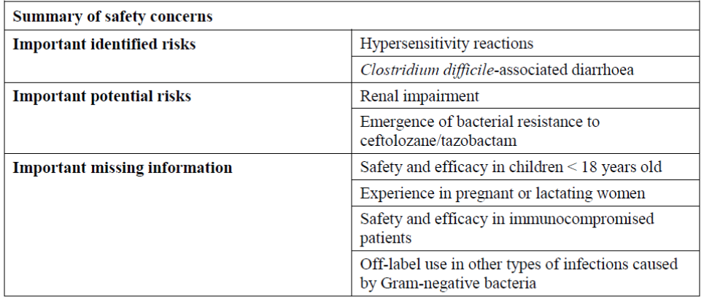

RMP reviewer comment
Notwithstanding the evaluation of the nonclinical and clinical aspects of the Safety Specification, the following recommendations are made. The following should be added as Safety Concerns and become part of the pharmacovigilance plan and risk minimisation plan:

Important identified risks
- Localised fungal infections
- Convulsions
- Hepatic enzyme elevation
- GI disorders

Important potential risks
- Drug-drug interactions with inhibitors of OAT1 and OAT3
- Haematological abnormalities

Missing Information
- Severe renal impairment
- Non Caucasian population

Pharmacovigilance plan
The sponsor proposes only routine pharmacovigilance activities for important identified and potential risks and missing information. No additional activities are planned.
It is noted that the sponsor is conducting a prospective study to monitor resistance and decreased susceptibility in the US.

RMP reviewer comment
Routine pharmacovigilance is not considered sufficient.

Antimicrobial resistance and decreased susceptibility monitoring
The sponsor has provided an Annex document outlining antibiotic resistance data for Zerbaxa which includes some Australian data. However, neither the EU-RMP, nor the ASA nor the antibiotic resistance data annex, give details on how the sponsor proposes to monitor for antibiotic resistance and decreased susceptibility, in particular in Australian sites.
The sponsor should provide these details in their Section 31 response and ultimately add them to the ASA document to ensure reporting in Periodic Safety Update Reports (PSURs). Furthermore, the sponsor should add the prospective study to monitor resistance and decreased susceptibility in the US to the ASA and commit to updates in PSURs.

Risk minimisation activities
The sponsor is not proposing any additional risk minimisation activities.

RMP evaluator comment
The sponsor’s conclusion is adequate in the context of this submission, if the requests made by the RMP evaluator are implemented.

Reconciliation of issues outlined in the RMP report
The following section summarises the OPR’s first round evaluation of the RMP, the sponsor’s responses to issues raised by the OPR and the OPR’s evaluation of the sponsor’s responses.

Recommendation #1 in RMP evaluation report
Safety considerations may be raised by the nonclinical and clinical evaluators through the consolidated Section 31 request and/or the nonclinical and clinical evaluation reports, respectively. It is important to ensure the information provided in response to these includes a consideration of the relevance for the RMP, and any specific information needed to address this issue in the RMP. For any safety considerations so raised, the sponsor should provide information that is relevant and necessary to address the issue in the RMP.

Sponsor response
The sponsor has taken into account safety considerations that have been raised by the nonclinical and clinical evaluators through the consolidated Section 31 request and/or nonclinical and clinical evaluation reports respectively. For any safety consideration raised, the sponsor has responded to those questions in the response document. The impact on the RMP of responses to such requests will also be considered.

Evaluator’s comment
The response has been noted.

Recommendation #2 in RMP evaluation report
The following should be added as an Ongoing Safety Concern and become part of the pharmacovigilance plan and RMP:
- Localised fungal infections

Sponsor response
The sponsor considers that localised fungal infections should not be included as an important identifiable risk for the following reasons:
- In the ceftolozane/tazobactam Phase III clinical trials, fungal related infections were rare and the incidence was comparable between ceftolozane/tazobactam (0.5 %) and ALL active comparators (0.7%).
- The analysis of the Merck Adverse Event Review and Reporting System (MARRS) database cumulatively from market introduction (19 December 2014) through 14 June 2015 for ceftolozane/tazobactam spontaneous did not identify any postmarketing reports with a preferred term consistent with localised fungal infections.
- Occasional localised fungal infections can occur with use of all antibiotics. As a result these are not considered an identified risk that alters the risk-benefit balance of the product or have implications on public health.
In conclusion, the current available evidence of ceftolozane/tazobactam does not support the inclusion of this event as an important identified risk in the list of safety concerns of the ceftolozane/tazobactam RMP.

Evaluator’s comment
The sponsor’s response is considered acceptable in the context of this application. However, the decision may be reviewed when additional data becomes available.

Recommendation #3 in RMP evaluation report
The following should be added as an Ongoing Safety Concern and become part of the pharmacovigilance plan and RMP:
- Convulsions

Sponsor response
The Sponsor considers that convulsions should not be included as an important identifiable risk as the number of reported cases is low and all cases are confounded by other factors suggesting lack of causality with ceftolozane/tazobactam.
- In the pooled analysis of Phase II and Phase III cIAI and cUTI studies, there was one case of convulsions reported in each Phase II and Phase III cUTI trials. In addition a case of convulsion was identified through post marketing reports. A summary of each case is provided below:
  - In the reported Phase 2 cUTI case, the subject (was a subject with a history of epilepsy who was on clonazepam and carbamazepine along with study drug ceftolozane/tazobactam from 4 February 2010 to 13 February 2010. The subject experienced a single episode of convulsion on 15 February 2010 which was reported as a non serious event, moderate in intensity, resolved on the same day, and not related to ceftolozane/tazobactam. The event convulsion is likely related to subject's history of epilepsy.
  - In the reported Phase III cUTI case, the subject was a subject who was on ceftolozane/tazobactam from 6 November 2013 to 13 November 2013 and experienced convulsions on 14 November 2013, which was considered mild in intensity and not related to ceftolozane/tazobactam, and resolved shortly after. Based on the limited information provided in the report, the causality to ceftolozane/tazobactam cannot be established. The case is confounded by the subject's history of anxiety disorder, which can trigger convulsions in patients with non-epileptic seizures; and metastatic endometrial cancer.
  - The analysis of the Merck Adverse Event Review and Reporting System (MARRS) database cumulatively from market introduction (19 December 2014) through 14 June 2015 for ceftolozane/tazobactam identified 1 spontaneous postmarketing report with a preferred term consistent with convulsions. This is a medically confirmed report of generalized tonic clonic seizure in a male subject who was receiving ceftolozane/ tazobactam 1.5 g IV every 8 h for the treatment of a sacral decubitus ulcer and osteomyelitis (off label). The patient had a medical history of Crohn’s disease with diverting loop colostomy in 2008, and he was allergic to sulfamethoxazole/ trimethoprim. Since 2008, the patient was diagnosed with chronic sacral ulcers, sacral abscess, squamous cell carcinoma of a chronic sacral wound, and osteomyelitis. He experienced hidradenitis supurativa post multiple bilateral axillary excisions and was admitted with nausea and vomiting. He was receiving the following concomitant medications: famotidine, hydromorphone, daptomycin, morphine, loratadine, ondansetron and heparin. After this patient received hydromorphone hydrochloride (Dilaudid), he developed a twitching sensation in the mouth followed by loss of consciousness and two minutes of tonic/clonic seizure movements involving the upper extremities (Day 9 after initiation of ceftolozane/tazobactam). He did not experience tongue biting or urinary incontinence; did not have any focal neurological deficits. After the seizure, the patient experienced emesis and received lorazepam 1 mg IV. He did not have a history of convulsions. At the time of the seizure, the patient’s magnesium level was reported as low (1.0 mg/dL). Therapy with ceftolozane/tazobactam was continued and therapy with hydromorphone was discontinued. The reporter stated that the events of convulsion and hypomagnesemia were considered as not related to ceftolozane sulfate/tazobactam sodium. Hypomagnesemia is a known risk factor for convulsions, and is the origin of this metabolic abnormality is unclear. In addition, the event occurred post administration of hydromorphone, a medication for which convulsion is a labeled event.
After the seizure, the patient experienced emesis and received lorazepam 1 mg IV. He did not have a history of convulsions. At the time of the seizure, the patient's magnesium level was reported as low (1.0 mg/dL). Therapy with ceftolozane/tazobactam was continued and therapy with hydromorphone was discontinued. The reporter stated that the events of convulsion and hypomagnesemia were considered as not related to ceftolozane sulfate/tazobactam sodium. Hypomagnesemia is a known risk factor for convulsions, and is the origin of this metabolic abnormality is unclear. In addition, the event occurred post administration of hydromorphone, a medication for which convulsion is a labeled event
In summary, there were three cases (2 from the clinical program and 1 spontaneous post-marketing report) of convulsion; however, all 3 cases were confounded by comorbidities and concomitant medications. Therefore, the current available evidence of ceftolozane/tazobactam does not support the inclusion of convulsion as an important identified risk in the list of safety concerns of the ceftolozane/tazobactam RMP.

Evaluator’s comment
The sponsor’s response is considered acceptable in the context of this application. However, the decision may be reviewed when additional data becomes available.

Recommendation #4 in RMP evaluation report
The following should be added as an Ongoing Safety Concern and become part of the pharmacovigilance plan and RMP:
- Hepatic enzyme elevation

Sponsor response
The sponsor considers that hepatic enzyme elevations is not an important identifiable risk for the following reasons:
- Overall incidences of treatment emergent adverse events of ALT / AST elevations were low and similar between ceftolozane/tazobactam (1.6%/1.4%) and comparators (1.0%/0.8%) in the Phase III clinical trials.
- The events reported above were considered mild, not associated with hepatotoxicity nor premature discontinuation of therapy, and the ALT/AST elevations returned to baseline values following completion (and/or discontinuation) of ceftolozane/tazobactam therapy. The low incidence, comparative nature of the findings, and absence of adverse clinical consequences suggests that hepatic enzyme elevations in patients treated with ceftolozane/tazobactam does not warrant an important identifiable risk.
- The analysis of the Merck Adverse event Review and Reporting System (MARRS) database cumulatively from market introduction (19 December 2014) through 14 June 2015 for ceftolozane/tazobactam spontaneous, postmarketing reports with one or more preferred terms consistent with hepatic enzyme elevation, did not identify reports of hepatic enzyme elevation during this period.
In conclusion, the current available evidence of ceftolozane/tazobactam does not support the inclusion of this event hepatic enzyme elevation as an important identified risk in the list of safety concerns of the ceftolozane/tazobactam RMP.

Evaluator’s comment
The sponsor’s response is considered acceptable in the context of this application. However, the decision may be reviewed when additional data becomes available.

Recommendation #5 in RMP evaluation report
The following should be added as an Ongoing Safety Concern and become part of the pharmacovigilance plan and RMP:
- GI disorders

Sponsor response
The sponsor considers that gastrointestinal disorders should not be included as an important identifiable risk for the following reasons:
- The GI adverse events seen in the Phase III clinical trials, (nausea, diarrhoea, constipation, vomiting, abdominal pain, and dyspepsia) are well recognized common adverse events reported when antibiotics are used in the indications studied (cUTI and especially cIAI).
- The event rates were similar between ceftolozane/tazobactam (15.9%) and comparators (14.1%).
- Despite the report of these adverse events, the majority of patients continued on study drug. There were 3 premature study drug discontinuations, and all GI events connected to premature study drug discontinuations are also common disease characteristics of cIAI disease states (abdominal pain, diarrhoea, vomiting).
- The sponsor carried out an analysis of the Merck Adverse event Review and Reporting System (MARRS) database cumulatively from market introduction (19 December 2014) through 14 June 2015 for ceftolozane/tazobactam spontaneous, postmarketing reports with a preferred term consistent with gastrointestinal disorder. Reports of vomiting and diarrhoea, which are labeled events for ceftolozane/tazobactam have been received during postmarketing use. The events described in these reports were considered non serious.
Given the above points of commonality with other antibiotics, low frequency and mild nature of the events observed, in the case of ceftolozane/tazobactam, GI disorders are not considered an identified risk that could impact the risk-benefit balance of the product or have implications for public health.
Therefore, the current available evidence of ceftolozane/tazobactam does not support the inclusion of this event as an important identified risk in the list of safety concerns of the ceftolozane/tazobactam RMP.

Evaluator’s comment
The sponsor’s response is considered acceptable in the context of this application. However, the decision may be reviewed when additional data becomes available.

Recommendation #6 in RMP evaluation report
The following should be added as an Ongoing Safety Concern and become part of the pharmacovigilance plan and RMP:
- Drug-drug interactions with inhibitors of OAT1 and OAT3

Sponsor response
The sponsor does not have evidence of any potential drug-drug interactions of ceftolozane/tazobactam with inhibitors of OAT1 and OAT3 to be classified as an Important Potential Risk. It has been shown that the transporters, OAT1 and OAT3, are involved in the elimination of tazobactam via the kidney and thus, there is a potential that inhibitors of these transporters could affect the elimination of tazobactam and increase its blood levels. While this has not been directly investigated clinically, it is not considered to be an Important Potential Risk because tazobactam has been approved and has been used for several decades in combination with piperacillin. The Sponsor is not aware of any report of adverse reaction with this product resulting from interactions with inhibitors of OAT1 or OAT3 and therefore, the sponsor expects the same to apply to the use of tazobactam with ceftolozane in Zerbaxa.
Furthermore, the sponsor analysed the Merck Adverse Event Review and Reporting System (MARRS) database cumulatively from market introduction (19 December 2014) through 14 June 2015 for ceftolozane/tazobactam spontaneous, postmarketing reports with a preferred term consistent with drug-drug interactions. No reports were identified during this period.
Therefore, the current available evidence of ceftolozane/tazobactam does not support the inclusion of this event as an important potential risk in the list of safety concerns of the ceftolozane/tazobactam RMP.

Evaluator’s comment
The sponsor’s response is considered acceptable in the context of this application. However, the decision may be reviewed when additional data becomes available.

Recommendation #7 in RMP evaluation report
The following should be added as an Ongoing Safety Concern and become part of the pharmacovigilance plan and RMP:
- Haematological abnormalities

Sponsor response
The sponsor considers that haematological abnormalities should not be included as an important potential risk for the following reasons:
- The incidence of adverse events from the SOC blood and lymphatic system disorders that were observed in the Phase III trials were similar to that of comparators (2.8% versus 2.5%) and did not lead to study drug discontinuation.
- The changes observed in the clinical laboratory values for haematology parameters were generally consistent with the stage of illness from diagnosis through recovery, and was similar in the ceftolozane/tazobactam and comparator treatment arms.
- The low incidence and comparative nature of the findings suggest that ceftolozane/tazobactam had no significant effects on haematology laboratory parameters.
- The analysis of the Merck Adverse Event Review and Reporting System (MARRS) database cumulatively from market introduction (19 December 2014) through 14 June 2015 for ceftolozane/tazobactam spontaneous, postmarketing reports with a preferred term consistent with haematological abnormalities did not identify spontaneous reports with haematological abnormalities during this period.
Therefore, the current available evidence of ceftolozane/tazobactam does not support the inclusion of haematological abnormalities as an important potential risk in the list of safety concerns of the ceftolozane/tazobactam RMP.

Evaluator’s comment
The sponsor’s response is considered acceptable in the context of this application. However, the decision may be reviewed when additional data becomes available.

Recommendation #8 in RMP evaluation report
The following should be added as an Ongoing Safety Concern and become part of the pharmacovigilance plan and RMP:
- Severe renal impairment

Sponsor response
The sponsor acknowledges that patients with severe renal impairment were excluded from the cUTI and cIAI studies. However, the Sponsor conducted a Phase 1 study to investigate the pharmacokinetics of ceftolozane/tazobactam in subjects with severe renal impairment (n = 6). Data from this study was used to determine the appropriate dosing regimen for patients with severe renal impairment based on achieving target exposures similar to that of patients with normal renal function.
In addition, although the Phase III cUTI and cIAI study protocols excluded patients with severe renal failure due to lack of dosing recommendation at the time, 6 patients with severe renal impairment were enrolled in the Phase III clinical trials, 5 of whom received ceftolozane/tazobactam. Of these 5 patients, 1 patient discontinued on study day 1 per protocol due to an AE of worsening renal function and 2 subjects discontinued the study due to protocol inclusion/exclusion criteria. The 2 subjects who completed study drug (albeit receiving a higher dose than appropriate for severe renal impairment) were deemed clinical cures and achieved microbiologic eradication.
In summary, although the data is limited in patients with severe renal impairment, the risk of an adverse drug effect or lack of efficacy in patients with severe renal impairment is considered low since with appropriate ceftolozane/tazobactam dosing, drug exposures in these patients are expected to be similar to those with normal renal function. Hence, the Sponsor believes there is adequate justification not to include the severe renal impairment population as missing information in the RMP.

Evaluator’s comment
The sponsor’s response is considered acceptable in the context of this application.

Recommendation #9 in RMP evaluation report
The following should be added as an Ongoing Safety Concern and become part of the pharmacovigilance plan and RMP:
- Non Caucasian population

Sponsor response
In the ceftolozane/tazobactam clinical development program the percentage of non Caucasian across Phase I to Phase III was 11.4%. Although the percentage of non Caucasian patients is smaller than that of Caucasians, available data from both the PK and safety/efficacy studies conducted to date does not suggest any differences in PK, safety, or efficacy based on Race or Ethnicity.
In the ceftolozane/tazobactam clinical development program the percentage of non Caucasian across Phase I to Phase III was 11.4%. Although the percentage of non Caucasian patients is smaller than that of Caucasians, available data from both the PK and safety/efficacy studies conducted to date does not suggest any differences in PK, safety, or efficacy based on Race or Ethnicity.
A study comparing the pharmacokinetics of ceftolozane/tazobactam involving 10 Caucasians, 9 Chinese and 10 Japanese subjects, has since been conducted. The study is titled “A single dose, open-label, parallel-group study to evaluate the pharmacokinetics, safety and tolerability of ceftolozane/tazobactam administered intravenously to adult Japanese, Chinese and Caucasian healthy subjects”.
Comparable PK parameters were demonstrated between the groups, except for higher exposures of the inactive tazobactam M1 metabolite in Caucasians, which was not shown to impact the safety or efficacy and thus the benefit/risk profile of ceftolozane/tazobactam in Caucasians. As consequence, no dose adjustment of ceftolozane/tazobactam is recommended based on ethnicity.
In addition, the MARRS database was searched cumulatively from market introduction (19 December 2014) through 14 June 2015 for ceftolozane/tazobactam spontaneous, postmarketing reports in which patient race was identified. Three reports of ceftolozane/tazobactam treatment in patients of African-American ethnicity were identified during this period. One report included the preferred terms generalised tonic-clonic seizure, hyperhidrosis, hypomagnesaemia, and vomiting and has been previously described in detail above. In the remaining 2 reports, off label use and/or medication error preferred terms were reported without any associated adverse events.
Given the absence of clinically significant differences by ethnicity, the sponsor considers there is adequate justification not to include Non Caucasian population in the RMP as missing information.

Evaluator’s comment
The sponsor’s response is considered acceptable in the context of this application.

Recommendation #10 in RMP evaluation report
The sponsor should provide details on how they propose to monitor for antibiotic resistance and decreased susceptibility, in particular in Australian sites.

Sponsor response
Resistance and decreased susceptibility to ceftolozane/tazobactam will be monitored through a surveillance study. This study started in 2011 in the EU and US, and additional countries including Australia have been added. In 2014, there were over 11,000 isolates from 29 sites in the US, 35 sites in the EU and 6 sites in Australia. All organisms are isolated from documented infections and only one strain per patient infection episode is included in the surveillance. The isolates are collected primarily from bloodstream infections, skin and skin structure infections, pneumonia in hospitalised patients, urinary tract infections in hospitalised patients and IAIs. Ceftolozane/tazobactam activity is evaluated against clinical Enterobacteriaceae, P. aeruginosa, and Streptococcus spp. isolates. The isolates are identified locally and forwarded to a central monitoring laboratory (JMI Laboratories, North Liberty, Iowa, USA) for confirmation of species identification and reference antimicrobial susceptibility testing. Year over year analysis will be performed to determine if there are changes in susceptibility.

Evaluator’s comment
The commitment to inclusion of 6 Australian sites is acceptable.
The sponsor has not provided enough details on the study and the Australian sites. The sponsor should supply the study protocol or study protocol synopsis of the surveillance study for review.

Recommendation #11 in RMP evaluation report
The sponsor should add the prospective study to monitor resistance and decreased susceptibility in the US to the ASA and commit to updates in PSURs.

Sponsor response
Surveillance studies will be performed annually in Australia and New Zealand to monitor change in susceptibility. The sponsor will include information on the prospective study to monitor resistance and decreased susceptibility in the next update of the ASA and include information in the next PSURs until the end of the prospective study.

Evaluator’s comment
The sponsor’s response is considered acceptable in the context of this application.

Recommendation #12 in RMP evaluation report
The sponsor should state whether the product is intended for hospital use only, or additionally for home use or event for self administration.

Sponsor response
Ceftolozane/tazobactam is intended for use in hospitals, surgical centres or any other facilities where the product is indicated, the health care provider is able to manage it, and the facilities have appropriate storage conditions. Considering the dosing frequency (every 8 h) and limited room temperature stability (24 h or 7 days when stored under refrigeration at 2°C to 8°C (36°F to 46°F), ceftolozane/tazobactam is not anticipated to be used for home infusion or self- administration.

Evaluator’s comment
The sponsor’s response has been noted.

Recommendation #13 in RMP evaluation report
The sponsor should state whether the intended prescriber population is specialist infectious diseases physicians, any specialist, or any medical practitioner.

Sponsor response
Although ceftolozane/tazobactam can be prescribed by any specialty, it is anticipated that ceftolozane/tazobactam will be used mainly by infectious disease physicians, physicians working in the intensive care unit and surgeons.

Evaluator’s comment
The sponsor’s response has been noted.

Recommendation #14 in RMP evaluation report
The sponsor should provide a summary report on the AE profile experienced in the post-market environment.

Sponsor response
The MARRS database was searched cumulatively from market introduction (19 December 2014) through 14 June 2015 for spontaneous, postmarketing reports where ceftolozane/tazobactam was a suspect therapy.
A total of 25 spontaneous postmarketing reports (6 serious, 22 from healthcare professional) which contained 50 AEs (8 serious; 16%) were identified for the reporting period. A summary of AEs by System Organ Class (SOC) is provided in Table 8.
Table 8: Summary of AEs from ceftolozane/tazobactam postmarketing reports by SOC.
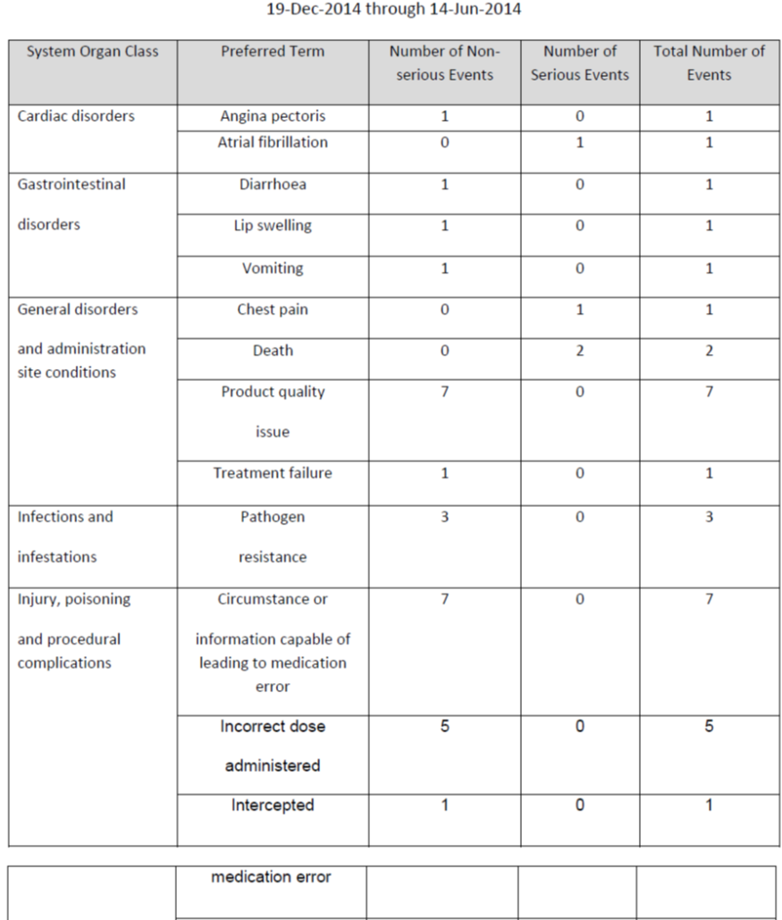

Table 8 (continued): Summary of AEs from ceftolozane/tazobactam postmarketing reports by SOC.
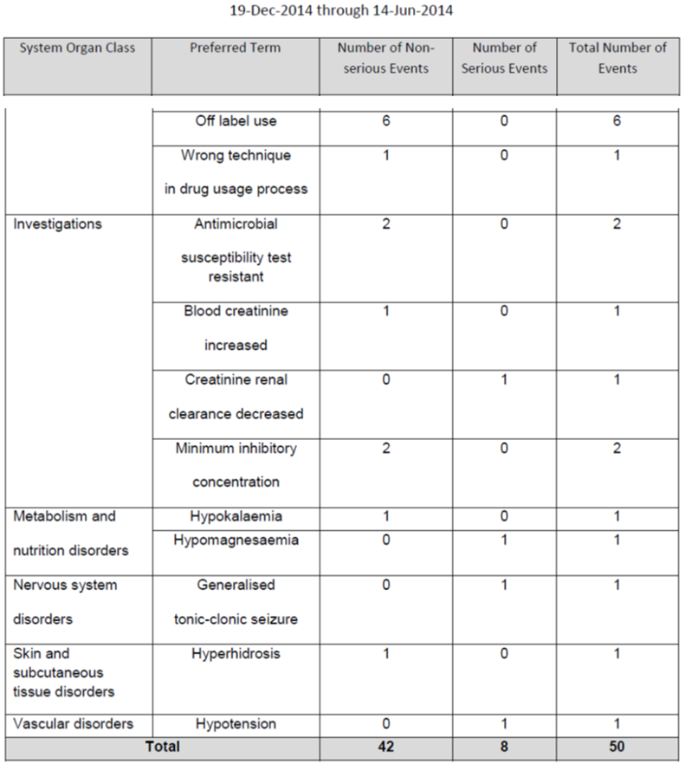

Evaluator’s comment
The sponsor’s response has been noted.
The sponsor should provide information on the two reported deaths in the postmarket environment.

Summary of recommendations

Outstanding issues

Issues in relation to the RMP
It is considered that the sponsor’s response to the TGA Section 31 request has adequately addressed most of the issues identified in the RMP evaluation report.

Outstanding RMP issues (including an additional recommendation)
- The sponsor has not provided enough details on the study and the Australian sites. The sponsor should supply the study protocol or study protocol synopsis of the surveillance study for review (Reference: Round 1).
- The sponsor should provide information on the two reported deaths in the post-market environment (Reference: Round 1).
- Any ASA updates should be provided in the current ASA format (Round 2 recommendation).

Advice from the Advisory Committee on the Safety of Medicines (ACSOM)
- Given bacterial resistance development is an important potential risk, but also considering that Zerbaxa will likely be used in hospitals, could the committee provide advice on whether it would be practical to require confirmation of antimicrobial susceptibility?
The committee prefaced its advice by noting that Zerbaxa was likely to be useful in the treatment of infections due to MDR Gram negative organisms and ESBL producing Enterobacteriaceae. Therefore, the committee advised that it would be a useful public health measure and consistent with the quality use of medicines to give consideration to a mechanism to help reserve Zerbaxa for use in patients with such infections and to minimise off label use.
The committee endorsed the proposed inclusion in the indications of the reference to consideration of published therapeutic guidelines. The local pattern of antibiotic resistance was also relevant to the appropriate selection of antibacterial agents.
The committee advised that Zerbaxa should be prescribed only with an understanding of local patterns of resistance for Gram negative organisms. The committee noted that therapeutic guidelines already recommend culture and susceptibility testing to antimicrobials for complicated infections.
To date, there is in vitro and in vivo evidence of intrinsic resistance to Zerbaxa by methicillin resistant Staphylococcus aureus (MRSA), methicillin sensitive S. aureus (MSSA), Streptococci, enterococci and anaerobes.
- Given bacterial resistance development is an important potential risk, but also considering that Zerbaxa will likely be used in hospitals, could the committee provide advice on whether it would be practical to limit prescribing to be done by Infectious Disease specialists?
The committee advised that it would be appropriate for prescribing of Zerbaxa to be limited to infectious diseases specialists or following advice from an infectious diseases specialist. Further, usage of Zerbaxa should be included within a local antibiotic stewardship program and reflect locally appropriate epidemiological data.
- The sponsor is not proposing additional pharmacovigilance activities to monitor for antibiotic resistance, and in particular, no monitoring in Australia. Can the committee comment on the need for monitoring in Australia, and if favoured by the committee, the number of sites?
The committee considered that the Australian Group on Antimicrobial Resistance (AGAR) program of protocols, sampling sites and surveys will monitor sensitivity and resistance patterns to ceftolozane/tazobactam by selected organisms. This will be the appropriate mechanism for monitoring antibiotic resistance relevant to Australian clinical conditions.
The committee noted the role of the Antimicrobial Resistance Standing Committee, which reports through to ministers of health, in improving antimicrobial stewardship. Its role includes identifying national priorities for action to address antimicrobial resistance across the health spectrum, including veterinary medicines.

Other
It was suggested that the advice in the PI on overdose needed revision, for example, mention of the percent removed by dialysis also needed to mention the time frame, and in context, ‘dialysis’ was a non specific term.
As a fixed dose combination product, attention should be given to ensuring clear labelling and dosage information to avoid medication errors, such as interpreting ‘1 g/0.5 g’ as a dose range or as 1.5 g of ceftolozane.
Zerbaxa must not be mixed with other medicinal products, other than the normal saline or 5% dextrose required for the infusion. To support this, the PI should include a precaution that a dedicated line is required for the infusion.

Comments on the safety specification of the RMP

Clinical evaluation report
The clinical evaluator made the following first round comment in regard to safety specifications in the draft RMP:
- The Safety Specification in the draft RMP is satisfactory.

Nonclinical evaluation report
The nonclinical evaluator made the following comment in regard to safety specifications in the draft RMP:
- Results and conclusions drawn from the nonclinical program for Zerbaxa detailed in the sponsor’s draft RMP are in general concordance with those of the Nonclinical Evaluator.

Key changes to the updated RMP
Not applicable.

Suggested wording for conditions of registration

RMP
Any changes to which the sponsor agreed become part of the risk management system, whether they are included in the currently available version of the RMP document, or not included, inadvertently or otherwise.
The suggested wording is:
- Implement EU-RMP Version 0.1 (dated 11 July 2014, DLP 1 February 2014) and ASA Version 1.0 (dated 17 October 2014) and any future updates as a condition of registration.
- Commit to monitoring of resistance and decreased susceptibility in 6 or more distinct Australian sites through a surveillance study or otherwise.

VII. Overall conclusion and risk/benefit assessment
The submission was summarised in the following Delegate’s overview and recommendations:

Quality
In early Phase I trials and the cUTI Phase II trial, ceftolozane and tazobactam were supplied as separate single agent, powder filled vials.
In later Phase I trials, the cIAI Phase II trial, and all Phase III trials ceftolozane/tazobactam was supplied in single vial. The proposed commercial product is the same as that used in the Phase III trials.
Ceftolozane is semi synthetic. There are no outstanding pharmaceutical chemistry issues apart from GMP clearance for some sites and product labels. Microbiological aspects of the submission have been evaluated separately and there are no objections to registration. The submission did not require referral to the Pharmaceutical Subcommittee (PSC) of the ACPM. However, advice was sought from the PSC in relation to population pharmacokinetics.

Nonclinical
The main deficiencies identified in the nonclinical package were a lack of teratogenicity testing in a non rodent species and lack of combined ceftolozane/tazobactam toxicology testing. Ceftolozane and its microsomal metabolites are not overt DNA interactive mutagens. In accordance with current guidance, carcinogenicity testing was not done. Overall, the dossier was considered compliant with the current guidance documents.
Ceftolozane is almost entirely removed by glomerular filtration. Therefore, metabolite characterisation was not required. It is not likely to be associated with clinically relevant drug-drug interactions. Drugs that inhibit or compete at OAT1/OAT3 may increase plasma concentration of tazobactam.
The key adverse event was induction of renal proximal tubular epithelial hyaline droplet lesions with ceftolozane exposures ≥28 days (without evidence of overt decompensated renal failure). The lesions were cumulative. Restriction of duration of treatment to ≤14 days, as proposed, is considered to avoid these effects.
Pregnancy category B1 is proposed.
The nonclinical area supports registration of Zerbaxa for the proposed clinical use in adults 18 years and above.

Susceptibility breakpoints
The sponsor has revised the draft Australian PI to include the approved FDA breakpoints (ceftolozane/tazobactam), in place of EUCAST/EMA breakpoints, as shown in Table 9.
Table 9: Susceptibility breakpoints.
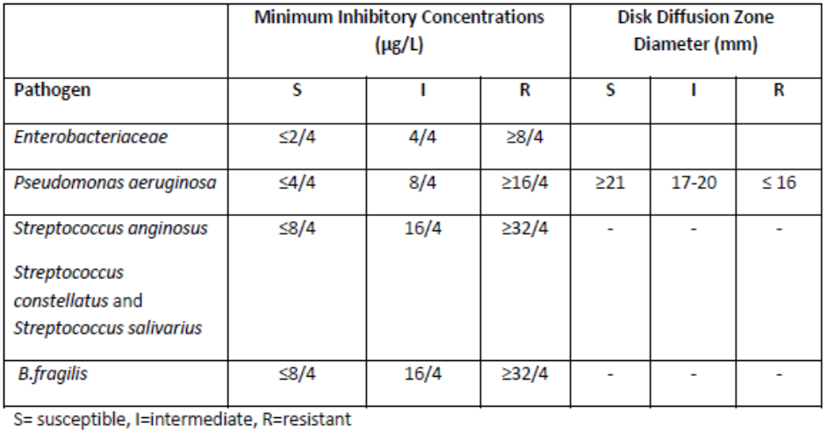
The sponsor is requested to provide updated information about EUCAST breakpoints in its pre ACPM response.

Clinical

Pharmacokinetics
Ceftolozane Cmax and AUC are dose proportional after single dose and at steady state as shown in Table 10.
Table 10: PK parameters.
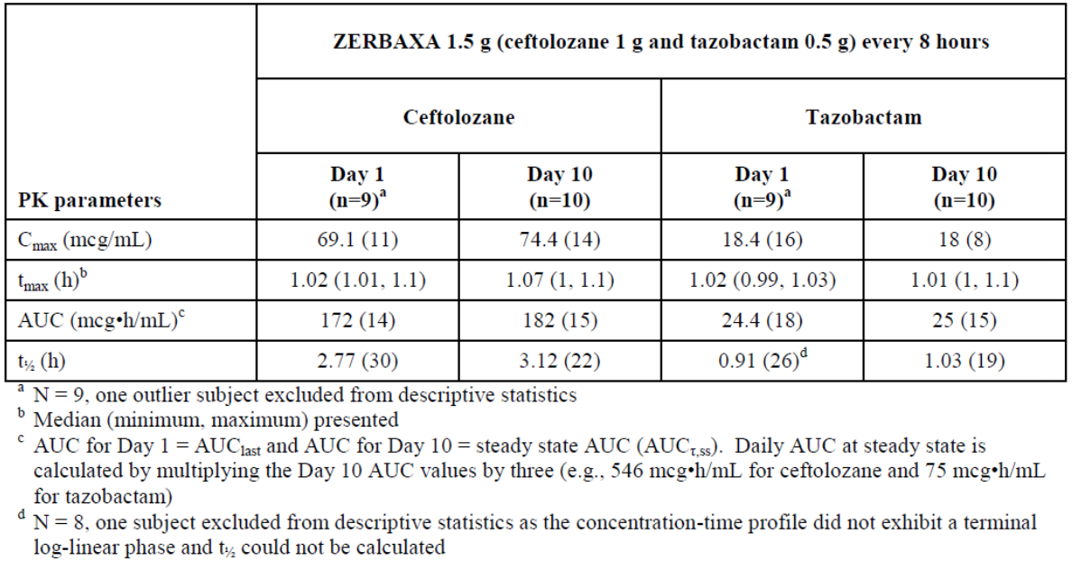
Tazobactam exposure also increases in a dose proportional manner. There was no PK interaction between ceftolozane and tazobactam. Plasma protein binding is low with 16-21% for ceftolozane and 30% for tazobactam.
Ceftolozane is nearly all excreted unchanged in urine by glomerular filtration without clinically meaningful tubular secretion. Ceftolozane is not a substrate for hepatic cytochrome P450 enzymes. There are no active metabolites of ceftolozane.
Tazobactam is eliminated (>80%) as unchanged drug by glomerular filtration and tubular secretion and the remaining as M1 metabolite. Tazobactam is also not metabolized by CYP450 enzymes. The M1 metabolite of Tazobactam is formed by the hydrolysis of tazobactam β-lactam ring and lacks pharmacological or antibacterial activity.
Dose adjustment is recommended in moderate (½ dose) or severe renal impairment (¼ dose), as well as in patients with ESRD on HD (500 mg/250 mg loading dose followed by 100/50 mg 8 hourly). Please see accompanying TGA population PK evaluation report which supports these recommendations.

Pharmacodynamics

Spectrum of antimicrobial activity
Ceftolozane acts by binding to PBPs leading to inhibition of bacterial cell wall synthesis. Ceftolozane/tazobactam has broad spectrum activity against common Gram negative bacteria implicated in cIAI and cUTI, that is, Enterobacteriaceae including ESBL producing and Pseudomonas aeruginosa including MDR strains.
In vitro, tazobactam potentiated the activity of ceftolozane against common species of Enterobacteriaceae including Citrobacter spp., Enterobacter cloacae, Escherichia coli, Klebsiella pneumoniae, Proteus mirabilis, and Serratia marcescens.
In vitro, ceftolozane showed potent activity against P. aeruginosa including drug resistant strains. The MIC of ceftolozane was ≤ 8 µg/mL for approximately 90% of the MDR and 97% of the meropenem-resistant isolates of P. aeruginosa in the 2012 USA surveillance data. The 2013 Australian surveillance data, based on 15 isolates of meropenem non susceptible P. aeruginosa, indicated that MIC was ≤8µg/mL in 12/15 (80%) isolates. Tazobactam has little impact on the susceptibility of P. aeruginosa to ceftolozane.
Ceftolozane has minimal activity against Gram negative anaerobes. Ceftolozane/tazobactam is active against B. fragilis. Gram positive organisms such as Staphylococcus aureus and enterococci are considered intrinsically resistant.
Please see sponsor’s antibiotic resistance data and assessment of risk of resistance development included in the ACPM papers.

Bacterial resistance
The drug is inactivated by bacteria that produce serine carbapenamases or metallo beta lactamases. Modifications and variations to the expression of β lactamases are potential mechanisms of resistance. Cross resistance to other cephalosporins may also occur.

PK/PD relationship
As with other cephalosporin antibiotics, the duration of time above the MIC of the infecting organism over a dosing interval is considered predictive of efficacy.

QT study
No significant clinical effect was demonstrated in a dedicated QT study.

Dose selection
Dose selection was based on population PK modelling and Phase II data. Evaluation of population PK data, including advice from the PSC, support the dosing regimen used in Phase III trials and proposed for clinical use including recommendations in renal impairment.

Efficacy
The efficacy data supporting cIAI and cUTI indications are based on two Phase III randomised, (placebo) double blind, active controlled, multicentre, international trials for each indication. These 4 trials were originally designed as independently powered studies to generate supporting data from 2 trials for each indication and would have roughly required 1000 patients in each trial.
Following agreement with FDA and EMA that a one study per indication was acceptable for regulatory purposes, the overall administration of 4 separate trials was maintained but sample sizes were revised down to roughly 500 patients per trial so that data from 2 trials of each indication could be pooled and presented as single dataset for the proposed indications.
All 4 trials were identically designed (population, interventions, endpoints, follow up) as non inferiority trials against current standard of care. Doses were adjusted for renal impairment. The non inferiority margin was set at -10% and -12.5% for the cUTI and cIAI indications, respectively. The primary efficacy endpoint was tested using higher 99% confidence interval (1 sided 99% confidence interval α = 0.005).
Allocation was by block randomisation, stratified by study site and site of infection. However, the primary analyses were adjusted for region due to small number of participating patients at many sites. All studies were conducted in adult patients.
The primary efficacy endpoints were microbiological success (cUTI) or clinical cure (cIAI) at TOC visit using ME population at TOC (subset of per protocol population) and CE population for the two indications, respectively.
Additional timepoints for assessment of efficacy were EOT and sustained response at LFU using various population sets. Unadjusted analyses, sensitivity analyses and subgroup analyses were also carried out.
EOT visit was within 24 hours of the last dose of drug.
TOC visit was within 5-9 days after last dose of study drug (cUTI) or 26-30 days of the first dose of study drug (cIAI).
LFU visit was 28-34 days after last dose of study drug (cUTI) or 38-45 days after the first dose of study drug (cIAI).
Please see clinical evaluation report for definition of various analysis populations and for additional details. Published reports of the cIAI and the cUTI trials have also been included in the ACPM papers.

cIAIs
The eligible participants were adult (men or women) patients with cIAI (evidence of intraperitoneal infection) confirmed with a surgical intervention within 24 h of (before or after) the first dose of study drug. Patients who failed prior antibacterial treatment were required to have positive baseline culture from an intra abdominal site and undergo surgical intervention in order to continue in the study.
The study treatments were C/T/M 1000/500/500 mg 8 hourly IVI and MER 1000 mg 8 hourly IVI. The duration of treatment was 4-10 days. After 4 days of therapy, the respective treatment could be stopped at the discretion of the investigator if criteria for success were met (predefined in protocol). The patients could receive up to a maximum of 14 days of treatment if antibiotic discontinuation criteria (plus additional predefined criteria) were not met by Day 10. All patients were hospitalised.
A total of 993 eligible patients were randomised to the 2 treatment groups (C/T/M and MER) but 23 had to be excluded from analysis due to data integrity issues. The remaining 970 patients (ITT set) were comprised of 476 and 494 patients in C/T/M and MER groups respectively.
The mean age was 50.7 ± 17.9 (range 18-92) and 50.7 ± 17.3 (range 18-94) years in C/T/M and MER groups respectively. Overall 10% patients were ≥ 75 years of age. Male to female ratio was roughly 60:40. Overall, 70%, 25% and 4.4% patients were in normal, mild and moderate renal impairment category at baseline.
Overall, the baseline diagnoses included cholecystitis with rupture/perforation/progression of infection (19%), diverticular disease with perforation/abscess (7%), appendiceal perforation/abscess (43%), acute gastric/duodenal perforation (11%) and traumatic perforation of intestine (1.5%). Intra abdominal abscess (single or multiple) was present in 56% patients and peritonitis in 82% patients. At baseline, Gram negative aerobes were identified in 82% patients, Gram negative anaerobes in 36% and Gram positive aerobes in 55% patients.
Baseline bacteraemia was diagnosed in 2.3% patients consisting of Gram negative aerobes (1%), Gram negative anaerobes (0.1%), Gram positive aerobes (1.2%), and Gram positive anaerobes (0.6%) organisms.
Minor differences in baseline disease/prognostic features included patients over 65 years of age (24.4% versus 21.3%), APACHE score >10 (18.5% versus 16.6%), CrCL <50mL/min (5.7% versus 3.4%) and diffuse peritonitis (42.7% versus 40.4%) for C/T/M versus MER groups respectively.
Overall the two treatment groups (C/T/M versus MER) were comparable at baseline. The primary analysis was based on CE population at TOC visit. The results were as shown in Table 11.
Table 11: cIAIs.
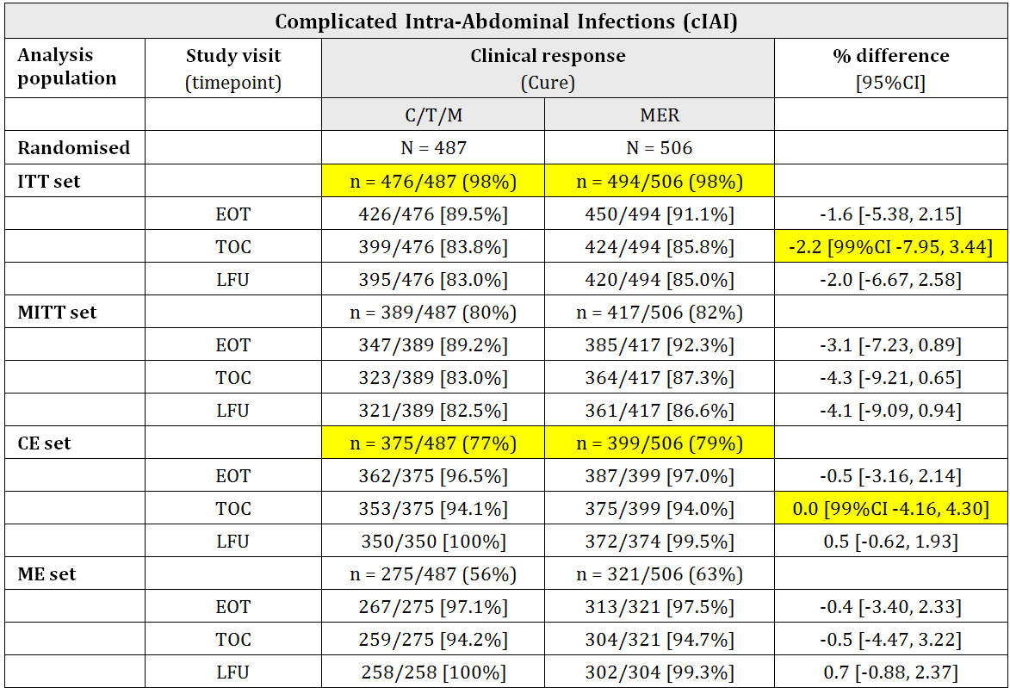
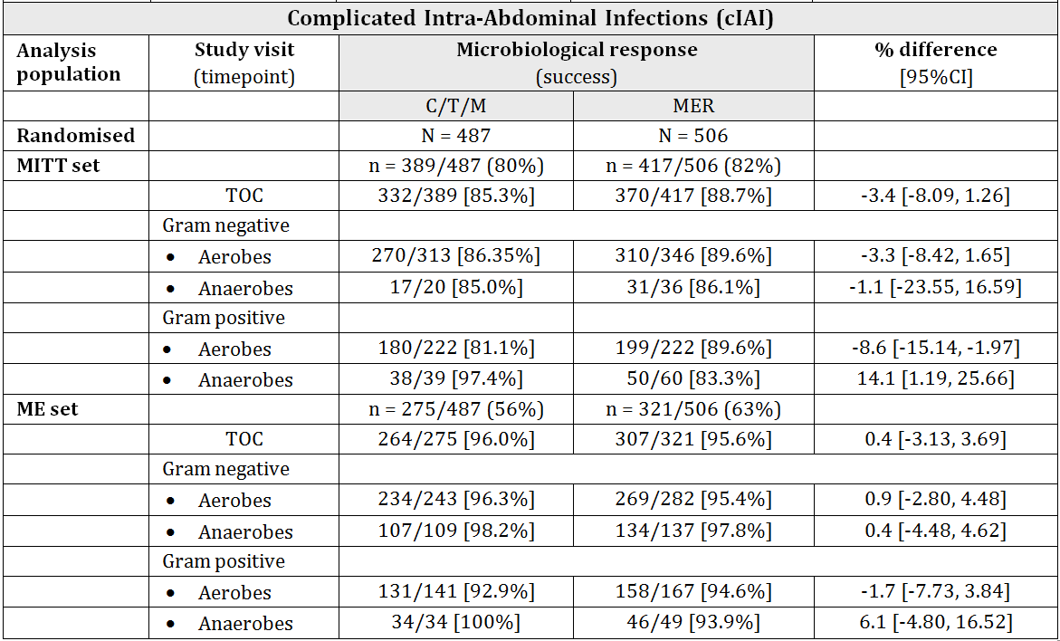
Non inferiority was demonstrated with clinical response rate of 94.1% versus 94.0% in C/T/M versus MER groups respectively indicating a Treatment Difference of 0.0% (LL 99% CI -4.16%) based on CE population at TOC.
ITT analysis at TOC was consistent with the primary analysis with response rate of 83.8% versus 85.8% for C/T/M versus MER indicating a Treatment Difference of -2.2% (99%CI -7.95, 3.44).
Microbiological success rate (MITT set at TOC visit) was 85.3% versus 88.7% in C/T/M and MER groups respectively indicating a Treatment Difference of -3.4% (95%CI -8.09%, 1.26%).

cUTIs including pyelonephritis
The eligible participants were adult (men or women) patients with cUTI (signs and symptoms of pyelonephritis or lower UTI with a qualifying complication), pyuria at baseline and judged to require IV antibiotic. Patients who had received a potentially therapeutic antibiotic in the preceding 48 hours or those with intractable UTI (who might require more than 7 days of treatment) were excluded. Hospitalisation was mandatory except for sites that were approved for outpatient parenteral antibiotic therapy.
A total of 1083 patients were randomised to C/T (n = 543) and LEV (n = 540) treatment groups.
The treatments were C/T 1000 mg/500 mg IVI every 8 h versus LEV 750 mg IV once daily for 7 days. Patients undergoing urinary procedures (including removal of an indwelling catheter, bladder instrumentation, and relief of an obstruction) could receive up to 9 days of treatment.
Overall, the baseline uropathogens were Gram negative aerobes (95.5%) and Gram positive aerobes (5.9%). The most common uropathogen at baseline was E. coli (76.8% and 80.5% in C/T and LEV groups, respectively).
The percentage of patients with bacteraemia at baseline was 7.1% and 7.4% in the 2 groups respectively. The causative blood pathogen was E.coli in 4.7% and 4.5% patients in the two groups respectively.
ME population at TOC (a subset of clinically CE patients at TOC) was used for primary analyses. The mean age in this population was 48.5 ± 19.64 (range 18-87) and 48.4 ± 20.2 (range 18-87) years in the C/T and LEV groups respectively. Overall, 11% patients were ≥75 years of age. Male to female ratio was 27:73. Overall, 65%, 27% and 7% patients were in normal, mild and moderate renal impairment category at baseline.
The percentage of patients with pyelonephritis at baseline was 82.4% and 81.3% in the two treatment groups respectively. The percentage of patients with complicated lower UTI (cLUTI) at baseline was 17.6% and 18.7% in the 2 groups respectively.
Overall the two treatment groups (C/T versus LEV) were comparable at baseline based on ME at TOC visit.
The results were as follows.
The primary outcome of microbiological success rate was 84.7% versus 75.4% in C/T versus LEV groups respectively based on ME population at TOC visit. The treatment difference was 9.4% (99%CI 1.54%, 17.12%) indicating a statistically superior efficacy in favour of C/T compared to LEV.
Table 12: Complicated Urinary Tract Infections (cUTI).
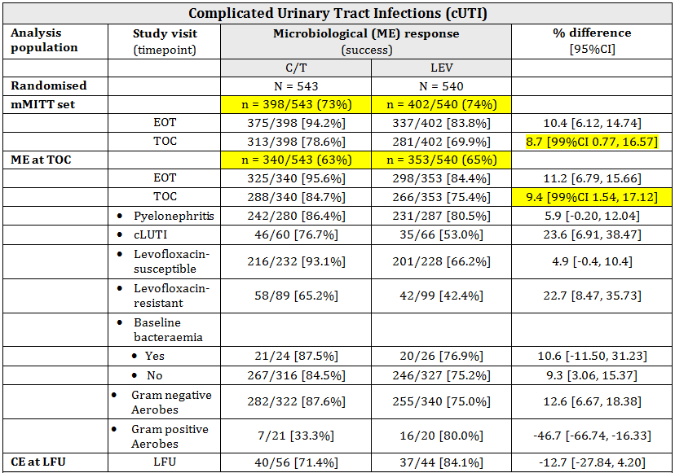
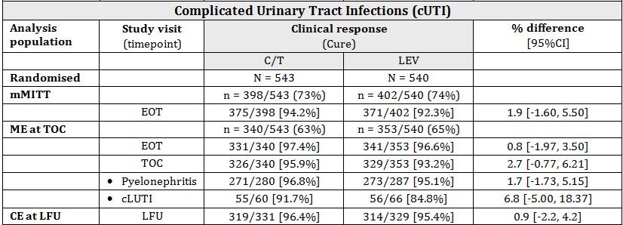
The analysis based on larger mMITT population at TOC was consistent with the primary analysis. The microbiological response rate was 78.6% and 69.9% in C/T and LEV groups respectively indication a Treatment difference of 8.7% (99%CI 0.77%, 16.57%) in favour of C/T.
The clinical response rate was 95.9% and 93.2% in C/T and LEV groups respectively based on ME population at TOC visit, indicating a Treatment Difference of 2.7% (95%CI -0.77%, 6.21%).
The results stratified for pyelonephritis and cLUTIs baseline diagnosis were consistent with the overall analysis.

Safety
Overall, the safety dataset consisted of 2604 subjects treated with ceftolozane alone, C/T combination or a comparator (including placebo) across Phase I-III clinical development program.
A total of 173 subjects received ceftolozane alone, and 1277 subjects received C/T combination (with or without metronidazole).
Across all studies, ceftolozane was administered as a single dose up to 2 grams and as multiple doses up to 3 grams daily for up to 10 days. The C/T combination was administered as a single dose up to 4.5 grams and as multiple doses up to 9 grams for up to 10 days.
A total of 2076 patients were randomised to Phase III studies, including 993 in the cIAI trials and 1083 in the cUTI trials.

cIAI indication: Phase III data
A total of 482 and 497 patients were exposed to the study drugs C/T/M (1000/500/500 mg IVI every 8 h) and MER (1000 mg IVI 8 hourly) respectively in the pivotal Phase III cIAI clinical study (pooled data from 2 trials).
Overall mean duration of treatment was 7.6 (SD 2.5) days and was similar in both groups. The median duration was 7 days (range 1-15 days) in both groups. About 85% patients in both groups were exposed to the study treatment for 4-10 days.
A total of 44.0% and 42.7% patients reported a treatment-emergent adverse event (TEAE) in C/T/M and MER groups, respectively. The rate of discontinuation due to TEAE was 2.7% versus 2.2% respectively.
The most frequently reported TEAEs in C/T/M arm were nausea (7.9%), diarrhoea (6.2%), pyrexia (5.2%), insomnia (3.5%), and vomiting (3.3%). The most frequently reported TEAEs in MER arm were nausea (5.8%), diarrhoea (5.0%), pyrexia (4.0%), vomiting (4.0%), and insomnia (2.2%).
Serious TEAEs (SAEs) were reported in 8.1% and 7.2% patients in the two groups respectively.

cUTI indication: Phase III data
A total of 533 and 535 patients were exposed to the study drugs C/T (1000/500 mg IVI 8 hourly) and LEV (750 mg IV once daily) respectively in the pivotal Phase III cUTI clinical study (pooled data from 2 trials).
Overall mean duration of treatment was 5.8 (SD 1.8) days and was similar in both groups. The median duration was 6.7 days in both groups. About 80% patients in both groups were exposed to the study drugs for 5-7 days.
A total of 34.7% and 34.4% patients reported a TEAE in C/T and LEV groups, respectively. The rate of discontinuation due to TEAE was 1.3% versus 1.7%, respectively.
Most frequently reported TEAEs in C/T arm were headache (5.8%), constipation (3.9%), hypertension (3.0%), nausea (2.9%), and diarrhoea (1.9%). Most frequently reported TEAEs in LEV arm were headache (4.9%), diarrhoea (4.3%), constipation (3.2%), nausea (1.7%), and urinary tract infection (1.7%).
SAEs were reported in 2.8% and 3.4% patients in the two groups, respectively. Two events (C. difficile colitis and pseudomembranous colitis), both in C/T arm, were considered related to the study drugs.

AEs of special interest

Anaphylaxis
No patient treated with C/T in Phase III studies experienced an anaphylactic reaction. One anaphylactic reaction was reported in the cIAI trials in MER treatment arm where the patient experienced circulatory collapse resulting in death.

Pseudomembranous Colitis
The incidence of pseudomembranous colitis was 0.4% and 0.3% in C/T and comparator treatment arms, respectively. AEs terms within this category included C. difficile colitis, pseudomembranous colitis, and clostridial infection. Pseudomembranous colitis was reported in 3 (0.6%) patients in C/T arm in the cUTI indication and 1 (0.2%) patient in C/T/M arm and 3 (0.6%) patients in MER treatment arm in the cIAI indication.

Haemolytic Disorders
No haemolytic disorders were reported in the integrated Phase III data.

Thrombophlebitis
A total of 8 (0.8%) and 11 (1.1%) patients in C/T and comparator treatment arms respectively reported at least 1 thrombophlebitis event. Events in this category included preferred terms of phlebitis, thrombophlebitis, deep vein thrombosis, pelvic venous thrombosis, thrombophlebitis superficial, and thrombosis.

Acute Renal Failure
Eleven (1.1%) and 8 (0.8%) patients in C/T arm and comparator treatment arms reported an acute renal failure event, which included preferred terms of renal impairment, renal failure, acute renal failure, and oliguria.

All-cause mortality
Twenty (20) deaths were reported in Phase III studies and 3 deaths in Phase II studies. No death was reported in Phase I studies.
The incidence of death in cIAI Phase III studies was 11/482 (2.3%) versus 8/497 (1.6%) respectively. Three deaths were reported in C/T/M arm compared to zero in MER arm in the identically designed Phase II cIAI Study CXA-IAI-10-01.
There was one death in C/T group in Phase III cUTI studies. No death was reported in LEV group. No deaths were reported in the Phase II cUTI study CXA-101-03.
No deaths were considered drug-related by the sponsor.
Pooling the Phase II and Phase III cIAI trials, the incidence of death was 2.5% (14/564) C/T/M in C/T/M treated patients compared to 1.5% (8/536) in MER treated patients.

Risk management plan
The submission was referred to ACSOM. The ACSOM comments are noted in the Round 2 advice in relation to the antimicrobial resistance surveillance activity in Australia.
Outstanding RMP issues include the extent of antimicrobial resistance surveillance activity to be conducted locally in Australia. Sufficient details have not been provided. This will need to be resolved to the satisfaction of RMP area and any ACSOM recommendations/comments prior to finalisation.
The RMP area has also noted two reported deaths in the postmarket phase.
The sponsor is requested to include details on both (resistance surveillance in Australia and deaths reported postmarket or compassionate use) in its pre ACPM response.

Risk-benefit analysis

Delegate’s considerations

Proposed use in cIAI
Clinical efficacy was satisfactorily demonstrated for the use of ceftolozane 1000 mg/tazobactam 500 mg/metronidazole 500 mg IVI 8 hourly for 4-14 days combination therapy in the treatment of cIAI. This regimen was shown to be non-inferior to treatment with the currently approved meropenem1000 mg IVI 8 hourly for 4-14 days.
The primary efficacy outcome was clinical response (cure) rate in CE population at the TOC visit. The response rate with C/T/M was 94.1% (353/375) compared to 94.0% (375/399) with meropenem. The treatment difference was zero (99%CI -4.16%, 4.30%).
The data were pooled from two independent, identically designed, trials. The hypothesis testing was at a higher 99% level of significance. The methodology was sound, the amount of missing data was acceptable and the primary analysis was corroborated with analysis using full ITT set [(399/476 (83.8%) versus 424/494 (85.8%) in C/T/M and MER respectively; treatment difference -2.2% (99%CI -7.95%, 3.44%)]. The efficacy result is considered internally valid and robust.
However, a safety signal was noted with for ‘All cause mortality’. Based on pooled data from the cIAI Phase III and Phase II trials (Phase II and Phase III cIAI studies were identical with respect to population, treatments and endpoints) a total of 14/564 (2.5%) deaths were reported with C/T/M treatment compared to 8/536 (1.5%) deaths with MER treatment. This may represent a statistically non significant but clinically important higher Relative Risk of 1.7 (UL95%CI 3.9; p =0.2).
Prior to seeking advice from the ACPM, the sponsor was requested to provide further information and comments regarding this safety concern. The sponsor’s presentation from a teleconference and a written response are included in the ACPM papers.
The sponsor has argued that this is not a true safety signal as the difference was small and could have arisen due to chance. The death rate was low and consistent with the expected mortality in cIAI patient population. The rate was also comparable to similar trials in cIAI with other agents, including those with combined metronidazole use. Small differences in baseline prognostic features are noted that could have adversely affected mortality in the C/T/M arm. All deaths were considered unrelated to the study drugs by the sponsor and temporal association was not found. Absence of similar signal in the cUTI trials was also noted.
Notwithstanding the cross comparison with previous trials of other agents in cIAI, the Delegate is of the opinion that the imbalance in ‘All cause mortality’ in this trial is a safety concern. The imbalance occurred in both Phases II and III and was limited to C/T/M use in the cIAI trials.
The statistical non significance is clearly due to small dataset (and low death rate) as the trials were not powered to assess difference in mortality.
The imbalance cannot be explained by assignment of relatedness to study treatments. The most unbiased estimate of effect in randomised, controlled dataset is ‘All cause mortality’. All else being equal including deterioration in the underlying condition, any difference (imbalance) can be justifiably attributed to the study treatments. A review of the attributed causes of deaths also indicates that in most cases assignment of relatedness would not be simple.
The Delegate notes the baseline differences in prognostic factors (patients >65 years of age (24.4% versus 21.3%), APACHE score >10 (18.5% versus 16.6%), renal impairment CrCL <50mL/min (5.7% versus 3.4%) and diffuse peritonitis (42.7% versus 40.4%) for C/T/M versus MER arms respectively in the Phase III studies) which could be the potential confounders for differential mortality rate in reported in the two arms.
Uncontrolled data from passive postmarket spontaneous reporting is not likely to reliably exclude or verify this signal because of confounding factors including attribution to deterioration in the underlying condition. The sponsor has advised that a mortality trial in currently underway for the use of C/T (at a higher dose) in the treatment of ventilator associated pneumonia. However, this may also not provide data relevant to the C/T/M use in cIAI.

Propose use in cUTI including pyelonephritis
The demonstration of efficacy in cUTI was based on ceftolozane 1000 mg/tazobactam 500 mg IVI 8 hourly for 7 days (75% patients had pyelonephritis at baseline) compared to levofloxacin 750mg IV once daily for 7 days.
The two regimens were shown to be non inferior to each other, based on predefined criterion, for the primary efficacy outcome of microbiological response (success) in ME at TOC visit.
The response rate with C/T was 84.7% (288/340) compared to 75.4% (266/353) with levofloxacin. The treatment difference was 9.4% (99%CI 1.54%, 17.12%) indicating a statistically superior result in favour of C/T. Using the modified ITT population (MITT) at TOC visit, the response rate was 78.6% (313/398) versus 69.9% (281/402) for the 2 groups, respectively. The treatment difference was statistically significant 8.7% in favour of C/T (99%CI 0.77%, 16.57%).
The data were pooled from two independent, identically designed, trials. The pooling strategy was sound. The hypothesis testing was at 99% level of significance. However, the amount of missing data was large. The ME at TOC population consisted of only 63% and 65% randomised patients in the 2 groups respectively.
The supporting analysis based on mMITT set consisted of 73% and 74% randomised patients, respectively. The clinical cure rates were also calculated based on these diminished datasets.
This large amount of incomplete data (results based on 65% of randomised patients) may be sufficient to seriously bias the results in the context of a non inferiority trial.
Comments were sought from the sponsor prior to seeking advice from the ACPM. The sponsor’s response is included in the Committee papers.
The sponsor has argued that it is incorrect to refer to this as missing data. The amount of missing data (patients who did not have a urine culture at TOC visit or the results were not interpretable) was small (overall 7.8%) and within expectations.
The remaining patients were excluded from the analysis based on predefined criteria for the respective PP analysis sets and most of them (145 (26.7%) patients in C/T arm and 138 (25.6%) in LEV arm) were due to lack of a baseline uropathogen. Other reasons for exclusions were also similar between the 2 groups.
In addition, the sponsor has provided a summary of an extreme case scenario sensitivity analysis in which all excluded patients were considered treatment failures leading to a simulated microbiological success rate of 313/543 (57.6%) in C/T arm compared 281/540 (52.1%) in LEV arm indicating a treatment difference of 5.5% (99%CI -3.14%, 14.97%) consistent with the observed results.
The Delegate is of the view that the results, at the minimum, represent an exaggerated estimate of efficacy based on primary analysis (84.7% versus 75.4% for the 2 groups respectively) which is more likely to be around 50-55% in clinical practice and similar for both treatments.
The additional deficiency is the use of levofloxacin as comparator in the cUTI trials. This agent is not approved in Australia and does not represent current Australian clinical practice. However, note that the Phase II cUTI trial included in the dossier (Study CXA-101-03) provides limited data with ceftazidime as the comparator.

Proposed action
Pending advice from the ACPM and further information from sponsor in its pre ACPM response, the Delegate is of the view that the supplied data package for Zerbaxa raises safety (cIAI indication) and efficacy (cUTI indication) concerns for the proposed therapeutic use.
However, this needs to be considered in the context of serious and life threatening infections, that is, cIAI or cUTIs (including pyelonephritis) especially with ESBL producing Enterobacteriaceae and multidrug resistant Pseudomonas aeruginosa, for which the ceftolozane/tazobactam combination provides an additional treatment option.
The small imbalances in some prognostic factors at baseline in cIAI trials, and sensitivity analysis in cUTI trials are also noted. Approval/positive opinion by overseas regulators is also noted.
It is considered that collection of additional mortality data premarket or commitment to postmarket active surveillance for the cIAI indication and selection of patients with culture/sensitivity prior to initiation of treatment for the cUTI indication may result in overall risk/benefit in favour of approval, although the use of unapproved comparator (levofloxacin) remains an issue. More extensive antimicrobial resistance surveillance in Australia recommended.
Submitted to ACPM for advice.

Request for ACPM advice
The ACPM is requested to provide advice on the following specific issues:
- cIAI: Is the ACPM satisfied that a higher ‘All cause mortality’ with Ceftolozane/Tazobactam/Metronidazole combination compared to Meropenem in treatment of cIAI does not preclude approval based on overall net risk/benefit? Does the Committee propose additional clinical trials data either premarket or postmarket to verify or rule out this safety signal?
- cUTI: Does the ACPM consider the evidence of efficacy for the use of Ceftolozane/Tazobactam in the treatment of cUTI to be sufficiently robust, in comparison with the comparator levofloxacin which is also not approved in Australia, to have an overall favourable net risk/benefit for approval?
- Based on the information provided by the sponsor, including any in the pre ACPM, response, is the ACPM satisfied that proposed postmarket antimicrobial resistance surveillance activities to be conducted in Australia are satisfactory?

Response from sponsor
Merck Sharp & Dohme (Australia) Pty Limited (the sponsor) does not concur with the Delegate’s view that the supplied data package for Zerbaxa (ceftolozane/tazobactam) raises safety (cIAI indication) and efficacy (cUTI indication) concerns for the proposed therapeutic use. The sponsor maintains the risk/benefit assessment remains favourable to support the registration of Zerbaxa for the treatment of the following infections in adults:
- cIAIs in combination with metronidazole
- cUTIs, including pyelonephritis
Consideration should be given to published therapeutic guidelines on the appropriate use of antibiotics.

Overseas regulatory status
The FDA designated Zerbaxa as a Qualified Infectious Disease Product (QIDP) for the indications of cIAI and cUTI. This is in recognition of the intended use of Zerbaxa to treat serious or life threatening infections, including those caused by resistant pathogens. Zerbaxa was granted priority review and was approved by the FDA in December 2014 for the same indications as those proposed in Australia.
On 23 July 2015, the Committee for Medicinal Products for Human Use (CHMP) of the EMA adopted a positive opinion, recommending the granting of a marketing authorisation for Zerbaxa, for the treatment of cIAIs, acute pyelonephritis and complicated urinary tract infections. Furthermore, the CHMP noted that the increasing resistance to commonly prescribed antimicrobial agents is a recognised serious global problem. Zerbaxa is currently under review in Switzerland, Canada, and New Zealand.

The sponsor’s response to the issues raised by the Delegate
The Delegate has identified three specific issues on which the advice of the ACPM is sought. The sponsor’s response to these matters is set out below.

Advice sought
- cIAI: Is the ACPM satisfied that a higher “all cause mortality” with Ceftolozane/Tazobactam/Metronidazole combination compared to Meropenem in treatment of cIAI does not preclude approval based on overall net risk-benefit? Does the Committee propose additional clinical trials data either premarket or postmarket to verify or rule out this safety signal?

Response
The sponsor does not believe that the difference in the all cause mortality in cIAI represents a safety signal with Zerbaxa + metronidazole as the incidence of all-cause mortality was low and is in line with prior trials conducted in the patient population. Hence, the sponsor considers that this should not preclude approval.

a) The incidence of all cause mortality reported in the cIAI Phase II and Phase III trials was low
In the Phase III cIAI study, the incidence of all cause mortality was 2.3% (11/482) and 1.6% (8/497) in Zerbaxa + metronidazole and meropenem treatment regimen, respectively. The 0.7% difference (3 patient difference) in the incidence of all cause mortality between the two treatment regimens and the 95% CI of -1.3%, 2.6%, indicated no signal for an added risk of the Zerbaxa + metronidazole treatment regimen, as the difference is small and the 95% CI includes zero. Furthermore, the overall all cause mortality rate across Phase II and Phase III cIAI trials was 2.5% versus 1.5% with Zerbaxa and meropenem, respectively. The 95% CI of the Relative Risk of (0.7, 3.9) does not confirm the significance of the safety signal, as the CI includes 1, and both sides of the CI have equal consideration. For event rates in the 1.5 to 2.5% range, a total of 1100 patients included in this analysis is insufficient to rule out this finding being due to chance.

b) In various Phase III trials of other approved antibiotics in the cIAI indication, the all cause mortality was similar to that seen for Zerbaxa
Please see Table 13.
Table 13: The incidence of all cause mortality reported in studies with other antibiotics in the cIAI indication.
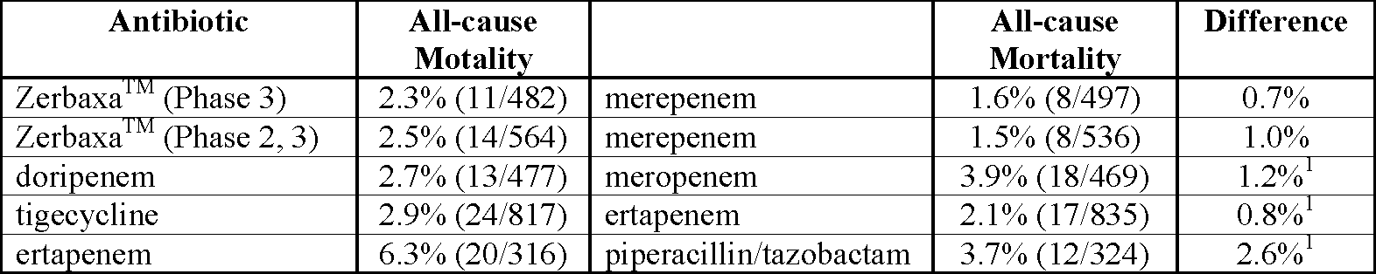
The incidence of all cause mortality observed with Zerbaxa is in line with these prior trials and consistent with the patient population under study. In addition the numerical difference in mortality cases between Zerbaxa and meropenem in Phase III studies (11 versus 8, respectively) is smaller than the numerical difference seen in these prior studies. Furthermore, none of the deaths in Phase II or IIII trials were considered related to the study drug by either the investigator or sponsor. Most deaths occurred following completion of study therapy with no temporal relationship to study drug administration. Furthermore, the majority of deaths were related to underlying comorbidities/concurrent conditions in conjunction with infectious and surgical complications. Finally, the incidence of all-cause mortality due to Zerbaxa in the clinical studies is significantly lower than that reported in population based studies. In such studies, often including a significant number of high-risk patients with intraabdominal infections, the mortality rates have been estimated from 10% to 32% depending on the source of infection, extent of peritonitis, increasing age, and preexisting organ dysfunction.

c) It should be noted that the imbalance in all cause mortality was not discussed during the review with other regulatory authorities
In the EU, there were no discussions regarding an imbalance in all cause mortality and no additions to the Summary of Product Characteristics were required. In the CHMP Assessment Report, it was noted that there were no major concerns raised by the small difference in numbers of deaths, and there were no major concerns regarding safety.
In the approved label in the US, the following statement is included in Section 6.1 Clinical Trial Experience:
Increased Mortality:
In the cIAI trials (Phase 2 and 3), death occurred in 2.5% (14/564) of patients receiving ZERBAXA and in 1.5% (8/536) of patients receiving meropenem. The causes of death varied and included worsening and/or complications of infection, surgery and underlying conditions.

d) Treatment with ceftolozane alone or ceftolozane/tazobactam (Zerbaxa) evaluated in more than 1400 subjects was not associated with any notable unexpected safety signals or concern
The totality of the efficacy and safety results supports a favourable benefit-to-risk assessment for the use of Zerbaxa in the treatment of adult subjects with cUTI and cIAI. This therapy will address an important and growing unmet medical need with regards to multidrug resistant Gram negative pathogens. The urgent medical need in cUTI and cIAI stems largely from the spread of resistance among common causative pathogens such as ESBL producing Enterobacteriaceae and MDR P. aeruginosa. With its potent activity against these resistant pathogens, ceftolozane/tazobactam has the potential to be used as a carbapenem sparing agent to prevent the risk of carbapenem resistance among Gram negative pathogens.
In summary, the sponsor does not believe that the difference observed in the cIAI all cause mortality rate represents a true safety signal that should preclude registration of Zerbaxa in Australia or require additional risk minimisation activities. The positive risk benefit profile of Zerbaxa is further supported by the huge unmet need that Zerbaxa can help to address with regard to the resistant Gram negative infections, namely P. aeruginosa in critically ill hospitalised patients.
In addition, the sponsor is currently conducting a Phase III study comparing Zerbaxa 3 g every 8 h (twice the current approved dose for cIAI and cUTI) versus meropenem 1 g every 8 h in adult subjects with ventilated associated bacterial pneumonia (VABP) (ASPECT-NP). Based on FDA guidelines, the primary objective of this study is to demonstrate the non inferiority of Zerbaxa versus meropenem based on the difference in Day 28 all cause mortality rates in the Intent-To-Treat (ITT) population. To date a small number of patients (n = 25) have been enrolled in this study with no safety concern. A Data Safety Monitoring Board has been established for this trial to monitor the safety of participants during the study in addition to the routine pharmacovigilance activities carried out for the product. The study is projected to complete in 2018 with the intention to submit for extension of Indication to include VABP thereafter.
The sponsor acknowledges the Delegate’s view that the efficacy and safety data provided in support of registration of Zerbaxa needs to be considered in the context of serious and life threatening infections for which Zerbaxa provides an additional treatment option. However, the sponsor believes that collection of additional mortality data premarket or commitment to postmarket surveillance for the cIAI indication is not warranted. The ongoing Phase III trial in VABP will provide additional safety and efficacy data to further support the benefit to risk ratio for Zerbaxa.

Advice sought
- cUTI: Does the ACPM consider the evidence of efficacy for the use of Ceftolozane/Tazobactam in the treatment of cUTI to be sufficiently robust, in comparison with the comparator levofloxacin which is also not approved in Australia, to have an overall favourable net risk/benefit for approval?

Response
The sponsor believes that the evidence of efficacy in cUTI with ceftolozane/tazobactam (Zerbaxa) versus the globally acceptable comparator levofloxacin is sufficiently robust to support a favourable net risk/benefit for approval.

a) In the Phase III cUTI study, there is consistency of efficacy results for Zerbaxa compared to levofloxacin in the microbiological response rate between the ME population and the larger mMITT population (includes all subjects with a baseline pathogen)
For mMITT population, in order to preserve randomisation, subjects who were excluded from the ME population due to missing data or other confounding factors were included in this analysis population. In addition, all patients with missing data (7.8%) were included in the mMITT analysis as treatment failure, which represents an extremely conservative approach.
The findings from the ME (primary) analysis were confirmed by the mMITT (secondary) analysis with the difference in microbiolgical success rates of 9.4% (99% CI 1.54, 17.12) and 8.7% (99% CI 0.77, 16.57), respectively. These analyses demonstrated the non inferiority of Zerbaxa to levofloxacin with a non inferiority margin of 10%. In addition, because the 99% CI did not include zero for both ME and mMITT analyses, these results also demonstreated statistical superiority of Zerbaxa to levofloxacin in both the primary ME and secondary mMITT population.

b) In an effort to further demonstrate the robustness of the results, an analysis in the all randomised (ITT) population was simulated to include subjects that were excluded from the mMITT analysis population due to lack of baseline urine pathogen. These results further support the efficacy of Zerbaxa in this indication.
The 138 subjects who were in the levofloxacin arm but excluded from the mMITT population were simulated to have an 80.4% response rate (in other words 111/138 subjects achieving microbiological success). Similarly, the 145 excluded subjects who were in the Zerbaxa arm were simulated to have a 49.7% response rate (in other words 72/145 subjects achieving microbiological success). When these assumed microbiological success rates are combined with the mMITT results of 313/398 (78.6%) and 281/402 (69.9%) in the Zerbaxa and levofloxacin arms, respectively, the overall microbiological success rate in the ITT population is 385/543 (70.9%) in the Zerbaxa arm and 392/540 (72.6%) in the levofloxacin arm. These rates correspond to a difference in the microbiological success rate of -1.6 with a 99% CI of -8.6 to 5.5. This demonstrates that even if these non evaluable subjects excluded from the mMITT population would have had a response rate in Zerbaxa arm that was demonstratively worse than the levofloxacin rate, Zerbaxa would still be non-inferior to levofloxacin at the prespecified margin of 10% in the all randomized population, as the 99% CI includes zero.

c) The sponsor maintains that levofloxacin, the chosen Phase III comparator for the cUTI study, is well recognized as an appropriate treatment option for cUTI infections.
The Delegate has commented that the comparator used in the cUTI trials, IV levofloxacin, is not approved in Australia. Levofloxacin was chosen as the comparator in the global Phase III clinical trials because it is recommended by international treatment guidelines for treatment of cUTI therefore it is widely used worldwide and it is approved for treatment of cUTI in countries which participated in the cUTI clinical studies. Thus, the data on the comparative efficacy of Zerbaxa versus levofloxacin is anticipated to be clinically relevant to physicians worldwide. There is also TGA precedent for the use of levofloxacin as a comparator to support registration of Doribax (doripenem) in Australia for cUTI. Further, the TGA approved the sponsor’s justification for use of levofloxacin as a comparator in this indication as part of the pre-submission discussions on Zerbaxa. The Sponsor therefore believes that levofloxacin is an appropriate comparator for evaluating efficacy of Zerbaxa in cUTI, thereby demonstrating an overall favourable risk-benefit for approval.

d) The sponsor maintains that the design of the clinical trial in cUTI, wherein patients were empirically initiated on study therapy even ahead of the availability of culture results, is appropriate.
The Delegate commented that selection of patients with culture/sensitivity prior to initiation of treatment for the cUTI indication may result in overall risk-benefit in favour of approval. The sponsor does not concur with the Delegate’s comment, as conducting culture/sensitivity testing prior to initiation of treatment is not consistent with standard of care in patients with cUTI and is therefore not warranted. This is supported by the Phase III trials in which patients were randomised to receive study drug prior to knowledge of culture or sensitivity, an approach which is consistent with standard of care. Of note, 99.6% of the E. coli isolates were susceptible to ceftolozane/tazobactam (regardless of ESBL phenotype) with MIC90 of 0.5 μg/mL. Considering the high susceptibility rate against the common urinary pathogens, high microbiological response rates observed across analysis population, and the high urinary concentrations of ceftolozane/tazobactam, the sponsor believes that the clinical benefits in initiating treatment with ceftolozane/tazobactam prior to culture/sensitivity results would outweigh any possible risk in patients with cUTI.

Advice sought
- Based on the information provided by the sponsor, including any in the pre ACPM response, is the ACPM satisfied that proposed postmarket antimicrobial resistance surveillance activities to be conducted in Australia are satisfactory?

Response
The sponsor will monitor resistance and decreased susceptibility to ceftolozane/tazobactam in 6 distinct Australian sites through an ongoing antimicrobial surveillance program. This program evaluates the activity of ceftolozone/tazobactam and comparator antimicrobial agents against clinical isolates collected from medical centres in the USA, Europe, Australia, and New Zealand. For Australia, clinical isolates have been collected since January 2013 and collection is ongoing. The isolates are to be collected primarily from bloodstream infections (BSI), skin and skin structure infections (SSSI), pneumonia in hospitalised patients (PIHP), UTIs in hospitalised patients, and IAIs.
The Australian and New Zealand sites included in the antimicrobial surveillance program are located in major metropolitan areas across 6 sites in 5 Australian states and 2 sites in New Zealand . Approximately 850 isolates are to be collected from a total of 8 Australian and New Zealand medical centres (70-75% of isolates from Australian sites and 25-30% from New Zealand sites): approximately 700 Enterobacteriaceae, P. aeruginosa, and Acinetobacter spp., 50 β haemolytic streptococci, 50 S. pneumoniae, and 50 H. influenzae.
The sponsor believes that this sample size is representative, and similar to other antimicrobial surveillance programs conducted in Australia for this purpose. It should be noted, the RMP evaluator has accepted the Sponsor’s commitment for inclusion of 6 Australian sites through this surveillance study.

Other
- The sponsor is requested to provide updated information about EUCAST breakpoints in its pre ACPM response.

Response
The EUCAST breakpoints are presented in Table 14 to be published as an addendum to Clinical Breakpoints v 5.0 upon approval in Europe.
Table 14: The EUCAST Breakpoints for ceftolozane/tazobactam.
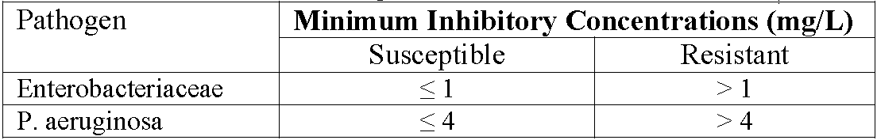

Other
- The sponsor is requested to provide details on deaths reported post-market or compassionate use in its pre ACPM response.

Response
Zerbaxa was approved in the US on 19 December 2014. Zerbaxa has been made available for compassionate use to hospitals that did not participate in Zerbaxa clinical trials, and/or in countries where Zerbaxa has not yet been approved. Cumulatively, 22 instances of compassionate use have been reported. In addition, in the United States, the cumulative number of patients treated with marketed Zerbaxa from 19 December 2014 to 30 July 2015 ranged from approximately 1,725 to 6,038 patients, depending on the duration of treatment. At the Delegate’s request, the Merck Adverse Event Review and Reporting System (MARRS) database was searched cumulatively from market introduction (19 December 2014) through 30 August 2015 for Zerbaxa postmarketing cases and cases from compassionate use studies in which a fatal outcome was reported. A total of 5 cases (3 postmarketing reports, 2 compassionate use reports) were identified. In all 5 reports, the patients receiving Zerbaxa were severely ill. With regard to the 3 postmarketing reports, one report contained limited information. In the second report, it is unclear if a death even occurred during therapy with Zerbaxa. In the third report, a patient with significant underlying lung disease died secondary to respiratory failure in the setting of pneumonia after care was withdrawn. Details on the first two reports have been provided to the TGA in response to the RMP evaluation.
With regard to the 2 compassionate use reports, one of the 2 reports concerned a pediatric patient where source control of the infection was not achieved, which, combined with the patient’s severe immunosuppression, likely lead to the fatal outcome. In the second report, only a single dose of Zerbaxa was administered given baseline resistance was discovered quickly due to a carbapenemresistant enterobacter. The patient improved with the initiation of another investigational antibiotic, but later succumbed to sepsis and pneumonia secondary to S. maltophilia.
In all cases, the fatal outcome was likely related to the underlying disease and progression of the infectious process. The target population who are receiving Zerbaxa are very sick patients with multiple comorbidities and serious infections and, as a consequence, have a high mortality rate.
In summary, in the review of postmarketing reports with fatal outcome, no new safety signals were identified. The sponsor will continue monitoring fatal cases reported in patients receiving Zerbaxa and report them in the PSURs as part of routine pharmacovigilance.

Conclusion
As previously noted, the sponsor maintains the risk/benefit assessment remains favourable to support the registration of Zerbaxa for the treatment of the following infections in adults:
- cIAIs in combination with metronidazole
- cUTIs, including pyelonephritis
The sponsor does not believe that the imbalance in the all cause mortality in cIAI represents a true safety signal as the incidence of all cause mortality was low in the cIAI Phase 3 trials with 0.7% difference (95% CI of -1.3%, 2.6%) (difference of 3 cases) between the 2 treatment arms (Zerbaxa versus Comparator Groups). The 2.3% all cause mortality rate observed with Zerbaxa is consistent with the patient population under study and prior trials in this indication. It is also important to note that the safety data from the cUTI trials does not support all cause mortality as a safety signal with Zerbaxa. In conclusion, the totality of the data suggests a favourable safety profile for Zerbaxa, consistent with the cephalosporin class of antibiotic.
The sponsor believes that the evidence of efficacy in cUTI with Zerbaxa versus the globally acceptable comparator levofloxacin is sufficiently robust to support a favourable net risk/benefit for approval. The number of subjects in the ME population lead to an adequately powered trial to investigate the question of non inferiority. There is consistency of results in the efficacy of Zerbaxa compared to levofloxacin in the microbiological response rate between the ME population and the larger mMITT population (includes all subjects with a baseline pathogen) that not only demonstrated the non inferiority but the superiority (a higher standard than non inferiority) of Zerbaxa compared to levofloxacin.
Zerbaxa has the potential to help address an urgent medical need for new antibacterial agents based on its vitro susceptibility, predictable PK/PD profile, and efficacy and safety results from clinical studies. The urgent medical need in cUTI and cIAI stems largely from the spread of resistance among common causative pathogens such as ESBL producing Enterobacteriaceae and MDR P. aeruginosa.
The sponsor trusts the ACPM will concur that the totality of the available efficacy and safety data supports a favourable benefit-to-risk assessment for the use of Zerbaxa in the treatment of adults with cUTI and cIAI and recognise the potential for this therapy to address an important and growing unmet medical need with regards to MDR Gram negative pathogens.

Advisory Committee Considerations
The ACPM, taking into account the submitted evidence of efficacy, safety and quality, considered Zerbaxa powder for injection containing 1000 mg of ceftolozane (as sulfate) and 500 mg tazobactam (as sodium salt) to have an overall positive benefit-risk profile for the amended indication:
Zerbaxa is indicated for the treatment of the following infections in adults suspected or proven to be caused by designated susceptible microorganisms:
    - Complicated intra-abdominal infections in combination with metronidazole
    - Complicated urinary tract infections, including pyelonephritis
Consideration should be given to published therapeutic guidelines on the appropriate use of antibacterial agents.

Proposed conditions of registration
The ACPM agreed with the Delegate on the proposed conditions of registration.

Proposed Product Information (PI)/Consumer Medicine Information (CMI) amendments
The ACPM agreed with the Delegate to the proposed amendments to the PI and CMI and specifically advised on the inclusion of the following:
- A statement similar to that in the US PI to acknowledge the rate of deaths in the cIAI trials to reflect the trial data accurately.
- Amendment of the CMI to better reflect Australian circumstances, with reference to the standard CMI template and the Usability Guidelines and the PI as approved by the TGA.

Specific Advice
The ACPM advised the following in response to the Delegate’s specific questions on this submission:
- cIAI: Is the ACPM satisfied that a higher ‘All cause mortality’ with Ceftolozane/Tazobactam/Metronidazole combination compared to Meropenem in treatment of cIAI does not preclude approval based on overall net risk/benefit? Does the Committee propose additional clinical trials data either premarket or postmarket to verify or rule out this safety signal?
The ACPM observed that deaths reported in the Phase III cIAI trials were 11/482 (2.3%) versus 8/497 (1.6%); across Phase II and III trials deaths were 14/564 (2.5%) versus 8/536 (1.5%). The ACPM also noted the sponsor’s argument that reported mortality was similar or lower than in other trials of cIAI; that none of the deaths were considered related; that there was no temporal relationship with most occurring after the course of treatment; that many deaths were ascribed to underlying comorbidities; that the rate of deaths were not raised by FDA or EMA.
The ACPM noted the possible safety signal with increased deaths in the cIAI trials. It was reassuring that there was no consistent cause of death, and no increased risk of death in the cUTI group. Nonetheless, the ACPM advised this should be monitored and reported via the Risk Management Plan. In addition, the ACPM advised that the rate of deaths in the clinical trials should be acknowledged in the PI in a similar statement to that in the US PI.
- cUTI: Does the ACPM consider the evidence of efficacy for the use of ceftolozane/tazobactam in the treatment of cUTI to be sufficiently robust, in comparison with the comparator levofloxacin which is also not approved in Australia, to have an overall favourable net benefit:risk for approval?
The ACPM noted the Delegate raised the issue of missing data: ME <65% of total and mMITT <75% of total. However, most missing data was due to the lack of positive cultures at baseline, and this proportion is within the expected range from clinical practice. Levofloxacin is not standard of care in Australia and not available; the recommended regimens are ampicillin/gentamicin or ceftriaxone. However, available evidence suggests that C/T is at least non inferior to these broader spectrum agents than would be used in Australia. The ACPM considered this product has a borderline positive benefit-risk balance. The ACPM advised that although the level of evidence was limited it was sufficient to support the modified indication.
- Based on the information provided by the sponsor, including any in the pre ACPM, response, is the ACPM satisfied that proposed postmarket antimicrobial resistance surveillance activities to be conducted in Australia are satisfactory?
The ACPM advised that resistance is a real risk and it is a serious individual and public health matter. This antibiotic has a role targeted to MDR as last resort antibiotic.
The sponsor proposes sentinel surveillance at 6 sites in Australia. The ACPM advised that it would be better to coordinate with established surveillance systems such as Australian Group on Antimicrobial Resistance (AGAR) or the national antimicrobial resistance surveillance programme being developed by the Australian Commission on Safety and Quality in Health Care (ACSQHC).
The ACPM advised that implementation by the sponsor of the recommendations outlined above to the satisfaction of the TGA, in addition to the evidence of efficacy and safety provided would support the safe and effective use of this product.

Outcome
Based on a review of quality, safety and efficacy, TGA approved the registration of Zerbaxa ceftolozane sulfate/tazobactam sodium 1000 mg/500 mg Powder for Injection vial indicated for:
Zerbaxa (ceftolozane/tazobactam) is indicated for the treatment of the following infections in adults suspected or proven to be caused by designated susceptible microorganisms:
  - Complicated intra-abdominal infections in combination with metronidazole
  - Complicated urinary tract infections, including pyelonephritis
Consideration should be given to published therapeutic guidelines on the appropriate use of antibacterial agents.

Specific conditions of registration applying to these goods
- The Zerbaxa (ceftolozane sulfate/tazobactam sodium 1000 mg/500 mg) EU-RMP Version 1.2 (dated 1 July 2015, DLP 1 February 2014) and ASA Version 1.1 (dated 28 August 2015) and any future updates, as agreed with the TGA will be implemented in Australia.

Attachment 1. Product Information
The PI approved for Zerbaxa at the time this AusPAR was published is at Attachment 1. For the most recent PI, please refer to the TGA website at <https://www.tga.gov.au/product-information-pi>.

Attachment 2. Extract from the Clinical Evaluation Report

Therapeutic Goods Administration
PO Box 100 Woden ACT 2606 Australia
Email: info@tga.gov.au Phone: 1800 020 653 Fax: 02 6232 8605
https://www.tga.gov.au

Sponsor changed to Merck Sharp & Dohme Australia Pty Ltd after initial submission.
Meek ME, et al. A framework for human relevance analysis of information on carcinogenic modes of action. Crit Rev Toxicol. 33: 591-653 (2003); Meek, ME et al. New developments in the evolution and application of the WHO/IPCS framework on mode of action/species concordance analysis. J Appl Toxicol. 34: 1-18 (2014); Carmichael N, et al. Using mode of action information to improve regulatory decision-making: an ECETOC/ILSI RF/HESI workshop overview. Crit Rev Toxicol. 41: 175-86 (2011); Boobis AR, et al. IPCS framework for analyzing the relevance of a noncancer mode of action for humans. Crit Rev Toxicol. 38: 87-96 (2008); Boobis AR, et al. IPCS framework for analyzing the relevance of a cancer mode of action for humans. Crit Rev Toxicol. 36: 781-92 (2006); OECD, “Guidance Document on Developing and Assessing Adverse Outcome Pathways. Series on Testing and Assessment, No. 184. Paris: Organization for Economic Co-operation and Development (ENV/JM/MONO(2013)6)", 17 April 2013.
FDA Pregnancy Category C: Animal reproduction studies have shown an adverse effect on the foetus and there are no adequate and well-controlled studies in humans, but potential benefits may warrant use of the drug in pregnant women despite potential risks.
TGA Pregnancy Category B1: Drugs which have been taken by only a limited number of pregnant women and women of childbearing age, without an increase in the frequency of malformation or other direct or indirect harmful effects on the human foetus having been observed. Studies in animals have not shown evidence of an increased occurrence of foetal damage.
Current TGA approved recommended dosing regimen for Tazocin: IV infusion of piperacillin 4g/ tazobactam 500mg to be given 8 hourly.
European Medicines Agency, “Guideline on the evaluation of medicinal products indicated for treatment of bacterial infections (CPMP/EWP/558/95 rev 2)”, 15 December 2011.
European Medicines Agency, “Addendum to the guideline on the evaluation of medicinal products indicated for treatment of bacterial infections (EMA/CHMP/351889/2013)”, 24 October 2013.
European Medicines Agency, “Points to consider on application with (1) meta-analysis; (2) one pivotal study (CPMP/EWP/2330/99)”, 31 May 2001.
European Medicines Agency, “Points to consider on application with (1) meta-analysis; (2) one pivotal study (CPMP/EWP/2330/99)”, 31 May 2001.
Including sodium, potassium, chloride, bicarbonate, blood urea nitrogen (BUN), creatinine, albumin, total protein, total bilirubin, alanine aminotransferase (ALT), aspartate aminotransferase (AST), alkaline phosphatase [ALP], gamma-glutamyl transferase (GGT)calcium, phosphorus, uric acid, and non-fasting serum glucose.
European Medicines Agency, “Guideline on reporting the results of population pharmacokinetic analyses (CHMP/EWP/185990/06)”, 21 June 2007.
C/T/M = Ceftolozane 1000mg/Tazobactam 500mg and Metronidazole 500mg 8 hourly IVI.
MER = Meropenem 1000mg 8 hourly IVI.
C/T = Ceftolozane/Tazobactam 1000mg/500mg 8 hourly IVI.
LEV = levofloxacin 750mg once daily IV.
Sartelli M, et al. Complicated intra-abdominal infections in a worldwide context: an observational prospective study (CIAOW Study). World J Emerg Surg. 8: 1 (2013); Sartelli M, et al. Antimicrobial management of intra-abdominal infections: literature's guidelines. World J Gastroenterol. 18: 865-71 (2012).
Mazuski JE. Antimicrobial treatment for intra-abdominal infections. Expert Opin Pharmacother. 8: 2933-45 (2007); Anaya DA, Nathens AB. Risk factors for severe sepsis in secondary peritonitis. Surg. Infect. 4: 355-62 (2003).
Grabe M, et al. In: Guidelines on urological infections. Armhem, The Netherlands: European Association of Urology (EAU). 2012 Chapter 4, Complicated URIs due to urological disorders, pp. 28-32; United States Department of Health and Human Services. Food and Drug Administration: Guidance for Industry. Complicated urinary tract infections and pyelonephritis – developing antimicrobial drugs for treatment, February 2012; Levaquin (levofloxacin) Prescribing Information; Janssen Pharmaceuticals, Inc. April 2012; Cek M, et al. Healthcare-associated urinary tract infections in hospitalized urological patients--a global perspective: results from the GPIU studies 2003-2010. World J Urol. 32: 1587-94 (2014); Hooton TM, et al. Diagnosis, prevention, and treatment of catheter-associated urinary tract infection in adults: 2009 International Clinical Practice Guidelines from the Infectious Diseases Society of America. Clin Infect Dis. 50: 625-63 (2010).

